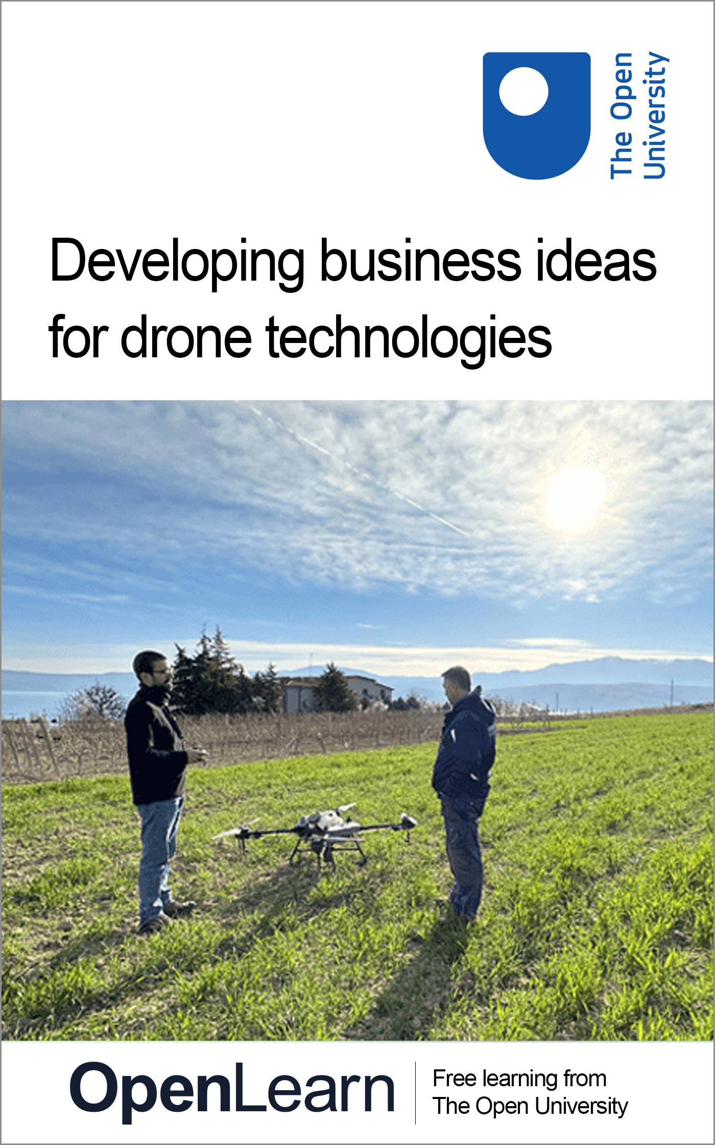

ICAERUS_1

Developing business ideas for drone technologies

About this free course
This free course is an adapted extract from the Open University course .
This version of the content may include video, images and interactive content that may not be optimised for your device.
You can experience this free course as it was originally designed on OpenLearn, the home of free learning from The Open University –
There you’ll also be able to track your progress via your activity record, which you can use to demonstrate your learning.
First published 2024.
Unless otherwise stated, copyright © 2024 The Open University, all rights reserved.
Intellectual property
Unless otherwise stated, this resource is released under the terms of the Creative Commons Licence v4.0 http://creativecommons.org/licenses/by-nc-sa/4.0/deed.en_GB. Within that The Open University interprets this licence in the following way: www.open.edu/openlearn/about-openlearn/frequently-asked-questions-on-openlearn. Copyright and rights falling outside the terms of the Creative Commons Licence are retained or controlled by The Open University. Please read the full text before using any of the content.
We believe the primary barrier to accessing high-quality educational experiences is cost, which is why we aim to publish as much free content as possible under an open licence. If it proves difficult to release content under our preferred Creative Commons licence (e.g. because we can’t afford or gain the clearances or find suitable alternatives), we will still release the materials for free under a personal end-user licence.
This is because the learning experience will always be the same high quality offering and that should always be seen as positive – even if at times the licensing is different to Creative Commons.
When using the content you must attribute us (The Open University) (the OU) and any identified author in accordance with the terms of the Creative Commons Licence.
The Acknowledgements section is used to list, amongst other things, third party (Proprietary), licensed content which is not subject to Creative Commons licensing. Proprietary content must be used (retained) intact and in context to the content at all times.
The Acknowledgements section is also used to bring to your attention any other Special Restrictions which may apply to the content. For example there may be times when the Creative Commons Non-Commercial Sharealike licence does not apply to any of the content even if owned by us (The Open University). In these instances, unless stated otherwise, the content may be used for personal and non-commercial use.
We have also identified as Proprietary other material included in the content which is not subject to Creative Commons Licence. These are OU logos, trading names and may extend to certain photographic and video images and sound recordings and any other material as may be brought to your attention.
Unauthorised use of any of the content may constitute a breach of the terms and conditions and/or intellectual property laws.
We reserve the right to alter, amend or bring to an end any terms and conditions provided here without notice.
All rights falling outside the terms of the Creative Commons licence are retained or controlled by The Open University.
Head of Intellectual Property, The Open University

Contents
- Introduction and guidance
  - Introduction and guidance
    - What is a badged course?
    - How to get a badge
  - Acknowledgements
- Week 1: Discover the drone industry
  - Introduction
  - 1 The ICAERUS project
    - 1.1 The five ICAERUS Use Cases
  - 2 The drone industry and its growth
    - 2.1 The drone industry lifecycle
    - 2.2 The Incubation stage
    - 2.3 The Pre-Firm Takeoff and the Pre-Sales Takeoff stages
  - 3 Identifying and developing new business ideas
    - 3.1 Sources of ideas
    - 3.2 Identifying your idea
  - 4 The importance of stakeholders
    - 4.1 Internal and external stakeholders
    - 4.2 Primary and secondary stakeholders
    - 4.3 Using drones for crop health assessment
  - 5 This week’s quiz
  - 6 Summary of Week 1
  - References
  - Acknowledgements
- Week 2: Business models and drones in agriculture
  - Introduction
  - 1 Do farmers use business models?
  - 2 Business ideas and business models from the first ICAERUS open call
  - 3 Business model types
    - 3.1 Product business model
    - 3.2 Solution business model
    - 3.3 Matchmaking business model
    - 3.4 Multi-sided business model
  - 4 Sustainable business models for the use of drones in agriculture
  - 5 Value capture and revenue models
    - 5.1 Razor and blade revenue model
    - 5.2 Freemium revenue model
  - 6 Bringing business and revenue models together
  - 7 This week’s quiz
  - 8 Summary of Week 2
  - References
  - Acknowledgements
- Week 3: Frameworks for understanding drone data and regulations
  - Introduction
  - 1 Data and policy – an emerging relationship
    - 1.1 Complex data sets of drones
    - 1.2 The Five Vs of big data
    - 1.3 Domains and technology – BDAFs in context
  - 2 Drone policies and regulations
    - 2.1 Maximising flexibility
    - 2.2 The EASA and drone regulations in Europe
    - 2.3 Information on relevant civil drone regulations
  - 3 This week’s quiz
  - 4 Summary of Week 3
  - References
  - Acknowledgements
- Week 4: From new business ideas to value propositions
  - Introduction
  - 1 The business model canvas
  - 2 The value proposition canvas
    - 2.1 The customer profile
    - 2.2 The value map
  - 3 Design a value proposition canvas
    - 3.1 Design a value proposition
    - 3.2 Present a value proposition
  - 4 This week’s quiz
  - 5 Summary of Week 4
  - References
  - Acknowledgements
- Week 5: Designing a business model (infrastructure and sustainability areas)
  - Introduction
  - 1 The customer area
    - 1.1 Customer segments
    - 1.2 Customer relationships
    - 1.3 Channels
    - 1.4 The Drone Spraying Use Case
  - 2 The value proposition canvas
    - 2.1 Evaluate a value proposition
    - 2.2 The fit of a value proposition
  - 3 This week’s quiz
  - 4 Summary of Week 5
  - References
  - Acknowledgements
- Week 6: Business model canvas – part 2
  - Introduction
  - 1 The infrastructure area
    - 1.1 Key resources
    - 1.2 Key activities
    - 1.3 Key partners
    - 1.4 Designing the infrastructure area
  - 2 The financial viability area
    - 2.1 Cost structure
    - 2.2 Revenue streams
    - 2.3 Designing the financial viability area
  - 3 The sustainability area
    - 3.1 Eco-social costs
    - 3.2 Eco-social benefits
  - 4 Piecing the canvas together
  - 5 This week’s quiz
  - 6 Summary of Week 6
  - References
  - Acknowledgements
- Week 7: Ecosystems and networks
  - Introduction
  - 1 Ecosystems in business and management
    - 1.1 Business interactions and ecosystems
  - 2 Ecosystems: using drones for livestock management
  - 3 Drone use for sustainable livestock management in rural France
  - 4 Drone-driven ecosystems for sustainable livestock management in rural France
  - 5 Ecosystem attributes: knowledge
  - 6 Ecosystem attributes: innovation
  - 7 Ecosystem attributes: entrepreneurial
  - 8 Ecosystems embedded in networks: network relational dimension
  - 9 Ecosystems embedded in networks: network structural dimension
  - 10 Networks: structural characteristics and benefits
  - 11 This week’s quiz
  - 12 Summary of Week 7
  - References
  - Acknowledgements
- Week 8: Presenting your business idea
  - Introduction
  - 1 Introduction – the why
    - 1.1 Communicating effectively with different stakeholders
  - 2 The elevator pitch
    - 2.1 Creating your own elevator pitch
    - 2.2 Developing your elevator pitch
  - 3 Demonstration activities
  - 4 Reflecting on your learning and identifying next steps
  - 5 Creating an action plan
  - 6 Summary of Week 8
  - 7 This week’s quiz
  - 8 Course conclusion
  - References
  - Acknowledgements
- Solutions
- Descriptions

Introduction and guidance

Introduction and guidance
Welcome to Developing business ideas for drone technologies, a free badged course which lasts 8 weeks with approximately 3 hours’ study time each week. You can work through the course at your own pace, so if you have more time one week there is no problem with pushing on to complete another week’s study.
In this free course you will develop an initial view of the drone industry, looking at the evolution of the industry and the potential market opportunities available. The aim of this course is to present the potential for business development in the drone industry. You will look at recent developments and the latest industry data before identifying opportunities for your own drone business idea.
After completing this course, you should be able to:
- understand the drone industry and the emerging innovations in the sector
- understand business models, with application of drone technologies
- identify and collect relevant information to develop evidence to support the development of a new business idea
- evaluate the economic, social and environmental impact of new business idea, considering its sustainability
- articulate and professionally communicate a new business idea to different stakeholders.

Moving around the course
In the ‘Summary’ at the end of each week, you can find a link to the next week. If at any time you want to return to the start of the course, click on ‘Full course description’. From here you can navigate to any part of the course. Alternatively, use the week links at the top of every page of the course.
It’s also good practice, if you access a link from within a course page (including links to the quizzes), to open it in a new window or tab. That way you can easily return to where you’ve come from without having to use the back button on your browser.

What is a badged course?
While studying Developing business ideas for drone technologies you have the option to work towards gaining a digital badge.
Badged courses are a key part of The Open University’s mission to promote the educational wellbeing of the community. The courses also provide another way of helping you to progress from informal to formal learning.
Completing a course will require about 24 hours of study time. However, you can study the course at any time and at a pace to suit you.
Badged courses are available on The Open University’s OpenLearn website and do not cost anything to study. They differ from Open University courses because you do not receive support from a tutor, but you do get useful feedback from the interactive quizzes.

What is a badge?
Digital badges are a new way of demonstrating online that you have gained a skill. Colleges and universities are working with employers and other organisations to develop open badges that help learners gain recognition for their skills, and support employers to identify the right candidate for a job.
Badges demonstrate your work and achievement on the course. You can share your achievement with friends, family and employers, and on social media. Badges are a great motivation, helping you to reach the end of the course. Gaining a badge often boosts confidence in the skills and abilities that underpin successful study. So, completing this course could encourage you to think about taking other courses.

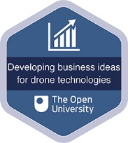
View alternative description - Uncaptioned Figure

How to get a badge
Getting a badge is straightforward! Here’s what you have to do:
- read each week of the course
- score 50% or more in the two badge quizzes in Week 4 and Week 8.
For all the quizzes, you can have three attempts at most of the questions (for true or false type questions you usually only get one attempt). If you get the answer right first time you will get more marks than for a correct answer the second or third time. Therefore, please be aware that for the two badge quizzes it is possible to get all the questions right but not score 50% and be eligible for the badge on that attempt. If one of your answers is incorrect you will often receive helpful feedback and suggestions about how to work out the correct answer.
For the badge quizzes, if you’re not successful in getting 50% the first time, after 24 hours you can attempt the whole quiz, and come back as many times as you like.
We hope that as many people as possible will gain an Open University badge – so you should see getting a badge as an opportunity to reflect on what you have learned rather than as a test.
If you need more guidance on getting a badge and what you can do with it, take a look at the OpenLearn FAQs. When you gain your badge you will receive an email to notify you and you will be able to view and manage all your badges in My OpenLearn within 24 hours of completing the criteria to gain a badge.
Get started with Week 1.

Acknowledgements
This free course was written by Giacomo Carli, Kristen Reid and Despoina Filiou.
The development of this course was funded by the ICAERUS project.
The ICAERUS project was funded by the EU under the Horizon Europe scheme Grant Agreement 101060643 and UK under Innovate UK reference 10038181.
Except for third party materials and otherwise stated, including any quotes referenced in the course and not acknowledged here (see terms and conditions), this content is made available under a Creative Commons Attribution-NonCommercial-ShareAlike 4.0 Licence .
The material acknowledged below is Proprietary and used under licence (not subject to Creative Commons Licence). Grateful acknowledgement is made to the following sources for permission to reproduce material in this free course:
Course image: Courtesy: Dr Katerina Kasimati
Course badge: © The Open University
Every effort has been made to contact copyright owners. If any have been inadvertently overlooked, the publishers will be pleased to make the necessary arrangements at the first opportunity.
Don't miss out:
1. Join over 200,000 students, currently studying with The Open University – http://www.open.ac.uk/ choose/ ou/ open-content
2. Enjoyed this? Find out more about this topic or browse all our free course materials on OpenLearn – http://www.open.edu/ openlearn/
3. Outside the UK? We have students in over a hundred countries studying online qualifications – http://www.openuniversity.edu/ – including an MBA at our triple accredited Business School.
Don't miss out
If reading this text has inspired you to learn more, you may be interested in joining the millions of people who discover our free learning resources and qualifications by visiting The Open University – www.open.edu/openlearn/free-courses.

Week 1: Discover the drone industry

Introduction
Welcome to Week 1 of Developing business ideas for drone technologies. This week you will develop an initial view of the drone industry, looking at the evolution of the industry and the potential market opportunities available. The aim of this week is to present the potential for business development in the drone industry. You will look at recent developments and the latest industry data before identifying opportunities for your own drone business idea.
Figure 1 shows the learning cycle for Week 1.

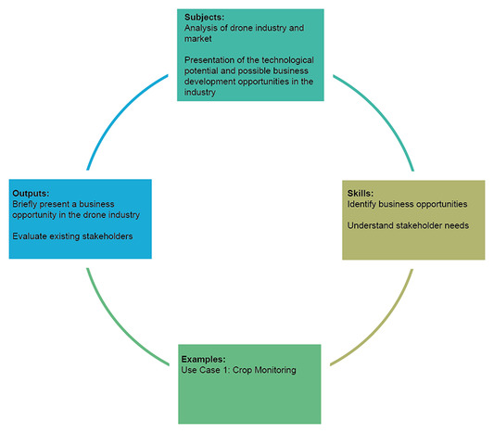
Figure 1 Learning cycle for Week 1
View description - Figure 1 Learning cycle for Week 1
View alternative description - Figure 1 Learning cycle for Week 1

By the end of Week 1, you should be able to:
- understand the development and growth of the drone industry and emerging innovations in the agricultural, forestry and rural sectors
- identify a business idea in the drone industry
- identify and map the stakeholders of a business idea.

1 The ICAERUS project
This course is part of the ICAERUS (Innovation and Capacity building in Agricultural Environmental and Rural UAV Services) project, a 4-year project aiming to increase the business use of drones in agriculture, forestry and rural areas across Europe. In Video 1 you will meet Professor Spyros Fountas and Dr Katerina Kasimati who will introduce the vision and purpose of ICAERUS and discuss why drone applications are having a huge impact on many human activities. It is important to note that in this course we use the word ‘drone’ and UAV (Unmanned Aerial Vehicle) as synonyms, although there are some sources that connect the acronym UAV to military aircrafts that are guided autonomously (Guilmartin, 2024).

Video content is not available in this format.
Video 1
View transcript - Video 1

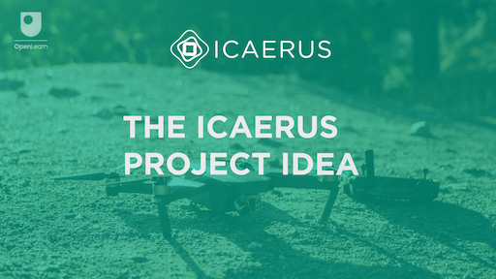
View alternative description - Uncaptioned Figure

You can visit the ICAERUS website to explore the project objectives and challenges in more detail. To avoid losing your place in the course, if you are studying on a desktop you should open the link in a new tab or window by holding down Ctrl (or Cmd on a Mac) when you click on it. If you are studying on a mobile device hold down the link and select to ‘Open in New Tab’. Return here when you have finished.
Figure 2 shows the stakeholders of the ICAERUS project. The project aims to benefit agricultural communities and a range of stakeholders ranging from private sector to public bodies developing policies and offering funding for innovation. There are four areas of activities in the project: research; develop and demonstrate; education and train; and scale up. Content that is being produced through the ICAERUS project is shown at the top of Figure 2, which includes this course that is part of the ICAERUS Academy.

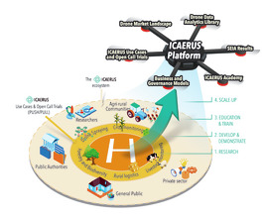
Figure 2 The different stakeholders in the ICAERUS project
View description - Figure 2 The different stakeholders in the ICAERUS project
View alternative description - Figure 2 The different stakeholders in the ICAERUS project

In this course you will review the different technologies developed in the ICAERUS project and develop your knowledge of the drone industry. You will also have the chance to develop the skills that will allow you to identify a business idea and map the stakeholders that could help transform your idea into a reality.
The project is funded by the EU under the Horizon Europe scheme and UK under Innovate UK. Figure 3 shows the project logo and the EU and UK Funders logo and grant agreement numbers.

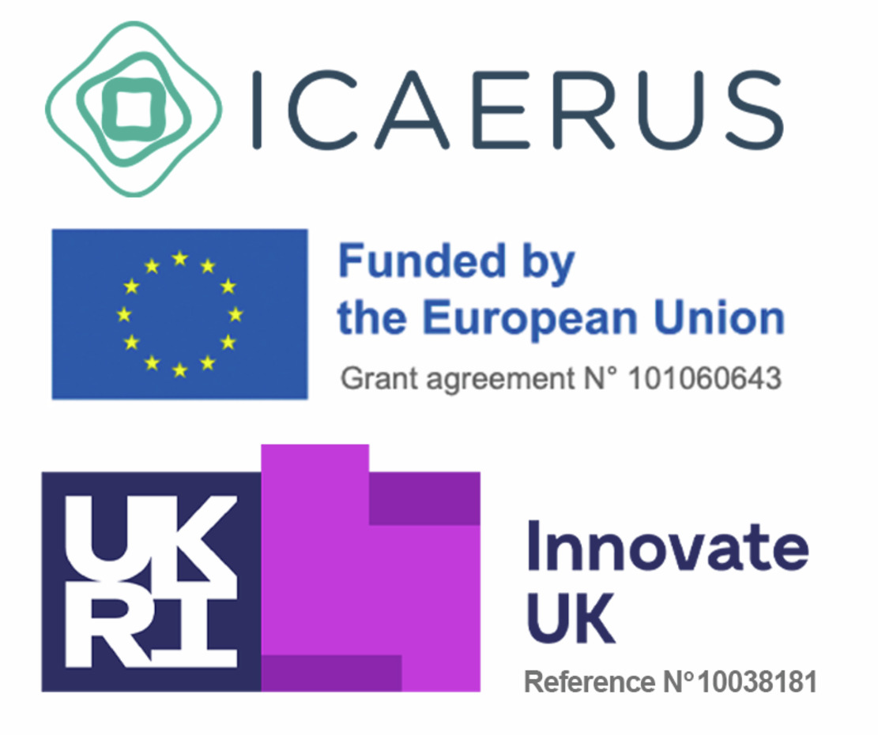
Figure 3 The ICAERUS project logo and grant agreement numbers with the related funders
View description - Figure 3 The ICAERUS project logo and grant agreement numbers with the related funders ...
View alternative description - Figure 3 The ICAERUS project logo and grant agreement numbers with the related funders ...

1.1 The five ICAERUS Use Cases
The ICAERUS project centres around five Use Cases which have been set up to develop and test innovative drone technology for agricultural and rural purposes. Each Use Case is developed by an ICAERUS Project Partner located in a European country as shown in Figure 4.

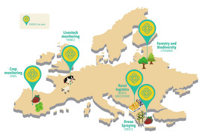
Figure 4 The five Use Cases of the ICAERUS project
View description - Figure 4 The five Use Cases of the ICAERUS project
View alternative description - Figure 4 The five Use Cases of the ICAERUS project

Activity 1
Allow approximately 5 minutes.

Familiarise yourself with the different technologies developed in the ICAERUS project by matching the short descriptions of the technological development to the relevant Use Case below.

Interactive content is not available in this format.

Optional further study
If you want to find out more about the Use Cases and the activities and partners involved, visit the ICAERUS project website.

2 The drone industry and its growth
The civilian drone industry emerged in 2007, mainly because drones, originally developed for military purposes, started being used for aerial photography and video. Since that time, the civilian market has had tremendous growth. In 2018, the worldwide value of the civilian drone industry reached 2.9 billion USD and by 2023, had grown to 4 billion USD (Statista, 2023). According to Statista (Figure 5), the civilian drone industry alone is forecasted to reach 4.7 billion USD by 2028, without military drones. Nearly 1 million drones are expected to be in operation in the UK by 2030 (PwC, 2022).

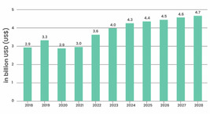
Figure 5 Civilian drone revenues from 2018 to 2028 (estimates by Statista, 2023)
View description - Figure 5 Civilian drone revenues from 2018 to 2028 (estimates by Statista, 2023)
View alternative description - Figure 5 Civilian drone revenues from 2018 to 2028 (estimates by Statista, 2023)

As the drone industry grows, new products and services continue to emerge. These innovations offer lots of different opportunities for businesses in industries spanning agriculture and photography to logistics. Market estimates suggest that the greatest growth for new business opportunities will come from geographical locations where currently restrictive regulations could be relaxed, namely the EU and the UK (MarketLine, 2022). Currently, the fastest growing drone market is in Asia, followed by the US, where the regulatory environments are more relaxed and the cost of drone technology is lower.
Within the drone market, one of the fastest growing industry segments is related to drones in agriculture. An industry segment is a specific category within an industry (Denoo et al., 2022), for instance the industry segment of agricultural drones or the industry segment of logistics drones.
Despite much of the drone market still being in its infancy, PwC forecasts that, in the UK, agricultural and logistics drones will see the largest gains from the adoption of drone applications by 2030, with other growing industry segments including defence, health, education, mining, and gas and electricity. The global value of the agricultural drones dedicated to spraying was estimated at 1.8 billion USD in 2020 and is expected to reach 3.2 million USD by 2031 (Fact.MR, 2021).
In this course, you will focus on how to develop business opportunities for the use of drones in different contexts. The examples from the ICAERUS project consider mainly the use of drones in agriculture, but these may apply to a wider range of applications to industrial and consumer uses. First, though, it is worth appreciating that drone applications are at different stages of development; for instance the use of drones for delivery is at a more advanced stage of development compared to drone use for livestock management.

2.1 The drone industry lifecycle
Every industry has a lifecycle which can be broadly divided into four stages: introduction, growth, maturity and decline. At the Introduction stage, there is a limited number of players offering differentiated products with a low level of competition. Rivalry is limited but profits are also low because of the amount of investment needed to start up. The demand is low because few buyers are keen on trying the new product/service. In this context, competition is focused on attracting and educating new customers and consolidating market shares.
Overall, the drone industry can be considered in its lifecycle Introduction stage (see Figure 6) with a convergence (or coming together) toward one or more dominant designs in products and services still to take place. Grant (2016, p. 207) remarks that it is when there is a convergence towards a dominant design that the industry moves from the introduction to the growth stage. This is because customers feel less risk in adopting a widely accepted solution, and companies are more likely to invest in creating production capacity. Large companies may be interested in entering the competition, to benefit from its high profits, as in 2016 with the rapid diffusion of fitness trackers.

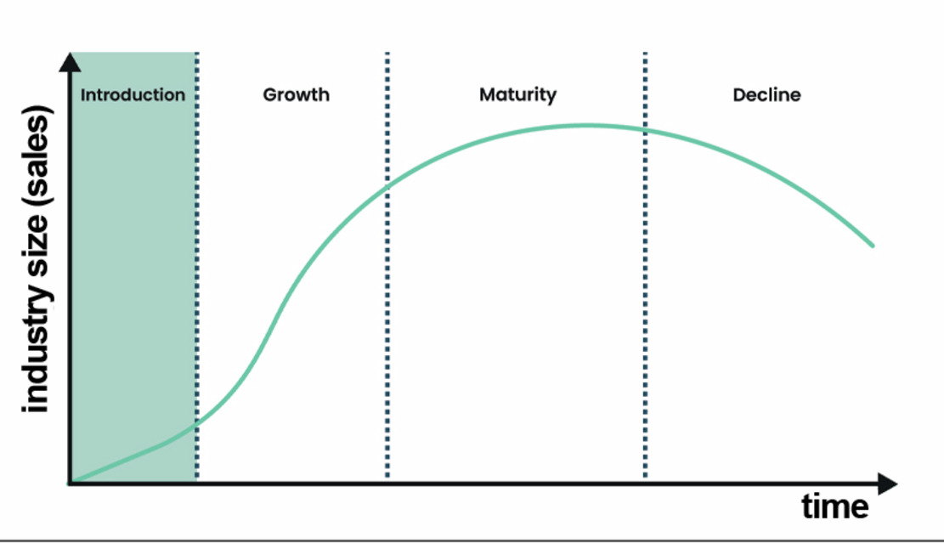
Figure 6 Industry lifecycles
View description - Figure 6 Industry lifecycles
View alternative description - Figure 6 Industry lifecycles

Researchers are now developing a greater understanding of what happens at the Introduction stage of an industry. The Introduction stage can be divided into three sub-stages: incubation stage, Pre-Firm Takeoff stage and Pre-Sales Takeoff stage (Moeen et al., 2020). Each sub-stage might not progress to the next one if the knowledge that is developed is not at satisfactory levels, as will be explained in the next sections.

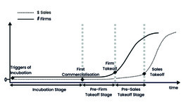
Figure 7 Introduction stage of the industry lifecycle
View description - Figure 7 Introduction stage of the industry lifecycle
View alternative description - Figure 7 Introduction stage of the industry lifecycle

The different industry segments of the drone industry are at various substages of the Introduction stage, with different competitive environments, different sets of stakeholders involved in innovation development, and different areas of focus for products and services.
Take for example the industry segment of drones dedicated to photography. When civilian drones first emerged they were primarily used by hobbyists and there was no clear market for them. However, as drones became more prevalent in photography and videography, through new designs with integrated powerful cameras of high quality and stability, business opportunities developed in the market as part of the ‘Incubation’ stage. The launch of the ‘drone gimbal’ in 2012 then re-defined the meaning of drones as ‘flying cameras’ (or ‘eyes in the sky’), boosting their use for professional aerial photography, and giving new meaning to the use of drones. The drone gimbal reflects ‘first commercialisation’ in Figure 7.

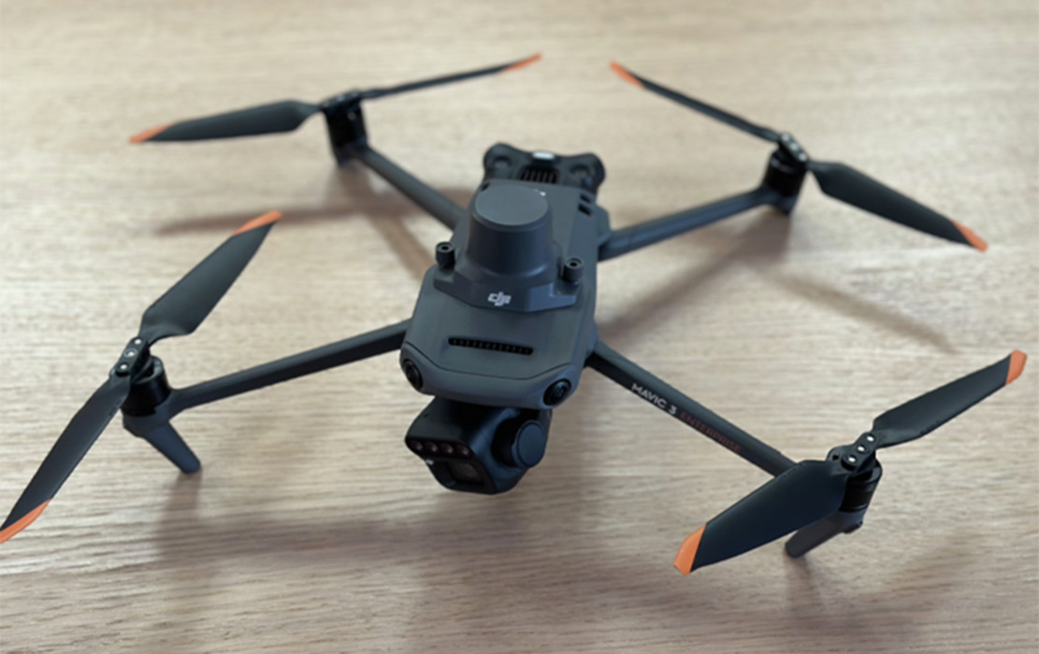
Figure 8 A drone gimbal
View description - Figure 8 A drone gimbal
View alternative description - Figure 8 A drone gimbal

Despite its success, the early versions of the gimbal were not attractive to the mass market as users needed to assemble its parts and install software. The need for greater flexibility and ease of use forced drone manufacturers and innovators to create the ‘ready to fly’ or RTF drone, a fully integrated drone, ready to use right ‘out of the box’. The RTF was very important because it made drones easy to use by amateur photographers, pushing industry sales further. At this point, the industry segment of photography drones progressed from the Incubation stage to the ‘Firm Takeoff’ stage, thus attracting more companies to serve the increasing demand with more investment to back them.
In the next section you will look at the Introduction sub-stages in more detail and relate them to the agricultural and rural segment of the drone industry.

2.2 The Incubation stage
You will now look at the different stages of the Introduction phase in the industry life cycle, in relation to the drone industry, beginning with the Incubation stage. Each stage of industry growth gives different opportunities.
Box 1 shows the key actors involved, the knowledge developed at this stage and what would enable the move to the next stage. As you have seen for photography drones, at this stage the main actors are scientists and inventors, and in some cases hobbyists.

Box 1 Incubation stage

Key actors:
- scientists
- user inventors
- legal system

Knowledge
- Technology: architecture components
- Demand: single product or service
- Institutions: eligibility for intellectual property rights

Jump to the next stage
- Is there enough knowledge for offering a commercial product?
  - Yes: first commercialisation
  - No: delay or abandon

Fruitful interactions between ‘technology developers’ (e.g. drone manufacturers) and users are key for the industry to grow beyond the stage of ‘incubation’. For example, in 2014–2016, drones began to be used for precision agriculture in the US. The drones were re-designed to meet the requirements of farmers (users) for specific farming tasks: field monitoring, crop spraying and so on. These tasks required drones with higher speeds, longer ranges and more endurance, and needed to be equipped with liquid sprayers and multi-spectral sensors. User needs were quite different to the needs of the aerial photographers, and the ‘drone gimbal’ needed re-adjusting. These changes in drone design, as shown in Figure 9, gave new meaning to their use (from ‘eye in the sky’ to ‘a hand in the sky’), and a new industry segment opened up.

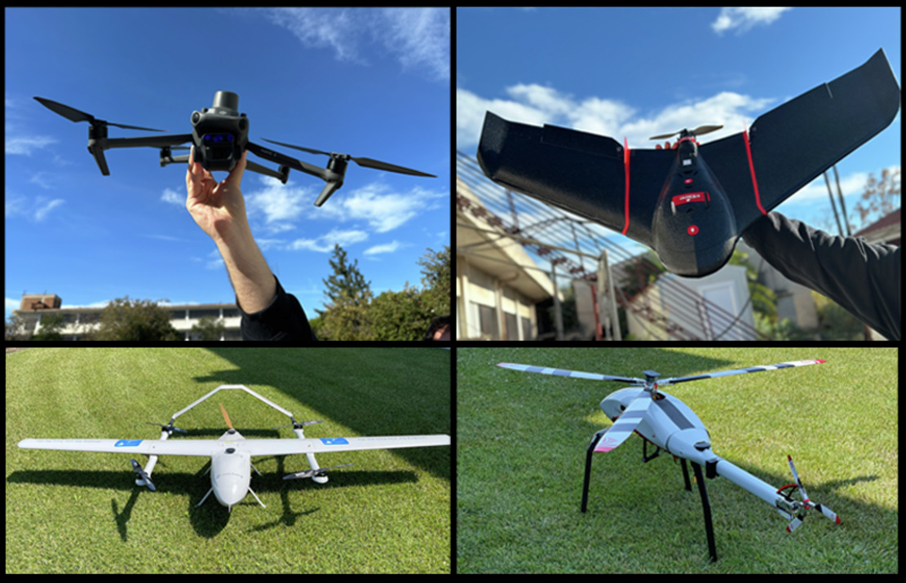
Figure 9 Various drone designs
View description - Figure 9 Various drone designs
View alternative description - Figure 9 Various drone designs

Some of the initial entrepreneurs who helped develop this industry segment were farmers themselves, who had a deep understanding of the potential market and innovative ways to meet farmers’ needs. Note how Box 1 identifies the crucial role of ‘user inventors’, in this case the farmers, at the Incubation stage. It’s also important to recognise the strong influence of regulation at this stage. For example, US laws first allowed the use of drones for spraying in 2012 with wide adoption allowed by 2016. In the EU, the legal frameworks governing the use of drones in agriculture are still being negotiated. Entrepreneurs may need to lobby to progress regulations and legitimise the use of drones for precision agriculture in the EU.

2.3 The Pre-Firm Takeoff and the Pre-Sales Takeoff stages
After the Incubation stage, gradual increases in demand attract more entrepreneurs and companies that want a share of the growing market.

Box 2 Pre-Firm Takeoff stage

Key actors:
- incubation actors arrange for profit
- new actors similar to previous stage
- suppliers
- regulators
- social movements

Knowledge
- Technology: refinements for adding extra functionality
- Demand: multiple product or service
- Institutions: definition of industry identity; circumventing regulation; setting of intellectual property rights

Jump to the next stage
- Has the industry segment developed enough knowledge for attracting a critical mass of companies?
  - Yes: Firm Takeoff
  - No: delay or abandon

Most of the actors at the ‘Pre-Firm Takeoff’ stage aim to boost demand by increasing the visibility of their product or service, either through advertising or through exhibitions and demonstrations to show the service or product’s benefits.
Demand grows as more users are convinced about the benefits and affordability of the product. There is often a wide variety of innovations at this stage, as well as different products and services. For example, some entrepreneurs may not sell drones directly to farmers, but they may offer integrated, drone-based services for a fee. Services include agronomic monitoring based on advanced data analysis to improve crop health and reduce the use of pesticides. In these cases, the innovations come in the software, algorithms and data analysis models (identified in Box 2 as ‘refinements for adding extra functionality’).
As market demand grows, industry segments move from the Pre-Firm Takeoff stage into the Pre-Sales Takeoff stage.

Box 3 Pre-Sales Takeoff stage

Key actors:
- actors from previous stages
- new actors similar to previous stages
- complement providers (providers of products or services that complement the offer of the company)
- new businesses funded by employees of initial companies
- firms from threatened industries

Knowledge
- Technology: redesign for cost-effectiveness
- Demand: additional customer segments and willingness to pay
- Institutions: shaping and responding to regulations; addressing positive and negative social attention
- Ecosystem: scalability and cost effectiveness; introduction of complementary products and services

Jump to the next stage
- Is there sufficient knowledge for appealing to a critical mass of customers?
  - Yes: Sales Takeoff
  - No: delay or abandon

One example of this is the use of drone applications for ‘supply chain operations’ which focuses on the final stage of the delivery process to the customer, or what’s called the ‘last-mile delivery’. At this stage, new players from established industries, such as Amazon and Uber in the case of ‘last mile delivery’, enter the industry segment (see ‘firms from threatened industries’ in Box 3). They then collaborate with drone manufacturers to invest in producing drones that are cheaper to manufacture, safer to use, and able to deliver parcels of various sizes and weight. Well known airframe manufacturers such as Airbus and Boeing also invest in drone prototypes that can carry cargo or even passengers. Unless drones become cheaper and production scalable, sales will not take off.

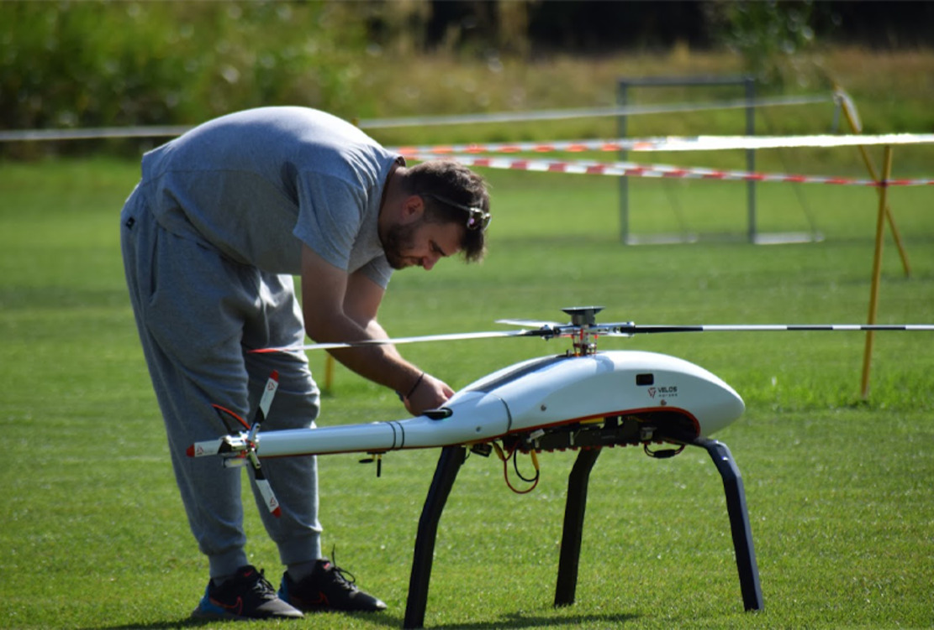
Figure 10 A project member of Use Case 5 setting up one of the drone prototypes
View description - Figure 10 A project member of Use Case 5 setting up one of the drone prototypes
View alternative description - Figure 10 A project member of Use Case 5 setting up one of the drone prototypes

At this stage of growth, you will see a number of complementary products and services developing into what is called an ‘ecosystem’. In a business context, an ecosystem is a network of related participants each contributing to the offer of combinations of products and services (e.g. the Google ecosystem of applications). For the drone industry, these products and services include support services in drone use, companies specialising in creating higher power batteries, and remote flying drone charging stations.

3 Identifying and developing new business ideas
Now that you have a better understanding of the drone industry, you may be starting to think of opportunities and business ideas of your own. Do you recognise yourself in one or more of the following characters?
- I am a drone pilot and would love to explore the opportunity of offering my services to farmers.
- I know nothing about drones, but I work on a farm and would like to experiment their use.
- I am a student and would like to learn how drones can impact positively on agricultural sustainability.
- I would like to work on a business idea I have and prepare it to apply for funding.
- We are already offering some drone-based services, and we would like to expand our offer.
Developing a new business idea is not a straightforward process. There will be several iterations as shown in Figure 11. Week 1 will help you navigate this process as you start considering your own business idea for the use of drones in agriculture.

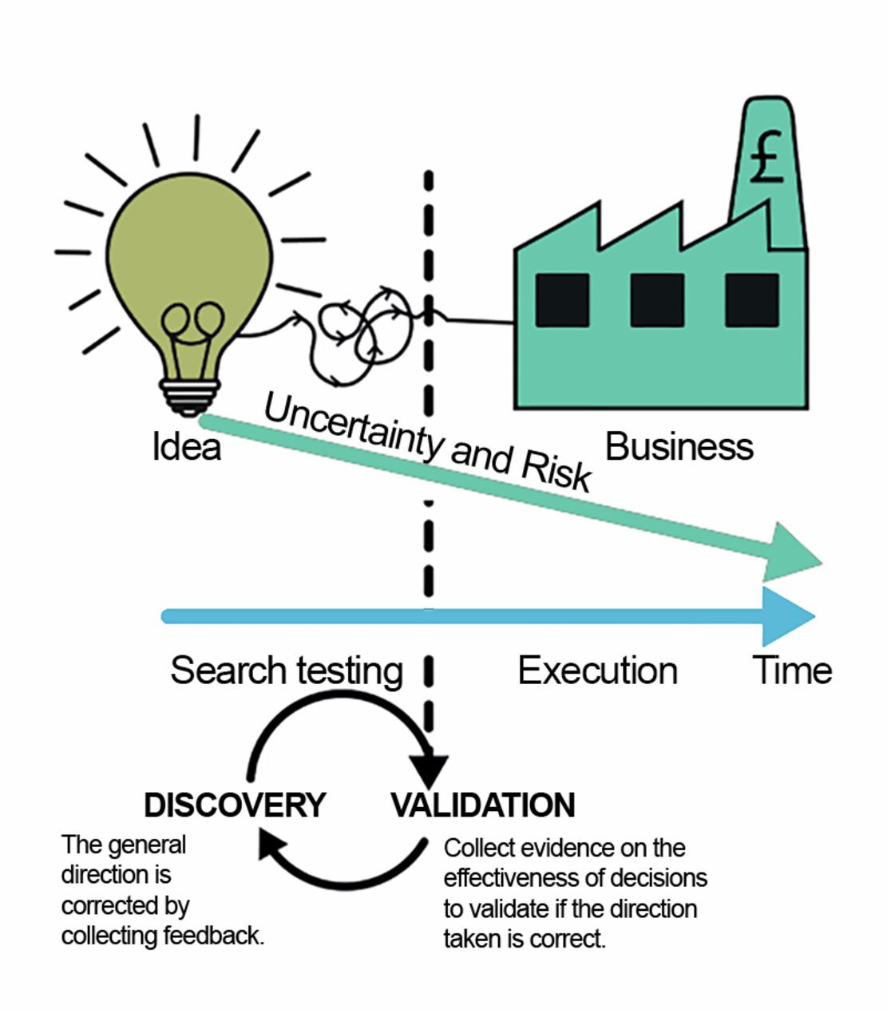
Figure 11 The search and testing phases reduces uncertainty and risk
View description - Figure 11 The search and testing phases reduces uncertainty and risk
View alternative description - Figure 11 The search and testing phases reduces uncertainty and risk

Before becoming an actual business, your idea would need to be distilled in order to reduce its uncertainty and risk (Bland & Osterwalder, 2020). In the Search and Testing phase you will need to engage in the discovery of what direction to take with the design of the business idea, which should also be informed by the feedback of stakeholders. Moreover, the collection of evidence will enable you to engage in the validation of the direction taken. This iterative process is meant to reduce the risk and uncertainty of the initial idea.

3.1 Sources of ideas
In this section you will think about possible sources of ideas and innovations for your business. Even if you already have a business idea, this section will help you better describe the context of your innovation.
Peter Drucker suggested ‘Seven Sources of Innovative Opportunity’ (Drucker, 2002), as represented in Figure 12.

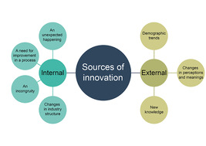
Figure 12 Sources of innovation
View description - Figure 12 Sources of innovation
View alternative description - Figure 12 Sources of innovation

There are four internal sources:
- An unexpected happening – an unexpected situation such as a particular experiment or even a life event enabling the development of a new idea.
Example: The discovery of Post-it adhesive was something unexpected: read more about it here.
- An incongruity – incongruities arise from the mismatch between expectations (what it should be) and reality (what it is).
Example: how negative customer feedback can give you some possible insights on new ideas.
- A need for improvement in a process – it relates to some process that could be improved in terms of efficacy (reaching its goals) and/or efficiency (improving the use of resources and time).
Example: the efficiency introduced by online booking of flights.
- Changes in industry structure – the external context changes thus requiring internal changes to a project approach.
Example: new rules and regulations are introduced.
Three sources are located outside a company or industry:
- Demographic trends – evolution of demographic characteristics of the population in the relevant area.
Example: changes in customer needs due to ageing.
- Changes in perceptions and meanings – changes in what customers value more.
Example: the greater attention to zero carbon emission and to the possibility of recycling products is an important trend in current stakeholders’ perceptions.
- New knowledge – ‘scientific, technical, or social’ discoveries would be a good source of innovation when translated into new technologies, products and services.
Example: the development of the Turing machine.
Now you have looked at where your idea may stem from, you will look to identify your business idea.

3.2 Identifying your idea
It is now time to gather some business ideas. Complete Activity 2 to help you start thinking about your potential business idea.

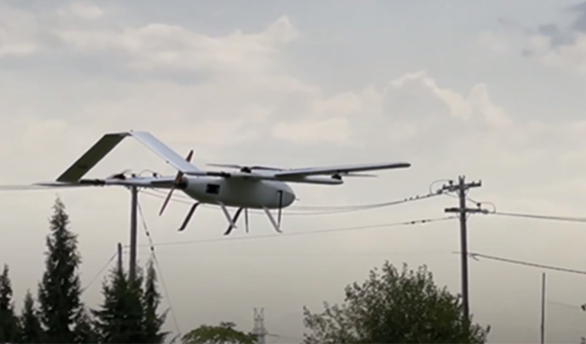
Figure 13 A fixed wing drone tested in ICAERUS Use Case 5
View description - Figure 13 A fixed wing drone tested in ICAERUS Use Case 5
View alternative description - Figure 13 A fixed wing drone tested in ICAERUS Use Case 5

Activity 2
Allow approximately 20 minutes.

Answer the following questions. You will find examples related to the rural logistics Use Case of the ICAERUS project as feedback.
What is your business idea?

Provide your answer...

Who are your potential customers?

Provide your answer...
View discussion - Part

What is your product or service going to do for them?

Provide your answer...
View discussion - Part

Who do you need to work with to make it happen?

Provide your answer...
View discussion - Part

4 The importance of stakeholders
In addition to thinking about your business’s potential market and customer base, you should also consider how other stakeholder perspectives will impact on your business idea. Stakeholders are most often identified in reference to an organisation and are ‘any group or individual who can affect or is affected by the achievement of the organization’s objectives’ (Thompson, 1967, in Freeman et al., 2010, p. 46). For organisations, stakeholders include ‘shareholders’, who are specifically people who own shares in a business. However, the meaning of the term ‘stakeholders’ is much broader, and it can also refer to creditors, employees, customers, governments, competitors, media and communities, among others.

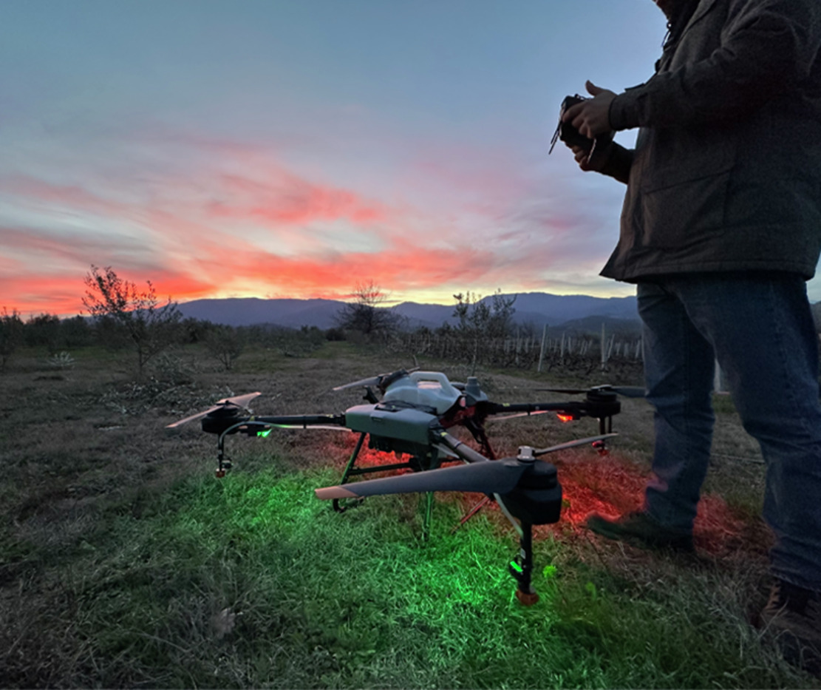
Figure 14 A spraying drone tested in ICAERUS Use Case 2
View description - Figure 14 A spraying drone tested in ICAERUS Use Case 2
View alternative description - Figure 14 A spraying drone tested in ICAERUS Use Case 2

Even if you are still developing your business ideas, it’s a good idea to identify the range of stakeholders that could impact on your idea’s success or, conversely, how your idea might impact on them. This will help you to better understand any resources you can access or risks you should manage in the wider business environment. In the sections that follow, you will learn how to identify the stakeholders for your business idea and how to analyse their interests and impact.

4.1 Internal and external stakeholders
When you start to identify stakeholders for your business idea, you can think of them in two different but related ways: internal and external stakeholders, and primary and secondary stakeholders.
The first is to think about internal and external stakeholders, an approach more easily applied to organisations. Internal stakeholders would include shareholders, employees, managers and board members of an organisation. External stakeholders are then all those stakeholders that sit outside an organisation, such as customers, competitors, regulators, creditors and local communities (see Figure 15, adapted from Hill et al., 2020).

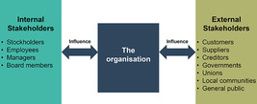
Figure 15 Stakeholders and the organisation
View description - Figure 15 Stakeholders and the organisation
View alternative description - Figure 15 Stakeholders and the organisation

In Figure 15, you can see that two-way relationships exist between stakeholders and organisations that are based on contributions (to the organisation) and influence (by the organisation). Applying this approach for stakeholders of a business idea, you can identify what stakeholders might contribute to the idea (or indeed how they might influence it), and what stakeholders your idea might influence (or contribute to, such as other organisations). Because stakeholders often bring necessary resources (ideas, funds, and other inputs) to your business or future business, it is important you maintain smooth relations. Oftentimes stakeholders may have conflicting demands. For example, suppliers may increase prices for inputs, and this may increase prices for customers. For this reason, understanding stakeholder perspectives is an essential part of getting an idea successfully off the ground.

Activity 3
Allow approximately 10 minutes.

Interactive content is not available in this format.

View discussion - Activity 3

How then do you prioritise which stakeholders are the most important for your project? In the next section, you’ll look at how you can identify ‘primary’ and ‘secondary’ stakeholders.

4.2 Primary and secondary stakeholders
A second approach to thinking about your stakeholders is to identify primary and secondary stakeholders. Primary stakeholders are individuals and groups, such as customers and staff, that have an immediate interest in the success of an idea, such as its effectiveness or other day-to-day issues. Secondary stakeholders, on the other hand, may have an interest in the business idea (such as regulatory bodies), but not as specifically as the primary stakeholders. Secondary stakeholders can, however, take an immediate interest, such as when business suppliers want to make sure that business agreements are upheld.
In the case of this second approach, your focus moves to the interest the stakeholder has in your idea. Hill et al. (2020, p. 357) recommend a five-stage approach to identifying and analysing stakeholders:
- Identify stakeholders
- Identify stakeholders’ interests and concerns
- As a result, identify the claims stakeholders are likely to make on the organisation (or idea)
- Identify the stakeholders who are most important from the organisation’s perspective (or from the perspective of developing a business idea)
- Identify the resulting challenges.
This five-stage approach can help you to think about who may have an interest in your idea and the kinds of concerns they may have. In the fourth stage, you prioritise the stakeholders you’ve identified – what interests and concerns do you need to address first? Then you build into your business plan if and how you can address these interests and concerns. In some cases, you may find that a primary stakeholder can contribute to the success of your business idea, such as an investor or a business partner. Or a primary stakeholder’s needs may require you to address their needs or concerns early in the development process, such as the customers you wish to attract.
One way to help you prioritise stakeholders is to use a power versus interest matrix (see Figure 16) developed by Johnson et al. (2008) adapted from an earlier model (Mendelow, 1991).

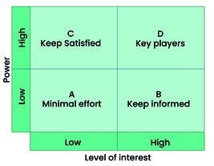
Figure 16 Power versus interest matrix
View description - Figure 16 Power versus interest matrix
View alternative description - Figure 16 Power versus interest matrix

This matrix has become an integral part of identifying stakeholders, such as in managing projects. The four quadrants of the matrix help to prioritise your efforts with your stakeholders by mapping them with respect to the power to influence your business idea or organisation and their level of interest.
- Quadrant A – these are stakeholders with low power and low interest. They will require minimal effort to satisfy but it is worth continuing to monitor this group of stakeholders in case their interest or power changes.
- Quadrant B – you will want to keep these stakeholders informed because, even though they have low power over your idea, they are still very interested. It’s also worth mentioning that stakeholders’ power and interest are not static. For example, an interested community group may find an incident or accident with a drone galvanises the group to call for increased safety and privacy. This is particularly important as the general public is still relatively uninformed about civil drone usage (Smith et al., 2022).
- Quadrant C – these are the stakeholders to keep satisfied. They have high levels of power, such as a regulatory agency, but they will have low interest in directly influencing your idea.
- Quadrant D – these are the key players as they have a high degree of power and high levels of interest. These are the stakeholder relationships you will want to prioritise first and foremost and ensure your business plan addresses their needs and requirements.
In the next section you will look at how to prioritise stakeholders, using an example from ICAERUS Use Case 1, crop monitoring, Catalonia.

4.3 Using drones for crop health assessment
Located in Barcelona, Spain, Noumena is a leading technology company specialising in the study and analysis of spatial dynamics with a focus on spatial analytic models and machine learning, novel data collection and management processes and emergent technologies, including remote sensing and computer vision. In 2022, Noumena started the development of ICAERUS Use Case 1 which focuses on crop monitoring and vineyard disease detection. In Use Case 1, Noumena works side by side with Ecological Integrations, an applied research group operating in Catalogna. Video 2 introduces two key members of Use Case 2, Esther Ver and Jonathan Minchin, who introduce their companies and the stakeholders of Use Case 1.

Video content is not available in this format.
Video 2
View transcript - Video 2



The project is being carried out in the vineyards of Mas Martinet farm in Priorat of the Tarragona region of Spain, where the fertile Catalan mountains meet the coastal plains stretching out to the Mediterranean. The region is a major wine-producing area in Catalonia and accounts for a significant percentage of the regional and national food industry sector.

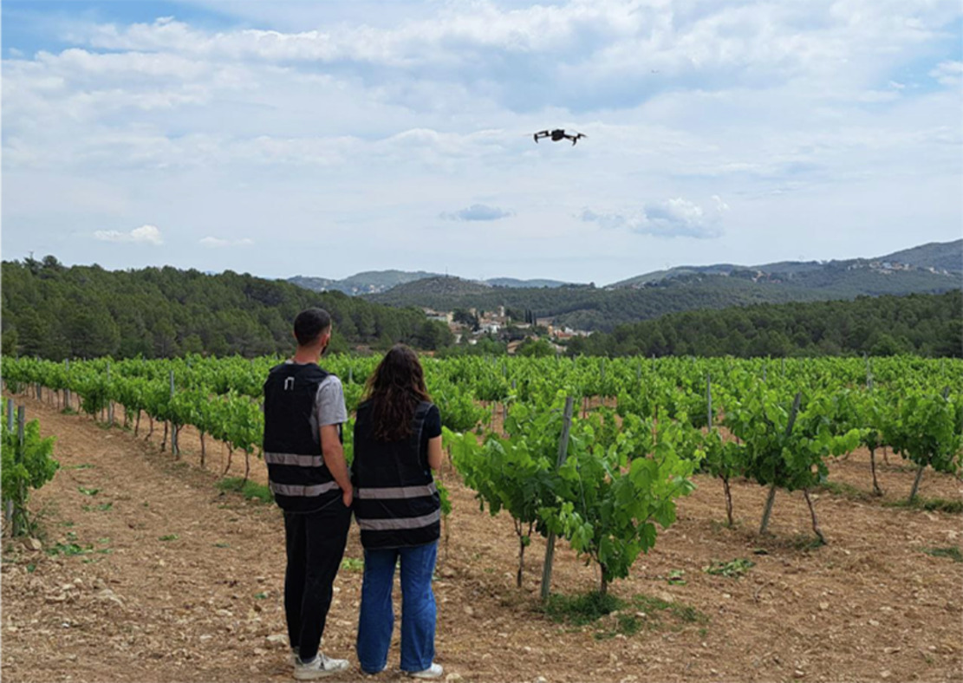
Figure 17 Members of Use Case 1 testing a drone on a vineyard
View description - Figure 17 Members of Use Case 1 testing a drone on a vineyard
View alternative description - Figure 17 Members of Use Case 1 testing a drone on a vineyard

The overall aim of the project is to facilitate and support the use of organic agricultural methods through the use of drone-based data collection, monitoring and crop health management. Drone imaging feeds into a crop management dashboard to monitor and assess field data and organic crop management techniques. There has been a resurgence in organic viticulture in the region, with Mas Martinet farm leading in new techniques. Organic vintners need to have high quality data to meet organic standards, as well as to ensure the ongoing health of their crops.
The project has many different stakeholders, including data operators and software developers, agrarian universities and research institutes, including educators, drone manufacturers and other industry operators, farmers, vineyard holders and agricultural associations, public sector regulators and public authorities of Catalonia, and indeed the final customers purchasing the wine. Figure 18 shows a mapping of the stakeholders of the project.

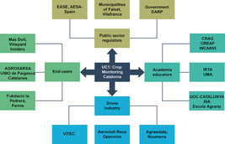
Figure 18 Organisational stakeholders in the Noumena ICAERUS project
View description - Figure 18 Organisational stakeholders in the Noumena ICAERUS project
View alternative description - Figure 18 Organisational stakeholders in the Noumena ICAERUS project

While many different actors and organisations play a role in the project, it is useful to consider the main stakeholder groupings within the power versus interest matrix. Using stakeholder data collected for the ICAERUS programme, you can map five example members into the matrix.
AGRAWDATA is a Noumena partner responsible for the development and deployment of agricultural geographic and GIS data, as well as decision support systems to assist farmers. They aim to collaborate with partners and end users (farmers) in order to build a market for their data analytics products and enhance science and knowledge in technological precision farming techniques. They are also in need of a skilled workforce to deploy emerging technologies. As they are a major partner in the project, with ties to both the suppliers of the technology and its users, they exert a great deal of influence (power) in the project and have a high level of interest in its success. You can therefore map them as a ‘Key Player’ in the project.
The Municipality of Falset, Villafranca is the municipal authority that governs the local area where the project is taking place. They are very interested in the project, particularly with respect to public safety and opinions, and are keen to understand its outcomes for potential policy impacts. While they exert a great deal of power in terms of regulatory oversight, their interest is mainly general given the broader scope of their activities. You thus map them to the ‘Keep Satisfied’ quadrant.
Fundacio La Pedrera Farms is a large agricultural association founded by the largest landowner in the area. Its interest is to promote best practices, agricultural employment and skills and conservation programmes in Catalonia. The association often collaborates in large government projects to train farmers and coordinates large-scale transition programmes. They, too, are a major partner in the project with key connections across the public and agricultural sectors, including end users and agricultural customers. You thus map them to the ‘Key Players’ in quadrant D.
The Institute for Agrifood Research and Technology (IRTA) is an academic institution sponsored by the Catalonian government. They support and coordinate between the public and private sectors to promote research and technological development in the agrifood industry. They are able to provide important data, including air traffic data and have a general interest in the project (although do not specifically resource it). They have a high level of interest in the project due to their mission, but do not exert a high level of influence over it. You map them to the ‘Keep Informed’ quadrant.
The European Aviation Safety Agency (EASA) is an EU-level government body responsible for civil aviation safety. It coordinates with member state agencies (e.g. at country level) to ensure the safety of drone operations and advises on safety regulations. While regulatory compliance is an essential aspect of the project, interactions with the EASA are minimal on a day-to-day basis. In this case, you place them in the ‘Minimal Effort’ category.

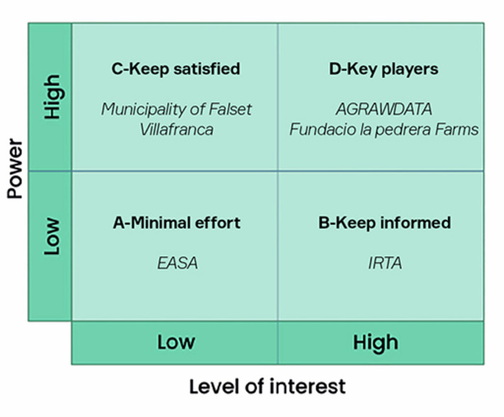
Figure 19 Power versus interest of stakeholder groups in the Noumena crop monitoring project
View description - Figure 19 Power versus interest of stakeholder groups in the Noumena crop monitoring ...
View alternative description - Figure 19 Power versus interest of stakeholder groups in the Noumena crop monitoring ...

The stakeholders for your business idea are likely to fall within some of these larger categories or groups – customers, investors, employees, business partners, regulators, suppliers, etc. Mapping their power and interest will help you to see which stakeholders to prioritise and, as noted earlier, which ones might have competing interests. In the final activity of this week, you’ll identify the stakeholders of your business idea and map their power and interest. This will help prepare you for the second week of the course where you will be introduced to business models.

Activity 4
Allow approximately 15 minutes.

Consider the idea you have developed in Activity 2 and identify your stakeholders. List these possible stakeholders, dividing them between external and internal
Now, using this PowerPoint slide, identify where in the power and interest matrix your stakeholders lie.

5 This week’s quiz
Now that you’ve completed Week 1, you can take a short quiz to help you to reflect on what you’ve learned.
Week 1 practice quiz
Open the quiz in a new tab or window and come back here when you’ve finished.

6 Summary of Week 1
Week 1 introduced you to the concepts of identifying a business idea and mapping the stakeholders, in the growing industry of drone technologies.
You were introduced to the ICAERUS Horizon EU project and its set of different Use Cases: five innovative developments of drone-related technologies which have potential to be integrated into new businesses.
You looked at the nascent stage of the industry lifecycle to understand what happens in the first three stages of the development of a new industry. The drone industry, like many other new industries, is articulated in industry segments that are at a different stage of development. You looked at the features of each stage as they can influence both the amount and the nature of business opportunities – it is important to understand where a new business idea would be located.
You then looked at the process of identification of business ideas and looked at the trajectory of the development of an idea towards a marketable product or service. This trajectory is definitely not linear and there are several iterations where the idea is refined and distilled in a more structured proposition.
In this process, the interaction with stakeholders and their feedback becomes fundamental, and you looked at stakeholders, learning how to identify them and categorise whether they are internal or external, primary or secondary and prepare a map of their power and interest.
You should now go to Week 2.

References
Carli, G., Reid, K. & Filiou, D. (2023) Syllabus and Certification Criteria (Deliverable 4.1 of the ICAERUS Project). Unpublished.
Denoo, L., Yli-Renko, H. and Clarysse, B. (2022) ‘The impact of customer ties and industry segment maturity on business model adaptation in an emerging industry’, Strategic Entrepreneurship Journal, 16(3), pp. 602–632. Available at: DOI: 10.1002/sej.1400.
Drucker, P. F. (2002) ‘The Discipline of Innovation’, Harvard Business Review. Available at: https://hbr.org/2002/08/the-discipline-of-innovation (Accessed: 10 October 2023).
Fact.MR (2021) Agricultural Sprayers Market. Available at: https://www.factmr.com/report/3476/agricultural-sprayers-market (Accessed: 28 November 2023).
Freeman, R. E., Harrison, J. S., Wicks, A. C., Parmar, B. & de Colle, S. (2010) Stakeholder theory: The state of the art. Cambridge: Cambridge University Press.
Grant, R. M. (2016) Contemporary Strategy Analysis: Text and Cases, 9th edn, Chichester, West Sussex, Wiley.
Guilmartin, J. F. (2024) 'unmanned aerial vehicle', Encyclopedia Britannica. Available at: https://www.britannica.com/technology/unmanned-aerial-vehicle (Accessed: 15 October 2024).
Hill, C. W. L., Schilling, M. A. & Jones, G. R. (2020) Strategic management: Theory & Cases: An integrated approach. 13th edition. Hampshire: Cengage Learning.
Horton, L. & Pilkington, A. (2014) ‘Rolling back from the power/interest matrix: A new approach for role based stakeholder engagement in projects (Advances in Project Management Series)’, PM World Journal, III(V). Available at: https://pmworldlibrary.net/wp-content/uploads/2014/05/pmwj22-may2014-Horton-Pilkington-AdvancesSeriesArticle.pdf (Accessed: 28 November 2023).
Johnson, G., Scholes, K. & Whittington, R. (2008) Exploring Corporate Strategy, 8th edition. Harlow: FT Prentice Hall.
MarketLine (2022) ‘Global Drones. MarketLine Industry Profiles’, MarketLine (Accessed 28 November 2023).
Mendelow, A. (1991) Proceedings of the Second International Conference on Information Systems. Cambridge, MA.
Moeen, M., Agarwal, R. and Shah, S. K. (2020) ‘Building Industries by Building Knowledge: Uncertainty Reduction over Industry Milestones’, Strategy Science, 5(3), pp. 218–244. Available at: DOI: 10.1287/stsc.2020.0103.
PricewaterhouseCoopers (PwC) (2022) Skies Without Limits v2.0. Available at: https://www.pwc.co.uk/issues/emerging-technologies/drones/the-impact-of-drones-on-the-uk-economy.html (Accessed: 28 November 2023).
Smith, A., Dickinson, J. E., Marsden, G., Cherrett, T., Oakey, A. & Grote, M. (2022) ‘Public acceptance of the use of drones for logistics: The state of play and moving towards a more informed debate’, Technology in Society, 68. Available at: https://doi.org/10.1016/j.techsoc.2022.101883.
Statista (2023) Drones-market data & analysis. Available at: https://www.statista.com/study/78525/drones-market-data-and-analysis/ (Accessed 28 November 2023).

Acknowledgements
This free course was written by Giacomo Carli, Kristen Reid and Despoina Filiou.
The development of this course was funded by the ICAERUS project.
The ICAERUS project was funded by the EU under the Horizon Europe scheme Grant Agreement 101060643 and UK under Innovate UK reference 10038181.
Except for third party materials and otherwise stated, including any quotes referenced in the course and not acknowledged here (see terms and conditions), this content is made available under a Creative Commons Attribution-NonCommercial-ShareAlike 4.0 Licence .
The material acknowledged below is Proprietary and used under licence (not subject to Creative Commons Licence). Grateful acknowledgement is made to the following sources for permission to reproduce material in this free course:
Course image: Courtesy: Dr Katerina Kasimati
Course badge: © The Open University
Figures
Figure 2: Illustration Courtesy: Dr Katerini Kasimeti
Figure 3: The ICAERUS project logo and grant agreement numbers with the related funders including logos. Protected by Intellectual property laws and/or agreements worldwide
Figure 4: Illustration Courtesy: Dr Katerini Kasimati
Figure 5: Civilian drone revenues from 2018 to 2028 (estimates by Statista, 2023) adapted from: Statista (2023) Drones-market data & analysis. Available at: https://www.statista.com/ study/ 78525/ drones-market-data-and-analysis/
Figure 7: from Moeen, M., Agarwal, R. and Shah, S. K. (2020) ‘Building Industries by Building Knowledge: Uncertainty Reduction over Industry Milestones’, Strategy Science, vol. 5, no. 3, pp. 218–244 [Online]. DOI: 10.1287/stsc.2020.0103
Figure 8: photograph Courtesy: Dr Katerini Kasimati
Figure 9: Various drone designs: photographs Courtesy: Dr Katerini Kasimati
Figure 10: Courtesy GEOSENSE P.Co. Geosense - Αρχική
Figure 11: redrawn by The Open university and based on: D Bland, D. J., & Osterwalder, A. (2020). Testing business ideas. John Wiley & Sons, Inc
Figure 12: Illustration by The Open University adapted from: Drucker, Peter F. (2007) The Practice of Management. Butterworth-Heinemann.
Figure 13: Courtesy: GEOSENSE P.Co. Geosense - Αρχική
Figure 14: photograph Courtesy: Dr Katerini Kasimati
Figure 15: Stakeholders and the organisation adapted from Hill, CWL, Schilling, MA, & Jones, GR. (2020). Strategic management: An integrated approach: Theory & cases. (13th edition). Cengage
Figure 16: Power versus interest matrix: Adapted/redrawn from B207 (p39) Block 3 The Open University course reader Shaping business opportunities and adapted from: Fischbacher, M. (2005) ‘Masters in public health’, course material, University of Glasgow
Figure 17: Courtesy: Noumena Data Service SL
Figure 18: Organisational stakeholders in the Noumena ICAERUS project. Created for the ICAERUS project/course
Figure 19: Power versus interest of stakeholder groups in the Noumena crop monitoring project: Adapted/redrawn from B207 (p39) Block 3 The Open University course reader Shaping business opportunities and adapted from: Fischbacher, M. (2005) ‘Masters in public health’, course material, University of Glasgow
PowerPoint slide: level of interest –Adapted/redrawn from B207 (p39) Block 3 Open University course reader Shaping business opportunities and adapted from: Fischbacher, M. (2005) ‘Masters in public health’, course material, University of Glasgow
Trademarks.logos: The Open University; OpenLearn; The European Union; ICAERUS; INNOVATE UK/ protected by Intellectual property laws and/or agreements worldwide
Activity 1 Images:
Crop health: Courtesy: Aldo Sollazzo
Test three types of drone technologies to deliver different sizes of packages at different distances: Courtesy:GEOSENSE P.Co. Geosense - Αρχική
Test drone spraying of crops and compare it to other techniques such as ground spraying. Courtesy: GEOSENSE P.Co. Geosense - Αρχική
Monitor forests to identify possible risks (e.g. fires) and locate wildlife (e.g. wild boars) Courtesy: Kestutis Skeidaila
Monitor grazing herds of livestock: Courtesy: Adrien Lebreton, Estelle Nicolas
Video
Video 1: Introduction to course: Professor Spyros Fountas and Dr Katerina Kasimati ©The Open University (2024)
Video 2: What do Noumena dn Ecological Interactions do? ©The Open University (2024)
Every effort has been made to contact copyright owners. If any have been inadvertently overlooked, the publishers will be pleased to make the necessary arrangements at the first opportunity.
Don't miss out
If reading this text has inspired you to learn more, you may be interested in joining the millions of people who discover our free learning resources and qualifications by visiting The Open University – www.open.edu/openlearn/free-courses.

Week 2: Business models and drones in agriculture

Introduction
Welcome to Week 2 of Developing business ideas for drone technologies. This week focuses on business models and revenue models, or how firms create and capture value. You will look at different types of business models and evaluate which one best suits your business idea. You will also learn about different revenue models, or ways to generate income from your business.
To be successful as a business you need to make money, and to do that you need to create something unique that others would want to buy. A business model can be thought of as a recipe that brings all the ingredients (or ‘resources’, e.g. people, land, machinery, crops, livestock) of your business together to create that something unique.
Revenue models are the various ways you can make money to sustain your business. If you don’t earn enough to cover the costs of resources (the ingredients for your recipe) and make profit to cover things such as your living costs as a business owner, you can be very quickly ‘out of business’. As you will discover later in this week, there are many creative ways to earn the most you can from your business. Business and revenue models go hand-in-hand; you cannot have one without the other, so keep this in mind as you work your way through this week.
Figure 1 shows the learning cycle for Week 2.

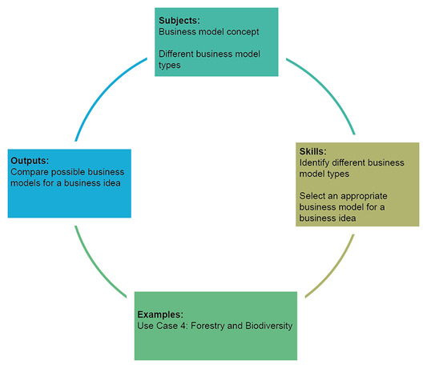
Figure 1 Learning cycle for Week 2
View description - Figure 1 Learning cycle for Week 2
View alternative description - Figure 1 Learning cycle for Week 2

By the end of Week 2, you should be able to:
- recognise different business models for the use of drones, with a specific focus on agriculture and rural areas
- recognise how to distinguish between, and make use of, different types of business models
- appreciate the broader environmental and sustainability issues of business models using drones in agriculture and rural areas
- communicate your business ideas in a professional way that appeals to various stakeholders.

1 Do farmers use business models?
Agios Germanos is a village on the shores of Lake Prespa in Florina, Greece with few inhabitants. Very few tourists visit this part of Greece either, but Prespa is famous with biologists and environmentalists as the wetlands of Prespa are protected by the Ramsar convention and form one of the most precious ecosystems in Europe.

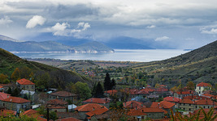
Figure 2 Agios Germanos village, Lake Prespa, Florina, Greece
View description - Figure 2 Agios Germanos village, Lake Prespa, Florina, Greece

Agios Germanos is also renowned for its butter beans, which are unique to the area. The butter beans, which are known as the ‘Elephants of Lake Prespa’ or ‘elephants’, are famous for their quality, taste and size.
But what does Agios Germanos and its butter beans have to do with business models? Well, a few decades ago a group of farmers from the area started experimenting with organic farming on small plots in the mountains (see Filiou et al., 2000). Without being fully aware, these organic farmers, running small farms on isolated plots, followed a very different business model to conventional farmers in the same area, who were cultivating the same crop but in larger plots and using different farming techniques. The organic farmers were using different ingredients in their recipe! They were using manure and organic compost, instead of chemical pesticides; they were using traditional farming techniques rooted in century-old practices and local knowledge, with the use of simple tools and reliant upon the preservation of indigenous seed varieties and crop diversity. The organic butter beans they produced maybe didn’t look as ‘perfect’ as the produce of conventional farming, but the organic ‘Elephants of Prespa’ were unique butter beans. By following two different recipes (business models) and using different ‘ingredients’ these two types of farmers created different value for consumers.
For the organic farmers, although the organic beans might look ‘imperfect’ they have a higher price in the market because they’re more difficult to produce and rare to find. They are able to sell their beans directly to boutique health shops both locally and in big cities.
In contrast, conventional farmers sell their beans to big food companies to package and distribute them to be sold in supermarkets.
Organic and conventional farmers charge different prices and use direct and indirect sales respectively. They use different ways to make money (revenue models) and different methods to ‘capture (some of the) value’ they create with their produce. This week will enable you to grasp the differences between these revenue models.

2 Business ideas and business models from the first ICAERUS open call
As you read about in the previous section, organic farmers started experimenting in the early 2000s with the idea of using an alternative recipe (or business model) to conventional farming. They succeeded in achieving organic certification for their products.
Once you have a new business idea, it is important you come up with a recipe and a way to put together all the activities and resources required to transform your idea into an actual business. Business models are just that. They provide a broad design of your activities and resources and show how everything connects together. There is so much written about business models that it is hard to contain it into one week. Throughout the course of this week, you’ll be given various definitions of business models, but as an appetiser, you can think of a business model as:

…a framework or recipe for making money – for creating, (delivering) and capturing value…
(Afuah, 2014, p. 4)

In Prespa, transforming the idea of organic farming into a business model was appealing to some farmers as it helps to protect economic income and sustain the biodiversity of the wetlands.
Ideas on how to make all agricultural practices both environmentally and economically sustainable, whilst closely monitoring both crop health and nutritional needs, are so important and it is at the heart of the ICAERUS project. One way of doing this is through precision agriculture which reduces inputs by targeted interventions. Box 1 looks at a project, funded by ICAERUS, that aims to implement precision agriculture.

Box 1 AGRICLOUD and the SKYFAR project
The ICAERUS project offers financial support and consultancy advice to support businesses and projects that can contribute to drone innovation in agriculture, forestry and rural areas. The aim is to fund projects that develop drone-based ideas, concepts and prototypes which can be introduced to the market.
AGRICLOUD was awarded ICAERUS funding for its project SKYFAR, which stands for ‘School of Sky Farmers’. SKYFAR aims to facilitate farmers and agri-entrepreneurs to be able to integrate drone technology in their daily work. SKYFAR is about designing, developing and marketing a cross-training program on drone piloting/controlling and managing data augmented by drones, together with other supporting technologies, such as GIS (Geographic Information System), ground penetrating radars and light detection.
The ultimate purpose of SKYFAR is to support farmers to adopt precision agriculture techniques, reduce costs and support both environmental and economic sustainability. It offers local and regional workshops with practical presentations, demonstrations and testing of drone technologies in Romania where the project originates from, and also aims to build capacity in the region by increasing technology awareness and adoption, and by making the use of drones user-friendly and intuitive.

Activity 1
Allow approximately 10 minutes.

Read Box 1 above about AGRICOULD’s project SKYFAR and answer the following questions.

What is the business idea behind SKYFAR?

Provide your answer...
View discussion - Part

What are the main activities that AGRICLOUD needs to put in place to deliver SKYFAR?

Provide your answer...
View discussion - Part

What are the resources (ingredients) that AGRICLOUD needs to put together to deliver SKYFAR?

Provide your answer...
View discussion - Part

With SKYFAR, AGRICLOUD aims to create unique value by providing precision agriculture with the use of drones. In order to do this, AGRICLOUD will need to plan a wide range of activities. The ways that these activities are combined together and how they are governed and orchestrated captures SKYFAR’s business model. In other words:

‘...a business model is a representation of the whole business, what it does, how it does it, who does what, who is the end recipient of the value offering and how value is appropriated by the business.’
(Afuah, 2014, p. 4)

This is a comprehensive definition of a business model. In subsequent weeks, you will find it useful when applying tools, such as the business model canvas, to help you design the details of your business model. For now, you will explore the different types of business models, or the different ways that exist to represent the design and broad configuration of business.

3 Business model types
This section focuses on value creation and later on you will concentrate on value capture (aka revenue models). Baden-Fuller et al. (2017) provide an overview of the different business models that exist, based on the way value is created and captured (also see: Baden-Fuller and Haefliger, 2013; Baden-Fuller and Morgan, 2010).
Business models can be categorised between dyadic and triadic. Dyadic business models involve the exchange of a product or service between two parties. Triadic business models involve three parties in the interaction. Parties can be any type of business, organisation (e.g. a charity) or individual, such as consumers.
Dyadic business models can be split into product and solution business models. The organic farmer of the example used in Section 1 uses a product dyadic business model when selling the butter beans directly to end consumers.
Triadic business models can be either matchmaking or multi-sided. Although these terms might sound ‘foreign’ to you, you will have experienced a ‘multi-sided’ business model, such as when logging in to your Facebook account. Figure 3 (below) summarises the four categories of business. In the sections that follow you will look at each type of business model in turn.

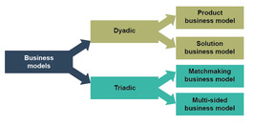
Figure 3 Typology of business models (Baden-Fuller et al., 2017)
View description - Figure 3 Typology of business models (Baden-Fuller et al., 2017)
View alternative description - Figure 3 Typology of business models (Baden-Fuller et al., 2017)

3.1 Product business model
This is probably the most common type of business model and involves selling products to customers, which can be either final customers or other businesses. In business to consumers (B2C) business models, for example, a drone manufacturer sells a drone to a hobbyist that uses drones to take aerial photographs on holiday. In business to business (B2B) product business models, for example, a drone manufacturer sells drones to farmers or to an organisation such as AGRICLOUD to use them during farmer training and demonstration events.

Interactive content is not available in this format.
Animation 1 Product business model
View description - Animation 1 Product business model

In Week 3 you will see how regulation can affect drone sales and adoption. For any drone manufacturer that wants to make their product appealing to end users (consumers or business) they need to promote drones, inform users of the benefits of their use and offer some training on drone piloting or control (for business use). At this point you might recall the discussion in Week 1 (Section 2.3), that in order to develop drone demand for precision agriculture, farmers need to be well informed about the benefits, affordability and user-friendliness of drones.

3.2 Solution business model
This business model is focused on the creation of a tailored or bespoke solution for a problem the customer faces, as displayed in the animation below. Again, here a ‘customer’ can be both an end consumer or a business or other type of organisation. The solution business model makes the engagement with customers greater than in product business models. Therefore, trust is crucial for this business model to succeed.

Interactive content is not available in this format.
Animation 2 Solution business model
View description - Animation 2 Solution business model

Simple examples of solution business models in cases where the ‘customer’ is an end-consumer (B2C) are kitchen design and interior decoration, where the firm builds a relationship with the consumer and designs a kitchen that suits their family needs and space. Examples where the end customer is a business (B2B), include all the bespoke services, such as accounting services, or any other consultancy advice that it is unique and tailored to the needs of the end customer.

Activity 2
Allow approximately 15 minutes.

Watch the video presentation of GEOSENSE, an ICAERUS project partner and pioneer in the professional drone Greek market, and answer the following question.

Video content is not available in this format.
Video 1
View transcript - Video 1

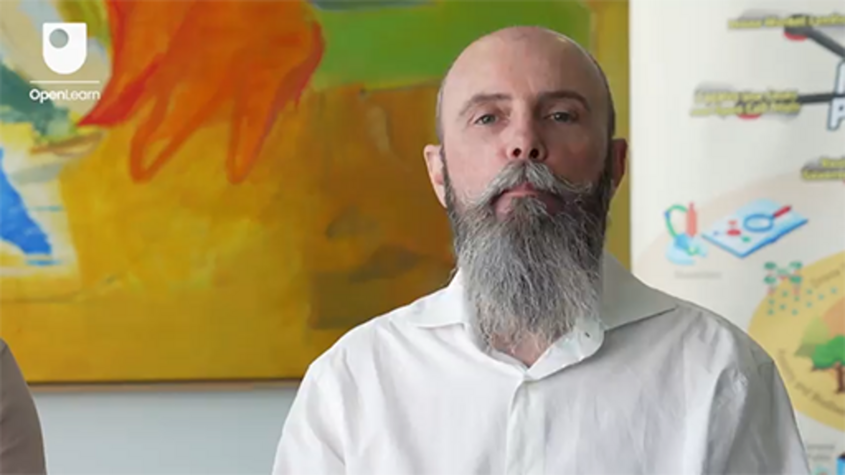

Does GEOSENSE use a product or a solution business model?

Provide your answer...
View discussion - Activity 2

Solution business models offer great opportunities in agriculture. Farmers can purchase bespoke services rather than invest money to buy drones. Such bespoke services include outputs generated by the use of drones. This includes farm and crop analytics which can provide in depth information on diseases and nutrition needs of crops and farms. Bespoke services such as these create lots of opportunities for businesses interested in offering such services to farmers.

3.3 Matchmaking business model
This type of business model relies on the firm (or any other organisation) on the left-hand side of the animation below, facilitating exchanges between two ‘customers’ that would not have interacted otherwise or previously. In this type of business model, the firm is joining sellers (customer A) and buyers (customer B) in its online or physical platform (online marketplace). For example, a firm or an organisation organising a ‘makers market’ where independent producers of woodcraft, pottery, food and clothing bring their stalls and sell to end consumers, including each other.
Animation 3 shows how the matchmaking business model works.

Interactive content is not available in this format.
Animation 3 Matchmaking business model
View description - Animation 3 Matchmaking business model

In recent times, there have been numerous examples of matchmaking business models created online. Typical examples of this business model are online platforms that connect two individuals (e.g. Airbnb, BlaBlaCar, Love Home Swap) or a company and an individual (e.g. Uber, Lyft, Deliveroo, Just Eat). Charging mechanisms are almost always based on a fee. For instance, Deliveroo applies a fee based on trade to ‘regular’ customers and a flat monthly fee to ‘Plus’ customers who subscribe to its membership plan. In some instances, the firm/platform organiser might charge additional fees to companies for just being able to offer their products and services through the platform. All these represent different revenue models used by the platform to make money: flat fee, rate on the sales and membership. You will find out more about ways to make money later this week, but this example shows how business and revenue models go hand-in-hand.
The matchmaking business model offers new opportunities both for drone manufacturers and agri-business entrepreneurs, such as those offering drone maintenance services. For example, either of them can establish a physical (or online) marketplace for drone component parts, such as cameras, second-hand drones, or maintenance of drones. Farmers can get access to drones or to spare parts at more affordable prices on such marketplaces.

3.4 Multi-sided business model
This fourth type of business model requires the firm, or any other organisation, to provide different products or services to different customer groups. The defining feature of this business model is that one group of customers gets benefits from the other group’s use of a certain product or service, thus making the value proposition multi-sided. Free newspapers are a typical example of this business model. Readers receive the newspaper for free (customer B), which is paid for by advertisers (customer A). As such, the use of free newspapers by the first group of customers (readers) as a marketing tool generates a positive externality for the second group of customers. The newspaper itself benefits from gaining a wider readership which attracts more companies that want to pay the newspaper for advertising.
The multi-sided model is also high-risk, high-reward. Although failure rates are high, so are potential profits. Watch the animation below to see how this process works.

Interactive content is not available in this format.
Animation 4 Multi-sided business model
View description - Animation 4 Multi-sided business model

Another example of firms using this business model is that of companies harvesting data from their customers (group B) to resell it to new customers (group A). The US life insurance company John Hancock announced in 2018 that it would add an option to all its policies to track the policyholder’s fitness online – via a website, app or the use of a fitness tracker such as Apple Watch or Fitbit – to better adjust the pricing of its policies based on the health information provided. There are serious ethical and legal concerns if data protection guidelines are not followed. Week 3 explores data issues related to drone technologies.
But how can the multi-sided business model be relevant in the use of drones in agriculture, forestry and rural areas? It’s not straightforward to apply this type of business model to create value in this case, but below is a possible example that could work, at least in theory! It might even inspire you to put it into practice!
The multi-sided business model can be used by any organisation acting as the ‘platform organiser’ (see Animation 4) connecting farmers (customer A) and drone manufacturers (customer B). The organiser provides drone related training and services to farmers. Farmers do not have to pay for these services. The services are paid for by the drone manufacturers on the platform. The manufacturers in turn benefit by advertising and promoting their drones on the platform. The ‘platform organiser’ can collect and analyse the farmer data and sell them as consumer profiling to drone manufacturers. Consent has to be obtained in advance for such data analysis and re-use.

4 Sustainable business models for the use of drones in agriculture

‘A sustainable business model is one whose rational for value creation, delivery and capture allows an organisation to contribute to solving sustainability challenges and to promoting sustainable development.’
(Lüdeke-Freund et al., 2022 p. 36)

The use of drones in agriculture can help to address some related sustainability challenges through precision agriculture that is low-input compared to conventional farming. There is a broad range of sustainability challenges and there is a commitment worldwide to pursue sustainable development. In this section you will focus on two types of sustainable business models that are particularly relevant for the use of drones in agriculture. These are the cooperative ownership and the shared ownership business models (Lüdeke-Freund et al., 2022). Sustainable use of drones requires that they are used to their full capacity and recycled after obsolescence. Sustainability of income and reducing risks of investment are also crucial for farmers investing in new technologies.
Cooperatives are quite a common form of organising in agricultural and rural areas. Traditionally, farmers are organised in ‘producer cooperatives’ to collectively negotiate better prices for their produce by collective trading. Cooperatives offer a great way to manage forests and grazeland because they may be owned by the public. Cooperatives give both ownership and decision/voting rights to a group of stakeholders with aligned interests – either producers of the same crop or a community in the case of forests. Profits are shared among members or are invested back to the cooperative to sustain it in the long-term. Members have collective responsibility for all the common assets, such as machinery. Even though it is an appealing form of organising, cooperatives can be slow in decision-making and conflicts can occur when the values and interests of members diverge, or when there is misuse of common assets.
Shared ownership business models are based on the same collectivism principles as cooperatives but do not require the formation of a separate legal entity: the cooperative. Businesses and individuals can share the use of a product (e.g. machinery, technology) and own it collectively. For example, a village where farmers want to experiment with the use of drones but consider them expensive or a risky investment, can use a shared- or cooperative ownership business model to reduce both the cost and risk of using drones. Cooperatives, in particular, allow farmers to jointly cover the costs of pilot training or hire drones specialists to operate them. They can also be a source of advice on how to interpret the sophisticated analytics reports generated by drones and related applications.
Cooperative and shared ownership models also contribute to sustainability. One way they achieve this is by promoting collaborative use and consumption. This both reduces inefficient use of assets (drones) and offers a great solution for gaining access to products that:
- are relatively rarely used
- are expensive
- have not been fully tested
- many users are unwilling to purchase.
You will now explore how these apply to the ICAERUS Use Case for forestry and biodiversity monitoring.

Activity 3
Allow approximately 15 minutes.

Meet Kęstutis and Adele, from Art21 and AgriFood Lithuania, who work on Use Case 4 on forestry and biodiversity. This Use Case develops and promotes innovations on the use of drones in forestry and biodiversity monitoring.

Video content is not available in this format.
Video 2
View transcript - Video 2

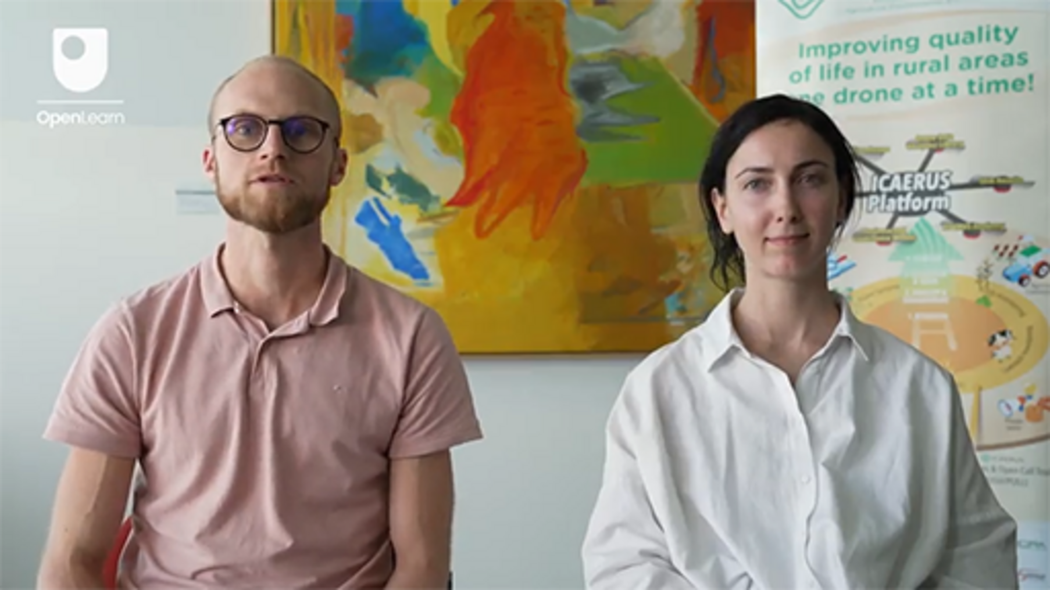

How are Art21 and AgriFood Lithuania advancing the use of drones for forestry and biodiversity monitoring?

Provide your answer...
View discussion - Part

What business models can be developed based on the technology developed by Art21 and AgriFood Lithuania?

Provide your answer...
View discussion - Part

5 Value capture and revenue models
So far, you have looked at how firms or any other type of organisation create a product or a service by using a business model (recipe) to combine resources (ingredients) through a range of activities and practices (mixing ingredients, simmering, boiling, grilling!). These firms need to create something unique and valuable so that consumers or other businesses want to pay money for it. If not, the firm will be unable to recover the money it paid to get access to the resources and to conduct its activities (its costs).
In this section you will look at how firms can capture value from the products or services they create. Revenue models capture the specific ways firms are able to capture value and generate income. Some organisations create broader value than what they can capture back with the sales of their products or services. For example, by using renewable energy and embedding product re-use and re-cycling in their manufacturing practices, firms may reduce air pollution. However, although we all benefit from cleaner air and lower waste, firms cannot monetise ‘clean air’ and so cannot monetise all of the value they generate.
The concept of ‘monetising’ or putting a price to a product or a service, lies at the heart of revenue models. That is why, in their simplest form, revenue models are what are widely known as pricing models, such as listed / posted price, auction and give-away.
Revenue models can include a combination of sources of revenue, which may be prioritised. For example, eBay generates revenue using several sources: advertising fees, subscription fees to sellers, and fees from transactions. There are various revenue models, such as ‘razor and blade’, ‘freemium’, ‘subscription’, ‘cash and carry’ and ‘leasing’. In the sections that follow you will look at the razor and blade, and freemium models in more detail.

5.1 Razor and blade revenue model
The razor and blade revenue model involves selling a product at a low price and profiting from the consumables that customers need to purchase to use the said product. This revenue model was popularised by Gillette, hence its name! In this example, the idea was to attract consumers with a relatively cheap core product (razor) and make money by selling a high volume of consumables (razor blades). For this model to work, the core product is made compatible only to own-manufacturer consumables. This makes consumers ‘locked-in’ to buying consumables from the core product manufacturer. Another example is Nespresso, which gets customers to make a relatively small one-off investment in the coffee machine, but repeatedly buy the capsules required to use the machine.


Figure 4 Coffee machines during promotion events are given for free to consumers signing up for an annual membership for coffee pods
View description - Figure 4 Coffee machines during promotion events are given for free to consumers ...

This model has created a lucrative market for compatible consumables at a lower price. The challenge is for the manufacturers of the original core product to protect their revenue streams by blocking or hindering the use of such compatible consumables. This can be by voiding warranties, or introducing some form of detection system by connecting the core product to an online registration and service system, for example.
In the case of the coffee pods, the high volume of coffee pods has resulted in negative environmental effects. This has led some firms to create compostable coffee pods or to offer options for recycling them. Broadly, this has been the motivation for adopting 'green razor and blade’ revenue models, which are based on a durable core product that isn’t easily disposable, and environmentally friendly consumables. A good example is Epson’s EcoTank printer range, which is equipped with refillable ink tanks.

5.2 Freemium revenue model
This type of revenue model combines ‘free’ and ‘premium’; that is, customers can access basic features at no cost, but they have to pay a subscription to access further functions. Tech companies such as LinkedIn or Spotify use this revenue model.


Figure 5 Linkedin, the online professional networking platform, employs the freemium revenue model
View description - Figure 5 Linkedin, the online professional networking platform, employs the freemium ...

Under the free offering, firms get revenue from advertising income. They also benefit from understanding consumer preferences and their patterns of use; in other words, they benefit from user data.
Other benefits come from creating network effects, which are the benefits each user gets from interacting with a high number of other users. So, for instance, users will find a free networking platform more attractive than one that charges fees, which as a result raises the number of users on the platform. These users then benefit from being able to interact with a higher number of other users – very few people would want to join a networking platform with low numbers of users! This is an example of networking effects: the greater the number of users the higher the benefits for each user. Users find it challenging to switch to other platforms because it is hard to re-create the same network and not everyone in your network will join if you switch to a new platform.
Users can then also choose to pay a subscription fee and access ‘premium’ enhanced services. They still benefit by the high number of platform users. Ultimately, the free option provides the networking platform with a high number of users, which enhances its competitive edge.

Activity 4
Allow approximately 10 minutes.

If you haven’t already got one, visit Linkedin and create a professional profile. Find the profile of the ICAERUS project and start following its updates. You might also want to connect with the leaders of the ICAERUS Use Cases and the new businesses funded by ICAERUS and start extending your network in the sector.

A variation of the freemium model is the social freemium model. A firm, or organisation, offers the same service or product for free to low-income consumers and charges those that can afford to pay. In this way technologies and services become available to those who would not otherwise be able to access them. This increases the availability of the service and reduces the risk of exclusion amongst groups who are deemed vulnerable. Dropbox uses this approach as premium users finance the infrastructure and content for all users (Lüdeke-Freund, et al., 2022). The BBC also uses this approach as specific parts of the British population, such as the retired, do not have to pay a license fee.

6 Bringing business and revenue models together
So far, you have looked at business and revenue models separately. This is because of how complex they both are, with various types and options available. However, business models and revenue models go hand-in-hand. The first is a recipe of how to create value and the second is a formula to capture that value. In reality businesses and organisations will probably use a combination of multiple business and revenue models to create and capture value respectively. Complete Activity 5 below to explore some examples.

Activity 5
Allow approximately 15 minutes.

The Business Model Zoo™ website contains over 90 exemplar business-model cases illustrating Baden-Fuller et al.’s typology of business models (2017). Visit the website and fill in the following table with a company that exemplifies each type of business model.

Table 1 Examples of business model types
Business model | Company | Value creation | Value capture
Product
Solutions
Matchmaking
Multi-sided

View discussion - Activity 5

7 This week’s quiz
Now that you’ve completed Week 2, you can take a short quiz to help you to reflect on what you’ve learned.
Week 2 practice quiz
Open the quiz in a new tab or window and come back here when you’ve finished.

8 Summary of Week 2
This week you learned about the different types of business and revenue models, and looked at how these can be applied to the use of drones in agriculture, forestry and rural areas. You also learned to distinguish between different business and revenue models and to appreciate environmental and broader sustainability issues linked to business models. You looked at the specific examples of ICAERUS push open call winners (AGRICLOUD and SKYFAR), project partners (GEOSENSE) and Use Cases (forestry and biodiversity monitoring in Lithuania) and connected business and revenue models to these examples through videos and activities.
You should now go to Week 3.

References
Afuah, A. (2014) Business model innovation. Concepts, analysis and cases. New York: Routledge.
Baden-Fuller, C., Giudici, A., Haefliger, S. and Morgan, M.S. (2017) Business models and value. Unpublished.
Baden-Fuller, C. and Haefliger, S. (2013) ‘Business models and technological innovation’, Long Range Planning, vol. 46, no. 6, pp. 419–26. DOI: 10.1016/j.lrp.2013.08.023 (Accessed: 4 June 2019).
Baden-Fuller, C. and Morgan, M. S. (2010) ‘Business models as models’, Long Range Planning, vol. 43, no. 2–3, pp. 156–71. DOI: 10.1016/j.lrp.2010.02.005 (Accessed 4 June 2019).
Filiou, D., Pyrovetsi, M., Daoutopoulos, G. (2000) ‘Conventional and organic agriculture in Prespa National Park’. International Symposium: Sustainable Development of Prespa Region. Oteshevo, Formal Yugoslavia Republic of Macedonia (FYROM), 23–25 June.
Lüdeke-Freund, F., Breuer, H. and Massa, L. (2022) Sustainable business model design. Frankfurt am Main: Druck- und Verlagshaus Zarbock GmbH & Co.

Acknowledgements
This free course was written by Giacomo Carli, Kristen Reid and Despoina Filiou. This week was written by Despoina Filiou. Despoina Filiou would like to thank Dr Matthew Higgins for feedback on earlier drafts of this text.
The development of this course was funded by the ICAERUS project.
The ICAERUS project was funded by the EU under the Horizon Europe scheme Grant Agreement 101060643 and UK under Innovate UK reference 10038181.
Except for third party materials and otherwise stated, including any quotes referenced in the course and not acknowledged here (see terms and conditions), this content is made available under a Creative Commons Attribution-NonCommercial-ShareAlike 4.0 Licence .
The material acknowledged below is Proprietary and used under licence (not subject to Creative Commons Licence). Grateful acknowledgement is made to the following sources for permission to reproduce material in this free course:
Course image: Courtesy: Dr Katerina Kasimati
Course badge: © The Open University
Figures
Figure 2: n. angelikakis/Shutterstock
Figure 3: Typology of business models (Baden-Fuller et al., 2017) adapted from Baden-Fuller, C., Giudici, A., Haefliger, S., and Morgan, M. S. (2017) ‘Business models and value’. Unpublished work
Figure 4: Galaxymix/Shutterstock Note people used for illustrative purposes only
Figure 5: photograph featuring Linkedin™ JuliusKielaitis/Shutterstock
Videos
Video 1: What is Geosense’s Mission? ©The Open University (2024)
Video 2: What Does Art21 Do? ©The Open University (2024)
Every effort has been made to contact copyright owners. If any have been inadvertently overlooked, the publishers will be pleased to make the necessary arrangements at the first opportunity.
Don't miss out
If reading this text has inspired you to learn more, you may be interested in joining the millions of people who discover our free learning resources and qualifications by visiting The Open University – www.open.edu/openlearn/free-courses.

Week 3: Frameworks for understanding drone data and regulations

Introduction
Welcome to Week 3 of Developing business ideas for drone technologies. This week you will learn about two important topics in the use of drones for agricultural, forestry and rural purposes. First, you’ll take a look at different types of data and data analytics and consider what steps you may need to take to use drone data effectively and securely. You’ll have an opportunity to visit the ICAERUS platform’s Data Analytics Library. Second, you’ll learn about the importance of regulations in governing how drones are used and hear from ICAERUS partners about the key regulations that impact on their Use Cases. You’ll also learn about a model to help you determine key regulations that may affect your business idea.
Figure 1 shows the learning cycle for Week 3.

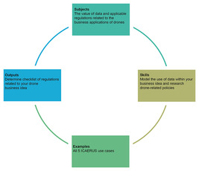
Figure 1 Learning cycle for Week 3
View description - Figure 1 Learning cycle for Week 3
View alternative description - Figure 1 Learning cycle for Week 3

By the end of Week 3, you should be able to:
- understand ways that you can characterise the big data used by drones and their application to rural drone uses
- apply a big data architecture framework to your business idea
- identify different types of regulations that might apply to your drone business idea.

1 Data and policy – an emerging relationship
The data created and used by drones are part of a ‘datasphere’, where information is created and manipulated, stored, ‘flows’ and creates new spaces of human interaction. Across this huge datasphere, it is estimated that between 175–181 zettabytes (i.e. 10²¹ bytes, see Figure 2) of data will be ‘created, copied, captured and consumed’ annually by 2025 (IDC and Statista, 2021). With ever-increasing large data sets contributing to the creation and analysis of ‘big data’, public and private sectors are prioritising data storage capacity – such as storage in the ‘cloud’ – and its security as critical pieces of developing the world’s data infrastructure. Yet, despite its exponential growth and integral role in human activity, such as agriculture, the datasphere is still vulnerable. For example, in July 2024, an update to a computer security software programme brought down millions of computers running Windows operating systems across the world, and affected businesses in finance, aviation, healthcare and other sectors. The update bug also affected users of virtual ‘cloud’ computers in Microsoft’s Azure cloud as well as in competitor Amazon’s AWS cloud (Li, 2024; Targett, 2024). While machines running other operating systems, such as Mac or Linux, were not affected by the bug, the event has highlighted the interdependence within the largely unregulated datasphere environment.

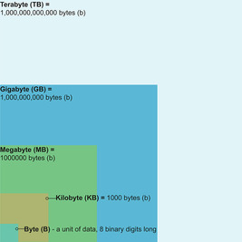
Figure 2 Data volumes (not to scale)
View description - Figure 2 Data volumes (not to scale)
View alternative description - Figure 2 Data volumes (not to scale)

As such, policymakers are in a race to match the pace of change presented by the digital environment. It is for this reason that drones and their associated data and technologies occupy an ever-changing space. An Organisation for Economic Co-operation and Development (OECD) 2019 report on digital opportunities for agriculture noted that, while innovations in digital technology and data were already revolutionising agricultural practices, there were significant challenges in how to integrate these innovations into policy, risk assessments, policy implementation, and monitoring and oversight plans (OECD, 2019). For entrepreneurs wishing to develop drone technologies and innovations in analytical processes, the regulatory environment is an important but at times confusing landscape of policy at multiple levels and addressing multiple areas of the business. In this week, you will learn about data and some of the key regulatory issues – often related to data – that you will need to consider as you develop your business idea.

1.1 Complex data sets of drones
Drones generate and use large data sets, such as those that generate images of agricultural fields, or that help to orient and direct drones delivering small parcels to rural areas. Many of these large data sets can be considered as ‘big data’, and any business idea using drones and drone data will need to address the impact of big data for their business. This is not just in terms of the technical specifications to process the data, but also how your customers will be interfacing and using the data.
In the following video, Vassilios Polychronos, Chief Technical Officer at GeoSense, discusses how they are developing software as part of the ICAERUS use case in rural logistics, and the types of data that the software will analyse and process.

Video content is not available in this format.
Video 1
View transcript - Video 1

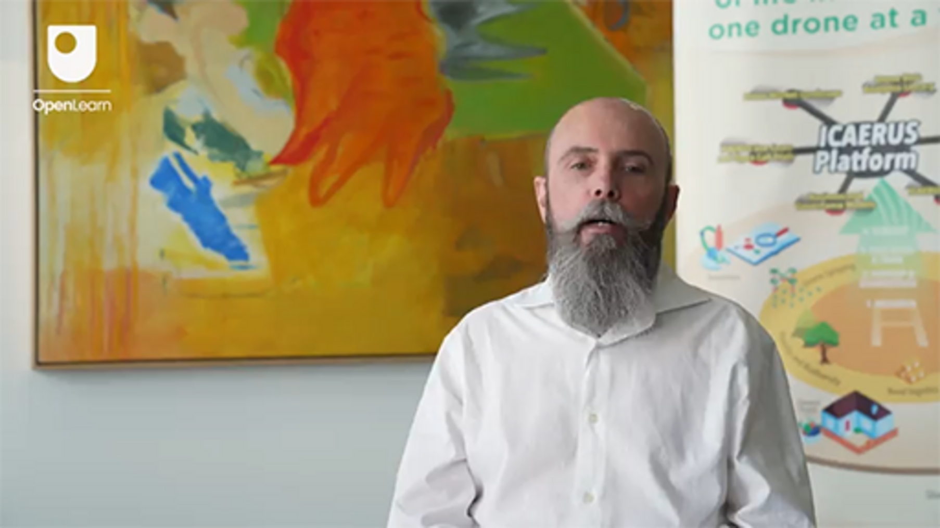

1.2 The Five Vs of big data
One way you can think about the different ways big data will impact your business is to use what is called a ‘Big Data Architecture Framework’ or ‘BDAF’, which can help you think about how your data will be collected, stored, processed, analysed and applied.
An early version of a BDAF (McAfee & Brynjolfsson, 2012) identified three characteristics of big data (volume, velocity and variety). Later, two more characteristics were added to create what is now known as the ‘Five Vs of Big Data’:
- Volume – how much data is generated and used?
- Veracity – how trustworthy and reliable are the data?
- Variety – how many types of data are collected and what business decisions could these different types of data help with?
- Velocity – the speed by which data can be collected and used, such as in real time.
- Value – what value can businesses gain from using and analysing data?

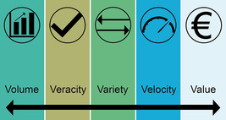
Figure 3 The Five Vs of big data
View description - Figure 3 The Five Vs of big data
View alternative description - Figure 3 The Five Vs of big data

In the next activity you’ll see how you can apply a BDAF to a drone case.

Activity 1
Allow approximately 10 minutes.

Read the short case study below about the use of drones for the delivery of small parcels. Then match the questions with the correct BDAF characteristic.

Dimitar owns a farm supply depot in Bitola, a city on the Dragor River in the southwestern agricultural region of North Macedonia. He has recently agreed to work with a local drone group to test a small parcel delivery service in the area. Using an online ordering service, Dimitar’s rural customers – many of them farmers of Bitola’s famous red peppers – can now order small parts and dry goods from his store and have them delivered to them via drone. The project is partly sponsored through a grant from the government to see how drones can help to provide better access to essential goods in rural areas.
Knowing that customer data, such as financial information, is highly sensitive, Dimitar has been particularly interested in how his customers’ data will be handled and stored, as well as the costs of ensuring data security. He also wants to make sure that deliveries are timely and free from error. He has asked the drone group a series of questions to learn more about how data will be created and used in the project.

Match Dimitar’s questions with the correct BDAF characteristic.

Interactive content is not available in this format.

View discussion - Activity 1

1.3 Domains and technology – BDAFs in context
Another useful way to categorise BDAFs is through domain areas covered and the technologies that are used in big data activities. For example, BDAFs can be categorised in the following ways (Mohamed et al., 2020):
- Sources of data generation (for drones, this is the ‘Internet of Things’ or IoT, but sources also include the world wide web, phones, email and other digital communication, social media, sensors and mobile phones)
- Data format (unstructured, semi-structured and structured data)
- Data processing and storage (batch, stream and hybrid processing)
- Different types of data analytics (e.g. statistical analyses or visualisation techniques)
- Data visualisation (e.g. tabular, reports, dashboards).
Different domains will have different challenges and needs with respect to a framework. For example, in forestry management, data will often come from multiple sources. Drones provide just one of the sources of data, which can include other digital methods and physical analysis, such as chemical and genetic analysis (Taylor et al., 2020). This thus influences how the analytical approaches identified in the BDAF will account for different types of data. For example, researchers at the Norwegian Institute for Bioeconomy Research (Puliti and Granhus, 2021) compared the usefulness and cost effectiveness of drone technology in monitoring forest health with other, more established methods, such as piloted airborne laser scanning (ALS) and traditional, field-based methods. The researchers found that using the right analytical tools was an important element of transforming raw data collected by drones into ‘actionable insights’. As actionable insights are what help businesses and their customers to extract value from big data, both the quality of the data and the quality of the analytical tools will be crucial aspects to include within a BDAF.

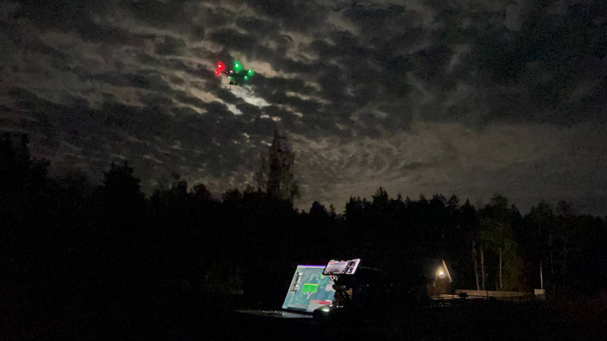
Figure 4 Hyperspectral imaging data (processed) of a Scots Pine and mixed forest, Lithuania
View description - Figure 4 Hyperspectral imaging data (processed) of a Scots Pine and mixed forest, ...
View alternative description - Figure 4 Hyperspectral imaging data (processed) of a Scots Pine and mixed forest, ...

As with the drone delivery case in Activity 1, the security of data will also be a key consideration for businesses and their customers. Data security is also prioritised by government and the public sector. For example, above and beyond solving technical issues related to using drones to deliver small parcels to remote rural areas, the personal customer data utilised in requesting, paying for and making the delivery will need to be secured, including fleet security. If these data need to be shared between different businesses (such as between a retailer/shop owner and a drone delivery business), how will this be managed?
There are, of course, more common delivery models already in place that can be used as data sharing models, but how these are implemented within a scenario using drones needs careful consideration. Researchers note that drones can be considered part of the Internet of Things (IoT) and are thus themselves at risk of internal and external threats: ‘As part of heterogeneous networks, things have to support advanced security concepts, such as authentication, access control, data protection, confidentiality, cyber-attack prevention, and a high level of authorization’ (Lagkas et al., 2018, p. 2). How a drone business ensures data security is essential in establishing trust with their customers and with regulators.

Activity 2
Allow approximately 30 minutes.

An essential outcome of the ICAERUS project is the creation of an open access platform that includes a Drone Data Analytics Library, where algorithms and data sets from the Use Cases and other drone innovators can be shared with the global drone community.

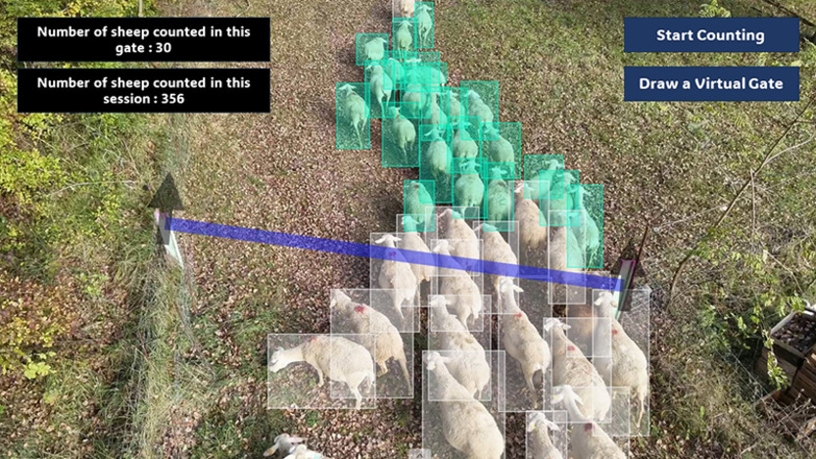
Figure 5 Drone processed image of cattle sheep in grazing areas, France
View description - Figure 5 Drone processed image of cattle sheep in grazing areas, France
View alternative description - Figure 5 Drone processed image of cattle sheep in grazing areas, France

Go to the ICAERUS Drone Data Analytics Library on the ICAERUS website and have a look through the available data sets and algorithm pages.
- Consider how the uploaded data sets relate more generally to the desired outcomes of the different Use Cases. You can read more about the Use Cases on the ICAERUS website. How are the data and/or algorithms featured in the expected outcomes of the Use Cases?
- Using the project’s livestock monitoring Use Case in France, consider the value data provide to farmers.
- How might the different Use Cases (and their data sets and/or algorithms) relate to your own drone business idea?

Provide your answer...
View discussion - Activity 2

2 Drone policies and regulations
As you have seen so far this week, with certain aspects of drone data architecture, such as data security, the regulatory environment of civil drone operations is varied and complex. The aim of this section is to provide you with an approach to assess how drone-related policies, laws and regulations apply to your business idea.

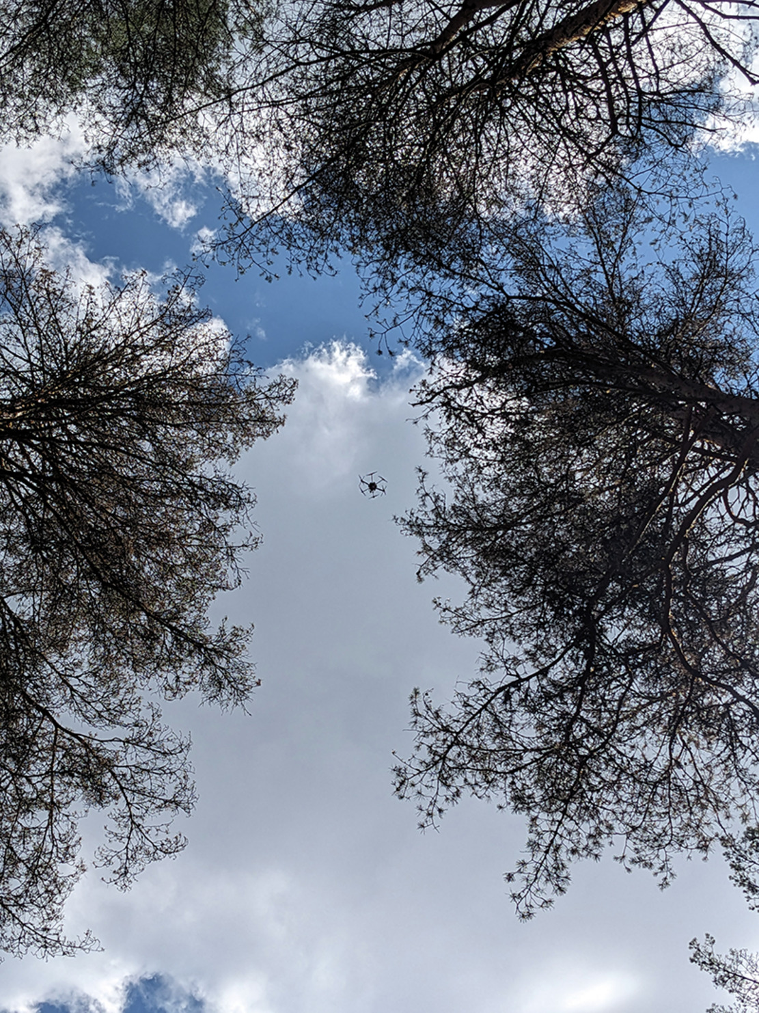
Figure 6 A drone
View description - Figure 6 A drone
View alternative description - Figure 6 A drone

The civilian drone sector is still relatively new, and governments are still working toward harmonisation of regional and local policies. For example, within the European Union, the European Union Aviation Safety Agency (EASA) is working across EU states to provide maximum flexibility alongside a harmonised set of laws and regulations to govern the sector. Such policy considerations become even more complex when one considers international treaties and changes to political structures, such as the United Kingdom’s exit from the EU in 2016. Public policy not only needs to address advances in technology, but it also needs to account for changes in political affiliations, structures and organisations (Kyprianou, 2023). Because the regulatory environment is so complex, it is helpful to use frameworks to analyse potential impacts on your business idea.

2.1 Maximising flexibility
Regulations are often thought of as prohibiting or limiting activities of the public, such as limiting where drones can be flown in and around urban or residential areas. However, public policy (e.g. laws, legislation and regulations) – is also often a way governments can support the growth and development of a sector. In the case of drone-related policies, policymakers need to achieve a balance between supportive policies, which can drive innovation, and sanctioning (or restrictive) policies, which are used to ensure public safety and good governance.
One way policymakers do this is through ‘smart’ or ‘responsive regulation’ which starts from the premise that public policy should encourage industries to self-regulate, especially in innovative and rapidly growing sectors, such as in technology, or in cases where regional differences might exist, such as in the EU (Ayres & Braithwaite, 1992).
Policy therefore ‘responds’ to the needs of the regulatory environment with gradually restrictive or supportive laws and rules. Policy analysts refer to this type of responsive approach as ‘pyramids’ of supports and sanctions (Bluff, 2018). Figure 7 shows how the supportive pyramid moves to more supportive approaches (e.g. from ‘nurturing continuous improvement’ through praise, recognition and finally reward), whereas the sanctioning pyramid moves from supporting the capacity for the industry or sector to manage risk, then to issuing notices, to enforcement and finally to issuing penalties.

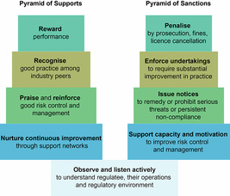
Figure 7 Pyramids of supportive and sanctioning policies (Adapted from Bluff, 2018, p. 52)
View description - Figure 7 Pyramids of supportive and sanctioning policies (Adapted from Bluff, 2018, ...
View alternative description - Figure 7 Pyramids of supportive and sanctioning policies (Adapted from Bluff, 2018, ...

Given the direction of recent EASA directives, which appear to support flexibility in order to encourage innovation, there seems to be a tendency toward a responsive regulatory approach in governing civil drones, although there is still much under negotiation. For example, European states appear to be working toward harmonising and standardising drone-related policies across European states. Moreover, whereas strict aviation policies applied to drones often limited innovation in preference for public safety, there seems to be a growing acceptance that policies can be developed in these kinds of stepped, pyramid ways to encourage innovation, such as in finding ways to accommodate beyond visual line of sight (BVLoS) flights for small package deliveries.
In the next section you will hear from two of the ICAERUS partners about the policies that they think are the most impactful to their case and the wider ecosystem. However, first attempt Activity 3.

Activity 3
Allow approximately 10 minutes.

Read the scenarios below, and determine whether each is a supportive or sanctioning approach.

Interactive content is not available in this format.

2.2 The EASA and drone regulations in Europe
Despite a move toward harmonisation, there is still variation across European states in terms of applicable laws. Moreover, a move toward flexibility and encouragement of self-regulation can emerge from a narrower definition of the issue needing regulation. For example, like the regulatory environment in Europe, the Australian regulatory environment in the early-to-mid 2020s for drones is still fairly narrowly defined to focus on aviation safety, which policy analysts argue can mean that other important issues, such as environmental concerns, privacy and security, are not addressed (Zenz, 2024). Nevertheless, while large parts of the regulatory environment governing civil drones are common across the EU, there are still policies specific to local and regional areas, and policies related to the individual Use Case environments. The next set of videos in the sections that follow are with two of the ICAERUS partners and illustrate the regulatory environments for rural logistics and livestock monitoring.

2.2.1 Rural logistics in North Macedonia
Here, Vassilios Polychronos from GeoSense and Mario Petkovski from AG Futura, discuss how regulations impact on their development of innovations in rural logistics using bespoke software and different drone models.

Video content is not available in this format.
Video 2
View transcript - Video 2

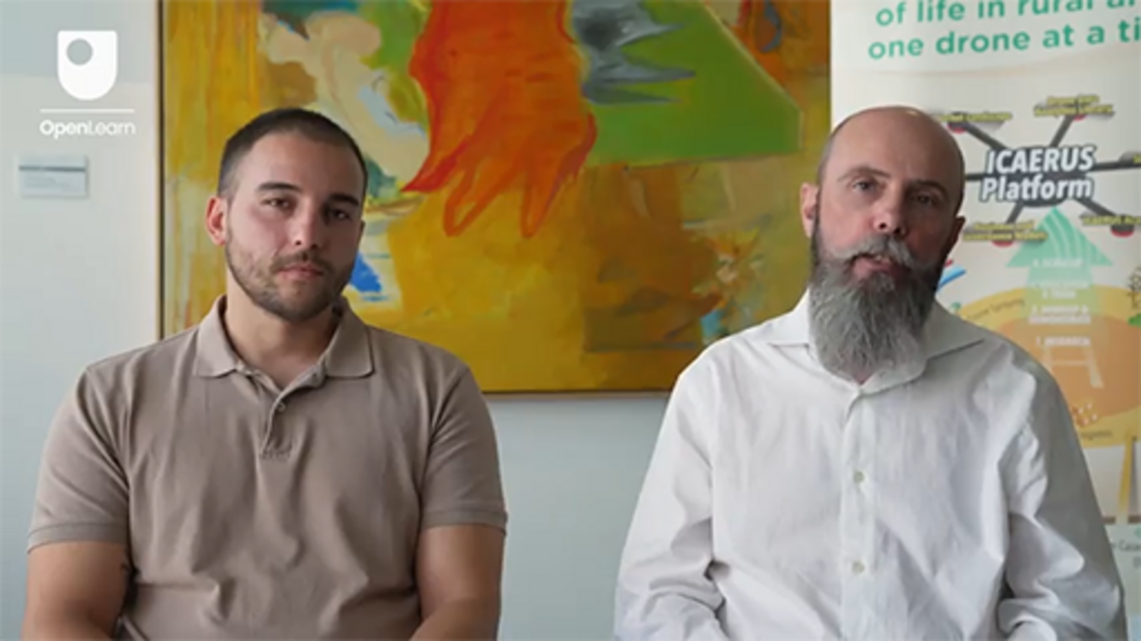

2.2.2 Livestock monitoring in France
As you read in the feedback to Activity 2 earlier this week, the Use Case in France is investigating how drones can be used among the local farming community to monitor livestock. Here, Adrien Lebreton discusses the regulatory environment.

Video content is not available in this format.
Video 3
View transcript - Video 3

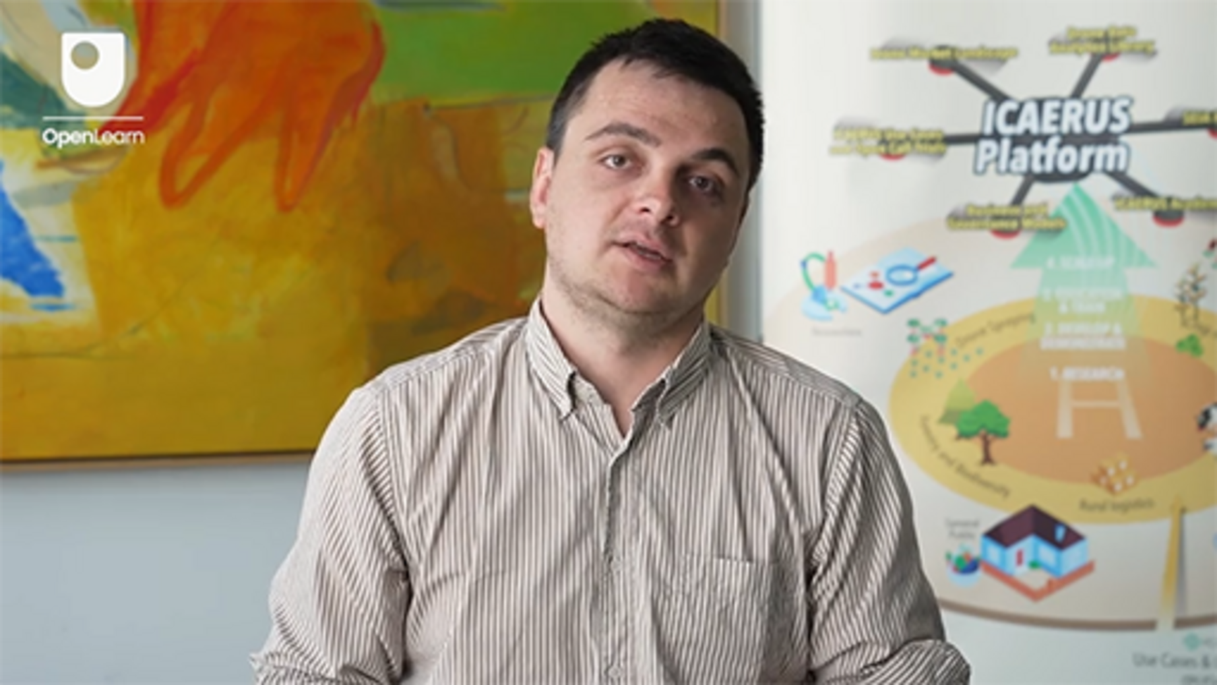

2.2.3 A complex regulatory environment
Like the many different implications of big data for businesses, there are many other legal areas that can impact on business success and the determination of risk. For example, when researchers aimed to develop an automated process for identifying applicable EU drone legislation, they found that numerous other types of regulations would be implicated:

For instance, [an Unmanned Aircraft System (UAS)] that causes personal injury due to a crash will likely lead to questions of liability for which liability law (or even criminal law) will need to be consulted. A UAS that flies too close to buildings and captures confidential work within the facility is likely to violate privacy laws, whereas a UAS that closely flies over one’s home may violate property law, more specifically, ownership rules that entail that property ownership includes not only the property itself but also a part of the airspace above the property. Considering that the applicable rules depend on the facts, a method for finding relevant UAS legislation should allow the user to select or focus on legislation that is applicable to the Use Case relevant to them.
(van Dijck et al., 2023, pp. 490–491)

In the next section you will be provided with guidance and a template for beginning your own investigation into the regulations that might be related to your drone business idea.

2.3 Information on relevant civil drone regulations
Depending on your geographical location and sector focus, you should be able to find information on the specific regulations relevant to your drone business idea. The European regulatory environment can cover a number of important areas of drone operations (some of these are discussed by Schnitker & van het Kaar, 2021), including addressing the following kinds of questions:
- What are the compliance requirements for drone operation?
- What risk assessments are necessary to perform for safe drone operations?
- Which regulatory bodies authorise drone operation?
- What licensing or certification procedures are required prior to operating a drone?
- How do regulations differ depending on whether a drone is remotely controlled or autonomously piloted?
The next activity offers some possible resources to start your investigation.

Activity 4
Allow approximately 30 minutes.

As noted, the EASA regulates drones in the EU. Download the template below, to access a customisable Word document you can use to guide your investigation into the regulatory environment of your business idea. You will be able to use this information later in the course as you develop your business case.
Regulatory environment investigation – template
Table 1 below provides five links and resources for you to start your investigation.

Table 1 Links and resources on drone regulations
Website | Description
EASA –Air & mobility | This link takes you to the ‘Air & Mobility’ pages of the EASA website. It includes information on:  - The types of aircraft covered  - Operating requirements  - Rules and regulations  - Examples and case studies.
EASA – National aviation authorities | This is a subpage of the EASA website that provides information on the national authorities in each of the EU member states.
EASA – Regulatory framework background | This is a subpage of the EASA website that gives the history behind drone regulation and more information on existing and proposed regulations (updating as necessary).
European Parliament Newsroom | This link is to a 2018 press release on the 2018 EU rules for drones. You can use this website to search for news specific to your drone business idea.
Denton’s – Drone laws around the world | This is a link to the Second Edition (2023) compendium of drone laws and regulations across the world complied by a global law firm.

Provide your answer...
View discussion - Activity 4

3 This week’s quiz
Now that you’ve completed Week 3, you can take a short quiz to help you to reflect on what you’ve learned.
Week 3 practice quiz
Open the quiz in a new tab or window and come back here when you’ve finished.

4 Summary of Week 3
Week 3 has covered two complex and multifaceted topics, which should help you to start to map out the context in which your drone business idea sits – the big data of drones and the regulatory environment.
You learned that the public sector, businesses and customers are also interested in one way or another in extracting value from the data generated and analysed by drones. Big data researchers commonly use Big Data Architecture Frameworks, or BDAFs, to categorise the different characteristics of data, such as the ‘Five Vs’: volume, veracity, variety, velocity and value, and that consideration of these characteristics can help you to identify important needs and resources for your business.
You also learned about the regulatory environment for drones and that policymakers often use a middle-ground approach in creating legislation and regulation in order to encourage flexibility and innovation. The landscape of drone regulation is in a period of change as policies become insufficient to deal with new technological breakthroughs.
Finally, you had opportunities to consider your drone business idea in the context of big data architecture frameworks and relevant legislation, which can feed into the development of your business case.
Next week, you will learn more about creating value with your business idea and take the next step toward making your idea into business reality.
You should now go to Week 4.

References
Ayres, I. and Braithwaite, J. (1992) Responsive regulation: Transcending the deregulation debate. Oxford: Oxford University Press.
Bluff, E. (2018) ‘Regulatory theories and frameworks’, in M. Fabian and R. Breunig (eds) Hybrid public policy innovations: Contemporary policy beyond ideology. Abingdon: Routledge, pp. 46–62.
Dentons (2023) Drone laws around the world: A comparative global guide to drone regulatory laws. 2nd edn. Available at: https://www.dentonslee.com/en/insights/articles/2023/september/6/drone-laws-around-the-world-a-comparative-global-guide-to-drone-regulatory-laws (Accessed: 20 March 2024).
EASA (2024) Drones & air mobility. Available at: https://www.easa.europa.eu/en/domains/civil-drones#group-easa-and-you-custom (Accessed: 28 February 2024).
EASA (2024) Drones – regulatory framework background. Available at: https://www.easa.europa.eu/en/domains/civil-drones/drones-regulatory-framework-background (Accessed: 28 February 2024).
EASA (2024) Flying in your country – National Aviation Authorities. Available at: https://www.easa.europa.eu/en/domains/civil-drones/naa (Accessed: 28 February 2024).
European Parliament (2018) EU-wide rules for safety of drones approved by European Parliament’, 12 June [Press release] Available at: https://www.europarl.europa.eu/news/en/press-room/20180607IPR05239/eu-wide-rules-for-safety-of-drones-approved-by-european-parliament (Accessed: 28 February 2024).
IAA (2024) Data privacy and drones. Available at: https://www.iaa.ie/general-aviation/drones/privacy (Accessed: 28 February 2024).
IDC and & Statista (2021) Volume of data/information created, captured, copied, and consumed worldwide from 2010 to 2020, with forecasts from 2021 to 2025 (in zettabytes). Available at: https://www-statista-com.libezproxy.open.ac.uk/statistics/871513/worldwide-data-created/ (Accessed: 28 February 2024).
Khan, M.A., Uddin, M.F. and Gupta, N. (2014) ‘Seven V’s of big data: Understanding big data to extract value’, Proceedings of 2014 Zone 1 Conference of the American Society for Engineering Education, Bridgeport, Connecticut, 3–5 April. DOI: 10.1109/ASEEZone1.2014.6820689
Kyprianou, E. (2023) ‘Drones and legal challenges’, The Open University Law School Blog, 2 May. Available at: https://law-school.open.ac.uk/blog/drones-and-legal-challenges (Accessed: 20 March 2024).
Lagkas, T., Argyriou, V., Bibi, S. and Sarigiannidis, P. (2018) ‘UAV IoT Framework views and challenges: Towards protecting drones as “Things”’, Sensors, 18(4015). Available at: https://doi.org/10.3390/s18114015
Li, F. (2024) ‘Microsoft-CrowdStrike outage: how a single software update was able to cause IT chaos around the globe’, The Conversation, July 21. Available at: https://theconversation.com/microsoft-crowdstrike-outage-how-a-single-software-update-was-able-to-cause-it-chaos-across-the-globe-235165 (Accessed: 22 July 2024).
Mohamed, A., Njafabadi, M.K., Wah, Y.B., Zaman, E.A.K. and Maskat, R. (2020) ‘The state of the art and taxonomy of big data analytics: View from new big data framework’, Artificial Intelligence Review, 53, pp. 989–1037. Available at: https://doi.org/10.1007/s10462-019-09685-9
McAfee, A. and Brynjolfsson, E. (2012) ‘Big data: The management revolution’, Harvard Business Review, 90(10), pp. 60–68.
OECD (2019) ‘Digital innovations and the growing importance of agricultural data’, in Digital Opportunities for Better Agricultural Policies. Paris: OECD Publishing. Available at: https://doi.org/10.1787/367ac383-en
Puliti, S. and Granhus, A. (2021) ‘Drone data for decision making in regeneration forests: from raw data to actionable insights’, Journal of Unmanned Vehicle Systems, 9(1), pp. 45–58. Available at: https://doi.org/10.1139/juvs-2020-0029
Schnitker, R. and van het Kaar, D. (2021) Drone law and policy: Integration into the legal order of civil aviation. Boom Uitgevers Den Haag.
Targett, E. (2024) ‘CrowdStrike’s unholy cluster is terrible news for CISOs’, The Stack, July 19. Available at: https://www.thestack.technology/crowdstrike-driver-outage-cause/ (Accessed: 22 July 2024).
Taylor, R., Davis, C., Brandt, J., Parker, M., Ståuble, T. and Said, Z. (2020) ‘The rise of big data and supporting technologies in keeping watch on the world’s forests’, International Forestry Review, 22(S1), pp. 129–141. DOI:10.1505/146554820829523880
van Dijck, G., On, A.-D., Snel, J. and Nanda, R. (2023) ‘Retrieving relevant EU drone legislation with citation analysis’, Drones, 7(8), pp. 490–509. Available at: https://doi.org/10.3390/drones7080490
Zenz, A. (2024) ‘Safety first: analysing the problematisation of drones’, Griffith Law Review. Available at: https://doi.org/10.1080/10383441.2024.2303937

Acknowledgements
This free course was written by Giacomo Carli, Kristen Reid and Despoina Filiou. This week was written by Kristen Reid.
The development of this course was funded by the ICAERUS project.
The ICAERUS project was funded by the EU under the Horizon Europe scheme Grant Agreement 101060643 and UK under Innovate UK reference 10038181.
Except for third party materials and otherwise stated, including any quotes referenced in the course and not acknowledged here (see terms and conditions), this content is made available under a Creative Commons Attribution-NonCommercial-ShareAlike 4.0 Licence .
The material acknowledged below is Proprietary and used under licence (not subject to Creative Commons Licence). Grateful acknowledgement is made to the following sources for permission to reproduce material in this free course:
Course image: Courtesy: Dr Katerina Kasimati
Course badge: © The Open University
Figures
Figure 4: Hyperspectral imaging data (processed) of a Scots Pine and mixed forest, Lithuania. Courtesy: Lina Usvaltien
Figure 5: Drone processed image of cattle sheep in grazing areas, France. Courtesy: Dr Katerina Kasimati
Figure 6: A drone. Courtesy: Lina Usvaltien
Figure 7: Pyramids of supportive and sanctioning policies (Adapted from Bluff, 2018, p. 52) adapted from Bluff, E. (2018).Figure 4.1 (p. 52) ‘Regulatory theories and frameworks’, in M. Fabian, M, & and R. Breunig, R. (eEds.) Hybrid public policy innovations: Contemporary policy beyond ideology. Abingdon: Routledge.
Activity
Activity 4: Regulatory environment investigation – template © The Open University
Videos
Video 1: Vassilios Polychronos, Chief Technical Officer at GeoSense: 1.1 Complex data sets of drones. Discussion © The Open University (2024)
Video 2: Vassilios Polychronos, Chief Technical Officer at GeoSense and Mario Petkovski from AG Futura: 2.2.1 Rural logistics in North Macedonia. Discussion © The Open University (2024)
Video 3: Adrien Lebreton discusses the regulatory environment 2.2.2 Livestock monitoring in France © The Open University (2024)
Every effort has been made to contact copyright owners. If any have been inadvertently overlooked, the publishers will be pleased to make the necessary arrangements at the first opportunity.
Don't miss out
If reading this text has inspired you to learn more, you may be interested in joining the millions of people who discover our free learning resources and qualifications by visiting The Open University – www.open.edu/openlearn/free-courses.

Week 4: From new business ideas to value propositions

Introduction
Welcome to Week 4 of Developing business ideas for drone technologies. Week 4 is the first of three weeks dedicated to the concept of the business model canvas. This week you will have the chance to learn what a value proposition is. The value proposition is the main component of the business model canvas, and it is fundamental to designing a full business model canvas.
Figure 1 shows the learning cycle for Week 4.

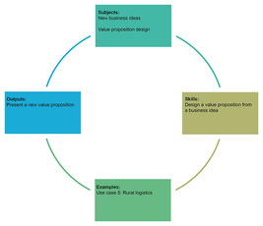
Figure 1 Learning cycle for Week 4
View description - Figure 1 Learning cycle for Week 4
View alternative description - Figure 1 Learning cycle for Week 4

By the end of Week 4, you should be able to:
- understand the concept of a business model canvas and value proposition canvas
- identify and design the different elements of a value proposition
- present a value proposition to an audience.

1 The business model canvas
Alexander Osterwalder introduced the concept of the Business Model Canvas in his PhD dissertation (Osterwalder, 2004). In a recent interview, Osterwalder discussed the uses of the business model canvas as a tool:

The Business Model Canvas is used in very many different ways. It’s really used the way we envisioned it to be: to visualize and assess an existing business model or to create an entirely new business model. We envisioned both uses, but it’s just one tool.
(Osterwalder & Euchner, 2019, pp. 12–13)

As Osterwalder explains, this managerial tool is used to visualise business models of companies, enabling a collaborative process among stakeholders. Thanks to its popularity, stakeholders can discuss the design of a new business model or the changes to an existing one, sharing ideas around a common framework – the business model canvas.
The original business model canvas is made of nine blocks, as shown in Figure 2. The original blocks can be grouped into four main areas: customers, offer, infrastructure, and financial viability.

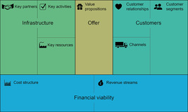
Figure 2 The original Business Model Canvas with nine blocks divided into four areas
View description - Figure 2 The original Business Model Canvas with nine blocks divided into four a ...

One could ask: why has it been designed in this way? The key idea behind this representation is that the value propositions (Offer) are at the centre, and the right-hand side works in conjunction with the left-hand side: the infrastructure enables an offer to be made to the customers. At the bottom of the canvas, the balancing of costs and revenues is considered in the financial viability area.
Of course, this is just one possible way of representing business models, and there are plenty of alternatives. For instance, the growing attention on sustainability has led to the development of frameworks that depict sustainability elements more directly. Figure 3 shows the sustainable business model canvas as developed by the CASE project (Competencies for a sustainable socio-economic development) in collaboration with Wageningen University, a partner of the ICAERUS project.

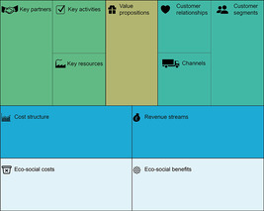
Figure 3 The sustainable business model canvas
View description - Figure 3 The sustainable business model canvas

In this representation, eco-social costs and benefits are represented below the costs and revenues. Whereas this model might look simplistic in just adding two building blocks, our choice to adopt it comes from the practical experience of ICAERUS partners in their interactions with stakeholders and applications to funding calls. Its benefit lies in its direct derivation from the original canvas developed by Osterwalder: adopting this more complete form of the canvas builds on an understanding of the original structure, with no need to uproot the existing blocks and the concepts they represent.
It is important to note the necessity of matching sustainability benefits not only with related sustainability costs, but also with the cost structure. Similarly, sustainability costs should be counterbalanced by both sustainability benefits and revenue streams.
Evidently there is not just one version of the business model canvas – and you might be involved in projects where different evolutions of Osterwalder’s original concept (2004) might be used.

2 The value proposition canvas
In 2014, Osterwalder et al. introduced the value proposition canvas framework. They looked at the two fundamental building blocks of a business model canvas (value propositions and customer segments) and proposed to split these two blocks into six components. The result is that the value proposition canvas is embedded within the business model canvas and serves to explain the relationship between the value propositions and the customer segments more clearly. Figure 4 shows how it all fits together.

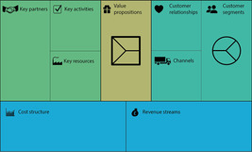
Figure 4 The value proposition canvas is part of the value proposition and the customer segments block
View description - Figure 4 The value proposition canvas is part of the value proposition and the customer ...
View alternative description - Figure 4 The value proposition canvas is part of the value proposition and the customer ...

In proposing this model, Osterwalder et al. (2014) refined the names of the two blocks. The customer segments block is now called customer (segment) profile, and it details the understanding of the customer. The value propositions block is now called value map, and it shows how the business model creates value for the customer.
The customer segments are groups of people or organisations that comprise the business model’s object of interest: the value proposition is dedicated to creating value for them (Osterwalder et al., 2014, p. XVI).
The value proposition is defined as:

the bundle of products and services that create value for a speciﬁc Customer Segment.
(Osterwalder et al., 2010, p. 22)

This week will look more closely at ICAERUS Use Case 5 (rural logistics), and you will develop a value proposition canvas for a possible company using the drone technology of this Use Case. Before approaching this task, it is important to dig into the structure of the value proposition canvas.

2.1 The customer profile
The value proposition canvas is made up of two main blocks: the customer profile and the value map. These are represented in Figure 5. They each comprise three sub-blocks that are designed to show how the demands of customers are met by the offer of the organisation.

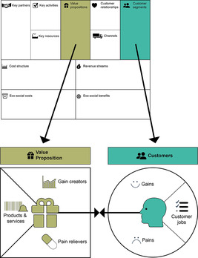
Figure 5 The components of the value map and customer (segment) profile
View description - Figure 5 The components of the value map and customer (segment) profile

The customer profile shows which customer segments are served by the business model, whereas the Value Proposition shows the offer of the company.
The rest of this section will look more closely at the sub-blocks of the value proposition canvas, with a particular focus on designing them to convey a clear message.

2.1.1 Customer jobs
The customer jobs block shows what customers are trying to achieve, for instance, opening a banking account or cleaning their house efficiently. Osterwalder et al. (2014) divided them into three types of customer jobs and three types of supporting jobs.
The three types of customers jobs:
- Functional jobs involve the task that a customer is trying to complete, or the problem they are trying to solve. For example, the printing of a large high-definition picture, or the booking of a table at a restaurant.
- Social jobs relate to improving the perception of a customer’s status among others. This may involve the achievement of a particular title or qualification, such as a language certification, or the acquisition of trainers from the latest collection of a famous brand.
- Personal/emotional jobs concern a personal or emotional state of mind. They can span from the entertainment provided by a trip to Disneyland Paris, to the more everyday wellbeing derived from a good spinning class at a gym.
Supporting jobs are more complex activities. They are more akin to the multi-sided business model type that was presented in Week 2. There are three categories of supporting job:
- Buyer of value jobs have to do with the process of buying value, such as the comparison of offers or the completion of a payment. For instance, the possibility offered by online booking websites and apps to compare different offers of hotels, flights, insurances, etc.
- Cocreator of value jobs involve the collaborative design of products or services offered by an organisation, such as publishing a video on YouTube, a story on Instagram or a review on Tripadvisor.
- Transferer of value jobs relate to the closing of a relationship, such as the disposal or recycling of a product. One example is the opportunity to sell products locally on Facebook Market.
These three categories of supporting job can be viewed as more or less important by customers. For example, consider the task of comparing different offers: this buyer of value job could be important in the choice of a restaurant, but is perhaps less relevant in the choice of a petrol station.

Activity 1
Allow approximately 5 minutes.

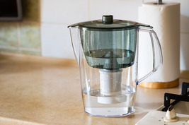
Figure 6 A water filter jug
View description - Figure 6 A water filter jug

Have a look at this list of customer jobs relating to water filter jugs. Pair them up with the correct job category.

Find water filter replacements in a grocery stoe
Drink water with low impurities
Compare prices of filters online
Switch to a compatible filter
Reduce the use of plastic bottles
Buyer of value job
Functional job
Buyer of value job
Transferer of value job
Social job
View answer - Activity 1
View discussion - Activity 1

2.1.2 Customer gains
The customer gains block relates to the outcomes that customers connect to the product or service. For instance, with their bank account, customers might expect to receive instant notifications on their smartphone whenever their debit card is used. But that’s not all: another gain could be the insight provided on their finances, indicating whether their monthly spendings are in line with the previous month or if they are overspending. This more advanced feature might be perceived as useful by some customers, but instead as an invasion of privacy by other customers.
Osterwalder et al. (2014) suggest categorising customer gains into four categories. These are shown in the table below, using an example based on an electric car.

Table 1 The four categories of customer gains (the benefits and outcomes desired by customers)
Customer gains type | Description | Example
Required gains | Necessary customer gains that enable a solution to work | The basic car functions to drive smoothly and monitor the level of the battery
Expected gains | Basic customer gains expected from a product | The possibility to connect to services such as Android Auto and Apple Car
Desired gains | The gains that customers consider beyond their expectations | The presence of a reverse camera for parking
Unexpected gains | Gains that customers did not think of | The possibility to open the car from the smartphone

In the following activity, you will practise categorising the gains yourself.

Activity 2
Allow approximately 5 minutes.

Booking a hotel or another accommodation online is a common activity. What would you expect from it in terms of customer gains? Match each customer gain with its possible category.

Payment is processed correctly
Option of contacting the venue to indicate the time of arrival
Collecting loyalty points to earn discounts
Ability to modify the booking dates
Availability of the room at arrival
Required gain
Desired gain
Unexpected gain
Desired gain
Required gain
View answer - Activity 2

Of course, these are just a few examples of possible customer gains in this context, and the different customer segments may seek out many other alternatives (e.g. the option of adding a third bed).

2.1.3 Customer pains
Customer pains can have a different nature. According to Osterwalder et al. (2014) they can be grouped into three categories: undesired outcomes, obstacles and risks.
Undesired outcomes are the negative aspects that a customer may experience in getting a job done. They can be:
- functional: a solution does not work
- social: a solution is not appreciated socially
- emotional: a solution does not create positive emotions
- ancillary: a solution creates some annoyance.
Obstacles are the things that prevent customers from doing something. For instance, using a banking application on a smartphone can pose serious difficulties for some customers who are not confident in using the technology.
Risks are related to things that could go wrong while using the service. For instance, when using a delivery service such as Deliveroo, customers run the risk of food arriving damaged or cold, which is something that the app considers in its interaction with customers.
Referring back to the context of a hotel booking platform, you will now try categorising customer pains.

Activity 3
Allow approximately 5 minutes.

Match each type of customer pain with its category, considering a customer who would like to book a pet-friendly accommodation.

The platform is known to charge high fees to hotels and flat owners
There is a limited and very expensive supply of pet-friendly accommodation
The platform does not send a confirmation email of the booking
The design of the platform website looks outdated
The platform seems to have a weak data protection policy
The platform sends too many marketing emails
Social problem
Obstacle
Functional problem
Emotional problem
Risk
Ancillary problem
View answer - Activity 3

2.2 The value map
The second fundamental block of the value proposition canvas is the value map. It is represented in the left-hand side of Figure 5, and is made of three blocks: product and services, gain creators, and pain relievers. You will now examine each of these in turn.

Figure 5 (repeated) The components of the value map and customer (segment) profile
View description - Figure 5 (repeated) The components of the value map and customer (segment) profi ...

2.2.1 Products and services
This is a very important sub-block of the value proposition canvas. It showcases the offer in terms of bundled products and services. According to Osterwalder et al. (2014, p. 29), these can be:
- Physical/tangible: physical goods that can be grown or manufactured.
- Intangible: a product or service that has no physical nature, such as a patent (product), or a haircut (service).
- Digital: digital products such as online videos or music. These were most likely categorised separately because they may adopt a platform or a multi-sided business model.
- Financial products: these are categorised separately as they have particular business models (such as insurance products) or even platforms (used to exchange cryptocurrencies such as Bitcoin and Ethereum).

Activity 4
Allow approximately 5 minutes.

Match each product and service with the correct category.

An insurance policy to protect household possessions from robbery or damage
The copyright on the content of a new book
The new season of a popular TV series
Vegetables from the local farmers market
Financial
Intangible
Digital
Physical
View answer - Activity 4

2.2.2 Gain creators
This sub-block of the value map is directly related to the customer gains sub-block in the customer profile. Gain creators explain how the products and services offered create gains for the customers. It is important that they have a relationship with customer gains in order to create value for a group of customers; however, not all customer gains will necessarily be satisfied by the offer of the organisation.
Gain creators are not themselves products or services, but characteristics of the products and services on offer. For example, a printer could respond to the customer requirement of printing documents, and the ability to print from a smartphone would be a good gain creator for customers who would value that function on their device.


Figure 7 A printer
View description - Figure 7 A printer

This distinction might look more blurred when assessing digital product and services. If you consider a multi-sided business model introduced in Week 2, you would need to evaluate the gains offered to the different customers involved.


Figure 8 Music app on smartphone
View description - Figure 8 Music app on smartphone

Shazam is a company (now owned by Apple) that developed a smartphone app capable of identifying music being played out loud. It is a typical multi-sided business model, which is free for customers but able to generate revenue – initially this came from advertising, but Shazam has also partnered with a range of companies (including Spotify, the Walt Disney Company and Coca Cola) (Zampitelli, 2022). In the case of Shazam, customer gains should be identified by dividing the customer gains brought to end users of the app who enjoy its ease of use and speed in recognising a song, and the gains obtained by partners who can increase their number of customers readdressed to their platforms thanks to the integration of Shazam.

2.2.3 Pain relievers
Like gain creators, pain relievers are able to reduce customer pains outlined in the customer profile. Again, the value proposition would not be able to address all of them, but just a sub-group of them.
It is important to consider the differences between the concepts of gain creators and pain relievers. The concepts of pains and gains are connected. Consider a bank account. The availability of quick access to customer service using a chat function on the bank’s app would be a good gain creator. Access to customer service through an online chat could also be perceived as a risky design solution, because some customers might find it difficult or even consider it as a barrier to access the service.
It is important to understand what makes customers feel that a feature offered is a gain creator, and what barriers and risks can constitute a risk and a customer pain. With this knowledge it is possible to design gain creators and pain relievers appropriately.

3 Design a value proposition canvas
In the previous section, the two fundamental blocks of the value proposition were outlined. You can now apply this knowledge to develop a good value proposition canvas for a drone business. This week will look at Use Case 5 of the ICAERUS project which is about rural logistics.
The objective of this Use Case is to develop not just a drone but a drone-delivery fleet management system able to deliver small parcels in remote areas.
The following video will present the features of the technology developed.

Video content is not available in this format.
Video 1
View transcript - Video 1

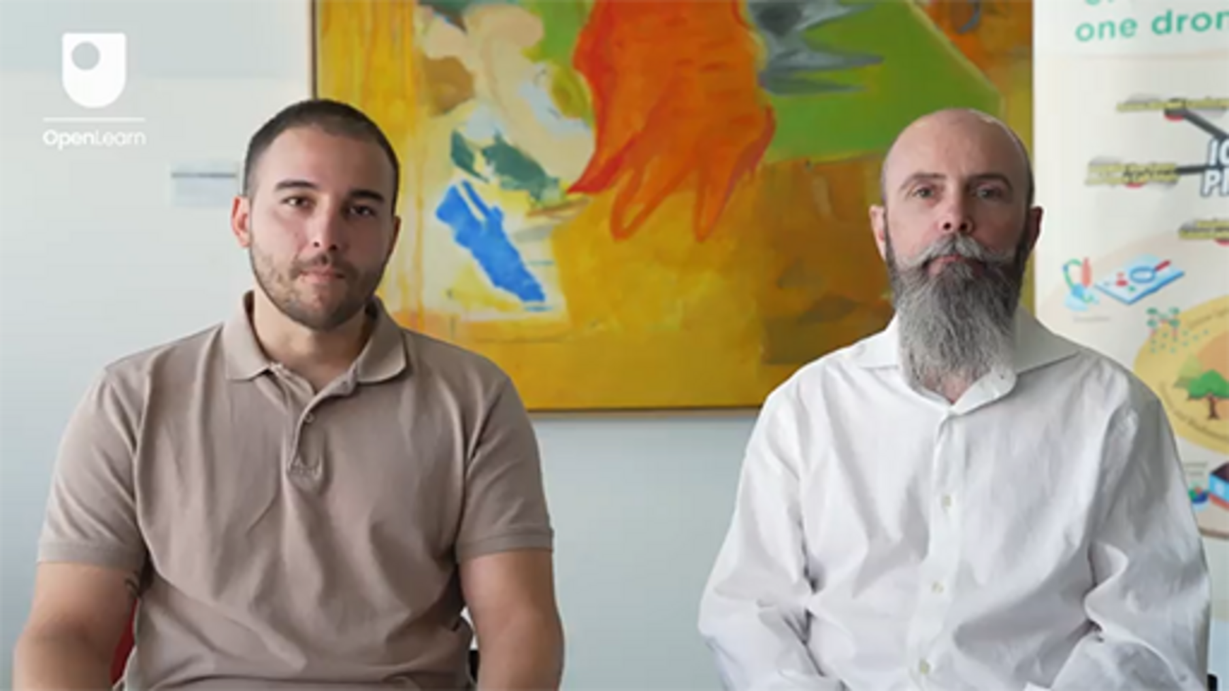

You can also look back at Week 3, where Vasilios Polychronos, Chief Technology Officer of Geosense discussed the feature of the software solution embedded in Use Case 5.

3.1 Design a value proposition
What steps should you follow to prepare a good value proposition?
You can start thinking of the technology that you have been developing (technology push) or that the customers need (market pull). This will be discussed more during the next week, but for now it is important to understand your starting point in order to consider your value proposition canvas.
If you have an innovative technological solution, it makes sense to start from there and think about what customers would like to make use of it. In this case, you can consider developing a good value proposition as a solution to customer needs. The customer would provide valuable insights about their interest.
Alternatively, a market pull approach considers customer jobs, pains and gains first and develops the customer profile block before delving in the value map.

Activity 5
Allow approximately 40 minutes

Task A

Consider the technology outlined in Use Case 5 then answer the following question.
In designing a value proposition canvas, which would be more appropriate to adopt?

A technology push approach
A market pull approach
View answer - Task A

Task B

Now, you will begin designing a value proposition canvas for Use Case 5.
As discussed in Video 1, the drone technology offered would enable the delivery of medicines and vital supplies in difficult-to-reach areas, or to people in an emergency.
Download this template of the value proposition canvas and try to create a possible value proposition.

View discussion - Task B

3.2 Present a value proposition
The value proposition canvas presents a structured way of developing a business model canvas. In some contexts, there might be a need to quickly introduce the idea in terms of what you are working on. In these cases, you might consider the suggestions of Osterwalder et al. (2014, p. 82) to use a sentence formulated like the following:

Our (product and services) help(s) (customer segment) who want to (jobs to be done) by (introducing gains) and reducing (introduce customer pains).

This approach is a simplification, but it enables you to pitch your ideas in a simple and clear manner.

Activity 6
Allow approximately 5 minutes

Think about the value proposition related to Use Case 5 – rural logistics. Select the correct phrase from the drop-down options to complete the sentence.

Interactive content is not available in this format.

View answer - Activity 6

It is important to note that this approach is a simplification, and that this short presentation should be adapted to the particular context. For instance, if you are addressing a national agency representative, it could be more important to concentrate on the gains offered by the centralised fleet management and the scalable investment.
In Week 8, you will find additional suggestions on how to present innovative ideas.

4 This week’s quiz
It’s now time to complete the Week 4 badge quiz. It’s similar to previous quizzes but this time, instead of answering five questions, there will be 15.
Week 4 compulsory badge quiz
Remember, this quiz counts towards your badge. If you’re not successful the first time, you can attempt the quiz again in 24 hours.
Open the quiz in a new tab or window and come back here when you’ve finished.

5 Summary of Week 4
In this week you looked at the business model canvas and the sustainability business model canvas. These concepts will be explored in more detail in Weeks 5 and 6, but here you were introduced to the idea of zooming into the business model canvas to study two blocks: the value proposition and the customer (segment) profile. These are the building blocks of the value proposition canvas. You explored them in detail by looking at their sub-blocks. In the final section, you considered Use Case 5 – rural logistics, and developed a value proposition canvas for the drone technology developed in that Use Case.
You should now go to Week 5.

References
Osterwalder, A. (2004) The Business Model Ontology – A Proposition in a Design Science Approach. Université de Lausanne.
Osterwalder, A., Pigneur, Y. and Clark, T. (2010) Business model generation: a handbook for visionaries, game changers, and challengers. Hoboken, NJ: Wiley.
Osterwalder, A., Pigneur, Y., Bernarda, G., Smith, A. and Papadakos, P. (2014) Value proposition design: how to create products and services customers want. Get started with (Strategyzer series). Hoboken, NJ: Wiley.
Osterwalder, A. and Euchner, J. (2019) 'Business Model Innovation: An Interview with Alex Osterwalder', Research-Technology Management, 62(4), pp. 12–18. Available at: https://doi.org/10.1080/08956308.2019.1613114
Zampitelli, M. (2022) 'From startup to profitability: Shazam’s 16-year journey', Medium, 13 December. Available at: https://bootcamp.uxdesign.cc/from-startup-to-profitability-shazams-16-year-journey-189bda5c16fa (Accessed: 19 June 2024).

Acknowledgements
This free course was written by Giacomo Carli, Kristen Reid and Despoina Filiou. This week was written by Giacomo Carli.
The development of this course was funded by the ICAERUS project.
The ICAERUS project was funded by the EU under the Horizon Europe scheme Grant Agreement 101060643 and UK under Innovate UK reference 10038181.
Except for third party materials and otherwise stated, including any quotes referenced in the course and not acknowledged here (see terms and conditions), this content is made available under a Creative Commons Attribution-NonCommercial-ShareAlike 4.0 Licence .
The material acknowledged below is Proprietary and used under licence (not subject to Creative Commons Licence). Grateful acknowledgement is made to the following sources for permission to reproduce material in this free course:
Course image: Courtesy: Dr Katerina Kasimati
Course badge: © The Open University
Figures
Figure 5: The components of the value map and customer (segment) profile Strategyzer AG https://www.strategyzer.com/
Figure 6: Alexandra Harashchenko/Shutterstock
Figure 7: A printer photo: Samsung Printer, scanner https://www.pickpik.com/printer-desk-office-fax-scanner-home-office-125349
Figure 8: Music app on smartphone: photograph LG smartphone freestocks.org
Video
Video 1: What does AGFUTURA Technology Do? and What is Use Case 5 about? Mario Petkovski and Vassillis Polychronos ©The Open University (2024)
Every effort has been made to contact copyright owners. If any have been inadvertently overlooked, the publishers will be pleased to make the necessary arrangements at the first opportunity.
Don't miss out
If reading this text has inspired you to learn more, you may be interested in joining the millions of people who discover our free learning resources and qualifications by visiting The Open University – www.open.edu/openlearn/free-courses.

Week 5: Designing a business model (infrastructure and sustainability areas)

Introduction
Welcome to Week 5 of Developing business ideas for drone technologies. Week 5 is the second week dedicated to looking at the fundamental tools of the business model canvas developed by Osterwalder and colleagues. Last week you looked at two blocks of the business model canvas that make up the value proposition canvas – the customer (segment) profile and the value proposition. This week you will look at the larger picture including the remaining blocks of the customer area. You will then see how this can be applied in real life using ICAERUS Use Case 2 (Drone Spraying).
Figure 1 shows the learning cycle for Week 5.

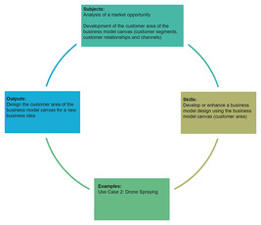
Figure 1 Learning cycle for Week 5
View description - Figure 1 Learning cycle for Week 5
View alternative description - Figure 1 Learning cycle for Week 5

By the end of Week 5, you should be able to:
- understand the different blocks of the customer area of the business model canvas
- consider how the value proposition canvas informs the business model canvas
- design the offer and customer areas of a business model canvas.

1 The customer area
The customers area has three blocks: customer segments, customer relationships and channels.

Figure 2 The sustainable business model canvas
View description - Figure 2 The sustainable business model canvas

You will look at the three blocks which make up the customer area in more detail in the sections that follow, starting with the customer segment.

1.1 Customer segments
A distinct group of customers with a similar customer profile or characteristics (e.g. demographics, needs, lifestyle) can be considered a customer segment. In Week 4, this block was named Customer Profile as part of the Value Proposition Canvas.
There are several ways to define customer segments, and some techniques are applied in marketing.
It is important to consider some fundamental aspects: the first is whether the business model is targeting a mass market or a niche market.

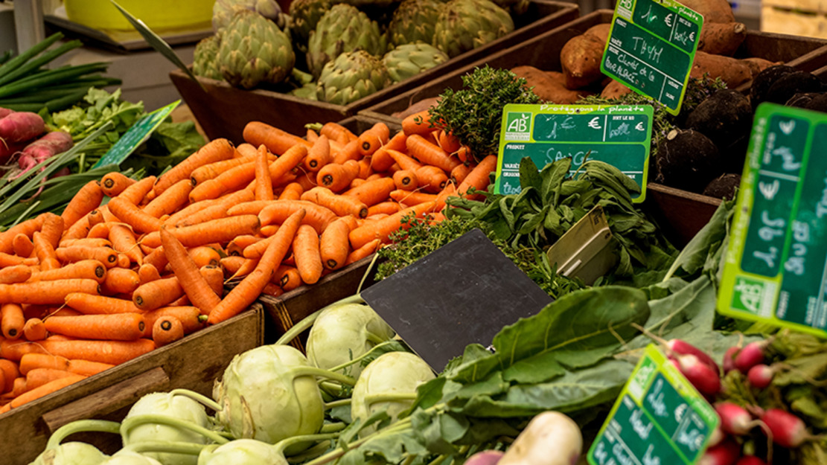
Figure 3 Mass market: groceries
View description - Figure 3 Mass market: groceries

A mass market is often found for products that are not largely customised. Examples of mass markets are groceries, electronics and food.

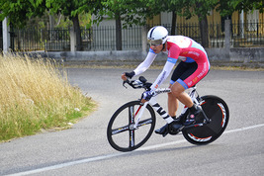
Figure 4 Niche market: specialised sports equipment
View description - Figure 4 Niche market: specialised sports equipment

A niche market serves a limited group of customers. For instance, specialised sports equipment is typically for a niche market. In this case, producers invest in developing new materials to enhance the performance of athletes.
In some cases, it is possible to serve more than one segment of clients. Therefore, in this block, the second question to ask is: what customer segments is the business model targeting? In Week 2 you were introduced to matchmaking and multi-sided business models. These models often combine different segments of customers, so it is important to consider what is valuable to each customer segment you target.
Some customers segments are more accessible when customer relationships are developed that enable you to approach them specifically. This will be discussed in the next sections on customer relationships and channels.

1.2 Customer relationships
Customer relationships portray the type of relationship established with each customer segment. The question to be considered when designing this building block is: what type of relationship will be developed with the customer?
Osterwalder et al. (2010, p. 29) identified six types of customer relationships:
- Personal assistance: the customer refers to a representative in person or through a media (e.g. by phone, online) to receive support in the transaction or in the relationship with the company.
- Dedicated personal assistance: a dedicated assistant is assigned to the customer to provide a single point of contact. You may think this is reserved for wealthy clients using particular services, however that’s not always the case. For instance, some people may appreciate dedicated personal assistance by being seen by the same general practitioner or doctor.
- Self-service: the customer completes the purchase autonomously without interacting with personnel. Vending machines and self-service counters, which have replaced many personal assistants in large shops, are typical examples of this type of customer relationship.
- Automated service: this mode of service combines self-service with customisation based on automatic profiling of the customer. In doing so, it tries to personalise the relationship with the customer. Online stores like Amazon profile clients according to data collected such as previous purchases and searches. This approach is expanding: grocery stores have launched apps that offer personalised discounts to their clients on the basis of their profile.
- Communities: the customer or user creates communities around a particular product or service. This is the case for software users. The popular statistical packages Stata or R have communities of users, such as researchers, who develop and share code for performing specific analyses. The knowledge exchange among members of the community allows members to have their needs solved by the contributions of other members or to ask questions to the community. Communities are also important for collecting valuable information on products and services. This is typical in software development, where communities develop around a specific software. The ICAERUS platform contains a library of models, algorithms and datasets that are shared freely and enable the development of drone applications.
- Co-creation: the customer and service provider develop value together. This is the case of YouTube and other multi-sided business models where its value depends on the participation of different parties towards the development of products and services.

1.3 Channels
Channels can be considered as interfaces between the company and its customers. A channel combines activities, people and organisations to deliver a product or a service to customers. This building block of the canvas tries to answer the question: how do businesses reach customers?
Osterwalder et al. (2010, p. 27) defines five channels which can be categorised according to the control (own or through a partner) and the type (direct or indirect). Table 1 shows how channels can be classified.

Table 1 Classification of channels
Control of the channel | Type of channel | Type | Definition
Own | Direct | Sales force | A team of employees who directly engage with customers or clients to promote and sell the organisation's products or services. This involves personal interaction, often face-to-face or via phone calls.
Own | Direct | Web sales | An official website used to sell products or services.
Own | Indirect | Own stores | Retail outlets owned and operated by the organisation where customers can directly purchase the organisation's products.
Partner | Indirect | Partner stores | Retail outlets owned by other companies that sell the organisation's products, often alongside products from other brands.
Partner | Indirect | Wholesaler | An intermediary that buys large quantities of products from the manufacturer and sells them in smaller quantities to retailers, who then sell them to the end customers.

The organisation controls its own channels directly, but partner channels are controlled by others. Direct channels connect the organisation straight to the customer, cost more to set up, but give the organisation more control. Indirect channels, on the other hand, go through partners who share some of the business risk and cost less to set up.

Activity 1
Allow approximately 5 minutes.

Match the examples on the left side with the right type of channel.

A large warehouse that buys products in bulk and sells them to small retailers.
A team of company employees who visit local pharmacies to sell cosmetic products to loyal clients every two months.
The Eurostar website which sells the tickets of the trains which cross the English Channel
The local farm shop which sells fresh eggs and seasonal vegetables
An electronics store that sells different brands of computers and other electronic gadgets
Wholesaler
Sales force
Web sales
Own store
Partner store
View answer - Activity 1

One or more channels can be used at different stages to deliver the value proposition to customers. A company can mix and match channels to interact with customers at various points in the customer relationship.
Look at the following table to understand the phases of the delivery of a value proposition.

Table 2 Delivery phases of a value proposition
Phase | Definition | Example
Awareness of the proposed products and services | At this stage, the customer learns about the existence of the product or service | Social media ads, TV commercials, and billboards that introduce a new smartphone
Evaluation of the value proposition | The customer gets a chance to try out or learn more about the product or service | Free samples of cosmetics, trial periods, or demo videos of a new software application
Purchase | In this phase, the customer buys the product | Buying a pair of shoes from the brand's official website or from a physical retail store
Delivery | This is how the product or service reaches the customer | Receiving the ordered shoes through home delivery or picking them up from a store
After sales | During this phase, customers stay in touch with the company for support and to manage the ongoing relationship after the purchase | Calling customer service for help with a product issue or getting software updates for a device

Now test your understanding by doing the following activity related to the purchase of a fitness tracker.

Activity 2
Allow approximately 5 minutes.

Match the different examples related to the purchase of a fitness tracker with the phases of the customer relationship.

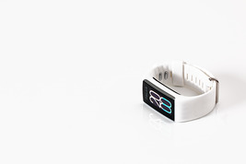
Figure 5 Fitness tracker
View description - Figure 5 Fitness tracker

Awareness of the proposed products and services
Evaluation of the value proposition
Purchase
Delivery
After sales
Seeing an Instagram ad about the new fitness tracker.
Trying the fitness tracker at a demo station in a local electronics store.
Buying the fitness tracker from the company’s official website.
Receiving the fitness tracker through home delivery after purchasing it online.
Calling customer service for help with setting up the fitness tracker with an iPhone or an Android smartphone.
View answer - Activity 2

1.4 The Drone Spraying Use Case
In this section you will apply the knowledge you have gained on the customer area of the business model canvas to Use Case 2 of the ICAERUS project.
Plant protection products (PPPs) are used in farming to protect crops from pests, weeds and diseases. This helps keep European agriculture productive, profitable and sustainable. One important method of applying these products is spraying, which is crucial for growing all kinds of open-field crops like vegetables, orchards, vineyards and arable crops.

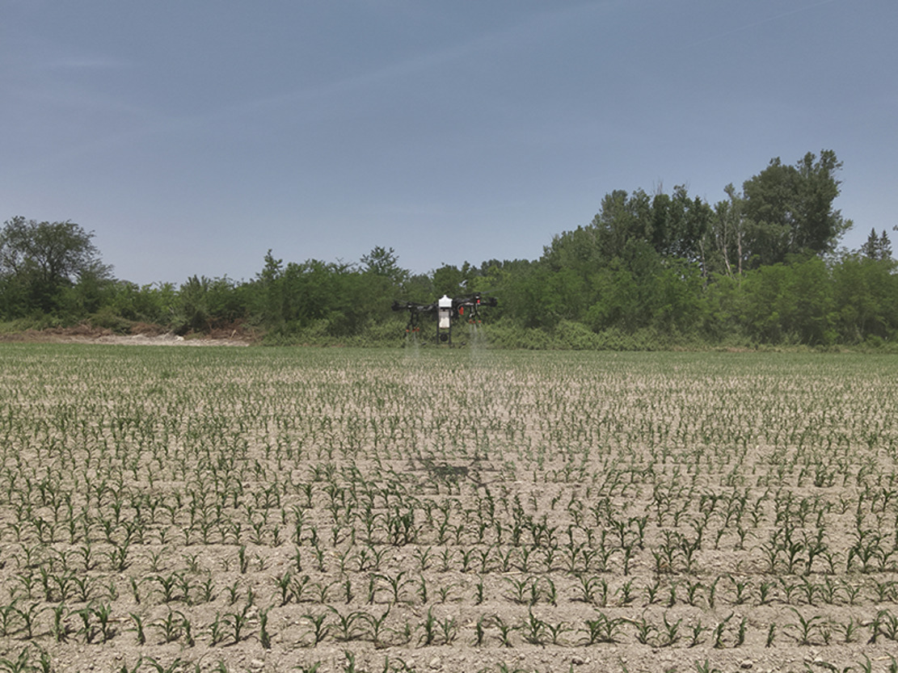
Figure 6 A spraying drone

A spraying drone is a type of unmanned aerial vehicle (UAV) that can apply agrochemicals accurately and close to the crop canopy, typically from a height of less than 5 metres. These drones can be operated either manually or automatically.
The goal of Use Case 2 is to test and evaluate different ways of using spraying drones to ensure they work well in real field conditions. This involves studying how well the drones spray (e.g. how evenly the chemicals are applied, how deeply they penetrate the crop canopy, and how much spray drifts away) when using different settings (such as varying the height, speed, and flow rate of the nozzles). These results will then be compared to traditional spraying methods, like those using ground-based boom and mist sprayers.
Use Case 2 also aims to identify any risks associated with using drones for spraying and to develop new strategies to mitigate these risks, ensuring that drone-based spraying is both safe and environmentally friendly.

Activity 3
Allow approximately 15 minutes.

Task A

Watch the following video and take some time to reflect on the different aspects of the technology developed and its potential applications.

Video content is not available in this format.
Video 1
View transcript - Video 1

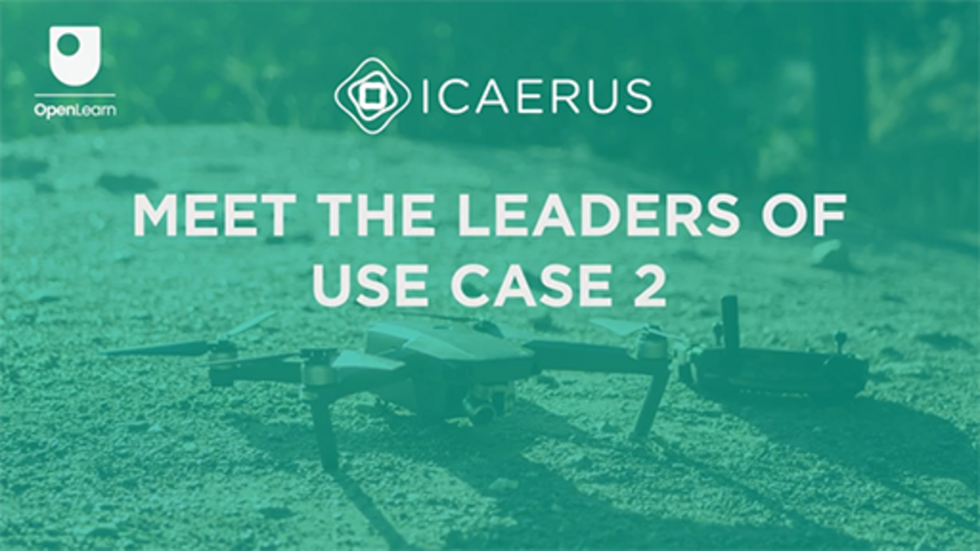

Task B

Now match the examples given below to the correct customer area block.

View discussion - Task B

2 The value proposition canvas
In Week 4, you looked at the three building blocks of the value proposition area. This week you will look at what makes a good value proposition.
Osterwalder et al. (2010, pp. 23–25) discuss what creates value to customers. There is not a definitive answer to this question, but they propose several aspects which can contribute.
- Newness: some value propositions meet new needs that people didn’t even know they had because there was no similar product or service before, or the offer was quite limited. This is often related to technology, but not always. For example, the creation of live streaming platforms like Twitch introduced a whole new way for people to interact. Similarly, ride-sharing apps like Uber changed the way we think about travel by making it easy to book transport. However, newness isn't always about technology; think about fair-trade products, which cater to a growing demand for ethically produced goods without relying on new tech.
- Performance: making a product or service better is a common way to create value. For example, video game consoles like the PlayStation and Xbox get more powerful with each new version, offering better graphics and faster performance. However, there are limits to this strategy. Recently, even though smartphones have become faster and more advanced, these improvements haven't always led to increased sales, as people may not see enough benefit in the small upgrades each year.
- Customisation: creating value by making products and services that fit individual needs has become very popular. The idea of mass customisation lets businesses offer personalised products while still making them efficiently. For example, Vans allows customers to design their own sneakers, combining personalisation with large-scale production. Similarly, websites like Canva let users create custom designs for everything from posters to social media posts, tailoring the experience to each user's needs.
- Getting the job done: value can be added by simply helping people accomplish specific tasks. For example, Spotify helps users by curating playlists and recommending new music, making it easy to discover and enjoy songs without spending hours searching. Another example is food delivery services like DoorDash, which connect people with restaurants, allowing them to order food without leaving their home.
- Design: design is a crucial yet challenging aspect to measure in creating value. A product with superior design can stand out significantly. In technology, products like the Nintendo Switch are known for their innovative and user-friendly design, making them popular among gamers.
- Brand/status: customers often find value in the status associated with a particular brand. For example, wearing designer clothing signifies a connection to fashion and celebrity culture. On the other hand, wearing a Patagonia jacket might show a commitment to environmental sustainability.
- Price: offering similar value at a lower price is a common way to attract budget-conscious customers. Fast fashion retailers such as Zara, Boohoo and Misguided provide stylish clothes at affordable prices, although there are serious concerns about the sustainability of their business model in terms of use of resources and labour conditions (IESE Insight, 2015). Xiaomi is another example: their smartphones offer good quality at a lower price than most, making them accessible to more people. Increasingly, free offerings are also popular, with services like free apps and games supported by ads or in-app purchases.
- Cost reduction: helping customers save money is a significant way to create value. For example, Google Docs is free and allows users to create, share and edit documents online, saving them the cost of purchasing expensive software.
- Risk reduction: reducing the risks people face when buying products or services is highly valued. For instance, a student might appreciate a laptop warranty, which lessens the risk of paying for repairs if it breaks. In online shopping, companies like Amazon offer easy returns, providing assurance to buyers that they can return products if they're not satisfied.
- Accessibility: creating value by making products and services available to those who previously couldn't access them is another strategy. For example, Kindle Unlimited offers a vast library of books for a monthly fee, making it easier for avid readers to access a wide range of books. Online learning platforms like OpenLearn provide access to courses from The Open University, allowing people from around the world to learn new skills and build knowledge.
- Convenience/usability: enhancing convenience or ease of use can create significant value. For example, using Google Maps makes it easy to find directions and explore new places without getting lost. Netflix and Spotify let users stream their favourite shows, movies or music on demand, making it incredibly convenient to access them.

Activity 4
Allow approximately 15 minutes.

Task A

Note down in the text box below a value proposition for the Drone Spraying Use Case. To do so, you may also want to revisit Week 4.

Provide your answer...
View discussion - Task A

Task B

A drone spraying service for farmers would give several benefits. You can explore them in the second part of this activity. Match the value proposition element in the list below with the correct aspect.

Reduce the use of agrochemicals
Reduce the risk of workers spreading pesticides
Data-driven insights: enable informed farming decisions: mapping of the field created before the spraying
Cost efficiency: reduce overall operational costs for farmers
Control the treatment remotely
Collect accurate data
Precision agriculture: enhance crop yield and reduce chemical usage by ~10%
Environmental sustainability: lower the ecological impact of farming
Getting the job done
Risk reduction
Newness
Cost reduction
Convenience/usability
Accessibility
Performance
Performance
View answer - Task B

As you can see, not all aspects suggested by Osterwalder et al. (2010) are relevant to a value proposition of a new service.

2.1 Evaluate a value proposition
When considering the suitability of a value proposition, a reliable first approach is to conduct a simple SWOT analysis. SWOT analysis helps in identifying internal and external factors that can impact the success of an entity. It stands for:
- Strengths
- Weaknesses
- Opportunities
- Threats.
Strengths are internal attributes that give an advantage over others. Weaknesses are internal attributes that place the entity at a disadvantage. Osterwalder et al. (2010, p. 217) suggest considering the following aspects:
- Alignment between customer needs and value proposition: a good response to customer needs would make the value proposition solid.
- Ability to create network effects: network effects refer to the increase of the value of a product or service as more people use it. This effect occurs because each new user adds value to the existing users, creating a positive feedback loop that enhances the overall utility of the product or service. Consider a social media platform like Instagram. When only a few people use it, its value is limited because there are fewer people to connect with. However, as more people join and use the platform, its value increases for each user because there are more friends, family members and acquaintances to interact with.
- Synergies between products and services offered: this means that the bundle of products and services offered should be integrated in order to enhance the value provided. Besides the typical examples of technological gadgets that embed services such as the Android or Apple ecosystems, this integration can also include the possibility of having a support community. A good statistical software is typically supported by a community of users who develop custom procedures to perform complex analyses.
- Customer satisfaction: this is a complex measure of how well a company’s products or services meet or exceed customer expectations. Companies often use surveys, feedback forms, and direct communication to gauge satisfaction levels and identify areas for improvement.
Opportunities are external factors that the entity can exploit to its advantage. According to Osterwalder et al. (2010, p. 222), the following elements should be considered:
- Recurring revenues: in designing a solid value proposition, it is important to consider the possibility of converting products into services that can generate recurring revenues, such as a subscription fee.
- Additional customer needs: it is worth considering serving a wider range of customer needs to expand the market.
- Integration with complements: it is important to consider the integration of complements. In the case of drone systems, a data analysis service that could be offered as a complement to the drone service would utilise the extensive data that is collected.
Threats are external factors that could cause trouble or loss. In this case, Osterwalder et al. (2010, p. 220) identified the following aspects:
- Presence of substitute products: substitute products are goods or services that can be used in place of each other to satisfy the same consumer need or desire. When the price of one product rises or its availability decreases, consumers may switch to the substitute product. Streaming services can be considered substitute products of cinemas or satellite TV, or even of traditional TV channels.
- Presence of competitors: competitors able to operate in the same industry can pose a threat by lowering prices or offering more value with a differentiated product.

2.2 The fit of a value proposition
According to Osterwalder et al. (2014, p. 48), it is possible to evaluate a value proposition by considering three types of fit between its different blocks.
The first type of fit is between customer needs and the value proposition itself and is called a problem-solution fit. In Week 4 you looked at the three subblocks of the value proposition (product and services, gain creators and pain relievers) and the three subblocks of the customer profile (customer jobs, customer gains and customer pains). A problem-solution fit ensures the value proposition is designed to address customer needs.
The second type of fit is named a product-market fit and relates to the creation of customers. Are customers reacting positively to the value proposition? If there is a demand it demonstrates the ability to create value for customers.
The third type of fit is a business-model fit and relates to the value proposition being embedded in a profitable and scalable business model. This means that all the elements of the business model are integrated together and create a sustainable financial return. It also means that it is possible to scale-up the model, for example expanding in different locations.

3 This week’s quiz
Now that you’ve completed Week 5, you can take a short quiz to help you to reflect on what you’ve learned.
Week 5 practice quiz
Open the quiz in a new tab or window and come back here when you’ve finished.

4 Summary of Week 5
This week you focused on the customer and offer areas of the business model canvas. You learnt how to design the blocks which make up the customer and offer areas: customer segments, customer relationships, channels. Moreover, you applied this knowledge to the Drone Spraying Use Case and explored how it could lead to more precise distribution of agrochemicals. Next week is dedicated to the remaining areas of the business model canvas and to the sustainability blocks added in the sustainable business model canvas.
You should now go to Week 6.

References
IESE Insight (2015) The Nuts and Bolts of Fast Fashion. IESE Insight. Available at: https://www.iese.edu/insight/articles/fast-fashion-business-model-zara/ (Accessed: 25 June 2024).
Osterwalder, A., Pigneur, Y. and Clark, T. (2010) Business model generation: A handbook for visionaries, game changers, and challengers. Hoboken, New Jersey: Wiley.
Osterwalder, A., Pigneur, Y., Bernarda, G., Smith, A. and Papadakos, P. (2014) Value proposition design: how to create products and services customers want. Get started with (Strategyzer series). Hoboken, NJ: Wiley.

Acknowledgements
This free course was written by Giacomo Carli, Kristen Reid and Despoina Filiou. This week was written by Giacomo Carli.
The development of this course was funded by the ICAERUS project .
The ICAERUS project was funded by the EU under the Horizon Europe scheme Grant Agreement 101060643 and UK under Innovate UK reference 10038181.
Except for third party materials and otherwise stated, including any quotes referenced in the course and not acknowledged here (see terms and conditions), this content is made available under a Creative Commons Attribution-NonCommercial-ShareAlike 4.0 Licence .
The material acknowledged below is Proprietary and used under licence (not subject to Creative Commons Licence). Grateful acknowledgement is made to the following sources for permission to reproduce material in this free course:
Course image: Courtesy: Dr Katerina Kasimati
Course badge: © The Open University
Figures
Figure 3: Mass market: groceries placed in public domain by pxhere.com
Figure 4: Niche market: specialised sports equipment Dana Tentis/264 Images, placed in public domain by pxhere.com
Figure 5: Fitness tracker https://pxhere.com/en/photo/1186634 placed in public domain
Figure 6: of a spraying drone. Courtesy: Dr Katerina Kasimati
Video
Video 1: meet the leaders of use case 2 © The Open University (2024)
Every effort has been made to contact copyright owners. If any have been inadvertently overlooked, the publishers will be pleased to make the necessary arrangements at the first opportunity.
Don't miss out
If reading this text has inspired you to learn more, you may be interested in joining the millions of people who discover our free learning resources and qualifications by visiting The Open University – www.open.edu/openlearn/free-courses.

Week 6: Business model canvas – part 2

Introduction
Welcome to Week 6 of Developing business ideas for drone technologies. This week follows on from last week’s study on the business model canvas and will continue to develop your skills related to the internal part of the business model considering resources, activities and partnerships (infrastructure) (Osterwalder et al., 2010). In addition, you will also be introduced to methods of evaluating revenues and costs (financial viability) to help support you in drafting a financial plan (McAdam, 2013). You will also learn about eco-social costs and eco-social benefits and how these can help create a sustainable business model canvas. The ICAERUS Use Case on Drone Spraying will be applied to explain this part of the business model canvas.
Figure 1 shows the learning cycle for Week 6.

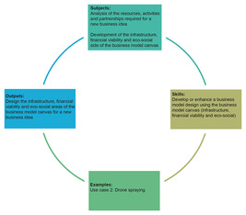
Figure 1 Learning cycle for Week 6
View description - Figure 1 Learning cycle for Week 6
View alternative description - Figure 1 Learning cycle for Week 6

By the end of Week 6, you should be able to:
- develop a business model canvas for an innovative business, specifically for drone applications in the agriculture sector
- recognise and be able to apply seven of the 11 blocks in the sustainable business model canvas. They are key resources, key activities, key partners, cost structure, revenue streams, eco-social costs and eco-social benefits.

1 The infrastructure area
As introduced in Weeks 4 and 5, a sustainable business model canvas comprises five areas (infrastructure, offer, customers, financial viability and sustainability) and 11 blocks: key resources, key activities, key partners, value propositions, customer relationships, customer segments, channels, cost structure, revenue streams, eco-social costs and eco-social benefits.
In the sections that follow you will look at the three blocks that make up the infrastructure area of the sustainable business model canvas: key resources, key activities and key partners. They are all related to each other, so when one block is discussed it is important to also think about its internal relations with the other blocks.

Figure 2 The sustainable business model canvas
View description - Figure 2 The sustainable business model canvas

1.1 Key resources

Key resources can be owned or leased by the company or acquired from Key Partners.
(Osterwalder et al., 2010, p. 34)

Key resources are the resources used to deliver the value proposition, reach markets, keep customer relationships and generate revenues. Different key resources are required depending on the business model type. Resources may be categorised into three types (Grant, 2016):
- tangible resources (e.g. cash, equipment, estates and land)
- intangible resources (e.g. reputation, culture, property rights and patents)
- human resources (e.g. skills, competencies and motivation).
For example, for a drone spraying business, key resources include tangible resources such as advanced drones, batteries, power generators, and specialised plant protection products; intangible resources such as a licence for drone spaying, data analytics tools for crop and spray data analysis; and human resources such as drone pilots and agronomists.

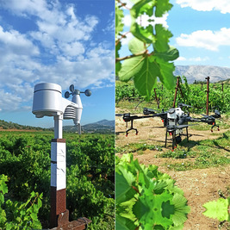
Figure 3 Example of the technological components deployed in Use Case 2 (Anthymildis et al., 2023

Activity 1
Allow approximately 5 minutes.

Match the different resources listed below with the correct resource type.

Funding from investors
Machinery and tools
Patented innovation
A skilled human resource (e.g. a drone pilot)
Tangible (financial)
Tangible (physical)
Intangible
Human
View answer - Activity 1

1.2 Key activities
Key activities are the core activities performed by the organisation to make the business model work. Activities combine resources to deliver value propositions, reach markets, keep customer relationships, and generate revenue. Activities depend on the type of business model offered by the organisation. If it is a product business model, some production or operational activities would take place in order to deliver a product or a service. If it is a matchmaking business model, activities will be more related to the management of the platform.
Production, problem solving and platform/network activities are three main categories for key activities.
- Production activities pertain to the design, manufacturing and delivery of a product in significant quantities and/or exceptional quality. For instance, drone manufacturers are mainly in this key activity type.
- Problem solving activities often relate to providing a new solution or service to a customer’s problem. For instance, drone spaying organisations dedicate themselves to offer optimal plant protection product usage to their customers.
- Platform/network related key activities are mainly reflected in the case of matchmaking or multi-sided business models introduced in Week 2. Activities are concentrated on running a platform, promoting its diffusion and provisioning service. For instance, the ICAERUS platform websiteintegrates comprehensive information about drone application in agriculture sectors to serve all kinds of stakeholders; their key activities include managing the website, promoting the platform by various dissemination activities and updating information to serve their stakeholders.

Activity 2
Allow approximately 15 minutes.

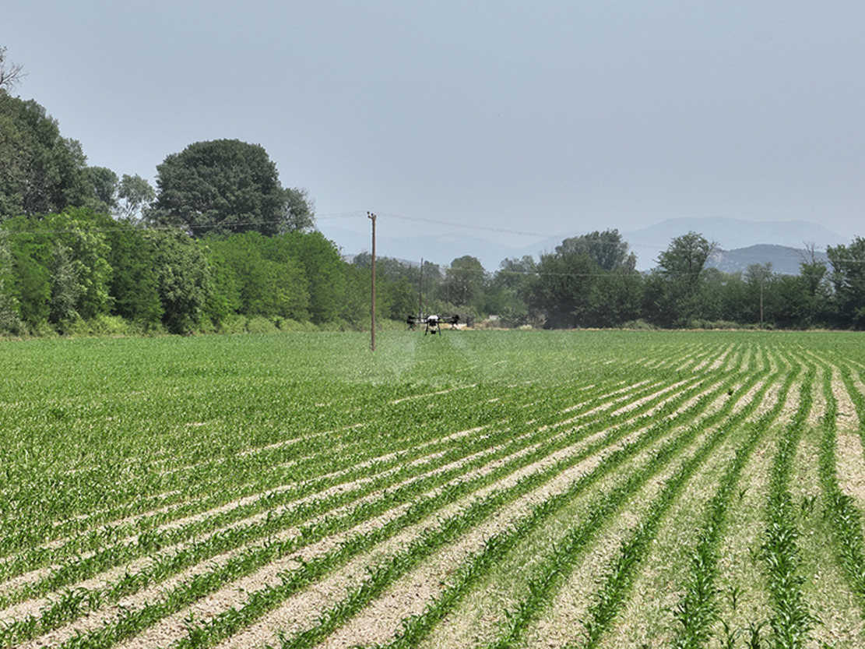
Figure 4 A Photo of a drone spraying

Considering Use Case 2 – Drone Spraying, what key activities should be performed to support the business model outlined in Week 5?

Provide your answer...
View discussion - Activity 2

1.3 Key partners
Key partners are fundamental for every business model. Which activities are delivered by partners? Which resources are provided by partners? Which key resources can be acquired from partners? Which key activities do partners perform? These are key questions this block tries to answer.

Key partners
Key partners are the external companies, organisations or individuals that a business work with to create and deliver the value. There are several types of key partners.
- Strategic alliances involving non-competing companies. For example, agricultural research institutes are key strategic partners to drone spraying businesses for research and development collaboration.
- Competition characterised by strategic partnerships between competitors. For example, competing companies in the drone spraying industry might share anonymised crop data to improve overall spray accuracy and crop health analytics.
- Joint ventures established to foster the development of new businesses. A drone manufacturer and an agricultural service provider might form a joint venture to establish a dedicated company that focuses on the design, production, and service of drones specifically for spraying applications.
- Buyer–supplier relationships aimed at ensuring dependable suppliers. For example, drone spraying business partners with drone manufacturers.
Organisations form partnerships with the aim of enhancing their business models, reducing risks or securing resources. In the sustainable business model canvas, this is also known as motivation for partnerships.
- Acquisition of particular resources and activities: it is rare that an organisation owns all the resources they need for their business. Therefore, obtaining certain resources and activities such as knowledge and licenses by partnering with other organisations would be beneficial for the business.
- Optimisation and economy of scale: in designing a business model it is important to consider whether activities should be done internally or externally. This choice depends on several factors including economies of scales.
An economy of scale arises if fixed costs remain constant as output increases, thus lowering the cost per unit of output. The concept is usually applied to explain the benefits arising from increasing the size of an organisation. For instance, a larger company can spread the fixed costs of its administrative staff or of its plant on more products than a smaller company. This means that the unit cost of the products for the larger company will be lower.
Since economies of scales can be different across industries, it is then necessary to decide whether to do some activities internally or to enlist the help of partnerships and suppliers. In a drone spraying business, advanced drones and plant protection products are key resources. The production of plant protection products requires large plants and investing in an in-house production would not be efficient. Drone components are mostly developed by large companies, but their customisation can happen at a smaller scale.
- Reduction of risk and uncertainty: partnerships could help to reduce risk and uncertainty in a competitive or new environment. For example, as the drone industry is in the introduction stage of the industry lifecycle, partnering with agricultural research institutions for research and development collaboration would enable the possibility of testing multiple technological solutions and spread the risk of failure across several partners. Uncertainty will also be reduced due to the sharing of knowledge and the development of capacity, which is one of the objectives of the ICAERUS project.

1.4 Designing the infrastructure area
Now that you have explored the sub-block of the infrastructure area of the business model canvas, you can apply this knowledge to Use Case 2 – Drone Spraying.

Activity 3
Allow approximately 15 minutes.

Considering Use Case 2 on Drone Spraying, match the examples given below to the related infrastructure area in the business model canvas template.

View discussion - Activity 3

From this activity you can see the importance of connecting resources, activities and partners in a way that their combination is able to deliver the value proposition.

2 The financial viability area
The financial viability area of the sustainable business model canvas is composed of two blocks: cost structure and revenue streams.

Figure 5 The sustainable business model canvas
View description - Figure 5 The sustainable business model canvas

In the following sections you will look at both in turn in more detail.

2.1 Cost structure
Cost structure identifies the costs underlying the business model. The questions at issue here are:
- What are the most important costs inherent in the business model?
- What costs are generated by the resources employed?
- What costs originate from the activities of the business model?
If the business model focuses on efficiency, the cost structure is cost-driven. The cost-driven business models tend to minimise the costs wherever possible by offering low price value propositions, extensive automation and outsourcing. Low-cost airlines such as EasyJet and Ryanair are good examples for cost-driven business models.
If the business model is oriented towards providing superior value to the customer, then the cost structure can be defined as value-driven. Value-driven business models tend to prioritise value creation by offering premium value propositions with a high level of customised services.
Based on attributes, costs could be classified as fixed costs, variable costs, economies of scale and economies of scope.
- Fixed costs are costs that remain the same no matter how many products or services are offered. For example, rents and utilities are typical examples of fixed costs. In the case of drone spraying, compliance and certification costs are fixed costs.
- Variable costs are costs that change in proportion to the quantity of products or services produced, such as plant protection product purchase costs in drone spraying businesses.
- Economies of scale: these are cost advantages that a business experiences as its output increases. See the previous section for more details.
- Economies of scope: these are cost advantages that a business gains as a result of expanding its activities in different industries or related businesses. In other words, the same resource can be used in different activities: a drone pilot can serve both an agricultural business, but in case of emergency the same company can be asked to offer drone delivery services and the pilot could be employed in this different activity.

2.2 Revenue streams
Revenue streams are the sources of revenues that the business model is able to generate. The question at issue here is: ‘For what value are customers willing to pay?’ (Osterwalder et al., 2010, p.31). It is also important to clarify how revenues are collected or, in other words, how customers pay. Different types of business models have different ways of generating revenues. The different types of revenue models are advertising, subscription, transaction fee, sales and affiliate models. A business model is able to generate both one-time payment transaction revenues and recurring revenues by continuing to offer value proposition to customers, or from post-sale services.
In the case of a drone spraying business, there are several ways they can generate revenue:
- direct sale of drone systems
- subscription services for software and data analysis tools
- leasing programs for drones and equipment
- training services for farmers and agricultural workers
- consultancy fees for providing expert advice and customised solutions.
Revenue streams are also dependent on pricing mechanisms. Osterwalder et al. (2010, p.33) identify two main mechanisms: fixed price, based on static variables; and dynamic prices, based on market conditions.
The following table shows the fixed prices mechanism.

Table 2 Fixed price mechanisms
Pricing mechanisms | Description | Example
Fixed pricing | The price is fixed and does not change | Some commodities whose price is fixed, such as water or energy (considering a short-term horizon).
Feature dependent | The price is based on the level of quality | The price of a model of a car depends on the trim and the option
Customer segment | The price changes according to the customer segment approached | The price may change for particular groups of clients, such as students
Volume dependent | There are discounts related to quantity purchased | Many sellers of goods offer discounts if products are bought in large quantities

Dynamic price mechanisms are presented in the table below.

Table 3 Dynamic price mechanisms
Pricing mechanisms | Description | Example
Negotiation | The counterparts negotiate an agreement | The price is agreed and usually defined in a specific contract: house renovations are typically agreed between the contractor and the landlord.
Yield management | The price changes according to availability and time | Flight tickets are priced dynamically according to several variables, including the time of purchase and the capacity.
Real-time market | The price changes according to supply and demand | This is the typical case of stock markets
Auctions | Competitive bidding defines the price | Auction houses such as Sotheby’s in London or online platform such as eBay offer this kind of pricing mechanism.

Activity 4
Allow approximately 5 minutes.

Considering the pricing mechanisms in Tables 2 and 3, match the product or service proposed below with its most likely pricing mechanism.

Hotel rooms
Retail clothing
House sales
Abandoned property
iPhone
Software licences for business and academic statistical software
Bulk purchase of groceries
Foreign currency
Yield management
Fixed price
Negotiation
Auction
Feature dependent
Customer dependent
Volume dependent
Real-time market
View answer - Activity 4

2.3 Designing the financial viability area
Now that you have explored the blocks of the financial viability area of the sustainable business model canvas, you can apply this knowledge to Use Case 2 – Drone Spraying.

Activity 5
Allow approximately 15 minutes.

Using Use Case 2 on Drone Spraying, match the examples given below to the related financial viability area in the business model canvas template.

View discussion - Activity 5

3 The sustainability area
This area of the sustainable business model canvas is made up of two blocks: eco-social costs and eco-social benefits. As introduced in Week 4, these two blocks were added to the original version of the business model canvas by Osterwalder et al. (2010) by members of the CASE Project (CASE, 2018). The ecological and social impact of the activities are the focus for this area: these blocks aim to help maximise positive outcomes while minimising negative effects on both the society and the environment. As a result, sustainability is ingrained within the fundamental operations of the business.

Figure 6 The sustainable business model canvas
View description - Figure 6 The sustainable business model canvas

3.1 Eco-social costs
When considering the eco-social costs of a business, the questions at issue are:
- What ecological or social costs is the business model causing?
- Which key resources are non-renewable?
- Which key activities consume substantial resources?
For instance, eco-social costs for a drone spraying business would be consumption of materials and energy to deliver the value proposition and accomplish key activities (i.e. spraying chemicals on specific trees or even leaves of a tree and disposal of old drones and parts). Re-using and recycling materials could help to minimise such costs.
Life Cycle Assessment (LCA) is commonly used to assess the eco-social costs for a business. LCA is the systematic analysis of the potential environmental impacts of products or services during their entire life cycle (‘cradle-to-grave’ analysis). In the following video, an expert on LCA will introduce you to the aims, method and outcomes of LCA.

Video content is not available in this format.
Video 1
View transcript - Video 1

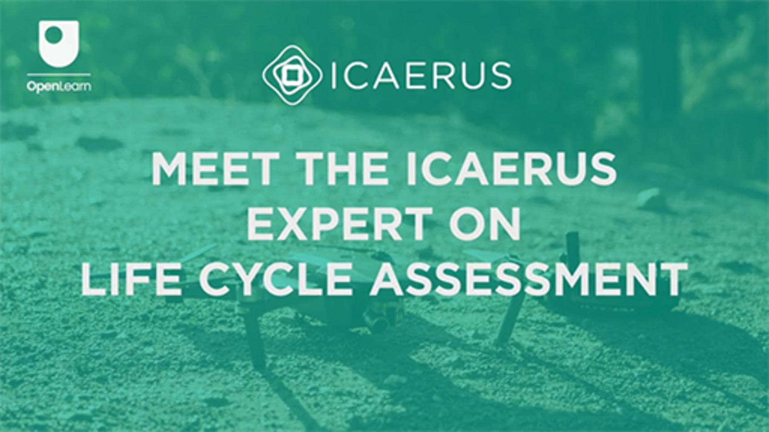

According to Barrionuevo (2023, p. 14), the implementation of LCA enables:
- the evaluation of the environmental burdens linked with a product, process or activity by identifying and quantifying energy and materials usage as well as wastes released into the environment
- the assessment of the impact of the energy and materials utilised and released into the environment
- the identification and assessment of opportunities for environmental enhancements.
When a LCA is performed, it is necessary to define the scope of the analysis (Step 1) by identifying the product or system to be studied (definition of the system boundaries) and the related input and outputs. Figure 7 shows a model of this process.

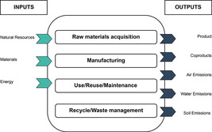
Figure 7 Graphic representation of flows in and out of the system (Barrionuevo, 2023)
View description - Figure 7 Graphic representation of flows in and out of the system (Barrionuevo, ...
View alternative description - Figure 7 Graphic representation of flows in and out of the system (Barrionuevo, ...

A whole life cycle of a product/service encompasses a number of stages:
- material extraction
- production
- packaging and distribution
- use
- end of use
- waste treatment or recovery.
Step 2 of the assessment aims to identify indicators which quantify the different inputs (e.g. energy, water, resources, land) and outputs (e.g. emissions, wastes, products) of the life cycle of an industrial process, technology, or commodity. This allows the flows of energy, resources and materials in and out of the system being studied to be mapped. Indicators should measure distinct quantities like volume, mass, or weight. The kind and quality of the data used to compile this inventory will determine the robustness of the results obtained.
In Step 3, impact categories, such as climate change, acidification, terrestrial toxicity, etc. are selected. The results of Step 2 are then categorised. In the last phase (Step 4), the results are interpreted to identify significant issues and to provide recommendations on possible limitations of the study.
The following results of LCA for the Drone Spraying Use Case are expected:
- the adoption of electric-powered drones is anticipated to yield several environmental benefits, including a reduction in groundwater and soil contamination, prevention of biodiversity loss, and mitigation of soil compaction
- employing electric-powered drones is expected to result in a decreased carbon footprint and lower fuel consumption
- the enhanced efficiency of utilising UAVs for pest control is projected to lead to decreased operational and input costs.
(Barrionuevo, 2023)
To conclude the overview of LCA, the following video offers some final advice from Bruno Barrionuevo, the ICAERUS expert on LCA. He offers four suggestions to apply LCA successfully.

Video content is not available in this format.
Video 2
View transcript - Video 2

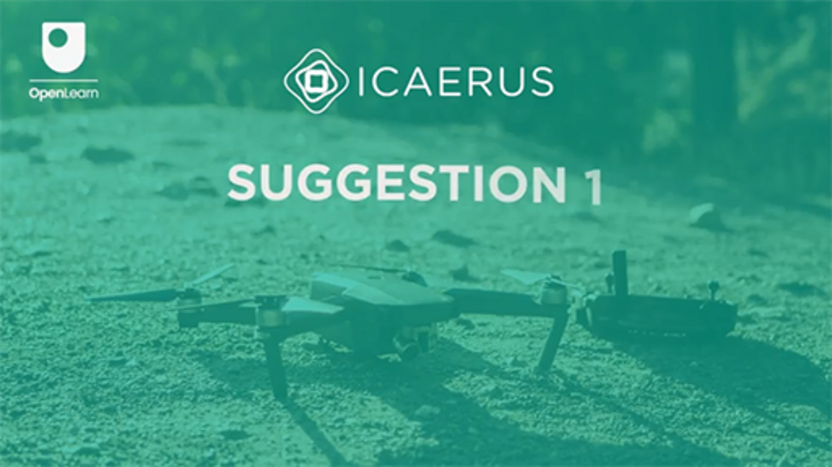

3.2 Eco-social benefits
When considering the eco-social benefits of a business, the questions at issue are:
- What ecological or social benefits is the business model generating?
- Who are the beneficiaries? Are they potential customers?
- Is it possible to transform the benefits into a value proposition?
In the case of drone spraying, the reduction of chemical runoff and exposure will lead to less environmental contamination, increased biodiversity and healthier local communities.
When considering eco-social benefits, you may also be thinking about the Sustainable Development Goals (SDG). These are a set of 17 global objectives established by the United Nations General Assembly in 2015 as part of the 2030 Agenda for Sustainable Development.
The SDGs aim to tackle a variety of global issues, including poverty, inequality, climate change, environmental degradation, peace, and justice. Each goal includes specific targets and indicators to track progress, with the aim of achieving them by 2030. These goals are designed to be interconnected, acknowledging that actions in one area will influence outcomes in others, and emphasising that development must balance social, economic, and environmental sustainability. The 17 goals are shown in the figure below.

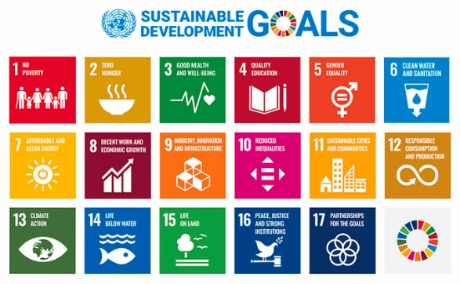
Figure 8 The United Nations’ Sustainable Development Goals (SDG)
View description - Figure 8 The United Nations’ Sustainable Development Goals (SDG)
View alternative description - Figure 8 The United Nations’ Sustainable Development Goals (SDG)

When thinking of the eco-social benefits block of the sustainable business model canvas, it is important to reflect on how your business model might influence specific SDGs. For instance, in the case of drone spraying, Goal 15 – life on land (i.e. protect, restore and promote sustainable use of terrestrial ecosystems, sustainably manage forests, combat desertification, and halt and reverse land degradation and halt biodiversity loss) and Goal 3 – good health and well-being (i.e. ensure healthy lives and well-being at all ages) would be applicable as the reduced chemical use would contribute to a healthier ecosystem and increased biodiversity, as well as benefiting the field workers and local communities’ health. Moreover, the drone industry itself as an innovation would match Goal 9 – industry, innovation, and infrastructure (i.e. build resilient infrastructure, and sustainable industrialisation and foster innovation).
In addition to the SDGs, the Common Good Balance Sheet is a tool which can be used to assess the eco-social benefits of a business based on various indicators related to human dignity, solidarity, environmental sustainability, social justice, and democratic participation. The common good matrix serves as a framework for assessing business activities and facilitating organisational growth. 20 Common Good themes describe and offer direction on evaluating an organisation’s contribution for the common good.

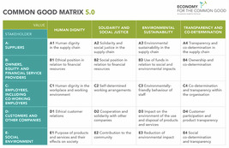
Figure 9 Common Good Matrix (Blachfellner, et al., 2017)
View description - Figure 9 Common Good Matrix (Blachfellner, et al., 2017)
View alternative description - Figure 9 Common Good Matrix (Blachfellner, et al., 2017)

To use the Common Good Matrix, you need to understand the four values in the columns shown in Figure 9 and how they match with the different groups of stakeholders in the rows.
You could gather data and information from your business and assess each indicator within the matrix. You could rate each good theme on a scale (such as 1 to 7 or 0 to 10), with a higher score equating to a better performance. You could then analyse the results and identify the strengths and weaknesses of your organisation against each theme for future improvement.
For example, if you want to measure environmental sustainability, you would need to gather information on the indicators about resource consumption and waste management, and measure energy usage, water consumption and waste production. Page 69 of the document in the Further reading below provides more information about E3 reduction of the environmental impact.

Further reading
For more information, visit: Workbook, Compact balance sheet 5.0 (Blachfellner, et al., 2017)

4 Piecing the canvas together
The eleven blocks in the sustainable business model canvas are interconnected. Together they provide a comprehensive view of how a business creates, delivers and captures value. For instance, key partners can provide additional resources needed to deliver value, may perform key activities that complement the organisation’s own activities, could enhance value proposition via collaboration and resources sharing, could extend or support distribution channels, which may lead to additional revenue streams or reduced costs. Changes or decisions in one area can significantly impact others, therefore, keeping a holistic strategy in mind when designing a business model is important.
The four areas or blocks of the sustainable business model canvas piece together:
- the value proposition and the customer profile, which assesses how what the organisation proposes matches with what customers want
- the infrastructure area and the customer area of the business model canvas, which evaluates the balance between the resources and activities developed to create value and the way in which the value is provided to the customer
- the two blocks of the financial viability area: the cost structure and the revenue streams which should be balanced to give the business financial sustainability
- the two blocks of the sustainability area to maximise positive outcomes while minimising negative effects on both the society and the environment.
Together with Week 5, this week has shown you how to design a business model using the sustainable business model canvas. You have looked at Use Case 2 – Drone Spraying from the ICAERUS project as an example. Figure 10 shows you an integrated business model canvas of drone spraying. As mentioned before, all blocks in the business model are somehow related to each other.

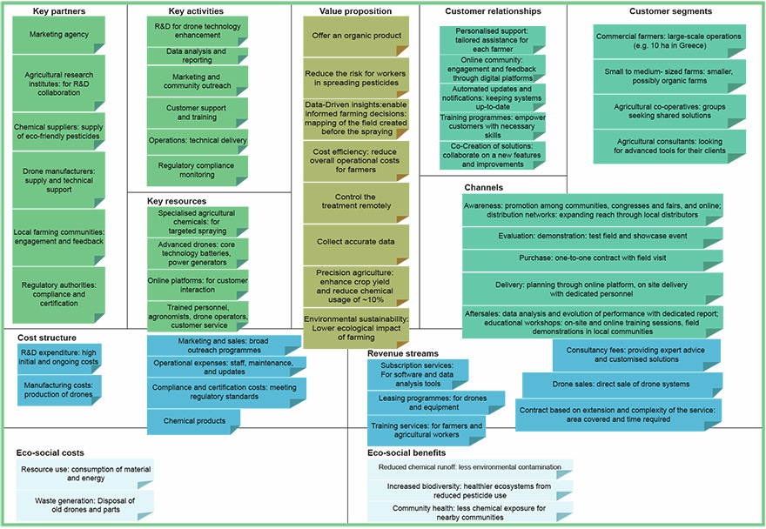
Figure 10 A possible sustainable business model canvas for drone spraying. You can download a larger, PDF version of Figure 10 here.
View description - Figure 10 A possible sustainable business model canvas for drone spraying. You can ...

Download the sustainable business model canvas template here.

5 This week’s quiz
Now that you’ve completed Week 6, you can take a short quiz to help you to reflect on what you’ve learned.
Week 6 practice quiz
Open the quiz in a new tab or window and come back here when you’ve finished.

6 Summary of Week 6
This week you have learned about seven of the blocks that make up the sustainable business model canvas. They are:
- key resources, key activities, key partners (infrastructure area)
- cost structure and revenue streams (financial viability area)
- eco-social costs and eco-social benefits (eco-social area).
You have also seen how each block can be related to and influence each other; as well as how each block applies in the Drone Spraying Use Case.
You should now go to Week 7.

References
Anthymildis, M., Grigoriadis, K. and Polychronos, V. (2023) D3.1: Use Case Plan, Version A. ICAERUS Consortium, 2022
Barrionuevo, B. (2023) D3.5: Report on Socio-economic and Environmental Impact, Version A.
Blachfellner, M., Drosg-Plöckinger, A., Fieber, S., Hofielen, G., Knakrügge, L., Kofranek, M., Koloo, S., Loy, C., Rüther, C., Sennes, D., Sörgel, R. and Teriete, M. (2017) Economy for the Common Good Workbook Compact balance sheet 5.0. Available at: https://www.ecogood.org/wp-content/uploads/2020/04/ecg_compact_balance_sheet_workbook.pdf (Accessed: 22 May 2024).
CASE (2018) Sustainable Business Model Canvas. Available at: https://www.case-ka.eu/index.html%3Fp=2174.html (Accessed: 21 June 2024).
Grant, R. M. (2016) Contemporary Strategy Analysis, New York: John Wiley and Sons.
McAdam, J. (2013) The One-Hour Business Plan. 1st edn. Hoboken, New Jersey: Wiley
Osterwalder, A., Pigneur, Y. and Clark, T. (2010) Business Model Generation: A Handbook for Visionaries, Game Changers, and Challengers. Hoboken: Wiley.

Acknowledgements
This free course was written by Giacomo Carli, Kristen Reid and Despoina Filiou. This week was written by Jie Deng and Giacomo Carli.
The development of this course was funded by the ICAERUS project.
The ICAERUS project was funded by the EU under the Horizon Europe scheme Grant Agreement 101060643 and UK under Innovate UK reference 10038181.
Except for third party materials and otherwise stated, including any quotes referenced in the course and not acknowledged here (see terms and conditions), this content is made available under a Creative Commons Attribution-NonCommercial-ShareAlike 4.0 Licence .
The material acknowledged below is Proprietary and used under licence (not subject to Creative Commons Licence). Grateful acknowledgement is made to the following sources for permission to reproduce material in this free course:
Course image: Courtesy: Dr Katerina Kasimati
Course badge: © The Open University
Figures
Figure 3: Example of the technological components deployed in Use Case 2 (Anthymildis et al., 2023) Courtesy: Dr Katerina Kasimati
Figure 4: A Photo of a drone spraying Courtesy: Dr Katerina Kasimati
Figure 7: Graphic representation of flows in and out of the system (Barrionuevo, 2023) Adapted from Barrionuevo, B. (2023) D3.5: Report on Socio-economic and Environmental Impact, Version A.
Figure 8: United Nations Sustainable Development Goals https://sdgs.un.org/goals
Figure 9: Common Good Matrix Publisher: Matrix Development Team April 2017. Authors: Manfred Blachfellner, Angela Drosg-Plöckinger, Susanna Fieber, Gerd Hofielen, Lutz Knakrügge, Manfred Kofranek, Sigrid Koloo, Christian Loy, Christian Rüther, Dominik Sennes, Regina Sörgel, Moritz Teriete.Editors: Angela Drosg-Plöckinger, Manfred Kofranek, Sigrid Kolo https://creativecommons.org/licenses/by/4.0/deed.en
Videos
Video 1: Meet The ICAERUS Expert on Life Cycle Assessment: ©The Open University (2024)
Video 2: Life Cycle Assessment suggestions 1-4. ©The Open University (2024)
Every effort has been made to contact copyright owners. If any have been inadvertently overlooked, the publishers will be pleased to make the necessary arrangements at the first opportunity.
Don't miss out
If reading this text has inspired you to learn more, you may be interested in joining the millions of people who discover our free learning resources and qualifications by visiting The Open University – www.open.edu/openlearn/free-courses.

Week 7: Ecosystems and networks

Introduction
Welcome to Week 7 of Developing business ideas for drone technologies. This week focuses on business, innovation and entrepreneurial ecosystems. Such ecosystems are embedded in a vast array of networks which in turn are formed through a complex web of both informal and formal collaborations.
This week focuses on examples from ICAERUS Use Case 3 on the use of drones for livestock management in France and maps the networks that found this early-stage ecosystem. You will explore different types of such ecosystems and create links with drone innovation and entrepreneurship. Finally, you will go deeper in understanding the role of networks for business and entrepreneurship and you will develop relevant skills. Figure 1 shows the learning cycle for Week 7.

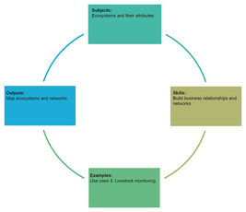
Figure 1 Week 7 learning cycle
View description - Figure 1 Week 7 learning cycle
View alternative description - Figure 1 Week 7 learning cycle

By the end of Week 7, you should be able to:
- understand the meaning of ecosystems for business, innovation and entrepreneurship and how to identify them in practice
- explore in depth the meaning of entrepreneurial ecosystems in the context of ICAERUS and the case of livestock monitoring in France
- understand the role of networks in business and entrepreneurship
- develop networking skills for entrepreneurship.

1 Ecosystems in business and management
The word ecosystem is often associated with nature. The word itself stems from ecology and system: eco-system. In nature, an ecosystem is a collection of living things and the environment in which they live. The size and boundaries of an ecosystem, the bits to be studied, and the interactions to be investigated, are all determined by what we want to know. So an ecosystem can be large (a rainforest) or small (a pond). Large ecosystems can also often be broken down into a number of smaller ones. The important thing is that ecosystems are produced by living organisms interacting with each other and the physical environment (OpenLearn, 2019). Or in other words, ecosystems are systems that have within them other systems, which might in turn be embedded or overlapping with other systems.

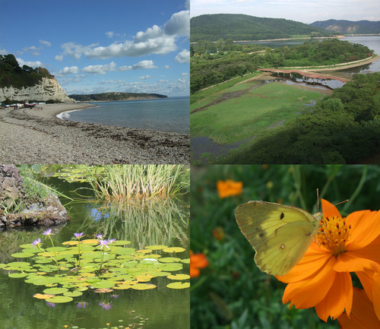
Figure 2 Four different habitats which can be individual ecosystems or groups of ecosystems. They may constitute different ways of understanding ecosystems
View description - Figure 2 Four different habitats which can be individual ecosystems or groups of ...
View alternative description - Figure 2 Four different habitats which can be individual ecosystems or groups of ...

The concept of ecosystems has improved our understanding of phenomena in social science and in business management. After all, ‘no business is an island’ and business interactions are very important! Even entrepreneurs with groundbreaking new business ideas rely on other businesses and individuals to bring their ideas to market. Understanding business relationships and interconnections is very important for entrepreneurs, managers, business owners and policy makers.

1.1 Business interactions and ecosystems
It is typical for a business to interact with other businesses, organisations and their end-users. But how can ecosystems in business and management be identified? This can be challenging because of the complexity of ecosystems; so to start, let’s look at a broad definition of ecosystems in business:

‘in management and economics, the term [ecosystems] is now widely used to denote a network of autonomous economic actors interacting to create value, including a complementary surplus, which is distributed across actors.’
(Baldwin et al, 2024, p. 1)

The actors of an ecosystem are independent and can include any type of organisation or even individuals. At the same time, actors in an ecosystem complement each other and this is the basis for creating aggregate value that is more than the sum of its parts. In other words, the joint action and interdependencies across such actors create surplus joint value. Interactions among actors are based on various bilateral and multi-lateral agreements, such as contracts, exchange relations, negotiations and standards.
Another principle of an ecosystem is that its products and processes are parts of a broader architecture. Oftentimes in practice this is the technical architecture of a product. For example, think of the production of the Boeing aircraft, with different parts (engine, wings) produced by different actors (Rolls-Royce and Mitsubishi) located in different countries. By using complex processes, these parts are brought together in the final product architecture, the aircraft itself.
This is just an introductory example, and the sections that follow offer examples from other products from daily life (see Section 6). In this week you will also discuss examples of drone ecosystems such as the one portrayed in Figure 7 in Section 6.

2 Ecosystems: using drones for livestock management
Ensuring both environmental and economic sustainability of rural areas is highly challenging. A high number of parameters and actors are involved; sustainability requires joint and coordinated action. Adopting an ecosystem’s lens helps to understand how new technology-based solutions, such as the use of drones, can be applied to offer sustainability solutions in specific contexts.
Before you explore in detail how concerted actions of actors in rural areas can promote sustainability, you will first explore some of the challenges faced by ruminant farmers.

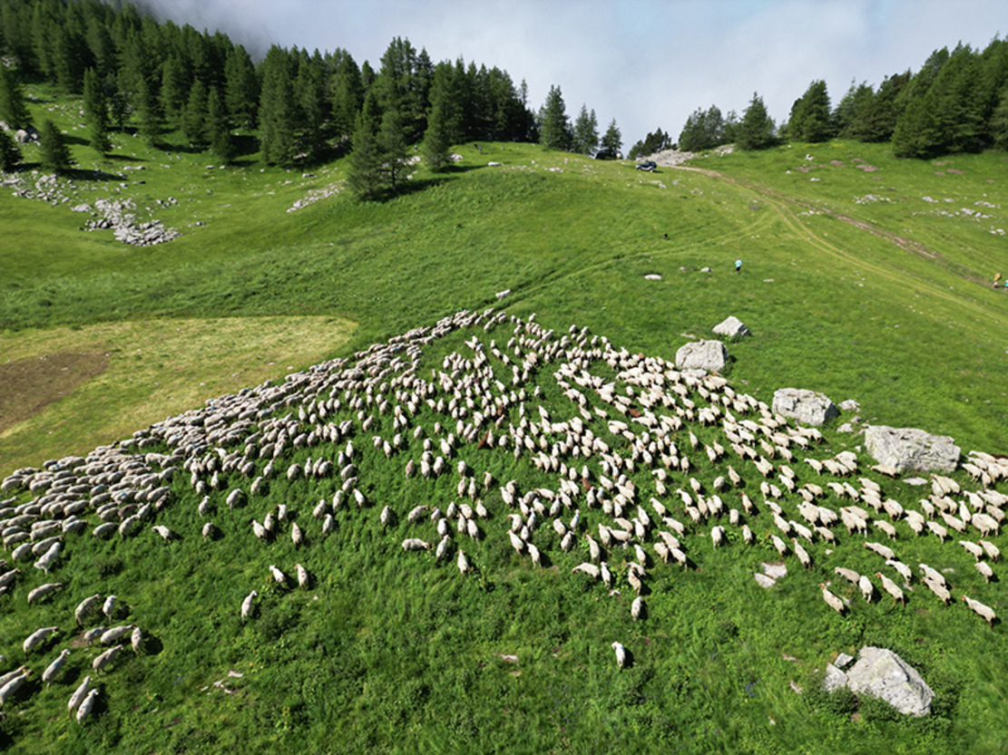
Figure 3 Summer pasture of the sheep pilot farm (Ferme de Carmejane), Alpes De Hautes Provences, France
View description - Figure 3 Summer pasture of the sheep pilot farm (Ferme de Carmejane), Alpes De Hautes ...

Activity 1
Allow approximately 5 minutes.

Ruminant farming lies at the heart of the economies of isolated rural areas, with oftentimes challenging landscapes. Based on your experience and knowledge of ruminant farming, reflect on the following statements and select whether you think they are true or false.

Nowadays ruminant farmers apply a wide range of technologies to support them with their livestock production processes.

True
False
View answer - Part

Contemporary approaches to livestock farming have made this an easy profession.

True
False
View answer - Part

Because of its proximity to nature, life in rural areas is conducive to well-being.

True
False
View answer - Part

One of the biggest challenges of ruminant farming is the high time demands of monitoring livestock, managing grassland, and the time needed to master all the related technologies. All these make ruminant farming a very labour intensive and time demanding profession. Resorting to seasonal labour to relieve pressure from such demands is not always a readily available option to farmers. The combined impact of these factors is that ruminant farmers do not enjoy a good work-life balance. The pressures from the job can impact on farmer well-being and can also make the profession less appealing to future generations.

3 Drone use for sustainable livestock management in rural France
Supporting ruminant farmers is a high priority area for policy makers, because it can ultimately ensure both the economic and environmental sustainability of rural areas. Specialist research organisations on ruminant farming have funding to pilot research projects on interventions that can improve time efficiencies, quality of life and, in turn, the appeal of this profession to future generations.
IDELE (Institut De L’Elevage) is a not-for-profit research organisation with expertise in livestock monitoring and farming. IDELE is currently piloting the use of drones in rural France as part of the ICAERUS project. The pilot research involves two exemplary farms and the use of drones to monitor livestock on grasslands in the Municipalities of Jalogny (Ferm’Inov farm) and Le Chaffaut-Saint-Jurson (Carmejane farm).

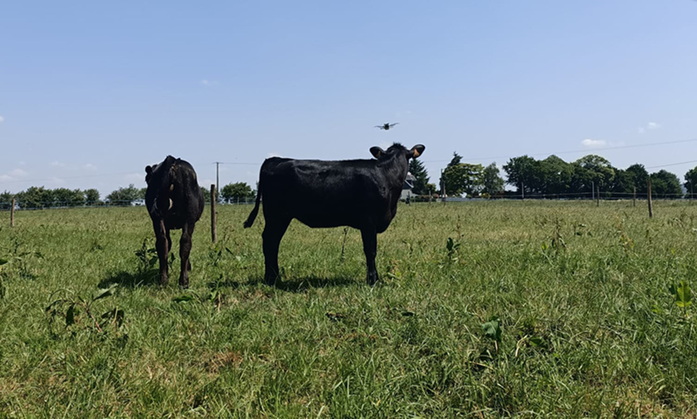
Figure 4 Drones used in livestock monitoring, IDELE research facility: CIRBEEF farm, Brittany, France
View description - Figure 4 Drones used in livestock monitoring, IDELE research facility: CIRBEEF farm, ...

Using drones on alternating days, relieves farmers from time demands while ensuring that continuous oversight of livestock is maintained. Preliminary results indicate that farmers saved 30% of their time when using drones. Note that time savings depend on the type of farm and the working methods used. Over time, the use of drones can give farmers access to a wide range of data on animal physiology. Sophisticated analysis of such data can enable farmers to better diagnose animal health, nutrition and pregnancy demands. Such analytics will offer reliable support and relief from some job pressures whilst improving animal welfare.
Research at IDELE is currently exploring drone-animal interaction, and by training animals to get accustomed to the drone noise it minimises any potential adverse impact on their welfare.
The use of drones is increasing outside this pilot initiative. In France, currently 8% of ruminant farmers are already using drones, and another 20% are considering adoption (IDELE, 2023). There is a need for formal training and certification to ensure compliance and minimise risks with animal interference and neighbouring civilian concerns. Access to drones needs to be made available to all farmers, as current costs can make it both a costly and risky investment.

4 Drone-driven ecosystems for sustainable livestock management in rural France
There is a wide range of actors, such as policy makers, regulators, farmers, drone manufacturers, that are all interested in exploring and supporting the uptake of drones for livestock management.
Figure 5 below maps the interactions and interdependencies of all the actors that have a direct and indirect interest (akin to ‘stakeholders’ of Week 1) in this area and that are linked to the pilot research of IDELE.

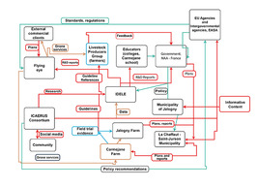
Figure 5 Drone-driven ecosystem for livestock management in rural France as captured in 2023 (Bojkova et al., 2023)
View description - Figure 5 Drone-driven ecosystem for livestock management in rural France as captured ...
View alternative description - Figure 5 Drone-driven ecosystem for livestock management in rural France as captured ...

Graph note: Red boxes denote new research/exploratory generated knowledge (e.g. reports, guidelines, data); Green denotes policy recommendations/implications; Green denotes information/resource flows linked to drone technical aspects. NAA: National Aviation Authority, a governmental organisation in France; EASA: European Agencies and Inter-governmental Agencies in drone regulation.
Figure 5 gives an example of a drone-driven ecosystem for livestock management in this specific area of France. Note that the actors represented in the graph are connected through various mechanisms and complex relations and depend on each other to source expert knowledge and understanding of drone use regulations, and evidence-based research findings on the benefits of drone use for livestock management. (The note on Figure 5 offers details on how each type of interaction is represented in the graph using colours).
The text below explains in detail how different actors depend on each other to source something valuable. The links between the different actors in Figure 5 are captured by directional arrows. These directional arrows represent flows of different types of ‘value’ (e.g. information on technical aspects, research findings) that is exchanged, shared or jointly created by the actors in this ecosystem. For instance, IDELE gets evidence on the use of drones from pilot research from field trials on the Jalogny farm (orange arrow). IDELE uses this evidence, together with its expertise, to generate evidence-based research reports documenting the costs/benefits for the use of drones. These reports can in turn be directed to both:
- the French government to inform new policy in the use of drones in rural areas
- Flying Eye, a leading manufacturer and distributor of drones in France, to support them with research on manufacturing purpose-built drones specific for this market of livestock management.

5 Ecosystem attributes: knowledge
Figure 5 in Section 4 reflects the complexity of ecosystems. As in nature, ecosystems in economics and business can be systems formed by various sub-systems. It is useful to identify specific sub-systems, based on some main characteristics. As the case of the drone-driven ecosystem for livestock management in rural France shows, there are links and interconnections across these sub-systems. An actor can be part of more than one such sub-system.
For example, ecosystems where their main attribute is new knowledge creation, also known as knowledge ecosystems, are formed to generate new knowledge or a new understanding on specific topic areas.

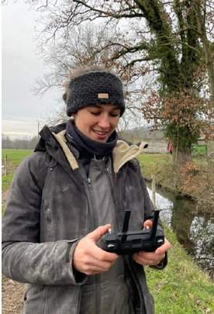
Figure 6 Victorine Perrin-Peyer, a farm worker and herd technician of IDELE at Ferm Innov, a beef cattle pilot farm. Victorine also runs her own farm
View description - Figure 6 Victorine Perrin-Peyer, a farm worker and herd technician of IDELE at Ferm ...

Typical actors that interact in such ecosystems are universities, research centres, government agencies and potentially firms. Knowledge ecosystems create value not only by generating new knowledge but also through its dissemination. This means that the aggregate/joint value of knowledge ecosystems might not be directly commercially exploited. It can, however, benefit all actors in the ecosystem, or even actors beyond this specific geographical ecosystem. As you will see later, drone demonstration events disseminate knowledge on drone use with broad benefits for both participants and their communities.

Activity 2
Allow approximately 10 minutes.

Go back to Figure 5 and closely inspect the different actors of the drone-driven ecosystem for livestock management in rural France. Can you identify any actors that may typically comprise a knowledge ecosystem?

Provide your answer...
View discussion - Activity 2

Knowledge ecosystems can play an important role in the uptake of drone technologies in agriculture. Drones are a new technology, and evidence-based research is needed to understand the benefits of using drones as well as their limitations and how these can be overcome. Look back at Week 1 to appreciate the importance of generating new knowledge in reducing uncertainty around the adoption of new technologies.

6 Ecosystem attributes: innovation
Innovation is a fundamental attribute of many ecosystems. Think of some of the products you use daily. The iPhone is an example of an innovation ecosystem. The product itself is a technical arrangement (or architecture) of different complementary components. Apple is the coordinating firm and collaborates with a wide range of component suppliers and software developers (creating the various applications) to provide innovative products of unique value to end users.
Innovation ecosystems can have a central coordinator (a firm or a hub); in this case they can also be known as platform ecosystems, such as the example of Apple above. Innovation ecosystems can also be non-platform based. In the latter case, the actions of different ecosystem actors are coordinated with various types of bilateral and multilateral relations and agreements and not by a single firm. Later sections in this week discuss the importance of such relations and how they can be managed in the context of networks.
The figure below shows how these concepts can be made relevant to drones.

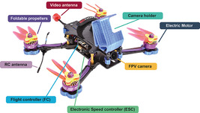
Figure 7 A drone and its components
View description - Figure 7 A drone and its components

Figure 7 above shows the different components of a drone, such as batteries, cameras and motors. There can be other types of components in a drone, such as multispectral or thermal cameras depending on the specific drone use. Moreover, as discussed in Week 1, the main body of the drone can take different forms such as fixed-wing, multi-rotor or helicopter. There are more parts in a drone architecture not captured in Figure 7, such as the software used to capture and analyse the data gathered (see Bojkova et al., 2023). Finally, drones can be piloted with hand-held controllers and these peripherals can also be considered as parts of the drone innovation ecosystem.
Innovations can stem from different parts of this ecosystem. In turn, innovations on each part can be led by a different firm or type of organisation. Currently drone ecosystems are dominated by a small number of large corporate organisations which produce both the main frame and most of the components (see Doornbos et al., 2024).

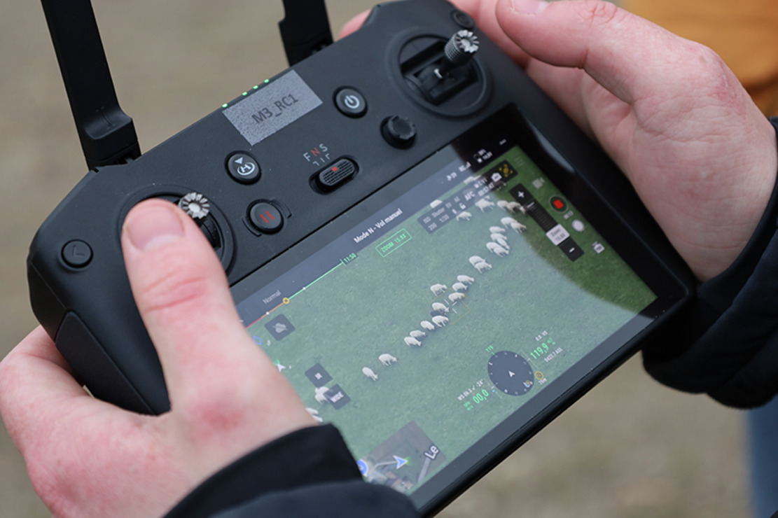
Figure 8 A drone hand-held controller with high resolution screen, allowing for close inspection of individual animals from a distance. With such level of detail, drones are worthy of their ‘nickname’: ‘an eye in the sky’. Picture taken during a drone demonstration event led by Adrien Lebreton, at CIIRPO farm, IDELE’s sheep research facility, Massif Central, France
View description - Figure 8 A drone hand-held controller with high resolution screen, allowing for close ...

Modifying drones to better meet the requirements of specific uses can create ample opportunities for innovation. Understanding the specific requirements of users is crucial. For example, most ruminant farmers are currently using ‘generic’ drones which might not completely meet their needs. Users play a crucial role in innovation, and they need to be acknowledged as key actors in ecosystems. IDELE’s research aims at understanding user needs. Flying Eye of Figure 5, the main drone manufacturer and distributor in France can draw on such user needs and use them as a basis to develop a new range of drones to meet the demands of ruminant farming. Moreover, there is ample room for developing advanced software to more clearly identify individual animals in a herd. These can support further innovations in sophisticated analytics that can be used to get insights on animal health and nutrition, which can improve animal welfare and make farming more efficient.

7 Ecosystem attributes: entrepreneurial
Ecosystems can be initiated by policy makers with the view of advancing the economies and welfare of certain geographic areas. These ecosystems are also referred to as entrepreneurial ecosystems.
There are various definitions of entrepreneurial ecosystems. Based on recent understandings of the concept, entrepreneurial ecosystems can be considered as:

… a community of diverse and interdependent agents operating at multiple, interconnected levels, and whose complex interactions within an entrepreneurship conducive environment support self-sustaining and adaptable processes of venture creation and growth.
(Candeias and Sarkar, 2024, p. 78)

Entrepreneurial ecosystems can promote entrepreneurship through the provision of infrastructure (e.g. clusters, incubators). Entrepreneurial activity can also be supported by encouraging, promoting and strengthening the formation of networks amongst entrepreneurs and other actors. These actors can be other businesses, such as suppliers, or public sector organisations which consult on things such as regulations. Moreover, networks with funders, business angels and advisers, and other institutions that offer support services, specialist knowledge and talented labour can support and promote entrepreneurial activity.
It should be noted that drone-driven ecosystems in agriculture and rural areas are primarily focused on enhancing the efficiency and sustainability of existing agricultural businesses and secondary new business formation. The drone-driven ecosystem of ICAERUS Use Case 3 (Figure 5, Section 4) is formed through publicly (both at national-French government and EU levels) funding IDELE to lead pilot research on the benefits of drones for livestock management. This is primarily aimed at supporting existing farmers with the uptake of the technology.
Other actors in this ecosystem play an important role in promoting the use of drones and related entrepreneurial activities. For instance, regulatory actors are crucial in communicating and shaping a regulatory framework conducive to the use of drones for business (these actors are represented by National Aviation Authority (NAA) and EU Aviation Safety Agency (EASA) in Figure 5). Public authorities, such as the municipalities of Jalogny and La Chaffault-Saint-Jurson in Figure 5 are also important because they can ensure that any concerns of the public (e.g. privacy) are appeased (see Filiou et al., 2024).
The interactions among these ecosystem actors can create opportunities that can attract new entrepreneurs, such as businesses, to offer drone-related services or to manufacture purpose-built drones that can better meet the requirements of agricultural tasks. Some of these opportunities might be taken up by existing farmers as a complementary source to their income.
One step in supporting the uptake of drone technologies on the ground is the organisation of drone demonstration events. IDELE often organises ‘open farm’ events to demonstrate new technologies and to create networking opportunities among various actors interested in livestock management. Figure 9 below is taken during a drone demonstration event where stakeholders could experiment and learn more about the technology.

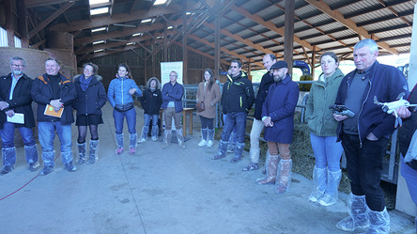
Figure 9 A drone demonstration event run by IDELE during an ‘open farm’ event gathering local farmers and livestock stakeholders from the region around Ferm Inov (a beef cattle IDELE pilot farm), Saône et Loire, France
View description - Figure 9 A drone demonstration event run by IDELE during an ‘open farm’ event gathering ...

In the video below you can watch Adrien Lebreton, a Precision Breeding expert from IDELE, discussing how ‘open farm’ events are organised and the various stakeholders that take part in such events. Stakeholders learn about each other’s needs and preferences through such interactions. Such networking opportunities are important for the further development of drone applications in agriculture.

Video content is not available in this format.
Video 1
View transcript - Video 1

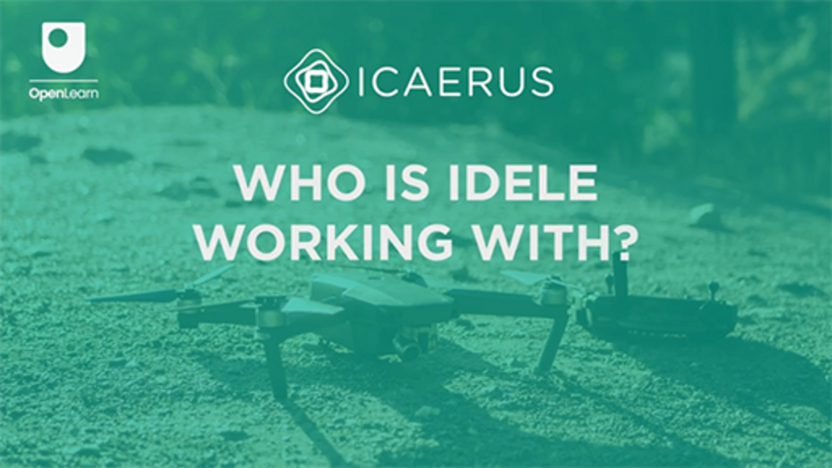

The discussion above highlights how ecosystems are based on complex interactions and networks between various actors. Entrepreneurial activity can be supported by encouraging and strengthening networks amongst entrepreneurs and other actors. The following section discusses the role of networks in entrepreneurship in greater depth.

8 Ecosystems embedded in networks: network relational dimension
Business networks are based on a web of relationships between two or more actors. These relationships can be informal and personal. For example, entrepreneurs rely on their family and friends, personal contact networks, and on their extended social networks to gain access to resources – such as capital and talent – needed to establish their business.


Figure 10 Business networks are embedded on a web of personal interactions
View description - Figure 10 Business networks are embedded on a web of personal interactions

Oftentimes business relations and formal cooperative agreements, such as supplier and buyer contracts, are based on a sea of personal and social networks. This is because knowing your partner helps to build a relationship based on trust. Trust is important because it creates reassurances that partners will commit and honour contractual or exchange agreement. Trust is an important lubricant for knowledge exchange and sharing of valuable information and resources in cooperative agreements.

Activity 3
Allow approximately 20 minutes.

Go back to Week 1 and revisit your business idea. In Weeks 4–6 you were introduced to the business model canvas as a way of gaining an overview of your new business idea and all the elements required to develop it. Use the space below to reflect on how your personal and social networks can support you to gain access to the resources you require to develop your business.

Provide your answer...

Besides trust, for cooperative agreements to work, partners need to meet each other’s objectives and to offer to each other something desirable and valuable. Usually this is based on partners bringing to the agreement either complementary or supplementary resources.
Complementarity between two (or more) partners is an ecosystem principle. It means that two (or more) partners bring together pieces of a jigsaw, as in the case of the drone ecosystem of Figure 7 or the iPhone ecosystem. Complementarities exist between drone products and software, with the latter being based on specialist algorithms trained and developed to analyse case-specific data (e.g. livestock images generated by drone monitoring). Complementarities suggest that partners become interdependent, which means that one partner’s success depends on that of the others in a relationship. This can form the basis to ensure partner commitment to promoting the objectives of their relationship.
Actors in dyadic or multi-lateral agreements can also enjoy benefits from cooperation when they pool supplementary resources. In some cases, partners may join forces to share risks and costs. This in turn may increase the variety of alternative options for end-users. For example, think of the airline industry and the alliances formed to economise on-ground service costs and to create hub-and-spoke route sharing to serve transatlantic markets.
Likewise, farmer producer cooperatives can be formed on a similar basis, with the intent of sharing resources, such as machinery, and growing their market. Producer cooperatives have traditionally been used in countries such as Greece because they can improve the negotiating power of farmers. Farms are usually small in size and produce relatively standardised, quite similar and highly substitutable products between them, so pooling their produce together improves their negotiating power against wholesale traders. Farmers may collectively organise activities that add value to their main agriculture produce or assume direct sales (e.g. cooperatives of olive producers may organise processing and direct sales of edible olives, produce pitted olives and olive tapenade).

9 Ecosystems embedded in networks: network structural dimension
Networks have a structural dimension which is important when considering which partner to choose when forming new collaborations. The structural dimension of networks suggests that it is not only important who you are directly connected to, but in turn, the connections of your partners indirectly matter to you too. Moreover, because of the importance of indirect connections, actors that obtain a central position in a network, through their large numbers of direct connections, increase in importance. They become central nodes and conduits of most network information and knowledge.


Figure 11 Visualisation of a network and its structural dimension
View description - Figure 11 Visualisation of a network and its structural dimension

Alternatively, an actor might gain importance in a network because they are the only ones connected to distant, otherwise disconnected actors. Therefore, such actors can become important for bringing to the network such distant and varied information. If you’re a new actor in a network and you wish to access the maximum knowledge and information possible with the least number of dyadic relationships, it might be worth considering connecting to such actors.
The animation below shows a simplified network map, based on a real example, and showcases the importance of both direct and indirect connections. You can explore the personal contact network of Flora, the founder of a social enterprise operating in the health and social care sectors, by hovering over the highlighted features and clicking on any links or nodes (another name for network actors) that change to red. Spend a few minutes exploring the animation as it will help you to become more familiar with some key concepts linked to networks.

Interactive content is not available in this format.
Animation 1 Flora, a founder of a social enterprise in health and social care and her personal contact network

Activity 4
Allow approximately 20 minutes.

After considering the structural elements of networks and the example of Flora’s network shown in Animation 1, can you come up with any further ideas on possible indirect connections that can support you in developing your business idea and business model canvas?

Provide your answer...

In Week 2 you created a LinkedIn professional profile and connected with the profile of the ICAERUS project. You might have also connected with the leaders of the ICAERUS Use Cases and the new businesses funded by ICAERUS. These actors are parts of your social network. Can any of these actors support you to gain access to resources to develop your business idea? You could start approaching your direct and indirect connections and start discussing your business idea.

Provide your answer...

10 Networks: structural characteristics and benefits
Networks can be very different from each other based on some basic characteristics which can be important for innovation and entrepreneurship. Such network characteristics are based on the structural dimensions discussed in the previous section. By statistically analysing network structural dimensions a range of network indicators can be obtained. Specifically, these indicators are estimated using sophisticated calculations that use information on the number of network actors and the number and frequency of their connections.
These indicators can be used to identify which types of networks may provide better opportunities for knowledge and information sharing than others. This is important for entrepreneurship because new entrepreneurs can understand which networks offer more opportunities to gain access to novel knowledge and information than others. Table 1 below shows some well-established network indicators and how they could affect innovation potential and benefit the entrepreneurs participating in such networks.
The estimation of network indicators and characteristics in the table below is beyond the scope of this course. Instead, the aim is to increase your awareness of these concepts, their meaning and importance for entrepreneurship.

Table 1 Network characteristics and potential benefits to innovators and entrepreneurs
Network characteristic | Meaning/definition | Potential benefits to entrepreneur or innovator
Size | The number of actors (individuals or organisations) in a network. | Though it might seem better to be part of a larger network, its density and diversity are likely to be more important factors.
Density | The number of linkages (or ‘ties’) between the various actors in a network as a proportion of the total number of possible linkages. | Dense networks with lots of overlapping (or ‘redundant’) ties are often good for exchanging information quickly, but are likely to be less effective as sources of new knowledge and resources.
Diversity | The amount of variety in the types of network actor (e.g. for organisations: size, sector, technical specialism; for individuals: skills, knowledge, age, nationality). | Low-diversity networks may make for easier communication, but high-diversity networks are more likely to provide actors with opportunities to make ‘new combinations’ of knowledge and resources.
Openness | The extent to which actors in one network are connected to actors in other networks. | More open networks (like high-diversity networks) are more likely to provide access to new knowledge and resources.
Strong ties | Close links between actors who typically know one another well, such as close friends or organisations that have collaborated together regularly or over a long period. | Strong ties can be useful, particularly as ways of sharing complex knowledge, or where it is important to maintain trust or support.
Weak ties | More distant links between actors who do not know one another very well, such as people you have met just a few times, or organisations that may occasionally trade with one another. | Weak ties have been identified as an important source of new knowledge and (to a lesser extent) resources.
Structural holes | Gaps (i.e. an absence of links) between two more densely-connected parts of a network, with the result that each of these parts is lacking some important knowledge or resources. | Structural holes are often a source of entrepreneurial opportunities – the key is to find a way of ‘bridging the gap’, with the entrepreneur typically taking the role of broker between actors in the two (previously separated) parts of the network.

11 This week’s quiz
Now that you’ve completed Week 7, you can take a short quiz to help you to reflect on what you’ve learned.
Week 7 practice quiz
Open the quiz in a new tab or window and come back here when you’ve finished.

12 Summary of Week 7
This week introduced you to the concepts of ecosystems and networks. You became familiar with various ecosystem attributes, and explored how these apply to the context of the ICAERUS Use Case of livestock management in rural France. You proceeded to explore the concept of networks in greater depth including the importance of personal networks and structural network characteristics for entrepreneurship. You discovered how to visualise network structures and map your own network of personal contacts. Through the activities in this week, you reflected on how you can deploy both your personal and social networks to develop your business idea.
You should now go to Week 8.

References
Baldwin, C. Y., Bogers, M. L. A. M., Kapoor, R. and West, J. (2024) ‘Focusing the ecosystem lens on innovation studies’, Research Policy, 53(3), 104949.
Bojkova, V., Doornbos, J., Arampatzis, S., Shkurti, E. Kasimati, E., Psiroukis, V., Anthymidis, M., Grigoriadis, K. Skridaila, K., Lebreton, A., Oses, P., Calgua, S. and Minchin, J. (2023) Deliverable 1.1 of the ICAERUS Project. Unpublished.
Candeias, J. C and Sarkar, S. (2024) 'Entrepreneurial Ecosystems Policy Formulation: A Conceptual Framework', Academy of Management Perspectives, 38, pp. 77–105.
Doornbos, J., Bennin, K. E., Babur Ö., and Valente, J. (2024) 'Drone Technologies: A Tertiary Systematic Literature Review on a Decade of Improvements', Ieee Access, 12, pp. 23220–39.
Filiou, D., Lebreton, A., Bojkova, V.,Kasimati, A., Reid, K., Carli, G., Deng, J., Estelle, N. and Arampatzis, S (2024) 'UAV-Driven Ecosystems for Sustainable Livestock Management in Rural France: A Case Study', R&D Management Conference, Stockholm, Sweden, 17–19 June.
IDELE (2023) Enquête nationale Sm@rt Elevage sur les taux d'équipements des éleveurs en outils numériques, Available at: https://idele.fr/smartelevage/publications/detail-article?tx_atolidelecontenus_publicationdetail%5Baction%5D=showArticle&tx_atolidelecontenus_publicationdetail%5Bcontroller%5D=Detail&tx_atolidelecontenus_publicationdetail%5Bpublication%5D=20572&cHash=17327085726c4a4eb9e370769e9899de (Accessed: 29 April 2024).
OpenLearn (2019) Introduction to ecosystems. Available at: https://www.open.edu/openlearn/science-maths-technology/introduction-ecosystems/content-section-overview (Accessed: 30 May 2024).

Acknowledgements
This free course was written by Giacomo Carli, Jie Deng, Despoina Filiou and Kristen Reid. This week was written by Despoina Filiou.
Despoina Filiou would like to extend special thanks to Adrien Lebreton, Viara Bojkova and Jurrian Doornbos for their close cooperation in providing research material for this week.
The development of this course was funded by the ICAERUS project .
The ICAERUS project was funded by the EU under the Horizon Europe scheme Grant Agreement 101060643 and UK under Innovate UK reference 10038181.
Except for third party materials and otherwise stated, including any quotes referenced in the course and not acknowledged here (see terms and conditions), this content is made available under a Creative Commons Attribution-NonCommercial-ShareAlike 4.0 Licence .
The material acknowledged below is Proprietary and used under licence (not subject to Creative Commons Licence). Grateful acknowledgement is made to the following sources for permission to reproduce material in this free course:
Course image: Courtesy: Dr Katerina Kasimati
Course badge: © The Open University
Figures
Figure 2: Four different habitats which can be individual ecosystems or groups of ecosystems. They may constitute different ways of understanding ecosystems. Courtesy: Dr David Robinson
Figure 3: Summer pasture of the sheep pilot farm (Ferme de Carmejane), Alpes De Hautes Provences, France: Courtesy: Adrien Lebreton
Figure 4: Drones used in livestock monitoring, IDELE research facility: CIRBEEF farm, Brittany, France Courtesy: Adrien Lebreton
Figure 5: Drone-driven ecosystem for livestock management in rural France as captured in 2023 (Bojkova et al., 2023) From: Bojkova, V., Doornbos, J., Arampatzis, S., Shkurti, E. Kasimati, E., Psiroukis, V., Anthymidis, M., Grigoriadis, K. Skridaila, K., Lebreton, A., Oses, P., Calgua, S. and Minchin, J. (2023) Deliverable 1.1 of the ICAERUS Project. Unpublished.
Figure 6: Victorine Perrin-Peyer, a farm worker and herd technician of IDELE at Ferm Innov, a beef cattle pilot farm. Victorine also runs her own farm. Courtesy: Adrien Lebreton
Figure 7: A drone and its components Photo by Pawel Spychalski/Unsplash https://unsplash.com/photos/blue-red-and-black-lego-toy-_15l4YuUq1k
Figure 8: A drone hand-held controller with high resolution screen. Courtesy: Adrien Lebreton
Figure 9: A drone demonstration event run by IDELE. Courtesy: Adrien Lebreton
Figure 10: Business networks are embedded on a web of personal interactions. Rawpixel.com/Shutterstock
Figure 11: Visualisation of a network and its structural dimension. Pete Linforth/Pixabay
Video
Video 1: Who is Idele working with? ©The Open University (2024)
Every effort has been made to contact copyright owners. If any have been inadvertently overlooked, the publishers will be pleased to make the necessary arrangements at the first opportunity.
Don't miss out
If reading this text has inspired you to learn more, you may be interested in joining the millions of people who discover our free learning resources and qualifications by visiting The Open University – www.open.edu/openlearn/free-courses.

Week 8: Presenting your business idea

Introduction
Welcome to Week 8, the final week of Developing business ideas for drone technologies. This week you will draw on your learning from the past seven weeks to develop a concise written summary and presentation of your business idea. You will learn some tips in effectively communicating your idea to a range of stakeholders and hear from ICAERUS partners on good practices for pitching an idea. Figure 1 shows the learning cycle for Week 8.

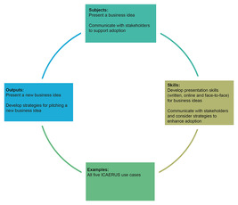
Figure 1 Week 8 learning cycle
View description - Figure 1 Week 8 learning cycle
View alternative description - Figure 1 Week 8 learning cycle

By the end of Week 8, you should be able to:
- understand the key elements of effective communication with different stakeholder groups
- create a cohesive summary of your business idea and a pitch to share with stakeholders
- reflect on your learning in this course and identify next steps for taking your business idea forward.

1 Introduction – the why
In Week 7 you learned about the different business relationships and interconnections that make up different ecosystems in business contexts. You learned how you can connect into networks to access resources, build your knowledge, link up with suppliers and customers, and cultivate strong relationships with supporters, regulators and business partners. Added to the overview of the industry and introduction to stakeholder analysis in Week 1, you should now have a pretty good idea of who your primary and secondary stakeholders are and which ecosystems they belong to, and where you want to situate your own idea in these networks.
In Week 3 you learned about different types of data you are likely to be creating and using with your drone business idea, as well as the different regulatory contexts you will need to consider. Added to Weeks 2, 4, 5 and 6, where you learned about different business models and used the sustainable business model canvas to develop your idea, you should now be able to identify what your business idea is, how you plan to implement it and when you want to achieve it.
This week is all about the ‘why’. Of course, you will have already identified the core value proposition for your business idea. Many people consider purpose to be key to success. For example, Jesper Lowgren, technology transformation guru and author of the book On Purpose (2014), wrote ‘An extraordinary business starts with extraordinary people. Extraordinary people start with purpose.’

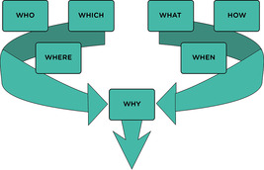
Figure 2 The ‘why’ as the key driver for success
View description - Figure 2 The ‘why’ as the key driver for success

Such inspirational quotes from successful entrepreneurs, thought leaders and influencers are pretty common. However, what the past seven weeks should have helped you to understand is that there is a lot of information, planning, networking and hard work that goes into making a business idea successful. Knowing your purpose – your why – is what drives your ambition toward success. And it is this ambition and purpose that you want to communicate to your stakeholders.

1.1 Communicating effectively with different stakeholders
As you learned in Week 1 of this course, you will have many different stakeholders for your business idea. Some will be your primary stakeholders and some will be secondary stakeholders, and they may be internal to your organisation or external (see Figure 3, adapted from Hill et al., 2020).

Figure 3 Stakeholders and the organisation
View description - Figure 3 Stakeholders and the organisation
View alternative description - Figure 3 Stakeholders and the organisation

As part of managing your different stakeholders, you will have different ways of communicating with them. Of course, depending on how well developed your drone business idea may be, you may or may not have the same kinds of stakeholders depicted in Figure 3. However, it’s safe to say that a critical part of developing any business idea is learning how to communicate it to others.
As you develop your idea, decide on your business model, and begin to add detail to the elements of your business model canvas, you will begin to identify the key parts of a business plan. A business plan is a formal document, which presents your business idea in written form. The renowned and emeritus entrepreneurship professor, Poornima Charantimath, explained that a business plan is a ‘dynamic document’ (i.e. it is meant to be updated regularly), and that:

[a] good business plan can be the most important factor in the success of the business. It should be brief, clear, and properly organized. Before writing your business plan, it is necessary to know for whom it is written. Business plans usually take from one week to three months to write. A business plan is not only a tool for raising money; it also helps the entrepreneur to identify and deﬁne business goals and to determine the best methods for achieving those goals. A business plan should highlight the points that can attract investors. The assumptions made in preparing the business plan should be realistic.
(Charantimath, 2018, p. 154)

Within Charantimath’s quote, there are some important points related to communicating with your stakeholders:
- Who is it written for?
- How can it help you identify and define your business goals?
- What points do you want to highlight to attract investors?
There are many books available to help you design a business plan. As Charantimath explains, it can take up to three months to write a cohesive plan that covers all of the different areas of the business model canvas, such as (in very simple terms):
- a clear and concise description of your business idea
- your assessment of the business environment and your value proposition
- who will be working on the business idea with you
- how you will develop the business idea
- how you will build the business and take it to market
- how you intend to finance it.
Yet before you begin to detail a business plan, your first step should be to create a robust ‘elevator pitch’ that you can pitch to potential investors, as well as to potential grant funders, partners, customers, suppliers and other important stakeholders. The elevator pitch is the verbal equivalent of a concise one-page executive summary; summarising your business idea in the 60 seconds it might take to ‘pitch’ to a potential investor while going from the ground floor to the top of a skyscraper in an elevator or lift.

2 The elevator pitch
In many cases, you will start with an elevator pitch and work your way toward a fully developed business plan (in much the same way you might start with a business concept and work toward a business model). Indeed, popular television programmes, such as Dragons’ Den or Shark Tank, focus primarily on the pitch. It is with your pitch that you communicate both your passion for your innovative and exciting project (your ‘why’), as well as your keen business sense and ability to realise a financial and/or social return on investment. An elevator pitch is never meant to provide the listener all the detail. Rather it is meant to persuade and make the listener interested and wanting to hear more.
As with business plans, there are many resources available to develop a good elevator pitch. Some key points Charantimath (2018) and other authors suggest incorporating into your elevator pitch include:
- A clear and concise description of your business idea and how it takes advantage of a market opportunity. What ‘problem’ does your product or service solve?
- Keep it simple – you want to remove all the industry buzzwords and technical language (although note the next bullet point). You want it to be simple enough so that the listener remembers it.
- Tailoring your message to the listener. Is it a potential investor? Then communicate how you will finance your idea and what investment is needed, how you will use it and what realistic return on investment they could expect and when. Is it an expert in your field? If so, use technical language effectively.
- Being clear about your target market – what does your business idea do that is different and better than the competition? What is your potential customer base, what are their needs, and how will you reach your customers?
- What do you bring to the table in terms of knowledge, skills and experience?
- Make sure you give the person listening a way to get in touch with you (e.g. a business card or other digital version, and collect their card/contact details, if possible), and aim to set an appointment for a more detailed discussion.
- You may wish to have a prototype to hand to demonstrate your idea (clearly, this is not always feasible, especially in an elevator!).
Charantimath also includes an essential point: to refine your pitch based on feedback and results (more on this later in this week). In the following sections you will work through two activities to help you refine your pitch.

2.1 Creating your own elevator pitch
The idea of the elevator pitch has, ostensibly, been around since the inventor of the elevator, Elisha Otis, ‘sold’ an elevator safety mechanism to an audience while demonstrating it during an elevator ride. Today, these kinds of ‘pitches’ are even more refined, with consultants recommending 30-second pitches, and in some cases, just single lines with the key to make a connection with your audience (Gilbert, 2023). While such short encapsulations of your idea may be helpful in some situations, a well-thought-out pitch containing just the right amount of information is an invaluable tool to get people interested in your idea.

Activity 1
Allow approximately 30 minutes.
This activity is split up into two tasks, which will take you through the process of understanding what an elevator pitch is, how to develop it, and then to practise it.

Task A

Using YouTube or another favourite video sharing website, search for ‘elevator pitch examples’. Note that college and universities, particularly those in the US, routinely hold student competitions, so you may want to filter these with other terms, such as ‘business’.
To get you started, here are two different resources from YouTube.
- Entrepreneur Tashi Dorjee from The Failed Founder channel (Dorjee, 2024) provides examples for three types of pitches, from the shortest and simplest to one pitched at an industry expert level.

Watch the video at YouTube.com.
Video 1

- Spanish–American educator and venture capitalist, Mar Hershenson, gives advice on how to tailor your pitch to the person you are pitching to for the TEDTalk series, The Way We Work (Hershenson, 2023).

Video content is not available in this format.
Video 2
View transcript - Video 2


View alternative description - Uncaptioned Figure

Take note of some of the key messages suggested by the videos and examples.

Provide your answer...
View discussion - Task A

Task B

Watch the following video where Mackenzie Baert, Project Manager at reframe.food, discusses what she looks for in a pitch for ICAERUS Open Calls.

Video content is not available in this format.
Video 3
View transcript - Video 3

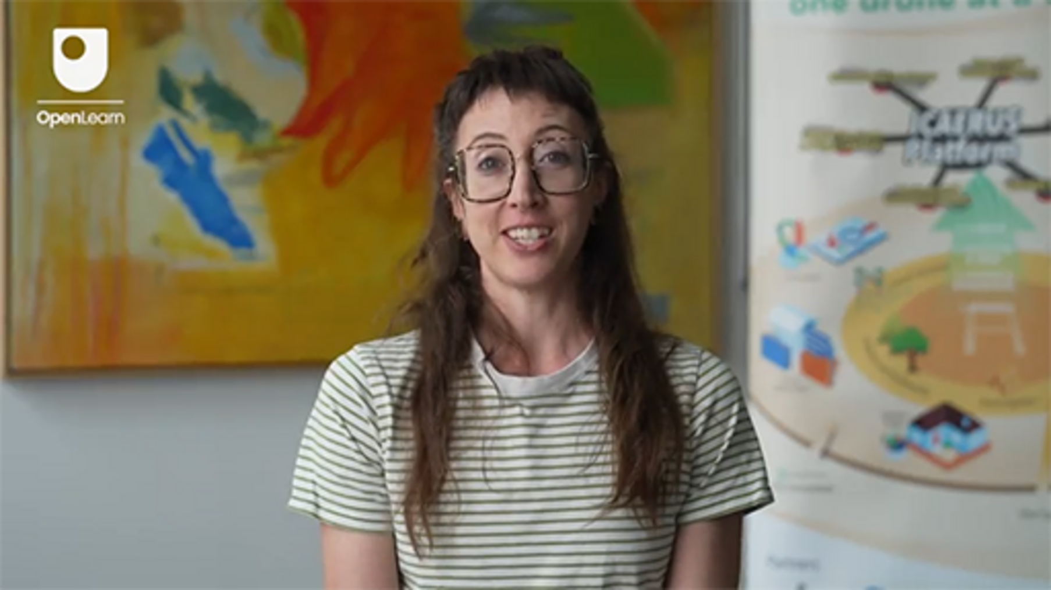

- What key information do you look for in concept pitches from Open Call applicants?
- What are the top three characteristics of a good pitch?
- What are the top three characteristics you think people should avoid in their pitches?
- Could you give an example of a recent pitch you were impressed by? What made it impressive to you?

Provide your answer...

Review the application template for the ICAERUS Open Call (note: although this call may be closed to further applications, the template is still available to view). Compare the information that the template covers with the information in the sustainable business model canvas (CASE, 2018) (replicated below in Figure 4 for ease of access). What is similar? What is different?
What seem to be the key priorities of the Open Call, and what areas of the sustainable business model canvas might you draw on to respond to them in this kind of open call application?

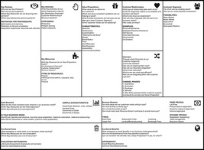
Figure 4 The sustainable business model canvas
View description - Figure 4 The sustainable business model canvas
View alternative description - Figure 4 The sustainable business model canvas

Provide your answer...

In the next section, you will begin drafting your own elevator pitch for your business idea.

2.2 Developing your elevator pitch
If you have not already started drafting your elevator pitch, you will now have a chance to begin developing one for your drone business idea. In Activity 2 you will draft three pitches, each more detailed than the next, and then practise pitching them to a colleague, friend or family member.

Activity 2
Allow approximately 40 minutes.

To start:
Write a one-line pitch of your drone business idea. This is your idea at its most basic and most easily understandable for all stakeholders (even those who are unfamiliar with drone technology). Your first stage pitch should be no more than 15 words (a single sentence).
Your first stage pitch…

Provide your answer...

Next:
Draft a slightly longer, more detailed version of your pitch by adding to your one-line pitch. Note who the audience is for this pitch and how you want to connect with the audience with this pitch. You may want to touch on parts of the ‘hero’s story’ that Mar Hershenson talked about in her video. This pitch should be about 50-75 words maximum and could be delivered in about 30 seconds.
- What is the core idea you are pitching?
- What is the problem or issue that your product or service will address?
- What does your product or service do to solve this problem (in simple terms)?
Your 30-second stage pitch:

Provide your answer...

Your full elevator pitch:
Now, draft your full elevator pitch. Draw on the guidance you have found through your searches or through the guidance of the videos in the earlier activity (about 100-150 words – keep it short, snappy and memorable).
- What is the core idea you are pitching?
- What is the problem or issue that your product or service will address?
- How does your product solve this problem? How is it innovative or better than the competition in doing this? (add more detail to the 30-second stage pitch)
- Why are you the right person for the audience to trust? (brief info on your skills and experience)
- What action do you want your audience to take (desire more information, ask questions, set a meeting, consider investing) – tailor the information you provide in the pitch toward these actions.

Provide your answer...

Practise your pitches
Now take your pitches and begin to refine them by practising them with family, friends and trusted colleagues. Through this practice you should be able to:
- Identify how and with what phrases you best connect with your audience (remembering that different stakeholders may need different messages).
- Identify the kinds of questions that your pitch provokes in the audience, so that you can prepare appropriate answers.
- Identify where you lose your audience. That is, if and when your audience may lose interest or may become confused, in which case you may want to simplify rather than add more detail.
- Keep note of what works and what doesn’t. You may want to use a notebook or an app to keep track of how you’ve changed your pitch over time.

View discussion - Part

3 Demonstration activities

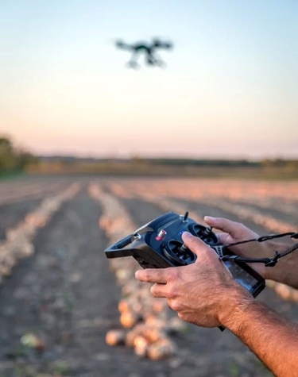
Figure 5 A drone flying over a field
View description - Figure 5 A drone flying over a field

An incredibly effective way to show potential investors and other stakeholders (such as customers) the value of your product or service is to provide a demonstration of it. For example, open calls, such as the ones supported by the ICAERUS project, will have demonstration activities as part of their funding process. Demonstration activities may take place as part of your initial pitch, such as a prototype, or a more developed product you are pitching for growth investment (think of Dragons’ Den). A demonstration may also come at the end of the project period where funded start-ups showcase the results of their implemented ideas, such as in the ICAERUS project’s drone technologies and data analytics technologies in farming, forestry and rural challenges.

Activity 3
Allow approximately 20 minutes.

Some of the most important aspects of an effective demonstration of your business idea come before you even set foot in the demonstration space. That is, preparation and practise.
In this next video, Mackenzie Baert, Project Manager at reframe.food talks about the dos and don’ts of product demonstrations. While watching the video, take notes on preparations you might make for demonstrating your drone business idea.

Video content is not available in this format.
Video 4
View transcript - Video 4

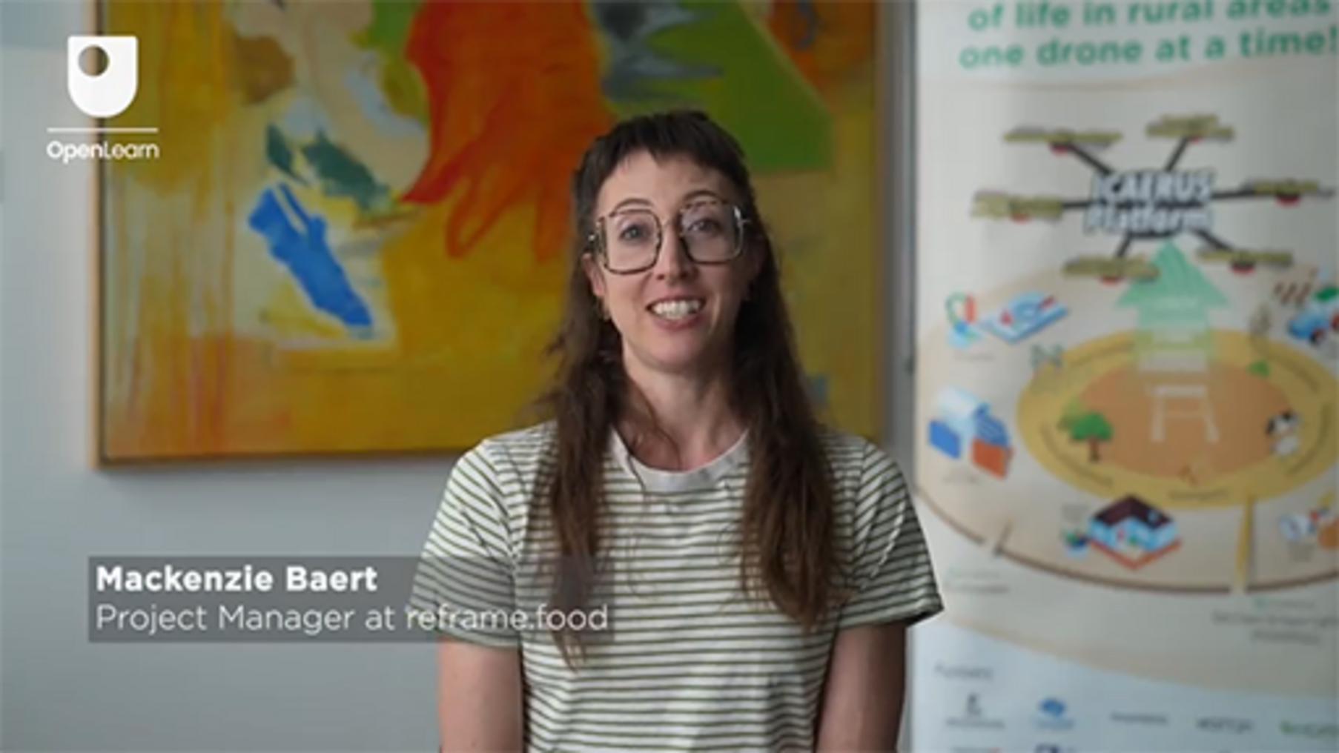

- What would be the top two suggestions you would give to Open Call recipients preparing for their demonstrations?
- What would be the top three suggestions you would give to Open Call recipients to avoid in their product demonstrations?
- How do prototype demonstrations differ from other demonstrations?
- What is a recent memorable and excellent demonstration you’ve seen? What made it memorable and excellent?

Provide your answer...
View discussion - Part

4 Reflecting on your learning and identifying next steps
Throughout this course, you have developed a better understanding about what it will take to bring a business idea to market. Part of this understanding relates to the skills you’ll need to develop your idea, make connections with your stakeholders and networks and access and build the resources to make it happen. You’ve also learned some of the ‘softer’ skills that support success, such as communication skills. Another important ‘soft skill’ is being able to reflect on your learning and using that reflection to identify next steps and future actions.
Far from being purposeless ‘navel gazing’, reflection on learning can provide you with specific directions for action, such as how to integrate what you’ve already learned into what you are currently doing, and what else you need to learn to progress an idea. Sometimes this reflection is done very quickly in the moment, for example, a quick change of direction in a drone’s flight path based on new information emerging in the moment. MIT Professor, Donal Schön called this type of in-the-moment reflection, ‘reflection-in-action’ (Schön, 1983). Born in 1930, Schön’s ideas continue to influence the way we understand learning and innovation. Importantly, building your reflection-in-action skills can also help to spur innovative thinking as you not only apply what you know and what you’ve learned, but you develop skills in creating new ideas.
Other times, reflection takes place after something happens, what Schön (1983) called ‘reflection-on-action’. With this type of reflection, you consider what happened, or the actions you have taken, and think about how you might do things differently. For example, if a drone component stops working, you might want to do a systematic, post-flight review of the component and how it communicates with other parts of the drone to identify how to fix the issue.

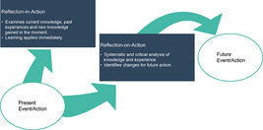
Figure 6 Depiction of Schön’s (1983) types of reflection
View description - Figure 6 Depiction of Schön’s (1983) types of reflection

Similarly, in developing a business idea, you might have momentary inspirations of innovative thinking leading to a great example that you come up with (via reflection-in-action) while pitching your idea to a new group of funders based on their initial response to your business idea. Then, when you have some time after the meeting, you sit down to review how the pitch went, what you could do differently at the next pitching session, and how this might improve your desired outcomes (reflection-on-action).
Although an arguably simplified description of Schön’s reflection-in-action and reflection-on-action, you can use these two types of reflection to develop innovative thinking and to identify next steps for learning and action. In Activity 4 you will use these to reflect on next steps for developing your business idea.

Activity 4
Allow approximately 30 minutes.

This activity will support your preparation of a plan for next steps in developing your business idea. You will be asked to reflect on the key takeaways and learning you have achieved in each of the weeks of this course. Then, in Activity 5, you will identify a set of next steps in the short and medium term.
You have now reached the end of eight weeks of study. Spend some time reviewing each of the weeks of the course – its content and any outputs you may have created. Use the table below to record up to three takeaways you have gained or achieved in your study of each week. You may want to review the learning outcomes (reproduced here) to help you reflect on your learning. You may also notice that some topics, such as presenting your business idea, have come up several times in the course. In these cases, identify how your thinking has changed or evolved with each revisiting of the topic.

Table 1 Course weekly takeaways
Week | Key learning
Week 1  - understand the development and growth of the drone industry and emerging innovations in the agricultural, forestry and rural sectors  - identify a business idea in the drone industry  - identify and map the stakeholders of a business idea. | 1. 2. 3.
Week 2  - recognise different business models for the use of drones, with a specific focus on agriculture and rural areas  - recognise how to distinguish between, and make use of, different types of business models  - appreciate the broader environmental and sustainability issues of business models using drones in agriculture and rural areas  - communicate your business ideas in a professional way that appeals to various stakeholders. | 1. 2. 3.
Week 3  - understand ways that you can characterise the big data used by drones and their application to rural drone uses  - apply a big data architecture framework to your business idea  - identify different types of regulations that might apply to your drone business idea. | 1. 2. 3.
Week 4  - understand the concept of business model canvas and value proposition canvas  - identify and design the different elements of a value proposition  - present a value proposition to an audience. | 1. 2. 3.
Week 5  - understand the different blocks of the customer area of the business model canvas  - consider how the value proposition canvas informs the business model canvas  - design the offer and customer areas of a business model canvas. | 1. 2. 3.
Week 6  - develop a business model canvas for an innovative business, specifically for drone applications in the agriculture sector  - recognise and be able to apply seven of the 11 blocks in the sustainable business model canvas. They are key resources, key activities, key partners, cost structure, revenue streams, eco-social costs and eco-social benefits. | 1. 2. 3.
Week 7  - understand the meaning of ecosystems for business, innovation and entrepreneurship and how to identify them in practice  - explore in depth the meaning of entrepreneurial ecosystems in the context of ICAERUS and the case of livestock monitoring in France  - understand the role of networks in business and entrepreneurship  - develop networking skills for entrepreneurship. | 1. 2. 3.
Week 8  - understand the key elements of effective communication with different stakeholder groups.  - create a cohesive summary of your business idea and a pitch to share with stakeholders.  - reflect on your learning in this course and identify next steps for taking your business idea forward. | 1. 2. 3.

View discussion - Activity 4

In the final section of the course, you will look at the next steps for your business idea by creating an action plan.

5 Creating an action plan
Action plans are useful tools for identifying the steps and stages for achieving a goal or set of goals. Action plans can be very detailed, and to be meaningful, they do need a certain amount of detail, including the goal you want to achieve, the individual steps or tasks you’ll need to take to achieve them, and the date when you should complete the task or tasks.

Activity 5
Allow approximately 30 minutes.

Use the table below to identify three main tasks you want to undertake for three goals related to your business idea. You will likely have more goals and more tasks to perform. However, use the table to help you prioritise your next steps in the short- (next few months) and medium- (next 6-12 months) term.

Table 2 Goal setting
Goal 1
(Is this a short-term or medium-term goal?)
Task/Action 1: | Due date:
Task/Action 2: | Due date:
Task/Action 3: | Due date:
Goal 2:
(Is this a short-term goal or medium-term goal?)
Task/Action 1: | Due date:
Task/Action 2: | Due date:
Task/Action 3: | Due date:
Goal 3:
(Is this a short-term or medium-term goal?)
Task/Action 1: | Due date:
Task/Action 2: | Due date:
Task/Action 3: | Due date:

View discussion - Activity 5

6 Summary of Week 8
In this this final week of the course, you have learned important ways that you can communicate your business idea to different stakeholders. The week built on many of the lessons you have already learned throughout this course to help you develop a series of successively more detailed ‘elevator pitches’ with which you can pitch your idea to a variety of audiences.
You’ve heard from ICAERUS partners on how pitches are evaluated for the project’s open calls, and how product and service demonstrations and showcases are developed and presented. Your study of this week will have helped you to articulate your central value proposition in a clear and concise manner and given you an opportunity to practise this with trusted colleagues, family and friends.
You also learned about how reflecting on your learning – both at the time it is taking place ‘in the moment’, and after – can provide you with invaluable opportunities to refine your knowledge and skills and identify next steps in your learning and in the development of your business idea.
The activities in this week will have provided you with some concrete steps for action as you develop and implement your business idea and bring your ideas to fruition.

7 This week’s quiz
Congratulations on almost reaching the end of the course.
It’s now time to complete the Week 8 badge quiz. It’s similar to previous quizzes but this time, instead of answering five questions, there will be 15.
Week 8 compulsory badge quiz
Open the quiz in a new tab or window and come back here when you’ve finished.

8 Course conclusion
This course was designed as part of the ICAERUS Horizon EU Project. It aimed to support you in developing a business idea that makes use of drone technologies. The eight weeks of this course introduced several current business concepts starting from a view of the drone industry, moving towards the notions of business models, their different types, and the concepts of revenue models and business ecosystems.
The course encouraged you to develop a business idea starting from the identification of stakeholders and moving towards business modelling activities. The ability to create a solid value proposition and the development of a business model canvas are fundamental skills, which you should now have to help you evolve your initial business.
The course concluded with a look at the importance of stakeholder engagement and management, the value of business networking, and introduced you to the skills related to developing good elevator pitches and demonstrations.

References
Carli, G., Reid, K. & Filiou, D. (2023) Syllabus and Certification Criteria (Deliverable 4.1 of the ICAERUS Project). Unpublished.
CASE (2018) ‘Sustainable business model canvas’, CASE Project webpages. Available at: https://www.case-ka.eu/index.html%3Fp=2174.html (Accessed 14 June 2024).
Charantimath, P. (2018) Entrepreneurship Development and Small Business Enterprises, 3/e (Third edition). Pearson Education.
Gilbert, S. (2023) ‘Leveraging Psycholinguistics to create your elevator pitch’. Available at: https://www.forbes.com/sites/forbescoachescouncil/2023/04/18/leveraging-psycholinguistics-to-create-your-elevator-pitch/ (Accessed 14 June 2024).
Hill, C. W. L., Schilling, M. A. & Jones, G. R. (2020) Strategic management: Theory & Cases: An integrated approach, 13th edition. Hampshire: Cengage Learning.
Lowgren, J. (2014) On purpose: The path to extraordinary business transformation. Gower International Publishing.
Schön, D. (1983) The reflective practitioner: How professionals think in action. Basic Books.

Acknowledgements
This free course was written by Giacomo Carli, Jie Deng, Despoina Filiou and Kristen Reid. This week was written by Kristen Reid.
The development of this course was funded by the ICAERUS project.
The ICAERUS project was funded by the EU under the Horizon Europe scheme Grant Agreement 101060643 and UK under Innovate UK reference 10038181.
Except for third party materials and otherwise stated, including any quotes referenced in the course and not acknowledged here (see terms and conditions), this content is made available under a Creative Commons Attribution-NonCommercial-ShareAlike 4.0 Licence .
The material acknowledged below is Proprietary and used under licence (not subject to Creative Commons Licence). Grateful acknowledgement is made to the following sources for permission to reproduce material in this free course:
Course image: Courtesy: Dr Katerina Kasimati
Course badge: © The Open University
Text
2.1 Application template: ICAERUS Innovation and Capacity building in Agriculture Environmental and Rural UAV Services. PULL Open Call for Farming, Forestry and Rural Challenges (FFRC) Proposal template. Funded by The European Union.
Figures
Figure 3: adapted from Hill, C. W. L., Schilling, M. A. & Jones, G. R. (2020) Strategic management: Theory & Cases: An integrated approach, 13th edition. Hampshire: Cengage Learning
Figure 4: From: https://www.case-ka.eu/wp/wp-content/uploads/2017/05/SustainableBusinessModelCanvas_highresolution.jpg https://creativecommons.org/licenses/by-sa/4.0/deed.en
Figure 5: Courtesy: Adrien Lebreton
Figure 6: adapted from Schön, D. (1983) The reflective practitioner: How professionals think in action. Basic Books.
Videos
Video 2: The Secret to Successfully Pitching an Idea | The Way We Work, a TED series https://www.youtube.com/watch?v=l0hVIH3EnlQ Deed - Attribution-NonCommercial-NoDerivatives 4.0 International - Creative Commons
Video 3: Mackenzie Baert © The Open University (2024)
Video 4: Mackenzie Baert ©The Open University (2024)
Every effort has been made to contact copyright owners. If any have been inadvertently overlooked, the publishers will be pleased to make the necessary arrangements at the first opportunity.
Don't miss out
If reading this text has inspired you to learn more, you may be interested in joining the millions of people who discover our free learning resources and qualifications by visiting The Open University – www.open.edu/openlearn/free-courses.

Solutions

Activity 2

Part

Discussion
The rural logistics case offers a long range (up to 30 km) drone able to lift and transport up to 30 kg. The potential customer that would buy this as a product would need piloting skills as well as knowledge of the drone technology. Alternatively, if offered as a drone-as-a-service it could be accessible to different groups of clients. For example, if your service was to bring medicines to inaccessible places during an emergency, your customers could be local authorities providing emergency services.
Back to - Part

Part

Discussion
If you consider the capability of the drone in delivering a load during an emergency, the service would be able to provide first aid assistance to people in difficult situations, such as car accidents or even populations cut off from safe transportation because of floods or earthquakes.
Back to - Part

Part

Discussion
This last question opens up the need to engage stakeholders which is the topic of the next section, but for now it would suffice to say that operating such a service would not just require technical skills but also clearance for flying the drone.
Back to - Part

Activity 3

Discussion
Stakeholder impact can vary widely. Some stakeholders can wield a significant amount of power in how you shape and develop your idea. For example, obtaining licensing for drone pilots can be very expensive, especially when combined with liability insurance and seeking legal advice (Carli et al., 2023).
Internal stakeholders, too, can exert powerful influences over the development of your business idea. Business partners, investors and employees may have important perspectives you’ll need to consider when developing your idea. Indeed, often stakeholders are essential contributors. These can range from ‘sponsors’, for example funders or managers who control resources, to ‘users’ (Horton & Pilkington, 2014), which can include customers. Many successful business ideas will engage with customers or users of a service at the design stage to make sure that the product or service meets their expectations.
Back to - Activity 3

Activity 1

Part

Discussion
The business idea of SKYFAR is to provide farmers services related to the use of drones. These services focus on drone piloting and managing data generated by using drones.
Back to - Part

Part

Discussion
AGRICLOUD will undertake the design, development, promotion and marketing of training programmes and the delivery of bespoke workshops. Part of SKYFAR is to offer local and regional workshops with practical presentations, demonstrations and testing of drone technologies in Romania.
Back to - Part

Part

Discussion
Training material to be used to run the workshops; drones to be used at demonstration events; specialist staff, such as accredited drone pilots; drones and other complementing parts and technologies for the demonstration workshops (e.g. ground penetration radars, multispectral cameras, weather stations, IoT equipment.
Back to - Part

Activity 2

Discussion
GEOSENSE distributes well-known brands from international drone manufacturers in Greece and conducts research & development for drone modification and advancing drone functionalities. As a result, you can say that GEOSENSE uses a product business model.
However, GEOSENSE does other things too! It offers bespoke services and turn-key solutions according to end-user needs, such as, to name only a few, GIS surveying, spatial data capturing, data management and analysis. It also modifies drone kits to provide interchangeable components depending on user needs. For this part of its operations, GEOSENSE uses a solution business model. The use of two business model types is common in large, complex organisations.
Back to - Activity 2

Activity 3

Part

Discussion
AgriFood Lithuania and Art21 have been advancing work for ICAERUS Use Case 4 – forestry and biodiversity (UC4, see Week 1 of this course) by using a combination of different types of drones and cameras to create optimised solutions for forestry and biodiversity monitoring. For example, they use a multi-rotor drone to monitor tree health and fire risk, as well as a fixed-wing drone to monitor wildlife. Satellite imaging data will be used to detect possible tree stress, and multi-rotor drones will be used for detailed (high-resolution) monitoring of specific forest areas (including tree health and fire risks).
Fixed-wing drones are becoming an efficient tool in forestry research and can be used for wildlife monitoring because of their capacity to cover vast areas quickly. Since they can cover large areas within a limited time frame, the operational costs of monitoring are significantly reduced by implementing drones in comparison to other monitoring means, such as manned aerial surveys. So the use of drones in this area can lead to saving labour costs.
Back to - Part

Part

Discussion
Forests and wildlife are a public good, not only because they belong to all of us, but because we all benefit from their sustainability. As a result, there is very rarely private business interest in investing in efficient ways to monitor forests and wildlife, such as drones. National forestry and agriculture offices can purchase drones to support such uses. Drones used for forestry and biodiversity management can also support private timber management companies to monitor forests before wood is cut for commercial exploitation. In certain nations, the commercial exploitation of forest wood is organised by community cooperatives. Cooperative ownership of drones can be an effective business model, ensuring efficient fire and wildlife monitoring and timber management. A shared ownership business model can be used instead or alongside cooperative ownership.
There are many applications of drones in different areas that are mentioned in the video of Use Case 4 from Lithuania. You might have noticed one application that is mentioned is the use of drones for oceanography. This can support understanding various aspects of oceans, not only the organisms that live in them, but also the geology and chemistry of oceans, including measurements of temperature and ocean currents. Such applications of drones can open wide scope of business uses in this sector. Drones for ocean management can also support public sector organisations such as those responsible for marine life and its management.
Back to - Part

Activity 5

Discussion
You can access the library with over 90 exemplars of the business models discussed in this section. Each of them includes background information on the firms, as well as how they create and capture value.
Back to - Activity 5

Activity 1

Discussion
Dimitar’s questions all contribute to a better understanding of how the drones (and the data they use) contribute value to his business. Therefore, a crucial task for any business generating, collecting, analysing, using, storing, or selling big data is to determine the costs associated with these activities. Any aggregated costs need to be less than the value of the data – otherwise, it can severely impact on the success of the business (Khan et al., 2014). While managing big data can be an additional cost for businesses (such as hiring professionals), small businesses, start-ups and early prototyping may be able to bypass some (but not all) of these costs. However, any plans for scaling up to expand the business will need to revisit the BDAF to assess its impact on operations, especially if these introduce new risks.
Similarly, as the regulatory environment is changing quickly to address new innovations in the sector, drone-related businesses will need to monitor how these changes might impact on the value of their data, including how customers might assess its value. For example, regulations that relax requirements on Visual Line of Sight (VLOS) when used for last mile delivery models could make drones a much more attractive alternative to traditional delivery methods.
Back to - Activity 1

Activity 2

Discussion
The livestock monitoring Use Case in France is assessing ‘labour reduction capabilities of drone-based herd monitoring’ and is examining ‘governance models and drone adoption barriers and drivers’. The Use Case aims to achieve the following outcomes:
- Quantify the cost, labour and time saving impact of drones for livestock monitoring.
- Identify drivers and barriers for drone adoption.
- Support grazing livestock systems to better meet society’s demand for free-range animal products.
- Increase farmers’ quality of life by improving work conditions.
Each of these outcomes can be thought of in terms of extracting value from big data, i.e. the data sets, algorithms and drone technologies. Successful outcomes, such as quantifying the cost, labour and time-saving impact of using drones, will be influenced by the relevant ‘Vs of big data, as well as by the broader BDAF categories. For example:
- Volume: How much data will be generated and how will data be stored and communicated to the farmer? (Sources of data generation, data format)
- Veracity: Can farmers be assured that the data are giving them reliable information about the health and welfare of their herds? (Sources of data generation, data analytics)
- Variety: Are there different types of images or analytics that the farmer can use to make decisions? (Data visualisation and data analytics strategies)
- Velocity: Are the data processed and available in real time to the farmer to make it a time-saving alternative? (Data processing, sources of data generation)
As you learned earlier in this section, both data and analytical tools (e.g. algorithms) are important contributions to the value of your business idea. The ICAERUS Drone Data Analytics platform is a repository that shares data sets and algorithms from the project partners and open call grantees. You can download algorithms and practise with the data sets provided to see how they might be used in your own business case scenario.
Back to - Activity 2

Activity 4

Discussion
The amount of information available on drone regulation can seem a bit overwhelming, especially when you are first starting out with your business. The EASA website recommends that the first step is to register in the country where you live by contacting the relevant National Aviation Authority. You may also wish to contact local, regional or national drone associations, or indeed local governmental bodies in your initial investigations.
It is also worth noting that your business idea may not relate specifically to the physical operation of drones. You may be developing a data analytics tool or a new type of imaging algorithm, for example. For this reason, legislation and regulations on data protection, such as the EU’s General Data Protection Regulation (GDPR) may be applicable in how you collect and store data. National Aviation Authorities may also have information on these regulatory areas, e.g. the Irish Aviation Authority provides information to drone operators on how GDPR may affect their drone operations (IAA, 2024).
Back to - Activity 4

Activity 1

Answer
The correct matches are:
Find water filter replacements in a grocery stoe
Buyer of value job
Drink water with low impurities
Functional job
Compare prices of filters online
Buyer of value job
Switch to a compatible filter
Transferer of value job
Reduce the use of plastic bottles
Social job
Back to - Activity 1

Discussion
Can you think of any possible cocreator of value or personal/emotional jobs related to this product? It’s not always possible to come up with examples in every category, so when you can’t find one there’s no need to shoehorn something in.
Back to - Activity 1

Activity 2

Answer
The correct matches are:
Payment is processed correctly
Required gain
Option of contacting the venue to indicate the time of arrival
Desired gain
Collecting loyalty points to earn discounts
Unexpected gain
Ability to modify the booking dates
Desired gain
Availability of the room at arrival
Required gain
Back to - Activity 2

Activity 3

Answer
The correct matches are:
The platform is known to charge high fees to hotels and flat owners
Social problem
There is a limited and very expensive supply of pet-friendly accommodation
Obstacle
The platform does not send a confirmation email of the booking
Functional problem
The design of the platform website looks outdated
Emotional problem
The platform seems to have a weak data protection policy
Risk
The platform sends too many marketing emails
Ancillary problem
Back to - Activity 3

Activity 4

Answer
The correct matches are:
An insurance policy to protect household possessions from robbery or damage
Financial
The copyright on the content of a new book
Intangible
The new season of a popular TV series
Digital
Vegetables from the local farmers market
Physical
Back to - Activity 4

Activity 5

Task A

Answer
Right:
A technology push approach
Feedback
Correct. The technology proposed by Use Case 5 is flexible: drones able to transport objects of different weight can be employed in several contexts. It is then possible to consider the needs of different groups of customers.
Wrong:
A market pull approach
Feedback
Incorrect. The technology of Use Case 5 is sophisticated and requires an understanding of which groups of customers would appreciate the specific gain creators or pain relievers offered.
Back to - Task A

Task B

Discussion
It’s helpful to identify a sector and a country/location where you think the technology could be used. Then, reflect on what customer jobs would be connected to the technology.
Once you have done this, consider customer gains and gain creators, and customer pains and pain relievers.
This example considers the use of the technology for the delivery of medicines and emergency goods to a population after an earthquake. Emergency management is often operated by dedicated agencies which may invest in a range of technologies used in several contexts.

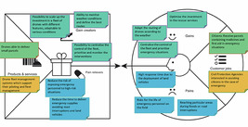
Figure 9 An example of a Value Proposition Canvas applied to Use Case 5 – rural logistics
View description - Figure 9 An example of a Value Proposition Canvas applied to Use Case 5 – rural ...

This example then develops the idea of a service offered by specialised personnel to deliver first aid assistance in emergencies. National agencies would be one of the clients, but the benefit of the service would go to citizens. This idea is quite aligned with a multi-sided business model: two groups of customers would be expected as represented in the customer jobs block of Figure 9.
You can download the full example in Power Point here.
Back to - Task B

Activity 6

Answer
Product and services: drone and drone fleet management system
Customer segment: national agencies dealing with emergencies
Jobs to be done: deliver small parcels (e.g. medicines)
Introducing gain creators: enabling their delivery in areas not reachable by land during a disaster
Introducing pain relievers: offering a fast response and reducing risks for rescuers
Back to - Activity 6

Activity 1

Answer
The correct matches are:
A large warehouse that buys products in bulk and sells them to small retailers.
Wholesaler
A team of company employees who visit local pharmacies to sell cosmetic products to loyal clients every two months.
Sales force
The Eurostar website which sells the tickets of the trains which cross the English Channel
Web sales
The local farm shop which sells fresh eggs and seasonal vegetables
Own store
An electronics store that sells different brands of computers and other electronic gadgets
Partner store
Back to - Activity 1

Activity 2

Answer
The correct matches are:
Awareness of the proposed products and services
Seeing an Instagram ad about the new fitness tracker.
Evaluation of the value proposition
Trying the fitness tracker at a demo station in a local electronics store.
Purchase
Buying the fitness tracker from the company’s official website.
Delivery
Receiving the fitness tracker through home delivery after purchasing it online.
After sales
Calling customer service for help with setting up the fitness tracker with an iPhone or an Android smartphone.
Back to - Activity 2

Activity 3

Task B

Discussion

Table 3 Completed customer area block
Customer relationships | Customer segments | Channels
Personalised support: tailored assistance for each farmer | Commercial farmers: large-scale operations (e.g. 10 ha in Greece) | Awareness: promotion among communities, congresses and fairs, and online; distributor networks: expanding reach through local distributors
Online community: engagement and feedback through digital platforms | Small to medium-sized farms: smaller possibly organic farms | Evaluation: demonstration – test field and showcase event
Automated updates and notifications: keeping systems up-to-date | Agricultural co-operatives: groups seeking shared solutions | Purchase: one-to-one contract with field visit
Training programmes: empower customers with necessary skills | Agricultural consultants: looking for advanced tools for their clients | Delivery: planning through online platform, on site delivery with dedicated personnel
Co-creation of solutions: collaborate n new features and improvements |  | Aftersales: data analysis and evolution of performance with dedicated report; education workshops: on-site and online training session; field demonstraions in local communities

Back to - Task B

Activity 4

Task A

Discussion
Spraying drones help farmers who want to reduce the use of agrochemicals by spreading them more precisely, enhancing yields, and reducing their cost of the treatment.
Back to - Task A

Task B

Answer
The correct matches are:
Reduce the use of agrochemicals
Getting the job done
Reduce the risk of workers spreading pesticides
Risk reduction
Data-driven insights: enable informed farming decisions: mapping of the field created before the spraying
Newness
Cost efficiency: reduce overall operational costs for farmers
Cost reduction
Control the treatment remotely
Convenience/usability
Collect accurate data
Accessibility
Precision agriculture: enhance crop yield and reduce chemical usage by ~10%
Performance
Environmental sustainability: lower the ecological impact of farming
Performance
Back to - Task B

Activity 1

Answer
The correct matches are:
Funding from investors
Tangible (financial)
Machinery and tools
Tangible (physical)
Patented innovation
Intangible
A skilled human resource (e.g. a drone pilot)
Human
Back to - Activity 1

Activity 2

Discussion
In Section 1.4 you will find a complete example of the three blocks of the infrastructure area of the business model canvas.
Back to - Activity 2

Activity 3

Discussion

Table 1 Completed infrastructure area block
Key partners | Key activities | Key resources
Marketing agency | R&D for drone technology enhancement | Specialised agricultural chemicals: for targeted spraying
Agricultural research institutes: for R&D collaboration | Data analysis and reporting | Advanced drones: core technology batteries, power generators
Chemical suppliers: supply of eco-friendly pesticides | Marketing and community outreach | Data analytics tools: for crop and spray data analysis
Drone manufacturers: supply and technical support | Customer support and training | Online platforms: for customer interaction
Local farming communities: engagement and feedback | Operations: technical delivery | Trained personnel: agronomists, drone operators, customer service
Regulatory authorities: compliance and certification | Regulatory compliance monitoring

Back to - Activity 3

Activity 4

Answer
The correct matches are:
Hotel rooms
Yield management
Retail clothing
Fixed price
House sales
Negotiation
Abandoned property
Auction
iPhone
Feature dependent
Software licences for business and academic statistical software
Customer dependent
Bulk purchase of groceries
Volume dependent
Foreign currency
Real-time market
Back to - Activity 4

Activity 5

Discussion

Table 4 Completed financial viability area block
Cost structure | Revenue streams
R&D expenditure: high initial and ongoing costs | Subscription services: for software and data analysis tools
Manufacturing costs: production of drones | Leasing programmes: for drones and equipment
Marketing and sales: broad outreach programmes | Training services: for farmers and agricultural workers
Operational expenses: staff maintenance and updates | Consultancy fees: providing expert advice and customised solutions
Compliance and certification costs: meeting regulatory standards | Contract based on extension and complexity of the service: area covered and time required
Chemical products

Back to - Activity 5

Activity 1

Part

Answer
Right:
True
Feedback
A wide range of technologies are used for milk production, storing and distribution and for overseeing animal nutrition and weight.
Wrong:
False
Back to - Part

Part

Answer
Right:
False
Feedback
Even though technologies support farmers with their daily tasks, the demands of ruminant farming remain high. A wide range of skills is required for this profession, such as being able to use a wide range of technologies, as discussed above, manage grassland, and develop capabilities for early diagnosis of animal health and pregnancy needs.
Wrong:
True
Back to - Part

Part

Answer
Right:
False
Feedback
The answer to the above statement is not straightforward. Being close to nature can have a positive impact on well-being. However, farming is a highly demanding profession, requiring continuous oversight of livestock, working long and unsociable hours. These can contribute to farmers developing feelings of isolation, having less options to take holidays and time to socialise.
Wrong:
True
Back to - Part

Activity 2

Discussion
The ecosystem in Figure 5 shows at least three actors which could comprise a knowledge ecosystem (or sub-system in this case). The actors are: IDELE, because it is a research organisation aiming at advancing knowledge in ruminant farming and drone use in this area; the ICAERUS consortium, which focuses on evidence-based research and communication of new research findings on the use of drones in agriculture and rural areas; educators – local colleges, who can support existing and new generations of farmers with developing the requisite skillset for using new technologies.
Back to - Activity 2

Activity 1

Task A

Discussion
Your will have compiled a list of key messages from the examples you found. From the two videos listed in the activity, you might have identified the following points:
- A pitch can be a powerful story or narrative about your idea. Mar Hershenson called this a ‘hero’s story’, which you can use to capture the imagination and interest of your audience.
- Both Mar and Tashi talked about how important it is to tailor your message to your audience. Tashi explained that you can build on your pitch message from a very simple single statement all the way to a more detailed pitch, depending on who you are speaking with.
- You also want to make sure that you are prepared to deal with any potential pitfalls in your idea. Mar explains that you should deal with these directly in your pitch and show how you will deal with them.
- Finally, both videos talk about the importance of passion in how you communicate your ideas. Now, you may want to carefully consider whether all of Tashi’s advice is useful in this regard (with respect to his ‘urinal pitches’), but it’s clear that passion is a big part of his approach.
Back to - Task A

Activity 2

Part

Discussion
Practising your pitches is an essential part of creating a successful pitch. This applies to both pitches you make verbally and other types of pitches, such as part of a presentation with slides. Knowing how your audience may respond is invaluable information, and keeping track of how you’ve modified your pitch will also help you to refine and tailor it to different audiences.
Back to - Part

Activity 3

Part

Discussion
As with elevator pitches, a demonstration, showcase, or even a presentation or simulation should be tailored to the audience. For example, showcases to other industry experts or peers familiar with the technologies you are using will expect you to use industry jargon effectively. For example, they might want to hear about the technical affordances (i.e. likely outputs or outcomes) of your product or service – very often in comparison to other or earlier models.
It is important to consider the degree of detail required by your customers. Some customers will be very knowledgeable on the technical details of how you are achieving the outcomes or solutions through your idea, while others are simply interested in the solutions themselves and would not be as interested in how they are achieved. For example, industry peers may be extremely interested in the detail of how a particular drone sprayer achieves a certain output level and spray area, whereas a farmer who is unfamiliar with drone technology may be less interested (at first) in how it achieves this and more interested in the spray area’s coverage, its reliability in achieving that coverage and its impact on overall costs and labour.
It’s also worth noting that in areas of technological innovation, such as those that covered in this course, community education is an important part of developing a market (Carli et al., 2023). In some cases, you will need to assume that the stakeholders have very little knowledge of the innovation your business idea harnesses, hence, you will need to consider how you can market your idea in a way that helps them to understand your value proposition.
Back to - Part

Activity 4

Discussion
You could approach completion of the table as simply a checklist of what content was covered in each week. That approach can be helpful in keeping track of the different information, such as where links to different resources might be located. You might also use the table to note where you found the material challenging or where you may want to further develop your skills. A third approach might use the table to also take notes of how your thinking has changed as you’ve learned new ideas, applied them to your business idea, and reflected on how they work in practice.
This kind of reflection may have brought up new questions for you or stimulated your thinking about what you want to do next. In the final task in the course, you’ll develop an action plan for developing your business idea.
Back to - Activity 4

Activity 5

Discussion
You have probably heard the term ‘SMART goal’, which stands for:
- Specific (clear)
- Measurable (so that you know you’ve attained it)
- Attainable (realistic and achievable within the time and resources you have available)
- Relevant (to your overall purpose)
- Timely (has a date for when you want to achieve it).
These characteristics can also apply in many cases to the supporting tasks or actions. For example, you could identify ‘milestones’ – or smaller goals along the way toward achieving the bigger goals – that are a result of completing actions. The table in Activity 5 is a very simple version of an action plan, and there are myriad tools to help you develop and visualise a comprehensive plan, including Gantt charts, which can be created using templates in spreadsheet programmes, such as Excel. These tools can serve as important aids in moving forward with your business idea, completing your business model canvas, and putting together a comprehensive business plan.
Back to - Activity 5

Descriptions

Uncaptioned Figure
Developing business ideas for drone technologies digital badge
Back to - Uncaptioned Figure

Figure 1 Learning cycle for Week 1
Learning cycle divided into four parts – subjects, skills, example and outputs.
Back to - Figure 1 Learning cycle for Week 1

Figure 1 Learning cycle for Week 1
4 parts of the learning cycle
- Subjects:
Analysis of drone industry and market
Presentation of the technological potential and possible business development opportunities in the industry
- Skills:
Identify business opportunities
Understand stakeholder needs
- Examples:
Use Case 1: Crop Monitoring
- Outputs:
Briefly present a business opportunity in the drone industry
Evaluate existing stakeholders
Back to - Figure 1 Learning cycle for Week 1

Uncaptioned Figure
Back to - Uncaptioned Figure

Figure 2 The different stakeholders in the ICAERUS project
Diagram showing the parts of the ICAERUS project
Back to - Figure 2 The different stakeholders in the ICAERUS project

Figure 2 The different stakeholders in the ICAERUS project
The diagram represents a drone flying from a take-off area. Around the take-off area, ICAERUS stakeholders are represented: Agri-rural communities, Researchers, Public Authorities, General Public, Private Sector. The ICAERUS use-cases are also represented on a circle: livestock monitoring, rural logistics, forestry and biodiversity, drone spraying, crop monitoring.
The ICAERUS Platform is represented by the hovering drone with the following arms: the Drone Market Landscape analysis, the Drone Data Analytics Library, the ICAERUS Use Cases and Open Call Trials, the Socio-economic and Environmental Impact Assessment (SEIA) Results, the Business and Governance Models, and the ICAERUS Academy.
An arrow points to the ICAERUS platform from the take-off area and alongside is a numbered list rising up from 1 to 4:
- Research
- Develop & demonstrate
- Education & train
- Scale up
Back to - Figure 2 The different stakeholders in the ICAERUS project

Figure 3 The ICAERUS project logo and grant agreement numbers with the related funders
ICAERUS logo. Funded by the European Union. Grant agreement No 101060643
Back to - Figure 3 The ICAERUS project logo and grant agreement numbers with the related funders

Figure 3 The ICAERUS project logo and grant agreement numbers with the related funders
ICAERUS logo. Funded by the European Union. Grant agreement No 101060643
Back to - Figure 3 The ICAERUS project logo and grant agreement numbers with the related funders

Figure 4 The five Use Cases of the ICAERUS project
A map of Europe with five pins identifying the locations of the ICAERUS Use Cases
Back to - Figure 4 The five Use Cases of the ICAERUS project

Figure 4 The five Use Cases of the ICAERUS project
A map of Europe with five pins identifying the locations of the ICAERUS Use Cases:
- Livestock monitoring, France
- Crop monitoring, Spain
- Drone spraying, Greece
- Rural logistics, North Macedonia
- Forestry and biodiversity, Lithuania
Back to - Figure 4 The five Use Cases of the ICAERUS project

Figure 5 Civilian drone revenues from 2018 to 2028 (estimates by Statista, 2023)
Bar graph to show civilian drone revenues in billion USD (US$) from 2018 to 2028
Back to - Figure 5 Civilian drone revenues from 2018 to 2028 (estimates by Statista, 2023)

Figure 5 Civilian drone revenues from 2018 to 2028 (estimates by Statista, 2023)
Bar graph to show civilian drone revenues in billion USD (US$) from 2018 to 2028:
- 2018 – 2.9
- 2019 – 3.3
- 2020 – 2.9
- 2021 – 3.0
- 2022 – 3.6
- 2023 – 4.0
- 2024 – 4.3
- 2025 – 4.4
- 2026 – 4.5
- 2027 – 4.6
- 2028 – 4.7
Back to - Figure 5 Civilian drone revenues from 2018 to 2028 (estimates by Statista, 2023)

Figure 6 Industry lifecycles
Graph to show the four stages of industry lifecycle
Back to - Figure 6 Industry lifecycles

Figure 6 Industry lifecycles
Graph to show the four stages of industry lifecycle (x-axis – time, y-axis – industry size (sales): introduction, growth, maturity, decline
Back to - Figure 6 Industry lifecycles

Figure 7 Introduction stage of the industry lifecycle
Graph to show the sub-stages of the introduction stage of the industry lifecycle
Back to - Figure 7 Introduction stage of the industry lifecycle

Figure 7 Introduction stage of the industry lifecycle
Grap to show the introduction stage of the industry lifecycle.
X-axis: time, Y-axis number of firms (continuous line) and sales (dotted line).
The x-axis is divided in three substages: Incubation Stage, Pre-Firm Takeoff Stage, and Pre-Sales Takeoff Stage.
The Incubation stage starts with Triggers of incubation and ends with First Commercialisation.
The Pre-Firm Takeoff Stage starts with First Commercialisation and ends with Firm Takeoff.
The Pre-Sales Takeoff Stage starts with Firm Takeoff and ends with Sales Takeoff.
In the Incubation stage both the number of firms and the sales lines are low (just above zero).
In the Pre-Frim Takeoff stage the Sales line remains close to zero, while the Number of Firms starts to grow.
In the Pre-Sales Takeoff Stage the Number of Firms continues to rise, and the Sales line starts to rise from zero.
The whole introduction stage ends when the sales lines starts to grow more rapidly.
Back to - Figure 7 Introduction stage of the industry lifecycle

Figure 8 A drone gimbal
Close up photo of a drone gimbal
Back to - Figure 8 A drone gimbal

Figure 8 A drone gimbal
Close up photo of a drone gimbal
Back to - Figure 8 A drone gimbal

Figure 9 Various drone designs
A montage of four different designs of drone
Back to - Figure 9 Various drone designs

Figure 9 Various drone designs
A montage of four different designs of drone
Back to - Figure 9 Various drone designs

Figure 10 A project member of Use Case 5 setting up one of the drone prototypes
A person crouched by a drone
Back to - Figure 10 A project member of Use Case 5 setting up one of the drone prototypes

Figure 10 A project member of Use Case 5 setting up one of the drone prototypes
A person crouched by a drone
Back to - Figure 10 A project member of Use Case 5 setting up one of the drone prototypes

Figure 11 The search and testing phases reduces uncertainty and risk
An infographic showing the uncertainty and risk that occurs between thinking of an idea and the realisation of a business.
Back to - Figure 11 The search and testing phases reduces uncertainty and risk

Figure 11 The search and testing phases reduces uncertainty and risk
A new business idea is represented as a light bulb. The process leading to its realisation in a real business, represented as a working factory, is represented as a squiggly line. This process leads to the gradual reduction of risk and uncertainty.
The iterations happen during the initial phase named Search and Testing. During this phase, the idea is developed through Discovery (the general direction is corrected by collecting feedback) and validation (collect evidence on the effectiveness of decisions to validate if the direction taken is correct).
The execution phase follows the discovery phase and it is a more linear process.
Back to - Figure 11 The search and testing phases reduces uncertainty and risk

Figure 12 Sources of innovation
This is a diagram of the two sources of innovation: internal and external.
Back to - Figure 12 Sources of innovation

Figure 12 Sources of innovation
This is a diagram of the two sources of innovation: internal and external.
Examples of internal innovation include: an unexpected happening, a need for improvement in a process, an incongruity happening and changes in industry structure.
Examples of external innovation include: demographic trends, new knowledge, changes in perceptions and meanings.
Back to - Figure 12 Sources of innovation

Figure 13 A fixed wing drone tested in ICAERUS Use Case 5
A drone in the sky
Back to - Figure 13 A fixed wing drone tested in ICAERUS Use Case 5

Figure 13 A fixed wing drone tested in ICAERUS Use Case 5
A drone in the sky
Back to - Figure 13 A fixed wing drone tested in ICAERUS Use Case 5

Figure 14 A spraying drone tested in ICAERUS Use Case 2
A person using a remote controller next to a drone
Back to - Figure 14 A spraying drone tested in ICAERUS Use Case 2

Figure 14 A spraying drone tested in ICAERUS Use Case 2
A person using a remote controller next to a drone
Back to - Figure 14 A spraying drone tested in ICAERUS Use Case 2

Figure 15 Stakeholders and the organisation
Internal and external stakeholders that are able to influence an organisation
Back to - Figure 15 Stakeholders and the organisation

Figure 15 Stakeholders and the organisation
Internal and external stakeholders that are able to influence an organisation.
Internal stakeholders:
- Stockholders
- Employees
- Managers
- Board members
External stakeholders:
- Customers
- Suppliers
- Creditors
- Governments
- Unions
- Local communities
- General public
Back to - Figure 15 Stakeholders and the organisation

Figure 16 Power versus interest matrix
Power versus interest matrix. Four quadrants.
Back to - Figure 16 Power versus interest matrix

Figure 16 Power versus interest matrix
Power versus interest matrix. Four quadrants:
- Low level of interest, low power – A Minimal effort
- High level of interest, low power – B Keep informed
- Low level of interest, high power – C Keep satisfied
- High level of interest, high power – D Key players
Back to - Figure 16 Power versus interest matrix

Figure 17 Members of Use Case 1 testing a drone on a vineyard
Two people standing in a vineyard with a drone hovering in the sky above
Back to - Figure 17 Members of Use Case 1 testing a drone on a vineyard

Figure 17 Members of Use Case 1 testing a drone on a vineyard
Two people standing in a vineyard with a drone hovering in the sky above
Back to - Figure 17 Members of Use Case 1 testing a drone on a vineyard

Figure 18 Organisational stakeholders in the Noumena ICAERUS project
Stakeholders in ICAERUS Use Case 1, crop monitoring, Catalonia
Back to - Figure 18 Organisational stakeholders in the Noumena ICAERUS project

Figure 18 Organisational stakeholders in the Noumena ICAERUS project
Stakeholders in ICAERUS Use Case 1, crop monitoring, Catalonia:
- Drone industry – Vitec; Aeroclub Reus Openvino; Agrawdata, Noumena
- Academia educators – CRAG CREAF INCANVI; IRTA UA; UOC-Catalunya XIA Escola Agraria
- End-users – Mas Doit, Vineyard holders; AGROXARXA UNIO de Paigesos Catalanes; Fundacio la Pedrera Farms
- Public sector regulators – EASA, AESA, Spain; Municipalities of Falset, Villafranca; Government DARP.
Back to - Figure 18 Organisational stakeholders in the Noumena ICAERUS project

Figure 19 Power versus interest of stakeholder groups in the Noumena crop monitoring project
Power versus interest matrix. Four quadrants.
Back to - Figure 19 Power versus interest of stakeholder groups in the Noumena crop monitoring project

Figure 19 Power versus interest of stakeholder groups in the Noumena crop monitoring project
Power versus interest matrix. Four quadrants:
- Low level of interest, low power – A Minimal effort: EASA
- High level of interest, low power – B Keep informed: IRTA
- Low level of interest, high power – C Keep satisfied: Municipality of Falset, Villafranca
- High level of interest, high power – D Key players: AGRAWDATA, Fundacio la Pedrera Farms
Back to - Figure 19 Power versus interest of stakeholder groups in the Noumena crop monitoring project

Figure 1 Learning cycle for Week 2
Learning cycle divided into four parts – subjects, skills, example and outputs.
Back to - Figure 1 Learning cycle for Week 2

Figure 1 Learning cycle for Week 2
4 parts of the learning cycle
- Subjects:
Business model concept
Different business model types
- Skills:
Identify different business model types
Select an appropriate business model for a business idea
- Examples:
Use Case 4: Forestry and Biodiversity
- Outputs:
Compare possible business models for a business idea
Back to - Figure 1 Learning cycle for Week 2

Figure 2 Agios Germanos village, Lake Prespa, Florina, Greece
A landscape photo. There are red rooved buildings in the foreground. Behind are grass and tree covered hills. There is a lake in the background.
Back to - Figure 2 Agios Germanos village, Lake Prespa, Florina, Greece

Figure 3 Typology of business models (Baden-Fuller et al., 2017)
A flow diagram showing types of business models
Back to - Figure 3 Typology of business models (Baden-Fuller et al., 2017)

Figure 3 Typology of business models (Baden-Fuller et al., 2017)
A flow diagram. The box on the left is labelled 'Business models'. This has two arrows branching off. The top arrow branches off to a box labelled 'Dyadic'. The bottom arrow branches off to a box labelled 'Triadic'.
The Dyadic box has two arrows branching off of it. The top arrow branches off to a box labelled 'Product business model'. The bottom arrow branches off to a box labelled 'Solution business model'.
The Triadic box has two arrows branching off of it. The top arrow branches off to a box labelled 'Matchmaking business model'. The bottom arrow branches off to a box labelled 'Multi-sided business model'.
Back to - Figure 3 Typology of business models (Baden-Fuller et al., 2017)

Animation 1 Product business model
Animation 1 features a box on the left-hand side labelled ‘Firm’. There is also a box on the right-hand side labelled ‘Customer’. There is a single headed arrow running between the base of the box labelled ‘Firm’ (from left-to-right) and the box labelled ‘Customer’ – this arrow is labelled ‘Product or service’. There is also a single headed arrow running between the top of the box labelled ‘Customer’ and the box labelled ‘Firm’ (from right-to-left) – this arrow is labelled ‘Payment’. There is also an icon symbolising a cup of tea at the tip of the lower arrow where it interfaces with the ‘Customer’ box.
Back to - Animation 1 Product business model

Animation 2 Solution business model
Animation 2 features a box on the left-hand side labelled ‘Firm – Redesign solution’. There is also a box on the right-hand side labelled ‘Customer – Customer’s need’. There is a single headed arrow running between the base of the box labelled ‘Customer – Customer’s need’ and the box labelled ‘Firm – Redesign solution ‘ (from right-to-left). The arrow is labelled ‘Customer’s need’. There is also a single headed arrow running between the middle of the box labelled ‘Firm – Redesign solution’ and ‘Customer – Customer’s need’ (from left-to-right). The arrow is labelled ‘Integrated solution’ and there is an icon that symbolises a garment positioned above the arrow at the tip where it interfaces with the ‘Customer – Customer’s need’ box. There is also a single headed arrow running between the top of the box labelled ‘Customer – Customer’s need’ and the box labelled ‘Firm – Redesign solution’ (from right-to-left). There is also an icon symbolising three coins above the arrow which is labelled ‘Payment’.
Back to - Animation 2 Solution business model

Animation 3 Matchmaking business model
Animation 3 features a box on the left-hand side labelled ‘Firm – Platform organiser’. There are also two boxes on the right-hand-side (positioned vertically above one-another) labelled ‘Customer A, Seller – Customer’s need’ and ‘Customer B, Buyer – Customer’s need’.
There is a single headed arrow running horizontally from right to left between the box labelled ‘Customer A, Seller – Customer’s need’ and the box labelled ‘Firm – Platform organiser’. This arrow is labelled ‘Fee for using platform’.
There is also a single headed arrow running horizontally from right to left between the box labelled ‘Customer B, Buyer – Customer’s need’ and the box labelled ‘Firm – Platform organiser’. This arrow is also labelled ‘Fee for using platform’.
There are two single-headed arrows running vertically between the boxes labelled ‘Customer A, Seller – Customer’s need’ and ‘Customer B, Buyer – Customer’s need’. The arrow on the left is pointing vertically downwards and the arrow on the right is pointing vertically upwards. In between the two arrows there is an icon symbolising a shopping cart. The left arrow pointing vertically downwards is labelled ‘Product/service’ and the right arrow pointing vertically upwards is labelled ‘Payment’.
To the right of the two boxes there is a label which states: ‘Buyer (Customer B) and Sellers (Customer A) are connected to the firm’s digital or physical platform’.
Back to - Animation 3 Matchmaking business model

Animation 4 Multi-sided business model
Animation 4 features a box on the left-hand side labelled ‘Firm – Platform organiser’. There are also two boxes on the right-hand side (positioned vertically above one-another) labelled ‘Customer A, Seller – Customer’s need’ and ‘Customer B, Buyer – Customer’s need’.
There is a single headed arrow running horizontally from right to left between the box labelled ‘Customer A, Seller – Customer’s need’ and the box labelled ‘Firm – Platform organiser’. The arrow is labelled ‘Payment’ and there are three icons symbolising three coins above the arrow.
There is a second single headed arrow running horizontally from left-to-right between the box labelled ‘Firm – Platform organiser’ and ‘Customer A, Seller – Customer’s need’. This arrow is labelled ‘Product X’. There is a third single-headed dotted arrow running from left-to-right between the box labelled ‘Firm – Platform organiser’ and the box labelled ‘Customer A, Seller – Customer’s need’. This arrow is labelled ‘Additional benefit’.
There is a single headed arrow running horizontally from right to left between the box labelled ‘Customer B, Buyer – Customer’s need’ and the box labelled ‘Firm – Platform organiser’. This arrow is also labelled ‘Payment’ and there are three icons symbolising three coins above the arrow.
There is a second single headed arrow running horizontally from left-to-right between the box labelled ‘Firm – Platform organiser’ and ‘Customer B, Seller – Customer’s need’. This arrow is labelled ‘Product Y’. There is a third single-headed dotted arrow running from left-to-right between the box labelled ‘Firm – Platform organiser’ and the box labelled ‘Customer B Buyer Customer’s need’. This arrow is labelled ‘Additional benefit’.
In the middle of the two sets of arrows there is a label that says: ‘By using Product X, Customer A creates an additional benefit of value to Customer B access through Product Y’. There is also an icon symbolising three documents to the left of the label.
Back to - Animation 4 Multi-sided business model

Figure 4 Coffee machines during promotion events are given for free to consumers signing up for an annual membership for coffee pods
A coffee machine, with a bowl of coffee pods to the side of it
Back to - Figure 4 Coffee machines during promotion events are given for free to consumers signing up for an annual membership for coffee pods

Figure 5 Linkedin, the online professional networking platform, employs the freemium revenue model
A zoomed in shot of a computer screen showing the LinkedIn homepage
Back to - Figure 5 Linkedin, the online professional networking platform, employs the freemium revenue model

Figure 1 Learning cycle for Week 3
Learning cycle divided into four parts – subjects, skills, example and outputs.
Back to - Figure 1 Learning cycle for Week 3

Figure 1 Learning cycle for Week 3
4 parts of the learning cycle
- Subjects:
The value of data and applicable regulations related to the business applications of drones
- Skills:
Model the use of data within your business idea and research drone-related policies
- Examples:
All five ICAERUS Use Cases
- Outputs:
Determine checklist of regulations related to your drone business idea
Back to - Figure 1 Learning cycle for Week 3

Figure 2 Data volumes (not to scale)
Five boxes one inside another. The smallest box is labelled Byte (B) – a unit of data, 8 binary digits long.
Back to - Figure 2 Data volumes (not to scale)

Figure 2 Data volumes (not to scale)
Five boxes one inside another representing data volumes from a byte to a terabyte
- The smallest box is labelled Byte (B) – a unit of data, 8 binary digits long.
- The next box is labelled Kilobyte (KB) = 1000 bytes (b)
- The third box is labelled Megabyte (MB) = 1000000 bytes (b)
- The fourth box is labelled Gigabyte (GB) = 1,000,000,000 bytes (b)
- The fifth box is labelled Terabyte (TB) = 1,000,000,000,000 bytes (b)
Back to - Figure 2 Data volumes (not to scale)

Figure 3 The Five Vs of big data
The The Five Vs of big data: volume, veracity, variety, velocity and value.
Back to - Figure 3 The Five Vs of big data

Figure 3 The Five Vs of big data
The The Five Vs of big data (volume, veracity, variety, velocity and value) shown in boxes next to each other. Each has a symbol representing it and a multi-sided arrow stretches across the five rectangles, with an arrowhead pointing to both the left and right of the boxes.
Back to - Figure 3 The Five Vs of big data

Figure 4 Hyperspectral imaging data (processed) of a Scots Pine and mixed forest, Lithuania
Photograph of a drone in the air of a Scots Pine and mixed forest, Lithuania. There is a laptop on the ground showing the data from the drone.
Back to - Figure 4 Hyperspectral imaging data (processed) of a Scots Pine and mixed forest, Lithuania

Figure 4 Hyperspectral imaging data (processed) of a Scots Pine and mixed forest, Lithuania
Photograph of a drone in the air of a Scots Pine and mixed forest, Lithuania. There is a laptop on the ground showing the data from the drone.
Back to - Figure 4 Hyperspectral imaging data (processed) of a Scots Pine and mixed forest, Lithuania

Figure 5 Drone processed image of cattle sheep in grazing areas, France
An aerial photgraph of a herd of sheep. The photo is annotated
Back to - Figure 5 Drone processed image of cattle sheep in grazing areas, France

Figure 5 Drone processed image of cattle sheep in grazing areas, France
An aerial photgraph of a herd of sheep. The sheep each have a computerised box over them, some boxes are coloured green, others are white. The photo has two arrows added to it, between the two arrows is a purple line connecting the two arrows.
The photo is annotated with the following:
In black boxes in the top left corner:
- Number of sheep counted in this gate: 30
- Number of sheep counted in this session: 356
In blue boxes in the top right corner:
- Start Counting
- Draw a virtual gate
Back to - Figure 5 Drone processed image of cattle sheep in grazing areas, France

Figure 6 A drone
Photograph of a drone in the air among some tree branches.
Back to - Figure 6 A drone

Figure 6 A drone
Photograph of a drone in the air among some tree branches.
Back to - Figure 6 A drone

Figure 7 Pyramids of supportive and sanctioning policies (Adapted from Bluff, 2018, p. 52)
Two pyramids. One showing Pyramid of Supports, the other showing Pyramid of Sanctions
Back to - Figure 7 Pyramids of supportive and sanctioning policies (Adapted from Bluff, 2018, p. 52)

Figure 7 Pyramids of supportive and sanctioning policies (Adapted from Bluff, 2018, p. 52)
Two pyramids. Sitting at the bottom of both pyramidsis a box which reads 'Observe and listen actively to understand regulatee, their operations and regulatory environment'.
In the Pyramid of Supports pyramid, the boxes making up the pyramid from bottom to top then read:
- Nurture continuous improvement through support networks
- Praise and reinforce good risk control and management
- Recognise good practice among industry peers
- Reward performance.
In the Pyramid of Sanctions pyramid, the boxes making up the pyramid from bottom to top read:
- Support capacity and motivation to improve risk control and management
- Issue notices to remedy or prohibit serious threats or persistent non-compliance
- Enforce undertakings to require substantial improvement in practice
- Penalise by prosecution, fines, licence cancellation.
Back to - Figure 7 Pyramids of supportive and sanctioning policies (Adapted from Bluff, 2018, p. 52)

Figure 1 Learning cycle for Week 4
Learning cycle divided into four parts – subjects, skills, example and outputs.
Back to - Figure 1 Learning cycle for Week 4

Figure 1 Learning cycle for Week 4
4 parts of the learning cycle
- Subjects:
New business ideas
Value proposition design
- Skills:
Design a value proposition from a business idea
- Examples:
Use Case 5 Rural logistics
- Outputs:
Present a new value proposition
Back to - Figure 1 Learning cycle for Week 4

Figure 2 The original Business Model Canvas with nine blocks divided into four areas
The original Business Model Canvas. It is split into four main areas: Infrastructure on the left, Offer in the middle, Customers on the right and Financial viability at the bottom.
The Infrastructure area is broken up into three blocks: key partners, key activities and key resources.
The Offer area represents the Value proposition.
The Customers area is broken up into three blocks: customer relationships, customer segments and channels.
The Financial viability area is broken up into two blocks: cost structure and revenue streams.
Back to - Figure 2 The original Business Model Canvas with nine blocks divided into four areas

Figure 3 The sustainable business model canvas
The sustainable business model canvas. It is split into five main areas each coloured in a different colour.
In the top left area, coloured green, are three blocks labelled key partners, key activities and key resources.
Next to this in the centre is the block labelled value propositions, coloured brown.
In the top right area, coloured turquoise, are three blocks labelled customer relationships, customer segments and channels.
Underneath these three areas is an area coloured sky blue. Two blocks make up this area labelled cost structure and revenue streams
Finally underneath the sky blue area, is a light grey area. Two blocks make up this area labelled eco-social costs and eco-social benefits.
Back to - Figure 3 The sustainable business model canvas

Figure 4 The value proposition canvas is part of the value proposition and the customer segments block
The business model canvas showing the value proposition canvas
Back to - Figure 4 The value proposition canvas is part of the value proposition and the customer segments block

Figure 4 The value proposition canvas is part of the value proposition and the customer segments block
The business model canvas split into four main areas each coloured in a different colour.
In the top left area, coloured green, are three blocks labelled key partners, key activities and key resources.
Next to this in the centre is the block labelled value propositions, coloured brown. This area has a square drawn in it with a horizontal Y in it.
In the top right area, coloured turquoise, are three blocks labelled customer relationships, customer segments and channels. This area has a circle drawn in it with a horizontal Y in it.
Underneath these three areas is an area coloured sky blue. Two blocks make up this area labelled cost structure and revenue streams
Back to - Figure 4 The value proposition canvas is part of the value proposition and the customer segments block

Figure 5 The components of the value map and customer (segment) profile
At the top of the image there is a grid in the shape of a blank miniature Business Model Canvas. The ‘Value proposition’ block in the Business Model Canvas is coloured brown and the ‘Customers’ block in the Business Model Canvas is coloured turquoise. The rest of the blocks in the Business Model Canvas are white.
There are two single-headed arrows pointing vertically downwards from the Business Model Canvas, one from the ‘Value proposition’ block (on the left-hand side) and one from the ‘Customers’ block (on the right-hand side). The arrow on the left feeds into a brown coloured box labelled ‘Value proposition’ which includes a gift icon as a symbol. The second arrow feeds into a turquoise coloured box labelled ‘Customers’ that is symbolised by an icon featuring two people.
Below the ‘Value proposition’ box there is a large box broken down into three segments shaped as a horizontal ‘Y’. The top segment of the box is labelled ‘Gain creators’ and includes a graph with an arrow as its symbol. The lower segment of the box is labelled ‘Pain relievers’ and includes a capsule as its symbolic icon. The third segment, to the left of the box is labelled ‘Products and services’ and it has a barcode as its symbol. At the centre of the box is an icon of a gift/present. There is also a horizontal single-headed arrow running (from left-to-right) from the box towards a large circle on the right-hand side of the figure.
The large circle on the right-hand side is also broken down into three segments shaped as a horizontal ‘Y’. The upper segment of the circle is labelled ‘Gains’ and includes a smiley face as its symbol. The segment to the right of the circle is labelled ‘Customer jobs’ and has a tick box icon as its symbol. The lower segment of the circle is labelled ‘Pains’ and it has a frowning face icon as its symbol. At the centre of the circle is a profile of a face, facing towards the left of the figure.
There is also a horizontal single-headed arrow running (from right-to-left) from the circle towards the large box on the left-hand side. The tips of both arrows, from the large box on the left and the large circle on the right, meet in between the two shapes.
Back to - Figure 5 The components of the value map and customer (segment) profile

Figure 6 A water filter jug
A water filter jug with water in it on a worktop
Back to - Figure 6 A water filter jug

Figure 5 (repeated) The components of the value map and customer (segment) profile
At the top of the image there is a grid in the shape of a blank miniature Business Model Canvas. The ‘Value proposition’ block in the Business Model Canvas is coloured brown and the ‘Customers’ block in the Business Model Canvas is coloured turquoise. The rest of the blocks in the Business Model Canvas are white.
There are two single-headed arrows pointing vertically downwards from the Business Model Canvas, one from the ‘Value proposition’ block (on the left-hand side) and one from the ‘Customers’ block (on the right-hand side). The arrow on the left feeds into a brown coloured box labelled ‘Value proposition’ which includes a gift icon as a symbol. The second arrow feeds into a turquoise coloured box labelled ‘Customers’ that is symbolised by an icon featuring two people.
Below the ‘Value proposition’ box there is a large box broken down into three segments shaped as a horizontal ‘Y’. The top segment of the box is labelled ‘Gain creators’ and includes a graph with an arrow as its symbol. The lower segment of the box is labelled ‘Pain relievers’ and includes a capsule as its symbolic icon. The third segment, to the left of the box is labelled ‘Products and services’ and it has a barcode as its symbol. At the centre of the box is an icon of a gift/present. There is also a horizontal single-headed arrow running (from left-to-right) from the box towards a large circle on the right-hand side of the figure.
The large circle on the right-hand side is also broken down into three segments shaped as a horizontal ‘Y’. The upper segment of the circle is labelled ‘Gains’ and includes a smiley face as its symbol. The segment to the right of the circle is labelled ‘Customer jobs’ and has a tick box icon as its symbol. The lower segment of the circle is labelled ‘Pains’ and it has a frowning face icon as its symbol. At the centre of the circle is a profile of a face, facing towards the left of the figure.
There is also a horizontal single-headed arrow running (from right-to-left) from the circle towards the large box on the left-hand side. The tips of both arrows, from the large box on the left and the large circle on the right, meet in between the two shapes.
Back to - Figure 5 (repeated) The components of the value map and customer (segment) profile

Figure 7 A printer
A printer with paper in the machine
Back to - Figure 7 A printer

Figure 8 Music app on smartphone
A hand holding a smartphone with a music app opened on it
Back to - Figure 8 Music app on smartphone

Figure 9 An example of a Value Proposition Canvas applied to Use Case 5 – rural logistics
On the left is a large box broken down into three segments shaped as a horizontal ‘Y’. The top segment of the box is labelled ‘Gain creators’ and includes a graph with an arrow as its symbol. Within the box are two post-it notes coloured turquoise. The first one reads: 'Possibility to scale up the investment in a fleet of drones with different features, adaptable to various conditions'. The second post-it note reads: 'Possibility to centralise the control of the fleet, prioritise and monitor the interventions'.
The lower segment of the box is labelled ‘Pain relievers’ and includes a capsule as its symbolic icon. Within the box are two post-it notes coloured blue. The first one reads: 'Reduce the risk of exposing emergency personnel to high-risk situations'. The second post-it note reads: 'Reduce the time to deliver emergency supplies avoiding road interruptions and land vehicles'.
The third segment, to the left of the box is labelled ‘Products and services’ and it has a barcode as its symbol. Overlapping the Gain creators and Products and services segments is a green post-it note which reads: 'Drone able to deliver small parcels'. Overlapping the Products and services and Pain relievers segments is a yellow post-it note which reads: 'Drone fleet management systems which support their piloting and fleet management'.
At the centre of the box is an icon of a gift/present. There is also a horizontal single-headed arrow running (from left-to-right) from the box towards a large circle on the right-hand side of the figure.
On the right-hand side is a large circle broken down into three segments shaped as a horizontal ‘Y’. The upper segment of the circle is labelled ‘Gains’ and includes a smiley face as its symbol. Within the box are two post-it notes coloured turquoise. The first one reads: 'Optimise the investment in the rescue services'. The second post-it note reads: 'Centralise the control of the fleet and prioritise emergency situations'.
The lower segment of the circle is labelled ‘Pains’ and it has a frowning face icon as its symbol. Within the box are three post-it notes coloured blue. The first one reads: 'High response time due to deployment of land vehicles'. The second post-it note reads: 'Risks for the life of emergency personnel on the field'. The third post-it note reads: 'Reaching particular areas during floods or road interruptions'.
The segment to the right of the circle is labelled ‘Customer jobs’ and has a tick box icon as its symbol. Overlapping the Gains and Customer jobs segments is a green post-it note which reads: 'Citizens: Receive parcels containing medicines and first aid in emergency situations'. Overlapping the Customer jobs and Pains segments is a yellow post-it note which reads: 'Civil Protection Agencies interested in assisting citizens in the case of emergency'.
At the centre of the circle is a profile of a face, facing towards the left of the figure. There is also a horizontal single-headed arrow running (from right-to-left) from the circle towards the large box on the left-hand side. The tips of both arrows, from the large box on the left and the large circle on the right, meet in between the two shapes.
Back to - Figure 9 An example of a Value Proposition Canvas applied to Use Case 5 – rural logistics

Figure 1 Learning cycle for Week 5
Learning cycle divided into four parts – subjects, skills, example and outputs.
Back to - Figure 1 Learning cycle for Week 5

Figure 1 Learning cycle for Week 5
4 parts of the learning cycle
- Subjects:
Analysis of a market opportunity
Development of the customer area of the business model canvas (customer segments, customer relationships and channels)
- Skills:
Develop or enhance a business model design using the business model canvas (customer area)
- Examples:
Use Case 2 Drone Spraying
- Outputs:
Design the customer area of the business model canvas for a new business idea.
Back to - Figure 1 Learning cycle for Week 5

Figure 2 The sustainable business model canvas
The sustainable business model canvas. It is split into five main areas each coloured in a different colour: Infrastructure, Offer, Customers, Financial viability and Sustainability.
The Infrastructure area is in the top left and is coloured green. It is made up of three blocks labelled key partners, key activities and key resources.
Next to this in the centre is the Offer area also labelled value propositions, coloured brown.
The Customers area is in the top right area, coloured turquoise. It is made up of three blocks labelled customer relationships, customer segments and channels.
Underneath these three areas is the Financial viability area coloured sky blue. Two blocks make up this area labelled cost structure and revenue streams
Finally underneath the Financial viability area, is the Sustainability area, coloured light grey. Two blocks make up this area labelled eco-social costs and eco-social benefits.
Back to - Figure 2 The sustainable business model canvas

Figure 3 Mass market: groceries
A vegetable market stall. There are boxes of carrots, radishes, artichokes and potatoes
Back to - Figure 3 Mass market: groceries

Figure 4 Niche market: specialised sports equipment
A cyclist riding a bike on the road wearing a helmet and lycra.
Back to - Figure 4 Niche market: specialised sports equipment

Figure 5 Fitness tracker
A smart watch
Back to - Figure 5 Fitness tracker

Figure 1 Learning cycle for Week 6
Learning cycle divided into four parts – subjects, skills, example and outputs.
Back to - Figure 1 Learning cycle for Week 6

Figure 1 Learning cycle for Week 6
4 parts of the learning cycle
- Subjects:
Analysis of the resources, activities and partnerships required for a new business idea
Development of the infrastructure, financial viability and eco-social side of the business model canvas
- Skills:
Develop or enhance a business model design using the business model canvas (infrastructure, financial viability and eco-social)
- Examples:
Use Case 2 Drone Spraying
- Outputs:
Design the infrastructure, financial viability and eco-social areas of the business model canvas for a new business idea.
Back to - Figure 1 Learning cycle for Week 6

Figure 2 The sustainable business model canvas
The sustainable business model canvas. It is split into five main areas each coloured in a different colour.
In the top left area, coloured green, are three blocks labelled key partners, key activities and key resources.
Next to this in the centre is the block labelled value propositions, coloured brown.
In the top right area, coloured turquoise, are three blocks labelled customer relationships, customer segments and channels.
Underneath these three areas is an area coloured sky blue. Two blocks make up this area labelled cost structure and revenue streams
Finally underneath the sky blue area, is a light grey area. Two blocks make up this area labelled eco-social costs and eco-social benefits.
Back to - Figure 2 The sustainable business model canvas

Figure 5 The sustainable business model canvas
The sustainable business model canvas. It is split into five main areas each coloured in a different colour.
In the top left area, coloured green, are three blocks labelled key partners, key activities and key resources.
Next to this in the centre is the block labelled value propositions, coloured brown.
In the top right area, coloured turquoise, are three blocks labelled customer relationships, customer segments and channels.
Underneath these three areas is an area coloured sky blue. Two blocks make up this area labelled cost structure and revenue streams
Finally underneath the sky blue area, is a light grey area. Two blocks make up this area labelled eco-social costs and eco-social benefits.
Back to - Figure 5 The sustainable business model canvas

Figure 6 The sustainable business model canvas
The sustainable business model canvas. It is split into five main areas each coloured in a different colour.
In the top left area, coloured green, are three blocks labelled key partners, key activities and key resources.
Next to this in the centre is the block labelled value propositions, coloured brown.
In the top right area, coloured turquoise, are three blocks labelled customer relationships, customer segments and channels.
Underneath these three areas is an area coloured sky blue. Two blocks make up this area labelled cost structure and revenue streams
Finally underneath the sky blue area, is a light grey area. Two blocks make up this area labelled eco-social costs and eco-social benefits.
Back to - Figure 6 The sustainable business model canvas

Figure 7 Graphic representation of flows in and out of the system (Barrionuevo, 2023)
A flow chart moving from inputs to outputs
Back to - Figure 7 Graphic representation of flows in and out of the system (Barrionuevo, 2023)

Figure 7 Graphic representation of flows in and out of the system (Barrionuevo, 2023)
On the left is the heading 'Inputs', which underneath has natural resources, materials and energy listed. Three arrows point from this list to a box with the following written in it:
- Raw materials acquisition
- Manufacturing
- Use/reuse/maintenance
- Recycle/waste management
Arrows then point from this box to the right hand section of the figure which has a heading 'Outputs'. Underneath the word 'Outputs' the words product, coproducts, air emissions, water emissions and soil emissions are listed.
Back to - Figure 7 Graphic representation of flows in and out of the system (Barrionuevo, 2023)

Figure 8 The United Nations’ Sustainable Development Goals (SDG)
Graphic showing the 17 United Nations’ Sustainable Development Goals
Back to - Figure 8 The United Nations’ Sustainable Development Goals (SDG)

Figure 8 The United Nations’ Sustainable Development Goals (SDG)
An infographic titled Sustainable Development Goals. They are listed as follows:
- No poverty
- Zero hunger
- Good health and well-being
- Quality education
- Gender equality
- Clean water and sanitation
- Affordable and clean energy
- Decent work and economic growth
- Industry, innovation and infrastructure
- Reduced inequalities
- Sustainable cities and communities
- Responsible consumption and production
- Climate action
- Life below water
- Life on land
- Peace, justice and strong institutions
- Partnerships for the goals.
Back to - Figure 8 The United Nations’ Sustainable Development Goals (SDG)

Figure 9 Common Good Matrix (Blachfellner, et al., 2017)
A table showing the Common Good Matrix
Back to - Figure 9 Common Good Matrix (Blachfellner, et al., 2017)

Figure 9 Common Good Matrix (Blachfellner, et al., 2017)
Common good matrix 5.0. Table showing the values running across the top and the stakeholders A–E.

Common Good Matrix 5.0
 | Human dignity | Solidarity and social justice | Environmental sustainability | Transparency and co-determination
A: Suppliers | A1 Human dignity in the supply chain | A2 Solidarity and social justice in the supply chain | A3 Environmental sustainability in the supply chain | A4 Transparency and co-determination in the supply chain
B: Owners, equity and financial service providers | B1 Ethical position in relation to financial resources | B2 Social position in relation to financial resources | B3 Use of funds in relation to social and environmental impacts | B4 Ownership and co-determination
C: Employees, including co-working employers | C1 Human dignity in the workplace and working environment | C2 Self-determined working arrangements | C3 Environmentally friendly behaviour of staff | C4 Co-determination and transparency within the organisation
D: Customers and other companies | D1 Ethical customer relations | D2 Cooperation and solidarity with other companies | D3 Impact on the environment of the use and disposal of products and services | D4 Customer participation and product transparency
E: Social environment | E1 Purpose of products and services and their effects on society | E2 Contribution to the community | E3 Reduction of environmental impact | E3 Social co-determination and transparency

Back to - Figure 9 Common Good Matrix (Blachfellner, et al., 2017)

Figure 10 A possible sustainable business model canvas for drone spraying. You can download a larger, PDF version of Figure 10 here.
Key partners
Marketing agency
Agricultural research institutes: for R&D collaboration
Chemical suppliers: supply of eco-friendly pesticides
Drone manufacturers: supply and technical support
Local farming communities: engagement and feedback
Regulatory authorities: compliance and certification
Cost structure
R&D expenditure: high initial and ongoing costs
Manufacturing costs: production of drones
Marketing and sales: broad outreach programmes
Operational expenses: staff, maintenance, and updates
Compliance and certification costs: meeting regulatory standards
Chemical products
Key activities
R&D for drone technology enhancement
Data analysis and Reporting
Marketing and community outreach
Customer support and training
Operations: technical delivery
Regulatory compliance monitoring
Key resources
Specialised agricultural chemicals: for targeted spraying
Advanced drones: core technology batteries, power generators
Online platforms: for customer interaction
Trained personnel, agronomists, drone operators, customer service
Eco-social costs
Resource use: consumption of material and energy
Waste generation: Disposal of old drones and parts
Value proposition
Offer an organic product
Reduce the risk for workers in spreading pesticides
Data-Driven insights: enable informed farming decisions: mapping of the field created before the spraying
Cost efficiency: reduce overall operational costs for farmers
Control the treatment remotely
Collect accurate data
Precision agriculture: enhance crop yield and reduce chemical usage of ~10%
Environmental sustainability: Lower ecological impact of farming
Revenue streams
Subscription services: For software and data analysis tools
Leasing programmes: for drones and equipment
Training services: for farmers and agricultural workers
Consultancy fees: providing expert advice and customised solutions
Drone sales: direct sale of drone systems
Contract based on extension and complexity of the service: area covered and time required
Eco-social benefits
Reduced chemical runoff: less environmental contamination
Increased biodiversity: healthier ecosystems from reduced pesticide use
Community health: less chemical exposure for nearby communities
Customer relationships
Personalised support: tailored assistance for each farmer
Online community: engagement and feedback through digital platforms
Automated updates and notifications: keeping systems up-to-date
Training programmes: empower customers with necessary skills
Co-Creation of solutions: collaborate on a new features and improvements
Channels
Awareness: promotion among communities, congresses and fairs, and online; distribution networks: expanding reach through local distributors
Evaluation: demonstration: test field and showcase event
Purchase: one-to-one contract with field visit
Delivery: planning through online platform, on site delivery with dedicated personnel
Aftersales: data analysis and evolution of performance with dedicated report; educational workshops: on-site and online training sessions, field demonstrations in local communities
Customer segments
Commercial farmers: large-scale operations (e.g. 10 ha in Greece)
Small to medium- sized farms: smaller, possibly organic farms
Agricultural co-operatives: groups seeking shared solutions
Agricultural consultants: looking for advanced tools for their clients
Back to - Figure 10 A possible sustainable business model canvas for drone spraying. You can download a larger, PDF version of Figure 10 here.

Figure 1 Week 7 learning cycle
Learning cycle divided into four parts – subjects, skills, example and outputs.
Back to - Figure 1 Week 7 learning cycle

Figure 1 Week 7 learning cycle
4 parts of the learning cycle
- Subjects:
Ecosystems and their attributes
- Skills:
Build business relationships and network
- Examples:
Use Case 3 Livestock monitoring
- Outputs:
Map ecosystems and networks.
Back to - Figure 1 Week 7 learning cycle

Figure 2 Four different habitats which can be individual ecosystems or groups of ecosystems. They may constitute different ways of understanding ecosystems
Four photos showing different ecosystems
Back to - Figure 2 Four different habitats which can be individual ecosystems or groups of ecosystems. They may constitute different ways of understanding ecosystems

Figure 2 Four different habitats which can be individual ecosystems or groups of ecosystems. They may constitute different ways of understanding ecosystems
Four photos: tope left Jurassic coast in the UK; top right: a river system in South Korea, bottom left: plants floating on a pond; bottom right: a butterfly feeding from a single flower.
Back to - Figure 2 Four different habitats which can be individual ecosystems or groups of ecosystems. They may constitute different ways of understanding ecosystems

Figure 3 Summer pasture of the sheep pilot farm (Ferme de Carmejane), Alpes De Hautes Provences, France
An aerial view of grass fields with a large flock of sheep on them. In the distance are a large number of conifer trees
Back to - Figure 3 Summer pasture of the sheep pilot farm (Ferme de Carmejane), Alpes De Hautes Provences, France

Figure 4 Drones used in livestock monitoring, IDELE research facility: CIRBEEF farm, Brittany, France
A photo of two cows in a grass field.
Back to - Figure 4 Drones used in livestock monitoring, IDELE research facility: CIRBEEF farm, Brittany, France

Figure 5 Drone-driven ecosystem for livestock management in rural France as captured in 2023 (Bojkova et al., 2023)
A complex network with many interconnected actors in a drone-driven ecosystem
Back to - Figure 5 Drone-driven ecosystem for livestock management in rural France as captured in 2023 (Bojkova et al., 2023)

Figure 5 Drone-driven ecosystem for livestock management in rural France as captured in 2023 (Bojkova et al., 2023)
The figure shows a very complex network with many interconnected actors. The figure shows the interactions among the actors with directional arrows. Different colours are used to denote different types of interactions and exchanges among these actors. IDELE is the central actor of this network and there are several red arrows directed away from IDELE towards other network actors. The red arrows, as it is explained in the graph note in the main text, show new knowledge generated in the form of reports, guidelines and new data, which is directed from IDELE towards actors such as: Educators (colleges and the Carmejane school), Livestock Producer Groups, Governmental Actors and to Flying Eye (a leading manufacturer of drones in France). The network shows directional arrows for information flows on policy recommendations and drone technical aspects. Some of these arrows depart from EU Agencies and intergovernmental organisations on drone regulations and are directed towards the National Government and to Flying Eye. Some information on policy recommendations and drone technical aspects departs from the ICAERUS project consortium and it is directed back to the EU Agencies as new policy recommendations to inform new regulations in this sector. There are several other interactors among the actors in this graph, which includes local authorities, the pilot farms cooperating with IDELE, members of the local communities and external commercial clients. The interactions described are the core ones in this network.
Back to - Figure 5 Drone-driven ecosystem for livestock management in rural France as captured in 2023 (Bojkova et al., 2023)

Figure 6 Victorine Perrin-Peyer, a farm worker and herd technician of IDELE at Ferm Innov, a beef cattle pilot farm. Victorine also runs her own farm
A person holding a remote control outside by a stream
Back to - Figure 6 Victorine Perrin-Peyer, a farm worker and herd technician of IDELE at Ferm Innov, a beef cattle pilot farm. Victorine also runs her own farm

Figure 7 A drone and its components
A drone with the following components labelled:
- Video antenna
- Foldable propellers
- RC antenna
- Flight controller (FC)
- Electronic speed controller (ESC)
- FPV camera
- Electric motor
- Camera holder
Back to - Figure 7 A drone and its components

Figure 8 A drone hand-held controller with high resolution screen, allowing for close inspection of individual animals from a distance. With such level of detail, drones are worthy of their ‘nickname’: ‘an eye in the sky’. Picture taken during a drone demonstration event led by Adrien Lebreton, at CIIRPO farm, IDELE’s sheep research facility, Massif Central, France
A close up of a pair of hands holding a drone hand-held controller. On the screen of the controller is an aerial view of a field with sheep in it.
Back to - Figure 8 A drone hand-held controller with high resolution screen, allowing for close inspection of individual animals from a distance. With such level of detail, drones are worthy of their ‘nickname’: ‘an eye in the sky’. Picture taken during a drone demonstration event led by Adrien Lebreton, at CIIRPO farm, IDELE’s sheep research facility, Massif Central, France

Figure 9 A drone demonstration event run by IDELE during an ‘open farm’ event gathering local farmers and livestock stakeholders from the region around Ferm Inov (a beef cattle IDELE pilot farm), Saône et Loire, France
A group of people standing in a barn, all looking in the same direction
Back to - Figure 9 A drone demonstration event run by IDELE during an ‘open farm’ event gathering local farmers and livestock stakeholders from the region around Ferm Inov (a beef cattle IDELE pilot farm), Saône et Loire, France

Figure 10 Business networks are embedded on a web of personal interactions
A networking event with adults standing in small groups with each ther talking.
Back to - Figure 10 Business networks are embedded on a web of personal interactions

Figure 11 Visualisation of a network and its structural dimension
A vast amount of dots connected to each other by lines to create what appears to be a 3D shape.
Back to - Figure 11 Visualisation of a network and its structural dimension

Figure 1 Week 8 learning cycle
Learning cycle divided into four parts – subjects, skills, example and outputs.
Back to - Figure 1 Week 8 learning cycle

Figure 1 Week 8 learning cycle
4 parts of the learning cycle
- Subjects:
Present a business idea
Communicate with stakeholders to support adoption
- Skills:
Develop presentation skills (written, online and face-to-face) for business ideas
Communicate with stakeholders and consider strategies to enhance adoption
- Examples:
All five ICAERUS use cases
- Outputs:
Present a new business idea
Develop strategies for pitching a new business idea
Back to - Figure 1 Week 8 learning cycle

Figure 2 The ‘why’ as the key driver for success
The figure comprises seven small text boxes and three arrows. Three text boxes are grouped on the left side of the figure (who, which and where), and three are grouped on the right (what, how and when). An arrow leads from each grouping to a central text box which reads why. An arrow leads from this central text box to the bottom of the figure.
Back to - Figure 2 The ‘why’ as the key driver for success

Figure 3 Stakeholders and the organisation
Internal and external stakeholders that are able to influence an organisation
Back to - Figure 3 Stakeholders and the organisation

Figure 3 Stakeholders and the organisation
Internal and external stakeholders that are able to influence an organisation.
Internal stakeholders:
- Stockholders
- Employees
- Managers
- Board members
External stakeholders:
- Customers
- Suppliers
- Creditors
- Governments
- Unions
- Local communities
- General public
Back to - Figure 3 Stakeholders and the organisation

Uncaptioned Figure
Back to - Uncaptioned Figure

Figure 4 The sustainable business model canvas
An annotated sustainable business model canvas
Back to - Figure 4 The sustainable business model canvas

Figure 4 The sustainable business model canvas
Table showing the 11 blocks of the sustainable business model canvas, annotated:
- Key partners:
  - Who are our key partners?
  - Who are our key suppliers?
  - Which key resources are we acquiring from partners?
  - Which key activities do partners perform?
Motivation for partnerships:
  - Optimisation and economy
  - Reduction of risk and uncertainty
  - Acquisition of particular resources and activities
- Key activities
  - What key activities do our value propositions require?
  - Our distribution channels?
  - Customer relationships?
  - Revenue streams?
Categories
  - Production
  - Problem solving
  - Platform network
- Key resources:
  - What key rsources do our value propositions require?
  - Our distribution channels?
  - Customer relationships?
  - Revenue streams?
Types of resources:
  - Physical
  - Intellectual (brand patents, copyright, data)
  - Human
  - Financial
- Value propositions
  - What value do we deliver to the customer?
  - Which one of our customer's problems are we helping to solve?
  - What bundles of products and services are we offering to each customer segment?
  - Which customer needs are we satisfying?
Characteristics:
  - Newness
  - Performance
  - Customisation
  - 'Getting the job done''
  - Design
  - Brand/status
  - Price
  - Cost reduction
  - Risk reduction
  - Accessibility
  - Convenience/usability
- Customer relationships
  - What type of relationship does each of our customer segments expect us to establish and maintain with them?
  - Which ones have we established?
  - How are they integrated with the rest of our business model?
  - How costly are they?
Examples
  - Personal assistance
  - Dedicated personal assistance
  - Self service
  - Automated services
  - Communities
  - Co-creation
- Customer segments
  - For whom are we creating value?
  - Who are our most important customers?
Possibilities
  - Mass market
  - Niche market
  - Segmented
  - Diversified
  - Multi-sided platform
- Channels
  - Through which channels do our customer segments want to be reached?
  - How are we reaching them now?
  - How are our channels integrated?
  - Which ones work best?
  - Which ones are most cost-efficient?
  - How are we integrating them with customer routines?
Channel phases:
  - Awareness
  - Evaluation
  - Purchase
  - Delivery
  - After sales (post-purchase customer support) of products and services and value proposition
- Cost structure
  - What are the most important costs inherent in our business model?
  - Which key resources are the most expensive?
  - Which key activities are most expensive?
Is you business more:
  - cost driven (leanest cost structure, low price value proposition, maximum automation, extensive outsourcing)
  - value driven (focussed on value creation, premium value proposition)
Sample characteristics
  - Fixed costs (salaries, rents, utilities)
  - Variable costs
  - Economies of scale
  - Economies of scope
- Revenue streams
  - For what value are our customers really willing to pay?
  - For what do they currently pay?
  - How much would they prefer to pay?
  - How much does each revenue stream contribute to overall revenues?
Fixed pricing
  - List price
  - Product feature dependent
  - Customer segment dependent
  - Volume dependent
Dynamic pricing
  - Negotiation (bargaining)
  - Yield management
  - Real-time market
Types
  - Asset sale
  - Usage fee
  - Subscription fees
  - Lending/renting/leasing
  - Licensing
  - Brokerage fees
- Eco-social costs
  - What ecological or social costs is our business model causing?
  - Which key resources are non-renewable?
  - Which key activities use a lot of resources?
Evaluation instruments:
  - Life-cycle assessment (of products and services)
  - Common good balance sheet
- Eco-social benefits
  - What ecological or social benefits is our business model generating?
  - Who are the beneficiaries? Are they potential customers?
  - Can we transform the benefits into a value proposition? If yes, for whom?
Instruments:
  - Social reporting standard
  - Common good balance sheet
Back to - Figure 4 The sustainable business model canvas

Figure 5 A drone flying over a field
Photograph show an outdoor setting. An agricultural field extends into the background with a drone flying in the distance. In the foreground, a pair of human hands holds a drone piloting handset.
Back to - Figure 5 A drone flying over a field

Figure 6 Depiction of Schön’s (1983) types of reflection
Flow chart starting in the bottom left: Present event/action. Two arrows then feed off this, one to a box titled Reflection-in-Action, the other titled Reflection-on-Action.
The Reflection-in-Action has two bullet points listed as follows:
- Examines current knowledge, past experiences and new knowledge gained in the moment.
- Learning applied immediately
The Reflection-on-Action has two bullet points listed as follows:
- Systematic and critical analysis of knowledge and experience
- Identifies changes for future action
The Reflection-on-Action box then has an arrow pointing from it to a box labelled Future event/action.
Back to - Figure 6 Depiction of Schön’s (1983) types of reflection

Video 1

Transcript
SPYROS FOUNTAS:
Hello, my name is Spyros Fountas and I'm professor on precision agriculture in Agricultural University of Athens. I'm the scientific coordinator of the ICAERUS project. And the idea of the project started, actually, from our group that we've been working with drones for the last 10 years in various aspects in agriculture and crop, and livestock. And through the Horizon Framework project, there was a call for how to exploit drones in agriculture. And then we form a very dynamic and challenging consortium and we were very happy to gain this project, and actually, now, implement it.
Actually, vision of this ICAERUS project is to utilise all different technologies for all the major domains in crop, livestock and rural environment, to be able to advance the role of drones in the European agrifood sector.
KATERINA KASIMATI:
My name is Katerina Kasimati and I'm an agricultural engineer at the Agricultural University of Athens. And for the ICAERUS project, I'm working as a project manager, working with a lot of people from 13 organisations, from eight different European countries. I'm happy to share some information about the ICAERUS project and the upcoming open call that is a very good opportunity for innovation and collaboration.
The ICAERUS project aims to foster the effective and efficient adoption of drone technologies across Europe. In order to achieve this, we're issuing a couple of open calls, namely the push and pull of an open call, offering financial support to the third parties. This fosters idea generation, data set collection and enhances the European network for drone technology adoption. The push open call focuses on innovation development.
And on the other hand, the tool open call, addresses challenges in farming, forestry and rural communities. For those interested, all necessary documents can be found on the official ICAERUS open call hub.
SPYROS FOUNTAS:
Why drones are a source of innovation in Europe? There are actually two major things. First of all, drones is a new domain, which is only started 10 years ago. So there are many innovative aspects to be studied and exploited. And as a second point, there are many areas that traditional machinery and systems cannot cope. And in this way, drones can play a role. And this role will be actually investigated within this project.
KATERINA KASIMATI:
I would like to highlight why developing new business ideas from drones is a game changer. First of all, drones redefine how industries operate, we're optimising processes, and of course, making these processes more efficient and effective. We streamline operations and cut costs by optimising, for example, agricultural practices, even to enhancing logistics. Sustainability is another important aspect, as drones enable precision farming, reducing environmental impact.
And also, in terms of societal impact, they can be instrumental in emergency response and public safety. Developing new business ideas from drones is very important. It's not just a piece of technology, but it's a tool for transport. It's a tool with a transformative force. It's about efficiency, sustainability, and of course, for the markets to thrive and contribute positively to society and environment.
Back to - Video 1

Video 2

Transcript
ESTHER VERA
Hello, my name is Esther Vera, and I'm a computer vision engineer at Noumena. What we do is analyzing images through computer vision algorithms.
JONATHAN MINCHIN
I'm Jonathan Minchin, founder of Ecological Interactions, which is an applied research group working with communities in Southern Catalonia.
ESTHER VERA
Noumena is a company that is specialised in spatial analytics through computer vision, machine learning, and image processing. We try to understand how we can relate data with space. So our scope involves using our knowledge into the urban analytics, urban planning, retail, hospitality, and also precision agriculture.
JONATHAN MINCHIN
Ecological Interaction, we work with traditional methods of land use and work with communities to try to build with new technologies and current methods.
ESTHER VERA
Use Case 1 is about crop monitoring. What we try to do is to understand the growth of the plant and being able to prevent the diseases over the leaves. Also, we are starting all this information with drone images so we are organising this information into a platform visualisation. So it has a user-friendly interface for the farmers to help them into the yield management.
JONATHAN MINCHIN
Use Case 1 is also about connecting with communities, particularly with farmers in the field, with the drone industry, policy-makers, and other types of operators in the rural environment.
ESTHER VERA
We have very close conversations with the local farmers. They are really helping us into this process of data collection. We are scheduling the flights depending on the period of the time, and they're also helping us to understand how the plants grow.
JONATHAN MINCHIN
It's very important for us to listen to the farmers, as well as policy-makers. The knowledge and expertise that they have can really help inform us with new technologies and deployments of new abilities.
Back to - Video 2

Video 1

Transcript
VASSILIS POLYCHRONOS
My name is Vassilis Polychronis. I come from Greece and I work at GeoSense company located in Thessaloniki, Greece. I'm the chief technical and technology officer at GeoSense, and I'm mostly dealing with drone technology. GeoSense is a trading company. We were established back in 2002, serving the geoinformatics market segmentation. And since 2010, we shifted our business model, working mostly with a UAV technology and drones, as we call it. And what we do is we distribute a number of well-known brands coming from abroad to Greek market. And also, we work very close to our customers, with our customers integrating their tailor-made, let's say, payloads, or any kind of specialised payload that cannot be found out of the shelf in a ready to fly product. Our mission is to provide our customers much better, let's say, understanding of this new technology, and assisting them to implement it in their everyday business, and to gain as much profit as possible out of it. GeoSense is a company that mainly, is mainly a trading company. We established back in 2002, working in the segment of geoinformatics. And lately and since 2010, we've been introducing in Greek market drone technologies, and we sell a lot of well-known brands in Greek market. But apart from box moving, let's say, we also help our customers to integrate their specialised sensors on the drone systems, and we help them also to maximise the output of this technology in their everyday business. So we started back in 2002 where the technology at that time was GNSS receivers, total stations in the segment of geoinformatics. And since 2010, we switched to drone technology because drones, for us, was something like satellites, meaning that they were giving us the ability to map and 3D reconstruct the terrain from a very low altitude, giving us very rich, detailed results. To give you an example, drones can provide us what Google Maps do, for example. OK? Meaning what? You can have an updated map, but with drones, the detail is very, very high. considering that a typical imagery coming from Google Maps has a resolution of 1 meter, we can deliver products down to a few centimeters.
Back to - Video 1

Video 2

Transcript
KESTUTIS SKRIDAILA
Hello, my name is Kestutis. I'm from Lithuania. And I am representing company Art21. And I am project coordinator in ICAERUS project.
ADELE JANULIONYTE
Hello, my name is Adele. And I'm also working with the same ICAERUS project from AgriFood Lithuania site.
KESTUTIS SKRIDAILA
Art21 is a tech developer company based in Lithuania. And they started their journey 10 years ago. Mainly they are focusing in innovation projects and development of some kind of technologies. Those technologies are based for agriculture sector, for forestry sector. We started our journey focusing on agriculture sector and we collected a lot of data and knowledge. And now we see possibilities to move further to other sectors. So now we are focusing on forestry. And our next mission, next steps is oceans.
ADELE JANULIONYTE
We're a digital innovation house and a cluster that brings together different stakeholders from public, private, and business sectors to launch and introduce technological and digital innovations to the rural society and farmers.
KESTUTIS SKRIDAILA
Our use case in the ICAERUS project focusing on forestry and biodiversity monitoring. So we have in our use case three different scenarios. So one is fire risk assessment, tree health monitoring, and wild boar monitoring. Those scenarios are very important for our forest engineers, for our forest managers, because it is important to them to have a very, how to say, accurate data for their activities. And based on that data, we can develop proper models which could help them to save time by doing their labours, by doing their daily tasks. And of course, it can save money for them as well. And this also closely related to the environmental monitoring and biodiversity monitoring, which is very important with the climate actions as well.
ADELE JANULIONYTE
ICAERUS drones can be utilised in a wide variety of services and sectors, starting from governmental and NGOs for forestry protection and monitoring, research, and development, as well as businesses and private sector and initiatives for their own forest observation, crop monitoring, or livestock censoring.
KESTUTIS SKRIDAILA
For businesses it's very important to be aligned with certification, because if you would like to promote some kind of services or product, it is very important to have a certificate for that. And also, it is very important to be aligned with all regulation which is directly related with the European Commission and with the drone associations and other institutions.
ADELE JANULIONYTE
For businesses, it is important to stay informed and keep up to date with current regulations as well as projects and opportunities to receive funding for development of new products and services that would enable to use the drones for even broader spectrum of possibilities.
Back to - Video 2

Video 1

Transcript
VASSILIS POLYCHRONOS
One of the tasks we need, we have to develop through this use case is also the software side of the system. It's a kind of a fleet management software, but in a much more wider version, meaning that it's a software that needs to accept requests for services, and then the software needs to assign those requests to the certain type of drone, meeting the needs of weight, distance, weather conditions in order to do the delivery. Furthermore, the software needs to design routes and trajectories for the drones that need to respect the airspace conditions, the airspace restrictions, the elevation, and avoiding populated areas also, in order to end up to a minimal risk in each operation we do.
Back to - Video 1

Video 2

Transcript
VASSILIS POLYCHRONOS
The biggest challenges we face in use case 5 are the beyond visual line of sight missions, which means that we need to fly beyond our visual line of sight, [NON-ENGLISH] as we call it, where we had to develop a number of technologies in order to have a redundant communication with the drone and to be able to give, let's say, redirection or to instruct an emergency landing. And the second challenge is the minimization of risk, because we carry on a big weight system, a big weight system, and we need to fly over populated areas and over uneven terrain. In European Union, we have a common regulatory framework when it comes to drones, which means that the way we comply in Greece is the same way that we will comply in France or Germany or in any other European Union country. And more or less, it restricts the use of drones depending on the risks you are taking. So having a heavy drone flying over people is prohibited, and that is the way you always need to find a way to work around with these limitations. And that is not exactly the same situation in North Macedonia.
MARIO PETKOVSKI:
Yes, in North Macedonia, as a country with pre-accession status, we tend to implement all the regulations that are created by the European Union. And this use case will eventually help in order to implement those regulations successfully and help the process that will eventually and hopefully starting with the implementation of this year.
VASSILIS POLYCHRONOS
So my number one advice for new entrepreneurs is, first of all, comply, and comply, and comply to regulatory system. And my second advice is that build on the experience others have already gained. When you fly a drone, you take major risks. So don't underestimate the existing know-how, use it and build on that.
Back to - Video 2

Video 3

Transcript
ADRIEN LEBRETON:
I'm Adrien Lebreton. I'm a project manager in PLF, Precision Livestock Farming, in Edell. Edell is a non-profit research organisation appointed by the French Ministry of Agriculture to perform applied research for livestock sectors. I'm part of a PLF team. This team is developing new digital solutions and assessing the impact of those solutions on the daily life of livestock farmers. The biggest regulatory challenge in livestock monitoring is the fact that the pilot has to keep the drones in their visual line of sight. So practically, the drone cannot go further than 500 metres away. So that's a big limit because the farmers want to monitor the animals that are far away. If you want to go further, it's big on visual line of sight regulation. It is possible, but you need more training. You need more certification. And sometimes, you need more paperwork. So it's not that easy to implement for livestock farmers. So maybe, sometimes we can imagine like a big loss beyond visual line of sight, a flight regulation adapted to low risk areas such as pastures. Recently, the European Union built a framework of different flight operations. The first one is open category. It's dedicated to low risk operations of drones. And it was really a progress because before that framework, everything was it is for leisure, or it is for business. So when we're using drones for livestock monitoring activities, it was for business. So it was needed to have certain certification that are very hard to obtain for livestock farmers. So, European Union, with its open category framework, have simplified a lot the implementation of drones in livestock activities. However, we are still in a period of transition between national regulation and European regulation. So there are still older rules, and it's very hard for livestock farmers to understand, oh, I am in France. So I have the European Open category framework. But I have also old rules that I cannot fly at night, that I cannot fly in the city. So in one or two years when the transition will be fully done between national regulation to European regulation, it will be easier for all the real-world stakeholders to implement drones. My advice for future users of drones in livestock application would be there is this nice framework. This is the open category European framework. It's easy to use, easy to implement. You can't do everything, but you can do a lot of things. So, project yourself in it. And then if your business is increasing, maybe you can project yourself on more complex drone operation, like specified operation or certified operation. But that's - you have to start somewhere, and start with the open category.
Back to - Video 3

Video 1

Transcript
MARIO PETKOVSKI:
My name is Mario Petkovski. I come from AgFutura Technologies from North Macedonia. I'm an agronomist and digital agriculture specialist. AgFutura Technologies is an advisory company that utilises digital and precision agricultural technologies for the improvement of the decision-making process of the farmers that will ultimately lead to the improvement of the food production in rural areas. AgFutura Technologies is established 2016, with its main mission to encourage the utilisation of digital agriculture technologies in rural areas. With the project ICAERUS and the Use Case 5, the rural logistics, we are going to be able to showcase the benefits of utilisation of drone technologies, which is a great part of the advisory process that we are doing to encourage farmers to showcase them that it's good to use and can improve their livelihood in rural areas. VASSILIS POLYCHRONOS: Use Case 5 in the ICAERUS project is a use case that deals with what we call rural logistics. It's like a kind of a drone delivery system we will test and develop throughout this project. It's not like the last mile thing that it's-- everybody is talking about in courier services. It's something more bigger, meaning that what we try to do is that we try to deliver products to remote areas, areas that they are hard to reach because of bad road connectivity, because of bad weather, or because it's not feasible. So what we will try to do is to deliver goods using three different types of drones, mainly based on the multirotor technology. It's kind of a helicopter, but with more than two rotors than a typical helicopter. So we're going to test multirotor systems with four rotors. We're going to test a helicopter system. And also we're going to test a fixed-wing system, which is like an airplane. But it has-- it's hybrid, meaning that it can take off and land vertically and flies like an aeroplane-- different shapes, different characteristics, different capacity in terms of weight it can carry, distances that it can cover. We will try to mix them all together to end up to some meaningful conclusion-- what-- answering the question, what is best for what?
Back to - Video 1

Video 1

Transcript
VASILLIS PSIROUKIS
Hello, everyone. My name is Vasillis Psiroukis. I'm an agricultural engineer. I work at the Agricultural University of Athens and within the ICAERUS project, I am leading Use Case 2, the spraying drone experiment.
FRANCESCA YDRAIOU
I am Francesca Ydraiou. I'm an agronomist specialised in crop protection. And I am the director of Hellenic Crop Protection Association.
GEORGE FRAGOPOULOS
And I am George Fragopoulos. I am occupied also in the Hellenic Crop Protection Association as an agronomist. The European Green Deal, which was launched by the European Commission in 2019 - and one of its strategies, especially the strategy from farm to fork, promotes the use of digital and precision agriculture. And this includes also the drones in agriculture. This is what ICAERUS is trying to do and take advantage of this legislation. And this is what we are trying to do to develop the drones as a spraying tool.
VASILLIS PSIROUKIS
So spraying drones can be bought from individual farmers that want to purchase an alternative spraying vehicle. But, at the same time, companies can also benefit from that. They can create their own fleet and they can provide drone spraying as a service.
FRANCESCA YDRAIOU
And these companies can be really new companies, start-up companies that they are dealing either with crop protection or with IT. And I think they can combine both and have really a new company, which might be very useful to provide this service to small farmers.
So these new companies have to try to find ways just to contact the potential customers. And there are different ways to do it, either online nowadays or in the more traditional way, which is actually contacting in person, participating in fairs, and things like that. And I think it's - it depends, again, on the country and the countries where customers - no matter if they are farmers or technicians, they are more advanced in communicated online and other countries, like, mostly in the South, where we might have people that they prefer the face-to-face contact.
Right now, the European legislation prohibits the use of drone spraying. And the reason for this is that, according to the European legislation, this is considered to be an aerial spraying. And, in general, aerial spraying is prohibited in the EU.
But when we're talking about aerial spraying, actually we're talking about spraying with helicopters, aircrafts, etc, not with drones. And I think that there is a need to clarify, as soon as possible, the framework regarding the spraying drones, and their use in the EU, and define the protocols necessary to do it.
Back to - Video 1

Video 1

Transcript
BRUNO BARRIONUEVO
I am Bruno Barrionuevo. I'm a political scientist, but for the last few years, I've been working on the field of sustainability assessments. I work for a company called GeoSense in Greece, as well as for a research center there in which I basically focus on performing economic and environmental impact assessments covering, which is two of the three dimensions of sustainability. And as part of the GeoSense team, I take part in the Kairos Project, where we're trying to analyse and understand the economic and environmental impacts of the use of drones in the five use cases we have in this project as compared to the impacts, economic and environmental impacts, of other more conventional ways of doing the same tasks. Life cycle assessment is basically a methodology that allows us to calculate and evaluate the impacts upon the environment associated with any given product or service along its entire life cycle, which means that we are not going to be focusing only on one specific part of the life of that product, for instance, when we are using that object. But we try to look at the whole period of life of this product from the moment that we extract the necessary raw materials to create that product, the actual production process, the transport from one part of the world to another, to the point in which we use the actual product up to the point when we no longer need it. And then we have to dispose of it, whether by throwing it, recycling it, or reusing it. LCA helped us to compile a list of all the inputs in terms of natural resources, material, and energy with their amounts that we need to actually create that product as well as all the outputs in terms of the use and value that product is going to have, any form of waste that it creates, and any form of emission to the environment. And through a number of calculations LCA allows us to translate these inventories into quantified effects upon a list or a range of impact categories that are very relevant for our environment. When we talk about sustainability analysis, we need to remember that we're talking about the analysis of three different dimensions, the economic, the social, and the environmental. The three of them are very important, but sometimes they tend to get into conflict with each other. So when we try to do a sustainability assessment, we need to look at the three dimensions. In the specific case of a life cycle assessment, we have here a methodology that helps us only with the environmental dimension. LCA has four characteristics that I think bring a lot of value to this world of sustainability assessment. One of them has to do with its life cycle perspective. What LCA tries to do is to look at the impact on the environment of any given product through its entire life cycle, not just for a short part of its life. At the same time, LCA, or Life Cycle Assessment, looks at a wide range of environmental impacts. As we said, the environment is a quite complex thing in itself. And if we are to look only into one impact, for instance, climate change, we may fall into the risk of forgetting or not considering other aspects that are equally important. So LCA gives us, let's say, like a whole picture or environmental profile of any product or service. At the same time, a life cycle assessment is a quantitative method which allows us to put a number, if you want, associated with each of those impact categories. And finally, it's a method based on science which allows us to use it with some confidence. It has some robustness, and it allows a work of comparison with different products, different points, and different levels, which helps, I believe, on its replicability and diffusion.
Back to - Video 1

Video 2

Transcript
BRUNO BARRIONUEVO
Life cycle assessment is a methodology that in the last decade has gone through a considerable level of standardisation. So when you are going to use life cycle assessment, you need to take into consideration that there is a number of quite specific rules that you need to follow. Number 2. Life cycle assessment is a very data-intensive process. Take into consideration that the quality of the results that you are going to obtain are going to be dependent, in a big measure, on the amount and quality of the data that you can obtain. It's very important to take into consideration here that when you are studying any specific system, you're going to try to get as much direct or foreground data-- data specific for that system. In that way, you will get an answer, a result that is closer to what you are actually studying. Number 3. Although we've said that life cycle assessment is a very standardised methodology, at the same time, since it needs to be applied to a wide range of products and services, it allows for a considerable amount of flexibility. So very important aspect when you're going to apply life cycle assessment is that you need to get very familiar with the process you're studying in order for you to establish or determine the aspects that are going to allow you to get the results that you need. Number 4. Life cycle assessment is a methodology that will allow you to quantify and evaluate environmental impacts of any given product or service. However, taking into consideration that the result that you're going to obtain is not always a very clear, black and white answer, on the contrary, what you will obtain many times or most times is a more complex and nuanced answer since you're going to have a quantification of the impact in a wide range of categories, which have as a goal to inform or help in decision-making processes.
Back to - Video 2

Video 1

Transcript
ADRIEN LEBRETON
IDELE is working with a network of a dozen farms. Those farms are dedicated to apply research and dissemination, and it's part of our mission to do demonstration activities. So in average, they have demonstration activity every week on all the projects they are testing and improving. And for example, for drones, it's a very fancy technology. So a lot of people are asking, from very little workshop to a big events. So I will say on this farm, there will be an open farm or workshop on farm condition every two months, maybe. I will tell you a bit about open farm event. IDELE is working with farms that are dedicated to implementing different trials and new solutions for testing them, but also for dissemination activities. And one of the main part of dissemination is to welcome farmers on farm to demonstrate activities like drones. We are demonstrating how we monitor animals to different stakeholders. There is a good attendance and good frequency of those events because I think there will be demonstration activities on different project every week. So local stakeholders are really used to go on those farms to see demonstration activities. Regarding the topic of the event, different stakeholders can come. Much of the people are farmers. They want to see how the solutions are implemented, how we can use drones. But there are also different other stakeholders like farming advisor. There are also Farmers Union. Sometimes, there are also politicians, local politicians, and public bodies. So we try to reach all the local and remote stakeholders of the territory of the farm. On this attendance, we have different companies. Some are little startups of digital solutions, but also bigger cooperatives. They are used to provide different services in the rural area. They are also already providing services to crop sectors, so they are willing to evaluate if they can provide new services on the livestock sectors. And demonstration is the best way to discuss with the different stakeholders and discover the technology. And in fact, drone is like a buzzword. So it's attracting a lot of companies, and they are willing to really evaluate if the drone can be a new tool for them and a new service to provide to their clients. So the stakeholders' interest in this demonstration are really simple question-- what is the cost of the drone? Which models are usable and fitted to the livestock sectors? Can I expect a return on investment? And to provide all of this very practical-- to provide all the answers to this practical question, we built a guidebook answering everything about regulation, about how to pick a drone, how to implement drone regarding the regulation, regarding animal reactions to the drones. And it also received very good feedback, so we are happy about it.
Back to - Video 1

Video 2

Transcript
Mar Hershenson
Do you know the secret to successfully pitching an idea? Well, it's something kind of unexpected. It's FOMO. The fear of missing out.
As someone who invest in companies early in their journeys. I listen to nearly 2000 pitches a year, and I work countless hours with company founders to help them make their pitch even more compelling. You may equate pitching with a slick deck based on some standard format, but whether you're pitching a company or trying to get buy in for a passion project that work, so much of pitching is a storytelling exercise.
You need to bring people along with you. You need to tell your audience a story that not only will draw them in, but it will make them feel that if they don't say yes, they will be missing out on something really big.
[TEXT ON SCREEN: Step 1: Know your audience]
When people think about pitching, they're thinking inwards, they think about their nerves, how smoothly they're talking, or what it takes to get to a yes.
But the secret of successful pitching is to flip it upward. Who are you pitching to? What do they care about? How can you speak to what motivates them? For example, if you're pitching your startup idea to a venture capitalist who has lots of money to invest and needs big returns, they probably care about backing the next Uber or DoorDash.
So you should focus your story on the size of the market opportunity. If you're pitching to a philanthropist or a nonprofit, their motivation is likely about large social impact. So focus on showing how your product or idea will improve things in a lasting way. If you're pitching a project at work, focus on the people you're pitching the project to.
What do they care about? More customer loyalty, more revenue, or perhaps a promotion? Tell them how your project will help them attain the goal that they want, in a way that makes it almost inevitable. Give them that feeling of if I don't support this, I'm going to miss out on something I care about deeply.
[TEXT ON SCREEN: Step 2: Think about the hero's journey]
Pitching is much like telling a story, just like a movie tells a story. You're charting the hero's journey in three acts. First, you start by telling about the hero's world. The status quo in this case, the current situation that your product, idea or service will be addressing. Then introduce tension and conflict, showing all the problems that existing products aren't yet addressing.
This will lead you to the big confrontation. You the hero, swooping in to save the day. And from there, give the resolution. How are things changed as a result of your actions? How does your product, idea or service solve the problems you highlighted earlier? One of the best pitches I've heard follow this arc perfectly. The story started with a disturbing status quo depending on where and how it's produced.
One gallon of milk can take roughly a thousand gallons of water to produce, and can create about six kilograms of CO2 equivalent or more in the process. In this case, the hero was the CEO and their team of scientists and food industry experts who have come up with a way to engineer plants to produce animal proteins. They showed how a small crop of soybeans could create lots of delicious cheese, and how this could feed the global population in a sustainable and yummy way.
To anyone who cares about both the environment and good food. It was an irresistible story. It made me feel like I needed to be part of it, or I would be missing out on a big opportunity.
[TEXT ON SCREEN: Step 3: Shore up your weakest point]
When people are done charting their hero's journey, I make them identify their biggest weakness. Is it that they're missing somebody on their team, or that it's very competitive, or that they're trying to do something that it's never been done before?
Most people's instinct is to gloss over it or even skip it altogether. But that's exactly the wrong thing to do, because the audience will notice it and will ask you about it. Instead, face it directly. Tell your audience, hey, you may think this is a problem, but here's exactly what I'm going to do about it. And by showing the strengths and weaknesses of your story and not hiding anything, you inspire confidence not only in you, but also in your story. The best storytellers, they live in the future, and they come here not to just tell us about it, but to show us the steps to get there. And this makes the audience lean forward. And all they need to do to be part of this amazing story is say yes.
Back to - Video 2

Video 3

Transcript
MACKENZIE BAERT
So some of the really great pitches that I've seen, the sub-projects have come up with their acronym. They have a logo created. And when they're presenting their ideas, they're clear. They're concise. Their roadmap not only features the activities, but they're really well defined targets so that someone listening-- myself, who might not be a technical expert-- could really understand exactly what was going to happen, and how it was going to have a really positive outcome. When we hear from open call applicants, whether it's in their proposal that they submit, or in the pitches that they present, if they've been selected, there are a few things that we really do want to hear about. One of those things is the concept and the feasibility. So this means how can their project really become a reality? We are looking for KPIs, so key performance indicators. We want to see specific targets and a clear map of the activities that they have planned so that we know that it can really come to fruition. A second element is the technical readiness and the innovation development. This means where is the technology, and where is the solution at the start of the project, or the sub-project, and where will it be at the end? Each of the ICAERUS use cases have an implementation of 12 months. So we really want to see some sort of development and some sort of progress over the course of that implementation. The third element is the potential impact and the exploitation. This means, what benefits and opportunities can we see from the projects by the end of their implementation? For example, we're not only looking at economic impacts. We're also looking for societal and environmental. We would consider, for example, the amount of time that a farmer might save using a drone as opposed to doing the work manually. It could also be the environmental impact, so a reduction of fuel use that they're saving by using drones. Those would be a couple of examples. In terms of exploitation, we are talking about the potential for reuse or use of the knowledge that they're creating, or of the specific solution or technology beyond just the scope of their sub-project. In terms of exploitation, we're talking about how the sub-project results or the sub-project knowledge can be used or reused after their implementation. And finally, we'd like to know about their organisational capacity. So we want to make sure that they've really thought about their budget, of course, that it aligns with the requirements of the call, but also that their resources are properly distributed and that they're going to be able to fully execute their sub-projects.
Back to - Video 3

Video 4

Transcript
MACKENZIE BAERT
So one really excellent demonstration event that I attended was very well-balanced. The day started off with an overview of the project, an introduction, just to provide a little bit more context and a clear setting for the rest of the day's activities. The next part of the event took us outside, so we actually got to see the drones up close. We got to watch their flight and watch the whole sort of process of the preparation that goes into it, as well as a bit of the flying, and to see the type of environment that they really work in. The rest of the day also gave us a chance to discuss and learn a little bit more and go into more detail about the solutions that were being developed. The most important thing to consider when preparing a demonstration event is what is the goal or what is the outcome of the demonstration event. Is it to try and gain more funding? Is it to try and influence policy-makers? Is it to try and engage with end-users? The most important thing is to think about what do you as the demonstrator want to take away, but also what do you want your audience to take away. Another important aspect of preparing a demonstration event is the target audience. Who are they, and what do they want to take away from the event? The first thing to avoid when preparing a demonstration event is not having a clear objective and a clear takeaway message. It's really important that the participants are able to leave at the end of the day with something, what they learned, what they can look forward to, but they really need to have a clear message. Another thing to avoid when preparing a demonstration event is to keep people in their seats. If you're going to be attending a demo event, the expectation is that there's going to be a level of engagement, that you're going to see something, that there might be even a hands-on element. But the last thing you want to do is just keep people in their seats and lecture them. So you want to make sure, yeah, it's a really kind of engaging event. The final thing to avoid is poor time management. The last thing you want is for your event to drag on, for people to slowly trickle out and to lose interest. People need to know when the event starts, what is the programme, and you want to do your best to stick to it.
Back to - Video 4

