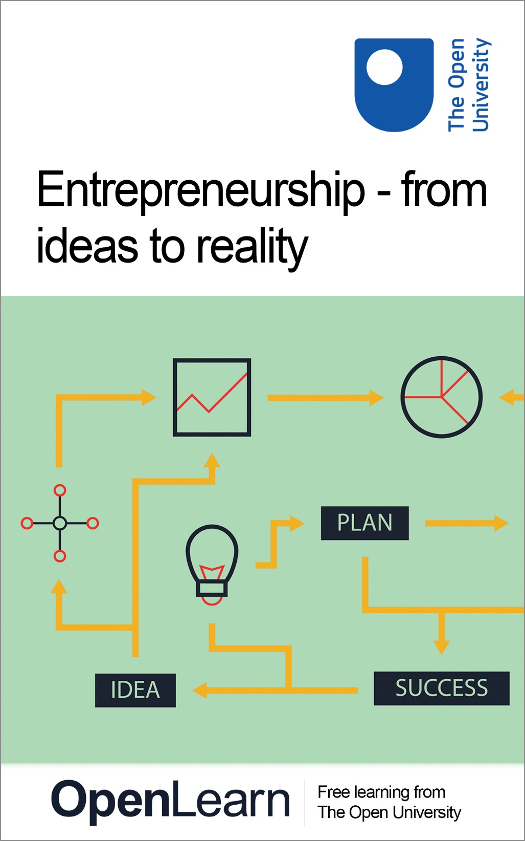

ENT_1

Entrepreneurship – from ideas to reality

About this free course
This free course is an adapted extract from the Open University course .
This version of the content may include video, images and interactive content that may not be optimised for your device.
You can experience this free course as it was originally designed on OpenLearn, the home of free learning from The Open University –
There you’ll also be able to track your progress via your activity record, which you can use to demonstrate your learning.
Copyright © 2018 The Open University
Intellectual property
Unless otherwise stated, this resource is released under the terms of the Creative Commons Licence v4.0 http://creativecommons.org/licenses/by-nc-sa/4.0/deed.en_GB. Within that The Open University interprets this licence in the following way: www.open.edu/openlearn/about-openlearn/frequently-asked-questions-on-openlearn. Copyright and rights falling outside the terms of the Creative Commons Licence are retained or controlled by The Open University. Please read the full text before using any of the content.
We believe the primary barrier to accessing high-quality educational experiences is cost, which is why we aim to publish as much free content as possible under an open licence. If it proves difficult to release content under our preferred Creative Commons licence (e.g. because we can’t afford or gain the clearances or find suitable alternatives), we will still release the materials for free under a personal end-user licence.
This is because the learning experience will always be the same high quality offering and that should always be seen as positive – even if at times the licensing is different to Creative Commons.
When using the content you must attribute us (The Open University) (the OU) and any identified author in accordance with the terms of the Creative Commons Licence.
The Acknowledgements section is used to list, amongst other things, third party (Proprietary), licensed content which is not subject to Creative Commons licensing. Proprietary content must be used (retained) intact and in context to the content at all times.
The Acknowledgements section is also used to bring to your attention any other Special Restrictions which may apply to the content. For example there may be times when the Creative Commons Non-Commercial Sharealike licence does not apply to any of the content even if owned by us (The Open University). In these instances, unless stated otherwise, the content may be used for personal and non-commercial use.
We have also identified as Proprietary other material included in the content which is not subject to Creative Commons Licence. These are OU logos, trading names and may extend to certain photographic and video images and sound recordings and any other material as may be brought to your attention.
Unauthorised use of any of the content may constitute a breach of the terms and conditions and/or intellectual property laws.
We reserve the right to alter, amend or bring to an end any terms and conditions provided here without notice.
All rights falling outside the terms of the Creative Commons licence are retained or controlled by The Open University.
Head of Intellectual Property, The Open University
978-1-4730-2877-7 (.kdl)
978-1-4730-2878-4 (.epub)

Contents
- Introduction and guidance
  - Introduction and guidance
  - What is a badged course?
  - How to get a badge
- Session 1: Where do good ideas come from?
  - Introduction
  - 1 Are you an entrepreneur?
  - 2 What’s the big idea?
  - 3 Invention, innovation and enterprise
    - 3.1 Finding ideas or ideas finding you
    - 3.2 Discovery skills
  - 4 Learning about ideas
    - 4.1 Ideas all around us
  - 5 Solving problems and seeing opportunities
    - 5.1 Design thinking
    - 5.2 Framing
    - 5.3 Learning from mistakes
  - 6 This session’s quiz
  - 7 Summary
- Session 2: From idea to reality
  - Introduction
  - 1 Starting your business
    - 1.1 Motivation and context
  - 2 Business in the UK
  - 3 Planning for growth
    - 3.1 Medium-sized businesses
    - 3.2 What are your goals?
  - 4 Protecting your idea
    - 4.1 Professional advice is advised
  - 5 What kind of business structures are there?
    - 5.1 Not for profit
    - 5.2 What structure do I need?
  - 6 Getting and running a business
    - 6.1 Bootstrapping it
    - 6.2 Developing your enterprise and finding help
  - 7 This session’s quiz
  - 8 Summary
- Session 3: Creating value
  - Introduction
  - 1 Practice and theory
    - 1.1 Traditional approaches to business
    - 1.2 The business model canvas
    - 1.3 Defining the terms of a business model
  - 2 Your business model is unique
  - 3 The entrepreneur’s dilemma
    - 3.1 Dilemma 1: building confidence
    - 3.2 Dilemma 2: managed growth
    - 3.3 Dilemma 3: finding support
    - 3.4 Dilemma 4: pivoting
  - 4 This session’s quiz
  - 5 Summary
- Session 4: Customers and markets
  - Introduction
  - 1 Who are your customers?
    - 1.1 Are they customers at all?
    - 1.2 Beyond customer transactions
    - 1.3 Getting to know your customers
    - 1.4 What do customers want?
    - 1.5 Customer segments
  - 2 The marketing mix
    - 2.1 What does the market look like?
    - 2.2 What kind of market is it?
  - 3 How will you compete?
    - 3.1 Returning to the Ps
    - 3.2 Returning to the competition
  - 4 This session’s quiz
  - 5 Summary
- Session 5: Defining and building the value proposition
  - Introduction
  - 1 The value proposition (VP)
  - 2 How mutual value is created
    - 2.1 Dimensions of value
  - 3 Optimising value
  - 4 Brand or USP?
  - 5 Defining your value proposition
  - 6 This session’s quiz
  - 7 Summary
- Session 6: Aligning resources to opportunities
  - Introduction
  - 1 An environmental scan
    - 1.1 Porter’s Five Forces
  - 2 Transformation model
    - 2.1 Types of transformation process
    - 2.2 Overlapping transformations
  - 3 From resources to capabilities
    - 3.1 Human resources
    - 3.2 Tangible resources and ‘know how’
    - 3.3 Mapping your capabilities
  - 4 Sustainability and making a difference
    - 4.1 Key success factors
  - 5 This session’s quiz
  - 6 Summary
- Session 7: Financing your business
  - Introduction
  - 1 Financing your business
  - 2 Cash management
  - 3 Financial accounts
  - 4 Limited liability
  - 5 What are potential investors looking for?
  - 6 Debt
  - 7 Grants
  - 8 Alternative finance
    - 8.1 Online platforms
    - 8.2 Rate of return
    - 8.3 Crowdfunding
    - 8.4 Peer-to-peer lending
    - 8.5 What is public equity?
    - 8.6 Private equity
    - 8.7 Angel investors and venture capitalists (VCs)
    - 8.8 Weighing up the pros and cons
  - 9 This session’s quiz
  - 10 Summary
- Session 8: Bringing it all together – just start!
  - Introduction
  - 1 Overcoming self-doubt
  - 2 Building your network
  - 3 Pitching your business
    - 3.1 What to cover in your pitch
  - 4 The secrets of success
  - 5 This session’s quiz
  - 6 Summary
  - Where next?
  - Tell us what you think
- References
- Further reading
- Acknowledgements
- Solutions

Introduction and guidance

Introduction and guidance
This free badged course, Entrepreneurship – from ideas to reality, lasts 24 hours, with 8 ‘sessions’. You can work through the course at your own pace, so if you have more time one week there is no problem with pushing on to complete a further study session.
The course has been designed to help you in starting up and running your own business. Using case studies it will take your through the decisions from generating initial ideas through to deciding what you will do and how to establish your business and grow it.
You will be guided through business models, funding options, business types, the influence of location and importantly assessment of your own skills, values and attitudes to risk. You will receive practical advice from real entrepreneurs and will also be signposted towards additional support which can help you develop your own capabilities further.
There will be numerous opportunities to check your learning. This includes interactive quizzes, of which Weeks 4 and 8 will provide you with an opportunity to earn a badge to demonstrate your new skills. You can read more on how to study the course and about badges in the next sections.
After completing this course, you will be able to:
- identify strengths of an entrepreneur and what support is needed to run a business
- evaluate, develop and refine a business idea and create a business model
- identify the gaps in resources and capabilities needed to grow a new business
- create a plan to develop capability and make progress growing a business
- create a pitch to gain support for development of a business.

Moving around the course
In the ‘Summary’ at the end of each session, you will find a link to the next session. If at any time you want to return to the start of the course, click on ‘Full course description’. From here you can navigate to any part of the course.
It’s also good practice, if you access a link from within a course page (including links to the quizzes), to open it in a new window or tab. That way you can easily return to where you’ve come from without having to use the back button on your browser.
Get careers guidance
This course has been included in the National Careers Service to help you develop new skills.
The Open University would really appreciate a few minutes of your time to tell us about yourself and your expectations for the course before you begin, in our optional start-of-course survey. Participation will be completely confidential and we will not pass on your details to others.

What is a badged course?
While studying Entrepreneurship – from ideas to reality you have the option to work towards gaining a digital badge.
Badged courses are a key part of The Open University’s mission to promote the educational wellbeing of the community. The courses also provide another way of helping you to progress from informal to formal learning.
Completing a course will require about 24 hours of study time. However, you can study the course at any time and at a pace to suit you.
Badged courses are available on The Open University’s OpenLearn website and do not cost anything to study. They differ from Open University courses because you do not receive support from a tutor, but you do get useful feedback from the interactive quizzes.

What is a badge?
Digital badges are a new way of demonstrating online that you have gained a skill. Colleges and universities are working with employers and other organisations to develop open badges that help learners gain recognition for their skills, and support employers to identify the right candidate for a job.
Badges demonstrate your work and achievement on the course. You can share your achievement with friends, family and employers, and on social media. Badges are a great motivation, helping you to reach the end of the course. Gaining a badge often boosts confidence in the skills and abilities that underpin successful study. So, completing this course could encourage you to think about taking other courses.

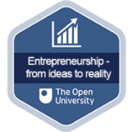
View description - Uncaptioned Figure

How to get a badge
Getting a badge is straightforward! Here’s what you have to do:
- read each session of the course
- score 50% or more in the two badge quizzes in Session 4 and Session 8.
For all the quizzes, you can have three attempts at most of the questions (for true or false type questions you usually only get one attempt). If you get the answer right first time you will get more marks than for a correct answer the second or third time. Therefore, please be aware that for the two badge quizzes it is possible to get all the questions right but not score 50% and be eligible for the badge on that attempt. If one of your answers is incorrect you will often receive helpful feedback and suggestions about how to work out the correct answer.
For the badge quizzes, if you’re not successful in getting 50% the first time, after 24 hours you can attempt the whole quiz, and come back as many times as you like.
We hope that as many people as possible will gain an Open University badge – so you should see getting a badge as an opportunity to reflect on what you have learned rather than as a test.
If you need more guidance on getting a badge and what you can do with it, take a look at the OpenLearn FAQs. When you gain your badge you will receive an email to notify you and you will be able to view and manage all your badges in My OpenLearn within 24 hours of completing the criteria to gain a badge.
Get started with Session 1.

Session 1: Where do good ideas come from?

Introduction
Every great business starts with a good idea that provides the impetus for you to make your enterprise happen. The question is where do these ideas come from?
The answer to this is that they come from thinking – from you thinking of something that other people really want or need. Perhaps though the question should be more explicit and ask where do good ideas come from and how do you know they are good? An even harder question following this is how do I know if it is a good idea for me?
It is the power of your idea that will ultimately attract interest from stakeholders, customers and end users.
This first session will consider the source of ideas before helping you to explore how to assess your ideas. In the sessions that follow, you will then receive practical guidance on how to progress them to a plan of action.
By the end of this session, you will be able to:
- understand the different ways that ideas arise and how to evaluate and develop them
- reflect on your own experiences and the examples and approaches provided to generate ideas
- recognise that ideas evolve and can lead to more ideas about different parts of a business.
The Open University would really appreciate a few minutes of your time to tell us about yourself and your expectations for the course before you begin, in our optional start-of-course survey. Participation will be completely confidential and we will not pass on your details to others.

1 Are you an entrepreneur?
You may well have a good idea, but does that make you an entrepreneur? The term entrepreneurship is a troublesome one to define – does it describe a type of person, or a way of doing business? More importantly, is it something you are born with or something you can develop? Entrepreneurship and enterprise are closely related concepts. Below are two definitions that the rest of this course is based on.

Entrepreneurs are those persons (business owners) who seek to generate value, through the creation or expansion of economic activity, by identifying and exploiting new products, processes or markets.
(Blundel, et al., 2018, p. 3)

Entrepreneurs are defined by their actions (not the size of organization they work for*). They create and/or exploit change for profit, by innovating, accepting risk and moving resources to areas of higher return.
Enterprise is an alternative term for a business or firm, as in the widely used term ‘small and medium sized enterprise’ (SME). They include ‘social enterprises’ which are trading organisations that serve a primary social purpose, and which can take a variety of legal forms….
*An intrapreneur is a salaried employee in a larger company and the profits and risks of their work go to their employer.
(Blundel, et al., 2018, p. 4)

In these definitions you will hopefully recognise yourself – or the possibility that you can become an entrepreneur if you have an idea and you know how to exploit it.
In this course you are also going to learn through the experiences of real entrepreneurs who are in the process of developing and growing their own venture. You will be introduced to four of them here and as you work your way through the course they will describe some of the key decisions they made, and why.

- Claudio Marturano, Nubis Aviation Training
- Emma Prince, Evolve Intervention (www.evolve-intervention.com/)
- Nick Allen, Flo and Vie (www.floandvie.co.uk)
- Alex Bond, CEO of Fresh Check (www.freshcheck.com)

Video content is not available in this format.
Video 1 Who are you and what is your enterprise?
View transcript - Video 1 Who are you and what is your enterprise?

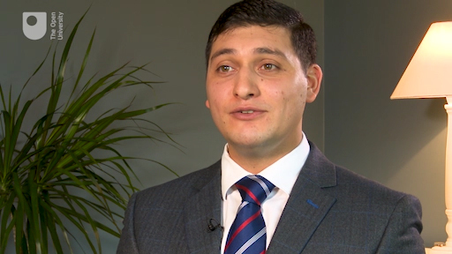
View description - Uncaptioned Figure

Next you will consider the source and inspiration for a business idea.

2 What’s the big idea?
There are many potential sources of ideas. Some fairly common examples include:
- spotting an opportunity (e.g. a gap in the market)
- experiencing a problem and looking for a solution for it (e.g. an invention)
- being able to do something that others can’t (e.g. using a talent)
- being prepared to do something others don’t want to or can’t do (e.g. cleaning)
- having something that others might need or want (e.g. investing in plant or machinery for hire).
You may have a sense of where and how our entrepreneurs in Video 1 came up with their ideas from their short biographies and the nature of their business. However, in the video that follows in Activity 1 they will talk about their ventures and confirm where their ideas came from.

Activity 1 Inspiration for a business
Allow about 10 minutes

Watch the video on the four entrepreneurs talking about their ideas and make notes on your initial impressions of each of them. Think about how they represent their idea(s). Did they try something that worked and just run with it, or was it something they could already do? Perhaps they saw an opportunity to apply something in a new area. Or maybe they started developing knowledge and skills that they could later turn into a business. Note your comments in the box below.

Video content is not available in this format.
Video 2 Where did the idea come from?
View transcript - Video 2 Where did the idea come from?

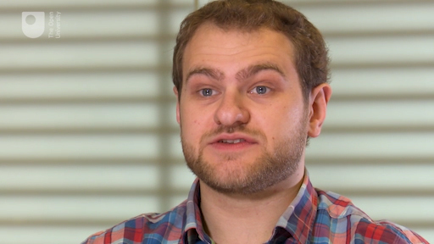
View description - Uncaptioned Figure

Provide your answer...
View discussion - Activity 1 Inspiration for a business

Having listened to others and taken time to reflect on your own ideas, you might have started to see patterns emerging. The idea may solve a problem, perhaps one encountered in your personal or professional life. It might be something our entrepreneurs are well placed to solve as they have the necessary expertise. Or they may have fresh insight as to how to improve on something or access to expertise from elsewhere.
Some ideas go beyond problem solving though. By seeing a possibility that others do not, opportunities can come around in the most surprising ways. Your idea may arise from something you are particularly passionate about – a cause, issue or interest you simply must share – or a particular capability that others seek.

3 Invention, innovation and enterprise
Writers on enterprise tend to differentiate between innovation and enterprise. Not everyone who comes up with an innovative new idea, like an inventor, is an entrepreneur. The entrepreneur is the person who turns an innovative idea into either commercial ends or, in the case of a social entrepreneur, solves a particular social problem. Sometimes they may be one and the same person, but not always.
The story of inventor James Dyson is a classic example of someone who had an idea, which he was also able to create in reality. You will read more about him and the bagless vacuum cleaner in Section 4. Having an idea and successfully building a product or a company on the back of it does not always happen. So when talking about where ideas come from, we are talking about innovation. You will explore the sources of innovation next.

3.1 Finding ideas or ideas finding you
Peter Drucker, a well-known management consultant, educator and writer on business and entrepreneurship, suggested that innovation may originate in three ways: internally, externally, or the ‘bright idea’.

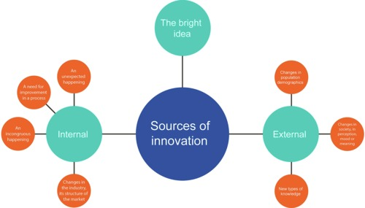
Figure 1 Origins of innovation
View description - Figure 1 Origins of innovation

When looking at Drucker’s sources of innovation, you might think of your idea as solving a persistent problem, or perhaps you are taking a good idea from somewhere and applying it in a different context. Technology continues to present opportunities to do things differently, or do them better, or even to do things that were not possible before.

Activity 2 Where are the opportunities to innovate?
Allow about 25 minutes

The following list is taken from another Open University course where people cited the sources of their innovation. Starting with this list and adding to it based on your personal experiences or observations, group the sources of innovation in relation to whether they are internal, external or the elusive ‘bright idea’.
- past and present work and experience
- hobbies and leisure interests
- qualifications and studies
- new markets/uses for existing products
- solving a persistent problem
- research and development (R&D)
- patents, licences and research institutes
- invention
- opportunities from new technologies
- opportunities from economic/market changes
- changes in consumer behaviour
- complaints and irritations expressed by potential customers
- changes in rules and regulations
- imitating an idea from a different locality
- imitating an idea from a different industry
- improving an existing product
- films, TV and radio
- books, magazines and the press
- trade shows, exhibitions and conferences
- business and social networks
- family and friends.
(The Open University, 2011)

Table 1 Internal, external or the bright idea?
Internal
An unexpected happening | Provide your answer...
An incongruous happening | Provide your answer...
A need for improvement in a process | Provide your answer...
Changes in the industry, its structure or the market | Provide your answer...
External
Changes in population demographics | Provide your answer...
Changes in society, in perception, mood or meaning | Provide your answer...
New types of knowledge | Provide your answer...
Bright idea | Provide your answer...
Source: Drucker (2007), cited in Blundel et al. (2018, p. 82).

View discussion - Activity 2 Where are the opportunities to innovate?

The aim of this course is to provide you with a deeper understanding of your own motivation, to zoom in on the source of your own idea. As you will see from examples that follow, ideas rarely emerge fully formed and are subject to almost constant refinement. Being able to spot where you can make important improvements is the key. Sometimes you may be too close to your own ideas and this is when looking at what others do can provide insights to your own situation.

3.2 Discovery skills
You may already have an idea for a new venture, or you may be considering your options. Either way, thinking about the source of an idea can help assess your existing ideas or even help to develop new ones. Remember, your idea may just be a starting point and you should be alert to many more that will occur to you as the course unfolds. These new ideas will also require evaluation to select the best options for you.
Ideas from nowhere are exceedingly rare. Most come from experiences, positive and negative, and they may not actually register with you unless you are alert to them. Life provides numerous opportunities and experiences to learn from but it is the extent to which you care about them that provides the impetus to act. Figure 2 and the table below summarise the type of discovery skills that lead to creativity and innovation.

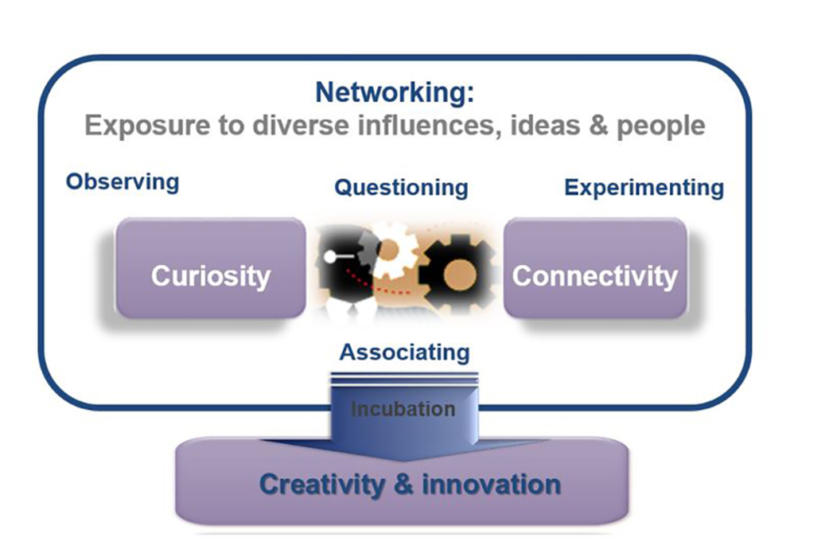
Figure 2 Discovery skills
View description - Figure 2 Discovery skills

Table 2 Types of discovery skills
Observing | actively noticing, watching, listening, perceiving, experiencing something
Questioning | asking relevant questions
Curiosity | the behaviour that causes you to ask questions and seek answers to why, how, where, when things happen as they do
Connectivity | linking objects, people, concepts, data, ideas etc. to see what results - or in the case of computing linking devices to each other and the internet
Associating | making connections between one thing and another - for example possible alternative solutions to a problem; possible ways to satisfy a need or want
Incubation | the process of developing ideas or solutions to a point where they have form
Creativity and innovation | the production of a new idea, solution, product, service or business which may be new to the world, an improvement on something, or provides access to a new market.

Later in the course you will return to these skills in practical activities. Next, you will read about a famous example of an innovator and an entrepreneur.

4 Learning about ideas
Is there such a thing as an ‘ideas person’? This course assumes not and nor does it assume that being enterprising is a trait you are born with. The assumption is that people can and do learn how to develop ideas. People who appear to be good at solving problems or identifying opportunities have learned to do so.
Obviously people are not the same, so are not all exposed to the same sets of opportunities. It is those differences between people that create diversity in views, attitudes and approaches, which result in different ideas. Indeed, being entrepreneurial is understood as having that ability to take advantage of differences (Blundel et al., 2018). To explore this further you will look at the example of James Dyson.

Box 1 James Dyson

Figure 3 James Dyson
View description - Figure 3 James Dyson

James Dyson was a product designer. He undertook a degree in design at the Royal College of Art and developed specific skills. Through his contacts he ended up working for an entrepreneur called Jeremy Fry who favoured a ‘hands-on’ approach to design and problem solving.
While working on renovating his house, Dyson encountered industrial extraction fans. Feeling frustrated by the poor suction of vacuum he used to tidy up post renovation, he wondered whether a solution from industry might work in a domestic setting. A few thousand prototypes later, a bagless domestic vacuum appeared on the market.
Clearly this account ignores lots of technical aspects involved in taking a technology that operates at one scale and turning it into a domestic product on another, but as an example it does demonstrate the value of learning.
Now listen to James Dyson offer his views on being an inventor.

Video content is not available in this format.
Video 3 What makes an inventor tick?
View transcript - Video 3 What makes an inventor tick?

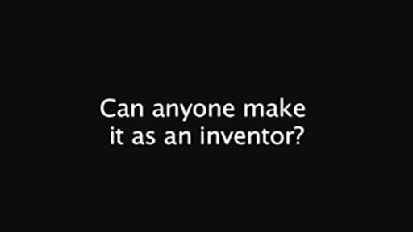
View description - Uncaptioned Figure

Next you will look at the different ideas that are around us.

4.1 Ideas all around us
Dyson’s source of inspiration, or perhaps his frustration, turned into an opportunity. If others felt as he did about those poor experiences then surely there was an opportunity. Sometimes new or better solutions can come from:
- simplifying what is there
- adding to what is there
- emphasising different attributes
- making something available in one place that otherwise customers would have to seek in many different places.
In other words, ideas are borne from context – they are not fixed. As a word of caution though, although you may perceive things in one way and can see a new approach, this does not necessarily mean others will share your vison, or view your idea as better. It is likely that changes and adaptation will happen. Sometimes this comes as a result of your own internal view changing, sometimes the context, or even the way you perceive it. Testing your ideas against others is important, as the Dyson example, which took many prototypes before getting it right, illustrates.
Now complete Activity 3 where you will hear more from our entrepreneurs and see whether their original ideas have changed over time.

Activity 3 How ideas change over time
Allow about 5 minutes

Watch Video 4 below. As you listen to the entrepreneurs, think about what reasons, if any, they gave for changing course.

Video content is not available in this format.
Video 4 Changing ideas
View transcript - Video 4 Changing ideas

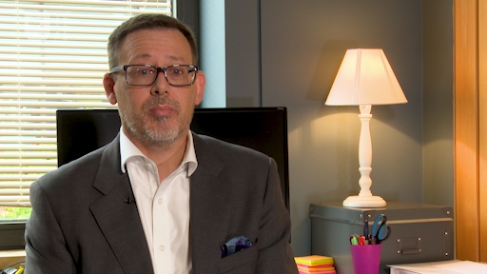
View description - Uncaptioned Figure

Provide your answer...
View discussion - Activity 3 How ideas change over time

Next, you will consider the tools and techniques which will help you meet the challenges of refining your idea.

5 Solving problems and seeing opportunities
Ideas arise from internal and external sources and through different experiences. But how do they relate to each other and help you to source new ideas? Often the simplest ideas and solutions are found to be the best. However, behind the apparent simplicity lies some very practical challenges. This section explores some of the tools and techniques you may find useful to meet those challenges.

5.1 Design thinking
‘Design’ has become a somewhat fashionable way to approach problem solving. Designers are seen as a great source of ideas: Dyson applied what is now called ‘design thinking’ – the process from which ideas develop – before it was fashionable. There are many design tools that can help individuals and teams to develop ideas. The Further reading section at the end of this session provides some useful information on these.
While ‘design thinking’ could be a course in itself, it is worth touching on a few points that are useful when developing and evaluating ideas. Drawing on the experience of others will help you to understand a challenge. For problem solving, the collective experience is useful to shape a range of possible solutions. Indeed, it is often the mix of experience and being able to ‘see’ how an idea from one area addresses an issue in another that provides novel ways of thinking.

5.2 Framing
‘Framing’ is the ability to recognise the type of issue in hand and structure it in a way that allows you to try alternative ideas to arrive at a solution. If one idea doesn’t work, try another. Framing is all about applying different approaches to describe the problem and applying potential solutions in different ways – it often starts with the question ‘what if…?’.
This framing technique works where there is a clear sense of what needs to be achieved. It means thinking about:
- how people are going to use the things you plan to make
- how you will create value and, critically, for whom.
Thinking like a designer is an excellent way to think about the future. While you retain a view of the value you want to achieve, during exploratory phases this means defining clearly what the real nature of the underlying problem is. Only once this is agreed does it make sense to move onto alternative possible solutions.
For each possible solution, a sense check is used to demonstrate how each different frame may impact on the desired outcome. The UK Design Council has formalised this in its ‘double diamond’ process (Figure 4), which identifies four distinct phases: discover, define, develop and deliver.
- Discover: this phase is intended to provide more insight into the problem or challenge being addressed. Hence this opens up thinking.
- Define: in this phase the intention is to focus upon specific areas to identify priorities, test assumptions and feasibility
- Develop: once more, thinking is broadened out to highlight all potential solutions, prototypes and concepts that can be tested
- Deliver: in this phase, evaluation of alternatives is designed to filter down to solutions that will be finalised and produced.

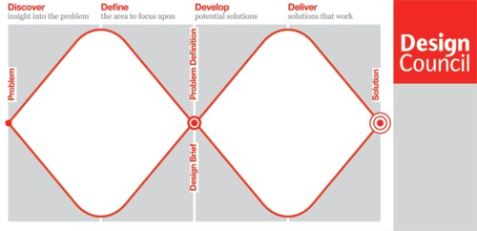
Figure 4 Double Diamond model. (Design Council Double Diamond, created in 2004).
View description - Figure 4 Double Diamond model. (Design Council Double Diamond, created in 2004).

For a more detailed look at the UK Design Council’s double diamond process visit the Further reading section at the end of this session. For an alternative, the ‘d school’ at Stanford also provides insights, which you can also find out more about in the Further reading section.

Activity 4 Generating and evaluating ideas
Allow about 20 minutes

- Think of a problem or irritation you are aware of – or else simply try to create something for fun. Now watch this detailed approach to brainstorming and come up with as many ideas as you can to solve your problem or create something.

Watch the video at YouTube.com.
Video 5 Brainstorming

Try to come up with at least five ideas. Don’t filter or judge them in any way yet and remember they can be anything you want. In the next part of the activity you will explore how you filter your ideas.

1.
2.
3.
4.
5.

- Academic Roger Martin and designer Tim Brown (Brown and Martin, 2015) have suggested that designers juggle the following questions when they assess ideas:
- Is it suitable – does the idea actually address the issue?
- Is it feasible – is it technically possible?
- Is it acceptable – is it acceptable to all stakeholders?
Using Table 3 below, write down each of the ideas you came up with and score it 1 to 5 for suitability, feasibility and acceptability, with 5 being the most and 1 the least, to see which one scores highest. The blank column is for you to add your own filtering criteria. You could add different things that are significant to you such as: fit with family, passion, suits lifestyle, or whatever is the most relevant for you.

Table 3 Will it work?
Idea | Suitable | Feasible | Acceptable | Significant criteria | Total
Provide your answer... | Provide your answer... | Provide your answer... | Provide your answer... | Provide your answer... | Provide your answer...
Provide your answer... | Provide your answer... | Provide your answer... | Provide your answer... | Provide your answer... | Provide your answer...
Provide your answer... | Provide your answer... | Provide your answer... | Provide your answer... | Provide your answer... | Provide your answer...
Provide your answer... | Provide your answer... | Provide your answer... | Provide your answer... | Provide your answer... | Provide your answer...
Provide your answer... | Provide your answer... | Provide your answer... | Provide your answer... | Provide your answer... | Provide your answer...

View discussion - Part

5.3 Learning from mistakes
It is easy to neglect the value of learning from things that don’t work. Most of what we know about entrepreneurs and ideas comes from people who have been successful. Sometimes they might have been lucky, and being lucky is important, but more often it is hard work, and learning and recovering from lots of mistakes.

Figure 5 Not all ideas work
View description - Figure 5 Not all ideas work

Take for example Apple. What would have happened if the learning that Apple took from their disastrous mistake of producing the early handheld touchscreen device ‘Newton’ in 1993 was that they should never develop another touchscreen mobile device?
One of the key elements of Dyson’s story is what he learnt from his idea of a ball barrow being stolen. The innovation was to replace the front wheel of a wheelbarrow with a ball making it much easier to manoeuvre. His idea, however, was stolen by a US company. This was a valuable lesson in failure to protect his idea, which he later applied to controlling production and intellectual property for future ventures (Blundel et al., 2018, pp. 248–51).
It is easier to learn from your mistakes than to discern the real lessons. People are sensitive to failure and have a real aversion to loss. This can affect your decision making if when you tried something in the past (or to use designers’ language, framed a problem or solution in a particular way) it failed. Your objectivity about whether it will work again is affected. You will often hear ‘we tried that before and it didn’t work’. Challenging this attitude can be difficult. Some design approaches, particularly from software development, champion the notion of learning from failure. ‘Move fast and break things’ or ‘fail fast’ are increasingly popular mantras.
In theory it is useful to think about how learning from and embracing failure creates something stronger, but there can be resistance to this from some quarters. Some cultures – countries or organisational ones – do not encourage failure at all. For example, the risk to reputation or the consequences of failure may be considered too high or damaging for individual careers.
Failure is not simply inconvenient for some enterprises. In particular, the social consequences for social enterprises should not be underestimated nor trivialised (UnLtd, 2016). Another example could be a failed banking app, which might mean that thousands of customers have no access to their accounts, do not get paid, and have fees applied through no fault of their own etc.
Care therefore does need to be exercised over how one learns from failure. It is the interpretation that is important. Some failures spur you on to greater things. Those at Apple didn’t ditch the idea of touchscreens. Some have instead suggested that the Newton was simply a device launched before its time and that pricing and handwriting recognition problems were more to blame (The Telegraph, 2018). Given the success of the iPhone and iPad, it is hard to argue with that view.
It is highly likely that one or more aspects of your own idea will be challenged or rejected at some point. You can choose to ignore this feedback. Or you may agree and use it to tweak or revise your idea, seeing it as a way to produce something more robust. Try not to let negative feedback cause you to falter at the first hurdle. As you carry on with the course you will see that it is not always plain sailing for any entrepreneur, including the four you are following at the moment, who will continue to share their experiences with you.

6 This session’s quiz
Check what you’ve learned this session by taking the end-of-session quiz.
Session 1 practice quiz
Open the quiz in a new window or tab, then come back here when you’ve finished.

7 Summary
Telling a good story – and our entrepreneurs have good stories to tell – is of course part of the ability to turn an idea into reality. After all, it is not only you that needs to be convinced that what you have is a good idea. You will need to convince others to help you, to join your team, to provide some resources or finance, and in time it will be real people who will engage with your product or service as users or customers.
An entrepreneur is not necessarily the source of innovation. While Dyson’s first idea of the ball barrow was borne out of his frustration, later the wheel/ball became part of his vacuum cleaner, though arguably it was the suction and not the ball that made the difference. Recognising the application of an industrial systems approach to the domestic market, and setting out to try to make it work, was the crucial factor. As you progress through this course you will find yourself on a similar journey, as you address each area of a business where you have further potential to innovate.
In this session, you have:
- heard from a number of entrepreneurs, in particular where their ideas come from
- considered how to generate an idea and the tools which can be used to evaluate an idea to provide you with greater confidence that it will work
- listened to examples of ideas that have worked, as well as those that did not, and how they evolved as a result of learning from failure.
In the next session you will explore how to make ideas a reality.
You can now go to Session 2.

Session 2: From idea to reality

Introduction
Many new businesses fail within two years of starting up – 50 per cent within three years (Business Wales, 2018). Have you thought about how you can avoid this happening to you? In the last session you considered sources of ideas; indeed you may already have an idea, but what happens next? In this session you will consider the decisions needed to formally start your business and three vital aspects of a business that you will have to manage simultaneously to succeed:
- Delivering the business
Are you able to produce something that can be monetised in some way? That is to say, can you consistently meet the demand for a product or service that others consider worth paying for (or making use of)? If you can’t, your business won’t even get off the ground.
- Running the business
Running a business or, in other words, fulfilling the functions and obligations required of an organisation properly, observing the law, and at the same time, meeting the expectations of your stakeholders (customers, shareholders, suppliers and so on) is also essential. If you fall foul of the law or regulator (if appropriate), or you consistently fall short of customer expectations, it won’t take long for your business to go under.
- Getting the business.
This is your ability to find, supply and keep on getting new sales, contracts and customers. Again, with no future income streams, you will deplete your initial capital and resources very soon, along with your ability to meet obligations to your creditors.

Figure 1 Business involves spinning many plates at once
View description - Figure 1 Business involves spinning many plates at once
View description - Figure 1 Business involves spinning many plates at once

Clearly, having a successful, sustainable business means being able to balance and address all three aspects at the same time.
By the end of this session, you will be able to:
- describe your own motivation for starting your enterprise
- identify what support and actions you will need to make your business idea a reality
- evaluate a number of alternative business structures to refine those that are appropriate to your needs.

1 Starting your business
There are a number of considerations when you start your business, including your ambitions for it, your own motivation, goals, context and circumstances, and the nature of the business you intend to run. It may sound odd, but another important consideration is your exit strategy, i.e. how you would prefer to leave the business. There are a number of ways this could happen – you may want to be bought out, pass or sell it on to family or employees, wind it up or be taken over. As you are deciding what structure your business will take, you should have this in mind.

1.1 Motivation and context
What is your motivation? Is this a lifestyle business, e.g. a way to earn a living that fits with your lifestyle, using mainly your own skills, talents and/or time? Does it have to fit with a family situation? If so, you may see yourself as being self-employed, staying local and staying small to ensure that you can maintain a sensible work–life balance.
Perhaps your business is dependent upon your immediate environment for several reasons, such as:
- natural features, like wonderful views, and amenities that you want to exploit
- ready access to customers (enabling footfall or easy logistics) or the infrastructure your business needs, which could be anything from a central location to superfast broadband.

Reflection

Reflect on your own motivation for starting your enterprise taking into consideration all of the aspects that have so far been discussed.

Provide your answer...

Next, you will look at different types of businesses and how funding can be distributed between them.

2 Business in the UK
Successive governments have identified low productivity in the UK economy and so have provided support to entrepreneurship, new business start-ups and therefore new jobs. In 2020, the government estimated around 6 million businesses in the UK, of which 5.94 million were small (0–49 employees) and 36,100 were medium-sized enterprises (50–249 employees). Only 7,800 businesses were deemed large (BEIS, 2020).
Different definitions of small to medium-sized businesses (SMEs) – which form the vast majority of businessees – exist, but those used by government in the UK differentiate on the basis of turnover and employee numbers. Micro-businesses are considered to be those with fewer than ten employees and a turnover of less than £2m. An SME may have up to 250 employees and a turnover of up to £25m, which in the UK represents over 99 per cent of all businesses (Rhodes, 2017).
As the chart in Figure 2 shows, there are many times more small businesses than there are large ones. UK business angels have continued to invest a similar level to pre-Covid times (British Business Bank, 2020a), though initial investments were a little lower, which accounted for some caution on the economic uncertainty around. Since the pandemic, the UK Business Angels Association (UKBAA) have continued to prioritise proposals from healthcare; biotech, life sciences and pharmaceuticals; and software as a service (British Business Bank, 2020b).

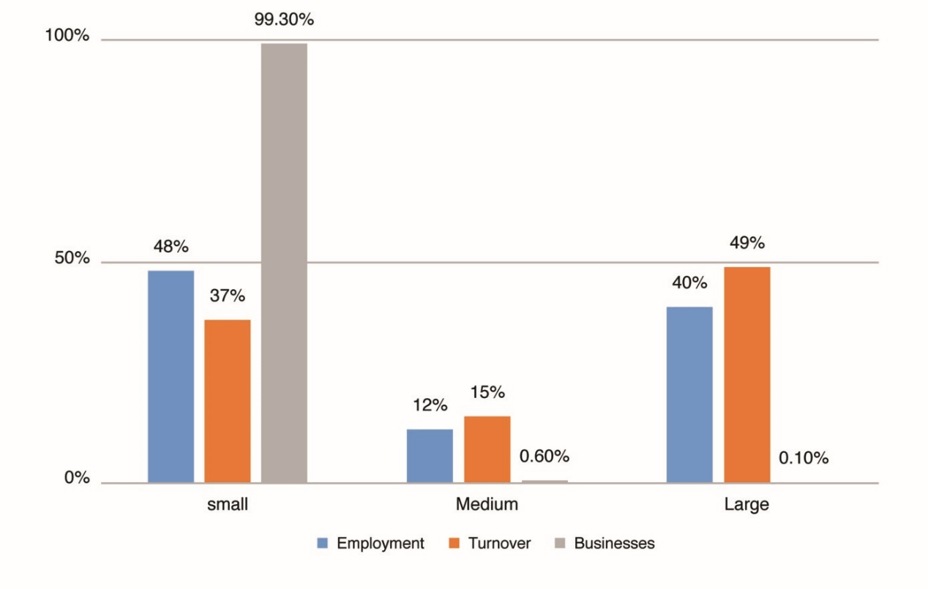
Figure 2 Share of enterprises
View description - Figure 2 Share of enterprises
View description - Figure 2 Share of enterprises

The UK government prioritises financial services, science and technology, energy and health sectors. These are sectors that are particularly important from the perspective of ensuring the security of the economy, as well as being sectors where the UK can be influential. There are many more that are important to the prosperity of the UK, including food and drink, clothing and textiles, and transport. In your own nation, there may be a slightly different emphasis and therefore different opportunities. It is worth checking with the websites of the devolved administrations in Scotland, Wales and Northern Ireland or indeed other countries to see how these differ.
While government priorities do not mean you cannot build a thriving business in another sector, you may find that funding is more readily available in the priority sectors. In Section 6.2 you will find a list of development agencies and support for start-ups in the UK nations and Ireland. These will provide more detail of grants and funding schemes for target sectors.
Large companies account for only 0.1 per cent of businesses, but 40 per cent of employment and almost half (49 per cent) in turnover in the UK. You can perhaps understand how growing businesses are economically important to governments, but that it is much easier said than done. Growing a business for a small enterprise takes much more than working harder and faster.
Next, you will look at what is involved in scaling up to a medium-sized enterprise.

3 Planning for growth
Do you have all the skills, time, resources and organisational ability to keep all three aspects of your business (getting, delivering and running it) going? If not, you will have to consider who will get, do and run your business. That may mean becoming an employer with all the responsibilities and obligations that implies.
Jyoti Banerjee of the M-Institute (a not-for-profit organisation that supports and promotes growth of medium-sized businesses) observes that leading a small business versus a medium-sized business is very different and requires quite different behaviours and attitudes.
Watch this short video to hear Banerjee describe how medium-sized businesses are different to small businesses.

Watch the video at YouTube.com.
Video 1 Jyoti Banerjee: mid-sized businesses

Small businesses tend to be concerned with survival and viability, and may also be based around the lifestyle of the owner.
A medium-sized business is concerned with growth and scaling up, which requires a different mindset and managerial behaviours as a result.

3.1 Medium-sized businesses
Scaling up to a medium-sized business arguably results in one of the biggest challenges for entrepreneurs who have been successful in creating their small business. Being totally focused on keeping on top of everything, making it work, knowing who’s doing what, and following up on every opportunity in a small business is very different to deploying a staff of 50 or 200 employees.
As you grow your business, you simply cannot wrap your arms around it all. With growth comes a little less direct control and an ability to find and trust other people to perform their role.

Figure 3 Scaling up is one of the biggest challenges for an entrepreneur
View description - Figure 3 Scaling up is one of the biggest challenges for an entrepreneur
View description - Figure 3 Scaling up is one of the biggest challenges for an entrepreneur

If your idea has high growth potential and you don’t have the means to finance it yourself, you will have to seek external investment. To achieve growth it is highly likely you will need employees, a means of production (which may mean premises, equipment or people), and a structure. You may also need to finance research and development. These all entail increasing costs. Medium-sized businesses have to find and manage access to finance to grow and this can be more difficult for them than larger companies.
Some regulations apply to all businesses, irrespective of size. Small businesses may be exempt from some, for example, the need for financial audits for a turnover below £10.2m and fewer employees than 50, but medium-sized firms need to fulfil all the requirements of a larger business without having the structure and specialist staff to deal with them.
As a medium-sized business you will have to compete in the job market for trained or skilled staff, or find the budgets and time to train and develop these amongst your own employees. And of course there will be the need to pay them competitive wages, and provide pensions and benefits, if you want to retain those staff. Involving investors will require you to take a longer term view to satisfy them of your plans to show how you can increase costs while generating future revenues.
Banerjee (2011) suggests that entrepreneurs who want to run medium-sized businesses have to think differently by setting aside the instinct to do everything themselves because they know they’re best at it. Entrepreneurs have to be able and prepared to bring on board a team to spread the load and provide diversity of thinking and new ideas.
You will return to financing your business in more detail in Session 7.

3.2 What are your goals?
Knowing what you want to get from setting up your own business is an important early step. The following reflection will help you to outline what your goals and ambitions are for your business.

Reflection

What does running your own business mean to you?

Provide your answer...

What is your business all about? What is its purpose – or to use the jargon – its mission?

Provide your answer...

Who else will be affected by your decisions?

Provide your answer...

Thinking ahead five years, where do you see yourself, your family, your business?

Provide your answer...

Do you have the mindset that Banerjee suggests is vital to grow?

Provide your answer...

Now consider your own personal values – what is important to you? Does your image of the future square with your values? Are there any that are likely to conflict?

Provide your answer...

Five years from now, your business could be well established and hopefully you will have achieved your goals, but to get there means taking stock of your situation, making some decisions and taking action now.
Next you will look at how to protect your idea from being stolen or copied.

4 Protecting your idea
In Session 1 you explored the business idea. One of the most important decisions you will face in starting your business is how to protect your intellectual property. Intellectual property (IP) is the intangible property that comes about from your ideas and thoughts and includes ‘inventions, literary and artistic works, designs, symbols, names and images used in commerce’ (WIPO, 2018).
Ensuring you protect your IP makes it much harder for other people to steal or copy it. As the Dyson example in Session 1 illustrated, this can turn out to be very significant! It does not come without costs and you should build this into your growth planning.
If your business idea is to run as a franchise, or you intend to grow your business through licencing your idea or franchising it to others, IP is an essential consideration. There are different types of IP available. Box 1 outlines some of the more common ones.

Figure 4Patent, copyright and trademark symbols
View description - Figure 4Patent, copyright and trademark symbols
View description - Figure 4Patent, copyright and trademark symbols

Box 1 Different types of IP
Patents – provide the inventor with the right to prevent other people from making, using or selling the subject matter under patent. Patents are the best protection for a new product.
Copyright – covers original works of art, authorship or written copy (books, music, film etc.).
Trademarks – protect the value of a name, brand, logo or other symbols that allow your product to be distinguished from others. Think of the three stripes or the tick for Adidas and Nike. Before you register your company and website address or consider a business that operates in international markets, it is worth considering whether you can have these and use them without infringing any other business. You may also want to consider any cultural references that make your product less attractive overseas. In addition, it makes sense to ensure that your product and company name work for customers and other stakeholders. Is it memorable? Can it be spelled and therefore found?
Trade secrets – allow the owner to take action against anyone who breaches the agreement to keep something confidential – for example a family recipe.

4.1 Professional advice is advised
This course cannot provide you with everything you need to know about intellectual property, however here are some tips to consider and discuss with a legal adviser, as you start your business.
- If you are currently working for someone else, you should check the terms of your employment to ensure that your employer does not own any new ideas or inventions. Similarly, working on your own idea under the radar, in their time and using their resources, could create problems for you further down the line. Keep a clear distinction between your employed work and your new venture.
- A non-disclosure document or confidentiality agreement will allow you to have conversations with experts and advisers about your ideas without jeopardising your position.
- As you work up your idea you will possibly have sought and gained lots of input from friends, colleagues and others. These conversations may even result in joint ideas or loose proposals to be co-founders. Once there is an agreement between you and others, you need to agree on the terms of the relationship to prevent huge problems down the line.
- If you are going to be working with other people on your business idea – perhaps employing independent contractors – then you should ensure that all IP rights are assigned to your company. If you employ someone from a competitor, then ensure that they aren’t bound by any confidentiality or non-compete conditions.
- If you are using open source software as part of your product, you need to carefully check the rights and permissions. Similarly, if you intend to use images on your website, you do not want to infringe others’ copyright.
- Protection should cover all the country markets that you intend to trade in.
While this course is written as though starting a new business is a linear process, the reality is that you will have to operate on many fronts at the same time.

Activity 1 Finding advice
Allow about 5 minutes

Before you move on to consider the types of business there are, take some time to make some notes below on whether you need to get advice on protecting your idea. There is a lot of information available via the internet and often your local enterprise partnership or economic development agency will have local law firms that provide seminars and free advice for new businesses.
Here are some websites that produce information on all aspects of starting a business and entrepreneurship:
www.Gov.uk
www.forbes.com
www.techcrunch.com

Provide your answer...
View discussion - Activity 1 Finding advice

Next you will look at the different legal structures a business can take.

5 What kind of business structures are there?
One of the decisions you will be faced with early on in the setting up of your business is what legal structure it will take. It is important to distinguish between the legal form – how the law regards the enterprise – and organisational type, which is how you regard it and present it to the world. You can have several organisational types, but you will have only one legal form.
There are several legal options available for your business structure. Here are some brief definitions:
- Sole trader – the simplest way to operate. However, there are implications for how you raise finance and your personal liability for debts and tax. As a sole trader you are not separate from the operation.
- Partnerships – where two or more people co-own a business and share the income from it. As with sole traders, in the law, the business is not seen as separate from its operators.
- Limited liability partnerships – require at least one general partner and one limited partner – but you cannot be both. Limited partners contribute to the funding to start the company and are liable for debts up to the amount contributed. A limited partner cannot manage the business. General partners manage the business and are liable for any debts the business cannot pay.
- Limited company – the business is separate from the operators. Its finances are separate from the owner’s personal finances. Companies can retain profits after paying corporation tax. Companies need directors and shares, memorandum and articles of association and, in the UK, need to be registered with Companies House.
- Franchise – a business in which the owner or franchisor gives a third party (franchisee) the right to use their business name, logo and business model. McDonalds and Subway are well known examples of franchises on the high street. This is one way to start a business which avoids much of the activity required for a new business. It is also a way to scale your own business idea.
- Social businesses – there are common organisational types used by social businesses:
  - Social enterprise – a business with primarily social objectives. Profit is mostly reinvested in the business or in the community, rather than maximising profit for shareholders and owners.
  - Community enterprise – generally taken to be a social enterprise owned and run by a geographical community or a community of interest.
  - Co-operative – an autonomous association of persons united voluntarily to meet their common economic, social and cultural needs and aspirations through a jointly-owned and democratically controlled enterprise (International Co-operative Alliance definition). There are many types of co-operative:
– worker co-operative – co-operative owned and run by its workers
– housing co-operative – co-operative owned and run by its tenants
– consumer co-operative – co-operative owned and run by its customers
– co-operative consortium – co-operative owned and run by other businesses which use the services of the co-operative
– multi-stakeholder co-operative – a mixture of any or all of the above.
- Community land trust – an organisation created to hold land as an asset for community use.
- Credit union – a non-profit financial institution that is owned and operated entirely by its members.
- Development trust – a community-based enterprise that secures and manages community assets.
- Social firm – a business committed to creating employment and training opportunities for people who are furthest from the labour market.
Any one of these business types can also be an ethical business, but whereas a social enterprise is established to benefit people and the planet as its primary purpose, an ethical business is one that seeks to minimise the harm done by its business to people and the planet.
Deciding what structure your business should take requires thinking about how you will finance it and what size of business you anticipate it will become. Bear in mind that an individual can trade for a social purpose as well as being a sole trader, and call themselves a social business. Indeed, there is very little legislation or regulation of the use of organisational types in business branding or marketing.
Refer back to your goals and ambitions. The structure will also have implications for who has control of the business, and whether audited accounts and named directors are required.

5.1 Not for profit
In recent times funding has become available to support a range of ‘not-for-profit’ enterprises, community companies, social enterprises, charities, or community interest companies. These types of organisations are becoming increasingly important, especially as central government devolves more local service provision to local government and reductions in funding means many services are being cut.
In setting up one of these, you (and your community) will need to consider exactly the same things as any private or for-profit enterprise: demand, financial viability, skills and capacity, and how to secure funding.
However, as these are often publicly regulated bodies, they have a more complex legal structure and you should contact one of the organisations listed at the end of this session to find out more.

5.2 What structure do I need?
Before making your mind up about the kind of legal structure you need, you will find it useful to do some research of your own. The questions below might help you to narrow down the options for further discussion with a professional adviser, and the GOV.UK website is another useful place to start. Answer these questions to help you complete Activity 2.
- Are you planning on starting the business on your own or with one or more others? What would you want to happen in future in the event of one or other wanting to leave, for example retiring or moving away?
- Are you taking over a business from someone else? What is the structure of that business, who owns it and what further involvement might they want in it, if any?
- How much administration is needed? Although you will always need to keep adequate records for tax and other reasons, some structures do not require you to register your company, incorporate it, file accounts or have them audited, or to make annual returns.
- How much finance do you need? Where will your finance come from? What assets do you have and are prepared to use as a collateral if necessary to borrow capital to invest in your business? Will it come from you or from loans and shareholders? How does having shareholders impact on your growth plan?
- Do you need to consider tax advantages or protection of personal assets?
- What about other considerations like your community, surroundings or the environment?

Activity 2 Deciding on the structure of your business
Allow about 20 minutes

Using your answers to the questions above as a prompt, look up the types of structure that exist to see how they would fit for you. Complete the table below.

Table 1 Finding what business structure works for you
Structure | How would this work for me? | What wouldn’t work for me
Sole trader | Provide your answer... | Provide your answer...
Partnership | Provide your answer... | Provide your answer...
Limited liability partnership | Provide your answer... | Provide your answer...
Limited company | Provide your answer... | Provide your answer...
Social business | Provide your answer... | Provide your answer...
Franchise | Provide your answer... | Provide your answer...

View discussion - Activity 2 Deciding on the structure of your business

Next you will think about what else you should consider once you have started your business.

6 Getting and running a business
What are the core functions and roles that keep a business running?
At this point it is interesting to see how our entrepreneurs started out.

Video content is not available in this format.
Video 2 Starting out
View transcript - Video 2 Starting out

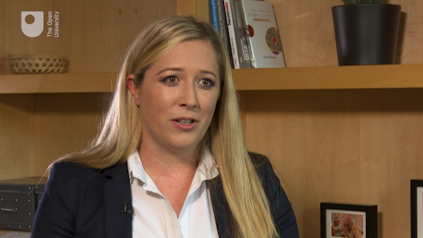
View description - Uncaptioned Figure

Next you will think about the benefits of taking on employees as your business grows.

6.1 Bootstrapping it
Many small businesses start small, with no external help or funding. They do not usually start by hiring people to run the business, but instead try to turn their hand to everything which can mean long hours, learning new skills and relying on a lot of advice – that’s bootstrapping it. Don’t panic!
One of the dilemmas small businesses face is when they need to hire their first employees. Being a good employer means taking responsibility on a number of fronts. You will return to these later in the course when you consider on a personal level the implications for you and them. One useful piece of advice about taking on employees is to consider a term from economics – the ‘opportunity cost’. At some point, you should consider whether it is cheaper or more efficient for someone else to carry out the functions of the business – either running it, getting it or delivering the business. If you can make more profit from turning out something to sell per hour, than you can doing your book-keeping, then it makes more sense, economically speaking, for you to hire someone to do the books. This ‘make or buy’ decision can be applied to each aspect of your business. At this point, you should reflect back on the points made by Jyoti Banerjee about growing your business in Section 3.

Activity 3 Core functions of a business
Allow about 15 minutes
Under each of these headings, make a list of tasks and roles that you would need to consider when running your business.

Finance

Provide your answer...
View discussion - Finance

Administration and governance

Provide your answer...
View discussion - Administration and governance

Sales, marketing and customer service

Provide your answer...
View discussion - Sales, marketing and customer service

6.2 Developing your enterprise and finding help
There is a lot to running a successful business. If you don’t have the skills now, you could acquire them over time. There are many free courses on book-keeping and budgeting, marketing, social marketing and a host of useful tips you can find on OpenLearn and on the internet.
As you develop your enterprise you will also have a number of potential people who can offer support amongst friends, family or your extended network. While in the short term working with people you know and trust may be an obvious solution, it is worth thinking through whether this is in fact the best idea. There are pros and cons. Your friends and family will almost certainly have your best interests at heart, but they also have their own priorities, perhaps jobs and other responsibilities. Can you ensure that their investment or support is sustainable and won’t lead to an unacceptable risk or loss for them? Will you be able to pay them? Will the business be able to sustain all of your needs and ambitions? Will your relationships withstand disagreements, well intentioned advice that goes wrong, mistakes, long hours, and other inevitable pressures? Would having two people earning a living from the same business be an advantage or a pressure?

Reflection

Of course, many family businesses work very well indeed. So far in the discussion above there has been more cons than pros. Take a moment now to find a counterbalance to these with some of the advantages that arise from working with people you trust and who may share your ambition.

Provide your answer...

As well as turning to family and friends, many public bodies also provide sources of support, resources, information and advice, and can signpost you to local organisations. You will find more specific and local support from organisations near you, but Activity 4 gives you a list of some organisations to start with in each of the UK nations and Ireland.

Activity 4 Finding useful resources
Allow about 20 minutes

The links below are a list of useful sources of information, guidance and signposting. Make a note of, or bookmark, the links that may be most useful to you so you can come back to them at various points throughout the course and as you develop your business.

Entrepreneur Handbook on grants and funding for small businesses in the UK
Local Enterprise Partnership network of growth hubs in England
Social Enterprise UK covers all of the UK with members across the world
Business Gateway (Scotland)
Highlands and Islands Enterprise
Highlands and Islands Social Enterprise Zone
Just Enterprise
Scottish Institute for Enterprise
Scottish Enterprise
Scottish Government Rural Business Support
Scottish Rural Network
Enterprise Northern Ireland
Invest Northern Ireland
Social Entrepreneurs Ireland
Social Enterprise Northern Ireland
Business Wales
Wales Council for Voluntary Action
Trade & Invest Wales

7 This session’s quiz
Check what you’ve learned in this session by taking the end-of-session quiz.
Session 2 practice quiz
Open the quiz in a new window or tab, then come back here when you’ve finished.

8 Summary
There are many professional advisers – lawyers and accountants – that will advise and set up your company for you, for a fee. You should, however, do your research first and take advantage of the numerous public bodies that exist to support new and growing businesses, from the large economic development agencies in your nation to the smaller local ones. As well as introducing you to a network of support from their own resources these agencies also run or can suggest other gatherings where you can access other local businesses (who could be a source of custom as well as advice). They also provide training courses, resources such as templates and guidelines, and may also provide you with a mentor or personal adviser. They will be very keen to understand your vision for your enterprise and in the next session you will be introduced to the business model canvas as a useful way to plan and describe your business to others.
In this session, you have:
- recognised how businesses can be sustainable through managing all the core functions of getting, doing and running the business
- identified that there are several different types of business entity to choose from depending upon how big you think your business is going to become
- considered how your own motivation and how you intend to finance the business has an impact on the structure of your business
- learned how to assess gaps in the core skills your business needs
- identified how important it is to get professional advice and support from others.
In the next session you will explore how your business can create value for you.
You can now go to Session 3.

Session 3: Creating value

Introduction

‘A business is a value delivery system.’
(Lanning and Michaels, 1988)

What is meant by a value delivery system and why is this important in starting a new enterprise? It is only by creating something that people are willing to pay for or support that you will make money and be able to sustain your enterprise.
In this session you will start to understand how your business can create value for you through delivering products and services for your customers.
Lanning and Michaels (1988) described a business as a means of delivering value. But for whom? The concept of value is an important one for many reasons and it goes beyond strictly financial meanings of cost or price. For example, sentimental value is nothing to do with financial value, and the price premium we are prepared to pay for an item with an exclusive brand goes beyond the cost of raw materials, and producing and delivering it to the end customer.
By now you should have recognised that all businesses start from an idea or arise from something that people want or need. In this session you will consider different ways of looking at how you can deliver value to users or customers.
By the end of this session, you will be able to:
- create and describe your business model as a foundation for creating value
- identify the kind of dilemmas that entrepreneurs face in setting up their business
- recognise why it is important to remain flexible and willing to adapt and change to be successful.

1 Practice and theory
While it’s tempting to dismiss theory and go straight to creating your product or service, you may quickly run into problems with cash-flow, HMRC, suppliers and customers, amongst others, if you haven’t first established your legal status and your business model. A little planning and preparation now will help those around you to be clear about how to set things up well, and about the contacts and infrastructure you will need. It will also help others to know who they are dealing with and how to respond efficiently.
In Session 2 you concentrated very much on managing the business (remember the three essential activities):
- Running the business (e.g. those ‘must do’ activities that mean you can create and settle invoices, pay your taxes, comply with regulations and so on)
- Getting the business (e.g. find, attract and keep customers)
- Delivering the business (i.e. create the product or service that customers want to use or buy).
In this session you will go into a little more detail about the business model – how it will actually operate and how you will go about getting and delivering the business.
The benefit of the models used in this course is that they can be used in a very practical way as a checklist or framework on which you can quite quickly create a visual outline of your business. This will be useful to build the business and to explain it to others who can support you.

1.1 Traditional approaches to business
The traditional approach to a business could be represented in this way:

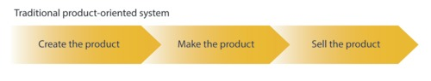
Figure 1 Traditional product-oriented system
View description - Figure 1 Traditional product-oriented system

McKinsey’s value delivery system offers an alternative, but still quite traditional, view of business, as shown in Figure 2.

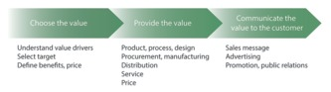
Figure 2McKinsey’s value delivery system
View description - Figure 2McKinsey’s value delivery system
View description - Figure 2McKinsey’s value delivery system

In both systems, the assumption is that as you move along from left to right, there are opportunities to create value.
Next you will look at what has become a very popular model of describing the essential features of a business, the business model canvas.

1.2 The business model canvas
The business model canvas, sometimes referred to as the value nine box model, was proposed by Alex Osterwalder (Osterwalder and Pigneur, 2010) and it is yet another way of systematically working through the essential elements of any business. The nine boxes are not seen as something in isolation, but rather an integrated way of operating with each part capable of adding value. It has become very popular amongst the start-up community and especially those based on technology.
Download a blank version of this business model canvas to capture ideas and experiment with your own version as you work through the course and as each of the nine aspects of the business model are discussed.

1.3 Defining the terms of a business model
While some of the terms used in the three models of business – the traditional product-oriented system, McKinsey’s value delivery system and the business model canvas – may be familiar or obvious to you, it may be useful to check on your understanding in Activity 1 before continuing.

Activity 1 Describing the business model canvas
Allow about 15 minutes

First watch the short video which defines a number of terms and brings the business model canvas to life. Then match the definitions to the terms, which follow.

Watch the video at YouTube.com.
Video 1 The business model canvas

The bundles of products and services that are designed to appeal to and provide value to different customer segments
The groups of people with a distinct need or use for your products or services
What assets (e.g. people, equipment, premises) are absolutely necessary to deliver value
People or organisations with expertise or the ability to do essential things you rely upon but cannot do for yourself, cost effectively
Defines how you will relate to your customers (e.g. loyalty schemes or discounts, rewards, recognition of greatest need etc.)
What things you absolutely need to do very well
Where costs arise in the business
The touchpoints – places or means of distributing your product or service
How and through which activities you will capture value in your business
Value proposition
Customer segments
Key resources
Key partners
Customer relationships
Key activities
Cost structure
Channels
Revenue streams
View answer - Activity 1 Describing the business model canvas

Hopefully you have found the models useful to prompt your thinking about some of the things you will need to plan and set up for your enterprise.
Next you will look at how your business model can help you to differentiate yourself from others to gain an advantage.

2 Your business model is unique
As you work through this course you will cover all aspects of the business model canvas. You will have more detail or ideas for some parts and for others, less. You should complete Activity 2 now to help you identify these areas.

Activity 2 Thinking of your own business model canvas
Allow about 10 minutes

Take a few minutes to think about your own business idea and what aspects of a business model you could clearly describe for it now. Which will you need to work on? Note your thoughts down in the text box below.

Provide your answer...
View discussion - Activity 2 Thinking of your own business model canvas

As your business model should be unique to your idea, you are the expert in it. While you may have similar component parts to other businesses, your business model differentiates you in some way. It is for you to find ways that you consider will confer a competitive advantage and therefore a compelling reason for customers to favour or buy from you. This can come from any part of the business model – including your pricing strategy and the elements of your value proposition.
In the following video our entrepreneurs talk about their business model and whether they planned it or if it emerged over time.

Video content is not available in this format.
Video 2 Plan or jump in?
View transcript - Video 2 Plan or jump in?

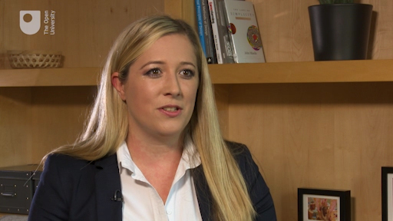
View description - Uncaptioned Figure

Any part of your business model may provide a source of competitive advantage and indeed there are examples to be found in many sectors of companies who have done just that. For example, some companies have been extremely successful in targeting a very specific group of customers – SAGA being one British case in point that started by focusing on the over 50s. The business was founded by Sidney De Haan in 1959 who passed on to his son in 1984. They provide packaged holidays, related insurance products (travel, caravan, motor) and then, more recently, branched into financial services products (travel money, credit cards) and latterly health care.
As the changing demographics demonstrate, this is a growing market. You can see how the value proposition for older customers with particular needs and attributes is a good strategic fit. SAGA owns a direct mail and fulfilment service and publishes a subscription magazine which is widely subscribed to and reckoned to be read by around one million readers. As you are considering your own business model, it is worth thinking about how you will reach your customers. It is also worth spending a few minutes looking at the SAGA website in a new window or tab, to see how they provide added value to their customers, whom they refer to as members.
Next you will look at some of the dilemmas you may face as an entrepreneur.

3 The entrepreneur’s dilemma
Looking at the choices and alternatives that exist in each area of your business model, you may wonder at times how it is possible to decide what is best. As a new venture, you may have no previous experience, or there may be no predecessors to learn from, however, that is quite normal. In fact, every entrepreneur and business start-up faces dilemmas about what to do. The next sections take a look at some of the most common dilemmas faced by entrepreneurs.

3.1 Dilemma 1: building confidence
One dilemma for a new business is that so much is unknown and untested. Yet to get supporters, investors and customers on board they are likely to need more certainty. This is especially so with a completely new or unique business idea.
While passion and self-belief, hard work and persistence are important to make a business work, uncertainty and a lack of evidence that provide others with confidence in your ability to deliver may deter important stakeholders. In other words, you will have to be able to convince stakeholders even before you convince customers. The activities in this course are designed to help you to clarify your ideas and ultimately to create the elements of a compelling pitch, backed by supporting ‘evidence’ for use with those you need to influence to support your venture.
This is one benefit of planning how you will operate. A second is that it allows you to sense check your idea with other people, get their input and advice and thereby reduce the risk of being blinded by your own enthusiasm. For example, an accountant will be able to sense check your assumptions about costs and revenue streams, and basic market research or researching competitor offers will provide evidence and comfort to stakeholders.

3.2 Dilemma 2: managed growth
A second dilemma is that it is very common for start-ups to ‘bootstrap’, i.e. to operate with no external help or finance beyond one’s own savings or available personal credit (which was first discussed in Session 2). While it might be exhilarating and interesting keeping it all under your own control, pretty soon it may also prove to be overwhelming or even counter-productive.

Activity 3 Limitations of bootstrapping
Allow about 10 minutes

Can you think of three signs that indicate it is time to go beyond bootstrapping to seek external resources?

Provide your answer...
View discussion - Activity 3 Limitations of bootstrapping

The combination of the knowledge, skills and often ‘personality’ of you and your staff/volunteers or network is unique and can form part of your competitive advantage.
However, many small firms do not employ support staff, turning instead to more creative uses of technology (e.g. accounting software) or making more use of outsourcing (e.g. virtual PA or customer service centre, or sales).

3.3 Dilemma 3: finding support
Your idea may require you to take on premises and employees from the outset. However, for many small businesses and start-ups, their growth will be more gradual until they literally outgrow their own resources.
The entrepreneur community is known for the concept of ‘paying it forward’ – in other words, recognising the help, advice and support they have received personally, they are willing to provide the same for others. In this spirit, a growing number of organisational opportunities have arisen for entrepreneurs and investors to step in to provide an infrastructure that brings together entrepreneurs in the early stages of their ventures, and start-ups, usually supported by a programme to help them grow. There are a variety of set-ups and models for these, including incubators, accelerators and co-working spaces.
Incubators, which are typically physical work spaces, may also provide training, mentors, access to commercial networks and equipment. They may be rent free, or charge rent or even a membership fee. Often they may have a particular sector focus (e.g. biotech). Many are aligned with universities or enterprise development agencies.
Accelerators are a slightly different concept that appeared more recently based on the original ‘Y Combinator’, which is a US-based programme that began in 2005 to support digital start-ups.
Watch Video 3, which describes a range of providers of accelerators run by Barclays, Lloyds of London and Microsoft, based in London.

Video content is not available in this format.
Video 3 What are accelerators?
View transcript - Video 3 What are accelerators?

View description - Uncaptioned Figure

This model of support to start-ups has been replicated all over the world. In addition to the developmental support, accelerators are more focused on and involved with investment and the potential for high growth. For this reason they are more selective and they tend to bring start-ups on to the programme in cohorts, with the aim of developing their business plans, prototypes and pitch to investors. The programme may last anything between three and 12 months. The involvement of investors means that they will usually seek equity in these companies rather than requiring a fee. There may also be mentorship, training and even seed funding (the initial investment) to get the business up and running. Some provide physical workspace and others provide services only. Figure 3 shows the location of accelerators and incubators in the UK.

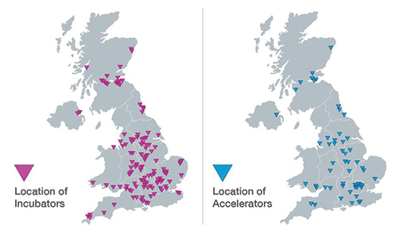
Figure 3 Location of accelerators and incubators in the UK (NESTA, 2018)
View description - Figure 3 Location of accelerators and incubators in the UK (NESTA, 2018)
View description - Figure 3 Location of accelerators and incubators in the UK (NESTA, 2018)

Co-working spaces are simply that. Beyond a place to work and be in contact with other companies or similar organisations (e.g. some are run as social enterprises) these provide access to networks, and sometimes events and other opportunities to participate in publicity events.

3.4 Dilemma 4: pivoting

To improve is to change; to be perfect is to change often.
Winston Churchill

Eric Ries (2011) has become well known in entrepreneur circles for the concept of the ‘lean start-up’ methodology and is credited with the term ‘pivoting’. To pivot is to make a change in your strategy without changing your vision. Pivoting is a key decision point when you are faced with something that isn’t working (or working in the way you thought it would). Pivoting your business is finding ways around obstacles to succeed, to achieve your ultimate goal by solving a customer problem or meet a need. Ries advocates developing your business through testing and learning from both your successes and failures.
The classic dilemma for entrepreneurs is knowing when to stop doing something and when to stick with it or do it differently! Giving up on one aspect can be surprisingly painful as you may have invested a lot of emotion and belief in the idea only to find that the customers or colleagues don’t in fact find it as compelling. It is particularly relevant if you are taking over someone else’s ideas. For example, if you have a product developed with teenagers in mind but through time and testing you recognise it has more potential for adults, this would be a customer segment pivot if you then went on to target adults and design around them.
Another type of pivot is where you believe your idea meets a problem or need but you find that in fact the product is doing something else (more compelling) for those customers. An example of this is PayPal, which was originally intended to be cybersecurity software but has finally evolved after a reported five pivots to become a secure payment system for mobile and online use, and the beneficiary of a huge explosion in e-commerce.
There are many other famous examples of pivots and in fact most, if not all, successful companies have had to consider when and how to change to take advantage of opportunities, to learn from customer feedback and behaviour, or to avoid failure.

4 This session’s quiz
Check what you’ve learned in this session by taking the end-of-session quiz.
Session 3 practice quiz
Open the quiz in a new window or tab, then come back here when you’ve finished.

5 Summary
In this session, you have:
- considered different ways of looking at the business model to deliver value to customers
- familiarised yourself with the business model canvas which is a visual summary of how you will realise your business idea
- recognised how the business model canvas makes clear who the business is aimed at, its infrastructure, key resources and activities
- identified how your business model is unique to you and in each element there are opportunities to innovate
- considered how your business is likely to change as you develop your ideas, test and learn from customers, and gain experience.
In this session you also explored some of the dilemmas that entrepreneurs face around decisions about how to develop a business model.
The business model canvas has been introduced as one way of designing and describing the elements of your business. Throughout the course you are invited to keep checking back and adapting your own business model, highlighting gaps to be investigated and using the activities and your learning to prepare an action plan. In Session 4 you are going to zoom in on your customers and the market for your product.
You can now go to Session 4.

Session 4: Customers and markets

Introduction
Who is going to buy your offering and why should they? In this session your thinking will turn to how you make your idea happen, and towards your customers.
Taken together, customers, markets and competitors are considered the domain of marketing. Marketing is a broad area and to paraphrase business guru, Peter Drucker, any enterprise is a mix of innovation and marketing. This means addressing questions that arose in your business model from Session 3 – who is going to buy this? How do I communicate the benefits? How much will they pay for it?
The approach taken in this course is to recognise that examining the relationship between what you offer and what people might find useful touches on every part of an organisation’s operations. You will also identify that marketing for an established business (which may be about maintaining market share, or launching new products) is quite a different prospect from marketing for a new business.
By the end of this session, you will be able to:
- identify the customers that your business is aimed at
- describe in detail the market you are competing in
- define who you think you will be competing with.

1 Who are your customers?
This is a big question as it implies not only being able to describe who your customers are, but also where they are, their needs and wants, how you will come to know them, and how you will develop and maintain relationships with them. Without knowing the details of your business, this course can at best provide a quick tour of some critical questions.

1.1 Are they customers at all?
Who are my customers? It seems like quite a simple question with an obvious answer. However, a number of related questions arise from this. The first one probably ought to be, are they customers at all? Here are some examples to illustrate:
- Customers are those that purchase a good or service. If you go to a vegetable supplier and buy a box of avocadoes for your ‘pop up’ café, you are being a customer, but not a consumer.
- Consumers are those who use a product or service. If you work in a large organisation it is likely you will use stationery or other equipment bought centrally, in which case you are a consumer but not the buying customer. If you get to choose it for yourself, you may be a customer and consumer.
- The term ‘client’ is often used in a professional services context, like accountancy, but is increasingly applied to a range of services in the public and third sector. In part this is because it suggests a mutual expectation and is intended to recognise the stake each has in the relationship.
(Adapted from The Open University, 2018)

Activity 1 Customer, consumer or client
Allow about 10 minutes

- How do you think of your customers? Are they buyers or users? Would it be accurate to think of them as customers, consumers or clients? Or is there another way that you think of them?

Provide your answer...
In Video 1 all of our entrepreneurs refer to customers. Watch the video now paying particular attention to how they describe their customers.

Video content is not available in this format.
Video 1 Who are your customers?
View transcript - Video 1 Who are your customers?

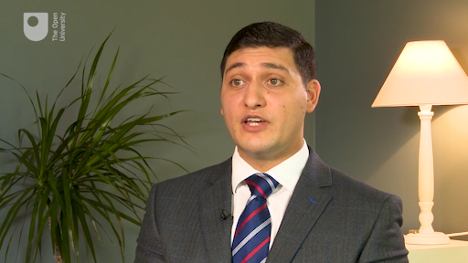
View description - Uncaptioned Figure

- Having listened to Claudio, Alex, Emma and Nick, make some notes for yourself about how you might describe the target audience for your marketing communications, products and services.

Provide your answer...
View discussion - Part

1.2 Beyond customer transactions
In most of the relationships we have with enterprises in our daily lives we are both customer and consumer. For example, when you purchase food it is likely so you can eat it. Here, you use the term customer to refer to the relationship between your business and the people you want to engage through your offer. The word ‘customer’ does not necessarily convey the subtlety of the relationship. In part, the term does not adequately cover the changing relationships around how value is now created between organisations and their customers. Previously there was a sense that organisations developed products or services and you paid for them and this was very much a transactional relationship. In recent times though there has been a shift towards customer relationships, customer loyalty and engagement, with companies increasingly interested in hearing from and, indeed, engaging customers as advocates for their business.
It might seem obvious that customers are stakeholders who have a stake in your business (think back to Session 3). Depending on the sector you are in, you may even recognise customers as intimately involved in the value creation process (the concept of value is explored in more detail in Session 5). For example, if you are a personal trainer, then customer value encompasses their own effort as much as yours.

Figure 1Personal trainer and client relationship
View description - Figure 1Personal trainer and client relationship
View description - Figure 1Personal trainer and client relationship

As an entrepreneur, often ideas arise from being close to the product or service and the person who might use it. Indeed the source of your idea might be your experience as a disgruntled customer who has developed a new approach to an existing problem, or spotted something you think others have missed. This provides you with a level of insight, and so opportunities, that larger organisations may not have. This may provide a source of competitive advantage.

1.3 Getting to know your customers
Can you be sure that you are representative of the customers you are targeting? Are there others like you and, if so, how many? That is, do your experiences make you typical so you can use your knowledge to represent others? Having suggested that the would-be entrepreneur is closer to their customer experience, it is right to urge some caution. You can only really answer these questions by engaging with your potential customers.
Even if you are not sure what your offer is beyond an initial idea, your understanding of whether others ‘buy into’ your idea or concept will require you to pass it by other people. There are several potential sources of help and feedback, not least family members, and you will also need to convince sympathetic suppliers who might offer good credit terms, bank loans, or other investors. All of these are people you may need to convince first.
This kind of engagement and even persuasion can be referred to as internal communication or marketing, and it is an area that should not be overlooked. Suppliers, distributors and funders are all people who need to be able to trust your judgement, feel that your experiences are authentic, and believe that you are reliable. You need to be able to persuade these people just as much as you need to persuade your customers.
Now listen to our four entrepreneurs as they describe how they have used the feedback and input from customers to shape their businesses.

Video content is not available in this format.
Video 2 Using cutomer feedback
View transcript - Video 2 Using cutomer feedback

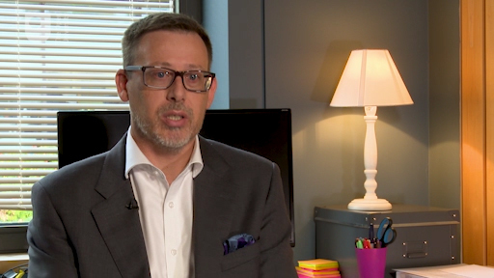
View description - Uncaptioned Figure

When watching the video you might have noted the different ways our entrepreneurs talked about different stakeholders, and perhaps even some tentativeness around knowing who their customers are.
Next you will consider the ways in which to get to know what your customers are looking for.

1.4 What do customers want?
One thing you might want to try when starting up your business is to widen the range of potential customers you speak to in order to get a better sense of the market for your product or services. There are lots of ways to do this, even if you don’t have a prototype or physical example for people to try. Market researchers conduct ‘focus groups’ to gather qualitative feedback from small groups of people. These facilitated group discussions are useful ways of understanding issues at a deeper level – if they are well conducted or moderated.
Facilitators may ask questions, show or demonstrate products, use images or share overall concepts and key messages. They will record how the group responds to these, positively and negatively, and whether their responses are held by all or some, the reasons behind them and so on.
This idea of sharing early and often, common in the software industry, is how many companies operate.
For example, Lego is particularly well known for how it involves its broad customer and fan base in the development and design of its products. Is this an approach you could use, or could you at least adopt a similar ethos?

Activity 2 Testing and learning from feedback
Allow about 15 minutes
Imagine you have run one focus group made up of people you know (perhaps friends, family and people you know well). You now wish to arrange a second one with a group of ‘real’ customers or potential customers.
The results of your first focus group were positive. This time around you have managed to gather a broader range of people, some whose interest in your offer is not immediately apparent.
Market researchers ask you to consider:
- Are the benefits of the product clearly communicated and believable?
- Does the product or service address a need or solve a problem?
- What other products or services can you imagine using to meet the need?
- What is the customer’s perception of how valuable the product or service would be to them?
- Would they use/purchase the product or service?
- How often would they use/purchase it and where would they look for it?
(Adapted from Kotler et al.,2012)
You cannot ask these questions or get a meaningful response from others until you have thought them through yourself. Try these three thought experiments:

- First, think about how you would answer the questions above and note down your own answers.

Provide your answer...

- Second, in the description of the first focus group it was indicated these were people you knew, or who knew you. What about the people in the second focus group – how are they the same or different in terms of their views, experiences and feedback?

Provide your answer...

- Finally, draft how you might run or structure a focus group to elicit a response to these questions. What questions might you ask? What specifics would you want to probe into? Are there any images, products, assumptions or scenarios you would want to test?

Provide your answer...
View discussion - Part

By working through the activity on focus groups, you will have started to sense check or refine your understanding of the value you are creating for the customer. Thinking about your ‘usual suspect’ touches on who your ideal customer is, and asks you to think through the intended customers and perhaps even unintended ones. It has become quite usual for organisations to develop ‘personas’ often based on real information about perfect or even difficult customers. These detailed descriptions are folded into the development process and used to inform decision making about how different groups might be treated. User Experience Development emerged in the software industry and is becoming increasingly common across the service sector as a whole.

1.5 Customer segments
Earlier you were asked to consider whether you are a typical customer. Customers come in all forms, and different customers will help you create value in different ways. This is important as your enterprise develops and grows – particularly with regards to listening to the ‘right customers’. Reinartz and Kumar (2002) suggested four customer segments. It is worth reflecting on these as you listen to your customers.

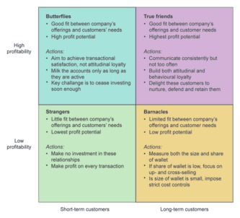
(The Open University, 2018 )
Figure 2 The Loyalty Model
View description - Figure 2 The Loyalty Model
View description - Figure 2 The Loyalty Model

In an ideal world you would get answers to the questions posed in Activity 2 in Section 1.4 that indicate people do find what you are offering valuable, that they would buy it, tell their friends and get one every day regardless of the cost. However, this is unlikely to be the case. Through asking customers what they think, you are seeking answers about the market, and the competition in it, which might well provide the kind of vital information that leads to a pivot (Session 3).
Next you will consider the market your business will enter.

2 The marketing mix
A standard approach to thinking about your offering is in relation to the four, and what has now become seven, Ps that make up what is called the marketing mix.

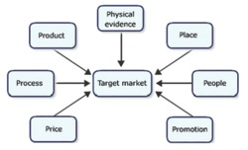
Figure 3The seven Ps which make up the marketing mix
View description - Figure 3The seven Ps which make up the marketing mix
View description - Figure 3The seven Ps which make up the marketing mix

Activity 3 The marketing mix from a customer perspective
Allow about 5 minutes

- Given the focus on customers in this session, try to replace the four Ps with a more customer-oriented version:
Which P corresponds to which C?

Price
Promotion
Place
Product
Cost
Communication
Convenience
Customer needs/wants
View answer - Part

- What do you think is the point of identifying the four Cs?

Provide your answer...
View discussion - Part

2.1 What does the market look like?
You can categorise markets in different ways, but perhaps the simplest is whether it is ‘business to business’ (B2B) or consumer facing, sometimes referred to as B2C or ‘business to consumer’. Within these, you might consider the following:
- geography: where is it located? Is it local? Is it international?
- demographics: including the size of other businesses in it, the stage of maturity, volume of potential business, and so on
- behavioural characteristics: how do businesses compete? Consider the value of all purchases, frequency of purchase (i.e. one-offs or regular) and so on
- decision-making process: who makes the purchase decision? What factors or people influence them? Who are the people who make the decisions? What do we know about them?
(Adapted from The Open University, 2012)
These all shape your understanding of the potential market. It is now worth thinking about how they can influence the development of your business. All will help you refine your offer and think through the particular segments you want to focus on. Some aspects are particularly relevant to those entering the market with a new offer.
The shape of the market is clearly important, as is the ability to recognise shifts in geography, behaviour, competition and customers. Changes can lead to opportunities. For example, ten years ago if asked where you would buy a mattress from, you would probably have responded with ‘a shop’. After all, a mattress is a relatively expensive, infrequent purchase, and you probably want to try before you buy. Interestingly this is changing. The internet has meant that some companies sell direct, online, usually along with the offer of being able to try it at home for an extended period. This is literally the opportunity to ‘sleep on it’.

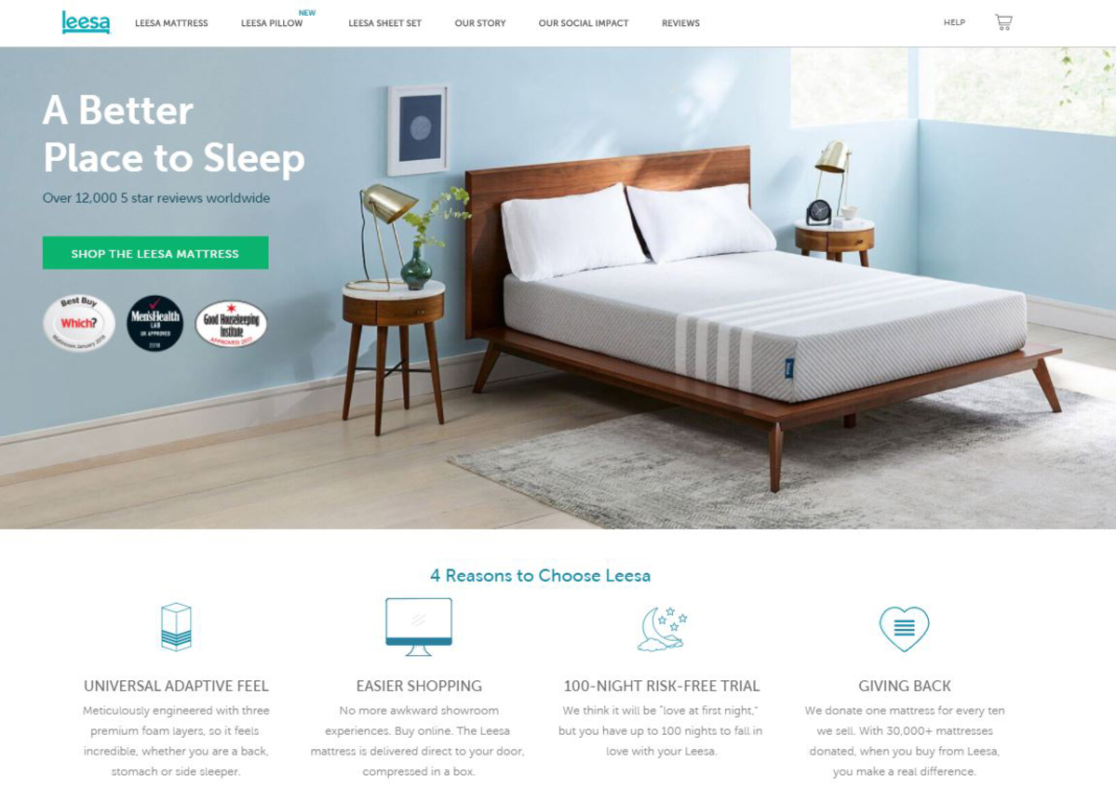
Figure 4Buying a mattress online (Leesa Sleep, 2018)
View description - Figure 4Buying a mattress online (Leesa Sleep, 2018)
View description - Figure 4Buying a mattress online (Leesa Sleep, 2018)

The image above is a screenshot of an advertisement for one of many furniture and online, direct delivery businesses. Reflect for a moment about this trend of moving purchases online, to a direct-to-consumer model, and how it has been supported by both social media and the need to provide certain types of guarantees. Convenience is clearly an important factor. Why might that be?
As a secondary thought, think of the opportunities that have arisen for businesses who provide warehousing, couriers, and delivery and packaging solutions, as well as social media advertising, which is changing the whole nature of the customer relationship.

2.2 What kind of market is it?
When discussing markets and opportunities, one useful way to consider these is that they have a lifecycle: they grow, mature and often they disappear. Each of these phases has a different character.

Lifecycle model
- Introduction: in this phase sales are small – often it is difficult to make any profit due to the costs of taking the offer to market
- Growth: this phase is when the market is growing rapidly, providing opportunities for profits, and when others may come into the market
- Maturity: at this point the increase in sales starts to tail away then plateau, profits are still present but competition may be intense
- Decline: this phase sees sales and profits decline.
(Adapted from Kotler et al., 2012)
This approach sets out the different conditions in the market at different stages, and suggests phases where competition and profit vary. It also asks you to consider questions around organisational strategy. Another way of looking at this is in relation to the Rogers (1962) technology adoption curve.

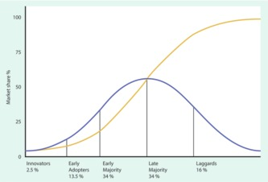
Figure 5Rogers’ technology adoption curve
View description - Figure 5Rogers’ technology adoption curve
View description - Figure 5Rogers’ technology adoption curve

In the graph above, the blue bell-shaped curve shows the stage at which successive customer groups enter the market. The yellow steep rising curve shows the cumulative market share eventually resulting in saturation of the market. Rogers’ focus is on the consumer rather than the lifecycle of the product. Early adopters of technology are typically well educated with higher disposable income, which can be read as a prediction of which socio-economic groups might adopt new approaches first. Rogers (1962) also suggested you think of the phases of adoption in terms of how to move consumers along the curve from Awareness through Persuasion, to Trialling, then Adoption and Consolidation.

Activity 4 The product life cycle
Allow about 15 minutes

Considering the product focus of the lifecycle model, think about the following questions. It might also be useful to ask the same questions of the technology adoption curve.
- How well does the lifecycle model apply to the market you are interested in?

Provide your answer...

- What does your intuition tell you about what phase the market might be in?

Provide your answer...

- How might you test your intuition?

Provide your answer...
View discussion - Part

There are several ways in which this section has provided a fairly traditional view of the market. Consider this question – do you think the market for your offer is out there already or does your offer create an entirely new one? In the vast majority of cases, unless your offer is something akin to the iPad, you will be competing in an existing market. So what kind of market is it? How will you compete? You will look at this next.

3 How will you compete?
In this final section of Session 4, you will draw together questions around customers and markets, and consider how you will position your enterprise. In short, how will you compete? This is a highly contextual question. For example, in a social enterprise looking to promote a healthy diet, competition does not quite seem the right concept, though of course you are competing for people’s attention and perhaps against some longstanding behaviours and attitudes.

3.1 Returning to the Ps
The seven Ps, or ‘marketing mix’, have been presented as a series of dimensions on which one might vary a product or service. Getting the right mix means engaging customers and matching the mix at different stages of your enterprise and product/service development. In early phases you might work with customers to get the product right, to provide physical evidence of the quality or the process, to get the people element right and establish the optimum price. For example, imagine you open a sandwich shop surrounded by offices and other similar eateries. If the value you offer is the same as all the others (i.e. no discernible differences in the quality of food, service or environment) then your price may need to be competitive. If you are an artisan baker selling sandwiches, then price might be a less dominant factor than fresh bread baked on the premises using traditional recipes and locally sourced fillings.

Activity 5 Differentiating your enterprise from the rest
Allow about 15 minutes

Which Ps are dominant for your enterprise? Run through the seven Ps and think how you could positively differentiate your offer from others in relation to each of them. Once you have done this, try to think where you want to be in the short term (a year), medium term (five years) and long term (ten years), and how your focus may switch.

Provide your answer...
View discussion - Activity 5 Differentiating your enterprise from the rest

3.2 Returning to the competition
Earlier you looked at demographic factors, the shape of the market and how people compete. Clearly the maturity of the market, the size and number of the competitors and the dimensions on which competition takes place all shape the market.
Some have suggested the need to add in to this view products or services that are compatible with or complementary to those you offer. For example, there is a synergy between cars and the insurance industry that has an impact in each market.

Activity 6 What kind of organisation do you want to develop?
Allow about 5 minutes

Consider what kind of organisation you want to develop. Using the analogy from music below, what kind of band do you want to be?
- Playing to a small but loyal audience who love your music
- Loved by the critics with ‘decent enough’ sales
- Loyal to your fans and you would never sell them out
- Playing to 3000 plus, on TV, next stop Glastonbury
- Like The Stones – huge and still rolling on
- Beyoncé.

Provide your answer...

4 This session’s quiz
Now it’s time to complete the Session 4 badged quiz. It’s similar to previous quizzes, but this time instead of answering five questions there will be fifteen.
Session 4 compulsory badge quiz
Remember, this quiz counts towards your badge. If you’re not successful the first time, you can attempt the quiz again in 24 hours.
Open the quiz in a new tab or window then come back here when you’ve finished.

5 Summary
For a subject as wide-ranging as marketing, it is a struggle to stick within the boundaries set at the start, however, in this session, you have:
- identified the customers that your business is aimed at
- described in detail the market you are competing in and its characteristics
- defined who you think you will be competing with.
You may feel you are already close to your customer, but there is more listening to be done. Using the techniques given in this session you should now return to your idea, and refine and develop it in relation to the needs of customers and the competitive forces in the market.
It is sometimes said that ‘the customer is always right’, but remember that may not always be so. When faced with a new product that in turn creates a new market, sometimes your intuition is a better judge than asking others less invested in change. So be careful which customers you listen to. Returning to the music analogy used in Activity 6, if you want to be the biggest band in the world it might not pay to listen to those loyal fans who liked your early stuff.
However, the customer, client, consumer or person engaging with what you offer ultimately belongs at the centre as the most important stakeholder in your business model. Being close to them, seeing changes in their taste, in technology, in the shape of markets, and unmet needs is one of the key advantages of being a small organisation. It means you can shape your offer to their needs.
You are also asked to consider how you create value for your customer, client or consumer as your business grows and develops. How will you continue to create value if market conditions change? What kind of competitor do you want to be? This has broad implications for your enterprise, for your business model, for how you build value for the customer through the alignment of the internal environment and the external one. In other words, value cuts across all aspects of the enterprise, and you will be revisiting this idea throughout the course. Use these insights to help you develop the sections of the business model canvas on customer relations, market segments and crucially your value proposition, which comes up next in Session 5.
You are now halfway through the course. The Open University would really appreciate your feedback and suggestions for future improvement in our optional end-of-course survey, which you will also have an opportunity to complete at the end of Week 8. Participation will be completely confidential and we will not pass on your details to others.
You can now go to Session 5.

Session 5: Defining and building the value proposition

Introduction
Why do some businesses succeed when others don’t? Where do they draw their advantage from? The answers to these questions lie in the concept of the ‘value proposition’. In this session you will be introduced to the concept of a value proposition and consider where value is derived in a business, how to build it into a proposition for customers and how to ensure it is sustainable for your business.
Value is an interesting concept – like beauty, it is in the eye of the beholder! In other words, where you may think your business idea adds value may be different from where your potential customers are looking for it. Another way of looking at it is that, in the end, value is measured by how much people are willing to pay for something.
By the end of this session, you will be able to:
- explain what a value proposition is
- define and build one for your own enterprise
- demonstrate how it can differentiate your business from others for a competitive edge.

1 The value proposition (VP)
In Session 3 you were introduced to the business model canvas and this explained the value proposition at the centre of your business model. The value proposition is the answer to the question – what is it you are trying to build and for whom? It goes beyond an idea or product and expands to:
- what problem(s) or need(s) you are solving or meeting for customers
- how your idea will either alleviate the problem or provide a gain for customers
- who the customers are whose needs or problems you are focused on.
The best value propositions are clear about these points and provide a compelling reason for a big enough group of customers to choose your business, product or service over another. To help illustrate this point, think of the spreadsheet and social media apps as examples.
The spreadsheet was originally developed for accountants to organise and manipulate a lot of complex data that would otherwise be very time-consuming and problematic to do manually. It solves the problems of complexity, manual data inputting, errors and duplication of data. So it is a very convenient technological resolution to a problem that has now become universally adopted for a much wider audience.
As human beings, however, we have many different kinds of need – e.g. the need to be entertained, to socialise and communicate with others. Social media apps arguably have provided a solution to some of these needs.
Arguably, the recent pandemic and indeed lockdown, and the prevailing economic conditions have taught us all that our perceptions of value can change. The concept of the frontline or essential worker has shifted attitudes to work. The furlough scheme has also changed dynamics in many ways. Changes in the supply and demand for some products and services due to shortages or delivery difficulties in the supply chain create both headaches for businesses and customers, but potentially also opportunities along the supply chain. The shift to working from home and alternative means of delivering services and especially the rise in online shopping have meant that there are major shifts in consumer and customer attitudes and behaviours and as a result a need for businesses to reflect on their business models and their value proposition.
One thing you might notice is that where you do solve a universal need, the target audience could be very large indeed as opposed to a very niche group of customers.

Activity 1 Reflecting on how a major event impacts on your idea
Allow about 10 minutes

Take a few minutes to consider how a major event such as the Covid-19 pandemic has had an impact on your life as a consumer or customer. Have you noticed a shift in your own values, buying behaviour or priorities? How do they impact on your choice of suppliers and your own notions of value?

Provide your answer...
View discussion - Activity 1 Reflecting on how a major event impacts on your idea

Next you will consider how mutual value is created.

2 How mutual value is created
Not all customers are the same, as you saw in Session 4. Some will have greater need, use or preference for your products or services than others. Therefore, some will bring greater financial gain for you, some will make more demands on your customer service and some will be more profitable. If you have not started trading yet, you won’t have any data or experience to verify this in any detail, but it does help to consider the types of customer you may attract at the point of setting up your business model.
A second consideration for how you set up your operations is what support your customers may need to buy from you initially and afterwards. If your product is a one-off purchase (or at least an infrequent one) and you are one of several potential suppliers then the value you create may come from other sources of value to customers. For example, follow-up supplies, refills, upgrades etc. If you think again about your business model carefully, and understand your customers sufficiently well, you may be able to build that value into your business model, right from the start. An interesting example of this is where manufacturers of coffee machines and printers have changed their business models. In relative terms the cost of the hardware element has come down and instead the revenue comes from the repeat purchase of the consumable elements – the coffee pods and cartridges.

Figure 1Repeat purchases, such as coffee pods, have helped businesses increase revenue.
View description - Figure 1Repeat purchases, such as coffee pods, have helped businesses increase revenue. ...
View description - Figure 1Repeat purchases, such as coffee pods, have helped businesses increase revenue. ...

A third consideration may be the extent to which your product or idea is ‘unique’ or different from others in the marketplace. Not all successful businesses succeed by being unique in all regards – they do however find competitive advantage from another source. Your business may not uniquely solve one or a number of existing problems that customers have. What it may do though is reduce the ‘friction’ they currently experience in their dealings with other suppliers in the marketplace. One example of this comes from the numerous technology and mobile phone companies that have entered the financial services marketplace. Think of how phone apps and technology have made banking, saving and payments much easier than ten years ago for many people. While the basic service remains the same (e.g. making a payment), the user experience is very different.
Next you will explore the four dimensions of value.

2.1 Dimensions of value
Figure 2 shows one way of looking at how, as you think about your own business idea, you might increase value for customers across four dimensions.

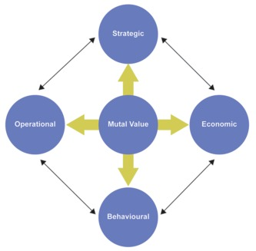
Figure 2Dimensions of value (adapted from Parvatiyar and Seth, 2001)
View description - Figure 2Dimensions of value (adapted from Parvatiyar and Seth, 2001)
View description - Figure 2Dimensions of value (adapted from Parvatiyar and Seth, 2001)

Strategic value
The more aligned you are with your customers’ needs and wants, and the more relevant a place you have in their lives, the more likely you are to succeed. That means that your values, brand, ways of working and of course the product itself are a good fit with your target audiences.

Economic value
For your business, economic value means being able to achieve a price that exceeds the cost of providing the product or service being offered. This requires efficiency in the costs associated with sourcing and providing products and services, and serving and supplying customers. From the customer point of view it means paying a price they think is worth paying and that the value you offer is worth paying relative to alternative solutions to their need or the problem you are seeking to solve.

Operational value
Your customers will come into contact with your business in a variety of ways – sometimes referred to as customer touchpoints. Wherever and whenever they touch your business, there is an opportunity to reinforce the value of what is being offered (and if you think about it, also to detract from the value in the case of poor customer service). In today’s world where people are considered to be time poor, this means making it convenient and easy for customers to deal with you.

Reflection
Allow about 5 minutes

Take a moment to reflect on how many suppliers or providers you deal with as a customer. How do they perform on this dimension of being easy to deal with? What is it they do – or even don’t do –that makes dealing with them good or bad?

Provide your answer...
View discussion - Reflection

There are many ways to set up your organisation to provide a smoother, more effective experience for customers that not only add value to customers but differentiate you from others.
The whole banking industry has been turned upside down by the introduction of mobile banking and indeed it has attracted many new businesses into the sector, many of whom are not banks. Think of companies like Apple (with Apple Pay), and Amazon and Alibaba – both online retail companies –that have revolutionised how you pay for goods and services at the touch of your smartphone. You can move money around, pay for things, receive money, exchange it for other currencies and even use cryptocurrencies as a result of technology. The convenience of apps and cashless payments is for many people (customers and traders alike) infinitely more secure, efficient, convenient and cheaper than visiting a distant physical branch to make a deposit, withdraw cash, pay cheques in or exchange money. However, even with banking there are some transactions where the human touch is preferable to dealing with technology.
One further example of adding value and differentiating your business from others comes from how you and your staff behave to add value through the experience.

Behavioural value
You can probably remember occasions when the service of a member of staff in an organisation has left a good or bad impression. You will probably also remember how it made you feel – anything from satisfaction to delight to frustration and annoyance. The point is that for most businesses there is a real benefit to encouraging customer satisfaction and even delight. For one thing, happy customers come back, but moreover, delighted customers will tell other people.
The flip side to that is that unhappy customers tend to be more vociferous in telling people about bad experiences. In the interests of retaining customers and growing your business it pays to be attentive to customer expectations and the customer experience.
Next you will look at ways of optimising value for your business.

3 Optimising value
By now you should have gathered that value is more than cost and price, and comes from more than your product or service. It is the sum total of what you provide for customers as a business. In other words, it can be delivered through all the elements of your business model.
The underlying premise of marketing and economics however is that your business should create value that people want or need, at the right price to encourage purchase and/or use. In this way there is an exchange of value – customers pay you for all that you give them. In order to have a viable value proposition you therefore need to refer back to Session 4 to understand:
- who and where your target audience is
- how your target audience perceives the offer being made to them and indeed how you can shape your target market’s perception
- how the offer can be positioned in the marketplace (i.e. how it is perceived relative to competing products, services or suppliers) in terms of its features and benefits
- how to communicate this value in a meaningful way to customers, emphasising what they care about most.
Before moving on to describe your own value proposition it is worth pausing to consider how you would describe your target audience. How much do you know about them and their needs or problems, and how much do you understand about the difference your idea would make to them? Would it be enough of a difference to persuade them to change their current buying or usage behaviour? Does it save enough time, provide enough of a benefit to change habits or suppliers, or pay more?
If you don’t know the answers to some of these questions you may have to do some more research (recall the focus group activity in Session 4) amongst your potential target customers to investigate where you need to concentrate your efforts. Or perhaps you need to understand much more about where your competition is likely to come from and what their value proposition is. Don’t forget that a competing product or service may be something quite unrelated to how you would classify your own product or service. For example, a car that runs on alternative fuels competes with petrol or diesel engine cars, but it also competes with bicycles, public transport and taxis for some groups of customers.

Activity 2 Feature or benefit?
Allow about 10 minutes

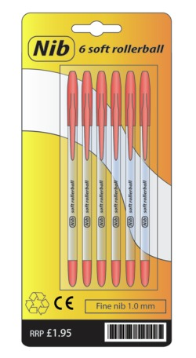
Figure 3 More than a pen?
View description - Figure 3 More than a pen?
View description - Figure 3 More than a pen?

- List at least four features of the product shown above – properties or aspects of its design. Then for each of these features provide a customer benefit.
(Hint to define the benefit: complete the sentence ‘which means that…’.)

Provide your answer...

- If this was your product, how might you express the value to customers of this product in no more than 100 words? (Look back at Session 3 for tips.)

Provide your answer...
View discussion - Part

The purpose of this activity was to encourage you to think as your customers do – what is important to them and how, if you need to, could you persuade them that your own business provides sufficient value to merit them paying the price you ask for, switching their behaviour or supplier, or even trying something novel or new?
Next you will consider how branding can influence your business.

4 Brand or USP?
Think of some recent consumer products you have bought – it could be clothing or shoes; a technology product or toiletries, beauty products or even washing liquid. How did you decide what to buy? Perhaps you have a favourite or perhaps you are convinced that you only ever buy the cheapest available. How your customers make their choice is vital to understand if you are going to communicate effectively with them about the value of your own business or products.
In Activity 2 in the previous section you differentiated between features and benefits. Sometimes these features or benefits can be unique – so unique that they are memorable and lead to a point of difference, which people are prepared to pay more for. They may even be patented. Think of the mint with the hole. It is unique, memorable and a trademark. Think also how UK households are filled with containers that once contained a product – e.g. a coffee jar of a particular shape with a seal that can be reused as a storage jar. These unique features add value and encourage loyalty beyond the preference for the taste of the coffee, especially where the product inside may not provide the basis of a strong preference.
Now think back to those trainers you or a teenager you know may have purchased – was the decision really based only on price? It may have been if you had budgetary constraints, but then where there are multiple products in the same price range how would you decide? There are many consumer purchases where the label or brand is as important. The brand is important for a number of reasons. It may confer a certain value or imply the wearer’s values and style through being classic, high quality, or trendy and popular. The brand is associated with these values and for this reason customers tend to be prepared to pay more for this association. Some household names have famously become so popular they have become ‘genericised’ – think Hoover, which ultimately became a verb, as has Google (to google it)!
Having a good brand name will help your business to stick in the minds of prospective customers and customers, but this takes a lot of time, marketing and communications activity, and often budget to achieve any serious level of awareness. It can therefore be very hard for a new business to establish itself as a brand from a standing start.

Reflection

Before you go on to define a value proposition for your own idea (or one for a product or service you are familiar with), consider the following questions:
- In what ways do you think a product or company name can suggest something about a product or service that customers will experience?
- Can it convey a particular image or suggest something that separates it from others in the marketplace?
- How do brands and USPs impact on the price? How about the customer’s perception of value?

Provide your answer...

Now listen to the following videos where our entrepreneurs are asked about their business’ value proposition. Listen to how they have thought it through and how useful a value proposition is as a concept for them. You may want to take some notes in a noteboook to capture your ideas when they occur. What did the entrepreneurs say about their value proposition?

Video content is not available in this format.
Video 1 Value proposition
View transcript - Video 1 Value proposition

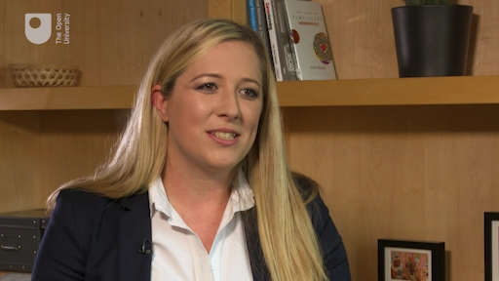
View description - Uncaptioned Figure

Next you will work on defining your own value proposition.

5 Defining your value proposition
Using the guide below, describe a business or product idea you have been thinking of. It doesn’t have to be a real one, in fact here is a completely fictitious one to illustrate.

Example:
To parents of young active toddlers, our new ‘Peekapoo’ disposable nappies contain a microchip and are made of completely disposable materials that allow you to not only save the planet but also keep track of where your precious little one is hiding using our unique tracking technology on your phone.
- In this example, the target customer group would be ‘parents of young, active children’.
- The brand name is ‘Peekapoo’.
- The new concept is the microchip in the environmentally friendly nappy.
- What makes it distinct and so differentiates it from other renewable nappies is that you are not only demonstrating your green credentials, but you can also track your baby on your phone.

Activity 3 Creating a ‘boilerplate’ description
Allow about 10 minutes

Now with reference to this example, try to create a ‘boilerplate’ description for your business or product idea, or another fictitious example, by completing the blanks below:

To [write in here the target group and the need you serve] our [state the product, service or brand here] is [describe the concept or product or service category] that [write in here your organisation or product or service’s unique or distinctive feature].

Provide your answer...

While it doesn’t seem like much, the thought and research that goes into defining, describing and communicating your value proposition may take more time than you think. Try testing out a few versions on friends, family or trusted advisers until you think you have got it right.

6 This session’s quiz
Check what you’ve learned in this session by taking the end-of-session quiz.
Session 5 practice quiz
Open the quiz in a new window or tab, then come back here when you’ve finished.

7 Summary
In this session you have considered how products and businesses are the basis of a mutual value exchange with customers. From the business perspective, you have to be able to persuade customers that what you have is something that they value sufficiently to pay the price you are asking for, or perhaps to change their behaviour in some way. This may mean trialling your product, changing supplier or doing something they have previously done in a completely different way.
In this session, you have:
- learned about the key concept of the value proposition
- attempted to define a value proposition for your own business idea that you will undoubtedly refine as you go on
- considered how your value proposition may differentiate you from competitors, provided customers understand the value for them.
The concept of value is a mutual one, but in order to persuade customers that there is value for them, businesses need to demonstrate it through their value proposition, which is a way of solving problems or meeting needs. The value goes beyond the features or the product alone and, done well or better than other comparable products or providers, can provide a winning differentiator.
As you work your way through your business model, you will encounter many ways in which to add value to customers. Some, like a positive customer-friendly attitude, cost nothing; other features, such as special packaging or an exclusive distribution outlet, could add cost to the business. In this way, balancing the value you provide to the price and volume of use and purchases you can expect is important to ensure that value is mutual.
You can now go to Session 6.

Session 6: Aligning resources to opportunities

Introduction
How do you ensure that you are playing to your strengths? How can you be sure that you are maximising your chances of success? The answers to these often come down to how well you analyse opportunities, how objective you are about the context you are operating in and of course good judgement and good luck.
Having examined what your value proposition might be in the previous session, you will now consider how you can align the resources you have and develop the capabilities of your enterprise.
This session takes a traditional approach as it focuses on the fit between the external environment and the internal environment – that which you are creating. You will start by looking outside your business environment. Then you will concentrate on the internal environment, which will be the main focus of this session. While the external environment is very important, there are many excellent online resources already in existence to help you understand it. The potential for the resources and capabilities of your enterprise to be a source of innovation or competitive advantage is vital.
By the end of this session, you will be able to:
- apply an environmental analysis to spotting opportunities or threats to your idea
- recognise the kind of transformation processes that occur in your enterprise
- recognise the kinds of resources and capabilities you have or might look to develop
- appreciate the alignment of those resources and capabilities and their potential as a source for innovation and sustaining a competitive advantage.

1 An environmental scan

Figure 1 Are there challenges heading your way?
View description - Figure 1 Are there challenges heading your way?
View description - Figure 1 Are there challenges heading your way?

When starting an enterprise, it makes sense to firstly scan the external environment to see where there could be either forthcoming threats or opportunities that could impact on the timing of your decision to launch or whether to go into a market. You should also consider the nature of competition within markets and make an assessment of whether one market is more attractive than others.
One well-known example to help remember these environmental scans is through the acronym STEEPLE.

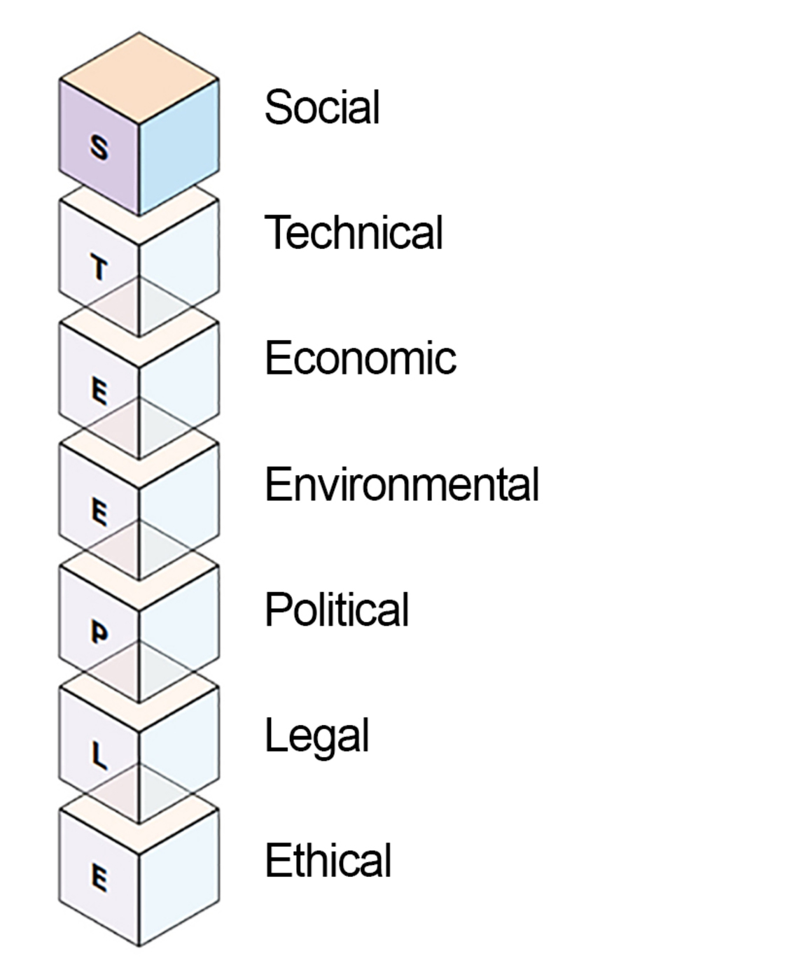
Figure 2 STEEPLE
View description - Figure 2 STEEPLE
View description - Figure 2 STEEPLE

When looking at these various elements, you should consider the factors within them that are the most dominant for your circumstances or, in other words, have the greatest potential to provide opportunities or represent threats. For example, social factors might include an ageing society or a low birth rate. Thinking back to Session 3, what implications would this have for SAGA – who target the older population – in the short and longer term? And what about for a baby food manufacturer?
Political factors might be policy changes, including nationalisation or large infrastructure projects. Under legal you might consider regulation and, for economic, trends in employment or perhaps a change in taxation. Environmental, technological and ethical factors are more self-explanatory. The main thing is to understand the rate of change and the extent of impact on your sector and market.

1.1 Porter’s Five Forces
‘Porter’s Five Forces’ (Porter, 2008) is often used to assess the rivalry in any given market as a clue to how you need to position yourself.

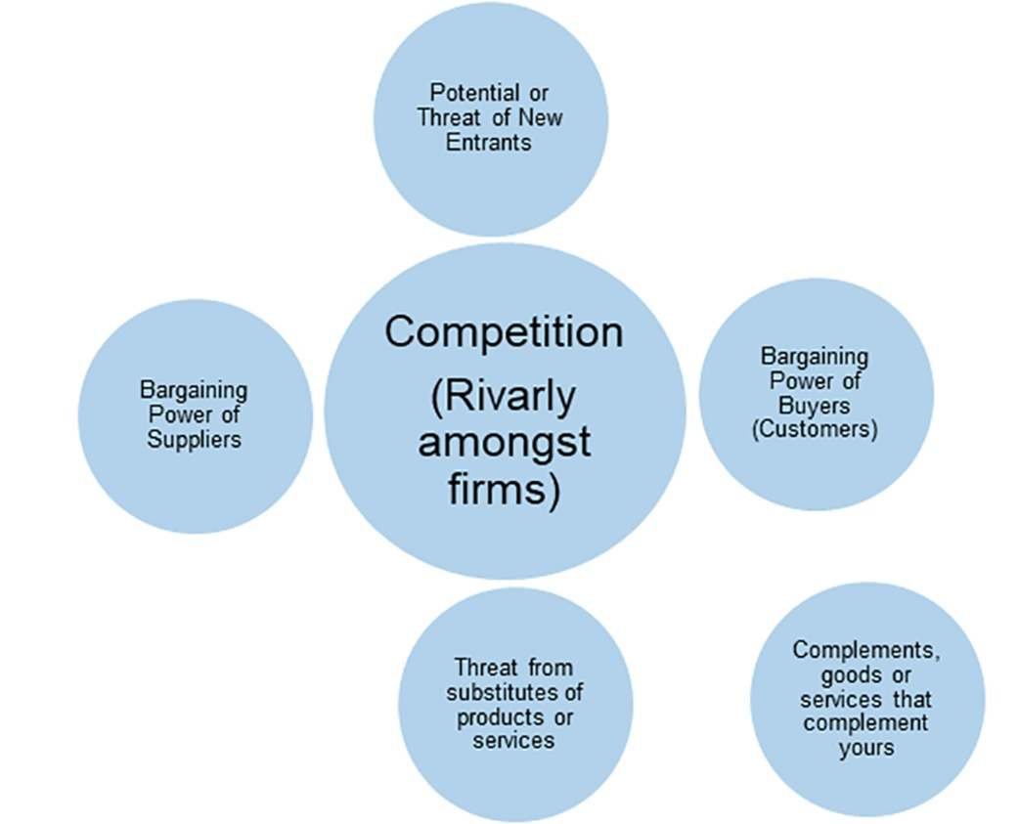
Figure 3 Porter’s Five Forces and complements (Adapted from Porter, 2008)
View description - Figure 3 Porter’s Five Forces and complements (Adapted from Porter, 2008)
View description - Figure 3 Porter’s Five Forces and complements (Adapted from Porter, 2008)

For example, as the new entrant, you might use this to assess an existing market. If you wanted to set up a coffee shop, the cost of entering the market might be low (depending on location), but you might think carefully about suppliers and in particular discounts and credit. However, you would probably be most concerned about threats of substitution and buyer power as many of the coffee chains have become established and others have branched into the lifestyle business – working space or healthy alternatives to coffee, such as chai-based beverages, juice bars and so on.
You might also start to think about complements. Coffee and books, for example, seem to be a staple on the high street now, and more than one independent has evolved from one form of outlet to another one – with a café or internet café or bookshop with café – over the last 20 years.
Enterprises need to reflect the outside world and how it is changing. If you have not used STEEPLE, Porter’s Five Forces or other similar scanning tools, you can try now to see what results you would get when you apply them.

Activity 1 How useful is the theory in practice?
Allow about 20 minutes

- Thinking of your own business idea or enterprise, make some notes using either or both of the scanning tools mentioned above, or another one you may be familiar with.

Provide your answer...

- Having tried to use either STEEPLE or Porter’s Five Forces, how useful did you find them?

Provide your answer...
View discussion - Part

By being concerned about how you create value and about the unique way you compete, this will lead to greater diversity as every individual or group will have a different set of resources and capabilities. This session focuses on that approach. Before looking at it in detail, you will first need to develop a clearer view of what happens within an enterprise. In the next sections you will consider what kinds of transformation processes occur.

2 Transformation model
In Session 3 you were introduced to the idea that business is a value delivery system with both inputs and outputs. However, as enterprises attend ever more closely to the customers, it is important not to forget the bit between the big idea and someone actually using it. You might call this transformation, production or operations.

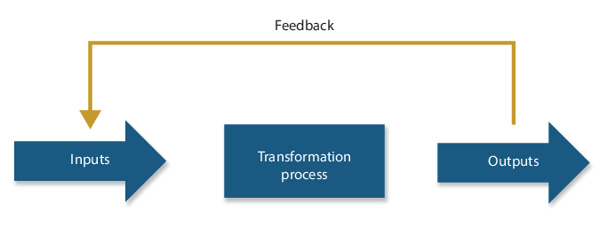
Figure 4Transformation of inputs to outputs
View description - Figure 4Transformation of inputs to outputs
View description - Figure 4Transformation of inputs to outputs

In this simplified model, inputs fall into three main types:
- materials, or the physical things you might turn from one state into another
- information, which is part of the process or transformed through the process
- people, who through engagement are transformed in some way.
Here transformation is not just turning raw material into something else. It also involves the transformation of information (e.g. an accountant turning receipts and invoices into financial statements) or the transformation of people (e.g. a personal trainer making you fitter). In this middle stage, the transformation process involves the configuration of:
- facilities, such as land, premises, machines or other equipment
- people, such as staff or contractors directly involved in the transformation process.
Through the organisation of inputs and the alignment of resources into capabilities within a transformation process, you then get some kind of output.
Next you will look at the different types of transformation processes that can occur.

2.1 Types of transformation process
When something physical is being made, like a car on a production line or a craftsperson fashioning a chair, it is easy to see what is being transformed. When it comes to service based on people or information, it is less clear. Transformation processes can include:
- changes in physical characteristics of materials or customers (e.g. fruit into jam)
- changes in the location of materials, information or customers (e.g. taxi, distribution services)
- changes in the ownership of materials or information (e.g. retailing)
- storage or accommodation of materials, information or customers (e.g. warehousing services)
- changes in the purpose or form of information (e.g. offering an online timetable)
- changes in the physiological or psychological state of customers (e.g. a beautician, hairdresser, hospital or doctor).

2.2 Overlapping transformations
Organisations often transform a series of inputs. Returning to a previous example, imagine you are attending a class to learn how to make a chair. It is not simply the wood that is being transformed – tacit information about how to make a chair is being made explicit and you are, hopefully, acquiring a new set of skills and perhaps even a feeling of well-being. You can categorise transformation as follows:
- manufacture – the physical creation of products
- transportation – involving the movement of materials or customers
- supply – involving change of ownership
- service – involving the way customers are treated or the storage of materials.
The overall transformation process will typically involve a series of smaller transformations with different inputs. Taking a real example, social enterprise, Social Bite, operates sandwich shops and deliveries in order to address homelessness. Amongst other things, it involves:
- the transformation of raw materials through food preparation
- customer service which goes beyond meeting basic needs as the customers know that through their purchases they are helping the homeless
- the supply of sandwiches to different locations
- supporting the transformation of its employees through the employment and training of the homeless.

Activity 2 What transformation is involved?
Allow about 5 minutes

For this activity you can either select a business idea from our entrepreneurs, or use your own enterprise. Based on what you have learned so far, sketch out the kinds of transformation processes involved in the enterprise in the table below.

Table 1 Transformation processes
Input | Transformation process | Output
Provide your answer... | Provide your answer... | Provide your answer...
Provide your answer... | Provide your answer... | Provide your answer...
Provide your answer... | Provide your answer... | Provide your answer...
Provide your answer... | Provide your answer... | Provide your answer...
Provide your answer... | Provide your answer... | Provide your answer...
Provide your answer... | Provide your answer... | Provide your answer...

View discussion - Activity 2 What transformation is involved?

Next you will look in more detail at the resources and capabilities of your business.

3 From resources to capabilities
What are resources? And what are capabilities? So far there has been some quite deliberate language used to talk about resources and hints at developing particular capabilities based on the alignment of resources. These are specific to you or your organisation, which makes it difficult for others to imitate, perhaps because they are tacit or unspoken, or even because they are something only you have access to. This could be a specific component, recipe or even location. You can think of resources as being:
- tangible – something physical that can be touched like a workshop, or a particular machine
- intangible – ‘know how’, your reputation, or work culture
- human – the people you might work with and their skills.
Critical questions in any enterprise are how you use the resources at your disposal, how you acquire the ones you need and how you configure them to make your enterprise different from others, i.e. creating strategic value, which you saw in Session 5.
One of the main things that makes enterprises different are the people in it. Therefore next you will consider human resources.

3.1 Human resources
It seems too obvious, but enterprises need to work with the right people, and that assessment of the right person for the right job includes the entrepreneur.
In your own enterprise, the separation between intangible and human resources may seem artificial as it may only be you and what you know. Perhaps you can do it all: think of ideas, have the skills to make them happen, attract the right funding, keep things running well, and be an advocate for the company. This can happen, but as an enterprise grows you will need to work with others. So how do you find the right people? One way is to think about the jobs that need to be done.

Activity 3 Job analysis
Allow about 15 minutes

In this activity you are going to think in terms of a job, or a series of jobs, to be done.
Note that in this activity you won’t spend time considering the attributes of an entrepreneur, however, if you want to read more about this there are links to resources in the Further reading section at the end of this week.
Now imagine you had to advertise your own job, based on the job needs analysis below. What would you put in the essential criteria and what would be in the desirable ones? What specific capabilities are needed for it and how do these create value for customers?
By answering the questions below, you will conduct a job needs analysis.

Job role
- What tasks are required to produce the product or service?
- What tasks are required to sell the product or service?
- What tasks are required to support the production and sales staff?
- Which of these tasks need to be done in-house?

Purpose of job
- How does it contribute to the successful production of the product?
- How does it contribute to the successful sale of the product?
- How does it contribute to achieving the aims of the firm?

Essential functions
- What key tasks actually form the job?
- Are they all essential?
- How are the key tasks related to each other?
- Is there a sequence in which the tasks have to be done?
- What physical activities need to be performed?
- Can the activities be shared among a number of people?
- How much time is spent on each task?
- Are the tasks equally important to the successful completion of the job?
- What happens if a task is not completed?

Job qualifications
- Are formal qualifications required?
- Is specialist knowledge required?
- What are the skills required?
- What training is required?
- What previous experience is required?

Job context
- Where are the essential tasks done?
- How is the work organised?
- What are the physical conditions?
- What are the social conditions?
- How is the job supervised?
(Source: The Open University, 2018)

Provide your answer...

If you found this activity useful you might want to apply the same process to another role/job. If your family or friends do a job, it could make it easier to use this to have a conversation around how well they perform it.
As your business develops, eventually you may need to look outside the organisation for specialist skills or experience. It is wise to anticipate that there may be tensions in a team as you progress, due to disagreements about expectations, performance and capabilities. If you can anticipate and resolve to discuss these things openly and honestly, you will be better able to overcome tensions and become a stronger team as a result.
Using the questions in the job needs analysis and talking about these together is a more objective way of discussing things and, if each participant is open to understanding different ideas and points of view, improvements and suggestions may result. Allied to this issue is the organisation’s culture. Without going into this in any depth, perhaps the fit between the person and the role is less of an issue than how well they fit with the culture you create (deliberately or by your example). If interested, you can learn more about this and other aspects of human resources in the Further reading section at the end of this week.
Being able to recognise how the resources you have (or can readily access) relate to a potential opportunity, and then deploying them effectively, is an important part of your enterprise’s success. It may seem easier to recognise how to acquire and align physical resources than human ones, however, in the next section you will see how this has its own challenges and opportunities.

3.2 Tangible resources and ‘know how’

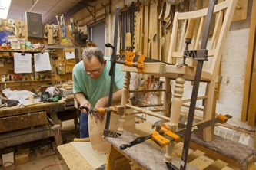
Figure 5 Resources are interrelated
View description - Figure 5 Resources are interrelated
View description - Figure 5 Resources are interrelated

Resources are interrelated. Think back to the chair-making class and how transformations can overlap – the human resources, the machines, the location, the reputation, the quality of the materials and the ‘know how’ all link together.
In particular, there is a link between the ‘know how’ and the tangible resources, which can be difficult to untangle.
When thinking about the economy as something based on knowledge or information, it is easy to forget that the realignment of tangible resources could be a source of innovation and provide a competitive advantage. For example, much has been made of the role of technology in the creation of disruptive innovations. Tech companies can disrupt whole markets using technology to meet an unmet demand. This disruption often comes through at a lower price point or by dispensing with superfluous levels of service (Christensen et al., 2015).
Think back to Session 5 where there was discussion on reducing ‘friction’ and increasing convenience through innovation, which was highlighted through the mobile banking example. This type of innovation is often called disruptive innovation where a smaller company with fewer resources can successfully challenge an established large player in the marketplace by offering alternatives (often at lower cost and with broader customer appeal). This often draws new customers into the market place.
The concept of disruption can be extended to differentiate between demand-led disruption and supply-side disruption (Gans, 2016). The former is where new features or functionality provided go on to change what customers are looking for in a product (e.g. cheaper or more efficiencies). Meanwhile, an example of supply-side disruption is the entry of Apple into the smartphone marketplace, allowing people to go beyond text messaging and emails (something which Blackberry had enabled very well until that point). Apple effectively provided a handheld computer.
Over time most products or services, from making a printer to a hotel-stay, develop set ways of doing things. Improvements to accepted ways of working are made in incremental stages. Processes and ways of working are a means of organising and aligning resources with capabilities and tasks, and it may be your specialist capabilities or access to particular resources that provide a source of competitive advantage. When a radically different approach or a new technology offers the opportunity to change how things are done, this is supply-side disruption (Gans, 2016).
A lot is written about how those already in the market (incumbents) can compete with new entrants engaged in disruptive innovation. However, it can also be applied to new enterprises. Entrepreneurs often have a new way of looking at things and in Sessions 1 and 4 it was suggested that one of the key advantages you might have is being close to your customers – indeed you might be ‘a customer’ who sees a way to improve things.
Another potential source of innovation relates to finding new ways of delivering value, of putting products or services together in different ways and disrupting existing routines. How disruptive will you be? Will you change the way that others operate? What in your business model might they seek to imitate?
Next you will start to think about the capabilities of your enterprise.

3.3 Mapping your capabilities
It is often easier to recognise and name tangible resources. Intangible ones, by their very nature, can be harder to address. Sometimes you can see that the combined impact of tangible and intangible resources can produce an effect that appears more than simply the sum of its parts – they complement and augment each other in a way that creates something bigger and better. On the other hand they do not combine well and the effect produces seems less for some reason. Any long suffering fan of a sports team will recognise this, in particular when things don’t work out.
Grant (2010) suggests in order to put together your resources successfully you need to think through the following (which have been explained here with the help of an example of a restaurant):
- the processes involved, and the sequence of different actions that enable a transformation to take place (e.g. serving a restaurant meal – deciding on a recipe, deciding quantities, sourcing and buying food components, preparing each element, blending ingredients, cooking, apportioning it, presenting and serving it, taking payment for it)
- the organisational structure, how effectively it is co-ordinated, often involving simple things like co-location or apparently simple things like sharing (e.g. does the food prep take place in the restaurant kitchen? Is buying done centrally? Does one kitchen prepare for more than one restaurant?)
- motivation, whether people are able to be effective in realising the potential of the resources (e.g. are waiting staff trained? Do they understand the menu? Are they able to recommend suitable drink options? Is there a reward system – e.g. tipping or share of service charge etc.?)
- alignment, whether all these things come together to ensure a good fit with the wants and needs of customers (e.g. is the restaurant located in a good place with high footfall, the ability to recruit good kitchen and front of house staff, can foods be locally and sustainably sourced so meet demand and quality standards expected etc.?).

Activity 4 Mapping resources and capability
Allow about 40 minutes

Using the template below, start to map out your resources and think through the capabilities of your organisation, or one that you are familiar with.
This is not a simple exercise and it might take some time, but it is worth doing and might provide some useful insights. For example, examining a corporate monster like Walmart, which on one level appears to be a grocer that has gone global, you will find one of the reasons it was able to out compete others in price and stock was through being very good at logistics to ensure it got the right product in the right place at the right time.

Organisational capabilities
Provide your answer...

Process | Organisational structure | Motivation | Organisational alignment
Provide your answer... | Provide your answer... | Provide your answer... | Provide your answer...

Resources
Tangible | Intangible | Human
Provide your answer... | Provide your answer... | Provide your answer...

There is no feedback for this activity.

Next you will look at how to maintain a competitive advantage over other businesses over time.

4 Sustainability and making a difference
How will you be able to sustain any competitive advantage you create? So far in this session you have mainly looked internally at the resources you have and those you might need. You have also considered the importance of aligning them appropriately, focusing on what might be distinctive or different about them, and how that will allow you to make a difference. So how do you sustain any advantage you have? Firstly, you need to keep an eye on both your internal and external environments.
As competitive advantage can erode over time, here is a useful set of things to ask yourself using the acronym VIRO. Are the capabilities and resources you have access to:
- valuable, i.e. valuable to the enterprise
- inimitable, i.e. difficult to imitate
- rare, i.e. hard to acquire
- organisational, i.e. organised in such a way that your organisation can take advantage of them and exploit them?

Activity 5 Maintaining competitive advantage
Allow about 20 minutes

Pick one specific resource or capability that you believe to be a point of differentiation for your enterprise or another you are familiar with. Use the template below to put it into the framework, answering ‘Y’ (yes) or ‘N’ (no) for each category.

Table 2 Points of differentiation
Resource or capability | Valuable | Rare | Inimitable | Exploited by the organisation
Provide your answer... | Provide your answer... | Provide your answer... | Provide your answer... | Provide your answer...

View discussion - Activity 5 Maintaining competitive advantage

4.1 Key success factors
The skill in developing an enterprise is ensuring the resources and capabilities match the key success factors in any given area. Grant (2010) suggests the key success factors are addressed through asking about customers and the competition.
Questions to ask about customers
- Who are they?
- What do they want?
Questions to ask about competition
- Who are the competition?
- What are the main dimensions of competition?
- What drives it and what is the intensity?
These questions ask you to consider how you position yourself in relation to customers and competitors to ensure survival. Or, in other words, how your internal organisation is aligned with the external environment, as the two should be considered together. In this session more time has been allocated to thinking through your internal environment. Partly this is because it is vital for anyone starting a new venture, but also because you will have to be able to find and recognise your own appropriate sources of information about the external environment.

Activity 6 Your key success factors
Allow about 15 minutes

Based on the work you have done so far, try to map out your key success factors. You should build on your ideas around what customers want as part of an analysis of demand and assess how organisations survive and prosper in the area of the market you intend to operate through external scans of the market and competition. Having developed these you should try to map them onto your resources and capabilities.
Note that some enterprises will find this easier than others. If you are creating a completely new market (discussed in Session 4), i.e. providing something that customers might not yet know they want, it might be harder to discern the precise nature of competition. However, think in terms of what alternatives there are now and consider that there might be a complete vacuum or absence of competition. Or perhaps it is a venture which is not looking to compete.

Provide your answer...

5 This session’s quiz
Check what you’ve learned in this session by taking the end-of-session quiz.
Session 6 practice quiz
Open the quiz in a new window or tab, then come back here when you’ve finished.

6 Summary
This session has focused on the alignment of resources and capabilities within your organisation. It has emphasised the idea that the way you align them is what makes you different, and this difference may be the difference that makes a difference!
In this session, you have:
- considered the external environment and how that impacts on your enterprise over time
- recognised your internal capabilities and resources, and how these need to be aligned to create competitive advantage
- recognised that to sustain your competitive advantage you need to remain aware of both the internal and external environments in relation to your enterprise
- identified what your key success factors are.
You have taken the insights you have about the market and about your value proposition, and considered the alignment of your resources and capabilities. Through this process you will have noted the areas where you will need to acquire resources and develop specific capabilities.
This session should help you to develop an understanding of what you need to do well, particularly thinking about how you align your resources to ensure this. Think through your partners, what you are good at, and what you might get others to do, and reflect on the key resources and capabilities you have and those you need to acquire.
This session has tended to focus on the intangible (‘know how’) and people, however, one of the key resources you will need is finance, and the next session will explore this in more detail.
You can now go to Session 7.

Session 7: Financing your business

Introduction
One of the main reasons businesses fail is that they run out of cash. Your business model might be sustainable in the first instance through investment of your own money. It might be sustainable over time through retained profits. However, it is unlikely you will be able to finance growth and expansion that way, indefinitely.
Every business needs to capture some percentage of the value in each transaction they make. In Session 3 you learned about how that value is provided. Capturing the balance of value means there is sufficient value to you to make investment of your time and energy worthwhile, and also enough reason for your key stakeholders to transact with you. In other words, it is not only a matter of you maximising your profits, your key stakeholders (suppliers, customers, distributors, investors, staff and so on) should also perceive that there is mutual value in the deal, making it worthwhile for them.

Figure 1 Capturing value in each transaction leads to sustainability
View description - Figure 1 Capturing value in each transaction leads to sustainability
View description - Figure 1 Capturing value in each transaction leads to sustainability

There are many ways to finance your business, however, the key to a sustainable business is cash flow management. Managing cash flow means being able to understand how and when income and expenditure arises, and being able to forecast and plan to ensure that you can meet financial obligations as they arise in the short and long term.
By the end of this session, you will be able to:
- recognise alternative sources of finance for a new business and how to choose between them
- understand some of the key financial concepts needed when running a business
- understand the two most important financial statements that you will need to manage your business
- recognise the ways in which you can improve your cash flow management and sustain your business
- understand how investors and lenders evaluate your business when they consider funding it.
This session will not make you a finance expert but it will put you in a better position to evaluate the benefits, risks and obligations that each form of finance takes. It will also introduce you to some concepts that will allow you to have a more informed discussion with a finance professional.
Many other courses are available to improve finance skills and it is recommended that you study finance more closely after completing this course if you don’t have access to the knowledge and skills already. You can find finance courses on OpenLearn here.

1 Financing your business
There are three main sources of business funding:
- Equity financing – contributed by the owners of the business at start-up. Equity is never repaid, unless the business is closed down and only in circumstances where there are sufficient funds from liquidation to return to the owners. While no regular interest payments are made to them, investors will hope to receive a dividend if the business performs well and is profitable.
- Debt financing – comes from a third party, external to the business. The loan must be repaid in full at the end of the loan period and interest payments are made on the loan amount. The lender gets their money back and is first in the queue if the business is made bankrupt, provided there are sufficient funds. One advantage of borrowing money in the form of debt is that, in the UK, currently the interest charged is deducted as an expense from sales revenues before taxation charges are calculated.
- Reinvested profits – come from the owners of the business but profits need to materialise as cash to be re-invested, or spent, in supporting the business.

Activity 1 Pros and cons of funding sources
Allow about 10 minutes

Consider what the pros and cons to your business may be of equity financing, debt financing and reinvested profits.

Provide your answer...
View discussion - Activity 1 Pros and cons of funding sources

Next you will look at how to assess the cash flow of your business.

2 Cash management
A growing business needs to make the most of all its resources, including cash. You need to think not only about the cash needed to run your business, but also to grow it. Cash management means assessing the flow of cash in your business and thinking about how you can improve it.
In particular, cash management considers:
- the agreements and terms you reach with suppliers and distributors, if applicable
- the speed at which you collect money in from customers
- the speed at which you pay money to suppliers
- the amount of cash you want to keep invested in inventory (the stock of goods that are being held for re-sale).
The first steps in external funding decisions are to evaluate your current cash position, as prospective lenders will do the same.
Sales are usually made on account or on credit, which means a delay between making the sale and cash being received. Without sufficient cash flowing around a business to cover that delay between sales and cash receipts from those sales, your enterprise will come to a halt.
Establishing where your business has cash committed can be quite complex as:
- goods may have been bought and paid for in cash
- employees involved in manufacturing or operations will need to be paid
- business overheads – rent, energy or computer costs – may have already been paid out.
All of these running costs must be funded during the period before cash is actually received from customers.

Box 1 Solvency and liquidity
A business remains solvent when its cash resources can satisfy its longer term financial obligations as they fall due. This requires liquid funds, i.e. cash, or assets that can be readily transformed into cash, and so liquidity is the ability of an enterprise to pay its short-term obligations. Good management of working capital will help ensure that profits do become cash.

Next you will look at working capital and how a balance sheet is used to indicate a business’ financial health.

3 Financial accounts
The term given to the day-to-day running costs and operational resources is ‘working capital’. A positive figure for working capital indicates that current assets (immediate cash and what is owed to the business) is greater than current liabilities (what is owed by the business). This will give a sense of security to suppliers and lenders. Working capital comprises cash held at the bank, the inventory (items held for re-sale) plus the cash due to be received from customers (receivables), less the cash due to be paid to suppliers (payables).
A balance sheet provides a summarised list of the assets and liabilities of a business, and its equity, at a particular moment in time. The terms are explained here:
- Assets – things a business owns, or money owed to it.
- Liabilities – financial obligations, or amounts of money the business owes to somebody else.
- Equity (sometimes called ‘net worth’) – the assets minus liabilities, that is, the total remaining value of the business after all obligations are taken into account.
Depreciation is an accounting term used to allocate the cost of an asset over an appropriate number of years, usually equal to the time period of its ‘useful life’. Therefore, on the balance sheet, fixed assets (like plant or machinery) may appear with declining value in successive years.
The balance sheet is an indication of the business’ financial health, which means its ability to pay its bills when they fall due. It shows its cash resources and how much debt there is in relation to equity.

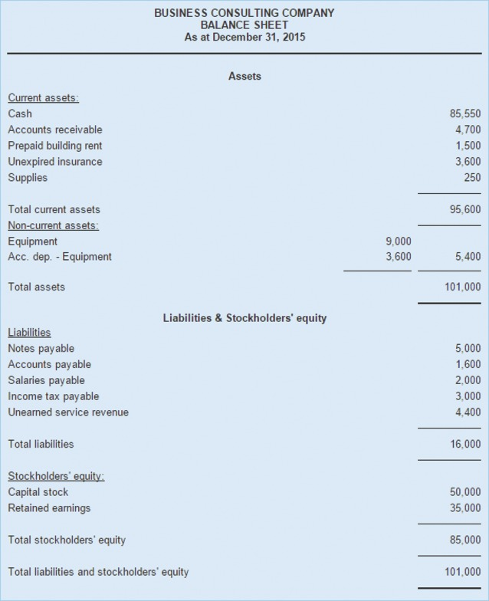
Figure 2Example of a balance sheet
View description - Figure 2Example of a balance sheet
View description - Figure 2Example of a balance sheet

A profit and loss account (p&l), sometimes known as an income statement, shows how a business has performed over a period of time. It measures whether or not the business is economically viable. It pulls together the sales revenues and expenses for a specific time, for example over a year or a month,to show whether a profit or loss was generated.

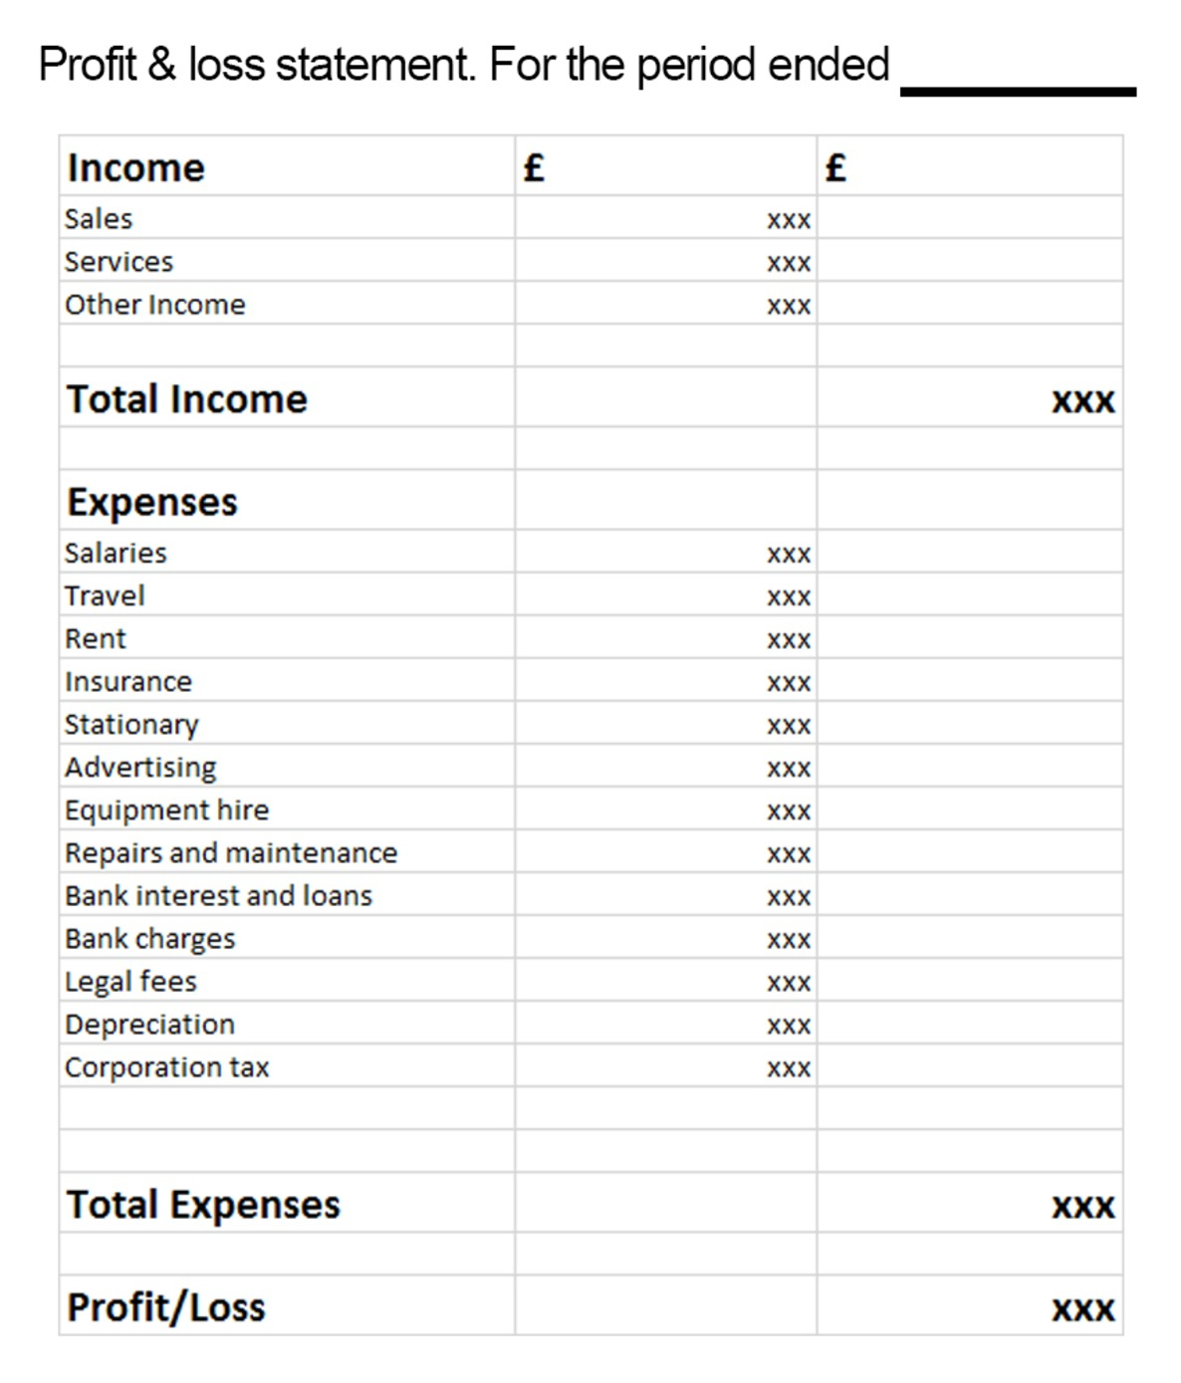
Figure 3 Example of a business’ profit and loss account
View description - Figure 3 Example of a business’ profit and loss account
View description - Figure 3 Example of a business’ profit and loss account

The p&l (or income statement) shows the complete trading picture and business activities over time, including those sales made before the customers have paid cash for their purchases. As a result, expenses shown will include all costs and expenses incurred, including those for which the business may not yet have paid.
Sales revenue includes cash sales and sales made on credit terms. Cost of goods sold includes cash purchases and purchases made under credit terms.
The income statement is a basis for making business decisions and allows the business owners to see trends on sales, expenses and margins over time, and to make comparisons with previous periods and other similar businesses. It provides a basis for budgeting for the future.
Next you will look at limited companies.

4 Limited liability
A limited company is owned by its shareholders, i.e. those who have paid money to the company in order to acquire a legal and financial interest (‘a share’) in it. If you have incorporated your business (i.e. you are a Limited, Ltd or plc) as owner, you are protected from taking on the losses of the business as it is deemed to be a separate legal entity (refer back to Session 2). The incorporation process therefore protects investors and acts as an incentive to invest. The maximum amount a shareholder can lose, in the event of a business collapse, is their original investment amount.
Company shares can be bought and sold by the owners without financial impact on the company, other than the legal obligation to record and maintain a register of the names and other details of its shareholders at any time.
In the next section you will consider what investors are looking for.

5 What are potential investors looking for?
It is easy to get caught up in your own ideas and beliefs in the value of what you are doing – and this is a good thing. However, in order to get investors and those a little more distant from it to literally buy into it, they need to see the mutual value.

Reflection

Take a moment to reflect on what kind of enterprise you might invest in and why. What factors might you take into consideration? What would you expect in return? Capture your thoughts below.

Provide your answer...

You may have additional terms or values that you take into consideration over and above external investors, however, generally speaking, potential investors seek a return through regular repayments, dividends or on an increase in the future value of their shares. They will want to understand past performance as an indication of the viability of your plans. For example, can you demonstrate your profit margin? This tells them how well you control your costs. A higher profit margin indicates more resilience to unforeseen situations and events. There are other facts and figures you may want to gather to satisfy investors of your prospects:
- The rate of growth compared with your past, competitors, and the current state of the economy will provide an indicator of the attractiveness of providing a loan or investment.
- Your own personal track record, particularly if you are starting out, to provide relevant history of success. Do you have any particular skills or resources or capabilities that you intend to exploit (refer back to Session 6). Is there a particular technology or knowledge for which you have a patent? Is there a new demographic or geographic market that you are targeting? All of the work you have done to define your business model and your value proposition – as emphasised in Session 3 – needs to translate into ways in which investors can see a return.
- Your effectiveness in collecting cash from customers to manage cash flow, if you have been trading for a while.
- Evidence of any collateral or assets that provide security.
Some businesses are seasonal or cyclical and so need to plan for shortfalls of cash after periods of high demand, e.g. Christmas or Hanukkah. Demonstrating that supply can meet demand at the peak point of the cycle is important for business continuity. A cash flow forecast will help you pace your expenditure in order to cope when sales are low and cash is scarce. Having a cash contingency plan in place for when cash inflows drop will make for more comfortable reading by investors and other stakeholders.

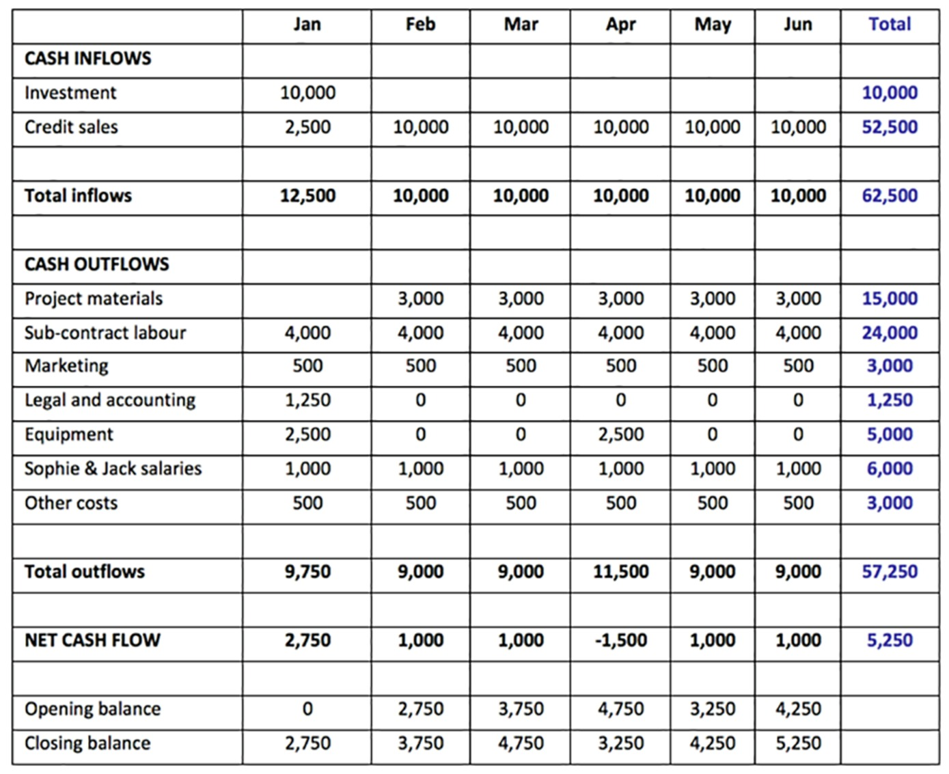
Figure 4Example of a cash flow forecast
View description - Figure 4Example of a cash flow forecast
View description - Figure 4Example of a cash flow forecast

Can the cash flow forecast withstand a short-term, sharp shock like an equipment breakdown or loss of a major client order? Is there sufficient cash to recover, repair and recommence operations?
There may be many other questions, so be prepared by evaluating and testing your cash flow forecast.
Next you will look at debt financing.

6 Debt
The most common cause of failure in small businesses is the inability to generate the cash to repay debt and repay interest costs. Once internal sources, such as working capital, have been considered, either equity or debt finance can be used to satisfy shortfalls in cash. A business owner may inject further cash in the form of equity, and may share the financial risk by inviting other investors to contribute additional equity investment. The equity investors might then consider if any other forms of finance are required to reduce their risk and meet planned expansion.
There is a range of different types of debt agreements.
- Preference shares – these often carry a guaranteed fixed interest rate and rank ahead of ordinary shares in any repayment arising from insolvency.
- Loan stock or debentures – debentures are a special form of contracted loan, usually redeemable at a specific maturity date. They may be issued to raise capital for the purchase of specific assets, and may be secured on those assets.
- Bonds – another form of a contracted loan. Bonds are potentially tradable, although usually unsecured.
- Leasing – specific assets may be acquired using lease finance, which would always be secured on the asset. Leasing saves an upfront, large cash outflow for the purchase of the asset. It can be less risky than borrowing from a bank as the lease is secured on the asset (being leased), rather than the owner’s property or other business assets. A lease contract requires the commitment to regular payments and there may be an early cancellation fee.
- Bank loans – bank loans are usually arranged for a fixed period, carrying a fixed or variable rate of interest. They are often secured on specific assets or on the business as a whole.
- Bank overdraft – an overdraft is offered at the discretion of the bank. It can be cancelled at any time – and not necessarily because of any concerns about the business itself. Sometimes internal bank decisions or concerns about the external economic environment may influence this. An overdraft is suitable for funding short-term cash shortfalls. It is repayable on demand and there will be interest charges and a fee for using this flexible type of borrowing.
- Suppliers or trade payables – suppliers give an interest free loan if they offer credit terms of a month. Suppliers will assess the credit standing of a business before offering generous credit terms.
Next you will consider the potential of business grants.

7 Grants
Apart from equity, a business grant is the only other source of business finance that is not repayable. A grant is a permanent cash injection but, unlike equity, there is no loss of control over the business when a grant is received. In Session 2 you were introduced to a number of development agencies and networks, many of whom offer grants or can point you towards organisations that do so.
Since the pandemic, there have been a number of grants from organisations such as Innovate UK, specifically aimed at funding research and development ideas that would have a significant impact on the UK economy.
Applying for a grant is a competitive process and often they are only provided for a specific future project. If you live in the UK, the website Gov.uk offers more information about grants and other funding schemes, including the Graduate Entrepreneurship Visa, which you can find out more about in the Further reading section at the end of this session. Many other governments around the world also provide funding support for entrepreneurs to live and work.
Next you will learn about alternative sources of finance.

8 Alternative finance
The term ‘alternative finance’ is used to describe a way of raising business and consumer funding that does not involve a bank as an intermediary in the lending decision. It has developed in the past 15 years to bridge the funding gap for micro and small businesses, when traditional bank funding was difficult to obtain. It involves individuals coming together and pooling their funds so that larger amounts of money from the pool can be lent out to consumers and businesses. The most common of these are crowdfunding and peer-to-peer lending.

8.1 Online platforms
Traditionally, banks acted as intermediaries by gathering together small deposits and lending out larger amounts of money. The intermediary in alternative finance is an online portal, or platform, which is a website that allows lenders and borrowers to have instant access to information about the business or project that needs funding. Funds are raised over a fixed limited time, usually a couple of months. Online platforms are not regulated to the same extent that banks are. The pooling and decision to lend is managed by the platform, which is compensated through fees or charges.

8.2 Rate of return
Alternative finance has attracted a range of investors from retail savers to businesses, many attracted by the higher returns on offer compared to low interest rates offered by banks. Low interest rates, in the region of 1–2% in the UK (in 2018), have made alternative finance returns attractive. The peer-to-peer lender Funding Circle, for instance, quotes a return of 7 per cent on consumer loans.
While higher rates are attractive to savers, the risk for the lender is higher too. Alternative finance returns are not guaranteed and the amounts lent are not protected under investor compensation schemes. In the UK, the Financial Services Compensation Scheme guarantees bank deposits of up to £85,000 in the case of bank failure (FSCS, 2018). There is no such guarantee for an alternative finance investor. In order to provide increased security for lenders, online portals use a number of different approaches when pooling and arranging loans.

8.3 Crowdfunding
Crowdfunding has enabled start-ups and microbusinesses with no tangible assets to offer as security, no track record of profitability, and limited internal cash resources, to use their existing customers and supporters to provide the funding they need to develop their business.
Crowdfunding offers online funding opportunities to the public, rolling up small sums of money offered by many individual lenders or investors, sometimes as little as £10, to form a potentially large amount for the borrower. Matching borrowers to willing lenders is usually made via the platform which distributes requests for funds to borrowers. Potential investors and donors can see the amount of support from others and may be influenced by supporters’ comments and business updates during the funding period. There are different types of crowdfunding:
- Investment-based or equity-based crowdfunding – the investor receives a share in the business in return for their funds and the lender receives interest and repayments as usual with bonds and debentures.
- Peer-to-peer lending or peer-to-peer crowdfunding – funds can be arranged as loans. The lender receives interest payments for a fixed period of time and repayment of their loan amount in full.
- Reward-based crowdfunding – funding is arranged in return for goods or services. The value of the goods or services is determined by the borrower.
- Donation-based crowdfunding – funding is arranged for a charitable cause. Investors donate funds without expecting anything in return.
- Invoice trading – a type of alternative finance managed on an online portal which helps businesses borrow in advance of receiving money from their customers.
- Mini-bonds – offered on some equity-based crowdfunding portals. These are not regulated in the same way as equity-based crowdfunding and have a higher risk for the investor than equity.
Crowdfunding and peer-to-peer lending (covered in the next sub-section) are two innovative ways to get money into your business, but they are very different in some important aspects. For a business in the earliest stages of its life cycle, crowdfunding may appeal. You make your pitch to investors via a platform and those interested can contribute towards your proposed venture. Kickstarter is the world’s largest reward-based crowdfunder.
Investment crowdfunding is growing rapidly. UK examples are Seedrs and Crowdcube. If you do go down this route, you will need professional legal advice and to ensure your financial forecasts are in good shape. You can find out more about each of these in the Further reading section at the end of this week.

Activity 2 Succeeding with crowdfunding
Allow about 10 minutes

Read more about how to succeed with crowdfunding by reading advice from Nesta and then answer True of False to the statements below.
All ventures funded by crowdfunding platforms are successful.

True
Fasle
View answer - Part
View discussion - Part

The biggest mistake crowdfunders make is in asking for too little money.

True
False
View answer - Part
View discussion - Part

All platforms are the same so there is no point in shopping around.

True
False
View answer - Part
View discussion - Part

All crowdfunding platforms are regulated by the FCA.

True
False
View answer - Part
View discussion - Part

8.4 Peer-to-peer lending
Funding Circle is an established peer-to-peer platform with tens of thousands of investors as well as local government, universities and others looking to lend to British businesses. The Government-owned British Business Bank has also pledged to lend £40m via this platform to investors (Funding Circle, 2017).
Peer-to-peer lending provides a viable alternative to traditional funders, as you can apply for loans up to £1 million in the case of Funding Circle and £3 million for Thincats, repayable over terms of up to five years. Many platforms only lend to creditworthy borrowers, making those a much safer bet for investors. Investors don’t own shares; instead, the reward is the interest that is paid on the loan.
Peer-to-peer lending has been tax free in the UK since April 2016. Tax benefits around equity-based crowdfunding are more complex but still attractive. Find out more about the government’s EIS and SEIS schemes for prospective lenders seeking tax relief on their investments in the Further reading section at the end of this week.

8.5 What is public equity?
As a business grows and becomes successful in generating profits, the increase in net assets will make it an attractive investment proposition to additional external investors.
The need to increase funding is the main reason to go public (Kim and Weisbach, 2008). Alternatively, a business may have further expansion plans and might want to raise additional finance. Both can be achieved through an initial public offering (IPO) of shares through a stock exchange. The IPO decision involves a consideration of the management time and costs (fees for professional advisers) that stock exchange regulation will require.

8.6 Private equity
There are several reasons why private equity may prove to be a better option than issuing public shares.
- If a business is too small, does not have a track record or has too high a business risk profile staying privately owned may be the better option
- Staying privately owned means that there is less requirement to disclose details about the business to the public (and competitors).
- There is less onerous compliance and regulation when staying privately owned.
- Raising private equity from local investors or friends may be quicker.
- Dilution is the term used to describe the situation where each shareholder’s interest in the total business is reduced as more shareholders are invited into the business. The more shareholders with voting rights, the less control you have.
- Staying privately owned means less exposure to a hostile takeover and less pressure to produce consistently high profits to keep shareholders invested.

8.7 Angel investors and venture capitalists (VCs)
A business angel is an investor who can contribute both equity funding and management skills. Earlier in the course you were introduced to the UK Business Angels Association which is the trade body for Angel Investors around the UK. Normally, syndicates of individuals come together to spread their individual risk and portfolio of investments. Both angels and venture capitalists (VCs) can provide funding for businesses that don’t want to go public but do want to expand. Business angels may take up board director roles and their investment over a period of at least three years.
Venture capital is the term given to groups of investors who provide equity funding for early-stage, innovative and high-risk businesses. The venture capitalists expect a high return on their investment to be achieved in the medium term. Venture capital may also support the business with advice and guidance.
A survey of 158 UK-based angel investors showed that 56 per cent of the investments made by angels terminated at a loss, with ‘most of them losing their whole investment’ (Nesta, 2009). Angel investors require high returns to compensate for the high risk; overall returns of 22 per cent for UK angels were noted (Nesta, 2009).
Investors tend to want to be involved at the very early stages of reasonably well-established businesses with ambitions to grow substantially, but without the financial backing to do it on their own. That is to say – they have the potential to ‘scale up’ and the business plan to demonstrate this.
Many business owners reject equity finance because they don’t want to give up control of their business or they may have a social mission that does not fit with the ambitions of investors. Angel and VC investors will want a seat on the board (or more), and will insist on strong governance and regular meetings. They will want monthly management accounts and regular reports from the management team. So while you get the benefit of their finance and their knowledge, contacts and experience, you will effectively be accountable to them for this.
A VC investor will expect to see an exit route (that is, a way to realise the gains on their original investment in cash) outlined by the business.
Now watch our entrepreneurs discuss how they financed their business start-up and some of the issues about matching expectations of investors with their own ambitions and ideas.

Video content is not available in this format.
Video 1 Financing a business start-up
View transcript - Video 1 Financing a business start-up

View description - Uncaptioned Figure

8.8 Weighing up the pros and cons
Business owners need to consider the advantage of keeping control of their projects and their business against receiving expert advice, support and access to a large amount of funding from a venture capital firm or business angel.
Through crowdfunding, businesses get feedback and comments on goods and services from their investors who are also customers and can become advocates, which in turn helps to develop the business further.
Relatively speaking, crowdfunding is still in its early stages although it has undoubtedly filled a much needed funding gap for small and medium-sized enterprises (SMEs). There have been many successes where an exit route has created value for the original investors. For example, E-Car Club, an electric car-sharing company that raised £100 000 in equity on the platform Crowdcube, was later acquired by the rental group Europcar. However, there have been spectacular failures (e.g. iBackPack which was to provide charging and hotspots on the go), and also some famous scams too (e.g. Cataldo’s Cancer).

9 This session’s quiz
Check what you’ve learned in this session by taking the end-of-session quiz.
Session 7 practice quiz
Open the quiz in a new window or tab, then come back here when you’ve finished.

10 Summary
In this course, it is only possible to skim the surface of all you will need to learn and every option available to you to finance your business throughout the different phases of its life. This session has introduced options from the very beginning of your enterprise lifecycle to those that become relevant in high-growth phases. The most important advice in this session is to understand your own business and your own values.
In this session, you have:
- recognised how crucial it is to manage cash flow
- looked at three important financial statements to help you understand how your business is doing – the balance sheet, profit and loss account, and the cash flow statement
- considered the different sources of funds available at different stages of the business lifecycle and how it is important to assess these in relation to your business aims and objectives, and the terms and conditions associated with them.
In terms of the business, you should consider its costs, expenditures and the pattern of sales and revenue. Managing cash in the early stages, and taking good decisions about how to finance growth and development, are key skills for an entrepreneur to learn.
If you decide that you will approach external investors, then it is essential that you understand both what they are looking for and what they can provide (remember it is a two-way exchange of value). You need to be clear about what you want to get from any deals, which may include what you are prepared to give up. This could be control, ownership and almost certainly a share of future profits. It is hard to imagine the return that those original Google investors may have amassed for the few thousand dollars of seed funding they invested. So timing of involving investors is also a consideration for you and them.
Seeking professional advice and having the confidence to interpret your own financial statements will be crucial steps in getting your business up and running and planning its future.
You can now go to Session 8.

Session 8: Bringing it all together – just start!

Introduction
How many times have you had a conversation with a friend or colleague – or in your own mind – about an idea only to talk yourself out of it? There are many more would-be entrepreneurs than real ones. Often, the only thing stopping you from achieving what you want is your own self-doubt. So where do you start? Well, actually, for many entrepreneurs, the difference is that they don’t spend a lot of time working out where to start – they just start!
If you have completed the activities in this course you will hopefully be buzzing with ideas to try, or perhaps you are feeling overwhelmed and wonder where to start. In this final session, before you complete the final quiz and earn your badge, you will create an action plan. This plan will give you focus and help you to overcome the inertia that often comes with self-doubt and a sense of having too much to do. The action plan will:
- increase your network of contacts (and may even find you your first customer)
- identify elements of your business model to prioritise and research further
- help you to effectively pitch your business idea to others.
By the end of this session, you will be able to:
- use some tools and techniques to help you start on the next phase of your business idea
- identify people to expand your network
- make a pitch to prospective customers, other stakeholders or investors
- set out some measures of success for you and your enterprise.
Your action plan will take you several steps closer to starting your business or becoming your own boss.

1 Overcoming self-doubt
It is perfectly normal to have doubts about starting out on your own, especially if you are giving up a steady income working for someone else who takes the decisions and the risks for the uncertainty of working for yourself. These doubts often become magnified by being on your own. One thing to remember is that many other people have done this successfully.
Activity 1 is designed to help you gain perspective that may help you to move forward with more confidence. It may even uncover challenges or opportunities that you have been unable to see as you have become too close to your business idea.

Activity 1 Overcoming barriers
Allow about 20 minutes

- Fill in Table 1, using the guidance below.
  - List all the problems or obstacles you see that are preventing you from moving forward in the first column.
  - In the middle column, look at each challenge in turn from the left-hand column and write down all the possible alternative solutions you can think of to overcome them.
  - The third column is for use in Step 3 so you do not need to focus on it at this stage.

Table 1 Addressing the problems in your business idea
Problems/obstacles | Alternative solutions | Discussion
Provide your answer... | Provide your answer... | Provide your answer...
Provide your answer... | Provide your answer... | Provide your answer...
Provide your answer... | Provide your answer... | Provide your answer...
Provide your answer... | Provide your answer... | Provide your answer...
Provide your answer... | Provide your answer... | Provide your answer...

- Show your list to another person. Explain the challenges and your solutions to them. There are three possible outcomes:
  - By explaining the barrier, you might begin the process of solving it.
  - The other person may actually be able to solve it.
  - Any suggestions they make may spark some new idea or thinking.
- Now return to the first column. From your deliberations, do any of these challenges now seem more like an asset or opportunity you could exploit? If so, capture this in the third column.

Working on your own, perhaps even in your own home, can feel quite isolating, and even more so if you have been used to working as part of a larger team. One way to sustain yourself is to build a network of people and involve them in some way with your idea – as sounding boards, advisers, prospective users or customers, mentors or partners. To do this, you will need to build your network of contacts. Earlier in the course you were introduced to the concept of co-working spaces, accelerators and incubators. These provide one way of reducing your isolation and increasing your working network amongst others in a similar position.
Now listen to our entrepreneurs discuss the ups and downs they have experienced and how they have overcome any feelings of doubt in their ability to succeed.

Video content is not available in this format.
Video 1 Overcoming feelings of doubt
View transcript - Video 1 Overcoming feelings of doubt

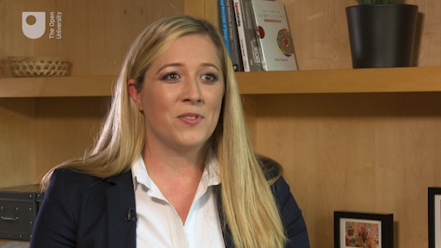
View description - Uncaptioned Figure

Reflection

Having listened to our entrepreneurs, do you share any of their doubts? What strategies might you pick for yourself to help overcome the challenges that threaten to derail you?

Provide your answer...

Next you will look at how bringing people onboard with your business venture can be an important part of sustaining it.

2 Building your network
One of the most important activities you will do to get your venture off the ground and thereafter to sustain it, is to bring other people along with you. If by now you still feel passionate about your business idea, then the chances are this will be obvious to other people you speak to, as well. If you are less sure then you have nothing to lose by testing it out on other people. Maintaining your energy and enthusiasm for your project is an essential part of sustaining it.

Reflection

Take a moment to think about different ways you could benefit from getting feedback from some people you trust.

Provide your answer...
View discussion - Reflection

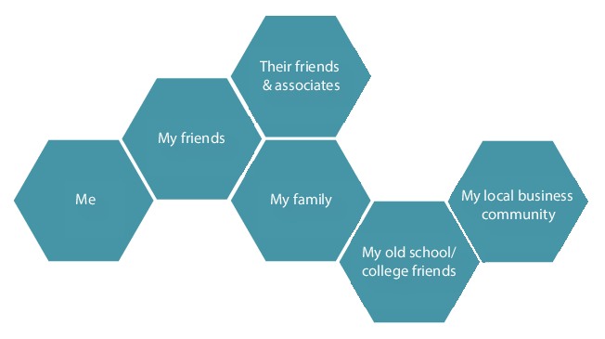
Figure 1 Your network of people
View description - Figure 1 Your network of people
View description - Figure 1 Your network of people

To start building your network, begin by making a list of people you know in your personal, social and professional circles. These may be people who:
- have money they would be prepared to put up
- may be willing to take a risk
- know other people who could help you
- would be fun to work with
- you know are people who get things done
- have a skillset you would find useful – like finance, marketing, communication, administration, attention to detail or experience of building up an enterprise.
Next, you will need to approach and enrol them in your venture. For some people this may be the hardest part of all as it may feel like you are exposing yourself to possible rejection or disappointment. The first thing to remember is that you are not trying to sell these people anything, but rather offering them the chance to do something they may want to do for themselves. There is an important distinction between those who will be excited for you and those for whom your enterprise taps into a desire or a genuine opportunity for them. In an earlier session you considered your own motivation for starting out on your entrepreneurship journey but now you need to think of the motivation of others. If you can see real gains and these are aligned with your contacts, then there is no problem. If they are not, again there is no problem – don’t take it personally.
If you are thinking of working with friends or relations, it is worth thinking through where their motivation comes from. It will be unhelpful in the long run if your friends or family feel pressure to support your venture in any formal way. In Session 2 you considered whether you had any longer term aims around your immediate family (e.g. what might be in jeopardy if the worst happens with your business venture). There are many ways that people can support you personally but lending money or working for you for free, out of obligation to your relationship, is not sustainable. It can create future difficulties if later this is at the expense of their own need for money or time. It is therefore quite useful to discuss the venture more objectively in terms of what is an ‘acceptable risk’ or even ‘acceptable loss’ to them. In this way both parties understand their position.
Enrolling others will require them to understand what it is that you are seeking to do and what you are seeking from them. You will need to ensure that they feel the same enthusiasm and desire to move forwards that you do.
Next you will consider your pitch to those in your personal, social and professional network.

3 Pitching your business
The elevator pitch is so called because it lasts no longer than 60 seconds, or as long as it might take you to explain your business idea to someone if you got into a lift with them! It is a good discipline to be able to explain quickly and concisely what your business is to busy people whom you may want to enrol to support you.
The ideal pitch will quickly inform them of what you do and what you are looking for from them. If you go back to the value proposition you prepared in Session 3, you may well have your elevator pitch ready to go. Some tech entrepreneurs borrow from other well-known brands, for example, ‘We are like a social enterprise version of Uber’ could work for a community transport scheme – as long as everyone understands the concept of Uber!

Activity 2 Listen and learn
Allow about 15 minutes

Listen to the following short extract from The Bottom Line (Radio 4 Business programme commissioned by The Open University). In it Evan Davis introduces two teenage entrepreneurs, Akshay Ruparelia and Henry Patterson, and effectively draws from them their short pitch. As you listen, think about whether you could improve upon their pitch. Listen to the questions that Evan asks them (especially Henry) to get the clarity he is looking for.

Audio content is not available in this format.
Audio 1 The Bottom Line
View transcript - Audio 1 The Bottom Line

Provide your answer...
View discussion - Activity 2 Listen and learn

For most situations you will need a little more detail than the boilerplate and this is where you can refer back to the work you did on your business model canvas and other tools introduced earlier in the course. If you are in the position to create a presentation then you may wish to prepare it as a short, succinct slide deck, using images and bullet points rather than a lot of words. However, this is not always the most effective way of presenting and slides can be overused and so less likely to help you to stand out in people’s memories, which is one of the objectives.
The purpose of the pitch is to create a positive (first) impression, to inform, engage and be memorable. After all, if people cannot remember you or what you are seeking to do, they won’t have any way of engaging with you later or be able to refer you to anyone else.
One of the best ways to engage people is to demonstrate your passion and enthusiasm. Another is to use stories that help to bring the problem or need alive so that you can then demonstrate with energy how your business idea solves it. Stories are easier to relate to than technical details and if they tap into emotions and empathy, they are also more memorable.
You may well have to get over anxieties about public speaking or selling, but these are essential skills to learn. Prospective customers, investors and mentors are not only buying into the idea but also you, as without you the idea will not succeed. One good way to overcome fear and anxiety is to prepare thoroughly, know what you want to say and how you want to come across, and then to practise.
Next you will look at the different areas you may want to cover in your pitch.

3.1 What to cover in your pitch
There are many things you may want to cover in your pitch: the why, what, who, how much and when.

Vision and value proposition
This is your 60 second elevator pitch that describes in a nutshell the problem you are solving and why it is worth solving for customers. These one or two sentences may be the hardest you have to write to pitch it right. Imagine you are writing it for a Tweet.

The problem
This is where the storytelling can often help by bringing alive the problem, challenge or gap in customers’ lives. Can you think of one that illustrates with passion the need, gap or want you have the solution to?

The opportunity
This is about your target market. Really zoom in on who your solution is aimed at. While you may hope that everyone could benefit, you will have more success if your design and focus is on the most likely customer segment.
Prospective investors will find it more realistic and reassuring to see that you have researched the market. They will be more impressed by your understanding of the size, location and data around different customer segments and how groups of customers are currently underserved in the market. A customer segment is only valid if you know who those customers are; what their needs are; that there is a sufficient number of them to make it worthwhile and that you have the means to reach them.

The solution
You might well wonder why this is not upfront in the presentation, but remember this is a narrative. Where a ‘new to the world’ idea, invention or particularly technical product or service is concerned, you will have to ensure that your audience can first relate to the impact of your solution and the difference it will make to their lives (or businesses if you are aiming at a business market).

Business model
Having worked through your business model canvas and done your financial homework, prospective investors or partners will want to know how you propose to make money. This means how you will compete and the revenue streams that you anticipate. Some business types provide a range of revenue streams over and above product sales – e.g. a hairdressing salon may make most of its money from cutting hair but could also make more money from selling hair products such as shampoo. A business based on tourism or an experience may sell merchandise like tee shirts.

Early successes
As you learned earlier in the course, one of the obstacles to overcome is a lack of trading history. While you may not be able to demonstrate a long history of sales, you may well be able to demonstrate that your idea already has some traction in another market, how well received it has been in focus groups, or that you already have had early interest, forward orders or other proof that your concept is a success. Perhaps you have won a competition, early funding or press coverage for your idea. Successes such as these are reassuring.

Marketing
In Session 4 you considered your marketing strategy. Having decided on your target markets, this section of your presentation should concentrate on your sales strategy – who will sell your idea, what sales channels, e.g. website, social media, face to face (e.g. pop-up shops, festivals etc.), and tactics will you utilise? What are your key messages and what features will you emphasise?

The team
Why should your audience take a chance on you? What are your previous achievements? What skills, knowledge, experience and track record do you have that will make you successful? What about others in the team (not only employees, but also partners if you have them)?
Being realistic about what you have in place and showing that you recognise where you may have gaps will be reassuring to others and may also net you some new supporters or partners who want to work with you.

Financials
This is where the work you have done on forecasting profit and loss, and understanding your cost base and your potential revenue streams comes in. For a presentation or pitch, you would be unlikely to require a lot of detailed spreadsheets or financial statements. However, if you are able to show graphs, trends and a summary of the overall picture, this will demonstrate that you understand and can manage your cash flow, can control your costs and know where your breakeven point is. This helps prospective investors or funders to understand when they are likely to expect a return.
Prospective investors or funders will also want to understand that you have a firm grasp of your finances and so you should be prepared to discuss the underlying assumptions behind your figures. There is little point in overstating the potential income as most experienced, prospective investors will immediately discount these in their own mind.

The competition
You considered your competitors earlier in this course and as such you will recognise that they could take several forms. Some might be a direct competitor – a straight choice between two alternative solutions; others will be indirect competitors in the same way that a home shopping delivery service is an indirect competitor to a retail outlet. Both provide the same solution for the end customer – their groceries or other shopping items – however, the business model and experience are very different.
When discussing competition you will want to demonstrate that you understand that end customers have a choice and that you are providing a viable (better) alternative that will compel them to switch product, supplier, experience or channel. If you have discovered that you are filling a currently unmet need, then you should also consider what people currently do, or make do with.

Planned investment
This part of the pitch is where you say what funding you need, either in the form of seed funding to get started, or growth funding to develop your business. Investors will want to have some detail of the planned use of funds. They will use other financial details to assess whether the plans are realistic and judge the prospect of making some sort of return on their investment.
In earlier sessions you came across the need for an ‘exit strategy’, that is, your long-term plans to divest yourself of the business either through passing it on or selling it. Investors will want to understand how likely and how long it will be before they get their investment back and in what form. Will it be through equity (a share in ownership), dividends or other means? They will also certainly need to know exactly what return they can expect.

Prototype or demonstration
As the introduction to Section 3 on creating your pitch mentioned, the purpose of the pitch is to create a favourable and memorable opportunity to engage others in your business. Few things are more successful in achieving this than an effective physical demonstration. Whether this be a prototype (an early manifestation or mock-up of a physical product, a model) or a simulation, this will show and tell the audience about your idea more than a thousand words.
Do:
- ensure that you have the correct environment and surroundings to make the demonstration work
- ensure you have practised it so that it goes smoothly
- make sure that your demonstration will stand up to the enthusiastic testing of someone in the audience, if appropriate.
For example, you could be scoring an own goal if you claim your product is a simple, streamlined way of executing something but you then cannot get it to work! Take especial care to ensure you have a good broadband connection if you are working with the internet.

4 The secrets of success
There are no guarantees of success when starting a new business and indeed there are many different ways success could be defined for yourself, beyond the ‘bottom line’ which originally referred to profit.
Think back to the earliest sessions of this course when you were asked to consider your motivation for starting a new enterprise, and how our entrepreneurs have described their businesses. Would you define your business as a success if you were making a profit but you had a miserable family life due to long working hours and periods away from home? Would you define it as a success only if you succeed in selling your business for £1m, or if you created a small part-time business that provides a healthy income source for your family and offers employment to some local people? Or what if it improves the lives of your friends and neighbours or wins the approval of the local business community?
It is worth considering how you will recognise such successes in the short and longer term. In somewhat basic terms, you might say that a successful business is one that is profitable and sustainable over the longer term.
The quadruple bottom line is a concept that describes success for yourself, your family, the firm and the community (which might also include the environment).

Activity 3 Defining your four bottom lines
Allow about 15 minutes

Complete the table below, adapted from Katz and Green (2013), to outline your own goals, measures and achievement levels.

Table 2 Goals, measures and achievement levels
Dimension | Goal | How would I measure success? | Achievement goal
Yourself | Provide your answer... | Provide your answer... | Provide your answer...
Your family | Provide your answer... | Provide your answer... | Provide your answer...
Enterprise | Provide your answer... | Provide your answer... | Provide your answer...
Community | Provide your answer... | Provide your answer... | Provide your answer...

View discussion - Activity 3 Defining your four bottom lines

Inevitably there is going to be an element of risk in starting a business but many people do – why? The answer to this is because they can, and they really want to do something meaningful with their lives.
What is meaningful is highly individual, however, so it is perhaps more sensible to focus on what you can do to mitigate the risk of failure. Four factors critical to the success of start-ups appear to have emerged from extensive examination of the research data. These are:
- Seek the advice and support of your local economic development agency (refer back to Session 2 for links to some of these in the UK).
- Join the sector or industry body for your line of business and make use of their advice and referrals.
- Network with other entrepreneurs and small businesses to get their advice and referrals.
- Consult with a legal expert or accountant.
What do you notice about these four points? Quite simply each recommends that you seek and use all the help available to you. Those who do seek the help of experts will fare better than those who do not. Those who are part of an incubator or accelerator programme are more likely to succeed, and the same thing holds for students undertaking entrepreneurship and small business courses (Charney et al. cited in Katz and Green, 2000). In other words, the more you know, the better the chances of succeeding.

5 This session’s quiz
Now it’s time to complete the Session 8 badged quiz. It’s similar to previous quizzes, but this time instead of answering five questions there will be fifteen.
Session 8 compulsory badge quiz
Remember, this quiz counts towards your badge. If you’re not successful the first time, you can attempt the quiz again in 24 hours.
Open the quiz in a new tab or window then come back here when you’ve finished.

6 Summary
Successful entrepreneurs learn to deal with uncertainty – if you could predict everything beforehand, life would be much easier, but arguably also much duller! Fortunately it is possible to move forward and take corrective action as you go or to start a venture part time until you are confident to go all out. Many successful businesses have done that.
In this final session, you have:
- considered how you can overcome fear and anxiety to take the next steps
- recognised the importance of widening your network by bringing other people on board
- identified what makes a good pitch
- set your own bottom line – what constitutes success for you.
While it might seem that serial entrepreneurs are impulsive, or even compulsive, risk takers, in many ways this is not the case. They often operate based on the principle you were introduced to earlier in this session of ‘acceptable loss’. In other words, they understand what the bare minimum is they (and anyone they are responsible for) could survive on, and for how long, if nothing or very little came in from the business. This leads them to carefully consider costs, to listen very carefully to advice, especially from those who have made mistakes, and to differentiate between those who are committed to their idea and those who are not.
There are no guarantees of success and it is true that many businesses fail. Throughout this course you have looked at best practice and have been introduced to research to help your enterprise succeed. Success though is a relative thing and something you have to define for yourself.
Through the process of being in business you will continue to learn and, by doing so, drive down the cost of the next step on the journey to a point where it doesn’t make sense not to do it. By keeping moving, and taking corrective action as you go, you prevent the ‘paralysis by analysis’ that comes from over-thinking. This takes you back to the early premise that entrepreneurship and being enterprising is something that correlates very closely with learning: learning about yourself, learning about what you know that you can use (probably more than you think) and being open to learning about things you don’t know about or how to do yet.
In this course you have been introduced to many concepts and theories (knowledge), as well as activities to develop some key skills. These include analysing situations and opportunities, creating alternatives and thinking critically about them, and making judgements and decisions about people, situations, opportunities and threats.
Entrepreneurs must be good at enlisting the support of others and so you have been introduced to the ideas around marketing and communicating about your business model and your idea. You have also been introduced to skills that will help you to structure your ideas and actions. These are all extremely valuable skills for your future employability, should you change your mind about running your business.
You may well have started out with an idea and developed it through this course, but equally you may well have changed direction. Hopefully, you have at least gained from the insights of others who have started and built their business and this will stand you in good stead for the future in whatever circumstances you use these. Congratulations on taking the first step towards making your enterprise a success.

Where next?
If you’ve enjoyed this course you can find more free resources on OpenLearn. In particular, in you may be interested in:
- Understanding your sector
- Making creativity and innovation happen
- First steps in innovation and entrepreneurship
- Understanding and managing risk
- Leadership and followership
- Leadership challenges in turbulent times
New to University study? You may be interested in our access courses. Alternatively, you may be interested in The Open University’s Corporate Professional Development (CPD) courses.
Making the decision to study can be a big step and The Open University has 50 years of experience supporting its students through their chosen learning paths. You can find out more about studying with us by visiting our online prospectus.

Get careers guidance
The National Careers Service can help you decide your next steps with your new skills.

Tell us what you think
Now you’ve come to the end of the course, we would appreciate a few minutes of your time to complete this short end-of-course survey (you may have already completed this survey at the end of Session 4).

References
Blundel, R., Lockett, N. and Wang, C. (2018) Exploring Entrepreneurship. 2nd edn. London, Sage.
Brown, T. and Martin, R. (2015) ‘Design for action: How to use design thinking to make great things actually happen’, Harvard Business Review, September, pp. 56–64.
Burns, P. (2016) Entrepreneurship and Small Business Start-up, Growth and Maturity, 4th edn, London: Palgrave-MacMillan.
The Open University (2011) Developing entrepreneurial ideas, Milton Keynes, The Open University.
The Telegraph (2018) Top 10 technologies that were ahead of their time [Online]. Available at https://www.telegraph.co.uk/technology/news/11377731/Top-10-technologies-that-were-ahead-of-their-time.html?image=9 (Accessed 10 August 2018).
UnLtd (2016) Understanding social business models in the employment sector: Insights from social entrepreneurs [Online]. Available at https://www.unltd.org.uk/uploads/general_uploads/Findings_Paper_10_Understanding_Social_Business_Models_in_the_Employment_Sector.pdf (Accessed 28 November 2018).
BEIS (2020) Business population estimates for the UK and regions 2020: statistical release [Online]. Available at https://www.gov.uk/government/statistics/business-population-estimates-2020/business-population-estimates-for-the-uk-and-regions-2020-statistical-release-html (Accessed 14 October 2021).
British Business Bank (2020a) The UK Business Angel Market 2020 [Online]. Available at https://www.british-business-bank.co.uk/wp-content/uploads/2020/10/20201008-BBB-Business-Angels-Report-Final.pdf (Accessed 14 October 2021).
British Business Bank (2020b) More than half of UK business angels have continued to invest post Covid-19 reveals new UK Business Angels 2020 report by the British Business Bank. 8 October. Available at https://www.british-business-bank.co.uk/press-release/more-than-half-of-uk-business-angels-have-continued-to-invest-post-covid-19-reveals-new-uk-business-angels-2020-report-by-the-british-business-bank/ (Accessed 14 October 2021).
Katz, J. and Green, R. (2013) Entrepreneurial Small Business, 4th edn, McGraw-Hill Irwin International Edition, New York.
Rhodes, C. (2017) Business statistics, briefing paper, Number 06152 [Online]. Available at researchbriefings.files.parliament.uk/documents/SN06152/SN06152.pdf (Accessed 6 November 2018).
UKBAA (2018) Five Hot Sectors for High-Growth Businesses in 2018 [Online]. Available at www.ukbaa.org.uk/news/five-hot-sectors-for-high-growth-businesses-in-2018/ (Accessed 29 November 2018).
Welsh Government (2018) Business Wales [Online]. Available at http://www.businesswales.gov.wales/ (Accessed 6 November 2018).
WIPO (2018) Inside WIPO [Online]. Available at www.wipo.int/about-wipo/en/ (Accessed 29 June 2018).
Lannings, M. J. and Michaels, E. G. (1988) ‘A business is a value delivery system’, McKinsey Staff paper, July, p. 41.
NESTA (2018) Incubators and accelerators: An updated directory for the UK. [Online]. Available at www.nesta.org.uk/blog/incubators-and-accelerators-an-updated-directory-for-the-uk/ (Accessed 29 November 2018).
Osterwalder, A. and Pigneur, Y. (2010) Business Model Generation: A Handbook for Visionaries, Game Changers, and Challengers, John Wiley & Sons, Switzerland.
Ries, E. (2011) The Lean Startup: How Today’s Entrepreneurs Use Continuous Innovation to Create Radically Successful Businesses, Crown Publishing Group, USA.
Saga (2018) Saga [Online]. Available at www.saga.co.uk (Accessed 6 November 2018).
Kotler, P., Keller, K. L., Brady, M., Goodman, M. and Hansen, T. (2012) Marketing Management, Pearson, London.
Leesa Sleep (2018) Leesa [Online]. Available at https://www.leesa.co.uk/ (Accessed 14 August 2018).
Porter, M. E. (2004) Competitive Strategy: Techniques for Analysing Industries and Competitors, Free Press, London.
Reinartz, W. and Kumar, V. (2002) ‘The mismanagement of customer loyalty’, Harvard Business Review, July.
Rogers, E. M. (1962) Diffusion of Innovations, The Free Press [Online]. Available at https://teddykw2.files.wordpress.com/2012/07/everett-m-rogers-diffusion-of-innovations.pdf (Accessed 29 November 2018).
The Open University (2018) ‘The counter argument’, BG013 Connecting with your customers, Milton Keynes, The Open University.
The Open University (2012) Managing Marketing, The Open University, Milton Keynes.
The Open University (2018) Stakeholders in Marketing and Finance [Online]. Available at https://www.open.edu/openlearn/money-management/money/accounting-and-finance/stakeholders-marketing-and-finance/content-section-1.1 (Accessed 6 November 2018).
BBC (2021) ‘Households “buy 3.2 million pets in lockdown”’, 12 March. Available at https://www.bbc.co.uk/news/business-56362987 (Accessed 14 October 2021).
Greedy, E. (2021) ‘Employees considering career change after furlough’, HR, 13 April. Available at https://www.hrmagazine.co.uk/content/news/employees-considering-career-change-after-furlough (Accessed 14 October 2021).
Parvatiyar, A. and Seth, J. (2001) Journal of Economic and Social research, vol. 3, no. 2, 2002 Preliminary Issue, pp. 1–34.
Barney, J. B. and Hesterly, W. S. (2015) Strategic Management and Competitive Advantage, Concepts, Pearson.
Christensen, C. M., Raynor, M. and McDonald, R. (2015) ‘What is disruptive innovation?’, Harvard Business Review, December, pp. 44–53.
Gans, J. (2016) ‘The other disruption’, Harvard Business Review, March, pp. 78–86.
Grant, R. M. (2010) Contemporary Strategy Analysis, 7th edn, Blackwell, Oxford.
Porter, M. (2008) Competitive Strategy: Techniques for Analyzing Industries and Competitors, New York, Free Press.
The Open University (2018) Rural Entrepreneurship in Scotland [Online]. Available at https://www.open.edu/openlearn/money-business/rural-entrepreneurship-scotland/content-section-5.3.1 (Accessed 6 November 2018).
Baeck, P., Bone, J., Garvey, K., Zhang, B. and Ziegler, T. (2016) Pushing Boundaries: The 2015 UK Alternative Finance Industry Report, London: Nesta and the University of Cambridge.
Funding Circle (2017) British Business Bank expands partnership with Funding Circle [Online]. Available at www.fundingcircle.com/blog/press-release/british-business-bank-expands-partnership-funding-circle/ (Accessed 29 November 2018).
FSCS (2018) FSCS [Online]. Available at https://www.fscs.org.uk/ (Accessed 29 November 2018).
Katz, J. and Green, R. (2014) Entrepreneurial Small Business, McGraw-Hill Irwin International Edition, USA.
Kim, W. and Weisbach, M. S (2008) ‘Motivations for public equity offers: An international perspective’. Journal of Financial Economics, vol. 87, no. 2, pp. 281–307
Morris, M. J. (2011) Starting a Successful Business: Choose a Business; Control Your Finances; Manage Operations, 7th edn, Kogan Page, London.
NESTA (2009) Siding with Angels [Online]. Available at https://www.nesta.org.uk/report/siding-with-angels/ (Accessed 6 November 2018).
Charney, A. and Libecap, G. (2000) The Impact of Entrepreneurship Education: An Evaluation of the Berger Entrepreneurship Program at the University of Arizona, 1985–1999, The Kauffman Center for Entrepreneurial Leadership, Missouri: Kansas City.
Katz, J. and Green, R. (2013) Achieving success in the small business’, in Entrepreneurial Small Business, 4th edn, McGraw-Hill Irwin, International Edition, New York, pp. 666–671.
Schelsinger, L. A., Kiefer, C. F. and Brown, P. B. (2012) Just Start: Take Action, Embrace Uncertainty Create the Future, Harvard Business Review Press.

Further reading
Double diamond process:
You can take a more detailed look at the UK Design Council’s double diamond process, which you looked at in Section 5.2, here: www.designcouncil.org.uk/news-opinion/design-process-what-double-diamond
The ‘d school’ at Stanford is an alternative the UK Design Council’s ‘double diamond’. Find more about the ‘d school’ here: https://dschool.stanford.edu/
Developing ideas:
This article ‘What is ideation – and how to prepare for ideation sessions’ looks at how to get the most from ideation sessions and the design thinking process.
Social enterprise UK:
Social Enterprise UK provides advice and support for not-for-profit enterprises. You can look for the list of the latest winners of the UK Social Enterprise Awards for inspiration.
Accelerators and incubators:
If you want to find out about the accelerators and incubators available in your area, you can go to the NESTA website for further information.
Marketing:
There are many courses and free resources on marketing available on OpenLearn and elsewhere. These range from general courses like Marketing in the 21st Century which provides you with an overview of marketing, brands, and changes in marketing practice, to more specific ones on developing your understanding of customers, clients and consumers as stakeholders in your business in the course Stakeholders in marketing and finance.
Marketing as a form of inbound and outwards communication is covered in the course Marketing communications as a strategic function, as is social marketing in the course Social marketing, which aims to use approaches from marketing to address social problems.
Involving your customers:
Learn more about customer-led innovation at Lego on 100%Open.
Transformations:
Social Bite, as explained in Section 2.2, has a number of different inputs which produce a series of smaller transformations. You can visit their site here.
Attributes of an entrepreneur:
Find out more about what makes a successful entrepreneur stand out from the crowd in this article published on OpenLearn: www.open.edu/openlearn/money-management/management/business-studies/the-entrepreneurial-paradox
Human resources:
The free OpenLearn course, Human resources: recruitment and selection, looks at the process of recruiting and the steps involved to ensure you choose the right applicant.
Grants:
If you live in the UK, you can find more information about grants and other funding schemes at Gov.uk. The website also has information about the Graduate Entrepreneur Visa for graduates whose business idea is endorsed by the Department for International Trade (DIT) or a UK higher education institution (HEI).
For those living and working outside of the UK, many other governments also provide funding support for entrepreneurs, such as the EU and Chile.
Crowdfunding:
Find out more about the three crowdfunding platforms discussed in Section 8.3 on the websites for Kickstarter, Seedrs and Crowdcube.
Peer-to-peer lending:
Funding Circle and Thincats are two examples of peer-to-peer lending platforms.
Government schemes for prospective lenders:
The government’ s EIS and SEIS schemes offer tax relief on investments for prospective lenders.
Bootstrapping versus venture capital:
The pros and cons of bootstrapping versus accepting venture capital is discussed in various videos, however this one provides thorough coverage of the issues for one high-scale online retailer.

Acknowledgements
This free course was written by Liz Moody and Ronald Macintyre. It was first published in February 2019 and updated in November 2021.
Except for third party materials and otherwise stated (see terms and conditions), this content is made available under a Creative Commons Attribution-NonCommercial-ShareAlike 4.0 Licence.
The material acknowledged below is Proprietary and used under licence (not subject to Creative Commons Licence). Grateful acknowledgement is made to the following sources for permission to reproduce material in this free course:

Images
Introduction and guidance
Course image: © The Open University
Session 1
Figure 1: Adapted from: Drucker 2007; redrawn version (c) The Open University
Figure 2: Adapted from Burns, P. (2016) Entrepreneurship and Small Business Start-up, Growth and Maturity (4th ed.) London: Palgrave-MacMillan, pp 86-117
Figure 3: CARTA image / Alamy Stock Photo
Figure 5: patpitchaya; iStockphoto.com
Session 2
Figure 1: mrPliskin; iStockphoto.com
Figure 2: adapted from: BIS, Business population estimates 2017, p1
Figure 3: VSanandhakrishna/iStockphoto.com
Session 3
Blank version of business model canvas link: Business Model Foundry AG; https://creativecommons.org/licenses/by-sa/3.0/deed.en
Figure 3: Business Incubators and Accelerators: The National Picture; BEIS Research Paper No. 7; Bone J; Allen O; Haley C; http://www.nationalarchives.gov.uk/doc/open-government-licence/version/3/
Session 4
Figure 1: Tono Balaguer; Shutterstock.com
Figure 4: Leesa Sleep Limited
Session 5
Figure 1: Daniela Staerk; Shutterstock
Session 6
Figure 1: solarseven; Shutterstock
Figure 5: Jim West / Alamy Stock Photo
Session 7
Figure 1: anilakkus; iStockphoto.com
Figure 2: taken from: https://www.accountingformanagement.org/balance-sheet/
Figure 4: Jim Riley

Audio/Video
Session 1
Video 5: Brainstorming: Permission has been granted by Group Harmonics, Inc. for teaching and training purposes only.
Session 8
Audio 1: The Bottom Line: a co-production between the BBC and the Open University
Every effort has been made to contact copyright owners. If any have been inadvertently overlooked, the publishers will be pleased to make the necessary arrangements at the first opportunity.
Don't miss out
If reading this text has inspired you to learn more, you may be interested in joining the millions of people who discover our free learning resources and qualifications by visiting The Open University – www.open.edu/openlearn/free-courses.

Solutions

Activity 1 Inspiration for a business

Discussion
Undoubtedly, as you listen to the accounts you will also be conscious of your own experiences and whether you have something in common with them. While you may or may not share a similar background or interest, you may have had similar experiences, or relate to having skills, a talent or an area of expertise to apply to a problem. Maybe you have been involved in a family or other type of business and so recognise an opportunity. Your idea may be a development of the areas you presently operate within, or you may be able to apply it to a different area. Hopefully you have recognised that there is no one path that is sure to result in an idea or an entrepreneur.
Back to - Activity 1 Inspiration for a business

Activity 2 Where are the opportunities to innovate?

Discussion
To help you think this through look at internal sources of ideas and take ‘incongruities’ as an example. Incongruities arise when you apply your experience and knowledge to things that don’t feel quite right, often in a sector you know quite well or an area you feel passionate about. Sometimes personal or professional life events are important sources of ideas. It could be solving a persistent problem, perhaps through imitating an idea from elsewhere and applying it in another context, or by introducing new technology. Perhaps ‘insider knowledge’ allows you to see possibilities in a sector that others might miss.
Change may be gradual, or may happen quickly – like a fashion. When people are quick to see possibilities they can exploit them to gain advantage. Entrepreneurs may be quicker than most at spotting opportunities.
The ‘bright idea’ or noting opportunities in the external environment are not mutually exclusive. Several of the examples used so far in this course from our entrepreneurs arise from frustration that leads people to seek change.
Back to - Activity 2 Where are the opportunities to innovate?

Activity 3 How ideas change over time

Discussion
Ideas can arise from many places: internally (such as from a talent or ability), from experiences and frustrations, or from challenges that you perceive as opportunities. However, these can all change over time. This evolution is common as when ideas come into contact with potential customers or users of a product or service, they may challenge your assumptions and their feedback on their likes and dislikes can lead to new insights.
Back to - Activity 3 How ideas change over time

Activity 4 Generating and evaluating ideas

Part

Discussion
This is a simple exercise, though oddly effective. Often people completing this exercise feel they want one particular idea to win and so they might ‘fix’ the scores, or else feel disappointed afterwards. This highlights how we tend to filter out ideas ‘that will never work’, or where we feel ‘nobody would go for this’. It hopefully also highlights the importance of removing those initial filters before putting them back in in a systematic way.
Back to - Part

Activity 1 Finding advice

Discussion
If you have a particularly novel concept, product or idea and you have invested a lot of your time and energy in developing it, it makes no sense to allow someone else to capitalise on it. By seeking professional advice early on you may save yourself a lot of trouble later, or costly challenges from employers, employees or colleagues.
Back to - Activity 1 Finding advice

Activity 2 Deciding on the structure of your business

Discussion
It is impossible to give general feedback here about you, your circumstances or your idea without knowing what they are. However, you will get a lot more from a discussion with a legal adviser having done some preparatory thinking and being clear about what is important to you based on all the points made above about your goals, future ambitions, the lifestyle you are seeking and whether or how you want to grow your enterprise.
Back to - Activity 2 Deciding on the structure of your business

Activity 3 Core functions of a business

Finance

Discussion
Here are some you might have thought of:
Book-keeping; banking cash and cheques; payroll; invoicing; chasing unpaid invoices; making VAT returns (if applicable); budgeting; forecasting cash flow; settling invoices.
Back to - Finance

Administration and governance

Discussion
Here are some you might have thought of:
Making statutory returns (if applicable); keeping customer records; managing supplier contracts; managing employee contracts; managing pensions; complying with data protection and security; managing leases and hire contracts; keeping insurances up to date (e.g. property, life insurance, public liability); share agreements; partnership agreements; managing stock and supplies; securing premises; establishing policies, for example – refunds, payment terms, customer loyalty, employment terms and conditions.
Back to - Administration and governance

Sales, marketing and customer service

Discussion
Here are some you might have thought of:
getting and converting leads; answering enquiries; following up leads; closing deals; responding to tenders; drafting proposals; solving customer queries (complaints, payment errors etc.); replacing and managing faulty goods; building loyalty; getting referrals; networking and the more formal part of setting up contracts with customers, distributors and clients.
Back to - Sales, marketing and customer service

Activity 1 Describing the business model canvas

Answer
The correct matches are:
The bundles of products and services that are designed to appeal to and provide value to different customer segments
Value proposition
The groups of people with a distinct need or use for your products or services
Customer segments
What assets (e.g. people, equipment, premises) are absolutely necessary to deliver value
Key resources
People or organisations with expertise or the ability to do essential things you rely upon but cannot do for yourself, cost effectively
Key partners
Defines how you will relate to your customers (e.g. loyalty schemes or discounts, rewards, recognition of greatest need etc.)
Customer relationships
What things you absolutely need to do very well
Key activities
Where costs arise in the business
Cost structure
The touchpoints – places or means of distributing your product or service
Channels
How and through which activities you will capture value in your business
Revenue streams
Back to - Activity 1 Describing the business model canvas

Activity 2 Thinking of your own business model canvas

Discussion
It is highly unlikely that you will have fully explored all the areas of your business model canvas unless you have developed beyond a concept or idea. As our entrepreneurs suggested in previous videos, ideas can change. This is something that you will explore in more detail as you continue with the course.
Back to - Activity 2 Thinking of your own business model canvas

Activity 3 Limitations of bootstrapping

Discussion
Enterprises of different types will have slightly different needs. For example a physical product may need to store raw materials, manage packaging and be made on premises. Before long you might find that, for example, sharing a kitchen, computer, phone line or office space will create a problem with capacity.
Nobody has more than 24 hours in a day! No matter how talented and willing you are to work hard and do it all, at some point you will have to decide where you should focus your time and energy for the best. At that point, you may need to consider recruiting staff, volunteers or other support to be effective in each of the three areas of your enterprise – running, getting and delivering the business.
To turn a business idea into a reality you will need to deploy a range of skills, knowledge, experience and resources. Some of these you will have already. Other skills and knowledge can be acquired or developed, either through your own learning or by hiring the right people, on a temporary or permanent basis.
Back to - Activity 3 Limitations of bootstrapping

Activity 1 Customer, consumer or client

Part

Discussion
Clearly, the entrepreneurs describe their customers in many different ways – from businesses or organisations, roles within an organisation (e.g. teachers) or even Coco Chanel. Emma talked about parents – those with children who are the ultimate beneficiaries of her service. Over time they have all got to know in increasing detail who their customers are and in both Alex’s and Nick’s case, this has resulted in a view of the ‘ideal customer’ for their business.
Thinking about your own enterprise or ideal – would it be an individual or someone that represents the end consumer? Why might it be important to make these decisions? One answer lies in understanding the distinction between who pays, and who uses or benefits from the product or service. Your relationship to both of these parties and how you communicate with them could be substantially different.
Back to - Part

Activity 2 Testing and learning from feedback

Part

Discussion
Hopefully you will have considered that there are many different perspectives and opinions to be gained from this wider consultation exercise and that the answers given by the two groups may differ significantly from how you answered them. This is likely to be true in the real world when you start to try to sell your product or service. What you think is important, essential or attractive as an offer may not resonate with customers. There may be potential needs and uses for a product or service that have not occurred to you or whole groups of customers – leading to a pivot!
Are the people in your groups typical of the customers you are targeting or even representative of different target groups? If not, can you trust the findings? How reliable are the responses from friends and family – can they be critical and honest?
You do have to start testing your idea out somewhere and so it is legitimate to start with people you know or likeminded people. However, you may want to frame your questions in such a way to widen out the possible uses, competitors, needs, key messages etc. You may also want to profile possible customer types before getting real customers to narrow down some of these options. This technique of opening up discussion to get input and broad insights needs to be matched with the ability to listen carefully and zoom in to explore points of real interest and use to you as you plan your marketing strategy. There are many videos and tips on conducting focus groups online – what to do and what not to do. If you want to explore more it could be very beneficial.
Back to - Part

Activity 3 The marketing mix from a customer perspective

Part

Answer
The correct matches are:
Price
Cost
Promotion
Communication
Place
Convenience
Product
Customer needs/wants
Back to - Part

Part

Discussion
One reason for replacing the Ps with Cs is that it forces businesses to orientate themselves around customers rather than thinking about it from a purely organisational perspective. Words like ‘communication’ and ‘convenience’ remind us of the two-way nature of the relationship.
Back to - Part

Activity 4 The product life cycle

Part

Discussion
Perhaps you found the curves useful to reflect on the stage of product lifecycle and type of customers present. Has it provided you with some useful insights, even if only by considering questions you hadn’t asked before? Perhaps you recognise the need for more information. If so, secondary sources like industry reports or trade magazines might be useful.
If you found them less useful, you may have spotted problems with interpreting whether the market is in a growth phase or not. If sales are stable, how long will they remain so? Will sales go up or go down?
Another criticism of this approach is that it doesn’t account for fashion or fads. For example, how does it account for the resurgence of Vinyl records? At the time of writing these are enjoying booming sales.
Faddish products like the latest toy might grow rapidly and then crash, and technology companies offering a new software or hardware product may seek to rush straight past early adopters and go from margin to mainstream very quickly. Perhaps the phases themselves are not important, but what you can take from Rogers’ observation is the need to move on from early adopters through acts of persuasion to become mainstream, by moving beyond the usual suspects to activate latent demand. Or you recognise and are happy to operate in a niche!
Back to - Part

Activity 5 Differentiating your enterprise from the rest

Discussion
Unless your aim is to situate yourself in a particular niche or occupy the same position for the next ten years, then as you shift from introducing a product through to mature markets, moving from early adopters to mainstream markets, different aspects of the seven Ps will be accentuated at different stages. For example, those areas that are not considered price sensitive may become so. At some point if you set a price that is your cost plus a margin, this may no longer be appropriate as you seek to maximise your market share and take it from competitors. Also consider how you might expand and control costs to grow, while maintaining the value you offer to your customer. You can begin to see how marketing cuts across all aspects of an enterprise. The course returns to these questions later.
Back to - Activity 5 Differentiating your enterprise from the rest

Activity 1 Reflecting on how a major event impacts on your idea

Discussion
Here are just a few trends that have been reported, which suggest that even in a crisis and adversity such as a global pandemic, opportunities arise for some people and businesses.
- As a result of lockdown, there was a rise in pet ownership as reported by the Pet Food Manufacturers Association. As 3.2 million UK households introduced a new pet into their homes (BBC, 2021) shortages in dog and cat food were also reported as a result of increased demand.
- Some restaurants and pubs unable to open to table-seating customers, pivoted to provide a takeaway service.
- There was an initial shortage of grocery delivery slots as supermarkets were unable to keep up with increased demand.
- Millions of people who switched to home-working had to equip themselves to work from home. This provided a boom for home office furnishings and equipment, home refurbishment, the need for stable internet connections and so on. However, the bigger question for many people is to what extent some of these changes to the world of work may be lasting. There are some big societal questions arising from this question and also opportunities for some.
- Lastly, HR Magazine reported that following lockdown 51% of UK employees who were furloughed are considering a career change (Greedy, 2021). Partly driven by a feeling of insecurity over their future jobs, and partly by a desire to reskill and develop themselves. Some will inevitably have decided to take the plunge and pursue their own business idea!
Back to - Activity 1 Reflecting on how a major event impacts on your idea

Reflection

Discussion
You may have thought of the opening hours, or convenient location, or even an option for self-service which means that you can deal with suppliers at the time best suited to you. You may also have thought about efficient processes – for example, you are ‘remembered’ as a returning customer and so don’t have to provide all your details or repeat your request. Or perhaps you appreciate the recognition or rewards for your loyalty which means that the company uses the data and information you have provided to good effect.
Back to - Reflection

Activity 2 Feature or benefit?

Part

Discussion
Here are the features that are immediately obvious from what you can see in Figure 3:
The pen is affordably priced which means that you don’t have to worry about losing it as it can be replaced cheaply; it has a fine nib (so can be used for handwriting or fine detailed work); it uses red ink (which means that writing or marking will stand out more than normal black or blue ink); it packaged in recycled packaging so creates less damage to the environment; the quality standard ensures a minimum standard that is accepted throughout the European market which provides assurance of the standard of the materials used.
You may well have come up with other features and benefits. You should now think of your own product or service in this way and make some notes about your value proposition. Hopefully you can do better than this:
‘A cost-effective pen that doesn’t cost the planet.’
Back to - Part

Activity 1 How useful is the theory in practice?

Part

Discussion
Focusing on the rapidly changing external environment alone can leave us wondering how to respond, i.e. nobody actually tells you what to do. That is something you still have to work out for yourself. One criticism of such techniques is that if you spend a lot of time worrying about what others are doing, who is worrying about what you are doing? Another is that the analysis is only a snapshot in time – the environment changes sometimes quite rapidly, or parts of it do. How often will you repeat the analysis? Finally, who decides which issues or challenges are more or less important? The answer of course is you!
Despite these criticisms, if the alternative is to never think of the external factors and how they could impact on your enterprise, it may be that, like the meteor heading for Earth in Figure 1, you can’t see the trouble heading your way – and it could be damaging!
Back to - Part

Activity 2 What transformation is involved?

Discussion
Look back at how you have described these transformation processes. As you look, reflect on what you learned from looking at the business model earlier, and in particular the value proposition. Can you identify where in the transformation process the value is built and who makes that happen? Perhaps you may be able to see ways to add value for customers, make things more efficient and thereby reduce costs? This might lead you to an idea about where you can innovate.
Back to - Activity 2 What transformation is involved?

Activity 5 Maintaining competitive advantage

Discussion
The table below provides the ‘standard answers’ and strategic implications of those answers. However, like any of these tables or tools it is the process – the discussions that lead to filling in the blanks – which will help you most.

Valuable | Rare | Inimitable | Exploited by the organisation | Implication
N |  |  |  | Disadvantage
Y | N |  |  | Parity
Y | Y | N |  | Temporary advantage
Y | Y | Y | N | Advantage insufficiently used
Y | Y | Y | Y | Sustained advantage

Back to - Activity 5 Maintaining competitive advantage

Activity 1 Pros and cons of funding sources

Discussion
How you finance your business will depend upon a number of factors like whether you are prepared to give away ownership of the business, whether you have expectations of high growth, whether you have a sales pipeline that looks healthy and whether you have a rapid turnover of sales and your customers pay you on time. There may well be other specific reasons to consider relevant to your business.
Back to - Activity 1 Pros and cons of funding sources

Activity 2 Succeeding with crowdfunding

Part

Answer
Right:
Fasle
Wrong:
True
Back to - Part

Discussion
The correct answer is False. More than half are not.
Back to - Part

Part

Answer
Right:
True
Wrong:
False
Back to - Part

Discussion
The correct answer is True. It is essential to make proper estimates of your costs.
Back to - Part

Part

Answer
Right:
False
Wrong:
True
Back to - Part

Discussion
The correct answer is False. Some platforms are focused on a particular sector, cause or industry. Some may be rewards-based, others specialise in equity-based lending. There may be a difference in the commission taken.
Back to - Part

Part

Answer
Right:
False
Wrong:
True
Back to - Part

Discussion
The correct answer is False. You should read further about the risks to investors and lenders.
Back to - Part

Reflection

Discussion
Some of the benefits of sharing your ideas might be that you are able to:
- gain more resources to draw upon – people, funding, suggested suppliers or outlets
- spread the risk beyond yourself – you may find that more people want to get involved and hence more people contribute ideas, knowledge, skills, funds and time to it
- tap into more sources of knowledge and creativity – again opening you up to the possibility of improvements, solutions or gaps in your thinking – all useful things to learn from
- access more experience and the means to evolve your original idea – especially those who can prevent you from making costly mistakes
- build confidence in your idea from their feedback and affirmation that you are on to something – which will help with periods of doubt or uncertainty that are bound to occur.
Back to - Reflection

Activity 2 Listen and learn

Discussion
How do you think they did? It is important to remember that this was a live broadcast and that these were young (in one case very young) people who were answering the question ‘what is it that you do?’ Bearing that in mind, they did very well indeed.
The first answer from Akshay was much clearer (although Evan did clarify the point on £99). Henry, being much younger relied a little more on questions. If you are nervous you will get more polished with time, and by learning what others say. You probably don’t need to state your age as part of your pitch!
Back to - Activity 2 Listen and learn

Activity 3 Defining your four bottom lines

Discussion
The completed table below shows examples of goals, measures and achievement levels. These, of course, could be very different from yours.

Table 2 completed
Dimension | Goal | How would I measure success? | Achievement goal
Yourself | Feel in control of my own destiny | My own feelings and opinions | Achieved
Your family | Good work–life balance | Feedback of my partner and friends | 20 days holiday per year
Enterprise | Profit  Local authority contract | Income of £60,000 per year  Contract secured for three years | Retained profit £60,000  Achieved
Community | Provide employment for one apprentice  Support local charities | Satisfied employee  5% of turnover in donations | Employment for five years minimum; good feedback  (not achieved) 3.5% in first year

(Adapted from Katz and Green, 2013)
Back to - Activity 3 Defining your four bottom lines

Figure 1 Origins of innovation

Description
This is a diagram of the three sources of innovation: internal, external and the bright idea. Examples of internal innovation include: an unexpected happening, a need for improvement in a process, an incongruous happening and changes in the industry, its structure of the market. Examples of external innovation include: changes in population demographics, new types of knowledge, changes in society, in perception mood or meaning, new types of knowledge.
Back to - Figure 1 Origins of innovation

Figure 2 Discovery skills

Description
Diagram showing discovery skills. At the top of the diagram is Networking described as ‘exposure to diverse influences, ideas and people’.This is then followed by Observing, Questioning and Experimenting, before on the next row Curiosity and Connectivity. Next is Associating and then Incubation, which altogether then leads to Creativity and Innovation.
Back to - Figure 2 Discovery skills

Figure 3 James Dyson

Description
A black and white photograph of James Dyson taken from above. He looks to be working on building something and has a number or tools around him.
Back to - Figure 3 James Dyson

Figure 4 Double Diamond model. (Design Council Double Diamond, created in 2004).

Description
The double diamond model is made up of two touching diamond shapes signifying how the creative process is an iterative one that begins by opening up ideas and insight into a problem before narrowing down to focus on priorities, opening up again to seek possible solutions and then narrowing down to produce a viable solution.
Back to - Figure 4 Double Diamond model. (Design Council Double Diamond, created in 2004).

Figure 5 Not all ideas work

Description
Photo of a light bulb surrounded by screwed up pieces of white paper.
Back to - Figure 5 Not all ideas work

Figure 1 Business involves spinning many plates at once

Description
Image of a woman spinning plates. She is facing away from the camera and is spinning two plates. Around her are a number of other plates all on top of sticks, which appear to be spinning as well.
Back to - Figure 1 Business involves spinning many plates at once

Figure 2 Share of enterprises

Description
This figure is a chart which shows the share of enterprises between small, medium and large businesses. Small businesses represent 99.30% of all businesses, with 37% of the total turnover and 48% of total employment. Medium businesses represent 0.60% of all businesses, with 15% of total turnover and 12% of all employment. Meanwhile large businesses represent 0.10% of all businesses, 49% of total turnover and 40% of employment.
Back to - Figure 2 Share of enterprises

Figure 3 Scaling up is one of the biggest challenges for an entrepreneur

Description
Image of a goldfish jumping between two fish bowls. The fish is jumping from a smaller bowl to a larger bowl.
Back to - Figure 3 Scaling up is one of the biggest challenges for an entrepreneur

Figure 4Patent, copyright and trademark symbols

Description
This figure shows the patent, copyright and trademark symbols
Back to - Figure 4Patent, copyright and trademark symbols

Figure 1 Traditional product-oriented system

Description
This figure shows the traditional product-oriented system to a business in the form of a basic flow chart. The flow chart goes from: ‘Create the product’ to ‘Make the product’ and then finally ‘Sell the product’.
Back to - Figure 1 Traditional product-oriented system

Figure 2McKinsey’s value delivery system

Description
This figure shows the McKinsey’s value delivery system to a business in the form of a basic flow chart. The flow chart has three stages: Choose the value, Provide the value and Communicate the value to the customer. Underneath Choose the value are examples of this: understand value drivers; Select target and Define benefits, price. Underneath Provide the value are the examples: Product, process, design; Procurement, manufacturing; Distribution; Service; Price. Underneath Communicate the value to the customer are the examples: Sales message; Advertising; Promoting, public relations.
Back to - Figure 2McKinsey’s value delivery system

Figure 3 Location of accelerators and incubators in the UK (NESTA, 2018)

Description
This figure shows two maps of the United Kingdom. One shows the location of incubators and the other shows the location of accelerators.
Back to - Figure 3 Location of accelerators and incubators in the UK (NESTA, 2018)

Figure 1Personal trainer and client relationship

Description
An image showing a female preparing to perform a deadlift. Next to her is a male who looks to be guiding and instructing her as her personal trainer.
Back to - Figure 1Personal trainer and client relationship

Figure 2 The Loyalty Model

Description
This diagram is a two by two matrix, based on customer loyalty. The rows are labelled high profitability above and low profitability below. The columns are labelled short-term customers on the left and long-term customers on the right. This divides the matrix into four quarters. - Butterflies (short-term customers, high profitability). Good fit between company’s offerings and customer’s needs; high profit potential. Actions – aim to achieve transactional satisfaction, not attitudinal loyalty; milk the accounts only as long as they are active; key challenge is to cease investing soon enough. - Strangers (short-term customers, low profitability). Little fit between company’s offerings and customers’ needs; lowest profit potential. Actions – make no investment in these relationships; make profit on every transaction. - Barnacles (long-term customers, low profitability). Limited fit between company’s offerings and customers’ needs; low profit potential. Actions – measure both the size and share of wallet; if share of wallet is low, focus on up- and cross-selling; if size of wallet is small, impose strict cost controls. - True friends (long-term customers, high profitability). Good fit between company’s offerings and customer’s needs; highest profit potential. Actions – communicate consistently but not too often; build both attitudinal and behavioural loyalty; delight these customers to nurture, defend and retain them.
Back to - Figure 2 The Loyalty Model

Figure 3The seven Ps which make up the marketing mix

Description
The original four Ps are:
- product – the core benefits of the offer
- price – often real costs paid, but may include other forms of exchange
- place – how people access the offer
- promotion – how the offer or ‘marketing mix’ is communicated.
The additional three Ps are:
- people – which accounts for the interactions in the service industry
- physical evidence – which relates to the ability of the customer to discern qualities of a product
- process – which acknowledges the importance of how a service is delivered.
This are all pointing inwards towards the Target market.
Back to - Figure 3The seven Ps which make up the marketing mix

Figure 4Buying a mattress online (Leesa Sleep, 2018)

Description
A screenshot of the Leesa website (a company selling mattresses).
Back to - Figure 4Buying a mattress online (Leesa Sleep, 2018)

Figure 5Rogers’ technology adoption curve

Description
This graph shows how market share increases over time as more buyers or consumers use a product. On the lower bell shaped curve the number of consumers is shown, the yellow steep curve shows the cumulative effect over time.
Back to - Figure 5Rogers’ technology adoption curve

Figure 1Repeat purchases, such as coffee pods, have helped businesses increase revenue.

Description
Image of coffee pods.
Back to - Figure 1Repeat purchases, such as coffee pods, have helped businesses increase revenue.

Figure 2Dimensions of value (adapted from Parvatiyar and Seth, 2001)

Description
This figure shows the dimensions of mutual value: economic, strategic, operational and behavioural. Each dimension has an arrow pointing to it from the term Mutual value. The four dimensions also have arrows pointing each way to each other.
Back to - Figure 2Dimensions of value (adapted from Parvatiyar and Seth, 2001)

Figure 3 More than a pen?

Description
This figure shows a pack for six red soft rollerball pens, which according to the packaging have a fine nib of 1.0mm. They are priced at £1.95 and are packaged in recyclable packaging.
Back to - Figure 3 More than a pen?

Figure 1 Are there challenges heading your way?

Description
Image of burning meteor travelling towards Earth.
Back to - Figure 1 Are there challenges heading your way?

Figure 2 STEEPLE

Description
An image of building blocks spelling out the acronym STEEPLE, which stands for Social, Technical, Economic, Environmental, Political, Legal and Ethical
Back to - Figure 2 STEEPLE

Figure 3 Porter’s Five Forces and complements (Adapted from Porter, 2008)

Description
Image of Porter’s Fiver Forces and complements. In the middle is a circle which reads: Competition (Rivalry amongst firms). Surrounding this circles are four other slightly smaller circles which have the following written in them: Potential or threat of new entrants; Bargaining power of buyers (customers); Bargaining power of suppliers); Threats from substitutes of products or services. Slightly to the side of these is a circle which reads: Complements, goods or services that complement yours.
Back to - Figure 3 Porter’s Five Forces and complements (Adapted from Porter, 2008)

Figure 4Transformation of inputs to outputs

Description
Linear process. Arrow: Inputs; Box: Transformation process; Arrow: Outputs. Arrow from front to back: Feedback.
Back to - Figure 4Transformation of inputs to outputs

Figure 5 Resources are interrelated

Description
Photograph of man in a workshop carving wood to make a chair.
Back to - Figure 5 Resources are interrelated

Figure 1 Capturing value in each transaction leads to sustainability

Description
Sketch of a bar chart showing an upward trajectory.
Back to - Figure 1 Capturing value in each transaction leads to sustainability

Figure 2Example of a balance sheet

Description
An example of a balance sheet showing the breakdown and totals of current assets, non-current assets, liabilities and stockholders’ equity.
Back to - Figure 2Example of a balance sheet

Figure 3 Example of a business’ profit and loss account

Description
A spreadsheet showing an empty example of a profit and loss account. In the left hand column are forms of Income and Expenses and in the right hand column there is space to input the total cost/price of each of these.
Back to - Figure 3 Example of a business’ profit and loss account

Figure 4Example of a cash flow forecast

Description
A spreadsheet showing cash inflows and outflows for January to June. The spreadsheet also shows the net cash flow as well as the opening and closing balances for each month.
Back to - Figure 4Example of a cash flow forecast

Figure 1 Your network of people

Description
A series of hexagons connected together. On the left it starts with ‘Me’, which is joined to ‘My friends’. Connected to ‘My friends’ is ‘Their friends and associates’ and ‘My family’. Connected to ‘My family’ is ‘My old school/college friends’ and finally connected to this is ‘My local business community’.
Back to - Figure 1 Your network of people

Video 1 Who are you and what is your enterprise?

Transcript
CLAUDIO MARTURANO:
My name is Claudio Marturano. I'm an MBA student of the Open University. And my company is called Nubis Aviation Ltd. It's a training organisation for maintenance personnel within the aviation industry.
It came about because, from my 14 years experience in the industry and when I was the chief engineer for my last company, I found that I couldn't find a provider for the needs that I wanted. There was a need in the market for training of personnel. And there was no solid solution in order to actually keep the costs down and keep the momentum up for the individual. And so the concept of my business came around that way.
EMMA PRINCE:
My name is Emma Prince. And I am the Director of Evolve Intervention. We are an early intervention service, based in Essex. And we provide support and help to children of all ages, all the way up to adulthood through group work, through intervention, through one-to-one support, and working with schools and other organisations, as well as families and parents.
NICK ALLEN:
So I'm Nick Allen. Our company is Flo and Vie . And we produce luxury accessories. Our business started with cards and putting my wife's designs onto these cards. We took them to shows and trade fairs. And we got lots of feedback from people saying, you should put these onto silk scarves. And so now we produce my wife's designs on silk scarves. And we are now in our third year of doing that.
ALEX BOND:
I'm Alex Bond from Fresh Check. And I founded it with two of my colleagues from Imperial College, London. We help people test their hygiene. So at the moment, abattoirs have a really big issue. And anywhere any food production service has a really big issue-- that they can't test their hygiene.
So they don't know whether they're up to scratch. And a quarter of all hygiene tests in these areas in food production fail. And so we're offering the first affordable and easy method to help people identify when they're at risk of contamination.
Back to - Video 1 Who are you and what is your enterprise?

Video 2 Where did the idea come from?

Transcript
ALEX BOND:
: Some of our colleagues won an award for a business that they'd started based on detecting fungi in potatoes. And we thought, we want to do something really similar to that. We did-- we're PhD students studying chemical biology of health and disease. And so we wanted to tackle something in that area that we thought we could hopefully make a bit of money from, but also really make a change to the world around us.
NICK ALLEN:
My wife is an interior designer, or has been a commercial interior designer for quite a long time. She has a huge array of different designs. And she asked me to start to try and sell them for her.
So we put them onto cards. We put the designs onto pictures. We took them to some markets and asked people what they thought of them.
We had a little suggestion box on the end of the table. And lots and lots of people said put these designs onto silk scarves and see how you get on. And that's where the business went for us.
EMMA PRINCE:
It really came from working with children and young people, my whole career in Essex and directly in schools, and seeing just how many of them were going without effective intervention in place, due to restrictions on budgets and things in the local area. And so I wanted to try and set something up that kind of complemented what was already in place. And mentoring and coaching seemed the place to start. And it seemed to be the way that I could reach the most children and young people and have the impact I was looking for.
CLAUDIO MARTURANO:
: The idea came from my own experience within the field. I've been in aviation for over 14 years now. I was the chief engineer of an airline. And one of my responsibilities was the training of maintenance personnel. I had over 200 personnel.
And one of the main issues was that people were always away on training, and there was a huge manpower, man planning burden. And I couldn't find a provider to actually come up with the needs that I wanted. So the idea that business came from that, to develop the actual need for the industry.
Back to - Video 2 Where did the idea come from?

Video 3 What makes an inventor tick?

Transcript
JAMES DYSON
It can happen, and it does happen. But it takes a lot of determination. And I think it usually is more likely to happen if the person who has the idea actually goes off and makes it rather than trying to persuade what are quite often disinterested manufacturers to do it.
Well the first thing to do is to reduce your invention to practise, as they say. Build a model of it, a working model to show and prove that it works. And then take that, and your drawings, to a very good patent agent and get it patented.
Well, I'm sorry to disappoint, but there's never a Eureka moment. I wish there was. This idea that you have an idea in the bath is completely mythical. What actually happens is that you start off with often a very bad idea, and then you build lots of prototypes, lots of models to try and make it work. And what you actually end up with at the end of that is something completely different to the idea that you started with, but it works. And you're so exhausted you don't even think of it as a Eureka moment. So you get there by processes. You can describe a story afterwards which makes it sound like a Eureka moment, but it never happens like that.
A lot of people would follow the logical path, and that's of course what most people do. I always like thinking of the opposite of the correct way to do something to start with. I call it wrong thinking. Because it sets you off on a different channel. And OK, it not-- it doesn't work. The first thing doesn't work. But it starts you thinking in a different way.
And if you do several bits of wrong thinking, you end up not thinking like everybody else, so following a different path and making your own discoveries. And A, that's much more exciting and stimulating. But B, you're much more likely to come up with something no one else has ever thought of.
I think having ideas-- the sort of person who sees something that doesn't work properly or isn't very good, and his brain starts ticking over, or her brain, to make something, a solution that would work-- that's important, so curiosity, then willing to be patient, and do lots and lots of tests, and then to enjoy doing those tests. That's really important. And then I think having dogged determination and being like a rubber ball. Every time you're knocked down, just bounce back up.
If you explain to, in my case, big retailers who I was trying to sell to who said, I'm not going to take your company because you aren't a brand-- if you start to talk to them honestly and say, look, I haven't got any money for advertising, but I think I've got a good product-- do you agree it's a good product? If you open your heart to them, not everybody, but some people will want to help you.
It really upsets me that you have to pay patent renewal fees for each patent in each country every year. And that's really a tax on innovation, or alternatively, the patent offices make a profit, which they do, a very large profit. So the cost of it is a big grievance for me-- not for myself, but for small inventors and small businesses. They can't afford it.
We only produce 24,000 engineering graduates a year. And we have vacancies for 37,000. Meanwhile, China is producing 350,000 engineers a year, India a reputed 2 million. So we're vastly under-producing engineers. And what this means, of course, is that we're filing fewer and fewer patents. We file 1/15 of the patents that Japan files and 1/12 of the patents that America files and 1/3 of the patents that France files. So our technology base is shrinking very, very fast.
And I don't think it needs to. We did a survey amongst schoolchildren and found that 2/3 of them, aged about 14 or 15, wanted to do engineering at GCSE level, and they can't. So what you're seeing is there's great interest amongst children in engineering which get stamped out through the education system and later on in life. But it's going to-- we'll end up as a nation that doesn't make anything, that simply trades in financial services and the media.
It's never been particularly part of our culture. In France, engineering is the highest profession and has been for 250 years. It's clearly very important to the Chinese and the Japanese. But in Britain, I don't think we think very much of it. And I remember at school, I was told that if I didn't work hard, I'd end up in a factory. Well, I have ended up in a factory, but the point being that engineering and manufacturing is seen as a dirty, Dickensian thing.
The most exciting bit for me is developing technology and suddenly seeing it, after a lot of stress and difficulties, working. I think that's the most exciting bit. The next bit is a huge unknown. Will people like this? Will people want it? Will they buy it? Will they pay for it? So that's all very interesting seeing all that pan out. But for me, the most exciting bit is making the technology work as we wanted it to.
Back to - Video 3 What makes an inventor tick?

Video 4 Changing ideas

Transcript
NICK ALLEN:
We didn't know what we were going to have to begin with. The idea was we had some designs. We knew that people liked them. And we were being asked to produce more and more of them.
Just briefly, the way it works is that my wife asked people for four or five things that they really love, and then she creates a picture out of those things. She finds some references to their lives and creates a story with them on the design. Because we knew people liked them, we thought we would just see if any anyone else would like them.
At that stage, we really had an identity crisis. We didn't know exactly what our business was. We didn't know how it was going to develop. And I know there's lots and lots of stuff we learned from the Open University about plan and understand your market and things like this.
But we thought we would just try. We would just take them somewhere, to a market, and see what would happen. And lots of people guided us towards silk scarves with their suggestions. So that's where we went next.
CLAUDIO MARTURANO:
The original concept is pretty much the same, because the whole concept is about actually creating a support mechanism for aviation maintenance personnel, such as myself. But how the plan has come around has changed dramatically. Because it was just a concept. I just knew I wanted. I didn't know how to execute. I didn't have a business plan. I didn't actually have anything like that. So the Open University, the MBA programme, actually really helped push that level.
EMMA PRINCE:
: I would say it's evolved. Because as I say, it started off as a mentoring and coaching service with the offer of group work if there were more than one young person or child in any given setting that needed help. But schools were soon asking for things that I hadn't previously thought of-- for example, education coaching, tuition, working with families. And so, through recruitment this year, we've been able to expand our offer to cover what we were being asked to do.
ALEX BOND:
The idea of the label was really obvious to myself. It seemed like a really clear benefit to me. Because I'd know whether my food was off or not.
But after speaking to the big food manufacturers, the cost of packaging is so slim that adding in any sort of label was just going to make it way too expensive. And so no one wanted to purchase it. But we had this cool technology and we wanted to still use it for something. So we started to develop our spray product.
Back to - Video 4 Changing ideas

Video 2 Starting out

Transcript
EMMA PRINCE:
So when I first had the idea, I started talking to my contacts in the local area about what provision was needed and whether there was any scope to be able to put something in place. And all the schools that I was connected with and senior leaders and people at the council were all saying the same thing, which is there's a shortage, and we need help.
So I took a bit of a leap of faith. I had to give three months notice on my role at that time. So I used that time to network, to talk to different people who were working charities and working with small organisations and trying to learn from them about some of the pitfalls and things to watch out for. And with the support of my family, really, and my partner, who helped cover my costs in the first couple of months of setting up, we were able to get it off the ground.
CLAUDIO MARTURANO:
Basically, it came from my wanting to get out of the corporate world and wanting to get out of the job that I was doing and wanting to do something myself. So the idea of entrepreneurship came about. And since I already had the idea in my head and that the concept coming out and the planning stage of it, I got lots of advice from the Open University, from Business Gateways, Scottish Enterprise. And I just took the plunge and went to start my own business.
ALEX BOND:
We came up with the idea in 2015. And we immediately started to look at ways to get a patent. Because that was what we thought was the right next step. And we spoke to a lot of people actually at Imperial in the business school, and we ended up doing an accelerator with them. We had a purely academic background, so we had no idea what we were doing.
And they gave us advice on how to form a company, how to raise funding, all about the market research. And that was where we started to figure out about the problems with the label. And it was really from there that we started to develop it into a real business with their advice.
NICK ALLEN:
So when we first started out, we asked lots of friends if they knew anyone in the industry. That was our starting point. Neither Naomi or I have been retailers before. And so we thought we would try and find people.
We were very lucky. We found a former buyer from M&S who gave us lots of assistance in the early days to help us shape what our brand and our message needed to be. We definitely had an identity crisis early on. We didn't quite know exactly who we were aiming for and how. She helped us shape that.
But in the process of talking to her, we also started to talk to other businesses and ask what they'd done, which is only natural. But we also approached our growth hub for our county, which led us on to speaking to the European enterprise network, and then to the Department of International Trade to start to understand some structures for how we might take the business forward in a bigger way. That led to us getting regular advice from one of the advisors that they send to you.
In fact, we got advice from a whole load of different people from that sort of local government arena. And lots of opportunities opened up from there. We talked to advisors and businesses in all sorts of different ways. We also talked to trading standards to make sure that our website was pitched at the right level and compliant. They just opened lots of doors for us it was very helpful.
Back to - Video 2 Starting out

Video 2 Plan or jump in?

Transcript
EMILY PRINCE
I really jumped in, if I'm honest. A lot of the interventions and the work that we offer is work that I've been doing for years. So I already had of all of my resources and all of the things I needed.
Where I sought support was through the business side of it. So I started talking to an accountant who's been with me since the beginning and took advice from just local business people, who through sites like LinkedIn made contact when I was asking for help on different issues. And just kind of used all of their expertise to just go for it. And probably not the most conventional thing to have done, but I felt there was an urgent need for what I had to offer. And so I wanted to get out there as soon as I could.
CLAUDIO MARTURANO
I definitely never jumped right in. Like I said before, the idea came five years ago. We've been working on it now for over a year. And it really took a year of planning and going to see customers, going to see the market, going to really see how it was developed. Why the competitors were doing what they were doing, why nobody was doing what I wanted to be done. And there was a lot of planning involved in coming up to this stage that it is now.
NICK ALLEN
Naomi is very creative and has a totally different personality to me. I'm much more of the finance and operations kind of person, much more conservative, in general. And so she was very keen to just throw ourselves out there and see what people thought of us. And I was much more keen to use my Open University knowledge and build plans.
ALEX BOND
When we initially started and we were going all over the place, we weren't really conforming to any of these standard business practices. But I think, if we look back now, we do everything that had been advised to us. It just took us an extra six months, because we were going around doing it without any rhyme or reason. And we didn't want to follow it. It seemed logical to us to do it in our own free way. But, I mean, the advice is there for a reason. It's ultimately a great way to build business.
Back to - Video 2 Plan or jump in?

Video 3 What are accelerators?

Transcript
[MUSIC PLAYING]
[TEXT ON SCREEN: What are accelerators? How does your programme work?]
CHRIS ADELSBACH:
Techstars really invented the modern accelerator back in 2006. It's a 12 week programme, broken into three parts. The first part is all about mentorship. The companies get to meet about 100 amazing mentors that range from, in terms of fintech, ex-bankers, lawyers, entrepreneurs, investors. The second part of the programme is all about traction. This is actually getting out and actually doing deals. And the third part of the programme is about story. And this is about getting yourself ready for demo day, investor day.
KIRSTY RUTTER:
Barclays are involved with Techstars because they give us access to a phenomenal global startup community. They give us access to an amazing mentor community, too. And that helps us build partnerships with startups to solve real banking problems and provide new opportunities.
JESS MCGAHAN:
At L Marks, we run a range of different programmes across sectors with large corporates. And we help them find interesting startups that are meeting their business needs and help them to work together effectively. An example of one of our programmes is the Lloyd's Lab. And that's our programme run with Lloyd's of London. It's focused on insurtech. And we'll be bringing 10 startups into a 10 week programme to work closely with just Lloyd's and the market participants to bring new innovations to life.
KEVIN MONSERRAT:
We have one programme for early stage businesses, which we offer $25,000 of free credits of Azure. And then we have a more hands-on programme, which is the Microsoft Full Scale up Programme, which is divided into two pieces. The first piece is four month full-on Programme, whereby we help the businesses to understand how to leverage the Microsoft network. And the second pillar of our Programme is to actually create sales distributions for those businesses.
[TEXT ON SCREEN: What kind of businesses do you support?]
KIRSTY RUTTER:
So the businesses we support through the accelerator are very diverse. They range from those who are absolutely on point to deliver our strategy, be that our internal strategy or our client strategy, and then there are those teams who give us an opportunity to be more efficient in the way we do things, be those, for example, in HR tech, from an internal development point of view. And we've even had examples where we've gone into renewable energy, and it supports our green agenda.
KEVIN MONSERRAT:
So the type of businesses we support are typically B2B enterprise software, mostly focusing on deep technology. Our particular idea is to understand the complexity of their business from a technology angle.
CHRIS ADELSBACH:
We support businesses within health tech, within regtech, within fintech, sustainability, smart cities, mobility, a whole variety of important themes. Within my world of fintech, we support payments, regtech, companies that are using AI and blockchain. Provided that it's a great team that are solving big, important problems, we try to support them.
[MUSIC PLAYING]
[TEXT ON SCREEN: How is your accelerator model different to others?]
JESS MCGAHAN:
Each Programme is sponsored by one corporate partner. And we're looking at finding solutions that meet that specific partner's innovation agenda or business challenges. So a startup joining our Programme is going to get a deep dive into that one business with a view to actually working with them in a commercial sense.
KEVIN MONSERRAT:
We are only helping the businesses with technical support. So they can leverage our technology. And we create sales distributions for our startups.
CHRIS ADELSBACH:
We're an investor. We run a $420 million fund. We're on fund four. We have had 165 exits. And amazingly, 90% of the companies that we've invested in, over an 11 year period, remain in business.
[MUSIC PLAYING]
[TEXT ON SCREEN: How can start-ups prepare themselves to be successful in an accelerator?]
KEVIN MONSERRAT:
So startups are preparing themselves by ensuring that they articulate their value proposition clearly. They have a clear growth plan and growth strategy. They have understood what we stand for and the duties and rights of leveraging our Programme. And basically, they also have to be fully scalable businesses. Because what we are doing here it's taking the businesses to other continents.
CHRIS ADELSBACH:
In order to give yourself the best chance to be accepted onto our Programme, it's all about forming a great team. Most people would have an MVP, Minimum Viable Product preprogram. And that's because the partner we work with wants companies to be close to or at enterprise ready capability.
JESS MCGAHAN:
Make sure the right person from your team has enough time to engage with the Programme. Be flexible about your thought process and your ideas. Don't think you know all the answers. And be open to listening. You'll get so much input from so many different people when you're on a Programme.
KIRSTY RUTTER:
I guess the winning candidates for the accelerator are invariably differentiated by the founder. The founder, and usually founders, are energised. They have vision. And they have clarity of purpose.
[TEXT ON SCREEN: What advice would you give to start-ups on finding the right programme for them?]
JESS MCGAHAN:
There are loads of startup accelerator or growth programmes that a startup could think about joining. And it can be quite difficult to identify the right one for you. My advice would be think about what your business needs at that point in your journey. And look for the Programme that's going to provide that opportunity for you. That might be breaking into a new industry with new clients by going to an industry focused Programme. It might be finding funding by going to an investment focused Programme.
KEVIN MONSERRAT:
I always recommend them to understand the business model of the incubators and accelerators, because they will tell you a lot about how they're going to be able to help you.
[MUSIC PLAYING]
[TEXT ON SCREEN: How would you define success for start-ups on your programme?]
The way startups qualify their success is on profit and revenue. And our Programme has a direct impact on their revenue lines, because we take the business in front of customers in a very programmatic way.
JESS MCGAHAN:
Success for startups on our programmes is all about how far they're able to secure a commercial relationship, or an investment relationship, or both with the corporate sponsor on that lab.
Back to - Video 3 What are accelerators?

Video 1 Who are your customers?

Transcript
CLAUDIO MARTURANO:
The product is specifically targeted to maintenance personnel within the aviation industry. The business is designed to be a support mechanism to give constant, up to date, accurate and regulatory training for maintenance personnel.
ALEX BOND:
Initially, our customers were going to be anyone who had risk of food poisoning. And now they've switched to being anyone who runs food manufacturing plants. So any, Two Sisters is a big one, Bakkavor they're our ideal sort of customers.
EMMA PRINCE:
Our customer base ranges from parents and carers, through to the local authority, through to schools, and the youth service and other organisations. We work very collaboratively. And of course, the recipients of our service, the children and young people themselves. And they range from 5 up to 20 at the moment. So it's quite a broad reach, really.
NICK ALLEN:
We named our customer Coco, after Coco Chanel. Because she's fun. She's very stylish. She loves what she wears. She feels very comfortable in social situations. And she likes to have her clothes noticed. And so we've made luxury scarves that are very shimmery and feel very nice and soft to touch. And the designs draw you in.
Back to - Video 1 Who are your customers?

Video 2 Using cutomer feedback

Transcript
NICK ALLEN:
We found it almost inevitable that you find yourself influenced by your own views on fashion. And it's hard to get away from that, to a certain extent. However, the more experience you build up, the more you realise you can step away and just listen.
I think that was very important for us. Rather than trying to project, which we did very early on. I projected my views, which are not very creative. My wife projected much more valid creative views. And what we found is, when we just stopped doing that, listened, and gathered the information, it was much easier to separate ourselves and really understand who our customer is rather than just be influenced by how we wanted.
That having been said, it is a family business. We have two young daughters. And they like what we produce, too. So sometimes we just produce things that they like.
EMILY PRINCE:
I was looking for people who were in a position of authority and who held the purse strings. Because I wanted to know from them what it was they were looking for when it came to investing in an intervention. So I deliberately targeted people who worked at the local council, at their local authority, head teachers, deputy head teachers, people that really were the decision makers.
And then I also, right down the other end, talked to quite a few parents and people that I knew were looking for support for their children, either having worked with them before, or you know, hearing about them. And finding out from them what the barriers were and how I could try and overcome them in terms of accessing the support. Because often, support needs to be referred for by a professional person rather than a parent directly themselves. So I wanted to kind of bridge that gap a little bit.
CLAUDIO MARTURANO:
Like most good ideas, it started out as my concept. And I thought that if I've come up with this, and I'm already in the industry and this is what I need, other people are going to need it, too. However, that's not the reality.
The reality is, especially within aviation, the demographic, the geographic is completely wide. And when you go and actually start to speak to all these people at conferences, at networking events, over the phone, over LinkedIn, over social media, and in the small communities that they're in, you get to understand that everybody wants something slightly different. So you have to adapt the product to the end user. And a lot of it is bespoke. A lot of it has to be adapted to the individual company.
ALEX BOND:
So we spoke to so many people this time because, when we were developing the label and we didn't speak to many people, we developed a product that people didn't really want. And so when it came to developing the spray, because of the heartbreak of developing a product almost to its final stages and then not releasing it, we wanted to make sure that if we were going to release a product that it was something people actually wanted. And so that's why we started speaking to everyone under the sun in the industry.
Back to - Video 2 Using cutomer feedback

Video 1 Value proposition

Transcript
EMMA PRINCE:
So at the outset of setting up I didn't have a value proposition as such, because I was just looking to meet a need in my local community. But as things developed, I was looking for advice and support. So part of that was entering into a competition with the Open University, the process of which you had to complete quite a lot of detailed information about your business and what you were trying to achieve. And so I had to start thinking about things like that, value proposition and what it was I was going to say.
And that's kind of evolved as well, because the company has expanded as I hoped it would. And we're now offering quite a few different things, so what was originally our value proposition in terms of the mentoring and coaching has now changed. So we're just at the process now as a team of sitting down and putting together what our value proposition will be from now on.
CLAUDIO MARTURANO:
The value proposition for my company is the fact that the regulatory training has to be carried out by maintenance personnel. Through the use of my learning management system, it can be broken down into bite-sized training modules from 5 to 30 minutes. The main proposition is that instead of engineers having to be taken off shift to carry out training, they can now carry out that training whilst on shift.
It makes two main benefits. One, the end user has constant information and information retention. And the actual organisation saves tens of thousands of pounds a year, because they don't have to take personnel off shift. And so they don't have to work planning deficits.
NICK ALLEN:
We try to make sure that everything we produce is very high quality. We try to make sure we are bringing some happiness to people's lives. We talk about enchantment a lot. What we like is those few moments where people get drawn into the designs. You look at them from afar, and they look very pretty. But when you get closer, you start to see the detail. And people get drawn.
It's a lovely moment when you see people. And we've had people come up to us and say, you know what? I love scuba diving. I really like that scarf because it really reminds me of it. It's those little connections. That is exactly what we were about.
CLAUDIO MARTURANO:
The value proposition as the main point of a business plan. If you don't have that, you don't have the selling point to the end user. So having that value proposition is always something that is a conversation starter. It's always something that leads on to the next conversation, leads on to the next sale. You always have to have that as an entrepreneur.
EMMA PRINCE:
I think it's useful in terms of it's really clear what it is that you're offering and what your customers can expect from you. There's an awful lot of people who I've noticed on social media and just through networking who say, yes, I do coaching, or I do mentoring. And nobody's really clear about what that means. And it can mean so many different things to different people. So I think having that clarity there is really helpful for us and for the people that are seeking support.
NICK ALLEN:
So looking at a value proposition quite early on was very useful. When you're not sure how your business is going to go forward, trying to understand what value you are adding to the customer is extremely helpful, because it helps you steer away from the things that you're not going to be useful for. When you know that some of your competitors, at least, are enormous companies, it gets a bit disheartening. But when you start to think to yourself, OK, are we really competing against those people, or is our market a little bit more like this area of the luxury market, it became a lot easier.
ALEX BOND:
Absolutely it's useful to have a value proposition. Our first idea didn't have one, and we didn't know what we were selling to people. But now we have a value proposition, and we can say to people that we can save them a quarter of their current operating costs on hygiene auditing, which amounts to 75 million pounds in the UK total, which is a huge saving for companies. And we can save them time, and we can also make it simpler. So they don't have to have professional training to use the tools that are currently available. And by being able to describe this in such a concise, easy term, it just-- everyone says, yes, we want that. Of course we do.
Back to - Video 1 Value proposition

Video 1 Financing a business start-up

Transcript
ALEX BOND:
At first, we financed through grants. There's a lot of free money available, especially in areas of hot topics so clean energy or anything green is good, with digital things. And so, when we were initially developing it, we could find lots of grants.
When we knew we were focusing directly on hygiene auditing, there are less grants. Because, like I said, it's not a very interesting industry. And so they became harder to find, and we had to find outside sources of funding.
And we went to lots of events. We spoke to lots of investors, VC firms, and just talked them through our idea, and asked them if they wanted to invest in us.
NICK ALLEN:
Right from the very beginning, we decided that we would self finance the business. At least in the medium term, we wanted complete control over the business. There's a really important reason for that-- we didn't want to run a business that didn't have our values behind it.
It was really important to us to try and make people happy. And we have a motto for the business, which is if you're going to do something, do it really well. If at any stage you hear yourself saying that will do, then it's not good enough, and you've got to do some more work on it. So we wanted to keep control of that.
We financed it ourselves. And so I have another job. And this is a separate business for us. And our medium term proposition is not to conquer the world, it is to set something up for our daughters. So that in maybe five, six years' time, as they get through university, then there is a platform for them to use their creativity and go on from there.
EMILY PRINCE:
When I first went into it, made the decision to this – is what I'm going to do, I'm going to put my savings into it, my partner was behind me and said, right, let's do this, I did have, for the first few weeks, moments of absolute panic. Oh, my goodness, what am I going to do if it doesn't work.
But then, as soon as the first person said yes, that just seemed to dissipate. And because I knew the need was out there, it's just a question of telling people that this was available. And then, you know, hopefully it would go from there. And that's what's happened.
CLAUDIO MARTURANO:
Came to a point where I realised I had enough self funding to get it to the 11th month. And I had that agreement with my wife that that would be the point, if it didn't get to the next stage, then we would call it quits. Because you always have to have an exit strategy.
Luckily, since then, I've managed to get some funding from the government, from grants, from competitions. And I've managed to get to a point where I can now self fund for the next year and a half for these various opportunities. And the next stage, then, will be actually income. When I eventually launch, which hopefully will be by the end of October then income will be my next stage of funding.
Back to - Video 1 Financing a business start-up

Video 1 Overcoming feelings of doubt

Transcript
EMMA PRINCE:
I'd say every six weeks to two months, I suddenly look at everything that we're trying to do and all the plates I'm spinning and thinking, oh, I need to do this, and I need to do that. And my to-do list is, like, this long. And I think, oh, god, can I do it? But when you read the feedback from the children that we're working with, and when you hear from the schools that have seen the positive impact of that, that really helps, because it puts everything into perspective.
And actually we're doing this, my team and I, because we genuinely care about what's out there. And that comes with its own emotions, because we're also passionate about what we're doing. And I think it's incredibly important to have people around you that can be supportive and can lend an ear if you just need to vent. I found it really, really helpful talking to other small business owners, because as a small business, there are particular sets of challenges that are quite unique, because it generally all rests on your shoulders. So definitely talk to other people, because that's been really helpful for me, who are in the same boat as you.
CLAUDIO MARTURANO:
The reality is, like most people, especially from the Open University, or educated people, I had a sense of arrogance about myself. I thought, of course I'm going to succeed. I've got experience in the field. I've got my education. I've got ways to get through it. Then, when you actually start planning everything, you realise that you don't have all the answers. And that's very important, especially from an entrepreneur stage. You have to realise that you don't have all the answers.
And so, for me, the main thing was just to go and ask-- ask for help, ask for advice, ask everybody, and my wife, the Open University, the Scottish Government. There was a lot of advice coming from a lot of places, which has really benefited me. And that now is actually helping me to succeed, is helping me having the mindset that actually now I can actually sustain something, because I have a network of people that I can go to for help. And that's very important, especially at the early stage of entrepreneurship, is to have a network of people that you can go to for support.
ALEX BOND:
Well, you doubt yourself in one moment, and then you're elated the next. And you just have to trust in each other. I mean, obviously people are sometimes found on their own, and that can be amazing. But for me, it's been so useful to have partners going through the same experience as me so that we can discuss how stressed we are and keep that doubt at bay.
NICK ALLEN:
Yes, we doubt ourselves most weeks, I think is the reality of it. You have ideas, and you try and follow them. And you get knock-backs from time to time, and it throws you off. However, we have a really good partnership, my wife and I, with the creative balance against the more structural financial balance. One of us always picks the other one up. So whoever's up, it's their job to keep us moving forwards. So for us as a small business, it works incredibly well. We just let the other one push on for a while and wait until we're both on the same page again.
That having been said, in the early days, it's a very bumpy journey. Working and setting up a business with your wife is not for everyone. We are very lucky that we have a very strong and solid relationship, because you definitely need it at times. It is very tough. You find yourself trying to change direction with things, trying to find something that works in terms of financial benefit but also works in terms of the creative outlet. And there's a real conflict there. So we had to get through those conflicts.
However, now that we're in our third year, I think we have come to a good landing on how we need to help each other. And it mainly revolves around me listening a lot more and talking a lot less.
Back to - Video 1 Overcoming feelings of doubt

Audio 1 The Bottom Line

Transcript
AKSHAY RUPARELIA:
It is an online estate agency, which has been running for about a year and a half. We’re now the fourteenth largest estate agent in Britain. And the aim is just to revolutionise the property market by bringing it online.
EVAN DAVIS
And you are how old now?
AKSHAY RUPARELIA:
Now 19 years old.
EVAN DAVIS
So you started the business when you were-----?
AKSHAY RUPARELIA:
Seventeen.
EVAN DAVIS
Seventeen?
AKSHAY RUPARELIA:
Yes.
EVAN DAVIS
And just in terms of what the product is, people will be familiar with Rightmove and Zoopla if they’ve moved house in the last 10 years probably. And it’s, it’s a web-based product.
AKSHAY RUPARELIA:
Yeah, it’s a web-based product, so instead of the normal estate agency commission, we sell homes from £99.
EVAN DAVIS
Your commission is £99 – not the home, we should probably clarify.
AKSHAY RUPARELIA:
Yes.
EVAN DAVIS
Okay. Let me introduce my third guest and my youngest guest, Henry Patterson. Henry, your business is called Not Before Tea. And you’re here with your mother, Becky. We’ll hear from Becky in a sec. Just tell us what the business is, Henry.
HENRY PATTERSON:
So Not Before Tea is a children’s brand selling lots of different products based around a book I wrote, and then my brand-new business Young and Mighty is kind of like an online platform to help young people to turn their idea in, into kind of a thing, whether it be a business-----
EVAN DAVIS
Right.
HENRY PATTERSON:
-----or just selling tee shirts on the street.
EVAN DAVIS
So it’s helping them to be like you in fact, is that right? Launch their own product and-----?
HENRY PATTERSON:
Yes, kind of.
EVAN DAVIS
I’m trying to get what the word is for your business. Merchandising? Is that what it is? It’s basically you’ve got the characters-----
HENRY PATTERSON:
Yeah.
EVAN DAVIS
What are the characters called?
HENRY PATTERSON:
So we have eight different characters. We have a mouse called Pip, Sherb the Owl, Brendan the Badger, Vera the Vole-----
EVAN DAVIS
We get the picture.
HENRY PATTERSON:
Lots of animals.
EVAN DAVIS
But in terms of what people do, they can buy the book, or they can go to the website and buy merchandise related to the characters.
HENRY PATTERSON:
Yes.
EVAN DAVIS
And there’s more on the website as well I think, isn’t there?
HENRY PATTERSON:
Yep.
Back to - Audio 1 The Bottom Line

Uncaptioned Figure

Description
'Entrepreneurship – from ideas to reality' digital badge
Back to - Uncaptioned Figure

Uncaptioned Figure

Description
Back to - Uncaptioned Figure

Uncaptioned Figure

Description
Back to - Uncaptioned Figure

Uncaptioned Figure

Description
Back to - Uncaptioned Figure

Uncaptioned Figure

Description
Back to - Uncaptioned Figure

Figure 1 Business involves spinning many plates at once

Description
Image of a woman spinning plates.
Back to - Figure 1 Business involves spinning many plates at once

Figure 2 Share of enterprises

Description
A chart that shows the share of enterprises between small, medium and large businesses.
Back to - Figure 2 Share of enterprises

Figure 3 Scaling up is one of the biggest challenges for an entrepreneur

Description
Image of a goldfish jumping between two fish bowls.
Back to - Figure 3 Scaling up is one of the biggest challenges for an entrepreneur

Figure 4Patent, copyright and trademark symbols

Description
Patent, copyright and trademark symbols
Back to - Figure 4Patent, copyright and trademark symbols

Uncaptioned Figure

Description
Back to - Uncaptioned Figure

Figure 2McKinsey’s value delivery system

Description
McKinsey’s value delivery system to a business in the form of a basic flow chart.
Back to - Figure 2McKinsey’s value delivery system

Uncaptioned Figure

Description
Back to - Uncaptioned Figure

Uncaptioned Figure

Description
Back to - Uncaptioned Figure

Figure 3 Location of accelerators and incubators in the UK (NESTA, 2018)

Description
Two maps of the location of accelerators and incubators in the UK
Back to - Figure 3 Location of accelerators and incubators in the UK (NESTA, 2018)

Uncaptioned Figure

Description
Back to - Uncaptioned Figure

Figure 1Personal trainer and client relationship

Description
An image showing a personal trainer and client relationship
Back to - Figure 1Personal trainer and client relationship

Uncaptioned Figure

Description
Back to - Uncaptioned Figure

Figure 2 The Loyalty Model

Description
The customer Loyalty Model shown in a two by two matrix
Back to - Figure 2 The Loyalty Model

Figure 3The seven Ps which make up the marketing mix

Description
The seven Ps which make up the marketing mix
Back to - Figure 3The seven Ps which make up the marketing mix

Figure 4Buying a mattress online (Leesa Sleep, 2018)

Description
A screenshot of the Leesa website (a company selling mattresses).
Back to - Figure 4Buying a mattress online (Leesa Sleep, 2018)

Figure 5Rogers’ technology adoption curve

Description
A graph showing how market share increases over time as more buyers or consumers use a product.
Back to - Figure 5Rogers’ technology adoption curve

Figure 1Repeat purchases, such as coffee pods, have helped businesses increase revenue.

Description
Image of coffee pods.
Back to - Figure 1Repeat purchases, such as coffee pods, have helped businesses increase revenue.

Figure 2Dimensions of value (adapted from Parvatiyar and Seth, 2001)

Description
A figure of the dimensions of mutual value: economic, strategic, operational and behavioural.
Back to - Figure 2Dimensions of value (adapted from Parvatiyar and Seth, 2001)

Figure 3 More than a pen?

Description
An image of a pack of six red soft rollerball pens
Back to - Figure 3 More than a pen?

Uncaptioned Figure

Description
Back to - Uncaptioned Figure

Figure 1 Are there challenges heading your way?

Description
Image of burning meteor travelling towards Earth.
Back to - Figure 1 Are there challenges heading your way?

Figure 2 STEEPLE

Description
An image of building blocks spelling out the acronym STEEPLE
Back to - Figure 2 STEEPLE

Figure 3 Porter’s Five Forces and complements (Adapted from Porter, 2008)

Description
Image of Porter’s Fiver Forces and complements
Back to - Figure 3 Porter’s Five Forces and complements (Adapted from Porter, 2008)

Figure 4Transformation of inputs to outputs

Description
Linear process of transformation of inputs to outputs
Back to - Figure 4Transformation of inputs to outputs

Figure 5 Resources are interrelated

Description
Photograph of man in a workshop carving wood to make a chair.
Back to - Figure 5 Resources are interrelated

Figure 1 Capturing value in each transaction leads to sustainability

Description
Sketch of a bar chart showing an upward trajectory.
Back to - Figure 1 Capturing value in each transaction leads to sustainability

Figure 2Example of a balance sheet

Description
Example of a balance sheet
Back to - Figure 2Example of a balance sheet

Figure 3 Example of a business’ profit and loss account

Description
A spreadsheet showing an empty example of a profit and loss account.
Back to - Figure 3 Example of a business’ profit and loss account

Figure 4Example of a cash flow forecast

Description
A spreadsheet showing cash inflows and outflows for January to June.
Back to - Figure 4Example of a cash flow forecast

Uncaptioned Figure

Description
Back to - Uncaptioned Figure

Uncaptioned Figure

Description
Back to - Uncaptioned Figure

Figure 1 Your network of people

Description
A series of hexagons connected together showing your network of people.
Back to - Figure 1 Your network of people

