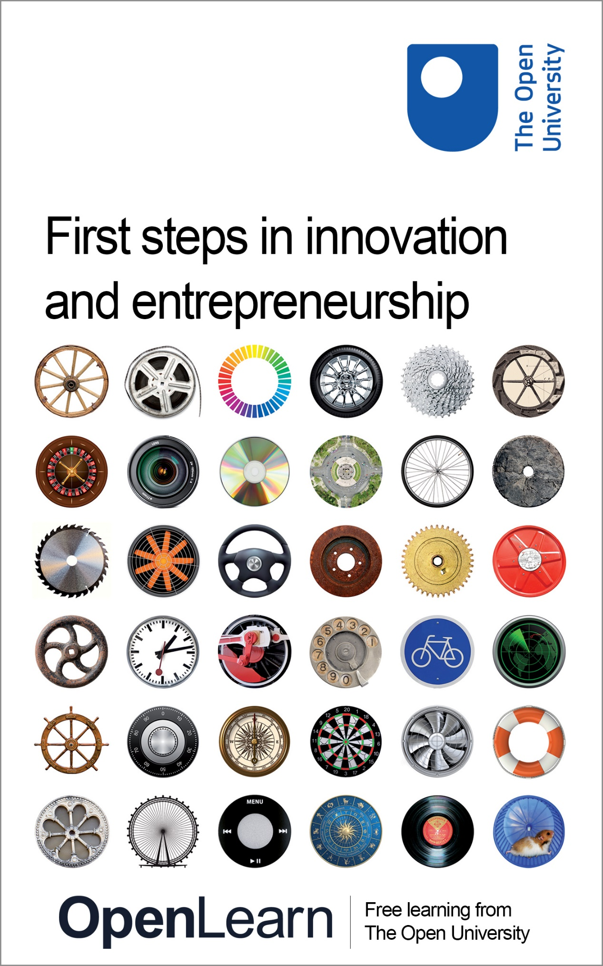

B205

First steps in innovation and entrepreneurship

About this free course
This free course is an adapted extract from the Open University course B205 Exploring innovation and entrepreneurship.
This version of the content may include video, images and interactive content that may not be optimised for your device.
You can experience this free course as it was originally designed on OpenLearn, the home of free learning from The Open University –
www.open.edu/openlearn/money-management/first-steps-innovation-and-entrepreneurship/content-section-0
There you’ll also be able to track your progress via your activity record, which you can use to demonstrate your learning.
Copyright © 2016 The Open University
Intellectual property
Unless otherwise stated, this resource is released under the terms of the Creative Commons Licence v4.0 http://creativecommons.org/licenses/by-nc-sa/4.0/deed.en_GB. Within that The Open University interprets this licence in the following way: www.open.edu/openlearn/about-openlearn/frequently-asked-questions-on-openlearn. Copyright and rights falling outside the terms of the Creative Commons Licence are retained or controlled by The Open University. Please read the full text before using any of the content.
We believe the primary barrier to accessing high-quality educational experiences is cost, which is why we aim to publish as much free content as possible under an open licence. If it proves difficult to release content under our preferred Creative Commons licence (e.g. because we can’t afford or gain the clearances or find suitable alternatives), we will still release the materials for free under a personal end-user licence.
This is because the learning experience will always be the same high quality offering and that should always be seen as positive – even if at times the licensing is different to Creative Commons.
When using the content you must attribute us (The Open University) (the OU) and any identified author in accordance with the terms of the Creative Commons Licence.
The Acknowledgements section is used to list, amongst other things, third party (Proprietary), licensed content which is not subject to Creative Commons licensing. Proprietary content must be used (retained) intact and in context to the content at all times.
The Acknowledgements section is also used to bring to your attention any other Special Restrictions which may apply to the content. For example there may be times when the Creative Commons Non-Commercial Sharealike licence does not apply to any of the content even if owned by us (The Open University). In these instances, unless stated otherwise, the content may be used for personal and non-commercial use.
We have also identified as Proprietary other material included in the content which is not subject to Creative Commons Licence. These are OU logos, trading names and may extend to certain photographic and video images and sound recordings and any other material as may be brought to your attention.
Unauthorised use of any of the content may constitute a breach of the terms and conditions and/or intellectual property laws.
We reserve the right to alter, amend or bring to an end any terms and conditions provided here without notice.
All rights falling outside the terms of the Creative Commons licence are retained or controlled by The Open University.
Head of Intellectual Property, The Open University
978-1-4730-2208-9 (.kdl) 978-1-4730-2207-2 (.epub)

Contents
- Introduction
- Learning outcomes
- 1 Initial impressions and experiences
  - 1.1 My impressions of innovation and entrepreneurship
  - 1.2 Name three innovations and entrepreneurs
- 2 Innovation and why it matters
  - 2.1 Distinguishing terms: discovery
  - 2.2 Distinguishing terms: invention
  - 2.3 Distinguishing terms: design
  - 2.4 Distinguishing terms: innovation
- 3 Varieties of entrepreneurship
  - 3.1 Different types of entrepreneurship
  - 3.2 The impacts of entrepreneurial activity
- 4 Connecting innovation and entrepreneurship
  - 4.1 Invention, design, innovation and (social) entrepreneurship
- Conclusion
- References
- Acknowledgements
- Solutions

Introduction
This free course, First steps in innovation and entrepreneurship, provides you with a short introduction to innovation and entrepreneurship, clarifying some key themes and terminology and helping you to examine your own views about these important subjects. There are four sections:
- Initial impressions and experiences
- Innovation and why it matters
- Varieties of entrepreneurship
- Connecting innovation and entrepreneurship
This OpenLearn course is an adapted extract from the Open University course B205 Exploring innovation and entrepreneurship.
The full course examines different forms of innovative and entrepreneurial practice around the world and at different scales, including: technological and social innovation; commercial and social enterprise; independent and corporate entrepreneurship. It also helps learners to develop subject-related skills, knowledge and understanding as they participate in activities including preparing a ‘visual essay’, taking part in online negotiations and developing their own proposals for an innovative entrepreneurial venture.

Learning outcomes
After studying this course, you should be able to:
- examine personal pre-existing ideas and assumptions about innovation and entrepreneurship, and see how they compare to those of other people
- identify core innovation and entrepreneurship terms and categories, apply these categorisations to practical examples and recognise where boundaries between these categories are blurred
- recognise the main connections between innovation and entrepreneurship and start to isolate a distinctively ‘entrepreneurial’ role in the innovation process.

1 Initial impressions and experiences
In this section, you will look at some of your pre-existing ideas about innovation and entrepreneurship, and see how they compare with those of other people.

1.1 My impressions of innovation and entrepreneurship
In the following activity, you will consider your existing ideas about innovation and entrepreneurship.

Activity 1
Allow about 50 minutes for this activity

- What words or images come to mind when you hear the words innovation or entrepreneurship? Write down these first thoughts before continuing with the task. In the case of an image, try to give a short description.

Innovation:

Entrepreneurship:

- Now watch this six-minute video, which profiles Westmill Wind Farm, a community-owned wind farm that began operations in the south of England in 2008.

Video content is not available in this format.
View transcript - Uncaptioned interactive content

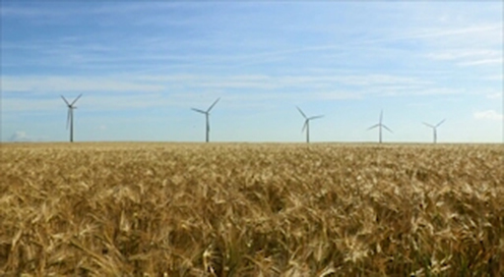

Record your responses to the following questions:
  - What (if anything) about Westmill Wind Farm would you describe as ‘innovative’?

Provide your answer...

  - Who (if any), of the people featured in the video, would you categorise as ‘entrepreneurial’?

Provide your answer...

  - What types of challenge has Westmill Wind Farm experienced over the years?

Provide your answer...

  - How would you determine whether Westmill Wind Farm had achieved its aims?

Provide your answer...

- Watch the video a second time. Revisit your answers, modifying them if necessary.
- Look back at the ideas about innovation and entrepreneurship that you recorded in question 1. Would you change them after watching this video?

View discussion - Part

1.2 Name three innovations and entrepreneurs
In the following activity, you will continue to examine your existing ideas about innovation and entrepreneurship.

Activity 2
Allow about 30 minutes for this activity

- Think of the first three innovations and the first three entrepreneurs that come into your mind and note them in the boxes below. These can be recent or historical examples. When you’ve noted your examples, click the Save button under each box.

Innovations:
1.
2.
3.

Entrepreneurs:
1.
2.
3.

- Now review your list. How many of the innovations that you have selected would you regard as a ‘success’? Likewise, how many of the entrepreneurs have had a ‘successful’ career? Note your reactions in the box below.

Reactions:
View discussion - Part

2 Innovation and why it matters
In this section, you will look at the concept of innovation and how it relates to discovery, invention and design, using a series of case studies.

2.1 Distinguishing terms: discovery
The word ‘innovation’ usually implies novelty and its practical use. But how can we be more specific? We first need to distinguish the term from three closely-related concepts: discovery, invention and design. These words are often used interchangeably, so it is important to be clear about the differences in meaning and how each relates to ‘innovation’. We have selected illustrations of each term. By reading them in turn and finding your own examples, you will develop a clearer idea of each, and how they relate to innovation. First we look at discovery.

Case study: Discovery
Alexander Fleming discovers penicillin
Alexander Fleming was born in Scotland in 1881 and later trained as a doctor in London. He became a research scientist at St Mary’s Hospital Medical School, working on vaccines. During the First World War, he served in the British Army’s Medical Corps where he witnessed the prolonged impact of battlefield infections. After the war, Fleming returned to his research career at St Mary’s. He began to study influenza (flu), a disease that was a particular priority following the pandemic of 1918–19, which is estimated to have killed more than 20 million people. The research team had been using a set of Petri dishes to grow the bacterium staphylococci. One day in September 1928, Fleming was sorting through some used dishes and noticed a bacteria-free circle on a dish that had been accidentally contaminated with mould from a neighbouring laboratory. Following consultations with colleagues, the mould was identified as penicillium notatum and Fleming decided to name the active substance, ‘penicillin’. By the end of the century, this pioneering antibiotic was being described as the world’s most effective life-saving drug.

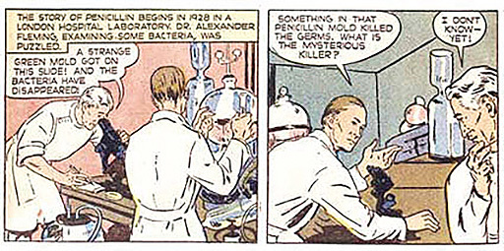
Figure 1 A dramatisation of the moment of Alexander Fleming’s discovery of penicillin

Activity 3
Allow about 15 minutes for this activity

- Can you think of another example of discovery? You could select one from the world of scientific research, or another area of human activity, such as the visual arts. Describe the discovery you chose in the box below.

Provide your answer...
View discussion - Activity 3

2.2 Distinguishing terms: invention
In the following activity, you will look at a case study relating to invention.

Case study: Invention
Leonardo da Vinci invents the aerial screw
The aerial screw is one of Leonardo da Vinci’s most famous and surprising inventions, regardless of the fact that it could never work in practice. The illustration (pictured) is from his own sketchbook and was drawn more than 500 years ago. Da Vinci was investigating a variety of theoretical problems, such as the dynamic and physical characteristics of air, and it seems that his intention was to demonstrate that air could be compressed and therefore gain material density. Da Vinci’s aerial screw anticipated some aspects of the modern helicopter, but there was no possibility of building a functioning prototype with the materials available in his time. He also sketched several other ideas for a flying machine. These included a glider with intricately-drawn wings that were derived from a detailed study of birds.

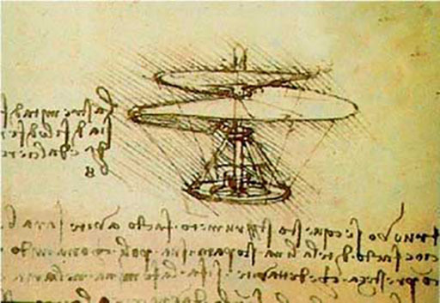
Figure 2 Leonardo Da Vinci’s sketch of the aerial screw

Activity 4
Allow about 15 minutes for this activity

- Can you think of another example of invention? For instance, you could select a new technology, a product, or a less tangible invention such as a process or service. Describe your invention in the box below.

Provide your answer...
View discussion - Activity 4

2.3 Distinguishing terms: design
In the following activity, you will look at a case study relating to design.

Case study: Design
Charles and Ray Eames design original furniture
Charles and Ray Eames are among the most influential designers of the twentieth century. Charles had a background in architecture and Ray was an artist, who had studied with the German abstract expressionist painter Hans Hofmann. They met at the Cranbrook Academy of Art in Michigan and began to collaborate on a variety of projects, including architecture, furniture design, industrial design and photography. Following their marriage in 1941, they relocated to California and began to produce a series of original furniture designs that exploited compression-moulded plywood and other new materials. Following the Second World War, the couple licensed a US company to manufacture their new furniture designs. The Eames’ ‘LCW’ (Lounge Chair Wood) made from moulded plywood, was described by one leading critic as, ‘the chair of the century.’ This was followed in 1956 by the ‘670/671’ Eames Lounge Armchair and Ottoman (pictured) and many other products. The family home that they designed in 1949 also become an icon of ‘mid-century’ design. Many of the Eames’ furniture designs remain in production today. These designs are also widely imitated, a perhaps unwelcome, yet significant, indication of their enduring quality and popularity.

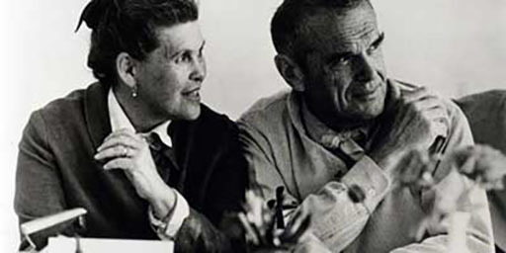
Figure 3 Ray and Charles Eames

Figure 4 A classic Eames design – the 670 lounge chair and 671 ottoman

Activity 5
Allow about 15 minutes for this activity

- Can you think of another example of good (or bad) design? As with invention, you could select a product design or something less tangible like the design for a process or service. Enter your own example in the box below.

Provide your answer...
View discussion - Activity 5

2.4 Distinguishing terms: innovation
Finally, in the following activity, you will review the previous case studies focusing on innovation.

Case study: Innovation
Drugs, helicopters and armchairs …
Penicillin
An important aspect of this story is that Alexander Fleming was not responsible for the subsequent development of penicillin. He was not a chemist, and would not have been able to produce penicillin in a sufficiently stable form with the technologies available at the time. In 1929, Fleming published a scientific paper describing his findings, but this was largely ignored. In fact it was more than ten years later in the early years of the Second World War that a research team at Oxford University, led by Howard Florey and Ernst Chain, created the first functioning version of the antibiotic that could be produced in volume. Florey and Chain travelled to the United States, where much of the subsequent development took place. This involved many new actors, including commercial drugs companies such as Merck and Pfizer, a US Government Agency (The War Production Board) and an entirely new production process, the design of which was overseen by the chemical engineer, Margaret Hutchinson Rousseau. These intensive efforts resulted in a massive increase in production volumes, so that, by 1945, many billions of units were being produced.
The helicopter
Leonardo da Vinci’s invention is often described as a source of inspiration for the helicopter, but it would be five centuries before the concept was fully realised. The term ‘helicopter’ (meaning ‘spiral wing’) was first used by a French writer in the mid-nineteenth century. By the first decade of the twentieth century, several inventors were experimenting with helicopters, among them a Russian aeronautical engineer, Igor Sikorsky, who described his first attempts at building this kind of aircraft:
‘My first two machines were built between 1909 and 1910 and were helicopters. The first of these ships refused to leave the ground while the second could lift itself, but refused to lift me.’ (Sikorsky Archives, n.d.)

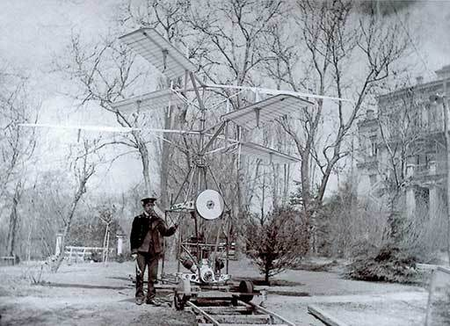
Figure 5 Igor Sikorksy’s ‘H2’ helicopter (1910)

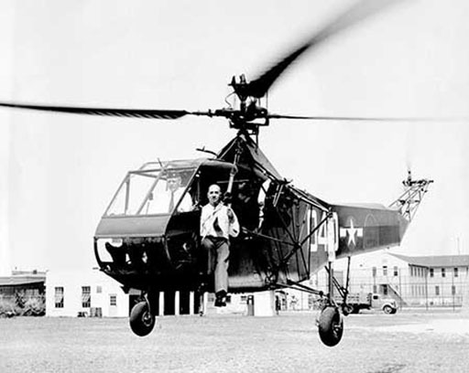
Figure 6 The Sikorsky R-4 helicopter (1943)

Despite these early setbacks, Sikorsky went on to produce the first successful single main rotor helicopter. Having moved to the USA in the early 1920s, he created a company, Sikorsky Aero Engineering Corporation, which specialised in the design and manufacture of new types of aircraft such as flying boats. In 1939, the company introduced the Vought-Sikorsky VS-300 and, just four years later, it announced a modified version that was to become the world’s first mass produced helicopter, the Sikorsky R-4(pictured).
Armchairs
Behind the groundbreaking furniture designs of Charles and Ray Eames and especially the LCW chair, was a highly innovative approach to construction and using newly available technologies for materials: the moulded plywood. The design’s success could be attributed to the fact that the chair was – surprisingly perhaps for wood – comfortable, lightweight and practical. By bringing together influences from their respective backgrounds: architecture (Charles) and art (Ray), the outcome was a highly functional, yet aesthetically pleasing item. This chair has become an enduring design icon, along with a number of Eames designs.

Activity 6
Allow about 15 minutes for this activity

- Can you think of another example of innovation? Enter your own example in the interactive box below.

Provide your answer...
View discussion - Activity 6

3 Varieties of entrepreneurship
In this section, we examine different types of entrepreneur and entrepreneurial activity, and start to think about their economic, social and environmental impact.

3.1 Different types of entrepreneurship
In the following activity, you will listen to some real-life entrepreneurs and consider the types of entrepreneurship they represent.

Activity 7
Allow about 1 hour 30 minutes for this activity

- To begin this activity, try to list as many different types of entrepreneur as you can. We are looking for modifications which usually involve inserting another word in front of the original word. For example, a ‘social entrepreneur’. Don’t attempt any internet searches. Simply record the terms below so that you can refer back to them later:

Provide your answer...

- Listen to this audio, which features four entrepreneurs talking about their contrasting ventures. It lasts about six minutes

Audio content is not available in this format.
View transcript - Uncaptioned interactive content

- Now study the following definitions and try to match the entrepreneurs (and types of entrepreneurial activity) that you heard about in the audio to one or more of the highlighted terms. You can also insert your own terms by copying them from the list you produced in part 1. Record your comments in the box below, then refer to the discussion.
Corporate entrepreneur / intrapreneur
These terms are both used to describe someone who acts entrepreneurially inside an existing organisation, which may range from a medium-sized firm to a large corporation, government agency or charity. The constraint of operating from within an organisational hierarchy, rather than being free to act independently, is the key feature that distinguishes corporate entrepreneurs / intrapreneurs from other entrepreneurs. Some organisations actively encourage corporate entrepreneurship / intrapreneurship as a way of promoting innovation and adaptability. There are strong parallels between this role and that of ‘product champion’ which is a term sometimes used by innovation researchers.
E-preneur
This term has been derived from the wider use of the letter ‘e’ to refer to ‘electronic’ (as in ‘email’ and ‘e-commerce.’). It is used to refer to the growing number of people who run businesses that depend entirely on the internet. With the proliferation of internet-based businesses, it now represents a very broad category, and could include anyone from the owner of a large online retailing empire to a self-employed person using an online shopping platform (such as eBay.com or Etsy.com) to sell specialist products from home.
Ecopreneur
This term has become popular as a way of describing entrepreneurs who establish ventures, or introduce new initiatives with the aim of tackling specific environmental problems. In practice, this can mean a wide variety of activities, ranging from a small, community-based enterprise selling organic fresh produce to a large commercial business operating in a low-carbon industry sector, such as the manufacture or installation of solar photovoltaic (PV) panels.
Lifestyle entrepreneur
This term is normally used to describe a person who has set up a small business in order to pursue a personal interest such as a craft (e.g. a pottery studio) or a sporting activity (e.g. horse-riding holidays). It is sometimes seen as a negative term, with the same kind of implied criticism as for ‘hobby’ farmers. The term refers to the idea that this type of entrepreneur prioritises quality of life over other common motivations for running a business. They might want to achieve a reasonable level of income from the venture, but are not actively pursuing purely commercial goals such as growing it into a much larger business, or securing large (or short-term) financial returns.
Portfolio entrepreneur
This term refers to someone who operates several different ventures at the same time. There are different types of portfolio entrepreneur. They can range from extremely wealthy owners of multiple businesses to much less prosperous people, often based in remote rural areas, who engage in several different small enterprises in order to reduce risks and to maintain an income when local markets, or economic conditions more generally, are depressed or uncertain (note the distinction between this term and the ‘serial entrepreneur’).
Rural entrepreneur
This term refers to people who create or operate businesses in the countryside. It is sometimes used in a more restricted way to focus on the traditional rural industries, such as agriculture, forestry, food manufacturing and rural crafts. However, the term is also used to refer to those running a variety of businesses that happen to be located in a rural area. It can also be difficult to define the geographic boundaries of rural businesses (e.g. does it include an entrepreneur whose business is located in a village that is on the fringes of a large city, or someone based in a remote rural location who spends much of their time doing business internationally).
Serial entrepreneur
This term refers to someone who sets up several different ventures over a period of time, often reinvesting profits from the sale of an existing business in order to finance a new one, sometimes in an entirely different field of activity. This pattern may reflect the entrepreneur’s preference for creating new ventures rather than managing larger established businesses (note the distinction between this term and the ‘portfolio entrepreneur’).
Social entrepreneur
This term is normally used to identify the founder(s) of a social venture, or someone who initiates a larger programme of social change. The distinctive feature of this type of entrepreneurship is that the primary purpose is to address social or environmental problems rather than simply to achieve commercial goals. This suggests a number of differences, including the values involved, how people understand concepts such as entrepreneurial ‘opportunity’, and the way that organisations are run. There has been a lot of interest in social entrepreneurship in recent years and this has generated many competing definitions.
Technology entrepreneur
This term typically describes a person who has founded a new venture in order to develop some form of advanced technology, most commonly in industry sectors such as information and communications technology (ICT), biotechnology, nanotechnology and other applied sciences. One of the distinctive features of this kind of entrepreneurial activity is that it is often very fast-moving, as a result of new scientific discoveries and often intensive international competition – there are also particularly strong links to innovation. Governments around the world see this kind of entrepreneurial activity as a particularly important source of economic growth as well as offering possible solutions to major societal challenges such as poverty and climate change.

Identifying types of entrepreneur and entrepreneurial venture
Interviewee | Type of entrepreneur / entrepreneurial venture
Danny Quinn | Provide your answer...
Julia Charles | Provide your answer...
Dan Wright | Provide your answer...
Catherine Bottrill | Provide your answer...

View discussion - Part

3.2 The impacts of entrepreneurial activity
Entrepreneurial activity can have decisive effects on us as individuals. It can also make a real difference to the communities we live in, to the performance of national and regional economies, and the state of the natural environment. In this task we examine these impacts of entrepreneurship, which can be both positive and negative.
Is entrepreneurship always ‘a good thing’? Research suggests that increased levels of entrepreneurial activity can help to generate positive economic outcomes, including more employment opportunities, less unemployment, lower prices, more rapid technological innovation, and increased rates of economic growth. However, entrepreneurial activity can also act in dysfunctional ways that inflict serious economic damage. The global financial crisis of 2007–10 was a particularly dramatic example, with devastating effects on individuals, businesses, and communities around the world. In a widely cited article, the US economist and entrepreneurship researcher, William Baumol distinguished between economically ‘productive’, ‘unproductive’, and ‘destructive’ forms of entrepreneurship (Baumol, 1990). He sees productive entrepreneurship as having a beneficial impact (e.g. increasing incomes and employment and meeting people’s needs). By contrast, unproductive entrepreneurship (e.g. ‘rent-seeking’ activities, such as tax avoidance) has negative effects, while destructive entrepreneurship (e.g. organised crime) can undermine an entire economy. Baumol’s historical study explores how entrepreneurial resources have been reallocated between these three roles over the centuries.

Activity 8
Allow about 1 hour 30 minutes for this activity

- Watch these two videos, which examine contrasting impacts of different kinds of entrepreneurial activity in Mexico and Peru. Each video lasts about seven minutes.

Video content is not available in this format.
View transcript - Uncaptioned interactive content

Video content is not available in this format.
View transcript - Uncaptioned interactive content

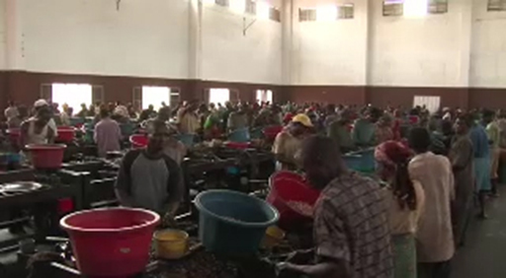

- Having watched the videos, categorise the examples featured using Baumol’s (1990) categories of economically ‘productive’, ‘unproductive’ or ‘destructive’ entrepreneurship, then add one or two additional examples from your own experience. Include a brief explanation as to why you have placed each example in the chosen category.

Type of entrepreneurship | Practical example | Brief explanation
Productive | Provide your answer... | Provide your answer...
Unproductive | Provide your answer... | Provide your answer...
Destructive | Provide your answer... | Provide your answer...

View discussion - Activity 8

4 Connecting innovation and entrepreneurship
In this concluding section, we look at the connections between innovation and entrepreneurship.

4.1 Invention, design, innovation and (social) entrepreneurship
In the following activity, you will watch a video about a social enterprise and use this to review some of the themes you have studied in this course.

Activity 9
Allow about 1 hour 30 minutes for this activity

- Watch this video about a solar light promoted by the social venture ‘Liter of Light’ (n.b. The word ‘Liter’ in this organisation’s title is the US spelling of ‘litre’). The video lasts about four minutes.

Video content is not available in this format.
View transcript - Uncaptioned interactive content

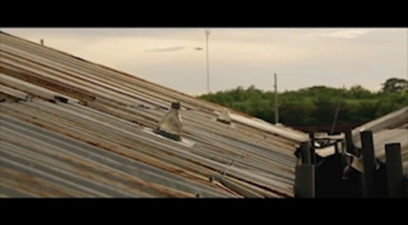

- Consider how the video illustrates some of the themes discussed in this course, and in particular:
  - the differences between the terms: discovery, invention, design and innovation - and how they are related to one another in practice
  - the different types of entrepreneur, including any distinctive features of social entrepreneurs
  - the connections between entrepreneurial activity and innovation.
Make your own notes below, responding to these questions and adding any other reflections on what you have discovered during the course.

Provide your answer...
View discussion - Activity 9

Conclusion
We hope you have enjoyed this short OpenLearn course, First steps in innovation and entrepreneurship. You should now have a clearer view of your pre-existing ideas and assumptions about innovation and entrepreneurship, and be able to see how they compare to those of other people. You should also be able to identify some of the core terms and categories used in innovation and be able to apply them to practical examples. Lastly, you should have started to recognise how the topics of innovation and entrepreneurship are connected and feel more confident about taking your studies to the next stage.
If you are interested in innovation and entrepreneurship, take a look at our undergraduate specialism in this area, BA (Honours) Business Management (Innovation and Enterprise). You can also view the following introduction to B205 Exploring innovation and entrepreneurship.

Video content is not available in this format.
View transcript - Uncaptioned interactive content

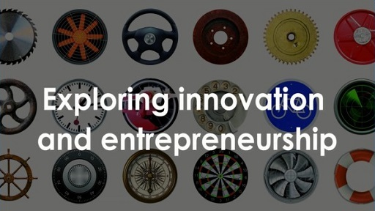

References
Baumol, W.J. (1990) ‘Entrepreneurship: productive, unproductive, and destructive’, The Journal of Political Economy, vol. 98, no. 5 part 1, pp. 893–921.
Conway, S. and Steward, F. (2009) Managing and Shaping Innovation, Oxford, Oxford University Press.

Acknowledgements
This free course was written by the B205 Exploring innovation and entrepreneurship course team.
Except for third party materials and otherwise stated (see terms and conditions), this content is made available under a Creative Commons Attribution-NonCommercial-ShareAlike 4.0 Licence.
The material acknowledged below is Proprietary and used under licence (not subject to Creative Commons Licence). Grateful acknowledgement is made to the following sources for permission to reproduce material in this free course:

Images
Course image: old wheel © iStockphoto/malerapaso; typical railway station clock © iStockphoto/assalve; black locomotive © iStockphoto/omersukrugoksu; vintage phone dial © iStockphoto/MyImages_Micha; bicycle post © iStockphoto/didemgecegezer; military radar screen © iStockphoto/petersimoncik. Full acknowledgements for course image used elsewhere.
Figure 1: from www.the-scientist.com/
Figure 2: Eric VANDEVILLE / Getty Images
Figure 3: © Eames Office LLC (eamesoffice.com)
Figure 4: © Vitra International AG
Figure 5: Igor I. Sikorsky Historical Archives, Inc © 2015
Figure 6: Igor I. Sikorsky Historical Archives, Inc © 2015

Video
Activity 1: Video: Westhill Wind Farm courtesy of http://energyshare.com/
Activity 8: Video: Mexico courtesy of www.cultureunplugged.com
Activity 8: Video: Peru courtesy of www.cultureunplugged.com
Activity 9: Video: courtesy of Jason Magbanuawww.youtube.com/watch?v=cQCHvO2H0_0
Every effort has been made to contact copyright owners. If any have been inadvertently overlooked, the publishers will be pleased to make the necessary arrangements at the first opportunity.
Don't miss out
If reading this text has inspired you to learn more, you may be interested in joining the millions of people who discover our free learning resources and qualifications by visiting The Open University – www.open.edu/openlearn/free-courses.

Solutions

Activity 1

Part

Discussion
We selected a slightly unusual example of innovation to encourage you to review your existing ideas and assumptions about innovation and entrepreneurship. Consider, for example, why you thought a particular feature of Westmill Wind Farm was innovative – did your list include the wind turbines (i.e. the technology) or did you see it as too well-established to fit that description? Did you identify other features, such as the financing and ownership model (i.e. a community-based online share issue), or did that fall outside your image of innovation? Turning to the search for entrepreneurs, did you see the founders of Westmill Wind Farm as fitting that category? If so, what was it that made them fit your definition? If not, why did they not meet your criteria for being an entrepreneur? Would you categorise any of the other people featured (e.g. the local investors or the volunteers at the open day) as entrepreneurial?
As an optional follow-on activity, you might find it interesting to compare Westmill Wind Farm to its sister organisation Westmill Solar, the UK’s first co-operative, community-run solar farm.
Back to - Part

Activity 2

Part

Discussion
It would not be surprising to find that there are very few cases of failure on these lists. People tend to be attracted to success stories and they are a common feature of most popular media coverage, especially in the case of ‘celebrity entrepreneurs’, although there are some notable exceptions. For example, journalists and politicians sometimes highlight a failed innovation, particularly if it has proved costly to large numbers of consumers or taxpayers (e.g. a new product that has to be withdrawn from the market because it is dangerous, or a new government computer system that is cancelled because it does not work properly). There are many reasons why individuals and organisations are tempted to concentrate on enterprises and innovations that have succeeded rather than those that have failed. For example, it is generally much easier to gather evidence about an organisation or venture that is still operating.
Back to - Part

Activity 3

Discussion
Scientific discoveries are often the result of long periods of systematic research. However, Alexander Fleming’s experience shows that discovery can happen from chance or serendipity. In his case, the accidental contamination of a research study generated an unexpected outcome. We tend to associate discovery with the natural sciences, but it does occur in other fields. For example, in earlier generations, explorers could discover new parts of the world, and historians continue to discover new information about the past. In addition, creative artists often describe their work as the outcome of a process of discovery – often self-discovery.
Back to - Activity 3

Activity 4

Discussion
Just as in the case of some discoveries, it may not have been possible to convert Leonardo da Vinci’s flying machine invention into a working technology at the time, however, even ‘failed’ or ‘stalled’ inventions can still contribute to the innovation process by passing on ideas that may only be fully realised in the future. For the innovation scholars Freeman and Soete (1997, p. 6, cited in Conway and Steward, 2009, p. 9), an invention is, ‘an idea, a sketch or model for a new or improved device, product, process, or system.’ They also note that, although an invention may sometimes be patented, it may not necessarily lead to a technical innovation.
Back to - Activity 4

Activity 5

Discussion
Designers respond to users’ needs and market requirements by providing physical shape, form or order to products, services and other artefacts (e.g. processes and organisational structures). The design process typically involves a series of stages, as the designers (often working in conjunction with technicians, marketers and other specialists) create and refine a concept. In the case of product designers such as Ray and Charles Eames, this might involve a progression from initial sketches though to detailed drawings and technical specifications. Designs are sometimes unique and un-repeatable. However, products destined to be produced in large numbers, such as Eames chairs, need to be designed in order to facilitate volume manufacturing. (You can find out more about the Eames design partnership at their official site). We now turn to the concept of innovation to distinguish it from discovery, invention and design. To do so, we reconsider the three immediately previous examples because each of them can be viewed as a step on a much longer path.
Back to - Activity 5

Activity 6

Discussion
We have avoided defining the terms that have been discussed in this section. This is because the distinctions between discovery, invention, design and innovation are quite subtle and open to interpretation. It is therefore worth exploring these concepts for yourself, rather than jumping immediately to simple definitions.
Back to - Activity 6

Activity 7

Part

Discussion
We suggest that our interviewees fall into the following categories:
Danny Quinn – social entrepreneur. He describes his business, Black Sheep, as a social enterprise working in arts and culture undertaking performance-based work and participatory community arts projects. They train new and emerging artists and provide opportunities for real experience in the creative industries working alongside professionals.
Julia Charles – lifestyle entrepreneur. Julia is following her passion for staging entertainment events. Whilst the term lifestyle entrepreneurs is sometimes used for individuals who have limited growth aspirations for their ventures, Julia has no such limited aspirations.
Dan Wright – ecopreneur and technology entrepreneur. Heliex Power helps industrial companies recover wasted energy with an inventive engineering product that is protected by patents. If you listen carefully Dan also mentions that he has started and sold companies in the past – also making him a serial entrepreneur.
Catherine Bottrill – ecopreneur, e-preneur and portfolio entrepreneur. Her company, Pilio, helps organisations reduce their use of energy. Their product is software, accessed online in a ‘software as a service’ model. Catherine also mentions that she is involved with another organisation, Julie’s Bicycle, indicating she is a portfolio entrepreneur.
This shows that the entrepreneur types often overlap, rather like different types of innovation. The exercise also highlights how difficult it can be to produce a single definition for these varied types of activity. It is important to bear these points in mind as you start to use this terminology, and to avoid jumping to conclusions when you see a reference to a particular ‘type’ of entrepreneur or entrepreneurial activity.
Entrepreneurship has generated more than its fair share of new terms (or ‘neologisms’). We have concentrated on those that are most commonly used, and that are (in most cases) reasonably well-defined. However, there are many other terms, most of which are simply passing fads and fashions. We have also tried to avoid a few terms that are either inappropriate or slightly offensive. Examples of these more dubious terms include ‘Alterpreneur’ (referring to an older person, possibly beyond the normal retirement age, who establishes a new business venture), ‘Kidpreneur’ (an ugly term, typically used to describe a young person who has become wealthy by creating a commercially-successful app or computer game), and ‘Mompreneur’ (a particularly dubious term, occasionally used to refer to a woman who sets up a business while, or possibly after, having a family).
While the interviewees are different types of entrepreneur, they also demonstrate common themes. For example, both Danny and Catherine talk about identifying a gap in the market that provided an opportunity for their business.
Back to - Part

Activity 8

Discussion
This task referred to the work of a US economist and entrepreneurship researcher, William Baumol, who distinguished between economically ‘productive’, ‘unproductive’, and ‘destructive’ forms of entrepreneurship (Baumol, 1990). He suggested that productive entrepreneurship has beneficial impacts. By contrast, unproductive entrepreneurship has negative effects, while destructive entrepreneurship can undermine an entire economy.
The fish farming venture illustrates how entrepreneurial activity can be economically productive, generating higher incomes and providing new employment opportunities for women in this remote Peruvian community. The venture was initially supported by micro-finance provided by a regional women’s development organisation, Pro Mujer. The work of this organisation could also be described as productive (social) entrepreneurship. The video shows how it has successfully adopted an innovative approach to financing very small enterprises pioneered in Bangladesh by Muhammad Yunus and the Grameen Bank. By contrast, the Mexican example illustrates how opportunity-seeking entrepreneurial activity can be economically unproductive, or even destructive. In this case, unregulated commodities market speculation has inflated the price of the corn used to make tortillas, which are a key part of the national diet. While speculation is nothing new, technological and financial market innovations have enabled it to exert much more powerful effects on world markets. By creating high and unstable prices, this kind of speculation can undermine the confidence of investors and damage the economic livelihoods of individuals, families and small businesses.
During this task, you may have identified examples that could be placed in more than one of the boxes. For example, entrepreneurial activity that has increased mobility (e.g. low-cost airlines flying to islands in the Indian Ocean), could be seen as economically productive in the short term, helping to promote tourism and other forms of economic development. However, this kind of activity may prove to be economically destructive over the longer term due to its environmental impacts (i.e. increasing carbon emissions, contributing to global warming and rising sea levels).
This task has raised several important issues around the impact of entrepreneurial activity, and of particular kinds of innovation.
Back to - Activity 8

Activity 9

Discussion
The Liter of Light case illustrates many of the themes we have been discussing this short course on innovation and entrepreneruship. You can find out more about the invention of the solar light online by visiting the organisation’s website or by conducting your own web search. There are also some interesting videos online, showing how to assemble a solar light, which highlight various design issues (e.g. how to make the roof watertight and how to provide light at night by extending the basic ‘bottle’ design).
The rapid spread of this invention to other countries, and enrolling local people to produce and distribute the lights, can be seen as representing types of technological innovation and social innovation. There is also evidence that the activity of social entrepreneurs such as the Liter of Light founder, Illac Diaz, has helped to drive these innovations into new areas.
Lastly, did you see any evidence of discovery in this story? It appears that in 2002 a Brazilian engineer named Alfred Moser came up with the idea of using a plastic bottle filled with water to refract sunlight and provide alternative lighting during the country’s frequent power failures. A few years later, Illac Diaz founded ‘MyShelter Foundation’ to provide affordable housing in the Philippines using recycled materials. The people at MyShelter Foundation were filling plastic water bottles with mud (to make walls) and with water (to make windows). Someone alerted Diaz to Moser’s closely-related idea. He saw the opportunity it presented and, in 2011, founded the social venture ‘Liter of Light’ to put it into practice.
We can also explore the links between different types of innovation and entrepreneurship through the different ways in which they create value. For example, an e-preneur might make a great deal of money by launching a new app – this would be an example of creating economic value. However, if this innovative service was designed to address a social issue (e.g. to raise awareness of a health issue such as diabetes, or to reduce bullying in schools), it could also create social value.
Back to - Activity 9

Uncaptioned interactive content

Transcript
[SOUND EFFECTS PLAYING]
[ELECTRICITY CRACKLING]
[TURBINE SPINNING]
[MUSIC PLAYING]
LIZ ROTHSCHILD
Ready?
GIRL
Whoo!
LIZ ROTHSCHILD
What’s really exciting is when we come up here with actually adults and children. The first word you hear is ‘Wow!’
[TURBINE SPINNING]
ADAM TWINE
So here, out west, we’re on the farm on the Oxford and Wiltshire border. I farm here. This is our crop of barley at the back here – golden, blowing brightly in the breeze.
LIZ ROTHSCHILD
So I’m called Liz. This is Sue.
Well, I’m sort of inevitably involved with the wind farm because my partner is Adam Twine, and he set it up. It was crucial, from our point of view, that it should be a community-owned wind farm.
[PEOPLE TALKING AND BACKGROUND NOISES]
ADAM TWINE
In the crop, there were 2500 people who invested into the wind farm. It’s not owned by me. The wind turbine is not owned by a large company but by local people. It’s the bit about the wind farm which is the most exciting bit to me.
[MUSIC PLAYING]
LIZ ROTHSCHILD
Every year, we have an open day so people can come and learn about the turbine.
COLIN WILSON
So we are here today because we invested in these wind turbines about four years ago, and it’s really nice to see them working. And today, we’ve had the opportunity to go inside them and see them very close at hand.
[MUSIC PLAYING]
SARAH WOOD
I’ve seen them in the distance, but I’ve never, sort of, wandered around one or been quite as close.
[MUSIC PLAYING]
EOIN LEES
Open days are crucial because there is so much unthinking resistance to wind farms. We get people here, and the first thing they say is, ‘They’re not as noisy as I thought they were going to be.’ Everyone says that to me.
SARAH WOOD
Well, I thought people said they were noisy, but I mean, it’s just incredibly quiet.
REBECCA DALE
I think when they see them, they’re so majestic. They’re like sculpture. And I think that, hopefully, it’s reassured a lot more people.
[MUSIC PLAYING]
BOY:
Yeah.
LIZ DALE
Now, are you ready to play with the kite?
[MUSIC PLAYING]
MIKE BLANCH
The wind farm generates about 12 gigawatt hours a year, which equates with income of about a million pounds a year. And that goes back to help pay for the wind farm, which cost about 8 million originally. So it’s about an eight-year payback.
ADAM TWINE
Westmill has two and a half thousand shareholders. They put in between 250 quid or 20,000 pounds each. The average was 2000 pounds investment, and they would hope to get a return of 16 per cent. That’s what we have in our share offer. At the moment, we’re on track for doing that.
[WHOOPING]
[MUSIC FADING]
BOY
If you just follow me around to over here.
LIZ ROTHSCHILD
‘WeSET’ stands for ‘Westmill Sustainable Energy Trust’, and we’re a charity that was set up immediately that the cohort was formed, really. And the idea is that all our shareholders have agreed that we can take 0.5 per cent of the income each year in order to dedicate it to encourage sustainability in our local area, and what that looks like is that we run a lot of education projects.
REBECCA DALE
I think it’s really good for the children to come and see what’s around, see whether they can get other forms of energy without draining too many resources.
BOY 1
Now, who wants to have a guess at how many houses each turbine can power? Yes?
STUDENT
60.
BOY 2
Higher. A lot higher.
BOY 1
Higher.
[MUSIC PLAYING]
BOY 1
Each one of these turbines powers 500 houses, which is 2500 total.
BOY 2
Solar group, if you want to gather around here.
LIZ ROTHSCHILD
We’ve got this fantastic team of student environmental educators who we’ve been working with in the local secondary school.
BOY 2
It’s called an ‘anemometer’. Have any of you heard of them before?
LIZ ROTHSCHILD
It’s a sort of cascaded learning.
BOY 1
Peter, that one’s wrong. It’s got metres per second.
BOY 2
No wait. I’m just showing them how.
BOY 1
No. Swap them around.
LIZ ROTHSCHILD
OK. What’s really exciting about that, from our point of view, is to see young people taking ownership of the place. We already have a sense that some people feel these are their wind turbines. I just had a young girl come up to me just now and say, ‘That’s the turbine my school named.’
[MUSIC PLAYING]
LIZ ROTHSCHILD
Then there’s a whole other stream, which is really developing now, which is looking to see how we can offer possibilities in the local community in terms of what they might do about their building.
COLIN BELL
This is our local village hall, and we’ve just paid for insulation here. It’s 300 square metres of loft insulation, so this has all been done through money we’ve generated through the wind turbines and buying resets. The plan is that we use this as a base for sustainable energy surges, and we’ll offer advice to local people on how they can save money through different sustainable energy solutions.
[MUSIC PLAYING]
ADAM TWINE
These wind turbines arrived just three years ago. I’ve felt it’s a bit like the hunting issue in rural communities. It just divides people. It’s a challenge.
[CHUCKLING]
[MUSIC PLAYING]
ADAM TWINE
It took a long time to get them up here. We were, I think, 12 years in planning nearly. You don’t get anywhere without upsetting people.
LIZ ROTHSCHILD
The day they first started putting up the turbine, we were just beside ourselves with excitement.
ADAM TWINE
I mean, it was a complete roller-coaster from the start to finish. And at any one time, it might not have happened
[MUSIC PLAYING]
LIZ ROTHSCHILD
I think the things that we learn are always communicate, always be honest, never misrepresent. Just say it how it is and keep saying it how it is, and be prepared for a long haul.
[MUSIC PLAYING]
COLIN WILSON
It’s investing in the community and investing in the future.
GIRL
Being able to watch TV on the computer just by using the wind. So I just think that’s a really good idea.
EOIN LEES
I feel very proud, and the reason I do feel proud is because I have helped create that. I own a bit of that.
LIZ ROTHSCHILD
These turbines are like five hearts beating in our community producing power for us all.
[MUSIC FADING]
[SOUND EFFECTS PLAYING]
[ELECTRICITY CRACKLING]
Back to - Uncaptioned interactive content

Uncaptioned interactive content

Transcript
DANNY QUINN:
My name’s Danny Quinn from the Black Sheep Collective Community Interest Company.
JULIA CHARLES:
My name is Julia Charles from Julia Charles Event Management.
DAN WRIGHT:
I’m Dan Wright. I am the founder the Heliex Power Ltd.
CATHERINE BOTTRILL:
I’m Catherine Bottrill. I’m CEO of Pilio.
DANNY QUINN:
The Black Sheep Collective is a social enterprise working primarily in arts and culture and performance-based work and participatory community arts. We train new and emerging artists and we provide opportunities for real-time experience in the creative industries working alongside professionals both in the corporate realm and the public realm as well as devising our own projects.
JULIA CHARLES:
We operate within the corporate sector and the private sector. So an example of a corporate event, we do a product launch for Audi for their new car. And that would involve project management and we could then work on an amazing private event where we could organise a large festival for a private client for their 50th birthday party.
DAN WRIGHT:
The company that I formed in 2010 is called Heliex Power Ltd and it’s a company specialising in the development of equipment to recover energy that would otherwise go to waste in industrial processes. The customers for this equipment are major energy users like the steel industry, the food industry, biomass companies, petrochemical companies and what we do is to recover energy that would otherwise go to waste, basically, up the chimney.
CATHERINE BOTTRILL:
Pilio is a software business that works with other businesses to help them understand their energy use to identify opportunities where they can reduce their energy bills and their environmental impacts.
DANNY QUINN:
We came up with the idea for the Black Sheep Collective really by just connecting with other artists and creative types that were kind of operating in silos and on their own and looking to connect with others really.
I met with my now business partner, Georgia, who graduated from the Liverpool Institute of Performing Arts and also returned to Milton Keynes. And we both felt the same, that there was a lack of opportunity for people like ourselves that had gone out, got some experience and returned to Milton Keynes to really engage and follow what we want to do not only as a career but as a passion. It wasn’t constituted for the first kind of few months, we were just artists in our own right doing our own thing but operating under a banner. And then when we felt that we had more strength in being an alliance of such, we decided to constitute in to a company.
JULIA CHARLES:
I came up with the idea for my business when I was incredibly young. I was 18 years old and I just came in to work on the Monday morning and was looking around the office and realised that IT just wasn’t for me.I had a passion for entertainment and I wanted to pursue it. And then I realised that actually a company I was currently working for in the entertainment sector wasn’t open to suggestions about moving their brand forward. So I decided to give it a go myself and here I am.
DAN WRIGHT:
I worked in the compressor industry and there was a particular type of technology in the compressor industry used worldwide and it’s called a screw compressor. City University in London for about 40 years has been a major source of innovative technology to the compressor industry. And that’s partly because of two professors, one world famous thermodynamicist and the other a very good mechanical professor. So over a period of about ten years we kept each other posted on our thoughts on how this new technology might be worth something one day.
And eventually when the costs of energy, the need to reduce carbon dioxide and so on became important to politicians and to governments, the time for this technology to go into the marketplace had come. I decided to have a go at forming my own company. And that worked.
The first one I formed I sold twice and bought back once. I used that money to do some other things.
CATHERINE BOTTRILL:
I was a researcher at Oxford University in a group called the Environmental Change Institute. Researchers need data to do good policy analysis and understand the world that we live in. And what we found is there was really poor energy data and therefore we couldn’t do good analysis.
So Russell Layberry, my colleague, and I, over cups of tea, lunches, conversation, thought, how could we create some tools to gather that data, and we didn’t want just to gather the data. We wanted to be able to give feedback to the people that had contributed the data. And it was through that exploration that I started designing an online tool for building energy management.
And that collaboration and exploration turned in to my company, Pilio.
I’ve also been involved with a business called Julie’s Bicycle which is an organisation which is helping the arts embed sustainability across the supply chain from everything from a theatre venue, to a record label, to a music studio, to a festival, and helping all the organisations there understand what their environmental impacts are and what they can do to reduce those environmental impacts.
Back to - Uncaptioned interactive content

Uncaptioned interactive content

Transcript
NARRATOR:
The cost of food across the world is on the rise, and many have blamed the scale of price spikes on one thing-- rampant food speculation on the global financial markets. The ecologists travelled to Mexico, the birthplace of corn, to find out how speculation is forcing up the price of the country’s staple food, with profound effects felt across Mexican society.
In the mountains of Oaxaca State in southern Mexico, it is coffee production that fuels the local economy. Rural communities like these are not self-sufficient in food and are dependent on a cash crop, making them vulnerable to sudden price rises of staples such as corn.
IGNACIO CANSECO:
[Speaks Spanish]
NARRATOR:
Lorenzo Hernandez and his wife [? Genovena ?] Olivera look after their grandchildren during the day, while the rest of the family work in the coffee fields.
LORENZO CANSECO HERNANDEZ:
[Speaks Spanish]
NARRATOR:
Food price volatility on this scale has been linked directly to speculation.
MURRAY WORTHY:
Food speculation is basically the way in which banks and other financial traders can essentially bet on the price of food. And this takes place through what are known as futures markets. So these were originally set up to help farmers, and food producers, and buyers-- to kind of manage their risk of prices changing over time. But instead, what we’re seeing now is other people coming who’ve got no connection with the food supply whatsoever, coming in and using these markets just to bet on the rising and falling price of food.
ALFONSO MURILLO:
The speculation is going stronger and stronger. Right now, we think that about 20 per cent of the total market for corn is in the area of investor-- financial investor, speculators-- that are just making a contract and re-selling the contract. They don’t need the grain for any other purpose.
NARRATOR:
At a wholesale market in Oaxaca City, traders have seen prices rise in recent months.
MARIA VELASRO:
Corn prices have increased due to the cold front in February that happened in Sinaloa. It supplies nearly all of Mexico’s corn, and so supplies were affected
ALFONSO MURILLO:
In Sinaloa, that is the principal state of production of corn, there were frosts, very heavy frosts. So the production expected went down. About half of the total production was lost. So during the year we have been importing corn from the US and from South Africa also.
MURRAY WORTHY:
What we’re seeing somewhere like Mexico is that when there’s a good local harvest, things are fine. They can rely on the local crops. But increasingly, particularly in Mexico, domestic maise production is being undermined by free trade deals with America, where maise is much more heavily-subsidized. So now what we see is, when there are poor harvests, Mexico now relies on importing food from abroad, which is where the high prices that have come from food speculation really hit them hardest.
NARRATOR:
For Mexicans, that means higher prices for their daily tortilla.
LUIS HERNANDEZ NAVARRO:
[Speaks Spanish]
ALEIRA LARA GALICIA:
[Speaks Spanish]
LORENZO CANSECO HERNANDEZ:
[Speaks Spanish]
MURRAY WORTHY:
It’s not just hunger that’s the real problem here. It has massive impacts across different aspects of poverty. So for example, we found that when food prices have risen, families had to eat less fruit, and less vegetables, less meat and dairy, and have a far less healthy diet. We’ve also seen households that have had to eat into their savings or take out loans, just to be able to afford food. And we’ve also seen them have to cut back on expenditures such as health care and education. And all these things have much longer-term impacts than just the impact of a shortage of food in the short term.
KENNETH SHWEDEL:
The impact of the higher prices is felt throughout the expenditures of the poorer Mexicans. And then subsequently, it’s felt in terms of a lower demand for other things within the Mexican economy, which is a real concern because we don’t see the domestic demand growing as fast as would be necessary.
MURRAY WORTHY:
Food speculation has become a real issue now because of deregulation of these markets that happened about 10 years ago. What we’ve seen since then is big investment banks-- people like Barclays Capital and Goldman Sachs-- moving into commodity markets. So over the last 10 years, we’ve seen about $100 billion pour into these markets-- flooding, as I said-- the farmers and food producers that normally are around these markets and overwhelming them. And that’s why this has become such a problem now.
NARRATOR:
In an unusual move, the Mexican government has itself begun speculating on the food futures market, in an effort to counter volatility in corn prices. But many believe that the only answer is regulation.
KENNETH SHWEDEL:
My particular opinion is, if you look at any regulation in the market, we’ve got to look at some sort of regulations, or some sort of movements, or some sort of actions which would limit the volatility in the market, as you move into the future. I’m not really worried about the large money coming in. I’m worried about the coming in, moving out, and coming in, and moving out. That’s the real concern on the future.
MURRAY WORTHY:
So what we’re calling for is a limit to be introduced, that limits the amount of the market these traders can hold. At the moment, they’re dominating the market. They make up much more of the market than farmers and other traders, who actually rely on these market day-in and day-out. What we want to see is new rules put in that cap that, that limit their influence, and can then allow prices to be more fair, more stable, and more transparent in the future.
Back to - Uncaptioned interactive content

Uncaptioned interactive content

Transcript
[ON-SCREEN TEXT:] Barbara Stocking, Chief Executive, Oxfam GB.
BARBARA STOCKING:
You do need aid in the poorest countries because there’s no way that they can afford to put in the health and education services or even the agricultural development support that’s needed to help people get out of poverty. You need that as a base. And many of the countries, I think about the East Asian Tigers, have put a lot of energy and money in their early stages into making sure that, for example, there are good education systems.
NARRATOR:
A good educational system is the basis for the creation of competitive, viable jobs. Infrastructure that functions well attracts investors. Providing support to developing countries in these areas gives them the leverage they need to then help themselves.
[ON-SCREEN TEXT:] Mo Ibrahim, African entrepreneur
MO IBRAHIM:
We need to focus on infrastructure, the arteries of commerce of trade we’ll call it. Do you have good telecommunications? Do you have roads? Electricity, power, clean water. All the basic infrastructures are really necessary for the development of the country; Education.
So if that was a hardware for infrastructure, the software is the people. And we need to focus on the people. This is the people who are going to create wealth, are going to run the businesses.
NARRATOR:
Entrepreneurship is self-help. And it’s probably the only way that leads out of the crisis.
[ON-SCREEN TEXT:] Hernando De Soto, President, Institute for Liberty and Democracy, Peru.
HERNANDO DE SOTO:
There is never enough money to alleviate poverty. There’s just not enough in the world. People will end up creating their own wealth the same way Europeans created their own wealth. Nobody came and aided you, you had to create it yourself. That’s the only sure way to do it.
NARRATOR:
Many states are aware of the relevance of capital investment and building up their economy. But they also know that they have to create a climate conducive to investment and also fight corruption.
[ON-SCREEN TEXT:] Joaquim Chissano, former President of Mozambique.
JOAQUIM CHISSANO:
Actually, the private sector, foreign or national, is a very important tool for economic development because it’s a way of doing things which the state itself is not yet prepared to do. We have to work with the donors also in order to avoid corruption. And so we should decrease the probability of the corrupters to have a success.
NARRATOR
The fight against poverty is not just the task of the poor countries or just the wealthy ones, it needs both of them in partnership, with both parties openly and honestly sharing their needs and their capabilities. However, this also requires mutual trust. And above all, it needs the will of the developing countries to be in control of their own destiny.
[ON-SCREEN TEXT:] Yash Tandon, Executive Director, South Centre.
YASH TANDON
I think there’s a misconception in the developed part of the world that development is their responsibility. It’s not. Development is responsibility of the people in the developing countries. And the best thing that the developed countries can do is to allow the people in the developing countries to define for themselves what is development.
NARRATOR:
Entrepreneurs need money to finance their business ideas and most do so via loans. Usually, however, only someone who has collateral, such as capital or properties, gets loans from the bank. This is where microcredit comes in.
It’s based on the applicant’s reputation and not on their collateral. One institution which offers this type of loan is Pro Mujer in Peru.
WOMAN 1:
[SPEAKING SPANISH]
NARRATOR
Despite the trust factor, the loan has to be paid back in full with interest as any other commercial loan. Microcredit was developed in Bangladesh in the 1970s. The loans are very small, usually only $100. But this is often enough to help someone to become self-sustaining.
Pro Mujer not only offers money to various organisations, but also offers advice and experience on how to make the most out of small financial means.
WOMAN 1
[SPEAKING SPANISH]
NARRATOR:
These fisherwomen at Lake Titicaca have been able to invest in new fishing nets thanks to credit from Pro Mujer and are now earning their own money every day on the market as small business women.
WOMAN 2:
[SPEAKING SPANISH]
NARRATOR:
Pro Mujer’s microfinance system has a clear focus.
[ON-SCREEN TEXT:] Carmen Velasco, co-founder, Pro Mujer.
CARMEN VELASCO:
I think that one of the biggest differences between Pro Mujer and the rest of - some other institutions is that we are mainly, we’re focused on women because we see them as the engine to help their families and to bring their kids to a different level. We have been, from the very beginning, very active listeners; listening to what they need, and tailoring the answers to the needs they have. So every single programme that we have developed in Pro Mujer was as an answer to what they needed, to what they were asking. That’s why, at the beginning, we were only a training institution. And then, little by little, they began to ask more and more. We included health training and we included business training. And they asked us, now we need money to begin a business.
Back to - Uncaptioned interactive content

Uncaptioned interactive content

Transcript
[MUSIC PLAYING]
[CHILDREN RECITING TOGETHER]
[MUSIC PLAYING]
AHMED:
I am Ahmed [INAUDIBLE] and I’m in the Liter of Light as a volunteer, to be able to reach each and every home, to educate people. At the same time, help in saving on electricity costs and teach them alternative sources of energy to help them to stop depending on commercial electricity.
[BACKGROUND NOISES]
AHMED:
It is possible to do this without being an electronics engineer, without being a technician, but just simple, basic knowledge in electronics. Only two per cent of the Filipinos know about alternative sources of energy, such as solar.
[MUSIC PLAYING]
MALE 1:
What has Liter of Light done to your household?
FEMALE 1:
We are able to save up on electricity. That’s the only thing we use during the day.
[CHUCKLING]
FEMALE 1:
It’s a really bright light, especially when the sun is out.
[MUSIC PLAYING]
MALE 2:
A lot of people have become fond of this invention because they save up a lot. They don’t even need to turn it off.
FEMALE 2:
We heard the news people will teach us about solar power and it got us interested because it’s really one thing we need. That’s why we came.
AHMED:
Let’s start with the bottle, where the light passes through. But even more important is what it can do during night time.
The revisions we made for the standard solar bulb, because it’s useful in just the morning. When the sun is out and the night comes, it is rendered useless to the families.
What we have here, we designed a simple circuit. When night comes the bulb is triggered to light up. We made the circuit available and easy to understand for everybody.
So this is our older bottle. Where we added a bulb. It shuts off during the day when the sun is out and during the night, it automatically turns on.
Theoretically speaking, with the one watt powered light it can light up a 15 square meter room by itself. It means with this light alone you are able to read.
FEMALE 2
This is a big thing for us, who live in far flung areas. I’m excited to spread the news among the women here. It is also something we can make a living out of in the tough times.
[BACKGROUND NOISES]
AHMED:
We will open source all this to help.
Not only for the household but as a means of livelihood. This is Liter of light. A fix for the day time but an even better solution at night.
FEMALE 3:
It is very bright.
[MUSIC PLAYING]
[ON-SCREEN TEXT: LITER OF LIGHT]
[ON SCREEN TEXT: HELP US LIGHT A HOME, A BOTTLE AT A TIME www.ALiterofLight.org Info@ALiteroflight.org]
Back to - Uncaptioned interactive content

Uncaptioned interactive content

Transcript
DR. RICHARD BLUNDEL
From exciting new technologies to life-saving social ventures, our world is constantly being reshaped by innovations of all kinds. Some are relatively modest in their scale. Others have had truly global impact. So what makes a successful entrepreneur? In this Open University module, you’ll examine contrasting case studies, hear from real-world practitioners, and study the factors that influence the development of new ventures, new technologies, social, political, and geographical contexts, teams and leadership.
Today, for example, I’m at the west London factory of the folding bike specialist Brompton.
BROMPTON EMPLOYEE
We started a Brompton Bike Hire scheme. The idea was we’re trying to get more people on our bikes.
DR. MICHAEL NGOASONG
Context can be an opportunity.
PROF. ELIZABETH DANIEL
The Black Sheep Collective is a social enterprise.
BLACK SHEEP COLLECTIVE EMPLOYEE
We nurture new creative talent, with a view to inspiring the next creative generation.
FEMALE INSTRUCTOR
Students don’t just learn about entrepreneurship, but they’re absolutely immersed in it. It’s about active learning.
DR. RICHARD BLUNDEL
You’ll learn key skills, such as negotiation, business model design, and visual communication.
FEMALE INSTRUCTOR
It’s a fantastic experience for real life.
DR. RICHARD BLUNDEL
Which will help you to realise your own innovative ideas on a local, national, or even international scale. Innovation and entrepreneurship with the Open University.
Back to - Uncaptioned interactive content

