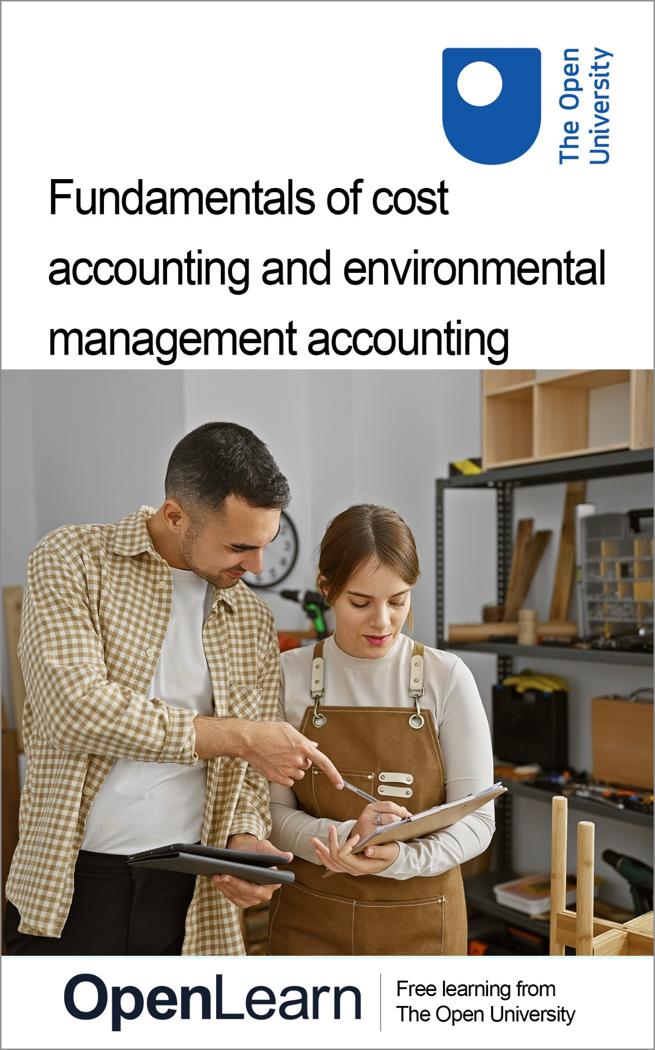

b253_1

Fundamentals of cost accounting and environmental management accounting

About this free course
This free course is an adapted extract from the Open University course B253 and related to the Open University qualification BSc (Honours) Accounting and Finance https://www.open.ac.uk/courses/accounting/degrees/bsc-accounting-finance-r52.
This version of the content may include video, images and interactive content that may not be optimised for your device.
You can experience this free course as it was originally designed on OpenLearn, the home of free learning from The Open University – Intermediate management accounting https://www.open.edu/openlearn/money-business/intermediate-management-accounting/content-section-0
There you’ll also be able to track your progress via your activity record, which you can use to demonstrate your learning.
First published 2025.
Unless otherwise stated, copyright © 2025 The Open University, all rights reserved.
Intellectual property
Unless otherwise stated, this resource is released under the terms of the Creative Commons Licence v4.0 http://creativecommons.org/licenses/by-nc-sa/4.0/deed.en. Within that The Open University interprets this licence in the following way: www.open.edu/openlearn/about-openlearn/frequently-asked-questions-on-openlearn. Copyright and rights falling outside the terms of the Creative Commons Licence are retained or controlled by The Open University. Please read the full text before using any of the content.
We believe the primary barrier to accessing high-quality educational experiences is cost, which is why we aim to publish as much free content as possible under an open licence. If it proves difficult to release content under our preferred Creative Commons licence (e.g. because we can’t afford or gain the clearances or find suitable alternatives), we will still release the materials for free under a personal end-user licence.
This is because the learning experience will always be the same high quality offering and that should always be seen as positive – even if at times the licensing is different to Creative Commons.
When using the content you must attribute us (The Open University) (the OU) and any identified author in accordance with the terms of the Creative Commons Licence.
The Acknowledgements section is used to list, amongst other things, third party (Proprietary), licensed content which is not subject to Creative Commons licensing. Proprietary content must be used (retained) intact and in context to the content at all times.
The Acknowledgements section is also used to bring to your attention any other Special Restrictions which may apply to the content. For example there may be times when the Creative Commons Non-Commercial Sharealike licence does not apply to any of the content even if owned by us (The Open University). In these instances, unless stated otherwise, the content may be used for personal and non-commercial use.
We have also identified as Proprietary other material included in the content which is not subject to Creative Commons Licence. These are OU logos, trading names and may extend to certain photographic and video images and sound recordings and any other material as may be brought to your attention.
Unauthorised use of any of the content may constitute a breach of the terms and conditions and/or intellectual property laws.
We reserve the right to alter, amend or bring to an end any terms and conditions provided here without notice.
All rights falling outside the terms of the Creative Commons licence are retained or controlled by The Open University.
Head of Intellectual Property, The Open University

Contents
- Introduction
- Learning outcomes
- 1 Cost classification
  - 1.1 Variable and fixed costs
  - 1.2 Other ways of classifying costs
  - 1.3 Cost centre, cost object and centres
- 2 Cost behaviour
  - 2.1 Calculating the unit cost
  - 2.2 Stepped fixed costs
- 3 Determining fixed versus variable costs
  - 3.1 The high–low method
  - 3.2 Assessing costs using a scatter graph
- 4 Direct and indirect costs
  - 4.1 Direct/indirect and fixed/variable costs
- 5 Why organisations need to know the costs of products, processes and services
- 6 Why organisations need costing systems
  - 6.1 Calculating profit
- 7 Cost information
- 8 The nature of production costs: materials, labour and overheads
  - 8.1 Materials
  - 8.2 Labour costs
  - 8.3 Overhead costs: production and non-production
  - 8.4 Direct and indirect production costs
- 9 Environmental management accounting
  - 9.1 The Sustainable Development Goals
  - 9.2 Why sustainability is important to organisations
  - 9.3 Why should a management accountant care about environmental issues?
  - 9.4 EMA process
  - 9.5 EMA techniques
  - 9.6 Understanding environmental management accounting and traditional management accounting
- Summary
- References
- Acknowledgements
- Glossary
- Solutions
- Descriptions

Introduction
This course is designed to provide you with a solid understanding of the principles and practices of cost accounting.


Figure 1
View description - Figure 1

Cost accounting enables managers to understand the true costs of products, services and processes in order to help them make informed decisions, control costs and improve the overall performance of the organisation. Throughout this course, you will explore various aspects of cost accounting. You will learn that to distinguish between fixed costs and variable costs allows for a range of important decisions in any business. An understanding of basic cost behaviour is essential to the work of management accountants. This course will cover the foundations of cost accounting and your ability to apply this knowledge.
In the final section you will look at the concept of environmental management accounting and analyse the impact of environmental costs and their implications for management accounting.
To help you plan your studies, this table outlines the activities you will be working on in this course. Please note that you will also need to allow time for reading the linked material and reflecting on what you have learned. To help you manage your workload, the approximate time to complete each activity is provided.

Table 1 Course activities breakdown
 | Activity | Description | Duration
 | Activity 1 Cost classifications | Answer the questions | 10 minutes
 | Activity 2 Cost changes | Answer the question | 5 minutes
 | Activity 3 Calculation of the unit cost | Calculate unit cost | 15 minutes
 | Activity 4 Direct or indirect costs | Answer the questions | 5 minutes
 | Activity 5 Direct or indirect costs – Nancy’s jewellery | Answer the questions | 5 minutes
 | Activity 6 Decision-making information | Answer the questions | 15 minutes
 | Activity 7 Performance information | Answer the question | 5 minutes
 | Activity 8 Cost classification activity | Answer the question | 5 minutes
 | Activity 9 Internal and external pressures on organisations to be sustainable | Share your thoughts | 20 minutes
 | Activity 10 The role of EMA | Vote in the poll | 10 minutes
 | Activity 11 Understanding and applying environmental management accounting | Read and write a definition | 15 minutes
 | Activity 12 Drawbacks of traditional management accounting | Answer the questions | 15 minutes

This free course is an adapted extract from the Open University course B253 and related to the Open University qualification BSc (Honours) Accounting and Finance.

Learning outcomes
By the end of this course you will be able to:
- describe how fixed, variable, stepped fixed and semi-variable costs behave and interpret cost-behaviour graphs
- explain why classifying costs as direct or indirect supports planning and decisions, and why organisations must know the costs of products, processes and services
- distinguish cost objects, units and centres, and outline production costs: materials, labour and overheads
- explain non-production costs, apply environmental management accounting and analyse environmental cost impacts.

1 Cost classification
An important role of management accounting in most organisations is providing managers with information about the cost of making each particular product or, in the case of a service organisation, providing each particular service. Managers need product cost information for a number of reasons, including:
- establishing selling prices
- determining product (or service) profitability
- cost management
- valuing inventory for financial accounting purposes.
This need for cost information raises the fundamental question: what constitutes a cost?
Costs can be defined as the expenses incurred by a company in order to purchase goods, produce products, provide services, pay staff or perform repairs. These expenses are quantifiable in monetary terms. However, there are also costs that cannot be measured monetarily, known as external costs or externalities. Externalities refer to the impact a company has on parties outside the organisation that did not participate or agree to the activities causing the impact. For instance, the construction of a big manufacturing unit may cause displacement of the local community. The people affected by the displacement are not the buyers or sellers of the manufacturing unit’s services or products, but the impact on their lives cannot be measured monetarily. The construction of this unit may also contribute to the depletion of the natural resources and biodiversity within the region – these are also examples of externalities. While externalities such as these are significant, management accountants have historically concentrated on costs that can be quantified. However, with increasing attention on the need for companies to be more socially and environmentally responsible, the focus of management accounting is changing.
Knowing the cost of a product is essential for any business. It helps to ensure that the price covers all the expenses associated with producing and selling the product, while also generating a profit. Having accurate cost information can also help in making informed business decisions, such as identifying areas for cost savings, setting the right price, improving efficiency and increasing profitability. This course defines ‘product’ in a broad sense and can refer to both tangible goods and services.
Costs can be classified in several ways. The principal classifications are:
- variable and fixed
- direct and indirect.
The classification into variable costs and fixed costs is used in marginal costing (a costing approach in which variable costs are charged to product units and fixed costs are charged against profit as a period expense – that is, not charged to specific units of output or activity). Figure 2 shows the difference between fixed and variable costs.

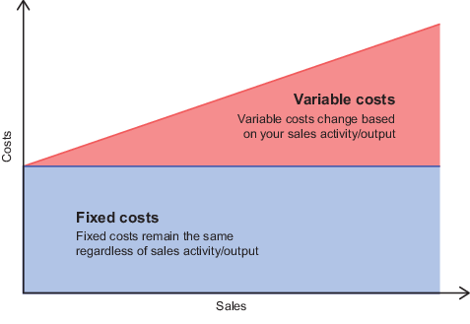
(The Open University, adapted from Oberlo)
Figure 2 Fixed and variable costs
View description - Figure 2 Fixed and variable costs

The classification into direct costs and indirect costs is used in absorption costing (a costing approach that charges both direct costs and indirect costs – and, crucially, fixed and variable costs – to units of output or activity).
There are other ways of classifying costs, such as distinguishing between actual cost and standard cost or controllable cost and non-controllable cost. These classifications are relevant in standard costing and budgetary control.

1.1 Variable and fixed costs
The distinction between variable and fixed costs is the basis of marginal costing. Once the variable and fixed costs are known for marginal costing, we can work out the marginal cost of a unit of output at any level of activity within the so-called relevant cost range. When we cannot accurately predict the future level of activity (which happens often), this classification of costs gives us a powerful management tool for evaluating results under different levels of activity.

Variable costs are directly proportional to the level of activity or output. Total variable costs are costs that change as the quantity of the good or service that a business produces changes.

For example, if activity doubles, the total variable cost also doubles; if activity trebles, the variable cost trebles. This assumes that, at unit level over a set range, the unit variable cost does not change.
In the case of a car factory, variable costs include raw materials, labour costs and direct production expenses – such as the engine, tyres, plastics and so on. Importantly, some indirect costs are also variable – for example electric power to drive the machinery and consumable materials such as lubricants. Variable costs are sometimes referred to as the marginal costs.
An important concept in connection with variable costs is contribution, which is an abbreviation of the phrase ‘contribution towards fixed costs’. It refers to the difference between the cost of sales that varies with production volume and the revenue generated – i.e. sales minus variable cost. Essentially, it is a measure of how much each unit of production or sales contributes to covering the fixed costs of a business. Contribution can be calculated per unit or aggregated for all production, providing valuable information for decision making and cost control.

Fixed costs are costs that remain constant, regardless of the level of activity or output.

Fixed costs are any other costs that are not variable. They are, in essence, a function of time, not of activity level or volume of output. They are the costs that would be incurred even if activity is zero. In a car factory, fixed costs include the rent, depreciation of equipment, management salaries, property taxes and so on.
In summary, total variable costs vary with changes in activity level, while fixed costs remain constant. Understanding the distinction between these two types of costs helps businesses make informed decisions about their production and cost management strategies. However, it is important to note that this holds true within a specific range called the ‘relevant range’. Fixed costs remain fixed within this range of output, beyond which they change. Similarly, variable costs per unit remain constant within the relevant range, after which they change (for example due to economies of scale, quantity discounts etc).
You will now consider these ideas in an activity.

Activity 1 Cost classifications
Allow around 10 minutes for this activity
In an accounting practice, which of the following costs are variable and which are fixed?
Select the correct answer in each instance.

(a) an annual software licence fee for use of accounting software throughout the practice

fixed cost
variable cost
View answer - Part

(b) advertising

fixed cost
variable cost
View answer - Part

(c) telephone bills

fixed cost
variable cost
View answer - Part

(d) secretaries’ salaries

fixed cost
variable cost
View answer - Part

(e) wages paid to the office cleaners

fixed cost
variable cost
View answer - Part

(f) 10% commission paid on sales

fixed cost
variable cost
View answer - Part

1.2 Other ways of classifying costs
In addition to the principal classifications of variable and fixed, we can identify several other classifications for costs, as outlined below.

Table 2 Cost classifications
By nature | This would include material or labour. Classifying costs by nature can also be termed subjective classification.
By purpose | Direct or indirect. We will explore this further in this course. Classifying costs by purpose can also be termed objective classification.
By function | For example, production, administration or selling.
By how it behaves | Fixed, variable, semi-variable, stepped fixed.
Normal/abnormal | This considers whether unusual events have influenced costs.
Controllable/non-controllable | This is concerned with whether the manager, within whose area of the organisation a cost is incurred, can influence the cost.
Relevant/irrelevant | This distinction is used in decision making. Relevant costs are considered when making a decision, as they have a direct impact on the decision outcome. Irrelevant costs do not have an impact on the decision and are therefore not taken into consideration.

1.3 Cost centre, cost object and centres
Cost centre is the term used to describe where in an organisation costs are gathered and then attributed to the units of output. Normally, cost centres consist of departments, but a cost centre can also be a project. A cost object refers to any thing or activity for which a separate measurement of costs is desired. An example of a cost object would be the cost of rendering a service to a hospital patient. Other examples would include the cost of a product, the cost of a process or a department.
Cost objects and cost centres are a fundamental component of a cost accounting system. They serve as the basis for:
- Classifying actual costs incurred.
- Preparing budgets for planned costs.
- Comparing actual costs with budgeted costs (for management control purposes).
In addition to cost centres, there are several other types of centres:
- responsibility centres
- profit centres
- revenue centres.
You can read more about the types of centre in the interactive figure below.

Interactive content is not available in this format.
Interactive Figure 1 Types of centre

2 Cost behaviour
An understanding of how costs vary with different levels of activity is essential for decision making. Figure 3 shows the pattern of costs in relation to the volume of activity, based on the information shown in Table 3 for a period. The level of activity can be expressed in terms of the units of production or the level of service activity.

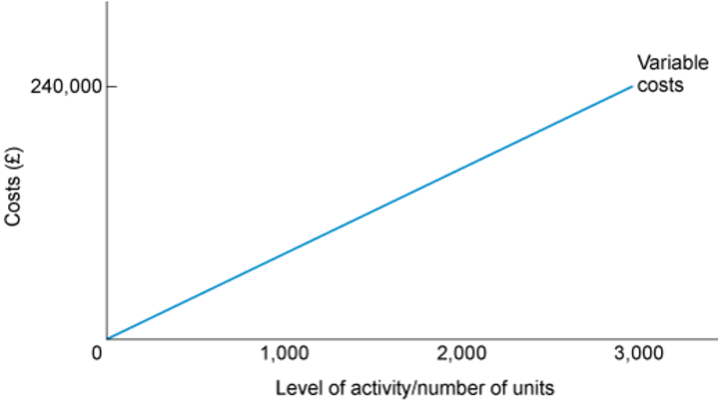
Figure 3 Variable costs
View description - Figure 3 Variable costs

The table below shows the variable costs at the maximum output and the fixed costs of the company.

Table 3 Variable and fixed costs for a period
Variable costs per unit | £80
Maximum output in the period | 3,000 units
Variable costs (at maximum output) | £240,000
Fixed costs | £100,000

We can calculate variable cost (VC) per unit as follows:
Maximum output in period = 3,000 units
VC at maximum output = £240,000
VC per unit = £240,000/3,000 = £80 (assuming fixed costs remain constant at £100,000)
The relevant range for which these relationships hold is 0–3,000 units.
Note how the variable costs are proportional to the level of activity and how they are always zero when the level of activity is zero.
Note also how the fixed costs remain constant at all levels of activity within the relevant range (Figure 4).

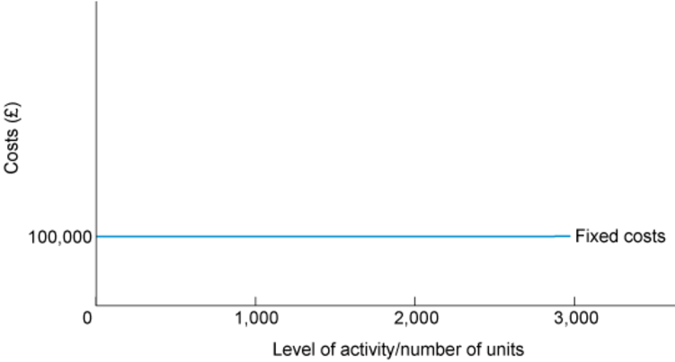
Figure 4 Fixed costs
View description - Figure 4 Fixed costs

The two graphs can be combined to show total costs (Figure 5).

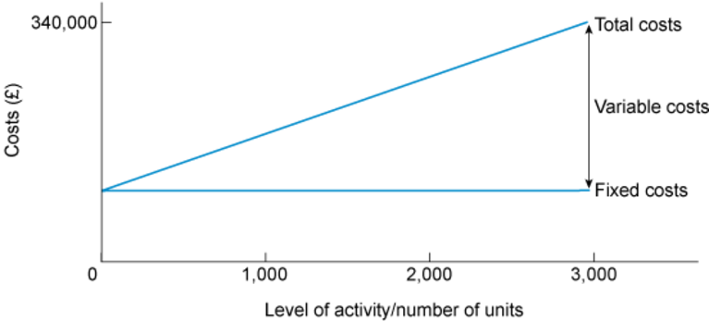
Figure 5 Total costs
View description - Figure 5 Total costs

At a production level of 3,000 units, the total cost is £340,000, resulting in a unit cost of £113.33. If the production level was 1,800 units, the total cost would be £244,000 (fixed costs of £100,000 plus variable costs of £144,000) and the resulting unit cost would be £135.56. As the volume of activity declines, the unit cost increases. Conversely, as the volume of activity increases, the unit cost decreases.

Activity 2 Cost changes
Allow around 5 minutes for this activity

Look again at the figures above and explain why the unit cost changes.

Provide your answer...
View feedback - Activity 2 Cost changes

2.1 Calculating the unit cost
Continuing with the example from Section 2, the changing unit cost of production is shown in Figure 6.

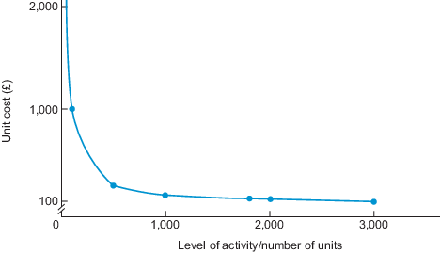
Figure 6 The changing cost per unit as the level of activity changes
View description - Figure 6 The changing cost per unit as the level of activity changes

To calculate the unit cost, divide the total of fixed costs and variable costs by the number of units produced. An example is given in Activity 3.

Activity 3 Calculation of the unit cost
Allow around 15 minutes for this activity

Using the following information for a period, calculate the unit cost at production levels of 2,000, 4,000 and 5,000 units of output. You can use this spreadsheet to complete this activity.

Table 4
Fixed costs | £264,000
Variable costs per unit | £279

View feedback - Activity 3 Calculation of the unit cost

It is important to bear in mind that both fixed and variable costs may only behave in this way over a relevant range. For example, within the relevant range (see Figure 7), unit variable costs are assumed to be constant. Beyond this range, they are not. (This could be due to bulk discounts in purchasing materials, for example.) In Figure 7, variable costs (per unit) are only constant between 600 and 1,200 units.

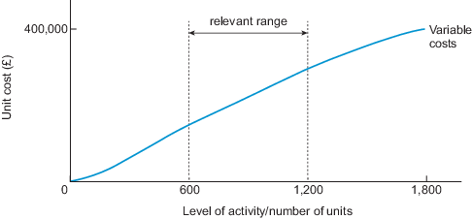
Figure 7 The relevant range
View description - Figure 7 The relevant range

The relevant range in Figure 7 refers to a specific activity level that is bounded by a minimum and maximum amount. Within the designated boundaries, certain cost levels can be expected to occur. Outside that relevant range, costs will likely differ from the expected amount.

2.2 Stepped fixed costs
Fixed costs are often only fixed within a range of activity levels, i.e. the relevant range. Fixed costs are often assumed to be fixed whatever the level of activity, but they do change. The term used to describe the concept of change in fixed costs is ‘stepped costs’. These can be described as being constant within a specified range of output but changing when outside this range, as illustrated in Figure 8, where above 2,000 units a new level of fixed costs is reached.

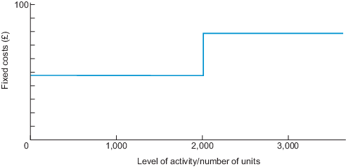
Figure 8 Stepped fixed costs
View description - Figure 8 Stepped fixed costs

The concept of stepped costs can be illustrated by an accounting practice. For a given level of clients, the practice can cope with the current number of accountants, but at a certain level of activity, the pressures of work will mean an additional accountant needs to be employed. If on a full-time contract, this extra accountant would be a stepped cost – that is, an increased fixed cost. (If an accountant could be employed on a casual, part-time basis, this would resemble more closely a variable cost.)

3 Determining fixed versus variable costs
The material, labour and machine resources needed to make a unit of a particular product (or provide a unit of a particular service) could be measured and then divided over the units to be produced, to give a unit variable cost. However, in practice things are not always as simple as that as many costs are semi-variable, with both variable and fixed components. Despite this complication, many planning and decision-making activities require an understanding of how costs change as the level of output changes. This requires separating costs into their fixed and variable elements.
There are a number of techniques, of varying degrees of sophistication, available to management for estimating fixed and variable costs, but you should always bear in mind that greater and greater levels of accuracy are usually more expensive to attain. Such levels of accuracy may also take longer to achieve because of the amount of information that has to be processed.
Organisations must always keep in mind that information has a cost and that it is pointless to have more detail and accuracy than necessary. The following subsections describe two techniques that could be applied for the purpose of estimating fixed and variable costs.

3.1 The high–low method
The high–low method is a technique for splitting mixed costs into their fixed and variable elements. It is simple and quick but will often not be very accurate. Suppose a business had recorded the following costs for electricity relative to units of production from the factory.

Table 6 Electricity costs relative to units of production
 | Electricity cost (£) | Units made
January | 10,000 | 11,000
February | 15,000 | 20,000
March | 12,000 | 13,000
April | 9,000 | 10,000
May | 10,000 | 11,000
June | 11,000 | 12,000
July | 14,000 | 18,000
August | 13,000 | 17,000
September | 12,000 | 13,000
October | 11,000 | 11,000
November | 11,000 | 12,000
December | 12,000 | 14,000

First, identify the periods with the highest and lowest production – here, the months of February and April.

Table 7 Periods with the highest and lowest production
 | Units | £
High | 20,000 | 15,000
Low | 10,000 | 9,000

You can see that these costs are not purely variable otherwise they would double as the output doubles.
You can now assume that the increase in costs must arise from the variable part of the costs. So, the extra 10,000 units cause the additional costs of £6,000. This implies variable costs of £0.60 per unit.
If the variable costs are £0.60 per unit, 10,000 units would cause £6,000 total variable costs. At this output, the total costs are £9,000, so the fixed costs must amount to £3,000.
You can check the fixed costs by looking at the output levels chosen. At 20,000 units, variable costs would be £12,000. As total costs are £15,000, fixed costs must be £3,000, as before.

3.2 Assessing costs using a scatter graph
Scatter graphs plot data points on a graph and are useful as another means of examining the relationship between fixed and variable costs. By drawing in the line of best fit, which plots a line which best fits the spread of the data, we are, in effect, setting out the total cost line, as in Figure 9. This meets the vertical axis at an activity level of zero, so the total costs at that point must be the fixed costs. It follows that if we take the total costs at a particular level of activity, deduct the fixed costs and divide the resulting answer by the level of activity, we arrive at the variable cost per unit.

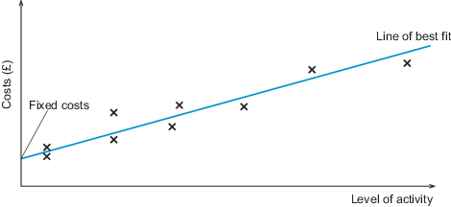
Figure 9 Using a scatter graph to find the line of best fit
View description - Figure 9 Using a scatter graph to find the line of best fit

A scatter graph is a useful visual insight into the relationship between fixed and variable costs and, indeed, can be regarded as superior to the high–low method, which uses only two data points. However, remember that it is only a guide to the relationship: ultimately, the precise answer can only be calculated by a detailed analysis of the cost data such as by regression analysis, which was covered in B126.
Now that you have explored cost behaviour in terms of fixed and variable costs, you will look at the notion of direct versus indirect costs.

4 Direct and indirect costs
Cost can be divided into two broad categories: direct costs and indirect costs. This distinction is important and forms the basis of absorption costing. The following definitions are attributed to Horngren et al. (1999).

Direct costs are all costs that can be directly attributed to a cost object and that can be traced to it in an economically feasible (cost-effective) way. A cost object is defined as anything for which a separate measurement of costs is desired.

For instance, in an analysis of sales regions, the salaries, commissions and expenses of sales personnel working exclusively in one territory constitute direct costs of that territory.

Indirect costs are all costs that cannot be directly traced to a cost object in an economically feasible way. Indirect costs are allocated to the cost object using a cost allocation method.

The narrower a cost object is (e.g. a customer or a product line), the greater will be the proportion of costs that are indirect, whereas the more broadly based a cost object is (e.g. a sales territory), the greater will be the proportion of costs that can be traced directly to it. It should be noted, however, that direct costs can be fixed or variable in nature (as can indirect costs), so directness should not be linked in any general way with variable costs alone, whether in a marketing setting or in any other instance.
Horngren et al. (1999, p. 32) give the example of a tennis racket as a cost object. The cost of the carbon fibre used to make the racket is a direct cost because it can be easily traced to the racket. However, the cost of lighting in the factory where the racket is made will be an indirect cost. This is because, although lighting helped in the manufacture of the racket (the workers needed to see), it is not cost-effective to try to determine exactly how much lighting cost was used for a specific racket.
Whether a cost is direct or indirect depends on the cost object. Indirect costs are also known as overheads.

Activity 4 Direct or indirect costs
Allow around 5 minutes for this activity
The following list shows typical costs for a customised sports car manufacturer. Decide whether the following costs are direct or indirect.
Select the correct answer in each instance.

a. component parts

direct cost
indirect cost
View answer - Part

b. production labour

direct cost
indirect cost
View answer - Part

c. depreciation of manufacturing equipment

direct cost
indirect cost
View answer - Part

As you can see from these examples, it is necessary to remember that we are considering whether costs are direct or indirect relative to a particular product. Hence, component parts and production labour are directly linked to the particular product in contrast to depreciation, which is not so related.

Activity 5 Direct or indirect costs – Nancy’s jewellery
Allow around 5 minutes for this activity
Nancy runs a design and assembly workshop for jewellery. She employs various craftspeople in her workshop. Classify the following costs as either direct or indirect (assume that the individual item of jewellery is the cost object).
Select the correct answer in each instance.

a) silver used in making necklaces, earrings and bracelets

direct cost
indirect cost
View answer - Part

b) cost of electricity for smelting

direct cost
indirect cost
View answer - Part

c) salary of workshop supervisor

direct cost
indirect cost
View answer - Part

d) labour costs to shape and smelt jewellery

direct cost
indirect cost
View answer - Part

4.1 Direct/indirect and fixed/variable costs
You will remember that fixed costs and variable costs were discussed in Section 1 and that this distinction was crucial to understanding cost behaviour. You should note that costs may be simultaneously:
- direct and variable
- direct and fixed
- indirect and variable
- indirect and fixed.
An extended example of cost classification is given in Figure 10.

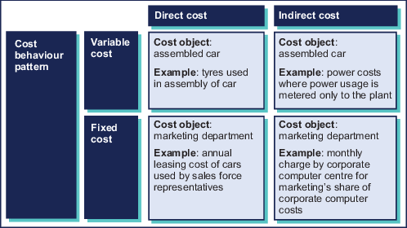
Figure 10 Assignment of costs to cost object (Adapted from Horngren et al., 1999, p. 38)
View description - Figure 10 Assignment of costs to cost object (Adapted from Horngren et al., 1999, ...

In Figure 10, you can see that the tyres used in the assembly of a car are both variable and direct costs. Another example of a direct cost is the annual leasing cost of cars used by sales representatives, although you should note that these particular costs are fixed as they do not vary with the level of activity in terms of the number of cars assembled.
In terms of indirect costs, you can see that power costs, where usage is metered at the plant level only, constitute indirect but variable costs. Finally, the monthly charge by the corporate computer centre for marketing’s share of corporate computer costs will be classified as simultaneously indirect and fixed because, again, these will not vary with the level of activity in terms of cars produced.
For a meaningful system of cost control to work, there must be a proper administrative system operating that enables costs to be monitored and allocated in order to calculate the cost of the product or service in an appropriate way.
The cost of each unit in a commercial organisation is then related to the sales revenue generated by selling each unit. In other words, once the cost of each unit is known, you can calculate the profit per unit sold. Alternatively, you can set the selling price at a level that will generate the profit per unit that you wish to achieve.

5 Why organisations need to know the costs of products, processes and services


Figure 11
View description - Figure 11

Ascertaining the cost of something is an essential part of effective management in an organisation. This applies to the commercial, not-for-profit and public sectors of the economy. In fact, it applies to all organisations, whatever their nature and form. An organisation without the necessary understanding of its cost structure and cost control is rather like a rudderless ship, lacking clear direction and at risk of breaking up when it meets the shore.
Costs are shown in external financial statements (such as the income statement) but what is disclosed about them is determined by the needs of reporting to shareholders or other stakeholders. Such information may provide a useful insight into overall performance, but it is insufficiently detailed to be an in-depth analysis of specific activities, such as the labour cost of an individual product or how much a particular service costs. It is important to make clear therefore that such aggregate information is not adequate for day-to-day management of the organisation, which requires details about, for example, the cost of individual products or services for pricing decisions, and so on. In this context, costing comes into its own. It provides a powerful management tool to monitor and plan activities.
In any organisation, it is necessary to define clearly the nature of the product or services provided. This, in turn, will be the basis for defining the cost structure. The cost unit is defined as the unit of product or service for which cost is computed. Hence, a cost unit for a fruit juice factory might be a carton of fruit juice, while the cost unit for a firm of professional accountants could take the form of a given year’s tax computation for a particular client (depending on the type of work undertaken). Normally, the management of an organisation in the commercial and not-for-profit sectors, or the funding agencies in the public sector, decide what is a convenient cost unit.

6 Why organisations need costing systems

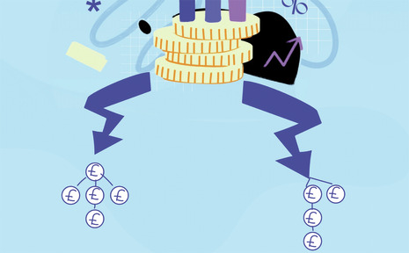
Figure 12
View description - Figure 12

As certain activities will have the same types of costs irrespective of the individual organisation, entities in the same trade or sector may have very similar cost structures. In the public sector, for example, hospital trusts will all have similar costs and this drives the way in which they collect and report cost information. In higher education, the government-financed funding councils specify how costs are to be reported.
The need to comply with public sector external reporting requirements focuses organisations on determining the costs that have to be identified to meet those requirements. This is also the case for commercial and not-for-profit organisations. The way they calculate their costs is governed, to some extent at least, by the external reporting requirements of their sector and the regulators concerned. See the Charity Commission for England and Wales, for example.
The accurate measurement of cost for any organisation is also important for several other reasons, including:
- providing a basis for assessing past performance
- planning for future operations
- pricing purposes
- monitoring actual performance against budget
- assisting in decision making
- assisting in cost reduction and control.
In the next activity you will consider these factors in more detail by looking at the case of a window manufacturer supplying standard products to the house-building industry.

Activity 6 Decision-making information
Allow around 15 minutes for this activity

(a) What cost information does the window manufacturer’s management require?

Provide your answer...
View feedback - Part

(b) How does the window manufacturer assess past operations and future plans?

Provide your answer...
View feedback - Part

6.1 Calculating profit
For a window manufacturer, the key is to establish whether total revenue from the sale of windows exceeds the total costs incurred in its provision for sale. If the windows are manufactured (as opposed to bought in ready for resale), the gross profit would be calculated as follows. (Figures and dates are assumed for the sake of this example.)

Table 8 Gross profit calculation for the year ending 31 December 2024
 | £
Sales | 2,000,000
Less: Cost of production | (1,800,000)
Gross profit | 200,000

This calculation uses the sales and the cost of goods sold, which includes labour and material costs incurred as well as production indirect costs to arrive at the gross profit (or loss). However, as a basis for the day-to-day management of the factory, it provides us with only a limited insight into the company’s performance.

Activity 7 Performance information
Allow around 5 minutes for this activity

What is it about this information that restricts us to a limited view of the company’s performance?

Provide your answer...
View feedback - Activity 7 Performance information

The following report gives us a starting point for measuring the factory’s detailed financial performance.

Table 9 Gross profit calculation for the year ending 31 December 2024
 | £ | Per window £
Sales | 2,000,000 | 100
Less: Cost of production | (1,800,000) | 90
Gross profit | 200,000 | 10

Let us assume that all the windows were of the same specification and that inflation has not distorted the figures. From this information we can easily establish that the average selling price was £100 and that each window cost an average of £90 to produce.
As a result, management can see that every unit made an average gross margin or gross profit of £10. This information can then be used for planning purposes. Is that enough per window? Is it enough gross profit overall – to cover expenses and result in an overall net profit? Can the gross profit be increased – either per window or overall?
In the simple case of the window manufacturer, only when information about sales revenue, costs (including costs of production) and, therefore, gross and net profit per window, is available, does it become possible for management to consider revising its pricing, production levels and cost plans. Such individual unit cost information is vital for internal decision making (e.g. pricing) in the normal multi-product firm or in a services firm where different types of service offering are provided.

7 Cost information
You might now be beginning to see the need for a costing system. Such a system relates production costs to activities – in this example, window production – and, in a commercial context, it enables us to establish the profitability of the activities. In the public sector or in a not-for-profit organisation, it provides the means of assessing the cost of providing a service or supplying a product.
Once management knows the level of activity, it can take a much more informed view of its operations. In the real world, accountants and managers would need to learn much more about the nature of the total cost of production of £1,800,000 for the window producer. For example, they would want to know how much the materials for the frames cost, how much the fittings cost, the cost of finishing and the charge for assembly labour, as well as the factory’s expenses.
This simple example considered cost in a manufacturing context. If the organisation provided a service, similar information in terms of the cost of service delivery would be required. The precise nature of the cost information would depend on the purpose for which the cost information was to be used.
The next section will consider the ways in which we both classify costs and summarise them to provide meaningful insights into the effective (and ineffective) management of an organisation.

8 The nature of production costs: materials, labour and overheads
Production costs can be classified into three broad categories: materials, labour and overheads. These costs will be captured on a cost card. The cost card is a summary of costs that together make the total cost of one unit of a product – for example, a television or a meal. The term cost card is from an age that pre-dates computers, when costs were summarised on cards as they were incurred in the production process. Today, cost cards are embedded within accounting software with various coding systems, but the principle remains the same and the same information is recorded.
The information recorded constitutes the basic elements of cost: the materials used, the cost of labour and the proportion of indirect costs attributable to a particular unit of output. The source of this information is described in the next few sections. See the example below of a cost card for a door (figures are assumed).

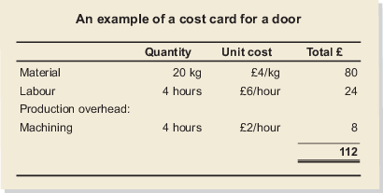
Figure 13 A cost card
View description - Figure 13 A cost card

You certainly need to understand the basic way in which cost data is captured. The broad categories of cost in an organisation are covered in the next three sections.

8.1 Materials
There must be a proper system of inventory control for any meaningful costing system to operate. Such a system needs to control adequately the buying, receipt, storage and subsequent allocation of all items relevant to the cost of the product or service.

8.2 Labour costs
Labour costs have to be collected and charged to the appropriate goods or services. It is beyond the scope of this course to consider a detailed remuneration accounting system. You just need to be aware of the basic cost implications and how cost is charged to each unit of output.
In general, remuneration can be paid by two methods or combinations of them:
- time-related
- performance-related.
In a time-related system, an effective means of recording the time spent on a job is needed, which involves using time records. The remuneration is calculated by multiplying the time incurred on particular work by the appropriate rate per hour, minute and so on.
In the case of performance-related pay (PRP), where the amount of pay depends on the efficiency and effectiveness of staff, systems have to be devised that record the level of relevant activity (e.g. the number of units produced). This is then used to pay employees at the appropriate rate. It is unusual for employees to be paid purely on a performance basis. Generally, they receive a minimum basic wage or salary and then their PRP is added to it.
The wages costs have to be allocated to products (cost units) or relevant cost centres. How this is done depends on the nature of the activities. For example, for individual discrete jobs (e.g. shipbuilding), it is based on the time spent on the job. In continuous processing or production (e.g. jam making), the labour costs incurred at each stage of the process are added together to arrive at the total labour cost, which is then divided by the number of units of output produced to obtain the labour cost per unit. In an accounting services firm, the cost allocation of wages for their services can be based on the time spent on each client engagement.
It is important to recognise that when charging labour to production, the associated labour costs, such as employer’s pension contributions and other directly related costs, should also be charged to production.
Labour costs can be categorised as direct (relating to a specific item, e.g. table leg cutter wages) or indirect (relating to activities in general, e.g. factory supervisor salaries, rather than to specific individual items). Alternatively, they can be classified in terms of whether they are variable costs or fixed costs.
These classifications are not always straightforward. For example, when premium time, such as overtime, is involved, this is generally treated as an overhead cost. However, where a customer demands a job urgently, the cost of the overtime premium may well be charged directly to the specific, unplanned job (as a direct cost). Similarly, the use of PRP has potential implications for the classification of costs between fixed costs and variable costs. One way of avoiding these difficulties is to employ labour on a sub-contract basis.

8.3 Overhead costs: production and non-production
Production overhead costs are costs involved in the manufacturing of goods, such as manufacturing overhead. Non-production costs are costs incurred that are not part of manufacturing, for example, selling and administrative expenses. Overhead costs are indirect costs.
Examples of production overhead costs include supervisors’ salaries and factory rent. In addition to materials and labour costs, a wide range of other overhead costs needs to be recorded and collected so that an appropriate estimate of cost can be made. Many of these overhead costs will be periodic expenditure on items with which you will be familiar, including:
- rent and business rates (either related to production or non-production)
- insurance (either related to production or non-production)
- administration expenses (likely to be non-production)
- motor and travelling expenses (likely to be non-production).
Non-production overheads are usually grouped into three classifications, as demonstrated in Interactive Figure 2.

Interactive content is not available in this format.
Interactive Figure 2 Non-production overheads

Classification in this way is known as classification by function. This provides a clear understanding of the different types of expenses incurred and helps businesses to make informed decisions regarding their cost structure. Costs that cannot be fully classified into these groups may be classified as general overheads or may receive their own separate name, such as research and development costs.
These expenses are recorded in the accounting system and allocated or apportioned to the appropriate departments, and analysed to aid decision making. In addition to these costs, which are paid in the normal course of trading, there are other costs, notably depreciation, which do not necessarily involve a cash outlay during the period under review. Depreciation (which is, of course, an operating cost) will have to be calculated using a suitable method.

8.4 Direct and indirect production costs
Production costs can be further classified as direct costs or indirect costs. Direct costs include:
- Direct material costs, which are the costs of materials that can be directly traced to the production of a product or delivery of a service.
- Direct labour costs, which are the costs of the workforce directly involved in the production or delivery of a product or service. These costs are calculated by measuring the time spent in direct production/performance work.
- Other direct expenses, which are expenses incurred as a direct result of making a product, providing a service, or running a department. The difference between direct expenses and overheads is that direct expenses are directly related to the production or delivery of a product or service, whereas overheads are not. Direct expenses vary in direct proportion to the output or activity level, whereas overheads are usually fixed or semi-variable. Direct expenses can be controlled easily, whereas overheads are difficult to control.
On the other hand, indirect costs are expenses that cannot be directly tied to a specific product or service. These costs are indirect because they are necessary for the overall operation of a business and support the production of multiple products or services. Examples of indirect costs include supervisors’ wages, rent of the factory, legal and accounting fees, cleaning materials and building insurance.
Total cost is therefore all direct costs (material, labour and other direct expenses) plus all indirect costs (also known as overheads).

Activity 8 Cost classification activity
Allow around 5 minutes for this activity

Identify whether the following costs are material, labour or expenses and whether they are direct or indirect for the production of a car.

Interactive content is not available in this format.

9 Environmental management accounting
In this section you will delve into the topic of environmental management accounting (EMA), its significance in organisational decision making and the evolving role of management accounting.


Figure 14
View description - Figure 14

As you have learned, management accounting serves as a crucial component to support managers in decision making within organisations. With the increasing awareness of the need for sustainable development, it’s important that management accounting adapts to address society’s expectations of organisations playing a role in the transformation towards sustainability. As Milne (1996, p. 136) noted, management accounting is ‘incomplete as generally practiced’ by neglecting the external effects of corporate activities.
Environmental management accounting (EMA) is a reflection of this evolution, as it recognises the interdependence between the environment and the economy and provides valuable insights into the environmental impact of organisational activities. By integrating environmental considerations into decision making, organisations can demonstrate their commitment to sustainability and contribute to the achievement of environmental goals.
EMA is an emerging aspect of management accounting that deals with the collection, analysis and presentation of environmental cost and information for internal decision-making purposes. By providing managers with a clearer understanding of the environmental aspects of their organisations, EMA contributes to a more sustainable and responsible approach to business operations.
Schaltegger and Zvezdov (2015, p. 1333) define EMA as:

EMA is the subset of management accounting dealing with environmental issues and has been defined as the group of accounting methods and activities that support the collection, creation, analysis and communication of the necessary information to take decisions for dematerialization, environmental impact reduction and improved eco-efficiency (Herzig et al., 2012; Jasch, 2003; Schaltegger and Burritt, 2000).

9.1 The Sustainable Development Goals
Globally, there is growing attention on the environmental performance of organisations and their sustainability efforts, as well as the incorporation of United Nations Sustainable Development Goals (SDGs) within their strategy.
The SDGs are a set of 17 goals, created by the United Nations in 2015, to enhance sustainable development globally. These goals can have significant implications for financial management as they provide a roadmap for creating a sustainable future.

Interactive content is not available in this format.
Interactive Figure 3 The United Nations Sustainable Development Goals

By aligning financial decisions with the SDGs, organisations can contribute to achieving the goals, while also promoting financial stability and resilience. For example, investments in renewable energy can help to address climate change (SDG 13), while also creating new economic opportunities and enhancing sustainability (SDGs 8 and 11).
In addition to investment decisions, responsible financial reporting and accounting practices can help to ensure transparency and accountability in the use of financial resources, which is important for achieving many of the SDGs, such as SDG 16.
Overall, the SDGs provide a framework that can be useful for integrating sustainability into financial decision making, which can help to create a more just, equitable and sustainable future for all.
If you are interested in reading more about this, take a look at the UN’s Global Compact website and the 17 Sustainable Development Goals.

9.2 Why sustainability is important to organisations
Organisations are facing increasing expectations to be accountable for ethical, social and environmental issues as well as to be managed in a sustainable way. There is strong recognition that environmental resources are limited, and stakeholders are paying closer attention to organisations’ ‘carbon footprint’ and recycling practices.

Activity 9 Internal and external pressures on organisations to be sustainable
Allow around 20 minutes for this activity

What are the pressures (internal/external) on your organisation to be sustainable? Share your thoughts below.

Provide your answer...
View feedback - Activity 9 Internal and external pressures on organisations to be sustainable

The interactive figure below shows some of the potential environmental costs that organisations might incur.

Interactive content is not available in this format.
Interactive Figure 4 Potential environmental costs

9.3 Why should a management accountant care about environmental issues?
So far, you have discovered that a management accountant is a professional responsible for collecting, analysing and presenting information for internal decision-making purposes. Traditionally, the focus of accounting information collection for internal decision making was on maximising profits and minimising costs. However, it has been increasingly recognised that management accounting plays a vital role in achieving a wider range of goals, including social and environmental objectives. Over the last few decades, the scope of management accounting for internal decision making has expanded beyond just financial costs and performance.
For instance, in order to minimise the use of valuable resources such as water and energy, and reduce waste and CO₂ emissions, etc., managers must carefully analyse the inputs and outputs of their production processes and work to reduce any negative impacts. This process of accounting, while relying on non-financial measurements, is still a critical component of management accounting. The goal is to create a more sustainable and responsible approach to business operations.
The importance of managing environmental costs has become increasingly prominent for companies for a number of reasons. First, environment-related costs are increasing significantly for many companies, with some industries using more than 20 per cent of operating costs to prevent, reduce or repair damage to the environment arising from their operating activities. Such significant costs need to be managed. Second, there are growing regulations and penalties for non-compliance. Third, society is demanding that companies be more environmentally responsible. Therefore, in order to stay competitive, organisations need to integrate environmental considerations into their business decision-making process.
Management accountants are now required to integrate environmental considerations into mainstream business decision making. Management accounting practices have therefore gradually shifted beyond information provision to focus on the reduction of waste (the reduction of resource loss) to the generation of value (the effective use of resources). Section 1 highlighted how the standard conventional management accounting costs are only a part of the total costs that a company might incur, particularly when you consider all the possible external/environmental costs.

Activity 10 The role of EMA
Allow around 10 minutes for this activity

EMA is an accounting approach that focuses on providing managers with the necessary information to make informed decisions about the environmental impact of their organisational activities. Which of the following key elements of EMA do you believe to be the most important for an organisation?

Interactive content is not available in this format.

View feedback - Activity 10 The role of EMA

However, in the recent academic literature, management accounting has been criticised for not giving sufficient attention to incorporating environmental, social and sustainable issues. Studies such as Bartolomeo et al. (2000), Henri et al. (2014, 2016) and Schaltegger and Burritt (2017) reported that not enough companies were explicitly tracking environmental cost, which can lead to a lack of visibility into the true costs associated with environmental factors, making it difficult for organisations to make informed decisions.

9.4 EMA process
Tracking environmental costs facilitates the understanding of links between costs and provides insights into cost reductions through specific actions on cost drivers. In most management accounting systems, however, environmental costs are hidden within general overheads; thus relationships are not identified. It is vital to allocate environmental costs to the processes or products which give rise to them. Only by doing this can an organisation make well-informed business decisions and improve controls and benchmarking. Techniques such as input/output analysis can help organisations balance resources and costs, making them more transparent and manageable.
For example, a manufacturing company should know exactly how much waste is created during a production process, what percentage of the waste is recycled and how much energy is consumed. Only by identifying and allocating such costs to individual production processes can the company make informed decisions about the environmental effects of its activities. Enhancing efficiency in the use of energy, water and other raw materials brings not only environmental improvements (reduced resource use and reduced waste and emissions), but also potentially significant monetary savings as the costs of purchase and waste treatment decrease.

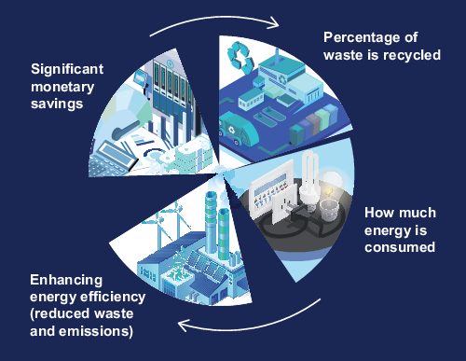
Figure 15 Circular model of production process: waste recycling and energy efficiency
View description - Figure 15 Circular model of production process: waste recycling and energy effic ...

Bennett and James (1998) suggested that the process of EMA involves three key levels: the gathering of environmental data (lowest level), the conversion of this data into useful information (middle level) and the dissemination of this information to decision makers, i.e. managers (top level).

Interactive content is not available in this format.
Interactive Figure 5 The three levels of EMA

9.5 EMA techniques
In this section you will learn about the following EMA techniques:
- input/output analysis
- material flow accounting
- activity-based costing
- lifecycle costing.
Input/output analysis is a technique used to reduce environmental resources and costs. Resources such as water, material and energy as inputs are balanced with the outputs such that what comes in must go out. For example, if 100 litres of water have been acquired but the production process only used 80 litres, then the 20-litre difference must be accounted for as this is considered avoidable waste for which actions need to be taken. The costs and resources used in the production process will become more transparent and hence manageable. Additionally, by incorporating both physical quantities and monetary values of outputs, businesses are compelled to prioritise environmental costs throughout their operations.

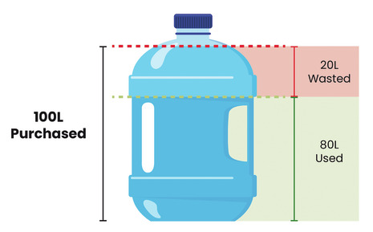
Figure 16 Input/output analysis
View description - Figure 16 Input/output analysis

Another EMA technique is material flow accounting or flow cost accounting. This approach evaluates physical movement of materials in an organisation and offers transparency in material flows by examining the physical quantities involved, their costs and the value they bring. Flow cost accounting divides material flows into three categories: material, system, and delivery and disposal. The values and costs associated with each flow are calculated and analysed, enabling organisations to understand their impact on the environment and on their bottom line.
The ultimate goal of flow cost accounting is to reduce the quantity of materials used in an organisation, with the belief that not only will this have a positive impact on the environment, but also lead to cost savings in the long term. By tracking and evaluating the movement of materials and their associated costs, organisations can identify areas for improvement and make informed decisions to reduce waste and optimise their operations.
Walz and Guenther (2021) analysed 73 case studies about material flow accounting and reported that tracking and evaluating material flow can contribute to improved performance and cost reduction for companies, while also helping to reduce environmental damage. The authors also provide some challenges and drawbacks associated with the implementation and application of material flow accounting within these companies.
If you are interested in studying further on the topic, Walz and Guenther’s 2021 article ‘What effects does material flow cost accounting have for companies?: Evidence from a case studies analysis’, which appeared in the Journal of Industrial Ecology, can provide valuable insights and evidence regarding the impact of material flow cost accounting on companies.
Activity-based costing (ABC) is another cost allocation method that assigns internal costs to cost centres and drivers based on the activities that generate those costs. In an environmental accounting context, ABC helps distinguish between environment-related costs, which can be attributed to joint cost centres; and environment-driven costs, which are often hidden within general overheads.
Lifecycle costing (LCC) is another technique used in environmental accounting that takes into account the full environmental impact and costs associated with producing a product from start to finish, often referred to as ‘cradle to grave’. This technique aims to identify all the environmental costs associated with a product, including raw material extraction, manufacturing, transportation, usage, disposal and so forth. LCC allows businesses to identify the full impact of their products and processes on the environment, including those that may have been previously overlooked.

9.6 Understanding environmental management accounting and traditional management accounting
As you have learned, management accounting is the process of providing relevant and timely information to managers and other internal stakeholders to support planning, decision-making and control activities within an organisation. However, traditional management accounting systems often fail to capture and report the environmental costs and impacts of business operations, which may lead to poor decisions and environmental performance. In this section, you will learn about both the drawbacks of traditional management accounting, and why it is still useful.

Activity 11 Understanding and applying environmental management accounting
Allow around 15 minutes for this activity

Read Section 2.1 (p. 19) of the IFAC report on Environmental Management Accounting (EMA). Having read the definition, if you were asked to come up with an alternate definition of EMA, what would it be? Write your own definition with an explanation of why you think your definition is more valid.

Provide your answer...
View feedback - Activity 11 Understanding and applying environmental management accounting

In contrast to environmental management accounting, traditional management accounting may not adequately address the environmental costs and benefits of organisational activities. This can result in a lack of information and awareness for managers to make decisions that are aligned with environmental goals. Let’s look at some of the drawbacks of tradition management accounting.

Activity 12 Drawbacks of traditional management accounting
Allow around 15 minutes for this activity

Traditional management accounting may fail to adequately deal with environmental costs and managers may therefore not have the adequate information to manage or reduce them. Tick all options that are a relevant drawback of traditional management accounting.

Inadequate consideration of environmental costs
Raw material and energy costs are grouped with overheads
Failure to account for future costs
Reputational costs
Externalities
View answer - Part
View feedback - Part

Note down a few reasons why traditional management accounting is still useful, then listen to the audio in the feedback.

Provide your answer...
View feedback - Part

If you are interested in learning more about environmental management accounting, you can access the Journal of Cleaner Production or Management Accounting Research journal or search for the term ‘environmental management accounting’ to take a look at a few articles published within this area.

Summary
This course explored why organisations need to know about costs and why they need costing systems. You learned about various possible classifications for costs as well as the nature of production and non-production costs. You also learned about the importance of understanding cost behaviour in terms of fixed versus variable cost elements. The importance of classifying costs as direct or indirect was also covered. Perhaps the overriding message of this course concerns the need for people to be able to describe costs as fixed or variable and so on if they are to be able to understand cost behaviour in relation to goods or services provided. Lastly, in this course we explored the basic principles of environmental management accounting and the role of management accountants in addressing environmental issues, including some environmental management accounting techniques.
You should now be able to:
- describe the nature and behaviour of fixed, variable, stepped fixed and semi-variable costs and interpret graphs showing the behaviour of different types of costs
- explain why costs need to be classified as direct/indirect for planning and decision making and why organisations need to know the costs of products, processes and services
- distinguish between cost objects, cost units and cost centres and discuss the nature of production costs in terms of materials, labour and overheads
- explain the nature of different non-production costs, apply the principles of environmental management accounting and analyse the impact of environmental costs and their implications for management accounting.
This free course is an adapted extract from the Open University course B253 and related to the Open University qualification BSc (Honours) Accounting and Finance.
Now you’ve come to the end of the course, we would appreciate a few minutes of your time to complete this short end-of-course survey.

References
Bartolomeo, M., Bennett, M., Bouma, J.J., Heydkamp, P., James, P. and Wolters, T. (2000) ‘Environmental management accounting in Europe: current practice and future potential’, European Accounting Review, 9(1), pp. 31–52.
Bennett, M. and James, P. (1998) ‘The green bottom line’, in M. Bennett and P. James, (eds) The green bottom line – environmental accounting for management: current practice and future trends. Sheffield: Greenleaf Publishing.
Bennett, M. and James, P. (2017) The green bottom line: environmental accounting for management: current practice and future trends. Routledge.
Burritt, L., Hahn, T. and Schaltegger, S. (2001) ‘Current developments in environmental management accounting – towards a comprehensive framework for environmental management accounting (EMA)’. Universitaet Lueneburg.
Henri, J.F., Boiral, O. and Roy, M.J. (2014) ‘The tracking of environmental costs: motivations and impacts’, European Accounting Review, 23(4), pp. 647–669.
Henri, J.F., Boiral, O. and Roy, M.J. (2016) ‘Strategic cost management and performance: the case of environmental costs’, The British Accounting Review, 48(2), pp. 269–282.
Herzig, C., Viere, T., Schaltegger, S. and Burritt, R.L. (2012) Environmental management accounting: case studies of South-East Asian companies. London: Routledge.
Horngren, C.T., Bhimani, A., Foster, G. and Datar, S.M. (1999) Management and cost accounting. London: Prentice Hall.
International Federation of Accountants (2005) International guidance document: environmental management accounting. Available at: https://www.ifac.org/knowledge-gateway/preparing-future-ready-professionals/publications/international-guidance-document-environmental-management-accounting (Accessed: 4 March 2024).
Jasch, C. (2003) ‘The use of environmental management accounting (EMA) for identifying environmental costs’, Journal of Cleaner Production, 11(6), pp. 667–676.
Milne, M.J. (1996) ‘On sustainability; the environment and management accounting’, Management Accounting Research, 7(1), pp. 135–161.
Oberlo (2024) What is variable cost?. Available at: https://www.oberlo.com/ecommerce-wiki/variable-cost (Accessed: 2 April 2024).
Schaltegger, S. and Burritt, R.L. (2000) Contemporary environmental accounting – issues, concepts and practice. Sheffield: Greenleaf Publishing.
Schaltegger, S. and Burritt, R. (2017) Contemporary environmental accounting: issues, concepts and practice. Routledge.
Schaltegger, S. and Zvezdov, D. (2015) ‘Expanding material flow cost accounting. Framework, review and potentials’, Journal of Cleaner Production, 108, pp. 1333–1341.
Walz, M. and Guenther, E. (2021) ‘What effects does material flow cost accounting have for companies?: Evidence from a case studies analysis’, Journal of Industrial Ecology, 25(3), pp. 593–613.

Acknowledgements
This free course was written by Anwar Halari.
Except for third party materials and otherwise stated (see terms and conditions), this content is made available under a Creative Commons Attribution-NonCommercial-ShareAlike 4.0 Licence.
The material acknowledged below is Proprietary and used under licence (not subject to Creative Commons Licence). Grateful acknowledgement is made to the following sources for permission to reproduce material in this free course:
Figure 1 Adapted from Image by vectorjuice on Freepik
Figure 2 The Open University, adapted from Oberlo
Figure 10 Horngren et al., 1999, p. 38 Horngren, C.T., Bhimani, A., Foster, G. and Datar, S.M. (1999) Management and Cost Accounting, London, Prentice Hall Europe.
Figure 11 Invgate
Figure 12 Invgate
Figure 14 galbiati / Getty Premium
Every effort has been made to contact copyright owners. If any have been inadvertently overlooked, the publishers will be pleased to make the necessary arrangements at the first opportunity.
Don't miss out
If reading this text has inspired you to learn more, you may be interested in joining the millions of people who discover our free learning resources and qualifications by visiting The Open University – www.open.edu/openlearn/free-courses.

Glossary
Absorption costing
An approach to costing in which all of the manufacturing costs involved are absorbed by the units produced. Absorption costing, also known as full costing, is where all the fixed manufacturing overheads, as well as variable manufacturing costs, are allocated to products.
Contribution
The excess of revenue generated from the sales of a product/service over the variable costs of producing those goods/services. This is regarded as the ‘contribution’ towards the fixed costs of production.
Cost accounting
The process of collecting, classifying and recording all the costs incurred in a business in a way that can be used to improve the management of such costs.
Cost card
A record showing how the cost of each product is built up, and thus the total cost of one unit of a product. The cost card records the quantities of material and prices, standard labour times, and the rates of pay, as well as the fixed and variable overhead rates per unit of product. Traditionally, this information was kept on a series of cards, but it is now invariably held in computer databases.
Cost object
A unit of product or service in relation to which costs are ascertained.
Cost unit
The unit of product or service for which cost is computed.
Direct costs
A direct cost can be directly traced to a specific cost centre. Direct costs are costs which can be specifically identified with a product. They thus include direct labour and materials but exclude variable overheads.
Fixed costs
A cost that does not change with the level of activity in the relevant range.
Indirect costs
An indirect cost is one that cannot be directly identified to a cost centre and therefore has to be apportioned to cost centres on another suitable basis.
Overheads
Overheads refers to the costs to operate a business but excludes the direct costs associated with creating a product or service.
Relevant cost range
The span of activity over which a certain cost behaviour holds true.
Revenue centres
An organisational segment for which a particular manager is held accountable in terms of revenue earned.
Variable costs
Costs which vary directly with changes in the number of units of output produced.

Solutions

Activity 1 Cost classifications

Part

Answer
Right:
fixed cost
Wrong:
variable cost
(a) A software licence of this type is a fixed cost. It will only change if the level of activity shifts outside the relevant range. For example, if the licence fee covers five computers, it would only change if the practice grew and needed more.
Back to - Part

Part

Answer
Right:
fixed cost
Wrong:
variable cost
(b) Advertising is usually regarded as fixed, but you must consider the circumstances. Do we need to say what the circumstances are? This is because advertising expenditure usually arises ‘upfront’ as a result of a management decision, rather than being determined in a ‘cause and effect’ manner by units produced or sold.
Back to - Part

Part

Answer
Right:
fixed cost
Wrong:
variable cost
(c) Most telephone bills can be divided into a fixed rental component and a variable usage element. The rental is clearly fixed and, if the usage is related to activity in an accounting practice, the usage is variable. Where calls cannot be traced to individual clients, they are normally treated as costs of the period – that is, they would be treated in the same way as fixed costs are treated.
Back to - Part

Part

Answer
Right:
fixed cost
Wrong:
variable cost
(d) Secretaries’ salaries are a fixed cost.
Back to - Part

Part

Answer
Right:
fixed cost
Wrong:
variable cost
(e) The wages paid for office cleaning are normally treated as fixed unless there is a direct link between activity in the accounting practice and cleaning the office.
Back to - Part

Part

Answer
Right:
variable cost
Wrong:
fixed cost
(f) Commission paid on sales is generally classified as a variable cost since it directly depends on the number of sales made by the company. As commission is typically calculated as a percentage of the sales revenue, it varies proportionately with the level of sales activity. When more sales are generated, the commission expense increases accordingly. Therefore, commission paid on sales is considered a variable cost as it fluctuates in relation to the company's sales performance.
Back to - Part

Activity 2 Cost changes

Feedback
The reason is that, with reducing volumes, each unit has to bear proportionately more of the fixed costs and, with increasing output, proportionately less of the fixed costs.
Back to - Activity 2 Cost changes

Activity 3 Calculation of the unit cost

Feedback

Table 5
Production levels | 2,000 units | 4,000 units | 5,000 units
 | £ | £ | £
Variable cost per unit | 279 | 279 | 279
Total variable costs | 558,000 | 1,116,000 | 1,395,000
Fixed costs | 264,000 | 264,000 | 264,000
Total costs | 822,000 | 1,380,000 | 1,659,000
Divide total costs by no. units | 2,000 units | 4,000 units | 5,000 units
Unit cost | = £411 | = £345 | = £331.80

Back to - Activity 3 Calculation of the unit cost

Activity 4 Direct or indirect costs

Part

Answer
Right:
direct cost
Wrong:
indirect cost
a. Component parts are clearly a direct cost of production and are variable – double the output and you double the number of components used. Each component can be directly identified with a unit of output.
Back to - Part

Part

Answer
Right:
direct cost
Wrong:
indirect cost
b. Similarly, production labour can be directly traced to particular products. However, it is important to recognise that, while the component parts are directly related to output and their costs are, in fact, variable, this is not necessarily the case with production labour. If the production line stops, the production operatives’ wages still have to be paid. However, this in no way changes the nature of these wages. They are a direct cost incurred making a particular product.
Back to - Part

Part

Answer
Right:
indirect cost
Wrong:
direct cost
c. Depreciation of manufacturing equipment is an indirect production cost. Manufacturing equipment also depreciates, for example, through the passing of time or through obsolescence, as new, better equipment will come on to the market.
Back to - Part

Activity 5 Direct or indirect costs – Nancy’s jewellery

Part

Answer
Right:
direct cost
Wrong:
indirect cost
Back to - Part

Part

Answer
Right:
indirect cost
Wrong:
direct cost
Back to - Part

Part

Answer
Right:
indirect cost
Wrong:
direct cost
Back to - Part

Part

Answer
Right:
direct cost
Wrong:
indirect cost
Back to - Part

Activity 6 Decision-making information

Part

Feedback
The cost information that the window manufacturer’s management requires depends on the purpose and level of decision making. For example, for strategic decisions, such as whether to expand the product range or enter new markets, management would need information about the market demand, prices customers may be willing to pay, and the costs of different types of windows (such as uPVC, aluminium, or timber). For operational decisions, such as how to allocate resources, management would need information about the production process, the materials and labour costs etc. An important source of information that management uses is about costs. While this information would be captured by the financial reporting system, managers need more detailed management accounting information, such as profitability of individual products, budget variances and so on.
Back to - Part

Part

Feedback
The window manufacturer would probably assess both past operations and future plans by calculating gross profit and net profit, two terms we consider next.
Back to - Part

Activity 7 Performance information

Feedback
If you want to use this performance information, you need more details. Decision makers need either disaggregated information or information that is organised and rendered useful. The information needs to be viewed in context if it is to be useful. For example, one essential piece of information is a sense of scale – how many windows were sold? Let us assume that 20,000 windows were sold. This information allows us to start analysing the company’s performance in a more meaningful way. Assuming that exactly 20,000 windows were produced during the year, we can now create a far more informative report than before.
Back to - Activity 7 Performance information

Activity 9 Internal and external pressures on organisations to be sustainable

Feedback
Internal pressures can be company policies, culture, goals, strategies and how they are driven by the leadership of the organisation. For example, if the CEO is highly supportive of environmental initiatives, all individual departments must consider this in their decision-making processes. External pressures come from outside the organisation so there may be governmental regulations to reduce waste or conserve resources such as water, or customer demand for more environment-friendly products or demand from shareholders and other stakeholders to meet environmental and social standards and address concerns about the environmental impact of operations. In addition to these factors, NGOs and media can shape consumer demand and increase pressure on organisations to be more sustainable and responsible in their operations.
Back to - Activity 9 Internal and external pressures on organisations to be sustainable

Activity 10 The role of EMA

Feedback
While all the above options are essential, the most critical element will depend on the context, scope and level of resources available to the organisation. Due to limited resources, organisations may have to prioritise some options over others, depending on their specific goals and strategies. Ideally, considering all of these elements will make an organisation more environmentally progressive.
Back to - Activity 10 The role of EMA

Activity 11 Understanding and applying environmental management accounting

Feedback
Burritt et al. (2001) stated there is still no precision in the terminology associated with EMA. However, it is widely accepted that EMA is a process of collecting, analysing and communicating environmental information to support organisational decision making. The definition of EMA is still evolving and has been expanded upon by multiple international organisations, including the IFAC. Nevertheless, the essence of EMA remains the same: it is a tool for organisations to make informed decisions by considering the environmental impact of their operations and activities.
The quality of your answer depends on its coherence and your ability to support and justify your view. The aim of this activity is to encourage critical thinking, independent thought, reflect on your own learning and to apply the knowledge gained in this section.
Back to - Activity 11 Understanding and applying environmental management accounting

Activity 12 Drawbacks of traditional management accounting

Part

Answer
Right:
Inadequate consideration of environmental costs
Feedback
Traditional management accounting does not take into account the environmental costs associated with production and operations. This leads to a lack of information for managers to make decisions about reducing these costs and managing them effectively.
Raw material and energy costs are grouped with overheads
Feedback
Traditional management accounting tends to group raw material and energy costs together with other overheads, making it difficult for managers to track and monitor these costs. This can result in a lack of visibility into the true cost of production and operations, making it challenging to make informed decisions.
Failure to account for future costs
Feedback
Traditional management accounting does not consider future costs, such as decommissioning and compliance costs, until the end of a project. This leads to a lack of visibility into the total cost of a project and can result in unexpected costs and budget overruns.
Reputational costs
Feedback
Traditional management accounting fails to consider the impact that environmental issues can have on a company’s reputation. This includes the cost of negative publicity and reduced investor confidence. A lack of information about reputational costs can result in a failure to fully understand the financial impact of environmental issues on a company.
Externalities
Feedback
Costs imposed on the environment that do not involve a direct monetary outlay by the organisation concerned. These costs can arise from various factors such as pollution and other similar impacts on the environment. Traditional management accounting (and EMA to some extent) fails to capture these costs.
Wrong:
Back to - Part

Feedback
All of the above are relevant drawbacks of traditional management accounting. This list is not exhaustive. Can you think of more?
Back to - Part

Part

Feedback
The following audio discusses why traditional management accounting is still useful.

Audio content is not available in this format.
Audio 1 Why traditional management accounting is still useful
View transcript - Audio 1 Why traditional management accounting is still useful

Back to - Part

Descriptions

Figure 1
A cartoon image of a woman standing in front of a digital tablet that is taller than she is. An arrow is coming out of the tablet and pointing into a funnel. Underneath the funnel are three pound symbols.
Back to - Figure 1

Figure 2 Fixed and variable costs
A graph that illustrates the relationship between fixed costs and variable costs. The x-axis represents sales and the y-axis represents costs. At approximately halfway up the y axis, there is a straight horizontal line that extends to the end of the x axis. Everything underneath this line is labelled ‘Fixed costs: fixed costs remain the same regardless of sales activity/output’. From the same point on the y axis, another straight line goes diagonally upwards to the end of the x axis. Everything between the two lines is labelled ‘Variable costs: variable costs change based on your sales activity/output’.
Back to - Figure 2 Fixed and variable costs

Figure 3 Variable costs
The figure has x and y axes. The x axis represents level of activity in number of units from 0 to 3000. The y axis represents costs in pounds from £0 to £240,000. The graph shows the variable costs line which is cross-referenced by level of activity and associated costs. The variable costs line starts from zero costs and units and grows as more units are produced and more costs spent to produce the units.
Back to - Figure 3 Variable costs

Figure 4 Fixed costs
The figure has x and y axes. The x axis represents level of activity in number of units from 0 to 3,000. The x axis represents costs in pounds. The graph shows the fixed costs line which is cross-referenced by level of activity and associated costs. The fixed costs graph is a straight horizontal line at £100,000 on the y axis.
Back to - Figure 4 Fixed costs

Figure 5 Total costs
The figure has x and y axes. The x axis represents level of activity in number of units. The y axis represents costs in pounds. The graph shows the total costs line and fixed costs line which are cross-referenced by level of activity and associated costs. Together variable costs and fixed costs represent the total costs.
Back to - Figure 5 Total costs

Figure 6 The changing cost per unit as the level of activity changes
The figure has x and y axes. The x axis represents level of activity in number of units. The y axis represents unit cost in pounds. The graph shows changing cost per unit as the level of activity changes.
Back to - Figure 6 The changing cost per unit as the level of activity changes

Figure 7 The relevant range
The figure has x and y axes. The x axis represents level of activity in number of units. The y axis represents unit cost in pounds. The graph shows the relevant range of variable costs. Unit variable costs are assumed to be constant between 600 and 1,200 units. Beyond this range, they are not.
Back to - Figure 7 The relevant range

Figure 8 Stepped fixed costs
The figure has x and y axes. The x axis represents level of activity in number of units. The y axis represents unit cost in pounds. The graph shows changing fixed cost which changes as the level of activity changes, increasing by a step.
Back to - Figure 8 Stepped fixed costs

Figure 9 Using a scatter graph to find the line of best fit
The figure has x and y axes. The x axis represents level of activity in number of units. The y axis represents unit cost in pounds. The graph shows changing fixed cost per unit as the level of activity changes by using scatter approach. Data plots a line which best fits the spread of the data, which, in effect, sets out the total cost line.
Back to - Figure 9 Using a scatter graph to find the line of best fit

Figure 10 Assignment of costs to cost object (Adapted from Horngren et al., 1999, p. 38)
A box containing cost behaviour patterns is divided into boxes with variable cost and fixed cost. Both variable and fixed costs are divided into direct cost and indirect cost. The variable and direct cost will have a cost object, such as assembled car, where tyres are used in the car assembly. The variable and indirect cost would also have a cost object – assembled car, for example, power costs where power usage is metered only to the plant. Fixed and direct cost would have a cost object marketing department, for example, annual leasing cost of cars used by salesforce representatives. Fixed and indirect cost with cost object – marketing department, for example, monthly charge by corporate computer centre for marketing’s share of corporate computer costs.
Back to - Figure 10 Assignment of costs to cost object (Adapted from Horngren et al., 1999, p. 38)

Figure 11
An image of a pile of four gold coins with a bar chart on top of them. There are images of symbols, arrows and shapes in the background.
Back to - Figure 11

Figure 12
An image of a pile of four gold coins with a bar chart on top of them. There are images of symbols, arrows and shapes in the background. Two arrows are pointing downwards from the bottom of the pile of coins at groups of circles with pound symbols in.
Back to - Figure 12

Figure 13 A cost card
An image of the following table:

Table 10
An example of a cost card for a door
 | Quantity | Unit cost | Total £
Materials | 20 kg | £4/kg | 80
Labour | 4 hours | £6/hour | 24
Production overhead:
Machining | 4 hours | £2/hour | 8
 |  |  | 112

Back to - Figure 13 A cost card

Figure 14
A green and white image. At the bottom are four hands reaching upwards. Above them are symbols such as a light bulb with a recycling symbol on, a bin, a charger with a leaf at the end of it and water droplets falling.
Back to - Figure 14

Figure 15 Circular model of production process: waste recycling and energy efficiency
A circular diagram broken into four segments. The first segment shows that a percentage of waste is recycled. The second segment shows how much energy is consumed. The third segment shows how this leads to enhancing energy efficiency (reduced waste and emissions). The fourth segment shows significant monetary savings. Arrows show that not only does each segment lead to the next but that the fourth segment leads back to the first segment again for continuous improvement.
Back to - Figure 15 Circular model of production process: waste recycling and energy efficiency

Figure 16 Input/output analysis
An image of a water bottle that has a capacity of 100 litres. On the left it says ‘100L purchased’. Horizontal lines have been drawn across the bottle to show that the top 20L is wasted and the bottom 80L is used.
Back to - Figure 16 Input/output analysis

Audio 1 Why traditional management accounting is still useful

Transcript
ANWAR HALARI
Why traditional management accounting is still useful.
So far, we have seen that there are a number of drawbacks of traditional management accounting in terms of accounting for environmental costs and externalities. However, I want you to think critically about the continued relevance of traditional management accounting. Why do you think traditional management accounting is still relevant in today’s business world?
While it may have limitations, traditional management accounting techniques still hold significant value. Can you think of specific examples, perhaps from your organisation, where traditional management accounting is still utilised? Many of you will come up with lots of examples.
Let me provide a few illustrations. For instance, budgeting and forecasting. Traditional management accounting techniques, such as budgeting and forecasting, are widely used in organisations to plan and allocate financial resources.
Another example is performance evaluation. Traditional management accounting facilitates performance evaluation by comparing actual results against predetermined targets and benchmarks. Key performance indicators (or as we call it KPIs) are established to assess various aspects of organisational performance, such as sales growth, profit margins, return on investment (or ROI) – and of course there is cost analysis and cost control.
These examples demonstrate that traditional management accounting techniques remain relevant and widely utilised in organisations today. They provide vital financial information and analysis that assists in planning, decision making, cost control and performance evaluation. While organisations increasingly recognise the importance of incorporating environmental considerations, traditional management accounting continues to serve as a foundation for financial management and decision-making processes.
It’s important to note that by integrating environmental considerations, and adapting traditional tools can address sustainability challenges and organisations can effectively manage their environmental costs and improve their overall sustainability performance.
Organisations can develop new performance indicators, matrices and benchmarks related to sustainability. For instance, incorporating sustainability related KPIs, such as carbon emissions or energy efficiency, organisations can evaluate their performance alongside financial matrix.
Back to - Audio 1 Why traditional management accounting is still useful

