

B810_1

Human Resource Management and EDI

About this free course
This free course is an adapted extract from the Open University course B810 The role of the human resource professional www.open.ac.uk/postgraduate/modules/b810.
This version of the content may include video, images and interactive content that may not be optimised for your device.
You can experience this free course as it was originally designed on OpenLearn, the home of free learning from The Open University –
www.open.edu/openlearn/money-business/human-resource-management-and-edi/content-section-0
There you’ll also be able to track your progress via your activity record, which you can use to demonstrate your learning.
First published 2025.
Unless otherwise stated, copyright © 2025 The Open University, all rights reserved.
Intellectual property
Unless otherwise stated, this resource is released under the terms of the Creative Commons Licence v4.0 http://creativecommons.org/licenses/by-nc-sa/4.0/deed.en. Within that The Open University interprets this licence in the following way: www.open.edu/openlearn/about-openlearn/frequently-asked-questions-on-openlearn. Copyright and rights falling outside the terms of the Creative Commons Licence are retained or controlled by The Open University. Please read the full text before using any of the content.
We believe the primary barrier to accessing high-quality educational experiences is cost, which is why we aim to publish as much free content as possible under an open licence. If it proves difficult to release content under our preferred Creative Commons licence (e.g. because we can’t afford or gain the clearances or find suitable alternatives), we will still release the materials for free under a personal end-user licence.
This is because the learning experience will always be the same high quality offering and that should always be seen as positive – even if at times the licensing is different to Creative Commons.
When using the content you must attribute us (The Open University) (the OU) and any identified author in accordance with the terms of the Creative Commons Licence.
The Acknowledgements section is used to list, amongst other things, third party (Proprietary), licensed content which is not subject to Creative Commons licensing. Proprietary content must be used (retained) intact and in context to the content at all times.
The Acknowledgements section is also used to bring to your attention any other Special Restrictions which may apply to the content. For example there may be times when the Creative Commons Non-Commercial Sharealike licence does not apply to any of the content even if owned by us (The Open University). In these instances, unless stated otherwise, the content may be used for personal and non-commercial use.
We have also identified as Proprietary other material included in the content which is not subject to Creative Commons Licence. These are OU logos, trading names and may extend to certain photographic and video images and sound recordings and any other material as may be brought to your attention.
Unauthorised use of any of the content may constitute a breach of the terms and conditions and/or intellectual property laws.
We reserve the right to alter, amend or bring to an end any terms and conditions provided here without notice.
All rights falling outside the terms of the Creative Commons licence are retained or controlled by The Open University.
Head of Intellectual Property, The Open University

Contents
- Introduction
- Learning outcomes
- 1 What is EDI, and why is it so important for HR professionals and HRM today?
  - 1.1 Equality
  - 1.2 Equity
  - 1.3 Diversity
  - 1.4 Inclusion
  - 1.5 EDI and intersectionality
- 2 Key HR practices in relation to EDI: the example of bullying and harassment
- Conclusion
- References
- Acknowledgements

Introduction
Human Resource Management and EDI is a free course provided by OpenLearn, based on adapted material from B810. This course will highlight why equality, diversity and inclusion (EDI) are key for the practice of Human Resource Management (HRM) today. This includes the promotion of the following dimensions in the workplace: fairness and equity, diversity and innovation, talent management, and legal compliance. Furthermore, this course will also show HR professionals how to embed EDI in the workplace, especially through HR policies and training.



This OpenLearn course is an adapted extract from the Open University course B810 The role of the human resource professional, which forms part of the OU’s MSc in Human Resource Management.

Learning outcomes
After studying this course, you should be able to:
- reflect on the link between the role of HR and HR practice and EDI
- discuss how EDI is important to organisations and how each element supports, but is different from, the others
- debate how and why EDI relates to the role of a professional HR practitioner
- understand key HR policies and training in relation to EDI.

1 What is EDI, and why is it so important for HR professionals and HRM today?
This section introduces you to the issues of equality, equity, diversity and inclusion. Equality, or equity, along with diversity and inclusion are generally grouped together and abbreviated as EDI.

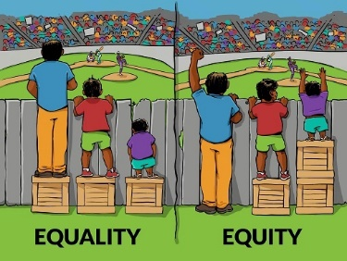

You will consider how and why these four issues are important for organisations and how they are defined. You will also consider how they relate to the UK’s Equality Act 2010 (EqA 2010), to issues of positive discrimination and affirmative action, and to the concept of intersectionality.

1.1 Equality

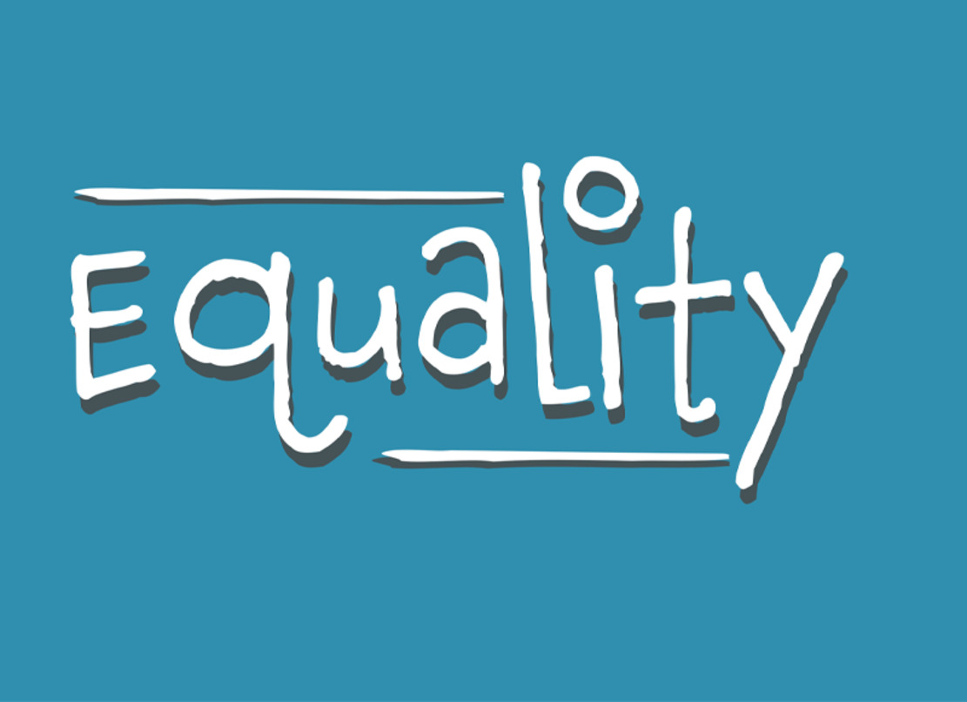

Equality is considered to mean that everyone irrespective of, for instance, their age, ethnicity, gender and physical ability, has the same access to resources and opportunities. Equality means that a person is not discriminated against because of their characteristics. Many countries have some form of equalities legislation. In the UK, the issue of equality at work is governed by the Equality Act 2010, which is a development of the Equal Pay Act 1970, the Sex Discrimination Act 1975 and the Race Relations Act 1976.
In the UK, implementation of the EqA 2010 is overseen and monitored by the statutory body the Equality and Human Rights Commission (EHRC), established in 2007. Enforcement of this Commission’s mandate varies, but is stronger in the public sector where there is additional legislation (Klarsfeld et al., 2012). Public sector organisations are required to set equality and diversity objectives and monitor progress. Diversity activities receive formal attention in the public sector and consequently are often better resourced and have greater breadth and coverage compared to within the private sector (Tatli et al., 2008); but discrimination still persists (Colley et al., 2021).
The EqA 2010 states that:

The following characteristics are protected characteristics:
- age
- disability
- gender reassignment
- marriage and civil partnership
- pregnancy and maternity
- race
- religion or belief
- sex
- sexual orientation.
(Equality Act 2010)

Each of these protected characteristics identified in the EqA 2010 has related specific legislation that protects individuals having that characteristic from discrimination. The EqA 2010 provides further guidance and explanation concerning each of these protected characteristics. Finally, it provides for the duties that are required of employers, organisations and institutions, particularly those in the public sector.
Note that the legislation allows for some flexibility of interpretation. There may be individual cases where discrimination against a protected characteristic may be considered to have been proportionate and, on occasion, different protected characteristics may conflict.

1.2 Equity

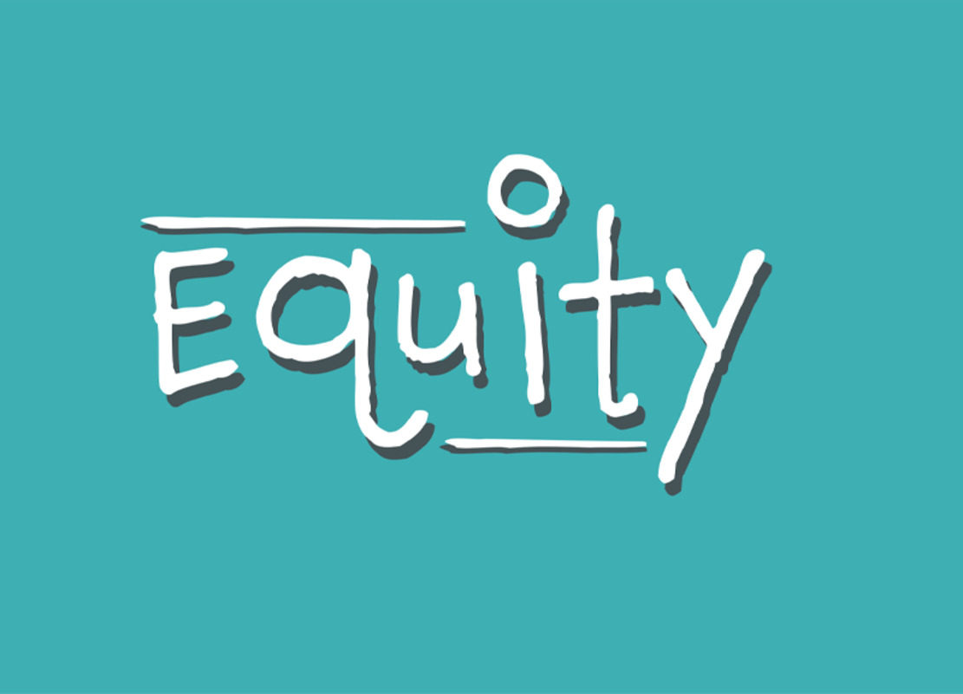

Equality is not the same as equity. While the former ensures that people have the same access to resources and opportunities, it also assumes that everyone has the same needs, abilities and so on. Equity focuses on assessing the needs of an individual and ensuring that they are suitably supported to achieve the same outcomes and have the same opportunities as other people.
Equity in the workplace may be enhanced through, for instance, mentoring programmes for under-represented groups, family- and carer-friendly policies that allow flexible working patterns (Collins et al., 2021), and additional training, support and resources. In the UK positive discrimination and in the USA affirmative action are considered ways to promote equity. In either case, preferential treatment is given to people from an under-represented group, for example to increase their representation in the workforce. This treatment is more active in its approach than simply, for example, basing recruitment decisions on neutral and objective criteria.
In the UK, positive discrimination is considered as a potentially discriminatory practice. Employers and HR practitioners must abide by the EqA 2010 and not discriminate in relation to protected characteristics. The policy of 50/50 recruitment of Catholics and Protestants in the police force in Northern Ireland, considered as an act of positive discrimination towards Catholics, ended in 2011 in favour of ‘recruitment on merit’.

1.3 Diversity

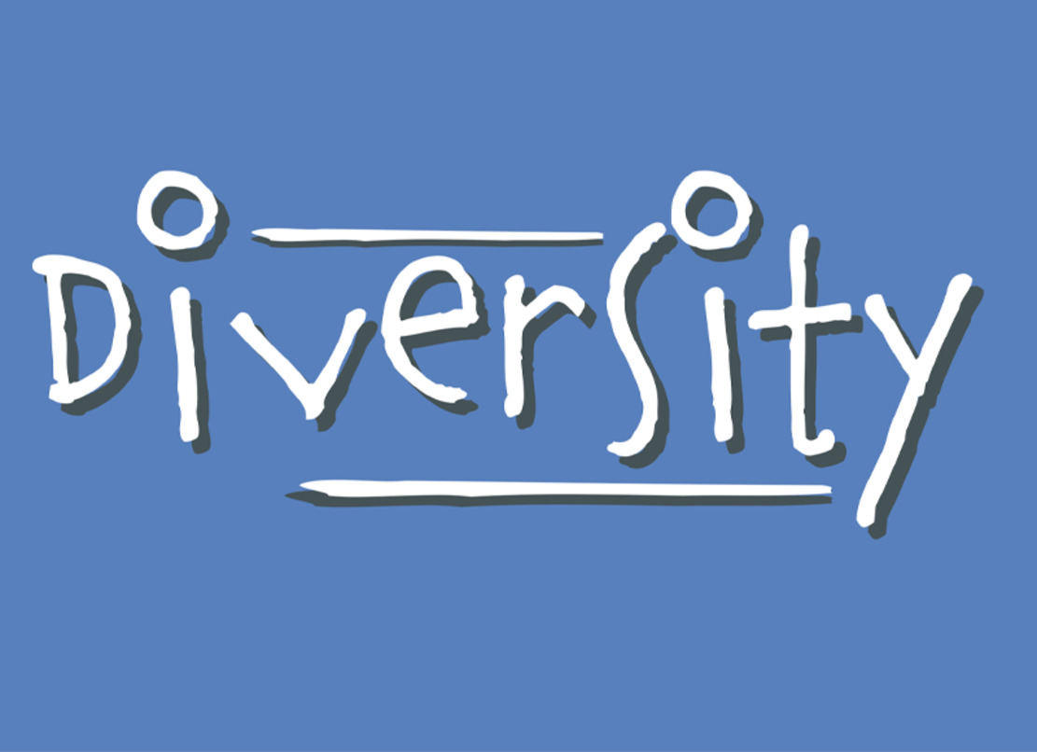

The academic interest in diversity may be traced back to a concern expressed in Workforce 2000 (Johnston and Parker, 1987) that in the USA women and ethnic minority groups would by the mid-1990s comprise a larger fraction of the US adult workforce than the traditional white males who had historically been the majority. Managers would therefore be faced with having to manage a diverse workforce. Work processes also became more complicated, requiring an increasing use of multifunctional and multi-skilled teams often drawn from different parts of an organisation.
Collaboration, team work and an ability to manage people with different skills, knowledge and abilities have increasingly become part of a manager’s work. While diversity includes, for instance, age, ethnicity and race, physical disability and gender, it may also be extended to include economic class, marital status, sexual orientation, education level, mental health, etc. Some of these may be visible (ethnicity), others invisible (education) and many may be open to change (marital status); some refer to the characteristics of the individual (age), while some may be concerned with the beliefs, norms and values of a group (religion). (It may even be the case that a visible characteristic (for example, age) can suggest an invisible one (people in particular age groups may hold the generally-ascribed values of that age group.)) In addition, in recent years attention has increasingly been paid to specific aspects affecting a particular category of people – for instance, looking at how women are affected by the menopause (Atkinson et al., 2021; Jack et al,, 2019).
In work, diversity of thought may also be important. It may help to broaden the understanding of an issue and reduce the potential for groupthink. It may also help an organisation to find creative and novel solutions to problems and issues.
Diversity thus can be understood to mean that staff have different personal, social and cultural backgrounds and characteristics.

1.4 Inclusion

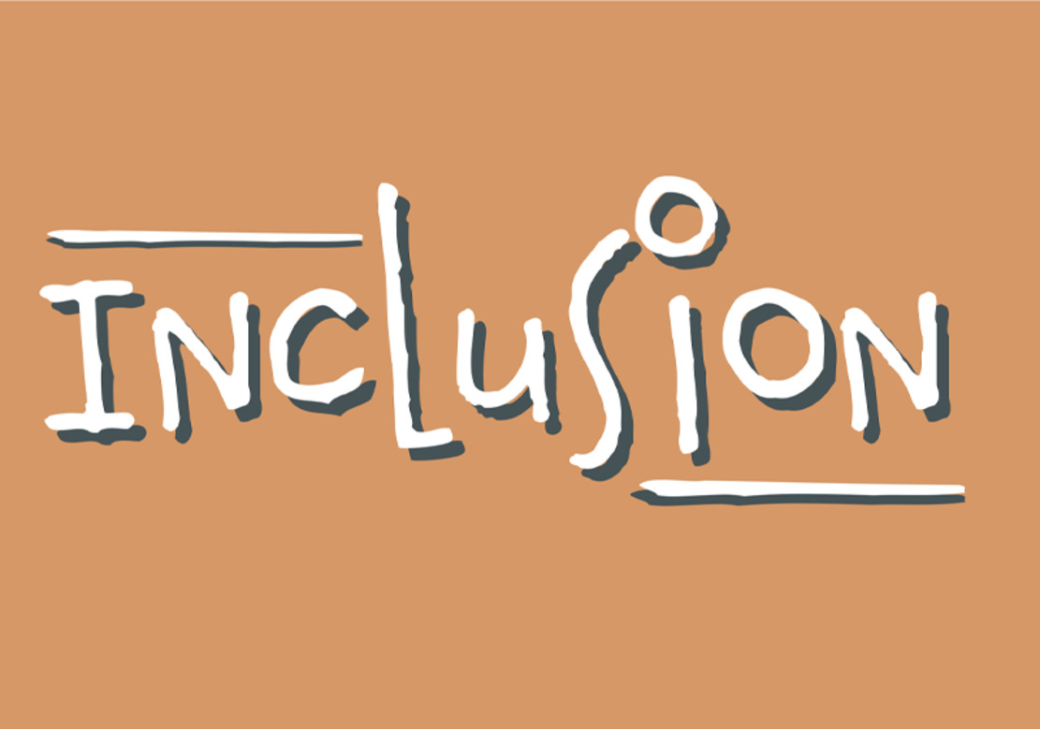

Research has considered both the persistence of discriminatory practices in work in spite of decades of equality legislation and how and why EDI initiatives may fail in organisations (for instance, Colley et al., 2021; Dobbin and Kalev, 2016; Noon and Ogbonna, 2021).
Many organisations have policies and initiatives concerned with improving and supporting EDI and some, like public sector organisations, are required to do this. Organisations whose boards of directors and senior management teams comprise only people whose gender, economic status and ethnic group reflect a privileged elite within society are not representative of society broadly. They may not have experienced how work policies and regulations may affect a diverse staff and, in some cases, may oppose the inclusion of people on the board of directors who have an identity, experiences or needs different from their own.
Inclusion, while related to equality, equity and diversity, moves from a focus on who is present in an organisation to a focus on how and where they are involved and represented. At its most basic, an organisation may have equal proportions of men and women in its employ, but the organisation may be discriminating against women if they are disproportionately excluded from senior, decision-making roles. Inclusion means that everyone should be welcomed and valued in the organisation.

1.5 EDI and intersectionality

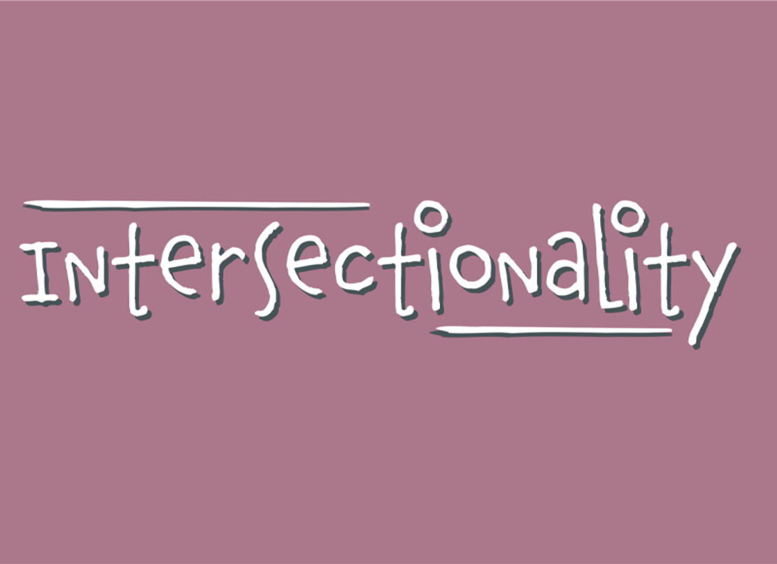

Individuals have many different characteristics and how these may interrelate and affect us to create interdependent systems of discrimination and disadvantage is considered as an issue of intersectionality (Crenshaw, 1989, 1991). The disadvantages that a Black neurodivergent woman may face may be different from those of a white neurodivergent woman and also different from those of a neuro-typical Black man. The whole story of discrimination may not simply be understood by ‘unpacking’ the individual protected characteristics in isolation of the others. Intersectionality underscores how discrimination is amplified through the crossing over and meshing of the experience of those characteristics.
It is not enough to understand the discrimination faced by a neurodivergent Black woman by considering her as a woman, or as neurodivergent, or as Black, or as a neurodivergent woman, or as a Black woman, or as a neurodivergent Black person. For intersectionality, the important issue is how gender, neurodiversity and race and ethnicity, for instance, combine to discriminate against the life chances of a neurodivergent Black woman in ways that are different from a neuro-typical Black woman, or a neurodivergent Black man, or a neurodivergent white man, and so on. Those disadvantages are dynamic and affected by social, cultural and historical contexts. The concepts of diversity and intersectionality put into sharp relief that EDI is an issue of power at work and in society more broadly. Those who are better able to exercise power are more able to determine what work is, who performs it, and where and how.

Activity 1 Thinking about EDI and intersectionality

Choose two equality characteristics, one visible and one invisible. Use information freely available in the public domain to find out what policies an organisation of your choice may have concerning EDI and those two characteristics.
Based on your research answer the following questions:
- What does the organisation do to include people at work with the two characteristics that you chose?
- If you were appointed as the organisation’s HR director what, if anything, would you do about EDI in the organisation?
Record your notes, up to 150 words, in the text box below.

Provide your answer...

2 Key HR practices in relation to EDI: the example of bullying and harassment
So far you have considered what EDI is and both the legislation and organisational policies that may exist concerning EDI. However, HR practices are diverse. Specifically, HR professionals develop practices of applying the EDI legislation.
For example, people may face discrimination and exclusion not only because of organisational and institutional issues but also because of the actions of individuals. While the latter may be the actions of an individual rather than an organisation, an HR professional may nonetheless be required to mitigate those actions. What you will now consider is how you might take positive action in the workplace to reduce bullying and harassment.
In the UK, bullying is not unlawful but harassment is unlawful when it relates to the protected characteristics under the terms and provisions of the EqA 2010. Harassment is unwanted behaviour that may make a person feel offended or intimidated and may include:
- unfair treatment
- creating and spreading malicious rumours
- regularly picking on or undermining someone
- denying someone promotion or training opportunities.
While harassment, and particularly harassment because of protected characteristics, may be unlawful, it is nonetheless common in work environments and may even be considered as acceptable in some organisations. For example, Kensbock et al. (2015) discuss the sexual harassment of room attendants in five star hotels, Good and Cooper (2016) describe sexual harassment in service sector employment, and Ozkazanc-Pan (2018) discusses sexual harassment at work post the #MeToo movement. Indeed, prior to #MeToo, harassment was normalised in some sectors whereby a victim’s employment could end if they objected. There is a long history of, for example, women being sexually harassed at work who then found that their employment ceased when they complained.

Activity 2 Dealing with harassment

- Use the internet to find advice for employers on workplace policies to deal with harassment. One example is provided by the Advisory, Conciliation and Arbitration Service (ACAS) here: Handling a bullying, harassment or discrimination complaint at work. You may use this example, or if you prefer to you may find and use your own.
- Choose one of the nine protected characteristics in the EqA 2010. Based on the information you have gathered suggest three steps or practices that an employer may undertake to protect an employee with the protected characteristic from harassment at work. Record your suggestions in the text box below.

Provide your answer...

Conclusion
During this OpenLearn course you have reflected on the issue of EDI at work. You were introduced to these terms plus the related concepts of equity and intersectionality. You were also encouraged to consider how implementing EDI in the workplace involves a variety of HR practices that are important for the work of HR professionals.
This OpenLearn course is an adapted extract from the Open University course B810 The role of the human resource professional, which forms part of the OU’s MSc in Human Resource Management.

References
ACAS (2024) Handling bullying and discrimination. Approaching a complaint. Available at: https://www.acas.org.uk/handling-a-bullying-discrimination-complaint (Accessed 22 July 2025).
Atkinson, C., Beck, V., Brewis, J., Davies, A. and Duberley, J. (2021) ‘Menopause and the workplace: new directions in HRM research and HR practice’, Human Resource Management Journal, 31, pp. 49–64.
Chartered Institute of Personnel and Development (CIPD) (2022) Our purpose and vision. Available at https://www.cipd.co.uk/about/who-we-are/purpose (Accessed: 22 July 2025).
Colley, L., Williamson, S. and Foley, M. (2021) ‘Understanding, ownership, or resistance: explaining persistent gender inequality in public services’, Gender, Work and Organization, 28(S1), pp. 284–300.
Collins, C., Landivar, L.C., Ruppanner, L. and Scarborough, H. (2021) ‘COVID-19 and the gender gap in work hours’, Gender, Work and Organization, 28(S1), pp. 101–12.
Crenshaw, K. (1989) ‘Demarginalizing the intersection of race and sex: a black feminist critique of antidiscrimination doctrine, feminist theory and antiracist politics’, University of Chicago Legal Forum, 1(8), pp. 139–67.
Crenshaw, K. (1991) ‘Mapping the margins: intersectionality, identity politics, and violence against women of color’, Stanford Law Review, 43(6), pp. 1241–99.
Dobbin, F. and Kalev, A. (2016) ‘Why diversity programs fail and what works better’, Harvard Business Review, 94(7–8), pp. 52–60.
Good, L. and Cooper, R. (2016) ‘“But it’s your job to be friendly”: employees coping with and contesting sexual harassment from customers in the service sector’, Gender, Work and Organization 23(5), pp. 447–69.
Jack, G., Riach, K. and Bariola, E. (2019) ‘Temporality and gendered agency: menopausal subjectivities in women’s work’, Human Relations, 72(1), pp. 122–43.
Johnston, W.B. and Parker, A.E. (1987) Workforce 2000: Work and Workers for the Twenty-First Century. New York, NJ: Hudson Institute.
Kensbock, S., Bailey, J., Jennings, G. and Patiar, A. (2015) ‘Sexual harassment of women working as room attendants within 5–Star hotels’, Gender, Work and Organization, 22(1), pp. 36–50.
Klarsfeld, A., Ng, E. and Tatli, A. (2012) ‘Social regulation and diversity management: findings from France, Canada, and the UK’, European Journal of Industrial Relations, 18(4), pp. 309–27.
Legislation.gov.uk (n.d.) Equality Act (2010) Available at: https://www.legislation.gov.uk/ukpga/2010/15/part/2/chapter/1 (Accessed: 22 July 2025).
Noon, M. and Ogbonna, E. (2021) ‘Controlling management to deliver diversity and inclusion: prospects and limits’, Human Resource Management Journal, 31, pp. 619–38.
Ozkazanc‐Pan, B. (2018) ‘On agency and empowerment in a #MeToo world’, Gender, Work and Organization, 26(8), pp. 1212–20.
Tatli, A., Özbilgin, M.F., Worman, D. and Price, E. (2008) State of the Nation, Diversity in Business: A Focus for Progress. London: CIPD.

Acknowledgements
This free course was written by Charles Barthold.
Except for third party materials and otherwise stated (see terms and conditions), this content is made available under a Creative Commons Attribution-NonCommercial-ShareAlike 4.0 Licence.
The material acknowledged below is Proprietary and used under licence (not subject to Creative Commons Licence). Grateful acknowledgement is made to the following sources for permission to reproduce material in this free course:
Images
Course image: designer491/Getty Images
Introduction image: geralt/Pixabay
Section 1 image: Interaction Institute for Social Change | Artist: Angus Maguire. interactioninstitute.org and madewithangus.com
Every effort has been made to contact copyright owners. If any have been inadvertently overlooked, the publishers will be pleased to make the necessary arrangements at the first opportunity.
Don't miss out
If reading this text has inspired you to learn more, you may be interested in joining the millions of people who discover our free learning resources and qualifications by visiting The Open University – www.open.edu/openlearn/free-courses.

