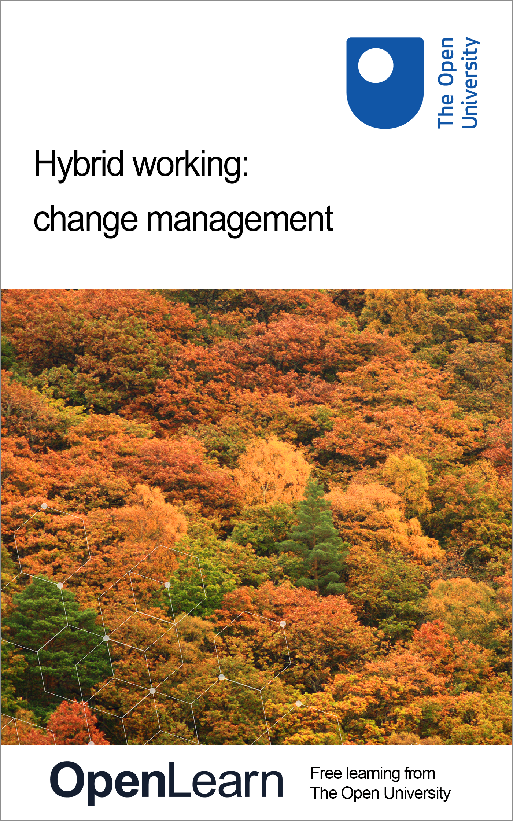

HYB_3 Change management for hybrid working

Change management for hybrid working

This publication forms part of the Open University Supporting hybrid working and digital transformation OpenLearn collection. Details of this and other Open University modules can be obtained from Student Recruitment, The Open University, PO Box 197, Milton Keynes MK7 6BJ, United Kingdom (tel. +44 (0)300 303 5303; email general-enquiries@open.ac.uk).
Alternatively, you may visit the Open University website at www.open.ac.uk where you can learn more about the wide range of modules and packs offered at all levels by The Open University.
The Open University,
Walton Hall, Milton Keynes
MK7 6AA
First published 2022.
Unless otherwise stated, copyright © 2022 The Open University, all rights reserved.
All rights reserved. No part of this publication may be reproduced, stored in a retrieval system, transmitted or utilised in any form or by any means, electronic, mechanical, photocopying, recording or otherwise, without written permission from the publisher or a licence from The Copyright Licensing Agency Ltd. Details of such licences (for reprographic reproduction) may be obtained from: The Copyright Licensing Agency Ltd, 5th Floor, Shackleton House, 4 Battle Bridge Lane, London, SE1 2HX (website www.cla.co.uk).
Open University materials may also be made available in electronic formats for use by students of the University. All rights, including copyright and related rights and database rights, in electronic materials and their contents are owned by or licensed to The Open University, or otherwise used by The Open University as permitted by applicable law.
In using electronic materials and their contents you agree that your use will be solely for the purposes of following an Open University course of study or otherwise as licensed by The Open University or its assigns.
Except as permitted above you undertake not to copy, store in any medium (including electronic storage or use in a website), distribute, transmit or retransmit, broadcast, modify or show in public such electronic materials in whole or in part without the prior written consent of The Open University or in accordance with the Copyright, Designs and Patents Act 1988.
Edited and designed by The Open University.

ISBN XXX X XXXX XXXX X
X.X

Contents
- Introduction
- Learning outcomes
- 1 The need for change
- 2 What are you trying to change and why?
  - 2.1 The Golden Circle and 5 Ws and H
  - 2.2 Situation assessment
- 3 What do we mean by change management?
  - 3.1 Hard and soft factors
  - 3.2 Using a change framework
  - 3.3 Engaging stakeholders
  - 3.4 Stakeholder engagement plan
- 4 Communicating change
  - 4.1 The importance of a communications plan
  - 4.2 The 7 Cs of communication
  - 4.3 Change networks
- 5 Assessing the change required
  - 5.1 Supporting structure
  - 5.2 Strategic analysis
- 6 Leading change
  - 6.1 Managing yourself and others
  - 6.2 Business change approaches
  - 6.3 Analysing tension
- 7 Managing change
- 8 Sustaining change
- 9 Building your change toolkit
  - 9.1 Lewin’s change management model
  - 9.2 The 7S model
  - 9.3 Kotter’s eight-step change model
  - 9.4 Prosci’s ADKAR change model
  - 9.5 Choosing a suitable framework
- Conclusion
- References
- Acknowledgements
- Solutions
- Descriptions

Introduction
Your role within an organisation will influence how comfortable you are with change. If you are responsible for driving and delivering change initiatives, it can be easy to focus on the desired outcomes rather than the journey you need to take people on.
The COVID-19 pandemic forced accelerated changes in the workplace and in personal lives. The impact is that people’s resilience to change will have grown for some, but for others, change will be something they are fearful of. The impact for change leaders is that the focus on people is now more important than ever, not only considering the wellbeing of those involved but also expectations, especially when working in hybrid organisations, where one size will not fit all.
This course aims to help you take a change initiative you need to implement, focusing on the approaches, frameworks, and tools you can use to manage the process in a more caring way, and take a sustainable human-centred approach to change, by putting the needs of people at the heart of your initiative and considering more sustainable ways of working.
We focus on functional and operational changes that help organisations deliver their strategies, rather than organisational changes, as these tend to be the change initiatives that most members of an organisation frequently experience.
To assist with thinking about change and organisational development in a different way, the ‘Hybrid ways of working: a contextual sustainability framework’ illustrated below has been designed for this collection to highlight the key areas you need to consider when thinking about organisational development. As many organisations and higher education institutions (HEIs) continue to evolve their hybrid practice, how you work and plan for the long term is essential. You need to balance the needs of your stakeholders and organisation while embracing and adapting to external factors to successfully meet strategic objectives.
The framework helps you to consider and understand your organisational context and needs from key perspectives.
- You and your ways of working should take account of the key stakeholders within your environment and their needs in relation to organisational development.
- You need to understand organisational requirements; the context, connections, and requirements for key areas of focus; and how these relate to the needs of your stakeholders.
- You need to consider your ways of working for the wellbeing of future generations.

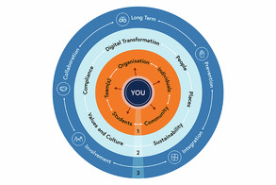
Figure 1 Hybrid ways of working: a contextual sustainability framework
View description - Figure 1 Hybrid ways of working: a contextual sustainability framework

In this course we do not focus on how to establish what you need to change. If you are new to planning for change, you may find it useful to study the Hybrid working: planning for the future course, which provides approaches for planning and focusing on what change is needed.

Learning outcomes
By the end of this course, you will be able to:
- describe what is meant by ‘change’ and what can be a catalyst for change
- explain what change management is and what processes and tools are needed to implement and sustain change
- identify how to lead change and the impact that change can have on people and organisations
- explore different frameworks and structures for change and examine how they can be used by organisations driving change around hybrid working
- manage the change lifecycle to enable change to be adopted and embedded within organisations.

1 The need for change
During his Day of Affirmation Address at the University of Cape Town in 1966, Robert F Kennedy said:

There is a Chinese curse which says, ‘May he live in interesting times.’ Like it or not, we live in interesting times. They are times of danger and uncertainty; but they are also the most creative of any time in the history of mankind.
(Kennedy, 1966)

This speech took place decades ago, but it seems that in every decade since, something of note has made that decade ‘interesting’ – whether it be man setting foot on the moon, birth control pills, DNA sequencing, the Internet, fibre optics, mobile phones, GPS, online shopping, social media, or services on demand like Uber. And, of course, COVID-19 kicked off the 2020s in the most ‘interesting’ way: it changed how we live and work and saw the acceleration of digital transformation but also brought a focus on wellbeing, inclusion, and the digital divide.
In video below, contributors share their experiences of adapting ways of working during the COVID-19 pandemic in 2020 and how they managed the changes required.

Video content is not available in this format.
Video 1 Operating during COVID-19
View transcript - Video 1 Operating during COVID-19

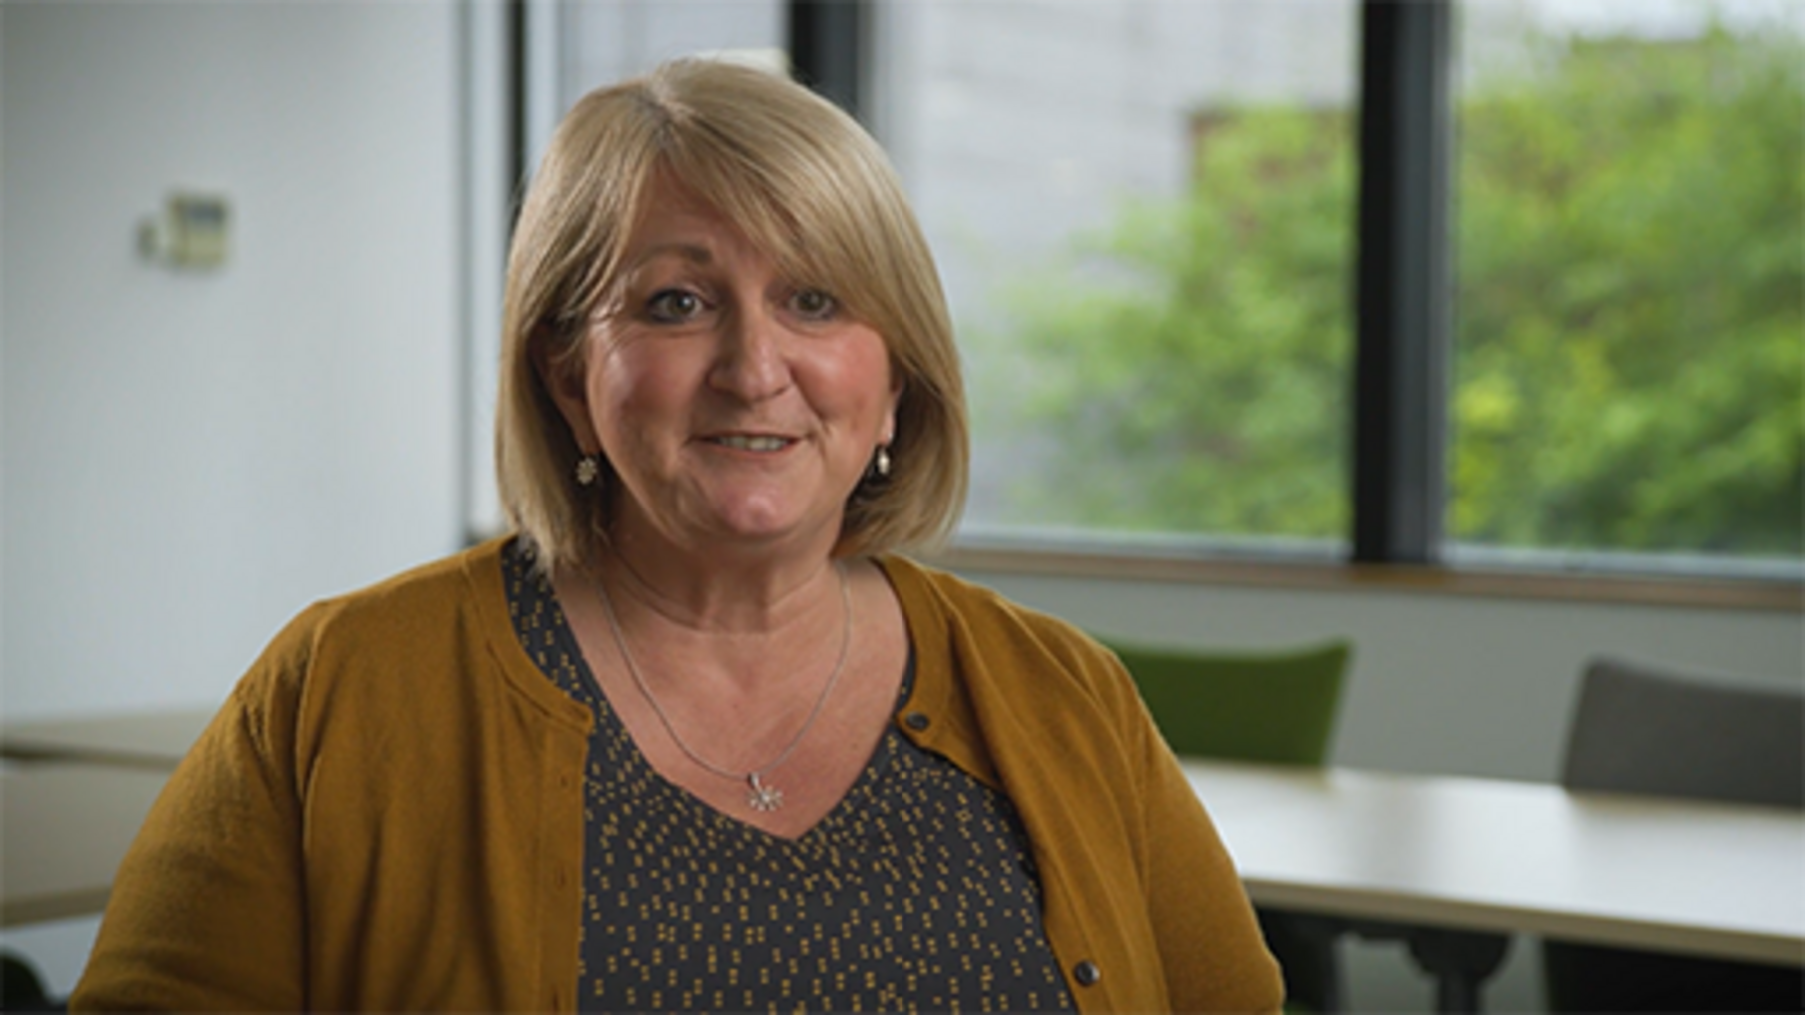

Responding to COVID-19 also showed what was possible and led to amazing rapid innovation and change implementation, such as vaccines being developed and pushed through human trials for approval for medical use, and the delivery of an unprecedented vaccination programme in the modern day in months rather than years. This was achieved by global collaboration between pharmaceutical companies, universities and governments to shorten the timeline between creativity, invention, innovation and the rollout of massive change, all under the unforgiving scrutiny of the media and the public.
In the post COVID-19 era, in a continued period of uncertainty, including economic uncertainty and cost of living challenges, people’s expectations, buying habits, trust and behaviour remain in flux. As a result, organisations, governments, public bodies, healthcare systems and even charities need to innovate new products, services and processes to compete. To do so means that invariably they need to undergo almost continuous change.
This need for change can come about, as Senior et al. (2020) point out, from any source and influence, be it socio-cultural, political-legal, technological or economic. To respond to that need can often mean that disciplines from across the entire organisation or wider ‘system’ have to work together.
Change often involves changing ways of working, policies, processes and procedures and adopting or developing new technology as well as delivering new products and services.
Change is not always easy, and the most important consideration for change is that it involves people who have different needs, expectations and comfort levels with change. For those leading change, being empathic and understanding about resistance to change is a skill that needs to be developed, alongside resilience, as people tend to go through a range of emotions at different stages of the change ‘journey’, as depicted in John Fisher’s (2012) Personal Transition Curve, shown in Figure 2.

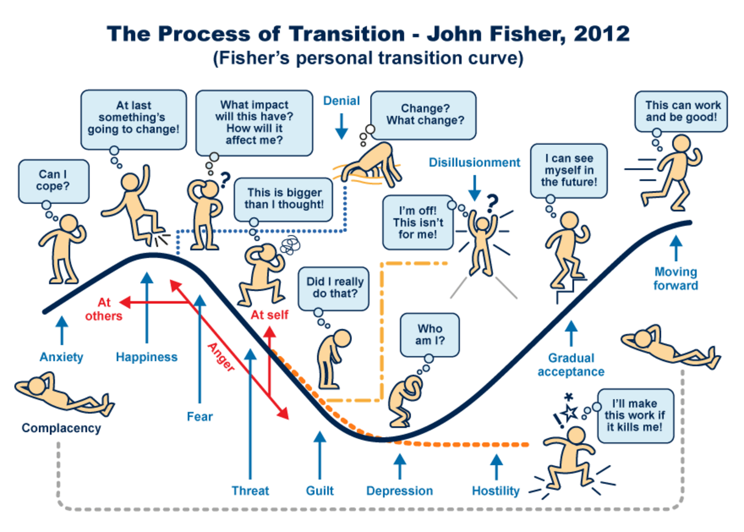
Figure 2 The process of transition – Fisher’s Personal Transition Curve (Fisher, 2012)
View description - Figure 2 The process of transition – Fisher’s Personal Transition Curve (Fisher, ...

At times, feedback can feel like a personal criticism of you and the change you are trying to make. Those leading change require not only the ability to listen and take criticism as constructive feedback from which to evaluate and learn but also the confidence to make informed decisions and be honest about what is possible.

Activity 1 How do you feel about change?
5 minutes

Look at Fisher’s personal transition curve, and reflect on the following:
- How did you cope with the different COVID-19 ‘lockdowns’ during 2020 and 2021?
- Think about a recent unexpected change you have had to deal with; how did you cope with it?

View discussion - Activity 1 How do you feel about change?

We know that change can be inevitable. We know that change can be difficult. A first step towards dealing with change is to clarify what exactly it is that needs to change and why. We look at this in the next section.

2 What are you trying to change and why?
Change is an inevitable continual process within organisations. Most people will experience change, from a small policy change to the introduction of new technical systems to new product delivery to major organisational restructures and changes to ways of working.
Your involvement in change will vary based on your role within the organisation. Whether you are leading or adapting to change, understanding the change process is useful to help you feel more comfortable with change. If you are experienced in change management, it is an opportunity to reflect on your own practice and consider whether your approach could be developed to help others on their journey of change.
In the last activity you were asked to reflect on how you feel about change. Acknowledging how comfortable you are with change will help you consider your approach if you are leading change and raise your awareness of how you naturally react to change so you can build your own resilience for adapting and accepting it.
Understanding how you feel will assist in your approach when a need for change arises and may assist in how you answer the following key questions:
- What are you trying to change?
- Why?
If you have identified it is a change that is necessary, always ask yourself WHY? Is it for a personal or professional reason that you want the change? We often think a change is required because of how we approach tasks/situations. While it might benefit you as an individual, is it something that is actually needed or will make a difference to others?
If a change is identified by others and you are either leading the change on their behalf or working as part of a change team, while you still need to understand what you are trying to change and why, you are not the owner of the answer but rather a facilitator – someone to ensure delivery of the change that is actually required. In some cases, this can mean either recommending a change in a different direction or stopping the initiative altogether.
Ensuring that you understand your ‘Why’ in relation to the organisational strategy and needs is essential for change. To understand this approach, the Hybrid working: planning for the future course explores ‘What’s your why?’ in more depth. In the meantime, we consider two approaches in brief in the next section.

2.1 The Golden Circle and 5 Ws and H
Simon Sinek, an author and inspirational speaker, uses the Golden Circle theory to assist leaders establish and understand their ‘why’. His belief is that most people will know the ‘How’ and ‘What’ an organisation does, but not necessary the ‘Why’. The ‘Why’ for organisations is often encapsulated in their mission statement. The vision statement reflects the ‘What’, and the values and objectives statements describe the ‘How’. The figure provides an overview.

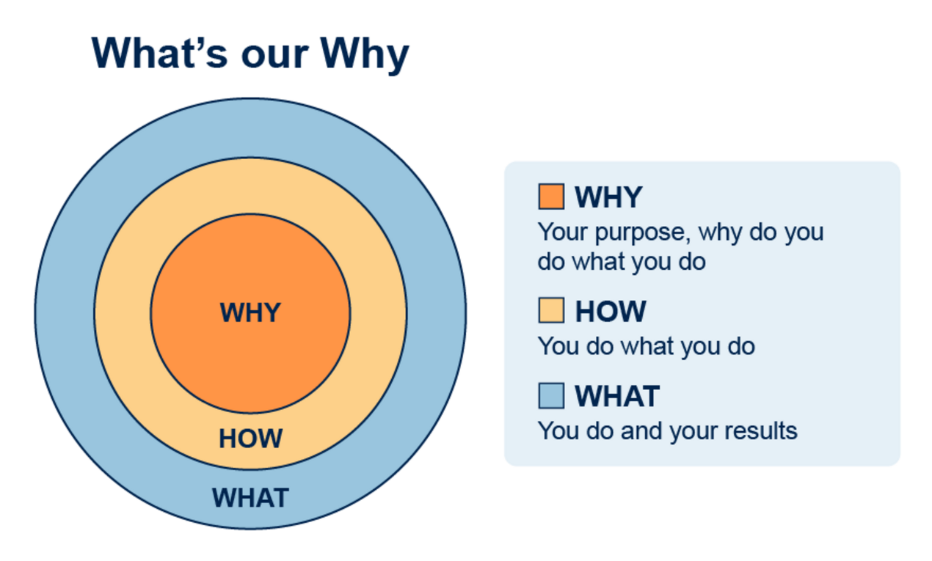
Figure 3 Simon Sinek's 'Golden Circle' (2009)
View description - Figure 3 Simon Sinek's 'Golden Circle' (2009)

An alternative simple approach for establishing what and why is to ask the 5 Ws and H questions for assessing why change is needed. If you consider the decisions you make every day, you may unconsciously use this approach. For example, when you go shopping; ask yourself:
- What do you want to buy?
- Why do you need it?
- Where will you get it from?
- When are you going to go?
- Who needs to come with you?
- How will you get there?
When applying this approach in an organisational context, you will have different questions depending on the change you are being asked to consider. Some example questions are shown in the table below.

Table 1 The 5 Ws and H
What | Why | When | Where | Who | How
What is the desired outcome?  What is the benefit of doing this?  What if we don’t do it? | Why do we need it?  Why is it needed now? | When is it needed by? | Where is it needed? | Who asked for the change?  Who needs to be involved?  Whom does it impact? | How will it be done?

The order can vary depending on the context, but arguably the two most important Ws are the Why and the What, as these will help to inform the questions you may want to ask for the When, Where and Who in order to establish the How.
Why: You need to establish why this change is actually required so you can make the decision whether to proceed. Throughout the process you should always come back to the Why, even when a decision has been made.
What: The actual outcome desired needs to be established. Often when a change is requested, the first outcome stated is not always the actual outcome that is needed. Using the 5 Ws approach helps to surface what is needed and whether it is actually required. You may in fact decide to stop.
Once you are confident that you have your Why and your What, you can then start to focus on the How.
If you are a public body based in Wales, you may wish to link to the following frameworks list below:
- Future Generations Framework for scrutiny (Future Generations Commissioner for Wales, 2019)
- Future Generations Framework for service design (Future Generations Commissioner for Wales, 2018)
- Future Generations Framework for projects (Future Generations Commissioner for Wales, n.d., a)
- Guidance on using the Future Generations Framework for projects (Future Generations Commissioner for Wales, n.d., b)
These provide guidance on how to establish the connections of your change initiatives or projects to the Well-being of Future Generations (Wales) Act 2015’s seven wellbeing goals and consider their five ways of working.
If you are not familiar with the wellbeing goals and five ways of working, you may wish to review the Sustainability and wellbeing section in the Hybrid working: organisational development course.

Activity 2 What are you trying to change?
20 minutes

In this course you will be looking at how you can implement change management at your organisation. To begin, you should take the time now to think about a particular change in your organisation and the scope of what it is you are trying to change.
If you do not have a change to implement, you may wish to use one of the ‘Simple Changes’ on the Future Generations Commissioner for Wales (2022) website.
Use the following questions as prompts:
- Why are you doing it; what are the drivers?
- What technology will be involved in supporting the change?
- What processes will the change impact?
- Who will be impacted and how?
- How do you think they will react to the need for change?
- How do you think they will feel about the change itself?
- What benefits will the change bring?
You can use the text box below to capture your reflections, if you wish.

Provide your answer...

2.2 Situation assessment
Having identified the change you want to make, it is useful to carry out a situation assessment to help consider the elements of your change initiative and plan how to have better conversations with your stakeholders.
We look at stakeholders in more detail later in the course.
The content of a situation assessment often includes:
- Change characteristics – begin by understanding the change that is being introduced. Why are you undertaking the change, what are the drivers, what are the desired outcomes, how will you measure the change’s success? Changes can be formalised projects, strategic initiatives or even small adjustments to how the organisation operates. Understanding the characteristics of the change requires you to answer questions like: What is the scope of the change? How many people will be impacted? Who is being impacted? Are people being impacted the same way, or are they experiencing the change differently? What is being changed – processes, systems, job roles, etc.? What is the timeframe for the change?
- Organisational attributes – next, work to understand the people and groups being impacted by the change. The organisational attributes are related to the history and culture in the organisation and describe the backdrop against which this change is being introduced. What is the perceived need for this change among employees and managers? How have past changes been managed? Is there a shared vision for the organisation? How much change is going on right now?
- Impacted groups – the final step in building your situational awareness is developing a map of who in the organisation is being impacted by the change and how they are being impacted. A single change – say, the deployment of a web-based expense reporting system – will impact different groups very differently. Employees who do not have expenses to report will not be impacted at all. Staff who travel once a quarter will be only slightly impacted. Associates who are on the road all the time will be more impacted, although filing expenses is only a portion of their day-to-day work. For those in accounting who manage expense reporting, however, their jobs will be completely altered. Outlining the impacted groups and showing how they will be impacted enables specific and customised plans later in the change management process.

Activity 3 Evidence for change
20 minutes

Watch the video in which Dr Nick Barratt, Director, Learner and Discovery Services at The Open University, explains the evidence for leading change at The Open University as they adapt to new ways of working following the COVID-19 pandemic.

Video content is not available in this format.
Video 2 Evidence for leading change
View transcript - Video 2 Evidence for leading change

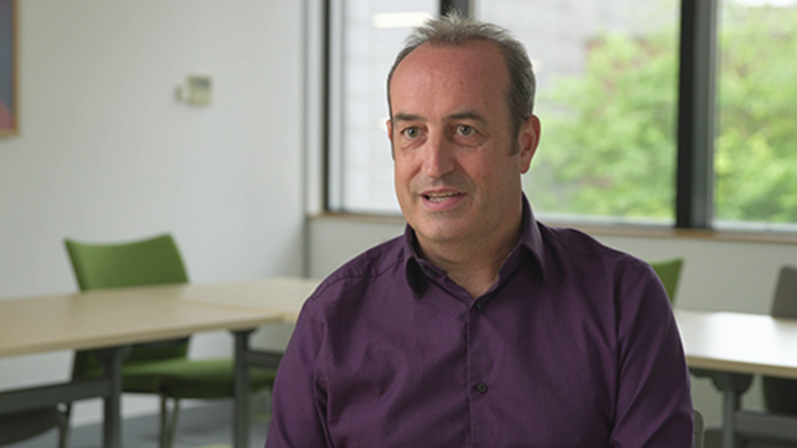

Then read the blog article by the change management company Prosci, 'Before you act, consider these keys to preparing for change' (Creasey, n.d.), which looks at the key activities you need to undertake when planning change management.
Drawing on the video and the article, answer the questions below for the change initiative you chose for Activity 2.
- What is the evidence that the change is required/why are you being asked to make this change?
- What evidence do you have, or do you need to gather, to make better decisions to support your change?
- What is the outcome you are hoping to achieve from the change?
- What evidence will you need to demonstrate the impact/outcomes?
Use the text box below to capture your reflections, if you wish.

Provide your answer...
View discussion - Activity 3 Evidence for change

In the next section we start to consider how the assessment of the situation can influence your change management process.

3 What do we mean by change management?
‘Change’ can be mapped onto a spectrum of scope, pace, complexity and scale; can be transformational (impacting an entire organisation); or can be a minor realignment of a single process. It can be proactive (addressing a future need) or reactive to an imminent challenge and can be hard or soft, planned or emergent. In terms of pace, change can be ‘continuous’ or ‘intermittent’, and in terms of scale, change can be reactive, planned, incremental, operational, strategic, radical, revolutionary or big-bang.

Activity 4 What do you think change management is?
10 minutes

Your experiences of change will influence what you think change management is and what it is not. You may have examples of change initiatives that have gone well and others less so. What were the differences in the approach to these initiatives, and what was the change they were trying to achieve?
Watch the video below and consider how it reflects your understanding and experiences of change management. You may wish to make notes in the box below.

Video content is not available in this format.
Video 3 What is change management?
View transcript - Video 3 What is change management?

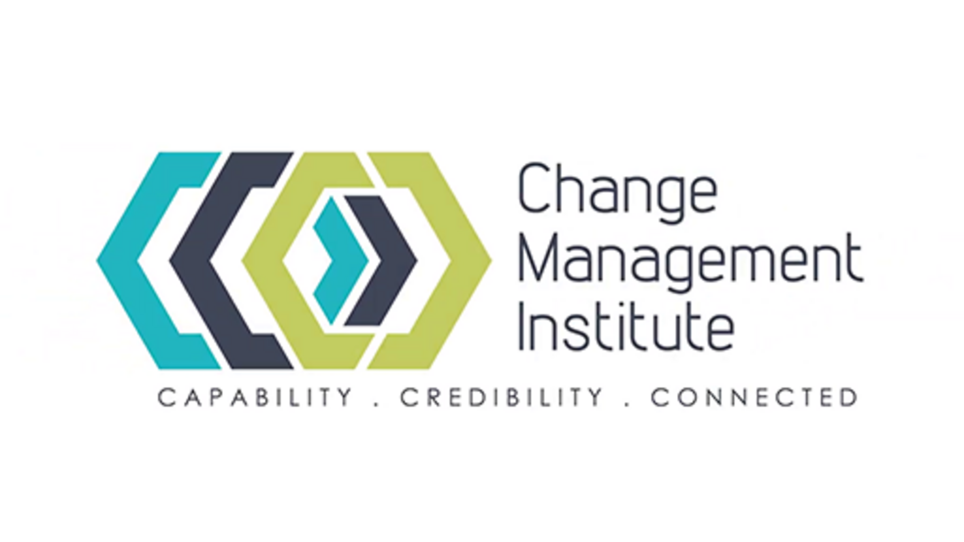

Provide your answer...

There are many definitions of change management in circulation, and most describe it in terms of a structured process and set of tools used for leading people from the current state to a future desired state to achieve an outcome. We explore some of the aspects of change management in the next steps.

3.1 Hard and soft factors
As a starting point, one aspect of change management that is useful to consider is the distinction between the so-called hard and soft factors of your organisation.
- Hard factors are generally easier to define or identify and are directly influenced by management. Examples of these include strategy statements, organisational structure and reporting relationships, formal processes and IT systems.
- Soft factors can be more difficult to describe; less tangible; and more likely to be influenced by history, tradition or culture. Soft elements can have equal or even greater impact than hard factors on the success of a change effort. Examples of these include leadership and communication styles, organisation values and norms, and individual and team competencies and skill sets.
(Workforce Management Strategies, n.d.)
Implementing a change initiative will involve an element of project management, and it useful to understand the boundaries to ensure that you are focusing on delivering change and not just managing a process. The video below explains the difference.

Video content is not available in this format.
Video 4 Change management vs project management
View transcript - Video 4 Change management vs project management

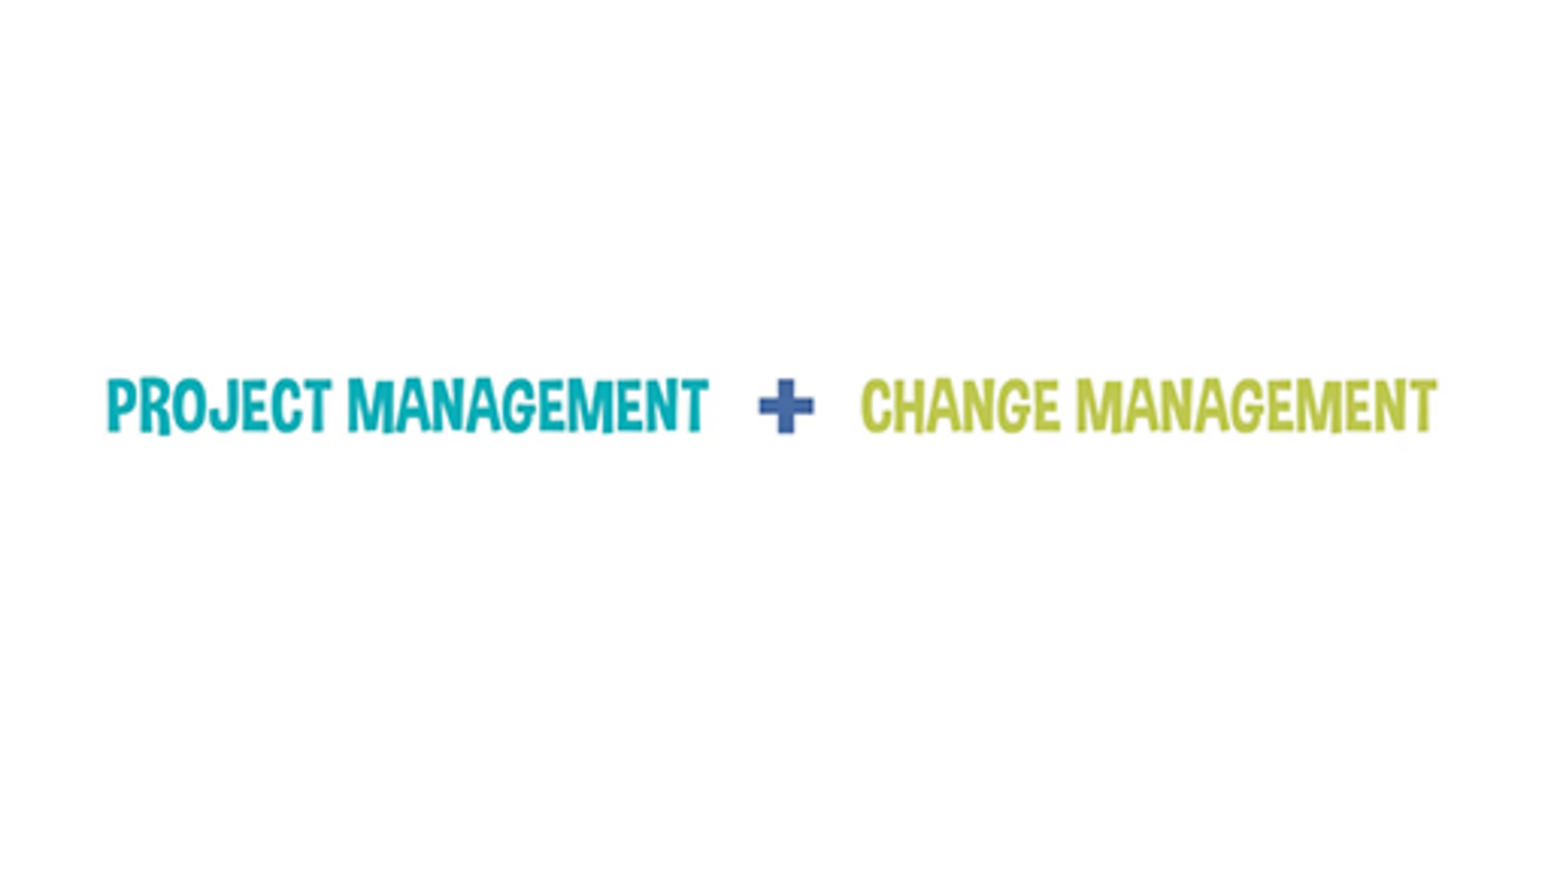

Change managers, therefore, are an essential role for all change initiatives; they are the champions of the change, and their primary focus should be the outcomes required. The video below, What does a change manager do? (CMI, 2021), provides a useful overview of the role of the change manager.

Watch the video at YouTube.com.
Video 5 What does a change manager do?
View transcript - Video 5 What does a change manager do?

3.2 Using a change framework
While some incremental or small changes do not require a formal approach, having an understanding of change frameworks can help to ensure successful outcomes. Later in this course, as your understanding of change management develops, we introduce frameworks that can be used for complex or large change initiatives. They will build on the principles of the frameworks below that can be used for underpinning most approaches to change.
The Change Management Institute (CMI)’s ‘Change practice framework’ (CMI, 2022a), shown below, focuses on four dimensions – define, analyse, co-design and refine. This is a circular process and needs to be underpinned by the context for change, your organisational context and your people. The ‘Hybrid ways of working: a contextual sustainability framework’ (which you came across in the introduction to this course) breaks this down further to ensure the connections and interdependencies across the organisations are fully considered.

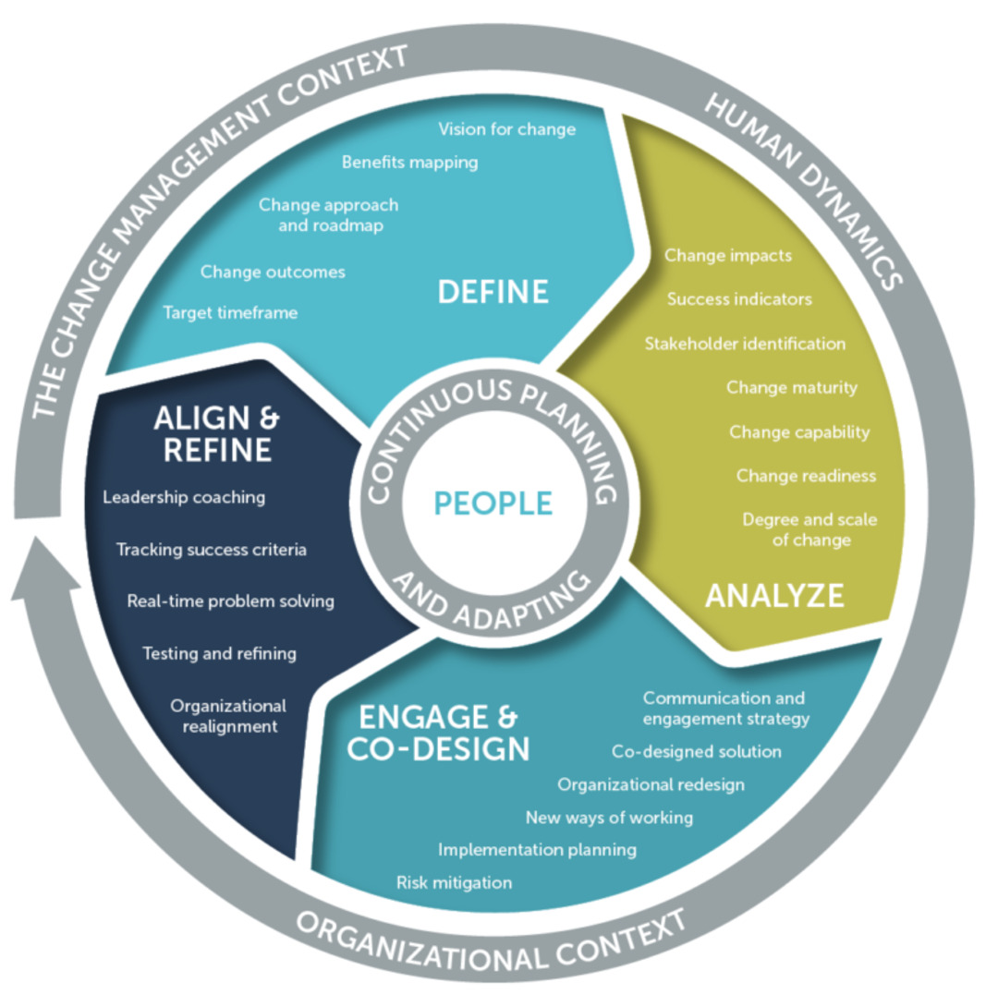
Figure 4 CIM Change Practice Framework
View description - Figure 4 CIM Change Practice Framework

This CMI framework provides a useful visual representation of the areas to consider, and the circular process. It is designed for change managers as part of The change management body of knowledge (CMBoK™)(CMI, 2022b).
We have simplified the CMI framework for the purposes of this course to take you through the key steps for change. The steps below provide a summary of elements you need to consider, but they are not exhaustive – you may have other elements you would like to add. We propose:
- Step 1: Assessing
- Step 2: Leading
- Step 3: Managing
- Step 4: Sustaining
Step 1: Assessing
Identifying options for change and building a shared understanding of the right change to make. There are many different activities that can be used to assess change, from those that surface barriers to change to those that identify new opportunities for change and those that help to enable change.
Tasks:
- Problem analysis – Why is there a need for change?
- Impact desired – What does success look like?
- Benefit – What will the benefits be?
- Type of change required – How complex is it?
- Readiness for change – Reflect on the ‘Hybrid ways of working: a contextual sustainability framework’ (see the introduction to this course)
- People – How will this impact them?
- Ability to problem solve – Who will you need?
- Organisational design – What is the context?
- Process design – How will you approach this?
- Experience design – What will it feel like?
Step 2: Leading
Actively promoting the vision and direction of change and influencing others to achieve buy-in. This is achieved by ensuring strategic alignment of the change is reflected in the scope and requirements, effective governance and accountable decision making, and building a team with the right people with the right skills. It is also about working to understand the people and culture and the extent to which they are ready for change.
Tasks:
- Change initiative business case – Do you have an agreed-on case for the change initiative?
- Strategic alignment – How will you ensure alignment to strategy?
- Leadership and vision – Who will provide the leadership and vision?
- Governance – What are the requirements to ensure successful delivery?
- Change team – How will it operate; how will you lead it?
- People – How will you support them through change?
- Culture – Will a cultural change be required?
- Scope and requirements – Who, What, Where, When, How and Why?
Step 3: Managing
Coordinating and overseeing the day-to-day change and project management activities that help to move people from a current state to a future state. These activities include everything from planning and running a project to engaging with people to helping mitigate resistance to change. Assurance activities can help to facilitate change by providing evidence-based information and learning, to projects and programmes, to supporting decision making.
Tasks:
- Communication – What is the approach to communication?
- Planning – What planning will be required, how will this be approached and how will you ensure you can deliver the change initiative?
- Dependencies – What/who needs to be considered for success?
- Strategic alignment and benefits – How will you ensure you meet these?
- Stakeholder management – How will you do this; what are their needs?
- Change team – How will you manage the team and external suppliers?
- Change control – How will this be monitored and implemented?
- Risks and issues – How will these be captured and resolved?
- Self-management – What will you need, and how will you manage your own wellbeing?
- Implementation – What will be need as you implement the initiative?
Step 4: Sustaining
Ensuring that changes are sustainable and achieve the desired benefits and impact through effective transition management and implementation. Supporting people with appropriate training and providing mechanisms that reinforce continuous learning throughout the project cycle will also increase the chance of change sticking for the long term. This is important for ensuring people do not revert back to old ways of working.
Tasks:
- Impact analysis – How do you monitor the impact – what evidence will you require?
- Benefit realisations – How will you know these have been achieved?
- Training support – What training will be needed long term?
- Continuous learning – How will you capture the learning and use it in the future?
- Transition management – How will you know this is business as usual, and what ongoing activities will require support?
- What next?

3.3 Engaging stakeholders
Engaging stakeholders is a continual process, and the power and/or dependencies on these stakeholders will change throughout your change initiative. Depending on how formal your change initiative is, you may have a project sponsor(s) who will be your most important stakeholder(s), as ultimately you have been entrusted to deliver their initiative.
Stakeholders are ‘individuals and organizations who are actively involved in the project, or whose interests may be positively or negatively affected as a result of project execution or successful project completion’ (Project Management Institute (PMI®), 1996).
One frequent problem those leading change encounter is that stakeholders may not be aware of the changes required and may not be interested in or understand the need for change. Often some changes will not be a priority for organisations, so evidence for change is important to help ensure the changes that have been identified are prioritised.
One of the first activities you should carry out is a stakeholder analysis to identify your stakeholders. It can be useful to think about stakeholders in terms of influence and impact to identify who they may be. The figure represents a way of identifying stakeholders.

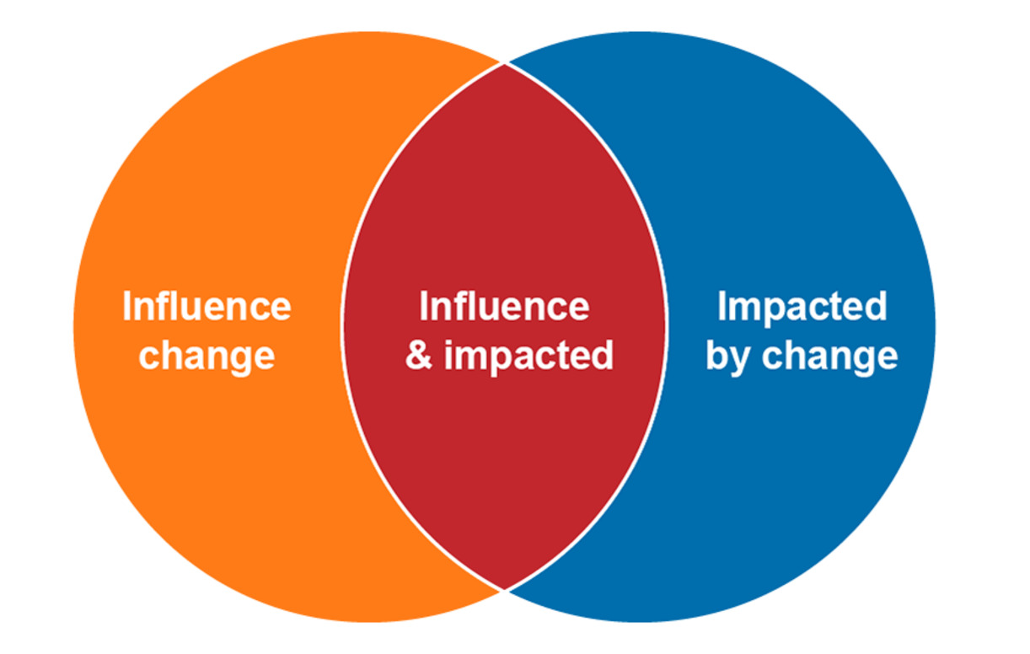
Figure 5 Identifying stakeholders
View description - Figure 5 Identifying stakeholders

Influence change: These are stakeholders who have the power to make decisions and/or the resources/tools/people you require to help implement change.
Influence and impacted: These are people who will be impacted by the change but, due to their roles/knowledge/experience or ownership of tools/systems, are stakeholders you will need to actively engage with, either for requirements analysis or support, or they may be people you will need to help you implement and sustain change, such as team leaders who may have the influence to help you succeed or not.
Impacted by change: These are stakeholders who will not have influence or necessarily be involved directly in any requirements but will have to adapt to the changes implemented.
You may know who your stakeholders are, but it can be sensible to review them by creating a stakeholder map. By visualising both your internal and external stakeholders, it can help you clarify who they might be and identify those you may not have considered. It is advisable to collaborate with others when doing this and look at your organisation’s strategy – are there focal areas within it that might include stakeholders that you have not considered?
When leading complex or large-scale change projects, it can be useful to categorise your stakeholders and then look for the interdependencies. In the stakeholder map below based on an organisational change initiative, a high-level approach was taken to start to identify groups of stakeholders, using the ‘Hybrid ways of working: a contextual sustainability framework’ to think about different organisational needs.

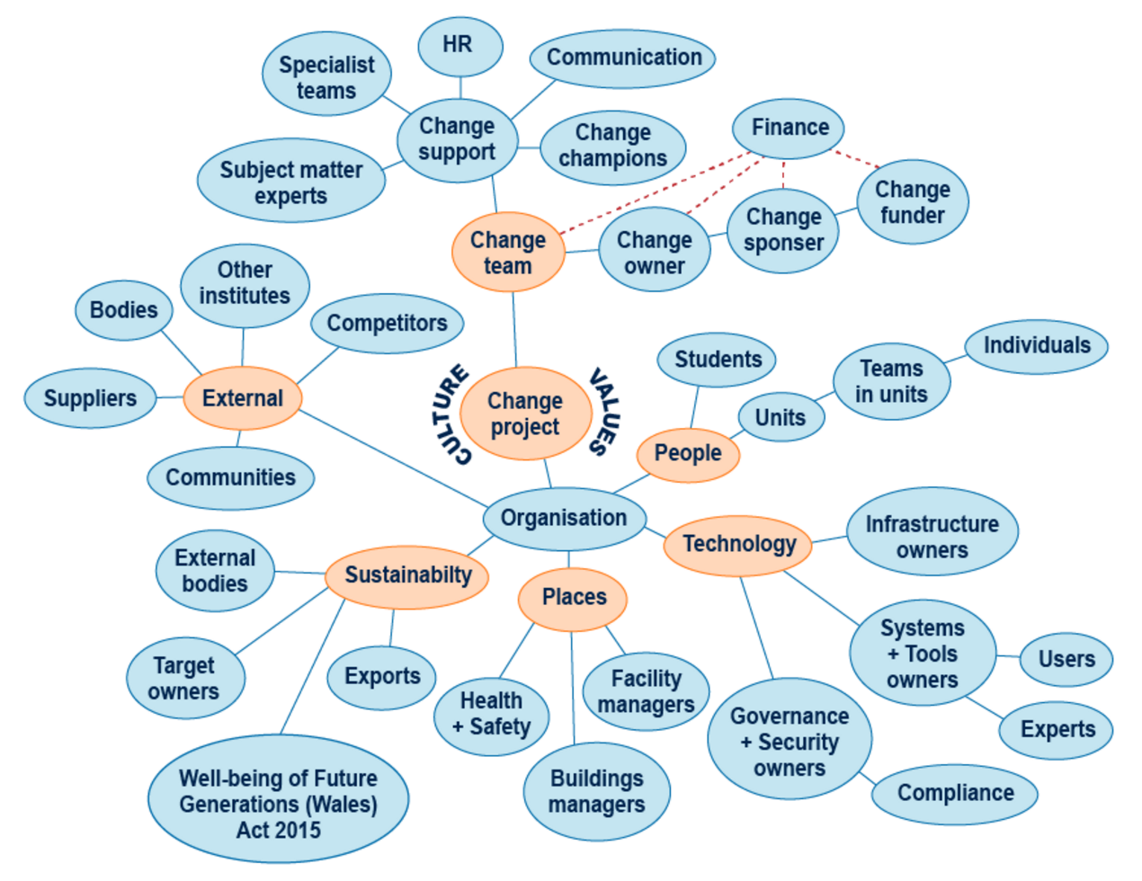
Figure 6 Stakeholder map
View description - Figure 6 Stakeholder map

This then allows you to break the groups down further and identify individuals who should be engaged directly with the change project.

3.4 Stakeholder engagement plan
To give depth to such a list of stakeholders, and to help with developing your knowledge of them and their power, interest and needs, it is useful to map stakeholders on two different derivatives of a Mendelow power matrix (Mendelow, 1991).
The first matrix indicates the stakeholders’ relative position in terms of their impact on the initiative’s success (their power) and the initiative’s impact on them (their interest). The second matrix gives a view of their level of commitment for the change mapped against their level of readiness.
When taking the two relative positions together, you can begin to build a stakeholder management plan, as shown in Figure 7.

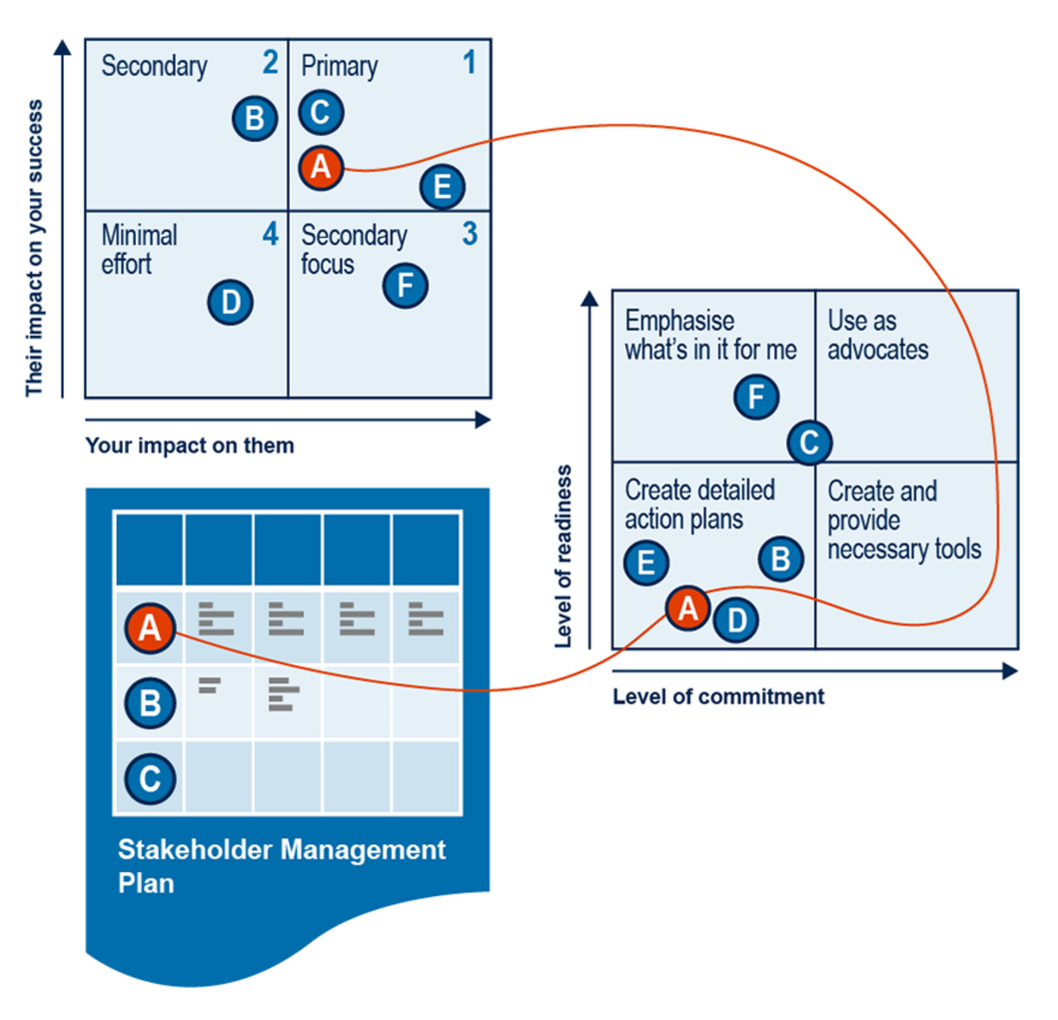
Figure 7 Stakeholder management plan
View description - Figure 7 Stakeholder management plan

Another dimension to the stakeholder plan is to indicate where their expectations are before the change occurs and where you would want them to be after the change. Table 2 provides an example.

Table 2 Stakeholder engagement plan
Stakeholder | A | B | C | D | E
Unaware |  | CP
Resistant | CP |  |  | CP | CP
Neutral
Supportive |  | DP | CP / DP | DP | DP
Leader | DP
Your impact on them | High | Low | High | Low | High
Their impact on you | High | High | High | Low | Low
Level of readiness | Low | Low | High | Low | High
Level of commitment | Low | Low | Medium | Low | Low
Next comms action | Manage closely | Keep satisfied | Manage closely | Monitor | Keep satisfied
Comment/current position | Detailed action plan |  | Use as advocate | Detailed action plan | Emphasise benefits

Key:
- CP – Current position
- DP – Desired position
- Manage closely: daily updates, regular invites to exclusive events, personal contact
- Keep satisfied – Weekly updates, invitations to certain occasions
- Monitor – Monthly updates
- Keep informed – Weekly updates, invitations to certain events

Activity 5 Creating a stakeholder engagement plan
10 minutes

Take some time now to think about the stakeholders in your change initiative. Then, drawing on Table 2 above, create a stakeholder engagement plan.

Provide your answer...
View discussion - Activity 5 Creating a stakeholder engagement plan

Having started to think about your change management process and engaging the stakeholders, you now need to plan ways to communicate the change. This is what we explore in the next section. If you are new to stakeholder management, you may wish to explore the Discovering management course on the OpenLearn platform.

4 Communicating change
You saw in the previous section how to identify stakeholders, assess their likely impact on the success of the project and develop plans to improve engagement levels. A key part of the engagement plan is to ensure that communications are effective and that there is an appropriate mix of communication techniques to satisfy the level of involvement and interactivity required to impart your message or gain feedback.
This is especially true during stakeholder consultation, as the sooner you involve stakeholders, the better. Stakeholders are more likely to engage with your change initiative if they feel they are part of the change and that their worries are addressed head on. To ensure this happens, a communications plan will be needed to support the change strategy.

4.1 The importance of a communications plan
The objectives of the communications plan are to:
- build understanding and support of the change initiative and facilitate successful implementation
- build trust, commitment and ownership
- change behaviours of colleagues to contribute towards the future direction and success of the implementation and business change
- build manager and leader capability around communications by providing tools and resources to drive ownership of dialogue with all stakeholder groups
- engage all stakeholders where opportunities exist for dialogue
- monitor and measure feedback.
It is essential that leaders and project teams initiating the change remember that their knowledge and acceptance of the change is much further ahead than colleagues who have just heard of it. It is important that leaders and project team members remember to pace themselves with the learning and understanding of others.
The communication approach needs to change as people shift from receiving information to making sense of what they have heard and identifying the implications for themselves, their work and relationship with others. These initial shifts require the communications to change from a telling and selling communication style to one of question and answer, enabling exploration and involvement in what it means for individuals. Through involvement, people gain commitment and understand the situation themselves, resulting in changes in behaviour.
Gaining people’s commitment to proposed changes is a progressive process. Communication is the most significant key to achieving engagement (buy-in) and commitment from those impacted. Figure 8 below illustrates the communication stages through which individuals typically progress as they transition towards becoming fully engaged and committed to the initiatives being undertaken.

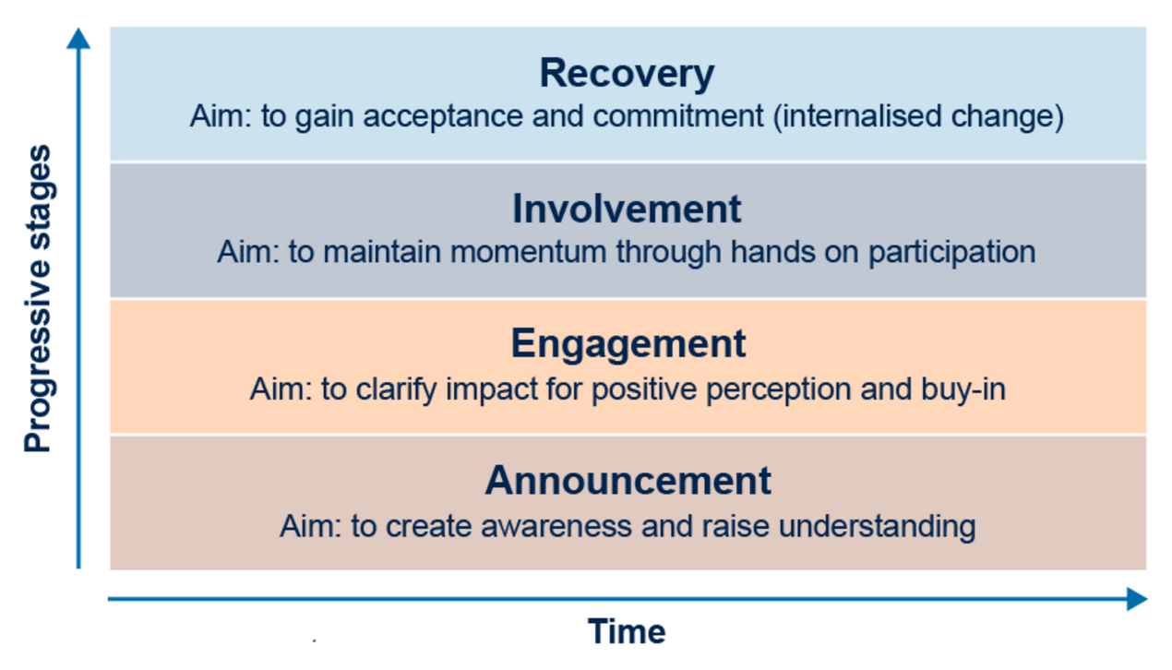
Figure 8 Communication stages
View description - Figure 8 Communication stages

The impact of missing out stages in the communication progress can be as follows:
- No engagement can result in negative perception and resistance to the change – people need to understand how the change will impact them, i.e. What does it mean for me?
- No involvement might mean a loss of support – individuals need to feel that they are part of the change effort rather than feeling like it is being done to them.
- No recovery can result in regression – if the change is not embedded to become business as usual (BAU), it very easily starts to regress to ‘how it used to be’.
Table 3 shows some of the common methods of communication used by change agents.
Often a change communications plan (the headings of which could be as indicated in the table) will make use of many channels.

Table 3 Change communications plan
Element | Example
Date | Date of message
Change stage | Announcement, engagement, etc.
Key message and objective | The key points you want/need to get across to the audience
Audience | The group that is being targeted
Channel | Method, such as changing network email
Owner | Who is the message going from, and who is actually writing it?
Evaluation | How will you assess success? Survey, feedback, focus groups?

There many communication changes, so it is important to consider what you are trying to communicate and to whom to choose the most appropriate. Figure 9 provides some of the main ones you might consider for internal communication. It suggests the primary methods of change communication are roadshows and demonstrations (the ‘Go see’); team talks which may be delivered face-to-face or virtually either as remote-only or hybrid events; and the development of a change network. We will discuss change networks in the next section.

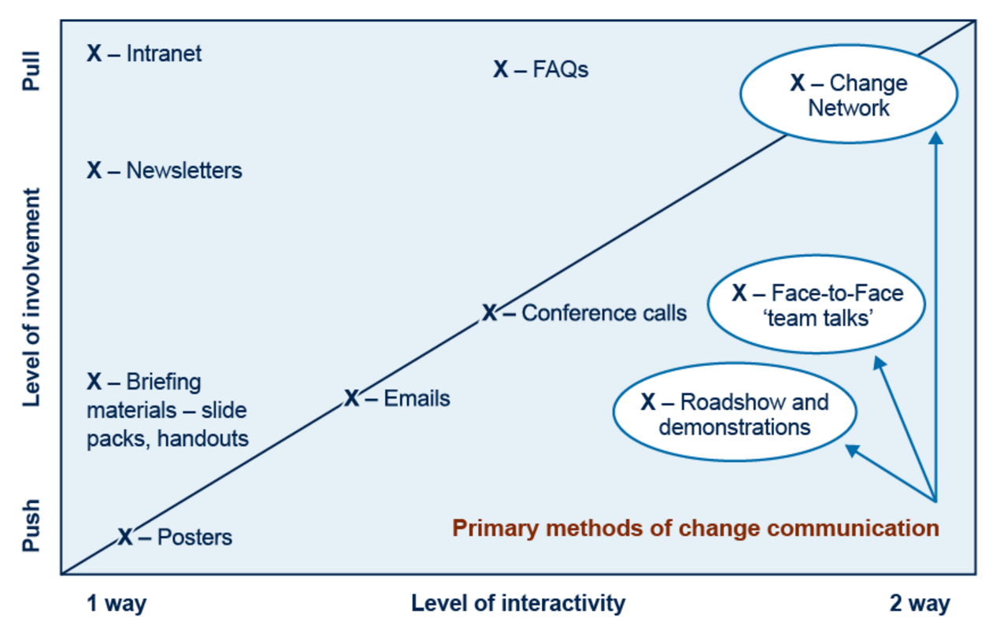
Figure 9 Primary methods of change communication
View description - Figure 9 Primary methods of change communication

Whichever channel is used, a few guiding principles should be followed:
- be visible and accessible
- take an open and honest approach
- focus on two-way communications
- schedule timely, planned communication and engagement activity
- have clear, consistent and credible messaging
- use tailored communications targeted to specific audiences
- use efficient and straightforward communications that are ‘fit for purpose’
- face-to-face (in person or virtually) communication should be the primary channel, with written and other forms as secondary channels
- gather regular feedback and evaluate.
It is important that the appropriate style of communication is used to ensure that the messaging is clear, concise, correct, concrete, coherent, complete and courteous, which are often referred to as the 7 Cs of communication, as explored in the next section.

4.2 The 7 Cs of communication
The 7 Cs of communication is a useful approach to use when considering effective communication. Figure 10 provides an overview of the seven elements.

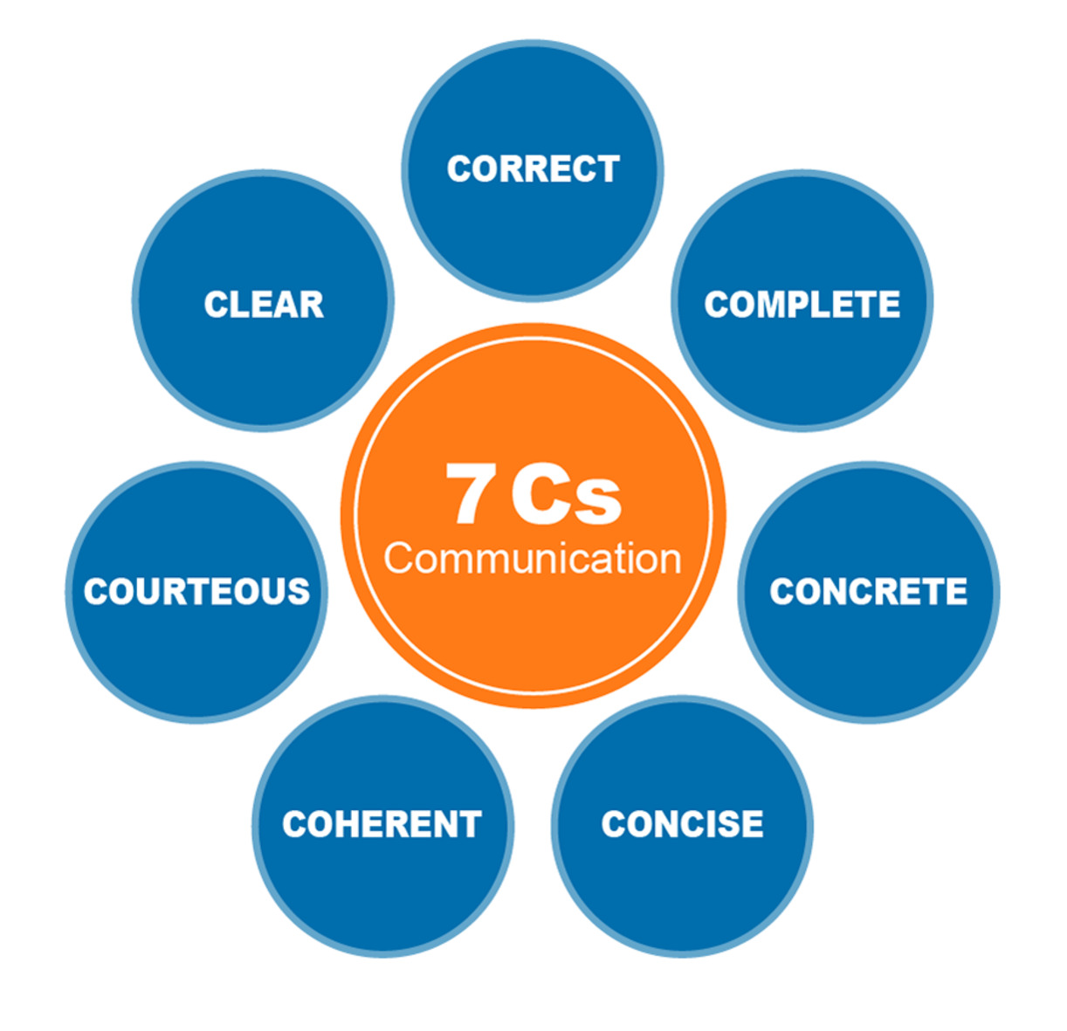
Figure 10 The 7 Cs of communication
View description - Figure 10 The 7 Cs of communication

Watch the following Mind Tools video to get a brief explanation of the 7 Cs of communication:

Video content is not available in this format.
Video 6 The 7 Cs of communication
View transcript - Video 6 The 7 Cs of communication

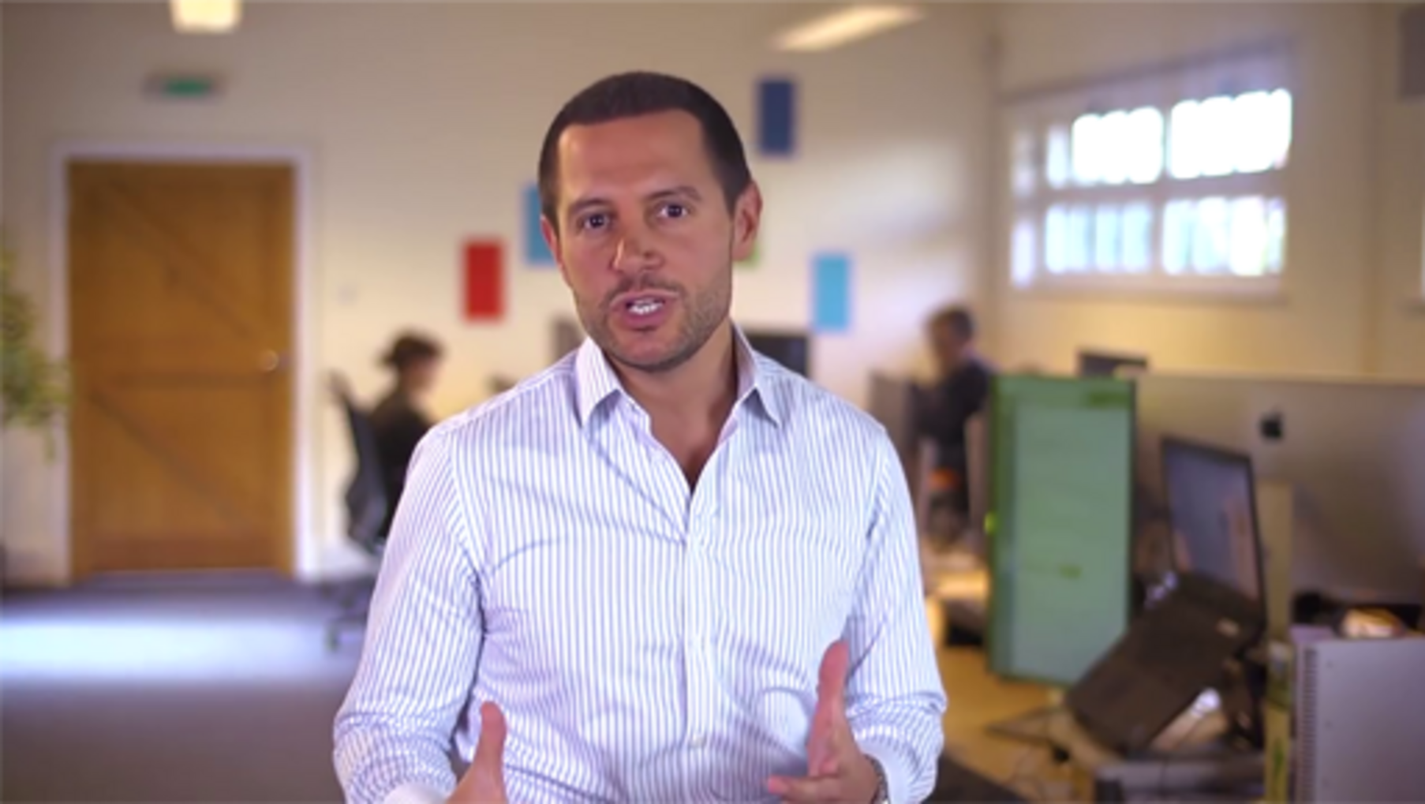

The video provided a short checklist for effective communication which we have summarised below.
- Clear: What is the purpose of the message and the outcome you desire, does the recipient understand why they are receiving the message?
- Concise: Focus on the core points. Try to keep it simple and short.
- Concrete: Be specific, brief and present in a logical order. Stick to facts, and provide evidence if required.
- Correct: Ensure both the information and the delivery is correct and error free.
- Coherent: Is the message logical and consistent?
- Complete: Provide all the required information and actions expected.
- Courteous: Use a friendly, open and honest tone. Consider your audience’s viewpoint and be empathic towards this.
If you want to find out more, there are many resources available that outline effective communication, including those on the OpenLearn platform, such as the badged open course Effective communication in the workplace.

4.3 Change networks
A change network is a group of individuals who lead and support colleagues through change during a time of transition or transformation. Establishing a change network provides reinforcement to the messages being delivered through line management cascades and other communication channels. It also offers a further method of gaining feedback on how people are adapting to change and how they are feeling about it. Its members can be instrumental in breaking down barriers and obstacles and in refining the project approach. It is a function that is integrated and incorporated into the individual’s regular job.
There are two distinct roles in the change network – change champions and change agents, otherwise known as change team members. Each brings different skills and has a particular part to play.
- Change champions are a selected group of leaders who can shape the desired outcomes and deliver the vision for the change. They have an input into the design, planning and execution of change-related activities.
- Change agents or change team members are functional representatives with subject matter or process knowledge. They act as change advocates, supporting change through day-to-day activities, and do the work required to support the change activity.
There are many benefits of developing a change network, and not just for the change project:
- For the project
  - Act as a catalyst for change
  - Identify ‘hot spots’ of resistance
  - Feedback on the changes within teams
  - Act as a conduit of communication.
- For the organisation
  - Acquire change skills – a scarce resource
  - Internal ‘consultant’ capability
  - Future change leader to drive continued improvements.
- For the agent
  - Greater job satisfaction
  - Helping to shape the future
  - Higher profile and visibility
  - Increased confidence.

Activity 6 Change networks in your organisation
15 minutes

Consider what steps you might take to set up a change network. If your organisation already has a change network, how you could work with it?
Use the box below to capture your reflections, if you wish.

Provide your answer...

So, you’ve thought about your communication plan. Next, you should consider those around you who can offer support. This is what we explore in the following section.

5 Assessing the change required
In Section 2, ‘What are you trying to change and why’, you explored the creation of a situation assessment and began gathering evidence to support the need for change. In this section, you will round off the creation of the change management strategy, of which situation assessment is a part. The other two sections that constitute the strategy are 'Supporting structure' and 'Strategic analysis'.

5.1 Supporting structure
The supporting structure is made up of two parts: the team structure and the sponsor coalition.

Team structure
The change management team structure identifies who will be doing the change management work. It outlines the relationship between the project team and the change management team. The most frequent team structures include:
- change management being a responsibility assigned to one of the project team members, or
- an external change management team supporting a project team.
The key in developing the strategy is to be specific and make an informed decision when assigning the change management responsibility and resources.

Sponsor coalition
The sponsor coalition describes the leaders and managers that need to be on board for the change to be successful. Starting with the primary sponsor (the person who authorised and funded the change), the sponsor model documents the leaders of the groups that are being impacted by the change. The change characteristics will determine who must be part of the coalition. Each member of the sponsor coalition has the responsibility to build support and communicate the change with their respective audiences.

5.2 Strategic analysis
In order for change to be successful, you need to analyse the risk, resistance and tactics for change and how ready your organisation is for change. By doing a strategic change analysis, it will help you understand what attitudes and behaviours you may have to manage.
- Risk assessment – the risk of not managing the people side of change on a particular change is related to the dimensions described in the 'Situation assessment' section. Changes that are more ‘dramatic’ and further reaching in the organisation have a higher change management risk. Likewise, organisations and groups with histories and cultures that resist change face higher change management risk. In developing the strategy, overall risk and specific risk factors are documented.
- Anticipated resistance – many times, after a project is introduced and meets resistance, members of the team reflect that ‘they saw that reaction coming.’ In creating the change management strategy, you can identify where resistance can be expected. Are regions or divisions impacted differently than others? Were certain groups advocating a different solution to the same problem? Are some groups heavily invested in how things are done today?
- Special tactics – the final step of the change management strategy is the identification of any special tactics that will be required for this change initiative. The special tactics formalise much of the learning from the strategy development related to the change and how it impacts different audiences in the organisation. Throughout the change implementation, special tactics may need to be revisited and updated.
- Readiness assessment – assessing the organisation’s ‘readiness for change’ is a key aspect of strategic analysis. It provides a benchmark of where the organisation is prior to the instigation of the change initiative. Regular revisits to the assessment throughout the lifecycle of the change will provide an indication of the progress made, as well as what adjustments to attitudes and behaviours have yet to happen.
Depending on the size of the change initiative, a change readiness assessment can be conducted using a simple form (like the one shown in Table 4 below) or a more complex tool or platform.

Table 4 Change readiness assessment form
Questions: | How fast do you want to implement the change?  What are the timescales, and have you worked backwards to see if it is possible?  Is the change project integrated with other strategies?  Is it agreed – evolution or revolution?  Do you have the leadership capabilities to match?
What are you doing well?
What do you need to do?
Coalition - Align the team
Questions: | How broad does your top team need to be?  Are 70% of the executive committed to the change?  How will the stakeholders be engaged?  Do you have a political champion?  Are the vision and drivers clear and shared?  Are the roles and responsibilities of the top team clear and understood?  Have the right behaviours as role models been defined?  How do you plan to keep the top team engaged?
What are you doing well?
What do you need to do?
Energy - Build momentum
Questions: | How can you create and sustain the energy?  Has the resource been identified and agreed?  Has a programme office been established?  Has backfill been agreed is necessary?  Has the resource been freed up?
What are you doing well?
What do you need to do?
Control - Execute discipline
Questions: | How much central control is required?  Is ‘Go see’ established?  Are roles and responsibilities defined and understood?  Have champions been briefed and prepared?  Have milestones been set and governance put in place?  Are links made to service/business plans?
What are you doing well?
What do you need to do?
Methodology - Build change capabilities
Questions: | How do you overcome your unique challenges?  Have you selected a suitable organisation approach?  Have champions/change agents been identified?  Has a core team been selected?  Have all key skills been identified, for example, BPI, procurement, marketing, contract management, others?  Has a skills assessment been completed?  Are training needs linked to the organisational development plan?
What are you doing well?
What do you need to do?
Risk - Monitor and adjust
Questions: | How do you handle the risk of the planned changes?  Is your attitude to risk appropriate for the pace you want?  Is governance in place?  Is it working?  Have you established the correct measures?  Do you have good performance information?
What are you doing well?
What do you need to do?
Engagement - Make it personal
Questions: | How differently must people behave?  Have you defined the new culture?  Are the role models leading the change?  Are people clear (WIIFM – what's in it for me)?  Have the links been made with organisational development to the performance development reviews?  Are the objectives linked to the day job?
What are you doing well?
What do you need to do?
Transparency - Communicate the change
Questions: | How much transparency do you need?  Do you want to brand the programme?
What are you doing well?
What do you need to do?

Figure 11 provides more information about each of the steps outlined in Table 4.

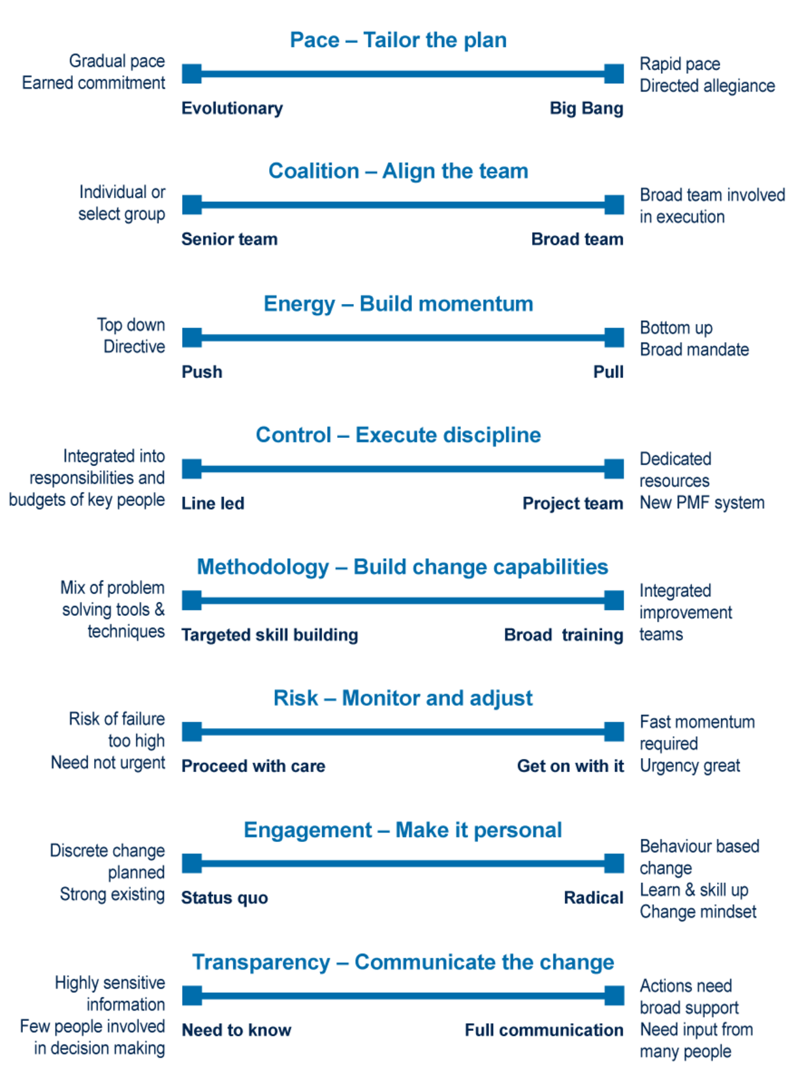
Figure 11 Change readiness assessment form
View description - Figure 11 Change readiness assessment form

Activity 7 How ready for change are you?
10 minutes

Think about your organisation’s readiness for change. Using the readiness assessment form in Table 4, and the additional information in Figure 11, what could you personally do in each step to become an effective change agent?

Having identified your supporting structure and carried out a strategic analysis, it is a good idea to bear in mind what is involved in leading change. This is the topic of the next section.

6 Leading change
Creating an organisation where creativity and innovation thrive, and where the necessity of change is fully embraced in order to deliver the benefits of that innovation effort to its stakeholders, is not easy.
Very few organisations are able to maintain the focus required to keep up with stakeholder demands whilst simultaneously reacting to often conflicting internal and external drivers for change. Linda Hill and her colleagues suggest that the most innovative companies are led by people who ‘understand that their most important role is to create a context in which others can collectively do the work of innovation’ (Hill et al., 2014).
It is fair to say that change ‘leadership’ is not a reserved title for the senior management of an organisation (although it may be incumbent on them to allocate sufficient resources and help create the environment to enable innovation and change to happen). The title can be applied to people at every level of an organisation, and indeed, Buchanan and Boddy (Buchanan, 1992) were the first to describe a ‘change agent’ as any member of an organisation seeking to sponsor, initiate, implement or deliver change.
Change agents require the right mix of skill, knowledge, experience, behaviours and attitudes, and these core competencies can be grouped and used as a basis for assessing the capabilities of a change agent. At the start of the course we looked at the John Fisher’s (2012) Personal Transition Curve, and you considered how you felt about change. Developing your emotional intelligence and competencies for leading change is critical to enable you to build better relationship with those involved and/or impacted by change initiatives.
One of the most considered pieces of research around change agent competencies comes from Daniel Goleman (1996), who defined ‘emotional competencies’ for change leaders. His model of emotional intelligence focuses on the aspects included in the following table:

Table 5 Emotional competencies for change leaders
Self-Awareness | Self-Management | Social Awareness | Relationship Management
Emotional self-awareness | Emotional balance  Adaptability  Achieve positivity | Empathy  Organisational awareness | Influence  Coach  Conflict management  Teamwork  Inspire

Another approach developed by Malcolm Higgs and Deborah Rowland in 2000. Their findings are listed and compared in Table 6 below.

Table 6 Change agent competencies proposed by Higgs and Rowland (2000)
Competency cluster | Competency indicator
Change initiation (CIN):  Ability to create the case for change and secure credible sponsorship | Surfaces issues
 | Demonstrates impact of issues on performance
 | Influences key sponsors
 | Secures sponsor commitment
Change impact (CIM):  Ability to scope the breadth, depth, sustainability and returns of a change strategy | Scope of thinking
 | Depth of impact (systematic thinking)
 | Reframing
 | Identifies ‘returns on change’
Change facilitation (CF):  Ability to help others, through effective facilitation, to gain insight into the human dynamics of change and to develop the confidence to achieve the change goals | Manages human dynamics
 | Encourages and supports self-management
 | Conflict management
 | Process management
Change leadership (CL):  Ability to influence and enthuse others, through personal advocacy, vision and drive, and to access resources to build a solid platform for change | Networking
 | Relationship building
 | Personal impact
 | Sells ideas
Change learning (CLE):  Ability to scan, reflect and identify learning and ensure insights are used to develop individual, group and organisational capabilities | Coaching
 | Listening and inquiry
 | Knowledge management
Change execution (CEX):  Ability to formulate and guide the implementation of a credible change plan with appropriate goals, resources, metrics and review mechanisms | Organisation savvy
 | Manages resistance
 | Journey design
 | Journey management
Change presence (CP):  Demonstrates high personal commitment to achievement of change goals through integrity and courage while maintaining objectivity and individual resilience (‘a non-anxious presence in a sea of anxiety’) | Courage
 | Resilience
 | Authenticity
 | Objectivity
Change technology (CT):  Knowledge, generation and skilful application of change theories, tools and processes | Theories
 | Tools
 | Processes

Source: Adapted from Higgs and Rowland (2000), pp. 124–125

Activity 8 Your change agent competencies
10 minutes

Using each of the competency clusters identified by Goleman (1996) and Higgs and Rowland (2000), think about your own change agent competencies. How would you rate your ability in each of these areas, and which areas could you develop to become a more effective change agent?
Use the text box below to capture your reflections, if you wish.

Provide your answer...

Goleman (1996) also identified six leadership styles to choose from to deploy in any situation and at any point in the change process. These are:
- coercive
- authoritative
- affiliative
- democratic
- pacesetting
- coaching.
Goleman suggested that a leader may have to use combinations of these depending on the type of change, the phase of the implementation and the culture of the organisation or when dealing with resistance to change.

6.1 Managing yourself and others
When leading change programmes, there are many aspects that a leader or change/project manager need to consider to ensure the change’s success. You have already seen some of these in the course, such as the need to understand and support stakeholders through the anxieties associated with their ‘personal transition curve’ (see Section 1).
As a leader or manager of change, you need to consider your own resilience and approaches you can take to lead change initiatives successfully, both in terms of the change approach itself, but also in terms of managing yourself and others. Some key considerations are:
- organisational culture
- control and influence
- empathy
- building trust.
If you are new to leading others, you may wish to explore the Hybrid working: skills for leadership course, which explores the key considerations listed above in more detail.

Survival anxiety and learning anxiety
Edgar H. Schein (2017) suggests a three-stage cycle of change management and draws out some ‘anxieties’ to look out for and address in the change process.
- Stage 1 – Creating the motivation to change (unfreezing)
This stage starts with ‘disconfirmation’, which shows people within the organisation that its goals are not being met; that is, ‘someone is hurting somewhere’ or ‘something is wrong somewhere’. Disconfirmation can then be used to induce ‘survival anxiety’ (if we don’t fix this we may not survive) and consequent ‘learning anxiety’ (if I can’t learn/adopt new behaviours then I might lose my position), which can both in turn create motivation to get things done. Learning anxiety, however, if sufficiently strong, can produce resistance to change through a number of manifestations of ‘fear’, such as the fear of loss of power or position, fear of temporary incompetence, fear of punishment for incompetence, fear of loss of personal identity and fear of loss of group membership. Indeed, Schein suggests that ‘it is the interaction of these two anxieties that creates the complex dynamics of change’ (Schein, 2017, pp. 325, 328–329) and posits two guiding principles when trying to balance the two:
  - Principle 1 – survival anxiety or guilt must be greater than learning anxiety.
  - Principle 2 – learning anxiety must be reduced, rather than increasing survival anxiety.
Principle 2 is all about what Schein calls ‘creating psychological safety’ and includes interventions such as ‘providing a compelling positive vision’, ‘provid[ing] formal training’, ‘involving the learner’, ‘train[ing] relevant “family” groups and teams’, ‘provid[ing] resources’, ‘provid[ing] positive role models’, ‘provid[ing] support groups in which learning problems can be aired and discussed’ and ‘remov[ing] barriers and build[ing] new supporting systems and structures’ (Schein, 2017, pp. 328–329)
- Stage 2 – Learning new concepts, new meanings for old concepts and new standards for judgement (the actual change and learning process)
This stage highlights two mechanisms to learn new behaviour, beliefs and values; imitating a role model and scanning the environment and using trial and error to invent new solutions until something works. In practice, again, Schein (2017) recommends a mix of both, as the first may be more expedient, but the second, due to the feeling of ‘ownership’, is likely to be more embedded. Schein also suggests that an organisation might have to ‘unlearn something and learn new things that might challenge our competencies, our role or power position, our identity elements, and possibly our group membership’ to move forward.(Schein, 2017, pp. 330–337)
- Stage 3 – Refreezing, internalising and learning agility
A period of stability is required to reinforce new behaviours and emphasises that change success criteria should be defined in concrete behavioural terms and not as ‘culture change’.

6.2 Business change approaches
At an organisational level, Michael Beer and Nitin Nohria (2000) name two business change approaches.

Theory E changes
‘The creation of economic value and high returns to shareholders’ (Kippenberger, 2000) are normally driven from the top of the organisation, are strategic and programmatic in nature and often carry financial incentives. ‘Disconfirmation’ triggers in this case may be easier to identify, as key metrics are often regularly measured such as turn-over, a sharp drop in profits from a particular product or a change in market conditions (adapted from Beer & Nohria, 2000 and Kippenberger, 2000).

Theory O changes
In contrast, Theory O changes ‘see the organisation as having many stakeholders … [and] has at its heart the development of organisational capabilities and employee’s capacity’ (Kippenberger, 2000). Theory O disconfirmation is more emergent and less planned (such as a high turn-over of staff in a particular department), and change in this area emphasises values and high employee engagement (i.e. trying to address ‘learning anxieties’) (adapted from Beer & Nohria, 2000 and Kippenberger, 2000).

As with Schein’s model, ‘tension’ obviously exists between these two approaches. Successful changes normally require an element of both, but the balance has to be right: Beer and Nohria state that only a third of any initiatives to change organisational culture achieve success and suggest that where ‘the objective is to create an organisation that will adapt, survive and prosper in the long run, Theory E change must be combined with Theory O’ (adapted from Beer & Nohria, 2000 and Kippenberger, 2000).

6.3 Analysing tension
A way of analysing the tension between opposing forces (those that drive a change forward – driving forces – and those that offer resistance to change – restraining forces) was devised by Lewin in 1951 (Senior, Swailes, & Carnall, 2020, pp. 259-261). A simple example of an output of a force field analysis exercise can be seen in Figure 12 below.

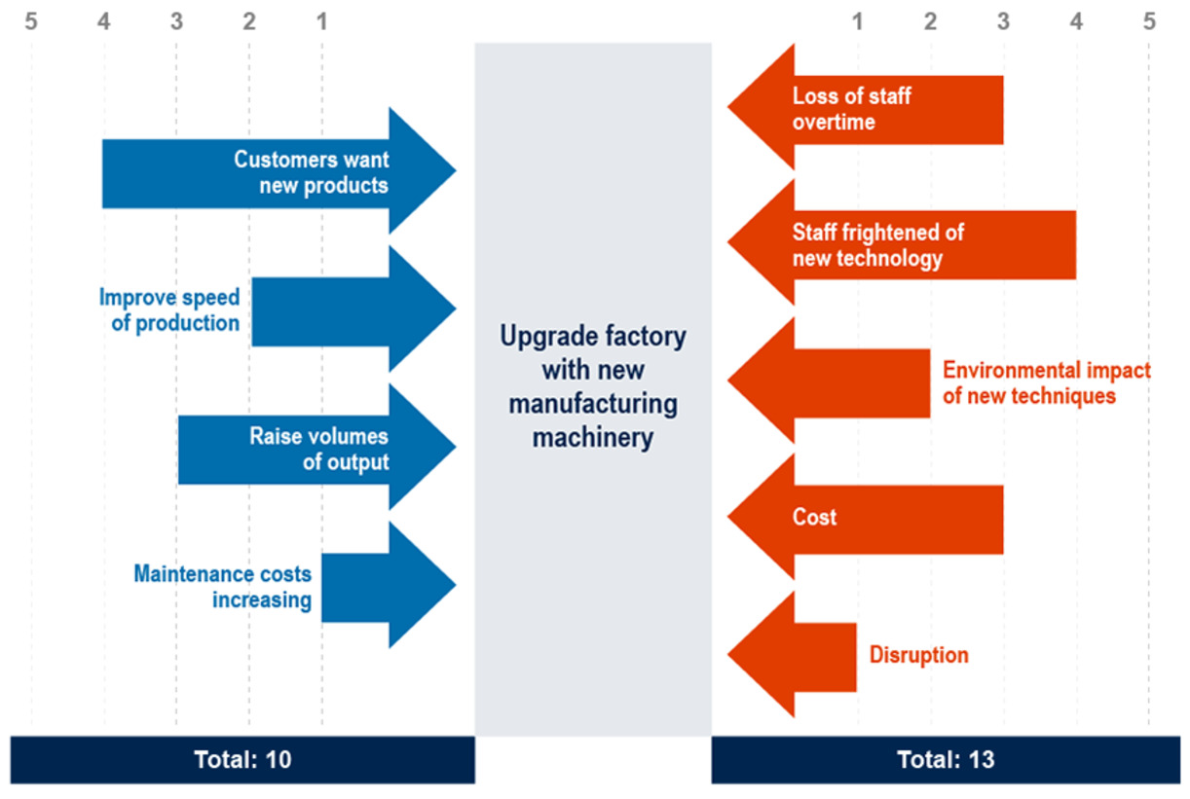
Figure 12 Force field analysis
View description - Figure 12 Force field analysis

Driving forces – are those forces affecting a situation that are pushing in a particular direction; they tend to initiate a change and keep it going – such as pressure from a leader, incentive earnings or a compelling vision.
Restraining forces – are forces acting to restrain or decrease the driving forces. Apathy, hostility and poor communication may be examples of restraining forces against change. Equilibrium is reached when the sum of the driving forces equals the sum of the restraining forces.
This model is usually used as follows:
- Step 1 – take some time to consider what status quo will change and write this in the middle column.
- Step 2 – now think about what is forcing the change and what will block it; write these things in the columns either side of the status quo.
- Step 3 – consider the strength of these forces and give each reason or restraint a score out of 5.
Some of the forces will be out of your control, so using a stakeholder analysis in conjunction with this mode can help you understand how you can work with influential stakeholders to move the forces.
Sometimes it’s easier to reduce the strength of one force rather than strengthening another.

Activity 9 Analysing tension in your context
20 minutes

Read the short description of Lewin’s force field analysis in this Force field analysis guide (Visual Paradigm Online, 2022).
Then use one of the templates offered on that website to document the driving and restraining forces on your change initiative, or you may wish to use one of the ‘simple changes’ from the Future Generations Commissioners for Wales (2022) website.
If you would like more information on Lewin’s model and factors that may impact the take-up of the change, take a look at the video Lewin’s model of force field analysis (2018) on the Tutor2u website.

In the next section we explore managing change and its connection with project management.

7 Managing change
As you saw earlier in the course, change management and project management are complementary disciplines both focused on creating successful change in an organisation. While the project plan focuses on the delivery side of a change such as deadlines, budgets and resources, change management focuses on the people side such as communication, resistance and changing behaviour. Each needs to be in place for a project to be successful, moving from a current state to a future state, as shown in the figure below.

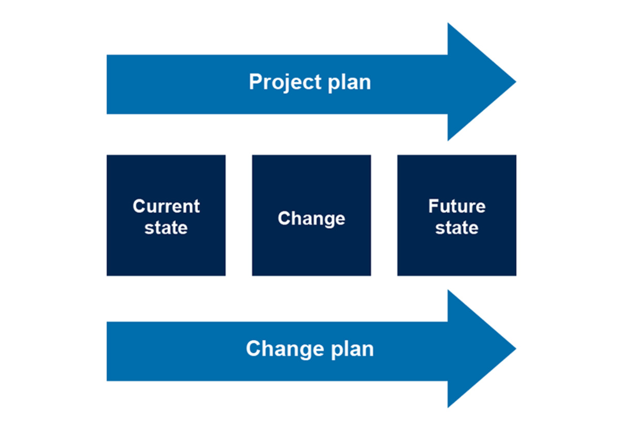
Figure 13 Moving from current state to future state
View description - Figure 13 Moving from current state to future state

The objective, then, is to integrate both the project and change activities so the overall change initiative meets its goals and delivers its intended results.
Project management focuses on the technical side of moving from the current state to the future state and involves the following processes and tools.

Table 7 Project management processes and tools
Process | Tools
- Initiation  - Planning  - Executing  - Monitoring/controlling  - Closing | - Statement of work  - Project charter  - Business case  - Work breakdown structure  - Budget estimations  - Resource allocation  - Schedule  - Tracking

Change management, on the other hand, focuses on the people side of moving from current state to future state and involves these processes and tools.

Table 8 Change management processes and tools
Process | Tools
- Organisational  - Preparing for change  - Planning the change  - Managing change  - Reinforcing change  - Individual  - Change curve | - Communication plans  - Change network plan  - Leadership roadmap  - Coaching plans  - Training plans  - Reinforcement plan

As with frameworks, there are many integrated change management approaches when it comes to making change happen.

Activity 10 Understanding integrated change management
15 minutes

It is often the case that you will act as both the change and project manager for a change initiative or be working with a project manager. Read the following articles and consider how you can take a more integrated approach.
- ‘Integrated change management’ (Wanner, 2013) on the Project Management Institute website.
- ‘Striking the right balance between project and change management in an organisation’(Dennis, 2020) on the Association for Project Management website.
You may wish to make notes in the box below.

Provide your answer...

In the next section we move on to the important stage of sustaining change of making sure the change sticks.

8 Sustaining change
The final phase of change initiatives requires a period of stability to reinforce new behaviours and to realise (and celebrate) the benefits of the change.
Reinforcement helps make the change sustainable over the long term. Once the change is embedded into the cultural web of the organisation as ‘the way we do things around here’, then the change can be said to be truly sustainable. The cultural web was developed by Johnson (1992) and cited in Senior, Swailes and Carnall (2020) to explain the different dimensions of an organisation’s culture.

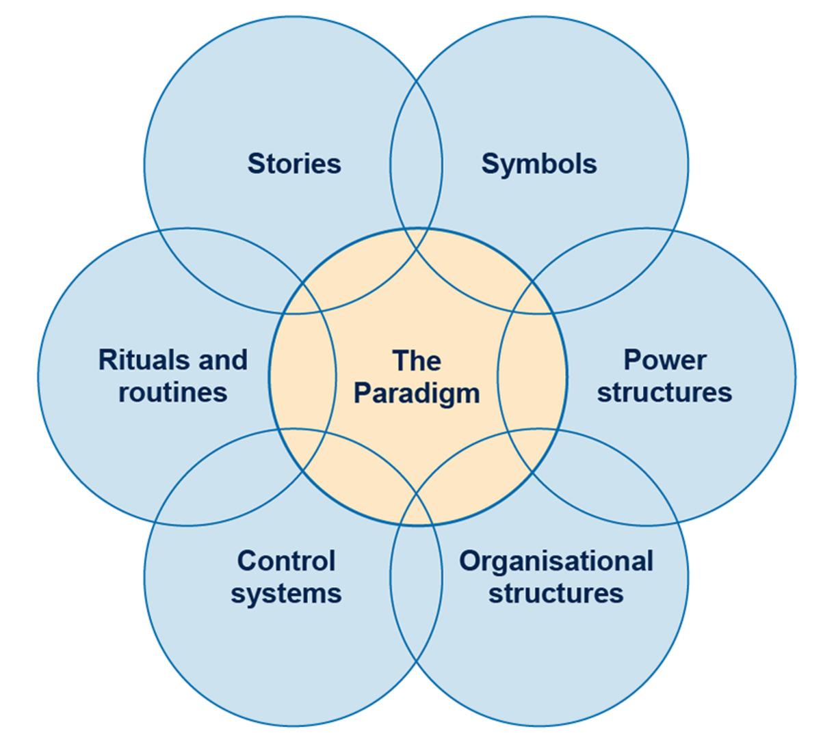
Figure 14 The cultural web (adapted from Johnson, 1992)
View description - Figure 14 The cultural web (adapted from Johnson, 1992)

As you can see from the figure above, it includes:
- the routine ways that members of the organisation behave towards each other
- the rituals of organisational life
- the stories told by members of the organisation to each other, new recruits and outsiders
- the symbolic aspects of the organisation, such as logos, furnishings, titles, status differentials
- the control systems, what gets measured
- the power structures
- the formal organisational structure.

Activity 11 Reinforcing change
15 minutes

Read the article ‘Reinforcing change: all your questions answered’ (WalkMe, 2019) on The Change Management Blog.
Then think about how you can reinforce change and the approaches you might take.

Managing change is an iterative and ongoing process, as change initiatives are implemented and sustained. In the next section we explore a selection of change frameworks that can help structure your change programme.

9 Building your change toolkit
As you become more confident leading change initiatives, you may wish to draw on other frameworks that allow for more in-depth analysis and challenge your approach to change. There are also over 60 well known frameworks that can help structure your change programme and lots of accessible literature on the subject. Some points to consider when thinking about which framework is most appropriate include complexity, potential resistance, capability, timescale, culture, advocacy, context, previous experience and leadership style.
The following sections explore a few of the common frameworks, along with suggested optional further reading/references for further study, which you may wish to use in the future depending on the context of the change you are considering and the environment in which you operate.

9.1 Lewin’s change management model
Lewin’s three-stage model of change, first mentioned in 1947, assumes a linear approach to change and likens it to changing an ice cube into a different shape through unfreezing, changing and refreezing:

- Unfreezing: a stage within which those involved come to recognise the need for something to change; it involves examining the status quo, increasing the drivers for change and decreasing the resistance to change;
- Change: a stage during which new ideas are tested and new ways of working emerge; and
- Refreezing: a stage within which new behaviours, skills and attitudes are stabilised and commitment to change is achieved.
(Senior, Swailes & Carnall, 2020)

Despite criticism for being linear, somewhat simplistic and assuming ‘organizations operate in a stable state; was only suitable for small-scale change projects; ignored organizational power and politics; and was top-down and management-driven’ (Burnes, 2004), this model is still valid, especially when considering incremental changes.

Activity 12 How could you use Lewin’s change management model?
15 minutes

To learn more about the model, read the article ‘Lewin’s change management model’ (Mind Tools Content Team, 2022) and watch the short video taken from the article below.

Video content is not available in this format.
Video 7 Lewin's change management model
View transcript - Video 7 Lewin's change management model

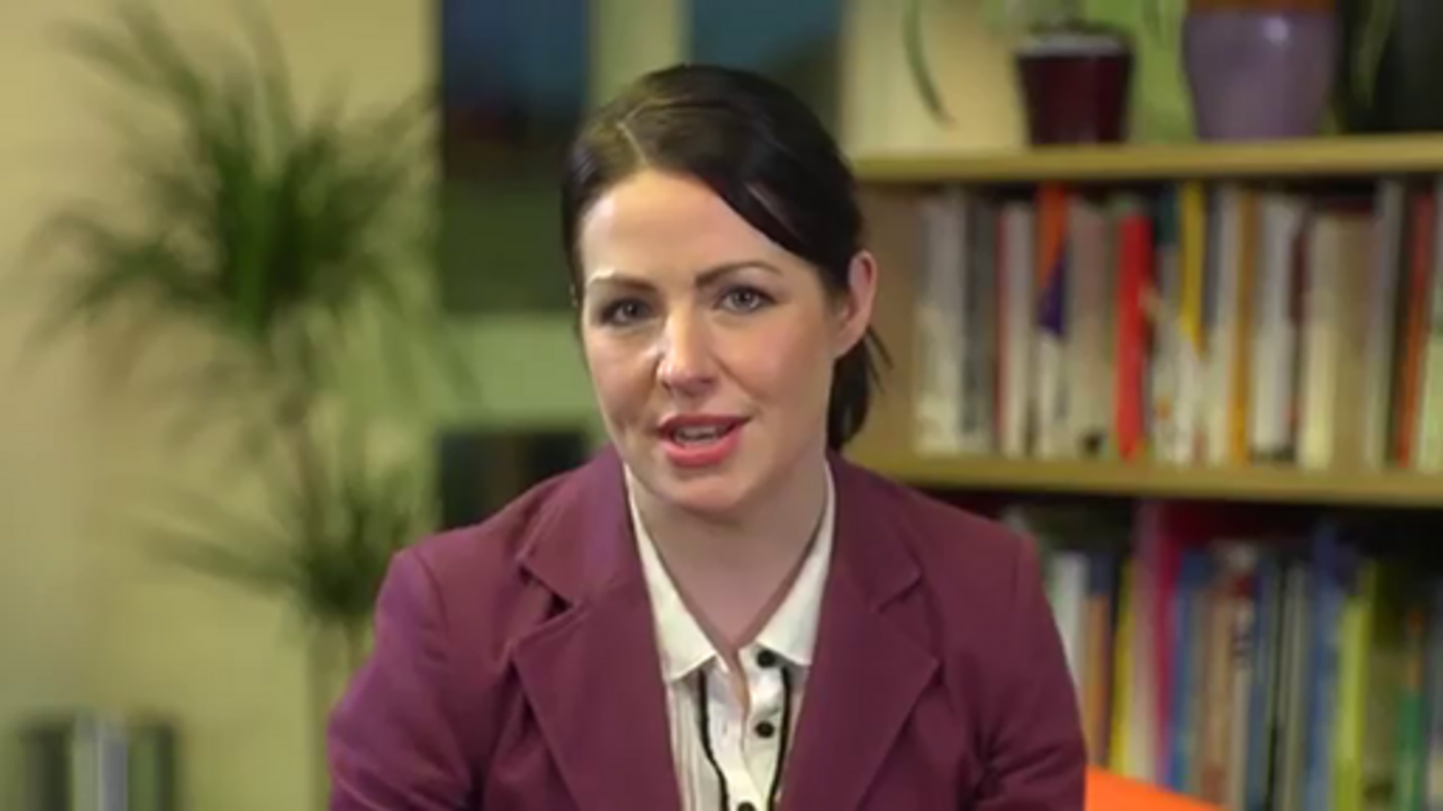

Now, think about the practical steps you could take to:
- unfreeze change
- ease the change stage
- embed the change into your organisation or your team’s culture.

9.2 The 7S model
The Seven S framework first appeared in The art of Japanese management by Richard Pascale and Anthony Athos in 1981. They had been looking at how Japanese industry had been so successful at around the same time Tom Peters and Robert Waterman were exploring what made a company excellent. The Seven S model was born at a meeting of the four authors in 1978. It went on to appear in In search of excellence by Waternans and Peters and was taken up as a basic tool by the global management consultancy McKinsey: it's sometimes known as the McKinsey 7S model.
The model comprises the following. You can see how they relate to each other in Figure 15.
- Shared values – What does the organisation believe in?
- Strategy – What does the organisation intend to do?
- Structure – What is the structure of the organisation?
- Systems – What procedures, processes and routines are important?
- Style – How do people behave? What is the culture?
- Staff – Who works in the organisation, and what do they do?
- Skills – What are the core competencies of the organisation and the staff?

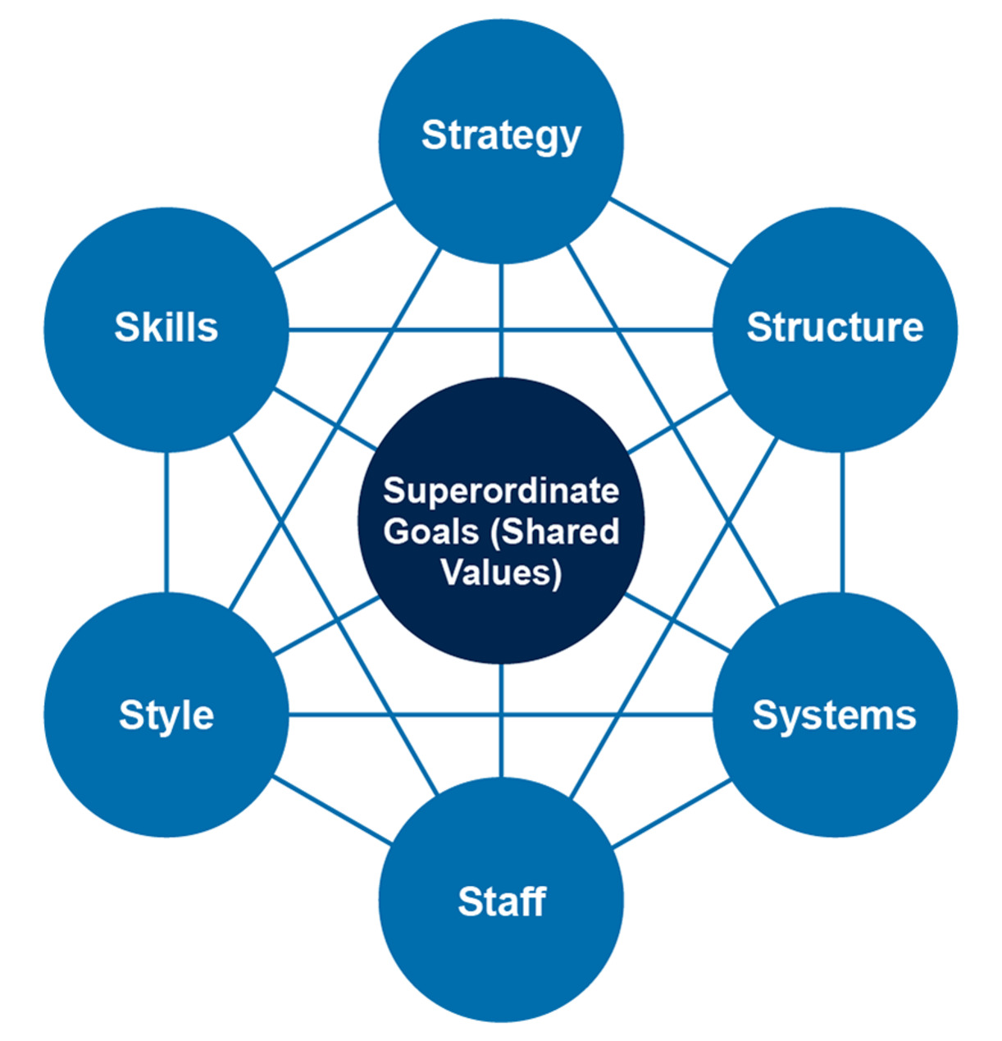
Figure 15 The 7S model
View description - Figure 15 The 7S model

The main benefit to using the 7S model is its ability to ‘diagnose’ the status quo and its influential elements. It provides the user with a complete view of the organisation.
It is important to remember that each element is interdependent, so if one is changed, there will be an impact on other elements.
In an environment of ‘constant change’, you should focus on the flexibility of the model and not allow it to become too rigid.

9.3 Kotter’s eight-step change model
World-renowned leadership and change management guru John Kotter first introduced his eight-step change process in his 1996 book, Leading change, shown in Figure 16.

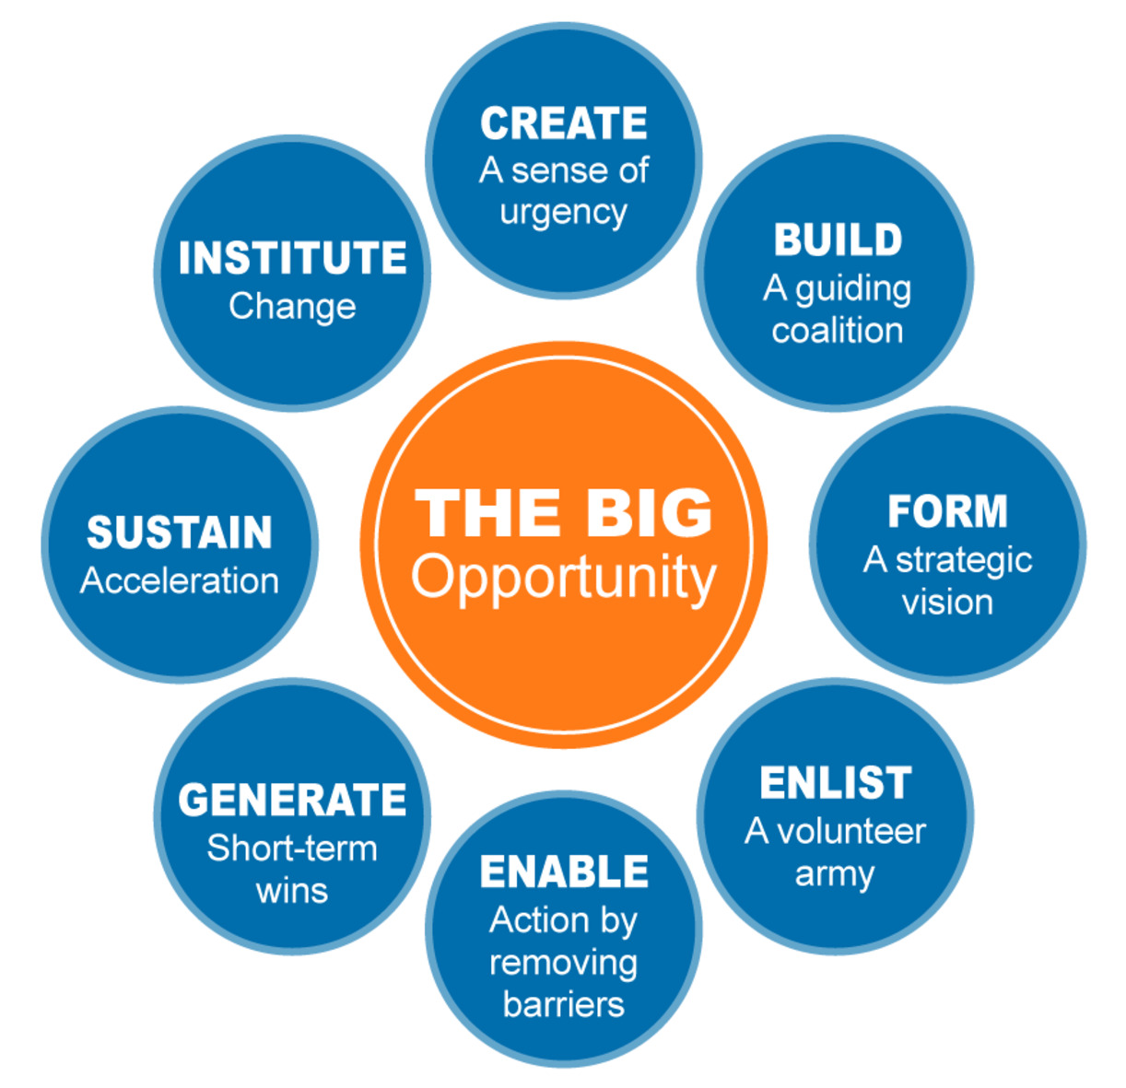
Figure 16 Kotter's eight-step change model
View description - Figure 16 Kotter's eight-step change model

The process involves:
- Establishing a sense of urgency – his ‘burning platform’. There is nothing like a sense of urgency to instigate change.
- Creating a ‘guiding coalition’ – to convince people that change is necessary, strong leadership and visible support from key people within the organisation is required. Managing change isn’t enough – it must be led.
- Developing a vision and strategy – a clear vision can help everyone understand why the change is needed and their part in making it happen.
- Communicating the change vision – what is done with the vision after it is created determines the change success.
- Empowering employees to act by removing obstacles.
- Generating ‘quick wins’ – success is a great motivator, and Kotter recommends that change managers build in ‘victories’ early in the change process.
- Consolidating gains and producing more change – don’t declare victory too early. Multiple successes build on what is going right and help identify what can be improved upon.
- Anchoring new approaches in the organisation culture – to make any change stick, it should become part of the core of the organisation.
(Kotter, 1996)

Activity 13 Applying Kotter’s eight-step change model to your context
15 minutes

To find out more about the eight-step change model, browse the The 8 steps for leading change on the Kotter website and read ‘Kotter’s 8-step change model – implementing change powerfully and successfully’ (Mind Tools Content Team, n.d.). Then watch the short video taken from the article.
While you watch the video and read the article, consider which steps you could take to help lead change. Use the text box below to capture your reflections, if you wish.

Video content is not available in this format.
Video 8 Kotter's change model
View transcript - Video 8 Kotter's change model

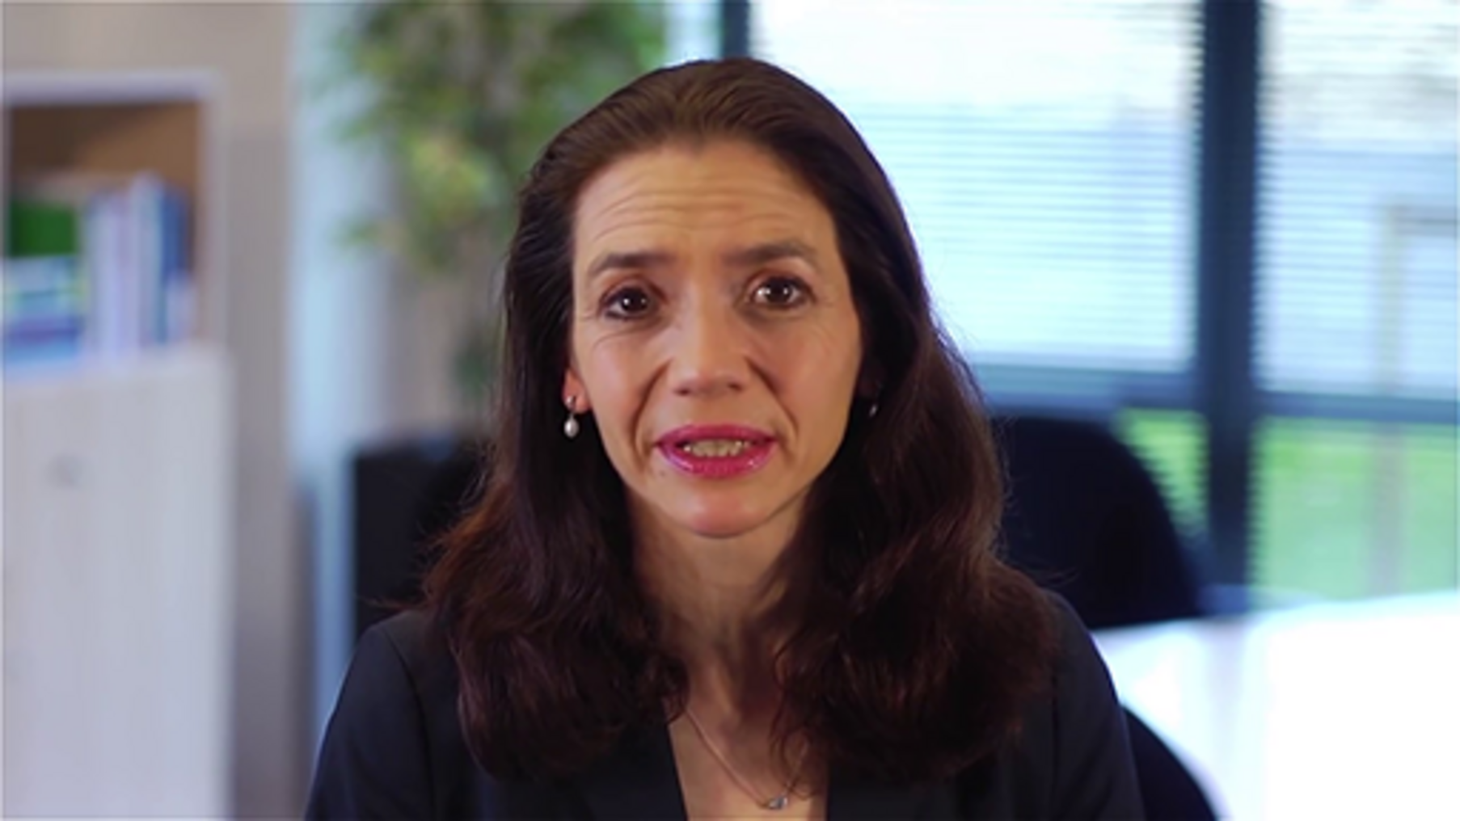

Provide your answer...

9.4 Prosci’s ADKAR change model
The ADKAR change model was developed nearly two decades ago by Prosci founder Jeff Hiatt after studying the change patterns of more than 700 organisations. It looks at change from the viewpoint of the individual rather than at an organisation level. Figure 17 provides an overview.

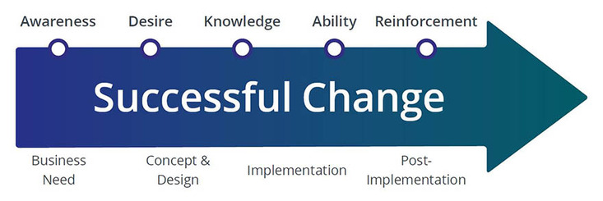
Figure 17 The ADKAR model
View description - Figure 17 The ADKAR model

‘ADKAR’ is an acronym for the five outcomes an individual needs to achieve for a change to be successful:
- Awareness – of the need for change.
Read the brief ‘Awareness - The Prosci ADKAR model'(Prosci, n.d) and watch the short video taken from the article below.

Video content is not available in this format.
Video 9 Awareness - The Prosci ADKAR model
View transcript - Video 9 Awareness - The Prosci ADKAR model

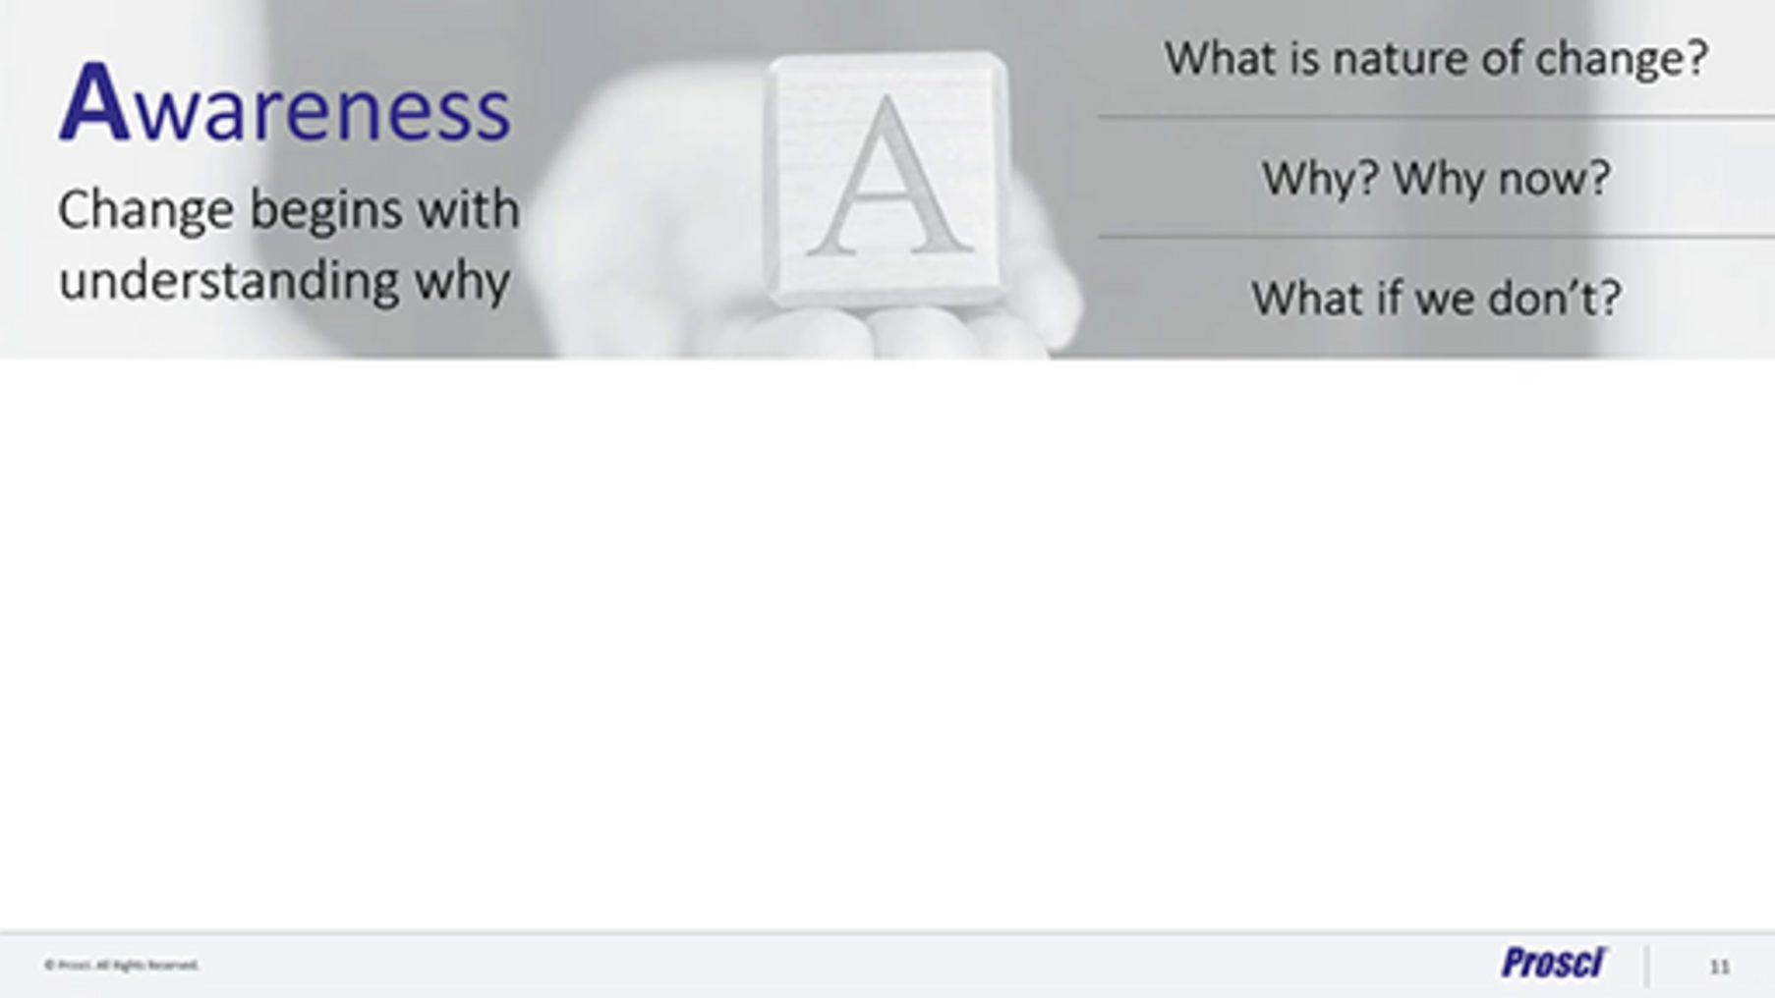

- Desire – to participate and support the change.
Read the brief ‘Desire - The Prosci ADKAR model’ (Prosci, n.d) and watch the short video taken from the article below.

Video content is not available in this format.
Video 10 Desire - The Prosci ADKAR model
View transcript - Video 10 Desire - The Prosci ADKAR model

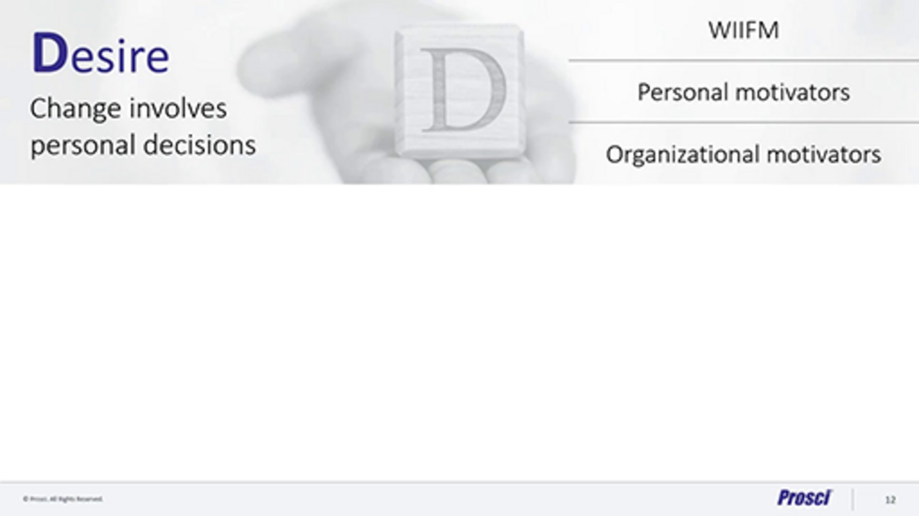

- Knowledge – on how to change.
Read the brief ‘Knowledge - The Prosci ADKAR model’(Prosci, n.d) and watch the short video taken from the article below.

Video content is not available in this format.
Video 11 Knowledge - The Prosci ADKAR model’
View transcript - Video 11 Knowledge - The Prosci ADKAR model’

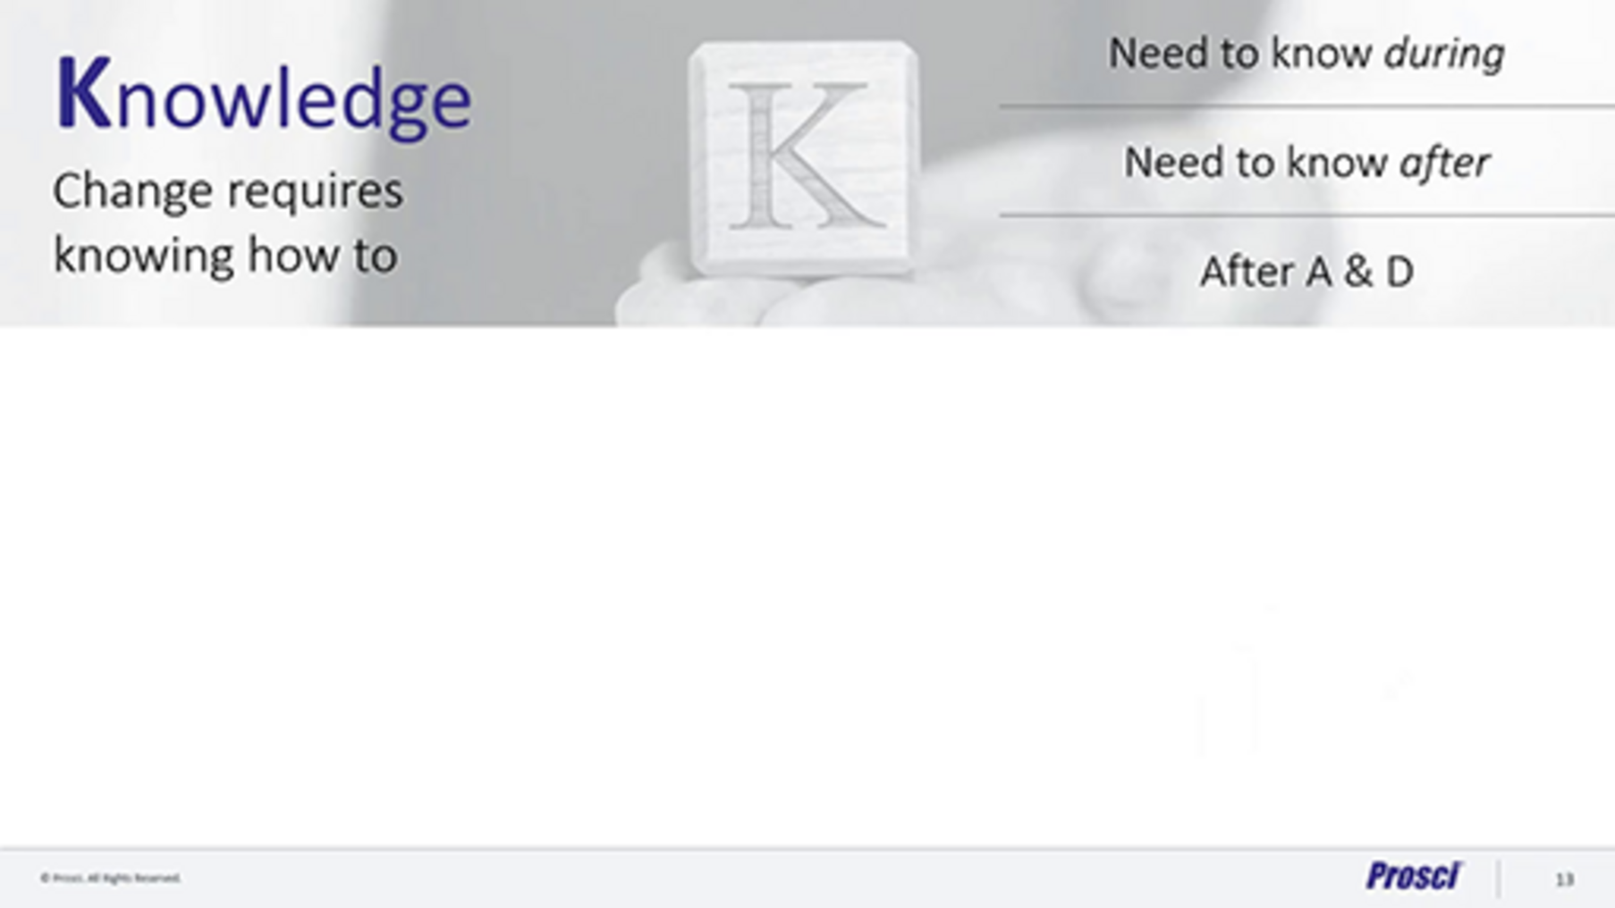

- Ability – to implement certain skills and behaviours.
Read the brief ‘Ability - The Prosci ADKAR model’(Prosci, n.d) and watch the short video taken from the article below.

Video content is not available in this format.
Video 12 Ability – The Prosci ADKAR model
View transcript - Video 12 Ability – The Prosci ADKAR model

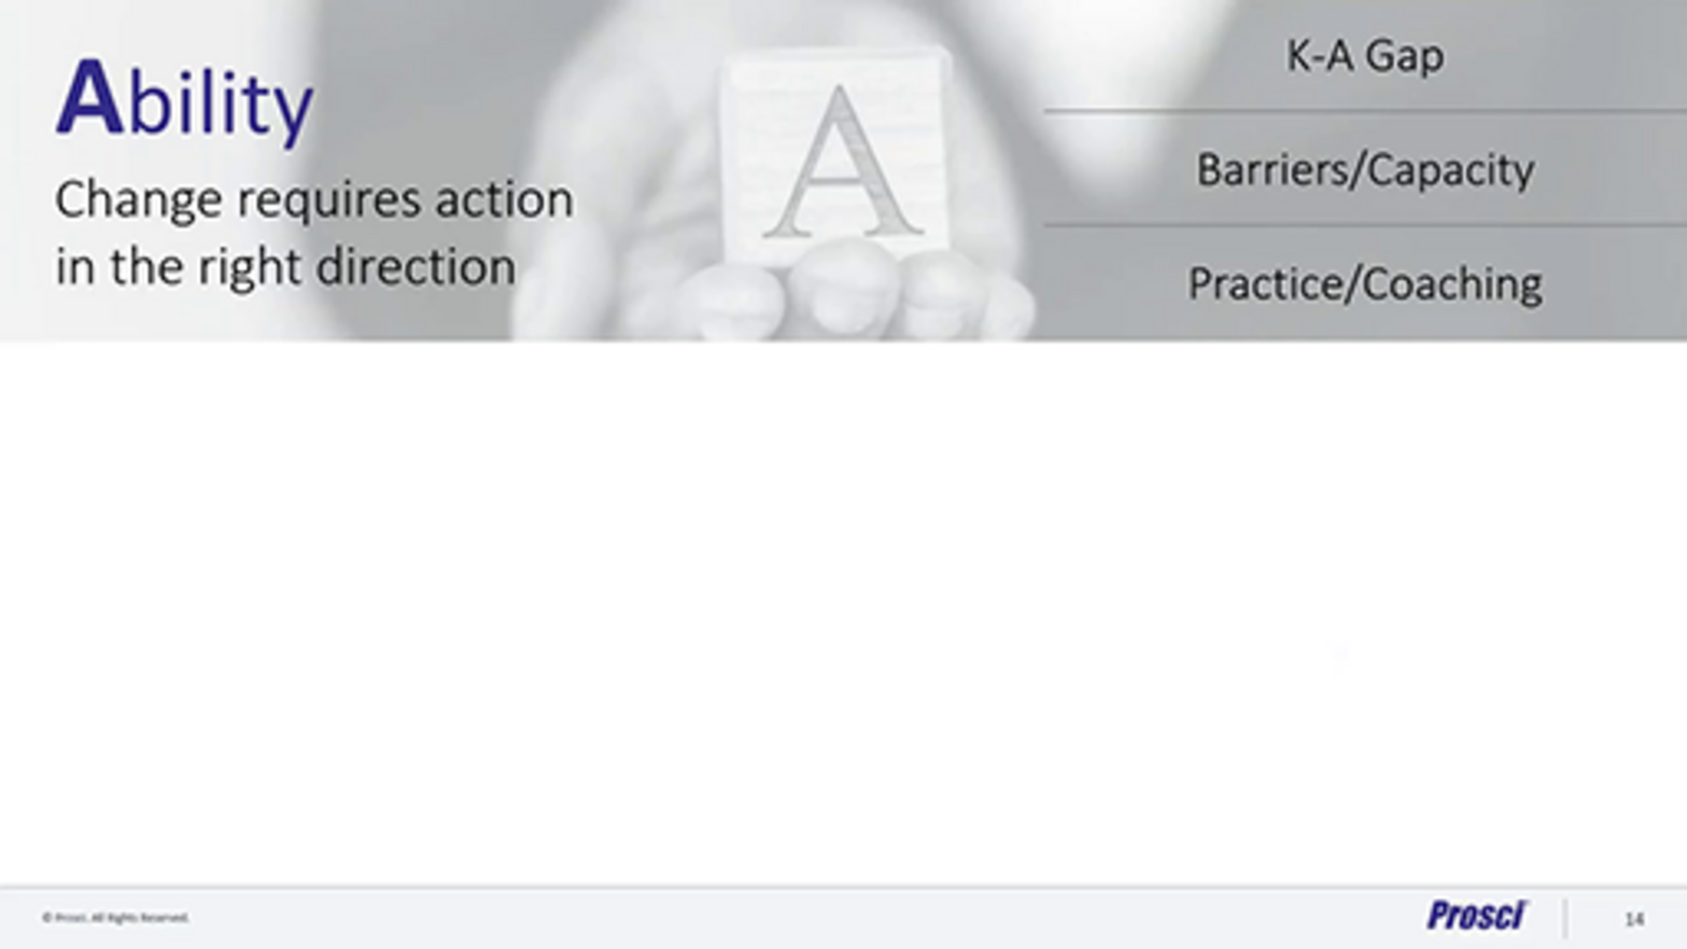

- Reinforcement – to sustain the change.
Read the brief ‘Reinforcement - The Prosci ADKAR model’(Prosci, n.d) and watch the short video taken from the article below.

Video content is not available in this format.
Video 13 Reinforcement - The Prosci ADKAR model
View transcript - Video 13 Reinforcement - The Prosci ADKAR model

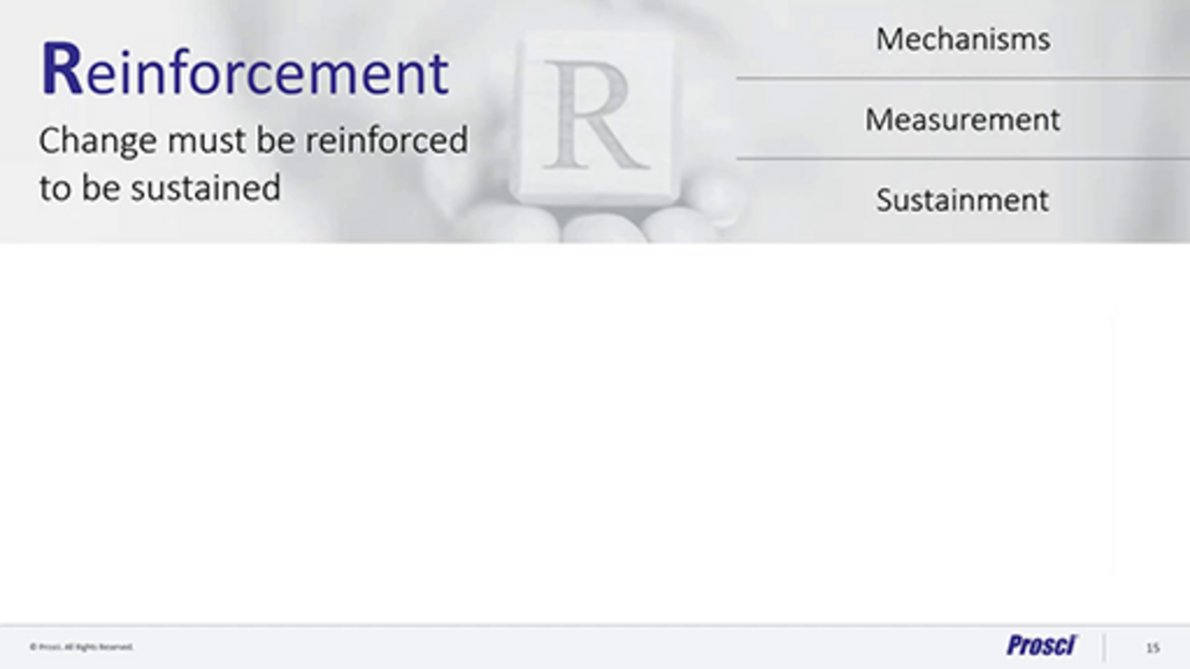

Activity 14 Exploring the Prosci methodology
10 minutes

You have now been introduced to the ADKAR model and considered how change can be influenced at an individual level by guiding the change and addressing issues and barriers. Taking individuals on a change journey is critical for success.
The ADKAR model is part of the Prosci methodology, which considers change from the individual and organisational perspective in order to lead to success.
Take some time now to explore this methodology further on the Prosci methodology overview webpage (Prosci, 2022) and consider how individual influencers could enable organisations to implement successful change programmes.
Use the text box below to capture your reflections, if you wish.

Provide your answer...

9.5 Choosing a suitable framework
As you have seen in this section, there is a plethora of theories and models relating to change and how it can be achieved, but no ‘unified’ theory or model exists. It is likely that your organisation’s context, your personal approach and the change you are trying to implement will influence the framework(s) you use. For example, a large institutional change may align better with Kotter, and a smaller technology-supported change may be better served by the ADKAR model. In reality, however, to embed a change successfully, it may be necessary to use several models together in more of a hybrid approach.

Activity 15 Choosing the change management framework for your context
10 minutes

Think about the change you identified in Activity 2. Which change management framework would you consider using for that change? Why would that be the best fit for you/your organisation? Which do you feel more comfortable with?
Use the text box below to capture your reflections, if you wish.

Provide your answer...

As a change manager, developing your understanding and learning from others is an essential skill for ensuring successful change management. It is useful to build a toolkit that you can draw on, such as the frameworks in this section, and also consider your own personal development going forward. Resources such as The change management podcast | University of South Wales can provide useful insights into how to approach change initiatives for the future.

Conclusion
Take time to reflect on what you have learned about how organisations are operating now, the considerations for planning and adapting in uncertain times, the impact of digital transformation and the importance of embedding sustainable working practices, as well as meeting both the Well-being of Future Generations (Wales) Act 2015 seven wellbeing goals and net zero targets.
As your organisation evolves to succeed and protect the wellbeing of future generations, continue to develop your own skills and understanding of hybrid ways of working for HEIs, and think about how you can use the contextual framework to assist you long term. The framework was identified in the introduction to this course and is repeated below to help you draw your conclusions.
The framework helps you to consider and understand your organisational context and needs from key perspectives.
- You and your ways of working should take account of the key stakeholders within your environment and their needs in relation to organisational development.
- You need to understand organisational requirements and the context, connections and requirements for key areas of focus and how these relate to the needs of your stakeholders.
- You need to consider your ways of working for the wellbeing of future generations.

Figure 1 (repeated) Hybrid ways of working: a contextual sustainability framework
View description - Figure 1 (repeated) Hybrid ways of working: a contextual sustainability framewor ...

In the video below, Sophie Howe, the Future Generations commissioner for Wales, shares her thoughts how HEIs can help to protect future generations. As you reflect on the course and perhaps start to think about your next change initiative, consider the role that HEIs, public bodies and all organisations can play in developing new ways of working to protect future generations.

Video content is not available in this format.
Video 14 Protecting future generations
View transcript - Video 14 Protecting future generations

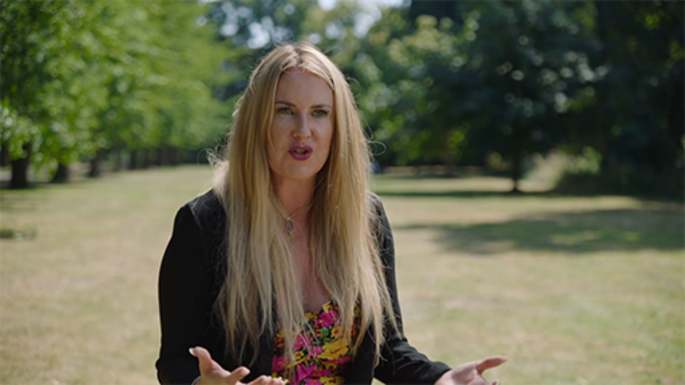

Then bookmark the Future Generations frameworks for scrutiny, service design and projects so that you will be able to draw on them when planning your next change initiatives and consider a more sustainable approach to protect future generations. You came across these in Section 2.1: The 5 Ws and H, but they are repeated below for your ease of access.
- Future Generations Framework for scrutiny (Future Generations Commissioner for Wales, 2019)
- Future Generations Framework for service design (Future Generations Commissioner for Wales, 2018)
- Future Generations Framework for projects (Future Generations Commissioner for Wales, n.d.. a)
- Guidance on using the Future Generations Framework for projects (Future Generations Commissioner for Wales, n.d., b)
This course is part of the Supporting hybrid working and digital transformation collection, which you may wish to explore further.

References
Bakowski, S. (2021a) Building a change network that works (Part 1 of 2). Available at: https://makingchangehappen.co.uk/blog/change-network-that-works (Accessed: 1 December 2022).
Bakowski, S. (2021b) Building a change network that works (Part 2 of 2). Available at:https://makingchangehappen.co.uk/blog/change-network-that-works-part2 (Accessed: 1 December 2022).
Beer, M. and Nohria, N. (2000) Breaking the code of change. Cambridge, MA: Harvard Business School Press.
Buchanan, D. A. (1992) The expertise of the change agent. Hemel Hempstead: Prentice Hall.
Burnes, B. (2004) ‘Kurt Lewin and the planned approach to change: a re‐appraisal’, Journal of Management Studies, 41(6).
CMI (2021) What does a change manager do? 30 March [YouTube]. Available at:https://www.youtube.com/watch?v=0D0e8z1-RGQ (Accessed: 26 November 2022).
CMI (2022a) Change practice framework. Available at:https://change-management-institute.com/what-is-change-management/
CMI (2022b) The Effective Change Manager: The Change Management Body of Knowledge (CMBoKTM). Available at: https://change-management-institute.com/cmbok/ (Accessed: 24 November 2022).
Creasey, T. (n.d.) Before you act, consider these keys to preparing for change. Available at: https://www.prosci.com/blog/keys-to-prepare-for-change (Accessed: 24 November 2022).
Dennis, M. (2020) Striking the right balance between project and change management in an organisation, 24 June. Available at:https://www.apm.org.uk/blog/striking-the-right-balance-between-project-and-change-management-in-an-organisation/ (Accessed: 26 November 2022).
Fisher, J. (2012) The process of transition - John Fisher 2012 (Fisher's personal transition curve). Available at:https://www.businessballs.com/freepdfmaterials/fisher-transition-curve-2012bb.pdf(Accessed: 25 July 2022).
Future Generations Commissioner for Wales (n.d.a) Future Generations Framework for projects. Available at: (Accessed: 1 December 2022).
Future Generations Commissioner for Wales (n.d.b) Guidance on using the Future Generations Framework for projects. Available at:https://www.futuregenerations.wales/wp-content/uploads/2018/11/FGCW-Guidelines_01.pdf (Accessed: 1 December 2022).
Future Generations Commissioner for Wales (2018) Future Generations Framework for service design. Available at:https://www.futuregenerations.wales/resources_posts/future-generations-framework-for-service-design/ (Accessed 1 December 2022).
Future Generations Commissioner for Wales (2019) Future Generations Framework for scrutiny. Available at: (Accessed: 1 December 2022).
Future Generations Commissioner for Wales (2022) Simple changes. Available at:https://www.futuregenerations.wales/simple-changes/ (Accessed: 1 December 2022).
Goleman, D. (1996) Emotional intelligence: why it can matter more than IQ. London: Bloomsbury.
Higgs, M. and Rowland, D. (2000) ‘Building change leadership capability: “The quest for change competence”’, Journal of Change Management, 1(2), pp. 116–130.
Hill, L. A., Brandeau, G., Truelove, E. and Lineback, K. (2014) Collective genius. the art and practice of leading innovation. Boston: Harvard Business Review Press.
Johnson, G. (1992) ‘Managing strategic change - strategy, culture and action’, Long Range Planning, 25(1), pp. 28–36.
Kennedy, R. F. (1966). Day of affirmation address, University of Capetown, Capetown, South Africa, 6 June [Speech]. Available at:https://www.jfklibrary.org/learn/about-jfk/the-kennedy-family/robert-f-kennedy/robert-f-kennedy-speeches/day-of-affirmation-address-university-of-capetown-capetown-south-africa-june-6-1966 (Accessed: 25 July 2022).
Kippenberger, T. (2000) ‘Two contrasting theories of change: Theory E and Theory O’, The Antidote, 5(7), pp. 17–21.
Kotter, J. P. (1996) Leading change. Cambridge: Harvard Business School Press.
Mendelow, A. L. (1991) ‘Environmental scanning: the impact of the stakeholder concept’, Second International Conference on Information Systems, Cambridge, MA, pp. 407–418.
Mind Tools Content Team (n.d.) Kotter’s 8-step change model – implementing change powerfully and successfully. Available at:https://www.mindtools.com/a8nu5v5/kotters-8-step-change-model (Accessed: 1 December 2022).
Mind Tools Content Team (2022) Lewin’s change management model. Available at:https://www.mindtools.com/ajm9l1e/lewins-change-management-model (Accessed: 26 November 2022).
Pascale, R. T and Athos, A. J. (1981) The art of Japanese management. New York: Simon & Schuster.
Project Management Institute (1996) A guide to the project management body of knowledge (PMBOK® Guide). Newtown Square, PA: Project Management Institute.
Prosci (n.d.) In-depth articles from the experts. Available at: https://www.prosci.com/resources/articles (Accessed: 26 November 2022).
Prosci (2022) Prosci methodology. Available at:https://www.prosci.com/methodology-overview?hsLang=en-us (Accessed: 26 November 2022).
Schein, E. H. (2017) Organizational culture and leadership. Hoboken, New Jersey: Wiley.
Senior, B., Swailes, S. and Carnall, C. (2020) Organizational change. Harlow: Pearson Education Limited.
Sinek, S. (2009) Start with why: How great leaders inspire everyone to take action. USA: Penguin.
Tutor2u (2018) Lewin’s force field model (change management). Available at:https://www.tutor2u.net/business/reference/models-of-change-management-lewins-force-field-model (Accessed: 26 November 2022).
Visual Paradigm Online (2022) Force field analysis guide. Available at:https://online.visual-paradigm.com/knowledge/change-management/force-field-analysis/ (Accessed: 26 November 2022).
Wanner, M. F. (2013) ‘Integrated change management’, PMI® Global Congress 2013 –North America [Conference paper]. New Orleans, Project Management Institute. Available at:https://www.pmi.org/learning/library/integrated-change-management-5954(Accessed: 26 November 2022).
WalkMe (2019) Reinforcing change: all your questions answered. Available at: https://change.walkme.com/reinforcing-change(Accessed: 1 December 2022).
Waterman, R. H. and Peters, T. (1982) In search of excellence. lessons from America's best-run companies. New York: Harper & Row.
Workforce Management Strategies (n.d.) Change management. Available at:https://www.workforcemgmtstrategies.com/change.html (Accessed: 19 July 2022).

Acknowledgements
This free course was written by Martin Roots and Esther Spring with support from Sue Lowe.
Except for third party materials and otherwise stated (see terms and conditions), this content is made available under a Creative Commons Attribution-Non Commerical-Share Alike 4.0 Licence.
The material acknowledged below is Proprietary and used under licence (not subject to Creative Commons Licence). Grateful acknowledgement is made to the following sources for permission to reproduce material in this free course:
Images
Course Image: Matthew Taylor/Alamy Stock Photo
Figure 2: The process of transition – Fisher’s Personal Transition Curve (Fisher, 2012) courtesy ©J M Fisher 1999/2012 https://www.businessballs.com/freepdfmaterials/fisher-transition-curve-2012bb.pdf
Figure 4: CIM Change Practice Framework courtesy of Change Management Institute https://change-management-institute.com/what-is-change-management/
Figure 14: adapted from Johnson and Scholes cultural web (1992) to improve understanding of Organisational culture: a critical review by Seonaidh McDonald and Richard A. Foster
Figure 16: adapted from https://www.kotterinc.com/methodology/8-steps © 2022 Kotter International Inc
Figure 17: the ADKAR model from: https://www.prosci.com/hubfs/367443/2.downloads/ebooks/The-Prosci-ADKAR-Model-Overview-eBook.pdf?hsLang=en-us © Prosci Inc.
Figure 17: The Cynefin framework: adapted from https://thecynefin.co/about-us/about-cynefin-framework/ ©Cynefin® 2022
Tables
Table 6: adapted from Higgs, M. and Rowland, D. (2000) ‘Building change leadership capability: “The quest for change competence”’, Journal of Change Management, 1(2), pp. 116–130
Audio / Visual
Video 3: What do you think change management is? Courtesy: Change Management Institute Change Management Institute - For Change Professionals (change-management-institute.com)
Video 4: Project Management vs Change Management: Courtesy: Change Management Institute Change Management Institute - For Change Professionals (change-management-institute.com)
Video 6 4.1: The 7 Cs of communication: Emerald Works Emerald Works | Emerald Works https://www.mindtools.com
Video 7 Activity 12: Lewis’s change management model: Emerald Works Emerald Works | Emerald Workshttps://www.mindtools.com
Video 8 Activity 12: Applying Kotter’s eight-step change model to your context: Emerald Works Emerald Works | Emerald Workshttps://www.mindtools.com
Video 9 Awareness: Prosci ADKAR model © Prosci All rights reserved. ADKAR and ADKAR terms are registered trademarks of Prosci Inc. Used with permission. www.prosci.com
Video 10 Desire: Prosci ADKAR model ©Prosci All rights reserved. ADKAR and ADKAR terms are registered trademarks of Prosci, Inc. Used with permission. www.prosci.com
Video 11: Knowledge: Prosci ADKAR model ©Prosci All rights reserved. ADKAR and ADKAR terms are registered trademarks of Prosci Inc. Used with permission. www.prosci.com
Video 12 Ability: Prosci ADKAR model ©Prosci All rights reserved. ADKAR and ADKAR terms are registered trademarks of Prosci Inc. Used with permission. www.prosci.com
Video 13: Reinforcement: Prosci ADKAR model © Prosci All rights reserved. ADKAR and ADKAR terms are registered trademarks of Prosci Inc. Used with permission www.prosci.com
Every effort has been made to contact copyright owners. If any have been inadvertently overlooked, the publishers will be pleased to make the necessary arrangements at the first opportunity.
Don’t miss out
If reading this text has inspired you to learn more, you may be interested in joining the millions of people who discover our free learning resources and qualifications by visiting The Open University –www.open.edu/openlearn/free-courses

Solutions

Activity 1 How do you feel about change?

Discussion
The chances are that the lockdown periods in 2020–2021 seem a distant memory. You may have specific recollections, but no matter how challenging that time may have been for you, you adapted and dealt with the continual uncertainty and change. There may be learning you took from those lockdowns. For many it offered an unexpected opportunity not only to re-evaluate what was important but also how resilient you can be.
My overwhelming memories are how rapidly I had to adapt and change, not least to cope with home schooling and work but also having to shield. I had to plan, adapt and change. While these were comparatively small-scale ‘change projects’, it involved scoping, planning, implementation (with a lot of resistance from my children!) and delivery, in order to adapt to living in lockdown whilst also looking after my children, working and managing my own wellbeing. Some days were really mentally challenging.
If you are dealing with or have recently dealt with change, your feelings may be much stronger. Even though I am used to dealing with continual change due to the nature of my work, I can identify with nearly all the stages, and I know I have a loop of anxiety (is this the right approach?), guilt (did I just say that?) to moving forward (we can do this). However, I learn from these feelings and talk to others to get different perspectives, ideas and support.
Back to - Activity 1 How do you feel about change?

Activity 3 Evidence for change

Discussion
Understanding why you need to make the change and what the expected outcomes are, prior to starting the change management process, is the essential first step. Evidence to support the decision should be gathered, reviewed and agreed, often best encapsulated in a situation assessment.
Back to - Activity 3 Evidence for change

Activity 5 Creating a stakeholder engagement plan

Discussion
Your stakeholder map and engagement plan may evolve during the lifecycle of your change initiative, as you identify and adjust requirements. It is sensible to allocate time to review these at each stage of the process to ensure that your approach continues to be appropriate for the needs of your stakeholders and the needs of the initiative.
Back to - Activity 5 Creating a stakeholder engagement plan

Descriptions

Figure 1 Hybrid ways of working: a contextual sustainability framework
Image shows three concentric circles around a central circle containing the word ‘YOU’. In the first of the outer circles (labelled 1), there are arrows pointing outwards from the central circle to the words Team(s), Organisation, Individuals, Community and Students, which are spaced evenly around the circle. Each of these terms have double-headed arrows connecting them to each other. The next circle out (labelled 2) surrounds the first and contains the terms Digital Transformation, People, Places, Sustainability, Values and Culture and Compliance. These are evenly spaced around the second circle and double-headed arrows sit between each term. The outer circle (labelled 3) has the words Long term, Prevention, Integration, Involvement and Collaboration spaced out around the circle with double-headed arrows connecting each term. Beside each term is an icon to represent it. The words and the circles show the interconnection between, stakeholder, organisation needs and ways of working.
Back to - Figure 1 Hybrid ways of working: a contextual sustainability framework

Figure 2 The process of transition – Fisher’s Personal Transition Curve (Fisher, 2012)
The process of transition, showing people tend to go through a range of emotions at different stages of the change ‘journey’, which include anxiety, happiness, denial, fear, threat, disillusionment, guilt, depression, hostility and gradual acceptance moving forward.
Back to - Figure 2 The process of transition – Fisher’s Personal Transition Curve (Fisher, 2012)

Figure 3 Simon Sinek's 'Golden Circle' (2009)
Figure shows the Golden Circle. Three circles one inside each other. In the small circle in the middle, the word Why, in the middle circle, the word How, in the outer circle, the word What. To the side of the circle text explains these: Why – your purpose, why you do what you do. How – you do what you do. What – you do and your results.
Back to - Figure 3 Simon Sinek's 'Golden Circle' (2009)

Figure 4 CIM Change Practice Framework
CIM Change Practice Framework, circles in middle with text, People, with Continuous planning and adapting in text around the circle, then large circles spilt into four, covering following activities:
Define – elements of this, vision for change, benefits mapping, change approach and roadmap, change outcomes, target timeframe.
Analyse – Change impacts, success indicators, stakeholder identification change maturity, change capability, change readiness, degree and scale of change.
Engage – and co-design – elements within it – communication and engagement strategy, co-designed solution, organisational redesign, news ways of working, implementation planning, risk mitigation
Align and refine – elements within it – leadership coaching, tracking success criteria, real-time problem solving, testing and refining, organisational realignment
Outer circle – text – The change management context, human dynamics, organisational context
Back to - Figure 4 CIM Change Practice Framework

Figure 5 Identifying stakeholders
Two circles overlapping, to show a way of identifying stakeholders, in one circle – influence change, in the other impacted by change, where the circles overlap – influence and impacted
Back to - Figure 5 Identifying stakeholders

Figure 6 Stakeholder map
Stakeholder map, showing the stakeholder groups for an organisational change initiative. Circle in middle – change project, with values and culture around it. Then branches of this with groups of stakeholders related to each branch.
Change team – change owner, change sponsor, change funder, finance
Change team – change support – change champions, communication, HR, specialist teams, subject matter experts
Organisation – people – students, units, teams in units, individuals
Organisation – technology – infrastructure owners, systems and tools owners, uses, experts, governance and security owners, compliance
Organisation – places, facilities managers, buildings managers, health & safety
Organisation – sustainability, experts, Well-being of Future Generations (Wales) Act 2015, target owners, external bodies
Organisation – external – competitors, other institutions, bodies, suppliers, communities
Back to - Figure 6 Stakeholder map

Figure 7 Stakeholder management plan
Image showing stakeholder management plan. Three tables, first showing levels of impact of stakeholders for success and your impact on stakeholders. Second table, showing stakeholders readiness and level of commitment, and third table listing the stakeholders into a final plan.
Back to - Figure 7 Stakeholder management plan

Figure 8 Communication stages
Figure shows the communication stages in a chart with the x axis for time and y axis for progressive stages. Stages are:
Announcement – to create awareness and raise the understanding.
Engagement – to clarify impact for positive perception and buy-in
Involvement – to maintain momentum through hands-on participation
Recovery – to gain acceptance and commitment (internalised change).
Back to - Figure 8 Communication stages

Figure 9 Primary methods of change communication
Image shows following communication channels on a chart that plots on the x axis – level of interactivity, and y axis – level of involvement. Channels include intranet, newsletters, briefing documents, posters, emails, conference calls, FAQs, change networks, face-to-face ‘team talks’, roadshows and demonstrations.
Back to - Figure 9 Primary methods of change communication

Figure 10 The 7 Cs of communication
This is an illustration showcasing the 7 Cs of communication: clear, concise, correct, concrete, coherent, complete and courteous.
Back to - Figure 10 The 7 Cs of communication

Figure 11 Change readiness assessment form
This shows eight steps of the change readiness assessment form. Tailor the plan – Pace, from gradual pace, earned commitment on the left to rapid pace, directed allegiance on the right. Align the team – Coalition, from individual or select group to broad team involved in execution. Build momentum – Energy, from Top-down directive to bottom-up broad mandate. Execute discipline, from Integrated into responsibilities and budgets of key people to Dedicated resources new PMF system. Build change capabilities – Methodology, from mix of problem-solving tools and techniques to integrated improvement teams. Monitor and adjust – Risk, from risk of failure too high need not urgent to fast momentum required urgency great. Make it personal – Engagement from discrete change planned strong existing talent to behaviour-based change learn and skill up change mindset. Communicate the change – Transparency, from highly sensitive information few people involved in decision making to actions need broad support need input from many people.
Back to - Figure 11 Change readiness assessment form

Figure 12 Force field analysis
Figure shows force field analysis, a way of analysing the tension between opposing forces (those that drive a change forward – driving forces – and those that offer resistance to change – restraining forces). Change initiative is in the middle; on either side arrows point to the change to represent the forces that drive change one side and those that resist on the other. The ‘forces’ in the arrow are based on the drives or resistance based on the change initiative
Back to - Figure 12 Force field analysis

Figure 13 Moving from current state to future state
Figure shows arrow at top with text project plan, three boxes in middle with text – Current state, change, future state, then arrow at bottom with text change plan.
Back to - Figure 13 Moving from current state to future state

Figure 14 The cultural web (adapted from Johnson, 1992)
Figure shows the organisational culture web, showing seven interlinking circles: the paradigm in the middle circle, with the following circles around it, Symbols, Power structures, Organisational structures, Control systems, Rituals and routines and Stories.
Back to - Figure 14 The cultural web (adapted from Johnson, 1992)

Figure 15 The 7S model
Figure shows six circles around a centre circle which has the text – Shared Values. The circles around it have, Strategy, Structure, Systems, Staff, Style, Skills
Back to - Figure 15 The 7S model

Figure 16 Kotter's eight-step change model
A flower shape consisting of one large orange circle interlocking with eight small blue circles around its edge, each describing one of the eight steps in the process. Kotter’s eight-step change process -Create a sense of urgency. Build a guiding coalition. Form a strategic vision and initiatives. Enlist a volunteer army. Enable action by removing barriers. Generate short-term wins. Sustain acceleration. Institute change.
Back to - Figure 16 Kotter's eight-step change model

Figure 17 The ADKAR model
Figure shows the ADKAR model . Arrow with Successful Change written on it, above Awareness, Desire, Knowledge, Ability, Reinforcement; below the arrow, Business need, Concept and design, Implementation, Post implementation.
Back to - Figure 17 The ADKAR model

Figure 1 (repeated) Hybrid ways of working: a contextual sustainability framework
Image shows three concentric circles around a central circle containing the word ‘YOU’. In the first of the outer circles (labelled 1), there are arrows pointing outwards from the central circle to the words Team(s), Organisation, Individuals, Community, and Students, which are spaced evenly around the circle. Each of these terms have double-headed arrows connecting them to each other. The next circle out (labelled 2) surrounds the first and contains the terms Digital Transformation, People, Places, Sustainability, Values and Culture, and Compliance. These are evenly spaced around the second circle and double-headed arrows sit between each term. The outer circle (labelled 3) has the words Long term, Prevention, Integration, Involvement and Collaboration spaced out around the circle with double-headed arrows connecting each term. Beside each term is an icon to represent it. The words and the circles show the interconnection between, stakeholder, organisation needs and ways of working.
Back to - Figure 1 (repeated) Hybrid ways of working: a contextual sustainability framework

Video 1 Operating during COVID-19

Transcript
LOUISE CASELLA:
In Wales, Welsh government were very clear about what the requirements were about presence in the office, and how we worked in the office and when you could come into work and when you couldn't. That was different, to in England. I think that's going to be one of the interesting things about the pandemic. It's really exposed to devolution and the powers of different governments to take decisions within the UK.
We therefore had to make sure it was well understood, what we had to do within the office in Wales vis-a-vis working in Milton Keynes on campus works, and really understand how we adapted our processes in Wales, adapted our working practices, made the office safe for those for whom coming into the office mattered and it really was important for them to be in.
But also supported those who weren't coming into the office as well. So, getting that balance became quite a challenge. But it meant really understanding what were the legal requirements upon us and really understanding how we kept people safe and well whilst they were here.
We've paid a lot of attention to trying to balance what the organisation needs with what the individual needs throughout the pandemic. I think we started off very much focusing on the individual.
We recognise that this was a big change for everybody and what came first was getting their home life sorted out and getting themselves working whilst at home. Was a very different challenge to before. So we very much focused, at the beginning, on what the individual needed and making sure the individual was well equipped to do that. As time went on, we spent more-- we paid more attention to what teams needed and what the organisation needed. And therefore, how we fitted the individual's needs into that.
So trying to balance off team objectives to, perhaps, how an individual would like to work. So we had to think about the whole of that picture and navigate our way through it. And I think our emphasis at the moment is probably much more on the team than the individual whilst obviously respecting what individual preferences may be. But we are, obviously, we have students to support, we have work to do, and people are working for us to do that.
So how they come together to do that is where our emphasis is now. Is about the outcomes and the service to students. Whereas at the beginning of the pandemic, it probably would have very much been on that individual circumstances and making sure that individual was safe.
MATT WINTLE:
Before the pandemic, Admiral, we had around about 350, 400, what we would call homeworkers or flexible workers, which is a small portion of the population of the employees at Admiral. We're about 10,000 strong. And very quickly, within a few months, three to four months, we went to 6,000 to 7,000 people working at home. And that acceleration would have taken years-- three, five years if we'd done it in peacetime, if you like.
So that's what changed really. Was this huge acceleration of capability to allow people to do their jobs effectively to the same quality, serve the customer as well as they do in the office at home. So that embracing of technology to be able to do that had to happen, and it had to happen fast. I think it was fascinating the way that it did happen. Admiral prides itself on a culture that's very empowering and giving people autonomy to make decisions.
And actually, in that period of time, we needed to go back to a bit of command and control because it wouldn't have happened. That acceleration and the way in which we managed to make that happen would never have happened if we hadn't gone back to a bit of planning and a bit of we've got to make this happen. But we did it, and everybody bought into it.
And then we quite quickly became aware that we needed to get back to some of the great things Admiral's always done around communication and culture and redress that balance of that kind of shock, if you like, of getting people working from home.
Where it's landed us now is a much more wider use of technology across the business, if you like. So you would always have the IT departments and the data areas who would be at the forefront of using some of these tools-- collaboration tools, messaging tools, those sorts of things. And now that has to be everybody because that's the way that we're communicating most of the time.
So the real shift is in the way that we communicate and the tools we use to do it. And when I talk about communication, that could be a meeting or it could be a document that you're sharing. And that's fundamentally changed through the pandemic.
JONATHAN MORGAN:
The pandemic changed the way that Object Matrix worked in so much that prior to the pandemic, probably 90% of the workforce was in the office on a daily basis. Post the pandemic, maybe, 90% of the workforce is working from home on a regular basis. So it has changed.
It has changed the way that people live and organise their lives, it's changed the way we organise the work, it's changed the way we schedule the work even because the schedule of the work should allow smaller units to work with regular communication so that we don't just leave someone for a month and then come back to them. So in many ways, the pandemic has changed the nature of the organisation much for the better, and some things have been challenges.
SARAH JONES:
The University adapted very quickly to the pandemic. Our new digital services directorate was created within months of us going into lockdown. New teams, new functions were put into place, new blended learning, teaching and learning standards, the implementation of the Jisc discovery tool. It was very fast and a big shock for a lot of people. The usage of Teams, we were very lucky. We were already using Teams as an institution. However, it did mean that people had to be learning a lot, very, very quickly whilst also carrying on with their day-to-day work.
Teaching had to carry on, library services still had to carry on, everybody was carrying on whilst also trying to adapt to doing this all from home. During lockdown, we had the opportunity to develop services that we would not, otherwise, have had the time to develop because we weren't dealing so much with the face-to-face side of things. And we've been able to carry many of those services forward since coming back on campus. And I think it's allowed us to view the student journey in a different way.
MICHAEL WOODS:
The need to adapt to the pandemic in March 2020 was quite significant for us. We went very quickly to having to switch to working from home and teaching online. And I think one of the challenges for us now is finding that balance going forward. I think all of us, students and staff, have seen this as a learning gradient of adapting to new ways of working and to new technologies.
It wasn't necessarily fully new. We have for some time, for example, always recorded our lectures and made those available to students. So the idea of students watching lectures online or accessing those resources online was not necessarily new. What was different was that they were doing that instead of being in a class rather than in addition. So one of the challenges, I think, has been not in itself just moving to an online way of working, but subsequently moving to a hybrid way of working where we are teaching different aspects and different ways.
Now, I think in terms of how we take that forward. I think we do value in-person teaching and we value the campus experience. That's been important to the students' experience in Aberystwyth. It's also important, I think, for staff to have that campus interaction. But we're also reflecting on what was a value of the hybrid form of teaching and the online forms of teaching that we may maintain.
Certainly, I think, we've appreciated the ability to use more online resources, support our teaching, and making those available in addition to the in-person taught content. So that may well be your short videos explaining particular concepts on methods or techniques which may go alongside other teaching content.
And then I think finally more broadly, I think, as a way of working, I think we are continuing with many of our meetings conducted online. That we are more flexible in the working conditions we are able to offer staff with more working from home. And it's important, I think, that we do still have opportunities where we bring people into campus, where we meet in-person and campus. But we also see that some of the routine work, some of the routine meetings can be offered more through online platforms.
NICK BARRETT:
It really is extraordinary how something like the OU has weathered the storm and I think really grown into its potential to a certain extent. So yeah. Very exciting experience. I wouldn't wish it on anyone, but in doing so, our ways of working are much more aligned with the experiences of our students. And I think that's helped teach me the value of why we do what we do.
There were so many challenges and potential legal landmines that we had to avoid and navigate as we started to switch our experience. Now, as the OU, I think we were slightly protected compared to some higher educational institutions. I mean, the competition in markets authority, let's get technical here. Have requirements about not misselling the experience and of course, many organisations had promised a face-to-face learning experience.
Now, we are distanced by design, but we had a lot of face-to-face encounters. Summer schools, for example, tutorial groups. And we had to, again, as an organisation, switch those quite rapidly. Making sure that we weren't falling foul of regulations. We spun up some really rapid reaction groups to look at this. It was a very agile period of decision making.
We were talking in a different way with different folk in the room. It cuts across normal governance, which obviously carries risk, but it brought a freshness to the way we make decisions around circumstance rather than protocol, if that makes sense. We were reacting to situations and really thinking through what we were trying to do. So I think there were some benefits there. The challenge, I guess, was trying to keep people informed and engaged. And see that this wasn't just something we were doing because of the short term pandemic, the crisis management element, but some of these things are going to actually have a long lasting benefit.
LLINOS NEALE:
Welsh Ice has been so agile during the pandemic. It's had to be because, obviously, we're a physical space and physical spaces were just places people didn't go during the pandemic. So we needed to make sure that we were still offering the businesses based here access because they needed to get important pieces of post, that kind of stuff. But we also needed to make sure that the community and everything people were getting that wasn't physical space from this all went online.
Now, the hub has evolved and grown to respond to what people need post-pandemic. So people need to be way more flexible. So they're going to be needing space where they can do things online as well as in-person. And this has to be a way more dynamic space for people. So we're just evolving to respond to that.
Back to - Video 1 Operating during COVID-19

Video 2 Evidence for leading change

Transcript
NICK BARRATT:
The OU has changed its ways of working thanks to the pandemic in so many different ways because we've had to adapt our entire operating model. Now, we are a distance learning organisation. And we support our students who never really set foot on site, apart from our post grads. And our associate lecturers who tutor them and support them, again, don't really come on site at all.
But a lot of our other activities were all based on one of our sites, either at Walton Hall for Milton Keynes or in the regions in England, Nottingham and Manchester, and of course, our four nations. So literally overnight, everyone had to up sticks and find new ways of engaging with each other.
So there's a sustainability benefit. But we have lost some of that face-to-face spark, that excitement of going into a room to do some workshopping. So we're almost trying to get the best of both worlds with a hybrid model. So the bits that work from the pandemic, we've held those. The bits we've missed, we're trying to bring them back, but in a very deliberate way.
The experience of trying to switch to a new way of working has been challenging. I think that's a very diplomatic way of saying it. It was quite stressful because as someone fairly new to the OU, but with a large unit to look after, there's 580 people in learner discovery services, you do feel the weight of responsibility, of decision making.
I was really lucky to have a great senior team around me and some brilliant colleagues in all the teams to manage that really rapid change of an overnight switch. But also trying to make it as supportive an experience, so we spent a lot of time looking at the wellbeing of our colleagues, assessing our workloads, trying to do some fun stuff. So we can connect with each other. So it's not a disengaged and remote experience.
And you have to experiment. You have to try new things. You stretch yourself as a person. So I guess I've learned a lot about myself, about my ways of working, about the strengths of my colleagues, and I guess the robustness of the institution. It really is extraordinary how something like the OU has weathered the storm, and I think really grown into its potential to a certain extent. So yeah, very exciting experience.
I wouldn't wish it on anyone. But in doing so, our ways of working are much more aligned with the experiences of our students. And I think that's helped teach me the value of why we do what we do.
There were so many challenges and potential legal landmines that we had to avoid and navigate as we started to switch our experience. Now, as the OU, I think we were slightly protected compared to some higher educational institutions. Now, we are distance by design. But we had a lot of face-to-face encounters, summer schools, for example, tutorial groups.
And we had to, again, as an organisation, switch those quite rapidly, making sure that we weren't falling foul of regulations, office for Students, of course, monitoring the situation. So we spun up some really rapid reaction groups to look at this. It was a very agile period of decision making. We were talking in a different way with different folk in the room.
It cut across normal governance, which obviously carries risk. But it brought a freshness to the way we make decisions around circumstance, rather than protocol if that makes sense. We were reacting to situations and really thinking through what we were trying to do. So I think there were some benefits there.
The challenge, I guess, was trying to keep people informed and engaged and see that this wasn't just something we were doing because of the short-term pandemic, the crisis management element. But some of these things would actually have a long-lasting benefit. So unintended benefits, some challenges that we're still working through. But surely that's an example of a very agile, forward-thinking organisation. We were set up for the pandemic because we have been distance learning by design for so many years.
This hasn't just been a suck it and see approach. We have tried to balance the needs of the organisation. And by that, I mean, our students and our associate lecturers, as well as some of our staff who have been used to working on one of our sites. And this has been done quite deliberately.
We have tried to take an evidence-based approach. So just thinking about the unit that I look after, learner discovery services, we've run a series of pulse surveys, just checking in with our folk on a regular basis. As each particular phase of the pandemic has either started or we look like we're coming out of it, we just wanted to see how people felt. Are we doing enough to support their well-being, for example?
So we were trying to take an evidence-based approach. And that's now pulled through into some of our forward planning. So we are looking to retain some of the benefits of offsite working, but bring back the benefits of onsite and just test and evaluate what works, whether that's the use of different space, evaluating how people engage with it, not just in terms of whether people feel more productive, but also how they feel about themselves and whether that then pulls through into some of the well-being statistics that we monitor.
So we've created a really robust people plan which will change over time as we go through different phases. We are looking at how we check in each year with our teams, just to make sure that they are linking their activities with a very deliberate what's our why, what's our purpose. And so they can then start to think of the right environment, the right support they need. And that'll be different for different teams across my unit, and of course, across the university.
So everything we do, I mean, you'd expect, this as a university, is based around research, data led insights. But also, let's not forget, there is a little bit of intuitive experience that we're bringing to bear. We have been through an unprecedented pandemic. Some of the work we've done has not been evidence-based because we've just had to get on and do it.
And I think it has given confidence to the balance between trying to go to place everything and get the absolute perfect data sets and just seeing that it's probably working, experimenting, test and learn methodology, and just suck it and see, good, old-fashioned intuitive management as well.
One of the challenges that we faced was trying to balance the operational needs of keeping a university running with some of the challenges that we knew already existed around whether we were inclusive, whether we were particularly diverse, making sure people had an equal and equitable experience at work. And that can play across a wide range of areas.
So we saw the Black Lives Matter movement during the first phase of the pandemic. But we'd already identified a problem in our unit and across the university that we were trying to tackle. So even during lockdown, we made sure that the group that we put together were empowered and given a wide range of opportunities, some funded, some-- because we freed them up from their day-to-day activities-- to really explore what we can do to help people during the pandemic.
And that allowed us to experiment. Because we were in this sort of unprecedented phase, we didn't have our traditional working patterns, we just tried a few different things. We introduced reverse mentoring. Because we were now doing online recruitments, we tried a range of anonymised recruitment techniques. We made sure that there was training in place that you could do online, rather than trying to gather people together.
So we really stepped into some of the potential solutions. And it's still not right. There's a long way to go with some of this work. But it's allowed us to rethink and reset how we need to move forward as an organisation. Our ways of working aren't just operational, they're cultural. They're values led. If we can't get this right, how will people trust us with their learning experiences?
We talk a lot, as the Open University, about the skills you need to study with us. And we have all sorts of foundation level courses. And we do have a preparedness to study at the OU open course on our OpenLearn platform. There are some digital literacy skills. And there are some digital capability skills which are out there.
But we never thought to apply that to ourselves. So some of this is organisational. Some of it is using new software packages. Some of it is just simply working out the new etiquette. And that's really sharpened our focus, not just on the skills we need to bring new people into the OU, but how important those skills are when we encourage our students to study with us.
And in many ways, these skills are life skills. These aren't just skills that help you study. These are skills that employers will be looking for. So building more tools to help people and sharing those skills, of course, to help people with their daily digital lives as more and more of society remains digital, this could be, I think, the greatest or most lasting legacy of the pandemic for the OU. We're upskilling ourselves, but we're sharing that experience with others.
Communications and engagements, it sounds easy. You tell people stuff, you engage them. Actually, it's really tricky to get the messaging right. And we're still learning about what works and what doesn't. I think the greatest lesson is just be transparent.
We are doing something for the first time. We don't know how it's going to go. We don't have the answers. Let's be upfront about that as well. But also seek help from people. What is it that you need from us? So that we can be more responsive to your needs, make it a very open-ended conversation, rather than broadcast communication.
This is what we're doing to you. Actually, we've got a very good student support network. The OU Students Association has been instrumental in helping us adapt and making sure that we are keeping the things that work, but also quickly addressing things that haven't worked. And we've tried to build them in to as many of our decision-making bodies as possible.
The suppliers, again, have also had to adapt. And that's been a bit of a learning curve. We haven't been able to do certain things the way we would have liked. Changes to contractual terms and conditions, making sure that we are far more robust around cybersecurity. I mean, that's a huge risk in the digital age.
And so just tightening a few of those loopholes, making sure that we're protecting our data, making sure there aren't any potential cybersecurity breaches. That's been something that's really risen up the agenda as the organization has understood what digital means in a post-pandemic world. So lots of change, lots of challenge.
But again, we have to communicate two ways. It's not just about telling people what we're doing. It is listening to what they need us to do as well.
I think for higher education, we need to think about the experience of the pandemic on some of our younger learners. And it's disrupted education all the way through, from people starting in primary education to those transitioning into secondary, taking exams, and learning remotely for a couple of years. We have to think about the mental impact on that, the impact on mental health and wellbeing, but also the skills that they've had to learn.
And higher education just needs to be more aware to the possibility of doing things differently. Now, there's a big push to get back to face-to-face learning environments for a lot of the traditional higher education institutions. And there's real value in that because, for many people, particularly a younger learner coming straight from A-levels, surely that's what uni is about. It's about meeting friends, socializing, finding yourself, learning with colleagues.
But I think what we've shown, certainly as in OU, is that you can blend that. There is an element of distance learning that point of demand in an age group where their digital ecosystem is hardwired into what they do. Their social media networks, their point of demand, instant access to content.
So I think we need to think, as a sector, about how we blend and bring the best of both worlds together. I think that the OU is in the best place to do that, to lead that conversation. We've been doing this for 53 plus years. And that's made us a little bit shock absorbent when it's come to the pandemic. But we've learned an awful lot.
And I think the key thing is that you can't do this overnight. If you want to get a really good and effective learning environment, you need to spent a couple of years designing what it is you want to teach, what those experiences will look like. We've been certainly doing that for 20 plus years in an online environment.
So we'd be very happy to share this with the sector. But I think the sector needs to step into that space as well. Let's look at what the government is encouraging. And again, that means we're going to have to rethink, as a sector, how, when, and where we provide education to a much broader range of people throughout their lives.
It's not just about getting your qualification and of you go into the world of work. You learn constantly through your life. And we should all be there, providing different learning experiences to help people. So some really fundamental thinking has to go into the way higher education adapts to the modern world. It's going to be tough out there for many years, if not decades, with the economic shock of the war in Ukraine post-pandemic, cost of living, these are problems that are going away, let alone the other societal challenges, such as the environment.
So we need to be ready for that. We need to find more sustainable ways of educating and probably more engaging and relevant ways of educating throughout someone's journey through life. That's why the OU, I think, is in the right place at the right time.
Back to - Video 2 Evidence for leading change

Video 3 What is change management?

Transcript
SPEAKER:
Every day we managed to navigate an exponential amount of changes in our lives, big and small, from overcoming road detours and downloading new apps, to adopting flexible office environments or moving overseas. At the individual level, change is a human process we all experience when we try new things, do things differently or when something impacts the way we function day to day.
The way we experience change is very personal. It's our thoughts, feelings and beliefs, positive or negative, that drive our behaviour. They determine if we perceive change as a threat that needs to be avoided or an opportunity to be embraced. How we respond to change can determine the success of projects or transformation initiatives. And when we consider that organisations are composed of groups of individuals, the challenge of change management becomes so much greater.
Change for organisations is now constant. Customer and business demands are changing, technology is becoming more agile and our work environment is constantly evolving. With a greater degree of change on its way, a company's ability to adapt successfully at an individual and organisational level will make the difference between whether the company survives or thrives, and this is where change management comes in.
Change management is a business discipline focused on navigating change by exploring key questions, such as who the change affects, how the affect will be felt and what the change will ultimately deliver, and by when. This discipline focuses on increasing acceptance and adoption of changes by reducing uncertainty, confusion and human angst as the people transition unfolds. This can get complex, especially as multiple changes overlap.
As such, change management has evolved into both a profession and an organisational capability. People that are highly skilled at designing and enabling effective change processes and practices have become specialists in this business discipline, while organisations are building internal change capabilities to better manage and adapt to constant change. In a busy workplace where priorities compete, it takes effort from everyone, individuals, leaders and those tasked with implementing the change, to achieve collective organisational change.
And you'll know you've accomplished this when you can truly say that leaders demonstrate sound leadership and consciously dedicate time to engage their teams in conversations about the changes. The pace and volume of change is managed, and those responsible for implementation understand how different change initiatives fit together. Project frameworks incorporate strong people change processes. Change is implemented with true and transparent input from those impacted. And change processes are managed through effective partnership between change professionals and business leaders.
To help you on your change journey, connect with the Change Management Institute today. We're all about supporting our members and our community to be better connected, to strengthen capability and enhance credibility.
Back to - Video 3 What is change management?

Video 4 Change management vs project management

Transcript
SPEAKER:
When it comes to projects, project management and change management both play an important role in achieving success. However, it can sometimes be a little confusing trying to separate the two. They both involve managing relationships, planning and overseeing activities, and identifying and mitigating risks. So what makes them different?
Project management is the application of knowledge, skills, tools and techniques to activities to ensure project requirements are met. Project managers typically initiate, plan, and deliver the project and often use a methodology or structured approach to achieve the desired outcome. More specifically, a project manager focuses on project activities, outputs, outcomes and benefits; solution design ensuring project requirements are met; and the progress of works and management of time, scope, budget and quality.
From a project manager's point of view, a project is considered to be a success if it has been delivered to scope, time and budget and is technically accepted by the business. But what happens if a project is delivered successfully and the benefits are not adopted and realised by the business?
This is where change management comes into play. Change management focuses on the optimal adoption of new practices by those impacted by projects or programs of work. In a project environment, change managers typically use their deep understanding of the psychology of change, specialist tools and frameworks to design the human change process.
Alongside the project manager, the team, and in consultation with the business, they also plan and advise how to integrate the project outcomes into the organisation. More specifically, a change manager focuses on who the stakeholders are, such as employees and customers; the context into which the change is being delivered; communication, engagement and adoption; skills and capability development, including leadership coaching and ownership; and change readiness to ensure the change is sustained and sticks. Unlike project management, a change manager's success is measured on the realisation of benefits and the adoption of the new ways of working.
Can a project manager also manage the change elements? Yes and no. It really depends on the size and nature of the change. The integration of change management and project management creates value and together provide a unified approach for achieving the desired results and outcomes of organisational change.
To help you on your change journey, connect with the Change Management Institute today. We're all about supporting our members and our community to strengthen capability, enhance credibility and to be better connected.
Back to - Video 4 Change management vs project management

Video 5 What does a change manager do?

Transcript
SPEAKER:
As organisations constantly evolve, it can sometimes be a little overwhelming trying to handle all the changes. You might have a single change for a defined group of employees or customers, perhaps as a result of a project.
Maybe you want to achieve transformational change, such as a significant shift in your business model which involves identifying and managing multiple strands of change together. Or maybe you want to build internal organisational capability to better manage and adapt to the constant volume of change.
This is where change managers come into play. Change managers are experts when it comes to change. They have a specialised yet diverse set of skills and tools, and often use a structured, agile or iterative approach to define plan and manage change.
Depending on the need, they can be an internal change consultant engaged to support your leaders and people with the change. An organisational development professional, a leader or a middle manager charged with the responsibility to bring about a change. Or a team leader, who gets people excited about the change.
Change managers understand that every organisation is different and the importance of the context in which change is delivered. As such, they will often adapt their approach and solution to meet your specific change needs.
They can articulate your current state and what your organisation will look like. Explore who is affected by the change, how the change will be felt and how to sustain the end result.
Establish and facilitate change networks to involve and engage those impacted, including effective communication, coaching, training, monitoring and support when the rubber hits the road.
And help you prepare for the change, increase adoption and transition to a new way of working. When it comes to implementing change big or small, change managers play an important role in ensuring the benefits you set out to achieve are realized and are key to success.
The Change Management Institute is all about supporting our members and our community to strengthen capability, enhance credibility and to be better connected.
To learn more about how competency framework and the skills and abilities you need to be able to define, plan and manage change, get in touch with us today.
[MUSIC PLAYING]
Back to - Video 5 What does a change manager do?

Video 6 The 7 Cs of communication

Transcript
[MUSIC PLAYING]
PRESENTER
Welcome to Mind Tools Video Learning Series. Whether it's writing an email, sending a report, chairing a meeting or giving a presentation, most of your working day will likely be spent communicating. So one of the best ways to boost your productivity is to communicate in the clearest, most effective way possible. A great tool for this is the seven Cs of communication, a seven-point checklist for delivering engaging and effective messages.
The first of the seven Cs is to be Clear. Ask yourself, what's the purpose of your message? If you're not sure, the person you're communicating with won't be either. Make your key messages stand out. Do this by minimising the number of ideas you talk about in each sentence – one is ideal. You don't want people to have to read between the lines, as this could lead to misunderstandings.
Second, be Concise. Keep it brief, avoid repetition and delete unnecessary adjectives and filler words like "kind of" or "basically."
Third, when your message is Concrete, your audience will have a clear picture of what you're telling them. Detail is important, but not too much. Try to include some stand-out facts, and make sure you have a laser-sharp focus on your key message.
Next, be Correct. Double-check for mistakes. When your communications are error free, they'll look professional and polished.
When something's Coherent, it's logical. It means that you've connected all of your points and made them relevant to the key topic. This will also help to keep the tone and flow of your message consistent.
The sixth point on the checklist is Complete. Supply your audience with all the information that it will need to make an informed decision or take action. If, for instance, you're sending a reminder about a meeting, be specific. Include details of the location, time and purpose, and ask people to respond.
Lastly, be Courteous. This means having a friendly, open and honest tone, and avoiding hidden insults or a passive-aggressive tone. Always keep your audience viewpoint in mind, and show that you empathise and understand its needs.
For further examples of how you can apply the seven Cs to your communications, read the article that accompanies this video.
Back to - Video 6 The 7 Cs of communication

Video 7 Lewin's change management model

Transcript
SPEAKER 1:
If you've ever tried to implement a major change program in your organisation, then you'll know it's often difficult. People can resist change, and it can be hard to make change stick in the long term. This is why it's so important to understand the change process. Then, you can manage it effectively and get people's support at each stage. A useful way to get a better understanding of this process is to use Kurt Lewin's Unfreeze, Change, Refreeze model. This is based on the analogy of melting a block of ice and then refreezing it into a new shape.
The first stage in the model is unfreeze. This is the part of the change process where you have to communicate why this change is necessary. Make sure everyone who will be affected by the change knows this, and make sure you deal with people's doubts and concerns. Next, comes the change itself. This is where people begin to get used to the idea that things will be different. Keep communicating how the change will benefit the people involved so they continue to support it. And remember, that the change itself doesn't happen overnight, so give people plenty of time to adjust to it.
The last stage in Lewin's model is refreeze. This is when the change is set in place and becomes part of your organization's culture. In this last stage, make sure people have the training and support they need to stay on the right track, and regularly check that the change has happened and that people are using the new processes that you've implemented. It's also important that you celebrate everyone's hard work in making the changes success. This helps people find closure and it helps them believe that future changes will also be successful.
Now, read the article that accompanies this video and learn more about the strategies you can use at each stage of the process.
Back to - Video 7 Lewin's change management model

Video 8 Kotter's change model

Transcript
SPEAKER:
If you've ever tried to make a big change in your team or organisation, you'll know you can't just expect everyone to hop on board. Many people feel wary of change. So it's important to prepare them for it and guide them through the process.
John Kotter's eight-step change model is a useful approach to follow, and this video shows you how. Kotter's first step is to create a sense of urgency around the need for change. This helps spark the motivation in your team to get things moving. Discuss the threats of not changing and the opportunities that successful change will offer. Give people the chance to ask questions and get involved.
Next, get together a powerful coalition of people who are willing to show their support for your idea. A mix of respected leaders, experts and stakeholders from across your organization can make highly effective champions. Then create a vision for change. Explain the values that are central to the process. And share an inspiring picture of the future that people will want to be a part of.
The fourth step is to keep communicating your vision frequently and powerfully and to embed it in everything you do. Talk about it at every chance you get. And walk the talk to demonstrate the kind of behaviour you're looking for from others.
One of the most helpful things you can do for your team members is to remove any obstacles in their path. Are there any processes or structures that are holding up change? Is there anyone who still needs convincing? If so, focus your energies there. Then recognise and reward people for making change happen.
There are three more steps to follow in Kotter's change model – creating short-term wins, building on the change and anchoring the change. To learn about them and the tools that will help you put the whole model into practice, read the article that accompanies this video.
[MUSIC PLAYING]
Back to - Video 8 Kotter's change model

Video 9 Awareness - The Prosci ADKAR model

Transcript
SPEAKER:
The first A in ADKAR is awareness, awareness of the need for change. And it's because change begins with understanding why. This is a question we began asking when we turned about two years old as human beings – why, why, why?
We're seeing it show up all over the business literature, as well. You look at Simon Sinek's Golden Circle. You look at all the work around purpose-driven organisations. The notion of why as a central driving force is becoming more and more evident. Awareness has been the beginning building block of ADKAR since ADKAR was created.
What are the factors that influence awareness? They are things like your view of the current state, how you perceive problems and the credibility of the center. Do you think the current state is broken and needs to get fixed, or do you think the current state is doing great? Because you know what, you're the one that built the current state.
Are you hearing a lot of rumours about the current state, or are you not hearing much about the current state? Do you identify problems as soon as they start to creep up, or are you kind of oblivious until a problem is sort of blatantly right in front of you? Who's telling you this is a problem? Who's telling you that there's a need for change? Is that someone that you trust? Is it someone that is credible? Do you buy into the message?
So that's awareness of the need for change. It's what's the nature – why, why now, what if we don't. And I'm going to make one quick observation here. Notice that it is not awareness that the change is coming. It's awareness of the need for change. It is a subtle but incredibly important difference because I've heard even skilled change practitioners say, oh, we built awareness. We told them when it was coming. Awareness that it's coming is not awareness in the ADKAR model. We define awareness as awareness of the need for change. It's when I've internalised and understand why this is happening in the first place.
Grab your smartphone. We're going to do a couple – we're going to build a real quick word cloud here. That question why we begin asking from the very beginning – what I'm asking here is, what are some of the common reactions that a person is asked to change but they don't understand why? A person is asked to change, but they don't understand why.
This is stupid. Resistance – they resist. They panic – frustration. Sometimes we just ignore, you know? Reluctance, consolidation, apathy. Yeah, I will shut down. The why is so important to open up my receptivity to hear anything else that's about to come and to start to open up to the fact that I might need to take a step out of my current state how I do things today because there might be a need to change. If we don't create that compelling why, we see confusion, resistance, people ignore, we get fear and anger and all of those consequences.
[MUSIC PLAYING]
Back to - Video 9 Awareness - The Prosci ADKAR model

Video 10 Desire - The Prosci ADKAR model

Transcript
SPEAKER:
After awareness, the second building block of the ADKAR model is desire, desire to participate and support the change. It is the personal decision to get on board. It's when you are standing still, and you put your left foot in front of the right foot. You took a step. You made the personal decision that I am going to engage in this change.
There's all kinds of factors that influence desire. It's a very personal component because it is that personal decision. It's an internalisation. It's an internal flip of the switch.
What are the things that influence desire? Well, what's in it for me? Certainly, there is a driver about, what is it actually going to mean for me or my team or us? But there is a, what is the payoff at the individual level?
Organisational context plays a role in influencing desire, too. What else is going on within the organisation? What else am I involved with? What else is hitting me? How do I see myself moving forward or out of or within this organisation?
My personal situation influences desire, absolutely. All of the things that go on in my life, inside and outside of the work walls will influence my personal decision around this particular initiative.
And then finally, what motivates me? Am I internally motivated, externally motivated? Do I need lots of appreciation and acknowledgment? Do I not need any of it? What is it that motivates me? And it's going to trigger that personal decision.
Desire is tricky because it is that personal decision. We cannot make somebody have desire, but we can nudge and influence desire when we better understand these influencing factors.
And I'll give you a little bit of an extra tidbit here on the bottom right. This is a visual I used for many years. I hadn't used it for probably five years now, but I thought it was worth pulling forward because I think it's an interesting view of the same change but different desires.
The same change here is for you to buckle up your safety belt when you're driving. Notice the first sign, buckle up, it could save your life. The second sign, buckle up, it's the law. And then the third sign, click it or ticket, $142 minimum fine.
Fascinating. It's the exact same change getting you to buckle your safety belt, but we have three different appeals to desire – conformity to the law, personal safety, and avoiding that $140 ticket.
Interestingly, I was at the Prosci headquarters in Fort Collins, Colorado just a couple of weeks ago. I was driving up from DIA along E-470, and they've got those big old signs that are up above the roadway that they can change out. And as I drove by one, it said, seat belt unbuckled? Seriously?!? Which found fascinating because now here, we are attempting to shame me into making the personal decision to click my seat belt.
After awareness of the need for change comes the desire, the personal decision to engage in the change.
[MUSICAL FLOURISH]
Back to - Video 10 Desire - The Prosci ADKAR model

Video 11 Knowledge - The Prosci ADKAR model’

Transcript
SPEAKER:
Following desire comes knowledge, the knowledge on what to do. What do I need to know during the change? What do I need to know after the change? Knowledge is important, but it needs context.
Knowledge needs to come after awareness and desire. It's necessary but not sufficient. Now, there are factors that influence your knowledge. Your current knowledge base certainly plays a role. How big is the knowledge gap between what you know today and what you need to know to be successful after this change happens?
Certainly, your learning style and your capability and capacity to learn new things will be important here. Nobody's going to ever be able to teach me math. It's just kind of the way it is. And so there might be inhibitors around my style or capability to learn certain things.
And then resources, what time do I have available? What resources do I have available to help me learn?
Now interestingly, from an ad car observation perspective, knowledge is the knee-jerk default reaction. We have a change we need employees to make. What do we do? Send them to training.
And I use this analogy, the picture of the hammer. If you only have a hammer, everything looks like a nail. And before change management became matured to where it is today, before it really got the rigor and the process and structure and repeatability, the way we could try to bring about change was training. It was the hammer we had to swing around.
Training and communication, right? Those are the two hammers we had. And so I think that notion of, if we need somebody to do something differently, send them to training has perpetuated into our organizations today.
Without context, without awareness and desire, the attempt to build knowledge is going to be a miss. We're going to have people sitting at the back of their room with their arms crossed across their chest, wondering what it was they were going to make for dinner that night. Knowledge is critical and necessary, but insufficient when we don't have awareness and desire beforehand.
[MUSICAL FLOURISH]
Back to - Video 11 Knowledge - The Prosci ADKAR model’

Video 12 Ability – The Prosci ADKAR model

Transcript
SPEAKER:
The next A is ability to implement the change. This is the notion that change requires action in the right direction. It takes a step forward.
So ability is where we are actually demonstrating the capability to do things the new way. Ability is where I am eating better, I am working out more, I am effectively logging into my payroll system, I am using all of the functionality of Office 365 that I'm supposed to be. Ability is where I'm doing my job the new way.
There are factors that influence ability, certainly, like psychological and physical capabilities and blocks. There are just certain things – I will never be able to run a four-minute mile, I won't be able to do it. So there might be true limiting capabilities or blocks or barriers. Habits can certainly influence my ability to adopt a new set of skills or behaviours or processes or mindsets.
And then availability of time and resources. Do I have coaching? Do I know where to go when I need help? Am I able to practice in a safe environment so that I can hone that ability? So that's ability.
My observation here on the bottom right is that knowledge does not equal ability. I have a lot of people say, Tim, aren't knowledge and ability the same thing? And I encourage them to go golfing with me one time to see the difference between knowledge and ability. And you don't even have to play 18 holes with me, one hole will do.
Because I know how to approach the ball, I know how far apart to keep my feet, I know how I'm supposed to bend my knees, I know I'm supposed to keep my head down. Like, I know that I'm supposed to keep my head down. I have the knowledge that I'm supposed to keep my head down. But I do not have the ability to keep my head down. So knowledge and ability are different. Knowing something and having the capability to do it are different.
Now the knowledge ability gap can be different, it can be wider or narrower, though. Sometimes I'll use the example, you take something like electronic health records rolling into a hospital. You have two doctors, one of them is nearing the end of his time. He's not a big fan of technology. And he still carries a flip phone. And the other one is six months out of medical school, has never not attended school without a tablet in front of them. The knowledge ability gap for using a new touch screen–based electronic health record will be different for those two people.
And for a particular person, different changes are going to have different knowledge ability gaps. When I had to move from Office '03 to Office '07, that was a huge knowledge ability gap for me because I'm a keystroke guy. And so that ribbon kind of ruined my world for a couple of months. But then when I jumped from '07 to '10, the ribbon stayed the same and I had a much smaller knowledge ability gap. Because I had assembled the base level knowledge I needed to interact with that ribbon and relearn all my keystrokes that I needed to get through.
Ability is when the change has happened. Ability is when left foot has gone in front of the right foot. I have demonstrated the capability that I can show up and do things the new way that I need to, that I'm trying to achieve in this change.
[MUSIC PLAYING]
Back to - Video 12 Ability – The Prosci ADKAR model

Video 13 Reinforcement - The Prosci ADKAR model

Transcript
SPEAKER:
And then the final building block of ADKARs are reinforcement to sustain the change, that we know we will slide back to what we used to know if we don't reinforce. There are certainly factors that help us make sure the change sticks – things like accountability, the removal or absence of negative consequences, and celebrations and recognition of progress, getting the pat on the back, the thank you. Those are the things that are important around reinforcement.
Now, my observation here is that it is our natural, physical and psychological tendency to revert back to what we know. Comfort is a very powerful thing. And there's actually research showing that it takes more glucose for the brain to do something different than to do things how it always has.
So it's our natural tendency to go back. Reinforcement, then, is critical to sustain the progress and to make sure the change sticks. But reinforcement must be meaningful.
And so my question to you that just popped up on the poll is, what attributes make reinforcement meaningful? Because in order for reinforcement to really ensure that the change sticks, it must be meaningful. It must be meaningful to the person who's receiving it. It must be meaningful relative to the, I think, accomplishment or the change that was made.
Ah, look at this word cloud here. It involves recognition. It is timely. It's sincere. It is credible. It is relevant. It is authentic. It's consistent. Yeah, look at all these things.
Don't give baseball tickets to somebody who doesn't like baseball. Don't applaud somebody for something that they didn't think they actually accomplished. We must be consistent and sincere and authentic and relevant.
That doesn't mean we don't celebrate small things. Don't get me wrong. Throw a humongous celebration for those very small steps that are going to start to build the momentum in the right direction. But let's be sure that we are reinforcing true performance, a true change that has been demonstrated, and that the reinforcement is meaningful to the person who's receiving it.
[AUDIO LOGO]
Back to - Video 13 Reinforcement - The Prosci ADKAR model

Video 14 Protecting future generations

Transcript
SOPHIE HOWE
So our public institutions, our government, our local authorities, our health boards, are facing a huge number of challenges. They’re trying to deal with the problems in the here and now, the cost of living crisis, the rising costs of care, the need to transition to a low carbon economy. And they are not going to be able to do those things without help, advice, and support from our academic institutions, who hold a huge amount of knowledge and a huge amount of innovation and a huge number of solutions to some of these challenges that we’re facing.
So a really effective Wales would be one where our public institutions are coming together with our academic institutions to be finding solutions to some of these big societal challenges collectively.
Back to - Video 14 Protecting future generations

