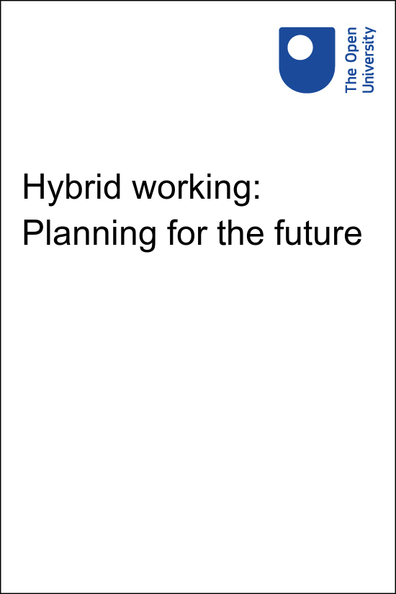

HYB_7 Hybrid working: Planning for the future

Hybrid working: Planning for the future

This publication forms part of the Open University Supporting hybrid working and digital transformation collection on OpenLearn. Details of this and other Open University modules can be obtained from Student Recruitment, The Open University, PO Box 197, Milton Keynes MK7 6BJ, United Kingdom (tel. +44 (0)300 303 5303; email general-enquiries@open.ac.uk).
Alternatively, you may visit the Open University website at www.open.ac.uk where you can learn more about the wide range of modules and packs offered at all levels by The Open University.
The Open University,
Walton Hall, Milton Keynes
MK7 6AA
First published 2022
Unless otherwise stated, copyright © 2022 The Open University, all rights reserved.
All rights reserved. No part of this publication may be reproduced, stored in a retrieval system, transmitted or utilised in any form or by any means, electronic, mechanical, photocopying, recording or otherwise, without written permission from the publisher or a licence from The Copyright Licensing Agency Ltd. Details of such licences (for reprographic reproduction) may be obtained from: The Copyright Licensing Agency Ltd, 5th Floor, Shackleton House, 4 Battle Bridge Lane, London, SE1 2HX (website www.cla.co.uk).
Open University materials may also be made available in electronic formats for use by students of the University. All rights, including copyright and related rights and database rights, in electronic materials and their contents are owned by or licensed to The Open University, or otherwise used by The Open University as permitted by applicable law.
In using electronic materials and their contents you agree that your use will be solely for the purposes of following an Open University course of study or otherwise as licensed by The Open University or its assigns.
Except as permitted above you undertake not to copy, store in any medium (including electronic storage or use in a website), distribute, transmit or retransmit, broadcast, modify or show in public such electronic materials in whole or in part without the prior written consent of The Open University or in accordance with the Copyright, Designs and Patents Act 1988.
Edited and designed by The Open University.
Printed and bound in the United Kingdom by [name and address of printer].

ISBN XXX X XXXX XXXX X
X.X

Contents
- Introduction
- Learning outcomes
- 1 Future possibilities
  - 1.1 Sustainable futures
  - 1.2 The Well-being of Future Generations (Wales) Act 2015
  - 1.3 Futures planning for the world today
  - 1.4 Future trends of work
  - 1.5 Future global trends and risks
- 2 Futures Planning and organisational strategy
  - 2.1 Managing expectations
  - 2.2 Mission, vision, values and objectives
  - 2.3 Planning for new ways of working
- 3 Identifying and understanding your 'why'
  - 3.1 Discovering your ‘Why’
  - 3.2 Preparing the workshop
  - 3.3 During the workshop
  - 3.4 ‘How’ and ‘What’
  - 3.5 Developing the ‘How’
- 4 The complexity of problems
  - 4.1 Sensemaking for futures planning
  - 4.2 Cynefin – making better decisions
- 5 Approaches for Futures Planning
  - 5.1 Three Horizons
  - 5.2 The Oxford Scenario Planning Approach
  - 5.3 Introduction to Islands in the Sky
  - 5.4 Islands in the Sky – the methodology
  - 5.5 Islands in the Sky – a case study
  - 5.6 Better Value Sooner Safer Happier
  - 5.7 Choosing an approach
- 6 Developing options – a systems thinking approach
  - 6.1 Systems thinking tools
- 7 Agreeing the option
  - 7.1 Data driven decisions
  - 7.2 Stakeholder acceptance
  - 7.3 What do you need to progress the plan?
- Conclusion
- References
- Acknowledgements
- Solutions

Introduction
Planning for the future is key for any organisation to thrive, be successful and have positive outcomes for your stakeholders and customers, or students if you are a higher education institution.
Organisations are constantly evolving and there is a continual planning cycle of updating strategic documents, unit business plans and responding to operational needs. Even before the COVID-19 pandemic which required rapid reactive planning, there was a need for organisations to focus on futures planning and develop their workforce’s understanding and skills.
The Well-being of Future Generations (Wales) Act 2015 and the role of the Future Generations Commissioner is ensuring that public bodies are ‘Acting today for a better tomorrow and aiming to make ‘long-lasting, positive change to current and future generations’ (Future Generations Commissioner for Wales, n.d.a).
This course takes a human-centred approach to planning, draws on the Future Generations Commissioner’s resources and introduces you to ‘recognised’ approaches. These methodologies will help you understand the needs of your organisation to evolve their ways of working, particularly in hybrid working and digital transformation. It is part of the Supporting hybrid working and digital transformation collection and is designed to give you the opportunity to review the environment and context that you, your team, and organisation are operating in.
While futures planning often is focused on innovation, this course will encourage you to reflect on whether your organisation’s approach is fit-for-purpose as you explore different methods for planning with foresight, sense-making of situations, continuous improvement of ways of working, and managing change. You will develop a strategy to use a single framework model or a mix of models whilst considering elements of business strategies, workplace values and culture, wellbeing and sustainability as well as the digital skills and capabilities you require to meet your objectives.
The course does not focus on understanding and developing an organisational strategy. Instead, it focuses on how you can help to achieve a strategy’s desired outcomes by concentrating on planning, connected to operational and functional needs.

Learning outcomes
After studying this course, you should be able to:
- develop your futures planning understanding and approach
- evaluate how to define your purpose as a team, department, or organisation
- analyse your ‘Why’ to enable better decision-making
- explore a selection of methods and methodologies to make sense of situations and plan any changes required with foresight
- interpret and manage uncertainty more confidently and effectively.

1 Future possibilities
To start this course, we want to move away from thinking specifically about your own organisational internal and external environments. Instead, we want you to consider what the future could be like and to encourage you to be open to possibilities and uncertainties. This first section aims to enable you to feel comfortable with the fact that you may have questions you may think you should know the answer to, and don’t. Futures planning often involves unknowns and idea that may seem impossible. The course has been designed to help you to manage unknowns more effectively and the later sections become more structured as we explore futures planning in detail.

Activity 1 Reflect on the past and think about the future
10 minutes

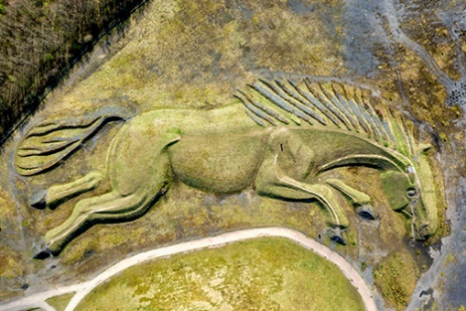
Figure 1 Sultan the Pit Pony sculpture in south Wales
View description - Figure 1 Sultan the Pit Pony sculpture in south Wales

Watch the video ‘Sultan the Pit Pony’ below. Reflect on the past and think about future, both from a personal and organisational perspective.
Then make a note of how you imagine the future.
BBC Wales - The Slate, Sultan the Pit Pony
Video 1 Sultan the Pit Pony

View answer - Activity 1 Reflect on the past and think about the future

The future possibilities for the world are infinite, and as an organisation predicting your own role in that future and how you continue to succeed, will either be an exciting or daunting prospect. For some this may feel overwhelming as, for most organisations, your focus is often on the immediate needs to survive and operate. Others may be fortunate to have Futures and Innovations, or Research and Development teams, but many rely on the knowledge, experience and enthusiasm of those in the workforce tasked with planning, implementing and sustaining change.
In the previous activity you considered the future. We now explore the idea of a futurist mindset.

Activity 2 Do you have a futurist mindset?
10 minutes

In the video below Jacob Morgan, four times best-selling author, speaker and professionally trained futurist explains the futurist mindset.
As you watch the video, consider how you think about the future and when working on tasks, consider how you approach these – do you think about different possibilities? Then answer the poll.

Video content is not available in this format.
Video 2 The skills of the futurist
View transcript - Video 2 The skills of the futurist

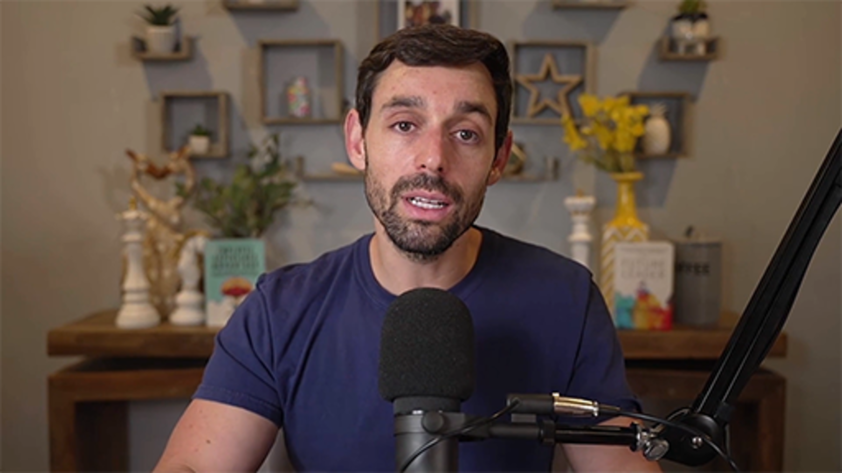

Do you feel you have a futurist mindset?

Interactive content is not available in this format.

View answer - Part

1.1 Sustainable futures
Those focusing on futures planning also now need to ensure that sustainability is an embedded part of their approach. The Millennium Project, a global participatory think tank established in 1996, identifies 15 Global Challenges that have an impact on the future – see Figure 2.

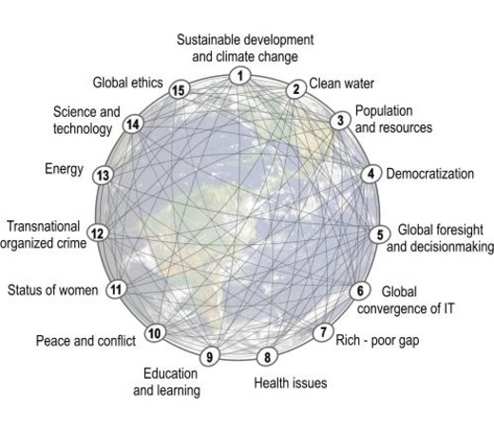
Figure 2 The 15 Global Challenges impacting the future (The Millennium Project, 2022)
View description - Figure 2 The 15 Global Challenges impacting the future (The Millennium Project, ...

For those familiar with the UN Sustainable Development Goals (SDGs), you will note the similarities of these global challenges to the UN SDGs shown in Figure 3.

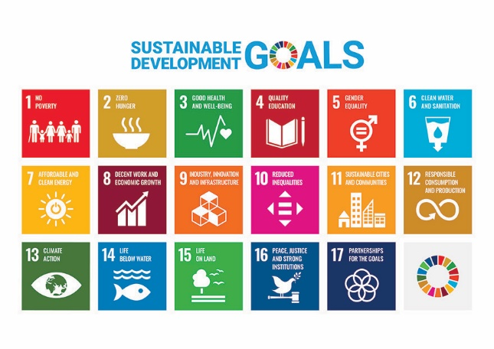
Figure 3 The 17 UN global goals for sustainable development (United Nations, n.d.)
View description - Figure 3 The 17 UN global goals for sustainable development (United Nations, n.d ...

The challenge is to balance the UN global goals for sustainable development with the needs for organisations to evolve, especially in relation to digital transformation which, due to innovation and development as well as the impact of the COVID-19 pandemic, has had an unprecedented acceleration. This will continue to require organisations to embrace technology and ensure they have the capability to utilise it to its full potential. The World Economic Forum article ‘17 ways technology could change the world by 2025’ written in June 2020, during the global COVID-19 pandemic, provides insights into the technology we may already need to understand and engage with, in both our personal and professional lives (World Economic Fourm, 2020).
The unintended benefits to the environment during lockdown during the COVID-19 pandemic ‘due to movement restrictions and a significant slowdown of social and economic activities has led to the air quality improving in many cities with a reduction in water pollution in different parts of the world’ (Rume and Islam, 2020). These benefits are being rapidly reserved as we move more freely again, leading to the question: how can organisations adapt, drawing on appropriate evidence and research to ensure that net-zero targets are achieved?
All UK organisations are required by law to reduce their carbon emissions. The approach to this varies throughout the UK. You can explore these for your nation via the links below:
- Wales – Well-being of Future Generations (Wales) Act 2015 (Public bodies only) and Environment (Wales) Act 2016 (Legislation.gov.uk, n.d.a)
- England – Climate Change Act 2008 (Legislation.gov.uk, n.d.b) and ‘Sustainability and climate change: a strategy for the education and children’s services systems’ (GOV.UK, 2022)
- Scotland – Climate Change (Emissions Reduction Targets) (Scotland) Act 2019 (Gov.SCOTLAND, n.d.)
- Northern Ireland – Northern Ireland Climate Change Adaptation Programme (Department of Agriculture, Environment and Rural Affairs, n.d.)

1.2 The Well-being of Future Generations (Wales) Act 2015
In the UK, the most developed approach to reducing carbon emissions is the Well-being of Future Generations (Wales) Act 2015(Future Generations Commissioner for Wales, n.d.a). It is seen as a world leading approach to protecting future generations and addressing climate change.

The seven wellbeing goals
To ensure that Wales is working towards the same shared purpose and vision, the Act has seven wellbeing goals that all public bodies must work towards achieving. These are outlined in Figure 4 and explained in Table 1.

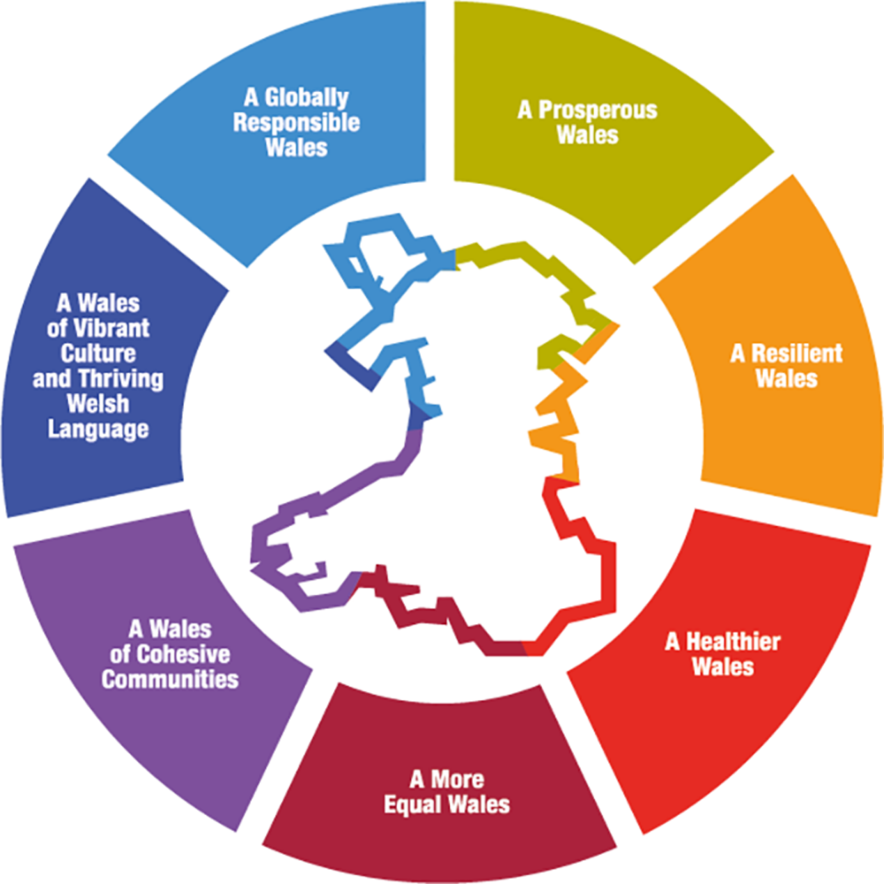
Figure 4 The seven wellbeing goals in the Well-being of Future Generations (Wales) Act 2015
View description - Figure 4 The seven wellbeing goals in the Well-being of Future Generations (Wales) ...

Table 1 Well-being of Future Generations (Wales) Act 2015 - Seven well-being goals
A Prosperous Wales
An innovative, productive, and low carbon society that recognises the limits of the global environment and therefore uses resources efficiently and proportionately (including acting on climate change); and which develops a skilled and well-educated population in an economy that generates wealth and provides employment opportunities, allowing people to take advantage of the wealth generated through securing decent work.
A Resilient Wales
A nation which maintains and enhances a biodiverse natural environment with healthy functioning ecosystems that support social, economic and ecological resilience and the capacity to adapt to change.
A More Equal Wales
A society that enables people to fulfil their potential no matter what their background or circumstances (including their socio-economic circumstances).
A Healthier Wales
A society in which people’s physical and mental wellbeing is maximised and in which choices and behaviours that benefit future health are understood.
A Wales of Cohesive Communities
Attractive, safe, viable and well-connected.
A Wales of Vibrant Culture and Thriving Welsh Language
A society that promotes and protects culture, heritage, and the Welsh language, and which encourages people to participate in the arts, and sports and recreation.
A Globally Responsible Wales
A nation which, when doing anything to improve the economic, social, environmental and cultural wellbeing of Wales, takes account of whether doing such a thing may make a positive contribution to global wellbeing.
Source: Future Generations Commissioner for Wales, n.d.a

The Act has a strong focus on how the goals will be achieved by encouraging public bodies and organisations to use sustainable development principles of long-term, prevention, integration, collaboration, and involvement, as depicted in Table 2 below.

Table 2 Well-being of Future Generations (Wales) Act 2015 - Five ways of working
Long-term: The importance of balancing short-term needs with the needs to safeguard the ability to also meet long-term needs.
Integration: Considering how the public body’s wellbeing objectives may impact upon each of the wellbeing goals, on their objectives, or on the objectives of other public bodies.
Involvement: The importance of involving people with an interest in achieving the wellbeing goals, and ensuring that those people reflect the diversity of the area which the body serves.
Collaboration: Acting in collaboration with any other person (or different parts of the body itself) that could help the body to meet its wellbeing objectives.
Prevention: How acting to prevent problems occurring or getting worse may help public bodies meet their objectives.
Source: Future Generations Commissioner for Wales, n.d.a)

Activity 3 Thinking about the possibilities for higher education institutions
15 minutes

In the video below, Scott Stonham, Independent Sustainable Technology Analyst and author, shares the role higher education institutions (HEIs) could play in the future.
As you watch the video make a note of the following:
- the strengths within your own organisation
- areas that are of interest to you
- how you might be able to make a difference in the future.

Video content is not available in this format.
Video 3 HEIs for the future
View transcript - Video 3 HEIs for the future

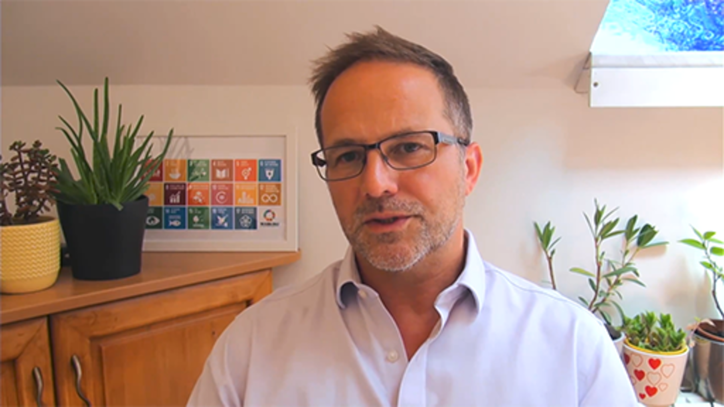

Provide your answer...
View feedback - Activity 3 Thinking about the possibilities for higher education institutions

1.3 Futures planning for the world today
In the last few years, all industry sectors including the higher education (HE) sector have had to react to unprecedented change and uncertainty, while being mindful of the impact on wellbeing of those within your organisation and wider community. The COVID-19 pandemic required us to adapt continually and rapidly, as restrictions and guidance changed between 2019 and 2022. The external environment is still uncertain, as economic, and social stability continue to fluctuate, and the cost of living rises.
How you lead your organisation and plan for business continuity and growth is critical to address your short-, medium-, and long-term needs, aims and objectives.
There are various approaches to foresight and futures planning, as shown in the figure below, and in this course, we only explore a few of these.

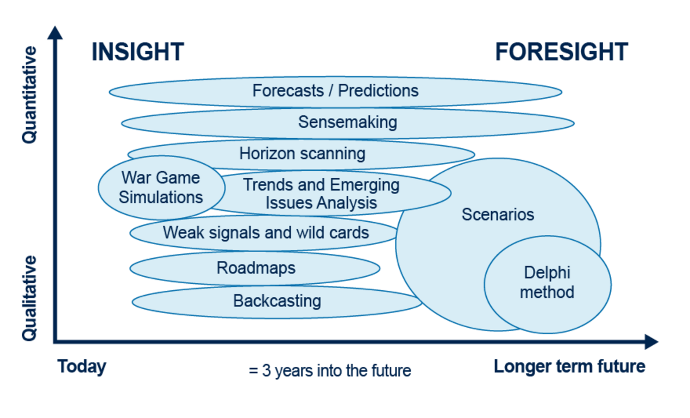
Figure 5 Different approaches to foresight and futures planning (Futures Platform, n.d.)
View description - Figure 5 Different approaches to foresight and futures planning (Futures Platform, ...

In the video below Dr Matt Finch (Associate Fellow, Saïd Business School) and Professor Rafael Ramírez (Professor of Practice, Saïd Business School, University of Oxford) provide an introduction to futures and scenario planning. As you watch think about your own understanding of this type of planning.

Video content is not available in this format.
Video 4 What is futures planning?
View transcript - Video 4 What is futures planning?

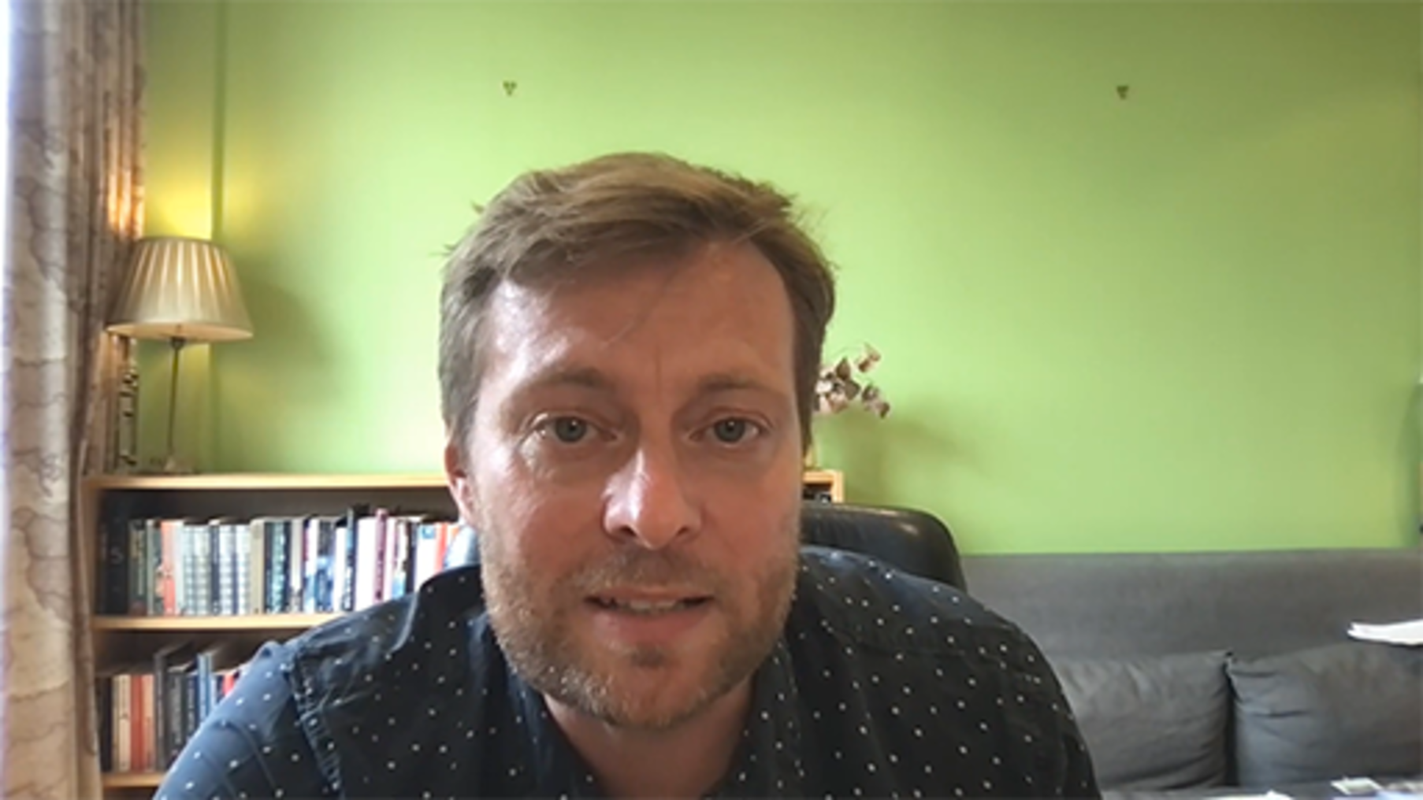

To assist you as you move through the course and consider your approach to futures planning, the ‘Hybrid ways of working: a contextual sustainability framework’ illustrated below, has been designed for this collection of courses. It highlights the key areas you may wish to think about developing for your organisation while managing the expectations, needs and wellbeing of your stakeholders.
The framework helps you to consider and understand your organisational context and needs through a different lens, while being mindful of your own wellbeing.
- You and your ways of working should take account of the key stakeholders within your environment and their needs in relation to organisational development.
- You need to understand organisational requirements, the context, connections, and requirements for key areas of focus, and how these relate to the needs of your stakeholders.
- You need to consider your ways of working for the wellbeing of future generations.

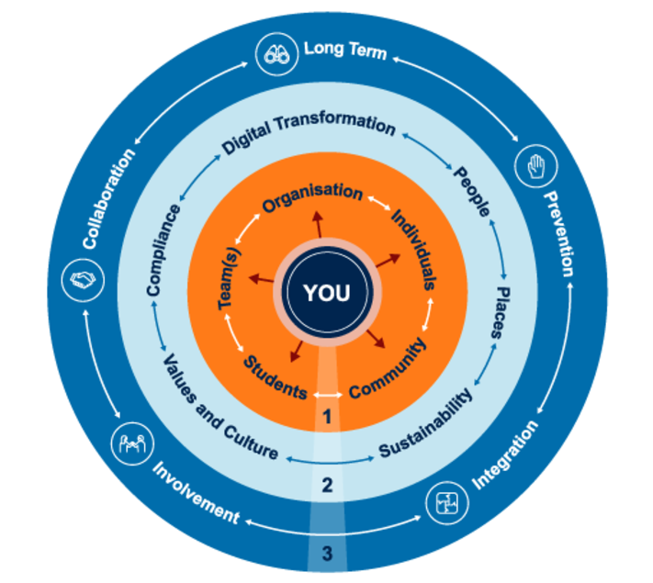
Figure 6 Hybrid ways of working: a contextual sustainability framework
View description - Figure 6 Hybrid ways of working: a contextual sustainability framework

If you are unfamiliar with the term ‘lens’ this term is used to encapsulate looking at things from different perspectives, with an empathic approach. By placing yourself in different situations or by looking at things from someone else’s perspective – considering those points of view and repeating this for the different elements/stakeholders/areas involved – builds a more holistic and consolidated view of the needs, support available and possible questions and solutions that may evolve.

1.4 Future trends of work
Many higher education institutions (HEIs) are reflecting on lessons learned from reactive ways of working during the pandemic and evolving their working practices and policies to embed more inclusive and proactive ways of working. In higher education (HE) this has resulted in more hybrid work environments and developing their capabilities in response to digital transformation. While there is more for organisations to navigate and implement, many can now take a more reflective approach. They can take the time to plan for what is needed in both the short- and long-term and continue to embed more sustainable ways of working.
As organisations plan for the future, the wellbeing and expectations of employees and the employee experience, need to be priorities. As teams are more distributed, traditional unit functions may no longer be appropriate for these new ways of working, so organisational structures need to be developed in line with these changes.
The Gartner article ‘9 Future of work trends post covid-19’ (Turner and Baker, 2022) identify trends that have the greatest impact on the employee experience as:
- Hybrid work becomes mainstream
- There’s a shortage of critical talent
- Well-being is a key metric
- DEI (diversity, equity and inclusion) outcomes could worsen
- Turnover will increase
- Managers’ roles are changing
- Gen Z wants in-person work experiences
- Shorter work weeks are a new EVP (employee value proposition)
- Data collection is expanding
You may recognise some of these trends in your organisation today, others you may feel are on the horizon. When it comes to identifying the need to plan for hybrid working, Turner and Baker, (2022) suggest you are not alone – their article states nearly 39% of organisations would risk losing employees if they went back to fully on-site arrangements. While according to the Office for National Statistics (2022), of all employees surveyed, 84% of workers that worked from home during the pandemic intend to carry out a mix of working at home and in their place of work in the future.
Of course, there is a difference between having to work remotely during a period of global crisis, where individuals and organisations had to be quick to adapt to working and learning from home, and developing a long-term strategy to support workers, customers and other stakeholders who choose to work remotely at least some of the time.
This means, as an organisation, your awareness and understanding of employees’ expectations is critical to managing expectations and also for effective planning and strategy development. We frequently hear ‘one size does not fit all’ but for an organisation the reality is, you have to find a balance in order to operate effectively. This may require radical transformation. The McKinsey and Company article ‘Organizing for the future: Nine keys to becoming a future-ready company’ (De Smet et al., 2021) states reinvention is needed, and proposes the following nine imperatives that future-ready companies will exhibit.

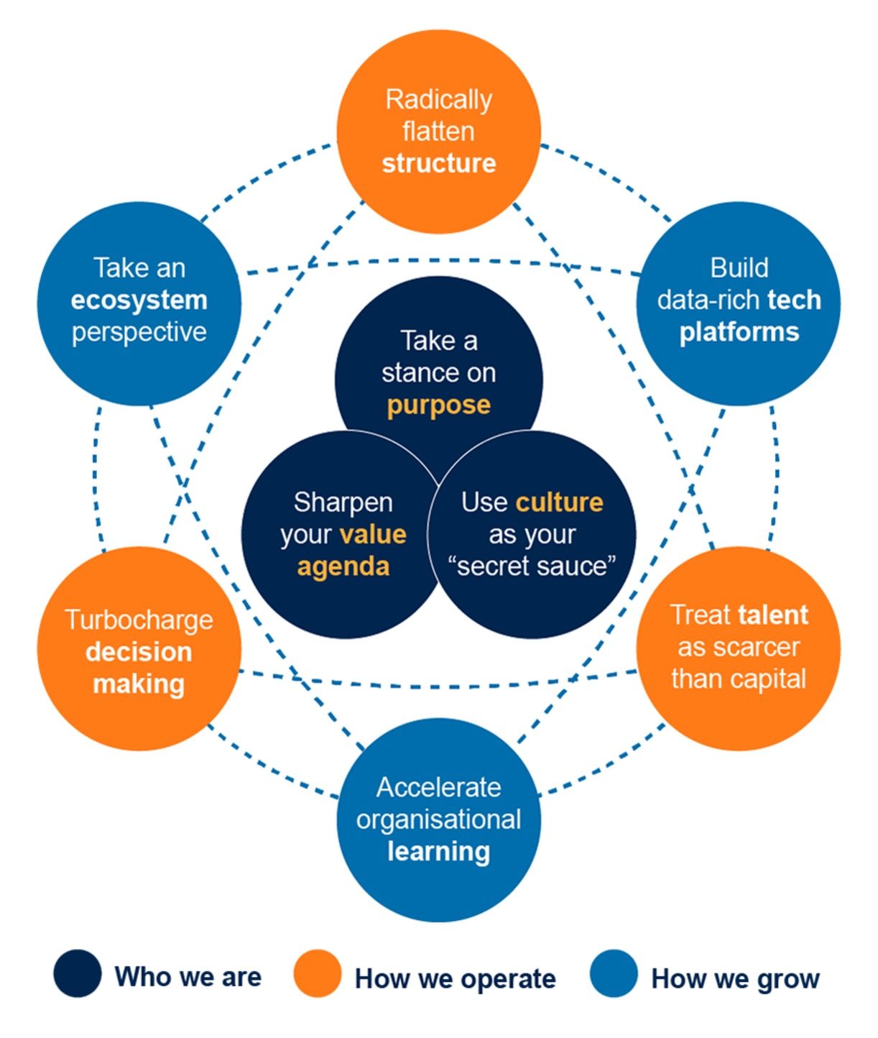
(De Smet et al., 2021)
Figure 7 Nine organisational imperatives for future-ready companies
View description - Figure 7 Nine organisational imperatives for future-ready companies

The trends and imperatives may be areas you already consider, however, delivering such a strategy requires embarking on a journey from understanding why you want to do it, through consideration of the challenge from every angle (organisationally, personally, and societally) to careful planning and change management – all within a context of continual uncertainty.

Activity 4 What will these trends and imperatives mean to your organisation?
10 minutes

Refer back to the Gartner article ‘9 Future of Work Trends Post Covid-19’ (Tuner and Baker, 2022) and the McKinsey article ‘Organizing for the future: Nine keys to becoming a future-ready company’ (De Smet et al., 2021).
Consider the trends that may impact the employee experience, then the think about organisational imperatives that are required to be a future-ready organisation.
How future ready do you think your organisation is, and what might your need to focus on?

Provide your answer...

1.5 Future global trends and risks
The COVID-19 pandemic sought as a reminder that the external environment is not something we can control. While we adapted and found solutions to live with COVID-19, we continually have to develop an awareness of our external environment and ensure that we have plans and strategies for dealing with the knowns and unknowns.
It is not realistic or appropriate to plan for every possible scenario but having an awareness and focus on those that are most likely to happen, or impact your organisation, is sensible. Most of these are likely to be areas that you already monitor through formal and informal channels and are embedded within your organisational planning.
The UN report Shaping the Trends of Our Time (United Nations, 2020) identifies the following five megatrends at a global level:
- Climate change and environmental degradation
- Demographic trends and population ageing
- Sustainable urbanization
- Digital technologies
- Inequalities
These are equally reflected in the World Economic Forum’s Global Risks Report 2022 (World Economic Forum, 2022a). This report and the resources on the website provide insights into areas organisations need to have an awareness of and which risks they have control over and can contribute to mitigating the impact of. Knowledge of these can potentially prevent negative outcomes both within their organisation, and externally through collaboration.
The figure below shows the Global Risks Horizon – when the risks will become a critical threat to the world. You may already be familiar with many of these. Most organisations now have net-zero targets and focus on cyber security and digital capabilities, and while mental health and the wellbeing of those within in your organisation have always been important, they have become more of a priority as the impact of COVID-19 and hybrid working, both on our mental and physical wellbeing, started to be more fully understood.

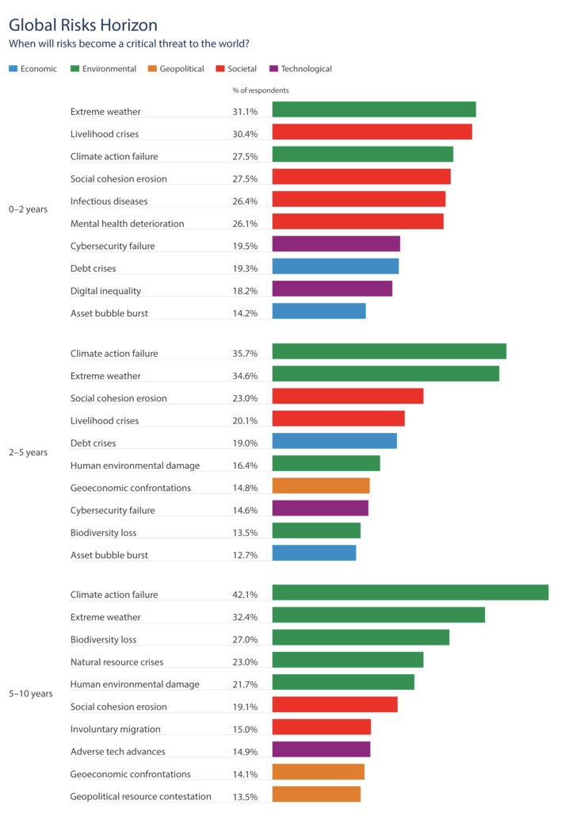
Figure 8 Global Risks Horizon (World Economic Forum, 2022a)
View description - Figure 8 Global Risks Horizon (World Economic Forum, 2022a)

Activity 5 Explore the Global Risks Report 2022
15 minutes

Explore the Global Risks Report and the data on global risk perceptions on the World Economic Forum website.
- The Global Risks Report 2022 (World Economic Forum, 2022a)
- Data on Global Risks Perceptions (World Economic Forum, 2022b)
1. Consider how you, your team and organisation can respond to and help minimise the impact on your stakeholders from the short-, medium- and long-term risks the World Economic Forum have identified. Make some notes on this below.

Provide your answer...

2. Answer the following question in the report by voting in the poll below.
How do you feel about the outlook for the world?

Interactive content is not available in this format.

View answer - Part

Although there are many views of future trends (and some are certainly bleaker than others), it must be understood that these are only possible futures, that may or not come about, and need to be understood in the context of your sector, organisation or project.
Traditional planning normally relies on past and current factors whereas, according to the OECD’s OPSI Futures & Foresight website, futures and foresight methods ‘embrace uncertainty and encourage the analysis and consideration of a range of future possibilities to inform decision making’ (OECD, n.d.). They suggest that there is ‘no absolute future, but there are many relative futures’ which ‘can take many different forms: predicted, projected, preferred, path-dependant, probably, plausible and possible’.

2 Futures Planning and organisational strategy
While having an appreciation of global trends, understanding how the workplace is evolving and thinking about possible futures enables you to broaden your perspective. For most people involved in futures planning, your primary focus will be on solving problems, innovating, and delivering outcomes linked to your organisation’s strategy.
Strategy, according to Davide Sola and Jerome Couturier, ‘is a set of coordinated, creative and sustainable actions (a plan) designed to overcome one or more core challenges that create value’ (Sola and Couturier, 2014). They go on to say these core challenges need to be overcome as they may be preventing you from delivering your ‘higher purpose’, the ‘ultimate goal’, the reason you, your project, your team, or your business exists.
Post the COVID-19 pandemic organisations have had to review their strategies, and how as an organisation they evolve and thrive, in a politically turbulent, financial, and economic uncertain and increasingly insecure world. Widening inequality and external drivers are forcing organisations to rethink their operating models, ways of working, and reconsider their resilience in terms of people, technology, processes, supply chains and impact on the planet.
Futures planning for an organisation is not easy as the further into the future you seek to look, the more uncertainty exists. Couple this uncertainty with external factors outside of your control or influence, and planning becomes even more challenging. Global imperatives, such as the UN’s Sustainability Development Goals, and National initiatives, such as the Well-being of Future Generations (Wales) Act add additional drivers (and potentially constraints) for change to the mix.

2.1 Managing expectations
It is also important to manage expectations, taking a human-centred design approach to futures planning. While this may feel like a challenge to balance the needs of the organisation to the needs of individuals and teams, it can help build empathy within an organisation, create better experiences, and build resilience to and trust in change. As a result, the organisation’s culture enables confidence to try new ways of working, learn and evolve.

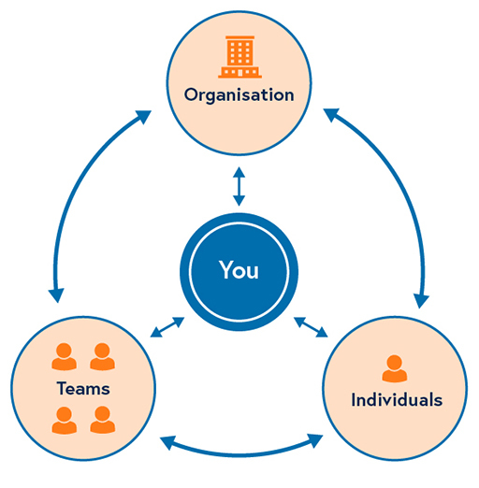
Figure 10 Putting people first
View description - Figure 10 Putting people first

Human-centred design is a creative approach to problem solving that starts with the needs of the user, emphasises the importance of diverse perspectives, and encourages solution-seeking among multiple actors. It consists of five phases: Empathize, Define, Ideate, Prototype and Test. What differentiates human-centred design from other problem-solving approaches is its focus on understanding the perspective of the person who experiences a problem most acutely.
(UNDP, n.d., Human-Centered Design )

This involves observing, using empathy to explore the problem further, to uncover what at first might not be obvious, generating ideas, with test-and-learn activities to gather feedback, prior to implementing a potential solution.
You may have noted when exploring future trends that individual personal expectations of working have changed, having had to adapt to hybrid working environments and living through lockdowns. For organisations this has meant they are having to re-evaluate the employee value proposition and experience. Many employees in a position to do so, have simply left organisations that do not align with their values or expectations, and prospective candidates are now often in a position to be more selective when choosing to work for an organisation.
Those within organisations being asked to adjust to new ways of working equally will have expectations that may not now align to the needs of the business, especially if they were recruited during a lockdown period. In addition, the impact on leaders and managers needs to be supported as those responsible for managing others and implementing change often are at the front line of managing expectations of all stakeholders.
People must be considered in any planning activity and as a futures planner you will need to work with appropriate teams to ensure that your strategy reflects what is possible within your organisation.

2.2 Mission, vision, values and objectives
In order for strategies to be successful they are underpinned by your mission, vision and values, and how the objectives throughout the organisations are set to ensure success, as such these need to be considered and understood when futures planning.
According to Richard Whittington (Professor of strategic management, Saïd Business School, University of Oxford) and colleagues:

A mission statement aims to provide employees and stakeholders with clarity about what the organisation is fundamentally there to do. This is often ascertained by asking for a description of what the organisation does, then keep asking ‘why?’ until the real mission of the organisation reveals itself.
A vision statement is concerned with the future the organisation seeks to create. This ‘typically expresses an aspiration that will enthuse, gain commitment and stretch performance’.
Statements of corporate values communicate the underlying and enduring core ‘principles’ that guide the organisation’s strategy and define the way that the organisation operates. These values need to be enduring and should not change with circumstances.
Objectives are statements of specific outcomes that are to be achieved.
(Whittington et al., 2020, pp. 8-9)

The following case study allows you to explore how mission, vision, values and objectives connect, and can be presented for all stakeholders.

Case Study: Bangor University
Bangor University’s Strategy 2030 (Bangor University, n.d.) provides a notable example of the above statements:
OUR MISSION: A research-led University of and for North Wales, providing transformative learning experiences and nurturing a positive impact on society regionally, nationally, and internationally.
OUR VISION: A globally connected University, realising opportunities for success through transformative, innovative, impact-driven research and teaching, with a focus on sustainability: safeguarding the environment, revitalising society’s health, and promoting economic, social, bilingual, and cultural vibrancy.
OUR VALUES AND GUIDING PRINCIPLES: These six values and guiding principles are our cultural cornerstones, guiding our decision-making and how we work together as a University community.
Ambition
Inspired by our history and our people, we enable the extraordinary. We are courageous, ambitious for our University, our colleagues, and our students, as well as supporting the ambitions of our partners.
Inclusivity
We provide equal access, equal rights, and equal justice to all. We will promote mutual regard for the rights and liberties of diverse people and their ideas, backgrounds, and approaches to the pursuit of knowledge and understanding.
Integrity
We act with honesty and transparency and will seek to collaborate in all we do. We will facilitate intellectual growth through academic freedom, creative expression and communication of truth, knowledge, social and moral development.
Respect
We trust, value, empower and care for each other, and we hold ourselves accountable. As collaborators we will be responsive and will achieve more together. We will foster civic engagement and social responsibility that supports and enhances education, research, service-learning, culture, and quality of life on and beyond our campus environments in Welsh and English.
Sustainability
We are passionate about promoting a culture and scholarship of environmental stewardship, living in harmony, and caring for the world in ways that meet our economic, social, environmental, and cultural needs. Underpinned by our world-renowned research, we will support the development of Wales as a bilingual learning country with a knowledge driven economy for the benefit of the world and future generations.
Transformation
As a place of academic endeavour, innovation, and transformation, we are driven to help enrich society. We are committed to excellence at all levels of the educational and creative experience and will support everyone in our University community to achieve their dreams and fulfil their potential.
And their objectives (goals) are clear, and measurable. Importantly, there is also recognition that there is a need to retain ‘some degree of flexibility to remain relevant in an ever-changing political and operating environment’:
- Improved performance in respected rankings that align to our mission, vision, and values
- Improve graduate skills, employment, and job creation outcomes
- Research of scale and quality that is internationally recognised and underpinned by our Global Excellence in Sustainability
- Build market share of students
- A sector-leading student experience
- Enhanced Welsh language provision
- Financially sustainable and resilient
- Strategic tertiary education partnerships across North Wales
- Deliver ambitious, transformative Campus and Digital infrastructure developments
- Increase life sciences research and innovation, underpinned by an interprofessional Health and Medical School for North Wales

Next, work through the activity below to find out more about your organisation’s higher purpose.

Activity 6 What are your organisation’s mission, vision, values and objectives?
10 minutes

Does your organisation have published mission, vision, values, and objectives statements? Can you get a true sense of your organisation’s ‘Why’ from them? If not how would amend them to draw out and clarify your organisation’s higher purpose?
Capture your thoughts in the text box below, and then read our feedback for this activity.

Provide your answer...
View answer - Activity 6 What are your organisation’s mission, vision, values and objectives?

2.3 Planning for new ways of working
Most people within an organisation are not directly involved with creating the organisational strategy but may be involved in activities and objectives with specific outcomes that are required in order to achieve the organisation’s purpose. Now that you have thought about possible futures, gained an understanding of trends to be aware of and are thinking about your own organisation’s strategy, we focus next on developing your skills for futures planning.
In this course you will be looking at how to approach futures planning for your organisation. When we think of futures planning sometimes it can be approached with a simple question – What might the future look like?
More often you will be looking to solve a particular problem or be focusing on an area/topic where a strategic need has been identified.
As many organisations have permanently moved to hybrid working as we live with COVID-19, it is important to learn from the journey of adapting due the pandemic and draw on the experience to help planning for a future where digital transformation will continue, and sustainability becomes ever more important.

Activity 7 Thinking about a problem you need to solve
15 minutes

Spend some time reflecting on how your organisation has evolved and responded over the last few years, and the lessons that have been learnt.
Then take time to review what your organisation has, or is doing now, in relation to ways of working – has it adopted a hybrid model? What are its digital transformation and sustainability plans?
Consider the following questions then make some notes in the box below:
- How aligned should delivery programmes be to the organisational strategy?
- How will these programmes impact stakeholders (positively and negatively)?
- What capabilities can you draw upon within your organisation to ensure the success of a hybrid working or digital transformation?
- How can you look at the problem through different lens?
Then think about a problem your organisation may need to solve or is already addressing, that you may wish to use and draw on as you work through this course, and consider:
Why does this problem need solving?
If you do not have a problem that needs solving/addressing you can simply consider: What does the future of your organisation look like?

Provide your answer...
View answer - Activity 7 Thinking about a problem you need to solve

3 Identifying and understanding your 'why'
In the last activity we asked you to think about Why a problem may need solving. It may seem obvious, but how often have you asked ‘why’ are you doing something? Most initiatives fail or do not deliver the expected outcomes because there was not the appropriate level of understanding of why something needs to be done, and how that ‘why’ relates to the purpose (strategy) of your organisation. It is the purpose of an organisation that should inspire those within it to work collectively to ensure that the organisation succeeds.
If a strategy is developed to move an organisation from the current state to some envisioned future state, where a problem is solved, an opportunity is exploited and/or a benefit is realised, then it is extremely important to understand what that future state looks like and why we need to get there.
Simon Sinek (2011) an author and inspirational speaker, calls this the ‘Why’ and puts this at the centre of his ‘Golden Circle’ as shown in the figure below. His belief is that most people will know the ‘How’ and ‘What’ an organisation does, but not necessary the ‘Why’. The ‘Why’ for organisations is often encapsulated in their mission statement. The vision statement reflects the ‘What’, and the values and objectives statements describe the ‘How’.

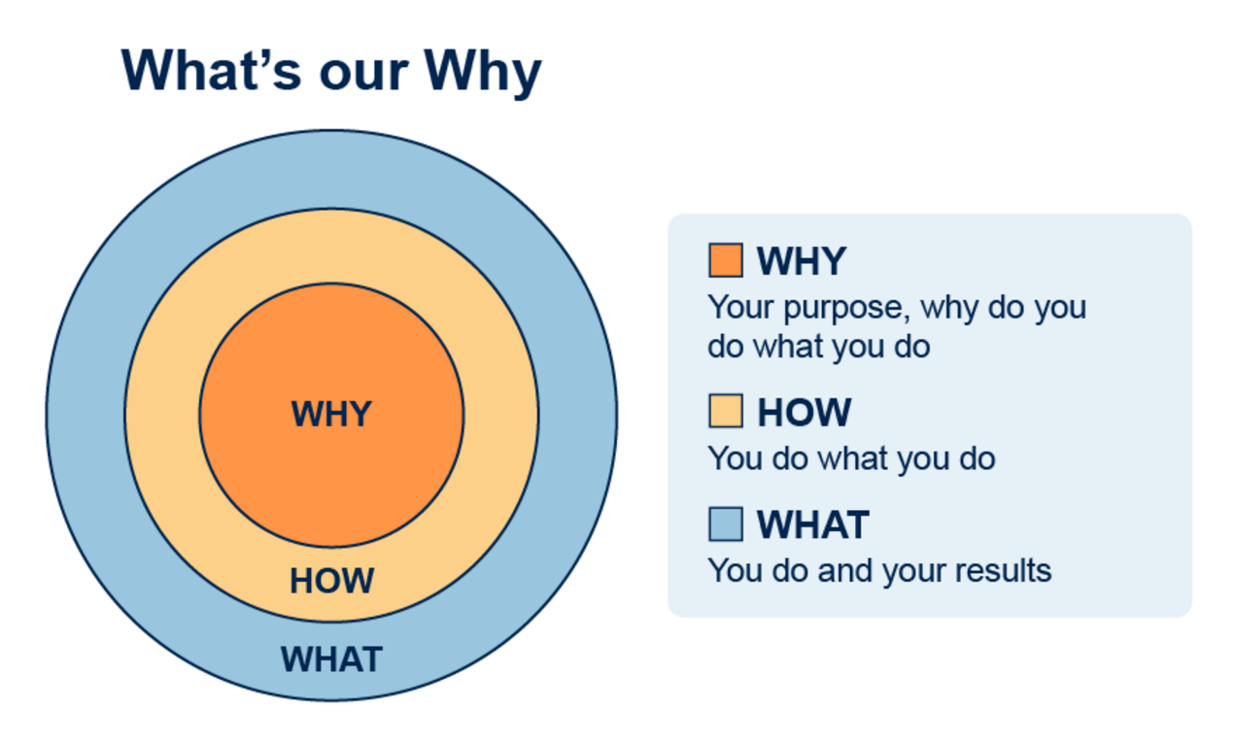
Figure 11 Simon Sinek’s (2011) ‘Golden Circle’
View description - Figure 11 Simon Sinek’s (2011) ‘Golden Circle’

Sinek suggests that when thinking about developing a strategy and a plan, not just at an organisational level, but also when working on problems and initiatives, this is where we should start because without knowing why we do something (our higher purpose) we will find it extremely difficult to attract the right people that believe in what we do, and who will work hard together towards achieving it.
‘The goal’ Sinek says, ‘is to do business with everybody who needs what you have, the goal is to do business with people who believe what you believe’ (Sinek, 2011).

Activity 9 Start with Why
30 minutes

Watch ‘Start with Why’, the TED Talk by Simon Sinek in which he introduces the golden circle and the concept of ‘Why’. As you watch think about the ‘Why’, ‘How’ and ‘What’, and how can you use this approach to help to establish your ‘Why’ for futures planning?
Make notes in the box below in order to refer back to these for later activities in the course or you may wish to draw your own Golden Circle.

Watch the video at YouTube.com.

Video 5 Start with Why: How Great Leaders Inspire Action

Provide your answer...

2. Look at the following links to see examples of how the Golden Circle has been used.
- Our Golden Circle (TADA n.d.)
- Golden Circle (cerculdeaur.ro)

In the next section we consider establishing your ‘Why’ further.

3.1 Discovering your ‘Why’

For those who hold a leadership position, creating an environment in which the people in your charge feel like they are a part of something bigger than themselves is your responsibility as a leader.
(Sinek et al. 2017)

Being a leader or manager is challenging, especially to ensure that our teams, departments, or organisations understand the mission they are working for and their purpose in an organisation.
Simon Sinek doesn’t claim to have invented asking ‘why’, he codified it when he noticed that companies, organisations, and people throughout history with similar backgrounds and purposes perform so differently; only some seem to defy the average with greater success.
Knowing your ‘Why’ is equally important at a function, team, or project level, and it can be especially powerful if your project’s ‘Why’ is directly supporting the organisations ‘Why’. Sinek (2011) calls this a ‘Nested WHY’.
It can be a useful approach before starting future’s planning, to ensure that those involved understand the organisational ‘Why’ but also the ‘why’ for the futures planning you intend to do. In order to help bring this process to life, we take you through the stages for running a workshop to discover your ‘Why’.

Finding the fundamental purpose
Finding the ‘real why’ can be challenging but if you ask the question at least five times you should be able to get to the fundamental purpose.
An organisation, team or individual can be guided through the discovery of their ‘Why’ by following a simple three-stage process, according to Sinek et al. (2017). This is explained in the figure and table below:

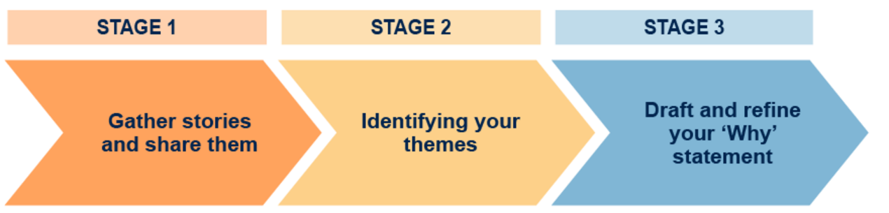
Figure 12 What’s your ‘Why?’ – three stage process
View description - Figure 12 What’s your ‘Why?’ – three stage process

Table 3 What’s your ‘Why?’ – three stage process
Stage | Action
Stage 1 – Gather stories and share them. | Look into your past to find meaningful, emotionally charged stories to help connect with or find your ‘Why’.
Stage 2 – Identifying your themes. | Begin to recognise emerging themes from your stories in order to pull together your ‘Why’ into something cohesive.
Stage 3 – Draft and refine your ‘Why’ statement | Produce a simple and clear single sentence, which is actionable, focused on how you contribute to others, and what Sinek calls ‘evergreen’ (applicable to everything you do).

While you can do this as an individual, bringing others into the conversation can help to consider your ‘Why’ through a different lens, and help you define it more effectively. This could be done in a workshop. As you read through the following suggested approach to running the workshop, consider how you might use this for discovering your ‘Why’ with your team or organisation. The output from doing this activity should provide you with valuable insights and a better understanding of your ‘Why’. You can then use this to develop outputs you are responsible for, such as reports or project/programme proposals.

3.2 Preparing the workshop
Who needs to be involved? Ideally you will have a diverse team of representatives, who may be internal or external to your organisation – this could be staff, suppliers and students if you are in higher education?
Who will facilitate the workshop? It’s helpful if this is someone who is the problem owner to provide context and guidance. The facilitator manages the workshop and keeps participants focused and on track. According to Sinek, the ‘ideal person for this role is someone trusted by the organisation who has a desire to serve, a strong natural curiosity and an ability to ask probing questions.’(Sinek et al., 2017, p.165)
Depending on your participants, decide the most appropriate environment for your workshop – remote, hybrid or face-to-face. What tools will you need and will they be physical or online, or a mix, e.g.
- whiteboards
- sticky notes
- breakout rooms
- polls
- drawing ‘rich pictures’ (if you are unfamiliar with rich pictures and would like a brief overview, you can access video tutorials from the OpenLearn Rich Pictures resource).
Depending on the size of your group you may wish to put participants into sub-groups for certain activities at each stage and allow time to come back as a group to discuss the outcomes. When forming sub-groups, consider the diversity of the groups to ensure a range of voices are in the room.
- the purpose and focus of the workshop
- the Golden Circle, and explain this is to think about their ‘Why’, ‘How’ and ‘What’
- questions you may wish them to think about.
This can be done as an email with the agenda, some slides, a video explaining what they can expect, or another method of your choice. Below is a suggested template you can draw upon.

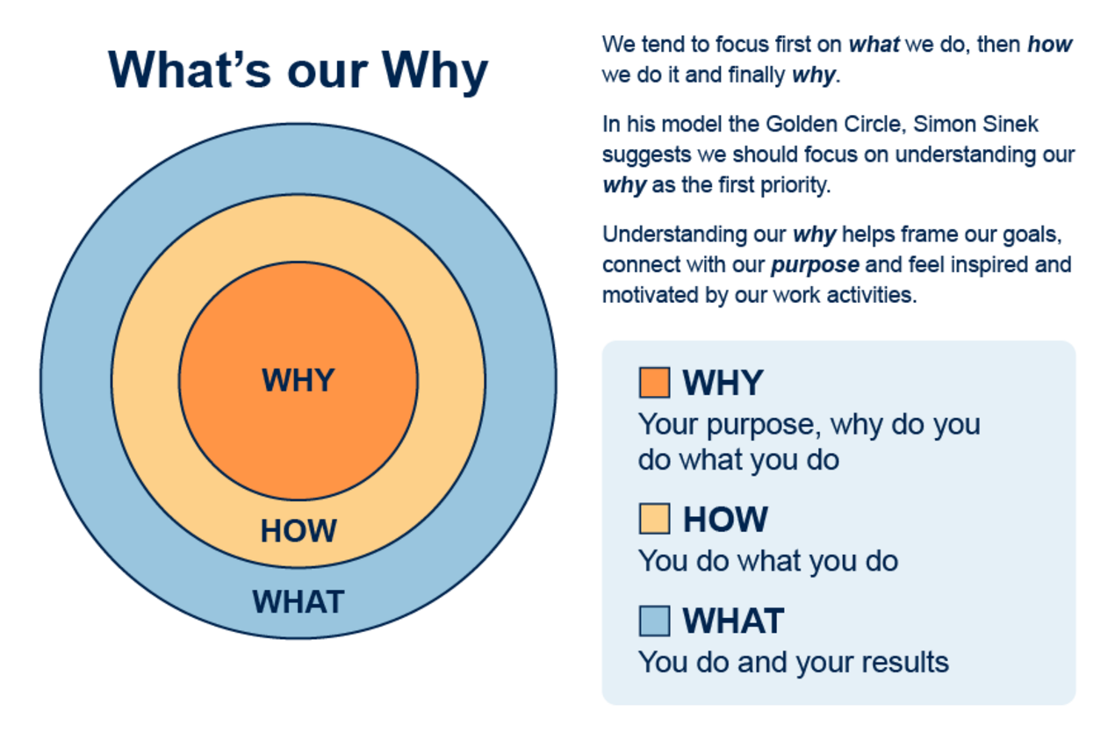
Figure 13 Example slide to introduce the Golden Circle.
View description - Figure 13 Example slide to introduce the Golden Circle.

3.3 During the workshop
It is sensible at the start of the workshop to run through the checklist below, to help set expectations and clarify the outcomes you hope to achieve.
- Overview of what to expect depending on the purpose.
- The context for the workshop
- The outcome intended for the workshop
- Be prepare to active listen – provide overview of what this means in your context
- Preparing – do they need to know how use online tools?
- Accessibility and inclusion considerations
- Workshop 'house keeping'.
As participants may not be familiar with the What’s your Why? three stage process shown in Figure 12 (repeated), take them through the stages and what to expect (these are explained in the next sections in detail).

Figure 12 (repeated) What’s your ‘Why?’ – three stage process
View description - Figure 12 (repeated) What’s your ‘Why?’ – three stage process

Each stage should be structured in two parts Discovery and Reporting out (as Sinek calls the replay). The workshops are not about agreeing the ‘How’ and ‘What’, this should be done through other approach appropriate to your requirements.
Remember, your output from the workshop is to understand ‘Why’. Reaching agreement on your ‘Why’ may take refinement depending on the complexity of the focus for your ‘Why’. At a team level this might be achievable in one or two workshops, but for organisational-wide initiatives this could take several sessions and conversations to reach agreement.
In order to assist with capturing the output from the stages you may wish to use the template in the table below:

Table 4 Workshop output template
Now | Future
This is our 'Why' | This could be our 'Why'
How we work now | How we could work
What we do now | What we could do
Areas we would like to improve
Anything we should stop doing?

Stage 1: Gather stories and share them
Discovering your ‘Why’ requires active listening, allowing those in the room to share their experiences and views, and not interrupting them – let them tell their story. Encourage participants to make notes as others talk and wait till, they come to a natural finish.
It can be useful to start with an icebreaker, which is linked to discovering your ‘Why’. This helps to make participants comfortable and build confidence to fully participate.
For example, an activity could: Share three things that you were proud about on the last thing you delivered. Write these on a sticky note. Then go round the group for them to summarise and identify common themes. Or ask everyone to draw a rich picture of their story on a piece of paper and talk through their story.
For example, an activity could: Share three things that you were proud about on the last thing you delivered. Write these on a sticky note. Then go round the group for them to summarise and identify common themes. Or ask everyone to draw a rich picture of their story on a piece of paper and talk through their story.
Discovery
This is time to focus on the ‘Why’ questions and allowing participants to share their stories, you could ask:
What is your understanding of:
- your organisational ‘mission’
- the role of your team to support that mission
- your role as an individual to contribute to that mission
- what our end users want.
Supporting the mission:
- How do your team and you as an individual add value?
- What can you solve, deliver, contribute?
- What are your strengths as a team and individual?
- How do you measure success?
- What is the impact of what you do, both for students, staff and the organisation?
Do you agree with the mission?
- How your team and you as an individual contribute toward the mission.
- What would you change?
- This is an important question, as to challenge the mission and your role, can help to identify areas that help with refocusing your ‘Why’ and generate areas for further exploration – if something is not quite right – why?
Learning from failure:
If your workshop is focusing on a specific issue, ask participants to imagine they are two years in the future, and the solution chosen had failed. This approach can help with reframing an issue but thinking of possible future outcomes.
- How do they feel about this?
- What might cause a failure?
- How could it be mitigated?
Capture the stories in short story statements. These might be a bulleted list, a sentence or paragraph, or their ‘rich picture’ with a heading that reflects the focus of the story.
Reporting out Stage 1
- How do participants feel?
- What has been the impact on them?
- What else do they want to know?
- What else do they want to share?
- Is this what they expected?
This is time to review what you have explored and the opportunity for clarification and further probing:
Then focus on the story statements and look for the themes that are emerging, and capture these for Stage 2.

Stage 2: Identifying your themes
Your ‘reporting out’ in Stage 1 should help to start the conversation of recognising the emerging themes from your story statements. In this section of the workshop your aim is to explore the themes further to develop your ‘Why’ into something more cohesive, but also to consider your ‘How’.
Discovery
Agree the emerging themes, and list these – is anything missing?
Ask participants to:
- Discuss the contribution they can make to others in relation to the themes
- What are the most interesting and impactful stories from your participants in relation to the themes?
- What inspires them, and did they feel they could share their own story because of it – what was their story?
Developing the themes:
- What do the themes mean in reality – ask participants to reshare their stories but focus on:
  - Why they did it.
  - How they did it.
  - What they did.
- What themes emerge from sharing the stories? Focus on the reasons and what was involved?
- As a group rewrite the stories and emerging themes as action statements, e.g., ‘to include all’, ‘to inspire innovation’.
Ensure these are captured to refer back to for reporting out Stage 2.
Reporting out Stage 2
Review and discuss the outputs.
- How do participants feel?
- What has been the impact on them?
- What else do they want to know?
- What else do they want to share?
- Is this what they expected?
Then take the action statements and collate these into similar themes and discuss which might be the most relevant to your current focus and those that might be important for the future.

Stage 3: Draft and refine your ‘Why’ statement
The last stage of discovering your ‘Why’ is to agree and refine it. This focuses on thinking about the contribution that is required to enable all within an organisation (internal or external) to succeed.
Discovery
Review how to support the mission:
- How does your team and you as an individual, add value?
- What can you solve, deliver, contribute?
- What are your strengths as a team and individual?
- How do you measure success?
- What is the impact of what you do, both for students, staff and the organisation?
- What is the emotional impact of what you do, both for students, staff and the organisation?
What has changed from Stage 1 to Stage 3?
- Who is in your story now?
- What might change for the people in your story as a result of the actions of your team?
- How might it effect the people in the story, or those who witnessed it?
- What can you do differently?
Ensure that these are captured as short contribution statements, to be able to refer back to for reporting out Stage 3.
Review and discuss the outputs:
- How do participants feel?
- What has been the impact on them?
- What else do they want to know?
- What else do they want to share?
- Is this what they expected?
Reporting out Stage 3
Then look at the outputs from the gathering stage and ask the group to adopt a signal phrase to encapsulate the impact and produce impact statements.
Draft the ‘Why’ statement
The stories from Stage 1 help to maintain the meaning behind the action and impact statements. Your ‘Why’ statement draft is normally linked to one or two stories from Stage 1.
- Select the action statements and map them to the impact statements and choose one or two that you feel strong align to the ‘mission’ and then craft the most inspiring draft ‘Why’ statement.
- Then review the ‘Why’ statement as a group and define it further if required.
- This should enable you to produce your key outcome for the workshop – your draft ‘Why’.
The last part of Stage 3 is to consider your action statements again, based on your draft ‘Why’ statement and produce context statements. These help you to refocus on the context of your ‘Why’ and how it links to a 'problem' you think you need to solve. Why are you doing it?
An example, would be if you were focusing on an ‘inclusion theme’ you might produce the following context statements:
- Be kind, be curious, be inclusive.
Be open and keen to learning about others, their backgrounds and lived experiences – be curious and interested about people’s differences as there is no such thing as ‘normal’.

3.4 ‘How’ and ‘What’
According to Sinek (2011), the ‘How’ and the ‘What’ are just as important as the ‘Why’ and should be reviewed and planned once you have agreed your ‘Why’. This starts by reconsidering or gathering more evidence or data whether a change is required. What outcomes do you hope to achieve? How will you achieve them? How will you measure the impact of your achieved outcomes?
If the outcome is that a change is required and if you do not define what you need to get done or plan how to get it done, then the ‘why do it?’ is irrelevant: the impact will not be achieved, and progress will not be made.
The context for your ‘Why’, will normally direct the approach for working on your ‘How’ and ‘What’, and may use different frameworks, conversations and resources available to you to make the change. This is especially true when futures planning as the how and what maybe unknown, as options are explored for different possible futures. Later in the course we introduce frameworks that are commonly used for futures planning.
As a final part of your workshop, it can be useful to look at your ‘How’ and ‘What’ now, to capture what might need to change, to inform further sessions to look at these in detail. If you have used the workshop output template review and update it.

Table 4 (repeated) Workshop output template
Now | Future
This is our 'Why' | This could be our 'Why'
How we work now | How we could work
What we do now | What we could do
Areas we would like to improve
Anything we should stop doing?

Activity 9 What’s our Why? – Planning a workshop
30 minutes

Drawing on the outline of running a ‘What’s our Why?’ workshop, plan a workshop you could run with either a team you are part of, or group that you collaborate with.
We have provided a What’s your why toolkit which is a downable PDF/PowerPoint that contains elements from this section to use for running your own workshop.
Download the toolkit

3.5 Developing the ‘How’
Once you have established your 'Why’ and have a feel for the future vision you are going explore, the ‘How’ and the ‘What’ come next, and for that we need to develop a strategy and approach for planning.
According to Sola and Couturier (2014), there are five stages in the strategy development process which can be applied for planning, and one force that will need constant consideration – organisational culture (they call this the ‘Invisible Hand’) – which can be difficult to manage:

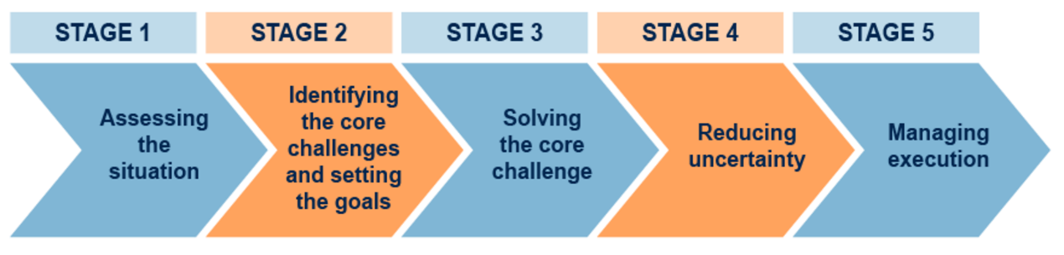
Figure 14 Five stages of the strategy development process (Adapted from Sola and Couturier, 2014)
View description - Figure 14 Five stages of the strategy development process (Adapted from Sola and ...

This can be done through:
- an analysis of the current business model
- value proposition
- key activities
- resources and capabilities
- value network (partnerships, supply chain)
- differentiation.

Stage 1: Assess the situation
Sola and Couturier (2014) suggest you should also look at your position relative to your sectoral peers, macro-environmental factors (PESTLE analysis is useful here – see Figure 15), and sector/industry-related factors and trends (maybe use Michael Porter’s five forces model for this one – see Figure 16).

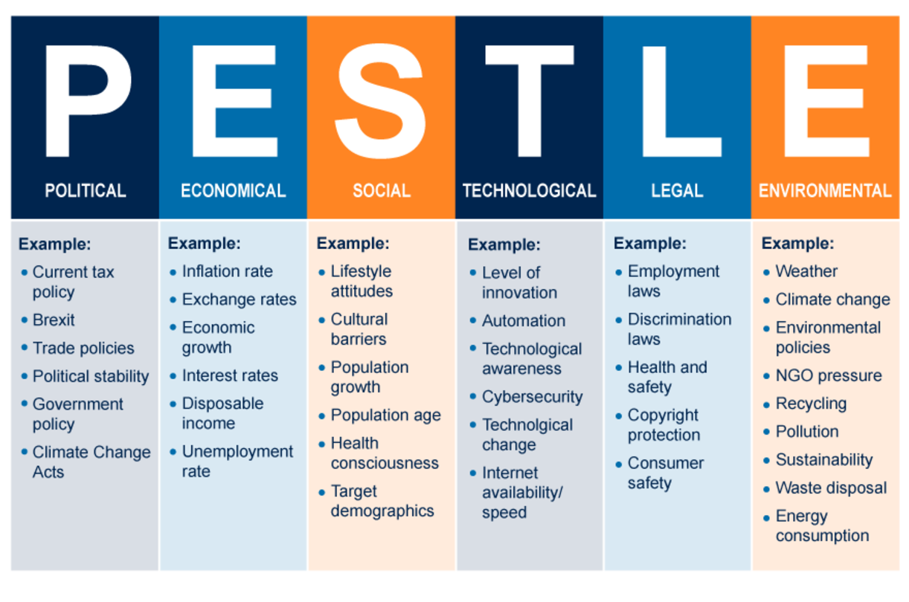
Figure 15 PESTLE analysis chart. (Source: Impact Innovation, n.d)
View description - Figure 15 PESTLE analysis chart. (Source: Impact Innovation, n.d)

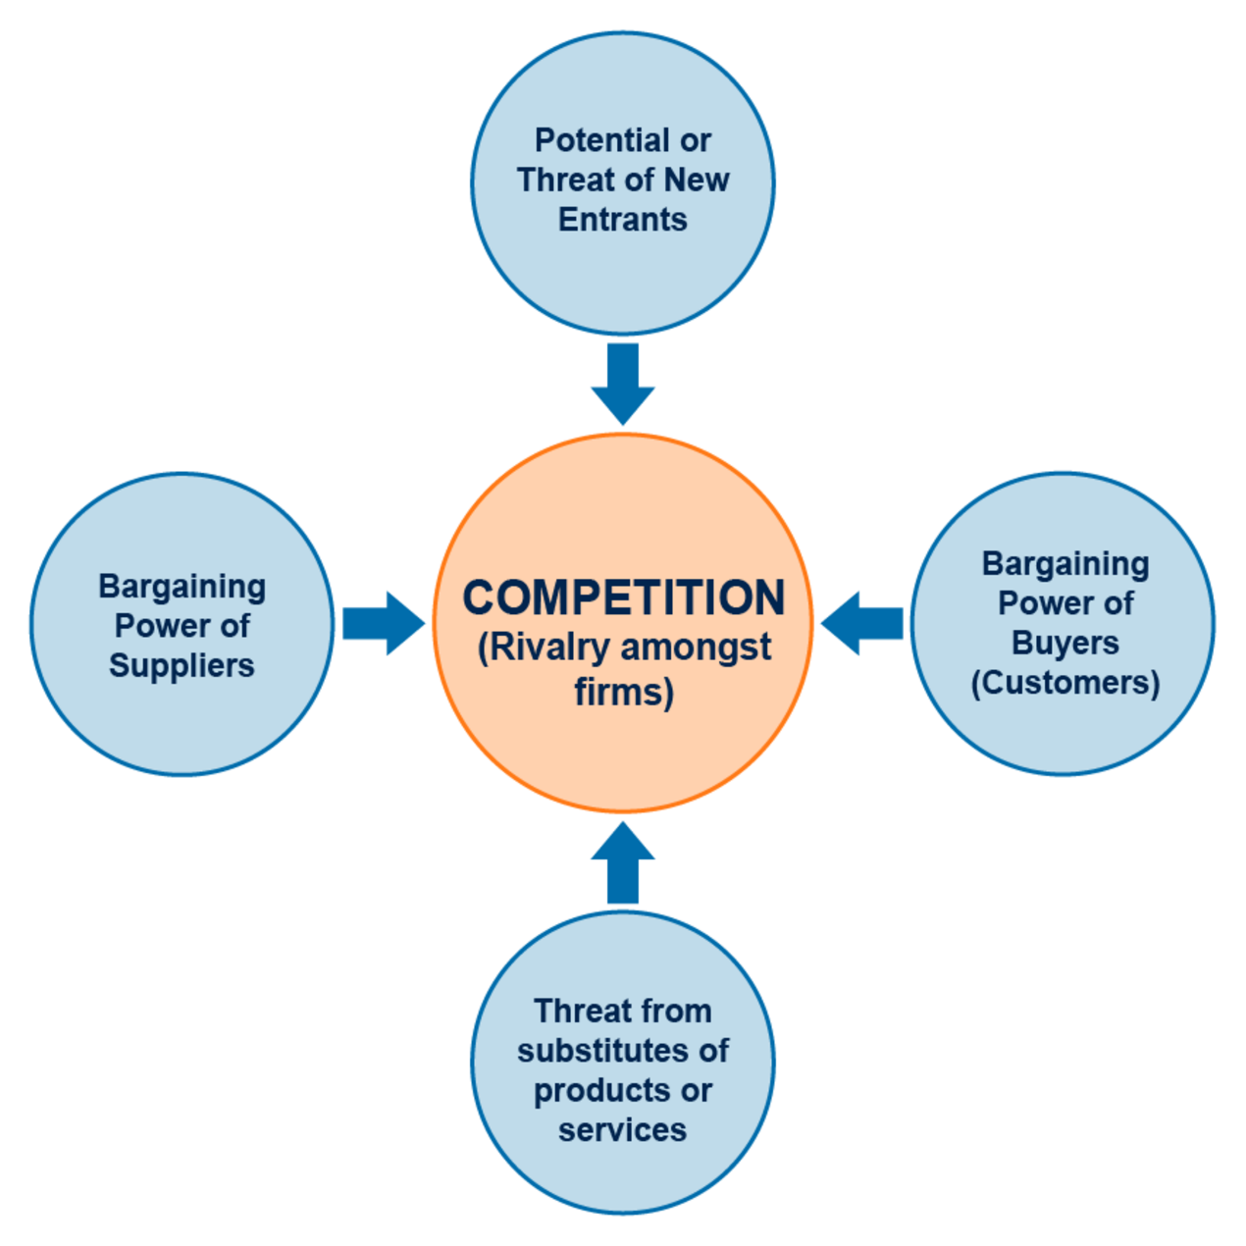
Figure 16 Porter’s Five Forces and complements (Source: adapted from Porter, 2008)
View description - Figure 16 Porter’s Five Forces and complements (Source: adapted from Porter, 200 ...

Stage 2: Identifying the core challenges and setting the goals
Using a SWOT analysis (see Table 5) can be helpful but identified positive and negative effects should be validated against their cause.

Table 5 Common questions used in a SWOT analysis
Internal factors | External factors
Strengths  - What are we best at?  - What intellectual property do we own?  - What specific skills does the workforce have?  - What financial resources do we have?  - What connections and alliances do we have?  - What is our bargaining power with suppliers and intermediaries? | Opportunities  - What changes in the external environment can we exploit?  - What weaknesses in our competition can we attack?  - What new technology might become available for us?  - What new markets might be opening up to us?
Weaknesses  - What are we poor at doing?  - Is our intellectual property outdated?  - What training does our workforce lack?  - What financial constraints do we have?  - What connections and alliances should we have, but don’t? | Threats  - What might our competitors be able to do to hurt us?  - What new legislation might damage our interests?  - What social changes might threaten us?  - How might an economic cycle affect us?
(Source: based on Blythe, 2001, p. 17)

To reduce the number of core challenges, you can ask whether overcoming them will create value for the organisation (or destroy value if it is not addressed). You can ask whether you have the right resources or capabilities to address the core challenge, and finally, will the organisational culture assist in overcoming it, or will it get in the way?
Setting strategic objectives:
You then need to set the strategic objectives – these need to:
- have a clear timeframe (2–5 years)
- be easy to understand/communicate
- be challenging but achievable
- have a clear impact on competitive advantage or delivering to your ‘Why’.
Once these have been identified, strategic guidelines need to be developed for each.

Stage 3: Solving the core challenges
This is never easy as they often involve social/human, economic, legal, and technological elements. Often it is best to try to reduce the core challenge’s complexity, by breaking it down into key constituents and understanding their importance. Once the complexity is reduced, solution options can be identified.
Once solutions options are identified, you will need to select the best potential option. You will need to assess which one will have the most impact on addressing the core challenge, cost/benefit and when they can be implemented.

Stage 4: Reducing uncertainty
Uncertainty in strategy exists in three ways:
- Uncertainty around value creation, whether the delivered benefits outweigh the investment.
- Uncertainty around the ability to scale the initiative and keep the levels of return.
- Uncertainty regarding sustainability of the actions the organisation has chosen to implement.
Sola and Couturier (2014) suggest testing the options using the ‘lean testing’ approach to reduce uncertainty. The approach consists of four phases:
- Stating the underlying assumptions along three dimensions – value, growth, and sustainability.
- Testing assumptions about value.
- Testing assumptions about growth.
- Testing assumptions about sustainability.

Stage 5: Managing execution
This is where we get to implement the tested solutions and achieve the results we expect. Executing your strategy is about taking action that is coordinated and complementary and, according to Sola and Couturier (2014), most strategy failures can ‘be traced back to issues that undermine or prevent this coordination’.
They cite culture, communication, and corporate structure amongst these issues. They also cite two other reasons for failure: people do not understand the ‘Why’ and ‘What’ to change, and even if they do, they don’t know ‘How’ as they fail to see the link between strategy and practical change (Sola and Couturier, 2014).

4 The complexity of problems
Of course, the scope of the strategy and detail behind the execution plan will depend on the type of problem you are trying to solve and the urgency within which you are trying to solve it. Some plans need to rapidly react to a situation and others have time to plan and explore 'what could be possible'.
Stage 1 of Sola and Couturier’s (2014) five stages in the strategy development process is ‘Assessing the situation’ and Stage 2 is ‘Identifying the core challenges and setting the goals’. Both of these together give you a view of the problem you are trying to solve.
There are many ways of describing, analysing, and resolving problems depending on their level of difficulty and complexity as shown in the figure below. There are even concepts that describe complex problems in terms of ‘tame’ to ‘wicked’ (Alford and Head, 2017).

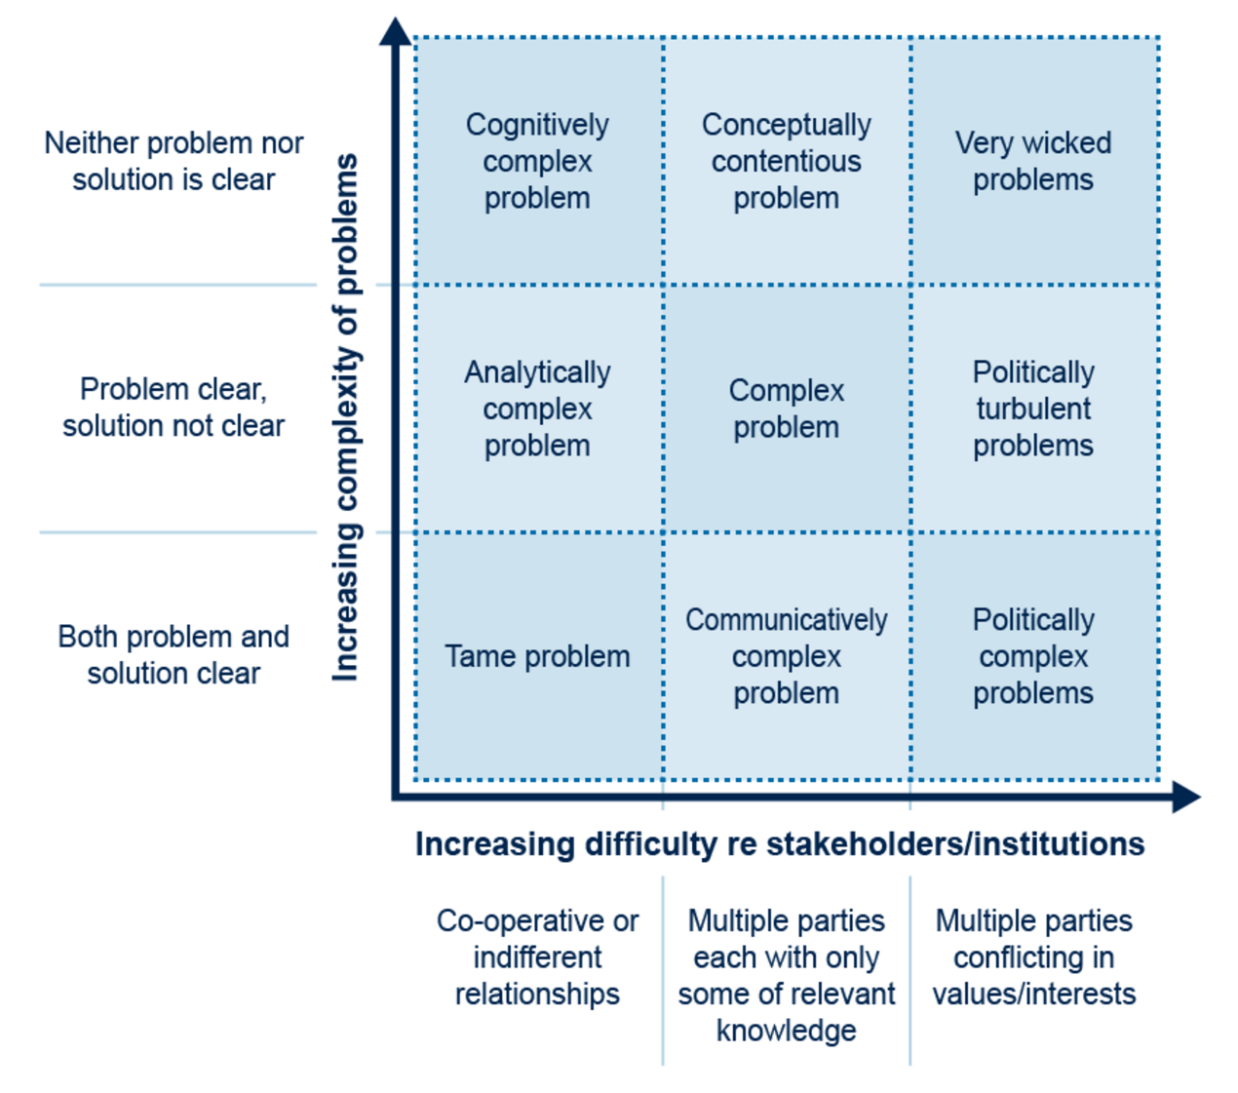
Figure 17 Types of complex problems. Source: Alford and Head, 2017)
View description - Figure 17 Types of complex problems. Source: Alford and Head, 2017)

John Alford and Brian Head (2017) suggest that a ‘problem' is more likely to be wicked if several conditions (or most of them) are present. These include the following.

- Structural complexity: inherent intractability of the technical (i.e., non-stakeholder-related) aspects of the problem.
- Knowability: Not only is there little knowledge about the issue, but the nature of the problem or its solution is such that it is unknowable – that is: the relevant information is hidden, disguised or intangible; it comprises multiple complex variables; and/or its workings require taking action to discover causal links and probable outcomes.
- Knowledge fragmentation: the available knowledge is fragmented among multiple stakeholders, each holding some but not all of what is required to address the problem.
- Knowledge-framing: some of the knowledge receives either too much or too little attention because of the way it is framed, thereby distorting our understanding.
- Interest-differentiation: the various stakeholders have interests (or values) which are substantially in conflict with those of others.
- Power-distribution: There is a dysfunctional distribution of power among stakeholders, whereby very powerful actors can overwhelm less powerful ones, even if the latter constitute a majority consensus; or whereby sharply divided interests are matched by sharply divided power.
(Alford and Head, 2017, p. 407)

Russell Ackoff coined the term ‘Messes’ in 1974 to distinguish between different types of problems. ‘Messes’ are larger in scale than ‘difficulties’ and have more serious implications due to the larger number of people affected, the longer duration of the situation, and they are more complex. Additionally, there is an uncertainty element to ‘Messes’, and it is not easy to succinctly define the situation or problem.
These problems can be categorised as shown in the table below.

Table 6 Categorising messes
Wicked  issues are difficult to define and change with time, several stakeholders are involved, problem root cause analysis leads to alternate solutions that diverge into other possible solutions (i.e., each resolution creates new issues) | Wicked Mess  wicked and has the complexity of interrelated issues, suboptimal solutions pose other problems
Tame  issues can be clearly defined, few stakeholders are involved, problem root cause analysis leads to alternate solutions that converge into a single possible solution (i.e., resolution is definitive) | Tame Mess  but has the complexity of interrelated issues, suboptimal solutions pose other problems

In addition, Rittel and Webber (1973) identified ten characteristics of wicked problems, which helps to further understand the complexity of considering what may be in involved with approach problems you have. See Figure 18.

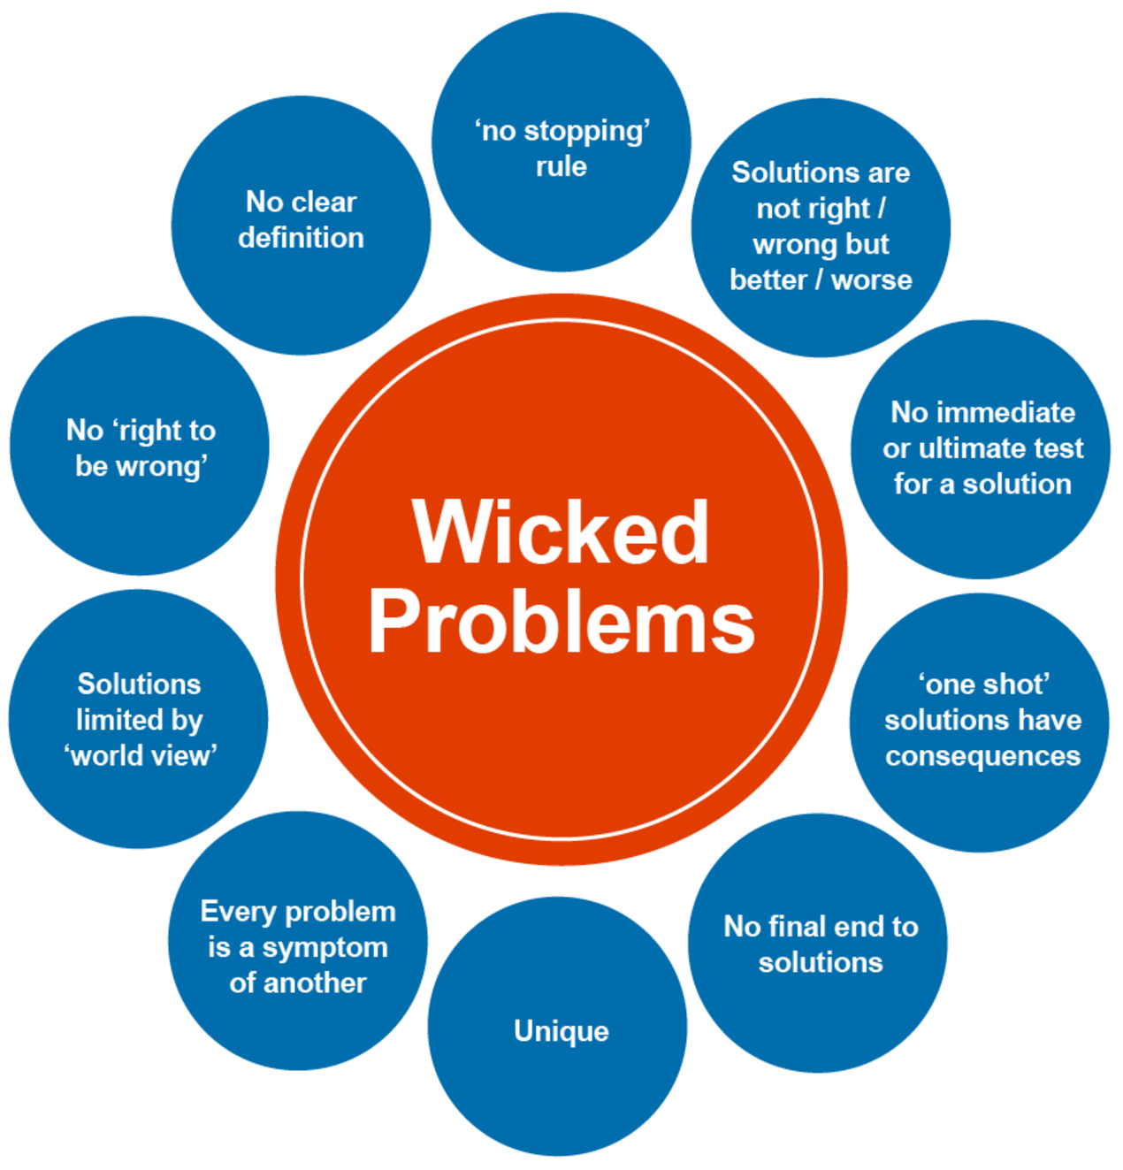
Figure 18 Wicked problems, adapted by Sarkar and Kotler (no date) from Rittel and Webber (1973)
View description - Figure 18 Wicked problems, adapted by Sarkar and Kotler (no date) from Rittel and ...

By its very nature, you may not be able to solve the overall wicked problem, but you can mitigate some of the consequences. This requires being open to ideas and experimenting with different approaches, such as human-centred design or an interdisciplinary focus (IDEO, 2015).
While wicked problems have frameworks from which to consider them, another approach is to think about problems as ‘intractable’ − those for which there is no obvious approach to solving them. As you consider a problem you reframe it and try to make sense of the problem and look for different paths that will help to mitigate the issue. This draws from taking a more human-centred approach to problem solving.
That involves observing, using empathy to explore the problem further, to uncover what at first might not be obvious, generating ideas, with test-and-learn activities to gather feedback, prior to implementing a potential solution.

Activity 10 Reframing your problem
10 minutes

Think about a complex and challenging scenario in your life or work-life and take a moment to judge whether your situation/problem is a tame or wicked mess, and if it is intractable? Then start to reframe your situation/problem to explore if there are elements that could be tamed.
Make some notes about this process in the box below.

Provide your answer...

4.1 Sensemaking for futures planning
In Activity 10 in which you planned a workshop to discover your Why, you started the process of sense-making. In Section 1.4 you viewed some predicted trends towards a vastly different post-pandemic world to the world before 2020. Irrespective of where these trends are heading, in order for us to continue to deliver on our personal, project, team and organisational mission, we need to respond accordingly.
Responding in an era of uncertainty is complex, especially where people are involved. Fortunately, tools, frameworks and concepts are available to help us through the complexity.
One such concept that builds on thinking by others, was developed by Karl Weick in 1995 and is known as ‘sense-making’. ‘Sense-making involves turning circumstances into a situation that is comprehended explicitly in words and that serves as a springboard into action’ (Weick et al., 2005).
Sense-making helps us understand a situation, how elements of the situation are connected (whether tightly coupled or looser), and how and why people behave in it in the way that they do. Sense-making is particularly helpful in a complex situation when some aspects are not obvious. Taking into consideration the personal interest of those impacted by a change when planning is extremely important to a successful implementation, as ‘personal investment’ in a change can be a great motivator.
Sense-making is particularly useful in understanding how people and teams engage and organise following a crisis or change.
Dave Snowden founder of the Cynefin framework defines sense-making in his ‘What is Sense-making?’ reflections as: ‘How do we make sense of the world so we can act in it’ (Snowden, 2008). ln the video below he explains how sense-making can be used for exploring problems and making decisions.

Video content is not available in this format.
Video 6 Sense-making for exploring problems and making decisions
View transcript - Video 6 Sense-making for exploring problems and making decisions

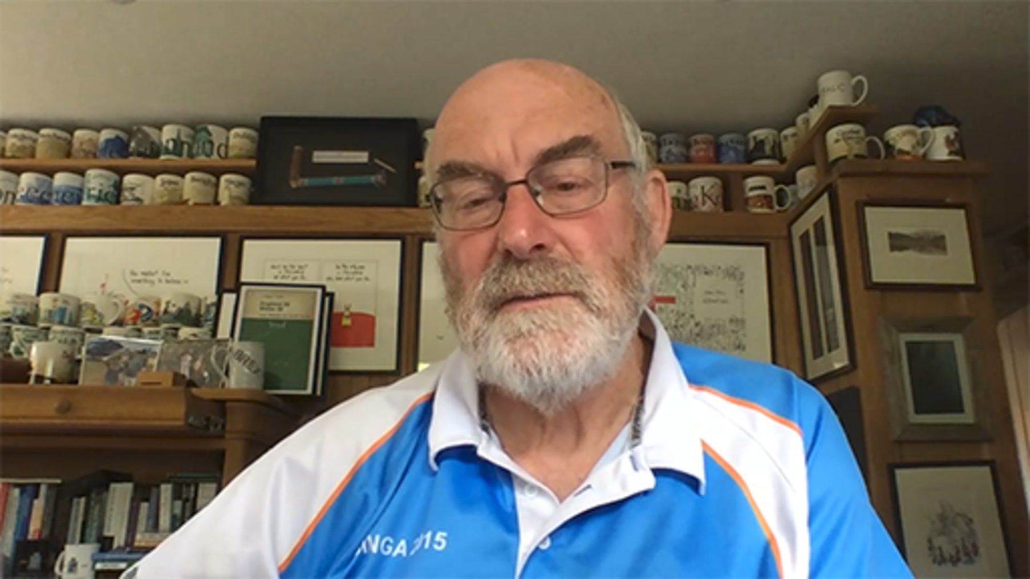

Activity 11 Sensemaking conversations
15 minutes

Drawing on the insights that Dave Snowden shared in the video above, now watch Video 7 below, ‘Sensemaking: using conversations to make a difference every day’. In this second video, Alan Arnett explains how sensemaking can move us forward, to answer the following three questions:
- What are we solving?
- Where are we heading?
- How might we get there?

Watch the video at YouTube.com.

Video 7 Sensemaking: using conversations to make a difference every day
As you watch the video make notes in the box below and consider:
- How can sense-making aid understanding what you are solving?
- How can it help with a human centred approach to making sense of problems, and understand where you might be heading?
- How could it lead to better conversations, to understand how you might get there?

Provide your answer...
View answer - Activity 11 Sensemaking conversations

4.2 Cynefin – making better decisions
The Cynefin® Framework (pronounced ‘ku-nev-in’) is the Welsh word for ‘place of your multiple belongings,’ (Cynefin, n.d.a) and was developed by David Snowden in 1999. David Snowden and Mary Boone published the framework in the Harvard Business Review in 2007 and since then it has helped leaders understand their challenges and make decisions in context, based on the different environments we are operating in. By sense-making we can develop an awareness of what is really complex and what isn’t and respond accordingly. This ensures no energy is wasted in overthinking the routine but also ensures that we shouldn’t try to resolve complex scenarios with standard solutions.
When making decisions and planning for change, the Cynefin framework is designed to develop your ability for sensemaking, by learning from the past and exploring possible future scenarios. The model focuses on five situational domains that organisations and leaders operate in:
- confused
- clear
- complicated
- chaotic
- complex.
Constraints are then applied to each of them, and the model then helps to indicate the type of processing that works best in each domain. Figure 19 shows the five domains of the Cynefin framework.

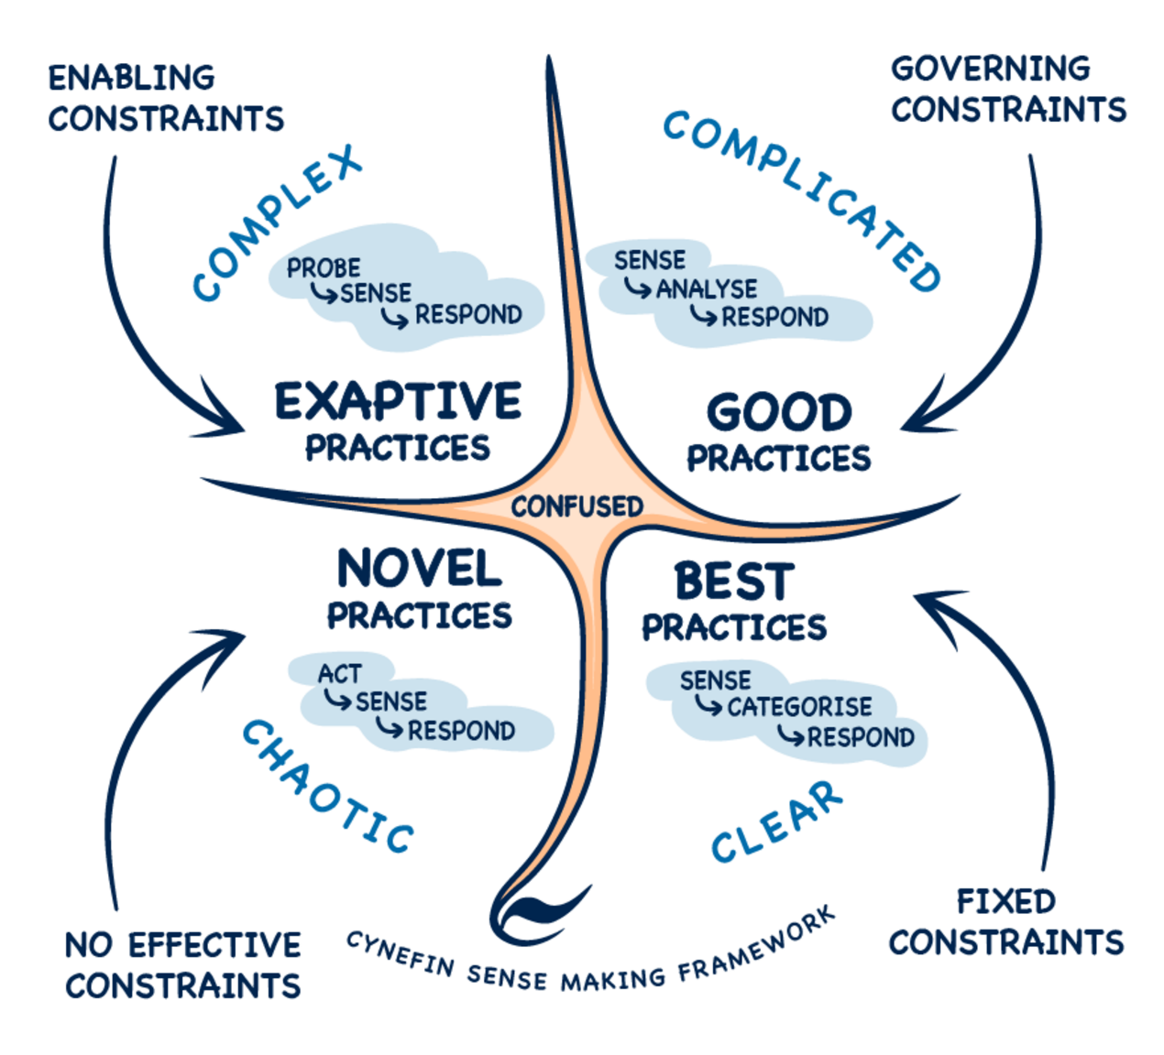
Figure 19 Cynefin sense-making framework
View description - Figure 19 Cynefin sense-making framework

In the video ‘Introduction to Cynefin’, Dave explains how the framework evolved and how it can be used to make better decisions, both as a leader and within teams developing future scenarios and managing change projects.

Video content is not available in this format.
Video 8 Introduction to Cynefin
View transcript - Video 8 Introduction to Cynefin

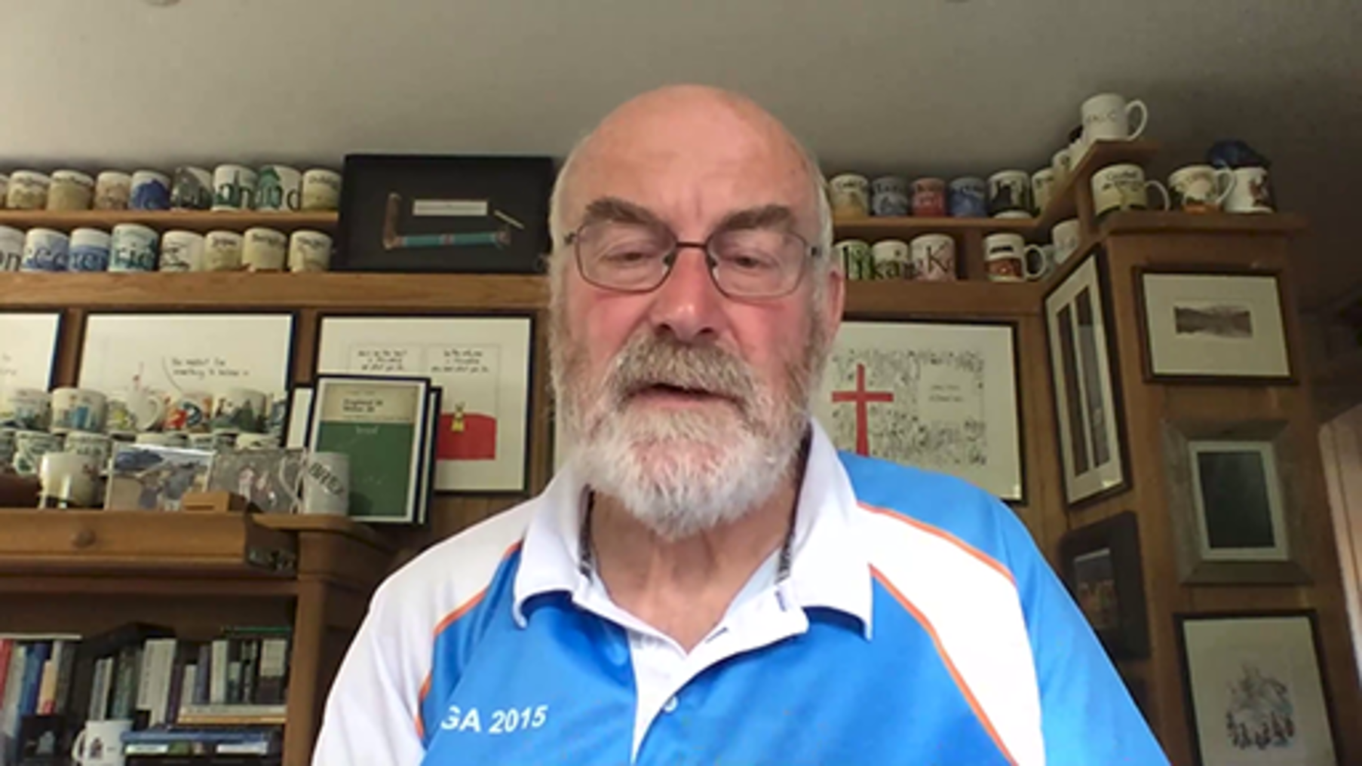

As Dave Snowden explains in Video 8 ‘Cynefin Framework – Getting started with Cynefin’, there is an element of simplicity in its approach for problem solving as ‘one size does not fit all’, and he highlights the importance of informal networks for better and more effective problem solving. The Cynefin framework can be adapted, to provide a simple approach that could be fitted on the back of a napkin, and he refers the children’s party story to demonstrate the simplest of the framework.
He believes there are three things all organisations that should do to build employees’ confidence for anticipating and dealing with unknowns and change, and to build informal and formal networks:
- Map your knowledge to the granularity required
- Repurpose what you are already good at
- Build formal networks.

Activity 12 Getting started with Cynefin
30 minutes

We recommend you allow up to 30 minutes for the introduction, then allocate time outside studying this course to take your understanding further.
1. Take some time to explore the Cynefin framework, using the following resources and the video below:
- The Cynefin Co - Home (Cynefin, n.d.b)
- The Cynefin Co - Estuarine mapping(Cynefin, n.d.c)
- Cynefin.io – Naturalising Sense-Making wiki (Cynefin, n.d.d)
- Cynefin.io - Field guide to managing complexity (and chaos) in times of crisis (n.d.e)
- Cynefin.io - Flexous curves(Cynefin, n.d.f)
In the following video ‘Cynefin Framework – Getting started with Cynefin’, Dave Snowden explains the framework in more detail.
How could it help you make better decisions? Consider the following questions and make notes in the text box below:
- What are the challenges for understanding which ‘system’ you are in?
- What does ‘ontology’ mean to you? (If this is a new term to you, you may wish to research it first.)
- What are your formal and informal networks that you can draw on?
- What is your personal preference: chaos, complexity or order? Why is that?

Watch the video at YouTube.com.

Video 9 Cynefin Framework – Getting started with Cynefin (2022)

2. Write a short introduction to Cynefin, based on your learning so far.
(If you would like to take your learning further, feel free to allocate time to this outside your study time for this course.)

Provide your answer...
View answer - Part

5 Approaches for Futures Planning
Once you have an understanding of the problem you need to solve, the next stage is solving the core challenges. This is at the heart of futures planning, options are explored, and possible solutions tested using approaches to challenge and guide your exploration. First though you need to be open to the concept of the ‘Art of the Possible’.
Tom Cheesewright, applied futurist, in his article The art of probable, the possible and the desirable states that the art of the possible has come to mean ‘achieving what we can (possible), rather than what we want (often impossible) (Cheesewright, n.d)’, but Paul Mahoney suggests in his article The Art of Possible that it should be viewed as a tool for moving forward with ideas that are big and bold as well as small and innovative. (Mahony, 2021)
As you start to plan for the future, considering what is both possible and impossible, often will lead to ideas that provide the solution, or enable your organisation to innovative and evolve in ways they may not have considered at the start of the process.

Activity 13 Simple changes

The ‘Art of the Possible’ programme of work (Future Generations Commissioner for Wales, n.d.b), focused on how public bodies and other organisations could start to focus on long term changes that will improve the wellbeing of communities across Wales, and start their journey to meeting the wellbeing goals of the Act.
One of the outputs from this programme was the creation of a resource bank of ‘Simple Changes’. These are important as it is often the simple changes that assist in finding solutions for more complex problems you need to solve, but also those small changes you can make often have the most impact for those within your organisation.
Spend some time exploring some of the ‘Simple Changes’ (Future Generations Comissioners for Wales, n.d.c) resources, to start to collate ideas that could help you in your approach to problem solving.
Simple Changes – The Future Generations Commissioner for Wales

Further reading
If you are a public body based in Wales, you may wish to use the following resources to establish connections of your change initiatives (or projects) to the Well-being of Future Generations (Wales) Act 2015’s (Future Generations Commissioner for Wales, n.d.a) seven wellbeing goals:
- Future Generations Framework for scrutiny (Future Generations Commissioner for Wales, 2019)
- Future Generations Framework for service design (Future Generations Commissioner for Wales, 2018)
- Future Generations Framework for projects (Future Generations Commissioner for Wales, n.d.d)
- Guidance on using the Future Generations Framework for projects (Future Generations Commissioner for Wales, n.d.e)

Selecting an approach for planning
When looking at developing options to resolving problems, there are many approaches available to help you. Some help at a high level to frame your thinking, others help you delve deeper into the detail.
If you are new to planning, it often helps to use a single approach, but as you become more familiar and experience, those involved with futures planning, often will combine approaches drawing on the elements that work best for the problem they are trying to solve, or the context within they are working.
This section is slightly different to the rest of the course, as we explore three approaches that you can use for assisting with futures planning and problem solving. Due to the length of the content to introduce and provide guidance for these, you may wish to only focus on one in detail while studying this course, and come back to the others outside time allocated. As you work through the section consider the ‘Hybrid ways of working: a contextual sustainability framework’ we introduced at the start of the course.

5.1 Three Horizons
The International Futures Forum’s ‘Three Horizons model’ is a simple way to encourage conversations about challenges in the present, aspirations for the future and the innovation and solutions that maybe required to address these.
It is an approach that has been adopted and adapted by the Future Generations Commissioner for Wales, to create a toolkit for public bodies to use to assist with their long term futures planning.
In Video 10, Bill Sharpe (Founding Partner – Future Stewards, Independent Researcher in Science, Technology and Society) and Dr Louisa Petchey (Senior Policy Specialist – Public Health Wales) discuss how the Three Horizons approach was used to develop an approach to futures thinking.
As you watch the video, think about some of the earlier sections of the course and reflect on how comfortable you feel about futures planning now.

Video content is not available in this format.
Video 10 Using the Three Horizons for futures planning
View transcript - Video 10 Using the Three Horizons for futures planning

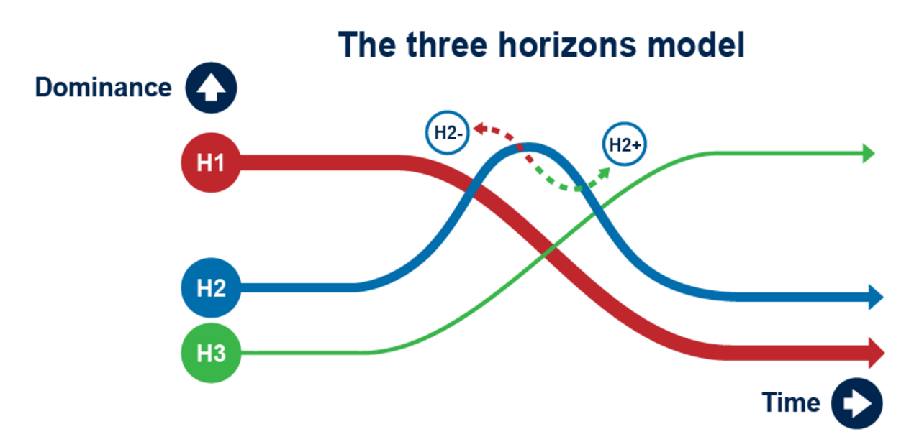
Figure 20 Three Horizons model. (Source: Petchey, n.d.)
View description - Figure 20 Three Horizons model. (Source: Petchey, n.d.)

The Three Horizons approach can be used to consider the issue, how it might change over time and the different perspective of stakeholders. This is shown in Figure 20 and Table 7.

Table 7 How the Three Horizons model can be applied
 | What | How | Stakeholder perspectives
Horizon 1  Business as usual – the current situation | The need for the current situation to change | Right now, current trends and issues | Power holders
Horizon 2  Activities and innovations for doing things differently | Ideas for how to get from where we are now | Emerging trends | Innovators
Horizon 3  Long-term solutions and new ways of doing business as usual | A vision for the future | Trends that might dominate the future, competing visions | Visionary
(Petchey, n.d.)

In video 11 below Bill Sharpe explains the Three Horizons approach.

Video content is not available in this format.
Video 11 Overview of the Three Horizons approach
View transcript - Video 11 Overview of the Three Horizons approach

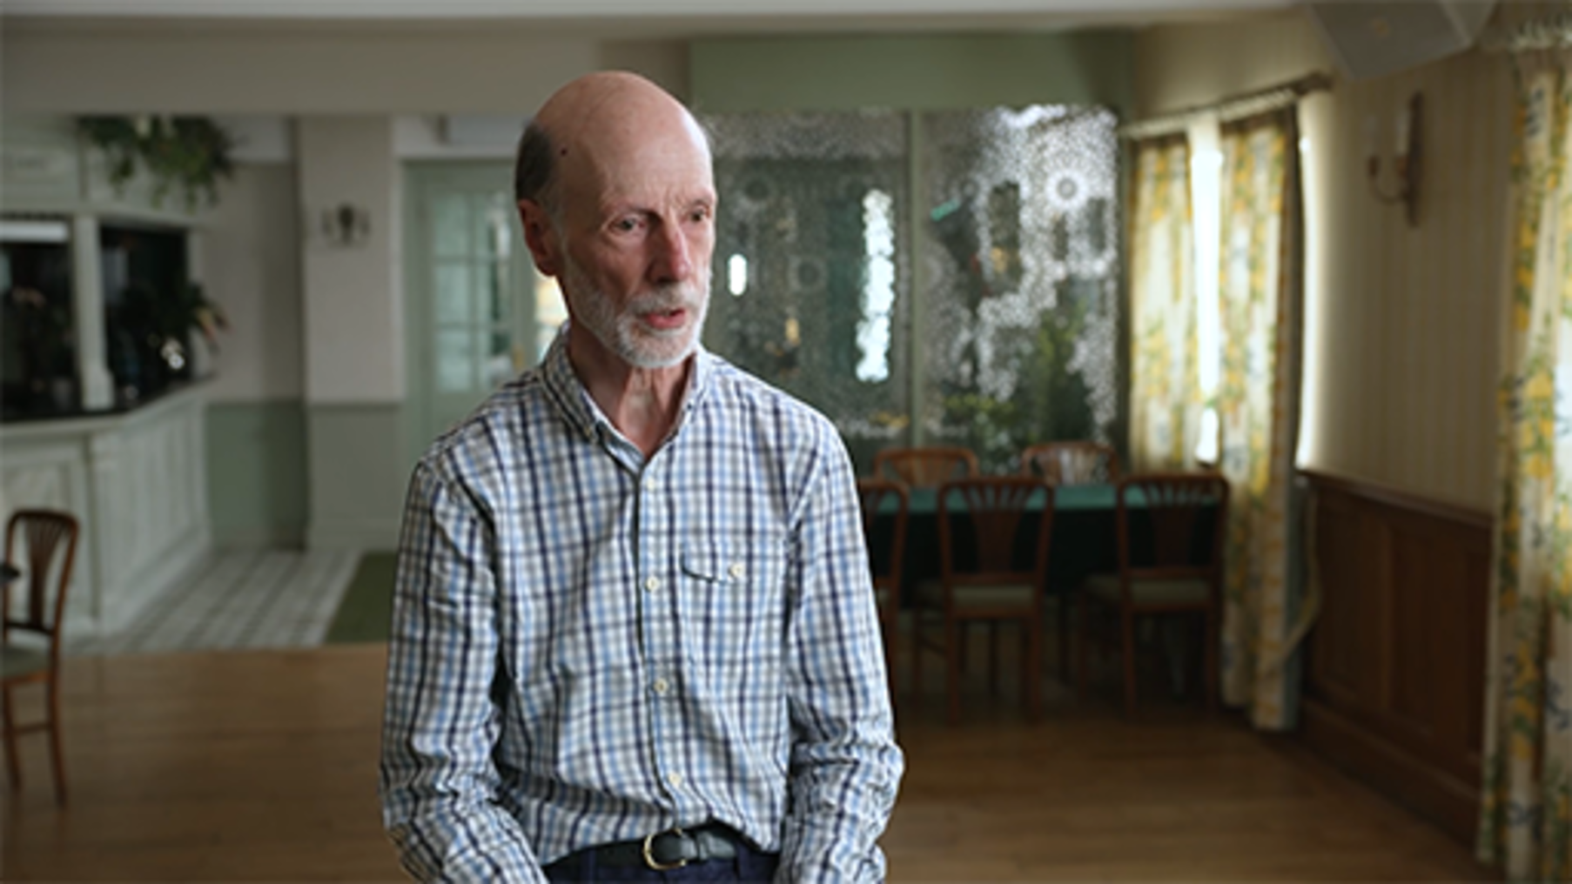

In the video Bill Sharpe explained that the Three Horizons approach draws attention to the three horizons as existing in the present moment, from which we can gather evidence about the future from the present, in order to consider different possible futures.
Each horizon is designed to allow you to explore the different possibilities.

H1 – The First Horizon...
… is the dominant system at present. It represents ‘business as usual’. We rely on these systems being stable and reliable but as the world changes, so aspects of business as usual begin to feel out of place or no longer fit for purpose. Eventually business as usual will be superseded by new ways of doing things.
H3 – The Third Horizon...
…emerges as the long term successor to business-as-usual. It grows from fringe activity in the present that introduces completely new ways of doing things but which turn out to be much better fitted to the world that is emerging than the dominant H1 systems. We call these early manifestations ‘pockets of the future in the present.’
H2 – The Second Horizon...
…is a pattern of transition activities and innovations, people trying things out in response to the ways in which the landscape is changing. Some of these innovations will be taken up by H1 systems to prolong their life while some will pave the way for the emergence of the radically different H3 systems.
(Sharpe, 2019)

All horizons should be looked at together to think about the changes between them overtime.

Activity 14 Consider how you can use the Three Horizons approach
15 minutes

1. Watch the video in which Dr Louisa Petchey, explains the Three Horizons approach and how it can be used by public bodies to assist with long term planning.

Video content is not available in this format.
Video 12 Using Three Horizons for long term planning
View transcript - Video 12 Using Three Horizons for long term planning

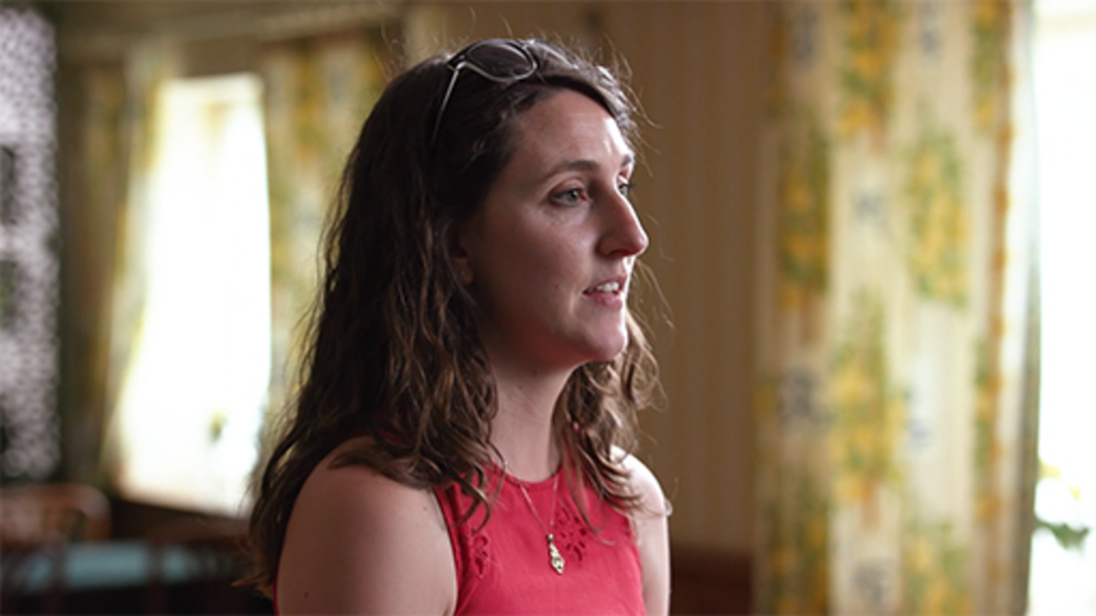

2. Review the ‘Three horizons: A toolkit to help you think and plan for the long-term’ (Petchey, n.d.) and plan a workshop (see p. 11 of the toolkit) with your colleagues outside the time allocated to studying this course. Familiarise yourself with the model and focus on an issue/problem you wish to address together.
You may wish to make notes on how you will approach this, below.

Provide your answer...

If you wish to develop your understanding of the Three Horizons approach further, the International Futures Forum and H3 Unit provide access to guidance on using the approach and resources that are freely available for use.
- Three Horizons (iffpraxis.com)
- Three Horizons (h3uni.org)

5.2 The Oxford Scenario Planning Approach
The Oxford Scenario Planning Approach (OSPA) focuses on scenarios and strategic options should something change to an organisation’s status quo, either as immediate issues, or to plan for possible versions of the future.
The OSPA is particularly robust as it ensures that the scenarios created are actually used by the person they are developed for and for the purpose that they were devised. Professor Rafael Ramírez (Professor of Practice, Saïd Business School, University of Oxford) defines scenarios as ‘a small set of manufactured possible future contexts of something for someone for a purpose with a pre-specified use interface [and that is its] actual use’.
In the video below he explains OSPA further.

Video content is not available in this format.
Video 13 Introduction to Oxford Scenario Planning Approach
View transcript - Video 13 Introduction to Oxford Scenario Planning Approach

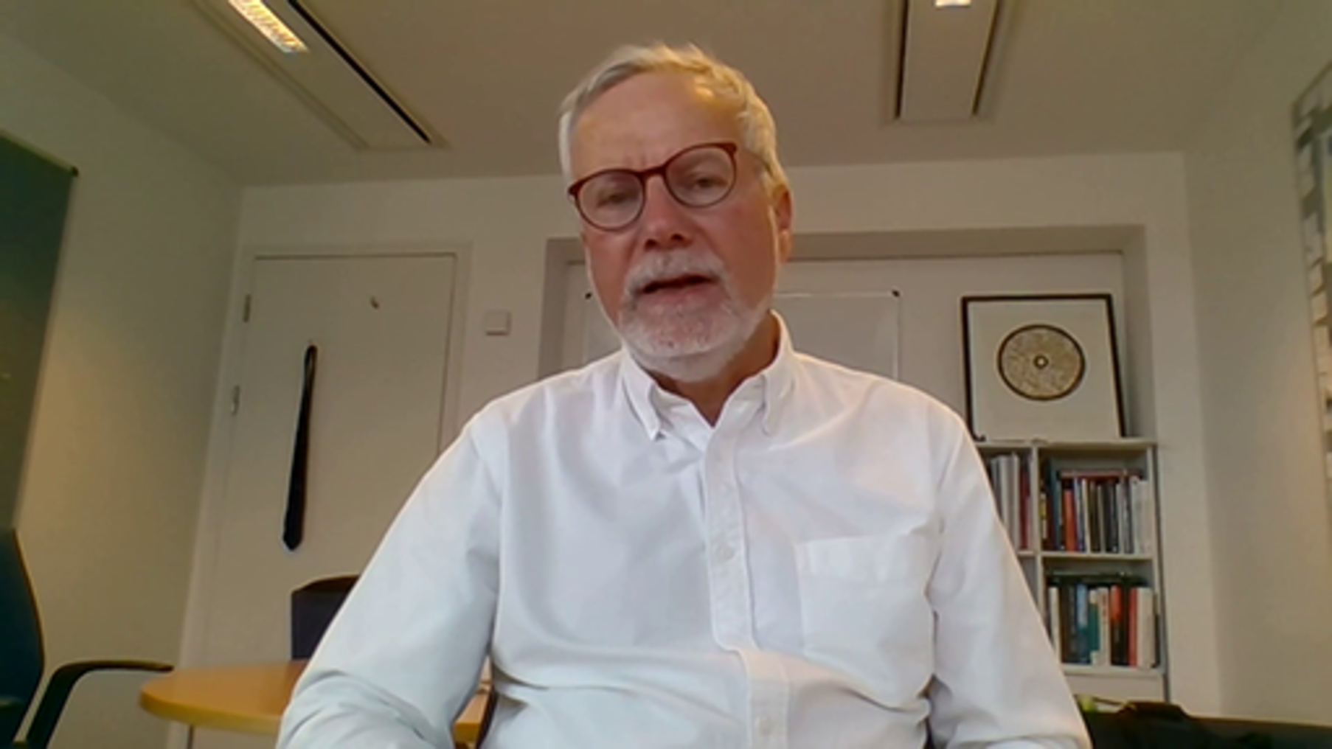

In the video, Professor Rafael Ramírez refers to TUNA conditions – Turbulence, Uncertainty, Novelty (& unique) and Ambiguity. This may help to reframe scenarios as a social process in times of uncertainty, in order to consider and search for new ways to survive and succeed. Figure 21 provides more information.

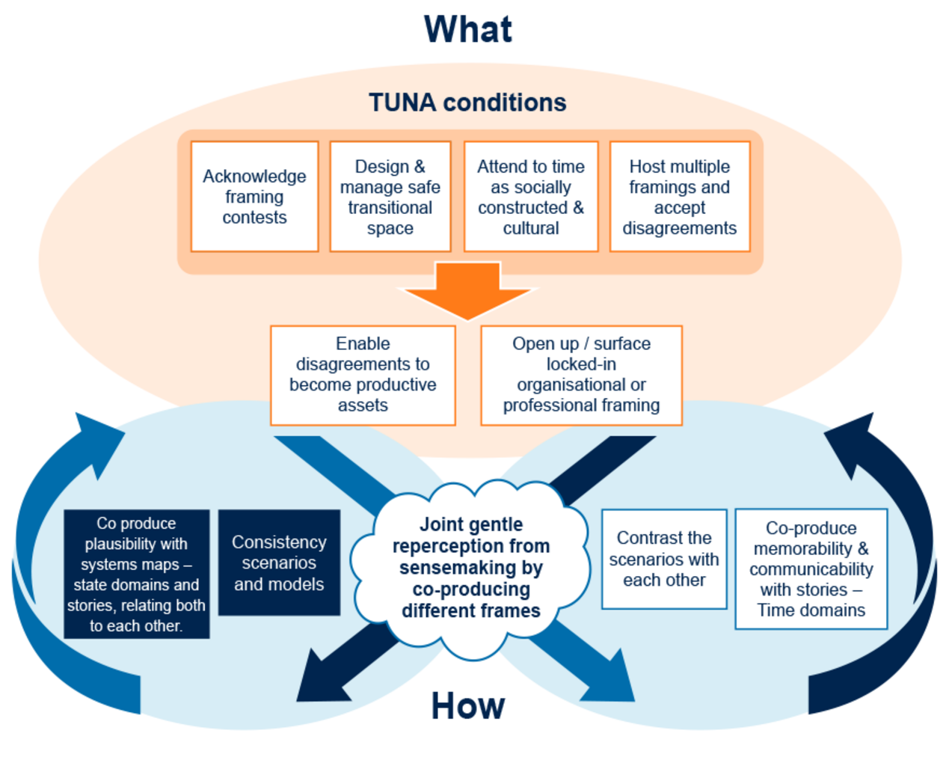
Figure 21 The OSPA as a social process (Source: Adapted from Ramírez and Wilkinson, 2016)
View description - Figure 21 The OSPA as a social process (Source: Adapted from Ramírez and Wilkinson, ...

Activity 15 Thinking about TUNA conditions
10 minutes

Reflect on Video 13 ‘Oxford Scenario Planning Approach’ and how you might reframe scenarios drawing on the TUNA conditions described. How might the impact of these conditions influence decision-making and help you respond to your external environment?
You may wish to make notes on this below.

Provide your answer...
View discussion - Activity 15 Thinking about TUNA conditions

In the next section we focus on Islands in the Sky, created by Dr Matt Finch, and how it draws on elements of OSPA, to provide a simplified approach to enable teams and organisations to carry out rapid scenario planning – as was required during the height of the COVID-19 pandemic in 2020 – when organisations were dealing with continual uncertainty. The approach offers a framework for those less familiar with futures and scenario planning to engage with different approaches, feel comfortable planning for the unknown, and consider future possibilities.

5.3 Introduction to Islands in the Sky
Islands in the Sky is a situational awareness and scenario-based strategic planning tool that is especially useful for managing uncertainty. It is designed for structuring conversations about the future business environment to inform decision-making in the present. This allows a voice for everyone and for things to get done quickly. It might not be perfect, but it helps form a base from which we can learn and iteratively develop.
The approach encourages you to bring a range of voices into the conversation and to consider different cultural and social values. Different lived experiences and perceptions of reality are all considered to navigate what the most important things are in a culture, society or organisation.
Individuals and/or teams are brought together to explore the environment and consider the future. This normally takes place in a workshop, and it is recommended that you either do this remotely or face to face, rather than hybrid. You then work through a series of stages, using collaboration tools to input into the sessions.

Activity 16 Riding a bicycle
15 minutes

In the video below, Dr Matt Finch (Associate Fellow, Saïd Business School) explains the Islands in the Sky approach and how it can help with navigating uncertain futures and understanding your transactional relationships with an introduction from Professor Rafael Ramírez.
1. As you watch the video, think about the following question posed by Matt at the end of the video:
How do I go beyond expectation and the things I currently anticipate – even beyond my hopes and fears – to really see how the future could be different, in ways that previously lay in my blind spot? (Extract from Video 14)

Video content is not available in this format.
Video 14 Introduction to Islands in the Sky
View transcript - Video 14 Introduction to Islands in the Sky

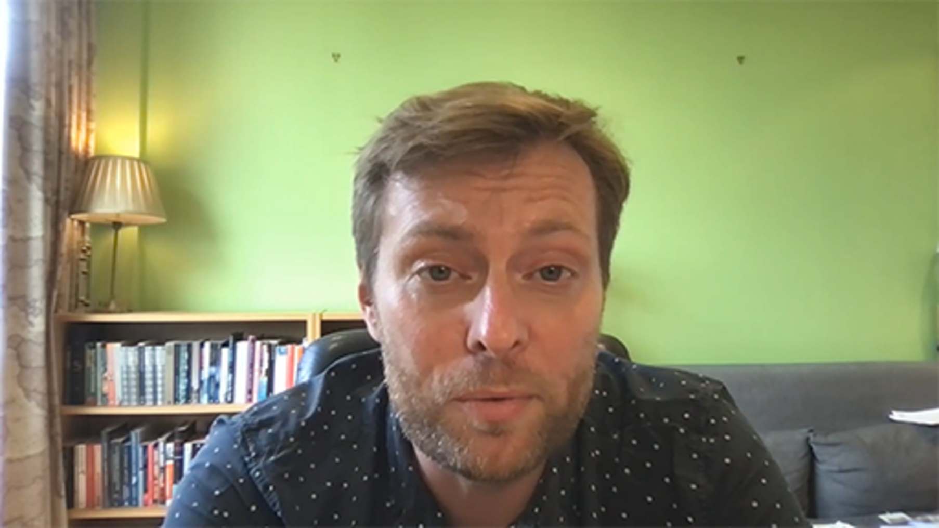

Provide your answer...
View answer - Part

2. Think about the statement by Rafael and the bicycle analogy, and how might this help you be aware of your blind spots. Consider how open to action learning for uncertain futures you are. Then vote in poll below:

Interactive content is not available in this format.

View answer - Part

In the introduction to Islands in the Sky, Matt and Rafael discuss the need to consider your transactional relationships, against a backdrop of rapid change and uncertainty, where you can’t see what tomorrow is going to hold. They refer to ‘TUNA’ conditions – turbulence, uncertainty, novelty and ambiguity. You started thinking about these in Activity 16. Below, Table 6 provides more information about TUNA conditions. These conditions take a systems thinking approach and can enable teams/organisations to develop their situational awareness, and better understand the context they are operating in to create a better future.

Table 8 TUNA conditions (based on Ramírez and Wilkinson, 2016, pp. 28–32)
Turbulence | Uncertainty | Novelty (& unique) | Ambiguity
Speed of change, with high complexity and uncertainty. | Uncertainty is unpredictable, disruptive and can be uncontrollable. | Response to situations that are both imaginable and unimaginable that require new concepts, technologies and approaches. | Managing and understanding different interpretations of situations, often when there is little or contradictory information available.

In Video 15 ‘Working with uncertainty’, Dr Matt Finch explains that when we are operating in times of unpredictable uncertainty, and we cannot draw on data or our experience of similar situations, then we have to find vantage points from which to draw.

Video content is not available in this format.
Video 15 Working with uncertainty
View transcript - Video 15 Working with uncertainty

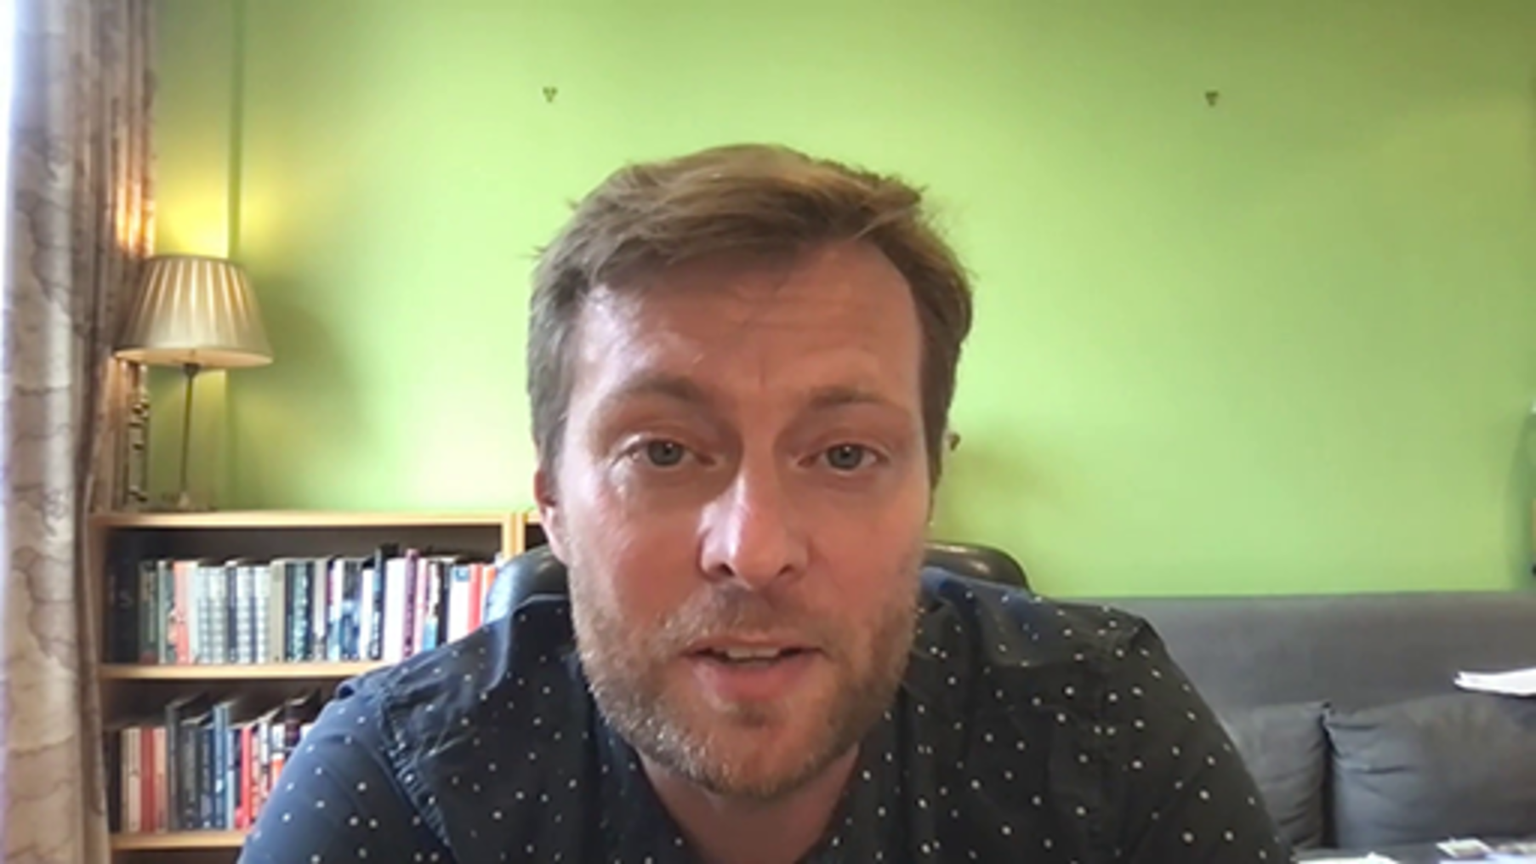

An invitation to work with uncertainty

The name of ‘Islands in the Sky’ itself, is an invitation. It lets people know that when they take part in this process, there is an element of play. There is an element of ‘make believe’ and they are actually the foundations of these imagined future contexts, precisely because they won't be like yesterday. They're not purely founded in the expectations and assumptions of the past. They can also be built based on ‘what if’ and the questions of ‘what might be’ – the things which go beyond our usual expectations, the ways that we think that trends are going to play out, their way of thinking about what happens if a trend bends or even breaks.
And that means that they are, in a way, more like looking up at the sky and seeing pictures in the clouds, seeing faces drifting past us. But that doesn't mean that they don't anchor something very real and very serious when it comes to the decisions we face in turbulent times.
(Finch, 2022)

Activity 17 Build your confidence with uncertainty
10 minutes

Islands in the Sky is designed to build confidence with uncertainty by posing questions such as:
- What if things turn out differently to how I expect?
- What if those choices and their consequences have to exist in that future?
- Are they still good choices?
- IF that future was going to happen, what would it mean for our choices today?
Think about these questions, and Matt’s encouragement that this approach is an invitation to play and look up to the sky. If you were to look up to the sky and think about possible futures, and the ‘islands’ and relationships on those islands, what would this look like.
To help with your thinking, take a piece of paper and draw the images that come to mind. This is a concept often referred to as ‘rich pictures’, You came across this idea in Section 3, Figure 22 below is a ‘rich picture’ visualising what Islands in the Sky might look, by one of our course authors. These pictures do not have to be master pieces, just a reflection of your thinking.

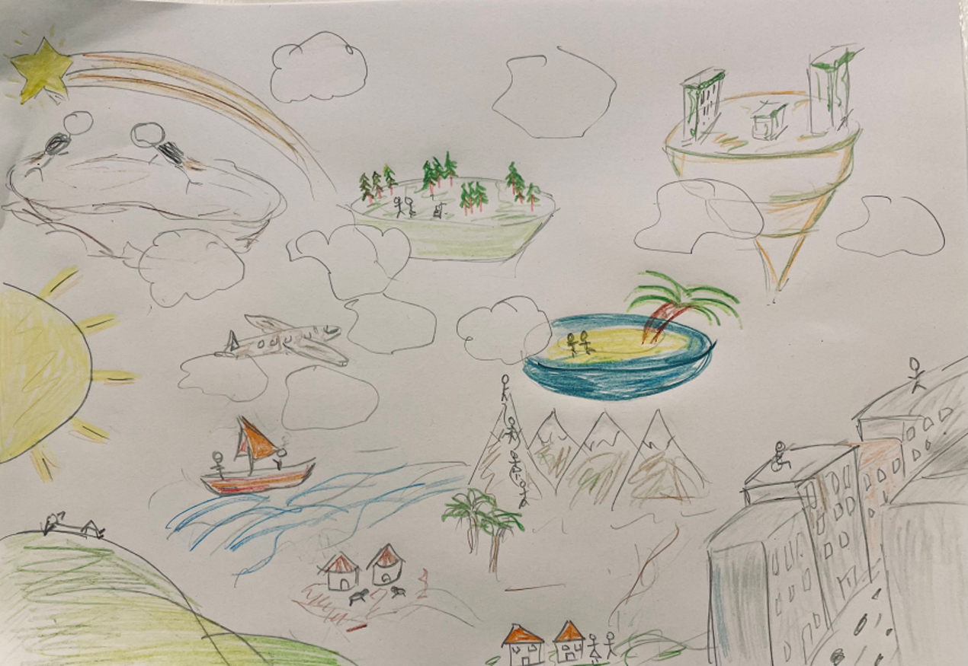
Figure 22 Example of a simple rich picture
View description - Figure 22 Example of a simple rich picture

In the next section we take you through the Islands in the Sky methodology in detail.

5.4 Islands in the Sky – the methodology
Islands in the Sky can help surface insights about future challenges and opportunities. It creates a space for creative discussion and fresh ideas regarding different possible futures, in order to develop future strategies.
The approach for this is normally through workshops with a diverse group of participants, to ensure a range of voices in the room. The methodology has six stages:
- Confirm the purpose (normally you will know what you want to explore in advance of a workshop, but remind participants of the purpose).
- Map the transactional environment – internal and external relationships involved in the mission.
- Label the relationships with ‘social’ and ‘functional’ value generated for both parties.
- Identify the uncertainties that shape decisions on the island, and how these might play out to redraw the future.
- Review the opportunities and challenges:
  - select those that require more investigation or could be progressed
  - apply the learnings.
- Feedback and follow up.
In the video Dr Matt Finch provides insights as to how you can use and adapt Islands in the Sky for your purposes and better conversations. As you read through the stages of the methodology reflect on the insights that he shares.

Video content is not available in this format.
Video 16 Adapting Islands in the Sky for better conversations
View transcript - Video 16 Adapting Islands in the Sky for better conversations

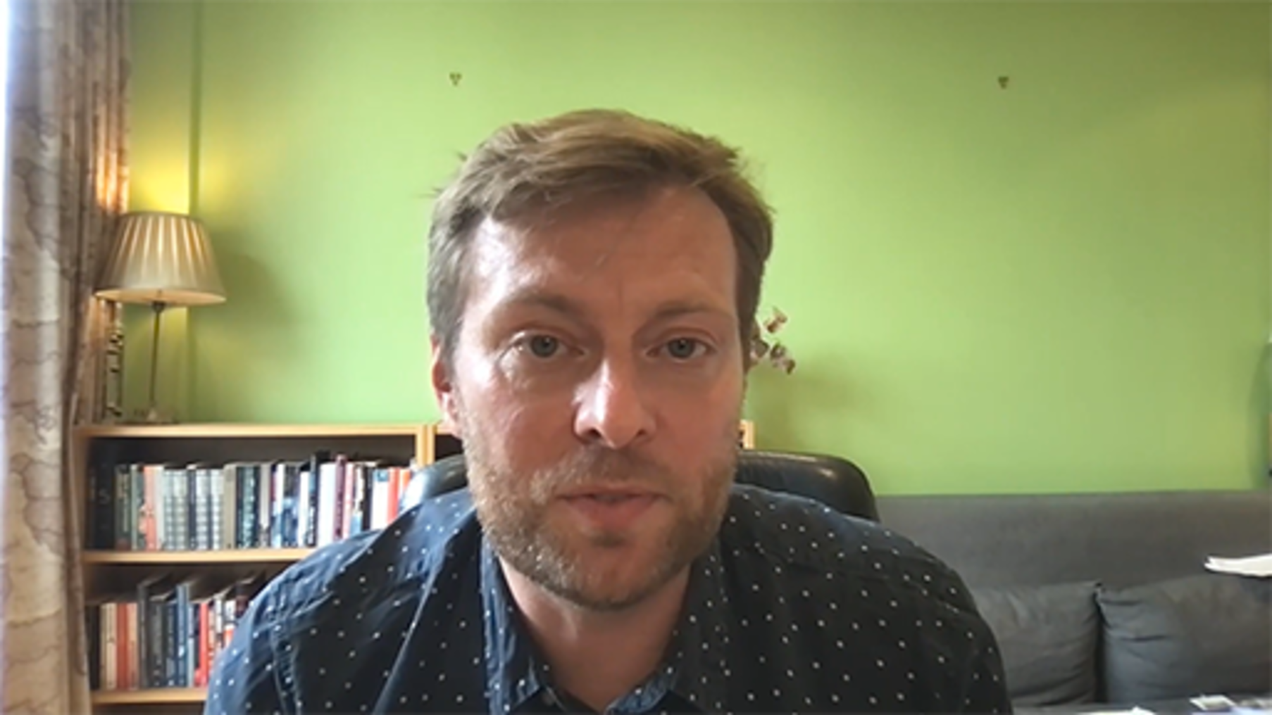

Stage 1: Purpose
Review your current mission statement (purpose), then clarify what are you trying to imagine a different future of/for?
The method can be used for a variety of purposes from organisational future planning, focusing on a specific topic, change required due to issues, or for generating ideas for innovation.
Consider:
- What decisions are you trying to explore?
- What is your time ‘horizon’ frame?
- Which entity has to make that decision?
You may wish to use the ‘What’s your Why?’ approach prior to running the Islands in the Sky workshop if you are not clear of the purpose.

Stage 2: Transactional environment

Figure 23 The transactional environment
View description - Figure 23 The transactional environment

A transactional environment is the 'island' that you inhabit based on communication and relationships between those that you interact with in the course of business. It is important to understand the different needs and perspectives of each person, to reach an understanding or an agreement together.
Participants map their transactional environment and capture all the entities they interact with directly as they carry out their work, to map the internal and external relationships involved in their mission.
Consider:
Internally and externally:
- Who do you work with?
- Who do you have to consider?

Stage 3: Value of the relationships

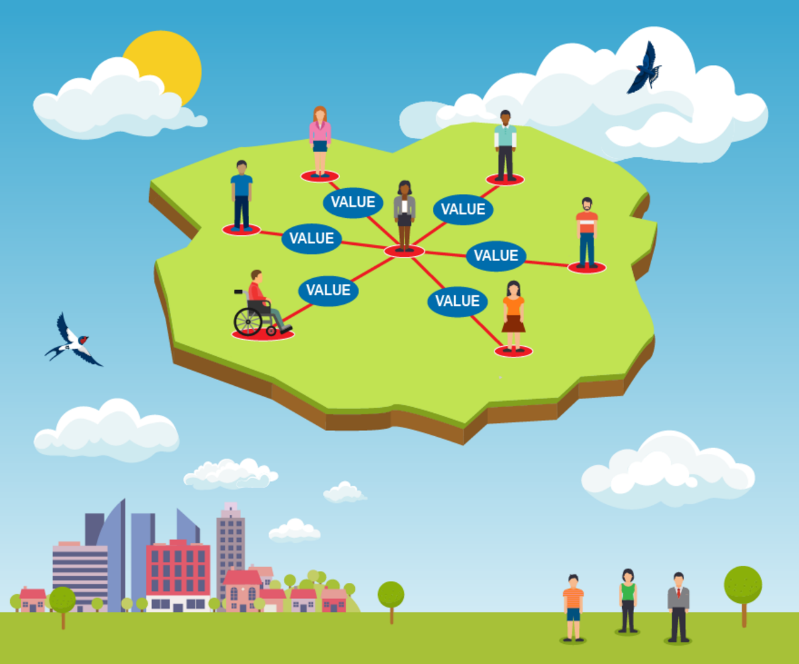
Figure 24 The value of relationships in the transactional environment
View description - Figure 24 The value of relationships in the transactional environment

The Islands methodology was originally devised to explore post-pandemic hybrid ways of working. This meant considering when people and teams needed to gather in person or online for social, collaborative reasons, and when the reasons were purely task-focused. Consider the relationships with social and functional value generated by both parties and label these with the value they generate for both parties.
Social: you discuss and collaborate.
Functional: primarily transactional/task-focused.
Ask quantitatively and qualitatively:
- what difference does each relationship make in each direction?
Think of the things that influence the decisions people or organisations make and the things that may change their behaviours. You can use a template like the one shown in Table 9 below to help your thinking.

Table 9 Decision influence catergories
Political | Technological | Feelings | Challenges
Provide your answer... | Provide your answer... | Provide your answer... | Provide your answer...
Economic | Legal | Perceptions | Opportunities
Provide your answer... | Provide your answer... | Provide your answer... | Provide your answer...
Social | Environmental | Trends | Threats
Provide your answer... | Provide your answer... | Provide your answer... | Provide your answer...

Stage 4 Part A: Uncertainties

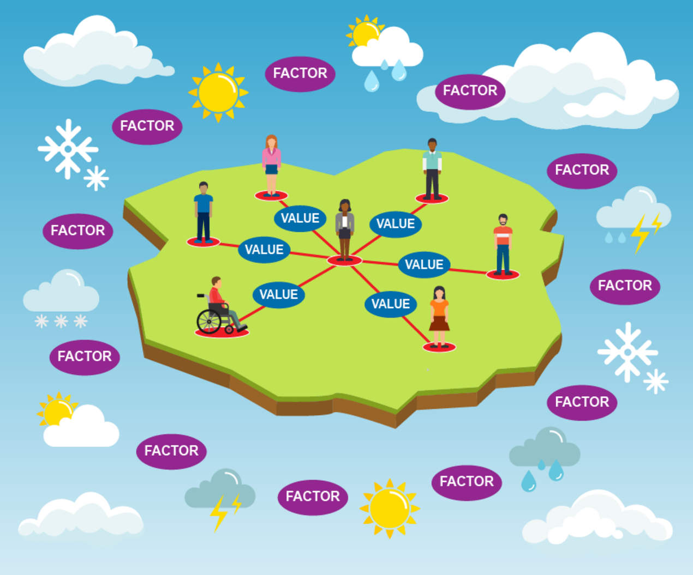
Figure 25 The uncertainties that shape and drive decisions within the transactional environment
View description - Figure 25 The uncertainties that shape and drive decisions within the transactional ...

Participants are then asked to identify the uncertainties that shape and drive decisions made by the entities on the island. Which factors beyond our own direct control shape the decisions of the other actors on our island? Such factors could affect just one actor, or many. Participants then consider the factors or forces that can’t be fully predicted in advance, and that might result in a redraw of the map of the island in the future.
What:
- do you feel most uncertain about?
- has the biggest impact?
- takes you out of business-as-usual thinking?
- do you not really think about?
- could really change your focus/how you go about your day to day, if it changed?
- offers a different perspective?
Consider your forces, external and internal environment:
- Which forces are most uncertain or uncomfortable?
- Which forces aren’t you paying attention to?
- Which forces can’t be known in advance?
- What does the island look like if these forces play out?
How is your decision maker’s ecosystem reshaped?

Stage 4 Part B: Multiple Island sketch scenarios

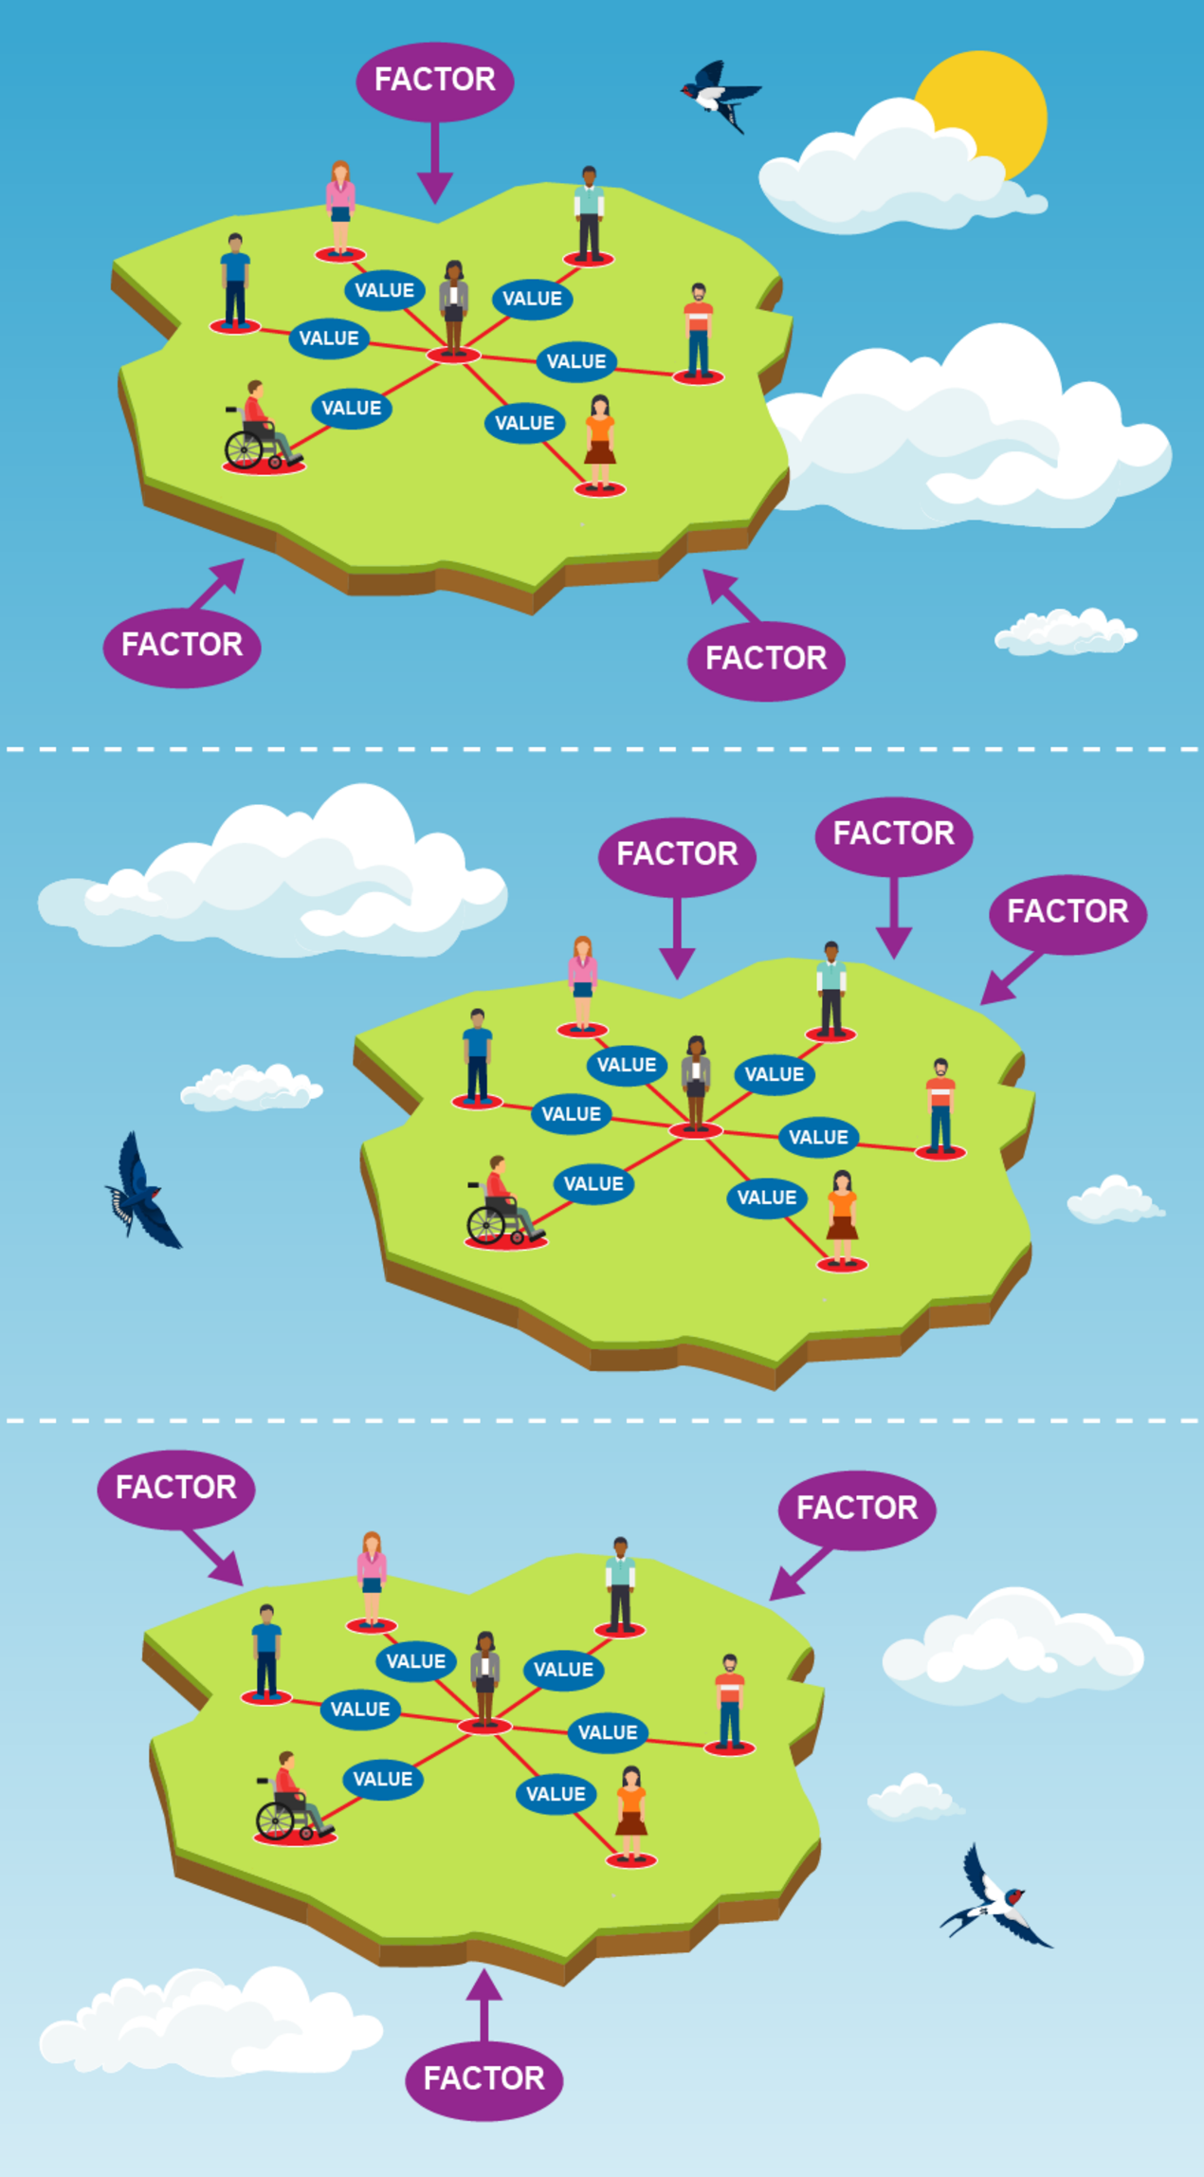
Figure 26 Multiple Island sketch scenarios
View description - Figure 26 Multiple Island sketch scenarios

Multiple islands can then be drawn as sketch scenarios to explore how different combinations of factors might ‘wash ashore’ and redraw the map of relationships in the future.
How might our transactional environments change, depending on how these uncertainties play out in combination? Would there be new or different actors on the island? Would the relationships and values change? How would the island differ from today?
Consider:
- What are the external factors relevant to your focus area, that could be critical to your work if they were to change?
- What difference does it make if you change your time ‘horizon’?
- What are the signs that this type of change might already be happening?

Stage 5: Review the opportunities and challenges

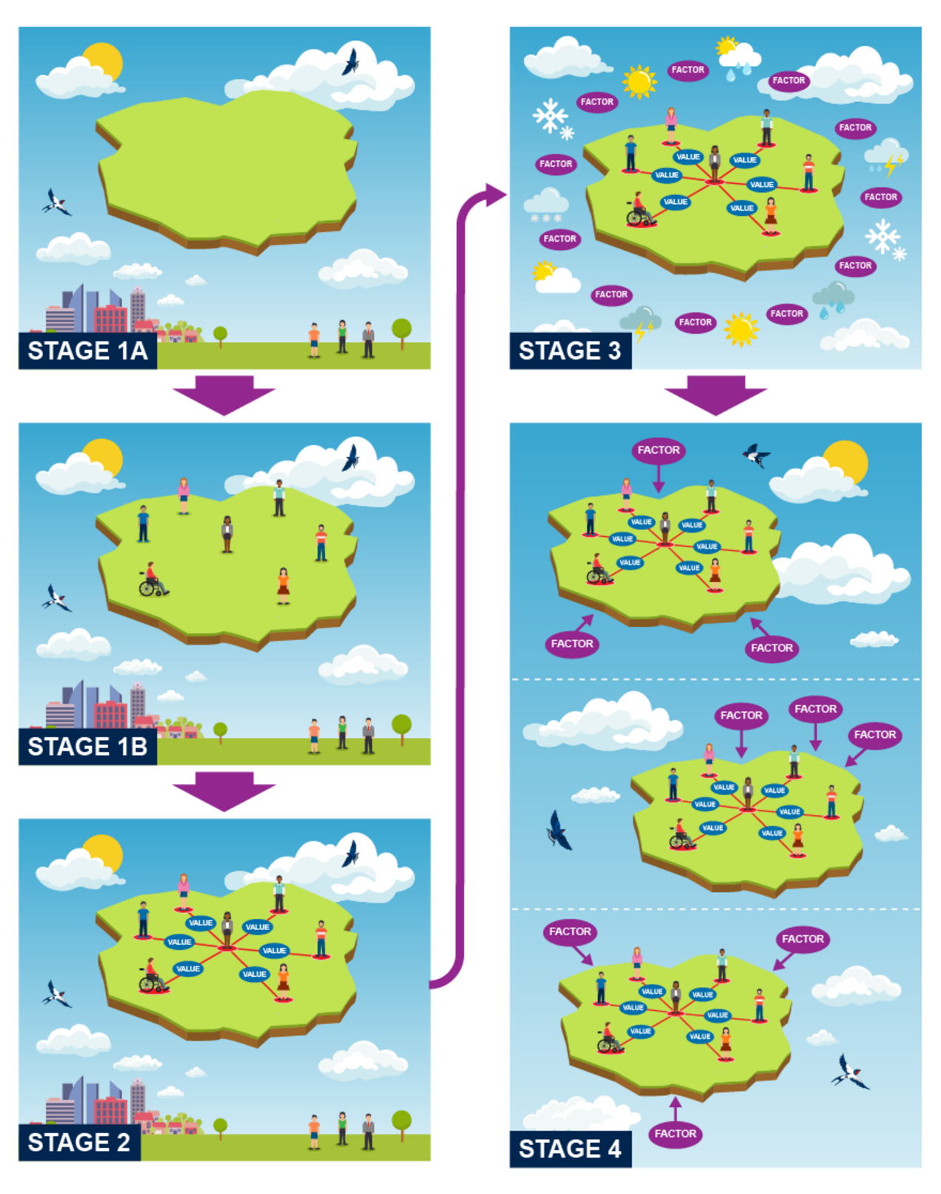
Figure 27 The gradual development of islands sketch scenarios over time
View description - Figure 27 The gradual development of islands sketch scenarios over time

In the final part of the workshop, take time to review your island(s) and consider the implications, opportunities, and challenges. If this future came to pass, what would be the wisest choices for us to make today? How would our current decisions, policies, and values be judged by the inhabitants of that future island? Are there choices we can make which are resilient across a number of possible futures?
Discuss the experience with those who attended. It is useful to arrange a follow up session, because after the workshop participants will often reflect on what they have learned and consolidate their thinking. A follow up session provides a space for participants to share their reconsidered inputs, perhaps redraw their sketches and they may have additional views to talk about.
Review the opportunities and challenges further and then develop your options for the purposes required. The approach for developing options and presenting these to others will depend on the purpose of your workshop and your organisational needs.

Stage 6: Feedback and follow up
At the end of the workshop, provide an opportunity for participants to share their experience of doing the workshop and how they now feel about futures planning.
Questions that may be useful to consider:
- How do participants feel?
- What has been the impact on them?
- What else do they want to know?
- What else do they want to share?
- Is this what they expected?
- What would they change?
It is then important to follow up with participants to seek any clarification from their input into the workshop. Having had time to reflect, is there anything else they wish to contribute towards a summary of the outcomes?
Futures planning should be an ongoing process within organisations, so consider your approach to planning cycles.

Activity 18 Plan an Islands in the Sky session
10 minutes

Create a short plan of how you could run an Islands in the Sky session. What do you want to focus on and what approaches might you take?
- Remote or face-to-face workshops?
- Who could you invite to the workshop?
- What questions will you want to ask?
- How will you review the workshop and outcomes?
You may wish to make notes in the box below, and download the Islands in the Sky toolkit PowerPoint for use in the future should you wish to run your own workshop.
Download the toolkit

Provide your answer...

Islands in the Sky can be an effective approach to help you think about future scenarios and quickly explore problems. It has been designed to focus on understanding your environment and the value you can generate within your transactional relationships in order to gain a fresh perspective.
In the video Dr Matt Finch shares tips for effective use of the Islands in the Sky approach.

Video content is not available in this format.
Video 17 Tips for using Islands in the Sky
View transcript - Video 17 Tips for using Islands in the Sky

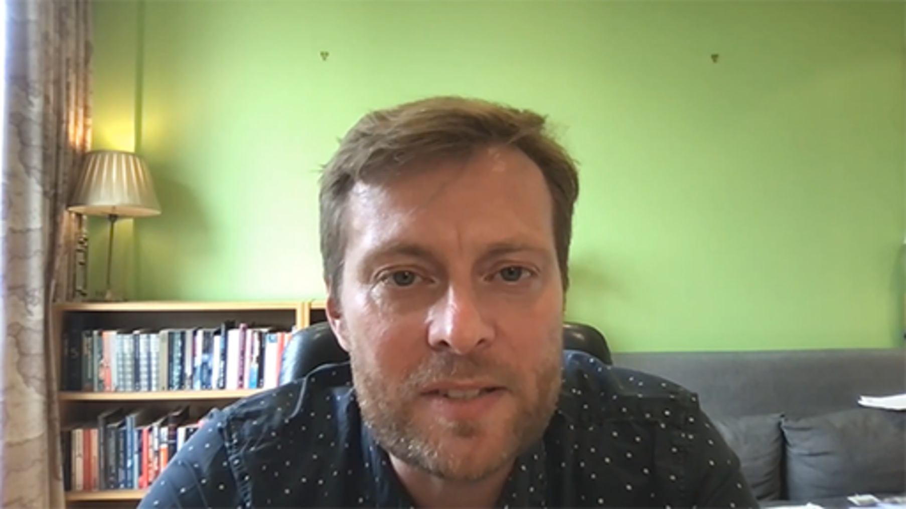

In the next section you have the opportunity to explore a case study on the use of Islands in the Sky within The Open University.

5.5 Islands in the Sky – a case study
In the following case study Anne Gambles (Senior Project Manager, The Open University) explains the work they did with Dr Matt Finch and Murray Cook, Brendan Fitzgerald and Zindzi Cresswell (Strategy and Scenario Practitioners) and the team from AZB Selva, consulting to use Islands in the Sky for exploring new ways of working within The Open University’s Learner and Discovery Services (LDS) unit.
The case study provides an outline of the approach, integrated with videos in which Anne and Murray share their experience of the process.

Case study: Islands in the Sky with LDS, The Open University

Developing the approach
During the COVID-19 pandemic in 2020, we identified a need to find new ways of working that would be fit for the future. We used pulse surveys to gather colleagues’ views on how they would like to work in the future and run ‘What’s our Why?’ sessions. To complement these activities, we decided to look for an innovative approach to help structure our thoughts and conversations about the future, while working in uncertain times.
Dr Matt Finch was engaged in 2021, to introduce a future thinking methodology to help people think and talk about the future in a meaningful way. Phase 1 workshops were run with project teams and strategic leaders to test the Islands in the Sky method. These demonstrated an awareness and appetite to connect with innovative and practical responses to construct robust and authentically equitable futures. These outcomes helped to inform the design of test and learn experiments for hybrid working and physical workspace design with the Open University.
In 2022, we engaged AZB Selva (Murray Cook, Zindzi Cresswell and Brendan Fitzgerald) to work with us on Phase 2, to further develop the Islands in the Sky methodology and plan for the future.
Phase 2 focused on creating and embedding a toolkit for individuals and teams to have conversations about the future.
The main aims were to:
- Encourage a creative and imaginative approach for foresight and futures planning.
- Foster resilience and encourage engagement with the near future.
- Build confidence and capability for managing uncertain futures.

The process
Over a period of five weeks during the COVID-19 pandemic, we ran remote-only workshops for colleagues from across the Open University. The learning from these sessions was used to develop the Islands in the Sky toolkit in Miro, an online collaborative whiteboard, and guidance presented in a PDF.

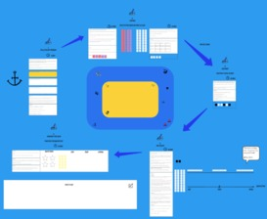
Figure 28 Miro environment for the Islands in the Sky workshops
View description - Figure 28 Miro environment for the Islands in the Sky workshops

We asked participants to begin by deciding on their focal issue and time horizon. The focal issue is something that they wish to explore or to make a decision about. They then start mapping their transactional environment and identify the internal and external entities they interact with as they carry out their work, and the type of relationship they have with them – either functional or social.
Participants then considered the uncertainties which shape, or drive decisions made by the entities they interact with. Then they focused on factors or forces that can’t be fully predicted in advance, and that might radically change their way of working in time to come.
Different combinations of these factors were then chosen by participants to explore and sketch different scenarios, and how they may impact relationships and working environments of the future. Participants thought about what the factors might look like in relation to their chosen time horizon.
Participants were then asked to consider the critical issues they identified, the context they were operating in and the impact of these on their focal issue. They were then asked if the focal issue has changed at all? What should they stop, start or continue now, that may help them act if/when change happens – what needs to be in place?
Lastly, time was allocated to review the experience, and agree what actions they might take away. The outputs from the workshops where then summarised and collated into reports to feedback to the project sponsor and arrange ongoing conversations with workshop participants.
In the video Anne and Murray reflect on the experience of running the workshops.

Video content is not available in this format.
Video 18 Experience of using Islands in the Sky
View transcript - Video 18 Experience of using Islands in the Sky

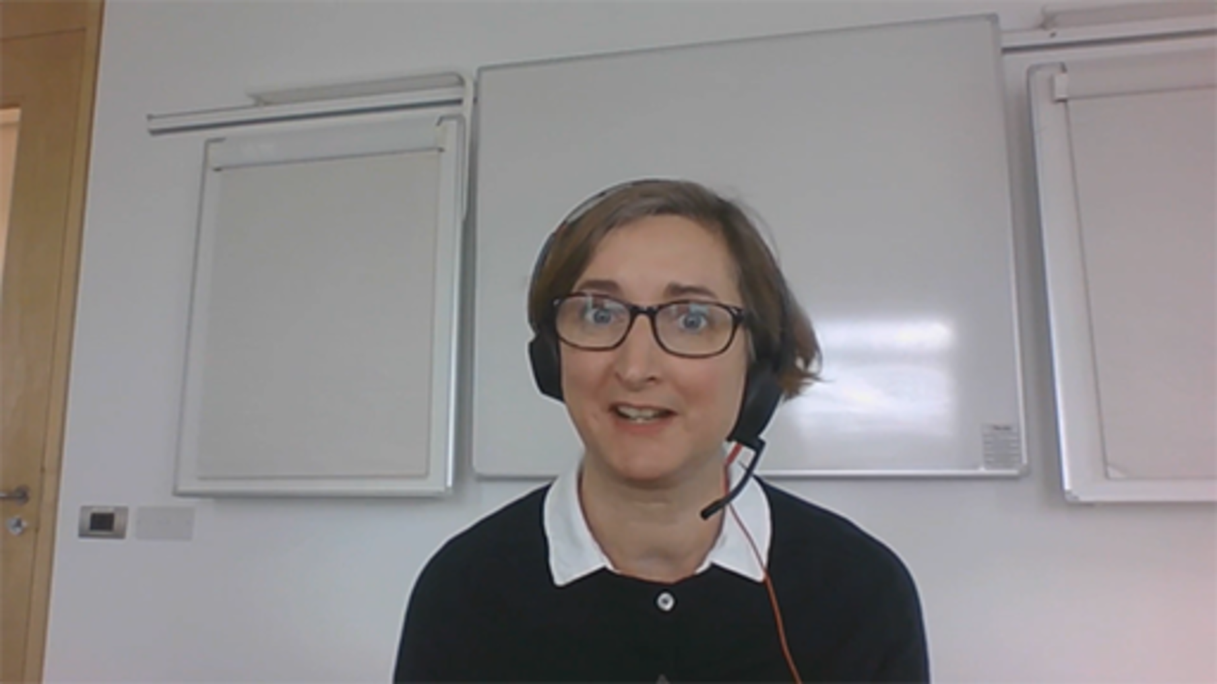

Outcomes
The initial benefits from using Islands in the Sky are the diverse voices, experience and opportunities that we have collated from the workshops. These have been used by the Directorate and senior leadership group to inform unit planning and draw on the evidence to consider risk management, business continuity planning and strategic directions.
The Islands in the Sky toolkit can now be used by teams according to their planning/business cycle and can be used alongside our ‘What’s our Why?’ toolkit. In order to do this and embed the learning further, we are developing further resources. This includes a programme to develop an in-depth understanding of the methodology for change champions, to enable others to lead workshops for organisation-wide strategic programmes across The Open University.
Reflection and learning
In the video Anne and Murray share their reflections on the benefits and opportunities of using this method.

Video content is not available in this format.
Video 19 Benefits and opportunities
View transcript - Video 19 Benefits and opportunities

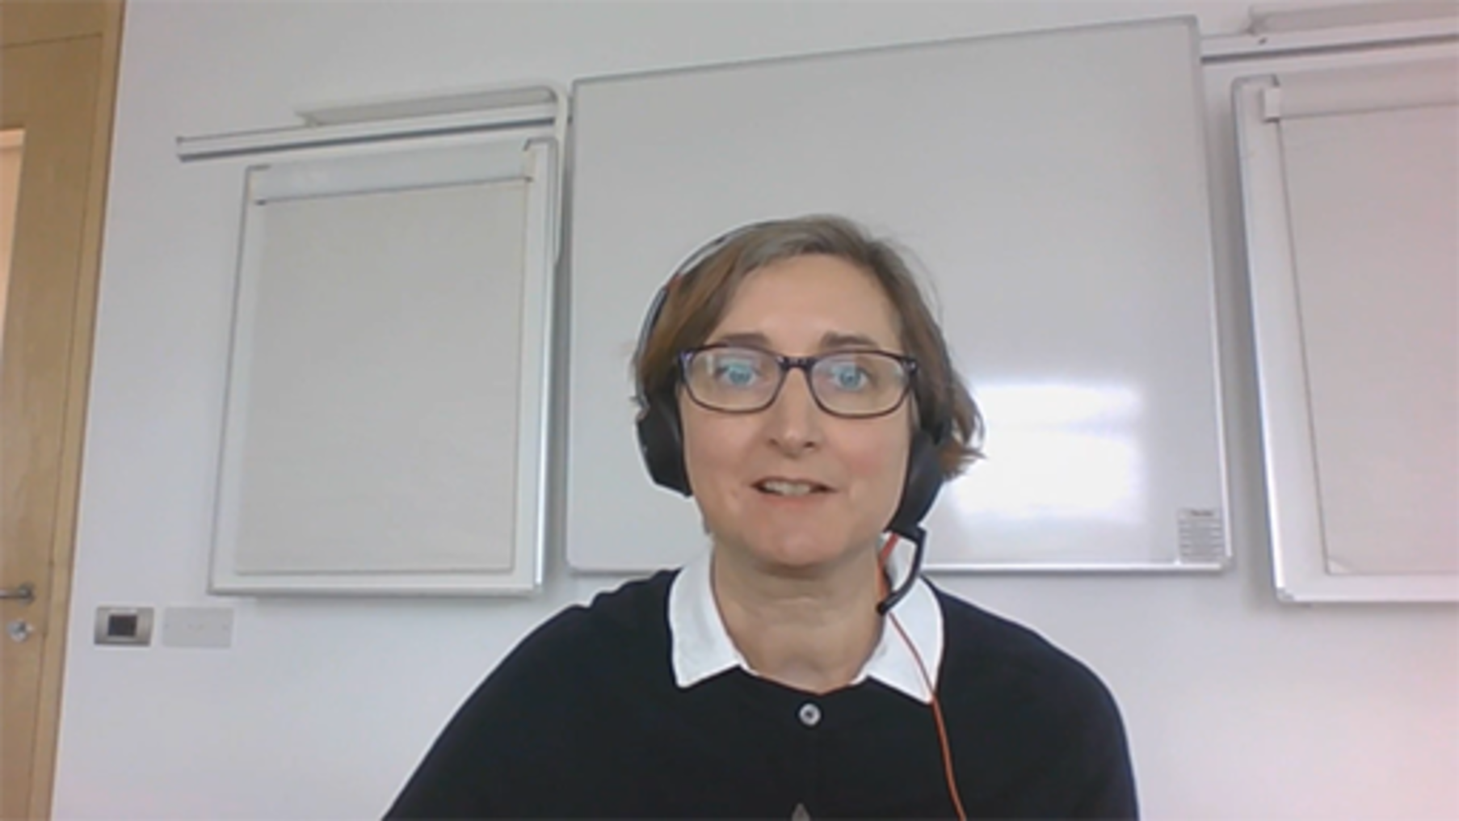

An important point that underpins the Island in the Sky method is that you cannot look at the future once. Futures work requires you to come back again and again, as, not only does the world change, but people’s views and information they can share changes. It is thought that by embedding this methodology into our strategic planning cycles it can become a very powerful tool to continually consider what we need to start or stop doing.
In order to develop the approach further, we gathered feedback from the workshop participants, and found the key themes that emerged where:
- They enjoyed how collaborative the workshops can be.
- They valued hearing the views of colleagues from other areas of the university as this helped them to piece together a puzzle that had been difficult to make sense of.
- It created a safe space to talk about and exchange shared experiences of the uncertainties they were facing as individuals within the workplace, but also how they felt about the organisational uncertainties.
- More positive outcomes could be achieved by adapting the workshops to reflect the participants, and focusing workshops for different groups, for example:
  - senior leaders only
  - mix job role
  - mixed unit groups
  - focusing on those involved in strategic priorities, like developing our understanding of inclusion, by offering a safe space for specific groups to be open about how they feel we as an organisation can be more inclusive and diverse.
The feedback and reflecting on our experience of developing Phase 2 has been invaluable for shaping the development of this approach. By having different conversations within The Open University about our opportunities, uncertainties, our future, and how we can support the wider purpose of the organisation, can help to develop a shared understanding.

Activity 19 Thinking about collaborating with others
10 minutes

An important element of Islands in the Sky is collaborating with others and bringing different voices into the conversations to create a shared understanding. In the case study, a key consideration was raised from the review of the process – that they may not have had the right people involved.
Think about problems/issues and who you need to have ‘in the room’ to ensure that you gain the right insights to help move forward. Reflect on the notes you took while watching the videos from Matt, Anne and Murray.
Consider how using the Islands in the Sky approach might lead to better conversations for the future and help identify the areas you need to focus on when approaching futures planning.
You may wish to make notes in the box below.

Provide your answer...

5.6 Better Value Sooner Safer Happier
Choosing the right approach for the problem you need to address is important, especially if you are focusing on problems that are connected to digital transformation. Approaches that have evolved based on the use of technology can guide you and help you discover insights that are specific to dealing with decisions and/or problems that involve digital transformation.
The Better Value Sooner Safer Happier (BVSSH) approach, developed by Jonathan Smart and colleagues (2022), helps you define your problem and provides a powerful roadmap to delivering your objectives and measuring the success of your outcomes. Like many others, the creation of the approach started with ‘why?’ (such as: Why do we need a better way of working and a better way of creating value?) which evolved out of their work with information technology firms.

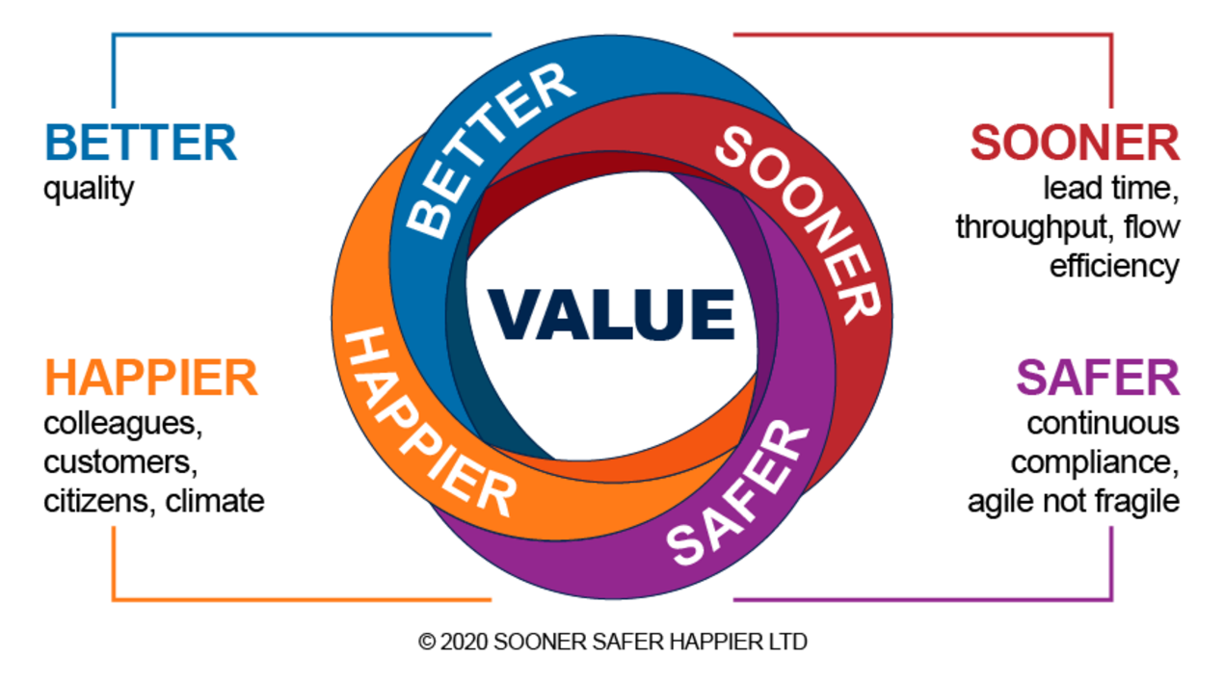
Figure 29 Better Value Sooner Safer Happier (Smart, 2020)
View description - Figure 29 Better Value Sooner Safer Happier (Smart, 2020)

Sooner Safer Happier is a textbook based on decades of practical experience of improving ways of working in hundreds of organisations. Learnings are structured into eight ‘patterns’ and ‘antipatterns’ for business agility.
A pattern is a response to a situation that, more often than not, is effective and improves desired outcomes. Of course, this all comes with ups and downs, back and forth, it’s all about the people. A pattern can help to create a tailwind for change.
The antipattern is to deploy a capital ‘A’, capital ‘T’, Agile Transformation across your organisation, with fixed scope/budget/plan, i.e. to apply old ways of thinking to new ways of working, which is unlikely to generate the desired benefits.
Table 10 explains the kind of organisational problems these patterns can assist with.

Table 10 Organisational problems and desired outcomes
Organisational problem | Desired outcome
‘We’re too expensive and inefficient. It’s too hard to get anything done, and organizational inertia is holding us back. The cost of change is high and it takes ages. We have to be more efficient!’ | I want more efficient delivery of value
‘We need to get better at benefits management. We don’t really know what value our change investments are adding, it’s just opinion. We have to get smarter at articulating, measuring, and prioritizing highest value!’ | I want to optimize for highest value
‘Things take too long. If we don’t change we will not exist. We are not keeping up with the competition. Doing nothing means we are going backward quickly. We have to accelerate.’ | I want to decrease time to value
‘When our delivery teams hit the risk and control gates it doesn’t matter whether they are agile or not, they all slow to the same speed. It can feel like we have governance gridlock, yet we are highly regulated and must manage risk and maintain regulatory trust.’ | I want to have both speed and control
‘Our best people keep leaving. The talent market is so competitive. Our staff turnover is really wasteful. We lose knowledge and reputation. We have to get better at attracting and retaining the best talent.’ | I want a more engaged workforce
‘We waste a lot of time talking about it. We have some pockets of improvement, but there is no shared understanding. Everyone has such entrenched beliefs. The arguments can get heated. Our energy needs to be focused on making real improvement.’ | I want to know why ways of working matter
‘We have talked about transformation for a long time and made a start. We’re making some progress in IT but the wider organization is not yet feeling the benefit. As a leadership team we want to improve outcomes and we want lasting change.’ | I want to nurture cultural change
‘For our organization to survive and thrive we know we have to adapt quickly. The scale of change is daunting and we are not sure where to begin making these changes.’ | I want to know where to (re)start
‘Our investment funding is tied to detailed upfront business cases and annual project cycles. It’s hard to understand what a different funding model might look like in new ways of working.’ | I want to know how to fund agility
(Sooner Safer Happier Ltd, 2022)

In the video below Myles Ogilvie and Matt Turner (both Principals at Sooner Safer Happier Limited) explain the principles of Better Value Sooner Safer Happier.

Video content is not available in this format.
Video 20 Better Value Sooner Safer Happier introduction
View transcript - Video 20 Better Value Sooner Safer Happier introduction

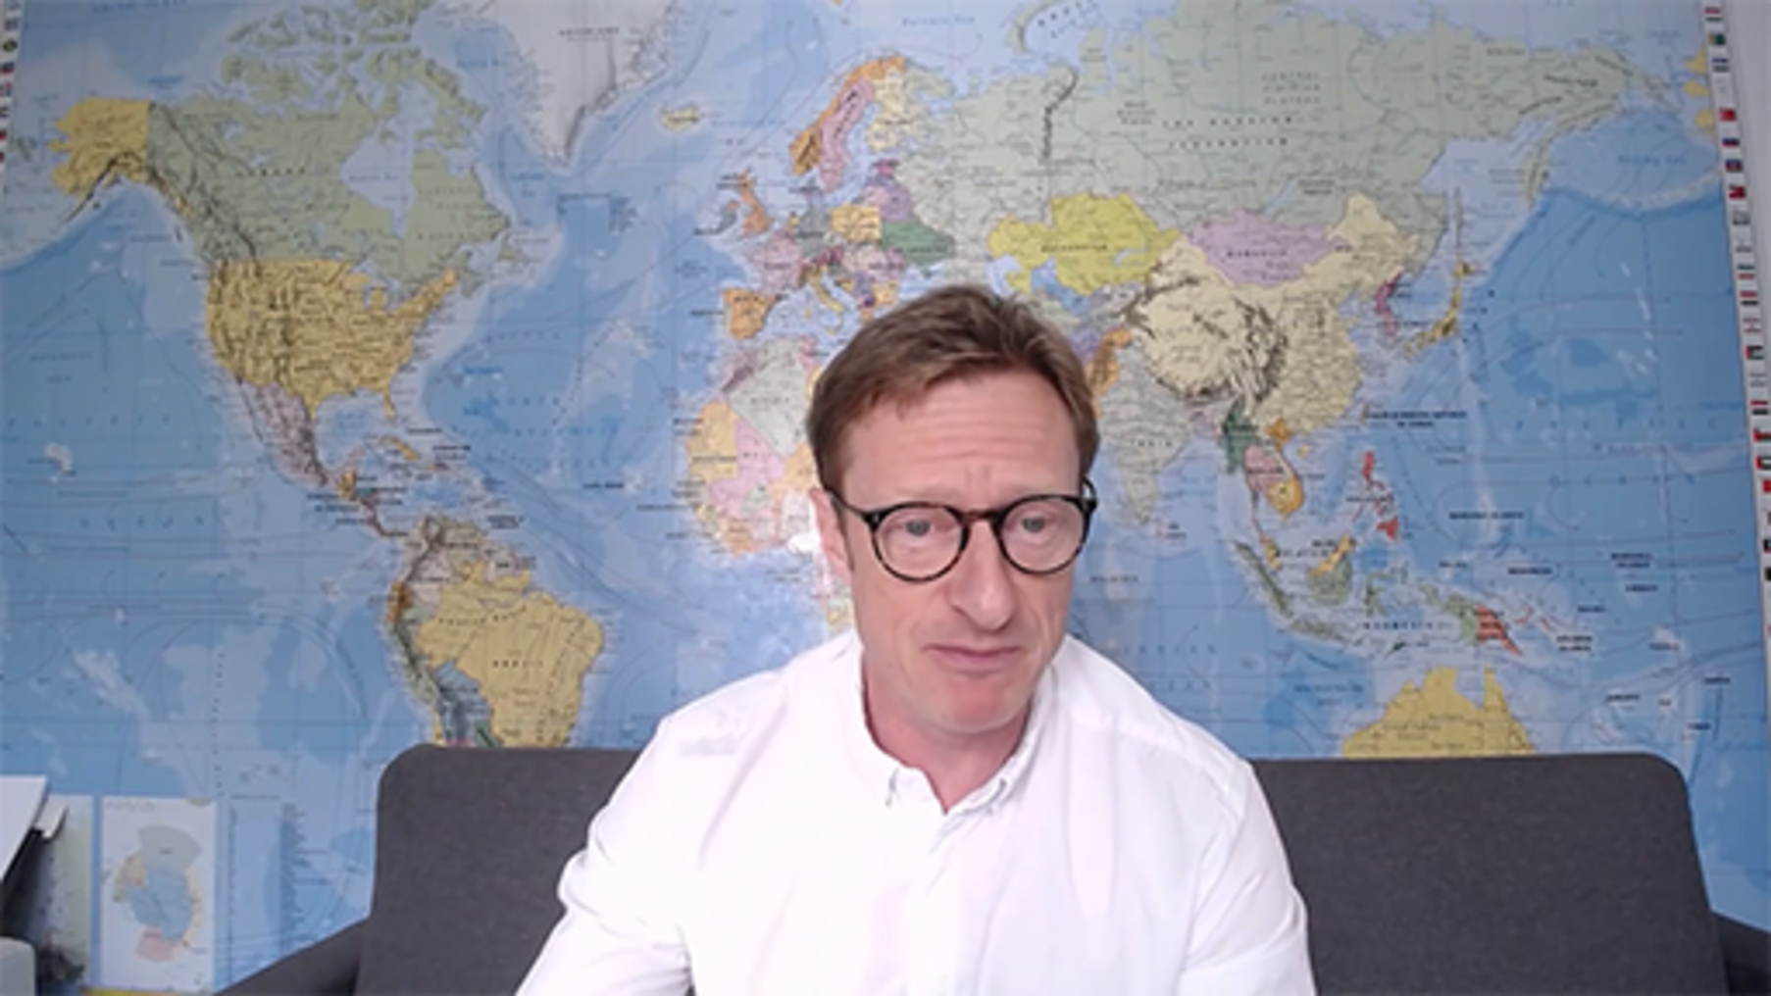

Activity 20 Learn more about Better Value Sooner Safer Happier
10 minutes plus optional further work outside of this course

Read the article ‘What is BVSSH?’ (Smart, 2022) and then explore the Sooner Safer Happier website to discover more about this approach.
Consider how focusing on outcomes might help with developing more robust ways of working. You may wish to make notes in the box below.

Provide your answer...

If this is an approach that is of interest to you the Better Values Sooner Safer Happier team have created a course for OpenLearn to develop your understanding further which you may wish to study as well. Introduction to business agility - OpenLearn - Open University

5.7 Choosing an approach
You may have found that one of the approach we introduced you to, naturally feels the most appropriate for you to use. Often it is your personal preference and approach to planning that will influence your choice. Or you may feel that there are elements of the different approaches you can take to develop your own approach for working with your teams to do future planning.
There are numerous approaches and toolkits available for use, and we have only introduced you a few.

Further reading
OPSI website
The Observatory of Public Sector Innovation (OPSI) website provides some excellent background reading and links to frameworks, models, and workshop templates. You may find these useful to help you discover signals for, and analysing the impact of, your anticipated future(s) and planning how you are going to respond to it. https://oecd-opsi.org/
Futures Frequency Workshop
This site is useful for considering different futures and provides videos to stimulate your thinking and a toolkits to run your own workshops. Review the videos and content on the Sitra Futures Frequency website: Futures Frequency - Sitra.
OpenLearn
If you are working on projects that focus on innovation you may wish to also study the OpenLearn course Making creativity and innovation happen .

Activity 21: Plan using an approach
15 minutes

Spend some time reflecting on the approaches and create a plan as to how you might use them for running a futures planning session with others, or to help you make sense of the problem you need solve. As you do so make notes on areas you might want to consider, what tools you may need to use to assist with using the approach, and what other research you might want to do.

6 Developing options – a systems thinking approach
Having chosen and used your preferred approach for futures planning and started to identify possible options, you may have noticed that they often make reference to drawing on systems thinking to help develop options further. Systems thinking is just one tool but is frequently used by most organisations.

Systems thinking enables you to grasp and manage situations of complexity and uncertainty in which there are no simple answers. It is a way of learning your way to effective action by looking at connected wholes rather than separate parts.
(Praxis, n.d.)

Activity 22 What is ‘Systems thinking’?
15 minutes

Read and listen to the audio file in the OpenLearn article below and reflect on how systems thinking could help you in develop your options further.
Systems explained by Peter Checkland (The Open University, n.d)
You may wish to make notes in the box below.

Provide your answer...

Systems thinking tools help you by visualising the information and what might be possible. They allow you to share and collaborate on ideas quickly and provide a different way of thinking. It is useful to when working with these tools, to remember that you do not own an idea and that anyone can adapt and change your ideas, so that you maximise the opportunities for understanding a problem and new ways of working.

6.1 Systems thinking tools
The OpenLearn Systems Thinking Hub (The Open University, n.d.) provides access to range of tools and courses which may be of interest to those who wish to develop their understanding further by starting with Systems thinking and practice – OpenLearn (The Open Univeristy, 2021). For the purposes of this course, we focus on three approaches, that you may wish to use to help develop options further.

Causal loop diagrams
A causal loop diagram consists of four basic elements:
- the variables
- the links between them
- the signs on the links
- the sign of the loop.
The following video will walk you through how to create a causal loop diagram.

Video content is not available in this format.
Video 21 Casual loop diagrams
View transcript - Video 21 Casual loop diagrams

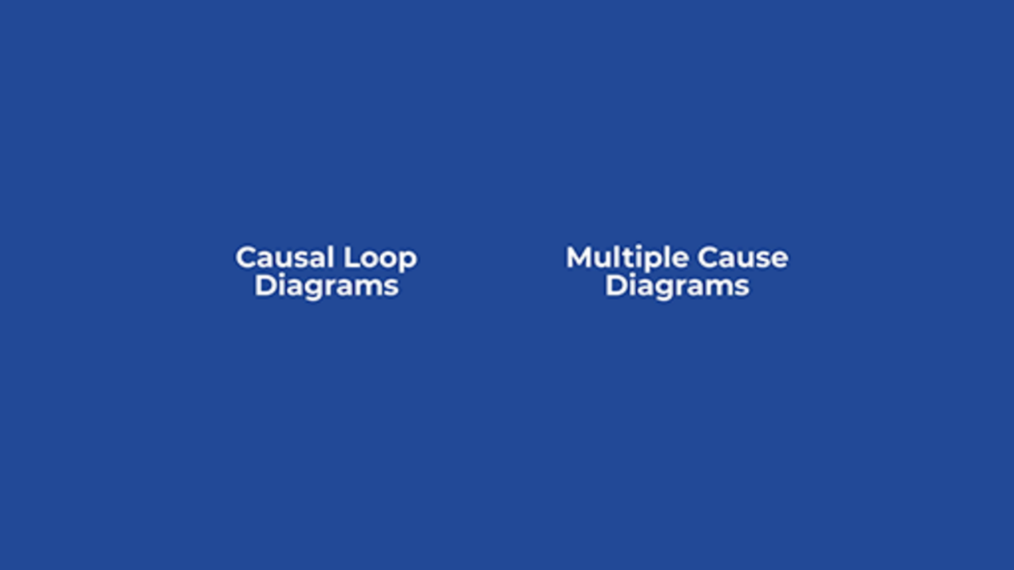

Multiple cause diagrams
If you need to explore the causal dynamics of a situation then you need a multiple cause diagram. This will show you an overview of a number of relevant causal factors and how these relate to one another in terms of what causes what else to happen. The following video will walk you through how to create a multiple cause diagram.

Video content is not available in this format.
Video 22 Multiple cause diagram
View transcript - Video 22 Multiple cause diagram

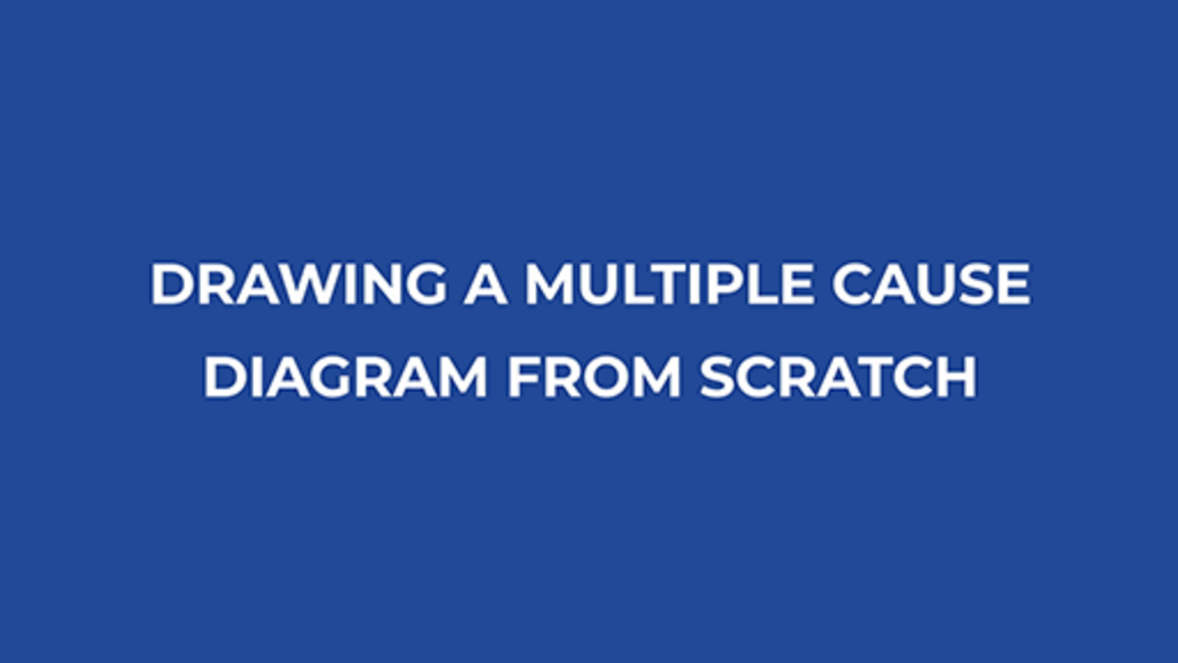

Influence diagram
It can be useful to start with a systems map and then adapt it to serve as an influence diagram, as this diagram uses arrows to depict the influences between subsystems. The following video will walk you through how to create an influence diagram.

Video content is not available in this format.
Video 23 Influence maps
View transcript - Video 23 Influence maps

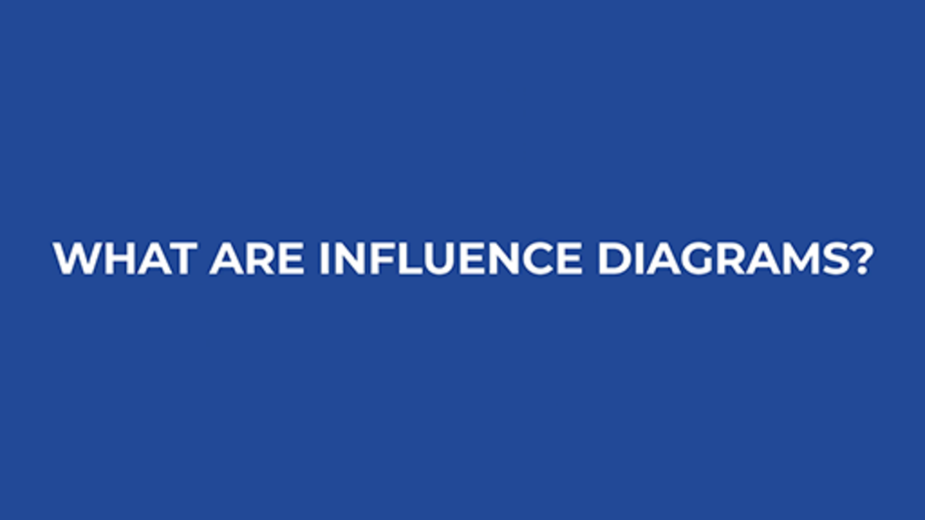

Now you’ve had chance to explore systems thinking tools, the following activity asks you to try one of them out.

Activity 23 Try out the tools
15 minutes

Use one of the three approaches to explore some of the challenges of moving to a hybrid model you are thinking about.
- What is the culture of your organisation? Blame or accountability, assimilative or inclusive, risk adverse or experimental, etc.
- What are the conditions, the opportunities, and constraints of your project? Budget, costs, staffing, locations, legislation and so on?
- Who and what are collaborating to create what is done, and what are the interconnections that facilitate this happening?
- Are those interconnections tightly coupled or looser?
Reflecting on your sense making:
- Did you discover anything new about the situation?
- Did you see any different perspectives of the situation as you worked through the situation?
- Did you identify any loops in your diagrams? And what do you think they depict?
- Did you find more uncertainty that you need to make sense of?

The introduction to systems thinking and approaches we have explored in this section may help you develop your options with better clarity and engage stakeholders.

7 Agreeing the option
Sola and Couturier (2014) cite culture, communication and corporate structure amongst the issues as to why strategy implementation fails. They also say failure often follows when people do not understand the ‘Why’ and ‘What’ to change, and even if they do, if they don’t know ‘How’ they still fail as stakeholders, as they don’t make the link between strategy and practical change.
Once you have possible options, agreement needs to be reached as to which one(s) should be taken forward and gain stakeholder approval. In many cases options may require a formal change programme to be initiated and planned. A formal change programme may involve:
- further identifying, engaging, and managing stakeholders
- developing a clear plan
- delivery of timely and clear communications for all involved.
These aspects are crucial to gain acceptance for, and commitment to, the change initiative. The approaching change management is explored within the Hybrid working: change management - OpenLearn - Open University

7.1 Data driven decisions
The Digital Strategy for Wales Mission 6: data and collaboration, states:

Services are improved by working together, with data and knowledge being used and shared
Data underpins everything we do digitally. … It enables responsive and continuous improvement in public services, supports seamless services, enables digital innovation and automation, and informs good decision making.
…
The scale of the data revolution has raised important questions about access to data and how data are used. We must ensure data ethics, transparency and trust are threaded into the actions we take.
(Welsh Government, 2021)

Data and information are central to organisations operating and developing and are potentially one of their most valuable assets. Decisions based on evidence normally gained from data and information allow you to analyse your organisation to:
- make decisions
- identify needs
- track your workforce’s wellbeing
- provide evidence against objectives/targets for both internal and external stakeholders.
In presenting options, it is always sensible to have evidence to validate your reasons, which is normally a collection of facts and statistics based on qualitative or quantitative research and information.
We think of data, in the first instance, as information that has been collated digitally from information stored across, or via, digital systems. But data can also include information that has been gathered and captured from talking to others or taken from reports. Data can often be grouped as follows:
- Internal data – provides insights into your operations, finances, performance management, productivity and infrastructure. It allows for gap analysis and understanding the needs of your workforce.
- External data –often helps with analysing trends and benchmarking within your external environment.
- Marketing data –is used to understand customers’ behaviours and preferences, for example to assist HEI student enrolment and retention.

Activity 24 Data storytelling
20 minutes

Presenting options and using data, needs to be engaging and meaningful, one approach is the concept of data storytelling. In the video below Laura Dewis (Chief Operating Officer, Full Fact) explains how you can bring data to life.
1. Watch the video and consider how you present data to others, and how you could approach this in the future.

Video content is not available in this format.
Video 24 Data storytelling
View transcript - Video 24 Data storytelling

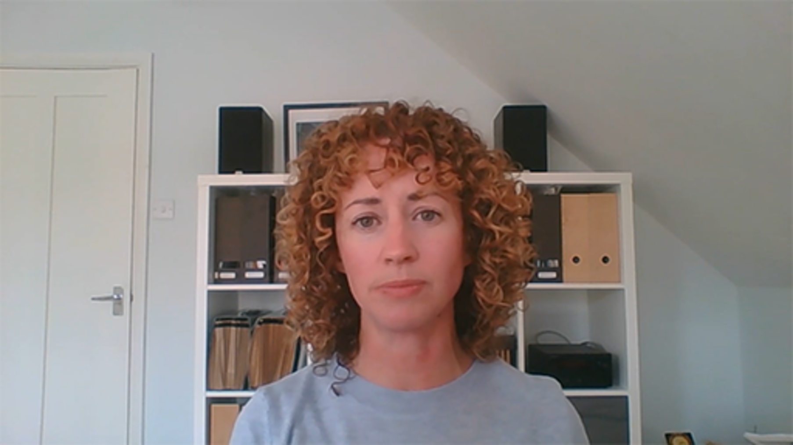

2. Read the article: ‘Hybrid Work Is Just Work. Are We Doing It Wrong?’ (Microsoft, 2022)
Consider how the article has been presented and how data is used to draw out the key points from the report. If you were future planning for new ways of working, how might you use the data to inform areas you might need to focus on?

View answer - Part

7.2 Stakeholder acceptance
Stakeholders’ resistance to change creates a powerful headwind against your organisational objectives being met and can even cause an initiative to stall. The power of aligning personal, team, and function ‘Whys’ to the organisation’s ‘Why’ to deliver the desired outcomes is an is essential part of the strategy, as commitment is developed and individuals, teams and functions come together to get things done.
As you clarify options and present these to stakeholders, you require an understanding of who your stakeholders are and their interests. This will help you envisage how they are likely to be impacted by the initiative and how they are likely to react to the announcement of the new organisational vision.
Acceptance comes when stakeholders understand why the change is required and this has to be backed up with evidence that demonstrates, not only the need but also supports the approach you are taking.
Of course, feedback and input into the change is key – inclusion over infliction is preferred, and there may be many aspects of the current modus operandi that work and should be continued or integrated with the new way forward. Often, only those close to this can see how best this can be done – observe, question, listen and adapt with this fresh thinking.
The threat of change introduces opportunities, but it can also introduce fears for those affected that can manifest in defensive behaviour, insecurity, and resistance which has to be addressed quickly, honestly and with empathy. If there are any consequences of the initiative that some stakeholders may be considered ‘bad’, it should not be hidden from them – clarity is key at every stage.
The time it may take to realise benefit from the change following implementation, and it being smoothly embedded, may be longer than stakeholders envisage. Therefore, it is important to be realistic with this, and plan for and communicate the potential impact, and what can be expected during the transition.
On a positive note, some things can just be done with no high-level approval as things can just get done because a team moves it forward due to an immediate need. Shine a light on these initiatives as examples of the power of empowered autonomous action at a local level.

7.3 What do you need to progress the plan?
Once there is executive approval to progress with the programme of change, following the formal governance often associated with strategic programmes of this nature, the initiative can begin to be implemented.
If approved what happens next? This takes us back to stage five of Sola and Couturier’s strategy development process, Managing Execution, which involves the delivery of:
- Preconditions that prepare the ground for change (a shared understanding of the need for change, a vivid picture of where the organisation can be as a result of the change, and a clear communication of the strategic initiatives associated with the change programme);
- Triggers that make the change happen (that launch and spread the change, including a compelling story); and
- Boosters that accelerate the rate of change (through the identification and engagement of enablers, the instigation of changes in the environment, the development of capability through training, and reinforcing mechanisms).
(Sola and Couturier, 2014)
These, and more, are outlined in the Hybrid working: change management - OpenLearn - Open University.

Activity 25 Progress your plan
15 minutes

Reflect on the problems you have explored throughout this course, and how you might take them forward.
Earlier in the course you heard from contributors sharing their experiences of planning for immediate and long-term changes. As you plan for the future, draw on your own experiences to help you consider the world from different perspectives.
Once an option(s) is approved, in order to start a change programme, the next step is to understand who and what will be required to in order for the option to be developed further. Spend some time capturing your ideas about this.
You may also wish to make some notes in the box below on tools and learnings from the course so you can integrate them into your work, or explore them in more detail later.

Provide your answer...

Conclusion
In this course we have provided frameworks, tools and techniques to frame problems in the context of extremely complex environments. You have studied models to help you analyse problems and develop options and solutions against key drivers, impacts and constraints.
We looked at the key techniques for gaining acceptance for, and driving forward, your programme. After starting with ‘Why’ you then examined strategies to move ‘What’ you are changing and, importantly ‘How’ you are going to deliver the ‘What’ in the future.
Take time to reflect on the importance of embedding sustainable working practices, as well as meeting both the Well-being of Future Generations (Wales) Act 2015 seven wellbeing goals and net zero targets. As your organisation evolves to succeed and protect the wellbeing of future generations, think about how you can use the contextual framework to assist you long term. The framework was identified in the introduction to this course and is repeated below to help you draw your conclusions.
The framework helps you to consider and understand your organisational context and needs from key perspectives.
- You and your ways of working should take account of the key stakeholders within your environment and their needs in relation to organisational development.
- You need to understand organisational requirements and the context, connections and requirements for key areas of focus, and how these relate to the needs of your stakeholders.
- You need to consider your ways of working for the wellbeing of future generations.

Figure 6 (repeated) Hybrid ways of working: a contextual sustainability framework
View description - Figure 6 (repeated) Hybrid ways of working: a contextual sustainability framewor ...

As you reflect, watch the video below, where Sophie Howe, the Future Generations Commissioner for Wales, shares her thoughts on how HEIs can help to protect future generations. When you are planning for the future, consider the role that HEIs, public bodies and all organisations can play in developing new ways of working to protect future generations.

Video content is not available in this format.
Video 25 Protecting future generations
View transcript - Video 25 Protecting future generations

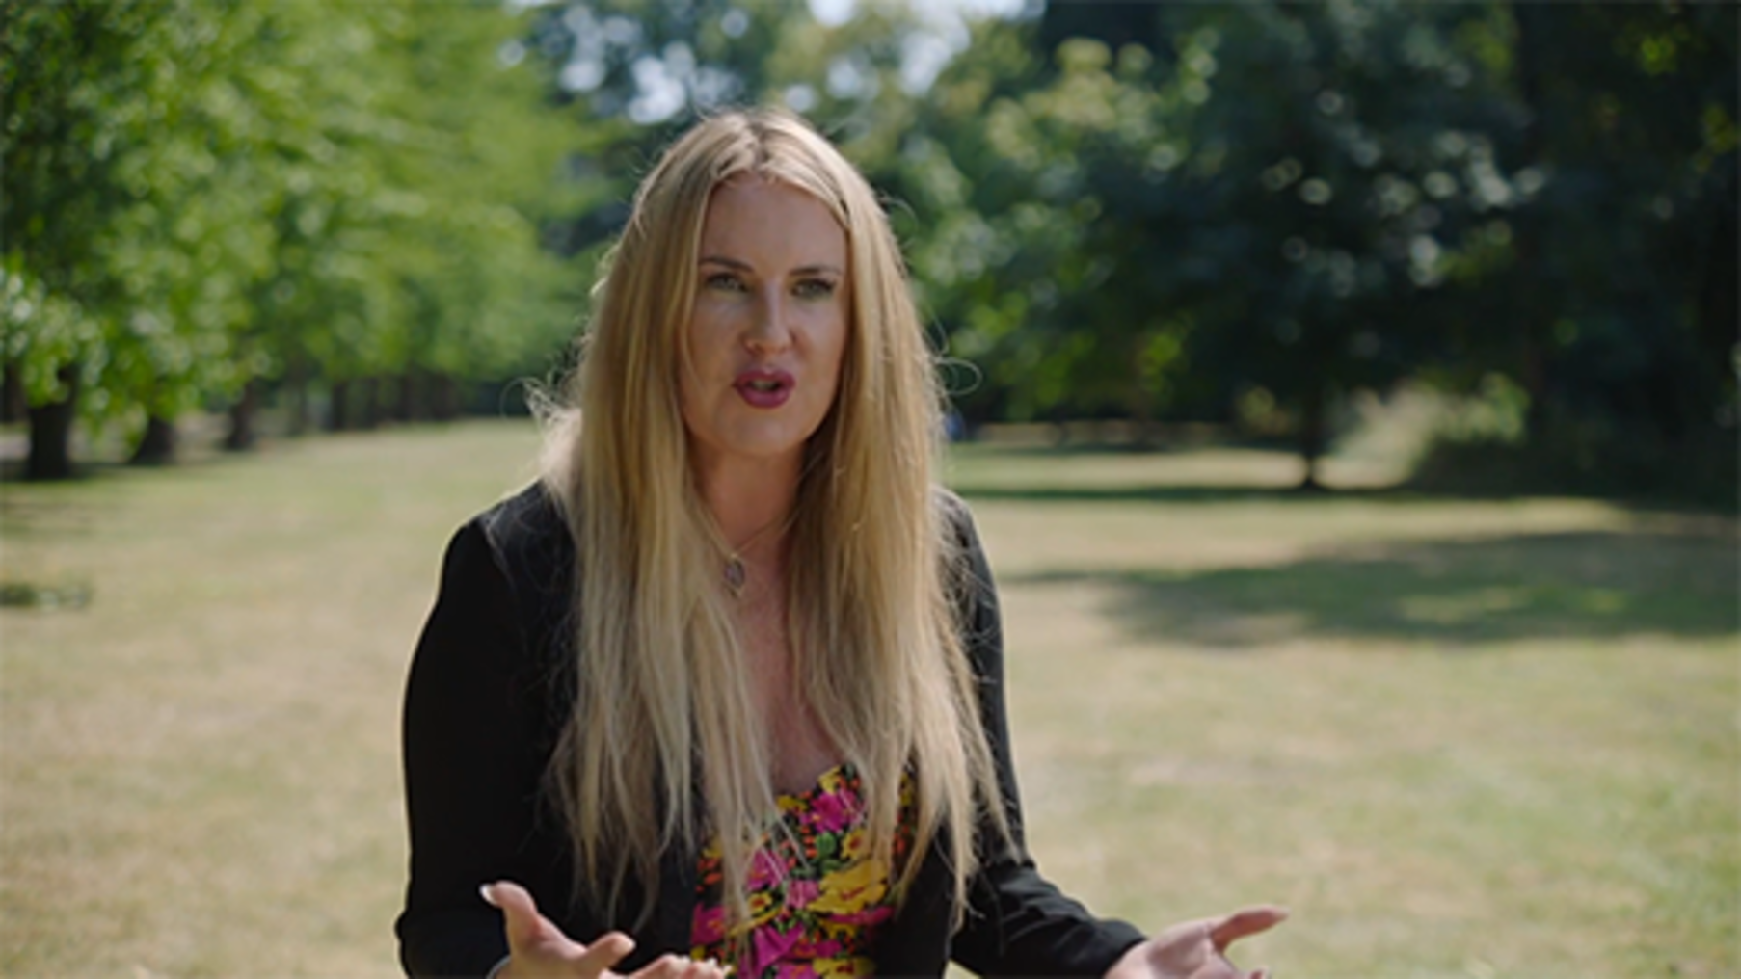

It is important to ensure the change in ways of working you envisage is sustained and embedded, through the delivery of objectives and the realisation of benefits over the long term. We hope that everything covered here, and all the additional resources, help you to develop your plan.
This course is part of the Supporting hybrid working and digital transformation collection, which you may wish to explore further.

References
Alford, J. and Head, B. (2017). ‘Wicked and less wicked problems: A typology and a contingency framework’, Policy and Society, vol. 36, no. 3, pp. 397–413 [Online]. Available at:https://academic.oup.com/policyandsociety/article/36/3/397/6407933?login=false (Accessed: 14 October 2022).
Bangor University (n.d.) Bangor University's Strategy 2030: A Sustainable World for Future Generations [Online]. Available at: https://www.bangor.ac.uk/strategy-2030 (Accessed: 13 October 2022).
Blythe, J. (2001) Essentials of marketing, 2nd edition. Harlow: Financial Times/Prentice Hall.
Checkland, P. (2022) Systems explained [Online]. Available at: https://www.open.edu/openlearn/money-business/leadership-management/systems-explained-peter-checkland (Accessed: 14 October 2022).
Cheesewright, T. (n.d.) The art of the probable, the possible, and the desirable. Available at: https://tomcheesewright.com/the-art-of-the-probable-the-possible-and-the-desirable/ (Accessed: 6 December 2022).
Cynefin (n.d.a) The Cynefin® Framework [Online]. Available at: https://thecynefin.co/about-us/about-cynefin-framework/ (Accessed: 14 October 2022).
Cynefin (n.d.b) Cynefin website [Online]. Available at: https://thecynefin.co/ (Accessed: 14 October 2022).
Cynefin (n.d.c) Estuarine mapping. Available at: https://thecynefin.co/estuarine-mapping/ (Accessed: 14 October 2022).
Cynefin (n.d.d) Cynefin.io wiki [Online]. Available at: https://cynefin.io/wiki/Main_Page (Accessed: 14 October 2022).
Cynefin (n.d.e) Field guide to managing complexity (and chaos) in times of crisis [Online]. Available at: https://cynefin.io/wiki/Field_guide_to_managing_complexity_(and_chaos)_in_times_of_crisis (Accessed: 14 October 2022).
Cynefin (n.d.f) Flexuous curves. Available at: https://cynefin.io/wiki/Flexuous_curves (Accessed: 14 October 2022).
Department of Agriculture, Environment and Rural Affairs (n.d.) Northern Ireland Climate Change Adaptation Programme [Online]. Available at: https://www.daera-ni.gov.uk/articles/northern-ireland-climate-change-adaptation-programme (Accessed: 13 October 2022).
De Smet, A., Gagnon, C. and Mygatt, E. (2021) Organizing for the future: Nine keys to becoming a future-ready company, 11 January [Online]. Available at: https://www.mckinsey.com/capabilities/people-and-organizational-performance/our-insights/organizing-for-the-future-nine-keys-to-becoming-a-future-ready-company (Accessed: 13 October 2022).
Future Generations Commissioner for Wales (2018) Future Generations Framework for service design [Online]. Available at: https://www.futuregenerations.wales/resources_posts/future-generations-framework-for-service-design/ (Accessed: 14 October 2022).
Future Generations Commissioner for Wales (2019) Future Generations Framework for scrutiny [Online]. Available at: https://www.futuregenerations.wales/resources_posts/future-generations-framework-for-scrutiny/ (Accessed: 14 October 2022).
Future Generations Commissioner for Wales (n.d.a) Well-being of Future Generations (Wales) Act 2015 [Online]. Available at: https://www.futuregenerations.wales/about-us/future-generations-act/ (Accessed: 13 October 2022).
Future Generations Commissioner for Wales (n.d.b) The art of the possible [Online]. Available at: https://www.futuregenerations.wales/the-art-of-the-possible/ (Accessed: 14 October 2022).
Future Generations Commissioner for Wales (n.d.c) Simple changes [Online]. Available at: https://www.futuregenerations.wales/simple-changes/ (Accessed: 14 October 2022).
Future Generations Commissioner for Wales (n.d.d) Future Generations framework for projects [Online]. Available at: https://www.futuregenerations.wales/wp-content/uploads/2018/11/FGCW-Framework.pdf (Accessed: 14 October 2022).
Future Generations Commissioner for Wales (n.d.e) Guidance on using the Future Generations Framework for projects [Online]. Available at: https://www.futuregenerations.wales/wp-content/uploads/2018/11/FGCW-Guidelines_01.pdf (Accessed: 14 October 2022).
Futures Platform (n.d.) 9 Foresight analysis methodologies successful companies use to stay ahead [Online]. Available at: https://www.futuresplatform.com/blog/9-foresight-methodologies-successful-companies-use-stay-ahead (Accessed: 13 October 2022).
Getting started with Cynefin (2022) YouTube video, added by Dave Snowden [Online]. Available at: https://www.youtube.com/watch?v=ogtpxA6brGo&hl=en&fs=1&rel=0 (Accessed: 14 October 2022).
GOV.SCOTLAND (n.d.) Climate change [Online]. Available at: https://www.gov.scot/policies/climate-change/ (Accessed: 13 October 2022).
GOV.UK (2022) Sustainability and climate change: a strategy for the education and children’s services systems, 21 April [Online]. Available at: https://www.gov.uk/government/publications/sustainability-and-climate-change-strategy/sustainability-and-climate-change-a-strategy-for-the-education-and-childrens-services-systems (Accessed: 13 October 2022).
IDEO (2015) The Field Guide to Human-Centered Design. San Francisco, CA: IDEO.
Impact Innovation (n.d.) PESTLE analysis. Available at: https://www.impact-innovation.co.uk/pestle-analysis (Accessed: 26 August 2022).
International Futures Forum (n.d.) Three horizons [Online]. Available at: https://www.iffpraxis.com/three-horizons (Accessed: 14 October 2022).
Legislation.gov.uk (n.d.a) Environment (Wales) Act 2016 [Online]. Available at: https://www.legislation.gov.uk/anaw/2016/3/contents/enacted (Accessed: 13 October 2022).
Legislation.gov.uk (n.d.b) Climate Change Act 2008 [Online]. Available at: https://www.legislation.gov.uk/ukpga/2008/27/contents (Accessed: 13 October 2022).
Mahoney, P. (2021) The art of the possible. Available at: https://www.linkedin.com/pulse/art-possible-paul-mahoney/ (Accessed: 6 December 2022).
Microsoft (2022) Hybrid work is just work. Are we doing it wrong?, 22 September [Online]. Available at: https://www.microsoft.com/en-us/worklab/work-trend-index/hybrid-work-is-just-work (Accessed: 14 October 2022).
OECD (n.d.) Futures & Foresight [Online]. Available at: https://oecd-opsi.org/guide/futures-and-foresight/ (Accessed: 13 October 2022).
Office for National Statistics (ONS) (2022a) Is hybrid working here to stay? 23 May [Online]. Available at: https://www.ons.gov.uk/employmentandlabourmarket/peopleinwork/employmentandemployeetypes/articles/ishybridworkingheretostay/2022-05-23 (Accessed: 13 October 2022).
Petchey, L. (n.d.) Three horizons: A toolkit to help you think and plan for the long-term [Online]. Available at: https://www.futuregenerations.wales/wp-content/uploads/2020/02/PHW-Three-Horizons_FINAL.pdf (Accessed: 14 October 2022).
Porter, M. (2008) Competitive Strategy: Techniques for Analyzing Industries and Competitors, New York: Free Press.
Praxis (n.d.) Systems thinking [Online]. Available at: https://www.praxisframework.org/en/library/systems-thinking (Accessed: 14 October 2022).
Ramirez, R. and Wilkinson, A. (2016) Strategic Reframing, the Oxford Scenario Planning Approach, Oxford: Oxford University Press.
Rittel, H. W. J. and Webber, M. M. (1973) ‘Dilemmas in a general theory of planning’, Policy Sciences, vol. 4, pp. 155–169.
Rume, T. and Islam, S. M. D. (2020) ‘Environmental effects of COVID-19 pandemic and potential strategies of sustainability’, Heliyon, vol. 6, no. 9, p. e04965 [Online]. Available at: https://www.ncbi.nlm.nih.gov/pmc/articles/PMC7498239/ (Accessed: 13 October 2022).
Scottish Government (n.d.) Climate change. Available at: https://www.gov.scot/policies/climate-change/(Accessed: 13 October 2022).
Sensemaking: using conversations to make a difference every day (2019) YouTube video, added by Alan Arnett [Online]. Available at: https://www.youtube.com/watch?v=XwC5Gfh_h0U (Accessed: 14 October 2022).
Sharpe, B. (2019) Three horizons, 29 November [Online]. Available at: https://h3uni.org/tutorial/three-horizons/ (Accessed: 14 October 2022).
Sinek, S. (2011). Start with Why - How Great Leaders Inspire Everyone to Take Action. London: Penguin.
Sinek, S., Mead, D. and Docker, P. (2017). Find Your Why: A Practical Guide for Discovering your Purpose for You and Your Team. London: Penguin.
Smart, J. (2020) Sooner safer happier, patterns & antipatterns for business agility. It Revolution Press.
Smart, J. (2022) What is BVSSH?, 21 September [Online]. Available at: https://soonersaferhappier.com/what-is-bvssh/ (Accessed: 14 October 2022).
Snowden, D. (2008) What is sense-making?, 7 June [Online]. Available at: https://thecynefin.co/what-is-sense-making/ (Accessed: 14 October 2022).
Sola, D. and Couturier, J. (2014). How to Think Strategically - Your Roadmap to Innovation and Results. Harlow: Pearson Education Limited.
Stonham, S. (2022) Exploring digital carbon footprints, 10 June [Online]. Available at: https://www.jisc.ac.uk/reports/exploring-digital-carbon-footprints (Accessed: 13 October 2022).
TADA (n.d.) Our Golden Circle [Online]. Available at: https://www.tada.brussels/golden-circle/?lang=en (Accessed: 13 October 2022).
The Millennium Project (2022) 15 Global challenges [Online]. Available at: https://www.millennium-project.org/projects/challenges/ (Accessed: 13 October 2022).
The Open University (n.d.) Systems Thinking hub [Online]. Available at: https://www.open.edu/openlearn/systems-thinking-hub (Accessed: 14 October 2022).
The Open University (2021) Systems thinking and practice [Online]. Available at: https://www.open.edu/openlearn/science-maths-technology/computing-ict/systems-thinking-and-practice/content-section-0?active-tab=content-tab (Accessed: 14 October 2022).
Turner, J. and Baker, M. (2022) Future of work trends post-Covid-19, 16 June [Online]. Available at: https://www.gartner.com/smarterwithgartner/9-future-of-work-trends-post-covid-19 (Accessed: 13 October 2022).
UNDP (n.d.) Human-centered design [Online]. Available at: https://www.undp.org/arab-states/human-centered-design (Accessed: 14 October 2022).
United Nations (2020) Report of the UN Economist Network for the UN 75th Anniversary Shaping the Trends of Our Time, September [Online]. Available at: https://www.un.org/development/desa/publications/wp-content/uploads/sites/10/2020/10/20-124-UNEN-75Report-ExecSumm-EN-REVISED.pdf (Accessed: 13 October 2022).
United Nations (n.d.) Sustainable Development Goals [Online]. Available at: https://www.un.org/sustainabledevelopment/news/communications-material/ (Accessed: 13 October 2022).
Weick, K., Sutcliffe, K. M. and Obstfeld, D. (2005). ‘Organizing and the process of sensemaking’, Organization Science, vol. 16, no. 4, pp. 409–421.
Welsh Government (2021) Policy and Strategy – Digital Strategy for Wales. Available at: https://gov.wales/digital-strategy-wales-html (Accessed: 13 October 2022).
Whittington, R., Regner, P., Angwin, D., Johnson, G. and Scholes, K. (2020). Exploring Strategy, Twelfth Edition. Harlow: Pearson Education Limited.
World Economic Forum (2020) 17 ways technology could change the world by 2025, 23 June [Online]. Available at: https://www.weforum.org/agenda/2020/06/17-predictions-for-our-world-in-2025/ (Accessed: 13 October 2022).
World Economic Forum (2022a) Global Risks Report 2022, 11 January [Online]. Available at: https://www.weforum.org/reports/global-risks-report-2022/digest#report-nav (Accessed: 13 October 2022).
World Economic Forum (2022b) Data on global risks perceptions, 11 January [Online]. Available at: https://www.weforum.org/reports/global-risks-report-2022/data-on-global-risks-perceptions#report-nav (Accessed: 13 October 2022).

Acknowledgements
This free course was written by Martin Roots and Esther Spring, with support from Chantine Bradstock, Anne Gambles and Sue Lowe.
Except for third party materials and otherwise stated (see terms and conditions), this content is made available under a Creative Commons Attribution-NonCommercial-ShareAlike 4.0 Licence.
The material acknowledged below is Proprietary and used under licence (not subject to Creative Commons Licence). Grateful acknowledgement is made to the following sources for permission to reproduce material in this free course:
Images
Course image: joan gravell; Alamy Stock Photo
Figure 1: WhitcombeRD; Getty Images
Figure 2: © 2022 The Millennium Project
Figure 3: © United Nations
Figure 4: The Welsh Government; Contains public sector information licensed under the Open Government Licence v3.0.
Figure 5: © Futures Platform 2022
Figure 7: Exhibit 2 from “Organizing for the future: Nine keys to becoming a future-ready company”, January 2021, McKinsey & Company, www.mckinsey.com. Copyright © 2022 McKinsey & Company. All rights reserved. Reprinted by permission.
Figure 8: from The Global Risks Report, 17th Edition, Insight Report, © World Economic Forum
Figure 9: © World Economic Forum; adapted by the Open University
Figures 11, 12, 13 and 14: from Simon Sinek's Start With Why? page 37. Sinek S. (2011)
Figure 15: ©Sola and Couturier (2014)
Figure 16: ©Impact Innovation adapted by the Open University
Figure 17: from Porter, M. (2008) Competitive Strategy: Techniques for Analyzing Industries and Competitors, New York, Free Press.
Figure 18: from: Wicked and less wicked problems: a typology and a contingency framework, Policy and Society; John Alford & Brian W. Head (2017)
Figure 19: adapted by Sarkar and Kotler (no date) from Rittel and Webber (1973);
Figure 20: The Cynefin Company; https://thecynefin.co/about-us/about-cynefin-framework/
Figure 21: Future Generations Commissioner for Wales; https://www.futuregenerations.wales/
Figure 22: Rafael Ramirez and Angela Wilkinson, Oxford University press, 2016
Figures 24 - 28: based on Islands in the Sky by Matt Finch of mechanicaldolphin.com, derived from the Oxford Scenario Planning Approach".
Figure 30: © 2020 Sooner Safer Happier Ltd
Activity 19: Islands in the Sky by Matt Finch of mechanicaldolphin.com,
Table 5: Blythe, J. (2001) Essentials of marketing, 2nd edition, Harlow, Financial Times/Prentice Hall.
Audio/Visual
Video 5: Start With Why: How Great Leaders Inspire Action; TEDx Talks; https://creativecommons.org/licenses/by-nc-nd/4.0/
Every effort has been made to contact copyright owners. If any have been inadvertently overlooked, the publishers will be pleased to make the necessary arrangements at the first opportunity.
Don't miss out
If reading this text has inspired you to learn more, you may be interested in joining the millions of people who discover our free learning resources and qualifications by visiting The Open University – www.open.edu/openlearn/free-courses.

Solutions

Activity 1 Reflect on the past and think about the future

Answer
It may have seemed strange to have been asked to watch a video about a sculpture dedicated the memory of pit ponies and coal mines. Many of us may be too young to remember the scale of the coal industry in Britain, as importing from overseas became more cost effective from the 1970s British coal mining started to rapidly decline. At its peak in the 1920-30’s it may have been unimaginable for those involved in the industry that this was an energy source in the future we would actively decide to stop using. As we came aware on the impact it had on our climate the focus on long-term energy sources is a fundamental part of futures planning, to find more sustainable ways of working and ensure we meet the net-zero climate targets.
While you may not be directly involved in finding the solution for cleaner energy resources, your vision of the future is dependent on energy in some form. The purpose of the video was to redirect your thinking from your own understanding of the world and technology. Often when you are asked to imagine the future the first reaction is to talk about technology. The video highlighted the human impact of an evolving world and as future planners you have to balance both organisational and people’s needs. This requires you to be open to collaborating with others and to draw on examples from other industries and areas of work. It also requires you to become comfortable managing uncertainty and to imagine the unknown and maybe impossible, in order to develop your own sense-making skills and assist in the evolution of your organisation.
Back to - Activity 1 Reflect on the past and think about the future

Activity 2 Do you have a futurist mindset?

Part

Answer
Having a futurist mindset draws on many skills and approaches you may already use, but perhaps you have not considered that on daily basis you do futures planning in your approach to everyday tasks and decisions. These include the act of considering possibilities, exploring options and asking questions such as those Jacob Morgan posed in the video:
- Why might this happen?
- What else might happen?
- What factors may influence it happening/not happening?
- What is the future of work that YOU want to see happen?
Back to - Part

Activity 3 Thinking about the possibilities for higher education institutions

Feedback
Scott Stonham is the author of the Jisc report Exploring digital carbon footprints (Soneham, 2022), which focuses on the hidden environmental cost of the digital revolution and the steps universities and colleges can take. Feel free to download and read the report in your own time.
Back to - Activity 3 Thinking about the possibilities for higher education institutions

Activity 5 Explore the Global Risks Report 2022

Part

Answer
The Global Risk Report is something that many people in organisations do not need to engage with at a detailed level, but you may have seen similar themes and trends that you are focusing on within your organisation.
Your response to the poll will be based on your own experiences, what is of interest/concern to you and how you feel about uncertainty. Do you actually worry about the trends identified or are they a fleeting concern?
The results from respondents as part of the report for this question are available in two places from the World Economic Forum, one within the report and the other on their website. Interesting these are displayed different in the two images (figure 9 below) One is presented left to right, negative to positive and the other, left to right, by percentage biggest to smallest.
Does seeing the data in the different ways change your reaction to how worried/concerned you might need to be?

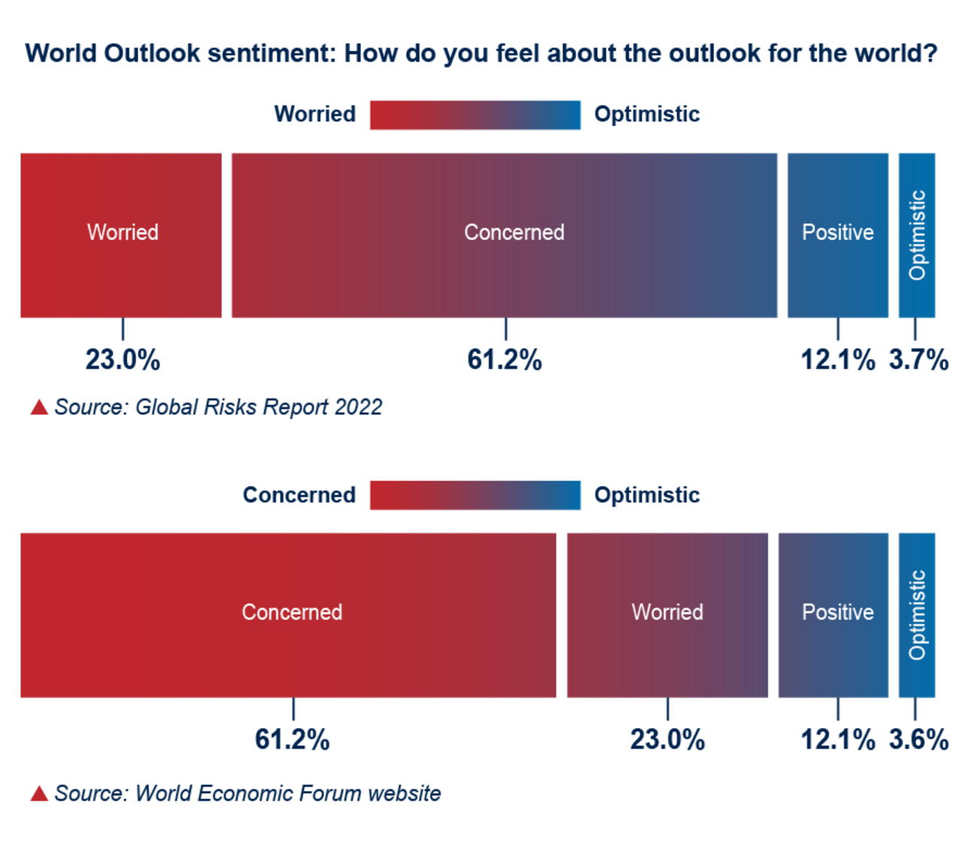
Figure 9 Ways of presenting data. Source: World Economic, Forum Global Risks Reports 2022
View description - Figure 9 Ways of presenting data. Source: World Economic, Forum Global Risks Reports ...

Later in the course we explore how to present evidence and data to your stakeholders in a meaningful way.
Back to - Part

Activity 6 What are your organisation’s mission, vision, values and objectives?

Answer
Strategy statements succinctly summarise an organisation’s strategy in a paragraph or two. According to Whittington et al. (2020), these should cover three main themes:
- The fundamental mission, vision, values, and objectives the organisation seeks (as outlined above).
- The scope or domain of the organisation’s activities (customers/clients they serve, geographic location, and extent of ‘vertical integration’ i.e., the activities they deliver themselves versus the activities they outsource or sub-contract).
- The advantages or capabilities they have to deliver all of these.
Strategies can work at many levels:
- Corporate-level: concerned with aspects of geographic scope, diversity of products/services, and how resources are allocated. So, in terms of Higher Education, this might be the overarching university strategy.
- Business-level: concerned with ‘business units’ and how they should compete in their particular markets – this could be a ‘faculty strategy’ or ‘research strategy’.
- Function-level: concerned with how components of an organisation deliver the corporate and business level strategies in terms of resources, processes, and people. This could be the ‘IT Strategy’, or ‘Teaching & Learning Strategy’ when thinking about it in an HE setting.
(Whittington et al., 2020)
Strategies can also be developed at a project (or personal) level – it is all about the scope. For projects, in a similar vein to business and function level strategies, the stronger the link or integration between a project’s ‘Why’ and the higher levels of strategy it will support, the more likely it is going to get the advocacy, and resources, it requires to succeed.
Back to - Activity 6 What are your organisation’s mission, vision, values and objectives?

Activity 7 Thinking about a problem you need to solve

Answer
As you did this activity, you may have found that specific reference to hybrid working is not in your organisational strategy, but that there are initiatives across your organisation that are focusing on specific requirements for hybrid working. This may in part be due to the frequency that organisational strategies are updated, or many of the activities which need to be planned for are in fact fall under business continuity and operating strategy which tend to be captured at a more granular level.
Whereas it is likely that digital transformation and building digital capabilities will be, as the impact of technology has been and will continue to be, a priority for most organisations.
Back to - Activity 7 Thinking about a problem you need to solve

Activity 11 Sensemaking conversations

Answer
The language we use is a key part of assisting with sense-making, how we have conversations and the language we use helps both ourselves and others come to common understandings and enables us to explore the world in different ways, especially in uncertain times.
In the video 6 Dave Snowden highlights:

'Most human beings communicate novel ideas through metaphors and stories, and that's still the most successful way of doing it.' (Snowden, 2022)

Storytelling is a powerful tool for engaging others and helping people understand problems and the world, by helping them to visualise what is possible in a way that is relatable and meaningful to them. This can also assist with encouraging people to talk to each other, as Alan Arnett highlighted in the video, it can be a challenge to have better conversations in order to make sense of our world.
Back to - Activity 11 Sensemaking conversations

Activity 12 Getting started with Cynefin

Part

Answer
Understanding your challenges and the support you have to assist in approaching problems is fundamental for futures planning and implementing change. The Cynefin framework can help you make sense of the problem and highlight who can support you and lead to better decisions being made. It can help to ask those you trust so you can become more comfortable with talking about uncertainty and dealing with ‘unknowns’ as it can help you accept that often we are operating in an environment where the unknowns will not necessarily become known.
Back to - Part

Activity 15 Thinking about TUNA conditions

Discussion
Managing and responding in times of uncertainty, requires the confidence to make decisions based on unknown factors to try to mitigate risks. Exploring TUNA conditions can help to reframe and consider the alternative futures that may unfold, to allow you to develop scenarios and design approaches for a number of eventual possibilities.
Back to - Activity 15 Thinking about TUNA conditions

Activity 16 Riding a bicycle

Part

Answer
Rafael states that this methodology expects action learning, where you give it a try and make a few mistakes, using the riding a bicycle analogy that is similar to this kind of learning – if you fall off, you get back on and try again.
Back to - Part

Part

Answer
How comfortable you feel with this approach will depend on your experience of managing uncertainty and change. In an organisational setting where we often have little control over the strategic direction and organisational objectives, uncertainty can be a common feeling.
This approach can help with managing your feelings towards uncertainty by reframing the context and helping you feel more comfortable with the unknown. Similar to if you learned to ride a bicycle – the first time you tried you had no idea what it would feel like, but as your ability and confidence grows, you are willing to try new things. How many of you tried this as a child, or are even now still trying, to ride your bike with no hands?
Back to - Part

Activity 24 Data storytelling

Part

Answer
Using data storytelling is a powerful way to engage others to focus on key areas. It helps to highlight information and encourage different ways to consider the information. In the article colourful visuals of the data were used to draw out key points from the report Productivity paranoia, people come in for each other and re-recruiting your employees (Microsoft, 2022). The article creates a story of the future and the needs of your employees, which for those involved in futures planning, raise complex questions that can lead to many possible different futures for an organisation.
Back to - Part

Figure 1 Sultan the Pit Pony sculpture in south Wales

Description
Aerial view of a public earthwork of a pit pony above a closed coal mine.
Back to - Figure 1 Sultan the Pit Pony sculpture in south Wales

Figure 2 The 15 Global Challenges impacting the future (The Millennium Project, 2022)

Description
The fifteen global challenges are arranged around an image of the globe. They are 1 Sustainable development and climate change, 2 Clean water, 3 Population and resources, 4 Democratization, 5 Global foresight and decision making, 6 Global convergence of IT, 7 Rich-poor gap, 8 Health issues, 9 Education and learning, 10 Peace and conflict, 11 Status of women, 12 Transnational organized crime, 13 Energy, 14 Science and technology, 15 Global ethics.
Back to - Figure 2 The 15 Global Challenges impacting the future (The Millennium Project, 2022)

Figure 3 The 17 UN global goals for sustainable development (United Nations, n.d.)

Description
Image shows the 17 UN sustainable development goals: 1 No poverty; 2 Zero hunger; 3 Good health and well-being; 4 Quality education; 5 Gender equality; 6 Clean water and sanitation; 7 Affordable and clean energy; 8 Decent work and economic growth; 9 Industry, innovation and infrastructure; 10 Reduced inequalities; 11 Sustainable cities and communities; 12 Responsible consumption and production; 13 Climate action; 14 Life below water; 15 Life on land; 16 Peace, justice and strong institutions; 17 Partnerships for the goals.
Back to - Figure 3 The 17 UN global goals for sustainable development (United Nations, n.d.)

Figure 4 The seven wellbeing goals in the Well-being of Future Generations (Wales) Act 2015

Description
A diagram showing the silhouette of Wales in the centre of a circle, which comprises seven segments. Each segment has one of the wellbeing goals noted within it: A Prosperous Wales; A Resilient Wales; A Healthier Wales; A More Equal Wales; A Wales of Cohesive Communities; A Wales of Vibrant Culture and Thriving Welsh language; A Globally Responsible Wales.
Back to - Figure 4 The seven wellbeing goals in the Well-being of Future Generations (Wales) Act 2015

Figure 5 Different approaches to foresight and futures planning (Futures Platform, n.d.)

Description
The figure shows an x axis moving from today to the longer term future and a y axis moving from qualitative to quantitative. At the top left is the word insight, top right foresight. In ovals from the top down: Forecasts, predictions. Sensemaking. Horizon scanning. War game simulations. Trends and emerging issues analysis. Scenarios. Weak signals and wild cards. Road maps. Backcasting. Delphi method.
Back to - Figure 5 Different approaches to foresight and futures planning (Futures Platform, n.d.)

Figure 6 Hybrid ways of working: a contextual sustainability framework

Description
Image shows three concentric circles around a central circle containing the word ‘YOU’. In the first of the outer circles (labelled 1), there are arrows pointing outwards from the central circle to the words Team(s), Organisation, Individuals, Community, and Students, which are spaced evenly around the circle. Each of these terms have double-headed arrows connecting them to each other. The next circle out (labelled 2) surrounds the first and contains the terms Digital Transformation, People, Places, Sustainability, Values and Culture, and Compliance. These are evenly spaced around the second circle and double-headed arrows sit between each term. The outer circle (labelled 3) has the words Long term, Prevention, Integration, Involvement and Collaboration spaced out around the circle with double-headed arrows connecting each term. Beside each term is an icon to represent it. The words and the circles show the interconnection between, stakeholder, organisation needs and ways of working.
Back to - Figure 6 Hybrid ways of working: a contextual sustainability framework

Figure 7 Nine organisational imperatives for future-ready companies

Description
Image shows three interlocking circles in the middle representing who we are with the following text: Take a stance on purpose. Use culture as your secret sauce. Sharpen your value agenda. Around the circles with interconnecting lines, five circles, representing how we operate – Radically flatten structures, Treat talent as scarcer than capital, Turbocharge decision making, then three circles representing How we grow – Build data-rich tech platforms, Accelerate organisational learning, Take an ecosystem perspective.
Back to - Figure 7 Nine organisational imperatives for future-ready companies

Figure 8 Global Risks Horizon (World Economic Forum, 2022a)

Description
Figure shows the global risk horizons, and the percentage the responses to the question – When will risks become a critical threat to the world? Responses are shows as follows – Risk, percentage of responses – risk type
0-2 years
Extreme weather - 31.1% - environmental, Livelihood crises – 30.4% - Societal, Climate action failure – 27.5% - environmental, social cohesion erosion – 27.5% - Societal, Infectious diseases – 26.4% - Societal, Mental health deterioration – 19.5% - Societal, Cybersecurity failure – 19.5% - Technological, Debt crises – 19.3% - Economic, Digital inequality – 18.2% - Technological, Asset bubble burst – 14.2% - Economic.
2 – 5 years
Climate action failure – 35.7% - Environmental, Extreme weather -34.6% - Environmental, Social cohesion erosion -23.0% - Societal, Livelihood crises – 20.1% -Societal, Debt crises – 19.0% - Economic, Human environmental damage – 16.4% - Economic, Geoeconomics confrontations – 14.8% -Geopolitical, Cybersecurity failure – 14.6% - Technological, Biodiversity loss – 13.5% - Environmental, Asset bubble burst – 12.7% - Economic.
5 -10 years
Climate action failure – 41.2% - Environmental, Extreme weather – 32.4% -Environmental, Biodiversity loss – 27.0% - Environmental, Natural resource crises – 23.0% - Environmental, Human environmental damage – 21.7% - Environmental, Social cohesion erosion – 19.1% - Societal, Involuntary migration – 15.0% - Societal, Adverse tech advances – 14.9% - Technological, Geoeconomics confrontations – 14.1% - Geopolitical, Geopolitical resource contestation – 13.5% - Geopolitical.
Back to - Figure 8 Global Risks Horizon (World Economic Forum, 2022a)

Figure 9 Ways of presenting data. Source: World Economic, Forum Global Risks Reports 2022

Description
Figure showing to response to the question How do you feel about the outlook for the world? from the World Economic Forum Global risk report 2022. The first version included in the Global Risk Report presents the data as follows: Worried, 23.0%, Concerned, 61.2%, Positive, 12.1%, Optimistic, 3.7%. The second version which is on the World Economic Forum website presents that data as follows: Concerned, 61.2%, Worried, 23.0%, Positive, 12.1%, Optimistic, 3.6%.
Back to - Figure 9 Ways of presenting data. Source: World Economic, Forum Global Risks Reports 2022

Figure 10 Putting people first

Description
Image showing that you need to think about organisations, individuals and teams. In the centre is a circle containing the word ‘You’. Double-ended arrows sit between this central circle and three other circles, entitled ‘Organisation’, ‘Individuals’ and ‘Team(s)’, which are spaced out around the central circle. There are also double-ended arrows between each of the three outer circles.
Back to - Figure 10 Putting people first

Figure 11 Simon Sinek’s (2011) ‘Golden Circle’

Description
Figure shows the Golden Circle. Three circles one inside each other. In small circle in middle words WHY, in middle circle words – How, in out circle words What. To side of circle text to explain these – Why – your purpose, why you do what you do. How – you do what you do, what – you do and your results.
Back to - Figure 11 Simon Sinek’s (2011) ‘Golden Circle’

Figure 12 What’s your ‘Why?’ – three stage process

Description
Three chevrons, first chevron has text, Stage 1: Gather stories and share them. Second chevron has text, Stage 2: Identifying your themes. Third chevron has text, Stage 3: Draft and refine your 'Why' statement.
Back to - Figure 12 What’s your ‘Why?’ – three stage process

Figure 13 Example slide to introduce the Golden Circle.

Description
Figure shows the Golden Circle. Three circles one inside each other. In small circle in middle words WHY, in middle circle words – How, in out circle words What. To side of circle text to explain these – Why – your purpose, why you do what you do. How – you do what you do, what – you do and your results. In the top right corner there is the text ‘We tend to focus first on what we do, then how we do it and finally why. In his model the ‘Golden Circle’, Simon Sinek suggests we should focus on understanding our why as the first priority. Understanding our why helps frame our goals, connect with our purpose and feel inspired and motivated by our work activities.’
Back to - Figure 13 Example slide to introduce the Golden Circle.

Figure 12 (repeated) What’s your ‘Why?’ – three stage process

Description
Three chevrons, first chevron has text, Stage 1: Gather stories and share them. Second chevron has text, Stage 2: Identifying your themes. Third chevron has text, Stage 3: Draft and refine your 'Why' statement.
Back to - Figure 12 (repeated) What’s your ‘Why?’ – three stage process

Figure 14 Five stages of the strategy development process (Adapted from Sola and Couturier, 2014)

Description
Figure shows the five stages of strategy development process, in chevrons linked together to show the connection between in each. Stage 1 - Assessing the situation. Stage 2 – Identifying the core challenges and setting the goals, Stage 3 – Solving the core challenge, Stage 4 – Reducing uncertainty, Stage 5 – Managing the execution
Back to - Figure 14 Five stages of the strategy development process (Adapted from Sola and Couturier, 2014)

Figure 15 PESTLE analysis chart. (Source: Impact Innovation, n.d)

Description
Image shows PESTLE model, which represents the different external driving forces that characterise the external environment. Each letter is expanded in a box with examples underneath.
Political – Current tax policy; Brexit; Trade policies; Political stability; Government policy; Climate Change Acts. Economical – Inflation rate; Exchange rates; Economic growth; Interest rates; Disposable income; Unemployment rate. Social – Lifestyle attitudes; Cultural barriers; Population growth; Population age; Health consciousness; Target demographics. Technological – Level of innovation; Automation; Technological awareness; Cybersecurity; Technological change; Internet availability/speed. Legal – Employment laws; Discrimination laws; Health and safety; Copyright protection; Consumer safety. Environmental – Weather; Climate change; Environmental policies; NGO pressure; Recycling; Pollution; Sustainability; Waste disposal; Energy consumption.
Back to - Figure 15 PESTLE analysis chart. (Source: Impact Innovation, n.d)

Figure 16 Porter’s Five Forces and complements (Source: adapted from Porter, 2008)

Description
Image of Porter’s Five Forces and complements. In the middle is a circle which reads: Competition (Rivalry amongst firms). Surrounding this circle are four other slightly smaller circles which have the following written in them: Potential or threat of new entrants; Bargaining power of buyers (customers); Bargaining power of suppliers; Threats from substitutes of products or services. Slightly to the side of these is a circle which reads: Complements, goods or services that complement yours.
Back to - Figure 16 Porter’s Five Forces and complements (Source: adapted from Porter, 2008)

Figure 17 Types of complex problems. Source: Alford and Head, 2017)

Description
Figure shows a chart of the types of complex problems in a chart. The x axis – increasing difficulty re stakeholder/institutions, and fall into three areas:
Co-operative or indifferent relationships: Cognitively complex problem Analytically complex problem tame problem.
Multiple parties each with only some of relevant knowledge: conceptually contentious problem, complex problem, communicatively complex problem.
Multiple parities conflicting in values/interests: very wicked problems, politically turbulent problem, politically complex problems.
The y axis shows - increasing complexity of problems, which fall into three areas:
Neither problem nor solution is clear: Cognitively complex problems, conceptually contentious problem, very wicked problems.
Problem clear, solution not clear: Analytically complex problem, complex problem, politically turbulent problem.
Both problem and solution clear: tame problem, communicatively complex problem, politically complex problems.
Back to - Figure 17 Types of complex problems. Source: Alford and Head, 2017)

Figure 18 Wicked problems, adapted by Sarkar and Kotler (no date) from Rittel and Webber (1973)

Description
Image shows a large central circle containing the term ‘Wicked problems’. In individual circles sitting around the central circle are the ten elements noted as wicked problems. Starting at the top and going clockwise, the text reads: ‘No stopping’ rule; Solutions are not right / wrong but better / worse; No immediate or ultimate test for a solution; ‘One shot’ solutions have consequences; No final end to solutions; Unique; Every problem is a symptom of another; Solutions limited by ‘world view’; No ‘right to be wrong’; No clear definition
Back to - Figure 18 Wicked problems, adapted by Sarkar and Kotler (no date) from Rittel and Webber (1973)

Figure 19 Cynefin sense-making framework

Description
Figure show s the Cynefin framework. The term Confused is at the centre, with four separated areas around it. The top left area is titled ‘Complex’, with the term ‘Enabling constraints’ sitting outside it and an arrow pointing towards it. Inside the quadrant is the term ‘Exaptive practices’, as well as the words probe, sense and respond, with an arrow from probe to sense and another arrow from sense to respond. The top right area is titled ‘Complicated’, with the term ‘Governing constraints’ sitting outside and pointing towards it. Inside the quadrant is the term ‘Good practices’ as well as the words sense, analyse and respond, with an arrow from sense to analyse and another arrow from analyse to respond. The bottom left area is titled ‘Chaotic’, with the term ‘No effective constraints’ sitting outside and pointing towards it. Inside the quadrant is the term ‘Novel practices’ as well as the words act, sense and respond, with an arrow from act to sense and another arrow from sense to respond. The bottom right area is titled ‘Clear’, with the term ‘Fixed constraints’ sitting outside and pointing towards it. Inside the quadrant is the term ‘Best practices’ as well as the words sense, categorise and respond, with an arrow from sense to categorise and another arrow from categorise to respond.
Back to - Figure 19 Cynefin sense-making framework

Figure 20 Three Horizons model. (Source: Petchey, n.d.)

Description
Mae'r ffigwr yn dangos Model y Tri Gorwel, sy'n dangos sut all problem newid dros amser a phersbectifau gwahanol randdeiliaid. Mae'n cynnwys y geiriau goruchafiaeth ac amser, yna tair llinell, G1, gorwel 1 mewn coch, G2, gorwel 2 mewn glas a G3, gorwel 3 mewn gwyrdd.
Back to - Figure 20 Three Horizons model. (Source: Petchey, n.d.)

Figure 21 The OSPA as a social process (Source: Adapted from Ramírez and Wilkinson, 2016)

Description
Figure shows the OSPA as a social process. At the top of the figure is What, and bottom How. There are three interconnected circles, in the top circle are the TUNA conditions in boxes – Box 1 - Acknowledge framing contests. Box 2 - Design and manage safe transitional space. Box 3 - Attend to time as socially constructed and cultural. Box 4 - Host multiple framing and accept disagreements. There is then an arrow to two boxes with following text. Box 1 – Enable disagreements to become productive assets, box 2 – Open up/surface locked-in organisational or professional framing. In the circle to the left there are two boxes. Box 1 – Co produce plausibility with systems maps – state domains and stories, relating both to each other. Box 2 – Consistency scenarios and models. There is then a cloud image with text – Join gentle reperception from sensemaking by co-producing different frames. Then in right hand circle two boxes. Box 1 – Contrast the scenarios with each other, Box 2 – Co-produce memorability and communicability with stories – Time domains.
Back to - Figure 21 The OSPA as a social process (Source: Adapted from Ramírez and Wilkinson, 2016)

Figure 22 Example of a simple rich picture

Description
Hand drawn image, representing what comes to mind when thinking about the future and having islands in the sky. It shows different types of islands in the sky, then on the ground, hills, mountains and towns.
Back to - Figure 22 Example of a simple rich picture

Figure 23 The transactional environment

Description
The figure illustrates a transactional environment based on communications and relationships between people you interact with. The figure contains a digitally created picture of an island floating in the sky with clouds, sun and birds in the sky around the island. On the island, several people are standing (with one being in a wheelchair) apart from each other, around a person located in the middle of the island. On the ground, below the island in the sky, is a cityscape on the left, with three people and a tree on the right.
Back to - Figure 23 The transactional environment

Figure 24 The value of relationships in the transactional environment

Description
The figure illustrates the value of relationships between people you interact with. The figure contains a digitally created picture of an island floating in the sky with clouds, sun and birds in the sky around the island. On the island, several people are standing (with one being in a wheelchair) around a person located in the middle of the island. Lines have been drawn to connect the person in the middle of the island with the other people. Each line is labelled with the word ‘value’. On the ground, below the island in the sky, is a cityscape on the left, with three people and a tree on the right.
Back to - Figure 24 The value of relationships in the transactional environment

Figure 25 The uncertainties that shape and drive decisions within the transactional environment

Description
The figure illustrates the uncertainties that shape and drive decisions made by entities on the island. The figure contains a digitally created picture of an island floating in the sky with clouds, suns, rain, storms and snow in the sky around the island. Several labels containing the word 'factor' also surround the island in the sky. On the island, several people are standing (with one being in a wheelchair) around a person located in the middle of the island. Lines have been drawn to connect the person in the middle of the island with the other people. Each line is labelled with the word ‘value’.
Back to - Figure 25 The uncertainties that shape and drive decisions within the transactional environment

Figure 26 Multiple Island sketch scenarios

Description
The figure illustrates how multiple islands can be drawn as sketch scenarios, to explore how different combinations of factors might “wash ashore” and redraw the map of relationships in the future. The figure contains three digitally created pictures, each with an island floating in the sky with clouds, sun and birds around the island. Three labels containing the word 'factor' also surround each island in the sky; these labels have an arrow pointing to the island’s coast. The factor labels are in slightly different positions in each of the three pictures. On each of the three islands, several people are standing (with one being in a wheelchair) around a person located in the middle of the island. Lines have been drawn to connect the person in the middle of the island with the other people. Each line is labelled with the word ‘value’.
Back to - Figure 26 Multiple Island sketch scenarios

Figure 27 The gradual development of islands sketch scenarios over time

Description
The figure illustrates stages two, three and four of the islands in the sky methodology. It aims to show the gradual development of island sketch scenarios over a period of time. The figure contains five digitally created pictures, each is slightly different but all have at least one island floating in the sky with clouds, sun and birds around the island.
The first picture is of a blank island floating in the sky, this is the starting position in Stage two. The second picture of Stage two shows people located on the island.
The second picture of Stage two illustrates a transactional environment based on communications and relationships between people you interact with. The image contains a digitally created picture of an island floating in the sky with clouds, sun and birds in the sky around the island. On the island, several people are standing (with one being in a wheelchair) apart from each other, around a person located in the middle of the island. On the ground, below the island in the sky, is a cityscape on the left, with three people and a tree on the right.
The stage three picture illustrates the value of relationships between people you interact with. This figure contains a digitally created picture of an island floating in the sky with clouds, sun and birds in the sky around the island. On the island, several people are standing (with one being in a wheelchair) around a person located in the middle of the island. Lines have been drawn to connect the person in the middle of the island with the other people. Each line is labelled with the word ‘value’. On the ground, below the island in the sky, is a cityscape on the left, with three people and a tree on the right.
The stage four part A picture illustrates the uncertainties that shape and drive decisions made by entities on the island. The figure contains a digitally created picture of an island floating in the sky with clouds, suns, rain, storms and snow in the sky around the island. Several labels containing the word 'factor' also surround the island in the sky. On the island, several people are standing (with one being in a wheelchair) around a person located in the middle of the island. Lines have been drawn to connect the person in the middle of the island with the other people. Each line is labelled with the word ‘value’.
The stage four part b picture illustrates how multiple islands can be drawn as sketch scenarios, to explore how different combinations of factors might “wash ashore” and redraw the map of relationships in the future. The figure contains three digitally created pictures, each with an island floating in the sky with clouds, sun and birds around the island. Three labels containing the word 'factor' also surround each island in the sky; these labels have an arrow pointing to the island’s coast. The factor labels are in slightly different positions in each of the three pictures. On each of the three islands, several people are standing (with one being in a wheelchair) around a person located in the middle of the island. Lines have been drawn to connect the person in the middle of the island with the other people. Each line is labelled with the word ‘value’.
Back to - Figure 27 The gradual development of islands sketch scenarios over time

Figure 28 Miro environment for the Islands in the Sky workshops

Description
Figure showing the miro environment used for holding Islands in the Sky workshops. It shows the different stages and the activities participants had to complete.
Back to - Figure 28 Miro environment for the Islands in the Sky workshops

Figure 29 Better Value Sooner Safer Happier (Smart, 2020)

Description
Figure shows the Better Value Sooner Safer Happier approach. In middle is word Value with interlocking circles with Better, Sooner, Safer, Happier around it. Then in a square around the circle in each corner is: Better – Quality, Sooner – lead time, throughput, flow efficiency, Safer, continuous compliance, agile not fragile, Happier – colleagues, customers, citizens, climate.
Back to - Figure 29 Better Value Sooner Safer Happier (Smart, 2020)

Figure 6 (repeated) Hybrid ways of working: a contextual sustainability framework

Description
Image shows three concentric circles around a central circle containing the word ‘YOU’. In the first of the outer circles (labelled 1), there are arrows pointing outwards from the central circle to the words Team(s), Organisation, Individuals, Community, and Students, which are spaced evenly around the circle. Each of these terms have double-headed arrows connecting them to each other. The next circle out (labelled 2) surrounds the first and contains the terms Digital Transformation, People, Places, Sustainability, Values and Culture, and Compliance. These are evenly spaced around the second circle and double-headed arrows sit between each term. The outer circle (labelled 3) has the words Long term, Prevention, Integration, Involvement and Collaboration spaced out around the circle with double-headed arrows connecting each term. Beside each term is an icon to represent it. The words and the circles show the interconnection between, stakeholder, organisation needs and ways of working.
Back to - Figure 6 (repeated) Hybrid ways of working: a contextual sustainability framework

Video 2 The skills of the futurist

Transcript
JACOB MORGAN:
Another one of the important skills that leaders need to practice and embrace is the skill of the futurist. And futurists don't predict the future. A futurist simply helps make sure that you're not surprised by what the future might bring. And I like to use the analogy of chess. You can probably tell I love chess. There's these chess pieces behind me. And one of the things that separates really good chess players is that they have the ability to think in terms of scenarios and possibilities.
So if you've ever played chess or, for example, any other kind of board game as well, you know that one of the things that really helps is your ability to think in terms of these scenarios and possibilities. Now, let's take chess as a specific example. In the game of chess, whenever you make a move, you're constantly thinking, well, how might my opponent respond?
If I move my pawn, my opponent can move their bishop. They can move their knight. They can move their pawn. Maybe they can move their queen. And if they do one of those things, here's how I'm going to respond. In other words, you're thinking of those different scenarios and possibilities all the time.
Interestingly enough, this was ranked as the number one skill for current and aspiring leaders according to the 140 CEOs that I interviewed. And it's precisely because we live in a world that is changing so quickly that we are often times very obsessed and focused on one path and going down that only path.
And when problems arise, and when we get derailed, our mentality is, no, nothing is going to stop us. Keep ploughing ahead, even though everyone else around you is looking at you going like, that's probably not the best approach because we don't think oftentimes in terms of those scenarios and possibilities.
Funnily enough, we do a pretty good job of thinking like this in our personal lives. Think about the time when you went on a first date or when you bought a house. Your first date, you're immediately thinking, how is this person going to respond in a difficult situation? Can I spend the rest of my life with this person? Can I have kids with this person? Can I bring this person home to my parents? And you already start going through these scenarios and possibilities, same thing when you buy a house. Is the value going to go up or down? What's going to happen to the schools? You think about the future and all of these different options.
But at work, as soon as you show up to the office, you're kind of just smacked in the face with, here respond to this email. Do this task. Do this project. Go talk to this person. And that thinking, that part of our brain just shuts down. And we're just focused on to do list, task, task, task, task, check off, check off, check, and that's it. And that thinking like a futurist is completely-- it just doesn't happen inside of our organisations, which is pretty scary when you think about that.
So the skill of the futurist is really about asking four questions on a regular basis. And if you can implement and ask these four questions, I think that it will teach you how to embrace this skill. You can ask these questions for big decisions, or you can ask them for smaller things that you're trying to consider.
So the four questions are, number one is why might this happen? So regardless of what you're pondering, ask yourself, what would cause this to happen? Why might this happen? Second question, what else might happen? So what's another scenario that might arise? Third question to ask yourself is, what are some of the factors that are going to influence or that could influence why something will or will not happen?
In the last question, which I think is the most important one, which is, what do you want to happen? This is the one that oftentimes people forget to ask. We oftentimes say things like, what is the future of work?
But the reality is that we should be asking, what is the future of work that you want to see happen?
Because otherwise, you put yourself in a very passive role. It's as if something is going to happen to you, and all you can do is just kind of brace for impact.
But the reality is that you have an active role to create and design in shape what the future and what the future of work is going to look like. So you have to ask yourself, what do I want the future to look like? And how am I going to build that future? And I think if you can start to embrace these four questions on a regular basis, you will inherently start to embrace this skill of the futurist.
Back to - Video 2 The skills of the futurist

Video 3 HEIs for the future

Transcript
SCOTT STONHAM:
The challenge of sustainability within higher education institutions. This, like most things, where there's change, there's opportunity. So, I think on one hand, you can look at the higher education sector from different perspectives, of course. On one hand, that need for information, for that need for research, that need for kind of pulling together brightest minds to come up with solutions, and answers, and explore these ideas. That's absolutely an opportunity.
There's so many things that we just don't know. And so many things that we're not even aware. We don't know of, yet. That it's the journey through sustainability, is a never ending one. And it starts off with a huge amount of uncertainty.
These are, as well as that opportunity of uncertainty, we've also got to, how do we deal with that uncertainty? How do we manage that? How do we communicate it?
And there's kind of-- there were three-- When early on in my life, we went through some troubles, and we said with our child, as long to get through this, we needed to have three, we need to look at three C's, certainty, clarity, and consistency. And if you can look at those three C's, then it would be difficult, but you'd get through it. And I think we're in that situation right now, where all of those three C's are a little bit vague and ambiguous, and kind of all over the place.
So, the challenge is, how do we manage that in order to get to that opportunity? Also, the other big thing is pace. If we had an infinite amount of time to deal with uncertainty, then it would be-- we could deal with it. But we don't. Things are moving faster and faster.
We just need to look back over the last five years, in terms of what we see, in terms of the climate around us. The pace is accelerating, not just in terms of the climate impact, but our lifestyles have been moving ahead at an exponential pace. The economy is going through some difficult times right now. It too is moving at ever accelerating pace, the changes in it.
The demands of the employers are changing at breakneck speed. So, the other challenge we've got is, how do we deal with all this uncertainty? How do we prepare for the future, for both the institutions, and also, most importantly, obviously, the students and the academics moving through this faster than we did yesterday?
And this is the slowest point in time where we need to make a change. Everything else is going to be faster. So we've got to deal with that.
And there's kind of techniques we can look at how we deal with that. But most importantly, I think, deal with, get comfortable with uncertainty. And if we're all comfortable with it, that's a good place to start. The other aspect to think about when we think about the opportunity and the challenges for higher education, is if we think about the SDG's one of the things that I haven't mentioned yet, that I do like about them, is how if you think about them, they're all on a spider's web. You can't pull one without impacting another. So, they're all so interdependent and interwoven.
It's life. That's what life is. You can't just decide that you're going to fix climate.
You can't do that, because you have to fix all these other things, or you impact all of these other things as well. And for me, what that does is that really highlights the skill sets we need to think about in the future. And the skill sets need to be broad enough to be able to understand the impact across these different things.
So, you can look at these skills kind of cross-cutting skill sets. You've got to have those skills that are all about systems and critical thinking. So understanding the complexity, dealing with information overload, and being able to kind of challenge, it's always been done like this, that status quo.
So, looking at that, you've got to be able to anticipate these outcomes, these interactions, these consequences. And then, actually build the strategies, to not only implement it, but to deal with these things, if and when may they actually happen. And beyond that, as we're challenging the norms, and being more aware of how you react, your place, your impact, and those around you as well. But ultimately, with things changing so fast, with so much uncertainty, we need to be really good at adaptation, and problem solving faster, and more efficiently, and importantly, collaboratively than we've ever been, I think.
So, if we're looking at higher education institutions, and some of the challenges, and opportunities that lay ahead of us right now, I mean, there are those broad kind of cross-cutting challenges are not specific to sustainability, funding, and politics, all of those kind of things. We've got new challenges that have kind of come up in the last few years, I think, as well, when we start thinking about, what did COVID bring to the situation? How did that change teaching? How did it change how we work together? How did it change staffing issues?
There is a lot of opportunity here, I think, because universities are in a very good place to tap into that need for information, and understanding, and new knowledge when it comes to dealing with that uncertainty. They are also in a really strong place to create, and guide, and mould, and develop those skills that we need to solve some of the critical issues we've got today, let alone tomorrow. They're also tremendous melting pots.
So, bringing that collaboration together and coming up with those ideas for solutions that are definitely not silo problems to solve. All of these things require that different thinking, that diversity in mindset, as well, that we need to bring to it. So I think sustainability, when we think about sustainability, we think about, again, through these things, the interconnectedness, the interdependence, the interwoven nature of all of these challenges we have to bring.
And for universities, you're in a very good place to put all that together, and to leverage those skill sets that you have. So, challenges, I think challenges are there already. Sustainability is another kind of challenge on top of that. But there's plenty of opportunities that come through that too.
All of our lives have changed quite a lot in the last couple of years. And the lives that really are significantly different, I think, to most of the lives, our parent's lives. In just a generation, things have changed remarkably. And just in the last two years, or three years, things have changed even more. It's all part of that exponential, or part of that exponential journey.
I think in the next 30 years or so, 20 years, 30 years, as we reach those key milestones in our global challenges, we're going to start to see changes happen much more rapidly. We have to. There's the things that we have to change more rapidly, and the things that are just going to change more rapidly anyway, i.e., the environment.
Some of the things that I think we will see from the environmental, the digital, and the social point of view, is we're going to start to understand that we're going to have a better understanding that everything we do has consequences that we didn't previously understand, or even, we weren't previously aware of, primarily, to do with climate to start with. But I think that will change as well. We'll start to see the intertwined goodness of these things playing through.
It will get easier. I believe. I'm a stubborn optimist. It will get easier.
We're right at the beginning of this collective journey. Lots of people have been doing it before us before, we sit here and talk about it. But right now, there's a huge momentum in this direction for very important reasons.
And it's difficult for a lot of us. But it will get easier. The challenges that we have right now, is we're trying to make decisions, we're trying to make changes without the information, without the toolsets, without the direction. Those tools, the information, and direction will come.
We will see from a reporting point of view, and a-- yeah, reporting point of view, and an information awareness point of view, these 25 or so different standards we have right now over time, they're going to come together somehow. And we'll start to see that reporting become easier. And when that reporting becomes easier, and more transparent, then that information will pass on to the individual and the buyers, so it becomes easier to look at product A and product A, and product A and product B, or service A and service B, and say, you know what? For the same price, I'm going to take that one, 'cause that's going to do-- be better for the environment and actually support my local community.
But again, that will only come when we have the right reporting structure, and the right mechanisms to be able to make those judgments, and those decisions are not automated, and in a scalable way. So, I think I think there some of the big things we will see. Will we see us all living in moss-lined buildings with urban farms. Maybe that will happen.
Will we see these dystopian futures of technology controlling our lives? Yeah, I think it already is controlling our lives in many degrees. But I think we'll start to understand more about how we can control it, and the bounds, and the limits that we must put in place, and collectively understand around those technologies, in order for it to do benefit for as many different aspects of our lives as we can, rather than harm and benefit just a few.
Back to - Video 3 HEIs for the future

Video 4 What is futures planning?

Transcript
MATT FINCH
Scenario planning is a way of understanding the context that we're operating in, not just as it exists today, but looking at the uncertainties, the forces, the factors and trends which surround that context, and which might have the power to redraw that map in the future. So, in times of uncertainty, in times when we can't trust that tomorrow will be like the conditions are today or yesterday, we can map both the relationships which currently exist and the uncertainties which influence that little island of relationships, and then manufacture potential futures, look at the environment we might be operating in times to come. So, what we do is we create a small set of potential future contexts.
We do that for a particular reason. There's a particular issue or purpose, something we need to discuss, a decision that we need to take. And we try to ensure that set of alternative potential future contexts those in some way challenge or enhance our current assumptions and expectations about the future we might have to inhabit.
So, we have a sense of the future that we might live in or that particular issue might live in. But actually, because the future hasn't arrived yet, because we can't gather data or evidence from things which haven't happened yet, we need to stretch our frame and really challenge our understanding of what's going on around us and how things might play out in times to come. So, each scenario is like a little glimpse of a world that we might have to inhabit defined by its ability to get under our skin and encourage us to rethink and reframe what is currently going on.
And then what strategy is always about the choice or the decision or the conversation we need to have about what we're actually going to do. And that of course, is informed by our sense of what's going on and how it's going to play out in times to come. So, each scenario gives us a different vantage point on the present, and we can either use those scenarios to test or wind tunnel scenarios in the same way that aircraft are tested in a wind tunnel. We can build strategies that have options within them so that we can adjust and adapt to different scenarios as they emerge. And also, sometimes the mere act of looking at an imagined future which wasn't the one we anticipated or expected, that can show us new opportunities, new challenges, new threats, but also new positives that we haven't been able to see before through the current frame of reference.
During the pandemic it became clear that there was a great need for people to think differently about what was going on to understand how an uncertain future might play out and that had to be done very swiftly, often at very short notice. And I can give a brief example from just before the pandemic, working with Norwegian schools through the University of Oslo. We were looking at the future of schooling in Norway and we had three scenarios for the year 2050.
And one of these was very much about children taking responsibility for their own learning in remote virtual spaces. One of these was very much about the idea that an institution would monitor children's health via the algorithm when they were learning in virtual spaces, and that parents might take issue with this, and that parents might campaign against the algorithm deciding their children's health and care. And then the third one was about the idea that Norway, which is a very oil-rich nation, might suffer as a result of the climate crisis.
We might have to stop burning fossil fuels suddenly. And then if there was mismanagement or scandal or some other disruption, Norway might no longer be as wealthy as it has grown used to being in the 20th century. And what happened was these scenarios were published in late 2019, early 2020. They were set 30 years hence. But actually, within months of publication, all of those issues came to the floor as part of the COVID-19 pandemic. Children taking responsibility for their own learning, online working from home via laptops, and various virtual platforms, parents battling with institutions over what was right for their children's health, should they go into school, should they be vaccinated, all those concerns, and Norway even dipped into its sovereign wealth fund as a result of the slowdown in the oil trade during the pandemic.
So, although we looked to the future, what it's really about is surfacing some of those issues that surround the environment that we've come to take for granted in the present and show us how those uncertainties could become real, concrete environments where we might have to make tough decisions, but where there might also be great opportunities.
We've just been through this moment that reminds us of how easy it is for us to be surprised, to be blindsided for our whole environment to be transformed. But the danger is we only learn from experience. There's always a tendency to plan for the crisis we've just been through rather than think about the next one.
So, I think one of the really important things is not just to learn from the pandemic and genuinely see how profound and radical changes were possible and embrace the changes which seem like they're going to be useful in times to come. But it's also saying, where's the place we're not looking now? Where's the thing that isn't being covered on the front page of the news that isn't being talked about in our meetings or over cups of tea with our colleagues? Where is our new blind spot?
And are there things we need to unlearn-- to unlearn from the pre-pandemic era and even from the era that has been affected by COVID-19? So, for me the challenge is that I don't want to create new blind spots by suggesting the uncertainties that people should attend to, but say that for each one of us there will be things that we don't see or that we can't see or that we don't let ourselves see. And part of the work is to recognise we're not omniscient, we don't have the time or the capacity, the resources, or the appetite to look at every single eventuality.
So, we always need to frame our work. There is always a limit or a bound to what we can understand in terms of scanning the environment, thinking about what it means for us, thinking through our capacities. But if you recognise that you always have a limit, at least you can try and map the contours of where the edge lies, where can I stretch things, how can I expand my sense of what is plausible so that I'm not just planning for yesterday, I'm not just building even on the experience of this enormous season of radical upsets that we've had through COVID-19 and all the surprises of the 21st century, but that I've genuinely become more resilient in the sense of preparing for a tomorrow that might still be uncertain, that might still come from an angle that I haven't considered fully.
And there's a great quote from an Oxford academic called Eleanor Murray, who says, "resilient entities don't bounce back, they bounce forward, they bounce forward into that changed context." So, my advice to everyone would be to think even just having been through this incredibly intense experience of the pandemic, which has the potential to totally redraw how we live and work. Just bear in mind that even that is only experience from the past. And finding ways to have an eye on tomorrow and to recognize the limits of the ways we are talking and thinking about tomorrow I think is fundamental to wise decision making in the times we find ourselves in.
RAFAEL RAMÍREZ:
So, what is scenario planning and how does it sit-in relation to strategic planning in some ways, it's very simple in principle. When you make a plan or a policy or an intent that is supposed to take place and be set into reality, you're making assumptions about the context in which that intent is going to live. You're making assumptions about the context in which the organisation or the team that is making a plan will live in.
And what scenarios are about is to pay attention to the context more than to the plan, at least initially. What if the context that you're planning to inhabit with your initiative fails to show up? What if you're planning to do something for a long war in Ukraine and suddenly peace breaks out? So, what we do is we look at the assumptions about the context that a certain plan or initiative has and then manufacture an alternative or two or three alternative futures to the one that is expected and see if the plan would still be robust and resilient, should a different future show up instead of the one that has been implicitly thought would be there once the plan is up and running. And so, scenario planning is about bringing those alternative futures to bear in present decisions and see if the strategy can be made more resilient should a different future show up compared to the one that you were planning for.
Why is it important for organisations to do scenario planning? Simply because you're not sure that the context is going to be there for you anymore. If you're planning to run in the Olympics next time, you don't need scenario planning because you know all the rules are there, you know the competitors, you probably train at the same altitude and humidity and heat as the setting.
So, the setting is given for you. All you have to do is train. But if you're going to be planning the next Olympic games, you do need scenario planning because you don't know what the financial set up for your country and how much debt and how much the debt will cost to run the games and to set up the equipment.
You don't know what political whims and winds will be blowing and who you need to exclude and include. You don't know what the security situation might be, et cetera, et cetera, et cetera. So, if you are not sure that the context is going to be there for you, scenario planning is very helpful.
We look at how the bigger forces in the context, things like the demographics of China, the rate at which climate change is unfolding, the speed of greater inequality in the world, the debt that Western countries are taking on and financing through QE and then the rate of inflation and possibly a recession, all those aspects come together and shape the immediate environment of actors with whom you collaborate to produce value. And so, the scenarios set the context in which strategy happens. And it is designed for periods, such as hours of very turbulent, unpredictable, uncertainty, ambiguity, and novelty. So, it is designed to be adapted and adopted from everything from the IMF to very small NGOs.
Back to - Video 4 What is futures planning?

Video 6 Sense-making for exploring problems and making decisions

Transcript
DAVE SNOWDEN
Sense-making is defined in my language, which has a hyphen, of how do we make sense of the world so that we can act in it. So, it has that pragmatic, we will never know everything we need to know. But how do we know what decisions we can make in the context of our current understanding?
Naturalising, and this is probably more important for the question, says that you have to link what you do into natural science. So, we use natural science is what's called an enabling constraint. So, to give a really simple example of this. If you take a group of radiologists and you give them a batch of X-rays and ask them to look for anomalies. And on the final X-ray, you put a picture of a gorilla in plain sight, which is 48 times the size of a cancer nodule. 83% of radiologists will not see it, even though their eyes physically scan it. And the 17% who do see it, come to believe they were wrong if they talk with the 83% who didn't.
Now for the last four or five decades, though we've known about this for a long time. People have been trying to train leaders to see everything. And you can't do that. We scan about 3% or 4% of available data. We do a very rapid association of physical, mental, and social patterns. And we do a first fit pattern match. Because the early hominoids, if you think about them on the savannas of Africa. If you have to escape Lions, you have to make decisions very, very quickly based on partial data scan.
So, when you recognise that's a reality, then you say, well, actually, that means anybody making a decision is not seeing the outliers. So, we say, what you need to do is to build human sensor networks, so you can do real-time engagement. So that you can see patterns of belief and patterns of attitudes, and you can find people who've seen a gorilla whereas nobody else has seen them.
So, understanding leadership decision-making and understanding the role of leadership is really important. And there's probably a couple of big shibboleths to challenge. One I've just done, which is you can become a rational decision-maker. I think the other is to focus on the individual decision maker. And we evolve to make decisions in small extended family and clan type groups, where there would be sufficient cognitive and experiential diversity to support decision making.
So, as we get that scientific understanding, we can start to rethink organisational design away from these hyper-rational logical process-based, enlightenment-based models. Which anybody who's been at sea level, and I've been at sea level, that's not the way it works, anyway.
The language we use is actually really important. Heidegger famously said, man thinks he's the master of language, but language is the master of man. And I could give lots of examples. But there are three phrases which concern me, because they're excuse words. So, people talk about mindset, they talk about VUCA, they talk about wicked problems. And so, it all ends up, well, we did this big initiative, and it didn't work because our employees didn't have the right mindset. We live in a VUCA world, and it was a wicked problem, anyway.
So, the language doesn't lead into action, so we would do something different. Instead of mindset, we would say what are the affordances provided with the environment? So, there's no point in trying to plant trees if the environment is a desert, to use the metaphor. So, what's available to us within the environment in which we operate?
Assemblages, this is a delusion reference, but it's what's the patterns of previous history which determine how we see the world. Because organisations have history. So, what are those? That's called an assemblage. And then finally, who or what has agency? Because that may define it. Now, if I do that, I can then say, well, how do I change those things in order to get a better result? So that's a more realistic way of doing it.
VUCA is just a label. Wicked problems, I would talk about what's intractable. Because often, wicked problems-- and you go back to 1970s, the definition is very complex. It's difficult to explain. Everything becomes a wicked problem. Whereas an intractable problem is one where we've tried to solve it, but we failed. We can't get a grip on it. And therefore, people are prepared to do something different. So, I think we need to avoid simplistic labels that allow people excuses. Or which put things into big bucket classes, where we have to do two or three more stages before we can decide what to do. We used to have mission statements, and then value statements, and then purpose statements, right? They're all exactly the same thing, they just knew branding. There's a new one, by the way, now called, deep purpose.
So that's what I mean, the simplistic use of language. And if you look at all of those things. It's the same group of platitudes assembled on the same picture. If we're doing commander's intent, we actually use counterfactual narratives to convey purpose. We don't use two or three words. We use a counterfactual narrative because that can't be gained and can't be misinterpreted.
So, part of this is looking at how human beings communicate. Most human beings communicate novel ideas through metaphors and stories. And that's still the most successful way of doing it. One of the things as I said in the middle of the pandemic, is that it was God's gift to humanity because kind of like it's a containable issue. And it's a chance to sort things out because there's worse plagues coming. And there's worse things happening than global warming. But I think one of the things is-- and I'm feeling quite optimistic at the moment, because we already show the shift from systems thinking to complexity thinking starting to happen. But the pandemic has accelerated it. Because people now know that the world is unforecastable.
You can't model it with a series of feedback loops around multiple entities with a big diagram. And you can't define it as a series of pre-given patterns, which is what most cybernetics does. It's much more complex. So, people are more open to that. And if you look at the big thing, and again, this comes back to the new field guide, we repurposed the programme in the year to get that out fast. It came out last year. It's all about building an ecosystem which can respond to un-anticipatable threat.
Back to - Video 6 Sense-making for exploring problems and making decisions

Video 8 Introduction to Cynefin

Transcript
DAVE SNOWDEN
Within the body of work we've got, there are three major frameworks. One is called flexuous curves, which is a variation of market lifecycle, which identifies when organisations can do things. The newest one, Estuarine mapping is coming sideways from quantum mechanics. And I'm really excited about that. That's a focus. But Cynefin is currently probably the dominant one it's trained in every military force in the US at the moment. You get trained in how to understand Cynefin.
And it arose originally from work I was doing with Max Boisot when I first knew him. It comes from the I-Space originally. It was my response to Boisot’s I-Space. I started in-- so I started to play around with that, I work within IBM, the big first paper on it, the major paper which is much cited was recognising that informal networks were far more important in IBM than formal systems. And the ratio is about 60 to 1.
The first time I ever drew Cynefin in its five-domain format was to describe different types of community in IBM. That's a paper called Complex Acts of Knowing and that basically argued that you stimulate the informal networks and when you get something you want, you make it formal. You don't start with something formal, because it won't be at the right level of abstraction or codification. That's the click back to Boisot.
Either way, it kind of like developed like that and it's probably easier to explain its current form. Basically, in nature, if you ignore plasma, there are three types of system which exist-- ordered systems, complex systems and chaotic systems. And the way-- the definitions aren't fully agreed in the field yet, particularly on chaos, so I'll define my terms. All right? Somebody wants to call it something different, I don't mind.
But an ordered system is so highly constrained that everything is predictable. So, if you come to the UK, we drive on the left, in Germany, they drive on the right. You've got a level of constraint and social acceptance, which means you've got predictability within the system.
I've just been walking in Ireland, and I managed to dislocate my finger. I've been taught how to un-dislocate my finger, but I also walk with doctors. So, it was splinted within seconds. They know what to do. I don't, because they've had that sort of training. So, there's a body of knowledge where you've got predictability and certainty, and the issue is what level of population has that certainty. And that's good stuff so that's ordered.
A chaotic system in my word, in my language, is a system where there are no effective constraints. So, this is not the same thing as deterministic chaos in physics. And it's a system which means it's only ever a temporary state in humans. Humans do not like systems without constraints. They create them very quickly. And therefore, one of the most important things in a chaotic state is to recognise it fast, because you may not see it till it's too late. And somebody else would have created structure.
Then the third state is complex, and this comes from complex adaptive systems. Complex systems have what are called enabling constraints. In a simple way of explaining it, ordered systems are contained, complex systems are connected. Which means they don't necessarily have boundaries.
So, everything is connected with everything else, but there are so many possible connections. Or to use better language, entanglements, that you can't predict the results. So, the key thing to understand about a complex adaptive system is there is no material linear causality.
So, a complex system has dispositions and propensities, but no causality. And that scares the living daylights out of most people, but it's how we live our lives. That's why I created the children's party story, for example, to illustrate it.
Now there's a simple metaphor here. So, if I take solid, liquid, and gas, then order is solid, complex is liquid, gas is chaos. That's actually quite a good metaphor. Some systems are ordered, some are chaotic, some are complex. Our perception of those may be different from what they are, but reality exists. So, three systems, phase shift energy gradients between them. And if you remember your basic high school science, then there's a point of balance of pressure and temperature, where it's actually probable, whether something will become solid, liquid, or gas.
And in Cynefin, that's the central domain, which a lot of people keep forgetting, which is now known as the aporetic domain. That's a reference to Derrida's concept of aporia. There is a famous - he said a question to which you know the answer is not a question, it's a process. The only valuable questions are questions to which you do not know the answer until you think differently.
So, in using Cynefin, people should-- and we actually have lists of physical, aesthetic, and linguistic aporia that people can use. Sometimes known deliberate confusion, so that you can decide what aspects of a problem are ordered, complex, or could be chaotic.
We then further divide the order domain of Cynefin into two, but this is not a phase shift boundary - clear and complicated. So clear is the example that we drive on the left, everybody accepts it. Complicated is a medical example, only a small number of people do it. And then when we get really sophisticated, we draw one more line on Cynefin, and we create four liminal areas. So, a point where complex systems are becoming complicated, a liminal area of complicated where experts don't agree, like epidemiologists did not agree with behavioural scientists in the build up to COVID. So, there's liminality there and that allows us to create aporia as confused, badly confused, goods, and then this big area about how to use chaos to do distributed decision making.
So Cynefin, depending on how you do it, has four domains, five domains, or nine domains at different levels of sophistication. And the basic principle is, work out where you are, and choose the appropriate decision tool. Everything we do is designed to be drawn on the back of a table napkin from memory. And there's a really important epistemological point there. If you can't draw something on a back to the table napkin from memory, you will not use it on a continuous basis.
So Cynefin, in its simplest form, is three lines, then you can just add two more lines to it and you've got what you need. And it's that ability to do that and have a conversation, which is really important in decision support frameworks.
If we're going to use Cynefin for teams or ways of working, it's relatively simple. Right? And it's based on both/and principles. So different tools and techniques work in different contexts. I'll give a couple of examples because that will make it clearer.
If you're working in software development, you have a whole range of methods, tools, and frameworks available to you. One of the most popular is called scrum, which is reasonably well-established. In Cynefin terms, it's really good at what's called liminal complex. So, taking things which are partially formed and doing linear iteration in order to make them complicated so we can scale them as is. Right? When you're in that space, you do, but it's not very good at pure complex. So, there we have other methods.
One of the ones we use, for example, is to take a user train to talk to IT people. It's easier to train users to talk to IT people than train IT people to understand users. As systems architect and the young programmer, that's a type of trio, and we'll throw 20 trios at a problem to build prototypes before we move it into a scrum process. So, we're putting lots of smaller things in parallel.
When you're in the complicated domain, then things like time boxes work, and so does things like waterfall. Right? So traditional development techniques. So, it shifts you away from saying there's one tool or technique we should always use, to say different techniques work in different ways.
One of the drivers for it is when business process re-engineering came in. I remember looking at it and saying this is really good for manufacturing. But it's crap for services because it assumes an ordered, controlled, contained system. And so, there's nothing wrong with these highly structured ERP systems, where you have order and containment and control over time, where you don't have that, you have to use different techniques which can feed them.
So, the principle of Cynefin is to say, OK, you might, in preparation, actually allocate all your tools and techniques to Cynefin. So how do we deal with different systems because if it's ordered, we’ve got predictability. If it's complex, we have to do parallel safety-fail probes and so on. It's that British phrase, horses for courses. You have to work out which course the race is being run on before you choose which horse you're gonna bet on.
I think if you look at the wider change program space, then Cynefin is one component there. It's worth people downloading the new field guide, because that actually has a whole process laid out of how do you build an ecosystem which can respond to as yet un-anticipatable threat? And the big threats for companies are not the unknown knowns, they're the unknowable unknowns. And then critically, the unknown knowns, the things that our organisation knows but we don't at a decision level.
So, say, the field guide lays that out and identifies three key things that all organisations should do. Build your employees and key contacts into a human sensor network so you can get these real-time feedback loops. Map your knowledge at the right level of granularity. In a crisis, you have to repurpose things you already are good at, to do something completely different. And that means you've got to know what you know at the right level of granularity to deal with it. And the third thing is, build informal networks. If everybody is within two degrees of separation of everybody else, the system has high resilience.
Now within that, educating people on Cynefin build specialist crews, there's a whole body of tools and techniques in it. But the fundamental principle of design in an organisation, particularly in the modern world, is to design an organisation which can largely make distributed decisions in context, with a sense of purpose, but not with specific goals. And I think that's kind of like this next generation of strategy.
Back to - Video 8 Introduction to Cynefin

Video 10 Using the Three Horizons for futures planning

Transcript
LOUISA PETCHEY:
Our very first step was to try and, as the office puts it, walk the walk rather than just talk the talk. So, we were very much starting from the basis of saying, how good are we at long-term thinking? How can we get better at doing features in this organisation?
And so, we were like, let's use this three-horizons model to help us think internally about what our vision is for these policy areas, like housing, what is concerning for us about the current situation, the things that we need to change, and how can we start thinking about what to do to get to that future vision? And, yeah, I remember using the three horizons as that first experience really of trying to flesh that out for the office and put that really long-term perspective on the work that the commissioner was planning to do.
BILL SHARPE:
Hmm. Something I've never been able to ask you before, but I'm interested now is, Graham and I were bringing three horizons out because for people who didn't know futures, it's a very easy entry point. And I know this conversation is how we've worked together, but you're a poster child for the fact that we did very little to support you. You just ran off with your colleagues and started using it and adopting it.
And I was sitting back in Pembrokeshire thinking, oh, I'm going to be getting calls and they'll be asking me to do stuff. And you really didn't very much. So, I'm really interested in what that experience was in the first few months as you started pioneering it and learning about doing futures. What was that like for you?
LOUISA PETCHEY:
I think it probably just reflects my futures naivety at the time because I think coming into the role, my understanding was that other people knew a lot more about futures than I did because it had never really been something I'd worked on before. And that you coming to present the three-horizons model, that loads of other people were already using it and I was already behind and needed to catch up.
So, I was just taking it as a given that this was a technique that I needed to use and that I needed to get my head around and figure out how I was going to bring that to the public sector in Wales. So, yeah, I just cracked on really because I already felt like this was the way that we needed to be working.
And I just tried to make it make sense to myself, knowing that I was coming to it from the same position as a lot of the public bodies would be, which is from not knowing very much at all, but knowing that it had to be a grounding feature of how we needed to work, this long-term thinking. So, I just knew that if it could make sense to me or somebody who didn't know anything about it before, then hopefully, it would be helpful for the public bodies I was working with as well.
BILL SHARPE:
One of the benefits we see of using three horizons is it doesn't only help you take that long-term view to think about the future but gets a conversation about change and transformation without having to use big, difficult words like systems thinking, that it orients people to looking at that change from where we are to the future we might want. Again, did you find that was a natural way in for you? Did it open up that space equally easily for you?
LOUISA PETCHEY:
I think what I discovered as I was starting to go out to public bodies and promote futures and the three-horizons model in particular is that it became apparent to me that by doing three horizons and having those three horizons conversations it wasn't just doing the long-term way of working but was actually helping to support public bodies to do all of the other ways of working as well.
So, it actually had that cross-cutting benefits that, like you say, convening that systems thinking because some of the other ways of working are integration, collaboration, involvement. So just the act of bringing those stakeholders together to identifying the other issues which aren't central to the discussion, but actually are really important when you're trying to think about that big picture of how you achieve transformational change.
Suddenly, I was able to sell it to public bodies as, actually, if you use these approaches, this is how you can live all five of the ways of working through one activity. Rather than seeing it as futures as a thing on the side that would be a nice to have, you can really use it to underpin how you do all of the ways of working.
I've always really thought of three horizons a bit of a gateway futures method because I know that whenever I'm invited to go and speak to a public body or any other stakeholder who is asking for that introduction to futures-- what is this, how does this fit in with the acts, what does it mean to think long term-- the three horizons is my go-to model for saying this is an example of how you can think long term. And then the relationship and their understanding of futures and how they can bring that into their work spirals from there. And I think in that way, it's a fantastic technique because it stops people seeing futures, thinking it's something scary and really difficult. Gets them over that threat and into thinking long term and understanding that it's not that alien. It's something that they can do.
And then with that confidence, they can go on to look at those different techniques to start bringing some depth into their three horizons conversation to look at what other tools are out there because they already feel like they know what they're doing a little bit more. I think that's a really powerful thing about three horizons.
Back to - Video 10 Using the Three Horizons for futures planning

Video 11 Overview of the Three Horizons approach

Transcript
BILL SHARPE:
I spent most of my career in the computer industry. All through that time, I was on the leading edge of new things and having to think about the future and how the computing technology was likely to change. And, of course, computing changes every 10 or 15 years. The whole industry goes through complete cycles of renewal. So needed to find some ways of thinking about the future, constructing strategies for that, and working with businesses to sort out what we might do.
Most organisations were trying to think about the future, but without any experience of using these ways of working. So, I started working more closely with an organisation called International Futures Forum that had got together to anticipate the sort of problems that we're now experiencing of multiple interacting crises and seeing what could we do to give people more capacities to work on those problems.
So, what I do now is all to do with working on supporting organisations in how they think about the future and how they might bring about change. I do that particularly with an organisation called Future Stewards, which is a partnership of organisations working particularly with business and global organisations for more effective ways to change what we do so that 10 billion people will be able to live well on one planet.
Three horizons is just a really simple way of thinking about where we are, where we want to get to, and the process of change in between. So, we call the first horizon the everyday patterns of life that we're embedded in, the things that we rely on to work when we get up in the morning. And we either are responsible for those ourselves, putting food on the table, or expect other people to be responsible for them, like keeping the trains running or whatever it is.
That's the first horizon. And if we're having a three-horizon conversation, it's because we feel that, in some respects, that pattern of everyday life is either losing its fit to the future, maybe showing signs of strain or failure, or isn't really grasping what's opening up as some new opportunity.
So, the third horizon is that pattern of life that we anticipate or want to bring about that will replace the current first horizon over time-- that we'll reach out to that opportunity or repair the failings that we're seeing in the first.
And the second horizon is that rather messy space of transition where entrepreneurs try things out. Some things work. Some things fail. And, gradually, we sort out which new pattern is going to become the new third horizon. So, it's just a really simple way of exploring the patterns of life-- the ones we've got now, the ones we have some vision for in the future, and the entrepreneurial space of change in between.
It came about on a piece of work I was doing with some colleagues for the UK government's Foresight program. And we were just trying to find out, on a rather complex program, some suitable way of just structuring the work we were doing.
And I was particularly being asked about what sort of evidence do we have 50 years out. And I was saying, well, I can't really tell you. We don't have much evidence for the future, after all-- and then realised that the evidence we have of the future is just what people say they're going to try and do. So, whether or not I think somebody's ideas are good, if they say that's what they're trying to do, that's the sort of evidence of the future.
So that's how it actually came about. And then, over time, we started to find that this very simple way of having a conversation about the future was something that most people could just get hold of really quickly and easily and start to use. And when you realise that most people don't have any ways of working on the future, something simple that you can explain in a few minutes and people can start to use straight away is really valuable.
It doesn't exclude anybody. It takes you quite a long way into starting your journey into doing futures thinking more effectively. So, it doesn't compete with any other methods. They're all good. But most futures work grew up in an organisational environment where there were lots of resources for big projects and skilled practitioners to support you in doing that.
And that's not the situation we have now. We have a situation where everyone needs to think about change and needs some sort of tools to do it with. The challenges and questions come from, really, the topic that they're looking at. It can apply to anything, and what its advantage is that it begins to give people a sense of holding that complexity more effectively and seeing how they might get into action to do something about it.
So, it both lets people look at that situation and have some sense of understanding what they need to bring about, and also putting themselves into the picture, seeing what is their responsibility for it. So, of course, what they need to bring to it is a readiness to consider their own role in maintaining the first horizon, with all its weaknesses and difficulties, and a readiness to be really entrepreneurial and visionary and ambitious in bringing about change. So, it helps highlight what those real challenges actually are.
One of the groups I've been working with in the last couple of years is the Climate Champions. So, as you know, COP, the Conference of Parties-- the formal process is all those who are formal parties to the agreement. But around that, the Climate Champions convene all the other actors in society and business who are not part of the formal process but are very much part of the action.
So, each round of the COP talks brings in a high-level champion. In the UK, it was-- Nigel Topping was appointed to that-- and brings in a lot of people who will come in part time or full time seconded from organisations to work on campaigns and programs to marshal a societal-wide program of change.
And, again, many of these people have deep expertise in their own areas, but don't necessarily have any shared practice for thinking about the future. So, I've been working with Nigel Topping and the team, helping them build up some ways of shared working and, of course, using three horizons as a structure and framework for those different tools.
It already is accessible to all. Working with the International Futures Forum and colleagues in a small educational charity we've set up, we've put a lot of resources online that anybody can use for free. So, my ambition is that there's a wide variety of resources for thinking about the future and change that are completely free to use-- that we find some way of really creating a whole generation of people who will feel confident and able to use these ways of working to support the changes we need.
The two approaches share the name, three horizons. But the McKinsey approach was what I would call a one-dimensional approach to them. So, the first, second, and third horizons were just short, medium, and long term. Whereas what makes the three horizons frameworks as we've developed it really powerful is that you see these three horizons as all present at all times. And there's different ways that we as human beings relate to the future in the present.
So, the first horizon is that sense of being responsible for something. And we've never got enough time. We're always short of time. And we've got deadlines to meet. It's very much a time as a limited resource. The third horizon is when we think in terms of a visionary. We have dreams of the future. We make a decision about what we're going to stand for. So that's a different quality of being in the present moment, relating to the future. What am I going to stand for? Time isn't, then, a limitation. Time is just the present moment.
And in between the two is the sense of being an entrepreneur, where time is about the opportunity. The opportunity comes and goes. And am I going to go with this? Am I going to make this decision now? And so, you find that everybody can relate to that sense of being responsible as the manager, holding a vision, holding it in mind, or being an entrepreneur, going to an opportunity, and that those are three qualities of the future in the present moment. So, three horizons taps into that completely natural orientation we have to the future and makes it three-dimensional. It gives it a richer understanding and a richer potential for action
Back to - Video 11 Overview of the Three Horizons approach

Video 12 Using Three Horizons for long term planning

Transcript
LOUISA PETCHEY
I'm Dr. Louisa Petchey. I'm a senior policy specialist at Public Health Wales, and part of my role involves working in partnership with the Future Generations Commissioner's Office, where we work together to try and help public bodies embed the long-term way of working in their thinking and planning as part of their duty under the Well-being of Future Generations Act.
So the partnership that Public Health Wales has with the Future Generations Commissioner's Office started towards the end of 2018 and was the result of the Commissioner recognising that the long-term way of working was one of the five ways of working under the Act that public bodies were finding the hardest to embed. So we agreed to have a shared role between Public Health Wales and the Office that would dedicate some of their time to thinking about Futures as a approach for embedding that long-term way of working into public bodies, so building awareness, skills, and confidence, really, for public bodies in starting to use these techniques and approaches in their day-to-day work.
We first started to use the Three Horizons Model internally to help the Commissioner and her team think through what their vision was for a lot of her priority policy areas, so topics like housing or planning or transport. And as we were working through this internally, we started to realise that this was exactly the same thinking journey that we wanted public bodies to be able to go on as well.
So we were really keen to start sharing the Three Horizons methodology with them too. So that's part of why we started developing the toolkit to provide them with the information they needed to be able to think about what is the ultimate goal that they're trying to work towards, what is the current situation, and how can they make sure that keeping that long-term goal in mind, their short-term decisions that they have to make are making it easier for them to reach that long-term goal rather than harder.
And also, one of the things that's really important in the Act is involvement. It's one of the five ways of working. And we wanted to share with them our experience of how using the Three Horizons in a participatory way is a fantastic way to get your stakeholders and citizens thinking about the future and using that involvement way of working so that you can start checking to see whether people have the same vision as you, whether you're working towards the same goal, and whether they have the same ideas as to what the best way of making that journey is.
So we were really keen to try and push the fact that thinking long term can also help you with your involvement as well. The Well-being of Future Generations Act requires public bodies in Wales to embed five ways of working in the way that they go about their work. One of these is the long-term way of working. And a short time into the Commissioner's role as a Future Generations Commissioner, she realised that of all the five ways of working, the one that public bodies were really struggling with the most was the long-term way of working. They just couldn't get a handle on what that actually involved doing.
That's when we came together and identified Futures and Futures techniques and approaches as a practical way that we could support public bodies to think long term. What we really liked about the Three Horizons Model was just how quick and easy it was to understand.
After a very quick five-minute introduction to the model, you can dive straight into having really rich discussions. And then once you've hooked people in, you can build on that iteratively. And after each conversation, go a little bit deeper until you've got a really comprehensive picture. But you've got people over that threshold and starting to think about the long-term without having it as a scary, big project.
The other thing that we really liked about it provided us with a shortcut language to talk about really complicated topics and issues that we shared. So in particular, the idea of an H2 plus and an H2 minus innovation very quickly allows people to understand whether you're talking about something which is a stepping stone to genuine transformational change or just a sticking plaster that's going to keep the current system ticking over but isn't really going to be helping you reach your long-term goal. One of the great things about the Three Horizons Model is it gives you a structured way to talk to your team or your stakeholders and reach a shared understanding of what your long-term goal is, what is your vision.
Because once you've got that in place, it becomes much easier to think about what you're going to do in order to reach that goal, and you can use the language of the Three Horizons Model to understand, in a shared way, what are the sticking plasters that are just holding things together versus what are the actual, truly transformational ideas that are going to help you reach that long-term goal together.
Back to - Video 12 Using Three Horizons for long term planning

Video 13 Introduction to Oxford Scenario Planning Approach

Transcript
RAFAEL RAMÍREZ:
The Oxford Scenario Planning Approach was developed in Oxford by many people since 2003, when I joined Oxford, having left the Shell Scenarios team, where I was a visiting Professor of Scenarios and Corporate Strategy. And it's still evolving as we speak. It's a process of inquiry that lends itself to people who want to learn together about that context that is uncertain.
So, one of the distinguishing features of our approach is that it is centred on people who want to learn more than only make decisions with scenario planning, which other schools of scenario planning are more focused on. So, we focus on the learner. And the approach lends itself to looking at the context, the immediate context of actors with whom the learner works to produce value, whether that value is produced by an NGO or by a scientific field or a city or a government department or an intergovernmental organisation or a company.
We look at how the bigger forces in the context, things like the demographics of China, the rate at which climate change is unfolding, the speed of greater inequality in the world, the debt that Western countries are taking on and financing through QE, and then the rate of inflation and possibly a recession-- all those aspects come together and shape the immediate environment of actors with whom you collaborate to produce value.
And so, the scenarios set the context in which strategy happens. And it is designed for periods such as ours, of very turbulent, unpredictable uncertainty, ambiguity, and novelty. So, it is designed to be adapted and adopted from everything from the IMF to very small NGOs.
So, it's a learning by doing methodology. And there's a lot happening in the field of scenario planning these days, as well as in strategy. And so, every year that we teach the program-- we teach a week-long program for executives in Oxford twice a year-- we change the content 10% to 15% every time because we've learned something didn't work as well as we hoped the previous time. And new things come in and we start a peer-reviewed process. So, we have a reviewer in the classroom acting as a participant, sometimes two reviewers, who give us feedback, and the participants themselves bring us new life cases and new challenges.
So, it's a core learning process of discovery, which we then write up as scholarly articles, often with alumni, often with people that have lent us a life case. And it's almost like being a clinical professor of medicine, where you are, at the same time, teaching, researching, and engaging reality, all at the same time.
The learning that is derived has to fit with the methodology. There are certain things to learn that the methodology would not serve well. But if you want to learn about future contexts that might be different and what opportunities that opens up and what challenges it brings in, that it would be good to prepare for today, rather than leaving it a bit too late, it's a very good methodology for that.
The robustness of the method is that it can be adapted. We do not have a cookie cutter, here are the six steps or nine steps that you have to do. We have focused on the methodology and the theoretical principles, epistemological principles, ontological assumptions that the methodology articulates. But we're quite open as to whether you do this in six months with 200 people or in six weeks with 20, as long as you fit the principles of the methodology. And so, it's robust in the sense that it's very adaptable. It's robust in the sense that it has been proven by many people to be useful in learning about the context and in opening up new possibilities, particularly in business terms, top-line growth possibilities, not only things that could go wrong and new risks to attend to.
It's also robust in the sense that the methodology is quite easy to understand in principle. Mastering the details of that takes some time, as does everything. Learning to play tennis or play golf is no different than that. But the principles are very easy to understand. And so, if you go to the board of an organisation or to a CEO and they give you five minutes to explain it, it's quite easy to explain.
People often ask, how do I bring this methodology to my organisation? How do I get approval from my boss or my boss's boss to do it? And the easy answer to that is that your boss and your boss's boss and so on, they're already doing scenario planning. They're already making assumptions about the context they're in, except that they're not paying attention to what they're doing. And they're, in all probability, doing it quite badly because they're not paying attention too.
So, if you do a figure-ground reversal and say, instead of spending 90% of the intent on the plan and 10% maybe on the context of the plan, let's spend 50% on the context of the plan, or even 80% on the context of the plan and make sure that this is correct. And so, the learning is that you have rehearsed the future, even if a different future arrives. And we had rehearsed how we would leave the route we were on and start exploring and developing alternatives for the new one. And we were much more agile and responded a lot faster than would have been the case had we not done the scenario planning.
So, it is helpful for being more open to alternatives for looking at, if there's a disagreement between two factions in your team, maybe saying, well, team A is maybe making assumptions about the future that are A, and team B is making assumptions about the future that are B. Under what circumstances might team B be right and team A wrong and vice versa? So, it's more about inquiring and understanding each other's perspectives, rather than reaching agreement too fast on some sort of common denominator that tends to be shallow and unquestioned.
My colleague, Trudi Lang, here at Oxford, and I wrote something about the lily pond effect in Oxford Answers-- you can look it up online-- where when you have situations like we have had with the pandemic, where it starts slow and then it accelerates very quickly, or inflation at the moment, governments and others tend to react a bit slow at the beginning because it's slow-moving and then react too late once the thing has sped up. And so imagining change that is in that logarithmic sense rather than a linear mode, which is the way most change management programs implicitly assume change will continue and acting early to stop or slow down things or delay things to prepare for that speeding up second phase of the growth is something that is extremely valuable, both economically and in terms of the attention you give to particular aspects. You're not going to burn out pursuing something late that you should have attended to early.
TUNA we came up-- my co-author, Angela Wilkinson, who's now head of the World Energy Council, she was here at Oxford at the time. She and I came up with the acronym TUNA, for Turbulent, Unpredictably Uncertain, Novel, and Ambiguous conditions because we found that to be better in social science terms, more rigorous than the VUCA, Volatile, Uncertain, Complex, Ambiguous acronym, which I understand the US Army came up with and spread all around the world. And volatility tends to be something that people put a number to before they think it through.
And the methodology we have is qualitative first and quantitative afterwards, whereas VUCA tends to be quantitative first and then maybe a bit qualitative. And we find that often when you put a number, particularly a percentage, in front of somebody, they stop thinking, whereas our methodology is to get them to think more, think further, and think again. So, we found TUNA to be more helpful as an acronym for the conditions that this methodology is pertinent to than the VUCA.
Back in 1993, my late colleague, Richard Normann, and I published a paper in the Harvard Business Review called "Designing Interactive Strategy," which was an attack on the value chain. And it became, and still is, I think, my most cited article. And one of the cases that we used to explain this notion of interactive strategy was IKEA, the Swedish manufacturer of parts for furniture, which you assemble in your bedroom or your living room or your dining room or your kitchen. Where us, the client, is, in fact, treated as a supplier of labour, and many of the suppliers of parts by IKEA are treated as customers of IKEA services-- for example, purchasing in bulk so that they can purchase at the lowest price, rather than whatever they could do internally.
And so, the idea was that strategy, certainly in service businesses, involves many parties coming together, orchestrated by somebody, in this case, IKEA, to each do its part to help each other create value. And so, when applied to scenario planning, it means that if you come together in the immediate transactional environment, those parties with whom you transact and you do business with, whether business is for profit or value creating in the public domain, not for profit, or an NGO, when you come together, you can do so to jointly stabilise the field in which you're in.
Back to - Video 13 Introduction to Oxford Scenario Planning Approach

Video 14 Introduction to Islands in the Sky

Transcript
RAFAEL RAMÍREZ:
Islands in the Sky has taken the principles of the methodology and adapted them to the specifics of the project, as has been done by many, many organisations and fields of inquiry around the world. And we're delighted that this is one more proof that the methodology can be adapted, adopted, and rendered useful.
The approach that we have been developing in Oxford and are still developing. It is an unfolding story of inquiry. There's a wonderful book by the late Wes Churchman called The Design of Inquiring Systems. And we very much think of the approach as a designed inquiring system, where different people play different roles in developing inquiry and in redesigning it, as has been the case with the Islands in the Sky project, which has redesigned aspects of the methodology and adapted them for the specific uses that you have had in mind.
The methodology also is an action-learning one, where you have to give it a try and perhaps make a few mistakes until you master the approach. It's a bit like riding a bicycle. I'm a pretty decent lecturer, but I would never be able to succeed in teaching somebody to ride a bicycle if they did not get on the bike and try it and fall and try and so on. So, it's a learning-by-doing methodology. And there's a lot happening in the field of scenario planning these days as well as in strategy.
MATT FINCH:
During the pandemic, it became clear that there was a great need for people to think differently about what was going on, to understand how an uncertain future might play out, and that had to be done very swiftly, often, at very short notice.
So, Islands in the Sky began as a way of taking one of the fundamental insights of the Oxford scenario planning approach, which is that there's a difference between the transactional islands of relationships which we perceive we can influence directly, of entities that we interact with in the real world. And then a wider sea of contextual uncertainties, forces like climate change, the environment, the economy, demographics, social values, all of which have the power to come ashore and redraw that island in the present day.
So, what we tried to do was find a way that even in a short period of time, groups could come together and explore that fundamental difference and see what it might mean for them. So, it isn't full scenario planning. It doesn't go through that process of completely building future visions of iterating and exploring them in depth.
But it allows people to have that first moment of potential insight. If I can't really see what tomorrow's going to hold, can I at least explore the way that different uncertainties might play out? And what that means for us in the here and now if we get a vision of a tomorrow that challenges our assumptions.
Essentially, with Islands in the Sky, what we do is look, first of all, at the islands that we inhabit. That set of transactional relationships, all of the different entities and actors we interact with, and we look at those relationships where we perceive we have an influence. And that's like looking at the other people who live on the same island with our institution as it goes about its business.
And then we consider the sea around that island. And what we look for is the uncertainties and the forces which drive the decisions of the other actors that are on that island with us. So, it might be an uncertainty that just drives the decision of one actor. It might be an uncertainty that drives the decisions of two or three. Or it might be a wider uncertainty that affects everyone, something like climate change, or macroeconomics, or geopolitics.
And then, by exploring how those forces in the sea could come together in different combinations, could play out in different ways, and could redraw the map of our island. Maybe bringing on new actors, removing old ones, changing relationships, changing what is valued or how value is created on that island, we get to see how the world could be different. And that creates a discussion which can inform the decisions we have to make today.
So, Islands in the Sky arose out of an attempt to take some of the key insights of the Oxford scenario approach and find ways to apply them as swiftly as possible. It doesn't do the complete job of scenarios which take time to be built out, which require reflection and iteration. It's an ongoing process much more than just an away day or a workshop.
But even by simply mapping what are the relationships we perceive we can control and influence now, and what are the uncertainties that have the potential to redraw that ecosystem, that act of mapping in itself can already yield insights and get us to step out of the perspective that we use in the day-to-day and see things more strategically.
To maybe have a moment where we look at the world and we think, I hadn't seen that before. And really, I've never looked at my situation from that angle. And that moment of surprise can actually form the basis for wise decision-making, even in those moments where there's complete pressure, complete uncertainty, and the pace of things seems hectic.
So, you step back. You almost take a breath. And you survey the terrain, and you willingly engage your imagination to say, actually, what are the things that normally I think well, that could never happen? How do I go beyond expectation and the things I currently anticipate, even beyond my hopes and fears, to really see how the future could be different in ways that previously lay in my blind spot?
Back to - Video 14 Introduction to Islands in the Sky

Video 15 Working with uncertainty

Transcript
MATT FINCH:
The issue of working with uncertainty is really at the heart of both the Oxford Scenarios Approach and the Islands in the Sky tool as well because both of these approaches are designed to cope with times of unpredictable uncertainty or what some people call TUNA conditions, which is an acronym standing for Turbulence, Uncertainty, Novelty, and Ambiguity.
So if it feels as if the ground beneath our feet is unstable, if it feels like we simply can't forecast what tomorrow will hold, if situations seem to be arising which we've never seen before in our experience or our frame of reference, or if the situation is ambiguous and you can read it more than one way, then it's very, very difficult to get firm purchase on what's going on around us.
And if we can't trust experience, and if we can't use a predictive model based on what we know has happened in the past, then we have to manufacture future contexts to give us a frame of reference that we can think about what's going on. So, in a way, we give ourselves firm ground by imagining things from times which haven't happened yet because the truth is you can't gather one jot of data, one jot of evidence from an event which haven't happened yet.
So essentially, we're always dependent on the idea that we're projecting something forwards into the unknown. No one has been to the future yet. But when conditions are stable, then we can predict, well, I need to do this tomorrow because I know how things were yesterday.
But when we're in these times of uncertainty-- and the 21st century has been full of these shocks and surprises. They weren't things that couldn't be predicted. They weren't things that no expert had anticipated. But whether it is the pandemic, whether it is some of the political upsets that we've seen domestically and internationally, whether it's COVID-19 or the Ukraine invasion, all of these things have surprised us. It feels like something has come ashore from the sea of uncertainty and changed the map that we operate on.
We live in an age with a great vogue for data-driven decision-making. And of course, sound judgment is often based on evidence. It's based on information that we've gathered and processed. But the challenge is that data always comes from the past. And how we value and interpret and make sense of that is also something that happens within a particular frame of reference.
So actually, because there is no data yet from the future, we have to find different vantage points, especially in times which are characterised by uncertainty. So doing scenarios work, it's not just about a game of make-believe. A great scenario planner called Pierre Wack said, "It's like standing, looking at rain clouds on a mountain, and trying to think if that means there's going to be floods in the valley below in three days' time."
It's still about thinking about the situation we might have to inhabit. It's still very much about sense-making and obtaining whatever information we can from the world around us. In many ways, it is, in fact, a map of the present.
It's looking at the relationships which already exist and the uncertainties, forces, and factors which might drive those relationships in times to come. And one of the things scenarios can do and that the Islands in the Sky approach can do is complement data-driven decision-making by letting us see the world from a new angle and see things afresh.
Back to - Video 15 Working with uncertainty

Video 16 Adapting Islands in the Sky for better conversations

Transcript
MATT FINCH
Once you've used Islands in the Sky to visit these plausible, challenging, imagined futures, the question is, how do we bring that back to bear on the present? And there are various ways in which this can happen. But perhaps the most straightforward is just to use that future vantage point and say, what if that was definitely the future that was ahead of us? If we knew we were going towards that island, what should we stop, start, or continue doing? What new conversations should we start having today if we knew that new actors were going to be on the island with us in times to come?
And particularly with that question of the stop, there's always this urge to do more, to take on more, to expand, to stretch our scope. And when we think of what we ought to stop strategically, we almost always think of something that is obviously negative or burdensome. But the real question with strategy is always that trade-off. I am going to do x and not y, and this is the reason that I'm making that choice.
So, when you look at the stop, you might look at the islands that you've generated, think about the discussions you've had, and then say, if that was the future that was definitely ahead of us, what otherwise good and worthwhile thing would I surrender, sacrifice, ease off, or give up on because I decided that something else was more important? And by having a collection of imagined futures, different islands, each of which differ from the one that you currently live on or the one that you expect to live on, it lets you generate a kind of playbook of options.
You can think of yourself almost like a rock climber trying to make their way up a mountain. There are different routes to the summit. Some of them might be marked. Some of them you might try and explore and go your own way. But what you've done through having this conversation is rehearsed. And the aim of that rehearsal is to help you to make a wiser decision in the present based on having thought differently about what might lie ahead.
And one of the things the Islands in the Sky methodology can do is it gives you future islands which you can then say, what would people in this island think? What would their judgments be? In a world that had been transformed by climate catastrophe, what would they think of the way that we're using fossil fuels, the way that we're consuming materials? Will they judge us in the same way that we perhaps judge some generations of the past for things that maybe they didn't have the benefit of hindsight for?
So, I think, in a sense, we're all ancestors of a future that hasn't arrived yet. And that includes thinking about what we are going to consider to be right and wrong, what we are going to value, who is going to have power and privilege, who is going to have rights and responsibilities, who is going to be allowed to say that we belong to the land or that the land belongs to us. So, I think really it's not my place to pass judgment on these things, but rather to try and find ways to convene that conversation, which might have to be a really courageous conversation.
Back to - Video 16 Adapting Islands in the Sky for better conversations

Video 17 Tips for using Islands in the Sky

Transcript
MATT FINCH:
The tips I would give for people using the Islands tool are really very simple. The first is to really think very hard when you map that island of relationships. It's very easy to overlook an actor or to take them for granted. But when you really take the time to think about every single entity that your institution, or your team, or your community interact with in the part of going about their business, you'll find that there's this rich and complex ecosystem. So really taking the time, iterating, ensuring that there are multiple people involved, each of whom will have different perspectives, who will spot relationships that you've overlooked, all of that will be of benefit.
And then, again, when it comes to those uncertainties, to the extent that those contextual uncertainties are driving forces which shape the decisions of other actors, it's worth taking the time to almost go and inhabit the shoes of each different actor on that island with you and think, what does drive their decisions? And this is where you can pull in insights from, for example, user experience and the use of personas. You can really try and imagine, what is it like for each one of those actors to live on that island in the here and now? What drives their decisions?
And then, as you manufacture future islands, like scenarios, which show us how things could be different in times to come, once again, you can sit in the position of different actors on the island. And say, what would it be like for them to live, work, and inhabit that future context? So, it's really an opportunity for empathy, for imagination, and play, always anchored in the business of making a real decision in the here and now, but a chance to go beyond the things that we maybe don't even take time to question from day to day.
The name of Islands in the Sky itself is an invitation. It lets people know that when they take part in this process, there is an element of play. There is an element of make believe. And that actually, the foundations of these imagined future contexts precisely because they won't be like yesterday, they're not purely founded in the expectations and assumptions of the past, they can also be built based on what if. The questions of what might be. The things which go beyond our usual expectations. The ways that we think that trends are going to play out.
They're a way of thinking about what happens if a trend bends or even breaks. And that means that they are, in a way, more like looking up at the sky and seeing pictures in the clouds, seeing faces drifting past us. But that doesn't mean that they don't anchor something very real and very serious when it comes to the decisions we face in turbulent times.
Participants in the process get access to this space that's almost like a sandbox or a playpen, where they can consider how issues might play out in ways that are challenging or opportune. They can look at things which might not be considered in the run-of-the-mill business of conducting their operations, that might not even be considered in traditional ways of thinking about strategy, like SWOT analyses. The aim of Islands in the Sky is to go beyond current expectations. And that means that participants can bring their own concerns and their own questions, but it also means they can expect to be surprised.
And there might be an element of discomfort too. And that's not because these are intended to be dystopian. This isn't about the futures we want or fear. It's not about expectation and prediction. It's not about norms. It's actually about seeing something that surprises us.
But that means that we can expect that slightly unsettling moment, which can feel like a real exciting thing. It can feel like an aha or a wow moment. I never thought the world could be that way, but now that I've looked at these islands, I can see how the world might change. And that means I'm going to think differently about the decisions I have to make today.
Back to - Video 17 Tips for using Islands in the Sky

Video 18 Experience of using Islands in the Sky

Transcript
ANNE GAMBLES
We put together a proposal or a brief for the work. Just the way things happened, we ended up iterating on that, and working quite closely, I think, in collaboration with Murray and his team to develop our brief. Well, our original thinking was that we'd maintain the focus on hybrids. But actually, we are Open University future ways of working project had moved on somewhat.
And we thought, actually, we would be better placed to refocus the development of this tool, this methodology, more widely, so it's not just focused on hybrid and future working. But it can be used in a variety of contexts. So, there was a bit of iteration there, in collaboration with Murray, just to check the thinking against the theory, with which they are far more expert than we are. So, there was that.
And then I think when we started up the project, in the lead-up to it, we had quite a few conversations between ourselves here in LDS and myself, the project manager, and my small project team met fairly regularly with Murray and team-- there were three of them all together, and discuss the brief and how best to take it forward, and I guess made sure that we were all in the same place, really, in terms of what it was we're aiming to achieve. We're aiming to develop a methodology, a toolkit, that could be used by managers, facilitators within LDS, but also develop a standalone aspect to it as well-- a simple version of the Islands in the Sky tool. So yeah, it's really important to have those early conversations, make sure we're all on the same page.
MURRAY COOK:
Part of our activity was to experiment and see what worked. And what we found as we went through those experiments was there were different questions people wanted to ask and answer to come back to the user purpose. Methodology works across those questions, but people have different questions to answer or ask, if you like.
So, Anne's point was, it was very iterative. It was very collaborative. And what we're trying to do is develop a tool which works for a whole range of questions, a whole range of circumstances. I think we've done that.
And what I really liked was the fact that we had really diverse views where we used the tool. We have an approach which is around how we will get, if you like, the OSPA approach or scenarios programme approach. We also have a tool which is much quicker where we can have a conversation which is part around performance management, part around futures, part around what to do next.
So far, it's a really powerful iteration, and we got to a point where we have a tool that works across, if you like, populations. One of the things we have to think about is that where we do work, it's not always consensus. We need to bring in different voices, quieter voices, diverse voices.
ANNE GAMBLES:
We asked people to start by thinking about or reviewing what's their why, what's the purpose for their area, their service area, their team who their stakeholders are, their main objectives and so on-- their outcomes they're aiming to achieve and using that to really focus in on what their focal issue is, the issue, the topic that they want to explore in the workshop.
MURRAY COOK:
I think one of the things we did which helped people actually was focus on what's our why-- why are we here, because often, we go through life, don't we, and we do thing. We do transactional stuff, whether it be deliver an objective.
And one of the things I think worked in this environment was what's our why, why are we doing this. Why should we be doing this? Should we be doing this? Should we stop this perhaps, or should do it faster?
ANNE GAMBLES:
I think the workshop had a gentle approach, really, to that. We eased people in. We were very mindful that we were doing this in an online environment, and that we were working with people who didn't necessarily know each other or the technology that we're using.
We used the Miro online whiteboard. And so, we gave people a little bit of prework, I guess, if they wanted to and they had time to. We gave them a link so that they could explore some online learning materials, which are just 10 minutes of exposure, to how to use Miro.
And then in the workshop sessions, we generally started with an introductory activity, where people could talk, do a bit of an icebreaker and introduce themselves, and have a little bit of a play in Miro in a safe kind of way, so they could have a bit of experience of how to create a sticky note and write things on it. It was a learning experience, I would say. Running workshops in Miro online was a learning experience. I think one of the key things we learnt was to share the link to the Miro board and enable people to navigate it for themselves.
MURRAY COOK:
One of the things we talked about in quick depth actually was almost the behaviours we expect. So, we expect people to have an equal voice. We expect people to contribute and be there. Actually, we expect people to, if you like, have respect for those few points. I find it's quite important because the future is not here yet. It's not defined. And people have very often quite strong views about what the future should look like. The future is agnostic to you, so it's about exploring that future which is not what you want it to be.
So, one of the things we did, or talked about, was how we try and let those voices come through. And equally, when you're on a call or a Miro board or a virtual environment, some people are really-- if you like, some people are quieter. And if you're in a room, you can spot those people. You can try to bring them into conversation.
In a virtual environment, it's a little bit more difficult. So partly, trying to get them brought into that conversation, I felt was really important. And we saw that. And I think workshop 3, Anne, where we had a group which were quite quiet to start off with, but the confidence to talk about what they thought for the future. And I was so pleased by that-- really pleased.
And I think we had a couple of people who came back a couple times who started to refine their views. So, they said first time round, it was like, OK, what's going on? Second then, write, oh, actually, I've been reflecting on this.
And suddenly, I'm see something different happening in the world because I'm joining up the dots. I'm joining up the conversation. I felt that was very powerful as well.
Back to - Video 18 Experience of using Islands in the Sky

Video 19 Benefits and opportunities

Transcript
ANNE GAMBLES:
I think Islands in the Sky is an opportunity to make our work, make our thinking more visible, actually, so that the things we've captured in these workshops can be shared more widely. Island in the Sky is a very creative, visual tool and documents our thinking at that point in time.
And it's shareable. Certainly, the way we've developed it in a whiteboard, you can share with your stakeholder groups, or talk them through the process you went through and your thinking and get their feedback on it. And I think that's a really helpful thing to do. And perhaps even helps them understand how you've got to where you've got to in your thinking, why you are proposing, say, a change, why you are proposing, why you should actually stop doing something, you need to start focusing on something else because you can see this particular set of factors that are coming up.
MURRAY COOK:
One of the great things around this approach is visibility of thinking. Because it's there in the process, very visible as well, and visualised, which I think is very helpful. What I think I took, I don’t know about yourself, from sessions was having that mix of individuals start talking about collaboration.
So, I mean, it's part of the whole year. I mean, it's part of the whole year. But our challenges sort of look the same. Therefore, how do you work together to get that better solution, as opposed to me working in access, or IT, or LDS, or actually, if we can have that conversation, across the organisation, much more powerful.
ANNE GAMBLES:
I think it helps towards us feeling like we are actually just one team, aren't we? And perhaps one of the most effective ways of working is to identify who you need to have to help you address an issue, solve a problem, who best to have in a room to have a conversation about something, and to have the freedom to be able to do that is really powerful.
MURRAY COOK:
I'm in a safe space as well. One of the things I'm looking about is this tool gives you a safe space. It's not about somebody having the correct view, if you like, or an official view. It gives you an opportunity to have that conversation, abundant conversation as well, which says I'm not quite sure about this, or can we try this, do we experiment?
I think it's really important, as we go through these really turbulent conditions, people have different views, different ideas. And it's about trying to surface those ideas and explore them, actually.
ANNE GAMBLES:
So, I think it's looking at the outcome of the workshop or set of workshops and how they relate to your current plans, your current objectives, your KPIs, OKRs, looking at how they need to be tweaked, or stopped, how activities need to be stopped, started, done differently, maybe. And yeah, who needs to be involved? Have you got the right people on the right activities in the right areas? Is it structured correctly? That can be part of it as well, actually.
MURRAY COOK:
One of the things I'd hope and, again, for Anne to feedback is that some of this activity makes you more agile. Because you're thinking about what may happen, may plausibly happen. So, you start to think about how you either open up some options or develop some skills in space. Because often we think about strategy as very linear, don't we, year one, year two, year three. Of course, we're living in a very turbulent world.
So, one of the things I'd hope would be that this activity starts thinking, OK, there may be something happening over here. Let's explore that. We build some capability in that space, not necessarily invest lots of money or time, but exploring. So, one of the things I'd hoped for is that may happen, because you're seeing the world a little bit differently and you're starting to explore different parts of that world.
Back to - Video 19 Benefits and opportunities

Video 20 Better Value Sooner Safer Happier introduction

Transcript
MATT TURNER:
Better Value Sooner Safer Happier to me is very much like a lens, a way an organisation can view itself, can view how it will learn, can view how it will start to understand its purpose, and then tune its fitness for that purpose.
MYLES OGILVIE:
Better Value Sooner Safer Happier refers to a number of outcomes that organisations seeking to improve business agility need to be focused on. There's around eight patterns in all that are encompassed within this language for improving business agility. And of these, first and foremost is the focus on outcomes. And this is a contrast with traditional ways of improving organisational effectiveness, which tends to focus on method and process and framework.
So, deploy a new method, and that will get you better results. But often we find they don't. What Better Value Sooner Safer Happier is advocating is to focus on outcomes, and the ones that we find are universally helpful to focus on and measure.
B is Better. It means quality-- better quality. So that means focusing on improving process accuracy, reducing complaints, reducing breaks, reducing incidents, so improving quality. And there's a range of different measures that you might choose in your context to apply to know that you are improving quality. Good quality is an outcome.
Value in Better Value Sooner Safer Happier is the reason your organisation exists. It's what it's for. If you're a charity, it's the charitable social benefits that it's achieving. If you're a financial organisation, it's the financial services that you are offering. And if you're a university, it could be the education that you're delivering.
So, Value is the reason you exist, and you can measure the value that you're getting through your organisation using objectives or outcomes with key results. So OKRs as a phrase is popular in the overall landscape at the moment-- OKRs, or outcomes with key results. But this is around slicing value into much more fine-grained units and measuring them than happened in the past.
Sooner is around measuring lead time, measuring throughput, and measuring flow efficiency. So, it's about how swiftly is your organisation able to generate change. Safer is around measuring risk management, shifting from a reactive-based dealing with the risks towards proactive solving risks before they've emerged.
So, there's a number of measures there around safer. And happier is around measuring the outcomes of customer and colleague happiness. So BVSSH, Better Value Sooner Safer Happier, what we find when we sit down with the leadership team of any organisation, and we talk about the problems that they're having in that organisation, the problems can usually be sorted into those five categories.
Better Value Sooner Safer Happier was developed because the nature of work has changed. It's changed from complicated-- so in the age of mass production, machines and components are complicated. It requires skills and knowledge to assemble complicated machines. But they are designed. They are known. The product that you're creating is known.
Recall defines work complicated, even if it has a lot of components in it. So, the nature of work has changed from that to complex. When we are innovating software, that is complex work. So, what you need to build cannot be known when you set out trying to build it, because you do not know how the consumers of that software will respond to it. People do not know what they want until they see it working in their hands.
In a complex environment, there are so many moving parts around your landscape, you cannot know what you are trying to build until it is built. That constant sense and learn is what's needed. This is why the nature of work is different with software-enabled organisations.
So, with the approach of Better Value Sooner Safer Happier, you are constantly sensing, and learning are we heading in the right direction. If we are, we're amplifying. If we're not, we're reducing. Agile and lean thinking are really core to this, and they've been recognised across industry as essential.
However, BVSSH is a response to organisations that try to embrace agile and lean through mass rollout of those methods. So traditional industrial-minded organisations, which is the majority of our economy at the moment, are still in an industrial mindset. So, they see something that looks like a method.
There is a tendency to want to do a mass rollout on it. But that misunderstands what agile and lean really are about. There's a culture change. Primarily, these are cultural approaches. And by focusing on outcomes, Better Value Sooner Safer Happier, we find it's a more effective way for your organisation to embrace these changes than by trying to deploy a process with a bunch of new job roles and lots of complexity around how that process should work.
And we can look at, for example, Nokia that, when it was building the Symbian operating system, it was investing a huge amount in agile methods at that time. And it won an award for being the most agile organisation shortly before it went bankrupt. The method did not save that organisation.
What it failed to do was to actually look at the speed of delivery it was able to achieve with its particular technical construct at that time. It wasn't measuring the outcome of flow, of sooner. And therefore, it was completely unable to keep up. If it had been, it would be doing different things, such as architecting differently, as opposed to focusing on agile methods.
So Better Value Sooner Safer Happier encourages you to measure the outcomes that matter to you, and then apply any kind of changes-- be it organisational, be it technical, be it social or cultural leadership. So there is a range of different changes that you might try to deploy. And we're not prescriptive about how those methods might run.
In terms of the human-centred approach, what we see is, we're talking here about helping organisations learn. And for people to learn, they need to have a safe environment for humans to actually learn about different things, and to sense and to change their behaviour and adapt, that needs to be a safe environment for them to behave in. Across our industry and our economies today, many people are programmed and are taught to follow a process.
They're not taught to be continually learning. And so, a more human-centered approach is really critical if we're going to change that, and enable people to actually experiment and explore, and feel confident and safe that some things will work, some things won't work. But learning is the most valued thing here.
So, in the past, managers in an organisation, in an industrial context, would decide what the organisation and the people need to do based on the manager's knowledge and experience. That was how traditional organisations worked. But in the age of digital, we know that the people closest to the consumer of whatever software enablement is involved are the ones who have to do that sensing and learning.
So, it's the people closest to the work that actually know what work is needed, and the managers aren't directing that anymore. So, this is why human-centric matters. The role of the manager has changed. Managers become lines of support for people, rather than lines of management of people.
And as lines of support, the role is to enable and to empower teams to achieve the outcomes the organisation needs-- first to be more human-centric. Therefore, what's critical is purpose is really clearly explains. And often in organisations, we see purpose is missing, even if there is an overarching strategy that can be phrased in such broad-brush language that the organisation does not genuinely understand what its strategy is.
It does not genuinely measure the small bits of progress it's making towards that. That clarity of purpose and direction and progress needs to be really clear for people to understand are we moving in the right direction or not. And for teams to align themselves against that ambition, and for teams to feel safe to try out and experiment, and ways to support that, there needs to be psychological safety. And that environment of team trust is something that managers and leaders have a key role in enabling for people.
So, measuring the system of work around better, quality, sooner time-to-market and safer deliveries and more engaged colleagues-- better, sooner, safer, and happier, measuring the system of work is core for us to continually improve on. And it matters more than cost. In the past, project thinking is often focused on cost management. And our experience is normally, when you focus on the cost, cost goes up, or at least the value you get comes down disproportionately to the cost reduction. So, you get less for less.
If you're focusing on a system of work and optimising the system of work all the time, cost looks after itself. As flow goes up, efficiency goes up. And the value at the centre that we talked about earlier, is a separate measure. So that's the objectives with key results, and that's a key item for understanding the value. So, we're trying to optimise the system of work and focus on the value.
If you map this back to all language, we talked about cost-benefit analyses for the project or something. But what we're really talking about here is zooming in on the benefits, because so often, when you do a cost-benefit on a project, the costs are micro-managed down to the nearest penny, and the benefits are completely ignored and forgotten. And that's just unhelpful. So, by focusing on the benefits, the value element and the key results associated with that value, and then optimising continually the system of work, we're enabling organisations to get the outcomes that they really need to.
MATT TURNER:
With Better Value Sooner Safer Happier, what we're trying to achieve here with people is to allow them to see that we don't know what we're going to achieve when we embark on a change initiative. But we do have the ways and means of understanding as quickly as possible how we are achieving it. And therefore, what we're not going to say to an organization is, you do it in this way. We will map out all of your behaviours and your exercises your practices for the next two years.
What will guide you in doing it is, how would you know that it's going right or wrong? What are those practices? And essentially, I mean, you can boil it back down to things like the scientific method. How do we know what's going on in the world around us?
For a higher education establishment, it's really nice to maybe draw the parallel to epistemology. How do we know that we know? And what we are putting down in the book, what we're describing in the book Sooner Safer Happier, are those means of understanding how we would know.
How would we run these experiments? What is discipline in a complex world where we don't know what's going to go right or wrong? If everything went as expected, if we reach the end of that two-year project and everything went as expected, there would be no learning necessary.
But we know that we are in a complex adaptive world now. We know that digital has meant that disruptions come from all over the place. So, we can't control that environment because it's so complex. We know that what that means is it won't go as expected. And therefore, the most important thing is that we learn at the fastest pace possible.
So Better Value Sooner Safer Happier are those disciplines and those practices and those means of delivery and means of meeting change, such that we are caught out and surprised as little as possible. And one of the other major things about agility and how it's different from traditional ways of delivering change is that, in traditional ways of delivering change, what you would often ask people is what is it that you want. And I want you to be very, very descriptive and very, very nailed on and sure of what you want at the end of these two years, and we're going to ask you that right at the beginning. So, we're going to be very specific about that.
And then at the point you've described that, it's locked in. It's contracted now. So that's what you'll get at the end of two years. And obviously, there's a heck of a lot of risk in that because the world is changing at such a pace.
We can have uprisings in Eastern Europe. We can have global pandemics from one week to the next. So, you wouldn't want to lock that in two years prior to then delivering something. With agility, with Better Value Sooner Safer Happier what we’re describing is how you can safely change your mind when you start to understand we should probably change our mind.
MYLES OGILVIE:
There are a number of elements to bear in mind when you're trying to improve Better Value Sooner Safer Happier. And focusing on the outcomes and measuring the outcomes is one of the key elements to bear in mind. But there's another seven patterns that we recognise will help.
So firstly, is thinking in terms of achieving big through small. So that's thinking about transformation carpaccio. If you're trying to make changes to improve your organisation towards Better Value Sooner Safer Happier really make small changes. Small changes are faster to deploy. They're quicker for people to learn about, and they're easier for you to understand, are they actually going to add value.
So, transformation carpaccio-- in the same way that you would have thought maybe about minimum viable product, if you're trying to build some software, think about minimum viable transformation. Make really small changes. So, think big. You've got your mission to improve your organisation in certain ways. But start small and learn fast.
The second element is then around invitation over inflection. So, this comes back to not having a one-size-fits-all framework or method that you're rolling out to your organisation, but to having a level of optionality about how people change. So, you're inviting people to change. You're offering options for them, and you're not instructing people about exactly what needs to do.
Allow people to be finding their own paths within guardrails. People learn in different ways, and what we see is the diffusion of innovation curve is really helpful with this. So, your early adopters, your innovators in your organisation, are always going to be the people to start with.
So, if you're thinking big, but starting small, start with your innovators. And then you're helping those innovators share their stories with others in the organisation. You'll see the majority start to get interested once there is some social proof created by the innovators that these improved ways of working are starting to help them get Better Value Sooner Safer Happier.
Back to - Video 20 Better Value Sooner Safer Happier introduction

Video 21 Casual loop diagrams

Transcript
[MUSIC PLAYING]
Causal loop diagrams are very closely associated with multiple cause diagrams. Both are used to explore and portray the web of interconnected causes and effects in a system of interest, and many of the steps in developing them are similar. Just like a multiple cause diagram, the first stage can be to write down some of the key factors within the system of interest and to indicate the major connections between them with arrows, where a change in one causes a change in the other.
Although signs could be added onto the arrows in the diagram at this stage, it may be more helpful to think through the logic of the causal relationship between these factors. This can then be expressed by adding in words that indicate the effects of more or less of some of those factors on other factors. For example, less pests can lead to more crop plants.
As causal loop diagrams can be the basis of system dynamic models, it's helpful to think of all the factors as variables in a model and to discard factors where variation may not be important. Of course, doing this can make the diagram very complicated and you may need to produce revised versions to clarify your thinking.
For instance, I've taken out arable land as an intermediate factor between crop and human populations and reverted to not including any words to indicate the nature of the causal relationship. With experience, you won't need to go through this stage. Instead, just think about the key factors and connections and the nature and direction of the causality by using signs.
In causal loop diagrams, either the factors or the arrows might be labelled to indicate that an increase or decrease in the factor at the tail of an arrow helps to increase or decrease the factor at its head. This is a major point of difference from multiple cause diagrams. In a causal loop diagram, these arrows are normally labelled with an S rather than a word like increases, or an O rather than words like decreases or prevents.
The S means that a change in one factor causes a change in the same direction in the other factor. The O means that the change in one factor causes a change in the opposite direction in the other factor. However, you may come across examples where the S and the O are replaced by a plus or positive, and minus or negative sign to mean the equivalent causal relationship.
Where the labels on a loop are all the same, the loop will be reinforcing and is labelled with an R. Where the labels are different, the loop will be balancing and is labelled with a B. Here, some simple loops are shown-- one reinforcing and three balancing. The reinforcing loop shows that increases in the human population cause increases in the area of crops grown. The increased food production can then support an even larger population.
The three balancing loops showed that an increase in one variable leads to an increase in the other, which in turn causes a decrease in the first variable. This, in turn, leads to a decrease in the second variable, which ultimately causes an increase in the first variable.
It's important to remember that some loops can have several steps or can take time to take effect. This particular balancing loop has four variables where the influence of one variable on the next may only be noticeable over months or years-- so I've put double line breaks on two of them. [MUSIC PLAYING]
Back to - Video 21 Casual loop diagrams

Video 22 Multiple cause diagram

Transcript
[MUSIC PLAYING]
When drawing a multiple cause diagram, you often start with one event or state you want to explain. Perhaps because it's something you want to achieve, or maybe something you want to avoid. You ask yourself a question, what causes this? These may be the causes that first come to mind, but before moving on, it's often helpful to ask what else causes this.
Next, you ask what causes each of these, and again, what else causes each of these. And for each of these factors, you can ask the same questions again, and so on.
In practice, it's not usually as straightforward as this, and there are two or three further questions you have to ask. Firstly, for each link you need to ask, is this a direct link or are there any intermediate factors it might be helpful to identify?
This is important because each of these intermediate factors may itself have multiple causes, and one of these may provide the most promising way to intervene in this situation.
Here's an example. Drought can cause famine but opening out the chain of causal factors between the two can help you to see where action might be taken. Secondly, you need to look for causal connections between the factors you've identified. These interconnections can be the most important ones to identify because some of them may form feedback loops where the arrows follow each other around a closed loop.
Feedback loops play an important role in governing the behaviour of the system as a whole, so they can help you identify the points where intervention might be most effective.
If you're working on paper, you're likely to go through quite a few sheets. Some people find it helpful to use Post-it notes so that they can move them around the page.
An alternative way to draw a multiple cause diagram might be to start with an event you want to explore the possible consequences of and to proceed in a similar way, asking what might be the effect of this. What other effects might there be, and what might be the effects of these?
This sort of approach could be useful for exploring the likely consequences, both intended and unintended, of initiatives you might take in an existing situation. In this case, you'd be likely to have already analysed the situation using the first approach, so you'd be more likely to be adding to an existing diagram than starting one from scratch. [MUSIC PLAYING]
Back to - Video 22 Multiple cause diagram

Video 23 Influence maps

Transcript
[MUSIC PLAYING]
Drawing an influence diagram can help you think about situations where many different bodies, groups, and individuals influence each other in various ways, and where perhaps you would like to influence the situation yourself. Blobs represent the entities which influence each other and can be almost anything. For example, blobs can represent individuals or a role and groups of people, like teams, departments, or organisations. They can represent a process, equipment, hardware, almost anything. Arrows represent the flows of influence between them.
As with rich pictures, drawing an influence diagram involves a process of discrimination. If you include every influence you can think of, you'll end up with a tangled network of interconnected nodes. The diagram only becomes useful when you identify the influences which are most significant in relation to your particular interest in the situation. [MUSIC PLAYING]
Back to - Video 23 Influence maps

Video 24 Data storytelling

Transcript
LAURA DEWIS:
So there's a real range of people's expectations, and also knowledge of data that you have to think about when you are designing and communicating data. The way that we did that in the ONS was to really try to create products that worked for each of those different audiences. So if you're an expert, you want data in a table. You understand how to read labels, you understand the structure of data, that's very intuitive to you. And it also means that you can download that data in a structured way, and combine it with other data sets that might be similar that you want to cross-reference. So providing data in that way is the best way for those kinds of expert users.
At the same time, if you don't want to do any of those activities, and you simply want to find out a bit more information about something you've perhaps heard on the news, you are more likely to just want a short article with an explanation. And we really thought about it in terms of journalism. So how do news articles get written? And how do we use the inverted pyramid approach to making sure that the information that the user most wants to hear about is right at the top? So it was all about structuring and ensuring that the language we used was accessible. So that created a product for people who just wanted a very quick explanation of what was going on behind that figure from a trusted source, which is why they came to the Office for National Statistics.
Then there are other people who really want to understand the subject in a bit more depth, and they're willing to lean forward and engage with the data and interact with it. But they're not necessarily expert users of particular technology that would perhaps be used by other more expert people to interrogate that data. But they are prepared to put in some parameters, try to make sense of that data in their own context. And that can be very, very motivating to tell a personal story through the data, to be able to get people to connect with that data from their own personal perspective. A couple of examples of that are pension calculators, where people might be thinking, I want to retire early, but what does that mean for my income. So they can put in their age, and their salary, and figure that out. Or it might be a crime calculator. So what's going on with crime in my area, and how likely am I to be a victim if I compare my own characteristics to the data out there on who is affected by crime in my area?
So lots of examples of where people can interact with that data, and really understand what it means for them on a personal level. And I think there are other companies out there who are doing some really great work as well to engage people in their products. And a really nice example of that, I think, is where Spotify do the yearly review of what music that you've played on their platform. And they do that really well, because music is quite an emotive thing, and people react to emotions. And so being able to tell a story of how many things have you listened to, and what was the most popular thing that you listened to this year, really engages people in the data, but beyond the data, in a memory and experience that they had. And often it can be quite surprising, because people don't think that particular song was going to be their most popular that year. Maybe somebody else has been using their Spotify account in the family. But it can create all kinds of discussions and emotions, and that's a really nice way of engaging people in data.
Data visualisation is a really good technique to use if you want to communicate a subset of data, a snapshot in time. Data storytelling tends to look at trends and a narrative over time. One particular example of that, that I really loved, was when I worked for the Office for National Statistics, we discovered that in 2013 there were around 250,000 fewer marriages that year than there had been the previous year. When we found that data point we thought, what's the story behind that? Our hypothesis were that people were superstitious, and they didn't want to get married in a year with 13 in the date. So we looked back at what had happened in 1913, and that started a whole narrative about the trends in the dates in which people get married over time, and what had affected that like, for example, historical tax breaks if you got married.
And so it became a really interesting story, and we used photographs of people who had got married at ONS to illustrate that. And because I think most people have got a wedding photo somewhere in their house, and it's a way of engaging people in something a bit more personal, even though this is about the state of the nation, and it's about demographics and social information that we were providing. So I think the more that you can tell a story over time, often you can provide the context, and you can explain the trends in the data.
When you're thinking about data literacy, I always tend to advise people to think about how they read data. So how do they understand data, how they write data, and how they present data. And if you can think about the skills that you might need in those three areas, that can be really important. Part of it is about knowing what questions to ask. Part of it is about understanding how do you critically analyse different sources of data. So what are the things that you would look out for in terms of knowing whether a source of data can be trusted or not. And I think also to think about the different methods that you might apply to analysing data.
Back to - Video 24 Data storytelling

Video 25 Protecting future generations

Transcript
SOPHIE HOWE
So our public institutions, our government, our local authorities, our health boards, are facing a huge number of challenges. They’re trying to deal with the problems in the here and now, the cost of living crisis, the rising costs of care, the need to transition to a low carbon economy. And they are not going to be able to do those things without help, advice, and support from our academic institutions, who hold a huge amount of knowledge and a huge amount of innovation and a huge number of solutions to some of these challenges that we’re facing.
So a really effective Wales would be one where our public institutions are coming together with our academic institutions to be finding solutions to some of these big societal challenges collectively.
Back to - Video 25 Protecting future generations

