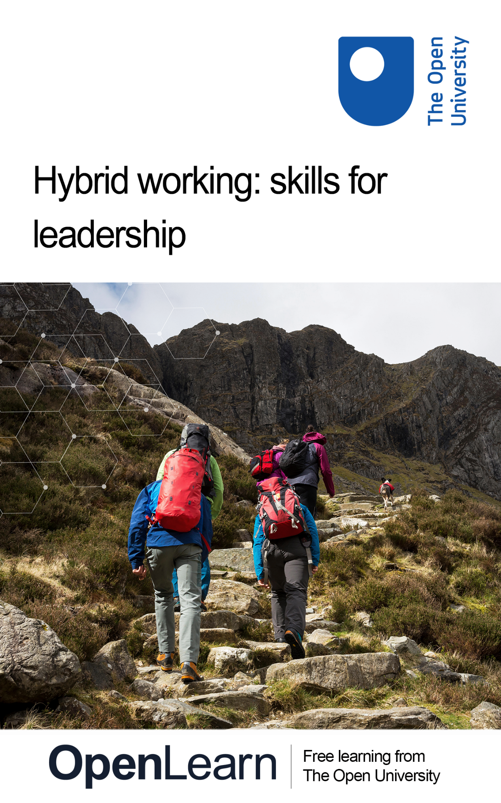

HYB_2

Hybrid working: skills for leadership

About this free course
This version of the content may include video, images and interactive content that may not be optimised for your device.
You can experience this free course as it was originally designed on OpenLearn, the home of free learning from The Open University –
www.open.edu/openlearn/money-business/hybrid-working-skills-leadership/content-section-0
There you’ll also be able to track your progress via your activity record, which you can use to demonstrate your learning.
Copyright © 2022 The Open University
Intellectual property
Unless otherwise stated, this resource is released under the terms of the Creative Commons Licence v4.0 http://creativecommons.org/licenses/by-nc-sa/4.0/deed.en_GB. Within that The Open University interprets this licence in the following way: www.open.edu/openlearn/about-openlearn/frequently-asked-questions-on-openlearn. Copyright and rights falling outside the terms of the Creative Commons Licence are retained or controlled by The Open University. Please read the full text before using any of the content.
We believe the primary barrier to accessing high-quality educational experiences is cost, which is why we aim to publish as much free content as possible under an open licence. If it proves difficult to release content under our preferred Creative Commons licence (e.g. because we can’t afford or gain the clearances or find suitable alternatives), we will still release the materials for free under a personal end-user licence.
This is because the learning experience will always be the same high quality offering and that should always be seen as positive – even if at times the licensing is different to Creative Commons.
When using the content you must attribute us (The Open University) (the OU) and any identified author in accordance with the terms of the Creative Commons Licence.
The Acknowledgements section is used to list, amongst other things, third party (Proprietary), licensed content which is not subject to Creative Commons licensing. Proprietary content must be used (retained) intact and in context to the content at all times.
The Acknowledgements section is also used to bring to your attention any other Special Restrictions which may apply to the content. For example there may be times when the Creative Commons Non-Commercial Sharealike licence does not apply to any of the content even if owned by us (The Open University). In these instances, unless stated otherwise, the content may be used for personal and non-commercial use.
We have also identified as Proprietary other material included in the content which is not subject to Creative Commons Licence. These are OU logos, trading names and may extend to certain photographic and video images and sound recordings and any other material as may be brought to your attention.
Unauthorised use of any of the content may constitute a breach of the terms and conditions and/or intellectual property laws.
We reserve the right to alter, amend or bring to an end any terms and conditions provided here without notice.
All rights falling outside the terms of the Creative Commons licence are retained or controlled by The Open University.
Head of Intellectual Property, The Open University

Contents
- Introduction
- Learning outcomes
- 1 The new normal
  - 1.1 How did we get to this point?
  - 1.2 Leaders need to raise the bar
  - 1.3 How we work now: more than just a change of venue
  - 1.4 Understanding your organisational culture
  - 1.5 Defining culture: the gold standard
  - 1.6 Hybrid culture: what does great look like?
  - 1.7 (Re)designing and developing your hybrid culture
- 2 New ways of working need new ways of leading
  - 2.1 Control and influence
  - 2.2 Don’t play the blame game
  - 2.3 Accountability
  - 2.4 Introducing appreciative inquiry (AI)
  - 2.5 AI in practice
  - 2.6 Empathy
  - 2.7 Developing self-awareness
  - 2.8 Resilience
  - 2.9 Reframing your problems
- 3 Creating an environment for moving from surviving to thriving
  - 3.1 Communicating without distraction
  - 3.2 Active listening
  - 3.3 Work better together
  - 3.4 The need for new collaboration skills
  - 3.5 How to lead collaborative teams
  - 3.6 Building trust
- Conclusion
- References
- Acknowledgements
- Solutions

Introduction
It seems that there has been a shift in acceptance of hybrid working since the pandemic, with mixed-location working here to stay for many organisations. For years many employees had battled with bureaucracy for the right to work wherever they felt would be the most productive location for them, and for some that remained just a dream. However, for others it is now the new reality. You only have to look across the job adverts on LinkedIn and from recruitment companies such as Indeed, to see that remote or hybrid working is no longer viewed as an attractive perk of a job but is actually now an essential requirement.
While employees and employers are enjoying the many benefits of hybrid working models; leaders need to be more aware than ever of how it makes their employees feel and to do that they need to be more empathetic than ever. Forced home-working during the pandemic gave us an insight into each other's domestic lives, but the empathetic practices and habits formed during a pandemic can start to fade, and previous in-person working habits can creep back in. Leaders must step up and clarify what hybrid working means and set up suitable frameworks, policies and guidelines to support their employees.
As Vanderheyden and De Stobbeleir (2022) quip: ‘functioning optimally in a hybrid working environment requires more than just good Wi-Fi and an ergonomic office chair at home’. Leaders must recognise that different skills will be needed to support their employees and managers. Hybrid meetings – to build bridges between those in the office and those working at home – are tricky; managers need not to micromanage but to allow their employees to make their own decisions. Active listening will become a pivotal skill to communicating effectively. It is often easier to be distracted outside of the office with competing priorities, or just feel overwhelmed back in an office hot-desking and looking for a seat to work in.
There is no doubt that hybrid working is here to stay and, if supported well, it can be a really positive change for an organisation, but it requires leaders to foster inclusion and create connections with their hybrid workforces.
This free course, which is part of the Supporting hybrid working and digital transformation collection, is designed to allow leaders to reflect on hybrid working arrangements and provide insights into some of the different views of what is meant by ‘hybrid’, as well as exploring areas such as accountability and communication skills. Throughout the course there will be signposts to frameworks and guidance to help you identify how you move forward and adapt for ways of working in the future.

Learning outcomes
After studying this course, you should be able to:
- explore definitions of hybrid working and identify how to create a shared understanding of these at work
- analyse how hybrid working impacts productivity and describe the ideal hybrid working environment
- identify ways that a hybrid culture can be grown and developed
- become self-aware as a hybrid leader, including how to be more resilient and an active listener
- explain what is meant by accountability and appreciate how to create accountability in a hybrid world
- analyse the importance of empathy as a hybrid leader and distinguish it from sympathy.

1 The new normal
The COVID-19 pandemic has been a catalyst to experimenting with flexible ways of working, and we are still on a journey to understand what hybrid means and to (re)design optimum ways of working in a world where 9–5 in an office is no longer assumed to be the norm.
According to Sage (2022) ‘hybrid working is the new normal’ and the pandemic is responsible for accelerating the ‘greatest global shift in work for a century’ (Gratton, 2022). There are many changes occurring in business and lots of transformations taking place, for example automation is reshaping industries such as auditing, as seen at Deloitte, and this changes the roles those industries require. We are now living longer than ever and retiring later, and issues of equity, diversity and inclusion are more prominent than ever. It is fair to say that what our parents’ generation needed and wanted from work is not what we want from work now, and businesses are having to respond rapidly to this.
According to Gartner (and as seen in Figure 1 below), 82% of company leaders plan to continue to offer remote working after the pandemic.

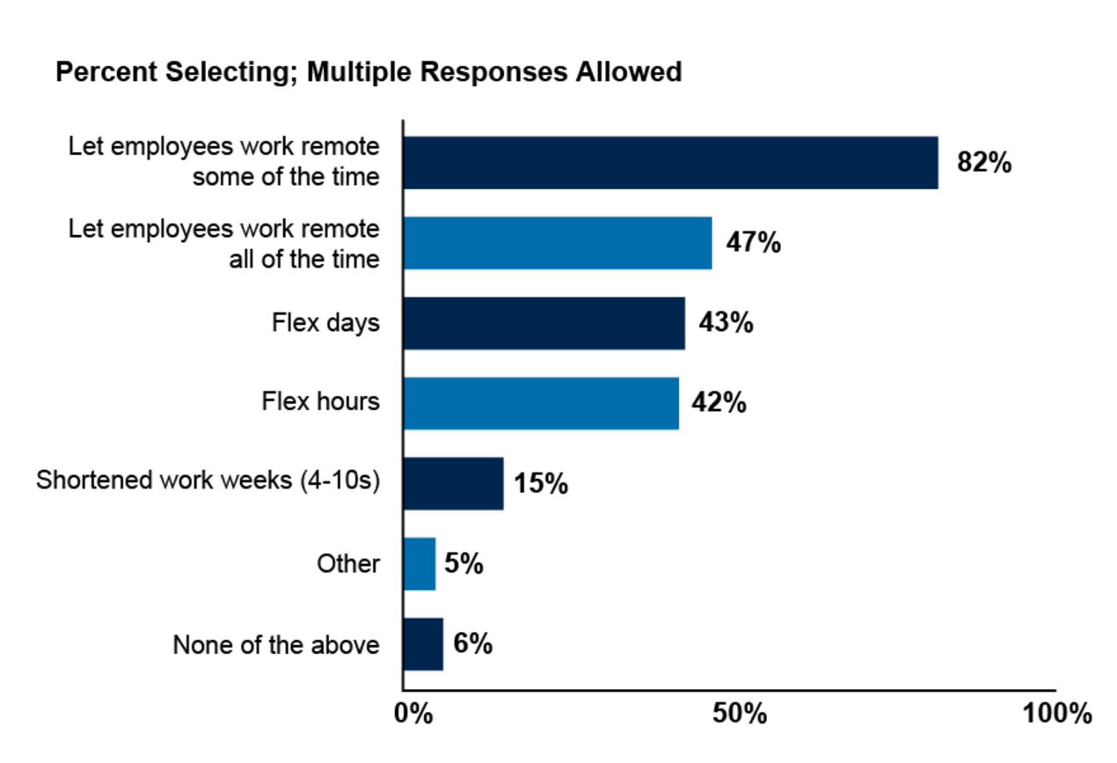
Figure 1 Percentage of company leaders planing to continue to offer remote working post-COVID-19.
View description - Figure 1 Percentage of company leaders planing to continue to offer remote working ...
View alternative description - Figure 1 Percentage of company leaders planing to continue to offer remote working ...

Meanwhile a report published by Cisco/Webex in 2021 said that ‘the hybrid worker era is here’ (Dimensional Research, 2021) and that 68% of those surveyed were already working from both home and the office. What is not surprising is the amount of people who said that they would actually leave an organisation if there was no option for hybrid working.
That being said, the report did identify that people are concerned with digital tooling and teaming, that the need to be able to collaborate effectively was still key, and that there is a need for advanced collaboration solutions.
We are at a significant point – do we return to the older ways of working, or do we take this opportunity to transform and redesign our working environment? This course will guide you through a toolkit of possibilities, but it does not claim to offer a ‘one size fits all’ solution. Whatever path you take, as a leader you will require self-knowledge, the ability to build empathy and understanding with your teams and also to develop their digital capabilities. You will need to design, test, iterate and keep creating new ways of working that suit your context and your stakeholders.
This course is designed to encourage you to consider who you are as a leader working with hybrid teams, and how you work with those teams. You will have opportunities throughout the course to carry out reflections and develop action plans to enable you to strengthen your skills as a hybrid leader.

Activity 1 Hybrid working in 2022

Watch this video What hybrid working will look like in 2022 and reflect on any thoughts or concerns you might have as a leader around hybrid working with your team(s).
How do the preferences of women and people from Black and Minority Ethnic backgrounds stated in the video fit with the diversity of your organisation?
How does redesigning ways of working to include hybrid options really make you feel – are you aware of being biased one way or another?
You will get the chance to revisit these initial reflections at a later point in the course, to see if your views have changed.
If you want to, add your notes to the text box below.

Provide your answer...
View discussion - Activity 1 Hybrid working in 2022

1.1 How did we get to this point?
Even before the COVID-19 pandemic, many organisations were slow to pivot to the changing demands around hybrid working. According to a study reported in TechRadar (2022) there are still many US-based companies that don’t yet have any hybrid working strategies in place.
Senior Vice-President of marketing at AT&T Business, Alicia Dietsch, states:

There’s been a non-reversible shift in the way business is done thanks to the constraints of COVID-19. It’s clear that a successful talent program now requires a hybrid work policy, but that policy needs to be supported by a strategic tech-first cultural reset, to ensure business growth and competition. Firms need to ask themselves if they have the in-house expertise to achieve this, or whether it’s now time to go beyond a partner in remote infrastructure rollout to a partner in tech-first remote business strategy.
(Spadafora, 2022)

Prior to the pandemic, many employees and employers had bad habits around working such as scheduling too many meetings, enduring long commute times, not having a work-life balance that allowed them to spend enough time with loved ones, and feeling like they had to be ‘always on’ for work. Workers had a long list of complaints that they wanted to fix and viewed the growing impact on both mental health and the environment through increasing the carbon footprint as warning signs. The pandemic really highlighted those bad habits and eyes were well and truly opened.
According to Gratton (2022), the pandemic also allowed us to see into each other’s working and domestic lives for the first time, and to connect on a level that we have never achieved before. We started to adopt new habits and talk about how we can get work done not in an office. It was also a big wake-up call to the leaders around us that had to quickly pivot, adapt and get everything online, literally overnight in some cases. The question is now, will leaders continue to be bold, brave and work with employees and rethink and redesign the ways or working or will they revert to old habits around presenteeism and getting back into offices?
This really is a tipping point: we have the opportunity to sit down and redesign how work gets done and no longer view working from home and hybrid working as employee perks.

1.2 Leaders need to raise the bar
The COVID-19 pandemic gave us the opportunity to ‘raise the bar’ (Gratton, 2022, p. 6) and ‘lift up’, and it removed the delays and dragging of feet that were previously happening in organisations and the functions within them. Business leaders started to listen to their teams, sound more empathetic, and truly understand their employees’ situations. Many leaders up to that point had just not been aware of the realities of their employees’ domestic situations, but video calls revealed that workers were not just employees, but parents with children, or young lonely professionals with limited facilities to work from home, or multi-generational families sharing spaces so cramped people had to work on beds to complete their tasks. The pandemic served to ‘Lift the veil of ignorance’ (philosopher John Rawls, 1970, quoted in Gratton, 2022, p. 6) as leaders faced similar difficulties to their employees; this brought about a much deeper empathy very quickly, something that had, up to this point, been difficult to re-enact in training courses.
In 2020 Hiroki Hiramatsu, Global Head of HR at Fujitsu, moved 80,000 of their team to work at home and it wasn’t long before they started to feel the benefits, with 55% of them favouring a mix of home and office – a hybrid model. In September 2021 he declared that ‘we are not going back’ and that ‘two hours many people spend commuting is wasted – we can use that time for education, training, time with our family’ (Gratton, 2021).
If leaders and managers want to make this transition successfully, however, they’ll need to do something they’re not accustomed to doing: designing hybrid work arrangements with individual human concerns in mind, not just institutional ones.
In the following video, Jacob Morgan talks about what leaders need to consider around flexibility in the workplace, and how to manage employee expectations of this.

Video content is not available in this format.
View transcript - Uncaptioned interactive content



1.3 How we work now: more than just a change of venue
As Dyer and Shepard (2021) note, hybrid working is more than just thinking about it as working from somewhere else.

Activity 2 Your take on hybrid

What does hybrid working look like and mean to you?
How and where do you think you can work remotely?
List or describe where you might work, and how you would support your team working in their preferred hybrid situation(s).

Provide your answer...

What does it mean to work in a hybrid way?
According to the ACAS website, hybrid working is a type of flexible working where an employee splits their time between the workplace and remote working (ACAS, 2022).
The short video that you watched in Activity 1 provided one definition of hybrid working. Now watch this longer video on defining hybrid work, which explores different interpretations of the various terms used to describe a range of flexible and remote working models: Defining hybrid work: is this what the future of work flexibility looks like?.
In the video the presenter explained what they felt was meant by the words remote, hybrid, dispersed, on base, etc. While the terminology is being used interchangeably, it is important that employees stick to a consistent use of the phrases and terms they want to adopt in their own organisation.
Some people find that their local coffee shop is where they feel they get their best work done: what should be done for those employees? A phrase that has been coined for this type of working environment is a ‘coffice’. What next: a ‘pubffice’? What about if they want to work in their local library or student union, or other ‘collab space’?

Digital nomads
If you allow your employees to ‘work from anywhere’, you may be asked whether they can work outside of the geographical area they are employed to work in. ‘Work anywhere’ or being a ‘digital nomad’ often conjures up the image of working on beaches. It potentially allows employees to have ‘flexibility to live in a geography of their choice’ (Choudhury, 2022) and some companies such as AirBNB and GitLab have announced they will support this. However, companies and their employees will need to investigate a range of requirements including any tax implications of being employed by a company in one country and working in another; often it can trigger payments of social security contributions in the new country (Osborne, 2022). So while it sounds great to be able to give your employees the flexibility to work remotely in some faraway exotic location, in practice it can be quite complicated and costly.

What is the right environment for hybrid working?
It is important that leaders take the time to see how their current policies around working practices support and adjust for these situations and that a common understanding is created. Leaders should listen to the voices of those that work in their organisations when outlining what is meant by ‘office’ and ‘remote’, as making it feel that someone has to either be in the office or at home as the only means of working remotely can actually reduce productivity.
There has been plenty of research which has suggested that for some, sitting looking at the same four walls can numb creativity, and actually a bit of chaos in environments like coffee shops, or somewhere that has natural lighting and a space to stand, can help people think more creatively. However, for others this could be overwhelming and a sensory overload, and their perfect ‘office’ environment would be a library or other quiet and comfortable space. When creating policies around acceptable working environments, consider what is non-negotiable and what flexibility and options are there for staff to be able to work at their best.
The Open University has focused on redesign working spaces, to make them more inclusive and accessible, and to allow teams to come together differently. In the following video, Dr Nick Barratt, Director of Learner and Discovery Services at The Open University, explains the approach and shares the insights the OU hopes to gain from it.

Video content is not available in this format.
View transcript - Uncaptioned interactive content

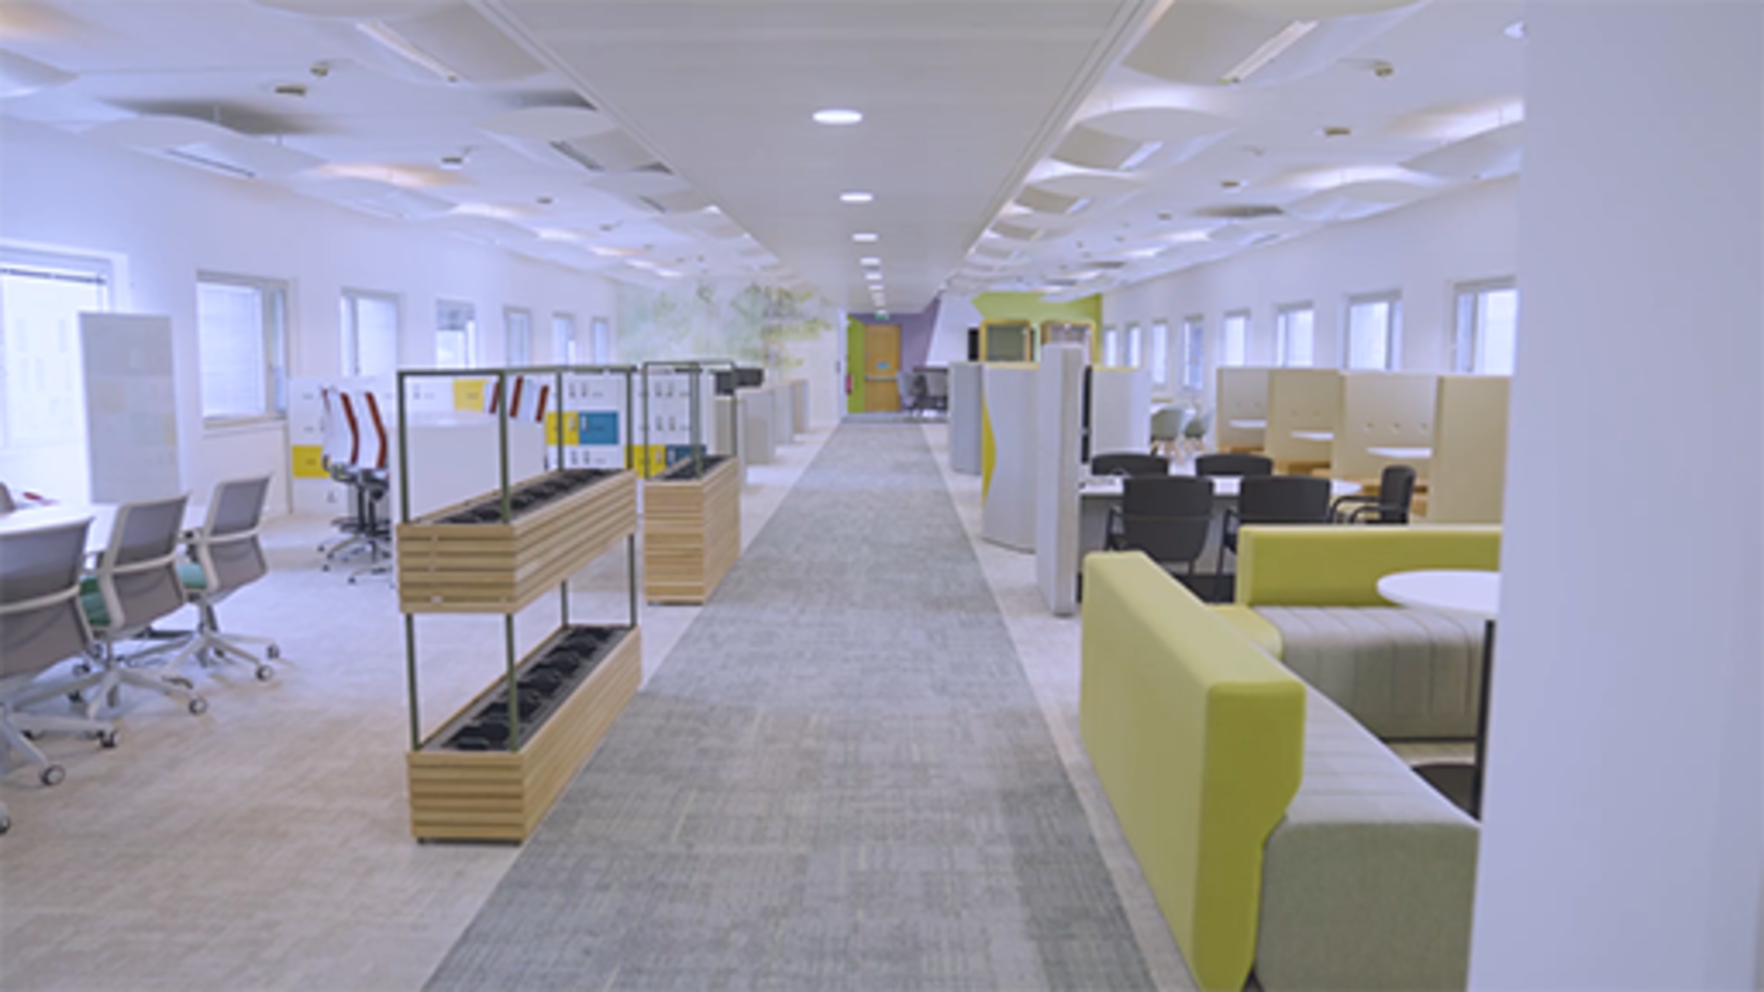

Activity 3 Your ideal space

Where do you do your best work?
Think about a time when you had a really fantastic idea and where you were when that happened. What was the environment around you that led to that?
If you had to design your ideal office (space a) and home space (space b) what would be in each space and what would you exclude?

Provide your answer...

1.4 Understanding your organisational culture
A key question before moving towards hybrid adoption is to start looking at what your current culture is and whether it supports a hybrid environment.

Attempting to define culture
What is culture? Well, every organisation has one and ideally, according to Dyer and Shepherd (2021), the culture you have is something that you designed, created and developed. However, often culture ‘just happens’. They compare culture to a garden, in that if you look after it then it will grow but if you don’t then it can become a ‘lifeless patch of dying weeds or an uncontrolled infestation of poison ivy’.
Have you ever asked a colleague what they think culture means? Or searched for a definition of it online? If you do, you will get roughly 4,720,000,000 (as of May 2022) different possible results. Some people believe an organisation’s culture is how employees feel. Others think it is ‘Lunch is free and every Thursday we drink beers’ (Vollebregt, 2021). This is not really organisational culture; it could be part of your culture, but it is not the only thing that defines it.
There have also been many academic definitions, for example Balogun and Johnson’s’ ‘the way we do things around here’, or Denison’s ‘the underlying values, beliefs and principles that serve as the foundation for an organisations management system’. It is a combination of conscious and unconscious values and the actions of your organisation. Mix them together and you get a certain feel and a culture.
To others, culture is a feeling (Dyer and Shepherd ,2021, p. 21). The takeaway here is that there is no right or wrong answer as to what culture is or isn’t, or should and shouldn’t be. In the following quote, Jon Katezenbach, founder of the Katzenbach Center and author of The Critical Few, summarises it well:

No culture is all good or all bad. Every culture has emotional energy within it that can be leveraged.
(strategy&, 2018)

1.5 Defining culture: the gold standard
Schein’s iceberg model (Schein, 1992), reproduced below, is a useful way of illustrating that some cultural aspects of an organisation are visible while others are hidden and difficult for outsiders or newcomers to interpret.

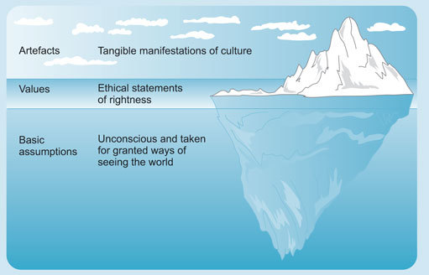
Figure 2 Schein’s iceberg model of culture.
View description - Figure 2 Schein’s iceberg model of culture.
View alternative description - Figure 2 Schein’s iceberg model of culture.

Examples of visible cultural aspects include written documents, strategic plans, job descriptions and disciplinary procedures. Less visible, however, are a culture’s values, beliefs and norms, which can be much harder to identify and interpret. The key to Schein’s model is that, through analysing the three levels shown in Figure 2, a better understanding of the different components of culture in organisations can be achieved.
Culture is not static, it is never ‘finished’, and it grows and evolves – as we have seen during the COVID-19 pandemic. As a leader, you will need to be really clear on what your culture is and ensure that your employees know what it is and are comfortable within it. You don’t want to have a culture and strategy clash; if you do have one you should look for ways to address this. There is no such thing as a perfect culture but it should support your employees and organisation in the best possible way. Throughout this course you will explore how to create a healthy culture, with psychological safety and effective communication.

1.6 Hybrid culture: what does great look like?
A hybrid culture develops in an environment that blends virtual and in-person work arrangements. Although changes in the world of work have dominated our thoughts for the last couple of years (and with good reason, since work is a huge part of our lives), workplaces are not the only environments considering what it means to have a hybrid culture (Cooks-Campbell, 2022).
What seems to be clear in the HEI sector is that the rapid pivot to online as a knee-jerk reaction to the pandemic has caused a great deal of cultural tension for both staff and students.
According to an article by Stanier et al. (2022), a hybrid culture will only work if you treat everyone as working remotely. This ensures that everyone gets the same information, tools and opportunities to succeed, and it doesn’t differ according to where they sit and whether they are working at a desk in an office, hot-desking in a collab space, or at home. They feel that a successful hybrid culture needs consistent action from leadership in the five areas listed below and, as a leader, you will need to ask yourself some of the questions included in each area.
- Embracing asynchronous communication – Do your employees have equal opportunities to participate in communication? If they don’t, you need to move your synchronous exchanges to asynchronous, which can be achieved through moving to written or recorded communications. Do you really need to have that daily stand-up? Are there people unable to attend? If so, you could create a chat channel with short updates or provide a recorded video to replace a company-wide live meeting. If something really does need to be live communication, ensure that you provide a recording and a transcript for those that were unable to attend.
- Making communication boundaries clear – Do your employees know when and how to get in touch with each other? Are your current employees annoyed at being interrupted when they are working? If so, start to create some rules of engagement per platform. Do you expect instant messages to be answered instantly? What about emails? Are meetings optional or compulsory? By making this really clear and part of your culture, it can reduce anxiety and stop the fear of missing out among your employees. Do your employees make their work hours clear with each other?
- Championing documentation and artefacts – Can your employees find content and information easily? Do you use collaboration tools to enable employees to collaborate remotely in real time and make comments on documentation? If you don’t, start to identify tools and technology that facilitate this, as this can really cut down on wasted time in duplication, and also increase employee morale and feelings of ownership, according to Stanier et al. (2022).
- Broadcasting communication – One thing employees really missed during lockdown was the ability to just talk and have what some call ‘water cooler’ conversations. One-to-one conversations might have been possible in a small office environment but it is really difficult to scale them up (Stanier et al., 2022) and not possible in a hybrid culture. Instead, Stanier et al. suggest that leaders need to develop a culture of written or recorded messaging to convey the heartbeat of the company. This can be achieved through regular newsletters or recorded weekly messages. On a smaller scale, teams could be encouraged to self-manage this sort of communication, sharing successes and achievements and working with other teams to provide updates and share what they are working on: ‘A company of sharing encourages further sharing’.
- Providing the tools to succeed – Do you have digital tools that enable your employees to work effectively? Do you have a plethora of tools available, but none that are widely used? Do your employees have a safe and comfortable working environment at home and in the office? During the pandemic, many employees just had to adapt to what they had, even if that meant working from their sofa, their bed or even in a chaotic family kitchen. It is the company’s responsibility to ensure that employees are successful wherever they are.
In the following video contributors share insights for developing shared values and inclusive organisational cultures.

Video content is not available in this format.
View transcript - Uncaptioned interactive content

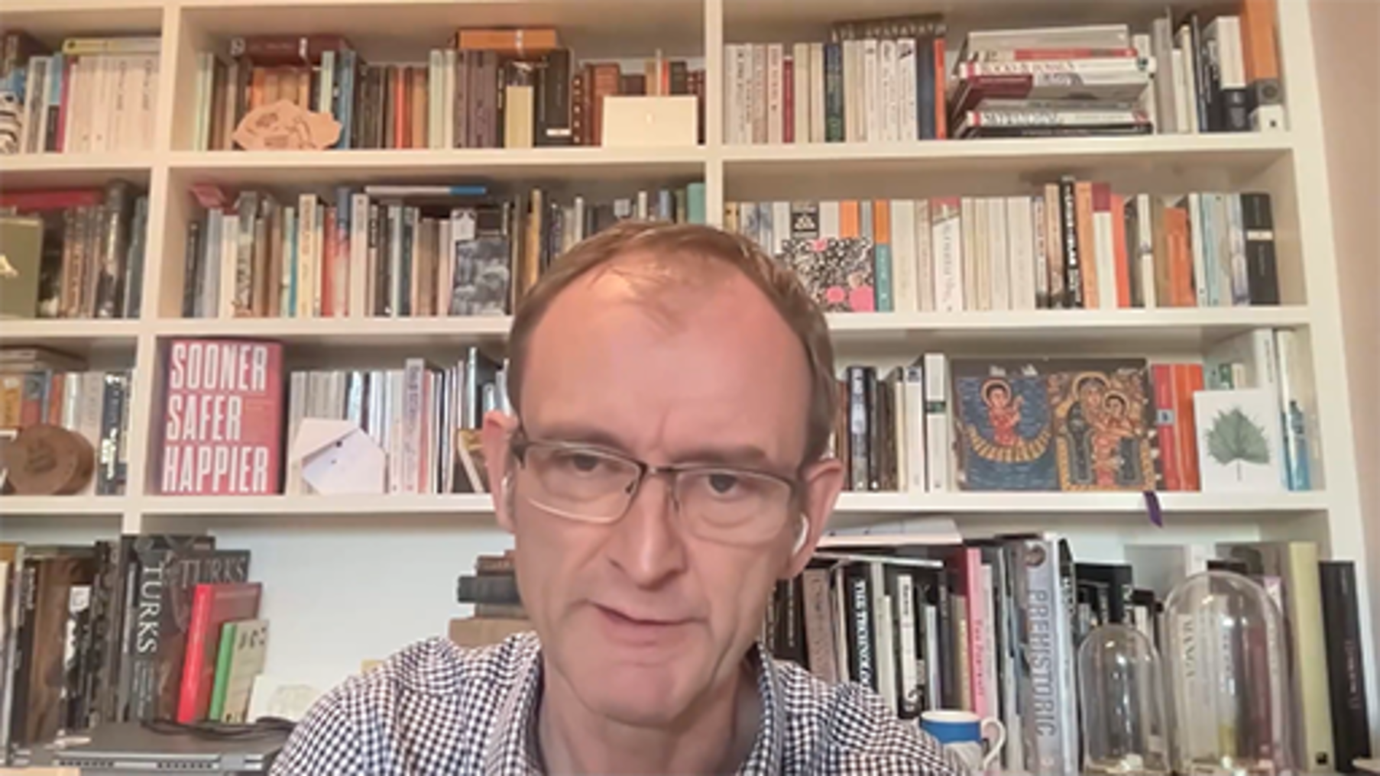

1.7 (Re)designing and developing your hybrid culture
Changing your organisational culture might seem overwhelming, but even small actions can move it forwards. Focus on the five key areas identified by Stanier et al. (2022) that were introduced in the previous section and try to take steps to answer the questions listed.
James Clear once wrote about the theory of ‘aggregation of marginal gains’, whereby we convince ourselves that ‘massive success requires massive action’. However, the difference a ‘tiny improvement can make over time is astounding’.
If you can make your employees’ working lives one per cent better each day for a year, after 12 months you will have improved their situation by 37 per cent, as Clear’s illustration below shows.

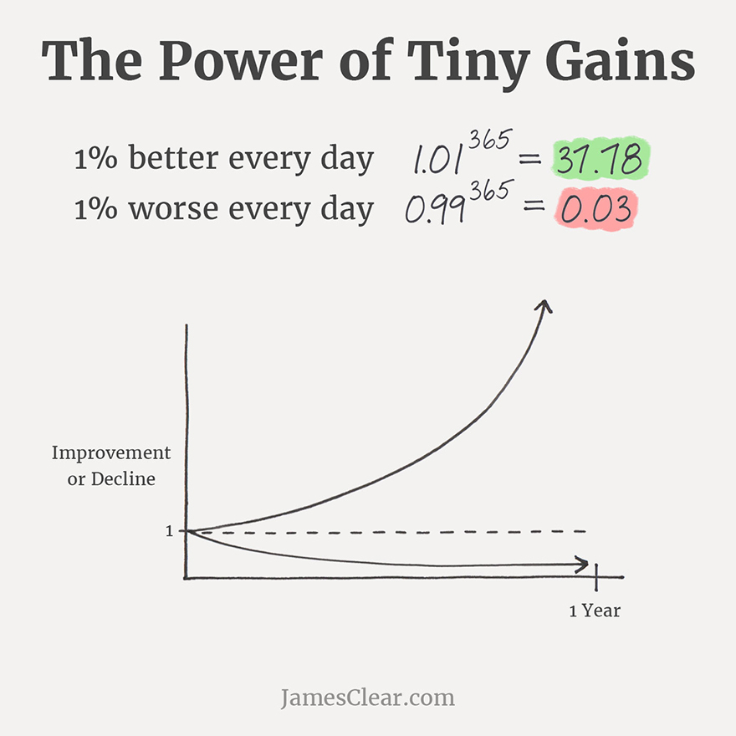
Figure 3 The power of tiny gains.
View description - Figure 3 The power of tiny gains.
View alternative description - Figure 3 The power of tiny gains.

You may not be able to make big improvements instantly, but the most significant things in life are not stand-alone events but the sum of all the moments we experience and the changes we choose to make.
To understand how to develop your organisational culture, you need to take a snapshot of what it currently looks like. The next activity will help with this.

Activity 4 The Culture Design Canvas

Fearless Culture, a workplace culture consulting firm, have developed a mapping tool called the Culture Design Canvas to help businesses:
- assess their current organisational culture
- design their desired future culture, and
- evolve their culture to keep it current and relevant, and explore future possibilities for the organisation.
Take some time to explore the Culture Design Canvas page. Pay particular attention to the following:
- The different sections of the Culture Design Template: does anything there surprise you?
- The examples provided from other organisations: to what extent do they reflect your experience of university organisational culture?
As a leader, do you think the Culture Design Canvas would be a useful tool for mapping the culture at your organisation?
If so, how would you use it? Would you do it online using a digital tool such as MURAL, or would you gather your team into the same physical space and use analogue tools such as a whiteboard or pens and paper?
Use the space below to note your thoughts, if you wish.

Provide your answer...

2 New ways of working need new ways of leading
Who are you as a hybrid leader? This next section of the course will focus on you and your role as a hybrid leader. You will have to be flexible in your leadership approach to adapt to the volatile, uncertain, complex and ambiguous (VUCA) world we live in, and that flexibility requires self-awareness. Anderson and Adams (2019) believe that we become better leaders by transforming ourselves.
In the next video Jacob Morgan, best-selling author, speaker and trained Futurist, focuses on the qualities leaders need for the future.

Video content is not available in this format.
View transcript - Uncaptioned interactive content

Thinking of great leaders you may have observed in organisations you have worked for or with, you may have noticed qualities that they possess that you would like to develop or build on. There may be other qualities and behaviours that you feel are not something you want to develop.

It can be lonely at the top
Sarah McVanel published a guide called ROCK as a Leader: How to Thrive Through Change and Crisis on how to survive making tough calls, as often it can feel lonely at the top (Dyer, 2022, p. 138). During COVID-19 more than ever leaders had to make tough decisions which could affect many if not hundreds or thousands of people, with incomplete information at their disposal. McVanel came up with a set of leadership behaviours to enable a leader to be a ‘rock star’ or to ROCK in this kind of situation, where ROCK stands for recognise, organise, communicate and kindness. Exhibiting these behaviours, she says, will enable your team to deliver STAR results: satisfaction, teamwork, accomplishment and retention. McVanel argues that these behaviours will not only set you up to survive in a hybrid world and even survive a crisis, but actually enable you and your team to thrive and continue thriving beyond the crisis.

Activity 5 The best and worst of hybrid leaders

In this activity you will reflect on hybrid leadership attributes by writing a fictional blog from two perspectives:
- As though you were the best hybrid leader
- Where you were the worst hybrid leader
Think about what each version of hybrid leader would look like, sound like and what they would think, feel and do in your organisation. Consider the impact they have on the business and their employees. Aim to write about 200 words maximum for each version.
If you are uncomfortable with creative writing, research an example of a great hybrid leader and one you think is a poor hybrid leader. For each example, consider the impact they have on their organisation and its employees. Again, aim to write about 200 words maximum for each version.
Do you share any traits with the leaders you have written about?

Provide your answer...

2.1 Control and influence
A famous Greek philosopher Epictetus advised ‘To make the best of what is in our power, and take the rest as it occurs’. He said:

Some things are in our control and others not. Things in our control are opinion, pursuit, desire, aversion, and, in a word, whatever are our own actions. Things not in our control are body, property, reputation, command, and, in one word, whatever are not our own actions.
(Daily Stoic, 2021)

So what does that even mean? Part of working in new ways is about understanding that we need to learn to focus on the things we can change and learn to accept there are just some things we cannot change. Of course, that is easier said than done. We can often feel out of control, which can lead to feelings of failure, helplessness and even hopelessness. This is not good for our mental health and can result in high levels of anxiety and stress.

How the COVID-19 pandemic affected our thoughts about control
As a leader you may feel that you should have control and be in control of situations, but the pandemic made many of us feel more out of control than ever (Hope, 2021). During this time some of the only things we could have in our control was to wash our hands and follow guidelines on meeting with other people. ‘Dealing with Covid was not in our daily repertoire of stressors’, said Susan Albers, a clinical psychologist at the Cleveland Clinic who, in her career, has focused on people with control issues. ‘There is no handbook for coping with Covid. There are no role models or well-documented research that points to how to effectively cope with a global pandemic. Covid requires a new set of coping skills that many people have never had to exercise’ (Hope, 2021).
We learned from this that we cannot really control anyone or anything other than ourselves. We feel like we should control others to get the best results, and you might find yourself saying that you feel like you have lack of control over various areas, departments or even situations. What you are really saying is that if you could have control of the people in them, you could then get what you needed done! However, control is a mere illusion. Richards (2018) said that leadership is about influence, not control, and the best leaders inspire and motivate rather than dictate.

What do you have control over?
The things you can have control over as a leader include:
- your reactions
- your attitudes
- your biases.

Activity 6 Record your ABCs

This short activity is to help you understand that external events do not cause emotions, but they do affect our beliefs. It is a good warm up exercise in self-awareness before you move onto the next section of the course. It will create a grounding exercise to help you reflect on how you react to events and give you some ideas of what you could do next time.
- A stands for the activating event that triggers your inner dialogue
- B stands for the beliefs you formed after the event
- C stands for the consequences or how you feel.
The scenario:
Imagine that you have tried to log onto your laptop and your Wi-Fi has gone down or is unstable. You become anxious imagining you won’t make it to your virtual meeting on time and it is a big one with the rest of your team and a member of the senior leadership team. What are your ABCs in this situation?

Provide your answer...
View answer - Activity 6 Record your ABCs

Bouncing back from perceived loss of control
As part of understanding yourself as a hybrid leader you will be looking at what you can influence and control. Sometimes there will be things you are concerned about but you cannot influence, and that can be tough.
Watch this video: Circle of Influence - From The 7 Habits of Highly Effective People
In the video you heard about how we operate in two circles:
- The circle of concern – the things we care about but can have very little impact on and no control over.
- The circle of influence – things we can make an impact on and have influence over.
This idea is taken from Stephen Covey’s book The 7 Habits of Highly Effective People (Covey, 1989). Covey distinguishes between reactive people, who focus their energy on the circle of concern, and proactive people, who focus on the circle of influence.
Focusing on the circle of concern is a waste of energy and actually causes influence to shrink. The video showed an example of this and, as a result, he alienated the executive team surrounding him. One executive in the video, however, was proactive – he took initiative and focused on his own circle of influence. Working to complement the strength of the leader who focused on the circle of concern, and in the process that proactive executive created powerful support and increased his sphere of influence.

The circle of control
Stephen Covey’s model has been adapted by psychologist Claire Newton to include a third circle – the circle of control.

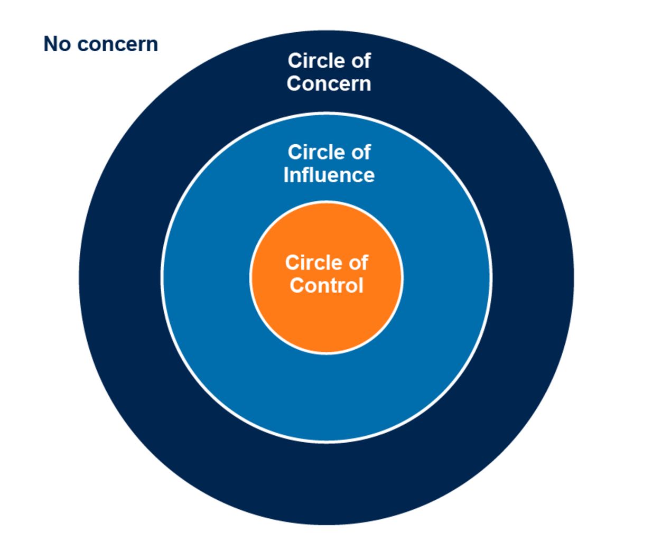
Figure 4 Circles of control.
View description - Figure 4 Circles of control.
View alternative description - Figure 4 Circles of control.

The inner circle of control is about things we have direct control over. This includes our own thoughts and behaviours. It can also include our decisions, choices, moods, work ethics and even our words.
When you lead with influence, you build a dialogue with your team, rather than telling them what to do. You encourage the team and model positive behaviours and language, rather than demanding cooperation. With this approach, you’re likely to earn the team’s respect and enhance their engagement. Using influence, you change the way the team perceives or reacts to situations, which allows you to get the best out of team members, even under challenging conditions.
The key takeaways around control and influence are:
- If you cannot control it, do not get stressed about it.
- If you cannot influence it, do not get upset about it.
- Focus on what you can change, not on what you cannot.

Influence is better than control
To become a better leader, Richards (2018) believes that you must ‘recognise that your ability to influence is much more crucial than your power to control. Leadership is about service’. Move away from micromanaging, as that can indicate you do not trust your employees. Instead take the time to delegate to others. It is possible to control and be a leader, but it is very hard to control and influence all at the same time, and you might at times need to get out of your own way and let others be guided by you.

Activity 7 Your circles of control and influence

In this activity you will reflect on your own:
- circles of control
- circles of influence
- circles of concern
A space has been provided below for you to type your notes, but you could create your own digital board (e.g. using tools such as Padlet, Miro or Mural) or just draw one on a piece of paper and use sticky notes to annotate it. What you choose to apply this to could be in your role as a hybrid leader or it could be about something in your life in general, but it is a good way to really ground your thoughts about what you can control and have control over and actually what you cannot control.

Interactive content is not available in this format.

2.2 Don’t play the blame game
Are you a bit of a blamer? When something bad happens, do you ever jump to the conclusion that it must be someone’s fault, and look to attribute blame? If so, why do you think you do that? Why do you want it to be someone’s fault rather than no one’s fault? Perhaps because it provides some semblance of control over the situation?
Watch the following video by American research professor, lecturer, author and podcast host, Brené Brown: Brené Brown on blame.
What did you think of Brown’s explanation that blame is simply discharging the pain and discomfort? Blame has an inverse relationship with accountability, and accountability can be a process that makes us feel vulnerable: it is challenging telling someone that they upset us or hurt our feelings and holding them accountable; without blaming them. When we move from accountability to blame, we stop really listening and we stop building empathy; we are looking to pin the blame as quickly as our brain allows us to connect it to someone.

Activity 8 Reflecting on blame

Reflect on the last time you blamed someone for something. What was it for? Was it actually that person’s fault?
Map out what happened, try to identify what the reason was that they did something you blamed them for and note the consequences for you.

Provide your answer...
View discussion - Activity 8 Reflecting on blame

Now watch this short video: Everybody, Somebody, Anybody, Nobody
As you can see, it highlights the impact of asking for something to be done but not making it someone’s specific responsibility. This can lead to the blame game.

2.3 Accountability
In 2017 it was reported that 72% of those surveyed globally thought that leadership accountability is a critical issue in their organisation but only 31% were satisfied by the degree of accountability demonstrated by their leaders (HRD, 2017).
Although this survey was undertaken a few years before the COVID-19 pandemic, it still highlights the importance of accountability to those within the business. But what is accountability and why is it so important?
‘Accountability’ suggests that leaders are held accountable to someone or something. There are several measures of accountability, for example business performance, which most companies prioritise. But leaders must also be accountable to company culture (stated mission, vision, values and purpose), as well as to the workforce itself.
McGrath and Whitty (2018) point out in their research paper that the concepts of responsibility and accountability have and can be really confused, with one often defining the other. It is important to clarify and define what these terms mean to avoid causing confusion within the workplace. They point out that many organisations use tools such as RACI (R= responsible, A= accountable, C= consult and I= inform). They deduced that accountability boiled down to ensuring there was liability on someone to ensure that the work was done satisfactorily.
Pechan (2021) states that accountable leaders communicate goals, objectives and key results to their team and seek to foster alignment and focus. As well as accepting responsibility when things go wrong, they celebrate and give credit when things are going well. They feel that owning your own mistakes is about ensuring accountability is developed in teams; it is not just something done by a leader.

Accountability culture in a hybrid world
This course has talked a lot about building a culture to support hybrid working, and Pechan (2021) outlines three key elements that can help build a culture of accountability in your company:
- Have strong company values and make sure they are communicated with your employees and that they understand them and what those behaviours look like in their roles. In a podcast, Hancock et al. (2021) said that ‘values are a core differentiator of companies that maintained a healthy culture during Covid-19’.
- Defined leadership model – leaders need to be held accountable to a defined leadership model. Do you know what your leadership model looks like?
- Team accountability – What are the expectations for your team? What should they be doing? What are the processes they should follow? What performance are you expecting from them? Giving your team the feeling that they need to be accountable means they are more likely to succeed and meet their goals and deadlines.
Accountability is important because without it a remote organisation cannot succeed (Udoagwu, 2021). The benefits of accountability, and good team accountability in particular, are that it can lead to increased employee commitment (which can only be a good thing as we go through the ‘great resignation’) as well as higher employee morale.

Accountability, trust and productivity
Accountability and trust really are key to productivity for remote or hybrid teams, because such teams are in and out of the office (physically or virtually) at different times, regularly using virtual communications and/or collaborative technology. It’s no longer unusual for full teams to have never even met in person.
You will need to have open dialogues with team members about digital collaboration, including transparency around working on collaborative documents. You may also find you have to talk about the impact of delays on other people’s productivity, whether that is joining a virtual meeting late or missing a deadline. Start having the difficult conversations about accountability early on, to start building a culture of team accountability.
The key ingredient here, and one that will be explored later in more depth, is trust. Teams need to trust each other and leaders need to trust their teams. Both will have to think about how they can bring team accountability into the mix early on in a project and make it part of the regular processes. Leaders will have to step up and be role models in the virtual/remote world as well as in the office and show accountability by demonstrating the desired behaviours and values. If you want your organisation to build a feeling of psychological safety but you only act that way in person in an office then you as a leader will need to be accountable for your actions if that inconsistent behaviour contributes to the destruction of psychological safety online. As a leader, you will have to lead by example and reward those team members that proactively embrace accountability at work (Udoagwu, 2021). Those within your sphere of influence can work with others joining the organisation to guide and teach them how to be accountable.
Accountability is going to be a habit/mission that you need to continually work on and is not a ’one and done’ effort or task.

Accountability is not micromanaging
You might at times need to take a step back and consider whether you are micromanaging rather than building accountability. If you find yourself checking in on your team, asking for constant status updates and generally ‘hovering over their shoulders’ while they work, you are probably micromanaging. If you want to check whether you are a micromanager – or indeed have ever worked with one – you can read A cautionary tale: top 10 signs that you’re a micromanager (Son, 2014).
Accountability is a bit like being a gardener, in that you need to give your team the right environment to do their own thing, grow and perform at their best. They need the ability to use collaborative tools to communicate with others in the team and share knowledge and information. It helps them all be transparent and builds an environment of trust and clarity. Making things visible and not ‘out of sight, out of mind’, can help improve team accountability.

Activity 9 Are you a micromanager?

If you read A cautionary tale: top 10 signs that you’re a micromanager (Son, 2014), reflect now on the 10 signs and consider how many of them you feel you demonstrate in your current role.
Then write down some actions that you could take to stop doing one of these habits.

Provide your answer...

2.4 Introducing appreciative inquiry (AI)
One way to encourage ideas from team members and encourage them to develop and share ideas is to foster engagement, creativity and leadership at all levels.
What if you could do that simply by improving the quality of your conversations? That’s the promise of appreciative inquiry, known as AI – not to be confused with artificial intelligence.
AI is used to foster positive change in individuals, groups and organisations. The idea of AI is that we create each interaction, meeting and ultimately all our social systems through conversation and shared meaning-making. According to David Cooperrider, founder of the AI approach: ‘We live in worlds our conversations create’ (Cooperrider, 2021).
Think about a time you had a conversation with someone who listened with their full attention and brought time, focus, new ideas and perspectives, and positive energy to the conversation. How did that feel? Now contrast that with the last time you spent time in a meeting with people who were distracted by messages or documents and who seemed not to listen, just waiting to speak themselves while criticising or blaming others.
In AI, the first of these types of conversation (attentive, focused, positive) is ‘appreciative’ and adds value to a situation, person or opportunity. The second is ‘depreciative’ – it reduces the value of a situation, person or opportunity.
In appreciative conversations, we share ideas, acknowledgements, useful information and suggestions. This strengthens connections, enhances relationships, sharpens our perception, expands our awareness and generates new knowledge and innovation.
Depreciative conversations, in contrast, are characterised by failure to listen, interruption, distraction, criticism and complaining. They weaken and strain relationships, narrow our horizons, reinforce assumptions and dull creative and critical thinking. Ultimately, depreciative conversations can have a destructive effect on workplace engagement, team performance, organisational success and ultimately even individual mental and physical health.
Due to twentieth-century expectations about leadership, many leaders have been conditioned to focus on problems, manage issues and risks, analyse root causes of difficulties and hold people to account. This can lead to a tendency to become involved in depreciative conversations.
AI challenges you to be a different kind of leader by having appreciative conversations. It involves looking beyond the immediate problem and taking a wider view of the team or organisation as a living system, or as one of many ‘universes of strengths and unlimited human imagination’ (Stavros and Torres, 2018).
The heart of AI consists of the cooperative search for the best in people, their organisations, and the world around them and that solving tough problems from that perspective results in creative solutions, which is life-giving for people.

2.5 AI in practice
How do we start having these conversations? AI has two practices and five principles to help you approach this.

Practice 1: positive framing
This has two aspects:
- First, we need to resist the urge to see a situation or person as a problem that needs to be solved. The matter may be serious, but we intentionally choose to frame it positively, focusing on what is already positive in the situation.
- Second, we direct attention to positive actions and outcomes.

Practice 2: asking generative questions
Generative questions are questions that:
- spring from an attitude of open-mindedness and curiosity – for example, questions starting ‘What if…?’
- elicit and make use of diverse and different perspectives, for instance, ‘How do you see the situation?’
- surface new knowledge and information, for instance, ‘How did they manage this process in your last company?’
- stimulate creativity and possibilities, for instance, ‘What might be possible if we were to…?’

Five principles
This sounds simple, but these practices are choices, and to make these choices we need to be able to pause and reflect on a situation and think before we speak and act.
This is hard to do. Most of us don’t pay attention to the factors that shape and drive our conversations. We act in the moment, often under pressure. Our immediate circumstances often dictate our framing, behaviour and reactions, rather than us choosing them ourselves.
To help with this, the AI approach provides a set of five principles. We can use these to train ourselves to think and reflect on situations, challenge habitual thinking, perceptions and reactions, and choose a positive framing to enable appreciative conversations and positive outcomes.
The five principles are shown in the table below.

Principle | Description
Constructionist principle: ‘Words create worlds’ | Our understanding, relationships and social reality are shaped by language and through conversation – when we change how we talk and the questions we ask, we change our reality.
Simultaneity principle: ‘Inquiry is intervention’ | Change begins as soon as a question is asked or a statement made, as our mind and emotions react immediately.
Poetic principle: ‘You have a choice in how you see things’ | It is possible to see every person, every situation, every organisation from many perspectives – the ‘truth’ depends on our perception and focus of attention.
Anticipatory principle: ‘We see what we expect to see, and what we look for, we find’ | Our personal thoughts and mental images shape our conversations, so that our expectations determine what we experience and what we hear and see.
Positive principle: ‘Positive images and positive actions produce positive results’ | More positive questions beget more positive actions and long-lasting outcomes.
(Adapted from Cooperrider and Whitney, 1999)

Leaders can take different approaches to developing an AI approach within organisations, such as bringing specific groups together to share their experiences and ideas, or at an individual level using reverse mentoring to listen to others. Many organisations are moving towards using the term ‘reciprocal mentoring’ rather than ‘reverse mentoring’ to reflect that both the mentor and the mentee gain something from the process. In the following video, Louise Casella, Director of The Open University in Wales, and Dr Nick Barratt, Director of Learner and Discovery Services at The Open University, discuss their experience of AI approaches.

Video content is not available in this format.
View transcript - Uncaptioned interactive content

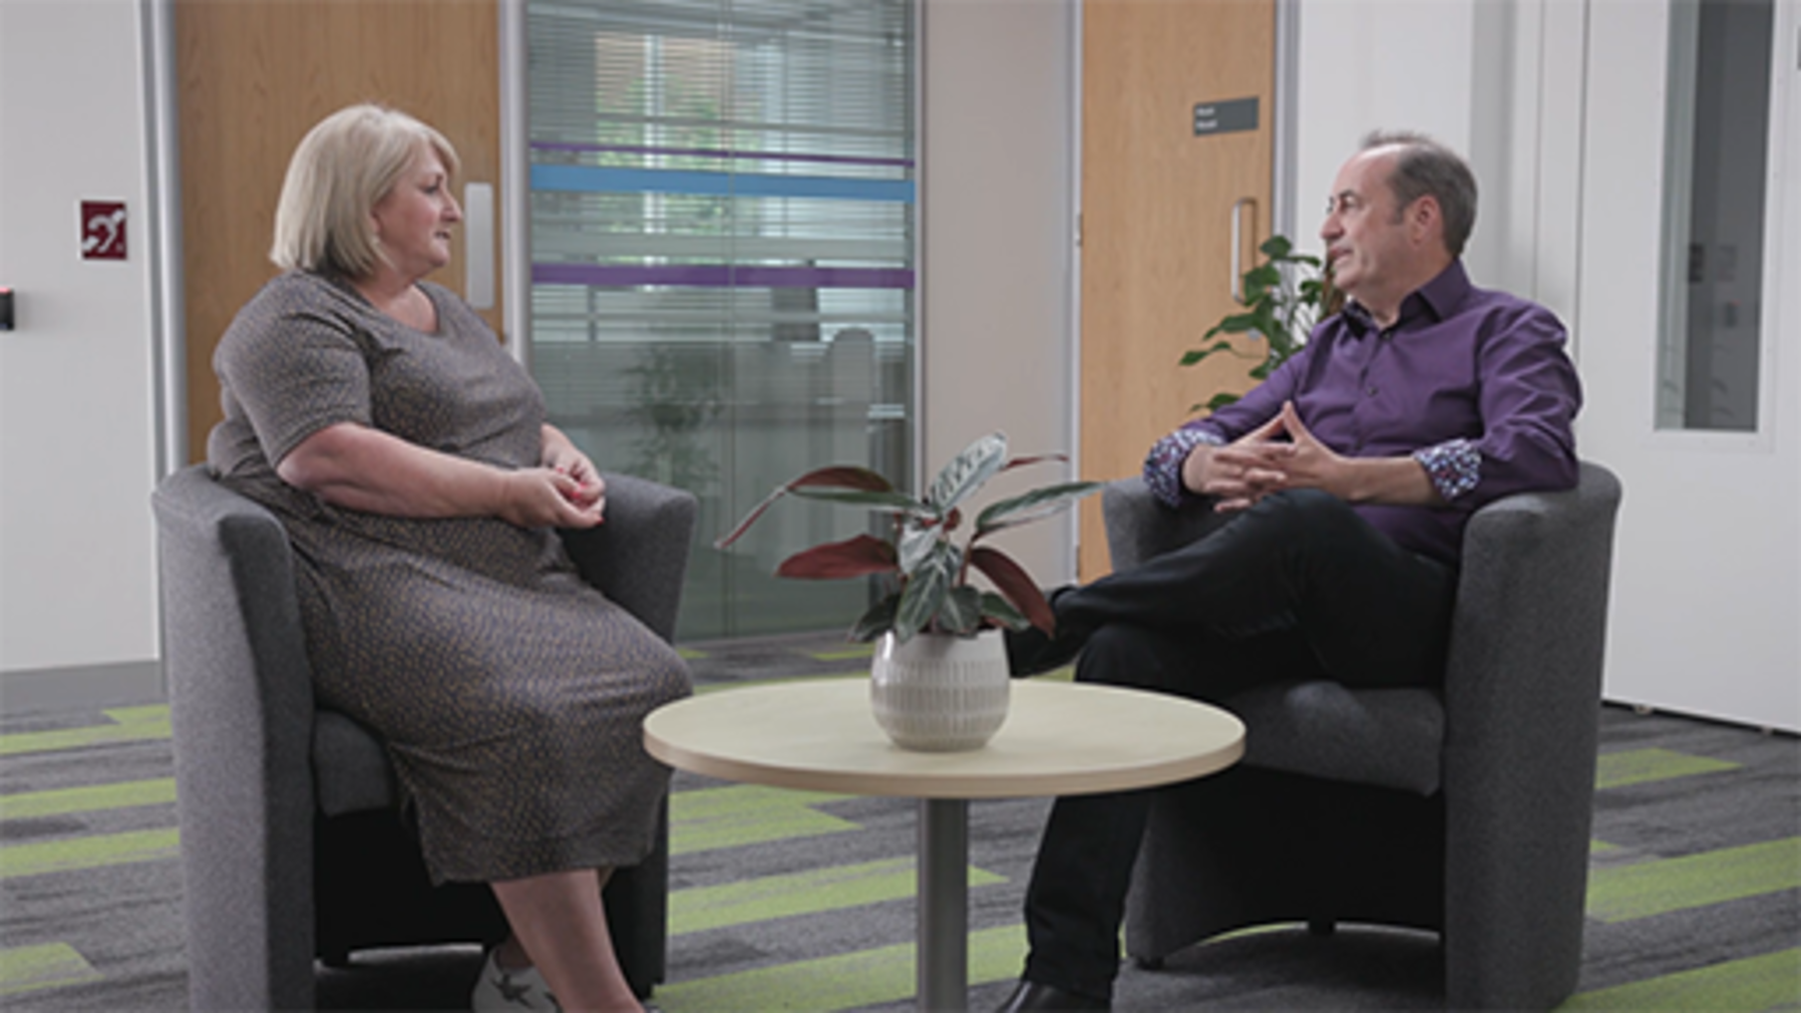

Reflect on the practices and principles mentioned and try to use these to improve the quality of your conversations, stimulate and energise colleagues and teams, enhance engagement and purpose, and inspire new possibilities, positive outcomes and better living.
If you tend to default to a problem-focused approach, you may find AI particularly helpful. Next time you find yourself in a depreciative conversation, try flipping things around by asking generative questions. This is a great first step towards turning an unproductive conversation into a conversation worth having.

2.6 Empathy
What is empathy? Many of us think of it as a bit of a fluffy, fuzzy, ‘feel-good emotion’ or relate it to being kind and emotionally sensitive. Krznaric defines it as ‘the art of stepping imaginatively into the shoes of another person, understanding their feelings and perspectives and using that to guide your actions’. It is very distinct from sympathy, as you will see later in this section.

Activity 10 What does empathy mean to you?

Before getting into this part of the course, note down what you feel is the definition of empathy and what that might look like.

Provide your answer...

Now watch this short animation from Brené Brown, for her perspective on empathy: Brené Brown on empathy.

Understanding empathy
Think about some of the actors who famously practise the art of method acting. Through that approach they have taken the time to really understand what their character would be feeling, hearing and seeing and then used that to ‘become’ the character. Notable examples include Adrien Brody in the film The Pianist and Jim Carrey in Man on the Moon.
Patricia Moore is an example of someone who built empathy in the workplace to develop a new innovative product. She was the only female designer out of 350 men in her organisation and she asked a simple question during a design session for a new fridge: ‘couldn’t we design the door so that someone with arthritis would find it easy to open?’. She was told by a colleague ‘we don’t design for those people’, which prompted her to conduct a radical experiment in empathy (Krznaric, 2015, p. xi): she dressed up and ‘became’ an 85 year old woman. She said she didn’t want to be an actor pretending to be an elderly woman so she used theatrical makeup, clothing and a walking stick and transformed herself into an elderly woman. She kept up this persona from 1979 to 1982 and her experience gave her a first-hand understanding of how difficult it was to walk up steep stairs, use can openers and open fridges, etc. She realised that there was a gap in the market and she took product design in a new direction. Based on her insights and experiences she created products that were suitable for use by the elderly and for those with arthritis.

Expanding your empathetic potential
To cultivate a habit of being empathetic, Krznaric (2015, p. xiv) suggests the following six habits of highly empathetic people:
- Switch on your empathetic brain – Understand that empathy is core of human nature and that it can continue to develop and grow.
- Make the imaginative leap – Make a conscious effort to step into someone else’s shoes no matter who that is, whether it is friend or foe. Acknowledge their humanity, individuality and perspectives.
- Seek experiential adventures – Explore lives and cultures that are not the same as your own whether this is through direct immersion or empathetic journey mapping.
- Practice the craft of conversation – Be curious, be inquisitive, be like a child again asking questions and listen and connect. Don’t be an examiner, be the interested enquirer.
- Travel in your armchair – You cannot always go to the place to build empathy, but you can put yourself into someone else’s mind using art, literature, film and online social networks.
- Inspire a revolution – Start to generate empathy and use it to create social change and extend your empathy skills to embrace the natural world around you.
Empathy is not an easy skill to practise at work, and according to Business Solvers 2021 Empathy Study, 70% of CEOs felt that they struggled to demonstrate it at work consistently. However, empathy is a growing priority in the workplace, particularly with ‘Gen Z’ (those born in the late 1990s and early 2000s) employees, 90% of whom say they are more likely to stay in their jobs if their employer is empathetic.

Empathy vs sympathy
Empathy is very distinct from sympathy, which is more about feeling pity for someone else (Krznaric, 2015, p. x). Feeling sorry for someone is not trying to feel with them and understand their emotions or point of view, as this short animation illustrates: How empathy works – and sympathy can’t.
The table below (adapted from Waters, 2022) summarises the differences between empathy and sympathy.

Empathy is: | Sympathy is:
feeling what someone else feels | having thoughts about what someone feels, e.g. when you feel pity or sorry for them
actively listening to what they have to say | when in conversation, giving unasked for advice
not judging | passing judgement
being aware of nuances and non-verbal cues | only noticing the surface-level issue
discovering the other person’s perspective | understanding only from your own perspective
acknowledging everyone’s feelings | ignoring or suppressing your emotions

Why is empathy important?
Have you ever started to listen to someone tell you how they are feeling and then begun to offer unsolicited suggestions on what you think they should do? Watch the following video, which shows the consequences and reactions of trying to ‘fix’ your partner rather than just empathise with them.
It’s not about the nail
This is a risk with not building empathy – we try to fix and ‘solutionise’ things.
Having empathy can help you improve communication, build important relationships and it has been shown that it can reduce discrimination and unethical behaviour.

Empathy in leading hybrid teams
During the peak of the COVID-19 pandemic restrictions, the knowledge that people around the globe were facing similar challenges seemed to connect us and increase our levels of empathy. Since restrictions have eased, we have had to shift and adapt to hybrid working and try to move seamlessly between in-person and virtual work. We used to collaborate around whiteboards in an office and now we are doing this via digital tools online. The expectations remain the same even if the method and modality of working has shifted. So what can you do as a leader to develop and have empathy with your teams, even if you no longer bump into them in an office?

Activity 11 Connecting with your team to build empathy

First, watch the video in which Natasha Davies, Policy and Research Lead for Chwarae Teg, talks about how leaders can be more empathic for hybrid ways of working.

Video content is not available in this format.
View transcript - Uncaptioned interactive content

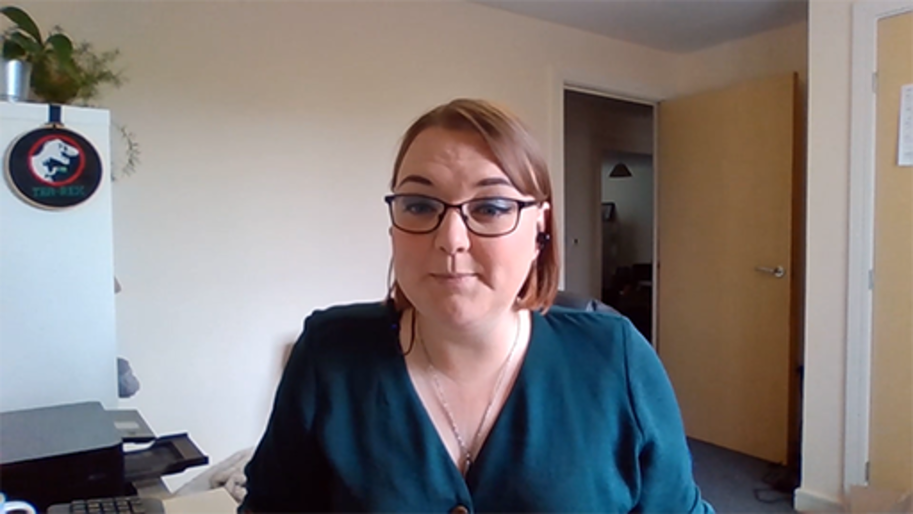

Then read the following article for some practical tips on empathetic leadership: Leadership: How to show empathy to hybrid work teams.
Make some notes on what you find and what questions you could ask when connecting with your team to build empathy. It is a skill that takes practice and working remotely can create barriers that you may not have even thought of but you may have only thought about how productive they are instead of being measured by the visibility of being online.

Provide your answer...

2.7 Developing self-awareness
In this section you will be introduced to a tool for thinking about and developing your levels of self-awareness.
The Johari Window is named after its originators, Joseph Luft and Harrington Ingram. It consists of four areas, shown in Figure 5, and looks like the separate panes of a window.

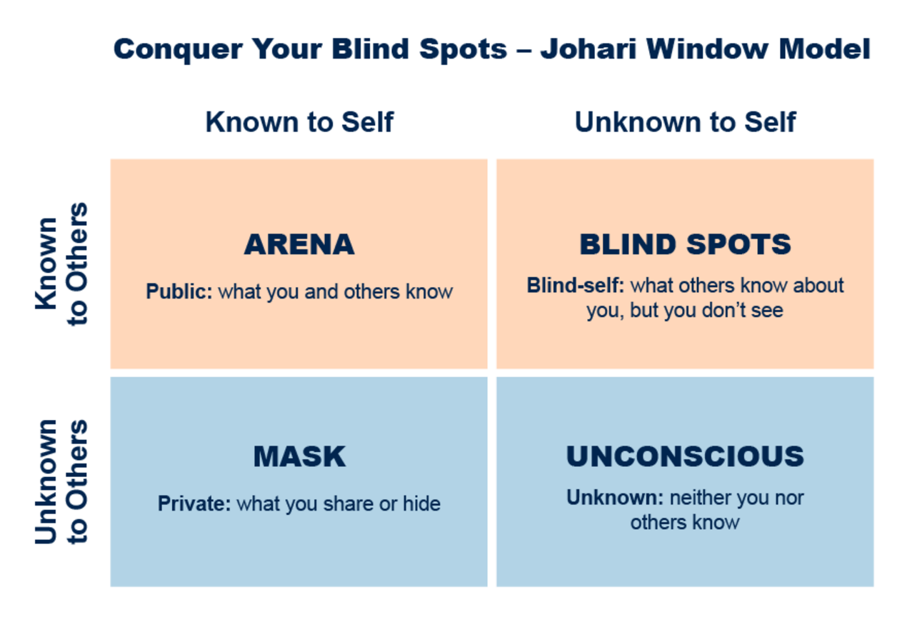
Figure 5 The Johari Window.
View description - Figure 5 The Johari Window.
View alternative description - Figure 5 The Johari Window.

- The open (also known as arena) area covers what you know about yourself. You know about this aspect and are happy to share it with others. An example might be if you are happy to tell someone about the strengths that you bring to your job.
- The blind (also known as blind spots) area covers what other people know about you but of which you are not aware. You might, for instance, be unaware of always using a particular phrase that irritates everyone with whom you come into contact.
- The hidden (also known as masked) area is what you know about yourself but would prefer other people not to know. For example, this could include opinions that you do not want to share with others as well as any weaknesses that you feel you have.
- The final area is unknown both to you and to others. This area is sometimes called unconscious. This might include hidden talents, unconscious feelings, or abilities and qualities that have never been brought to the surface. In other words, it may represent resources that could help your learning. Getting involved in new activities with new groups of people increases the chances of your finding out about these, as yet unknown, resources.

How to use the Johari Window
The purpose of the Johari Window is for individuals to learn more about themselves and how others perceive them. It is a tool that can facilitate conversations about team members’ strengths and blind spots, which will enable the team to work together better. Information is revealed in four ways: self-discovery, self-disclosure, shared discovery and feedback, as shown in Figure 6.
You will also see in Figure 6 that each of the four quadrants is not necessarily equal in size and they will vary depending on:
- how much you share with other people
- how well others (try to) know you
- how well you know yourself

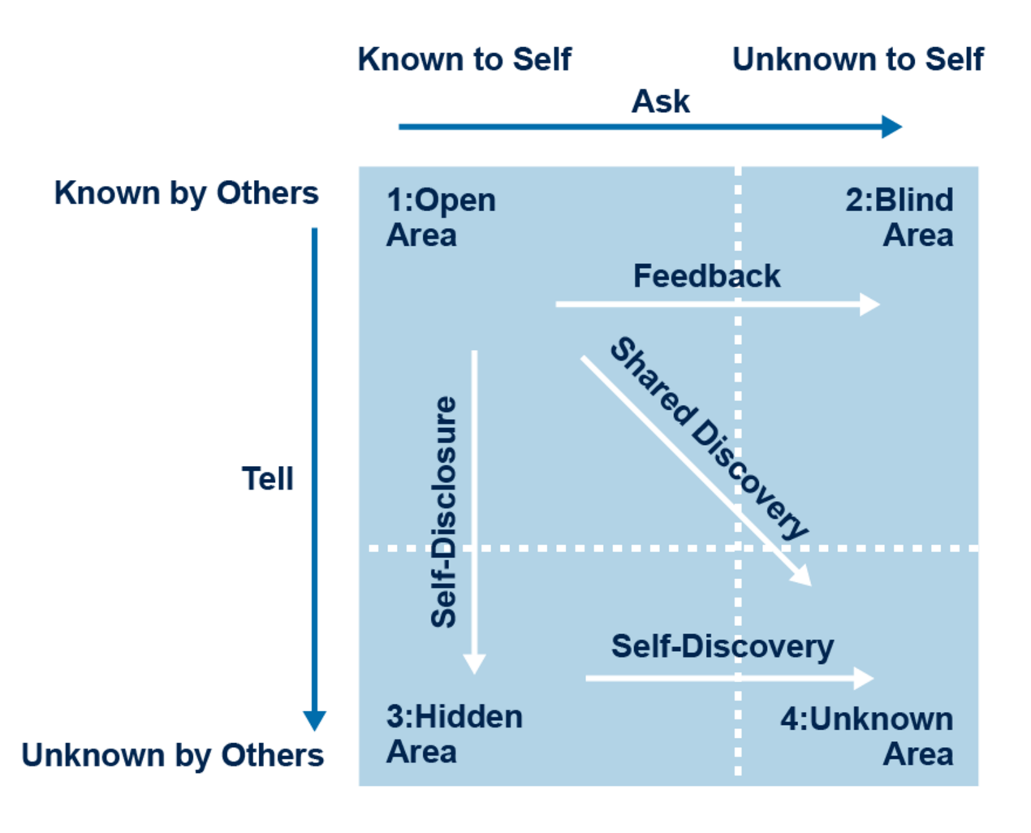
Figure 6 The Johari Window.
View description - Figure 6 The Johari Window.
View alternative description - Figure 6 The Johari Window.

Activity 12 Carry out a self-assessment

Choose the five adjectives from the list below that you feel best describe you. Be objective and honest.

Able | Extroverted | Mature | Self-assertive
Accepting | Friendly | Modest | Self-conscious
Adaptable | Giving | Nervous | Sensible
Bold | Happy | Observant | Sentimental
Brave | Helpful | Organised | Shy
Calm | Idealistic | Patient | Silly
Caring | Independent | Powerful | Smart
Cheerful | Ingenious | Proud | Spontaneous
Clever | Intelligent | Quiet | Sympathetic
Complex | Introverted | Reflective | Tense
Confident | Kind | Relaxed | Trustworthy
Dependable | Knowledgeable | Religious | Warm
Dignified | Logical | Responsive | Wise
Energetic | Loving | Searching | Witty

Next ask a friend or a trusted colleague/team member to evaluate you as well. Ask them to be honest and objective in selecting their five adjectives. You could ask family members, but you might find that they say something completely different, as they are unlikely to have seen you in a work context.
Next compare their list of adjectives with your list.
- Where an adjective appears on both lists, place it in the open area.
- If an adjective appears on your list, but not your friend/colleague’s list, place it in the hidden area.
- When an adjective appears your friend/colleague’s list, but not on your own, put it in the blind area.
- Any remaining adjective that appeared on neither list can go in the unknown area.
Finally reflect on whether there are there any adjectives that you are surprised to see that someone chose to describe you that you hadn’t used.

Provide your answer...
View discussion - Activity 12 Carry out a self-assessment

2.8 Resilience
According to Lucy Hone (TED, 2019), we have all had to deal with some tough times at some point and how we deal with them is through resilience. Psychology Today defines it in the following way:

Resilience is that ineffable quality that allows some people to be knocked down by life and come back stronger than ever. Rather than letting failure overcome them and drain their resolve, they find a way to rise from the ashes.
(PositivePsychology.com, 2022)

Resilience is defined as our ability or tendency to adapt and ‘bounce back’ when things don’t go as planned, and being resilient is having the ability to learn from mistakes and then to grow.
When the COVID-19 pandemic started in March 2020 and people were told to work from home, there were many examples of people bouncing back and even thriving in unfamiliar situations. New businesses were started in fact; according to Jones (2021), the UK saw a 14% increase in new businesses despite the pandemic. People like Bora Kirgiz turned from a disillusioned taxi driver to open up Bona Couple Cafe & Lounge.
The phrase ‘bouncing back’ is an interesting concept as instead of giving up in the face of adversity, we get back up and get on with things. This short video of young children trying to knock a toy down provides a vivid illustration of this: A lesson on resilience.

Activity 13 Strengths of resilient people

Take a few minutes to think about someone you know, or a well-known person, whom you think of as resilient. Consider in what way, or in what type of situation, they are resilient, and what strengths they show.
Which of the following qualities do they demonstrate?
- confidence
- problem-solving
- a positive outlook
- forward thinking
- a good planner
- a good communicator
- comfortable with their emotions
- intelligence.
Which others would you add?

Name of resilient person | Provide your answer...
Characteristics | Provide your answer...

Developing career resilience
Another familiar example of a resilient type of person is an athlete. Watch this short video to see how British gold medal winning sprinter and former gymnast Asha Philip approaches resilience: Asha Philip on resilience.
While we won’t all need to demonstrate this level of resilience in our lives, we can learn some lessons from Asha’s journey. She talks about the importance of having the belief of others, taking things step by step, mental toughness, and seeing change or adversity as an opportunity to learn more about yourself. Those lessons can be applied in many different situations.

Resilience strategies
Everyone has the capacity for resilience and an extreme example is given by Lucy Hone during a TEDx talk: The three secrets of resilience people
In summary, Hone describes how she lost her 12 year old daughter in a car crash, how this caused trauma and disruption in her life, and that the support she received at the time left her feeling powerless and like a victim. She advises that there are three strategies or secrets of resilient people:
- acceptance/acknowledgement of the situation as part of your life
- selectional attention (focus on the things you can change/that are in your sphere of influence and on the positive things)
- control over the situation and being kind to yourself – think ‘is what you are doing helping or harming you?’.

Is resilience in our DNA?
Looking at the specific characteristics that enable some people to be more resilient than others helps us to think about why some people show greater degrees of resilience than others when faced with a similar situation.


Figure 7 The importance of DNA.
View description - Figure 7 The importance of DNA.
View alternative description - Figure 7 The importance of DNA.

But why do individuals develop these characteristics differently? Advances in genetic research over the last ten years have linked various genes to a range of social behaviours. Are genes also linked to our ability to cope with life’s challenges?

Activity 14 In the blood?

Watch the video ‘In the blood’ with Simon Weston. You can read the transcript for the video here.
Weston is a veteran of the British Army who became well known throughout the UK for his charity work after he suffered severe burn injuries during the Falklands War. In the video he visits the Genome Centre in London to meet psychologists Dr Michael Pluess and Dr Aneta Tunariu and to see if he has the resilience gene.
Note down how Weston explains his ability to be resilient.
Did the video have any broader messages for you?

Provide your answer...

While the scientific community is still divided on the genetic component of mental resilience, psychologists have highlighted the importance of training ourselves to be more resilient.

Can you learn to be more resilient?
Psychologists have argued for more than 100 years that early childhood socialisation has a significant impact on the way that individuals relate to others later in life. This socialisation also supports our resilience, through:
- strong and supportive family relationships
- family social networks that extend into the community
- the development of good communication skills
- the ability to show empathy to others
- sociability, i.e. a liking for developing new social relationships.
Of course, our liking for social relationships is also connected to our personality characteristics. Some people are more sociable than others. This will be explored in the next activity.

Activity 15 Sociability and social networks
Allow about 10 minutes

Watch the video Resilience: personality and note how chartered psychologist Professor Ivan Robertson explains how resilience is connected to our ability to develop social relationships.
Consider what his explanation means for you. Can you identify whether your personality type might have a positive impact on your resilience? Or might you need to find other ways to develop it? Make some notes in the box below.

Provide your answer...

You might think that if the personality characteristics that we are born with play such a key part in our resilience, it can’t be learned after all.
However, CEO Genie Joseph, founder of ACT RESILIENT, disagrees. She outlines three types of resilience that she has identified through her work with US military personnel and their families (Joseph, 2012). They are:
- Natural resilience – the resilience you are born with. It protects us and encourages us to play and learn and explore our world.
- Adaptive resilience – which occurs when challenging circumstances cause you to adapt and grow, becoming stronger and more resilient because of what you have encountered.
- Restored resilience – also known as learned resilience. This means you can learn techniques that can restore the natural resilience we had as children.
The implication here is that through adaptive and restored resilience we can certainly learn techniques and build habits that will support us in developing and enhancing our resilience further.
One thing we can certainly do to support our own resilience is build caring and supportive relationships around us.
In the earlier clip Professor Robertson talked of the importance of social support networks, or the ability to develop them, in helping resilience. Simon Weston also talked about the support of his family and friends contributing to his resilience. According to the American Psychological Association (2014), many studies show that the primary factor in personal resilience is having caring and supportive relationships within and outside the family. These relationships create love and trust, provide role models and offer encouragement and reassurance. This helps to bolster a person’s resilience, particularly in times of difficulty.
So, in summary, while personality traits and strong support networks clearly have an influence on how resilient we are, resilience is also a skill that can be learned and developed.
You’ll explore strategies for developing your own resilience later in the course.

Resilience over time
Below is an image which shows a fictional person’s resilience through time and how that can vary. This is an important consideration, as it can help you see that it is normal to feel more or less resilient at different times of your life.

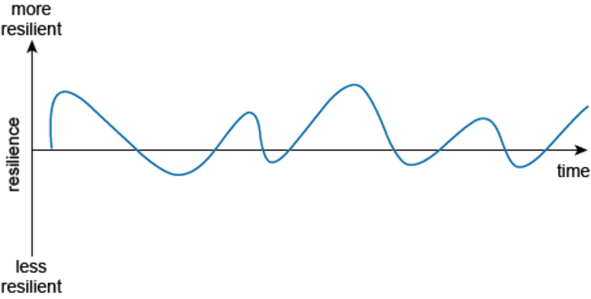
Figure 8 Resilience over time.
View description - Figure 8 Resilience over time.
View alternative description - Figure 8 Resilience over time.

Activity 16 Your resilience timeline
Allow about 25 minutes

If you had to draw an image to represent your own resilience timeline, what would that look like? How has your resilience level been affected by the COVID-19 pandemic – especially the periods of lockdown – or by moving to remote and hybrid working?
Try drawing a timeline like the example shown above to illustrate variations in your personal resilience over time. Use pen and paper or your preferred digital tool.
This might seem like a daunting task at first, so one way to start might be to divide the line into decades of your life. Then you can identify the points at which you have felt most in control of your life, able to meet and deal with challenges. Follow that by thinking about the points in your life where you have felt less resilient, and then join the points to create your resilience timeline.
Use the timeline to reflect on:
- a time when you may have moved from a feeling of helplessness about a situation to a feeling of control and optimism about the future.
- the relationships or circumstances that have made a difference for you – for example, working remotely might have removed you from the support networks you had with work colleagues, or alternatively, it might have introduced you to new support networks and digital tools that you didn’t have before.
- whether there is anything from your past experience that you should reintroduce into your life to enhance your resilience now.

2.9 Reframing your problems

The world we have created is a process of our thinking. It cannot be changed without changing our thinking.
(Albert Einstein)

This quotation serves as a reminder that we have power over our thoughts and that we can change the way we think about problems.
After months of pandemic-related uncertainty, along with shifting working patterns, Maier (2022) writes that ‘it is not surprising to hear from teams … that emotions are running much closer to the surface than usual, made all the more raw due to depleted energy levels’. In uncertain times there is a need to rethink things and gain new perspectives. We have to be aware that people may not have a commute home during which they can ‘decompress’, or that when working from home they can’t just wander around the office to find a friendly face, so there is a danger of carrying out a post-mortem on one’s thoughts and problems, and overthinking things.
Another way of moving forward could be through ‘reframing the problem’ and seeing it from a different perspective; often those new perspectives are more positive and can help you cope better with uncertainty (Jackson, 2020). Sometimes you want to be resilient and bounce back but you might get stuck in a rut making the same mistakes and having the same recurring issues.
A good example of how reframing can happen is by looking at things with a long-term perspective. If you had a small child, aged 5 say, and you could see and appreciate that they were a strong, confident, assertive and independent child, but they did something that you were not happy with, how would you respond? You could reframe your thinking and instead of yelling in the moment, take a step back and think how you would deal with the situation in hindsight by asking yourself ‘When I look back on this moment a year from now, how will I have wanted to respond?’. Not only will imagining that ‘distance’ help calm the situation down, it will also help you react with more empathy.
Now imagine how you would handle a challenging situation as a leader, taking a long-term vision of how you would behave and react. When you are next faced with a difficult or even positive conversation and a problem, think about how you would want to look back on it a year or so from now.

Activity 17 Your experience of reframing a problem

Think of an example where you tackled a problem, either at work or in your life, and consider when you might have turned a problem into an opportunity or where you reframed a problem and came up with an unexpected solution.

Provide your answer...

Reframing strategies
There are a few different ways of reframing that you might encounter and want to experiment with; a few are listed below to get you started.

Strategy | Description | How to foster this mindset
Cognitive reappraisal | Changing the way you think about an emotional stimulus in order to change the emotional impact. For example, if you are invited to attend a job interview, instead of looking at it as being stressful, you could view it as an opportunity to practise interview skills and learn more about the company. | Cognitive appraisal involves looking at the thing that involves pain, becoming aware of it, tolerating it and accepting it.  You can ask yourself questions like:  - How can I accept things I can’t control?  - How can I adapt to this?  - What are some other ways to see this?  By doing this and facing the negative stressor accepting it you will spend less time/energy fighting something you cannot control. This approach also promotes self-awareness
Positive reappraisal | Here you will identify a positive meaning in a negative stressor and focus on the ‘good’. It is often called ‘benefit finding’. For example, during the pandemic you might have looked for the ‘good’ in forced home working by viewing the time saved commuting as an opportunity to spend longer with loved ones, learn a new skill, etc. | Look for the benefits or the ‘silver lining’ and identifying the ‘good’ in the situation. Ask yourself the following:  - What are the positives of this situation?  - What energises me to want to tackle this challenge instead of seeing it as an obstacle?  - What are the strengths I, my team, or the organisation bring to navigating through this?  - How will I look back on my actions one year from now? Five years from now?  Move from problem to opportunity:  - What can I hope to learn?  - How can I benefit from this challenge?  - How can I use this challenge to build something better?
Coping statements for tough situations/moments | You might have found yourself using one of these before, statements include saying ‘this too shall pass’ to yourself or ‘one step at a time, I can handle this’. It is a self-talk statement that can help you see things in a more positive light. | Anchor your thinking to the present moment and create positive reference points. You might want to say:  - I will make it out of this.  - I am doing the best I can.  - Even though things are changing, many things I like are also staying the same.

Cognitive distortion
A negative or unrealistic interpretation of a situation, known as cognitive distortion, comes from biased thinking and is basically our mind convincing us of something that is not true. Cognitive distortions can hijack your brain and your position as a leader. They can set a pattern of negative thinking and convince us that the things we think we hear or see are true when in reality they are just triggering feelings of negativity and pessimism (Naoumidis, 2019).
There are many types of cognitive distortions. Three are described below, but Activity 18 invites you to explore others by reading Naoumidis’ (2022) article ‘Thinking traps’.
- Filtering – You only let through the negative information and then you magnify the details and filter out the positive. You might find yourself doing this if you have had a really positive project with great results but you then start to over-focus on the areas you missed or goals you did not achieve.
- Overgeneralising – Applying something you may have seen or heard in the past and assuming that this pattern will continue. For example, you might say ‘it is always like this’‚ ‘it never works’, ‘working from home will never work’ or ‘people are always chatting and not productive when they’re in the office’ – do you know that this for sure?
- Mind-reading – This one is a really easy habit to get into especially when working away from our team. You might convince yourself that your team are thinking negatively about you or your team might be thinking that you think negatively about them.

Activity 18 Read about the other distortions

Have a look at Naoumidis’ (2022) article ‘Thinking traps’ and identify a time when you have experienced one of these distortions.
What would you do differently if you encountered it again?
Is there any particular cognitive distortion that you find you fall into on a regular basis?

Provide your answer...
View discussion - Activity 18 Read about the other distortions

How can you reframe a distortion or cognitive bias?
- Name and identify the distortion: Next time you find yourself thinking about it get into the habit of calling it out. Like the train drivers in Japan who point and call using the principle of Shisa Kanko, say it out loud to yourself or write it down. Seeing it and calling it out will enable you to create a space to think about the problem in a more positive way.
- Check the facts: Switch your thinking around – before you jump to a negative thought and conclusion, look at the facts and the evidence first.
- Experiment: Test out your negative thoughts to see if it is true.
- Think in shades of grey: Instead of seeing things in black and white and at two extremes of an ‘all or nothing’ try to put it on a scale of 0–100 and see where it lands and look for the partial successes rather than the failures.
The last few years from the pandemic as well as the shift to more hybrid working have been really difficult for leaders and their teams. Using reframing and developing reframing skills can help to get through the tough times and the challenges and ‘bounce back’.

3 Creating an environment for moving from surviving to thriving
There is no doubt about it, hybrid working is here to stay. So how do you – as a leader – help yourself and your teams to not only survive this working situation, but actually start to thrive? In this transition from pre-pandemic practices to post-pandemic ways of working, workers seem to be leaving workplaces that are not supporting them in their droves, as you may have seen with ‘the Great Resignation’. People are far more aware now of their own needs and about looking after their mental health.
What do we mean by thrive?
According to various dictionary definitions, to thrive means to be able to grow and flourish and to actually prosper, making continual progress. Whereas surviving is about doing the basics, the bare minimum, or just what is necessary to live.
Can you recall a time when you felt like this in each of these situations? Have you ever felt stuck in the survival mode? Why do you think that is? Looking back over the pandemic, you may have felt that you were in survival mode, putting one foot in front of the other and just focusing on getting through one day at a time. Transitioning from surviving to thriving for some people is not easy: it can be a real challenge. Just making the decision that you are ready to move from surviving to thriving can feel hard, never mind actually taking the necessary steps. You might find that you keep postponing those steps to another day, even though you feel that you are not really living if you are in survival mode.

Activity 19 Compiling a survive/thrive balance sheet

Reflect on whether you feel you are in a survive or a thrive state right now. You will have to be really honest with yourself.
Try drawing up a table with one column headed ‘surviving’ and the other ‘thriving’ and write down all the actions you take and feelings you have that relate to each column.
Assess your table – is one side longer than the other?
Keep this safe as you will come back to it shortly in a later task.

You might need to change your mindset
It is no wonder that you might feel like you are in survival mode when you are surrounded by constant change and uncertainty, and trying to navigate the hazy landscape of hybrid working for you and your teams. According to Hougaard (2020), shifting from survive to thrive involves a mindset shift, reframing threats as possibilities. Some of the ways to do this are:
- Cultivate self-compassion which is not necessarily about sitting cross-legged, with your eyes shut meditating. It is more about being kinder to yourself, silencing that inner critic and being patient with yourself. Recognising that change is not an instant thing, that it takes time and patience, and that you will make mistakes and learn things as you progress. Take one step at a time.
- Moving from a fixed to a growth mindset and not feeling like you have to accept that you have to survive but that you can thrive. Linked with self-compassion having a fixed mindset means that you feel that things are predetermined and that you see a challenge as a threat. Well, it isn’t always a threat and you have to switch your mind to recognize that failures are not a bad thing and there is learning to be had from those moments – you will need to see they are an opportunity to learn and bounce back.
- Engage your beginners’ mind which is a little bit easier than it sounds. For some we are all beginners in the area of hybrid and working in this unique way for other parts of it are more familiar. If you truly adopt a beginner’s mind you can then start to go back to the beginning, back to basics and it is almost as though you are viewing your role, team and even your business with fresh eyes – as if you know nothing about hybrid working.

Activity 20 Reframe to move from survive to thrive

Using the three reframing possibilities above, revisit your list from the previous activity – your survive/thrive balance sheet – and identify one or two items in the surviving column where the reframing approaches could help you to shift them to the thriving column.

In the next sections of the course you will explore some more frameworks that could be useful to make your organisation an environment where people thrive, such as active listening and how to work better together. You will also explore how you will need to build the foundations of psychological safety and trust in order for people to feel safe to speak up and for them to really thrive.

3.1 Communicating without distraction
Watch the following video: Why active listening is crucial to motivating teams (hrdconnect.com)
Most leadership courses have sections about the importance of communication, but it has never been more important to develop listening and communication skills than in this new world and this new hybrid working world. As Dropbox’s Director of International HR, Laura Ryan, believes‚ we actually give these skills less time than ever before and that ‘being 100% present is actually a rare thing’.
Often the advice given to us about improving our listening and communication skills is about minimising the use of technology, but that is really difficult to do when you are logged into your laptop working from home or away from the office. A survey from Valoir in 2020 revealed that, although productivity has only been impacted by a small amount – the average reduction is 1% – social media is proving to be the biggest distraction when working from home (Valoir, 2020). One-third of Valoir’s survey respondents admitted to spending nearly 2 hours a day on social media. The other respondents felt children were a distraction. Employees compensate for these distractions by logging on earlier and finishing later, working an average 9.75 hour day (Valoir, 2020, p. 5).
It should be noted that those based in the office also suffered distractions from working in an open plan setting. Some employees said they actually got more work done and were less distracted at home, where there were fewer co-worker and boss interruptions (Valoir, 2020, p. 5).

Activity 21 Managing distractions

How distracted are you? Where are you most distracted? Do you keep track of how much time you spend on social media? Do you look at every notification that comes through on your phone or click on the pop-ups on websites?
Take the time to estimate how much time you spend on all these distractions from work and the impact that has on your day. If you don’t already have one, you could download an app that helps with focus by disabling certain functions while you are working.
Write some clear actions that you can take to reduce distractions this week and put them in your calendar to review at the end of the week. Consider how you could share these with your teams.

Don’t bring your meetings to a HALT
HALT – hungry, angry, lonely or tired – is an approach mentioned in Dyer and Shepherd’s (2021) book Remote Work. They recommend meeting leaders to check that participants are not suffering from any of the symptoms of HALT. Indeed, you should regularly check yourself during the day to see whether you are suffering from HALT before a meeting or other work conversation. If so, you might want to invite participants to eat their lunch (offscreen) while listening, or to take a few minutes to come back to the call. Include time in your meetings for personal connection and small talk, or arrange slots outside the meeting if time is critical, to arrange social activities to build connections and not just rely on work-based activities to do that.

Activity 22 Have you ever suffered from HALT?

Think back to when you experienced hunger, anger, loneliness or tiredness before a meeting and the impact it had on the meeting.
You can read about the particular impact hunger has on productivity here: What you eat affects your productivity. Do you recognise this ever happening to you? What actions did you take during a meeting because you were hungry?
You could also investigate the impact another aspect of HALT might have had on your meetings via an online search.

Provide your answer...

3.2 Active listening
According to Cuncic (2022):

Active listening refers to a pattern of listening that keeps you engaged with your conversation partner in a positive way. It is the process of listening attentively while someone else speaks, paraphrasing and reflecting back what is said, and withholding judgment and advice. When you practice active listening, you make the other person feel heard and valued.

Activity 23 How well do you listen?

Have you ever been in a meeting where you can see someone checking their phone, or you feel they are surreptitiously checking their emails? You might even hear whispering conversations and interruptions from other employees. How did that make you feel?
Have you ever been in a really important meeting and you have not listened? Why was that? How would that person feel if they ever found out that you were not fully present? Were there any implications of you not listening fully in that meeting? Did it result in any miscommunications or errors? Or did you ‘get away with it’?
Can you identify any triggers that cause you to stop actively listening and paying attention?

Provide your answer...

How can you be present when listening?
We now have even more ways to communicate than ever. But how do you actively listen? And how do you stay connected? As Dropbox’s Director of International HR, Laura Ryan, says: ‘it’s the big one, it’s the one everyone talks about all the time’ (HRD Connect, 2021) and she does this by really doing her best to listen on calls and shut down other distractions. Switch on ‘do not disturb’ on computers, shut down emails, turn off your phone or even put it in another room – actively listen. As a result, Ryan says it really does help build relationships and solve problems faster with less churn and a happier team. Most importantly, it deepens trust and gives people a sense of value and that you have listened.
When we are present, we are giving our full attention. When we are present we are more grounded and able to give a better response. Being present also sharpens our awareness of what is going on around us. We will ask better questions, understand more and simply be the best version of ourselves (Prince, 2022).
In the video below, contributors share their insights into the importance of effective communication.

Video content is not available in this format.
View transcript - Uncaptioned interactive content

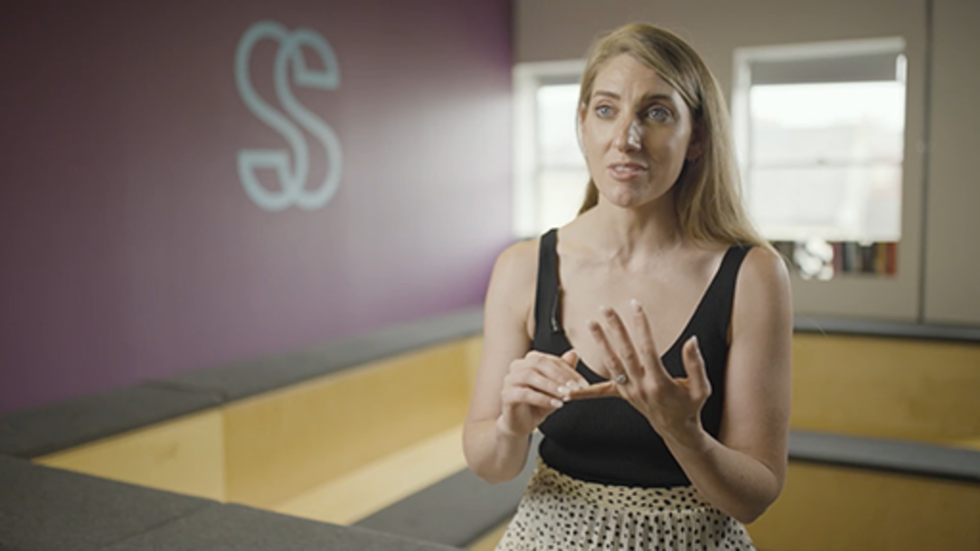

How to apply active listening skills
You don’t have to apply all of the tips below all of the time, but take the time to be mindful of your impact on your team during both in-person and remote calls to show that you are actively listening.
You could take some of the following actions if you are comfortable to do so:
- Pay full attention and give them your undivided attention. So put away your distractions and pay attention to verbal and non-verbal communication cues.
- Show you are listening by making eye contact or reacting to their words. You don’t just have to nod and smile but be authentic in your reactions – asking questions for instance.
- Have empathy and listen to what they have to say – resist the urge to give unsolicited opinions, form solutions in your head or interrupt them. If you want to improve your meetings, consider making them more inclusive for full range of diversity in the team.

Not everyone listens in the same way: hold neuroinclusive meetings
Meetings, and particularly video meetings, can be really tiring and, as Amanda Kirby (2021) writes: ‘Being a facilitator can be a bit like being the conductor of an orchestra all playing different tunes and starting off at different times.’
Calling people in and making eye contact with them is not as easy remotely as it is when you are all in the same physical room, and turn-taking and not knowing when to speak and when to not speak can be difficult. We make judgements that someone is not interested or not listening if their camera is off but to someone who is neurodivergent it can actually be a way of them really giving you their full attention and listening. Just because someone is off camera don’t fall into the trap of assuming they are asleep or doing something else.
There are many tips on holding neuroinclusive meetings in this LinkedIn blog written by Professor Amanda Kirby. She also talks about setting ground rules and ensuring to discuss the length and purpose of the meeting, encouraging people to change names on Zoom links as to how they wish to be addressed, maybe even spelling it phonetically or including gender preferred pronouns.
As a facilitator of meetings you might want to include polls and allow for comments in chat boxes to get ideas from others. It also allows you a chance to minimise conformity bias to give employees space to disagree and for those who might feel uncomfortable not speaking up. You could follow up after meetings by asking if there was any support that would have helped for the meeting.
Another way to enable participants to really listen is to give them a chance to listen again by sharing a recording of the meeting.

3.3 Work better together
The growth of distributed teams, dispersed teams and remote working can be seen as an exciting development, indicating increased internationalisation and flexibility in organisations. The potential of collaborative online teams is nicely demonstrated by the following video which shows a virtual choir of 300 people in 15 different countries. This proves that it is possible to create harmonies and a beautiful product when collaborating in a dispersed team.
‘Bridge Over Troubled Water’, Quarantine Choir Cover

3.4 The need for new collaboration skills
Dhawan and Chamorro-Premuzic (2018) point out several challenges for online communication that can hamper collaboration, including the absence of visible body language leading to misinterpretations. They also point to the fact that many digital ‘discussions’ do not happen in real time, but can involve messages going back and forth over the course of the day (and sometimes the night).
They argue that the challenge of online communication involves three types of distance:

- Physical distance: Individuals in distributed, dispersed or hybrid teams are in different places and may be working in different time zones.
- Operational distance: There may be variation in team size, bandwidth and skill levels between those in different locations.
- Affinity distance: There may be a distance between the values, trust and interdependence of those in different locations.
(Source: Dhawan and Chamorro-Premuzic, 2018)

For successful remote working, Dhawan and Chamorro-Premuzic recommend focusing on reducing affinity distance between team members. Some practical tips to do this include the following:

- In remote communication, try to use video calls rather than emails or voice-only calls.
- Don’t confuse brief communications and clear communications. Do what you can to communicate clearly and unambiguously, even if it takes more time.
- Don’t overload your team with too many messages.
- Establish norms in your team relating to online communication (what communication channels you will use, when you expect a reply to a message and how formal language should be).
- Establish repositories of relevant information that everyone can access.
- Identify opportunities – for instance, an online setting may encourage those more comfortable communicating in writing to express their views and share their ideas.
- Hold virtual team-building activities that give the team opportunities to communicate with each other regularly and put their collaboration skills into practice.
- Create space for celebration (birthdays, product launches, welcoming new joiners and so on). This can strengthen relationships in the team and lay the foundation for future collaboration.
(Source: Dhawan and Chamorro-Premuzic, 2018)

According to James Law, Human Resources Director at Envato: ‘There is always fear that collaboration is based on face-to-face contact but it turns out it is not! People can work on things together asynchronously and be just as effective!’ (Remote.co, no date).
Online collaboration has challenges, but with effort from you as a hybrid leader, it can be made effective. You can ensure that your distributed, dispersed or hybrid team meets together online as often as they would if they were all in the same office (Sutherland and Janene-Nelson, 2020). Your job is to build a culture of trust and collaboration that works as well online as it would for a team working face to face.

Activity 24 Metaphorical sailboat

In this task you will try a reflective tool to think about how you collaborate with your hybrid teams.
- Make a drawing of a sailing boat on the sea using paper, a whiteboard or a relevant digital tool. The boat should be heading towards an island. There should be wind in the sails, an anchor, and rocks between the boat and the island. See the image below for an idea of the kind of drawing expected.
- Reflect on your experience of collaboration with a distributed, dispersed or hybrid team now or in the past. If you don’t have experience of working in this kind of team, imagine the sort of issues that might arise.
- Using sticky notes if you have drawn the boat on paper, or using text on a digital image, add labels to the diagram as follows:
  - Sailing boat: Here add labels to show who is ‘in your boat’ – that is, who is in your team.
  - Island: What is your team’s goal?
  - Wind: What factors are helping the sailing boat move towards the island (particularly in the area of online collaboration)?
  - Anchor: What is holding the sailing boat back?
  - Rocks: What future risks may prevent you from reaching the island?

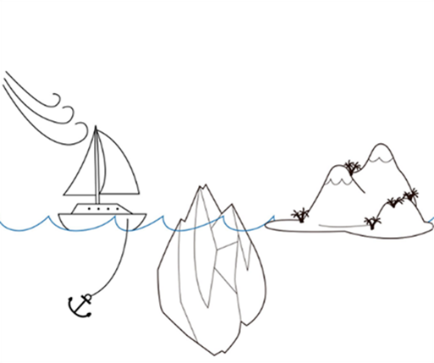
Figure 9 Sailing boat diagram.
View description - Figure 9 Sailing boat diagram.
View alternative description - Figure 9 Sailing boat diagram.

3.5 How to lead collaborative teams
Up to this point, you have explored how well you currently collaborate and the conditions needed for collaboration. In this section, you will focus more closely on ways to support collaboration in your team as a leader.
When thinking about team collaboration and performance, it is useful to consider a sports team, say in football or basketball. Imagine the team working together to set things up so that one of their players can score. What led to the player scoring? How did they know where to be and what do to? The talent of the player who scores is important. But for that player to be in a position to score, the team had to have a shared vision that was understood by all, a collective strategy and trust in each other (Boitnott, 2015).
The following tips from McCarthy (2020) consolidate many of the key ideas covered in previous sections. To foster collaboration in your team:

- let go of being the person who has all the answers – allow others to have input
- actively listen to your team and make sure that you ask the right questions
- work alongside your team to find out what they need – avoid a top-down approach
- focus on building personal relationships across the team
- establish trust in your leadership – lead by example; be honest, particularly about your mistakes, and stick to your commitments, treating colleagues equally and recognising achievements
- embrace diversity in the team
- learn to resolve conflict – conflicts should be expected to arise when a team is collaborating, as you are bringing together different ideas and perspectives to reach the best solutions; develop your mediation skills and ability to create compromise with empathy – your role here is crucial
- learn how to make consensus decisions – make sure you get buy-in from your team for each decision, helping them work together towards the same goal.
(McCarthy, 2020)

Ossawa (2019) shares further practical examples of how you, as a hybrid leader, can support team collaboration. These centre on building team trust and improving communication. Ideas include:

- Create shared understanding: You need to create a clear common language. Use simple, unambiguous language in your communications. Work as a team to create formalised task descriptions and ensure that they are understood by all – for example, have team members summarise their understanding of what their task involves before they start it.
- Involve team members in discussions: Everyone in the team needs to have a voice, not just those who tend to be more vocal. Encourage everyone to contribute ideas. Good ideas can come from anywhere in the organisation, and that includes across all team members.
- Keep team members up to date on the wider goals and mission: Involve team members and keep them informed about the overall mission and process, giving them an understanding, for example, of stakeholders’ interests or of organisational goals. Don’t have team members working on tasks with no idea of where their work fits into the bigger picture.
- Don’t micromanage: Learn to let go. Allow team members space to work as a team and trust them to do their work.
- Celebrate wins and share mistakes: Make sure you celebrate successes in the team. At the same time, be transparent about what is going well and what needs improvement. This will build trust in the team. Create safety for team members to share information about mistakes.
(Ossawa, 2019)

This last point is crucial. Collaboration depends on team members feeling comfortable sharing information about mistakes and things that are going wrong.
An illustration of where this did not happen is the case of United Airlines Flight 173 which crashed in 1979. The crash appears to have occurred partly, it seems, due to issues with a top-down management style. While deliberating over a relatively minor issue with the plane, more junior crew members felt unable to tell the captain about a fatal issue he was overlooking – namely that the plane was running out of fuel (Rogers, 2020).
To collaborate, your team needs to feel safe sharing their concerns before the issues they have identified become catastrophic.

3.6 Building trust
If you don’t trust your employees or your team – if you find you are asking yourself ‘how do I know whether they are working?’ – then this suggests that you are not in the right frame of mind to succeed with hybrid working in your organisation. As we’ve already mentioned, new ways of working require new ways of leading. Arguably the most important step in this is to build trust.
Two parts of the concept of trust have been identified:

- Cognitive trust: This is how confident someone feels about another person’s ability or reliability, often using relatively objective criteria to judge their ability, such as performance measures, awards or qualifications. This has been described as a ‘dispassionate type of trust’.
- Affective trust: This is how secure someone feels about their relationship with another person, and their feelings about whether the other person seems ethical, trustworthy and has integrity. This is trust driven by emotional and relational factors.
(Investors in People, no date)

Earning trust from your team

To earn trust, money and power aren’t enough; you have to show some concern for others. You can’t buy trust in the supermarket.
(His Holiness the Dalai Lama)

But ‘employees need to earn my trust’ – right? Wrong – this is a really old-fashioned attitude, and actually quite a lot of the time we give trust to people who have not earned it. According to Armstrong (2019): ‘When we believe that people must earn our trust, we begin putting in padlocks that only we have the keys to, all the while hoping that others will open their doors to us’.
Jurgen Appelo (2011) points out that trust operates in two directions. You can choose to trust someone, and they can choose to trust you – but this might not happen at the same time.
There may be times that you trust your team, but they may not have trust in you as a leader. You cannot assume the team will trust you – trust has to be earned as a leader. When this is lacking, this can cause issues for the team.
Appelo (2011) argues that as a leader, you need to be consistent in your behaviour to build trust. Be ‘predictably pleasant’ to team members to help establish affective trust. Similarly, you can ‘build trust simply by doing what you have committed to do’. The main habit you need to develop as a leader is keeping your commitments. So, if you have promised to give responsibilities to other team members, do not interfere or start micromanaging. If you promise to help a colleague or send them some information, remember to do this.
Keeping your commitments can help you earn trust, but remember also that trust is easily destroyed if you do not do what you say you will do.

Building blocks of trust
Jaffe (2018) outlines some of the ways to build trust:
- Reliability and dependability
- Transparency
- Competency
- Sincerity, authenticity and congruency
- Fairness
- Openness and vulnerability
Trust is a natural response to certain qualities in a person and if those are absent then trust can disappear.

Achieving a culture of trust
To build a culture of trust in a workplace where fear is widespread is difficult. Even suggesting change may lead to defensiveness. As a leader, however, you may have to step out of your comfort zone to build trust in the team. Ryan (2018) offers some suggestions on how to do this:
- Talk with your team about the culture of the organisation. Discuss where there is fear and where there is trust, and how to improve things. If there is fear and a lack of trust in the culture, it may take time for team members to feel safe expressing their views. You need to support that safety.
- Avoid a blame culture – as you have seen many times, psychological safety and a willingness to admit mistakes are crucial for successful agile teams. As part of this, admit both your own mistakes and mistakes made in other parts of the organisation that are relevant to your team.
- Review employee handbooks and policies – are these rules that shape the culture likely to instil fear or trust? Think about what you can do to change this.
- Try to create opportunities for meetings between senior leadership and those working on the front line. Trust will be improved if those at all levels get to know each other better as people.
- Show that you value your team members as people in your interactions with them.
- Check in with team members regularly and respond to their feedback.
- Avoid jargon when communicating with your team – communicate with them straightforwardly.
- Be honest with your team in communicating what is going on in the wider organisation, in terms of plans, priorities and challenges.
In the next video, contributors talk about the importance of building trust, and approaches that can be taken to achieve it.

Video content is not available in this format.
View transcript - Uncaptioned interactive content

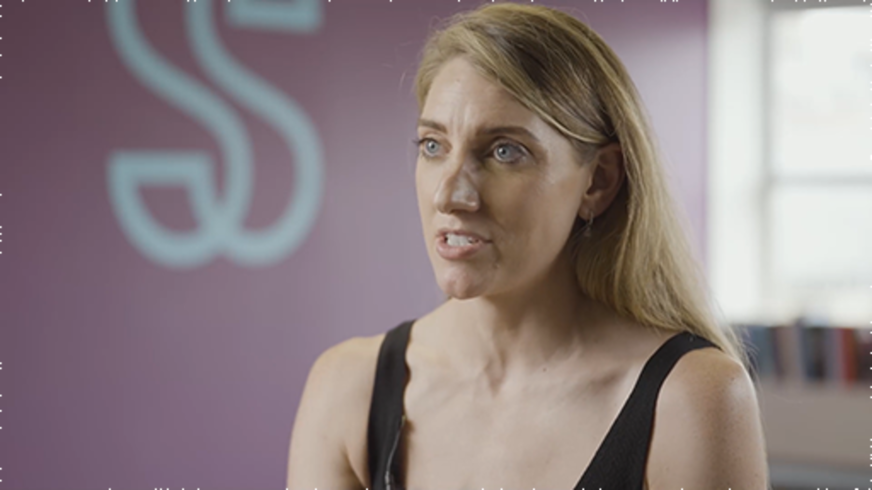

Conclusion
In this course you have spent time thinking about who you are as a hybrid leader and what you would like to see happening in your organisation in the future in order to fully embrace the hybrid way of working. You have also explored what needs to be created or developed in terms of the environment and conditions in order for your employees to feel that they can bring their best self to work and enabling them to thrive in this new way of working.
You should now be able to:
- explain a few definitions of hybrid working and identify the steps needed to create a shared understanding of this term within your working environment
- analyse the effect hybrid working has on productivity and describe the ideal hybrid working environment
- compare traditional definitions of culture, articulate how these differ from hybrid culture and identify ways that a mixed culture can be grown and developed
- complete a self-reflection and identify how to become self-aware in the role as a hybrid leader in the new post-pandemic hybrid world, including how to be more resilient and become an active listener
- explain what is meant by accountability and appreciate how to create accountability in a hybrid world
- analyse the importance of empathy as a hybrid leader and distinguish it from sympathy.
What next?
Use the frameworks and techniques introduced throughout the course that are appropriate to your context to work with your teams and develop yourself as a hybrid leader, and/or share them with other hybrid leaders in your organisation.
You will find that taking the time to regularly step back and reflect on your own practices and approaches as a hybrid leader will help you reframe your current mindset and recognise where you could adopt a growth mindset that could help with any challenges ahead.
You might also like to look at platforms like LinkedIn to keep up to date with the current thoughts on hybrid working, or explore other OpenLearn courses on various aspects of professional development.
This course is part of the Supporting hybrid working and digital transformation collection, which you may wish to explore further.

References
American Psychological Association (2014) The road to resilience. Available at: https://advising.unc.edu/wp-content/uploads/sites/341/2020/07/The-Road-to-Resiliency.pdf (Accessed: 28 July 2022).
Anderson, R.J. and Adams, W.A. (2019) Scaling leadership: building organizational capability and capacity to create outcomes that matter most. Hoboken, NJ: John Wiley & Sons.
Appelo, J. (2011) Management 3.0: Leading agile developers, developing agile leaders, Indiana: Addison-Wesley.
Armstrong, C. (2019) ‘The idea that “trust is earned” is a myth’, LinkedIn. Available at: https://www.linkedin.com/pulse/idea-trust-earned-myth-chris-armstrong-cde-acc-cmf (Accessed: 16 July 2022).
Boitnott, J. (2015) ‘Use these great examples of sports teamwork to grow your business’, Inc., 7 July. Available at: https://www.inc.com/john-boitnott/business-lessons-from-the-most-amazing-sports-teamwork-moments.html (Accessed: 28 July 2022).
Bove, L.L. (2019) ‘Empathy for service: benefits, unintended consequences, and future research agenda’, Journal of Services Marketing, 33(1), pp. 31–43. Available at: https://doi.org/10.1108/JSM-10-2018-0289 (Accessed: 26 July 2022).
Business Solver (2021) 2021 State of workplace empathy. Available at: https://resources.businessolver.com/c/2021-empathy-exec-summ?x=OE03jO (Accessed: 6 July 2022).
Choudhury, P. (2022) ‘How “digital nomad” visas can boost local economies’, Harvard Business Review. Available at: https://hbr.org/2022/05/how-digital-nomad-visas-can-boost-local-economies (Accessed: 6 July 2022).
Choudhury, P. and Salomon, E. (2020) GitLab and the future of all-remote work. Available at: https://hbsp.harvard.edu/product/620066-PDF-ENG?Ntt=Gitlab (Accessed: 6 July 2022).
CIPD (2020) Organisational culture and cultural change. Available at: https://www.cipd.co.uk/knowledge/culture/working-environment/organisation-culture-change-factsheet#64826 (Accessed: 6 July 2022).
Coldewey, D. (2022) ‘Airbnb commits to fully remote workplace: “Live and work anywhere”’, Techcrunch. Available at: https://techcrunch.com/2022/04/28/airbnb-commits-to-fully-remote-workplace-live-and-work-anywhere/ (Accessed: 6 July 2022).
Cooks-Campbell, A. (2022) ‘The new hybrid culture you need and how to build it’, BetterUp. Available at: https://www.betterup.com/blog/hybrid-culture (Accessed: 6 July 2022).
Cooperrider, D. (2021) Prospective theory: appreciative inquiry: toward a methodology for understanding and enhancing organizational innovation. s.l.: NRD Publishing.
Cooperrider, D.L. and Whitney, D.A. (1999) Appreciative inquiry: a positive revolution in change, Oakland: Berrett-Koehler Communications.
Covey, S. (1989) Seven habits of highly effective people, New York: Simon and Schuster.
Cuncic, A. (2022) ‘What is active listening?’, Verywell mind. Available at: https://www.verywellmind.com/what-is-active-listening-3024343 (Accessed: 7 July 2022).
Dhawan, E. and Chamorro-Premuzic, T. (2018) ‘How to collaborate effectively if your team is remote’, Harvard Business Review. Available at: https://hbr.org/2018/02/how-to-collaborate-effectively-if-your-team-is-remote (Accessed: 7 July 2022).
Dimensional Research (2021) Entering the era of hybrid working: understanding how the workplace must evolve. Available at: https://www.webex.com/content/dam/wbx/us/gated/analyst-report/dimensional-research-entering-the-era-of-hybrid-work-cm-2220.pdf (Accessed: 16 July 2022).
Dyer, C. and Shepherd, K. (2021) Remote work: redesign processes, practices and strategies to engage a remote workforce, London: Kogan Page.
Economist, The (2014) ‘Decluttering the company’, The Economist, 2 August. Available at: https://www.economist.com/business/2014/08/02/decluttering-the-company (Accessed: 28 July 2022).
Friedman, R. (2014) ‘What you eat affects your productivity’, Harvard Business Review. Available at: https://hbr.org/2014/10/what-you-eat-affects-your-productivity (Accessed: 6 July 2022).
FT (2020) ‘Does working from home make us more or less creative?’. Available at: https://www.ft.com/content/2519a4c0-a8f1-4ff9-a1f8-4454306eaa7a (Accessed: 6 July 2022).
Gartner (2020) ‘Gartner survey reveals 82% of company leaders plan to allow employees to work remotely some of the time’. Available at: https://www.gartner.com/en/newsroom/press-releases/2020-07-14-gartner-survey-reveals-82-percent-of-company-leaders-plan-to-allow-employees-to-work-remotely-some-of-the-time (Accessed: 14 July 2022).
GoodTherapy (2018) How are you feeling? Take a minute to HALT for your health. Available at: https://www.goodtherapy.org/blog/how-are-you-feeling-take-minute-halt-for-your-health-0515184 (Accessed: 6 July 2022).
Graham, J.T. (2022) ‘Hybrid working is the new workplace normal’, Sage HR Blog, 9 May. Available at: https://blog.sage.hr/hybrid-working-the-new-workplace-normal-hr-workforce/ (Accessed: 16 July 2022).
Gratton, L. (2021) ‘How to do hybrid right’, Harvard Business Review. Available at: https://hbr.org/2021/05/how-to-do-hybrid-right (Accessed: 6 July 2022).
Gratton, L. (2022) Redesigning work – How to transform your organisation and make hybrid work for everyone, Penguin Books Ltd.
Guardian, The (2014) ‘The coffice: the future of work?’. Available at: https://www.theguardian.com/money/shortcuts/2014/jan/05/coffice-future-of-work (Accessed: 6 July 2022).
Hancock, B., Schaninger, B. and Weddle, B. (2021) Culture in the hybrid workplace. Available at: https://www.mckinsey.com/business-functions/people-and-organizational-performance/our-insights/culture-in-the-hybrid-workplace (Accessed: 7 July 2022).
Hickey, S. and Osbourne, H. (2022) ‘Blue-sky thinking: new rules allow digital nomads to work in the sun’, The Guardian. Available at: https://www.theguardian.com/money/2022/mar/14/blue-sky-thinking-new-rules-allow-digital-nomads-to-work-in-the-sun (Accessed: 7 July 2022).
Hope, A. (2021) ‘Losing our sense of control during the pandemic’, CNN Health . Available at: https://edition.cnn.com/2021/03/03/health/losing-control-pandemic-wellness/index.html (Accessed: 6 July 2022).
Hougaard, R. (2020) ‘From Survive To Thrive: 3 Mindset Shifts That Matter’, Forbes. Available at: https://www.forbes.com/sites/rasmushougaard/2020/06/01/from-survive-to-thrive-3-mindset-shifts-that-matter/?sh=3937d5151f7a (Accessed: 11 August 2022).
HRD (2017) ‘Leadership accountability is a “critical” business issue, research says’, HRD. Available at: https://www.hcamag.com/asia/news/general/leadership-accountability-is-a-critical-business-issue-research-says/149496 (Accessed: 16 July 2022).
HRD Connect (2021) Why active listening is crucial to motivating teams. Available at: https://www.hrdconnect.com/2021/11/11/watch-enabling-highly-productive-teams-in-hybrid-working-2/ (Accessed: 6 July 2022).
Investors in People (no date) Leadership skills: the two types of trust and why you need both. Available at: https://www.investorsinpeople.com/knowledge/leadership-skills-trust/ (Accessed: 7 July 2022).
Jackson, T. (2020) Reframing: coping strategies for resilient leaders. Available at https://medium.com/@jacksonlead/reframing-coping-strategies-for-resilient-leaders-eed62b2ce3c6 (Accessed: 7 July 2022).
Jaffe, D. (2018) ‘The essential importance of trust: how to build it or restore it’, Forbes. Available at: https://www.forbes.com/sites/dennisjaffe/2018/12/05/the-essential-importance-of-trust-how-to-build-it-or-restore-it/?sh=727fa9ad64fe (Accessed: 7 July 2022).
Janene-Nelson, K. and Sutherland, L. (2020) Work together anywhere: a handbook on working remotely, successfully, for individuals, teams, and managers, Wiley.
Jones, M. (2021) ‘Number of new businesses in the UK increases by 14% despite impact of pandemic – outpacing global average’, UHY Hacker Young website. Available at: https://www.uhy-uk.com/insights/number-new-businesses-uk-increases-14-despite-impact-pandemic-outpacing-global-average (Accessed: 16 July 2022).
Joseph, G. (2012) ‘The three types of resilience’, Act Resilient Blog, 28 August. Available at http://www.act-resilient.org/Site/Blog/Entries/2012/8/28_The_Three_Types_of_Resilience.html (Accessed: 28 July 2022).
Knell, L. and O’Mara, S. (2017) Changing mindsets in organisations, one brain at a time. Available at: https://iedp.cld.bz/ Developing-Leaders-issue-26-Spring-20171/ 10. (Accessed: 17 July 2022).
Krznaric, R. (2015) Empathy: why it natters, and how to get it, London: Rider.
Kuntz, J.C. (2020) ‘Resilience in times of global pandemic: steering recovery and thriving trajectories’, International Association of Applied Psychology. Available at: https://iaap-journals.onlinelibrary.wiley.com/doi/full/10.1111/apps.12296 (Accessed: 28 July 2022).
Maier (2022) Johari’s Window; stepping into the unknown. Available at: https://www.maier.co.uk/insights/week-14-joharis-window-stepping-into-the-unknown/ (Accessed: 7 July 2022).
McCarthy, D. (2020) Learn how to be a collaborative leader. Available at: https://www.thebalancecareers.com/how-to-be-a-collaborative-leader-2275830 (Accessed: 28 July 2022).
McGrath, S.K. and Whitty, S.J. (2018) ‘Accountability and responsibility defined’, International Journal of Managing Projects in Business, 11(3), pp. 687–707.
Naoumidis, A. (2019) ‘Thinking traps: 12 cognitive distortions that are hijacking your brain’, Mindset Health. Available at: https://www.mindsethealth.com/matter/thinking-traps-cognitive-distortions (Accessed: 6 July 2022).
Newton, C. (2022) Circles of control. Available at: https://www.clairenewton.co.za/my-articles/circles-of-control.html (Accessed: 6 July 2022).
Ossawa, E. (2019) ‘How to build trust and improve communication within agile teams’, DZone. Available at: https://dzone.com/articles/how-to-build-trust-and-improve-communication-withi (Accessed: 28 July 2022).
Pechan, C. (2021) ‘Accountability in leadership’, Betterworks. Available at: https://www.betterworks.com/magazine/accountability-in-leadership/ (Accessed: 16 July 2022).
Prince, E.S. (2022) ‘How hybrid working has transformed our listening skills’, TrainingZone. Available at: https://www.trainingzone.co.uk/deliver/training/how-hybrid-working-has-transformed-our-listening-skills (Accessed: 15 July 2022).
Richards, D. (2018) ‘You can control, and you can lead, but you can’t do both’, Forbes. Available at: https://www.forbes.com/sites/forbescoachescouncil/2018/07/25/you-can-control-and-you-can-lead-but-you-cant-do-both/?sh=7b12d16c5697 (Accessed: 7 July 2022).
Rogers, P. (2020) A tale of two teams in crisis: different leadership styles, different outcomes. Available at: https://medium.com/agile-outside-the-box/a-tale-of-two-teams-in-crisis-different-leadership-styles-different-outcomes-1fabaa61a319 (Accessed: 28 July 2022).
Roosen, C. (2020) ‘How the ritual of pointing and calling Shisa Kanko embeds us in the world’, Christopher Roosen Adventures in a Designed World, April. Available at: https://www.christopherroosen.com/blog/2020/4/20/how-the-ritual-of-pointing-and-calling-shisa-kanko-embeds-us-in-the-world (Accessed: 6 July 2022).
Ryan, L. (2018) ‘Ten ways to build trust on your team’, Forbes. Available at: https://www.forbes.com/sites/lizryan/2018/03/17/ten-ways-to-build-trust-on-your-team/?sh=73655e0a2445 (Accessed: 28 July 2022).
Schein, E. (1992) Organizational culture and leadership, San Francisco: Jossey-Bass.
Spaces (2021) Can your surroundings make you more creative?. Available at: https://www.spacesworks.com/can-your-surroundings-make-you-more-creative/ (Accessed: 6 July 2022).
Spadafora, A. (2022) ‘The vast majority of companies still don’t have a hybrid work strategy’, TechRadar. Available at: https://www.techradar.com/news/the-vast-majority-of-companies-still-dont-have-a-hybrid-work-strategy (Accessed: 6 July 2022).
Stanier, J., Li, M. and Anderson, J. (2022) ‘What great hybrid cultures do differently’, Harvard Business Review. Available at: https://hbr.org/2022/03/what-great-hybrid-cultures-do-differently (Accessed: 6 July 2022).
Stavros, J.M. and Torres, C. (2018) Conversations worth having: using appreciative inquiry to fuel productive and meaningful engagement. San Francisco, CA: Berrett-Koehler Publishers.
strategy& (2018) Where organizational culture is headed: views from 2,000 leaders and employees worldwide. Available at: https://www.strategyand.pwc.com/gx/en/insights/global-culture-survey.html (Accessed: 7 July 2022).
TED (2019) The three secrets of resilient people, 25 September. Available at: https://www.youtube.com/watch?v=NWH8N-BvhAw (Accessed: 13 July 2022).
Udoagwu, K. (2021) ‘How to keep team morale high during difficult times’, Wrike. Available at: https://www.wrike.com/blog/keep-team-morale-high-difficult-times/ (Accessed: 6 July 2022).
Valoir (2020) The Real Productivity Impact of Remote Work: A Valoir Report. Available at: https://static1.squarespace.com/static/5db8a4995630c6238cbb4c26/t/5ecc114b250a6a0b1ab056e7/1590432078145/Valoir+Report+-+The+real+productivity+impact+of+remote+work.pdf (Accessed: 6 July 2022).
Vanderheyden, K. and De Stobbeleir, K. (2022) ‘Seven ways leaders can develop their hybrid skills’, People Management. Available at: https://www.peoplemanagement.co.uk/article/1756509/seven-ways-leaders-develop-hybrid-skills (Accessed: 27 June 2022).
Vollebregt, M. (2021) ‘The first step towards working better together right now: understanding organizational culture’. Available at: https://marcvollebregt.medium.com/the-first-step-towards-working-better-together-right-now-understanding-organizational-culture-ce2e15120f30 (Accessed: 6 July 2022).
Waters, S. (2022) ‘Understanding the difference between sympathy and empathy’, BetterUp. Available at: https://www.betterup.com/blog/empathy-vs-sympathy (Accessed: 6 July 2022).
Yarritu, I., Matute, H. and Vadillo, M.A. (2014) ‘Illusion of control: the role of personal involvement’, Exp Psychol, 61(1), pp. 38–47.

Acknowledgements
This free course was written by Becky May with support from Beccy Dresden and Esther Spring.
Except for third party materials and otherwise stated (see terms and conditions), this content is made available under a Creative Commons Attribution-NonCommercial-ShareAlike 4.0 Licence.
The material acknowledged below is Proprietary and used under licence (not subject to Creative Commons Licence). Grateful acknowledgement is made to the following sources for permission to reproduce material in this free course:

Images
Course image: Andrew Kearton; Alamy Stock Photo
Figure 1: from: Gartner Survey Reveals 82% of Company Leaders Plan to Allow Employees to Work Remotely Some of the Time © Gartner.com
Figure 2: from Introducing Organisation Behaviour and Management, Knights, D. and Willmot, H., © 2007, Thomson Learning.
Figure 3: from ‘Continuous Improvement Featured Goal Setting Self-Improvement’; James Clear.
Figure 4: from ‘Circles of Control’; Claire Newton
Figures 5 and 6: from: The Johari Window Exercise - Increase self-awareness and team awareness; Gustavo Razzetti; April 2019; Fearless Culture
Figure 7: ktsimage; Getty Images
Figure 8: The Open University
Figure 9: adapted from Valente, J. (2020) ‘How to conduct the Sailboat retrospective.’
Every effort has been made to contact copyright owners. If any have been inadvertently overlooked, the publishers will be pleased to make the necessary arrangements at the first opportunity.
Don't miss out
If reading this text has inspired you to learn more, you may be interested in joining the millions of people who discover our free learning resources and qualifications by visiting The Open University – www.open.edu/openlearn/free-courses.

Solutions

Activity 1 Hybrid working in 2022

Discussion
This video was originally posted in December 2021. How accurate have its predictions proved to be in your organisation – or to your sector more widely?
Back to - Activity 1 Hybrid working in 2022

Activity 6 Record your ABCs

Answer
The activating trigger in this scenario is the broadband going down.
Your beliefs might have included thinking that it looked like you were not working or were slacking off, because joining a meeting on time is important to you. You might believe that being late for or even missing the meeting would damage your reputation and affect performance review conversations.
As a consequence, you might have started to panic and hit the keyboard, frantically tried to log on via your mobile phone instead, and eventually phoned the broadband provider and shouted at them.
Back to - Activity 6 Record your ABCs

Activity 8 Reflecting on blame

Discussion
Have you ever thought you asked someone to do something and actually it turned out that nobody did it because it wasn’t clear who was to do it – was it everybody? Somebody? Anybody? And then it turned out to be nobody?
Back to - Activity 8 Reflecting on blame

Activity 12 Carry out a self-assessment

Discussion
None of these areas is fixed. We can increase the size of the open area by asking other people to tell us what they know about us – in other words, by asking them for feedback. We can also increase this area by revealing hidden aspects of ourselves to other people. We can reduce the size of the unknown area by looking into ourselves (self-discovery) or by finding out about ourselves with the help of others (shared discovery).
If you’ve used the Johari Window before, do you think the pandemic and/or hybrid working has affected the adjectives you or your friend/colleague chose?
Back to - Activity 12 Carry out a self-assessment

Activity 18 Read about the other distortions

Discussion
Avoiding cognitive distortion is a skill that requires practice. It involves identifying unrealistic negative interpretations of an event and replacing them with a more realistic mindset.
Back to - Activity 18 Read about the other distortions

Figure 1 Percentage of company leaders planing to continue to offer remote working post-COVID-19.

Description
Horizontal bar chart headed Percent Selecting; Multiple Responses Allowed. Starting at the top and working downwards, the bars and percentages are as follows; Let employees work remote some of the time, 82%; Let employees work remote all of the time, 47%; Flex days, 43%; Flex hours, 42%; Shortened work weeks (4-10s), 15%; Other, 5%; None of the above, 6%. The horizontal axis at the bottom of the chart has 0%, 50% and 100% marked on the scale.
Back to - Figure 1 Percentage of company leaders planing to continue to offer remote working post-COVID-19.

Figure 2 Schein’s iceberg model of culture.

Description
The diagram shows an iceberg at sea with the sea level only allowing a small amount of the iceberg to be visible above water. Three levels are noted: Above water and fully visible: Artefacts – Tangible manifestations of culture. At water level so partly visible: Values – Ethical statements of rightness. Below the water line and so invisible or unseen: Basic assumptions – Unconscious and taken for granted ways of seeing the world.
Back to - Figure 2 Schein’s iceberg model of culture.

Figure 3 The power of tiny gains.

Description
Figure is headed The Power of Tiny Gains. Below that are two statements with calculations beside them: 1% better every day 1.01 to the power of 365 = 37.78, highlighted in green; 1% worse every day 0.99 to the power of 365 = 0.03, highlighted in red. Below that is a graph with Improvement or Decline on the vertical axis and 1 Year marked at the right-hand side of the horizontal axis. Partway up the vertical axis, 1 is marked, with a dotted line marked horizontally. One arrow curves quite steeply upwards from the 1 to the top right of the chart; another arrow curves down just below the dotted line to the bottom right of the chart.
Back to - Figure 3 The power of tiny gains.

Figure 4 Circles of control.

Description
Image show three concentric circles. Outer circle is dark blue, labelled Circle of Concern. Middle circle is lighter blue labelled Circle of Influence. Inner circle is orange, labelled Circle of Control. Outside the circles, at the top left of the figure, are the words No concern.
Back to - Figure 4 Circles of control.

Figure 5 The Johari Window.

Description
Figure is headed Conquer Your Blind Spots –Johari Window model. There are four panels arranged in a two-by-two rectangle that resembles a window pane. The first panel – on the top left – is labelled ARENA, with Public: what you and others know written beneath that, and Known to Others written vertically on the left-hand side of the pane; above the pane is written Known to Self. The second panel – on the top right – is labelled BLIND SPOTS, with Blind-self: what others about you, but you don’t see written beneath that; above the pane is written Unknown to Self. The third panel – on the bottom left – is labelled MASK, with Private: what you share or hide written beneath that, and Unknown to Others written vertically on the left-hand side of the pane. The fourth panel – on the bottom right – is labelled UNCONSCIOUS, with Unknown: neither you nor others know written beneath that
Back to - Figure 5 The Johari Window.

Figure 6 The Johari Window.

Description
A worked example of a Johari window diagram. Like Figure 5, there are four panels arranged in a two-by-two square, but they are different sizes. Across the top of the diagram is an arrow labelled Ask pointing from left to right; above that are the words Known to Self (on the left) and Unknown to Self (on the right). To the left of the diagram is an arrow labelled Tell that points from top to bottom. At the top of that are the words Known by Others; at the bottom of the arrow it says Unknown by Others. Pane 1 (Open Area, top left) is bigger than all the other windows, and square. An arrow labelled Feedback points to the right from this pane into Pane 2 (Blind Area, top right). An arrow labelled Shared Discovery points diagonally downwards and to the right from Pane 1 into Pane 4 (Unknown Area), which is a small square. An arrow labelled Self-Disclosure points downwards at the left-hand side of Pane 1 into Pane 3 (Hidden Arear). An arrow labelled Self-Discovery points to the right into Pane 4 (Unknown Area). Pane 3 and Pane 4 are rectangles of roughly equal size, smaller than Pane 1 but larger than Pane 4.
Back to - Figure 6 The Johari Window.

Figure 7 The importance of DNA.

Description
This is a decorative image of the DNA double helix structure.
Back to - Figure 7 The importance of DNA.

Figure 8 Resilience over time.

Description
A timeline showing variations in personal resilience over time. The vertical axis on the left is labelled more resilient at the top, resilience along its side, and less resilient at the bottom. The horizontal axis is an arrow pointing right from the word resilience. The head of the arrow is labelled time. A wiggly blue line loops up and down across the horizontal axis.
Back to - Figure 8 Resilience over time.

Figure 9 Sailing boat diagram.

Description
A simple drawing of a sailing boat on the sea. The boat is on the left of the diagram, with lines indicating wind blowing into its sails. The boat is sitting on a line that represents waves, with an anchor visible below the waves. The boat is heading towards an island, on the right of the diagram, but blocking its way are rocks, partially visible above the waves and blocking the way below the waves.
Back to - Figure 9 Sailing boat diagram.

Uncaptioned interactive content

Transcript
JACOB MORGAN:
Some people will come in to an office and other people won't. It depends on the work that you're doing. If you're working in a manufacturing facility, if you're working in retail, if you're working in a particular role where you need to be seeing your customers, chances are, yeah, you're not going to be working in a virtual world. You are going to be working in person.
But if you're doing things that don't require that, then sure, you may have that luxury and ability to work in a virtual world. So it really depends on the function that you have. But we need to remember that it's not about working in a virtual environment just for the sake of being in a virtual environment. If the role that you are performing, if your job is not conducive to working in a virtual world, then you're not going to be working in a virtual world. I mean, that's how it works.
So I think there is this misconception that it's just about, oh, let's work virtually because we can. No. I mean, you're still ultimately a part of a business. You still are ultimately a part of a team, a part of an organisation, and you still have your roles that you need to fulfil. You still have a job that you need to get done.
And if you're leaders and if there is data and evidence and something that supports where you are not as effective in a virtual world, then, of course, the organisation is going to ask for you to perform the things that you are doing in person and coming to the office.
Now, however, I do think there is still room for flexibility there because a leader might say, hey, look, I understand that you have some peers, and you know that there are some employees at this company who are working virtually. And you might think that it is a little bit unfair that you need to come into the office. Here's what we can do.
Why don't we figure out the things that you need to perform that are requiring you to come in and which things that you can perform in a virtual world. In other words, if you are meeting with customers, if you are going to be a part of any kind of sales meetings, things like that, I would like for you to come in. But if you have a day or several days during the week where you're not performing those functions and you're doing other things, it's totally fine for you to work from home.
That's where the flexibility comes into play. And I think a big part of what's required is having that dialogue between leaders and between teams. I think it is a little ignorant just to say, oh, you got to come into the office full time. Well, what if I don't have any meetings that day? What if the stuff that I'm doing that particular day is just answering a bunch of emails or working on a presentation?
So there does need to be that dialogue, that flexibility, that open two-way conversation between leaders and employees to see what makes sense and what doesn't. This is, again, going back to the theme of flexibility and hybrid work. I'm not a fan of any kind of blanket statements, of any kind of general rules, everybody has to do this, everybody has to do that. I think it really does need to be more of that conversation.
I think there's kind of this balance that organisations are trying to strive between convenience and what is effective for the business because just because something is convenient-- I mean, I have a lot of friends, for example, who work in a virtual environment, and it's just convenient. You don't have to drive. It's convenient for your kids. You're near your fridge, which I personally love being near my refrigerator. I have two dogs at home. I love hanging out with my dogs. I like going for walks during the day.
It's convenient. And it's convenient for a lot of people out there. But is it also the best thing for the business? And that's kind of the balance that we need to be focusing on all the time. In other words, it can't just be about the convenience for the people. It can't just be about what's good for the business.
There needs to be a balance between the two. So how do we figure out what is convenient for employees and also good for the business? And that is, I think, the dialogue that we need to be spending more time having, where is that overlap between the two?
Back to - Uncaptioned interactive content

Uncaptioned interactive content

Transcript
NICK BARRATT
We’ve decided to build a few show homes across The Open University. We’ve got some in Milton Keynes and also another in Wales with more planned. Now this is to bring to life some of the testing and work that we’ve been doing. The pandemic, as everyone knows, was a bit chaotic, getting people off-site very quickly. But over a longer period of time, just trying to think about how we’re going to work differently. Holding some of the bits of online working that obviously work well, but trying to think about what certain teams need, and thus the idea of show homes were born.
So it’s a bit of an experiment. A few areas have gone first just to see how different environments will support different ways of working. So we’ve got some of the traditional desk-based activity. But we have more bookable desks. So if you want to just pop in for a day or two to be around colleagues, you can do that. But there’s also far more open plan meeting space, there’s some soft seating, so you can have a more relaxed-style conversation, some soundproof booths if you need meetings.
So we’re just looking at a range of different environments to see how this can ideally influence other teams to think about their ways of working. So they’re fluid spaces. We will learn by watching how people interact with some of the objects and the spaces, how they move things around to better suit their working environments.
One of the things we’ve noticed over the last, well, two years or so is that people miss coming together as people. Not necessarily to do meetings, we’ve got Teams and Zooms and other things for transactional meetings. Not even necessarily to do the thing that we do to create content in our computers, but to work sociably. And that’s where we often have great ideas, conversations, social chats, that should be part of what brings us in together and we’ve missed that.
So knowing when colleagues are going to be together will actually give more of an incentive to come in, but we need to design spaces that will make that a really welcoming experience. So it’s great that people are beginning to start to think about workshops or training sessions or strategy sessions where we come together, we do a bit of brainstorming, all that management speak. What we’re doing is just talking to each other in a very different way.
So by creating different spaces, we can see what works best. And if it works well, great, we’ll continue that, if it doesn’t work, we’ll stop. And that’s all part of a different way of working, experimentation. But I think one of the great concerns is that we have spent two years working mainly in a remote environment, and that’s really impacted people’s mental health and wellbeing.
And so part of building new spaces is just to encourage people that it’s safe to come back, and that actually, you can enjoy yourself, have fun at work. I mean, goodness, perish the thought, but if we’re enjoying ourselves, we’re often far more creative as a result. So that’s partly why we’re trying to do this.
Something we need to look at both as an Open University, and in many ways, all organisations, is what is the basic level of equipment, an office in a box, if you like, that should be provided, or should be at an employee’s disposal, shall we say, to make it a suitable working environment? Now in the old days pre-pandemic, you’d come into work, you’d be given your desk, your laptop, your screens.
You’d have a safety assessment to make sure you were working safely. Everyone would know where the fire exits were, there’d be fire marshals, and, of course, we need to keep some of that going as we start to move to a more hybrid balance between on-site and off-site. But, of course, what about people who are forced to go home and work and possibly didn’t have the right equipment? Or they had cramped living conditions?
There’s an inequality, an inequity, if you like, that we might have built in. So we need to be fair, we need to be equal, and we need to put safety at the heart of what we do. So it’s going to require a new set of skills for people who are signing up to an organisation, for line managers, and people in charge of health and safety just to check that someone isn’t struggling at home, or whether it might be better for them to be given the support that they need in an on-site environment because otherwise, we’re going to be building further problems.
So checking in with staff is really important. Have you got the right equipment for your job? Is your home environment, if that’s their preferred or required space of work, suitable for that work? And if not, what alternatives can we provide? And that way, we can begin to describe what that basic package looks like that everyone is entitled to so they can do the job to the best of their abilities.
We’ve tried to think of as many different environments in our show homes as possible, because we don’t really know how people are going to use them. We’ve taken as much feedback as we can from our units, and just got a sense of what needs to stay the same, what we can introduce? So you will still see banks of desks with docking stations, and screens.
So you can book a desk, or if you’re pretty much on-site the whole time have your own allocated desk. So that will look familiar and very much the same. But you will start to see more open plan meeting spaces. So tables, where you can just grab some time with colleagues and have a chat. There’ll be quiet zones so that you’re not disrupted, or the noise levels get too much. So you’ll find some soft seating, often enclosed in screens.
You might find something that’s a bit of a hybrid between a standard desk and just somewhere where you can sit, think, do a little bit of typing on your laptop, whatever you might want to do. And then there are almost meditation booths, where you can have some really quiet time just to gather your thoughts, take that quiet moment. There are rooms where you can go where there’s beanbags and comfy seating if you just need to chill out for a little bit, meditate, think.
If you’ve got a particular issue that you’re working through and you don’t need to be around other people, there were all sorts of different spaces that we will build, and hopefully, will improve people’s experiences of being on-site. But the only way we’ll know what works, is if people come and use them, and tell us, and change the spaces and make it work for them.
One of the things I’ve enjoyed most about coming back and spending time with people, is it gets the creative juices flowing in ways you can’t do with just a screen. We tried various techniques. We had an experiment with Miro, for example. Kanban boards, which work pretty well online. But actually, the good old-fashioned whiteboard, or durable walls or things where you can just put your thoughts down and play around with them, and people can add to it, that just shows what we’ve missed.
And even with some of those online tools and having run various strategy or planning sessions online, you’ve got good outputs, but we’ve got more done in one afternoon with a whiteboard and a group of people and lots of caffeine, that helped a lot, just simply to connect in ways that we didn’t previously. The iteration of ideas, the development of ideas, and just setting things out in a logical sequence. Maybe it’s just the way my brain works, but everyone seemed to get a real buzz out of it. So that’s something we’re looking to explore again, building those creative spaces, not just to work, but to really be creative again.
Back to - Uncaptioned interactive content

Uncaptioned interactive content

Transcript
ELISE LOCKYER
How do we enable you to bring, be, become your best selves within Sonovate? And by your best selves, it means your individual best self, you. Every single person within the business is different. Every single person is driven by different things, motivated by different things. And we want to understand each and every person's individual motivations, drivers, desires, skills to be able to enable them to come on the journey, their individual journey within Sonovate, but as part of a wider, more understanding team that will enable them to join their career and grow.
In terms of employee experience and the impact that it has on culture, they sit absolutely hand in hand. If you're driven to provide your employees the best experience that they can have along the whole employee life cycle with you, then culture is going to be pretty important to you. It's going to be at the top of your priorities. And a culture is really something that's created by tying together all of the experiences of all the individuals and what they bring to the business.
So organisations need to consider how it comes down to the employee lifecycle. It comes down to every single point that an employee will travel on throughout their journey within a business. So you need to think about how you want to operate as a business. What are your values? What are your behaviours? What's really important for you? What's the strategic vision of the business? What's the vision? What's the short-term plan versus what's the long-term plan?
And I think the most important thing to note that historically you would have had a very-- if you think of push and pull style of communication, you would have historically had a very push style of communication potentially within organizations where the senior leadership team or the executive team would have pushed information down to their employees and not necessarily had the opportunity to have two-way conversations for them to ask questions to really gain an understanding. And even if they did, they may not have fully listened to what was truly being said.
JACOB MORGAN
There are ten things for culture, there are three things for technology, and there are four things for space. But broadly speaking, those are the three environments. And organisations, leaders, just need to understand that, hey, these are the three things that we can design and create for. That's number one.
Number two is I think leaders need to understand the moments that matter in the lives of their employees. We traditionally have this concept of the employee lifecycle, which a lot of people know, it's this circular image, and it's attract, hire, nurture, retain, transition, blah, blah, blah, blah, blah. The problem with that is that that's not how employees view their time with you. If you were to go to any one of your employees and say, hey, what stage are you in? They're going to look at you like you're nuts, like, what do you mean what stage am I in, and who are you?
But instead, if you go to one of your employees and say, hey, how is it going at the company? They're going to respond to you in terms of moments. Oh, I'm working on this really big project. I just got promoted. I'm having a really hard time with this client. It's moments.
And so leaders need to understand the moments that matter in the lives of their employees. These could be personal moments or these could be work related moments. Buying my first house. I'm going through a divorce. We had our first child. What are these moments, whether personal or professional, that matter in the lives of your employees, and how do you design experiences around them? So moments that matter in the lives of your employees, crucial.
Another thing that organisations can do, you put people in positions of power who care. I can talk to you about employee experience all day long, but if you have leaders in your company who are like, nah, command and control, I'm going to tell you what to do, you shut up and do your job, it doesn't matter how much I tell you, it doesn't matter what books I recommend, that's how it's going to be. So put people in positions of power who care about employee experience and putting people first.
And the last thing that I can recommend is to treat your organisation much more like a laboratory and less like a factory. Factories are linear. They're process-centric. They're all about the status quo. It's the pyramid hierarchy, right? That's how the factories operate.
MATT WINTLE
You've got to find a balance that allows a business to run effectively. I think a lot of it's about culture. I really do. I think the core of every business is its people. And the way that people interact with one another is what makes a business run. So you have to protect that.
But you have to also mitigate the risk of people being unhappy because you're asking them to work in a way they don't want to. Plus, you have to mitigate the risk of recruiting people who actually have got an offer over here, where they can work in whatever pattern they want. So it's playing out really interestingly. We don't know the answer yet. It'll be interesting to see where it lands in the next few years.
When I think about the balance of working at home and working in the office, I think there's been a fundamental shift in what people expect from those two experiences. Our employees tell us, and certainly I feel it, that working from home used to be the time where you had the space to be able to do some of the work you'd never get to. So whether that's writing a document or preparing a board paper or whatever it might be, it used to be in the office, you'd never get any chance to do that because you're constantly busy, in meetings, talking to people, doing things.
Now I think that's completely changed because the expectation now, or at least the behaviour, whether it's expectation or not, I'm not sure, but the behaviour is you're back to back on meetings when you're at home. So that time at home that used to be, take a breath, I can get some work done, is now boom, boom, boom, boom, boom, meeting, meeting, meeting.
MYLES OGILVIE
There's at least three key patterns within leadership that we know are so important. And this is leadership at all levels, whether you're a CEO, whether you're a senior executive, whether you're a middle manager, or whether you're a team leader, you're a leader at any level, and you set the culture of the team or the team of teams or the divisions that you're responsible for.
And so in setting that culture, one thing to bear in mind is role modelling. If you're seeking to improve ways of working, you need to be role modelling those ways of working, and that means some of the things we've talked about, such as making work visible, making strategy visible, making purpose visible, measuring results, and showing you care about those results. So role modelling the focus on flow, on quality, on staff engagements, on safety, and on value.
Another item is creating psychological safety. And what you can do as a leader to improve psychological safety, which is another way of helping your teams to learn. And the third key leadership element is around offering people autonomy, but maintaining alignment.
So alignment is all around enabling purpose to be clear, helping across different teams that purpose to be clear across teams so that different teams can align to that purpose, but giving teams autonomy about how they respond to it.
So there's three considerations for leadership to be aware of. And then moving on through some of the other patterns for improving better value since it's for happier, we see your organisation structure is important, a key topic, how you actually choose to organise your teams into long-lived cross-functional units that are aligned to value as opposed to, historically, you'd have had a functionally-based organisation. You're going to find it hard for teams to continually improve the outcomes if they are in functional silos because they have a limited impact over the outcome.
NATASHA DAVIES
And so it's really important, actually, that leaders, organisations are building inclusive cultures, getting the foundations right with good policies and procedures that don't just hit the legal minimums, but actually strive for best practice, building in equality and inclusion from the very, very top within organisational strategies, making sure that somebody is championing this right at the most senior levels of the organisation, whether that's around your senior leadership table or any boards, getting the right culture in place so that making sure that policies and procedures are applied consistently, that we've got leaders at every level within the organisation who are embracing the vision and the values in relation to equality, diversity and inclusion.
And I think with culture, it's really important, actually, that focus doesn't slip because it's really easy to fall into bad habits. And then that can really shift and change the culture that you've actually got in place within an organisation. Obviously, training and stuff like that is going to be really important as well, but not just a one off, it's continued investment in development so that all staff are contributing to a more equal, equitable and inclusive work environment.
And then ultimately, it's really important that we're measuring what we're doing. Have we got KPIs in place that focus on equality and diversity? Are we carrying out staff engagement surveys to actually check whether the culture we think we have is the culture that we do have? Because if we don't measure where we are, we don't know when to celebrate successes, we don't know where we need to learn from mistakes, and we can't identify areas where we can change and adapt to be even better than perhaps we're already doing or to fix any problems that we might have.
Back to - Uncaptioned interactive content

Uncaptioned interactive content

Transcript
JACOB MORGAN:
One of the big challenges for a lot of leaders is not just even leading in a remote world, but it's just thinking about how leadership is changing. That was actually one of the big themes-- actually, the theme that I explored in my most recent book, The Future Leader.
And for that, I interviewed 140 CEOs around the world. And one of the things that I was trying to figure out is, how is leadership changing? And from doing these interviews, I identified a very specific set of four mindsets and five skillsets that all current and aspiring leaders need to practice.
And these include things like having the global citizen mindset, which means you can think big picture and surround yourself by people who are not like you. It means you have the mindset of the explorer, which is about curiosity, having a growth mindset, being agile and nimble.
It also included skills like the technology teenager, where you embrace technology. You don't run from it. The skill of the futurist, where you think in terms of scenarios and possibilities instead of just picking one path and going down it. The skill of the coach, where you believe that your role as a leader is to help make other people more successful than you.
Part of the challenge that a lot of leaders are faced with now is really understanding that their role has changed who they are. Their purpose as leaders has changed. For many, many years, you were able to get into a leadership role not having to be able to practise any of these mindsets or skillsets.
If you stayed at the company for a long time, if you brought in a lot of money, if you were good at office politics and bureaucracy, if you knew somebody in a higher position, chances are you eventually made it into that leadership role.
And the big thing that I'm hearing from a lot of the CEOs that I'm interviewing now is that that's not going to work anymore because there is this collective, I think, consciousness shift for organisations, for leaders, for employees where they recognise you now need to earn that leadership position. You're not just going to get it because of these loopholes that you were able to get around.
So leaders are really, I think, going through an interesting transformation where they actually have to become leaders. And part of that means understanding and learning how to lead in a virtual world, which means you're not micromanaging. You can't micromanage in a virtual world. You're going to drive people nuts.
It also means that you need to be able to practise empathy even in a virtual world. When you get on a conference call, when you get on a call with your team, you don't just jump into it and say, hey, how are those sales figures going? How are you? How is your family? Are you OK? Being able to bring that humanity even if it's in a virtual environment. All those things are very, very important for leaders.
There's also a lot of trust that goes into it because you don't see people working. You're not in an office. So there is a level of trust on behalf of the leaders. There's a level of trust on behalf of the employees.
And there's also, I think, an increased level of accountability where if you're in an office, it's very easy because you can have a leader that checks in on you all the time. Hey, what are you working on? How are you doing? Blah, blah, blah.
If you're in a virtual world and you don't have somebody constantly near you, you need to be very much accountable yourself to make sure that you are motivating yourself, pushing yourself, getting things done, producing good quality work because you might not have somebody who's constantly checking in on you. So there's a lot that goes into it. But by and large, I think leaders need to accept that we live in a hybrid world. We work in a hybrid world. And that means we need to shift how we think about leadership as well.
Back to - Uncaptioned interactive content

Uncaptioned interactive content

Transcript
LOUISE CASELLA: Nick, I know your department's been experimenting with quite a few things around connecting senior staff with the different groups of staff, different backgrounds, something we're trying here in Wales as well. What's your experience?
NICK BARRATT: Personally I found it a really positive but challenging experience, but we're still trying to work out whether it's going to have the impact, the change, that we're looking for across the wider unit. I mean, we're quite large, 580 people. And we know that some of our colleagues from different backgrounds are really struggling to find their identity, their voice, and to see themselves reflected in what we do.
So it came out of giving the groups the opportunity to challenge us as leaders just to provide a bit of allyship and do something different, be risk-takers, which is where our reverse mentoring came from. Can we make a difference? Can we actually hear some of the stories and be comfortable with being really uncomfortable? I mean, what approach have you taken in Wales?
LOUISE CASELLA: I suppose we started in terms of that kind of letting people-- asking people to challenge us in the wake of Black Lives Matter, where we kind of stopped and thought about what are we doing because we're doing all the right box-ticking things about putting the plans in and doing our equality impact assessments and everything else. But there was a question really about who we are asking to give us their experiences and to take part? And I don't know about you, but in the wake of that, I had a flood of communication from staff about what that meant to them and how it impacted on them.
And so one of the things we put together out of that was what we call our Equality Challenge Group. And their role is to ask us-- it's not their job to make us change. It's their job to ask us if we're-- to scrutinise us and to test whether we're setting the right targets to see if we're actually making progress or whether it's just something we're doing on paper.
But that then kind of led to us thinking about and how do we know, and where are the conversations and stuff? So we've got a good reverse mentoring programme started to run now. I've experienced it. It's a bit of a challenge, isn't it, when you start having those conversations, and you start realising the distance between your experience and the people that you're talking to. And it starts making you think in a more conscious way about how you develop policy or how you develop practices in the office. That, for me, has been the difference.
NICK BARRATT: It's really interesting that you're asking your group to hold the senior leaders to account because we-- I suppose we've taken a similar view. We need to be held to account, absolutely, because as a leadership group, we realised, in learning and discovery services, we're not that diverse, which was the first problem, because we could just be trying to do things and be seen as box-ticking but not actually understand the root cause of the problem or the experience that people had on a daily basis. But we also realised that we probably weren't close enough to what those answers might look like.
LOUISE CASELLA: Yeah.
NICK BARRATT: So the reverse mentoring for us was that chance to see things first-hand and to really-- to listen, you know? I mean, leadership roles, we all have different styles. But you're often seen to be the ones that do things and make the change. And actually, it was really challenging and very uncomfortable just listening to people's stories and hearing that played back to you.
So I think it's, first of all, the courage that people showed in becoming mentors to quite senior figures, the courage in taking that step up, because we are quite a hierarchical organisation, but also that raw honesty in telling people what they've experienced. I mean, there were so many times when my jaw was on the floor because I just hadn't witnessed it because I'm not encountering it myself.
LOUISE CASELLA: No, you're not in those groups yourself, are you?. So it does kind of take your breath away sometimes when you hear about people's-- I think particularly for me, some of the experiences were not necessarily with the OU, and that was quite interesting. And what they were reflecting on was difference between the experience they had now and the experience they had in the past, but how what they'd experienced in the past, they couldn't shake off, no matter. And so it's a question of how do you give people that safety and reassurance in their current role that it's not going to be the same and that's not where we want to go, but take some learning from them about how easy it might be to slip into it unconsciously as well.
NICK BARRATT: How did you find your reverse mentoring sessions? What did you feel that changed for you? Was there a moment where-- I don't know about you, but the world just shifted on its axis. Was there one of those moments?
LOUISE CASELLA: I don't think that I-- no, I don't think I had-- I didn't have that epiphany moment, but it was a kind of gradual kind of, oh yeah, I hadn't thought about that. Oh yeah, I hadn't thought about that. And then they kind of built up, and there was a moment I think I probably stepped away from it. The latest session, I suppose, I did, where I kind of thought collectively about it and actually asked myself how I was going to reflect on that. And I suppose there's something conscious you have to do about it at the end rather than just kind of absorb it.
NICK BARRATT: Yeah. I tend to jump into what can we do to fix the thing, jump into operational mode. But that reflection is so important because I think it is about giving oneself the space to look at the full issue but also that sometimes there isn't a quick win. It's just part of a range of things we need to do as an organisation and as people, too.
LOUISE CASELLA: I mean, I'm a great jumper-in and trying to fix it as well, and part of it is you can't do that, and actually you may do more damage by doing that because some of the things that have been revealed to you or being talked about with you-- if you start to try and fix them, you will expose how you know about them.
So you've got to take a broader view and actually think about it from your seat, where you can actually pull quite a few threads together to make something-- you can fix that thing over there by pulling some threads together and making sure you're addressing the whole. I think that you need to be a bit careful in how you take your learning and apply it.
NICK BARRATT: How do you think this might play out across the OU in Wales in terms of making sure that reverse mentoring is something that people have the opportunity to engage with? But also some of the learning and some of the resources that support it are part of our daily lives, the way we work, as opposed to--
LOUISE CASELLA: Well, that's the interesting thing.
NICK BARRATT: --something that's on the side?
LOUISE CASELLA: I think it is the daily lives and the way we work. I think it would be really odd to kind of go, and now we have all learnt this and how are we all going to bring all this together as a team and say what we're going to do, because that shouldn't be part of your daily thinking and part of your unconscious approach to things in future. You need to switch where your unconscious is from one place to another and then make sure it applies.
And how are we going to change it? Well, I think we're just going to keep on learning from it. I'm not sure I'm going to change it very much at the moment. I quite like where we are at the moment in terms of what we're doing and what we're bringing forward. It's got a little bit of time to bed in yet, and then we'll think about where we evolve it and what happens next. What about you?
NICK BARRATT: I think a similar situation, and I think it's being comfortable with the fact that it's not an overnight solution. The meaningful change will come by doing it right, taking the time, but also a number of different levers we have to pull. So reverse mentoring, I think, is really, for those who've been involved in the senior leadership of LDS has, I think, brought home the scale of the challenge, but also the real benefits.
It's not just about, oh yes, we need to do it because it's a good thing to do. We've begun to explore how actually that rich diversity of experience will change the way we approach everything we do, from the way we produce material to support our students, the way we interact with each other to live our values and others so I think there's something really deep and fundamental, which is, I think, an important part of the learning.
But also that we have to think about how we inspire and model our behaviors, how we provide allyship-- that was one of the big takeouts from my own mentoring sessions, that sense that we really can't do stuff, but you guys can help us do it because we haven't yet got that representation in the higher parts of the organisation.
So I think there is that, what can we do short term to help people get the space, the confidence, the trust that we are actually on something that isn't going to be, oh yeah, we've done a few things, and we're just going to stop this? This is what we are. This is the OU. This is our values, and we want to make sure that goes through everything-- the way we recruit, the way we support. So it's an ongoing conversation, I suspect.
LOUISE CASELLA: Yeah. I suppose it also doesn't have to be structured as well. I think one of the other things-- I mean, we do the structured reverse mentoring bits, but I think it's a reminder to go out and talk to people on a regular basis as well.
NICK BARRATT: And that's I think where our wider ways of working are so important because I think we have lost something important by moving to online, and we need to get some of that back.
LOUISE CASELLA: It's about how you get that balance, and I think that I've done all my reverse mentoring sessions online, so I haven't met my reverse mentees in person. I mean, I have met them before, but I haven't met them in person since we've been doing it, and I think that's quite an interesting kind of switch as well as time goes on, actually, to do it in person rather than online.
NICK BARRATT: Yeah, I've had one face-to-face session, but it came at the end. And so we were able to explore some of the material together in an online setting. But actually, the really valuable conversation came when we just sat down over coffee and chatted and really got-- so maybe some of that early bonding and engagement helped, but it just felt natural.
LOUISE CASELLA: Yeah. But interesting, too, whether it felt safer for the mentee-- the mentor, sorry, because we are the mentees in this situation-- whether it was safer for the mentor being online with us--
NICK BARRATT: That's an interesting one, isn't it?
LOUISE CASELLA: --to start off with--
NICK BARRATT: I should've asked. [LAUGHS]
LOUISE CASELLA: --because it wasn't quite so scary to sit down with somebody supposedly very senior.
NICK BARRATT: Yeah, but it's about how we, I suppose, create that safe space because I know it sounds great because people see us by our job titles more often than not. And yet, I learn every day, and that's the great thing about the OU is you learn by meeting different people and different-- it's such a broad organisation. And hopefully, we can encourage people that, actually, we are just people trying to understand the right language, the right terms of engagement, that we're up for experimentation and trying things out. We don't know best some of the time.
LOUISE CASELLA: I think it's exposing your willingness to learn, exposing the fact that you haven't got all the answers but you need input from others to get to those answers is important in what you're doing as well.
NICK BARRATT: So where are you going next with the scheme?
LOUISE CASELLA: Repeating it, opening it up again for the next tranche. I think we've also got a curious coffee scheme running where people can have a coffee with anybody. So it doesn't feel quite as formal as reverse mentoring, I think. And I think that may give people more-- we hope that will make more people feel like they can come in, and anybody can ask to have a coffee with anybody. And that may give people a softer way in that then may develop into a more structured reverse mentoring scheme.
NICK BARRATT: It feels more natural, doesn't it?
LOUISE CASELLA: Mhm.
NICK BARRATT: I think we can do something very similar-- broaden it out, get more people involved from every sense, and just see where it goes. But I think you'll know when it's reached the point where it's just something that we do.
LOUISE CASELLA: Yeah, absolutely.
NICK BARRATT: And I like that point about doesn't have to be boxed and structured to work. Let's just experiment and see where we take it.
LOUISE CASELLA: That's it. Great.
NICK BARRATT: Right?
Back to - Uncaptioned interactive content

Uncaptioned interactive content

Transcript
NATASHA DAVIES
New ways of working are inevitably going to mean new ways of leading and managing teams and organisations, which is obviously going to have an impact on the skills and attributes that we need from our leaders as we move forward.
We did some research actually during the pandemic that helped us highlight a number of areas where training might be needed. And it was around things like, managing virtual teams, self-awareness, how different leadership styles might impact or work differently in a hybrid dispersed world of work, training around resilience, motivating team members, managing wellbeing, being a particularly key area. And training some of the softer skills that we think might be really important.
So we're prioritising things like wellbeing, but also thinking about communication, and empathy, and that kind of thing. Through the same research that we did, we also identified a number of attributes that our stakeholders felt that leaders and managers are going to need. And that is very much leaders who are effective communicators, who can actively listen, who prioritise regular contact with staff, who embrace new ways of communicating in a virtual and digital world. Empathetic leaders who understand how different ways of working, how changes in how we work, might affect individuals differently.
Leaders who can act as role models, who set out clearly what they expect, who don't regularly overwork themselves, because we know overworking really is a risk in a more dispersed world of work. Leaders who really lead by example, managing their own wellbeing, and the wellbeing of their teams. And then also leaders who are emotionally intelligent, who are open and transparent, and are visible across the organisation, and I think who recognise that things that perhaps happen quite naturally around being visible, or approachable, or contactable, when we're all working in the same physical location, we're going to need to be quite proactive about those in the future.
And I think it's really important as well to remember that in this space, this is quite a dynamic space. This is something that-- we're not going to implement new ways of working now that are just going to stay static I think we're going to constantly be finding new ways of organizing our workplaces, particularly as new technology becomes available that can facilitate that collaborative working that perhaps we've relied upon doing in person in the past. And so I think we're going to need leaders who are open to learning, adapting, and embracing new ways of doing things as we move forward.
I think there are many things that can be done to help leaders develop a more empathetic approach. Inevitably, training is going to be part of that. But I think something that perhaps gets missed in this conversation sometimes is that empathy requires self-reflection, and self-reflection requires time. So I think it's really important, that within organisations, we're creating the space and time for leaders to be able to reflect on their leadership style, on their leadership skills, and to develop their leadership skills. And as a leader, sometimes that can be quite a difficult thing to do, because I'm so busy doing the day job, it's easy to forget that actually being a leader is an important part of my day job as well, and I equally need to be developing my skills in that space.
And so I think I think creating spaces with an organisation so that leaders can take that time to do the self-reflection, the development, is important. I think investing in the development of our leadership team is important. And I think probably doing that collectively, so that leaders are able to learn from other leaders within the organisation. I think it's quite difficult to just send somebody away with the instruction ‘right, you need to be more empathetic’, because that's going to look different in different situations.
So I think, yeah, investment in opportunities for your leadership team to develop collectively, but also to engage in some peer to peer support, to learn about new styles and approaches, what's worked well, what's enabled people to really connect with their staff, and understand how their changing world of work is affecting them. Because I think when we're thinking about managing this shift in ways of working-- yes, it's important to think about the ways of working themselves, but also change can be quite scary for people. And for some, this shift is going to be quite significant change in how they work. So I think it's just-- it's ensuring that our leaders are able to understand how change can leave people feeling quite uncertain, and how that can affect them in their day to day as well.
Back to - Uncaptioned interactive content

Uncaptioned interactive content

Transcript
ELISE LOCKYER
So communication is the absolute essential tool for making sure that there's a variation of communication, so be it through open Q&As, where you actively have sessions where you really listen to what your people are saying, and you answer them authentically. And if you don't know the answer, go away and find out and come back. You know, thank them for their time, their engagement. They may have brought something up to you that you had no visibility of. And that is the amazing part of really engaging and opening up lines of communication with the team. You work on different things. You do different things. You have different areas of specialism. There is no one more important in the team.
And making sure you've got eyes everywhere-- you can do that when you're having open communication with your team because they would bring things to you that they had no idea of. And you would bring things to them that they had no idea of. So it's really about communication, collaboration, and teamwork. When I say different methods of communication, you've got different people who operate in different ways, work in different ways, learn in different ways. So you have to mix up your methods of communication, be it through a newsletter and having it a little bit more colourful and documented down, and the statistics being very clear, versus having a company-wide huddle or presentation where you are engaging with people, either remotely or in the office and taking them through the key and most important things within the business, following it up in a written format, a CEO report, or a documentation, using Slack as an open way of communication to colleagues that's there and available for them.
But one of the most important things that we've done throughout the pandemic, and we've changed a load of ways in which that we operate, is ensuring that we have the technology and the tools to enable these conversations to happen on a one-to-one basis, on a team basis, on a company-wide basis, on a written format, and making sure then that the messages are transparent and are repeated multiple times for them to be heard across the organisation.
MATT WINTLE
So we'd be at the forefront of using some of these tools, collaboration tools, messaging tools, those sorts of things. And now that has to be everybody, because that's the way that we're communicating most of the time. So the real shift is in the way that we communicate and the tools we use to do it. And when I talk about communication, that could be a meeting, or it could be a document that you're sharing. And that's fundamentally changed through the pandemic.
In terms of knowledge sharing and production of collateral, if you like, within the business, I feel there's always been an opportunity to do things better. The technology's actually been around for quite a while, but it's the adoption that's difficult. So I'll give you an example. It used to be that we're writing a Word document because we need to do a proposal or a business case or something that's important for the business, somebody would write it. They'd send it around. Somebody would comment on it. And that's quite a long verbose process. Well now, the behaviour that we expect is much different because it's all live and dynamic. So the document is stored somewhere. Everybody can see it. Everybody can access it in real time. If you want to go and change it and I'm changing it at the same time, the technology allows you to do that. So you get much more speed, and you get much more collaboration. And if you think of the power of that on a meeting, so no longer we're on a meeting and I'm taking notes, and I'm going to update that later. We're going to do it together as we're having the discussion.
So the power is actually really, really strong. But the behaviour change is necessary. And that's difficult for some people because they're not used to working in that way. And whether that's because you now need to work a bit quicker and you need to be a bit more dynamic, or for some people, it's that loss of control-- some people like the fact that they're in control of that document-- and it's a change of culture. And it's all about collaboration and speed.
In terms of the balance between a fast-moving collaborative world and the governance that needs to surround that, I feel that we need to address it with some structure at one level and then acknowledge flexibility at another. And therefore, at Admiral, there are now slightly different frameworks in place to manage that. So everybody's quite comfortable to be online sharing these ideas and creating these documents. But actually now, if you want to send that somewhere, you want to circulate it, it needs to be classified in a certain way. So to balance out that flexibility, there's a level of governance.
So for example, I find-- and I'm certain others do-- that if you're doing Teams calls all day, there are calls that you have to have because they're work related and they're scheduled, and it's for a reason. Whereas, if you're in the office for the day, you have meetings that you were never meant to have, whether that's making a coffee or over the water cooler or whatever it is. And those meetings-- I'll call them meetings-- they're just conversations, are really valuable because you learn more about what's going on in other areas of the business. You share some of the ideas of what it is to be at Admiral, especially with new starters. So we want people to be in the office some of the time.
LOUISE CASELLA
Those of us who work in UK-wide organisations, but sit in Wales, like us-- we're used to sitting on not very good Skype-for-Business calls before pandemic. And that really, being a very second-class experience for the people who are at the other end of that call. Whereas now, we've really kind of learned how to use Teams in the best way we can and learned how to use Zoom or whatever technology somebody is using-- Google MeetUp-- we now switch between them with relative ease, like what were we worried about before? We just do it.
But I think one of the things that we could learn more is how we exploit the most-- how we get the most out of those technologies, because it's like using your washing machine. You use two programs, whereas there's 18 there. There's probably loads more within that we could all learn how to use and make an even better experience for each other. So I love it when somebody tells me there's something else I can do with it, or there's something else I can switch to. And then you start adding to your repertoire all the time. But I think the key thing has been about seeing them as tools-- you still have to communicate. They're not the solution. They're the means to a solution, and to remember that you still have to have those conversations. You still have to connect with people, and that the tools just enable you to do it.
JONATHAN MORGAN
So there are many reasons why regular communication is fundamental to building trust between the company at all levels for interaction. The pandemic changed the way that Object Matrix worked in so much that it has changed the way that people live and organise their lives. It's changed the way we organise the work. It's just changed the way we schedule the work even, because the schedule of the work should allow smaller units to work with regular communication so that we don't just leave someone for a month and then come back to them. So in many ways, the pandemic has changed the nature of the organisation, much for the better. And some things have been challenges.
Biggest challenges for Object Matrix, post the pandemic, that we have a workforce that has been admirable, has been brilliant, actually, at delivering quality software products and support for our customers. But that has a potential to drift. And by drift I mean there's a communication of what is the purpose of the company, where are we going with the company, and making sure everybody is 100% involved in setting that direction, but also in the delivery of that direction and the communication of that direction. It's very possible if you spend too long apart that you start to drift in your directions. You might be working just as hard. But you may not be fully aware of where the company is going. So the real challenge for me is, how do we keep on the same page? How do we have camaraderie? How do we have cross training of people so that they are all equally up to speed with the technologies that are happening? And how do we deliver that in a hybrid way of working?
Mental health of employees is a very important subject indeed. It's hard enough to manage that when you're in the office and you see somebody on a day-to-day basis, and you see them and know them and understand them, yet alone when they're working from home. But we should also be encouraging conversation and meetings at a personal level. It could be a "HR," "HR" in quotes, because ultimately, it's two people speaking together and seeing how they are. And that doesn't need to be a manager to an employee kind of a relationship. That could be either co-workers, but it could be coffee clubs. That way people meet up online and just talk about whatever they want to talk about. It could be ensuring that we have regular meet ups of the staff. And it could be, as I say, the "HR" side of things. So they are three really clear ways that Object Matrix is trying to work to make sure that the mental health of the employees is noticed, and then we can, if something is amiss, we can always talk about that and what the best action is.
NATASHA DAVIES
And we did some research actually, during the pandemic that helped us highlight a number of areas where training might be needed. And it was around things like managing virtual teams and self-awareness, how different leadership styles might impact or work differently in a hybrid dispersed world of work, and training around resilience, motivating team members, wellbeing, managing wellbeing being a particularly key area, and training some of the softer skills that we think might be really important. So we're prioritising things like wellbeing, but also thinking about communication and empathy and that kind of thing. Through the same research that we did, we also identified a number of attributes that our stakeholders felt that leaders and managers are going to need. And that is very much leaders who are effective communicators, who can actively listen, who prioritise regular contact with staff, who embraced new ways of communicating in a virtual and digital world, empathetic leaders who understand how different ways of working, how changes in how we work might affect individuals differently, leaders who can act as role models, who set out clearly what they expect, who don't regularly overwork themselves, because we know overworking really is a risk in a more dispersed world of work-- leaders who really lead by example, managing their own well-being and the well-being of their teams, and then also leaders who are emotionally intelligent who are open and transparent and are visible across the organisation.
We're not going to implement new ways of working now that are just going to stay static. I think we're going to constantly be finding new ways of organising our workplaces, particularly as new technology becomes available that can facilitate that collaborative working, that perhaps, we've relied upon doing in person in the past. And so I think we're going to need leaders who are open to learning, adapting, and embracing new ways of doing things as we move forward. And I think there are many things that can be done to help leaders develop a more empathetic approach. Inevitably training is going to be part of that. But I think some things that perhaps gets missed in this conversation sometimes is that empathy requires self-reflection. And self-reflection requires time.
Back to - Uncaptioned interactive content

Uncaptioned interactive content

Transcript
ELISE LOCKYER
Trust in a hybrid-working, remote-working environment is the most important thing. And they must trust you as much as you've got to trust them. If people don't trust your leadership team, your executive team, and the executive and leadership team are questioning whether they trust their individuals, there's a fundamental problem that you need to address.
So I think the most important way of creating trust is yes, through communication, but that communication needs to be specifically clear. You need clarity in terms of the strategic direction of the business. You need to be clear and honest with your people around what's most important. And the goals will always be stretching in somewhere like Sonovate. They will be. But you need to be as open and as honest and challenging to your people so they understand what's important. They can do their bit and share their skills in what's important and how to deliver against them, but recognising the human point of the world.
The human element of human resources has never been as important as it is today. And whilst a lot of HR teams are being called now "the people team," it's really important to focus on the humans that sit behind the job titles, the roles, the departments within the organisation. Everybody has something going on in their lives, which we may not necessarily be aware of. So whilst the trusting element is important, regardless of what's going on in their lives, it's about making sure we have the communication and the ability to understand what that is, support them through that period, and understanding that at that point in time that work might not be their main priority, for whatever reason. But we can support them in getting through that period in their life to enable them to add more things when things are getting better.
Now clearly, there are times where this doesn't always work out. And we do need to manage performance. That is still a key topic. It is still essential as a business that we deliver what we're supposed to do strategically and commercially. But the human element, and really supporting and driving that within any organisation, certainly within Sonovate, is absolutely essential to make sure that people are giving, being, becoming their best selves within the business. And there will be peaks and troughs within that. And we'll support them throughout that.
JONATHAN MORGAN
When the pandemic hit, we saw a huge amount of trust being transferred from the management to the workforce. And in the main, the workforce has absolutely, 100% responded by delivering the level of quality of work and the level of amount of work that they always did when they were in the office. And that's been an amazing thing to see. In the office of course, you're there, you're seeing them, you're helping them, hopefully, to achieve their aims. When they're working from home, yes, there is an element of trust there. Yes, there is an element of not being able to watch them on every minute of the day. But actually, the results are the work. And the results are in every meeting that we have and the quality of the work that they deliver.
Object Matrix built trust with the employees, really, by if you like regular meetings, perhaps when we were in the office, we didn't necessarily speak to everybody every day. We were just here. We were doing our work. We were in meetings sometimes, but not always. We did take a conscious decision when working from home that meetings should happen every day, and nobody should be left alone. Nobody should be left alone because maybe, they get very focused on the problem at hand without discussing it. They shouldn't be left at home because ultimately, that builds trust for sharing amongst co-workers and management, what's happening. And they shouldn't be left alone also, for their own mental health reasons. People can very easily spiral in a bad direction if they don't have contacts with their co-workers and the world in general. So there are many reasons why regular communication is fundamental to building trust between the company at all levels for interaction.
LISETTE SUTHERLAND
On top of that, though there is the organisational side of just being a team. And so for that, we can dive probably more into this in a bit. But for that I would say, one of the things about team building and what we know about trust on a remote team is that it's built on reliability, consistency and responsiveness. So you need to create an environment in which you can build reliability, consistency and responsiveness. So in order to do that, we start by creating agreements for how we're going to work together. And that's just basic. Like, what information are we going to share? How are we going to communicate? How do we know each other are doing? And then, we build regular feedback loops. So agile software teams have retrospectives once every week or once every two weeks. And it's not about the work. It's more on how they're doing as a team. And I think that that is a brilliant practice to bring into any team is to just once every two weeks, sit down and talk about what's going well, what's not going well, what could we do better, and what are we still questioning. Right? Like, just that act alone builds trust on the team. So it's not one thing, which is why it makes it so complicated. But it's a variety of things that we have to do deliberately in order to have it.
So in the past when we were working together in a physical office, we kind of knew what was going on by proximity. And nothing was too far away. You could always correct it by just walking over to a desk. When we go remote, we have to create, we have to visualise that environment in a different way-- or when we go hybrid. So our work needs to go online, but so does our task planning and how or where we have to visualise that, somehow. Every company has a different system, so there is no one right system. But we definitely know that visualising the work and making it more transparent, one, it helps with everybody knowing what's going on, and it helps build trust in the environment, because we have to go from being time-oriented to being results-oriented. Which sounds super easy to say, until you really start to dive into-- I mean, just think about, how do on any given week for yourself, if you've been productive or not? Like, how do you measure that for yourself?
NATASHA DAVIES
I think it's probably fair to say that the pandemic has accelerated a shift in ways of working that was probably underway already. And organisations, like Chwarae Teg, we've been talking about the need for more flexible, agile, remote, inclusive ways to working for a long time. And the pandemic kind of forced the issue, particularly in relation to remote work, because we had no choice other than to support many workers to work from home. So I think it really challenged a lot of perceptions about what is and isn't possible, dispel some of the myths, I guess, around productivity might go down if people aren't in the office, how can I trust people to be doing the work that they say that they're doing. So it's kind of shifted that quite significantly.
I think from our perspective, we'd say that the shift is happening whether we like it or not. So I think it's really important as we move forward that anybody who's involved in structuring and organising workplaces are prioritising issues, like autonomy and choice, thinking about how people's different circumstances might affect how they experience changes in how we work and the shift to hybrid working. It's really important that equality is built in from the start, really simple things, like asking staff what they think, how they found working from home during the pandemic and post-pandemic, what they think might be best going forward. Working with community groups, trusted leaders within different communities, because trust is a big issue as well, particularly for example, if we're talking about people from ethnic minority backgrounds, racism is still rife and discrimination is still rife that there are so many stories of bad experiences within employment, particularly within areas where perhaps, there is a particularly smaller population of people from an ethnic minority background, which is why we see huge numbers of young ethnic minority people leaving south Wales for example, to move to places like Birmingham and London because there's a sense that that's going to be a more welcoming and inclusive and safer environment for them.
So I think that trust piece is really important. And we can do a lot with local communities thinking about routes in-- is there more that we can do around apprenticeships, internships to give people a hands-on opportunity to come in and find their way? And bringing that positive action measure in as well, I think is a really important thing, because we don't live in a meritocracy. I wish that we did. But the reality is that sometimes, we need to treat people differently in order to make sure we have fair and equitable outcomes. And until we actually get to the point where we have a level playing field, that's going to be a requirement I think.
Back to - Uncaptioned interactive content

Figure 1 Percentage of company leaders planing to continue to offer remote working post-COVID-19.

Alternative description
Horizontal bar chart headed Percent Selecting; Multiple Responses Allowed. Starting at the top and working downwards, the bars and percentages are as follows; Let employees work remote some of the time, 82%; Let employees work remote all of the time, 47%; Flex days, 43%; Flex hours, 42%; Shortened work weeks (4-10s), 15%; Other, 5%; None of the above, 6%. The horizontal axis at the bottom of the chart has 0%, 50% and 100% marked on the scale.
Back to - Figure 1 Percentage of company leaders planing to continue to offer remote working post-COVID-19.

Figure 2 Schein’s iceberg model of culture.

Alternative description
The diagram shows an iceberg at sea with the sea level only allowing a small amount of the iceberg to be visible above water. Three levels are noted: Above water and fully visible: Artefacts – Tangible manifestations of culture. At water level so partly visible: Values – Ethical statements of rightness. Below the water line and so invisible or unseen: Basic assumptions – Unconscious and taken for granted ways of seeing the world.
Back to - Figure 2 Schein’s iceberg model of culture.

Figure 3 The power of tiny gains.

Alternative description
Figure is headed The Power of Tiny Gains. Below that are two statements with calculations beside them: 1% better every day 1.01 to the power of 365 = 37.78, highlighted in green; 1% worse every day 0.99 to the power of 365 = 0.03, highlighted in red. Below that is a graph with Improvement or Decline on the vertical axis and 1 Year marked at the right-hand side of the horizontal axis. Partway up the vertical axis, 1 is marked, with a dotted line marked horizontally. One arrow curves quite steeply upwards from the 1 to the top right of the chart; another arrow curves down just below the dotted line to the bottom right of the chart.
Back to - Figure 3 The power of tiny gains.

Figure 4 Circles of control.

Alternative description
Image show three concentric circles. Outer circle is dark blue, labelled Circle of Concern. Middle circle is lighter blue labelled Circle of Influence. Inner circle is orange, labelled Circle of Control. Outside the circles, at the top left of the figure, are the words No concern.
Back to - Figure 4 Circles of control.

Figure 5 The Johari Window.

Alternative description
Figure is headed Conquer Your Blind Spots –Johari Window model. There are four panels arranged in a two-by-two rectangle that resembles a window pane. The first panel – on the top left – is labelled ARENA, with Public: what you and others know written beneath that, and Known to Others written vertically on the left-hand side of the pane; above the pane is written Known to Self. The second panel – on the top right – is labelled BLIND SPOTS, with Blind-self: what others about you, but you don’t see written beneath that; above the pane is written Unknown to Self. The third panel – on the bottom left – is labelled MASK, with Private: what you share or hide written beneath that, and Unknown to Others written vertically on the left-hand side of the pane. The fourth panel – on the bottom right – is labelled UNCONSCIOUS, with Unknown: neither you nor others know written beneath that
Back to - Figure 5 The Johari Window.

Figure 6 The Johari Window.

Alternative description
A worked example of a Johari window diagram. Like Figure 5, there are four panels arranged in a two-by-two square, but they are different sizes. Across the top of the diagram is an arrow labelled Ask pointing from left to right; above that are the words Known to Self (on the left) and Unknown to Self (on the right). To the left of the diagram is an arrow labelled Tell that points from top to bottom. At the top of that are the words Known by Others; at the bottom of the arrow it says Unknown by Others. Pane 1 (Open Area, top left) is bigger than all the other windows, and square. An arrow labelled Feedback points to the right from this pane into Pane 2 (Blind Area, top right). An arrow labelled Shared Discovery points diagonally downwards and to the right from Pane 1 into Pane 4 (Unknown Area), which is a small square. An arrow labelled Self-Disclosure points downwards at the left-hand side of Pane 1 into Pane 3 (Hidden Arear). An arrow labelled Self-Discovery points to the right into Pane 4 (Unknown Area). Pane 3 and Pane 4 are rectangles of roughly equal size, smaller than Pane 1 but larger than Pane 4.
Back to - Figure 6 The Johari Window.

Figure 7 The importance of DNA.

Alternative description
This is a decorative image of the DNA double helix structure.
Back to - Figure 7 The importance of DNA.

Figure 8 Resilience over time.

Alternative description
A timeline showing variations in personal resilience over time. The vertical axis on the left is labelled more resilient at the top, resilience along its side, and less resilient at the bottom. The horizontal axis is an arrow pointing right from the word resilience. The head of the arrow is labelled time. A wiggly blue line loops up and down across the horizontal axis.
Back to - Figure 8 Resilience over time.

Figure 9 Sailing boat diagram.

Alternative description
A simple drawing of a sailing boat on the sea. The boat is on the left of the diagram, with lines indicating wind blowing into its sails. The boat is sitting on a line that represents waves, with an anchor visible below the waves. The boat is heading towards an island, on the right of the diagram, but blocking its way are rocks, partially visible above the waves and blocking the way below the waves.
Back to - Figure 9 Sailing boat diagram.

