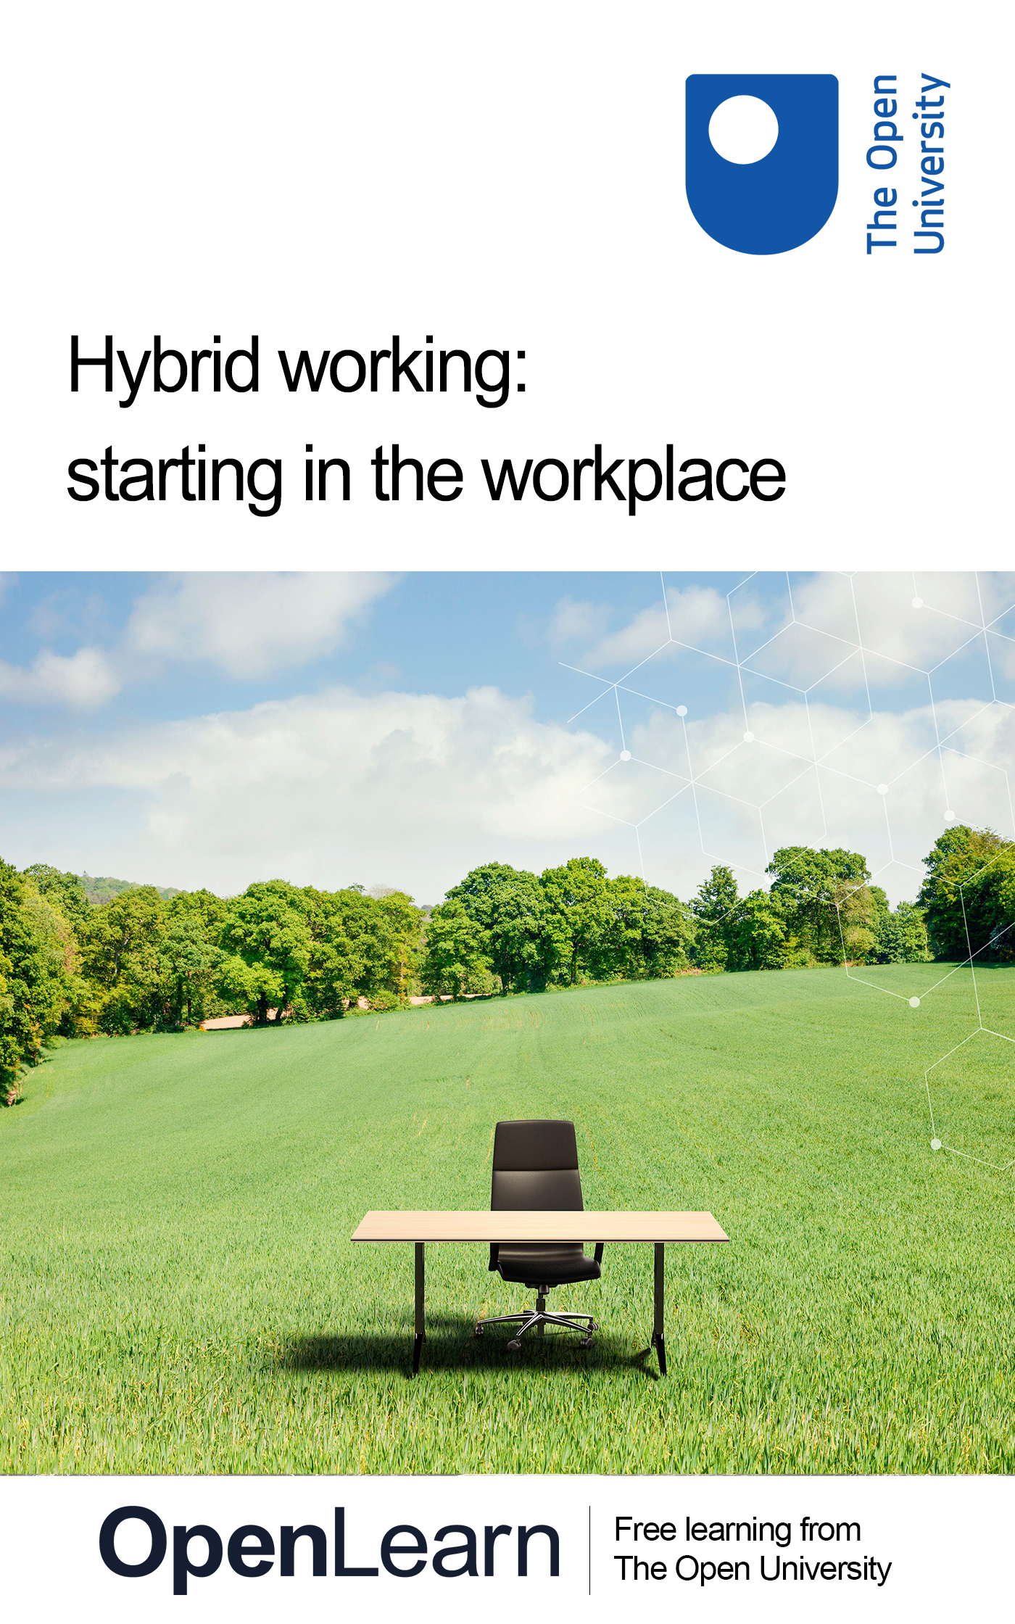

HYB_8 Hybrid working: starting in the workplace

Hybrid working: starting in the workplace

About this free course
This version of the content may include video, images and interactive content that may not be optimised for your device.
You can experience this free course as it was originally designed on OpenLearn, the home of free learning from The Open University –
There you’ll also be able to track your progress via your activity record, which you can use to demonstrate your learning.
Copyright © 2022 The Open University
Intellectual property
Unless otherwise stated, this resource is released under the terms of the Creative Commons Licence v4.0 http://creativecommons.org/licenses/by-nc-sa/4.0/deed.en_GB. Within that The Open University interprets this licence in the following way: www.open.edu/openlearn/about-openlearn/frequently-asked-questions-on-openlearn. Copyright and rights falling outside the terms of the Creative Commons Licence are retained or controlled by The Open University. Please read the full text before using any of the content.
We believe the primary barrier to accessing high-quality educational experiences is cost, which is why we aim to publish as much free content as possible under an open licence. If it proves difficult to release content under our preferred Creative Commons licence (e.g. because we can’t afford or gain the clearances or find suitable alternatives), we will still release the materials for free under a personal end-user licence.
This is because the learning experience will always be the same high quality offering and that should always be seen as positive – even if at times the licensing is different to Creative Commons.
When using the content you must attribute us (The Open University) (the OU) and any identified author in accordance with the terms of the Creative Commons Licence.
The Acknowledgements section is used to list, amongst other things, third party (Proprietary), licensed content which is not subject to Creative Commons licensing. Proprietary content must be used (retained) intact and in context to the content at all times.
The Acknowledgements section is also used to bring to your attention any other Special Restrictions which may apply to the content. For example there may be times when the Creative Commons Non-Commercial Sharealike licence does not apply to any of the content even if owned by us (The Open University). In these instances, unless stated otherwise, the content may be used for personal and non-commercial use.
We have also identified as Proprietary other material included in the content which is not subject to Creative Commons Licence. These are OU logos, trading names and may extend to certain photographic and video images and sound recordings and any other material as may be brought to your attention.
Unauthorised use of any of the content may constitute a breach of the terms and conditions and/or intellectual property laws.
We reserve the right to alter, amend or bring to an end any terms and conditions provided here without notice.
All rights falling outside the terms of the Creative Commons licence are retained or controlled by The Open University.
Head of Intellectual Property, The Open University

Contents
- Introduction
- Learning outcomes
- 1 Changing priorities
  - 1.1 Adapting to change
- 2 Applying for a job in the hybrid workplace
  - 2.1 Developing and documenting your skills
  - 2.2 Virtual CVs
  - 2.3 Online interviews
  - 2.4 Learning from each attempt
  - 2.5 Before accepting a job
- 3 Preparing to start your new job
  - 3.1 Your home office
  - 3.2 Work uncertainties
  - 3.3 Tools of the trade
- 4 Organisational culture
- 5 Achieving goals
- 6 Digital skills
- 7 Virtual collaboration in the workplace
- 8 Managing your wellbeing when working remotely
  - 8.1 Virtual meet-ups
  - 8.2 Recognising when you need support
- Conclusion
- References
- Acknowledgements
- Solutions

Introduction
In this course, you will discover the skills and behaviours required for joining the hybrid workforce, from finding a job, to your first day in post, to managing your wellbeing in the face of change.
In 2005 Halford defined hybrid working as:

‘Being employed to work both at home and also in an organisational setting, using ICTs to maintain workloads and relationships across both domestic and organisational spaces.’
(Halford, 2005, p. 20).

While the definition of hybrid work remains fairly similar in the 2020s, higher-speed broadband, better quality webcams and microphones, and more advanced communication and meeting platforms mean that hybrid working now has the potential to be a more streamlined and efficient experience.
However, hybrid work was still an uncommon practice, even into the late 2010s. It was only the COVID-19 pandemic which accelerated the numbers of hybrid workers, with lockdowns forcing many people to work from home if they could. Almost overnight, the UK remote working population rose from 5% to nearly 50% (Felsted and Reuschke, 2020). This was obviously a dramatic change for many workers and their households, and organisations had to rush to adapt to this new era of working. Weekly online meetings, ‘log-in’ checks, and rapid virtual messaging all became more commonplace, and within a few months the way we worked had changed forever.
This free course is part of the Supporting hybrid working and digital transformation collection.

Learning outcomes
After studying this course, you should be able to:
- prepare yourself for finding a job in the hybrid workforce
- prepare for your first day in the hybrid workplace
- understand what is expected from a cultural perspective
- recognise the digital skills you will need to work in the hybrid environment
- collaborate with others in the hybrid workplace
- manage your wellbeing and loneliness
- make a difference and contribute further in the hybrid workforce.

1 Changing priorities
As the way we work has changed, many organisations are redefining their culture and employee experience for a remote and hybrid-first world, and focusing on developing more inclusive workplaces and promoting social mobility. To understand what organisations are considering, and the skills they are focusing on, in the video below, Jessica Leigh Jones MBE, co-founder and Chief Executive of iungo Solutions, a company working at the intersection of business, education and government, discusses what employers can do to maximise diversity and enable social mobility, observing that ‘learning and development plays an important role in levelling the playing field for socially diverse talent’.
Recruiting and retaining that socially diverse talent benefits both employers and employees but, as Gemma Hallett, Head of Skills at Fintech Wales and founder of Mifuture, comments in the video, matching skills to roles, particularly in remote rural areas of Wales, has sometimes been an issue. However, remote and hybrid working is bringing new opportunities to these communities – though this is not without its challenges.

Video content is not available in this format.
View transcript - Uncaptioned interactive content

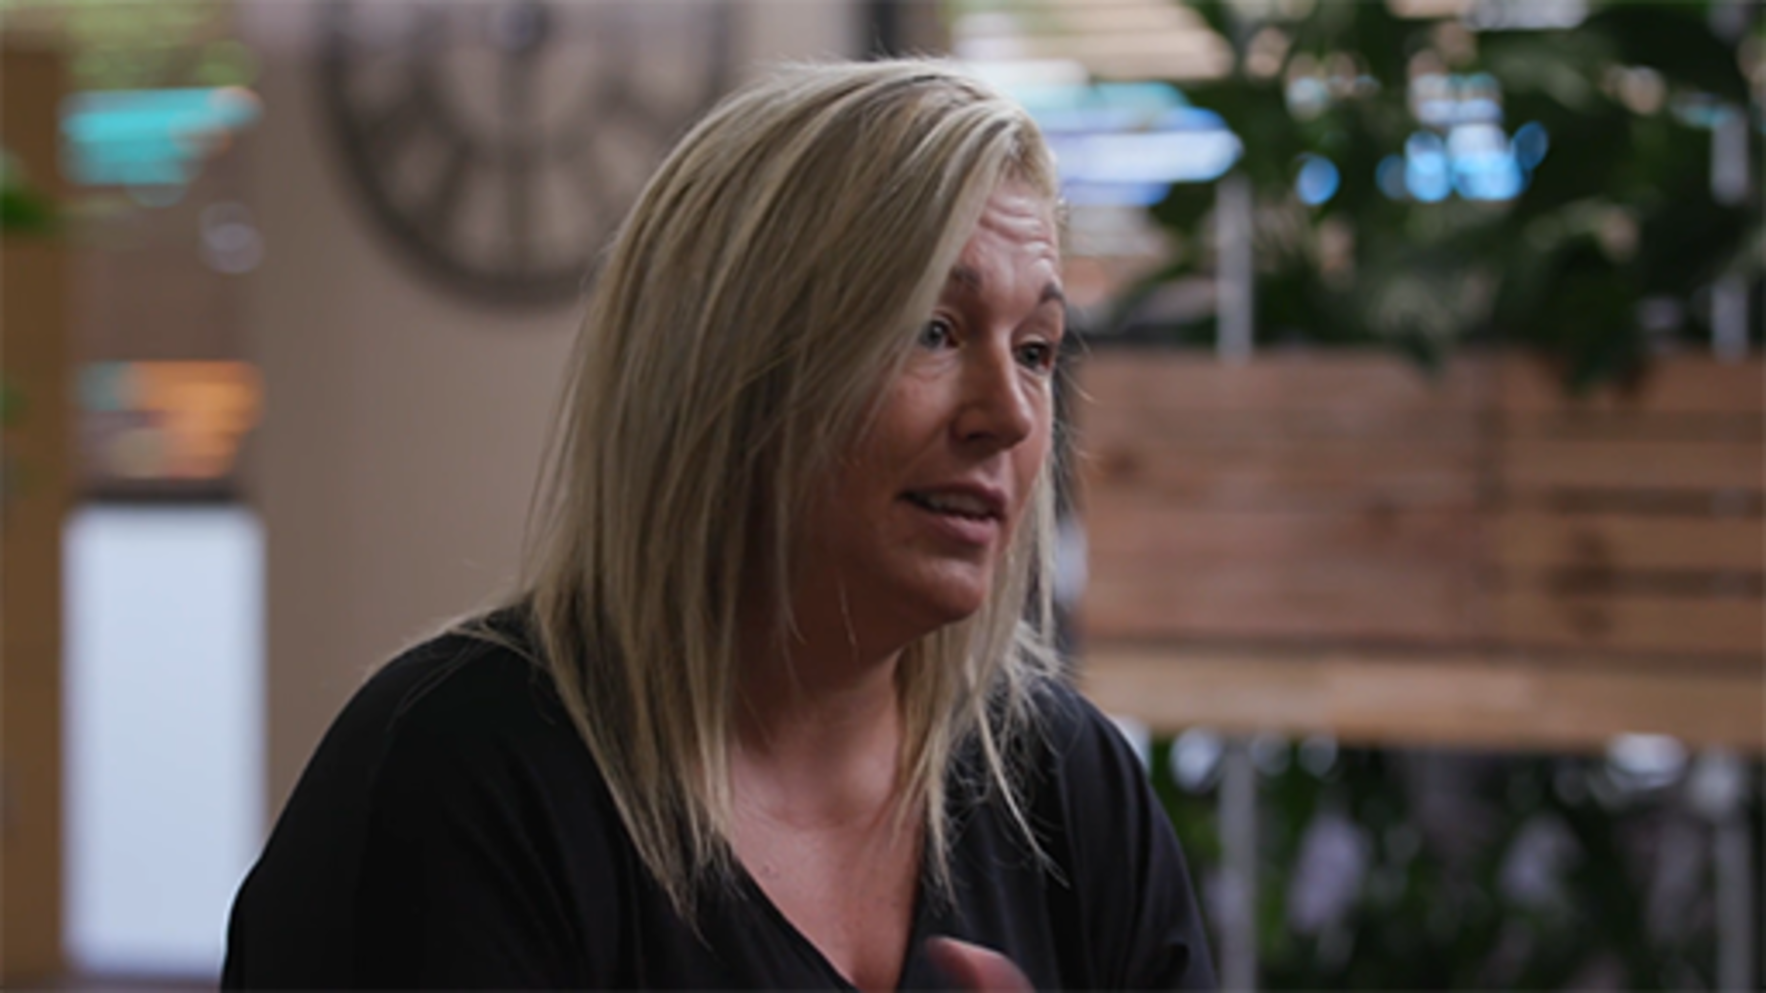

Clearly, the hybrid workplace is here to stay, meaning it is more important than ever to learn and develop the skills and behaviours required to succeed within this new environment.
If you are about to enter or return to the workplace, now is a good time to think about your expectations around hybrid working and to reflect on what your priorities are for personal and professional development in this next phase of your life. Activity 1 will help you to consider both of these things in relation to this course.

Activity 1 Definitions and priorities
10 minutes

Reflecting on the video and those organisations that are still evolving as they redefine their cultures for hybrid ways of working, answer the following questions.
- Examine Halford’s (2005) definition of hybrid working in the Introduction. Do you think this definition still applies today? What would you change about it?
- Read the course Learning outcomes and rank them in order of importance for you personally in terms of what you need most help with, with 1 being the most important and 7 being the least. This should help you determine where to focus your time on this course.

View discussion - Activity 1 Definitions and priorities

1.1 Adapting to change
For many people, starting work or switching careers is a major change they need to adapt to. It can be exciting and lead to numerous opportunities. It can also require some planning to make the most of the new job, and changes it may have for your personal circumstances.
When joining the hybrid workforce, a number of specific skills and behaviours need to be learned in order to successfully manage the new expectations your employer may have.
Change management has long been an area of discussion within the workforce, but it is only recently that change management and hybrid working have been discussed together (Power, 2021; Lenka, 2021). Traditional models can be used to show how significant change, such as moving into the hybrid workforce for the first time, can lead to increased anxiety, dissatisfaction, and a loss in productivity.

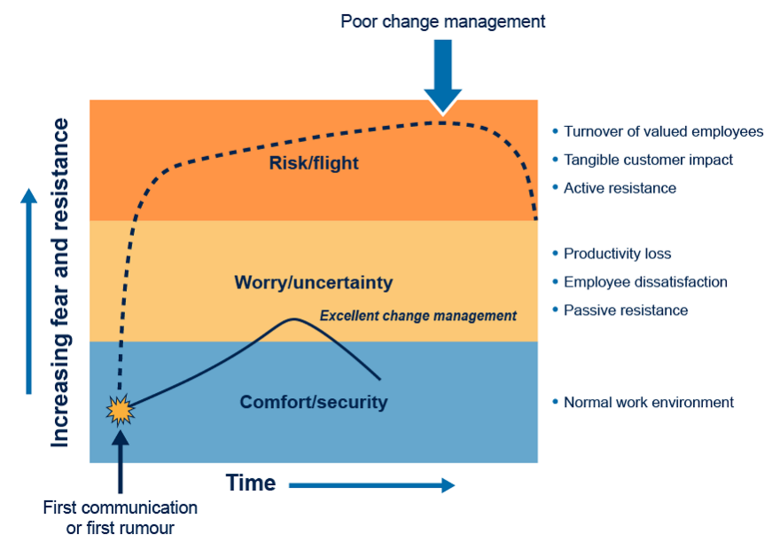
Figure 1: The Prosci Flight-Risk Model (Prosci, 2004)
View description - Figure 1: The Prosci Flight-Risk Model (Prosci, 2004)

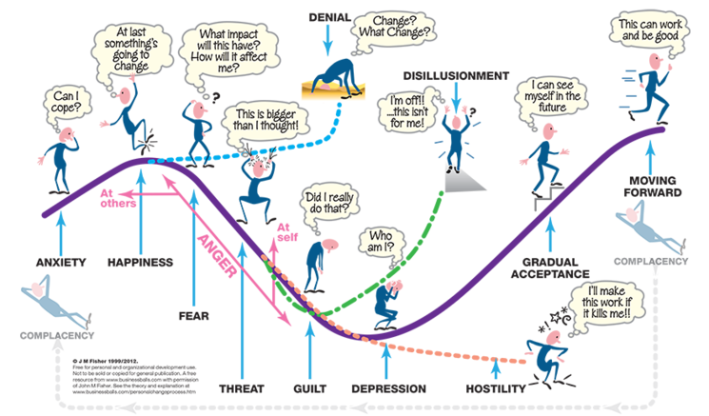
Figure 2: Fisher’s Personal Transition Curve (Fisher, 2012)
View description - Figure 2: Fisher’s Personal Transition Curve (Fisher, 2012)

Various change management models, such as those in Figures 1 and 2, depict similar issues, namely that without appropriately managing a change within the working environment, individuals can face fear, resistance, and depression, all of which significantly reduce their ability to work effectively (Fisher, 2012; Prosci, 2004). This is why it is so important to be prepared for change, to understand the difficulties you might face, and to improve any skills that may be needed to help manage this change.

Activity 2 Dealing with change
5 minutes

Look at the Fisher Curve (Figure 2) and think about a time when you have faced a significant change.
- Where did you find yourself on the curve?
- If it was in a negative part of the curve, how did you overcome those feelings?
- If it was in a positive part of the curve, how did you make the most of those feelings?

View discussion - Activity 2 Dealing with change

2 Applying for a job in the hybrid workplace
In many ways, applying for a job in the hybrid workplace should be no different to any other application. You will almost certainly need a CV, and it needs to cover the key basic points – suitability for the job, proactivity, skills, and evidence (UCAS, 2022).
Primarily, you need to match your CV to the job you are applying to, showing how fit you are for the role. If the job description mentions specific key skills, be sure to include them in your CV. Employers are looking for a mix of technical ability – e.g. the things that you can ‘do’, whether that’s developing databases, calculating coordinates, or writing reports – and ‘soft’ skills, such as teamwork, communication, leadership, and commercial awareness.

2.1 Developing and documenting your skills
While technical ability can be acquired through training courses, formal work experience or part-time jobs, soft skills can be developed through voluntary work, extracurricular activities, and personal projects. Be sure to document these, identifying detailed examples of when you have showcased each skill. If you can incorporate numeric information, like a budget you managed, or include statistics that illustrate the impact of your skills, this evidence will back up your claims.
In the video below, three contributors from iungo Solutions – Zainab (a recent graduate, now a technical content analyst), Ploy (an HR and recruitment executive); and Jessica (co-founder and chief executive) – talk about their experiences of looking for employment, skills development, the recruitment process, and the importance of being proactive.

Video content is not available in this format.
View transcript - Uncaptioned interactive content

Your CV should demonstrate how you take action to develop new knowledge and skills, whether that is during your studies or in your spare time. Activities such as maintaining a specialist blog, doing voluntary work, and developing job-relevant hobbies will help to demonstrate your lifelong learning mindset.
Nick van Dam is an advisor, author, speaker and researcher on corporate learning and leadership development, with a keen interest in how individuals learn and develop within organisations. In a lecture he gave in 2016, he discussed six essential elements of a lifelong-learning mindset:
- Focus on growth
- Become a serial master
- Stretch
- Build a personal brand
- Own your development
- Do what you love and discover your Ikigai – your ‘reason for being’.
(The full lecture, ‘Learn or Lose’, is available on YouTube if you are interested in exploring this topic further.)
Over the decades, the skills required by employers have evolved, as client expectations, technology, and how people interact with their environments have also evolved. Many employers are looking for people who demonstrate lifelong-learning mindsets by moving from deep competency in one specialist area (sometimes described as a T-shaped skill set) to developing deep competency in several areas (sometimes described as an M-shaped skill set).
Your lifelong-learning mindset could be demonstrated by, for example, your engagement with social media accounts, small side-businesses, or part-time volunteering/charity work. You need to show how you meet employer requirements but also how you try to develop yourself.
Finally, don’t forget how things have changed in the hybrid workplace. In the video above, Jessica Leigh Jones gave advice about key skills for work-from-anywhere organisations. Mentioning key hybrid skills such as organisation, independent work, experience of working virtually, and key digital skills could all make a huge difference to your application.

Activity 3 Which skills do employers want?
10 minutes

Read the UCAS webpage What do employers look for in graduates? (UCAS, 2022) and the Prospects article How to write a CV (Prospects, 2022).
Which aspects of your CV need to be updated to really showcase the skills that employers want? Consider how you can ensure that your CV is succinct. You do not have to describe your experience in detail, according to Indeed a CV should be around one to three pages, depending on your experience. The more experienced you are, the longer the CV. (Indeed, 2022).

2.2 Virtual CVs
The hybrid workplace has not only impacted the day-to-day activities involved in many jobs, but it has also significantly altered how people get jobs in the first place. From new skills required on applications, to the rise of virtual interviews, the way in which we apply for jobs has changed enormously in recent years.
The virtual CV has become a focal point, with sites such as LinkedIn or Indeed acting as a place where people can build their CV. If you don’t have a LinkedIn (or similar) profile, we highly recommend you create one and start adding people to your network, as this will make you more visible to potential employers. Recruiters will search services like LinkedIn based on your current job position, so even if you don’t have a job you should still put something into the ‘current job title’ box, such as ‘Trainee Accountant’ or whatever job you want to get. Then, in the ‘company box’ you should simply write ‘looking for a new opportunity’. This will help show recruiters and companies that you are definitely looking for a role, and you will show on the algorithm more prominently.

Activity 4 Update (or set up) your virtual CV
20–30 minutes

Read the article Networking for Job Seekers: 10 LinkedIn Alternatives to explore the different professional networking sites. Many professionals will now have a LinkedIn profile, but also profiles on sites that specialise on jobs within their chosen sector.
Then, watch the YouTube video 5 Must-know LinkedIn Profile Tips for Job Seekers! (Jeff Su 2022) on tips for creating a great LinkedIn profile, which can be applied to any networking site you choose.
Finally, create or update your profile based on the tips in Jeff Su's video and those stated above. If you don’t have a LinkedIn profile, now is the time to make one!

Services like LinkedIn also have an ‘about’ section which should act as your main digital CV. When employers look at your profile, this is what they will search through to see if your experience is relevant. The ‘about’ section should therefore match your CV, with a few paragraphs explaining your main achievements, skills, and experience. Again, try to use numbers or evidence of impact to back up what you are saying. You should also try to add keywords here that recruiters may well be looking at for your specific role as this will help recruiters find you.

2.3 Online interviews
When applying for a job in a hybrid workplace, you will often be invited to an online interview. Some employers will have every interview online, while others may ask you to do online competency tests as part of the selection process, before holding the first round of interviews online and then invite you to the office. Either way, preparation is crucial.
- Make sure everything is looking neat and tidy in your virtual workspace.
- Find out which platform or application your online interview will use and familiarise yourself with it by downloading the app and testing your connection with a friend.
- If you are using browser-based software rather than an app, make sure your web browser is up to date and meets any compatibility requirements.
- Use a good quality webcam, so you are clearly visible, and make sure your microphone is working.
- Try to ensure that you are in a quiet location, with no distractions or interruptions. If you live with others, make them aware you are being interviewed. If you have pets, ensure they are in another part of your home, if possible.
By having a well-prepared virtual interview space, you will improve your chances of making a great first impression on the interviewer.
A really good idea is to research the company well and prepare for likely interview questions. In the following video, Zainab and Ploy from iungo Solutions describe their interview experiences, including tips for neurodivergent candidates.

Video content is not available in this format.
View transcript - Uncaptioned interactive content

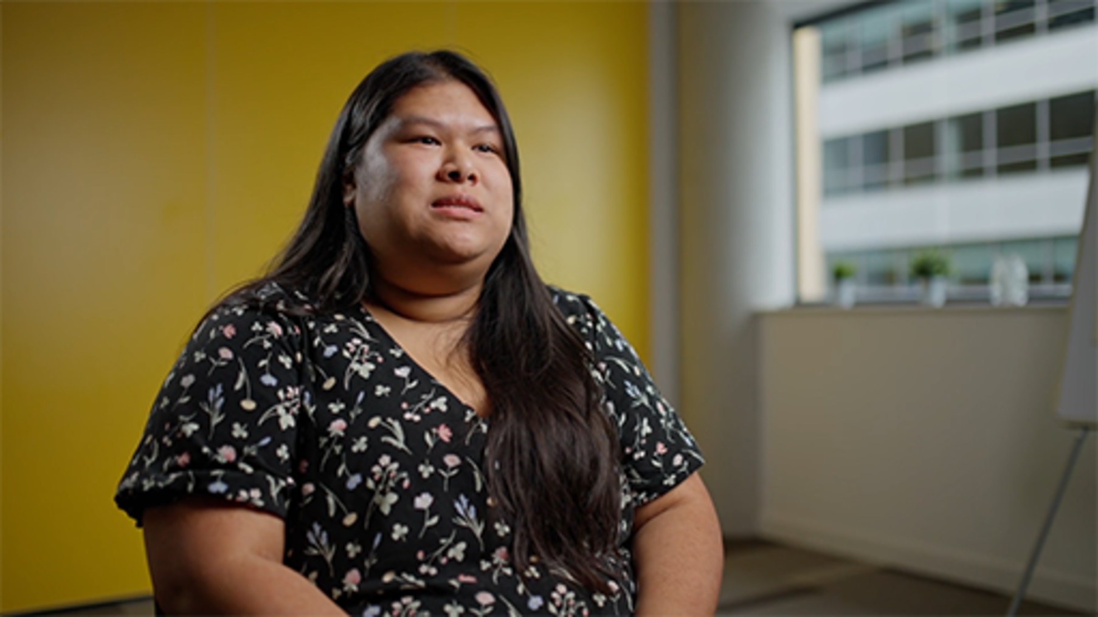

Were there any useful techniques that Zainab and Ploy mention in the video that could help you?
You should write down everything you think you would have to do in the job. The job description should help you to do this too. Prepare answers, showing how your skills and experience match every single aspect of the job. For example, if one of the parts of the job is ‘communicating with clients’, prepare an answer that explains how you have had experience in communicating with clients in the past, and how your communication skills make you a perfect candidate for this new job.
As well as preparing skills-based answers, you should prepare generic interview answers in case you are asked classic interview questions such as those shown in Table 1.

Table 1 Classic interview questions
‘Why do you want this job?’ | Your answer should demonstrate how you meet the job description, and why you want to work for that organisation.
‘What is your biggest weakness?’ | Your answer should demonstrate awareness of your weakness, how you mitigate the impact, and how it can be used as a strength.
‘Which three words would you choose to describe yourself?’ | Think about why you chose the words, and have examples as you may be asked to expand on these.

You will probably be asked at least one or two of these during the interview, and if you have a good answer prepared, you will have a much better chance of getting the job.
You should practise with a friend or family member. Have them ask you different questions about the job, and practise answering in front of them. Sometimes you can have a brilliant answer written down, but when you try to say it out loud it sounds terrible. Only by practising answering questions out loud will you be able to properly prepare for a real interview.

2.4 Learning from each attempt
As with any job application, you need to get used to being unsuccessful. It is estimated that it can take up to 80 job applications before some people receive an offer (Zippia, 2022). There are thousands of experienced applicants out there, so the important thing is not to worry when you aren’t successful, and instead try to learn from your experience.

Activity 5 Making rejection positive
5 minutes

Think about a time when you faced rejection. What did you learn from it? How did you use this experience to help you improve in the longer term, or how could you use it in the future?

View discussion - Activity 5 Making rejection positive

Sometimes you will receive feedback from the employer as to why you did not get the job. This can range from not having enough relevant experience on your CV, to the quality of answers you gave at interview, or simply that they had a very large and strong range of applicants. Hopefully they can give you some useful information (if not, you can always ask) which you can then take forward for other roles. Be sure to update your CV/cover letters with any new information, and try to improve on your interview technique based on any feedback you are given.

2.5 Before accepting a job
If you’ve made it through the interview process and been offered the job, congratulations! However, before accepting a job offer, it’s important to take a good look at the organisation and understand what exactly you are being asked to do. But perhaps most importantly, what is the hybrid working model like at the organisation?
You need to examine their employee value proposition (strategy) for hybrid working, and how organised they are in terms of days in/out of work (Sto, 2022). By understanding the schedule and their future plans, you’ll be able to see how this works for you. It’s also important because it demonstrates how much an organisation may care about their employees’ wellbeing. If they don’t have clear values and structure, you could end up being left with a working pattern that doesn’t suit you: for example, in a fully remote role or a fully in-person environment.
You should also look at the organisation’s culture, and see if it fits your personality. More than a third of employers struggle to maintain an appropriate company culture (Sto, 2022).
As Ploy and Zainab suggest in the video below, it is very important to make sure the culture aligns with your own beliefs and values. Is the working environment what you are looking for? Do the working hours suit you?

Video content is not available in this format.
View transcript - Uncaptioned interactive content

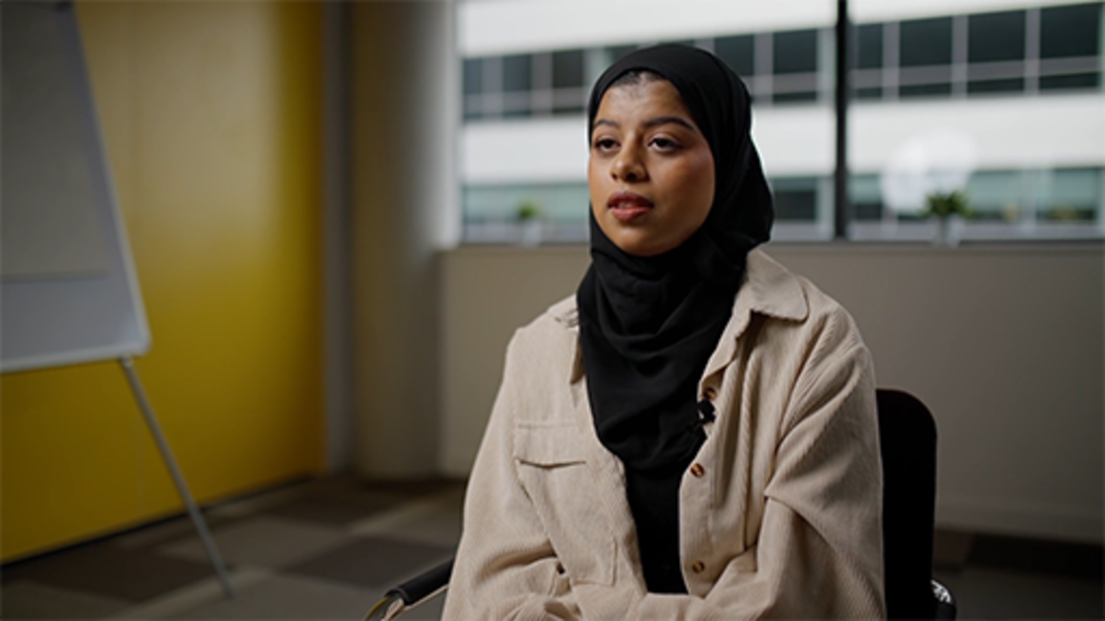

You need to make sure the organisational culture is something you feel comfortable with, as it is hugely important, and cannot be underestimated when deciding whether or not to accept a job offer.

3 Preparing to start your new job
Preparing for your first day in any workplace can be daunting, and that is just as true for a hybrid workplace. Without knowing exactly what to expect, the best approach is to ensure you have done everything possible to ensure a smooth and stress-free transition.
In a major study from 29 European countries during the COVID-19 pandemic, the three major constraints of working remotely were found to be:
- home office constraints,
- work uncertainties, and
- inadequate tools.
(Ipsen et al., 2021).
These are all areas you should think about before you start your new role. In the following videos you will hear from Ploy and Zainab at iungo Solutions again, this time discussing important considerations around behaviour, culture, support and workspaces in remote or hybrid-first organisations.

Video content is not available in this format.
View transcript - Uncaptioned interactive content

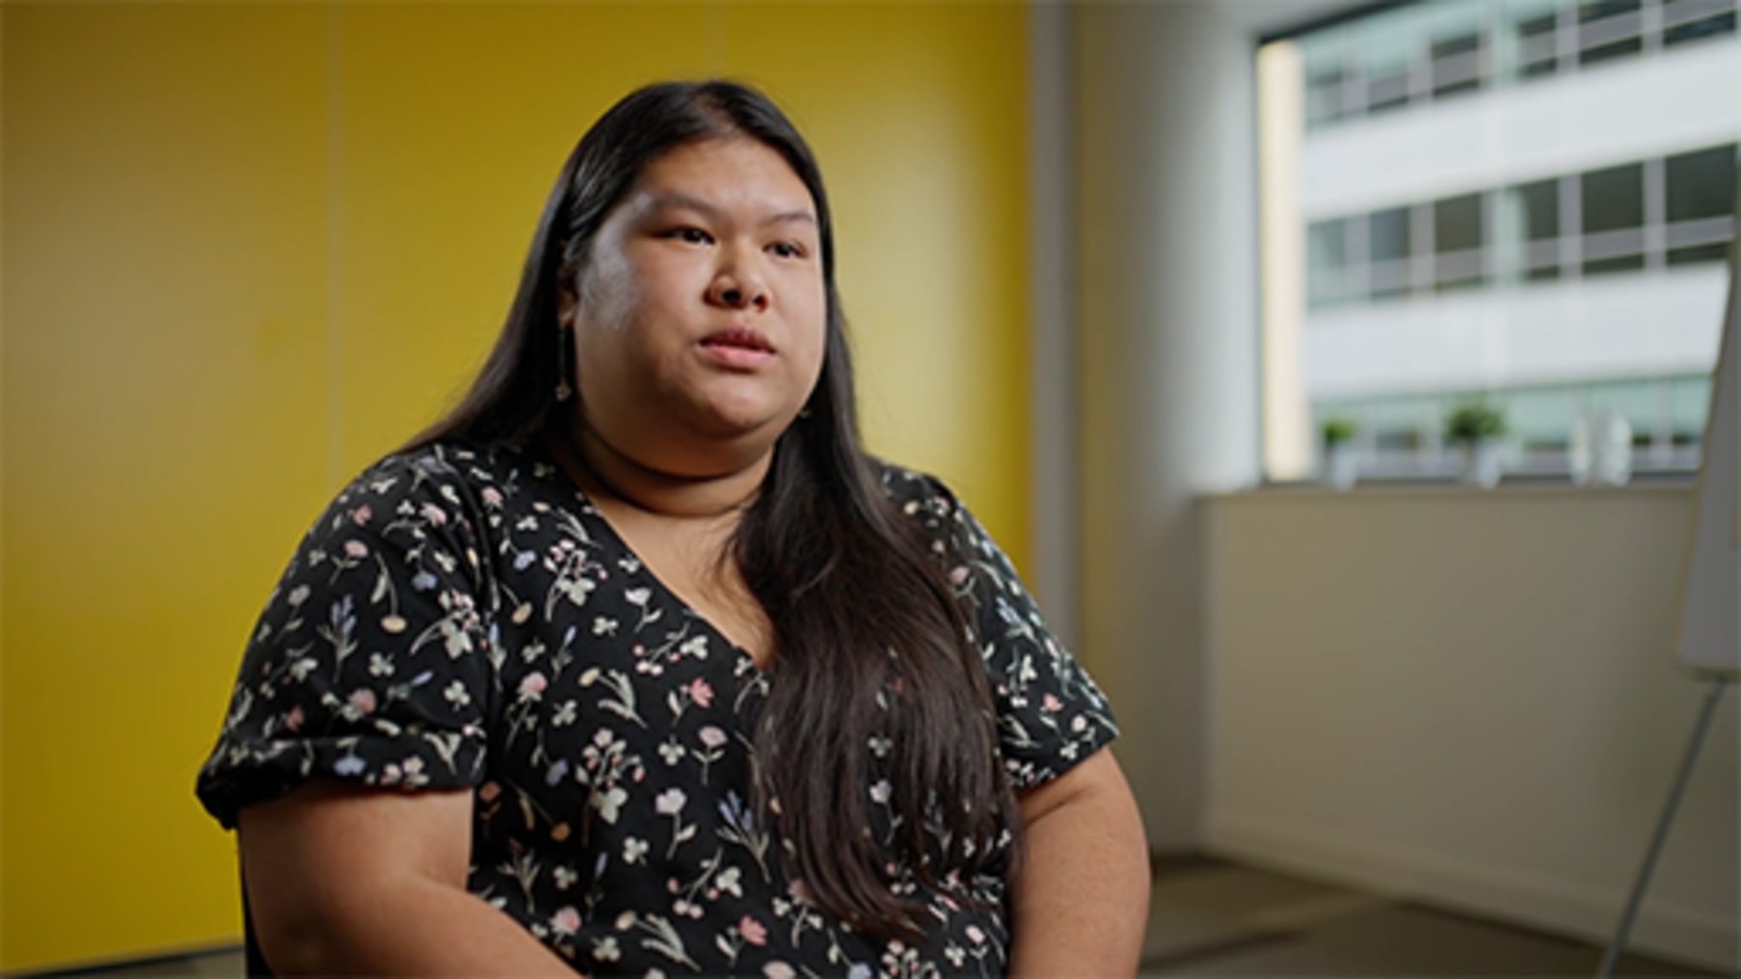

Video content is not available in this format.
View transcript - Uncaptioned interactive content

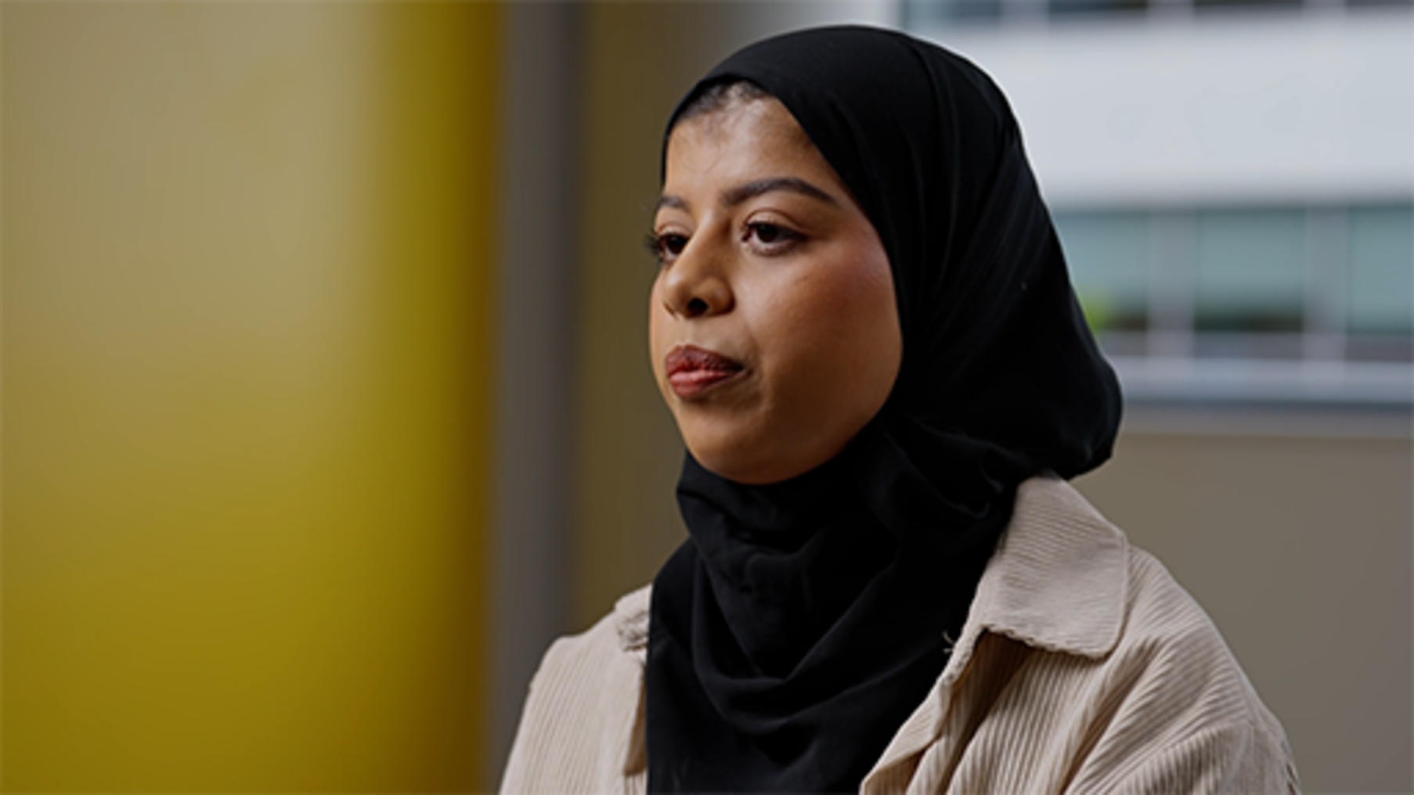

3.1 Your home office
As you heard in the videos in the previous section, having a dedicated space for your remote work is preferable, if possible. Home distractions are one of the major issues impacting productivity in the home workspace (Franken et al., 2021). Ideally you should pick a location that is only used for work, with space for everything you need to perform your role. Noise should also be kept to a minimum: research has shown factors such as having more children in the house can unsurprisingly negatively impact work productivity (Franken et al., 2021). Somewhere that other members of your household will not be wandering into unexpectedly is therefore going to be the optimum location for your home office.
You should also take care in setting up your webcam and microphone. Not only should these be of appropriate quality, but you should try to find a professional (or plain) background. Video calls are one of the most prominent features of the hybrid workplace, so having a professional background can help prevent any embarrassing moments when you first start. Ideally, you want your workstation positioned so that nobody (including any pets) can walk behind you and get on the camera.
However, this is the ideal approach, and one of the benefits to come from the COVID-19 pandemic is the shared experience of remote working. Most workplaces and colleagues understand that housemates, children and pets are part of our working life, and have evolved to adopt a more inclusive approach which accepts that sometimes our home lives and work collide.

Activity 6 Planning your home office
5 minutes

Think about your own home. Based on the advice above, where would be the best place for your home office? Why?

3.2 Work uncertainties
Everyone faces work uncertainties before starting a new job. What will the role be like? What if I don’t know what to do? When will I meet my work colleagues? These are all valid concerns, and the only thing you can do to help with these is to do your research. You may not have an exact idea about what you will be doing, but there are a few things you can do to prepare:
- Ask around – You should have the contact information for your manager or the recruiting team, so sending a quick email asking if there is anything you should familiarise yourself with could really make a difference when your first day arrives.
- The job description – Refamiliarise yourself with the job description, which should include a list of your basic responsibilities or tasks. If there is anything on there you do not understand, research it. You should be taught what to do anyway, but there is no harm in getting a head start.
- Visit the company website – It may seem obvious, but the company website should tell you all about what the organisation does, and it may even have information on your specific role. Understanding the company is crucial to success in any job!
Remember, you will never know everything about the job before you start. You will learn a lot in the first few weeks and months, once you arrive. However, it doesn’t hurt to be prepared, and this can help alleviate any work uncertainties you may have before starting!

3.3 Tools of the trade
In the remote workplace, there are a number of tools you should be familiar with (from your studies, or perhaps you already use them at home), many of which have become a necessity in recent years. Figure 3 provides an overview of some of the tools available for organisations.

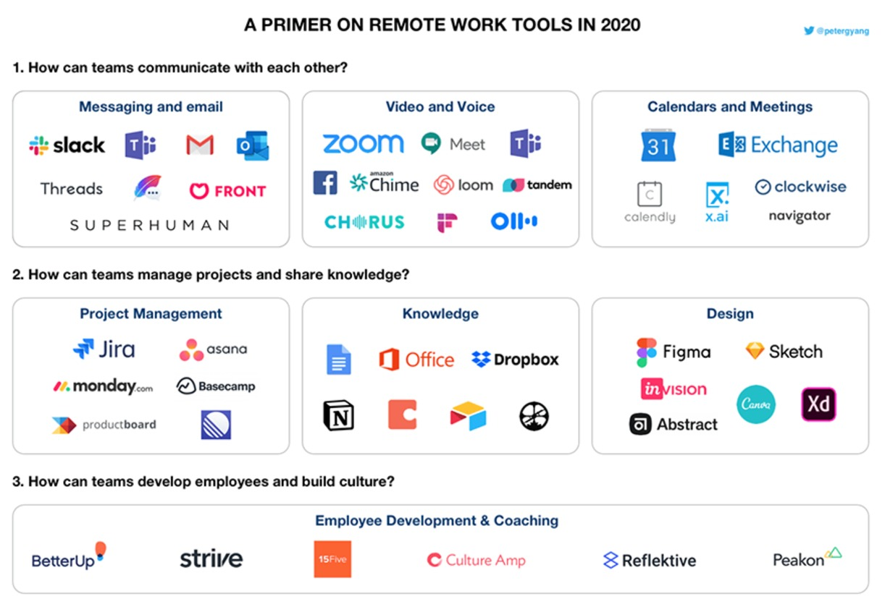
Figure 3: Remote work tools (Yang, 2020)
View description - Figure 3: Remote work tools (Yang, 2020)

Don’t be overwhelmed by the various programs and systems that help drive hybrid work, as you may be familiar with some of them already, and you are unlikely to need to use all of those shown in Figure 3. Many are fairly easy to get to grips with, so if you want to get a head start, many of the companies that developed them offer free access, user guides or tutorials on their websites; alternatively, you could search online for how-to videos.
However, it is important for you to understand the basic tools your new company uses. Do they have a workflow management system? How do they communicate? It could be useful to ask these questions before you start, as getting to grips with some of these programs could help you feel more comfortable in your new role.

Activity 7 Researching remote work tools
20 minutes

- Examine the remote work tools figure above. How many of these do you know? Are any that you consider essential missing? Research some of the tools you may not have heard of.
- Read this article: Top 22 work from home tools to make your remote work life easy (Kashyap, no date). How many of these work-from-home tools would be useful for the career you want to go into?

4 Organisational culture
One of the most crucial parts of starting a new role, whether in a hybrid workplace or not, involves understanding exactly what is expected of you. Organisational culture can be defined as the way work is performed in an organisation (Atkinson, 1990). Culture can be seen as embodying the values of an organisation, particularly in the way it operates (Johnson, 2013). These definitions illustrate just how important culture can be to the underlying workings of a company, and therefore it is important to have a clear understanding of your organisation’s culture.
Johnson and Scholes’ (1992) Cultural Web Theory suggests that there are six interrelated factors which, when combined, produce the cultural paradigm of an organisation:

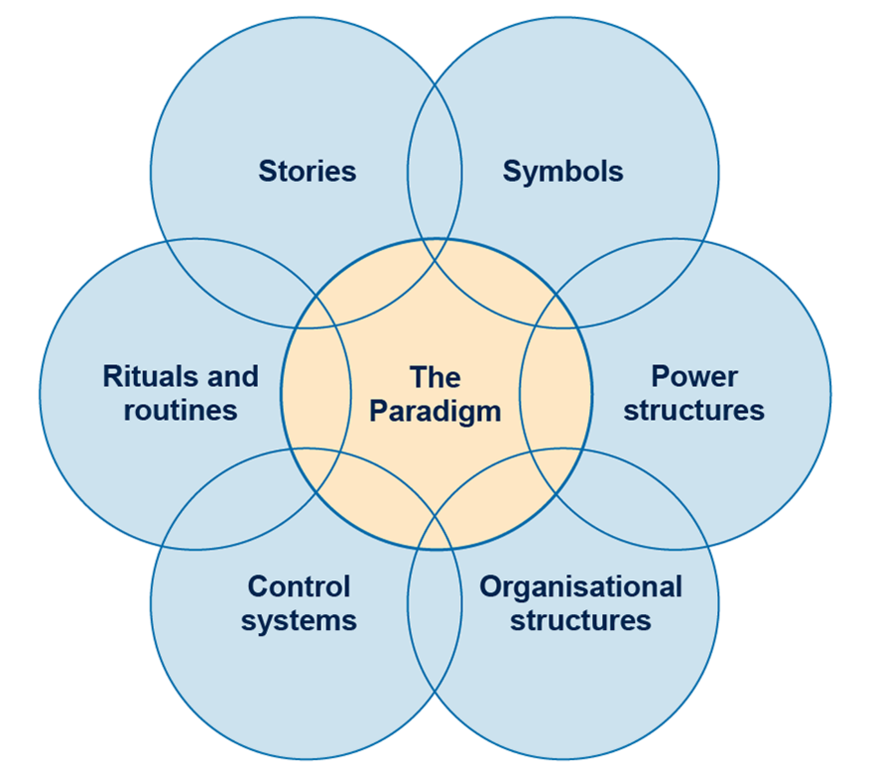
Figure 4: The cultural web, adapted from Johnson, 1992 (MindTools, 2018)
View description - Figure 4: The cultural web, adapted from Johnson, 1992 (MindTools, 2018)

Whilst this is a fairly academic approach, it obviously has a number of practical implications, and using the Cultural Web as an example, it could perhaps be beneficial to try to and analyse the different aspects of your organisation during the early months of your employment:
- What are the common rituals and routines which need to be observed? (daily video calls, weekly team meetings, etc.)
- What are the power structures and where do you fit in? (managers, who you report to, the levels of delegation to each role, etc.)
- What are the stories or values of the organisation and how can you make sure you are navigating these ‘unwritten’ rules?
At iungo Solutions, Jessica Leigh Jones MBE talks about the pivot towards ‘intrapreneurship’ in a hybrid world. In the next video Jessica and Ploy explain how they are trying to increase the diversity of the talent pool and harness different perspectives to take the company to the next level.

Video content is not available in this format.
View transcript - Uncaptioned interactive content

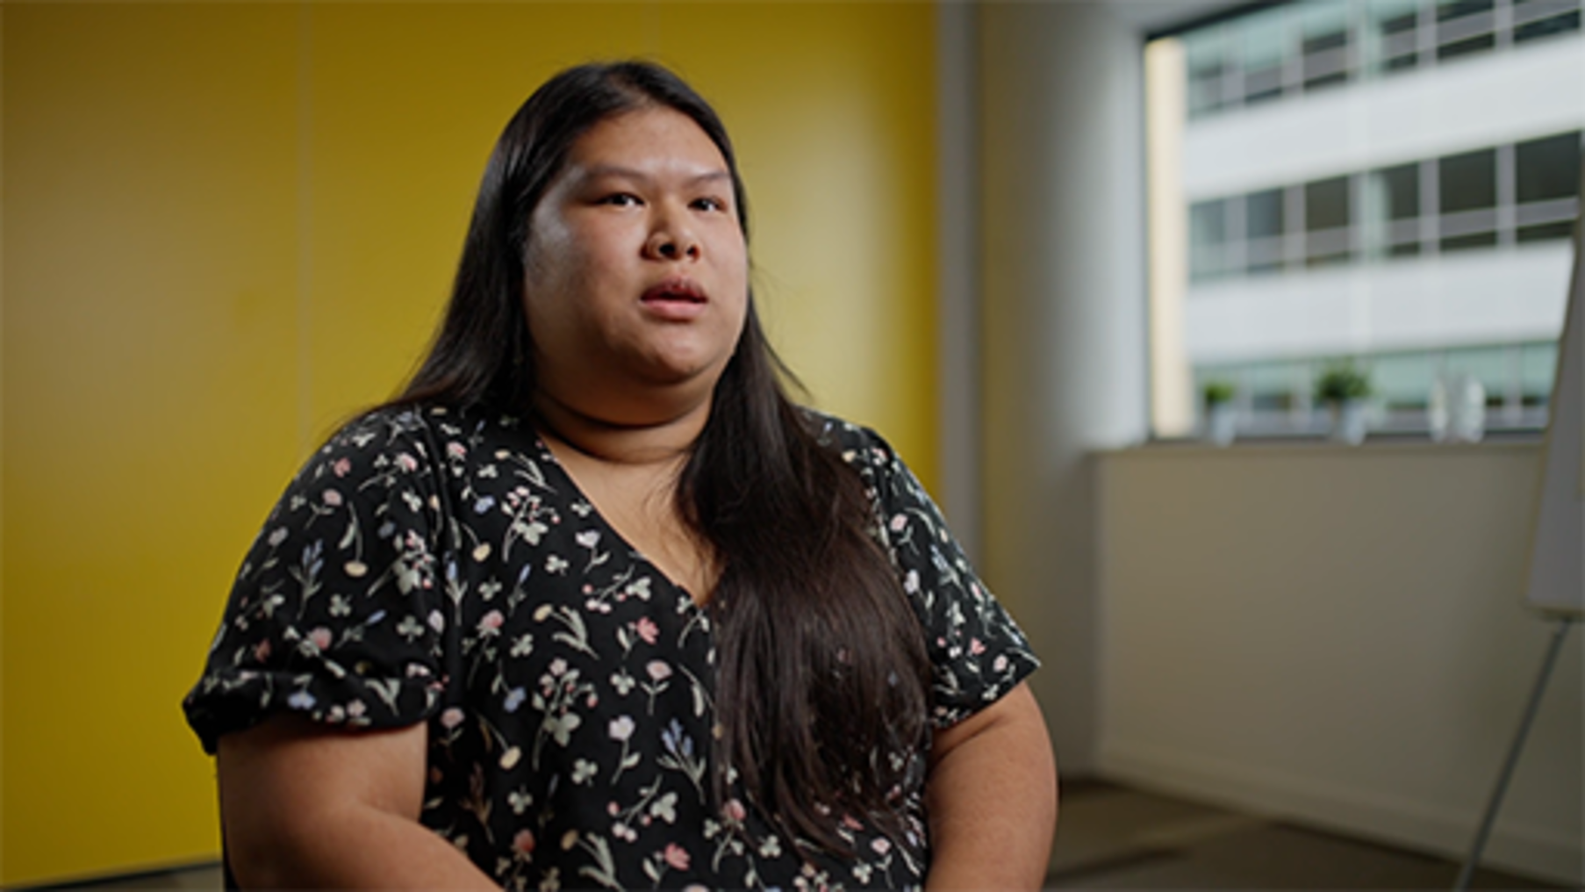

Your success in any role depends on your ability to understand the expectations of your organisation and integrate your authentic self with the organisational culture. There has been an increase, in recent years, in organisations making diversity and inclusion a priority, to nurture employee creativity and autonomy in how work gets done, so you're aiming for a mutually beneficial integration between what you have to offer and what the organisational culture has to offer you, rather than just assimilation. If you can do this, it will make your working experience much smoother, and can help you quickly fit into your new role.

Activity 8 Analysing an organisation’s culture
5 minutes

Reflect on the video and think about an organisation you have been a part of (society, university, school, job). Using the Cultural Web theory, briefly analyse this organisation. Consider, for example, what are the symbols, stories, power structures, and rituals common in this organisation? What was their approach to inclusion, and how can you learn from others with a different experience and perspective?

5 Achieving goals
As well as cultural expectations, you will also have productivity (your task) and results-based (your goals/objectives) expectations. This has arguably become even more important in the hybrid workplace. Without a constant office environment, it can be easy for productivity to slip, particularly if you are faced with distractions at home, or increase if you do not manage your time effectively, as it can be very easy to start to do a few more hours when you don’t have to log off and leave an office. As a consequence, organisations are finding it crucial to set specific goals and results for you to reach.
If you are starting your very first job, having goals to reach can be a scary thought. What if I don’t achieve them? How will I manage these new expectations? These are all valid concerns, but it is important not to get overwhelmed, as most managers will regularly review these with you. A useful trick is to write down your goals, and plan how you will achieve them, categorising them according to what is an immediate actionable task vs those that may take longer. This can help reduce the magnitude of what you are facing, and helps you find a more manageable solution to achieving goals. It can be helpful to set weekly targets, and rank the most important tasks of your week (based on how far they contribute to your goals), meaning you will have a weekly (and daily) plan that will help you keep on top of your tasks and results.

Activity 9 Making goals achievable
Allow at least an hour for this activity

A useful and popular approach to making goals achievable is using the SMART acronym. The table below explains what each letter stands for.

Table 2 SMART
Specific | Be clear and precise about what you need to do and want to achieve.
Measurable | How will you know you have achieved the goal? What is the outcome?
Achievable | Is the goal realistic? Is it something you can deliver?
Relevant | Is the goal required? Why are you doing it and is it a priority?
Time limited | What is the deadline for the goal to be achieved?

- Review your current goals to ensure that they are aligned with the SMART goals approach.
- Now list the weekly tasks you need to complete in order to achieve these goals. Prioritise these in terms of importance.

View discussion - Activity 9 Making goals achievable

However you manage your time, make sure your goals don’t overwhelm you, and always remember you can ask for help if things are getting too much!

6 Digital skills
In the hybrid workplace, there are a number of basic digital skills which you will need to have in order to work effectively. This not only involves understanding the key programs used at your organisation, but also understanding the behaviour and expectations for using them, and the ability to adapt and learn on the job. Being adaptable and open to training and learning will be crucial (Prince, 2021). As with any technology, there is a learning curve, but if you put the effort in and carefully follow the instructions or training, there is no reason why you cannot learn new technologies quickly and efficiently.

Tools and systems
Most organisations will use a variety of different digital tools and systems, such as Microsoft Office 365 or Google Drive that all staff may use, for collaborating, communicating and sharing documents. Shared work technologies have never been more important, particularly in a hybrid workplace.
Depending on the nature of your work, you may be required to use digital work management software (WMS). Tools such as Zoho, Trello, or Monday are an increasingly popular way for hybrid workers to manage their daily tasks. With less time spent in the office, these programs are becoming more and more important for helping everyone stay organised and on-track within an office environment.
Video calls and messaging are an equally important aspect of hybrid working. The use of virtual communication tools are an essential part of hybrid working, and it is worth making sure you familiarise yourself with these tools, such as how to share a screen, record a meeting, quickly turn on/off your microphone/camera, and more. As mentioned in Section 4, it is also important to understand the culture of your organisation, including the ‘rituals’ and ‘systems’ (Johnson and Scholes, 1992). What is the dress code for virtual meetings? Does everyone keep their camera on? What is an appropriate background? It’s crucial to understand these values quickly, in order to make a positive first impression and ensure you are meeting the ‘norms’ of the company you are working for.
Many large organisations also have their own in-house systems that have been developed, which will have specific requirements and require you to develop your skills for using these. Your employer should provide training in the tools and systems you have to use, but you could take the initiative and build your confidence, skills and understanding by finding online guidance (e.g. via the tool or system’s website) or by asking your colleagues for tips.

Activity 10 Thinking about tools for communication in a hybrid workplace
15 minutes

Attending remote and hybrid meetings will probably form part of your daily work routine. Feeling comfortable attending these and having the confidence to use the virtual conferencing tools requires not only digital skills, but also behavioural. Take some time to reflect on the following questions:
- Think about a time you have been on a video call in the past six months. What additional features of the videoconferencing platform were used, e.g. chat, screensharing, meeting break-out rooms? Are you confident using each of these features?
- How do you feel when participating in virtual meetings? Do you have your camera on/off? Do you fully participate? Does it depend on the type of meeting?

It can be useful to try to familiarise yourself with video conferencing tools, and a ‘safe’ way to do this is to arrange calls with trusted work colleagues or friends where you may be less worried about making mistakes and asking questions.
To develop your digital skills and behaviours, for working with tools and systems, and communicating and collaborating online, you may wish to study the following courses from the Supporting hybrid working and digital transformation in Wales collection.
- Hybrid working: skills for digital transformation
- Hybrid working: digital communication and collaboration.

7 Virtual collaboration in the workplace
Discussions about virtual collaboration in the workplace date back to the very beginnings of the internet (Cascio, 2000). However, recent years have seen a huge increase in remote/hybrid work, and the importance of virtual collaboration has since been redefined (Colbert et al., 2016; Ferreora-Lopes and Rompay-Bartels, 2020).
Virtual collaboration is no longer about simply communicating remotely. It involves shareable documents, collaborative tasks, and virtual content management. With the technology now available to us, we can now work on high-quality collaborative projects without the need for in-person meetings.
Collaboration is a key part of the workplace. For many people, the only way to effectively get work done is to partner with others. In a hybrid environment, it’s important for collaboration not to be impacted. Even if you cannot physically talk to someone, it should not stop your ability to effectively communicate and collaborate on projects.

Activity 11 What makes virtual collaboration challenging?
5 minutes

Think about a time you have collaborated virtually on a project.
What worked well, what were the major challenges you faced, and how did you overcome them?
What would you do differently on similar projects in future?

Without effective collaboration, hybrid work can become dysfunctional. It is therefore imperative that you engage regularly with your team(s) and line manager. Many teams will have daily updates or ‘stand ups’, weekly meetings, and/or monthly reviews. If there are no organised opportunities for collaboration, you could try to create something similar yourself, for example scheduling regular updates with your team or communicating with a co-worker about any concerns you may have, or to ask for help with a task. Most importantly, be sure you know how to get in touch with people, whether that is through your organisation’s designated messaging systems, email catch-ups or weekly calls. In a traditional office, you would probably be having regular conversations – formal and informal – with others, so don’t let it be any different in the hybrid world. Without these interactions, burnout and loneliness could become a serious issue.
How exactly should this be done? The next activity offers some suggestions.

Activity 12 What makes virtual collaboration effective?
15 minutes

- Read this Harvard Business Review article on 4 tips for effective virtual collaboration (Saunders, 2020). Which of these do you think would be the most useful? Why?
- Make your own top four list for virtual collaboration. What four key things do you think would most help you succeed in any virtual collaborative task?

There are many ways in which colleagues in the virtual workplace will collaborate. Whether that be on video call, editable shared docs, or other collaboration tools. Many of these skills have already been mentioned, but don’t forget to stay up to date with the latest tools and programs. Not only will this help you be successful in your new role, but it can help you form relationships with a variety of different people.
One of the downsides of remote work, for many people, is that building new friendships or working relationships with your colleagues can be more difficult. However, if you are good at collaborative work, and you make an effort, then you will be able to navigate through these struggles and come out with some meaningful working relationships, as well as building up your network which could end up being extremely beneficial in your future career.

8 Managing your wellbeing when working remotely
There have been various studies on the implications of remote or hybrid work on mental health (Xiao et al., 2021). Without a clear schedule, the lines between work and personal time can get blurred and become stressful to manage, and social isolation can be a concern, if you are not regularly talking to others online, or finding opportunities to meet people in person. This can lead to a lack of motivation and also anxiety, and can take a toll on your mental health. It is therefore useful to take certain precautions in order to best protect yourself mentally. Here are four simple tips to avoid hybrid burnout and mental struggles from remote work:
- Setting a clear routine can be one of the best ways to keep on top of things. Make sure you go to bed and wake up at a similar time each day, finish work at a similar time, and put everything away once you have finished to ensure your work environment fully ‘stops’ at the end of the day.
- If you have the room in your home, creating a dedicated working space for work can leave you feeling more motivated for the working day ahead. It will also help you avoid distractions and ensure a productive day.
- Arrange to talk to someone either virtually or meeting for a coffee, or going for a walk at least once a week. This does not have to be a work colleague.
- Lastly, making time for breaks is important to help manage feelings of stress. Try to take lunch breaks and regular screen breaks and give yourself something else to concentrate on, even if it is only for five minutes. Hybrid/remote work involves much more screen time than a traditional office day, so be sure to take breaks as much as possible.

Activity 13 Your daily working timeline
10 minutes

Use the text box below to note down a timeline for your average day working from home.

Provide your answer...
View discussion - Activity 13 Your daily working timeline

8.1 Virtual meet-ups
When you start your new role, you are often introduced to numerous co-workers all at once and it can be difficult to remember who they are and what role they play. Virtual meet-ups with your team can help solidify relationships and ease you into your new role. They can also be important for managing your wellbeing. Perhaps you could suggest a virtual meet-up to your manager, or they may already have one in place so you can get to know the people you will be working with most closely. As mentioned in Section 7, collaborative work is crucial for success in the hybrid workplace, and forming effective working relationships with your colleagues will really help to achieve this.

8.2 Recognising when you need support
Sometimes at work things can become overwhelming and you may feel like you’re struggling to cope with work pressures, or perhaps it is simply the fact that you feel isolated working in an unfamiliar hybrid environment.
It’s crucial to remember that you are not alone: many people will feel like this, and the most important thing is to understand that you can ask for help at any time. In your job you can always turn to your manager or team leader for advice and support; they may be able to talk things through with you to see how they can help.
Alternatively, there may be a wellbeing team within the organisation who can support you. Whatever the case, be sure to talk to your colleagues and manager about your feelings if things become difficult. No job is worth sacrificing your mental health over.

Activity 14 Taking care of your mental health
15 minutes

- Visit the Student Minds website. This is a fantastic charity with lots of support for students and young people, as well as loads of great resources for anyone feeling lonely or needing additional help.
- Watch the video Working from home – taking care of your mental health on YouTube (Trainer Bubble, 2020). Write down your top take-aways from the short clip.

For more guidance on managing your wellbeing whilst working in a hybrid or remote model, explore the Hybrid working: wellbeing and inclusion course that is part of this collection.

Conclusion
We hope you found this course useful. Hybrid work is still a relatively new phenomenon for the majority of the population, and we are still in the process of understanding the best practices and processes to help workers navigate through this new world.
Having read our advice, it’s important to take things into your own hands now. Do your own research, read up on the organisation you are working for, or would like to work for in future, develop the skills you know you are lacking when it comes to digital and collaborative working, and make an extra effort to communicate with your new team. Starting a new job can be daunting, but with the appropriate preparation, you will be able to ensure a smooth and successful transition.

Activity 15 Revisiting your priorities
5 minutes

Look back to Activity 1, where you ranked the learning outcomes in order of importance to you. Are your priorities still the same or have they changed? Which, if any, could you explore further in your new role?

Once you have settled into your new role, and the hybrid work environment is no longer so challenging, you can start to look for new ways to benefit your organisation and make a positive impression on your manager or employer.
The idea of ‘transformational leadership’, for example, suggests that managers should be looking to promote informal leadership processes and rapid decision making within teams (Uhl-bien et al., 2007). If you can start to display leadership qualities, and become an ‘informal’ leader in some team tasks, then this is something many organisations value highly, and could help you progress further in the coming years. This is just one example of something managers look for in their employees. You can find many more examples of leadership theories and value-add strategies online if you are interested.
The Supporting hybrid working and digital transformation collection has free courses and resources to help you navigate the world of work. Be sure to explore the site – you never know what new skills or information you might pick up that could support your career progress.

References
Atkinson, P.E (1990) ‘Creating Cultural Change’, Management Services, 34(7), 6-10.
Baruch, Y. (2000), ‘Teleworking: Benefits and Pitfalls As Perceived by Professionals and Managers’, New Technology, Work and Employment, 15, 1, 34–49.
Business News Daily (2022) 10 LinkedIn Alternatives for Job Seekers [online]. Available from: https://www.businessnewsdaily.com/8218-networking-sites-job-seekers.html [Accessed: 26 October 2022].
Cascio, W.F. (2000) ‘Managing a virtual workplace’, The Academy of Management Executive, 14(3), 81–90.
Cindy Makita (2022) Job Rejection: How to Deal with Rejection [video, online]. Available from: https://www.youtube.com/watch?v=nhFMf4G0ATQ [Accessed: 26 October 2022].
Colbert A, Yee N, George G (2016) ‘The digital workforce and the workplace of the future’. Acad Manag J, 59, 731–739.
Cooper, C. and D. Rousseau (eds) (1999) The Virtual Organization. Chichester: John Wiley
DecisionSkills (2014) SMART Goals – Quick Overview [video, online]. Available from: https://www.youtube.com/watch?v=1-SvuFIQjK8 [Accessed: 3 October 2022]
Felstead, A and Reuschke, D (2020) ‘Homeworking in the UK: before and during the 2020 lockdown’, WISERD Report, August, Cardiff: Wales Institute of Social and Economic Research.
Ferreira-Lopes, Luana, and Van Rompay-Bartels, I. (2020). ‘Preparing future business professionals for a globalized workplace through intercultural virtual collaboration’. Development and Learning in Organizations, 34(2), 8–11.
Fisher, J. (2012) Process of Personal Transition [online]. Available from:https://www.businessballs.com/change-management/personal-change-stages-john-fisher-162/. [Accessed: 28 May 2022]
Franken, E., Bentley, T.,Shafaei, A., Farr-Wharton, B., Onnis, L., & Omari, M. (2021). ‘Forced flexibility and remote working: Opportunities and challenges in the new normal’. Journal of Management & Organization, 1–19.
Halford, S 2005, 'Hybrid workspace: re-spatialisations of work, organisation and management', New Technology, Work and Employment, vol. 20, no. 1, pp. 19–33
Indeed (2022) Q&A: How long should a CV be? [online]. Available from: https://www.indeed.com/career-advice/resumes-cover-letters/how-long-should-a-cv-be [Accessed: 26 October 2022].
Ipsen, C.; van Veldhoven, M.; Kirchner, K.; Hansen, J.P. (2021) ‘Six key advantages and disadvantages of working from home in Europe during COVID-19’. Int. J. Environ. Res. Public Health 2021, 18, 1826.
Johnson, G. and Scholes, K. (1992) Exploring Corporate Strategy. NJ: Prentice Hall.
Johnson, R. (2013) ‘Changing corporate culture’, Governance & Compliance, June, 3.
Kashyap, V. (no date) ‘Top 22 Work from Home Tools to Make Your Remote Work Life Easy’, ProofHub [online]. Available from: https://www.proofhub.com/articles/work-from-home-tools [Accessed: 29 September 2022].
Lenka, R. (2021) ‘Unique Hybrid Work model – The future of remote work’, Palarch’s Journal of Archaeology of Egypt/Egyptology, 18(7).
MindTools (2018) The Cultural Web [online]. Available from:https://www.mindtools.com/pages/article/newSTR_90.html. [Accessed: 28 May 2022]
ONS (2022) Is hybrid working here to stay? [online]. Available from:https://www.ons.gov.uk/employmentandlabourmarket/peopleinwork/employmentandemployeetypes/articles/ishybridworkingheretostay/2022-05-23#:~:text=Since%20then%2C%20the%20proportion%20of,14%25%20in%20the%20same%20period [Accessed: 21 May 2022]
Power, R. (2021) 4 Things A Successful Hybrid Workforce Requires [online]. Available from:https://www.forbes.com/sites/rhettpower/2021/06/06/4-things-a-successful-hybrid-workforce-requires/?sh=583f45175543 [Accessed: 21 May 2022]
Prince, E. (2021) How to develop career starters in a hybrid workplace [online]. Available from:https://www.trainingzone.co.uk/develop/talent/how-to-develop-career-starters-in-a-hybrid-workplace [Accessed: 26 May 2022]
Prosci (2004) Change Management Toolkit. Prosci Learning Center Publications.
Prospects (2022) How to write a CV [online]. Available from: https://www.prospects.ac.uk/careers-advice/cvs-and-cover-letters/how-to-write-a-cv [Accessed: 26 October 2022].
Saunders, E. G. (2020) ‘4 Tips for Effective Virtual Collaboration’, Harvard Business Review [online]. Available from: https://hbr.org/2020/10/4-tips-for-effective-virtual-collaboration [Accessed: 29 September 2022].
Sto, A. (2022) The Ultimate Checklist before Accepting a Job in a Hybrid Workplace [online]. Available from:https://andysto.com/the-ultimate-checklist-before-accepting-a-job-in-a-hybrid-workplace/ [Accessed: 25 May 2022]
Trainer Bubble (2020) Working from Home - Taking Care of your Mental Health [online]. Available from: https://www.youtube.com/watch?v=z5wLF6N2niw [Accessed: 29 September 2022].
UCAS (2022) What do employers look for in graduates? [online]. Available from:https://www.ucas.com/careers/getting-job/what-do-employers-look-graduates [Accessed: 28 May 2022]
Uhl-Bien, M., Marrion, R., and McKelvey, B. (2007) ‘Complexity Leadership Theory: Shifting Leadership from the industrial age to the knowledge era’. The Leadership Quarterly, 18(4), 298–318
Xiao, Y., Becerik-Gerber, B., Lucas, G., Roll, S.C., (2021) ‘Impacts of working from home during COVID-19 pandemic on physical and mental well-being of office workstation users’. J. Occup. Environ. Med. 63 (3), 181–190.
Yang, P. (2020) A Primer on Remote Work Tools in 2020 [online]. Available from:https://medium.com/@peteryang/a-primer-on-remote-work-tools-in-2020-833c1a1bbfe7 [Accessed: 25 May 2022]
Zippia (2022) How many applications does it take to get a job? [online]. Available from: https://www.zippia.com/advice/how-many-applications-does-it-take-to-get-a-job/ [Accessed: 26 October 2022].

Acknowledgements
This free course was written by Jonty Purvis and Martin Roots, with support from Chantine Bradstock, Jo Parker and Esther Spring.
Except for third party materials and otherwise stated (see terms and conditions), this content is made available under a Creative Commons Attribution-NonCommercial-ShareAlike 4.0 Licence.
The material acknowledged below is Proprietary and used under licence (not subject to Creative Commons Licence). Grateful acknowledgement is made to the following sources for permission to reproduce material in this free course:
Images
Course Image: incamerastock / Alamy Stock Photo
Figure 1: from The Prosci Flight-Risk Model (Prosci, 2004) https://www.prosci.com/blog/understanding-resistance-to-change
Figure 2: courtesy: © J M Fisher 1999/2012
Figure 3: © medium.com
Figure 4: adapted from The Use of Johnson's Cultural Web to Improve Understanding of Organisational Culture: A Critical Review by Seonaidh McDonald and Richard A. Foster
Every effort has been made to contact copyright owners. If any have been inadvertently overlooked, the publishers will be pleased to make the necessary arrangements at the first opportunity.
Don't miss out
If reading this text has inspired you to learn more, you may be interested in joining the millions of people who discover our free learning resources and qualifications by visiting The Open University – www.open.edu/openlearn/free-courses.

Solutions

Activity 1 Definitions and priorities

Discussion
- The term ICT (Information and Communications Technology) isn’t used so much today, in the 2020s. However, the principle of using technology to work in an organisational setting and somewhere else is still valid. That said, in the 2020s, working remotely does not necessarily mean working from home, since the development of mobile technology enables people to work on the move, such as on a train. Since the COVID-19 pandemic, there has also been more of a focus on flexibility of working patterns, for example to allow employees to balance work responsibilities and caring responsibilities.
- There are no right or wrong answers for this question. If you have limited time, you might want to concentrate first on the parts of the course that cover the learning outcomes you ranked as 1 or 2. Otherwise, work through the course in chronological order, as this is how the course has been designed.
Back to - Activity 1 Definitions and priorities

Activity 2 Dealing with change

Discussion
Everyone reacts differently to change, so there are no right or wrong answers. You may find yourself at different points on the curve at different stages within a single change. If feeling angry or afraid, some people find it helpful to talk to friends and colleagues. Help may be available through your organisation, or charities such as Mind provide information on their website that may be useful. It is also important to build on times when you feel happy and excited; perhaps you could share your ideas of how the change could benefit you and your colleagues, or make suggestions to make the change even better?
Back to - Activity 2 Dealing with change

Activity 5 Making rejection positive

Discussion
Rejection can be difficult, especially if you felt that an interview had gone well. Developing coping strategies and learning is an important part of building your resilience. Watch the video Job Rejection: How to deal with Rejection on YouTube, in which Cindy Makita-Dodd, co-founder and COO of PEMA, suggests a four-step approach to handling rejection:
- Recoup
- Reason
- Redirect
- Rise.
Back to - Activity 5 Making rejection positive

Activity 9 Making goals achievable

Discussion
Breaking bigger, longer-term goals into smaller chunks or tasks can make them more achievable. For example, if your long-term goal is to become a line manager, you might have decided that some weekly goals are:
- speak to your current line manager about what it entails
- search on your workplace intranet for guidance to support line managers
- make a list of the relevant skills you already have and those you need to develop
- research courses or qualifications that may help you develop the skills you are missing.
Back to - Activity 9 Making goals achievable

Activity 13 Your daily working timeline

Discussion
Are you including enough time for screen breaks, spending time outside, or communicating with other people? If not, try to make these activities part of your day.
Back to - Activity 13 Your daily working timeline

Figure 1: The Prosci Flight-Risk Model (Prosci, 2004)

Description
The model comprises three regions, depicted as horizontal layers. Comfort/security (shown in blue at the bottom of the figure), is the normal work environment. The middle layer is Worry/uncertainty (shown in yellow), which can include productivity loss, employee dissatisfaction and passive resistance. The top layer is Risk/flight (shown in orange), where turnover of valued employees and tangible customer impact are issues, and active resistance to change is apparent from some employees. Along the vertical axis, employee fear and resistance is increasing. Along the horizontal axis, time is moving forward. A dashed line, starting at the bottom left of the Comfort/security layer, moving straight up through Worry/uncertainty into Risk/flight and then crossing horizontally to the right-hand side of Risk/flight until it starts to tail off downwards, represents a potential track that a group of employees may follow when faced with change. This track begins with a management communication or a rumour that change is coming and is labelled as poor change management. A solid line starts from the same point but moves gradually out of Comfort/security into the lower levels of Worry/uncertainty, before returning to Comfort/security. This line depicts the employee experience under excellent change management.
Back to - Figure 1: The Prosci Flight-Risk Model (Prosci, 2004)

Figure 2: Fisher’s Personal Transition Curve (Fisher, 2012)

Description
John Fisher’s Personal Transition Curve shows a stick man going through the highs and lows of change. The curve shows him coming to terms with the fact that change will happen, dealing with what that change means, and gradually gaining confidence in the ‘new world’. The stages are, from left to right: anxiety; happiness [a high point]; fear; threat; guilt; depression [the lowest point of the main curve]; hostility [a downwards offshoot from depression]; gradual acceptance; and moving forward [the highest point of the curve]. An offshoot from happiness is denial; an offshoot from guilt is disillusionment.
Back to - Figure 2: Fisher’s Personal Transition Curve (Fisher, 2012)

Figure 3: Remote work tools (Yang, 2020)

Description
The figure depicts examples of remote working tools in use in 2020. It categorises them according to three questions: 1) How can teams communicate with each other?; 2) How can teams manage projects and share knowledge?; 3) How can teams develop employees and build culture? The first category includes: ‘messaging and email’ (featuring logos of tools such as Slack, Teams, Gmail, and Outlook); ‘video and voice’ (featuring logos of tools such as Zoom, Google Meet, Teams and Facebook); and ‘calendars and meetings’ (featuring logos of tools such as calendly, Google Calendar and Microsoft Exchange). The second category includes: ‘project management’ (example logos are Jira, asana and Monday.com); ‘knowledge’ (example logos are Office and Dropbox); and ‘design’ (example logos of tools are Figma, Sketch, and Canva). The third category covers ‘employee development & coaching’, with examples such as BetterUp, strive and Culture Amp.
Back to - Figure 3: Remote work tools (Yang, 2020)

Figure 4: The cultural web, adapted from Johnson, 1992 (MindTools, 2018)

Description
Figure depicts the cultural web of an organisation, showing seven interlocking circles. In the centre is The Paradigm, surrounded by the following six interlinked circles: Symbols; Power structures; Organisational structures; Control systems; Rituals and routines; and Stories.
Back to - Figure 4: The cultural web, adapted from Johnson, 1992 (MindTools, 2018)

Uncaptioned interactive content

Transcript
JESSICA JONES:
My name is Jessica Leigh Jones. I'm the co-founder and chief executive of iungo Solutions, and I'm also the former chair of the Centre for Digital Public Services in Wales. My new white paper, written in collaboration with The Open University and TrainingZone, launched just recently. And we're looking at the role of L&D in enabling social mobility.
So the white paper is very practical. We do a deep dive into different socially diverse talent pools, the specific barriers that they face, and how we can help those individuals and those groups to contribute and add value to the organisation, whilst also then being able to progress and improve their social mobility. So it's a very, very practical paper. We're looking at providing hints and tips for employers to really maximise social diversity and maximise the talent in their organisations at a time where it's very, very difficult to recruit and retain new talent.
When we talk about social mobility from a workplace context, we're talking about how we can identify groups of individuals who may have specific barriers due to their socioeconomic background, and how we can help those individuals to overcome those barriers, so that they can achieve higher levels of success and progression within the organisation. Social mobility is important to organisations because, as we know, it is very, very difficult to recruit and retain talent. And so what recruiting from a socially diverse talent pool offers is the ability to recruit, grow, retain, and reward different types of talent that can offer different contributions, different perspectives, diversity of thought, that can help that organisation to go further.
There are many different types of social mobility. And there's guidance in the report on how, as an organisation, regardless of your size and your resources and your expertise in this area, there is guidance on how you can measure the social diversity of your workforce. There's also then guidance on how you can support specific individuals to really unlock the potential that they have and progress within your organisation.
Learning and development plays an important role in levelling the playing field for socially diverse talent, particularly for individuals who perhaps didn't connect particularly well with school, workplace L&D, and L&D in later life, offers that opportunity for individuals to access higher levels of education without being in what might seem an intimidating full-time education environment. And it's a little bit more practical for them to be able to engage with learning around their home, work, and life commitments as well.
GEMMA HALLETT:
You know a lot of people, young people in south Wales living in generational poverty, we’re in third generational poverty in some of the valleys. If we can break down those barriers using a very simple concept the young people helped design, to bring these opportunities into their communities. And with working as it is, hybrid models, we’ve got these companies in Cardiff that can employ people from the valleys, and without having to travel they can work.
There is an opportunity and equally a challenge for Welsh organisations. So if we just centralise around Cardiff right now. Cardiff companies are able to employ people in the valleys, people who may find traveling to Cardiff is more of an occasion than a commute.
So it opens up that talent pool. We can get into the communities because of remote working. We can offer Welsh people Welsh jobs. Conversely, because the skill set is maybe not there, those jobs are actually going remote elsewhere. So we're exporting skills. Sorry, we're importing skills, we're exporting jobs. And that's a real concern of mine because if we had the talent, if we've been on a journey and we'd upskilled that talent by now, we always knew it was coming, remote working, but the pandemic has just accelerated it. Welsh companies unfortunately don't have access to the talent they need, so they’re having to export jobs, import talent. But hopefully with the work that I'm doing and so many more, we can upskill a generation so those jobs stay in Wales.
JESSICA JONES:
There are lots of enablers available to employers to help them to work with these socially diverse groups. So longer-term interventions, maybe things like apprenticeships – higher apprenticeships, entry-level apprenticeships. There are various different pathways that exist to take people from all levels of the organisation up to filling those key skills gaps.
There are also much shorter-term interventions that are currently being developed. So, for example, the new skills bootcamps and the skills academies and related products that exist across the four nations can really help to plug those immediate short-term skills requirements.
Back to - Uncaptioned interactive content

Uncaptioned interactive content

Transcript
ZAINAB AL MUHARRAMI:
My name is Zainab. I'm a Technical Content Analyst at iungo Solutions. iungo is a training provider. And my role within the company is both technical and creative. So I help with social media posts and content strategy, as well as things like the website and developing some coding content.
I applied for a number of roles when I graduated university. At the beginning, I was actually looking for cybersecurity roles, because that's what I graduated from at university. But because it was during COVID, I found it very difficult to actually find jobs. I ended up taking a coding program by myself and learning how to code through that program. And then I applied for this current role using a graduate scheme.
PORNNARAI NILDUANG:
Hi, my name is Ploy. I'm from iungo Solutions, and I work as a HR and Recruitment Executive. I applied for my current role through the kickstart program. So it was more of a day where they came to the job centre to interview a load of applicants. And I happened to be one of them.
As a student coming out, you might not think there's a wide network for you. But I think reaching out, starting your LinkedIn profile, and as cheesy as it sounds really helps reaching out to your past alumnis, who, I mean, for me at least, it was great, especially if you're in an industry where you're not sure if you want to be in there, just to get the experience and they’re always there to help you.
Again, maybe doing courses to upskill yourself if you don't think that you have the necessary qualifications or experience, you can get courses for free or paid, online or in person. Those will definitely help as well.
JESSICA LEIGH JONES:
My name is Jessica Leigh Jones. I'm the Co-founder and Chief Executive of iungo Solutions and the former Chair of the Centre for Digital Public Services in Wales. And I'm the author of the white paper L&D’s Role in Enabling Social Mobility in the Workplace, written in collaboration with The Open University and TrainingZone.
From my own perspective, as an employer of a digitally native organisation, so a remote-working first organisation, I would say the key skills that you need to operate effectively in this environment and to be successful and be able to progress in this environment, would be proactive communication skills, as you'll spend a lot of time on your own working things out by yourself.
PORNNARAI NILDUANG:
In terms of how we recruit people, I think most companies recruit for a job role. But we recruit for them as a person. So even though we look up the role that they've applied for, if there are other roles that we think that they best fit, so we look at the individual themselves rather than based off their CV, and match it to that description. So whenever we bring someone new in, we always look at the personality.
We do interviews a little bit different than many corporate companies. So we have an interview panel that will be comprised with who they'll be working with on a daily basis. So for someone who is interviewing for one of the, possibly one of our tech roles, we'd get the tech team involved. We'd prep them for the interview, get them to see and sense the person that they'll be working with. If they have the necessary skills, that's great. If they don't, but they have the attitude and drive and ambition for that role, we'd have to consider if they'd be a good fit for our team. And if they do, then we'll put them on the necessary courses they need.
Obviously, we'd encourage to have a little bit of experience, depending on the role that they're applying for. But if they are lacking a little bit of experience, but they have that drive and passion, then we will strongly consider them as a candidate.
Back to - Uncaptioned interactive content

Uncaptioned interactive content

Transcript
ZAINAB AL MUHARRAMI:
I applied for this current role using a graduate scheme. The interview process for that was two interviews with the graduate scheme, and then one interview with iungo. And then after that process, I got the job. The interview process was that I got through the group interview with the graduate scheme that then shortlisted me to the iungo interviews.
I had an interview with two people from the tech team and our HR lady, Ploy. And they asked me some questions about my background and my experience, and I told them that I didn't have much experience within the coding industry actually because I had just taught myself how to code. And I did the program which was a beginners’ course. And they said that it was OK, and that I would be able to learn more on the job anyway. So that made me feel better about the job.
PORNNARAI NILDUANG:
Hi, my name is Ploy. I'm from iungo Solutions and I work as a HR and Recruitment Executive. I applied for my current role through the kickstart program. So it was more of a day where they came to the job centre to interview a load of applicants and I happened to be one of them.
So I briefly chatted with one of the senior people. And then afterwards, I had an in-depth telephone interview with the CEO of the company. It was fairly relaxed, conversational. Compared to the other roles that I had applied for, I'd say it was a bit less formal. So most of the other roles they had quite lengthy application processes, maybe personality tests, and then you'd go in for an interview. And then possibly, it could be a one-to-one or it will be a group one. If it was a group one, we'd be invited back for a individual one, and then invited again for a, an experience day. And then they'll tell you the outcome of that. So compared to the other roles I've applied for, this one was quite short and straightforward.
So in terms of barriers, I think would be a lengthy, complicated application process would be, I think, the main one, especially if you're neurodivergent. So if you do not do well with lists and multiple questions, I think it would be quite stressful. So I'd recommend people who are neurodivergent, have stresses of doing that, to ask family member to go through with them verbally and help them through the process.
Depending on the role that you do, you might be asked to do a technical task. So the internet is a wealth of information. So I definitely recommend people to do their research thoroughly on the company. There's lots, especially, if you're going for a very corporate well-known company, there will be interview questions, and tests, and stuff. So definitely think of your questions, especially if you have a virtual interview. They can't see your laptop, so if you want to put notes next to their faces, I mean, that's what I did when I did interviews, and it's quite a little hack, especially if it's quite a big company, and they've got a lot of information out there.
Back to - Uncaptioned interactive content

Uncaptioned interactive content

Transcript
PORNNARAI NILDUANG:
I'd say my biggest advice is to thoroughly research the company, especially if it's your first time going into a place of work, just to see what that company – do they do they follow your beliefs? Do they have the same missions as you? Do they align with what you want to do and your morals?
I think when you're looking for a job and financial stability, you kind of lose your own personal beliefs sometimes, or like how it would affect your mental health and wellbeing. I think that when you're in the interview process, it's very much a two-way street. I think a lot of people think it's a one-way street or traditionally it has been. But I think in our day, we have the choice of saying no if that company, if you don't believe that you're going to thrive there or that your role there won't be pleasing to you, I think, that you should have that choice of saying no, and look for a role that's more fulfilling for you.
ZAINAB AL MUHARRAMI:
So in the actual job description that was given, it did say that it was fully remote working. So that's kind of one of the things that actually drew me to the job because I got to work from home and also the hours were fully flexible. And I didn't know it at the time, but my graduate job was actually in partnership with the Kickstart scheme. So I got my job through the graduate scheme, but it was also part of the Kickstart scheme from the job centre.
So they will call you and check up on you every couple of months into the Kickstart to make sure that you're doing well at your job and if there's anything that they can do to support you. And then if you decide that you don't want that current job that you have, or if they're not going to keep you on after the Kickstart scheme, they'll actually help you find something else that you might want to do.
So in terms of resources, I think that it would be a good idea to look into graduate schemes. There's loads of different ones that you can look into. And they actually send you emails that will tell you whenever there's a new job available and they’re across loads of different sectors usually. So I actually subscribed to one that sent loads of different tech jobs, but there were also some in marketing and some in finance. So there's loads of different sectors that you can choose from. And you can also go to the job centre. They're usually really good with advice and just helping you find a job.
Back to - Uncaptioned interactive content

Uncaptioned interactive content

Transcript
PORNNARAI NILDUANG:
Hi, my name's Ploy. I work for iungo Solutions. And I'm their Human Resources and Recruitment Executive. So iungo is a start-up creative technologies company in south Wales. We design and build immersive learning within Workplace 4.0.
I would define Workplace 4.0 as immersive learning, so a lot of technology based within manufacturing, engineering, and industries alike. So we design virtual reality courses that can be used for multiple, instead of the traditional training day. So we do all our courses like that. We've partnered with different colleges to design courses within expectations and customisable of the new industry for that's coming into play.
What we do in the company is really well. So there isn't a set time that we need to come in, so we have our core hours, which will normally have our main touchpoints and meetings. But I think it's just the perception of not having that. We don't really micromanage. We don't – there isn't a check in, you know, like the traditional office where you where you check in your time, there's a timesheet. There's nothing like that.
I remember being in my little office at home because we were digitally native, so we didn't have an office space back then. So it was it was strange. I didn't really know what to do when I – we're very flexible, so we don't have a time where we say, oh, this is the time that we start and we expect you to be online. So I think that aspect was quite new, so I chose a time. And I didn't really know at the time, we were a team of 10, now we're a team of 20. So it was definitely strange. I was a bit confused before we had our daily meetings. But after that, it was quite clear of what my responsibilities were for the day, for the week. And then having daily touchpoints with my manager was really helpful. So we used WhatsApp quite a bit, so that informal communication really built up our relationship and it was quite easy, first day, overall.
So my onboarding experience started right after I signed the contract. Depending on the immediate starts, we normally give – we normally like to have one to two formal chats with the new starter. So for me, I had one chat with the CEO and my manager. We had to chat about the employment contract, any questions I had, and they run through with what the company was, what they stand for, and their beliefs, their the missions. And I had a more in-depth chat with my manager. We had a lot of – we had a lot of common things within our personalities. So it was quite nice to go into my first day knowing my manager was there. I had her phone number if I needed to call her. Everything was set up through WhatsApp for informal communication. All of my formal communications, like my Gmail and stuff, was already set up, so I had already, before I even started, built a network with my team before I even met them.
So you behave differently online compared to your way – from your personal life to your work life. So you will have to conduct yourself in a in a way whether it be electronically on emails or like in meetings, so you just familiarise yourself with that. Conduct yourself accordingly to your corporate policies and guidelines. Obviously, when you are at home in your own space, you can do whatever you want, so there are some restrictions probably depending on your corporate and your organisation. So I'd say that's the main difference, is a little bit limited to what you do, but you should try to follow an organisation that at least you can have a sense of self working there, rather than being completely different person.
The main things that you'd need to consider while working remotely I think are your environment and your equipment. So in terms of your equipment, you need to make sure that you have all the necessary equipment, such as your laptop, any tablets, or any extra screens that you might need to help you work a bit better, and your headphones if you're working outside the office, making sure that your, all of your software is up to date to prevent any cyber attacks.
In terms of your environment, if you're working remotely, depending on your home situation, you might be lucky enough to have an office. I say decorate it how you want. Because at the end of the day, it is your home. You need to feel relaxed, motivated. So just put a lot of customisation into it. I would make sure that, you know, to be respectful. Because depending on what your background is, just be respectful of your colleagues as they'll see you on camera, or at least we tend to just to gauge more in terms of meetings, and teamwork, and that.
The experience of working remotely and in the office are completely different. I think when people say, when people hear that you work remotely or you work flexible, they're very – they're like, oh, you know, you have such an easy life. I have to go into the office every day. And they don’t, they fail to see that it is quite isolating working from home. It's lucky enough that we have daily touch points, so we get to see the team's face at least, even though it's digitally. So it can be quite isolating at times, if you don't have any of the meetings or the touchpoints.
So you know when you're working from home, you haven't got the luxury of like looking over the shoulder in an office and saying, hey, can you help me with this? Or you know, I've got this paperwork – at least in my department anyways – I got this paperwork that I need you to fill in, can you please fill it in now? I know you got five.
So, yeah, it's when we are in the office, I definitely take advantage of those if I need any paperwork from anyone, or if I need to speak to anyone privately, or sensitive information. I tend to use that as – you know, scheduling meetings and stuff can be a bit – depending on their day can be a bit daunting as they've got, you know, five or six meetings that day. You can't really squeeze it in. So it's quite good to see them in the office and having that human contact, shall we say.
Working in HR, I find it easier working in the office from time to time. As I think when I send out a mass email about a certain topic or if I send out contract renewals and stuff, and depending on that person, if they do get a lot of emails, it can get filtered down quite easily, depending on their role. So I like working here as I can just remind them like, hey, I’ve got this. I need you to fill out. Or, I find working collaboratively is much easier, as well, especially if you've got like a whiteboard and paper.
We have what we call a Jamboard on Google that we use quite a bit. But it's quite different working from the office. You can see and bounce ideas off each other. And it's much easier to do collaborative work in the office than online. I find, at least.
I’d say the advantages is that due to some of the nature of my role in HR, I find that I deal a lot with confidential information and quite sensitive information. So working from home, I don't have to worry about it, you know, another team member walking past to look at over my screen and stuff like that. So I do find it much easier in terms of like collecting documents, drafting up those confidential documents before they're released. It's much easier at home because I haven't got to worry about those sort of issues.
I think in the future, the world of work is going to be a bit different from what you'd imagine. So I think a lot of people would say it would be quite technology based and I do believe in that. I think that there will be a lot of work in terms of the people that run those computers, robots, or the AI and stuff. So I think it will be quite flexible and hybrid working, at least much more of it.
I think – I hope that hybrid working will eliminate the traditional 9 to 5 that we have. I think there's going to be a higher level of healthy work–life balance, and just people who enjoy their roles. I think the idea of the traditional 9 to 5 is slowly going out the window as people learn that there's more in life than the work. So I think it's definitely going to be quite hybrid and flexible in terms of that at least.
So I see a lot of large corporates still doing hybrid, even though COVID has, I think has kind of dissolved as much – it's how much influence these days. So a lot of people are still working from home. A lot of people have transitioned, so maybe like 25% of the time in the office, or like 50% of the time. So I see a lot of – or I've heard a lot of corporate companies shutting down some parts, for example, if they hired three floors, they're now only hiring one. And they give the options to their employees to come into the office and book out timeslots, if they wish to.
I think us as a generation – I think the new generation coming into the workplace next really expects more than the traditional 9 to 5. So they understand now that there are more ways of making money and gaining financial stability than working in an office job, a desk job from like 9 to 5, where they can work flexibly. They can have a better work/life balance. They can work less but still making the same amount of money, or they can, you know, not travel for 2 hours at a time to commute back and forth to work. And I think it really has become an expectation now, rather than a perk or a benefit of not going into the office.
Back to - Uncaptioned interactive content

Uncaptioned interactive content

Transcript
ZAINAB AL MUHARRAMI:
My first day of work was an induction day. It was a group meeting with myself, two of the new starters, and our HR lady, Ploy. She sort of gave us an introduction to the company, what we do, introduced us to each other, so we have people to speak to that joined the same time that we did. And then after that, I had a meeting with my manager, who sort of went through what my role would be in the company, what I would be doing, explained what the current project was that we were working on, and also sort of who I can speak to if I needed help or assistance with anything.
Then we had a group meeting with everybody across the companies because iungo was, well, quite small when I started. There wasn't that many people. But it was a group meeting just to get us all introduced to each other. And so I can familiarise myself with everyone. And it was like, sort of, if you have any questions, you can ask anybody. And they'd be willing to help.
And so the onboarding experience was pretty good. We got the information about the company itself. We got the employee handbook and just sort of relevant information about the role itself. We also got told who we can go to if we need help or support, the different emails that we would need for different contact information.
When working from home, it's important to have a specific area where you're going to work from. So I took an empty room in my house and made it into an office. I put a desk in there, my laptop, and a desk chair. And I used that specifically for work, so that I can separate my work life from my, you know, my regular life, I guess.
It's important to create a plan as well of your day when you're working from home, just to make sure you're taking your breaks at the right time. And you're working, you know, your full contracted hours without then going over that time as well. It's also important to not procrastinate and just do the work that you're supposed to do and not think, oh, I'll do that later, or I can do that later. But then you don't actually end up doing it. And then you're rushed to reach deadlines and things like that.
But it's important to also, you know, take time out of your workday to maybe go for a walk to stretch your legs, do something, because you're sitting for hours at a time with your computer. And so it's important to actually, you know, sit back, take a break, and just go from there.
All of our meetings are done via Google Teams. So you have to be able to have the knowledge of, I guess, how to navigate that, and also how to communicate with everybody online. So as opposed to in-person, where you can just speak to someone face to face, it’s more how to write those professional emails and how to set up those meetings with other members of the team.
There's also different applications that are used within iungo, especially within the tech team, that when I started, I actually wasn't familiar with, things like GitHub and the coding studio that we use. So it was quite daunting when I first started because I wasn't actually aware how to use those. But I think with any job, you'll be – if you aren't familiar with something, you can just ask and people will be able to help you. And they're more than happy to help you. So that you can develop those skills and use all of the programs that they require you to use.
Working from the office is actually a lot different from working from home. So we come into the office once a week. And I feel like when I'm in the office – well, when we first started coming to the office, I was much more productive at the office compared to how I was at home. And that was because I knew that there were other people around me that were working. And so I, therefore, also had to work.
But we did end up changing the structure actually of the meetings that we were having, so that we were having daily meetings instead. And with those daily meetings then, because you had to show your progress and sort of say what exactly what you've been doing, even when working from home, there was someone still checking up on you. So I guess with that, I became more disciplined with the work that I was doing. I made sure I set myself achievable daily tasks. So they were similar to what would be done at the office, but I could achieve those at home.
Another thing that is different to working from the office is obviously that you're by yourself, so there's not other people working with you. And it's different. And the fact that if you need help with something, you can't just go to the next room and speak to someone or, you know, ask for help from the person sitting next to you. So you do actually have to, you know, email someone or set up a meeting. So it does take longer for someone to get back to you with things that you need help, but you have to learn to be patient and you'll get those answers that you need.
Back to - Uncaptioned interactive content

Uncaptioned interactive content

Transcript
JESSICA LEIGH JONES:
As employers, we can build more inclusive workplaces by firstly adopting a triple-A approach to recruitment and provision of opportunities. So triple-A is attitude first, then aptitude, and then ambition. So what that means is, rather than thinking about qualifications, previous experience, we're thinking about the potential that individuals have to offer our organisation. And we're thinking about where those individuals could grow in the future, and the value that they could add once we've made an investment in them, be that through L&D, or intrapreneurship, or other mechanisms. We may have hired somebody into an administration role who happens to know a lot about social media, for example. So how can we migrate those into those roles?
PORNNARAI NILDUANG:
The upside of working for a company who is at the forefront of hybrid working, and flexible working, and Workplace 4.0 is that we utilise everyone's skills, whether it be within their job description or not. So we don't want to confide anyone to just their role. If they want to work in a project that's outside of their department, and we know that they've got the skill sets for that, even if they don't, we welcome them to try new skills and develop their existing ones. So I think that's, I think more companies are doing that, trusting their employees’ initiatives, and rolling with it, and seeing how it goes.
JESSICA LEIGH JONES:
So this framework really helps employers to take that broader, longer-term, holistic view as to how they develop their workforce to get the best. Organisations need to pivot their business models and create new strategies in order to take them forward in a new era. And this is really where intrapreneurship comes in.
So is intrapreneurship is less of a formal L&D intervention and more about harnessing the unique experiences, qualities, and attributes of a socially diverse workforce to help them kind of take the organisation to the next level. So it's very much about innovation. And I think lots of people think that you have to be an entrepreneur, you have to set up your own business in order to be entrepreneurial. But actually, these are the exact kind of qualities that socially diverse people can bring to our companies to help us make the boat go faster.
Intrapreneurship is a mindset that we can adopt at all levels of the business, but particularly for those individuals who may be underemployed, it's a really good opportunity to elevate their profile, to sponsor them to work on a new initiative, and to really help build their confidence and their social mobility and progression within the organisation.
So we've developed a framework within the report that helps employers to think holistically about how they recruit, reward, and retain socially diverse talent within their organisations. So thinking about what the key business needs are, thinking about those skills deficits, looking at where potentially we can pull skills from different areas of the business that we may not have thought of.
So first and foremost, I would say adopt a triple-A approach. Secondly, to build an inclusive workplace, we really need to create a culture of understanding. So we need to understand the social diversity of our workforce, and then be able to identify and develop mechanisms for addressing specific barriers so that we are levelling the playing field and giving everybody an opportunity to bring their best to work.
Back to - Uncaptioned interactive content

