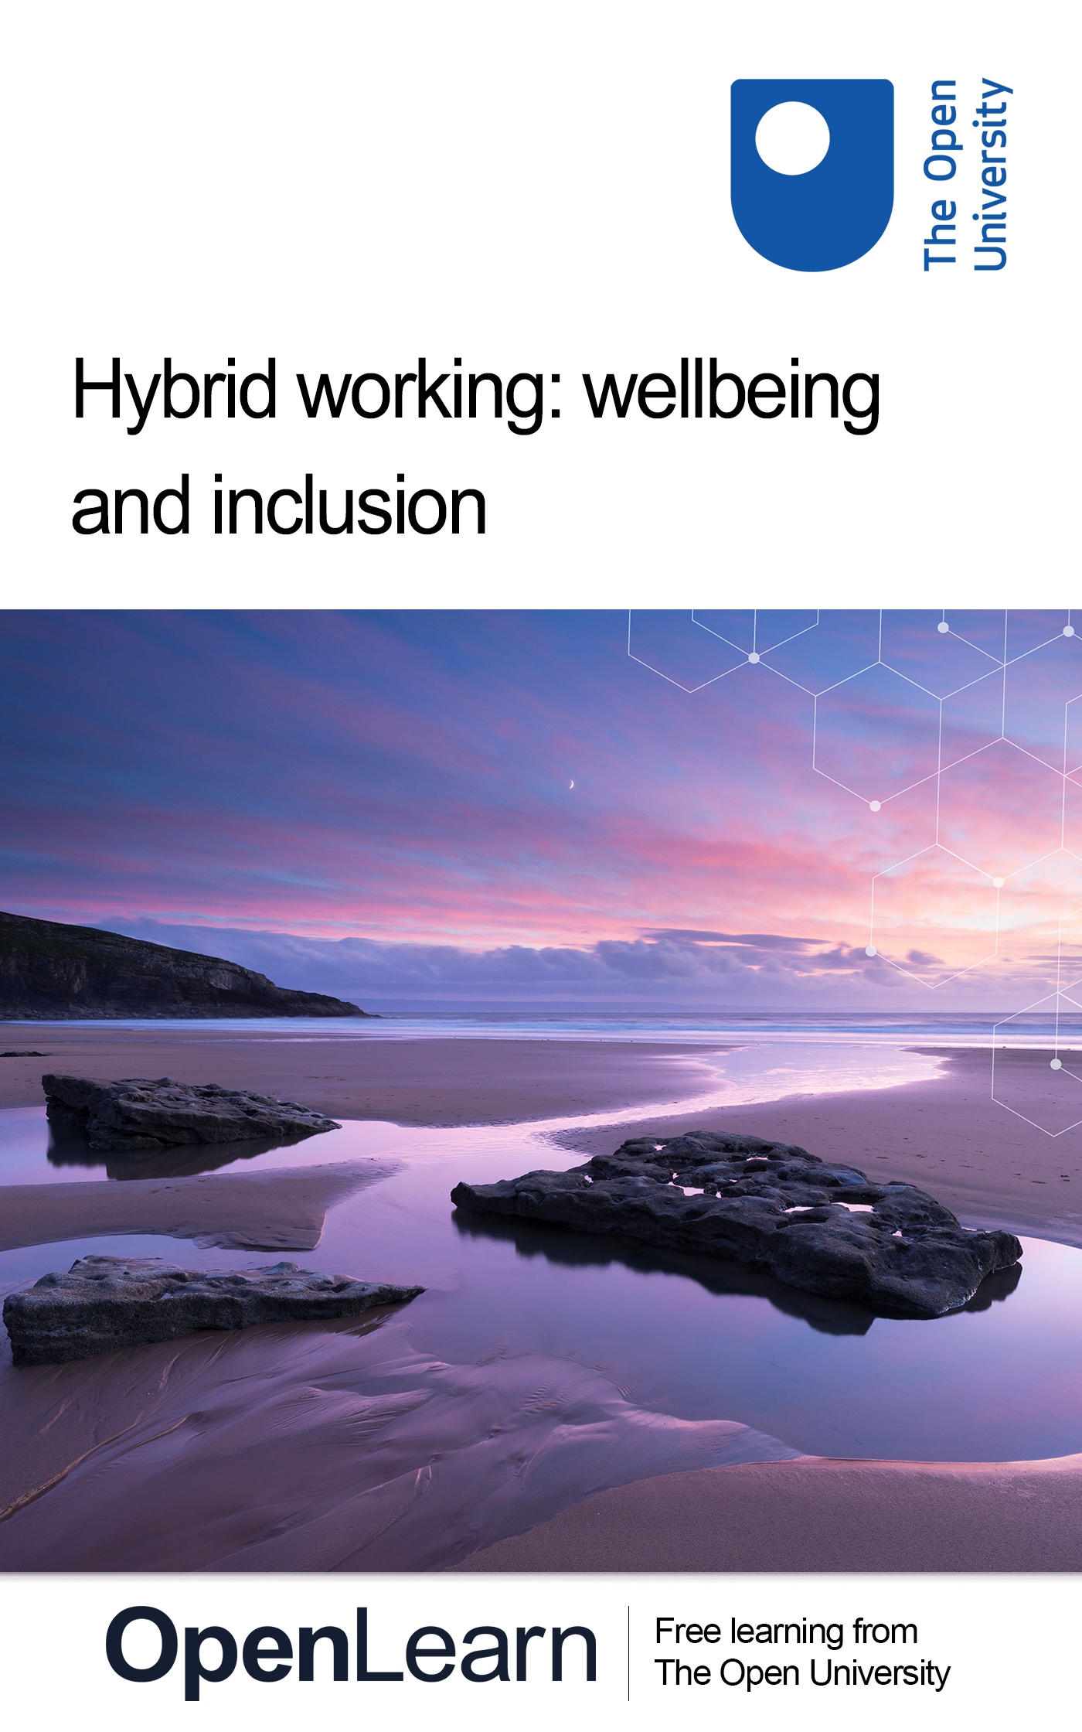

HYB_4

Hybrid working: wellbeing and inclusion

About this free course
This free course is an adapted extract from the Open University course .
This version of the content may include video, images and interactive content that may not be optimised for your device.
You can experience this free course as it was originally designed on OpenLearn, the home of free learning from The Open University –
There you’ll also be able to track your progress via your activity record, which you can use to demonstrate your learning.
Copyright © 2022 The Open University
Intellectual property
Unless otherwise stated, this resource is released under the terms of the Creative Commons Licence v4.0 http://creativecommons.org/licenses/by-nc-sa/4.0/deed.en_GB. Within that The Open University interprets this licence in the following way: www.open.edu/openlearn/about-openlearn/frequently-asked-questions-on-openlearn. Copyright and rights falling outside the terms of the Creative Commons Licence are retained or controlled by The Open University. Please read the full text before using any of the content.
We believe the primary barrier to accessing high-quality educational experiences is cost, which is why we aim to publish as much free content as possible under an open licence. If it proves difficult to release content under our preferred Creative Commons licence (e.g. because we can’t afford or gain the clearances or find suitable alternatives), we will still release the materials for free under a personal end-user licence.
This is because the learning experience will always be the same high quality offering and that should always be seen as positive – even if at times the licensing is different to Creative Commons.
When using the content you must attribute us (The Open University) (the OU) and any identified author in accordance with the terms of the Creative Commons Licence.
The Acknowledgements section is used to list, amongst other things, third party (Proprietary), licensed content which is not subject to Creative Commons licensing. Proprietary content must be used (retained) intact and in context to the content at all times.
The Acknowledgements section is also used to bring to your attention any other Special Restrictions which may apply to the content. For example there may be times when the Creative Commons Non-Commercial Sharealike licence does not apply to any of the content even if owned by us (The Open University). In these instances, unless stated otherwise, the content may be used for personal and non-commercial use.
We have also identified as Proprietary other material included in the content which is not subject to Creative Commons Licence. These are OU logos, trading names and may extend to certain photographic and video images and sound recordings and any other material as may be brought to your attention.
Unauthorised use of any of the content may constitute a breach of the terms and conditions and/or intellectual property laws.
We reserve the right to alter, amend or bring to an end any terms and conditions provided here without notice.
All rights falling outside the terms of the Creative Commons licence are retained or controlled by The Open University.
Head of Intellectual Property, The Open University

Contents
- Introduction
- Learning outcomes
- 1 Three key contexts
  - 1.1 A national context
  - 1.2 A digital context
  - 1.3 Your organisational context
- 2 What do we mean by wellbeing?
  - 2.1 Statistical measures of wellbeing
  - 2.2 The PERMA model
  - 2.3 Different dimensions of wellbeing
  - 2.4 Mental wellbeing or mental health: what’s the difference?
- 3 Whose responsibility is workplace wellbeing?
  - 3.1 Managing your own wellbeing
  - 3.2 Supporting your colleagues’ wellbeing
  - 3.3 Leading wellbeing
- 4 Work–life balance and overload
  - 4.1 Managing email – and its alternatives
  - 4.2 Video meetings: the good and the bad
  - 4.3 The problem of presenteeism
  - 4.4 Establishing boundaries
  - 4.5 Positives and negatives of digital work wellbeing
- 5 Social wellbeing at work
  - 5.1 Communication in a hybrid working world
  - 5.2 The influence of generational traits on communication
  - 5.3 Building and maintaining work relationships
  - 5.4 Avoiding isolation
  - 5.5 Social media safety issues
  - 5.6 Psychological safety
  - 5.7 Cybersecurity for hybrid working
  - 5.8 Positives and negatives of digital social wellbeing
- 6 Inclusion
  - 6.1 Exploring inclusion
  - 6.2 Valuing diversity
  - 6.3 Intersectionality
  - 6.4 Neurodiversity
  - 6.5 How to harness diversity
- 7 Equality
  - 7.1 Protected characteristics: tackling discrimination
  - 7.2 Accessibility at work
  - 7.3 Making physical workspaces accessible
  - 7.4 Making online workspaces accessible
- 8 Building and maintaining a supportive and inclusive hybrid workplace
  - 8.1 Making wellbeing and inclusion a priority
  - 8.2 Benefits and costs of maintaining workplace wellbeing
  - 8.3 Benefits and costs of inclusion, equality and equity
  - 8.4 Where does hybrid working fit in?
- Conclusion
- References
- Acknowledgements
- Solutions

Introduction
Since early 2020, the higher education (HE) sector has had to react to unprecedented change and uncertainty caused by the COVID-19 global pandemic. The so-called ‘pivot to online’ (Salmon, 2020) forced emergency ways of working on university campus-based staff in an attempt to continue educating students while physical attendance at lectures, seminars, etc. was not permitted. As COVID-19 becomes endemic, many higher education institutions (HEIs) are taking the opportunity to reflect on how these emergency practices and policies could or should evolve into a planned and proactive approach to working in a hybrid environment. This process of reflection includes a greater focus on the wellbeing and inclusion of staff and students, which considers:
- the impact – positive and negative – of digital practices adopted as a result of forced home working
- employee expectations around office-based working
- assumptions about how university campus facilities and systems are managed and used.
Why is wellbeing and inclusion so important in a higher-education context? Barbara Bassa, a Programme Director at Advance HE, explains:

There is no argument about the fact that the quality of student experience at university starts with the quality of the services provided by the university staff: academics and professional support staff. In order for all staff to provide these quality experiences, they need to feel well and supported themselves. You cannot pour from an empty cup.
(Bassa, 2022)

This free course is part of the Supporting hybrid working and digital transformation collection.

Learning outcomes
After studying this course, you should be able to:
- reflect on digital/hybrid work habits and practices and their impact on personal wellbeing, and that of colleagues
- discuss various aspects of wellbeing, equality, inclusion and diversity in the context of digital and hybrid working
- articulate likely benefits and/or risks to personal wellbeing associated with engaging in online activities
- appreciate the importance of developing and maintaining a diverse and inclusive working environment
- recognise the role of personal responsibility and leadership in valuing equality, inclusion and difference on an individual level, as well as to teams and the wider organisation.

1 Three key contexts
This course is designed to give you the opportunity to consider key aspects of wellbeing and inclusion in the environment in which you, your colleagues and your organisation operate. The subject will be explored from a range of perspectives, with three particular contexts in mind:
- a national context
- a digital context
- your organisational context.

1.1 A national context
This course was developed with funding from the Higher Education Funding Council for Wales (HEFCW), the public body operating between the Welsh Government and higher education providers, so it’s mainly the Welsh national context that will be referred to here. Your own nation may have different aspirations or targets for improving wellness and inclusion in the workplace.
In Wales, the Well-being of Future Generations (Wales) Act 2015:

requires public bodies in Wales to think about the long-term impact of their decisions, to work better with people, communities and each other, and to prevent persistent problems such as poverty, health inequalities and climate change.
(Future Generations Commissioner for Wales, 2022a)

The Act contains seven goals to improve the social economic, environmental and cultural wellbeing of Wales – but the areas they cover could apply equally to other nations. The goals are shown in Figure 1 and described in Table 1.

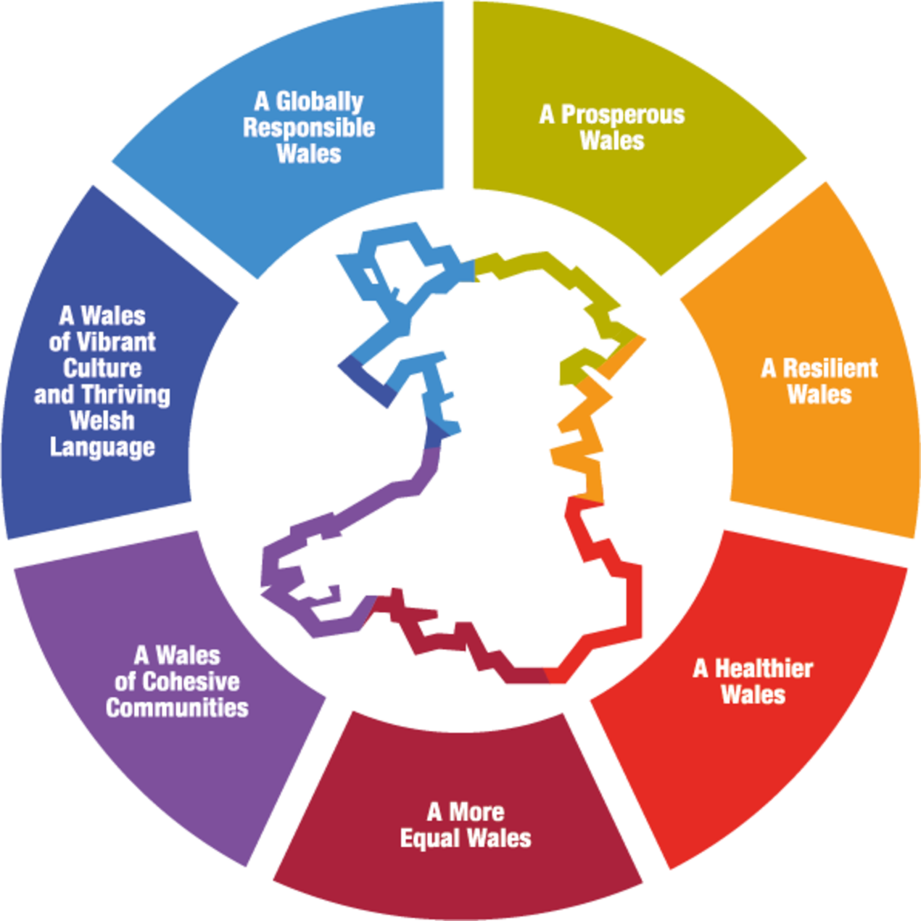
Figure 1 Wellbeing goals.
View description - Figure 1 Wellbeing goals.

Table 1
A Prosperous Wales
An innovative, productive, and low carbon society that recognises the limits of the global environment and therefore uses resources efficiently and proportionately (including acting on climate change); and which develops a skilled and well-educated population in an economy that generates wealth and provides employment opportunities, allowing people to take advantage of the wealth generated through securing decent work.
A Resilient Wales
A nation which maintains and enhances a biodiverse natural environment with healthy functioning ecosystems that support social, economic and ecological resilience and the capacity to adapt to change.
A More Equal Wales
A society that enables people to fulfil their potential no matter what their background or circumstances (including their socio-economic circumstances).
A Healthier Wales
A society in which people’s physical and mental wellbeing is maximised and in which choices and behaviours that benefit future health are understood.
A Wales of Cohesive Communities
Attractive, safe, viable and well-connected.
A Wales of Vibrant Culture and Thriving Welsh Language
A society that promotes and protects culture, heritage, and the Welsh language, and which encourages people to participate in the arts, and sports and recreation.
A Globally Responsible Wales
A nation which, when doing anything to improve the economic, social, environmental and cultural wellbeing of Wales, takes account of whether doing such a thing may make a positive contribution to global wellbeing.
(Future Generations Commissioner for Wales, 2022a)

The two goals that most naturally relate to this course are ‘A Healthier Wales’ (for wellbeing) and ‘A More Equal Wales’ (for inclusion), and resources associated with these goals will be highlighted at appropriate points throughout the course, particularly what the Future Generations Commissioner for Wales (2022b) calls ‘Simple Changes’. Look out for the boxes throughout the course containing links to these resources. The other goals won’t be explicitly addressed, but as you work through the course, try to reflect on how the topics covered could link to them.

A healthier Wales
The ‘A Healthier Wales’ goal is defined in Table 1. This goal will be explored from different perspectives in this course, with a particular focus on the impact of remote and hybrid working on mental and physical wellbeing.

A more equal Wales
The ‘A More Equal Wales’ goal is also defined in Table 1. The Well-being of Future Generations (Wales) Act 2015 suggests that this goal could be realised by:

achieving more diversity in our decision-makers and our broader workforce, and ensuring that organisations in Wales are taking preventative, integrated approaches to end poverty and reduce inequalities.
(Future Generations Commissioner for Wales, 2022d)

This course will explore how to improve workplace diversity, equality and equity, and identify some of the benefits such improvements could bring to your organisation.

1.2 A digital context
As this course is part of a digital transformation collection, it will examine wellbeing and inclusion from a digital perspective. This will be informed by one element of Jisc’s Building Digital Capabilities Framework (Jisc, 2018), namely ‘Digital Identity and Wellbeing’. Jisc defined ‘Digital Wellbeing’ as the capacity to:
- look after personal health, safety, relationships and work–life balance in digital settings
- use digital tools in pursuit of personal goals (e.g. health and fitness) and to participate in social and community activities
- act safely and responsibly in digital environments
- negotiate and resolve conflict
- manage digital workload, overload and distraction
- act with concern for the human and natural environment when using digital tools.
Many of these points will be explored throughout the course. It will also touch on some aspects of the ‘Digital Identity’ part of Jisc’s framework, which relates to having an understanding of the reputational benefits and risks involved in digital participation.
The other elements in Jisc’s Building Digital Capabilities Framework are explored in the following courses from the Supporting hybrid working and digital transformation in Wales collection:
- Hybrid working: skills for digital transformation
- Hybrid working: digital communication and collaboration

1.3 Your organisational context
Your organisation may already have wellbeing and inclusion strategies in place, but are they just policy documents, or are they embodied by the behaviours and skills of staff at all levels and the values, culture and practices in your physical and digital workplaces? As its title suggests, this course will explore various aspects of wellbeing and inclusion, before considering how you can bring them together to build and maintain a supportive and inclusive hybrid workplace.
To learn about other aspects of organisational development in the hybrid workplace, you might like to study the Hybrid working: organisational development course included in this collection.
In the video below contributors share their insights and approaches for supporting wellbeing and creating a more inclusive organisation.

Video content is not available in this format.
View transcript - Uncaptioned interactive content

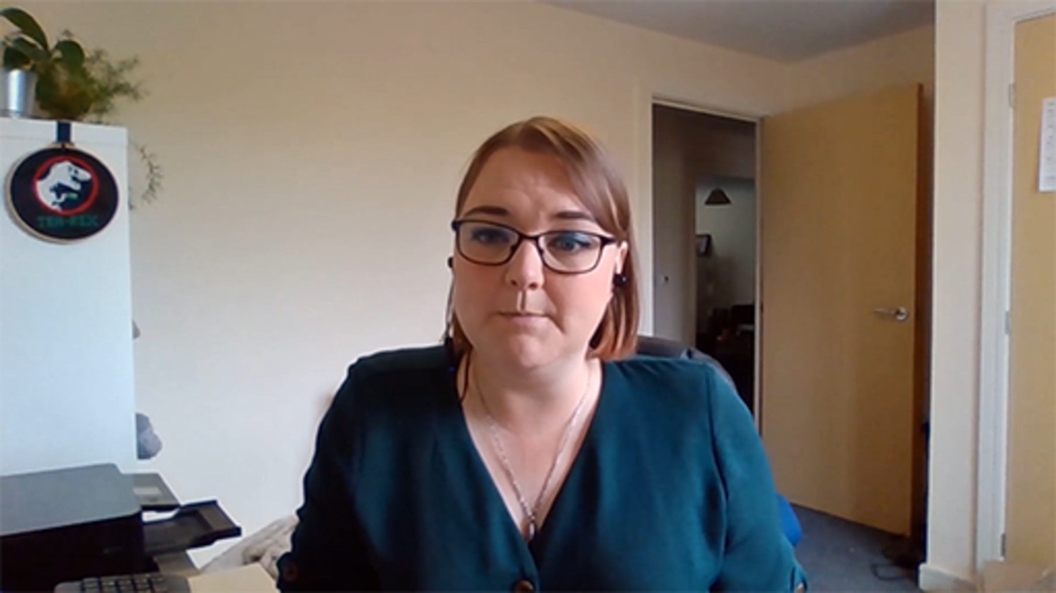

Effective leadership recognises the need to embed wellbeing and inclusion throughout the different levels of an organisation. For wellbeing, this could mean diversifying the support approach, rather than relying on a single, outsourced employee support service. For inclusion, this may mean recognising that there is a problem inherent within the structures of the organisation based on societal norms.

2 What do we mean by wellbeing?
There’s no doubt that wellbeing has become a real buzzword in contemporary society – particularly since the emergence of COVID-19 forced us all to pay more attention to our health. But what does the word mean to you?

Activity 1 What does wellbeing mean to you?
Allow about 10 minutes

Spend a few minutes noting down the words you associate with wellbeing. Try to come up with at least one, but no more than ten.
Then pick your favourite word – the one that best encapsulates what wellbeing means to you.

Provide your answer...
View discussion - Activity 1 What does wellbeing mean to you?

Next let’s hear some students talking about what wellbeing means to them, in a series of vox pops captured by SHARP (Strong, Healthy and Resilient People) (Be Sharp, 2019), a resource run by the Strong Young Minds charity.
What is wellbeing? (open link in a new/tab window so you can return easily).
Were the students’ views on wellbeing similar to your own? Was there anything they talked about that you didn’t think of? You might have noticed that none of them mentioned work, as they are probably still all in full-time education, but if you are of a different age/generation, your work may be having a much greater impact on your overall wellbeing. The impact of generational differences on wellbeing will be looked at later in this course.

2.1 Statistical measures of wellbeing
The UK Office for National Statistics (ONS, 2020) measures wellbeing for young people at a national level using a series of indicators against which they ask people aged 16–19 and 20–24 years to rate their level of satisfaction with different aspects of their lives. These indicators include the following questions:
- Personal wellbeing – e.g. are they satisfied with their lives overall; how worthwhile do they think the things they do are; how would they rate their happiness yesterday; how would they rate their anxiety yesterday?
- Relationships – e.g. do they have people who would be there for them if they needed help; do they quarrel with a parent more than once a week; do they talk to a parent about things that matter more than once a week?
- Health – do they have a reported disability; are they satisfied with their health; is there evidence indicating depression or anxiety; are they overweight or obese?
- Occupation (‘what we do’) – are they unemployed; are they satisfied with their amount of leisure time; have they volunteered more than once in the last 12 months; have they engaged with/participated in an arts or cultural activity at least three times in the last year?
- Location (‘where we live’) – have they been a victim of crime; have they felt safe walking alone after dark; have they felt they belonged to their neighbourhood; have they accessed the natural environment at least once a week in the last 12 months; are they satisfied with their accommodation?
- Personal finance – are they satisfied with their household income; have they found it difficult to get by financially?
- Education and skills – are they in education, employment or training (NEET); what level of education have they attained?
These questions offer a wider view of wellbeing than you may originally have considered. Some of them will be revisited in Section 3. Next, however, you’re going to look at a psychological perspective on wellbeing.

2.2 The PERMA model
Wellbeing is defined by the Oxford English Dictionary as ‘the state of being comfortable, healthy, or happy’. However, it is important to realise that wellbeing is a much broader concept than moment-to-moment happiness. While it does include happiness, it also includes other things, such as how satisfied people are with their life as a whole, their sense of purpose and how in control they feel.
A useful perspective on this comes from American psychologist, educator and author Martin Seligman. Seligman’s research (2011) indicated that five core elements are needed for people to achieve a healthy sense of wellbeing, fulfilment and satisfaction in life. He called this the PERMA model:
- Positive emotion
- Engagement
- Relationships
- Meaning
- Achievement.

Activity 2 Identify examples for the PERMA model
Allow about 20 minutes

- Spend a few minutes thinking of a workplace example for each of the elements of the PERMA model – e.g. what was the last positive emotion you felt at work, and why; what gives meaning to your work?
- Now read this short article (700 words) on Positive Psychology in the Workplace (Finkbeiner, 2022) from workplace wellbeing provider Zevo.

Provide your answer...

How did the examples you thought of compare to the suggestions from Zevo? Note that the author of the article says ‘Employers, managers, and leaders all have a role to play in workplace happiness’. Section 3 will pick up on this.

2.3 Different dimensions of wellbeing
Section 2.1 referred to the dimensions of wellbeing the UK ONS (Office for National Statistics) uses to measure young people’s wellbeing, which were:
- personal
- relational
- health-based
- occupational
- environmental
- financial
- educational/skills-based.
If you research dimensions of wellbeing (often called ‘wellness’ in the USA) you will find other categorisations that range from five elements (typically aligned to the PERMA model described in the previous section) to eight elements. Eight seems to be the most common set, and comprises the types of wellbeing illustrated in Figure 3.

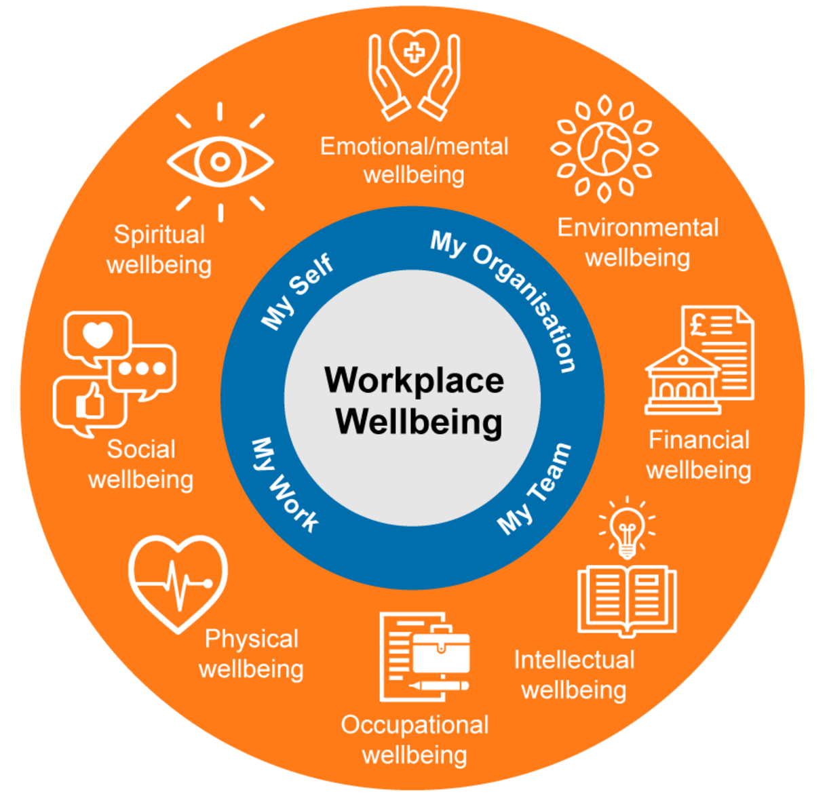
Figure 3 Dimensions of wellbeing.
View description - Figure 3 Dimensions of wellbeing.

This course considers the post-COVID-19 digital landscape and the hybrid ways of working that have emerged in response to the pandemic, so much of it will be focused on factors relating to occupational (work-based) wellbeing. However, occupational wellbeing is hugely affected by your mental and physical health. Additionally, it’s difficult to entirely separate what happens during working hours from every other aspect of your wellbeing, so the course will inevitably touch on several of the other dimensions listed above, to a greater or lesser degree.

2.4 Mental wellbeing or mental health: what’s the difference?
Let’s address a common question: what’s the difference between mental wellbeing and mental health?
This course tends to refer to ‘wellbeing’ rather than ‘health’, and different interpretations of the meaning of ‘wellbeing’ (mental and physical) have already been presented. It’s worth noting, however, that the terms ‘mental wellbeing’ and ‘mental health’ often get used interchangeably, and some of the resources included in this course will therefore refer to ‘health’ rather than ‘wellbeing’. The UK Department of Health explains the relationship between mental wellbeing and mental health as follows:

Mental illness and wellbeing are independent dimensions; mental health is not simply the opposite of mental illness. It is possible for someone to have a mental disorder and high levels of wellbeing. It is also possible for someone to have low levels of wellbeing without having a mental disorder.
(Department of Health, 2014)

The terms ‘mental illness’ and ‘mental disorder’ are used to describe specific, diagnosable health conditions that involve emotional, thinking or behavioural changes – or a combination of these. They tend to have persistent behavioural signs and symptoms, just as health conditions such as diabetes or heart disease have measurable physical symptoms.
Slightly confusingly, the World Health Organization actually includes the word ‘wellbeing’ in its definition of mental health:

Mental health is a state of mental well-being that enables people to cope with the stresses of life, realize their abilities, learn well and work well, and contribute to their community. It is an integral component of health and well-being that underpins our individual and collective abilities to make decisions, build relationships and shape the world we live in. Mental health is a basic human right. And it is crucial to personal, community and socio-economic development.
Mental health is more than the absence of mental disorders.
(World Health Organization, 2022)

Student Minds, the UK’s student mental health charity, states that ‘mental health is based on a continuum and can fluctuate at different times’ (StudentMindsOrg, 2018). They have a useful graphic to illustrate this:

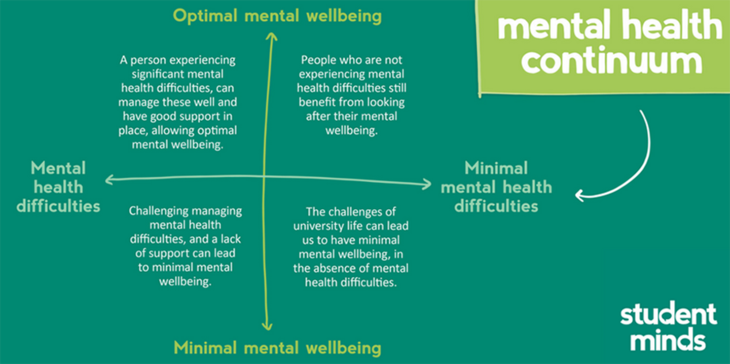
Figure 4 Mental health as a continuum.
View description - Figure 4 Mental health as a continuum.

In summary, there’s no straightforward distinction between the two terms, but there’s no doubt that a person’s mental wellbeing can have a considerable effect on their mental health. Looking after your mental wellbeing, and having resources and strategies in place to support you during challenging or stressful situations, can help you avoid developing more serious mental health problems. This course will introduce some of these resources and strategies, but it will not cover mental illness in detail. If you are interested in learning more about this subject, OpenLearn has numerous free courses, which you can find by visiting the Free courses page and typing ‘mental health’ in the search bar.
See also: Wellbeing and mental health collection.

3 Whose responsibility is workplace wellbeing?
It was noted earlier that ‘Employers, managers, and leaders all have a role to play in workplace happiness’ (Finkbeiner, 2022).
However, when it comes to wellbeing, it is really important to be aware of your own status before you try to support others, and for you to feel able to seek support or take action to improve your own wellbeing if you need to. In safety briefings on aeroplanes, you are instructed to put on your own oxygen mask before helping others, and looking after your own wellbeing should be a similar priority in a work context, to equip you to be able to support colleagues at all levels.
In the video below, Sharon Mallon PhD, Senior Lecturer in Mental Health at The Open University, discusses how organisations and individuals can have greater awareness of monitoring wellbeing.

Video content is not available in this format.
View transcript - Uncaptioned interactive content

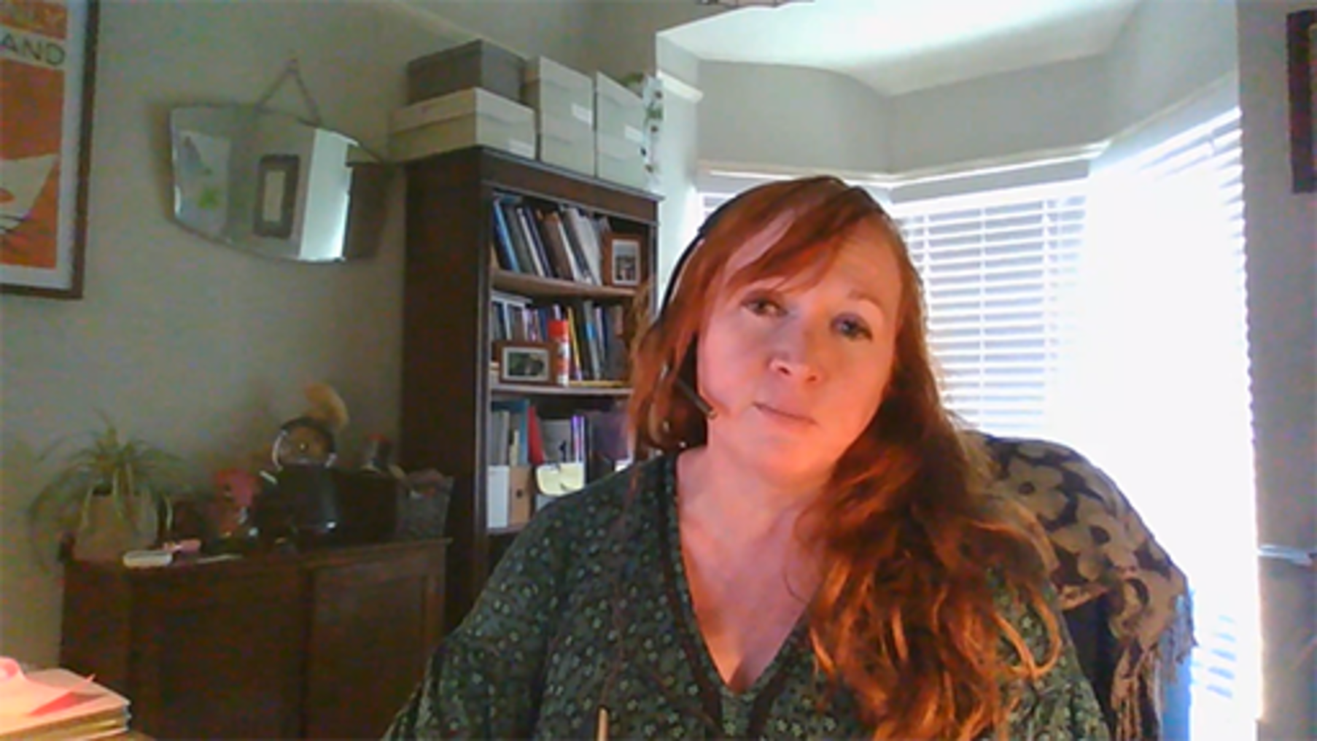

3.1 Managing your own wellbeing
Section 2.1 introduced the indicators used by the ONS to measure the level of satisfaction young adults have with different aspects of their lives. The ONS also have a simplified set of four personal wellbeing questions that have been used in a range of surveys to measure national wellbeing since 2010 (ONS, 2018). Try answering these questions now in Activity 3.

Activity 3 Four measures of personal wellbeing
Allow about 5 minutes

Table 2 contains four questions about your feelings on aspects of your life. There are no right or wrong answers. For each of these questions, note down an answer on a scale of 0 to 10, where 0 is ‘not at all’ and 10 is ‘completely’.

Table 2
Measure | Question
Life satisfaction | Overall, how satisfied are you with your life nowadays?
Worthwhile | Overall, to what extent do you feel that the things you do in your life are worthwhile?
Happiness | Overall, how happy did you feel yesterday?
Anxiety | On a scale where 0 is ‘not at all anxious’ and 10 is ‘completely anxious’, overall, how anxious did you feel yesterday?
(ONS, 2018)

View discussion - Activity 3 Four measures of personal wellbeing

3.1.1 Your physical wellbeing: signs of stress
The medical profession uses measures such as body mass index, blood pressure and cholesterol levels to determine physical wellbeing, but feeling physically well means different things to different people. If you have a long-term medical condition, for example, your personal sense of your physical wellbeing may differ from what’s considered medically ‘normal’.
As modern life has become more and more hectic, and the COVID-19 pandemic introduced a whole new set of things for us to worry about, we may have become used to feeling stressed nearly every day. A small amount of stress or anxiety might help us be more productive, according to what is known as the Yerkes–Dodson law, illustrated in Figure 5.

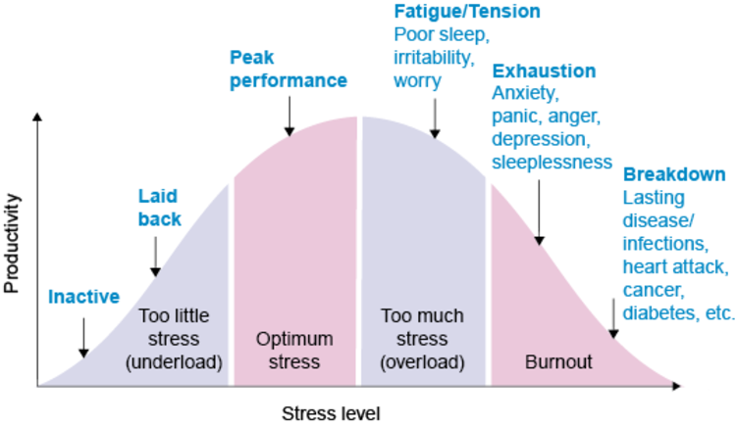
Figure 5 The Yerkes–Dodson law.
View description - Figure 5 The Yerkes–Dodson law.

However, too much stress can have a negative impact on our health and productivity. These physical signs can be a useful indicator of whether you might be too stressed:
- Headaches – frequent/chronic headaches have been linked to high levels of stress, but other triggers for headaches include dehydration, lack of sleep or high alcohol consumption.
- Frequent illness – being stressed has a direct impact on the immune system, making you more vulnerable to infections, but your diet and physical activity level can also affect immunity.
- Low energy/fatigue – energy levels naturally vary throughout the day, but feeling like you’re constantly running on empty, to the extent that performing simple tasks is a challenge, could be a sign that you’re too stressed; however, insufficient sleep, dehydration, low blood sugar and anaemia are also factors that affect energy levels.
- Insomnia – trouble sleeping, because you can’t ‘switch off’ your mind or you’re tossing and turning at night, are classic indicators of high stress levels. Good sleeping habits are a key component of wellbeing and reduced sleep can also cause low energy and headaches and impact your immune system.
- Digestive issues – physical symptoms such as diarrhoea and constipation can manifest as a result of too much stress, or if you already live with Irritable Bowel Syndrome or Inflammatory Bowel Disease, stress can worsen your symptoms.
- Appetite – changes in appetite, whether that’s feeling more or less hungry than normal, could be a response to excessive stress.
Most people experience some level of stress in their daily lives, but it affects us in different ways. If you feel like you are too stressed, start by considering the source of that stress. If it’s work related, could you speak to your line manager about decreasing your workload? If your personal life is the issue, could you find some more time to look after yourself?
Simple self-care approaches to dealing with stress include meditation, breathing techniques, yoga and other mindfulness-based activities. Many organisations offer such activities to employees in a variety of online and offline formats – your human resources team should be able to point you towards these. However, if you are regularly experiencing the physical symptoms mentioned above, it’s also advisable to contact your GP or healthcare provider to clarify the cause of your symptoms and discuss the best course of action.

3.1.2 Your digital wellbeing
It was mentioned earlier that this course would examine wellbeing from a digital perspective, informed by the ‘Digital Wellbeing’ element of Jisc’s Building Digital Capabilities Framework (Jisc, 2018). Let’s look at this now.

Digital wellbeing is a term used to describe the impact of technologies and digital services on people’s mental, physical, social and emotional health.
(Jisc, 2019a)

Hybrid working, communication and digital collaboration can sometimes be challenging or demanding, and can affect your wellbeing.
It can be more difficult to develop organisational culture and build trust in hybrid working environments. Culture and trust are built through human connections, and, as humans, we have had to adjust to be able to develop these, both in person and in a digital virtual world.
While this situation is still evolving, it is worth asking questions such as: Have we adapted? How is it different now? If you think about how you work with your colleagues and your organisation in a post-COVID-19 context, you may find that your culture and trust has evolved naturally, and adapted to hybrid ways of working. Many of you may find you have actually built a higher level of trust with those you work with, as you have been through a shared experience. In addition, being in your own ‘home’ environment can lead to feeling more secure, as it is familiar, which can improve your sense of wellbeing.

Activity 4 The impact of digital technologies on your wellbeing
Allow about 30 minutes

Look carefully at the diagram below.
- Consider how technologies can improve your digital wellbeing at work by identifying positive and negative impacts they have had, either from your own experience or those you’ve observed in colleagues.
- What capacity do you think you have to change your digital practices to improve your wellbeing?

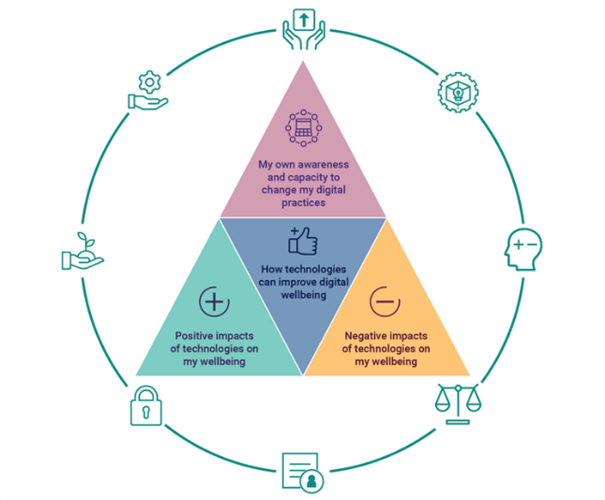
Figure 6 Four aspects of digital wellbeing for individuals.
View description - Figure 6 Four aspects of digital wellbeing for individuals.

You can make some notes in the box below.

Provide your answer...
View discussion - Activity 4 The impact of digital technologies on your wellbeing

Then watch the video in which Sas Amoah, Digital Media Producer at The Open University, shares how he manages his digital wellbeing.

Video content is not available in this format.
View transcript - Uncaptioned interactive content

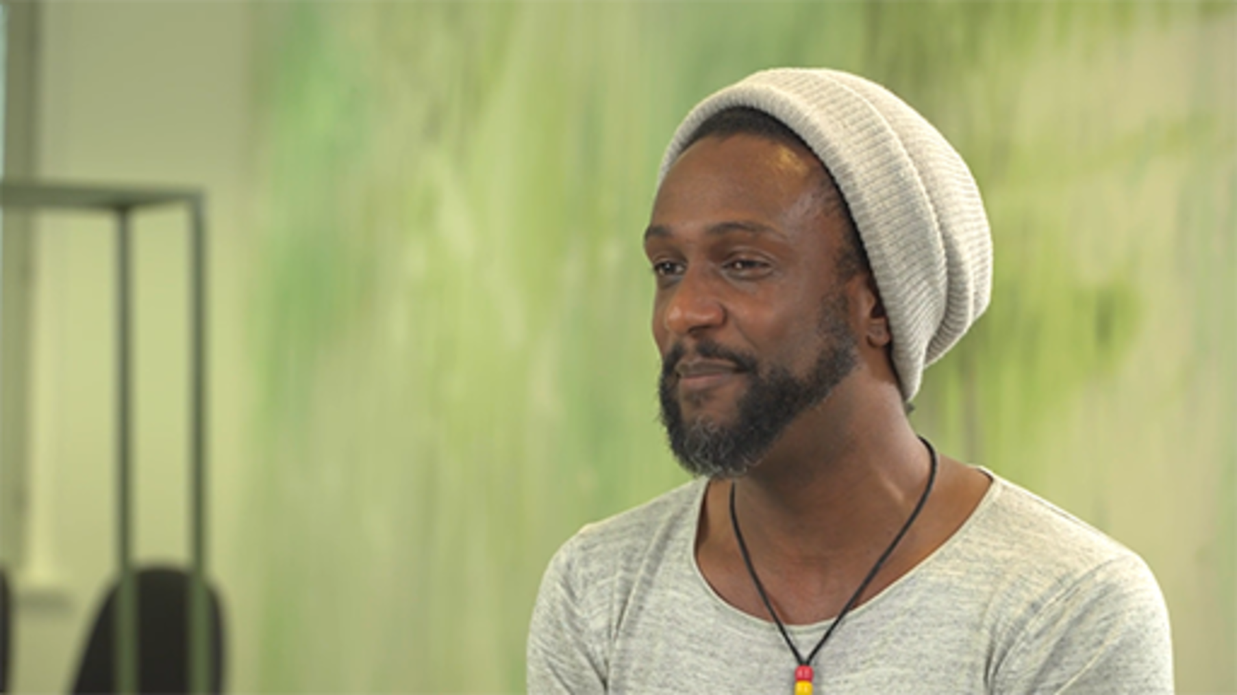

The Jisc model focuses on four contexts – social, personal, learning and work – that can help you consider areas you might want to focus on for your own wellbeing. These are listed in Table 3.

Table 3
Digital wellbeing context | Positives | Negatives
Social | - Preventing isolation  - Building and maintaining relationships  - Reducing loneliness  - Full participation and connection with family, friends and wider communities  - Increased opportunities for inclusion (e.g. disabled people) | - Cyberbullying  - Online grooming (e.g. sex, radicalisation)  - Exclusion and/or accessibility (e.g. gender, age, poverty)
Personal | - Creating a positive identity  - Building self-worth  - Enjoyment (e.g. games, fun, interactions, music)  - Convenience/time saving (e.g. shopping)  - Access to new ideas/inspiration  - Tools for physical health | - Negative comparison with others  - Addictive online behaviours (e.g. gambling, porn, checking devices)  - Passive consumption  - Access to illegal activities/materials  - Personal data breaches  - Lack of access and/or being left behind  - Lack of sleep  - Impact on physical health (e.g. eye strain, posture, lack of exercise)
Learning | - Alternative ways to learn  - Online collaborative learning opportunities  - Engaging learning activities  - Practising digital skills for employment  - Learning digital skills for new careers/career change  - Increased access to learning  - More engaging assessment and feedback | - Lack of digital skills  - Digital overload  - Negative impact of compulsory online collaboration  - Time learning new technologies not the subject  - Inappropriate use of technologies  - Lack of choice (e.g. told which technologies to use)
Work | - Improved communication  - Global collaboration  - Flexible working  - Tools to manage workload  - Tools to make things easier  - Creating positive online professional identity  - Link to other professional/subject networks | - Digital overload  - Always on (24-hour access)  - Changes to job roles/activities  - Automation of tasks (e.g. redundancy)  - Poor ergonomics
(Jisc, 2019c)

Some of the recommendations Jisc suggests to help improve your digital wellbeing are:
- Ask for training and support on the digital systems and tools relevant to your role, so that you can use them effectively and safely.
- Take time to explore and understand your digital preferences and needs.
- Consider the impact of digital activities on your own health and the health of others.
- Manage your digital workload by learning how to use tools effectively, managing your emails and avoiding distractions.
- Create a positive digital identity.
Many of these will be explored in Sections 4 and 5 of this course.

3.2 Supporting your colleagues’ wellbeing
This section began by asking you to consider your own wellbeing at work. Now it’s time to think about the wellbeing of others – your colleagues.

Activity 5 How can you help others?
Allow about 20 minutes

Read this short article (500 words) titled How can I support my colleagues?, from Scotland’s National Wellbeing Hub (no date), then spend some time reflecting on the following questions:
- Have you tried any of the suggestions in the article? If so, how successful were they? What sort of response did they elicit?
- To what extent do you feel responsible for supporting your colleagues’ wellbeing at work?
- What other actions, ideas, approaches and strategies have you identified as having the potential to improve the wellbeing of your colleagues?
You can make some notes in the box below.

Provide your answer...
View discussion - Activity 5 How can you help others?

3.3 Leading wellbeing
If you are in a leadership role, you should be:
- looking at the bigger picture, keeping up with trends in workplace wellbeing and setting strategic priorities in a high-level, proactive way rather than reacting to individual situations
- considering the wellbeing of your people over the entire employee lifecycle, e.g. including caring responsibilities, pregnancy (and pregnancy loss) and chronic health conditions
- modelling behaviours that support workplace wellbeing, i.e. practising what you preach
- facilitating your managers, by taking responsibility for their wellbeing and the wellbeing of their teams.
In a digital context, Jisc (2019b) have identified eight good practice principles for organisation-wide approaches to digital wellbeing:
- provide inclusive and responsive services that support digital work or learning activities
- incorporate digital wellbeing into existing policies and strategies, particularly accessibility and inclusion policies
- provide safe physical and online environments
- comply with the duty of care to staff and students in relation to digital work or learning activities
- meet ethical and legal responsibilities in relation to accessibility, health, equality and inclusion
- provide appropriate training, educational opportunities, guidance and support for participation in digital work or learning activities
- understand potential positive and negative impacts of digital work or learning activities on wellbeing
- provide inclusive and accessible digital systems, tools and content.
For some examples of actions that you could take to enact these principles, you can download the full briefing paper for senior leaders, which is linked in the References section at the end of the course. Jisc also published a briefing paper on digital wellbeing aimed at practitioners, which emphasises that:

Although education organisations have a duty of care to make sure their employees and students have a safe, legally compliant and supportive digital environment to work and learn in, individuals have responsibility for aspects within their control and should take appropriate steps to ensure they achieve and maintain a positive approach to digital wellbeing.
(Jisc, 2019c)

Jisc’s advice may be intended for a digital context, but it applies equally to hybrid working.
The Future Generations Commissioner for Wales has six ‘Simple Changes’ relating to wellbeing that you, as a leader, could implement at your organisation. Follow the links below to find out more (open them in a new window/tab so you can easily return here).

Box 1 Simple Changes #21–22, 24–27
Simple Changes #21 Take stock of mental health in your workplace.
Simple Changes #22 Provide mental health and suicide awareness training for all staff.
Simple Changes #24 Provide lockers for your employees.
Simple Changes #25 Have a flexible working policy.
Simple Changes #26 Encourage your employees to take breaks and eat away from their desk.
Simple Changes #27 Encourage walking and standing meetings, where appropriate.
(Future Generations Commissioner for Wales, 2022b)

4 Work–life balance and overload
Section 3 touched on some aspects of work–life balance and overload. This section will look at the day-to-day practicalities of managing these issues in a hybrid working environment.
Mobile digital technologies, smart devices, superfast broadband and cloud computing mean that for many people, work is now just a click away, 24 hours a day, 7 days a week. This ‘always-on’ culture makes it challenging to maintain effective workload management and keep a healthy work–life balance. This challenge was intensified by the pandemic forcing many of us to create an ‘office’ within our own homes.
In a recent CIPD (2020) survey, 86% of respondents identified the ‘inability to switch off during out-of-work hours’ as the main negative effect of technology on wellbeing. This was closely followed by the stress resulting from technology failure (70%).
To maintain our wellbeing in the face of all this, we need strategies in place to stop us burning out.
In the following video Grace Emiohe from The Open University shares her experiences of maintaining her own wellbeing.

Video content is not available in this format.
View transcript - Uncaptioned interactive content

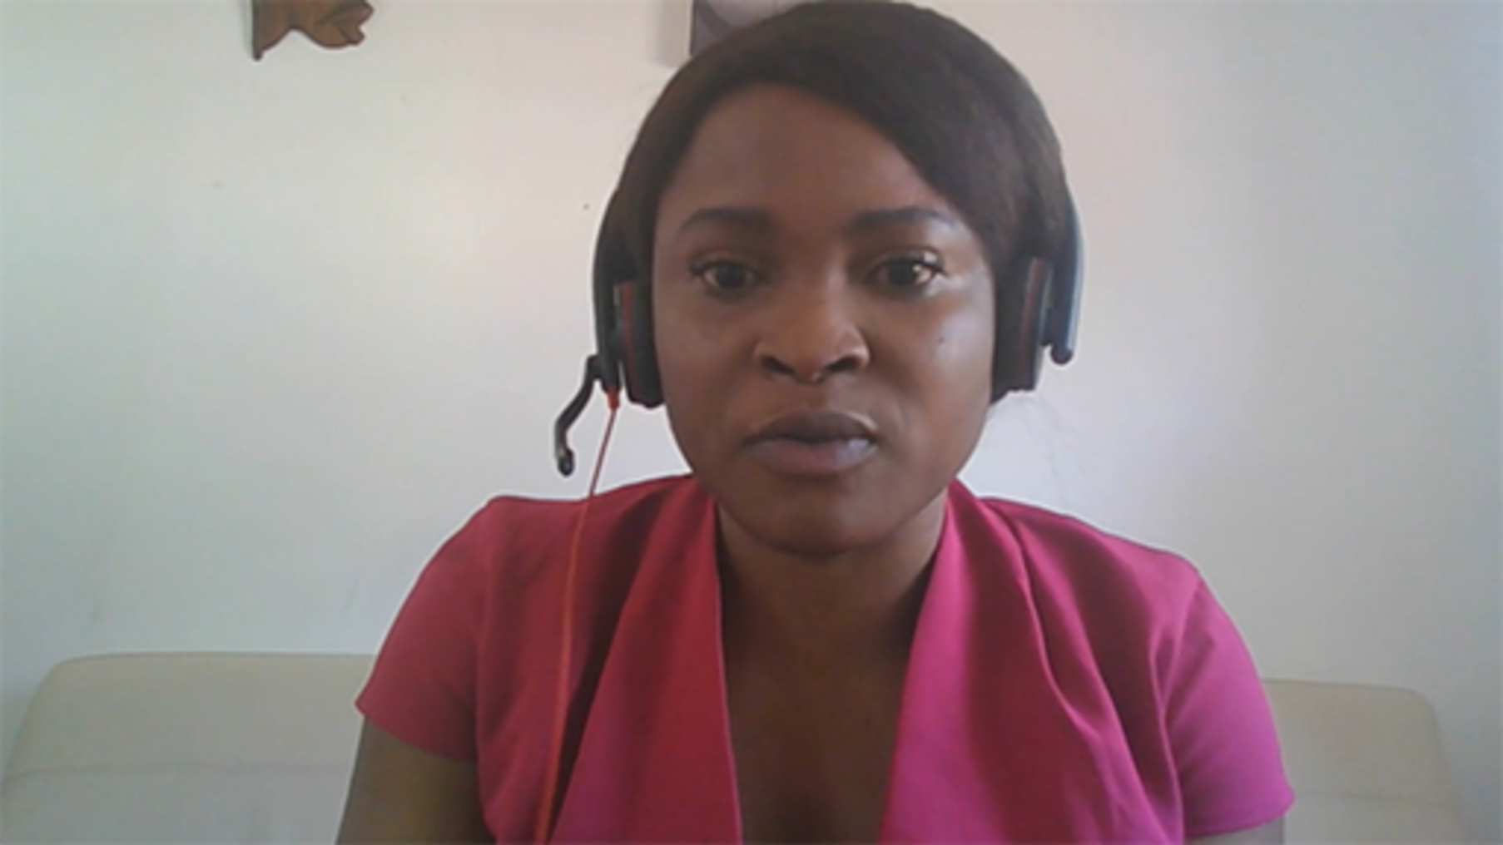

Activity 6 Monitoring your online/onscreen working time

If working remotely for some or all of your time has meant that you’re not sticking rigidly to traditional office hours, it’s important to keep track of how long you are spending online/onscreen, to ensure you don’t unintentionally become one of the ‘always-on’ workers mentioned before.
Over the next week, try to make a note of your ‘screen time’, whether that’s using a computer (desktop or laptop), a tablet, a smartphone or any other kind of work-related digital technology. Count each device separately. You might want to take a break from the screen to record your time with a pen and paper!
Pay particular attention to times when you weren’t planning to work, but the affordances of technology meant that you ended up doing it anyway. For example, when you were sat on your sofa watching TV in the evening, but had your smartphone next to you, and when a work notification popped up, you couldn’t stop yourself from checking it.
Also try to note whether you felt that the online/onscreen time was particularly positive (e.g. it made you feel satisfied at your productivity) or negative (e.g. reading ‘out-of-hours’ emails made you feel stressed or angry). If it caused no strong feelings either way, you don’t need to note that.
At the end of the week, review your notes to identify how much time you spent online/onscreen, and what impact the emotional responses you noted had on your wellbeing.
Make some notes summarising your experience in the box below.

Provide your answer...
View discussion - Activity 6 Monitoring your online/onscreen working time

4.1 Managing email – and its alternatives
Do you dread opening your email inbox? Do you feel like you spend so long each day reading, responding to and administering email that you have no time to do your ‘actual work’? If so, you’re not alone.
Email is a digital tool and, like all tools, learning how to use it more effectively, familiarising yourself with its strengths and weaknesses, and exploring different techniques and approaches in using it will help you minimise any negative impact on your mental wellbeing – and that of your colleagues.

When is email the best tool for the task?
What is the purpose of your email, and is it time-sensitive? For example, if you have a question that needs a quick response, would online chat, a phone call or a video call work better? Group chat tools such as WhatsApp can be useful if you need to discuss something with multiple contacts but don’t want to generate a lengthy and confusing email chain. However, be aware that not everyone has a mobile phone for work and they may not welcome such exchanges on a personal device.
If your email is a regular update for an audience that includes a mixture of internal and external contacts, would a blog or social media post be more effective?
Essentially, when used well, email is a great way to communicate with colleagues asynchronously – without needing to be on the same platform or free at the same time.

Email formatting and features
Emails have a subject line for a reason. If your email has a precise but concise subject line, the recipient(s) will immediately know what it relates to and can prioritise it accordingly. It will also help to stop that email getting overlooked in an overstuffed inbox full of messages with vague or empty subject lines.
How long is your email, and how is it structured? People who receive a lot of emails will skim the contents for the most important points, so it’s important to make any key messages or actions unmistakeable. Bullets or bold text can help with this. No one wants to read an email essay, so get to the point quickly and use concise sentences and short paragraphs.

Check before you send!
It’s all too easy to send emails on impulse, but recovering from mistakes, omissions or using a misjudged tone in them is a lot harder.
Before you click ‘send’, check that you’re sending it to the right person or people – and that you’ve chosen the correct option between ‘reply’ and ‘reply all’. Make sure you’ve only addressed it to the people that it is absolutely relevant to and haven’t copied in people who don’t need to engage with its content. One of the biggest contributors to email overload is copying in everyone with even the slightest connection to the subject. This is a waste of their time and yours.

Imposing order on your email chaos
- Establish a strategy or schedule for reading and responding to email, e.g. if you feel that it’s taking over too much of your working time, try checking your emails only at certain times of day.
- Share your strategy with others, so they know not to expect an immediate response if they contact you via email.
- Use folders to organise what you can’t delete – these could be as simple as Action, Waiting, Reference and Archive, or you could create a folder for every project you work on.
- Consider setting up rules to send certain emails directly to those folders.
- Use your personal email account (if you have one) for all non-work email.

Email alternatives
Use of Microsoft Teams seems to have increased rapidly in the HE sector as a consequence of the pandemic, thanks to its ‘one-stop shop’ functionality. Some people now use it as their primary communication tool, instead of email, and it can be great for working collaboratively and synchronously. However, used without care, it can be just as much of a pest as email: interrupting work and sending endless notifications, for example. It also doesn’t yet seem to have established the sort of etiquette that email has been developing over the last few decades.
A notable feature of platforms like Teams (see also Slack and Discord) is that they allow you to set a ‘status’ that indicates to other people whether you’re available to talk, busy working on something, temporarily ‘away’ or offline. However, some people may feel pressure to keep this constantly up to date, or worry about being seen to be productive, especially when working from home – as you’ll see later in Section 4.3 which covers the problem of presenteeism.

4.2 Video meetings: the good and the bad
Perhaps one of the most significant impacts of the COVID-19 pandemic on the way we work has been the stratospheric rise in the use of video conferencing as a means of communicating or holding work meetings. Google Meet™, Microsoft Teams and – perhaps most notably – Zoom (see below) have all reported huge increases in traffic since 2019. The jury is still out on whether this is a positive change or not, but here are some good and bad aspects of video meetings that have been identified.

The good
In a recent article, the Microsoft 365 Team outlined what they view as the ten benefits of using video conferencing (Microsoft, 2022):
- Improves communication.
- Helps build relationships.
- Saves money.
- Saves time.
- Streamlines collaboration.
- Improves efficiency.
- Increases productivity.
- Makes scheduling meetings easier.
- Creates consistent, accurate records.
- Enables live events.
How many of these reflect your own experience of meetings moving online? What other benefits (if any) have you identified?

The bad
If working on campus meant your days were often filled with back-to-back meetings, you might have imagined that working from home (or another remote location) would have changed that for the better. However, for many people those in-person meetings have been replaced with even more prolific video calls. This is especially true if colleagues use shared calendars for scheduling rather than actually checking your availability: those 10 minutes you used to allow to walk between meeting rooms and your desk seem to have been eroded, and now they’re seen as usable online meeting time.
In the first year of the pandemic, articles about ‘Zoom exhaustion’ or ‘Zoom burnout’ started to appear. This reflected the negative wellbeing impact experienced by many people while meeting in person was restricted, with video calls being used for work meetings as well as maintaining social lives. There is even a ‘Zoom fatigue’ Wikipedia page, which notes that ‘the phenomenon of Zoom fatigue has been attributed to an overload of nonverbal cues and communication that does not happen in normal conversation’ (Wikipedia, 2022). You will dig a little deeper into how this affects some people more than others in the section on neurodiversity later in this course.
Finally, when video calls fail – especially at a crucial point in a work meeting or event – that can be another source of anxiety for remote/hybrid workers. ‘Technology failure’ was the second most common negative effect of technology on wellbeing mentioned by respondents to the CIPD (2020) survey.

4.3 The problem of presenteeism
This is how the CIPD view presenteeism and leaveism, which you’ll consider further in the next activity:

Presenteeism (people working when unwell) and leaveism (employees using allocated time off such as annual leave to work or if they are unwell, or working outside contracted hours) are not the signs of a healthy workplace. With debate continuing about the wellbeing risks of an ‘always on’ culture and the rapid increase in homeworking, organisations need to ensure that the boundaries between people’s work and home lives do not become blurred.
(CIPD, 2022)

Activity 7 Has presenteeism gone digital?
Allow about 30 minutes

Read this article (1500 words) titled Why presenteeism wins out over productivity from BBC Worklife (Lufkin, 2021). As you read it, keep the following questions in mind:
- To what extent was presenteeism an issue in your workplace pre-COVID, and how has that changed over the last two years, with increased remote and hybrid working?
- What impact does it have on your personal wellbeing?
- What impact does it have on your team or department?
- If you’re a manager or a leader, what steps are you taking to tackle presenteeism?
Note down the key points that resonate with you. You can use the box below.

Provide your answer...
View discussion - Activity 7 Has presenteeism gone digital?

It is important that organisations do not abandon the benefits of flexible working, which has been opened up to a much wider range of employees than before the pandemic. Finding the right balance might take a period of experimentation in which employers and employees try out a range of options before choosing to permanently adopt what works well. However, a culture of presenteeism should never be part of this.

4.4 Establishing boundaries
When you’re a home-based worker, it’s not always obvious to family, friends or other members of your household when you’re working and when you’re not, and when you can or cannot be interrupted – you need to make it clear where your boundaries are.
Some people don’t mind receiving emails or messages outside of traditional office hours, but others prefer to keep work and non-work distinct. Which camp do you fall into?
If you want that work–life separation, consider including a short message about your working practices in your email signature, which will help manage your colleagues’ expectations around response times.
Use the wellbeing features – such as ‘do not disturb’ settings – on your digital devices to minimise notifications, identify times when you won’t look at them, or even consider switching them off completely outside your working hours. This idea of ‘digital disconnection’ – a counterpoint to the issue of presenteeism – is a hot topic in the human resources and occupational health sectors at the moment, as you will see in the next activity.
In terms of the on-site aspects of hybrid working, what boundaries are there in relation to coming in to the office? Does your organisation or department have stated expectations around attendance at on-site meetings? If you no longer have your own designated desk in your organisation’s offices, are there clear guidelines about where and when you can work on site?

Activity 8 Digital disconnection
Allow about 30 minutes

Read What is the right to digital disconnection? (1300 words) on the ifeel website (Rodríguez, 2022). ifeel is a business that offers emotional wellbeing resources to organisations.
As you read it, note down the key points that resonate with you and your experience of hybrid/digital working. You can use the box below to capture your thoughts.

Provide your answer...
View discussion - Activity 8 Digital disconnection

4.5 Positives and negatives of digital work wellbeing
Figure 7 is an infographic from Jisc that summarises the positives and negatives of digital work wellbeing from the perspective of their digital capabilities.

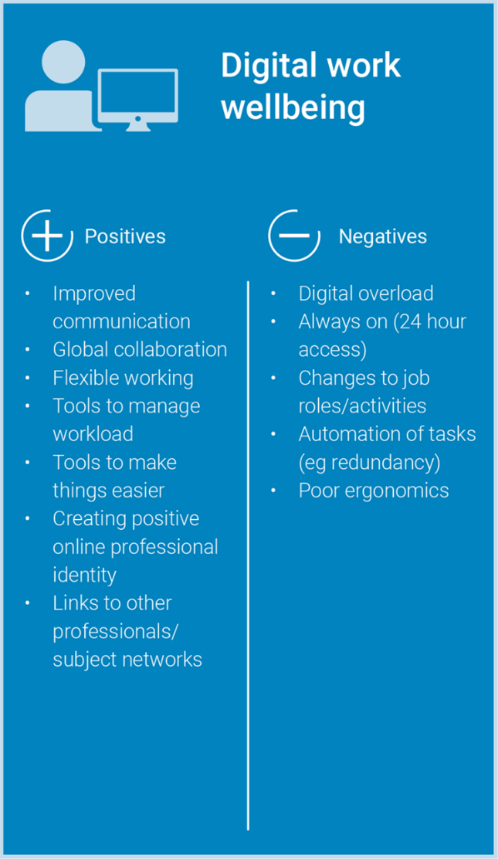
Figure 7 Digital work wellbeing.
View description - Figure 7 Digital work wellbeing.

You will recognise that this course hasn’t yet dealt with all of these points. Some of them (like communication) are covered in later sections; others will be touched on but labelled differently; and some are beyond the scope of this course. You may wish to use Jisc’s terms to do some independent research on the topics not covered here.
A different way of depicting the potential positive and negative impacts of remote working and technology on work–life balance has emerged from research undertaken by Dr Lara Pecis of Lancaster University’s Management School and Work Foundation, a think tank associated with that HEI (Pecis and Florisson 2021).

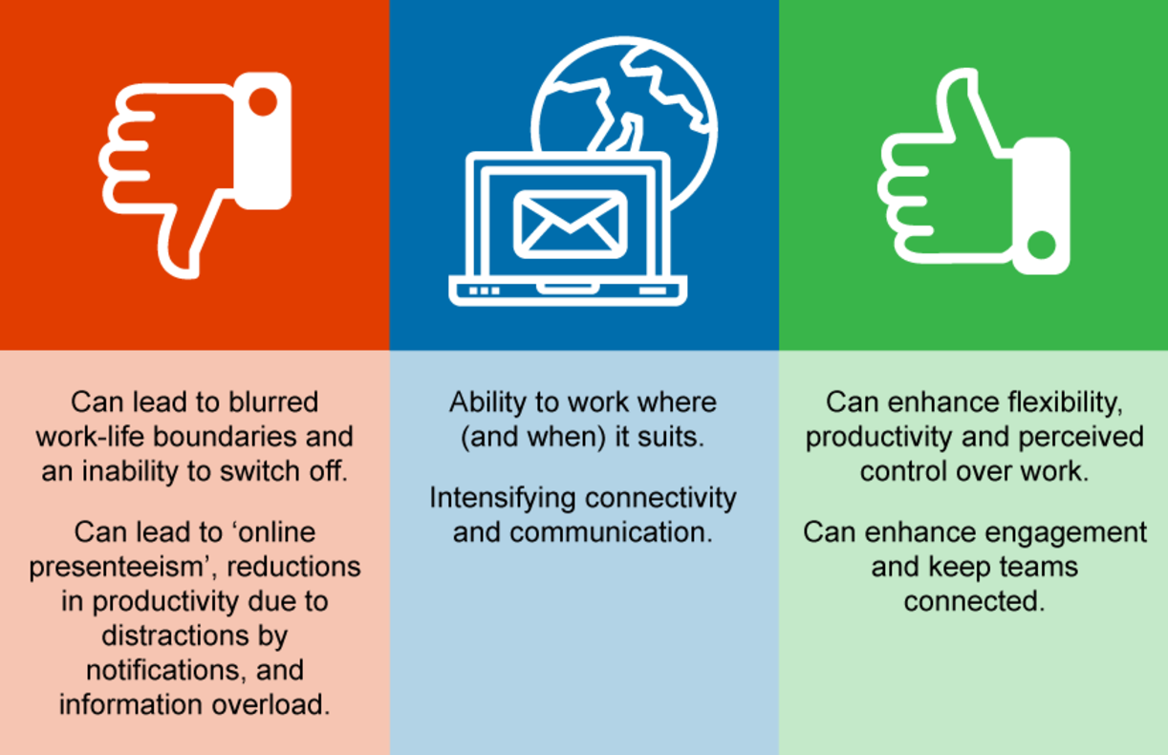
Figure 8 Positive and negative impacts of remote working.
View description - Figure 8 Positive and negative impacts of remote working.

This diagram more closely reflects this course’s approach to wellbeing.

5 Social wellbeing at work

Employee social wellbeing has become more widely acknowledged over the past year as many workplaces have had to do a virtual pivot. Not only have more and more employees been working from home or remotely, but there has also been a heightened sense of job uncertainty, so it’s more important than ever for businesses to focus on improving the social wellbeing of their team, so individuals are satisfied socially and feel as though they belong.
(People Value, 2022)

The foundation of social connection is communication, so let’s begin by exploring how communication – and miscommunication – can affect social wellbeing at work.

5.1 Communication in a hybrid working world
In the workplace, developing effective communication skills will enable you as an individual to interact more effectively with colleagues and others, as well as improving your chances of gaining promotion or securing new employment. This is true whether you are based in a large, open-plan office or working from your home or another remote location.
There is also significant evidence, from the 1970s onwards, to support a link between effective communication in the workplace and enhanced job satisfaction. Clampit and Girard (1993) analysed the construct of communication satisfaction and concluded that:

Communication satisfaction factors provide an effective way to distinguish between employees who are in the upper and lower parts of the spectrum in terms of both job satisfaction and self-estimates of productivity.
(Clampit and Girard, 1993)

More recently, a study of nurses in paediatric intensive care units – a particularly high-pressure working environment – also concluded that:

There is a relationship between effective communication and job satisfaction that needs to be of a greater importance for organizations to achieve a higher success.
(El-Gawad, 2013, p. 2662)

If those around you are communicating effectively and you have a clear sense of what’s expected of you and how you can contribute in the workplace, it makes sense that you are likely to feel more satisfied; therefore it has a positive impact on your wellbeing.
Effective communication gives clear benefits to the individual, but there are significant benefits for the organisation too. If communication is poor, reduced job satisfaction and productivity can have a significant impact on the business. For example, when 4,000 people were surveyed by Think Feel Know Coaching, 46% said that they were ‘unsure of what was being asked of them by their line manager when given tasks’ (Woods, 2010). The same study estimated that up to 40 minutes per individual per day were wasted because of this. Using these figures, an average company with 1,000 employees could have as many as 83 people doing nothing every day (Woods, 2010).
When there is uncertainty or change within an organisation, employees can feel ill-informed about the impact on their roles. If their concerns are not addressed and vital information is not communicated, staff morale will be affected. This can lead to a lack of trust and engagement, which can result in low productivity and absenteeism.
For an organisation to embrace effective communication, every individual must play their part – from senior managers to new trainees.
Sometimes miscommunication is the problem. The video in the next activity suggests some simple rules for avoiding this.

Activity 9 Miscommunication
Allow about 20 minutes

Watch the following TedEd video on miscommunication.

Video content is not available in this format.

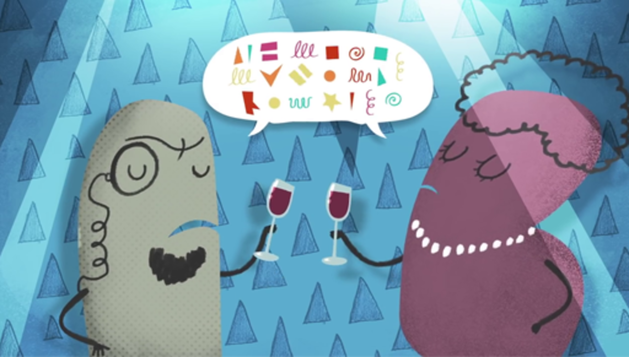

Now use the box below to note your own experiences of miscommunication.
What impact do you think the hybrid working practices in place since the emergence of COVID-19 (e.g. meetings via video call) have had on miscommunication?

Provide your answer...
View discussion - Activity 9 Miscommunication

Throughout your life you continually change how you speak and what you speak about. Each situation you find yourself in will require a slightly different method of communication. You’ve just reflected on situations when communication faltered and resulted in misunderstanding. Did any of your experiences with miscommunication involve colleagues of a different generation to you? If so, the next section may help to explain that.

5.2 The influence of generational traits on communication
In HEIs it’s common to see employees of multiple generations working side-by-side. While our character traits and work habits are shaped by our personalities, not by our age, there are historical and social influences that have affected each generation, and understanding these can help to improve intergenerational communication and inclusion.
Depending on who you ask there are currently four or five generations represented in the workplace, commonly defined as follows:
- Traditionalists (sometimes called the Silent Generation) – born between 1928 and 1945.
- Baby boomers – born between 1946 and 1964.
- Generation X – born between 1965 and 1980.
- Generation Y (also known as Millennials) – born between 1981 and 1996.
- Generation Z – born between 1997 and 2012.
Each generation comes with its own set of characteristics based on the environment in which its members were raised, e.g. post-war, during financial crisis, etc.

The amount of technological development that has happened between the birth of the first traditionalists and Gen Z was so vast that it has created two entirely different life experiences. When Baby Boomers first got a job, a computer at each desk wasn’t commonplace, whereas Millennials and Gen Z have never known a world without one.
(Rice, 2021)

Let’s briefly look at some of the key work-related differences that have been identified for each group. However, please note that these are generalisations, so do not automatically apply to everyone in a particular age group!

Traditionalists
Traditionalists only make up about 3% of the workforce in 2022. They are known for their strong work ethic and formal demeanour in the workplace, although they also make efforts to help colleagues. They appreciate job security and are more accustomed to formal attitudes in work environments rather than relaxed, flexible work environments.

Baby boomers
Baby boomers enjoy face-to-face communication and printed information. They are loyal to their job and treat it as a priority in their life, focusing on career progression. They are willing to take risks at work to achieve success. They expect respect for their job title. Many of them are now at traditional retirement age, and the pandemic is thought to have accelerated retirement rates, but of those who still need to work, many are now moving into consulting roles.

Generation X
Gen X shook up the traditional workplace with their independence and entrepreneurial spirit – they are the ‘start-up’ generation, valuing autonomy and innovation. They want respect for their ideas and are focused on results. They are also credited with introducing the concept of work–life balance and they lean towards ‘working to live’ rather than ‘living to work’. They tend to communicate at work via email or instant messaging, and favour soft copy documents over hard copy.

Generation Y/Millennials
Millennials are the fastest-growing segment of the workforce. They are focused on skills, especially creativity, and they value meaningful work in a relaxed environment. They expect their employers to have proactive and positive attitudes to sustainability, equity, diversity and inclusion. They are comfortable using technology to acquire just-in-time knowledge. They prioritise friendship and involvement.
A commonly discussed characteristic of ‘millennials’ is their desire for more feedback than previous generations. This can be very positive, but does require a different approach to communication from other generations.

Generation Z
As the newest generation to the workforce, their workplace characteristics are less well researched and defined than the other groups. However, one thing is certain, they have only ever known a digital world. The COVID-19 pandemic has come at a critical developmental stage for Gen Z – normally this would have been the time when they would be making new connections and transitioning into adult life, but that has been dramatically affected by lockdowns and other restrictions. They are disproportionately employed in industries such as hospitality and retail so many of them have lost their jobs during the pandemic. They value authenticity, transparency, innovation and personal growth.

What this means for your communication approach
These generational characteristics can lead to various challenges in the workplace. Adapting your communication style and content to the needs of your audience is an important consideration in this context. For example, if a leader comes from a different generation to their team, they might need to use communication methods outside their comfort zone in order to fully engage and share information with team members.
In the video below, contributors share their insights to working across generations and how you can build more inclusive workplaces.

Video content is not available in this format.
View transcript - Uncaptioned interactive content

5.3 Building and maintaining work relationships
Connecting with people you work with, whether they are full-time colleagues or occasional participants, means being able to build a bond that stimulates their interest and engagement. Communication often serves two purposes: conveying information and/or an interpersonal function. The interpersonal function relates to developing confidence, trust and rapport with others, which are essential aspects of building and maintaining successful working relationships.
The technical name for small talk is ‘phatic communication’. Examples are ‘Hi, you OK?’ or a comment about the weather. Questions or comments such as these are not meant to elicit detailed responses, but they do serve a social purpose. Phatic talk openings to dialogue are important in establishing goodwill, collaboration and cohesion between people.
Communication involves not only the words you use, but also the accompanying paralinguistic features such as pace, volume, rhythm and intonation of speech, all of which add to meaning.
Non-verbal communication features include gestures, proximity and eye contact. These contribute to effective communication.
Hand gestures are often used by speakers to accentuate the rhythm of their speech and give emphasis to certain words. They can also be used to point inwardly to magnify the first person (i.e. ‘me’, ‘I’ or ‘personally’) or outwardly to those listening (i.e. ‘you’).
Head gestures are often used by listeners in a dialogue to show they are listening.
You can partly control the feelings you exhibit, but hiding your innermost emotions can be hard – our faces leak information as numerous micro-expressions involuntarily flicker across our face.

Activity 10 The impact of hybrid on communicating with colleagues
Allow about 10 minutes

Due to the pandemic, many of us are now working with people we have never actually met ‘in real life’.
Thinking about the aspects of communication described above, how have hybrid or digital-only working arrangements affected your ability to build and maintain work relationships?
You can make some notes in the box below.

Provide your answer...

5.4 Avoiding isolation
Social isolation is a challenge often associated with remote working. While some people may actually prefer working away from a busy office, it’s important to ensure that individuals and teams still have people or networks that they can reliably speak to. In a virtual working world as part of a virtual team, it’s easy for people to become invisible.
In some organisations the increase in hybrid and remote working means that full-capacity, open-plan offices where everyone had their own designated desk have been transformed into bookable hot-desking areas. This means that when you do arrange to go into the office, you might be the only person in the room all day, which may make you feel isolated or uncomfortable.
Check in regularly with your line manager and if you work in a matrix management situation, establish regular contact points with any other colleagues you’re doing work for, making sure both you and they understand the deliverables, the objectives, and when and how you need to deliver them.
If you used to have team-based social events in the office, have you tried virtual team events? These could be as simple as a half-hour tea or coffee break via video call, where you have the sort of conversations you might have had previously in the office kitchen, or it could be something more involved like a scavenger hunt. You can find more examples and inspiration for virtual team building activities at teambuilding.com (make sure to open the link in a new tab/window).

5.5 Social media safety issues
Section 3 touched on your digital wellbeing, and preventing isolation, building and maintaining relationships and reducing loneliness were all identified as positive aspects of digital activity. These can be achieved by participating in social media and social networking. However, there are also safety issues associated with social media, particularly around inappropriate posting. This could be as a result of you inadvertently or deliberately posting inappropriate content, or it could be inappropriate responses to your social media activity.
Your organisation should have guidance on what is permissible on social media, with the consequences of not following this advice made very clear.
You may receive negative responses from other social media users. Comments that do not agree with your views or perspectives are perfectly acceptable, but you may find yourself overwhelmed by a ‘backlash’ of comments, or even a victim of cyberbullying or harassment. If so, you need to consider how to, or even whether to, respond to this.

Box 2 Support and guidance
There are numerous resources online that provide support and guidance if you’re exposed to negative behaviours, or you’re worried about your own behaviour. You may wish to take some time to explore some that are listed below:
- Cyberbullying and online harassment advice | The National Bullying Helpline
- Help Center | The Cybersmile Foundation
- Welsh Government Online Safety guidance | Welsh Government
- I’m being harassed by someone on social media. What can I do? | Metropolitan Police
- Social Networking Sites | Get Safe Online
- Dealing with online harassment | Support, health and wellbeing, University of York

5.6 Psychological safety
Psychological safety is about individuals feeling empowered to share ideas and opinion without fear of reprisal, discrimination or humiliation. It’s a key aspect of a positive organisational culture and a key contributor to your workforce’s wellbeing.
Signs of a psychologically unsafe workplace include hesitance to speak openly and honestly, reluctance to admit to making mistakes and an overall air of low motivation. People can feel unsafe in any situation or working at any level – it’s not just an issue for staff in junior roles.
To achieve a psychologically safe working environment there needs to be trust between employees and managers, and between colleagues. The Hybrid working: skills for leadership course that is part of this collection explores in more detail how to develop that trust. The aspects of communication mentioned earlier in this section can contribute to the establishment of such trust, as can a good support network. Some organisations have wellbeing ambassadors to help with this.
As a manager or leader, when it comes to safety, don’t ask your team members to do anything that you wouldn’t do. Be mindful of their concerns and provide reassurance. Encourage participation and contribution from all team members.
It may seem paradoxical, but while you want people to feel able to speak freely, that doesn’t mean ‘anything goes’. It’s important that aggression, bullying and belittling behaviours are acknowledged and dealt with promptly.

5.7 Cybersecurity for hybrid working
When you were completely office-based, your organisation’s IT team probably took care of your cybersecurity needs. But if you’re now partly or entirely based at home, you need to pay more attention to cybersecurity threats yourself – not least because IT teams may also be working in a range of locations, which could affect the services they offer and their response times. Key principles to follow are:
- Use antivirus and internet security software – your organisation may be able to provide you with this, but if not, there are a range of free and paid-for options available.
- If you live with others – especially children – keep your devices locked or password protected when you are away from them.
- Consider covering your webcam when you’re not actively using it, as they can be accessed by hackers. If you use a separate webcam (i.e. not built in), unplug it when it’s not in use.
- Use a virtual private network (VPN). If you are accessing work servers from home, this is probably something your organisation already insists on.
- Use your organisation’s centralised cloud/server storage for important files, don’t just save them locally.
- Make sure your home Wi-Fi is secure, using a strong password. Information on this should’ve been provided with your router. Alternatively, your internet service provider (ISP) should have guidance on their website.
- Make video meetings private by requiring a password for entry, or only allowing someone with administrator permissions to admit guests – you may remember ‘Zoom bombing’ attacks hitting the headlines during the first lockdown.
- If possible, avoid working near any voice-controlled devices to avoid the possibility of remote listening-in.
- Be conscious of what’s visible behind you during video calls. You may want to use a physical screen or virtual on-screen blurring to avoid revealing sensitive or personal artefacts.
- Use strong and secure passwords.
- Make sure software and operating systems are up to date and have the latest security patches installed.

5.8 Positives and negatives of digital social wellbeing
This section of the course concludes with another Jisc infographic, this time summarising the positives and negatives of digital social wellbeing. Note that many of these points apply more widely to all types of hybrid working, not just to exclusively digital work.

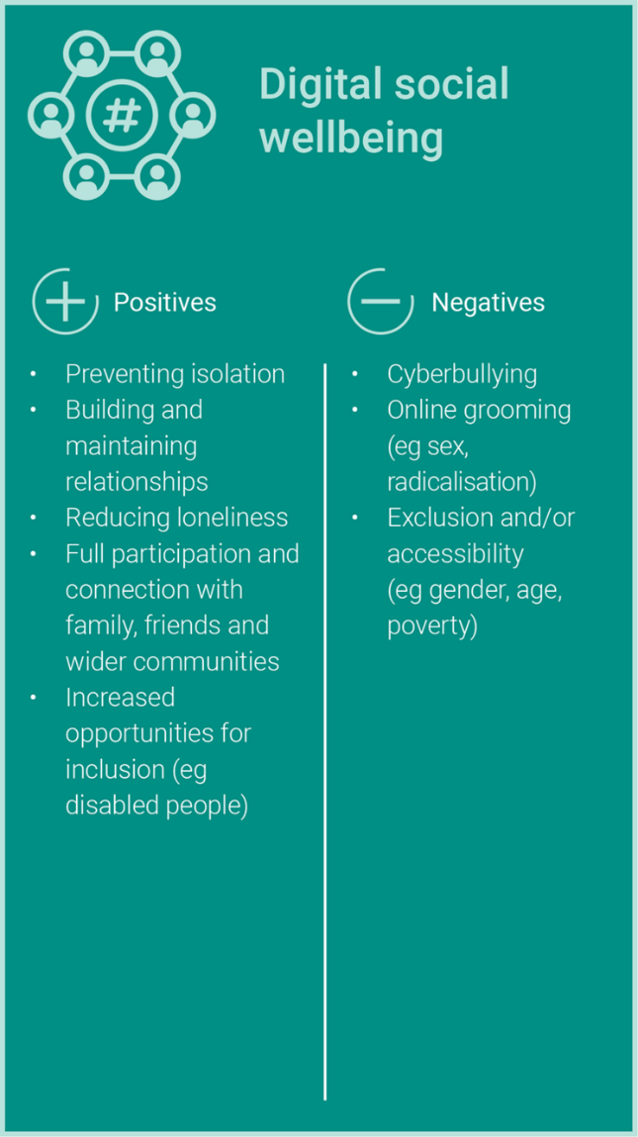
Figure 9 Digital social wellbeing.
View description - Figure 9 Digital social wellbeing.

As you can see from the figure, Jisc highlights increased opportunities for inclusion as one of the positives of digital social wellbeing – and exclusion and accessibility as negatives. The next section of the course explores these topics.

6 Inclusion
Let’s start with a quotation from Inclusive Employers, a membership organisation founded in 2011 for employers who are committed to prioritising inclusion and creating truly inclusive workplaces.

Inclusion is a broad subject and is a term that trips of the tongue of many. However, people have different understandings of what the word means. … Many people use the words inclusion, diversity and even equality interchangeably. … At Inclusive Employers, we focus on workplace inclusion. For us, inclusion is an overarching culture encompassing diversity, equality, and many other aspects of our working lives.
(Inclusive Employers, 2022)

This course has similarly taken the approach that diversity and equality sit under the umbrella of inclusion. This includes accessibility and digital inclusion, with concerns about the digital divide growing, which are increasingly important topics thanks to the ‘hybridisation’ of higher education workplaces that was accelerated by the COVID pandemic.
In the video below, contributors share insights into considerations for digital inclusion.

Video content is not available in this format.
View transcript - Uncaptioned interactive content

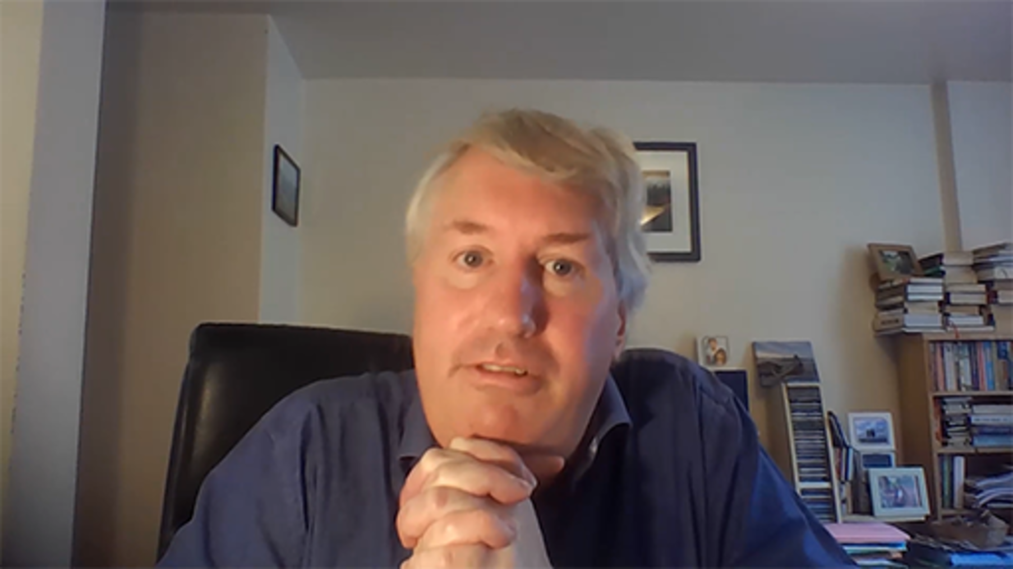

6.1 Exploring inclusion
People are often so busy thinking about their own point of view that they cannot see the point of view of others. People also tend to judge the ideas of others rather than trying to understand them. As academic researcher Michàlle E. Mor Barak (2017) explains in their work, we have difficulty accepting that others may achieve the same result in a different or a better way.
However, bringing a mix of different people from various backgrounds together is an important factor in finding and implementing creative solutions to problems. Thinking ‘outside the box’ and interacting with diverse colleagues improves people’s ability to work in a volatile, uncertain, complex and ambiguous world (this description is commonly shortened to the acronym ‘VUCA’).
Inclusion in the workplace means making the most of diversity in staff and students. It increases the depth and range of behaviours, capabilities and skills that the organisation can use in order to respond to the needs of a VUCA environment. In fact, a leader who is able to manage and engage a company’s heterogeneous workforce can obtain a unique competitive advantage and deal with leadership challenges more effectively. As you will see in the next activity, an organisation becomes an inclusive workplace when it accepts and makes use of the diversity of its workforce, characterised by different styles, personalities and cultures.

Activity 11 Leadership strategies for (global) inclusion
Allow about 20 minutes

Watch the video at the link below on ‘global inclusion’ by Ernest Gundling, co-founder and managing partner at Aperian Global.
What is global inclusion? (open link in a new/tab window so you can return easily).
What does Gundling mean by ‘global inclusion’? Make some notes in the text box below.

Provide your answer...
View discussion - Activity 11 Leadership strategies for (global) inclusion

Barak (2017) defines an inclusive workplace as one that:
- values and utilises the differences of the individual and groups – ultimately, it will aim to modify the organisational values and norms to accommodate its employees
- works with the surrounding community and contributes to the community – the organisation acknowledges that it does not have responsibility only to its stakeholders but to the wider society
- works with individuals, groups and organisations from a variety of national and cultural backgrounds – the organisation seeks to develop international collaborations so as to further expand the possibility for diversity
- seeks ways to support disadvantaged groups – the organisation will seek to hire and train people that are perceived as belonging to disadvantageous groups.
You will probably notice that Barak goes a step further than Gundling – who speaks about internal inclusion – and also presents the importance of external inclusion.
In order for a leader or manager to achieve inclusion in a global and turbulent environment, they need to look at both internal and external inclusion. They need to find ways and practices to accept, welcome and equally treat groups or individuals from different backgrounds, and at the same time respond to the needs of their community or organisation.
If inclusion is the ‘overarching culture encompassing diversity, equality, and many other aspects of our working lives’, diversity is ‘the mix of people’ (Inclusive Employers, 2022). The next section explores various attributes of that mix.

6.2 Valuing diversity
In their 2013 article ‘Great leaders who make the mix work’, Boris Groysberg, an academic researcher, and Katherine Connolly, a research associate in the organisational behaviour unit at Harvard Business School, discuss the importance of diversity and inclusivity.

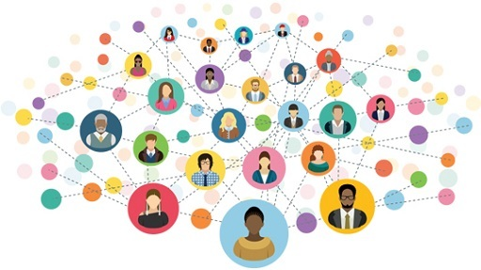
Figure 10 Diversity and inclusion within the workplace.
View description - Figure 10 Diversity and inclusion within the workplace.

Groysberg and Connolly (2013) explain that diversity should be perceived as an investment in the most important assets of the organisation’s balance sheet: the people. Diversity is about investing in people. Diversity is necessary because it allows an organisation to stay competitive, to seek the best possible ideas and solutions, and continue to innovate and grow. Moreover, by harnessing diversity, employees feel valued and are therefore more willing to support the aims of the organisation, serve the ‘customers’ (students, in an HEI context) and work together.
At the same time, diversity may create dissent and challenge people’s way of thinking, leading them into deep inquiry or breakthrough.
In the video below, contributors discuss how to value diversity and create more inclusive workplaces.

Video content is not available in this format.
View transcript - Uncaptioned interactive content

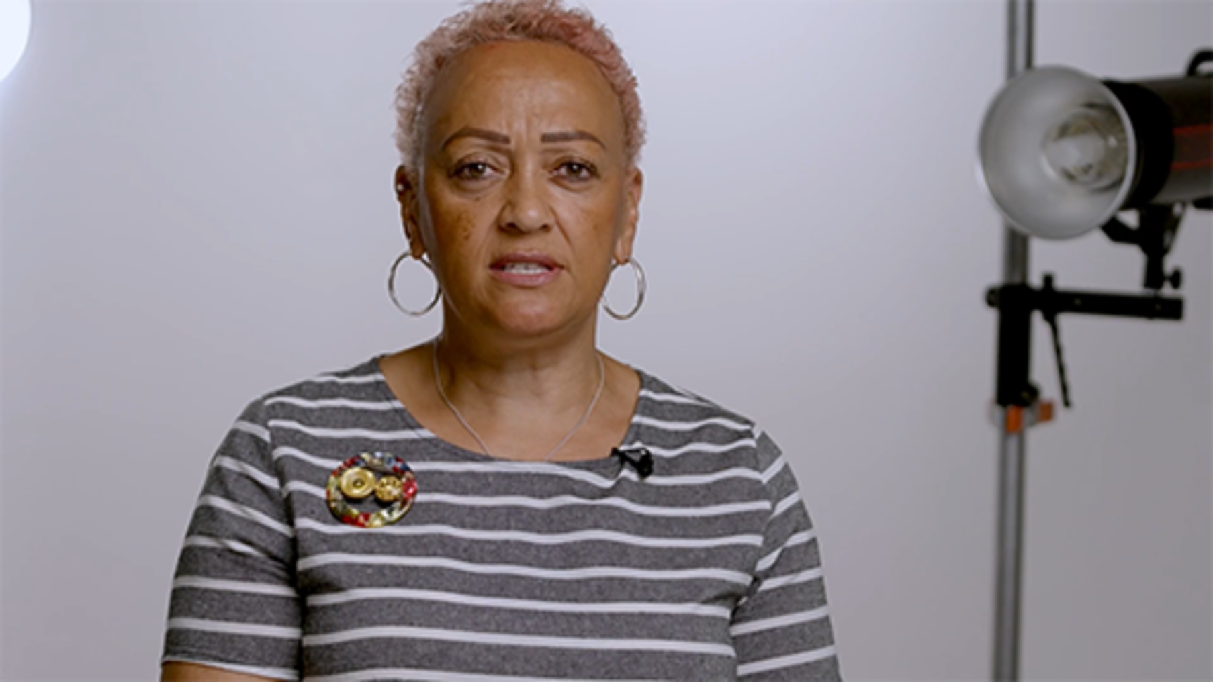

Activity 12 Diversity in your workplace
Allow about 45 minutes

Watch and listen to the following videos and audios in which contributors share their experiences of diversity in the workplace.

Video content is not available in this format.
View transcript - Uncaptioned interactive content

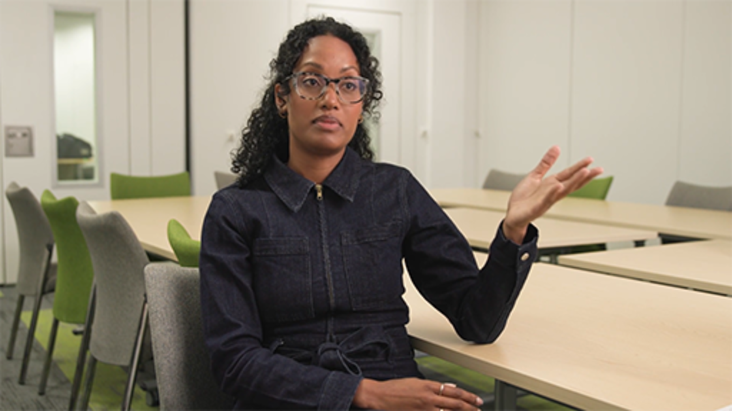

Audio content is not available in this format.
View transcript - Uncaptioned interactive content

Video content is not available in this format.
View transcript - Uncaptioned interactive content

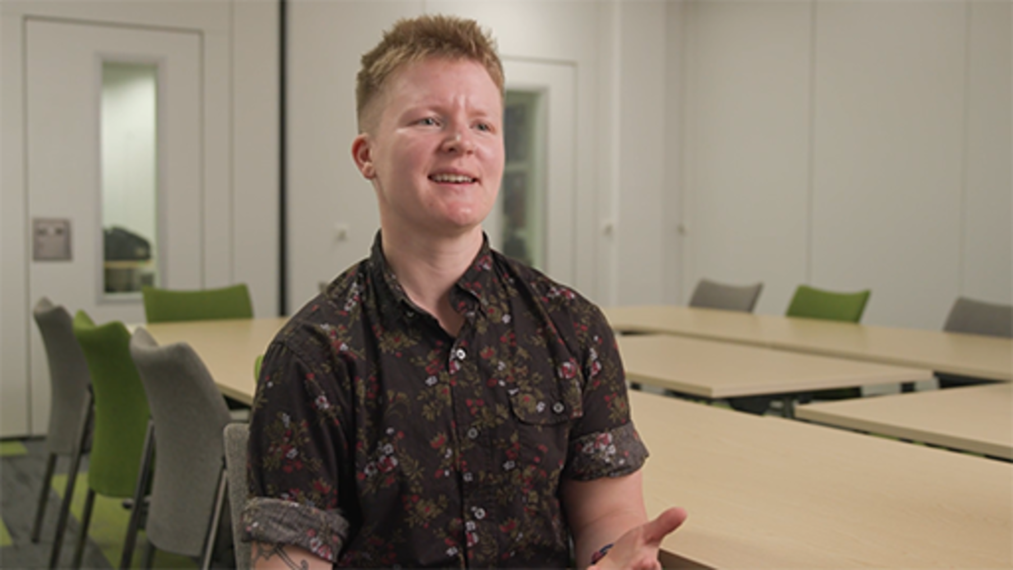

Consider your current working environment (or a previous one) and list some examples of the diversity among colleagues or students (or other ‘customers’).

Provide your answer...
View discussion - Activity 12 Diversity in your workplace

6.3 Intersectionality
Diversity includes all identities. It is about the representation of difference. Whether you identify by your ethnicity, religion, sexual orientation, or any other characteristics you may have noted in the last activity, you have many identities and you are part of many communities. Why does this matter in the workplace? Because each identity provides a person with a relative level of privilege over, or disadvantage to, any other person – this means every person has a specific level of disadvantage in society based on their converging identities.
‘Intersectionality’ is a term coined by Professor Kimberlé Crenshaw to describe this. Watch the video at the link below to learn what it means and what impact it can have on health and wellbeing.
Intersectionality and health explained (open link in a new/tab window so you can return easily).

6.4 Neurodiversity
As the world pivoted towards online meetings, advice proliferated about how to run such meetings effectively, such as requiring participants to have their cameras on throughout the meeting to show they are fully engaged. This might have been well intentioned, but everyone in your team or department is different and has different needs, so what works well for some may be a source of anxiety for others. Taking time to understand those varying needs is important to fostering wellbeing in your workplace culture.

Neurodiversity describes the idea that people experience and interact with the world around them in many different ways; there is no one ‘right’ way of thinking, learning, and behaving, and differences are not viewed as deficits.
(Baumer and Frueh, 2021)

The term ‘neurodiverse’ has been adopted to cover people with a range of neurological conditions and specific learning differences – for example, autism spectrum disorders, dyslexia and Down’s syndrome – that mean they need to develop coping strategies to function in a world designed for the neurotypical.
As a leader or manager, you can make your workplace more inclusive of neurodiversity by:
- not making assumptions about preferences or needs – ask the individual
- not equating ‘camera on’ behaviour or eye contact with attention being paid
- considering recording meetings for later review – with the consent of participants
- communicating clearly – avoiding sarcasm, euphemisms/metaphors and subtext
- being sensitive to sensory requirements, e.g. related to sound or movement
- providing clear, concise, step-by-step instructions for tasks
- not making last-minute, unexplained changes to plans or schedules.
Watch the video below in which Becky May explains her experience of being neurodiverse.

Video content is not available in this format.
View transcript - Uncaptioned interactive content

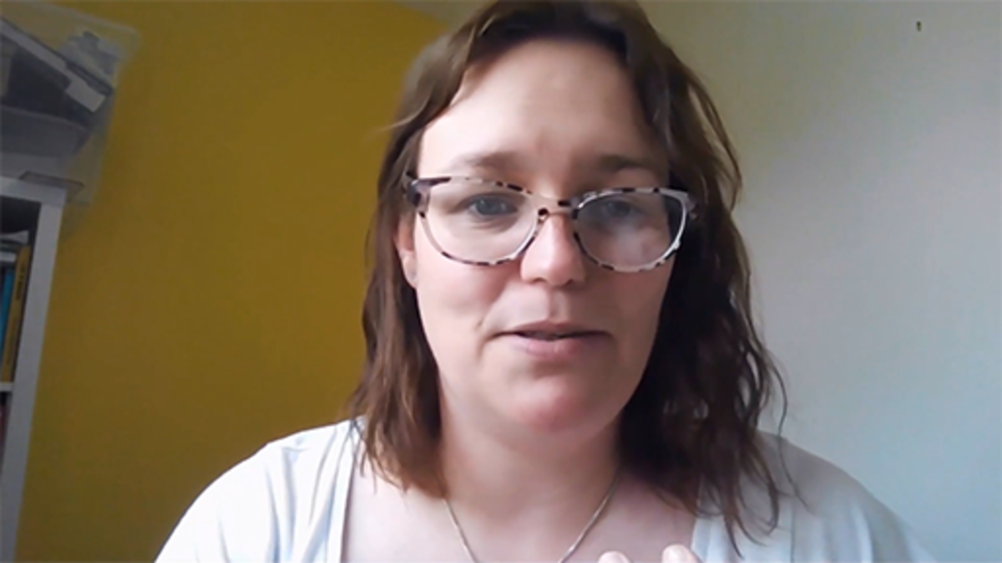

6.5 How to harness diversity
So, how do you create or maintain a diverse organisation? Groysberg and Connolly (2013) present eight organisational practices that seem to be effective at harnessing diversity:
- Measure diversity and inclusion: be aware of the level of diversity in the organisation. Collect data to measure what you are doing well and what can be improved in order to make the organisation a more diverse place.
- Hold managers accountable: diversity and inclusion should be among the goals of the organisation. For example, incorporate them as part of the manager’s professional development, ask them to get involved or offer them training.
- Support flexible work arrangements: offer benefits that help employees balance professional and personal commitments, provide greater flexibility of working hours, allow transitional periods, offer childcare support etc.
- Recruit and promote from diverse pools of candidates: searching for talent at the hiring stage is the starting point but it is also very important to maintain this talent afterwards.
- Provide leadership education: provide leadership development opportunities for everyone in the organisation and seek to support less advantageous or represented groups. Offer diversity training and opportunities for external education and development.
- Sponsor employee resource groups and mentoring programs: offer less structural approaches to professional development through resource groups, networks, mentoring programs etc.
- Offer quality role models: a varied array of leaders indicates that an organisation is committed to diversity and offers role models to identify with.
- Make the position of the chief diversity officer count: create a chief diversity and inclusion officer position and ask for the CEO to maximise its effectiveness.
The Future Generations Commissioner for Wales has a Simple Changes resource related to improving diversity in your workplace. Follow the link in Box 3 to find out more.

Box 3 Simple Changes #39
- Simple Changes #39 Have initiatives to recruit people from groups that are under-represented in your workforce.
(Future Generations Commissioner for Wales, 2022b)

7 Equality
As mentioned in the introduction to this course, one of the goals of the Well-being of Future Generations (Wales) Act 2015 is ‘A More Equal Wales’, defined as:

A society that enables people to fulfil their potential no matter what their background or circumstances (including their socio economic circumstances).
(Future Generations Commissioner for Wales, 2022d)

Achieving greater diversity in your organisation, both in leadership/decision-making roles and in the broader workforce, is one step towards this goal, but diversity and equality are not the same thing. Equality in the workplace is about equal opportunities for everyone, which means equal chances to:
- apply and be selected for posts (pre-employment)
- be trained and promoted while employed
- have your employment terminated equally and fairly.
In the UK, the key piece of legislation protecting people’s rights to such equal opportunities is the Equality Act 2010. Denying the right to equal opportunities in the workplace is effectively discrimination, which is unlawful under the Act.
A body called the Equality and Human Rights Commission (EHRC) was established in 2007 to promote and protect the workplace rights covered by the Act. The EHRC replaced the Equal Opportunities Commission, the Disability Rights Commission and the Commission for Racial Equality.
The Equality Act 2010 specifies nine areas that it terms ‘protected characteristics’. These are (in alphabetical order):
- age
- disability
- gender reassignment
- marital or civil partnership status
- pregnancy and maternity
- race (including colour, nationality, ethnic and national origin)
- religious background
- sex
- sexual orientation.
You will probably recognise that these are very similar to the categories identified by Ahmed (2018) in the discussion from Activity 12. Before exploring some of the protected characteristics in more depth, here’s a short activity to clarify the difference between equality and equity.

Activity 13 Equality or equity?
Allow about 15 minutes

Read the short article (650 words) titled Equality and Equity on the Social Change UK website. Then spend a few minutes trying to think of an example of how equity has contributed – or could contribute – to greater equality in your own organisation. Conversely, you might have an example of when equity was used incorrectly; if so, how would you address this?
You can make some notes in the box below.

Provide your answer...
View discussion - Activity 13 Equality or equity?

7.1 Protected characteristics: tackling discrimination
As mentioned in the previous section, the Equality Act 2010 specifies nine areas that it terms ‘protected characteristics’. The next section of the course will explore aspects of one of these (disability), but in terms of discrimination, two UK organisations have an array of resources and references on each of the protected characteristics:
- the Advisory, Conciliation and Arbitration Service (ACAS), an independent public body that receives funding from the government to work with employers and employees to improve workplace relationships
- the Chartered Institute of Personnel and Development (CIPD), a UK professional body for human resources and people development.

Activity 14 Explore anti-discrimination resources
Allow about 90 minutes

Visit each of the resources linked below to gain an overview of each of the protected characteristics covered by the Equality Act 2010.
- age (CIPD)
- disability (CIPD)
- gender equality (sex discrimination) (CIPD)
- marital or civil partnership status (National Union of Journalists (NUJ): there is an ACAS report on this topic, but it is a 30-page PDF file)
- pregnancy and maternity (ACAS)
- race (CIPD)
- religion and belief (CIPD)
- sexual orientation, gender identity and gender reassignment (CIPD).
You should spend at least 10 minutes on each characteristic, but if you wish to spend more time exploring this topic, there are additional CIPD and external resources at the bottom of each page.

Conversations related to protected characteristic require a sensitive and empathic approach. Often these involve situations that the person may not feel comfortable discussing, or potential concerns that they wish to raise about the organisation’s approach. Many organisations are becoming more aware and have appropriate networks in place to support both employees and line managers to start to have better conversations.

7.2 Accessibility at work
Accessibility means different things to different people, so let’s start this section by interrogating your understanding of the term.

Activity 15 What does accessibility mean to you?
Allow about 10 minutes

Spend a few minutes noting down the words you associate with accessibility at work. Try to come up with at least one, but no more than ten.
Then pick your favourite word – the one that best encapsulates what accessibility means to you.

Provide your answer...
View discussion - Activity 15 What does accessibility mean to you?

Here’s one definition of accessibility:

Accessibility is about removing barriers from a workplace or work function, so that everyone has equal access to the location, tools and tasks required to perform their role.
(Office Reality, 2022)

Your organisation has a moral duty to make sure nobody is excluded from taking an active part in working life, and a legal duty to make ‘reasonable adjustments’ for disabled staff and job applicants (potential employees). Exploring those duties in detail could be a substantial course in itself – the aim here is just to summarise key aspects of accessibility in a hybrid working context, and provide you with links to more detailed resources that you can explore in your own time.

7.3 Making physical workspaces accessible
The Equality Act 2010 puts a legal duty on education providers, employers and service providers to make ‘reasonable adjustments’ within the workplace to allow disabled people to take part in education, use services and carry out their day-to-day workplace activities.
In terms of physical workspaces, the design or layout of a building (including space between desks and other furniture, the arrangement of conference rooms, etc.), how you access it (e.g. parking and signage) and what’s inside it (e.g. desks, chairs, lighting, toilet facilities) are just some examples of factors that may present a physical barrier for a person with a disability. With regards to improving wellbeing, are there spaces in or around the buildings where employees can go to rest or recharge?
If your physical workspace is a university campus, how would you describe it in terms of accessibility? The Scope resource in the next activity will help you with this.

Activity 16 Finding out if a workplace is accessible
Allow about 15 minutes

Scope is a charity that campaigns for equality for disabled people. Read their Find out if a workplace is accessible page (Scope, 2022), and then try to answer the questions for your own physical workplace (if you have one).
You can make some notes in the box below.

Provide your answer...
View discussion - Activity 16 Finding out if a workplace is accessible

Thinking about the wider accessibility of university campuses, an organisation called AccessAble has worked with over 100 universities to produce what they call a ‘Detailed Access Guide’, which lets people with disabilities know what access will be like when they visit the campus, including routes into the sites and what is available inside. AccessAble (originally called DisabledGo) was set up in 2000 by Dr Gregory Burke, as a result of his own experiences as a wheelchair user and disabled walker. You can visit the AccessAble website to find out whether your own HEI is included.

7.4 Making online workspaces accessible
The Public Sector Bodies (Websites and Mobile Applications) (No. 2) Accessibility Regulations 2018 came into force in September 2018 and imposed duties on public sector bodies – which includes most HEIs – to ensure that their websites meet approved accessibility standards, and to publish an accessibility statement on each website to confirm that the standards have been met. There were three key dates to meet the requirements, the last of which was in June 2021, so in theory this should be standard practice at your organisation now.
Jisc produced an Accessibility regulations – what you need to know guide for colleges and universities in December 2019, updated in January 2020. If you want to explore that in your own time, it’s approximately a 45-minute read.
If you would like to explore an example of a statement, you can find the Accessibility statement for OpenLearn.
There is also another OpenLearn course, Accessibility of eLearning, which you might be interested in studying. Although it is primarily aimed at education professionals involved in developing online learning materials for students, it contains material of more general interest around disability, usability and accessibility.

Activity 17 Aspects of online accessibility
Allow about 40 minutes

Visit each of these short sections from Accessibility of eLearning. As you read, consider how they could be applied to your online/virtual workplace(s) to improve your user experience and that of your colleagues.
- considering disabled people
- usability and accessibility
- special resources or universal design?
- keyboard and mouse alternatives
- alternative content
- quick ways to improve accessibility
You can make some notes in the box below.

Provide your answer...

The Future Generations Commissioner for Wales has two Simple Changes resources related to improving online accessibility. Follow the links in Box 4 to find out more.

Box 4 Simple Changes #77–78
- Simple Changes #77 Use plain English and Welsh as standard in any documents intended for the public.
- Simple Changes #78 Use a variety of accessible, inclusive engagement methods and formats.
(Future Generations Commissioner for Wales, 2022b)

8 Building and maintaining a supportive and inclusive hybrid workplace
Before 2020, the phrase ‘hybrid workplace’ might not even have been in your vocabulary:

At the start of the COVID-19 pandemic, employers took swift action to create a mentally healthy workplace – often while simultaneously navigating the challenges of an entirely remote workforce for the first time. Now, as workplaces adopt a hybrid model, in which they combine remote and onsite working, employers again need to face the challenge of how to care for the mental health and wellbeing of their workforce – this time in a hybrid model.
(Deligiannis, 2022)

However, as we mentioned in the introduction to this course, as COVID-19 moves from being a pandemic towards becoming endemic, and hybrid working in the higher education sector is ‘the new normal’, the time has come to ensure that your workplace has the necessary systems and strategies in place to properly support wellbeing and inclusion for all staff, whatever your model of hybrid looks like.

8.1 Making wellbeing and inclusion a priority
One way of making wellbeing a priority is to work with an organisation like Mind, whose Workplace Wellbeing Index is a benchmark of best policy and practice in wellbeing. Watch the short video at the link below to find out more about this.
Our Workplace Wellbeing Index (open link in a new/tab window so you can return easily).
The Future Generations Commissioner for Wales has a Simple Changes resource that recommends reviewing your organisational policies to ensure opportunities to improve the health and wellbeing of your workforce are optimised. Follow the link in Box 5 to watch a video case study on the actions one company takes to provide a healthy workplace for its staff.

Box 5 Simple Changes #23
- Simple Changes #23 Review your policies to ensure you’re optimising opportunities to improve your employees’ health and wellbeing.
(Future Generations Commissioner for Wales, 2022b)

If you’re really not sure how to make workplace wellbeing a priority, Zest for Work (2022) have some tips in their article ‘What is workplace wellbeing and how to start?’.

8.2 Benefits and costs of maintaining workplace wellbeing
Every organisation depends on having healthy and productive employees, so if you support the wellbeing of your staff, they are far more likely to achieve your business goals. As noted in the introduction to this course, in the HE sector, those goals affect not just the employees of your organisation, but also your students.
Jisc’s 2021 report, Student and staff wellbeing in higher education, highlights four principles for wellbeing in HE:
- Wellbeing is for everybody: a whole population approach – We are all affected by our mental wellbeing and that of others.
- Wellbeing is a lifelong project: a whole life approach – Wellbeing doesn’t start when someone becomes an undergraduate and stop when they graduate. It needs lifelong learning and lifelong skills development to build resilience.
- Wellbeing is embedded in all activities: a whole curriculum approach – Universities are health organisations as well as learning organisations. For individuals to thrive and learn, health gain cannot be separated from learning gain.
- Wellbeing is a collective endeavour: a whole university approach – The whole-university approach values the contribution of all. It moves mental wellbeing away from being the sole concern of student health and mental health support services and involves the entire community. This takes sustained effort and leadership.

8.3 Benefits and costs of inclusion, equality and equity
Why is inclusion of benefit to your organisation? According to Inclusive Employers:

All evidence proves that organisations focused on building a more inclusive culture attract and retain a wider diversity of talent.
The inclusive culture then empowers diverse talent to think differently and share their experiences and perspectives, which in turn is a key driver for innovation, development and engagement.
(Inclusive Employers, 2022)

Meanwhile, the Equal Opportunities Commission (EOC) stated:

When an organisation supports the principle of equal opportunities for all, employees can rest assured that they will not be discriminated against in the workplace. Employees are more committed to working hard when they know that they have equal opportunities for advancement and there are no barriers to job progression.
Also, knowing that they are evaluated solely on their on-the-job performance and measurable merits empowers employees and encourages them to do their best.
(EOC, 2022)

8.4 Where does hybrid working fit in?

Remote working during the pandemic brought some workers real benefits to their wellbeing and work-life balance, which they are not keen to give up now that work from home guidance is coming to an end. Last year saw a 50% increase in the number of tribunal cases appealing refused flexible working requests. In a context where flexibility is increasingly important to workers, employers who don’t proactively offer longer term flexibility risk losing valued staff.
(Florisson, 2022)

As mentioned earlier, diversity is important in the workplace to promote high performance in teams. As workforces change the ways they work to increase remote working and hybrid approaches, it’s important to listen to those diverse voices to prevent inequities in working models.

Box 6 Remote working case studies
These case studies are examples of what some Welsh organisations did to respond to lockdown restrictions on office-based working. They include examples of the opportunities and challenges people faced, and what the organisations are planning around diversifying ways of working in the future. You don’t need to read each example, but select at least to two to gain alternative perspectives.
- Blaenau Gwent County Borough Council
- Disability Wales
- Race Equality First
- Theatr Clwyd
- Welsh Ambulance Services NHS Trust

There are many reasons why people may or may not be keen to return to working full-time in an office. Whichever model your organisation adopts, all communities need to be heard, with their needs and reasons for different working models understood. This is enshrined by the Five Ways of Working (see Table 4) that emerged in response to the Well-being of Future Generations (Wales) Act, in particular ‘Involvement’ and ‘Collaboration’. These two ways of working value involving and working with others to ensure the diverse representation of communities to help achieve the wellbeing goals set out in the Act.

Table 4
Long-term: The importance of balancing short-term needs with the needs to safeguard the ability to also meet long-term needs.
Integration: Considering how the public body’s wellbeing objectives may impact upon each of the wellbeing goals, on their objectives, or on the objectives of other public bodies.
Involvement: The importance of involving people with an interest in achieving the wellbeing goals, and ensuring that those people reflect the diversity of the area which the body serves.
Collaboration: Acting in collaboration with any other person (or different parts of the body itself) that could help the body to meet its wellbeing objectives.
Prevention: How acting to prevent problems occurring or getting worse may help public bodies meet their objectives.

Conclusion
This course began by quoting Barbara Bassa, a Programme Director at Advance HE, who observed that the quality of the university student experience starts with the quality of services provided by university staff. Throughout the course, you have been reflecting on how the staff at your organisation are coping with the transition to increased digital/hybrid ways of working, as well as considering the impact of the ‘pivot to online’ on your and their wellbeing, and the processes and practices that resulted from it.
You should now have a better understanding of what ‘workplace wellbeing’ means in a hybrid working world, specifically:
- whose responsibility it is
- the challenges involved in creating and maintaining it
- the benefits that nurturing wellbeing can bring to your organisation.
How employers respond to the wellbeing of workers through this pandemic and beyond will be key to maintaining employee engagement and productivity and reducing absence and/or staff turnover.
EDI (equality, diversity and inclusion) is often derided as ‘political correctness gone mad’ or a box-ticking exercise for legal requirements, but this course has emphasised the critical role it plays in achieving a culture of wellbeing. Making your organisation inclusive, diverse and a champion of equal opportunities is more than a moral or legal duty, it is an investment in the most important asset your organisation has: the people who work there.
This course is part of the Supporting hybrid working and digital transformation collection, which you may wish to explore further.

References
Ahmed, A. (2018) ‘Types of workplace diversity’, Bizfluent. Available at: https://bizfluent.com/facts-5618840-types-workplace-diversity.html (Accessed: 28 June 2022).
Bailenson, J. N. (2021) ‘Nonverbal overload: A theoretical argument for the causes of Zoom fatigue’, Technology, Mind, and Behavior, 2 (1). Available at: doi:10.1037/tmb0000030 (Accessed 12 September 2022).
Barak, M. E. M. (2017) Managing diversity: Toward a globally inclusive workforce. 4th edn. USA: Sage Publications.
Bassa, B. (2022) ‘Pouring from an empty cup: poor university staff wellbeing is an impossible ground for high quality teaching’, AdvanceHE, (18 May). Available at: https://www.advance-he.ac.uk/news-and-views/pouring-empty-cup-poor-university-staff-wellbeing-impossible-ground-high-quality (Accessed: 12 June 2022).
Baumer, N. and Frueh, J. (2021) ‘What is neurodiversity?’, Harvard Health Publishing, (23 November). Available at: https://www.health.harvard.edu/blog/what-is-neurodiversity-202111232645 (Accessed: 28 June 2022).
Be SHARP (2019) What is wellbeing? 31 August. Available at: https://www.youtube.com/watch?v=NeWilXAbF5U (Accessed: 29 June 2022).
CIPD (2020) Health and Well-being at Work. Available at: https://www.cipd.co.uk/Images/health-and-well-being-2020-report_tcm18-73967.pdf (Accessed: 29 June 2022).
CIPD (2022) Health and wellbeing at work. Available at: https://www.cipd.co.uk/knowledge/culture/well-being/health-well-being-work (Accessed: 29 June 2022).
Clampitt, P. G. and Girard, D. (1993) ‘Communication satisfaction: a useful construct?’, The New Jersey Journal of Communication, 1(2), pp. 84–102. Available at: https://doi.org/10.1080/15456879309367255 (Accessed: 29 June 2022).
Deligiannis, N. (2022) ‘How to prioritise the wellbeing of your people in a hybrid workplace’, Hays plc − Advice & Insights. Available at: https://www.hays.com.au/blog/insights/how-to-prioritise-the-wellbeing-of-your-people-in-a-hybrid-workplace (Accessed: 5 June 2022).
Department of Health (2014) The Relationship between Wellbeing and Health. Health Improvement Analytical Team Department of Health January 2014. Available at: https://assets.publishing.service.gov.uk/government/uploads/system/uploads/attachment_data/file/295474/The_relationship_between_wellbeing_and_health.pdf (Accessed: 5 June 2022).
El-Gawad, S. A (2013) ‘Effective Communication and Job Satisfaction among Staff Nurses Working in Pediatric Intensive Care Units’, Life Science Journal, 10(1), pp. 2661–2669. Available at: https://www.researchgate.net/publication/261359002_Effective_Communication_and_Job_Satisfaction_among_Staff_Nurses_Working_in_Pediatric_Intensive_Care_Units (Accessed: 12 September 2022).
EOC (2022) Equal Opportunities Commission. Available at: https://www.eoc.org.uk (Accessed: 26 June 2022).
Equality Act 2010. Available at: https://www.legislation.gov.uk/ukpga/2010/15/contents (Accessed: 12 September 2022).
Finkbeiner, K. (2022) ‘Positive psychology in the workplace’, Zevo Health, 28 February. Available at: https://www.zevohealth.com/uk/blog/positive-psychology-in-the-workplace (Accessed 26 June 2022).
Florisson, R. (2022) ‘Unlocking flexible working’, Lancaster University Work Foundation, 31 January. Available at: https://www.lancaster.ac.uk/work-foundation/news/blog/unlocking-flexible-working (Accessed: 20 June 2022).
Future Generations Commissioner for Wales (2022a) Well-being of Future Generations (Wales) Act 2015. Available at: https://www.futuregenerations.wales/about-us/future-generations-act (Accessed: 20 June 2022).
Future Generations Commissioner for Wales (2022b) Simple changes. Available at: https://www.futuregenerations.wales/simple-changes (Accessed: 20 June 2022).
Future Generations Commissioner for Wales (2022c) A journey to a healthier Wales. Available at: https://www.futuregenerations.wales/wp-content/uploads/2019/11/FINAL-Healthier-Wales-Topic-1.pdf (Accessed: 15 August 2022).
Future Generations Commissioner for Wales (2022d) A more equal Wales. Available at: https://www.futuregenerations.wales/a-more-equal-wales (Accessed: 15 August 2022).
Groysberg, B. and Connolly, K. (2013) ‘Great leaders who make the mix work’, Harvard Business Review, 91, pp. 68–76. Available at: https://hbr.org/2013/09/great-leaders-who-make-the-mix-work (Accessed: 12 September 2022).
Inclusive Employers (2022) What is inclusion? Available at: https://www.inclusiveemployers.co.uk/about/what-is-workplace-inclusion (Accessed: 20 June 2022).
Jisc (2018) Building digital capability. Available at: https://www.jisc.ac.uk/rd/projects/building-digital-capability (Accessed: 20 June 2022).
Jisc (2019a) Digital wellbeing. Available at: https://digitalcapability.jisc.ac.uk/what-is-digital-capability/digital-wellbeing (Accessed: 7 September 2022).
Jisc (2019b) Good practice principles to support the digital wellbeing of your students and staff: Briefing paper for senior leaders. Available at: https://digitalcapability.jisc.ac.uk/what-is-digital-capability/digital-wellbeing (Accessed: 30 June 2022).
Jisc (2019c) Digital wellbeing for you, your colleagues and students: Briefing paper for practitioners. Available at: https://digitalcapability.jisc.ac.uk/what-is-digital-capability/digital-wellbeing (Accessed: 29 June 2022).
Jisc (2021) Student and staff wellbeing in higher education. Available at: https://www.jisc.ac.uk/reports/student-and-staff-wellbeing-in-higher-education (Accessed: 29 June 2022).
Lufkin, B. (2021) (2021) Why presenteeism wins out over productivity. Available at: https://www.bbc.com/worklife/article/20210604-why-presenteeism-always-wins-out-over-productivity (Accessed: 17 August 2022).
Microsoft 365 Team (2022) 10 benefits of use video conferencing [sic]. Available at: https://www.microsoft.com/en-us/microsoft-365/business-insights-ideas/resources/10-reasons-to-use-video-conferencing (Accessed: 13 September 2022).
Mind (2018) Our Workplace Wellbeing Index, 4 June. Available at: https://www.youtube.com/watch?v=uRvZIlKQdBM (Accessed: 17 August 2022).
National Wellbeing Hub (no date) How can I support my colleagues? Available at: https://wellbeinghub.scot/resource/how-can-i-support-my-colleagues (Accessed: 29 June 2022).
Office for National Statistics (ONS) (2018) Surveys using our four personal well-being questions. Available at: https://www.ons.gov.uk/peoplepopulationandcommunity/wellbeing/methodologies/surveysusingthe4officefornationalstatisticspersonalwellbeingquestions (Accessed: 29 June 2022).
Office for National Statistics (ONS) (2020) Young people’s well-being measures. Available at: https://www.ons.gov.uk/peoplepopulationandcommunity/wellbeing/datasets/youngpeopleswellbeingmeasures (Accessed: 26 June 2022).
Office Reality (2022) How to create an accessible workplace for people with disabilities. Available at: https://www.officereality.co.uk/blog/how-to-create-an-accessible-workplace-for-people-with-disabilities (Accessed: 29 June 2022).
Pecis, L. and Florisson, R. (2021) ‘Mitigating wellbeing pressures in remote and hybrid working models’, Lancaster University Work Foundation, 12 August. Available at: https://www.lancaster.ac.uk/work-foundation/news/blog/unlocking-flexible-working (Accessed: 20 June 2022).
People Value (2022) Social wellbeing: why it’s important and how to support your employees. Available at: https://peoplevalue.net/why-is-social-wellbeing-important-in-the-workplace (Accessed: 28 June 2022).
Public Sector Bodies (Websites and Mobile Applications) (No. 2) Accessibility Regulations 2018. Available at: https://www.legislation.gov.uk/uksi/2018/852/contents/made (Accessed 12 September 2022).
Rice, D. (2021) ‘Generations in the workplace’, HR Exchange Network, (28 January). Available at: https://www.hrexchangenetwork.com/employee-engagement/articles/generations-in-the-workplace (Accessed: 1 July 2022).
Rodríguez, R. S. R (2022) ‘What is the right to digital disconnection?’ ifeel, (March 2). Available at: https://ifeelonline.com/en/occupational-health/right-to-digital-disconnection/ (Accessed: 1 July 2022).
Salmon, G. (2020) ‘Covid-19 is the pivot point for online learning’, WONKHE, 29 April. Available at: https://wonkhe.com/blogs/covid-19-is-the-pivot-point-for-online-learning (Accessed: 12 June 2022).
Scope (2022) Finding out if a workplace is accessible. Available at: https://www.scope.org.uk/advice-and-support/find-out-if-workplace-is-accessible (Accessed: 17 August 2022).
Seligman, M. (2011) Flourish: a new understanding of happiness and well-being – and how to achieve them. London: NB Publishing.
Social Change UK (2019) Equality and equity, 29 March. Available at: https://social-change.co.uk/blog/2019-03-29-equality-and-equity (Accessed: 29 June 2022).
Sociological Studies Sheffield (2020) Intersectionality and health explained, 8 October. Available at: https://www.youtube.com/watch?v=rwqnC1fy_zc (Accessed: 28 June 2022).
Student Minds (2018) ‘Mental health is based on a continuum and can fluctuate at different times...’ [Twitter] 12 October. Available at: https://twitter.com/studentmindsorg/status/1050672633123983360 (Accessed: 29 June 2022).
Well-being of Future Generations (Wales) Act 2015. Available at: https://www.legislation.gov.uk/anaw/2015/2/contents/enacted (Accessed 12 September 2022).
Wikipedia (2022) Zoom fatigue. Available at: https://en.wikipedia.org/wiki/Zoom_fatigue (Accessed: 7 September 2022).
Woods, D. (2010) ‘Poor communication between managers and employees wastes time and impacts productivity’ HR Magazine, (12 September). Available at: https://www.hrmagazine.co.uk/content/news/poor-communication-between-managers-and-employees-wastes-time-and-impacts-productivity (Accessed: 16 August 2022).
World Health Organization (WHO) (2022) Mental health: strengthening our response. Available at: https://www.who.int/news-room/fact-sheets/detail/mental-health-strengthening-our-response (Accessed: 5 June 2022).
Zest for Work (2022) What is workplace wellbeing? Available at: https://zestforwork.com/what-is-workplace-wellbeing (Accessed: 14 September 2022).

Acknowledgements
This free course was written by Beccy Dresden, Becky May, Chantine Bradstock and Esther Spring.
Except for third party materials and otherwise stated (see terms and conditions), this content is made available under a Creative Commons Attribution-NonCommercial-ShareAlike 4.0 Licence.
The material acknowledged below is Proprietary and used under licence (not subject to Creative Commons Licence). Grateful acknowledgement is made to the following sources for permission to reproduce material in this free course:
Images
Course image: Adam Burton; Alamy Stock Photo
Figure 1: The Welsh Government; Contains public sector information licensed under the Open Government Licence v3.0
Figure 2: Boris15; Shutterstock.com
Figure 3: Zest for Work
Figure 4: Student Minds
Figure 5: Adapted from Yerkes–Dodson Stress Curve (Corbett, 2015)
Figure 6: from: Good practice principles to support the digital wellbeing of your students and staff; © JISC
Figures 7 and 9: from: Digital wellbeing for you, your colleagues and students: Briefing paper for practitioners; © JISC
Figure 8: Pecis, L. and Florisson, R. (12 August 2021). Mitigating wellbeing pressures in remote and hybrid working models. The Work Foundation at Lancaster University. Available from: https://www.lancaster.ac.uk/work-foundation/news/blog/mitigating-wellbeing-pressures-in-remote-and-hybrid-working-models
Figure 10: aelitta / iStock / Getty Images Plus
Figure 11: somsong; Shutterstock.com
Videos
Activity 9 Video: TEDEd; How miscommunication happens (and how to avoid it) – Katherine Hampsten; https://creativecommons.org/licenses/by-nc-nd/4.0/
Every effort has been made to contact copyright owners. If any have been inadvertently overlooked, the publishers will be pleased to make the necessary arrangements at the first opportunity.
Don’t miss out
If reading this text has inspired you to learn more, you may be interested in joining the millions of people who discover our free learning resources and qualifications by visiting The Open University – www.open.edu/openlearn/free-courses.

Solutions

Activity 1 What does wellbeing mean to you?

Discussion
Figure 2 shows a word cloud containing some common words associated with wellbeing.

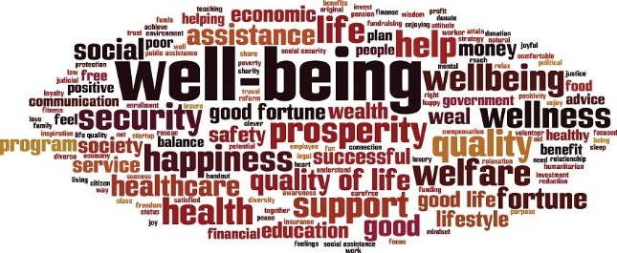
Figure 2 Words relating to wellbeing.
View description - Figure 2 Words relating to wellbeing.

Did your chosen word appear? Are you surprised by any of the words included in the cloud?
Does wellbeing mean something different to you in a workplace context? Keep that question in mind, as you’ll be asked to reflect on it later.
Back to - Activity 1 What does wellbeing mean to you?

Activity 3 Four measures of personal wellbeing

Discussion
This is a really useful little tool to regularly check in and monitor your own emotional or mental wellbeing. If you answered at the lower end of the scale for one or more questions, think about what actions you could take to improve it, and what support you might need.
Back to - Activity 3 Four measures of personal wellbeing

Activity 4 The impact of digital technologies on your wellbeing

Discussion
Jisc’s ‘Digital Identity and Wellbeing’ capability includes the capacity to:
- look after personal health, safety, relationships and work–life balance in digital settings
- use digital tools in pursuit of personal goals (e.g. health and fitness) and to participate in social and community activities
- act safely and responsibly in digital environments
- manage digital workload, overload and distraction
- act with concern for the human and natural environment when using digital tools.
How does this relate to your response to this activity?
Jisc (2019b) have stated that for individuals in an education context, digital wellbeing ‘links closely to their personal and social digital wellbeing and to developing and managing their professional and personal digital identities and footprints.’
Back to - Activity 4 The impact of digital technologies on your wellbeing

Activity 5 How can you help others?

Discussion
Even if you don’t have any formal responsibility for supporting your colleagues’ wellbeing, if you think back to the PERMA model, helping others – having a positive impact on their wellbeing at work – is an easy way to add more meaning to your working life.
Some of the activities mentioned in the article will be explored in more depth later in Section 5.
Back to - Activity 5 How can you help others?

Activity 6 Monitoring your online/onscreen working time

Discussion
Did you record more or less time than you expected?
Were the activities that caused negative emotions (if any) unavoidable, or could you take action to reduce these?
Did any of the activities create a positive sense of connection or community with your colleagues? Or were there things you felt would have been done more effectively in person/away from a screen?
Back to - Activity 6 Monitoring your online/onscreen working time

Activity 7 Has presenteeism gone digital?

Discussion
According to the CIPD’s April 2022 report Health and Wellbeing at Work 2022, working when ill (presenteeism) remains prevalent – and is even higher for those working from home (81% versus 65% among those in a workplace). This culture can result in mental ill health and increased stress for employees, which can lead to long-term sickness. It is therefore a problem that cannot be ignored if your organisation is to succeed.
Back to - Activity 7 Has presenteeism gone digital?

Activity 8 Digital disconnection

Discussion
For some people, like those who have significant caring responsibilities or are living with chronic illness or disability, hybrid/digital working has opened up new possibilities for more flexibility in their working schedule. However, the danger remains that employees feel pressured to work longer hours, e.g. those who mainly fulfil their contractual obligations early in the morning/late at night and/or at weekends may still feel obliged to attend meetings or respond to communications received during traditional office hours.
Back to - Activity 8 Digital disconnection

Activity 9 Miscommunication

Discussion
The video mentions four practices that can improve interactions and avoid miscommunication:
- Recognise that there is a difference between passive hearing and active listening.
- Listen with your eyes and ears as well as your gut.
- Take time to understand the perspective of the person/people you are talking to.
- Try to be aware of your own perceptual filters.
The next time you are discussing a difficult issue with colleagues, try to put these ideas into practice. See if it makes a difference.
Back to - Activity 9 Miscommunication

Activity 11 Leadership strategies for (global) inclusion

Discussion
The way that Gundling addresses global inclusion incorporates the following:
- To include people of different race and gender.
- To work together with people from different functions and generations.
- To be ready to cross the barriers.
- To find ways to include people from an expert area to help in other areas.
- To invite the unexpected.
- To look for new sources of information.
In this video, Gundling discusses global inclusion, which he says not only refers to race and gender, but to areas such as functional and generational differences. For example, being a technical expert doesn’t mean you have no opinions on marketing, sales, or any other areas that you don’t have a strong knowledge or engagement with. In this example, you need to be ready to cross the barriers and find ways to include technical experts to help the company in other areas too.
Gundling also offers some strategies for inclusion that leaders and managers can use, such as:
- look for new sources of information
- challenge their assumptions
- ask people to think about their network so as to expand it
- invite the unexpected.
Back to - Activity 11 Leadership strategies for (global) inclusion

Activity 12 Diversity in your workplace

Discussion
How did you find the task? There are no right or wrong answers here, but your list may have included some or all of these categories (Ahmed, 2018):
- race and ethnicity
- age and generation
- gender and gender identity
- sexual orientation
- religious and spiritual beliefs
- disability and ability
- socioeconomic status and background
- thinking style and personality
- personal life experience.
Although you might not have thought of the final two categories, the diversity that they bring to the workplace can present challenges. For example, Ahmed describes the possibility of a team with introverted personalities struggling with giving a monthly presentation. He also suggests that the life experience of someone who has seen active service in the armed forces might bring particular issues to the workplace.
Understanding this breadth of diversity should help you to identify many occasions when you have experienced some level of diversity both in and outside of work.
Back to - Activity 12 Diversity in your workplace

Activity 13 Equality or equity?

Discussion
As the conclusion to the article notes:

Equality and equity may be inherently different but are also bound together. In order to create true equality of opportunity, equity is needed to ensure that everyone has the same chance of getting there. However, we must act cautiously when dealing with equity; providing too little to those who need it and too much to those who do not can further exacerbate the inequalities we see today.
(Social Change UK, 2019)

Back to - Activity 13 Equality or equity?

Activity 15 What does accessibility mean to you?

Discussion
Figure 11 shows a word cloud containing some common words associated with accessibility.

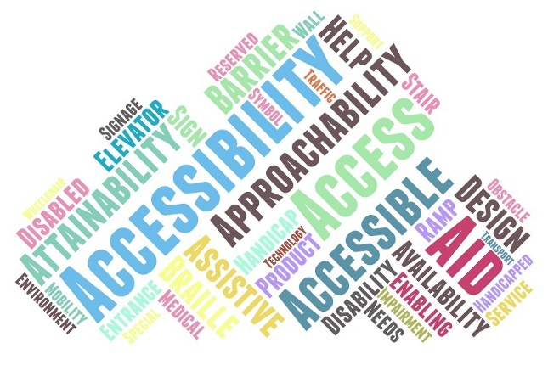
Figure 11 Words relating to accessibility.
View description - Figure 11 Words relating to accessibility.

Did you think about accessibility in relation to removing physical obstacles, or were you considering it in terms of website usability standards, for example? In a hybrid working world, both are important.
Back to - Activity 15 What does accessibility mean to you?

Activity 16 Finding out if a workplace is accessible

Discussion
How did your workplace measure up? Were you surprised by anything Scope asked you to think about? How many of them had you previously considered as potential accessibility issues?
If you think there are issues to be addressed at your workplace, Scope also has a page containing a range of useful information about reasonable adjustment at work.
Back to - Activity 16 Finding out if a workplace is accessible

Figure 1 Wellbeing goals.

Description
A diagram showing the silhouette of Wales in the centre of a circle, which comprises seven segments. Each segment has one of the wellbeing goals noted within it: A Prosperous Wales; A Resilient Wales; A Healthier Wales; A More Equal Wales; A Wales of Cohesive Communities; A Wales of Vibrant Culture and Thriving Welsh language; A Globally Responsible Wales.
Back to - Figure 1 Wellbeing goals.

Figure 2 Words relating to wellbeing.

Description
This is a word cloud, in which the largest words are the most popular/relevant. The largest words displayed here are: well-being, happiness, health, support, prosperity, quality, wellness, wellbeing, life, welfare, assistance, social, economic, fortune, money, education, healthcare, safety. There are many smaller words which include: helping, communication, balance, lifestyle, benefit, food, advice, plan, people, potential, social security, diversity, awareness, mindset.
Back to - Figure 2 Words relating to wellbeing.

Figure 3 Dimensions of wellbeing.

Description
A diagram containing three concentric circles. The inner circle contains the words ‘Workplace Wellbeing’. The middle circle contains the words ‘My Self’, ‘My Organisation’, ‘My Team’ and ‘My Work’. The outer circle lists eight different types of wellbeing, each of which has a circular icon representing it. The types are: Emotional/mental wellbeing, Environmental wellbeing, Financial wellbeing, Intellectual wellbeing, Occupational wellbeing, Physical wellbeing, Social wellbeing, and Spiritual wellbeing.
Back to - Figure 3 Dimensions of wellbeing.

Figure 4 Mental health as a continuum.

Description
This diagram shows a four-quadrant graph. The x-axis runs from ‘Mental health difficulties’ on the left to ‘Minimal mental health difficulties’ on the right. The y-axis runs from ‘Minimal mental wellbeing’ at the bottom to ‘Optimal mental wellbeing’ at the top. The axes meet in the middle, producing four quadrants, each one containing some text. The top-left quadrant reads ‘A person experiencing significant mental health difficulties, can manage these well and have good support in place, allowing optimal mental wellbeing’. The top-right quadrant reads ‘People who are not experiencing mental health difficulties still benefit from looking after their mental wellbeing’. The bottom-left quadrant reads ‘Challenging managing mental health difficulties, and a lack of support can lead to minimal mental wellbeing’. The bottom-right quadrant reads ‘The challenges of university life can lead us to have minimal mental wellbeing, in the absence of mental health difficulties’.
Back to - Figure 4 Mental health as a continuum.

Figure 5 The Yerkes–Dodson law.

Description
This diagram shows a graph with ‘stress level’ on the x-axis, and ‘productivity’ on the y-axis, and depicts a bell curve shape. There are various segments and labels. The low end (i.e. low stress level, low productivity) segment is ‘too little stress (underload)’. At the bottom of the curve is the label ‘inactive’. Slightly higher up the curve is the label ‘Laid back’. The next segment, which reaches the middle of the bell curve as it crests (i.e. moderate stress, high productivity), is ‘Optimum stress’, with the label ‘Peak performance’ just before the peak. The next segment then begins the descent back down the bell curve (i.e. stress increasing, productivity decreasing). This segment is ‘Too much stress (overload)’, with the label ‘Fatigue/tension. Poor sleep, irritability, worry’ on this side of the peak. The high end (i.e. high stress, low productivity) segment is ‘Burnout’. Halfway down the curve is the label ‘Exhaustion. Anxiety, panic, anger, depression, sleeplessness’. At the bottom of the curve is ‘Breakdown. Lasting disease/infections, heart attack, cancer, diabetes, etc.’
Back to - Figure 5 The Yerkes–Dodson law.

Figure 6 Four aspects of digital wellbeing for individuals.

Description
This diagram shows a triangle split into four segments, containing text as follows. Top segment: ‘My own awareness and capacity to change my digital practices’. Bottom left segment: ‘Positive impacts of technologies on my wellbeing’. Bottom right segment: ‘Negative impacts of technologies on my wellbeing’. Middle segment: ‘How technologies can improve digital wellbeing’.
Back to - Figure 6 Four aspects of digital wellbeing for individuals.

Figure 7 Digital work wellbeing.

Description
This infographic is headed ‘Digital work wellbeing’. It’s then split into two columns, with ‘positives’ and ‘negatives’. The positives are: improved communication; global collaboration; flexible working; tools to manage workload; tools to make things easier; creating positive online professional identity; links to other professional/subject networks. The negatives are: digital overload; always on (24 hour access); changes to job roles/activities; automation of tasks (eg redundancy); poor ergonomics.
Back to - Figure 7 Digital work wellbeing.

Figure 8 Positive and negative impacts of remote working.

Description
This diagram has three columns. The middle column (which is headed by icons of a computer and the earth) lists two statements about remote working and technology. The left-hand column is headed with a ‘thumbs down’ icon and lists the negative impact. The right-hand column is headed with a ‘thumbs up’ icon and lists the positive impact. The first statement is ‘Ability to work where (and when) it suits’. Negative impact: ‘Can lead to blurred work-life boundaries and an inability to switch off’. Positive impact: ‘Can enhance flexibility, productivity and perceived control over work’. The second statement is ‘Intensifying connectivity and communication’. Negative impact: ‘Can lead to “online presenteeism”, reductions in productivity due to distractions by notifications, and information overload’. Positive impact: ‘Can enhance engagement and keeps teams connected’.
Back to - Figure 8 Positive and negative impacts of remote working.

Figure 9 Digital social wellbeing.

Description
This infographic is headed ‘Digital social wellbeing’. It’s then split into two columns, with ‘positives’ and ‘negatives’. The positives are: preventing isolation; building and maintaining relationships; reducing loneliness; full participation and connection with family; friends and wider communities; increased opportunities for inclusion (eg disabled people). The negatives are: cyberbullying; online grooming (eg sex, radicalisation); exclusion and/or accessibility (eg gender, age, poverty).
Back to - Figure 9 Digital social wellbeing.

Figure 10 Diversity and inclusion within the workplace.

Description
This decorative image shows a number of cartoon drawings of heads and shoulders, within coloured circles. Dotted lines connect the circles.
Back to - Figure 10 Diversity and inclusion within the workplace.

Figure 11 Words relating to accessibility.

Description
This is a word cloud, in which the largest words are the most popular/relevant. The largest words displayed here are: accessibility, accessible, access, approachability, aid, attainability, assistive, design, barrier. Smaller words are: availability, disability, braille, disabled, elevator, enabling, product, handicap, help, ramp, stair, reserved, needs, technology, signage, medical, impairment, entrance, wheelchair, obstacle, support, symbol, traffic, transport.
Back to - Figure 11 Words relating to accessibility.

Uncaptioned interactive content

Transcript
MICHAEL WOODS
As we’re coming out of the pandemic, one of the trends we’re seeing is that there is a lasting shift towards remote working. And that can be quite significant. So actually, in 2011, only about 1 in 10 employees in rural Wales worked from home. The Welsh Government now has a target of aiming for 30% of the Welsh workforce working from home.
NATASHA DAVIES
I don’t think it’s ever been more important for mental health and wellbeing to be a priority for employers and within organisations. There’s the impact of not having that in real-life interaction with colleagues, which perhaps makes it more difficult to pick up on somebody who might be struggling.
But I think we also have to be mindful that we’re still kind of emerging from the pandemic. And actually, that had a very real and long-lasting impact on people’s wellbeing, which I think we’re going to have to be mindful of for a good number of years while people just re-find their feet and are dealing with a drastically changing world of work around them at the same time.
So I think within organisations, it’s important that well-being, mental health are reflected in strategies and policies. I think having a wellbeing strategy in place is absolutely important. It helps to make sure that it remains a priority because there’s an accountability aspect there.
I think it’s important to have champions for mental health and wellbeing around your senior leadership tables and on any boards. Some really practical things-- checking in with staff regularly to see how they’re doing, particularly because we’re not just going to be having the chat as we make a cup of tea in the office, necessarily.
Training our leaders and managers to be confident and have the vocabulary needed to have conversations about mental health-- being confident to signpost staff to sources of support, whether that’s support measures that have been put in place within an organisation, but the wider mental health provision and support that’s available outside of work as well.
I think it’s important that leaders are empowered to safeguard staff wellbeing. And that as organisations, we are engaging with the specialist organisations who can offer advice and guidance on how to embed this in our ways of working, because this can’t just be about individuals having to take responsibility for their own mental health and well-being. Because we’re all affected by the situation that we find ourselves in day-to-day.
So it is important that we’re building this focus into the ways of working that we’re deciding to adopt and implement within our workplaces. And I think-- I suppose, the other really important thing is that it’s actually invested in. This can’t just be about the odd well-being webinar. We have to invest in this.
Our staff are our most valuable resource as an organisation. If we don’t look after them-- we just have to be looking after them. So I think it’s important that it is invested in and that, likewise, wider changes in ways of working, we’re open to reflecting on what we’re doing well, what we need to do better, and that we’re looking to adopt new approaches and tools as they emerge that can help make sure that all staff are able to maintain a really good level of mental health.
In an increasingly hybrid space, the reality is, we’re going to be incredibly reliant upon digital technology. And if we don’t take action to address the quite different levels of digital skills and digital competence that we have across the workforce, I think we are at risk of excluding people, particularly if our ways of ensuring good communication, collaboration, management of mental health and wellbeing are increasingly reliant upon new and emerging technologies.
MICHAEL WOODS
As people work from home, they are less reliant on being close to their workplace. And therefore, they’re realising that they have more flexibility about where they may live. And for many, that’s turning into an interest to moving into rural communities.
Now, that has potentially both positive and negative consequences for rural Wales. On the positive side, there is the possibility that it might help to keep more younger people in rural Wales by creating more employment opportunities.
It may help younger families to return to rural Wales, to settle in some rural villages which have become quite distorted in their age profiles. It will mean more people in small towns and rural communities during the day helping to support local shops and services. So those are potentially positive sides of that shift.
However, there are also concerns that a growing interest in moving into rural areas will help to fuel house prices in rural Wales. And that’s already a significant issue. We’ve seen significant increases over the last two years. And that’s added to a pre-existing problem of affordability of housing in many parts of rural Wales, especially for younger people.
So one of the things which have to be considered by organisations who are trying to encourage people from working from home is also thinking about equity of access to that, because another dimension of this is, of course, is that in order to work from home, you do need a reliable broadband connection. You need that accessibility to digital infrastructure.
So there are concerns, I think, in thinking through that. There’s a need at-- how people living in different areas have different ability to work from home. There is a sense that the growth of this may be geographically uneven. It may favour some regions over others.
And organisations and companies which are encouraging working from home might wish to consider that, may wish to consider what support they might need to give to employees who maybe are already living in areas which have less strong access to the digital infrastructure, whether there’s ways in which they can support them, whether they need to, for example, consider rather than working from home, remote hubs or supporting remote access sites.
NATASHA DAVIES
In order to get to more equitable, inclusive, fair work places, there are lots of things that need to shift. And there are lots of actors that can take action to deliver change. The progress we’ve made-- we have made progress, Chwarae Teg, 30 years old. We’ve certainly made progress since we were first set up.
That has been helped with people who have really, I suppose, led the charge, as it were, and acted as role models and smashed down some of those barriers and glass ceilings for others who are coming up.
And I think there are some things that individuals who find themselves coming up against barriers-- there are sources of support. There are schemes and initiatives out there that work directly with underrepresented groups to give them the skills, the confidence, the qualifications to be able to progress.
There are measures within larger organisations, networks, and initiatives that bring people together to work collectively, to identify what the problems are, and demonstrate to senior leaders what the problems are and hopefully push for change.
But I think ultimately what does need to happen is that we need to be fixing the system so it isn’t falling down to individuals to fight hard and perhaps change how they work in order to thrive in a system that ultimately hasn’t been designed with their needs in mind.
SHARON MALLON
Employers can be really aware of the impact of isolation by having a kind of individualised awareness of what the circumstances of their employees are. So for some people who have quite large families or are well-connected socially, it might not be such an issue to not be connected with work colleagues. They might be engaged in other social networks that are kind of fulfilling that need.
I think it’s important for managers to have those delicate kind of questions with people. How much contact are you having with somebody outside of work, or would you like more contact, informal opportunities throughout the day to perhaps connect in rooms that are not work-related? There are also the opportunities to arrange regular catch-ups.
ELISE LOCKYER
I think regardless of whether you’re working hybrid, remote, or in the office, mental health and well-being has been a huge topic and will continue to be a huge topic in years to come. Especially when working in a remote or hybrid setting, I think the only thing that you can do is provide the right environment and an open environment, a trusting environment where the hope would be that they would come and talk to you if they needed to. Or talk to a member of my team, or talk to their manager.
Everybody, regardless of who you are and what you do within an organisation, will have had some level of mental health issues. It may not be them individually, but it may be a member of their family. Everybody carries traumas, stories that they bring with them on a day-to-day basis.
And so, absolutely, mental health wellbeing, imposter syndrome, doubting yourselves, being able to have the conversations where that’s acceptable and we support you through a period of time, we will absolutely do what we can to support them.
Now, at times, we can’t. We’re not the people that have the expertise to provide the individuals what they need. But at those times, that’s where we rely on our external resources and our external professionals to do that, because we are not best placed then to support somebody. So we make sure that we use the tools that we have internally, the skills, the collaboration, and the communication internally absolutely partnered with the resources that we have externally. Because you need absolute experts to be able to solve some of the kind of deep challenges that some individuals have.
MATT WINTLE
We are seeing that we have to tell people that you don’t have to do that in your spare time. We have to find a way to get that balance right. Because the other problem with being at home is the always-on problem. And we’re dealing with that as well and encouraging people that-- have a separate space. Make sure at the end of the day, you leave that space and go and do something different. And don’t go back to that space until you’re working again.
And we really have to encourage those behaviours, and it is creating a bit of a two-tier system as well. Because I’m fortunate enough that I can do that, because I’ve got a room that I can dedicate to doing it. Not everybody is that fortunate. So we’re quite focused on making sure that we’re aware that some people may not be able to do that. They’re working where they live, and that’s their only option.
So as a manager in that situation, you really need to be tuned into that and encouraging people to end the day in some way and making sure they’re not carrying on into the night and that they’ve got that break.
The wellbeing of our employees has always been really important for us at Admiral. Before the pandemic, it was something that we’d put front and centre of the way that we run our business. People have always been at the forefront of our business, and we pride ourselves in that as part of our culture.
That said, obviously, we’ve been very aware that the last couple of years have put particular strains and stresses on people. And therefore, we’ve had to react to that in a certain way. My opinion on that is, the best way to deal with that is to educate our managers in empathy, understanding that everybody’s different.
People at home might have different situations, and the way they react to that may be different. And you can’t assume because often, wellbeing issues will bubble up under the surface. It might be things that you can’t see, and maybe it’s too late before you address it. So we’ve rolled out training packages, for example, to our managers that help them understand more about how to spot these things, have the right conversations with people. And like I say, understand the differences with how people might react to the strains and stresses that we’ve been under.
NICK BARRATT
We have tried to take an evidence-based approach. So just thinking about the unit that I look after, Learner and Discovery Services, we’ve run a series of pulse surveys, just checking in with our folk on a regular basis. As each particular phase of the pandemic has either started or we looked like we’re coming out of it, we just wanted to see how people felt.
Are we doing enough to support their wellbeing, for example? And there are a range of data sets we looked at. So we looked at our sickness totals. And we noticed that initially, short-term sickness had dramatically decreased. And then we started to see that some of the well-being issues were linked to mental health.
So we realised, well, OK. Maybe people aren’t getting the coughs and colds you get in an office. But they’re now working harder and longer and suffering from some of the signs of isolation. So we tried to make sure that we were exploring what was causing that, provided opportunities for people to come together in COVID-safe environments on site to get that and commonality and human interaction, if they were suffering from a withdrawal from the support that they get from work which they might not have at home.
So we were trying to take an evidence-based approach, and that’s now pulled through into some of our forward planning. So we are looking to retain some of the benefits of off-site working but bring back the benefits of on-site and just test and evaluate what works, whether that’s the use of different space, evaluating how people engage with it, not just in terms of whether people feel more productive, but also how they feel about themselves and whether that then pulls through into some of the wellbeing statistics that we monitor. So we’ve created a really robust people plan which will change over time as we go through different phases.
We are looking at how we check in each year with our teams, just to make sure that they are linking their activities with a very deliberate-- what’s our why? What’s our purpose? And so they can then start to think of the right environment, the right support they need. That’ll be different for different teams across my unit and, of course, across the university.
We’re then starting to collocate teams that possibly were working in silos, separated across the campus, and seeing whether they’re seeing different benefits from being put together. So everything we do-- I mean, you’d expect this as a university-- is based around research, data-led insights. But also, let’s not forget there is a little bit of intuitive experience that we’re bringing to bear.
Back to - Uncaptioned interactive content

Uncaptioned interactive content

Transcript
SHARON MALLON
The key concerns for me as we come out of the pandemic and we continue to work at home is how organisations and individuals respond to those changes and whether or not the changes that continue, so whether or not people who are still working at home or who are forced to go back into the office are comfortable with those choices.
It’s been a very, very difficult couple of years for everybody. And we’ve had to adapt quite fast to different ways of working. Some of those ways have worked really well for some people. People not having to commute, for example, gives extra time at home.
But similarly, there have been a lot of downsides. I know that social isolation is having a really big impact on people’s mental health. And it’s also really difficult to keep up some working relationships, particularly if there are difficult conversations to be had or tensions between individuals. These can be exacerbated by online meetings and not meeting in person, and having that kind of one to one informal chat that might repair relationships.
So, those are the key things for me as we go forward, learning the best ways to work online, learning how we can most take advantage of going back into the office if that’s what we need to do, and also being mindful that the pandemic has changed everybody. Some people are much more anxious about being in public spaces now, and that will need to be managed really carefully.
One of the things I would say about social anxiety is that it is completely normal as we come out of a situation where we’ve mostly been at home, mostly been on our own, perhaps with families, to then be anxious about going back into situations that once upon a time we would have been really comfortable in. But they’re new now. And we all have over the last few years really become very aware of the closeness of other people to us physically.
I know that when I first started returning out into the spaces that I had once always been in, I was much more aware of how close people were to me. I was uncomfortable. I didn’t really know how to have the conversations where I would ask people to, maybe, back off from me a little bit. And I think it’s important for us to normalise all of that.
It’s not a disorder in itself just to feel a little bit anxious. Those kind of feelings are perfectly understandable. And the way I personally manage it is through very careful self-talk, so reassuring myself, telling myself it’s OK, taking actions to move a little bit further away from people if I need to, asking people to maybe give me a bit of space if that seems appropriate.
I know that mask wearing is no longer compulsory, but I would encourage it if it makes you feel a little bit safer to do so, and to plan really carefully, think carefully about where you’re going, what it might be like, how you might feel like when you’re there, and not to do too much all at once so that you don’t overwhelm yourself or expect too much of yourself, to really be kind and compassionate to yourself as you re-emerge into the world.
I think the pandemic has really changed how we think about mental health. Initially, I was a little bit worried about people who were talking about a tsunami of mental health problems or that they were automatically expecting that there would be a pathological rise in mental health disorders.
The truth is people were quite divided. Some people really adapted well, and after an initial period of anxiety, find they like the new working situation and were happier to be at home. I think there’s also a degree now of us having gotten used to it. But I know that very recently there’s been reports of a rise in depression among certain groups.
So I think that it’s important that we continue to have those conversations about the impact that it’s had on us all. I know that the situation we were all in gave us permission to discuss aspects of how we were reacting emotionally to the situation.
It allowed us to reflect, maybe, on what we were coping well with and what we weren’t coping well with. And I think as we now are able to socialise a little bit more, it’s a really nice time for us to reflect on that.
There’s been quite a lot in the media focusing on wellbeing and mental health. And I guess my strong message would be that we encourage ourselves to think of it as something that we are able to manage and respond to, that we don’t just accept that it’s had a very negative impact on us, that we can use it as a learning experience and as a growth experience. And I definitely think that’s something that’s possible for us all.
There are a number of things that I think have emerged from the pandemic that are positive, one of which is that, I think, we shared vulnerability with each other. And we were much more open than I think we’ve ever been before about things being tough.
I think that we were able to talk about our emotional health in a way that perhaps we hadn’t really given ourselves permission for. And I think that we allowed a conversation of struggle and of fighting back to really emerge. There are some really nice examples of connections that I made with other people just by telling them that things were really hard. And those are the connections that I would like to take forward.
On a personal level, again, I think we don’t talk enough about the growth that can happen through really traumatic circumstances. And the circumstances were much more traumatic for some people than for me. But I know that there’s a great deal to be learnt over how we all coped over the last couple of years, what we’ve learnt about ourselves.
And even knowing that you can reach real lows, but come back from them is something that we can all take forward and just really celebrate in the resilience that can come about.
I’ve learned a lot about boundaries that I didn’t know before. And that’s partly because during the pandemic, all of the boundaries fell down. And I was working silly hours, and I was home schooling, and I was trying to keep everybody happy and really forgot about myself.
And one of the things I’m taking out of it is that especially now, we all work from home, and I am technically available via my computer screen at any time, that it’s important for me to place boundaries around myself that protect me and my mental health. I feel like I survived the pandemic and have learnt a lot from it. I wouldn’t repeat it, and I certainly wouldn’t repeat how all my boundaries fell.
But I think my boundaries are now stronger than ever. And I acknowledge that I have limitations. But I know that if I pull back when I feel like those limits are being close to reached, then I can make strong decisions and communicate those decisions to my employer that protect me and will continue to protect me, but that will ultimately enable me to be productive and achieve going forward.
So it’s not about dropping out of any kind of responsibility. It’s not that at all. It’s just about accepting that you can’t continue to work like that for long periods of time without there eventually being a consequence.
Back to - Uncaptioned interactive content

Uncaptioned interactive content

Transcript
SAS AMOAH
At home, I work in my living room. We’ve actually got a very small space, so the options were fairly limited. So yeah, I work in my living room. I actually work on my couch, which isn’t great for your back, but I do sit in my spread lotus yogi space, and that’s really good-- with my legs crossed-- and I’ve got cushions on my back keeping my back straight.
So I have my work PC and then I have two Macs as well, and I tend to work across all three of them, and then I’ve got the TV in the background. But I find, actually, it’s a really good setup now for what I need, but it did take a bit of trial and error initially when the pandemic happened.
It was a bit of a struggle to figure out what was the best place to work in at home and what was the best seating arrangement. But after a few months, I’ve settled on one, I think, which is quite productive. In terms of managing my digital wellbeing, I try to take a break I think every two or three hours from staring at a screen.
I hadn’t realised, but I think I was suffering a bit of an adverse effect from staring at a screen for 10 hours a day. So I try to take a break I think every two to three hours, 20 or 30 minutes, just to do something else to give my eyes a bit of a break. I’ve actually also got a new set of glasses I wear that takes away, I think-- is it the blue light you get from screen sometimes?
I tend to wear those as well if I’m going to be on screen for more than one or two hours. So between that and taking the breaks, I find that that really helps. One of the things I do if I know it’s a particularly busy time and because I do a variety of roles at the OU-- so a lot of people might want to contact me for all sorts of reasons-- is I take my profile off active when it comes to online spaces. People can still contact me by email, but I know it can be very quickly overwhelming when I get a number of different calls. So that’s the good way for me of just managing the amount of contact I have with people, particularly when I know it’s going to be a really busy time. And obviously, when I do get an email, I’m in a position to contact people and get back to them at the right time for me.
Back to - Uncaptioned interactive content

Uncaptioned interactive content

Transcript
GRACE EMIOHE
I am Grace Emiohe. I work at the Open University as a senior performance consultant. I’ve been in that role now for almost seven years.
So I am a single person. I live alone. So when pandemic happened, it really get close to home for me.
So I don’t have any support within my environment. And at that moment, one of the things I really found that was weird was when the organisation was capturing feedback in terms of from different people, I tend to- I used to be a minority, but I didn’t tends to become extra-minority. So what does that mean?
It’s that because everybody was talking about how great it is, I’m a family person, I have got family, and different stuff. But I don’t have family. So what was working for other people didn’t work for me. And also, I mean, I’m a young Black woman. You know?
And I felt like my minority was even becoming more closer. So it was about we have to do what works for the majority. So that really impacted me. And also the fact that COVID was affecting people more of the minority background, that was really a big thing for me.
And then I got sick, and I went to the hospital. I was in the hospital for a long period of time. And that was another shocking aspect for me, too, in terms of especially what I’m dealing with.
I was to do research for it. What I’m dealing with is something that affects mostly Caribbean and Black women. And the research is very, very low. So that was kind of shocking, dealing with that within the pandemic. And also at work having to then how do I come back to work, how do I get that social interaction, how do I deal with things. And it was just coming at different angle.
So I talked about for me personally it becomes not just the case of who I am. You know? It was just a case of the society tends to just want to feed to the majority. And it really impacted me.
And I just learned to kind of live with it, which is a bad thing. You know? But all my life, I’ve learned to live with it because I’ve been in the minority group. I just learned to- like, you know what? I just have to deal with this and move on, and that’s what I’ve learned to do.
I keep telling them this. You’ve got to identify me. I know it’s difficult. You’ve got thousands of employees, but there has to be things put in place to give someone like me a space to come in. And when I meet someone like me, I’m referring to someone that- I’m not just a Black young woman. I’m also a Black single young woman. So that means I’m in two different categories. And it’s about seeing what works for me.
So at the moment- and I have had to deal with my own inner struggles because I was alone. You know, I didn’t have any support. I’ve had to then look at what works for me in that period. And all of a sudden, I’m being told you have to change that because now we just need everybody to do hybrid work. We need everybody to start coming back but not actually identifying what works for me because I’ve had to deal with this on my own without a lot of support.
And it’s about coming back to actually making sure that is about- I think what is the biggest problem for me is that support is now being destroyed because I have to fit into the new way that I think is the right way of working. And that’s a concern for me as a person. One of the things that’s really helped is my line manager because you become lost in a very big pool of things.
So I’m being able to let my line manager know- you know, I get a lot of support from my line manager in terms of, OK, how can we move things forward, how can we- because before when pandemic happened I was very much like, I need to go into the office because I was in that category of people that felt like this is just something that would last for a month.
So I didn’t kind of prepare, you know, and then it becomes more months, and I’m like, oh, I need to have a plan. I am falling. So my line manager did work with me.
And when I started identifying things that would work for me in terms of that, I get that loads of support. So I think in terms of the organisation, the fact that our line manager is empowered to make decision with us is very, very good. And I think that’s something the organisation did really well.
And there was a lot of things that they put in terms of connections, social connections. So that really helped because for someone like me, I needed that social connection to be able to know that it’s not only me. I’m not the only one left, the last woman unheard, because I’ve been locked in my house.
You know, so there was a bit of we had- for my units, we had team gathering and social gathering, where you can bring your own drink. You get to- it’s not touching face to face people. But kind of that reminds me that I’m not alone. There are other people with me, and that was very good.
In terms of at work, there was a lot of surveys international and also across the organisation but also kind of like to my own unit to kind of get my thoughts. You know? And also one of the support was also kind of working with me to see what kind of equipment I need that’s going to make working from home easy and things like that.
So equipment support was also there and also because then I said I need this, I need that, and then I was given a space to come in and actually get the things that I need from the office to help me set up properly. So I thought equipment was really good supporting in terms of equipment. Also, kind of identifying what kind of check-in I would need.
So for example, my team, we were doing a daily stand-up whereby we had a 30-minute daily stand-up, 15 minutes just to have conversation about whether the things you would do when you used to see each other. And 15 minutes was about work, so that was really, really kind of useful.
So we also have coffee catch-up, you know, whereby we just come in and you bring your coffee. It’s just another 15 minutes to me that’s like twice or three times a week. And you just- those things you do it by when you’re in your office, you go to the kitchen, and you run into somebody. So we try to turn that into -. So a lot of stuff we’ve been put in time to accommodate that social interaction.
So it was about just identifying, getting our feedback in terms of what would work, what kind of tools do we need to put in place, you know, and what kind of allowance do we need to give people, giving people the capacity to say it’s actually OK if you’re just off your system for like 10 minutes to take a walk. Sending that kind of image so we trust you, and I think that was really key because you’re kind of like, oh, I don’t want him to see me as not being online or offline or something like that.
So it’s kind of like you don’t- I think what I love about the organisation is it wasn’t given. It was actually being communicated because sometimes you can’t just assume that something is given. So that was good.
I think one of the things that could be better is if we do survey it and we tend to see majority, we need to take a pause and consider minority. It’s really important. I think we’ve got to be careful we don’t fall into that stuff of let’s take a vote. Oh, 10 out of 12. That’s fine. We go with the 10 people.
I know it looks like the two people are just small in the bigger- but then these are also human beings. So I think the aim is continue to do what they do but trying to stretch out into the minority and actually see what they can do to accommodate that minority. So if majority just said we prefer hybrid working, we prefer simple- there could be a small, which tends to fall into they just want something different.
And it’s about thinking outside of the box to say, OK, how can we reach them? You know? And it’s not just about trying to customise to every single person. It’s actually saying we are going to take it upon ourselves to make sure that the little ones are not lost. The minority are lost in times of trying to bring a solution.
But I think using the approach of your unit- your line manager really helps because your line manager will bring that one to one. And I think that is what will make the massive difference. And that’s something that my unit was able to do. So it it’ll be good to hear this that across the entire unit because then that is something that would really bring the minority into the fold.
We’ve learned to see the importance of being there for one another. Because one of the things that pre-pandemic happened is life was so fast. We didn’t have the moment to pause. You know? And this has brought a lot of positive in terms of supporting one another.
I tell you during the pandemic a colleague of mine that didn’t even work in my department but I used to work with came and just brought a card and waved to me from my forefront because she felt like I was alone. You know, she knew that, and she wanted to just check in with me. So that was something that was- it really warmed my heart. It was a five-minute wave from my Juliet balcony.
But it was still kind of like- it brought that people connection. So I feel like that people connection, we’ve been reminded we are not alone. And I thought that is just amazing.
I mean, we hear the big stuff happening. But actually at work I have actually seen that with my colleagues, actually just connecting with one another, kind of like even when we couldn’t see each other, just driving down somebody’s house, just pressing the horn and just waving to them just so that- and that’s something that really warms my heart. So I think the people connection is the great aspect.
So before I went into the pandemic, I was one of those people that believed that I need to be in the office to work. I was very strong mindset like that- office needs to be office and that’s just how it works. And one of the things I have found is working from home is becoming- it’s made me more productive. I was extremely- I’m a very hard worker, but I actually found that actually I’ve becoming to identify my own space.
It’s developed me more, and that doesn’t mean I’m all for- I’m not against remote working. But what I felt like I really, really love about this is bringing us as human beings into the fold because before we were taught by this society the only way to work is you go to go to the office. You’ve got to, and I came with that mindset. That’s the only way, and then I’m beginning to recognise that actually I can help to- the evolutionary can come from this in terms of me deciding what the working patterns should be.
And I think if that’s something good the organisation is recognising, so going to do it this way. It has to be a 9:00 to 5:00. I don’t know how well that has been adopted, but I think the conversation is there. Even is 9:00 to 6:00 the right thing to do? So I think that is bringing actually human being to the forefront of it, actually saying we recognise that your needs is different from this other person, so therefore we’re going to work with you.
So I think for so many years we’ve talked about balanced working. We talk about bringing- we talk about how we want to make sure you’ve got work-life balance. But I think this pandemic has really brought that because now it’s opened the field for conversation, whereby we can actually talk and say, OK, what can we do? You know, how can we help you to give you that work-life balance that you need?
And it’s creating lots of opportunity for people to be creative because you need a quiet space to bring yourself. So I think in time of the pandemic it’s kind of revolutionary the workforce. So it’s interesting to see what’s going to happen for the future. I’m excited.
Back to - Uncaptioned interactive content

Uncaptioned interactive content

Transcript
GEMMA HALLETT:
There's so many opportunities through degree apprenticeships, apprenticeships, online learning, bite-sized courses, micro-credentials, boot camps, academies. Back when I was leaving school, the options were limited. The options are massive now. And what we need is the world of work to start to see, actually, we can get them in early. We can train them up the way we want. We can train them in-house. We can train them through different providers.
But for young people, it's getting to work early, earning that skill, learning and earning. In this economy, it's a difference between leaving with debt or leaving with a degree and no debt. There are so many options.
And I've met young people in the valleys that are upskilling through various micro-credential courses that are running side hustles, self-taught through YouTube. There's incredible opportunities out there now. University is one route. [LAUGHS] Sorry, but there's so many more.
I have learned so much from young people. I've been studying Gen Z. But before that, I was working in education. So I was constantly learning about what helps my young people, helps them learn better. And what I've seen is this acceleration of this bite-size, on-demand generation. It's not just about what they consume, but it's how they engage. And it's their behaviour and how they learn.
So it's about taking that constant on, constantly available to learn. And YouTube is the second largest search engine for a reason because its bite-size. It's instant.
And what I'm learning from Generation Z is these young people telling me they want to constantly learn. Learning is not this kind of historic, linear, one academic year in one kind of subject. It's actually, I want to do a little bit of this, a little bit of that. And I'll pick it up as I go along, and I'll drop it because I have access to all of it.
We have people in industry making decisions. And we're still coming from the hierarchical kind of perspective. It's, OK, we've always done it this way, so we'll continue doing it this way. And we're coming up against barriers and blockages. But all you've got to do is speak to young people, or speak to the people you're employing, speak to the people you're working with. What works best for you? And I think that takes away the barriers.
So what we've got to understand from young people, if I take you on a bit of a journey, we've got Gen Alpha now who are entering primary school who are used to trying to turn TV over with a swipe. They are the swipe generation, the touch generation.
One of the things I'm really excited about in the future of work is not necessarily the work itself but the environment. So we've got Gen Z who have grown up on their devices and the next generation of employees are coming in bite-sized, ready to learn, wanting to learn, wanting to pick up new skills, actively doing that in their own time. I think that's such a crucial kind of mindset that we can really embrace and get out of their way and allow them to continue to do that in the world of work.
And we know that hybrid working, remote working was coming anyway. The pandemic has just accelerated that. So it benefits Gen Z, and it's something they've always kind of aspired to do. Not everybody. I don't want to generalise. But the Gen Z I speak to, young people I speak to, are quite excited at the possibility of being remote, not having a 9 to 5. It suits their bite-size, on-demand kind of lifestyle.
JESSICA LEIGH JONES:
So within my organisation at iungo, we found that younger people coming into our organisation, digital natives, whilst they were very familiar with using collaboration tools, they couldn't actually use Excel particularly well. So as part of our onboarded process, we had to provide specific training around using Excel and developing Excel formulas.
For our more mature individuals within the workforce, it was actually those collaboration tools that they struggled with. So I can think of a specific example where somebody would only upload their work when it was completely finished, and that was a real frustration for the digital leaders who were saying, well, you need to create the file from within Google Workspace. And everybody needs to be able to see it, and everybody needs to be able to kind of contribute to it.
And that was a real culture shock for this particular individual because they were concerned about being criticised for not producing a finished product. So we came to a compromise with that, where this person would develop the documentation from within the drive but would put a PDF version in once it was completed. And so I think that really helped to bridge that generational gap within the organisation and to respect the cultural clash, if you like, of the digital natives and the more mature workers that we've got.
It's quite straightforward to teach people how to use digital tools, but using them effectively for collaboration is sometimes a little bit more challenging. So I think it's really important to educate people around digital workflows and moving away from single-siloed roles within an organisation where a person is responsible for a particular function.
And that's what they do and not doing anything else, to actually move into a model where we've got more of a fluid organism-type structure where we are using the brain power of different people within our organisation to contribute to building something better than any one of us could do individually. And that's really the power of digital and the power of digital collaboration tools.
JONATHAN MORGAN:
The skills and digital transformation coming from the next generation are already amazing. The next generation already teaches us about how to use social media, how to embrace new technologies and use them without going on-- it might have been a six month training course. Now, it's download an app and start using it and make amazing things happen.
Digital transformation at that level is great. But what we would also like to see from people coming into an employment situation is that the tools that are used, the office tools, the document tools, the spreadsheet tools, the collaboration tools, that the time is taken by the new employees to really dig into those and learn them really well. Because they're key on a day-to-day basis for productivity.
So maybe the new generation, they have this amazing ability to take on new things and learn cool gadgets really quickly for the benefit of the company. But there's an underlying level of detail on day-to-day tools that shouldn't be forgotten, and it's hard work to learn them.
ELISE LOCKYER:
So the different demographics that you've got within the organisation are always going to be present. And whichever generation that you are focusing on, there are theories that different people bring different "ways of working." But they really group all of these people. Millennials act in a certain way. Gen Z act in a certain way.
And I think the reality is that it comes, for me, back to your values and behaviours as an organisation and what you're trying to achieve. It comes back to the purpose of the business. And if you're really clear on the purpose of the business and who you are and your values and your behaviors, they should be adaptable to whichever generation that's entering the workforce.
Now, I guess the challenge that you do have with hybrid and remote working is different people at different times in their lives may be either more or less comfortable with technology. So it's making sure that you're understanding and having the conversations on the way in with those individuals about those skills and understanding what we can do to support the development of those skills through training and onboarding processes.
For those that are coming in to their career for the first time, the challenge is that they would be sat at their home, potentially, on their first day. They won't have people surrounding them. They won't have a clear list of to-dos, or training, or guidance, which they might have done had they been in the office. And they don't pick up on the anecdotal conversations and learning that you just absorb when you are in an office environment.
So some of the things that we've had to do is be really, really clear around how we have started documenting all of our processes, procedures, how-to in little nuggets, little break-down aspects of information where people can pull on that as and when they need it.
And so you've got a directory of information where people can obtain what they need when they need to obtain it via a technology system to enable that they've got the skills, the needs, the requirements to do their role, but of course, that they can always call on people in and around them through a buddy scheme or through kind of their people team if they need someone to call on just to ask any additional questions over and above what's documented.
Back to - Uncaptioned interactive content

Uncaptioned interactive content

Transcript
JESSICA LEIGH JONES:
The Well-being of Future Generations Act is a legal framework in Wales that encourages organisations to improve and enhance their social, environmental, economic wellbeing. We're actually the first country in the world to have what you might consider a minister for the unborn. So we have a wellbeing of future generations Commissioner in Wales. The Well-being of Future Generations Act itself is comprised of seven key goals.
So some of those goals, for example, are to create a more resilient Wales, a more prosperous Wales, and a more equal Wales. And digital is one of the key enablers in making that happen. However, it can also be a double-edged sword. Some of the digital infrastructure that we have in Wales isn't quite at the level that it needs to be to enable that digital equity. And actually what happens is we get digital exclusion.
So within the Centre for Digital Public Services, we ran a really amazing alpha program for adult social care, where we completely transformed one of the processes. So we used SMS text message to increase the amount of communication, reduce wait times for patients and carers. And the results were absolutely fantastic.
However, there are still 12% of households in Wales that don't have access to proper broadband or proper mobile phone signals. And those individuals would be completely excluded from a fantastic process like that. So there's still a lot of work that we have to do in order to invest in that digital infrastructure and some work that we have to do to consider people who don't have access to that.
Where I live, which is very rural, I've been unable to use two-factor authentication, which is an essential cybersecurity measure for any organisation. Again, because I can't receive text messages. So developers of digital tools and standards have to think beyond what the majority of the population can access because some people will be completely excluded from using those tools.
Jobs for life are a thing of the past. It's not even about changing career multiple times anymore. It's about actually creating your own jobs in the future. And so the role that further education and higher education can play in equipping people with those digital skills is to really look at how we create short, sharp, upskilling interventions for individuals and for industries and for employers who are going on that journey.
GEMMA HALLETT:
I'm not anti-university, I'm just pro showing all the options and in a way that's digitally inclusive, accessible, to young people. The ones that are going off to university, that 20%, 30%, they're taken care of. You don't need to worry about them. But we need to worry about the 70%, 80%. So using a tool, a digital application that they've engaged with, that they've co-created is a way of showing all those opportunities, so many opportunities, particularly in Wales right now, you've got growth emerging in priority sectors.
That ultimately, these school leavers, young people can-- I say it's not about jobs of the future, it's about sectors of the future. But for young people, it's getting into work early, earning that skill, learning and earning. In this economy, it's a difference between leaving with debt or leaving with a degree and no debt. There are so many options. I've met young people in the valleys that are upskilling through various micro-credential courses that are running side hustles through-- self-taught through YouTube. There's incredible opportunity.
We have people in industry making decisions, we’re still coming from the hierarchical perspective. It's OK, we've always done it this way, so we'll continue doing it this way. And we're coming up against barriers then and blockages. But all you've got to do is speak to young people or speak to the people you're employing, speak to the people you're working with, what works best for you.
We can't just generalise that everybody’s coming with digital skill sets. Especially in rural Wales, we just don't have access to it. A lot of people, young people in south Wales, are living in generational poverty, we’re in third generational poverty in some of the valleys. If we can break down those barriers using a very simple concept the young people help design to bring these opportunities into their communities and with working as it is, hybrid models. We got the companies in Cardiff that can employ people from the valleys. And without having to travel, they can work.
There is an opportunity and equally a challenge for Welsh organisations. So if we just centralise around Cardiff right now, Cardiff companies are able to employ people in the valleys, people who may find traveling to Cardiff it's more of an occasion than a commute. So it opens up that talent pool. We can get into the communities because of remote working. We can offer Welsh people Welsh jobs.
Conversely, because the skill set is maybe not there, those jobs are actually going remote elsewhere. 99.7% of businesses in Wales are SME, 70% of them are one-man bands. So they don't have the resource to upskill handhold staff. So there's a challenge there. And I'm trying to solve that challenge.
MATT WINTLE:
Equality in people working from home, I think, is really important to us. And that is ensuring that people have the same opportunities. And that's ensuring that people have the same or equal working environment because of that. And it's being able to react to that and listen to that and give people what they need to be able to do the job well. And we've done that in a number of ways. We've done that through financial support, we've done that through technical support, we've resisted saying, well, actually you'll have to come back in then because that, again, creates that two-tier system.
So I think being very aware that not all things are equal and being able to react to that and give people the support they need has been really important for us. And it wasn't easy. Those first three or four months, I was still working in technology at that point, was a Herculean task. To be able to get everybody the tools that they needed to be able to do the job effectively is really tough. And if you didn't go through that concentrated period of doing it, then I think the focus on that over time, you have to retain that focus because otherwise, you'll leave people behind.
And you only need to leave a few people behind to start breaking down that positive culture that you might have in your business. It's really important that as a business you continue to focus on the equality of people working at home and working in the office and making that experience great for everybody, especially with the potential inequities of people's home environments and their technology and what they have to work with. And you can't forget that because even if you've done a lot of effort to get people there, it may not always be the same. So now that just becomes a normal part of running the business.
MICHAEL WOODS:
So one of the things which have to be considered by organisations who are trying to encourage people from working from home is also thinking about equity of access to that, because another dimension of this is, of course, that in order to work from home, you do need a reliable broadband connection. You need that accessibility of digital infrastructure.
So there are concerns. I think in thinking through that, there's a need to how people living in different areas have different ability to work from home, there is a sense that the growth of this may be geographically uneven, it may favour some regions over others. And organisations and companies which are encouraging work from home might wish to consider that, may wish to consider what support they might need to give to employees who maybe are already living in areas which have less strong access to the digital infrastructure.
Whether there's ways in which they can support them, whether they need to, for example, consider rather than working from home, remote hubs or supporting remote access sites. So there are a number of small scale initiatives which are being taken to try to address some of the real blackspots in terms of access to digital infrastructure. But the other way of approaching this is to actually try to think about provision of more collective facilities.
So looking at communal workspaces and hubs, say in small towns. Where there might be access to fast broadband, there might be access to other digital equipment, there might be spaces for meetings, other workspaces, as well those who are working from home, as well as those who have, maybe, local businesses in the area could come in and use. Those might, for example, be joined onto existing facilities like libraries and so on. Or they could be new facilities.
So again, there are some initiatives starting to develop in that way, and there are some historic models of these kind of hubs existing. But I think this is becoming more part of people's planning about how we need to equip Wales, in particular rural Wales, with the infrastructure. Not just in terms of the technical infrastructure, the wires, and the cables, but also the infrastructure of hubs, of access to facilities to ensure that the benefits of the digital economy are equally accessible across all parts of Wales.
NATASHA DAVIES:
The reality is we're going to be incredibly reliant upon digital technology. And if we don't take action to address the quite different levels of digital skills and digital competence that we have across the workforce, I think we are at risk of excluding people, particularly if our ways of ensuring good communication, collaboration, management of mental health and wellbeing, are increasingly reliant upon new and emerging technologies.
So I think as businesses, but also from the government, we absolutely need to have investment in basic digital skills to make sure that everybody's got a good baseline. I think, some organisations had to quite quickly during the pandemic, adopt a far more digital first approach. So I also think it goes beyond the basic digital skills and making sure that we're supporting staff and our workforce and our leaders to be confident in embracing and trying out new technology as it comes.
It can't be a static thing. Technology can be a great way of including people, but it can, if not used in the right way or isn't thought about from an equalities perspective, it can exclude as well. So I think this is really an important space for everybody to have a basic level of understanding around equality and inclusion. And to be switched on to how that needs to affect decisions about how we're using technology, how we're communicating, how we're structuring things like team meetings, collaborative workspaces, socials, and that kind of thing. If we're going to have a massive shift to more remote working, which does seem inevitable and it's certainly-- it's the goal of the Welsh Government here to have 30% of the workforce moving to working away from the office as the norm. We're going to have to think about the infrastructure that's in place to support that at a very basic level to all parts of Wales.
For example, we've got very large rural parts of the country. Does everybody have access to good high-speed broadband? Not at the moment. So that needs to be fixed as a matter of urgency. Is there good mobile phone coverage? Because we're not always at our desks, in the home office, or we might be reliant upon-- if we’re out and about, on our phones. And again, the coverage isn't great in terms of mobile phone signal.
But I think it also stretches into decisions about building, for example. Are we building properties that as standard, have space for a home office? More of an issue, I think in urban areas, but we have a large number, for example in Cardiff, of HMOs where people literally have a bedroom or studio flats or one-bed flats.
But I think there needs to be a much bigger discussion about the wider implications of a more dispersed and remote working norm. And those conversations have started, but I think they probably need to happen at a much quicker pace to make sure that we're not putting people in a situation that doesn't really work for them where they might not have the space at home, they might not have the access to the broadband that's needed to be able to take up new opportunities.
JO PARKER:
In terms of building an organisation which is digitally inclusive, you can't make one-size-fit-all. You just can't. Everybody's individual, everybody's got different backgrounds, everybody's got different needs and experiences, and you bring all of that with you when you come to work. In terms of inclusion, I think probably, the things that came to the fore-- you know, I work in a library, most of our services are virtual. We were able to shift to online support for our students and deliver most of our services online, anyway.
But I think what we found in our interactions with each other, what was trickier was people having the space to be able to do their work. So appropriate setting to be in work but then make that shift to being at home and preserve that work-life balance. So the space was an issue. Kit. Decent access to kit, decent access to broadband. The relevant hardware and software, making sure that was all set up and working. But then also, there's an issue around skills as well. And I think for me, they're the three main things. When it comes to being inclusive, there are three key things to think about. Have you got the kit, have you got the space, have you got the skills? Thinking about digital skills and the future and where we're going, I think we're looking at more equality of access, I think. I think people who have, perhaps, grown up with more digital stuff will start to-- I was going to say take over, but I don't mean take over.
Will start to really come to the fore and you think about my kids, they're playing with their devices and they're teaching me stuff. And I think just the possibilities of learning from other people and from younger people teaching older people and whatever, I think that's a really exciting prospect.
Back to - Uncaptioned interactive content

Uncaptioned interactive content

Transcript
LURRAINE JONES
Hello. My name is Lurraine Jones, and I’m the Deputy Dean for Equality, Diversity, and Inclusion at the Open University. COVID-19 and the Black Lives Matter movement continues to shine a stark light on the racial inequalities that exist through all sections of UK society. Year on year, research evidences that for certain groups of students, especially Black students, the higher education playing field is not a level one. Inequalities, such as racial harassment and stark degree-awarding gaps between Black students and their white peers, cannot be ignored.
Whether one is a staff member or a student, being included, feeling a sense of belonging and relatedness to the University is important for one’s wellbeing and feeling valued. Universities UK released a report entitled "Tackling Racial Harassment in Higher Education," which revealed that almost 25% of students from Black and minority ethnic backgrounds have experienced racial harassment. The soft employability skills that are desirable for jobs, careers, and promotion, i.e. empathy, communication, leadership, and teamwork, are developed in this course.
NATASHA DAVIES
It’s really important actually that leaders, organisations are building inclusive cultures; getting the foundations right with good policies and procedures that don’t just hit the legal minimums but actually strive for best practice; building in equality and inclusion from the very, very top within organisational strategies; making sure that somebody is championing this right at the most senior levels of the organisation, whether that’s around your senior leadership table or any boards; getting the right culture in place, so they’re making sure that policies and procedures are applied consistently; that we’ve got leaders at every level within the organization who are embracing the vision and the values in relation to equality, diversity, and inclusion. And I think, with culture, it’s really important actually that that focus doesn’t slip because it’s really easy to fall into bad habits. And then that can really shift and change the culture that you’ve actually got in place within an organisation.
SAS AMOAH
So there are five key strategic areas within LDS, my unit, Learner and Discovery Services, and those five areas align of wider Open University strategies as well. So the first key area within my department, People, Culture, and Innovation, has lots of subgroups that feed into it. And one of the ones that feed into it is EDI, and I’m the lead for the EDI team. So the team has a number of volunteers from across the unit, which is kind of really useful. But in addition to having volunteers from within the unit, we have a number of volunteers from outside the unit.
So we have representation from a number of different units and people who cut across a number of different kind of categories as well and marginalised groups. But we also have an executive champion in the group, which is really useful. So when we start proposing these ideas, the executive champion can push these forward when it comes to trying to turn them into policy as well. But we also have representation from the central EDI office as well, so that’s kind of our connection centrally. So as we develop these policies and proposals, we have a direct line to the central EDI team and they can help us shape these as we push forward.
Having a number of different volunteers from across the unit is really valuable, particularly because we have a number of people from a variety of different backgrounds, different levels of seniority, from a lot of different personal experiences as well. So what I do find is having all those people together encourages really open and honest conversations, and they’re a really easy way to identify obstacles that particular groups face. So once we’ve identified an obstacle, we do try to develop a policy that would address the particular concern that was raised.
So I know, in the past, policies that are now embedded into business as usual within the units started off in the group. So for example, we now have equality objectives embedded into CDSA, Career Development Appraisals, which is really a positive step. But also, we have ring-fenced career development budgets specifically for people from marginalised groups. So our research suggested that people from marginalised groups were much less likely to take up the training. So by ring-fencing the training development budget, we can ensure that, even if they can’t take up the training early on in the year, they have opportunities later on in the year.
NATASHA DAVIES
Obviously, training and stuff like that is going to be really important as well but not just a one-off. It’s a continued investment in development so that all staff are contributing to a more equal, equitable, and inclusive work environment. And then ultimately, it’s really important that we’re measuring what we’re doing. Have we got KPIs in place that focus on equality and diversity? Are we carrying out staff engagement surveys to actually check whether the culture we think we have is the culture that we do have? Because if we don’t measure where we are, we don’t know when to celebrate successes. We don’t know where we need to learn from mistakes, and we can’t identify areas where we can change and adapt to be even better than perhaps we’re already doing or to fix any problems that we might have.
SAS AMOAH
One of the positive impacts we think we’ve achieved from kind of developing work in this way is creating a more inclusive recruitment process. So for example, a few years ago, we did an anonymised recruitment pilot and we compared the number of staff we received from a variety of backgrounds into traditional recruitment process and when we did anonymised recruitment.
And what we actually did find is that, when we removed a lot of the identifying information, groups from particularly marginalised backgrounds almost doubled in terms of representation and being hired at the Open University. And that became a really strong evidence base for central HR, what we call "People Services," to kind reconsider their inclusive recruitment process as well. So they’ve taken on elements of what we developed and have created a anonymised recruitment process of their own.
For higher education institutions, what would be a key concern to address is the degree-awarding gap between different groups of students. I think that should definitely be a primary focus. And obviously, one of the ways you can start supporting students in that way is by creating a more inclusive curriculum. For staff, I think, if we could start to address maybe the pay gap between different ethnicities and different genders as well, I think, again, that’s a very good, concrete way of addressing issues. And I think those two key concerns are really important when it comes to higher education.
NATASHA DAVIES
I do you think the stuff that we can do as employers, yes, there’s positive action that can be done within our recruitment exercises. But there are other things that can be done around recruitment, around how we’re designing job descriptions, how we’re designing jobs. It comes back to things of like ways of working. Is home-working going to be possible for everybody? No. So we’re making sure that we’re offering different ways of working that will suit different people’s circumstances.
Working with community groups, trusted leaders within different communities because trust is a big issue as well. Particularly, for example, if we’re talking about people from ethnic minority backgrounds, racism is still rife. Discrimination is still rife. There are so many stories of bad experiences within employment, particularly within areas where perhaps there is a particularly smaller population of people from an ethnic minority background, which is why we see huge numbers of young ethnic minority people leaving south Wales, for example, to move to places like Birmingham and London because there’s a sense that that’s going to be a more welcoming and inclusive and safer environment for them.
So I think that trust piece is really important, and we can do a lot with local communities. Thinking about routes in, is there more that we can do around apprenticeships, internships to give people a hands-on opportunity to come in and find their way? And bringing that positive action measure in as well I think is a really important thing because we don’t live in a meritocracy. I wish that we did, but the reality is that sometimes we need to treat people differently in order to make sure we have fair and equitable outcomes. And until we actually get to the point where we have a level playing field, that’s going to be a requirement, I think.
DAVE SNOWDEN
I remember giving a lecture at Google once and they picked it up, which said, if you really want to recruit good coders, you could look at people with Asperger’s Syndrome. And most people who are really good at coding are really good at maths, are at that end of the scale. There’s nothing right or wrong about it. I’ve written several articles for somebody who’s a synesthesiac, so she sees text as colours. And it’s not just cognitive diversity. It’s also physical and experiential diversity.
So one of the big things that we need to start to look at, at the moment, is to realise that consciousness is not co-located with the brain. This is called "post-Cartesian understanding," and that’s the mind-body dualism. The Cartesian concept has been deeply problematical. So we know actually the body makes a lot of decisions for you. The brain only fires after you’ve made your decision, to check if the automatic response was right this time or not.
We also know from Andy Clark’s book, my work, and other people that social narrative provides a form of extended scaffolding in which your consciousness sits. Yeah? And that links in with delusion concepts, for example, of assemblages and the complexity concept of strange attractors and the narrative concept of a trope. So effectively, you’re in this highly complex ecosystem. It’s not that you get data and you look at it logically and you make a decision. Yeah?
There are affordances operated by the environment you’re in. There are assemblage structures which determine what you see or don’t see. And then you’ve got these fundamental cognitive issues, the degree of agency you’ve got, the degree of understanding you’ve got. So say, if we start to look at that differently, the way we work now, is you would present a situation, for example, to the whole of your workforce. They would interpret that situation, and the human interpretation is key.
We use what’s called "semiotic signification" or "high-abstraction signification" so that nobody knows what the right answer is. That’s really important. Otherwise, you get gaming. And then from that, we draw what are called "fitness landscapes." This comes from evolutionary biology. So they show the evolutionary potential of the current state, dominant areas where the decision will be easily accepted, areas where it would be more difficult. And then critically, those outliers, those people who’ve seen a gorilla. And we can now do that so an executive can see those results within five minutes. Just punch it out, get the results, never to talk with. And that breaks that linear-type process.
MATT FINCH
I think one of the big questions that communities face in changing times is the notion of inclusion and inequality. And this applies at every level, from geography and population, right down to individuals and how they are made welcome to a space and to a community and to an institution. And there’s been some interesting foresight work that I’ve been lucky enough to be a part of through the European Commission Horizon Europe Program called "IMAJINE," which looks at the changing dynamics between Europe’s nations and regions.
And I think one of the things that’s really important to bear in mind, particularly when it comes to digital inclusion, is it’s not purely about technical skills and capacity, that it’s about changing values. It’s above all about a changing sense of identity. One of the things that we noticed was that you can’t simply run the numbers when it comes to justice because it’s about values. It’s always something which is qualitative, which is shifting, which is subject to debate and discussion. And if you think about going into a court of law and they talk about deciding something on the balance of probabilities, it’s not really about probabilities and numbers even then. It’s still competing stories seeking to persuade people.
So one of the things we need to think about is identity and about people’s values and even the power imbalance that’s implied in inclusion. To what extent is the institution or the community itself saying that we’re going to remain unchanged and we’re going to welcome you in? To what extent are we also going to change to adapt to newcomers, to the changing flux of the make-up of the different communities that we live and work in? I saw a really interesting comment recently from a doctor in New Zealand who had changed the notes he made about his patients. And he said, I used to write "patient doesn’t speak English" and now I write, "doctor doesn’t speak Arabic" or whatever the language is.
So one of the things to think about is, how does power play out in these different settings? And things like ‘Islands in the Sky’, let us look at if those dynamics shift. Traditionally, there’s been an urban-rural divide, but the poles of that divide might change over time. And we saw, with pandemic and with the vogue for remote working, the extent to which people might actually flee the cities, the idea that digital technologies might create new opportunities for people to live differently, including where they live.
But then it’s about access, not just to the infrastructure, not just to the technical skills that let you lose these tools, but it’s also about those questions of culture and values and justice. And the truth is, because these things are playing out now, it’s necessary for us to imagine different possible contexts in order to really understand what’s going on. Because those value judgments aren’t just about what we think is right and wrong now. It’s about how things are going to play out in times to come.
Back to - Uncaptioned interactive content

Uncaptioned interactive content

Transcript
SHAUNNA LATCHMAN
My name’s Shaunna. I’m the Comms Executive here at the OU in Wales, mostly supporting internal communications, with a real focus on mental health and wellbeing. I’ve not been here very long. I’ve actually been here since the beginning of the year. So it’s been a lot of change.
And it’s been quite cool, actually, because when I joined, we were still doing the hybrid working, more so that we were working at home. And now, we’ve shifted into home and office. And if I’m completely honest, it’s been a brilliant experience here at the OU in Wales, which I can’t really say for previous working environments.
I’ve been in higher education for like, six, seven years now, and in my previous role, obviously, we went into lockdown during 2020, and it was a bit of a culture shock for everyone. But as a Black woman, I felt that there were certain experiences that were very unique to Black and Brown communities. And that was quite an adjustment, I feel, at that time.
Just because everyone’s in the same boat, but then, because of the colour of your skin, you feel like there are certain elements that not everybody else will understand. At the time, there was a lot of coverage about the impact it would have on Black and Brown communities because of their socioeconomic backgrounds. So you already had this pandemic, and then you had this thing that was like, because of the colour of your skin, you might be even more affected.
And the headlines were really sort of scaremongery, so without doing the reading, you kind of came to assumptions on your own. And then, obviously, once you understood the reasoning for these headlines, you kind of took a breath. And then you fast forward, and then we had the horrific incident of George Floyd’s murder, and, again, you’re forced to face your background and the colour of your skin, and then you’re forced to have conversations that you don’t necessarily want to have in a professional environment.
Because, unfortunately, at that time, I was one of the only Black people within my team and within my department, and I was constantly faced with having to explain the emotion behind what was happening around the world, how it was affecting me, how it would affect my potential colleagues, because there weren’t a lot of people in my office that looked like me. And you just want to do the diligent thing of being supportive to your colleagues and answering the questions because people are now curious and they want to know, but there was a very thin line between curiosity and ignorance. So again, you’re faced with the very real fear of being in a pandemic, and then, also, the emotional turmoil of what’s happening around the world.
And I can’t explain it, but it was like my body was just drained constantly. Because you’re thinking about your family members, you’re thinking about how you look and how that impacts your experience, and that is part of your everyday experience as a Black person, but you kind of put that to one side because you’ve got a job to do, because you want to be perceived as ‘normal’. You want to be perceived as being like everybody else. You don’t want to be reminded that you are Black, because you know that, and you know your experiences are different.
But that particular time frame was incredibly stressful. And unfortunately, the organisation I was in was not supportive. And that made me feel quite depressed, quite low, quite isolated, and really disappointed, if I’m completely honest.
And then, eventually, I found the job here at the OU in Wales, and the difference in the way I am approached, the difference in the way that I’ve been treated, it’s huge. And that’s not to say that my colleagues in my previous organisation weren’t lovely people, they were. It was more so that management didn’t know how to handle the situation and didn’t know how to support me as a Black person, and that was incredibly disappointing.
But here at the OU in Wales is a completely different story. It feels very much inclusive and welcoming. And there are certain microaggressions that you experience as a Black person day-to-day that you just kind of deal with because you don’t want to have to explain things to everyone. But I never thought that I would be in an organisation where I can just be myself.
I’m not questioned about anything. I’m not made to feel uncomfortable. And when people approach me with curiosity, it’s with complete honest and open curiosity. It’s not done in a way that’s intrusive or accusatory, which has been a real refreshing experience for me.
Being in the OU has been like a palate cleanser, almost. Having worked in higher education for so long, I became so drained just with certain things that happened consistently, over and over again. And you become a bit disenchanted.
Initially, I came into this line of work to hopefully make a change, make an impact, and ideally, encourage more people that look like myself to either work in higher education or participate in higher education, especially because I don’t have any qualifications as far as higher education is concerned. The first time I realised how different the OU was when I joined in January and I was told, you’re going to be sent a bunch of equipment, and this is how you’ll use it.
And I remember receiving this package, and everything that you would need, so a large screen, your laptop, headphones, everything that you would need to have the correct setup at home was there. It was all provided for me.
In my previous role, I had to source my own screen. I had to get my own keyboard. I had to physically go into the office to collect things. It felt very clear that the OU had learnt from the last two years, being in a pandemic, and the importance of having the correct working set up.
And there was no assumption that I had the means or the correct setup at home. It was almost like, do you have everything you need? If not, that’s fine. Don’t worry. Here’s a checklist. We’re sending all of this to you.
So, I’d say that my line manager is brilliant. We have our regular catch-ups every week, and we draw our usual checklist of what’s going on, and then there’s always space and time for me to talk about anything that’s bothering me. And there’s almost like it’s your stage now, whatever you want to talk about.
And because of the way he approaches things and because of his relaxed manner with me, I’ve not had any issues saying, I’m really frustrated about this thing, or, this irritated me. Can we look at this differently? He’s very open to hearing how I feel about something. And I think that’s really important, having a line manager that allows you to say how you feel, and then, actually listens and acts upon your concerns. That makes me feel more confident in the organisation as a whole.
So there’s a lot of people in our office, but you never feel like that because we have a rotation system here. So, for example, I’d be in Monday and Thursday, and then, there’s communication with the office manager to make sure that there’s parking available, to make sure that you have everything to your comfort. And then, also, when there are opportunities for us to come in on days that we don’t normally come in on, that’s encouraged as well to allow us to mingle with colleagues that we don’t often get to see. Being at home more often has offered a better work-life balance, and it feels as if they recognise that and want to encourage that support for their staff.
So there’s definitely an element of a two-way communication channel, whether that is from the regular updates from the director and her reinforcing the safety measures that they’ve put in place and that there are open channels for communication, or through actual line management and those people making sure that they are, again, listening to their staff and giving them the opportunity to feedback. With the mental health focus and wellbeing focus, it is important that we are listening to how people feel right now because there is still a pandemic, and there is still a lot of uncertainty and people are still having to make a lot of changes around childcare and caring responsibilities and commuting. So it does feel like we’re trying to bridge that gap to ensure that people feel supported at this particular time.
Here, I genuinely look forward to coming in because I feel safe. I feel that the office space is set up for free flow, for people to have enough space, for the sanitation areas all over. So that physical safety is there.
There’s a phrase, it’s called code switching, and it’s basically whereby someone from-- I think, originally, it was created to talk about people from multicultural communities or multilingual communities, so you switch between languages. And as time has gone on, it’s become a phrase that more describes people from various backgrounds who quite literally change their behaviour or monitor their behaviour within their environment to make sure that they come across as more palatable. And you don’t think about it. And I definitely didn’t think about it until I saw the phrase code switching, and I was like, oh, what’s that?
And I actually realised that when you’re in a professional environment as a Black person, you find yourself just making yourself quieter, more easily acceptable to your colleagues. And it’s not necessarily an active decision. Sometimes, it’s something that you’re taught from quite young, like, you have to just be quieter, calmer. You don’t want to come across as the certain phrases that are used to describe Black people in a discriminatory sense.
And then, when we moved into virtual working, that kind of veil, it disappears. Because now, everyone is welcomed into your home, just as you’re welcomed into everybody else’s home. And there are pieces of your culture all over your home because it’s your home. It’s your safe space.
And you don’t think about it and you don’t question it until someone on the other side of the camera says, oh, what’s that? What does that mean? Where is that from? Oh, I’ve never seen anything like that before.
And then, you’re having to explain your cultural differences, your background, your beliefs, things that you might not choose to discuss in a working environment, but you’re now forced to have people in your home. So, you’re now having to have these conversations. And in those moments, there are elements of ignorance that come through that you find yourself being like, well, I didn’t realise that this person had those preconceived notions about my culture, and now, I’m having to educate somebody on what it is to be Black.
Back to - Uncaptioned interactive content

Uncaptioned interactive content

Transcript
SPEAKER
So I started, I think, it was April, right at the beginning of lockdown. So everything was sent out to my home. I didn’t see the office at all for ages. I was really-- didn’t know what would happen in those initial few weeks before I started.
Fortunately, I had an amazing line manager who really reached out, and was really lovely, and reassured me. I got sent all my kits. Because everything was happening remotely, I had loads of inductions put in in my first few weeks of meeting people.
But it was really odd. I think, particularly, because it was so new. I’ve never worked in higher education before. New organisation, new people, all sitting at home in my office, or office. So it was really intense, but it felt guided.
But I think, then, I was probably one of the first people to have done that remote induction. Whereas, now we’ve recruited massively over that time, and we’re quite used to doing those remote inductions, and working out what that looks like. But everything was very scary and very uncertain for everyone at that point. So it just all felt heightened.
So yeah, it was a lot at first, constant check-ins, increased check-ins at the initial phase with my line manager. But also, there were certain things we did. There were social quizzes that went on in the weeks and learning, reaching out to encourage you to do that.
We have quite a lovely thing that we do here, in that whenever we get any new starters, they send off a little blurb and photo about the people. And it encourages people to reach out and say hi. And I did that, and I had not experienced that before. And I had loads of people reach out and say, hi, you talked about this. I’m really interested in this.
And that was a really nice initial starting thing to make me feel, I guess, more bedded into things, even though I didn’t have those connections in that organic way. So it was really positive, but it was definitely-- it required a lot more conscious thought and conscious planning than just letting things happen in that way that they would in an office space.
I come in three days a week. But I have some flexibility about what those days might be. I personally really like working in the office. I like that structure of leaving the house, walking into work, or getting the bus into work, and getting to leave my laptop here at the end of the day.
I really like that separation of space. That’s very important for me to just have that structure of things. It means I get to see people, which I don’t necessarily have at home because I live by myself. Having that dynamic and having that atmosphere around you of just walking casually around, going to the kitchen, having a chat with somebody is really important to me. But also, those contacts, and those friends that I made whilst working remotely, I then get to see in the office, and then so that’s really lovely.
But it’s super flexible. I have my scheduled days. But if I don’t want to come in those days, or I’m waiting for a parcel, or I don’t know, I’ve got washing, all those really practical, everyday things that it’s so much easier to do now you can work from home. If I want to swap those days, I’ll just come in on a different day.
And it’s very easygoing and very much about what works for me. So it’s lovely. It’s very nice. It’s a good balance to have, I think. And it’s a good thing to keep. There’s quite a lot of space to keep experimenting with-- actually, that was working for me then, but now maybe I’ll try something else. So, for me, it’s worked really well.
Everyone’s lovely, but obviously, you have your particular people you connect with more. So being able to find my people within that space, it’s really nice to know that you’ve got your go-to people, which initially took a while while starting remotely. And it took a bit more of putting myself out there a bit more. But The OU has been really receptive to that at the same time as well. So you might put yourself out there more, but actually, you get that back.
I think I get read as straight quite a lot, but I’m not. And I think if I was with a partner who was a woman, I think, perhaps, not necessarily for me, but although I am quite a private person, there is that risk if that person isn’t out, that actually, by having that insight into somebody’s home life, they then are at risk of outing themselves, if that’s not something that they’re in a place to do or they want to do for whatever reason.
So it’s quite a sudden intrusion into your life and a merging of private and work life in a way that people were more able to, I guess, control before. And that’s rightly or wrongly. But I think some people would want to keep those things separate. So I think there’s definitely more risk around that.
There’s more risk around people perhaps not wanting to put their cameras on because of whatever is going on in their backgrounds, whatever people might read into that. And so there’s definitely-- although it works for me, I could see that that would be a big concern for some people. And that’s not just around sexuality. That’s around lots of different aspects of people’s lives, caring responsibilities, disabilities, gender exploration.
So the things are getting quite blurred. And I think you have to have a lot of trust in the organisation and the people who lead the organisation to respond to you, and to respond to your community in a positive, welcoming way. And I think The OU does that. But I think it’s important to acknowledge that that might not be the case for everyone.
Depending on the type of person you are, I think, having spoken to my colleagues who have suffered through the pandemic, as we all have, they know the support’s out there, but either they don’t want to access it, perhaps, because if we’re talking about mental health, and depression, and things, the stigma around that. But also, it’s quite weird because in many ways, this is something we’ve gone through collectively.
So I know a lot of people I’ve spoken to are quite acutely aware that other people are going through things as well, and not wanting to be a burden on them. So they’re very mindful of other people’s headspaces, things on their lives, and don’t want to add to that. That’s a personality thing. But I think it’s really important to reassure people that it is OK, and they don’t have to go through things by themselves.
I think in terms of practicality things, we have a director’s update here, which is a weekly update that goes round. Louise does a great job of flagging. This is our employee assistance program. These are the wellbeing activities and events that we have going on. And that’s really important. It’s something that I do in working with students. But that stigma is still there, and that stigma will still be there. So it’s just about carrying on to break that down and normalise people asking for help, really.
I think, in some respects, we have grown massively over the pandemic. But we are still that bit smaller. And therefore, we’re able to keep that transparency. And certainly, as an individual, I do feel my input is valued. It feels like decision-making around what things look like for us as an organisation, as The OU in Wales is to a certain extent, a collective decision.
And I do have faith in our senior leadership team. And I know that I personally was really reassured by the fact that we were bringing back to the office. And I was really reassured by the fact that Louise had quite a clear stance on, actually, we weren’t going to lose the space. The space is important. Collaboration is important. Having time to connect is important. And it was really reassuring to hear her-- that she’d just articulate that, it gave me faith in the fact that things would be done right.
Because I think, for me, if I knew that I’d be at home five days a week, I’d look for a different job. I wouldn’t want to do that. That’s not what I like. That’s not the environment I want. So for her to be so vocal about the fact that we’re going to have a new office, we’re committing to the space for the employees in Wales, is really reassuring.
And I know that I can go speak to one of my colleagues who’s on one of the planning teams about what that looks like. I know that I can be involved in consultation around things. I know that I can have a chat with my line manager. So it feels very open. It does feel like you have a say in what it looks like.
It was sometimes confusing operating across four nations, not always knowing when announcements came out, if they were for England, Scotland, Wales, Northern Ireland. And because we had different legislative positions, we had different governance positions around, actually, what was happening with the pandemic, at that point. So that was quite confusing around navigating, actually, what was happening for us in Wales.
Back to - Uncaptioned interactive content

Uncaptioned interactive content

Transcript
AMO KING
My name is Amo. I am the Equality, Diversity, and Inclusion Project Officer at The Open University in Wales. And that’s a role I’ve taken on recently, but I’m also the Chair of The Open University Trans Staff Network. And so, that’s what I want to talk about first and my experience as a trans member of staff during the pandemic and hybrid working.
So, obviously, working in our homes, that gave me a bit more space in terms of how I wanted to dress and maybe a little more aggressive of a haircut. And I think, speaking to members of my network, that’s been a common experience. And the people have had the space to experiment a bit more and present themselves and move in the world in a way that’s a bit more close to what feels natural to them.
But obviously, coming out of the intense lockdown and back into hybrid working models, people are then taking their self-discovery, and their comfort, and the changes that they’ve perhaps made in their lives back into the working environment. And obviously, that then potentially presents challenges in terms of access, in terms of, say, access to toilets that people feel comfortable using, also interactions with colleagues maybe that they hadn’t seen for a while.
So, for me, I’m so lucky with The Open University in Wales. We’ve got a really super friendly, close, inclusive community here. So, I’ve not had a massive problem with that personally, but I know for colleagues in other areas of the university, perhaps it’s been more of a challenge.
So, in terms of what workplaces could do to accommodate that, it’s really thinking broadly about trans inclusion; about the availability of resources and facilities like toilets and things like that; about basic training so that everyone feels comfortable interacting and using different pronouns and things like that and so that it’s not such a kind of a thing that people will worry about, well, will I be accepted? Can I go back into this space and interact with people? How to negotiate that.
So, yeah, definitely something that is really interesting to think about, and particularly in the context of the shift between working in home, and then back into the workplace, and that point of transition, if you like, back into our workplace communities.
So, I’m going to speak a bit about my experience as a trans member of staff. So, during the pandemic, I actually shifted and asked my colleagues to use he/him pronouns for me, which they were super generous and receptive to.
And also within my home environment, I was able to definitely dress 100% as I wanted to. I didn’t need to worry about how people were going to perceive me, like passing me or meeting new strangers in a workplace context. So, that gave a massive sense of freedom.
I think interacting as well, online, there’s a certain amount of control that you have an agency over, how you’re looking on that screen. And when we move back into a 3D world and interactions a bit more organically, there’s not necessarily that sense of control. I think, for me personally, my perception was more-- people maybe found it easier to adjust to the pronouns when it was just a one-to-one interaction.
And then, when you’re back in a context maybe with cis men, by which I mean men who identified as male at birth and continue to identify that way, there’s a comparison that potentially comes in. And so, I found that maybe people struggled a little bit more just to hold in their head what I’d asked for in the context of why you’re not like those guys, which is fine, and that’s beautiful, and it’s part of diversity.
But for me, that was maybe a bit of a hurdle to be like, oh well, I was in this safe bubble of where I had complete control. And I went back into this, and how am I going to negotiate that and retain my confidence in that space?
And I know speaking to other members of the trans staff network, it’s a bit of a common experience in terms of people being able to have the freedom to settle into their own comfort zone really with themselves, but then having to bring that back into a workplace community, and how to do that smoothly, and the support that they maybe needed from line managers and other colleagues to do that.
So, for me, I’m super lucky I work in the Cardiff office, and we’ve got lovely accessible toilets. I could get to a toilet on every floor if I want to. It’s delightful, but I know that other colleagues, maybe it’s a bit more difficult for them to find access to facilities that feel comfortable, where they’re not kind of thinking, oh, is somebody going to see me going in here, and they think I’m in the wrong place. So, that’s something that’s been fantastic.
And definitely thinking of employers in general, just giving a bit of thought to how people can have access to all of those facilities in the workplace, in an environment where they don’t have to second guess is somebody’s going to think I’m in the wrong place. So, if you can do gender neutral toilets, it’s a gift.
Also, just I’m really lucky. In my context, it’s quite a small workplace community within The Open University in Wales. It’s about 190 staff, so that’s plausibly enough intimacy that you can know everyone by name. And so, for me, that’s been massively beneficial because people know me, and really, there’s this community support from colleagues.
Obviously, like in a wider, bigger workplace, you may be interacting with more strangers, so that could potentially be a bit of a flash point. So, in that case, just some trans awareness training so people what-- kind of a set up for success, really, and knowing how to interact with people because, majority of the people, best will in the world, they’re trying to do their best, but it’s just having the comfort of knowing what to say. So, if workplaces can think about providing that, then that’s also fantastic.
I can think of an example of a meeting where somebody had introduced me and been through like every possible pronoun under the sun, and panicked. So it’s not something that I would take offense at at all, but in terms of meeting new people and being introduced to them, it’s not the best announcement because you’re like, this person is different.
So, that had happened to me. But I was able to speak to my line manager about it and say like, oh, it was really awkward, and they were super supportive. And I think, yeah, just having people in line management positions who’ve got a bit of awareness and empathise basically, because it’s something that happens. People will say slightly the wrong thing. And it’s not a big deal, but it’s just supporting people so they don’t feel like they’re the problem, really.
Another aspect that I would like to speak about in terms of my experience is my experience as a member of the wider LGBT community and a queer person. An aspect of my queerness, particularly, is that I practice ethical non-monogamy, which is essentially where you have the potential to have more than one romantic partner, but everybody is aware of that, and it’s a consensual arrangement.
So, I have two partners. I live with a partner, and I have a long-distance partner as well. And during the pandemic, obviously, total nightmare, unable to see each other for months at a time. And really, hybrid working has been a massive gift in terms of the potential to actually work from another location and spend quality time with that partner.
I would view it as an alternative family structure. And so that’s the level of importance for me, that that holds, and to be able to of spend time making space for that relationship. Particularly in terms of the pandemic, although the restriction aspect has now come to a close, there’s still potential for scarcity panic because plans are made, and then there’s a disruption of somebody gets COVID. And we don’t know if we’ll be able to follow through on plans.
So, actually that flexibility from an employer point of view and be able to go and work from another location is hugely valuable just in terms of giving some sense of security. And I think it speaks to also the wider mental health challenges around the pandemic, not just in terms of in the thick of it with the fear of infections or the rest of it, but now moving on from that, just how we deal with continued disruptions, and unpredictability, and a lack of control. So it ties in together with a mental health anxiety angle as well.
Back to - Uncaptioned interactive content

Uncaptioned interactive content

Transcript
BECKY MAY
Hi, my name is Becky. I am a learning experience designer. And I’ve been working in hybrid for a number of years, having transitioned from working in a face-to-face environment to then being on-boarded with the company and working 80% remotely and 20% in the office. I made my transition to working hybrid a number of years, even before COVID. And I found at that point it was much less flexible than it is now.
It’s become less of an issue. And actually, teams are now working more to try and push and consider well-being instead and taking breaks and normalised. That being said, though, working in a hybrid world as somebody with dyslexia and dyspraxia, plus some other hidden illnesses and disabilities, means that I actually find just turning up to an office and finding a hot desk really difficult and quite anxiety-building. And it would be great-- I had this thought that maybe if you could book a desk and the desk had a rating on it, as you would rate say an Airbnb or any other kind of rental property, in terms of accessibility, such as noise and distraction levels. And I think if people started to do that, and they started to see the corners of the office that felt uncomfortable to people, then it might prompt leadership to start really thinking and recognising how it works for neurodiverse and neurotypical people at work in the office, and where things are not ideal.
I also hate the trauma of having to get dressed in a certain way. For example, our working policy is wear business casual clothing. Well, that can be quite confusing. And actually wearing suits, having worked at home in your kind of casual clothing, can be really uncomfortable. And actually, it’s really distracting all day when you’re feeling hot and itchy from wearing your more formal attire.
My days in the office, I find, are much more unstructured and actually quite chaotic. I find people-- they want to come and chat to you face-to-face a lot more because I’m only in 20%. It’s a bit more of a novelty. And they want to build those connections. But for me, it takes a lot of energy out of me. I am quite introverted normally, so being around other people and their energy and enthusiasm, as much as it is really exciting and great to connect with people, it is quite draining, and especially coming from a world where I’ve been in quite a quiet and calm situation.
So this is what I would call a land of chaos and enthusiasm. And because of it, I do tend to kind of mask my anxieties. And that, on top of having to deal with this kind of energy drain, is actually really exhausting. And I sometimes go home feeling pretty empty by the end of the day,
I also feel like I act a little bit weird around other people or not in the normal, typical states that people would be seen when they’re working at the desk. So you would probably catch me gazing out the window for long periods of time. I’m not skiving, I promise. I am in deep focus. And I do have occasions where I just randomly stand up during meetings or during conversations just because I need that kind of energy movement to kind of kick me back into thinking about things a bit deeper again. It’s quite hard to explain the reasons behind it, but it’s just something that I do.
Unfortunately, for me, it kind of brings back memories of treatment at school and doing this in class. And if you were a person that kind of looked out of the window or not automatically writing and focusing on your work, then you were deemed as having lacked focus. And you would read that in school reports that Becky doesn’t focus. She isn’t going to succeed in life because she doesn’t do things the normal way. And I feel like that kind of school hangover messaging has never really gone away for me. And I have kind of carried that baggage into this new hybrid world as well. And that adds to the kind of anxiety bucket.
I have chronic fatigue, or ME, as it’s sometimes referred to. And that means that I have to be really conservative with my energy for the day. So if you’ve ever heard of the kind of spoon theory metaphor, it means that I measure out certain activities that I do during the day in spoonfuls.
Each spoon represents a certain activity for me. And I often estimate I have about 12 spoonfuls of energy a day. I don’t have an endless supply. And certain activities during the day, such as a really busy commute on a tube to London or taking my kids to school on the school run and trying to be at my desk by 9:00, or even just going to really long kind of creative meetings, they all use up energy from my spoonfuls of the day. And quite often to the point when I go home and I log off, I’m probably out of spoons. And therefore, you know, that impacts on my family and home life.
Well, things are less structured that turn up in my day eat away at my energy budget that I allowed for the whole day working in the office. So what I would probably say is if people are really transparent and they book time in my calendar in advance and they arrange meetings in like 15 to 50 minute blocks maximum, then I can be prepared, reserve energy for it. But if people constantly interrupt me when I’m, like I said, in that deep flow and deep focus, then that really does have a knock-on effect and can impact the quality of my work.
And I’m really not great with my boundaries. And I always will stop for people. And I will talk to them, but that normally is at the detriment of me. And I then pay the price of it. I have seen companies try to provide quiet zones and quiet spaces for people to work in. And these are great. And they are a step towards being more neuroinclusive. But they should really try to take care on what that means and looks like for their employees and speak with them because sometimes they can quite often feel a bit like a padded cell. And you’ve been segregated, or again, harking back to that school hangover feeling that you’ve been put in the naughty corner, when actually, you’re just trying to kind of re-energise and re-centre yourself.
Some of the key advantages that I find, though, from working in the office compared to being at home is you get the instant response to the questions quickly that you need. And you get that constant feedback that you might miss out on if you didn’t have-- if you didn’t have that face-to-face connection. And one thing I’m really guilty of is I go into an over-analytical state when I am at home. And I’m in silence and I’m waiting for a response. So if I sent a question out or run a particular learning intervention pitch and I’ve not heard anything back, I’ve got nothing to read and nothing to bounce off. So I start in my head unpicking all of that good work that I’ve been doing.
When actually, in the office, you kind of get that instant feedback straight away. You can see how it hangs in the office on people’s faces. I also find it less lonely being in the office. So although I find it quite tiring being around other people, I also do still experience loneliness. And I think it’s quite important to talk about it and how different people experience it differently.
So I tend to overcome that, sometimes, by sitting in, like, a local library or a coffee shop or like a co-location place just so I can be around other people and know that other people are still alive and out there. And I feel less isolated. But the beauty of it is no one needs anything from me. And I can just carry on with my own work, but draw kind of creative inspiration and feel less anxious when I’m with others.
And I sometimes manage to get around that at work. It wasn’t possible during lockdown to actually sit-in a coffee shop. And I listen to the office background noises that you can get on some of the different music app channels.
When working at home, I have more of a routine in place. And I share this with my team. So we have stand-ups on a Monday morning. And we talk about what our week looks like, both at home and at work, and potential overlaps of what could affect us in the office, and what could affect our home life because of the projects that we’ve got on. And we really try to work around that as much as possible. And we plan lunches.
So we all commit to using our lunch to do something, rather than sitting and working through the lunch break or eating something unhealthily or even booking meetings and lunches. So that’s been a really great change because of working remotely, and more people working remotely now. I think prior to COVID, I probably would have just worked through my lunch.
And I think it’s been great because it builds up the feeling that you’re not just a two-dimensional person behind a screen anymore. You’re not a caricature. You’re actually a human and building up that empathy and understanding what’s affecting you what the struggles are. Then we’re starting to look after other people. And we’re role modelling to the rest of the team.
We then follow it up later in the week to kind of check in to see whether you stick to it. And you’ve got accountability, which is really helpful. Otherwise, I don’t think I would stick to it. Our connection as a team has actually gotten closer during the time. And I actually find, now, that I can get my whole work day done in one go.
So I tend to work from 5 AM in the morning and log on and get a big proportion of my day out of the way, which is not possible if I worked in an office. So if I had to wait till 9:30 to do my work, then I find I’ve wasted a lot of what would have been my natural energy pattern up to that point. And I’m effectively like a coiled spring waiting to go at 9:30. And like a torrent of ideas will come out in a really haphazard way, which is not helpful to anybody.
So working from home means I can work to my kind of natural rhythm and cadence for what works with me. And then I can then take time out of my day to take the dog for a walk a little bit later or perhaps practice some kind of self-care, such as meditation. I’m also able to use my bike during longer meetings and podcasts. So whereas before, I had the feeling that I had to sit behind my desk all the time. Now, if I need to go off and think about things or kind of ponder them in my head and unpick them and look at them from different directions, I quite often use a stationary bike that I’ve got in my house or a dog walk.
And it’s been really helpful because I work in quite a creative role, so I need to have that freedom and flexibility without feeling like my colleagues are looking at me or thinking that I’m wasting time. So a recent example was I was asked to come up with a new innovative learning intervention in my current role, something that they hadn’t seen before. And I was really interested in the Choose Your Own Adventure books. So I brought a couple of those to read during work time. And I then started to look at things like the Charlie Brooker Bandersnatch concept. And I don’t think I would have been able to do that had I been based in an office because, if somebody looked over my shoulder and saw that I was watching a Charlie Brooker’s Black Mirror, for instance, on YouTube, they would feel like I was wasting company time and having a great old time there just watching a bit of TV.
When, actually, for me, that was me doing some learning research. So had it been in the office, there’s no way I would have come up with that concept and that idea. As for me, it’s quite creative being at home. It gives you the space to just explore things and look at things in a different way. And it’s actually increased my levels of innovation.
And recently, I was actually hired because I do think differently and I’ve brought new ideas to the table. And that’s only been from the freedom of working in this way. In the home environment where I work, I would definitely say I’m much more relaxed, I’m much more creative, and I’m able to get the work done how I need it to get done, and how the business needs me to get it done as well. I can’t be creative if I’m behind my desk all the time.
Back to - Uncaptioned interactive content

