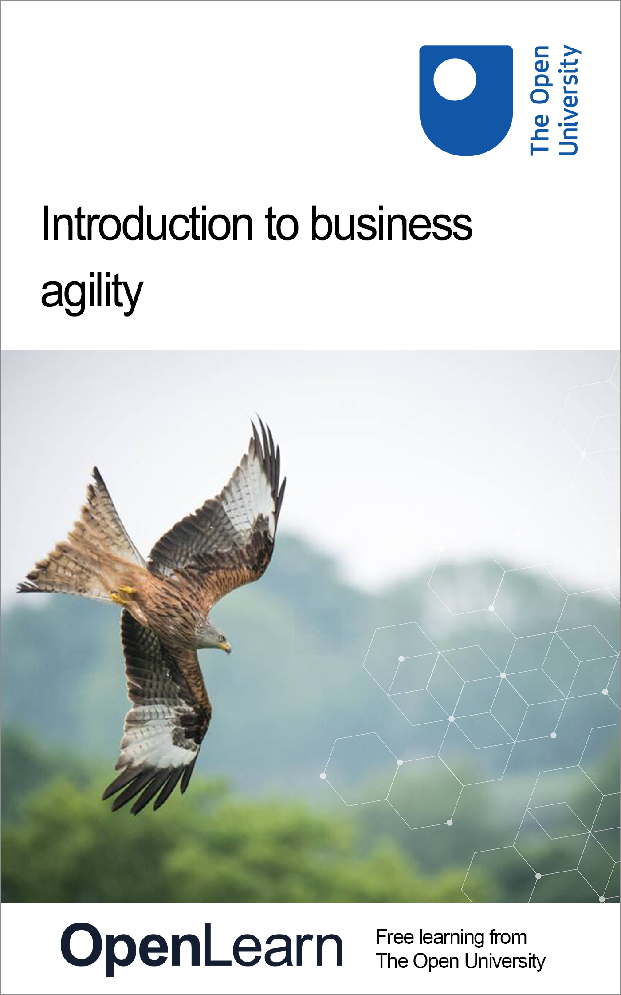

HYB_9 Introduction to business agility

Introduction to business agility

About this free course
This version of the content may include video, images and interactive content that may not be optimised for your device.
You can experience this free course as it was originally designed on OpenLearn, the home of free learning from The Open University –
There you’ll also be able to track your progress via your activity record, which you can use to demonstrate your learning.
Copyright © 2022 The Open University
Intellectual property
Unless otherwise stated, this resource is released under the terms of the Creative Commons Licence v4.0 http://creativecommons.org/licenses/by-nc-sa/4.0/deed.en_GB. Within that The Open University interprets this licence in the following way: www.open.edu/openlearn/about-openlearn/frequently-asked-questions-on-openlearn. Copyright and rights falling outside the terms of the Creative Commons Licence are retained or controlled by The Open University. Please read the full text before using any of the content.
We believe the primary barrier to accessing high-quality educational experiences is cost, which is why we aim to publish as much free content as possible under an open licence. If it proves difficult to release content under our preferred Creative Commons licence (e.g. because we can’t afford or gain the clearances or find suitable alternatives), we will still release the materials for free under a personal end-user licence.
This is because the learning experience will always be the same high quality offering and that should always be seen as positive – even if at times the licensing is different to Creative Commons.
When using the content you must attribute us (The Open University) (the OU) and any identified author in accordance with the terms of the Creative Commons Licence.
The Acknowledgements section is used to list, amongst other things, third party (Proprietary), licensed content which is not subject to Creative Commons licensing. Proprietary content must be used (retained) intact and in context to the content at all times.
The Acknowledgements section is also used to bring to your attention any other Special Restrictions which may apply to the content. For example there may be times when the Creative Commons Non-Commercial Sharealike licence does not apply to any of the content even if owned by us (The Open University). In these instances, unless stated otherwise, the content may be used for personal and non-commercial use.
We have also identified as Proprietary other material included in the content which is not subject to Creative Commons Licence. These are OU logos, trading names and may extend to certain photographic and video images and sound recordings and any other material as may be brought to your attention.
Unauthorised use of any of the content may constitute a breach of the terms and conditions and/or intellectual property laws.
We reserve the right to alter, amend or bring to an end any terms and conditions provided here without notice.
All rights falling outside the terms of the Creative Commons licence are retained or controlled by The Open University.
Head of Intellectual Property, The Open University

Contents
- Introduction: why improve ways of working?
- Learning outcomes
- 1 Business agility patterns
- 2 Pattern 1: Focus on the outcomes
  - 2.1 Outcome hypotheses and OKRs
  - 2.2 Value Stream Mapping
- 3 Pattern 2: Achieve big through small
- 4 Pattern 3: Invite over inflict
- 5 Pattern 4: Leadership behaviour will make it or break it
- 6 Pattern 5: Build the right thing – outcomes over output
- 7 Pattern 6: Build the thing right – speed with control
- 8 Pattern 7: Continuous attention to technical excellence
- 9 Pattern 8: Pop the learning bubbles – become a learning organisation
- Conclusion
- References
- Acknowledgements

Introduction: why improve ways of working?
With the latest technology-led revolution, we have gone from the Age of Oil and Mass Production, where work was mostly repetitive and knowable, to the Age of Digital, where work is mostly unique, time-sensitive and unpredictable. Like going from the Stone Age to the Bronze Age, a new means of production creates new expectations. In order to survive and thrive, there is a need for businesses to adopt ways of working suited to the new means of production.
In the Age of Digital, every organisation is a software organisation, directly or indirectly, and there are few cases where value delivery is not in some way underpinned by information technology. For example, government agencies, universities, health facilities, manufactured products, distribution and financial services all leverage software to solve human needs. Whereas in a factory 1,500 cars might be produced every day, one car a minute, repeating the same processes over and over again, in the Age of Digital, you do not write the same software thousands of times. Software is written once and then runs thousands of times.
This new means of value generation requires a completely new approach to ways of working. This applies whether you are in a service/product design, process improvement, operations or software engineering role and whether you are a senior leader or a junior leader. Agile is one of many possible practices, along with Lean, DevOps and more; however, it is not the ‘end’ in itself. Improvement can be elusive – organisations can be ‘doing Agile’ and not seeing any improvement in their outcomes

Learning outcomes
After studying this course, you should be able to:
- explain the most important focus areas when seeking to improve ways of working and how these can be measured
- apply two practical activities to your own context in order to get started with business agility
- locate further information and resources to dive deeper into this topic.

1 Business agility patterns
Sooner Safer Happier is a textbook based on decades of practical experience of improving ways of working in hundreds of organisations. Learnings are structured into eight ‘patterns’ and ‘antipatterns’ for business agility.
A pattern is a response to a situation that, more often than not, is effective and improves desired outcomes. Of course, this all comes with ups and downs, back and forth; it’s all about the people. A pattern can help to create a tailwind for change.
The antipattern is to deploy a capital ‘A’, capital ‘T’ Agile Transformation across your organisation, with fixed scope/budget/plan, that is, to apply old ways of thinking to new ways of working, which is unlikely to generate the desired benefits.
Better Value Sooner Safer Happier (BVSSH) is an outcome-orientated approach to continuously improving ways of working. It is a model for improving outcomes as organisations pivot to the nature of work in the Age of Digital. Instead of focusing on a particular framework, the focus needs to be on achieving a positive trend on desired outcomes, using Agile, Lean, DevOps, systems thinking, design thinking, theory of constraints and so on as figurative tools in the toolbox, suited to your context. Every organisation is unique and is a complex adaptive system; there is no one-size-fits-all approach.
Table 1 summarises the types of organisational problem these patterns can assist with. (Italic text in the third column refers to topics discussed in the Sooner Safer Happier textbook that are not covered in this course.)

Organisational problem | Desired outcome | Recommended BVSSH pattern(s)
‘We’re too expensive and inefficient. It’s too hard to get anything done, and organisational inertia is holding us back. The cost of change is high and it takes ages. We have to be more efficient!’ | I want more efficient delivery of value | Pattern 1: Focus on the outcomes  Pattern 5: Build the right thing  Intelligent Flow  Pattern 7: Continuous attention to technical excellence
‘We need to get better at benefits management. We don’t really know what value our change investments are adding; it’s just opinion. We have to get smarter at articulating, measuring and prioritising highest value!’ | I want to optimise for highest value | Pattern 1: Focus on the outcomes  Pattern 5: Build the right thing  Intelligent Flow  Create a Learning Ecosystem
‘Things take too long. If we don’t change, we will not exist. We are not keeping up with the competition. Doing nothing means we are going backward quickly. We have to accelerate.’ | I want to decrease time to value | Pattern 5: Build the right thing  Intelligent Flow  Pattern 6: Build the thing right  Intelligent Control  Pattern 7: Continuous attention to technical excellence
‘When our delivery teams hit the risk and control gates, it doesn’t matter whether they are agile or not: they all slow to the same speed. It can feel like we have governance gridlock, yet we are highly regulated and must manage risk and maintain regulatory trust.’ | I want to have both speed and control | Pattern 4: Leadership will make it or break it  Pattern 5: Build the right thing  Intelligent Flow  Pattern 6: Build the thing right  Intelligent Control
‘Our best people keep leaving. The talent market is so competitive. Our staff turnover is really wasteful. We lose knowledge and reputation. We have to get better at attracting and retaining the best talent.’ | I want a more engaged workforce | Pattern 1: Focus on the outcomes  Pattern 3: Invite over inflict  Optimisation over One Way  Create a Learning Ecosystem
‘We waste a lot of time talking about it. We have some pockets of improvement, but there is no shared understanding. Everyone has such entrenched beliefs. The arguments can get heated. Our energy needs to be focused on making real improvement.’ | I want to know why ways of working matter | A Sense of Urgency  Pattern 1: Focus on the outcomes  Pattern 4: Leadership will make it or break it
‘We have talked about transformation for a long time and made a start. We’re making some progress in IT, but the wider organisation is not yet feeling the benefit. As a leadership team we want to improve outcomes, and we want lasting change.’ | I want to nurture cultural change | Pattern 2: Achieve big through small  Pattern 3: Invite over inflict  Optimisation over One Way  Pattern 4: Leadership will make it or break it
‘For our organisation to survive and thrive, we know we have to adapt quickly. The scale of change is daunting, and we are not sure where to begin making these changes.’ | I want to know where to (re)start | A Sense of Urgency  Pattern 1: Focus on the outcomes  The Best Time to Plant a Tree Is Twenty Years Ago; The Second Best Time Is Today
‘Our investment funding is tied to detailed upfront business cases and annual project cycles. It’s hard to understand what a different funding model might look like in new ways of working.’ | I want to know how to fund agility | Pattern 1: Focus on the outcomes  Pattern 5: Build the right thing  Intelligent Flow  Pattern 4: Leadership will make it or break it

2 Pattern 1: Focus on the outcomes
What are BVSSH outcomes?
(B)etter is quality. Quality that is built in rather than inspected in later. There are fewer incidents and outages and less rework. More time is spent proactively rather than reactively. Improving quality can be demonstrated through, for example, continually reducing trends of breaks/data exceptions/outage, increased mean time between failures and reduced time to recovery. A wide range of metrics is available to demonstrate quality trends, depending on your context.
(V)alue is unique; it is an outcome of value to your organisation, and it is your purpose. It could be financial; it could be maintaining public safety; it could be charitable. As the future is not knowable, value is articulated via outcome hypotheses with leading and lagging measures.
- The leading measures act as an early indicator, an early feedback loop, based on whether we are seeing the desired behavioural shifts happening. This enables pivoting and agility in order to maximise the outcome or have the cheapest cost of failure.
- The lagging measures will align more closely to impact metrics and more traditional benefits statements.
(S)ooner is time to market; time to learning, to pivoting, to de-risking, to avoiding a ‘sunk cost fallacy,’ to locking in progress and value early and often. There are three key measures:
- Lead Time is the time from starting work on an item of value to getting it into the hands of a customer.
- Throughput is the count of items of value delivered into the hands of a customer in a time period. As lead time comes down, throughput should go up.
- Flow Efficiency is the percentage of time that work is actively being worked on during its elapsed end-to-end lead time, as opposed to waiting to be worked on. For most large, service-based organisations, flow efficiency is typically 10% or lower. This means that work is waiting at least 90% of the time. This is where significant gains can be made. Focus on where the work isn’t, not where the work is.
(S)afer is Governance, Risk, and Compliance (GRC), information security, data privacy, regulatory compliance and resilience in chaos, be that a cyber-attack or a global pandemic. It is customers trusting your organisation.
(H)appier covers customers, colleagues, citizens and climate, as it is not about ‘more for less’ at any human or climatic cost. It is high levels of customer advocacy and colleague engagement with a positive impact on society and the one planet we live on.
Together, Better Value Sooner Safer Happier balance each other. If Sooner is achieved by working people harder or cutting corners, the result will be a reduction in Better, Safer and Happier.
When establishing BVSSH measures, it is important to look at the trends over time, the vector metrics, rather than absolute values. What matters is not the specific metric you use, nor the level you or your team are at, but rather that teams are monitoring and seeking to continually improve their performance along these dimensions. Think ‘personal bests’, not ‘I’m the best’.
BVSSH contains two types of outcome:
- Better Sooner Safer Happier are the how outcomes. They measure the improvement in your system of work.
- Value is the what, the ‘business’ outcome hypotheses that the system of work produces.
The two sets of outcomes form a virtuous circle, as illustrated in Figure 1.

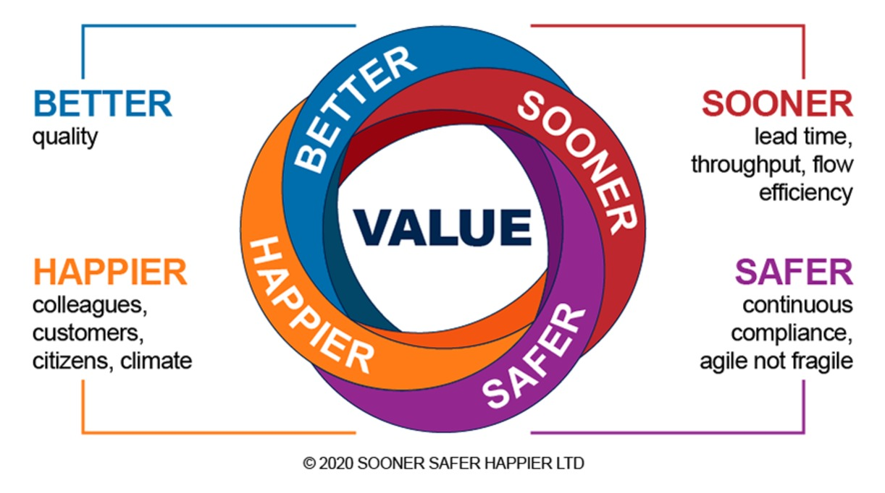
Figure 1 BVSSH (Better Value Sooner Safer Happier) meanings © Sooner Safer Happier Ltd, 2020
View description - Figure 1 BVSSH (Better Value Sooner Safer Happier) meanings © Sooner Safer Happier ...

Improvements in the how lead to improvement in the what due to faster feedback, the ability to pivot, higher quality and more engaged colleagues and customers. Rather than inflicting one set of practices, focus on BVSSH and empower teams to improve using their own brains, with support, in their unique context. With incentivisation and psychological safety, this will build a new muscle memory, a continuously learning and improving organisation.

2.1 Outcome hypotheses and OKRs
Activity 1 (below) aims to help you understand how to measure and continually improve Value.
The value associated with unique change is best articulated as outcome hypotheses (also known as Objectives and Key Results, or OKRs). This creates a clear expectation that it is a hypothesis and may be invalid and that there are unknown-unknowns that will only be uncovered when the work takes place. It also creates a clear expectation that experimentation is required, with people empowered to use their own brains to discover how to best achieve the outcome, or even if the outcome hypothesis is worth continuing trying to achieve.
You can write an outcome hypothesis like this:
Due to <this insight>
We believe that <this capability>
Will result in <this outcome>
We will know that we’re on the right track when:
- Measure 1: quantified and measurable leading or lagging indicator
- Measure 2: …
- Measure 3: …
In the short video below, Myles Ogilvie, Principal at Sooner Safer Happier Limited, explains more about the importance of leading and lagging indicators, and how they relate to value and behavioural shifts.

Video content is not available in this format.
View transcript - Uncaptioned interactive content

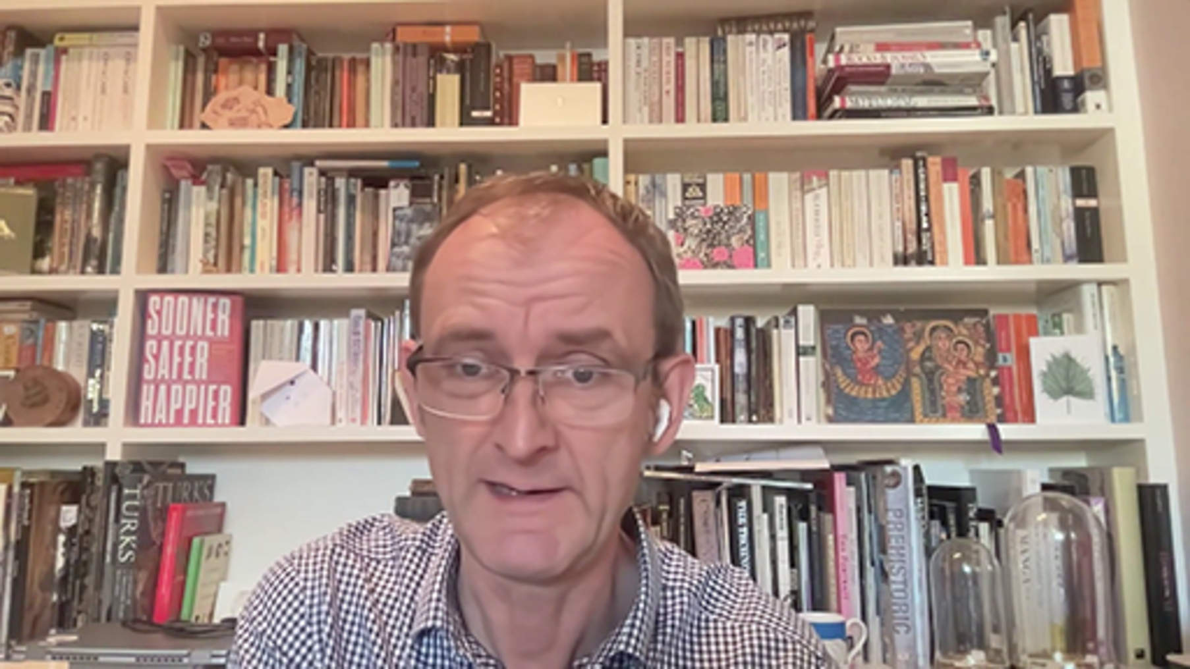

To aid the writing of your first business outcome, use the canvas below (Figure 2).

Activity 1: An outcome hypothesis
allow at least 30 minutes

On a whiteboard (or digital canvas), draw four quadrants with a circle in the middle, like Figure 2 (below). Label the quadrants as shown in Figure 2 and the circular customer segment in the middle.
For an outcome you are seeking to achieve, and using the completed canvas in Figure 2 for guidance, start to populate each sector with information. It does not matter which sector you start in, and you can iterate each sector as your thinking develops.
As you populate your canvas, reflect on the following questions:
- For this outcome – how will you decide when your outcome is achieved? Is it based on a date, a scope, budget spent or something else?
- What is the time horizon you chose for your outcome? (see Pattern 5)

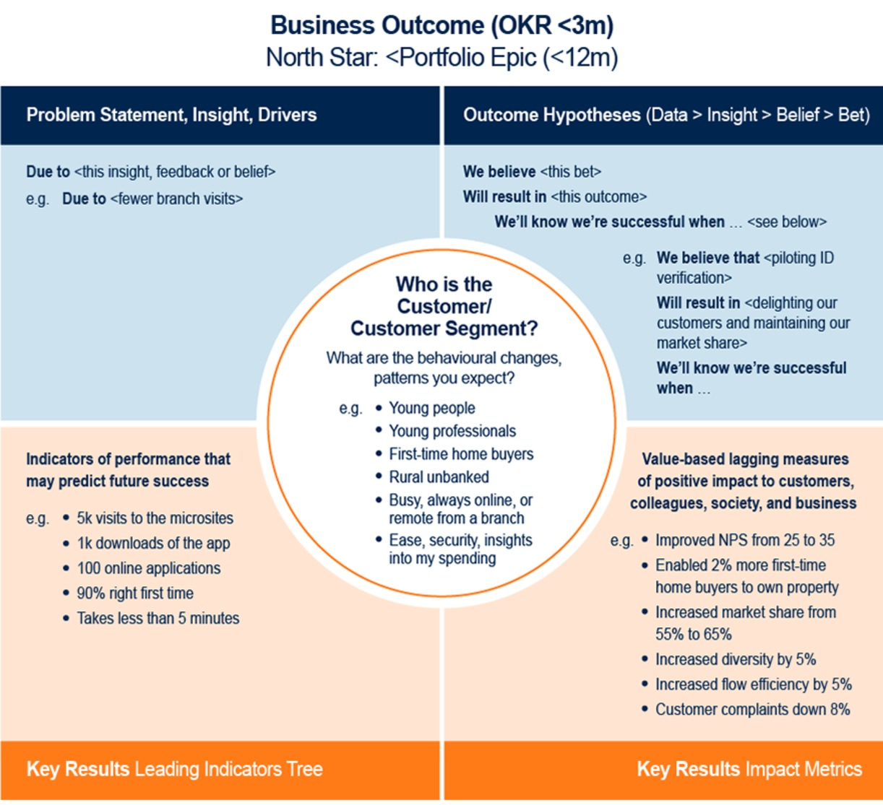
Figure 2 Business Outcome Canvas © 2020 Jonathan Smart
View description - Figure 2 Business Outcome Canvas © 2020 Jonathan Smart

Over time, as your mastery of this approach increases, consider writing business outcomes as ‘moonshots’ or stretch goals. Traditional objective setting tends to lead to mediocrity, to underpromising in order to overachieve the goal. Achieving 100% regularly is not thinking big enough. Instead, achieving 60% to 70% of a business outcome is doing well.

Further information
To explore this pattern in more depth, watch the following YouTube videos:
- OK NOTOK OKRs - Jon Smart (Americas) (54 minutes 54 seconds)
- Output vs Outcome & Impact (10 minutes 37 seconds)

2.2 Value Stream Mapping
In the following video, Myles Ogilvie introduces Value Stream Mapping, a powerful technique to help you to understand how to measure and continually improve flow.

Video content is not available in this format.
View transcript - Uncaptioned interactive content

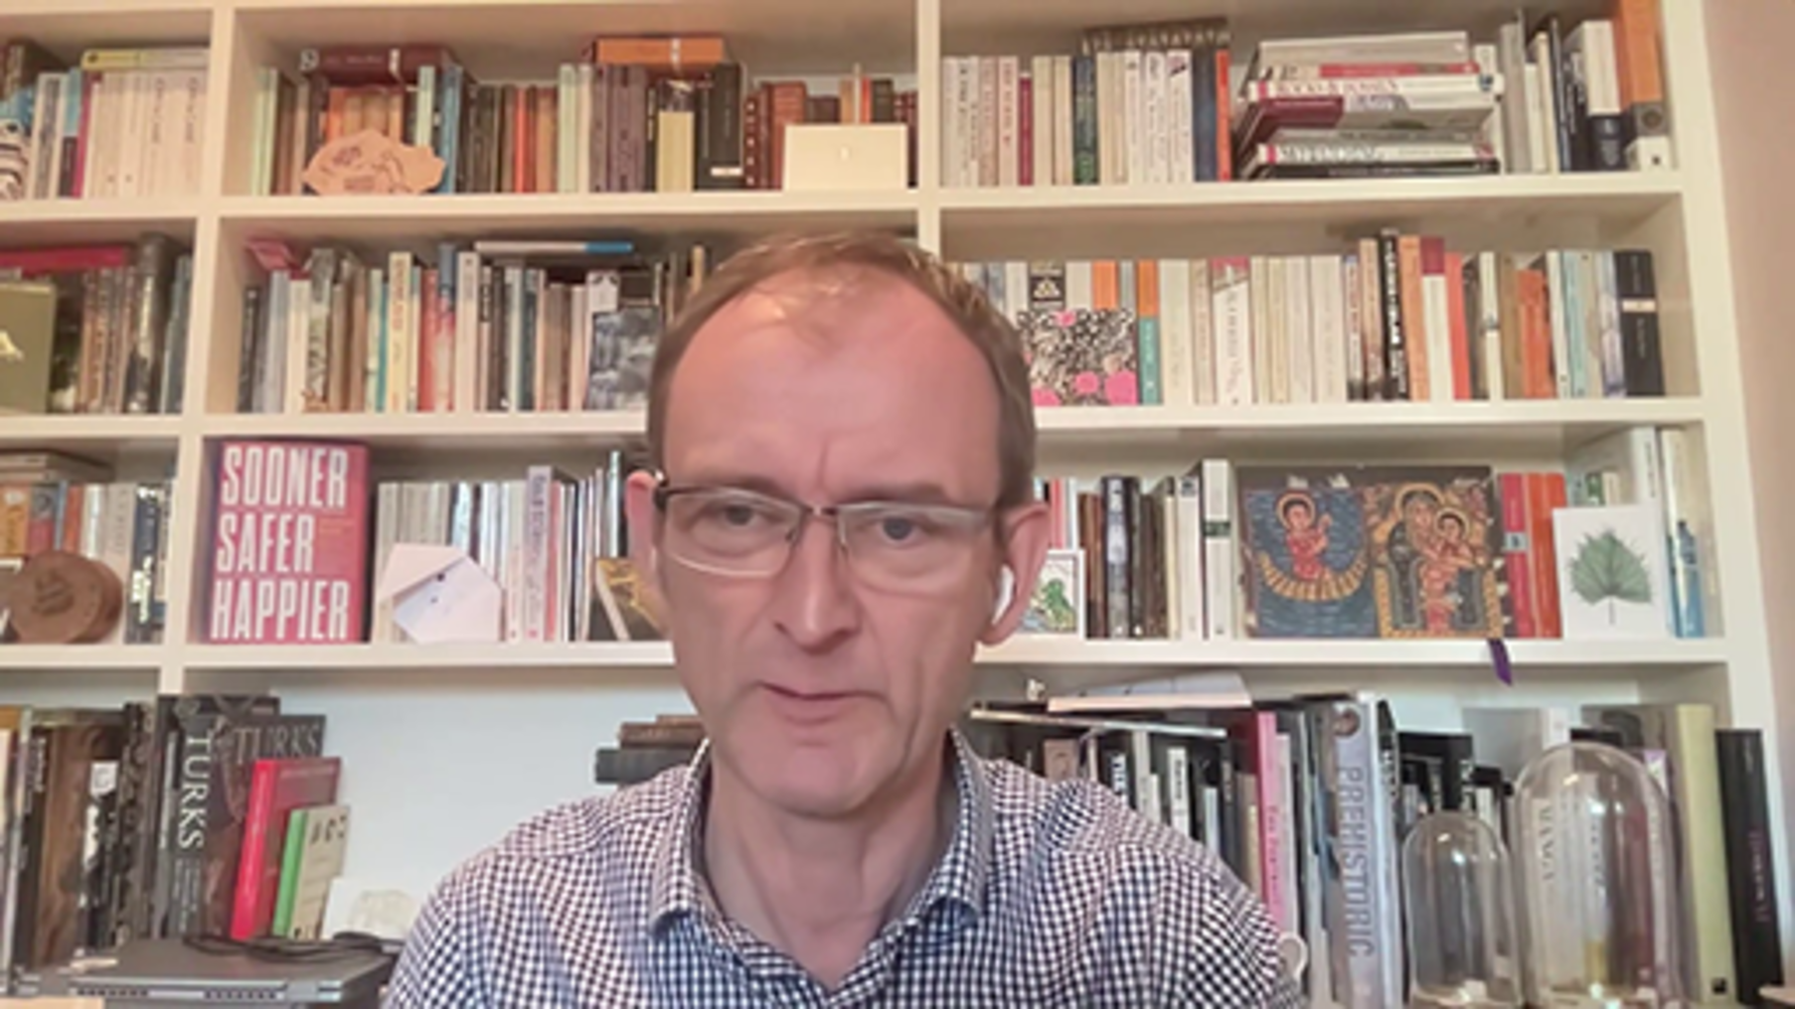

Figure 3 illustrates how to measure the flow efficiency when queuing for a cup of coffee. In this case, the flow efficiency is 20%, meaning you spent 80% of the time waiting.

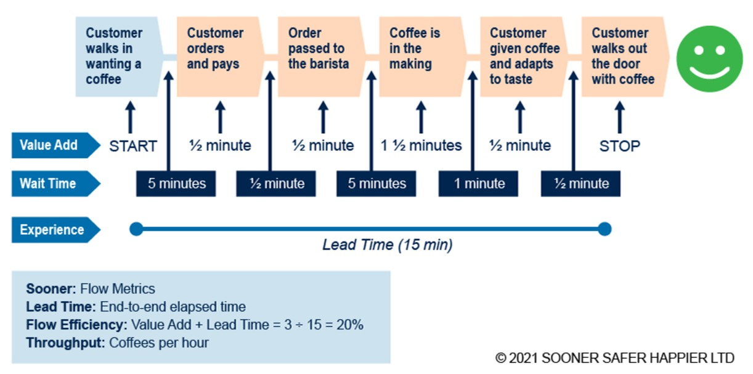
Figure 3 Value stream mapping © 2021 Sooner Safer Happier Ltd
View description - Figure 3 Value stream mapping © 2021 Sooner Safer Happier Ltd

As Myles Ogilvie explained in the video above, the wait time is when work is not happening. There are many different reasons work stops. Using the language of astronomy, the wait time could be considered the ‘dark matter’ of your system of work. By visualising and tackling this wait time, you can achieve radical performance improvement.
In most large organisations where there has been no historic focus on optimisation, the flow efficiency associated with work is below 10%: in other words, for over 90% of the time, work is waiting in queues. In order to improve the flow of value through your organisation, you will need to:
- visualise the flow,
- identify the wait times and bottlenecks and
- evaluate where the best place is to apply improvements.
Large organisations are complex and adaptive – as their people and environment shift, there can be a steady increase in disorder (entropy). A continual improvement approach to improving flow is advisable – improving ways of working is not a one-off exercise. The Law of Marginal Gains (the belief that small improvements to any process amount to a significant improvement when added together) means that many small improvements over time can lead to extraordinary outcomes.

Activity 2: Value Stream Mapping
allow at least 30 minutes

Try applying Value Stream Mapping to a process at your organisation.
- Using a whiteboard or a digital canvas, draw a horizontal line from one side to the other.
- At each end, place a sticky note (or a text box) explaining the start and end of the process you wish to improve.
- Between these, place another sticky note (or text box) describing each step of your process. Use the same colour notes for all of these. On each sticky note, write the time it takes to execute the tasks.
- Now add a different-coloured sticky note between each of the process steps you have just created and write the wait time on it.
- Finally, normalise the units you have used (seconds/minutes/hours/days/weeks/months) and calculate the flow efficiency of your process.
As you map your process, reflect on the following questions:
- What are the major impediments to flow in this process, the main sources of wait time?
- In order to accelerate flow, what do you want to tackle first?

The business agility patterns described in the next sections are fundamental enablers for improvements in Better Value Sooner Safer Happier outcomes within your organisation. Brief summaries are provided, but further information about these patterns can be found on YouTube at https://soonersaferhappier.com/ and in the published text Sooner safer happier, patterns & antipatterns for business agility (Smart, 2020).

3 Pattern 2: Achieve big through small
It is hard for humans to change behaviours learned over many years. Change can lead to a dip in morale and competence before learning embeds and improvement happens. Achieving broad organisational change that sticks requires transformational ‘baby steps’. Start with the smallest possible group of people who might effect improvement and the smallest possible scope that might make a difference. Run the experiment, create a rapid feedback loop using BVSSH measures and learn from that experience before determining the next step. As expertise increases, the changes will accelerate.
The antipattern would be to deploy a large-scale change across your complex organisation, changing hundreds or thousands of people’s roles and behavioural interactions at the same time.

4 Pattern 3: Invite over inflict
Improving ways of working is a form of innovation, and Everett Rodger’s writings from the 1960s on the Diffusion of Innovation are useful in this context. The population will contain some individuals who are most open to change – innovators and early adopters – but the majority will need to see social proof that the innovation is useful before they will feel comfortable to follow. There will be others who are highly sceptical of the change and may never agree to it.
There is no one-size-fits-all approach for improved ways of working leading to better outcomes. Experimentation is needed. When helping your organisation to change, it is important to identify innovators and early adopters – and to invite them to participate. These people are more likely to relish the opportunity, to have greater curiosity to explore what works and what doesn’t and to demonstrate the resilience to overcome obstacles.
The antipattern would be to inflict a one-size-fits-all, off-the-shelf framework across your complex organisation, mandating a fixed set of practices developed elsewhere.

5 Pattern 4: Leadership behaviour will make it or break it
Culture is set by leadership, and specifically by how leaders behave rather than what they say. This applies to leaders at all levels – teams, departments or the whole organisation. When leaders model improved ways of working, demonstrating curiosity and experimentation and learning, it sends a powerful signal to everybody else. Examples of positive leadership behaviour include:
- focusing on outcomes,
- using visualisation walls that are available to everyone in the organisation,
- fostering psychological safety and
- providing clarity of mission together with autonomy for teams to determine how to achieve their mission.
The antipattern would be ‘Do as I say, not as a I do’ – a lack of role modelling, a continued focus on output rather than outcomes, a command-and-control behaviour set.

6 Pattern 5: Build the right thing – outcomes over output
The outcome you defined in Activity 1 fits into a set of nested outcomes for your organisation.
For example:
- Level 1 – strategic goals.
- Level 2 – multi-year outcomes
- Level 3 – 1-year outcomes
- Level 4 – 3-month outcomes
- Level 5 – 1 month experiments, weekly iterations
- Level 6 – daily stories/tasks
To help your organisation optimise building the right thing, it is necessary to establish clear traceability of work across these levels, with regular prioritisation. This information may be shared through the visualisation walls mentioned above. Regular reviews and reprioritisation by leadership at all levels are based on measuring leading indicators of progress (answer to Experiment 1, Question 1).
To help your organisation optimise around the regular flow of value, it is necessary to consider how people are structured to support these outcomes. There is a pivot from project-based models towards long-lived product/service teams within long-lived value streams – containing all the cross-functional capabilities to achieve their prioritised outcomes. The longevity allows you to optimise belonging, learning, and colleague engagement. Hand-offs with areas that cause delay can be reduced.
The antipattern would be milestone-driven predicted solutions, where the output was defined up front, without experimentation, at the time of least available knowledge. This antipattern prioritises delivery of output over the outcome. As a UK government minister said in February 2021 during the COVID pandemic, ‘In determining the correct course of action we should be guided by the data, not the dates’.

Further information
To explore this pattern in more depth, watch the YouTube video from Jonathan Smart, The PMO is dead, long live the PMO

7 Pattern 6: Build the thing right – speed with control
Public organisations and regulated industries have a large number of externally mandated governance, compliance and control restrictions. The rise of online cyber crime represents a threat to all industries. Organisations need to manage risk to maintain customer trust.
The antipattern would be a fixed mindset around risk where a product/service/change undergoes inspection by risk experts once it has been built. At one organisation it took 3 months to complete inspection before a sample program that could familiarise users with the process was internally deployed. In that case, the control plane of the system of work was not optimised for flow.
Improving BVSSH outcomes requires speed with control. This includes seeking early collaboration between delivery teams and risk experts and taking a context-sensitive approach to judging risks and specifying mitigations. Equipping the system of work with measuring instruments used by product/service teams can help to visualise identified risks and their mitigations.
Operating at speed requires the availability of strong brakes, and this can be achieved through standard automated checks at time of release.

Further information
To explore this pattern in more depth, watch the YouTube video from Jonathan Smart, Risk & control is dead, long live risk & control.

8 Pattern 7: Continuous attention to technical excellence
Many organisations operate information technology departments as ‘feature factories’, with the emphasis placed on maximising the rate of feature delivery. A lower priority is placed on technical excellence practices, with the result that shortcuts taken to expedite feature delivery fail to be resolved – building up ‘technical debt’. Technical debt accumulates over time, and, if not repaid, it makes change harder, slower and more costly to achieve. Stakeholders with an interest in continually improving platforms should actively support continual investment in the technical underpinnings of the platforms themselves to reduce the long-term cost of change.

Further information
To explore this pattern in more depth, read Simon Rohrer’s article 'Slow down in order to “speed up”: Pay continuous attention to Technical Excellence'

9 Pattern 8: Pop the learning bubbles – become a learning organisation
Your organisation will be organised into departments and silos. Humans are tribal in nature, and we need to belong to groups. The tribal instinct is not just to belong; it is also to exclude. This exclusion promotes the creation of social bubbles – whether consciously or unconsciously.
While social structures have positive effects, they also raise challenges – especially when it comes to knowledge sharing across an organisation. Much of this course has focused on learning and the need for knowledge sharing within organisations to spread information about new ways of working. If the silos/social bubbles of your organisation are too strong, then this will not happen.
Being a change agent means finding ways to ‘pop the bubbles’, to foster the spread of knowledge about improved outcomes and new ways of working. This can be achieved through, for example:
- ‘brown bag’ lunch talks;
- communities of practice;
- internal conferences, events and awards;
- internal mobility programmes (helping folks transition their role across the organisation);
- book clubs; and
- open spaces.
Popping the learning bubbles does not just apply within your organisation; it also applies across organisations and industries. Organisations can learn from each other and from their presence at external conferences and interacting with/listening to thought leaders.

Conclusion
Sooner Safer Happier is a movement dedicated to enabling organisations to achieve better outcomes for all and a more humane world of work. The movement is supported by an active, open-to-all, free-to-access, global community of practice – for details, see https://soonersaferhappier.com/community/

References
Rogers, E.M. (2003) Diffusion of innovations (5th ed.). NY: Free Press.
Smart, J. (2020) Sooner safer happier, patterns & antipatterns for business agility. It Revolution Press.

Acknowledgements
This free course was written by the Sooner Safer Happier team, special thanks to Myles Ogilvie and Matt Turner.
Find out more about Sooner Safer Happier at soonersaferhappier.com. The Sooner Safer Happier book, Antipatterns and Patterns For Business Agility, is also available.
Except for third party materials and otherwise stated (see terms and conditions), this content is made available under a Creative Commons Attribution-NonCommercial-ShareAlike 4.0 Licence.
The material acknowledged below is Proprietary and used under licence (not subject to Creative Commons Licence). Grateful acknowledgement is made to the following sources for permission to reproduce material in this free course:
Images
Figures 1 and 3 © Sooner Safer Happier Ltd, 2022
Figure 2 © 2020 Jonathan Smart
Every effort has been made to contact copyright owners. If any have been inadvertently overlooked, the publishers will be pleased to make the necessary arrangements at the first opportunity.
Don't miss out
If reading this text has inspired you to learn more, you may be interested in joining the millions of people who discover our free learning resources and qualifications by visiting The Open University – www.open.edu/openlearn/free-courses.

Figure 1 BVSSH (Better Value Sooner Safer Happier) meanings © Sooner Safer Happier Ltd, 2020

Description
In the centre of the diagram is a multicoloured continuous circular knot, resembling a Möbius strip with the words BETTER SOONER SAFER HAPPIER on the circle itself and the word VALUE in the centre. Dotted lines flow outwards from the four words on the circle to the four corners of the diagram. Top left is the word BETTER, with ‘quality’ below it. Top right is the word SOONER, with ‘lead time, throughput, flow efficiency’ below it. Bottom right is the word SAFER, with ‘continuous compliance, agile not fragile’ below it, and bottom left is the word HAPPIER, with ‘colleagues, customers, citizens, climate’ below it.
Back to - Figure 1 BVSSH (Better Value Sooner Safer Happier) meanings © Sooner Safer Happier Ltd, 2020

Figure 2 Business Outcome Canvas © 2020 Jonathan Smart

Description
A Business Outcome Canvas diagram with four quadrants and a circular Customer Segment in the middle. The first quadrant (top left) is headed Problem Statement, Insight, Drivers, and below that, it says ‘Due to <this insight, feedback or belief>, e.g. Due to <fewer branch visits’. The second quadrant (top right) is headed Outcome Hypotheses (Data > Insight > Belief > Bet), and below that is the following text: ‘We believe <this bet>; Will result in <this outcome>; We’ll know we’re successful when … <see below>; e.g. We believe that <piloting ID verification>Will result in <delighting our customers and maintaining our market share>; We’ll know we’re successful when …’. The third quadrant (bottom left) is headed Key Results Leading Indicators Tree, and below that is the following text: ‘Indicators of performance that may predict future success; e.g. 5k visits to the microsites, 1k downloads of the app, 100 online applications, 90% right first time, Takes less than 5 minutes’. The fourth quadrant (bottom right) is headed Key Results Impact Metrics, and below that, it says ‘Value-based lagging measures of positive impact to customers, colleagues, society, and business, e.g. Improved NPS from 25 to 35, Enabled 2% more first-time home buyers to own property, Increased mkt share from 55% to 65%, Increased diversity by 5%, Increased flow efficiency by 5%, Customer complaints down 8%. The centre circle is headed Who is the Customer/Customer Segment? and contains the following text: ‘What are the behavioural changes, patterns you expect? e.g. Young people, Young professionals, First-time home buyers, Rural unbanked, Busy, always online, or remote from a branch, Ease, security, insights into my spending.’
Back to - Figure 2 Business Outcome Canvas © 2020 Jonathan Smart

Figure 3 Value stream mapping © 2021 Sooner Safer Happier Ltd

Description
A timeline diagram illustrating a value stream process from start to finish, taking into account the value added, wait time and experience from end to end. The steps are: Customer walks in wanting a coffee, Customer orders and pays, Order passed to the barista, Coffee is in the making, Customer given coffee and adapts to taste, Customer walks out the door with coffee. The Value Add timings associated with each of these steps are: START, ½ minute, ½ minute, 1½ minutes, ½ minute, STOP. The Wait Times are: 5 minutes, ½ minute, 5 minutes, 1 minute, ½ minute. The Experience Lead Time is 15 minutes. There is a summary box at the bottom left of the diagram containing the following information: Sooner: Flow Metrics, Lead Time: End-to-end elapsed time, Flow Efficiency: Value Add + Lead Time = 3 ÷ 15 = 20%, Throughput: Coffees per hour.
Back to - Figure 3 Value stream mapping © 2021 Sooner Safer Happier Ltd

Uncaptioned interactive content

Transcript
MYLES OGILVIE:
OKRs, they stand for Objectives and Key Results. If you read publicly what that stands for, we refer to them as Outcomes and Key Results because it's more clear. It helps people to focus on the outcome rather than the particular milestone or goal. So thinking about the outcome and how you will measure that outcome. And with key results, we advise you separate them into leading and lagging indicators.
And that is a super important ninja move for people trying to measure value to separate your key results into leading and lagging indicators. Traditional projects benefits management have usually focused on lagging indicators. Benefits realization, stuff that happens after the project is completed. So they're absolutely useless telling you whether you are building the right thing because they don't materialize until the project is completed. And if you built the wrong thing, they never materialize.
So lagging indicators is the impact the value you hope will arise, having made your investment, but the leading indicators are the super powerful ones. So that is where you're looking at behavioral change. The shift, for example, when Uber is coming to life, you're having a shift in behavior of people from instead of hailing taxis, they're now keying for them on their phone. That's a behavioral shift which has happened because of what that organization did.
And that you can start to measure that behavioral shift in terms of what it is that your enabling. If you enable a small slice of value, are you seeing some behavioral shift as a result of that value, that thing being deployed? So this could be if you are thinking of a new offering, a new student course, for example, are you pitching that on the internet? Are you detecting the downloads?
Are you detecting the interest levels? What's the smallest slice of behavioral feedback you can get to detect whether the thing that you're trying to do is heading in the right direction, is of use. And so that's your leading indicators. And if you have enough leading indicators, then they should start.
Back to - Uncaptioned interactive content

Uncaptioned interactive content

Transcript
MYLES OGILVIE:
Value stream mapping is a super powerful way to start to improve your flow. So this is a specific technique, value stream mapping, which helps you look at the end to end concept to cash process for anything. So whether it's buying a pencil, making a cup of tea, building software, or creating a new university course, value stream mapping is following the process from, I have an idea, to this is now generating value.
The way we run value stream mapping is typically get everybody into a room or a virtual room and invite, and everybody means everybody involved in that end to end process from having the idea, which is the beginning of the process, and the idea may be very ill formed to start with, so the beginning is having the idea, to getting the value.
Everybody involved in that interim process has a role to play in value stream mapping, which is to say what is the work that happens, what are the, lay all the tickets out on a great, big, long wall or a table or something. This idea happened, then it went to this committee, then it went to this conversation, then it went to that committee, work was done, passed on to another team, more work was done. Eventually, things happen.
When you lay out that value end to end and you date stamp it, when did these things happen, because you're looking backwards at a particular example or examples, and then you look at the wait time between things, between the tickets, what were the reasons for the wait and how long was the waiting. And what organizations find, is when you take an end to end process from concept to cash and you start mapping it for the first time when the organization has not been optimized, you tend to find that for about 95% of the time, work will be waiting. Nothing will be happening. So if you want to improve your flow, if you want to double your rate of flow through your organization, if your starting point is 95% idle, you only need to reduce that down to 90% idle and your working time has gone up from 5% to 10%. You've doubled your throughput.
So focusing on the wait time, this is like the dark matter of the universe, it's stuff you can't see because work is waiting, if you focus on the waiting, why is it waiting. The reasons that work waits we call impediments. These are things that are holding back your organization, stopping it from accelerating. If you know why work is waiting, then you can start to prioritize, well, which of those can we improve.
Can't improve everything. Some things will be easier to improve than others. But start to find your opportunities for improvement from your value stream map, which shows where things are waiting. That will help you accelerate, because getting faster delivery doesn't mean people running around faster doing work. It's not about accelerating the actual tasks people are doing. It's about removing the reasons for delay inside your organization. Very powerful method.
Business agility. If I just say a word about defining business agility, we find the words, better value, sooner, safer, happier, are the best definition of business agility that we've come across so far. They do express the reasons business agility is necessary, the reasons that organizations want it.
And that's why we coined the phrase here, better value, sooner, safer, happier, because talking about agility or waterfall or lean just alienates different people who have different cultural backgrounds, different methods that they're familiar with, different trainings they've done. Actually, they're all trying to improve these outcomes. And that's what organizations in the age of digital need to be able to do.
Back to - Uncaptioned interactive content

