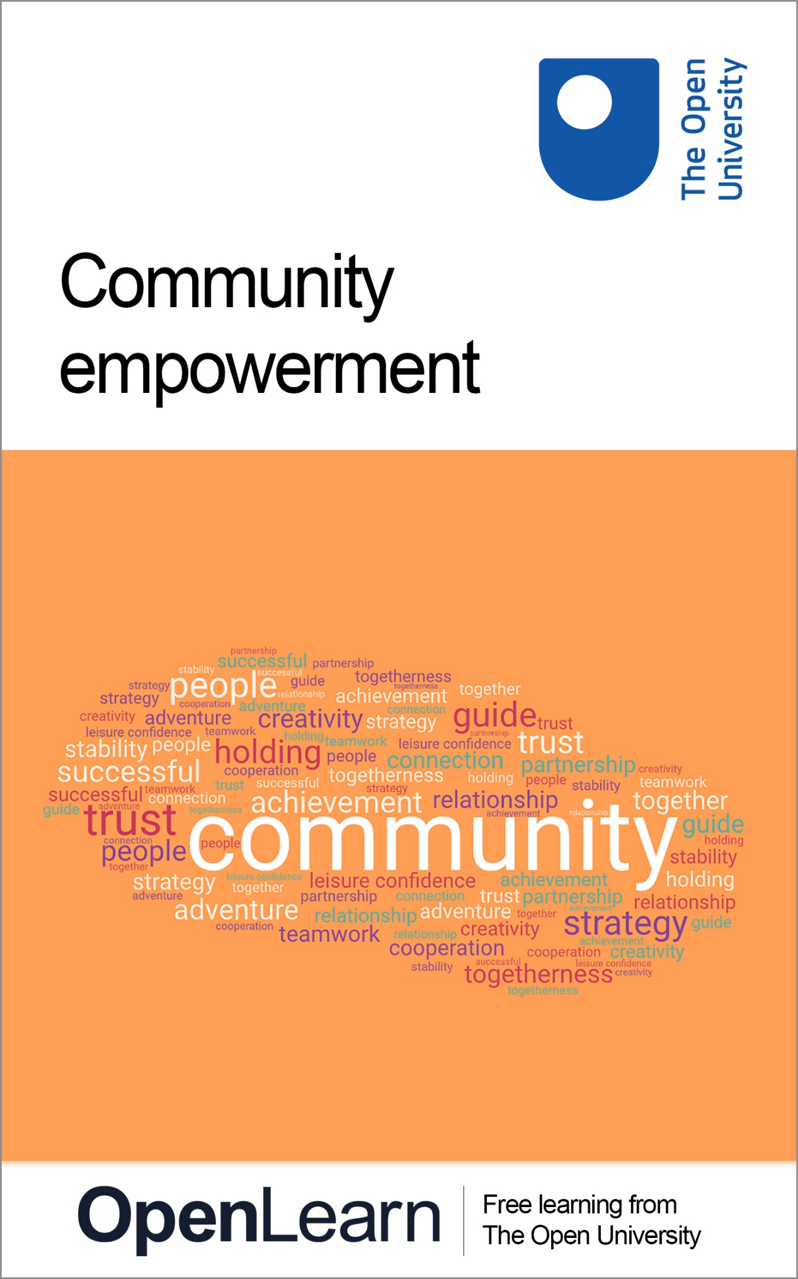

PWC_4 Empowering communities

Empowering communities

About this free course
This content was originally published as an open educational resource on the OpenLearn website http://www.open.edu/openlearn/.
This version of the content may include video, images and interactive content that may not be optimised for your device.
You can experience this free course as it was originally designed on OpenLearn, the home of free learning from The Open University – www.open.edu/openlearn/money-business/leadership-management/empowering-communities/content-section-0?
There you’ll also be able to track your progress via your activity record, which you can use to demonstrate your learning.
Copyright © 2021 The Open University
Intellectual property
Unless otherwise stated, this resource is released under the terms of the Creative Commons Licence v4.0 http://creativecommons.org/licenses/by-nc-sa/4.0/deed.en_GB . Within that The Open University interprets this licence in the following way: www.open.edu/openlearn/about-openlearn/frequently-asked-questions-on-openlearn . Copyright and rights falling outside the terms of the Creative Commons Licence are retained or controlled by The Open University. Please read the full text before using any of the content.
We believe the primary barrier to accessing high-quality educational experiences is cost, which is why we aim to publish as much free content as possible under an open licence. If it proves difficult to release content under our preferred Creative Commons licence (e.g. because we can’t afford or gain the clearances or find suitable alternatives), we will still release the materials for free under a personal end-user licence.
This is because the learning experience will always be the same high quality offering and that should always be seen as positive – even if at times the licensing is different to Creative Commons.
When using the content you must attribute us (The Open University) (the OU) and any identified author in accordance with the terms of the Creative Commons Licence.
The Acknowledgements section is used to list, amongst other things, third party (Proprietary), licensed content which is not subject to Creative Commons licensing. Proprietary content must be used (retained) intact and in context to the content at all times.
The Acknowledgements section is also used to bring to your attention any other Special Restrictions which may apply to the content. For example there may be times when the Creative Commons Non-Commercial Sharealike licence does not apply to any of the content even if owned by us (The Open University). In these instances, unless stated otherwise, the content may be used for personal and non-commercial use.
We have also identified as Proprietary other material included in the content which is not subject to Creative Commons Licence. These are OU logos, trading names and may extend to certain photographic and video images and sound recordings and any other material as may be brought to your attention.
Unauthorised use of any of the content may constitute a breach of the terms and conditions and/or intellectual property laws.
We reserve the right to alter, amend or bring to an end any terms and conditions provided here without notice.
All rights falling outside the terms of the Creative Commons licence are retained or controlled by The Open University.
Head of Intellectual Property, The Open University

Contents
- Introduction
- 1 Empowering communities to help themselves
  - 1.1 The principles and rights of community empowerment
  - 1.2 Key elements of community empowerment
- 2 Third Sector involvement
  - 2.1 Examples of the Third Sector in practice
  - 2.2 Barriers and incentives to community empowerment
- 3 Active citizenship and stakeholder engagement
  - 3.1 Volunteering
- 4 Participatory budgeting
  - 4.1 Participatory budgeting in action
- 5 Empowering communities to deal more effectively with crime and criminality
  - 5.1 The role of government and communities
- 6 Conclusion
- References
- Acknowledgements
- Solutions

Introduction
All communities have the capacity to grow and develop, but for some reason not all communities do so. In order to understand at least one of the reasons for behind this, this course will look at the topic of community empowerment. It will start by defining the key parameters of community empowerment and some of the most common forms, before looking at the barriers to community empowerment and ways that these can be overcome. It will conclude by looking at a particular challenge that can arise if communities are not sufficiently empowered and supported: crime and criminality.
After studying this course, you should be able to:
- understand the various ways in which communities can be empowered
- appreciate the key elements of community empowerment
- understood the barriers and incentives to community empowerment
- reflect on the various forms of stakeholder engagement
- consider ways in which empowered communities can deal more effectively with crime and criminality.

1 Empowering communities to help themselves

Figure 1 Working together
View description - Figure 1 Working together

At its simplest, community empowerment refers to measures designed to increase the degree of autonomy and self-determination in people and in communities in order to enable them to represent their interests in a responsible and self-determined way while acting on their own authority. The World Health Organisation (WHO, 2020) breaks down the concept of community empowerment as follows:

- Community empowerment refers to the process of enabling communities to increase control over their lives.
- Communities are groups of people that may or may not be spatially connected, but who share common interests, concerns or identities. These communities could be local, national or international, with specific or broad interests.
- Empowerment refers to the process by which people gain control over the factors and decisions that shape their lives. It is the process by which they increase their assets and attributes and build capacities to gain access, partners, networks and/or a voice, in order to gain control.
- Enabling implies that people cannot ‘be empowered’ by others; they can only empower themselves by acquiring more of power’s different forms…
(Adapted from World Health Organisation, 2020; emphasis added)

While the breakdown given above might seem fairly straightforward, it is far from being a clearly defined concept. As Robin Ersing has pointed out:

Despite the popularity of the term community empowerment, the concept eludes a precise definition. While some disciplines have contributed to defining aspects of community empowerment, these contributions often refer only to a particular viewpoint. For example, the field of public health often defines community empowerment in terms of “wellness” and the ability of local residents to increase health-promoting behaviours. From this definition, a campaign aimed at reducing alcohol or tobacco use would constitute one method for empowering the community through education, leading to a collective change in behaviour.
(Ersing, 2003, p. 262)

Activity 1 The meaning of empowerment
Allow approximately 15 minutes

What does ‘empowerment’ mean to you? Reflect for a few moments then note down your immediate thoughts and responses.
Some points to consider might include:
- When you think of the term ‘empowerment’, do certain words, images or scenarios come to mind? If so, what are these?
- Who do you think can be empowered – individuals or communities?

Provide your answer...
View discussion - Activity 1 The meaning of empowerment

1.1 The principles and rights of community empowerment
In addition to defining what community empowerment is, it is also worth reflecting on the key principles underpinning its practical application. Ersing (2003) argues that the practice of community empowerment can be summarised by three key principles, namely: building the competence or capacity of local residents and groups; providing opportunities for residents and local organizations to collaborate as change agents in resolving problems; and the use of advocacy and community or social action as change strategies to promote community well-being.
Within a UK context, the practice of community empowerment is arguably most developed in Scotland. Scotland’s 2015 Community Empowerment Act outlines a number of key rights which local communities can claim:

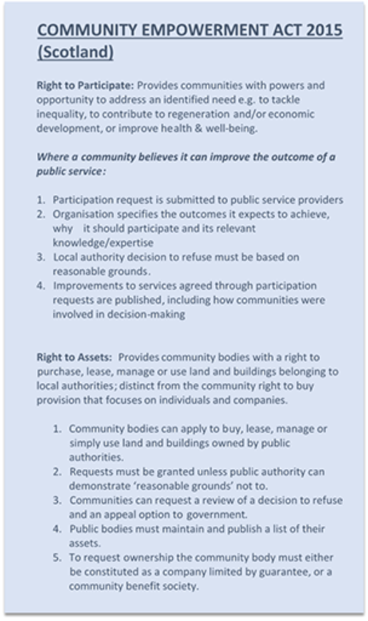
Source: (Development Trusts NI, no date.)
Figure 2 Community Empowerment Act (2015) Scotland
View description - Figure 2 Community Empowerment Act (2015) Scotland

In a similar vein, the 2011 Localism Act in England highlights the importance of the right to challenge as being crucial to community empowerment.

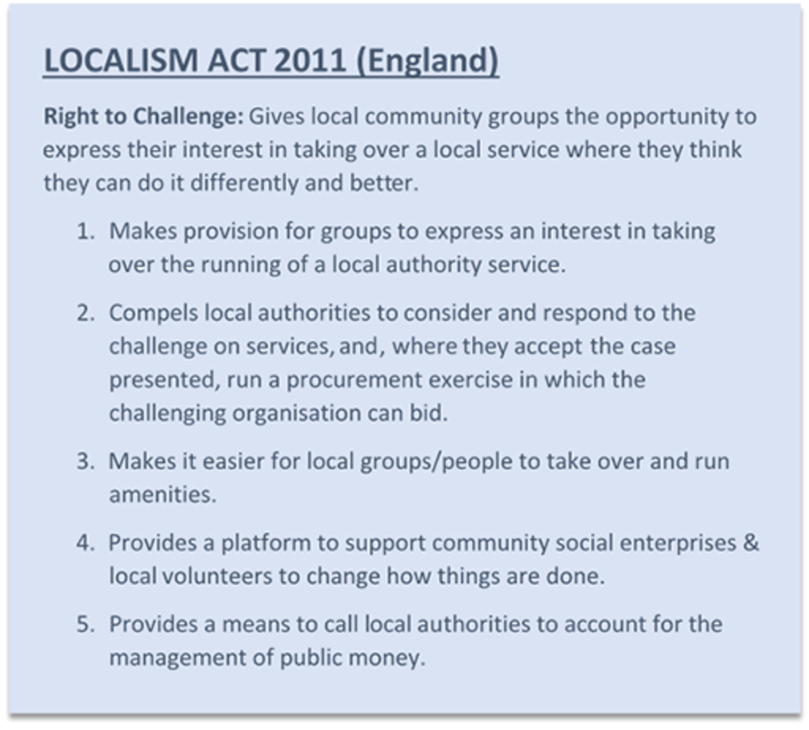
Source: (Development Trusts NI, no date.)
Figure 3 Localism Act 2011 (England)
View description - Figure 3 Localism Act 2011 (England)

1.2 Key elements of community empowerment
So what does Community Empowerment look like in practice?
In contrasting various approaches to community empowerment, Rolfe (2014) argues that any attempt at practical implementation must find a balance between power and responsibility:

On the one hand, many communities have a keen interest in gaining more power over their own destiny (not always for nimby-ish reasons), while on the other hand, there are concerns that governments want to shift responsibilities onto communities as they hollow out public services in a context of austerity.

One way of overcoming this is suggested by Miller et al. (2018) who argue for the use of assets-based approaches which ‘value the resources that exist in the community and build on the strengths and affordances of communities’. They further argue that ‘a strong assets-based approach that emphasises and values the experience of community members is an effective way to empower communities to make positive change’.
Perhaps not surprisingly, therefore, community empowerment has come to be regarded as consisting of three key ingredients:
- Active citizens: people with the motivation, skills and confidence to speak up for their communities and say what improvements are needed.
- Strengthened communities: community groups with the capability and resources to bring people together to work out shared solutions.
- Partnership with public bodies: public bodies willing and able to work as partners with local people. (Department of Communities and Local Government, no date.)
In the following section develops this further by looking at four key elements of community empowerment:
- Third sector involvement
- Active citizenship
- Engaging community stakeholders
- Participatory budgeting

2 Third Sector involvement

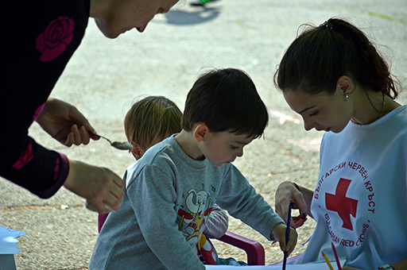
Figure 4 Supporting communities
View description - Figure 4 Supporting communities

On a very simple level, society can be seen to be made up of three main sectors: public, private and voluntary. While this breakdown might seem simplistic, it can help provide an initial starting point when thinking about the role that each plays.
- The term ‘public sector’ typically refers to organisations linked to the government and state that provide many of the core public services needed by society. These include such basic public services such as health, education, roads, and policing, and which are funded through general taxation.
- The ‘private sector’ refers to businesses, companies and other commercial organisations which provide goods and services in the economy and aim to make a profit.
- The ‘voluntary sector’ or third sector is neither government controlled nor is it focused on profit. Rather, it occupies a space between the public and private sectors and seeks to meet the unmet needs of society. These needs might be unmet because of a lack of potential profit (so discouraging interest from the private sector) or perhaps because the public sector has not had the resources to address them or has otherwise neglected to address them.
The UK Government has defined third sector as: ‘non-governmental organisations that are value driven and which principally reinvest their surpluses to further social, environmental or cultural objectives. It includes voluntary and community organisations, charities, social enterprises, cooperatives and mutuals. We also include housing associations within the third sector.’ (Department of Communities and Local Government, no date.)
Broadly speaking, organisations classed as being part of the third sector might include:
- charities
- community organisations including sporting bodies
- non-governmental bodies
- non-profit and not-for-profit organisations
- voluntary action groups
- churches and religious groups.
While the above definitions might seem to suggest a clear distinction between the public, private and third/voluntary sectors, the reality is – and always has been – quite different. In practice this can mean that organisations within each sector often operate beyond what might be regarded as their own sector’s boundaries.
Just as importantly, the development of effective solutions to community issues to requires collaboration between each of these sectors. No one sector or organisation can do it by themselves – rather resources, expertise and perspectives must be shared for the best result to be achieved for all community stakeholders.

2.1 Examples of the Third Sector in practice
Historical examples might include medieval monasteries providing healthcare and support for those in need (Thane, 2011) or the work of the various Joseph Rowntree Trusts in the provision of housing, education and other supports in the 19th and 20th centuries.
Similarly, in more modern times it is not uncommon for private sector organisations to provide services such as waste collection that were once provided by local authorities or for third-sector organisations to provide social housing or care for children with disabilities.
From a community empowerment perspective it is crucial to note that while most discussions of engagement with the third-sector relate to larger third-sector organisations which have a national or even international profile, the reality is that most are quite small. The UK Civil Society Almanac 2019 (NCVO, 2019) indicates that of the almost 167,000 charities in the UK, 47% of charities have an annual income of less than £10,000. By contrast, less than half a percent (or 708 organisations) have annual income of over £10 million. Interestingly, this same research (NCVO, 2019) has shown that on average the largest source of funding for third-sector organisations is donations and support from the public.
What this clearly indicates is the importance of stakeholder engagement and active citizenship, most particularly by enhancing volunteering and the level of community empowerment overall.

2.2 Barriers and incentives to community empowerment
While the above discussion might make community empowerment seem like an overwhelmingly positive and, indeed, necessary phenomenon thing, there are nonetheless challenges and barriers.
Research by Berry and associates (2014) with public health practitioners found a number of key issues with the concept of empowerment in practice. These include the following:
- ‘Empowerment is really easy to say but really difficult to do’ (Berry et al., 2014, p. 38).
- ‘Empowerment’ has become a buzzword and has lost its meaning over time, with some people seeing it as just jargon and others finding it quite alienating.
- It can be difficult to measure the outcomes of ‘empowerment’ initiatives so a strong evidence base can sometimes be hard to establish.
- ‘Empowerment’ is a long-term process and most project evaluations are based on short- or medium-term outcomes, making applying for funding difficult.
- ‘Empowerment’ is a difficult concept to translate into different languages and cultures, because ideas about what leads to empowerment, or what an empowered individual or community is, are informed by norms and values.
- It may be difficult to empower individuals and communities in cases where people have no hope that changes for the better can be made.
So what factors can help or, alternatively, hinder community empowerment? The 2008 Communities in Control White Paper from the UK’s then Department for Communities and Local Government outlined the following barriers and incentives:

Table 1 Barriers and incentives for community empowerment
Barriers | Incentives
Things that stop people wanting to take part include:  - Lack of interest or understanding about local governance  - Negative perceptions and lack of trust in public institutions  - Lack of awareness of how to get involved and inaccessible recruitment practices  - Lack of time to participate  - Lack of confidence and perceived lack of skills  - Stereotyping of those who participate  - Scepticism about the difference participation will make  - Earlier experience of poorly executed participation  - Financial costs of participation  - Fear of repercussions  - Structural disincentives and cultural resistance  - Socio-economic status | On the other hand, factors that make people want to take part include:  - A desire to serve the community, change things and/or make a difference  - Personal invitation to become involved  - Practical or rational reasons (for instance, personal benefit)  - Positive experiences of participation  - The existence of activist cultures and social capital  - Local leadership and/or institutional culture  - Socio-economic status, confidence and skills

Another key incentive to engagement with community empowerment is a clear focus on the benefits. In developing their approach to community empowerment the Scottish Government has drawn upon research which highlights that when communities feel empowered, there is:
- greater participation in local democracy
- increased confidence and skills among local people
- more people volunteering in their communities
- greater satisfaction with quality of life in the neighbourhood.
Consequently, better community engagement and participation lead to the delivery of better, more responsive services and better outcomes for communities.

Social loafing and learned helplessness
A particular challenge in community empowerment relates to social loafing. Social loafing can be understood as: ‘The general tendency for people to expend less effort on a task when working as part of a group than when working individually.’ (Law, 2016) In practical terms this relates to individual members of a group or community not making a full contribution on the basis that they expect that someone else will inevitably step in to fill the gap. In terms of community empowerment this might mean citizens not getting involved in community projects because they are confident that someone else will – even if that is not always the case.
The potential risk is that ultimately community empowerment suffers due to a sense of general apathy – those who are actively engaged and involved might give up because it seems as though others in the community simply do not care, while those who are not involved might just not bother.
At its most extreme, this can be exacerbated by what has been termed ‘learned helplessness’ – ‘A condition in which someone has learned to behave helplessly and feels powerless to alter her/his situation or condition, even if the opportunity presents itself’ (Harris and White, 2018).

3 Active citizenship and stakeholder engagement
So how might communities take proactive steps to enhance empowerment? In the following section we look at a number of approaches.
While it might seem like a modern and fashionable phenomenon, the notion of active citizenship is far from new. As Blunkett (2003) asserts:

The ethos of active citizenship is derived from the Athenian tradition which unites the values of democratic self-determination with mutuality and solidarity. This means that those who can look after themselves and contribute to the well-being of the wider community will endeavour to do so, while those who cannot will equally be respected and supported by others. This requires a sense of common purpose. As we live in a society with a diversity of cultures, what we need both to bind us together and to enable us to respect our differences, are common beliefs in the democratic practices of citizenship itself, and the rights and duties that go with it. (2003, p.8)

These common beliefs are crucially supported by ‘a set of fundamental values that includes respect for the rule of law, democracy, justice, tolerance and open mindedness, and regard for the rights and freedoms of others’ (Darmanin, 2012, p.7).
Just as important is active engagement with and by community stakeholders. McGee (2003) distinguishes four types of participation, starting with the most basic elements of information sharing and then ultimately progressing through to initiation and control by stakeholders.
- Information sharing
  - the state puts budget and public policy information into the public domain
- Consultation
  - the state sets up mechanisms such as forums, councils, and referendums or surveys to gather information on citizen preferences
- Joint decision making
  - citizens not only provide information on their needs and preferences but are active in real decision making
- Initiation and control by stakeholders
  - citizens have direct control over the full process of developing, raising funds for, and implementing projects or policy, as in social fund and community-driven development projects
As Fölscher (2007, p.247) points out, ‘As participatory practices move up this ladder, the argument goes, they become more effective instruments of participation: direct initiation and control by stakeholders is more powerful than joint decision making, which in turn is more effective than consultation and information sharing.’

Activity 2 Stakeholder engagement in your community
Allow approximately 5 minutes

What forms of stakeholder engagement have you have seen in your community?
Based on this, what in your opinion distinguishes kinds of stakeholder engagement which have been effective from those which were less effective?

View discussion - Activity 2 Stakeholder engagement in your community

Figure 5 Partnership working
View description - Figure 5 Partnership working

3.1 Volunteering
A key aspect of active citizenship is volunteering and involvement with charities and other third-sector organisations. Volunteering in this regard can be defined as ‘the commitment of time and energy, for the benefit of society and the community, the environment, or individuals outside (or in addition to) one's immediate family. It is unpaid and undertaken freely and by choice’ (Department for Communities, 2019).
Data from the Northern Ireland Department for Communities and Northern Ireland Statistics and Research Agency highlight that volunteering remains relatively high in Northern Ireland. Key headline figures from 2018/2019 indicate that:
- The proportion of the adult population volunteering remained consistent at 27% in 2018/19 compared to 2017/18.
- Of those who had volunteered in the previous year, 37% had carried out fundraising, 31% had helped in a church or religious organisation and 28% had worked with young people.
- The most commonly cited benefits as a result of volunteering were ‘makes me feel better about myself’ (68%), ‘helps me make a positive contribution to society’ (59%), ‘I made new friends’ (55%) and ‘I had fun’ (51%).
Ultimately, therefore, active participation is beneficial not just for the recipients of the support but also for those volunteering their time and energy.

4 Participatory budgeting
Originating in Brazil, participatory budgeting is a form of community stakeholder engagement relating specifically to the management of public finances. Defined by Wampler (2007, p. 21) as ‘a decision-making process through which citizens deliberate and negotiate over the distribution of public resources’, participatory budgeting processes are unique to the extent that they engage non-elected members of society in financial processes for the benefit of all members of society.
Wampler (2007, pp. 21-22) argues that participatory budgeting is effective, and consequently important, as it addresses the needs in a positive way of both the governments and the citizens in those areas where it has been practiced. Participatory budgeting can consequently play a role in enhancing not just the performance of state institutions but also and the quality of democracy and democratic involvement. In particular, participatory budgeting

helps improve state performance through a series of institutional rules that constrain and check the prerogatives of the municipal government while creating increased opportunities for citizens to engage in public policy debates. It helps enhance the quality of democracy by encouraging the direct participation of citizens in open and public debates, which helps increase their knowledge of public affairs. (Wampler, 2007, pp. 21-22)

What forms does participatory budgeting take?
Since its emergence, various studies have examined the forms that participatory budgeting can take in practice. A study by the Public Policy Institute for Wales (Williams et al., 2017) summarised the key forms of dimensions of participatory budgeting as follows:

Table 2 Forms of participatory budgeting
Level of participation | What involvement means in terms of degree of control (e.g. inputting views versus making the decisions) and whether PB is used as a tool for empowering participants or as a consultation mechanism with little change in power dynamics and influence.
Who is involved | Whether those who participate are, for example, citizens, representative groups, NGOs, or private companies.
At what stage are participants involved | Broadly, there are four stages, all of which could involve participants:  - identifying needs  - developing project proposals  - selecting projects to be funded  - monitoring effects.
Method of involvement | The two broad categories involve:  - ‘deliberative’ approaches, which involves some form of debate among participants; or  - ‘aggregative’ approaches, where participants vote for their preferred outcome.  - Often PB can involve both deliberative and aggregative approaches.
Scale | PB has been implemented at different spatial scales (e.g. national, local, neighborhood); with different types and levels of budget (e.g. small scale grant allocation, or setting priorities for, in some cases multi-million pound, mainstream budgets) and with different foci (e.g. making choices within a policy or thematic area, such as health, or across themes but within a geographical area).
Whether and to what extent PB is redistributive | - PB has been used to redistribute wealth by allocating more resources to the poorest areas.
(Adapted from Williams et al., 2017, pp. 5-6)

Examples of participatory budgeting
PB in Scotland
PB in Scotland has been increasing over the last few years and is viewed by the Scottish Government as a way of increasing citizen engagement in decision making. This ambition was developed into policy through the Community Empowerment Act 2015, which aimed (amongst other things) to strengthen citizens’ voices in the decisions and services that matter most to them. To deliver this, the Scottish Government created the Community Choices fund (£1.5 million) dedicated to funding and supporting PB. This national budget is delivered locally and has a redistributive element with the funding targeted particularly in deprived areas. There has also been a broader commitment to mainstreaming PB practice as by 2021 1% of all local government budgets will be allocated in this way. In October 2018, a PB festival was held to raise awareness and strengthen the implementation of PB processes locally.

Figure 6 PB Festival
View description - Figure 6 PB Festival

(Grounds and Murtagh, 2018, p. 9)

Example of participatory budgeting
PB in Northern Ireland
The implementation of PB processes across NI has been modest; however, the ‘The Big Dish Out’ represents a local example that was delivered by the ‘Waste No Time Team’ with support from the Causeway Coast and Glens local council. After a lengthy engagement period which helped to promote and secure support for the process, two PB events took place with participation from Cross Glebe Community Association and a number of local groups in the Cushendall area. The agreed bid pot of £6,000 attracted bids from 32 different projects, which was eventually split 10 ways to support local projects with various objectives that included tackling isolation, improving community safety and promoting inter-generational activity. Although each project only received £300, the Big Dish Out provided local people with a greater sense of ownership as they were able to decide what issues were important to them and as a result resources were allocated with full community backing.

Figure 7 The Big Dish Out
View description - Figure 7 The Big Dish Out

(Grounds and Murtagh, 2018, p. 9)

4.1 Participatory budgeting in action
In the following two clips, Angela McCann of Lisburn & Castlereagh City Council in Northern Ireland provides an overview of a participatory budgeting project in action.
In the first clip, Angela discusses what participatory budgeting means in practice and how, in a very practical sense, it can contribute to community empowerment.
In the second clip, Angela highlights some of the longer-term benefits and implications for communities of implementing participatory budgeting in practice.

Activity 3 Participatory budgeting
Allow approximately 20 minutes

Take a moment to reflect on how participatory budgeting might work in practice in your context. Are there any key steps you could take to tailor aspects of participatory budgeting to the needs of your community?

Video content is not available in this format.
Video 1 Angela McCann
View transcript - Video 1 Angela McCann

Video content is not available in this format.
Video 2 Angela McCann
View transcript - Video 2 Angela McCann

View discussion - Activity 3 Participatory budgeting

5 Empowering communities to deal more effectively with crime and criminality
A key challenge facing many communities across the world is that of how to deal more effectively with crime and criminality. Involvement in crime and what might be termed criminal persuasion can occur at any time of life, though children and young people are more vulnerable.
- In order to minimise the risk of criminality, the involvement of parents and communities is vital.

Role of parents
Parents are usually the most important people in their children’s lives. Their views and behaviours can have a good or bad influence on their children’s behaviour including offending behaviour. Children are much less likely to get into trouble if their parents:
- have a good relationship with them and can talk openly with them
- can agree sensible clear rules and encourage them to stick to them as much as possible
- know where they are and what they are up to.

School and community
Children are also less likely to get into trouble if their parents have an interest in their school life and they have good relationships with their teachers. This all helps to encourage children to go to school as often as possible.
Children are less likely to offend if their parents can help them to become involved in activities or interests in their local community. This can include youth clubs, sports clubs, uniformed groups and church groups. (NIDirect, no date)

Moving beyond the more commonplace types of crime and criminality, the terms radicalisation; extremism; grooming and recruitment are often heard in the media and popular discourse. These all play a significant risk for people of all ages, but most particularly young people.

What are the risk factors and protective factors for radicalisation?
In recent years a significant amount of work has been undertaken to understand the causes of radicalisation in various contexts. While there is no one single reason or cause, Bhui et al. (2012) summarise the key risk factors and protective factors for radicalisation as follows:

Table 3 Key risk factors and protective factors for radicalisation
Factor | Description
Risk factors | Young people facing transitions: education, place, family, religion and so on
 | Cognitive and social openings to new influences
 | Social isolation and exclusion
 | Grievances about discrimination that may be personal, related to unfair treatment at work, access to health care or about other inequalities in society
 | Unemployment
 | Migrant status and experiences before and after immigration
 | International conflict that is considered unjust against a group with which individual identifies on religious, national or cultural grounds
 | Perceived threat to family and cultural group
 | Marginalized and traditional cultural identities
 | Discrimination thought to explain group inequalities in health and social status and access to wealth
 | Not able to negotiate needs and protest through non-violent and democratic means
 | Contact with influential or charismatic leaders who justify terrorism (for example, in prisons, or in schools or universities)
Protective factors | Social support
 | Social cohesion
 | Social capital and trust in institutions
 | Feeling of safety and security in neighborhood
 | Integrated cultural identity
 | Employment success
 | Access to democratic means for negotiating needs and opinions
 | Access to critical religious leadership that can moderate and inform on legitimate religious perspectives

5.1 The role of government and communities
A 2008 report by the UK Department for Communities and Local Government (2008) emphasised the role that Government at any level can play in supporting communities to more effectively address the challenges posed by radicalisation and extremism. Underpinning this perspective is the recognition that government action alone is not enough, and instead must be supported by active community engagement. This is a view supported by pan-European networks set up to address the challenge posed by radicalisation and extremism, including the Radicalisation Action Network (RAN).
Extensive research by RAN (Russell, 2018) has emphasised the importance of local engagement and actions by communities in addressing the longer-term impacts of radicalisation. This applies both when working proactively to prevent future radicalisation but also to reduce existing levels of radicalisation:

Although governments and public authorities must do all they can, the prevention of extremism and radicalisation is most effectively addressed by communities. Extremism is able to thrive when communities themselves do not challenge those who seek to radicalise others. In some communities, particularly minority communities, there is a profound lack trust and confidence in the government, police and public authorities. This can make it harder for them to achieve success. It is therefore important to invest in community engagement and community empowerment. Community engagement should be in place routinely and not just implemented after a problem arises.
(Radicalisation Action Network, no date.)

Beyond the trust and engagement that are implicit in local communities, there is also arecognition that a clear understanding of ‘local dynamics and the hyperlocal nuances of a specific area’ (Smit and Meines, 2019, p. 3) are key aspects of any effect strategy for successfully grappling with radicalisation and extremism. Ultimately, it is crucial to recognise that:

Extremist groups exploit hyperlocal vulnerabilities and events to reinforce their narrative and strengthen their appeal. Since the local context plays a crucial role in the process of radicalisation, the local context forms the basis of any potential solution or counter/preventive strategy.
(Smit and Meines, 2019, p. 3)

Activity 4 Radicalisation and extremisim
Allow approximately 20 minutes

In the following clip Robert Örell, an expert in radicalisation and extremism, discusses some of the key challenges facing communities.

Video content is not available in this format.
Video 3 Robert Örell
View transcript - Video 3 Robert Örell

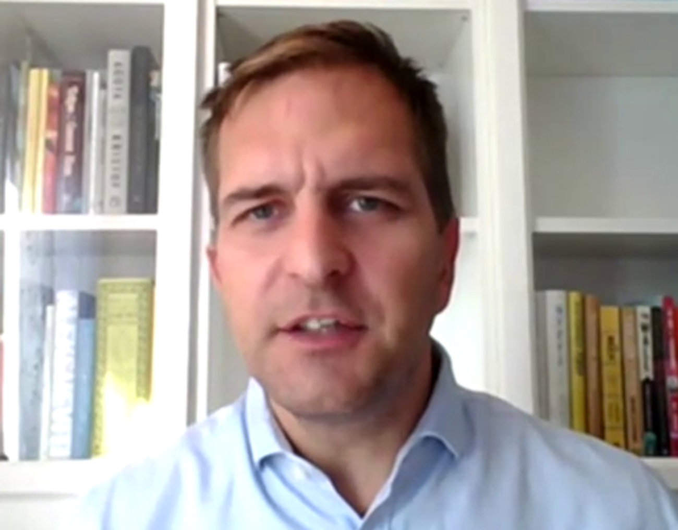

View discussion - Activity 4 Radicalisation and extremisim

6 Conclusion
This course has considered the concept of community empowerment and the way that its principles can be applied to help and support the development of communities.
We have argued that for communities to be successful, not only must they be empowered but stakeholders from all sectors must collaborate effectively. Social loafing and waiting for others to take the lead are not effective strategies in any context, most particularly not in a community setting.
By considering the barriers to community empowerment and some of the risks which can arise if communities are not effectively empowered we have sought to highlight its importance and relevance to communities of all types.

References
Berry, N. S., Murphy, J. and Coser, L. (2014) ‘Empowerment in the field of health promotion: recognizing challenges in working towards equity’, Global Health Promotion, 21(4), pp. 35–43.
Bhui, K. S., Hicks, M. H., Lashley, M. (2012) ‘A public health approach to understanding and preventing violent radicalization’, BMC Med, 10(16). https://doi.org/10.1186/1741-7015-10-16
Darmanin, A. M. (2012) Get up and get active! Active Citizenship: For a better European Society. Available at: https://www.eesc.europa.eu/resources/docs/eesc-2011-35-en.pdf (Accessed: 30 April 2020).
Department for Communities (2019) Experience of volunteering by adults in Northern Ireland 2018/19 Available at: https://www.communities-ni.gov.uk/publications/experience-volunteering-by-adults-northern-ireland-201819 (Accessed: 30 April 2020).
Department for Communities and Local Government (no date) What is community empowerment. Available at: https://webarchive.nationalarchives.gov.uk/20081106035352/http://www.communities.gov.uk/communities/communityempowerment/aboutcommunityempowerment/whatiscommunity/. (Accessed: 30 April 2020).
Department for Communities and Local Government (2003). Active Citizens, Strong Communities – Progressing Civil Renewal. Available at: https://webarchive.nationalarchives.gov.uk/20081014193920/http://www.communities.gov.uk/documents/communities/pdf/151825.pdf. (Accessed: 30 April 2020).
Department for Communities and Local Government (2008) Communities in Control Whitepaper – Impact Assessments. Available at: https://www.legislation.gov.uk/ukia/2008/173/pdfs/ukia_20080173_en.pdf. (Accessed: 30 April, 2020).
Department for Communities and Local Government (2008) Preventing Violent Extremism: Next Steps For Communities. Available at: https://webarchive.nationalarchives.gov.uk/20081106144406/http://www.communities.gov.uk/documents/communities/pdf/896799.pdf. (Accessed: 30 April 2020).
Development Trusts NI. (no date.). Time for Change - Time for an NI Community Rights Act. Available at: https://www.dtni.org.uk/op-ed/time-change-time-ni-community-rights-act (Accessed: 30 April 2020).
Ersing, R. (2003) ‘Community Empowerment’, in Christensen, K and. Levinson, D. Encyclopedia of Community: From the Village to the Virtual World. pp. 262-264.
Fölscher, A. (2007) ‘Appendix A: A Primer on Effective Participation’, in A, Shah. (ed.) Participatory Budgeting. Available at: http://documents.worldbank.org/curated/en/708251468338965560/Participatory-budgeting. pp. 243-256.
Grounds, A. and Murtagh, B. (2018) ‘Final Evaluation Impact Report for the PB Works project in Northern Ireland: November’. Available at: http://www.participatorybudgetingworks.org/uploads/files/lists/pb-works-evaluation-and-impact-report-20181211115542.pdf (Accessed: 30 April 2020).
Harris, J. and White, V. (2018) Learned Helplessness. Dictionary of Social Work and Social Care ,(2nd edition) Oxford, Oxford University Press. Available at: https://www-oxfordreference-com.libezproxy.open.ac.uk/view/10.1093/acref/9780198796688.001.0001/acref-9780198796688-e-945?rskey=lOGam1&result=3 (Accessed: 30 April 2020).
Law, J. (ed). (2016) Social Loafing. A Dictionary of Business and Management (6th edition.), Oxford, Oxford University Press. Available at: https://www-oxfordreference-com.libezproxy.open.ac.uk/view/10.1093/acref/9780199684984.001.0001/acref-9780199684984-e-5955?rskey=vdj5UP&result=3 (Accessed: 30 April 2020).
McGee, R. (2003) ‘Legal Frameworks for Citizen Participation: A Synthesis Report, Institute for Development Studies, University of Sussex, Brighton, United Kingdom.
Miller, K., McIntyre, R. and McKenna, G. ‘Assets based community participation and place making’, Journal of Finnish Universities of Applied Sciences. Available at: https://uasjournal.fi/tag/community-empowerment/#1458134585005-b3f22396-5506 (Accessed: 30 April 2020).
NCVO (2019), UK Civil Society Almanac 2019. Available at: https://data.ncvo.org.uk/profile/#income-sources (Accessed: 30 April 2020).
NIDirect (no date.). Preventing involvement in crime. Available at: https://www.nidirect.gov.uk/articles/preventing-involvement-crime (Accessed: 30 April 2020).
Radicalisation Action Network (no date.) Community engagement and empowerment, Available at: https://ec.europa.eu/home-affairs/sites/homeaffairs/files/what-we-do/networks/radicalisation_awareness_network/ran-best-practices/docs/community_engagement_and_empowerment.pdf (Accessed: 30 April 2020).
Rolfe, S. (2014). ‘You take the high road, I’ll take the low road, and we’ll see who’s more democratic when we get to the other end…’, OpenLearn. Available at: https://www.open.edu/openlearn/people-politics-law/politics-policy-people/participation-now/resources/you-take-the-high-road-ill-take-the-low-road-and-well-see-whos-more-democratic-when-we-get-the-other. (Accessed: 30 April, 2020).
Russell, J. (2018) ‘Developing counter- and alternative narratives together with local communities’. RAN Centre of Excellence, Available at: https://ec.europa.eu/home-affairs/sites/homeaffairs/files/what-we-do/networks/radicalisation_awareness_network/about-ran/ran-c-and-n/docs/developing_counter_and_alternative_narratives_together_with_local_communities_en.pdf. (Accessed: 30 April 2020).
Smit, Q. and Meines, M. (2019) RAN Policy & Practice Workshop – Narratives and Strategies of Far-Right and Islamist Extremists: 4th July. Available at: https://ec.europa.eu/home-affairs/sites/homeaffairs/files/what-we-do/networks/radicalisation_awareness_network/ran-papers/docs/ran_pp_workshop_narratives_strategies_of_far-right_and_islamist_extremists_amsterdam_20190704_en.pdf (Accessed: 30 April 2020).
Thane, P. (2011) ‘There has always been a “big society”’, History Workshop Online, 30 April’. Available at www.historyworkshop.org.uk/there-has-always-been-a-big-society/ (Accessed: 30 April 2020).
Wampler, B. (2007) ‘A guide to participatory budgeting’, in A. Shah. (ed.) Participatory Budgeting. Available at: http://documents.worldbank.org/curated/en/708251468338965560/Participatory-budgeting (Accessed: 30 April, 2020).p.
Williams, E., St. Denny, E. and Bristow, D. (2017) ‘Participatory Budgeting: An Evidence Review’, Public Policy Institute for Wales. Available at: http://ppiw.org.uk/files/2017/08/PPIW-report_participatory-budgeting-evidence-review_-July-2017-FINAL.pdf. (Accessed: 30 April 2020).
World Health Organisation (2020) Track 1: Community empowerment. Available at: https://www.who.int/healthpromotion/conferences/7gchp/track1/en/ (Accessed: 30 April 2020).

Acknowledgements
This free course was written by Laurie Knell. It was first published in February 2021.
Except for third party materials and otherwise stated in the acknowledgements section, this content is made available under a Creative Commons Attribution-NonCommercial-ShareAlike 4.0 Licence.
The material acknowledged below is Proprietary and used under licence (not subject to Creative Commons Licence). Grateful acknowledgement is made to the following sources for permission to reproduce material in this unit:
Images
Course image: https://wordart.com
Figure 1: Pixabay https://pixabay.com/photos/team-friendship-group-hands-4529717/
Figure 2: Community Empowerment Act (Scotland) https://www.dtni.org.uk/op-ed/time-change-time-ni-community-rights-act
Figure 3: Localism Act 2011 England https://www.dtni.org.uk/op-ed/time-change-time-ni-community-rights-act
Figure 4: Pixabay https://pixabay.com/photos/child-boy-people-emotion-park-774063/
Figure 5: Pixabay https://pixabay.com/photos/agree-agreement-asian-black-1238964/
Figure 6: courtesy: Scottish Community Development Centre https://www.scdc.org.uk/
Figure 7: poster: ‘The Big Dish Out’ a local example that was delivered by the ‘Waste No Time Team’ with support from the Causeway Coast and Glens local council.
Audio-visual
Video 1 and 2: Angela McCann © The Open University (2020)
Video 3: Robert Örell © The Open University (2020)
Every effort has been made to contact copyright owners. If any have been inadvertently overlooked, the publishers will be pleased to make the necessary arrangements at the first opportunity.
Don't miss out:
If reading this text has inspired you to learn more, you may be interested in joining the millions of people who discover our free learning resources and qualifications by visiting The Open University – www.open.edu/ openlearn/ free-courses.

Solutions

Activity 1 The meaning of empowerment

Discussion
It might be tricky to know where to start with this and you might have a range of ideas. The key is to recognise that there are different approaches to empowerment and that different people will understand and engage with empowerment differently depending on the type of involvement they have with the community.
Back to - Activity 1 The meaning of empowerment

Activity 2 Stakeholder engagement in your community

Discussion
You may have seen or even experienced many, varied forms of stakeholder engagement in your community. Quite possibly some of these were very effective, but equally some may have been less effective. Common reasons can include a lack of broader stakeholder commitment, competing demands for time/attention or even a lack of sufficient funding.
Back to - Activity 2 Stakeholder engagement in your community

Activity 3 Participatory budgeting

Discussion
Having watched these two clips you may have noticed a number of key themes emerging. You may have also seen some differences between the theory and practice of participatory budgeting. The key thing to remember is that each community setting and context is different and needs will vary significantly. As a consequence, any participatory budgeting process will need to be specifically adapted to the needs of the local community.
Back to - Activity 3 Participatory budgeting

Activity 4 Radicalisation and extremisim

Discussion
In this clip Robert Örell highlights some of steps communities can take to overcome both radicalisation and extremism and the role of community empowerment in supporting this process. Key to this is early and active engagement with youth to understand them and their challenges, and an awareness of the role which communities can and should play in supporting those who live within them.
Back to - Activity 4 Radicalisation and extremisim

Figure 1 Working together

Description
The image shows hands from a group people of diverse backgrounds, all joined together in the middle, with people evidently standing in a circle.
Back to - Figure 1 Working together

Figure 2 Community Empowerment Act (2015) Scotland

Description
A screen grab of the Community Empowerment Act (2015) Scotland.
Back to - Figure 2 Community Empowerment Act (2015) Scotland

Figure 3 Localism Act 2011 (England)

Description
A screen grab of Localism Act 2011 (England).
Back to - Figure 3 Localism Act 2011 (England)

Figure 4 Supporting communities

Description
The picture shows two young children painting, with an adult standing to the left holding a spoon and some food, while a worker from the Bulgarian Red Cross is seated and is helping the children
Back to - Figure 4 Supporting communities

Figure 5 Partnership working

Description
The image shows two hands of people from diverse backgrounds clasped in a handshake.
Back to - Figure 5 Partnership working

Figure 6 PB Festival

Description
A poster advert for the PB Festival. The poster is dominated by sections of yellow panels and contains a circle and four triangles. ‘PB Festival’ is written in big letters centrally and to the left, and dates for the festival are written below that.
Back to - Figure 6 PB Festival

Figure 7 The Big Dish Out

Description
The image is an advertisement for The Big Dish Out – a community event in Northern Ireland involving ‘a fest of music, song, dance and pizza’. The aim of the event is to celebrate various community projects
Back to - Figure 7 The Big Dish Out

Video 1 Angela McCann

Transcript
ANGELA MCCANN
Hi, my name is Angela McCann, and I am the Lisburn policing and community safety partnership manager for Lisburn and Castlereagh City Council in Northern Ireland.
Participatory budgeting is and innovative and democratic process involving local communities deciding how to allocate public funding. In its simplest form, it is about empowering local people and communities to have a say in how money can be used to address local priorities. It's a relatively new concept in Northern Ireland and was used for the first time by Lisburn and Castlereagh PCSP in February 2020. We took it forward in partnership with the housing executive, Sport NI, The Health Trust, and critically the foresight of the local superintendent Davy Beck.
So PB comes in all shapes and sizes. But for Lisburn and Castlereagh, we decided to give it a title called Grand Choice. We had grants of up to 1,000 pounds to award, hence the name "grand." And because it was going to be the people’s choice, we put the title together and decided that our project-- our initiative would be called Grand Choice.
Regardless of the name, the three main attributes of participatory budgeting are one about ideas generation. So ideas are generated by the local community about how a budget should be spent. The second point is people vote for their priorities. And thirdly, the projects with the highest number of votes then are awarded the funding.
So how is this different to how we would normally conduct our business? So we would normally initiate a grants process where people would apply in a very abstract manner by filling out an application that would come before a panel who wouldn't necessarily be familiar with what goes on in local communities nor the intricacies that are involved around what the local priorities would be. So this process very much put the power back into the very heart of communities and give them the say in how that funding should be allocated.
So first I think it's important to explore what community empowerment actually is. For me, it's about communities leading change. It is about shifting the power and the decision-making from the centre and placing it, along with the responsibility, back into the heart of communities who actually know what will work and what their local priorities are.
Very often in community development, in community safety and policing, and we hear from the few. People can be reluctant to engage for all sorts of reasons, and I suppose not least in Northern Ireland due to the legacy of our troubled past. However, PB changes that. It focuses on engaging people who may not have traditionally applied for public funds in the past but have ideas about how they want to improve their local community.
In fact from the experience in Lisburn and Castlereagh, the majority of applicants who applied had never before engaged with either the PCSP or the council. And I believe that this is community empowerment in its truest sense.
The emphasis here is on effective planning and level of community involvement. If you don't get these two attributes right at the start, you're really not doing PB correctly. So alongside the police, we agree the geographical area to be covered by the Grand Choice project.
And this was the rural district electoral area of Killultagh, which lies on the edge of our district council area. It includes a few large settlements with a mainly rural hinterland. It is an area that has seen some geographical challenges, and changes, and ongoing challenges in respect of community cohesion. So it made it really the ideal testing ground for us to trial this project before considering rolling it out to the rest of the council area.
So we formed a steering group consisting of the relevant agencies that I had mentioned earlier and assigned a budget for the initiative. And the three themes that we wanted to address were policing and community safety, mental health and well-being, and engaging young people.
Are promotional material was designed. And we brought our proposal to all areas of the community to share our ideas to get community buy-in from a very early stage in the process. We delivered awareness-raising sessions and workshops right across the district electoral area. And we laid out the process to be followed.
This was also promoted on social media through local churches, papers, community groups, schools, and really any organisation that would listen. Because what we wanted to do was to get into the hearts and minds of the communities to get people involved that hadn't previously been involved with any of our projects. What the group had to do was to design a proposal which they wanted funding for and submit it to an assessment panel for consideration.
If the criteria was met, they then successfully made it through to attend a marketplace event which took place on the first Saturday in February where they had to exhibit their proposal to the people who were going to be in attendance and explain why they felt that their project should win. Everybody who attended over the age of 7 were entitled to a vote. So this made it an extremely inclusive process.
On the day of the marketplace, we had 24 exhibitions in the community hall in Maghaberry. We had over 1,000 people attend at the event from 11:00 AM to 3:00 PM, which was just a phenomenal turnout for the event, more than we could ever have anticipated. They were allowed to choose 10 projects, and this eliminated any bias in the system.
So obviously when the people came out to vote, there would have been some projects they would have been familiar with but the majority that they wouldn't. So they were encouraged to look openly and see which projects that they felt should achieve their vote.
There was an enormous positive vibe in the hall, and we also had crime prevention stands. And we had representatives from various areas of policing in attendance. We had emergency services, trying to make it a very inclusive and community engagement event but also a celebration of everything that was good in the local community.
The votes were counted, and those with the highest number received the funding. The feedback was really positive, and the community felt that they had actually influenced where the funding was to be allocated. I have to say, in my 20 years as a practitioner in this field, it was probably one of the most successful events that I have been involved in, and I got a very real sense of community empowerment and local decision-making.
Back to - Video 1 Angela McCann

Video 2 Angela McCann

Transcript
ANGELA MCCANN
When done well, PB can be really meaningful, celebrating the good work that is happening in communities, and really an opportunity for groups and services to attract community support. PB brings people together to start conversations leading to relationships that make our communities stronger, building skills and confidence to go on and become more engaged. But the more PB is co-produced with communities, the more effective it becomes.
For us as a PCSP and council, we have made real connections with communities and individuals, and we have fostered a connectedness across communities, perhaps even traditionally those who may not have come together and had it not have been for the Grand Choice Initiative.
OK, so from a personal perspective, participatory budgeting needs to be further developed with a real commitment to expanding it in Northern Ireland. And this means government agencies allocating part of their budget to it. For communities, it has the potential to be transformational in terms of community empowerment. And by this, I mean that PB has the ability to transform the relationships that exist between local communities and the public bodies who serve them. It can ensure that the diverse needs of communities are understood, and that local voices are heard in local decision making, which, at its least, could radically reduce inequalities.
The process isn't easy, however, so don't come under an illusion that actually, that this is a simple process, because it's not. And there's not a lot of ground work that needs to be put in place to make the PB correct. And there are also many obstacles that you will come across that have to be overcome. But if you bring the community with you, and agree, and give them a voice, you will succeed in effectively implementing PB for the well-being of our local people.
Back to - Video 2 Angela McCann

Video 3 Robert Örell

Transcript
ROBERT ORELL
My name is Robert Orell. I worked for about 18, 19 years in the field of exit work, helping people to leave violent extremist groups. I worked for NGOs in Sweden with the EU and in the US on the similar topical helping people to leave but also supporting families and concerned communities. How do we understand and respond to violent extremists?
So radicalisation is usually described as a process of radicalising people into ideas and behaviours that promote extremist ideology. Often, we talk about violent extremists, so people adopt violent extremist ideas where they understand how to change society with violent means.
From both research and practise, we know that there’s a lot of different factors that affect why people join or become radicalised. And there's really not one single factor for this but a range of different factors that, together, links people to become radicalised. Very often, we see the role of social relations, so meeting somebody who were involved in these groups or getting in touch with these type of ideas and that that's helpful for individuals to process and lead into these type of groups.
So potential risk factors is usually lived through personal experiences. So looking at individuals’ experiences of, perhaps, school failure, of difficulties with social relations, family issues, but also being, perhaps, victim of a crime or bully, or even trying to understand society, in a way, and not really being able to get the different pieces together.
This can be potential risk factors for radicalization. But they, once again, need to be combined with getting attention and knowledge about these ideas and usually meeting individuals who are active and involved already.
So we look at this, once again, from the individual perspective. And when we talk about protective factors, we need to look at who is this specific individual, and what situation and needs and risks is involved with that person? This can be, for example, having a strong connection with adults, with professionals in the schools, being able to communicate about needs or events that you've gone through with adults or with the support of their peers. This can definitely be protective factors.
We also see emotional intelligence, being able to put words on your emotions and your lived-through experiences as helpful to deescalate different type of strong emotions but also managing conflicts or strained relations in constructive ways. So how do we communicate with people that we think differently with? How do we manage conflict?
How do we manage stress? How do we manage different type of situations in life, where we, instead of going into a polarised and conflict mindset, try to understand people from their perspective, so this, in a sense, cognitive flexibility or complexity in understanding others.
Well, primarily the close cooperation. So if we leave young people at risk, without connection, without being close to them, trying to understand them, listening to their needs, the risk is that they will seek out others who will help them to fulfil these needs and give them answers to their questions.
So I think it's really about being close to the individuals at risk and the concerned communities, so building close relationships and partnerships with them. This is usually done when we spend time with each other. We invest time in each other. We listen to each other. We try to facilitate needs or work together.
There’s also a model for how to engage young people and influence over their own decisions and communities called the influence [INAUDIBLE] or the participation [INAUDIBLE] which is really that we can communicate in different ways. We can communicate with young people by giving them information, and then they know.
We can raise the bar, and we can have a consultation, and we can understand what they think. We can raise the bar yet more, and we can go into dialogue, and we can resonate and respond and understand more from each other. We can also go into collaboration and help them to implement different type of things.
But primarily, we should look at actually cocreating to decide, to let young people have the influence of actually deciding important things for themselves in their communities. And this will definitely reduce the risks of other groups telling them that they have no influence, they have no future, nobody cares about them, but quite the opposite. This model gives a very strong sense of empowerment, of being listened to and being able to themselves create a change in the communities they want.
I think, primarily, it's important to understand, so to have awareness of radicalization. What does it mean? What is radicalization, and what is not radicalization? Which groups are we talking about? How do they identify themselves? What type of material do they spread? A bit of what we discussed here, as well-- what type of a process leads young individuals to become radicalised?
So the awareness level is one part. But then it's also identifying and responding to specific needs of young people to create appropriate measures for care and concern for young people. This can be, as we touched upon earlier, it can be everything from mediation and deescalation to listening to young people to empower young people to find constructive and inclusive ways to create change instead of not listening or not responding.
Back to - Video 3 Robert Örell

