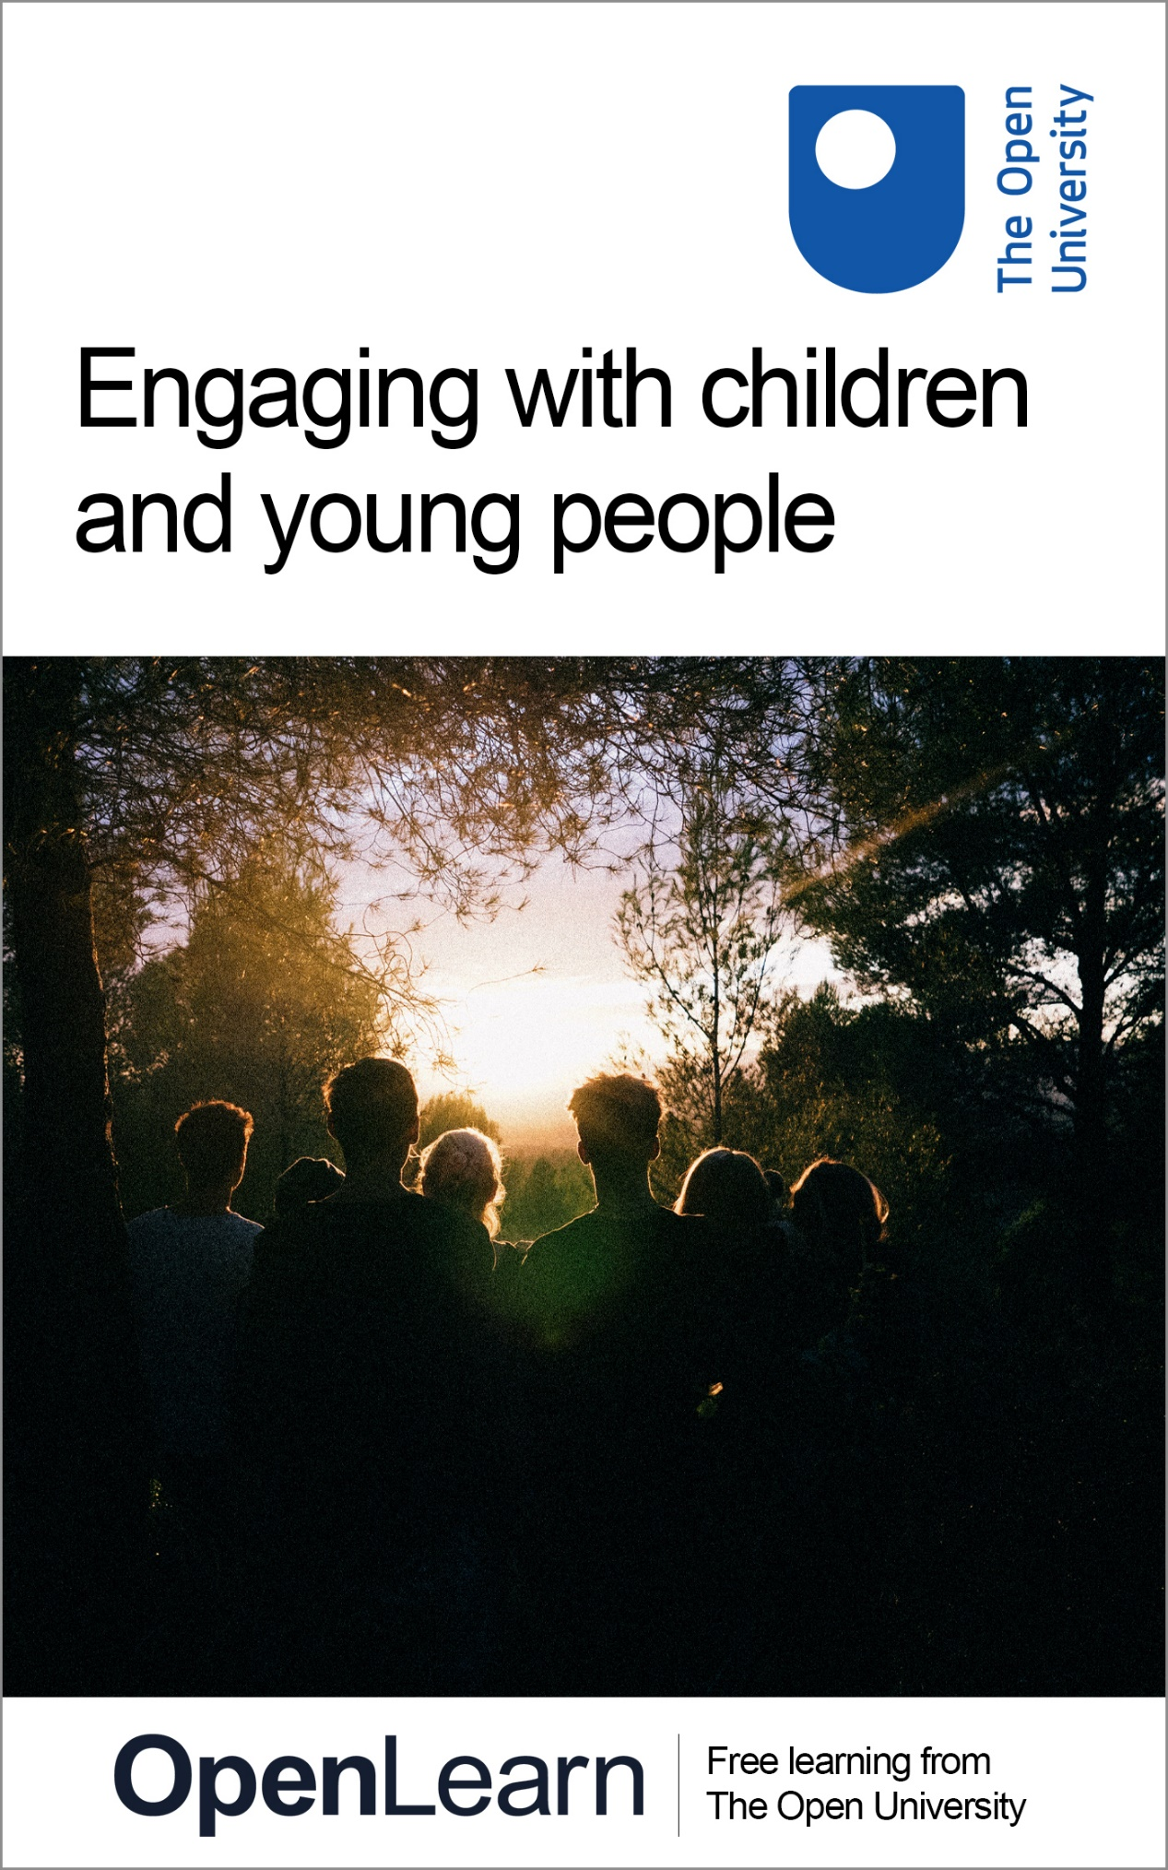

PWC_3 Engaging with children and young people

Engaging with children and young people

About this free course
This content was originally published as an open educational resource on the OpenLearn website http://www.open.edu/openlearn/.
This version of the content may include video, images and interactive content that may not be optimised for your device.
You can experience this free course as it was originally designed on OpenLearn, the home of free learning from The Open University – www.open.edu/openlearn/money-business/leadership-management/engaging-children-and-young-people/content-section-0?active-tab=description-tab
There you’ll also be able to track your progress via your activity record, which you can use to demonstrate your learning.
Copyright © 2021 The Open University
Intellectual property
Unless otherwise stated, this resource is released under the terms of the Creative Commons Licence v4.0 http://creativecommons.org/licenses/by-nc-sa/4.0/deed.en_GB. Within that The Open University interprets this licence in the following way: www.open.edu/openlearn/about-openlearn/frequently-asked-questions-on-openlearn. Copyright and rights falling outside the terms of the Creative Commons Licence are retained or controlled by The Open University. Please read the full text before using any of the content.
We believe the primary barrier to accessing high-quality educational experiences is cost, which is why we aim to publish as much free content as possible under an open licence. If it proves difficult to release content under our preferred Creative Commons licence (e.g. because we can’t afford or gain the clearances or find suitable alternatives), we will still release the materials for free under a personal end-user licence.
This is because the learning experience will always be the same high quality offering and that should always be seen as positive – even if at times the licensing is different to Creative Commons.
When using the content you must attribute us (The Open University) (the OU) and any identified author in accordance with the terms of the Creative Commons Licence.
The Acknowledgements section is used to list, amongst other things, third party (Proprietary), licensed content which is not subject to Creative Commons licensing. Proprietary content must be used (retained) intact and in context to the content at all times.
The Acknowledgements section is also used to bring to your attention any other Special Restrictions which may apply to the content. For example there may be times when the Creative Commons Non-Commercial Sharealike licence does not apply to any of the content even if owned by us (The Open University). In these instances, unless stated otherwise, the content may be used for personal and non-commercial use.
We have also identified as Proprietary other material included in the content which is not subject to Creative Commons Licence. These are OU logos, trading names and may extend to certain photographic and video images and sound recordings and any other material as may be brought to your attention.
Unauthorised use of any of the content may constitute a breach of the terms and conditions and/or intellectual property laws.
We reserve the right to alter, amend or bring to an end any terms and conditions provided here without notice.
All rights falling outside the terms of the Creative Commons licence are retained or controlled by The Open University.
Head of Intellectual Property, The Open University

Contents
- Introduction
- 1 What do we mean by ‘children’ and ‘young people’?
- 2 Understanding children and young people
  - 2.1 Talking on their own terms
  - 2.2 What happens when you listen to children?
- 3 Adverse childhood experiences
  - 3.1 What are ‘Adverse Childhood Experiences’?
  - 3.2 The importance of a supportive network
  - 3.3 Limitations of the ACEs model
- 4 ‘At risk’ or ‘a risk’?
  - 4.1 Adolescence as a stage of life
- 5 Steps to support children and young people
  - 5.1 Youth engagement
  - 5.2 Finding alternative pathways – influencing positive choices
- 6 Conclusion
- References
- Acknowledgements
- Solutions

Introduction
Perhaps more than any other engagement, the first encounter that a young person has with police can form their perception for years to come.
Chair of the All Party Parliamentary Group for Children 2013-2014, Baroness Massey of Darwen, is clear that:

Children’s first encounter with police officers can have a lasting effect on how they view the police and engage with them as adults. Many young people spoke passionately to the inquiry about the positive impact of developing close relationships with police officers – through community projects, in schools and with Volunteer Police Cadets – but we found that too frequently these initiatives were the result of the enthusiasm of a handful of staff, and practice was not widespread, leading to a ‘postcode lottery’ effect.
(All Party Parliamentary Group for Children, 2014, p. 2)

The key implication of this is that first impressions count. If children and young people are able to develop a neutral if not hopefully positive impression of the police, then it will support more positive outcomes and interactions in the long term.
In this course, we take a look at how police engage with children and young people, and how it might be done differently.
After studying this course, you should be able to:
- understand more effective ways of engaging with children and young people
- understand the impact of Adverse Childhood Experiences
- understand the difference between ‘at risk’ and ‘risky behaviours’
- evaluate potential steps that can be taken to better support children and young people.

1 What do we mean by ‘children’ and ‘young people’?
The National Police Chiefs’ Council’s National Strategy for the Policing of Children & Young People focuses on young people ranging from birth to the age of 24. In particular they break the population of children and young people down into three distinct groups:
- Those aged under 10
- Those aged between 10 and 17 years of age
- Those aged between 18 and 24 years of age

Activity 1 Defining ‘children and young people’
Allow 10 minutes

In this clip, Arlene Kee of the Education Authority of Northern Ireland discusses what is meant by the term ‘children and young people’ and why it is important for police and others providing social and community services to engage with children and young people.
As you watch the clip, reflect on the key points made and think whether you would define the term ‘children and young people’ in the way that Arlene Kee does.

Video content is not available in this format.
Video 1 Arlene Kee
View transcript - Video 1 Arlene Kee

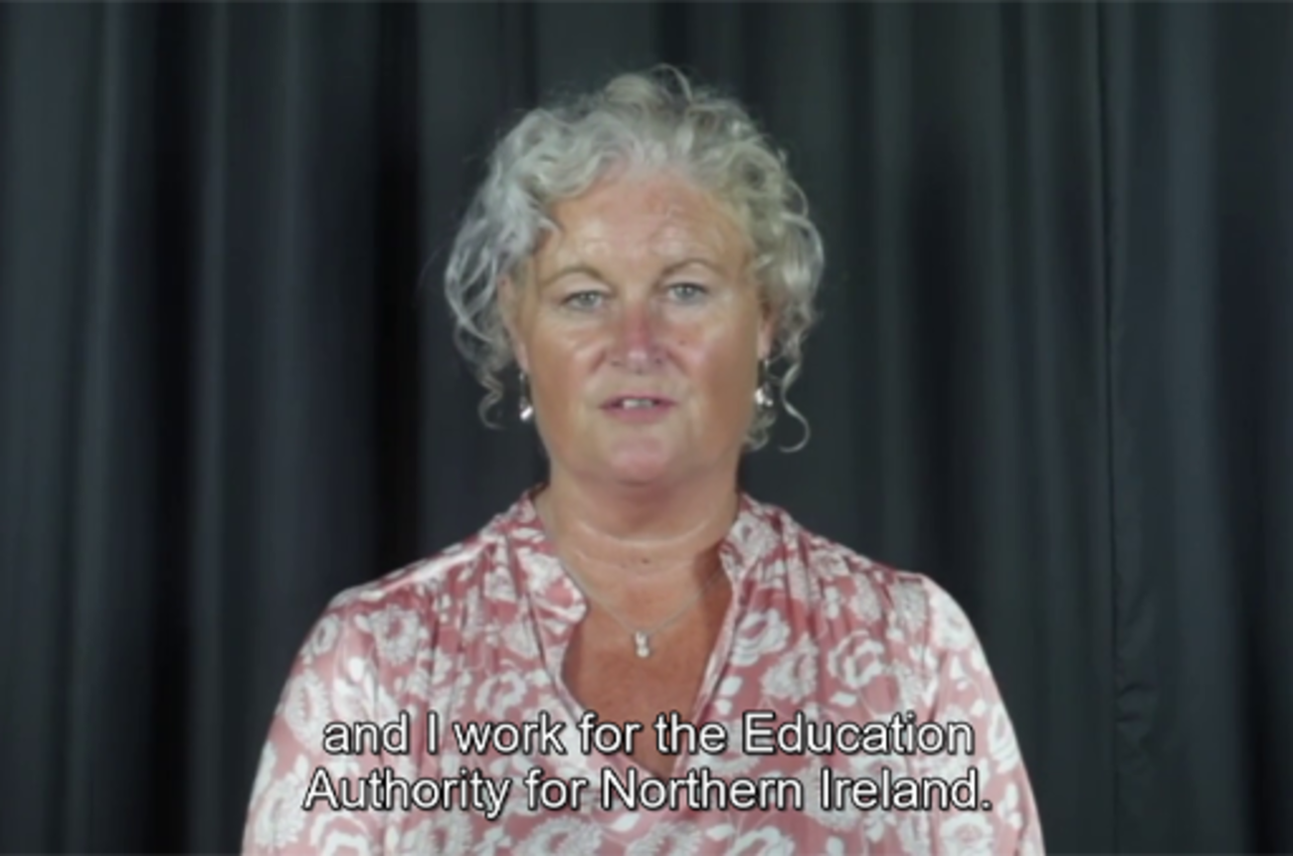

View discussion - Activity 1 Defining ‘children and young people’

This course focuses specifically on children and young people under the age of 17. This is for a number of reasons, not least because it aligns with general social and legal norms relating to adulthood and the age of majority. This also aligns with the United Nations Convention on the Rights of the Child (UNCRC), an internationally binding treaty to which 196 countries, including the United Kingdom, are party to. In particular, Article 1 of the United Nations’ Convention on the Rights of the Child states that:

For the purposes of the present Convention, a child means every human being below the age of eighteen years unless under the law applicable to the child, majority is attained earlier.
(OHCHR, 2020)

Box 1 What is the UN Convention on the Rights of the Child?
The Convention has 54 articles that cover all aspects of a child’s life and sets out the civil, political, economic, social and cultural rights that all children everywhere are entitled to. It also explains how adults and governments must work together to make sure all children can enjoy all their rights.
Every child has rights, whatever their ethnicity, gender, religion, language, abilities or any other status.
The Convention must be seen as a whole: all the rights are linked and no right is more important that another. The right to relax and play (Article 31) and the right to freedom of expression (Article 13) have equal importance as the right to be safe from violence (Article 19) and the right to education (Article 28).
…
The UNCRC is also the most widely ratified human rights treaty in the world – it’s even been accepted by non-state entities, such as the Sudan People’s Liberation Army (SPLA), a rebel movement in South Sudan. All UN member states except for the United States have ratified the Convention. The Convention came into force in the UK in 1992.
Summary of the UN Convention of the Rights of the Child.
UN Convention on the Rights of the Child, 1989

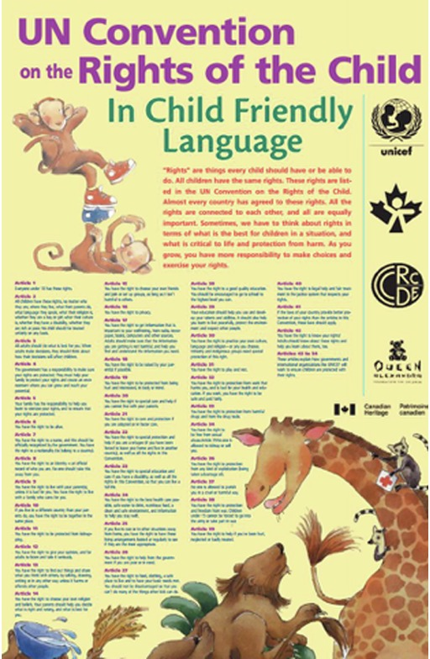
Figure 1 the United Nations Convention on the Rights of the Child: in Child Friendly Language
View description - Figure 1 the United Nations Convention on the Rights of the Child: in Child Friendly ...

Activity 2 Challenges engaging with children and young people
Allow 10 minutes

In this clip, Arlene Kee of the Education Authority of Northern Ireland continues her discussion of children and young people. In particular she focuses on some of the challenges engaging with children and young people and how police and others providing services can engage more effectively.
As you watch the clip, reflect on the key challenges engaging with children and young people highlighted by Arlene Kee.

Video content is not available in this format.
Video 2 Arlene Kee 2
View transcript - Video 2 Arlene Kee 2

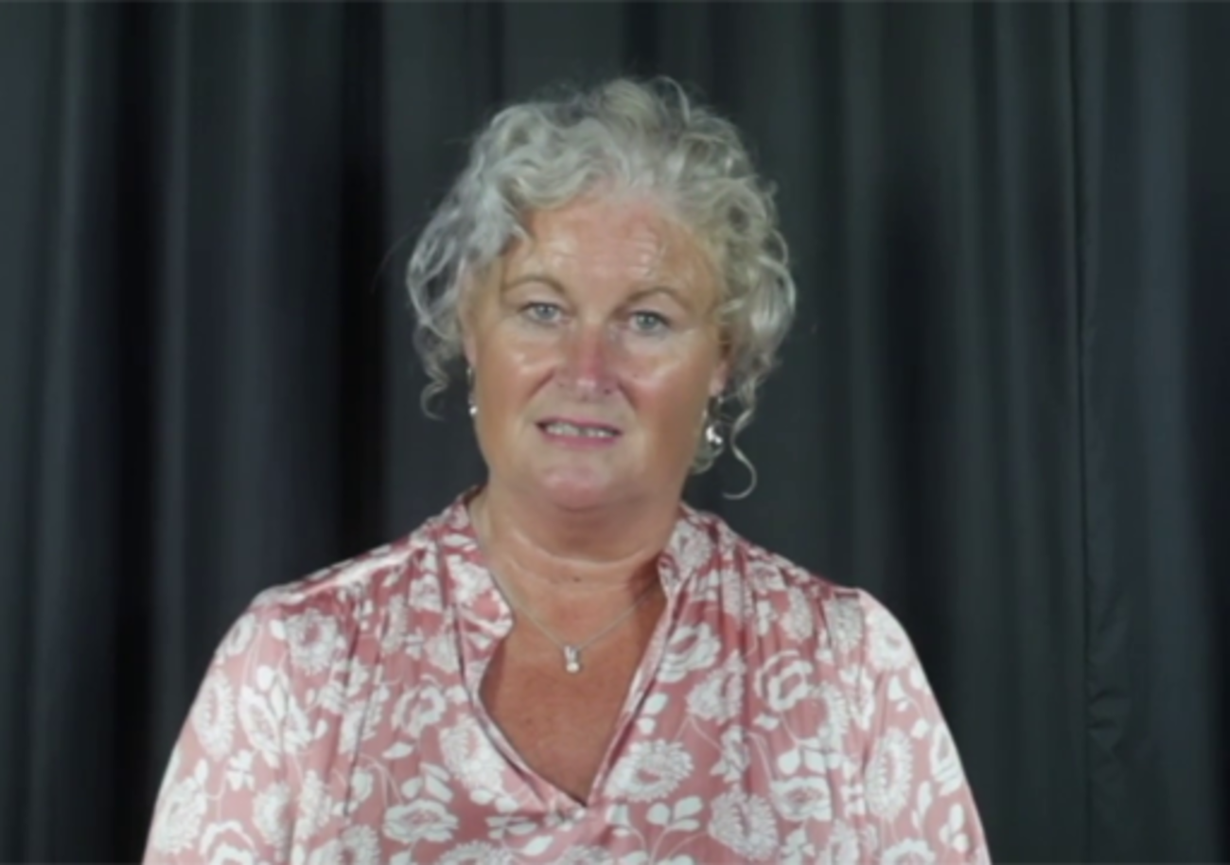

View discussion - Activity 2 Challenges engaging with children and young people

2 Understanding children and young people
While it might seem obvious, in order to support young people effectively it is crucial to go beyond the legal and ethical frameworks that guide interactions and actually understand the needs, wants and challenges of young people.
But how can you do this?
This section will look at steps you can take to better understand children and young people in order to develop more successful relationships and, ultimately, engage more effectively.

2.1 Talking on their own terms
An important place to start when engaging with children and young people, most particularly those who are vulnerable, is to treat them individually and to speak to them on their own terms.
A UK-wide study of social workers published in 2017 (Winter et al., 2017) found that while engaging with children and young people might be difficult those difficulties should not be overstated. A crucial step for anyone working with children and young people is to go beyond standardised frameworks and recognise that each child has individual needs and comes from their own specific context with particular challenges. By taking this step, relationships and conversations with children and young people can be improved dramatically.
As Gillian Ruch, professor of social work at the University of Sussex and one of the lead researchers of the project asserts:

The study underlined that it was not the application of a particular tool or method that was important, but the subtleties of relationships, and that these were unique to each child and family. This might not be a popular message for some, as it wasn’t about targets or tick boxes to satisfy the government or Ofsted. Instead, it was about finding out about the dynamics for every child, and working on a case- by-case basis.
(Lepkowska, 2017)

A key aspect of the dynamics referred to is understanding the young person’s particular context and being genuine and authentic in interactions. This same research made the very clear point that ‘far from children being passive receivers of social worker messages, they, like adults, can detect genuineness, in terms of interest in, and value attributed to, hearing their feelings, views and thoughts.’ (Winter et al., 2017, pp.1441-1442).

Activity 3 Police engagement with children and young people
Allow 10 minutes

Even though this research looked at the interactions between social workers and young people in particular, to what extent do you think it would also apply to police officers and staff undertaking their day-to-day job?

Provide your answer...
View discussion - Activity 3 Police engagement with children and young people

2.2 What happens when you listen to children?

Asking children what they think, but taking it no further will send a message that there is little real interest in their view.
(Mooney and Blackburn, 2002, quoted in Clark et al., 2003, p. 45)

A review by Alison Clark and colleagues of consultations with young children found that the impact of listening occurred at a number of levels: individual, institutional and strategic. These impacts are summarised in the following table:

Table 1 The impact of consultations with young children
Level | Group | Impact
Individual | Children | - Changes in everyday experiences, e.g. being allowed to do new things or changes to their environment  - Raised self-esteem and confidence  - Acquisition of new social or practical skills
 | Practitioners | - Feeling enabled and encouraged, e.g. to continue promoting child participation  - Feeling the benefits of working more democratically with children – e.g. not having to know all the answers
 | Parents | - Increased awareness of child’s competencies  - Raised expectations for child
Institutional |  | - Opportunities to reflect on practice, e.g. rethinking relationships, routines and activities  - Changes to policies  - Changes to the environment
Strategic |  | - Dissemination of local projects  - Organisation of special consultations, e.g. bringing the views of young children to the attention of strategic planners
(Based on Clark et al., 2003)

A key finding of this review for police and anyone else working with children and young people was that any engagement should be undertaken carefully, sensitively and with genuine interest. If not, there is a real risk that the drive to listen to and consult might be perceived by young people as simply an exercise in surveillance rather than consultation.

3 Adverse childhood experiences
While it is important to listen to and engage with young people, an awareness of context is also vital. A key part of anyone’s context is the way that the experiences we have had growing up shape and form us. In particular, it is important not to underestimate the impact of what have been termed ‘Adverse Childhood Experiences’ or ACEs.

3.1 What are ‘Adverse Childhood Experiences’?
SafeguardingNI (no date.) describe ACEs as follows:

Adverse Childhood Experiences (ACEs) are stressful experiences occurring during childhood that directly harm a child or affect the environment in which they live…
ACEs can include the following:
- Verbal abuse
- Physical abuse
- Sexual abuse
- Physical neglect
- Emotional neglect
- Parental separation
- Domestic violence
- Mental ill health
- Alcohol or drug misuse
- Household member incarcerated

While we might intuitively recognise the potentially negative impact of any one of these factors, it is worth looking at why this impact occurs and how it can be understood. As Mulcahy outlines:

Since 1998, Vincent Felitti, Robert Anda and colleagues have accumulated evidence that Adverse Childhood Experiences (ACEs) literally attack the structures of a child’s developing brain, leading to “lasting effects on brain structure and function”. This brain injury – acquired in infancy or adolescence – has serious individual and societal costs.
Basically, ACEs cause the production of toxic stress or cortisol in children which activate the “fight/flight/freeze” response and stunts the development of normal neural pathways. Childhood trauma haunts people into adulthood. Over time, the traumatized person’s “window of tolerance”, where they can comfortably “metabolize” the ups and downs of daily life, shrinks. This causes them to either remain constantly on high alert for danger, responding with anger, violence, impulsivity or defensiveness (hyperarousal) or by shutting down/disconnecting (hypoarousal) when emotionally overwhelmed or triggered.
(Mulcahy, 2018)

Since that initial research by Felitti, Anda and colleagues, multiple studies in various countries – including the nations of the UK – have shown a clear relationship between adverse childhood experiences and poor outcomes later in life,

...with the more ACEs a person suffers the greater their risks of developing health harming behaviours (e.g. substance misuse, risky sexual behaviour), suffering poor adult health (e.g. obesity, cancer, heart disease) and ultimately premature mortality...
(Hughes et al., 2016)

3.2 The importance of a supportive network
While many of the elements of adverse childhood experiences are beyond the scope or remit of policing bodies, police nonetheless have a vital role to play. In particular, through their various dealings with children police can play a role in helping to provide a protective network around children:

Focusing on the positives and the strengths in a child’s life is likely to help to improve outcomes by building a protective network around children (Daniel and Wassell 2002). At the same time, it is always important to be alert to whether any adversity of vulnerability is putting children’s well-being at risk and make sure this is taken into account. Home is important but so too is what is going on in the rest of a child’s world. School and spare-time activities, for example can provide opportunities for enhancing resilience.
(Scottish Government, 2010)

The crucial importance of this network is underlined by Ellis and Dietz (2017) who highlight that the impact of adverse experiences during childhood is even greater when combined with adverse community environments, summed in what has been called The Pair of Aces model:

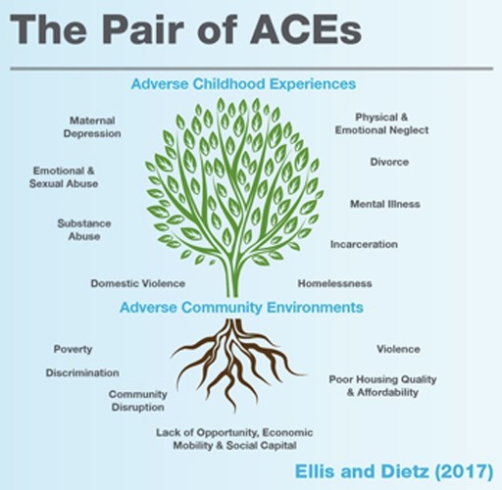
Figure 2 The pair of ACEs
View description - Figure 2 The pair of ACEs

3.3 Limitations of the ACEs model
It is important to note that while the concept of ACEs has proven itself to be very useful in terms of understanding subsequent behaviours, it should not be used as a way of assuming or predicting future challenges or anti-social behaviours.
As Bateson and colleagues (2020) emphasise:

Assessing risk of maltreating a child or committing a criminal offence is a complex issue thwarted with methodological challenges … Whilst the ACEs concept offers appealing simplicity, its predictive validity for child maltreatment, criminality or being taken into care has not been proven. For example, although four or more ACEs is associated with a 15 times greater likelihood of having committed violence against another person in the past 12 months … this cannot be used to predict future behaviour of an individual. In the same vein, statistical analysis of traffic trends can tell us the most likely time of day that an accident might occur on a given road but cannot tell us exactly which cars will be involved.
Individuals with a high ACE score, as a group, are more likely to be amongst society’s most high need populations so it would be easy to assume that an individual’s high ACE score also means they have high current need. However, an ACE score is retrospective and does not necessarily reflect a person’s current situation, needs or risks. For this reason, ACE scores are not a replacement for careful assessment of current needs, nor are they suitable to indicate whether someone meets the threshold for a particular service.
(Bateson et al., 2020, pp.4-5)

Activity 4 Applying the ACEs model
Allow 10 minutes

In this clip, Maria Morgan of SafeguardingNI discusses the key elements of the ACEs model and how it can be applied when dealing with children and young people.

Video content is not available in this format.
View transcript - Uncaptioned interactive content

Video 3 Maria Morgan

Having reflected on the comments made by Maria Morgan of Safeguarding NI, what do you think are the key benefits of the ACEs model and what are some of the limitations?

Provide your answer...
View discussion - Activity 4 Applying the ACEs model

While the discussion so far has concentrated on the adverse experiences that children and young people might have, it should also be recognised that the process of growing up also entails a degree of risk taking and risky behaviour. Some key elements of this are discussed in the following section.

4 ‘At risk’ or ‘a risk’?

Experience: that most brutal of teachers. But you learn, my God do you learn.
(CS Lewis)

Risky behaviours often seem like a natural part of being a teenager or youth. As Suttie points out:

Teens take risks. Some will do drugs, drink to excess, shoplift, and worse –activities that studies show are associated with problems later in life, including depression and anxiety.
But risk-taking is part of growing up, too, helping teens to develop independence and identities – to start becoming adults. Risks help them to find out what they can do, and to gain insight into the meaning of their lives.
(Suttie, 2016)

In many ways it should not be surprising that teens and young people are more likely to engage in risky behaviours. Recent research has shown that the human brain does not mature until around the age of 25 and moreover that different parts of the brain mature at different rates. Consequently, while for many teenagers that part of the brain dealing with pleasure seeking behaviours has already matured to an adult level, other parts of the brain which deal which decision making, attention and an awareness of future consequences remain under-developed, possibly even at the same level as a child (Eagleman, 2015, pp.14-17).

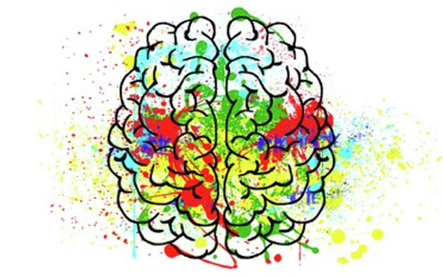
Figure 3 The chaotic brain?
View description - Figure 3 The chaotic brain?

It is for this reason amongst many others, that the National Police Chiefs’ Council’s National Strategy for the Policing of Children & Young People mentioned earlier includes young people up to the age of 24. As they outline:

It has been recognised that the 18-24 year age range is a key stage of development; the brain is still developing, independence is gained, socialising activity increases, and experimentation with drugs, alcohol and sexual relationships takes place. This coincides with a time when they are most likely to come into contact with the police.
(NPCC, 2015, p. 4)

We should consequently expect a degree of risk behaviour from teenagers. There is, however, a significant difference between what might be seen as more normal risky behaviour and genuine indicators of someone being ‘at risk’.

4.1 Adolescence as a stage of life
For many, adolescence is also seen as a ‘stage’ of life when young people are actively seeking risks and pushing the boundaries of what we perceive our family and society expects of us. This often includes such things as drinking, smoking and drug use, although statistics from England suggest that young people are engaging less in these risky behaviours than in the past (NHS, 2015). It can also include ‘hanging out’ and associating with people in situations which society might regard as being less than ideal.
Consider a 14 year old with a group of young men outside a shop who are playing with fireworks, spraying graffiti, setting fire to a bin and getting arrested by the police.
The young person will inevitably be seen by society as primarily posing a risk to the safety of others. But if there were subsequent reports that the rest of the group were older, and the 14 year old has a difficult family background, this may result in a reassessment of the young person as vulnerable, at risk from others, and in need of a response that promotes their safety as well as perhaps punishment.
If we were to learn that the young person in question is female this would perhaps make us think that the primary risk is actually one of her safety, although the issue of whether she is ‘putting herself at risk’ hanging around with men and older boys may also be part of the perception.
The way in which we – as a society – respond to young people’s behaviour is shaped by a number of factors including our own personal and professional background. It can also be influenced by assumptions about whether a young person is simply engaging in risky behaviour, at risk or even a risk to society.
Factors such as gender, ethnicity and community can play an important role in influencing our perceptions. Risk-taking behaviour of any sort is seen sometimes as being more ‘normal’, and therefore more acceptable, in boys than in girls. In relation to ethnicity, statistics demonstrating the disproportionate use of police stop and search powers on Black and Asian young men in England and Wales have been cited as an example of concerns that the police might act in a discriminatory way (Equality and Human Rights Commission, 2013).

5 Steps to support children and young people
The following section looks at a number of programmes which can help children and young people find alternative pathways – and the role that police can play in supporting these.

5.1 Youth engagement
The importance of ‘effective communication and engagement with children, young people and families’ has long been recognised and is one of the six key areas within the Common Core of Skills and Knowledge for the Children’s Workforce published by the UK Government (Children’s Workforce Development Council, 2010). On a certain level the term ‘engagement’ would appear to be fairly straightforward, yet what does it mean in the context of working with children and young people?
In 2008 the Youth Justice Board for England and Wales published a review of evidence entitled Engaging Young People Who Offend (Mason and Prior, 2008). Drawing on a range of research and practice material the authors, Mason and Prior, developed the following definition of youth engagement.

Techniques for engaging young people who offend are concerned with the question of how to gain young people’s interest and willing participation in interventions or programmes of interventions intended to prevent or reduce offending. ‘Engagement’ suggests a set of objectives around developing young people’s personal motivation and commitment to involvement in activities. It implies that passive involvement is not enough … For practitioners, the implication is that specific skills and knowledge (‘techniques’) are required to achieve engagement, in addition to skills and knowledge associated with the particular type of intervention.
(Mason and Prior, 2008, p. 12)

The process of engagement, then, goes beyond a young person just showing up to appointments or meetings, to include a range of other ways of doing things that both supports, involves and enthuses.

Box 2 Caring for Northern Ireland’s youngsters
Social workers across the UK tend to share common challenges associated with their work. But there are some unique features to the job in Northern Ireland. The legacy of the country’s conflict continues to permeate the lives of people living in the different communities.
‘This manifests in many ways,’ says Karen Winter, senior lecturer in social work at Queen’s University, Belfast, and one of the lead researchers for the Talking and Listening to Children project. ‘There remains a clear demarcation between nationalist and loyalist communities and social workers may experience a level of latent anxiety in travelling into an area that is not of their own identity.
‘Social workers have been threatened in communities that basically police themselves. Poverty, mental health problems and substance abuse are problems all social workers have to deal with, but there is an added social and political dimension here.’
Winter says people who have lived with conflict, perhaps been imprisoned or a victim of violence, have a high level of mental health problems. ‘Affected parents leave their mark on their children and so the problems continue from one generation to the next.’
For social workers like Sheila Simons and her colleagues at the South Eastern Health and Social Care Trust, one of the five integrated service providers covering Northern Ireland, this can mean access to vulnerable children is all the harder in some families.
‘As everywhere, we get extremes of parents – those who want to be helped and those who are obstructive and abusive,’ says Simons. ‘We have even had social workers’ homes targeted on social media, and because of the context of the Troubles , there can be suspicion.
‘It can be difficult for a child to see you as their advocate when the parents are being abusive towards you. So you go away and think about how you might have better handled the visit and what you might have done differently.’
(Source: Lepkowska, 2017)

5.2 Finding alternative pathways – influencing positive choices
Police have a crucial role to play when it comes to helping children and young people find alternative pathways. That said, this can only ever be done in conjunction with a broader range of social supports and interventions.
The problem in this regard is overcoming perceptions of what works and what doesn’t and ensuring to allocate sufficient resources. Traditionally, many approaches have focused on improving academic attainment under the assumption doing so will in turn lead to better outcomes for children and young people. Other approaches have tended to emphasise the need to increase the sanctions on children and young people for breaking the law or committing crimes. Yet the evidence to support either perspective is limited.
As Heller and colleagues assert:

Traditionally, social policy interventions for chidren have tried to improve outcomes by investing (often substantial) resources in improving the academic or vocational skills of young people or changing the long-term benefits or costs associated with crime or schooling, with impacts that have typically been quite limited. By comparison, the rate of return to investing in helping youth make better judgments and decisions in high-stakes moments seems promising.
(Heller et al., 2017, p. 51)

Two programmes which focus on helping you make better judgements and decisions are Becoming a Man (BAM) and Working on Womanhood (WOW), both developed by the Chicago-based Youth Guidance.
Both programmes work on the basis of engaging youth through structured mentoring programmes involving role play and group exercises. A key focus is on enhancing impulse control, emotional self-regulation and personal responsibility. Although the exact mechanism is unclear, research undertaken by the University of Chicago has found significant positive outcomes of the BAM programme:

participation in the program reduced total arrests during the intervention period by 28–35%, reduced violent-crime arrests by 45–50%, improved school engagement, and in the first study where we have follow-up data, increased graduation rates by 12–19%. The third RCT tested a program with partially overlapping components carried out in the Cook County Juvenile Temporary Detention Center (JTDC), which reduced readmission rates to the facility by 21%. These large behavioural responses combined with modest program costs imply benefit-cost ratios for these interventions from 5-to-1 up to 30-to-1 or more.
(Heller et al., 2017, p. 2)

While the BAM and WOW programmes might focus on a particular segment of the youth population, more general interventions such as the Lifestyle programme run by Humberside Police for over 30 years can also have significant benefits for children, young people and police engagement.

6 Conclusion
This course has looked at ways that those working in policing and other agencies can work more effectively with children and young people. Rather than just focusing on laws and social norms, we have looked at ways in which those in policing roles can engage more effectively with youth and young people.
A key element of this relates to an understanding of factors such as Adverse Childhood Experiences, as well as programmes that can be implemented to better support youth and young people better overcome the challenges they encounter.

References
All Party Parliamentary Group for Children (2014) ‘“It’s all about trust”: Building good relationships between children and the police’, Report of the inquiry held by the All Party Parliamentary Group for Children 2013-2014. Available at: https://www.basw.co.uk/system/files/resources/basw_20117-10_0.pdf (Accessed: 14 April 2020).
Bateson, K., McManus, M. and Johnson, G. (2020) ‘Understanding the use, and misuse, of Adverse Childhood Experiences (ACEs) in trauma-informed policing’, The Police Journal, 93(2), pp. 131-145.
Children’s Workforce Development Council (2010) The common core of skills and knowledge. Available at: https://adcs.org.uk/assets/documentation/CWDC_factsheet.pdf (Accessed: 14 April 2020).
Clark, A., McQuail, S. and Moss, P. (2003) Exploring the Field of Listening to and Consulting with Young Children, London: DCSF.
Daniel, B. and Wassell, S. (2002) Assessing and Promoting Resilience in Vulnerable Children, volumes 1, 2 and 3, London and Philadelphia, Jessica Kingsley Publishers Ltd.
Eagleman, D. (2015) The Brain: the story of you, Edinburgh, Canongate.
Equality and Human Rights Commission (2013) ‘Stop and Think Again: Towards Race Equality in Police PACE Stop and Search’, London, Equality and Human Rights Commission. Available at: www.equalityhumanrights.com/sites/default/files/stop_and_think_again.pdf (Accessed 14 April, 2020).
Heller, S. B. et al. (2017) ‘Thinking, fast and slow? Some field experiments to reduce crime and dropout in Chicago’, The Quarterly Journal of Economics, 132(1), pp. 1-54.
Hughes, K. et al. (2016) ‘Relationships between adverse childhood experiences and adult mental well-being: results from an English national household survey’, BMC public health, 16(1), p. 222.
Lepkowska, D. (2017) ‘Talking to vulnerable children on their terms helps to build trust’, The Guardian, 13 October. Available at: https://www.theguardian.com/social-care-network/2017/oct/13/children-social-care-talking-case-approach-trust (Accessed: 14 April 2020).
Mason, P. and Prior, D. (2008) Engaging Young People Who Offend: Source Document, London: Youth Justice Board. Available at: https://assets.publishing.service.gov.uk/government/uploads/system/uploads/attachment_data/file/356204/Final_EYP_source.pdf (Accessed: 23 February 2021).
Mulcahy, J. (2018) ‘The huge costs of Adverse Childhood Experiences’, RTÉ Brainstorm. Available at: https://www.rte.ie/brainstorm/2018/0221/942377-the-huge-costs-of-adverse-childhood-experiences/ (Accessed: 14 April 2020).
NPCC (2015) National Strategy for the Policing of Children & Young People. Available at: https://www.npcc.police.uk/documents/edhr/2015/CYP%20Strategy%202015%202017%20August%202015.pdf (Accessed: 14 April 2020).
NHS (2015) ‘Smoking, Drinking and Drug Use Among Young People in England – 2014’, NHS Digital. Available at https://digital.nhs.uk/data-and-information/publications/statistical/smoking-drinking-and-drug-use-among-young-people-in-england/2014 (Accessed 14 April 2020).
OHCHR (2020) Convention on the Rights of the Child. Available at: https://www.ohchr.org/en/professionalinterest/pages/crc.aspx. (Accessed: 14 April 2020).
SafeguardingNI (no date) What are ACEs? Available at: https://www.safeguardingni.org/aces-and-trauma-informed-practice/what-are-aces (Accessed: 14 April 2020).
Scottish Government (2010) Practice Briefing 5 Using the National Practice Model Ill: Analysing Information using the Resilience Matrix. Available at: http://www.wecanandmustdobetter.org/files/2714/2737/9616/Resilience_practice_briefing.pdf. (Accessed: 14 April 2020).
Suttie, J. (2016) ‘When Taking Risks is Good for Teens’, Greater Good Magazine. Available at: https://greatergood.berkeley.edu/article/item/when_taking_risks_is_good_for_teens (Accessed: 14 April 2020).
Winter, K. et al (2017) ‘Exploring communication between social workers, children and young people’, British Journal of Social Work, 47(5), pp. 1427-1444.

Acknowledgements
This free course was written by Laurie Knell. It was first published in February 2021.
Except for third party materials and otherwise stated and referenced in the course and in the acknowledgments section , this content is made available under a Creative Commons Attribution-NonCommercial-ShareAlike 4.0 Licence.
The material acknowledged below is Proprietary and used under licence (not subject to Creative Commons Licence). Grateful acknowledgement is made to the following sources for permission to reproduce material in this free course:
Images
Course image: Daan Stevens https://unsplash.com/photos/KSdfplrJreg
Figure 1: Unicefhttps://www.safeguardingni.org/
Figure 2:The pair of Aces model: adapted from: Ellis and Dietz (2017) https://www.safeguardingni.org/
Figure 3: Pixabay https://pixabay.com/illustrations/brain-mind-psychology-idea-hearts-2062048/
Audio-visual
Video 1 and 2: Arlene Kee © The Open University 2021
Video 3:Maria Morgan; Safe Guarding Board of NI © The Open University 2021
Every effort has been made to contact copyright owners. If any have been inadvertently overlooked, the publishers will be pleased to make the necessary arrangements at the first opportunity.
Don't miss out
If reading this text has inspired you to learn more, you may be interested in joining the millions of people who discover our free learning resources and qualifications by visiting The Open University – www.open.edu/openlearn/free-courses.

Solutions

Activity 1 Defining ‘children and young people’

Discussion
It is important to recognise that while in many ways children may seem more mature than in years gone by, for both social and legal reasons the definitions of ‘children and young people’ have not changed significantly. In addition, and as Arlene Kee outlines, children and young people have unique needs which means that it is important for policing and others providing services to ensure that they consider all children and young people.
Back to - Activity 1 Defining ‘children and young people’

Activity 2 Challenges engaging with children and young people

Discussion
While there can be many challenges engaging with children and young people, as Arlene Kee highlights in these two clips, it is crucially important that police and others providing social and community services of all kinds continue to do so in an effective manor.
Back to - Activity 2 Challenges engaging with children and young people

Activity 3 Police engagement with children and young people

Discussion
While those involved in policing may often engage with children and young people in different circumstances to others, some of the same basic principles apply. The most important of these is the recognition that each child has individual needs and comes from their own specific context with particular challenges. This should always be taken into consideration when engaging with children and young people.
Back to - Activity 3 Police engagement with children and young people

Activity 4 Applying the ACEs model

Discussion
While the ACEs model provides a very strong framework for understanding the various adverse experiences that children and young people might encounter as they grow up, it is vitally important that the limitations of the model are clearly understood. No model or framework is ever perfect, but the ACEs model goes a long way toward helping those who engage with children and young people – be they police or others providing various services – to consider the impact and implications.
Back to - Activity 4 Applying the ACEs model

Figure 1 the United Nations Convention on the Rights of the Child: in Child Friendly Language

Description
The image shows the a poster version of the UN Convention of the Rights of the Child – In child friendly language. It includes text defining just what “rights” are and then brief descriptions of the content of each of the articles of the convention. Cartoon-style images of a range of animals playing are in the background
Back to - Figure 1 the United Nations Convention on the Rights of the Child: in Child Friendly Language

Figure 2 The pair of ACEs

Description
The image is entitled The Pair of Aces. In the centre there is a tree with green leaves and brown roots. The section at the top of the top of the tree includes Adverse Childhood Experiences and these are outlined around the outside of the green leaves. These include: maternal depression, emotional and sexual abuse, substance abuse, domestic violence, physical and emotional neglect, divorce, mental illness, incarceration, homelessness. The lower section, aligned with the roots of the tree, includes key elements of adverse community environments. These include: poverty, discrimination, community disruption, violence, poor housing quality & affordability, and lack of opportunity, economic mobility and social capital.
Back to - Figure 2 The pair of ACEs

Figure 3 The chaotic brain?

Description
The image shows a hand-drawn image of the human brain in black ink with multicolour paint splashed randomly over it.
Back to - Figure 3 The chaotic brain?

Video 1 Arlene Kee

Transcript
ARLENE KEE
So my name is Arlene Kee, and I work for the Education Authority for Northern Ireland. I'm an assistant director within the Children and Young People's Services Directorate, and I have specific responsibility for the management of youth services in Northern Ireland. And I work with my colleagues in particular to support vulnerable children and young people.
Just last year, Northern Ireland published its first 10-year strategy for children and young people. So very interestingly, we have an overarching policy that gives us high-level outcomes that all government departments must work towards to support our children and young people. And in this context, one of those key outcomes is safety and stability for children and young people, and that is something that the Education Authority does want to do.
We support children right through from age four to 25. That's quite strange because you leave school when you're 18. But that's also because the Youth Service supports young people right up until they're young adults at the age of 25. We do have priority age bands, and they are age nine to 13 and 14 to 16.
And the reason that we do that is because we are very, very lucky. We have a policy that says that we must deliver services based on assessed need. And that means that we can support the children and young people at the point of need and who most require it. But we do have generous provision for everyone.
The Education Authority has a very hopeful and supportive process. And they have a slogan which says "we want to ensure that all children can be the best that we can be." So in Northern Ireland, within the context of the Children and Young People's Strategy, within the Education Authority, our role is to make sure that children have the best start in life, that they have the best opportunities within education, that we address their barriers to learning, and that we provide them with the personal and social development that they require to ensure that they can succeed.
We in the service complete a needs assessment every three years. And five months ago, we engaged directly with 18,000 young people in Northern Ireland. That was a very successful engagement piece of work.
And very interestingly, when we looked and reviewed our outputs for the past three years, we noticed something very important. Children and young people here involved in Youth Service have less challenges and less engagement with anti-social behaviour and crime, and they experience less problems in life. They have much more resilience and are better able to cope with themselves.
So why is it important? It's important that, in the Youth Service-- in school, it's very hard to take control of your education. It's very hard to then put into that. Schools do have schools councils, and children and young people can have a say in what's happening to them. Very differently in the Youth Service. They Youth Service do not do things to children and young people. They do things with them.
So we listen to the voice of children and young people. We plan with them. We let the young people execute their programmes. And we evaluate it with them. And the whole point is that there's a relationship between a youth worker and a young person that lets them take the journey and take their own decisions and have faith in themselves and making progress when they want to.
So it's very important to have the voice of the child at the centre of all that you do. And it's very important for children to be involved in making their own decisions and taking control of their own destiny.
If you don't do that, we now know from engaging directly with young people and from our evaluation of all the work that we do, that you don't end up with the same outcomes, and there's a greater lack of educational attainment for children and young people in that regard.
First of all, and the children and young people of our generation have very different demands, and they have challenges that we don't understand, particularly to do with the online arena, to do with, even, bullying. Now it isn't often someone on the playground. It's done on a cyber space.
And children and young people don't have the same opportunities. There are lots of challenges economically in our climate, in our culture, and in our country. And that has a part to play with children and young people.
But very much, it's about relationships. The family unit is not the same. The community cohesion is not necessarily the same. So in terms of that mentoring role, that supportive role, we often consider children and young people within concentric circles. And we don't often think of their family as the first set of peers that we want to influence and to make sure that they're supportive with one another.
We think of children in the context of their friends, their peers, then with their siblings, then, often, with their community, even sometimes before their parents. So trying to understand the complexities that children and young people live in, the lack of supports, and understanding that, actually, with all that they have to offer in terms of new technologies and new infrastructure around them, they can still be in a negative position.
And we talk about the power of one. We have found that, actually, what young people need are relationships. They need mentors. They need people to understand them. One of the things that we do with the Police Service for Northern Ireland is help officers see, how do you communicate with children and young people? How do you understand that behaviour as a form of communication?
So what we really want to do is travel with young people and see how we can almost get back to basics and build on relationships. So it's not about all the resources that they have or all the new technologies. It's about what their experiences are.
And we often find that young people are often led by their emotions, as well. And we know that mental health and resilience is something that our children and young people lack in Northern Ireland, and that's something that we feel that we have a good platform to support them on.
Back to - Video 1 Arlene Kee

Video 2 Arlene Kee 2

Transcript

INSTRUCTOR
There are many challenges because, at one level, they have so many things that are vying for their attention, and there are so many people who want to communicate with them. Very importantly, the NCRC talks about the rights of the child and talks about how important it is that they have a say in what they do.
But engaging with children and young people, whilst we have to use all new technologies and whilst we have to understand what Snapchat is and what Twitter is and all of those other things, we have found that, actually, it is, getting back to what I previously just mentioned, talking to young people and engaging with them at a relational level. That's where we have made our impact.
We have also found that children and young people are not a homogeneous group. They all have very different views. And it's very important to get platforms to engage with children and young people where you can talk to the needs of that individual. Because they are very individualised.
Also, there are lots of children without a voice. And that's really important to think about those groups who come from ethnic minority communities, those groups who come from the wider Section 75 groups. One of the groups of young people that we work with in connection with the Police Service for Northern Ireland are young people who are under paramilitary threat or are subject to paramilitary violence. And those young people do not have a voice. They don't know how to articulate that voice.
So there's kind of three main challenges. One, how do you do it within the environment that we're in? Two, because children and young people don't often know how to explain themselves and express themselves very well, it's helping them, actually, to do the articulation. And then, thirdly, it's doing something very meaningful with that information so that they understand that you have heard them, they understand that you've listened to them, but, more importantly, that the services that we have provide will change and adapt to meet their needs.
There are many opportunities. We have found that they want to engage with us, but they want to do that in a nonjudgmental way. So going back to the IT and the many platforms that we have, in our survey this year of 18,000 young people, we used small group work, we used individual work, we used questionnaires, we contacted young people in schools, we contacted them on the street, we used Twitter, we used Facebook, we used all of those methodologies, and we found that it wasn't a one size fits all, that you have to have a broad spectrum of approach.
But there's two types of contact, as well, that you want to consider. One is the sheer volume, and then two is the depth. And to get the depth, that requires the relationship and the contact at an individual level. Through the Children and Young People's Strategy, we feel that the voice of children and young people has been greatly strengthed.
One of the key things that we also do with the Police Service for Northern Ireland is that we amplify the voice of children and young people in the context of the police. So making sure that there are structures in place, particularly for those most vulnerable and have barriers to learning, even barriers to communication, and ensuring that you go out of your way to engage with those young people and make sure that they can have their voice heard, that is the most important thing. And that's what we have been very ably doing.
I think the first thing is being nonjudgmental and actively listening. And I know that sounds trite, but, actually, they have very clearly articulated it to us. There are lots of opportunities for them to state their position, but they are not clear that, A, that they've been heard-- that they've been heard correctly-- and, very importantly, that anybody has done anything about it. So I think integrity is very clear in the process.
I think, structurally, you have to have the opportunities for that to happen. And that's not siloed. One of the biggest challenges in Northern Ireland, I think, to all government departments, as we seek to support our children and young people, and particularly under the Children and Young People's Strategy, is the connectivity. Because even the most vulnerable children and young people, they are fed up, quite frankly, and can get very angry and aggressive at another person asking them personal questions, wanting to know how they feel.
So there's something about us getting this right at an adult level in terms of connectivity, being creative about that, being authentic about that, and then, as I said, making sure that we actually do something with the information. And it's not only that, it's closing the loop and going back to say, we did hear you, this is what we're going to do.
Then, you need to come back further down the line-- six months, 12 months, 18 months-- and say, can you see the difference, do you experience the difference, has this impacted you in the way that you need it to be? and then continue that critical self-reflective practise. And that isn't about, as I mentioned earlier, doing it onto young people, but young people can be part of that process. And that is also, with Early Years, we have a number of organisations that help us engage with those young people.
So it is possible. It is time consuming, and it does need you to work directly with those young people to understand their needs. But it is very worthwhile. And we know only when we do that will we get the outcomes, they will get the outcomes, that they need.
Back to - Video 2 Arlene Kee 2

Uncaptioned interactive content

Transcript
pwc_3_a3_maria_morgan_new
MARIA MORGAN
My name is Maria Morgan, and I work for the Safeguarding Board for Northern Ireland. And I have a remit along with colleagues within my team to promote a better understanding about adverse childhood experiences and how we collectively work alongside to support organisations, to become more trauma-aware, more trauma-sensitive and responsive to children and adults who have experienced adversity.
ACEs stands for Adverse Childhood Experiences, and they have been defined as stressful experiences that occur during childhood that can directly harm a child or affect the environment in which they live. So some examples of ACES could be abuse, so that could be emotional, physical, or sexual abuse, neglect, either physical or emotional, domestic violence, substance misuse by a member of the household, divorce or separation of parents, mental illness, or maybe having a member of a family or a household go to prison.
It's really important for us to understand the relationship between adverse childhood experiences and the impact that they can have on an individual right across the lifespan. There's been a study done of the Welsh population that surveyed around 2,000 people aged between 18 and 69 years, and that study indicated that individuals who have experienced four or more ACEs are at a higher risk of developing physical and psychological ill health. And they're also at a higher risk of adopting health-harming behaviours.
So for example, people with four or more ACEs were six times more likely to smoke cigarettes, four times more likely to be a high-risk drinker, 11 times more likely to smoke cannabis, 16 times more likely to have used crack cocaine or heroin, and 20 times more likely to be incarcerated.
So if you think about a child growing up in a home that has been maybe chaotic and unpredictable, maybe through domestic violence, alcohol, drug abuse, it's probably not surprising to us that as that child grows into teenage, adulthood, when there hasn't been the help and support needed to mitigate some of the fear and distress that that child may have been exposed to, health-harming common behaviours such as abusing alcohol, drugs, may be used by that person to attempt, maybe, to lessen feelings of distress in relation to what they may have seen, maybe they've heard, or maybe what they've been a victim of in their life. And that can bring with it a degree of vulnerability. And when you're under the influence of alcohol and drugs, a person can be much more vulnerable to getting involved with criminal-type behaviour.
The Welsh research also tells us that individuals surveyed with four or more ACEs were four times more likely to have type two diabetes by the age of 49 years, three times more likely to have a respiratory and coronary disease by age 49, 14 times more likely to have been a victim of violence, six times more likely to have ever received treatment for mental illness, and nine times more likely to have felt suicidal or self-harmed.
Well, I suppose ideally we would like to prevent ACEs from happening in the first place, and it's also critically important that we intervene and offer the support that's needed as early on in a child's life as we can, as the evidence is very strong in telling us that adversities in childhood can overactivate a child's stress response system. So essentially this is where a child can be in a constant state of physical and psychological stress, and if that child isn't offered help and support that they need to create a sense of safety and security, the stress response may not really get a chance to switch off. So this over activation, as it's called, is referred to as toxic stress, and that's the primary way in which adversity damages a child's development and well-being, potentially leading to problems for the child with self-regulation, emotional management, and impulse control simply because the child may not have been given the nurturing support that they need for the healthy development in those areas.
The Welsh research, however, identified four resilient factors, and these are really important because we know that these help to mitigate and buffer the toxic stress that can develop as a result of adversities. The key resilience factor is children have an access to a consistent loving and nurturing caregiver, so an available adult that provides a sense of safety and security for the child to develop and grow in a healthy way. And if for whatever reason that available caring adult is not the parents, it could be a granny, a grandpa, an aunt, uncle, youth worker, nursery worker, teacher, health visitor, social worker, policeman, anyone involved with the child who can offer a sense of nurture that increases that child's sense of stability and security.
The second resilience factor identified is having a sense of being able to overcome hardship and guide your own destiny, and overcoming hardship a guiding your own destiny can be dependent, as we know, on our self-confidence, self-esteem, and a sense of self-worth and self-belief. And that available caring adult can nurture that sense of confidence and self-belief in a child.
So the research talks about a third resilience factor, which is about prepping children to manage their emotions and behaviour. And that's helping children with the ability to read and label not only their own emotions but the emotional states in others. And that's really important, as we know because-- as I say, as we all know, emotional intelligence is that sense of internal balance within us that enables us to keep our composure, make good decisions, communicate effectively, which all really aides us to develop and maintain healthy relationships. So being involved and connected is the last resilience factor of the Welsh research, and that's about having a sense of belonging and acceptance within our family community and wider society, free from exclusion, oppression, and discrimination for whatever reason.
Well, some of the approaches that we need to be taking into consideration is, for example, counting the number of ACEs a person has been exposed to. That potentially can be problematic because it is quite possible to consider that someone exposed to one ACE of a very severe and maybe enduring nature could be much more effective physically and psychologically than an individual who had exposure to four ACEs but of a much more mild to moderate nature.
We also need to consider mitigating factors might have been available to a child living in an adverse situation. So for example, a child may have had a lot of contact with a grandparent who was in a position to offer calm, loving, and supportive environment, which acted as a protective buffer against the toxic stress that the child may be experiencing as a result of what was going on at the home. We also need to consider in terms of the approaches how counting ACEs can introduce the potential risk to individuals defining themselves by various count and how that might, in turn, impact on how they see themselves, where they fit, and what they can achieve in general, in life. There may not be the same expectations, for example, of schoolchildren in terms of doing well in school because of the ACEs that maybe are going on in their lives when the evidence is very clear that mitigating factors can make all the difference.
I suppose the other consideration is how we are addressing the environmental factors that may contribute to adverse childhood experiences. So what role does poverty, discrimination, community violence, [INAUDIBLE], and so on play in exacerbating adversely for children and households? And we also need to think about, when we are asking people about ACEs and using checklists, are we in a position to do something with the information we've asked for? Can we offer referral pathways to support these individuals with the help that they need? Are the support pathways and interventions offered evidence-based to respond to what the child, the person may have experienced?
And we need to consider that the services are not readily available. For example, we have lists of three, six months. What's offered to the person in the meantime who has completed in these questionnaire and has talked maybe openly about their adversity?
Caring and nurturing relationships are a robust and protective factor against the impact of ACEs, and adversity in childhood can be mitigated against. I think that's really important to conclude with that key message, and it's all really important for us to consider across whatever sector we work in to think about what support we are offering or could offer to vulnerable kids who might be experiencing adversity.
The Safeguarding Board for Northern Ireland, on its website, has a lot of really good information and research reports, some of which I referred to in this conversation, and it also has developed a wide range of really healthy resources that practitioners can use in their daily practise to support vulnerable families. So it's definitely worth a visit to the Safeguarding Board of Northern Ireland website, and all of those resources can be accessed for free. Thank you very much.
Back to - Uncaptioned interactive content

