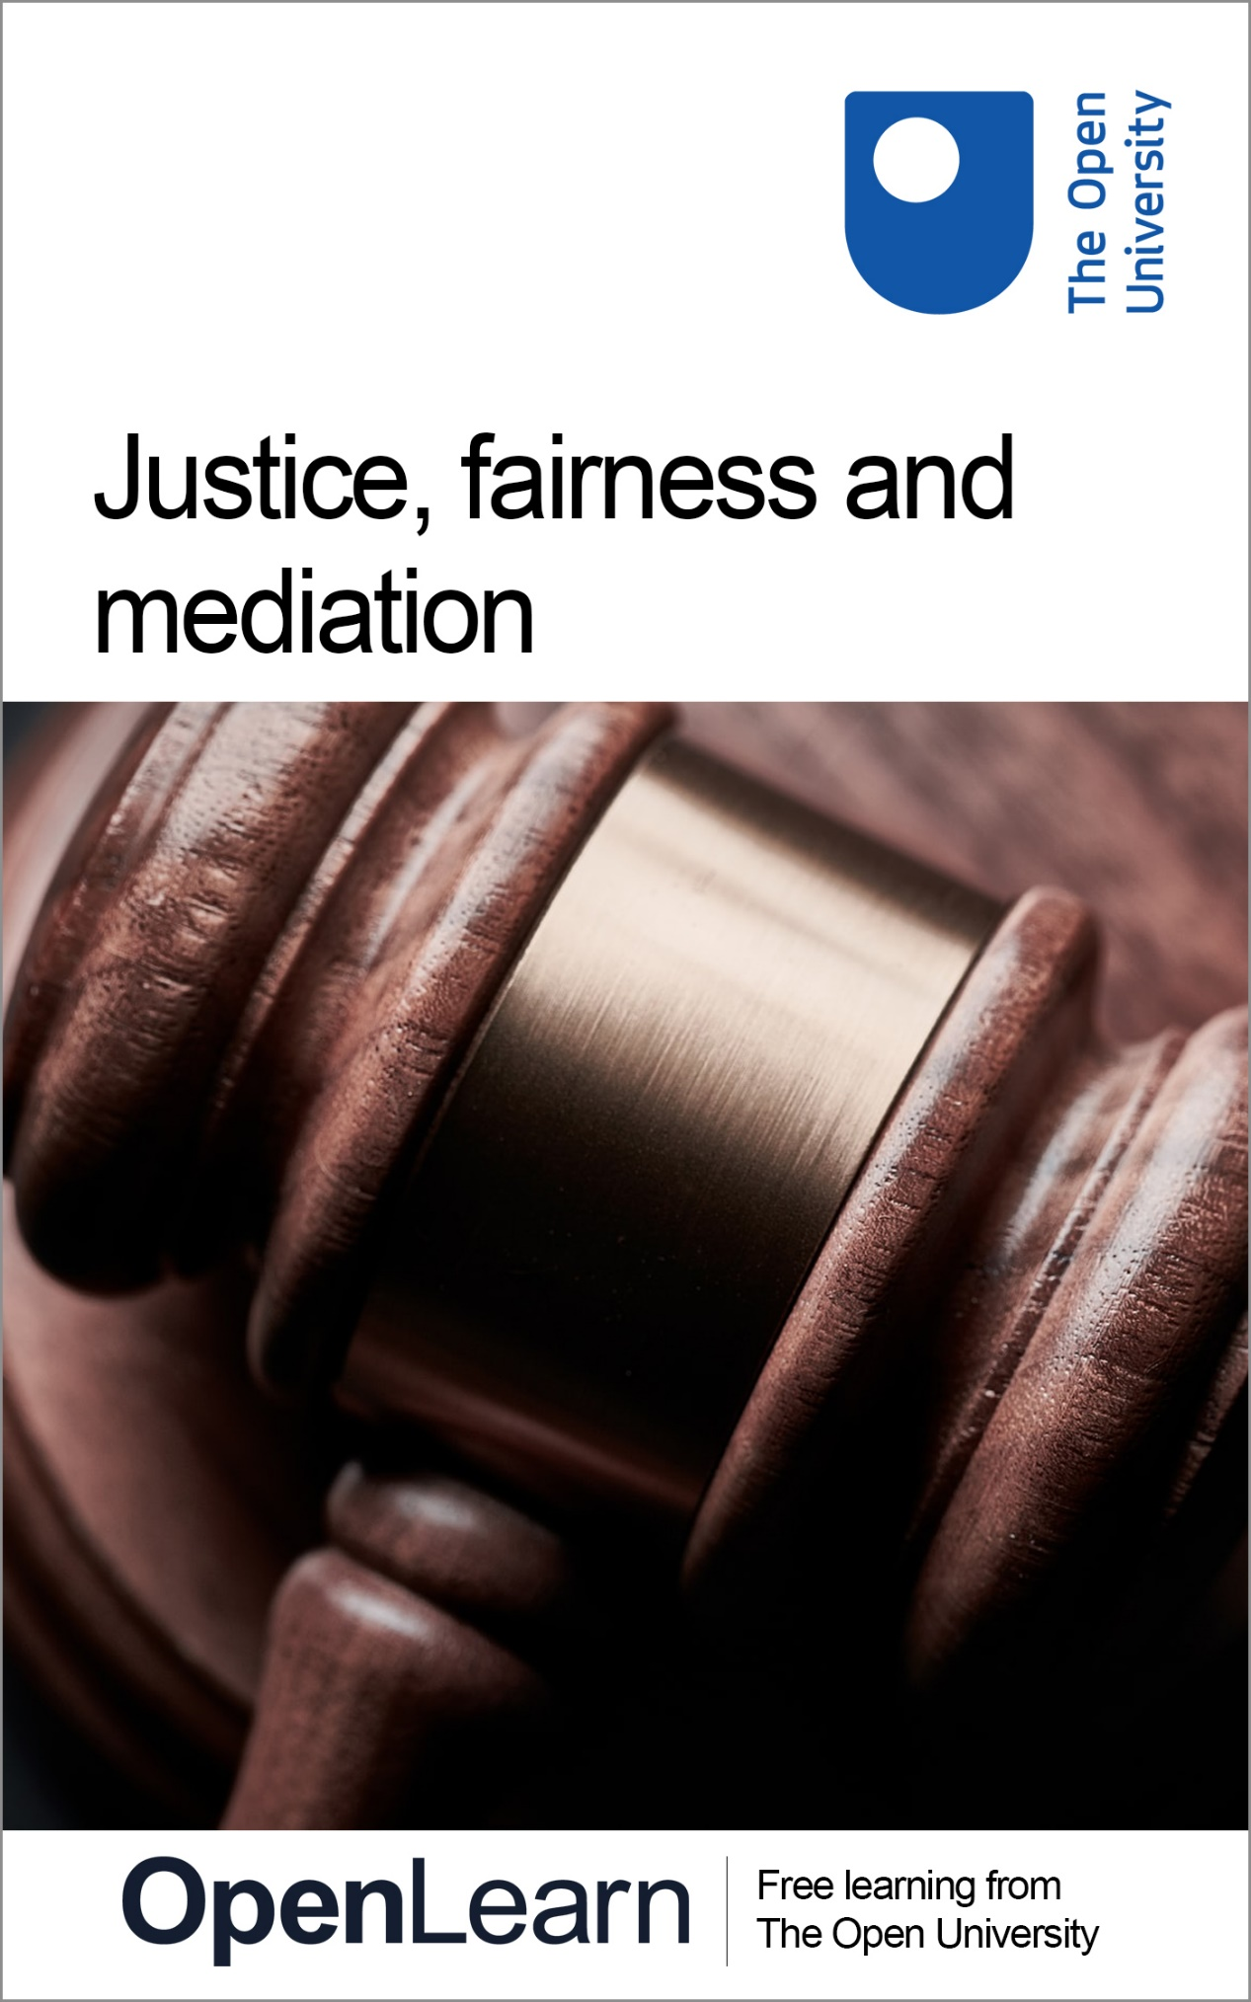

PWC_5

Justice, fairness and mediation

About this free course
This content was originally published as an open educational resource on the OpenLearn website http://www.open.edu/openlearn/.
This version of the content may include video, images and interactive content that may not be optimised for your device.
You can experience this free course as it was originally designed on OpenLearn, the home of free learning from The Open University – www.open.edu/openlearn/money-business/leadership-management/justice-fairness-and-mediation/content-section-0
There you’ll also be able to track your progress via your activity record, which you can use to demonstrate your learning.
Copyright © 2020 The Open University
Intellectual property
Unless otherwise stated, this resource is released under the terms of the Creative Commons Licence v4.0 http://creativecommons.org/licenses/by-nc-sa/4.0/deed.en_GB. Within that The Open University interprets this licence in the following way: www.open.edu/openlearn/about-openlearn/frequently-asked-questions-on-openlearn. Copyright and rights falling outside the terms of the Creative Commons Licence are retained or controlled by The Open University. Please read the full text before using any of the content.
We believe the primary barrier to accessing high-quality educational experiences is cost, which is why we aim to publish as much free content as possible under an open licence. If it proves difficult to release content under our preferred Creative Commons licence (e.g. because we can’t afford or gain the clearances or find suitable alternatives), we will still release the materials for free under a personal end-user licence.
This is because the learning experience will always be the same high quality offering and that should always be seen as positive – even if at times the licensing is different to Creative Commons.
When using the content you must attribute us (The Open University) (the OU) and any identified author in accordance with the terms of the Creative Commons Licence.
The Acknowledgements section is used to list, amongst other things, third party (Proprietary), licensed content which is not subject to Creative Commons licensing. Proprietary content must be used (retained) intact and in context to the content at all times.
The Acknowledgements section is also used to bring to your attention any other Special Restrictions which may apply to the content. For example there may be times when the Creative Commons Non-Commercial Sharealike licence does not apply to any of the content even if owned by us (The Open University). In these instances, unless stated otherwise, the content may be used for personal and non-commercial use.
We have also identified as Proprietary other material included in the content which is not subject to Creative Commons Licence. These are OU logos, trading names and may extend to certain photographic and video images and sound recordings and any other material as may be brought to your attention.
Unauthorised use of any of the content may constitute a breach of the terms and conditions and/or intellectual property laws.
We reserve the right to alter, amend or bring to an end any terms and conditions provided here without notice.
All rights falling outside the terms of the Creative Commons licence are retained or controlled by The Open University.
Head of Intellectual Property, The Open University

Contents
- Introduction
- 1 What’s fair for me may not seem fair to you – perception in policing
- 2 The importance of justice
  - 2.1 Forms of justice
- 3 Restorative justice
  - 3.1 Principles of restorative justice
- 4 Alternative approaches to dispute resolution
  - 4.1 Common features of ADR
  - 4.2 Types of ADR
- 5 Mediation
- 6 Advantages and disadvantages of mediation
- 7 Conclusion
- References
- Acknowledgements
- Solutions

Introduction
Questions of justice and fairness are central to how societies operate and how people and communities interact. While we might perhaps assume that there is one single view of what either justice or fairness mean, in reality they are contested ideas – that is to say, ideas which we all perceive and interpret differently.
This course considers the concepts of justice and fairness from various perspectives, looking particularly at the importance of both for effective policing and greater community empowerment and engagement. By looking at two specific approaches to justice and fairness – restorative justice and mediation – it considers how empowerment, engagement and better outcomes for all members of society can be achieved.
After studying this course, you should be able to:
- understand the various ways in which fairness and justice can be perceived
- understand the concept of restorative justice
- appreciate various forms of alternative dispute resolution
- reflect on the value of mediation to resolve community disputes.

1 What’s fair for me may not seem fair to you – perception in policing
Questions of fairness and equity are crucial to modern policing. The Cambridge Dictionary defines fairness as:

the quality of treating people equally or in a way that is right or reasonable
(Cambridge Dictionary, 2020)

To have legitimacy, policing organisations must not only act with fairness and, indeed, impartiality, but just as importantly they need to be seen to be acting in this way. This underlines the importance of perception, but where do perceptions come from? As has been noted, when it comes to policing, ‘Perceptions of fairness are not only driven by outcomes. They may also be influenced by the fairness and consistency of the process used to reach those outcomes’ (Center for Public Safety and Justice, 2013).

2 The importance of justice
Rather than just considering fairness, we should also consider notions of justice. Yet while we might agree that justice is important, defining exactly what justice is can sometimes be much harder.

Activity 1 The meaning of justice
Allow 5 minutes

Consider what you think justice means. Type your ideas in the box below.

Provide your answer...
View comment - Activity 1 The meaning of justice

Justice is often represented by the equally balanced scales of justice. The Greek goddess of justice, Themis, was traditionally represented carrying scales in which she measured the different aspects of the argument.
The meaning of justice has been considered over the centuries by successive philosophers, academics and lawyers, and there are many different theories. They can be quite complex and could justify a course in their own right! In light of that, what follows is a brief examination of some of the most relevant forms today.

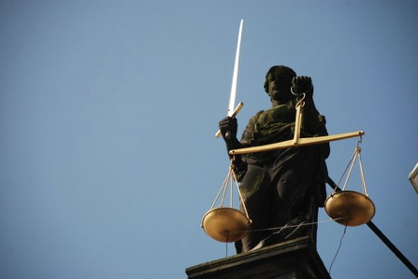
Figure 1 The scales of justice
View description - Figure 1 The scales of justice

Contested ideas of justice
The term ‘justice’ is a ‘contested concept’, one whose meaning is never completely fixed or finally closed and agreed upon. From this perspective we might recognise that each society (or group within it) will have its own definition of justice, and those definitions cannot (and perhaps should not) be reconciled. Equally, each of those same groups will have their own ideas about justice and practices for implementing them.
This has significant implications for how justice – and most particularly those ‘representing’ justice such as the legal professions, the courts and, of course, policing bodies – are perceived, accepted and regarded.

2.1 Forms of justice
Over the course of history, the idea of justice has been understood and defined in many different ways. This section considers some of the key forms of justice which still influence how we understand justice today.
Distributive and corrective justice
Writing in the fourth century BC, the Greek philosopher Aristotle was responsible for some of the earliest views on justice.
Aristotle believed that a just law was one that both encouraged individual freedom and enabled people to live peacefully. From society’s perspective, key to this was allowing people to fulfil themselves in society.
In considering perspectives on justice, Aristotle distinguished between what he saw as the two key forms: distributive justice and corrective justice.

Distributive vs corrective justice
At its simplest, distributive justice focuses on how things such as rights, goods and well-being should be distributed amongst people.
The core idea of distributive justice, according to Aristotle, is that of ‘treating equals equally’. Yet what exactly does this mean. Who, for example, are the relevant equals? And what is actually involved in treating people equally?
On the other hand, corrective justice is about giving someone either what they deserve or have a right to. In a legal sense, this can relate to punishment due for an offence which has been committed, or – conversely – the redress someone is due for a wrong suffered.

Natural justice
The ancient Roman’s took a slightly different perspective, arguing that rather than being the product of human society, basic legal principles are derived from nature. The underpinnings of this view still exist today in the form of natural justice. Key principles of natural justice hold that each person is entitled to a fair trial and that a judge must be free from bias. These principles – or at least the assumptions underpinning them – are still commonly found in discussions of rights and justice today.
Substantive justice
This is concerned with the content of the law. The legal principles created by relevant legislative bodies and the courts need to be regarded as ‘just’. What is considered to be just in these circumstances is influenced by a range of social and contextual factors, many of which are captured in this diagram:

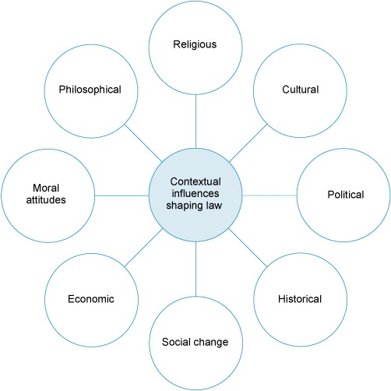
Figure 2 Contextual influences shaping law
View description - Figure 2 Contextual influences shaping law

Substantive vs formal justice
Beyond more philosophical perspectives, definitions of justice are also quite practical in nature. In this regard, it can be useful to distinguish between substantive and formal aspects of justice.

The moral and cultural values of the society in which the law is created are especially influential in determining whether any given law is regarded as just. Where a law is considered to be unjust the consequences for social order can be potentially far reaching, up to and including social unrest.
In contrast, formal justice is concerned with ensuring that legal principles are applied in a way which is fair. This invariably involves treating people in a similar situation in the same way: like cases should be treated alike. It is important that judges are unbiased when they hear cases, and that the same rules of procedure are applied to everyone in the same way. It is also important that regulatory frameworks such as health and safety laws, planning laws and financial services laws operate and are applied in a way that is fair and consistent.

The European Convention on Human Rights
Since 1950 the UK has been a signatory to the European Convention on Human Rights (ECHR). The ECHR is an international treaty signed by members of the Council of Europe and is, consequently, separate and unrelated to Brexit and the UK’s departure from the European Union. Being a signatory to the ECHR, means that the UK along with other countries, is ‘committed to upholding certain fundamental rights, such as the right to life, the right to a fair trial, and the right to freedom of expression’ (Dawson, 2019).

Activity 2 Types of justice
Allow 5 minutes

Reflect on the types of justice described in the animation below.
Which one do you feel is most relevant in a modern world?

Video content is not available in this format.
View transcript - Uncaptioned interactive content

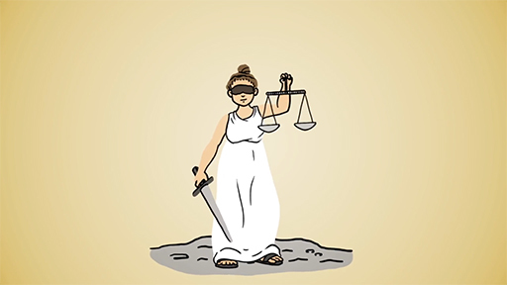
Video 1

View discussion - Activity 2 Types of justice

3 Restorative justice
Another form of justice which has gained increasing awareness in recent years is restorative justice.

Payne and colleagues emphasise that the underlying processes of restorative justice have evolved from victim-offender mediation, family group conferencing, circle processes, and various types of citizen panels. Each practice shares a common element: the transfer of some decision-making authority from government to victims and offenders, their family, friends and other
(Payne et al., 2010, p. 10)

Unlike some of the more formal aspects of justice discussed earlier, restorative justice is an essentially informal approach to resolving and redressing disputes. As Eriksson argues:

Restorative justice has been presented as a response to crime that promotes inclusive dialogue, acceptance of responsibility, reparation of harm, and rebuilding of relations among victims, offenders and communities.
(Eriksson, 2009, p. 1).

In this regard, restorative approaches to justice differ quite significantly to those approaches which involve retribution for wrongs perceived to have been committed. This is particularly so when it comes to dealing with the challenges presented by youth and juvenile offenders:

Our society’s common understanding of the need for juvenile offenders to be held “accountable” is closely linked to the concepts of punishment and retribution “when you violate the law, you incur a debt to society.” In this – viewpoint, offender’s are held accountable when they have received or taken a sufficient amount of punishment.
In the restorative justice paradigm the meaning of accountability shifts the focus from incurring a debt to society to that of incurring a responsibility for making amends to the victimized person; from passively taking punishment to actively making things right. Rather than emphasizing punishment of past criminal behavior, accountability in the restorative justice paradigm taps into the offender’s strengths and competencies to take direct and active responsibility to compensate the victim for material or emotional losses.
(Umbreit, 1995, p. 31)

The key differences between retributive and restorative justice are summarised in the table below:

Table 1 Differences between retributive and restorative justice
Retributive Justice | Restorative Justice
Crime defined as violation of the state | Crime defined as violation of one person by another
Focus on establishing blame, on guilt, on past (did he/she do it?) | Focus on problem-solving, on liabilities and obligations, on future (what should be done?)
Adversarial relationships and process normative | Dialogue and negotiation normative
Imposition of pain to punish and deter/prevent | Restitution as a means of restoring both parties; reconciliation/restoration as a goal
Justice defined by intent and by process: right rules | Justice defined as right relationships; judged by the outcome
Interpersonal, conflictual nature of crime obscured, repressed; conflict seen as individual vs. state | Crime recognised as interpersonal conflict; value of conflict recognized
One social injury replaced by another | Focus on repair of social injury
Community on sideline, represented abstractly by state | Community as facilitator in restorative process
Encouragement of competitive, individualistic values | Encouragement of mutuality
- Action directed from state to offender:  - Victim ignored  - Offender passive | - Victim and offender’s roles recognised in both problem and solution:  - Victim rights/needs recognized  - Offender encouraged to take responsibility
Offender accountability defined as taking punishment | Offender accountability defined as understanding impact of action and helping decide how to make things right
Offence defined in purely legal terms, devoid of moral, social, economic, political dimensions | Offense understood in whole context – moral, social, economic, political
“Debt” owed to state and society in the abstract | Debt/liability to victim recognized
Response focused on offender’s past behavior | Response focused on harmful consequences of offender’s behavior
Stigma of crime unremovable | Stigma of crime removable through restorative action
No encouragement for repentance and forgiveness | Possibilities for repentance and forgiveness
Dependence upon proxy professionals | Direct involvement by participants
(Zehr, 1985)

3.1 Principles of restorative justice
In a practical sense, restorative justice involves three main principles:
- making the offender take responsibility for his or her criminal action
- allowing reintegration of the offender into the community
- encouraging reparation being made to the victim.
Implicit in these principles is a ‘shift in accountability’ (Eriksson, 2009, p. 1) from offenders having a debt to society to offenders being held – and perhaps also holding themselves – accountable to the victims of crime (Corrado et al., 2003).
The process of restorative justice
Johnstone (2003) argues that in order to achieve the sorts of outcomes typically associated with restorative justice, a number of key approaches and processes are required. This includes interventions that:
- encourage offenders to undertake appropriate reparative acts
- instil repentance within offenders and facilitate its communication
- facilitate the social reacceptance of offenders who have expressed repentance and made serious efforts to repair the damage they caused
- assist ex-offenders who are making serious efforts to refrain from further offending
- promote the healing of victims and survivors of crime.
Johnstone continues by emphasising that:

by promoting respectful and constructive dialogue between victims and offenders (and between offenders and the community) such encounters bring offenders to appreciate the harmful consequences of their behaviour and enable victims and offenders to come to a better understanding of each other. Also, by giving victims an effective voice within the criminal justice process, and giving them the opportunity to see and hear their offender, these processes contribute to the recovery of victims from their traumatic experience.
(Johnstone, 2003)

4 Alternative approaches to dispute resolution
Alternative dispute resolution (ADR) is a collective term for any means of resolving a legal dispute that is not through what might be considered to be a traditional court or tribunal process. Typically used in relation to civil law cases, it is not normally used in criminal law cases.

Activity 3 What is ‘alternative’ about ADR?
Allow 5 minutes

Think about the term ‘alternative dispute resolution’. Why do you think it is ‘alternative’?

Provide your answer...
View comment - Activity 3 What is ‘alternative’ about ADR?

4.1 Common features of ADR
In dealing with legal cases that might otherwise have been dealt with by the courts, ADR may be more appropriate because it is less expensive, quicker or less adversarial than a court case, or because it is more focused on finding a resolution rather than apportioning blame or adjudicating which party is right. However, as ADR is outcome-focused, there may at times be a perception that the traditional concepts of ‘justice’ and ‘fairness’ found in the civil court system may be lost in the search for a resolution.
To understand why ADR is a viable alternative to courts and tribunals, it can be useful to consider some of its most common attributes:

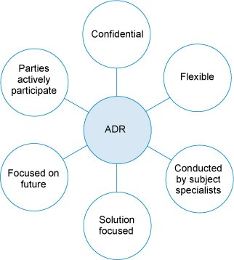
Figure 3 Common features of ADR processes
View description - Figure 3 Common features of ADR processes

The key points highlighted here can be summarised and understood as follows:
- ADR is confidential unless the parties agree otherwise. This means that sessions are held in private and are not reported. This can be particularly useful if a matter is sensitive, for example, for commercial reasons.
- ADR is flexible as it is not typically bound by the same rules in the same way that a court or tribunal would be; however, some forms of ADR, such as arbitration, are subject to rules agreed by the parties.
- ADR is usually conducted by a subject specialist: for example, a housing matter would be dealt with by a housing expert and a commercial matter by a commercial expert. This means that the person dealing with the case has a good understanding not only of the subject but also of the realities and practicalities of that area.
- ADR is focused on resolving the issue and how the parties can address the issue and move on, rather than what has already happened and apportioning fault or blame.
- Parties to ADR can actively participate in the process and mostly get to make the final decision, sometimes facilitated by an intermediary. In contrast, in courts or tribunals, the process is usually conducted by legal professionals on behalf of the parties and the decision is made for the parties with at times only limited involvement or understanding.

4.2 Types of ADR
There are many different types of ADR including mediation, negotiation, conciliation, arbitration, adjudication and Ombudsmen which are common forms of ADR, or expert evaluation, early neutral evaluation, expert determination and Med-Arb which are less common. Table 2 shows the main forms of ADR.

Table 2 The main forms of ADR
Type of ADR | Description | Form
Negotiation | Discussion undertaken to come to a mutually agreeable solution. Discussion is undertaken by the parties or their representatives. | Non-binding
Mediation | Neutral third party (the mediator) facilitates discussion by the parties to come to a mutually acceptable solution. | Non-binding
Conciliation | Neutral third party (the conciliator) actively facilitates parties resolving the dispute. | Non-binding
Arbitration | An independent third party (the arbitrator) who is not a court or tribunal decides the outcome of a dispute. | Binding
Adjudication | An independent third party (the adjudicator) makes an interim binding determination of the dispute. This lasts until the dispute is finally determined by arbitration or litigation. | Hybrid (in that the decision is only binding until the matter is fully concluded through arbitration or litigation)
Expert determination | An independent, expert third party is appointed to determine the outcome of the dispute. | Binding
Expert evaluation/early neutral evaluation | Similar to expert determination, an independent, expert third party advises on the merits and likely outcome of the dispute. The advice can be used as a basis for negotiations or an agreement, but is not binding. | Non-binding
Med-Arb | A hybrid of mediation and arbitration. The parties must first mediate and then the mediator acts as an arbitrator on any issues which were not resolved by the mediation. | Hybrid (in that mediation is non-binding but the arbitration is binding)
Ombudsman/woman | An independent body established to investigate complaints by individuals about public services and some private services. | Advisory

Activity 4 Forms of ADR in practise
Allow 15 minutes

Which forms of ADR have you seen in practise? What were the relative advantages/disasvantages and how might you be able to make better use of them?

Form of ADR | Advantages | Disadvantages | How you utilise this form of ADR?
Provide your answer... | Provide your answer... | Provide your answer... | Provide your answer...
Provide your answer... | Provide your answer... | Provide your answer... | Provide your answer...
Provide your answer... | Provide your answer... | Provide your answer... | Provide your answer...

View comment - Activity 4 Forms of ADR in practise

5 Mediation
In mediation an independent third party (a mediator) helps the parties to communicate with each other and to build consensus with the aim of achieving a mutually agreed settlement. Mediation may consist of the mediator consulting with each party or conveying their arguments or offers to each other. Consequently, this may mean that the mediation takes place with all parties in the same room or with parties in separate locations.

Figure 4 Mediation is a particularly important form of Alternative Dispute Resolution
View description - Figure 4 Mediation is a particularly important form of Alternative Dispute Resol ...

A crucial aspect of any mediation process is confidentiality. The mediator and any parties participating in mediation are bound by a duty of confidentiality. This means that the mediator cannot disclose to one party what the other has said, beyond conveying the key messages which the mediator has been asked to convey.
The focus of mediation is on the identification of a mutually agreeable solution to the issue. Rather than focusing on the parties’ legal rights and duties, the mediator focuses on the outcomes that the parties hope to achieve. This focus on the future outcomes can help parties to move beyond what has happened in the past to achieve a solution to the issue. While this might be a compromise it should be a compromise which all parties are comfortable with.
The key principles and characteristics of mediation are outlined below.
- Use of a mediator
  - Mediation cannot take place without a mediator – a neutral third-party whose role is to support the resolution of the dispute. The most important skill of a mediator is the ability to understand the problem from both sides, which requires listening, questioning and empathising.
- Neutrality of the mediator
  - The mediator’s neutrality and impartiality are essential to the mediation process. A mediator must be independent in order to assist discussions and help the parties in dispute to reach a mutually acceptable resolution without taking sides.
- Dispute resolution
  - The primary goal of all mediation is the settlement of a dispute; it seeks to deliver quickly a settlement that all parties can live with. This may mean that the parties in disagreement are more likely to sustain their relationship, whether it is a business, family or personal relationship.
- Providing a neutral and safe venue for negotiating
  - For mediation to be successful there must be conditions conducive to discussion, exploration of options and possibilities, and negotiation. This point highlights the essence of the mediator’s art: to bring the different parties together in the same room, minimise any hostility and encourage them to consider and discuss how they can reach a settlement which is acceptable to all parties.
- Confidentiality
  - One of the defining characteristics of all mediation is that it is a private and confidential process.
- Control rests with the disputing parties
  - The parties involved retain control over whether they wish to settle and on what terms. Mediation facilitates communication and encourages a problem-solving approach in which all parties have a direct input into the final outcome.

Mediation vs negotiation
While superficially mediation and negotiation may seem similar, there are nonetheless some crucial differences.
Mediation is more formal than negotiation as it requires the appointment of a mediator to conduct it. The mediator must be acceptable to all parties; this in itself may be a source of dispute, and it may require some negotiation to find a mutually acceptable mediator.
Mediation does not need to be conducted by a professional mediator. It can be conducted by anyone whom the parties agree as an appropriate person; however, many parties prefer to use a trained mediator and in some cases they may be required to do so.
As with negotiation, mediation is only effective when all parties are committed to the mediation. It is also beneficial if the parties have equal power/status or are willing to operate on that basis.

When might mediation be used?
There are a wide range of situations in which mediation might be used. These include:
- family issues
- community/neighbour issues
- health issues
- business/commercial issues
- environmental issues
- discrimination issues
- housing issues
- additional support needs issues
- employment issues
- financial issues, such as debt or small claims.
In addition, mediation might be used after negotiation has failed or parties may decide to start with mediation. If mediation fails, parties may be able to use other types of ADR or to go to court, though in some jurisdictions, the law requires or suggests that mediation should be used as an alternative to court proceedings or should be attempted prior to court proceedings. For example, in England the Children and Families Act 2014 requires mediation to be considered before some family law applications can be made.
Importantly, while mediation is less formal than going to court, it is not always less expensive.

6 Advantages and disadvantages of mediation
As with other forms of ADR, there are advantages and disadvantages to mediation. Some of these are outlined in the table below.

Table 3 Advantages and disadvantages of mediation

Advantages | Disadvantages
- ‘Everyone is a winner’ – mediation offers remedies which are not available to the courts in a litigation process. Therefore, usually mediation results in parties getting something that they want; there is not an outright winner or loser. This should be encouraged.  - Fewer cases in the court – mediation prevents a backlog of cases, and this has been cited as one of the main reasons for the system in Italy. This reduces costs for the parties in dispute as well as costs to the public purse.  - Access to justice – mediation is more affordable; therefore even if a party lacks financial means it can still resolve its dispute in this forum. Mediation is much cheaper than litigation, and is also cheaper than some of the other ADR procedures. The cost of mediation will depend on how complex the dispute is, and how many people are involved in the process.  - Quicker – mediation forces parties to communicate and negotiate rather than take part in an adversarial process. Mediation can result in parties realising that the issues in dispute are actually quite narrow. For example, voluntary mediation in Scotland currently has an 80% settlement success rate on the day and up to another 10% of cases settle before commencing litigation.  - Future relationship maintained – parties are more likely to maintain a positive relationship after attending mediation. | - ‘Everyone is a loser’ – in order for mediation to be successful parties have to be willing to compromise, and they may not wish to concede anything. Mandatory mediation may therefore pressure parties to concede issues and leave them with a feeling of dissatisfaction with the legal system. The ‘injured’ party may challenge why they are out of pocket if they are ‘right’.  - Fewer cases in the courts – this could result in a lack of precedent, due to mediation being a confidential process where cases are not reported.  - Access to justice – disputants have a right to litigate, and therefore mandatory mediation would simply prolong the process and add another layer of cost. This may have adverse implications for access to justice.
(Adapted from Drummond, 2013)

Activity 5 Mediation in practise
Allow 10 minutes

How does the process of mediation described in the video below match what you have experienced or seen in action?

Video content is not available in this format.
View transcript - Uncaptioned interactive content

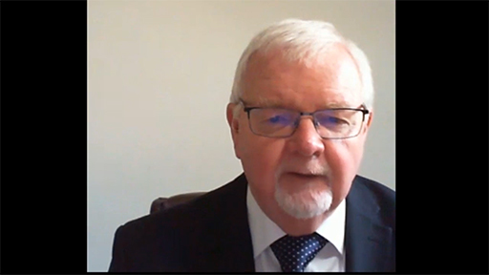

Video 2 Michael Doherty
What steps might you take in order to enhance your own skills as a mediator?

View discussion - Activity 5 Mediation in practise

7 Conclusion
This short course has considered the concepts of justice and fairness, and how they are applied. By focusing on restorative justice and alternative forms of dispute resolution – most particularly, mediation – it has highlighted that rather than being abstract or academic concepts, justice and fairness are acutely relevant to all our lives.
By enhancing our understanding of both justice and fairness, those working in or with communities can strengthen empowerment and engagement for the benefit of all.

References
Cambridge Dictionary (2020) Available at: https://dictionary.cambridge.org/dictionary/english/fairness (Accessed: 8 May 2020).
Center for Public Safety and Justice (2013) ‘“That’s not fair!” Policing and perceptions of fairness. Community Policing Dispatch’, 6(9). Available at: https://cops.usdoj.gov/html/dispatch/09-2013/policing_and_perceptions_of_fairness.asp (Accessed: 8 May 2020).
Corrado, R. R., Cohen, I. M. and Odgers, C. (2003) ‘Multi-Problem Violent Youth: A Challenge for the Restorative Justice Paradigm’, in Weitekamp, E. and Kerner , H. J.(eds.), Restorative Justice in Context: International Practices and Directives, Cullompton: Willan Publishing, 1– 22.
Dawson, J. (2019) ‘How might Brexit affect human rights in the UK?’, House of Commons Library, Available at: https://commonslibrary.parliament.uk/how-might-brexit-affect-human-rights-in-the-uk/ (Accessed: 7 May 2020).
Drummond, I. (2013) ‘Should mediation be mandatory?’, Lexology. Available at: https://www.lexology.com/library/detail.aspx?g=68019975-f314-4d43-8966-483af9e95667 (Accessed: 8 May 2020).
Eriksson, A. (2009) Justice in Transition: Community Restorative Justice in Northern Ireland, Taylor & Francis Group.
Johnstone, G. (2003) A Restorative Justice Reader: Text, Sources, Context, Cullompton, Willan.
Payne, B. et al (2013) Restorative Practices in Northern Ireland: A Mapping Exercise. Available at: http://www.facingforward.ie/wp-content/uploads/2013/08/Restorative-Practices-in-Northern-Ireland-A-Mapping-Exercise.pdf (Accessed: 8 May 2020).
Umbreit, M. S. (1995) ‘Holding Juvenile Offenders Accountable: A Restorative Justice Perspective’, Juvenile and Family Court Journal, 46(2), pp. 3-42.
Zehr, H. (1985) ‘Retributive justice, restorative justice’, MCC US Office of Criminal Justice.

Acknowledgements
This free course was written by Laurie Knell. It was first published in February 2021.
Except for third party materials and otherwise stated in the course and in the acknowledgements section (see terms and conditions), this content is made available under a Creative Commons Attribution-NonCommercial-ShareAlike 4.0 Licence.
The material acknowledged below is Proprietary and used under licence (not subject to Creative Commons Licence). Grateful acknowledgement is made to the following sources for permission to reproduce material in this free course:
Images
Course image: Photo by Bill Oxford in Unsplash
Figure 1: JEL/Pixabay.com
Figure 2: The Open University
Figure 3: The Open University
Figure 4: StarFlames/Pixabay.com
Audio-visual
Activity 5: ©The Open University 2021
Every effort has been made to contact copyright owners. If any have been inadvertently overlooked, the publishers will be pleased to make the necessary arrangements at the first opportunity.
Don't miss out
If reading this text has inspired you to learn more, you may be interested in joining the millions of people who discover our free learning resources and qualifications by visiting The Open University – www.open.edu/openlearn/free-courses.

Solutions

Activity 1 The meaning of justice

Comment
If you looked up the word ‘just’ in a dictionary you would find it defined along the lines of fairness or impartiality in action or judgement, conforming to high moral standards, namely honest, legally valid, unbiased, reasonable and rightful.
This is not an exhaustive list and your definitions will vary.
At its most basic level, justice refers to a situation where there is fairness in the way the situation is handled and in the result. In everyday life we expect parents, teachers, employers and referees of sporting activities to be fair in their handling of their children, students, employees and players. In the same way, we expect law to be fair and just in its principles and in the way that they are applied.
Back to - Activity 1 The meaning of justice

Activity 2 Types of justice

Discussion
Over the course of history there have been many different approaches to and interpretations of justice. Those forms of justice found in modern societies are often a reflection of a society’s history, but may also reflect efforts to adapt to meet the changing needs of the modern world. Ultimately, it is about recognising the value and importance of justice and the need to recognise the rights of every human as enshrined in human rights legislation and conventions.
Back to - Activity 2 Types of justice

Activity 3 What is ‘alternative’ about ADR?

Comment
ADR is an alternative as it provides a different means of resolving a legal dispute rather than using the traditional means of going to court or tribunal. It can also be thought of as being ‘alternative’ as the processes are different from those used in courts and tribunals. Given the extent to which ADR has now become a mainstream approach to resolving legal disputes, the extent to which it really is ‘alternative’ could be questioned.
Back to - Activity 3 What is ‘alternative’ about ADR?

Activity 4 Forms of ADR in practise

Comment
There are many forms of ADR which you may have seen in practice. While some of these might have been quite effective in achieving justice and positive outcomes for those involved, others might have been less effective. The most important thing is to recognise that there are multiple potential approaches to justice and dispute resolution, and no one approach is necessarily better than others.
Back to - Activity 4 Forms of ADR in practise

Activity 5 Mediation in practise

Discussion
As is no doubt evident from the clip, being a mediator requires not just skill and expertise, but also significant sensitivity to the challenging circumstances people might be encountering. You may have seen mediation in action in various contexts, or perhaps even been involved in mediation yourself. If so, you will no doubt understand how challenging – but ultimately rewarding – the process can be both for the mediator and for those involved.
To enhance your own skills as a mediator it would be vital to undertake professionally delivered training, perhaps leading to an accreditation with a recognised body. While skills in mediation are very useful to have, given the various challenges mediators face, people undertaking mediation should always be taken to work within the limits of their experience and expertise.
Back to - Activity 5 Mediation in practise

Figure 1 The scales of justice

Description
The image shows a statue of the Greek god Themis holding a sword aloft in her right hand and the scales of justice in her left hand.
Back to - Figure 1 The scales of justice

Figure 2 Contextual influences shaping law

Description
Figure 2 is a diagram. There is a central circle which is labelled ‘Contextual influences shaping law’ around which there are eight lines forming spokes. These spokes lead to eight circles. In each circle a different type of influence is named: religious, cultural, political, historical, social change, economic, moral attitudes and philosophical.
Back to - Figure 2 Contextual influences shaping law

Figure 3 Common features of ADR processes

Description
Figure 3 is a diagram of the common features of alternative dispute resolution. It shows six white circles surrounding one blue circle. Each white circle is connected to the blue circle by a short line. From the top of the figure the circles have the following labels: confidential, flexible, conducted by subject specialists, solution , focused on future, parties actively participate. The blue circle in the middle has the label ‘ADR’
Back to - Figure 3 Common features of ADR processes

Figure 4 Mediation is a particularly important form of Alternative Dispute Resolution

Description
Image shows two men sitting either side of a table and a third man standing up and leaning over the table. The third man is positioned centrally. One of the men appears to be signing or writing on a piece of paper. There are a number of documents on the table.
Back to - Figure 4 Mediation is a particularly important form of Alternative Dispute Resolution

Uncaptioned interactive content

Transcript
[MUSIC PLAYING]
SPEAKER:
It's often said that justice is blind. But what exactly is justice? We've all seen the image of the goddess Themis with her blindfold and scales symbolizing the ancient Greeks' idealized view of justice. And it was the Greeks who developed the first concepts of justice, with Aristotle distinguishing between distributive and corrective justice as far back as the 4th century BC.
Distributive justice is about ensuring fairness and equality. Its focus is on treating individuals equally when dishing out things like rights, goods, and well-being amongst people. Corrective justice, on the other hand, is about ensuring people receive their just desserts, whether that's punishment for crimes committed or reparation for harm suffered.
Later, in ancient Rome, the philosopher Cicero and others took a different approach to justice. They argued that basic legal principles and rights are derived from nature. This idea forms the basis of what's still known today as natural justice. It includes the principles of a fair trial and avoiding bias in judicial decisions. These perspectives still influence our ideas of justice today, though other, more practical perspectives have also become more important.
Formal justice is based on the idea that laws, judges, and the system overall should be inherently fair and unbiased. From this perspective, different people in the same or similar situations should be treated equally. This sense of fairness applies not just to the formal aspects of justice, but also to laws and regulations within society, such as health and safety planning and financial services.
Substantive justice is about ensuring that the content of the law created by parliaments and interpreted by the courts is fair and just. Here, social and contextual factors, such as culture, history, and moral attitudes, are paramount.
So while we might agree that justice should be blind, we must also remember that justice can be understood in different ways by different people.
[MUSIC PLAYING]
Back to - Uncaptioned interactive content

Uncaptioned interactive content

Transcript
MICHAEL DOHERTY
My name is Michael Doherty, and I work for an organization called Mediate NI, based in Derry, Londonderry.
Well, alternative dispute resolution takes many forms, but I think what we really means is an alternative to the court process, where people do not have to go to court if they can find another way of settling the dispute. So mediation is a third-party intervention in a dispute to help parties reach some agreement. It's completely safe, it's confidential, it's quick, and it's managed by an impartial mediator.
Well, our office will have an intake officer, which means that somebody rings in from the outside looking for a mediation service. And what happens is it's passed on to one of the mediators, and the mediator does what we would call "pre-case development work." That is, the mediator meets with the people separately to initiate the mediation process, and that is to give them an understanding of what the role of the mediator would be. But they are aware of this and a clear understanding that it's confidential, it's safe, and it's a lot quicker than a formal court process.
And what happens is then it goes through six stages once the parties agree to mediate at the table. They sign what's called a "consent to mediate form." Even though that form is without prejudice, it means quite clearly the parties are consenting to mediate with each other with the mediator present. The mediator takes them through six states, which is called Introduction, which covers ground rules. It covers confidentiality aspect of it, and then allows people to speak freely without interruption for whatever time they need to outline their issues.
The second stage then is that people tell their story on whatever the issues that are keeping them apart. And once that happens, the mediator then frames those issues into what we would call an agenda that has common issues that they know that they need to get sorted out. We take an amount of time, and they all say nothing is agreed, until everything is agreed.
Then it moves onto from the agenda stage into the agreement stage. And the agreement will be written up, clearly understood, and follows what we would call an acronym called "SMART," that it's specific, it's measurable, it's achievable, it's realistic, and time bound. That means that everybody knows exactly what it is that they have agreed to. That is then signed up, and if it's needed, it has to be ratified by the respective solicitors, evidence at court proceedings. And that runs a mediation to an end and a closure.
Well, first of all, it's quicker, it's safe, it's confidential, and people are free to speak within the mediation process knowing that it is confidential. But most importantly of all, the key aspect is that the agreements that are reached are the disputing parties' own agreements.
So we would use what's called a facilitative model of mediation, where the mediator doesn't give any advice at all during the process. That helps the parties really look at the issues and see what's good for them and let them come up with their own agreement. And once that happens, they have ownership of the outcome.
Well, some of risks and downsides are people entering the process in bad faith, that they do it because possibly they had been asked to do it by a court and requested to do it by a court, which means that they go through the motions of going through mediation just because somebody else asked them. That's a big drawback whenever people enter in bad faith.
The other drawback is they never really wanted to get an agreement anyhow. They wanted somebody else to make the outcome for them, make a decision for them so they can blame somebody else rather than them making the decision. That's another downfall.
But I think that the benefits outweigh the downfalls. When people enter it in good faith, then it makes it a lot easier. Where people have a willingness to get it sorted out, they usually sort it out. But my practice has been very clear. If I discover that people are entered-- have entered in bad faith, then I would stop a mediation immediately and not allow it to go any further.
The other part about it is that people enter mediation process in a fixed position. That is that they do not intend to move from their fixed position. So there's no benefit in getting into a mediation if it's not going to be a compromise somewhere along the line. There needs to be a give and take in the mediation process. Not everybody gets what they want, but everybody gets sufficient enough to satisfy themselves that was the outcome. I think that's a major benefit rather than a downfall.
Well, be very clear when you enter into the mediation process that the benefits for you are quite clear, that it's confidential. I think that's the main thing. The second part of it, it is voluntary. You do not have to enter into a mediation process even though a court may advise it and they ask you to go through mediation process. At this particular point in time, it would be a voluntary process whereby you have the right to go through a formal court process if you so wish.
So my advice to people would be very clear. Have a look at it, look at the benefits that are there. It's quicker, confidential. I keep saying that. And it's cost effective for yourself. But most of all, there are great benefits whenever you know that you have helped create your own outcome with the aid of the mediator.
Back to - Uncaptioned interactive content

