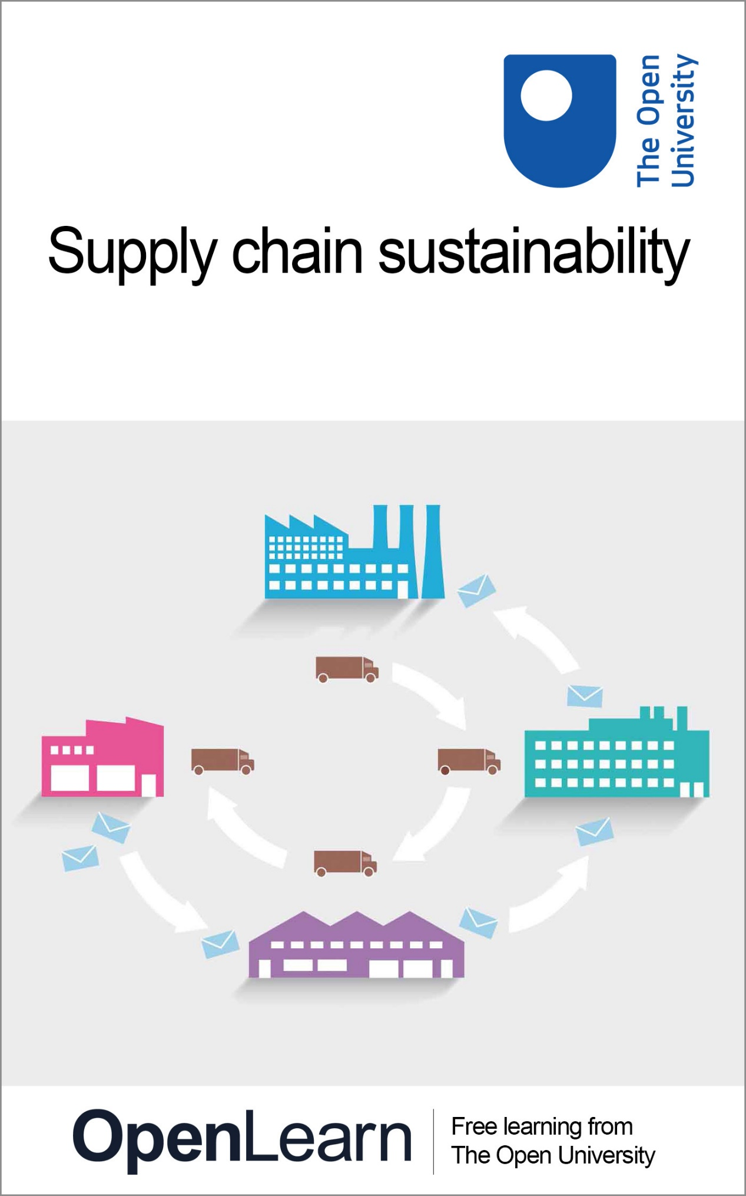

BB849_1 Supply chain sustainability

Supply chain sustainability

About this free course
This free course is an adapted extract from the Open University course BB849 Supply chain management www.open.ac.uk/postgraduate/modules/bb849.
This version of the content may include video, images and interactive content that may not be optimised for your device.
You can experience this free course as it was originally designed on OpenLearn, the home of free learning from The Open University –
www.open.edu/openlearn/money-business/leadership-management/supply-chain-sustainability/content-section-0.
There you’ll also be able to track your progress via your activity record, which you can use to demonstrate your learning.
Copyright © 2017 The Open University
Intellectual property
Unless otherwise stated, this resource is released under the terms of the Creative Commons Licence v4.0 http://creativecommons.org/licenses/by-nc-sa/4.0/deed.en_GB. Within that The Open University interprets this licence in the following way: www.open.edu/openlearn/about-openlearn/frequently-asked-questions-on-openlearn. Copyright and rights falling outside the terms of the Creative Commons Licence are retained or controlled by The Open University. Please read the full text before using any of the content.
We believe the primary barrier to accessing high-quality educational experiences is cost, which is why we aim to publish as much free content as possible under an open licence. If it proves difficult to release content under our preferred Creative Commons licence (e.g. because we can’t afford or gain the clearances or find suitable alternatives), we will still release the materials for free under a personal end-user licence.
This is because the learning experience will always be the same high quality offering and that should always be seen as positive – even if at times the licensing is different to Creative Commons.
When using the content you must attribute us (The Open University) (the OU) and any identified author in accordance with the terms of the Creative Commons Licence.
The Acknowledgements section is used to list, amongst other things, third party (Proprietary), licensed content which is not subject to Creative Commons licensing. Proprietary content must be used (retained) intact and in context to the content at all times.
The Acknowledgements section is also used to bring to your attention any other Special Restrictions which may apply to the content. For example there may be times when the Creative Commons Non-Commercial Sharealike licence does not apply to any of the content even if owned by us (The Open University). In these instances, unless stated otherwise, the content may be used for personal and non-commercial use.
We have also identified as Proprietary other material included in the content which is not subject to Creative Commons Licence. These are OU logos, trading names and may extend to certain photographic and video images and sound recordings and any other material as may be brought to your attention.
Unauthorised use of any of the content may constitute a breach of the terms and conditions and/or intellectual property laws.
We reserve the right to alter, amend or bring to an end any terms and conditions provided here without notice.
All rights falling outside the terms of the Creative Commons licence are retained or controlled by The Open University.
Head of Intellectual Property, The Open University

Contents
- Introduction
  - Introduction
- Learning outcomes
- 1 What do we mean by the term ‘sustainable supply chain’?
- 2 The environmental perspective
  - 2.1 The impact of logistics on the environment
  - 2.2 The impact of manufacturing and production on the environment
  - 2.3 The impact of waste on the environment
- 3 The financial perspective
  - 3.1 The traditional bottom line
- 4 The social perspective
  - 4.1 Ethics in the supply chain
- 5 The network perspective
  - 5.1 Stakeholders in the supply chain
  - 5.2 Best practice when working with stakeholders
- 6 The four perspectives of supply chain sustainability: a self-assessment
- Conclusion
- Keep on learning
- Acknowledgements
- Further reading
- References
- Solutions
- Descriptions

Introduction

Introduction
This free course, Supply chain sustainability, will define what is meant by a sustainable supply chain. This is important, because most of us will immediately (and often only) think of issues related to the environmental impact of the production and distribution of goods and services. Whilst the environmental perspective is certainly very important, it is not the only perspective. To get a holistic overview of supply chain sustainability, all the perspectives of supply chain sustainability should be considered. Once you have a general understanding of the supply chain sustainability, you will look at the environmental, the financial, the social, and the external stakeholder or network perspectives.
This OpenLearn course is an adapted extract from the Open University course BB849 Supply chain management.

Learning outcomes
After studying this course, you should be able to:
- understand what is meant by sustainability in the context of the supply chain
- explain the four perspectives of supply chain sustainability
- assess the degree of sustainability in your (or any other) organisation from each of these four perspectives, and provide suggestions for improving
- critically assess the extent of sustainability that is realistic in a given situation, and identify and explain the constraints to sustainability.

1 What do we mean by the term ‘sustainable supply chain’?
Let's start this course by having a closer look into what is actually meant by ‘sustainability’. The term is increasingly used in business, and generally it is used to indicate something good and positive about an organisation, process or product. But what does it really mean?
Think about the word ‘sustainable’ for a moment. What are the first things that come to mind? Here is a list of some possible answers:
- environmentally friendly
- lasting a long time
- continually growing
- organic
- biodegradable
- single earth living.
You may have come up with a very different list of words or ideas that mean something for you. This illustrates the difficulty with talking about sustainability. We all have a clear, but probably different (personal), view of what ‘sustainable’ means to us.
With this in mind, let’s now set out some common thoughts on what sustainability refers to in a business context. Crandall et al. (2015, p. 602) use the following definition: ‘sustainability, for a business, is the ability to keep operating successfully’. To these authors, a sustainable business is a business that can keep on doing its business. Anderson (2006) defines sustainable development as ‘development that meets the need of the present world without compromising the ability of the future generations to meet their own needs’ and give another angle to sustainability: that of not negatively impacting on future generations.
In sum, sustainability thus refers to an organisation’s ability to keep operating successfully without compromising the ability of future generations to meet their own needs.
In the following sections, you will review four perspectives of supply chain sustainability: the environmental perspective, the financial perspective, the social perspective and the external stakeholder or network perspective. These perspectives are illustrated in Figure 1.

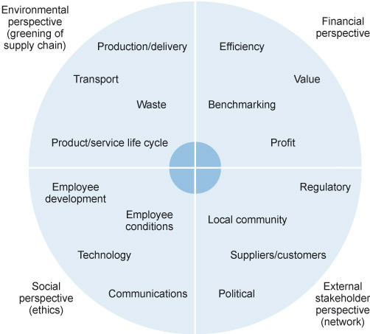
Figure 1 The four perspectives of supply chain sustainability
View description - Figure 1 The four perspectives of supply chain sustainability

2 The environmental perspective
Let’s now start the exploration of the sustainability perspectives with the perspective that tends to steal most of the limelight when talking about sustainability: the environmental perspective.

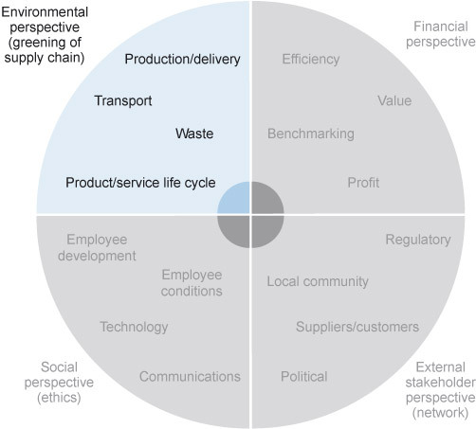
Figure 2 The environmental perspective
View description - Figure 2 The environmental perspective

What does ‘environmental performance’ mean?
When people say the word ‘environmental’ when talking about supply chain sustainability, they may have various things in mind. Let’s begin the exploration of the environmental perspective in Activity 1 by discussing and agreeing what we mean by ‘environmental performance’.

Activity 1 Defining environmental performance
15 minutes

Consider the term ‘environmental performance’. Note down the different areas that you think would need to be considered when evaluating the supply chain performance in that particular aspect.

Provide your answer...
View discussion - Activity 1 Defining environmental performance

2.1 The impact of logistics on the environment
When discussing logistics, both inbound and outbound logistics are considered. In other words, the movements involved in sourcing and replenishing the raw materials, components or finished goods needed for a business processes, as well as the movements of goods from an organisation to its customers, back to suppliers or out for disposal and recycling.
In the context of logistics, the prime concern tends to be pollution, or the impact of vehicle emissions into the atmosphere, onto the road or into the water. Vehicle emissions generally relate to burning fossil fuels and the gaseous and particulate emissions from the engines.
To get a sense of the scale of the impact that these emissions have on the environment, let’s have a look at the UK government’s transport statistics from 2016. Figure 3 shows the volume of freight moved each year. (A ‘tonne kilometre’ is the unit representing one tonne moved one kilometre, taking into account both weight and distance. So, 1 tonne moved 50 kilometres is the same as 50 tonnes moved 1 kilometre in this chart.) The chart shows that 76% of the freight moved in the UK was by road, and that that totalled 152 billion tonne-kilometres.

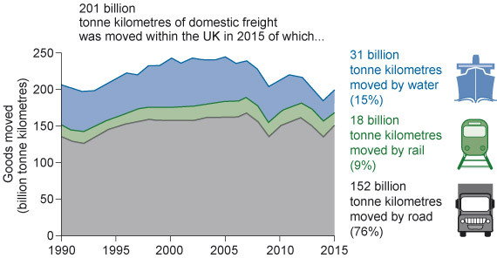
Figure 3 Domestic freight: goods moved by mode, 1990–2015
View description - Figure 3 Domestic freight: goods moved by mode, 1990–2015

If you link the tonne-kilometres to the statistics of greenhouse gas emissions, you can see that in 2014, 514.4 MtCO₂e (million tonnes of carbon dioxide equivalent) were released into the environment – 23% of which comes from us, transporting boxes of stuff from one link in the supply chain to another.
Now consider the logistics in your own organisation. In terms of raw materials, components and finished goods, what weight of goods is moved and how far? If you are based in the UK, what was your organisation’s contribution to the 152 billion tonne-kilometre figure of road transport? Was that contribution fully justifiable? To assess that, it is not only the weight and distance of the freight that needs to be considered; the way that the freight is transported is a key factor, as Figure 4 demonstrates.

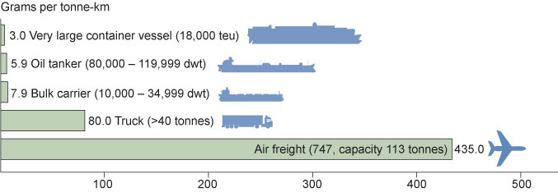
Figure 4 Comparison of typical CO₂ emission between modes of transport (IMO, 2009)
View description - Figure 4 Comparison of typical CO2 emission between modes of transport (IMO, 200 ...

In the discussion about the impact of logistics, we have predominantly focused on emissions by transport vehicles. We have not considered the environmental impact of constructing new roads, railways, airports or ports. These tend to be out of the direct control of the organisation, but are a result of the aggregate demand.
Let’s continue our discussion now by looking at the environmental impact of manufacturing and production.

2.2 The impact of manufacturing and production on the environment
When considering the environmental impact of production, we are looking at two key elements:
- the pollution caused by generating the energy used in production
- the pollution caused by the manufacturing process itself.

Pollution from energy production
Not just large traditional industries use lots of energy. For example, the information and communication technology (ICT) industry consumes massive amounts of power. However, in the absence of the large smoking chimneys that traditional industries have, this fact gets easily overlooked. The UK’s Parliamentary Office of Science and Technology (2008) predicts that ICT will be responsible for 3% of global emissions by 2020.
Just keeping the data available that facilitates a smoothly running supply chain requires vast amounts of energy. Have a look at the numbers in the United States:

US data centres consumed about 70 billion kilowatt-hours of electricity in 2014, the most recent year examined, representing 2 percent of the country’s total energy consumption, according to the study. That’s equivalent to the amount consumed by about 6.4 million average American homes that year. This is a 4 percent increase in total data centre energy consumption from 2010 to 2014, and a huge change from the preceding five years, during which total US data centre energy consumption grew by 24 percent, and an even bigger change from the first half of last decade, when their energy consumption grew nearly 90 percent.
(Sverdlik, 2016)

A total of 90% of all the energy used in a data centre goes to keeping the system cool. Admittedly, this is not just data required for the supply chain (it also includes videos of silly wet cats, and pictures of your colleagues on the beach), but you hopefully get the point.

Activity 2 Energy consumption in your organisation
20 minutes

In his book How Bad are Bananas?, Mike Berners-Lee calculates the carbon footprint of a vast range of items.
- A spam email, unopened, has a carbon footprint of approximately 0.3g CO₂e (carbon dioxide equivalent, the standard unit for measuring carbon footprints).
- An average email produces approximately 4g CO₂e.
- An email with a large attachment results in approximately 50g CO₂e. So an email with a long attachment sent to nine people has the same carbon impact as flying a tonne of freight one kilometre.
Consider the large energy consumers in your organisation.
- What proportion of the consumption is due to ICT?
- Does your organisation have a strategy for reducing energy use? Does that include ICT?

Provide your answer...

Pollution from the production or manufacturing process
In some cases, the pollution caused by the business activities is clearly visible. Consider the extreme examples of the BP Deepwater Horizon oil spill in 2010 or the explosion at the Chernobyl nuclear plant in 1986.
But in other cases, the pollution that is created in the production processes of goods and services is less obvious. Consider a power plant that draws water from a river to cool its systems and then returns the warmer water back to the river. Even if no chemicals are added to the water and safeguards are in place to ensure that fish are not drawn in, the warmer water changes the environment at the outlet. The changed profile of the water can alter the species that live at that point.
Any production facility will have a level of emissions to some degree. In most cases, the aim is to identify and control the emissions.
In the UK, it is the role of the Environment Agency to legislate and inspect operations. Similar agencies operate in the rest of Europe and across the world. Environment Agency officers liaise with organisations to ensure that environmental performance is optimised. Rigid limits are set for the release of pollutants, and these are enforced through legislation. The costs that organisations may incur by not complying with the regulations can be vast. By adopting explicit sustainability principles, organisations are more likely to meet the standards and avoid fines and clean-up costs.

2.3 The impact of waste on the environment
So what is waste? The common dictionary definition is ‘unwanted or unusable material, substances, or by-products’ (Oxford Living Dictionaries, n.d.).
According to the UK Department for Environment, Food and Rural Affairs (DEFRA), waste refers to ‘any substance or object which the holder discards or intends or is required to discard’ (DEFRA, 2012, p. 24).
Quite often we think of waste as being an issue for the production (operations) department, rather than in the context of supply chain management (SCM).
If you were to consider the ways in which SCM can impact on waste, either positively or negatively, you may come up with some of the following points:
- ordering too many items could result in the supplier or purchaser needing to dispose of the surplus
- waste created during transportation either through damage, perishability or obsolescence
- inaccurate specification of the products could lead to wastage or rework
- disposal of waste products.

With these in mind, read the following example:
In the early 1990s, at the start of the boom for home computers, a container ship left Japan with a container completely full of 2× speed CD drives for the home computer market.
The transportation time from the factory to the UK distributors was approximately eight weeks. By the time the delivery was made, the computer industry had moved on and the new standard for the CD drives was 8× speed. This meant that the shipment was unsellable, and so it was scrapped.

In this example, the potential outcome may not have been foreseeable, but ultimately the waste was due to the logistics – therefore, it was the ‘fault’ of SCM.
Besides the impact that these issues have on the environment, they often also imply significant costs. Therefore, when discussing supply chain sustainability, it is also important to consider the financial perspective. Let’s do that in the next section.

3 The financial perspective

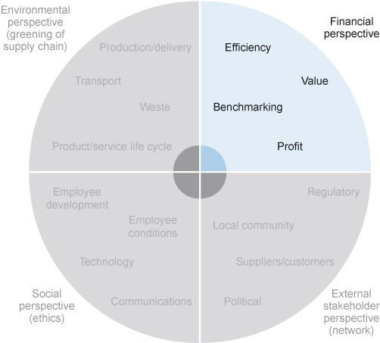
Figure 5 The financial perspective
View description - Figure 5 The financial perspective

Earlier you looked at Crandall et al.’s (2015, p. 602) definition of sustainability for a business as ‘the ability to keep operating successfully’; in other words, the ability of administrators to maintain an organisation over the long term.
However, the definition of financial sustainability, the second perspective of the sustainable supply chain that we address in this course, depends somewhat on the nature of the organisation. Specifically, it may vary between for-profit organisations and non-profits, as well as on the business structure, revenue structure and overarching goals of the organisation. For both for-profit and non-profit organisations, financial capacity consists of resources that give the organisation the ability to carry out its mission, seize opportunities and react to unexpected threats while maintaining general operations of the organisation. According to Woods Bowman at DePaul University in the US, ‘financial sustainability’ refers to the ability to maintain financial capacity over time (Bowman, 2011). Regardless of an organisation’s for-profit or non-profit status, the challenges of establishing financial capacity and financial sustainability are central in keeping the supply chain sustainable.

3.1 The traditional bottom line
The mission of any organisation is to become financially sustainable. For commercial organisations, this generally means that they must make a profit for its owners. In other words, when all costs made to run the business are deducted from the earnings (the traditional bottom line) a positive number should remain. Non-commercial organisations do not have this profit motive. However, this does not mean that they can ignore the financial aspect. Like commercial organisations, non-commercial organisations must cover the expenses that occur, be it through subsidies, grants, donations or other kinds of fundraising activities. The difference is that at the end of the financial period no surplus is expected.
The supply chain can make an important contribution towards the financial sustainability of an organisation. We have proposed four measures to use in our financial perspective:
- efficiency
- value
- benchmarking
- profit.

Activity 3 Personal impressions of financial performance
15 minutes

Using the four measures briefly mentioned above, please fill in Table 1. We do not want you to carry out any in-depth analysis of your organisation (or one that you are otherwise familiar with) at this point, but just to give your gut reaction to the headings.
For the rating, we want you to rate your organisational performance against the measure on a scale of 1 to 5, with 1 being very poor and 5 being excellent.
Make some notes on why you gave that rating and then consider what you could do to check your opinion.

Table 1 Personal impressions of an organisation’s financial performance
Measure | Rating | Basis for your rating | How could you check your rating?
Efficiency | Provide your answer... | Provide your answer... | Provide your answer...
Value | Provide your answer... | Provide your answer... | Provide your answer...
Benchmarking | Provide your answer... | Provide your answer... | Provide your answer...
Profit | Provide your answer... | Provide your answer... | Provide your answer...

Note that we are not asking you to share confidential information here. Rather, we want you to consider how you make these judgements without objective evidence to hand, and then what sorts of inquiry you might be able to undertake to confirm or modify your first impression.
There is no discussion for this activity.

4 The social perspective

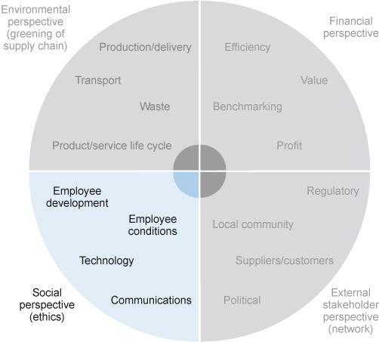
Figure 6 The social perspective on supply chain sustainability
View description - Figure 6 The social perspective on supply chain sustainability

In this section, we will be looking at the social and ethical aspects of supply chain management, or at least at a selection of them. Rather than presenting you with a comprehensive list of all the issues that you may encounter in this area, we seek to develop your awareness of the type of social issues that may affect your supply chain performance. Specifically, we will discuss the impact of poor performance of organisations with regards to their own staff and suppliers, both direct (tier one) and indirect suppliers (tier two up to the nth tier). Let’s begin our discussion by looking at the subject of ethics.

4.1 Ethics in the supply chain
So what are ethics and what does it mean to behave ethically? This may seem like a strange question, but there are different views on this.
There are multiple theories on ethics but we will touch on just two here: deontological ethics and utilitarian ethics as shown in Figure 7. To fully understand these two views would take dedicated study, but in a nutshell (and with a great degree of simplification) they are defined as follows:
- Deontologists believe that organisations should follow certain principles, no matter what the consequences. These include honesty and the treatment of people as an end in themselves rather than a tool to be used. Developed by Immanuel Kant in the eighteenth century, this ethical approach focuses on an individual following a moral obligation over a natural instinct, referred to by Kant as ‘the categorical imperative’. The focus of this ethical approach is everyday conduct rather than consequences.
- Utilitarians believe that the consequences of one’s actions are the important thing, and that organisations should work to deliver the greatest benefit to the greatest number of people. This approach can lead to a dispassionate evaluation of actions, comparing the number of people that benefit with the number of people who might suffer as a result of any actions. The focus is on the ultimate outcome rather than the conduct that leads to the actions.
We will use these two definitions to explore some areas to consider in the supply chain environment.

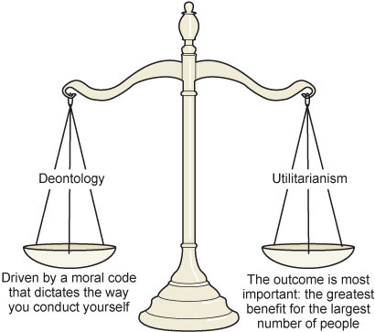
Figure 7 Two theoretical approaches for explaining ethics
View description - Figure 7 Two theoretical approaches for explaining ethics

Let’s have a look how these two definitions work in practice.

The UN approach to sustainability
A good example of an approach based on deontology would be the United Nations’ approach. For this institution, the idea of sustainable development is not new. In 1987, it commissioned a report that is still regarded as one of the seminal documents defining the ethical approach to sustainable development.
Commonly referred to as the Brundtland Commission report, the Report of the World Commission on Environment and Development: Our Common Future examined the threats faced by the world and suggested how we should move forward ‘towards sustainable development’.
Achieving social sustainability in the supply chain implies that individual organisations should not only review and assess their own business practices, but also consider the practices of the other members of the supply chain. In the next section, let’s delve deeper into the implications of questionable practices.

You are judged by who you do business with
Based on the utilitarian approach, if a supply chain is to be socially sustainable, all members of the supply chain need to comply with the prevailing expectations of the ultimate customer that this supply chain serves. It is not difficult to find examples of large organisations getting into costly troubles for supplying their customers with what turned out to be tainted goods. Around the turn of the century, sales of leading sportswear brand Nike were severely affected when it was discovered that their suppliers in Cambodia used child labour to produce their garments.
The Nike case has become a classic example in discussions about supply chain ethics ever since. Sadly, it has not led to an eradication of such questionable practices in the supply chain. Similar cases of malpractice continue making headlines. You may remember the 2012 fire in the garment factory of one of Wal-Mart subcontractors that killed 100 workers. Note the comment of the BBC journalist towards the end of the article (BBC News, (2012): ‘Fatal fires are common in Bangladesh’s large garment manufacturing sector. Lax safety standards, poor wiring and overcrowding are blamed for causing several deadly factory fires every year.’ Only six months after the deadly fire, in 2013, another garment factory in Bangladesh made headlines when it collapsed, killing 1000 workers inside who were making garments for, amongst others, the UK retailer Primark – this puts a 2014 Daily Mail article about Primark’s success in a different light. And if you thought that it couldn’t get any worse, what about the 2016 headline ‘Child refugees in Turkey making clothes for UK shops’ (BBC News), which implicated the supply chains of Marks and Spencer and ASOS.
In most instances, the above organisations did not seek out suppliers that were maintaining these deplorable labour practices, yet for a variety of reasons they ended up in the same supply chain. Having a thorough understanding of this perspective is therefore fundamental if you (or your company) would like to minimise the risk.
While very few of you would contemplate introducing the extreme practices observed in the sweatshop in your own organisations, assessing the way that you work with your direct and indirect supply chain partners makes an interesting exercise to see how you (or your organisation) is performing as a social citizen at a less extreme level.
Let’s now move on to the fourth and last perspective, the network perspective.

5 The network perspective

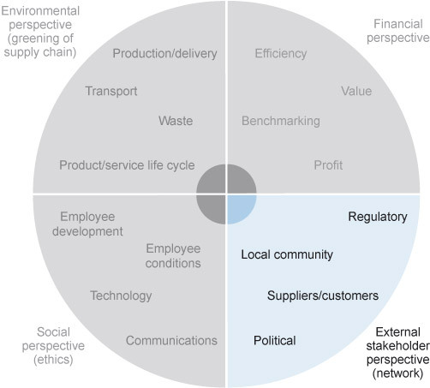
Figure 8 The network perspective on supply chain sustainability
View description - Figure 8 The network perspective on supply chain sustainability

The last dimension that we will explore in this course is the network perspective. Here, we will principally discuss the different stakeholders that impact your organisation and the best approaches that can be used with stakeholders in order to ensure the sustainability of your supply chain.

5.1 Stakeholders in the supply chain
In the broadest sense, a ‘stakeholder’ is any person, group or organisation that is impacted in some way by the action or inaction of another. In Activity 4 you will identify the external stakeholders and make a judgement on the impact that they might have on the supply chain.
The most commonly used definition of a stakeholder is: ‘groups and individuals who benefit from or are harmed by, and whose rights are violated or respected by, corporate actions’ (Freeman, 2001, p. 42).
In this section, we are particularly interested in the sustainability of stakeholders that are external to the organisation and whose impact contributes to a smoothly running supply chain. We will focus on:
- suppliers of raw materials, components and services
- governments imposing international and national regulations
- customers and consumers
- society in general
- competitors.

Activity 4: Analysing external stakeholder influence
15 minutes

Complete the following table and consider the potential impact that the sustainability of these five groups of stakeholders could have on the supply chain.

Table 2 The potential impact of stakeholders (A)
Stakeholder | Potential impact
Supplier | Provide your answer...
Governments | Provide your answer...
Customer/consumer | Provide your answer...
Society | Provide your answer...
Competitors | Provide your answer...

View discussion - Activity 4: Analysing external stakeholder influence

Although the direct impact of the sustainability of external stakeholders is not always obvious, organisations should manage their stakeholder relations or prepare for changes.

5.2 Best practice when working with stakeholders
We will now look at some approaches that can be used with stakeholders to enhance sustainability. First we will look at some research based on high-performing organisations; we will then apply the ideas to two very different UK businesses.
The book Sustainable Supply Chain Management: Practical Ideas for Moving Towards Best Practice (Cetinkaya et al., 2011) has some practical advice on how to manage sustainability across stakeholders, gathered from interviews with practitioners, industry experts, industry association representatives, academics and politicians:

Think locally, act globally
Gain a thorough understanding of how stakeholders in different countries and different sectors perceive your company’s sustainability performance, and of their expectations. This will allow you to use communication and collaboration strategies customised to suit individual supply chain partners.

Combine stakeholder communication with expertise and innovation
Do not outsource stakeholder relations to lawyers or consultants. Stakeholder relations are best run by experts and colleagues from the relevant business units, who fully understand the operations involved and can focus on innovation and continuous improvement.

Communicate and involve
Communication and involvement entails reporting, providing information, educating and forestalling confrontational behaviour, but also includes efforts to understand the needs, preferences and concerns of local communities and non-governmental organisations. Use a varied selection of platforms and channels for communication and stakeholder involvement, such as focus groups, opinion polls, formal progress review meetings, multi-stakeholder networks, websites with open forums, newsletters, canvassing of local businesses, community information displays, etc.

Collaborate and cooperate
Stakeholder involvement should be reciprocal. Take a proactive role and establish new types of relationships with regulatory stakeholders, including competitors. Aim to influence regulations and standards at the earliest opportunity where they affect their supply chain strategies.

Force a value-added, strategic and holistic approach

Consider the economic and social concerns of stakeholders strategically and accord top management commitment to them. Apply the concept of value-added at both financial and operational levels. This will lead to a different sustainable supply chain philosophy. Consider end-to-end supply chains as value chains, and think about unexplored resource inefficiencies and opportunity costs at the level of suppliers, channels, and customers. This will allow you to see regulatory stakeholders as innovation drivers, and will motivate the organisation to collaborate with regulators to shape incentives and develop sustainable supply chain solutions.
(adapted from Cetinkaya et al., 2011, p. 126)

Activity 5: Identifying best practice in stakeholder relationships
30 minutes

Having reviewed the above analysis, you should now put these ideas into practice.
Watch the following videos from Whitbread PLC and Technology Will Save Us (TWSU). Make notes of where you feel that Brodie or Henry are discussing points that link to the best practises that were discussed earlier.

Whitbread
Whitbread PLC is the UK’s largest hospitality company, owning Costa Coffee, Premier Inn, Beefeater Grill, Brewers Fayre, Table Table and Taybarns. Whitbread has outsourced its entire logistics operations for Premier Inn and Costa. Brodie McMillan, Logistic Director at Whitbread, talks us through the very close relationship Whitbread has with its logistics provider, Keuhne + Nagel. Brodie explains some of the technology and digital systems that enable Whitbread to exceed 98% on time and in full deliveries. Brodie makes it clear that this arrangement only works because of the level of trust and openness between the two organisations. Initially, Whitbread asked logistics companies to tender for the work; Keuhne + Nagel were the successful bidders and the partnership has grown ever since, with both organisations investing significant capital into the partnership.

Video content is not available in this format.
Whitbread overview: Brodie McMillan
View transcript - Whitbread overview: Brodie McMillan

TWSU
TWSU is a small business focused on inspiring kids and empowering parents to become creators of technology. With a range of ‘make it yourself kits’ and hundreds of digital tools and projects to support kids in learning though play, TWSU sells to more than 97 countries around the world. Henry Haslam, the Head of Production and Operations at TWSU, talks to us through the TWSU experience of international supply chain relationships.

Video content is not available in this format.
TWSU overview: Henry Haslam
View transcript - TWSU overview: Henry Haslam

Now write down some notes on:
- the extent to which you feel that these two organisations demonstrate good practice in stakeholder relationships
- how the different relationships discussed in the videos support the sustainability of each of the organisations.
There is no discussion for this activity.

Provide your answer...

With Activity 5 we have completed our review of the four perspectives. Now let’s pick up the learning from this course and apply the perspectives to your own context (that of the organisation that you work for or an organisation that you are otherwise familiar with).

6 The four perspectives of supply chain sustainability: a self-assessment
Now that you have reviewed the potential usefulness of the four perspective on supply chain sustainability, and you have seen a selection of examples and cases from practice, to wrap up this course, let’s do a self-assessment. Depending on the size of the organisation that you work for, and depending on your role and level, you may be very familiar with your context. But even then, we argue, it is good practice to assess, or re-assess, the performance of the organisation from these four perspectives.

Activity 6: Sustainable supply chain self-assessment
45 minutes

Taking into explicit consideration components of the four perspectives that we have discussed in this course, you should now analyse your organisation. Use this Excel spreadsheet to do the following:
- Rank how your organisation is performing for each aspect (good, average or poor).
- Rank the importance of the criteria for each aspect (low, medium or high).
Based on the rankings that you have given your organisation, the spreadsheet will return an outcome that a specific aspect is either ‘fine’, ‘needs to be watched’ or whether ‘action needs to be taken’.
For any aspect that is not ‘fine’, do the following:
- Analyse the causes and potential consequences that this may have on the sustainability of the supply chain.
- Devise a strategy for solving or improving the outcome of these underperforming aspects.
Taking into consideration your initial analysis (under 1 and 2) and your explanation and interpretations of the outcomes (under 3 and 4), now do the following:
- Revise the components under each of the perspectives and see if there are any measures that you can add in the table, then rank your organisation and explain your findings.
There is no discussion for this activity.

Conclusion
In this course, Supply chain sustainability, we discussed the sustainable supply chain, adopting Crandall et al.’s definition, which states that ‘sustainability, for a business, is the ability to keep operating successfully’. We introduced the four dimensions of supply chain sustainability (the environmental perspective, the social perspective, the network perspective and the financial perspective) and we have discussed the challenges of introducing changes in the business model.
If you are not (yet) directly involved in supply chain management, this course will increase your understanding of the function and your recognition of the importance that it has for the success of an organisation. If you are already working in the supply chain remit, it will offer you an opportunity to refresh and extend the knowledge and understanding that you already have. You will learn how to challenge the solutions that you have seen implemented in your own organisation and beyond.
This OpenLearn course is an adapted extract from the Open University course BB849 Supply chain management.

Keep on learning

Study another free course
There are more than 800 courses on OpenLearn for you to choose from on a range of subjects.
Find out more about all our free courses.

Take your studies further
Find out more about studying with The Open University by visiting our online prospectus.
If you are new to university study, you may be interested in our Access Courses or Certificates.

What’s new from OpenLearn?
Sign up to our newsletter or view a sample.

For reference, full URLs to pages listed above:
OpenLearn – www.open.edu/openlearn/free-courses
Visiting our online prospectus – www.open.ac.uk/courses
Access Courses – www.open.ac.uk/courses/do-it/access
Certificates – www.open.ac.uk/courses/certificates-he
Newsletter – www.open.edu/openlearn/about-openlearn/subscribe-the-openlearn-newsletter

Acknowledgements
This free course was written by Björn Claes and Rob Moore.
Except for third party materials and otherwise stated (see terms and conditions), this content is made available under a Creative Commons Attribution-NonCommercial-ShareAlike 4.0 Licence.
The material acknowledged below is Proprietary and used under licence (not subject to Creative Commons Licence). Grateful acknowledgement is made to the following sources for permission to reproduce material in this free course:
Images
Figure 3: Department of Transport, Transport Statistics Great Britain, December 2016. Reproduced under the terms of the OGL, www.nationalarchives.gov.uk/doc/open-government-licence.
Figure 4: International Chamber of Shipping, Shipping, World Trade and the Reduction of CO2 Emissions United Nations Framework Convention on Climate Change (UNFCCC), 2014.
Every effort has been made to contact copyright owners. If any have been inadvertently overlooked, the publishers will be pleased to make the necessary arrangements at the first opportunity.
Don't miss out
If reading this text has inspired you to learn more, you may be interested in joining the millions of people who discover our free learning resources and qualifications by visiting The Open University – www.open.edu/openlearn/free-courses.

Further reading
Further resources
Articles
Kaplan, R. S. and Norton, D. P. (1992) ‘The balanced scorecard – measures that drive performance’, Harvard Business Review, vol. 70, no. 1, pp. 71–9.
Kaplan, R. S. and Norton, D. P. (2007) ‘Using the balanced scorecard as a strategic management system’, Harvard Business Review, vol. 85, no. 7/8, pp. 150–61.
Useful websites
Transport statistics Great Britain: 2016: UK Government transport statistics
Energy and Air Pollution: World Energy Outlook Special Report: International Energy Agency report, 2015

References
Anderson, D. R. (2006) The critical importance of sustainability risk management, Risk Management, vol. 53, issue 4, pp. 66–74.
BBC News (2012) ‘Bangladesh factory fire “troubles” Walmart’, 27 November [Online]. Available at http://www.bbc.co.uk/news/world-asia-20506179 (Accessed 18 April 2017).
BBC News (2016b) ‘Child refugees in Turkey making clothes for UK shops’, 24 October [Online]. Available at http://www.bbc.co.uk/news/business-37716463 (Accessed 18 April 2017).
Berners-Lee, M. (2011) How Bad are Bananas? The Carbon Footprint of Everything, Vancouver, Greystone Books.
Bowman, W. (2011) ‘Financial capacity and sustainability of ordinary nonprofits’, Nonprofit Management & Leadership, vol. 22, no. 1, pp. 37–51.
Cetinkaya, B., Cuthbertson, R., Ewer, G., Klaas-Wissing, T., Piotrowicz, W. and Tyssen, C. (2011) Sustainable Supply Chain Management: Practical Ideas for Moving Towards Best Practice, Springer, Berlin Heidelberg.
Crandall, R. E., Crandall, W. R. and Chen, C. C. (2015) Principles of Supply Chain Management, 2nd edn, Boca Raton, FL, CRC Press.
Department for Environment, Food & Rural Affairs (DEFRA) (2012) ‘Guidance on the legal definition of waste and its application’ [Online]. Available at https://www.gov.uk/government/uploads/system/uploads/attachment_data/file/69590/pb13813-waste-legal-def-guide.pdf (Accessed 13 April 2017).
Department for Transport (DfT) (2016) Transport Statistics: Great Britain 2016, London, Department for Transport. Available at https://www.gov.uk/government/statistics/transport-statistics-great-britain-2016 (Accessed 13 April 2017).
Fishman, C. (2006) ‘The Wal-Mart effect and a decent society: who knew shopping was so important?’, Academy of Management Perspectives, vol. 20, no. 3, pp. 6–25.
Freeman, R.E. (2001) ‘Stakeholder theory of the modern corporation’, in Hoffman, W. M., Frederick, R. E. and Schwartz, M. S. (eds) Business Ethics: Readings and Cases in Corporate Morality, 4th edn, Boston, MA, McGraw-Hill pp. 39–48.
International Chamber of Shipping (ICS) (n.d.) ‘Comparison of CO2 emissions by different modes of transport’ [Online]. Available at http://www.ics-shipping.org/shipping-facts/environmental-performance/comparison-of-co2-emissions-by-different-modes-of-transport (Accessed 13 April 2017).
International Maritime Organization (IMO) (2009) Second IMO GHG Study 2009, London, International Maritime Organization. Available at http://lngbunkering.org/lng/sites/default/files/2009%2C%20IMO%2C%20Second%20IMO%20GHG%20Study.pdf (Accessed 21 April 2017).
Kenyon, P. (2000) ‘Gap and Nike: no sweat?’, BBC, 15 October [Online]. Available at http://news.bbc.co.uk/1/hi/programmes/panorama/archive/970385.stm (Accessed 18 April 2017).
London, B. (2014) ‘No shame in shopping at Primark anymore: high street chain in a “retailing powerhouse” that has “perfected art of mixing low prices with high fasion”’, MailOnline, 4 November [Online]. Available at http://www.dailymail.co.uk/femail/article-2820244/No-shame-shopping-Primark-anymore-High-street-chain-retailing-powerhouse-perfected-art-mixing-low-prices-high-fashion.html (Accessed 18 April 2017).
North, A. (2013) ‘The dark underworld of Bangladesh’s clothes industry’, BBC, 26 April [Online]. Available at http://www.bbc.co.uk/news/world-asia-22306135 (Accessed 15 September 2017).
Oxford Living Dictionaries (n.d.) Definition of waste in English [Online], Oxford University Press. Available at https://en.oxforddictionaries.com/definition/waste (Accessed 18 May 2017).
Parliamentary Office of Science and Technology (2008) ‘Postnote: ICT and CO₂ emissions’ [Online]. Available at http://www.parliament.uk/documents/post/postpn319.pdf (Accessed 13 April 2017).
Sverdlik, Y. (2016) ‘Here’s how much energy all US data centers consume’, Data Knowledge Center [Online]. Available at http://www.datacenterknowledge.com/archives/2016/06/27/heres-how-much-energy-all-us-data-centers-consume/ (Accessed 13 April 2017).
United Nations (n.d.) ‘Report of the World Commission on Environment and Development: our common future’ [Online]. Available at http://www.un-documents.net/wced-ocf.htm (Accessed 21 April 2017).

Solutions

Activity 1 Defining environmental performance

Discussion
You will likely have come up with a long and diverse list of areas that will probably have been influenced by the industry you are employed in (or which you kept in mind otherwise). It will be impossible to discuss all the areas you have come up with, so let’s look at two aspects that will likely have featured prominently on your list: pollution (the release of unwanted matter into the environment) and changes to the ecosystem (alterations in the local habitats or environments because of the activities of the supply chain). We will explore these two aspects in the following areas of the supply chain:
- logistics activities
- manufacturing and production activities
- waste disposal activities
Back to - Activity 1 Defining environmental performance

Activity 4: Analysing external stakeholder influence

Discussion
Here are some of our thoughts:

Table 2 The potential impact of stakeholders (B)
Stakeholder | Potential impact
Supplier | Depending on the nature of the product or service, an unsustainable supply could cause inconvenience in sourcing a replacement, raise costs through limited supply, or threaten viability if the product was unique or commercially sensitive. Consider the impact if all of your logistics was carried out by a third party that became unsustainable.
Governments | Governments under pressure may react in different ways. There may be tax incentives to attract business, tax levies to protect national interests, or incentives or levies to support initiatives or targets (climate change or emissions). At the time of writing, the tax position of Google in Ireland and the trading impacts of Brexit are yet to be fully established.
Customer/consumer | Some of the ethical issues in the previous section could impact on the willingness of customers to trade with an organisation. The sustainability of the market could impact on the sustainability of the supply chain; without demand for the product or service, there is no supply chain.
Society | Peer pressure cannot be underestimated, as any parent queuing up at Christmas to buy the latest ‘must have’ toy that is running out of stock will know. Society can have a massive impact on demand, both positive and negative. Society as a whole tends to operate on perceptions rather than reasoned fact.
Competitors | It may seem strange to include competitors in the list of stakeholders, but the sustainability of the competition could have a major impact on the organisation. Consider the impact of a major competitor going out of business – this could increase opportunities for the organisation but could also drive up prices, leading customers to seek alternatives that may damage the market in the long term. Conversely, a significant success of a competitor may eat into market share but could also be a catalyst for the development of the market.

Back to - Activity 4: Analysing external stakeholder influence

Descriptions

Figure 1 The four perspectives of supply chain sustainability
Figure 1 is composed of four quadrants representing the four perspective of supply chain sustainability. The upper-left quadrant is labelled ‘Environmental perspective (greening of supply chain)’ and includes production/delivery, transport, waste, and product/service life cycle. The upper-right quadrant is labelled ‘Financial perspective’ and includes efficiency, value, benchmarking and profit. The lower-left quadrant is labelled ‘Social perspective (ethics)’ and includes employee development, technology, employee conditions and communications. The lower-right quadrant is labelled ‘External stakeholder perspective (network)’ and includes local community, regulatory, suppliers/customers, and political.
Back to - Figure 1 The four perspectives of supply chain sustainability

Figure 2 The environmental perspective
Figure 2 is composed of four quadrants representing the four perspective of supply chain sustainability. The upper-left quadrant (highlighted) is labelled ‘Environmental perspective (greening of supply chain)’ and includes production/delivery, transport, waste, and product/service life cycle. The upper-right quadrant is labelled ‘Financial perspective’ and includes efficiency, value, benchmarking and profit. The lower-left quadrant is labelled ‘Social perspective (ethics)’ and includes employee development, technology, employee conditions and communications. The lower-right quadrant is labelled ‘External stakeholder perspective (network)’ and includes local community, regulatory, suppliers/customers, and political.
Back to - Figure 2 The environmental perspective

Figure 3 Domestic freight: goods moved by mode, 1990–2015
Figure 3 is a chart produced by the UK Department of Transport that shows the number of tonne kilometres of domestic freight that was moved within the UK between 1990 and 2015 for three transport modes: road, rail and water. It shows that in 2015, 152 billion tonne-kilometres were moved by road (76% of the total), 18 billion tonne-kilometres were moved by rail (9% of the total), and 31 tonne-kilometres were moved by water (15% of the total).
Back to - Figure 3 Domestic freight: goods moved by mode, 1990–2015

Figure 4 Comparison of typical CO2 emission between modes of transport (IMO, 2009)
The figure shows a bar chart with five horizontal bars illustrating the typical CO₂ emissions in grams per tonne kilometre in 2009. The upper bar shows that very large container vessels emit 3 grams per tonne kilometre; the bar below that shows that oil tankers emit 5.9 grams per tonne-kilometre; the bar below that shows that bulk carriers emit 7.9 grams per tonne kilometre; the bar below that shows that trucks emit 80 grams per tonne-kilometre; and the lowest bar shows that air freight emits 435 grams per tonne-kilometre.
Back to - Figure 4 Comparison of typical CO2 emission between modes of transport (IMO, 2009)

Figure 5 The financial perspective
Figure 5 is composed of four quadrants representing the four perspective of supply chain sustainability. The upper-left quadrant is labelled ‘Environmental perspective (greening of supply chain)’ and includes production/delivery, transport, waste, and product/service life cycle. The upper-right quadrant (highlighted) is labelled ‘Financial perspective’ and includes efficiency, value, benchmarking and profit. The lower-left quadrant is labelled ‘Social perspective (ethics)’ and includes employee development, technology, employee conditions and communications. The lower-right quadrant is labelled ‘External stakeholder perspective (network)’ and includes local community, regulatory, suppliers/customers, and political.
Back to - Figure 5 The financial perspective

Figure 6 The social perspective on supply chain sustainability
Figure 6 is composed of four quadrants representing the four perspective of supply chain sustainability. The upper-left quadrant is labelled ‘Environmental perspective (greening of supply chain)’ and includes production/delivery, transport, waste, and product/service life cycle. The upper-right quadrant is labelled ‘Financial perspective’ and includes efficiency, value, benchmarking and profit. The lower-left quadrant (highlighted) is labelled ‘Social perspective (ethics)’ and includes employee development, technology, employee conditions and communications. The lower-right quadrant is labelled ‘External stakeholder perspective (network)’ and includes local community, regulatory, suppliers/customers, and political.
Back to - Figure 6 The social perspective on supply chain sustainability

Figure 7 Two theoretical approaches for explaining ethics
The figure shows a two-armed scale balancing two theoretical approaches to ethics. The left arm of the scale is labelled ‘Deontology’, which is driven by a moral code that dictates the way you conduct yourself. The right arm of the scale is labelled ‘Utilitarianism’, where the outcome is most important: what gives the greatest benefit for the largest number of people?
Back to - Figure 7 Two theoretical approaches for explaining ethics

Figure 8 The network perspective on supply chain sustainability
Figure 8 is composed of four quadrants representing the four perspective of supply chain sustainability. The upper-left quadrant is labelled ‘Environmental perspective (greening of supply chain)’ and includes production/delivery, transport, waste, and product/service life cycle. The upper-right quadrant is labelled ‘Financial perspective’ and includes efficiency, value, benchmarking and profit. The lower-left quadrant is labelled ‘Social perspective (ethics)’ and includes employee development, technology, employee conditions and communications. The lower-right quadrant (highlighted) is labelled ‘External stakeholder perspective (network)’ and includes local community, regulatory, suppliers/customers, and political.
Back to - Figure 8 The network perspective on supply chain sustainability

Whitbread overview: Brodie McMillan

Transcript
BRODIE MCMILLAN
We move around 56 million cases a year. We are second to McDonald's in terms of size in the food service sector. So it's a big, big operation. We work with about 125, 130 vehicles plus rented in vehicles that come in to handle the additional volume as we grow. The volume throughput has grown by 70 per cent in the last five years, 35 per cent in the last two. So handling that is complex.
The way that we do that is to run both the Costa and WHR – Whitbread Hotels and Restaurants – operation under the one roof. That allows us to use the larger vehicles, which we use for WHR, which are 18 tonnes or 26 tonners whereas the Costa workhorse is a 14 tonner. Because we deliver to Costa 24 hours a day, we can get more deliveries done at night. So we use the WHR fleet overnight because they can get more drops. And so we get all the benefit of that within the supply chain, being able to use both fleets, if you like – similarly, the labour and the workforce.
So, in terms of how we try and control that, we keep both businesses, albeit separate, through the same supply chain channel. If you take Kuehne + Nagel, for existence, our partner for food and for consumables, that's going on at many different levels. So there is some straightforward transactional stuff that is also an awful lot of day-to-day activity where we are sitting down and talking and meeting with them.
Trade Team delivers our drinks, for instance. Trade Team is operated on a composite model – not a dedicated model, which this one is. So that requires a different level of engagement, although we are talking to Trade Team about a number of quite exciting opportunities for the future in terms of looking what else we can do with them other than just delivering drinks.
[ON SCREEN] Relationship with customers
Well, it depends how you classify ‘customer’. I suppose each of the brands are our customer because we're responsible for making sure they get what they ordered on time and in full. We are operating at about 99.5, 99.6 per cent availability quota, which is exceptional in our industry. It comes with a cost, but the cost of not delivering it is greater in our opinion than the cost of actually achieving that level. So there's that customer.
And then, clearly, there is the businesses' customer, which is the end user, either the person sitting in the restaurant eating the meal or the person going to bed in a Premier room. And we do a lot of surveys, a lot of customer surveys. There's a lot of feedback that comes into Whitbread.
[ON SCREEN] Delivering on time and in full
The biggest challenge is to make sure that you're delivering the product on time and in full. And that's, I suppose, what drives everything. The consequences of not doing that, clearly, are additional costs. What leads to that going wrong could be as elementary as getting the forecasting wrong, someone making an incorrect entry on to the order level so that the stock hasn't come in.
70 per cent of our stock is what we call ‘over the bank’, which is another expression for just in time. And that's what we call ‘pick to zero’. That's a huge proportion of what's the day's activity. You know, if it's not here, it's not here. If it hasn't come in, it hasn't come in. You're not going to get any more of that whereas the stock items, you can always repick and send out.
But it's not quite the same thing as getting your herbs delivered from Kent into Scotland when the delivery wasn't successful this morning. It's just not going to happen.
We've got people waiting at a hotel or at a restaurant for the delivery to arrive. We work on a one-hour delivery window. So that's how we calculate whether it's on time or not. So the staff is geared to know that, if their delivery's at 10 o'clock, there are sufficient staff there to receive it at 10 o'clock. If you arrive two hours later, the staff won't be there.
Back to - Whitbread overview: Brodie McMillan

TWSU overview: Henry Haslam

Transcript
HENRY HASLAM
Essentially we have two different types of supply chain currently. We have two types of product, one that's essentially a very low-tech kit product that the consumer actually assembles themselves, which is what we've grown up on. It's what we've sold over the last three, four years. And that involves a lot of procurement from, essentially, UK, European and Chinese manufacturers or distributors.
So about 50 per cent of our products come through distributors, electronics distributors. And they're based in the UK and in continental Europe. And about 50 per cent of our components will come direct from manufacturers, typically in China. And so what we do is we, essentially, source one of the two.
And what allows us to make that decision is the cost, the landed cost of these components in the UK and in our manufacturing site, which is here in London. And so we'll look at things like the cost at the supplier but also the transportation cost, any duties and taxes, and also minimum order quantities. So when you're going out to the Far East, there are large minimum order quantities that we need to address.
And so, once we've made that decision, we will procure those components. And they all come in bulk to our manufacturing facility – our mini factory, as we like to call it – here in London where the kits are actually assembled. So we have local labour coming in and making the kits. And then, from here, they go to one of our two fulfilment centres. So we have one fulfilment centre in the UK – the Heathrow Airport – and one fulfilment centre in New Jersey to serve the US market.
With a new product that we're bringing out, there are actually more advanced manufacturing techniques involved, which we don't have capability of doing internally. And so I've actually appointed an original design provider here in China who are going to help us take our design, do the design for manufacture. So that's looking at the printed circuit boards and making sure they're right for the machinery; looking at the plastics, making sure that, when you're injection moulding them, they will come out correctly and you're not going to get any marks, etc.; and actually help us to bring that product to market. And so that will come directly from China and will go to our fulfilment centres without us touching it from our mini factory here in London.
[ON SCREEN] Relationships with customers & suppliers
From a customer's perspective, our two main channels are direct to retailers. So the retailers will buy from us in bulk. And they, obviously, fulfil from either on their own websites or in their own stores. And also we have our own direct customers on our own e-commerce site.
So, from a customer perspective, we're trying to make sure we have a deeper relationship with them, one, from an e-commerce perspective so that we can understand why they're purchasing from us. And supply chain makes a huge part of the customer journey. So, yes, you can have a great customer journey online. And, like, you can buy the product very well.
But, obviously, you have to fulfil it in the timelines that you're giving them, etc. So we think we have an integral part in the whole customer experience. And so understanding what people want, when they want it – so convenient, speed, etc. – balancing that is interesting for us.
Similarly, from a retail perspective, it's very important, from our own perspective from inventory holding requirements, that we have a view of when orders are going to come in and when orders are going to be required. So we work closely with our retailers to help us understand when they want their orders so that we can plan effectively and we're not short on stock or have too much stock, etc.. So we really push that relationship to try and work out when we need the stock and where we need the stock.
From a supplier perspective, we have two types of supply, really – some that we just place orders with and they'll fulfil the orders and there's no real relationship there. But the distributors, we tend to have a better relationship. And we do a bit of co-planning with them. So we will forecast out 18 months. And we'll say, these are our requirements likely to be over the next six months. And so they can take those requirements into consideration so they can then plan their supply chain, plan their orders, manage their costs a bit more effectively.
But it also helps us to make sure that they have the stock that we need when we need it. So it's very much a collaborative planning exercise to say, OK, this is how much we're going to need and when we're going to need it. And then they can make sure that they have the correct stock and they're not overstocked.
And so, when we have issues with our supply chain, it is typically when we have the transactional relationships where we just order from them. There's no planning. There's no understanding of their stock levels. Generally, the suppliers we have a better relationship with – the better planning relationship with – we tend to have the stock when we need the stock because of the fact that we've planned out a bit further in advance.
Back to - TWSU overview: Henry Haslam

