

ALT_1 Managing my money

Managing my money
This content was created and adapted within The Open University and originally published as an open educational resource on the OpenLearn website – http://www.open.edu/openlearn/. This content may include video, images and interactive content that may not be optimised for your device. To view the original version of this content please go to OpenLearn – http://www.open.edu/openlearn/.
If reading this text has inspired you to learn more, you may be interested in joining the millions of people who discover our free learning resources and qualifications by visiting The Open University – http://www.open.ac.uk/choose/ou/open-content.
Copyright © 2014 The Open University
Except for third party materials and/or otherwise stated (see terms and conditions – http://www.open.ac.uk/conditions) the content in OpenLearn and OpenLearn Works is released for use under the terms of the Creative Commons Attribution-NonCommercial-ShareAlike 4.0 Licence – http://creativecommons.org/licenses/by-nc-sa/4.0/deed.en_GB.
In short this allows you to use the content throughout the world without payment for non-commercial purposes in accordance with the Creative Commons non commercial sharealike licence. Please read this licence in full along with OpenLearn terms and conditions before making use of the content.
When using the content you must attribute us (The Open University) (the OU) and any identified author in accordance with the terms of the Creative Commons Licence.
The Acknowledgements section is used to list, amongst other things, third party (Proprietary), licensed content which is not subject to Creative Commons licensing. Proprietary content must be used (retained) intact and in context to the content at all times. The Acknowledgements section is also used to bring to your attention any other Special Restrictions which may apply to the content. For example there may be times when the Creative Commons Non-Commercial Sharealike licence does not apply to any of the content even if owned by us (the OU). In these stances, unless stated otherwise, the content may be used for personal and non-commercial use. We have also identified as Proprietary other material included in the content which is not subject to Creative Commons Licence. These are: OU logos, trading names and may extend to certain photographic and video images and sound recordings and any other material as may be brought to your attention.
Unauthorised use of any of the content may constitute a breach of the terms and conditions and/or intellectual property laws.
We reserve the right to alter, amend or bring to an end any terms and conditions provided here without notice.
All rights falling outside the terms of the Creative Commons licence are retained or controlled by The Open University.
Head of Intellectual Property, The Open University

Contents
- Week 1: Financial planning and the life course
  - Introduction
  - 1.1 The economic backdrop
    - 1.1.1 The life course
    - 1.1.2 The life course game
    - 1.1.3 Your life plan
    - 1.1.4 Starting your financial plan
    - 1.1.5 Prioritising
  - 1.2 Your personality can seriously affect your finances
    - 1.2.1 Betting the house
  - 1.3 Building your financial planning model
    - 1.3.1 Applying the financial planning model
    - 1.3.2 Goals – the social and economic context
  - 1.4 Try the bad habits test
  - 1.5 Week 1 quiz
  - 1.6 Week 1 round-up
  - 1.7 Further reading
- Week 2: Income, taxation and benefits
  - Introduction
  - 2.1 Income, wealth and assets
    - 2.1.1 Income or asset?
    - 2.1.2 Incomes and inflation
    - 2.1.3 Measuring real incomes
  - 2.2 Taxation and benefits
    - 2.2.1 Calculating Income Tax
    - 2.2.2 Setting Income Tax rates
    - 2.2.3 National Insurance
    - 2.2.4 State benefits
    - 2.2.5 Benefits in transition
    - 2.2.6 Government minister and benefits reform
    - 2.2.7 State benefits – inflation and tapers
  - 2.3 Managing your budget
    - 2.3.1 Your budget – the income side
  - Week 2 quiz
  - Week 2 round-up
- Week 3: Expenditure and budgeting
  - Introduction
  - 3.1 What are your spending habits?
    - 3.1.1 Budgeting – the basics
    - 3.1.2 Meet Jenny
    - 3.1.3 Jenny's profile
    - 3.1.4 Jenny’s budget (Stage 1: assess the situation)
    - 3.1.5 The budget – the average month
  - 3.2 Setting a budget – things you need to think about
    - 3.2.1 Jenny’s options (Stage 2: decide on a financial plan)
    - 3.2.2 High street shopping in your kitchen
    - 3.2.3 Spotting dodgy websites
    - 3.2.4 The dodgy website – what did you spot?
    - 3.2.5 Heuristics and spending
    - 3.2.6 How to trim your expenditure
    - 3.2.7 Consumer society in 2018
  - 3.3 Jenny’s spending and her goals
    - 3.3.1 Jenny adjusts her budget (Stage 3: acting on the financial plan)
    - 3.3.2 Budgeting – taking control
    - 3.3.3 Ways of saving
    - 3.3.4 Budgeting (Stage 4: reviewing the financial plan)
    - 3.3.5 Now complete your budget
  - Week 3 quiz
  - Week 3 round-up
- Week 4: Debt and borrowing
  - Introduction
  - 4.1 Personal debt
    - 4.1.1 Debt and interest – some basics
    - 4.1.2 More on interest
    - 4.1.3 How much interest?
    - 4.1.4 Compounding of interest
    - 4.1.5 What determines the level of interest rates?
    - 4.1.6 Real interest rates
  - 4.2 Annual Percentage Rate (APR) of interest
    - 4.2.1 Types of interest rate
    - 4.2.2 Interest rates – fixed or variable?
    - 4.2.3 Individual interest rates
    - 4.2.4 The credit scoring game
    - 4.2.5 Credit scores – the outcome
  - 4.3 Meet the lenders
    - 4.3.1 Borrowing can take many forms
    - 4.3.2 Making borrowing decisions
    - 4.3.3 Affordability
    - 4.3.4 Tips when borrowing
  - Week 4 quiz
  - Week 4 round-up
- Week 5: Savings and investments
  - Introduction
  - 5.1 Managing savings and investments
    - 5.1.1 Why should households save?
    - 5.1.2 Savings and the life course
    - 5.1.3 Life’s events and savings
  - 5.2 Understanding savings products
    - 5.2.1 Variable rate and fixed rate savings products
    - 5.2.2 Spot the highest Annual Equivalent Rate (AER)
    - 5.2.3 Savings accounts on offer
    - 5.2.4 Why savings rates differ
    - 5.2.5 Savings accounts – the risks
  - 5.3 Understanding investments
    - 5.3.1 Shares
    - 5.3.2 Share prices do go up and down
    - 5.3.3 Are some shares riskier than others?
    - 5.3.4 Share price volatility
    - 5.3.5 Bonds (fixed interest investments)
    - 5.3.6 Investment funds
  - 5.4 What are the best performing investments over the long term?
    - 5.4.1 What is the best long-term investment?
    - 5.4.2 How investments are taxed
  - Week 5 quiz
  - Week 5 round-up
- Week 6: Housing and the household balance sheet
  - Introduction
  - 6.1 Housing and the household balance sheet
    - 6.1.1 The mortgage market
    - 6.1.2 Repaying your mortgage
    - 6.1.3 The costs of buying a home
    - 6.1.4 How much does it cost?
    - 6.1.5 Leasehold and freehold – some facts
  - 6.2 Selling property, re-mortgaging and housing as an investment
    - 6.2.1 Mortgages – the risks
    - 6.2.2 Financial planning when buying a home
    - 6.2.3 Remortgaging
    - 6.2.4 Remortgaging – a few sums
    - 6.2.5 Housing as an investment
    - 6.2.6 Spotting the risks
  - 6.3 The household balance sheet
    - 6.3.1 Completing your household balance sheet
    - 6.3.2 Targeting the current asset ratio
    - 6.3.3 Your household balance sheet – gearing
    - 6.3.4 Can gearing predict a crisis?
    - 6.3.5 Linking the balance sheet to income and expenditure
  - Week 6 quiz
  - Week 6 round-up
- Week 7: Pensions
  - Introduction
  - 7.1 Planning for a happy retirement
    - 7.1.1 State pensions
    - 7.1.2 The new flat-rate state pension
    - 7.1.3 Understanding the new flat-rate pension
    - 7.1.4 Occupational pensions
    - 7.1.5 Workplace pensions
    - 7.1.6 Calculating pension income
  - 7.2 Personal pensions
    - 7.2.1 Moving to average salary pensions
    - 7.2.2 Funded and pay-as-you-go pensions
    - 7.2.3 The 2015 pensions revolution: freeing up access to pension pots
    - 7.2.4 The challenges of the pension revolution
    - 7.2.5 Planning ahead for your retirement
    - 7.2.6 Financial planning when saving for retirement
    - 7.2.7 Spending money in retirement
  - 7.3 Planning ahead for your pension
    - 7.3.1 Pensions and retirement – a social revolution
    - 7.3.2 Acting on and reviewing your pension plan
    - 7.3.3 Take control
  - Week 7 quiz
  - Week 7 round-up
  - Further reading
- Week 8: Insurance
  - Introduction
  - 8.1 Insurance – setting the scene
    - 8.1.1 To insure or not to insure?
    - 8.1.2 Why do you buy insurance?
    - 8.1.3 Mick sorts out his insurance
    - 8.1.4 Apply Stages 1 and 2 of the financial planning model to insurance
    - 8.1.5 Apply Stages 3 and 4 of the financial planning model to insurance
  - 8.2 Home insurance
    - 8.2.1 Keeping down the cost of home insurance
    - 8.2.2 Motor insurance
    - 8.2.3 How to keep down motor insurance premiums
    - 8.2.4 Travel insurance
    - 8.2.5 Other general insurance
    - 8.2.6 Reviewing your insurance
  - 8.3 Life insurance and other types of insurance
    - 8.3.1 Health insurance
    - 8.3.2 Income protection insurance
    - 8.3.3 Gender and insurance
    - 8.3.4 Winners and losers?
  - End-of-course test
  - End-of-course guide and round-up
- References
- Acknowledgements

Week 1: Financial planning and the life course

Introduction
Before you start, The Open University would really appreciate a few minutes of your time to tell us about yourself and your expectations of the course. Your input will help to further improve the online learning experience. If you’d like to help, and if you haven't done so already, please fill in this optional survey.
Martin Upton is your educator and guide through the course. He is Director of the True Potential Centre for the Public Understanding of Finance, based at The Open University Business School. He’ll meet you at the start of each week of the course to tip you off about highlights and challenges, to remind you of what you’ve learned and to help you make the most of Managing my money. Note that each of the eight weeks of the course is designed to be studied over a period of three hours, ideally with one week being studied per week.

Video content is not available in this format.
View transcript - Uncaptioned interactive content

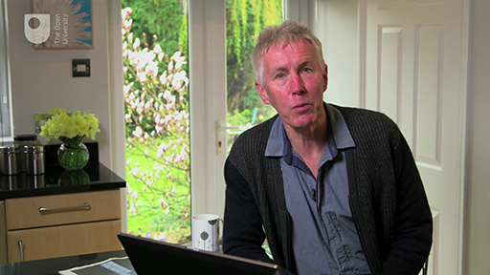

As the course progresses you’ll also meet personal finance expert Jonquil Lowe from The Open University.

Your financial profile
Some of the coolest features are the financial challenges, planners and calculators you get to explore throughout the course. See how you score in the financial bad habits test, build up your personal budget and household balance sheet, and develop your own ‘fact find’ to take away at the end of the course. Your fact find is available to use throughout the course as a record of your goals and financial circumstances. You can download your fact find now so that you’re ready to use it later this week. Record your own details and, if you wish, those of your partner.
This fact find is different to the documents you complete when acquiring financial products like investments and mortgages. The fact find for Managing my money is intended to provide a full summary our personal financial circumstances. When acquiring specific financial products your financial adviser or financial product provider (e.g. your bank) will only require details about your financial circumstances that are relevant to the financial product you are intending to acquire.
You can also access a handy short glossary to the course.

A note about financial advice
This course provides the information, frameworks and financial planning guidance needed to manage your finances and to assist in making financial decisions.
However, course contents do not constitute ‘advice’ with regard to which specific financial products you should use or which financial services providers you should do business with. Consequently the course educators and facilitators cannot answer questions about matters relating to such financial advice.
If you need specific individual financial advice you should contact an authorised financial firm or financial adviser.
This course is presented with the kind support of True Potential LLP.
The True Potential Centre for the Public Understanding of Finance (True Potential PUFin) is a pioneering Centre of Excellence for research in the development of personal financial capabilities. The establishment and activities of True Potential PUFin have been made possible thanks to the generous support of True Potential LLP, which has committed to a five-year programme of financial support for the Centre totalling £1.4 million

1.1 The economic backdrop
Everyone – directly or indirectly – is affected by the good and bad events in the economy. One way or another, those of us in wealthy societies are all shoppers in the financial supermarkets. The video highlights some of the many issues that have had an impact on households and personal finances in recent years.

Video content is not available in this format.
© The Open University (contains archive © BBC)
View transcript - Uncaptioned interactive content

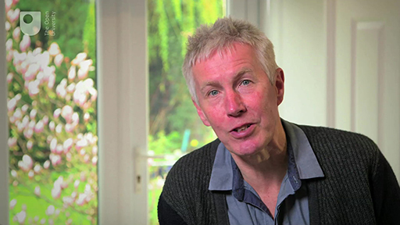

1.1.1 The life course
Considering the life course as a series of stages provides a means of thinking ahead and seeing an overall pattern.

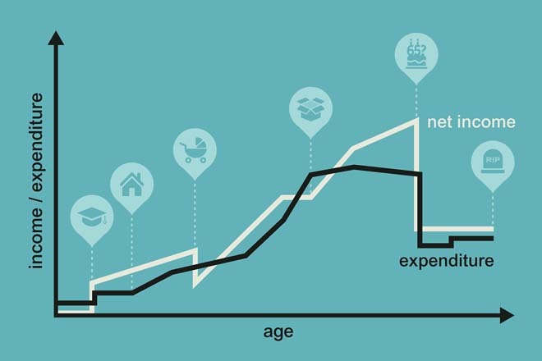
Figure 1 Flows of income and expenditure alter over the life course for everyone

Figure 1 illustrates a ‘typical’ pattern where youth, adolescence and young adulthood lead on to becoming part of a couple, where adulthood entails working and having dependent children who later on become independent themselves. The later part of the life course is usually marked by old age and retirement from working.
Of course, the life course won’t be the same for everyone; some people won’t form part of a couple or won’t have children, and some will experience family breakdown or bereavement.In relation to personal finance, the idea of the life course is helpful because it encourages planning ahead for the financial implications of each stage. For example, many people delay thinking about their provision for retirement because they don’t want to think about growing older, but they often come to regret this later in life when they realise that they would have benefited from earlier planning. Thinking in terms of stages in the life course might help to overcome this natural aversion. It provides a framework for thinking about possible life events such as marriage, parenthood, retirement, or even death, and this can make it easier to think ahead constructively.
No one can know exactly what will happen in the future. Financial capability – the ability to understand finances and make sound financial decisions – involves thinking ahead and planning for what might happen in the future; this includes not only things that we hope for, but also things that we hope will not happen.
Sensible planning takes into account the fact that the future may bring events that can be anticipated, as well as unexpected events with financial implications – unexpected bills or periods of illness or unemployment. Planning for the unexpected is one important aspect of financial capability.

1.1.2 The life course game

Table 1 Monthly income and spending for the Penny family
Total income | £2500
Mortgage and bills | £1150
Cars and other travel | £130
Cinema, takeaways, fun! | £70
Emergency fund saving | £200
Food and household goods | £500
Holidays | £150
Home contents insurance | £0
Life insurance | £0
Pension saving | £0
Total spending | £2200
Budget surplus/shortfall | £300

Try to work out what could happen to the Pennys’ financial position in the scenarios given below. Avoid overcomplicating your analysis – just ascertain whether these would be good or bad financial events for Mr and Mrs Penny, and how important they would be.
- Mrs Penny becomes permanently disabled.
- Mr Penny is made redundant.
- The Pennys’ car breaks down.
- The Pennys’ children move out of the family home after they finish college.
Now look at the Pennys’ spending. In terms of covering the cost of life’s events, are they taking any risks? You might want to draw up a revised budget for them.

1.1.3 Your life plan
Here’s the life course graph again. What do you think your own personal and financial circumstances might be in five years’ time?

Figure 2 Where are you in your own life course?

If you had answered this question five years ago what would your expectations have been? How closely would your answer have matched what has actually happened to you?
Does this lead you to revise what you think your circumstances might be in another five years?
What factors are influencing your thinking about the outlook for your personal and financial circumstances?

1.1.4 Starting your financial plan
Your first step in exploring financial capability is to think in a systematic way about the goals you have in your life. The process is called financial planning. In order to plan effectively you need to take into account the end goal.
This is the first occasion on which we want you to make use of your personal financial plan and fact find (from now on, called simply the ‘fact find’). A fact find is a means of setting out your current financial position and linking it to your goals in life. It’s a summary of your financial health, and can be used when you’re in discussions with advisers about financial decisions that need to be made. Download this now if you haven’t done so already, and when you’ve identified your goals record them in the first two rows, under the heading ‘Assess’.
Try noting down your three most important goals.
Goals are affected by individual circumstances and backgrounds, and by the kind of society in which the person or household is living.
People don’t form goals in a social vacuum. Many goals in life are ‘self-interested’, while others relate to political, ethical or religious commitments. Some people have a goal of helping achieve social fairness; they might be altruistic with their money and give to charity, or they might buy Fairtrade products that don’t exploit individuals or communities. Developments in ethical banking reflect these changes. Similarly, increasing awareness of environmental issues has affected some people’s goals by changing their pattern of consumption, which might lead them, for example, to cut back on unnecessary travel.
It’s very likely that goals will change in the course of a life as events unfold – as people form or leave relationships, have children, experience illness or disability, learn to cope with bereavement, move in and out of different household or family groupings, or live and work in different countries.
Think about goals with financial implications that, say, a young, single adult might have:
- take a holiday abroad next year
- buy a flat within ten years
- help the homeless
- get married in three years’ time
- have a comfortable retirement.
These goals relate to different time periods. In financial terms, ‘short term’ is normally taken to be under five years, ‘medium term’ is around five to ten years, and ‘long term’ is normally more than ten years. Taking a holiday next year and getting married in three years’ time are short-term goals. Buying a flat within ten years is a medium-term goal. Providing for a comfortable retirement is a long-term goal. Helping the homeless is an ongoing goal.

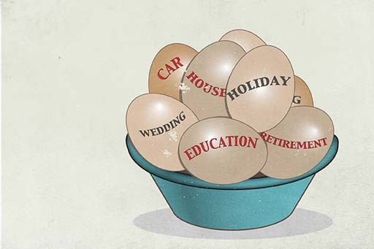
Figure 3 The ingredients of your financial plan

1.1.5 Prioritising
Thinking about goals is one starting point for financial planning, but the achievement of those goals may be constrained by the resources that a household has, together with its commitments.
For most households, achieving their goals is subject to the financial constraint of the resources that are available. Some households have goals that are not as affected by the available resources. In these cases the resources are not functioning as a constraint on financial plans. This may be because the household is rich, or because it has goals that are not financially demanding. Other households have goals that are severely constrained by available resources. In these cases, money difficulties are a constant source of anxiety and severely inhibit goals. Here the main goal might be basic financial survival.
So, an important question is whether all the goals can be achieved, given the financial constraints. Whether a person is able simultaneously to take a holiday next year, help the homeless, get married and buy a flat depends on their financial constraints. If the person can’t afford to do all these things, then choices have to be made. There’s a trade-off between using money and resources in some ways rather than in others. A trade-off involves giving up something in order to have something else that is preferred: taking lavish holidays means not being able to buy a flat. Which is more important? It’s necessary to prioritise.
- Take another look at your list of three most important goals. Have you listed the goals in any particular order?
- Try listing the goals in order of priority for you, given your circumstances and resources.
- Are there trade-offs between your goals?
- Has this prompted you to rethink any of your goals?
When doing (or buying) something involves giving up something else, the real cost is what would have been done (or bought) instead. This is called the opportunity cost. For example, the opportunity cost of buying a car is what would have been done (or bought) instead. The money might be spent on other things, or it might be saved or given away; it might be used to reduce or pay off existing debt. The opportunity cost of buying the car is the best alternative that is forgone (done without) in order to buy the car, such as buying a holiday with the money instead.
Time, as well as money, is a scarce resource. Most of us can’t do all the things we want to partly because we don’t have the time. The opportunity cost of you spending your time studying this course is what you would have done with your time if you hadn’t been doing this. It’s the best alternative use of your time. (If you wouldn’t have done anything else, then you’re not giving up anything to study the course, and so the opportunity cost would be zero.) Some busy people are particularly ‘time-poor’, even though they may be rich in a monetary sense.
Sometimes trade-offs have to be made between doing something now and doing it in the future. If you spend money now, it’s not available for later. There’s a tendency for people to place a greater value on £100 to spend now than on £100 to spend in one or two years’ time. You’ll find there are good economic reasons for this – especially because of inflation, which you’ll look into in Week 2.
But there are also rewards for not spending now in order to have more to spend later. If you’re hoping to build up a target amount for a future purchase or a pension, then just a few years’ delay in starting to put the money aside can greatly increase theamountyou have to put aside to be sure of meeting the target.
In addition, many financial products involve trade-offs of their own. For instance, financial investment tends to involve a trade-off between risk and return: the higher the expected return, the higher the risk attached. Which is the right product depends not only on how much risk – if any – can be afforded, but also on how risk averse a person is. Risk-aversion is the preference for a lower, but more certain, return rather than a higher, but less certain, return, other things being equal.

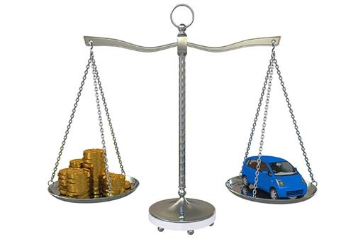
Figure 4

1.2 Your personality can seriously affect your finances
Are you risk averse or a risk taker? Find out about the behaviours that can lead to poor financial decisions and start to build your financial planning model.
Have you ever thought about how far your personality and, in particular your approach to risk taking, affects your financial decision making?
In this video Mark Fenton-O’Creevy, Professor of Organisational Psychology at The Open University Business School and an expert in behavioural finance, introduces the way behavioural biases affect personal financial decisions.

Video content is not available in this format.
View transcript - Uncaptioned interactive content

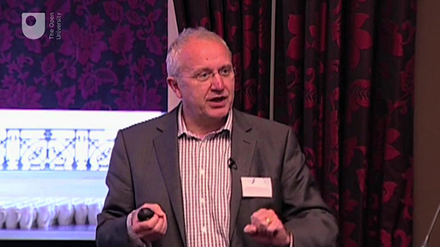

1.2.1 Betting the house
Most of us like to have a gamble once in a while – even if it’s just buying a lottery ticket or backing a horse in the Grand National. How big is your appetite for risk taking? How much are you prepared to lose on a bet – £5? £20? £100? Maybe even £1000? Ashley Revell was prepared to take on a huge gamble. Was it bravery or madness?

Video content is not available in this format.
View transcript - Uncaptioned interactive content



Activity 1

Would you say you’re risk averse? Or are you a risk taker?
What factors or changes to your circumstances might affect your answer?
Go to the fact find and log your appetite for risk in relation to your three goals.

View discussion - Activity 1

1.3 Building your financial planning model
Martin introduces you to the financial planning model – a process with which you’ll become very familiar as you progress through the course and develop your financial capability.

Video content is not available in this format.
View transcript - Uncaptioned interactive content

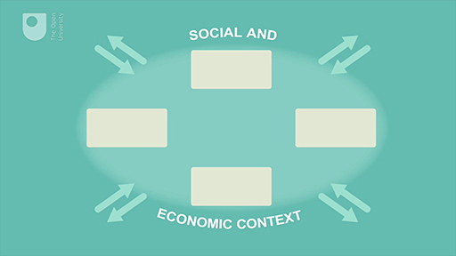

Financial capability involves being able to work out a financial plan for achieving a goal, given the constraints that you face. Constraints include things like income and existing savings, personal circumstances such as having to care for children or elderly relatives, and emotional factors such as how you feel about taking risks. For example, if your goal is to reduce debt worries, then financial capability involves better debt management. If you decide to consolidate debts into one package and then pay them all off systematically, some of these packages cost less than others (other things being equal). If there are debt problems, it’s better to seek advice from professional bodies like the government’s Money Advice Service (MAS), or from Citizens Advice or StepChange, rather than going to a ‘loan shark’ who charges extremely high rates of interest. Alternatively, if you’re saving to buy a flat, some savings schemes offer a better return than others (other things being equal), and all of them are likely to be better than stuffing cash under the proverbial mattress.
Seeking out well-informed advice and choosing better products, given constraints and goals, would be evidence of greater financial capability.

1.3.1 Applying the financial planning model
To make sure that your financial decisions are well managed, you should start to apply the financial planning model to financial decision making.
Think of a recent financial decision that you’ve taken and analyse your own process of financial planning. Try to remember each stage of your decision and have a go at analysing the stages in terms of the financial planning model. The decision could be something to do with moving house, buying a car, changing jobs, borrowing money for a project.

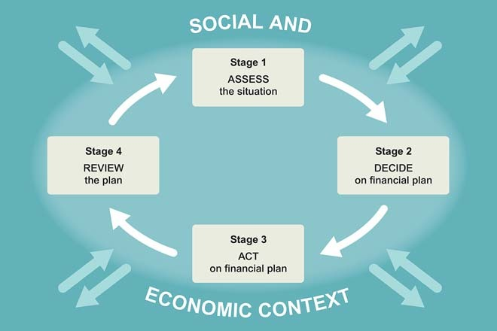
Figure 5 Assess, decide, act, review – the four golden rules

You’ll apply the financial planning model to your own financial circumstances as you work through the course to help you build your financial plan and complete your fact find.
If you were to make a similar financial decision right now, would you approach it differently?

1.3.2 Goals – the social and economic context
So far you’ve seen that financial planning can be understood as a sequence of stages: assess, decide, act and review – a continuous process. But as you see in this developed version of the financial planning model, these four stages also need to be understood in a broader context, as shown by the arrows pointing into and out of the process.
Thinking about your own life, you’ll be aware that your financial goals, and the ways you go about trying to achieve them, can be influenced by social factors such as your values, culture or religion as well as by economic factors. In terms of religious values, for example, the taking or paying of interest is prohibited under sharia law, as it was by the Roman Catholic Church in earlier centuries. Approaches to charitable donations, the giving of care and financial support to family members are also affected by contextual social factors.
The planning process impacts not only on individuals but also on the wider society. In the financial planning model this is shown by the arrows pointing outwards. Take a couple of instances: if many people decide to buy a flat, there is likely to be a rise in the price of flats which will have knock-on effects; or if many people decide to reduce their indebtedness, spending will fall and high-street retailers will face falling profits.
These examples – of increases in property prices and falling retail sales – illustrate the cumulative effect of many individual decisions, and how far the impact of individual decisions can spread. The effects were not an intended consequence of the individuals’ decisions at the time, and they can be different from what people individually expect. For instance, if an individual person or household goes on a spending spree, the consequences mainly affect that individual; but if a significant proportion of households go on a spending spree, there will be cumulative effects which have an impact throughout the economy.
Sometimes the effects of many people doing the same thing can become a ‘bubble’, and this can impact much more widely: every bubble eventually bursts, and when it does it sends ripples throughout society. In the late 1980s a large number of people wanted to buy property. Prices rose steeply in 1988 and 1989, but the bubble burst and property prices fell sharply in the early 1990s. This had severe consequences for some of those who bought when prices were at their peak. In the late 1990s there was a stock market bubble, with many people buying shares, especially in companies related to new technology and the internet. But from 2000 to 2002 the value of many stocks and shares fell dramatically, with negative financial impacts for those holding such stocks and shares. Similarly, throughout the 2000s property prices again rose sharply before falling with the onset of the financial crisis in 2007. After 2009, however, property prices started to rise again as the UK economy recovered from the economic recession that followed the financial crisis.
As you see, what individuals and households do with their money is not separate from the larger economy; in fact, it helps to define that larger economy.
Now take another look at the goals you listed earlier in your fact find. Think about social and economic influences on these goals. If the influences had been different, would your goals have been different?
It can be hard to imagine having had different influences. But if any of your economic circumstances or your social and cultural background were different, it is likely that your goals would be too. As you work through the next few weeks of the course, take time to reflect on some specific examples.

1.4 Try the bad habits test
As you heard earlier from Mark Fenton-O’Creevy, there are good reasons why we sometimes make bad financial decisions, even if we’re pretty smart about most other things in life.
Find out if you’re suffering from some of the factors that make personal financial choices particularly difficult – perhaps we should call them the ‘perils of personal finance’.

Video content is not available in this format.
View transcript - Uncaptioned interactive content

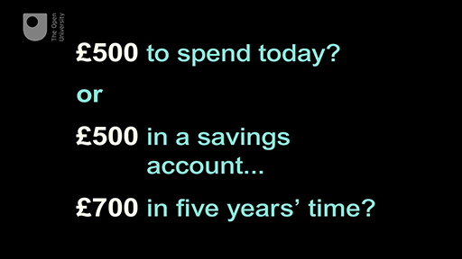

You’re almost at the end of the first week. When you’ve explored your bad habits, see what you’ve learned so far in the first test.

1.5 Week 1 quiz
This quiz allows you to test and apply your knowledge of the material in Week 1.
Complete the Week 1 quiz now.
Open the quiz in a new window or tab then come back here when you're done.

1.6 Week 1 round-up
In Week 1 you’ve seen:
- how to construct and use a financial planning model
- how our financial resources and needs alter over the life course.
Next week you’ll look at income as you meet one of the key financial challenges for all households – how to draw up and run a household budget.
You can now go to Week 2: Income, taxation and benefits


Figure 6

1.7 Further reading
The Open University Business School's True Potential Centre for the Public Understing of Finance (PUFin)
If you want to know more about the work of the True Potential Centre for the Public Understanding of Finance (PUFin) and its mission to improve personal financial capability, check out the centre’s website. The centre, generously funded by True Potential LLP, has a mission to develop teaching and undertake research to help improve public financial capability.

Week 2: Income, taxation and benefits

Introduction
Martin gives you a heads up on what to expect.
This is where you start to build your budget, filling in all your sources of income using a budget planner. Make sure you keep a copy of your workings so that you can refer to them again when you complete your budget by adding your expenditure. You can record these details in your fact find.

Video content is not available in this format.
View transcript - Uncaptioned interactive content

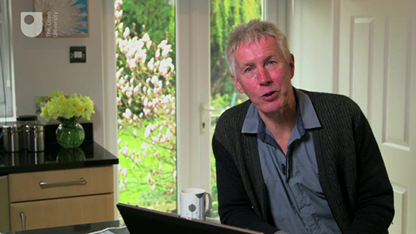

This course is presented with the kind support of True Potential LLP.
The True Potential Centre for the Public Understanding of Finance (True Potential PUFin) is a pioneering Centre of Excellence for research in the development of personal financial capabilities. The establishment and activities of True Potential PUFin have been made possible thanks to the generous support of True Potential LLP, which has committed to a five-year programme of financial support for the Centre totalling £1.4 million.

2.1 Income, wealth and assets
When thinking about personal finance it’s important to make a distinction between income and what is commonly called ‘wealth’. This might appear strange – having a high income and being wealthy are sometimes perceived as being the same thing, but they are two different concepts.
Income is a flow of money received over time – such as salary or benefit payments. An income flow might be, say, £24,000 per year, or the same amount could be expressed as £2000 per month, or £462 per week.
Wealth is a stock of assets owned and valued at a particular point in time. There are several ways of categorising these assets. The Office for National Statistics (ONS) splits assets into financial assets and non-financial assets (Social Trends, 2010). Financial assets are those assets which are not physical things and are held in order to produce a flow of income and/or a monetary gain. Examples are money held in a savings account (which pays interest) or share holdings (which usually pay dividends). By contrast, non-financial assets are those assets – usually tangible, physical items – that do not normally provide a flow of income, such as property, jewellery or an expensive work of art. Usually in order to obtain money from these assets you would have to sell them.
Assets can be categorised in other ways too. All of the examples so far are assets for which a market value (or price) can be realised, and so they’re said to be ‘marketable’ assets. However, there are some assets – such as money held in an occupational pension scheme – that normally cannot be sold, and so these are classed as ‘non-marketable’ assets.
A third way of categorising assets is perhaps the most important for personal finance. This is dividing up assets according to how ‘liquid’ they are. Liquid assets are those that can be converted into cash easily and readily. The most liquid asset is cash. Other liquid assets include the balance on a current account or a savings account. There are other assets that cannot be sold or liquidated so easily, such as a house. Later in the course you’ll look at household assets in more detail. In this session we concentrate on income.


Figure 1

2.1.1 Income or asset?
This quiz tests your ability to distinguish between an income and an asset.

Activity 1

Which of these lists includes assets only, and no form of income?

Antique clock, M&S shares, savings interest, salary
Classic car, Ming vase, pension fund, Tesco shares
Furniture, home being bought with mortgage, jewellery, monthly pension
Apple share dividends, bank account, rent from buy-to-let property, shares in an investment fund

2.1.2 Incomes and inflation
In order to consider changes in income levels or other financial variables over time, it’s important to know whether figures are in ‘real terms’. Figures that are expressed in ‘real terms’ have been adjusted to take inflation into account, so that we can compare like with like.
Let’s look at inflation in a bit more detail.
Inflation refers to a sustained increase over time in the general level of prices for goods and services. If, for example, the rate of price inflation is 4%, this means that you will need £104 to buy the same goods and services next year that you can buy this year with £100.
There are two main inflation figures used in the UK: the Consumer Prices Index (CPI) and the Retail Prices Index (RPI). Both follow the same underlying principle of expressing the rate of inflation as a percentage figure by measuring how much a typical ‘basket’ of goods changes in price from one year to the next.
The CPI and RPI are calculated once a month, with the contents of the basket of goods designed to reflect household spending. For many years the RPI was most commonly used in the UK. More recently the UK government has used the CPI. A key difference between the two is that the CPI excludes important housing costs such as mortgage interest payments and Council Tax. Typically, the CPI is lower than the RPI (ONS, 2012). Any shift to putting up state benefits or other financial payments in line with CPI, as opposed to RPI, would result in lower increases, which would save the government money. Recently (2014 to 2018), the RPI rate has tended to be circa 1% above the CPI rate.
Inflation is a concept that is crucial to personal finance, as is the distinction between real values, which have been adjusted to take into account inflation, and nominal values, which have not. Real values are usually expressed in terms of a particular year’s prices, such as ‘expenditure at 2018 prices’ or ‘income at 2018 prices’. When you see such a phrase added to a set of figures or a graph, you can tell that the values have been adjusted to take inflation into account. In the example above, where inflation is 4% and you will need to have £104 to buy the same as £100 today, £104 is the nominal value but the real value (the buying power of that money) is £100.
Let’s apply this to income. If, one year after starting a new job, your annual salary rises by 5% from £20,000 to £21,000, the nominal value of your salary is £21,000. But if price inflation in the same period has also been 5%, the real value of your new salary is £20,000 – the same as it was a year ago.
In real terms disposable income per head more than doubled between 1971 and 2007 (Social Trends, 2010). This would suggest that households in 2007 could afford a considerably higher standard of living than households in 1971. But in a number of years since the financial crisis of 2007 and 2008 the real incomes of many households in the UK have fallen, because nominal pay increases, particularly in the public sector, did not keep pace with price increases. Sharp price increases in energy, petrol and food at certain points during these years particularly hit living standards.


Figure 2

2.1.3 Measuring real incomes

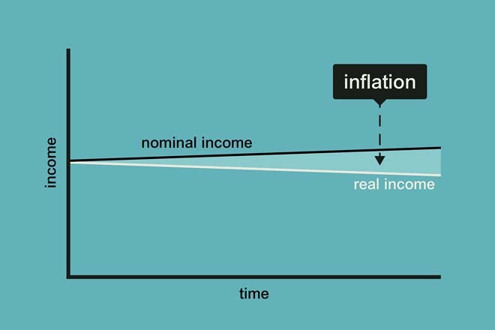
Figure 3 Is your income going up or down in value?

Have a go at measuring change in the real value of incomes.
Let’s say that your monthly gross income today is £1000.
The annual price inflation rate for the next three years is forecast to be 2% (this means that prices will rise by 2% in each of the next three years).
First, you want to know the real value of the £1000 in a year’s time. Go to the column in Table 1 that shows 2% and look at the row for one year. This shows that the real value of your £1000 gross monthly income will be £980.39 in a year’s time.

Table 1 Real value of £1000 if annual inflation averages:
Number of years | 1% | 2% | 3% | 4% | 5% | 6% | 7% | 8%
1 | £990.10 | £980.39 | £970.87 | £961.54 | £952.38 | £943.40 | £934.58 | £925.93
2 | £980.30 | £961.17 | £942.60 | £924.56 | £907.03 | £890.00 | £873.44 | £857.34
3 | £970.59 | £942.32 | £915.14 | £889.00 | £863.84 | £839.62 | £816.30 | £793.83
4 | £960.98 | £923.85 | £888.49 | £854.80 | £822.70 | £792.09 | £762.90 | £735.03
5 | £951.47 | £905.73 | £862.61 | £821.93 | £783.53 | £747.26 | £712.99 | £680.58

Now try the calculation again but with an inflation rate of 5%. What’s the outcome?
Now try the calculation again with the original inflation of 2% per annum but for a period of three years. What’s the outcome in three years’ time?
Next, think about the impact on real incomes if there’s an increase in the nominal value of your earnings.. Here what you have to do is calculate the difference between the growth of gross income and the rate of price inflation.
For example, for many people in the UK between 2010 and 2015, gross incomes were unchanged or grew at around 1% each year, while prices rose typically at between 2% and 3% each year. So, for many people, a reduction in real value of incomes was experienced in the range of between 1% and 3% each year.
Use Table 2 to see how much loss in value on £1000 results from price inflation exceeding earnings inflation. The top row of the table shows the change in nominal income over a year from a cut of 5% to an increase of 7%. Taking price inflation to be 3% over the year, the figures below the percentage change in nominal income show how the real value of income changes.

Table 2 Real value with these changes to nominal income in the year:
Number of years | -5% | -3% | -1% | 0% | +1% | +3% | +5% | +7%
1 | £922.33 | £941.75 | £961.17 | £970.87 | £980.58 | £1000.00 | £1019.42 | £1038.84

Now try the exercise using your own circumstances. Can you work out how much your gross income has risen (or fallen) in the past year?
Work out the percentage growth (or decline) and look at the relevant column in Table 2. A deduction of 0.6% is applied to get the real value of incomes, since 0.6% is close to the average rate of price inflation in the UK over the past year.
To calculate the exact figure for you, it is necessary to scale your gross income to the benchmark of £1000 in the table. So, for example, if your gross income is £2000 per month you need to double the values of the real incomes shown.
If you’ve been fortunate enough to see your gross income rise by more than the price inflation rate of 3% you can see from Table 2 how much your real income has increased.
Clearly the relationship between the rate of increase in your gross income and the rate of inflation is central to the determination of whether your standard of living is improving or declining.

2.2 Taxation and benefits
Take a look at deductions that are made to income in the UK in the form of Income Tax and National Insurance. Consider the income that comes in the form of state benefits and review the current overhaul of the UK benefits system.
In the video George Osborne, UK Chancellor of the Exchequer, announces his proposals for tax changes to a packed House of Commons.

Video content is not available in this format.
View transcript - Uncaptioned interactive content

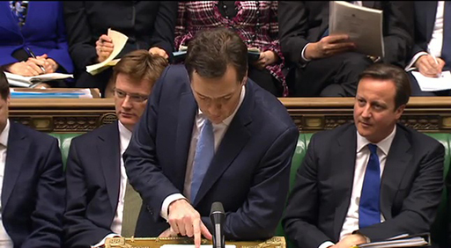

Here we start to look in more detail at the deductions (for Income Tax and National Insurance in the UK) and additions (through benefit payments) that take us from gross to net income. (Note that for some people another possible deduction from gross income is contributions to their pension scheme: these schemes are discussed later in the course.)
Income Tax is levied on almost all types of income, including paid employment. When it is collected via an employer it is often referred to as a ‘pay as you earn’ (PAYE) tax. Income Tax is paid on income received within a given tax year, from 6 April of one year to 5 April of the following year. Income Tax is the single largest source of government revenue. In 2016/17, Her Majesty’s Revenue & Customs (HMRC), the government department responsible for collecting taxes, collected £176 billion in Income Tax – close to a third of all government receipts (ONS, 2017).
In the UK Income Tax system most people receive an ‘allowance’ of income that can be earned before Income Tax has to be paid. This ‘personal allowance’ is £11,850 in 2018/19. The allowance is higher for certain groups of people, such as those who are registered blind. The personal allowance has an income limit of £100,000. Above this limit the allowance tapers away.
Income above the personal allowance is then subject to tax at three different standard rates in English, Wales and Northern Ireland (Gov.UK, 2018):
- in 2018/19 the first £34,500 (after the basic allowance has been taken into account) is taxed at 20%
- above this figure and up to £150,000 of taxable income, the rate is 40%
- there is an additional rate of 45% on taxable incomes over £150,000.
Since 1999 Scotland has had some discretion over its income tax rates. These powers were extended in 2016 and 2017 giving the Scottish Parliament full discretion over the income tax rates and bands applied to non-savings income. Discretion over income tax is also planned to be extended to Wales and Northern Ireland.
Using its discretion the Scottish Parliament approved the following income tax rates and bands for 2018/19 (BBC, 2017).

Income Band | Name of Band | Tax Rate
£0 - £11,850 (personal allowance) | Personal Allowance | 0%
£11,851 - £13,850 | Starter Rate | 19%
£13,851 - £24,000 | Basic Rate | 20%
£24,001 - £44,273 | Intermediate Rate | 21%
£44,274 - £150,000 | Higher Rate | 41%
£150,001 and above | Additional Rate | 46%

By taxing additional income slices at higher rates, the proportion of tax increases with income. UK Income Tax is an example of progressive taxation, meaning that the proportion of a person’s income paid as tax increases as their income increases. This tax structure therefore helps to reduce income inequalities in the UK.
Next, have a go at using what you’ve learned here to try some calculations for yourself.

2.2.1 Calculating Income Tax
This quiz tests your ability to calculate the Income Tax you should pay on an income.

Activity 2

Use the information you’ve just read to work out how much Income Tax would be paid by earning £26,850 (from employment or from a pension) for 2018/19 if you live in England, Wales or Northern Ireland.
You might find it helpful to work out your answer using the following process:
Income from employment or pension £26,850
Minus personal allowance £ —————
Leaves taxable pay of £ —————
Basic rate ————— % on £ ————— is £ —————
Tax to be paid in the year 2018/19 is £ —————

£5000
£6000
£3000
£1500

2.2.2 Setting Income Tax rates
Watch the UK Chancellor of the Exchequer, George Osborne, being interviewed on the BBC by Andrew Marr. This interview took place in 2012 and debates the cut in the additional rate of income tax (on taxable incomes above £150,000 annually) from 50% to the current rate of 45%.

Video content is not available in this format.
View transcript - Uncaptioned interactive content

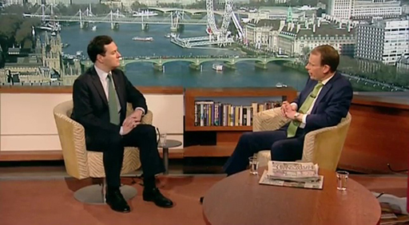

The social and economic backdrop to the issues discussed in the interview are important.
First, taxes (together with state benefits which you look at later in this week) represent an example of the interdependence between the individual and the broader social and economic environment in which they live. Taxation funds state benefits, such as state pensions and social security benefits, and pays for public services such as the National Health Service (NHS).
Second, the UK’s tax and state benefits system also has the effect of some redistribution of income – some of the taxes raised collectively are transferred back to individuals and households. Of course, the people receiving benefits will often be different from those paying taxes such as Income Tax, but many people will pay tax and receive benefits at different stages in their life course. The availability of state benefits is also an important part of the way that people cope with unexpected events, which you’ll examine later in the course.

Who should bear the burden?
What factors does the Chancellor of the Exchequer have to take into account when setting Income Tax rates for low-, middle- and high-income earners?

2.2.3 National Insurance
A second important deduction from gross income is National Insurance contributions. National Insurance – which was introduced in 1911 and subsequently expanded, especially in the 1940s – is paid by both employees and employers. Historically, it formed the basis for paying social security benefits related to unemployment, illness and retirement.
The government’s tax and National Insurance receipts fund all benefits as well as other public services and state provision. National Insurance contributions from employers and employees make up the second largest single contribution to UK government receipts, at £124 billion in 2016/17 or approximately 22% of all government receipts (ONS, 2017).
The mechanics of collection are that HMRC issues each person in the UK with a National Insurance account number against which contributions are recorded. The level of contributions influences entitlement to, and in some cases the level of, certain benefits. As with Income Tax, the rules and regulations surrounding National Insurance change regularly. In 2018/19 there is a primary threshold of £8424 per year and an ‘upper earnings limit’ of £46,384. On income between these limits, employees’ National Insurance is generally levied at 12%. Any portion of income above the upper earnings limit is subject to only a 2% levy (Gov.UK, 2018).


Figure 4

2.2.4 State benefits
So far you’ve looked at Income Tax and National Insurance. There are other taxes such as Value Added Tax (VAT), excise duties, Stamp Duty Land Tax and Inheritance Tax – all raising revenue to pay for state benefits and services such as health, education, defence, the transport infrastructure and the police service.
Money raised in taxes goes a substantial way towards paying for the physical and social framework within which citizens live and work. This money, raised and spent collectively, reduces the need for private expenditure that would otherwise be required for health, education and so on.
State benefits represent important components of the welfare state. They have been built up in the UK over the last century or so to provide social protection against various risks such as unemployment, sickness or work injuries, and to ensure that financially poor and marginalised citizens have sufficient income.
One key issue facing governments is a concern that provision of benefits might act as a disincentive for people to seek employment. Related to this is the need to ensure that those on low incomes are not treated unfairly by the tax and benefits system, by making them worse off than those who do not work. One way the UK government has been addressing these issues has been to raise the income threshold at which you start to pay income tax. There have also been two major initiatives since 1997 to address these issues through the structure of state benefits.
The Labour government that came to power in 1997 designed a new form of benefit payment called a ‘tax credit’ to help people move off welfare and into paid employment. These consisted of the Working Tax Credit (WTC) and the Child Tax Credit (CTC), and represented an attempt to integrate the benefits system with the tax system.
The Conservative/Liberal Democrat coalition government elected in 2010 introduced substantial changes to the benefits system. Its strategy was immediately to cut benefits and, in the medium term, replace many work-related benefits with a new benefit called a Universal Credit. Specific measures also included restricting Child Benefit payments to households where neither parent is a higher rate taxpayer, placing a cap on Housing Benefit payments and an overall cap on benefits.
Following trials in North West England, the coalition government’s major overhaul of the benefits system started to be phased in from October 2013, with Universal Credit replacing Income Support, Housing Benefit, Working Tax Credit (WTC) and Child Tax Credit (CTC), as well as the income-related parts of Jobseeker’s Allowance and Employment and Support Allowance. Initially Universal Credit will be paid to new claimants and existing claimants whose circumstances change – for example, if they have another child. Subsequently all other claimants will be transferred, in stages, to Universal Credit with the roll-out of the new benefits system (for both new and existing claimants) now expected to be finalised in 2022. On completion it is anticipated that 12 million working-age claimants will be receiving Universal Credit (BBC, 2013).
Some of these benefits are means tested: they are made only to those who are assessed to have a certain level of income or less, and in some cases a certain level of assets or less.
The government’s objectives are that the new benefits system will be simpler – with a single monthly payment rather than multiple payments to claimants. The new structure is also intended to make work pay by reducing the chance that incomes fall if people move from benefits into low-paid work. Administratively, Universal Credit is planned to be more efficient, with people managing their claims online – although the early trials of Universal Credit were beset with IT problems.
Some households will gain under Universal Credit – particularly those made up of couples with children – while others will lose, particularly couples with no children. Overall the ‘winners’ and ‘losers’ under the new system are widely expected to be approximately equal in number, although this has not stopped critics of Universal Credit claiming that the reform of the benefits system is intended to be a cost-cutting exercise.
Major changes to state benefits were announced in 2015. The key changes, which started to take effect from the 2016/17 tax year included:
- the freezing of working-age benefits for 4 years
- an annual household benefits cap of £20,000 for couples, with or without children living with them (£23,000 in London).
Additionally, from 2017/18 Child Tax Credits and the child element of Universal Credit have been limited to 2 children for children born on or after 6 April 2017. Some exemptions to this rule do apply though, for example in the case of multiple births.


Figure 5

2.2.5 Benefits in transition
In 2018, therefore, the benefits system is in the throes of a major transition. The current system comprises the following benefits. Those in the process of being replaced by Universal Credit are marked by an asterisk.
Jobseeker’s Allowance (JSA) is paid to those available and actively looking for employment. It is split into contribution-based JSA and income-based JSA *.
Income Support * is a means-tested benefit paid to certain groups of people who do not have enough money to live on.
Employment and Support Allowance (ESA) is for people who cannot work because of illness or disability. It is split into contribution-based ESA and income-related ESA * which is a means-tested benefit.
Personal Independence Payment (PIP) is a benefit for people under 65 who have personal care needs or problems with mobility.
Carer’s Allowance is a benefit for people who are giving regular and substantial care to disabled people in their own homes.
Attendance Allowance is a benefit for people with care needs who are over 65.
Child Benefit is a tax-free benefit paid to people with children whose household income falls below a certain amount. (From January 2013, individuals paying a higher rate of tax were excluded from this benefit.)
Pension Credit is a means-tested benefit for people over the minimum state pension age.
Council Tax Reduction is a means-tested benefit provided by local authorities for people on low income to help them pay Council Tax. It has replaced Council Tax Benefit.
Housing Benefit * is a means-tested benefit for people on low income to help them pay their rent.
Prescriptions and dental treatment are either free or subsidised.

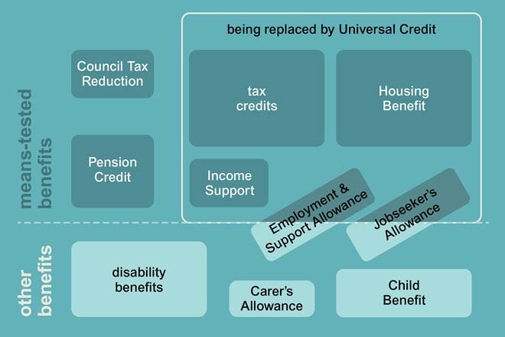
Figure 6 Benefits – a complex system

2.2.6 Government minister and benefits reform
Listen to Work and Pensions Secretary Iain Duncan Smith speaking to the Today programme presenter James Naughtie (9 December 2013). The interview focuses on the difficulties that are being encountered in rolling out this massive change to the benefits system – a change made even more challenging by problems with the supporting IT systems.

Audio content is not available in this format.
View transcript - Uncaptioned interactive content

In the interview Iain Duncan Smith refers to a figure of £30 billion when talking about benefits fraud. Please note that this figure has not been verified and has been challenged by other commentators.

2.2.7 State benefits – inflation and tapers
Now take a look at two important factors that determine the amount of money people receive from state benefits, and discuss their implications.

Activity 3

First, one of the early changes introduced by the Conservative/Liberal Democrat coalition government after coming to power in 2010 was the shift from increasing the benefits (including Income Tax allowances) in line with the RPI measure of inflation to the CPI measure.
Second, an important element of tax credits and of Universal Credit is that they are means tested on household income. In other words, the amount a household receives from them goes down as household income goes up. The rate at which these benefits are withdrawn as income rises is called tapering. For example, for 2018/19 the taper for Working Tax Credit and Child Tax Credit was set at 41 pence for each additional £1 earned by families beyond an annual household income of £6420 (Gov.UK, 2018).
With Universal Credit a ‘work allowance’ is disregarded and then, in 2018/19, a taper of 63 pence in the £ is applied to the rest.
Consider these two questions.
- Bearing in mind what you have learned about the relationship between CPI and RPI, what impact is the move to raising benefits in line with CPI likely to have?
- Why is a ‘taper’ applied to the removal of benefits as income increases? Why not just deduct £1 of benefit for each additional £1 of extra household income?

View answer - Activity 3

2.3 Managing your budget
You’ve seen that households can receive income from a number of different sources. You know that assessing your position is always an important first step in financial planning, and assessing income is often one of the most important factors in financial decision making. One tool that can be used to do this is the budget.
To draw up a budget you start by looking at your cash flows. This involves measuring inflows and outflows of money on a regular basis. In the remainder of this week, you concentrate on inflows. The spending side – outflows – of the budget statement is covered next week.
There are four issues to be considered in measuring the income side of a budget. You’ll soon start to do this in practice.
First, the statement should record inflows of income in the relevant time period, such as a month or a week. For most people this will represent their net income: payers of standard rate Income Tax whose income consists of pay will already have been taxed via PAYE, and National Insurance contributions (and, for people in occupational pension schemes, pension contributions) will have been paid. Self-employed people, by contrast, are not taxed via PAYE. They will need to set aside the sums due for tax payments on their gross earnings. These sums are normally made in two payments to HMRC in January and July each year. However, some people will receive at least some income paid gross, such as some investment returns or state benefits. In this case the gross income should be recorded, but it must be remembered that there may be tax still due on this income at the end of the tax year, and tax payments may be an expense that will need to be factored into the budgeting process.
Second, it is important to include all the different sources of income, such as income from paid employment, self-employment, savings and investments, pensions and social security benefits. Any additional income is recorded under the ‘other’ category.
Third, it is important to take account of how frequently different types of income are received. For instance, a household may receive a combination of weekly benefits and monthly pay. In order to standardise these different frequencies of income for a monthly budget, the technique is to calculate an equivalent annual income first (for example, by multiplying a weekly income by 52) and then estimate a monthly income equivalent by dividing this figure by 12.
Fourth, the income side of the budget can be drawn up at the level of the household or individual. The choice will depend on household composition, but to get an accurate figure of total household income it is necessary to include all income earners.

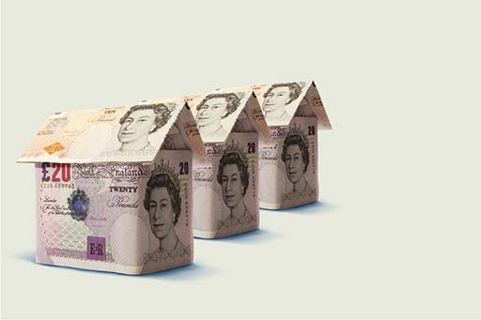
Figure 8

2.3.1 Your budget – the income side
This is your first opportunity in the course to use a budget planner. The UK government has set up an independent service called the Money Advice Service (MAS) which offers a set of excellent financial planners and calculators. You’ll be using a number of MAS planners and calculators, so why don’t you register for free with MAS now? Once you’ve registered you’ll also be able to save your workings and come back to them later.
The MAS budget planner is presented in two formats – a simple version and a version with more detail. Both are easy to use and self-explanatory. Go to the MAS budget planner in a new window or tab and choose the version with which you feel most comfortable.
Now complete the income part in the budget planner for your household.
If you’re in a one-person household, this means completing it for just yourself.
If you’re in a multi-person household, the normal assumption would be that the income of other household members would be recorded. However, if this is not possible, simply complete using your own income.
When you’ve done this go to your fact find and fill in the income side of your budget – the first five rows. Use the current month’s figures to fill in the column ‘Cash flow £ per month’. In the second column – ‘Average month £ per month’ you may want to adjust these figures if the current month is not a representation of what you get on average in a month. For people receiving salaries, there’s typically no difference but for those who are self-employed there can be wide variations in what is earned from month to month.
Don’t put in expenditure figures in at this stage – you’ll be looking at expenditure next week.
Once you’ve done this, move on to the test for this week.


Figure 9

Week 2 quiz
This quiz allows you to test and apply your knowledge of the material in Week 2.
Complete the Week 2 quiz now.
Open the quiz in a new window or tab then come back here when you're done.

Week 2 round-up
In Week 2 you’ve looked at the various ways income comes into households – either in the form of earnings from work or as state benefits.
You’ve learned about inflation and how it impacts on household finances, and you’ve seen the ways that incomes are taxed.
You’ve also examined the changing structure of UK state benefits.
Finally you’ve had some practical experience of drawing up an income side of a budget.
The next week turns to the other side of a household’s budget – expenditure.
You can now go to Week 3: Expenditure and budgeting

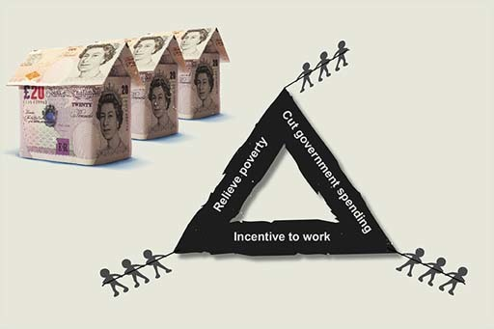
Figure 10

Week 3: Expenditure and budgeting

Introduction
The previous week was about incomes; now you turn to household expenditure. Bringing the two together enables you to build a budget. Look at more budgetary challenges and at how spending links to lifetime goals.
Martin introduces the week, which examines household expenditure and shows you how, by combining expenditure and income, you can compile a budget.

Video content is not available in this format.
View transcript - Uncaptioned interactive content

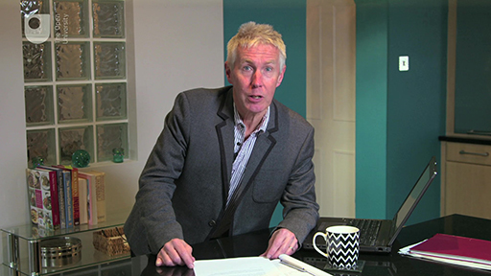

Once again you use the MAS budget planner to assist you in filling in the relevant parts of your fact find.
This course is presented with the kind support of True Potential LLP.
The True Potential Centre for the Public Understanding of Finance (True Potential PUFin) is a pioneering Centre of Excellence for research in the development of personal financial capabilities. The establishment and activities of True Potential PUFin have been made possible thanks to the generous support of True Potential LLP, which has committed to a five-year programme of financial support for the Centre totalling £1.4 million.

3.1 What are your spending habits?
Do you spend only what you need for your household to function? What factors influence your spending habits? To what extent are you aware of social pressures that affect the level and composition of your household expenditure?

Video content is not available in this format.
View transcript - Uncaptioned interactive content



3.1.1 Budgeting – the basics
For most people there’s considerable pressure to spend money on goods and services, yet we all need to avoid debt, to save and to invest for the future. The process of budgeting can help to reconcile competing demands on income. A budget identifies and adjusts income and expenditure flows. It looks forward, to estimate and plan income and expenditure over a future time period.
So how does setting a budget help you manage your household finances?
- It helps you control spending by comparing your income with your spending.
- It helps you check that you have enough spare income to pay current and future bills without having to borrow.
- It enables you to plan on how to meet your goals.
Carrying out a budgeting exercise once is useful to help you to assess whether your spending is under control, but budgeting is most effective in managing finances when you use it as part of an ongoing process.
Next, you see how an income and expenditure profile sheds light on the financial circumstances of a young woman called Jenny.


Figure 1

3.1.2 Meet Jenny
Jenny is a 28-year-old woman who works as an insurance clerk.

Video content is not available in this format.
View transcript - Uncaptioned interactive content



Next you’ll be taking a look at her expenditure and net income between 2006 and 2018.

3.1.3 Jenny's profile
Figure 2 shows both Jenny’s net income and her expenditure but the thing to note is her net income as that is what matters most for budgeting purposes. In order to think about planning expenditure, an individual or household needs to know how much income they have available to spend, save, invest or to pay back borrowing.

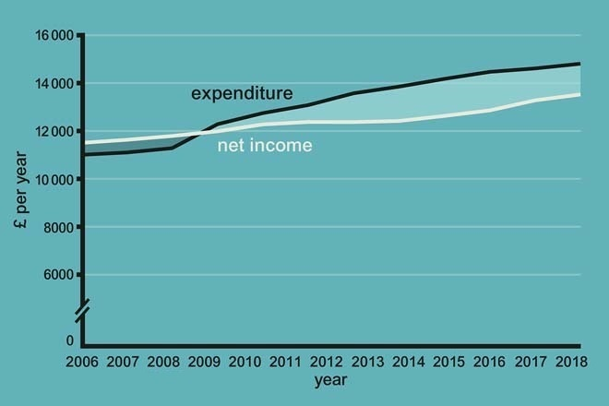
Figure 2 Jenny’s real net income and expenditure 2006–2018

Gross income does not provide this information because Income Tax and other deductions are not taken into consideration, whereas net income takes such deductions into account. For the same reason, the income side of the budget, in Week 2, showed net income.
You can see that since 2009 Jenny’s expenditure has been higher than her net income. From 2009 the gap between the two lines shows the amount that Jenny is spending over her income, and the shaded area from 2009 to 2018 between the two lines gives the total amount that she’s spent above her net income.
In such a situation, Jenny will have had to borrow to pay for this excess expenditure, unless she had savings to draw on. Between 2006 and 2009, when her net income was higher than expenditure, Jenny will have accumulated some savings, but these are not enough to prevent her having to borrow in the later period when she spends more than her income.
Assuming Jenny doesn’t want to accumulate larger debts, she needs either to increase her income or to reduce her expenditure, or both: effectively, she would like to move her income line up and/or her expenditure line down. If she manages to do this sufficiently (and budgeting is one way to achieve this aim), in the future she will be in a position where her expenditure no longer exceeds her income.
The graph shows Jenny’s total net income and total expenditure per year. This is useful because it gives Jenny a clear picture of what’s happening to her finances over time and provides an idea of why she might need to make changes in the future.
Budgeting can help you to plan such changes by looking at the details of your income and expenditure. This requires you to examine your income and expenditure flows over a shorter time horizon than a year, usually as often as income comes in (weekly or monthly), and then to project the flows forward to work on an annual level and beyond.
This example highlights the dual functions of a budget:
- first, it can be used to achieve the immediate goal of managing your money on a short-term, day-to-day basis
- second, it is vital for planning ahead to help ensure that your medium- and long-term goals – like coping with higher education fees and having sufficient money to retire – can be achieved.

3.1.4 Jenny’s budget (Stage 1: assess the situation)
As you’ve already identified, Jenny is spending more than her income and needs to get her money management under control. This is Jenny’s immediate purpose in preparing her budget.

Figure 3 The financial planning model

The approach to budgeting that you start here is once again the four-stage financial planning model. The start of the budgeting process could be described as the ‘reality check’, beginning with a cash flow statement.

Table 1 Jenny's budget in May 2018
 | Cash flow (£ per month) |  | Average month (£ per month) |  | Budget (£ per month)
NET INCOME
Earnings | 1115 |  | 1115 |  | 1115
TOTAL NET INCOME |  | 1115 |  | 1115 |  | 1115
Rent | 250 |  | 250 |  | 250
Council Tax | 50 |  | 50 |  | 50
Regular bills (gas, electricity, water, etc.) | 30 |  | 60 |  | 50
Telephone (mobile and landline) | 40 |  | 40 |  | 30
Home insurance (contents and building) | 12 |  | 12 |  | 10
Household goods | 15 |  | 30 |  | 30
Food and non-alcoholic drinks | 150 |  | 150 |  | 120
Alcohol | 40 |  | 40 |  | 40
Tobacco | 30 |  | 30 |  | 0
Clothing and footwear | 50 |  | 50 |  | 40
Medicines, toiletries, hairdressing (personal) | 30 |  | 30 |  | 30
Going out | 120 |  | 120 |  | 80
Holidays/other leisure | 20 |  | 100 |  | 50
Motoring costs (insurance, petrol) | 70 |  | 130 |  | 180
Birthday presents/charity/other gifts
Christmas presents/gifts | 10 |  | 45 |  | 30
Personal loan repayments | 100 |  | 100 |  | 100
TOTAL EXPENDITURE |  | 1017 |  | 1237 |  | 1090
SURPLUS/DEFICIT |  | 98 |  | -122 |  | 25

Last week you looked at the income flows of a household. Now, the expenditure side of the cash flow statement will be added to see whether expenditure is less than, more than, or equal to income.
This statement provides a snapshot of the income and expenditure of a household during a particular week or month. A month is the time period used here for Jenny’s budget, but the process is the same whatever period is chosen. When you’ve added expenditure you’ll look at why this cash flow statement might not be giving the whole picture.
A system of keeping and carefully filing all bank and credit card statements will help you to collect information on how your money is being spent: in other words, you will have a record of all your debit card transactions, direct debits, standing orders, and goods and services bought on credit. However, to obtain a full picture of how your money is being used, it’s a good idea to keep a spending diary that records all cash transactions.
Once all such information about expenditure has been collected, you need to classify it under different headings of expenditure. The level of detail to include and how broad the headings under which expenditure is classified are personal choices. Nevertheless, it’s important to have some different headings if the budget is to be useful when thinking about change.
Individual circumstances will influence this decision, as well as the amount of detailed information available to record transactions. For instance, if you go out frequently, you may want to have a detailed set of headings for specific areas of ‘going out’ – such as meals out, cinema, the pub, lunch, going to football … Amounts under the different headings can then be recorded on the cash flow statement, alongside the income section described in Week 2.
In the table you can see the various parts of budgeting on one sheet. For convenience, it groups all three parts as three columns together: the first shows the cash flow statement for a particular month, the second shows average monthly expenditure and the third shows the budget. Start by considering Jenny’s cash flow statement for May 2018 – the first column.
The income side of the cash flow statement for Jenny is straightforward, as her only income is from her salary. If she had other earnings or you were considering a household with more than one person, then there would be different sources of net income, which should all be recorded.
Jenny’s cash flow statement doesn’t seem quite as bad as might have been anticipated from the graph, which showed expenditure being consistently higher than income for several years. In fact, in May 2018 she has a surplus of £98. You know this because her net income was £1115 and her expenditure was £1017, leaving £98.

How accurate is Jenny’s cash flow statement?
Take another look at Jenny’s cash flow statement. Can you think why it might not give an accurate picture of how Jenny spends her money over a whole year?

3.1.5 The budget – the average month
The information in the cash flow statement shows one month only. May 2018 may not be a typical month. There will be some commitments that only come up every so often, such as road tax, quarterly bills, TV licence and other occasional spending such as going on holiday, buying a new piece of furniture or buying Christmas presents. This is why people can sometimes underestimate their spending. For budgeting, an ‘average’ or ‘typical’ month is needed.

Table 2 Jenny's budget in May 2018
 | Cash flow (£ per month) |  | Average month (£ per month) |  | Budget (£ per month)
NET INCOME
Earnings | 1115 |  | 1115 |  | 1115
TOTAL NET INCOME |  | 1115 |  | 1115 |  | 1115
Rent | 250 |  | 250 |  | 250
Council Tax | 50 |  | 50 |  | 50
Regular bills (gas, electricity, water, etc.) | 30 |  | 60 |  | 50
Telephone (mobile and landline) | 40 |  | 40 |  | 30
Home insurance (contents and building) | 12 |  | 12 |  | 10
Household goods | 15 |  | 30 |  | 30
Food and non-alcoholic drinks | 150 |  | 150 |  | 120
Alcohol | 40 |  | 40 |  | 40
Tobacco | 30 |  | 30 |  | 0
Clothing and footwear | 50 |  | 50 |  | 40
Medicines, toiletries, hairdressing (personal) | 30 |  | 30 |  | 30
Going out | 120 |  | 120 |  | 80
Holidays/other leisure | 20 |  | 100 |  | 50
Motoring costs (insurance, petrol) | 70 |  | 130 |  | 180
Birthday presents/charity/other gifts
Christmas presents/gifts | 10 |  | 45 |  | 30
Personal loan repayments | 100 |  | 100 |  | 100
TOTAL EXPENDITURE |  | 1017 |  | 1237 |  | 1090
SURPLUS/DEFICIT |  | 98 |  | -122 |  | 25

A budget has to include all expenditure – it’s very important that irregular expenditure or occasional items are included. This is normally achieved by recording the amount of any such payment, and the frequency at which it occurs, and recalculating it as an equivalent monthly figure. For example, if electricity charges are £180 for a year, this is recalculated as a monthly figure of £15 (£180 per year, divided by 12 months). If Jenny spends £600 on a holiday once a year, then this would equal £50 per month.
Similarly, if, in the month of recording the cash flow statement, Jenny were to undertake a once-a-year expenditure, this would need to be annualised, which would reduce the monthly expenditure figure by spreading that sum across all 12 months. Starting with a cash flow statement and averaging out the more infrequent expenditure should produce a reasonably accurate picture of current income and expenditure per month.
An additional point to be wary of is double counting when using a credit card for a purchase. Suppose you buy a television for £500 using your credit card, and record the purchase as an expenditure item of £500 in that month’s cash flow statement. If, in the following month, you pay off your credit card in full, you might record the £500 a second time as a credit card payment: that is, you’ve counted it twice even though you’ve only spent £500.
One possible option is to add an additional column in your cash flow statement that itemises credit card purchases, so you can track what you’re spending money on, but only record the payment being made once you’ve paid off the purchase on your credit card.
Another option is to have a series of subcategories under credit card purchases that itemise what you’ve bought on the credit card. Whichever technique you use, make sure you regularly update and review your cash flow statement, ensuring that items are only recorded once.
Jenny’s average monthly expenditure and net income are shown in the second column in the table. This provides a more accurate picture of Jenny’s finances by looking at monthly, rather than at one specific month’s, income and expenditure. With these estimates of monthly spending and income recorded, the ‘reality check’ is complete and an assessment can be made about the expenditure and income situation.
With these adjustments to gain a more accurate monthly picture, you can see that Jenny’s expenditure actually exceeds her income by £122 per month. This is very different from her initial cash flow estimate of a £98 surplus.

3.2 Setting a budget – things you need to think about
You’ve seen that to determine a budget, both income and expenditure need to be considered. Once these have been established there are two other things that should be reviewed.
First, what does the total amount of spending need to be in relation to your income each month, now and in the future, to enable your financial objectives to be achieved – for instance, paying off your mortgage or paying for your holidays?
Second, should the pattern of expenditure be changed?
Of course, it’s possible to be happy with the total amount of expenditure in relation to income but nevertheless to want to alter how that money is being spent. In other words, you might want to change the pattern of your spending. To illustrate, if someone wants both to do more for charity and to lead a healthier lifestyle, they may decide to give money to their favourite charity while buying fewer music downloads, and to join a gym instead of spending evenings in the pub. These don’t require a change in the total amount of expenditure, just a change in the pattern.
Decisions on changing the pattern of expenditure involve trade-offs: giving more to charity means a trade-off in terms of buying fewer music downloads. Another way to put this is in terms of opportunity costs: the opportunity cost of giving that money to charity is the music downloads that could have been bought. Put like that, it doesn’t sound much of a contest, but trade-offs also apply to more hedonistic options such as going out clubbing versus paying to see your favourite football team. Remember that opportunity costs work both ways: the opportunity cost of drinking in the pub is not being able to join the gym (as well as the direct health risks), and the opportunity cost of buying the music downloads is not being able to give that money to charity.
In Jenny’s case, she’s set herself the goal of reducing, or eventually eliminating, the gap between her income and her expenditure, and the goals of building up an emergency saving fund and paying off her personal loan – all at the same time. There are different approaches she might take to achieve all of this, as you see next.


Figure 4

3.2.1 Jenny’s options (Stage 2: decide on a financial plan)

What are Jenny’s options?
- Do nothing and hope things get better. Things may get better (an unexpected Lotto win?), but they may also get worse (an unexpected car repair bill?). Unexpected bills are a common reason why people go into debt.
- Increase income. This could be done by working overtime or by taking a second job.
- Reduce total spending and change the pattern of expenditure.
Let’s assume that Jenny has rejected the first approach, and that the second is not realistic for her at the moment. This leaves the third option – reducing total expenditure and changing her pattern of expenditure.
Although reducing her total expenditure is all that is necessary to achieve Jenny’s goal of lessening the gap between income and expenditure, in practice this will involve changing her pattern of expenditure too. This is because there are some forms of spending that are difficult to reduce and so others will have to take a more than proportionate cut. It’s also very hard to carry out a plan simply to reduce total expenditure – where and in what way the cuts are to fall has to be decided.


Figure 5

The first step in deciding where to make such cuts involves thinking about what constitutes essential and non-essential expenditure. Spending on food and housing would be defined as essential, but other items are less defined. These comparisons can make the distinction between what is essential and non-essential more difficult.
In the mid to late 1990s only a minority of UK households owned mobile phones and had access to the internet – yet most people now have access to these technologies. Are these essential items? Many people would argue that to participate fully in contemporary society they are. Although not essential for physical survival, not having these items can make someone feel excluded from society. If everyone else is communicating by mobile phone, for example, this creates pressure to own one.
Look at the goods and services you spend money on. Which do you consider to be essential?
How do you decide whether or not something is essential? You’ll have your own answers to this question, but your thinking will probably be affected by your income and social class. The sociologist Pierre Bourdieu pointed out that the size of a person’s income or being in a particular social class may affect the distinction between what is seen as essential and non-essential (Bourdieu, 1977).
Where particular goods or services are seen as essential, expenditure on them can’t be cut out completely. In this instance, budgeting is more about reducing the costs of these and other items, for example, by buying fewer of them, or a cheaper version. Part of this process usually involves careful ‘shopping around’, searching and comparing prices – a process made easier in recent years by the emergence of price comparison sites on the internet.
Now you take a look at some of the social and behavioural factors that influence spending. We’re going to come back to Jenny and how she resolves her budget problems later this week.

3.2.2 High street shopping in your kitchen
The emergence of online shopping provides the convenience and ability to shop around in a global marketplace, allowing those consumers who have access to the internet the chance to find the best deals. A survey in 2017 found that 87% of UK consumers had bought an item online within the previous 12 months and that the UK was second only to Norway for making e-commerce purchases in Europe (gurufocus.com, 2017).
It can also be argued that the convenience of paying online can lead to spending even more. Consumers can shop around the clock without the need to leave the comfort of their own home and may be more likely to make impulse purchases. Such technological changes in the way we buy goods and services are not new, and the shift from using cash to using cheques, and then from cheques to debit/credit cards had similar effects.
The transformation that the internet is bringing to our shopping habits was vividly demonstrated by the results of the Christmas shopping period in the 2010s. The UK stores that delivered the most impressive results for sales – John Lewis, House of Fraser and Next – all have huge and highly effective internet shopping systems. Additionally those supermarkets that performed strongly over the same period tended to be those that offer a good online shopping capability.
Shopping online does expose us to the risk of being defrauded by rogue sites posing as genuine online retailers, as you will see next.


Figure 6

3.2.3 Spotting dodgy websites

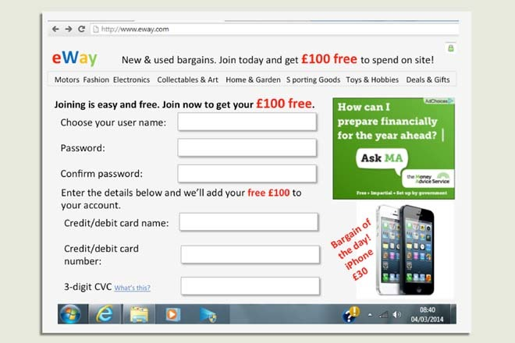
Figure 7 Does anything strike you as suspicious?

Which features would make you suspicious of this online retailer?

3.2.4 The dodgy website – what did you spot?

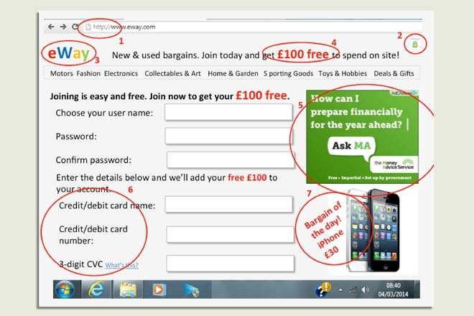
Figure 8 The spoof website

Well, what aroused your suspicions? You may have spotted some, or all, of the following.
- This site is asking for details, like a password, that should be gathered only over a secure site. But the site address (URL) starts with ‘http://’. A secure site’s address will start with ‘https://’.
- Another sign of a secure site is a padlock symbol. It should appear just before the website address or sometimes in the bar at the bottom of your computer screen. If, as here, it appears only in the body of the website, this is an indication that it could be fake.
- A name and logo that are very similar to a real website. It’s designed to trick you into thinking you’re on the real website or an associated company’s site.
- Inducements to sign up right now, so you don’t have time to think carefully about what you’re being asked to do.
- Genuine ads from real organisations designed to reassure you that the site is a trusted one.
- Collecting card or bank details over an unsecure site and unrelated to any purchase. This is the whole purpose of the fraudsters: to steal your card details and then go shopping at your expense.
- If an offer sounds too good to be true, then it usually is.
You might also notice that there are no contact details on the site, so there’s no way to find out more or to complain if things go wrong.
Here are some useful tips for consumers buying online – although many tips on buying online are the same as for buying from a shop.
- Shop around. That great deal might be on offer somewhere else – and cheaper.
- Use retailers and services you know about – or ones that have been personally recommended to you.
- A company might have a great website, but that doesn’t mean it’s law-abiding.
- Make sure you know the trader’s full address – especially if the company is based outside the UK. The internet makes buying from abroad easy so it’s important you know your rights.
- Don’t assume an internet company is based in the UK just because its web address has ‘UK’ in it – check out the physical address and phone number.
- Take into account the shipping, postage and packing costs. Weigh them up against the parking and travelling costs you would have to pay if you went to the high street.
- Although shopping from overseas websites is relatively safe, it may be difficult to enforce your contract if things go wrong. If the item or service is over £100 consider paying by credit card.
- Look for websites that have a secure way of paying (known as an encryption facility) – these show a padlock, as noted above, before the web address or at the bottom of the screen when you’re filling in the payment details.
- Check whether the company has a privacy statement that tells you what it will do with your personal information.
- If buying from an auction site, check the seller’s reputation. Be careful, some traders will make up accounts and post good comments about themselves. Look to see how many transactions the person giving feedback has carried out online; a number next to their name will indicate this.
- Be wary: if the price is too good to be true, it usually is.
(Adapted from ONS, 2010, p. 4, cited in Callaghan et al., 2012, pp. 109–10)

3.2.5 Heuristics and spending
One reason why people sometimes pay higher prices for certain goods and services is that they think a higher price equates to higher quality. The price of a product is often used as a mental short cut to assess quality. Such short cuts are called heuristics and they’re used to help assess situations when there’s limited information available.

Video content is not available in this format.
View transcript - Uncaptioned interactive content



3.2.6 How to trim your expenditure


Figure 9

There are so many ways to save money. Here are a few of the more common ideas from personal finance experts.
- Paying some bills by direct debit may save you money, for example utility bills. (But check this carefully as some bills such as household and car insurance may cost more if paid monthly by direct debit.)
- Think about remortgaging. Saving 1% on a £100,000 mortgage saves up to £83 a month (you look at mortgages in more detail in Week 6).
- Shop around when it’s time to renew insurance premiums. Premiums are often increased each year, relying on customers not bothering to switch to another company. Also check that you’re not paying for any ‘extras’ you didn’t ask for or want (you look at insurance in Week 8).
- If you’re paying high interest on your credit cards, look for 0% deals on balance transfers but check for transfer fees.
- Switch suppliers of gas, electricity, telephone or internet connection. Consider a water meter. There are major savings to be had in these areas.
- Reconsider being a member of a gym, and pay as you go instead – this can save money depending on how often you go.
- Think about whether a branded item is really value for money.
- Cut down on the number of takeaway meals you have – cutting from two to one a week would typically save over £250 a year.
- Call your mobile phone supplier and ask them if there’s a better tariff to suit your needs.
- Buying in bulk for items such as contact lenses saves a lot of money.
- Taking packed lunches to work can save lunch costs.
- Buy fresh fruit and vegetables in season. Check whether a local market is cheaper than the supermarket.
- Turn off lights, don’t leave stand-by buttons on and turn down the thermostat to save large amounts on energy bills (and help the environment) each year.
- Make a shopping list and stick to it. Try to use money-off coupons from papers and magazines where possible.
- Think carefully about buying extended warranties – it may be better simply to put aside some money in case of a problem.
- If you have internet access, look for price comparison websites to find the best deals.
You’ve read the list of tips from experts. Can you identify any social and economic changes that have influenced these ideas?

3.2.7 Consumer society in 2018
It could be argued that many of the money-saving tips you’ve discussed have arisen as a result of social and economic changes in the UK in recent decades. Some, such as being able to shop around for a cheaper internet or phone company, reflect the increased competition in certain sectors of the economy, with more suppliers available in the marketplace. Others, such as thinking about the cost of gym membership or cutting down on takeaways, reflect the increased focus in the media on healthy lifestyles. Technological change is also important with reference to mobile phones, buying online and comparing prices online.
The consumer society and the behavioural factors that drive spending decisions – which you looked at earlier this week when you examined ‘heuristics’ – are relevant when considering the motives behind buying certain branded items. The list of money-saving tips is particularly interesting because it highlights how social and economic changes can both increase household expenditure through more choice and pressure to buy, yet at the same time provide ways in which expenditure can be reduced.


Figure 10

3.3 Jenny’s spending and her goals
In this week, you reach ‘first base’ in managing your money – control over your income versus spending – and linkage of your finances to your life’s ambitions and goals.
When all the options have been weighed up and the necessary adjustments have been made, the final result is a budget showing planned expenditure and income for the following month(s).
In Jenny’s case, after making all of her adjustments to the pattern of her expenditure, her budget might look something like the third column in the table. By listing the budget together with her starting position, it’s easier to see the changes Jenny is planning to make. The new overall difference between income and expenditure is at the bottom of the budget.

Table 3 Jenny revises her spending
 | Cash flow (£ per month) |  | Average month (£ per month) |  | Budget (£ per month)
NET INCOME
Earnings | 1115 |  | 1115 |  | 1115
TOTAL NET INCOME |  | 1115 |  | 1115 |  | 1115
Rent | 250 |  | 250 |  | 250
Council Tax | 50 |  | 50 |  | 50
Regular bills (gas, electricity, water, etc.) | 30 |  | 60 |  | 50
Telephone (mobile and landline) | 40 |  | 40 |  | 30
Home insurance (contents and building) | 12 |  | 12 |  | 10
Household goods | 15 |  | 30 |  | 30
Food and non-alcoholic drinks | 150 |  | 150 |  | 120
Alcohol | 40 |  | 40 |  | 40
Tobacco | 30 |  | 30 |  | 0
Clothing and footwear | 50 |  | 50 |  | 40
Medicines, toiletries, hairdressing (personal) | 30 |  | 30 |  | 30
Going out | 120 |  | 120 |  | 80
Holidays/other leisure | 20 |  | 100 |  | 50
Motoring costs (insurance, petrol) | 70 |  | 130 |  | 180
Birthday presents/charity/other gifts
Christmas presents/gifts | 10 |  | 45 |  | 30
Personal loan repayments | 100 |  | 100 |  | 100
TOTAL EXPENDITURE |  | 1017 |  | 1237 |  | 1090
SURPLUS/DEFICIT |  | 98 |  | -122 |  | 25

Compare Jenny’s budget (shown in the budget column) with her previous pattern of spending (shown in the average month column) in the table. What things is she spending more on, and what is she spending less on? Do you think this budget will help her to meet her goals?

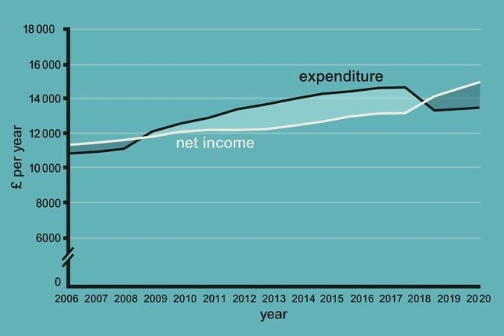
Figure 11 Jenny’s post-budgeting real net income and real expenditure profile, 2006–2020

The impact of Jenny’s decisions can be seen in the graph, showing her moving from a deficit to a surplus on her budget, which she intends to maintain in the future.

3.3.1 Jenny adjusts her budget (Stage 3: acting on the financial plan)

Video content is not available in this format.
View transcript - Uncaptioned interactive content



The only item of expenditure that has increased is Jenny’s payments on motoring costs. If Jenny sticks to her budget, she can save £25 a month and increase her motoring cost payments to £180 per month. If Jenny’s budget is implemented as planned, her income and expenditure profile will look much healthier in financial terms.
In the graph that you’ve just seen, for example, from 2018 Jenny’s income increases and her expenditure falls, and her income exceeds her expenditure. She is no longer adding to her debt (even though it may take her some time to pay off her existing debt), and she now has some surplus income, shown by the shaded area from 2018. Jenny could use this surplus to pay off some more of her debt and/or use it for saving.

3.3.2 Budgeting – taking control
The best of intentions and plans can be difficult to implement. One method suggested by personal finance experts to help implement a budget is an ‘envelope system’. This system uses hypothetical or, perhaps, real envelopes for each type of expenditure, and allocates the amount of money planned for that type of expenditure to its envelope. An alternative could involve using (empty) jam jars. Another way is to set up separate savings accounts for certain – more major – items of expenditure like holidays or a new car.
Once the different directions of spending and their ‘envelopes’ have been worked out, money is allocated to each of them and the ‘envelopes’ filled, by putting that money into different accounts. For example, the bank current account may be allocated an amount each month to pay for food and regular living expenses, such as travel costs, and commitments, such as insurance premiums.
A savings account may be allocated money for infrequent expenditure, so that money is built up to pay for holidays, birthdays or Christmas, while another savings account may be used for saving in case of an unexpected crisis. A fixed amount of cash each week is also needed for those areas usually paid for in cash, such as entertainment.
The idea of the envelope system is that you do not then switch money between these areas – when the envelopes run out, they run out. This creates a strong discipline to keep to the allocated budget amount.


Figure 12

3.3.3 Ways of saving
What’s your method of setting aside amounts of money? Watch this video and see how members of the public set aside their money.

Video content is not available in this format.
View transcript - Uncaptioned interactive content



3.3.4 Budgeting (Stage 4: reviewing the financial plan)
As budgeting is an ongoing process a review date is usually fixed. Initially, this review may be in just one month’s time, since at the beginning there may be some trial and error in the budgeting process. After a while it should settle down, and the review dates can be extended to, say, every six months.
At the review date a new cash flow statement needs to be calculated, with all the necessary information entered, to see whether the budget is working. The new cash flow statement allows the plans of the budget to be compared with what actually happened. It’s probable that more amendments may be needed as it becomes clear how easy or difficult the budget was to implement. A new budget is also required if the goals for which the budget was designed change. A further reason for review would be if income changes, and a new budget with more adjustments in expenditure is then required.
External influences, such as price rises and interest rate changes, are also likely to impact on budget plans. For example, a 5% annual inflation rate applied to Jenny’s expenditure would increase it from an annual figure of £13,080 (12 × £1090) to £13,734 – an increase of £654. Jenny’s income may have risen to accommodate this increase, but incomes may not always change at the same rate as prices so monitoring and reviewing these changes is important.
It’s easy to see how such external changes can greatly impact on financial plans, given that after her budgeting exercise Jenny was planning to save only £300 p.a. (£25 × 12 months). This is one reason why financial experts suggest adding a little on to planned expenditure to allow for price increases. For instance, a look at previous gas and electricity bills can show how much energy prices have risen. This precautionary approach may help to avoid some unpleasant surprises.

Figure 13 The financial planning model

3.3.5 Now complete your budget
You’ve got to the point where you should be able to complete your budget. Have a go at doing this now, using the MAS budget planner that you worked with first in Week 2 (remember to open it in a new window or tab). You’ve now got figures for both your income and expenditure, and so you can complete your budget in your fact find. You might want to revise your budget by making use of the third column – unless of course you’re entirely happy with your budgetary state of affairs.

Figure 14

What does the completed budget tell you about your current financial position?
What actions – if any – are you going to take to improve your financial position? Will this involve trying to increase income or cut expenditure or both?

Week 3 quiz
This quiz allows you to test and apply your knowledge of the material in Week 3.
Complete the Week 3 quiz now.
Open the quiz in a new window or tab then come back here when you're done.

Week 3 round-up
In Week 3 you’ve seen how comparing your expenditure with your income enables you to draw up a budget.
Effective budgeting provides the means for individuals and households to identify their priorities and objectives, and helps to identify what has to be done to achieve them.
Well done! You’ve completed your study of how to manage household cash flows.
Next you start to explore the various assets and liabilities people also have to manage during their life course. Week 4 looks at debt and borrowing – a subject familiar to virtually all households in the UK.
You can now go to Week 4: Debt and borrowing


Figure 15

Week 4: Debt and borrowing

Introduction
The UK’s mountain of personal debt. Are there ‘good’ and ‘bad’ debts? How the Bank of England sets interest rates. Interest calculations – simple and compound. How does inflation affect the cost of borrowing?
Martin welcomes you back to tackle debt, interest and inflation.

Video content is not available in this format.
View transcript - Uncaptioned interactive content

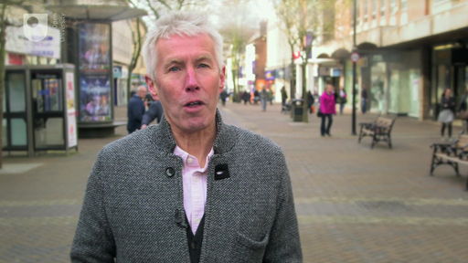

This course is presented with the kind support of True Potential LLP.
The True Potential Centre for the Public Understanding of Finance (True Potential PUFin) is a pioneering Centre of Excellence for research in the development of personal financial capabilities. The establishment and activities of True Potential PUFin have been made possible thanks to the generous support of True Potential LLP, which has committed to a five-year programme of financial support for the Centre totalling £1.4 million.

4.1 Personal debt
In the video Martin Lewis – money saving expert and media adviser on financial management – engages in a discussion with an audience about good and bad debt.

Video content is not available in this format.
View transcript - Uncaptioned interactive content

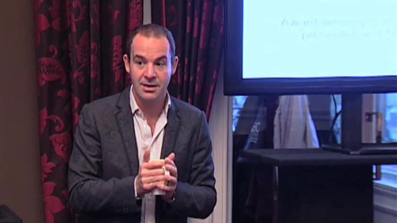

Debt is a topical issue, and for many households a sensitive and problematic one. But it’s necessary to take a measured approach and recognise, as Martin Lewis demonstrates, that all debts are not bad debts.
Debt arises when we borrow money, and there are many forms of borrowing – from credit card debt to bank overdrafts, bank loans, student loans (to finance higher education) and mortgages (to finance the purchase of property or land). Debt can be used to provide finance for everything from day-to-day spending (you’ll be aware of the growth in recent years of ‘payday’ loans) to holidays and to items we use over a number of years, such as furniture, cars and our homes.
Since 1993 the aggregate (total) value of personal debt has risen 3.5 times to a total of £1.56 trillion. The vast majority – around 87% – of this is ‘secured debt’, money lent against the security of property or other assets that the lenders can take possession of if the borrower fails to repay the money that has been lent to them. The rest is unsecured debt, which since the late 2000s has actually fallen slightly in aggregate value.
The UK has seen some dramatic swings in interest rates in recent decades – from the highs of the early 1980s to the historic lows we’re currently witnessing. So getting to grips with the factors that determine how much we have to pay on our debts is an essential aspect of financial planning.

4.1.1 Debt and interest – some basics
When someone acquires a debt, the money they have to repay to the lender consists of three elements.
First, there’s the amount originally borrowed – this is normally referred to as the principal sum, or sometimes the capital sum. Let’s say £10,000 is borrowed for five years to buy a car, how will this be repaid? There are two usual ways in which this principal sum can be repaid: either in one amount at the end of the term of the loan (in this case, five years), or in stages over the life of the loan. The former is often referred to as an ‘interest-only loan’ and the latter a ‘repayment loan’. If the principal sum is to be paid off in full at the end of the loan period, the borrower will need to have the money available through building up other savings to pay off the loan. An example of this type of loan is an endowment mortgage, which used to be a common way of buying a home – an interest-only loan is combined with saving through an endowment insurance policy that hopefully builds up enough lump sum to pay off the loan at the end of its term.
Second, there’s the important additional cost of having debt: the interest that has to be paid on it. In effect, interest is an additional charge on the repayment of debt. It is normally expressed as a percentage per year – for example 7% per annum, more commonly abbreviated to 7% p.a. The charging or paying of interest is generally rejected by sharia law, as it used to be by some Christians in earlier centuries. In modern economies the concept of interest comes about because lenders require recompense for three factors: for the access to the money they have given up; for the risk associated with not getting their money back; and to cover the expected inflation rate over the coming year.
Third, there may be charges associated with taking out, having or repaying debt. These will be explored in more detail later.

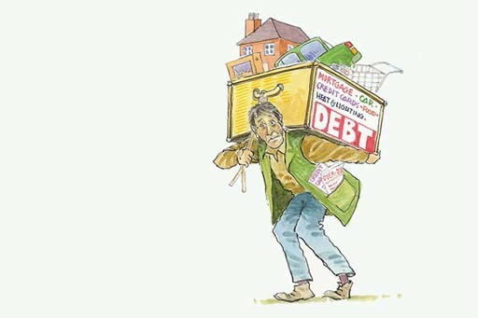
Figure 1

4.1.2 More on interest
Let’s look at interest payments in more detail. If £10,000 is borrowed and no repayments of this principal sum are made during the year, and the interest rate is 7% p.a. with interest being paid once a year at the end of the year, the interest charge for that year is £700.
So, provided the principal sum owed to the lender remains at £10,000 and the interest rate is 7% p.a., the borrower will have to pay £700 each year to the lender. This is an example of a simple interest calculation where the interest rate is applied just to the original sum borrowed.
If you want to look further into the cost of borrowing and the interest you pay on a loan, you can practice using the MAS loan calculator.

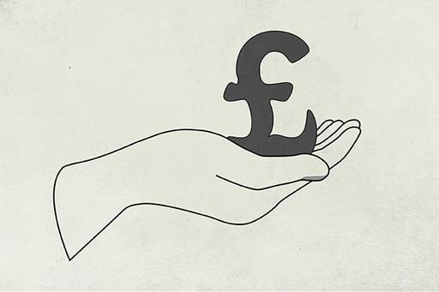
Figure 2

4.1.3 How much interest?
This quiz allows you to test your ability to calculate interest.

Activity 1

How much would you pay in interest per annum if you make no repayments on a principal sum of £50,000 and the rate of interest is 5%?

£5000
£2500
£17,500
£3350

How much would you pay in interest per annum if you make no repayments on a principal sum of £50,000 and the rate of interest is 6.7%?

£3750
£46,650
£44,890
£3350

4.1.4 Compounding of interest
As you completed the calculations in the quiz, you may have started to think of some factors that could complicate the calculation of the interest charge. For example, what would be the interest charge if some of the principal sum is repaid during the course of the year?
In many cases, the answer is that the interest rate calculation will be based on the average balance of the principal sum during the year. For instance, if £10,000 is owed at the start of the year and £100 is repaid halfway through each month, then the outstanding balance at the end of the year would be £8800. The average balance of principal outstanding during the year would be the average (mean) of the balance at the start and at the end of the year, or £9400 = ((£10,000 + £8800)/2). Based on this average balance, the interest for the year at 7% p.a. would be £658 = (£9400 x 7/100) – rather less than the £700 if no repayment of the principal sum had been made.
What happens if the borrower does not repay the interest due to the lender? Again, this will depend on the details of the contract with the lender and their attitude to borrowers who fall into arrears. Normally, the lender will add the interest charge left unpaid to the principal sum. This means that the following period’s interest charge is going to be higher since the borrower will be paying interest, not only on the original principal sum but also on the unpaid interest. This is known as compounding, and can quickly enlarge debts.

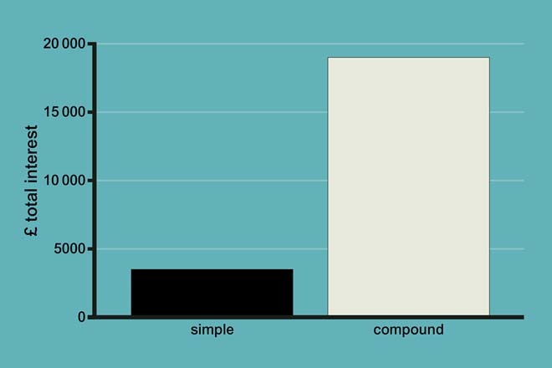
Figure 3 Simple and compound interest: 35% on £1000 for ten years

The example of compounding that you see in Figure 3 illustrates what happens if someone borrows £1000 at an interest rate of 35% and makes no repayments over ten years. Over this period of time, the debt would rise from £1000 to £20,107 (£19,107 interest on top of the £1000 borrowed). This is much more than if interest had been charged on a simple rather than compound basis – simple interest over ten years would have been just £3500.
The dangers of compounding were demonstrated vividly in a famous case which came to court in the UK in 2004. A debt of £5750 grew to the staggering sum of £384,000 in 15 years. In the event, the debt was (unusually) cancelled for being ‘extortionate’. Yet it showed the risks of compounding very clearly.
The precise practice for computing the interest charge varies among different lenders – and interest can be calculated by different lenders at different time intervals. One of the pieces of financial small print it is always vital to read is the basis on which interest is charged – that is, how often and by reference to what terms. For instance, if a person is repaying some of the principal sum of their loan regularly, the interest charged will be lower if the interest charge is calculated on a daily basis, rather than on a monthly or an annual basis. (Interest charged on an annual basis will be the least favourable option if repayments of the principal sum are being made.)

4.1.5 What determines the level of interest rates?
To understand what determines the level of interest rates charged when you borrow money, you first need to understand how ‘official’ interest rates are set.
The video, which features Mark Carney, Governor of the Bank of England, sets the scene by looking at the factors taken into consideration when setting official interest rates.

Video content is not available in this format.
View transcript - Uncaptioned interactive content

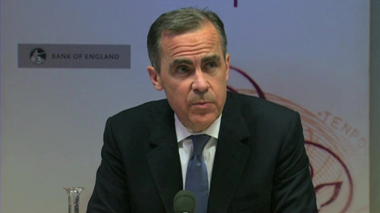

Prior to 1997, ‘official’ interest rates in the UK were determined by the UK government, usually after consultation with the Bank of England. Arrangements changed in May 1997 when the incoming Labour government passed responsibility for monetary policy and the setting of interest rates to the Bank of England to make the bank independent of political influence. This matches the arrangement in the USA and in the ‘euro zone’, where the Federal Reserve Bank and the European Central Bank respectively set official rates.
The rate set by the Monetary Policy Committee (MPC) known as the ‘Bank Rate’ is the rate at which the Bank of England will lend to the financial institutions. This, in turn, determines the level of bank ‘base rates’ – the minimum level at which the banks will normally lend money. Consequently, Bank Rate (also known as the ‘official rate’) effectively sets the general level of interest rates for the economy as a whole.
Note, though, that for individuals the rate paid on debt products will be at a margin – sometimes a very high margin – over Bank Rate and bank base rates. Indeed, one of the consequences of the financial crisis was that the margin between Bank Rate and the rate paid on debts widened sharply (except for those products whose rate was contractually linked to the Bank Rate).
Each month, the Bank of England’s MPC meets for two days to consider policy in the light of economic conditions – particularly the prospects for inflation. The MPC’s decision is announced each month at 12 noon on the Thursday after the first Monday in the month.
The prime objective is for the MPC to set interest rates at a level consistent with inflation of 2% p.a. For example, if the MPC believes inflation will go above 2% p.a. it might increase interest rates in order to discourage people from taking on debt – because if people spend less, it could reduce the upward pressure on prices. Conversely, if the MPC believes inflation will be much below 2% p.a. it might lower interest rates (also known as ‘easing monetary policy’) – people might then borrow and spend more.
However, in 2013 and 2014 the policy on the setting of official rates was modified to take greater account of the level of unemployment in the economy. First it was announced that official rates would not be raised while the rate of unemployment was above 7% of the labour force. Subsequently, following a sharp fall in unemployment towards and then below 7%, this stance was modified to one where the MPC would take account of the extent of spare capacity in the economy rather than just the rate of unemployment. The video explores this change of emphasis to the setting of official interest rates in the UK.
Official rates of interest tend to be cyclical, rising to peaks and then falling to troughs. Since 1989 the trend in the UK has been for nominal interest rates to peak at successively lower levels. Nominal rates fell to 3.5% in 2003. In 2009 they hit a record low of 0.5% and were still at this level in May 2016. This is because the Bank of England has been attempting to stimulate economic activity following the period of recession at the end of the 2000s. However, the benefit of these low nominal interest rates was not fully experienced by borrowers as the margin widened between the Bank of England’s Bank Rate and the rate charged by lenders on many of their debt products.
In November 2017 Bank Rate was raised for the first time in 10 years – from 0.25% to 0.5%. The change, although modest, was taken as a signal that future years will see higher interest rates than those experienced since the financial crisis of 2007/08.

4.1.6 Real interest rates
You will recall from Week 2 that it is important to take inflation into account when managing your finances. In Week 2 you looked at the distinction between nominal and real income, the latter taking into account the level of price inflation. Now you do the same in looking at interest rates.
Real interest rates are interest rates that have been adjusted to take inflation into account. Looking at the graph, you’ll see that when inflation is higher than the nominal interest rate, real interest rates are negative (as they were in 1980/81 and again from 2010). Real interest rates are at zero when the rate of inflation and the nominal interest rates are the same; and they are positive when the nominal interest rate exceeds inflation.

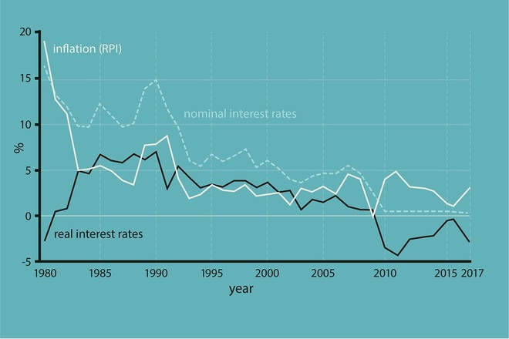
Figure 4 Nominal and real interest rates and inflation in the UK, 1980–2017 (Bank of England, 2017; ONS, 2017)

Real interest rates were low in the 1990s and 2000s, falling from 7% in 1990 to just under 2% by 2004. Subsequently they fell further. By 2013 the fall in the (nominal) official interest rate to a historical low of 0.5%, combined with price inflation of 2.7%, resulted in negative real interest rates of -2.2%.
So, if you earn a nominal rate of interest of 1.5% on your savings and price inflation is 2%, you are actually getting a real interest rate on your savings of -0.5% – a negative rate of return. Such a situation where real interest rates are negative is clearly adverse for savers. However it is good news for borrowers if the cost of borrowing is negative in real terms.
Unsurprisingly, the low interest rates offered on savings in recent years have encouraged some households to reduce their debts – particularly credit card debts which have relatively high interest rates – by reducing their savings balances.
Most mainstream lenders link interest rates, including mortgage rates, to the official rate of interest, and so the cost of debt, including mortgage debt, declined over this period. This is another reason why debt levels may have risen in the 1990s and until 2007.
After 2007 the relationship between the official rate of interest and the cost of debt products was altered by a widening in the margin between them. Nevertheless, in the mid 2010s interest rates on mortgages and many other debt products were historically low.

4.2 Annual Percentage Rate (APR) of interest
In this section, you'll find out more on interest and the choices for borrowers. You'll also take the credit scoring test, find what opens and closes the door to getting a loan and explore the links between credit quality and interest rates on debt.
You have seen that borrowers have to repay to the lender both the principal sum and the interest. On top of this there are often extra costs. Some of these costs arise from fees that may have to be paid on obtaining a loan and, under certain circumstances, on repaying the loan before the end of the term.
- Arrangement fees paid to the lender: usually flat-rate, one-off fees charged when the loan is first taken out. Sometimes they may be added to the loan.
- Intermediary fees: may be paid when a borrower deals with a broker rather than directly with a lender.
- Early repayment (or ‘prepayment’) fees: may have to be paid to a lender if a loan is repaid early. The argument used by lenders is that earlier repayment can incur additional costs. In the case of personal loans, early repayment charges mean the lender gets a share of the interest that would have been paid had a borrower kept the loan for the full term.
- Tied insurance: taking out insurance (for instance, payment protection insurance, life insurance, home insurance) may be required with a loan. In other cases, insurance may be optional, although this is not always made clear to borrowers, who may end up paying for inappropriate policies.
Given all these different potential charges, and the different methods of calculating interest, it’s important to have a good means of comparing the total cost of debt on different debt products. Fortunately, in the UK there is a way of ensuring a fairly accurate ‘like-for-like’ comparison and of assessing which debt product is most appropriate. This is known as the Annual Percentage Rate (APR) of interest.
The APR accommodates interest and those charges, discussed above, that are compulsory. It does not include optional charges, such as buildings insurance, that are not required as part of a mortgage package or contingent charges, such as early repayment fees, that would become payable only in situations that are not applicable to all lenders. The APR also takes into account when the interest and charges have to be paid. The method for calculating the APR is laid down by the Consumer Credit Act 1974, as amended by the Consumer Credit Act 2006. Generally, a low APR means lower costs for the borrower.
The APR should be seen as only a reasonably standardised guide for comparing one loan with another based on their total cost. APR is not a perfect measure of loan costs. As mentioned above, it does not include costs that are not a compulsory part of the loan. In 2003 the Parliamentary Treasury Select Committee report into credit and store cards found that there were, in practice, two different precise methods used to calculate the APR, and ‘up to 10 different ways in which charges are calculated, meaning that users of cards with the same APR can be charged different amounts’ (UK Parliament, 2003). The Department of Trade and Industry responded by publishing regulations that tightened up the assumptions that could be used in the calculation of the APR.


Figure 5

4.2.1 Types of interest rate
Interest rates can be set in a number of ways.
- A variable rate, which can move upwards or downwards during the life of the loan. In the UK variable rates usually move in tandem with movements in the official rate of interest. Some products (called ‘trackers’) are specifically linked to specific rates of interest such as the official Bank of England rates (Bank Rate).
- A variable rate with a ‘floor’. This is the same as a variable rate except that the rate cannot fall below a defined minimum level, known as the ‘floor’.
- A fixed rate where the rate is determined at the start of the loan and remains unaltered throughout the fixed-rate term. The rate will be based on what the lender has to pay for fixed-rate funds of the same term.
- A capped rate where the rate cannot rise above a defined maximum (the ‘cap’), but below this ‘cap’ it can move in tandem with movements of official interest rates. A variation to a capped-rate loan is a ‘collared’-rate loan where rates can move in line with official rates but cannot go either above a defined maximum (the ‘cap’) or below a defined minimum (the ‘floor’). Such products usually require the payment of a fee to the lender at the start of the loan.
Most commonly, personal loans are set at a fixed rate; credit card debt and overdrafts are set at a variable rate; while mortgage lending is split between the four interest rate forms defined above.
Households with variable-rate mortgages are, along with most of those with credit cards and overdrafts, at risk from increases in interest rates. As mortgages account for a large proportion of personal debt, it is easy to see why the UK economy can be easily affected by even relatively small movements in interest rates.

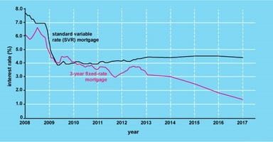
Figure 6 Debt products can be at either fixed or variable rates of interest

You will explore mortgages in detail in Week 6.

4.2.2 Interest rates – fixed or variable?

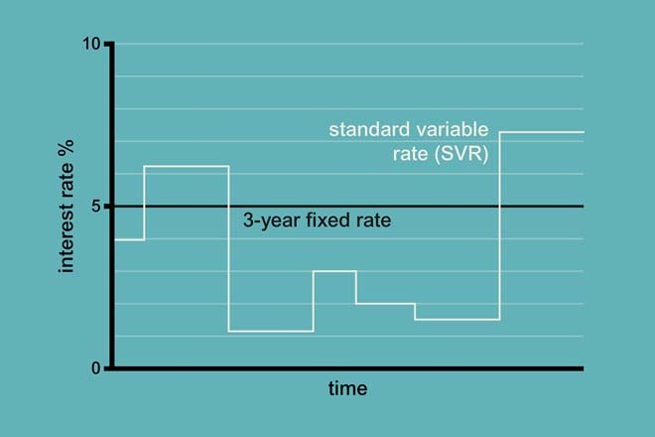
Figure 7 Fixed or variable?

Activity 2

Under what circumstances do you think it might be attractive to borrow at (a) a fixed rate of interest and (b) a variable rate of interest?

View discussion - Activity 2

What about your own debts – have you borrowed at a fixed or variable rate of interest?

4.2.3 Individual interest rates
You saw earlier that the Bank of England determines the official interest rate. Yet this is not the interest rate that will be charged to individuals taking out different types of debt. Lenders will tend to take into account a number of factors when setting the rates for a particular individual.
One of the reasons for charging interest has been the need for lenders to have a return for taking the risk associated with not getting their money back. Customarily, the basic principle here would be that the greater the estimated risk of loss, the greater the interest charged. This means that ‘higher risk’ borrowers may be charged more interest than those who are deemed ‘lower risk’. In a similar vein, interest charges will vary according to the security offered to the lenders by the borrowers.
This brings us to the distinction between secured and unsecured debt. Secured debt is money that is borrowed against an asset such as a home. If the debtor fails to make adequate repayments the lender has the right to recoup the money it has lent by selling the asset. By contrast, unsecured debt is not backed by any specified asset. For these reasons secured debts will, other things being equal, usually have a lower interest rate than unsecured debts.
Another factor that may affect interest rates is the size of the loan. Sometimes, larger loans will attract lower interest rates than smaller loans. The extent of competition between lenders will also be a factor. Typically, the greater the competition between lenders, the lower the interest rate you would expect them to charge.
One question that arises from this is whether such factors can explain the different interest rates charged, especially the higher rates often charged to people on much lower incomes. A Citizens Advice Bureau survey, for instance, found that APRs charged to clients with debts owed to money lenders and home-collected credit providers ranged from 25% to a staggering 360%, while interest rates charged on mainstream credit card debts ranged from 9.9% to 25.4% and on bank loans from 8% to 32.9% (Citizens Advice, 2003).
For many on low incomes, mainstream loans are simply not available because they fail the credit scoring tests such lenders apply. The result is that many have no option other than to borrow from non-mainstream lenders, whose high rates reflect both the risks involved in lending to those on low incomes and the recognition that such borrowers have few, if any, alternative options if they need a loan.
A Citizens Advice Bureau in Hampshire reported that their clients, a couple with two children, had taken out a £500 loan to repay their rent arrears which were the subject of possession proceedings. The total cost of the loan was £800 in total, with a 60% rate of interest. A West of Scotland Citizens Advice Bureau reported a client couple who had over £16,000 in debts. The couple had two recent loans from doorstep providers, both granted within two months of each other. The first loan was for £500, with a £275 interest charge. The second loan was for £100 with a £55 interest charge. These loans were being used to help meet the income shortfall on existing credit agreements (Citizens Advice, 2003, pp. 27, 28).
One alternative for those on low incomes is to see if they can borrow money from credit unions. These organisations do provide credit for those on low incomes – typically at interest rates higher than those charged by mainstream lenders but certainly lower than those charged by money lenders and the so called ‘payday lenders’. You’ll look at these types of lenders in a little more detail later this week.

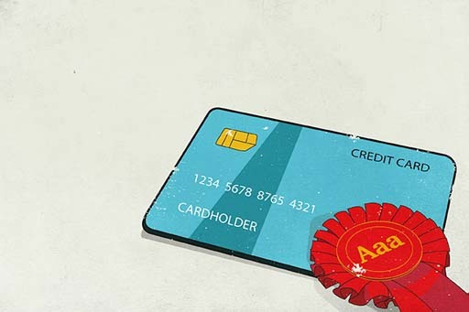
Figure 8

4.2.4 The credit scoring game


Figure 9 Bill, Dave, Jo and Rajeev

Take a look at the credit profiles of Bill, Dave, Jo and Rajeev below. Who has the best credit score and who has the worst? Can you place them in their credit score order and explain your reasoning?

Table 1
 |  | Bill | Dave | Jo | Rajeev
Age | How old are you? | 20 | 19 | 39 | 40
Employment | How would you describe your work? | Semi-skilled | Unskilled | Professional | Skilled
Employment | How long in current employment? | 2 years | Not employed | 5 years | 19 years
Marital status | Single/married/separated/divorced/widowed? | Single | Separated | Married | Married
Children | How many? | No children | 1 child | No children | 1 child
Bank account | Do you have one? | Yes | Yes | Yes | Yes
Credit card | Do you have one? | Yes | No | Yes | Yes
Housing status | Home owner or tenant? | Furnished tenant | Furnished tenant | Furnished tenant | Owner-occupier
Housing status | How long at your current address? | 2 years | 1 year | 2 years | 4 years

4.2.5 Credit scores – the outcome
How did you do? What order of credit worthiness did you put our four borrowers in?
First you should note that the credit scoring models employed do vary from one institution to another. This means that the scores they generate can vary accordingly when applied to the same applicant.
The key things that score well though, besides having a good or high level of household income, are factors that infer stability and orderliness in the financial affairs of applicants. So stability of employment and in domestic residence scores well. Being an owner-occupier does too – even when the borrowing sought is not going to be secured against the property. Being older helps as you may be able to demonstrate a record of credit worthiness that stretches back over decades. Having fewer children also helps as it implies lower household expenditure commitments. Being in a professional job also helps as this is likely to reduce the risk of having periodic gaps in employment that reduce household income. Having a bank account and credit cards also help – particularly as they demonstrate that credit scoring tests have been ‘passed’ on previous occasions. Being married is positive for your score – being divorced is negative given, again, the inference of these when it comes to the stability and robustness of household finances.
By contrast being young, having a large number of dependants, living in rented accommodation – particularly if there is a record of moving home regularly – having a poor employment record and limited existing access to banking facilities are generally bad news when it comes to a credit score. Such factors provide no comfort about the solidity and orderliness of household finances, implying that lending to such applicants is risky. Additionally it is less likely that such applicants would have been able to build up a long term record of proven credit worthiness. Lending to those with a poor credit score may still take place, but the interest rate charged may be higher – perhaps materially – to reflect the risks involved.
The assessments of credit rating agencies are, though, not impressionistic. They are underpinned by data analysis of statistical relationships between aspects of social status and evidence of credit defaults.
So our model produced the following credit league table ranking:
- Rajeev
- Jo
- Bill
- Dave.


Figure 10

4.3 Meet the lenders
In this section, you will meet the lenders and their debt products, use the financial planning model to guide your borrowing decisions for those ‘big ticket’ purchases and find out the best tips for making sure that the pitfalls of borrowing are side-stepped.
Here Jonquil Lowe, personal finance expert at The Open University, presents a tour of the lending industry in the UK.

Video content is not available in this format.
View transcript - Uncaptioned interactive content



Although the global financial crisis, which began in 2007, wrought havoc with the UK financial services industry, the sector has continued to be dominated by banks. This domination had been reinforced by the conversion of most of the large building societies to banks in the 1980s and 1990s – although all those that did convert were subsequently either acquired by other banks or, in the case of Northern Rock Bank and parts of Bradford & Bingley Bank, taken into public ownership during the financial crisis.

4.3.1 Borrowing can take many forms
Here’s a run-down of the most common forms of borrowing.
Overdrafts: a flexible means of accessing debt on a bank current account, up to a limit approved by the lender. Unapproved overdrafts normally attract penalty fees and high interest charges.
Credit cards (including store cards): their credit limits are set by the lender and normally require a minimum amount to be repaid each month – typically between 2% and 5% of the balance of debt. They may offer a short period of interest-free credit until payment is due. Credit cards vary widely in the interest rate charged on the balance that is not paid off, and some have an annual fee attached, although many do not. Store cards are a form of credit card used for buying from specified outlets. They tend to have much higher interest rates than credit cards.
Charge cards: can be used like credit cards to make purchases and obtain approximately two months’ free credit between purchase and paying off the outstanding amount. Charge cards differ from a credit card in that a borrower is required to pay off the entire balance each month. The two-month free credit period arises when the charge card bill is sent out monthly, with a further month in which to settle the bill. A fee may be payable for the card.
Personal loans: loans made to individuals, typically with terms of between one and ten years. They may be either unsecured or secured against a property (such as a house) or other assets. Unsecured personal loans are not contractually linked to any assets the borrower buys. These are available from credit unions, banks, building societies, direct lenders and finance companies.
Hire purchase (HP): a form of secured debt where payments (interest and part repayment of the principal) are made over a period, normally of up to ten years, to purchase specific goods. The legal ownership of the product only passes to the borrower when the final instalment has been paid.
Mortgages: loans to purchase property or land, which are secured against these assets. Debt terms for mortgages are normally up to 25 years. There are many types of mortgage and it’s possible to fund spending through equity withdrawal. Since the financial crisis, however, lenders have become more cautious about equity withdrawal, particularly in the wake of the decline in average house prices after 2007. We look at mortgages in more detail in Week 6.
Alternative credit: these are the areas of sub-prime lending described earlier, and include buying on instalments through mail-order catalogues, doorstep lending and ‘payday lending’. Commonly, interest rates are high and there are heavy penalties for late payment.
Peer-to-Peer (Peer2Peer) lending: this is an emergent form of lending in the UK and involves savers pooling funds for on-lending to individuals and businesses. This form of lending, arranged through intermediaries like Zopa and Financial Circle, circumvents banks and other conventional lenders.

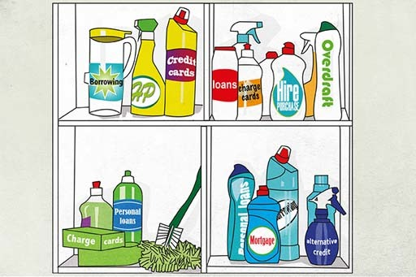
Figure 11

4.3.2 Making borrowing decisions
Philip wants to purchase a music system costing £1000. If you assume that he cannot simply fund the purchase out of his monthly budget, his options include:
- using existing savings
- building up savings first, then purchasing the item later
- using a mixture of savings and debt
- taking out a debt of £1000.
The option Philip chooses will obviously depend on a number of factors including, crucially, his initial financial position.
For the rest of this week, you’re going to help Philip make the best choice. Start by running through some generic issues related to each option.
Option 1 involves using existing assets held as savings. If Philip has savings, he could draw on these to buy the music system. When deciding whether or not to use his savings, Philip may think about opportunity cost – the savings he uses to buy the music system will not then be available to purchase something else. He will also have to give up the interest he would have received on the savings spent on the music system. He might want to compare debt costs with the loss of income on his savings.
There are generally two reasons why the interest paid on a debt may be rather higher than income earned on savings.
- Savings products and debt products are provided by the same institutions – such as banks and building societies – and these institutions make their profits from the difference between the interest rates on the two products. In normal circumstances it’s likely that the interest rate for debt will be higher than the rate earned on savings.
- Interest on savings will be taxed as income unless there is a means of sheltering the earnings – for example, by saving in tax-exempt products. If savings are taxed, the rate of interest received after tax is likely to be lower than the interest paid for borrowed money. (Savings are covered in more detail in Week 5.) So, other things being equal, using existing savings will usually be cheaper than taking out debt to fund a purchase.
Option 2 is to build up savings before purchase. Again, this depends on having disposable income to allow savings to be built up. It also depends on Philip being prepared to defer the enjoyment associated with having a music system for the time it takes him to build up the savings. For the same reasons as Option 1, this second option is most likely to be cheaper than using debt to fund the purchase.
Options 3 and 4 both involve taking on debt. For the reasons already given, it’s likely that using a mixture of savings and debt would be cheaper than funding the purchase solely through debt.
For the sake of clarity, assume that Philip chooses to borrow the full £1000.


Figure 12

4.3.3 Affordability


Figure 13

What does Philip need to think about?
Think back to the financial planning model. If Philip were to apply the ‘Stage 1: assess the situation’ part of the model, what are the issues he would need to consider?

Philip assesses the situation
Using as a guide the assessment part of the financial planning model, Philip would need to consider the relative importance of buying the music system within the wider context of his existing goals.
He would need to think about the constraints on his resources, and calculate whether he can afford the repayments within his household budget. In thinking through affordability, Philip should consider the possibility that his circumstances may change. For instance, if his household income were to fall or be interrupted during the term of the loan, would Philip still be able to afford the repayments? This assessment of affordability is essential – and it will, in any case, be undertaken by the lender when scoring Philip’s creditworthiness ahead of approving a loan.

4.3.4 Tips when borrowing
With good planning and financial management you can avoid debt problems. If you do encounter problems, take action to address them. Do not wait for what may be minor financial issues to escalate to major problems for you and your family.
Here are some expert tips on how to deal with borrowing issues.
- Get free advice.
- Don’t panic or ignore the problem: unopened bills won’t go away.
- You can’t ignore your debts. Better to pay a small amount than nothing at all – those you owe money to may be prepared to accept low repayments.
- If you’re struggling with store or credit cards, stop using them.
- Work out a realistic budget that covers all your income and spending. Check whether there are any benefits or tax credits you’re entitled to that you’re not getting.
- Decide which debts take priority – like mortgage or rent – and which cost you most through penalties or higher interest rates.
- Only agree to pay off debts at a rate that you can keep up – don’t offer more than you can afford.
- Contact those you owe money to as soon as possible. Let them know that you’re having problems. Many companies will be helpful if you talk to them.
- If organisations won’t accept your repayment offers, seek advice.
- If you get a threatening letter, get advice from your local Citizens Advice Bureau or trading standards service.
- If a debt collector calls at your home, you don’t have to let them in. If you want time to get advice, arrange a later appointment. If a debt collector or lender harasses you, contact your local Citizens Advice Bureau or trading standards service.
- Check if a loan will be secured on your home. If it is and you do not keep up repayments you could lose your home. If you do not understand the terms of a loan, get advice.
- If you’re thinking of taking out a new loan to pay off debt, make sure you find out the total cost of the loan, not just the monthly repayments.
- Think very carefully before borrowing more to pay off your debts. Get impartial advice and don’t rush into signing anything you don’t understand.
- If you are thinking of using a fee-charging debt management company, then make sure you understand exactly what you’re signing up to – check what fees you’ll be paying to the company and how long it will take you to pay off your debts.
- Keep copies of all letters you send and receive about your debts.
The Managing my money team conducted a poll of The Open University’s personal finance tutors to ask them what they thought were the most useful of these tips. The four deemed most helpful were:
- work out a realistic budget that covers all your income and spending
- don’t panic or ignore the problem
- decide which debts take priority
- contact those to whom you owe money.


Figure 14

Week 4 quiz
This quiz allows you to test and apply your knowledge of the material in Week 4.
Complete the Week 4 quiz now.
Open the quiz in a new window or tab then come back here when you're done.

Week 4 round-up
In this week you’ve looked at the subject of debt – a financial product with which virtually every household is familiar, from an outstanding balance on a credit card bill to a mortgage on a property.
The focus has been the cost of debt, introducing you to the key financial subject of interest rates. You’ve looked at the factors that determine the interest rate you pay when you borrow money, taking in on the way the subjects of official interest rates, real interest rates, the compounding of interest and APR.
Interest rates come up again in the next week, where you look at the ways that people can invest their money. So while this week has dealt with the subject of debt, which is known as a liability, Week 5 looks at savings and investments, which are collectively known as assets.
You can now go to Week 5: Savings and investments

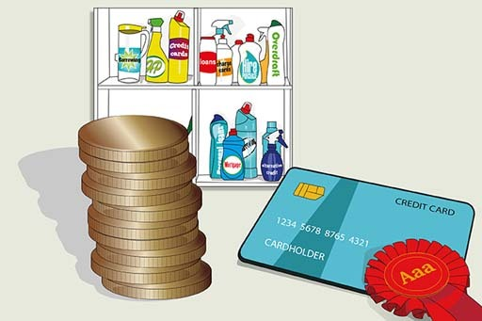
Figure 15

Week 5: Savings and investments

Introduction
Why do people save? Link savings to events in the life course. Understand savings rates and savings products. The choice between fixed and variable rate savings. See how the internet has changed the savings market.
This week you explore the many different ways of saving and investing. Martin explains the differences between the products, including the returns they provide, and the risks you take on when investing in them. You also have the chance to link to a savings calculator to see how your savings grow in different scenarios.

Video content is not available in this format.
View transcript - Uncaptioned interactive content

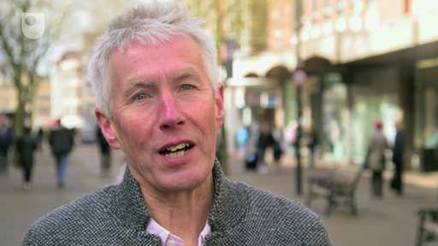

This course is presented with the kind support of True Potential LLP.
The True Potential Centre for the Public Understanding of Finance (True Potential PUFin) is a pioneering Centre of Excellence for research in the development of personal financial capabilities. The establishment and activities of True Potential PUFin have been made possible thanks to the generous support of True Potential LLP, which has committed to a five-year programme of financial support for the Centre totalling £1.4 million.

5.1 Managing savings and investments
This video was produced by the government’s savings agency National Savings & Investments (NS&I). It starts your analysis of savings by looking at their linkage to financial planning, and it resonates with the course’s key theme of ensuring that in all financial matters a rigorous planning process should be applied.

Video content is not available in this format.
View transcript - Uncaptioned interactive content



5.1.1 Why should households save?
Saving defers consumption from the present to a time in the future. Therefore, when thinking about the reasons for households to save, we’re really thinking about why households are deferring consumption rather than consuming now.
One important reason for saving is known as the ‘precautionary motive’ – perhaps more commonly known as ‘saving for a rainy day’. This involves building up savings to provide for unexpected events and bills. If you have no savings and an unexpected event with financial consequences occurs (such as a car being damaged or someone becoming too ill to work and losing their income), then there are only three alternatives:
- receiving a pay-out from any insurance taken out against such an unexpected event
- borrowing money (from family, friends or financial institutions) to pay the unexpected bills
- defaulting on any commitments, for example not making payments on a car loan or a mortgage, with the consequent risk of repossession and negative impact on future credit ratings.
Having savings is an important means of preparing for unexpected life events – the savings act as a buffer to protect a household against these other possibilities.
A second reason for saving is to do so for a specific purpose. You can put a certain amount aside each month (or week), based on a calculation of how much you need for a particular goal. One of the most significant purposes for saving is for retirement, but saving can also be for many other reasons, for instance saving for a child’s university education, sending money abroad to family or paying the costs of a nursing home for a parent. You can also save for events that occur in the relatively near future, like a holiday or Christmas, or for buying a car.
A third reason for saving could be to accumulate wealth for which, as yet, there is no defined purpose. The savings may later be spent on a variety of things, for example a second home, cosmetic surgery, a series of holidays after retirement or leaving an inheritance to children.
These three reasons all underline an important overall aim of having savings – to give a sense of independence and autonomy to do things. Having sufficient savings could enable you to leave a job or to take a break for a few months. Or it could enable you to do or buy things that you want, or to take advantage of opportunities that arise.

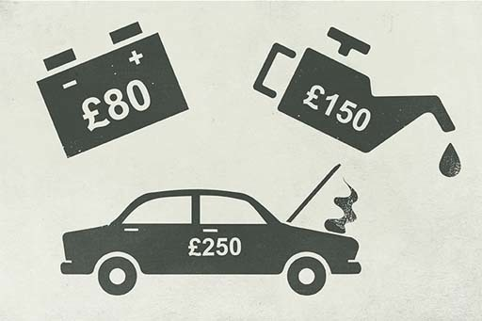
Figure 1

5.1.2 Savings and the life course
In the table are the various stages of the life course and the motives for savings. Take a look at these points in the life course and then at the motives for saving.

Table 1 Are your reasons for saving the same as any of these?
Life course stage | Motives for saving
Young, single | Car, house
Young couple, no children | House
Couple with dependent children | Saving for children's future, retirement
Single with dependent children | Saving for children's future, retirement
Older couple with nearly independent children | Savings for childrens future, retirement
Older, single, no children | Retirement
Older couple with independent children | Retirement
Couple, retired | Use savings for income, bequests
Single, retired | Use savings for income, bequests

Households are often targeted by the marketing departments of financial institutions according to their stage in the life course and their type of household. These are significant factors in the selling of different types of saving and investment products.
What are your reasons for saving money?

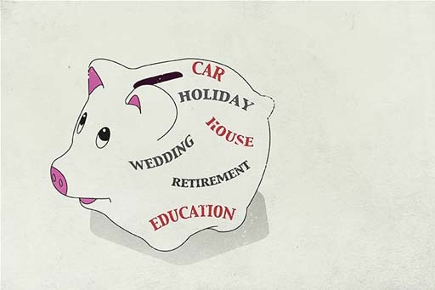
Figure 2 Savings behaviour and life events

5.1.3 Life’s events and savings
Whatever the motive to save, life events at any age can have an impact on saving plans – sometimes leading to starting or undertaking more saving, but at other times leading to less saving or ceasing to save altogether.
It is highly likely that you have experienced, or will in your lifetime experience, one of the events listed in the table, and so it is important to think about some of their consequences.

Table 2 Effect of selected life events on saving behaviour of people of working age in Great Britain, 1991–2000
 | Percentage of non-savers starting to save after the event | Percentage of savers ceasing to save after the event
Divorce/seperation | 15 | 46
Marriage | 25 | 29
Having a first child | 23 | 41
Having a seconf or subsequent child | 14 | 38
Becoming unemployed | 8 | 71
Moving into employment from unemployment | 29 | 38
Moving house | 20 | 40
Becoming a carer for at least 20 hours per week | 18 | 33

According to the data, unemployment has the greatest impact on saving – 71% of savers who experience unemployment stop saving. Moving back to employment has the biggest impact in causing non-savers to start to save, with 29% starting to save. Unemployment and employment have a large direct impact on an individual’s or household’s income and therefore on their ability to save.
The figures for divorce or separation, marriage and having children are also interesting. Joining together to form a household brings economies of scale, and so gives more scope for saving in a household budget. The high figure for non-savers starting to save after marriage isn’t too surprising, therefore. Similarly, divorce or separation may lose such economies of scale, making saving harder. So, again, it is perhaps not surprising to see that 46% of savers cease to do so after divorce or separation.

5.2 Understanding savings products
Here you start to explore the different savings choices for a household that has surplus income or has budgeted to create surplus income. You begin to learn to make some important distinctions between savings products:
- products that earn interest where the nominal value of the capital (the amount you put into the product) stays the same
- investment products, which you look at later, that can make capital gains and capital losses, where the investment you make can subsequently go up and down in value.
There are thousands of different savings products available, and such choice can be daunting. Yet it’s possible to make sense of the choice with reference to available interest rates and the taxation of that interest. An understanding of these, as well as a clear idea about the reason for wanting to save, should provide enough background information to make a more informed decision about a product.
The financial services industry is required to show interest rates on all savings products so that they can be easily compared. You saw last week how interest rates on debt products are expressed as the Annual Percentage Rate (APR). For savings products the comparable rate is called the Annual Equivalent Rate (AER).
The AER and the APR are similar in principle, and allow a comparison of financial products with different payment patterns. The AER is the annual interest rate that savers receive, taking into account when interest is actually paid (for instance, annually, quarterly or monthly).
Week 4 also introduced the idea of real interest rates – thinking in real terms can help to show what’s happening to the value of savings over time. For example, the significance of a 5% interest rate on savings is dependent on the rate of inflation, and is very different at either 1% or 6%.
In the latter case, the real interest rate is actually negative, that is, your savings could buy less in a year’s time, even after the receipt of interest. Theoretically, this could cause some people to decide to consume more now and save less. Conversely, when inflation has been high in the UK, it can make people want to save more to make sure the real value of their savings is not reduced.
In the UK, only National Savings & Investments periodically offers an inflation-proofed savings product in the form of index-linked certificates. For example, holders of the 48th issue five-year certificates are guaranteed to get their original investment (their ‘capital’) back at the end of five years with interest equal to inflation over the period plus 0.5% a year, in other words a real return of 0.5%. Someone who invested £1000 in these five-year index-linked certificates on the first date of their issue in May 2011 would, on 6 April 2016, have found that they had a valuation of £1172.80, giving a nominal return since the start of the investment of 3.3% a year once inflation had been added to the real return.
At times of low inflation, the return on index-linked investments can seem unattractive, but they come into their own in periods when inflation is expected to be high. Most savings products do not offer inflation-proofed returns.
If you want to explore savings accounts further and the returns you receive on them why not access the MAS savings calculator?


Figure 3

5.2.1 Variable rate and fixed rate savings products
In this audio a young professional, Ryan, ask for help from personal finance expert Jonquil Lowe in finding his way through the many savings products on offer.
We join their conversation as Ryan asks about a savings product he’s come across called a ‘term bond’.

Audio content is not available in this format.
View transcript - Uncaptioned interactive content

The other savings options that are described are trackers, variable rate accounts and notice accounts.

5.2.2 Spot the highest Annual Equivalent Rate (AER)
This quiz tests your ability to spot the highest Annual Equivalent Rate (AER).

Activity 1

Suppose that a savings account advertises an annual interest rate of 5%, with interest payable either daily, weekly, monthly or annually.
Which account will have the highest AER?

Daily
Weekly
Monthly
Yearly
View answer - Activity 1

5.2.3 Savings accounts on offer

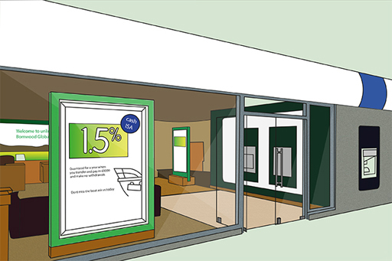

In the mid-2000s, there were major developments in ‘e-banking’ or online banking. Online savings (or ‘e-savings’) accounts can usually only be accessed online. With many accounts, the saver transfers money when needed from their online savings account into their current account electronically, which they can then access as they usually would. Some online accounts have a cash card, so money can be withdrawn via cash machines.
Interest rates are often (but not always) higher for ‘e-savings’ accounts because savers themselves manage the account. This reduces the costs to the bank or building society in terms of issuing a passbook or requiring branch availability to make transactions, however some institutions, although not all, require a current account to be held with them as well as the online savings account.
Every high street has multiple offers of different types of savings account from banks and building societies. Take a look at some of these in the table below, and then join in the discussion, focusing especially on these two points:
- What do you think are the key factors that explain why some accounts offer higher rates than others?
- Why would anyone want to take out an ‘Instant Access’ account?

Name of account | Interest tier | AER (gross p.a.) %
Internet Savings  An instant access online savings account | £1+ | 1.25%
Instant Access  An instant access telephone savings account | £1000+ | 1.35%*
Notice Account  A 120-day notice account | £500+ | 1.60%
5-Year Fixed Rate Bond  (interest paid annually) | £1000+ | 2.91%
Instant Access Cash ISA  A tax-free instant access account with cash card | £1+ | 1.41%
*Includes bonus in first year of 0.85% gross (0.68% net of tax at basic rate of 20%)
Savings products – some choices (adapted from Moneysupermarket.com, 2015)

5.2.4 Why savings rates differ
In the table you’ve just looked at, the five-year Fixed Rate Bond and the Notice Account both have higher net rates than the Instant Access account. The amount saved also influences the rates offered for both Instant Access and Notice accounts: the higher the savings deposited, the higher the rate.
The Internet Savings account can offer higher rates due to the lower costs of managing the account. Despite this, some people will still choose the most basic Instant Access account, mainly because it provides plenty of flexibility, with instant access using a cash card, so that money can be accessed night or day. The downside is the lower interest rate on offers.
The ISA (Individual Savings Account) is not subject to tax so all savers get the full (or gross) amount of interest. To encourage saving, the annual limit for investments in ISAs is £20,000 per person in 2018/19.
In the March 2016 budget statement it was announced that a new ‘Lifetime ISA’ would be available from April 2017 for those aged under 40 years. These new ISAs will allow tax-free savings of up to £4,000 per annum with the government topping up balances by £1 for every £4 saved. Lifetime ISAs, which can be built up until the age of 50 years, are intended to help people save for property purchase or to help provide income in retirement. To support this development the overall ISA limit (for both ordinary and lifetime ISAs combined) was raised to £20,000 from the 2017/18 tax year.
A new savings scheme for those on low incomes was also unveiled in March 2016 with those on in-work benefits who save £50 per month for up to 4 years getting a 50% (up to a maximum of £1200) top up from the government.

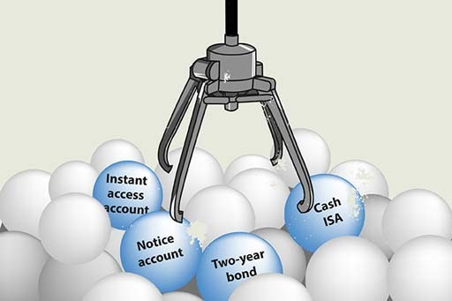
Figure 4 The time period for which savings are tied up affects interest rates.

5.2.5 Savings accounts – the risks
In this video Simon Katte of the government’s Money Advice Service (MAS) talks about the risks arising from savings and investments.

Video content is not available in this format.
View transcript - Uncaptioned interactive content

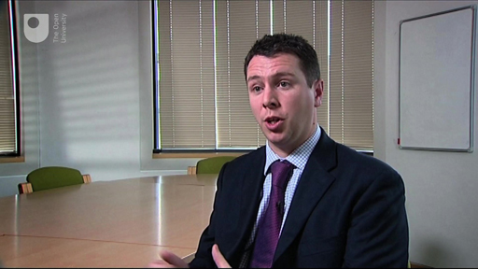

5.3 Understanding investments
In this section, you will examine how savings and investments differ, understand share investments and the returns they offer and discover why some shares are riskier investments than others.

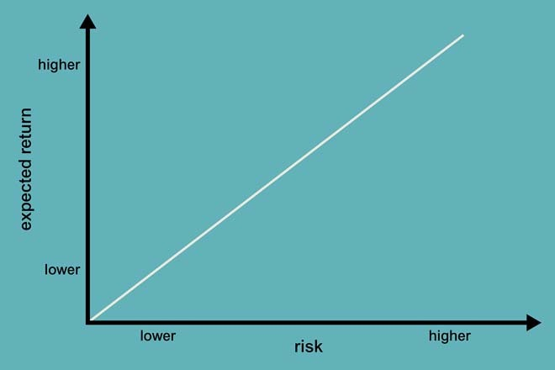
Figure 5 Higher returns normally involve taking higher risks

In personal finance, the terms ‘savings’ and ‘investments’ have different meanings. Savings accounts refer to any form of deposit account that pays interest on top of the amount deposited. The amount deposited is not at risk unless the institution defaults. Investments also allow interest or dividends to be paid but, crucially, the investment itself can fall or rise in value. Financial investments are those products with the warning in the small print that the value of your investment can go down as well as up.
Financial investments, which for simplicity we will call ‘investments’, include shares and bonds and investment funds that hold these types of asset. The amount invested – the ‘principal’ or ‘capital’ – is usually at risk, as well as the rate of return on the investment.
This means that it is not income alone that is relevant (as the rate of interest is on savings products) but the total return, which may be made up partly of income and partly of the change in the value of the capital. If the price of the investment goes up, a capital gain will be made, but if the price goes down, a capital loss is made. Newspapers often print cases of investors who have lost money on investment schemes.
With increased regulation of financial intermediaries and other financial firms, including the actual providers of savings and investment products and their company salespeople, and the requirement to explain fully the characteristics of the financial products they sell, mis-selling of financial products should, in theory, be unlikely, but it still happens.
Not everyone reads the small print on documents, or understands all the choices and all the products’ details, but the saying ‘the safest way to double your money is to fold it in half ’ is perhaps a reminder that promises of high returns usually carry higher risks. This can be linked to a risk–return spectrum. Products with low risks tend to have lower returns, and those with higher risks have potentially higher returns, as you see in the graph.
For the rest of this section, you explore investment funds, which represent the usual way that personal investors invest in the stock markets. You may think that investments are not relevant to you, but if you have pension savings or save regularly through a life insurance policy, then whether you know it or not, you are an investor! To understand the nature of these funds, you take a quick look first at how shares and bonds work, since these are the fundamental building blocks of most funds and many other investments.
Before you move on, bear in mind that the definition of the difference between savings and investment being used in this course is not a universal one. In particular, some products that are advertised as being ‘long-term savings products’ may well involve shares or other forms of investment, and so their value can go down as well as up.

5.3.1 Shares
Shares are sometimes called ‘equities’. They entitle the holder to a share or part ownership in a company. Depending on the type of share, this may entitle the shareholder to vote on how the company is run. Shares also usually entitle their owners to receive dividends, paid by the company out of the profit it makes. The receipt of these dividends is, for the shareholder, the income element of the return from their investment in the shares.
Look at the table showing some UK companies’ share prices. Take time to familiarise yourself with the key terms that are used when analysing the performance of a company’s shares.

Table 5 Share prices of selected UK high-street retailers, 27 November 2017 (The Times, 28 November 2017, p. 53. Prices rounded to nearest penny).
High | Low | Company | Price (p) | +/- | Yield | P/E
456 | 303 | JD Sports | 329 | -4 | 0.4 | 17.9
395 | 298 | Marks and Spencer | 300 | +2 | 6.2 | 22.3
253 | 207 | Morrisons (W) | 212 | Unch | 2.5 | 14.0
5320 | 3617 | Next | 4275 | -31 | 3.7 | 10.0
218 | 167 | Tesco | 193 | Unch | -- | 34.4
Unch = unchanged
Where no dividend is paid, there is no measure for yield
(The Times, 28 November 2017, p. 53)

Here’s an explanation of the information presented in the columns of the table.
- High: the highest price of share in a certain time period, for example over the last year.
- Low: the lowest price of share in a certain time period, for example over the last year.
- Company: the name of the company whose shares are shown in the table.
- Price: the current price of share, shown in pence.
- +/-: change in share price from the previous day.
- Yield: the dividend income per share expressed as a percentage of the price of the share. High figures can suggest higher income from investments, but a high yield can also indicate that the company is not growing very fast or is quite risky.
- P/E: the ‘price/earnings ratio’ is the share price divided by the earnings per share. So, if the share price is 200 pence and the earnings per share are 5 pence the P/E ratio would be 40. Investors are prepared to pay more for shares whose earnings they think are going to rise strongly, so demand pushes up the share price, which in turn increases the P/E ratio. The P/E ratio is often seen as a barometer of confidence in a company’s prospects.
The price at which a particular share can be bought or sold will vary from minute to minute depending on the balance of investors who want to buy them and existing holders who want to sell. If investors are able to sell shares at a higher price than they originally paid, they make a capital gain. If they sell for less, they make a capital loss.
Shares are bought through a broker. A broker can be found in high-street banks, on the internet or in a stockbroking firm. For online broking, there is typically a flat-rate charge for any transaction, say £12 for one-off trades, or £10 per trade for frequent traders, so it is not usually worth buying or selling shares in very small amounts. Conventional stockbrokers may also charge a percentage commission on the value of the transaction as well as a minimum commission.
Stamp Duty Reserve Tax (SDRT) of 0.5% is paid when shares are bought electronically (which the vast majority are these days). SDRT is not paid when shares are sold. Share prices can be seen in most newspapers that report daily on share prices as well as on other information.

5.3.2 Share prices do go up and down
You’ve probably heard many times the adage that shares can go up and down in value. Sometimes these movements are very sharp and sudden – particularly when shares fall in price. Over the years there have been times when share prices have plummeted. You may have heard of the Wall Street Crash in 1929 when the US stock market plummeted. The pop group 10cc had a hit song, ‘The Wall Street Shuffle’, about the vagaries of share prices in the 1970s.
Shares also collapsed in value worldwide in October 1987, and the video includes footage on what quickly became known as Black Monday. Share prices also fell around the world during and after the 2007 financial crisis.

Video content is not available in this format.
View transcript - Uncaptioned interactive content

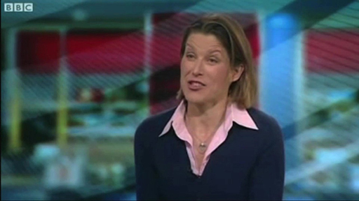

More recently, shares have staged a recovery as the world economy has started to recover from the financial crisis. The second part of the video provides covers this rise in share prices in 2013.
This recovery gathered further pace in 2017 with many stock market indices around the world – including the UK’s FTSE-100 – hitting all-time highs. Are we, though, close to the point where another of those sharp drops in share prices occurs?

5.3.3 Are some shares riskier than others?
Earlier, you looked at the prices of some selected UK companies’ share prices. The details included the price highs and lows of each of the shares over the past year.
Some share prices are more volatile than others. Why do you think this is?
To consider this issue you might want to think about different types of company – utilities, supermarkets, IT companies, construction companies. How might the activities of these different companies become reflected in the volatility of their share prices?


Figure 6

5.3.4 Share price volatility
All shares do move up and down in prices – with these movements often reflecting the general swings in stock market indices. But for some shares these movements are less extreme than for others.
The reason for this is that some companies are expected to make profits each year and for these profits to be relatively stable. This may be because they produce things people always need to buy – for example utility companies or supermarkets. Additionally their size may make it difficult for new entrants to enter their arena of business and reduce their sales and profits. So the prices of the shares in these types of companies are less volatile as investors have greater certainty about their financial performance. Their shares can still fall in price but such falls will tend to be lower than average for the share market as a whole.
By contrast companies whose sales and profits are prone to material change from year to year will have more volatile share prices. Investors know less about what to expect and the announcement of good or bad financial performances can therefore have quite dramatic effects – in both directions – on the companies’ share prices. Companies whose market share can be eroded – perhaps quickly – by new entrants or changes to technology, like biotechnology companies, are particularly likely to have share prices that are more volatile than for the share market as a whole. Mining is another sector where share prices are volatile, with the profits of companies in this sector exposed to changes in world commodity prices.
So we ask the question again: are you a risk taker or risk averse? If the former you might be inclined to dabble in mining shares if the latter you would stick to utilities and sleep easier.


Figure 7

5.3.5 Bonds (fixed interest investments)
A bond generally represents a promise to pay a regular rate of interest over a fixed period, from one to 50 years, plus the promise to repay the nominal value (also known as the face value) of the bond (say, £100) on the maturity date. The interest rate is normally fixed, for instance, at 5% or 10% of the nominal value each year.

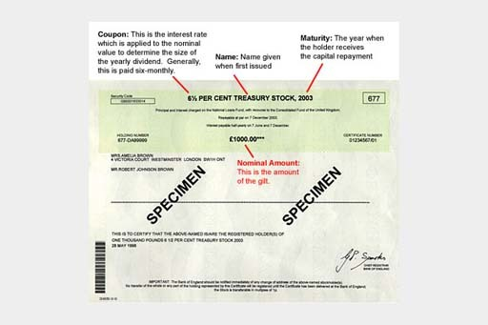
Figure 8 A gilt-edged bond certificate (known as a 'gilt')

The nominal value is the amount on which the interest is calculated and can be divided into small amounts for sale, usually £1000 or less. For example, an investor could buy £100 nominal of a ‘five-year 5% bond’. This will pay 5% a year for five years on £100 nominal – that is, £5 a year. The interest may be paid quarterly, semi-annually or annually, depending on the type of bond bought. At the end of the five-year period, an investor would receive £100 in repayment of nominal (or ‘face’) value.
Bonds tend to be less risky than shares because they have a promised interest rate and because company bonds rank in front of company shares in the event of a company being liquidated. Although less risky than shares, bonds are riskier than savings accounts. This is because with savings products typically the amount of capital you receive back is fixed – if you deposit £100, you get £100 back.
With a bond, the amount paid back on maturity is also fixed (but may be more or less than the amount paid for the bond). However, if the bond is sold before maturity, then more or less than the promised nominal amount may be paid. Whether it is more or less will depend on movements in the level of interest rates after the bond has been issued. If interest rates fall, the market value of an earlier issued fixed rate bond will rise since it offers investors an interest rate higher than that currently being offered on newly issued bonds. The reverse applies if interest rates rise.
An additional risk of bonds is if the issuer of a bond defaults. UK government bonds, known as gilts, are seen as safer than bank and building society accounts, as the government is even less likely than a bank or building society to default. Bonds can be bought through stockbrokers or, in the case of gilts, through a special Purchase and Sale Service organised by the Debt Management Office, the government department responsible for issuing government debt.
One problem with bonds is that not everyone means the same thing when they talk of a ‘bond’. The kinds of bond we have described are company or government bonds with a fixed interest rate and a fixed repayment date. But the term ‘bond’ has sometimes been taken in vain. Financial intermediaries have sold bonds that were in effect shares by another name. Similarly, long-term savings products may not only be bank accounts promising interest, but also linked to company bonds or shares. There is no regulation in the UK on terminology, and consequently it is important to read the small print of any product.
Some National Savings & Investment products use the name ‘bond’ – for example, Premium Bonds and Income Bonds – but are types of deposit. A range of products, some that are deposits and others more risky investments, used to be called Guaranteed Equity Bonds. Although they have since been reclassified as ‘structured products’, they still individually go by names such as Capital Bond, Stockmarket Linked Bond and Double Asset Bond. Therefore, in reality, the term ‘bond’ is applied to products that are very different, and not just company or government bonds. To get round this confusion, you will also see true bonds referred to as ‘fixed interest’ investments – as noted earlier.
An important product that does not fit within the bonds category that we have described is the Premium Bond. Premium Bonds, owned by 22 million investors in the UK in 2016, are a lottery-based form of savings account backed by the UK government. A lottery is held every month and the equivalent of 1.3% p.a. (in 2016) on all the Premium Bonds is paid out in tax-free prizes.

5.3.6 Investment funds
Buying shares in a single company or even holding shares in, say, three companies, is generally a risky form of investment. This is because the fortunes of a company, on which its dividends and share price depend, are subject to all sorts of risk. These risks can be broad economic risks, such as recession or an increase in the cost of oil, or risks specific to each company, such as the loss of a major contract or increased competition.
To spread these risks, investors typically invest in shares – and other assets, such as bonds – through investment funds. An investment fund pools the money of lots of investors and uses it to hold a wide range of shares, bonds and other assets. Even relatively small amounts of money placed into such funds can be spread across a wide variety of shares or other assets.
With different compositions of investments the returns from different unit trusts vary substantially.

Table 6 The best unit trusts of the decade
1 | BlackRock Gold and General | 684%
2 | JPMorgan Natural Resources | 579%
3 | Threadneedle Latin America | 360%
4 | Scottish Widows Latin America | 343%
5 | Jupiter Financial Opportunities | 336%

Table 7 The worst unit trusts of the decade
767 | Inv Perp Japanese Smaller Companies | -66%
768 | Legg Mason Japan Equity | -68%
769 | JPMorgan Japan | -69%
770 | New Star Technology | -70%
771 | AXA Framlington Global Technology | -72%
NOTE: past performance is no guarantee of future performance

The investments in these investment funds may be selected by managers, based on their research, which aims to assess the prospects for shares and other bonds (called ‘actively managed’ funds). Investors pay fees for the services of the fund managers and are provided with periodic reports on their investments. Other funds (called ‘passively managed’ or ‘tracker’ funds) simply hold investments designed to move in line with a specified share index, and typically have lower charges.
Investment funds come in many forms, including:
- Unit trusts: this is an arrangement whereby trustees hold shares and/or other assets on behalf of investors and a management company makes decisions about what and when to buy and sell. Investors hold units in the unit trust and the value of the units directly reflects the value of the underlying assets in the fund.
- Open-ended investment companies (OEICs): this is very similar to a unit trust, but is structured as a company rather than a trust. This structure is more familiar and acceptable to investors in other countries of the European Union and so enables managers to trade more easily across borders. Investors buy shares in the OEIC and the value of the shares directly reflects the value of the assets in the underlying fund.
- Investment trusts: these are companies that are quoted and traded on the stock market. But, unlike trading companies, the purpose of an investment trust company is to run an investment fund. Investors buy shares in the company. The price of the shares partly reflects both the value of the assets in the underlying fund (called the ‘net asset value’ or NAV). But the price is also affected by the balance between investors buying and selling the shares on the stock market. As a result, the shares could trade at less than the NAV (called trading at a discount) or at more than the NAV (trading at a premium). Like any other company, investment trusts can borrow money, which enables them to boost the amount they can invest. Borrowing to invest increases the inherent risk of the fund.
- Exchange-traded funds (ETFs): these are also companies traded on the stock market but, in this case, the share price is directly linked to the value of the underlying investments. Traditionally, ETFs are tracker funds. This could be, for example, the FTSE 100 Index or a more unusual index tracking, say, the price of commodities or works of art. But, increasingly, new types of ETF are being developed that follow different investment strategies.
- Life insurance funds: some types of life insurance can be used as investments. The investor pays in regular premiums or a single lump sum premium and the policy builds up a cash value that may be drawn out either as a lump sum or as a stream of income payments, depending on the particular type of policy. Often policies are unit-linked, which means that the premiums are invested in the policyholder’s choice of one or more funds, similar to unit trusts. The cash-in value of the policy depends on the performance of these funds.
- Pension funds: in a similar way to life insurance, contributions to a pension scheme may be invested in one or more underlying funds. The value of the pension scheme depends on the performance of those funds. You will look at pension schemes in detail in Week 7.
Investment funds can be bought direct from fund managers, through stockbrokers or through websites (often called ‘platforms’).
An additional consideration for many people is a desire to invest their money in a socially responsible way. There are different aspects to what constitutes socially responsible investment, including both positive and negative criteria.
Positive criteria include investing in companies that treat workers fairly or are engaged in environmental protection. Examples of negative criteria include avoiding funds that invest in companies involved with animal experiments, arms, violating human rights or pornography.
One difficulty for an investor is that ethical or social responsibility is a relatively subjective term so you need to examine where the fund invests your money. One way of checking whether a fund that claims to be ethical or socially responsible shares your own views, is to check the main companies the fund invests in.

5.4 What are the best performing investments over the long term?
Now that you’ve had a look at the alternative forms of investment , which of shares (equities), gilts (government bonds) or savings accounts (cash deposits) do you think provides the best returns to investors over the long term?

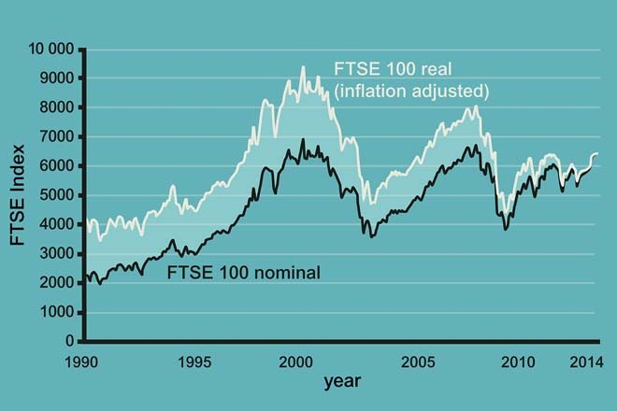
Figure 9 Movement of the FTSE Index from 1990 to 2014

5.4.1 What is the best long-term investment?
We know from the oscillations of equity markets that capital invested in shares is at high risk of losing value – although, as you see in the data presented in these tables, over long periods of time the performance of shares (equities) normally outperforms that of bonds (gilts) and cash deposits (savings accounts).
The uncertainties related to investments in equities – the reality that the prices of shares do move up and down – is highlighted by the chart that you saw in the previous discussion, which shows the movement in the FTSE 100 (the index based on the share prices of the 100 largest companies listed on the Stock Exchange) between 1990 and 2017.
The three tables here show the findings of a detailed study by Barclays into the differential performance of investments over the medium to long term. The findings are clear: the markets in shares (equities) may be volatile at times but over the long term the historical evidence is that they outperform other forms of savings and investments.

Table 8 Average real annual returns for UK equities (shares), gilts (government bonds) and savings accounts
 | 1899—2015 | 2005—2015
UK equities | 5.0% | 2.3%
Gilts | 1.3% | 3.0%
Savings accounts | 0.8% | -1.1%
‘Real’ return is the return after adjusting for inflation
(adapted from Barclays (2016))

Table 9 Equity outperformance of gilts (government bonds) and savings accounts in defined time periods, 1899—2012
 | Time period assets held
 | 5 years | 10 years
Percentage of times equities outperformed gilts | 72% | 79%
Percentage of times equities outperformed savings accounts | 75% | 91%
Equity outperformance of gilts (government bonds) and savings accounts in defined time periods, 1899–2015
(adapted from Barclays (2016))

Table 10 Value at the end of 2012 of £100 invested at the end of 1945, with gross income reinvested
 | Nominal | Real
UK equities | £2,265,437 | £28,232
Gilts | £36,395 | £454
Savings accounts | £20,535 | £256
'nominal' means before adjusting for price inflation; 'real' is the return after adjusting for price inflation
Value at the end of 2015 of £100 invested at the end of 1899, with gross income reinvested
(adapted from Barclays (2016))

5.4.2 How investments are taxed
Start by looking at the table to see the details of the allowance and tax bands for different forms of investment in 2018/19.

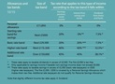

The taxation of interest from bonds, also known as fixed interest investments (and unit trusts and OEICs that invest mainly in bonds) is very straightforward because it is taxed in the same way as interest from a savings account. However, unlike savings accounts, interest from most bonds is paid out gross (without any tax already deducted).
Gains from investments are subject to Capital Gains Tax, but every person has a yearly tax-free allowance (£11,700 in 2018/19). Only gains in excess of that amount are taxable and, in 2018/19, the rate which then applies is either 10% or 20%. To work out which of these rates applies, the taxable gain is added to the investor’s taxable income for the year. Any part of the gain that falls within the higher or additional rate band is taxed at 20%, otherwise the 10% rate applies.
As explained earlier, most of the tax on savings and investments can legally be avoided by investing through ISAs.
So, in summary, there are two main types of tax for UK investors: Income Tax and Capital Gains Tax. Interest from savings and bonds, and dividends from shares, are taxed as income; the profit from selling something for more than it originally cost is typically taxed as a capital gain. Income and gains from some savings and investments are tax-free and, even when they are taxable, the investor may have tax-free allowances to use so that in practice no tax is due.
Tax-efficient investment means choosing tax-free products, using allowances and taking advantage of the difference in tax rates between different types of income and between income and gains – for example, choosing an investment that pays gains rather than income when gain

Week 5 quiz
This quiz allows you to test and apply your knowledge of the material in Week 5.
Complete the Week 5 quiz now.
Open the quiz in a new window or tab then come back here when you're done.

Week 5 round-up
You’ve covered a lot of ground this week, examining the types of savings and investment products in the UK that people place their money in.
You encountered some important factors that need to be borne in mind when making investment decisions – the impact of inflation and taxation as well as the different risks that are being taken with the money invested.
And you also took a step back to examine why people save money – an issue that recalled one of the core themes of the course – personal finances over the life course.
Next week focuses on another type of asset, one that for some people is an investment but that for most of us is also a home – property.
You can now go to Week 6: Housing and the household balance sheet

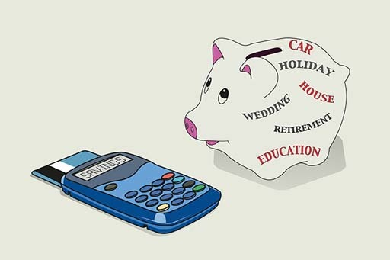
Figure 10

Week 6: Housing and the household balance sheet

Introduction
Property as a home and as an investment. Buying a property – mortgage products. What are the total costs of buying? How do you repay your mortgage? Freehold and leasehold properties – what’s the difference?
More so than in many other countries, the health of the UK property market is of pivotal importance to the health of the overall economy. This week you’ll be exploring how the UK property market and the associated market in mortgages work. You’ll see how both housing and mortgages fit into the household balance sheet and you’ll complete this as part of your fact find. You’ll also get a link to a mortgage calculator to enable you to look into the cost of a mortgage.

Video content is not available in this format.
View transcript - Uncaptioned interactive content

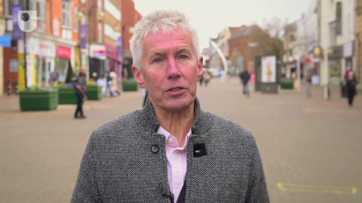

This course is presented with the kind support of True Potential LLP.
The True Potential Centre for the Public Understanding of Finance (True Potential PUFin) is a pioneering Centre of Excellence for research in the development of personal financial capabilities. The establishment and activities of True Potential PUFin have been made possible thanks to the generous support of True Potential LLP, which has committed to a five-year programme of financial support for the Centre totalling £1.4 million.

6.1 Housing and the household balance sheet
Today, with 65% of homes being owner-occupied – just 5% lower than at the peak of home ownership in 2002 when 70% of homes were owner-occupied – it is hardly surprising that considerable media attention is paid to the UK property market and the direction of house prices. For most people, their property is primarily a home rather than an investment – although some people do own properties for investment purposes only, for example to let for rental income. In England, about one-sixth of the 23 million housing stock is privately rented.

Video content is not available in this format.
View transcript - Uncaptioned interactive content



If you own your home, what were the reasons behind your decision to buy? In this video a range of people offer their stories. What comes across is that owning your own property is a key aspiration in the life course and that it is better than paying money in rent for a property that someone else owns. What also comes across is that property and home ownership are subjects people in the UK are always talking about.

6.1.1 The mortgage market
Buying a property, particularly your first property, usually involves taking out a mortgage – a loan secured against the home.
To guide you through what can seem like a maze of mortgages, here’s personal finance expert Jonquil to explain the six most common types: fixed rate mortgage, variable rate mortgage, capped rate mortgage, offset mortgage, flexible mortgage, shared ownership mortgage.

Video content is not available in this format.
View transcript - Uncaptioned interactive content

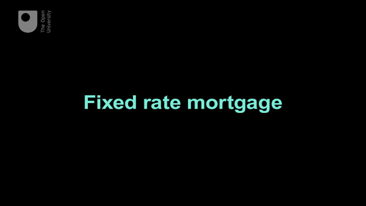

6.1.2 Repaying your mortgage
Another major choice to be made about a mortgage is how to repay it. The options are a ‘repayment’ mortgage or an ‘interest-only’ mortgage (or perhaps a combination of the two).
With a repayment mortgage, the capital or principal sum (the original amount of debt) is paid off in stages throughout the life of the loan. Look at the table below to see the pattern of payments on a repayment mortgage. The typical structure is a reducing balance loan with a set amount paid each month throughout the mortgage term unless the interest rate changes.
The effect of this is that the amount of the principal sum repaid accelerates over the term of the mortgage – initially the majority of annual mortgage costs are made up of interest payments, and then towards the end of the mortgage term these costs are mainly repayments of the principal sum.
One consequence is that a borrower who wishes to repay early might be surprised at how much of the principal sum remains. The table shows a £100,000 repayment mortgage payable over 25 years, at 7% APR with interest calculated monthly. Results will vary slightly if different periods are used – for instance, a daily calculation of interest. Only selected years are shown.

Table 1 Paying off your mortgage – interest and capital
Year | Interest | Capital | Total repayments for year
1 | £6736.41 | £1581.05 | £8317.46
5 | £6245.02 | £2072.44 | £8317.46
10 | £5410.76 | £2906.70 | £8317.46
15 | £4240.66 | £4076.80 | £8317.46
20 | £2599.54 | £5717.92 | £8317.46
25 | £297.79 | £8019.67 | £8317.46

With an interest-only mortgage, the principal sum outstanding is unchanged throughout the life of the loan and only interest payments are made to the lender until the end of the loan period. At the end of the period the borrower must have the means to repay the lender the principal sum. Failure to do this will result in the property being repossessed because it is secured against the debt.
With interest-only mortgages, repayment of the principal is typically achieved by putting money into a savings or an investment scheme (such as an ISA or unit trusts) throughout the life of the mortgage. (In the past, endowment insurance policies were also available to pay off the principal – hence the name ‘endowment mortgage’.)
To determine how much to save each month, the investment is projected to grow at an assumed rate in order to produce a lump sum large enough to repay the principal sum in full on the maturity of the mortgage. Following a reduction in the projection rate in 2000 to reflect changed economic conditions, the market for interest-only mortgages substantially declined, especially for first-time buyers. In October 2010, 93% of first-time buyers took out a repayment mortgage; this compares with 70% before 2007 (BBC, 2010) and just 47% in 1999 (Council of Mortgage Lenders (CML), 2001).
When comparing the interest charges on different mortgage products there are some key points to consider. As you may recall from Week 4, in order to obtain an accurate comparison of the interest charges on different debt products it’s useful to look at the APR quoted. This calculates the cost of the mortgage over its life, taking into account discounts and additional costs (which are not included in the quoted interest rate of the mortgage) as well as the timing of interest payments and charges.
The APR does not include charges for early repayment or options such as insurance or payments into an investment product for an interest-only mortgage. In addition, the APR will not take into account the cost of any mortgage indemnity guarantee (MIG) that might be levied on a higher risk borrower, for example, where the outstanding mortgage is high relative to the value of the property. (The term used to describe the ratio of mortgage to property value is ‘loan-to-value’, or LTV.) Provided the products are comparable (for example, all repayment mortgages), a low APR indicates that a mortgage is cheaper than one with a higher APR.
To help the process of making decisions in such a complex mortgage market, the UK’s financial regulator for this area has stipulated that each mortgage seller must provide a Key Facts Illustration (KFI). This document is produced as part of the mortgage application process, and includes details of the features, terms and conditions of the mortgage product to enable borrowers to compare different products on the same basis.
Included in the KFI is information on the overall cost of the mortgage, the amount of regular repayments, the APR and whether there are any early redemption penalties. The KFI also illustrates by how much monthly mortgage repayments would rise if there were a 1% increase in the rate of interest on a variable rate mortgage.
The introduction of the KFI can be seen as an example of regulators responding to the complexity that accompanies increased competition, in this case by insisting that lenders provide information to enable mortgage customers to compare products more easily.


Figure 1 Have fun moving in … making those mortgage repayments starts now!

6.1.3 The costs of buying a home
Once you’ve chosen a mortgage, it has to be applied for and the home purchased. This is equivalent to the ‘Stage 3 Act’ part of the financial planning process. In addition to the deposit, this is where homebuyers rack up other bills as well.
To show you how these costs may add up, let’s suppose you’re buying a property for £200,000. What costs do you incur?
- Mortgage arrangement fee (common with fixed rate, capped and discounted mortgages): say, £500.
- Legal costs including local searches and Land Registry fee: £800.
- Survey and valuation: £350.
- Stamp Duty Land Tax (SDLT): £1500. SDLT applies in England and Northern Ireland. It is charged at a graduated rate – 0% on the first £125,000 of the property price, 2% on £125,000 to £250,000 rising in steps to 12% on the amount of the purchase price above £1.5 million. In the 2017 Budget Statement it was announced that first-time buyers of residential properties costing up to £300,000 would be exempt from SDLT. This also applies to the first £300,000 on properties priced up to £500,000 in certain ‘expensive’ parts of the country. The equivalents to SDLT are Land and Buildings Transaction Tax in Scotland and Land Transaction Tax in Wales.
- Removal costs: say, £700.
- GRAND TOTAL: £3850.
There may also be a fee to the mortgage broker if you’ve used one to help choose and organise the mortgage. But more often the broker is paid by commission from the mortgage provider and this is ultimately borne by the borrower through charges for the mortgage.
The largest cost will be the price of the property itself, which you, the buyer, can try to negotiate down from the seller’s ‘asking price’. Once a price has been agreed, both parties approach their solicitors (or other conveyancer) to seek completion of the transaction.
Is the agreed price binding? In Scotland, the buyer submits their offer to the seller by an agreed date and the seller selects the best offer. Usually, at this point, the price agreed is binding so the mortgage needs to be arranged before the offer is made.
In England, Wales and Northern Ireland, until the legal contracts are ‘exchanged’ between the two parties, both the buyer and the seller are able to seek to change the price originally agreed and even to pull out of the deal without penalty. Sellers may accept a new, higher offer up to the point when contracts are exchanged – an unpopular process known as ‘gazumping’ – but if the market is weak there is the risk of ‘gazundering’, where the buyer cuts the level of their offer at the last minute.
The exchange date is particularly important if there is a long ‘chain’ of sales involved. Usually buyers and sellers in a chain of housing transactions coordinate to try to ensure that no one remains committed to buying a property without having secured a commitment to have their existing property bought. The longer the chain, the greater the risk of problems that will prevent completion of the individual transactions.
When the documentation is agreed and exchanged, the buyer pays a deposit to the seller and a ‘completion date’ is agreed, when ownership passes legally from the seller to the buyer and the money is paid. This is also usually moving day.
One decision that needs to be made if two people are going to buy together (whether as partners or not) is how the property will be owned legally. For instance, if they own it as joint tenants, each jointly owns the entire property, so upon the death of one party their interest in the property would pass automatically to the survivor. Therefore, couples will usually buy a property as joint tenants.
By contrast, tenants-in-common each have a distinct share in the property. In Scotland, the equivalent terms are joint owners and owners-in-common. However, in Scotland, joint owners will have to have a ‘survivorship destination’ clause in the deeds to determine what happens to the property if one of the joint owners dies.

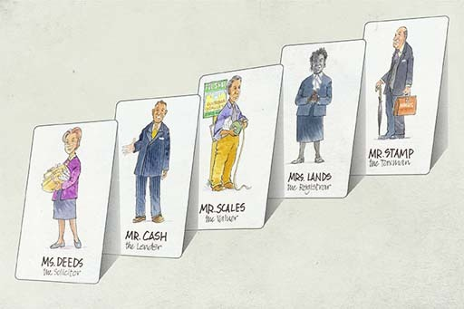
Figure 2

6.1.4 How much does it cost?
This quiz tests your ability to calculate the costs of buying a home.

Activity 1

An offer of £150,000 on a property has been accepted. The following costs apply:

Legal fees | £500
Valuation survey | £250
Structural survey | £750
Arrangement fee to the mortgage lender | £250
Removal costs | £1000
Stamp Duty Land Tax is payable at 2% on the purchase price above £125,000

How much does it cost in total to buy and move into this property?

£150,000
£153,250
£152,750
£150,500

An offer of £150,000 on a property has been accepted. The following costs apply:

Legal fees | £500
Valuation survey | £250
Structural survey | £750
Arrangement fee to the mortgage lender | £250
Removal costs | £1000
Stamp Duty Land tax is payable at 2% on the purchase price above £125,000

What are the extra costs (excluding the property price) as a percentage of the property purchase price?

2.17%
2.76%
0.28%
3%

6.1.5 Leasehold and freehold – some facts
Do you know the differences between leasehold and freehold? These are terms that are used every day in the property market world.
In this audio Martin sets out the basics, and gives you the heads up on the pros and cons of each.

Audio content is not available in this format.
View transcript - Uncaptioned interactive content

6.2 Selling property, re-mortgaging and housing as an investment
Once you’ve entered the property market, moving home commonly involves both buying a new property and selling your existing one. In these circumstances you’ll need to manage carefully the timing of the exchange process – the formal agreement to buy or to sell a property – to make sure you don’t end up owning two properties while desperately trying to sell one of them. If it’s not possible to synchronise the sale and purchase dates, there are bridging loans designed to supply the necessary funds until the situation is resolved.
Another possibility is to sell your property and allow a gap before buying another. You risk being priced out of the market if property prices are rising, but this is a sound strategy if prices are flat or falling.
What are your principal considerations when you’re a seller? First, you’ll want to achieve as high a price as possible, and TV shows give endless tips about making homes attractive to buyers.
A practical consideration, unless you’re selling at auction, is to decide how to sell and how many estate agents to engage in the process. Typically, selling commission is between 1% and 3% of the sale price. If you’re using one agent only (a ‘sole agent’), it may be easier to negotiate the estate agent’s commission than if several agents are used.
Selling without agents, using instead the media and the internet, is an alternative. Sellers in Scotland have to provide a home report which includes energy details and a survey. In England and Wales, sellers are obliged to provide an energy performance certificate.
Legal costs will be higher when both buying and selling since there’s more documentation to be completed.
One important final point if you’re selling your home – any profits you make by selling for a higher price than you paid when you bought it are not subject to tax. By contrast, if you make a profit on the sale of a property that is not your home – for example one that you’ve been renting to tenants – then you will be subject to Capital Gains Tax (CGT).


Figure 3

6.2.1 Mortgages – the risks
Figure 4 shows the numbers of properties in the UK that were repossessed by lenders between 2008 and 2016. This occurs when those buying a property with a mortgage find themselves unable to meet the repayments required.

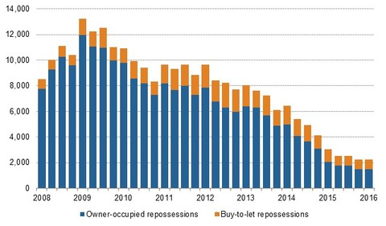
Figure 4 Repossessions, buy-to-let and owner-occupied markets (CML, 2016)

The reality of repossessions demonstrates a key risk involved when buying a property. You have to ensure that you can always make your mortgage payments. If you cannot do so, you risk losing your home.
The pattern of repossessions also demonstrates the links between the housing market and the wider economy. The high points in the repossession cycles in the early 1990s and late 2000s occurred when the economy was in difficulty, with unemployment increasing or with interest rates at high levels. Unemployment and high interest rates are two reasons why households become unable to pay their mortgages. If either of these happens for a sustained period, repossession then takes place.
The lender will often allow some leeway involving a small number of missed payments, provided they are advised of what the borrower believes to be a temporary problem. However, if payments are missed for a sustained period the lender is likely to take action, including as a last resort repossessing the property.
While some pressure has been applied to lenders by the government to act with consideration when borrowers fall behind with their payments, at the end of the day a mortgage is a secured loan. If the repayments are not met, the security (that is, the property) will be taken by the lender.
One way of protecting yourself is to take out Mortgage Payment Protection Insurance (MPPI), also known as accident, sickness and unemployment insurance (ASU). This usually covers the repayment of interest (but not capital) if you are unable to work because of accident, sickness or redundancy. Typically, a period of up to two years’ cover on mortgage repayments is insurable, but because of exclusions this type of insurance is not suitable for everyone.
The government may also assist through schemes to help people stay in their homes, for example by switching to renting part or all of their home or, for those on certain benefits, through help with mortgage interest payments.

Will your investment plan pay off your mortgage?
Another risk is that the savings or investment vehicle used to pay off the principal sum in interest-only mortgages produces insufficient money. Investment policies sold in the late 1980s and 1990s were based on assumptions about future investment performance that turned out to be too high.
Low inflation and interest rates since the early 1990s, and the periodic weakness of certain of the world’s stock markets, mean that some borrowers are at risk of finding that the principal sum of their mortgage cannot be paid off by the proceeds from their investment product. This is particularly true if borrowers did not regularly review how much they were setting aside.
This highlights the importance of the ‘Stage 4 Review’ part of the financial planning process: in this case, reviewing the progress of the investment regularly and making adjustments if the investment is unlikely to repay the loan in full. Sellers of the investment products should advise you about this risk when you take out such a mortgage, and should follow up with regular re-projections of how the product is performing.

Options if your investment plan is under-performing
If the risk looks as though it will materialise, you have the following options:
- increase monthly payments on the investment product to increase the projected earnings by the maturity date of the investment
- increase savings by paying extra into a different investment product, which then supplements the original
- move to a repayment mortgage for some or all of the outstanding debt
- find additional resources when the mortgage reaches the end of its term; this could include borrowing again to meet the outstanding debt
- switch from the original product into another, although this is likely to incur penalties
- sell another asset or perhaps use a lump sum paid from a pension scheme.
Investment products can produce a return that exceeds the principal sum. Recent policies have seen projected shortfalls, but older policies have often produced returns in excess of the principal sum of the mortgage, since these benefited from the higher investment yields seen in the 1980s and the early 1990s, and from tax reliefs that have now been abolished.
Another risk is that of negative equity. House prices fell between 1989 and 1995, declined again during the period from 2008 until the start of 2013, and could do so again in the future.
Many of those who bought houses at the peak of the market found themselves in a situation of negative equity, where the size of the mortgage debt exceeded the market value of their property. Moving into negative equity is not critical if the borrower is still able to meet their mortgage repayments and does not have to move home.
However, if moving is necessary and house prices have fallen, there is the risk that the sale proceeds will be less than the amount owed on the mortgage. Either the shortfall has to be made up from other resources (for instance, savings or a loan) or it has to be added to the size of any new mortgage on a new property – provided the lender agrees to this.
Some mortgage lenders, particularly during the housing boom of the 2000s, offered mortgages of more than 100% of a home’s value. What issues should you consider before taking out such a mortgage?
For some people, this kind of mortgage will enable them to buy a property that they otherwise could not buy. However, anyone taking on a debt for a sum greater than a property’s value should be aware that they will immediately be in negative equity. This means that if they want to move home in the future, they will have to finance the difference between the total debt and the property’s value, or gamble on house prices rising.
A further risk of having a mortgage is that the mortgage ends up costing more than it needs to. It is possible, even if the best available mortgage was arranged at the time of purchase, that either circumstances have changed or other mortgage deals have become available – such as if a fixed rate product is taken out and interest rates subsequently fall.

6.2.2 Financial planning when buying a home
You’ve now considered the main steps involved in buying a property. Here you see what Heather has to do to achieve her goal of buying her first home using the financial planning model that you first met in Week 1.

Video content is not available in this format.
View transcript - Uncaptioned interactive content



6.2.3 Remortgaging
Increased competition in the mortgage market has increased the popularity of ‘remortgaging’. This involves repaying an existing mortgage and taking out a new mortgage at a lower rate, from either an existing or a new lender.
Remortgaging may come about after a regular review of household finances or could be triggered by changes in household income, by changes in interest rates or by the end of being locked into a particular mortgage contract.
Remortgaging might seem simple, but there are costs. In addition to legal costs, there may be ‘early redemption’ or ‘prepayment’ fees. Generally these fees last for the first few years of the mortgage, or the period of any special deals, but sometimes they extend beyond a special deal (called a tie-in).
The terms of early redemption fees will be included in the KFI. When repaying a longer term, fixed-rate mortgage early, the prepayment fees may be substantial – a fee of six months’ interest is not uncommon.
This does not necessarily mean that remortgaging might not save money, particularly if interest rates have fallen a long way since the initial mortgage was arranged. It simply means that households need to make careful comparisons.
Any savings made from remortgaging will help with the budgeting process you explored earlier in the course. Stop and think about this next.

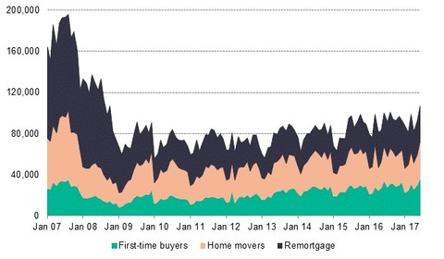
Figure 5 Number of mortgage loans to home owners, 2007-17 (CML, 2017)

6.2.4 Remortgaging – a few sums

Activity 2

For the purpose of this activity let’s keep things simple by considering an interest-only mortgage – the sums for a repayment mortgage will be a bit different but will follow the same principle.
Assume the fixed rate deal on a 25-year interest-only mortgage of £100,000 ends in three years.
- Currently the Barnett household is on a fixed rate deal at 5% p.a. If they repay now, the lender will charge an upfront six-month interest penalty.
- They have savings earning 2% p.a. net interest, which could cover this cost, and another lender has offered them a three-year mortgage at 3% p.a. and will cover all the other costs of remortgaging.
Should the Barnetts pay the penalty and remortgage?

View discussion - Activity 2


Figure 6

6.2.5 Housing as an investment
Throughout much of the 2000s, property was considered a serious alternative to other kinds of investment. Driven by the liberalised financial services sector, which made mortgages easy to obtain, and a boom in house prices, property was seen as a one-way bet. When property prices began to decline in 2008, investing in property for capital gain began to look like a more uncertain strategy.
This is not to say that you should overlook the investment in your own home. It’s easier to raise finance on the ‘primary residence’ than on second homes; there’s only one set of interest costs to worry about and there’s normally no liability for Capital Gains Tax on any profit made. The objective with your home (apart from having somewhere to live) would be to increase its capital value and so the equity in it. There are several ways in which that can happen over and above any general rise in property prices.
Homes can be bought in an ‘up and coming’ area where property prices will rise more than the average; they could be bought at below the ‘true’ market value; or someone can add value to a property by finding, for instance, a rundown home suitable for refurbishment and, when completed, sell at a profit over and above the total cost of the purchase, interest and refurbishment.
The video, from October 2013, explores the way in which the purchase of property as an investment has continued to be popular and to have a significant impact on property prices, particularly in areas like London.

Video content is not available in this format.
View transcript - Uncaptioned interactive content



Another way to make money from a home is to rent out a spare room, effectively using the home as an income-producing asset. Some people carry these ideas substantially further and rent out several rooms, or regularly buy, develop and then sell individual properties. Doing either would move into the realms of trading, and as a result both Income Tax ‘Rent-a-Room’ relief and Capital Gains Tax exemptions would be lost.

6.2.6 Spotting the risks
The risks of letting out an investment property include:
- property prices falling – something that can and does happen when economic activity is weak
- the landlord being unable to find tenants for the rental property for a period of time
- higher than anticipated costs on the property (for instance, on maintenance or renovation).
These risks reinforce the need for careful calculations and expert advice.

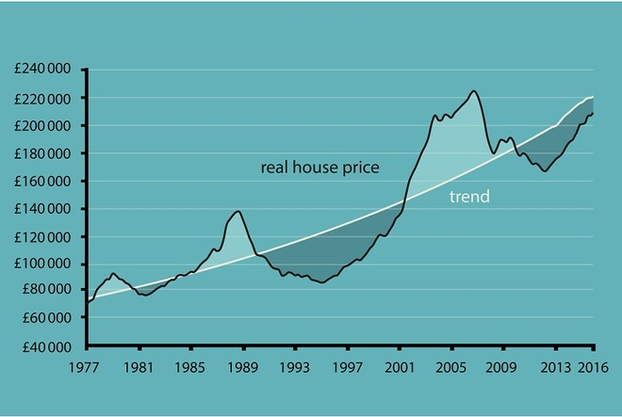
Figure 7 Trends in real house price

6.3 The household balance sheet
In this section, you will look at how to build the household balance sheet and calculate net worth, the current asset ratio and gearing. You will then find out how to link the balance sheet to the household budget.
Now you’re ready to explore the household balance sheet more fully. This gives an individual or a household a snapshot of their overall financial position at a particular point in time. It also gives clues to how vulnerable the household may be to the financial impact of future shocks. Such information, taken together with cash flow and budgeting statements, is crucial for financial planning.
Take a look at the household balance sheet in your fact find. Let’s take a tour of its components before you start to fill it in with your own details.
It lists the main items recorded in a financial balance sheet, and most of these items should now be familiar to you. Assets are split between liquid assets and other assets, while liabilities are split between short-term and other liabilities. The difference between total liabilities and total assets provides an estimate of the net worth (or wealth) of an individual or a household – rather like a summary of their overall financial position at a particular point in time.
Note that net worth is estimated rather than a precise calculation, because it can be difficult to obtain an accurate valuation of certain assets without actually selling them. For example, the value of a house can be estimated, but its actual value will depend on a price obtained in the marketplace.
You may also notice that contributions to pension schemes are not included in the assets column. This is because, generally, pensions cannot be sold, cannot be accessed before age 55 and, with some, they are promises of future income rather than pots of savings, making it hard to get a meaningful estimate of their worth. (Pensions are considered separately next in Week 7.)
Despite these reservations, the estimate of net wealth provided by the household balance sheet is useful in giving an overview of an individual’s or a household’s financial position.
Later you’ll look at other calculations related to the household balance sheet – the current asset ratio and gearing – and how these can help with financial planning.

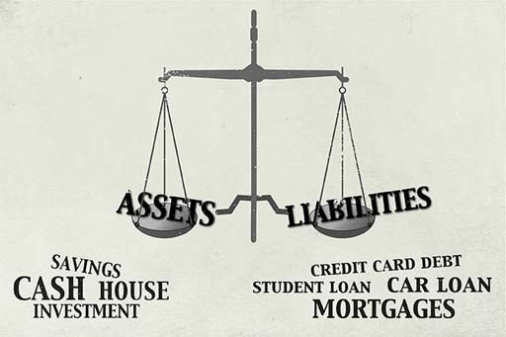
Figure 8

6.3.1 Completing your household balance sheet
Now complete your household balance sheet in your fact find as far as total assets, total liabilities and net worth. As you’re aware, you can do this individually or for your household – whichever you feel is appropriate. To do this you need to access your most recent bank account and credit card statements, and, if you’re an owner-occupier, your mortgage account. For certain of your assets, particularly your home or car, you’ll have to make an estimation of their current value. There are websites that can help you do this.
Don’t get overly stressed about getting valuations to the nearest pound. A rough estimate is perfectly good enough.
When you’ve done this you can determine your current net worth (or wealth) by deducting total liabilities (H) from total assets (G).

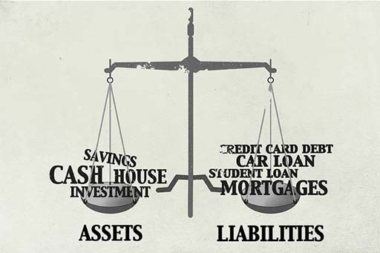
Figure 9

6.3.2 Targeting the current asset ratio
The household balance sheet can also be used to calculate the current asset ratio. This compares total liquid assets with total short-term liabilities and is useful in assessing how finances can be managed in the short term. It is calculated in the following way:
Current asset ratio = Total liquid assets / Total short-term liabilities
Personal finance experts say that the current assets ratio should always exceed 1. If it is below 1, then that tells us that short-term liabilities (such as bills and credit card debts) could not be met if circumstances made it necessary to do so. This can indicate that potentially serious financial difficulties could lie ahead. The risks are insolvency and potentially even bankruptcy.
Personal finance experts often argue that a good target to aim for – when well into adult life – would be a current asset ratio of 4, though a less conservative target might be only 3.
Now use the figures you’ve produced on your household balance sheet to calculate your current asset ratio by dividing total liquid assets (C) by total short-term liabilities (D). How might this be used in financial planning?
One possible use of your current asset ratio would be to assess the progress of particular financial plans. Someone with the goal of getting out of short-term debt, for example, could calculate their current asset ratio every three months and track it as it (hopefully) moves to a figure above 1.

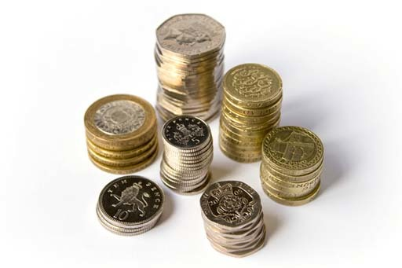
Figure 10

6.3.3 Your household balance sheet – gearing
Another important balance sheet ratio is gearing, which is usually worked out as a percentage and is simply:
Gearing = Total liabilities / Total assets × 100
You may have heard a lot in the news about whether government debt levels are too high and need to come down. In the same way, household debt levels can be too high as well. Why does it matter?
Consider the two household balance sheets. Use the formula to work out the gearing for each household. Then assume that house prices fall by 20%. Adjust the balance sheets for the new lower property values and comment on how each household has weathered this shock.

Table 2 The Sterling family's balance sheet
LIQUID ASSETS | £30,200
OTHER ASSETS
Home | £435,000
Other | £132,000
TOTAL ASSETS | £597,200
SHORT-TERM LIABILITIES | £5400
OTHER LIABILITIES
Mortgage | £62,000
3-year car loan | £6500
TOTAL LIABILITIES | £73,900

Table 3 The Penny family's balance sheet
LIQUID ASSETS | £2050
OTHER ASSETS
Home | £180,000
Other | £30,000
TOTAL ASSETS | £212,050
SHORT-TERM LIABILITIES | £3800
OTHER LIABILITIES
Student loans | £9400
Mortgage | £164,000
TOTAL LIABILITIES | £177,200

Looking at your own household balance sheet, you can now have a go at calculating your gearing using the guidance set out above.
Why do you think measuring gearing can provide an insight into how exposed to risk your household balance sheet is?

6.3.4 Can gearing predict a crisis?
Let’s start by looking at what happens if house prices fall by 20%. Both households will see the value of their assets fall but there is no change to their liabilities:

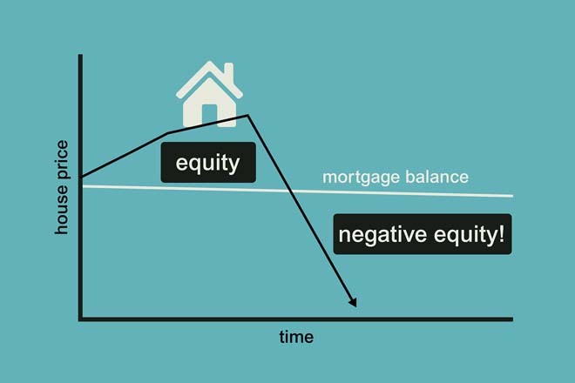
Figure 11 How well are you protected from a fall in house prices?

- The Sterling family’s home falls in value from £435,000 to £348,000 (which is 80% of £435,000). This is a big drop but the household still has net worth of £436,300 and so still has a large cushion against further shocks. The Sterlings probably do not have to make any immediate changes to their finances.
- The Penny family’s home falls in value from £180,000 to £144,000 (which is 80% of £180,000). This leaves them with negative net worth of -£1,150. Moreover, their house is now worth less than their mortgage. The Pennys now have very little scope to cope with further shocks, such as job loss or a major expense, and they cannot afford to move home if they need to.
Could these very different impacts of the same shock on these two households have been predicted? Consider the gearing of each household before the 20% fall in house prices:
The Sterling household has a gearing of £73,900 / £597,200 = 12.4%.
The Penny household has a gearing of £177,200 / £212,050 = 83.6%.
The much higher gearing of the Penny household is a clear indicator that they may be more vulnerable to shocks than the Sterlings. While there is no hard and fast rule about what is a ‘good’ gearing, you should be aware that the higher the ratio, the greater the financial risk to the household.

6.3.5 Linking the balance sheet to income and expenditure
Let’s end this week by looking at the relationship between liabilities and expenditure, and assets and income.
This is summarised in the image, which describes the inter-relationship between the stocks of assets and liabilities and the flows of income and expenditure. Assets are on one side of the scales and liabilities on the other.
In reality, these scales would be in constant motion, as money continually flows into and out of individuals’ and households’ pockets, and the value of assets and liabilities is continuously changing. For the sake of simplicity, assume the scales have stopped at a particular point in time. This allows an exploration of both how assets relate to income and how liabilities relate to expenditure.
The receipt of income adds to the asset side of the household balance sheet (at least in the short term) as money flows, such as pay from employment, go into a current account. Alternatively, income can be used to purchase shares, bonds or other forms of saving and investments. In turn, many assets produce flows of income, such as interest payments or share dividends.
Non-financial assets (for instance, a piece of art) generally do not produce an income flow, and would have to be sold to generate money. Yet even these assets could theoretically produce an income, for example, lending a work of art to an exhibition for a fee.
Similarly, expenditure is related to liabilities in the sense that having debts generates future flows of expenditure. Expenditure either reduces assets – perhaps by depleting the current account or by causing other assets to be sold – or increases liabilities, perhaps by taking out debt to pay for it. Expenditure that is higher than income generates liabilities because individuals or households will have to take on debts, for example, by using credit cards or overdrafts, to fund the gap between expenditure and income.
To return to the subject of housing, it can be interesting to consider how homes fit into the household balance sheet. Homes are typically regarded as the biggest asset of an individual or household. Yet an interesting point put forward by Robert T. Kiyosaki in his famous book Rich Dad, Poor Dad: What the Rich Teach their Kids about Money – that the Poor and Middle Class Do Not! (Kiyosaki, 2011) is that one of the key mistakes contributing to making people ‘poor’ rather than ‘rich’ is buying a home that is bigger than strictly needed.
Rather than buying assets that produce income (like shares or investments), the large mortgage actually causes expenditure to escalate. It’s a salient point, which provides an interesting counterweight to the British dedication to house buying.

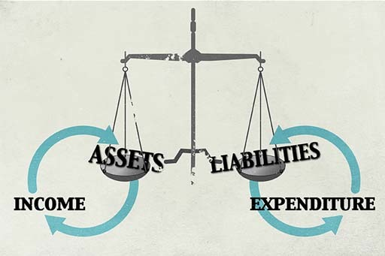
Figure 12

Week 6 quiz
This quiz allows you to test and apply your knowledge of the material in Week 6.
Complete the Week 6 quiz now.
Open the quiz in a new window or tab then come back here when you're done.

Week 6 round-up
In Week 6 you looked at the most important financial asset most households possess – their home.
You examined the processes and issues involved in buying and selling property, and at the mortgage products that are commonly used to fund property purchases. You also examined the ‘buy-to-let’ market and the range of risks involved in buying and owning property.
Household balance sheets provide a snapshot of individual or household net worth and are an important tool in personal financial planning. This tool adds to the cash flow statement and budgeting processes explained in Weeks 2 and 3, and together these offer a crucial tool kit in financial planning and money management.
The size and composition of the financial balance sheet is also very important as you become older – it will affect how you approach retirement planning, a subject you will look at next.
You can now go to Week 7: Pensions

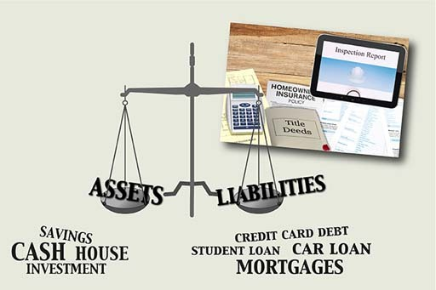
Figure 13

Week 7: Pensions

Introduction
Learn about the pensions crisis in the UK – state pensions (but at what age?), occupational pensions and now ‘workplace’ pensions. Calculate your pension income.
Martin introduces Week 7 and the most crucial personal finance issue in the UK – planning your retirement income.

Video content is not available in this format.
View transcript - Uncaptioned interactive content



This course is presented with the kind support of True Potential LLP.
The True Potential Centre for the Public Understanding of Finance (True Potential PUFin) is a pioneering Centre of Excellence for research in the development of personal financial capabilities. The establishment and activities of True Potential PUFin have been made possible thanks to the generous support of True Potential LLP, which has committed to a five-year programme of financial support for the Centre totalling £1.4 million.

7.1 Planning for a happy retirement
A significant proportion of the population has no plan for a pension other than that provided by the state.
With the state pension age moving up in stages in the coming decades and with evidence that a large proportion of people have inadequate non-state pension plans, there is a critical need for us to plan ahead to ensure that we have a sufficient income for an enjoyable retirement.

Video content is not available in this format.
View transcript - Uncaptioned interactive content



7.1.1 State pensions
Limited state retirement pensions were first paid in the UK in 1908. These were improved in the 1946 National Insurance Act which brought in flat-rate universal state pensions (with effect from 1948).
While various developments in state pensions have taken place since then, the main thrust of policy between 1980 and 2016 has been to limit public expenditure on state pensions.
The UK government plans staged rises in the age at which people can receive their state pension, to reach 68 years in the mid-2030s, with further increases likely. Many predict that the state pension age will eventually rise to 70 years. One aim of these moves is that, on average, no more than a third of adult life should be spent in retirement. So the longer the population lives on average the higher will be the state pension age.
‘There are actually two state pension schemes in place in the UK. The ‘old’ scheme for those who reached state pension age before April 2016 and the so-called flat-rate pension scheme for those reaching state pension age from April 2016 onwards.
The 'old' scheme has two parts. The first part, the state basic pension, is paid at a flat rate (£125.95 a week in 2018/19 for a single person), equivalent to about 20% of national average full-time earnings compared with 28% in 1980. The decline has been due to the fact that, since 1980, state pensions have generally been increased in line with prices, which historically have tended to rise more slowly than earnings.
However, from 2011 onwards, the state basic pension has increased each year with the higher of either earnings inflation, consumer price inflation or 2.5%. This is known as the ‘triple-lock’ – an arrangement that is proving to be politically controversial. Whilst this ‘triple-lock’ remains in place the basic pension should retain its value relative to earnings (or even rise a little faster).
Entitlement to the basic state pension depends on paying, or being credited with, National Insurance contributions (paid by employees and the self-employed) during working life. Credits are given for certain periods out of work, such as being ill, unemployed or caring for children.
People reaching state pension age before 6 April 2010 needed to have National Insurance covering roughly nine-tenths of their working life to get the full state basic pension. For people reaching state pension age on or after 6 April 2010, the required contribution record was reduced to 30 years and, although it will rise from April 2016, will still be just 35 years.
A shorter record means a reduced pension – although from 2016, a minimum number of years (expected to be 10) will be required to get any pension. However, people can now have substantial periods of not working without damaging their basic pension entitlement.
Wives – and, since April 2010, husbands and registered civil partners – can claim a basic pension of up to £75.50 (in 2018/19) based on their spouse’s or partner’s record if their own basic pension would come to less than this. From 2016 this stopped for those new to reaching state pension age.
The second part of the state pension – the state additional pension (or additional second pension) – is restricted mainly to employees. It was first introduced in 1978, when it was called the State Earnings Related Pension Scheme (SERPS).
In theory, additional state pension can provide a substantial boost to the state pension (by up to circa £40 per week) but, in practice, the average amount paid is much lower. Many people have been ‘contracted out’ of the state additional pension, which means that this part of their state pension has been replaced by a workplace or personal pension scheme in return for reduced or refunded National Insurance contributions.

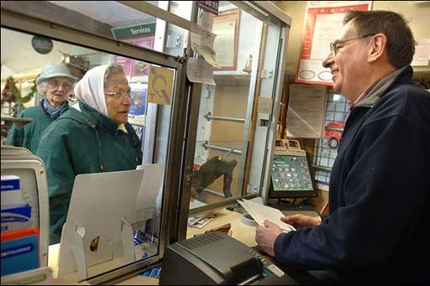
Figure 1

7.1.2 The new flat-rate state pension
From April 2016 for those new to attaining the state pension age (SPA) the state basic and additional pensions have been replaced by a single flat-rate pension (for 2018/19 of £164.35 a week).
For 2018/19, the UK government’s assessment of the minimum weekly income required by pensioners is £163.00 for a single person and £248.80 for a couple (whether married or not).
This contrasts with the situation in the mid-1980s, when the basic state pension was about the same as the minimum level of income that was deemed enough for a single householder to live on. Therefore, anyone relying solely on the basic state pension is now also eligible to claim a means-tested top up.
Such means-tested retirement benefits can discourage saving for retirement because building up a small private pension simply reduces the amount of benefits that can be claimed. The change to a flat-rate pension from April 2016 is intended to ensure that the state pension no longer falls short of the minimum income required. As a result, far fewer pensioners will need to claim means-tested benefits and there will be no disincentive to saving for retirement.


Figure 2

7.1.3 Understanding the new flat-rate pension
From April 2016 there’ll be a single flat-rate state pension.
How much is this worth? How many years of National Insurance contributions do you need to receive it? What happens if you haven’t paid enough in contributions?
Work through the sums in this video and see what’s likely to be the overall effect on people’s saving habits.

Video content is not available in this format.
View transcript - Uncaptioned interactive content

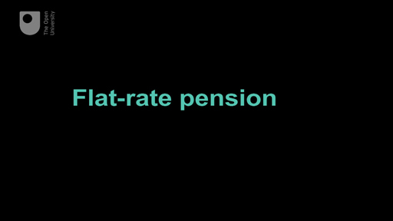

7.1.4 Occupational pensions
Occupational pension schemes are set up by employers for their employees. They typically provide a package of benefits:
- a retirement pension for the employee payable from the scheme’s normal pension age (often 65) or later
- a tax-free lump sum for the employee at retirement
- a pension payable if the employee has to retire early due to ill health
- pensions for a widow, widower, registered civil partner and dependent children if the employee dies either before or after retirement. Most schemes also pay such a pension to an unmarried partner
- lump sum life insurance if the employee dies before retirement.
There are generally two types of occupational pension scheme: defined contribution schemes (also called money purchase schemes) and defined benefit schemes.
Defined contribution schemes invest contributions from the employer, and normally the employee as well, to build up a pension pot for the employee. Personal pensions also work on this basis (more about this later this week). The key features to note are that employees don’t know in advance how much pension they might receive, and the pension is directly affected by factors such as the value of investments rising and falling with the stock market.
By contrast, a defined benefit scheme promises to pay a specified pension at retirement (often – but not necessarily – linked to the employee’s pay while working). In a defined benefit scheme, the yearly pension is commonly worked out according to a formula, for example:
Yearly pension = accrual rate × number of years in scheme × salary
The accrual rate is a fraction, typically 1/60th or 1/80th. How ‘salary’ is defined depends on the type of scheme and its rules. For instance, the salary that counts towards the pension might be less than the total salary the employee gets. In a ‘final salary scheme’, salary would mean pay just before retirement (or pay at the time of leaving if the person leaves before reaching retirement).
Increasingly, defined benefit schemes are shifting to a ‘career average revalued earnings’ (CARE) basis. This means the pension is based on average pay over all the years in the scheme, after adjusting each year’s pay for inflation between the time it was earned and the person retiring or leaving the scheme.
Whatever the definition of salary, this type of formula works in basically the same way. For example, a person earning £36,000 a year and retiring after thirty years in a 1/60th scheme would receive a pension of 1/60th × 30 × £36,000 = £18,000 a year.
The pension from a defined benefit scheme is usually increased each year in line with price inflation. Historically this was measured by the RPI but in 2010 the government announced that pensions for retired public sector workers would rise in line with the (typically lower) CPI. The pension from an occupational defined contribution scheme was covered by similar rules but, since April 2005, the retiring employee can usually choose whether or not the pension will be increased each year.
The key point is that the level of pension promised does not directly depend on factors such as stock market performance. For example, while a slump in stock markets is likely to push up the cost to the employer of funding the promised pension, the employee’s promised pension would be unchanged.
Nonetheless, indirectly, the employee could be affected if the increasing cost to employers of providing this type of pension results in the employer closing or changing the pension scheme or, worse still, going out of business, leaving the pension pot with too little in it to pay the promised pensions.
In recent years there’s been a marked decline in the number of employees who belong to defined benefit schemes. This shift has affected employees in the private sector: by 2016, there were over four times as many active members of defined contribution schemes as there were of defined benefit schemes (ONS, 2017).
Where defined benefit pensions continue for existing members, in many cases the pension formula has been changed to promise less generous pensions in future. New employees are typically offered membership of defined contribution schemes instead.
For the employer, defined contribution schemes are less risky than defined benefit schemes because the employer promises only to pay specified contributions– a predictable, stable cost to the employer’s business.
Defined contribution schemes are also less costly because most employers pay far less into this type of scheme than they would into a defined benefit scheme. In 2016, the average employer contribution to private defined benefit schemes was 16.9% of an employee’s pay, compared with just 3.2% for a defined contribution scheme (ONS, 2017). What this means, of course, is a reduction in the money going into an individual’s pension pot, which will tend to reduce the resulting pension.


Figure 3

7.1.5 Workplace pensions
A major development in pensions occurred in 2012 with the commencement of the government’s ‘automatic enrolment’ scheme for pensions. From October 2012 employers started being required both to offer a workplace pension scheme to their employees and to automatically enrol them onto the scheme.
Workplace pensions can take various forms, such as the defined benefit and defined contribution occupational schemes you looked at earlier. They can also be in the form of personal pension plans, which you’ll look at later this week.
Large employers were the first to undertake this new approach to pension planning in the workplace. By 2018 all employers will have to be automatically enrolling their eligible employees into a workplace pension scheme.
If employees do not want to be enrolled in the pension scheme offered by their employers they have to take action to opt out. So the prospect is that, for many, inertia will result in them becoming, and remaining, enrolled in a workplace pension scheme.
Automatic enrolment is an important initiative to get people to contribute to a pension plan, although some criticisms have been voiced about the scale of the fees levied on those enrolled onto schemes.


Figure 4

7.1.6 Calculating pension income
Learn in this video how to work out amounts of pension at retirement under defined benefit schemes.

Video content is not available in this format.
View transcript - Uncaptioned interactive content

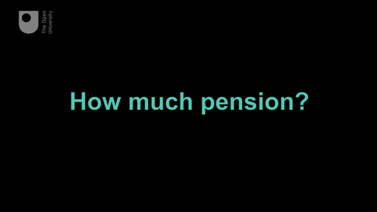

7.2 Personal pensions
In this section, you will look at personal pensions and the pensions revolution unveiled by the government in 2014. You will also look at the move from final to average salary pensions and apply the financial planning model to pensions.

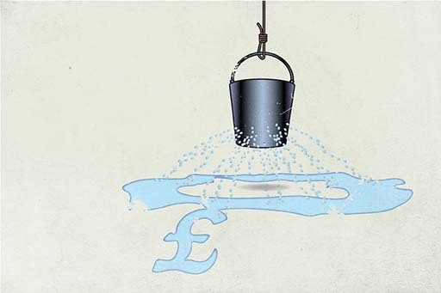
Figure 5

Personal pensions and defined contribution occupational schemes are examples of defined contribution schemes, and all work in essentially the same way. The pension depends on:
- the amount paid in, which is invested in a pension pot
- how much the invested pension pot increases in value
- how much is taken out of the pension pot in charges
- how much the saver decides to draw out as a cash lump sum at retirement
- how much pension the remaining pot can buy at retirement (most commonly the pot is used to buy an annuity, but an alternative is income drawdown).
Anyone can have a personal pension and anyone can pay into a personal pension for someone else – so the main earner in a couple could pay into a plan for a partner who has a caring role.
Personal pensions (unlike occupational defined contribution schemes) do not necessarily offer a package of benefits. It‘s up to the individual to choose whether to buy extra benefits, such as life cover, a pension for a partner or increases to the pension once it starts to be paid.
Personal pensions and occupational defined contribution schemes expose the individual to a variety of risks. To understand these risks, put yourself into the position of someone who is currently many years from retirement and who has to organise their own pension scheme to provide themselves with retirement income.
How much should you pay into the scheme? It’s important to get this decision right because if you pay in too little, your pension will be too small. Pay in too much, and you could limit your current spending and standard of living, but you can’t be certain of the correct amount. The eventual cost of the pension will depend on these factors.
- Investment returns: as you saw in Week 5, when investing for the long term – and pension savings are very long term – stock market investments, like shares and bonds, are likely to be most suitable. It’s impossible to know in advance how well these investments will perform. If, in planning for retirement, you assume they will perform well, you don’t need to invest too much. If your assumption is wrong and the investments turn out badly, you’ll have too little in your pot to provide the pension you wanted. What counts here is the investment return after all the charges have been deducted. An investment fund that offers the chance of higher returns but has high charges might be a poor choice compared with a less ambitious investment fund with modest charges.
- Inflation: Week 2 described how rising prices reduce the buying power of money. To protect against this, you would need to invest extra money to compensate for the effect of inflation both over the years when the savings are building up and once the pension starts. But you’ll also have to estimate what rate of inflation to guard against. If your estimate is too low, in real terms you’ll have a smaller pension than planned.
- Longevity: the aim is that the pension, when it starts, will provide a regular income, usually paid monthly, until your death. The longer you live, the more months of pension that have to be paid out, and the greater the total cost of the pension. In deciding how much to save, you need to make an assumption about how long you will live or the cost of insuring against living ‘too long’. If your assumption is wrong, either the money will run out before you die or you’ll have saved more than you needed to.
Therefore, defined contribution schemes, including personal pensions, lead to individuals shouldering the risks up to the time when the pension starts. This means that different people saving the same amount can receive very different pensions, and a person’s pension can be markedly different depending on when they retire.
On reaching retirement, you can protect yourself from further longevity risk by buying an annuity that will provide an income for the whole of your remaining life, however long you live. In effect, this is insurance against living for longer than your pension pot would otherwise last. However, the annuity provider will take a slice of the pension pot in charges before what remains is turned into income.
A revolution to defined contribution schemes, however, has been presaged in the 2014 budget statement by the Chancellor George Osborne. He announced that restrictions on pensioners’ access to their pension pots are to be eased from April 2015, with a quarter of pension pots able to be withdrawn without any liability to tax.
Thereafter withdrawals will be taxed effectively as income. The government plans to end the requirement for defined contribution pensioners to buy an annuity. Those retiring will instead be able to access their pension pot and invest it where they choose to provide an income in retirement.
Listen to our personal finance expert Jonquil Lowe talk about the proposed reforms to pensions announced in George Osborne's 2014 budget statement and about the risks associated with pension planning. This was first broadcast on Bolton FM (16 March 2014).

Audio content is not available in this format.
View transcript - Uncaptioned interactive content

7.2.1 Moving to average salary pensions
In early 2014 most employees in the public sector were still in a defined benefits pension scheme with the promised pension based on final salary. By 2015 their future benefits will instead be based on a career-average structure (Gov.UK, 2014).
How do you think such a switch could help to reduce the cost to the government of providing pensions?

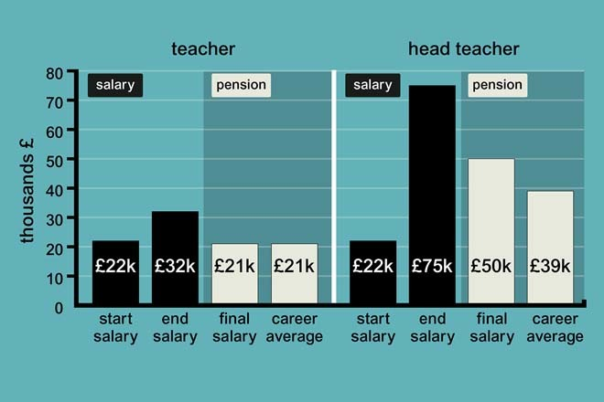
Figure 6 Salaries and pensions, based on a 40-year career

Which workers might gain and which might lose from such a switch? To help you identify winners and losers, take as an example an established profession such as teaching.

7.2.2 Funded and pay-as-you-go pensions
In the previous discussion you might have worked out that average salary pensions would be cheaper to provide than final salary schemes if, even after adjusting for inflation, a worker’s average pay over many years was lower than their pay just before retirement.
Workers whose pay tends to peak in mid-career might gain from a switch, whereas workers whose pay tends to peak towards the end of their career would lose. So, in the example of teachers, a person who reached the position of head teacher would lose out in relative terms from this change.

Table 1 Pensions in a nutshell
Pension scheme | Organised by | Basis on which pensions are provided | How pensions are financed | Who pays?
State scheme: basic | State | Defined benefit | Pay as you go
State scheme: additional pension | State | Defined benefit | Pay as you go
Occupational scheme: final salary | Some public sector employers | Defined benefit | Pay as you go | State provision, usually employee too¹
Occupational scheme: final salary | Private sector and some public sector schemes | Defined benefit | Funded scheme | Employer, usually employee too¹
Occupational scheme and NEST²: defined contribution | Private sector employers | Defined contribution | Funded scheme | Employer, usually employee too^{1, 3}
Personal pension | Individual | Defined contribution | Funded scheme | Individual (employer occasionally)¹
¹Tax relief on contributions and on the return from pension fund investments means the State also pays towards the cost of occupational and private pensions. However, some of this tax relief is clawed back once pensions start to be paid because pension incom is taxable.
² National Employment Savings Trust.
³ Employees must contribute to NEST.

With most occupational schemes and all personal pensions, money is paid into the scheme to create a pension pot – a pool of investments. These are called funded schemes. Employers pay into occupational schemes and usually require employees to contribute too. With other types of scheme, individuals often fund the whole scheme.
In most large, occupational defined benefit schemes, experts are appointed to manage the investments, and pensions are paid directly from the fund as they fall due. With defined contribution arrangements, an insurance company often looks after the investments, and the pensions are typically paid by taking money out of the fund to buy annuities.
By contrast, state pensions are pay-as-you-go (PAYG) schemes. There is no pension pot. Instead, the pensions paid out today are financed from National Insurance and other tax revenues collected today. Sometimes this is referred to as a ‘contract between the generations’, with today’s tax payers paying for today’s pensions on the understanding that when they retire, their pensions will be paid for by the taxpayers of the future.
Some public sector occupational schemes (covering, for example, civil servants, teachers, National Health Service (NHS) workers and the Armed Forces) are also financed on a PAYG basis, with employees’ contributions and general tax revenues used to pay the pensions of many retired public service workers. In contrast, the schemes for local authority employees and university lecturers in some universities are funded schemes.

7.2.3 The 2015 pensions revolution: freeing up access to pension pots



In his 2014 Budget Statement the Chancellor, George Osborne, unveiled proposals for pensions reform which are now changing the financial options for those approaching retirement. These proposals took effect from April 2015 and have led to tax restrictions on access to pension pots being eased.
These are the key features of the pensions revolution, introduced by the Coalition Government:
- The 2015 Taxation of Pensions Act provides greater freedom for those in ‘defined contribution’ schemes to access personal pension funds (or ‘pots’). Funds can be accessed before retirement and used, say, to invest in a range of assets (like property) or to pay off a mortgage or other debts or simply to finance current consumption. For each lump sum accessed 25% is tax-free. Sums accessed in excess of 25% are taxable as income and so could attract tax of up to 45% (for taxable income above £150,000).
- Those retiring with defined contribution pensions now have increased alternatives to buying an annuity with their pension savings. At retirement, up to 25% of the remaining pot can be taken as a tax-free lump sum (as previously applied prior to 2015). But, as an alternative to buying an annuity many are expected to leave at least 75% of their pots invested and take income from the fund when needed.
- There is a proposal for freedom, from April 2016, for 5 million existing defined contribution pensioners to sell their annuities for a lump sum which can then be accessed in the same way as for those approaching retirement, as set out above.
- The government announced that the cap on the lifetime allowance for pension schemes of £1.25m will reduce to £1m from April 2016. Amounts held in pension funds in excess of the lifetime allowance are subject to tax when accessed ,with a rate of 55% applying to lump sums and 25% (on top of normal tax) for taxable income drawn from the fund.
- There is greater flexibility to pass on a pension to dependents after death. For those dying prior to the age of 75 income from pension assets can be passed on to beneficiaries tax-free. This tax treatment previously only applied to lump sums from a pension ‘pot’. For those dying aged 75 or over, the tax rate applied to lump sums is now 45% instead of 55% (reducing to normal income tax rates from April 2016). Normal tax rates apply to income passed to beneficiaries.
This last reform is forecast to cost the Exchequer some £150m a year. Arguably, what it does do, though, is to remove an unfair excess tax charge on pension pots for which the deceased have spent their lives contributing to. An alternative view is that it will provide a way to avoid inheritance tax, with those in retirement drawing on savings and other investments while leaving their pension pots untouched. Doing this could leave up to £1.25 million in pension pots being exempt from inheritance tax.
While the greater flexibility that these reforms provide for pensioners should be welcomed a few concerns cannot go unobserved.
First, one motivation for these greater freedoms seems, in part, to be the belief that annuities are poor value and, by inference, that other ways of investing pension funds may be better for pensioners. Yet while there have clearly been issues about how some insurance companies have sold annuity products, it is unfair to say that all are poor value. The low annuity rates prevailing today simply reflect growing longevity and the currently prevailing low interest rates. If you want to learn more, see the related link at the bottom of this step.
Second, there are concerns that many pensioners will spend large portions of their pension pot and not invest the funds to provide the income stream needed in retirement. The upshot is that within a few years, some pensioners will find themselves short of the income needed for a comfortable retirement.
Finally, there is the concern – particularly given the pace of the reforms – that the pensions industry is currently not adequately prepared to deal with the consequent advice that will be required as a result of wider freedoms available to those pensioners and those moving towards retirement.

7.2.4 The challenges of the pension revolution

Video content is not available in this format.
View transcript - Uncaptioned interactive content

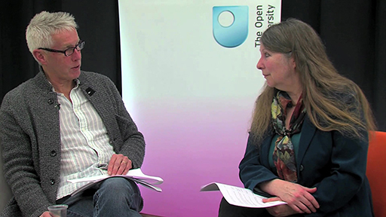

To round off our examination of pensions and the current pensions revolution in the UK, watch this video of Martin and Jonquil Lowe answering questions posed by learners. The areas covered include issues about pensions schemes and the new freedoms those retiring now have in making their pension arrangements.

7.2.5 Planning ahead for your retirement
To consider how an individual or household can plan ahead for their retirement years, look once again at the financial planning model. This, or similar planning models, would be used by a financial adviser as the foundation for advice about retirement planning and provides an approach that you can also use for yourself.

Figure 7 Using the model to help with your pension planning

Planning for retirement typically means looking many years ahead. Earlier in the course you learned about the need to know whether you’re dealing with figures in real terms – in other words, after taking inflation into account. When planning for retirement, it is important that all planning is done in real terms. This means that forecasts of future values should all be in terms of today’s money so that you’re looking at what a pension might buy after taking into account the possibility of price rises between now and retirement.
Central to the situation is the goal of a comfortable retirement. The need is to have enough income throughout retirement to finance a certain standard of living. The amount required will be determined largely by expectations of spending in retirement.
This raises a question: whose spending needs? Should the financial plan look at the individual or the household? The danger of basing the plan on the household is that many households change over time as, for example, couples split up, family members and friends decide to share a home or leave, or people die.
Traditionally, married couples have adopted the household approach, and the resulting financial plans have often proved inadequate in the face of death or divorce. This is a key reason why women account for such a high proportion of the poorest pensioners today.
The advantage of a retirement plan based on the individual is that each member of the household has their own pension arrangements, which they retain even if the make-up of their household changes.
Spending in retirement can be estimated from the individual’s or household’s current level and pattern of spending. Yet there are some good reasons to think that spending in retirement may be different from spending while working, and that spending needs in early retirement may differ from those later on. You’ll look more closely at this in the next activity.
An alternative might be to base estimated spending needs on the spending patterns of current pensioners, but bear in mind that what today’s pensioners actually spend may reflect the constraints of the income they ended up with rather than the income they wanted to have.

7.2.6 Financial planning when saving for retirement
This quiz tests what you've learned about financial planning when saving for retirement.

Activity 1

Dibyesh is in his 30s and is using the financial planning model to help him plan ahead for retirement.
Which one of the following would Dibyesh do in Stage 1 of the financial planning model (‘Assess the situation’)?

Choose a personal pension with SIPPly Pensions Ltd
Work out that saving £250 a month could provide the amount of retirement income he wants
Think about how much he might want to spend in retirement
Check to see how his pension savings are growing

Which one of the following would Dibyesh do in Stage 2 of the financial planning model (‘Decide on financial plan’) when planning for retirement?

Check his state pension age
Check how much pension he might get from an old employer’s pension scheme
Look at the pros and cons of saving through a pension plan or saving through an individual savings account
Use a comparison site to compare personal pension plans from different firms

Which one of the following would Dibyesh do in Stage 3 of the financial planning model (‘Act on financial plan’) when planning for retirement?

Go to a financial adviser for help choosing a pension provider
Get a state pension statement to see how much state pension he might get
Check his budget to see how much he can afford to save
Work out the gap between the retirement income he wants and the pension funds he has built up so far

Which one of the following would Dibyesh do in Stage 4 of the financial planning model (‘Review the outcome’) when planning for retirement?

Complete an application form to start a personal pension plan
Set up a direct debit to start paying into a pension plan
Decide which investment funds his pension contributions will be invested in
Check whether he should alter the amount he saves each month following an increase in his state pension age

7.2.7 Spending money in retirement
Some reasons why spending in retirement might differ from pre-retirement spending:
- By retirement, most homeowners will have finished paying off any mortgage, so the amount that these pensioners spend on housing may fall.
- Pensioners often spend more time at home, so bills for gas and electricity could rise.
- There will be savings on work-related costs such as pension contributions and commuting.
- There may be an increase in travel to see friends and relatives, but pensioners often qualify for reduced-rate or free travel, especially on public transport.
- Pensioners may spend more on holidays, especially in early retirement, but may save money by going away at off-peak times.
- In later retirement particularly, pensioners may have to spend significantly more on health-related items such as help with personal care.
Think about your own current spending. How do you think your own spending might change when you reach retirement (or, if you are already retired, over the next ten years)?
Your spending could change for reasons of both necessity and choice, as you saw in the list. One thing to remember is that these are only estimates – no one can be sure of the spending they will need to undertake in retirement, because personal circumstances at the time may differ from those anticipated beforehand.


Figure 8

7.3 Planning ahead for your pension
How well are you preparing for retirement? Are you sure you can afford to retire with your current pension plan?

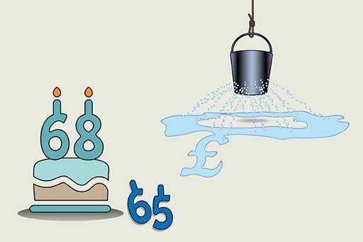
Figure 9

Most UK adults will already have some pension arrangements in place, not least because some are compulsory. Most employees and self-employed people have to pay National Insurance contributions and so build up a basic state pension. Most employees must also build up a state additional pension or a contracted-out occupational or personal pension instead. People may also have opted voluntarily to build up additional retirement savings.
The next stage in the financial plan is to check what arrangements are already in place, how much pension these arrangements are expected to produce by the chosen retirement age and whether there is a need to save extra. This is done by gathering forecasts and statements for the various arrangements.
Fortunately, these statements must all provide a forecast of the possible future pension in terms of today’s money, which helps with planning in real terms. The expected pensions can then be deducted from the target retirement income to see if the existing arrangements are likely to produce enough income.
If there is a shortfall, extra pension savings may be required if the retirement income target is to be met. There may be a tension between the amount a person needs to save and the amount they can afford to save given their current budget. In that case, either the retirement target will have to be revised or adjustments made to current income and spending via the budgeting process.
To see how the process of planning works in practice, return to the example of Dibyesh. He’s 37, thinks he should start saving for retirement, and so follows the initial steps of the financial planning model.

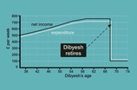
Figure 10 Dibyesh’s income and expenditure without any savings for retirement

Stage 1: assess the situation
The first step is to decide how much retirement income he might need. Dibyesh currently spends about £480 a week and, thinking about how his spending needs might change in retirement, he reckons he would then need about £260 a week in today’s money.
Allowing some adjustment for tax, that would mean a before-tax retirement income of, say, £275 a week or about £14,400 a year based on current tax rates. This is around 50% of his current gross income.

Stage 2: decide on a financial plan
Based on the changes to the state pension system introduced from 2016, Dibyesh expects to get the full flat-rate pension, equivalent to £164.35 a week (£8546 a year) from his state pension age of 68.
Currently, Dibyesh has no other retirement savings. He needs a plan to produce another £5854 a year of pension to generate that target pension income of £14,400 a year. He is self-employed, so there is no occupational scheme to join. Therefore Dibyesh looks at a personal pension.
The pension provider helps Dibyesh to work out that to produce a pension of £6500 a year by age 68, Dibyesh needs to start saving about £250 a month, assuming he increases this each year if his earnings rise. This means Dibyesh will need to save about 12% of his net income year after year. He is already saving some of his income each month but this is earmarked for other things. To save enough for retirement, Dibyesh decides he will have to cut back his current spending.

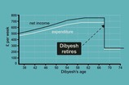
Figure 11 Dibyesh’s income and spending when he does pay into a pension

Without retirement savings, Dibyesh’s income drops very sharply once he reaches age 68 and his budget is so stretched that his spending actually exceeds his retirement income.

Stage 3: act
If he saves for retirement, his spending between the ages of 37 and 68 is reduced, but at age 68 the drop in Dibyesh’s income is much smaller and his retirement income is enough to cover an enhanced level of spending.
Dibyesh decides that giving up some spending today is a worthwhile trade for a better standard of living when he retires.
Later this this week you see how Dibyesh completes Stage 4 of the financial plan by reviewing his arrangements.

7.3.1 Pensions and retirement – a social revolution
This video shows a piece of recent history – how a debate from the mid-2000s has evolved into recent government announcements about the raising of the state pension age and the end, for most employees, of a compulsory retirement age.

Video content is not available in this format.
View transcript - Uncaptioned interactive content



If you don’t want to work well into your 60s you need to act on and regularly review your pension plan to see if you can afford to retire before the state pension kicks in.

7.3.2 Acting on and reviewing your pension plan
Once you’ve decided on the financial plan, the next stage in the model is to act on it. For most people regarding the state pension, little action is needed while it’s building up because it’s compulsory. As automatic enrolment into a workplace pension scheme is rolled out over the period 2012 to 2018, this will also be the case for most employees starting to save privately.
But the amount saved through automatic enrolment will peak at less than 8% of earnings and so may fall short of the amount required to reach the retirement income most people would like. This means that extra savings will be required. To join a workplace pension scheme or to find out about increasing the benefits from it, an employee would need to talk to their human resources (HR) department at work.
Personal pensions are more complex: choices need to be made about the provider, about how to invest the pension pot and about whether or not to get help from a financial adviser.
Acting on your plan also involves reviewing it regularly. The long timescale, the risks involved and the potential for all sorts of life changes add up to a lot of uncertainties.
It‘s also likely that the social and economic environment will change. The UK government’s phased increase in the state pension age for men and women is a good example. The qualifying age will be 66 years by October 2020 and will subsequently rise to at least 68 years by the mid-2030s. These changes will have to be taken into account by Dibyesh.
You’ve seen that Dibyesh’s real income increases between the ages of 37 and 68, reflecting progression in his career. As his income and current living standards rise, he might decide to revise his spending needs in retirement. He might decide that he wants to continue to enjoy his improved living standards and that he feels able to save more while working. For instance, Dibyesh might revise his retirement income target to become 60%, rather than 50%, of his current gross income.
Review is also essential for anyone using a defined contribution pension scheme because stock market performance is unpredictable, and the pension pot may not build up at the rate that was originally assumed to be likely.
Most pension schemes and plans issue statements yearly. This enables you to check regularly how your pension is building up, and to take steps in good time if your retirement planning is no longer on track for the income you expect to need in later life.
In Dibyesh’s case, because the return from a personal pension varies as the value of investments goes up and down, he checks each year to see if he’s on track for a real retirement income of £275 a week, and adjusts the amount he’s saving as necessary.
If Dibyesh finds that he is not on track, some difficult decisions will have to be taken. He could plan to retire later and so spend more years in paid employment building up his retirement fund. He could aim to cut back further on expenditure and save more, thus sacrificing aspects of his lifestyle now for a better income in retirement.
Dibyesh could also consider whether he has – or is likely to have – assets he could sell to supplement his retirement fund. Perhaps he expects to inherit a house that could be sold or rented out. Either way this would supplement the financial resources he has in retirement.
Whatever action is taken by Dibyesh there is one thing he must not do – do nothing and hope the problem goes away.


Figure 12

7.3.3 Take control
Now take control yourself, by using the Age UK pension calculator(open in a new window or tab) to assess your situation.
You’ll see whether or not you’re on course to get the income you need to afford the lifestyle you want.
Whatever the result, stop and think about ways to take control of your future.

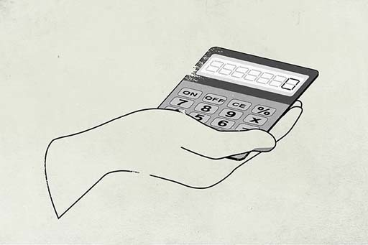
Figure 13

Week 7 quiz
This quiz allows you to test and apply your knowledge of the material in Week 7.
Complete the Week 7 quiz now.
Open the quiz in a new window or tab then come back here when you're done.

Week 7 round-up
As you’ve seen this week, pensions and pension planning are a hot topic in personal finance.
You examined the different types of pensions and the obligations each imposes on the (prospective) pensioner and pension provider.
You also saw how the financial planning model helps in pension planning.
Pension planning is, in a way, a means of insuring for the financial consequences of retirement.
Next, in the final week of the course, you explore the subject of insurance.
You can now go to Week 8: Insurance

Figure 14

Further reading
Annuities offer 'fair value' Jonquil Lowe, Lecture in Personal Finance at The Open University, queries the notion that annuities are poor value in a research paper.

Week 8: Insurance

Introduction
The rationale of insurance – household risk management. When to buy cover and when to self-insure? Apply the financial planning model to insurance decisions.
Martin introduces the final week of the course. The focus here is insurance – both compulsory and optional. How do you decide whether the optional types are worth paying for? In this week you revisit behavioural factors that influence financial decision making, and you tackle the end-of-course test.

Video content is not available in this format.
View transcript - Uncaptioned interactive content

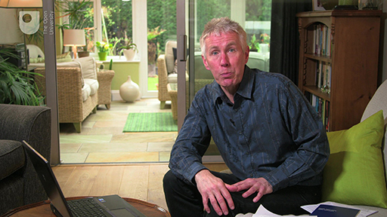

This course is presented with the kind support of True Potential LLP.
The True Potential Centre for the Public Understanding of Finance (True Potential PUFin) is a pioneering Centre of Excellence for research in the development of personal financial capabilities. The establishment and activities of True Potential PUFin have been made possible thanks to the generous support of True Potential LLP, which has committed to a five-year programme of financial support for the Centre totalling £1.4 million.

8.1 Insurance – setting the scene
How do you choose between the various types of insurance available?
What are the details that you, as a consumer, should focus on to ensure that the cover you’re buying is both necessary and appropriate for your circumstances? Under what circumstances can doing without a policy – known as ‘self-insurance’ – make sense?

Video content is not available in this format.
View transcript - Uncaptioned interactive content

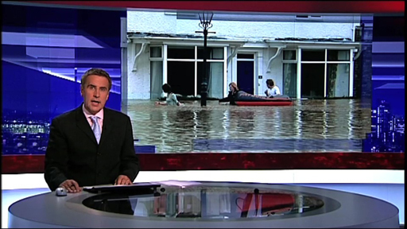

8.1.1 To insure or not to insure?
If you had complete freedom to make your own decisions about insurance – if there were no legal or contractual requirements to have insurance – which of these insurance products would you buy and which would you not buy?
- Travel insurance for a one-week holiday overseas. Cost of insurance: £50.
- Home insurance in respect of your property being flooded. Cost of annual insurance: £400.
- Extended warranty insurance coverage for breakdown of a washing machine. Cost of three-year insurance: £200.


Figure 1

8.1.2 Why do you buy insurance?
A theme throughout this course has been how households can use financial planning to protect themselves from the financial impact of future events, whether planned or unplanned, expected or unexpected.
Insurance is a method whereby individuals or households (or organisations) can protect themselves against the unexpected. To do this, they pay a sum of money called a premium to an insurer in exchange for being indemnified (protected) against the losses that result from specific perils, under conditions specified in a contract. This contract is called an insurance policy. When you take out an insurance policy you’re transferring to the insurer the risk of the financial loss arising from the peril, and so you’re reducing the potential consequences to yourself.

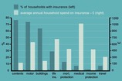
Figure 2 Household expenditure and purchase of insurance products in the UK, 2011 (ABI, 2013)

You can see from the chart the actual uptake of various types of insurance in the UK. The chart also shows the average expenditure on each type of insurance policy by those households that buy them, although it doesn’t include insurance cover provided through employers, so it understates total insurance expenditure.
Actuaries provide statistics to insurers to help quantify the risks that insurers are taking on. Insurers need data on the probabilities of the perils for which they offer insurance – death, illness, disease, burglary, accidents and so forth – and data on people of different ages, genders, locations, postcodes and households, so that they can estimate their risks of paying out.
Actuarial data will give an approximation of the future claims that the insurer might face across the range of perils they insure. Insurers will then aim to set premiums so that, on average, total premium income will cover the cost of paying out for claims, building up reserves and making a profit.
Insurers spread their risk by insuring many individuals and households against various risks. By insuring a large number of risks, the average number of times that insurers have to pay out will be more predictable, and so will be the total amount that they have to pay out in any given year. In taking on the risks of many and aggregating them, the insurer faces a more predictable future than individual policy holders would if they had to face their risks themselves.

What are the different strategies for managing risk and uncertainty?
One approach is to ignore the risk. If the peril then materialises, there could be major negative financial ramifications, and so this would be a high-risk strategy.
Another approach is to try to eliminate or reduce risk. Strategies here could include fitting house alarms (to reduce the risk of burglary or fire), eating healthily (to reduce the risk of premature death) or not flying (to eliminate a risk of death in an air crash). These might be beneficial in themselves – although they may have costs attached too – but they cannot eliminate all of life’s risks and uncertainties.
A different strategy is risk assumption. This involves taking on the potential financial impact of the peril materialising. It implies a policy of self-insurance: establishing a fund using savings products to cover the costs of any potential financial loss. This can be a strategy adopted by choice by people who are risk takers or who have enough income or savings to cover possible losses. It can also be adopted by default when other types of insurance are not available or are too expensive. Yet where the financial impact of a peril is large and beyond the financial resources of most individuals, many people who can afford to do so pursue a policy of transferring the financial risk, by using insurance to pass it on.

8.1.3 Mick sorts out his insurance
This quiz tests your ability to apply the financial planning model to insurance.

Activity 1

Which two of the following would Mick do in Stage 1 of the financial planning model (‘assess the situation’) when sorting out his insurance?

Go to insurer’s website to complete application form and pay the £75 premium
Add up the value of all his possessions
Go to several comparison websites to check cover, prices and exclusions
Check his budget and savings to see what he can afford to pay

Which one of the following would Mick do in Stage 2 of the financial planning model (‘decide on financial plan’) when sorting out his insurance?

Go to several comparison websites to check cover, prices and exclusions
Add up the value of all his possessions
Go to insurer’s website to complete application form and pay the £75 premium
Check if the policy covers the TV and games system he subsequently buys

Which two of the following would Mick do in Stage 3 of the financial planning model (‘act on financial plan’) when sorting out his insurance?

Go to the selected comparison website to choose an insurer
Check if the policy covers the TV and games system he subsequently buys
Check his budget and savings to see what he can afford to pay
Go to insurer’s website to complete application form and pay the £75 premium

Which two of the following would Mick do in Stage 4 of the financial planning model (‘review the outcome’) when sorting out his insurance?

Add up the value of all his possessions
Go to insurer’s website to complete application form and pay the £75 premium
Compare the selected renewal premium with other providers’ offers
Check if the policy covers the TV and games system he subsequently buys

8.1.4 Apply Stages 1 and 2 of the financial planning model to insurance
Look again at the familiar model and apply it to insurance. But remember that in practice financial planning needs to be a flexible process, with movement back and forth between the stages.

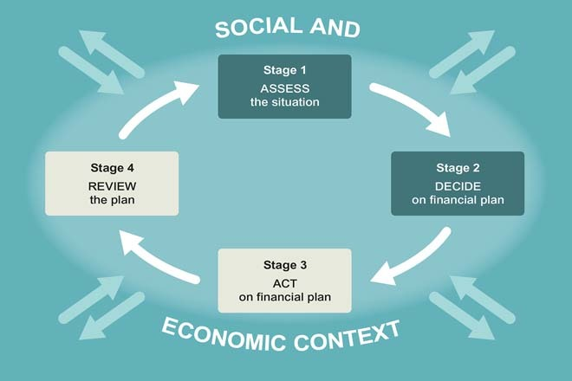
Figure 3 The financial planning approach to insurance – Stages 1 and 2

For Stage 1, where you assess the situation, it’s worth stressing the significance of the perils that can be insured against, as related insurance policies vary according to individual circumstances. Life insurance, for example, is likely to be especially important in a family with children and with one income earner, but may be regarded as irrelevant to a single person with no dependants.
An important factor to consider is what other protection is available. State benefits are part of this equation, as are any benefits available from an employer. With large employers, benefits may include sick pay above the statutory minimum, ‘death in service’ benefits and private medical insurance (PMI).
As part of your Stage 1 planning you need to find out what you are entitled to. Your entitlements may not completely replace the need for additional private insurance, but it’s important to know what they are.
The combination of what the state and an employer provide could eliminate the need for some types of private insurance, or reduce the amount of additional cover needed. The private insurance element can be seen as building on the insurance cover provided by the state and by employers.
A further factor to assess at Stage 1 is your attitude towards risk. Your aversion (or otherwise) to risk will be affected by a number of factors, including age, tastes and preferences. The more risk averse you are, the more likely you are to consider additional insurances.
Stage 2 is when you decide which additional insurance policies are appropriate for yourself or your household. As a rule, the greater the potential financial impact of a peril, the more likely it is that you will consider insuring against it. The key determinant is whether you could bear the cost of a risk materialising – even if the risk is very low.
The obvious example of this is insuring your home – rebuilding costs would be far beyond most people’s means, and so most owners decide that risk shifting makes sense (or have to do so as a condition of their mortgage).
But where the costs of the loss would be smaller, self-insurance may be considered a better alternative. To illustrate, paying the cost of domestic appliance repairs may make more sense than taking out an extended warranty.
Another factor in deciding on insurance is the cost of the insurance policy. Normally, the higher the premium, the less likely someone is to take out an insurance policy. It would be theoretically possible to calculate the expected benefit from an insurance policy, taking into account the financial impact of a peril and the probability of it occurring. However, such calculations are extremely hard to perform in practice.
Your decisions about whether to take out insurances will have a direct impact on your household budget as the more policies you take out the more your expenditure increases. Conversely, by actively seeking ways to reduce the premiums you pay, for example by fitting window locks or a burglar alarm, your expenditure will decrease. This feeds directly back into the budgeting process discussed in Week 3.
One way to think about the impact of insurance payments on your household budget is to realise that the current expense aims to protect you and your household from greater expense in the future.

8.1.5 Apply Stages 3 and 4 of the financial planning model to insurance
Stage 3 is about acting to put the insurance plan into effect. This involves looking at the details of policies and shopping around for the best deal. As you saw for other aspects of financial planning, there is quite a bit of going backwards and forwards during Stages 1–3. Some plans you try to put into action may not work, or the plans may turn out to be more expensive than you first thought, and so the plan will need to be remade.
As the UK’s insurance market is so developed, taking out most types of insurance is relatively easy. Insurance policies can be bought either directly from an insurance company or through an intermediary (usually called a ‘broker’) who can select a policy from different companies. Insurance is also sold by third parties, such as shops that sell extended warranties on their goods and travel agents that sell holiday insurance.
Brokers, such as members of the British Insurance Brokers Association, deal with insurance such as home, motor and travel insurance as well as term life insurance (which is an insurance policy for a defined period). Increasingly, though, insurance is bought on the internet – particularly via the numerous price comparison websites.
Financial advisers are the intermediaries who can give advice on life insurance, complex health insurances, savings and investments (covered in Week 5), and pensions (the subject of Week 7).
In all cases, unless simply ‘executing’ a client’s instructions, the company or intermediary is required to recommend a product that meets individual circumstances and needs. Generally, the more complicated the insurance, the more an intermediary can help you in assessing your situation and needs, recommending and explaining policies, and in assisting in the event of a claim.
Stage 4 is to ensure that you regularly review your financial planning decisions. This feeds into regularly assessing your need for insurance, and into the other stages too. You should always review your insurance needs when policies come up for renewal and when personal circumstances change (for example, when the composition of the household changes or when new assets are acquired).
A common failing in personal financial management is simply to renew with the same insurance provider rather than shop around for a new deal. Such inertia can cost you money, as the best deals are often offered only to new customers – not to existing ones.
As with any plan, you need periodically to check how things have worked out in the light of experience. This gives you the chance to remove ‘double insuring’ – to check that the same risk is not insured twice (for instance, with a travel and a home insurance policy), which would be unnecessary expenditure.
It is also important to remember that the financial planning process takes place inside the social and economic context. One feature of this context is that insurance is heavily marketed, with adverts for various insurance policies on television and in many other media, and with promises of cheaper quotes, often through market comparison websites. This reinforces the need to approach decisions about insurance in a methodical manner, such as through the four-stage financial planning process you’ve been looking at.


Figure 4 The financial planning approach to insurance – Stages 3 and 4

8.2 Home insurance
In this section, you will discover which kinds of insurance are compulsory and which are optional. You'll also find out some top tips for managing the cost of home and motor insurance, how to review your own insurance cover and how you might have been affected by mis-sold Payment Protection Insurance (PPI).

Figure 5

Given the size of the potential losses, home insurance is one of the first types of insurance to consider when you first rent or buy your home, and the majority of households, as you saw earlier, usually do decide to take it up.
Home insurance includes buildings insurance for the actual structure (for those who own their own home), and contents insurance for household possessions. Buildings and contents insurance don’t have to be taken out with the same company, and it can be cheaper to shop around for the lowest costs of each separately. However, by using one company for both you may obtain a small premium reduction, and speed up any claims in the event of damage to both home and contents.
If you have a mortgage on your home you don’t have to take out the home insurance offered by your mortgage company. You can make your own (often cheaper) arrangements. If you rent your home you won’t need buildings insurance as that is the responsibility of your landlord. But you should think about contents insurance (also called possessions insurance).
The costs of both elements of home insurance are determined by the risk factors associated with the particular policy and circumstances. Remember that insurance companies ask questions to try to ascertain the risk as accurately as possible. For example, the location of the property will enable judgements about whether it is subject to flooding or subsidence or other natural perils (and thus whether it will require a higher buildings insurance premium). Also, the rate of burglary in the area will be one of the main risk factors considered for contents insurance.
Here are some of the main variables to think about when assessing exactly the kind of contents insurance you need – adding them to your policy will increase the cover but also the premium.
- If you have limited possessions (for instance, when setting up home), a basic policy offering only a small amount of cover may be enough – this will keep the premium low.
- Paying for cover for £30,000 of contents insurance when you have only £15,000 worth of items would be wasting money.
- Having cover that does not equal the actual value of your possessions will mean that only a proportion of any actual claim will be paid.
- Accepting a higher excess in return for a lower premium is like a small element of self-insurance. It may help you to build up a no-claims discount by paying for small claims yourself.
- Different insurers may charge different premiums for the same cover, so decide exactly what kind of cover you require before shopping around for the best deal.

8.2.1 Keeping down the cost of home insurance
The video presents some of the main variables that will influence the level of home contents insurance premiums.

Video content is not available in this format.
View transcript - Uncaptioned interactive content



8.2.2 Motor insurance
UK law requires all car drivers to take out car insurance.
If you own a car the legal minimum obligatory insurance you must take out is third-party insurance. This will insure you against any damage you inflict on another person or their property (for example, your passengers, other drivers and their cars). However, it won’t cover your own costs.
Third-party, fire and theft insurance offers a higher level of cover. It will also pay for repairs or provide compensation if your own car is a write-off because of fire or theft.
Comprehensive insurance, as its name says, is comprehensive cover. It not only covers you for third party, fire and theft, it also covers damage or loss to your own car, whatever the cause.
Some policies include roadside assistance or a replacement car.


Figure 6

8.2.3 How to keep down motor insurance premiums
The video offers practical details on motor insurance, as well as some suggestions on how to keep your premiums low.

Video content is not available in this format.
View transcript - Uncaptioned interactive content



8.2.4 Travel insurance
Insurance for travel has changed radically since the 2000s, partly due to an increase in foreign travel but also because of changes in the insurance market itself.
Travel insurance covers:
- the risk of disruption to your holiday
- theft of your belongings
- the risk that you might cause injury, damage or loss to others
- the risk of medical problems while abroad.
If you have a medical emergency while travelling abroad you could end up with significant health-care bills, or large costs if you have to be repatriated to your home country. A European Health Insurance Card (EHIC) is available through UK post offices. It allows you access to emergency medical services throughout the European Economic Area (EEA) and Switzerland on the same basis as local nationals. You may have to pay towards the cost of those services in some countries, so an EHIC is not a substitute for full medical insurance.
Traditionally, travel policies were often offered for a single trip as part of the purchase of a foreign holiday, or you could make your own insurance arrangements for each trip you took. However, the market changed and increasingly people began to make insurance arrangements for their travel generally (rather than for a single trip) by buying insurance for a fixed time period.
This trend was enhanced by changes to the law in the UK that prevented holiday firms from forcing customers to pay over the odds for compulsory single-trip insurance. Since then, the market has expanded with the entry of new insurers and brokers, and new products have become available.
As with all other types of insurance, shopping around for the precise cover you require may reduce your costs. Different policies can cover different parts of the world. They may or may not include winter sports (an activity with a rather high probability of accidents). They vary as to how long any individual trip may be within a given time period.
One recent trend has been for travel insurance to be included with a particular credit card or bank account – but check carefully whether such ‘bundled’ policies meet your requirements.


Figure 7

8.2.5 Other general insurance
It may seem as though every time you buy a consumer item, you’re offered an extended warranty for it. This form of insurance policy is offered by retailers who earn commission from the insurers whose policies they sell.
Typically, extended warranties cost a large amount relative to the actual item, and do not pay out in all circumstances where the item becomes faulty. You need to examine this type of insurance with great caution, and perhaps consider self-insurance for items such as televisions and music centres. New electrical items and ‘white goods’, like washing machines, are generally reliable and unlikely to break down in the early years after purchase, the time period usually covered by extended warranties.
Payment Protection Insurance (PPI) is a type of insurance that, in recent years, has fallen into disrepute. In theory, it’s aimed at protecting your credit card or loan repayments. However, because PPI was offered largely at the ‘point of sale’ of taking out such cards or loans, it was subject to claims of serious ‘mis-selling’.
Consumers took out policies in the absence of any competition, often buying something they did not need or at an inflated premium. Alternatively, PPI was totally unsuitable because exclusions meant that the consumers weren’t covered anyway, perhaps because of health conditions or the nature of their employment.
In 2005 Citizens Advice made a ‘super complaint’ about PPI to the Office of Fair Trading. In 2009 the Competition Commission decided to ban PPI policies from being sold alongside cards, loans and mortgages. Then in 2010, after a flood of consumer complaints to the Financial Ombudsman, the FSA issued new rules effectively forcing firms that had mis-sold PPI to refund customers directly, rather than requiring them to go through the Ombudsman.
It has been estimated that as many as four million people might be in line for compensation for mis-sold PPI policies, with financial firms setting aside more than £20 billion for compensation payments (Guardian, 2014). Consumers who still want to take out PPI can do so independently of taking out the debt product, perhaps through shopping around on comparison websites and comparing the premiums and the details of the policies very carefully.
General insurance is an almost endless topic: if there is a risk of a peril, there is probably an insurance that could cover it, or that could be designed to cover it. Reportedly, American singers Mariah Carey and Jennifer Lopez insured themselves for up to $1 billion, and in 2006 England footballer David Beckham was reported to have insured himself for £100 million against injury, illness or disfigurement.
More prosaically, there is insurance covering the risk of rain disrupting organised outdoor events, as well as weddings insurance and insurance against the unexpectedly large costs of twins.
Pet insurance is one of the UK’s fastest growing areas of insurance, with now almost seven million pet insurance policies, or around one-third of all pets being covered by insurance (YouGov, 2010).
If you decide to take out pet insurance or any other general insurance you should consider it carefully, using the financial planning process.


Figure 8

8.2.6 Reviewing your insurance
Work through a financial planning process for your general insurance needs and decide on an insurance plan for you and your household. If this seems too big a task, concentrate on just one area of insurance – maybe home or travel insurance.
Try to be precise. For instance, be as specific as you can in terms of the amount of cover needed, and what excess you will accept.
When you’ve made the plan, obtain the information you’ll need to act on it by asking for quotes for insurance products from different companies. You may want to use the telephone or internet for this.
Now look at your current insurance in the area(s) you’ve selected:
- Do you find that you can make any savings over current insurance costs?
- Have you checked that you haven’t got double insurance for any particular risks?
- Can you revisit your budgeting process in the light of any savings you identify?


Figure 9

8.3 Life insurance and other types of insurance
In this section, you will learn what your options are for life insurance and when it makes sense to buy these products. You will also look at supplementing the cover provided by the state, like NHS cover for medical matters, and also the revolution in pricing of insurance.


Figure 10

Where someone’s income is the major (or sole) part of household income, or their unpaid work is necessary to the care of others, the death of that person would risk making the dependants or co-dependants suffer serious hardship. So protection insurance, such as term life insurance, may be important. However, life insurance may be irrelevant to a single person with no dependants.
Around 40% of all households decide to take out life insurance. Many life insurance products take the form of term insurance, which insures against the financial consequences of death within a specified term of perhaps five, ten or 20 years. You can choose a term that mirrors the length of a large debt such as a mortgage. Mortgage providers often insist on life insurance and for many homeowners it makes sense to have it.
Term insurance can be level term insurance, where the amount covered will remain the same during the whole of the cover term. Or it can be ‘decreasing’ term insurance, when the amount covered decreases over the length of the term. This is typically used to protect against a debt that declines over time such as a repayment mortgage.
There is also a type of term life insurance (called family income benefit) that pays an income rather than a capital sum to family members. You could consider this if you have no substantial debts to cover. It could be used, for instance, to provide an income that replaces that of the person who died, or an income that can be used to buy replacement childcare or elderly care if a parent or a carer dies.
Some life insurance is not for a specified term, but is open-ended, or whole of life, cover. This is rather more expensive than term insurance, and is often used to build up an investment rather than dealing with the consequences of an untimely death. The cost of cover will depend on age and state of health.
Endowment policies, unlike term insurance, build up an investment value and pay out at the end of the term if the policyholder has not died. As you saw in Week 6, these kinds of policy were commonly associated with house purchases. Where the policy was purchased with a mortgage, the insurance cover provided protection against death during the term, while the pay out at the end was intended to be sufficient to clear the outstanding mortgage debt.
However, since endowment policies are stock market-linked investments, there was no guarantee that the policy would grow enough to pay off the mortgage in full. Following controversies over their ‘mis-selling’, and poor stock market performance throughout the 2000s, use of endowment policies for mortgages has been in sharp decline, with under four million policies left in operation by 2010. But endowment policies are still used for insurance-based savings products and bonds.
Some life insurance tips:
- Life insurance can be written ‘in trust’, so that any pay out goes straight to the beneficiary rather than into the deceased’s estate. This avoids the danger of having to pay Inheritance Tax, and avoids delays that can be caused by legal processes.
- The amount of cover you require should be calculated before buying life insurance. This might include paying off debts (including a mortgage), and providing capital from which to produce some income for surviving household members. No one should take the level of cover offered without assessing their personal needs.
- If you wish to take out life insurance you need to think about the possible effect of inflation on the policy – how much is any pay out of capital or income going to be worth in the future?

8.3.1 Health insurance

Private medical insurance (PMI)
PMI is expensive, and questions have been raised about the lack of facilities in some private hospitals, such as the absence of accident and emergency facilities. Some people have political or moral objections to paying for private health care in a society with an NHS system. In 2009 the British Medical Association expressed concern that some PMI providers were preventing or restricting patient choice about the consultant or hospital that can treat them (BMA, 2012).
A decision about whether or not to supplement the care on offer in the UK from the NHS with private medical insurance (PMI) will depend on individual factors. For example, someone running a business that may lose trade while they wait for an operation may have a greater need for PMI than someone who is not in that position.
Other factors to consider may include your perception of local NHS waiting lists and facilities, or ancillary aspects of care such as being looked after in a private room, or being able to exercise more choice over where and when treatment takes place.
PMI usually covers hospital charges, treatments, drugs, diagnostic tests, outpatient treatments, and may pay cash for hospital stays when the insured opts for the NHS rather than private health care. Conversely, there are many substantial exclusions, such as all long-term and degenerative illnesses common in old age, AIDS, pregnancy, having vaccinations, and alcohol and drug misuse. PMI premiums have risen substantially in recent years for the same reason that term life cover premiums have been falling – advances in medical technology, procedures and available drug treatments. As a result, PMI can be very expensive in later life.
Partly in response to the rising costs, providers increasingly offer budget plans and pared-down policies with a larger excess that can limit the cost, as well as innovations such as links with gym memberships and so on.
NHS dental provision still exists on a patchy basis. While most people will have to pay 80% of treatment costs on the NHS, there are still some categories of people who are entitled to free treatment, such as children, people in receipt of certain benefits, pregnant women and people on a low income (including students), who can obtain an HC2 certificate by completing a form available from the dentist or local social security office. Being a pensioner does not guarantee access to free dental care. There are specific dental insurance policies available, as well as dental health plans. The latter require a monthly subscription in return for access to dental work – usually for no additional charge, or the subscription perhaps covers 75% of the costs incurred for certain ‘routine and restorative’ work. An individual’s monthly subscription will vary according to the condition of their teeth, although some schemes may be available through an employer on a group basis.

Health cash plans
These are different to PMI in that they offer small, direct cash payments in the event of certain medical circumstances, in return for a monthly payment that is effectively a subscription to belong to the plan (rather than an insurance premium). They also tend to focus on an individual’s (or family’s) primary health care needs, whereas PMI will focus more on specialist diagnostics and private hospital treatment. Health cash plans are traditionally offered by not-for-profit, mutual organisations like Health Shield and the Simplyhealth Group, which incorporates many previous plan providers like HSA and HealthSure. These plans enable policy holders to claim cash if they undergo common medical treatments such as dental and optical care, physiotherapy and sometimes complementary medicine, which PMI often does not cover.
Health plan providers generally offer a number of types of plan, ranging in cost and in the potential level of cash to be paid back to customers. Such plans are often available through employers who may operate a scheme whereby they obtain a discount for their employees. People take out these plans because they are seen as affordable and very simple. The number of health cash plans held in the UK is just over three million, with the vast majority of these being paid for by individuals rather than employers (Laing and Buisson, 2010). Another interesting development is that some providers of PMI (such as BUPA) who have been facing a declining market have entered the health cash plan market. This might in future serve to blur the distinction between the two types of financial product.


Figure 11

8.3.2 Income protection insurance
If the ability to work and earn income is impaired or lost, there’s a major risk to the financial well-being of an individual and their household. The long-term illness or disability of someone providing care can also cause major financial loss to a household if an alternative form of care has to be found and paid for.
Private insurance policies in this area are a complement to the protection that may be offered by employers and by the state. For example, in the case of serious illness, in the UK the state will offer some support through the National Insurance and benefits system, and some employers may do so too. Yet state benefits will produce an income that is well below average, and that may be insufficient to sustain an existing standard of living. So in addition to finding out what’s available from an employer, it is also important to consider what self-insurance is available: for how long could assets produce an income, or be used up, to sustain someone in a medical crisis?
Income protection insurance (IPI) (also known as permanent health insurance or PHI): designed to pay an income (sometimes tax-free) when a person is unable to work due to serious illness or injury, if necessary through to retirement. Its take-up has been very limited, perhaps because it is a complex product and subject to adverse selection, so that the premium can be too high for the people most interested in taking it out, such as those in poor health.
Critical illness cover (CIC): this used to be a simpler product than IPI but has become increasingly complex in recent years. It pays a lump sum tax-free payment if the insured is diagnosed with a restricted range of major disabilities or life-threatening illnesses, such as heart attack, stroke, some cancers, or nervous diseases, or if permanently disabled and unable to carry out basic tasks. Assessment often revolves around whether the insured is able to undertake certain basic tasks of daily living without assistance. Once payment has been made against such a policy, the insurance ceases and the insured is free to spend the money as they wish, for example, to make adaptations to the home, or pay for private nursing care.
It’s important to appreciate that only a precise list of conditions is covered in CIC and, as treatments and survival rates improve, the list is becoming increasingly hedged around by small print. Moreover, the most common reasons for being unable to work are back problems and mental stress – neither of which would trigger a CIC pay out. Similarly, rare or undiagnosed conditions result in no pay out. Consequently, CIC could not meet an assessed need of providing protection against any loss of income from being unable to work. Many insurers offer CIC in combination with life assurance, which can be on a level or, in the case of mortgage cover, a decreasing basis. CIC can be added on to an endowment policy when arranging a mortgage. Once again, these combinations should be considered carefully according to need, particularly if taking them out together would produce a discount. In this case, it is important to think about why such a discount is being offered. CIC policies vary – some have the option of a guaranteed or a renewable premium. The former is more expensive, but means the premium will not increase even if, for example, new screening methods result in more claims being made. Some policies are now available that offer reduced premium payments for less serious, more ‘survivable’ types of disease, and others offer ‘cancer-excluded’ policies for cancer survivors.
Accident, sickness and unemployment (ASU): this insurance covers these three named eventualities. It can be a standalone policy, it can be sold as loan payment protection insurance or, as mentioned in Week 6 it can be sold when connected with a mortgage, as mortgage payment protection insurance (MPPI). The distinguishing feature of ASU insurance is that the pay-out is (normally) limited to a maximum of two years, whereas PHI pays out until recovery or retirement. MPPI needs to be considered as part of the decision on an overall ‘insurance plan’, not just in terms of state benefits and assets but also in terms of other insurance arrangements and policies. For instance, it might be duplication to have both income protection insurance and MPPI, depending on circumstances. Normally, MPPI policies are offered at a particular rate and pay up to a maximum of approximately 125% of monthly mortgage outgoings, with payment normally starting a short period after the peril happens.


Figure 12

8.3.3 Gender and insurance
A decision in 2011 by the European Court of Justice (ECJ) meant that from December 2012 insurance companies in Europe could no longer take gender into account when pricing their insurance products. This move has had a major impact on the insurance industry.
Do you think the decision is rational, taking into account what you’ve learned about how insurance products are priced?
Who have been the gender winners and losers from this decision? In particular, think about car insurance and life insurance.


Figure 13

8.3.4 Winners and losers?
Women are losers when it comes to both car and life insurance – in both respects they are a lower risk than men and this should, with risk-based pricing, make insurance cheaper for women. By contrast men are losing out through the removal of the gender differential on annuities. Men used to get higher annuities due to lower average life-span – women got lower annuities due to longer average life-span. The differential has now been removed – although in recent years the average life-span gap between men and women has been narrowing.
You’re almost at the end of the course and in the next section you will complete the end-of-course test. It’s made up of 15 multiple-choice questions which cover the entire content of the course. Then Martin returns for a final round-up.


Figure 14

End-of-course test
This test allows you to test and apply your knowledge of the material in across the entire course.
Complete the End-of-course test now.
Open the quiz in a new window or tab then come back here when you're done.

End-of-course guide and round-up
Martin says a final goodbye as the course comes to a close.

Video content is not available in this format.
View transcript - Uncaptioned interactive content



The purpose of the course has been to provide you with the information and skills to manage your financial affairs effectively.
Week 1 explained how you can structure and operate a financial planning model for you or your household.
Weeks 2 and 3 looked at the cash flows of household income and expenditure and at how these can be measured to enable you to create both a budget and a projection of future net cash flows in future years.
Weeks 4, 5 and 6 built towards the construction of the household balance sheet. Week 4 looked at debts (liabilities) whilst Weeks 5 and 6 looked at savings, investments and home ownership (assets). Compiling the household balance sheet provides a clear summary of a household’s net wealth and enables you to test the strength of the balance using measures like the current asset ratio.
Week 7 looked at the key issue of planning for your pension and at the different forms of pension provision in the UK. The information here should be used to check how much income you will get in retirement and whether this will be sufficient for you.
Week 8 has concluded the course by looking at insurance products. You should check your own current insurance arrangements using the information provided this week to review whether you have sufficient (or perhaps too much?) insurance cover, given the nature of the activities and risks to which you and your household are exposed.
Well done for completing this OpenLearn course on personal finances.
Now you've completed the course we would again appreciate a few minutes of your time to tell us a bit about your experience of studying it and what you plan to do next. We will use this information to provide better online experiences for all our learners and to share our findings with others. If you’d like to help, please fill in this optional survey.

References
Thaler, R. and Sunstein, C. (2009) Nudge: Improving Decisions about Health, Wealth and Happiness, London, Penguin.
BBC (2010) ‘Pensions: is your scheme affected by the switch to the CPI?’ [Online]. Available at http://www.bbc.co.uk/news/business-10701442 (Accessed 17 August 2010).
BBC (2013) ‘Q&A: Universal credit and the benefits overhaul’ [Online]. Available at http://www.bbc.co.uk/news/business-11735673 (Accessed 5 November 2013).
BBC (2017) ‘Scottish income tax changes unveiled’ [Online]. Available at http://www.bbc.co.uk/news/uk-scotland-42356953 (Accessed 14 December 2017).
Gov.UK (2018) ‘Income Tax rates and Personal Allowances’ [Online]. Available at https://www.gov.uk/income-tax-rates (Accessed 1 March 2018).
Gov.UK (2018) ‘Universal Credit’ [Online]. Available at https://www.gov.uk/universal-credit (Accessed 1 March 2018).
HM Revenue & Customs (HMRC) (2013) ‘HMRC Tax & NIC Receipts’ [online], http://www.hmrc.gov.uk/statistics/receipts/info-analysis.pdf (Accessed 5 November 2013).
Office for National Statistics (ONS) (2012) ‘National Statistician’s consultation on options for improving the Retail Prices Index’, Figure 2 [online], http://www.ons.gov.uk/ons/about-ons/get-involved/consultations/archived-consultations/2012/national-statistician-s-consultation-on-options-for-improving-the-retail-prices-index/index.html (Accessed 15 April 2014).
Office for National Statistics (ONS) (2017) ‘HMRC Tax and NIC Receipts’ [Online]. Available at https://www.gov.uk/government/uploads/system/uploads/attachment_data/file/619800/May17_Receipts_NS_Bulletin_Final.pdf (Accessed 13 July 2017).
Social Trends (2010) no. 40, Basingstoke and New York, Palgrave Macmillan for The Office for National Statistics (ONS); also available online at the ONS website, http://www.statistics.gov.uk/downloads/theme_social/Social-Trends40/ST40_2010_Final.pdf (Accessed 16 February 2011).
Bourdieu, P. (1977) Outline of Theory and Practice, Cambridge, Cambridge University Press.
Callaghan, G., Fribbance, I. and Higginson, M. (eds) (2012) Personal Finance (2nd edn), Basingstoke, Palgrave Macmillan.
Gurufocus.com (2017) ‘UK Online Shopping and e-Commerce Statistics for 2017’ [Online]. Available at https://www.gurufocus.com/news/492058/uk-online-shopping-and-ecommerce-statistics-for-2017 (Accessed 28th November 2017).
Bank of England (2017) Official Bank Rate History [Online]. Available at www.bankofengland.co.uk/boeapps/iadb/Repo.asp (Accessed 28 November 2017).
Citizens Advice (2003) In Too Deep: CAB Clients’ Experience of Debt, Citizens Advice and Citizens Advice Scotland [Online]. Available at http://www.citizensadvice.org.uk/in-too-deep.pdf (Accessed 20 December 2005).
ONS (2017) RPI All items Index: Jan 1987 =100 [Online]. Available at www.ons.gov.uk/economy/inflationandpriceindices/timeseries/chaw/mm23 (Accessed 28 November 2017).
UK Parliament (2003) Report Published on Transparency of Credit Card Charges, Treasury Committee Press Notices, 17 December [Online]. Available at http://www.parliament.uk/parliamentary_committees/treasury_committee/tc171203_04.cfm (Accessed 20 December 2005).
Barclays (2016) Equity Gilt Study, 61st Edition, Barclays, London, pp 58-62 [Online]. Available at http://hungrydummy.com/media/pdf/EquityGiltStudy2016.pdf (Accessed 30 March 2016).
Moneysupermarket.com (2015) Data from website [Online]. Available at www.moneysupermarket.com (Accessed 20 April 2018).
The Times (2017) ‘Share prices of selected UK high-street retailers’, 28 November 2017, p. 53.
BBC (2010) ‘Mortgage shift for first time buyers’ [Online]. Available at http://www.bbc.co.uk/news/business-11968414 (Accessed 20 December 2010).
Council of Mortgage Lenders (CML) (2001) Housing Finance No. 49, February, London, CML.
Council of Mortgage Lenders (CML) (2016) ‘Repossessions and arrears still falling, reports CML’ [Online]. Available at https://www.cml.org.uk/news/press-releases/repossessions-and-arrears-still-falling-reports-cml (Accessed 29 November 2017).
Council of Mortgage Lenders (CML) (2017) ‘Remortgaging strengthens in July’ [Online]. Available at https://www.cml.org.uk/news/press-releases/remortgaging-strengthens-in-july (Accessed 29 November 2017).
Gov.uk (2014) ‘Live data on repossession activity’, Table 1300 [online], https://www.gov.uk/government/statistical-data-sets/live-tables-on-repossession-activity (Accessed 21 March 2014).
Kiyosaki, R.T. (2011) Rich Dad, Poor Dad: What the Rich Teach their Kids about Money – that the Poor and Middle Class Do Not!, New York, Warner Business Books.
National Housing and Planning Advice Unit (NH &PAU) (2008) Affordability Still Matters [Online]. Available at http://www.communities.gov.uk/nhpau/keypublications/reports/affordabilitystillmatters/ (Accessed 16 December 2010).
Telegraph (2010) ‘Buy to let market back on its feet – for now’ [Online]. Available at http://www.telegraph.co.uk/finance/personalfinance/investing/7789969/Buy-tolet-market-back-on-its-feet-for-now.html (Accessed 16 December 2010).
Gov.UK (2014) Public service pension reforms [online] https://www.gov.uk/government/publications/public-service-pension-reforms/public-service-pension-reforms (Accessed 16 February 2014).
Office for National Statistics (ONS) (2017) ‘Occupational Pension Schemes Survey UK, 2016’ [Online]. Available at https://www.ons.gov.uk/peoplepopulationandcommunity/personalandhouseholdfinances/pensionssavingsandinvestments/bulletins/occupationalpensionschemessurvey/uk2016 (Accessed 30 November 2017).
Association of British Insurers (ABI) (2013) Household spending on insurance tables based on data from the ONS Expenditure and Food Survey 2011) [online], https://www.abi.org.uk/Insurance-and-savings/Industry-data/Free-industry-data-downloads (Accessed 18 February 2014).
British Medical Association (BMA) (2012) British Medical Association summary of views on the Competition Commission market investigation into the market for privately funded healthcare services [online], http://www.competition-commission.org.uk/assets/competitioncommission/docs/2012/private-healthcare-market-investigation/120517_bma_initial_submission.pdf (Accessed 27 March 2014).
Guardian (2010) ‘Three million in the queue for compensation over PDI mis-selling’, 10 August [online], http://www.guardian.co.uk/money/2010/aug/10/fsa-issues-new-rules-on-ppi (Accessed 25 October 2010).
Guardian (2014) ‘The price of PPI: what the banks have set aside for mis-selling’, [online] http://www.theguardian.com/money/2014/feb/03/ppi-banks-misselling (Accessed 20 February 2014).
Laing & Buisson (2010) ‘Recession hits demand for private medical cover’ [online], http://www.laingbuissonconsulting.co.uk/PressReleases/Health_Care_Cover_2010_PR.pdf (Accessed 1 November 2010).
Money Advice Service (MAS) (2013) The Financial Capability of the UK, London, MAS, p. 2.
YouGov (2010) ‘Pet hate premiums’ [online], http://today.yougov.co.uk/consumer/pet-hate-premiums (Accessed 25 October 2010).

Acknowledgements
This unit was written by Martin Upton and Jonquil Lowe
Except for third party materials and otherwise stated in the acknowledgements section, this content is made available under a Creative Commons Attribution-NonCommercial-ShareAlike 4.0 Licence.
The material acknowledged below is Proprietary and used under licence (not subject to Creative Commons Licence). Grateful acknowledgement is made to the following sources for permission to reproduce material in this unit:
Unit image
Week 1
Figure 4 © iStockphoto.com/cherezoff
The economic backdrop © The Open University (contains archive © BBC)
Your personality can seriously affect your finances © The Open University (contains © 123RF and Patrick Landmann/Science Photo Library)
Betting the house © The Open University (contains © BBC archive, 123RF images and REX/Ken McKay)
Week 2
Figure 1 © The Open University/iStockphoto.com/kvkirillov/antagain/stocknshares/PhilipCacka/sorendls
Figure 2 © iStockphoto.com/1amgreen
Figure 5 © iStockphoto.com/Westend61
Figure 8 unknown source
Taxing income © Contains Parliamentary information licensed under the Open Parliament Licence v1.0 http://www.parliament.uk/site-information/copyright/open-parliament-licence/
Setting Income Tax rates © BBC
Government minister and benefits reform © BBC
Week 3
Figure 7 © The Open University/iStockphoto.com/pressureUA/hh5800/blueclue/rustemgurler
Figure 12 © iStockphoto.com/tirc83
Ways of saving © Money Advice Service
Week 4
Figure 5 © CORBIS/Reuters
Figure 6 © iStockphoto.com/GlobalStock/szefei/annebaek
Figure 7 © iStockphoto.com/GlobalStock/szefei/annebaek
Figure 9 © iStockphoto.com/rook76
Figure 10 © iStockphoto.com/CEFutcher
What determines the level of interest rates? © BBC
Meet the lenders (contains archive © BBC)
Week 5
Figure 6 © iStockphoto.com/narvikk
Figure 7 © iStockphoto.com/ahlobystov
Figure 8: source unknown
Managing savings and investments © NS&I
Share prices do go up and down © BBC
Week 6
Figure 1 ©iStockphoto.com/stevecoleimages
Figure 2 contains artwork ©Anthony Seldon
Figure 3 © iStockphoto.com/fazon1
Figure 6 © iStockphoto.com/georgeclerk
Figure 7 © iStockphoto.com/dlewis33
Figure 10 © iStockphoto.com/whitemay
Week 7
Figure 1 © Alamy/Adrian Sherratt
Figure 2 © iStockphoto.com/Ljupco
Figure 4 ©iStockphoto.com/Brasil2
Figure 8 © iStockphoto.com/MachineHeadz/LifesizeImages
Week 8
Figure 9 contains images © istock/AndrewJShearer/KLH49/vikif/asbe/stephanmoorris
Figure 14 © iStockphoto.com/pixdeluxe
Insurance – Setting the scene contains archive material © BBC
Keeping down the cost of home insurance contains images © 123RF
Every effort has been made to contact copyright owners. If any have been inadvertently overlooked, the publishers will be pleased to make the necessary arrangements at the first opportunity.
Don't miss out:
1. Join over 200,000 students, currently studying with The Open University – http://www.open.ac.uk/choose/ou/open-content
2. Enjoyed this? Find out more about this topic or browse all our free course materials on OpenLearn – http://www.open.edu/openlearn/
3. Outside the UK? We have students in over a hundred countries studying online qualifications – http://www.openuniversity.edu/ – including an MBA at our triple accredited Business School.

Activity 1

Discussion
The video on ‘betting the house’ depicts an extreme, high-risk and, in truth, reckless way of managing money and making financial decisions.
The reality with financial decisions is that there are many shades of risk taking between being completely risk-averse to being prepared to take on higher risks that can deliver higher returns. In fact some decisions that may seem risk-averse, like leaving savings in an instant access account offering a low, but guaranteed, return expose you to the risk that the balance of your savings may grow more slowly than the rate of price inflation, thereby reducing, over time, the value of goods your savings can buy.
We’ll learn more about how inflation impacts our personal finances in the second week of the course. Later we’ll look at the historical evidence about the correlation between risk taking and returns.
The picture you’ll get by the end of the course is that working out what risks are worth taking is more complex than, at one extreme, deciding to put your life’s savings on a single bet at a casino or, at the other extreme, just leaving your saved money in your bank account.
Back to - Activity 1

Activity 3

Answer
CPI inflation has historically been lower than RPI inflation. The changes are likely to reduce the size of annual increases in benefits.

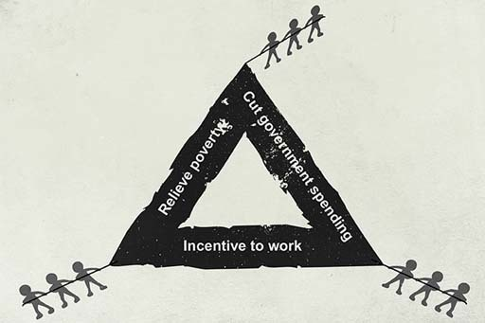
Figure 7

The existence of such a taper demonstrates an important challenge facing policy makers. They wish to make paid employment financially attractive but at some point they also wish to begin to remove benefit payments (in order to contain the cost to government of providing benefits). If they do this too quickly – say, for example, the taper was £1, or even 90 pence or 80 pence in the pound – then many benefit recipients might consider the financial reward for returning to work insufficient. Clearly there are many other positive aspects associated with entering the labour market, such as making a worthwhile contribution to society and improving your skills. But from a purely financial perspective paid employment with a high taper may not appear too appealing. Economists have described such a situation as the ‘poverty trap’, where a high taper represents a disincentive to enter the labour market.
Back to - Activity 3

Activity 2

Discussion
Assuming that borrowers have a choice and want to pay as little interest as possible, choosing a fixed rate may be preferred if rates are expected to rise, and a variable rate may be preferred if interest rates are expected to fall.
However, to assess which would be cheaper requires a forecast of how rates will move during the life of the loan, and making such forecasts is difficult because it is difficult to predict future rates of inflation and interest rates. In addition, the choice may reflect the borrower’s household budget. For example, households on a tight budget may choose a fixed rate because this would provide certainty of monthly expenditure.
Back to - Activity 2

Activity 1

Answer
Right:
Daily
Feedback
Well done. Daily is the correct answer. The more frequent the payment, the more compounding of interest there will be. Therefore, annual 5% interest paid weekly will have a higher AER than 5% paid monthly, which in turn will have a higher AER than 5% paid quarterly. The table here shows AERs for each period.
Wrong:
Weekly
Feedback
The more frequent, the payment the more compounding of interest there will be.
Monthly
Feedback
The more frequent, the payment the more compounding of interest there will be.
Yearly
Feedback
The more frequent, the payment the more compounding of interest there will be.

Table 3 AER for a range of interest payment periods
 | Advertised rate | 5%
 | Period rate | AER
Daily | 0.0137% | 5.127%
Weekly | 0.0962% | 5.125%
Monthly | 0.4167% | 5.116%
Quaterly | 1.2500% | 5.095%
Annually | 5.0000% | 5.0000%

Back to - Activity 1

Activity 2

Discussion
The calculation goes like this.
The six-month penalty costs the Barnetts 2.5% = (5% for half a year), which is £2500 = (2.5% of £100,000).
If they keep the £2500 invested at 2% for three years, leaving the interest in the account, this will total £2,653 at the end of the three years. This is because the interest would be compounded (you learned about compounding in Week 4).
The calculation is:
(£2500 × 1.02 × 1.02 × 1.02) = £2653
The annual savings with the new lender are:
5% - 3% = 2%.
For each year, the household would save £2000 = (£100,000 × 2%), totalling savings of £6000 over three years.
So, even if the Barnetts do not invest the annual sum saved, the minimum benefit from remortgaging is £6000 - £2653 = £3347, implying that the financially capable household should remortgage.
Back to - Activity 2

Uncaptioned interactive content

Transcript
Martin Upton
Hello, and welcome to Managing my money. I'm Martin Upton, Director of the True Potential Centre for the Public Understanding of Finance based at The Open University Business School.
Before working for The Open University, I spent twelve years as Treasurer to Nationwide Building Society. I'll be your guide for this course.
Ask yourself, how does the type of person you are affect the decisions you make? Are you your own worst enemy when it comes to money? Do you know where you can put your savings to get the best return? Do you need to worry about interest rates or inflation? Do you know how decisions made by the government and the Bank of England affect you?
Regardless of how much you may already know, whether you're a student or a young family, starting your first job or planning your retirement, living on benefits or banking your bonus, you'll learn how to make the most of your money.
Through the next eight weeks, you'll see how the big news stories about the economy, taxation and interest rates affect your household accounts. You'll learn how behavioural traits and social pressures affect your financial decisions.
And you'll learn life-long practical skills using UK data and real-life examples, although the issues covered are pretty well universal wherever you live.
As you work through the course, packed with high-quality audio and video, you'll find easy-to-use tools, expert discussions and bags of practical guidance. You'll become equipped with the skills to create your own personal action plan
With real incomes falling, record low returns on savings, and people facing the prospect of working ever longer to get a decent pension, there's never been a more important time to take control of your personal finances.
At the end of each week, you'll have the chance to gauge how much you've learned in a test. Your score from these weekly tests will be added to the results of a longer test you'll take in the final week. By the end of the course, not only will you have picked up some fantastic knowledge, but you'll also have developed skills that will be really useful for further studies in finance.
We have a group of experts who'll respond to and moderate discussions. Please join in and share ideas - you can post comments on anything in the course along the way
So, Week 1. Let's start by looking at how you can structure your financial planning. We look at a model that can be applied routinely when making financial decisions. We'll also start to explore a theme that we'll return to throughout the course - how financial resources and needs change through the course of our lives. Enjoy the journey.
Back to - Uncaptioned interactive content

Uncaptioned interactive content

Transcript
Martin Upton:
When managing your money, it's important to understand the features of the current economic backdrop that have a direct affect on your finances. So let's set the scene:
After the recession, our economy is growing again, though it's still quite fragile.
Interest rates have been at an historic low.
House prices in the UK are on the up again, getting closer and closer to their peak in the late 2000s. London property is especially booming.
Shares are enjoying a strong recovery.
Flooding is threatening to push up insurance premiums.
No gender price discrimination on insurance is now permitted in Europe.
Unemployment is falling, though it's still high, particularly for 18 to 25 year olds.
Meanwhile, university fees are at an all time high - at widely 9000 pounds per annum. Students are now graduating with debts of tens of thousands of pounds.
There is a planned pensions revolution - slated to kick in in April 2015 - where many people moving into retirement will have access to their pension pots to spend or invest their funds in the way they want.
From July 2014 a major change to the savings market will unfold with the annual limit on investments in tax-free ISA accounts ballooning to 15,000 pounds.
All in all, things are cautiously on the up after the 2007-2009 financial crisis and the double dip recession that followed it.
But in reality, real incomes - that is, the value of our earnings once inflation has eaten into them - have been falling for many if not most of us.
The price of food, fuel, and energy has been rising fast in recent years. This is quite a change from the long uptrend in living standards we saw in recent decades.
All things to keep in mind when managing your money, today and for the future!
Back to - Uncaptioned interactive content

Uncaptioned interactive content

Transcript
Mark Fenton-O'Creevy:
So I want to start off by introducing you to a chap called Phineas Gage. Phineas Gage was a railway worker and they used to make tunnels, they'd drill holes in the rock and then they'd have tamping iron which they used to compress the blasting powder with, and sometimes what would happen; as they were compressing the blasting powder is a spark would trigger the blasting powder, which would shoot the rod out with quite high speed and that's what happened to Phineas Gage and it went straight through his head. It took out a very particular part of his brain that is responsible for emotional processing.
So that was a very early example of how we started to get to learn about what bits of the brain do. It used to be that psychologists treated cognition, thinking and emotions as two completely separate processes. Different people studied them. But what we're learning more and more through neuroscience is that cognitions and emotions are completely intertwined and that as humans, emotions are a very important part of our thinking processes.
A quite simple way of thinking about how emotions and thinking come together is the dual process model of cognition. If we have a situation, we've got to make a decision, a sort of classical way of thinking about this might be: well there's some facts, we've got some options for making decisions, we can represent the future in some way, maybe do a bit of internal modelling of what's going to happen. Going on in parallel with that though, is a completely different process.
It's the activation - and biases is perhaps the wrong word but if you like, pre-existing scripts for deciding; based on our emotional experience of comparable situations. And the first process in blue is quite slow and this process is like that - perceiving is deciding. But what about consumers? we've got responses from about 110,000 people across the UK on their psychological and emotional relationships with money. So one of the things we did is we looked at people's impulsive buying behaviour.
And in a lot of the marketing literature this impulsive buying gets talked about as if it were mostly a good thing. Actually there's good evidence that people who are very impulsive buyers are often doing this as a not very effective way of regulating their emotions. They're not good at managing bad emotions, going shopping turns out to be a form of emotion repair. It turns out that people who are impulsive buyers are typically much more likely to get into financial trouble.
They are for example about three times more likely to go bankrupt. It's also the case of course that retailers invest significant resources in engaging with impulsive shoppers. There's a lot of effort goes into: how can we get the impulsive spend? We need an investment into education, which promotes emotional literacy about money. We also looked at a series of scales, which measure people's attitudes to money. People see money as power, money as love, money as freedom, money as security.
Money as love tends to be the female vice, money as power tends to be the male vice. There are quite strong gender differences here. Again we find a strong relationship to financial outcomes. Those who see money as security are much more likely to have a positive financial earn. So a final observation to finish with.
Policy makers often seek to influence behaviour by providing information.
Firms, through their advertisements, often seek to influence behaviour through engaging with emotions.
Guess who is more pessimistic about influencing consumer behaviour? Thanks very much.
Back to - Uncaptioned interactive content

Uncaptioned interactive content

Transcript
Martin Upton
Some people are BIG risk takers. Take Ashley Revell from Kent. In 2004, Ashley entered the Plaza Hotel and Casino in Las Vegas with only one thing on his mind: taking a big gamble! He'd raised thousands of pounds and he was now ready to put it all on the line - a total of 76,840 pounds' worth to be precise!
He contemplated a roulette wheel. Whether he chose to place his two piles of chips on red or on black would mean the difference between loosing it all and gaining thousands more. He had a 50/50 chance of winning or losing... but he felt lucky. He chose red at the very last minute... and that's where the ball settled.
On a whim, in one moment, he'd doubled his money to 153,680 pounds! But he could just as easily have lost it all. Would you be able to take such a gamble? Would you describe yourself as a risk taker? Or are you risk averse?
Back to - Uncaptioned interactive content

Uncaptioned interactive content

Transcript
Martin Upton
Financial planning is a process. It goes through different stages. In this course you look at one way of describing this staged financial process. It is a 'model' or, to put it another way, a simplification designed to help clarify a more complex process.
Stage 1 - Assess the situation
This involves clarifying and prioritising goals, working out constraints and resources, finding out relevant information and perhaps seeking out well-informed advice.
Stage 2 - Decide on a financial plan
This entails working out possible actions to take or changes to make, such as deciding on which type of financial product or service might be required to achieve a particular goal, or setting a budget to adjust income and/or expenditure.
Stage 3 - Act on the financial plan
This means acting on what has been decided: for example, making the planned changes to income and/or expenditure; shopping around and selecting which financial product is the best buy, given needs and constraints (such as a specific savings account or a specific insurance policy).
Stage 4 - Review the plan
This involves regularly reviewing the outcome of the action and taking into account recent changes or events - is your financial plan still the best option? Does further advice need to be sought?
Perhaps moving into a new cycle of financial planning is necessary.
The financial planning model shows each stage in the planning process and how each one - assessing, deciding, acting, reviewing - leads into the next stage. Planning is a continuous process over time, with one complete sequence through the four stages leading naturally into another such sequence. This demonstrates that financial planning is not a one-off matter but an ongoing process over time. Financial plans need to respond and think ahead to the different stages in a person's life course, and also to take into account possible future events.
You've seen how goals need to be clarified and prioritised: this is part of Stage 1. You've also seen, in Stage 2, how deciding on a financial plan aims to fulfil the goals, given the constraints.
Stage 3 entails acting on the financial plan; there's little point in devising brilliant financial plans if they're not actually acted upon! This stage might involve shopping around for best buys of specific financial products.
Stage 4 is the important one of reviewing the outcome and checking progress in the light of changing circumstances. This, in turn, may lead to another round of financial planning.
There may well be some to-ing and fro-ing between the stages. Financial plans are worked out on the basis of existing goals, but some goals may have to be revised in view of the financial plans that they turn out to require. Someone might have a goal of climbing Everest, but then they learn that the financial plan required to do it is too demanding, and so the goal is revised. Alternatively, perhaps, a financial plan has to be revised when more information is acquired about the actual financial products available. In reality, the lines dividing the separate stages of the financial planning process may be blurred. But not withstanding this, these stages of the four golden rules of effective personal financial management.
Back to - Uncaptioned interactive content

Uncaptioned interactive content

Transcript
Martin Upton
There are reasons why we sometimes make bad financial decisions. Find out if you're suffering from some of the factors that make personal financial choices particularly difficult - perhaps we should call them the 'perils of personal finance'! Try this Bad Habit Test!
Which would you rather have: £500 to spend today? Or £500 in a savings account... and then have £700 to spend in five years' time, when interest is added?
If you chose to have £500 today, you're in good company; despite the 7% per annum return on the savings account. Most people don't like delayed rewards. If our choice means putting money aside, there's an immediate pain of having less to spend in exchange for a very distant and uncertain gain. So, not surprisingly, making the right choices for the long-term future can be very hard. Prioritising the present over the future can even be due to capitulation, which means that some personal financial challenges seem so daunting you may be tempted to assign them to the category of 'things I could never afford to do'. For example, many young people today may give up on the aspiration of buying their own home when they look at the deposit required and the bills that go with home ownership.
Here are two groups of loans - Group A and Group B. If you needed to borrow £100 for one year which group of loans contains the best deal?
In Group A we have two loans -
Loan 1: pay back £120 at the end of the year.
Loan 2: pay back £115 at the end of year.
In Group B,
Loan 3: pay a £10 arrangement fee and then equal monthly repayments; the interest rate is 5% per annum.
Loan 4: you pay a £5 arrangement fee and equal monthly repayments; the interest rate is 8% per annum.
Loan 5: you pay off the loan in equal monthly instalments at an interest rate of 7% per annum, plus a final charge of £3.
And finally loan 6: there are no repayments for the first 6 months, then there are equal monthly repayments with a 3% per month interest charge.
Did you choose Group A? You may be surprised to discover the cheapest loans are Loans 5 and 6 in Group B. But we human beings do not like complexity. As options become more complex, the reliability of our decision making quickly deteriorates and we become more inclined to go for the simplest options or make no choice at all, just letting things carry on as they are. Moreover infrequency doesn't help. Many of our really big financial choices like changing jobs, taking a training course, buying a house besides being very complex, aren't taken very often. So there's not much opportunity to practise, but there is much scope to forget what we have learned from one time to the next.
Each year, you are 80% sure your boiler will not break down. How likely are you to take out a service contract for boiler repairs costing £15 a month?
a) Very or fairly likely
b) Not likely
We're very good at not expecting 'the unexpected'. In fact, we really don't like unpredictability at all. Financial planning involves projecting ourselves into situations we don't want to think about. So we may be tempted not to make financial provisions for unexpected events. Like major repairs to our cars or having to replace our boilers or finding that the roof needs retiling. But unexpected events not only happen, they are surprisingly likely. Take that boiler. Over a period of say four years, the chance of it not breaking down is 80% x 80% x 80% x 80% and this equals 41%. So viewed over a four year period there is a 59% chance that you would have to pay for boiler repairs. The unexpected event should now be expected within four years!
Imagine you inherit £20,000. The inheritance comes to you in the form of £5,000 in cash and £15,000 in shares. Would you:
a) Increase the amount invested in shares.
b) Make no changes.
c) Reduce the amount invested in shares.
Chances are you said 'make no changes'! That's because we all have a tendency towards inertia. That means we tend to feel uncomfortable making changes and so often stick with existing arrangements even when they might not be the best option. To help people deal with these problems, policy makers have become very interested in the idea of giving the rest of us a 'nudge'. This is a way of structuring financial choices so that, while people are still free to choose, the design of the choice steers them in a direction that's likely to be best for them.
For example, in the UK, the Government has argued that it's good for people to save for retirement, so it decided to enrol all employees into workplace pensions, unless they actively choose to opt out. Think about how you make choices, about what bad financial habits you might have. Have they ever created problems, or proved costly? Over to you - identify your bad habits and change them.
Back to - Uncaptioned interactive content

Uncaptioned interactive content

Transcript
Martin Upton
Hello again. Welcome to Week 2 of Managing my money.
The first week of the course showed you how to create and use a financial plan. It also looked at the behavioural factors and other hurdles that can sometimes get in the way of good financial management.
Careful financial planning not only helps us to keep on top of our finances today; it also helps to make sure we're matching our resources to our personal objectives in the future.
Over the next two weeks, you'll look at household income and expenditure - the two component parts of a household budget.
This week, you'll look at income, wealth and assets. You'll examine the different types of incomes people receive during their working lives, whether in the form of earnings from employment or from state benefits like Child Tax Credit and Universal Credit.
You'll think about how the tax and benefits system can be used to address income inequality, and you'll see the impact of inflation on household finances. Finally, you'll start compiling your own household budget.
So, what's the point of this week? One crucial part of understanding your finances is how you're taxed and how inflation impacts on your money.
Have a great week.
Back to - Uncaptioned interactive content

Uncaptioned interactive content

Transcript
GEORGE OSBORNE
.. will not to transform the finances of any family, but it helps a little to have some bills that aren't going up and it hel-
DEPUTY SPEAKER OF THE HOUSE
Order! Order! Can I just say to the back row and a couple of people in particular, that the panto season isn't for another nine months and if auditions do take place can they take place outside the chamber. Chancellor of the Exchequer.
GEORGE OSBORNE
Mister Deputy Speaker. It helps a lot to be able to keep more of the money you earn before you pay tax on it. This Government support people who work hard and want to get on.
When we came to office the personal income tax allowance stood at under £6500. In two weeks' time, the allowance will reach £9440, with the largest cash increase in its history. Twenty-four million taxpayers will see their income tax bill cut by an extra £200. Over 2 million of the lowest paid will be taken out of tax altogether.
In this Budget, the Government reconfirm its commitment to raising the personal allowance to £10,000, In fact, we go one better. Mister Deputy Speaker. We said we would raise the personal allowance to £10,000 by the end of the Parliament. Today I can confirm that we will get there next year. From 2014, there will be no income tax at all on the first £10,000 of your salary £10,000 of tax-free earning. That is £700 less in tax for working families than when this Government came to office. Almost 3 million of the lowest paid will pay no income tax at all. It is a historic achievement for this Government and for hard-working families across the country.
I am aware that the concept of a 10p tax rate has caused problems for honourable members opposite. First, they introduced it before deciding that introducing it was a mistake and that it ought to be abolished. Then they decided that abolishing it was a mistake and that they ought to introduce it again. To put them out of their misery, we are going to turn their 10p band into a 0p band, so they do not have to worry about it any more. Every person who is paying at the 10p rate that they doubled will now pay no income tax at all.
There is one final tax change that I want to tell the House about. It is about jobs. In the end, aspiration is about living in a country where people can get jobs and fulfil their dreams. The ending of contracting out that I talked about generates extra employee national insurance revenues for the Exchequer. I want to put those revenues to good use. I want to support jobs and the small businesses that create them, and I want to do it with a reforming tax cut. In fact, it is the largest tax cut in this Budget.
The cost of employing people is a burden on small firms. It is a real barrier to taking an extra person on. To help create jobs and back small businesses in this country, I am today creating the employment allowance. The employment allowance will work by taking the first £2000 off the employer national insurance bill of every company. It is a tax off jobs. It is worth up to £2000 to every business in the country. It will mean that 450,000 small businesses - one third of all employers in the country - will pay no jobs tax at all.
For the person who has set up their own business and is thinking about taking on their first employee, a huge barrier will be removed. They can hire someone on £22,000 a year, or four people on the minimum wage, and pay no jobs tax. Ninety-eight per cent. of the benefit of this employment allowance will go to SME's. It will become available in April next year, once the legislation has passed. We will also make it available to charities and community sports clubs. The last Government's answer to Britain's economic problems was to propose a tax on jobs. We stopped that and today this Government is taking tax off jobs.
A new employment allowance that helps small firms, a 20% rate of corporation tax and a £10,000 personal allowance - major achievements delivered by this Government in difficult times.
We understand that the way to restore our economic prosperity is to energise the aspirations of the British people. If you want to own your own home, if you want help with your child care bills, if you want to start your own business or give someone a job, if you want to save for your retirement and leave your home to your children, and if you want to work hard and get on, we are on your side. This is a Budget that does not duck our nation's problems; it confronts them head on. It is a Budget for an aspiration nation. It is a Budget that wants to be prosperous, solvent and free, and I commend it to the House.
DEPUTY SPEAKER OF THE HOUSE
Thank you. Order! Order! If we are going to make progress, if we want to vote on it, if we want this budget we'd better put the vote. [LAUGHTER] Under the standing order number 51 the first motion entitled, 'provision and collection of taxes' must be decided without debate will the Chancellor of the Exchequer move formally?
Back to - Uncaptioned interactive content

Uncaptioned interactive content

Transcript
GEORGE OSBORNE
My priority is to help low and middle earners. That is where the bulk of the effort in the budget is going to be. We want to see real and substantial progress on lifting low income people out of tax. We have already a million low income people out of tax and helping working families; the people who get up in the morning, go out to work, try and provide for their family, the people who are looking for jobs if they have lost jobs. Those are our priorities in this budget and I think people will see on Wednesday that is where the bulk of the measures are directed.
ANDREW MARR
Gordon Brown, Ed Balls created the 50p top rate. Has it worked as a tax?
GEORGE OSBORNE
Well we are going to get an assessment in a couple of days' time from the Inland Revenue.
ANDREW MARR
You haven't seen it yet?
GEORGE OSBORNE
Well I have seen it but I'm getting to it.
ANDREW MARR
So I'm asking, has it worked as a tax?
GEORGE OSBORNE
We'll just have to wait for that assessment from the Inland Revenue and of course all the forecasts, including the forecast of what taxes raise are signed off by the Office for Budget of Responsibility. Ed Balls (I was just watching him on your program) made a mistake there. He said, 'Why have I asked the Inland Revenue to assess these things?' Well first of all they are not a bad group of people to ask because they're the people who actually see the tax returns, but any forecast for the taxes already being levied is something that is now produced by an independent body. I know that is completely alien to the treasury that Ed Balls was in, but we do have an independent referee on the measures we take and indeed on the measures that are already in existence.
ANDREW MARR
But I come back to my first thing because you have seen the figures, I'm just wondering if you think it has worked as a tax, if it has been an effect tax in terms of the amount it costs to collect and how much you get back?
GEORGE OSBORNE
Well I just don't think I should talk about specific taxes. This will apply to any of the taxes you ask me about today just a couple of days before the budget. I think that is right that I unveil what we are doing, what we are not doing on budget day.
ANDREW MARR
Yes, because I mean, as you know, the opposition all sorts of people are sort of hoping that you are going to cut the 50p rate because they can then jump at you there and say, 'look Conservatives look after their own, they look after the rich.'
GEORGE OSBORNE
Well, as I say, the bulk of the measures in the budget are going to be targeted, working people on low and middle incomes. That is our priority. What we want to do is make sure that this country earns its way in the world. We have secured this country's economic stability with our plan to reduce the debt and deficit which I think has been completely vindicated by events over the last year on the European continent. What we've got to do now is say look Britain has got to earn its way in the world and we have been cosseted over the last decade by high debts, with cheap finance, with the boom in the city of London. You know those mask the fact that Britain was becoming less and less competitive, sectors of our economy like manufacturing were shrinking. We have got to turn that situation around, you know. The illusion of the cheap money is over and now Britain has to go out there and graft and earn its way, create wealth and prosperity in a very competitive world.
ANDREW MARR
Whether we actually use the term tycoon tax or not is there also a general determination to insure that because people can afford expensive accountants that they've been able to avoid paying tax in all sorts of different ways and there should be some sort of ceiling or floor rather on the amount of tax people pay?
GEORGE OSBORNE
Well again, I can't be too specific about things in the budget but I'm very clear that people should pay a fair contribution to the government. You know I use the phrase, 'We are all in this together' because I wanted to make sure that the better off people in our society did make a contribution and as I say it is not just the tax rate they pay, it is whether they are actually paying. It's not just the tax rate it's whether they are actually paying the rate and we are going to take measures to make that the loop holes and some of the reliefs in the system are not exploited.
Back to - Uncaptioned interactive content

Uncaptioned interactive content

Transcript
JAMES NAUGHTIE
The refrain of the Work and Pensions Secretary Iain Duncan Smith about his Universal Credit reform has been pretty consistent - on time and on budget. But it's getting more difficult by the day - the Public Accounts Committee says his department has wasted 140 million in trying to get the system up and running, the department itself has already written off 34 million, Mr Duncan Smith had to call in an outside executive to try to rescue the timetable and the plan. The opposition said it wants all-party talks to try to save Universal Credit, which it accepts in principal, Mr Duncan Smith has said no to that. Well he'll be putting his case to the Commons' Work and Pensions committee today and he joins us now - Mr Duncan Smith, good morning.
IAIN DUNCAN SMITH
Good morning Jim.
JAMES NAUGHTIE
Do you still say that it's going to be on time and on budget?
IAIN DUNCAN SMITH
Yeah the plan that we-
JAMES NAUGHTIE
Yes?
IAIN DUNCAN SMITH
- the plan that we put together, which we actually put out at the end of last week, demonstrated really that in essence by the end of 2017 the vast vast majority of people will be on it, there's one group that we won't have taken into Universal Credit, which is those who are on ESA support, some on the workplace-
JAMES NAUGHTIE
About 3-quarters of a million people
IAIN DUNCAN SMITH
- Well there's about 700 thousand, but that depends, that shrinks-
JAMES NAUGHTIE
So when you say in essence-
IAIN DUNCAN SMITH
Can I just finish, it's quite important? The reason for that is we quite easily could've tried to rush those people in, but we decided not to. That was what Howard Shipley, the new leader of this has said to me, he'd like to take time because they're the people who don't have any work requirement on them and they've had the biggest change going through the work capability assessment, and therefore they need time to get through and I think it's only fair to give them longer because they're not in the same position as all the others, some 6-and-a-half million people that will be on by 2017, and that's the plan.
JAMES NAUGHTIE
So you're saying the fact that it isn't going to be on time and on budget is because-
IAIN DUNCAN SMITH
It's on budget! No, no, no, it's on budget-
JAMES NAUGHTIE
- because you're being fair to people?
IAIN DUNCAN SMITH
No, no, it's on budget, and as I said earlier on some 6-and-a-half million people will be on the system by the end of 2017.
JAMES NAUGHTIE
Alright, the plan was-
IAIN DUNCAN SMITH
Now what we're talking about is a real reason for why we want to roll those people in the ESA crowd, the people who are on sickness benefits because they've had the greatest change and they are the most vulnerable, and we've been urged to do this by the way by the commitee and by a number of others who have all said "Look, you know, it's fair get the most vulnerable, more slowly, not to fix them in just for a timetable" and I agree with that, that's fine, that's what they've been asked to do. Otherwise, everybody else will be on the system by the period at the end of 2017.
JAMES NAUGHTIE
Alright, you say it's on time and on budget-
IAIN DUNCAN SMITH
And the ABR figures show it is on budget as well.
JAMES NAUGHTIE
Well, 20-
IAIN DUNCAN SMITH
-spending some 2 billion will have- JAMES NAUGHTIE: 2015/16, 4-and-a-half million people were supposed to be on it. The figure that is now said to be the real figure for those who will be is 10% of that-
IAIN DUNCAN SMITH
Yes, Well, hold on a second-
JAMES NAUGHTIE
- how can that be described as efficiency?
IAIN DUNCAN SMITH
No, no, no, no, you're getting confused with what's on budget. The figures that we were given - 2 billion pounds to do this, and we will have spent under that by the time we get to the end of this program, so the budget figure that you have doubted is correct - the ABR shows that we will be within budget. The second thing is that we've never actually been specific about saying that there would be these, the original plan was the reason I put the red team report in a year-and-a-half ago because I was concerned that the relationship between the security and the online aspects wasn't going to work, and the people that came into the red team, the outside people, said that they agreed with me, and what we actually did was we reset the programme so that we do the volumes later in the roll-out, not so early, and I think that's fair because the lesson we learned from the rollout under the last government for example of Tax Credits where they put out huge volumes through very early on and the whole system crashed, costing-
JAMES NAUGHTIE
Alright, so just to-
IAIN DUNCAN SMITH
- 30 billion in fraud, that's a lesson I was very certain that we needed to learn, and not repeat, and we won't be repeating that this time.
JAMES NAUGHTIE
Ok so you said you were on time but you're not. Look, on the-
IAIN DUNCAN SMITH
I'm sorry, I disagree with you, some 6-and-a-half million people, all of those who have a job requirement on them, which is the key to Universal Credit, all the benefits that are relevant to Universal Credit will be on, the system will be the only benefit, all the others will be closed down by 2016, so in essence the decision about the sickest people is for the very good reason that they are actually going to take longer to do because we've got to be very careful that they don't have a work requirement, so that was our plan. Universal Credit will have a huge effect on peoples' lives - it will improve, as we've seen with the latest figures, the amount of time they spend looking for work, the chances they have of going to work and those who are on it at the moment - and we've already rolled out on the pathfinder areas - are all telling us this is a much better system and they approve of it.
JAMES NAUGHTIE
We've got to stop there, Iain Duncan Smith, thank you.
Back to - Uncaptioned interactive content

Uncaptioned interactive content

Transcript
Martin Upton
Hello again, and welcome to Week 3. This week you'll continue to work towards compiling a household budget by focusing on household expenditure, the counterpart to last week's work on incomes and benefits.
As you work through the week, you may be surprised to discover where your money really goes, how much is spent on coffees and colas, and how shopping around can save on essentials, and whether your online shopping habit is out of control.
And we're going to introduce Jenny, a young single woman who, just like the rest of us, has to make day-to-day decisions and choices to keep her household finances under control. You'll see the social factors that influence spending and the sensible things you can do to stop frittering away your hard-earned cash.
The important thing to bear in mind is that preparing a budget is one of the key tools of financial planning. It enables you to measure your financial position, identifying what you are spending your income on and where to make adjustments in order to meet your financial goals.
Have a great week.
Back to - Uncaptioned interactive content

Uncaptioned interactive content

Transcript
WOMAN #1
You've got to really shop, know, sort of your prices to know what you're actually buying.
WOMAN #2
Compulsive Shopper.
WOMAN #3
Yeah, absolutely.
WOMAN #4
I was a bit of a sucker for eBay.
MAN #1
With the new technology coming in, I felt that this was the time now to move on to a new HD style television.
WOMAN #5
I go to Sainsbury's because they're cheaper than anywhere else.
YOUNG MAN #2
My major purchase of recent is a DVD. I don't really spend that much myself. I'm quite strict.
WOMAN #6
Yesterday I think it was a banana.
WOMAN #7
Some underwear.
WOMAN #8
A handbag, two weeks ago, because I really needed a white handbag really and it was a good brand.
WOMAN #9
In an average week I have to pay for school trips, school meals, swimming, after school clubs.
YOUNG MAN #2
Council tax, rent, shopping and all other bills including phones and gas.
WOMAN #10
At the moment I'm being quite sensible and its literally, you know, food and drink and accommodation and just necessities.
YOUNG MAN #3
I can, I can afford the odd, the odd treat, the odd holiday every so often, yeah.
WOMAN #11
I'm quite a modest person. I don't really go for buying big things. I think the house or the flat is the biggest thing I've bought and will ever buy.
MAN #4
I love the image of a Merc. It's what the clients like, the people I drive. And. all my friends always said to me, 'Derv, one day you should own one of these', so now, thank God, I do own one of them . I just want to try and I just wanna keep going and try and pay for it.
WOMAN #2
Magazines influence me quite a bit.
WOMAN #12
I don't think about fashion that much. It's just what I see and what I like.
YOUNG WOMAN #9
Being a single mum, two young kids, wanting to better yourself. It's hard to find, find money to go and treat yourself to a new pair of shoes or whatever, yeah.
MAN #5
I done quite a lot of shopping from places like TK Max. It's just to do with price really. Quality and price as well.
MAN #6
My music, my shopping. I buy Italian food, I bought a bottle of wine the other day. Camera equipment.
WOMAN #1
A washing machine or something, yeah, things like that. Nothing else really. Unless you have - You don't get enough bloody pension.
Back to - Uncaptioned interactive content

Uncaptioned interactive content

Transcript
JENNY
Hi Martin! I'm Jenny, I'm 28 years old, single, I live in a rented flat share in London.
I'm an insurance clerk, it's interesting... but it's an entry level job, so I guess you can say my income is lower than average. I have lots of friends, so I do admit, I do spend a lot of money on going out.
I tend to think of myself as well organised. I always try to pay my bills on time, but it's hard to make ends meet. It's like my expenses are always increasing but I don't have the income to go with them. And I never manage to put money aside for a rainy day. I'm a bit stressed about that.
I'd love to own my own home. I also want to be able to afford to go and see my brother who lives in Australia. At 28, I'm desperate for my aspirations to become realities. I want to take tighter control of my finances and plan for the future.
Any advice, Martin?
MARTIN
Hi Jenny, well it sounds like you need to get to grips with your budget.
First assess your situation. Draw up a detailed break down of your income and spending each month. And remember to adjust monthly cash flows to take into account how some spending occurs just once or a few months each year. For example holiday spending or car insurance. Budget cautiously. Allow ample sums for unanticipated expenditure like car repairs, avoid optimistic estimates of what pay rises you may get. If you do this, it's more likely that the eventual financial outcome for you will be a pleasant surprise. With unanticipated expenditure lower than forecast, and pay rises higher than budgeted for. Better this than a nasty surprise if it's the other way round.
When you've got these details in front of you, you're in a position to decide on what to do with your spending, where to cut it and where perhaps to increase it. More importantly you can start to plan for the future and your medium to long term goals in life, when you have the present day under control.
Good luck!
Back to - Uncaptioned interactive content

Uncaptioned interactive content

Transcript
MARTIN UPTON
One reason why people sometimes pay higher prices for certain goods and services is that they think that a higher price equates to a higher quality. So price is used here as a mental short cut to assess quality. Such short cuts are called heuristics - mental short cuts that may or may not be accurate which lead to certain beliefs about the things we buy. They're used to assess situations when there's limited information available.
Marketing departments employ these market beliefs to influence peoples' spending. Of course, a link between price and quality may or may not be accurate; or at least the differences in price may not reflect differences in quality, especially when it comes to more expensive branded items.
Here's list of some common market heuristics. Think about what each heuristic is suggesting to you to do, and who wants you to believe it.
- Generic products are just brands sold under a different label at a lower price.
- Larger sized containers are cheaper per unit than smaller sizes.
- When in doubt, a national brand is always a safe bet.
- Items tied to 'give-aways' are not good value.
- Stores that have just opened usually charge attractive prices.
- Larger stores offer lower prices than smaller stores.
- Small shops give you better service than large stores.
- Higher prices indicate higher quality.
- When buying heavily advertised goods, you are paying for the label not quality.
- More recent products are likely to incorporate newer and better technology.
Some of these heuristics are suggesting that you should buy from large stores; some from small stores. Some are telling you that you should search out bargains; others that it's not worth it. Some suggest that buying named brands is a protection; others that they're a waste of money. In each case, there are some particular groups, producers or retailers, who would like you to believe in what is being said so that you spend your money on their products rather than their competitors'.
Back to - Uncaptioned interactive content

Uncaptioned interactive content

Transcript
JENNY
Hi Martin! So, I've assessed my situation, and I've come up with some goals that I really want to achieve. Here they are!
First, in the short term, I want to balance my budget. I want to reduce and get rid of the gap between my income and my spending. Next, I want to build up my savings, so I have an emergency fund if ever I need it. And I want to pay off my personal loan, that's a given. So that's all in the short term. In the medium term I want to buy property, maybe even a new car.
I want to be able to afford going to visit my brother in Australia. And eventually plan for a family. But overall, from this point forward, I want to avoid wasting money. I want my spending habits to reflect a more balanced lifestyle and better financial health. What do you think?
MARTIN
Hi Jenny! Those are great goals. Well done in assessing your income and spending. We're in agreement that now you've got to take action. You're spending more than you're earning. If you go on like this, you'll end up borrowing more. In the long-term, you'll never be able to buy property if you haven't got a financial plan to build up savings for a deposit.
First, sort out what is essential spending and what is non-essential. Shop around - using the internet to trim the cost of utility bills, phone bills and insurance. Comparison sites help but do look carefully at all the details of the competing products - often you're not comparing like-for-like. Stop smoking - that'll save you money and improve your long-term health. Consider going out a few times less each month - maybe entertain at home instead? And for some items you actually may have to set aside more money than you are budgeting now. Have you allowed for the cost of possible repairs to your car or the amount you would need to find if you wanted to replace your current car?
Once you've settled on a financial plan, it's time to put it into practice. Remember, as you act on your financial plan, it's important to review your plan and amend it, to reflect any spending needs you need to take into account or habits that have altered. Good luck!
Back to - Uncaptioned interactive content

Uncaptioned interactive content

Transcript
LEWIS
I'll probably go to Kenya by the end of the year and I'll probably go by just saving from my wage and then once I've got enough money just book it and go. Just cutting back, not going out on the weekends, riding to work instead of catching a bus. Just anything I can really to sort of save up.
PENNY
Well I actually save money by taking out one account and putting it into a savings account and not touching it and that was it, that was my holiday money because otherwise I spend it. (laughs)
KIERAN
Don't be afraid to have a look around and don't just assume if they're telling you that it's the best price then it is the best price. You know, dig a bit deeper and ordinarily, like anything else you should come of a little bit better.
LUCY
I recommend to open a savings account rather than saving the money in your actual bank account because if it is in your actual bank account you are more likely to spend it. If it is in a savings account without a bank card you're less likely to save it - spend it.
JOHN
Booking it a little bit in advance gives you time to budget properly and when you go at least that that stress isn't there because you feel you sort of deserve it, you have paid it.
ANNA
If you are going on holiday probably not to borrow and save for that bit longer until you can afford it because there's less anxiety in life than being in debt so it saves you a bit of stress and worry.
LEWIS
Don't borrow too much. Borrow what you need and that's it because you are going to end up paying back more anyway so. If your holiday costs 600 quid just borrow 600 quid.
KIERAN
Just stay clear of them instant cash, everyone's accepted you know the 3000 APR % - them people. Like as soon as you stay clear of them - just keep it sensible.
AVIL
Normally paying for things before you get them you get a bit more satisfaction rather than, 'I've had this, I've eaten it, I've taken it and now I've got to give a year's worth of savings away for it. I'd recommend saving up for your holiday before you go.
Back to - Uncaptioned interactive content

Uncaptioned interactive content

Transcript
Martin Upton
Hello again!
So far, this course has focused on the income and expenditure cash flows of individuals and households. This week will look at how people can use debt to finance their expenditure, and the costs associated with it.
Debt arises when we borrow money, and borrowing can take many forms - from credit cards and bank overdrafts to student loans and mortgages. It can be used to finance everything from day-today spending (you'll no doubt be aware of the growth in recent years of 'payday' loans) to holidays and items that we use over a number of years like furniture, cars and, of course, our homes.
The huge growth in the value of personal debt in recent decades has fuelled arguments about whether UK households are over-indebted and even about the morality of the lenders - the banks, the building societies and the finance houses - who have enabled this build-up of debt.
As personal debt in the UK has nearly quadrupled over the last twenty years to nearly 1.5 trillion pounds, it's important to identify the sources of debt, and whether those debts are 'good' or 'bad'.
As you work through this week, you'll examine the cost of debt - the interest we pay on our borrowings and what determines the level of interest rates we pay. Getting to grips with these factors is an essential aspect of financial planning.
The country has an array of financial advice agencies, and most of their work is tied up with people who have got into problems with their debts, with sometimes dreadful consequences for their lives. Don't be one of those, folks.
Have a great week.
Back to - Uncaptioned interactive content

Uncaptioned interactive content

Transcript
MARTIN LEWIS
We're going to play the Good Debt, Bad Debt game. Okay, you're all going to have to engage and join with me and give me your breadcrumbs. So, it's very simple, if you think its good debt, you say good debt - so if you think its good debt you say...
AUDIENCE
Good debt.
MARTIN LEWIS
Now, come on room, you're all in suits, but we're going to do it properly, this was designed for 15 year olds, you can cope with it. If it's good debt you say...
AUDIENCE
Good debt.
MARTIN LEWIS
If it's bad debt you say...
AUDIENCE
Bad debt.
MARTIN LEWIS
Now we're warmed up, so let's get going. Right, it's very easy - question number one, designed for 15 year olds, but there's an important message that goes here, and I'm always fascinated to hear the response of the room.
Question number one: I've been saving up to get a mortgage, a place for me and my family to live. We've managed to get a big enough deposit, it's over 10%. We're looking for somewhere for the long term, not an investment. We're getting a fixed rate mortgage for five years. It's affordable and is actually cheaper than our current rent. Good debt, bad debt?
AUDIENCE
Good debt.
MARTIN LEWIS
Of course it's good debt, but, oh, lo and behold, look what we've just done room - we have said debt is good. What happened to our grand, parental, neither a borrower or a lender be, young Johnny? Well, it's gone out the window, because if you want to buy a house in our modern world, you're going to have to borrow it. If you want to go to university, you're going to have to get what we call debt - I would argue it isn't, but it's what we call the student loan. So, what we have to do now, within financial education, is embrace the complexities of our modern world. We have to teach: debt isn't bad, bad debt is bad. How do we give you the tools to make these decisions?
Question number two: I've just seen a holiday to Jamaica, it costs 19,000 pounds. I earn 5,000 pounds a year, but the payday loan company says they'll lend me the money at only 10% interest ... an hour. Good debt, bad debt?
AUDIENCE
Bad debt.
MARTIN LEWIS
Bad debt, of course. I'm not saying all debt is good - of course we need to say, when is it right, when is this an investment base, have you planned for it, budgeted, can you afford it, what are you going to get back, how's it going to enjoy the functionality of your life?
Question number three: I used to work in a big urban centre, a city if you like. I lost my job six months ago and it's been a real struggle to find a new one. This week, I've just been offered a new job - it's in the countryside. I'm going to have to move myself and my family, but we've found a house we can afford to live in.
The problem is we always went by public transport in the past, and where we're going to be living now, my kids school is seven miles in that direction and my work is eight miles in that direction. Before you get clever, one of my children is disabled and has a bad leg, so there's no cycling. This is the problem - I've got a very bad credit score because I've been unemployed, so it's going to cost me 20% APR to get the loan and that, the repayments over five years, are going to put me at the brink of affordability - I can just do it, just manage it on the first income. But I've got a three month probation period. If I get the job, if I don't get the car, I can't get the job. If I get the car and get the job but my three month probation goes, I'm totally gone because there's no way I can afford to pay this, and, frankly, it'll push me other the edge, I'll go bankrupt. Good debt, bad debt?
UNIDENTIFIED FEMALE
Is there a credit union?
MARTIN LEWIS
20% APR wouldn't be that bad at a credit union either, I'm afraid. Smart arse. Good debt, bad debt? Good debt, bad debt? Okay, you see, it wasn't quite as easy as you all thought it was going to be in the start. So, I'm going to give you a second to mull, and then we have very eminent people in this room. I'm going to ask for hands up. Hands up good and, anybody in here, and I'm watching and I'm vicious. I always need the butt of my jokes when I do a talk - if your hand doesn't go up in one of these options, that's you.
Okay, so I want good debt or bad debt, I don't care which one you choose to vote for as long as your hand goes up at some point. Cameraman, you're allowed off. Right. You're not. Good debt? Bad debt? Interesting. So, let me tell you the official money saving expert answer - it's grey debt, it's somewhere between good and bad. No, I set the questions, I can give the answer. But the really important point here, what's fascinating, by the way, is when you do this with 15 year olds, they are vastly, predominantly bad debt.
When you do to a normal group of adults, it's 50/50. When you do this to an educated room of financial people, it tends to be 75% plus good debt. Really interesting, because I think the riskaverse nature of kids - that very black and white, it's all black and white - no, borrowing is bad, I've been told borrowing's bad, I'm not going to get the debt. What adults tend to do, and in fact, if you said good debt because what you thought is: six months unemployed is too long, this is an opportunity,
I've got to take it, I've got trust in my, faith in myself that I'm going to get this job; I'm going to work hard to make sure it doesn't go wrong, so I'm going to make the best of my opportunity, because the downside, frankly isn't that much worse than I've got right now - okay, I'll be bankrupt, but I've got nothing, I've got no job, but the upside is an ability to feed my children and have a house and a better life - then correct - good debt was right for you. To those who said bad debt and thought, you know what, I don't really like bad debt, I believe in myself, I think I might get another job somewhere else more quickly and I'm willing to hold out a little bit longer to wait until it's a sensible time, and get something somewhere else, and I prefer to be debt-averse - congratulations, you got the right answer for you. To those who just stuck your hand in the air because I forced you to, you got it wrong.
Right, and what we have to do when we educate about debt, and the most important thing that this teaches us in life, and one of the most difficult things to educate children and adults - and I struggle with it, personally - is uncertainty. And now as an expert, people ask me all the time: what's going to happen to interest rates? What's going to happen to house prices? Should I buy a new house? I don't know. The only way I could know is with a crystal ball - they don't exist. And we're very bad, even, should I marry this woman, am I going to be in love with her for the rest of my life, is that going to work? You know, should I take the job I've been offered, I'm in a good job right now, this sounds better, but will I enjoy it?
That is dealing with uncertainty. And what we have to do is: plan for the worst, hope for the best, look at the upsides and downsides, take a risk and not beat ourselves up if it goes wrong. All of those of you who said good debt, if you hadn't got the probation period - didn't mean you made the wrong decision, because you didn't have those facts, and it was impossible for you to know those facts at the time. And yet in life we, as adults and children, we are given this idea that there's some sort of universality of right and wrong.
And perhaps, each of those three questions, well, they sound quite trivial - the first one is designed to teach you debt can be good - or at least necessary - the second one is designed to say, let's not be stupid when you borrow, and the third one's designed to say, sometimes there isn't a right answer. And actually, those lessons are very important for that sense.
Back to - Uncaptioned interactive content

Uncaptioned interactive content

Transcript
HUGH PYM
Forward guidance on interest rates; it was Mark Carney's big idea when he arrived at the Bank of England last summer. But today the Governor, faced with unexpected developments in the economy, had to announce a policy overhaul. Growth is stronger this year and inflation lower than expected but he believes the repair job required on the economy is not yet complete.
MARK CARNEY
The recovery as yet is neither balanced nor sustainable. A few quarters of above trend growth, driven by household spending are a good start but they aren't sufficient for sustained momentum.
HUGH PYM
He hinted that the first interest rate rise might be in the spring of next year and there wouldn't be a lot more after that.
MARK CARNEY
One illustration of the possible level of bank rate in the medium term can be derived from the latest forecast of the bank, that is based on a market curve which itself approaches only 2% interest rates three years from now.
HUGH PYM
This is certainly a change of tack by the governor and his colleagues here at the bank. Interest rate decisions have been focused on unemployment falling to a certain level. But now that the 7% threshold has nearly been reached, policy makers instead will concentrate on a whole range of economic variables.
So what do businesses make of it all? This Barnsley based engineering firm invested in new machinery after the bank of England's assurances about low rates last summer. The boss has urged the bank not to abandon it's commitment to keeping a lid on borrowing costs.
INTERVIEWEE
We would really like to see interest rates remaining low and knowing what's gonna happen in the long-term is a really important part for us.
HUGH PYM
Critics argue the Bank of England's credibility has been dented because it's original forecast was wrong and it's now had to drop the unemployment threshold. The bank argues it's simply moved into a new phase. The challenge now is how to communicate it's views on low interest rates. Hugh Pym, BBC News.
Back to - Uncaptioned interactive content

Uncaptioned interactive content

Transcript
JONQUIL
It seems we're destined, at some time or another in our lives, to turn to a lender for help with either the purchase of a home or a car, or realising something important to us, like starting a business. So it's important to get to know lenders. There are banks and building societies, but also many others. And they're all different. Let's look at them in detail.
The financial services industry is dominated by banks. They include the major 'high street' names, such as Barclays, Lloyds Banking Group, HSBC, the Royal Bank of Scotland (also just called RBS) and Banco Santander. And there are also a number of smaller banks.
Banks are mostly public limited companies (PLCs) owned by their shareholders who expect to be paid dividends. The UK Government currently has majority shareholdings in RBS and Lloyds Banking Group as a result of the support that both needed at the height of the global financial crisis of 2007. Building societies are different. They're 'mutual' organisations, owned by their customers. They were originally founded mostly in the 19th century, by groups of people who saved together to buy land on which to build their homes. Later, 'permanent' building societies emerged with which people could save, even if they did not need to acquire a home themselves.
Building societies don't pay dividends, so can in theory plough this 'saving' into better interest rates for their customers. The number of building societies is shrinking as banks take up a bigger and bigger share of the lending market. But let's not forget other types of lenders. Finance companies are in many cases subsidiaries of banks and building societies. They specialise in personal loans, and motor and retail finance (the kind of in-store loans you might use to buy a sofa or washing machine). Examples of finance companies are Carselect, CarMax Finance and Ford Credit.
Direct lenders are also often subsidiaries of banks, building societies and insurance companies. But as opposed to other lenders, they don't have a branch network; they deal with customers via the internet, post or phone, like First Direct, Nemo Personal Finance, Hitachi Personal Finance and Shawbrook Bank. Credit Unions, are cooperative organisations, often small and run on a localised basis. They can be community-based, with members tending to come from low-income groups; or work-based, with members employed by the same employer or in the same industry. One of the largest is The Open University's credit union.
The Student Loans Company (SLC) is currently owned by the UK Government (though due to be sold off to the private sector). It lends to students in higher education to enable them to meet their expenses. With the cost of higher education increasing in recent years, the SLC has become a major lender.
Then there's the alternative credit market. It consists of 'sub-prime lenders' aimed mostly at people on low incomes. They provide high risk, unsecured lending to customers who have limited or no access to mainstream credit. As a reflection of this, the cost of credit is exhorbitant. Such lenders include some loans companies, door-to-door money lenders, rental purchase shops, and pawnbrokers. This market also includes unlicensed lenders who trade illegally.
A major development in this category in recent years has been the emergence of 'payday lenders'. These provide loans - usually for short periods - typically to those with limited access to mainstream credit. Loans can be arranged quickly via the telephone or the internet. These lenders have been criticised for their high interest rates and because of their marketing and debt recovery methods.
Finally, budgeting loans are available for people on some state benefits (or Budgeting Advances for people getting Universal Credit). These are interest-free loans which have to be paid back, and in 2014 they had a borrowing limit of 1500 pounds.
The basic business model of all lenders is really the same. It involves borrowing money from the public or wholesale markets, and lending the money (at a profit) to people like you and me, to companies, local authorities and even governments.
Back to - Uncaptioned interactive content

Uncaptioned interactive content

Transcript
Martin Upton
Hello again.
Two crucial parts of financial planning are savings and investments. Putting money aside allows us to fund a major purchase like a house, or to provide income for retirement. They also can be used to pay for unexpected bills, like car repairs. You might consider this 'saving for a rainy day'.
This week, you'll be asked to consider the impact of inflation, tax and interest on your savings and investments, as well as the risks involved.
We'll look at how different investments have performed over the long run, and we'll look at how the government tries to encourage us to save money. The 2014 budget statement unveiled substantial changes to the savings arena to encourage people to put more money aside for their future.
This week, then, we'll not only guide you around the superstore of savings and investments, we'll also point out what you need to know about the different products. You'll see there's more things you can do with your spare cash than just leaving it in your bank account.
Have a great week.
Back to - Uncaptioned interactive content

Uncaptioned interactive content

Transcript
PATRICK CONNOLLY
As people get older their priorities change and this could be when they start work, when they get married and have children, when they retire or in later life. When people are younger they can afford to take far more risk because if they lose money they can afford to get it back again. As they get older capital protection becomes more important and it's essential that they hang onto what they have made.
People should start long term savings as soon as they can. When people are younger they've often got other priorities and they may not have much money to spare but anything they can do at that stage is useful. They should then look to invest more as they get older. If you are a late starter it is always better to do something than nothing at all. There have been changes to the state pension as well which means whatever money people save, they will actually get the benefit from.
You should be reviewing your plan on an ongoing basis. Your priorities will change as your life changes so you need to adapt to that. If you are in any doubt you should look to take independent financial advice.
Back to - Uncaptioned interactive content

Uncaptioned interactive content

Transcript
RYAN
There are so many ways to save. Jonquil, I'm really not sure where to start. How about this account? It's called a 'term bond', but look, the interest rate is quite a bit higher than on the other accounts.
JONQUIL
Well, it depends when you think you'll need your money back, Ryan. Some savings products, like this term bond, lock you in for a fixed period of say, 2, 3 or 5 years. That interest rate is fixed for the full period. It often is higher than you'd get on other accounts, but the drawback is you can't usually get your money back early, or if you can there's a hefty charge such as loss of 90 days' interest.
RYAN
Right, this bond has a 3-year term, so I'd get that interest rate fixed for the whole 3 years? That's a good deal isn't it?
JONQUIL
It could be, if interest rates on other accounts stay the same or fall. But if you think interest rates will rise, you'll be locked into that fixed rate and it might not look so good after a while.
RYAN
Maybe not for me then, and look, it says that interest rate is paid out monthly. I really want an account where I can just leave my money to grow.
JONQUIL
Yes, some of these fixed term savings products pay out the interest at regular intervals, usually monthly. That's especially useful for people who need a regular income, like pensioners, but not so good for you. If your interest is re-invested, your savings will grow faster, and there'll be more to pay out at the end. That's the magic of compound interest.
RYAN
I like that, the 'magic of compound interest'. I definitely want to see my money grow, but I don't want to see myself locked into a fixed interest rate that might fall behind other accounts. What else could I look at?
JONQUIL
Have you thought about maybe a tracker account?
RYAN
A tracker account? What's that?
JONQUIL
With many accounts, the rate of interest varies when the Bank of England changes its official interest rate or 'Bank Rate' as it's known.
RYAN
Oh yes, I've heard about Bank Rate on the news.
JONQUIL
That's right. So, tracker accounts are a type of variable rate savings account.
RYAN
Variable rate?
JONQUIL
Yup. Variable rate simply means the interest rate tends to change over time. The changes are broadly in response to changes in Bank Rate, though variable savings rates are sometimes quick to fall but slow to rise. With a tracker account, there is a specific link to Bank Rate. That means if Bank Rate goes up, so does the interest rate on your account. Of course, if Bank Rate goes down, then your interest rate falls.
RYAN
And do these variable rate accounts have penalties if I want my money back?
JONQUIL
They do if they're notice accounts. So, those are accounts that typically pay a slightly higher interest rate, and you have to give the bank or building society a specified notice period for withdrawal - say 30 days or 90 days - otherwise you lose some interest, though some accounts may give you one or two penalty-free withdrawals every year. But there are plenty of instant access accounts that let you take your money out whenever you like without any penalty at all. They're especially suitable if you're looking for a home for your rainy day savings, and the market for instant access accounts is pretty competitive, so sometimes they give you a better interest rate than notice accounts anyway.
RYAN
That's all great advice, thank you so much Jonquil.
Back to - Uncaptioned interactive content

Uncaptioned interactive content

Transcript
SIMON KATTE
The risks associated with savings as opposed to other forms of savings and investments... of course there are risks. It is generally one of the safest forms of putting your money aside, but it does come with certain risks attached to it. The main one is around the return that you might get on the interest that you're receiving off the savings. And of course, the impact that that has in relation to inflation. So of course, if your savings rate isn't getting the same level as inflation or, or certainly above it, the value of your money over a set period of time is in fact likely to be going down. So there is a real risk in terms of inflation and the rate of interest.
Because of course, interest rates do vary, they're not always set at a certain level. They do go up and of course they do go down as well.
The other risk associated with savings is of course the security of the money that we've got put aside in terms of the safety of the institution that we're banking with, for example.
We've seen in the past institutions such as banks, building societies, can get into difficulty. But in respect of that, there are protection schemes in place to deal with that scenario. So should a bank or building society ever get into financial difficulty there are protection schemes in place, in place, through the regulators, to deal with that particular scenario.
We have also seen of course, in the past, Government has stepped in to protect the amount of savings that are put aside. But again, we can't always rely on that going forward.
Back to - Uncaptioned interactive content

Uncaptioned interactive content

Transcript
ANNOUNCER
The 1 o'clock news from the BBC with Michael Buerk.
MICHAEL BUERK
Good afternoon, it's been another disastrous morning on the London stock exchange. At one point 30 billion pounds was wiped off share values in 3 minutes.
STEPHANIE FLANDERS
We're talking here in the UK about a possible triple dip recession and yet the FTSE at the highest it's been in 5 years, the US market up nearly 10% since the start of the year. I think there's a few things going on, there is some optimism about the real economy really in the US, a feeling that there's a lot of business opportunities in the US and that those will continue despite the arguments between the president and congress over the budget.
We had a bit of good news about the UK economy today, that all important service sector showing much more strength than we'd expected, so there's some of that, but I think the main thing is all the signals that have been coming from central banks; from the US central bank, from the Bank of England, saying that they were going to carry on being very supportive ,we were going to have this very low interest rates loose monetary policy, that means lots of money sloshing around, still, in the global economy, investors know that it needs to find a home and they think asset prices are going to keep going up. But you can't get round it, I mean the financial markets have definitely got quite far ahead of where the real economy is, the governor of the Bank of England voiced some concern about that the other day. We want the real economy to catch up with where the financial markets are, otherwise there's a fear that markets will then come back down to Earth.
Back to - Uncaptioned interactive content

Uncaptioned interactive content

Transcript
Martin Upton
The UK property market is rarely out of the news, whether it's stories about the booming London market or plans to build a garden city.
In the UK, around 65 per cent of households are owner-occupiers - they either bought or are buying their home. With the marked up trend in house prices in recent years, the value of property is now much higher than it was at the start of the 1990s. For most, their property is primarily a home rather than an investment. But even as a home, it's likely to be the biggest asset. However, some people own properties for investment purposes only. These are buy-to-let properties.
Examining housing brings us back to the subject of debt studied in Week 4 - this time the focus is on mortgages. These are used by most households and make up the largest category of personal borrowing in the UK. Mortgage terms typically extend to 25 years, so they're a debt product we live with for a long time. It's very important that we understand how mortgages work.
In recent years mortgage rates have been at historic lows, and whilst this has been good news for people buying property, it creates concerns about what happens when interest rates start to rise again.
As you work through this week, you'll complete a further financial tool - the household balance sheet. This tool will help you understand your financial position and help to highlight how you may need to make your finances more robust in the face of life's events and external changes.
Enjoy Week 6 and I'll see you again next week.
Back to - Uncaptioned interactive content

Uncaptioned interactive content

Transcript
MAN #1
I waited two and a half years on the council waiting list to get a flat and I was lucky to get one.
WOMAN #1
I'm hoping to study next year. Um, I'm on benefits, Income Support and I live in a council rented property.
WOMAN #2
I'm renting at the moment. I live in London. I've got - I'm Irish, as you can tell, but I do have a house in Ireland that I'm hoping to sell.
WOMAN #3
I rented for, I would say about 8 years and I just found that I was just - it was just dead money, you know. I basically thought no, now is the time to buy. But yeah, I've been a home owner for I think about 9 years now.
WOMAN #4
I inherited some money so, um, it was quite a good - it was a good investment really. Um, yeah, I mean rent's kind of dead money.
WOMAN #5
I was sick and tired of paying somebody else's mortgage.
WOMAN #6
We have a mortgaged property in Surrey and we've got another I think five years before, um, the mortgage finishes.
WOMAN #7
I've just bought a shared ownership flat here, so I'm part of a, um, a housing association company. I've lived there for about a year now.
MAN #2
It was actually a lot cheaper than, er, renting anywhere. So I mean that's the reason I first bought it.
WOMAN #8
When my marriage ended, the house came to me, cos I the child, I kept the child, so I had the house.
WOMAN #9
I rent a house cos I can't afford to buy a house basically, that's why.
WOMAN #7
I think everyone likes to invest in a security and I don't wanna be somebody that's retired and worrying about paying rent, that's the main reason I bought.
Back to - Uncaptioned interactive content

Uncaptioned interactive content

Transcript
JONQUIL
If your budget will be a bit tight at first, one option is to look at a fixed rate mortgage. The interest rate is 'fixed' for the first two, three, even five years. The advantage of that is you know exactly what you'll be paying each month for the mortgage. You're protected from any interest rate rise. Some countries have mortgages fixed for long periods like 10 or 25 years, but although there are a few like that here in the UK, they've never really caught on.
Remember, you'd be locked into the same rate year after year. If other interest rates fall, you'd be paying over the odds, so a fixed rate that seems like a good deal at the start can become uncompetitive. Fixed rate mortgages usually have early redemption penalties. These are fees, payable for repaying the mortgage early.
So you would need to weigh up what you'd lose in charges against what you would gain in switching. And you do have to repay the mortgage and then take out another, so it may mean negotiating all over again, even if you stay with the same Bank or Building Society.
The opposite of a fixed rate is a variable rate mortgage, where the interest rate - and so your monthly payments - can go up and down. But, again if you're worried about your budget in the early years, you could go for a discounted rate mortgage. In other countries they sometimes call this the "low start" mortgage. Your interest rate and repayments start at a special low rate. The interest rate then goes up to the lender's full rate - called its 'standard variable rate - so you need to make sure you will be able to afford the increased payments. You could look around then to see if you can switch to another low-cost deal.
But discounted rate mortgages usually have early repayment charges that extend beyond the discount period, so - once again - you'd have to weigh those up against the gain from switching. You could opt for a 'capped rate' mortgage. That's a mortgage where the interest rate is variable, but can't exceed a maximum level and so you know your monthly repayments will never go above a certain amount. Like the other special mortgage deals, these are also likely to have early redemption penalties. An alternative product is a collared rate mortgage where there is both a cap on how high the rate can go and a floor below which the mortgage rate cannot fall. These, though, are uncommon in the UK mortgage market.
Offset mortgages are interesting. If you have surplus cash - say in your current account or your savings account - you can move that to the mortgage lender and its deducted from the amount you owe on your mortgage before the monthly mortgage interest is worked out. So if the interest rate received on the savings account is lower than that charged on the mortgage - which typically it is - this can be a good deal. In effect, your savings are earning interest at the mortgage rate. Usually, you can still draw your savings out - for example for a holiday or life's uncertainties - then of course, the interest charged on the mortgage goes up.
The interest rate on an offset mortgage is usually a bit higher than other lenders would charge. Whether it's a good deal really depends on the amount of savings you can offset. You might want to consider a flexible mortgage. A variable rate mortgage where you can choose to vary your monthly payments and sometimes borrow back money you've already paid off. Obviously being able to reduce your payments could be useful if you're going through a tough time financially. But flexibility is good the other way too.
Most mortgages these days let you pay off extra if you want to. That means you pay off your mortgage faster and pay less interest in total. However some people worry that, with the freedom to reduce payments in bad times, they won't push their payments back up enough in the good times. Like when you're on holiday, you don???t want to go back to work. With a fixed or variable rate mortgage, you pay whatever the lender tells you to pay each month - and that inflexibility is sometimes helpful, if you want to be disciplined about repaying.
Shared ownership schemes are becoming more available - they're often aimed at first-time buyers who can't pay a big deposit, or easily afford the payments on a full mortgage. The idea is that you partly buy and partly rent your house.
For example, you might buy 75%, and take out a mortgage on that. Then you pay rent on the other 25%. You still have to pay a deposit on the share that you're buying - but it can work out cheaper per month than buying the house entirely. And when you can afford more repayments, you can increase the share you're buying. For shared ownership you have to buy a house or flat from a housing association, or sometimes a property developer. That often means it'll be a new-build property, especially if you choose one of the special schemes backed by the government. The housing association sometimes has first-call on the property if you want to sell it. And not all banks and building societies will lend for shared ownership - but most do.
Back to - Uncaptioned interactive content

Uncaptioned interactive content

Transcript
MARTIN:
Leasehold and freehold. Two terms we hear a lot of in the property market world, but do we really understand the distinction between the two?
Let's look at leaseholds. Did you know that the leasehold system dates back as far as the middle ages? Most flats in England and Wales are purchased on a leasehold basis. There are more than 2 million leaseholders in England and Wales. As leaseholders, they don't actually own the property outright, instead they've purchased from a freeholder the right to live there for a predetermined period, usually 99 to 125 years, though some leases can run for as long as 999 years. Leaseholders are required to pay a nominal ground rent, and considerable service charges. These are payable to the freeholder or an intermediary known as a managing agent who takes care of the property on the freeholder's behalf. Service charges include the costs of maintainence, repairs and building insurance. They may also include things like lifts, lighting, cleaning and gardening. Leaseholders can always ask for a statement of their service charges, they also have the right to inspect the freeholder's accounts.
There are some major disadvantages of owning a leasehold property. One of them is that the lease can, well, run out! Once the lease has expired, ownership of the property reverts back to the freeholder. However, the tenant can stay in the property, paying a market rent. It's also hard to get a mortgage for a leasehold property that has fewer than 50 years left on its lease. On the other hand, there are many short lease properties in the most expensive parts of central London. You can get as much as 50% off the purchase price of a flat if it has fewer than 40 years to run on its lease. It is possible to purchase leasehold extensions, or in many cases purchase a share of the freehold. However, buying the freehold may not always be of interest, as freeholders are responsible for managing maintainance, building insurance and other matters. An alternative to this is a resident's committee.
Though leasehold houses are common in some parts of the country, most houses in the UK are purchased on a freehold basis. Freeholders own their property outright, meaning they are fully responsible for the maintainence of the property. Since 2004 there has been a third form of property ownership. It's called 'commonhold' and it applies to new developments of flats. Under commonhold, each flat owner has a freehold stake in the building.
Back to - Uncaptioned interactive content

Uncaptioned interactive content

Transcript
HEATHER:
Hi, I'm Heather. I've managed to get some savings together and I'm going to buy my first home!
Here's my dream house!
I know, I know... let's get practical. I have some deposit and I'll need a mortgage and I guess that's going to decide what I can afford.
This financial planning model looks like a great place to start!
I'm at Stage 1: Assess my situation.
I can afford to pay 500 pounds a month for a mortgage. My savings are 12,000 pounds and my parents have said they'll give me 10,000 pounds towards the deposit.
I reckon that's enough to get me a one-bedroom flat.
So that's Stage 1 sorted.
Now for Stage 2. I like the idea of a repayment mortgage - provided I make all the payments, by the end of 25 years the mortgage will have been completely paid off.
My budget's quite tight and everyone says interest rates are going up next year, so a fixed-rate deal where my payments stay the same every month sounds good. I used a mortgage calculator to work out that 500 pounds a month at current interest rates means I could borrow up to 85,000 pounds. With the deposit, that means I can look at flats up to about 105,000 pounds.
OK, onto Stage 3: let's get house hunting!
I found a flat for 95,000 pounds. The building society has given me a mortgage, but only for 80,000 pounds. So I used Mum and Dad's gift and 5,000 pounds from my savings to make up the rest. It's going to cost another 1,000 pounds or so in fees and moving costs, but that still leaves me with 6,000 pounds of savings in my rainy day fund.
I'll check in a year or so to make sure the mortgage still looks like a good deal. And who knows! Maybe I'll win the lottery and be looking to get my dream home after all!
One can dream!
Back to - Uncaptioned interactive content

Uncaptioned interactive content

Transcript
ELEANOR GARNIER:
This is luxury living. High ceilings, a touch of marble, plumped to perfection. London properties like this are a place for the world's millionaires to move their money and make more. A safe investment in a turbulent economic world and it's turning property in our capital, into a global reserve currency.
JOHN WALTERS:
So we've just bought this house on Glebe Place in Chelsea onto the market at 6.75 million pounds. Had we been marketing property a year ago we probably would have been asking closer to 6 million, perhaps 6.25 million pounds. The reason for that is that we've seen prices growing in the area by around 7%.
ELEANOR GARNIER:
It's a familiar story across the capital, in all areas of the market. Latest figures from the office for national statistics show that in the year to August, house prices in the capital shot up by 8.7%. One agency's recently reported that asking prices went up by more than 10% in a month. It's fuelling fears of a housing bubble and making London increasingly unaffordable for many.
MILES SHIPSIDE:
High level of international interest; some agents report over 50% of purchases coming from overseas, with their affordability being greater than the domestic buyer, that's obviously pushing up prices. So the choice for the domestic buyer is either move further out or really stretch their levels of borrowing, to levels that really aren't sustainable.
ELEANOR GARNIER:
It's not just the influence of foreign buyers and the influx of immigrants that's sucking up supply - there are many factors. Our strong cultural desire to own homes rather than rent, more people living alone and the help to buy scheme are all sighted. Close to the capital, in the South East, the ripple effect is being felt. Elsewhere, across England, Wales and Northern Ireland; house prices are rising, albeit far more slowly. In Scotland, they are falling. London's mayor Boris Johnson welcomes overseas investment. He believes the solution to high 1prices and short supply is to build more, but there's pressure on politicians for radical steps to help average income earners.
DUNCAN STOTT:
We need restrictions on foreign capital coming in, as they have in Singapore, Hong Kong, Switzerland, many other countries, and we need to make sure that council tax is much more applicable compared to how much house prices actually are, because a mansion in Kensington and Chelsea paying less council tax than a ordinary four bed house in Stoke-Upon-Trent, that's just not acceptable.
ELEANOR GARNIER:
New homes are springing up across the capital's skyline. The concern though, is they're serving the appetite of rich investors rather than helping to meet the drastic shortage of affordable housing.
Back to - Uncaptioned interactive content

Uncaptioned interactive content

Transcript
Martin Upton
So far in this course, we've focused on the financial matters that arise during our working lives - jobs, incomes, buying a home, opening savings accounts. This week we'll turn to the crucial issue of planning for retirement.
For those in early adulthood, retirement may seem too far in the future to think about. Yet you need to start planning as early as possible to ensure that you do have sufficient income to enjoy your retirement.
With the population living longer, interest rates low and companies offering less generous pension schemes, pension planning is the biggest personal financial issue that we face here in the UK.
As you work through this week, you'll find there are a numerous types of pensions available, from the state pension to occupational and personal pensions. We'll unravel the differences and consider the benefits and disadvantages of each.
With interest rates at historic lows in recent years, the incomes that many people get in retirement have been hit. And in 2014 in the budget statement, the government introduced various initiatives to give those approaching retirement greater flexibility when planning their pensions.
This week will lead you to think about what you have to do now to ensure that you have a comfortable retirement. See you again next week.
Back to - Uncaptioned interactive content

Uncaptioned interactive content

Transcript
WOMAN #1:
I'm 22 years old now so I think it's a bit early to think about it.
WOMAN #2
I'm 23 at the moment so, um, I think it's probably a good time.
WOMAN #3:
I haven't heard anything positive about pensions, it's not something that I feel I could rely on.
WOMAN #4:
If I, in hindsight, I would have started something like that a lot earlier.
WOMAN #5:
I did start a pension plan when I worked for a company in London but it's frozen at the minute, I'm not paying anything into it.
WOMAN #6:
Well I haven't thought about pensions at all. It's like, seems so far ahead that it doesn't seem comprehensible.
WOMAN #7:
I've actually had a pension since I was 20, which I'm really grateful for now. I'm glad I did it.
MAN #1:
My only pension will be the property or properties that I own when I intend to retire.
WOMAN #8:
I don't know how it all comes about when you actually retire, I have no idea how it all works out. Um, I know I should find out more but I leave that to my husband, which is a terrible thing to admit.
WOMAN #9:
I'm already in receipt of one pension, um, as a result of an injury at work.
MAN #2:
Oh I will get a pension, yeah. I've got some money in a pension, yeah.
WOMAN #8:
I'm not even sure now whether you're meant to retire when you're 62 for a woman or 60 -
WOMAN #10:
I don't know either!
WOMAN #08:
- or 60, I really haven't - I suppose I really should look into it, but I don't understand it.
WOMAN #11:
I do have pensions, um, that you know, obviously as you go from job to job you get different pensions, but to be honest, I don't really understand them and I'll probably only start really worrying about them when I'm 55 or 60.
WOMAN #12:
I've actually arranged to put in some additional money, AVCs, Additional Voluntary Contributions, because you get, um, tax allowance on that.
MAN #3:
I'm only in my late 20s, so I'm not, I'm not very keen to get a pension yet. I know that I would save money in the long run by, by getting one now, it would be, it would be financially beneficial, but, at the moment I just can't justify, um, getting one because I don't have that much of a disposal income and I'd prefer to invest in, in other products.
Back to - Uncaptioned interactive content

Uncaptioned interactive content

Transcript
Martin Upton
From April 2016, the current state pension system will be replaced with a new single flat-rate pension. At 2014-15 rates, this is worth 151.57 pounds a week. To get the full amount, a person needs 35 years of National Insurance contributions or credits.
If they have less than 35 years, they get 1/35th of the pension for each year, except that they must have a minimum number of years of contributions, which is expected to be 10, to get any state pension at all. So, work out how much pension someone would get with 33 years of National Insurance contributions. Well, someone with 33 years of National insurance contributions and credits would get 33/35 x 151.57 pounds = 142.91 pounds a week of state pension.
The government reckons a single person needs a minimum of 148.35 pounds a week to live on and will therefore provide means-tested benefits if actual income is less than this. Since the new flatrate is more than this minimum, someone qualifying for the full state pension should not need to claim means-tested benefits. Therefore any extra saving they make for retirement feeds straight through to a higher retirement income with no benefits to be lost through a means test. But bear in mind that only 35 years are required for the full pension. So someone with a working life of say 52 years could have 17 years' worth of gaps in their record before their state pension is reduced.
Back to - Uncaptioned interactive content

Uncaptioned interactive content

Transcript
Martin Upton
Let's practice working out how much pension people can receive from their final salary scheme. Here are three examples.
John retired after 20 years in a 1/80th scheme, his pay at retirement was 34,000 pounds a year. What's his annual pension? Do a quick calculation.
Let's check the answer. John's pension was 1/80th x 20 years x 34,000 pounds = 8,500 pounds a year.
If Paula stays in her 1/60th scheme until retirement, she will have been a member for 15 years. Assume her pay then will be the same as today: 51,000 pounds per year. What's her annual pension?
Here's the result: Paula can expect a pension of 1/60th x 15 x 51,000 pounds = 12,750 pounds a year.
Lewis is 27 now and has just joined his scheme. He expects to be a member of his 1/80th scheme until the age of 65. Assume his pay then will be the same as today: that is, 25,000 pounds per year. What's his pension?
The answer is: Lewis can expect to have 65 - 27 = 38 years in the scheme. His pension would be 1/80th x 38 x 25,000 pounds = 11,875 pounds a year.
Why do you think using pay today in the pension formula might give a reasonable guide to pension at retirement? Well, working out pensions from a final salary scheme using pay levels today means we assume that the expected pension is approximately adjusted for inflation between today and when the pension is drawn.
This is a reasonable assumption for a person who stays in their scheme until retirement because over the long term we expect earnings to rise by at least the same rate as prices. If the person leaves the scheme before retirement, the pension they have built up will typically be revalued with 1price inflation up to a limit, so using today's pay is still a useful guide. Good to know, isn't it!
Back to - Uncaptioned interactive content

Uncaptioned interactive content

Transcript
JONQUIL LOWE:
The really surprising issue was this change with pensions. So from 2015, instead of having to buy an annuity, which is what most people do with their pension pot, there will be total freedom to take your pension savings when you like and whatever form you like. So you could take it all out as a lump sum, if you wanted-- blow the lot at the start of retirement.
It wouldn't necessarily be terribly sensible, and certainly at the Open University, the personal finance courses that we deliver are all about being savvy with money and understanding long term planning. But what it might do is really put a bomb under the annuity industry, and get the insurance companies to come up with better products for retirement.
INTERVIEWER:
You don't think that the ability to take the whole lot as cash, if you like-- does that not undermine the predicted shortfall in people's pensions?
JONQUIL LOWE:
Yeah. I think it's very curious policy, actually. Because on the one hand, we've got automatic enrollment. The government has said, people-- leave them to themselves.
They don't make wise decisions. They don't save enough for retirement. So let's give them a nudge by automatically enrolling them into workplace pensions.
And then the complete opposite-- they're saying, OK, when it comes to retirement, you are a responsible person. You can make good choices. And we know that people are driven, to some extent, by their emotions. And spending money today is much more attractive than putting it aside for the future, which is kind of uncertain and it's a long way off.
And even the government's own figures-- they show that they're expecting the tax take from taxing pensions to go up in the years covered by their forecast because they are expecting people to draw money out of their pensions earlier and in larger amounts.
INTERVIEWER:
Don't you suppose if you are savvy about it yourself and you do know what you're doing, then it is a good thing?
JONQUIL LOWE:
It is a good thing, yes, up to point. I think what you've got to remember is that when you're planning finances over the long term, you can do everything right, and yet still have a bad outcome. Because there's always uncertainty.
We had the global financial crisis in 2008. There are people going back a bit further, 2000, who saw their pension funds tumble because of the dot com crisis. So just because you've made the sensible decisions, it doesn't mean you're sheltered from risk.
INTERVIEWER:
Finally overall, do you think it's good or bad for the country? Maybe that's an important little question to ask you.
JONQUIL LOWE:
I'd like to sit on the fence on that one because I think the pensions changes are so radical. I'm really worried that 20 years down the line, we're going to have two tier pensioners-- those with the good, defined benefit schemes having a regular income, good pension, and those who've got small pots or have frittered away their pension early in retirement and are actually having to eke out very poor living.
So I just don't know. We'll have to see. The verdict's out on that one.
INTERVIEWER:
Well Jonquil Lowe, thank you very much for your time. It's been a pleasure.
JONQUIL LOWE:
Thank you.
Back to - Uncaptioned interactive content

Uncaptioned interactive content

Transcript
MARTIN UPTON:
Interesting observation you made, there, about occupational schemes versus private schemes. It seems to me you get a better deal if you're in an occupational pension scheme, as opposed to paying for it all, yourself. Has to be the case, doesn't it. If you're employer is putting in something then it's a better deal for you than actually doing it all yourself through a private pension.
JONQUIL LOWE
Absolutely, yes. Now employer's, traditionally, provided occupational schemes and particularly if you work in the public sector, local authorities, NHS, emergency services and so on, then you're going to be in a scheme that's called a defined benefits scheme that promises you a certain amount of pension. Although, you're going to be paying in quite high levels of contributions, for that, your employer is paying in even more. The total that goes into providing that pension, for you is probably about 1/5 or 1/4 of your pay but large chunk of that, 2/3 of that is being paid by your employer. Those are pretty generous schemes. What we've seen since 2012 is the rollout of automatic enrolment which means that all employers by 2018 are going to have to provide some kind of pension through the workplace, but most of them are not going to be these defined benefits schemes they are more likely to be the alternative, which is called defined contribution where contributions are paid in and you build up your own pot of savings that you then use at retirement, to provide your pension. Those are far less generous. Under automatic enrolment there are some transitional rules, but once we're past those, the total that will go into that pot is 8% of your own contributions and your employer only has to pay 3%.You pay 4% and then 1% comes from tax relief. A lot of people have said that's well and good; it's a great place to start, but that 8% is not enough for most people to provide the kind of pension that they want in retirement, so, you probably need to look at saving more.
MARTIN UPTON
We looked at the first stage which is how much I need in retirement; then the process by which you work back to what pensions provision have I got to do, now, and how I go about it? Let's just say you've now got your pension products running, you're not retired, yet, but then someone tells you or somebody advises you or you make up your own mind that actually you would be better off moving from your current pension products to other pension products which seem to offer a better deal. How easy is it to switch pensions? If I were to move money from one pension into another pension, does the taxman get in the way and take a slice, in the process?
JONQUIL LOWE
Let's start with that, first. No, when you transfer funds from one pension to another, it's all done behind the scenes and you're still inside that pension wrapper so there shouldn't be any tax to pay. Just a small warning, there, though, there are scams around where people try and persuade you to cash in your pension. Some of these are offshore, and if you do transfer to those, not only do you run the risk of losing all your money but then, your money actually had come out of the pension scheme and you might find that the revenue and customs are after you, for tax, as well, so don't fall for scams and be very, very wary if someone comes to you and says you ought to transfer your pension. It should be a decision that comes from you and you need to think it through. With transfers, there are usually charges.
MARTIN UPTON
What sort of level are we talking about?
JONQUIL LOWE
I can't really answer that. It really depends on the scheme. There are some stakeholder pension schemes that are specifically set up to be portable and can't make a charge for transferring out, but with other schemes, it really depends what kind of scheme you've got. For example, quite a lot of self-invested personal pensions might charge £25 for each holding that you have, within the scheme, so every fund, or every shareholding you have would have a charge, so, it's going to vary, a lot. The advice really has to be, check before you transfer what those charges will be.
MARTIN UPTON
Something to really take notice of are the changes coming to the pension scene in the UK. There's a potential for scams to emerge and for people to make imprudent decisions about the movement of their pension money. So, you've really got to keep your eye on the ball, everybody. On a related subject, you may say, ok, I'm happy with my pension arrangements, but what if my pension provider goes bust? Obviously, not in the recent past but several years ago, we did see stories of pensions going bust and pensioners losing their pension income as a consequence. What protection have people got?
JONQUIL LOWE
You are protected, these days, because of those past scandals. If you're in one of those defined benefits schemes we talked about, where you're promised a certain level of pension, there's a scheme called the pension protection fund so, all schemes, they pay a levee to fund this compensation scheme and if your employer went bust and couldn't pay the promised level of pension, then you would get most of that pension, in some cases all of that pension, up to a certain limit. I think it's somewhere around £32,000 is the maximum that you would get from the compensation scheme. Another type of fraud we saw, way back, was with Maxwell.
MARTIN UPTON
Early nineties or late eighties, wasn't it?
JONQUIL LOWE
Yes. That was when money was just stolen from the pension scheme. There is also another fund called the fraud compensation fund which exists to replace assets that are lost, and provides replacement pensions, up to a certain limit.
MARTIN UPTON
Ok. A questionnaire came in from Sue Coddling and Faith Warren and I shall do a name check for people who asked about the ability to swap from one scheme to another. They are: Helen Hemington, Joanne Salters, Carol Rand and Ian Picstone. So, we're moving on now through working life towards retirement. Maybe there's a few decisions people have to make about their pensions arrangements. One question that has come in from Angela Townsend is that you may find when you're approaching retirement that you've got a large number of relatively small pension pots. Does it make sense to consolidate them, and in particular, if you've got some very small pension pots, can you just take all the money out of that without there being a tax liability? I think if it's a very small pot that you've got considerably more ability and flexibility to take some of that money out, haven't you?
JONQUIL LOWE
You have, yes. As you know, the rules are changing from April, so from April, if you're aged 55 or over, you can take money out of defined contribution pension pots; at any time and in any way you would like, in any case, yes, you can take them as lump sums. There are some other rules at work, at the moment. They will carry on after April, and they apply to all types of pensions, so, defined benefit pension schemes, as well as defined contribution. These are the small pot rules. So, you have to be at least 60 rather than 55 to use the small pot rules. If all your pensions together come to no more than £30,000, or you have individual pots that come to no more than £10,000 you can take the whole of those as lump sums with the caveat that with personal pensions, it's limited to three small pots, in your lifetime. That's to stop people from having a big pot and then just carving them up into lots of little one's and saying, well, I'll just take them all as a lump sum. When you take your money out of these pots as a lump sum the first 25% is tax free and the rest is taxable. Should you combine small pots if you're going to buy a pension income? Usually, you can get a better deal with a bigger pot rather than a little one, so it is a good idea to combine.
MARTIN UPTON
OK, so as you're approaching retirement, then, a few decisions about making your overall pot an efficient size and giving you the best value from the money that you've accrued, over your working life and paid into the pension fund. Ok, now you're getting quite close to retirement, now, and you may take the view that for most occupations there is no statutory retirement age, so you'll give it a few more years and defer the pension or delay it, because if you delay it, the annuity you get, the annual income you'll get from your pension pot will surely be more than if I don't delay it. Is that worth looking at, for a lot of people? It seems to be that now, people are working longer and annuities haven't been fantastic in terms of levels, in recent years, because of interest rates. Is this something people should be looking at, closely? Delaying and getting a bigger annuity when you eventually do say, 'I've had enough of work and I am retiring, now'.
JONQUIL LOWE
Again, thinking about the changes from April, there's a lot more flexibility with pensions, anyway, and I think we're going to see fewer people buying an annuity, even when they do want to start taking an income, they might use a different arrangement. They might leave their pension pot invested and either draw off an income or take out lump sums as they need them. Deferring is usually going to be better, in the sense that, you're then investing your money for longer so it has more time to grow; more time to build up, and it's going to be paid out in a shorter period. If you did buy an annuity, that's reflected in the annuity rate which is then higher, at older ages. With annuities, I would just be slightly cautious because the annuity rate is very highly associated with long term interest rates, which we know are very low, at the moment. Looking to the future, they're more likely to be higher. That would help annuity rates.
MARTIN UPTON
But, longevity.
JONQUIL LOWE
Exactly. They're also associated with the general population living longer. That still seems to be increasing, so that puts a dampening effect on annuities. I think what we might see is a lot of people using their pensions flexibly between their state pension age which is around 65 or 68, depending on when you were born, up to about 85, and then, perhaps, buying an annuity at that age. I think we might see a pattern like that, but it's really too early to say how it's going to pan out, from April, and what new products we're going to see. I don't think we're going to have this bilateral split that we seem to have, at the moment, of either leave your money invested or buy an annuity. I think we will see a lot more products in the middle ground that give you some guarantee's and some flexibility.
MARTIN UPTON
Ok, that's a good question that came in from Paul Hogan. When you were talking about annuities, you were referring to new arrangements coming into the UK which kick-in in April which give, people that are looking at their pension pots, greater flexibility in terms of accessing and using those pension pots. An interesting question has come in from Steven Cockcroft. He asks, 'do the pension companies have to comply with these new, flexible arrangements for pensions'. Are there rules that say you, as a pension company, you've got to provide this flexibility, or, is it up to the companies.
JONQUIL LOWE
It is up to the companies. These are permissive rules in the legislation, but it's up to different providers to decide whether or not to provide all of these options. If they don't, then you would be in the position of needing to transfer your pension, if you wanted to take advantage of the options. I think this is difficult for company schemes. They were never designed to be run like bank accounts. Some of them might not offer the options at all, whereas others, perhaps they will but not be ready for April. All of these pension changes have been rushed in over the space of 13 months. It hasn't given providers a lot of time to adapt and get new systems up and running.
MARTIN UPTON
Ok. Two more questions about this pension cycle which we've been talking about in this series of questions. What if I die before I start my retirement and start to receive my pension income? What happens? Was it just a complete waste of money or does someone benefit?
JONQUIL LOWE
Let's talk again, about April because we're so close now and the rules are changing. If you're under 75, anything you leave in your pension pot, whether it's a pension your've started to draw or not then that can be passed on to tax free to anybody, and it doesn't have to be someone who is dependent, on you. If you're aged 75 or over you can pass it over to anybody, but then it's taxed at the normal tax rates that the person, receiving your tax pot, normally pays, with the exception that just for one year, this 2015/2016 year coming up, if they take it as a lump sum it's taxed at a rate of 45%. Again, that's just a transitional arrangement to give providers time to put new tax arrangements in place.
MARTIN UPTON
These new arrangements give much greater flexibility for pensions, effectively, pass on to people who can inherit the money from you.
JONQUIL LOWE
Absolutely, that's exactly right. They become a tax efficient way of planning for inheritance, which is quite surprising because in the past, we've had a lot of legislation that has been designed to stop you using a pension scheme as a form of inheritance, so, it's a big turnaround.
Back to - Uncaptioned interactive content

Uncaptioned interactive content

Transcript
VOICEOVER:
Our great hope is that economic growth will be the saviour of living standards, as the productivity of those still in work increases to pay for our pensioners. But as the ratio of the working to non-working population continues to fall, what happens if productivity can't fulfil this role?
DAVID BLAKE:
It's very unlikely that at least in the short term we're going to get the kind of historical growth rate trends in terms of productivity. If companies are taking their profits and using them to make good pension deficits, that money is not available for investment programmes. Therefore, the capital per worker won't be there and that means you won't be getting the productivity growth improvements.
VOICEOVER:
One way to potentially increase productivity and cut the cost of pensions is to let people work for longer. An appealing option for many pensioners not yet ready to give up their working lives.
MORRIS SPENCER
You've got the Thames snaking around there. This...
VOICEOVER:
But at 71 Morris Spencer is still working here as an attendant. The museum has abolished its retirement age.
MORRIS SPENCER:
When I was made redundant off my other firm, being the age I was people just didn't want to know you. Right? Luckily enough I got an interview with this place and I've loved it ever since.
VOICEOVER:
At the museum, they believe its attitude not age, which matters at work.
GEORGE LEESON:
The research that we're doing at Oxford would indicate that people expect to actually continue to 1make a contribution in the workplace - they're not being allowed to for various reasons. Among others the rigidity for that structure in the workplace and in society, which says once you're out you're out and it's very difficult to get back in again.
CARER #1:
Most people can't get jobs once they get older. It is hard. You can go and work in B&Q for example, or you can come and work in places like this as a carer. But if you want to get any higher position I don't think you can get. There is still this bias towards age. For the next few years I can't see me retiring because I've got a house which I'm still paying mortgage for next four, five years. So really I need to work.
VOICEOVER:
Others have been thrust back into the work place by circumstances beyond their control.
CARER #2:
I was working for Orange Telecommunications and I thought that they'd carry me out of there in a box. I didn't really want to leave so I was made redundant. It's only three years ago, I was 57 and I thought ooo, you know, what the hell am I going to do now? So my husband had had a stroke, well I expected him to carry on working, me to semi retire, instead of being thrusted at the deep end to actually be the breadwinner. I couldn't see a light at the end of the tunnel. It was very, very scary, mainly because my husband really, not being able to earn money. And then I saw an advert for this so I think they're gonna carry me out in a box now or put me in a bed.
VOICEOVER:
Whether you wish to continue working later or not, the Turner report recommended that the retirement age move to 68 by 2050.
ADAIR TURNER:
What will happen is that people will get to what they thought was going to be retirement age, they'll get to their early or mid 60s, they will find that they have insufficient money in their pension plans and they will then feel the need to retire later.
DAVID BLAKE:
Adair Turner came up with four very stark choices. Either you work longer before you retired, or you paid more taxes to increase the state pension, or you put more into a private sector pension. The only other alternative is you accept living in poverty in old age. Now the problem that we face is that individually and collectively we don't pay more taxes, we don't put more money into a private sector pension plan, we refuse to work longer and then we are not willing to accept poverty in old age, and we demand that the next generation of tax payers bails us out.
Back to - Uncaptioned interactive content

Uncaptioned interactive content

Transcript
Martin Upton
So we're nearly at the end. Over the past seven weeks we've covered income and expenditure, debt and borrowing, savings and investments, and retirement planning.
In this final week of Managing my money, we look at insurance. Most households will be familiar with this, whether it's insurance for a car or a home, or optional insurance like travel, medical or contents insurance, which you need to decide whether to purchase or take the risk of going without.
You'll look at a variety of insurance products and ways you can keep down insurance costs without compromising the protection you need.
Once again the news has been full of this financial subject, due to the multiple number of natural disasters and calamities which have led to high insurance payouts, including the recent floods in the UK. Much focus has been on whether people have been insured, whether the insurers will meet all the costs incurred, and whether in the future they may refuse insurance cover to those people or areas there are at major risk.
As you will know, all the weekly tests have been building towards a final test at the end. Your score for this test, combined with those from the past seven weeks, will be aggregated to give you your final score.
Enjoy this final week and good luck in the test. I'll be back for a final word after you complete it.
Back to - Uncaptioned interactive content

Uncaptioned interactive content

Transcript
Newsreader
Insurance assessors now put the damage of the floods at 1.5 billion pounds. They say, you know, there have been 27,500 domestic claims and nearly 7000 claims by businesses.
Newsreader
Car insurance premiums could rise by a staggering 25 percent next year, that's according to a survey by the industry consultants Mintel. Insurance companies are blaming a large increase in personal injury claims and the high cost of motor repairs.
Adrian Chiles
The Competition Commission has written to electrical goods shops like Dixons, to consult on possible ways of improving competition in the market for the extended warranties. The aim is to give us the information we need as consumers to make an informed choice of whether we want an extended warranty.
Interviewee
The health insurance has to pay, it has to cover the actual costs of healthcare. We know that people who move from the 45 to 50 age bracket, up to the 50/55 age bracket, cost us 30 percent more in the cost of their claim.
Interviewee
The Financial Ombudsman's says it's had many more calls from holiday makers who found the policies aren't paying out when they expect it. The insurance companies say they're just following the rules we sign up to when we take out the policy.
Reporter
A lot of people look forward to more travel when they retire. The trouble is, it can get quite expensive getting travel insurance as you get older. That's because insurance companies see older people as a bigger risk.
Back to - Uncaptioned interactive content

Uncaptioned interactive content

Transcript
Martin Upton
Let's talk about home contents insurance. There are some variables and strategies to keep in mind to when it comes to premium costs.
These are some of the variables that will increase the level of your home contents insurance premiums:
Cover for accidental damage.
Special provisions relating to jewellery, antiques or fine art.
Higher limits for the value of individual items.
Cover for items kept in the shed or in the garden.
Bicycle cover.
Students' and holidaymakers' possessions when away from home.
'New for old' - that is the replacement of used and perhaps out-of-date domestic items with newer models.
Protection for business equipment for homeworkers.
Legal expenses insurance.
Living in a high-crime area.
Being a smoker (since this increases the risk of fire damage)
There are also some common strategies for reducing premiums.
Fitting higher standard locks.
Fitting burglar alarms (those connected to the police save more, but they are expensive).
Neighbourhood Watch' membership.
Taking on a higher policy excess.
Building up a 'no claims' discount (this is a reduction in the premium that applies when 'no claims' have been made)
So don't be passive - there are things you can do to shape the terms of your home insurance policy to fit your needs and your budget.
Back to - Uncaptioned interactive content

Uncaptioned interactive content

Transcript
Martin Upton
Let's talk about motor insurance. There are some variables and strategies to keep in mind to when it comes to premium costs. The first decision that needs to be made is on the type of cover needed, for example:
Third party insurance. This only covers your liability to others. Damage to yourself or your vehicle is not covered here. Alternatively there is third party with fire and theft cover, or there is comprehensive insurance cover. You also need to consider whether you want additional features to your cover such as roadside assistance or a replacement car when yours is not available.
Insurance premium costs are normally determined by risk factors. Among them are:
Age of the driver.
The record of previous convictions for traffic offences.
The record of previous accident and claims history.
The value and power of the car since more expensive and higher powered cars often have a higher probability of theft or accident, as well as higher repair costs.
The location and its crime rate.
But at the same time, there are some common strategies for reducing premiums:
The ability to park your car 'off-road' or in a garage.
Locking your car with an immobilising device, but remember if you promise to do this, you must actually do it.
Taking on a higher policy excess.
Building up a no-claims discount
Next time you change your car, consider choosing one in a lower insurance 'group'.
Trying new providers - online, telephone, motor insurance brokers, insurers specialising in market segments (for example, women drivers or older people)
Shopping around extensively.
Where a household has multiple cars, investigating a 'family' motor insurance policy that allows any household member to drive any car.
Taking and passing an advanced driving qualification.
Motorbike insurance is often more expensive than that for cars because the probability of accident and injury is higher, but the same practical principles apply.
Boat insurance is also similar to that for cars as it is necessary to have at least third-party insurance. Holiday caravan owners may also want to consider insurance and the risk attached to the loss or theft of the caravan from home or while on holiday. Some insurers though, may include caravan insurance as part of a main household insurance policy.
So once again don't be passive - there are things you can do to shape the terms of your car insurance policy to fit your needs and your budget.
Back to - Uncaptioned interactive content

Uncaptioned interactive content

Transcript
Martin Upton
Well, the team and I hope you feel you've got a lot out of this course, that you've learnt some new things, and that you feel better prepared to manage your money and to plan your financial future.
You can find out more about personal finance yourself, on the internet. And by now you should have a good idea about the search terms you should use.
We are also providing various links to Open University materials, if you want to find out more about studying personal finance or finance more generally.
The website for the Open University's True Potential Centre for the Public Understanding of Finance (PUFin) will also be providing details of further courses on personal finance planned for launch by the Open University in the near future.
Thanks, and goodbye.
Back to - Uncaptioned interactive content

