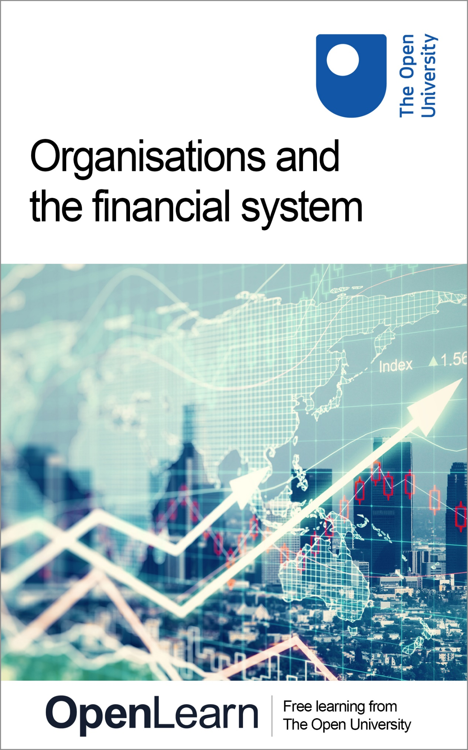

B294_1

Organisations and the financial system

About this free course
This free course is an adapted extract from the Open University course B294 Financial analysis and decision making - http://www.open.ac.uk/courses/modules/b294.
This version of the content may include video, images and interactive content that may not be optimised for your device.
You can experience this free course as it was originally designed on OpenLearn, the home of free learning from The Open University –
Organisations and the financial system - add link
There you’ll also be able to track your progress via your activity record, which you can use to demonstrate your learning.
Copyright © 2020 The Open University
Intellectual property
Unless otherwise stated, this resource is released under the terms of the Creative Commons Licence v4.0 http://creativecommons.org/licenses/by-nc-sa/4.0/deed.en_GB. Within that The Open University interprets this licence in the following way: www.open.edu/openlearn/about-openlearn/frequently-asked-questions-on-openlearn. Copyright and rights falling outside the terms of the Creative Commons Licence are retained or controlled by The Open University. Please read the full text before using any of the content.
We believe the primary barrier to accessing high-quality educational experiences is cost, which is why we aim to publish as much free content as possible under an open licence. If it proves difficult to release content under our preferred Creative Commons licence (e.g. because we can’t afford or gain the clearances or find suitable alternatives), we will still release the materials for free under a personal end-user licence.
This is because the learning experience will always be the same high quality offering and that should always be seen as positive – even if at times the licensing is different to Creative Commons.
When using the content you must attribute us (The Open University) (the OU) and any identified author in accordance with the terms of the Creative Commons Licence.
The Acknowledgements section is used to list, amongst other things, third party (Proprietary), licensed content which is not subject to Creative Commons licensing. Proprietary content must be used (retained) intact and in context to the content at all times.
The Acknowledgements section is also used to bring to your attention any other Special Restrictions which may apply to the content. For example there may be times when the Creative Commons Non-Commercial Sharealike licence does not apply to any of the content even if owned by us (The Open University). In these instances, unless stated otherwise, the content may be used for personal and non-commercial use.
We have also identified as Proprietary other material included in the content which is not subject to Creative Commons Licence. These are OU logos, trading names and may extend to certain photographic and video images and sound recordings and any other material as may be brought to your attention.
Unauthorised use of any of the content may constitute a breach of the terms and conditions and/or intellectual property laws.
We reserve the right to alter, amend or bring to an end any terms and conditions provided here without notice.
All rights falling outside the terms of the Creative Commons licence are retained or controlled by The Open University.
Head of Intellectual Property, The Open University
978-1-4730-3146-3 (.kdl)
978-1-4730-3147-0 (.epub)

Contents
- Introduction
- Learning outcomes
- 1 An overview of financing Small and Medium Enterprises
  - 1.1 Key sources of finance for business organisations
  - 1.2 Internal sources of finance
  - 1.3 External sources of finance
- 2 Alternative funding sources for Small and Medium Enterprises
  - 2.1 Crowdfunding
  - 2.2 Peer-to-peer lending
  - 2.3 Business angels
  - 2.4 Venture capital
  - 2.5 A comparative view of different sources of finance
- 3 Company financing: stock and bond issuance
  - 3.1 The stock and bond markets
  - 3.2 Stock issuance
  - 3.3 Bond issuance
  - 3.4 A bird’s-eye view on public-sector financing
- 4 Decision making in the process of business financing
  - 4.1 Financial resources and the main categories of expenditure
  - 4.2 External growth strategies: mergers and acquisitions
  - 4.3 Paying back shareholders: dividend distribution and share repurchase
  - 4.4 Decision making in practice: a scenario-based adventure
- 5 End-of-course quiz
- Conclusion
- References
- Acknowledgements
- Solutions

Introduction
What are the main types of financial resources available to organisations and how can these funds be used in an efficient way? Is one financial source always better than another? Can every type of goal be achieved by relying on the same source of financing?
This free course Organisations and the financial system will explore these questions by discussing the sources of financing potentially available to every type of organisation, including those in the public and voluntary sector. You will also look at why different organisations might opt for different sources of financing given their specific structures and goals.
The course consists of four sections:
- An overview of financing Small and Medium Enterprises
- Alternative funding source for Small and Medium Enterprises
- Company financing: stock and bond issuance
- Decision making in the process of business financing
The first three sections will introduce you to the different sources of finance available to business organisations. You will learn how different businesses rely on different types of finance, examining examples in order to gain an insight into how organisations raise finance in practice.
The activities in these sections will help you to understand the various financing solutions in different contexts and identify the most appropriate source of finance given a specific business structure.
Section 4 will provide an overview of the main ways in which financial resources might be used by organisations, such as for day-to-day operations or finance expansion projects. In the final part of this section you will have the opportunity to apply what you have learned by going through a short scenario-based adventure.
At the end of the course you will have the opportunity to complete a short quiz which will test your knowledge of the study material in this course.



This OpenLearn course is an adapted extract from the Open University course B294 Financial analysis and decision making.

Learning outcomes
After studying this course, you should be able to:
- describe and contextualise the nature of organisations’ financing
- identify the main types of financing and relate them to different types of business organisations
- give examples of business financing needs, opportunities, and constraints
- outline and describe the processes of stock and bond issuance.

1 An overview of financing Small and Medium Enterprises
Why do organisations need finance? Given the structure of the current socio-economic system, anyone with a goal needs some form of funding, even to perform basic day-to-day activities. Just think about the pocket money that children get in order to fund their first small expenses, or the various door-to-door fund-raising activities carried out by non-profit organisations. Of course, just as a child growing into adulthood requires more elaborate sources of finance to sustain increasingly complex objectives, organisations, too, must evaluate ways in which they can finance their goals.
Raising finance performs three main roles:
- It provides the money necessary to start up a business (e.g. to secure premises and/or equipment).
- It provides businesses with the funds required to fulfil their payment obligations and ensure the smooth running of their daily activities (e.g. payments to suppliers or staff wages).
- It equips businesses with the resources necessary to carry out expansion plans (e.g. through long-term investments).
Although in this section you will focus on different sources of finance suitable to various forms of business organisations, most of the sources of finance discussed should be understood as potentially available to every type of organisation, including those in the public sector. Some of the types of financing discussed are also available to not-for-profit organisations, although you will not cover this aspect in detail.
Before starting to look at the various sources of finance available to business organisations, it is worth trying to answer a basic but rather challenging question: where does money come from?

Activity 1 Where does money come from?
Allow around 20 minutes for this activity

Organisations need money to function properly. Therefore, it is important to understand the primary source of money, as it does not just fall from the sky. In this activity you will share your ideas on money creation before watching a short video from the Bank of England.

Part 1
Where do you think the money circulating in economic systems comes from? Write down your answer in the box below.

Provide your answer...

Part 2
A safe bet in answering this kind of question is to ask well-renowned experts on the topic, for example the research team of the Bank of England. Watch the following video on money creation in the modern economy. Once you have finished watching the video, use the box below to write notes on how money is created in the financial system. Was your original answer correct? If so, was there a particular aspect of money creation that you were not previously aware of?

Video content is not available in this format.
Video 1 The Bank of England on money creation in the modern economy
View transcript - Video 1 The Bank of England on money creation in the modern economy

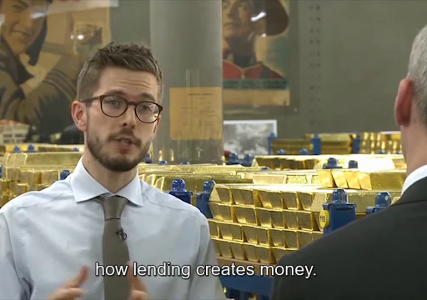

Provide your answer...
View discussion - Part

1.1 Key sources of finance for business organisations
Although there are a variety of financial resources that are available to business organisations, there is not one source of finance that is better than another. The decision about the best financing option ultimately rests on a variety of considerations, such as the business ownership structure, its stage of development and its future goals.
It is quite intuitive to see how the financing needs of newly established businesses could differ significantly from those of a well-established company. For example, for a business in its early stages, common financing options could be funds from the owner’s family, friends or their own savings. These types of funding will not be appropriate to sustain the complex business plans of established companies. Understanding the basic sources of finance and their features is essential for successful financial decision making and business success, since identifying the best and most appropriate available sources is a vital step in reaching the goals set.
Before going into the details of the various sources of finance, it is useful to look at the overall picture. Broadly speaking, sources of finance can be categorised according to two main features:
- whether the finance is generated internally or externally
- whether the duration of the financing is long- or short-term.

The space dimension: internal and external sources of finance
Sources of finance can be either generated internally or raised externally. Internal sources of finance refer to resources that are generated from within, through the business’ activities. External sources are retrieved from third parties. Amongst external sources of finance, it is possible to distinguish between equity financing (i.e. obtaining funds for the company by issuing shares) and debt financing (i.e. obtaining borrowed funds, for example, in the form of bank loans or, in the case of Plc's, by issuing bonds).
Debt finance, which you will look at more closely in Section 1.2, only implies the payment of interests on the total amount raised. It does not mean sharing any part of the business’ decision-making process or legal ownership with the lender. By way of contrast, equity finance presumes that part of the business’ ownership and control over decisions is shared with investors.

The time dimension: short- and long-term finance
Financial sources can also be classified according to the time period over which they are made available to the organisation. Accordingly, it is possible to distinguish between short-term and long-term finance.
Short-term finance typically refers to any financing that will be paid back within a year, while long-term finance refers to any financing that will be repaid over several years. Short-term financing is typically used to finance temporary deficiencies in funds, such as those arising from a delay in the payments from customers. In contrast, long-term financing is better suited to finance the acquisition of long-term assets such as plant and equipment. In general, bank overdrafts are considered an example of short-term finance, while bank loans are generally categorised as long-term finance.
When choosing between short-term versus long-term borrowing, the following elements should be considered:
- What type of asset will the funds be raised for?
Long-term borrowings might be more appropriate for financing non-current assets such as property, plant, equipment, or intellectual property (e.g. patents). Current assets (e.g. raw materials), which are held for a short period, would be more efficiently financed by more flexible short-term borrowings.
- What is the cost of short-term v. long-term finance?
Interest payments on long-term borrowing tend to be higher relative to those for short-term borrowing. This is because the lender requires higher returns to cover the longer period over which funds are loaned, as well as the higher risk associated with long-term borrowing. Despite this, since short-term borrowing must be renewed frequently, it could carry higher indirect costs, such as arrangement fees.
Table 1, below, summarises the different sources of finance that will be discussed in Section 1.2 and 1.3, according to the categorisation described above.

Table 1 Sources of finance
 | Internal | External
 |  | Debt | Equity
Short-term | - Debt factoring  - Invoice discounting  - Working capital management | - Bank overdrafts  - Bank loans  - Crowdfunding  - Peer-to-peer lending | - Crowdfunding
Long-term | - Retained earnings | - Bank loans  - Financial lease  - Hire purchase agreements  - Bond issuance | - Business angels and venture capital  - Stock issuance

1.2 Internal sources of finance
Table 2 (a) summarises the sources of finance that you will cover in this course. You will start by looking at examples of internal sources of finance (emboldened in the tale), beginning with short-term examples and concluding with the most common source of long-term internal financing.

Table 2 (a) Sources of finance
 | Internal | External
 |  | Debt | Equity
Short-term | - Debt factoring  - Invoice discounting  - Working capital management | - Bank overdrafts  - Bank loans  - Crowdfunding  - Peer-to-peer lending | - Crowdfunding
Long-term | - Retained earnings | - Bank loans  - Financial lease  - Hire purchase agreements  - Bond issuance | - Business angels and venture capital  - Stock issuance

Debt factoring
Once mainly used by large companies, but nowadays spreading across all organisations, debt factoring is a very well-established form of funding. In simple terms, it is a short-term way for a business to release funds that are blocked in the form of unpaid trade receivables by selling those debts on to a third-party factoring company at a discount.
Debt factoring is particularly suitable to industries in which the production process is characterised by consistent delays in receiving payments for goods sold and services delivered. Import and export, wholesale and distribution, and logistics are examples of sectors that make extensive use of debt factoring.
To illustrate how this tool works in practice, think about a situation in which customers of a trucking company named Flash Trucks take up to two months to pay their bills. A delay in receiving payments such as this could create serious issues for Flash Trucks and could ultimately affect its ability to function properly. For example, how can it continue to maintain its fleet of lorries or pay for fuel and drivers? With factoring, the organisation can be assured that they will receive payment for its services and continue to operate normally between the point of sale and the point at which its customers will pay.
The typical process of factoring is outlined in Figure 1. Click on each step in the figure to read about how debt factoring works in practice.

Interactive content is not available in this format.
Figure 1 The process of factoring
View description - Figure 1 The process of factoring

Invoice discounting
Another means of internal funding is invoice discounting, which is similar to debt factoring in many ways except for one important difference. In this case, the third party (an invoice discounter) will carry out a mini audit of the business and its customers upon the receipt of a copy of an invoice. The invoice discounter will then provide an agreed percentage of an invoice’s total value. As soon as the customer pays the invoice, the business will deposit the funds into a bank account that is controlled by the invoice discounter, who will then pay the business the remainder of the invoice, less any fees.
Unlike debt factoring, with invoice discounting it is the business itself that deals with the process of requesting the money from its customers. Whilst this would be a viable option if the business is equipped with a dedicated office (e.g. a debt collection department), it could be more problematic for newly established businesses.
In comparison to debt factoring, an obvious advantage is that the seller and the customer are in a clearer, more direct relationship. In addition, given the simpler service provided by the discounting company, invoice discounting usually has lower fees (usually around 0.5% to 1% of the sale value).
Both debt factoring and invoice discounting are ways of raising finance that can be very flexible. However, these two types of financing come with some disadvantages.

Activity 2 Disadvantages of debt factoring and invoice discounting
Allow around 10 minutes for this activity

Think about potential drawbacks connected to debt factoring and invoice discounting and note your ideas in the box below. How do your ideas compare to the feedback?

Provide your answer...
View discussion - Activity 2 Disadvantages of debt factoring and invoice discounting

Working capital management
Two additional ways in which finance can be raised within a business is through the management of working capital.
Working capital is the difference between a company’s current assets and current liabilities.

Working capital = current assets − current liabilities

The working capital formula measures a company’s short-term liquidity. The components of working capital can be ‘managed’ for financing purposes. There are two main ways of managing working capital to provide funds for the business:
- Depending on the specific type and condition of the products, reducing inventory levels (that is, selling the accumulated stocks) can provide short-term funding. However, a business should be aware of the risks that reducing inventories can carry, for example not being ready to accommodate any sudden increases in demand for its products.
- Businesses may also manage their cash flows to provide liquidity by operating with negative working capital. This is the situation when the outstanding amounts due to creditors (payables) exceed those due to be received from customers (receivables). The ability to raise liquidity with negative working capital will depend on the importance that the business places upon reputation as businesses running negative working capital risk exposure to reputational damage. This could affect the terms on which suppliers are prepared to do business with them.

Activity 3 Working capital in practice
Allow around 30 minutes for this activity

This activity applies what you have learned about working capital to a fictitious company named Cullen’s. Examine the information below and answer the questions that follow.

Cullen’s is a company that owns several supermarkets. The figures in the last available financial statement show that Cullen’s has £850,000 as cash in bank accounts, and £950,000 as inventory. Cullen’s accounts receivables are equal to £700,000, whilst its payables are £2,500,000. In addition, Cullen’s has short-term debt of £300,000 and long-term debt of £200,000.

Question 1

Does Cullen’s show positive or negative working capital?

Interactive content is not available in this format.

Provide your answer...
View discussion - Question 1

Question 2

Should Cullen’s financial managers be worried about the working capital figure you obtained in Question 1? Why?

Provide your answer...
View discussion - Question 2

Retained earnings



Retained earnings are the portion of past earnings retained within the business itself. They are an important source of internal finance for businesses looking to finance long-term projects.
For a business to be able to rely on these earnings to fund its activities, it has to have first made profits. As a result, this method could be difficult to use for newly established businesses due to the usually limited profitability in the first stages of production caused by significant initial costs. And even for profitable companies, satisfying this first condition alone is not entirely sufficient as they will need to take into consideration how much of their profits to distribute in the form of dividends to the shareholders before accounting for profits that are retained (if any). The following formula summarises the calculation of retained earnings in a given year:

Retained earnings_{t} = retained earnings_{t − 1} + income (loss)_{t} − dividends distributed_{t}
Where t represents the current time.

From the above formula it is evident that retained earnings carry opportunity cost for the company, which has to carefully consider the consequences of deciding not to distribute them to investors. In fact, the higher the dividends distributed to shareholders, the lower the amount of retained earnings and vice versa.
You will now look at the main external sources of financing.

1.3 External sources of finance
External sources of finance are funds available to business organisations that are derived from outside the boundaries of the organisation itself. As discussed at the beginning of Section 1.1, these can be further divided into debt and equity finance.
A key difference between debt and equity finance is the implications they have for the ownership of the business. Utilising debt finance to fund activities does not imply a dilution of control over the business for the owners. On the contrary, when choosing equity finance the owners should be ready to accept sharing control with the investors (shareholders) who are providing the funds by buying a portion of the company. The following sections illustrate the main sources of external financing available to business organisations.

Table 2 (b) Sources of finance
 | Internal | External
 |  | Debt | Equity
Short-term | - Debt factoring  - Invoice discounting  - Working capital management | - Bank overdrafts  - Bank loans  - Crowdfunding  - Peer-to-peer lending | - Crowdfunding
Long-term | - Retained earnings | - Bank loans  - Financial lease  - Hire purchase agreements  - Bond issuance | - Business angels and venture capital  - Stock issuance

Bank finance
Banks are the key suppliers of external finance to the business world, helping businesses to turn future sales into ready cash. For this reason, one of the traditional ways in which finance can be raised is by establishing financial relationships with the banking system.

Bank loans

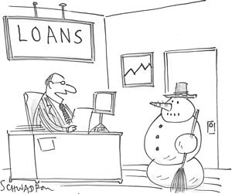

A bank loan is money advanced and borrowed for a given period with an agreed schedule for repayment. The lender (the bank) and the borrower (either an organisation or an individual) also agree on the repayment amount and the rate of interest (i.e. the cost for the lending service).
Even though it is quite a simple instrument, lenders generally seek a low exposure to risk, so they will evaluate the creditworthiness of the loanee. As a result, bank loans may not be accessible to all business organisations; rather, they are suitable mainly for well-established businesses with a solid track record of an ‘ability to repay’.
The lender usually tends to protect itself from the risk of not receiving loan repayments by asking for collateral. Businesses lacking collateral could find it quite difficult to borrow funds from banks. In addition to this, arranging a loan with a lender can sometimes be a rather lengthy process.
Interest rates on bank loans tend to be low, although the borrower will have to pay the interest rate calculated on all the outstanding debt. As you gradually pay off your loan, interest will be paid on a smaller amount of the principal. Conversely, the share of principal payments increases gradually as you repay the loan.

Bank overdrafts
Another way in which a business can use the banking system to fund its short-term activities is through bank overdrafts. Overdraft facility schemes can be arranged with a bank in order to obtain short-term funding within an agreed limit. As in the case of bank loans, there will be a cost for this service (the interest plus a fee) and a period within which the repayment must be made. Owners of smaller businesses may be required to provide security (collateral) against these overdraft agreements, usually in the form of property, although this is not a requirement for all overdraft facilities.
For businesses searching for some flexibility in funding, for example due to seasonal fluctuations in sales that might result in cash shortages, a bank overdraft would be preferable to a bank loan, as the latter is fixed both in terms of time and size. Moreover, in the case of bank overdrafts, the interest is calculated and paid only on the amounts borrowed (or overdrawn) each time because there is no outstanding principal.
Using an overdraft as a form of financing can be risky. The lender can demand that the overdraft is repaid or reduce the overdraft limit at any time. It could also be expensive for a business as a higher rate is charged by the lender to compensate for making funds available ‘on tap’ and, as a result, the business could lose other investment opportunities.
Table 4 summarises the main advantages and disadvantages of bank loans and bank overdrafts.

Table 4 Advantages and disadvantages of bank loans and bank overdrafts
 | Advantages | Disadvantages
Bank overdrafts | - Easier to arrange  - Flexible  - Unsecured  - Interest on amounts borrowed | - Risk of early repayment  - Relatively expensive (interest)
Bank loan | - Relatively cheaper (interest) | - Secured  - Harder to arrange  - Interest paid on amount outstanding

Financial lease and hire purchase agreements
Financial leases are another common way for business organisations to raise long-term debt finance. A lease is a relationship, or a contract, between a lessor (the provider) and the lessee (the receiver). The lessee agrees to a series of payments to the lessor for the right to use an asset (e.g. a portion of land, a building, or a vehicle) for a fixed period, or lease term. The agreement is usually mediated by a leasing or financing company. At the end of the lease, the asset either returns to the lessor or the lease is renewed.
The key advantages of financial leases are flexibility, and the fact that the business can avoid a large outflow of cash and smooth the expenditure over a longer period (i.e. the asset’s life). Leasing is a form of financing used across all sectors and represents a consolidated source of finance, particularly in transportation and manufacturing. Leasing, though, comes with some disadvantages. For example, in the case of missed payments, the assets may be repossessed, and the business’ credit rating can be compromised.
Cases where the agreement stipulates that the asset will be purchased at the end of the period are referred to as hire purchase agreements. In such arrangements, at the end of the lease term the lessee becomes the legal owner of the hired assets. This is a form of credit used to buy an asset, which is usually mediated by a financial institution.

Box 1 Financing Flash Trucks’ expansion
The financial management at Flash Trucks is facing a challenge. The company is exploring an opportunity to expand its delivery business into France, which will require an expansion of the current fleet. However, given uncertainty about future trade relations between the countries, and the viability of the new contract, buying three new lorries could be risky. Moreover, Flash Trucks does not currently have enough internal funds to sustain this expense.
A finance lease could be a solution. In fact, Flash Trucks will not be required to pay the full price for the three new lorries and can agree on a short period for the rentals (say one year). This will provide a good degree of flexibility to explore the new business opportunity. At the end of the lease period, Flash Trucks can also decide to sell the vehicles to a third party.



So far you have learned about the traditional ways in which organisations can fund their activities. The next section provides and overview about alternative ways of financing, such as Crowdfunding and Peer-to-Peer lending.

2 Alternative funding sources for Small and Medium Enterprises
Some business organisations can find it difficult to raise funds through the approaches described so far. As you have seen, the constraints related to the different sources of finance can be quite harsh, especially for a newly established business. However, alternative methods of raising finance have emerged in recent decades. Although these methods can be traced to their embryonic forms in previous centuries, they can be shown to have developed in response to the Great Financial Crisis in 2007/08 with the aim of overcoming the obstacles presented by the sources of funding discussed so far. Equally, advances in modern technology, particularly the internet, mean alternative types of finance are commonplace in today’s economic landscape.

2.1 Crowdfunding
One solution to the limitations posed by traditional means of financing has been to rely directly on the public to search for potential funders. Crowdfunding is the process of raising short-term funds in the form of small contributions to help businesses (or individuals) turn an idea or a project into a reality through the direct connection between investees and a large number of potential investors. Although especially useful for newly established businesses, crowdfunding has also been utilised by larger, more established companies. For example, Lego used crowdfunding to engage consumers in testing some newly developed products before launching them on to the market.



The crowdfunding process is mediated by dedicated online platforms, which have specialised in different business areas (for example see Fundable or AngelList). There are two types of crowdfunding:
- Reward-based crowdfunding is perhaps the most common type. Individuals contribute small amounts of money to projects in return for a reward that reflects their contributions. This reward can take many forms, such as vouchers, tickets for a showcase event, or even a prototype of the new product once available. In this case, crowdfunding falls under the category of debt finance, since no ownership control is shared with funders.
- With equity crowdfunding, the ‘crowd’ invests in a business in exchange for a portion of its capital, namely a share. If the business does well and is profitable then the funders will receive a share of the profits. If, on the contrary, the business fails then investors can lose part, or all, of their investment. Equity crowdfunding can be seen as a system aimed at expanding the number of people that can fund the early stages of business goals – a system once dependent on wealthy individuals.
Crowdfunding has expanded worldwide. However, it comes with risks from both the investor’s and investee’s perspectives. Although crowdfunding provides an easy way to raise finance for a niche opportunity, the system provides little or no protection for the investor, which, in the extreme, means it could be a victim of fraud. Moreover, even though this can be a way to test the potential of a project, the idea could be stolen by other businesses.

2.2 Peer-to-peer lending
Peer-to-peer (or P2P) lending is a method of raising funds in a manner similar to crowdfunding. It is a form of borrowing and lending between ‘peers’ without the involvement of a bank or other financial institution. As with crowdfunding, the process is intermediated by an online platform that tries to match individuals willing to lend to those that need funds. These platforms give the prospective borrower the opportunity to access a pool of lenders after a credit check, which can lead to competitive interest rates in cases where the borrower has an excellent credit history.
The risks associated with this practice are the potential inability of the borrower to repay the lender, and the fact that money lent through P2P is not guaranteed by governments, as in the case of banks. In fact, current accounts in most countries are protected (up to a certain amount) from potential bankruptcy of the bank in which they are held. With P2P lending, if the borrower defaults on its debt then the lenders will lose all their funds.
Currently, P2P lending is by far the largest type of alternative finance worldwide, while reward-based and equity crowdfunding remain limited, accounting for approximately a quarter and a tenth of P2P lending volume, respectively.

Activity 4 Which type of organisations could benefit from alternative ways of financing?
Allow around 20 minutes for this activity

Can you give one example of an organisation for which crowdfunding or P2P lending has been a useful source of finance? Search online for a success story (or a story of failure) and provide a short summary in the box below.

Provide your answer...
View discussion - Activity 4 Which type of organisations could benefit from alternative ways of f ...

2.3 Business angels
Business organisations with ambitious and, thus, risky projects (think for example about a start-up, or an early stage investment) might need to rely on other unconventional forms of external long-term funding: they could need the help of ‘venture captains’ or even ‘angels’.
According to the UK Business Angels Association (UKBAA), business angels (or BAs) are certified wealthy individuals with an income in excess of around £100,000, or net assets above £250,000 excluding pension and residence. BAs make use of their private funds to invest a variable amount of money (usually between £10,000 and £150,000) in small businesses in which they see strong potential for growth.
In general, when BAs decide to invest in a project, they buy some share of the business, thus becoming part of the ownership structure. This is why funding from BAs falls under the category of ‘external equity finance’. The ‘angels’ do not usually sit on a business’s board, but they do provide continuous support and consultation to help the company grow.
In the European context, currently the UK system stands out as the major beneficiary of BA involvement in the funding of growing businesses. Also, in Spain, Germany, Turkey, France and Russia, BAs account for a considerable amount of investment.

2.4 Venture capital
Venture captains in the business environment are called venture capitalists (or VCs). VCs are structured firms that invest previously collected funds in an ambitious project (i.e. a venture). VCs differ from BAs, as the former invest their funds through a managed fund (called a Venture Capital Trust), which is established using either private or public resources. The fund is managed in order to make a return for the fund’s investors. Compared to the structure of BA investment, VC investment carries substantial administrative costs, such as management fees, and organisational expenses, like consulting and research. In addition, the fund needs to sustain a consistent return for the investors. For these reasons, VCs will be more selective and prefer projects with a track record of good performance. Hence, VCs generally become involved with projects that are more mature than the ones targeted by BAs.
VCs usually invest sums above £1 million and expect high returns, as well as direct and constant involvement in the decision-making process within the business. As in the case of BAs, businesses agreeing to VC funding should be prepared to lose part of their equity control over the business. In Europe, the UK stands out as the major market for VC funding that finances growing businesses.

2.5 A comparative view of different sources of finance
So far you have seen the reasons why different types of financial resources might be suitable to different business organisations, but it is also useful to place them into the context of their prevalence in the real world. By taking a comparative view and examining the relative weight of each source of finance in different countries, you can develop a picture of how important different sources of finance are across the economies of today.

Activity 5 A comparative view of sources of finance
Allow around 35 minutes for this activity

This activity is divided into two parts. In Part 1 you are asked to match the sources of finance to the corresponding definitions. In Part 2 you will interpret and compare data about the use of various sources of finance in different countries.

Part 1

Interactive content is not available in this format.

Part 2

The table and graphs below show the relative importance of the main types of funding for small- to medium-sized enterprises (SMEs) across four countries. Please note that the terms ‘enterprise’ and ‘business’ are commonly used as synonyms. Although these are average values for the period 2013–16, you should be able to appreciate the different structure of financing in each context.

Table 5 Main sources of funding for SMEs, 2013–16 (average in millions of US dollars)
 | Outstanding business loans, SMEs | Venture capital investment | Leasing and hire purchases | Factoring and invoicing
UK | 144,606 | 2548 | 22,055 | 15,697
USA | 596,750 | 66,500 | 405,828 | 71,429
China | 529,251 | 50,360 | 592,364 | 441,670
Japan | 237,286 | 1319 | 23,642 | 71,306
Source: OECD and FCI

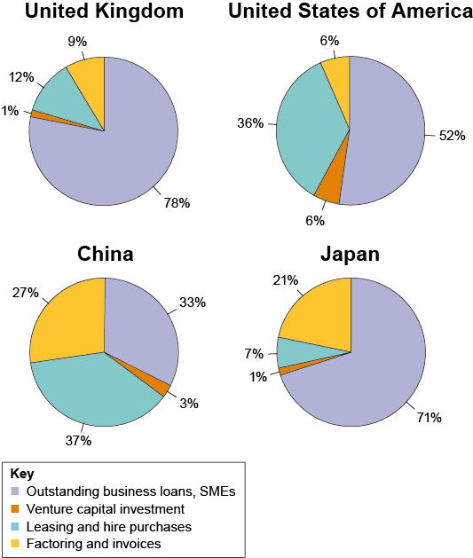
Source: OECD and FCI
Figure 2 The relative average weight of SMEs’ funding in the UK, USA, China and Japan
View description - Figure 2 The relative average weight of SMEs’ funding in the UK, USA, China and ...

In the box below, summarise what these figures tell you about types of funding for SMEs across each of the countries represented.

Provide your answer...
View discussion - Part 2

So far you have explored the main sources of financing for the various types of organisations. The next section focuses on those types of financing specific to Public Limited Companies (Plc).

3 Company financing: stock and bond issuance
Compared to other forms of business organisations, public limited companies (Plc) have the additional opportunity to build relationships with financial markets. Public limited companies (called ‘corporations’ in the United States) are those offering portions of their capital to the general public. The public buyers of this capital have ‘limited responsibility’, meaning that they cannot be held responsible for losses in excess of the amount they have invested into a specific company.
Plcs can raise finance by offering their shares for sale on a recognised stock exchange in order to raise capital or issue bonds. But what is a financial market and how can it help Plc’s to find the financial resources they need?
A financial market can be defined as the place in which operators with excess funds (lenders or investors) exchange their resources with those who lack funds (borrowers). Broadly speaking, the financial market comprises two key markets: the capital market and the money market.

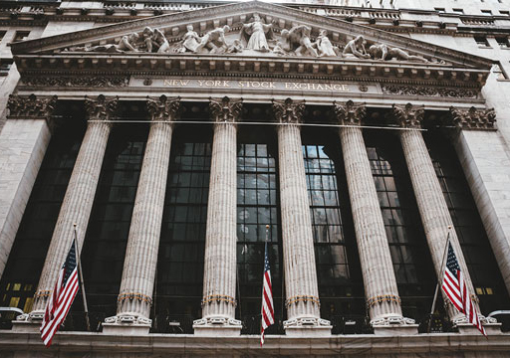
Figure 3 The New York Stock Exchange

The capital market
The capital market is where long-term financial securities are traded. Public limited companies, as well as governments, can issue (sell) securities on the capital market in order to raise funds. As you will see later, companies can issue both stocks and bonds in their respective markets in order to raise long-term finance, while governments can issue sovereign bonds.

The money market
The money market defines the second component of financial markets. Money markets are concerned with the buying and selling of short-term assets characterised by a high level of liquidity. As the name suggests, the financial assets exchanged in this market resemble money, or cash. Commercial papers, certificates of deposit, inter-bank loans, Treasury bills, cash deposits, and sale and repurchase agreements are the six major categories of money-market funding. The money markets are the entities in which mainly central banks and financial institutions deal with short-term lending and borrowing. The various money markets are less relevant in terms of most businesses’ financing strategies.

3.1 The stock and bond markets
A large portion of the capital market is represented by the stock market, where companies’ stocks are traded. Although the terms ‘stock’ and ‘share’ are nowadays used interchangeably, it is more appropriate to use the former when referring to the company as a whole (e.g. the stock of a manufacturing company), while the latter refers to the parts in which the company stock is divided.
Figure 4 below is a map showing the location and size of the top ten stock exchanges in the world. The size of a stock exchange is measured by the market capitalisation of its listed companies. It is easy to see how the USA, and especially the city of New York, currently dominates this type of market. In terms of market capitalisation, in 2018, the NYSE and the NASDAQ alone accounted for more than the other eight stock markets in the top-ten ranking together. Click on the locations to reveal information on each exchange.

Interactive content is not available in this format.
Figure 4 Top ten stock exchanges according to market capitalisation
View description - Figure 4 Top ten stock exchanges according to market capitalisation

Primary and secondary markets
The stock and bond markets are sub-divided into primary and secondary markets. The primary market, or ‘new issue markets’, is where newly created financial assets (for example a company that issues a bond certificate or a stock) are put on exchange. The secondary market deals with the trading of previously issued financial assets, where transactions between investors occur. The secondary market is where the highest volume of trading takes place.

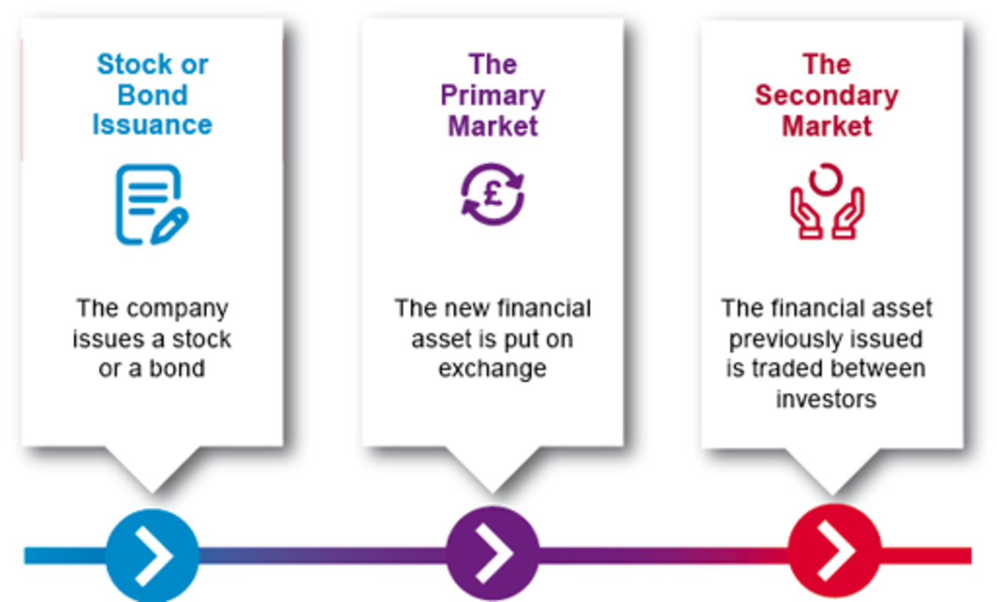
Figure 5 Asset trading in the financial markets
View description - Figure 5 Asset trading in the financial markets

Over-the-counter markets
A special type of secondary market is the ‘over-the-counter (OTC) market’. In contrast to the stock exchange, OTC markets are not physically recognisable: they are better described as networks of trading relationships between dealers. Moreover, unlike exchanges, OTC markets are not subject to strict regulation about the quantity and quality of the assets traded, and all the contracts are bilateral, i.e. only between two parties. Given these characteristics, OTC markets lack transparency compared to the ones discussed so far.
Financial instruments, such as stocks, debt securities, derivatives, and commodities can be traded OTC. Typically, small companies lacking the resources to be listed on formal stock exchanges trade their stocks OTC. However, even larger companies might decide to trade their stocks OTC.

Activity 6 The basic structure of the financial market
Allow around 15 minutes for this activity

The diagram below summarises the hierarchical structure of the financial market. Complete the diagram by clicking on the different components and adding your own definition for each. You should also think about the interaction between different elements of the financial market as you work through them.

Interactive content is not available in this format.

3.2 Stock issuance
One common way in which Ltds and Plcs raise finance is through a share issue. Shares represent the portions in which a company’s capital is divided. They entitle the holder to receive a portion of future profits in the form of dividends, usually paid yearly or half-yearly at the discretion of the company, subject to approval by shareholders.

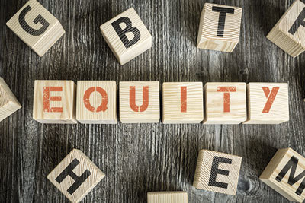

There are two types of shares: ordinary and preference shares.
- Ordinary shares (or common shares) have no special rights or restrictions attached to them. Each share provides the shareholder with equal rights to vote at general meetings (each share typically entitling its owner to cast one vote), receive a share of the company’s profit in the form of dividends, and receive a share of any remaining capital or assets should the company be wound up.
- Preference shares (or preferred shares) typically do not give shareholders voting rights. However, these shares come with an advantage over ordinary shares in terms of dividend distribution. Preference shareholders, who are entitled to a fixed rate dividend, have a preferential claim to dividends over ordinary shareholders, even if the company enters liquidation. Further, in case of insolvency, preferred shareholders have a higher priority claim to the company’s assets.
Shareholders expect a return on their investment. One way in which the ownership of shares gives a return is through dividends, which are paid at the company’s discretion. Most shareholders, however, hope to gain an additional return in the form of capital gains, that is, an increase in the value of the company. Any capital gain will be realised when the shares are sold to another party for a higher price at a later date. Investors’ expectations about the performance of these two components vary across countries and sectors of operation.

Issuing shares in practice
How can a company issue shares in order to raise funds? Limited liability companies can be classified as either private (Ltds) or public (Plcs); a key difference between them is that Ltds cannot sell shares on a recognised stock exchange whereas Plcs can.

Issuing shares as a private limited company
Even though Ltds cannot sell shares on a recognised stock exchange, this doesn’t mean that there are no options for private limited companies to raise funds through the sale of shares. Broadly speaking, there are two options for Ltds looking to raise finance through the sale of equity:
- Ltds can sell their shares without the mediation of a stock exchange. Shares in private limited companies can be bought and sold, usually to existing shareholders, but also to other private investors, such as venture capitalists
- Ltds can decide to ‘go public’. Such a decision can be relevant to companies that plan to grow significantly. Going public is a decision that entails huge organisational efforts, since the management has to spend time on the preparation of the public offering of the company’s shares. Moreover, after going public, the company will regularly have to make information about the business, such as financial records and remuneration policies, publicly available.

Issuing shares as a public limited company
Plcs have the great advantage of being able to raise a large amount of capital by offering shares to the wider public, hence reaching a larger number of investors compared with Ltds. When a company is listed on a stock exchange it can also attract the interest of large-scale investors such as mutual funds and hedge funds. Selling extra shares after the ‘initial offering’ will need a resolution to be voted on by the company shareholders. Nonetheless, issuing new shares will further dilute the control of the company.

Initial public offerings
The usual method for a Ltd to go public is to offer its shares via an initial public offering (IPO). The process of an IPO can be summarised in three steps. Watch the following animation for an outline of the process.

Video content is not available in this format.
Video 2 The process of an IPO
View transcript - Video 2 The process of an IPO



Activity 7 Equity finance in practice
Allow around 50 minutes for this activity

Part A Should DrinkIT stay private or go public?

DrinkIT is a private limited company established in the food and beverage sector. The managers at DrinkIT are currently exploring possibilities to expand the business even further, for which a large injection of funds will be needed. In particular, they are in the process of building a complex business plan to sustain the production of innovative non-alcoholic drinks called Mocktails. As the financial manager of DrinkIT, you must evaluate the case for raising the required funds through equity finance.

Question 1

What do you think the main advantages and disadvantages of DrinkIT’s two options? List your ideas below.

Table 6 Advantages and disadvantages
Advantages of staying private | Disadvantages of staying private
Provide your answer... | Provide your answer...
Advantages of going public | Disadvantages of going public
Provide your answer... | Provide your answer...

View discussion - Question 1

Question 2

Which is the option you would recommend for DrinkIT? Why?

Provide your answer...
View discussion - Question 2

Part B Facebook’s ‘botched’ IPO: what went wrong and why?

Much interest has been shown by financial analysts in the so-called ‘underpricing’ of shares offered through IPOs. Underpricing is evidenced by the price of shares rising (often sharply) in the immediate aftermath of the launch. Many traders try to take advantage of this common phenomenon.
If a fixed-price method is used for an IPO, then the lead bank (or co-leads) leading the offering will set the offer price at a level at which they are confident that all the shares will be sold to investors. This will mean that the banks underwriting the issue will not have to purchase a large proportion of the offer. Investors, knowing that the lead banks want to see a successful launch, may indicate a low price to force the issue price down as far as possible. Therefore, this often results in an unmet demand at the final offer price, with a surge in the traded share price on and after the launch date.
On 18 May 2012, Facebook held its IPO. By raising over $16 billion it became one of the largest IPOs in history. Quite surprisingly, there was no underpricing. On the first day of trading, the stock closed flat at its offer price. Many commentators described Facebook’s IPO as a ‘failure’ for the market.

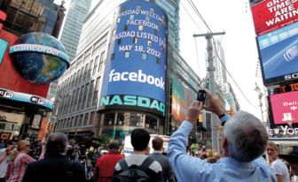
Figure 6 NASDAQ welcomes Facebook’s listing

Just four days after it went public on the stock market, Facebook became the centre of intense attention both on Wall Street and in Washington DC as shares hit $32, well below the initial offering price. Watch this video entitled ‘Facebook’s “botched” IPO: what went wrong and why?’ from 1.31 to the end.

Watch the video at YouTube.com.
Video 3 Facebook’s ‘botched’ IPO: what went wrong and why?
View transcript - Video 3 Facebook’s ‘botched’ IPO: what went wrong and why?

What factors discussed in the video do you think are the most likely to have caused Facebook’s ‘botched’ IPO?

Provide your answer...
View discussion - Part B Facebook’s ‘botched’ IPO: what went wrong and why?

In this section you have learned about the key steps in the process of stock issuance. The next section describes the other tool available to Plcs (as well as governments) to acquire financial resources, namely bond issuance.

3.3 Bond issuance
Along with the issuance of stocks, Plcs can issue debt securities to raise finance. With the issuance of stocks, companies are searching for partial owners; with the issuance of bonds, they are searching for partial lenders. The financial markets provide the means for companies to borrow money by the issuance of debt securities in the form of bonds.



From an investor’s point of view, owning a company’s debt is different to owning its stock in three main ways:
- Bondholders have no rights to vote and are not entitled to receive dividends. Instead, they receive interest payments (known as coupons).
- A bondholder’s capital is paid back in full at maturity, as compared to shares, of which the value is contingent on the current share price when the shares are sold.
- Bonds outrank stocks in seniority, meaning that in the event of the liquidation of a company, bondholders are among the first to be repaid. Thus, bonds establish a more secure financial relationship with a company as opposed to stocks.

Regulating and documenting the issue of bonds
Companies can raise funds both in the financial market of their home country (domestic bond) or in that of a foreign country (foreign bond). In either case, they have to comply with the regulations of the market in question – for example, those laid down for issuance by the Securities and Exchange Commission (SEC) apply to both US and non-US companies raising funds in the USA. In the UK, the regulatory body is the Financial Conduct Authority (FCA). Public issues of bonds in the international markets still need to be listed on an appropriate stock exchange: for example, Eurobonds are listed on either the London or Luxembourg stock exchanges.
Bond issues need to be accompanied by the documentation specified by the regulator and the listing authority for the relevant market, if the bond is to be entered on to the official list of the local stock exchange. As with equity issuances, usually companies are required to produce – and have approved by the regulator and the listing authority – a prospectus to support bond transactions. Prospectuses also have to be submitted to the credit-rating agencies that provide ratings for the bonds.
In recent years, several universities in the UK have issued bonds to fund their activities. Figure 7 is an image from the prospectus of a £300 million bond issue by the University of Cardiff in 2016. You don’t need to read the prospectus, but if you would like to take a look at it you can find it on the Cardiff University website.


Figure 7 A £300,000,000 bond issued by the University of Cardiff in 2016

Debt and credit ratings
Bond issuers will normally have to secure a rating to enable them to issue their bonds on the world’s financial markets. A credit-rating agency is a private company that assigns ratings for issuers of certain types of debt, such as bonds. The three major global credit-rating agencies are Standard & Poor’s, Moody’s, and Fitch Ratings Inc.
The function (and business) of rating agencies is to provide (supposedly) independent information to investors about the financial reliability of bond issuers. This information is called a ‘rating’. The higher the rating of the issuer, the lower the assessed credit risk of investing in it. The specific credit-quality rating assigned varies between agencies. Ratings with a relatively low risk of default correspond to ‘Investment grade’. According to Standard and Poor’s classification, to be included in this category an issuer should be rated BBB or higher.
Using a simplified version of a recent Standard and Poor’s classification, Table 7 summarises the ranking from lower to higher risk for the lender. Click on the grade bands to read how each is viewed by investors.

Interactive content is not available in this format.
Table 7 Standard and Poor’s classification

The following section discusses the main mechanisms of bonds.

The mechanics of bonds
All bonds have a face value (or par value), an interest rate (coupon rate) paid on the bond by the borrower, and a maturity date. Let us examine each of these elements in more detail.
A company issues bond certificates with a single face value (FV), which is the value that appears on the certificate. This is usually equal to £100 or £1000, while the total value of the bonds issued at a certain time could be millions (or even billions) of pounds. For convenience, bonds are often referred to in units of 100, though investors can buy smaller or larger sums and part-units.
The market value of the bonds is the price at which the bond market, that is where issued bonds are traded, is selling or buying the bond. When the market value (MV) is higher than the FV, it is said that the bond is trading at ‘premium’; by way of contrast, when the MV is lower than the FV, it is said that the bond is trading at ‘discount’. Finally, if the MV and FV are equal, the bond is trading at ‘par’.

Table 8 Bond trading prices
Face value (FV) | Market value (MV) | The bond is trading at
£100 | £100 | Par
£100 | £101 | A premium to par
£100 | £99 | A discount to par

The positive or negative difference between MV and FV value is given by the fact that the bond is traded, hence the fluctuations in buying and selling are reflected in its value.
In a primary offering, an investor buys the bond for par value from the issuer. The issuer pays interest to the investor periodically (usually annually), which is calculated by multiplying the face value by the coupon rate. For example, a bond with a fixed coupon issued at a face value of £100 with a 5% annual coupon rate will pay a coupon of £5 (i.e. £100 × 0.05) each year, or two semi-annual coupons worth £2.50 each. When the bond matures, then the bondholder will get back the par value of the bond.
A bond typically has a maturity date on which the bond expires, and the principal is paid back to the investors. For example, a 10-year corporate bond issued in June 2019 will mature in June 2029. Bonds typically have maturities in the range of 1 to 30 years. Undated or perpetual bonds, with no defined maturity date, can also be issued, although such issues are infrequent. The bulk of funding activity in the bond market is in maturities of up to 10 years.
If bondholders decide to hold a bond until the maturity date, then they can expect to receive a return commonly referred to as ‘yield to maturity’ (YTM), which equals the total interest payments to the investor plus any gain (or loss) between the price the bond was purchased at and the repayment price. For the purpose of this course you do not need to know how to calculate the YTM, you just need to note that a bond’s YTM considers its face value, purchase price, coupon rate, duration and compound interest.

Common types of bonds
Along with fixed coupon bonds, referred to in the previous example, there are other types of bonds which pay interest rates differently. Table 9 describes the most common types of bonds.

Table 9 Common types of bonds
Bond | Description
Fixed coupon bonds | Fixed coupon bonds are long-term debt instruments paying a fixed coupon rate until maturity. Investors are certain about the amount and quantity of coupons they will receive.
Floating rate (or variable) bonds | With floating rate (or variable) bonds the coupon is re-fixed periodically, typically each quarter (or each month, or half year). These bonds typically have a variable coupon that is indexed to a benchmark interest rate, such as the LIBOR (London Inter-bank Offered Rate) for example.
Zero coupon bonds | Zero coupon bonds pay no interest and pay only principal value at maturity. They are usually issued at a price which is significantly below the par value and redeemed at par on maturity. Zero coupon bonds are very common and are issued by companies, as well as by states and local governments.
Convertible bonds | A convertible bond gives investors the right to convert their bond into a predetermined number of ordinary shares or sometimes cash. The right to exercise the option to convert can be continuous throughout the life of the bond or can be applied only on defined dates.

Activity 8 The basics of bonds
Allow around 10 minutes for this activity

Now you have gone through the main components of bonds, work through the following activity and match the definition with the corresponding key term.

The value that appears on the bond certificate, usually equal to £100
The price at which the bond market is selling or buying the bond
The end of the fixed lifetime of a bond, usually between 1 and 30 years
The contractual regular income the lender (or bondholder) expects to receive
Bonds that pay no interest during their term, are issued at a discount to par and redeemed at par on maturity
A special type of hybrid bond that gives the investor the right to exchange the debt for the equity of the issuer
Bond in which the coupon is re-fixed (typically quarterly, monthly, or half yearly), with reference to a fixed margin, for example the LIBOR
Face value
Market value
Maturity
Coupon
Zero coupon bond
Convertible bond
Floating rate bond
View answer - Activity 8 The basics of bonds

The secondary market for bonds
As you have seen, a bond has a second price component besides its initial face value. This is the price of the bond as it trades in the secondary market, or its market value (MV).
Bonds trading in the secondary market will usually be priced either higher or lower than their original issue price. Changes in a bond’s price are linked to the following factors:
- prevailing interest rates
- inflation
- the bond’s credit rating.

(i) Prevailing interest rates
Assume, again, you have purchased a bond at par with a face value of £1000 and an annual coupon rate of 5%. The annual coupon payment will be equal to £50 (i.e. £1000 × 0.05). However, after your purchase the market value of your bond might fluctuate as a result of changes in interest rates. Suppose the prevailing (or the market) interest rate rises to 6%. Since new bonds are now being issued with a 6% coupon, your bond is no longer worth as much as it was when you bought it with a 5% coupon. Your bond becomes less attractive to other investors as they can invest £1000 to purchase a bond with a higher coupon rate. In this case, the market value of your bond will be less than £1000, the bond will be trading at discount.
By way of contrast, if the market interest rate falls from 5% to 4% after your bond purchase, the market value of your bond will rise, as investors will not be able to buy a new issued bond with a coupon rate as high as yours. In this case, the bond’s price will increase to £1,250 (£50/0.04), hence it will be trading at premium to par. This can be summarised by saying that a price of a bond fluctuates inversely with the prevailing interest rate, as shown in Table 10.

Table 10 Bond pricing on the secondary market
Bond coupon | Prevailing interest rate | Demand from investors | Bond price
5% | 6% | Decrease | Decrease
5% | 4% | Increase | Increase

In either scenario, the coupon rate loses meaning for a new investor. However, it is possible to roughly estimate the bond’s current yield by dividing its annual coupon payment by its market value. For example, if you purchased a bond on the secondary market that had a FV of £1000, with a 5% annual coupon rate, for £1200, the current yield would be equal to 4.2% (i.e. (£50/£1200) × 100). By way of contrast, if you purchased that same bond for £900, the current yield would be 5.6% (i.e. (£50/£900) × 100). These changes in current yield are summarised in Table 11.

Table 11 Purchase price and current yield on a bond
Face value (FV) | Purchase price | Annual coupon rate | Annual coupon payment | Current yield
£1000 | £1000 | 5% | £50 | 5%
£1000 | £1200 | 5% | £50 | 4.2%
£1000 | £900 | 5% | £50 | 5.6%

(ii) Inflation
Corporate bonds are also vulnerable to inflation. Bondholders receive interest set at a predetermined rate that is fixed on issue. As a consequence, if inflation rises, the return a bondholder will earn at maturity will be worth less in today’s pounds. Rising inflation often causes interest rates to increase, which in turn reduces the price of a bond. Conversely, deflation usually results in decreasing interest rates and, therefore, in increasing bond prices.

(iii) Credit ratings
Credit ratings also affect a bond price. The lower the credit rating, the higher the risk the issuer will not meet its payment obligations. Consequently, if the issuer’s credit rating goes up, the bond price will rise. Conversely, if the issuer’s credit rating goes down, the bond price will fall.

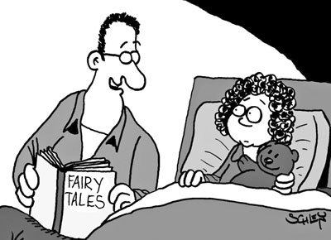
Figure 8 ‘And if the rating agency didn’t drop the kingdom’s creditworthiness, the prince and princess lived happily ever after.’

3.4 A bird’s-eye view on public-sector financing
The public sector is that part of the economic system that is controlled by the government. It consists of organisations, such as the National Health Service, which provide services free of charge or below cost price that benefit society as a whole. In the UK, the size and scope of the public sector has varied over time, featuring prominently during the period from the end of the Second World War to the late 1970s. After this, various rounds of privatisation generally reduced the scope of influence of public agencies.



From the late 1990s, especially in the UK and Australia, the public and private sectors established a specific form of public/private partnership, named ‘private finance initiative’ (PFI): a scheme that enables private organisations to fund major public projects. Under this scheme, the private company covers the up-front costs of a project and then leases the services to be provided to the government, which then pays the private company a regular amount for its provision.
The public sector remains a very well-integrated and important part of the economic system. Given the specific goals of public sector entities, their process of raising finance is quite different from that of private sector organisations.
In order to understand the basic role and functioning of the public sector, the starting point is to clarify the main functions of the ‘state’. Government activities range across all spheres of the economy, from the provision of social protection (such as benefits and pensions) to health, transport and defence. Governments spend money to supply goods and services that are not provided by the private or not-for-profit sectors. To fund their spending, governments mainly rely on revenue from taxation (public revenues). However, depending on whether the government spends more or less than what it can raise in public revenues, either a budget deficit or a budget surplus can arise. When the total expenses in a given year exceed total revenues, the government will need to borrow funds in order to cover the difference. This means that the government will issue bonds (government bonds), which are debt securities very similar to corporate bonds and are also subject to evaluation by the same ratings agencies discussed previously. One major difference between bonds issued by companies compared with those issued by governments is that, given the usually lower risk of bankruptcy for an entire country, government bonds are usually rated more highly.
By directly producing goods and services (and thus employment) through the public sector, the state directly intervenes in the economic sphere. One of the most direct ways in which the public sector intervenes within the economic sphere is through the establishment and management of state-owned enterprises (SOEs). SOEs can be entirely or partially owned by the government; it is used to translate government policies into the practice of commercial activities. In the UK, examples of this type of enterprise include the British Broadcasting Corporation (BBC), Network Rail and the Post Office.



Activity 9 Funding national health systems
Allow around 35 minutes for this activity

National health systems are a clear example of state intervention in the economic system. Open the blog ‘How health care is funded’ (McKenna et al., 2017) in a separate tab and answer the questions below. Rather than reading the full report, try to find the relevant information by skimming the article. By the end of this activity, you will have had practice in finding key information quickly from a web page or online document.

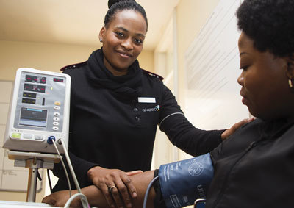

Question 1

Are the models of funding healthcare exclusive or complementary? Through which model is the funding of healthcare mainly provided around the world?

Provide your answer...
View discussion - Question 1

Question 2

How does the social health insurance (SHI) model work?

Provide your answer...
View discussion - Question 2

This section has provided an overview of the tools available to raise financial resources in the case of Public limited companies. Stock and bond issuance involve establishing relationships with financial markets. The last part of the section introduced some important issues in the case of public sector financing. You now have a fairly comprehensive overview of the main ways in which different organisations can and do raise financial resources. The next section focuses on how these resources can be employed to support organisations’ goals.

4 Decision making in the process of business financing
Having been introduced to the key sources of funding for both private and public sector organisations, you will now turn to the logical counterpart: the ways in which organisations, in particular businesses, deploy the finances raised.
Any decision made by an organisation should be consistent with its specific goals. In what follows, the relationship between types of funding and the business’ plans will be further clarified. Namely, you will be introduced to the main types of business expenditures and their role in generating revenue, ultimately sustaining the goals of shareholder-wealth maximisation. You will then look at ways of expanding a business, ending with a discussion on the main options available to companies once they generate revenues from their activities.

4.1 Financial resources and the main categories of expenditure
One common feature of any business is the occurrence of specific expenditures during their operations. This feature is similar to what happens in families, which in order to ‘function’ have to think about spending on day-to-day goods and services or on big expenses like a house. Similarly, business expenditures can represent either one-off or recurrent outlays and apply to almost every form of organisation. They can be broadly divided into two categories: revenue expenditures and capital expenditures.

Revenue expenditures
Revenue expenditures (also referred to as operating expenditures), identified by the acronym REVEX in accounting, refer to those expenditures that are incurred by a business in the daily running of its activities and whose effect is always short-term (i.e. their benefits are enjoyed by the business within the current accounting year). The most common examples of this type of expenditure are wages and salaries, rent expenses, utility bills, insurance policies, payments for repairs and maintenance, taxes, and interest on borrowed money. Table 12 shows what revenue expenditure looks like in the case of EasyJet Plc. Total expenditure for wages and salaries (highlighted) increased from £570 million for 2017 to £669 million in 2018.

Table 12 EasyJet’s total expenditure for wages and salaries (highlighted) 2017–18
The average monthly number of people employed by easyJet was:
 | 2018 | 2017
 | Number | Number
Flight and ground operations | 12,391 | 10,932
Sales, marketing and administration | 713 | 723
 | 13,104 | 11,655
Employee costs for easyJet were:
 | 2018 | 2017
 | £ million | £ million
Wages and salaries | 669 | 570
Social security costs | 86 | 73
Pension costs | 75 | 61
Share-based payments | 17 | 13
 | 847 | 717
(EasyJet Plc 2018)

Capital expenditures
Capital expenditures, identified by the acronym CAPEX in accounting, refers to those outflows of funds aimed at acquiring or improving the working capacity of any non-current (i.e. long term) asset. They can be seen as a long-term investments to reach future financial gains. The Cambridge Advanced Learner's English Dictionary defines investment as ‘the act of putting money, effort, time, etc. into something to make a profit or get an advantage’.
The investment decision and consequent expenditure is a very important aspect of a business’ functioning. Given that these types of expenses are usually massive, the total amount is ‘capitalised’, which means that the disbursement is spread over the projected residual useful life of the specific asset. An example of a capital expenditure is the purchase of a building or property. This is usually financed through debt, or mortgages. Acquiring or upgrading equipment such as machinery, software, or even vehicles, are other examples of capital expenditures. Table 13 shows the amount of capital expenditures reported in the accounts of EasyJet Plc. Total capital expenditures (highlighted) increased from £586 million for 2017 to £931 million in 2018.

Table 13 EasyJet’s total capital expenditures (highlighted) in 2017–18
 |  | Year ended 30 September | Year ended 30 September
 |  | 2018 | 2017
 |  | £ million | £ million
Cash flows from operating activities
Cash generated from operations |  | 1215 | 949
Ordinary dividends paid |  | (162) | (214)
Interest and other financing charges paid |  | (29) | (30)
Interest and other financing income received |  | 11 | 9
Net tax paid |  | (74) | (51)
Net cash generated from operating activities |  | 961 | 663
Cash flows from investing activities
Purchase of property, plant and equipment |  | (931) | (586)
Purchase of intangible assets |  | (81) | (44)
Net decrease/(increase) in money market deposits |  | 269 | (363)
Proceeds from sale and operating leaseback of aircraft |  | 106 | 115
Net cash used by investing activities |  | (637) | (878)
(EasyJet Plc 2018)

Capital expenditures play a fundamental role in the growth of businesses. They involve investments of large amounts of money, but also carry uncertainty and a commitment over the long term.

4.2 External growth strategies: mergers and acquisitions
In the previous section you saw how a business can expand its capacity through capital expenditures. For example, going back to the increase in EasyJet’s capital expenditure, this will almost certainly increase the number of flights, and hence the overall capacity of the business.
Along with this internal or ‘organic’ growth, companies also have the option to grow ‘externally’. Typically, companies will search for a balanced mix of internal and external growth. Despite being a more complex growth strategy, it could represent an opportunity to those companies that have exhausted other ways of increasing the scope of their businesses. In this section you will be introduced to the most common ways to pursue this type of expansion, and also see how these are usually financed.
One of the key options available to companies willing to expand the business is via mergers and acquisitions (M&As). In a merger, two companies (usually a leading and a target one) agree to ‘amalgamate’ themselves into a new company, sometimes under an entirely new name. An acquisition happens when one company purchases another one. The purchased company could be entirely absorbed, thus ceasing to exist, or it could continue to function independently, sometimes also keeping its original name. Mergers can be generally classified into three groups:

1. Horizontal mergers
Horizontal mergers are a combination of two companies operating in the same industry, offering very similar products and/or services, hence in direct competition with one another. For example, think about steel-producing giants Arcelor and Mittal Steel having merged in 2006 to create ArcelorMittal S.A.

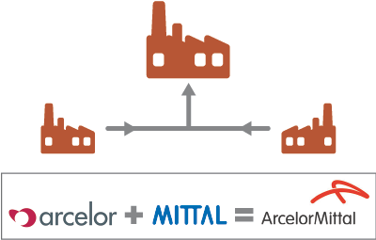

2. Vertical mergers
A vertical merger involves the acquisition of a company operating at different stage of the same supply chain. The post-merger company can expand in both directions, both towards the inputs for production or the final consumers. You might think of a manufacturer buying one of its suppliers. One of the many examples of this type of integration is the acquisition of ABQ Studios (film/TV production) by the streaming platform Netflix in 2018.

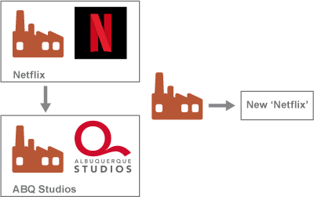

3. Conglomerate mergers
A conglomerate merger is where companies with totally unrelated lines of businesses combine. For instance, think of a record label buying a wholesale food store. One real-world example of an established conglomerate businesses is Virgin Group Ltd. Virgin Group’s activities span across music, banking, rail transport and aerospace services, among other things.

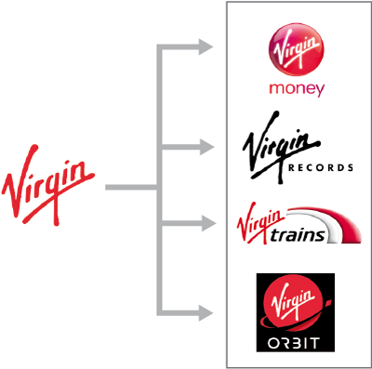

The three main types of mergers correspond to different purposes. In the end, the common motive for all mergers is to add value (i.e. how much the business is worth) by creating synergies – that is, fruitful collaborations. This is possible only if the two or more companies are worth more together than as single entities. There are five key sources of these synergies.
- Economies of scale: a company could become more competitive with respect to other players by increasing its size. The competitive advantage usually comes from the consolidation of business operations and from the reduction of redundant costs.
- Economies of vertical integration are available within the supply chain of a specific product or service. A company might try to control the production process by merging with a supplier of inputs or with a customer. In the last decades, outsourcing (obtaining goods or services by contract from an external supplier) has been the preferred option to establish this type of merger.
- A search for complementary resources is the motive behind a larger company merging with a smaller one. The two have what the other needs; usually the former can provide organisational and marketing skills while the latter has a unique product or service that needs commercialisation.
- Industry consolidations seek efficiency improvements via reducing the number of players in a specific sector.
- Companies, usually mature ones, might be in a situation which generates a stable and substantial amount of cash, but struggle to find profitable investment opportunities. Companies with surplus cash and no attractive investment opportunities might use these funds to finance a merger.

Financing mergers and acquisitions
A variety of funds can be used to finance M&As. Cash represents a simple means of payment for M&As. The best type of financing depends on the financial structure of the two parties involved in the merger or acquisition and, in particular, the total value of their assets and liabilities. The most common way in which M&As are financed is through an exchange of stocks. In this case, the buying company exchanges its stock for shares of the one being sold. Another method is to take on the debt of the company being sold. This provides the buyer with a less expensive way to acquire assets, while reducing the risk for the company being sold.
The other two methods of financing mergers or acquisitions are the issuance of bonds or shares and bank loans. With the former, the buyer asks for financial support from the current shareholders or the general public. The latter can be a relatively expensive way of funding, given both the size of these deals (several millions or even billions) and the cost of the funding, namely the level of the agreed interest rate.

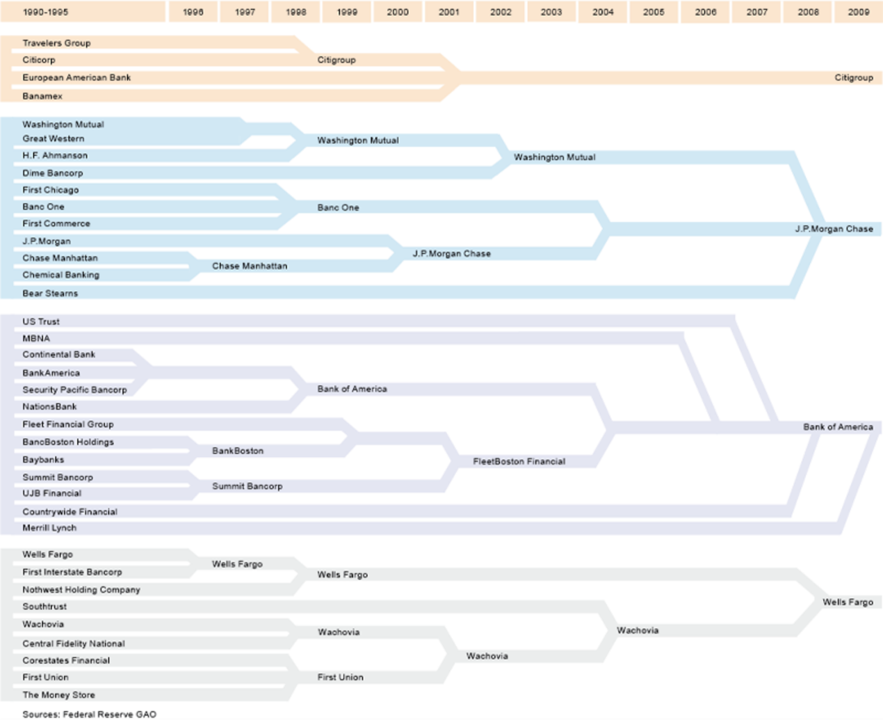
Figure 9 What an industry consolidation looks like: the US banking sector from 1990 to 2009
View description - Figure 9 What an industry consolidation looks like: the US banking sector from 1990 ...

Activity 10 Mergers and the economic system
Allow around 30 minutes for this activity

Read the article ‘Mergers are on the Rise: Is it good for the Economy?’ (The Yale Tribune, 2020).
Do you think the scope of mergers and the overall economic system coincide?

Provide your answer...
View discussion - Activity 10 Mergers and the economic system

4.3 Paying back shareholders: dividend distribution and share repurchase
Companies can also decide to reward their shareholders. The decision as to if and/or how much to pay back shareholders is naturally tied to financing and investment choices. For example, if the management foresees strong opportunities for expanding operations then retaining earnings to fund a new expansion will be preferable to distributing them. Also, if a company chooses to fund its capital investment, for instance via a bank loan, then this will free resources that could be handed back to shareholders.
Shareholders can be rewarded in two ways.
- Companies can decide to pay dividends to shareholders. This can be either recurring (usually quarterly) or a one-time (special) distribution, and generally takes two forms: cash or stock dividends.
  - Cash dividends are the most common type. These are payments made by a company out of its profits to shareholders according to their percentage of shareholding.
  - Stock dividends consist in an increase in the number of shares of a company, with the new shares being distributed to existing shareholders – based on a percentage applied to their shareholding. For example, if the company were to issue a stock dividend of 3%, then a shareholder will receive three shares for every 100 shares hold. The effect of a stock dividend is an increase in the total shares outstanding.
- Second, instead of distributing dividends, companies can repurchase their previously issued stock from existing shareholders. The main purpose of a share-repurchase (or buyback) is to improve the value of the shares, and to increase the payments to shareholders. In fact, if the company pays a fixed yearly dividend then when the total number of shares decreases each shareholder will receive a larger dividend. There are three main methods for repurchasing shares: open-market repurchasing, tender offers and targeted repurchases.
  - Open-market repurchases are by far the most common type. Companies announce their intention to buy their own stock on the secondary market, acting as if they were a third-party investor.
  - Tender offers are a type of repurchase where the company offers to buy back a specific number of shares at a specified price that is set at a substantial premium with respect to the market level (usually from 10% to 25%).
  - Targeted repurchases is a technique whereby a company buys back its own stock, typically at a substantial premium, from a potential buyer in order to forestall a hostile takeover.
Since share repurchases reduce the total number of outstanding shares, this results in an increase in earnings per share, and usually (but not inevitably) an increase in share price. Table 14 shows the change in earnings per share after Company XYZ decides to buy back 10,000 shares.

Table 14 Earnings per share before and after share repurchase
 | Before buyback | After buyback
Total shares outstanding | 100,000 | 90,000
Earnings | 180,000 | 180,000
Earnings per share | 1.80 | 2.00

The total shares outstanding after this repurchase are 90,000. Assuming that the earnings remain stable, the earnings per share (equal to earnings divided by the number of shares outstanding) will increase from 1.80 to 2.00 before and after the buyback respectively.

Activity 11 Share repurchases through the magnifying glass
Allow around 50 minutes for this activity

From the 1980s there has been a general reduction in the proportion of companies distributing dividends, and a persistent rise in share buybacks. Read the article ‘Should the US rein in share buybacks?’ (Palladino and Edmans, 2018) in which a business professor and an economist argue for and against the corporate spending extravaganza.

Question 1

Populate the table below with what you think are the main reasons for and against buybacks, as discussed in the article.

Table 15 Thumbs up or down for buybacks
Reasons to restrain in share buybacks | Reasons to continue share buybacks
Provide your answer... | Provide your answer...

Question 2

Who out of the two authors of the article do you think provides the most convincing argument and why?

Provide your answer...
View discussion - Question 2

4.4 Decision making in practice: a scenario-based adventure
In the following activity, you will take decisions about the best sources of finance at different stages of development for an innovative new business idea. Of course, the situations, decisions, and their consequences are simplified versions of how they exist in the real world. However, you will get a sense of the variables that businesses have to consider when deciding the most appropriate type of funding.

Activity 12 Funding your way: decision making for a new business idea
Allow around 20 minutes for this activity

Introduction

You are developing a potentially exciting and innovative idea. Each choice you make will contribute to an overall score, which will be revealed to you at the end of your business journey. The higher your score, the more efficient your decision making has been. Accompanying you at each step will be your business advisor who will help you think about the consequences of the choices you make. If you make a decision that isn’t the best fit for the business, your advisor will be there to help you to rethink your position.
Choose your player to read out about your big idea, then progress through each step by making your decision and calling your advisor who will advise you on whether you should progress your project or reconsider your course of action. Will you be able to take the right decisions at the right time and to drive the business from an idea with potential to real success? Good luck!

Interactive content is not available in this format.

5 End-of-course quiz
Well done – you have reached the end of the course. You can now check what you’ve learned by taking the end-of-course quiz.
End-of-course quiz
Open the quiz in a new tab or window by holding down Ctrl (or Cmd on a Mac) when you click on the link. Return here when you have finished.

Conclusion
In Sections 1 and 2, you explored the main financial resources available to business organisations and considered their suitability in terms of specific business structure and goals. You should now be familiar with the key issues to be considered when choosing between internal or external financing, and between short-term or the long-term finance.
In Section 3 you learned about the main features of corporate stock and bond financing. Although they are both external means for long-term financing, these two sources of finance carry different commitments for the companies, and different expectations from the investors. You also looked at aspects of public sector financing.
Finally, Section 4 focused on the main ways in which businesses spend the finance they have raised. You were introduced to revenue and capital expenditures, dividends and share repurchases, as well as to expenditures for external growth strategies such as M&As.
This OpenLearn course is an adapted extract from the Open University course B294 Financial analysis and decision making.

References
EasyJet Plc (2018) The warmest welcome in the sky. Available at: http://corporate.easyjet.com/~/media/Files/E/Easyjet/pdf/investors/results-centre/2018/2018-annual-report-and-accounts.pdf (Accessed: 23 December 2019)
McKenna, H., Dunn, P., Northern, E. and Buckly, T. (2017) ‘How health care is funded’, The King’s Fund. Available at: https://www.kingsfund.org.uk/publications/how-health-care-is-funded (Accessed: 14 October 2019).
McLeay, M., Radia, A. and Thomas, R. (2014) ‘Money creation in the modern economy’, Bank of England Quarterly Bulletin, Q1. Available at: https://www.bankofengland.co.uk/quarterly-bulletin/2014/q1/money-creation-in-the-modern-economy (Accessed: 11 October 2019).
Palladino, L. and Edmans, A. (2018) ‘Should the US rein in share buybacks?’, Financial Times, 9 December. Available at: https://www-ft-com.libezproxy.open.ac.uk/content/22c3269c-f7cf-11e8-a154-2b65ddf314e9 (Accessed: 14 October 2019).
The Yale Tribune (2020) Mergers are on the Rise: Is it Good for the Economy?. Available at: https://campuspress.yale.edu/tribune/mergers-are-on-the-rise-is-it-a-good-thing-for-the-economy/ (Accessed: 2 September 2020).

Acknowledgements
This free course was written by Daniele Tori. It was first published in September 2020.
Except for third party materials and otherwise stated (see terms and conditions), this content is made available under a Creative Commons Attribution-NonCommercial-ShareAlike 4.0 Licence.
The material acknowledged below and within the course is Proprietary and used under licence (not subject to Creative Commons Licence). Grateful acknowledgement is made to the following sources for permission to reproduce material in this free course:

Images/Tables
Course image: © Daniil Peshkov | Dreamstime.com
*** Logos copyright of their respective owners

Section 1
Introduction: Image by Arek Socha from Pixabay
Retained earnings: maximstepanov / 123rf
Bank finance, top image: Schwadron /www.cartoonstock.com
Bank finance, bottom image: Photo by Nigel Tadyanehondo on Unsplash

Section 2
2.1 Crowdfunding: vectortone/ 123rf

Section 3
3 Company financing: stock and bond issuance, Figure 3: Photo by Aditya Vyas on Unsplash
3.1 The stock and bond markets, Figure 4: Adapted from Abdou Chibah / 123rf
3.2 Stock issuance: Adapted from Gustavo Frazao / 123rf
Initial public offerings, Figure 6: Richard Drew/AP/Shutterstock
3.3 Bond issuance, top image: Dana Rothstein | Dreamstime.com
3.3 Bond issuance, Figure 7: Cardiff University of Wales
The secondary market for bonds, Figure 8: Schley / www.CartoonStock.com
3.4 A bird’s-eye view on public-sector financing, top image: Photo by Nik MacMillan on Unsplash
3.4 A bird’s-eye view on public-sector financing, Activity 9 image: Photo by Hush Naidoo on Unsplash

Section 4
4.1 Financial resources and the main categories of expenditure, Table 12: Easyjet Plc annual accounts 2018 : easyjet plc
4.1 Financial resources and the main categories of expenditure, Table 13: Easyjet Plc consolidated statement of cashflows 2018: easyjet plc
Financing mergers and acquisitions, Figure 9: John Colon,Only the strong survive 9 Dec 2015 blogs.thomsonreuters.com/answerson/strong-financial-institutions-survive/ (accessed 5 March 2020)
4.4 Decision making in practice: a scenario-based adventure: Image: Girl with laptop picture: ***Image by StockSnap from Pixabay
4.4 Decision making in practice: a scenario-based adventure: Sebastian: PeopleImages / iStock
4.4 Decision making in practice: a scenario-based adventure: drawing: simonkr / iStock
4.4 Decision making in practice: a scenario-based adventure: facial expressions: ozgurdonmaz / iStock
4.4 Decision making in practice: a scenario-based adventure: 3D printer: kynny / istock
4.4 Decision making in practice: a scenario-based adventure: Adapted from kynny / iStock
4.4 Decision making in practice: a scenario-based adventure: packages: undefined / iStock
4.4 Decision making in practice: a scenario-based adventure: blackboard : BrianAJackson / iStock

Audio/Video
Video 1: Courtesy of Bank of England, taken from The Bank of England's YouTube Channel, https://youtu.be/CvRAqR2pAgw
Video 2: The Open University
Every effort has been made to contact copyright owners. If any have been inadvertently overlooked, the publishers will be pleased to make the necessary arrangements at the first opportunity.
Don't miss out
If reading this text has inspired you to learn more, you may be interested in joining the millions of people who discover our free learning resources and qualifications by visiting The Open University – www.open.edu/openlearn/free-courses.

Solutions

Activity 1 Where does money come from?

Part

Discussion
The banking system is at the heart of the creation of money. In fact, almost all the money in the economy is directly created by banks, in the form of bank deposits, created in the exact moment banks concede loans.
In the words of the Bank of England:

Commercial [i.e. high-street] banks create money, in the form of bank deposits, by making new loans. When a bank makes a loan, for example to someone taking out a mortgage to buy a house, it does not typically do so by giving them thousands of pounds worth of banknotes. Instead, it credits their bank account with a bank deposit of the size of the mortgage. At that moment, new money is created.
(McLeay, Radia and Thomas, 2014 p. 16, bold in the original)

If you would like to read more about how money is created, you can find details of the article cited in this video, ‘Money creation in the modern economy’, in the References section.
Back to - Part

Activity 2 Disadvantages of debt factoring and invoice discounting

Discussion
In both debt factoring and invoice discounting, if customers do not honour their debts, then the business will have to pay off the funds that the factoring or discounting company has advanced in addition to the fees. Moreover, in the specific case of factoring, since the business cannot control the way in which the factoring company deals with the customer, there can be some degree of reputational risk (e.g. customers might not like the way in which the factoring company collects payments).
Back to - Activity 2 Disadvantages of debt factoring and invoice discounting

Activity 3 Working capital in practice

Question 1

Discussion
The working capital of Cullen’s is equal to current assets minus total current liabilities, or −£300,000. Therefore Cullen’s shows a negative working capital.

Table 3 Cullen’s current assets and liabilities
Cullen’s current assets | Cullen’s current liabilities
- Cash in the bank: £850,000  - Accounts receivables: £700,000  - Inventory: £950,000  Total current assets = £2,500,000 | - Accounts payables: £2,500,000  - Short-term debt: £300,000  Total current liabilities = £2,800,000

Cullen’s working capital = current assets − current liabilities =
£2,500,000 − £2,800,000 = −£300,000

Back to - Question 1

Question 2

Discussion
Operating with negative working capital is not intrinsically a bad condition, and it is fairly common in grocery stores. In fact, these businesses can generate cash very quickly. This is because in food retailing, goods are turned into cash at the checkout counters long before the suppliers are due to be paid. This allows such organisations to manage their cash flows with the intention of using them to provide liquidity, with the creditors providing an interest-free loan for the business.
Back to - Question 2

Activity 4 Which type of organisations could benefit from alternative ways of financing?

Discussion
The most common example of organisations suited to this type of finance are non-profits, charities, social enterprises or start-ups looking for funding to sustain small-scale projects, campaigns, or a new product. Even individuals usually refer to P2P lending or crowdfunding to sustain small-scale projects. Crowdfunding has been very important in the music industry as well. If you have time, have a look at this story about crowdfunding in music.
Back to - Activity 4 Which type of organisations could benefit from alternative ways of financing?

Activity 5 A comparative view of sources of finance

Part 2

Discussion
- Bank loans represent the major source of funds for SMEs in the UK, the USA, and Japan. Chinese SMEs rely relatively more on leasing and hire purchase as sources of finance.
- VC is a relatively minor source of finance in all four countries (from 1% to 6%).
- Leasing and hire purchase finance are very important in the USA and China.
- Factoring and invoice discounting are approximately three times larger in China and Japan than in the UK and USA.
- The figures are only indicative as they refer to a specific period of time. However, they can provide a useful insight about the differences in the ways in which business financing takes place in different countries.
Back to - Part 2

Activity 7 Equity finance in practice

Question 1

Discussion

Table 6 Advantages and disadvantages (completed)
Staying private |  | Going public
Advantages | Disadvantages | Advantages | Disadvantages
- Higher degree of control of the business  - Preserving the organisation’s culture | - Limit to cash resources  - Less attractive to new talent | - Access to large amounts of funding  - Increased growth potential  - Improved reputation | - Scrutiny from the relevant exchange commission  - Accountability to shareholders  - Partial loss of control  - Expensive and time-consuming

Back to - Question 1

Question 2

Discussion
Given both the information provided and the main advantages and disadvantages for the two options, in the case of DrinkIT it would be preferable to go public. However, management should be aware of the effort it will have to put into the processes required for DrinkIT to go public, and the challenges this may pose for the business plan.
Back to - Question 2

Part B Facebook’s ‘botched’ IPO: what went wrong and why?

Discussion
One interpretation of Facebook’s botched’ IPO could be that going public was the right choice in order to grow the business. However, investors overvalued the company with respect to its fundamentals (e.g. data about earnings and sales growth, market share, etc.). Facebook’s valuation reached over 100 times its revenues. After the initial ‘euphoria’, investors acknowledged the discrepancy between the earnings (coming entirely from selling adverts) and its astonishingly high valuation. The share price started to lose value, reaching a new, disappointing, level.
Back to - Part B Facebook’s ‘botched’ IPO: what went wrong and why?

Activity 8 The basics of bonds

Answer
The correct matches are:
The value that appears on the bond certificate, usually equal to £100
Face value
The price at which the bond market is selling or buying the bond
Market value
The end of the fixed lifetime of a bond, usually between 1 and 30 years
Maturity
The contractual regular income the lender (or bondholder) expects to receive
Coupon
Bonds that pay no interest during their term, are issued at a discount to par and redeemed at par on maturity
Zero coupon bond
A special type of hybrid bond that gives the investor the right to exchange the debt for the equity of the issuer
Convertible bond
Bond in which the coupon is re-fixed (typically quarterly, monthly, or half yearly), with reference to a fixed margin, for example the LIBOR
Floating rate bond
Back to - Activity 8 The basics of bonds

Activity 9 Funding national health systems

Question 1

Discussion
Countries typically use one of the three main funding models as the principal way of paying for healthcare alongside elements of the others. No country relies on one method alone: they use complementary methods to fund it. In general, countries rely mainly on taxation to fund healthcare. Tax-funded models typically seek to pool risk across large sections of a population and make health services available on a universal basis.
Back to - Question 1

Question 2

Discussion
In classic SHI models, members (normally employees) contribute a proportion of their salary, the level of contribution being related to income rather than risk of illness. Employee contributions are typically matched by employers.
Back to - Question 2

Activity 10 Mergers and the economic system

Discussion
The rising trend of M&As in the US (and worldwide) raises crucial questions in terms of their effect on the economic systems. While the benefits range from enhanced efficiency and growth, increasing debt and market power are examples of potential negative effects. The effects of M&As on the economy ultimately depends on considerations about companies’ motives and plans, as well as on the specific institutional setting in which they develop.
Back to - Activity 10 Mergers and the economic system

Activity 11 Share repurchases through the magnifying glass

Question 2

Discussion
You should try to build your argument on the two positions in the article by applying what you have learned so far about sources and uses of financial resources. Keep in mind that share buybacks should be seen in the context of the alternative uses of finance, and the trade-offs they imply.
Back to - Question 2

Figure 1 The process of factoring

Description
Figure 1 outlines the process of debt factoring for Flash Trucks, a fictional delivery firm. The figure shows a timeline from January to March. There are five steps along the time line. When each step is clicked, the following description is revealed.
Step 1, January. Flash Trucks delivers the machinery to the customer: Flash Trucks is a delivery company based in the UK. It has to deliver pieces of heavy machinery to a customer in January and has agreed to charge £10,000 for this service
Step 2, January. Agree delayed payment with customer: The customer agrees with Flash Trucks on a payment for the delivery delayed to the following 31st of March
Step 3, January. Factoring company buys rights to collect the receivables: The ‘factor’ (a factoring company) buys the right to collect the money Flash Trucks is owed. The factor legally owns the receivables and obtains all of the rights associated with them. Almost immediately, the factor pays to Flash Trucks a certain percentage of the total value of the product sold (typically no more than 90%). Let’s assume in this case the factory pays to Fast Truck 70% of the total value (i.e. 70% of £10,000= £7000).
Step 4, early March. Payment due from customer: When the payment is due, the customer will pay the factor directly, and Flash Trucks receives the remaining share of the value of the service provided (e.g. the remaining 30% of £10,000, i.e. £3000).
Step 5, end of March. Fee due to factoring company: Finally, Flash Trucks pays a fee to the factoring company for the service provided (typically around 3% of the value of the sale, i.e. £300 in this example). Factoring avoids the potential issues businesses can experience due to delayed payments from customers.
Back to - Figure 1 The process of factoring

Figure 2 The relative average weight of SMEs’ funding in the UK, USA, China and Japan

Description
Four pie charts representing the relative average weight of SMEs’ funding sources in four countries, for the period 2013–16. For the UK: outstanding business loans (78%), venture capital investment (1%), leasing and hire purchases (12%), factoring and invoice discounting (9%). For the USA: outstanding business loans (52%), venture capital investment (6%), leasing and hire purchases (36%), factoring and invoice discounting (6%). For China: outstanding business loans (33%), venture capital investment (3%), leasing and hire purchases (37%), factoring and invoice discounting (27%). For Japan: outstanding business loans (71%), venture capital investment (1%), leasing and hire purchases (7%), factoring and invoice discounting (21%).
Back to - Figure 2 The relative average weight of SMEs’ funding in the UK, USA, China and Japan

Figure 4 Top ten stock exchanges according to market capitalisation

Description
Figure 4 shows a map that locates the ten largest stock exchanges as of 2018 according to market capitalisation. The names, locations and sizes (US$) of these exchanges are: New York Stock Exchange (NYSE), New York, $23.12 trillion; NASDAQ, New York, $10.93 trillion; Tokyo Stock Exchange, Tokyo, $6.22 trillion; Shanghai Stock Exchange, Shanghai, $5.01 trillion; Honk Kong Stock Exchange (HKEX), Honk Kong, $4.46 trillion; London Stock Exchange (LSE), London, $4.38 trillion; Euronext, Amsterdam, $4.36 trillion; Shenzhen Stock Exchange, Shenzhen, $3.49 trillion; Toronto Stock Exchange (TSX), Toronto, $2.29trillion; Deutsche Boerse, Frankfurt, $2.22 trillion.
Back to - Figure 4 Top ten stock exchanges according to market capitalisation

Figure 5 Asset trading in the financial markets

Description
Figure 5 shows the three key stages of an asset trading in the financial markets. Each stage is indicated by a tab. The first tab, titled ‘Stock or bond issuance’, reads: ‘The company issues a stock or a bond’. The second tab, titled ‘The primary market’, reads: ‘The new financial asset is put on exchange’. The third tab, titled ‘The secondary market’, reads: ‘The financial asset previously issued is traded between investors’.
Back to - Figure 5 Asset trading in the financial markets

Figure 9 What an industry consolidation looks like: the US banking sector from 1990 to 2009

Description
The image shows a timeline going from left to right, for the period 1990 to 2009. The image shows that the number of companies in the US banking system has been reduced by mergers and acquisitions (industry consolidation).
Back to - Figure 9 What an industry consolidation looks like: the US banking sector from 1990 to 2009

Video 1 The Bank of England on money creation in the modern economy

Transcript
INTERVIEWER:
Ryland, your article is about how money gets created. We're surrounded here by gold in the vaults of the Bank of England. And historically in the gold standard, the amount of gold would have been related to the stock of money in the economy. Things are very different now. In the modern economy, where does money come from?
RYLAND THOMAS:
Well, let's start off with narrow or central bank money. As the name suggests, central bank money is determined by the Bank of England and consists of notes and reserves. And in normal times at least, notes and reserves are determined by the amount of notes that people want to hold or need for their transactions and the amount of notes and reserves that banks want to hold given the level of interest rates in the economy. It is not chosen or fixed by the central bank as is sometimes described in some economics textbooks.
INTERVIEWER:
Your article focuses on broad money. What determines how much of that there is?
RYLAND THOMAS:
Well, broad money, which in many ways is a better measure of the amount of money circulating in the economy, includes all the bank deposits of households and companies. And one of the key points of the article is that banks create additional broad money whenever they make a loan.
Now while this is nothing new, it is sometimes overlooked as the main way in which money is created and it runs contrary to the view sometimes put forward that banks can only lend out deposits that they already have. In fact, loans create deposits - not the other way around.
INTERVIEWER:
Now your article explains in more detail how lending creates money. It also explains how there are limits to how much banks are likely to create new money as a result of lending. These could be profitability considerations of the banks themselves through to how households and companies react in aggregate to having increased deposits as a result of higher lending.
RYLAND THOMAS:
That's right.
INTERVIEWER:
So if banks create money through lending, what then is the role of the monetary policy of the central bank in this story?
RYLAND THOMAS:
Well, you mentioned some of the limits to how much banks will lend in practice. Well, monetary policy provides the ultimate limit. Now in normal times-- say, before the Great Recession-- monetary policies is set through interest rates, and that determines the loan rates that are faced by borrowers in the economy and the amount of interest that banks pay out to depositors. And this directly affects the amount of lending that goes on in the economy and the amount of broad money that's created as a result.
Back to - Video 1 The Bank of England on money creation in the modern economy

Video 2 The process of an IPO

Transcript
The initial step for the company would normally be to appoint a lead bank or possibly a small number of co-leads in case the issuance is particularly large, to advise it through the listing process, and to manage the sale of shares to investors. The lead bank, or the co-leads, would usually be expected to underwrite the transaction, in effect, committing to buy those shares not subscribed by investors on the launch date.
Simultaneously, the company would appoint legal advisors to take charge of the documentation requirements. At this stage, other banks can be invited into the transactions to work under the lead or co-leads.
Next, the company must decide which stock exchanges to list the shares on. Among the key determinants of this choice will be the relative costs, where the company is domiciled, and, particularly in the case of a multinational company, where it conducts the largest volume of its business.
The second stage of the process involves the compilation of an issuing prospectus that must be reviewed by the relevant regulator. In the UK, this would be the Financial Conduct Authority, or FCA. And in the USA, this would be the Securities and Exchange Commission, or SEC. The information contained in the prospectus would include details of the company financial performance in the recent past, usually up to five years, and projections for future business performance.
Part of the process of producing the prospectus involves what's known as due diligence - where the company financial performance, current financial standing, and future plans are subject to review by the lead bank or co-leads underwriting the transaction. Particular focus is placed on the viability of the company business plan since the success of this will critically influence both the company's share price and the dividends in the years after the IPO.
Ahead of the launch, the company and the lead bank or co-leading banks would be likely to roadshow the issue, making presentations to groups of institutional investors such as pension funds and hedge funds. After assessing market sentiment, the lead bank and other members of the syndicate of banks can advise on the appropriate price to offer the shares. This is often a range rather than a specific price.
The underwriting bank can see how much interest there is from investors and where within the price range they're prepared to buy. The book of bids for the shares at prices within the range can then be built up. In doing this, the company will know where it should price to sell it shares. The exact price can then be set, and the issue launched.
This process of book building to determine the share price is a practise that's spread to other major financial markets from the US. This is perhaps not surprising, given that US investment banks dominate the international markets.
Back to - Video 2 The process of an IPO

Video 3 Facebook’s ‘botched’ IPO: what went wrong and why?

Transcript
INTERVIEWER
And we tackle some of the questions and investigations surrounding all this with Anant Sundaram, he teaches business administration at Dartmouth's Tuck School of Business, and Rob Cox, US editor of Reuters Breakingviews, a financial news website. Well, Rob Cox, so when we start to look at what went wrong, start with Morgan Stanley and the other underwriters. What's their role, and what questions are there now for them?
ROB COX
Well, in any IPO, what you try to do is balance the demand for the stock from institutional investors like big pension funds and hedge funds, and some retail investors. You try to get the right balance so that you price it appropriately so that in the first day of trading, it doesn't go way up in the sky and pop like it used to back in the big internet IPO days of the late '90s, but also sort of doesn't decline like we've seen with Facebook. And it's a really delicate balance, it's a very difficult job. But generally you try to get it right so that everybody's happy at the end of the day. You don't have four days later, everybody talking about a botched IPO, a problematic IPO. You don't have Mary Schapiro and the SEC and all sorts of regulators jumping in on it. And that clearly didn't happen in this case.
INTERVIEWER
Anant Sundaram, what would you add - these questions about what the underwriter has to tell potential investors, when, what kind of information is important? What would investigators be looking at in a case like this?
ANANT SUNDARAM
It is at this moment alleged that there might have been some information asymmetry that might have been exploited by some with favoured access to that information. I have only seen allegations so far. But let me first say that yes, there is a lot of criticism about this IPO and Morgan Stanley. But from an issuer standpoint, we have to recognise that this was a huge success. And Morgan Stanley's job, we should recognise, is to maximise the proceeds to the issuer. So to some extent, I find that part of the commentary a bit baffling.
But back to the information asymmetry issue, what is being suggested is that perhaps in the last minute, there was some information that might have been given to analysts at Morgan Stanley and a couple of other underwriter firms, that might have enabled them to revise their forecasts in their valuation models, thereby making institutional investors pull back on their demand for the IPO.
Now I find it extremely surprising that something like that would happen. But we don't know what the facts are. But I will say this. Facebook filed many amendments to its prospectus right up until the final date of the IPO, which I think was May 18. And they explicitly stated that their revenue has been declining from 155% all the way down to 45%, and that they continued to see declines.
Now it is not clear to me what an investor looking at that would have guessed, other than to say, well, they expect it to decline further. So it's a bit of a fine line, but we don't have all the facts.
INTERVIEWER
Well, Rob Cox, help us out here. What is the problem, then? Where do you look at with what Facebook did say or didn't say, or Morgan Stanley did or did not say?
ROB COX
Look, I take your point, Anant, about the idea that the issuer in this case, Facebook and the venture capitalists and the people behind Facebook with earlier supporters, had sold woohoo, 38 bucks a share, $16 billion of stock. But on day two, Mark Zuckerberg, the CEO and founder, who only sold stock in so far as he was dealing with tax issues, and all the 3,000 some odd people who are at Facebook, they've got to live with this company going forward. So what might have been a quick win for the backers of venture capitalists here, I think it's a real loss for Facebook.
We're sitting here talking about how Facebook is sort of up there with Morgan Stanley and the Wall Street money grubbers, as it were, rather than how Facebook is connecting 900 million people around the world, our ex-girlfriends, our old bosses, our parents, all those kinds of things. The very thing that Mark Zuckerberg tried to avoid by really taking himself out of the frame with the IPO. And remember, he said all along, I'm only doing this for my investors and my employees who want liquidity with the stock.
In a sense now, he's got more distractions than he bargained for. He's got lawsuits, he's got litigation. He's got Mary Schapiro, he's got the SEC, he's got us talking about it on television. And we're not talking about what a great creation it is, but what a botched IPO it is. So I just sort of would balance yes, it was a great deal financially for a few people. But on the broader term, this is not a great thing for Facebook going forward.
INTERVIEWER
Well, Anant Sundaram, what does history tell us about these kinds of IPOs, if there is any good analogy? Is it too early to tell about its success or failure?
ANANT SUNDARAM
Yes, it is too soon to tell us about its success or failure. But we do have considerable evidence on long run performance of IPOs in the academic finance literature. In general, on average, IPOs underperform over a three to five year horizon, it actually turns out. But actually, if the evidence again, on average, is to be believed, that the empirical evidence is pretty strong, that it's the stocks that are large IPOs such as Facebook that actually tend to outperform, and also stocks that are taken public by higher quality within courts, in which bankers, such as Morgan Stanley or Goldman Sachs, are supposed to sort of second tier. And with some bankers, the evidence shows that the extent of the underperformance is less.
My personal view is, six months from now, one year from now, which is really what an investor should care about from the point of view of his or her holding and wealth creation, and what the intrinsic value of this business is, six or seven months or ten months or one year from now, I think we will have forgotten the first few days. And the focus really will be on whether they're executing their strategies as they need to, and the fundamentals of where they are implied by this valuation.
INTERVIEWER
Well, Rob Cox, briefly, what do you think? We use the word investors. Let me put it in sort of small investors that we're talking about. What do you think small investors should learn from all this?
ROB COX
Well, there is a two tiered market in this country. And $100 billion of value was created before this thing went public. It was created for about 1,000 people or institutions. And retail investors were really not one of them. The retail investors are getting a bit of the drag of the market, because you can keep funding these companies through their best growth cycle, and they're not getting a great deal. I would say for IPOs it's a bad game to play if you're a retail investor generally. Wait it out as an onset. In a year, we'll see whether Mark Zuckerberg is able to execute on his strategy to make money from this fabulous creation of his.
INTERVIEWER
All right. Rob Cox, Anant Sundaram, thank you both very much.
Back to - Video 3 Facebook’s ‘botched’ IPO: what went wrong and why?

