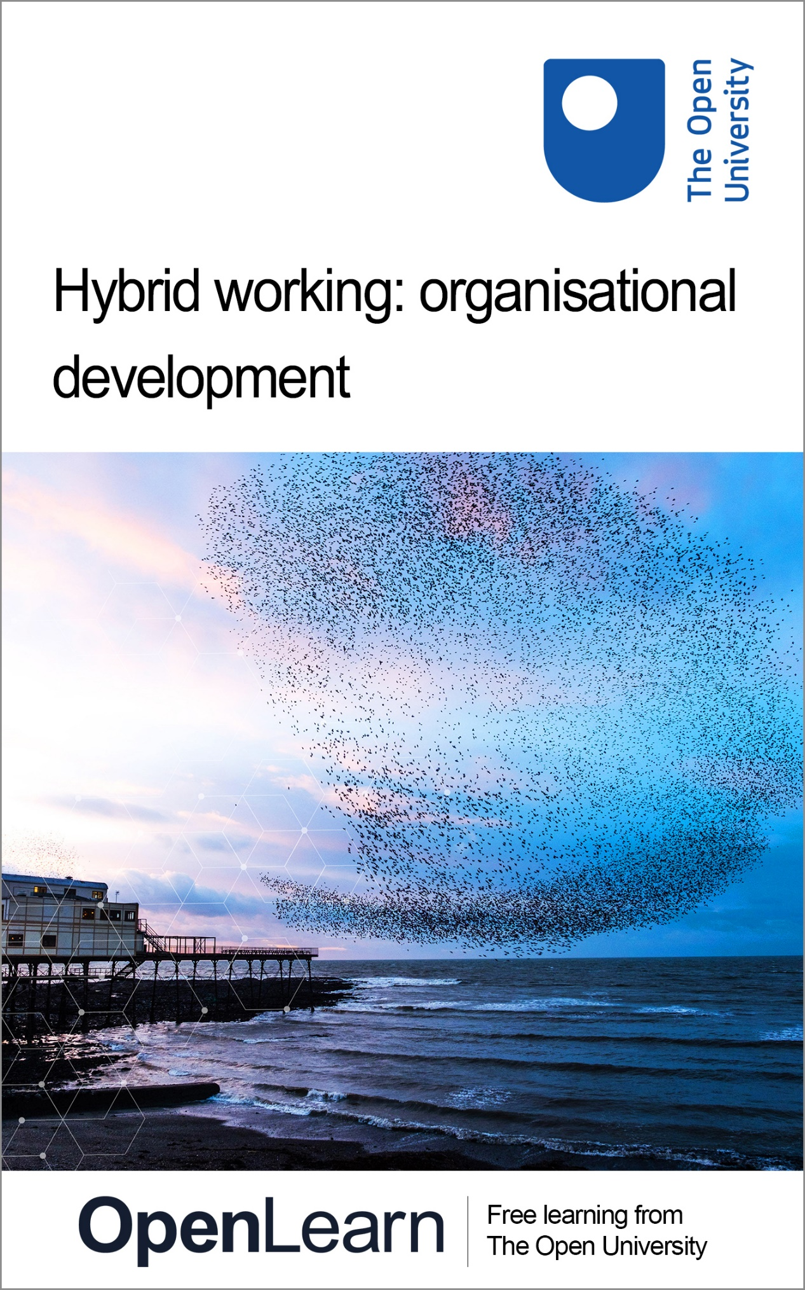

HYB_1

Hybrid working: organisational development

About this free course
This version of the content may include video, images and interactive content that may not be optimised for your device.
You can experience this free course as it was originally designed on OpenLearn, the home of free learning from The Open University – https://www.open.edu/openlearn/money-business/hybrid-working-organisational-development/content-section-0
There you’ll also be able to track your progress via your activity record, which you can use to demonstrate your learning.
Copyright © 2022 The Open University
Intellectual property
Unless otherwise stated, this resource is released under the terms of the Creative Commons Licence v4.0 http://creativecommons.org/licenses/by-nc-sa/4.0/deed.en_GB. Within that The Open University interprets this licence in the following way: www.open.edu/openlearn/about-openlearn/frequently-asked-questions-on-openlearn. Copyright and rights falling outside the terms of the Creative Commons Licence are retained or controlled by The Open University. Please read the full text before using any of the content.
We believe the primary barrier to accessing high-quality educational experiences is cost, which is why we aim to publish as much free content as possible under an open licence. If it proves difficult to release content under our preferred Creative Commons licence (e.g. because we can’t afford or gain the clearances or find suitable alternatives), we will still release the materials for free under a personal end-user licence.
This is because the learning experience will always be the same high quality offering and that should always be seen as positive – even if at times the licensing is different to Creative Commons.
When using the content you must attribute us (The Open University) (the OU) and any identified author in accordance with the terms of the Creative Commons Licence.
The Acknowledgements section is used to list, amongst other things, third party (Proprietary), licensed content which is not subject to Creative Commons licensing. Proprietary content must be used (retained) intact and in context to the content at all times.
The Acknowledgements section is also used to bring to your attention any other Special Restrictions which may apply to the content. For example there may be times when the Creative Commons Non-Commercial Sharealike licence does not apply to any of the content even if owned by us (The Open University). In these instances, unless stated otherwise, the content may be used for personal and non-commercial use.
We have also identified as Proprietary other material included in the content which is not subject to Creative Commons Licence. These are OU logos, trading names and may extend to certain photographic and video images and sound recordings and any other material as may be brought to your attention.
Unauthorised use of any of the content may constitute a breach of the terms and conditions and/or intellectual property laws.
We reserve the right to alter, amend or bring to an end any terms and conditions provided here without notice.
All rights falling outside the terms of the Creative Commons licence are retained or controlled by The Open University.
Head of Intellectual Property, The Open University

Contents
- Introduction
- Learning outcomes
- 1 Thinking about your organisational context now
- 2 Operating in uncertain times
  - 2.1 Dealing with uncertainty
  - 2.2 The problem with problems
  - 2.3 Explore your organisation’s external factors
- 3 Sustainability and wellbeing
  - 3.1 United Nations Sustainable Development Goals
  - 3.2 The Well-being of Future Generations (Wales) Act 2015
  - 3.3 Reducing your carbon emissions
  - 3.4 Digital carbon footprints
  - 3.5 Sustainable development
- 4 How we work now
  - 4.1 The new working environment
  - 4.2 Putting people first
  - 4.3 The evolution of the employee
  - 4.4 Thinking about inclusion
  - 4.5 Generational diversity
  - 4.6 Inclusion considerations for females
  - 4.7 Rural inclusion
- 5 Organisational structures
  - 5.1 Use of space – onsite and remote
  - 5.2 Redesigning space for sustainability
  - 5.3 Using space to work differently
- 6 The digital strategy for Wales
- 7 Digital transformation
  - 7.1 Digital leadership
  - 7.2 Digital inclusion
- 8 Transforming your organisation for the future
  - 8.1 Developing your workforce
  - 8.2 Building a data-driven culture
  - 8.3 Using data for decision making
  - 8.4 Policies and process
- 9 A shorter week: thinking about long-term planning
- 10 Course summary
- References
- Acknowledgements
- Solutions

Introduction
In the last few years, all sectors including the higher education sector have had to react to unprecedented change and uncertainty. The COVID-19 global pandemic required us to continually adapt, as restrictions and guidance changed between 2019 and 2022. Many higher education institutions (HEIs) are reflecting on lessons learned from reactive ways of working during the pandemic and evolving their working practices and policies to consider inclusive and proactive ways of working in a hybrid environment.
This free course, which is part of the Supporting hybrid working and digital transformation collection, is designed to give you the opportunity to consider the environment and context in which you, your team, and your organisation operate, and to encourage you to reflect on whether your current strategies, models, values and culture are fit for purpose. We will signpost the digital skills and capabilities required to meet your objectives in the post-pandemic hybrid working world and will take a holistic approach to wellbeing and sustainability, drawing on the Well-being Future Generations (Wales) Act 2015.
Throughout the course there are documents, reports and articles. While you are encouraged to read these, the timings for activities will provide an indication if you are expected to read them in detail. Some are long and you may wish to save them for future reference and read them in full at a later date.

Learning outcomes
By the end of this course, you should be able to:
- apply the Well-being of Future Generations (Wales) Act 2015 and explain why sustainability and wellbeing need to be integrated into organisational development
- explore pre-pandemic organisational structural norms and analyse how they can be redesigned to support hybrid working and sustainability goals
- identify how digital transformation has accelerated the need for working practices and priorities around digital inclusion
- explore the impact hybrid working has on developing your organisation, including workforce policies and processes and future ways of working.

1 Thinking about your organisational context now
The external environment is still uncertain, as economic, and social stability continue to fluctuate, and the rising cost of living. How you plan and lead your organisation for business continuity and growth is critical to address your short, medium, and long-term needs, aims and objectives.
The framework illustrated below has been designed for this collection to highlight the key areas you need to consider when thinking about organisational development. As many organisations and higher education institutions (HEIs) continue to evolve their hybrid practice, how you work and plan for the long term is essential. You need to balance the needs of your stakeholders and organisation while embracing and adapting to external factors, to successfully meet strategic objectives.

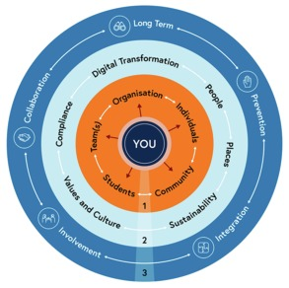
Figure 1: Hybrid ways of working: a contextual sustainability framework
View description - Figure 1: Hybrid ways of working: a contextual sustainability framework

- You and your ways of working should take account of the key stakeholders within your environment and their needs in relation to organisational development.
- You need to understand organisational requirements, the context, connections, and requirements for key areas of focus and how these relate to the needs of your stakeholders.
- You need to consider your ways of working for the wellbeing of future generations.

Activity 1: Thinking about your organisation now
15 minutes

Think about the framework above in relation to your organisation. Do you feel it has a clear approach for new ways of working? Add your vote to the poll below.

Interactive content is not available in this format.

Then take some time to explore Bangor University’s approach to ways of working:
Dynamic Working | Human Resources | Bangor University
In the free text box below list the areas you feel you need to focus on and make notes on Bangor’s ways of working that are of interest to you.

Provide your answer...

2 Operating in uncertain times
During the pandemic organisations’ ability to manage uncertainty became critical. Many had to make decisions and implement complicated changes, including digital transformation at an accelerated pace, to pivot most of the workforce to remote working during lockdowns.
The video below provides some insights from contributors about their experiencing of adapting ways of working during the COVID-19 pandemic.

Video content is not available in this format.
View transcript - Uncaptioned interactive content

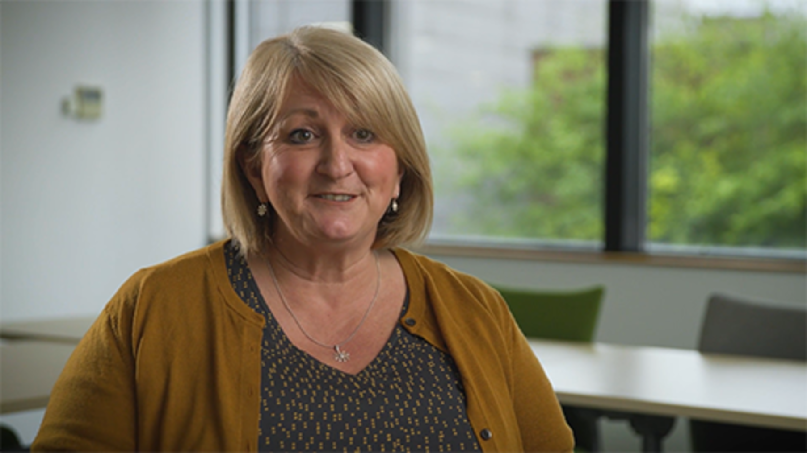

The impact of the pandemic on mental health, inequalities for certain groups in society, the economy and infrastructure are key areas organisations now need to focus on, alongside sustainability and how they can contribute to targets linked to the United Nations Sustainable Development Goals (UN SDGs) (UN, 2022) and reach net zero greenhouse gas emissions by 2050.
Prior to the COVID-19 pandemic, workforce practices were evolving in response to organisational trends in the late-twentieth century.
If you research ‘trends for organisations’ online, you will see a consistent focus on:
- changing workforce and expectations
- authenticity, resilience, and purposeful business
- equality, diversity and inclusion
- flatter, more agile organisations
- sustainability, including climate change, net zero targets and global economic instability
- digital transformation, sometimes referred to as the Fourth Industrial Revolution, and effective use of data (Baker, 2021; Marr, 2021; Kropp and McRae, 2022).

Activity 2: Thinking about your HEI’s experience of dealing with uncertainty
15 minutes

During the pandemic HEIs that had limited or no distance learning provision had to rapidly adapt their delivery models, alongside ensuring those who could work from home did, to ensure continuity of learning for their students.
Consider how your HEI and you as an individual deal with uncertainty. You may wish to make notes in the box below:

Provide your answer...
View discussion - Part

Take some time to research trends within the higher education sector and consider how organisations may need to adapt for the future, and the opportunities that could emerge.
You may wish to explore the following resources to help with your thinking. The Student Crowd page provides a snapshot of how UK universities adapted their modes of teaching in response to COVID-19 restrictions.
- A guide to higher education in Wales
- Future Trends Report Wales 2021: Narrative summary
- University Responses to COVID-19 | StudentCrowd
Then consider the impact of hybrid working for the wider community on:
- the economy and business
- towns and city centres
- issues affecting the workforce, and skills
- health (physical and mental) and wellbeing – see Remote Working: Implications for Wales (linked below)
- inequalities between different groups and different parts of Wales (including those areas with poor connectivity)
- the environment
- the transport network and infrastructure.
You may wish to access the full report:
Remote Working: Implications for Wales
Based on your research and that we are operating with uncertainty, do you agree with the following quote?

‘Universities are well-placed to collaborate with partners across Wales to support our nation’s recovery from the pandemic and build Wales’ future together.’
Universities Wales, 2022

Add your vote to the poll below.

Interactive content is not available in this format.

2.1 Dealing with uncertainty
All organisations must deal with uncertainty, which can be due to internal and/or external factors. While this is a constant element for organisations, it not only can impact an organisation’s ability to thrive, but also the wellbeing of those within it.
Having a robust approach to managing uncertainty requires a clear purpose and vision, and an embedded structure for change to help manage expectations and understanding as to why change is needed, both short term and long term.
Many organisations plan for the short- and long-term future, based on understanding the environment in which they operate.
The VUCA (volatile, uncertain, complex and ambiguous), TUNA (Turbulent, Uncertain, Novel, Ambiguous) frameworks, and the Cynefin Framework focus on sense making for ordered, complex and chaotic systems in time of uncertainty. They are often used by organisations to help make sense of uncertainty, futures planning and approaching change.
The acronym VUCA was used by the US military in relation to the international security environment after 2001 (Stiehm, 2002).

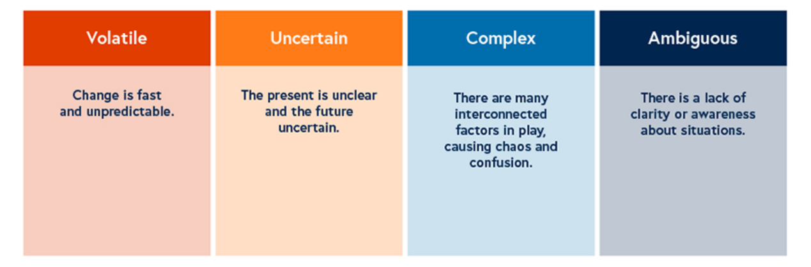
Figure 2: Original VUCA acronym meaning
View description - Figure 2: Original VUCA acronym meaning

This acronym was adapted for business by Bob Johansen (2009) to describe how external forces are disrupting organisations. Bill George (2017) suggested that leaders within organisations who plan for uncertainty need to be authentic, create clarity, and have the courage with their decision and the ability to adapt (Figure 3).

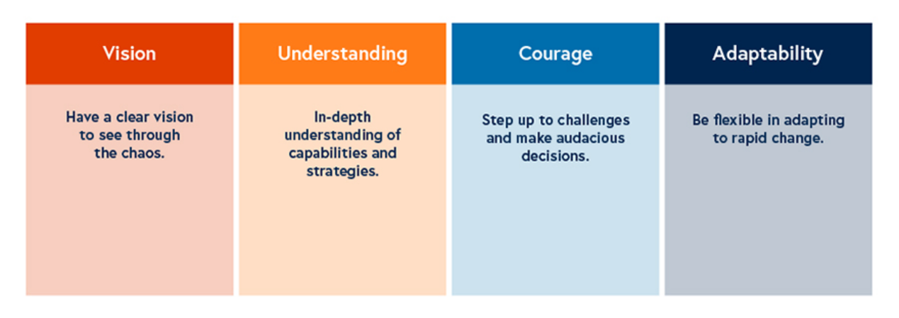
Figure 3: VUCA 2.0 acronym meaning
View description - Figure 3: VUCA 2.0 acronym meaning

TUNA environments is a social theory approach to understanding the conditions of uncertainty, developed by Dr Rafael Ramirez and Dr Angela Wilkinson, within the Oxford Scenario Planning Approach (OSPA). This approach is useful to consider, plan for and respond to rapid and radical change, and can help organisations to develop ‘Strategic re-framing’ for solving problems.

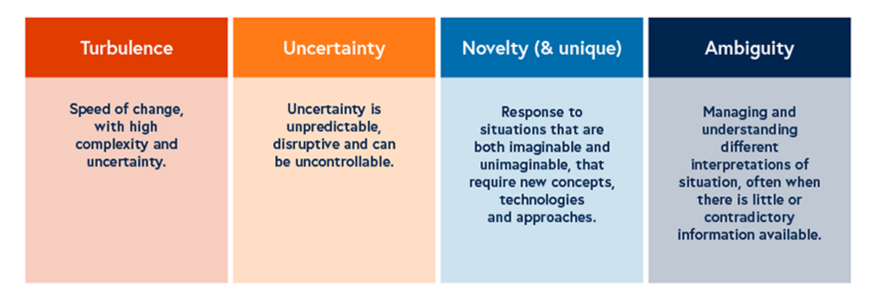
Figure 4: TUNA environments
View description - Figure 4: TUNA environments

The Cynefin Sensemaking framework developed by Dr David Snowden helps leaders and organisations make sense of different situations, and show that they may need a different approach to decision making. It provides five domains to assess the situation.

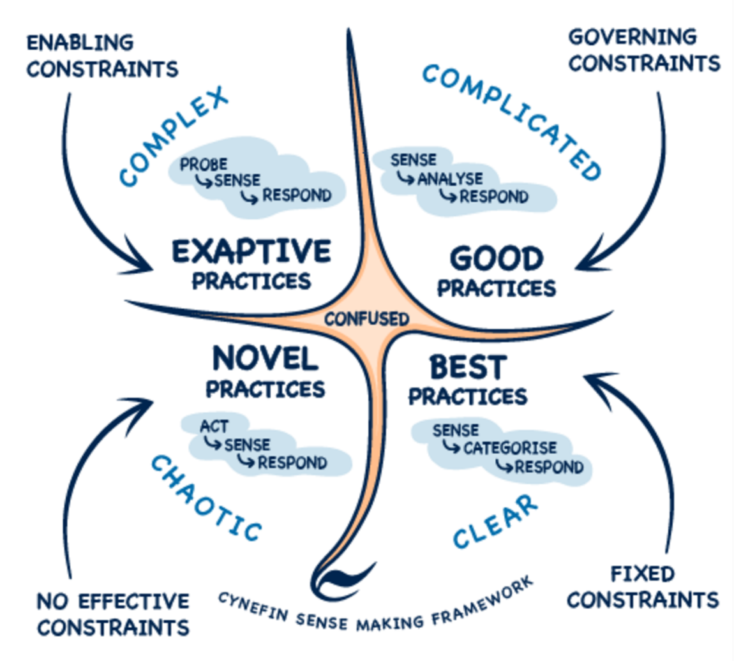
Figure 5: The Cynefin framework
View description - Figure 5: The Cynefin framework

The complexity of operating in an uncertain environment means that many of the challenges facing organisations can be considered as ‘wicked problems’ (Rittel and Webber, 1973) or intractable problems. You will explore these in the next section.

2.2 The problem with problems
According to Wong (2020), a wicked problem is ‘a social or cultural problem that’s difficult or impossible to solve – normally because of its complex and interconnected nature’. Examples include poverty, global warming, and traffic jams.
Wicked problems can be complex and difficult to identify what the actual issue is, and what might be the best solution. This is often due to conflicting information and views, the interdependencies that need to be considered, the large numbers of people they might affect and their economic viability.
Rittel and Webber (1973) identified ten characteristics of wicked problems:
- There is no definitive formulation of a wicked problem.
- Wicked problems have no ‘stopping rule’ (i.e., no definitive solution).
- Solutions to wicked problems are not true or false, but good or bad.
- There is no immediate and no ultimate test of a solution to a wicked problem.
- Every (attempted) solution to a wicked problem is a ‘one-shot operation’; the results cannot be readily undone, and there is no opportunity to learn by trial and error.
- Wicked problems do not have an enumerable (or an exhaustively describable) set of potential solutions, nor is there a well-described set of permissible operations that may be incorporated into the plan.
- Every wicked problem is essentially unique.
- Every wicked problem can be considered to be a symptom of another problem.
- The existence of a discrepancy representing a wicked problem can be explained in numerous ways.
- The planner has no ‘right to be wrong’ (i.e., there is no public tolerance of experiments that fail).

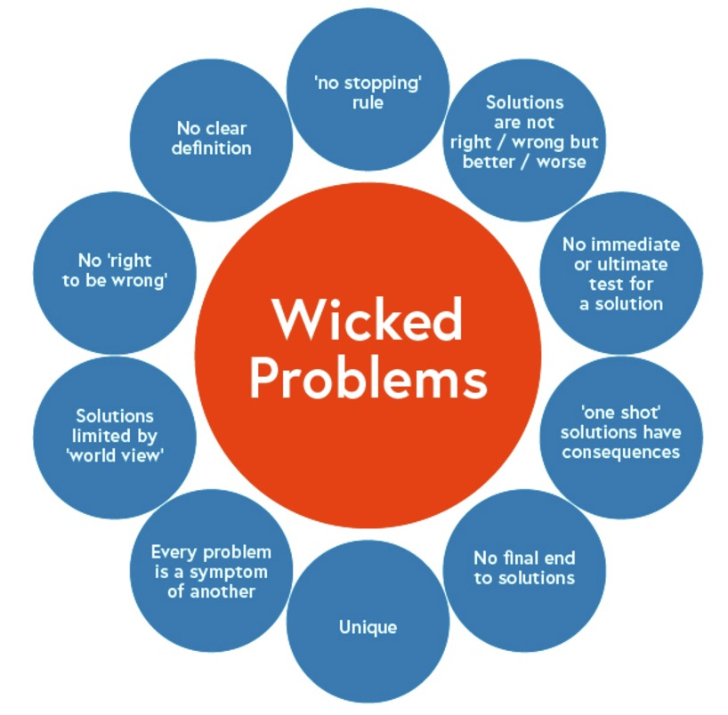
Figure 6: Wicked problems, adapted by Sarkar and Kotler (no date) from Rittel and Webber (1973)
View description - Figure 6: Wicked problems, adapted by Sarkar and Kotler (no date) from Rittel and ...

By its very nature, you may not be able to solve the overall wicked problem, but you can mitigate some of the consequences. This requires being open to ideas and experimenting with different approaches, such as human-centred design or an interdisciplinary focus (IDEO, 2022).
While wicked problems have a framework from which to consider then, another approach is to think about problems as ‘intractable’ − those for which there is no obvious approach to solving them. As you consider a problem you reframe it and try to make sense of the problem and look for different paths that will help to mitigate the issue. This draws from taking a more human-centred approach to problem solving.

Human-centred design is a creative approach to problem solving that starts with the needs of the user, emphasises the importance of diverse perspectives, and encourages solution-seeking among multiple actors. It consists of five phases: Empathise, Define, Ideate, Prototype and Test. What differentiates human-centred design from other problem-solving approaches is its focus on understanding the perspective of the person who experiences a problem most acutely.
Source: UNDP (no date) Human-Centered Design

This involves observing, using empathy to explore the problem further, to uncover what at first might not be obvious, generating ideas, with test-and-learn activities to gather feedback, prior to implementing a potential solution.

Activity 3: What problems does your HEI have?
15 minutes

Read the following article: Nothing is intractable: you can change the world and then consider if your HEI has wicked or intractable problems. And approaches that could be taken to understand them and potentially reframe or solve them.
Note your findings in the text box below.

Provide your answer...

2.3 Explore your organisation’s external factors
As we are still operating in an uncertain world, understanding your external environment is critical. A simple framework for analysing your environment is the PESTLE model. It is designed to help explore the key external factors that might influence your organisations – Political, Economic, Social, Technological, Legal and Environmental.

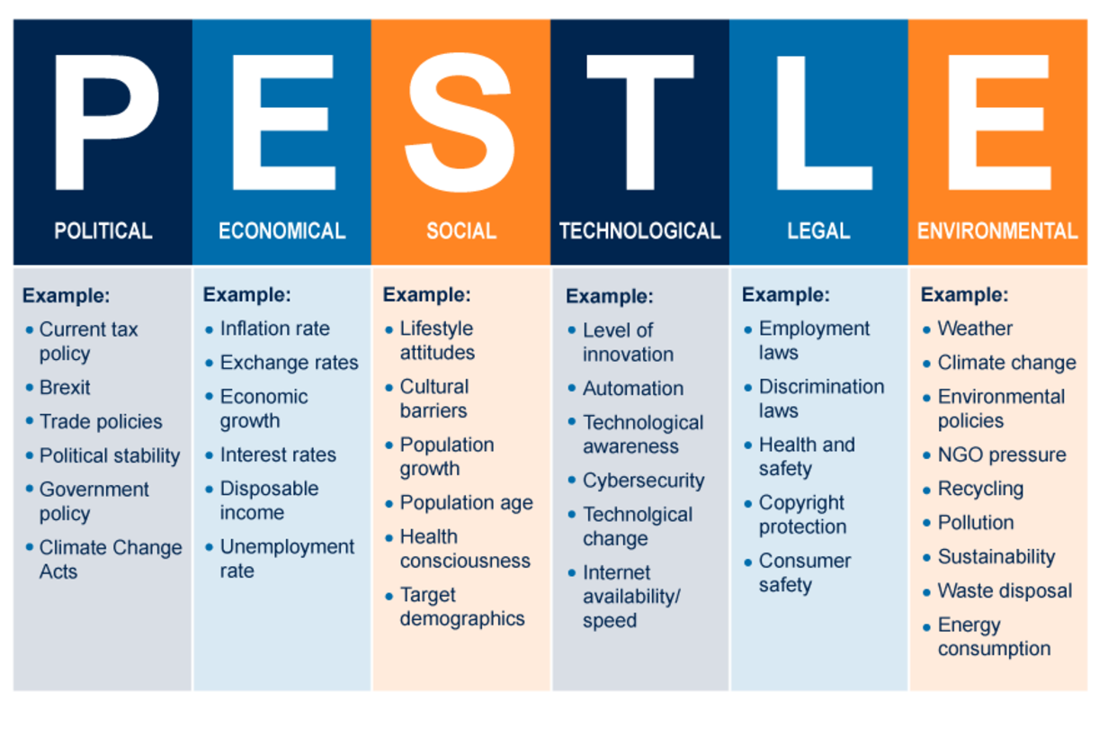
Figure 7: PESTLE model for analysis. Source: Impact Innovation (no date)
View description - Figure 7: PESTLE model for analysis. Source: Impact Innovation (no date)

This model allows you to consider your context in relation to your organisational environment and think about the impact the control and influence external factors can have. It should stimulate an organisation to research these areas further.

Activity 4: Evaluate your environment
15 minutes

Using the PESTLE model for analysis, evaluate the environment you are operating in and drawing on the problems you identified in the previous activity. You may wish to use the template provided.
If you are unfamiliar with using the PESTLE model, the CIPD website provides a useful overview and video on the PESTLE analysis.

While you were thinking about the environment you are operating in and what might pose as a problem, you may have considered the importance of sustainability and wellbeing. We explore this in more detail in the next section of the course.

3 Sustainability and wellbeing

‘In 1987, the United Nations Brundtland Commission defined sustainability as ‘meeting the needs of the present without compromising the ability of future generations to meet their own needs.’
(UN, no date (a))

When developing an organisational approach to sustainability, it is important that wellbeing is at the forefront, and the focus is not just on the targets to mitigate the climate change emergency. The Paris Climate Agreement 2015 set a target to stop the world’s average temperate rising above 2.0°C (ideally 1.5°C), and agreement from parties to the United Nations Framework Convention on Climate Change (UNFCCC) to reduce carbon emissions by 45% by 2030 and reach net zero by 2050.
All UK organisations are required by law to reduce their carbon emissions. The approach to this varies throughout the UK. You can explore these for your nation via the links below:
- Wales – Well-being of Future Generations (Wales) Act 2015(Public bodies only) and Environment (Wales) Act 2016
- England – Climate Change Act 2008 and Sustainability and climate change: a strategy for the education and children’s services systems
- Scotland – Climate Change (Emissions Reduction Targets) (Scotland) Act 2019
- Northern Ireland – Northern Ireland Climate Change Adaptation Programme

3.1 United Nations Sustainable Development Goals
The Sustainable Development Goals (SDGs) form the framework for improving the lives of populations around the world and mitigating the hazardous man-made effects of climate change (UN, no date)
In 2015 the UN adopted the SDGs as a guide to development policies. There are 17 SDGs, as shown in the image below. The intention for these goals was to enable individual countries to set and measure their own progress towards the goals through appropriate targets. As organisations develop their approach to sustainability, they should consider how they can meet these goals, and interweave them into their strategies, policies and ways of working.

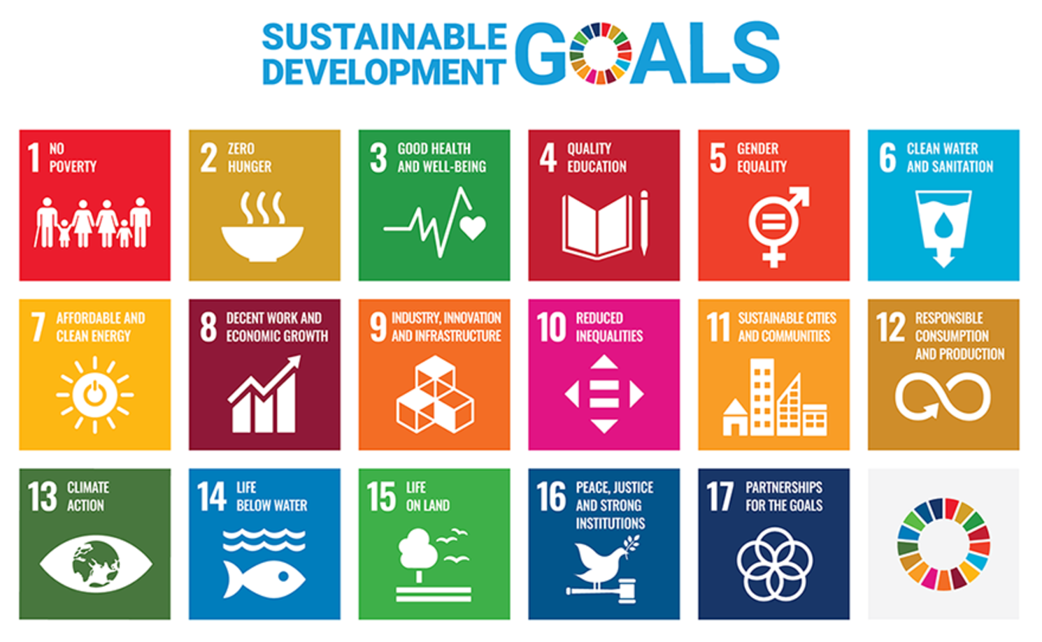
Figure 8: UN Sustainable development goals (SDGs)
View description - Figure 8: UN Sustainable development goals (SDGs)

Activity 5: Learn about the UN SDGs
15 minutes

Go to the UN SDG website, and take time to learn about the 17 goals and explore the site.
Consider which of the goals are most relevant to your organisation, how higher education institutions can contribute towards meeting these goals, and what your organisation is doing in relation to these goals. You may wish to use the box below to capture your thoughts.

Provide your answer...

3.2 The Well-being of Future Generations (Wales) Act 2015
Wales has some of the most contemporary legislation in the world, drawing on best practice from across the globe. The Well-being of Future Generations (Wales) Act 2015 (Welsh Government, 2015) places a duty on all Welsh public bodies to put sustainability at the heart of all decision making. A Future Generations Commissioner acts as a ‘guardian of future generations’, refocusing decisions on the long-term impacts and reporting on progress (Future Generations Commissioner for Wales, no date).

‘The Well-being of Future Generations (Wales) Act 2015 gives us the ambition, permission, and legal obligation to improve our social, cultural, environmental, and economic wellbeing.’
‘The Well-being of Future Generations (Wales) Act 2015 requires public bodies in Wales to think about the long-term impact of their decisions, to work better with people, communities, and each other, and to prevent persistent problems such as poverty, health inequalities and climate change.’
‘The Act is unique to Wales attracting interest from countries across the world as it offers a huge opportunity to make a long-lasting, positive change to current and future generations.’

The Act is a legally binding common purpose centred around seven wellbeing goals that detail the ways in which specific public bodies must work and work together to improve the wellbeing of Wales. The Act is the most developed act of the four nations of the UK, aiming to improve social, economic, environmental, and cultural wellbeing.
In the videos below Sophie Howe, The Future Generations Commissioner for Wales, explains the Act and the impact it is has had for Wales, and Jane Davidson, Author of #futuregen: Lessons from a Small Country explains how the Act was created.

Video content is not available in this format.
View transcript - Uncaptioned interactive content

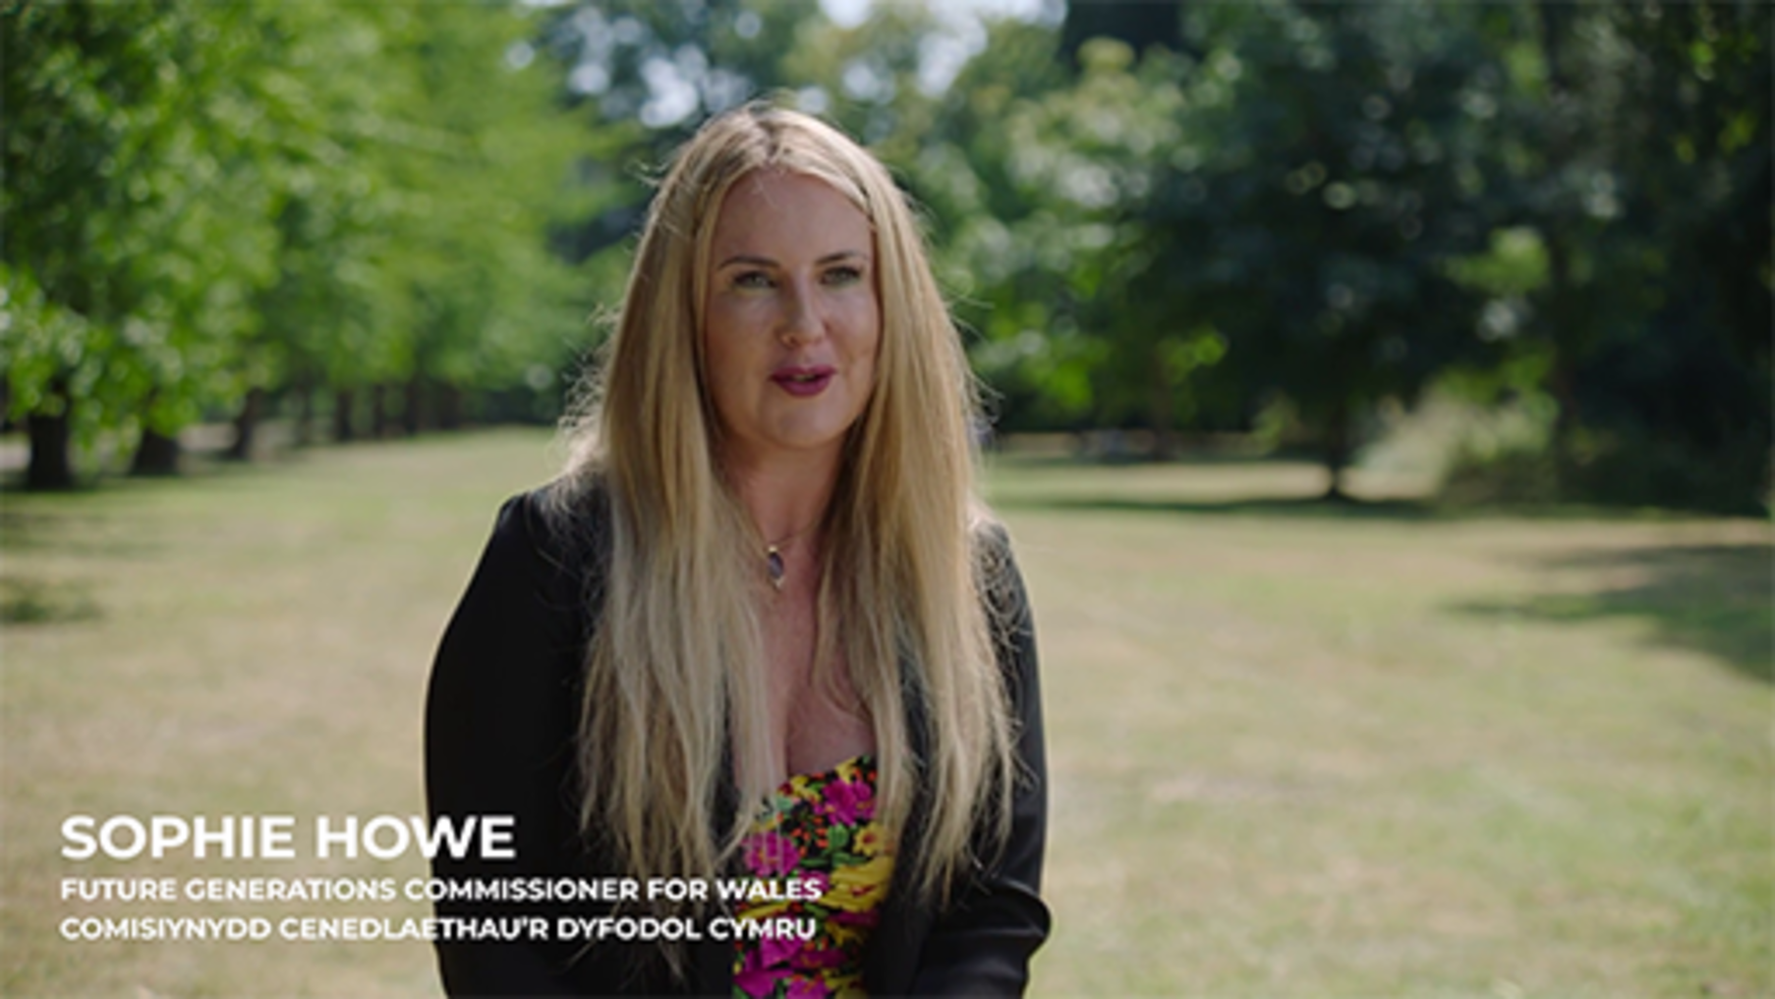

Video content is not available in this format.
View transcript - Uncaptioned interactive content



The seven well-being goals
To ensure that Wales is working towards the same shared purpose and vision, the act has seven well-being goals that all public bodies must work to achieve. These are explained in Table 1.

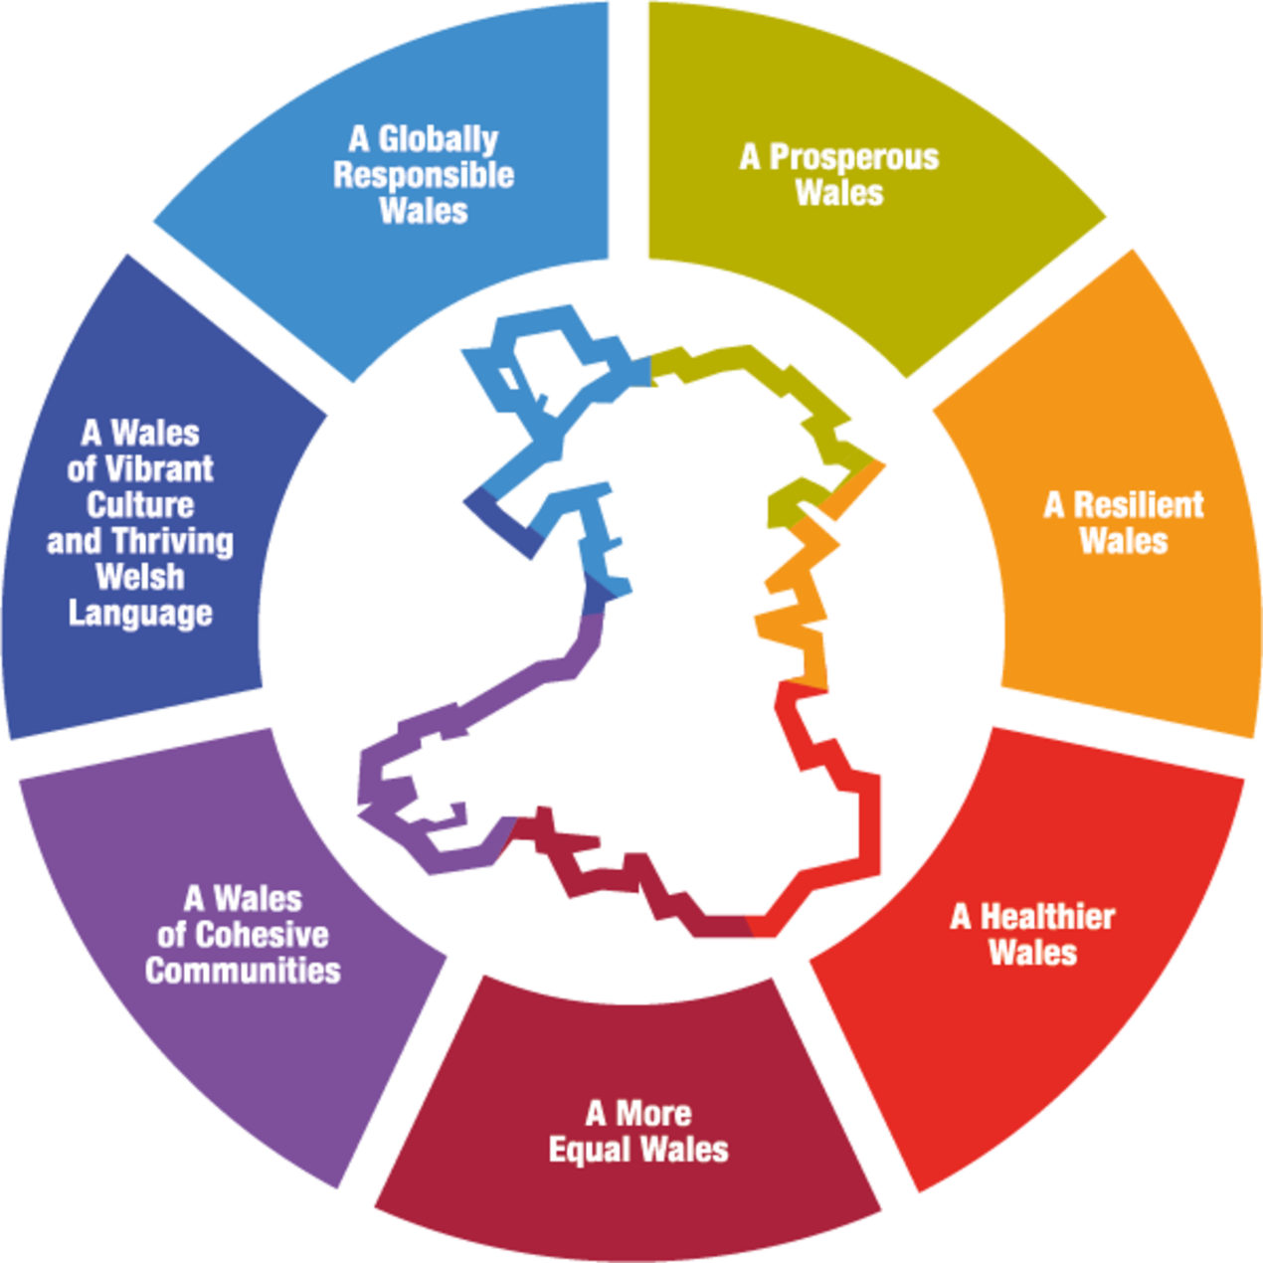
Figure 9: Well-being goals
View description - Figure 9: Well-being goals

Table 1
 | A Prosperous Wales  An innovative, productive, and low carbon society that recognises the limits of the global environment and therefore uses resources efficiently and proportionately (including acting on climate change); and which develops a skilled and well-educated population in an economy that generates wealth and provides employment opportunities, allowing people to take advantage of the wealth generated through securing decent work.
 | A Resilient Wales  A nation which maintains and enhances a biodiverse natural environment with healthy functioning ecosystems that support social, economic and ecological resilience and the capacity to adapt to change.
 | A More Equal Wales  A society that enables people to fulfil their potential no matter what their background or circumstances (including their socio-economic circumstances).
 | A Healthier Wales  A society in which people’s physical and mental wellbeing is maximised and in which choices and behaviours that benefit future health are understood.
 | A Wales of Cohesive Communities  Attractive, safe, viable and well-connected.
 | A Wales of Vibrant Culture and Thriving Welsh Language  A society that promotes and protects culture, heritage, and the Welsh language, and which encourages people to participate in the arts, and sports and recreation.
 | A Globally Responsible Wales  A nation which, when doing anything to improve the economic, social, environmental and cultural wellbeing of Wales, takes account of whether doing such a thing may make a positive contribution to global wellbeing.
Source: https://www.futuregenerations.wales/about-us/future-generations-act/

The Act has a strong focus on how the goals will be achieved by encouraging public bodies and organisations to use sustainable development principles of long term, prevention, integration, collaboration, and involvement, as depicted in the Five Ways of Working table below.

Table 2 Five Ways of Working
 | Long-term: The importance of balancing short-term needs with the needs to safeguard the ability to also meet long-term needs.
 | Integration: Considering how the public body’s wellbeing objectives may impact upon each of the wellbeing goals, on their objectives, or on the objectives of other public bodies.
 | Involvement: The importance of involving people with an interest in achieving the wellbeing goals, and ensuring that those people reflect the diversity of the area which the body serves.
 | Collaboration: Acting in collaboration with any other person (or different parts of the body itself) that could help the body to meet its wellbeing objectives.
 | Prevention: How acting to prevent problems occurring or getting worse may help public bodies meet their objectives.

The architecture of the Act links to the UN Sustainable Development Goals and framework. The image below provides a clear overview of how its impact will be measured.

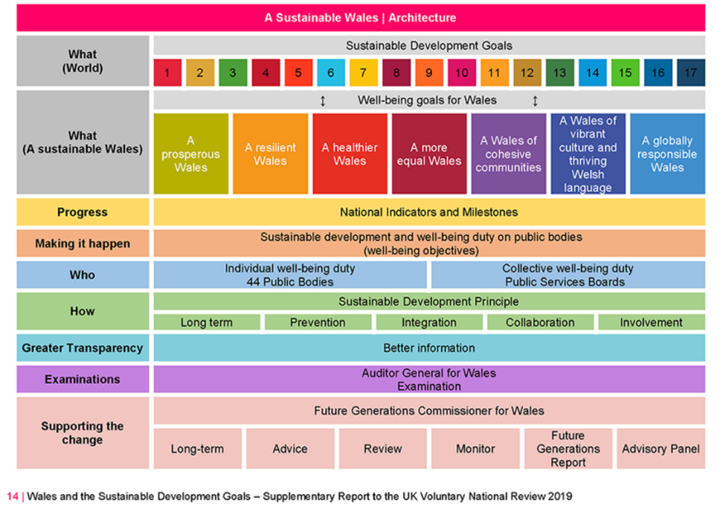
Figure 10: A sustainable Wales – architecture of the Well-being of Future Generations (Wales) Act 2015
View description - Figure 10: A sustainable Wales – architecture of the Well-being of Future Generations ...

Activity 6: Familiarise yourself
20 minutes

Start to familiarise yourself with the Future Generations Commissioner for Wales website.
As organisations operate in an uncertain climate, wellbeing and sustainability is critically important, and it is essential to embed this in organisational development activities and the development of employees’ understanding and capabilities.
Throughout the Supporting Hybrid Working and Digital Transformation collection, you will be referred to the Future Generations Commissioner for Wales website, which contains not only the full act, but also numerous resources that explain it in simple terms, practical tips and case studies of how an organisation can improve wellbeing and support its local community.
It is recommended that you read the Well-being Future Generations (Wales) Act 2015 essential guide available on the main page that provides access to the full Act and an overview of the approach Wales has taken, and then as you have time outside of the time allocated for studying this course, engage with website further.

3.3 Reducing your carbon emissions

It is unequivocal that human influence has warmed the atmosphere, ocean and land. Widespread and rapid changes in the atmosphere, ocean, cryosphere and biosphere have occurred.
(IPCC, 2021)

The above quote from the Intergovernmental Panel on Climate Change (IPCC) report highlights the impact of human activity on climate change, and many consider we are facing a climate emergency. The need to start to mitigate the impact of our activities and behaviours is now essential. As you have seen in the previous sections developing global goals, national legislative acts and setting targets provides a framework to drive change.
In this collection we have started to introduce you to think about sustainability, further resources are available in the Open University Sustainability Hub on OpenLearn.
While you may be familiar with many key terms and concepts related to climate change, in this section we provide an overview of some of the terms that are frequently used. You may also wish to bookmark the IPCC Special Report: Global Warming of 1.5 ºC glossary, which provides a comprehensive list of definitions.

Climate change
The United Nations Framework Convention on Climate Change defines climate change as:

‘Climate change’ means a change of climate which is attributed directly or indirectly to human activity that alters the composition of the global atmosphere and which is in addition to natural climate variability observed over comparable time periods.
United Nations Framework Convention on Climate Change

Net zero
Net zero is achieving the balance between the carbon emitted into the atmosphere and the amount removed from the atmosphere.
In the video Stephen Peake, Professor of Climate Change and Energy at The Open University, provides an overview of net zero.

Video content is not available in this format.
View transcript - Uncaptioned interactive content

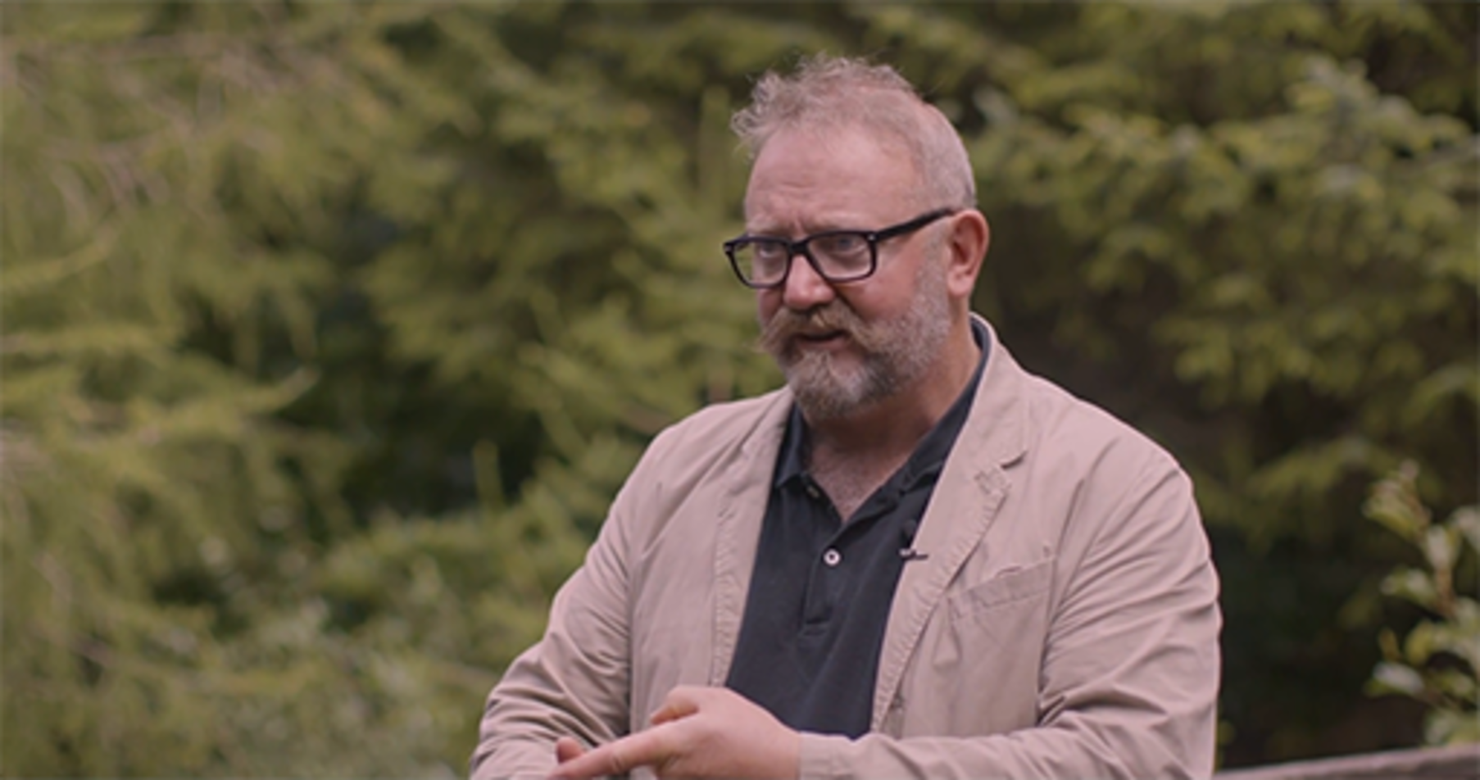

Global warming
Global warming is the long-term increase in temperature of the Earth’s surface due to human activities, which increase greenhouse gases that have the potential to warm and change our global climate.
In the video Stephen Peake provides an overview of global warming.

Video content is not available in this format.
View transcript - Uncaptioned interactive content

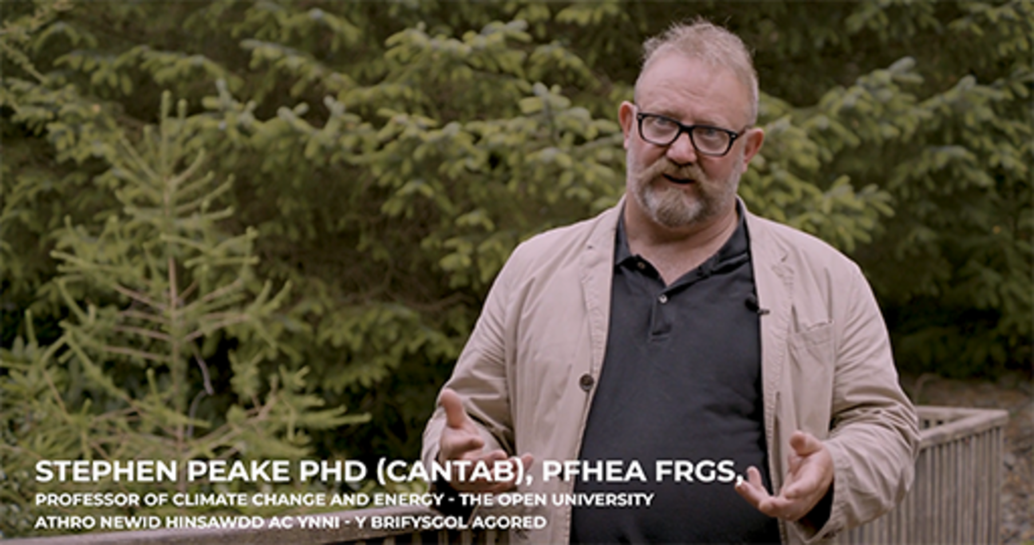

Greenhouse gas emissions
The Greenhouse Gas (GHG) Protocol is a global framework to measure and manage greenhouse gas emissions to enable corporate accounting and reporting standards for greenhouse gas emissions from organisations.
The greenhouse gas emissions are grouped into three ‘scopes’ shown in the table and figure below. Scope 1 and 2 require mandatory reporting by organisations. Scope 3 emissions can be challenging to determine, but account for approximately 80% of organisations emission.

Table 3
Scope 1  Direct emissions | Scope 2  Indirect emissions | Scope 3  All other indirect emissions
From sources that are controlled or owned by an organisation. | From the purchase of electricity, steam, heat or cooling. | Emissions generated by an organisations supply and value chain.
Fuel combustion  Company vehicles  Company facilities |  | 15 categories  - purchased goods and services  - capital goods  - fuel- and energy-related activities  - transportation and distribution  - waste generated in operations  - business travel  - employee commuting  - leased assets  - processing of sold products  - use of sold products  - end of life treatment of sold products  - franchises  - investments
Based on information from the GHG Protocol website

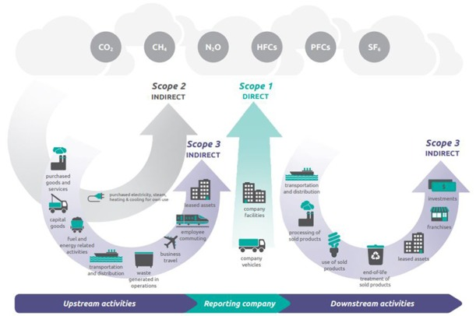
Figure 11: Diagram of scopes and emissions across the value chain
View description - Figure 11: Diagram of scopes and emissions across the value chain

In the video Scott Stonham, an Independent Sustainable Tech Analyst and author of the Jisc Exploring digital carbon footprints report, explains the GHG Protocol.

Video content is not available in this format.
View transcript - Uncaptioned interactive content

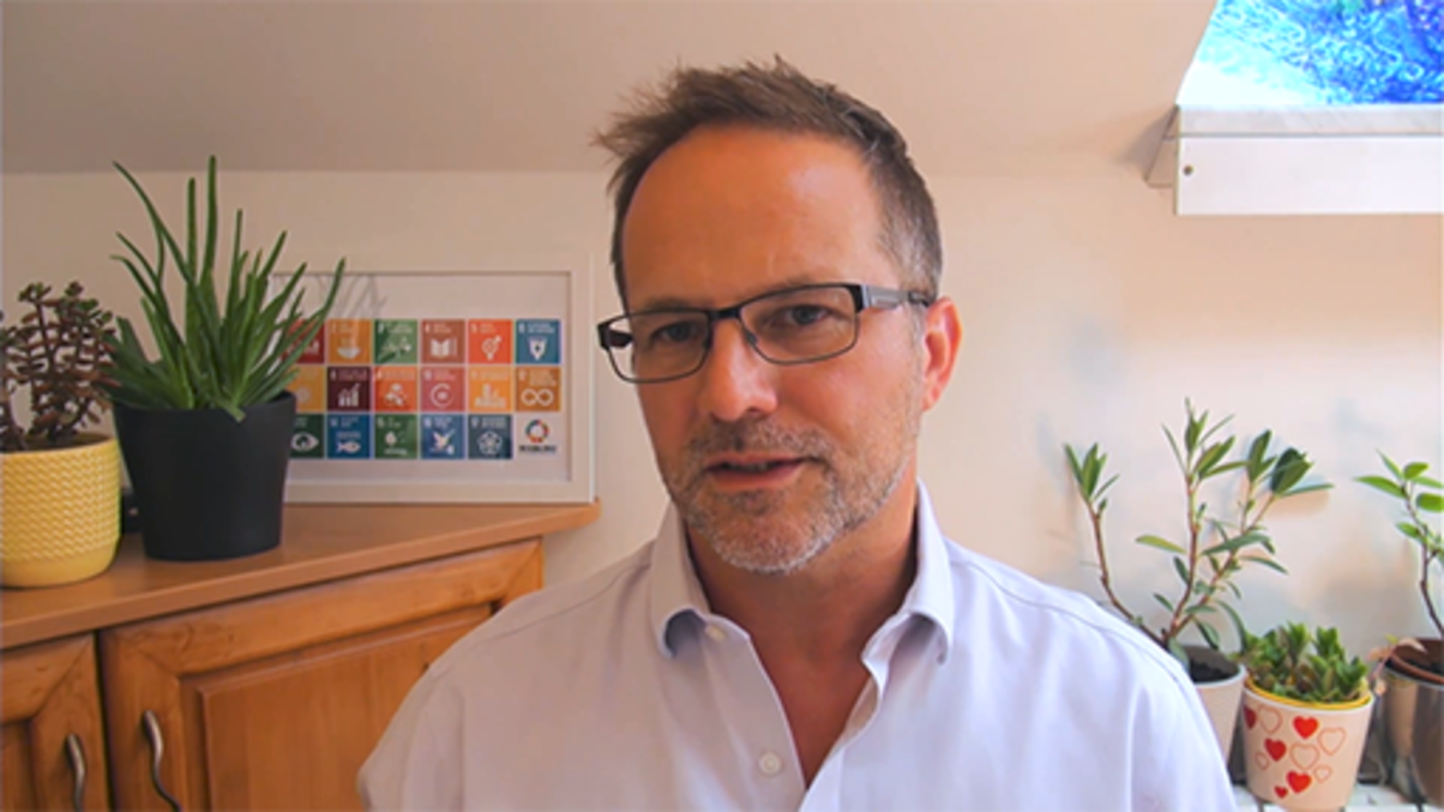

Carbon footprint
A carbon footprint is a measure of the greenhouse gases (GHG) that are produced directly or indirectly by the activities of an individual, organisations and community, and the activities for producing products.
In the video Stephen Peake explains what a carbon footprint is.

Video content is not available in this format.
View transcript - Uncaptioned interactive content

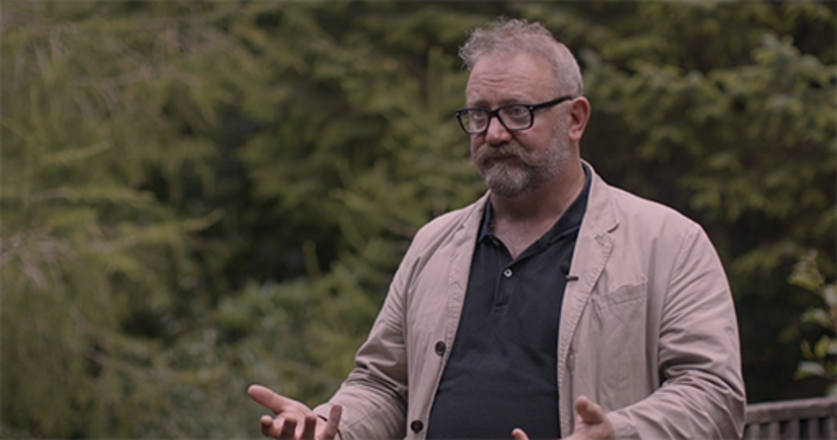

If you wish to understand more about your own carbon footprint, you can use The Open University’s Carbon Calculator on OpenLearn.

The circular economy
The circular economy is a framework to tackle global challenges including climate change that is based on three principles:
- Eliminate waste and pollution
- Circulate products and materials
- Regenerate nature
In the video Dr Alice Moncaster, Senior Lecturer in Sustainable Built Environment at The Open University, provides an overview of the circular economy.

Video content is not available in this format.
View transcript - Uncaptioned interactive content

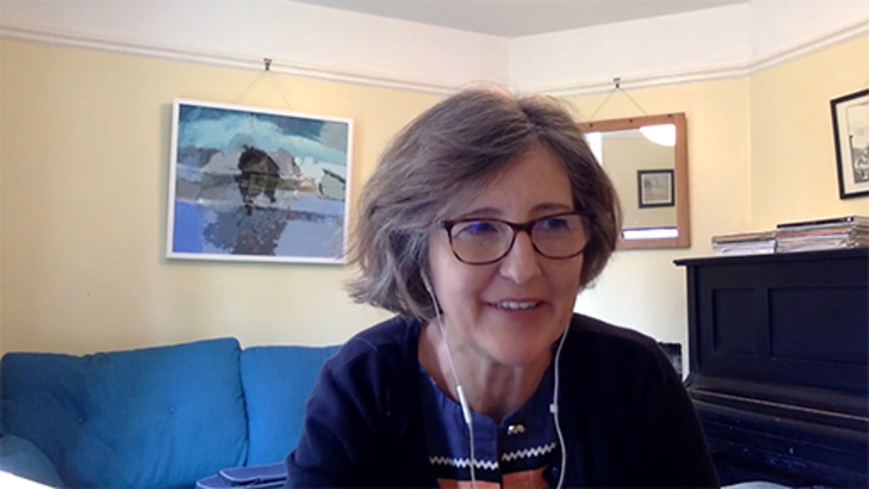

There is a growing focus on the circular economy, an area you may wish to come back to explore further. The Beyond Recycling area of the Welsh Government website, that includes its strategy to make the circular economy in Wales a reality, and the wellbeing assessment, provides an insight into what organisation need to consider to develop more sustainable ways reduce waste and preserve resources.
- What is the circular economy and why does it matter?
- What is a circular economy?

3.4 Digital carbon footprints
The carbon impact of technology and working digitally has been gaining more attention in recent years as we begin to understand and track the impact more effectively.

‘IT is often one of the biggest contributors to an education institution’s own carbon footprint, with one UK college attributing 20% of its emissions to IT alone.’
Exploring digital carbon footprints

In working towards reaching net zero, organisations need to start to understand their digital carbon footprint, not only within their ‘digital spaces’, but also the procurement, digital infrastructure, management of physical equipment and use of electricity.
We now live in a world where everything is ‘in the cloud’. However, many people do not think about what the cloud actually is. At a very basic level, it is data servers. While many organisations still have on-site servers, most are using ‘cloud servers’. These are servers managed by a third-party supplier based anywhere in the world.
This raises an interesting question for organisations – most IT purchasing decisions are based on the needs of the organisation, the reliability, service and tools a supplier can provide, and the cost. Many IT solutions may have been purchased before the focus on sustainability started to become part of the procurement process. Large IT providers are aware of this and have voluntarily improved the sustainability of their services, especially connected to the cloud.
Many organisations are now developing strategies for their approach, for example the UK Ministry of Defence has published their Sustainable Digital Technology and Services Strategic Approach 2021-2025, which provides a simple ambition for net zero emissions.
There are some simple changes that individuals can be encouraged to adopt to help organisations reduce their digital carbon footprint. This can be managed through new polices and processes, such as not having images within email signatures, encourage links to shared documents rather than sending them as attachments and clear policies on deleting digital files.
What is more challenging is decisions on systems, infrastructure, procurement and management of equipment. The life and disposal of physical equipment contributes not only to carbon emissions but waste. Many organisations are adopting longer life policies for equipment, considering their choice of suppliers, especially for cloud services and starting to understand the implications of remote working carbon emissions.
Earlier in the course we introduced the GHG Protocol ‘Scopes’, which should be considered for managing your digital carbon footprint, by focusing on areas that may lead to the greatest impact for reducing your emissions.
The Jisc Exploring your digital carbon footprint report provides a comprehensive overview of the source and impact of digital carbon footprints in four areas: procurement, on-premise IT, cloud technologies and remote working.
In the video below Scott Stonham, the author of the report, provides an overview of the key findings.

Video content is not available in this format.
View transcript - Uncaptioned interactive content

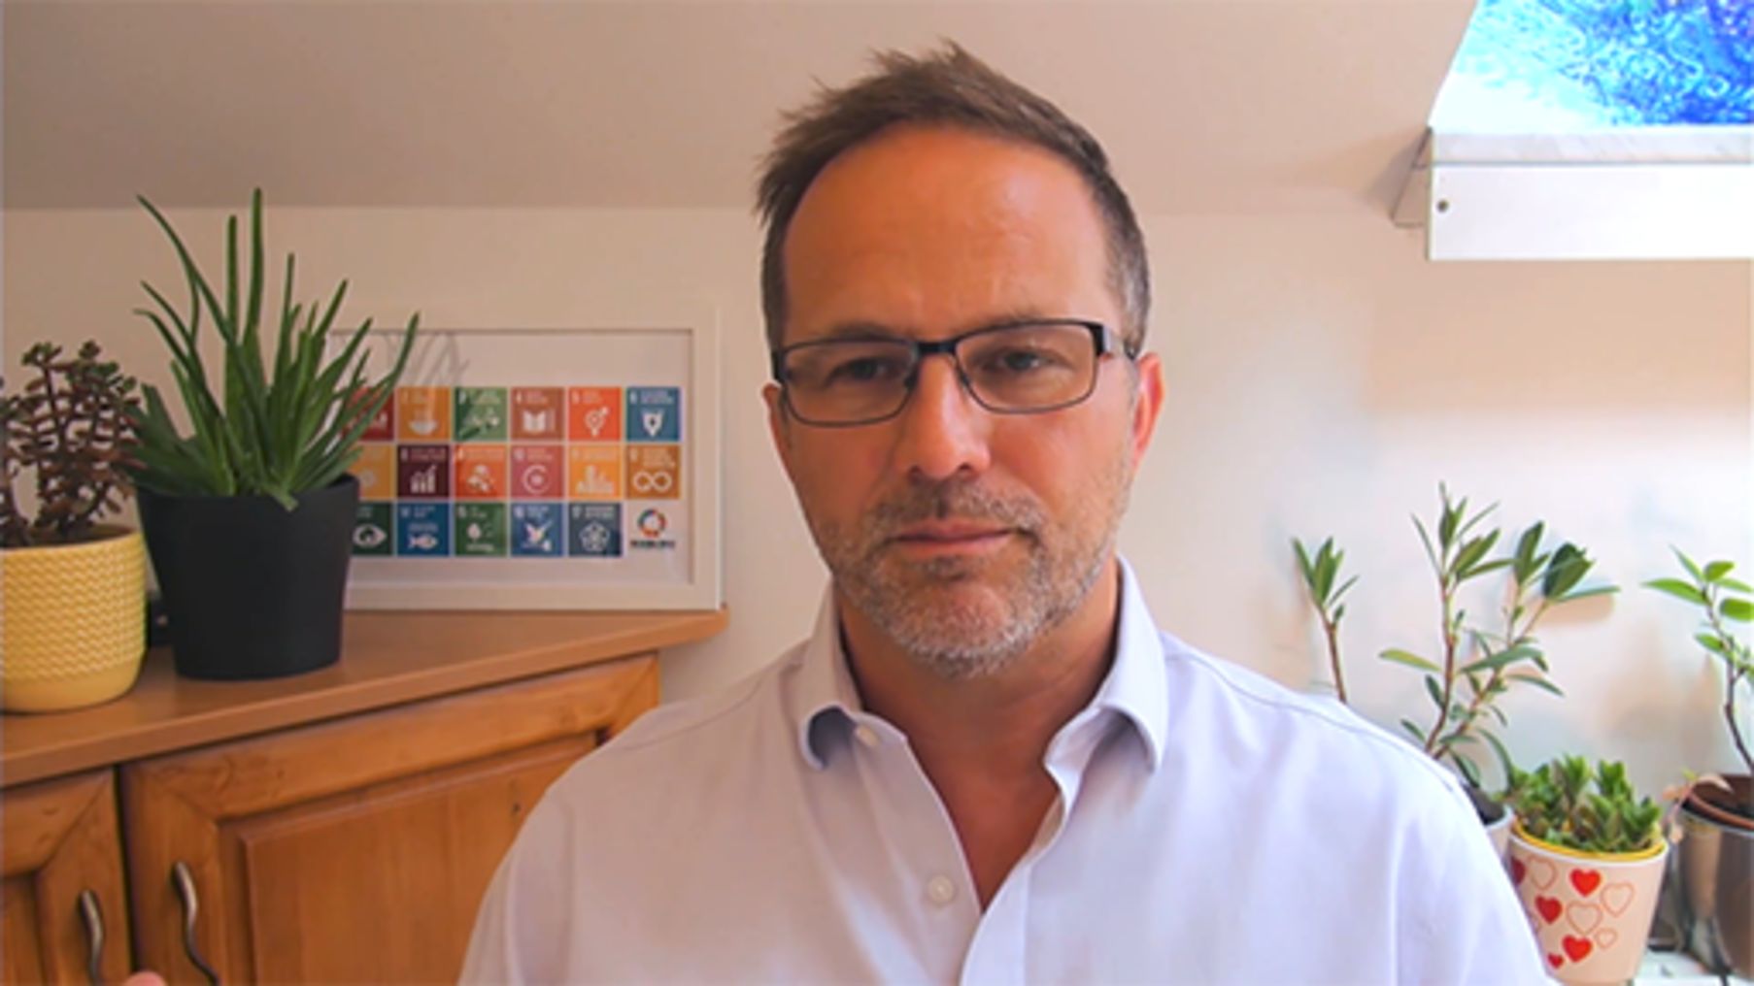

Bookmark the Jisc report to develop your understanding of your digital carbon footprint for use in your organisation and you may wish to explore the articles listed below written by Scott Stonham on OpenLearn. While you can read it as part of this course, they are not included within the study time allocated.
- Reducing the digital carbon footprint of the cloud
- Reducing the carbon footprint of on-premises IT
- How we can all tackle our digital carbon footprints
- Reducing digital carbon footprint through responsible procurement
- Digital carbon footprints and remote working
- How can corporations reduce digital carbon footprints
- What is a digital carbon footprint?

Activity 7: Which cloud?
15 minutes

Read the following article, and answer the following question:
When making a purchasing decision, what should organisations be considering about the sustainability practices of the potential supplier? You may wish to make notes in the free text box below.
Amazon, Google, Microsoft: Here’s who has the greenest cloud

Provide your answer...

3.5 Sustainable development
At the start of the course, we introduced hybrid ways of working: a contextual framework which suggests:
- You and how you work need to be mindful of the key stakeholders within your environment and their needs in relation to organisational development.
- You need to understand organisational needs, the context, connections, and requirements for key areas of focus and how these relate to the needs of your stakeholders.
- You need to consider your ways of working for the wellbeing of future generations.
The framework draws on the Triple Bottom Line (Elkington, 1994), and has been designed to assist with ensuring that wellbeing is an integral part of developing your organisation’s approach to sustainability, by considering the three pillars of sustainability: Social/People, Environmental/Planet, and Economic/Profit. They are of equal importance.

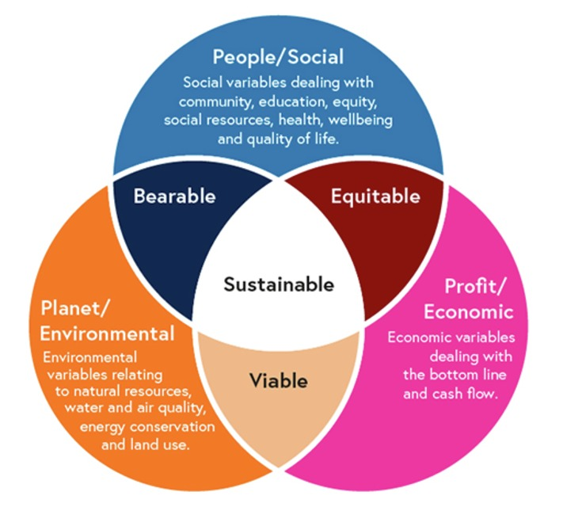
Figure 12: Three pillars of sustainability
View description - Figure 12: Three pillars of sustainability

People/Social – Organisations ensure responsible, ethical, and fair treatment of employees, stakeholders, and the community it operates in.
Planet/Environmental – Promoting activities that lead to the reduction of negative impact on the environment, both within the organisation and its supply chain.
Profit/Economic – An organisation needs to be profitable in order to operate.
In the video Stephen Peake explains the triple bottom line for sustainability. As you watch consider how it might assist you in embedding three pillars of sustainability within your organisation.

Video content is not available in this format.
View transcript - Uncaptioned interactive content

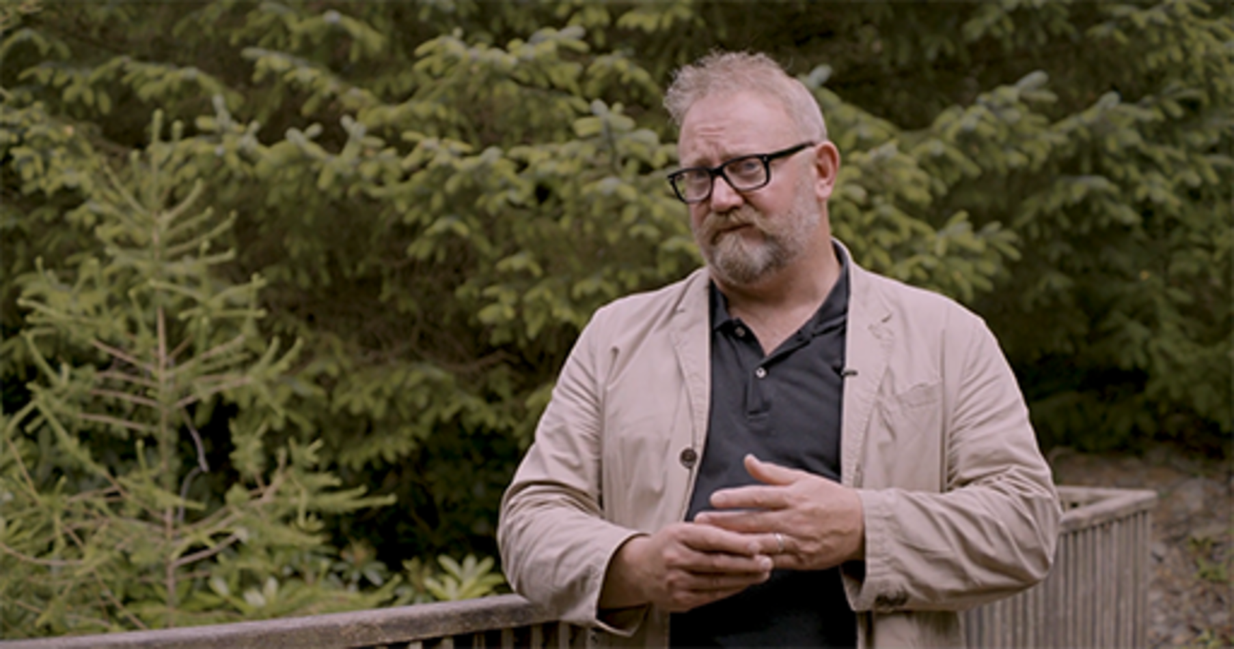

Developing a sustainable organisation may require decisions on profit margins. Committing to sustainable business practices requires change, and demonstrating the ‘environmental, social and governance’ (ESG) metrics are as equally important as the financial data, for measuring the success of organisations.
Many HEIs belong to The Alliance for Sustainability Leadership in Education, which provides numerous resources, including the Higher Education Supply Chain Emissions (HESCET) Tool for helping with procurement decisions.
The triple bottom line: what it is & why it’s important article from the Harvard Business School Online explains what organisations need to consider for measuring their social and environmental impact.

Activity 8: How can HEIs assist in meeting the Well-Being of Future Generations (Wales) Act 2015 well-being goals?
15 minutes

‘The Well-being of Future Generations Act requires public bodies in Wales to think about the long-term impact of their decisions, to work better with people, communities and each other, and to prevent persistent problems such as poverty, health inequalities and climate change.’
Well-being of Future Generations (Wales) Act 2015

Drawing on the information and your own research, how can HEIs develop sustainable practices, focus on the wellbeing of those within the organisation, and collaborate to ensure that long-term decisions provide better outcomes for future generations?

4 How we work now
It can be easy to forget that how we worked before the impact of the global COVID-19 pandemic has many similarities to how we work now. For many the pivot to remote working involved minimal changes to the work they do, but setting up their offsite workplace was a challenge. Employees and students in the higher education sector became more responsible and accountable for managing how they worked – especially during lockdowns – and had to balance their work against their personal environments and needs. Going forward, a way of working is needed that allows for continued flexibility while meeting organisational needs.

Activity 9: Shifting the way of work
20 minutes

Watch the video in which Jacob Morgan shares insights about how organisations are evolving.

Video content is not available in this format.
View transcript - Uncaptioned interactive content



Read the article from BBC Worklife – How companies around the world are shifting the way they work. Does this feel familiar to your experiences of the changes of ways of working?

As you can see from the images below, it is important to remember that some individuals’ working patterns did not change: they continued to go on site throughout lockdowns, or were already remote workers.

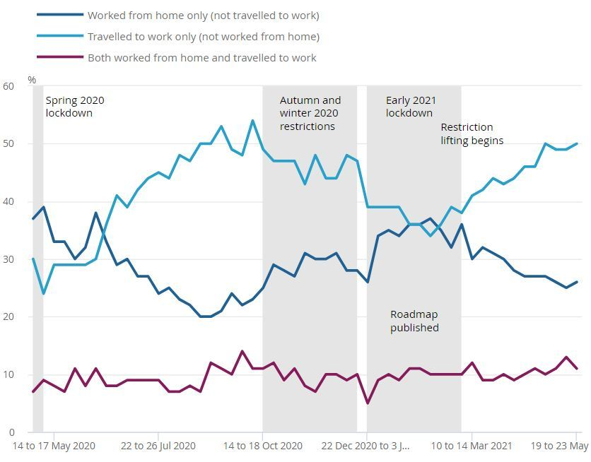
Figure 13: The proportion of working adults reporting working from home exclusively has varied over the course of the past year. Working adults, Great Britain, May 2020 to May 2021. Source: Office for National Statistics – Opinions and Lifestyle Survey.
View description - Figure 13: The proportion of working adults reporting working from home exclusively ...

Notes for Figure 13:
- Percentages may not sum to 100% due to rounding.
- ‘Spring 2020 lockdown’: 23 March 2020 to 13 May 2020.
‘Autumn and winter 2020 restrictions’: 14 October 2020 to 4 January 2021.
‘Early 2021 lockdown’: 5 January 2021 to 8 March 2021.
‘Roadmap for England published’: 22 February 2021.
‘Restriction lifting begins’: 8 March 2021.
- You can explore the interactive version of the image here.

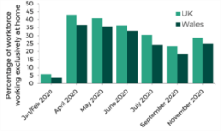
Figure 14: Numbers Exclusively Working at Home in the UK During 2020 Source: Remote working – the new normal?
View description - Figure 14: Numbers Exclusively Working at Home in the UK During 2020 Source: Remote ...

As the skills required to work effectively evolve, the reliance on technology due to remote working and learning has meant that digital, communication and time-management capabilities have had to develop rapidly.
Individuals and HEIs adapted how they worked and had to quickly provide remote learning for their students, and take domestic arrangements into account without the infrastructure to properly support this. This uncertainty has raised concerns about the trust students have in their HEI to provide the services and support they require.

‘UK should pay more attention to the potential relationship between trust and mental wellbeing. Among the more consistent findings in the literature are our results concerning gender, previous financial strain, food security and housing security, all of which have been found to impact mental health and/or mental wellbeing.’
Source: https://www.frontiersin.org/articles/10.3389/fpubh.2021.646916/full

Activity 10: Learning from the pandemic:
10 minutes

Browse the following articles and reports linked below, which explore the impact of the pandemic on HEIs and students. Consider how these reflect your own organisation’s current work practices.
- Lessons from the pandemic: making the most of technologies in teaching
- Student Mental Health in a pandemic
- Student Mental Health: Life in a pandemic
- Remote working – the new normal?
- Remote Working: Implications for Wales
Think about your own experience of the pandemic. How did you adapt, and how did your organisation respond? If you are within an HEI, what was the impact on students?
Make notes in the free text box below.

Provide your answer...
View answer - Activity 10: Learning from the pandemic:

For some people, this rapid and continual adjustment to ambiguity and uncertainty had a significant impact on their wellbeing, thanks to factors such as restrictions forced upon them, concerns about risks to their health, and balancing the demands of their personal lives as they dealt with constant change.
The full impact of this varied depending on personal circumstances. For example, people who had to shield faced the immediate implications of being completely shut off from the world, but in practice they had to consider circumnavigating the rules to do simple things like walk the dog, or even buy food. If you are told you cannot go to the shops, you have to work out other options, such as relying on friends/family to shop for you, online deliveries (if you could get a slot) or council-run food schemes, while having periods of not speaking to or seeing another person in the flesh.
Cultural changes will have occurred in organisations too, especially HEIs, where once thriving campuses became ghost towns, and the demand for online learning provision became a necessity. As a result, more HEIs will now be planning to offer a ‘blended’ approach to learning – ‘which included e-learning with only online formats, a blended approach that mixed online and face-to-face teaching with in-person teaching’ (Ameduni and Ligoro, 2022) – as a standard part of their provision, not just as an emergency response to the pandemic.

4.1 The new working environment
While some organisations might prefer to take a wait-and-see approach to working practices and cultural evolution, learning from their workforce’s experiences can provide valuable insights. Listening to those whose working patterns did not significantly alter during the pandemic, as well as those who had to change their working patterns, gives organisations an opportunity to consider and experiment with which working practices to keep and which to discard.
Research by the Corporate Research Forum suggests that hybrid flexible working has become the norm, and how organisations develop their policies and working practices needs to accommodate the new norms whilst considering ongoing organisational needs.

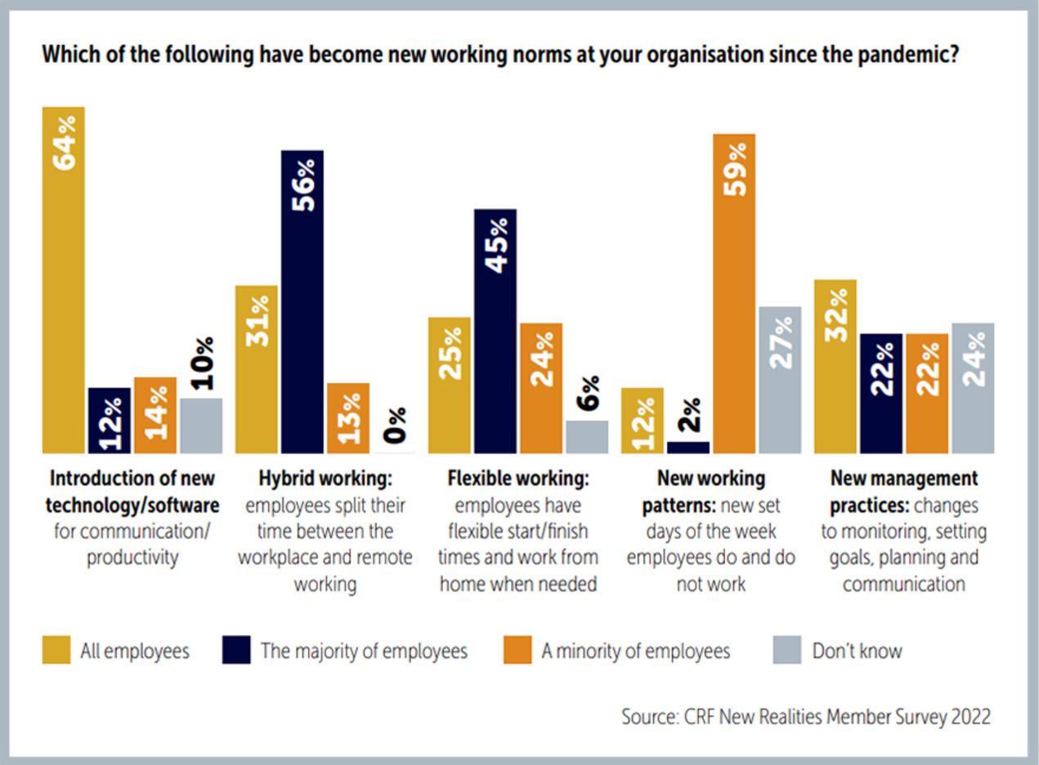
Figure 15: New working norms
View description - Figure 15: New working norms

The Advanced Workplace Hybrid Working Index tracks the uptake of hybrid working globally, and its first report in August 2022 found:
- On average only 26% of the population are attending the office each day with a peak of 31% in the office on a Wednesday.
- Only 40% of the desks in office are being used at peak time on a Wednesday, with an average run rate of 31% leaving over two thirds of the desks empty on average across the week.
- On average each worker, is attending the office 1.3 days a week, which is similar to the intentions expressed through our surveys during the pandemic.
- The majority of organisations have not set a Hybrid Working Policy and for those that have attendance is well below the level set in their policy.
Source: The AWA Hybrid Working Index
This index can help organisations to understand how its hybrid workforce is now working, which can be useful for planning new ways of working, including the use of space. You will explore this later in the course.

Activity 11: How do you work now?
10 minutes

While some organisations are now fully remote only, this is not achievable/practical for others. The Welsh Government has an ambition to see around 30% of Welsh workers working ‘at or close to home’ (source: senedd.wales).
Working practice approaches can be split into four areas:
- On site only
- Hybrid – on site and in remote location
- Remote location only
- Remote location – away from primary base. (e.g., field research as an academic, work hubs)
Take some time to consider the different types of working practice and the Future Generations Five Ways of Working. Spend some time researching what these approaches could mean for an organisation, teams and individuals.
What are your principles for ways of working and how they might relate to the Future Generations Five Ways of Working?
Summarise your thoughts in the box below.

Provide your answer...
View feedback - Activity 11: How do you work now?

4.2 Putting people first
While people have always been at the heart of an organisation it has never been more important to take a human-centred approach to organisational development, change and culture – often referred to as ‘The employee experience’. This may feel challenging because you have to balance the needs of the organisation and the needs of the individuals: you cannot be all things to all people and one size does not fit all, while also considering wellbeing and inclusion.

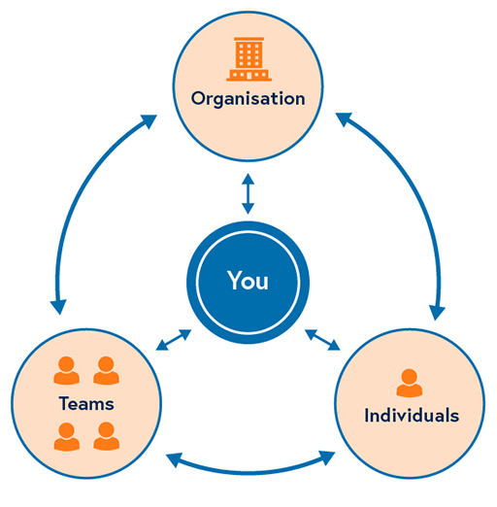
Figure 16: Putting people first
View description - Figure 16: Putting people first

Adopting a human-centred approach, with a clear communications plan, can help build empathy within an organisation, to create better experiences, and build resilience to and trust in change, so the organisation culture enables confidence to try news ways of working, learn and evolve.
The International Organization for Standardization guidance, which contributes to UN SDG Goals 3 and 8, states that:

‘The term human-centred is used to reflect that organisations not only have an impact on their customers (the users of their products and services), but also on other stakeholders, including their employees, their families, and the wider community.’
International Organization for Standardization (2019)

The ISO has seven principles that characterise a human-centred organisation. These are outlined below:

Table 4
Capitalise on individual differences as an organisational strength | The organisation recognises individual differences as a strength and takes this into account in all areas of its business. The organisation accommodates the nature and extent of individual differences and creates teams of individuals who have complementary skills.
Make usability and accessibility strategic business objectives | The human-centred organisation uses International Standards and best practices to ensure that products, systems and services are accessible and usable (effective, efficient and satisfying to use) both by personnel and by other stakeholders.
Adopt a total system approach | The organisation recognises that people are part of a comprehensive system, which can include many elements such as equipment, workspace, and the physical, social and organisational environment in which people work and live. These elements interact and are interdependent, and the organisation understands this and acts accordingly.
Ensure that health, safety and wellbeing are business priorities | The organisation takes the necessary steps to protect individuals (both inside and outside the organisation) from hazards to their health, safety and wellbeing, and aims to exceed the minimum requirements required by legislation.
Value personnel and create meaningful work | The organisation values and acknowledges the contribution that personnel make. It strives to create meaningful tasks for all potential users of the system. The intent for this principle is not to develop a workplace within which a worker simply ‘survives’ (passive vision), but to create an environment within which to live and thrive as a meaningful part of the organisation’s objectives and work.
Be open and trustworthy | The organisation benefits from being open and trustworthy through enhanced customer relations (internal and external), user confidence, and increased loyalty, as well as an enhanced reputation.
Act in socially responsible ways | The organisation is socially responsible. It behaves ethically and instils pride and confidence in its personnel, customers, and the local community.
International Organization for Standardization (2016)

In the next section you will consider how employee expectations have evolved, and how having a human-centred approach may benefit leaders in organisations for developing their ways of working and adapting for digital transformation.

4.3 The evolution of the employee
When people are put first, and a human-centred approach is taken, organisations need to consider what this will mean in reality, given the environment the organisation operates – what is possible? When there is finite resource, budget and limitations on infrastructure.
By understanding the evolution of the employee, organisations can start to design how they will work by considering the implications and how they can manage expectations and needs between organisations, teams and individuals.
Jacob Morgan’s info graphic succinctly visualises how the employee’s relationship to work has evolved.

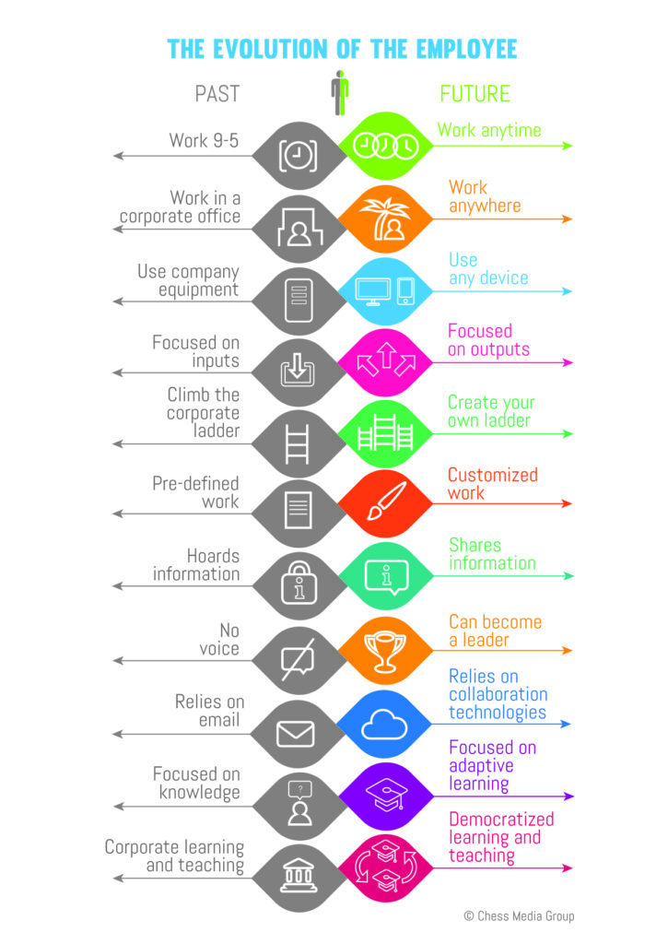
Figure 17: The Evolution of the employee
View description - Figure 17: The Evolution of the employee

In the video below, Jacob Morgan explains the evolution of the employee, and what this might mean for organisations.

Video content is not available in this format.
View transcript - Uncaptioned interactive content



The evolution of the employee must be considered alongside the Hybrid Ways of Working: A Contextual Framework because the elements within it will have an impact on your decisions as a leader, for example around cyber security. Hybrid working can mean organisations have less control over how, where and what devices employees use, which means that good online security policies and procedures for both employees and contractors are essential.

Now and the future
The evolution of the employee diagram above clearly shows the shift in expectations; some are already a reality, and understanding them will help you plan better for the future.
Work anytime: Employees set how they work their contracted hours around the needs of the outputs they need to deliver and the teams they are working with. This is especially important for those working on international projects, working across time zones, or those who welcome the flexibility to fit around their family commitments or have found that early mornings or late nights are when they perform best, with fewer distractions.
Work anywhere: Where does someone need to be to work? The pandemic has brought to the forefront that people can and will work anywhere if needed, for example those who regularly travel for business will frequently sit in cafés, airports, hotels to work. Online security and secure Wi-Fi access becomes essential in these situations.
Use any device: As an organisation you need to consider what devices your employees – and contractors – are using. People are using multiple devices as technology makes it easier to access work systems from smartphones and tablets, not just desktop computers or employer-issued laptops.
Focused on outputs: Trusting employees to deliver their outputs rather than ‘presenteeism’ allows flexible working and gives employees ownership over their work. Managing this can be challenging: leaders need to be able to monitor not only whether those outputs are delivered, but also whether employees are managing their workload effectively – both in terms of too little and too much – which can be hidden when working in hybrid teams.
Create your own ladder: Depending on the environment in which you operate, not all careers have a formal path of starting at the bottom of the ladder and working your way up. For many there is no fixed route, especially where the job they might go into doesn’t exist today or hasn’t even been imagined. People move in all directions within their careers, often completely changing their vocation and lifestyle choices.
Customised work: Many employees who can do so are managing their own careers and choosing to work for organisations or on projects either as employees or on contracts that fit with their lifestyles and career interests. Often the decisions are not about the career ladder, but their own motivations and values.
Can become a leader: The voice of the employee has become more valuable, especially as we come out of the pandemic, to understand their needs and share their ideas, thoughts and concepts that can help organisations develop. Access to people through collaboration platforms is enabling people to lead especially on projects, but also to lead others both formally and informally. A leader is not now seen as someone who has just been given that title, but through the actions they display to bring others together and take them on a journey.
Knowledge vs adaptive learning: The ability to find ‘knowledge’ via an internet search means most people can find an answer with ease. What becomes more important is an employee’s critical thinking skills to interpret that knowledge, and learn new things to adapt, understand interdependencies and apply the learnings to new situations and scenarios.
Everyone’s a teacher or a student: While formal education and organisational learning is still required, encouraging informal learning allows employees to quickly learn from each other, connect and build networks. Access to ‘learning’ through online platforms and networks such as OpenLearn, FutureLearn, Coursera, LinkedIn Learning, TikTok and YouTube has made it more accessible, cheaper and faster.
Source: adapted from The evolution of the employee

Activity 12: What makes a good employee and student experience?
15 minutes

Think about the expectations of ‘evolving employees’ and students, and what Josh Morgan believes organisations need to be focusing on for a good employee experience. Listen to Alayla Castle-Herbert, Policy Officer (Learning & Teaching) talking to Louise Casella, Director – The Open University in Wales about their experience of starting a new role.

Video content is not available in this format.
View transcript - Uncaptioned interactive content

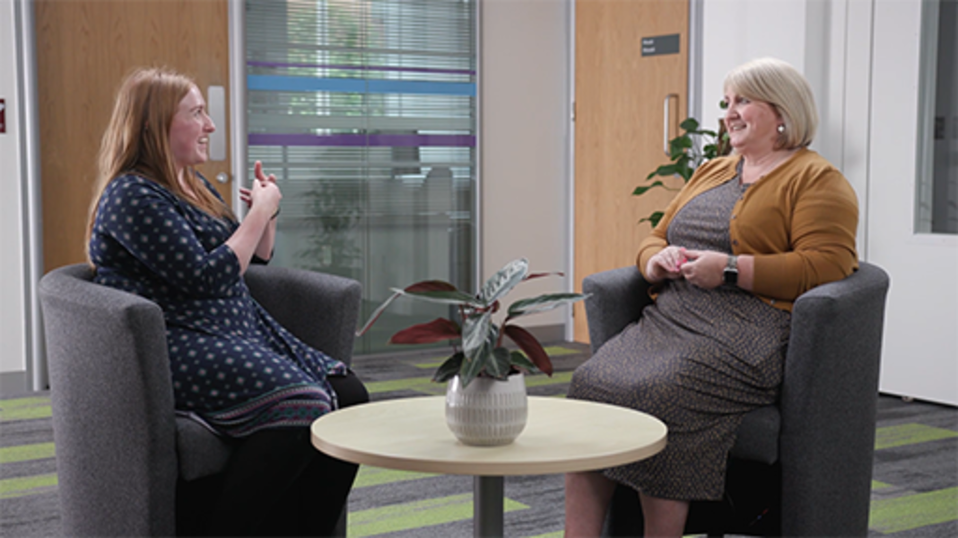

What might this mean for your organisation, what policies and procedures might be required?
How flexible can you be as an organisation, both for employees and for students?
How can you ensure the best experience for those within your organisation?

View discussion - Activity 12: What makes a good employee and student experience?

4.4 Thinking about inclusion
Equality, diversity, accessibility and inclusion (EDAI) should be at the heart of organisational development, to ensure you can provide the best experience for all those connected to your organisation, be they staff, students or other end users, and to develop a diverse workforce that is representative of the wider world, and that can bring different perspectives and experience, to help you thrive in a more connected world.
While inclusion was important prior to the COVID-19 pandemic, the pandemic brought to the forefront of people’s minds what do we mean by inclusion. During the pandemic the media focused on the lack of laptops or tablets for school children who had to be home schooled, and many communities came together to donate such devices to local schools for those children who did not have access to them.
The disparity for certain groups were more visible, but also expectations as we all adapted to lockdowns, in order to live and work. Having started to feel the world was returning to a new normal, many people are now having to face the impact of the increasing cost of living, which brings new challenges when considering inclusion and wellbeing.
EDAI is a wide and complex topic which we cannot cover in depth within this course. Instead, this course offers areas to consider. The Hybrid working: wellbeing and inclusion course explores inclusion further. You can find this course here: Supporting hybrid working in Wales.
During the research and speaking to contributors for this collection of courses, alongside diversity in the workplace, four topics were frequently raised that should be discussed when focusing on new ways of working: generational diversity; inclusion considerations for females; inclusion for those in rural locations; and digital inclusion – this is covered later.

4.5 Generational diversity
Understanding generational expectations is useful to explore the needs of both your employees and students.
The generational differences, experiences and expectations of those established within the workplace, or joined during lockdown who may have been furloughed or made redundant, to those starting in their first job will be very different from those in the organisation pre-COVID-19. Their confidence levels, needs and expectations will vary. Those who joined during lockdown might never have met their team in person, and those who have come straight from formal education will have had an unprecedented experience of a continual cycle of formal education adapting during lockdowns.
It is likely that their skillset and levels of understanding of how to behave in a workplace may need to be developed and supported. If their initial experience was working remotely, in-person work environments will be an adjustment, their digital capabilities will vary, and their resilience may be lower than expected.
Most organisations will have a diverse generational workforce. While it is sensible to consider their values and beliefs and work styles, it is also important not to assume that all Millennials are ‘digital natives’ or that Baby Boomers may not be tech-savvy. Depending on their roles within the organisation and experience, you need to consider the individual. It is important to understand the environments that different generations have been exposed to, their education, work expectations and access to technology. Understanding how to bring different generations together to learn from each other can be beneficial to an organisation, to encourage diversity and different perspectives.
The infographic from Generation Z provides a useful overview of the traits, characteristics and values each generation may bring to the workplace.

Activity 13: How to build trust across generations
25 minutes

In the video contributors share insights into generational needs. As you watch, consider how you could develop a culture of better inter-generational understanding in your organisation.

Video content is not available in this format.
View transcript - Uncaptioned interactive content

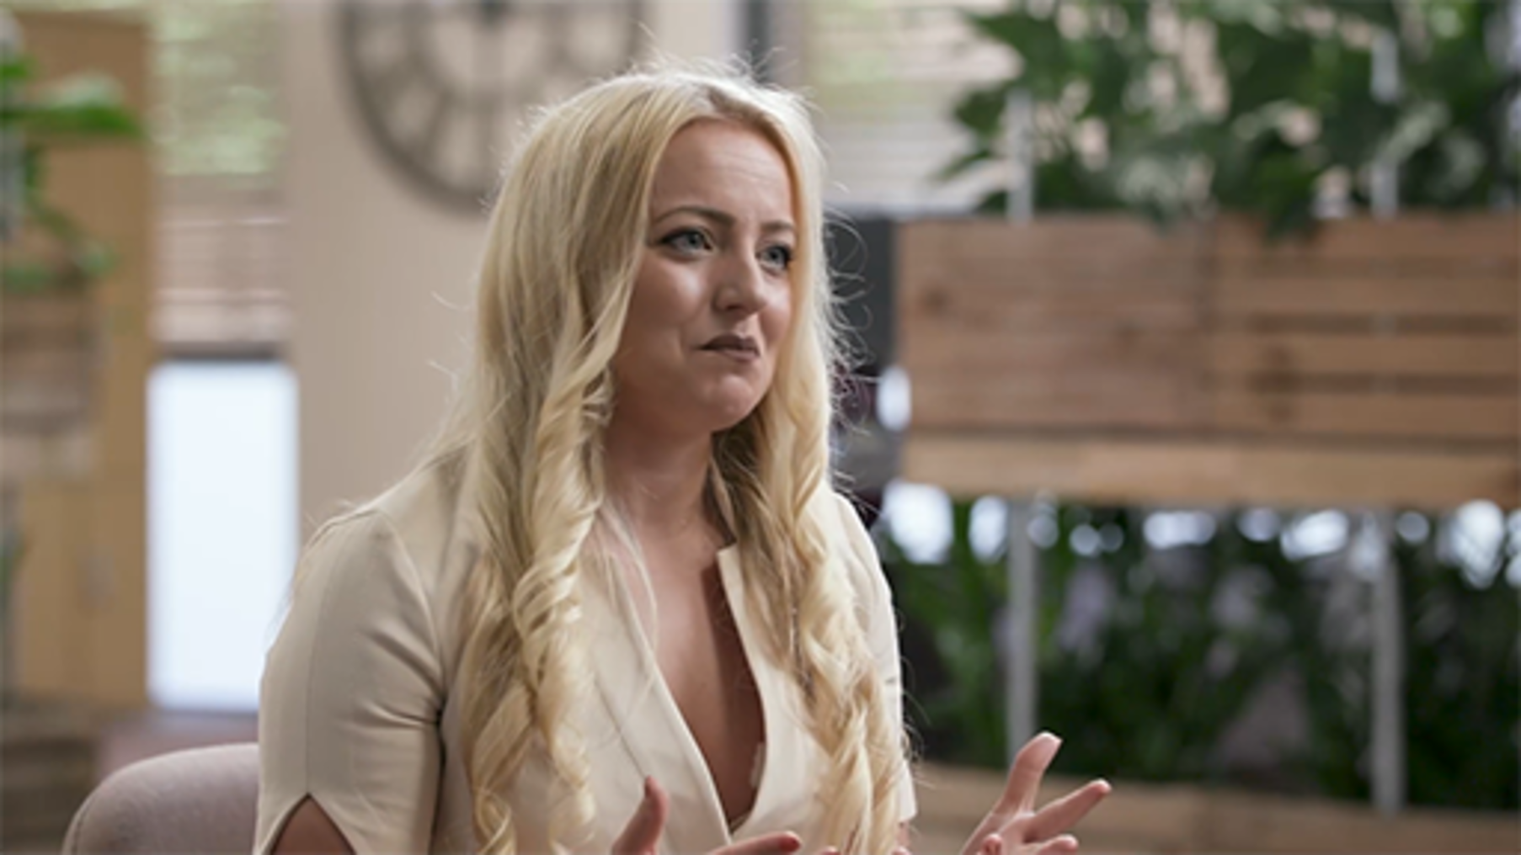

You may also wish to watch this optional video Why GQ is the kind of intelligence we all need | Poornima Luthra | TEDxOdenseWomen in which Dr Poornima Lurtha explains the three tools to develop generational intelligence (GQ), minimise micro-aggressions, and build trust each and how these could be applied within your own context.

Watch the video at YouTube.com.
View transcript - Uncaptioned interactive content

You may wish to make some notes in the free text box below.

Provide your answer...

4.6 Inclusion considerations for females
‘The United Nations’ report Progress on the Sustainable Development Goals: The gender snapshot 2021 highlighted that the pandemic has not only dented progress in key goals on gender equality but also reversed progress in expanding the rights of women worldwide.
The video below summaries the key findings of the report.

Video content is not available in this format.
Progress on the Sustainable Development Goals: The Gender Snapshot 2021 (Please note this video has no spoken audio.)

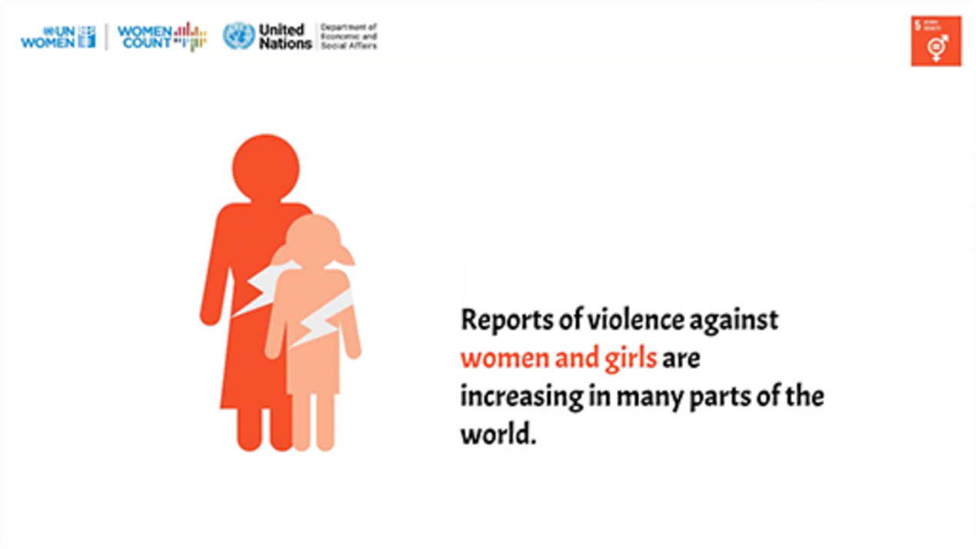

While there has always been an awareness of female equality and equity in the workplace, organisations need to consider how they can support closing the gap in their approach to new ways of working, and work to understand the needs of females.
In the videos below Natasha Davies, Policy and Research Lead from Chwarae Teg, who works to ensure women in Wales can enter and thrive in the workplace, and Samantha Hawtin, Research Student, The Open University, whose work focuses on the importance of place in the workplace, provide insights for what organisations should consider.

Video content is not available in this format.
View transcript - Uncaptioned interactive content

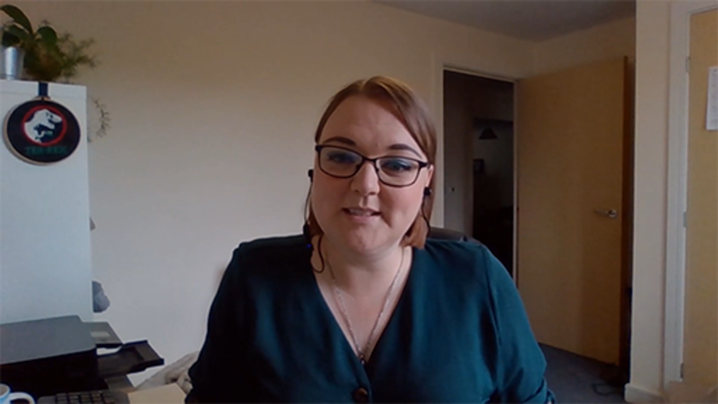

Video content is not available in this format.
View transcript - Uncaptioned interactive content

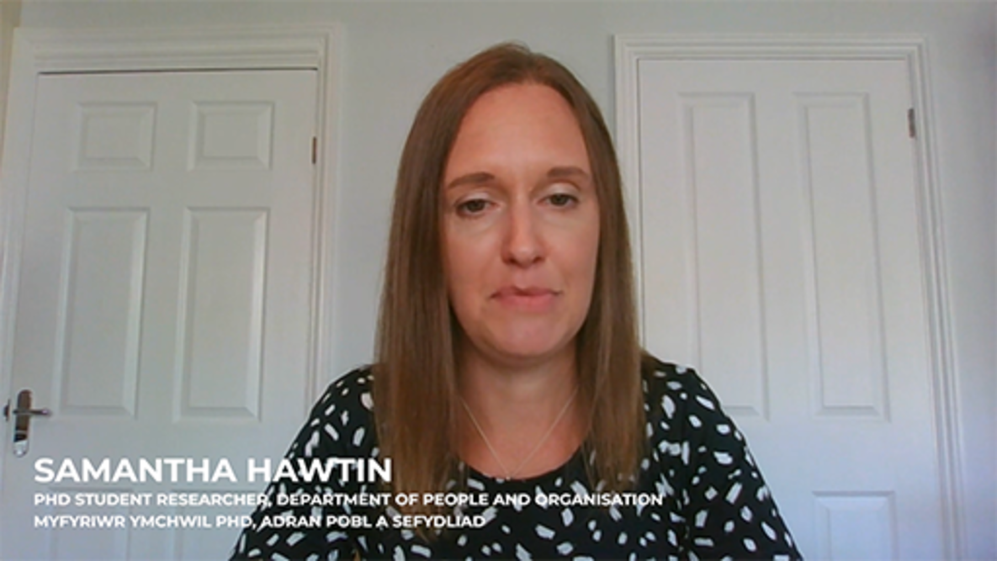

Activity 14: How flexible can you be as an organisation?
10 minutes

Many women have more time commitments outside the workplace, with responsibilities ranging from looking after children, ageing family members, managing the household, which not only can lead to difficulties managing their time in the workplace and home, due to having to work around ‘fixed hours’ (such as school hours, health care and financial service providers hours), which may cause anxieties about how they are perceived in the workplace, and impact their wellbeing.
Read Agile-and-Inclusive-Working-Practices.pdf (chwaraeteg.com) and consider the videos from this section.
What can organisations do to enable more flexibility and create a more supportive culture for women in the workplace, which allows them to be open to what they may help with when managing personal commitments? Make notes in the box below.

Provide your answer...

4.7 Rural inclusion
In 2021 the rural population in the United Kingdom was about 16%. In the image below, you can see that nearly 82% of Wales is classed as rural, with approximately 32% of the population living in rural areas.

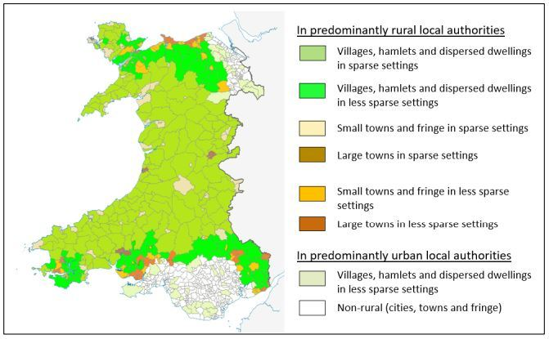
Figure 18: Typology of areas within Rural Wales using ONS classifications of settlement type and setting
View description - Figure 18: Typology of areas within Rural Wales using ONS classifications of settlement ...

Hybrid working potentially opens up opportunities for people living in rural areas to secure jobs that once were only available to those living in large towns or cities. As organisations embrace more flexible approaches to work, there are many factors that need to be considered to ensure an equal and equitable experience, including considering the cost and feasibility of sustainable commuting. Access to public transport can be limited and some people may have a low economic status.
Digital infrastructure in rural areas is often less developed, so the ability to work effectively remotely can be impacted. Rural communities are finding innovative ways to address this such as the Llanover Digital Inclusion Project (LDIP), to use village halls to provide access to improved broadband provision, raise digital awareness and digital skills in the community, alongside the use of co-working hubs that were explored earlier in the course.
In the video below, Professor Michael Woods – Co-Director, Centre for Welsh Politics and Society – Aberystwyth University, who is one of the co-authors of The Rural Vision for Wales, evidence report, explains the considerations for rural inclusion.

Video content is not available in this format.
View transcript - Uncaptioned interactive content

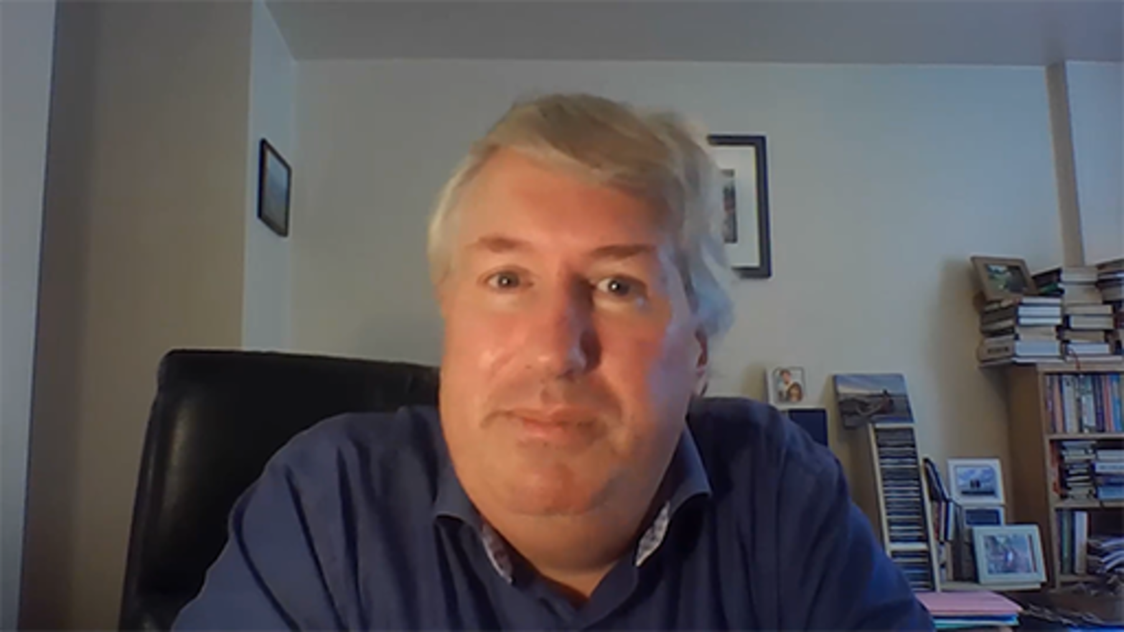

Activity 15: 15-minute neighbourhoods
15 minutes

The ‘15-minute neighbourhood concept’ was originally conceived by Carlos Moreno in 2016. His theory focuses on urban areas, with the aim of encouraging regeneration, improving social cohesion, thriving communities, health and wellbeing, while reducing the use of motor vehicles and promoting more sustainable living.
This place-based approach essentially promotes the idea of all residents of all ages and abilities being able to access their daily needs (housing, work, food, health, education, and culture and leisure) within the distance of a 15-minute walk or bike ride.
Reflect on the video above, how could the concept of a 15-minute neighbourhood enable long-term rural inclusion for hybrid working and sustainable ways of working? Make notes in the free text box below.

Provide your answer...

5 Organisational structures
As organisations plan for how they will work in the future, most HEIs may have structures that were originally designed for primarily ‘on site’ working, with boundaries between units and functional roles clearly defined. As technology, the scope of roles – which may be more interdisciplinary – and hybrid working environments have evolved, there may need to be significant changes, which allow more flexibility and have a more collaborative and integrated approach to meet the needs of how we need to work now.

‘The structure of an organisation is the pattern of relationships between roles in an organisation and its different parts. The purpose of the structure serves to allocate work and responsibilities in order to direct activities and achieve the organisation’s goals. Structure enables managers to plan, direct, organise and control the activities of the organisation.’
(Mullins, 1993)

Structures should reflect the organisation’s purpose and how it needs to work to enable effective and accountable decision making and policy making. While many organisations try to reduce ‘bureaucratic structures’, if appropriate parameters of ‘bureaucracy’ are understood and integrated effectively, they can provide clarity for employees on their roles, responsibilities and expectations of their organisation.
It can be useful to consider Charles Handy’s factors affecting organisational effectiveness, and the relationship between people power and practicalities, when reviewing your organisational needs and structure.

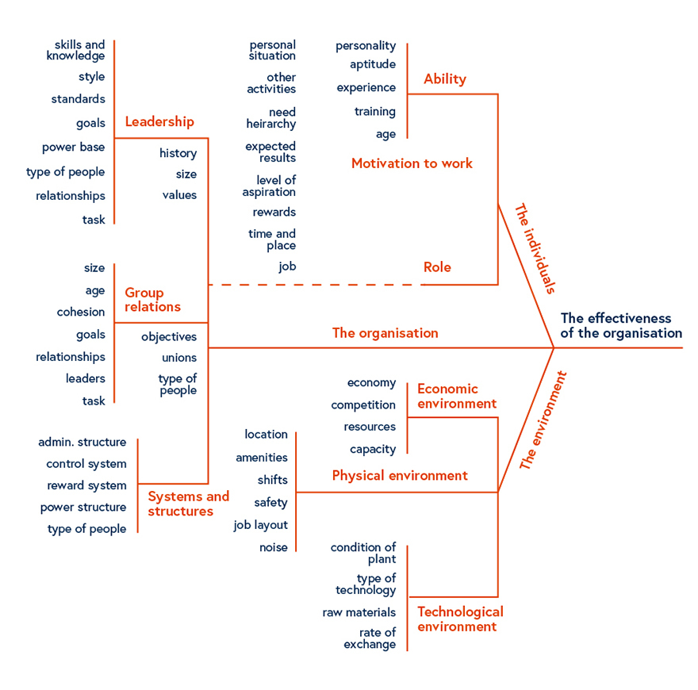
Figure 19: Factors affecting organisational effectiveness
View description - Figure 19: Factors affecting organisational effectiveness

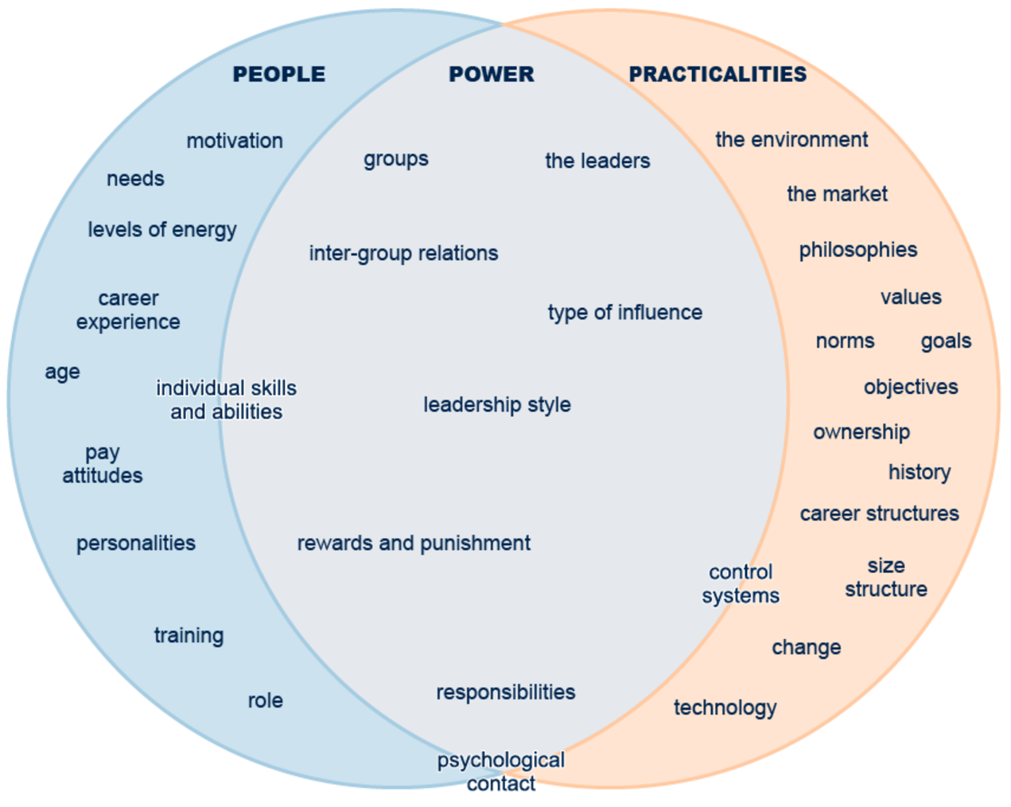
Figure 20: Factors affecting organisational effectiveness
View description - Figure 20: Factors affecting organisational effectiveness

There are various structural approaches that can be adopted, which tend to be based on either a horizontal, vertical or matrix structure.
Horizontal structures aim to have fewer levels of management, with many employees having a wide span of control that allows for better communication, autonomy and responsibility. When these are effective, they naturally encourage collaboration.
Vertical structures, in contrast, tend to be more hierarchical, defining a clear chain of command that can lead to complicated approval processes.
Many organisations have now adopted a Matrix structure, that allows for pathways throughout the organisation that enable dual reporting and task delegation. These are more common in complex organisational environments that need to be adaptive to change. This approach can lead to better and more informed decision-making, as can reduce silos and achieve better communication across departments.

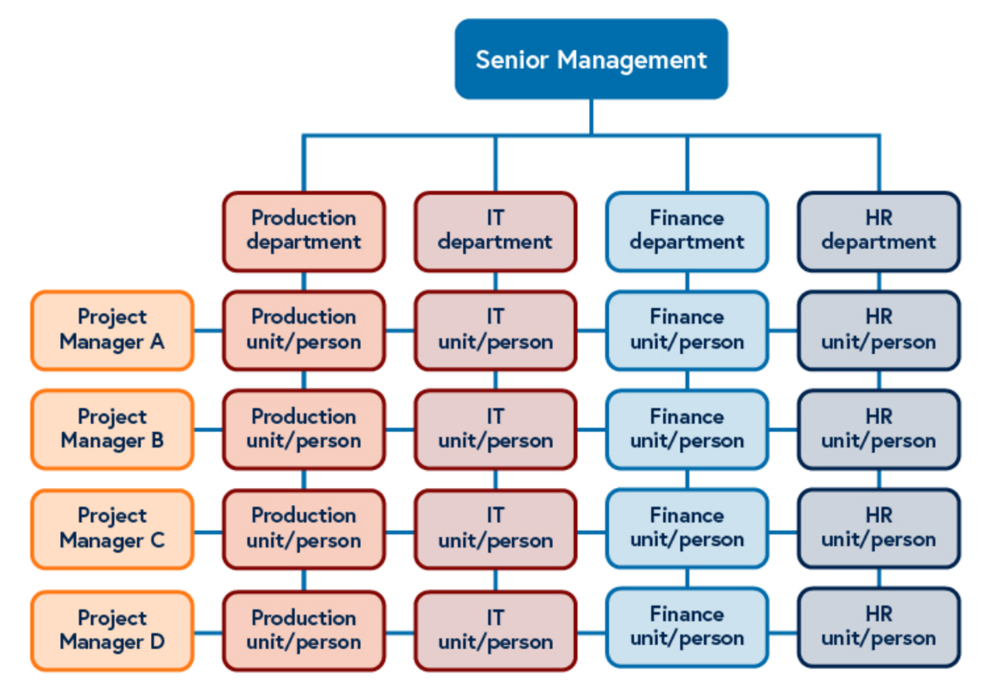
Figure 21: Matrix structure
View description - Figure 21: Matrix structure

Various approaches can be taken for organisational structure design and may HEIs will have their preferred approach, which links to change models. The Burke-Litwin change model’s premise is ‘that change starts externally and transitions to the individual’ (Burke-Litwin,1992) which can be complex due the factors it suggests considering. It has an integrated approach that focuses on the interdependences that may lead to better collaboration and involvement, as it allows you to consider the needs of the organisation, team and individual.

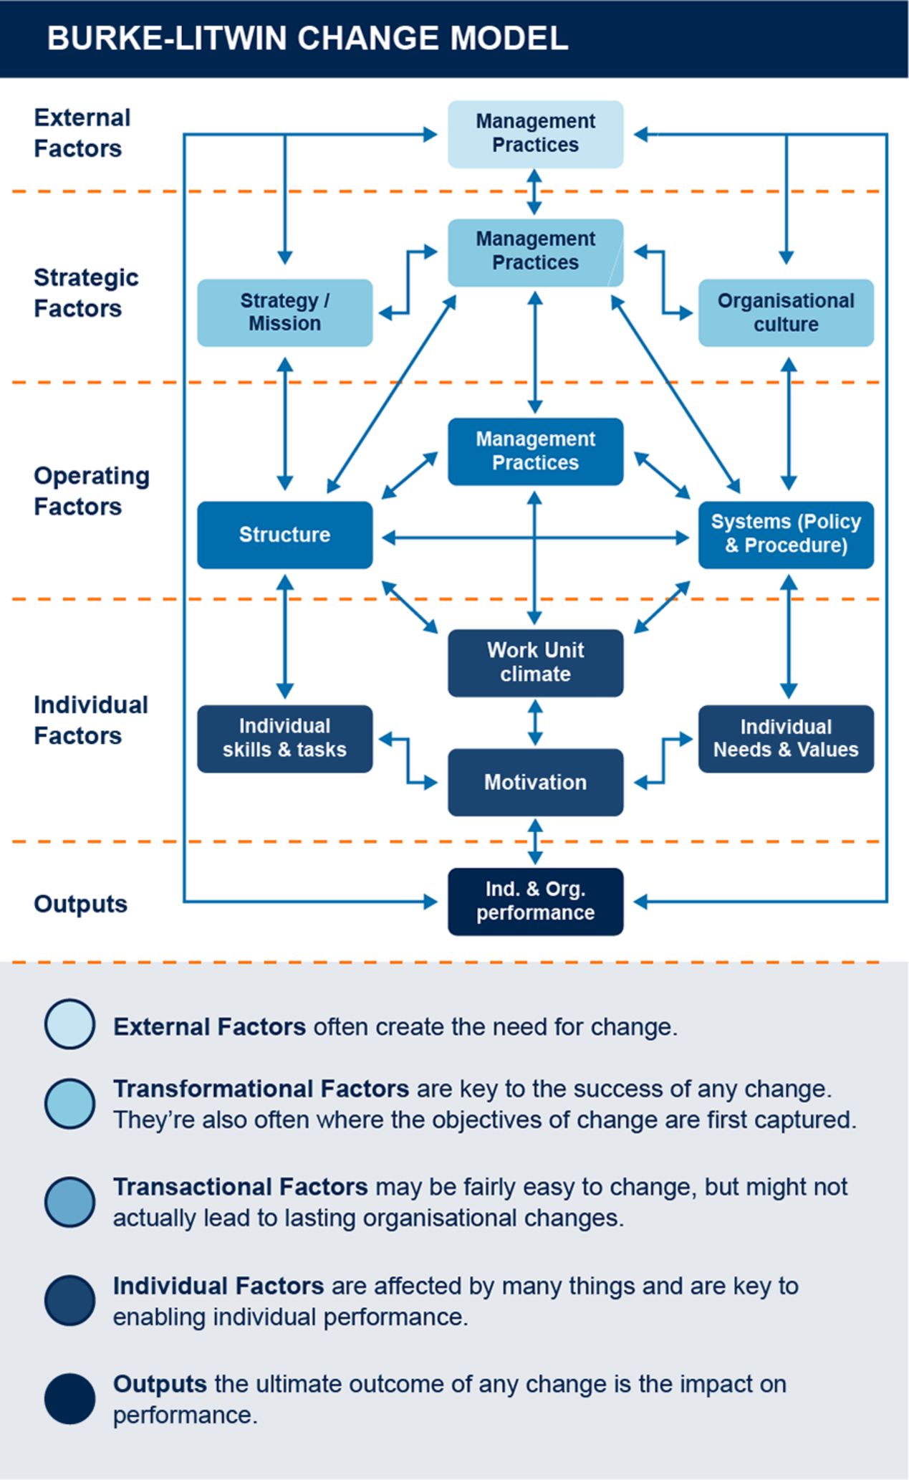
Figure 22: Burke-Litwin change model
View description - Figure 22: Burke-Litwin change model

As organisations better understand their business needs and the needs of their employees, and start to consider how best to utilise physical space in different ways to reflect fewer employees being based on site, and office space being used in more flexible ways, new structures may emerge.

5.1 Use of space – onsite and remote
As organisational structures evolve, and the workforce is dispersed between ‘on-site and remote’, organisations need to consider the use of space in both environments. The use of physical space on-site is likely to be reduced, and how it is used will change. Employees may not all be in the office with their team and may not need a permanent desk.
This poses challenges for organisations to plan for effective and efficient use of space that not only meets the needs of the organisation, but also that of individuals, especially those who have specific workspace requirements. Do teams/units need to be located together or are ‘hot desking’ areas sufficient? This decision will depend on how your organisation operates. For HEIs with students on campus the use of space is likely to remain similar to before the pandemic, but for distance learning HEIs, where fewer people may be on site, they are potentially faced with space being unused.
Organisations also now need to consider what their responsibility is for those who are based remotely, whose home-working environments may not be ideal. What is the basic entitlement that an employee can expect in terms of the equipment provided or financial support? Does the reduction in the cost of commuting offset other costs incurred with working remotely? Are all employees able to work in a safe environment? These are some of the considerations organisations need to weigh and ensure policies and processes provide clear guidance and manage expectations.
While there was an initial increase in people who were working remotely returning to ‘sites’, this appears to be plateauing, with organisations now seeing on average about a 25% usage of their space during the week. You can see from the figures below that the steady increases in those returning to office building and peak days.
For organisations monitoring use of buildings, tracking data will become critical to assist them in making informed decisions on how to design spaces for the future and where to invest in infrastructure.

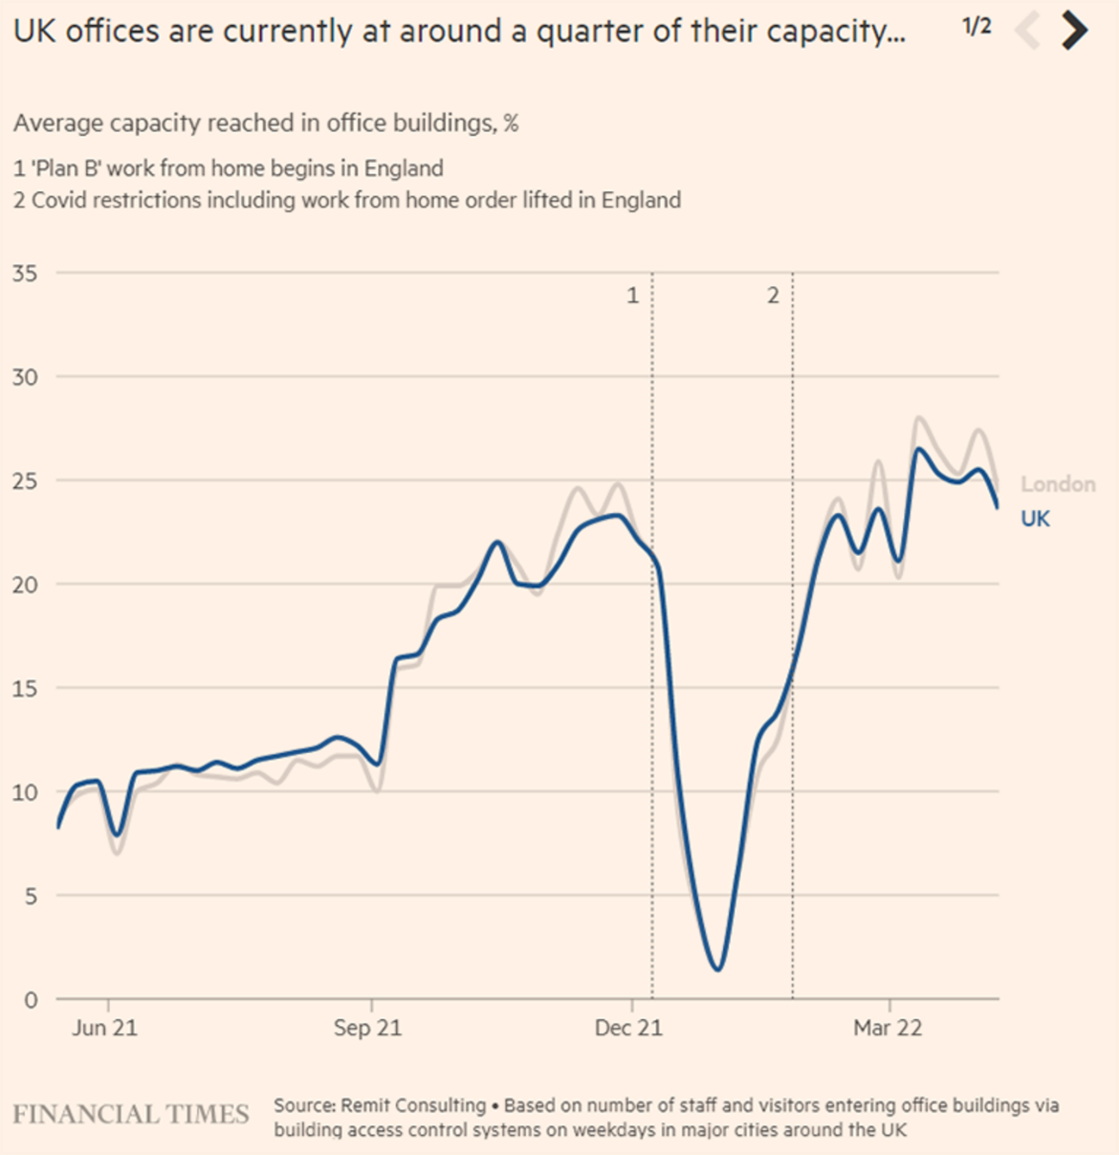
Figure 23: The average capacity reached in office buildings in London and the UK between June 2021 and March 2022
View description - Figure 23: The average capacity reached in office buildings in London and the UK ...

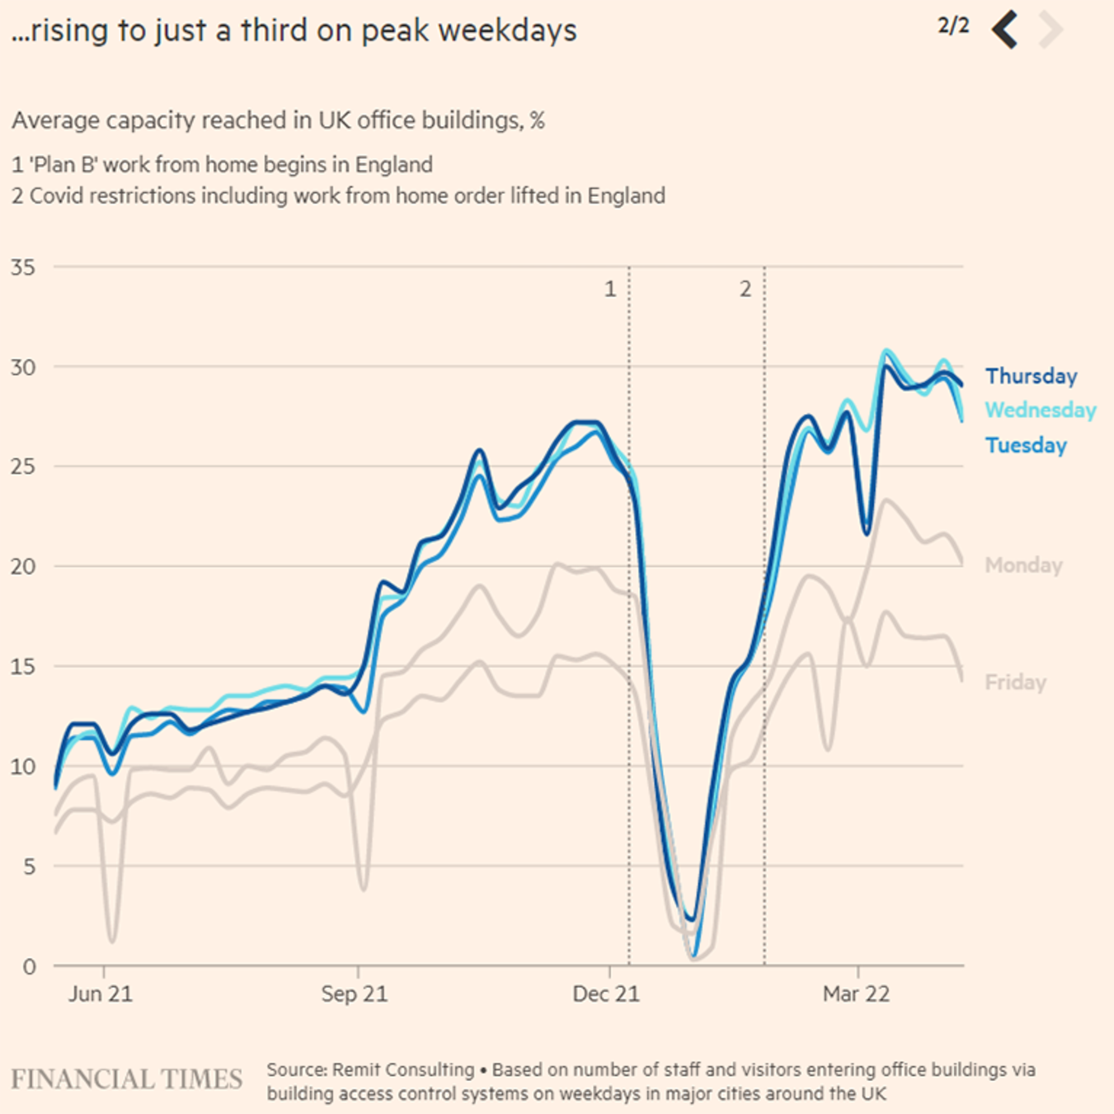
Figure 24: The average capacity reached on each weekday in office buildings in the UK between June 2021 and March 2022
View description - Figure 24: The average capacity reached on each weekday in office buildings in the ...

While some organisations would like to see all staff return to site, the indications are that employees do not wish for this to happen. This is a complex issue for organisations to resolve: planning for less space being used; considering how ‘sites’ are designed for the future to allow new ways of working; and identifying what the needs of remote workers will be – e.g. do they want to stay at home or use local hubs, rather than travel to an organisation’s main base?
The change in working patterns, use of space and hybrid working requires careful thought, consideration of health and safety, to ensure inclusion and accessibility are catered for, but also lone working as people are dispersed throughout buildings or working remotely. How people come together face-to-face and what activities they do this for, where teams are not required to be together onsite, and managing hybrid meetings also needs to be planned.
In redesigning space, facilities and services, and how employees use the space, organisations must consider sustainability as well. The commitment to reach net zero by 2050 means all organisations need to reconsider how they can operate more sustainably and understand the implications and requirements for reaching the targets.

5.2 Redesigning space for sustainability
As organisations review the use of space and services they provide, sustainability should be at the heart of planning. The three sustainability pillars – People/Social, Planet/Environment, and Profit/Economic – are fundamental to good use of space, meeting the needs of users and ensuring organisations can implement change.
As organisations have a commitment to reach net zero by 2050, they need to consider how this will be monitored to provide data that shows the reduction in their carbon footprint. While reducing energy consumption is perhaps one of the biggest challenges for organisations, focusing on sustainability also requires understanding your organisation, how it operates, and its culture and values.
Designing space needs to focus on integration of sustainability, and long-term prevention in your approach as a HEI. Planning needs to not just focus on physical space, but also on how the space is used, the services its users require, their inclusion and wellbeing, and the infrastructure required to operate.

Activity 16: Carbon within your buildings
20 minutes

Watch the video in which Dr Alice Moncaster – Senior Lecturer in Sustainable Built Environment at The Open University – explains what organisations need to consider when redesigning physical space. Then read Dr Alice Moncaster’s article Climate change and the built environment.

Video content is not available in this format.
View transcript - Uncaptioned interactive content

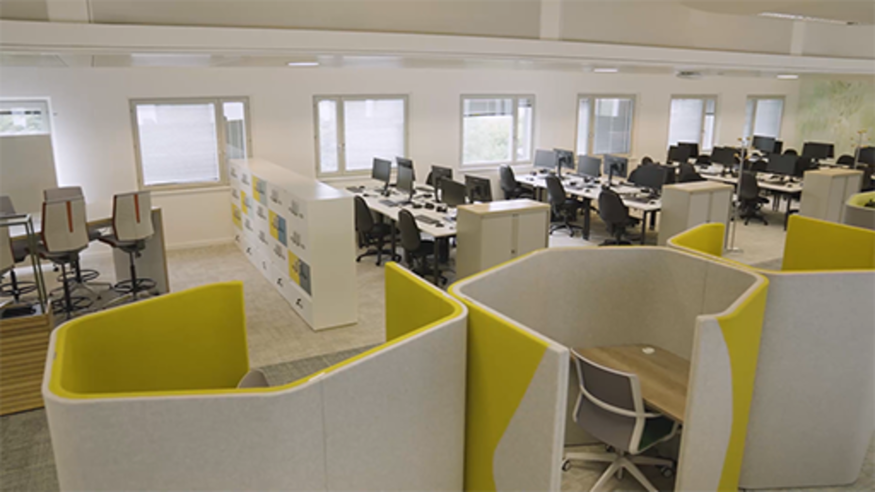

You will note in the article that it is estimated:
‘39% of all global greenhouse gas (‘carbon’) emissions. 28% of this is due to the operational carbon from heating, lighting and cooling our existing buildings, while the substantial remainder of the 11% comes from the embodied carbon of constructing new buildings each year.’
Then browse this article, which focuses on the built environment in Wales:
Delivering on the decarbonisation agenda in the built environment in Wales
Take some time to list the factors that might need to be considered when developing a plan to reduce the carbon footprint of buildings now and for the future. What might the key challenges be for your organisation / HEI?

Provide your answer...

5.3 Using space to work differently
As an organisation you have limited power over a ‘remote’ location that you do not have direct responsibility for, and you need to consider ways you can encourage your employees to take responsibility for reducing their carbon footprint.
One approach to understand more about your organisational needs is to run test-and-learn experiments with spaces and engage all your stakeholders in these conversations. The Open University has approached this by designing creative hubs – known as ‘Show homes’ – to explore the different ways of using space and how teams can come together with accessibility and inclusion at the forefront. Dr Nick Barratt, the Director of Learner and Discovery Services at The Open University, explains the approach and insights the OU hopes to gain from this approach.

Video content is not available in this format.
View transcript - Uncaptioned interactive content

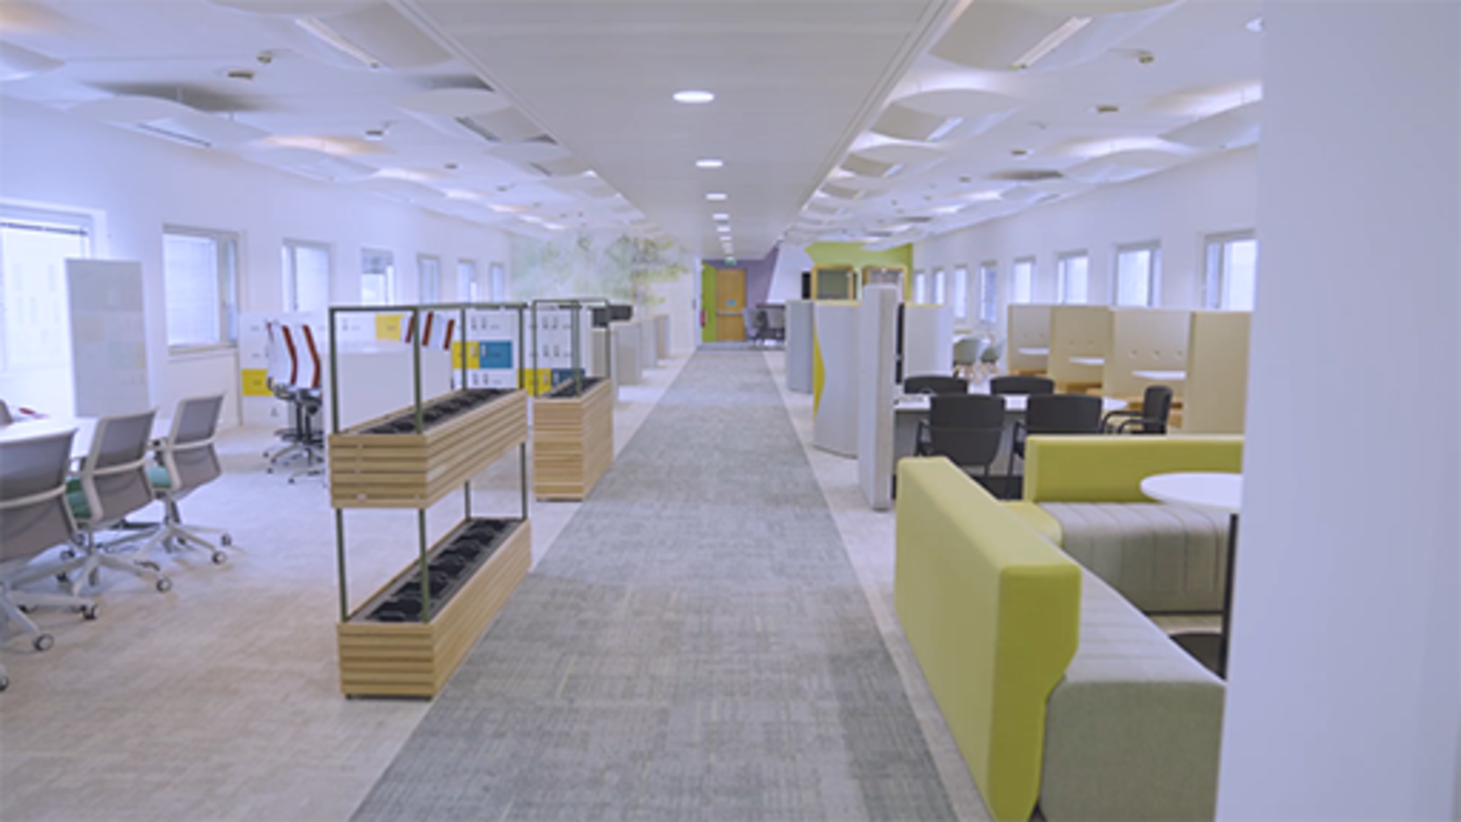

Remote co-working hubs
One of the challenges for hybrid working is that the infrastructure and wellbeing of remote workers can be variable. The Welsh government ran a survey in 2021 to explore the desire for remote working hubs and has set a long-term ambition of 30% of the Welsh workforce to be based away from a traditional office. The aim is to help town centres reduce congestion and cut carbon emissions. (Source: gov.wales) They now have over 30 remote working hubs throughout Wales. Find your local remote working hub
The result of this has been the release of funding to create remote working hubs. Collaborative working spaces are not a new concept. Most organisations do not own their premises and lease shared offices and spaces, often in large office blocks that house numerous organisations. These shared spaces are likely to become more popular as organisations re-evaluate the space needed for their workforce.
Smaller co-working spaces existed prior to the pandemic, but were predominately used by small business owners or the freelance community. However, they offer those who now work remotely for larger organisations an alternative to working from home or travelling to the office, which may be useful if their domestic situation makes working from home a challenge.
In the video Llinos Neale from Welsh ICE talks about how the use of remote working hubs have evolved since the pandemic.

Video content is not available in this format.
View transcript - Uncaptioned interactive content

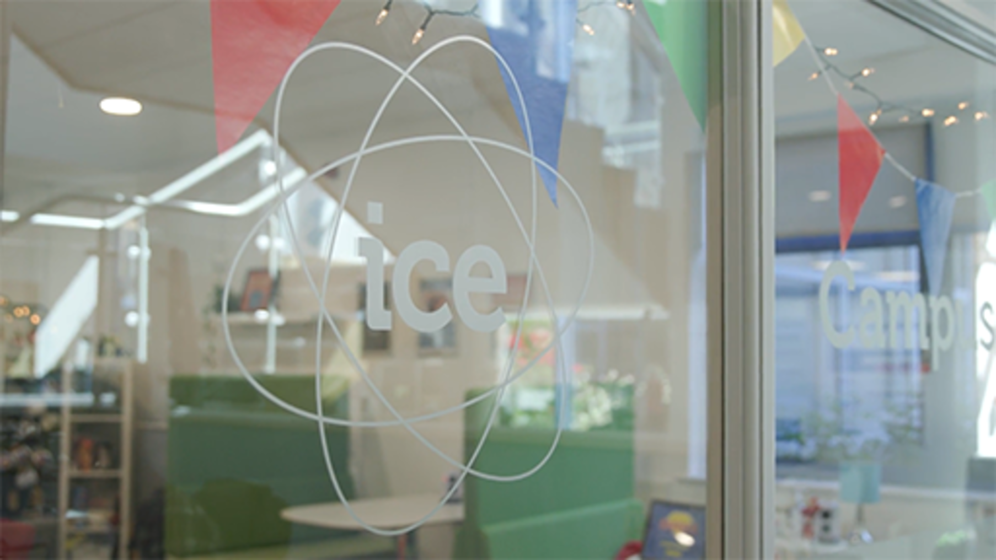

Activity 17: Think about how you can use both onsite and remote space more effectively
15 minutes

Read the following articles, which provide insights into how larger organisations approach reimagining the office.
- Reimagining the office and work life after COVID-19
- Coworking Post-Covid: WeWork’s Predictions for 2022
Consider what you have learned in this section and think about how you can use both your on-site and remote spaces more effectively, and what you can do to make them more sustainable.
Here are few areas you may wish to consider:
- Green spaces
- Catering facilities and provisions – do you ban single-use cups?
- Who is in your supply chain – what is their commitment to sustainability?
- What are the expectations for new builds and retro-fit projects?
- How accessible are buildings?
- What are your travel policies?
- Guidance for remote workers on setting up their home office environment.
- Guidance for remote workers on how they can reduce their carbon footprint within the own location.
- Impact on your local community, both benefits and negative impacts.

6 The digital strategy for Wales
The Digital Strategy for Wales aims to address how to use digital, data and technology to improve the lives of people in Wales.

‘Digital offers the potential to make our experience of the world better: enhancing people’s lives, strengthening the delivery of public services and the work of government, as well as helping businesses to adapt to the future.’
(Source: Digital strategy for Wales)

This vision of the digital strategy is improving the lives of everyone through collaboration, innovation and better public services. There are six missions to support the vision:

Table 5
Mission 1: digital services | Deliver and modernise services so that they are designed around user needs and are simple, secure and convenient.
Mission 2: digital inclusion | Equip people with the motivation, access, skills and confidence to engage with an increasingly digital world, based on their needs.
Mission 3: digital skills | Create a workforce that has the digital skills, capability and confidence to excel in the workplace and in everyday life.
Mission 4: digital economy | Drive economic prosperity and resilience by embracing and exploiting digital innovation.
Mission 5: digital connectivity | Services are supported by fast and reliable infrastructure.
Mission 6: data and collaboration | Services are improved by working together, with data and knowledge being used and shared.
Source: Digital strategy for Wales

The Well-being of Future Generations (Wales) Act 2015, A Prosperous Wales wellbeing goal specifically focuses on the skills for the future: ‘Encouraging organisations to develop a skilled population, fit for future technological change’. Digital skills for the future are essential for ensuring that not only organisations thrive, but that communities and nations protect future generations.

Activity 18: Understanding the digital strategy for Wales and Skills for the future
25 minutes

Watch the video in which Sophie Howe, The Future Generations Commissioner for Wales, explains the skills that will be required for the future.

Video content is not available in this format.
View transcript - Uncaptioned interactive content

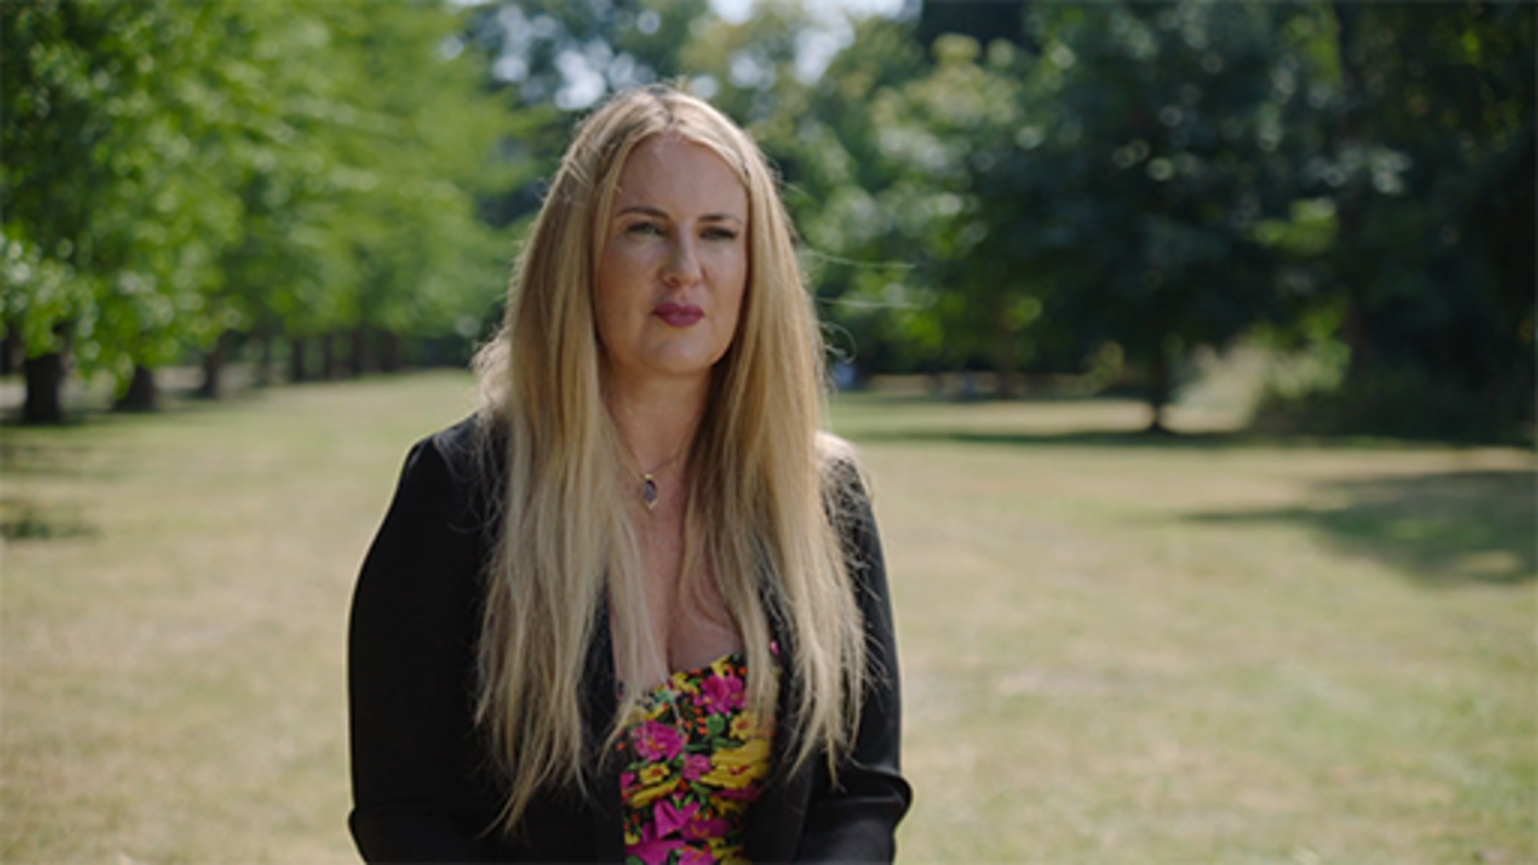

Then take time to read:
- The digital strategy for Wales
- The Digital Strategy for Wales – 12 months on (Watching the video within the article is optional due to the length.)
- Section 5 of A journey to a prosperous Wales
Note what this might mean for your organisation and for HEIs more widely, not only in terms of the digital skills that are required, but also what it may mean for the digital transformation of your institute.
If you are not based in Wales, you may wish to search for the digital strategy for the country that you are based in.

7 Digital transformation
Prior to the pandemic, digital transformation was important to ensure that organisations and individuals had the infrastructure, knowledge, experience and capabilities to thrive in a digital world.
The pandemic accelerated the need to adopt digital technology, use data more effectively to make decisions, and focus on digital inclusion, both in terms of capabilities of organisations and individuals, but also how to support those who are digitally excluded.
For organisations that had to adapt and support remote working and for HEIs delivering remote learning, the role of technology within an organisation has become a key focus. The table below, from a report by McKinsey, demonstrates the speed of change due to the pandemic.

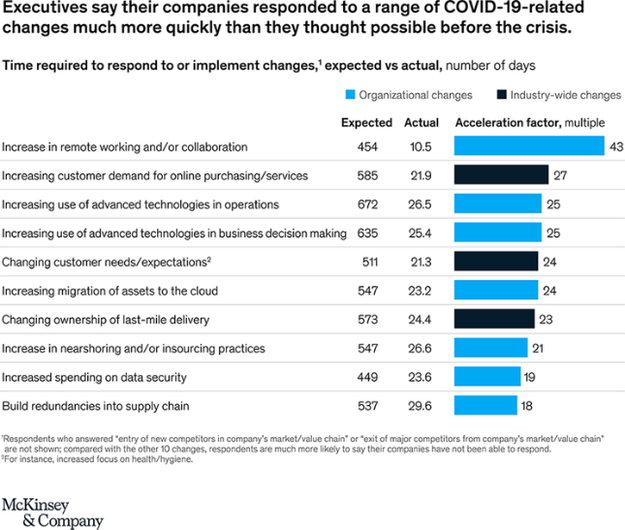
Figure 25: The time required to respond to or implement changes
View description - Figure 25: The time required to respond to or implement changes

As organisations adopt a hybrid approach to working, the reliance on technology will remain, and understanding how it is evolving is important.
In the video contributors explain what organisations need to consider for digital transformation and the digital capabilities required for the future:

Video content is not available in this format.
View transcript - Uncaptioned interactive content

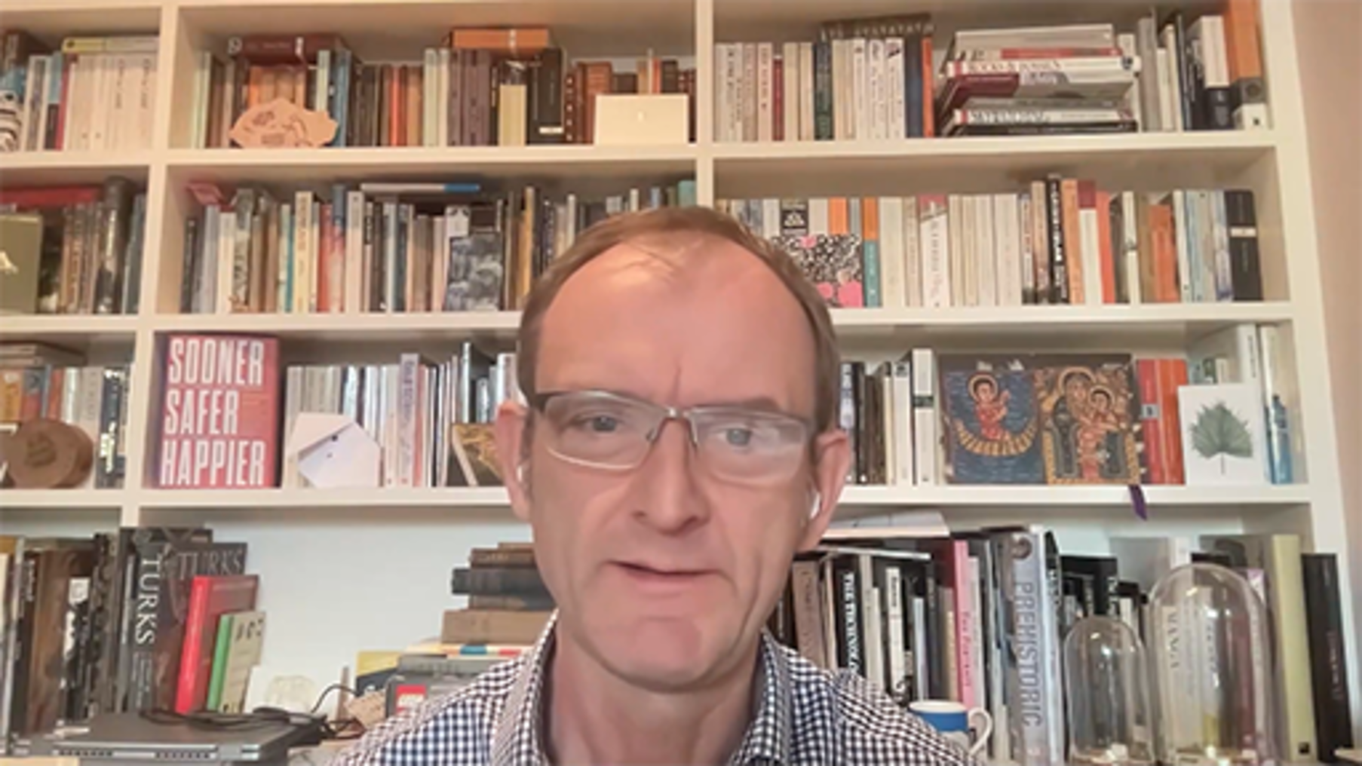

The figure below provides a useful summary of the some of the changes that occurred during the COVID-19 pandemic that are likely to continue.

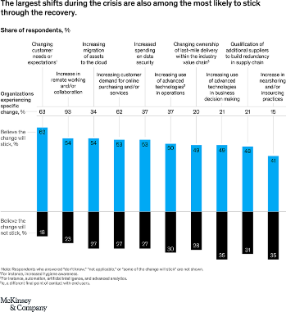
Figure 26: The largest shifts (per cent) during the COVID-19 crisis
View description - Figure 26: The largest shifts (per cent) during the COVID-19 crisis

Organisations need to consider not only their internal environment but also their supply chain and, critically, online security and behaviour. As organisations place more trust on employees, it is paramount that they raise their understanding of and ability to work securely online and use technology and systems (such as file sharing and storage) safely and correctly.
They also need to investigate the infrastructure and tools required, and plan for the future, while ensuring a focus on digital sustainability, the digital capabilities required and government strategies.
Some key themes organisations are considering for the future include:
- automation of business processes − machine learning and artificial intelligence (AI)
- cloud computing
- use of data to drive decision making
- attracting talent with the right digital capabilities
- zero-trust approach to security
- how the metaverse will develop
- sustainability − reaching net zero, and carbon footprints.

7.1 Digital leadership
For organisations to successfully digitally transform they need to cultivate digital leadership skills. Digital leaders do not have to be experts in technology but need to have the knowledge to be able to make connections and have conversations that enable the organisation to embed a digital first culture.
Having a digital common language for leaders, is an approach that can simplify technology jargon, and help focus on the opportunities and risks to enable digital transformation. Deloitte Insights suggest:
By embracing a common language, organisations can begin to:
- Break through human behavioural and structural barriers. Everything in an organisation is interconnected. Leaders across functions can speak thematically about shared needs, avoid redundant investments, address emerging risks, and change processes at scale by simply communicating better.
- Plan beyond a single technology. Platforms, capabilities, and initiatives often involve multiple digital and physical technologies securely working together. As these technologies combine, they become greater than the sum of their parts to bring new capabilities and greater value.
- Evolve into the future. Today’s breakthrough technology is tomorrow’s legacy tech. A common language can enable leaders to think flexibly across a matrix of business and technology needs, without having the business strategy reliant on any single technology.
- Achieve a greater strategic business value through its capacity to change and ability to win. This approach helps organisations better align and execute against their business strategy to achieve their desired results of advantage and adaptability of the organisation, humans, and technology.
Source: Deloitte

Activity 19: What does a digital leader look like?
20 minutes

Watch the video in which Jacob Morgan shares the skills for digital leadership.

Video content is not available in this format.
View transcript - Uncaptioned interactive content



Then browse the following articles:
6 Characteristics of Digital Leadership
Leadership in a digital age
What do you think is required for digital leadership? You may wish to make notes in the free text box below.

Provide your answer...

Digital leaders also need to plan a strategy to ensure that all employees have the digital capabilities, skills and behaviour necessary to harness digital tools and data, and have an awareness of the differing needs of their employees, students (for HEIs), and wider community.

Activity 20: Six factors for successful digital transformation
10 minutes

The Boston Consulting Group (BCG) recommends six factors for successful digital transformation:
- Integrated strategy with clear transformational goals.
- Leadership commitment from CEO through to middle management.
- Deploying high-caliber talent.
- An agile governance mindset that drives broader adoption.
- Effective monitoring of progress towards defined outcomes.
- Business-led modular technology and data platform.
Source: BCG: Digital Transformation
Watch the video The keys to digital transformation: getting the success factors right which explains the six factors. As an optional activity, you may also wish to visit BCG article Digital Transformation Strategy Consulting | BCG which about half way down has additional videos on each of the factors and explains.
How could leaders use these factors to develop their organisations approach to digital transformation? You may wish to make notes in the free text box below.

Provide your answer...

BCG’s approach to digital transformation starts by assessing where an organisation is today, and where it wants to go. The image below shows the timescales and the outcomes that organisations may aim to achieve.

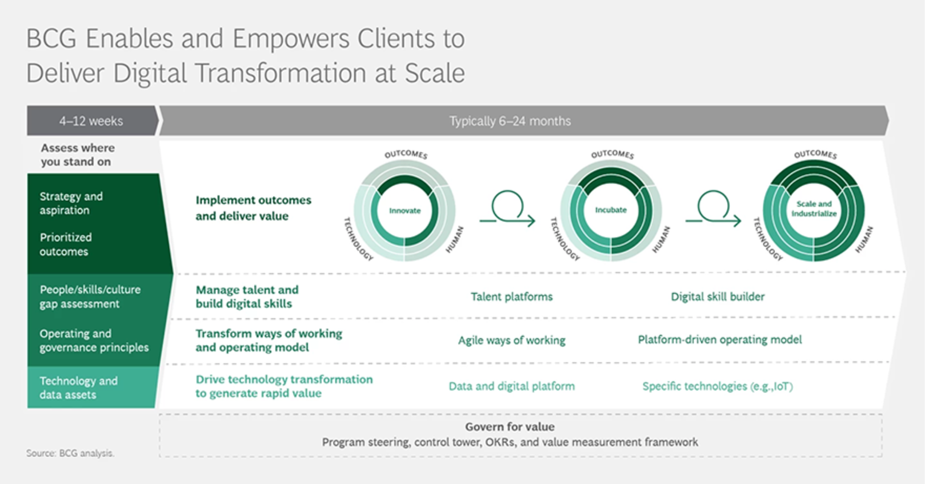
Figure 27: The Boston Consulting Group digital transformation process
View description - Figure 27: The Boston Consulting Group digital transformation process

Activity 21: Explore what digital transformation for HEIs might involve
15 minutes

In this section we have looked at digital transformation in the wider context predominantly aimed for the corporate world, which is important when thinking of HEIs in the context of a business.
Reflect on the Hybrid Ways of Working: A Contextual Framework, the Digital Strategy for Wales and the activities earlier in the course exploring your internal and external environment. While HEIs need to operate as a business, they also have to consider the needs of their students, approach to pedagogy and delivering teaching and learning, which the pivot to online learning during the COVID-19 pandemic has led many institutions to offering a blended learning approach.
Then read the following articles:
Tackling digital transformation together
Consider the Three Ds When Talking about Digital Transformation
Educause suggest a Three Ds approach to digital transformation for HEIs – Digitisation, Digitalisation and Digital Transformation.

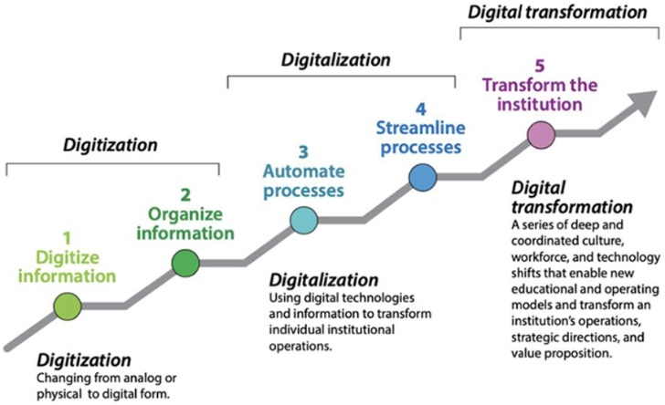
Figure 28: The process to achieve and differences between digitisation, digitalisation, and digital transformation
View description - Figure 28: The process to achieve and differences between digitisation, digitalisation, ...

Reflect on the Educause article, and consider what elements from the BCG and the Three D’s approaches can enable HEIs to digital transform and achieve the outcomes of the Digital Strategy for Wales and the A Prosperous Wales wellbeing goal – Skills for the Future successfully?
You may wish to make notes in the free text box below:

Provide your answer...

7.2 Digital inclusion
In Wales 7% of adults are not online; these are likely to be older adults, those with health conditions, lower educational attainment, low incomes, people in rural areas, and those whose first language is Welsh and do not speak English. (Source: Digital Communities Wales)
The Future Generations Act has continually focused on the need to build digital infrastructure and capabilities recognising the role of technical change and the impact on people, and the skills that will need to be developed to adapt to changes driven by technology, and to narrow the digital divide.
Research by Cardiff Business School on creating skills fit for the future has outlined several drivers of change, including:
- A significant proportion of tasks and jobs will be subject to continuous restructuring as a result of technological change. Repetitive and process-based tasks and jobs are at greatest risk, especially ‘white collar’ roles.
- Service delivery will be increasingly reliant on ‘the cloud’, which will be potentially mediated by a small number of global platforms. Most people will expect digital provision of/access to their public services to match private services.
- One potential outcome of automation is far less human involvement in economic production and distribution.
- Creativity and problem solving in complex contexts will remain human advantages for some considerable time, and therefore, will be increasingly valuable skills.
- Increased technology may disadvantage already economically deprived places and may have strong gender implications, including a potential ‘care crisis’.
(Source: Future Generations Commissioner for Wales, Slide 9 – A journey to a prosperous Wales. 5: Skills for the future)
HEIs play an important part in the long-term prevention of digital exclusion, and narrowing the digital divide both in terms of how the curriculum they offer students has a range of appropriate courses for specialist areas, and also how digital capability building is embedded throughout out all student activities. How HEIs engage with the wider community – through collaboration, research and partnership – also needs to be considered.
As we come out of the pandemic and organisations plan for the future, they need to consider what is being referred to as the Fourth Industrial revolution, which is driven by the advancements in artificial intelligence and emerging technologies, and greater automation within the workplace. The developments in this area potentially will lead to greater digital exclusion, and a skills gap.

Activity 22: Planning for inclusion and developing capabilities
25 minutes

Watch the video in which contributors share their insights about digital inclusion, and how to narrow the digital divide.

Video content is not available in this format.
View transcript - Uncaptioned interactive content



Then take some time to browse the following resources. Make notes of key points for further considerations to research outside of this course.
- A Journey to a Prosperous Wales
- Digital inclusion progress report: towards a digitally confident Wales
- Centre for Digital Public Services
- Digital maturity survey

Reflecting on the resources above, and activities throughout this course, what do you feel will be the main challenges for organisations and HEIs to plan for inclusion and developing capabilities?

8 Transforming your organisation for the future
As HEIs evolve and adapt, they need to consider the internal capabilities they have to deliver their organisational objectives and student outcomes, and to respond to external factors that demand new skills.
Who they will need to support these changes is a key question for organisations to address. Understanding your existing capabilities and identifying skills gaps will assist in planning for the future: do you have employees who are capable of developing themselves to meet the needs of the organisation, or do you need to recruit? It is vital that you have a balance of existing employees who understand your organisation, and new starters that can work with them in collaboration to meet the changing needs.
The LinkedIn Workplace Learning Report 2022 highlights that leadership skills are most important for the future. The infographic below provides a useful oversight of areas of learning and development (L&D) that need to be considered.

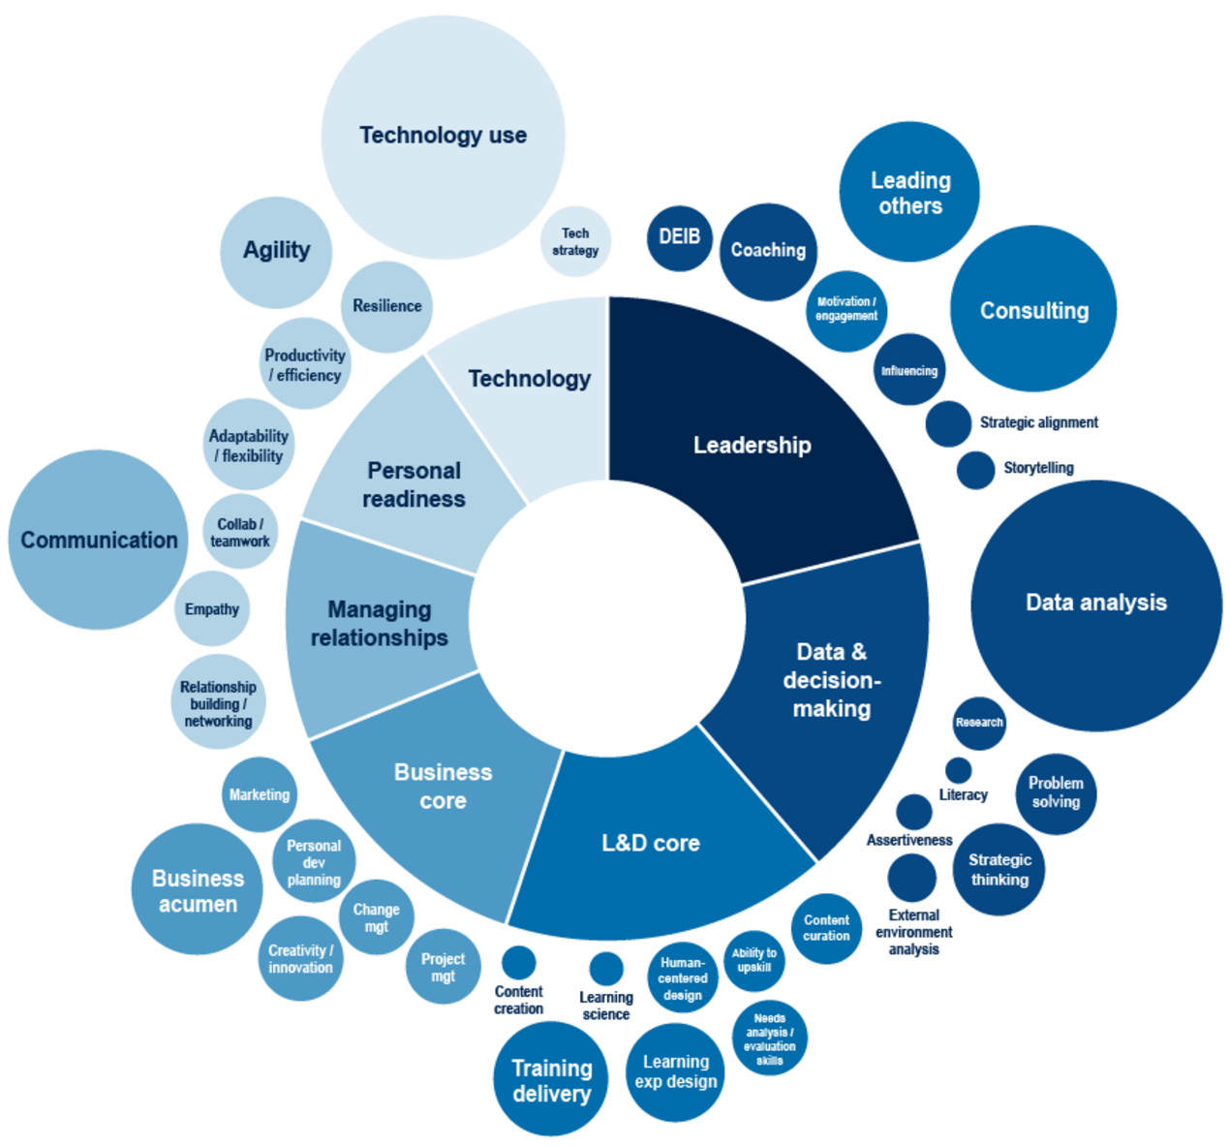
Figure 29: Where L&D Professionals see the need to grow
View description - Figure 29: Where L&D Professionals see the need to grow

HEIs can bring a unique perspective to developing their organisational capabilities by thinking about how professional services and the academic community could be involved in designing internal ‘Learning and Development’ plans for the long term. Enabling a culture within a HEI that encourages involvement and integrates stakeholders and expertise from different areas of the organisation, as well as with external partners, offers the potential to develop a ‘Learning and Development’ strategy that ensures the capabilities of your workforce will be raised.
Focusing on the needs of the organisational workforce, aligned to its strategy and understanding the external environment, allows for a more targeted and effective approach. This may involve creating new roles within your organisation, to lead on the areas you need to develop.
One of the key concerns for organisations is the digital skills gaps, and how to build digital capabilities within the workforce. This can be complex because most organisations’ technology and digital dependencies will also be complex, and governance, compliance and behaviour must be integrated into capability building. Nearly every member of an organisation will need digital skills but, depending on their role, these could range from specialist skills – for example DevOps developers – to just the ability to use email effectively in more manual roles.

Activity 23: Growth in the flow of work
15 minutes

Read the article A New Strategy For Corporate Learning: Growth In The Flow Of Work and consider your what and how for developing your approach to learning and development within your organisation. You may wish to make notes in the free text box below.

Provide your answer...

8.1 Developing your workforce
As we came out of the pandemic there was a focus on the ‘great resignation’ and the impact this has for organisations, such as considering how you retain existing staff or attract new staff when the demand is greater than supply.
Where competitive salaries, which can be challenging for public sector HEIs, cannot be offered, the focus on the employee experience, the culture and opportunities within the organisation become more important. How these are communicated and implemented requires a commitment to change, not just in the way an organisation operates, but also in its polices and processes. In the video contributors Jessica Leigh Jones, Elise Lockyer and Jacob Morgan provide insights into developing your workforce and the employee experience.

Video content is not available in this format.
View transcript - Uncaptioned interactive content

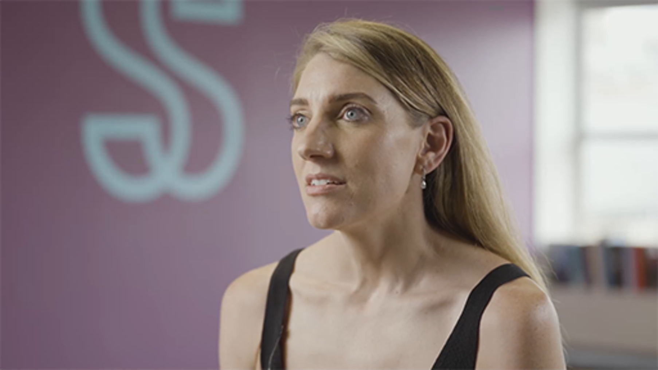

Activity 24: What are workers hopes and fears for new ways of working?
10 minutes

Read the following article from the Guardian, and the PwC summary of their Global Workforce Hopes and Fears Survey 2022 and think about the video above. Consider why people leave an organisation, whether generational expectations are different, and how might your organisation be better equipped to retain staff?
Turns out the Great Resignation may be followed by the Great Regret
PwC’s Global Workforce Hopes and Fears Survey 2022

While retaining staff is important, organisations also need to consider how to attract staff, and what skills and experience they want to bring into an organisation. The workforce is continually evolving as new opportunities open, so organisations have the dual challenges of retention and skills gaps. Often it is the most valuable employees who will seek new opportunities.
Ensuring that strategies for recruitment consider the new environments and needs of the organisations allows for more effective planning and efficient recruitment. Those involved in recruitment need to develop the skills to not only attract the right people, but where salary expectations cannot be met, have innovative strategies around reward, reputation and opportunities to ensure their organisation is an attractive offer. The recruitment process should be a positive one for all involved, and recruiters need to ensure that the capabilities and competencies are met by designing clear and effective job descriptions, selling the organisation and considering new approaches for assessing potential candidates.
Internal recruiters who may not be specialist in certain fields need to work collaboratively with specialist units within their organisation to understand the needs and requirements, and to consider their competitors, especially where salaries are not as attractive as other organisations.
Continual workforce planning and strategy needs to become a priority; the CIPD workforce planning process, shown in the diagram below, provides the steps that should be taken. Collating the right data and information to understand the organisation and its environment is critical. Data will ensure that you can effectively analyse your organisation’s workforce to determine what your actual needs are.

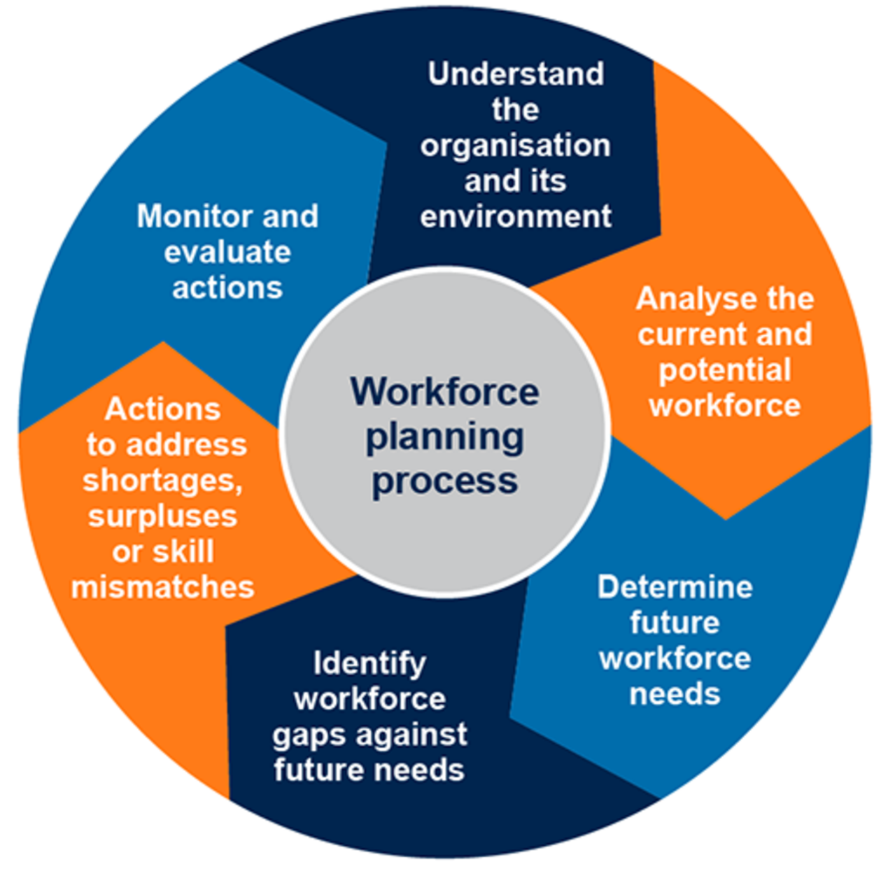
Figure 30: CIPD workforce planning process
View description - Figure 30: CIPD workforce planning process

Activity 25: Understand your workforce planning
20 minutes

How your organisation approaches work planning will differ. In the video below contributors share insights about approaching recruitment and retention of the workforce.

Video content is not available in this format.
View transcript - Uncaptioned interactive content

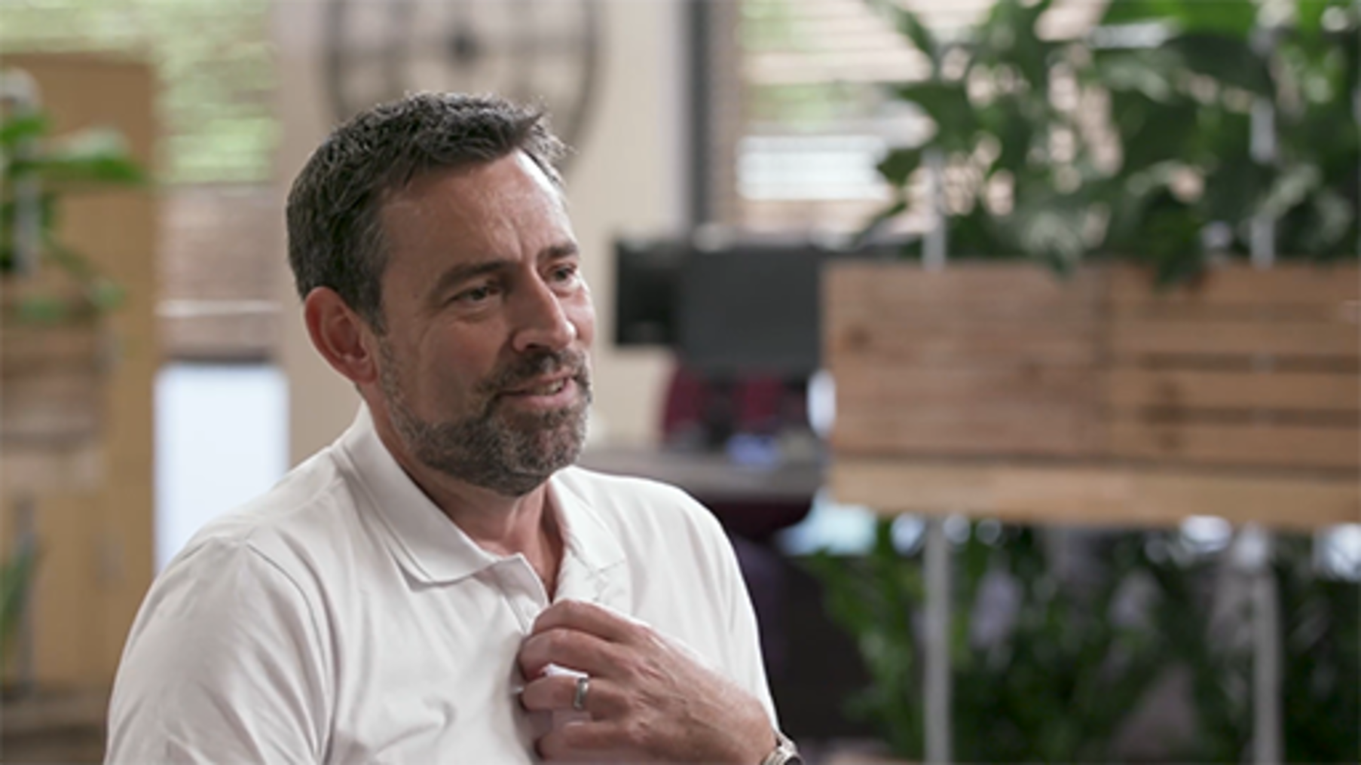

Reviewing your recruitment process and who is involved is important for ensuring that you have the capability and skills in order to be successful for the future.
Research your organisation’s approach to workforce planning, and if you have been involved in recruitment, reflect on your own experience. Reflecting on the video and your research consider what you might do different in the future.

8.2 Building a data-driven culture
The digital strategy for Wales Mission 6: data and collaboration, states:

Services are improved by working together, with data and knowledge being used and shared
‘Data underpins everything we do digitally. […] It enables responsive and continuous improvement in public services, supports seamless services, enables digital innovation and automation, and informs good decision making. […] The scale of the data revolution has raised important questions about access to data and how data are used. We must ensure data ethics, transparency and trust are threaded into the actions we take.’
Digital strategy for Wales

Data and information are central to organisations operating and developing, and are potentially one of their most valuable assets. Data and information allow you to analyse your organisation to make decisions, identify needs, track your workforce’s wellbeing and provide evidence against objectives/targets for both internal and external stakeholders.
For data to be used effectively within an organisation it is sensible to develop a data culture. The figure below shows the five stages of leading to a data-driven culture, where data becomes central across the organisation.

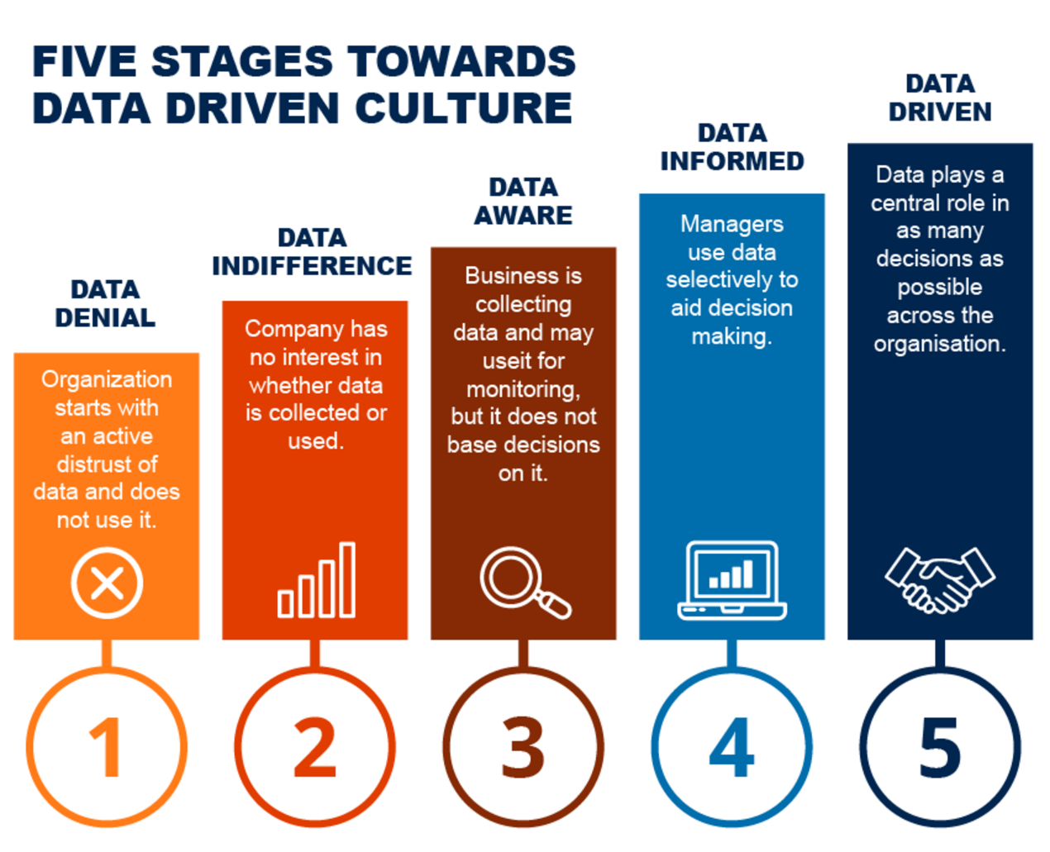
Figure 31: Five stages towards data driven culture
View description - Figure 31: Five stages towards data driven culture

A good data governance framework must be put in place. Data governance is an essential requirement of any organisation as it provides a foundation for all data management and ensures that organisations have policies and processes in place to meet their legal data responsibilities, such as the General Data Protection Regulation (GDPR). Data governance should be aligned to organisational strategies. The Hybrid Working: Skills for Digital Transformation course explores digital governance in more detail. You can find this course in the Supporting hybrid working in Wales collection.
To develop a data driven culture, managing data and information, especially in hybrid environments, requires clear polices and processes, to ensure that it can be accessed, is stored securely and contains the required metadata to ensure compliance and enable effective business continuity.

8.3 Using data for decision making
Data is a collection of facts and statistics normally based on qualitative or quantitative research and information. We think of data in the first instance as ‘raw data; information that has been collated digitally, from information stored across via digital systems, but it can also include information that has been gathered and captured from talking to others, and reports.
Using data allows you to consider how you can improve your outputs, and plan for change. This is especially important in HEIs, where student outcomes and experiences are critical. The whole student journey and how a HEI operates to support this should be based on evidence from data.
Such data can be broken down into:
- Internal data – which provides insights into your operations, finances, performance management, productivity and infrastructure. It allows for gap analysis and understand the needs of your workforce.
- External data – which often helps with analysing trends and benchmarking within your external environment.
- Marketing data – which is used to understand customers’ behaviours and preferences, to assist for HEI student enrolment and retention.
It is important to be clear on your data requirements, so that you are gathering meaningful information that can be trusted. Too often data sets are generated with no clear purpose or understanding of how they are to be used, or what insight could be gained from the data.
Data used well can help:
- make better and more effective decisions
- enable your organisation to be more proactive, and able to adapt to change more effectively
- ensure that your financial management is robust
- allow you to track your organisational performance and benchmark against others.
It can also help improve:
- operational efficiency
- new business models
- managing risk.

Activity 26: What data skills and capabilities are required?
25 minutes

Users of data can be considered as data producers and data consumers, who will require different data literacy skills for the ability to manipulate and understand data to make decisions.
Watch the video below in which contributors explain how data is used within organisations and the data literacy skills that are required.

Video content is not available in this format.
View transcript - Uncaptioned interactive content



Then read the article Data Literacy And Data Storytelling: How Do They Fit Together?
Identify the critical data skills that organisations need to focus on, and list these below.

Provide your answer...

Data storytelling
Data only becomes meaningful if it can be interpreted and tells a story. The image below clearly tells a story.

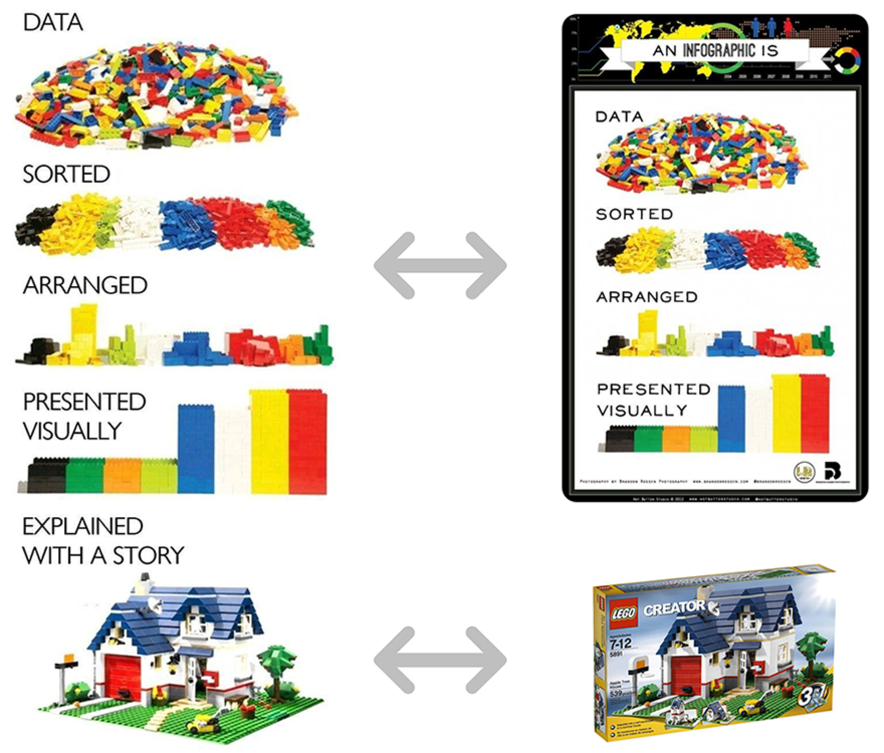
Figure 32: Lego in various stages
View description - Figure 32: Lego in various stages

Data storytelling is a concept that is used to provide a simple narrative for complex information, which can help individuals and organisations engage with and understand the data available.

Activity 27: Tell a data story
45 minutes

Read the article A Deeper Dive into LEGO Bricks and Data Stories, then watch the video in which Laura Dewis – Chief Operating Officer, Full Fact – describes how data storytelling can make data more engaging to its consumers.

Video content is not available in this format.
View transcript - Uncaptioned interactive content



Think of data you have available, and how you could use data story-telling to present the information from the data to others.

8.4 Policies and process
As HEIs adapt their ways of working as we move from a pandemic to an endemic state, policies and processes need to be reviewed, and updated to reflect the changing situation. It is important for hybrid working to have clear and easily accessible policies and processes in place, which have been effectively communicated, not only to provide clarity on the expectations from organisations, but also to ensure that they can be easily found.
When reviewing policies and processes it helpful to have a framework to adhere to, to ensure that their intended purpose is considered. You also need to consider which stakeholders need to be involved in reviewing policies, which often may also require union input.
Policies are formal statements of principles that should be followed and normally are mandatory. Many will be connected to legal requirements an organisation is required to meet. They normally link to strategic objectives, the direction an organisation will approach,, and be in a language suitable for the intended audience.
Procedures or processes are the ‘instructions’ someone needs to follow to achieve a reoccurring task or comply with a policy.
Guidelines are often considered as general guidance, it should be noted that it is accepted practice in some areas that they are in fact mandatory. Brand guidelines, for example, include some elements that are mandatory to use but others that allow for some flexibility, depending on the context, such as the logo. The logo image will be mandatory, but there will be a set of guidelines for its use in different contexts.
Standards are normally those issued by a third party such as the International Organization for Standardization (ISO). Some of these will be voluntary or mandatory within your organisations, alongside codes of conducts.
Policies and processes maybe owned by different departments, so collaboration is required, and agreements for those that are required for the whole organisation are managed and shared, compared to those that may be local-level only.
Where a policy is mandatory, and it is linked to a legal requirement, it is essential to ensure that you have considered what training might be required. This not only aims at engaging staff to read the policy, but also their responsibilities and the guidance on how to do the tasks associated with it, and where they can go for further information.
How you monitor that all employees have read and understood the policy needs to be considered as well: too often online training modules are little more than tick-box exercises that don’t actually ensure that the employee has understood their responsibilities or implemented an action as a result of the training. It is important to consider how the training associated with your policies can be effective, and how you use any data from this to demonstrate compliance of employees, which often needs to be shared with external organisations.

Activity 28: Review your organisation’s policies
20 minutes

HEI policies will not only relate to employment, health and safety, data protection, cyber security, sustainability, procurement, and regulatory acts, but also to academic practice and student welfare.
Depending on your HEI and location you will have different policies and processes in place, which will often be collated into one area on an internal intranet. Take some time to explore these at your organisation and consider those that are most relevant to your role within your HEI.
If you are involved with developing your organisation for hybrid working, you may wish to do further research on guidance for policies. We have provided some links about this below:
- Remote Working
- Smarter working: a remote working strategy for Wales
- Working from home and hybrid working
- The Future Generations Commissioner for Wales – Acting today for a better tomorrow
- Hybrid working: Practical guidance

9 A shorter week: thinking about long-term planning
This course has been designed to allow you to consider your organisational needs to assist with planning for change. The Well-being of Future Generations (Wales) Act 2015 requires public bodies to think about the long-term impact of their decisions. To assist with long term (and all planning) they have created a toolkit using the Three Horizons framework. Dr Louisa Petchey – Senior Policy Specialist, Public Health Wales – who was involved in the creation of the toolkit, explains how using it can help with long-term planning and thinking about the future.

Video content is not available in this format.
View transcript - Uncaptioned interactive content

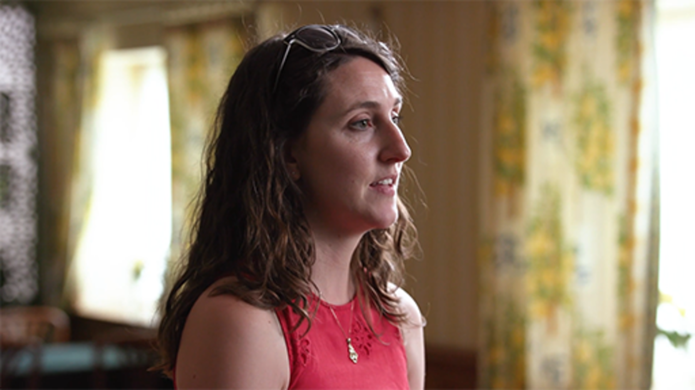

As we continue to evolve our approaches to work, and our expectations for work-life balance change, there have been calls to consider a shorter working week.
Read the article and watch the video below of Sophie Howe, the Future Generations Commissioner for the Welsh Government, to consider the implications of a shorter working week and continued remote working.
Future Generations Commissioner calls for Shorter Working Week trial

Video content is not available in this format.
View transcript - Uncaptioned interactive content

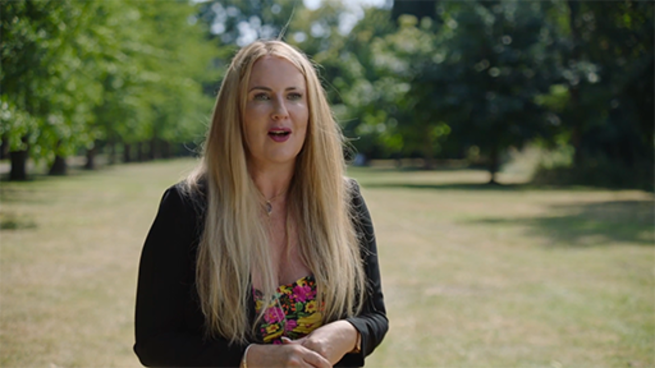

Activity 29: Trialling a shorter working week
15 minutes

Draw on the course and your understanding of your organisation to write a short summary of what you would need to consider to trial a shorter working week, a commitment to continued hybrid or remote only working, and the impact on your employees and students.
Once you have done this, you may wish to use the Three Horizon toolkit to work with others to develop your thinking of shorter working weeks, or another planning issue you may have outside the time allocated for studying this course.
You can develop your understanding further of planning for the future by studying the Hybrid working: planning course which explains the Three Horizons Framework and other frameworks for planning in more detail. You can find this course in the Supporting hybrid working in Wales collection.

Provide your answer...
View discussion - Activity 29: Trialling a shorter working week

10 Course summary
At the start of this course we asked you to think about your organisation’s ways of working and to consider whether:

‘Universities are well-placed to collaborate with partners across Wales to support our nation’s recovery from the pandemic and build Wales’ future together.’
Universities Wales, 2022

In the video below Sophie Howe, Future Generations Commissioner for Wales, shares her views on the role of HEIs for protecting future generations

Video content is not available in this format.
View transcript - Uncaptioned interactive content

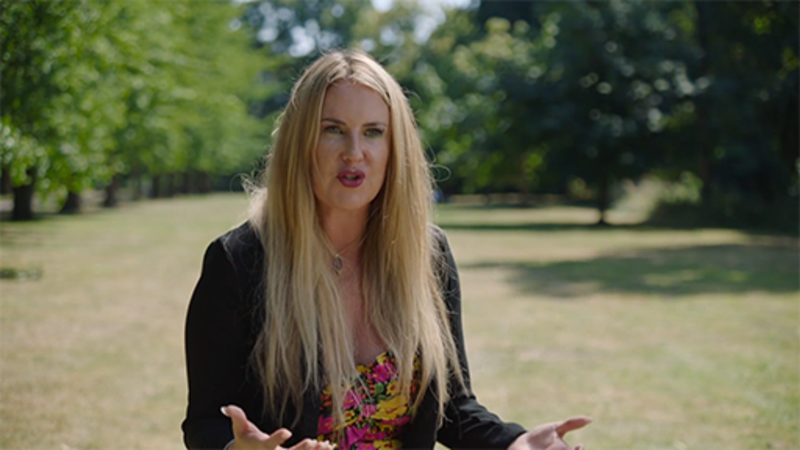

Take time to reflect on the video and what you have learned about how organisations are operating now, the considerations for planning and adapting in uncertain times, the impact of digital transformation, and the importance of embedding sustainable working practices, as well as meeting both the Well-being of Future Generations (Wales) Act 2015’s seven well-being goals and net zero targets.
Which areas do you feel your organisation is doing well in, and what may require improvement?
As your organisation evolves to succeed and protect the wellbeing of future generations, continue to develop your own skills and understanding for hybrid ways of working for HEIs, and think about how you can use the contextual framework to assist you long term.

Figure 1 (repeated): Hybrid ways of working: a contextual sustainability framework
View description - Figure 1 (repeated): Hybrid ways of working: a contextual sustainability framewo ...

- You and your ways of working should take account of the key stakeholders within your environment and their needs in relation to organisational development.
- You need to understand organisational requirements, the context, connections, and requirements for key areas of focus and how these relate to the needs of your stakeholders.
- You need to consider your ways of working for the wellbeing of future generations.
This course is part of the Supporting hybrid working in Wales collection, which you may wish to explore further.

References
Advanced Workplace Associates (2022) The AWA Hybrid Working Index. Available at: https://www.advanced-workplace.com/the-awa-hybrid-working-index/#more-12806 (Accessed: 25 August 2022).
Amenduni, F. and Ligorio, M.B. (2022) ‘Blended Learning and Teaching in Higher Education: An International Perspective’, Educational Science, vol. 12(2). Available at: https://doi.org/10.3390/educsci12020129 (Accessed: 21 May 2022).
Burke, W. W. and Litwin, G. H. (1992) ‘A Causal Model of Organisation Performance and Change’, Journal of Management, vol 18(3), pp 523–545.
CIPD (2021) PESTLE analysis. Available at: https://www.cipd.co.uk/knowledge/strategy/organisational-development/pestle-analysis-factsheet#gref (Accessed: 26 August 2022).
Defeyter M.A., Stretesky, P.B., Long, M.A., Furey, S., Reynolds, C., Porteous, D., Dodd, A., Mann, E., Kemp, A., Fox, J., Mc Anallen, A. and Gonçalves L (2021) ‘Mental Well-Being in UK Higher Education During COVID-19: Do Students Trust Universities and the Government?’ Frontiers in Public Health, vol. 9. Available at: https://doi.org/10.3389/fpubh.2021.646916 (Accessed: 21 May 2022).
Elkington, J. (1994) ‘Towards the sustainable corporation: win-win-win business strategies for sustainable development’, California Management Review, vol. 36, pp. 90–100. Available at: https://journals.sagepub.com/doi/10.2307/41165746 (Accessed: 20 May 2022).
Future Generations Commissioner for Wales (no date) A journey to A Prosperous Wales, 5: Skills for the future, page 9. Available at:https://www.futuregenerations.wales/wp-content/uploads/2019/09/FINAL-Prosperous-Wales-Topic-5-1.pdf (Accessed: 21 May 2022)
Future Generations Commissioner for Wales (no date) Future Generations Framework for Scrutiny. Available at: 20190108-Scrutiny-Framework-Draft-eng.pdf (futuregenerations.wales) (Accessed: 21 May 2022).
Future Generations Commissioner for Wales (no date) Future Generations Framework for service design. Available at: https://www.futuregenerations.wales/wp-content/uploads/2018/11/33869-Future-Generations-Framework-for-Service-Design_English_FINAL-WEB.pdf (Accessed: 21 May 2021).
Future Generations Commissioner for Wales (no date) Well-being of Future Generations (Wales) Act 2015. Available at: https://www.futuregenerations.wales/about-us/future-generations-act/ (Accessed: 21 May 2022).
George, B. (2017) ‘VUCA 2.0: A Strategy For Steady Leadership In An Unsteady World’, Forbes, (17 February). Available at: https://www.forbes.com/sites/hbsworkingknowledge/2017/02/17/vuca-2-0-a-strategy-for-steady-leadership-in-an-unsteady-world/?sh=5daa422f13d8 (Accessed: 27 May 2022).
Pillans, G. von Rohr, C. and Whelan, J. (2022) ‘The realities of the new working environment’ CRF, (5 May). Available at: https://www.crforum.co.uk/research-and-resources/research-the-realities-of-the-new-working-environment/ (Accessed: 26 August 2022).
Green House Gas Protocol (2013) Scope 3 Calculation Guidance. Available at: https://ghgprotocol.org/scope-3-technical-calculation-guidance#supporting-documents (Accessed: 26 August 2022).
Handy, C. (1993) Understanding Organisations. 4th edn. London: Penguin
Holladay, R. (2018) ‘Nothing is Intractable: You Can Change the World’, Human Systems Dynamics Institute, (April). Available at: https://www.hsdinstitute.org/resources/nothing-is-intractable.html (Accessed 26 August 2022).
IDEO (2015) The Field Guide to Human-Centered Design. San Francisco, CA: IDEO.
Impact Innovation (no date) PESTLE Analysis. Available at: https://www.impact-innovation.co.uk/pestle-analysis (Accessed: 26 August 2022).
International Organization for Standardization (2019) The human-centred organization — Guidance for managers (ISO Standard No: 27501:2019). Available at: https://www.iso.org/standard/64241.html (Accessed: 21 May 2022).
International Organization for Standardization (2016) The human-centred organization — Rationale and general principles (ISO Standard No. 27500). Available at: https://www.iso.org/standard/64239.html/ (Accessed: 21 May 2022).
IPCC (2021) ‘Summary for Policymakers’ in Climate Change 2021: The Physical Science Basis. Contribution of Working Group I to the Sixth Assessment Report of the Intergovernmental Panel on Climate Change. [MassonDelmotte, V., P. Zhai, A. Pirani, S.L. Connors, C. Péan, S. Berger, N. Caud, Y. Chen, L. Goldfarb, M.I. Gomis, M. Huang, K. Leitzell, E. Lonnoy, J.B.R. Matthews, T.K. Maycock, T. Waterfield, O. Yelekçi, R. Yu, and B. Zhou (eds.)] Cambridge University Press.
Johansen, B. (2009) Leaders make the future. San Francisco, CA: Berrett-Koehler Publishers.
LaBerge, L., O’Toole, C. Schneider, J. Smaje, K. (2020) ‘How COVID-19 has pushed companies over the technology tipping point—and transformed business forever’, McKinsey & Company, (5 October). Available at: https://www.mckinsey.com/business-functions/strategy-and-corporate-finance/our-insights/how-covid-19-has-pushed-companies-over-the-technology-tipping-point-and-transformed-business-forever (Accessed: 21 May 2022).
Miller (2020) ‘The Triple Bottom Line: What it is and why it’s important’, Business Insights, (8 December). Available at: https://www.researchgate.net/figure/The-interconnection-of-the-elements-of-the-Triple-Bottom-Line-concept_fig1_329185478 (Accessed 21 May 2022).
Mullins, L, J. (1993) Management and Organizational Behaviour. 3rd edn. London: Pitman Publishing.
Rittel, H.W.J. and Webber, M.M. (1973) ‘Dilemmas in a general theory of planning’, Policy Sciences, vol. 4, pp. 155–169.
Stiehm, J. (2002) US Army War College: military education in a democracy. Philadelphia, PA: Temple University Press.
UN (no date (a)) Academic Impact: Sustainability. Available at: https://www.un.org/en/academic-impact/sustainability (Accessed: 26 August 2022).
UN (2022) Digital Library: Net Zero Coalition. Available at: https://www.un.org/en/climatechange/net-zero-coalition (Accessed: 26 August 2022).
United Nations Development Programme (UNDP) (no date) UNDP in the Arab States − Human-Centred Design. Available at: https://www.undp.org/arab-states/human-centered-design (Accessed 21 May 2022).
Well-being of Future Generations (Wales) Act 2015. Available at: https://www.legislation.gov.uk/anaw/2015/2/contents/enacted (Accessed: 21 May 2022).
Wong, E. (2020) What is a wicked problem and how can you solve it? Available at: https://www.interaction-design.org/literature/article/wicked-problems-5-steps-to-help-you-tackle-wicked-problems-by-combining-systems-thinking-with-agile-methodology (Accessed: 22 May 2022).
https://www.researchgate.net/publication/329185478_Youth_entrepreneurial_projects_for_the_sustainable_development_of_global_community_evidence_from_Enactus_program
https://www.researchgate.net/publication/231829502_The_Concept_of_Sustainable_Economic_Development
https://www.ideo.com/eu
Human-centered organizations: why and how to build them (ibm.com)
https://www.ibm.com/design/thinking/page/hco
https://www2.deloitte.com/us/en/insights/deloitte-review/issue-3/mass-career-customization-building-the-corporate-lattice-organization.html
https://worldofwork.io/2019/07/the-burke-litwin-organizational-change-framework/
https://www.exeter.ac.uk/media/universityofexeter/humanresources/documents/learningdevelopment/understanding_drivers_for_change.pdf
https://www.cipd.co.uk/knowledge/strategy/organisational-development/workforce-planning-practice
https://gov.wales/digital-strategy-wales-html
https://www.majesteye.com/why-is-data-important-for-your-business/
https://damadach.org/dmbok2-dama-dmbok-version-2/

Acknowledgements
This free course was written by Esther Spring with support from Beccy Dresden.
Except for third party materials and otherwise stated (see terms and conditions), this content is made available under a Creative Commons Attribution-NonCommercial-ShareAlike 4.0 Licence.
The material acknowledged below is Proprietary and used under licence (not subject to Creative Commons Licence). Grateful acknowledgement is made to the following sources for permission to reproduce material in this free course:
Images
Course Image: keith morris / Alamy Stock Photo
Figure 5: The Cynefin Company; https://thecynefin.co/about-us/about-cynefin-framework/
Figure 6: adapted by Sarkar and Kotler (no date) from Rittel and Webber (1973)
Figure 7: adapted from Impact Innovation
Figure 8: United Nations
Figure 9: The Welsh Government; Contains public sector information licensed under the Open Government Licence v3.0.; https://gov.wales/well-being-future-generations-visual-toolkit
Figure 10: Welsh Government 2019, Crown Copyright; https://www.futuregenerations.wales/wp-content/uploads/2019/07/Wales-_-SDGs-_-VNR-_-Supplementary-Report-for-Wales-_-Version-10.1-Final-w-cover-ENG.pdf
Figure 11: from World Resources Institute and World Business Council for Sustainable Development, September 2011
Figure 12: adapted from: https://www.researchgate.net/figure/The-interconnection-of-the-elements-of-the-Triple-Bottom-Line-concept_fig1_329185478httpshttps://creativecommons.org/licenses/by/4.0/
Figure 13: Office for National Statistics; https://www.ons.gov.uk/employmentandlabourmarket/peopleinwork/employmentandemployeetypes/articles/businessandindividualattitudestowardsthefutureofhomeworkinguk/apriltomay2021
Figure 14: Professor A. Felstead, ‘Outlining the contours of the ‘Great Homeworking Experiment’ and its implications for Wales’
Figure 15: courtesy of Corporate Research Forum
Figure 17: courtesy of Jacob Morgan, © Chess Media Group
Figure 18: from: A Rural Vision for Wales: The Evidence Report; Written by Michael Woods with Jesse Heley, Helen Howells and Bryonny Goodwin-Hawkins, Aberystwyth University; CC-BY-NC
Figures 19 and 20: adapted from Understanding Organisations, Charles Handy, Penguin book, 4th ed, 1993
Figure 22: adapted from World of Work Project: https://worldofwork.io/2019/07/the-burke-litwin-organizational-change-framework/
Figures 23 and 24: The Financial Times: https://www.ft.com/content/5ed49b8a-6c69-418c-9a26-7f43a99b1d1f
Figures 25 and 26: from McKinsey and Company; https://www.mckinsey.com/business-functions/strategy-and-corporate-finance/our-insights/how-covid-19-has-pushed-companies-over-the-technology-tipping-point-and-transformed-business-forever
Figure 27: Boston Consulting Group
Figure 28: from: Consider the Three Ds When Talking about Digital Transformation; Betsy Reinitz, June 1, 2020, Educause
Figure 29: adapted from 2022 Workplace Learning Report, The Transformation of L&D Learning leads the way through the Great Reshuffle; Linkedin Learning
Figure 30: adapted from: Workforce planning practice; Chartered Institute of Personnel and Development 2022,
Figure 31: Smartboost
Figure 32: from: A Deeper Dive into LEGO Bricks and Data Stories; Brent Dykes
Table 3: Future Generations Commissioner for Wales; https://www.futuregenerations.wales/about-us/future-generations-act/
Audio/Visual
Activity 13: Video; Why GQ is the kind of intelligence we all need; Poornima Luthra; TEDxTalks; CC BY -- NC -- ND 4.0 International
Inclusion considerations for females section: Video; Progress on the Sustainable Development Goals: The Gender Snapshot 2021, United Nations Entity for Gender Equality and the Empowerment of Women (UN Women) and United Nations Department of Economic and Social Affairs (UNDESA), Statistics Division, 2021.
Every effort has been made to contact copyright owners. If any have been inadvertently overlooked, the publishers will be pleased to make the necessary arrangements at the first opportunity.
Don’t miss out
If reading this text has inspired you to learn more, you may be interested in joining the millions of people who discover our free learning resources and qualifications by visiting The Open University – www.open.edu/openlearn/free-courses.

Solutions

Activity 2: Thinking about your HEI’s experience of dealing with uncertainty

Part

Discussion
Your experiences will vary, depending on how your organisation responded to COVID-19, and on your personal circumstances. While there is often a focus on the negatives, many positives have emerged as a result for new ways of working.
Back to - Part

Activity 10: Learning from the pandemic:

Answer
At a personal level your experience will depend on your personal circumstances.
For example, I had to shield. From a working perspective nothing really changed as I was already a remote worker, but I changed jobs 4 times during the 2-year lockdown period, due to redundancy, freelancing and securing a fixed-term contract then a permanent role. I home schooled, renovated my house, and on some days relied on the dog walks and coffee from the local café to speak to another adult in person. Shielding has impacted my ability for socialisation. It is only recently that I feel more comfortable to start to mix with others again.
From an organisational perspective, this varied, from being sent ‘care packages’ to feeling completely isolated, with an increasing unseen workload. While also recognising that organisations were adapting daily and starting to find their own way through the uncertainty.
Back to - Activity 10: Learning from the pandemic:

Activity 11: How do you work now?

Feedback
In answering this you may have drawn on your own values and experiences or centred on the organisational context. The purpose of this activity is for you to start thinking about what principles may help to develop new ways of working within your organisation.
The OU uses the following principles which have been mapped to the Five Ways of Working from the Well-being of Future Generations (Wales) Act 2015.

OU – University-wide principles for ways of working:
- Strive to create a working environment that is inclusive, collaborative, and equitable.
- Strive to achieve a balance between our personal preferences, the needs of our colleagues/team/unit/school and the requirements of the organisation to deliver education, support students and undertake research.
- Position sustainability and our commitment to achieve net zero carbon as an important driver in our decision making.
- Learn from our experiences and commit to testing new ideas and approaches.
- Empower local units/teams.
Source: https://www.futuregenerations.wales/about-us/future-generations-act/

Back to - Activity 11: How do you work now?

Activity 12: What makes a good employee and student experience?

Discussion
Much of the focus of this model appears to be based on those workers who have some control over their work, but what does this mean for those who need to be onsite and have ‘prescriptive’ tasks – for example ‘on site catering roles’.
What could be the challenges if an organisation focuses on those who can work more flexibly, while not considering the impact of those in ‘constrained’ roles?
As ways of working change, it is important to consider all the stakeholders in an organisation, and what you are required to by law to consider/adhere to. While in some areas employees can work more flexibility, others either due to their ‘job’ or their individual needs cannot. It is essential to consider equity, diversity, inclusion and accessibility when developing your organisation.
To explore this further, the following articles from McKinsey provide further insights into employee’s needs.
Three types of modern flexibility today’s workers demand | McKinsey & Company
This time it’s personal: Shaping the ‘new possible’ through employee experience | McKinsey
Back to - Activity 12: What makes a good employee and student experience?

Activity 29: Trialling a shorter working week

Discussion
Planning for long term hybrid working and considering shorter working weeks, you may have thought about some the organisational impact this might have, the wellbeing of your employees and practicalities.
In the video below Natasha Davies, Policy and Research Lead from Chwarae Tegprovides insights for organisations to consider.

Video content is not available in this format.
View transcript - Uncaptioned interactive content

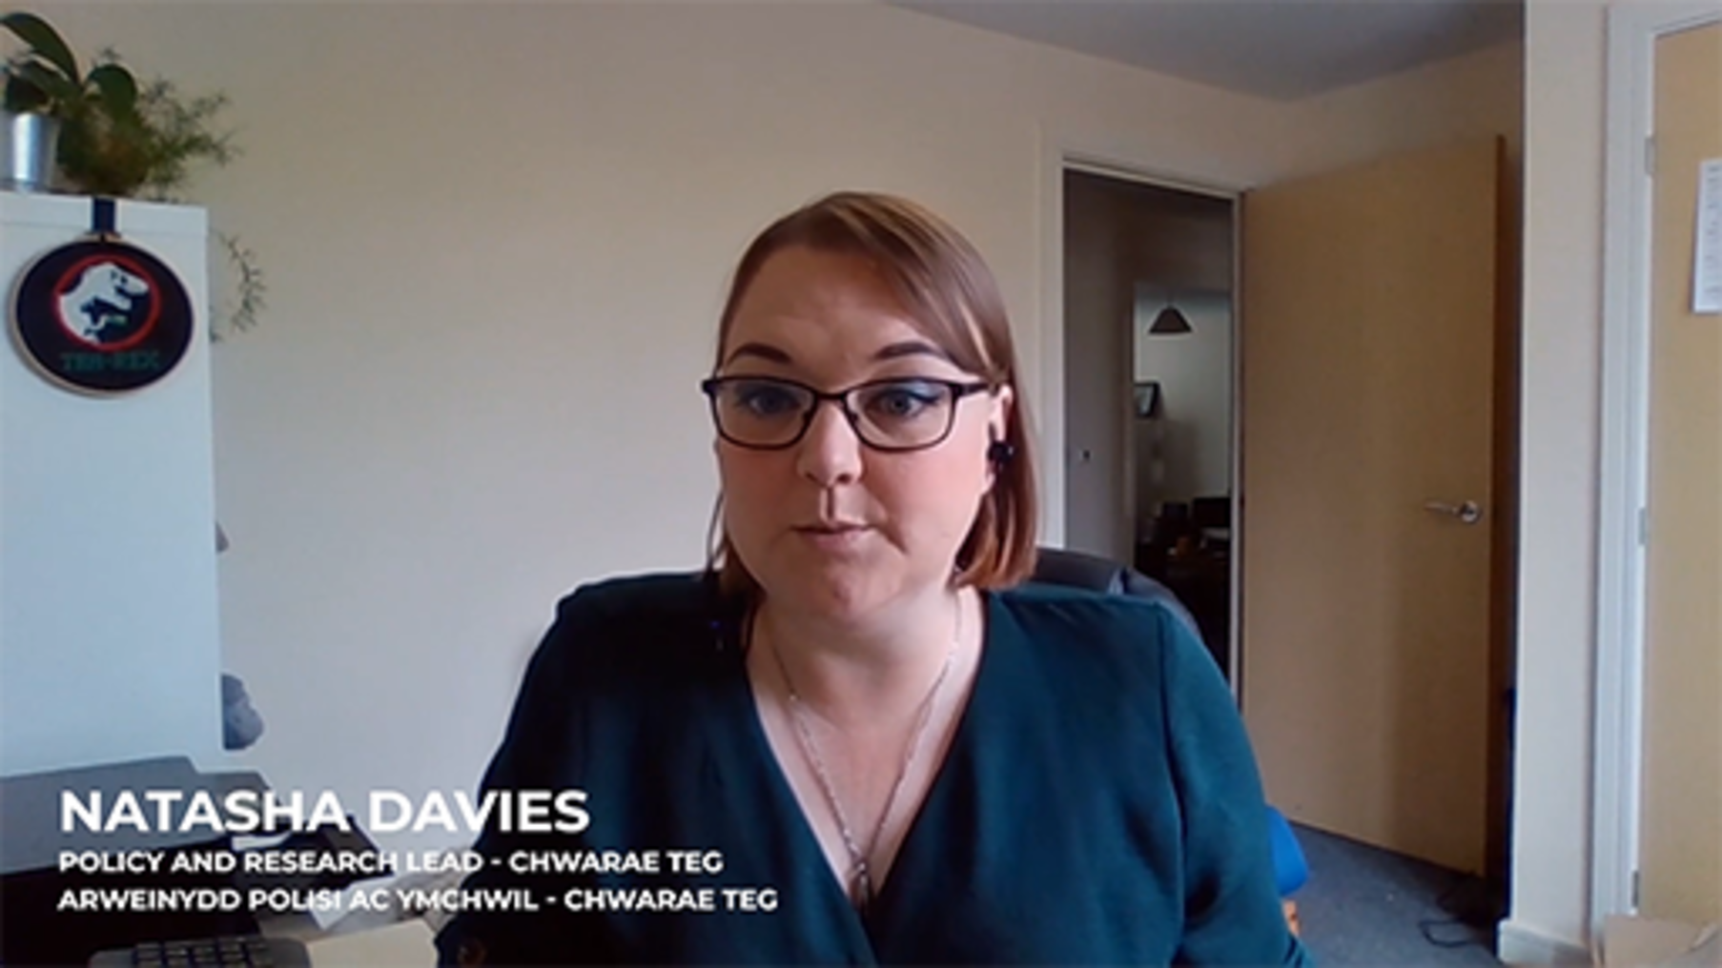

Back to - Activity 29: Trialling a shorter working week

Figure 1: Hybrid ways of working: a contextual sustainability framework

Description
Image shows three concentric circles around a central circle containing the word ‘YOU’. In the first of the outer circles (labelled 1), there are arrows pointing outwards from the central circle to the words Team(s), Organisation, Individuals, Community, and Students, which are spaced evenly around the circle. Each of these terms have double-headed arrows connecting them to each other. The next circle out (labelled 2) surrounds the first and contains the terms Digital Transformation, People, Places, Sustainability, Values and Culture, and Compliance. These are evenly spaced around the second circle and double-headed arrows sit between each term. The outer circle (labelled 3) has the words Long term, Prevention, Integration, Involvement and Collaboration spaced out around the circle with double-headed arrows connecting each term. Beside each term is an icon to represent it. The words and the circles show the interconnection between, stakeholder, organisation needs and ways of working.
Back to - Figure 1: Hybrid ways of working: a contextual sustainability framework

Figure 2: Original VUCA acronym meaning

Description
Image shows the meaning of VUCA, with each letter expanded in a box with the description underneath. Volatile – Change is fast and predictable; Uncertain – The present is unclear and the future uncertain; Complex – There are many interconnected factors in play, causing chaos and confusion; Ambiguous – There is a lack of clarity or awareness about situations.
Back to - Figure 2: Original VUCA acronym meaning

Figure 3: VUCA 2.0 acronym meaning

Description
The image describes VUCA 2.0, with each letter expanded in a box with the description underneath. Vision – Have a clear vision to see through the chaos; Understanding – In-depth understanding of capabilities and strategies; Courage – Step up to challenges and make audacious decisions; Adaptability – Be flexible to rapid change.
Back to - Figure 3: VUCA 2.0 acronym meaning

Figure 4: TUNA environments

Description

Turbulence | Uncertainty | Novelty (& unique) | Ambiguity
Speed of change, with high complexity and uncertainty. | Uncertainty is unpredictable, disruptive and can be uncontrollable. | Response to situations that are both imaginable and unimaginable, that require new concepts, technologies and approaches. | Managing and understanding different interpretations of situation, often when there is little or contradictory information available.

Back to - Figure 4: TUNA environments

Figure 5: The Cynefin framework

Description
Image shows the Cynefin framework. The term Confused is at the centre, with four separated areas around it. The top left area is titled ‘Complex’, with the term ‘Enabling constraints’ sitting outside it and an arrow pointing towards it. Inside the quadrant is the term ‘Exaptive practices’, as well as the words probe, sense and respond, with an arrow from probe to sense and another arrow from sense to respond. The top right area is titled ‘Complicated’, with the term ‘Governing constraints’ sitting outside and pointing towards it. Inside the quadrant is the term ‘Good practices’ as well as the words sense, analyse and respond, with an arrow from sense to analyse and another arrow from analyse to respond. The bottom left area is titled ‘Chaotic’, with the term ‘No effective constraints’ sitting outside and pointing towards it. Inside the quadrant is the term ‘Novel practices’ as well as the words act, sense and respond, with an arrow from act to sense and another arrow from sense to respond. The bottom right area is titled ‘Clear’, with the term ‘Fixed constraints’ sitting outside and pointing towards it. Inside the quadrant is the term ‘Best practices’ as well as the words sense, categorise and respond, with an arrow from sense to categorise and another arrow from categorise to respond.
Back to - Figure 5: The Cynefin framework

Figure 6: Wicked problems, adapted by Sarkar and Kotler (no date) from Rittel and Webber (1973)

Description
Image shows a large central circle containing the term ‘Wicked problems’. In individual circles sitting around the central circle are the ten elements noted as wicked problems. Starting at the top and going clockwise, the text reads: ‘No stopping’ rule; Solutions are not right / wrong but better / worse; No immediate or ultimate test for a solution; ‘One shot’ solutions have consequences; No final end to solutions; Unique; Every problem is a symptom of another; Solutions limited by ‘world view’; No ‘right to be wrong’; No clear definition
Back to - Figure 6: Wicked problems, adapted by Sarkar and Kotler (no date) from Rittel and Webber (1973)

Figure 7: PESTLE model for analysis. Source: Impact Innovation (no date)

Description
Image shows PESTLE model, which represents the different external driving forces that characterise the external environment. Each letter is expanded in a box with examples underneath.
Political – Current tax policy; Brexit; Trade policies; Political stability; Government policy; Climate Change Acts. Economical – Inflation rate; Exchange rates; Economic growth; Interest rates; Disposable income; Unemployment rate. Social – Lifestyle attitudes; Cultural barriers; Population growth; Population age; Health consciousness; Target demographics. Technological – Level of innovation; Automation; Technological awareness; Cybersecurity; Technological change; Internet availability/speed. Legal – Employment laws; Discrimination laws; Health and safety; Copyright protection; Consumer safety. Environmental – Weather; Climate change; Environmental policies; NGO pressure; Recycling; Pollution; Sustainability; Waste disposal; Energy consumption.
Back to - Figure 7: PESTLE model for analysis. Source: Impact Innovation (no date)

Figure 8: UN Sustainable development goals (SDGs)

Description
Image shows the 17 UN sustainable development goals: 1 No poverty; 2 Zero hunger; 3 Good health and well-being; 4 Quality education; 5 Gender equality; 6 Clean water and sanitation; 7 Affordable and clean energy; 8 Decent work and economic growth; 9 Industry, innovation and infrastructure; 10 Reduced inequalities; 11 Sustainable cities and communities; 12 Responsible consumption and production; 13 Climate action; 14 Life below water; 15 Life on land; 16 Peace, justice and strong institutions; 17 Partnerships for the goals.
Back to - Figure 8: UN Sustainable development goals (SDGs)

Figure 9: Well-being goals

Description
A diagram showing the silhouette of Wales in the centre of a circle, which comprises seven segments. Each segment has one of the wellbeing goals noted within it: A Prosperous Wales; A Resilient Wales; A Healthier Wales; A More Equal Wales; A Wales of Cohesive Communities; A Wales of Vibrant Culture and Thriving Welsh language; A Globally Responsible Wales.
Back to - Figure 9: Well-being goals

Figure 10: A sustainable Wales – architecture of the Well-being of Future Generations (Wales) Act 2015

Description
Image shows ‘A sustainable Wales: architecture’. The content is set up as a table with descriptors in the left column and definitions or comments completing the rows. Reading down the table from top to bottom, row by row: What (World) (left); Sustainable Development Goals, with numbers 1 to 17 in individual boxes set across the row under the text (right). What (A sustainable Wales) (left); Well-being goals for Wales with double-ended arrows pointing up to the row above and down to the goals listed in individual boxes set across the row under the text, reading A prosperous Wales, A resilient Wales, A healthier Wales, A more equal Wales, A Wales of cohesive communities, A Wales of vibrant culture and thriving Welsh language, A globally responsible Wales (right). Progress (left); National Indicators and Milestones (right). Making it happen (left); Sustainable development and well-being duty on public bodies (well-being objectives) (right). Who (left); Individual well-being duty: 44 Public Bodies and Collective well-being duty: Public Services Boards in separate boxes (right). How (left); Sustainable Development Principle spanning five separate boxes below: Long term, Prevention, Integration, Collaboration, Involvement (right). Greater Transparency (left); Better information (right). Examinations (left); Auditor General for Wales: Examination (right). Supporting the change (left); Future Generations Commissioner for Wales spanning six separate boxes below: Long-term, Advice, Review, Monitor, Future Generations Report, Advisory Panel (right).
Back to - Figure 10: A sustainable Wales – architecture of the Well-being of Future Generations (Wales) Act 2015

Figure 11: Diagram of scopes and emissions across the value chain

Description
Image shows an overview of the GHG Protocol scopes and emissions across the value chain. At the top of the image are some clouds, with six circles spread across them, each containing one of the following terms: CO2; CH4; N2O; HFCs; PFCs; SF6. At the bottom of the image there is an arrow running left to right, split into three sections, titled ‘Upstream activities’, ‘Reporting company’ and ‘Downstream activities’. From the left side cloud, there is a wide arrow that curves down and back up towards the clouds. This is titled ‘Scope 2: Indirect’ above the arrowhead. Slightly inset to the right and lower, is a similar arrow, titled ‘Scope 3: Indirect’. On the right side is a further curving arrow, like the others, also titled ‘Scope 3: Indirect’. Between these arrows, in the centre, is an arrow pointing up to the clouds, titled ‘Scope 1: Direct’. Along the Scope 2 arrow is the text ‘purchased electricity, steam, heating and cooling for own use’ with a plug icon. Along the left Scope 3 arrow are a number of icons and their associated text: ‘purchased goods and services’ with factory icon; ‘capital goods’ with lorry icon; ‘fuel and energy related activities’ with coal mining icon; ‘transportation and distribution’ with ship icon; ‘waste generated in operations’ with wheelie bin icon; ‘business travel’ with plane icon; ‘employee commuting’ with train icon; ‘leased assets’ with office icon. In the centre arrow, at the bottom is the text ‘company vehicles’ with a lorry icon and higher up is the text ‘company facilities’ with an office icon. Along the right Scope 3 arrow are more icons and their associated text: ‘transportation and distribution’ with ship icon; ‘processing of sold products’ with factory icon; ‘use of sold products’ with lightbulb icon; ‘end of life treatment of sold products’ with waste bin icon; ‘leased assets’ with office icon; ‘franchises’ with small business icon; ‘investments’ with money icon.
Back to - Figure 11: Diagram of scopes and emissions across the value chain

Figure 12: Three pillars of sustainability

Description
Image shows a Venn diagram. The top circle is titled ‘People/Social’ and contains the text: Social variables dealing with community, education, equity, social resources, health, wellbeing and quality of life. The lower left circle is titled ‘Planet/Environmental’ and contains the text: Environmental variables relating to natural resources, water & air quality, energy conservation & land use. The lower right circle is titled ‘Profit/Economic’ and contains the text: Economic variables dealing with the bottom line & cash flow. The section where the Economic and Environmental circle overlap is titled ‘Viable’. The section where the Environmental and Social circles overlap is titled ‘Bearable’. The section where the Social and Economic sections overlap is titled ‘Equitable’. The centre section where all three circles overlap is titled ’Sustainable’.
Back to - Figure 12: Three pillars of sustainability

Figure 13: The proportion of working adults reporting working from home exclusively has varied over the course of the past year. Working adults, Great Britain, May 2020 to May 2021. Source: Office for National Statistics – Opinions and Lifestyle Survey.

Description
Image of the age of Working adults, Great Britain, May 2020 to May 2021, showing the proportions of working adults reporting working from home exclusively, travelling to work exclusively, and a mixture of working from home and travelling to work during the COVID-19 pandemic lockdowns and post lockdowns. Throughout the course of the year, the mixture group stayed relatively consistent, ranging between approximately 7 and 13 per cent. Following the Spring 2020 lockdown, the travelling to work group levels increased from about 30 per cent to around 50 per cent, until the Autumn and Winter 2020 restrictions. During this same time, the working from home group levels dropped from about 40 per cent to about 20 per cent. During the Autumn and Winter 2020 restrictions and the Early 2021 lockdown, these groups decreased and increased, respectively, until both groups were sitting at about 35 per cent. After the Restriction lifting begins in March 2021, the working from home group levels dropped again, down to about 25 per cent in May 2021 and the travelling to work group levels increased to about 50 per cent. For all groups, there is a visible drop of about 5 per cent over the Christmas/New Year period.
Back to - Figure 13: The proportion of working adults reporting working from home exclusively has varied over the course of the past year. Working adults, Great Britain, May 2020 to May 2021. Source: Office for National Statistics – Opinions and Lifestyle Survey.

Figure 14: Numbers Exclusively Working at Home in the UK During 2020 Source: Remote working – the new normal?

Description
Image of chart (English and Welsh) that compares the workforce in Wales working from home versus the rest of the UK between January and November 2020 during the COVID-19 pandemic. During January/February 2020, just 4 per cent of the Welsh workforce worked exclusively at home. This rose to 37 per cent in April 2020, falling below 20 per cent in September 2020 but increasing back up to 25 per cent in November 2020. A similar pattern was noted for the rest of the UK, but their levels were always 3 to 6 percent higher than for Wales.
Back to - Figure 14: Numbers Exclusively Working at Home in the UK During 2020 Source: Remote working – the new normal?

Figure 15: New working norms

Description
Image of bar charts showing new working norms since the COVID-19 pandemic. Introduction of new technology/software for communication/productivity 64% All employees. 12% The majority of employees. 14% A minority of employees. 10% Don’t know. Hybrid working: employees split their time between the workplace and remote working. 31% All employees. 56% The majority of employees. 13% A minority of employees. 0% Don’t know. Flexible working: employees have flexible start/finish times and work from home when needed. 25% All employees. 45% The majority of employees. 24%A minority of employees. 6% Don’t know. New working patterns: new set days of the week employees do and do not work. 12% All employees. 2% The majority of employees. 59% A minority of employees. 27% Don’t know. New management practices: changes to monitoring, setting goals, planning and communication. 32% All employees. 22% The majority of employees. 22% A minority of employees. 24% Don’t know
Back to - Figure 15: New working norms

Figure 16: Putting people first

Description
Image showing that you need to think about organisations, individuals and teams. In the centre is a circle containing the word ‘You’. Double-ended arrows sit between this central circle and three other circles, entitled ‘Organisation’, ‘Individuals’ and ‘Team(s)’, which are spaced out around the central circle. There are also double-ended arrows between each of the three outer circles.
Back to - Figure 16: Putting people first

Figure 17: The Evolution of the employee

Description
Image showing the evolution of the employee (past/future) and how expectations have changed over time. Past/future changes are given as:
Work 9 to 5/work anytime; Work in a corporate office/work anywhere; use company equipment/use any device; focused on inputs/focused on outputs; climb the corporate ladder/create your own ladder; pre-defined work/customised work; hoards information/shares information; no voice/can become a leader; relies on emails/relies on collaboration technologies; focused on knowledge/focused on adaptive learning; corporate learning and teaching/democratised learning and teaching.
Back to - Figure 17: The Evolution of the employee

Figure 18: Typology of areas within Rural Wales using ONS classifications of settlement type and setting

Description
Image shows the typology of areas within rural Wales using ONS classifications of settlement types and settings. The classifications for the predominantly rural local authorities are denoted as: Villages, hamlets and dispersed dwellings in sparse settings. Villages, hamlets and dispersed dwellings in less sparse settings. Small towns and fringe in sparse settings. Large towns in sparse settings. Small towns and fringe in less sparse settings. Large towns in less sparse settings. The classifications for the predominantly urban local authorities are denoted as: Villages, hamlets and dispersed dwellings in less sparse settings. Non-rural (cities, towns and fringe). A large area in the southern/eastern and a small area in the very north-eastern part of Wales is denoted as urban, a lot of which is given as non-rural. Most of the rest of Wales is denoted as ‘Villages, hamlets and dispersed dwellings in sparse settings’, with some areas at the northern and southern areas denoted as ‘Villages, hamlets and dispersed dwellings in less sparse settings’.
Back to - Figure 18: Typology of areas within Rural Wales using ONS classifications of settlement type and setting

Figure 19: Factors affecting organisational effectiveness

Description
Image shows the factors affecting organisational effectiveness. The figure is split into three groups: individuals, organisation and environment. Within each group, there are sub-groups. Individuals group contains: Ability – personality, aptitude, experience, training, age. Motivation to work – personal situation, other activities, need hierarchy, expected results, level of aspiration, rewards, time and place, job. Role – linked by a dotted line to the organisation sub-groups. Organisation group contains: Leadership – skills and knowledge, style, standards, goals, power base, types of people, relationships, task, history, size, values. Group relations – size, age, cohesion, goals, relationships, leader, task, objectives, unions, type of people. Systems and structures – admin. structure, control system, reward system, power structure, type of people. Environment group contains: Economic environment – economy, competition, resources, capacity. Physical environment – location, amenities, shifts, safety, job layout, noise. Technological environment – condition of plant, type of technology, raw materials, rate of exchange.
Back to - Figure 19: Factors affecting organisational effectiveness

Figure 20: Factors affecting organisational effectiveness

Description
Image of two circles that overlap to show the relationship between people, power and practicalities. Within the ‘People’ part of the circle are the terms: motivation, needs, levels of energy, career experience, age, pay attitudes, personalities, training, role. Within the ‘Power’ part of the circle are the terms: groups, the leaders, inter-group relations, type of influence, leadership style, rewards and punishment, responsibilities. Within the ‘Practicalities’ part of the circle are the terms: the environment, the market, philosophies, values, norms, goals, objectives, ownership, history, career structures, size structure, change, technology. The term ‘Control systems’ sits across the line between the power and practicalities sections. The term ‘Individual skills and abilities’ sits across the line between the people and power sections. The term ‘Psychological contact’ sits across the line between the people, power and practicalities sections.
Back to - Figure 20: Factors affecting organisational effectiveness

Figure 21: Matrix structure

Description
The diagram illustrates a matrix organisation which features a combination of vertical and horizontal interconnected boxes. Vertical structures branch out into 6 layers, featuring boxes for different units and departments. Layer one features a box for senior management. Layer two features boxes for Production, IT, Finance and HR departments. Layers three, four, five and six feature boxes for Project manager, Production, IT, Finance and HR units.
Back to - Figure 21: Matrix structure

Figure 22: Burke-Litwin change model

Description
This image shows the Burke-Litwin change model. The model is split into five sections (vertically – top to bottom): external factors, strategic factors, operating factors, individual factors, and outputs. Sitting within each vertical section are boxes, all interconnected with arrows. External factors: Management practices. Note: External factors often create the need for change. Strategic factors: Strategy/mission; Management practices; Organisational culture. Note: Transformational factors are key to the success of any change. They’re also often where the objectives of change are first captured. Operating factors: Structure; Management practices; Systems (policy & procedure). Note: Transactional factors may be fairly easy to change, but might not actually lead to lasting organisational change. Individual factors: Individual skills & tasks; Work unit climate; Motivation; Individual needs & values. Note: Individual factors are affected by many things and are key to enabling individual performance. Outputs: Ind. & Org. performance. Note: The ultimate output of any change is the impact on performance.
Back to - Figure 22: Burke-Litwin change model

Figure 23: The average capacity reached in office buildings in London and the UK between June 2021 and March 2022

Description
Image shows the average capacity reached in office buildings in London and the UK between June 2021 and March 2022. Capacity starts at 10 per cent, rising to approximately 23 per cent just before the ‘Plan B’ work from home lockdown in December 2021. Capacity drops right down to less than 5 percent during this time, before rising back up to about 25 per cent in March 22 when out of lockdown.
Back to - Figure 23: The average capacity reached in office buildings in London and the UK between June 2021 and March 2022

Figure 24: The average capacity reached on each weekday in office buildings in the UK between June 2021 and March 2022

Description
Image shows the average capacity reached on each weekday in office buildings in the UK between June 2021 and March 2022. Apart from during the ‘Plan B’ work from home lockdown starting in December 2021, Tuesday, Wednesday and Thursday were consistently the most popular days to be in the office. Capacity starts at about 10 per cent on these days in June 2021, with Monday and Friday being about 3 per cent lower. From September to December, values increased to just over 25 percent for midweek days, but on Monday and Friday, the values were 7 to 12 per cent lower. This pattern continues after the restrictions were listed, with Friday being the day with the lowest capacity,
Back to - Figure 24: The average capacity reached on each weekday in office buildings in the UK between June 2021 and March 2022

Figure 25: The time required to respond to or implement changes

Description
Image shows chart of the time required to respond to or implement changes, with expected vs actual number of days shown, as well as the acceleration factor.
Increase in remote working and/or collaboration, 454 vs 10.5, acceleration 43. Increasing customer demand for online purchasing/services, 585 vs 21.9, acceleration 27. Increasing use of advanced technologies in operations, 672 vs 26.5, acceleration 25. Increasing use of advanced technologies in business decision making, 635 vs 25.4, acceleration 25. Changing customer needs/expectations, 511 vs 21.3, acceleration 24. Increasing migration of assets to the cloud, 547 vs 23.2, acceleration 24. Changing ownership of last-mile delivery, 673 vs 24.4, acceleration 23. Increase in nearshoring and/or insourcing practices, 547 vs 26.6, acceleration 21. Increased spending on data security, 449 vs 23.6, acceleration 19. Build redundancies into supply chain, 537 vs 29.6, acceleration 18.
Statement: Executives say their companies responded to a range of COVID-19 related changes much more quickly than they thought possible before the crisis.
Back to - Figure 25: The time required to respond to or implement changes

Figure 26: The largest shifts (per cent) during the COVID-19 crisis

Description
Image shows a chart of the largest shifts (per cent) during the COVID-19 crisis, which are also among the most likely to stick through the recovery. Data shows the change, along with the percentages of respondents that do/do not believe the change will stick:
Changing customer needs/expectations, 62/18. Increase in remote working and/or collaboration, 54/23. Increasing migration of assets to the cloud, 54/27. Increasing customer demand for online purchasing and/or services, 53/27/ Increased spending on data security, 53/27. Increasing use of advanced technologies in operations, 50/30. Changing ownership of last-mile deliver within the industry value chain, 49/28. Increasing use of advanced technologies in business decision making, 49/35. Qualification of additional suppliers to build redundancy into supply chain, 48/31. Increase in nearshoring and/or insourcing practices, 41/35.
Back to - Figure 26: The largest shifts (per cent) during the COVID-19 crisis

Figure 27: The Boston Consulting Group digital transformation process

Description
Image shows the Boston Consulting Group digital transformation process. This is a two-step process, with the first part expected to occur over 4 to 12 weeks (to assess where you stand on various aspects), while the second stage is expected to last 6 to 24 months. For ‘Strategy and aspiration’ and ‘Prioritised outcomes’, implement the outcomes and deliver value in terms of outcomes, technology and humans – innovate, incubate, scale and industrialise. For ‘People/skills/culture gap assessment’, manage talent and build digital skills – talent platforms and digital skills builder. For ‘Operating and governance principles’, transform ways of working and operating model – agile ways of working, platform driven operating model. For ‘Technology and data assets’, drive technology transformation to generate rapid value – data and digital platform, specific technologies (e.g. IoT). Govern for value – program steering, control tower, OKRs and value measurement framework.
Back to - Figure 27: The Boston Consulting Group digital transformation process

Figure 28: The process to achieve and differences between digitisation, digitalisation, and digital transformation

Description
Image shows the process to achieve and differences between digitisation, digitalisation, and digital transformation. An arrow with five stages along it goes from bottom left to top right. Stages 1 (Digitise information) and 2 (Organise information) sit under Digitisation (changing from analog or physical to digital form). Stages 3 (Automate process) and 4 (streamline process) sit under Digitalisation (using digital technologies and information to transform individual institutional operations). Stage 5 (Transform the institution) sits under Digital transformation (A series of deep and coordinated culture, workforce, and technology shifts that enable new educational and operating modules and transform an institution’s operations, strategic directions, and value proposition)
Back to - Figure 28: The process to achieve and differences between digitisation, digitalisation, and digital transformation

Figure 29: Where L&D Professionals see the need to grow

Description
Image shows a circle split into seven segments titled: Leadership; Data & decision-making; L&D core; Business core; Managing relationships; Personal readiness; Technology. Outside of the central circle are many separate smaller circles, relating to each segment. Leadership: DEIB, Coaching, Motivation/engagement, Influencing, Strategic alignment skills, Storytelling, Leading others, Consulting. Data & decision-making: Data analysis, Research, Literacy, Problem solving, Strategic thinking, Assertiveness, External environment analysis. L&D core: Content curation, Ability to upskill, Human-centered design, Needs analysis/evaluation skills, Learning exp design, Learning science, Training delivery, Content creation. Business core: Project mgt, Change mgt, Creativity/innovation, Personal dev planning, Business acumen, Marketing. Managing relationships: Relationship building/networking, Empathy, Communication, Collab/teamwork. Personal readiness: Adaptability/flexibility, Productivity/efficiency, Resilience, Agility. Technology: Technology use, Tech strategy.
Back to - Figure 29: Where L&D Professionals see the need to grow

Figure 30: CIPD workforce planning process

Description
Image shows a circle split into segments around an inner circle that contains the text: Workforce planning process. The outer segments are titled: Understand the organisation and its environment; Analyse the current and potential workforce; Determine future workforce needs; Identify workforce gaps against future needs; Actions to address shortages, surpluses or skill mismatches; Monitor and evaluate actions.
Back to - Figure 30: CIPD workforce planning process

Figure 31: Five stages towards data driven culture

Description
Images shows the five stages towards data driven culture. 1. Data denial – Organisation starts with an active distrust of data and does not use it. 2. Data indifference – Company has no interest in whether data is collected or used. 3. Data aware – Business is collecting data and may use it for monitoring, but it does not base decisions on it. 4. Data informed – Managers use data selectively to aid decision making. 5. Data driven – Data plays a central role in as many decisions as possible across the organisation.
Back to - Figure 31: Five stages towards data driven culture

Figure 32: Lego in various stages

Description
Image shows Lego in various stages, starting as a big pile (representing data) and finishing as a fully assembled house (explained with a story). The stages in between show the Lego bricks separated into different colours (sorted), then built into partial piles (arranged) and put into individual coloured ‘walls’ (presented visually. There is also an infographic to show this process.
Back to - Figure 32: Lego in various stages

Figure 1 (repeated): Hybrid ways of working: a contextual sustainability framework

Description
Image shows three concentric circles, The circle in the centre contains the word ‘YOU’, with arrows pointing outwards to the words – Team(s), Organisation, Individuals, Community, and Students, each of which have double-headed arrows connecting them to each other. The second or middle circle surrounds the first and contains the words Digital Transformation, People, Places, Sustainability, Values and Culture and Compliance. These are evenly spaced around the second circle and double-headed arrows sit between each term. The third or outer circle − has the words in a circle with ‘double headed arrows’ connecting them – Long term, prevention, integration, involvement, collaboration. The words and the circles show the interconnection between, stakeholder, organisation needs and ways of working.
Back to - Figure 1 (repeated): Hybrid ways of working: a contextual sustainability framework

Uncaptioned interactive content

Transcript
LOUISE CASELLA:
In Wales, Welsh Government were very clear about what the requirements were about presence in the office and how we worked in the office and when you could come into work and when you couldn't. That was different to in England. I think that's going to be one of the interesting things about the pandemic. It's really exposed devolution and the powers of different governments to take decisions within the UK.
We therefore had to make sure it was well understood what we had to do within the office in Wales vis-à-vis how working in Milton Keynes on campus works, and really understand how we adapted our processes in Wales, adapted our working practices, made the office safe for those for whom coming into the office mattered and it really was important for them to be in.
But also supported those who weren't coming into the office as well. So getting that balance became quite a challenge. But it meant really understanding what were the legal requirements upon us and really understanding how we kept people safe and well whilst they were here. We've paid a lot of attention to trying to balance what the organisation needs with what the individual needs throughout the pandemic. I think we started off very much focusing on the individual.
We recognise that this was a big change for everybody and what came first was getting their home life sorted out and getting themselves working whilst at home. Was a very different challenge to before. So we very much focused, at the beginning, on what the individual needed and making sure the individual was well equipped to do that. As time went on, we spent more-- we paid more attention to what teams needed and what the organisation needed. And therefore, how we fitted the individual's needs into that.
So trying to balance off team objectives to, perhaps, how an individual would like to work. So we had to think about the whole of that picture and navigate our way through it. And I think our emphasis at the moment is probably much more on the team than the individual was obviously respecting what individual preferences may be. But we are, obviously, we have students to support, we have work to do, and people are working for us to do that.
So how they come together to do that is where our emphasis is now. Is about the outcomes and the service to students. Whereas at the beginning of the pandemic, it probably would have very much been on that individual’s circumstances and making sure that individual was safe.
MATT WINTLE:
Before the pandemic at Admiral, we had around about 350, 400, what we would call homeworkers or flexible workers, which is a small portion of the population of the employees at Admiral. We're about 10,000 strong. And very quickly, within a few months, three to four months, we went to 6,000 to 7,000 people working at home. And that acceleration would have taken years-- three, five years if we'd done it in ‘peacetime’, if you like.
So that's what changed really. Was this huge acceleration of capability to allow people to do their jobs effectively to the same quality, serve the customer as well as they do in the office, at home. So that embracing of technology to be able to do that had to happen, and it had to happen fast. I think it was fascinating the way that it did happen. Admiral prides itself on a culture that's very empowering and giving people autonomy to make decisions. And actually, in that period of time, we needed to go back to a bit of command and control because it wouldn't have happened.
That acceleration and the way in which we managed to make that happen would never have happened if we hadn't gone back to a bit of planning and a bit of we've got to make this happen. But we did it, and everybody bought into it. And then we quite quickly became aware that we needed to get back to some of the great things Admiral's always done around communication and culture and redress that balance of that kind of shock, if you like, of getting people working from home.
Where it's landed us now is a much more wide use of technology across the business, if you like. So you would always have the IT departments and the data areas who would be at the forefront of using some of these tools - collaboration tools, messaging tools, those sorts of things. And now that has to be everybody because that's the way that we're communicating most of the time.
So the real shift is in the way that we communicate and the tools we use to do it. And when I talk about communication, that could be a meeting or it could be a document that you're sharing. And that's fundamentally changed through the pandemic.
JONATHAN MORGAN:
The pandemic changed the way that Object Matrix worked in so much that prior to the pandemic, probably 90% of the workforce was in the office on a daily basis. Post the pandemic, maybe, 90% of the workforce is working from home on a regular basis. So it has changed.
It has changed the way that people live and organise their lives, it's changed the way we organise the work, it's changed the way we schedule the work even because the schedule of the work should allow smaller units to work with regular communication so that we don't just leave someone for a month and then come back to them. So in many ways, the pandemic has changed the nature of the organisation much for the better, and some things have been challenges.
SARAH JONES:
The University adapted very quickly to the pandemic. Our new digital services directorate was created within months of us going into lockdown. New teams, new functions were put into place, new blended learning - teaching and learning standards, the implementation of the Jisc discovery tool. It was very fast and a big shock for a lot of people. The usage of Teams, we were very lucky. We were already using Teams as an institution. However, it did mean that people had to be learning a lot, very, very quickly whilst also carrying on with their day-to-day work.
Teaching had to carry on, library services still had to carry on, everybody was carrying on whilst also trying to adapt to doing this all from home. During lockdown, we had the opportunity to develop services that we would not, otherwise, have had the time to develop because we weren't dealing so much with the face-to-face side of things. And we've been able to carry many of those services forward since coming back on campus. And I think it's allowed us to view the student journey in a different way.
MICHAEL WOODS:
The need to adapt to the pandemic in March 2020 was quite significant for us. We went very quickly to having to switch to working from home and teaching online. And I think one of the challenges for us now is finding that correct balance going forward. I think all of us, students and staff, have seen this as a learning gradient of adapting to new ways of working and to new technologies.
It wasn't necessarily fully new. We have for some time, for example, always recorded our lectures and made those available to students. So the idea of students watching lectures online or accessing those resources online was not necessarily new. What was different was that they were doing that instead of being in a class rather than in addition. So one of the challenges, I think, has been not in itself just moving to an online way of working, but subsequently moving to a hybrid way of working where we are teaching different aspects and different ways.
Now, I think in terms of how we take that forward. I think we do value in-person teaching and we value the campus experience. That's been important to the students' experience in Aberystwyth. It's also important, I think, for staff to have that campus interaction. But we're also reflecting on what was a value of the hybrid form of teaching and the online forms of teaching that we may maintain.
Certainly, I think, we've appreciated the ability to use more online resources, support our teaching, and making those available in addition to the in-person taught content. So that may well be your short videos explaining particular concepts on methods or techniques which may go alongside other teaching content.
And then I think finally more broadly, I think, as a way of working, I think we are continuing with many of our meetings conducted online. That we are more flexible in the working conditions we are able to offer staff with more working from home. And it's important, I think, that we do still have opportunities where we bring people into campus, where we meet in-person and campus. But we also see that some of the routine work, some of the routine meetings can be offered more through online platforms.
NICK BARRETT:
It really is extraordinary how something like the OU has weathered the storm and I think really grown into its potential to a certain extent. So yeah. Very exciting experience. I wouldn't wish it on anyone, but in doing so, our ways of working are much more aligned with the experiences of our students. And I think that's helped teach me the value of why we do what we do.
There were so many challenges and potential legal landmines that we had to avoid and navigate as we started to switch our experience. Now, as the OU, I think we were slightly protected compared to some higher educational institutions. I mean, the Competition and Markets Authority, let's get technical here, have requirements about not misselling the experience and of course, many organisations had promised a face-to-face learning experience.
Now, we are distanced by design, but we had a lot of face-to-face encounters. Summer schools, for example, tutorial groups. And we had to, again, as an organisation, switch those quite rapidly. Making sure that we weren't falling foul of regulations. We spun up some really rapid reaction groups to look at this. It was a very agile period of decision making.
We were talking in a different way with different folk in the room. It cuts across normal governance, which obviously carries risk, but it brought a freshness to the way we make decisions around circumstance rather than protocol, if that makes sense. We were reacting to situations and really thinking through what we were trying to do. So I think there were some benefits there. The challenge, I guess, was trying to keep people informed and engaged. And see that this wasn't just something we were doing because of the short-term pandemic, the crisis management element, but some of these things are going to actually have a long-lasting benefit.
LLINOS NEALE:
Welsh ICE has been so agile during the pandemic. It's had to be because, obviously, we're a physical space and physical spaces were just places people didn't go during the pandemic. So we needed to make sure that we were still offering the businesses based here access because they needed to get important pieces of post, that kind of stuff. But we also needed to make sure that the community and everything people were getting that wasn't physical space from this all went online.
Now, the hub has evolved and grown to respond to what people need post-pandemic. So people need to be way more flexible. So they're going to be needing space where they can do things online as well as in-person. And this has to be a way more dynamic space for people. So we're just evolving to respond to that.
Back to - Uncaptioned interactive content

Uncaptioned interactive content

Transcript
SOPHIE HOWE
I’m Sophie Howe, and I’m the Future Generations Commissioner for Wales. Wales is the only country in the world that is legislated to protect the interests of future generations through our ground-breaking Well-being of Future Generations Act. It does a number of things.
First of all, it requires all of the institutions covered by the act-- 44 public institutions, that’s our government, our local authorities, our health boards, and a range of other national institutions as well-- to demonstrate how, when they’re taking decisions, they are meeting today’s needs without compromising the ability of future generations to meet their own needs. It then sets out seven long-term well-being goals, which are linked back to the United Nations sustainable development goals.
It sets out five ways of working, which requires our public bodies to demonstrate how they’ve considered the long-term impact of the things that they do, how they prevent problems from occurring or from getting worse, how they’re integrating and working in a holistic manner, how they’re working together, collaborating, and how they’re involving citizens. And it also establishes a Future Generations Commissioner-- that’s myself-- to oversee the implementation of the legislation.
So the Future Generations Act is having a fundamental impact on changes to public policy here in Wales, whether that’s cancelling of the M4 relief road, whether that’s a moratorium on all road building here in Wales, a new transport strategy, whether that’s significant shifts in spending on the climate emergency. We’re seeing a new curriculum being rolled out across all of our school age groups - a curriculum, which is future focused, which moves away from rote learning towards helping children and young people develop skills for the future.
A small anecdote, I spent some time with, three mums from my kids’ school, and two of those mums said that their daughters wanted whittling knives for their birthdays. Now, that’s an indication of those kids spending time in the new curriculum in Wales in forest school, connecting with nature. And the purpose of that curriculum is to help our young people understand their place and their roles and responsibilities in our planet.
But beyond that, we’re seeing preventative action being taken with a focus around young people’s mental health. We’re seeing changes to planning policy in Wales. We’re seeing the first government-backed pilot in the UK of a basic income. So there’s a huge amount to be proud of in terms of the Well-being of Future Generations Act but still a huge amount left to be done.
It’s really exciting that there’s a huge amount of international interest in the work that we’re doing here in Wales, being the first country to have legislated to protect the interests of future generations. But what we’re trying to do here, really, is a huge cultural change program. It’s one thing having rules and regulations that people need to follow. It’s another thing winning over their hearts and minds and getting them to act in completely different ways.
And we’re trying to unpick the bad habits of very many lifetimes, which are around short-term decision making, perhaps protecting your own budget within your own silo rather than, perhaps, spending it in a way that could prevent problems from occurring elsewhere, not thinking holistically across policy areas. So it is important that we do have people who are calling out the madness and holding politicians and others to account when they’re failing to act in the long term.
And the climate catastrophe is a prime example of that, and we’ve known for a long time. We’ve put more carbon into our atmosphere since Al Gore published his first Inconvenient Truth than at any other time during human history. And we’ve done that knowingly.
And so it’s absolutely right that governments must be held to account on how they are delivering against meeting their climate targets now. It’s also really important that we’re getting alongside some of our public institutions, helping them to collaborate with each other, finding connections to people to organisations who are doing good things that they can learn from because I think, when we work together and when we look at issues in a holistic manner, we come up with much better solutions.
So my hopes for Wales in 2050 is that we will have adapted sufficiently to the climate crisis but also we will have mitigated and prevented, played our part in preventing those global temperature rises. I would like everyone in Wales to be able to live in leafy suburbs, not just those who are affluent. I would like every children who enters primary school to be going into an education career which is equipping them with skills, not just for a pointless job but for a life well lived.
I would like all of us to understand our environmental impact on the planet and changing our own behaviors. And I would like to see a universal basic income rolled out across Wales to really get a grip of the intergenerational poverty that we’ve never really tackled. And I think, if we could do those things alongside building good quality net zero homes and communities, then I think we will have done a good job for future generations.
So please do have a look at our website www.futuregenerations.wales. There is a huge amount of resources on the website, from frameworks to help you think about how you should consider the long term, how you might be able to contribute towards our seven wellbeing goals, some practical ideas from simple changes that you can make in your life or in your organisation to help us get towards those long-term goals to things that would be really adventurous and ambitious.
And we all need to change the way that we work. We need to make sure that we’re considering the impact of the things that we do on the planet, of the things that we do in terms of how they play out for future generations. And that’s why it’s so important that we are using this framework of this ground-breaking legislation that we have uniquely in Wales to help us think and act in a different way.
Back to - Uncaptioned interactive content

Uncaptioned interactive content

Transcript
JANE DAVIDSON
My name is Jane Davidson. And I’m the author of #futuregen-- Lessons from a Small Country, which is the story of why Wales has a Well-being of Future Generations Act, the only country in the world we understand to have legislation to deliver on the sustainable development goals.
Previously, I was privileged to be a Welsh Government minister. And I had the environment and sustainability responsibility from 2007 to 2011. And through both those portfolios, I was particularly keen on how Wales could deliver on its duty to promote sustainable development in everything that the National Assembly did.
And one of the reasons that we now have a Well-being of Future Generations Act is it became very clear while I was exercising my responsibility in the portfolios that to promote was not enough. We needed a duty to deliver. And I proposed the duty to deliver. And now one administration later, I’m delighted that the new members of the National Assembly decided to support the legislation, the Well-being of Future Generations Act, which passed into law in 2015.
The Well-being of Future Generations Act essentially gives the Welsh Government a duty to deliver on sustainable development, to make sure that in all its decisions it delivers outcomes across society, the economy, environment, and the culture of Wales. And in doing so, it delivers on the Brundtland definition of sustainable development, to ensure that future generations needs are not compromised by decisions taken today.
Essentially, the act does two things. It has a set of goals, seven goals, linked to the 17 sustainable development goals. And those seven goals are what the Welsh Government and now the Welsh Parliament wants to achieve in Wales. And it wants to achieve it both for itself but also all the public sector organisations, which are in its responsibility.
But exercising that principle as a duty to promote did not require any organisation to change practice. What the Well-being of Future Generations Act does is puts in place both a process five ways of working. Organisations have to think long-term.
They have to think preventatively. They have to collaborate with each other. They have to involve people about whom decisions are being made. And they have to integrate outcomes.
And that process requirement is now married with a set of seven goals that ensure that organisations accountable to the Welsh Government for this delivery have to demonstrate how they will deliver prosperity in a low carbon way, making sure that they understand the implications of climate change, that they don’t just maintain but they enhance biodiversity, that in terms of health, it’s not just counting ambulance pick-ups or anything like that. But it’s how you create the conditions for good health. So you can already see that this is about upstream approaches to big policy conundrums.
When we think about what cohesive communities should look like, they need to be attractive. They need to be viable. They need to be well connected.
If we think about what culture and language looks like applied long term in the interests of future generations, this is part of a country’s national identity, how to ensure that identity, heritage, language are ensured places for the future. And, very importantly, of course, equality, particularly in Wales as the poorest country in the United Kingdom, the act focuses on social justice to make sure that whatever circumstances people come from, they should be given the chance to ensure that they are able to have the best opportunities.
And this act is framed as well in Wales’ relationship with the world. And that is in the context of global responsibility. On one hand, you could say what it means is that Wales cannot offshore any of its emissions so that it can be globally responsible, and it must behave away from Wales in the same way as it behaves in Wales.
So the essence of the Well-being of Future Generations Act is that the decisions in Wales will be taken for the long term. They will be preventative. They will be collaborative. They will integrate outcomes. They will involve people about whom decisions are being made.
They will factor in climate. They will factor in social justice. They will change the definition of prosperity to low carbon. They will tackle issues around ill health. They will tackle issues around inequality. They will support Welsh heritage and identity. And they’ll make absolutely sure that the communities here are viable. So it’s a completely new framework for how a government does business.
Back to - Uncaptioned interactive content

Uncaptioned interactive content

Transcript
STEPHEN PEAKE
There’s this phrase that probably a lot of you have heard, ‘net zero’. What does it mean? It simply means that we have to get our collection of greenhouse gas emissions, that’s carbon dioxide, methane, nitrous oxide, and some industrial gases along the way as well, we have to collectively stop emitting these into the atmosphere like it the atmosphere is just a dustbin and we can just keep filling it up. And we need to turn them off so that has stopped.
But because of that little word ‘net’, what that means is we have to go further than that. So zero emissions into the atmosphere. But in some cases for some gases, we have to start sucking those gases out of the atmosphere temporarily and storing them somewhere, squirreling them away for some time, maybe a couple of centuries. And we need to do this to get the Earth’s systems back in balance.
So net zero is all about the emissions that humans put into the atmosphere. And we have to switch it off to zero, but we have to go through zero to negative. And that’s why we use the word ‘net’ because it’s not just reducing the positive emissions, it’s going negative and sucking those emissions out of the atmosphere.
About 10 to 15 years ago, scientists got together and they started to talk about global warming in less abstract terms. They started to say, well, how much warming? How much? What does that mean? We’ve all signed an international agreement to stabilise the climate change and stop it happening, stop all the bad things happening, but we haven’t really put a number on it. So it’s just kind of, at the moment, it’s quite of a woolly target.
So as they ran their models, they started to come up with a figure, kept appearing again and again, and that figure was about 2 degrees above the pre-industrial. And they had a lot of meetings about it and they stroked their chins and scratched their heads and said is that about the right number, that we should not aim for global heating 2 degrees above the industrial?
And it turned out it’s about the right number. So if you want to stabilise global heating at 1 and 1/2 degrees above the pre-industrial, which is the most aspirational that the scientists tend to go to in the Paris Agreement, for example. If you want to stabilise at 1 and 1/2 degrees, your global emissions must reach 0 and go negative quite early on in the next 20 years, by 2050.
If you accept that you want to stabilise at a little bit higher temperature, plus 2 degrees above the industrial, then we’ve got a tiny bit more time. And the emissions to zero has to happen about 2070. So either way, whether we’re shooting for 1 and 1/2 degrees above pre-industrial or whether we’re shooting for a bit more room with 2 degrees heating, it’s round about the period, 2050 to 2070, that global emissions have to have peaked and ramped right down. And at that point, they’re going through zero and they’re becoming negative as we suck more of these gases out of the atmosphere than we put in.
Back to - Uncaptioned interactive content

Uncaptioned interactive content

Transcript
STEPHEN PEAKE
Let’s start with global warming. OK, the Earth has an atmosphere. It’s very thin if you look at it from space. But it’s a beautiful atmosphere made of air and lots of gases, oxygen, nitrogen, and some other gases.
And that atmosphere traps a bit of sunlight that would otherwise be just reflected straight back. So it just interrupts some of the sunlight temporarily. It traps it. It acts as a kind of, we like to say a blanket, but actually a blanket isn’t really a good definition. But neither is greenhouse, actually, if you’re going to get technical. But we call it the greenhouse effect because in a greenhouse it’s a bit warmer than outside, inside is actually warmer than the outside.
So that’s the greenhouse effect. That’s a temporary interruption of the solar radiation coming in and bouncing around a bit before it goes out. And while it bounces around it just warms the planet more than it would be if we didn’t have an atmosphere. We’d be quite a lot cooler on the planet. So the atmosphere performs a nice function. It keeps us warmer and allows life to be as it is.
Now, some of the powerful greenhouse gases in the atmosphere are water vapour. Well, that’s natural, but carbon dioxide. That’s natural. But when we burn fossil fuels, we put additional carbon dioxide into the atmosphere, which is not from a natural process. It’s the fossilised carbon that was in the ground that we dug up in oil, coal, and gas, burn it. And we push those emissions into the atmosphere.
So we get an enhanced greenhouse effect. We get an extra bit that we caused as humans, not that came from nature. So we slightly put that equation out of balance. So when you get extra anthropogenic, human-induced emissions, then we get the enhanced greenhouse effect. We call that global warming.
Back to - Uncaptioned interactive content

Uncaptioned interactive content

Transcript
SCOTT STONHAM
When we’re thinking about climate impact and carbon emissions, it’s kind of shorthand to say carbon emissions or carbon dioxide. There’s actually many other gases that are doing-- that are being generated and emitted that are doing even more harm than carbon dioxide. So there’s nitric oxide, there’s methane, there’s many hydrofluorocarbons. There’s all sorts of other gases.
And each of these has its own level of impact on the environment. Some of them stay in the environment longer, some stay shorter but have much greater impact in terms of the greenhouse gas capability, so how much they help trap in the heat within our planet. So in order to try and avoid some of this confusion and mismatch between all of these, we’ve come to that term you might have heard, called carbon dioxide equivalent.
So the carbon dioxide equivalent creates a level playing field across all of those when we talk about these CO2Es, carbon dioxide equivalents. Now, there’s an organisation called the GHG Protocol, Greenhouse Gas Protocol. And what that does is it tries to put these emissions into various different scopes around an organisation, so the things that an organisation has influence on.
The scopes are-- there’s three scopes. Scope 1, scope 2, scope 3. Scope 1 is those things where we have-- well, scope 1 and scope 2, let’s pull them together because they tend to be the things that all come together, really. There’s the electricity we buy, the energy we use to run and maintain our buildings and our fleets, though those are all within scope 1 and scope 2.
And those generally are fairly small in terms of the overall GHG emissions of an organisation. So how small? Well, they tend to be-- I mean, in Apple’s case, I think scope 1 and scope 2 is less than 1%. In fact, I think it’s 0.1% of their total declared emissions. And the rest of it falls into what’s known as scope 3.
Scope 3 covers everything else, and things that you probably wouldn’t even think that you as an organisation are responsible for. So of course, in there, you’ve got things like the emissions generated when you transport things. You’ve also got products, goods, and services that you’re buying.
So the carbon emissions that are generated as a result of the things that you buy, or even the online services that you subscribe to, the cloud services, there’s the fuel that you may need that’s outside of your electricity. So maybe you buy steam or other fuel sources as well.
There’s the waste that’s generated, there’s where your money is being invested in your pensions, and there’s also the energy that’s consumed by the end users of your products or your team that are working offsite as well. So these scopes are-- scope 1, scope 2, scope 3. But most of an organisation’s current emissions fall within scope 3. And within that, most of them fall within scope 3 category 1, which is products and services.
So this is where we can start looking at scope 1, scope 2, scope 3, within the GHG protocol as well. So scope 1, just to recap, is the energy that we buy and we consume. Scope 2 is the energy and the emissions associated from running our buildings and our fleets around. And scope [3] is everything else.
And everything else goes from the products and services we buy and the emissions that have been generated in producing and distributing those through to where our money is being used in the pensions and our investments through to the energy being used by the end users of our products, and our staff and our teams.
There’s 15 categories of scope 3. It’s the lion’s share of all emissions for all organisations. I think Apple’s report said it was 99.9% of their emissions were scope 3. Two universities I won’t mention off the top of my head, around 80% of theirs are scope 3. And this is something-- and within that scope 3, the purchasing of services and goods is, again, the chunk of that.
That is around 90% of most people’s-- scope 3 is in that, 70% to 90%. So that is something that supply chain and procurement has control over. The challenge is that we’re making decisions around-- we’re trying to make decisions over whether product A or product B is better, and we don’t have the full amount of information.
There are some tools in the sector-- the HESCET tool is one I know of-- that is trying to score suppliers based on their carbon intensity. So you work out how carbon intense a supplier is, how much money you spend with that supplier, and then work out which of your suppliers have the biggest carbon footprint and then focus down on those.
And that’s interesting. That’s definitely a good place to start. Trouble is you might buy products from-- different products from different suppliers and different countries, and it doesn’t really tally up completely. So one of the challenges that we see right now-- I already companies that help and drill down-- is how do you get down to the product level?
Because at the product level as well, when you can say that product A is better than product B instead of supplier A and supplier B, when it comes down to an individual making an impact and an individual making a decision, they resonate much easier-- we resonate more by understanding that, actually, this mouse is half the carbon footprint of that mouse and they do the same thing. So I’m going to have this one.
So we’ve got to get down to that product level. But supply chain in general is not just about purchasing things, it’s about how do we make sure we have the contracts and support to make sure that we can use them for longer. That’s a big area. So when we’re talking about IT, that comes down to circular IT, refurbished, remanufactured equipment.
And then also what happens once we’ve finished using it? And they say that 80% of the recycled materials never actually end up in the places they’re promised to go. They end up in horrible places doing horrible harm to-- making people live horrible lives. So we’ve got to be more accountable for that. We’ve got to have the information to help us make the right decisions about that too.
Back to - Uncaptioned interactive content

Uncaptioned interactive content

Transcript
STEPHEN PEAKE
So what is a carbon footprint? Your carbon footprint of say an activity like going on holiday or eating a steak or leaving the lights on, your carbon footprint is the amount of greenhouse gases which is associated with that thing, the activity that you’re doing. So you could calculate the carbon footprint of your meal, of a banana, you could calculate the carbon footprint of everything that you do in a year, you could do it on a yearly basis, you could calculate the carbon footprint of your household on a per weekly basis.
So carbon footprints is just this idea that you find a way of accounting for and adding up all the carbon dioxide or if you’re a farmer, nitrous oxide or methane, or other if you’re in industry, other industrial greenhouse gases that you are responsible for and that you chuck into the atmosphere. You add it up. And then that gives you a measure of the impact that you’re having. And we call it a footprint because, of course, footprints are the impact of people who’ve been walking on the sand or the soil. So it’s a footprint.
Back to - Uncaptioned interactive content

Uncaptioned interactive content

Transcript
ALICE MONCASTER
Yeah, sure. So circular economy I think, might be a really useful term for people to start to understand how to live for the future, how to live to minimise our impact on the world. But I think it could also be used in the wrong way as a bit of a, let’s support business as usual. And I’ll try to explain that.
So the circular economy I think, grew out of this sense of not looking at products from cradle to grave, from this birth to death, if you like, but looking at them from cradle to cradle. So this was back 15, 20 years ago, this idea of cradle to cradle came into being. And the circular economy basically says that. It says if you take a product at the end of its life and reuse it, put it straight back in, then you have a circle.
But it’s kind of a notion that is a bit like a perpetual motion machine. It doesn’t really work. Because actually, at the end of the life of a product, it’s at the end of its life because it can no longer achieve its function. And so what really happens is it gets downgraded. Even if it gets completely reused, it gets downgraded.
So in construction for instance, if concrete gets demolished, it doesn’t get reused as a piece of concrete. It gets reused as a bit of aggregate or a bit of hard core, which is a much lower value in terms of function and cost actually, material. So you’re not actually keeping all of that value in the chain. You’re actually losing masses through that circle.
So the circular economy says yes, you should do that. You should reuse materials at the end of life as much as you possibly can and in any way you can. But it also says you should extend the life of that material for as long as possible. Because as soon as it reaches the end of its functional life, it’s going to drop in value. So you have to extend its life.
And it also says, reduce, as far as you can, the materials that you put in in the first place. So it’s these three things. It’s not just closing the loop, if you like. It’s also narrowing the loop, and it’s also extending the life of a product.
So in building terms, I think this absolutely supports the idea of retrofit. If you can retrofit a building, you keep it in use for as long as possible. You retrofit it with the lowest carbon materials and the lowest amount of materials to do the best job that you can.
But when I say amount, I don’t really mean tons. I mean in terms of their impact on the earth, the lowest impact materials. So that’s the circular economy, in short. And it’s a great idea, and it really works well with manufactured products. In something like a building, which is lots of manufactured products, all put together, all of different lifetimes, all needing replacing at different times, it’s a very much more complicated process.
Something which makes a big impact on the whole life, impact of an office building is how often the lease is renewed. So if you have a new lease with a new occupant every year, then everything will be ripped out and replaced every year. So all the internal fittings and finishes of an office, if you include them and your whole life assessment, will come out as a huge proportion of the whole life carbon of that office. So yes, you’re quite right. It’s fittings and finishes that matter too.
Back to - Uncaptioned interactive content

Uncaptioned interactive content

Transcript
SCOTT STONHAM
I was recently invited by Jisc to work with them on what turned out to be a very timely and very interesting report on digital carbon footprints. They wanted to raise the discussion. Set a line in the sand and start talking about digital carbon footprints. There's been-- I think we all realise there have had lots of interesting conversations, some really-- I mean, over the last few decades, if you look back, there's been some amazing research already that's gone into understanding the carbon footprint and the energy consumption of our technological lifestyles and the digital usage.
When we were putting this report together, we decided to focus on four areas-- procurement, on-premises IT, cloud, and the kind of remote piece because you have the procurement piece, the on-prem IT, cloud technology, as well as remote working. The purchasing piece, we really went into the scope 3 impact of purchasing from the equipment we buy, how do we use it longer, how do we bring the philosophy and practice of refurbished re-manufactured IT into our environments to help us stretch the lifetime of these assets so we don't have to keep buying new things.
We also looked at how do we make sure that we're implementing the right policies to ensure that once we are done with the equipment, it doesn't just get trashed or end up in a landfill or--molten down and all of these harmful gases. There's various different approaches and tips and techniques that we can look at there from understanding how do you get down to a product level scope 3 understanding, which can help individuals buy in to change much more than just a cost or financial incentive. And then it also looked at-- when we're thinking about the on-premise, when we're thinking about the procurement side, how do we make sure we have the right baselines to make sure that we have the right questions to ask when we're purchasing things? We talked a bit about baselines and measuring things. And it's important for us to be able to put that baseline into play, but I understand that baseline is going to change as we developed our understandings further.
The procurement piece is really important, because if we look at the carbon emissions of IT in general, 80% of the carbon emissions are attributed to what's called the embodied carbon and carbon equivalent within that product. So that means that the carbon emissions that have been generated in the process of manufacturing, building, distributing your equipment.
Then of course, you have the e-waste problem as well. So what happens to it once it's gone? Do you reuse it? Do you recycle it? Do you break it down into its minerals and reuse those? All of that is a tremendous amount of the total carbon footprint of a piece of IT. On top of that, you have the energy and the emissions that are related to the things that happen when you're using it. But that tends to be 20%.
So if we're looking for the biggest area to focus on, it's got to be making sure that we're making wiser, more long-term decisions about the things that we are buying and what happens to them once we've finished using them. And ideally, how do we make sure that the time-- the usable lifetime is longer? How do we make that a longer service time?
So procurement is really important. But not all the information is there yet. And this is one of those things to do with uncertainty in working in a world where we don't know everything but we need to. So this is where we can start looking at scope 1, scope 2, scope 3 within the GHG protocol as well. Scope 1, just to recap, is the energy that we buy and we consume, scope 2 is the energy and the emissions associated from running our buildings and our fleets around. Everything else goes from the products and services we buy and the emissions that have been generated in producing and distributing those through to where our money is being used, in the pensions and our investments through to the energy being used by the end users of our products, and our staff, and our teams.
There's 15 categories of scope 3. It's the lion's share of all emissions for all organisations. Within that scope 3, the purchasing of services and goods is, again, the chunk of that. That is around 90% of most people's scope 3 is in that, 70 to 90%. So that is something that supply chain and procurement has control over. In the on-premises section, we looked primarily things like the primary technology. You would imagine an IT organisation being responsible for-- so laptops' screens, mice, and all sorts of other things.
But the other thing that we've got to think about is the world of IT is also stretching now into our buildings and our estates as well. As things are becoming smarter, smart buildings, our buildings are a tremendous-- have a tremendous environmental impact, but they can also have a more positive impact as well if we think about them carefully.
And IT is being enabled-- is being put into place to help enable that as well. So on the on-prem side, it's not just about laptops and servers, it's about other things related to IT as well. Cloud is an interesting area because, again, we kind of think of cloud as being out of sight, out of mind most of the time. But there is a cost to storing data, there's a cost to accessing it, cost of processing it. And that's not just, obviously, a financial cost, there's a carbon cost there as well.
So we looked at some of the things that we can do to help understand what those costs are and some of the things that we can do to help cut those things down. There are applications that we all have running in the cloud all the time that we don't need all the time. There are HR systems running-- sitting there spun up on the servers that we don't need if the organisation is on holiday or out of season. So there are things we can do there.
There are-- from all of the major manufacturers, cloud providers, they provide now their own scorecards, their own carbon dashboards as well. So understanding they're there and knowing how to use them can help bring awareness. The big piece of this as well is bringing out that data and making sure we understand what that data is so we know what the baseline is, and again, so we can improve it.
From the remote point of view, we looked at the cost of energy. How do we understand the energy that's being used by our workforce? How do we improve the access to equipment in a way that means that we're not adding extra carbon footprint for-- I don't know if your laptop breaks down, you don't have to go into the office to replace that and then come back again to get a new one. How do we solve things in a smarter way?
So all of that is in the report. And there's a lot of different tips and tricks from how do you optimise fan speeds in an on-premise data centre through to how could you, maybe, use a smart plug like this to understand and gamify change through different departments but also through remote working and remote learning as well.
Back to - Uncaptioned interactive content

Uncaptioned interactive content

Transcript
STEPHEN PEAKE
And I think what this triple bottom line, as it used to be called-- and we’d call it sustainability or regenerative thinking. The triple bottom line is a lovely idea of thinking about what was used to be called the three pillars of sustainability. So those three pillars are the social, the economic, and the environmental dimensions of sustainability. And John Elkington, a number of years ago now-- it must be more than 20. He just translated that with a diagram.
Instead of talking about the three pillars, he said, it’s all about people, planet, and profit, the three Ps. And he called that the triple bottom line. And the beauty about it, as a metaphor, was that business was used to thinking about the bottom line. It can’t affect the bottom line.
But he said, well, the line, it’s not one line. It’s three lines. And so that was the beauty of the triple bottom line. Now what it means for us is that instead of just playing with these ideas in an intellectual way, because we’re very good at that. That’s what we do, right?
We are under pressure to go one step further now and say, just stop thinking about it. And what are you going to do? And how are you going to act? And what are your values going to become? And can you lead the rest of us by adopting different values and different behaviours? And can you show us that it can be done?
So we’re like little experiments waiting to happen. And it’s up to us in the higher education sector to choose, are we going to be brave enough to try something, something quite, because we’ve not got a lot of time. And we need something quite radical.
And if we can’t do it, well, why would you look at anybody else in the private or the third sector and think, well, they can do it? So we’re uniquely placed. And I think I speak for almost all my colleagues who will ever think about this would say, yes, we want to do something bold and radical. And we want to turn this education about sustainability into education as sustainability, so education and sustainability are the same thing. That’s what we’re doing.
My favourite example of change is walking and cycling. Now, I know that that might not seem terribly modern. It’s not that modern. We’ve been walking a long time. And bicycles have been around for a couple of centuries a bit more.
But actually, if you can encourage people to walk and cycle a bit more, either a household level, individual, or across the organisation, you’re hitting so many things all at once. You’re not just reducing emissions, but you’re creating a healthier mental approach in the people that are doing the walking and cycling, providing they’re not too stressed about it. And they’re getting physically healthier. And just the whole thing is a virtual circle.
So I would say that whatever sustainability question you’ve got, almost certainly, the bicycle is the answer. I hope in the future that we stop talking about this word sustainability as if it’s something really exotic and that it just-- maybe that we stop talking about it. And maybe we don’t have to mention a new technical vocabulary because we’re doing something different. But we just talk about wellbeing or health or how are we or what kind of life are you leading. And we kind of understand that there are some principles and some values associated with that.
And so if we’re still talking about sustainability in 20, 30 years from now in the way we do today, then we probably haven’t made much progress. So it has to just become part of the furniture. And we just have different expectations about how we want to live, work, travel, how we want to be, what our relationship is with objects, what our relationship is with money, what our relationship is with the future.
And that is-- that’s a cultural thing. So it’s a cultural, the future of sustainability is a cultural phenomenon that we haven’t experienced yet. So it’s hard to kind of show you or take you on a tour. But it will happen just the same as it would be if I took you in a time machine and said, let’s go backwards to Victorian times. And I’ll let you understand and feel what it was like to be a Victorian.
I can do that. I can do that through television. I can do that through drama. But I can’t yet do it for the future. But we will. We will get there. And it will feel different.
Back to - Uncaptioned interactive content

Uncaptioned interactive content

Transcript
JACOB MORGAN
For me, I think the future of work is hybrid work. It’s flexible work. I think of the first job that I had at graduating college actually in Los Angeles in downtown LA, and I was spending an hour and a half driving to work and an hour and a half back from work each day. So 3 hours a day, 15 hours a week just spent driving. That’s 15 hours of productivity, combine that with who knows how much I was spending on gas. And its triple, quadruple the cost of that now.
So yeah, I think the future of work is flexible and a hybrid work, but it doesn’t mean virtual work. I think there is a blend to be found between working in an office and seeing employees face to face, your peers, your co-workers, your leaders and also doing work in a virtual world. So as far as how we keep that culture going, well, the way that you do that is you blend things together.
So when employees need to be face to face, when we need to create that trust, that psychological safety, when we need collaboration or innovation, when we need to brainstorm ideas, talk about important topics, when we need to come together as a team to create that feeling of belonging and purpose, like we’re a part of a team, sure, you can do a lot of that stuff in person. But if you’re working day-to-day on your projects, your tasks, you’re making phone calls, you’re emailing people, whatever it is that you’re doing, a lot of those things can be done in a virtual world. So this is why I think the ideal scenario is a blend between the in-person and between the virtual environment.
Back to - Uncaptioned interactive content

Uncaptioned interactive content

Transcript
JACOB MORGAN
In-- I think it’s 2014 now, which is crazy. It’s almost a decade ago. I created this concept called the Evolution of Employee Experience, basically talking about, how did we get to where we are today? In other words, why is employee experience such an important topic?
And there were four stages of that evolution to get us to where we are today. The first one was utility. And this is if you go way, way back in the day, as far as how organisations were structured, really, the only thing that employees needed or were given or things to get their jobs done. That was it.
So in other words, if you were in some sort of an office function or role, you were given a desk. You were given a phone. You were given a computer, if computers existed at that time, a notepad, a pen and paper, and that’s it.
It was really just about utility. You really were a cog. You were just there for a very specific function. And you were given the bare minimum of the tools and resources that you needed to be able to perform that function. Nothing beyond that was given to you.
And then I think, after a while, we realised, hey, wait a minute. This is probably not the most effective way for us to build organisations, and maybe we can do things a little bit better. How do we get a little bit more out of our employees?
And then we moved from this era of utility to this era of productivity. And productivity was really about, how do we get more out of our employees? How do we do more in terms of employee optimisation? How do we take these repeatable processes and standardise them and create rules around them?
And at that point, you employees were literally timed with stopwatches to shave seconds off of their tasks that they were doing to try to get them to be more efficient and more productive. I kind of think of analogies for employees that are like a lemon or some sort of a fruit. And the organisation was trying to get every last drop of juice out of those employees.
And then we moved to this era of engagement. And, again, we realised, hey, wait a minute. This probably isn’t the most effective way for us to think about employees. We shouldn’t just be viewing them as resources where we try to get as much as we can out of them. We should try to focus on making them happy.
And we introduced these concepts like employee engagement. We started doing annual employee surveys. We focused on corporate culture.
But the problem with that period is that we really viewed employee engagement as kind of like a short-term adrenaline shot. And what I mean by that is typically, what happens in any company is nobody ever shows up on day one thinking, this place sucks, right?
On day one, people are genuinely excited to be a part of your company. They are excited to work on cool things, to meet their team. They were ready to make an impact.
And then what happens is through outdated workplace practices, office politics, bureaucracy, their engagement, their satisfaction, their happiness levels dip. And at that point, the organisation does their wonderful annual employee engagement survey. And the company realises that they have a 72.
And then they go to their HR teams, and they say, hey, my goodness. We have a 72. We need, like, a 98. How can you guys improve this?
And a bunch of HR people get together around a table. And somebody says, hey, who’s got an idea? How do we improve employee engagement? And one of the HR people sheepishly raised their hand in the back, and they say, why don’t we give employees free food on Thursdays? Genius idea.
And what happens? Employee engagement satisfaction and happiness goes up. And then, again, outdated office politics, bureaucracy, blah, blah, blah, blah, blah. It goes back down.
And, again, we do our annual survey, and we freak out, and we say, what else can we do? And we say, well, why don’t we give them hot yoga on Fridays? And you can kind of see where this is going, right? In other words, we’re not making any core changes to the workplace practices.
We’re really just using employee engagement as an adrenaline shot. And when people aren’t happy, we give them something to get them to shut up and close their eyes to the reality of what it’s like to work for the company. And we keep giving them things and things and things. And then, when they wear off, we give them other things.
And this isn’t true change to the organisation. We’re not revisiting workplace practices. We’re not really making any changes whatsoever as far as leadership, as far as how work gets done, as far as what it means to be an employee. We’re just distracting employees from the sad reality of their lives.
And I think that’s gone on for a very, very long time. And that brought us to the realm of employee experience. And this is something that I’ve talked about for many, many years now.
And employee experience is about making changes to the core workplace practices of your organisation, around your people, focusing on three environments that your organisation can control, which are culture, technology, and space-- culture, technology, and space.
Culture is how employees feel working for you. Technology is about the tools and resources employees have access to to do their jobs. And space is exactly what it sounds like. It’s the spaces in which employees work, whether that’s a headquarters a home office, a co-working facility, or what have you.
And I think this is the world that we’re in now. And companies are really understanding and appreciating the value of employee experience. It’s the number one business trend, the number one business focus for organisations around the world, because this is how you attract and retain talent. And it really boils down to this theme of, how do we create an organisation where people actually want to be there, not where they need to be there?
And that I think is what employee experience is all about. And that’s what this evolution of employee experience image really signifies and represents is how we went from utility to productivity to engagement to experience over the past few years.
Back to - Uncaptioned interactive content

Uncaptioned interactive content

Transcript
ALAYLA CASTLE-HERBERT
Hi, Louise. We’re just kind of here to talk about, I suppose, experiences of working in the OU, experiences particularly kind of working remotely in marginalised communities, and talk a bit about my personal experience. We haven’t spoken about this before, have we? So I guess it’s one of kind of opportunities to have a discussion about what things might look like for people working at the OU, and perhaps what the last two years have looked like working remotely, and now, as we kind of move forward.
LOUISE CASELLA
Thanks, Alayla. It’s really helpful to me to hear that. And I think one of the things that I’ve been reflecting on is that as we’ve gone into hybrid working, as we’re working in a different way, how different everybody’s experiences are now. Because before, people would arrive at the office, go home at the end of the day, and I could probably never-- unless somebody wanted to share it with me-- never had to really think about what their experience outside their office day was like. And I think one of the things that’s interesting to me now is to understand, from people’s lived experiences, how hybrid working impacts on them. So I’d love to learn more about how it feels like from your perspective to have this mixed economy of working, if you like.
ALAYLA CASTLE-HERBERT
Yeah. Well, as you know, I kind of started at the beginning of lockdown. So I was very new to the OU just as things started. And I know for me, at that point, and kind of now, I was living by myself. So it was kind of a big thing. It felt very intense in the beginning, when everything felt heightened, everything felt panicky.
LOUISE CASELLA
It did, yeah.
ALAYLA CASTLE-HERBERT
Yeah. And I suppose, too, then, for me, because it was kind of a new job, not wanting to get it wrong, you know? New organisation, wanting to prove yourself. But then also not having those connections, not having people, not being able to make those connections in the workplace at that point in time. And it was quite isolating for me, even though I had great support from my line manager. But it’s not it’s not the same as being here, is it? It’s not the same. It doesn’t give the same structure.
And it just it felt a lot. It felt kind of very intense, I suppose. And I think since then, I suppose we’ve done quite a lot around doing remote inductions, because I was kind of one of the first. Yeah. So I think there are things in place for that now.
But I guess if you live by yourself and you’re in front of a screen all day-- and some days, it’ll be full of meetings, and then other days, you’ve just got your head down, and you’re doing your work, and then you’re, like, oh, didn’t actually-- unless you’re speaking to friends and family and things are opening up, so I can see them again now. But there definitely was a period of time where it felt like a lot.
LOUISE CASELLA
I mean, it’s really interesting hearing you saying that, because I think I thought, at home, it felt like a lot. But I had company at home. And you clearly were there alone, and learning a new job, and learning a whole new organisation and everything else. Do you think we’ve learned from that? What would you say to us in the senior team that you think we should learn? Have we learnt enough? What else could we be doing?
ALAYLA CASTLE-HERBERT
I think so. I think kind of at the start, there were kind of social things. But you know, and we all know, that it requires a bit more. Things don’t happen as organically working remotely, and I guess I’m probably more likely to put myself out there than perhaps some other individuals. So there is a certain reaching out. And it is very hard to do, because there’s an element of wanting to almost cocoon yourself sometimes.
LOUISE CASELLA
Yeah.
ALAYLA CASTLE-HERBERT
So yes. I think we have learned. But there’s probably more, I guess, around noticing when people are isolating themselves, noticing when people aren’t reaching out, and noticing when people are choosing not to engage or only engaging in, I suppose, the limited function to get the job done, perhaps not more.
LOUISE CASELLA
Yeah. There’s a difference between getting your job done and engaging, or getting the tasks done.
ALAYLA CASTLE-HERBERT
Yes. But not really--
LOUISE CASELLA
But not getting-- not being part of a larger community of achievement.
ALAYLA CASTLE-HERBERT
I think so. And you know, the OU is a community. The OU in Wales feels like a community, and that’s something that I feel. The people who I’ve connected with, mostly it’s about shared interests, and all of those things.
And you know, work is another place where you get that. It’s another thing that makes you feel connected. It’s another thing that makes you want to do your job and want to turn up to work, whether that’s remotely or literally come to the office.
LOUISE CASELLA
How supported were you in doing it?
ALAYLA CASTLE-HERBERT
Very, I would say. You know?
LOUISE CASELLA
Could we have made it easier?
ALAYLA CASTLE-HERBERT
Um, I think we were all learning, at that point. And we were all sort of thrown into it. And there was very much that kind of-- we’ll just have to try things out and see how they work. But probably, I guess, in terms of getting those connections beyond work.
LOUISE CASELLA
I appreciate that you have a confidence about you, that you’re willing to do that. There may be others who are much quieter. And I think partly, is it about opening up different ways, different pathways, and making sure there’s a multitude of them that people can connect in through?
ALAYLA CASTLE-HERBERT
I mean, absolutely. I think there’s an element of throwing things at people and seeing what sticks, or what certain people can relate to more than others.
LOUISE CASELLA
Yeah.
ALAYLA CASTLE-HERBERT
And you know, I’m particularly very interested in inclusion and have that focus very much. And you know, I think when we’re talking about ways to connect, in some respects, I always try to think of them as the, let’s say, wholesome ways to connect-- but you know, things that are apart from going to the pub, things that don’t involve things that might kind of exclude other people. Although that is absolutely an important bonding thing.
LOUISE CASELLA
Because it’s interesting for me, because of course, you’ve taken a particular – but you’ve got a particular responsibility in the OU in Wales about student voice, about including student voice in what we do. And our students are remote and out there. So is there stuff from that we can learn from about what you’ve been doing with students, that we could apply a bit more into staff as well?
ALAYLA CASTLE-HERBERT
Good question.
LOUISE CASELLA
Because you’ve been looking at kind of digitally creating communities, and supporting them to be a community online.
ALAYLA CASTLE-HERBERT
Yes. I mean, there probably are things that we could learn all about doing it more consciously. I think it is that, and putting that effort in. So you know, I don’t know. They do, like, fantastic, really easy things, the Students Association. Just, how are you feeling today, three emojis, that’s it. And they get hundreds of people responding. It doesn’t require anything more than-- anything more complicated than actually trying to articulate and find the right words.
LOUISE CASELLA
So some of that stuff’s really simple, isn’t it?
ALAYLA CASTLE-HERBERT
Yeah, it is.
LOUISE CASELLA
But it needs thinking about.
ALAYLA CASTLE-HERBERT
Responding and connecting. But it needs more. Yeah, it needs thinking about. But yeah, there definitely are ways to do it. I don’t think-- and this is a personal preference-- I don’t think you can lose that face-to-face, though.
LOUISE CASELLA
That’s interesting, because you were one of the earlier come-back-to-the-office people, weren’t you?
ALAYLA CASTLE-HERBERT
Yes. Intentionally.
LOUISE CASELLA
Intentionally. And that’s why you made the choice. When the choice was there, that suited you.
ALAYLA CASTLE-HERBERT
Yeah.
LOUISE CASELLA
Yeah. What fed into your decision around that?
ALAYLA CASTLE-HERBERT
I think, for me, you know, I know how I work and I prefer to work, and having that structure in place, as well as having the opportunity to meet people in person. But actually being able to get on the bus or walk to work, and having that separation between things.
LOUISE CASELLA
I like that as well.
ALAYLA CASTLE-HERBERT
Yeah. I think the first moment I got to leave my laptop here and then just know that I could come back to it the next day, but I wasn’t taking it home-- like, it’s just a feeling of--
LOUISE CASELLA
That’s symbolic.
ALAYLA CASTLE-HERBERT
It is symbolic. And it’s a closing off of one part of your life to then go on to the other part of your life.
LOUISE CASELLA
So now, when we’re thinking about the next-- not the next two months, but the next two years, or beyond-- how would you like us to develop our working practices? What do you want to hang on to, and what do you want to change?
ALAYLA CASTLE-HERBERT
I think the flexibility, definitely. I like to come into the office more than work at home, but actually not being constrained by days, you know? Just simple things like if you’ve got somebody coming around to do the boiler, it’s not an issue. You’re just, like, oh, I’m just working from home, you know? And then I’ll come in another day, and the ease of being able to do that-- it just kind of is not another thing you have to tick off in your mind or think, oh, I need to ask whether I need to do this.
LOUISE CASELLA
Have your personal circumstances changed at all, or are you still on your own at home? So is that, being here, still part of-- being in the office still part of giving you more structure?
ALAYLA CASTLE-HERBERT
It’s definitely given me more structure. I’m in a relationship now so it’s not quite the kind of-- although I’m at home in the day by myself. I’m not in the evenings. So that’s a part of it, definitely. But I think for me, having the structure and having your key people at work-- like, your people-- really matters, as well as the casual people you’ll talk to in the kitchen, and all that.
LOUISE CASELLA
I find that important, that it’s not just about coming in for meetings, or this task or that task, but it’s about seeing you on the stairs and saying hello, or asking somebody else something, and just the two-minute conversations, as well as the two-hour meetings. That’s as important.
ALAYLA CASTLE-HERBERT
I do feel very glad, I guess, that really, kind of, you have quite clearly articulated that it is important, because that’s not happening to, like, my friends. That’s not necessarily happening in other parts of the OU, potentially. But you’ve kind of articulated that the office space is important, having that space is important, what that looks like in the future is important. And that’s reassuring to me to have that voiced so clearly, because that’s what I want to hear.
But you know, it does build trust in the fact that I think it will happen. It will get done. I won’t kind of get all of that ripped out from underneath you, and that kind of source of support that that provides.
LOUISE CASELLA
So that’s interesting, because here, you see it as a sort of support, and that reassurance-- they aren’t words that people have used with me before about what the office means to them. Because I think it’s about it being more than a functional space.
ALAYLA CASTLE-HERBERT
Yeah, I think so. I mean, you know, I’m big on community and making sure that people feel happy and comfortable to come to work, and that feels like something that they enjoy doing. So yeah, you spend how many hours of the day doing your job. There’s a line, but you don’t want it to just be doing a job. You want it to be all these other things as well.
LOUISE CASELLA
Did you get good separation between work and home when you were at home all the time?
ALAYLA CASTLE-HERBERT
I was more fortunate than other people in that I had a space where I could close the door.
LOUISE CASELLA
Right.
ALAYLA CASTLE-HERBERT
And that’s definitely something that other people didn’t and still don’t have. But psychologically, even then, not the same-- not for me. So I guess, you know, like I said, I do feel comfortable and reassured by the fact that we are going through whatever this looks like together. And I feel like that’s a collective thing, even though you’re leading the way on it, I guess, in terms of actions for kind of what does that look like going forward.
LOUISE CASELLA
I suppose for me, it’s about keeping my mind open to what are the circumstances people are living through, as well as being in the office now, so that we make sure that the office environment works for everybody. So perhaps one of the actions for me is to make sure we’ve got a good variety of voices involved in that planning.
ALAYLA CASTLE-HERBERT
Yeah, definitely. I know we’re having this conversation today, but we’re having this conversation because I’m more comfortable after having this conversation with you. And there are so many people who perhaps aren’t getting their voices heard, potentially. And it’s about finding other avenues to reach those people.
LOUISE CASELLA
That’s a really useful thing for me to take away and to consider how we open up enough ways for people comfortably to get their voice heard. Thanks, Alayla.
ALAYLA CASTLE-HERBERT
OK.
LOUISE CASELLA
Thank you.
ALAYLA CASTLE-HERBERT
Thank you for taking the time.
Back to - Uncaptioned interactive content

Uncaptioned interactive content

Transcript
GEMMA HALLETT:
There's so many opportunities through degree apprenticeships, apprenticeships, online learning, bite-sized courses, micro-credentials, boot camps, academies. Back when I was leaving school, the options were limited. The options are massive now. And what we need is the world of work to start to see, actually, we can get them in early. We can train them up the way we want. We can train them in-house. We can train them through different providers.
But for young people, it's getting to work early, earning that skill, learning and earning. In this economy, it's a difference between leaving with debt or leaving with a degree and no debt. There are so many options.
And I've met young people in the valleys that are upskilling through various micro-credential courses that are running side hustles, self-taught through YouTube. There's incredible opportunities out there now. University is one route. [LAUGHS] Sorry, but there's so many more.
I have learned so much from young people. I've been studying Gen Z. But before that, I was working in education. So I was constantly learning about what helps my young people, helps them learn better. And what I've seen is this acceleration of this bite-size, on-demand generation. It's not just about what they consume, but it's how they engage. And it's their behaviour and how they learn.
So it's about taking that constant on, constantly available to learn. And YouTube is the second largest search engine for a reason because its bite-size. It's instant.
And what I'm learning from Generation Z is these young people telling me they want to constantly learn. Learning is not this kind of historic, linear, one academic year in one kind of subject. It's actually, I want to do a little bit of this, a little bit of that. And I'll pick it up as I go along, and I'll drop it because I have access to all of it.
We have people in industry making decisions. And we're still coming from the hierarchical kind of perspective. It's, OK, we've always done it this way, so we'll continue doing it this way. And we're coming up against barriers and blockages. But all you've got to do is speak to young people, or speak to the people you're employing, speak to the people you're working with. What works best for you? And I think that takes away the barriers.
So what we've got to understand from young people, if I take you on a bit of a journey, we've got Gen Alpha now who are entering primary school who are used to trying to turn TV over with a swipe. They are the swipe generation, the touch generation.
One of the things I'm really excited about in the future of work is not necessarily the work itself but the environment. So we've got Gen Z who have grown up on their devices and the next generation of employees are coming in bite-sized, ready to learn, wanting to learn, wanting to pick up new skills, actively doing that in their own time. I think that's such a crucial kind of mindset that we can really embrace and get out of their way and allow them to continue to do that in the world of work.
And we know that hybrid working, remote working was coming anyway. The pandemic has just accelerated that. So it benefits Gen Z, and it's something they've always kind of aspired to do. Not everybody. I don't want to generalise. But the Gen Z I speak to, young people I speak to, are quite excited at the possibility of being remote, not having a 9 to 5. It suits their bite-size, on-demand kind of lifestyle.
JESSICA LEIGH JONES:
So within my organisation at iungo, we found that younger people coming into our organisation, digital natives, whilst they were very familiar with using collaboration tools, they couldn't actually use Excel particularly well. So as part of our onboarded process, we had to provide specific training around using Excel and developing Excel formulas.
For our more mature individuals within the workforce, it was actually those collaboration tools that they struggled with. So I can think of a specific example where somebody would only upload their work when it was completely finished, and that was a real frustration for the digital leaders who were saying, well, you need to create the file from within Google Workspace. And everybody needs to be able to see it, and everybody needs to be able to kind of contribute to it.
And that was a real culture shock for this particular individual because they were concerned about being criticised for not producing a finished product. So we came to a compromise with that, where this person would develop the documentation from within the drive but would put a PDF version in once it was completed. And so I think that really helped to bridge that generational gap within the organisation and to respect the cultural clash, if you like, of the digital natives and the more mature workers that we've got.
It's quite straightforward to teach people how to use digital tools, but using them effectively for collaboration is sometimes a little bit more challenging. So I think it's really important to educate people around digital workflows and moving away from single-siloed roles within an organisation where a person is responsible for a particular function.
And that's what they do and not doing anything else, to actually move into a model where we've got more of a fluid organism-type structure where we are using the brain power of different people within our organisation to contribute to building something better than any one of us could do individually. And that's really the power of digital and the power of digital collaboration tools.
JONATHAN MORGAN:
The skills and digital transformation coming from the next generation are already amazing. The next generation already teaches us about how to use social media, how to embrace new technologies and use them without going on-- it might have been a six month training course. Now, it's download an app and start using it and make amazing things happen.
Digital transformation at that level is great. But what we would also like to see from people coming into an employment situation is that the tools that are used, the office tools, the document tools, the spreadsheet tools, the collaboration tools, that the time is taken by the new employees to really dig into those and learn them really well. Because they're key on a day-to-day basis for productivity.
So maybe the new generation, they have this amazing ability to take on new things and learn cool gadgets really quickly for the benefit of the company. But there's an underlying level of detail on day-to-day tools that shouldn't be forgotten, and it's hard work to learn them.
ELISE LOCKYER:
So the different demographics that you've got within the organisation are always going to be present. And whichever generation that you are focusing on, there are theories that different people bring different "ways of working." But they really group all of these people. Millennials act in a certain way. Gen Z act in a certain way.
And I think the reality is that it comes, for me, back to your values and behaviours as an organisation and what you're trying to achieve. It comes back to the purpose of the business. And if you're really clear on the purpose of the business and who you are and your values and your behaviors, they should be adaptable to whichever generation that's entering the workforce.
Now, I guess the challenge that you do have with hybrid and remote working is different people at different times in their lives may be either more or less comfortable with technology. So it's making sure that you're understanding and having the conversations on the way in with those individuals about those skills and understanding what we can do to support the development of those skills through training and onboarding processes.
For those that are coming in to their career for the first time, the challenge is that they would be sat at their home, potentially, on their first day. They won't have people surrounding them. They won't have a clear list of to-dos, or training, or guidance, which they might have done had they been in the office. And they don't pick up on the anecdotal conversations and learning that you just absorb when you are in an office environment.
So some of the things that we've had to do is be really, really clear around how we have started documenting all of our processes, procedures, how-to in little nuggets, little break-down aspects of information where people can pull on that as and when they need it.
And so you've got a directory of information where people can obtain what they need when they need to obtain it via a technology system to enable that they've got the skills, the needs, the requirements to do their role, but of course, that they can always call on people in and around them through a buddy scheme or through kind of their people team if they need someone to call on just to ask any additional questions over and above what's documented.
Back to - Uncaptioned interactive content

Uncaptioned interactive content

Transcript
[MUSIC PLAYING]
POORNIMA LUTHRA:
A few weeks ago, I was driving home from having bought my 8 and 10-year-old son’s new shoes. You know how quickly children’s feet seem to grow. On the way home, my 10-year-old son said to me, ‘Mom, thank you so much for my new shoes. They’re so sick.’ Now instead of being thrilled about the fact that he actually remembered to thank me by himself, I was stuck on the word sick. Who says sick, and what does sick even mean?
So of course, I proceeded to ask him why he couldn’t have used more positive and in my opinion appropriate adjectives like nice, cool, or amazing, to which he replied, ‘Mom, that’s just how my generation speaks.’ If you’ve had similar experiences at home, in the grocery store, or in the workplace, then you’re probably looking for answers on how to better manage generational differences. In the workplace, in spite of anti-age discrimination laws, ageism still exists.
Some of you may remember the 2013 time magazine cover, The Me Me Me Generation. Millennials are lazy entitled narcissists. Or you may recall that in 2007, Mark Zuckerberg said young people are just smarter. I think he may have forgotten that it’s the baby boomers Bill Gaetz and Steve Jobs who led the information revolution that even made Facebook possible.
More recently, I’ve heard the term OK Boomer being used as a retaliation against the older generations view of the young as being the Peter pan generation unable to grow up. While these are age related biases that are blatant and obvious, there are many times when they aren’t. I’m sure many of you have been in meetings where the phrase, ‘Oh, but we have always done it this way,’ has been used to continue with the way something has been done by the older generation.
I met a line manager who was extremely frustrated with her Millennial reports. And she said, ‘They really need to learn to walk before they can run.’ I met a young man who was part of a team leading the digital transformation in his organisation. And he casually commented that he thought that the new app being launched was way too techie for them. And by them, he was referring to his older colleagues.
And our business partner was sharing with me how often she hears hiring managers tell her that they would prefer younger candidates. Bad habits have been formed yet. These are micro-aggressions that you and me are producing or experiencing every single day. And why are we doing this quite simply it’s because we do not trust each other across the generations to be good enough at our jobs. Speaking of which, why should you trust me to be speaking about this.
Well, I’ve spent the last 12 years teaching diversity awareness to numerous groups of millennials and corporate talent of all generations. I’ve also spent this time researching generational diversity and writing case studies on organisations that have seen a need to address this. And after all this while, I still find that age tops the list of biases that are witnessed or experienced in the workplace, a view supported by the 2019 State of Inclusion Survey conducted by Deloitte.
Ageism still exists because we simply aren’t conscious or aware of these biases that manifest themselves as microaggressions, a term coined by Dr. Chester Pierce in the 1970s. Microaggressions are subtle and indirect biases that can be mistaken for a casual comment or even brushed aside as humor, where even the recipient may not be aware of the bias being communicated.
The rapid changes in the area of technology as well as in politics, economics, and society have created micro generations. Groups of people born in shorter segments of birth years sitting on the cusp of two generations having qualities of both those generations. In fact, this gives them an upper hand at being able to navigate across those generational differences of the two generations that they straddle.
In today’s organisations, we see five generations and micro generations coexisting at the same time. And we have the micro generations of the annuals and the wise annuals. Some of you here might be seniors who had a childhood without computers or the internet, who came of age during the bubble, and who like the millennials do probably enjoy more frequent feedback.
There may be some of you here who are wisenialls, who are part of the millennial selfie generation, and who also see the benefit of working collaboratively to solve the world’s biggest challenges like Generation Z. Here we are, a few weeks away from 2020. And in 2020, those under the age of 33 will form 50% of the global workforce. Here in Denmark, the millennials will form 40% of the workforce next year.
At the same time with increasing life expectancy, those born in the 1950s and 1950s are still very much an active part of society. And in 2020, the baby Boomer generation will form 25% of the global workforce. In my conversations with managers and leaders, managing generational differences is a key concern. And yet according to keys annual global CEO survey, only 8% of CEOs put age inclusiveness as part of their diversity and inclusion strategy.
While we all know the many benefits of diversity, what we do need for more inclusive workplaces for all ages is generational intelligence. The capability to work effectively in a multi-generational environment, to embrace micro generations, and minimise microaggressions. Generational intelligence or GQ, no it’s not the men’s magazine, can be nurtured at the individual, team, and organisational levels.
In nurturing GQ, we become conscious and aware of these microaggressions in and around us. While some of us may already be aware of cultural and gender microaggressions and we may even call them out, how many of us are really aware of age related microaggressions. When we become conscious, we start listening. And we find that these in fact do exist in our workplaces, and they affect a number of workplace factors.
The compositions of teams who we hire, who we promote. Microaggressions affect how engaged we feel in the workplace and how innovative our collective ideas are. At the heart of GQ is the need to build trust across the generations and micro generations. To go beyond the name calling towards a deep level of respect for the value that all ages bring.
Now imagine for a moment that you’re at a family wedding, where all the generations and micro generations are happy, feel respected, and are engaged on the dance floor. The bride dancing with her father, a seven-year-old boy dancing with his mother. Effortlessly, naturally. So how can we build GQ in ourselves and in our organisations, so that our interactions across generations can be just as effortless and inclusive and be built on trust?
Here are three things that we can do to build GQ. First, map your generations. For many of us, we may not know which generation we are from, let alone the people that we work with. Knowing who is a baby Boomer from Generation X, an xeniall, a millennial, a wisenial, who from Generation Z is the first step.
If you like me have looked at generational stereotypes out there and thought to yourself, I don’t really fit in with the generation I’m supposed to be from. I have some qualities of Generation X, but I do enjoy increased flexibility, more frequent feedback, and I’m pretty comfortable with technology. Then you like me could be an xeniall, sitting on the cusp of Generation X and the millennials.
Organisations that are able to map the generations at those that are able to meet their needs. Next, nurture generational empathy. With the generational map in hand, the key to nurturing generational empathy is to understand each of the generations and micro generations. What events influence their lives, what motivates them, how they prefer to communicate, and what their attitudes to it’s teamwork and technology are.
This understanding helps us to rationalise someone’s behavior, reduce misunderstandings and conflicts, and simply makes it easier for us to work across generations. It isn’t about fixing the young or the old. It is about developing this understanding to enable us to use more mindful communication, customised feedback, and targeted motivation strategies to be able to navigate across the generational differences.
At a large pharmaceutical company that was very keen to improve the communication across its generations and micro generations, everyone was encouraged to experiment with communication tools. What they found was that when interacting with young millennials using WhatsApp or instant messaging was appreciated and preferred. No surprises there. But it showed that the organisation understood and respected their preferences.
Older workers were then trained in the use of these tools much to their delight because they could now communicate instantaneously with their grandkids and became the cool grandparents. In fact, mutual mentoring is a great way to build trust and respect across generations and micro generations.
And finally, be an ally of all ages. I met a man in his mid-forties who was undergoing a major career shift. And he kept hearing people joke it off saying, Oh, you’re just having a midlife crisis. You’re at that age you know. And he didn’t recognise that those were microaggressions. We are so conditioned to thinking that these microaggressions are so normal. And calling them out simply means that we don’t have a good sense of humor or that we’re oversensitive.
I met a 31-year-old woman who had recently been promoted to be the CEO of her company. And she kept hearing people comment how young she is, wondering how she would do her job, and how she got there in the very first place. One of the key techniques that I encourage my trainees to do is to engage in tough but respectful conversations by the coffee machine, at lunch during meetings, to get fellow colleagues to think about micro generational differences and microaggressions.
Asking the right questions in the right tone can be extremely powerful in getting the other party to have those aha moments when discovering a bias that they didn’t even know that they had. So the next time you notice a microaggression, you could ask questions like, how did you get to that decision? Why do you think that? What led you to that conclusion? Or that’s a really interesting way of looking at it. Why did you say that? Just be honest, when the person that has to answer these questions is yourself.
And here’s a golden tip. A truly inclusive organisation is one where everyone is encouraged to be vulnerable, to discover their biases, and be rewarded for doing so. That is real trust both ways. Looking into the future, one of the key trends for diversity and inclusion is to expand the areas of diversity that we’re looking at. Ageism is the one that affects all of us. We were all young ones, and we will all grow old eventually.
In fact, many cultural and gender biases actually stem from generational experiences. This makes it even more critical for us to put generational diversity on the inclusion table. Some of you here might be wondering, well, why do we need to look at this now? After all, we’ve always had generations in the organisation.
The young, the old, and those in between, big deal. Well, let me ask you this. Do you want to become the older generation that has always done it a particular way, or do you want to be sandwiched in between and play that toxic role, or do you want your children or grandchildren to enter a workplace where they have to wait for opportunities rather than being trusted with opportunities based on their abilities?
My vision for the future is a workplace, where all generations and micro generations trust each other. A truly inclusive workplace where we can all bring our whole selves to work. I stand before you today and xeniall. Join me in fighting these microaggressions in and around us with these three simple steps for GQ. Map your generations, nurture generational empathy, and be an ally of all ages. Thank you.
[MUSIC PLAYING]
Back to - Uncaptioned interactive content

Uncaptioned interactive content

Transcript
NATASHA DAVIES
I’m Natasha Davies. I’m the policy and research lead at Chwarae Teg. We’re a gender equality charity based in Wales. We work with women, businesses, decision makers to identify the challenges that keep contributing to gender inequality in Wales that keep holding women back and identifying and delivering the solutions to overcome that inequality.
Our work is focused around three key areas-- women in the economy, women represented, and women at risk. We have a world that is still incredibly shaped by gender. Gender inequality is still very prevalent in our society and in our economy. We still got a gender pay gap.
We still see women less likely to be in work. Women who are in formal employment are more likely to be in part-time, low-paid, and precarious work. They’re underrepresented in particular sectors, in senior positions. And outside of work, we see the women are still overwhelmingly taking on the responsibilities for unpaid work and unpaid care, which in turn is shaping their ability to engage with the formal labour market.
So I think inclusion, in relation to gender inequality, would see that inequality addressed. That inequality simply wouldn’t exist anymore. Our workplaces would be flexible, welcoming, safe for everybody, free from discrimination, harassment. And as a result of inclusion, women, all women would see fair and equitable outcomes in terms of pay, their working conditions, and the types of jobs and sectors that they’re able to work in or that they are working in.
As a result of the unpaid work that women are taking on, obviously, that has an impact on their time. So a lot of women are time poor. That affects obviously their ability to engage with work. Are they able to work full time? Do they have to be available to pick the kids up from school, to drop the kids off to school? Do they need to have the ability to pop out of work throughout the day because they’re responsible for picking up the prescriptions from the pharmacist or organising the doctors appointments?
But that also has what generally is referred to as the mental load. That impact as well. So women are not only doing this unpaid work, they’re coordinating, managing, organising this unpaid work. If they have a partner, often they’re managing that household, essentially, which again, has an impact on their time because we know that takes time and brain space away from us.
But it also has a very real impact on women’s mental and emotional health as well and something that I really think became quite acute during the pandemic, for example, where we saw even more of that unpaid work falling onto women in quite stereotypical ways. The pandemic and new ways of working have had a massive impact on women and will require new ways and new approaches from business leaders, from organisations as we go forward, because there’s been quite an immediate shift but that shift is ongoing.
I think it’s probably fair to say that the pandemic has accelerated a shift in ways of working that was probably underway already. Organisations, like Chwarae Teg, we’ve been talking about the need for more flexible, agile, remote, inclusive ways of working for a long time, and the pandemic kind of forced the issue, particularly in relation to remote work because we had no choice other than to support many workers to work from home.
So I think it really challenged a lot of perceptions about what is and isn’t possible, dispelled some of the myths, I guess, around productivity, might go down if people aren’t in the office. How can I trust people to be doing the work that they say that they’re doing? So the pandemic kind of shifted that quite significantly.
I think, from our perspective, we’d say that the shift is happening whether we like it or not. What’s important now is that we steer it in a way that results in greater equality and inclusion within the workplace. Because actually just left to roll out by itself, that’s not necessarily a guarantee. We don’t want to be in a situation where we’re switching from an old one size fits all approach, where we have everybody in the office in the same hours every day of the week, to a new one size fits all, where we have the exact same working patterns but people are just sat at their desks at home instead.
So I think it’s really important as we move forward that anybody who’s involved in structuring and organising workplaces are prioritising issues like autonomy and choice, thinking about how people’s different circumstances might affect how they experience changes in how we work and the shift to hybrid working. It’s really important that equality is built in from the start. Really simple things like asking staff what they think, how they found working from home during the pandemic and post-pandemic, what they think might be best going forward.
And I think it’s also important that, if we’re in workplaces where, perhaps, we don’t have as diverse a workforce as we’d like, to really understand how these changes might impact different people. Reaching out to specialist, equality groups, exploring research that’s already being done to really try and understand what the impact of changes might be, and then using tools like equality impact assessments to think to consider how those changes might impact different people, and putting in place ways of measuring the impact, so as we further evolve and adapt ways of working, we can change our approach if needed to mitigate any negative impacts and seize any opportunities to really embed equality inclusion in this new world of work.
In order to get to more equitable, inclusive, fair workplaces, there are lots of things that need to shift and there are lots of actors that can take action to deliver change. The progress we’ve made-- we have made progress. Chwarae Teg, 30 years old, we’ve certainly made progress since we were first set up and that has been helped with people who have really, I suppose, led the charge as it were and acted as role models and smashed down some of those barriers and glass ceilings for others who are coming up.
And I think there are some things that individuals who find themselves coming up against barriers-- there are sources of support. There are schemes and initiatives out there that work directly with underrepresented groups to give them the skills, the confidence, the qualifications to be able to progress. There are measures within larger organisations, networks, and initiatives that bring people together to work collectively to identify what the problems are and demonstrate to senior leaders what the problems are and hopefully, push for change.
But I think ultimately what does need to happen is that we need to be fixing the system. So it isn’t falling down to individuals to fight hard and perhaps change how they work in order to thrive in a system that ultimately hasn’t been designed with their needs in mind.
Back to - Uncaptioned interactive content

Uncaptioned interactive content

Transcript
SAMANTHA HAWTIN
While working through the pandemic, the experience for males and females has been significantly different. Women have been disproportionately burdened with the majority of housework. In fact, 45% of mothers have done 90% to 100% of childcare and unpaid labour during the pandemic. So this has resulted in women reducing their working hours four to five times more than males during this time.
This is particularly concerning as some commentators have said that ways of living and working and equality between men and women has regressed to a standard seen in the 1950s. And this is particularly concerning as the gender pay gap has stalled in the last five years. And in 2022, the figure for the gender pay gap was 15.4%.
As we’ve seen in recent months, there’s been a huge availability of positions offering either flexible working or hybrid working. And these positions have proved hugely popular with female employees as it offers them flexibility surrounding their work, their home life commitments. This is obviously advantageous because it means that many women can go into employment.
However, some commentators have said that not being present in the office as much is detrimental for their career progression. So there’s concern that this flexibility may be adopted at the expense of their future career prospects, and leading to greater gender inequality.
So the key challenge is in terms of returning to work are that many inequalities have been embedded during the pandemic, and there’s concerns that when people return to their routines that these inequalities may persist and continue in their future working arrangements and home life arrangements. And there’s concern that women may still be juggling work alongside home life and particularly adopting working from home and experiencing the same difficulties they were during the pandemic due to having to juggle both home and work life.
So in terms of the experience for women with or without children, it’s been shown in research that women disproportionately take on the burden of paid and unpaid labour. So this affects women both with and without children. So with women with children, obviously have the additional responsibility of childcare issues as well. But there’s the concern that this flexibility will make it easier for women to take on these additional responsibilities due to the flexibility and that these roles will more easily fall to women by default.
Back to - Uncaptioned interactive content

Uncaptioned interactive content

Transcript
MICHAEL WOODS:
So the Rural Vision for Wales was produced as part of a larger project called ROBUST, which is a European project, where we're looking at urban rural interdependencies. And we work with the nine predominantly rural local authorities in Wales, led really by their interests and what they wanted to do. And what we did in that Rural Vision was to set out nine priority areas for future rural policy in Wales. And we've included things like upskilling the population, developing infrastructure, revitalising small towns, building community wealth and resilience, and a few others as well.
It's important to think about rural inclusion because about a third of the population in Wales lives in rural areas. So we're interested in developing any kind of public service or thinking about how we tackle inequalities, how we tackle issues around education and so on. We need both to think about the equality of treatment between those living in rural and urban areas, but also about inequalities within that rural area.
So the distinctions within rural Wales are twofold-- there are different geographical experiences of rurality within Wales. So for example, if you live in a relatively accessible area close to the M4, close to the A55, you have greater access to cities and urban areas and the services and facilities they have than those living in much more remote areas of, say, the Cambrian mountains or Snowdonia. And there's also a difference between whether you live in one of the small towns of rural Wales or in more open countryside.
We also, of course, have a cultural distinction that in large parts of northern and western Wales, the Welsh language is significant, which is less so in, say, parts of Monmouthshire or Powys. And that builds another dimension, I think, into the character of life in those areas, how people think about their place, the importance they put on that, and experience of access to services, and of cultural life in those communities.
But there's also a second dimension to thinking about inequalities within rural Wales, and that is of social inequalities. I think often there is an assumption that rural areas generally are more prosperous and urban areas or have less poverty. Certainly, we think that poverty is very visible in more urban areas. We see the scars of deindustrialisation, you can see concentrations of poverty in certain neighbourhoods and estates maybe.
All of that is less obvious in rural areas, but it doesn't mean that poverty doesn't exist. Indeed, probably a third plus of the rural population is struggling in some way to meet the costs of living, especially with rising costs at the moment. One of the key trends we're now seeing as we are coming out of the pandemic is that there is a shift towards more remote working as a legacy of the pandemic where people were working at home. And tied with that is an appreciation on the part of people that, as they're working from home, they are less tied to a particular workplace, less tied to living close to the workplace.
And therefore, there's growing interest in living in rural areas. That offers particular possibilities for places like rural Wales. It may become easier to keep younger people in rural Wales, for example, or to allow people who have young families to return back into communities. It might help to address some of the uneven age profiles of some rural communities, to have more people around you in order to support local services.
So there are some who see positive benefits of that trend coming through, but there's also concerns. There are concerns, for example, that interest in living in rural areas will help to continue to fuel house prices. That then may increase employment competition for workers, employees in many parts of rural Wales. In fact, local businesses may not be able to compete with the salaries being offered by larger national, international companies and organisations for remote working.
But there's also challenges when we look at younger people. So there is an overall trend across rural Wales of out migration of young people. That is partly driven by access to suitable employment opportunities. It's partly driven by access to affordable housing. It's partly driven by a wish to experience the wider world, to live in a more urban place and the cultural opportunities that affords. But as we start drilling down into that group of younger people, we also see that there are some gender differences which start coming out there.
So as a rule, young women are more likely to move away than young men. And that might be about the kind of opportunities available in the workforce locally. It might be other reasons. But it does create a clear distinction, which is there. And it does mean that we have a group, perhaps particularly of-- for want of a better word-- left behind men or stayers men, young men who are staying in those rural areas. That may be through choice. That includes often young men who are expected to inherit a farm or work in a farm or go into other local family businesses.
Within that group, a greater interest from young men in rural communities compared to young women in setting up their own businesses or being self-employed. So what we found in the survey was that nearly a third of young men said their ideal working environment would be running their own business or working for themselves. And of course, that is actually an interesting finding. But actually, it points to the fact that more support for entrepreneurship amongst young people could be one way of keeping more young people in rural areas.
But we then need to think of the additional demands for that. And this comes back to demands for education and training, not only in appropriate skills, but also in entrepreneurial activity, in running a business. It involves thinking about how we support the digital skills of those cohorts and how we actually enable start-up businesses to have access to the appropriate digital technologies they need to run in that way.
There can be challenges, difficulties of doing things on our own, particularly in smaller rural communities. And we do see evidence of issues of mental health from men living in rural areas. There's been particular concerns about mental health in the farming community. But I think that also expands into other economic sectors as well. Just that the expectations put on farmers and others who are running their own businesses in often challenging economic circumstances in small communities, the lack of support networks through peers or through wider organisations in those rural communities, that can often go under the radar.
And I think there is increasing concern about that, and the need to offer support. And again, digital technologies may provide part of the answer to that. There are schemes which are looking, for example, at using smartphones as ways of creating networks and trying to draw people who are working on their own in rural and in remote rural places into wider networks, creating social bonds, given access to facilities through that. So once again, digital technologies can be part of the answer to that, but only work if there is a signal, if there is a broadband connection to make that connection.
As we're coming out of the pandemic, one of the trends we're seeing is that there is a lasting shift towards remote working. And that can be quite significant. So actually, in 2011, only about one in 10 employees in rural Wales worked from home. The Welsh Government now has a target of aiming for 30% of the Welsh workforce working from home. And of course, as people work from home, they are less reliant on being close to their workplace. And therefore, they're realising that they have more flexibility about where they may live. And for many, that's turning into an interest to moving into rural communities.
Now, that has potentially both positive and negative consequences for rural Wales. On the positive side, there is the possibility that it might help to keep more younger people in rural Wales by creating more employment opportunities. It may help younger families to return to rural Wales to settle in some rural villages, which have become quite distorted in their age profiles. It will mean more people in small towns and rural communities during the day, helping to support local shops and services. So those are potentially positive sides of that shift. However, there are also concerns that a growing interest in moving into rural areas will help to fuel house prices in rural Wales. So I think more broadly in terms of the ways in which different workers with different needs then have access to some of the benefits, arguably, of remote working and working from home. They don't have the same capacity to have the residential freedom to choose to move to maybe a more rural location. They don't necessarily have the same flexibility to organise their working time around childcare, other requirements which others have seen as benefits out of remote working and one of the reasons why they may continue to do that.
So again, I think organisations need to be alert to this, to be alert to some of the new disparities between members of staff which may be arising from this. And obviously, it's not going to be possible to move every position to be remote working. And indeed, many won't do. One of the, again, factors, I think of, which is prevalent in rural locations, if people are living in relatively isolated rural localities, there often was, I think, an interest in coming into work to meet others. That's where you intersect, that's where you meet people. It's partly coming in that you then have the ability to call off in town and shop and whatever. So I think actually, although there's an assumption that remote working is tied to an interest in living in rural localities, actually, for many who do live in rural localities, the act of traveling into workplace and being with others in a workplace is significant for them and for their mental health.
The wider embeddedness of digital tools, of access to online teaching creates more opportunities in that way. It creates opportunities in health care provision, that the fact we've become used, in a sense, to having a online consultation with a GP. It does open opportunities about how those GPs deliver services to smaller rural communities, to people living in isolated rural dwellings, who might have had to travel in, which might have been difficult due to feeling unwell, who might not have access to public transport, who might have problems if they're elderly in that way. And that actually, I think, is beginning to address some of the aspects of exclusion, which had previously been experienced by many rural residents.
Migration in rural Wales is quite dynamic over time. And obviously, there are issues or questions around English migration to Wales, as well as international migration, which is part of how these things are considered. Overall, rural Wales has been relatively white, if you like, and British predominantly, in common with much of rural England. We are getting more mixed, more multicultural communities. And I think one of the hallmarks actually, particularly when it's come to refugee resettlement, has been the hospitality and openness of many rural towns towards migration and towards difference in that way. And I think there are small towns who've been quite pioneers in the way in which they've tried to reach out and to accept refugees, for example.
There's an awareness of the additional needs of migrants in terms of entering the labour force in rural Wales and meeting some of the demands of local business. So many international migrants are recruited because they have skills which perhaps cannot be recruited from amongst the local population. But for them to progress, maybe from some more manual jobs into higher skilled positions or into better occupied positions, there's sometimes a recognition of greater skilling required.
So there are some degrees of training opportunities for that, opportunities around digital skills, for example, particularly being drawn out, and of course, language skills are important. So part of the accommodation of new migrants into rural Welsh has been access to both English and Welsh classes, which have both helped in terms of integration within communities, but also widening opportunities for employment within the area.
Back to - Uncaptioned interactive content

Uncaptioned interactive content

Transcript
ALICE MONCASTER:
Yeah, so I think this is really interesting. And I think certainly how the pandemic has changed how we see the space and use of buildings was really dramatic when we first went into lockdown. I think a lot of us suddenly realised that we could work from home. A lot of businesses suddenly realised that people could work from home. And suddenly, you had a huge number of empty office buildings.
Of course, that hasn't stayed completely. So I did just look up some ONS statistics. And, apparently, I think there's about 50% of people who are in the office and another 20% of people who work on site or work in transport, so they don't usually have a fixed workplace. So the rest of us, the remaining 35%, are actually still doing hybrid working or mainly working from home or entirely working from home.
So there has been some shift, but there hasn't been as much of a shift as there was right at the start of the pandemic. But I think even this small shift has meant that there's a lot of places that have empty rooms. And I notice that higher education is one of the institutions, one of the sectors, which has embraced this, if you like, the most.
So there's the use of homeworking and hybrid working in higher education is much, much more prevalent than it was before 2020, before the pandemic. So this is obviously going to have a huge impact on what we do with our estate, what we do with our buildings. So what we need to do with our empty buildings, I suppose, is the real question, if the buildings are empty.
And I think there have been a number of interesting ideas. And some of them are quite innovative understandings of how we could repurpose those buildings into, perhaps, low-cost housing, affordable housing. I think there are a lot of difficulties with doing this, and there are a lot of negative press about rabbit hutch housing, where offices have been maladapted into small housing units, and it hasn't worked very well.
But I think this is a whole new branch in which architects might become really interested. It's a real technical and social problem, which we might be able to explore more interestingly. It's certainly better than-- from a carbon emissions, greenhouse gas emissions perspective, it's better to retain your buildings and repurpose them than to demolish them and build new.
So that's a definite. It's about 50% less carbon emissions to retain a building and majorly retrofit it up to current energy efficiency standards than to demolish it. But that's not necessarily going to be the case for all buildings. Not all buildings are going to be able to be transferred into housing, and that might not be the best thing to do with them.
So other ideas are looking at supporting start-ups, innovative companies. That's something that particularly higher education is interested in because a lot of academics and students are interested in spinout companies and need an incubation space where they can get support and colleagues to work alongside them in a small, supported office incubation environment.
And another potential use, I suppose, is people who aren't actually now traveling into their own workplaces but live nearby are looking for shared workspaces because we miss the social interaction. So you might want somewhere nearby where you can go in for one day a week and just meet other people. So those are the three top ideas. But I think it's going to be quite an interesting time ahead for the built environment.
Yeah, well the OU, like a huge number of businesses and higher education institutes across the country and across Europe, indeed, has got all these buildings from the '70s, '80s, and '90s, which are very poorly insulated, baking hot in this heat, and quite uncomfortable buildings to work in. So there's actually an issue with making the buildings better even if we were staying working exactly as we were.
And so retrofit is a really important issue at the moment. We really need to retrofit all our buildings to reduce the energy use in them. We need to retrofit them to cope with increasing heat. So I know in Cambridge next week, we're predicted 37 degrees, which is something that people in the UK are just not used to coping with and our buildings are not used to coping with. So we need to retrofit our buildings.
This has really got to be a priority for the government, for all governments, I think, at the moment, both to reduce energy use and carbon emissions, but also to make buildings habitable for future environments. And with use of buildings, I think it's really interesting-- and I know the Open University is trying a few different things at the moment. I really can't say what I think most people would want to do.
I think there will be an element of hybrid working. I think the ONS survey, actually, was really interesting. It said that people have improved work-life balance, improved satisfaction through hybrid working. And it said that employers are-- sorry-- employees are also finding this. They're finding that their staff satisfaction and productivity are two main reasons that they're encouraging hybrid working, with a subsequent secondary one being reduction of overheads, so I presume reduced energy use for the higher education institute or the business for the employer.
So, yeah, I'm not quite sure, really, what we will do with our buildings, but I think it's a really interesting issue. And I think that the more people we talk to about what we could do, the more the answer will kind of unfold as we all get used to this new way of working.
Back to - Uncaptioned interactive content

Uncaptioned interactive content

Transcript
NICK BARRATT
We’ve decided to build a few show homes across The Open University. We’ve got some in Milton Keynes and also another in Wales with more planned. Now this is to bring to life some of the testing and work that we’ve been doing. The pandemic, as everyone knows, was a bit chaotic, getting people off-site very quickly. But over a longer period of time, just trying to think about how we’re going to work differently. Holding some of the bits of online working that obviously work well, but trying to think about what certain teams need, and thus the idea of show homes were born.
So it’s a bit of an experiment. A few areas have gone first just to see how different environments will support different ways of working. So we’ve got some of the traditional desk-based activity. But we have more bookable desks. So if you want to just pop in for a day or two to be around colleagues, you can do that. But there’s also far more open plan meeting space, there’s some soft seating, so you can have a more relaxed-style conversation, some soundproof booths if you need meetings.
So we’re just looking at a range of different environments to see how this can ideally influence other teams to think about their ways of working. So they’re fluid spaces. We will learn by watching how people interact with some of the objects and the spaces, how they move things around to better suit their working environments.
One of the things we’ve noticed over the last, well, two years or so is that people miss coming together as people. Not necessarily to do meetings, we’ve got Teams and Zooms and other things for transactional meetings. Not even necessarily to do the thing that we do to create content in our computers, but to work sociably. And that’s where we often have great ideas, conversations, social chats, that should be part of what brings us in together and we’ve missed that.
So knowing when colleagues are going to be together will actually give more of an incentive to come in, but we need to design spaces that will make that a really welcoming experience. So it’s great that people are beginning to start to think about workshops or training sessions or strategy sessions where we come together, we do a bit of brainstorming, all that management speak. What we’re doing is just talking to each other in a very different way.
So by creating different spaces, we can see what works best. And if it works well, great, we’ll continue that, if it doesn’t work, we’ll stop. And that’s all part of a different way of working, experimentation. But I think one of the great concerns is that we have spent two years working mainly in a remote environment, and that’s really impacted people’s mental health and wellbeing.
And so part of building new spaces is just to encourage people that it’s safe to come back, and that actually, you can enjoy yourself, have fun at work. I mean, goodness, perish the thought, but if we’re enjoying ourselves, we’re often far more creative as a result. So that’s partly why we’re trying to do this.
Something we need to look at both as an Open University, and in many ways, all organisations, is what is the basic level of equipment, an office in a box, if you like, that should be provided, or should be at an employee’s disposal, shall we say, to make it a suitable working environment? Now in the old days pre-pandemic, you’d come into work, you’d be given your desk, your laptop, your screens.
You’d have a safety assessment to make sure you were working safely. Everyone would know where the fire exits were, there’d be fire marshals, and, of course, we need to keep some of that going as we start to move to a more hybrid balance between on-site and off-site. But, of course, what about people who are forced to go home and work and possibly didn’t have the right equipment? Or they had cramped living conditions?
There’s an inequality, an inequity, if you like, that we might have built in. So we need to be fair, we need to be equal, and we need to put safety at the heart of what we do. So it’s going to require a new set of skills for people who are signing up to an organisation, for line managers, and people in charge of health and safety just to check that someone isn’t struggling at home, or whether it might be better for them to be given the support that they need in an on-site environment because otherwise, we’re going to be building further problems.
So checking in with staff is really important. Have you got the right equipment for your job? Is your home environment, if that’s their preferred or required space of work, suitable for that work? And if not, what alternatives can we provide? And that way, we can begin to describe what that basic package looks like that everyone is entitled to so they can do the job to the best of their abilities.
We’ve tried to think of as many different environments in our show homes as possible, because we don’t really know how people are going to use them. We’ve taken as much feedback as we can from our units, and just got a sense of what needs to stay the same, what we can introduce? So you will still see banks of desks with docking stations, and screens.
So you can book a desk, or if you’re pretty much on-site the whole time have your own allocated desk. So that will look familiar and very much the same. But you will start to see more open plan meeting spaces. So tables, where you can just grab some time with colleagues and have a chat. There’ll be quiet zones so that you’re not disrupted, or the noise levels get too much. So you’ll find some soft seating, often enclosed in screens.
You might find something that’s a bit of a hybrid between a standard desk and just somewhere where you can sit, think, do a little bit of typing on your laptop, whatever you might want to do. And then there are almost meditation booths, where you can have some really quiet time just to gather your thoughts, take that quiet moment. There are rooms where you can go where there’s beanbags and comfy seating if you just need to chill out for a little bit, meditate, think.
If you’ve got a particular issue that you’re working through and you don’t need to be around other people, there were all sorts of different spaces that we will build, and hopefully, will improve people’s experiences of being on-site. But the only way we’ll know what works, is if people come and use them, and tell us, and change the spaces and make it work for them.
One of the things I’ve enjoyed most about coming back and spending time with people, is it gets the creative juices flowing in ways you can’t do with just a screen. We tried various techniques. We had an experiment with Miro, for example. Kanban boards, which work pretty well online. But actually, the good old-fashioned whiteboard, or durable walls or things where you can just put your thoughts down and play around with them, and people can add to it, that just shows what we’ve missed.
And even with some of those online tools and having run various strategy or planning sessions online, you’ve got good outputs, but we’ve got more done in one afternoon with a whiteboard and a group of people and lots of caffeine, that helped a lot, just simply to connect in ways that we didn’t previously. The iteration of ideas, the development of ideas, and just setting things out in a logical sequence. Maybe it’s just the way my brain works, but everyone seemed to get a real buzz out of it. So that’s something we’re looking to explore again, building those creative spaces, not just to work, but to really be creative again.
Back to - Uncaptioned interactive content

Uncaptioned interactive content

Transcript
LLINOS NEALE
A co-working hub is somewhere that people can go and work together. It’s flexible space. So there’ll usually be booths. So there’ll be a desk, standing desks, loads of different options so people can work however they want. It’ll have lots of facilities. So there’ll be places that people can use printing. And there might be a reception. So we have a reception here at Welsh ICE. There’s lots of facilities with that just to keep people as productive as possible so that they can keep working without any interruptions.
Welsh ICE has been so agile during the pandemic. It’s had to be because obviously, we’re a physical space, and physical spaces were just places people didn’t go during the pandemic. So we needed to make sure that we were still offering the businesses based here access because they needed to get important pieces of post, that kind of stuff.
But we also needed to make sure that the community and everything people were getting that wasn’t physical space from this all went online. Now the hub has evolved and grown to respond to what people need post-pandemic. So people need to be way more flexible. So they’re going to be needing space where they can do things online as well as in person. And this has to be a way more dynamic space for people. So we’re just evolving to respond to that.
We’ve had a lot of changes from the pandemic. People want flexibility now more than ever. So before, people would start on one membership, and they would stay on that membership maybe for a few years until their business changed whereas now people want to be able to travel when they need to go to different places, work from home sometimes, but also have the option for hub working, maybe work in a cafe.
People are more willing to work where people are instead of going to head offices. So it means that our memberships have got to be really flexible so people are swapping between memberships a lot more. We had to introduce day passes so people could come and use the space every now and again when they wanted to. And we’ve got a lot more like loyalty schemes so that people can still get all the benefits without maybe being so tied down because the flexibility is super important now.
Hybrid working is something that we’ve always had to answer to. It’s something people did pre-pandemic. But now it’s something that is expected across the board for every organisation to be factoring in. So what we used to have small amounts of-- we would have a call booth, or we would have space that people could go and take calls. And then we also had memberships where people could come in part of the week.
So we have to answer to that now even more because there’s huge organisations coming here and saying, we’re going to have five employees all sharing this kind of membership, and they’re going to come in and use the space. So we need to make sure that they’re all getting, one, the same experience and that they’re all getting what they need.
It also means that we’re going to have a lot more different people coming through the hub. So the community changes a little bit. It’s great because it also mixes new businesses with established businesses. So that means you’ve got people who are trying to find bigger clients that they could never have access to before, but now they’re in the same space. So it really gives people that edge to be able to network with people they couldn’t meet otherwise.
SPEAKER 1
One of the biggest benefits is the huge community here and the ability to meet up, network, and meet other businesses who can offer you help, advice.
SPEAKER 2
It’s more than just networking. It creates genuine relationships and friendships.
LLINOS NEALE
There are countless benefits to Welsh ICE. So there are loads of different ways that you can come and use the space. If you’re at home, you have distractions. So you could be in a back bedroom. There could be kids. There could be internet problems. There could be family visiting.
There’s loads of different things that could be impacting your workday whereas here, you know it’s going to be consistent. You know that there’s going to be a receptionist, that there’s going to be really fast internet, and that tea and coffee is never going to run out. So you have all of those things you can rely on. And you know you can come here, and none of that will affect your work.
Challenges that people face when they’re starting a business or using a hub or going freelance, all of those things are things that we’re experts in. So we know the kind of challenges people are going to face, what kind of things they’re going to ask like, how do I get my business online, why am I not getting the engagement I want online, is there a place that I can go that I can be more productive?
So we’re prepped and ready to answer these questions. And we can make sure that we know. And when they do ask those questions, we’re all here all the time. We also know the challenges that people are going to face on their mental health and the fact that going it alone is really scary. So instead of going it alone, when you come here, you’re not alone anymore. And you have a community around you of supportive people who know what it’s like. So with that, it’s just a real game-changer for people.
SPEAKER 3
I used to be an employee. And because I got so involved with the people at ICE community, I got empowered. I got confident at starting my own business.
LLINOS NEALE
For specific advice that people want, we have events like Meet the Experts. So we’ll stick an expert in a booth for hours where they can just drop in and chat to someone about something specific.
We also have a host of workshops. So there’s business support workshops. We also have workshops around mental health and wellbeing and being resilient and having a growth mindset. We also provide workshops for people who are looking at growing their business. So any point in the business journey that you are in, there is support here for you to access.
There aren’t as many challenges with digital security as people might think there would be. We are a very secure building. So there are pass controls all around the building. So we know who’s here. We know who’s using this space. All the people here have registered, and they’re members. And we know all of their details and all their business details.
And the Wi-Fi is secure. The password is really secure, and it’s changed regularly. And the people using it, we know and have their details. So it’s really secure. Obviously, there is going to be cybersecurity things. You want to think about locking your screen when you leave your computer to pop to the coffee station. And there’s going to be loads of little things like that that are just a consideration, which is great for data anyway.
But it’s so much more secure than, say, working in a cafe where you don’t know who’s accessing that Wi-Fi and you don’t know who you’re working next to and who’s going to overhear your phone call whereas here, at least you know everyone’s a professional working on their businesses. And that is a real game-changer for when you’re working somewhere that isn’t your home or in the office.
Wellbeing is so important when you’re starting a business, when you’re freelance, when you’re working remotely where you don’t have that place of work anymore and that routine. So wellbeing is all geared towards supporting people in that workplace. Now, if that’s changing and it’s becoming more flexible and hubs have to respond to that, we make sure that we are supporting those people as much as possible.
If you can’t go to work and you’re self-employed, no one’s going to cover you. So we need to make sure that we do as much as we can. We do that through-- we have a safe space for mental health here. So we have somewhere you can go if you’re having a tough time and just get away from it all and have a breather. We also have to make sure that our staff and all of the people that we can meet regularly are Mental Health First Aid trained. And then we can support people who are having a tough time.
We run a AB program called the 5 to 9 Club. The 5 to 9 Club is run between 5:00 PM and 9:00 PM. So you can do it alongside work, college, anything you might have during the day. And it covers a different topic every time. So we’ll have getting your business online, legal structures, funding, everything that people worry about when they’re starting. And we cover it all and get you ready to start your business.
We try and facilitate networking as much as possible in the hub. So we do that in the funnest way we possibly can. So we found that the best outcomes are when people actually form real friendships and real bonds with people. And you do that by sitting and eating lunch together. So we have a lunch table every day that people will sit around and chat about literally anything, usually not business.
We also have a Friday quiz that we run. We do Friday drinks after work. So we unwind, ready for the weekend, and chat about our weeks together. And a lot of really important collaborations and advice and peer-to-peer support happens in those moments. So we try and do them as much as we possibly can.
Back to - Uncaptioned interactive content

Uncaptioned interactive content

Transcript
SOPHIE HOWE
It’s so important for us to be thinking about the sorts of skills that are going to be relevant for people to be able to enter into the world of work in the future, but also to lead good lives. And the world of work is changing exponentially. We know that we have a huge number of skills gaps in industries that we will need to meet our climate targets, for example.
We know that digital is becoming increasingly important. And yet, perhaps in our schools, the digital skills are not as good as they could be. We know that, increasingly, rote learning and regurgitation of knowledge are not the sorts of things that people are going to need in the future. Already, automation and artificial intelligence is outperforming humans in terms of knowledge.
And so the things that we will need to focus on are those human skills, so the things that robots can’t do, cooperation, collaboration, teamwork, empathy, critical thinking. And that means that our whole education system is going to have to shift from where it has been in the past towards helping people to develop those skill sets. It also means that lifelong learning is going to have to become the new normal if we are all to keep up with the changing nature of technology and the changing nature of work.
So we need a big shift in the way in which we’re thinking about skills for the future if we’re going to meet our climate change targets. We know that across the industries in terms of the jobs that are going to be essential to meet those decarbonisation targets, there are huge skills gaps. So we’ve got gaps in terms of skills for people working in nature, gaps in terms of skills of engineers, the people who are going to install our electric vehicle infrastructure, the people who are going to be rebuilding our public transport networks.
And my analysis shows that there are the possibility of creating around 26,000 new jobs in the green economy here in Wales in the next two years. But we need to do that quickly in order to be able to deliver against our climate change targets. We also need to do it in a purposeful way because at the moment, the people who occupy those industries are predominantly white men.
And there is a risk that if we do not focus on targeting underrepresented groups, women, disabled people, those from Black ethnic minority communities into those jobs, there’s a real risk that we exacerbate existing inequality in the workforce. If we get this right, however, there’s a real opportunity for us to be tackling inequality whilst also doing what we need to do to meet our climate change targets.
Back to - Uncaptioned interactive content

Uncaptioned interactive content

Transcript
JESSICA LEIGH JONES:
The word digital has really evolved in terms of its meaning. So when I first came across the word digital as an engineer, I assumed that meant ones and zeros, binary, now digital has grown to have this much broader, much more holistic meaning about workflow and leadership and agile ways of working. So when we think about standards in digital, I think it's very easy to get caught up in the idea of using specific tools.
And in our organisation, previously, we made the mistake of mandating certain tools. We don't mandate what tools they use. So if they’re using an iPad, they might use Procreate, if they’re using a Windows machine, they might use Inkscape. And that's fine as long as the format is the same. But also, I think it's less about the tool itself and more about the way that those tools are used.
So for example, mind-mapping tools like Miro, like MURAL, Google Jamboard, they are great for collaboration but only if you put the preparation in to take your users through that journey. So the tool itself does not compensate for the workflow. The tool is part of the workflow. There are three types of digital role within a modern organisation.
So there are digital architects or digital leaders, and they are the people who really understand digital workflows, understand how to create and facilitate collaboration within the workforce. Then you have your digital developers. So these are the typical people that we think of when we talk about digital. These are your coders, your programmers. The people who develop the tools that we use to enable our organisations to become digital.
And then you have everybody else. Everybody else sits in that box of being a digital consumer. And so no matter what level, no matter what role, when you're recruiting somebody into an organisation or you're going through a digital transformation with your existing workforce, you have to think about those basic level digital consumer skills that everybody needs.
GEMMA HALLETT:
Technology is so different in the workplace. I see it all the time with our innovative start-up, high-growth, fast-moving companies, start-ups. Exciting places to work, of the latest technology. And then I see maybe-- for want of a better position, I'll pick the local authority. I've walked into council buildings where they're using big desktop monitors, keyboard, mouse. It's just that, if that's the world of work these young people are going into, then that's a different skill set, especially digital skill set than the ones for high fast-growing and fast-moving companies. Suppose technology-wise, digital-wise.
But we're also seeing it in the care sector as well. That's gone from writing down daily reports and leaving it in the kitchen or-- especially in domestic care where care workers have gone from using pen and paper to now there's an iPad mounted there and they're having to record everything digitally. And the skill shortage there when it comes to digital skills is huge. The training they have to do to bring somebody that's been in care for the last 10, 20, 30 years to be able to use an iPad and the apps that they use to monitor everything. That's the way the care sector is going. And that needs that skill set as well.
JONATHAN MORGAN:
It's very easy, when you're in an education environment, to play with a concept or a tool. But actually in the real world, what the customer wants is a rounded product, 100% working without flaws with documentation, that horrible word nobody likes. But actually, a product that's thought through from beginning to end. And perhaps, in education, as we do digital transformation, as we look at new technologies that can be used, it's also about the quality of delivery that ultimately customers will want to have in the real world.
New ways of working are phenomenal. Some of the productivity that comes out of new tools, some of the new things that are happening in my world and in asset management. How do you search a video? Can you search on people's faces? Can you search on the text? Can you have analysis of video to know that's a car chase, that's a romantic scene, that's something else happening and be able to search on that. So some of the technologies that are coming up productivity-wise, functionality-wise, they are going to transform the way that data in the media industry is used and that is so exciting.
BECKI VICKERSTAFF:
If we think outside of the education sector initially. If we look at just our digital world, pretty much everything we need to do is needing to be done online if we think about even paying our car tax, things like that. That requires us to be able to do these things online. So that initial-- it's having that awareness of the appropriate technology and the appropriate techniques to be able to-- again, it's about thriving successfully in a digital world but also having that awareness of where our own digital capabilities lie is really important.
And I think with staff and students initially, I think, there is a bit of a consensus, if you like, that when students come into the university, they're very naturally digitally literate, if you like. They're very happy with it. But whether that's necessarily true, I think what we have to understand is about the correct use of these digital technologies and it's about supporting staff and students. So we're thinking about the digital needs of our students and our graduates as well. When they go out into the workplace, the workplace is changing phenomenally at the moment in terms of the digital space.
So we need to provide them with those transferable digital skills. And I think as technology is evolving so quickly, I mean, suddenly, everyone is probably more aware of Teams than they ever were before and Zoom. So it's given us the idea that we need to be able to adapt with that. So we need to really embed that lifelong learning, embed the space to broaden those skills and also to be able to learn them as well.
MYLES OGILVIE:
The pandemic made it clear that every organisation is enabled by software. So whether you're a pub or you're a university or you're a school or you're a business, software is making the difference between your ability to survive or fail. If you're a pub being able to track people during the pandemic, to pick up shopping from your front door or from outside or somehow interact with your customers. Equally important.
So software is eating the world is one of the phrases that's used. Is this has been true for many years. We are in the age of digital and unlike in the age of mass production where work was optimised around consistency and standardisation and output per minute, with software, users don't know what they need until they see it. And everything is unique and a different optimisation is needed.
What does digital transformation look like in the future? There are a few key things to bear in mind. Firstly, across industry, we see organisations really at the beginning of this journey. And so there is lots of change ahead of us. And it won't stop. It's not like there's a finite end point you get to, but there is a key shift going on at the moment.
And in making those shifts, we'd say firstly, as a leader, you need to be thinking hard about the type of leadership on offer, getting clarity on purpose and challenging themselves how to evidence and detect success. You need to think hard about your organisation structure. Are you optimised for the flow of value, or are you in role-based silo still? And thinking hard about the system of work. How to really visualise from strategy through to execution how to regularly re-prioritise based on knowledge and lessons that have been learnt and pivoting to focus on the right thing.
NATASHA DAVIES:
So I think, as businesses, but also from the government, we absolutely need to have investment in basic digital skills to make sure that everybody's got a good baseline. I think some organisations had to quite quickly, during the pandemic, adopt a far more digital first approach. We've seen mass take up of systems like Teams, which are constantly evolving and changing as new features are rolled out to help collaborative working.
So I also think it goes beyond the basic digital skills and making sure that we're supporting staff, and our workforce, and our leaders to be confident in embracing and trying out new technology as it comes. It can't be a static thing. So we're going to need to make sure that we're creating a culture in which constant learning is the norm. And I'm making sure that we've got the support measures in place, the training in place, and to make sure that people are confident as new technology comes out. Or changes to the technology we're using every day are coming out, because they come out faster than-- you can keep up with a lot of the time.
I think we're going to need to make sure that leaders, in particular, have a good understanding about how different digital tools can be best used to support Agile and inclusive ways of working. No one digital solution is going to offer everything that we need. So our leaders are going to have to really be confident in doing that and able to lead by example on that, because if you've got a leader who's very hesitant about new technology, that's going to roll down into the way that teams are able to work.
ELISE LOCKYER:
Digital transformation, if you ask me what's going to happen in the next 5, 10 years, I can't tell you. I couldn't have told you what would have happened pre-pandemic. So the best skills that any individuals can have within an organisation or coming into employment for their first time is the desire to constantly learn, grow, develop, ask questions, stay curious, and be constantly open, and driven to learn, grow, and evolve their skills.
Of course, all the basic digital skills that children of today, adults of today within a professional working environment have are very, very important. But the ability and the openness and drive to develop those skills, learn more, adapt, grow, are the soft skills that are going to enable you to enhance and drive yourself forward and businesses forward.
Back to - Uncaptioned interactive content

Uncaptioned interactive content

Transcript
JACOB MORGAN
One of the important skills that leaders need to embrace is the skill of the technology teenager, and it pretty much is exactly what it sounds like. If you’ve ever had a problem with a piece of technology, whether it’s your Wi-Fi, your TV, your phone, your tablet, whatever it is, if you have kids chances are you know the feeling of you go to one of your kids, and say, hey, my Wi-Fi is down, you know what’s going on? Or, hey, can you fix my phone? Something’s wrong with it.
And, somehow, kids are just adept at figuring this stuff out. It’s not because they’re coders, it’s not because they’re developers, it’s not because they’ve built these things, but it’s because they’re not scared to tinker, to play around with, to experiment, to see how these things work.
And that’s really what the skill of the technology teenager is all about. It doesn’t matter if you’re 22, 42, 72, right? This is a skill that you need to embrace. Every company today is a technology company, which means every leader needs to be a technology-driven leader. I don’t mean that you need to know how to code, I’m not asking you to create your own blockchain or design your own form of artificial intelligence.
But from a high level as a leader, you need to understand what these different technologies are, you need to understand from a high level, how they work. And from a high level, you need to understand where the opportunities are, where are the potential threats, how might you take advantage of these technologies, how can they impact your business. That is really what the skill of the technology teenager is all about. Don’t run from technology, you have to embrace it.
Back to - Uncaptioned interactive content

Uncaptioned interactive content

Transcript
JESSICA LEIGH JONES:
The Well-being of Future Generations Act is a legal framework in Wales that encourages organisations to improve and enhance their social, environmental, economic wellbeing. We're actually the first country in the world to have what you might consider a minister for the unborn. So we have a wellbeing of future generations Commissioner in Wales. The Well-being of Future Generations Act itself is comprised of seven key goals.
So some of those goals, for example, are to create a more resilient Wales, a more prosperous Wales, and a more equal Wales. And digital is one of the key enablers in making that happen. However, it can also be a double-edged sword. Some of the digital infrastructure that we have in Wales isn't quite at the level that it needs to be to enable that digital equity. And actually what happens is we get digital exclusion.
So within the Centre for Digital Public Services, we ran a really amazing alpha program for adult social care, where we completely transformed one of the processes. So we used SMS text message to increase the amount of communication, reduce wait times for patients and carers. And the results were absolutely fantastic.
However, there are still 12% of households in Wales that don't have access to proper broadband or proper mobile phone signals. And those individuals would be completely excluded from a fantastic process like that. So there's still a lot of work that we have to do in order to invest in that digital infrastructure and some work that we have to do to consider people who don't have access to that.
Where I live, which is very rural, I've been unable to use two-factor authentication, which is an essential cybersecurity measure for any organisation. Again, because I can't receive text messages. So developers of digital tools and standards have to think beyond what the majority of the population can access because some people will be completely excluded from using those tools.
Jobs for life are a thing of the past. It's not even about changing career multiple times anymore. It's about actually creating your own jobs in the future. And so the role that further education and higher education can play in equipping people with those digital skills is to really look at how we create short, sharp, upskilling interventions for individuals and for industries and for employers who are going on that journey.
GEMMA HALLETT:
I'm not anti-university, I'm just pro showing all the options and in a way that's digitally inclusive, accessible, to young people. The ones that are going off to university, that 20%, 30%, they're taken care of. You don't need to worry about them. But we need to worry about the 70%, 80%. So using a tool, a digital application that they've engaged with, that they've co-created is a way of showing all those opportunities, so many opportunities, particularly in Wales right now, you've got growth emerging in priority sectors.
That ultimately, these school leavers, young people can-- I say it's not about jobs of the future, it's about sectors of the future. But for young people, it's getting into work early, earning that skill, learning and earning. In this economy, it's a difference between leaving with debt or leaving with a degree and no debt. There are so many options. I've met young people in the valleys that are upskilling through various micro-credential courses that are running side hustles through-- self-taught through YouTube. There's incredible opportunity.
We have people in industry making decisions, we’re still coming from the hierarchical perspective. It's OK, we've always done it this way, so we'll continue doing it this way. And we're coming up against barriers then and blockages. But all you've got to do is speak to young people or speak to the people you're employing, speak to the people you're working with, what works best for you.
We can't just generalise that everybody’s coming with digital skill sets. Especially in rural Wales, we just don't have access to it. A lot of people, young people in south Wales, are living in generational poverty, we’re in third generational poverty in some of the valleys. If we can break down those barriers using a very simple concept the young people help design to bring these opportunities into their communities and with working as it is, hybrid models. We got the companies in Cardiff that can employ people from the valleys. And without having to travel, they can work.
There is an opportunity and equally a challenge for Welsh organisations. So if we just centralise around Cardiff right now, Cardiff companies are able to employ people in the valleys, people who may find traveling to Cardiff it's more of an occasion than a commute. So it opens up that talent pool. We can get into the communities because of remote working. We can offer Welsh people Welsh jobs.
Conversely, because the skill set is maybe not there, those jobs are actually going remote elsewhere. 99.7% of businesses in Wales are SME, 70% of them are one-man bands. So they don't have the resource to upskill handhold staff. So there's a challenge there. And I'm trying to solve that challenge.
MATT WINTLE:
Equality in people working from home, I think, is really important to us. And that is ensuring that people have the same opportunities. And that's ensuring that people have the same or equal working environment because of that. And it's being able to react to that and listen to that and give people what they need to be able to do the job well. And we've done that in a number of ways. We've done that through financial support, we've done that through technical support, we've resisted saying, well, actually you'll have to come back in then because that, again, creates that two-tier system.
So I think being very aware that not all things are equal and being able to react to that and give people the support they need has been really important for us. And it wasn't easy. Those first three or four months, I was still working in technology at that point, was a Herculean task. To be able to get everybody the tools that they needed to be able to do the job effectively is really tough. And if you didn't go through that concentrated period of doing it, then I think the focus on that over time, you have to retain that focus because otherwise, you'll leave people behind.
And you only need to leave a few people behind to start breaking down that positive culture that you might have in your business. It's really important that as a business you continue to focus on the equality of people working at home and working in the office and making that experience great for everybody, especially with the potential inequities of people's home environments and their technology and what they have to work with. And you can't forget that because even if you've done a lot of effort to get people there, it may not always be the same. So now that just becomes a normal part of running the business.
MICHAEL WOODS:
So one of the things which have to be considered by organisations who are trying to encourage people from working from home is also thinking about equity of access to that, because another dimension of this is, of course, that in order to work from home, you do need a reliable broadband connection. You need that accessibility of digital infrastructure.
So there are concerns. I think in thinking through that, there's a need to how people living in different areas have different ability to work from home, there is a sense that the growth of this may be geographically uneven, it may favour some regions over others. And organisations and companies which are encouraging work from home might wish to consider that, may wish to consider what support they might need to give to employees who maybe are already living in areas which have less strong access to the digital infrastructure.
Whether there's ways in which they can support them, whether they need to, for example, consider rather than working from home, remote hubs or supporting remote access sites. So there are a number of small scale initiatives which are being taken to try to address some of the real blackspots in terms of access to digital infrastructure. But the other way of approaching this is to actually try to think about provision of more collective facilities.
So looking at communal workspaces and hubs, say in small towns. Where there might be access to fast broadband, there might be access to other digital equipment, there might be spaces for meetings, other workspaces, as well those who are working from home, as well as those who have, maybe, local businesses in the area could come in and use. Those might, for example, be joined onto existing facilities like libraries and so on. Or they could be new facilities.
So again, there are some initiatives starting to develop in that way, and there are some historic models of these kind of hubs existing. But I think this is becoming more part of people's planning about how we need to equip Wales, in particular rural Wales, with the infrastructure. Not just in terms of the technical infrastructure, the wires, and the cables, but also the infrastructure of hubs, of access to facilities to ensure that the benefits of the digital economy are equally accessible across all parts of Wales.
NATASHA DAVIES:
The reality is we're going to be incredibly reliant upon digital technology. And if we don't take action to address the quite different levels of digital skills and digital competence that we have across the workforce, I think we are at risk of excluding people, particularly if our ways of ensuring good communication, collaboration, management of mental health and wellbeing, are increasingly reliant upon new and emerging technologies.
So I think as businesses, but also from the government, we absolutely need to have investment in basic digital skills to make sure that everybody's got a good baseline. I think, some organisations had to quite quickly during the pandemic, adopt a far more digital first approach. So I also think it goes beyond the basic digital skills and making sure that we're supporting staff and our workforce and our leaders to be confident in embracing and trying out new technology as it comes.
It can't be a static thing. Technology can be a great way of including people, but it can, if not used in the right way or isn't thought about from an equalities perspective, it can exclude as well. So I think this is really an important space for everybody to have a basic level of understanding around equality and inclusion. And to be switched on to how that needs to affect decisions about how we're using technology, how we're communicating, how we're structuring things like team meetings, collaborative workspaces, socials, and that kind of thing. If we're going to have a massive shift to more remote working, which does seem inevitable and it's certainly-- it's the goal of the Welsh Government here to have 30% of the workforce moving to working away from the office as the norm. We're going to have to think about the infrastructure that's in place to support that at a very basic level to all parts of Wales.
For example, we've got very large rural parts of the country. Does everybody have access to good high-speed broadband? Not at the moment. So that needs to be fixed as a matter of urgency. Is there good mobile phone coverage? Because we're not always at our desks, in the home office, or we might be reliant upon-- if we’re out and about, on our phones. And again, the coverage isn't great in terms of mobile phone signal.
But I think it also stretches into decisions about building, for example. Are we building properties that as standard, have space for a home office? More of an issue, I think in urban areas, but we have a large number, for example in Cardiff, of HMOs where people literally have a bedroom or studio flats or one-bed flats.
But I think there needs to be a much bigger discussion about the wider implications of a more dispersed and remote working norm. And those conversations have started, but I think they probably need to happen at a much quicker pace to make sure that we're not putting people in a situation that doesn't really work for them where they might not have the space at home, they might not have the access to the broadband that's needed to be able to take up new opportunities.
JO PARKER:
In terms of building an organisation which is digitally inclusive, you can't make one-size-fit-all. You just can't. Everybody's individual, everybody's got different backgrounds, everybody's got different needs and experiences, and you bring all of that with you when you come to work. In terms of inclusion, I think probably, the things that came to the fore-- you know, I work in a library, most of our services are virtual. We were able to shift to online support for our students and deliver most of our services online, anyway.
But I think what we found in our interactions with each other, what was trickier was people having the space to be able to do their work. So appropriate setting to be in work but then make that shift to being at home and preserve that work-life balance. So the space was an issue. Kit. Decent access to kit, decent access to broadband. The relevant hardware and software, making sure that was all set up and working. But then also, there's an issue around skills as well. And I think for me, they're the three main things. When it comes to being inclusive, there are three key things to think about. Have you got the kit, have you got the space, have you got the skills? Thinking about digital skills and the future and where we're going, I think we're looking at more equality of access, I think. I think people who have, perhaps, grown up with more digital stuff will start to-- I was going to say take over, but I don't mean take over.
Will start to really come to the fore and you think about my kids, they're playing with their devices and they're teaching me stuff. And I think just the possibilities of learning from other people and from younger people teaching older people and whatever, I think that's a really exciting prospect.
Back to - Uncaptioned interactive content

Uncaptioned interactive content

Transcript
JESSICA LEIGH JONES MBE
At iungo, we work with organisations to help them embed immersive learning, flexible working, and remote working, and digital practices into their strategy and into their employee value proposition to help them really prepare a future-fit workplace.
And I think the critical thing there is around employee value proposition and how you utilise some of these technologies in your onboarding processes, in your learning, and development processes, and how you use them to really optimise the value that your employees can create for your organisation.
Since the pandemic, companies have really got to grip with how onboarding needs to change. It needs to become much more personalized to the individual. I think we've got a much better awareness of mental health, of wellbeing, of the need and the importance of work life balance, but also harnessing people's individual skills. They're not just a number in the workplace. They're there to create value. And so onboarding now, should be, at least, a much more personal process for an employee to go through. If we think about an employee value proposition, there are three levels to it.
So you've got your transactional layer of an employee value proposition, which is all about salary, and holidays, and those contractual benefits that you get. The middle tier is really about well-being and the employee experience.
And that really comes through now in the onboarding process, so the different types of benefits that you might offer an individual. But the top layer, possibly the most important layer, is about purpose. It's about the emotional connection between the employee and the organisation.
And I think most organisations that have really come out of the pandemic doing well and growing their workforce, rather than struggling to recruit and retain staff, have really managed to tap into that purpose and find something that links those employees to that overall mission. So, in some ways, the skills that managers and leaders need in a digital environment are actually not that different to the skills that we needed in a traditional environment.
The difference is there is a greater need. And the gap, if you like, is exacerbated, if we don't have those skills. So the core skills would be communication and how you embed communication channels throughout your organisation, how you make sure the right information is getting to the right people at the right time, but also how that network of communication happens within the organisation, rather than in those vertical channels.
I think that is a big change in a digital workplace. We've got a really good opportunity to have that network of relationships and connections. Managing expectations, it's always been important. We used to refer to it as the psychological contract.
When am I expected to turn up for work? When would I be expected to leave the workplace? Can I go offsite for my lunch break? It's turning that now into what are the expectations in a digital workplace?
Is it OK to start work at 10:00? Well, maybe it is, maybe it depends on your job. Is it OK to work at 2 o'clock in the morning? Some of my guys certainly do. So it's really understanding and bringing it back to bare bones on what are the key success factors for your organisation?
And how do you translate that into some guidelines and some expectations that employees can follow?
ELISE LOCKYER
Employee experience, quite simply, is the experience that you, as an employee, you get at any point within the employee life cycle. So the employee life cycle, for me and my team, when we're talking about it, is the first interaction that you have with Sonovate.
And that might be a job description or any piece of information that you might read on Sonovate, on a website, to the first conversation you have with us, when you're coming to discuss a potential opportunity. It will go right the way throughout the recruitment process, through to your offer process, onboarding, how we train, develop, engage you into the role, how we support you in learning new skills, how we discuss your individual values, your drivers, your motivations, and how we carry out what we call a best self-review.
Which, in old language, would be an appraisal. How do we enable you to bring, be, become your best selves within Sonovate. And by your best selves, it means your individual best self, you. Every single person within the business is different.
Every single person is driven by different things, motivated by different things. And we want to understand each and every person's individual motivations, drivers, desires, skills to be able to enable them to come on their individual journey with Sonovate.
But as part of a wider, more understanding team that will enable them to join their career and grow. And it goes right the way through then to the stage where they may decide to leave us and we part ways. So it's making sure that we really think about every step of that process and how we enable and support our people to come and be exceptional within the roles that they fulfil.
In terms of employee experience and the impact that has on culture, they sit absolutely hand in hand. If you're driven to provide your employees the best experience that they can have along the whole employ life cycle with you, then culture is going to be pretty important to you.
Is going to be at the top of your priorities. And a culture is really something that's created by tying together all of the experiences of all the individuals and what they bring to the business. Now when we talk about an employee experience, an exceptional employee experience, where you can bring, be, and become your best selves, and the individualisation within that, we're talking about celebrating the differences that people bring.
We're talking about how do we use people's superpowers. Whatever that may be, it could be a newer diverse individual, who is exceptional at a certain part of their job. And they could come on board and bring that.
And as part of the team, you have people that work together collaboratively to deliver something completely different and exceptional. It could be that you have somebody from a different background or somebody from a different ethnicity. It could be anything.
It's really about embracing all the differences that we have within people-- within Sonovate and external to Sonovate to ensure that, as a team, we work really well, collaboratively. We're a well-rounded team. That can drive success full of outcomes strategically, commercially, and collectively.
So organisations need to consider how it comes down to the employee lifecycle. It comes down to every single point that an employee will travel on throughout their journey within a business. So you need to think about how you want to operate, as a business.
What are your values? What are your behaviors? What's really important for you? What's the strategic vision of the business?
What's the vision? What's the short-term plan versus what's the long-term plan? And if you understand they're your foundation. They're your base line. And moving on from that, is then, how do you talk to people?
How do you support people? How do you bring people on the journey, right the way from your recruitment process, to onboarding, to developing, to providing feedback and growing, to training, to compensation and rewards, to, at some point, potentially leaving the business?
It's making sure that you go through every single step of it and ensuring that you are really clear as to what's important to you and how you operate the processes throughout all of those steps. Meaningful connections are only meaningful, if they are truly authentic.
And I think the most important thing to note that, historically, you would have had a very-- if you think of push and pull style of communication, you would have historically had a very push style of communication, potentially within organisations, where the senior leadership team or the executive team would have pushed information down to their employees, and not necessarily had the opportunity to have two-way conversations for them to ask questions to really gain an understanding. And even if they did, they may not have fully listened to what was truly being said.
JACOB MORGAN
To create great employee experiences, I think, there are a few things that organisations need to understand. And they can focus on. Number one, is to understand what I call the employee experience equation, which is culture times technology times physical space equals employee experience. Meaning, that every leader, every organisation needs to understand that there are three environments that they can control, and shape, and design for - culture, technology, and space.
There are 10 things for culture. There are three things for technology. And there are four things for space. But broadly speaking, those are the three environments. And organisations-- leaders just need to understand that, hey, these are the three things that we can design and create for. That's number one. Number two is I think leaders need to understand the moments that matter in the lives of their employees. We traditionally have this concept of the employee life cycle, which a lot of people know. It's the circular image.
And it's attract, hire, nurture, retain, transition, you know, blah, blah, blah, blah, blah. The problem with that is that that's not how employees view their time with you. If you were to go to any one of your employees and say, hey, what stage are you in? They're going to look at you like you're nuts.
Like, what do you mean what stage am I in? Who are you? But instead, if you go to one of your employees and say, hey, how is it going at the company? They're going to respond to you in terms of moments.
Oh, you know, I'm working on this really big project. I just got promoted. I'm having a really hard time with this client. It's moments. And so leaders need to understand the moments that matter in the lives of their employees.
These could be personal moments, or these could be work-related moments. Buying my first house. I'm going through a divorce. We had our first child. What are these moments, whether personal or professional, that matter in the lives of your employees and how do you design experiences around them. A classic one that a lot of employees, a lot of organisations get wrong is an employee's first day on the job.
How many times do you hear stories, an employee's first day on the job? And it's like, you know, nobody greets them. They get to their desk. They have a laptop that's folded down with a post note on it that says welcome.
They try to log in to things. They can't access anything. They've got to go to IT. They eat lunch by themselves. It's a terrible experience on day one. And then they get home, and their spouse or a significant other says, hey, honey. How was your day? You say, man, it sucked. Nobody even knew I was there.
I felt like a cog. I had lunch by myself, like it was terrible. And immediately, from day one, you're kind of like, no, I don't know if this is the right choice for me. So moments that matter in the lives of your employees are crucial.
Another thing that organisations can do, you put people in positions of power who care. I can talk to you about employee experience all day long. But if you have leaders in your company, who are like, no, command and control.
I'm going to tell you what to do. You shut up and do your job. It doesn't matter how much I tell you. It doesn't matter what books I recommend. Like, that's how it's going to be. And I've actually talked to a lot of CEOs, a lot of leaders in organisations who are making changes to their leadership team. And they're being very upfront and saying, look. If you're not on board with this new direction, then either these leaders are going to end up leaving the company.
They're going to transition. We're going to try to coach them and mentor them. If they're not able to get on board, they can't be part of this company. And we're going to see more and more of that going forward. So put people in positions of power who care about employee experience and putting people first.
And the last thing that I can recommend is to treat your organisation much more like a laboratory and less like a factory. Factories are linear. They're process-centric. They're all about the status quo.
It's the pyramid hierarchy, right? That's how the factories operate. Laboratories, on the other hand, they test. They experiment. They innovate. They embrace failure. There's coaching. There's data. That's how we need to think about this stuff.
You're not going to get everything right the first time, when it comes to employee experience. You're going to make mistakes. People might get angry. People might get frustrated. That's OK.
It's part of the process of learning what your employees care about and what they value. Because, really, what we're doing, we're creating experiences with our employees, not for them. But I think those are four places, where organisations can start to create better experiences for their employees.
No, I mean, when I think about the evolution of employee experience image, I think everything is still just as relevant now. In fact, I think we are now just barely getting started with that employee experience environment. We've talked about it for years.
But organisations, kind of, are like, yeah, yeah, yeah, that's nice to have. We'll get to it one day. Then the pandemic happened, and now it's kind of like front and centre. So now, more and more, we're seeing companies really focus on that. Nothing has changed, except, I think, the emphasis and the focus on employee experience now has never been greater.
Back to - Uncaptioned interactive content

Uncaptioned interactive content

Transcript
ELISE LOCKYER:
So recruiting for hybrid working now, some of the practices have remained the same. And some of them have changed. What I would say is, previously, we'd have probably wanted to meet individuals much sooner along the recruitment process than we would do today.
The fantastic thing about adapting to change and using technology is that, immediately, you can meet face to face via Zoom, build a rapport, and start to really have that first-- at least, first line of recruitment processes carried out in a way where we can really get to know the individual, have visuals on them.
They get to know us. And then we enhance it with a second stage of meeting face-to-face, where possible. We do carry out technical tests. We always have done that, certainly, within our technology roles.
And now, it's an opportunity where we would have held those in-house, previously. People can take those away. Do those at home. Complete them for us in their own time, and return them to us. But what I would say that's really changed with our recruitment processes and practices throughout the change pre-pandemic to where we are today, is our real focus on understanding and assessing behavioural qualities of our candidates and making sure that they have the alignment to our values and our behaviours as a business to ensure that they are bought in to who we are, how we operate, and what we do.
So when they join us, their behaviours, how they work from home, how they work when they are in the office, how they communicate, all align to what we're doing because they are skills that you cannot necessarily train and evolve. They're skills that need to be innate within individuals.
And we really look for those to enhance our employee experience, client experience here at Sonovate. In terms of wider businesses and how they are now operating their recruitment processes, you do notice that a lot of them are looking to speed up their recruitment process to ensure that they are moving the candidate through the process from initially discussing the role to closing them, and offering the opportunity much more quickly than they probably would have done historically. Now in part, that's because they can use the technology solutions to move through that process much, much quicker. But also will have been because there is such a huge demand on skill and talented candidates today.
That if you don't move quickly, you do potentially-- you may potentially lose them to other companies.
SPEAKER 2:
Thank you.
ELISE LOCKYER:
Our goal as a people team over the last 12 months has been focused on retaining and attracting new talent. So it is hugely important that we do both. Our first line of defence against attracting new talent is to retain the talent that we've got.
And I've already alluded to, but the cost of finding, acquiring, onboarding, getting people bought into your values, and behaviours is huge not only in time, but the actual financial cost of doing so.
So it is really important that we are proactive in the way that we look after our staff, understand where their development needs are, understand their own desires in their career and where they want to get to, and how we can support them in doing that, both on the job, learning from their colleagues around them, but also then in more formal and structured training.
Of course, there are times where we can't build those skills internally. And we do have to look externally. So I think about this year, alone, we've had more than 25 internal promotions. We really value the people that have been on the journey with us.
And as we are looking to expand the business and grow the skills that they've had along that journey with us are, in some cases, absolutely irreplaceable. Of course, where there are specific skills, where we just don't have within the business, then we will absolutely look to attract those externally.
And that's where the behavioural and values interview elements come in to make sure that we have the absolute technical skills that we need, but they also buy in and live our values and behaviours, too. There are so many unknowns. And all of that is a huge opportunity for change, evolution, growth.
And I'm excited to be at the forefront of forming and understanding what that looks like moving forward. And I think we should be really looking at how do we tap into a range of different recruitment solutions to enable us to really find people that come from diverse backgrounds, that have different skill sets, that have different drivers and motivations to come in and embrace the world of work, as it is today.
I think the brilliance of hybrid working and the change in the world of work that we have is that we will have, and I've mentioned it throughout. But we'll be able to tap into many different recruitment sources.
And that would be people who are changing career later on in life, that live in Timbuktu. It doesn't matter where they live because we can tap into their skills, their experience, their resources. We can open up and break down the barriers of having to employ people in and around the location of your office.
MATT WINTLE:
When focusing on the skills that we require to run our business, there's so many different facets that we need to consider. And particularly, in our sector, where the technology has really accelerated over the last 10 years, and its exponential accelerates, accelerates, accelerates, so it's very difficult to grow that type of talent within your business.
But the risk you run, if you always bring that talent from external, especially at a senior level, is that you start to water down some of the culture that you've grown in that business over the years. And that balance is a really difficult one to strike.
Bringing external people in is not the wrong thing to do, in the right circumstances. So if you need that injection of knowledge, you just don't have it in your business, then that's fine. But I think you need to be very aware of the balance because some of these jobs are trainable, that people can learn how to do them.
And, for example, at Admiral, we've got 10,000 employees. There are people within that employee pool who will have the skills already maybe. But certainly, the aptitude to be able to do some of these jobs that are available in the business.
So the way that we deal with that is we have schemes that allow people to be mobile across the different roles in the business and offer people the training and education from maybe a call centre role into a digital role, or a data role. And that can be really successful. And it means that people who've been at Admiral for a long time, bring with them all the things that they know about the business.
It's interesting in the last five to 10 years the balance did shift a little bit more towards looking external for some of these key roles and knowledge. And I think that's OK. Because as I said, the industry is catching up in terms of technology.
But we're looking to redress that balance now and make sure that we give our internal staff the opportunity to go for some of these roles. Because these roles are where the future is. The future is data, and digital. It's inevitable that that's where we're heading.
So you want your people to develop those skills and move into those areas. So that's what we do. We offer people opportunity, but we acknowledge that, sometimes, that's not always going to be the answer.
And we try and strike that balance the best we can. In terms of having a senior team in the business that understands the business well, but also can understand the new technologies that are in the market that are going to help drive the business forward, I think there are a number of solutions to that.
The first thing I'd say is don't underestimate what people are capable of. I've seen people move from very different roles. I'm a good example. I was CIO at Admiral. And now, I run talent.
It is doable. And I've seen people move from investor relations, into claims into ops, into all the different areas of the business. So people at a very senior level, probably, do have the capacity to be able to pick these things up.
So my view is explore inside, first, because there's quite often an opportunity that you didn't realise was there. And a good model that we're starting to test now is how-- if you look at the bottom line of the cost of this to the business, it's actually more cost effective to say. Well, actually, I'm going to bring a consultant in for 12 months.
They might cost me a bit of money for that 12 months. But they're going to help educate you on the gaps that you've got. They'll stay. You'll get that knowledge, and then they'll go.
Well, if you balance that out versus bringing somebody in on a full time salary, OK, over the first year, you might lose out. But over 10 years, you definitely don't. Plus, you've got someone who's in the business already, who gets that new injection of knowledge, which is great for the continuity of the business.
And it's great for motivation of staff because other people see that happening. And think there's great opportunity here for me, too. So I'm a firm believer that if you've got a medium to large organisation, unless you're consciously looking around the organisation for what talent you've got and the opportunities that are available, you will miss opportunity.
When bringing new people into the business, especially at either senior level, managerial, or senior level with technology or specialists, I think it's really important to have the right type of person, somebody who's there to help your staff be the best they can be.
And you want your employees to know that that's why they're there. And there is reason for that. And I think the way that you set that up is really important. Because, if you don't do it that way, there is a risk that you bring somebody in, and the team feel a bit disenfranchised.
They feel like somebody is coming in because they don't know what they're doing. That balance is really important. So I would always advocate bringing somebody in who's going to fit culturally, and who has a clear mission to educate the people that they're working with.
And the same goes for digital. And some of the other things that we're talking about as the 2.0 employee of the future. So, it, definitely, isn't a one size fits all. And you need to do the work to understand how that map looks and who needs what in terms of knowledge.
A great way of understanding what skills and knowledge that your employees are going to need for the future is to draw out a heatmap. So, if you look at the different roles that you've got and understand the capability that they require now, and then map out the capability they're going to require into the future, you can then start to understand the types of skills that they're going to need.
And when you've got that matrix, then you can start thinking about, do they have it? Do they not? How much focus do I need to put into each of these areas? And you can prioritise it by business need.
So I think that picture that you draw, even though, it takes time to get to, is very powerful. And it allows you to do a bit of planning. And it allows you to prioritise the learning and knowledge that your business needs.
Recruiting into the business has changed. And it's changed quite drastically over the last few years because employees are looking or prospective employees are looking for particular things. Now you'll never take salary off the table.
Salary will always be important. There are certain type of people who are looking for a job, and that's the most important thing, and rightly so. People need to put bread on the table.
But what we're also seeing is people want more than that. And actually, the competition for talent because of the gig economy, is very different to what it used to be. Somebody can earn an hourly rate that's very similar in delivering food as they can working in a call centre.
So that's changed the dynamic quite fundamentally. So you need to do something on your package. If you stand still, you're going to be in trouble. So let's not park that. That is something to deal with.
However, what we see is that's not everything that people are looking for. So let me talk about what the candidates are looking for, first, then I'll talk about what we're looking for. So what we see is a candidate wants to know that they're going to be looked after.
They'd like to know that they're going to be better, after they've been with you than they were before. So you're going to invest in them being better than they were, at whatever it is that they want to do.
They'd like to know that there's a career there for them. And they'd like to know that they have some flexibility in the way that they arrange their lives around work. So there's a lot of power now in prospective employees. And I think you have to-- as a recruiter, you have to acknowledge that is the case.
You have to refresh all your adverts. You have to sell the dream to these people. But you have to sell the dream that's real because the worst-case scenario is you sell a dream. And then people come into the business. And that's not what they get. And they leave. That's a very expensive way to do it.
Back to - Uncaptioned interactive content

Uncaptioned interactive content

Transcript
LAURA DEWIS:
There are loads of different types of data. I tend to think of data as numerical things often, so it might be the price of a packet of crisps, or it could be the number of people in employment, or it might be the salary you earn. So data can be lots of things. It can be images. It can be bits of information.
But it tends to be kind of single points of numerical information that people often think of when they think of data. And so a comparison might be, you might have the amount that you earn, which is a piece of data, a numerical piece of data, but that information is held in a payslip. And when you look at the payslip, and you look at all of the different types of information that are in that payslip, so for example, who you work for, how often you get paid, how much of your salary you take home, as opposed to pay in tax, that starts to tell a story, a narrative, which combined, provides some information and puts that single data point about how much you earn into context.
Data can be different to information in that data can be a single point of information, as opposed to the context that you might find data in. So often, when you are telling a story about data and you're providing a narrative around data, you're explaining why that data point is as it is, so what's happened to contribute to that. Organisations tend to use internal data and external data.
So a good example of internal data would be if you have key performance indicators. And so in Full Fact, we would certainly look at the health of the organisation. We would look at things like staff wellbeing, staff turnover. We would look at how many vacancies we have, what sickness absence looks like. So all of that data comes from inside the organisation and helps us make decisions about whether we're doing the right thing and taking the right approaches.
But we might also track for example, brand awareness. Are people aware of the charity, because that would help us make decisions about where we're spending money. And we might also look at how much income we're generating. So anything that really is tracking the health of the organisation and is defined as a key performance indicator tends to be data that we get from inside the organisation and monitor on a really regular basis, as opposed to external data, which we would often use in the development of strategy. So we want to know what else is going on in the world, what our competitors might look like.
For example, trends in giving money to charity-- is that going up or going down. So we would want to benchmark against other charities who do similar work, for example. So understanding what is going on in our domain, in our sector is really, really important to us. And we would need to look outside for that. That same would be true of making financial decisions. So lots of reasons to look externally for other data sources to help us make our decisions.
When making different business decisions, it's really important to think about how you bring data to the table. And so you'll start with a range of different options. You'll have your hypothesis, and you'll want to provide the evidence that challenges that hypothesis. So often, it's really about bringing data to a group of people in order to generate consensus in order to make that decision.
We often have decisions that we need to make that are quite difficult because you can bring your own biases, and you can be quite subjective about those decisions. So examples of that might be in recruitment, where you might have loads of excellent candidates. So how do you choose between them? So being able to actually create a scoring matrix against criteria and be able to apply data to your decisions that you're making as you go along in that recruitment process helps you make a much more objective decision at the end of that process.
The same might be true of risk management, where you have different risks that the organisation face. And you need to look at the likelihood or severity of those risks happening. Being able to apply a score, so a numerical figure to those particular criteria, will help you decide that that risk is more important to focus on than another risk. So different scoring matrices can be quite important in decision making and providing that evidence to make those decisions well. When you start out thinking about what data you might need in order to make a decision, it's really important to think about your problem statement, first and foremost. So what is the problem that you have? What are you wanting to use data to help you make a decision about or how to fix that problem? So having that hypothesis, having that problem statement really clearly defined.
So for us, that might be, do enough people know about the charity? Do enough people in the UK care about the things that we care about? And how do we find out that information? For us, that would be doing some external market research that might help us understand how many people in the UK know about us, who care about this particular topic.
If we're not reaching those people, then we would make a decision to invest potentially, in advertising, in order to make sure that we do raise awareness about the existence of the charity. If the research tells us that actually, everybody who cares about this subject in the UK already is aware of you, it might be about changing the offer to ensure that we're doing things that people who would support us want us to do. So being able to understand why you're trying to solve a problem, what the problem is, and being really clear about that will help you identify the types of data that you might want to collect.
I think secondly, when you're considering the use of data it's really important to make sure that you are identifying good, trusted sources of data. Full Fact have a toolkit, which we make available on our website. And at the bare minimum, we just encourage people to look at three questions. And that is-- where is the data from, what is missing, and also how do you feel about that data. Does it feel like it's come from a good place with clear explanations, sources, links to the raw data that might be behind what the analysis is that you're reading online?
It's always a good idea if you are not sure if they're a trusted source of information to check their About Us page on their website, to look at perhaps who funds the organisation, because that will give you an idea of whether they are independent and impartial for example, which might be a criteria you want to apply when you're looking at data in order to make decisions. I think other than that, finding other sources of information-- so one source of data is unlikely to tell you the whole story.
And if for example, you're using data to try to find the cause of an issue, then if you're only looking at one data source, that will only tell you a part of the story. If you try to get information from lots of different sources, you'll often find that it's a combination of factors that are leading to that problem. So the more information and the more data that you can bring together and cross-reference the more likely you are to have a holistic view of what's going on in that particular area.
And then I would say also, be very conscious of the context in which that data appears. So it may be a completely accurate figure. But it may be that the people who are providing that information only want you to see one side of the story. So while the figure is completely accurate, if it was combined with other figures, it would tell you a different story.
When you have a piece of information in front of you, you won't always have the source data available. When people are trusted sources of information, they often do to make that raw data available somewhere. So for example, the Office for National Statistics-- you will always be able to find the spreadsheet or another data format that holds that raw data so you can go right back to the originating figure and find out where it comes from, who's produced it, and how it's being produced because the methodology of how it's been produced might be important to you.
So even though the figures look like they might be comparable on the surface, actually, when you look at it, how the data is being collected, the methods that have been used, and what has been defined as the subject area could be quite different and sometimes subtly so. So it's quite important. If you really need to assure yourself that the data that you're using is accurate and that you understand it to the right level of detail to go back to that source.
You can have too much data in an organisation. You can be drowning in data. And if that data isn't easy to access or easy to understand, that's not necessarily going to drive the right behaviours. So when you start with that problem statement of why is it that we're collecting the data, think about the shelf life of that report. Do you need it just for a particular project? Do you need it on an ongoing basis?
And when do you need to check in on the data? If the data is never changing, that might be fine. You could leave it running automated. So think about how you use technologies for that kind of data that doesn't change and doesn't need looking at unless it changes. But also think about the fact that data can be time sensitive, and it can be only needed for a short amount of time. So don't keep collecting it if you don't need it, because not only is that a waste of resources, but it makes it much more difficult for people across the organisation to focus on what's really important.
MATT FINCH:
We live in an age with a great vogue for data-driven decision making. And of course, sound judgment is often based on evidence. It's based on information that we've gathered and processed. But the challenge is that data always comes from the past, and how we value and interpret and make sense of that is also something that happens within a particular frame of reference.
So actually, because there is no data yet from the future, we have to find different vantage points, especially in times which are characterised by uncertainty. So we're not really in the science fiction business. We're only using the future to give ourself a new place to stand and make sense of what's going on around us.
But simply data-driven decision making, or attempts to quantify what is going on around us by necessity restricts us to a frame where we're really trying to process things on the basis of models and experiences, which we already have, which have validity based on past conditions, not potential future ones. And so there's always a tension there. And one of the things scenarios can do is complement data-driven decision making by letting us see the world from a new angle and see things afresh.
JACOB MORGAN:
One of the good things about the environment that we're in now as far as technology is that we create and produce a lot of data. Now, that's a pro and also a con. It's a con because it makes it very hard to look at all that data. We have so many different data points that we need to be considering. But on the pro is, we have so many data points that we can be considering, which means that when we need to make decisions, we have a lot of different things that we can look at to help us make informed decisions. The other good thing is that now we have AI. We have machine learning. We have all these really cool tools and technologies that can help us make informed decisions.
Whereas in the past, we maybe had the data, but we didn't really know what to do with it. So for leaders today, I think data needs to be their friend. Now, I'm not advocating only making decisions based on data. I think there is still a role that leaders can play in looking at the different data points. There's still the relationship. There's still a little bit of that gut feeling that's important. There's still that intuition. There's still being able to look at trends and market conditions. Those things are still crucial for leaders.
But the good thing is that now when you make decisions, you can make it in a very informed way. And there are a lot of things the data can teach you. I mean, I remember one time I went to go speak at an organisation, and after my talk, I met with their executive team. And this was a huge financial institution. And we were talking. And we were talking about employee retention and engagement. And one of the members of the team said, you know, something really interesting happens at this company after two years. Employees-- that's kind of like the pivotal moment for them, where either they stay or they leave. And I said, well, that's a really interesting thing.
Why? What is it that's going on at that two-year mark that is causing employees to either leave or stay? And they said, we have no idea. They had no data on it. There was no people analytics, no data analytics on that.
I mean, think about what makes an effective leader? What makes a productive team? What makes for an engaged workforce? These are all questions that you answer with data.
And so if you want to create a more productive, a more engaged, a more efficient organisation, a company where you create better experiences for your people, a lot of that is going to come from data. So make data your best friend.
Back to - Uncaptioned interactive content

Uncaptioned interactive content

Transcript
LAURA DEWIS:
So there's a real range of people's expectations, and also knowledge of data that you have to think about when you are designing and communicating data. The way that we did that in the ONS was to really try to create products that worked for each of those different audiences. So if you're an expert, you want data in a table. You understand how to read labels, you understand the structure of data, that's very intuitive to you. And it also means that you can download that data in a structured way, and combine it with other data sets that might be similar that you want to cross-reference. So providing data in that way is the best way for those kinds of expert users.
At the same time, if you don't want to do any of those activities, and you simply want to find out a bit more information about something you've perhaps heard on the news, you are more likely to just want a short article with an explanation. And we really thought about it in terms of journalism. So how do news articles get written? And how do we use the inverted pyramid approach to making sure that the information that the user most wants to hear about is right at the top? So it was all about structuring and ensuring that the language we used was accessible. So that created a product for people who just wanted a very quick explanation of what was going on behind that figure from a trusted source, which is why they came to the Office for National Statistics.
Then there are other people who really want to understand the subject in a bit more depth, and they're willing to lean forward and engage with the data and interact with it. But they're not necessarily expert users of particular technology that would perhaps be used by other more expert people to interrogate that data. But they are prepared to put in some parameters, try to make sense of that data in their own context. And that can be very, very motivating to tell a personal story through the data, to be able to get people to connect with that data from their own personal perspective. A couple of examples of that are pension calculators, where people might be thinking, I want to retire early, but what does that mean for my income. So they can put in their age, and their salary, and figure that out. Or it might be a crime calculator. So what's going on with crime in my area, and how likely am I to be a victim if I compare my own characteristics to the data out there on who is affected by crime in my area?
So lots of examples of where people can interact with that data, and really understand what it means for them on a personal level. And I think there are other companies out there who are doing some really great work as well to engage people in their products. And a really nice example of that, I think, is where Spotify do the yearly review of what music that you've played on their platform. And they do that really well, because music is quite an emotive thing, and people react to emotions. And so being able to tell a story of how many things have you listened to, and what was the most popular thing that you listened to this year, really engages people in the data, but beyond the data, in a memory and experience that they had. And often it can be quite surprising, because people don't think that particular song was going to be their most popular that year. Maybe somebody else has been using their Spotify account in the family. But it can create all kinds of discussions and emotions, and that's a really nice way of engaging people in data.
Data visualisation is a really good technique to use if you want to communicate a subset of data, a snapshot in time. Data storytelling tends to look at trends and a narrative over time. One particular example of that, that I really loved, was when I worked for the Office for National Statistics, we discovered that in 2013 there were around 250,000 fewer marriages that year than there had been the previous year. When we found that data point we thought, what's the story behind that? Our hypothesis were that people were superstitious, and they didn't want to get married in a year with 13 in the date. So we looked back at what had happened in 1913, and that started a whole narrative about the trends in the dates in which people get married over time, and what had affected that like, for example, historical tax breaks if you got married.
And so it became a really interesting story, and we used photographs of people who had got married at ONS to illustrate that. And because I think most people have got a wedding photo somewhere in their house, and it's a way of engaging people in something a bit more personal, even though this is about the state of the nation, and it's about demographics and social information that we were providing. So I think the more that you can tell a story over time, often you can provide the context, and you can explain the trends in the data.
When you're thinking about data literacy, I always tend to advise people to think about how they read data. So how do they understand data, how they write data, and how they present data. And if you can think about the skills that you might need in those three areas, that can be really important. Part of it is about knowing what questions to ask. Part of it is about understanding how do you critically analyse different sources of data. So what are the things that you would look out for in terms of knowing whether a source of data can be trusted or not. And I think also to think about the different methods that you might apply to analysing data.
Back to - Uncaptioned interactive content

Uncaptioned interactive content

Transcript
LOUISA PETCHEY
I'm Dr. Louisa Petchey. I'm a senior policy specialist at Public Health Wales, and part of my role involves working in partnership with the Future Generations Commissioner's Office, where we work together to try and help public bodies embed the long-term way of working in their thinking and planning as part of their duty under the Well-being of Future Generations Act.
So the partnership that Public Health Wales has with the Future Generations Commissioner's Office started towards the end of 2018 and was the result of the Commissioner recognising that the long-term way of working was one of the five ways of working under the Act that public bodies were finding the hardest to embed. So we agreed to have a shared role between Public Health Wales and the Office that would dedicate some of their time to thinking about Futures as a approach for embedding that long-term way of working into public bodies, so building awareness, skills, and confidence, really, for public bodies in starting to use these techniques and approaches in their day-to-day work.
We first started to use the Three Horizons Model internally to help the Commissioner and her team think through what their vision was for a lot of her priority policy areas, so topics like housing or planning or transport. And as we were working through this internally, we started to realise that this was exactly the same thinking journey that we wanted public bodies to be able to go on as well.
So we were really keen to start sharing the Three Horizons methodology with them too. So that's part of why we started developing the toolkit to provide them with the information they needed to be able to think about what is the ultimate goal that they're trying to work towards, what is the current situation, and how can they make sure that keeping that long-term goal in mind, their short-term decisions that they have to make are making it easier for them to reach that long-term goal rather than harder.
And also, one of the things that's really important in the Act is involvement. It's one of the five ways of working. And we wanted to share with them our experience of how using the Three Horizons in a participatory way is a fantastic way to get your stakeholders and citizens thinking about the future and using that involvement way of working so that you can start checking to see whether people have the same vision as you, whether you're working towards the same goal, and whether they have the same ideas as to what the best way of making that journey is.
So we were really keen to try and push the fact that thinking long term can also help you with your involvement as well. The Well-being of Future Generations Act requires public bodies in Wales to embed five ways of working in the way that they go about their work. One of these is the long-term way of working. And a short time into the Commissioner's role as a Future Generations Commissioner, she realised that of all the five ways of working, the one that public bodies were really struggling with the most was the long-term way of working. They just couldn't get a handle on what that actually involved doing.
That's when we came together and identified Futures and Futures techniques and approaches as a practical way that we could support public bodies to think long term. What we really liked about the Three Horizons Model was just how quick and easy it was to understand.
After a very quick five-minute introduction to the model, you can dive straight into having really rich discussions. And then once you've hooked people in, you can build on that iteratively. And after each conversation, go a little bit deeper until you've got a really comprehensive picture. But you've got people over that threshold and starting to think about the long-term without having it as a scary, big project.
The other thing that we really liked about it provided us with a shortcut language to talk about really complicated topics and issues that we shared. So in particular, the idea of an H2 plus and an H2 minus innovation very quickly allows people to understand whether you're talking about something which is a stepping stone to genuine transformational change or just a sticking plaster that's going to keep the current system ticking over but isn't really going to be helping you reach your long-term goal. One of the great things about the Three Horizons Model is it gives you a structured way to talk to your team or your stakeholders and reach a shared understanding of what your long-term goal is, what is your vision.
Because once you've got that in place, it becomes much easier to think about what you're going to do in order to reach that goal, and you can use the language of the Three Horizons Model to understand, in a shared way, what are the sticking plasters that are just holding things together versus what are the actual, truly transformational ideas that are going to help you reach that long-term goal together.
Back to - Uncaptioned interactive content

Uncaptioned interactive content

Transcript
SOPHIE HOWE
So the way in which we work is fundamentally changing. And yet the hours we work haven’t changed in the last 100 years. And what we can see is that we are now increasingly working alongside technology. And many of the kind of basic tasks that we might have been doing previously can now be automated. And really, we need to be thinking about how do we reimagine the working week with these new developments?
So with this changing nature of work, there are opportunities for us to think about how we could also be supporting our own well-being by working fewer hours, for example. Studies across the world in different countries, in different organisations, seem to suggest that when people work fewer hours, far from productivity reducing, productivity actually increases. COVID was a massive disruptor in terms of changing the way that we worked practically overnight. And what we’ve seen during that homeworking period is that yes, that has brought about some challenges. But also it brings about a huge number of opportunities for people to be able to better balance their work and home lives.
Working from home, therefore, the Welsh Government continues to have a 30% target for people working from home. And that can bring a whole range of benefits, from reducing the carbon emissions from travelling back and forth to work to being within a community and part of a community, being able to shop locally, to be able to perhaps volunteer and look after your neighbours and your communities, to better be able to balance perhaps caring responsibilities, for example. And so I think that a target of 30% of people continuing to work from home absolutely is a sensible one and aligns with our seven well-being goals.
We also know that we’ve got some big challenges coming at us in the future, a really worrying trajectory in terms of poor mental health, particularly amongst young people, and also some real challenges coming towards us in terms of how we will meet the needs of care for an aging population. So this is why, combined with the technological advances that we’re seeing in the working world these days, which are only going to increase, and those bigger societal challenges around well-being, around being able to care, and a range of other things, that’s why I think it’s important for us to be thinking about the opportunities which could benefit a range of our well-being goals.
Back to - Uncaptioned interactive content

Uncaptioned interactive content

Transcript
NATASHA DAVIES
If we’re going to have a massive shift to more remote working, which does seem inevitable, and it certainly-- it’s the goal of the Welsh Government here to have 30% of the workforce moving to working away from the office as the norm. We’re going to have to think about the infrastructure that’s in place to support that at a very basic level to all parts of Wales. For example, where we’ve got very large rural parts of the country. Does everybody have access to good high-speed broadband? Not at the moment. So that needs to be fixed as a matter of urgency.
Is there good mobile phone coverage? Because we’re not always at our desks in the home office. Or we might be reliant upon-- if we’re out and about, on our phones. And again, the coverage isn’t great in terms of mobile phone signal.
But I think it also stretches into decisions house building, for example. Are we building properties that, as standard, have space for a home office? More of an issue, I think, in urban areas, but we have a large number, for example in Cardiff, of HMOs, where people literally have a bedroom or studio flats or one-bed flats. And the reality is that working from home most of the time with a desk in the corner of your living room or your bedroom is not good. It’s not good. It’s not healthy from a physical perspective or from a mental health perspective.
So I think as we have this vision for how the world of work is going to look in the future, we need a recognition from government at all levels-- UK, Welsh, local-- about what needs to be in place to support that. How far that’s going to need to reach into issues outside of workplace practice and policy. It’s good to see the investment here in Wales with co-working hubs. I think for rural areas that can be really valuable. It gives people an option to work somewhere that isn’t home if home isn’t their preferred place or isn’t a suitable place for them to be able to work.
It can prevent people from having to commute for long distances, which obviously, has good impact from a climate change perspective reducing the amount of cars on the road. But I think there needs to be a much bigger discussion about the wider implications of a more dispersed and remote working norm. And those conversations have started, but I think they probably need to happen at a much quicker pace to make sure that we’re not putting people in a situation that doesn’t really work for them-- where they might not have the space at home, they might not have the access to the broadband that’s needed-- to be able to take up new opportunities.
Back to - Uncaptioned interactive content

Uncaptioned interactive content

Transcript
SOPHIE HOWE
So our public institutions, our government, our local authorities, our health boards, are facing a huge number of challenges. They’re trying to deal with the problems in the here and now, the cost of living crisis, the rising costs of care, the need to transition to a low carbon economy. And they are not going to be able to do those things without help, advice, and support from our academic institutions, who hold a huge amount of knowledge and a huge amount of innovation and a huge number of solutions to some of these challenges that we’re facing.
So a really effective Wales would be one where our public institutions are coming together with our academic institutions to be finding solutions to some of these big societal challenges collectively.
Back to - Uncaptioned interactive content

