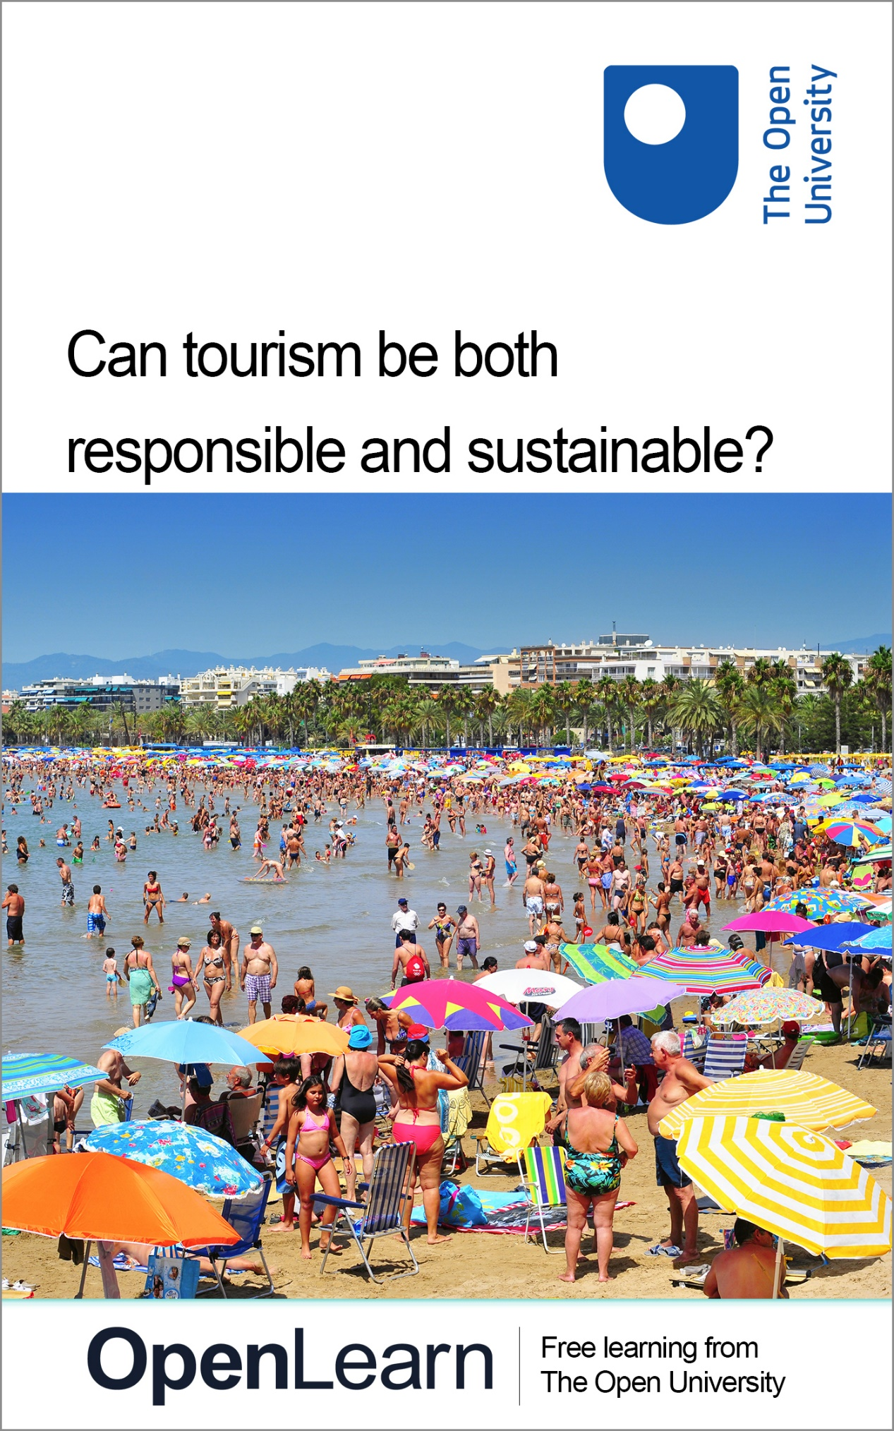

TOURISM_1

Can tourism be both responsible and sustainable?

About this free course
.
This version of the content may include video, images and interactive content that may not be optimised for your device.
You can experience this free course as it was originally designed on OpenLearn, the home of free learning from The Open University – https://www.open.edu/openlearn/nature-environment/can-tourism-be-both-responsible-and-sustainable/content-section-0
There you’ll also be able to track your progress via your activity record, which you can use to demonstrate your learning.
First published 2026.
Unless otherwise stated, copyright © 2026 The Open University, all rights reserved.
Intellectual property
Unless otherwise stated, this resource is released under the terms of the Creative Commons Licence v4.0 http://creativecommons.org/licenses/by-nc-sa/4.0/deed.en. Within that The Open University interprets this licence in the following way: www.open.edu/openlearn/about-openlearn/frequently-asked-questions-on-openlearn. Copyright and rights falling outside the terms of the Creative Commons Licence are retained or controlled by The Open University. Please read the full text before using any of the content.
We believe the primary barrier to accessing high-quality educational experiences is cost, which is why we aim to publish as much free content as possible under an open licence. If it proves difficult to release content under our preferred Creative Commons licence (e.g. because we can’t afford or gain the clearances or find suitable alternatives), we will still release the materials for free under a personal end-user licence.
This is because the learning experience will always be the same high quality offering and that should always be seen as positive – even if at times the licensing is different to Creative Commons.
When using the content you must attribute us (The Open University) (the OU) and any identified author in accordance with the terms of the Creative Commons Licence.
The Acknowledgements section is used to list, amongst other things, third party (Proprietary), licensed content which is not subject to Creative Commons licensing. Proprietary content must be used (retained) intact and in context to the content at all times.
The Acknowledgements section is also used to bring to your attention any other Special Restrictions which may apply to the content. For example there may be times when the Creative Commons Non-Commercial Sharealike licence does not apply to any of the content even if owned by us (The Open University). In these instances, unless stated otherwise, the content may be used for personal and non-commercial use.
We have also identified as Proprietary other material included in the content which is not subject to Creative Commons Licence. These are OU logos, trading names and may extend to certain photographic and video images and sound recordings and any other material as may be brought to your attention.
Unauthorised use of any of the content may constitute a breach of the terms and conditions and/or intellectual property laws.
We reserve the right to alter, amend or bring to an end any terms and conditions provided here without notice.
All rights falling outside the terms of the Creative Commons licence are retained or controlled by The Open University.
Head of Intellectual Property, The Open University

Contents
- Introduction
- Learning outcomes
- 1 What is tourism?
- 2 A brief history of tourism
  - 2.1 The birth of package holidays
- 3 Why does tourism matter?
  - 3.1 The global significance of tourism
  - 3.2 Tourism and development
- 4 Sustainability
  - 4.1 What is sustainability?
  - 4.2 What does sustainable tourism look like?
  - 4.3 Evaluating corporate sustainability in action
- 5 Responsibility
  - 5.1 Unseen Tours
  - 5.2 Individual responsibility
- 6 Challenges and opportunities for tourism
  - 6.1 Challenges with tourism
  - 6.2 Opportunities for sustainable and responsible tourism
- 7 The future of tourism
- Conclusion
- References
- Acknowledgements
- Glossary
- Solutions
- Descriptions

Introduction
This free course invites you to explore the paradox of modern travel – whether tourism can be both responsible and sustainable. Through case studies and reflection, you will start to understand the social, environmental, and economic forces that shape, and have shaped, global travel as we know it. By the end of the course, you will have a deeper understanding of tourism’s global impact and be ready to imagine how travel can better serve people, places, and, ultimately, the planet.
The course has seven parts. Each part should take no more than an hour of study.
- What is tourism?
- A brief history of tourism
- Two key aspects to explain why tourism matters – its global significance and tourism for development
- What is sustainability and what does sustainable tourism look like? Introduction to SEE: the three pillars of sustainable tourism – Social, Economic, and Environmental.
- What is responsible tourism and why is responsibility important? Whose responsibility is it?
- Key challenges and opportunities for tourism.
- The future of tourism. What do current trends tell us about whether tourism will be sustainable and responsible?

Learning outcomes
After studying this course, you should be able to:
- appreciate what tourism is and why it matters
- understand sustainability and responsibility in tourism
- acknowledge the importance of these concepts in modern-day tourism and apply this to tourism’s future.

1 What is tourism?
If you ask people in the UK what tourism means to them, they might give some surprisingly different answers. For one it may be their annual holiday to a beach in Spain (like Figure 1 showing a very crowded Salou beach in August 2010), for another it might be taking a business trip to present a paper at conferences in South Korea or Japan, for another it might be spending time away from work to stay with family who live elsewhere or for another it might be going to a museum in a town close to where they live.

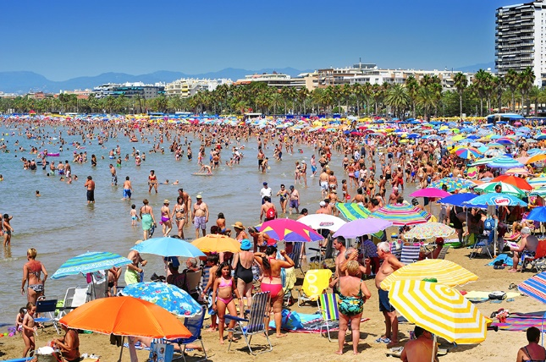
View description - Uncaptioned Figure
View alternative description - Uncaptioned Figure

Take a moment to reflect.
What does tourism mean to you?

Provide your answer...

UN Tourism; the relevant agency of the United Nations promoting responsible, sustainable and universally accessible tourism, defines tourism as:

‘…a social, cultural and economic phenomenon which entails the movement of people to countries or places outside their usual environment for personal or business/professional purposes.. tourism has to do with their activities, some of which involve tourism expenditure.’

This means:
- Tourism can be local or it can be global. What matters is that it is ‘outside (someone’s) usual environment’. If you worked in the Natural History Museum in London, for example, you could not be defined as a tourist if you went there but you could be a tourist if you went to the Horniman Museum. Even though this is also in London it is outside your usual environment.
- Tourism is social because it encourages visitors to interact with others – both other visitors and people in the places they are travelling to.
- Tourism is cultural because it can protect a community’s or country’s heritage as visitors want to see it. Cultural describes lots of things so this could include buildings, monuments, food, dancing or storytelling amongst other things.
- Tourism is economic because it creates jobs, creates tourism infrastructure such as better roads between places of interest or cafes near to them (that the general population can use) and it can assist in countries’ development particularly if tourism expenditure stays within the community or country.
People go to countries and places outside their usual environment as tourists for lots of different reasons. This can be for leisure travel (travelling for fun), seeing friends and family who live elsewhere or for business travel. These are the main types of tourism although there are many others.

Were you aware of the social, cultural and economic parts of tourism before reading this definition? Can you think of a time when you travelled and became aware of any or all of these aspects?

Provide your answer...
View discussion - Activity

Notice that the definition from UN Tourism doesn’t say anything about ‘staying’ anywhere – it talks of ‘movement’ instead. This is because although someone is ‘outside their usual environment’ this is defined rather loosely. This means, as in one of the examples above, someone could be a tourist if they visited somewhere in their own town or village, rather than travelling anywhere different. Eustat (nd), however, defines tourism as ‘the activities of persons travelling to and staying in places outside their usual environment for not more than one consecutive year’. This aspect of ‘staying’ could be very short – if someone was going to a museum near their home, for example – or it could be a long time such as students, or people able to afford the cost, taking a ‘gap year’ and using it to travel.

Why is tourism defined as staying somewhere ‘for not more than a year’?

Provide your answer...
View discussion - Activity

The next section outlines a brief history of tourism to explain how long tourism has been going on. Within that, though, it explains that travel has gone from only being something for the very wealthy to do, to being something that now many, many people have the opportunity to do. It identifies the ancient history of tourism to the development of tourism in the UK as well as a few of the people who played an important role in that.

2 A brief history of tourism
Tourism has been happening for centuries. The ancient Greeks travelled for pilgrimages and to see (or participate in) the famous Olympic Games from 776 BCE. Roman emperors visited the town of Troy in Turkey because of the Trojan War, which had been commemorated by a great temple in around 300 BCE.
The UK can track tourism from the 1600s when young men from wealthy families were sent abroad on what was called a ‘Grand Tour’ primarily to see the main cities in European countries such as France and Italy. Spa towns in England (such as Royal Tunbridge Wells) also became popular as destinations in the early1600s. By the 1700s, doctors were advising wealthy patients to go and spend time at the seaside suggesting it might cure a number of illnesses. Historically, however, it was mainly the wealthy who would engage in tourism.

Why do you think tourism was mostly only for the wealthier in society?

Provide your answer...
View discussion - Activity

Holidays for the less wealthy, in the form of a package holiday (according to the Cambridge dictionary ‘a holiday that is arranged for you by a travel company and for which you pay a fixed price before you go’) came much later. The city where package holidays started was not a beach town, nor a stop on the ‘Grand Tour’. It was Leicester and the year it started was 1841.

2.1 The birth of package holidays
Thomas Cook was a religious man and a member of the Temperance movement. This was a large and influential body of people who hated the idea of anyone drinking alcohol. Walking through Leicester to a meeting, Thomas Cook realised he could use the train station (which had only opened the previous year) to take people to Temperance meetings in other places. Click through the flashcards to learn more about Thomas Cook and Billy Butlin.

View description - Uncaptioned interactive content

After the Second World War, commercial airlines started to offer services too. Lusher (2015) details the first Horizon Holidays package to Corsica offered to guests in 1950. This promised ‘meat-filled meals and cheap wine’ (very important to people in Britain who were still experiencing meat rationing). When the first people arrived ‘on an airstrip built by the American army in 1943, the slightly bewildered tourists were greeted by a delegation bearing flowers and a municipal band’. Vladimir Raitz, the founder of Horizon Holidays, booked a number of flights for passengers in advance, choosing to do so to cut journey times and to allow fixed pricing. He is credited with starting the modern ‘package holiday’ that is so familiar to many today and takes us back to the picture of a beach holiday seen at the start of this course.
Since then, travel and tourism, globally, have expanded to levels that neither Thomas Cook, Billy Butlin nor Vladimir Raitz could have been able to dream of (and may not have wanted to dream of). Travel has become cheaper. More competition and more hotels means prices can be much lower than previously. Tourism is something undertaken by many people from many countries. Before we discuss responsibility and sustainability, though, it is important to understand the global significance of tourism including tourism for development, which follows on.

3 Why does tourism matter?
Tourism is worthy as a subject to study for two main reasons. Firstly, tourism is globally significant with some very big numbers attached to it. The second aspect is that tourism is often used as a way for countries to develop. Therefore there are two parts to this section – ‘The global significance of tourism’ and ‘Tourism and development’.

3.1 The global significance of tourism
In its booklet on ‘Fifty years of tourism’ (2024) UN Tourism reveals that ‘international tourism has grown from 222 million arrivals in 1975 to a projected 1.5 billion in 2025 (and) 2 billion tourist arrivals foreseen for 2030’ this is in spite of world banking shocks and pandemics. The World Bank also pointed out the amount of money going into countries from tourism totalled around $1.6 trillion in 2023 and, if transport was included, the figure rose to $2.2 trillion. This is just the amount for one year.
In January 2026, the World Economic Forum suggested that the tourism sector would create 91 million jobs by 2035, which chimes with the World Travel and Tourism Council (WTTC) saying, in April 2025, that growth in global travel and tourism would be greater than overall economic growth. Therefore, tourism has two main functions for countries:

This has meant tourism is an important part of many countries’ economies and many countries try to promote tourism as much as they can.
In 2023, the Barcelona Field Studies Centre commented that a study in Thailand ‘estimated that 70% of all money spent by tourists ended up leaving Thailand…estimates for other…countries range from 80% in the Caribbean to 40% in India’.
What is wanted instead is the multiplier effect. Simply, if a tourist stays at a local hotel (so money doesn’t leave the location), the hotel will employ local people, source food from local stallholders, maybe entertainment from local dance troupes or find antiques from local dealers. Each transaction benefits the locality and maintains jobs at every level. It also gives people a range of opportunities to be involved in tourism.
In October 2025, an online travel agency – On The Beach – put up recognisable posters (like ones from the First World War but this time with Lord Kitchener in) on the Canary Islands and in mainland Spain. At the time there were protesters complaining about the numbers of tourists on the islands. A senior manager at the agency said ‘Spain needs tourists, Spain wants tourists. Those taking part in the tourism protests are in the minority, and our posters are there to show Brits they’re not just welcome, they’re vital to the communities and businesses that rely on tourism’ (Evans and Ankers, 2025). Overtourism will be covered later, but for now it is important to understand why increasing tourism is attractive to many countries.
Let’s look at the most visited countries.

Can you put these countries in order of the number of tourists that arrived in 2024?

1
2
3
4
5
France
Spain
USA
Türkiye
UK
View answer - Activity
View discussion - Activity

In November 2024, the British government set an ambitious goal of wanting ‘to welcome fifty million international tourists by 2030’ and saw government and industry needing to work together, more than they had done in the past, to achieve this aim. In particular, the plan aimed to increase tourist travel outside of London and Edinburgh by improving marketing, making sure workers had appropriate skills and by revising the established tourist board infrastructure with stronger links to government. According to Al Khodairi (2025), London was the third most visited city in the world in 2024. It was important, to the government, that other areas had benefits from tourism too.
This section has shown the economic importance of tourism. This has meant that many countries see a need to increase their tourism offer, to make it attractive to as many people as possible, and to encourage more tourists. It has also suggested that this could be challenged by people within a country (or region) given why those posters were put up in the Canary Islands and Spain. The other important aspect of why tourism matters is that tourism can be extremely important to a country’s development efforts.

3.2 Tourism and development
The previous section showed there was a potential for countries to attract a great deal of money from tourism and it explained why countries wanted to both expand their tourism offer, to encourage more tourism, and to encourage more tourists. This can be transformative for countries wanting to develop infrastructure both for its population and its tourists.
Part of national tourism strategies is also, generally, to encourage people to stay for longer (particularly so they can travel away from the main tourism areas into lesser known ones) and to spend more money with the aim of as much direct income as possible staying in the country.
One of those countries that wants a higher tourist revenue for its development is Kenya. Kenya had a national marketing strategy from 2011 (Kenyan Tourism Board). Its aim then was to become the most visited destination in Africa and ‘to market Kenya as the home of human origin and as an all-year-round diverse, sustainable and authentic tourism destination’.
Kenya recently published its National Tourism Strategy 2025-2030. This says that by 2030 it is aiming for:
- 5 million international tourists per year (doubling the number of arrivals before 2025)
- 2.5 million jobs to be created (approximately 2 million jobs were supported before 2025 so this would be more than doubled)
- KES1.2 trillion in revenue (approximately £6.7 billion when revenue was £2 billion before 2025 so this would be more than tripled).
How will it do this?

Kenya’s strategy

  View description - Uncaptioned Figure  View alternative description - Uncaptioned Figure  Firstly, Kenya wanted to strengthen its brand – ‘Magical Kenya’, the logo for which is shown above. | The front page of the Magical Kenya website says ‘Welcome Home’.  This builds on the importance of Kenya to archaeological finds on human evolution and tallies with what it wanted to do in 2011 – highlight Kenya ‘as the home of human origin’.  It is not the only country referred to as ‘the cradle of humankind’ but it is one of them and ‘welcome home’ identifies it in this way.  Magical Kenya website

Do you think it is a good idea for countries to adopt a brand for their tourism industry?

Provide your answer...
View discussion - Activity

Kenya is famous for safaris and beach holidays but its new strategy intends to ‘broaden… what Kenya sells to the world and how it manages the natural assets that draw visitors in the first place’ (Oloo, 2025). For example, it wants to encourage people to go on safari in different areas by opening up other parks. Indakwa (2026) notes that ‘Despite boasting 23 terrestrial national parks, 28 terrestrial national reserves, four national sanctuaries, and four marine national parks, Kenya’s international tourism has largely been concentrated in just six national parks’. Extending destinations that tourists go to would spread out tourism, potentially spread out where money was coming into the economy and cause less disruption to animals and local populations.
An important part of this strategy took place in March 2026 when Kenya launched a global tourism campaign encouraging people to stay longer and to think about all opportunities available to tourists rather than ‘just’ safaris and beaches. You can watch their film here.

Watch the video at YouTube.com.
Video 1: Kenya magic – a cinematic journey

It also developed a physical or digital ‘Magical Kenya Souvenir Passport’ encouraging people to collect stamps from different areas outside of the usual tourist spots. This has been designed mainly for ‘younger travellers such as Millennials and Generation Z, who increasingly prioritise unique and shareable experiences when choosing travel destinations’ (Kipkemoi, 2026).

Do you think the video and visitor passport make visiting Kenya more popular or not? Why is this?

Provide your answer...
View discussion - Activity

One of the key themes raised here is that, in order to be effective, money raised by tourism needs to stay in the country where it is spent. Therefore, attracting tourists to countries is only one part of the equation – keeping tourists’ money is the other part. This has a direct link to ‘sustainable’ tourism, which is what the course goes onto next.

4 Sustainability
In order to consider whether sustainable tourism will meet the goals countries have, we first need to consider what sustainability is. There are two different aspects of sustainability that we look at here. The first is ‘What is sustainability?’ and the second is ‘What does sustainable tourism look like?’

4.1 What is sustainability?
The UN Department of Economic and Social Affairs (nd.) says that sustainable tourism is ‘tourism that takes full account of its current and future economic, social and environmental impacts, addressing the needs of visitors, the industry, the environment and host communities’. Primarily, it is a long-term goal – it focuses on how to maintain the system of tourism and how to use it to get best value without negative impacts either now or in the future.
The concept of sustainability was originally just about the environment. The first mention of sustainability in development was in a book called ‘Our Common Future’ by the World Commission on Environment and Development (WCED) in 1987. The WCED was put together by the UN, which believed there was a need for a global agenda for change by putting the environment first.
Chairing the Commission was the then Danish Prime Minister Gro Harlem Brundtland and the book is sometimes referred to as ‘The Brundtland Report’. ‘Our Common Future’ says that sustainability is where we can meet present needs without negative impacts on future generations meeting their needs. On that basis, it says, ‘the goals of economic and social development must be defined in terms of sustainability’ (2009). Looking at tourism, this means sustainability must be designed into tourism projects and should continue to meet needs without adversely affecting the future. Practically, then, although economic growth is important – what matters is whether the way to achieving it is sustainable or not. If it is not sustainable then it should not be considered desirable.
To emphasise the importance of sustainability within tourism, tourism also has a place in supporting the UN’s 2015 Sustainable Development Goals and is a key target in goals 8, 12 and 13 although it contributes to nearly all of the 17 goals.

Interactive content is not available in this format.
Figure (interactive) The United Nations Sustainable Development Goals

In terms of the specific goals where there is a key target, tourism must:
- For SDG 8 (promote sustained, inclusive and sustainable economic growth, full and productive employment and decent work for all) employ women and youth, ensuring access to finance for opening and expansion of tourism-related activities and waste management. Specifically, SDG target 8.9, aims to ‘by 2030, devise and implement policies to promote sustainable tourism that creates jobs and promotes local culture and products’.
- For SDG 12 (ensure sustainable consumption and production patterns) build local, regional and national capacity for sustainability and limit waste from tourism activities such as hotels and restaurants.
- For SDG 13 (take urgent action to combat climate change and its impacts) consider sustainable energy sources and natural resource management such as water use and ensuring biodiversity on land holdings.

4.2 What does sustainable tourism look like?
Sustainable tourism is not a ‘type’ of tourism in the same way leisure travel, seeing friends and family and business travel are (see Section 2). There is not even a single agreed definition of what sustainable tourism is. Instead, there is a global aspiration that all forms of tourism can and should be sustainable over time.
There are three pillars of sustainable tourism: social, economic and environmental often known by the acronym SEE. Let’s dig into these more deeply.

These show that sustainability is both for tourist destinations and for tourists to understand and put into practice. To be sustainable, then, tourism should be able to address these issues both now and through time.
Butler (2021) also defines sustainability as ‘limits (because)…in almost all…contexts, there is a maximum number of tourists who can be successfully accommodated.’ This is related to another term often used in tourism; carrying capacity.

The Kibale Association for Rural and Environmental Development
A good example of sustainable tourism is the Kibale Association for Rural and Environmental Development (KAFRED) in Uganda, which was founded in 1992 and is managed and run by the community in the village of Bigodi. This kind of tourism can also be called ‘community-based tourism’. Below is a picture of a group of tourists on one of the walks they offer.

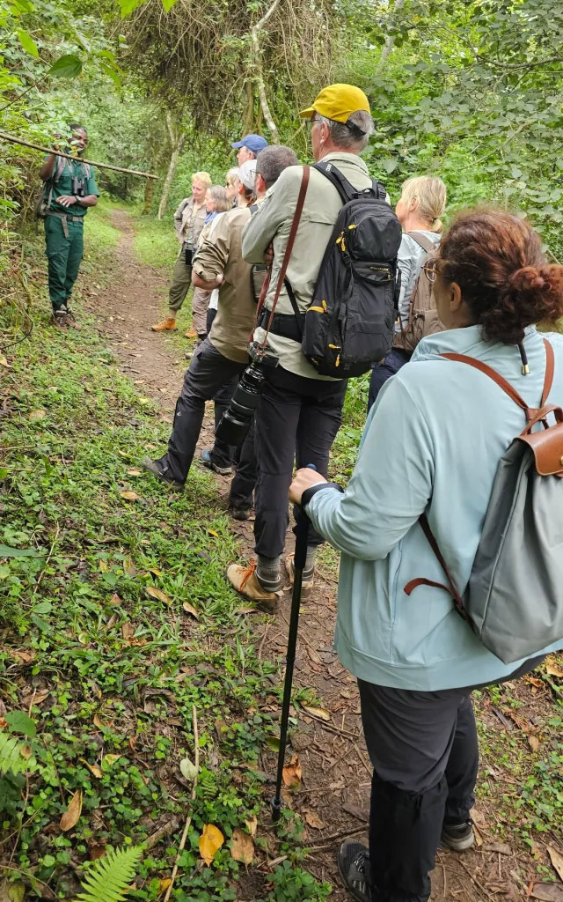
View description - Uncaptioned Figure
View alternative description - Uncaptioned Figure

You can read About KAFRED – Bigodi Wetland Sanctuary, which shows what developments there have been in Bigodi since KAFRED was first set up. There is lots of interesting information about KAFRED on this website but for the purpose of this section of the course you only need to look at the ‘about’ page.
In order to answer the question below, think about the evidence you can find on this part of its website in relation to its support of the social, economic and environmental aspects of sustainable tourism. You may find some of the things you identify fit into more than one of the three areas. This activity will take about 30 minutes to complete.

Why might KAFRED be a good example of sustainable tourism in terms of what it does under the three pillars (SEE)?

Provide your answer...
View discussion - Activity

Is it too early to say that KAFRED is ‘sustainable’? I don’t think so. It was started in the early 1990s and continues to diversify. For example, it has started a regenerative agriculture project, which has only recently been implemented but fits with what the community already does. John Tinka who set up KAFRED says: ‘The project has proved its sustainability because it continues to be supported across the community. Although tourism in Uganda has been impacted by armed attacks by its neighbours causing mainstream tourism to fail, as well as various threats such as HIV/AIDs and Ebola discouraging tourists, KAFRED and the wider Bigodi community have gone from strength to strength over the last 30 years. This is because it is, above anything else, a community that ‘does tourism’ rather than tourism being ‘done to it’.

The Roça Sundy hotel
It is not just communities as a whole that are focusing on sustainability. Hotel groups are too. The Roça Sundy hotel is on Principe; a small island in the Gulf of Guinea in Africa. In 2026, the Rocas – including this one – were given World Heritage Site recognition by UNESCO. This hotel, in the Principe Collection, is based around two restored plantation houses, where slavery was used to grow and harvest cocoa. Now ‘every stay here helps to support local initiatives, protect the island’s unique ecosystems and foster community well-being. In this way we hope to make it a part of the island’s positive future, without forgetting its past’ (Principe Collection, nd). The group as a whole says it is very involved in training (as the largest employer on Principe), offers scholarships and promotes school development, protects agriculture and highlights sustainable and seasonality of local food and the importance of the environment (turtles, trees and birds) as well as sponsoring clean-up initiatives.

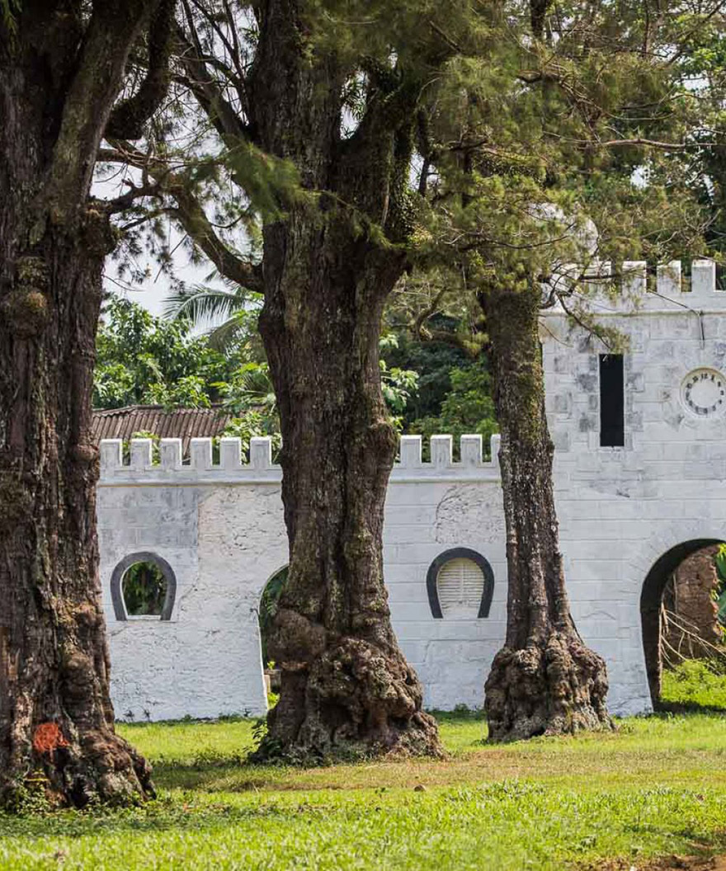
View description - Uncaptioned Figure
View alternative description - Uncaptioned Figure

4.3 Evaluating corporate sustainability in action
It is not just in the Global South where sustainability is a stated aim. Atlas Hotels, headquartered in Leicester in the UK, also highlights sustainability as one of the key aspects of its business. It reports on this annually. Atlas has 59 hotels in the UK and 1 in Germany and more than 2,500 employees. In their ‘Impact Report 2024’ flipbook (2025) they note that they are ‘positively impacting 16 of the UN SDGs; two more than last year’ (p.7). They track sustainability as a score (p.11) so they can keep track of how sustainable they are with the aim of continuing to do better. Furthermore, they raise money for charities (p.47) and aim to reduce energy, waste and water and report on that too (pp.14–16).
If we look at both these initiatives with the SEE framework, though, do we find they follow all the principles? Neither the Principe Collection nor Atlas talk explicitly about youth employment opportunities (although the Principe Collection talks about youth education). Atlas doesn’t mention local suppliers or food sustainability. The Principe Collection doesn’t tell us whether women’s or youth groups make goods for its shops (if they have them). Both hotel groups appear to be responsible to their owners and shareholders rather than solely the community they are in, unlike KAFRED. It is not clear, in either example, that individual staff can propose changes, for example, deciding which local groups to support.
This is not to say that both the Principe Collection and Atlas are not trying to be more sustainable – they clearly are. But it is the case that, with no agreed definition, the aspects of sustainability that are followed can be down to what is wanted by a company or by its shareholders. As tourists, if sustainability is important to us, we need to see through what companies ‘say’ and consider, instead, what they ‘do’.

What questions would you ask providers about sustainability? You can think about what you might ask the Principe Connection or Atlas Hotels if it helps.

Provide your answer...

Some academics believe that the terms ‘sustainability’ and ‘responsibility’ are linked and that you cannot have one without the other. We go onto responsibility next.

5 Responsibility
The Cambridge Dictionary gives a definition of responsibility that fits well here; ‘good judgement and the ability to act correctly’. This could be defined as personal or corporate (business) responsibility. Looking at this a little more critically, there is an evident problem in that everyone has slightly different ideas of what ‘good judgement’ is and how to ‘act correctly’. The UN understood this, which is why it convened the first responsible tourism conference in Cape Town in 2002 (Frey and George, 2010).
The Declaration, which followed the meeting, detailed the characteristics of responsible tourism in that it:
- ‘minimises negative economic, environmental and social impacts’
- ‘generates greater economic benefits for local people and enhances the well-being of host communities, improves working conditions and access to the industry’
- ‘involves local people in decisions that affect their lives and life change’
- ‘makes positive contributions to the conservation of natural and cultural heritage, to the maintenance of the world’s diversity’
- ‘provides more enjoyable experiences for tourists through more meaningful connections with local people, and a greater understanding of local cultural, social and environmental issues’
- ‘provides access for people with disabilities and the disadvantaged’
- ‘is culturally sensitive, engenders respect between tourists and hosts, and builds local pride and confidence’.
The end of the Declaration called for all tourism strategies, whether they were local, national or international, ‘determined to make tourism more sustainable, and accepting that it is the responsibility of all stakeholders in tourism to achieve more sustainable forms of tourism’.
It is important to note that responsibility is a day-to-day and stay-by-stay aim rather than the long-term aim of sustainability. It also suggests inclusivity as a guiding principle. The Declaration put responsibility into the hands of everyone involved in tourism – government, planner, tourist or business owner – each had responsibilities to exercise that ‘good judgement’ highlighted by the dictionary definition. Because of this, we can say responsible tourism is more about behaviours and actions by everyone from governments, the hospitality industry, local people or tourists rather than a long-term ambition.
We can map responsibility onto the SEE of sustainable tourism that we considered earlier. The responsibility characteristics, and where they differ from SEE, are added in emboldened text:

This mapping exercise shows that responsibility is more than sustainability. This is why academics suggest that both sustainability and responsibility fit together (or should fit together) to maximise the effectiveness of tourism for the greater benefit. This is because if you have responsible travel it should become sustainable travel.
One tour company trying to be responsible is Unseen Tours in London.

5.1 Unseen Tours
Unseen Tours is a social enterprise that trains people who have been homeless or in insecure housing to give tours of the parts of London that they know.

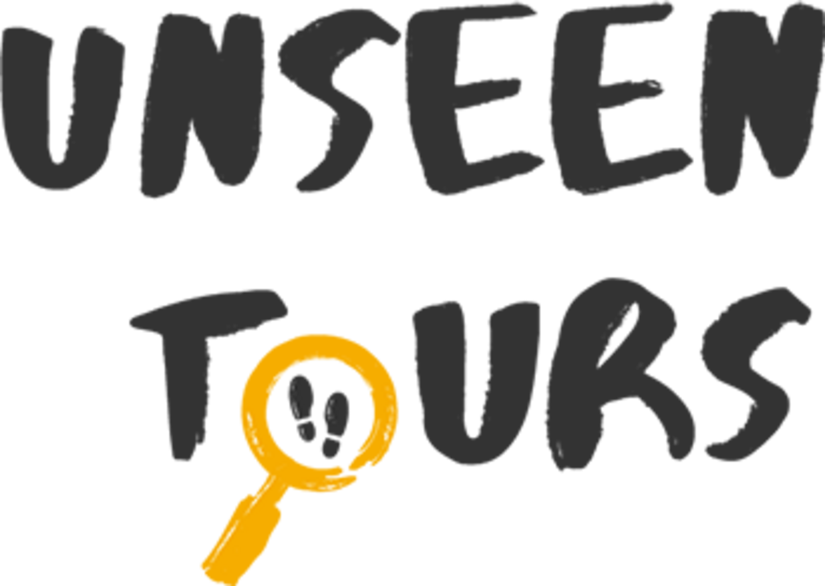
View description - Uncaptioned Figure
View alternative description - Uncaptioned Figure

You can learn about Unseen Tours here: About us – Unseen Tours. The reason why the company chose this name is because homelessness or housing insecurity is often unseen. People experiencing it might not talk about it. Some live in their cars or stay with friends or family, for example, and may have regular work so it is not necessarily noticed by others. In the worst case, people have to live on the streets but even they can become unseen because if they are somewhere regularly they become expected and normalised. Unseen Tours tries to make homelessness both seen and discussed and this plays an important role within its tours.
Now you have found out about Unseen Tours, this page looks at the impact they have: Our impact – Unseen Tours. Here are some questions about how responsible Unseen Tours is. These questions will take about 20 minutes to answer.

1) How does Unseen Tours try to make tourism responsible looking at the Social aspect?

Provide your answer...
View discussion - Part

2) How does Unseen Tours try to make tourism responsible looking at the Economic aspect?

Provide your answer...
View discussion - Part

3) How does Unseen Tours try to make tourism responsible looking at the Environmental aspect?

Provide your answer...
View discussion - Part

5.2 Individual responsibility
Now we have considered responsibility, if we look back at KAFRED, it is easier to see how sustainability and responsibility are joined.
- Community wellbeing has been directly enhanced from tourism.
- The community makes its own decisions about tourism in its area and builds pride and confidence through doing this.
- Connections between tourists and the community are excellent because the local environment and culture is celebrated.
- Community members can decide what to do with the money raised and how the project should be developed.
- There are economic benefits for local people from tourism in terms of income from guiding, producing things to sell in the shop and food provision. This means local people have access to economic opportunities because of tourism.
- There is more incentive for growing food that tourists – and the local population – can eat to limit leakage. This focus on agriculture has resulted in regenerative agricultural projects and beekeeping, which also has a positive effect on the environment.
- Natural heritage is protected and preserved with issues such as poaching and reed harvesting tackled together and children being educated about the importance of the area as an ecosystem.
- Tours are accessible.
From this, we can see that tourism positively affects communities where it is both responsible and sustainable. The principles of responsible travel identified in the Cape Town Declaration also discussed individual responsibility. What does individual responsibility look like in tourism? You should try to answer the question below with your ideas.

How can we, as individuals, travel more responsibly? Think of one big and one small way tourists can change their practices.

Provide your answer...
View discussion - Part

Can you find social enterprises near you and/or somewhere you will (or would like to) travel to?

Provide your answer...
View discussion - Part

Being responsible is not just about doing things or staying in particular places. What we buy as souvenirs can also help marginalised and vulnerable people. We saw earlier that, in KAFRED, women were making peanut butter and crafts to sell in the visitor centre, for example. Do you think such souvenirs would be more meaningful to tourists because of the story behind them or the experiences they were reminded of?
In this section we have looked at aspects of corporate responsibility and personal responsibility in tourism and what it means. We have discussed social enterprises as providing responsible choices for tourism. But what challenges do destinations have when they are so popular that many, many tourists visit? And what does this say about the future of tourism? This is what we draw our attention to next.

6 Challenges and opportunities for tourism
From what the course has covered so far, there has been barely any discussion of problems or opportunities for tourism. In this penultimate section of the course we will start to explore both issues. Starting with the challenges of tourism, this section will look at the two most pressing problems and what destinations are trying to do to solve them. The second part will look at opportunities for responsible and sustainable tourism including use of public transport.

6.1 Challenges with tourism
There are two main challenges with tourism that we will look at in this section. The first is overtourism, which was briefly mentioned at the start of the course in relation to what was happening in Spain and the Canary Islands. This means that growth – and bringing more people into a country or an area – becomes so important that people who live there, or the environment, is very much secondary. ‘Our Common Future’ identified that if economic growth (such as tourism) is not sustainable then it should not be considered desirable. This so-called ‘desperate addiction’ very much goes against that principle.
The second challenge is touristification. The result of touristification is often that local people leave particular areas of cities and, in the worst cases, leave the cities entirely.
First, watch the following video by German broadcaster DW. This video is a good introduction to some of the problems experienced in very popular destinations. Watching this video will take around 6 minutes. When you have finished, please check your understanding by answering the questions below.

Watch the video at YouTube.com.
Video 2: How top tourist destinations try to overcome overtourism and touristification

1) How did Raoul Bianchi define overtourism?

Provide your answer...
View discussion - Part

2) How were local people ‘squeezed out of the market’?

Provide your answer...
View discussion - Part

3) What had Amsterdam done to try to help solve its problems?

Provide your answer...
View discussion - Part

4) Did any of what was said in the video surprise you?

Provide your answer...

Barcelona
Barcelona has a similar problem to that of the Canary Islands. Abend (2026) discussed what its new Commissioner for Sustainable Tourism was planning to do to address its overtourism. This included:
- Make Barcelona attractive to locals again, for example by ensuring the Boqueria market remained a market for local people rather than becoming touristified by being focused on providing pre-prepared food for tourists.
- Continue to prevent new hotel construction (this was stopped in 2017).
- Having a maximum 16 million tourists – and ‘not one tourist more’ - with the make up of 1/3 business tourists, 1/3 cultural tourists and 1/3 leisure tourists (currently 2/3 are leisure tourists) and no day-tripper tourists from cruise ships with tourist taxes increased substantially to dissuade this.
- Make sure services that locals use are subsidized by tourist tax (including sewerage, security, power and transportation). Hotels also use a lot of water (especially in guestrooms, washing linens and having swimming pools) which can limit water availability – and raise costs – for local people.
- Give targeted support to shops that provide things for local people such as hardware stores.
- No new tourist infrastructure or touristification of existing infrastructure.
Overtourism is a comparatively recent phenomenon for Barcelona. Until it hosted the 1992 Olympic Games it was a rundown port town. Leading up to the Games, the government improved the centre so 2 miles (3.2km) of beach was built, palm trees imported, ring roads built and parks and green spaces overhauled as well as advertising campaigns beginning to encourage people to visit. Tourism has steadily increased from around 1.2 million people in 1990 to just over 26 million people in 2025. Barcelona has a population of only around 1.7 million in the city, which is where the majority of tourists go. The key message from the Commissioner for Sustainable Tourism is that he is trying to achieve a balance between tourism and the needs of the local population to enable both tourism and liveability. Barcelona has attracted lots of attention because of overtourism with even the Mayor of Athens in Greece commenting; ‘we must not become Barcelona’ (Touchtidou, 2026).

Venice
A number of other countries have expressed concerns about overtourism and touristification Below is a picture of Venice in Italy showing how overcrowded it can get at Carnival or in the peak holiday seasons. The company Responsible Travel says that Venice often ‘looks more of a theme park than a living, breathing city’ and details the depopulation that has resulted. You may be interested in reading what it says about Overtourism in Venice for yourself?

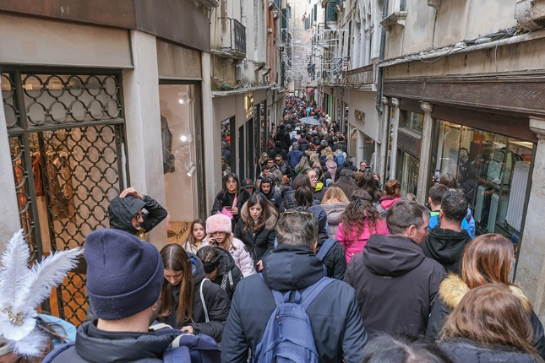
View description - Uncaptioned Figure
View alternative description - Uncaptioned Figure

Problems with overtourism have also started discussions in relation to safety. Recently there have been efforts by the Vietnamese government to limit negative behaviours of tourist boats in the scenic area of Ha Long Bay following accidents in 2025 (where a boat capsized) and 2026 (when there was a fire on a cruise ship). Now boats need to be equipped with radios and GPS alongside providing full passenger lists. There are also boat inspections and checks taking place to try to make sure all passengers on all boats are safe.
Although Venice is still hugely overtouristed, it has had some success in reducing visitors in its centre and in encouraging them to go to quieter areas. Venice now levies a tax for tourists staying in its centre, which is normally incorporated into the price of the hotel tourists stay in. This ensures money remains in the city and can help fund facilities for residents. Venice is also trying to push tourists away from its centre to places that are similar but quieter. For example, if a tourist wanted to stay in Venice they might instead be encouraged to stay on the islands of Burano or Murano across the Lagoon. Both islands have the same character as Venice but without the crowds and without the tourist tax. If this emphasis on relocating tourism to other places was being followed in Barcelona, tourist offices may suggest a tourist wanting to stay there should instead base themselves in Girona (with its 11 bridges and some incredible museums) or Tarragona (which has a Roman amphitheatre), both a short train ride away. Girona and Tarragona are both interesting but there is far less tourist pressure. Looking back at the discussion of safety and overtourism in Vietnam, tourists might similarly be encouraged to take a boat ride around Bai Tu Long – 30km away from Ha Long Bay – with the same incredible scenery but far fewer boats operating.

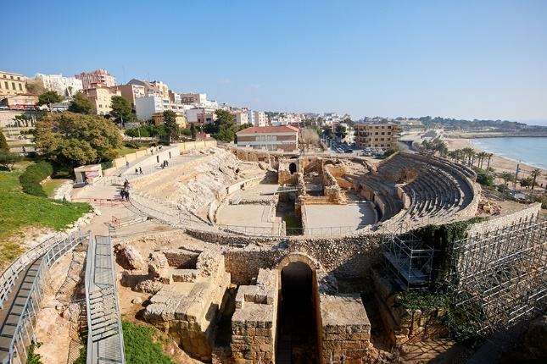
View description - Uncaptioned Figure
View alternative description - Uncaptioned Figure

Where would you advise tourists to travel outside of your nearest city?

Provide your answer...
View discussion - Activity

Overtourism is especially problematic where sites are vulnerable because they are very old and precious and where accessing money quickly by management to make repairs, or to have guards, is difficult. In 2026, UNESCO, which is responsible for designating and supporting World Heritage Sites (such as the Taj Mahal in India or the 17 sites in Kyoto, Japan) noted in its ‘World Heritage’ publication that ‘properties are facing increasingly complex challenges including development pressures, climate change, natural hazards, inadequate and insufficient maintenance and conservation’. Responsible Travel commented that ‘Unless the tourism industry changes its track, tourism could become one of the most problematic, and unwelcome, industries on the planet’. This highlights the importance of addressing challenges and in engaging in responsible behaviour with the aim of ensuring sustainability.

6.2 Opportunities for sustainable and responsible tourism
In this section we look at two big opportunities for tourism becoming more sustainable. Firstly through the growth of public transport and the development of potentially cleaner air travel. Secondly, opportunities for engaging with indigenous peoples, or rather indigenous peoples engaging with tourism on their terms.

Transport
An important aspect to responsibility and sustainability is travel. Destinations, and individuals, often try to encourage people to visit using public transport rather than by car and travelling this way is also called ‘slow travel’. Using public transport is particularly important in touristed areas where public transport can make streets less busy and pedestrianisation more possible as well as achieving better air quality. Venice has pedestrianised a number of streets to ensure people are not fighting for space with cars. Public transport is generally a more environmentally friendly option than a car as many more people can be accommodated in one vehicle. Public transport can also persuade tourists to see more sights than they might have initially planned because travel to and from them is much easier. Some cities are even rewarding tourists who arrive by train or who travel via public transport such as Copenhagen through its ‘Copenpay’ scheme.
One example of this is Stagecoach, a UK bus and coach company, which runs two open top ‘Peak Sightseer’ services from May until early October around the Peak District National Park. This encourages people not only to visit the National Park itself but attractions around it such as Chatsworth (a historic house), old mines that are now open to the public and Bakewell – home of the famous English pudding. As part of its offer, Stagecoach has negotiated money off certain suppliers so anyone using the service can benefit from reduced prices in some local shops and cafes in the places it calls at.

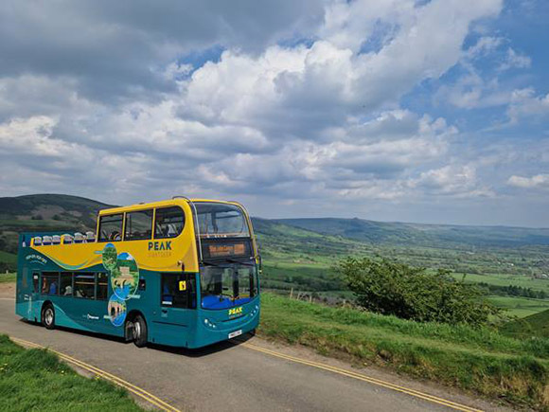
View description - Uncaptioned Figure
View alternative description - Uncaptioned Figure

Many cities now also have hop-on, hop-off bus services. Lima in Peru has a sightseeing bus that offers a nighttime trip so tourists can see the city lights. Bangkok has one too, the tickets for which can include a dinner cruise down the Chao Phraya River. Of course, in order to stop leakage, ideally local companies should be supported.
Train travel is also important. Since 2020 there has been a growth in night train services around Europe. Even in the UK, since 2025, the famous Caledonian Sleeper, which connects London to Scotland, now stops at Birmingham too. More than that, though, a number of countries are opening up high speed rail links in order to encourage tourists to visit places outside of their usual destinations as well as supporting local people accessing work or visiting family.
In June 2026 the United Arab Emirates started a new train service, which will eventually join up twelve cities across the Gulf States making it far easier to combine a beach holiday in Al Mirfa, Abu Dhabi with a golf holiday in Dubai. In the USA, AmeristarRail is also looking to upgrade current rail services on the East Coast with a high-speed service connecting New York to Washington DC in under an hour. It is planning on-train facilities for families with children and its top priced tickets may include luggage transfer services to and from the train to home/a hotel. Its aim is to make travel for business and pleasure easier, quicker and more affordable than having to use flights. Building rail networks take a lot of money and planning but they also make a positive difference to the environment, help tourists as well as locals and can reduce journey times significantly. For example, the train service in Laos between Luang Prabang and Vientiane (the capital city) takes from 1hr 45mins and costs from £19. The plane journey takes 51 minutes – not including check in time and potentially waiting for luggage at the other end – and costs from £52 and the bus journey takes around 8hrs and costs from £15.
But it is not just bus and rail that are important. Melbourne, Australia, which has the most tram tracks in the world, and has had trams since the 1880s, has just launched its ‘Next Generation’ trams (Jackson, 2026) to replace some of its older stock. Melbourne deliberately commissioned its new trams to be more accessible. Trams are free in the City Centre so it is very simple for tourists to travel around the sights and for residents to get to work. In fact, Melbourne advertises its ‘City Circle’ free tram route around Downtown Melbourne, which runs every twelve minutes. Its tourist office says; ‘No visit to Melbourne would be complete without experiencing a journey on board its most iconic mode of transport’. Trams, however, are also expensive to build. Fortunately for Melbourne, it never got rid of its trams the way other cities did (like Sydney or London) because of the growth of road travel.
Although it has high environmental impacts, it would be wrong not to mention developments in flying here too. Although trains are becoming popular and expanding, at the same time aeroplane use is increasing and scheduled to increase further as more people travel. Air travel releases a lot of greenhouse gas – it is not a sustainable mode of transport. To counteract this, United Airlines is attempting to reduce its fuel emissions 100% by 2050. It intends to do this by using more Sustainable Aviation Fuel (SAF). It was the first airline to try SAF on a passenger aeroplane in 2021. There have long been concerns about alternative fuels, especially using plant oils, as growing crops for fuel might replace growing food. However, in United’s vision, SAF consists of ‘used cooking oil, household trash, or forest waste’ rather than anything grown directly. Availability of SAF, though, is currently extremely limited and, therefore, extremely expensive. If it could be scaled up, this would help significantly limit carbon emissions and may even have a positive impact on waste disposal. Boom, the company currently testing a new supersonic aeroplane, has said its model, Overture, will be carbon neutral run on SAF as do Spike Aerospace with their Spike S-512 Diplomat supersonic jet (although supersonic aeroplanes need more energy than ‘normal’ aeroplanes so it is not clear how energy efficient it will be).
Because design is such an important factor in fuel use, Airbus is working on wing technology with its ‘Wings of Tomorrow’ programme. JetZero, from Japan, is trialling an ‘all wing’ plane that can reduce fuel use by up to 50%. The UK is now investing heavily into hydrogen, which looks as if it will have fewer adverse environmental effects too.

Given flying (at the moment) is environmentally unfriendly, would you consider taking trains or buses instead of flying if that was possible? Are you more or less optimistic about the possibility of environmentally friendly flying in the future?

Provide your answer...

Engaging with indigenous peoples
As discussed earlier in the context of Borneo Adventure, a growing trend is for tourists to want to engage authentically with indigenous peoples. This gives another opportunity for sustainable and responsible travel, often very small scale. At the larger scale, though, Australia’s tourism website highlights the importance of seeking out Aboriginal experiences by identifying their key role in environmental stewardship and their culture of storytelling. Similarly, New Zealand explains the importance of understanding Māori culture and emphasizes that tourists should seek out opportunities to expand their range of knowledge as this will enable them to see the world differently. Beyond this, though, indigenous communities are also working, at a small scale, with tourism on their own terms.
The Akwesasne Mohawk community in the USA and Canada recently opened a forest trail both for local people and tourists. It advertises this on its tourist website. You can see the 3 minute video about its opening here on YouTube - Grand Opening of the Kahrhaká:ion Walking Trail and the commentary makes clear how important it is to the tribe that this has happened. The Akawesasne Travel website (https://akwesasne.travel/about-us/) gives more ideas about what tourists can do to have authentic experiences in their territory including loom beading and basket weaving. Withrow (2025) mentions the Hualapai Nation reservation, which has built a glass arch ‘skywalk’ over the Grand Canyon for visitors and has opened trails and activities, including along the Colorado River. It has developed an app that provides information about the history and culture of the Hualapai as well as about what tourists can see and do in the area. This is small scale community tourism but it is responsible and sustainable as well as being authentic.
Another way to engage responsibly with indigenous people is to seek out social enterprises that support them or look for indigenous-owned enterprises. This might encourage tourists to identify activities they can do on their travels such as taking cooking courses in Belize (Central America) or finding shops selling indigenous handicrafts in Auckland (New Zealand) just as the women in KAFRED were selling crafts and peanut butter in their own visitor centre.

How would you find locally- or indigenous-owned shops where you were visiting?

Provide your answer...
View discussion - Activity

7 The future of tourism
We have said that both responsibility and sustainability should remain at the centre of tourism offers. This means it is important that we understand what the concerns of each ‘megatrend’ might be and how we might address or avoid the non-sustainable and non-responsible aspects of each. A company called Data Appeal wrote a report of the international travel market highlighting seven ‘megatrends’ for travel and tourism in 2026 and beyond. These trends are:

This is a picutre of the Anne of Green Gables Museum (as mentioned in bullet point 2 Set-jetting).

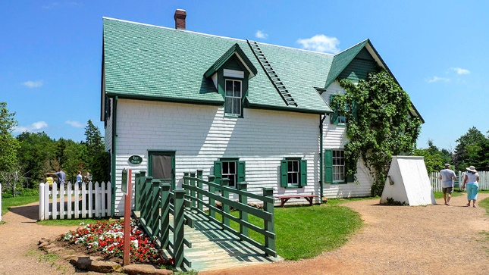
View description - Uncaptioned Figure
View alternative description - Uncaptioned Figure

This is a picture of Longmeadow Cider, Craigavon Co. Armagh, Ireland from its entry on the Tourism Cares Meaningful Map (as mentioned in bullet point 6 Experience-led).

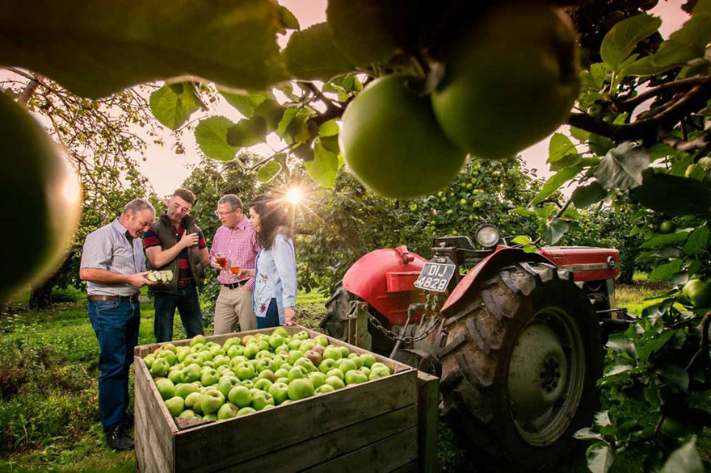
View description - Uncaptioned Figure
View alternative description - Uncaptioned Figure

Why might holidays arranged by travel agencies be more or less responsible and sustainable?

Provide your answer...
View discussion - Part

What meaningful local experience might be a good add-on to the Glastonbury Festival?
In order to answer this question, you might like to look at the Glastonbury festival website to see what it does already.

Provide your answer...

Given tourists are actively seeking out places that use tech-intelligence this does demand there are reliable wifi signals so rural areas may not be able to meet this requirement without some significant investment. Where it can happen, though, such as in a rural area in Jiangsu Province in China, which was not economically developed (Ye et al., 2025) there have been a number of benefits. One of the villagers said that since they adopted smart technology; ‘Urban residents are more willing to visit for tourism and purchase our agricultural produce and our income has also increased significantly.’ This is partly because an increase of visitors encouraged the development of craft and food businesses as well as homestays. Volunteering increased amongst the community to pick up rubbish and remind tourists of where to put it (although it appears littering is reducing due to growing understanding and increased awareness of ecology) all helping to achieve ‘social, economic and environmentally sustainable development’. As the offer is helping the village, and encouraging tourists, and it remains small-scale rather than encouraging hotels or chain restaurants (which might cause significant leakage) this seems a good example of sustainable community tourism handled responsibly. Given that AI use is increasing and what can be done with AI is also increasing, it is likely that ‘smart tourism’ will become more mainstream and be rolled out further to rural as well as urban areas. This content in this course is deliberately staying away from discussions about AI more broadly (including whether it is responsible and sustainable).

Conclusion
Tourism is big business. But that is not all that it is. We’ve seen in this course that sustainable and responsible tourism can change everything. However, we’ve also seen that tourism does not automatically include within itself aspects that are either sustainable or responsible. Instead, this has to be designed into tourism plans and understood as something that everyone throughout the process of designing, building, carrying out or participating in has to want and has to commit to.
Tourism can be dreadful for the environment. We’ve looked at places like Barcelona and Venice struggling with overtourism. The lack of liveability and the touristification of places is something to try to avoid. But we’ve also seen that tourism done well can be lifechanging. For the Bigodi community and KAFRED and for the Chinese rural community in Jiangsu as well as for those on the indigenous communities we discussed earlier, it has literally changed places for the better and opened up more opportunities, allowed more money to circulate with a multiplier effect and generally made a positive difference not just to the communities but also to the tourists who interact with them. It wasn’t just villages that benefitted from tourism either. When we think of Unseen Tours or other social enterprises, tourism can make a positive difference to individuals too. Growing their confidence and their pride, helping them believe in themselves and providing some great skills are all things we can see.
The key message is to know that we as individuals can make a positive difference too. By asking people in tourism ‘how is this sustainable’ or ‘how do women and youth play a part in this’ or ‘do you use sustainable palm oil’ we become responsible tourists ourselves and we demand others think about these aspects too. In fact, by telling people what matters to us, we encourage others to take their responsibility seriously.
If nothing else, this should make us optimistic about the future. The more people understand responsible and sustainable tourism, and their part in it, the more it will be deliberately sought out to become the normal way of holidaying. I hope this course has played a little part in that too.

References
Abend, H. (2026) ‘Barcelona’s new message: “Not one tourist more’’’, The New York Times, 10 July.
Alessandra at WeRoad (2026) ‘Set-jetting: trips inspired by movies and TV shows’, Stories: A Blog by WeRoad, 11 August. Available at: https://www.weroad.com/blog/set-jetting-trips-inspired-by-movies-and-tv-shows (Accessed: 12 August 2026).
Al Khodairi, H. (2025) ‘The most visited cities in the world from Paris to Kuala Lumpur’, CN Traveller, 9 September. Available at: https://www.cntraveller.com/article/the-most-visited-cities-in-the-world-from-paris-to-kuala-lumpur (Accessed: 22 May 2026).
Atlas Hotels (2025) Second ESG impact report. Available at: https://atlashotels.co.uk/atlas-hotels-publish-second-esg-impact-report/ (Accessed: 22 June 2026).
Barcelona Field Studies Centre (2023) Tourism multiplier effect, 19 January. Available at: https://geographyfieldwork.com/TouristMultiplier.htm (Accessed: 22 August 2026).
Butler, R. (2021) ‘Sustainable tourism – a state-of-the-art review’, in Saarinen, J. (ed.) Tourism and sustainable development. London: Routledge, pp. 11–29.
Cape Town Declaration on Responsible Tourism (2002) Available at: https://responsibletourismpartnership.org/cape-town-declaration-on-responsible-tourism/ (Accessed: 25 June 2026).
Data Appeal (2025) 7 megatrends reshaping international tourism in 2026. Available at: https://news.travelappeal.com/hubfs/GATED%20CONTENT%202025/Report_Megatrends%202026.pdf (Accessed: 13 August 2026).
Eustat (no date) Tourism. Available at: https://en.eustat.eus/documentos/elem_3441/definicion.html (Accessed: 22 May 2026).
Evans, A. and Ankers, W. (2025) ‘Posters in urgent appeal to Brit tourists appear in Spain and Canary Islands’, Yorkshire Live, 1 November. Available at: https://www.examinerlive.co.uk/news/tourism/posters-urgent-appeal-brit-tourists-32793303 (Accessed: 26 May 2026).
Frey, N. and George, R. (2010) ‘Responsible tourism management: the missing link between business owners' attitudes and behaviour in the Cape Town tourism industry’, Tourism Management, 32(1), pp. 621–628.
Glastonbury Festival (2026) Glastonbury Festival. Available at: https://www.glastonburyfestivals.co.uk/ (Accessed: 13 August 2026).
Hilton (2026) Hilton 2026 trends report. The whycation: travel’s new starting point. Available at: https://stories.hilton.com/2026-trends (Accessed: 11 August 2026).
Indakwa, E. (2026) Kenya’s push for international tourism sparks ecological concerns. IFAW, 23 February. Available at: https://www.ifaw.org/international/journal/kenya-push-international-tourism-sparks-ecological-concerns (Accessed: 26 May 2026).
Jackson, C. (2026) ‘Melbourne’s next generation of trams enters service’, Railway Gazette International, 4 August. Available at: https://www.railwaygazette.com/light-rail/2026/08/04/melbournes-next-generation-of-trams-enters-service/ (Accessed: 5 August 2026).
Kipkemoi, F. (2026) ‘Kenya unveils ‘Experience Wonder’ global campaign to woo more tourists’, The Star, 5 March. Available at: https://www.the-star.co.ke/news/2026-03-05-kenya-unveils-experience-wonder-global-campaign-to-woo-tourists (Accessed: 29 July 2026).
Lusher, A. (2015) ‘A history of package holidays: rising numbers indicate a renaissance with an updated and classier holiday experience’, The Independent, 8 June. Available at: https://www.independent.co.uk/travel/news-and-advice/a-history-of-package-holidays-rising-numbers-indicate-a-renaissance-with-an-updated-and-classier-holiday-experience-10306101.html (Accessed: 26 May 2026).
Murphy, J. and Alexander, J. (2025) ‘The 16 biggest wellness travel trends of 2026’, Conde Nast Traveller, 19 December. Available at: https://www.cntraveller.com/article/the-biggest-wellness-travel-trends-of-2026 (Accessed: 12 August 2026).
Oloo, C. (2025) ‘Kenya recasts national tourism strategy to link wildlife conservation, sustainability and business travel’, Africa Sustainability Matters, 15 December. Available at: https://africasustainabilitymatters.com/kenya-recasts-national-tourism-strategy-to-link-wildlife-conservation-sustainability-and-business-travel/ (Accessed: 26 May 2026).
Renew Europe (2026) Position paper: tourism the invisible engine. Available at: https://reneweuropegroup.app.box.com/s/5i64jno708goid809sfbbtvvvjff1amn (Accessed: 12 August 2026).
Spenceley, A. and Rylance, A. (2019) The responsible tourist. Available at: https://www.gstc.org/wp-content/uploads/2010/09/The-Responsible-Tourist---issue-1-FINAL.pdf (Accessed: 10 July 2026).
Stay67915979055 (2026) ‘Pretty awful’ – a review of Maya Bay on Tripadvisor. Available at: https://www.tripadvisor.com/Profile/Stay67915979055?fid=f1c296f8-37ed-4cbc-90e9-9dd3ba61f534 (Accessed: 12 August 2026).
Touchtidou, S. (2026) ‘“We must not become Barcelona”: Athens considers banning new hotels, mayor says’, Euronews, 21 April. Available at: https://www.euronews.com/travel/2026/04/21/we-must-not-become-barcelona-athens-considers-banning-new-hotels-mayor-says (Accessed: 13 July 2026).
UNESCO, ICCROM, ICOMOS and IUCN (2026) Managing World Heritage: resource manual. Available at: https://whc.unesco.org/document/224769 (Accessed: 5 August 2026).
UN Tourism (no date) Glossary of tourism terms. Available at: https://www.untourism.int/glossary-tourism-terms (Accessed: 22 May 2026).
Withrow, B. (2024) ‘The indigenous tribes reclaiming travel’, BBC Travel, 24 November. Available at: https://www.bbc.co.uk/travel/article/20230828-the-indigenous-tribes-reclaiming-travel (Accessed: 30 July 2026).
World Population Review (2026) Most visited countries 2026. Available at: https://worldpopulationreview.com/country-rankings/most-visited-countries (Accessed: 22 May 2026).
Ye, S., Shi, L., Feng, Z. and Hyok, G. (2025) ‘Toward a smarter, sustainable and satisfying life: exploring the mechanism of smart rural tourism construction empowering rural revitalization in the area of Yangtze River Delta’, Heliyon, 11(6). Available at: https://www.sciencedirect.com/science/article/pii/S2405844025010850 (Accessed: 13 August 2026).

Acknowledgements
This free course was written by Dr Kerry Somerset with thanks to Matt, Zoe D and Zoe W and the rest of the team for their enthusiasm and commitment to this project. Also to the incredible ‘Tourism Ladies’ Elissa Williams and Kassia Somerset-Brake, the latter who patiently read too many drafts and the former without whom I would likely still struggle with carrying capacity (and would never have got this far). I owe you both a lot.
Except for third party materials and otherwise stated (see terms and conditions), this content is made available under a Creative Commons Attribution-NonCommercial-ShareAlike 4.0 Licence.
The material acknowledged below is Proprietary and used under licence (not subject to Creative Commons Licence). Grateful acknowledgement is made to the following sources for permission to reproduce material in this free course:
Images
Course image and Section 1: by Nito; Shutterstock.com
2.1: Image of Thomas Cook taken from https://commons.wikimedia.org/wiki/File:Thomas.Cook.jpg
2.1: Image of Billy Butlin; Mirrorpix / Contributor; Getty Images
3.2 Subsection (Kenya’s strategy): Magical Kenya logo: Magical Kenya; Kenya Tourist Board
4.1: Interactive figure: United Nations, Department of Economic and Social Affairs; https://sdgs.un.org/
4.2 Subsection (The Kibale Association for Rural and Environmental Development): Local guides; courtesy of Bigodi Wetland Sanctuary
4.2 Subsection (The Roça Sundy hotel): Roca Sundy hotel; courtesy of Príncipe Collection Hotels
5.1: Unseen Tours logo; courtesy of Unseen Tours
6.1 Subsection (Venice): Venice at carnival time; Stefano Mazzola / Contributor; Getty Images
6.1 Subsection (Venice): Tarragona’s Roman amphitheatre; David Soanes Photography; Getty Images
6.2 Subsection (Transport): A Peak Sightseer Bus; courtesy of Stagecoach
7: Anne of Green Gables Museum; Dora Dalton; Getty Images
7: Longmeadow Cider; courtesy of Visit Armagh and Long Meadow Cider
Audio / Visual
Video 1: Magical Kenya; Kenya Tourist Board
Every effort has been made to contact copyright owners. If any have been inadvertently overlooked, the publishers will be pleased to make the necessary arrangements at the first opportunity.
Don't miss out
If reading this text has inspired you to learn more, you may be interested in joining the millions of people who discover our free learning resources and qualifications by visiting The Open University – www.open.edu/openlearn/free-courses.

Glossary
Carrying capacity
Carrying capacity is the number of tourists (and local people) a specific place – for example a cultural heritage site or hotels in a particular area – can hold without any negative effects.
Direct income
It’s appropriate to say here that money spent by tourists is called direct income.
Leakage
Money leaving the country is called leakage. Although leakage can also happen at a local and regional level, the focus here is at a national level.
Multiplier effect
Money associated with tourism should filter down to others in the community, making a positive difference, rather than leaving the community through leakage.
Overtourism
Mandic (2022) calls overtourism ‘the desperate addiction of tourism destinations to growth, which is often incompatible with sustainability goals and principles’.
Social enterprise
Social enterprises are businesses that ‘prioritise benefit to people and planet, and use the majority of any profit to further their mission. Social enterprises contribute to reducing economic inequality, improving social justice and to environmental sustainability’. (See What is a social enterprise, how do they work & what do they do?).
Touristification
This is where all the infrastructure in a destination becomes only about tourism and tourists, rather than supporting those that live in the destination year-round. Imagine if your local supermarket became a souvenir shop!

Solutions

Activity

Discussion
There’s no right or wrong answer here because everyone has different travel experiences. For example, I (the author of this course) currently live near Nottingham. When I went to Colwyn Bay in Wales I stayed at a locally-owned guesthouse (economic), talked to people not just at the guesthouse but also when I went shopping and when I went out to eat (social). I learned about Welsh food and traditions and visited castles in Caernarvon and Conwy (cultural).
Back to - Activity

Activity

Discussion
Because longer than that suggests someone has either settled in one place or has settled into a travelling lifestyle.
Back to - Activity

Activity

Discussion
Because of costs and time. Even workers in Lancashire in the 1870s had to save all year for an annual unpaid week’s holiday. Holiday entitlement for all workers only began in 1939 with the Holidays with Pay Act, but the take up was delayed by war and even then this was not compulsory for all employers.
Back to - Activity

Activity

Answer
The correct matches are:
1
France
2
Spain
3
USA
4
Türkiye
5
UK
Back to - Activity

Discussion
- France – top with 102 million visitors
- Spain – second with 93.8 million visitors
- USA – 73.4 million visitors
- Türkiye – 60.6 million visitors
- UK – 41.8 million visitors
Back to - Activity

Activity

Discussion
To some extent, countries have always been brands because they have a distinct and individual identity. However, it is generally considered a good idea to develop a country brand as it can bring all their tourism efforts together making them more visible and encouraging other industries in the country to think about how they contribute (or how they might contribute) to it. It needs government commitment because it is something that is long term so has to be constantly publicised.
Back to - Activity

Activity

Discussion
It is interesting to see all the things that a tourist could do in Kenya – beyond going to the beach or going on safari – and it might encourage tourists to go there if they had not thought of these things. The visitor passport might also act as an incentive for younger people to visit places so they can share them with friends and family and have a permanent record of their trip.
Back to - Activity

Activity

Discussion
- Social: We have evidence the community benefits from tourism. There are no outside managers so the community runs the tourism project itself. There are several mentions of what tourism has achieved for the community. As well as having the opportunity to stay outside the village, tourists are invited to eat local food and stay in the village or take tours around the wetlands or the community.
- Economic: Because of the above it appears the benefits have been spread throughout the community. We are told that women’s groups are able to make handicrafts and peanut butter to sell at the Visitor Centre at the wetlands. We do not know about the youth. There is nothing to suggest a great deal of leakage with the money that is raised except, perhaps, transport to get there.
- Environment: There is a significant section on ‘Biodiversity and Conservation’ on the webpage showing that it was the environment that drove the project in the first place. The area is said to have been improved, waste limited and sustainable harvesting and dyeing used in order to conserve the environment (and water). There is no suggestion of a lack of carrying capacity for the number of guests they can accommodate.
Back to - Activity

Activity

Part

Discussion
The opportunity for those on the walk to consider problems experienced through homelessness would give greater understanding of lives of people in London and the issues they face. The community responsible for guiding these walks would have more pride and confidence in showing people the areas they are very knowledgeable about (and this might encourage others in the community to feel the same way). This should increase their wellbeing too. The people involved are able to make decisions about where they guide. It feels as if this would be an enjoyable experience for tourists and residents and there would likely be more connection and understanding between people than you might expect from a usual walking tour.
Back to - Part

Part

Discussion
The company enables those having experienced homelessness access to the tourism industry and gives them economic benefits directly. This is partly because the organisation uses its profits to expand the business and partly because it wants the bulk of its income to go to the guides. The guides will also recommend pubs and cafes in the local area so this would benefit businesses in the area too.
Back to - Part

Part

Discussion
These tours are inclusive and can be adapted for wheelchairs and mobility scooters and Unseen will run tours for groups of different ages too. Cultural heritage is respected and, because of the nature of the tours, built heritage might be preserved. There is no energy (beyond person-powered) used on the walks and no food provided directly. To me, these walks use the environment in the best way possible.
Back to - Part

Activity

Part

Discussion
What did you find? One big way tourists might behave more responsibly would be to use tour companies in the country they are going to. Sometimes these are difficult to find but often guidebooks contain recommendations about local tours and travel. When a friend, Sally, went to Borneo she booked on a tour (including accommodation) with Borneo Adventures, which is based there. Borneo Adventures has also developed community tourism with the Iban tribe, which you can read about at Ulu Ai Project, Sarawak, Malaysia | Borneo Adventure. Sally says she was taken to places outside the usual tourist areas because Borneo Adventures know the area so well.
One small measure to help the environment might be to take a reusable bag when people travel rather than ask for one from a store. The UK government started to charge for plastic bags provided by shops in 2015. Certainly most people shopping in the UK seem to take their own bags with them. Tourists from the UK may find it normal to take reusable bags when they travel too. A number of countries have chosen to ban plastic bags from stores (such as Rwanda), or at least very much restrict their availability (such as Canada currently), so this seems that it might be an easy way of being just a little bit more responsible.
Another example of travelling responsibly, thinking about Unseen Tours, might be to find social enterprises local to the destination.
Back to - Part

Part

Discussion
In one of my local parks in Nottinghamshire there is a café called ‘Rumbles’. This is one of three cafes set up ‘To train and educate young people and adults in the county of Nottinghamshire, who are disadvantaged whether by disability, social or economic circumstances’ (see https://www.rumblescatering.org.uk/about/). Their food is wonderful too! Another example overseas, in Kampala, Uganda, there is the Silent Café – a deaf-owned and operated social enterprise (https://www.silentcafe.org/index.html). You can learn Ugandan sign language while trying local coffee. This is somewhere quite unique that would appeal to visitors.
Back to - Part

Activity

Part

Discussion
He said that overtourism meant tourists exceeded the carrying capacity of certain destinations.
Back to - Part

Part

Discussion
Houses that were available for local people were in short supply, there was house price inflation, rental properties had disappeared to become holiday lets and foreigners and hotel developers were allowed to buy houses (and land).
Back to - Part

Part

Discussion
Amsterdam had raised tourist taxes on accommodation, it had banned tour buses from the city centre and it had limited the number of cruise ships that could dock at ports.
Back to - Part

Activity

Discussion
My nearest city is Nottingham. If Nottingham suffered from over-tourism there are a number of other destinations tourists might choose to visit instead. Depending on their interests, for example, Newark is a town with a number of historic buildings, including a castle, and it borders Sherwood Forest. Lincoln is another beautiful city with a castle and a cathedral. Alternatively, perhaps tourists might like to go to Leicester to see its cathedral or the King Richard III Visitor Centre and the site of the Battle of Bosworth? Although Bosworth doesn’t have a train station, the others do (Newark has two train stations) and it is relatively easy to travel to each by bus from each other.
Back to - Activity

Activity

Discussion
Some of the online marketplaces highlight where shops are local or indigenous-owned. Looking in Auckland, a quick search on Ecosia found ‘Cleanstone’, which makes products from recycled plastics, ‘Māori by Design’ which makes jewellery as well as various restaurants. If you wanted Māori owned enterprises and couldn’t find them, you could look at specific listings such as the Whariki Directory (a list of Māori businesses).
Back to - Activity

Activity

Part

Discussion
Some travel agencies are geared towards beach holidays or city breaks in popular destinations. They may contribute to overtourism and touristification. All-inclusive hotels discourage tourists from spending money in their destinations so there is little to no economic benefit to local people. There could also be substantial leakage if the flight/hotel is not owned or managed locally. Some hotels may not be environmentally aware or care about the important role they could play for a community. Other travel agencies may be catering for a particular interest. It may be important to them to be responsible and sustainable and encourage community engagement. On that basis, they might be able to recommend places to stay that do care, where there is little leakage and local people do see benefits or where there is community tourism.
Back to - Part

Descriptions

Uncaptioned Figure
Photograph of vacationers in Llevant beach in Spain.
Back to - Uncaptioned Figure

Uncaptioned Figure
Photograph of people on Llevant beach in Spain. The beach is extremely crowded with people and parasols and there are many people in the water.
Back to - Uncaptioned Figure

Uncaptioned interactive content
Photographs of Thomas Cook and Billy Butlin.
Back to - Uncaptioned interactive content

Uncaptioned Figure
Image of Magical Kenya’s logo.
Back to - Uncaptioned Figure

Uncaptioned Figure
Image of Magical Kenya’s logo: a colourful semi-circle shaped pattern of blue, red and green triangles and black geometric shapes over the words Magical Kenya in black and red script.
Back to - Uncaptioned Figure

Uncaptioned Figure
Photograph of a group of people on a walking tour of Bigodi Wetland Sanctuary.
Back to - Uncaptioned Figure

Uncaptioned Figure
Photograph of a group of people on a walking tour of Bigodi Wetland Sanctuary.
Back to - Uncaptioned Figure

Uncaptioned Figure
This photograph shows the outside of the Roça Sundy hotel.
Back to - Uncaptioned Figure

Uncaptioned Figure
This photograph shows the outside of the Roça Sundy hotel. Several large, mature trees stand in front of a white stone wall with arched openings.
Back to - Uncaptioned Figure

Uncaptioned Figure
Unseen Tours logo.
Back to - Uncaptioned Figure

Uncaptioned Figure
Unseen Tours logo in bold dark-grey hand-drawn lettering. The letter ‘O’ in ‘TOURS’ is replaced by a yellow magnifying glass containing a set of small black footprints.
Back to - Uncaptioned Figure

Uncaptioned Figure
Photograph showing a very crowded small street with high rise buildings in Venice at carnival time.
Back to - Uncaptioned Figure

Uncaptioned Figure
Photograph showing a very crowded small street with high rise buildings in Venice at carnival time.
Back to - Uncaptioned Figure

Uncaptioned Figure
A picture of Tarragona’s Roman amphitheatre.
Back to - Uncaptioned Figure

Uncaptioned Figure
A picture of Tarragona’s Roman amphitheatre.
Back to - Uncaptioned Figure

Uncaptioned Figure
Photograph of a peak sightseer bus.
Back to - Uncaptioned Figure

Uncaptioned Figure
Photograph of an open topped Peak Sightseer bus on a road in the Peak District National Park.
Back to - Uncaptioned Figure

Uncaptioned Figure
Photograph of the Anne of Green Gables Museum in Prince Edward Island.
Back to - Uncaptioned Figure

Uncaptioned Figure
Photograph of the Anne of Green Gables Museum in Prince Edward Island. The house is white with a green roof and window shutters. There is a boardwalk with a green fence leading to the front door.
Back to - Uncaptioned Figure

Uncaptioned Figure
This is a photograph of Longmeadow Cider, Craigavon Co. Armagh, Ireland.
Back to - Uncaptioned Figure

Uncaptioned Figure
This is a photograph of Longmeadow Cider, Craigavon Co. Armagh, Ireland. People are on a tour looking at apples and there is large crate of apples attached to a tractor.
Back to - Uncaptioned Figure

