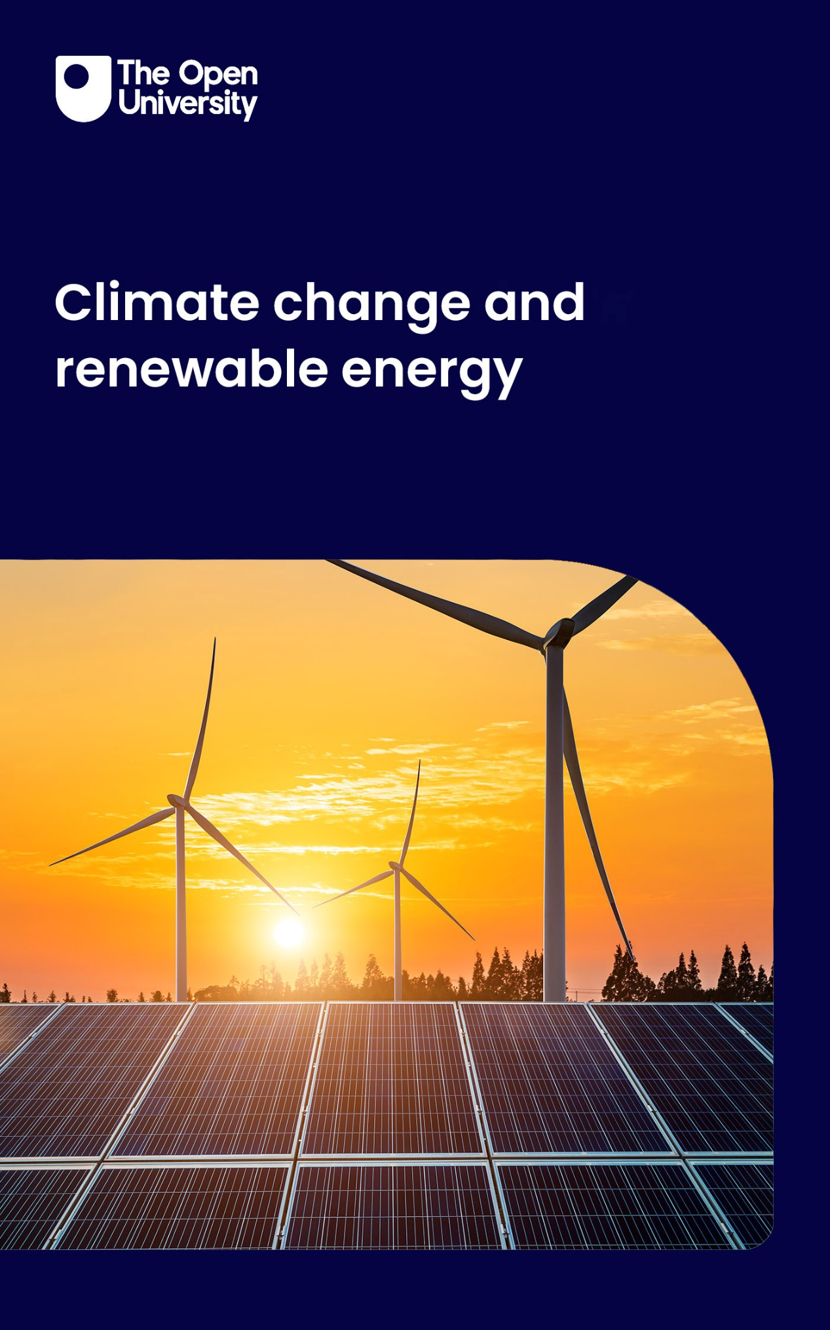

U116_7 Climate change and renewable energy

Climate change and renewable energy

About this free course
This free course is an adapted extract from the Open University course U116 Environment: journeys through a changing world https://www.open.ac.uk/courses/modules/u116.
This version of the content may include video, images and interactive content that may not be optimised for your device.
You can experience this free course as it was originally designed on OpenLearn, the home of free learning from The Open University: https://www.open.edu/openlearn/nature-environment/environmental-studies/climate-change-and-renewable-energy/content-section-0.
There you’ll also be able to track your progress via your activity record, which you can use to demonstrate your learning.
The Open University, Walton Hall, Milton Keynes, MK7 6AA
First published 2024.
Unless otherwise stated, copyright © 2024 The Open University, all rights reserved.
Intellectual property
Unless otherwise stated, this resource is released under the terms of the Creative Commons Licence v4.0 http://creativecommons.org/licenses/by-nc-sa/4.0/deed.en. Within that The Open University interprets this licence in the following way: www.open.edu/openlearn/about-openlearn/frequently-asked-questions-on-openlearn. Copyright and rights falling outside the terms of the Creative Commons Licence are retained or controlled by The Open University. Please read the full text before using any of the content.
We believe the primary barrier to accessing high-quality educational experiences is cost, which is why we aim to publish as much free content as possible under an open licence. If it proves difficult to release content under our preferred Creative Commons licence (e.g. because we can’t afford or gain the clearances or find suitable alternatives), we will still release the materials for free under a personal end-user licence.
This is because the learning experience will always be the same high quality offering and that should always be seen as positive – even if at times the licensing is different to Creative Commons.
When using the content you must attribute us (The Open University) (the OU) and any identified author in accordance with the terms of the Creative Commons Licence.
The Acknowledgements section is used to list, amongst other things, third party (Proprietary), licensed content which is not subject to Creative Commons licensing. Proprietary content must be used (retained) intact and in context to the content at all times.
The Acknowledgements section is also used to bring to your attention any other Special Restrictions which may apply to the content. For example there may be times when the Creative Commons Non-Commercial Sharealike licence does not apply to any of the content even if owned by us (The Open University). In these instances, unless stated otherwise, the content may be used for personal and non-commercial use.
We have also identified as Proprietary other material included in the content which is not subject to Creative Commons Licence. These are OU logos, trading names and may extend to certain photographic and video images and sound recordings and any other material as may be brought to your attention.
Unauthorised use of any of the content may constitute a breach of the terms and conditions and/or intellectual property laws.
We reserve the right to alter, amend or bring to an end any terms and conditions provided here without notice.
All rights falling outside the terms of the Creative Commons licence are retained or controlled by The Open University.
Head of Intellectual Property, The Open University

Contents
- Introduction
- Learning outcomes
- 1 The third planet
  - 1.1 The Earth’s mean temperature
  - 1.2 The greenhouse effect
  - 1.3 The right temperature for life
- 2 The carbon connection
  - 2.1 The first carbon trail, the carbon cycle
  - 2.2 The second carbon trail, human influences
  - 2.3 Measuring the atmospheric carbon dioxide concentration
- 3 Causes for concern
  - 3.1 Global temperature rise
  - 3.2 Extreme weather events
- 4 Climate talks
  - 4.1 The Intergovernmental Panel on Climate Change
- 5 From COP promises to action on the ground
  - 5.1 Global warming ‘well below 2 ˚C’
  - 5.2 Cuts in emissions
  - 5.3 The International Energy Agency Net Zero scenario
  - 5.4 Electrification of energy services - a pathway to net zero?
- 6 Elements of the energy transition
  - 6.1 Energy efficiency
  - 6.2 Heat pumps
  - 6.3 Solar electricity
  - 6.4 Wind Power
  - 6.5 Hydrogen
  - 6.6 Replacement of fossil fuelled road vehicles
  - 6.7 Hydroelectric power
  - 6.8 Nuclear power
  - 6.9 Biofuels
  - 6.10 Carbon capture, utilisation and storage (CCUS)
  - 6.11 Lifestyle changes
  - 6.12 Net zero and the importance of trees
- Conclusion
- End of course quiz
- References
- Acknowledgements
- Glossary
- Solutions
- Descriptions

Introduction
The Earth’s climate, although varying over millions of years, has been ‘just right’ to allow the development of life, first in the oceans and then on land. A key factor has been the natural greenhouse effect, which has warmed the planet and allowed the bulk of the world’s oceans to remain ice-free. This course describes the basic science of the greenhouse effect and how it has been modified by human activities such as the burning of fossil fuels. This has resulted in global warming, climate change and an increase in extreme weather events, posing a threat to the Earth’s ecosystems.
The course describes the large cuts in greenhouse gas emissions that will be required to stabilise the global climate, the role of international climate change negotiations and the need for an energy transition away from fossil fuels to other energy sources, particularly renewable energy.
This free course is an adapted extract from the Open University course U116 Environment: journeys through a changing world.

Learning outcomes
After studying this course, you should be able to:
- explain the basic principles of the atmospheric greenhouse effect and the term ‘Net Zero’
- understand the human influences causing the anthropogenic or enhanced greenhouse effect
- understand the reasons for, and the consequences of, climate change
- explain the role of international climate negotiations
- understand the need for large and immediate cuts in greenhouse gas emissions
- understand the key technologies and other actions, which will include behavioural change, needed to stabilise the global climate.

1 The third planet
Why does life exist on Earth but not, apparently, on our neighbouring planets?
The Earth is the third planet from the Sun. Its orbit lies between that of Venus, which is closer to the Sun, and that of Mars, which is further away. All three planets are composed largely of rock and metals, and have similar sizes, although Mars is smaller than the other two. In these two respects, they should all be capable of supporting life. Figure 1 shows the famous view of Earth from space, sometimes referred to as the ‘blue marble’, taken by the Apollo 17 astronauts in 1972.


Figure 1 Earth from space
View description - Figure 1 Earth from space

It shows a blue planet that is mostly covered by oceans and decorated with complex cloud patterns indicating our ever-changing weather. Mars and Venus, in contrast, are like barren deserts: there is no liquid water on their surfaces and they are apparently lifeless. The Earth teems with life, but the other two planets do not. Why is there such a dramatic difference?
The oceans have played a critical role in supporting life on Earth. Life began in the oceans, and for much of the Earth’s history existed only in the oceans. The presence of water, then, appears to be a requirement for life to survive and thrive, at least in the forms found on Earth. The history of the Earth also indicates that global temperatures, while varying considerably, have virtually always stayed within a range suitable for life and to maintain oceans. What factors have helped maintain the Earth’s mean temperature and make it habitable?

1.1 The Earth’s mean temperature
The two main factors that influence the mean temperature of the Earth and its neighbouring planets are distance from the Sun and the nature and extent of their atmospheres. Consider first the situation if the Earth had no atmosphere.
The ultimate source of almost all the energy reaching the Earth’s surface is the Sun. (Some heat energy flows from the interior of the Earth, but is tiny compared to the solar contribution.) The incoming energy is transmitted across space by solar radiation (the Sun’s rays), and when it reaches the Earth it is transferred to its surface, or to your skin which, as you will know from experience, warms.
All bodies give off heat in the form of infra-red radiation that depends on their temperature. Temperature also affects the regions of the spectrum in which the radiation is emitted (such as the visible spectrum, but also infra-red and ultraviolet and beyond). So the Earth, in turn, radiates energy back into space, but because it is at a much lower temperature than the Sun, this energy is in a more restricted part of the spectrum – namely the infra-red (it doesn’t glow visibly hot!). Its surface temperature would have risen in the past until it reached a value where the rate at which energy is transferred to it is balanced by the rate at which energy is radiated out to space from the surface of the Earth, as illustrated in Figure 2. Over time, if the output from the Sun is constant, the mean surface temperature of the Earth will stabilise at a particular value.

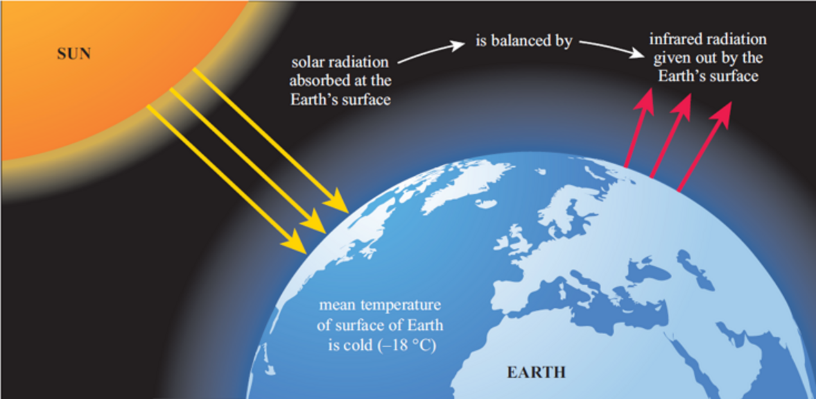
Figure 2 The energy balance at the Earth’s surface, without an atmosphere. Solar radiation input is balanced by infra-red radiation from the Earth with a mean surface temperature of −18 °C.
View description - Figure 2 The energy balance at the Earth’s surface, without an atmosphere. Solar ...

At what temperature would the Earth stabilise? If it had no atmosphere, its surface temperature can be calculated to be approximately −18 °C (minus 18 degrees Celsius). A similar calculation can be applied for our neighbouring planets: Venus, which is nearer to the Sun, should have a mean surface temperature of +50 °C, while for the more distant Mars the figure is −57 °C.
In fact the mean surface temperature of the Earth is usually quoted as plus 15 °C, and it has been getting warmer in recent years. The surface temperature is defined as the air temperature measured by standard instruments close to the surface, when averaged over the whole planet, over both sea and land. For this reason it is generally referred to as the global mean surface temperature (GMST).
The difference of +33 °C between the figure of −18 °C and +15 °C represents a significant warming. This warming is the difference the atmosphere makes, and is known as the greenhouse effect. This is an entirely natural effect, which has existed as long as the Earth has had an atmosphere, although the amount of warming will have changed with the composition of the atmosphere. Note that we are not describing human impact here.

1.2 The greenhouse effect
How does the Earth’s greenhouse effect work? The greater part of the Earth’s atmosphere is in the lower atmosphere, and when dry it is made up almost entirely of three gases: nitrogen, with 78% (78 parts out of 100) by volume; oxygen (21%); and an inert gas, argon, making up most of the remainder.
These three gases do not interact significantly with heat (i.e. infra-red) radiation from the Sun or the Earth. If these were the only gases in our atmosphere, then the Earth’s mean temperature would remain at −18 °C. The two main naturally occurring greenhouse gases are water vapour and carbon dioxide. They are normally present only in small amounts, but their impact is very significant.
Greenhouse gases in the atmosphere are largely ‘transparent’ to most regions of the spectrum of the incoming solar radiation, such as the visible and ultraviolet, but they intercept the outgoing infra-red radiation from the Earth by absorbing it and then emitting it again in all directions. As Figure 3 illustrates, most energy radiating from the Earth’s surface no longer escapes directly to space. Instead, it is absorbed and re-radiated several times within the atmosphere. Some of this re-radiated energy is sent back to the Earth’s surface, some to the lower layers of the atmosphere; both are warmed. Therefore, the Earth’s surface receives more radiated energy than just the direct solar, so its temperature rises until a new balance is struck when it again emits energy at a rate to match the increased input. The upper atmosphere still radiates energy back to space at an average temperature of −18 °C, from approximately 7 km high where the air is much colder, but now the Earth is much warmer at the surface.

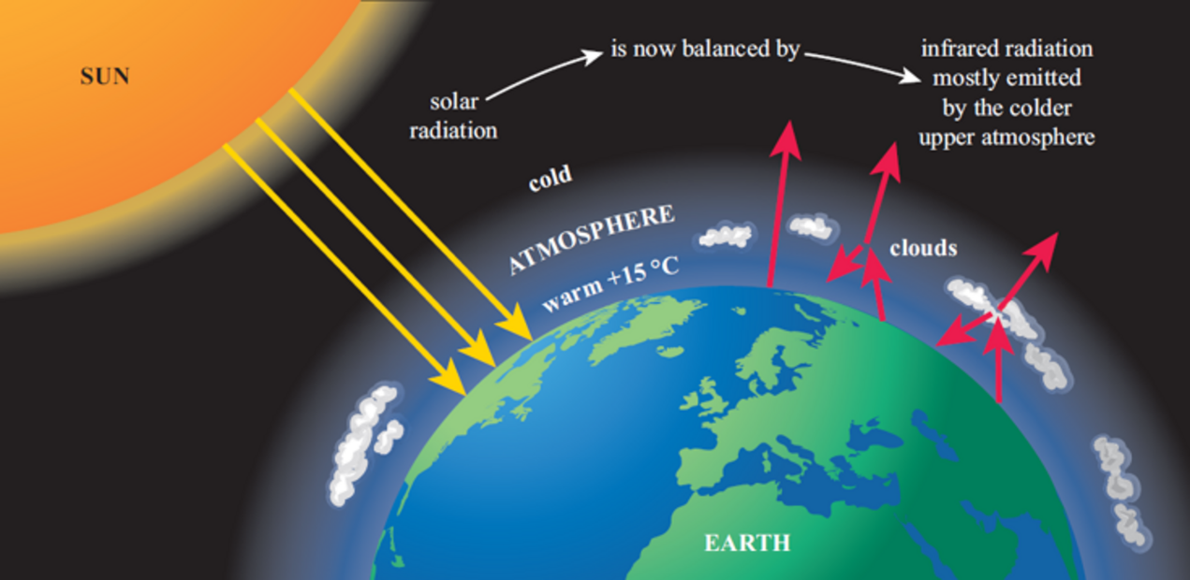
Figure 3 The ‘natural’ greenhouse effect of the Earth’s atmosphere. The energy balance is maintained, but the surface of the Earth is at approximately 15 °C and the lower levels of the atmosphere are warmed.
View description - Figure 3 The ‘natural’ greenhouse effect of the Earth’s atmosphere. The energy balance ...

The overall effect is for the atmosphere to act like the panes of glass in a greenhouse, keeping the Earth’s surface much warmer than it would otherwise be, hence the term ‘greenhouse effect’. Glass has similar selective properties of absorption or transmission as the Earth’s atmosphere – it is more transparent to visible and some ultraviolet radiation than infra-red.

Box 1 Greenhouse gases
A greenhouse gas (often referred to as ‘GHG’) is a gas that can absorb infra-red radiation, so contributing to the greenhouse effect. Not all gases can do this. The atmosphere absorbs infra-red radiation only because certain gases in the mixture that makes up air are greenhouse gases. A greenhouse gas molecule can absorb some infra-red radiation when the chemical bonds that hold molecules together act like springs, and like springs, they can vibrate. When the bond absorbs energy from the infra-red radiation, it vibrates more energetically. However, it turns out that infra-red radiation is absorbed only if a molecule contains more than two atoms, or – if it contains only two atoms – it must be a compound so the atoms at each end of the bond are of different elements.
The Earth’s atmosphere is largely made up of five gases: nitrogen (N₂), oxygen (O₂), argon (Ar), water vapour (H₂O) and carbon dioxide (CO₂). Which of these could act as a greenhouse gas? Argon exists as single atoms and so has no bonds and can’t absorb infra-red radiation. Oxygen and nitrogen molecules consist of two atoms of the same type, so these molecules can’t absorb infra-red radiation. Molecules of carbon dioxide and water both contain more than two atoms (and also two types of atom) – so these molecules can absorb infra-red radiation through changes in the way they vibrate. Both of these greenhouse gases are products of combustion of fossil fuels such as oil and gas.
There are smaller amounts of other greenhouse gases in the atmosphere. These include methane (CH₄), which can arise from many natural processes such as decomposition (rotting) of organic matter, a byproduct of some agriculture including wet rice cultivation, and ruminants (including cows and antelopes) digesting food (belches). It can also arise from natural gas leakage during fossil fuel extraction and distribution. Another example is nitrous oxide (N₂O), from vehicle emissions and the decomposition of agricultural fertilisers. Although they currently occur at much lower concentrations than carbon dioxide, these compounds can individually be more powerful absorbers of radiation than carbon dioxide (CO₂). For instance, methane may be rated 20 times more potent as a greenhouse gas than carbon dioxide. This is measured in terms of the relative Global Warming Potential (GWP), a somewhat complex quantity as it involves several aspects of the behaviour of the gas in the atmosphere.

1.3 The right temperature for life
The beginning of this section explored: ‘Why does life exist on Earth but not, apparently, on our neighbouring planets?’ Part of the answer is that the Earth’s distance from the Sun, in combination with the greenhouse effect of its atmosphere, maintains a range of temperatures on the planet that are suitable for oceans and life to survive. Mars, with its thin atmosphere and weak greenhouse effect, is too cold for life to flourish, while Venus, with its dense atmosphere and intense greenhouse effect, is too hot. The Earth is just right.
This is sometimes referred to as the Goldilocks thesis, named after the children’s story Goldilocks and the Three Bears, where Goldilocks finds the temperature for Baby Bear’s porridge to be ‘just right’. The good news (there sometimes is some) is that theoretical calculations suggest that we will not be able to pump enough carbon dioxide into the atmosphere to cause a runaway greenhouse effect like that on Venus. This is backed up by evidence from the Earth’s history: the oceans and life have survived much higher levels of greenhouse gases than now, although life has often suffered setbacks, including several episodes of mass extinction when a large proportion of all species have become extinct in a comparatively short geological time.

2 The carbon connection
The development of life on a dynamic Earth was associated with major changes in the composition of oceans and atmospheres, and carbon-based life played a key role in this. The section above discussed how greenhouse gases in the atmosphere have a major effect on the mean temperature of the Earth, through the greenhouse effect. Once again, carbon in the form of carbon dioxide plays a major role. This section will explore more fully the role that the element carbon plays in the life of the planet by following two trails: first, the trail that carbon atoms follow as they cycle through different parts of the Earth, and then the carbon trail produced by human activity.

2.1 The first carbon trail, the carbon cycle
Carbon dioxide, CO₂, is produced and released into the atmosphere when we burn fuels, such as wood harvested from a forest, or coal and other fossil fuels extracted from the ground. Note that the fossil fuels, i.e. coal, oil and natural gas, are derived from fossilised organic matter (once living organisms).
CO₂ is also produced by almost all living things, both animals and plants, at all times of the day and night, in the process called respiration. In our own bodies we tend to equate respiration with the physical process of breathing, the movement of air in and out of our lungs. Within the lungs, oxygen from the air is taken in, and some carbon dioxide is released from the body when we breathe out. When the oxygen reaches the cells of our bodies (and also the cells of other animals and plants), chemical reactions break down some of the complex carbon compounds such as carbohydrates that are stored there. This releases energy for our muscles to use. Oxygen is used in the process, and water and carbon dioxide are produced.
What happens to the carbon dioxide? Plants and certain types of bacteria remove carbon dioxide from the oceans and atmosphere in a process called photosynthesis. This is the process whereby green plants, and a few other organisms, trap energy from sunlight and use carbon dioxide and water to make carbohydrates and oxygen. The carbohydrates are used to store energy for use in the growth and maintenance of the plant, and the oxygen is released to the atmosphere where it can be used again by plants and animals for respiration. The two processes of respiration and photosynthesis underpin the cycling of carbon, on which most life on Earth depends.
Figure 4 shows the fundamentals of the carbon cycle, but in this diagrammatic form it reveals little about the component parts of the cycle and the links between them.

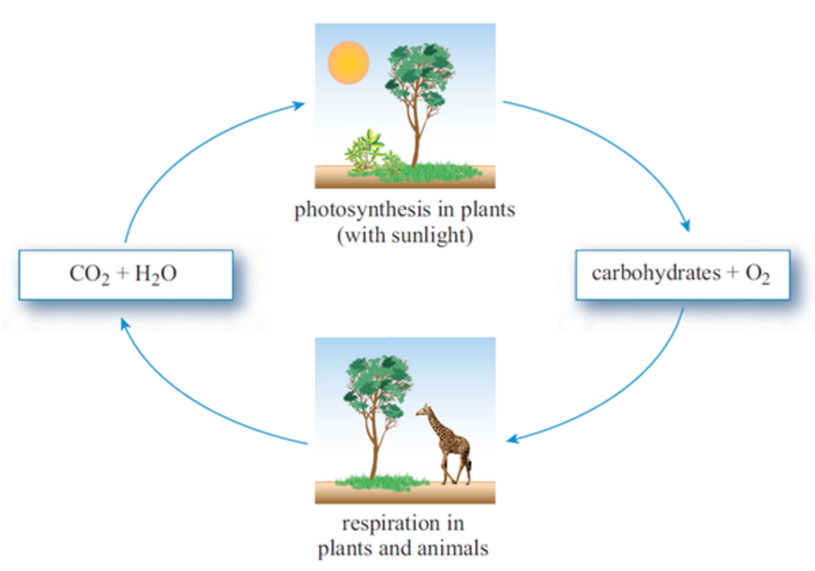
Figure 4 The basic carbon cycle
View description - Figure 4 The basic carbon cycle

Figure 5 gives a little more detail. Animals are represented by a giraffe, and plants are shown by a tree and some grass. The basic carbon cycle in Figure 4 can be traced in Figure 5 by arrows showing the movement of carbon dioxide. The respiration arrows from the tree and the giraffe to the air indicate production of CO₂, and the photosynthesis arrow shows CO₂ absorbed from the air by the tree. Both plants and animals contain carbon in their tissues in the form of carbohydrates and other carbon-based compounds known collectively as organic compounds. In Figure 5, the arrow from the tree to the giraffe makes the point that animals eat plants and there is a transfer of carbon in the process.

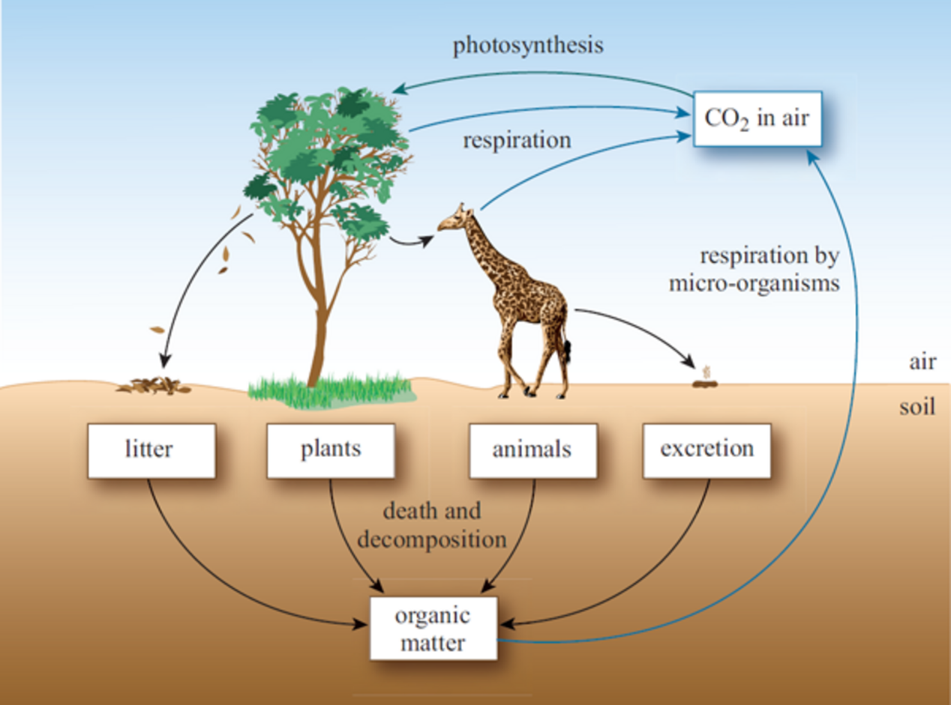
Figure 5 The carbon cycle at the local level
View description - Figure 5 The carbon cycle at the local level

So far, only the biological processes above the ground have been considered. Figure 5 also includes the vital parts of the cycle below the ground surface. While alive, both plants and animals produce waste products, for example in the form of leaf litter from trees and excreta from animals. These wastes and the remains of the dead plants and animals are broken down by micro-organisms living on and in the soil into simpler organic materials. In the process, these micro-organisms also respire and add carbon dioxide to the air. Any remaining organic matter will simply be incorporated into the soil. Figure 6 represents the global carbon cycle and has been broadened to include interactions involving the oceans, aspects of the Earth’s geology, and human activity. The discussion below this figure considers each of these components in turn.

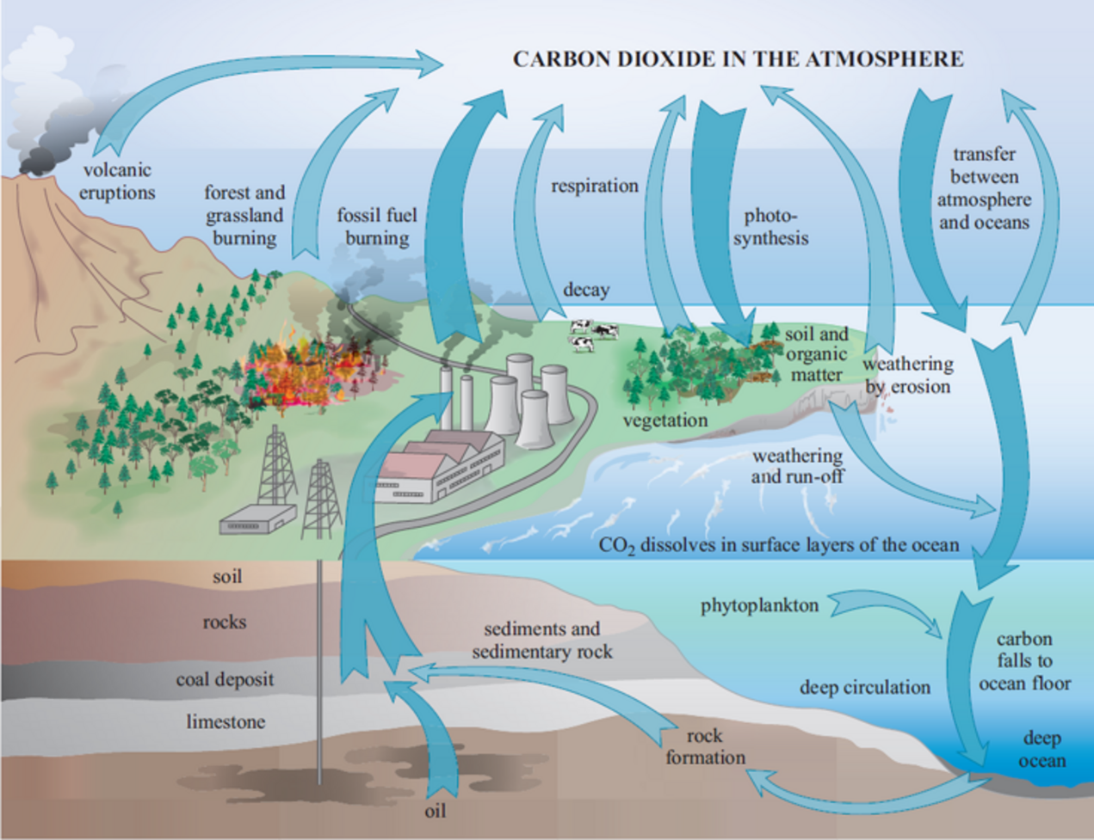
Figure 6 The global carbon cycle – the arrows show how the flows of carbon move around in the carbon cycle. The main upward flow is from fossil fuel burning; the two main downward flows are from photosynthesis and the flow down to the ocean.
View description - Figure 6 The global carbon cycle – the arrows show how the flows of carbon move around ...

In the oceans, phytoplankton (microscopic floating plants) play the same role as land plants in Figure 5. Carbon dioxide from the air dissolves readily in the surface waters and is used by phytoplankton in photosynthesis. However, as with green plants on the land, phytoplankton respire, so most of the carbon dioxide is returned to the atmosphere again from the surface of the oceans. Arrows show the two-way flows of carbon dioxide between the atmosphere and the oceans. Most of this activity takes place in the top few hundred metres of the oceans, the upper layer through which sunlight can penetrate and that is stirred by waves. Phytoplankton are eaten by zooplankton (microscopic floating animals), and both are eaten in turn by other marine animals. Many aspects of the carbon cycle shown for plants and animals on land are replicated in the ocean, although the details are not shown here. In addition, however, there is a slow trickle of carbon to the bottom of the oceans in the form of the dead remains of plankton and other marine organisms. Some of it remains in the ocean sediments, which eventually form new rock. Thus it is effectively removed from the main carbon cycle and enters what could be called the geological carbon cycle.
In Figure 6, two arrows point to geological mechanisms that remove carbon dioxide from the atmosphere. They indicate the slow processes of rock formation beneath the continents and the oceans, by which organic carbon is incorporated into rock strata, some in the form of coal, oil or gas, or mineral carbon from marine shells that forms rocks such as limestone and chalk (which are composed mainly of calcium carbonate). Other arrows show the return of this buried carbon as carbon dioxide to the atmosphere, through volcanic eruptions and weathering of rocks by erosion.
Two components of the global carbon cycle have now been identified: the biological carbon cycle, involving life on land and in the sea, that continually exchanges carbon with the atmosphere, and a geological component, that incorporates carbon in rocks before it is released to the atmosphere.
Where is most of the carbon on the planet? It lies buried in rock formations as limestone or chalk, or as organic deposits. Only 1 part in 1000 is found in all the other carbon stores, and 90% of that is dissolved in the deep oceans of the world where it does not mix readily with the upper layers. But geological mechanisms function very slowly and it normally takes millions or even hundreds of millions of years for carbon buried as rock to emerge into the air again. Even the carbon in the deep ocean is very slow to mix with the upper ocean, and it may be a thousand years before it reaches the surface again. For this reason, although these stores are massive, the amount of carbon they exchange with the air each year is tiny compared with the non-geological component.
Most of the movement of carbon takes place between four main stores: the atmosphere, living animals and plants, soils, and the upper ocean. Carbon from these four stores is cycled around continually by the natural processes explained above. If the natural processes were left largely undisturbed, the concentration of carbon in each of the stores would remain relatively constant.
However, human activities have been producing large quantities of carbon dioxide. Figure 6 shows two of them: the burning of fossil fuels and the use of fire to clear forests and grasslands.

2.2 The second carbon trail, human influences
Industrial economies, first in Europe and North America and now globally, have made increasing demands on the Earth to meet their material needs. We meet increasing demands upon agriculture to feed a growing and more affluent population by bringing more land under cultivation and using it more intensively. We are also heavily reliant on the use of the energy stored in fossil fuels to provide the electricity, heating, lighting and transport that modern societies take for granted. As a by-product of meeting these needs, we have inadvertently changed, and are now knowingly changing, our atmosphere.
The global carbon cycle can help explain what happens when these activities release additional carbon dioxide into the atmosphere. The two main sources have been shown in Figure 6. The first is the burning of fossil fuels, such as coal, oil and gas. These are compounds composed largely of carbon and hydrogen. When they are burned to release energy, carbon combines with oxygen to produce carbon dioxide (CO₂), and hydrogen combines with oxygen to produce water (H₂O), usually in the form of steam. This process parallels the respiration by plants and animals illustrated in Figure 5. (Cement-making, which uses limestone or chalk, also produces carbon dioxide and makes a lesser but still significant contribution.)
Figure 7 shows global CO₂ emissions from fossil fuel burning from 1850. Between 1950 and 2010 these emissions increased at a rate of about 500 million tonnes per year. However, the rate of increase has slowed since 2010 and the world may now be at, or close to, its peak rate of CO₂ emissions from fossil fuels.

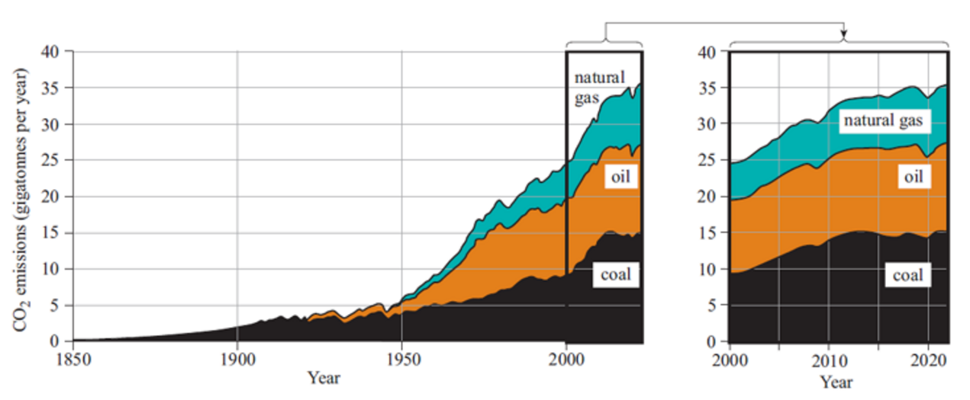
Figure 7 Global carbon dioxide (CO₂) emissions from fossil fuel combustion between 1850 and 2022, with an expanded section from 2000 to 2022 showing that the rate of increase has slowed since 2010
View description - Figure 7 Global carbon dioxide (CO2) emissions from fossil fuel combustion between ...

The second carbon dioxide source is land use change for agriculture and the spread of urban areas, which includes the burning of forests and grasslands and also the release of carbon from newly disturbed soil. Recent estimates (Global Carbon Project, 2023) suggest that fossil fuel burning is adding approximately 37 gigatonnes (37 000 million tonnes) of carbon dioxide to the atmosphere every year, with land use change contributing approximately 4 gigatonnes. The same estimates also suggest that around 40% to 50% of these carbon releases remain in the atmosphere for centuries or many thousands of years. The remainder is absorbed over a period of decades (or less) by the two carbon stores described earlier, namely by plants (mainly the forests of the northern hemisphere) and the oceans.

Box 2 Describing large and small numbers (and units)
37 gigatonnes can be written as 37 billion tonnes or 37 thousand million tonnes.
The prefix ‘giga’ and its symbol G (note that some symbols are capitalised and some are not) is an example of an internationally agreed set of terms to describe numbers and units. These form the Système international d’unités (international system of units) known as SI. The SI unit of length, for example, is the metre (m), and the SI unit for time is the second (s).
Example: What is 1000 metres in SI form? The prefix for one ‘thousand’ is ‘kilo’, so the answer is one kilometre (1 km in shortened form). One thousand metres, one kilometre and 1 km are alternative ways of describing the same thing.
There are several other different ways of writing large and small numbers, including fractions, decimals and powers of ten, which are shown here for reference (see Table 1).

Table 1 Examples of different ways of writing large and small numbers
Prefix | Prefix name | Meaning | Number or fraction | Decimal | Power of ten
G | giga | billion or thousand million | 1 000 000 000 | 1 000 000 000 | 10⁹
M | mega | million | 1 000 000 | 1 000 000 | 10⁶
k | kilo | thousand | 1000 | 1000 | 10³
 |  | one | 1 | 1 | 10⁰
m | milli | thousandth | 1/1000 | 0.001 | 10⁻³
µ | micro | millionth | 1/1000 000 | 0.000 001 | 10⁻⁶
n | nano | billionth | 1/1000 000 000 | 0.000 000 001 | 10⁻⁹

2.3 Measuring the atmospheric carbon dioxide concentration
In late 1957 the scientist Charles Keeling began a continuous series of measurements of the atmospheric carbon dioxide concentration at the Mauna Loa Observatory in Hawaii. This is situated high up at the top of a mountain. The results (the Keeling curve) are shown in Figure 8.

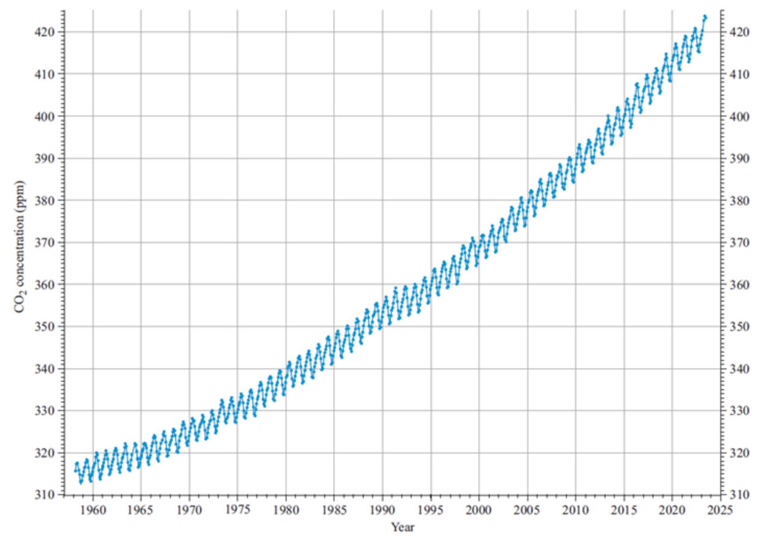
Figure 8 Annual fluctuations shown by the Keeling Curve (Scripps Institution of Oceanography, 2023)
View description - Figure 8 Annual fluctuations shown by the Keeling Curve (Scripps Institution of Oceanography, ...

It shows a continuously rising trend from about 315 parts per million (ppm) of CO₂ in the atmosphere in 1958 and reaching over 420 ppm in 2023. Measurements were taken simultaneously from other parts of the planet, including from Antarctica. These only differed very slightly, so the Mauna Loa figures can be taken to be representative of the global atmosphere.
Note that there is an annual variation, showing that peak levels are reached in spring in the northern hemisphere, before plants on the northern landmasses and continental shelves start growing strongly again and absorbing carbon dioxide.
This curve is important because it shows, very clearly, the steady increase of carbon dioxide in the atmosphere, one of the first major signs of global environmental change. This extra CO₂ is what most environmental scientists consider to be a major cause of climate change and the additional warming of the whole planet.

3 Causes for concern
The increased greenhouse effect due to human activity is called the anthropogenic greenhouse effect (sometimes called the enhanced greenhouse effect) to distinguish it from the natural effect discussed earlier. The effect on the Earth is very much as though the output of the energy from the Sun has increased. This increases the mean surface temperature of the Earth, often referred to as global warming, which then causes other changes to our climate. These include an increase in the number of extreme weather events.

3.1 Global temperature rise
Figure 8 illustrates the unprecedented extent and speed of recent changes to our atmosphere. Climate models have long predicted that this will lead to the Earth warming further and faster than has occurred for millions of years. The Earth’s climate system is now responding in line with these predictions. Since the 1970s, each decade has been approximately 0.2 °C warmer than the last one, meaning that we no longer have stable climate ‘normals’.
More recently, the World Meteorological Organization (WMO) has called 2011–2020 ‘a decade of acceleration’ (WMO, 2023a). It was the warmest on record for both land and ocean, with a rise in the global mean surface temperature (GMST) of the Earth of 1.1 °C above the 1850–1900 baseline (WMO, 2023b).

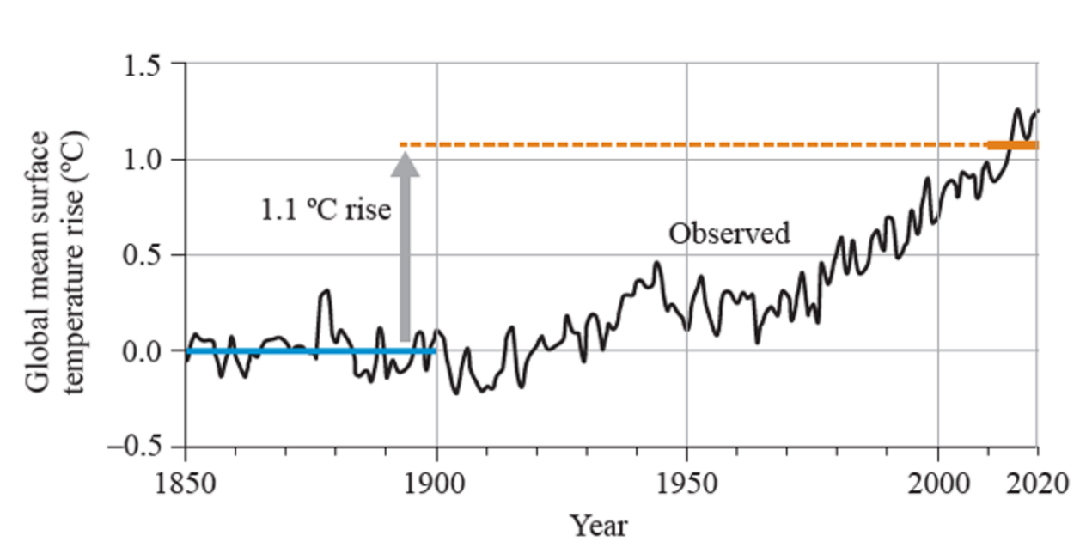
Figure 9 Global mean surface temperature 1850-2020. The average temperature for 2011-2020 was 1.1 °C above the 1850–1900 baseline (IPCC, 2023)
View description - Figure 9 Global mean surface temperature 1850-2020. The average temperature for 2011-2020 ...

3.2 Extreme weather events
The atmosphere reacts very rapidly to temperature rises over the land and sea. The extra heat turbo-charges the atmosphere, and excess heat and moisture is distributed around the globe. Unusual and extreme weather events are an early warning of such changes and are hard to ignore because of their damaging impacts. They damage ecosystems as well as our health and wellbeing, economies and infrastructure. In recent years, every region of the world has experienced impacts from record weather extremes: record temperatures and dangerous heatwaves, including marine heatwaves; sudden droughts; more intense storms and rainfall and damaging floods; and widespread wildfires in areas previously unaccustomed to them. For example, in 2023, high temperatures, low humidity and continuous winds caused extreme ‘megafires’ in Canada on an unprecedented scale, burning 18 million hectares of land – 10 million more than previous records (NASA, 2023; WWA, 2023)
Although the impacts of climate change are experienced across the world, some regions have experienced larger changes than others. Modelling shows that global warming will occur unevenly: the continents will heat up about twice as fast as the oceans, and polar regions will heat much faster than those near the equator. A global warming of 2 °C, for example, would mean that on average land surfaces would warm by 3 °C and the oceans by 1.5 °C, but more northern latitudes could warm by considerably more (WMO, 2023b). This is exactly what has been happening in recent decades. Figure 10 gives a snapshot of global warming for 2015–2019 (note that it uses a baseline of 1951–1980). Note in particular the extreme warming of the large land masses around the Arctic. By 2022, Europe had warmed by 2.3 °C above the 1850–1900 baseline – twice the global average rate – while parts of the Arctic warmed by three times the global average (WMO, 2023b).

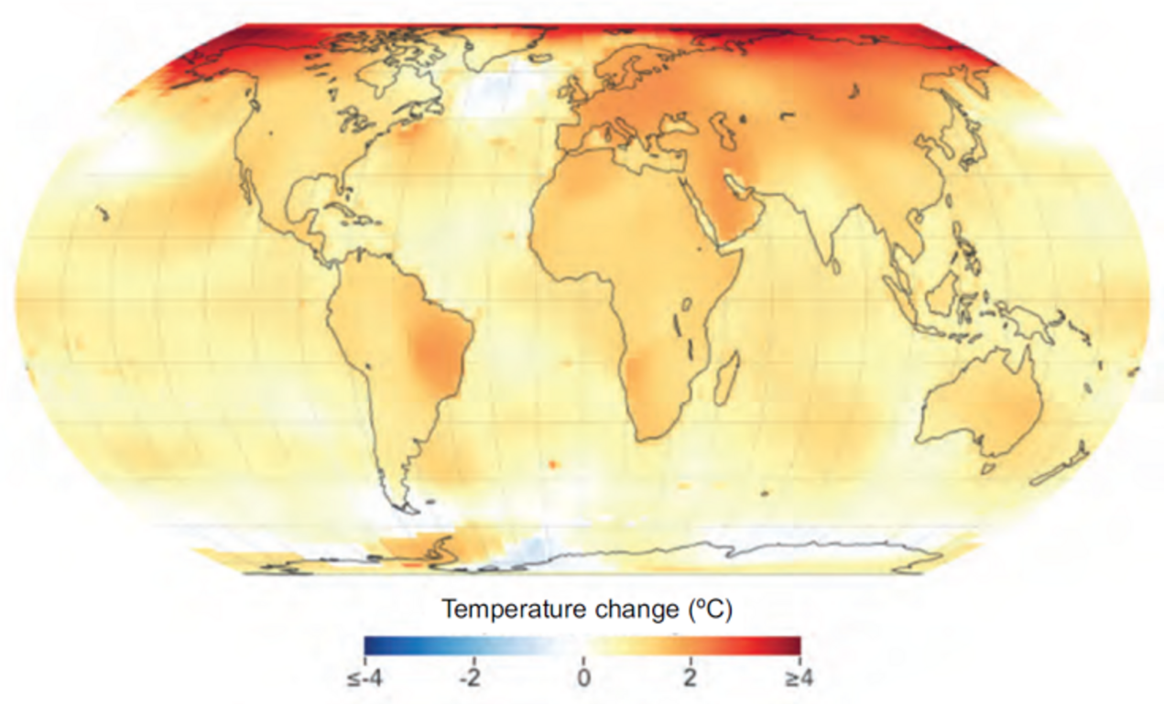
Figure 10 Global warming for 2015–2019 when compared with 1951–1980 (NASA, no date)
View description - Figure 10 Global warming for 2015–2019 when compared with 1951–1980 (NASA, no da ...

Thus while temperatures are hottest near the equator, where higher temperatures and humidity can approach the limits of habitability of many species (including us), in more temperate climates the changes can be larger and ecosystems and societies may be less adapted to extreme heatwaves, for example. Heatwaves are becoming more frequent and more intense globally, and they now occur in temperate and boreal regions, such as Siberia, Alaska and Northern Canada, where they used to be unusual. This is also true for wildfires – particularly for forest fires in boreal regions, which have increased dramatically in intensity with rising temperatures.

4 Climate talks
The threat of global climate change has spurred urgent international action. Starting in 1995 the United Nations has convened a series of annual Climate Change conferences, each normally now called a ‘Conference of the Parties’ (COP). The 1997 meeting in Kyoto in Japan agreed the Kyoto Protocol. Under this many industrialized countries agreed to legally binding reductions in greenhouse gas emissions of an average of 6% to 8% below 1990 levels to be reached between the years 2008–2012. Many countries have managed to exceed these targets. Indeed, by 2023, the UK’s greenhouse gas emissions had more than halved from their 1990 level (DESNZ, 2024).
In 2008 the UK Parliament passed a Climate Change Act which required that the country’s greenhouse gas emissions should continue to fall, by 80% of their 1990 levels by 2050. This Act was amended in 2019 to make the emissions level ‘net zero’ by 2050 (the meaning of this term will be described later in this course).
The 21st COP meeting (COP 21) was held in Paris in 2015. This set an important policy milestone. A total of 195 countries committed to curbing their greenhouse gas emissions ‘consistent with holding the increase in the global average temperature to well below 2 °C above pre-industrial levels and pursuing efforts to limit the temperature increase to 1.5 °C above pre-industrial levels’ (UNFCCC, 2016). A 1.5 °C target would mean limiting the rise in atmospheric concentration of CO₂ to below 440 ppm. In order to achieve this, global CO₂ emissions from human activities would need to peak immediately and fall to net zero by 2050.
A key part of the policy process lies in nationally determined contributions (NDCs), a set of short-term policy promises or pledges on emissions cuts from individual countries, initially only extending to 2025 or 2030, but which can then reviewed and increased over time. In addition, many countries (including the UK) have committed to a longer term target of reaching net zero emissions by 2050.
The COP series of meetings have continued each year (except in 2020 due to the COVID-19 pandemic). It has become clear since 2015 that the climate situation is more urgent than previously realised. As shown in Figure 10 the average global surface temperature has been rising steadily since the 1970s and could reach 1.5 °C before 2030. The COP 28 meeting held in Dubai in November 2023 (Figure 11) affirmed the need for policies to keep the global temperature rise to only 1.5 °C rather than just ‘well below 2 °C’ as agreed at the 2015 COP 21 meeting.

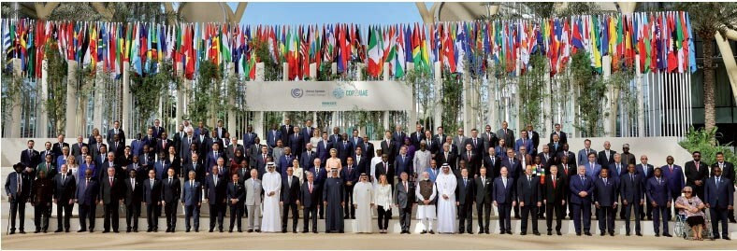
Figure 11 A line-up of world leaders at the UN COP 28 meeting in Dubai in the United Arab Emirates in 2023.
View description - Figure 11 A line-up of world leaders at the UN COP 28 meeting in Dubai in the United ...

The COP 28 meeting agreed that there should be a ‘transition away from fossil fuels in energy systems’ and that there should be a tripling of renewable energy capacity by 2030.’ The needs and implications of this energy transition are the subject of the rest of this course.
A key role in analysing climate change and providing scientific information to inform policy decisions is carried out by the IPCC.

4.1 The Intergovernmental Panel on Climate Change
The Intergovernmental Panel on Climate Change (IPCC) is the international body for assessing the science related to climate change. It was established in 1988 by the United Nations Environment Programme (UNEP) and the World Meteorological Organization (WMO). It provides regular assessments of the scientific basis for climate change, its impacts and risks, and options for adaptation and mitigation. These assessments provide the essential evidence for decision makers at all levels to develop climate-related policies and underlie any international negotiations. The First Assessment Report supported the establishment in 1992 of the United Nations Framework Convention on Climate Change (UNFCCC).
The IPCC draws on experts from nearly 200 member states, who volunteer their time to provide an authoritative and comprehensive assessment of climate change science. Its regular assessments are written by hundreds of leading scientists and supported by thousands of reviewers in an open and transparent process that ensures that the reports reflect the full range of views in the global scientific community.
As well as assessment reports, the IPCC publishes special reports on specific climate-related issues. Over the years, these reports have reflected the growing understanding of anthropogenic climate change and provided a more detailed picture of its current and future risks and of ways to deal with them.
The IPCC’s Fifth Assessment Report (AR5) was published in 2015 and provided support for the Paris Agreement in its goal to avoid dangerous climate change by keeping global warming to well below 2 °C and if possible limiting it to 1.5 °C.
The Sixth Assessment Report (AR6) was published in 2023, in time for COP 28 and the ‘first global stocktake’, when countries reviewed their progress towards the Paris Agreement targets. It adds urgency to these tasks by pointing out that unprecedented changes to our climate system are already causing extreme weather across the world.

5 From COP promises to action on the ground
The previous section showed how COP agreements have marked important progress in international climate change commitments. It is essential that these commitments are adhered to, regardless of changes in government. It is also essential that Nationally Determined Contributions (NDCs) to reduce greenhouse gas emissions are progressive (i.e. ratcheted up) for the commitments to be met. But just how much do emissions need to fall to limit warming to below 2 °C or 1.5 °C, and how do pledges translate into actions on the ground?

5.1 Global warming ‘well below 2 ˚C’
Section 2 showed how the concentration of carbon dioxide in the atmosphere has been rising over time (the Keeling Curve). In 2023 it passed 420 ppm, which is 50% higher than pre-industrial levels. It also explained how rising greenhouse gas emissions from human activity have led to the enhanced greenhouse effect and a warming of the Earth. The long-term trend shows that the global mean surface temperature was 1.1 °C warmer in 2011–20 compared to the last half of the 19th century, and is rising (IPCC, 2023).
Although carbon dioxide (CO₂) is not the only greenhouse gas – methane (CH₄) and nitrous oxide (N₂O) are also important – it is estimated to account for around two-thirds of global warming since pre-industrial levels. Whilst governments and fossil fuel producers have started to make commitments to reduce methane emissions, the main focus of climate change policies and action to date has been to reduce CO₂ emissions. These initiatives are yet to see global CO₂ emissions fall significantly, but there is some progress.
As shown earlier in Figure 7, between 1950 and 2010, global emissions from fossil fuel burning increased at a rate of about 500 million tonnes per year. However, the rate of increase has slowed since 2010 and the world may now be at, or close to, its peak of CO₂ emissions from the combustion of fossil fuels.

5.2 Cuts in emissions
But exactly how dramatically do carbon dioxide emissions need to fall to meet the Paris Agreement targets and limit the increase in global mean surface temperature to well below 2 °C, with the aim of 1.5 °C? The IPCC have stated that ‘without immediate and deep emissions reductions across all sectors, limiting global warming to 1.5 °C is beyond reach’ (IPCC, 2022), and they have produced a set of projections to show just how immediate and deep these reductions need to be (see Figure 12).

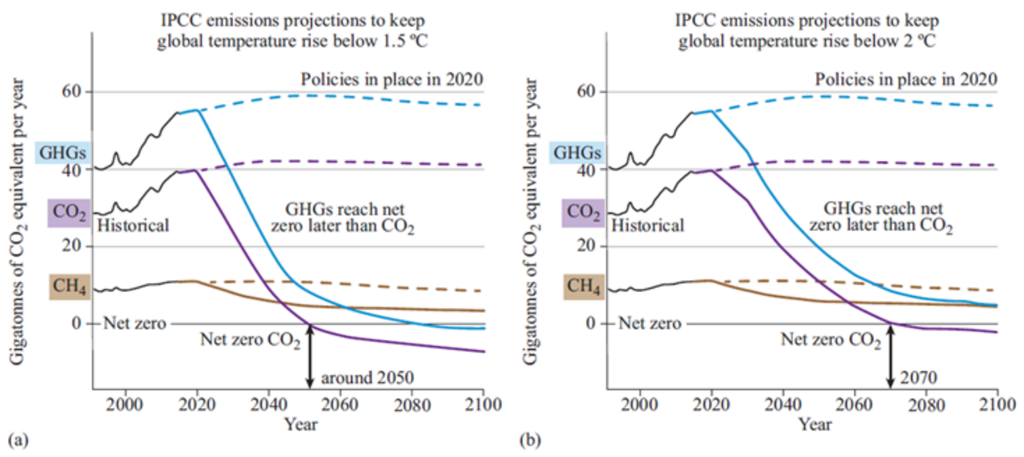
Figure 12 IPCC projections for future carbon dioxide and methane reductions, as well as the total greenhouse gas emission reductions necessary to limit global temperature rise to (a) 1.5 °C and (b) below 2 °C, by 2100 (adapted from IPCC, 2023). The dashed lines show emissions projections based on policies as of 2020 (i.e. in a ‘business as usual’ scenario).
View description - Figure 12 IPCC projections for future carbon dioxide and methane reductions, as well ...

Carbon dioxide emissions need to fall rapidly to limit warming to 1.5 °C by 2100 (Figure 12(a)), and even to keep below 2 °C warming (Figure 12(b)). For 1.5 °C, this means reaching net zero by around 2050 and then falling further below net zero (meaning that more carbon dioxide would need to be absorbed or captured from the atmosphere than is emitted). Even the lesser target of keeping below 2 °C means reaching net zero just 20 years later, in 2070.
Figure 12 also shows the methane reductions needed to contribute to the overall reduction in greenhouse gases. This reduction is less drastic than for carbon dioxide but is likely to be more challenging to achieve. About 40% of methane emissions are associated with food production; reducing these will be difficult because it will require lifestyle changes, with a move away from meat (particularly lamb and beef) and dairy products to a more plant-based diet. Fortunately, some methane emissions are easier to tackle because they are directly associated with fossil fuel use – as this falls, so will methane emissions.

Box 2 Net zero emissions
As discussed earlier, net zero emissions are core to international climate change agreements and many national policies. But what does net zero mean in practice?
It is fairly straightforward to define in one sentence: the point at which greenhouse gas emissions from human activity are balanced by greenhouse gases removed from the atmosphere by human intervention.
This balance cannot be achieved without a large reduction in greenhouse gas emissions from human activity, and this will need to be a focus to achieve net zero.
Solutions to reduce emissions fall into several categories:
- increased efficiency – using technologies that use energy and resources more efficiently, so that waste is reduced
- reducing and stopping deforestation
- a ‘transition away from fossil fuels’ – rapidly increasing the use of renewable energy sources such as wind and solar power, together with modest increases in hydro power and nuclear electricity generation
- behavioural changes – millions of individuals making small but significant changes, such as moving to a more plant-based diet, using public rather than private transport, avoiding flying and buying more refurbished or second-hand goods rather than new ones
- carbon capture, utilisation and storage (CCUS) – capturing carbon dioxide from power stations and industrial processes before it enters the atmosphere, and either using it or burying it deep underground.
Although the definition of net zero refers to all greenhouse gases, in practice the removal of these from the atmosphere centres around carbon dioxide. Methods for increasing this side of the net zero balance include:
- planting new woodlands and forests
- restoring natural landscapes, such as wetlands
- enhancing other natural processes (known as carbon geoengineering)
Some overall removal of carbon dioxide from the atmosphere will be necessary to offset those greenhouse gas emissions that are harder to deal with. These include methane emissions from agriculture and carbon dioxide associated with the production of cement. The need to combat these emissions helps to explain why, in Figure 12, projected overall CO₂ emissions fall below net zero to become negative.

As described in Section 2, once carbon dioxide has been emitted into the atmosphere, some of it will stay there for a century or more. So what will happen to the concentration of carbon dioxide in the atmosphere if the world can move towards net zero carbon emissions?
Figure 13(a) shows three possible scenarios for future global CO₂ emissions reductions. The historical emissions (the black line on the graph) are from fossil fuel combustion and exclude those from land use change and deforestation (as these data are less certain than those for emissions from energy consumption). This accounts for the approximate 5 Gt difference in 2020 in Figure 13(a) compared to Figure 12. Figure 13(b) shows the consequences for the concentration of CO₂ in the atmosphere of the three emission pathways (i.e. future projections of the Keeling Curve).

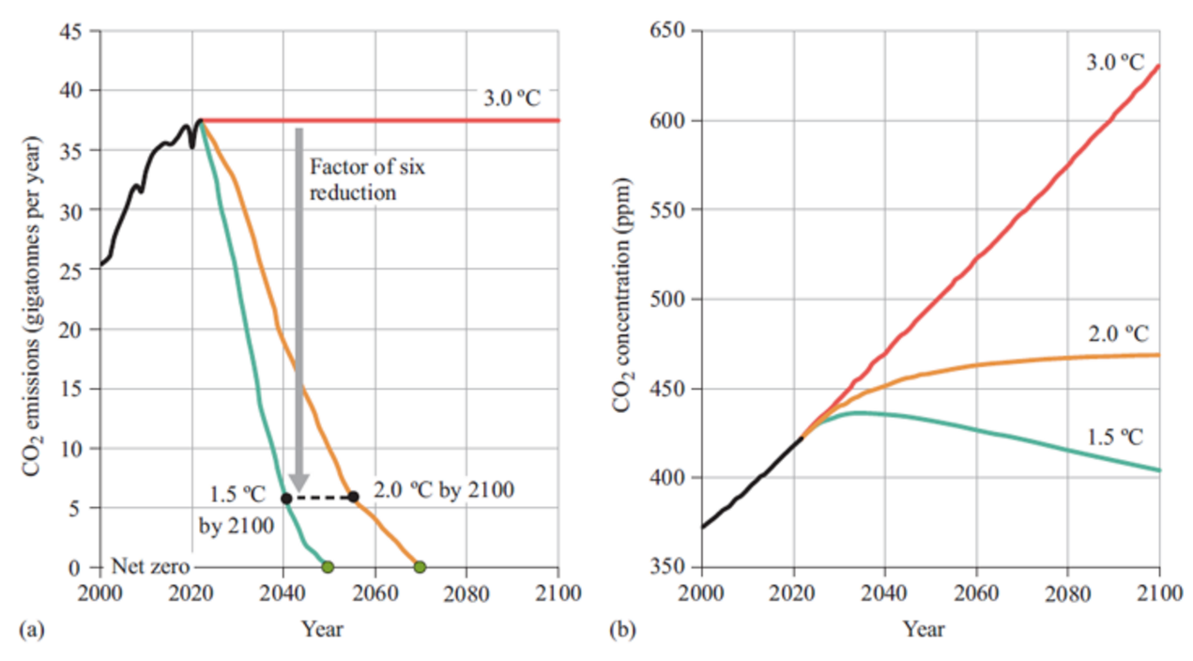
Figure 13 (a) Three possible future scenarios of global CO₂ emission reductions (based on the energy sector); (b) their projected effect on the future concentration of CO₂ in the atmosphere and the resulting rise in global mean surface temperature by 2100 (historical CO₂ emissions and CO2 concentration data: Climate Interactive, 2023; 1.5 °C and 2 °C emissions pathways: IPCC, 2023; CO₂ concentration projections: author’s estimates using the C-ROADS climate change policy simulator)
View description - Figure 13 (a) Three possible future scenarios of global CO2 emission reductions (based ...

The three scenarios shown in Figure 13 are described below.
- Constant CO₂ emissions of 37 Gt per year
If global emissions could be held at their 2022 level for the remainder of the century (the red line in Figure 13(a)) then the Keeling Curve – atmospheric CO₂ concentrations – would continue to rise at its 2022 rate (the red line in Figure 13(b)). By 2100, the atmospheric CO₂ concentration would have increased by 50% from its 2022 value, reaching 630 ppm. The global mean surface temperature would then be around 3 °C above its pre-industrial level, and still rising.
- Limiting global mean surface temperature rise to 2 °C
The orange line in Figure 13(a) shows a possible emissions trajectory to achieve this. In this scenario, CO₂ emissions would need to fall rapidly, down to one-sixth of their 2022 value by 2055 and reaching net zero by 2070. The Keeling Curve, shown by the orange line in Figure 13(b), would flatten out, reaching about 470 ppm by 2100. The global mean surface temperature rise would stabilise at approximately 2 °C above pre-industrial levels.
- Limiting global mean surface temperature rise to 1.5 °C
This will require immediate drastic cuts in emissions, as shown by the green line in Figure 13(a). Global CO₂ emissions will need to be reduced by a factor of six by 2040 and down to net zero around 2050. The Keeling Curve, shown by the green line in Figure 13(b), would peak at around 435 ppm in about 2035 and then fall slowly to about 405 ppm by 2100. The global mean surface temperature rise would stabilise at approximately 1.5 °C above pre-industrial levels. The effects of this are likely to be long-lasting and the consequent environmental benefits are likely to be experienced well into the 22nd century.
How likely are these different scenarios? As discussed in the previous section, many countries have committed to net zero carbon emission policies. If these ambitions are realised, and more countries follow suit, then a future that limits warming to 2 °C or lower could be on track. These drastic cuts in emissions, including ‘negative emissions’, will need to happen across all sectors, but one of the most important (since it is intrinsic to our daily lives) and largest (in terms of CO₂ emissions) is the energy sector. Although this – and in particular the technology solutions – will be the focus of the next section, actions to reduce emissions are still vital across all sectors, including agriculture.

5.3 The International Energy Agency Net Zero scenario
The global energy sector is already undergoing a transformation and starting to move away from fossil-fuel-based electricity generation. This has been achieved by a considerable expansion of renewable energy, especially solar and wind power, which in turn is largely due to a rapid fall in the costs of renewable electricity generation. The mass production of solar photovoltaic (PV) panels in China has now made the electricity from large-scale solar PV projects cheaper than fossil-fuelled electricity in many countries. Similarly, wind power development in Europe has made wind-generated electricity (both onshore and offshore) cheaper than that from fossil fuels (IPCC, 2023; IEA, 2021).
The International Energy Agency (IEA) is an intergovernmental organisation that regularly produces detailed energy statistics and economic analyses of world energy use. In their 2023 World Energy Outlook (IEA, 2023), they estimated that in 2022 over three quarters of the world’s primary energy supply came from the fossil fuels coal, oil and natural gas (see the pie chart in Figure 14). Renewable energy made up about 16% of the total.

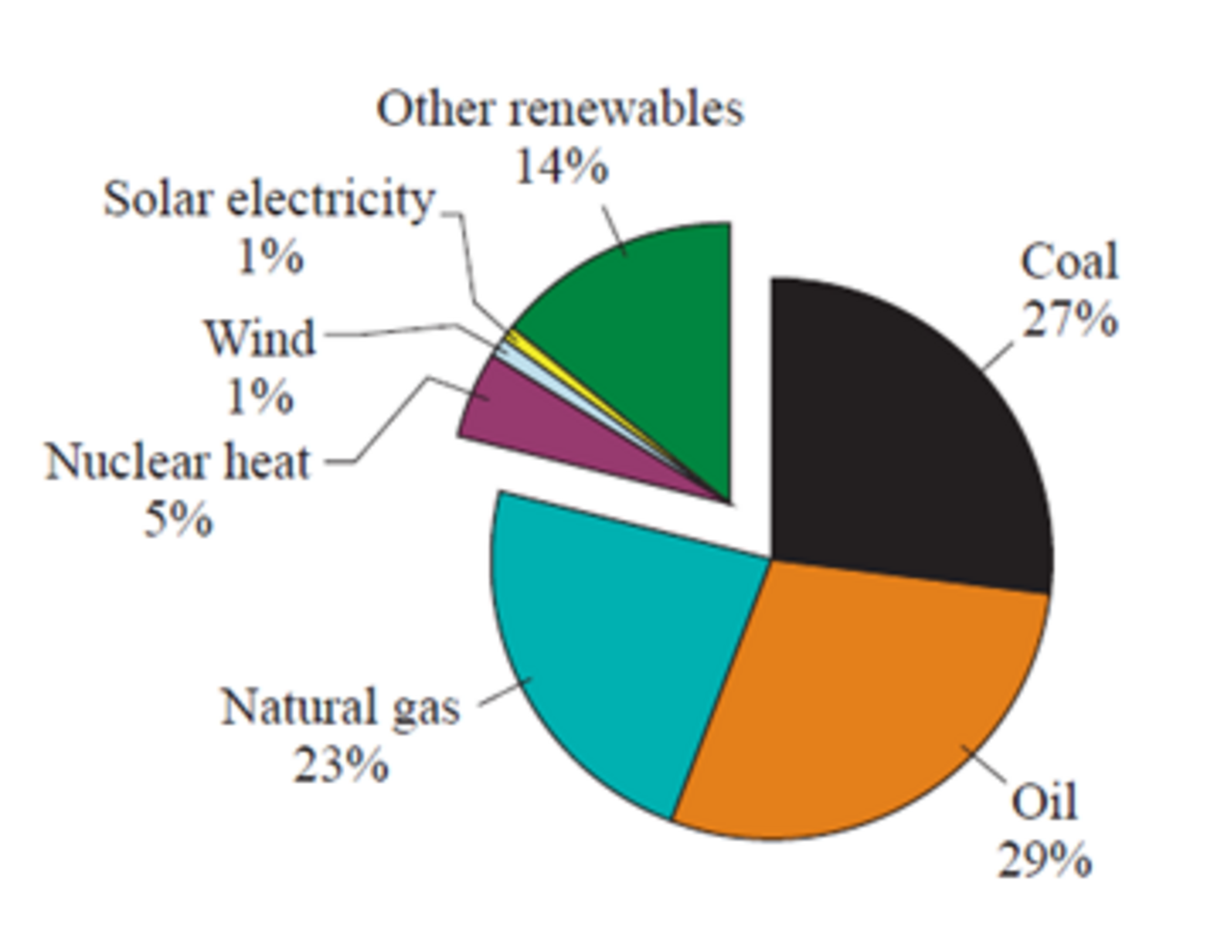
Figure 14 World energy supply in 2022 – just over three quarters fossil fuels
View description - Figure 14 World energy supply in 2022 – just over three quarters fossil fuels

Their report also contained a scenario for possible future world energy use aimed at limiting global temperature rise to 1.5 °C by 2100 (it assumed continuing world economic growth and a slowly increasing world population). This scenario was called ‘Net Zero Emissions by 2050’. In addition, the scenario aimed to meet two United Nations Sustainable Development Goals (SDGs) by 2030 (IEA, 2023, p. 88):
- providing access to electricity for the 775 million people in the world who lacked this in 2023
- providing access to clean cooking for the 2.2 billion people who lacked this in 2023.
The IEA modellers worked backwards from these assumptions to produce a scenario of possible future changes to the global energy economy and the necessary flows of investment. Not surprisingly, this scenario requires rapid major changes. Figure 13(a) highlights the fact that to reach net zero CO₂ emissions by 2050, global CO₂ emissions from energy would need to fall from about 37 Gt per year in 2022 to around 6 Gt in 2040, before reaching net zero in 2050. This is projected to limit global temperature rise to 1.5 °C.
Reaching the less ambitious target of 2 °C by 2100 requires the same level of cuts by 2055, rather than 2040, and net zero in 2070.
What does the IEA’s ‘Net Zero Emissions by 2050’ scenario mean in terms of global energy use? The IEA energy modellers have produced what they think is a possible world energy supply scenario by 2040, with total CO₂ emissions of only 6 Gt per year. This is shown in Figure 15.

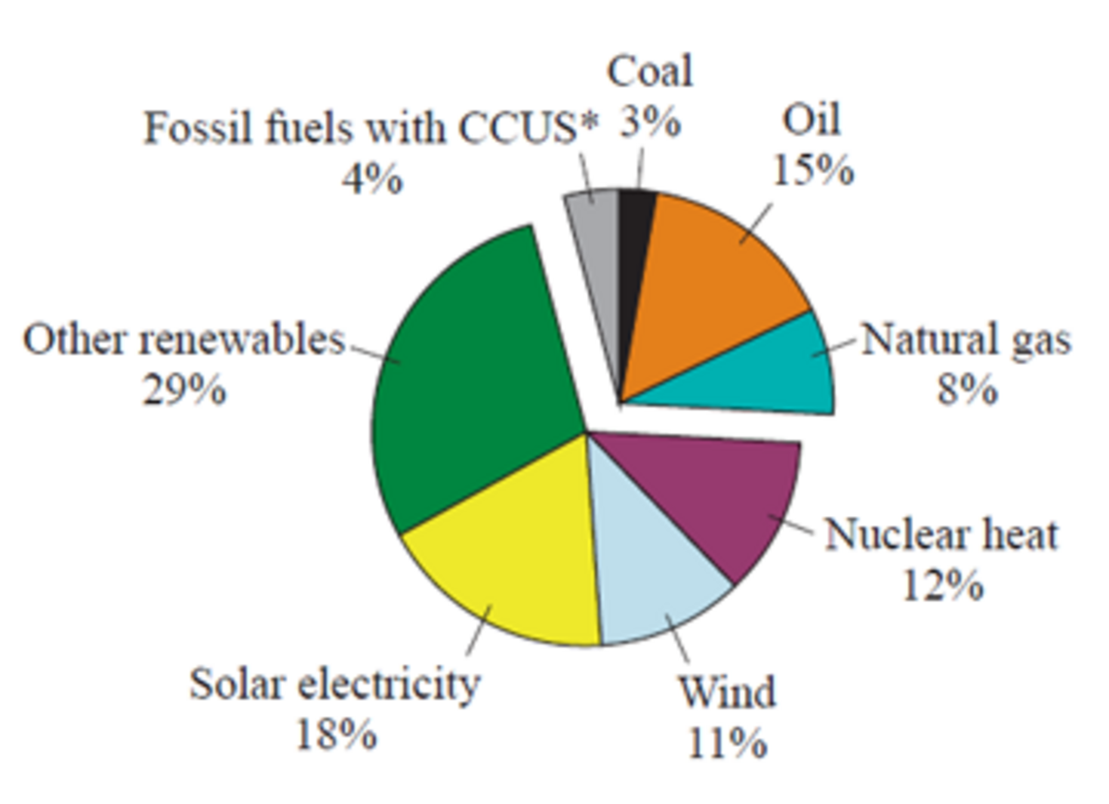
Figure 15 Possible world energy supply in 2040, as suggested by the International Energy Agency in their scenario for ‘Net Zero by 2050’.
View description - Figure 15 Possible world energy supply in 2040, as suggested by the International ...

In this energy mix, fossil fuels only make up 30% of the total. They are replaced by an enormous expansion in renewable energy sources such as solar electricity and wind power. There is also a more modest expansion of hydroelectric and nuclear power, together with the development of carbon capture, utilisation and storage (CCUS) technologies. These collect CO₂ from combustion and either bury it deep underground in layers of water-saturated rocks called aquifers or use it in other industrial processes.
The inclusion of CCUS technology and nuclear power may seem controversial and ‘un-environmental’ to some. However, achieving an equivalent cut in CO₂ emissions without using these technologies would require an even larger and more rapid expansion of wind and solar power (Teske, 2019).
If this transformation in energy supply can be achieved by 2040, then the world will indeed be on a pathway to limiting global temperature rise to 1.5 °C. If the global energy economy cannot change so quickly, then the temperature rise is likely to be greater. To limit the temperature rise to 2 °C, this low level of 6 Gt of CO₂ emissions per year needs to be reached just 15 years later, in 2055 (see Figure 16).

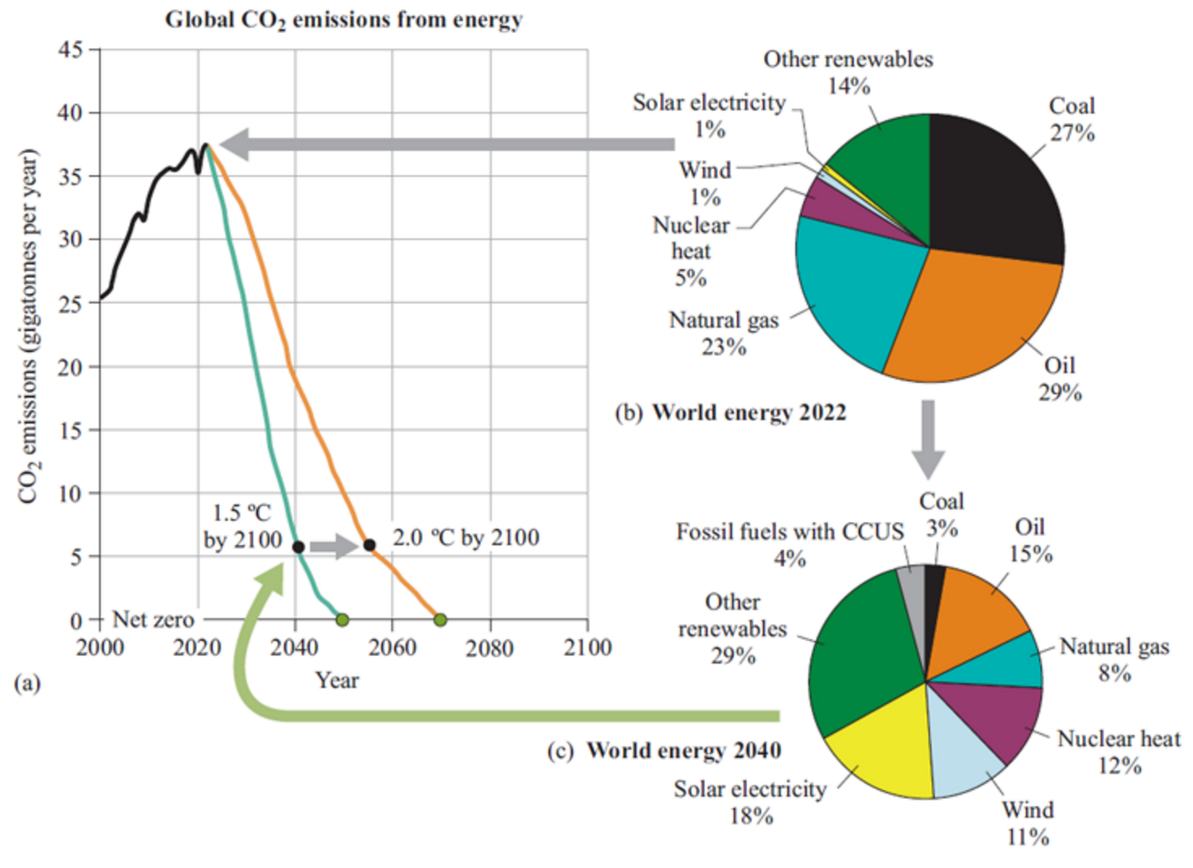
Figure 16 (a) Global CO2 emission pathways (from energy) for keeping the global temperature rise to 1.5 °C and 2 °C (also shown in Figure 13); (b) world primary energy consumption in 2022; (c) projected world primary energy consumption in 2040 for the IEA ‘Net Zero Emissions by 2050’ scenario. Note that CCUS stands for carbon capture, utilisation and storage. The ‘Other renewables’ category includes hydroelectricity, energy from waste and biomass, geothermal and solar heat. (Adapted from Climate Interactive, 2023; IEA, 2023; IPCC 2023)
View description - Figure 16 (a) Global CO2 emission pathways (from energy) for keeping the global temperature ...

This shows that there is only a small window of opportunity to act – any further delay in these drastic CO₂ emission reductions could lead to a global temperature rise above 2 °C, with the risk of dangerous climate change. Each degree (and fraction of a degree) of warming is critical, as research has shown that the impacts from 2 °C of warming are highly likely to be much more severe than the impacts from 1.5 °C (IPCC, 2018).

5.4 Electrification of energy services - a pathway to net zero?
The IEA’s Net Zero scenario shows an enormous ‘transition away from fossil fuels’ towards electricity. Figure 17 shows world electricity generation from 2000 onwards, split by energy source, with projected values as in the IEA’s ‘Net Zero Emissions by 2050’ scenario. The chart indicates how much the rate of electricity generation will need to accelerate to meet the additional demand associated with giving the population of the whole world access to electricity (a United Nations Sustainable Development Goal) and replacing fossil fuels used mainly for heating and transport. It is also clear from this how rapid and significant the growth in solar and wind generation will need to be.

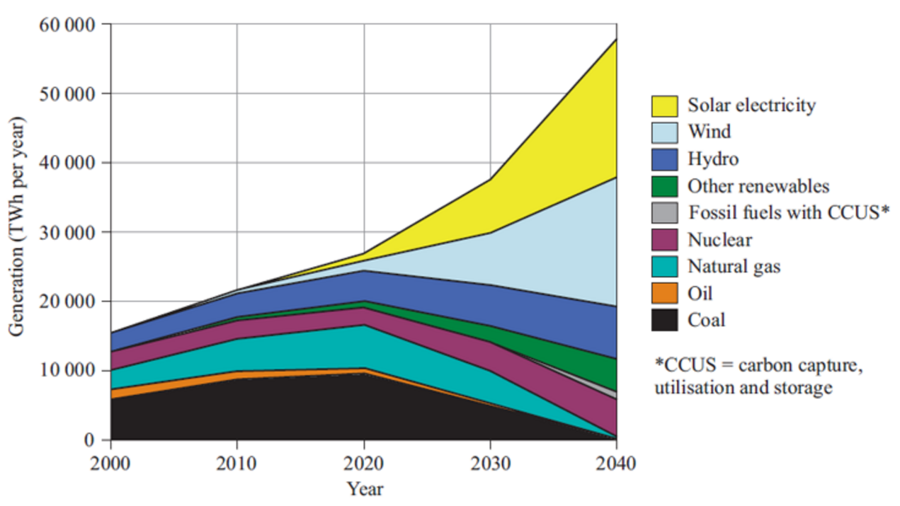
Figure 17 Actual world electricity generation from 2000 to 2020 and projections from 2020 to 2040, split by energy source (adapted from Energy Institute, 2023; IEA, 2023) Note that 1 TWh (terawatt-hour) = 1000 GWh (gigawatt-hours) = 10⁹ kWh (kilowatt-hours).
View description - Figure 17 Actual world electricity generation from 2000 to 2020 and projections from ...

The scenario assumes an almost complete phase-out of fossil-fuelled electricity generation by 2040. This also has the benefit of removing a large source of energy wastage, since coal-fired power stations are typically only 35% efficient and gas-fired power stations about 50% efficient. The world’s electricity demand is mainly to be met by an enormous expansion of solar and wind power. This will require changes in government policy and a surge of financial investment in both energy efficiency (to reduce demand) and clean power generation.

6 Elements of the energy transition
In the IEA’s scenario, drastic CO₂ reductions will require the deployment of a large number of different technologies by 2040. They do not all make an equal contribution and, depending upon the particular local context, some options will be more relevant than others. Deployment of technology will also need to be complemented by behavioural changes.
This section only lists some of the options – there are many more.

6.1 Energy efficiency
The best practice in energy efficiency will need to be used to keep total world energy demand down. This will include energy efficiency retrofits of a large proportion of the existing building stock including insulation (Figure 18) and double or triple glazing.


Figure 18 Rolling out a loft insulation base layer between the ceiling joists
View description - Figure 18 Rolling out a loft insulation base layer between the ceiling joists

Also, the highest levels of energy efficiency will need to be used in industrial and commercial processes and practices. A switch away from fossil-fuelled electricity generation will remove a major source of energy wastage due to the poor thermal efficiency of coal, oil and gas power stations.
Energy efficiency policies are already being implemented because they are both practical and highly cost-effective. Although it is often said that the world will need increasing amounts of energy for economic growth, in practice what consumers need are energy services – for instance, being able to heat and light their homes, and to travel to work and for leisure. The task of energy efficiency projects is to deliver the same level of service but by using less energy. For example, most countries across the world have passed legislation to phase out the incandescent light bulb, replacing it with more efficient LED (light emitting diode) lighting and to promote low-energy domestic appliances such as fridges. This is actually the cheapest way of supplying the ‘energy services’ of lighting and chilled food storage to the public.

6.2 Heat pumps
A large proportion of the world’s fossil-fuelled heating systems will need to be replaced by electric heat pumps. Small heat pumps are actually familiar objects. Every domestic refrigerator uses one. They use an electric compressor to ‘pump’ heat from an evaporator at a lower temperature (inside a fridge) to a condenser on the back of the fridge, where heat, now at a higher temperature, is released, warming one’s kitchen in the process.
In buildings a heat pump may be used for heating or cooling (more commonly known as air conditioning). When used for heating the evaporator, collecting low temperature heat, is located somewhere in the external environment. An air source heat pump is likely to have a fan coil unit, containing the evaporator, such as that shown in Figure 19.

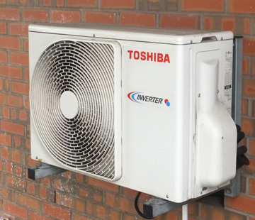
Figure 19 A fan-coil evaporator unit for an air source heat pump
View description - Figure 19 A fan-coil evaporator unit for an air source heat pump

A ground source heat pump uses pipes buried in the soil to gather low temperature heat. These may be laid in a shallow trench, or in a deep vertical borehole that may be 10 metres or more deep. This extracts heat indirectly from the outside air via the ground. Water source heat pumps can extract heat from rivers, the sea or outflowing sewage water. Heat is then pumped from the outside environment, via the evaporator, to a condenser inside the building, normally connected to a conventional central heating system. The temperature of the heat is sufficient to be useful for heating purposes.
Heat pumps can provide between 2 and 4 times the amount of heat for the same electrical consumption as direct electric heating. They are now widely used in Scandinavia and becoming more common right across Europe.

6.3 Solar electricity
Solar photovoltaic (PV) electricity
Solar energy can be harnessed directly to produce electricity using solar photovoltaic (PV) cells. They are made of specially prepared layers of semiconducting materials (usually silicon) that generate electricity when photons of sunlight fall upon them. Where silicon is used, it must be of an extremely high (99.9999%) purity. Since each cell only produces a low voltage, they are normally produced in ‘modules’ or ‘panels’ containing a large number of cells. These can range in size up to a metre square. Arrays of PV modules can be mounted on the roofs of domestic, commercial or industrial buildings, usually providing only some of their electricity needs. However, since 2005, an increasing proportion of installations have been in large grid-connected ‘solar farms’. Although their use has raised concerns about conflicts of land use for food production.
Large-scale production of PV panels has been under way since the 1990s and volume manufacture has resulted in falling prices. A critical factor has been the setting up, since 2005, of very large panel manufacturing plants in China and Taiwan. In 2023, approximately 95% of solar modules and their components came from Asia, primarily from China. China produced about 80% of PV modules and controlled more than 95% of the market for components such as silicon ingots and wafers (Fraunhofer, 2024).
The cost of electricity from large solar PV farms has now fallen to the point where it is highly competitive with that from fossil-fuelled generation (even in the UK). The result has been an extraordinary global growth in PV electricity generation right around the world. Between 2010 and 2023 it increased by a factor of nearly 50, an annual compound growth rate of 35% (Energy Institute, 2024). In 2023, PV electricity supplied over 5% of world electricity demand, including almost 5% of that in the UK.
Silicon PV panels have a limited efficiency, only turning about 17% of the incident light into electricity, so large areas are required to produce appreciable quantities of electricity. Considerable ingenuity is being used to finding suitable spaces, such as the large PV array on the roof of London’s Blackfriars railway station (Figure 20).

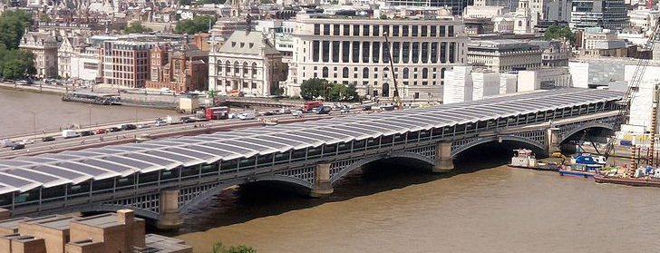
Figure 20 London’s Blackfriars railway station has 6000 square metres of PV panels on its roof, supplying roughly a half of its electricity demand.
View description - Figure 20 London’s Blackfriars railway station has 6000 square metres of PV panels ...

The world’s latest large-scale solar PV projects are in desert areas and on an extraordinary scale. In India, the Bhadla solar park in the Rajasthan desert covers 56 km², and has an installed generating capacity of over 2200 MW. Similar sized projects are under construction in China, Egypt and the United Arab Emirates. PV is also very useful on a much smaller scale, particularly when coupled with reliable rechargeable batteries. ‘Off-grid’ PV can supply electric light to many regions of the world beyond the reach of electricity grids, such as sub-Saharan Africa.
Concentrated solar power (CSP)
PV supplies the bulk of the world’s solar electricity. However, in many sunny countries, the Sun’s rays are strong enough to allow the production of high-temperature steam using arrays of concentrating mirrors. This can then power steam turbines for electricity generation. Such concentrated solar power (CSP) systems using parabolic mirrors have been operational in California since the 1980s and are now regarded as a ‘mature technology’. More recently, large ‘power tower’ systems using steerable arrays of flat mirrors called heliostats have been built in the USA, Spain, the Middle East and China (see Figures 21 and 22).

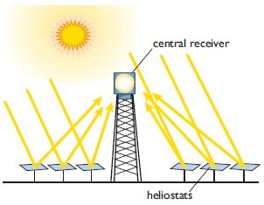
Figure 21 Principle of a central receiver ‘power tower’ CSP system
View description - Figure 21 Principle of a central receiver ‘power tower’ CSP system

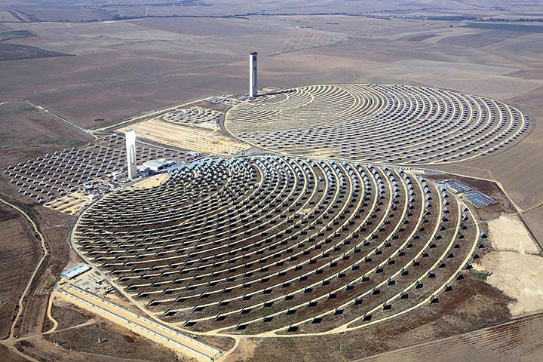
Figure 22 The Andasol PS10 and PS20 CSP systems near Seville, Spain. Installed between 2009 and 2011, they have generating capacities of 10 MW and 20 MW, respectively
View description - Figure 22 The Andasol PS10 and PS20 CSP systems near Seville, Spain. Installed between ...

The large size of the systems (10 MW or more) is a result of the use of ‘standard’ steam turbines, as manufactured for fossil-fuelled industrial power plants. CSP requires clear skies to operate, unlike the rival photovoltaic panels which can also produce electricity under cloudy conditions. However, CSP plants, being thermal, have a certain flexibility of operation. The most important addition is heat storage using a molten salt such as sodium or potassium nitrate. This potentially allows continuous solar-powered electricity generation right through the day and night.
Future growth
Electricity from CSP is more expensive than that from PV, so most of the future solar growth is likely to be in PV. Projections of future PV deployment see continued rapid growth.
The International Energy Agency (IEA) in its 2023 World Energy Outlook suggests that world PV electricity might increase ninefold from its 2022 value by 2040 (IEA, 2023). It could then be supplying over a quarter of the world’s electricity. However, meeting a ‘Net Zero by 2050’ target requires even faster growth. That shown in Figure 17 requires that the annual amount of electricity generated globally by both solar PV cells and CSP plants should increase by a factor of almost 20 by 2040. Globally, these systems could cover about 70 000 km², equivalent to about one third of the area of the UK.

6.4 Wind Power
When solar radiation enters the Earth’s atmosphere it warms different regions of the atmosphere to differing extents – most at the equator and least at the poles. Since air tends to flow from warmer to cooler regions, this causes what we call winds, and it is these air flows that are harnessed in windmills and wind turbines to produce power.
Wind power, in the form of traditional windmills used for grinding corn or pumping water, has been used for centuries. But the use of modern wind turbines for electricity generation has been growing rapidly since the 1970s, following pioneering work in Denmark. The size and power of land-based turbines has increased from machines producing 100 kW in the 1980s up to over 5 MW today (2024).
UK wind power has increased dramatically since the early 1990s, initially with onshore wind farms. The Ardrossan wind farm in Scotland constructed in 2004 (see Figure 23) is a typical UK example. It is equipped with 2 MW turbines with blades 40 metres long and these turbines are expected to continue operating into the 2030s. The photograph does demonstrate the visual impact, which has given rise to planning objections elsewhere.

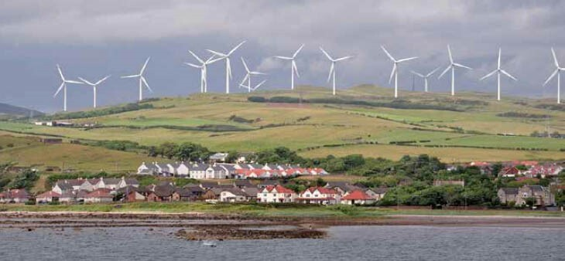
Figure 23 Ardrossan Wind Farm, Scotland, completed in 2004, is equipped with 2 MW turbines
View description - Figure 23 Ardrossan Wind Farm, Scotland, completed in 2004, is equipped with 2 MW ...

A significant development came in 2002 with the construction of the first large-scale offshore wind farm in Denmark. Offshore construction is more difficult than for onshore wind farms, but the expertise of the oil and gas industry in constructing offshore structures has proved very useful. Placing turbines offshore has many advantages:
- they can intercept stronger winds, both by virtue of being out at sea, and also by being taller
- single turbines can be physically larger; the largest 15 MW designs have blades over 100 metres long
- if they are manufactured at waterside locations, they can be moved to wind farm sites by ship
- they can be freed of some objections of visual intrusion in landscapes.
Since 2005 there has been extensive development of offshore wind power in the UK, Denmark and Germany. In 2023 the UK obtained nearly 30% of its electricity from wind power, with an increasing proportion coming from offshore sources (DESNZ, 2024).
There is plenty of scope for further expansion. The UK resource for offshore wind turbines mounted on the seabed is larger than the country’s total 2023 electricity demand. The world resource for land-based turbines alone is several times current world electricity generation.
Wind power is now the world’s second-fastest-expanding source of electrical energy (after solar PV), having achieved a growth rate of over 15% per annum between 2010 and 2023. In 2023 it supplied nearly 8% of the world’s electricity.
The IEA’s Net Zero by 2050 scenario requires a continuing high growth rate. The amount of electricity generated globally from wind power (onshore and offshore) needs to increase from its 2022 value by a factor of 8. If this was all done using offshore wind turbines, globally it would require an area of sea roughly equal to three times that of the North Sea.
This video visits a wind turbine in the Hornsea 1 wind farm in the North Sea, 75 miles off the Yorkshire coast. The wind farm was completed in 2020 and can produce over a gigawatt of electricity. Each 7 megawatt turbine has blades 75 metres long (and the turbines for more recent offshore wind farms are even larger!) The video demonstrates the sheer scale of the wind turbines and gives a sense of the engineering expertise required to construct them in a relatively hostile environment.

Watch the video at YouTube.com.
Video 1: I climbed 623 feet to the top of a wind turbine! | Powering Britain

6.5 Hydrogen
Hydrogen (H₂) is a clean-burning fuel, whose only combustion product is water. It is currently produced for industrial processes (particularly agricultural fertiliser manufacture) by a range of processes and they are increasingly being described in terms of their ‘colour’:
- black hydrogen is produced from coal
- grey hydrogen is produced from natural gas
- blue hydrogen is produced from natural gas but using carbon capture and storage (see section 6.10) to reduce the overall CO₂ emissions
- green hydrogen is produced using renewable energy (usually by the electrolysis of water)
- pink hydrogen is produced from nuclear electricity, again by the electrolysis of water.
Hydrogen is currently being used in transport applications using fuel cells. These can be thought of as a form of ‘gas battery’ which produces electricity when fed with a supply of hydrogen and oxygen (from the air). Fuel cell powered electric buses are currently (2024) widely in use in cities such as London. In Germany some rural train services now use hydrogen fuel cells to provide their power. Although some fuel cell cars have been produced, so far their use has been limited by the need to provide adequate hydrogen filling points at conventional petrol filling stations.
Hydrogen could potentially be used as a domestic piped heating fuel substituting for natural gas, but it is more likely that electric heating using heat pumps will dominate in the UK.
Its most important role is likely to be as a form of energy storage to cover periods when solar and wind powered electricity supplies are not adequate. A whole infrastructure will need to be developed for converting surplus renewable (and nuclear) electricity into hydrogen by the electrolysis of water. This will need to be coupled with large scale hydrogen storage and large scale electricity generation using hydrogen. This is likely to use combined cycle gas turbine (CCGT) technology, as currently used in natural gas fuelled power stations.

6.6 Replacement of fossil fuelled road vehicles
In 2023 road transport, which is almost totally fuelled by fossil petroleum, contributed 16% of global CO₂ emissions (IEA, 2023). In order to cut global CO₂ emissions by a factor of six by 2040, the bulk of the world’s fleet of fossil fuelled road vehicles will need to be replaced with battery electric or hydrogen powered vehicles.
The performance of battery electric vehicles (BEVs) has advanced significantly with the development and large scale manufacture of light-weight lithium-ion batteries.
Many countries have announced a ban on the sale of new fossil-fuelled cars (from 2030 in the UK) and schemes for promoting sales of electric replacements. Globally the sales of electric vehicles have matched the growth rates of solar power. Electric car sales in 2023 were 3.5 million higher than in 2022, a 35% year-on-year increase. In 2023, there were over 250 000 new registrations per week, which is more than the annual total in 2013, ten years earlier. Electric cars accounted for around 18% of all cars sold in 2023, up from 14% in 2022 and only 2% in 2018 (IEA, 2024).
In the International Energy Agency’s Net Zero scenario, electric car sales need to reach around 65% of total car sales by 2030. To get on track with this scenario, electric car sales must increase by an average of 23% per year from 2024 to 2030.

6.7 Hydroelectric power
Water power is another energy source that has been harnessed for many centuries for pumping, milling corn and driving machinery. The original source of this water flow is solar energy, warming the world’s oceans and causing evaporation. In the atmosphere, this forms clouds of moisture which eventually fall back to Earth in the form of rain or snow. The water then flows down through streams and rivers, where its energy can be harnessed using water wheels or turbines to generate power. Since the beginning of the 20th century, its main use has been in the generation of hydroelectric power. Its use has grown, in 2023 globally supplying about 14% of the world’s electricity (Energy Institute, 2024).
When harnessed on a small scale, hydroelectric plants create few adverse environmental impacts. However, many installations have been built on an enormous scale, for example the world’s largest scheme, the 22.5 gigawatt Three Gorges Dam in China. Such schemes have involved the building of massive dams and the flooding of extremely large areas of land. This particular scheme has required the relocation of 2 million people and considerable disturbance to the fish population in the river. The flooding can also result in methane emissions from rotting vegetation, meaning that hydro power is not a totally ‘climate friendly’ technology.
What of the future? The world’s hydro resource is estimated to be about four times current hydroelectricity production. However, developing this potential may not be easy. For example, the construction of large dams on rivers where they flow from one country to another can give rise to international disputes over rights to water.
The International Energy Agency’s ‘Net Zero by 2050’ scenario projects an increase in the global amount of hydroelectricity but only to about 70% above its 2022 value.

6.8 Nuclear power
Nuclear power is a mature technology and a low-carbon energy source. In contrast to the variable output of wind turbines and solar PV it produces a continuous supply of electricity. In 2023 it supplied about 9% of the world’s electricity, and about one seventh of that of the UK (Energy Institute, 2024).
Can nuclear power make a major future contribution to reducing world CO₂ emissions? Opinions are divided. Its role may be limited for several reasons:
- Resource limitations on the potential supply of uranium fuel for conventional ‘burner’ reactor designs. This problem could be solved by the development of fast breeder reactors. However, these involve the separation of plutonium, which could (but not easily) be used in the manufacture of nuclear weapons. This may thus be a technically feasible solution but one that may be politically unacceptable.
- Environmental objections to its use, particularly for the lack of a demonstrated policy for the long-term storage of nuclear waste.
- Unfavourable economics. Nuclear power has not seen the dramatic cost reductions of wind or solar power since 2010. In Europe, two reactors under construction, Olkiluoto 3 in Finland and Flamanville 3 in France, have suffered from long delays and cost overruns.
The IEA’s Net Zero by 2050 scenario requires a doubling of world nuclear generated electricity by 2040, which would only maintain its percentage contribution to global electricity at 9%. Other scenarios for both the UK and the world (for example Teske, 2019) see a complete phase-out of nuclear power in the future, with a concentration on renewable energy.

6.9 Biofuels
Biofuels are fuels produced directly or indirectly from biomass (i.e. living organic materials), including plants and animal waste.
- Gaseous biofuels
  - Animal wastes and wet food waste can be subjected to anaerobic digestion in closed tanks (i.e. without the presence of oxygen), producing a methane/CO₂ mixture called biogas. This is widely used as a clean cooking fuel in rural parts of China. The anaerobic digestion of urban sewage is widely carried out to produce sewage gas, usually used to provide electricity and heat for the operation of sewage and water treatment works.
  - The International Energy Agency’s ‘Net Zero by 2050’ scenario sees a 10-fold expansion in the use of gaseous biofuels by 2040, particularly to help provide a clean cooking fuel to the 2.2 billion people worldwide in need of this.
- Liquid biofuels
  - Renewable liquid biofuels can be produced from biomass. They are widely used for transport applications in spark petrol engines in the form of methanol, ethanol and butanol (all types of alcohols). Methanol can be produced from wood. Ethanol and butanol can be produced by the fermentation of sugars and starch. Ethanol is the most commonly used, usually blended with petrol. In the UK E10 petrol is a blend containing 10% ethanol. Biodiesel can be produced simply from vegetable oils and used in conventional road diesel engines, usually blended with conventional diesel fuel. In 2022 liquid biofuels made up about 4% of world transport fuel consumption.
  - Overall, liquid biofuel use is potentially controversial. It has been promoted, particularly in the USA and Brazil, as a way of avoiding oil imports. It can, however, be seen as being in competition with the use of crops for food. The IEA’s ‘Net Zero by 2050’ scenario requires three times the 2022 consumption of liquid biofuels for transport. Any future major global expansion of biofuel use may thus require diet changes away from meat consumption to free up the necessary land required.

6.10 Carbon capture, utilisation and storage (CCUS)
This technology collects the CO₂ from fuel combustion in factories or power stations and either buries it deep underground (a process called sequestering) or uses it in other industrial processes.
There are many possible locations for sequestering the CO₂. One is in the many large, deep, saline aquifers (i.e. porous rock layers containing salty water) that lie beneath the Earth’s surface. It must be said that the large-scale deployment of this technology is still in its infancy.
One example is at the offshore Sleipner natural gas field, halfway between the UK and Norway and operated by the Norwegian company Equinor. The gas in the Sleipner field is ‘acid’, i.e. it has a high (natural) CO₂ content, which must be separated out in order to make the gas saleable. Sequestration is used rather than releasing it into the atmosphere in order to avoid payment of Norway’s national carbon emission tax. The CO₂ is buried in a saline aquifer, the Utsira formation, 800–1000 m beneath its North Sea production platform. Since 1996 the company has sequestered over 20 million tonnes of CO₂. Equinor has calculated that the Utsira formation alone might be used to store some 600 gigatonnes of CO₂, equivalent to more than 15 years of global anthropogenic CO₂ emissions.

6.11 Lifestyle changes
In order to reach a net zero target many changes in lifestyle will also need to be taken into account, for example in diet and in modes of transport.
- Diet: Agriculture is responsible for about a third of anthropogenic methane emissions, particularly from ruminant livestock such as sheep and cattle. A move to a more vegetarian diet, away from meat and dairy products should reduce global methane emissions. It will also free up land for increased reforestation and biofuel production.
- Transport: Cutting CO₂ emissions will require a move away from individual car use to less energy-intensive modes such as walking, cycling and public transport. New low-carbon aircraft fuels will need to be developed. Until this is done there will need to be less flying.

6.12 Net zero and the importance of trees
Net zero does not only mean the deployment of technology options to reduce the emissions of greenhouse gases caused by human activities. Alongside these actions is the requirement to enhance the uptake of CO₂ from the atmosphere and thus reduce atmospheric CO₂ concentrations. Trees and the world’s forests are a key element of this.
As explained in Section 2, the carbon dioxide in the Earth’s atmosphere is part of an overall carbon cycle. CO₂ is continuously being emitted into the atmosphere by processes such as the burning of fossil fuels, but it is also continuously being removed. One of the most important mechanisms is the absorption of CO₂ during photosynthesis by plants on land.
When a plant grows, it absorbs CO₂ from the air and the carbon is chemically incorporated into the plant as carbohydrates. In trees (Figure 24) some carbon will be turned into wood and remain locked up in it for the whole of its life. The world’s forests contain about the same amount of carbon as is present as CO₂ in the atmosphere.

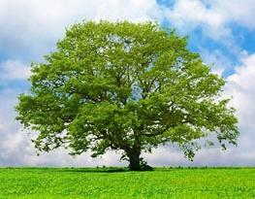
Figure 24 A large tree, when fully grown, may contain several tonnes of carbon
View description - Figure 24 A large tree, when fully grown, may contain several tonnes of carbon

The simplest (and cheapest) ways to increase the rate of removal of CO₂ from the atmosphere are to:
- stop deforestation
- restore the world’s forests by planting more trees.
The areas required are large. In the UK, converting one square kilometre of grassland to forest with broadleaved trees, such as oak or beech, is likely to result in the uptake of about 600 tonnes of CO₂ per year (Matthews et al., 2022). This value will vary depending on the type of forest. Thus, at the global scale, absorbing a gigatonne of CO₂ per year would require reforesting an area roughly seven times the total area of the UK.
Wood is also a very useful material. If it is used as a construction material, for example in housing, its carbon content will remain in storage out of the atmosphere for the life of the building, which in some cases can be considerable. The Horyu-ji temple in Japan (Figure 25) is thought to be the oldest surviving wooden structure in the world. It was built 1300 years ago and was constructed from trees that were 2000 years old when felled.


Figure 25 The 1300-year-old Horyu-ji temple complex in Japan
View description - Figure 25 The 1300-year-old Horyu-ji temple complex in Japan

So how much difference would it make if everyone in the world planted a tree? This video gives you a chance to consider what would happen.

Watch the video at YouTube.com.
Video 2: What if everyone planted a tree?

Conclusion
In this course:
- Section 1 has described the basic principles of the greenhouse effect, the action of greenhouse gases and how the temperature of the Earth’s surface has been maintained at the ‘right temperature’ for life to develop.
- Section 2 has described the principles of the global carbon cycle, and how this has been disturbed by human influences, particularly the large scale burning of fossil fuels. This has led to a rising concentration of carbon dioxide in the atmosphere resulting in additional warming of the whole planet and climate change.
- Section 3 has described two major causes for concern: the rapid rise in global mean surface temperature, particularly since the 1970s, and the increase in extreme weather events.
- Section 4 described the international climate talks that have been taking place since the 1990s, and their role in shaping national policies to keep the global temperature rise to ‘well below 2°C’ by 2100.
- Section 5 described scenarios for the large and rapid reductions in emissions of greenhouse gases that will be needed in the next few decades. It also described how there will need to be a major ‘transition away from fossil fuels’ towards renewable energy, particularly solar and wind power.
- Section 6 described a range of technological (and other) options that will need to be deployed to cut greenhouse gas emissions. These include the wide-spread deployment of energy efficiency and the replacement of fossil fuelled heating and road transport with heat pumps and battery electric vehicles. There will need to be an enormous expansion of renewable electricity generation, particularly from solar and wind power.
This video summarises the material in this course. It can be viewed at one time or as two sections. The first part recaps Sections 1 to 3 of this course. The second part recaps Sections 5 and 6.

Video content is not available in this format.
Video 3: From COP promises to a net-zero pathway.
View transcript - Video 3: From COP promises to a net-zero pathway.

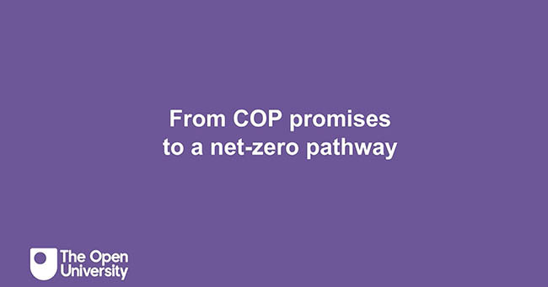

This free course is an adapted extract from the Open University course U116 Environment: journeys through a changing world.

End of course quiz
Test your knowledge with this end of course quiz.

End of course quiz

1. The Earth radiates heat into outer space by emitting what form of radiation?

infra-red radiation
Ultraviolet radiation
radio waves
View answer - Part

2. If the Earth did not have any atmosphere what would its surface temperature be?

-57 °C
-18 °C
+ 50 °C
View answer - Part

3. In global warming terms, how much more potent is methane than carbon dioxide as a greenhouse gas?

5 times
10 times
20 times
View answer - Part

4. Plants absorb carbon dioxide from the atmosphere as a result of which process?

Photosynthesis
Respiration
Decomposition
View answer - Part

5. Microscopic floating plants in the oceans are called:

Zooplankton
phytoplankton
nematodes
View answer - Part

6. A gigatonne is equal to

a million tonnes
1000 million tonnes
a million million tonnes
View answer - Part

7. In pre-industrial times the concentration of carbon dioxide in the atmosphere has been estimated to be:

280 parts per million
200 parts per million
420 parts per million
View answer - Part

8. Global warming over the years between 1951-80 and 2015-2019 has not been uniform over the globe. Which area has seen the largest temperature rise?

the Antarctic
the Equator
the Arctic
View answer - Part

9. The acronym IPCC stands for

Intergovernmental Panel on Climate Change
International Protocol for Climate Correction
Intergovernmental Process for Climate Correction
View answer - Part

10. The acronym COP stands for:

Committee of Progress
Conference of the Parties
Climate Organisation Participants
View answer - Part

11. At which COP meeting did the participants first agree that the global temperature rise should be limited to ‘well below 2 °C’?

Paris in 2015
Glasgow in 2022
Dubai in 2023
View answer - Part

12. In order to limit the global temperature rise to 1.5 °C anthropogenic CO₂ emissions will need to fall by a factor of six by what date?

2040
2055
2100
View answer - Part

13. In 2022 fossil fuels made up what proportion of the world’s primary energy consumption:

30%
Just over three quarters
85%
View answer - Part

14. In 2022 the concentration of carbon dioxide in the Earth’s atmosphere was 420 parts per million and rising. To what level will it need to be limited by 2100 to keep the global average temperature rise to only 2°C above pre-industrial levels?

470 ppm
520 ppm
550 ppm
View answer - Part

15. In the International Energy Agency’s Net Zero by 2050 scenario, what proportion of the world’s primary energy consumption is made up of fossil fuels in 2040?

20%
30%
40%
View answer - Part

16. How much of the world’s electricity did solar power provide in 2023?

0.1%
1%
over 5%
View answer - Part

17. How long are the blades on the turbines at the Ardrossan wind farm?

30 metres
40 metres
50 metres
View answer - Part

18. Hydrogen produced from different sources can be described by its ‘colour’. What is blue hydrogen?

Hydrogen produced from coal.
That produced from natural gas, but using CCS to cut CO₂ emissions.
Hydrogen produced from renewable energy.
View answer - Part

19. Roughly how many people were displaced by the construction of the Three Gorges Dam hydroelectric dam in China?

500,000
2 million
5 million
View answer - Part

20. According to the Norwegian company Equinor/Statoil, the Utsira saline aquifer formation is sufficiently large to absorb how many gigatonnes of CO₂?

10 gigatonnes
600 gigatonnes
1000 gigatonnes
View answer - Part

References
Climate Interactive (2023) The C-ROADS climate change policy simulator. Available at: https://www.climateinteractive.org/c-roads/ (Accessed: 4 August 2024).
DESNZ (2024) UK Energy in Brief, Department for Energy Security and Net Zero. Available at https://www.gov.uk/government/statistics/uk-energy-in-brief-2024 (Accessed 8 August 2024)
Energy Institute (2024) Statistical Review of World Energy. Available at: https://www.energyinst.org/statistical-review (Accessed 7 August 2024).
Fraunhofer (2024) Photovoltaics report. Available at: https://www.ise.fraunhofer.de/content/dam/ise/de/documents/publications/studies/Photovoltaics-Report.pdf (Accessed 7 August 2024)
Global Carbon Project (2023) Briefing on key messages: Global Carbon Budget 2023. Available at: https://globalcarbonbudget.org/carbonbudget2023/ (Accessed: 4 August 2024).
IEA (International Energy Agency) (2021) Net zero by 2050: a roadmap for the global energy sector. Available at: https://www.iea.org/reports/net-zero-by-2050 (Accessed: 6 August 2024).
IEA (International Energy Agency) (2023) World energy outlook 2023. Paris: IEA Publications. Available at: https://www.iea.org/reports/world-energy-outlook-2023 (Accessed: 6 August 2024).
IEA (International Energy Agency) (2024) Electric vehicles, Available at: https://www.iea.org/energy-system/transport/electric-vehicles (Accessed 9 August 2024)
IPCC (Intergovernmental Panel on Climate Change) (2018) Special report: global warming of 1.5 °C. Available at: https://www.ipcc.ch/sr15/ (Accessed: 5 August 2024).
IPCC (Intergovernmental Panel on Climate Change) (2022) ‘The evidence is clear: the time for action is now. We can halve emissions by 2030’, 4 April [Press release]. Available at: https://www.ipcc.ch/2022/04/04/ipcc-ar6-wgiii-pressrelease/ (Accessed: 5 August 2024).
IPCC (Intergovernmental Panel on Climate Change) (2023) AR6 synthesis report: climate change 2023. Available at: https://www.ipcc.ch/report/sixth-assessmentreport-cycle/ (Accessed: 5 August 2024).
Matthews, R., Henshall, P., Beauchamp, K., Gruffudd, H., Hogan, G., Mackie, E., Sayce, M. and Morison, J. (2022) Quantifying the sustainable forestry carbon cycle: summary report. Farnham: Forest Research. Available at: https://cdn.forestresearch.gov.uk/2022/07/QFORC_Summary_Report_rv1e_final.pdf (Accessed: 4 August 2024).
NASA (no date) World of change: global temperatures. Available at: https://earthobservatory.nasa.gov/world-of-change/global-temperatures/show-all (Accessed: 5 August 2024).
NASA (2023) Tracking Canada’s extreme 2023 fire season. Available at: https://earthobservatory.nasa.gov/images/151985/tracking-canadas-extreme-2023-fireseason (Accessed: 5 August 2024).
Scripps Institution of Oceanography (2023) Mauna Loa Observatory, Hawaii: monthly average carbon dioxide concentration. Available at: https://scrippsco2.ucsd.edu/assets/graphics/png/mlo_record.png (Accessed 4 August 2024)
Teske, S. (2019) Achieving the Paris climate agreement goals. Available at: https://link.springer.com/book/10.1007/978-3-030-05843-2 (Accessed: 4 August 2024).
UNFCCC (United Nations Framework Convention on Climate Change) (2016) The Paris Agreement. Available at: https://unfccc.int/sites/default/files/resource/parisagreement_publication.pdf (Accessed: 9 August 2024).
WMO (World Meteorological Organization) (2023a) The global climate 2011–2020: a decade of accelerating climate change. WMO-No. 1338. Geneva: WMO. Available at: https://library.wmo.int/records/item/68585-the-global-climate-2011-2020 (Accessed: 5 August 2024).
WMO (World Meteorological Organization) (2023b) State of the climate in Europe 2022. WMO-No. 1320. Geneva: WMO. Available at: https://library.wmo.int/records/item/66206-state-of-the-climate-in-europe-2022 (Accessed: 5 August 2024).
WWA (World Weather Attribution) (2023) ‘Climate change more than doubled the likelihood of extreme fire weather conditions in Eastern Canada’, Wildfire, 22 August. Available at: https://www.worldweatherattribution.org/climate-change-more-thandoubled-the-likelihood-of-extreme-fire-weather-conditions-in-eastern-canada/ (Accessed: 5 August 2024).

Acknowledgements
This free course was written by Roger Blackmore, Bob Everett, Rachel Slater and Maria Townsend.
Except for third party materials and otherwise stated (see terms and conditions), this content is made available under a Creative Commons Attribution-NonCommercial-ShareAlike 4.0 Licence.
The material acknowledged below is Proprietary and used under licence (not subject to Creative Commons Licence). Grateful acknowledgement is made to the following sources for permission to reproduce material in this free course:
Course image: ABCDstock; Shutterstock.com
Figure 1: NASA
Figures 2, 3, 4, 5, 6, 13,14,15, 16 and 21: The Open University
Figure 7: Adapted from Friedlingstein et al. (2022) Global Carbon Budget 2022 v1.0 dataset, available at https://globalcarbonbudget.org/carbonbudget/, and Energy Institute (2023) Statistical Review of World Energy 2023, available at https://www.energyinst.org/statistical-review.
Figure 8: © 2024 Regents of the University of California
Figure 9: © Intergovernmental Panel on Climate Change, 2023
Figure 10: NASA Earth Observatory/Lauren Dauphin
Figure 11: © European Union, 2024
Figure 12: © Intergovernmental Panel on Climate Change, 2023
Figure 17: IEA (2023), World Energy Outlook 2023, IEA, Paris https://www.iea.org/reports/world-energy-outlook-2023, Licence: CC BY 4.0 (report); CC BY NC SA 4.0 (Annex A)
Figure 18: © unknown
Figure 19: courtesy of Dr. Bob Everett
Figure 20: AlisonW (Alison M Wheeler); https://creativecommons.org/licenses/by-sa/4.0/
Figure 22: By Koza1983 - Own work by the original uploader, https://creativecommons.org/licenses/by/3.0/
Figure 23: Vincent van Zeijst; https://creativecommons.org/licenses/by/3.0/
Figure 24: Usersam2007| Dreamstime.com
Figure 25: Aagje De Jong / Dreamstime.com
Audio/Visual
Video 3: The Open University
Every effort has been made to contact copyright owners. If any have been inadvertently overlooked, the publishers will be pleased to make the necessary arrangements at the first opportunity.
Don’t miss out
If reading this text has inspired you to learn more, you may be interested in joining the millions of people who discover our free learning resources and qualifications by visiting The Open University – www.open.edu/openlearn/free-courses.

Glossary
anthropogenic greenhouse effect
This can also be called the enhanced greenhouse effect. That part of the greenhouse effect that can be attributed to human action (for example, burning fossil fuels, deforestation). See greenhouse effect.
battery
A device for storing electrical energy in a chemical form and supplying electric current. It usually consists of one or more electrical cells connected together in series.
battery electric vehicles
(BEVs) A vehicle that runs on electricity drawn from a battery (as opposed to a fuel cell).
biofuels
These are fuels produced directly or indirectly from living organic material – biomass, including plant materials and animal waste.
biomass
Materials such as wood, plant, animal waste, etc. that (unlike fossil fuels) were living matter relatively recently. Traditional biomass refers to biomass resources that are not formally traded, in contrast to new biomass.
black hydrogen
Hydrogen produced from coal. That from other sources is assigned different ‘colours’.
blue hydrogen
Hydrogen produced from natural gas but using carbon capture and storage to reduce the associated CO₂ emissions.
carbohydrates
(CHOs) Collective name for many organic compounds made from carbon, hydrogen and oxygen, e.g. starch, sugars, cellulose; one of the major food groups.
carbon capture, utilisation and storage (CCUS)
Techniques to separate carbon from fossil fuels when they are used to provide energy for any purpose, but particularly for power stations and energy-intensive industries. Carbon can be removed from the fuel before combustion or from the waste gases after combustion. In both cases it is extracted in the form of carbon dioxide, which is then transported to a storage site, such as a depleted oil or gas reservoir, for long-term burial.
carbon cycle
The movement of carbon between reservoirs such as the atmosphere, organisms, soil, and some rocks.
carbon dioxide
A naturally occurring chemical compound consisting of carbon and oxygen. A molecule of carbon dioxide consists of one atom of carbon and two atoms of oxygen with a chemical formula of CO₂. Carbon dioxide is produced in respiration and from the burning of carbon-intensive fossil fuels and consumed in photosynthesis. Carbon dioxide is the most important greenhouse gas released as a result of human activity.
concentrated solar power (CSP)
The use of sunlight to generate high-temperature steam by means of an array of mirrors. The steam then drives a turbine in the usual way.
COP
Conference of Parties – the yearly conference where the signatories of the United Nations Framework Convention on Climate Change (UNFCCC) meet.
electrolysis
The chemical decomposition of a liquid or solution that occurs during the conduction of electricity.
energy services
The ultimate aims for which energy systems are built: warm homes, cooked food, illumination, mobility and manufactured articles.
environment
The surroundings and influences on living things including humans.
excreta
The compounds disposed of by organisms in liquid, solid or gaseous form that are no longer needed or are harmful.
fertiliser
Any material used by humans as a source of plant nutrients.
fossil fuel
Buried fuels derived from past living plant and animal materials that have been modified and buried by geological processes, for example coal, oil or gas. The burning of fossil fuels causes carbon dioxide emissions and is the major cause of climate change.
fuel cell
A device for producing an electric current by means of what is essentially the reverse process to electrolysis – combining two gases (typically hydrogen and oxygen) to produce electricity.
gigatonne
Giga is the prefix for 10⁹ so one gigatonne is the same as 1000 megatonnes or a billion tonnes.
global warming
The rising average world temperature, often measured by the global mean surface temperature. Within this average it will still be possible for countries and regions to have colder weather.
global mean surface temperature (GMST)
This is a measure of the global average temperature of the Earth, measured near the surface. It is an average of (a) the sea surface temperature and (b) the air temperature measured 1.5 metres above ground, weighted for area.
Global Warming Potential
Global Warming Potential (GWP) is a relative measure of how much heat a greenhouse gas traps in the atmosphere. It compares the amount of heat trapped by a certain mass of the gas in question to the amount of heat trapped by a similar mass of carbon dioxide.
greenhouse effect
Natural mechanism, now modified by human activity, whereby solar radiation is trapped by carbon dioxide and other greenhouse gases in the Earth’s atmosphere, similar to the way in which heat is trapped by glass in a greenhouse.
greenhouse gases
(GHG) Gases, including carbon dioxide, water vapour, methane and nitrous oxide, that interact with infra-red radiation and when present in the atmosphere have the effect of warming the global climate. Without naturally occurring greenhouse gases the Earth’s temperature would be several tens of degrees Celsius colder than it is now (and life would not have evolved in its current form).
green hydrogen
Hydrogen that has been produced from renewable energy sources with minimal associated carbon dioxide emissions.
grey hydrogen
Hydrogen produced from natural gas, but without any use of carbon capture and storage to reduce the consequent CO₂ emissions.
heat pump
A device that ‘pumps’ heat from a cooler region into a warmer one, thus providing either warming or cooling to a living space. In an air-source heat pump (ASHP) the heat is taken directly from the air, while in a ground-source heat pump (GSHP) it comes from the soil but indirectly from the air.
hydroelectric power
Power harnessed from converting the energy coming of running water into electrical energy.
IEA
International Energy Agency
infra-red radiation
Electromagnetic radiation with a wavelength longer than visible light.
IPCC
The Intergovernmental Panel on Climate Change was established in 1988 by the World Meteorological Organisation (WMO) and the United Nations Environment Programme (UNEP). Its purpose is to provide scientific and technical advice to the United Nations Framework Convention on Climate Change (UNFCC) and assess current information on climate change, its impacts and how to mitigate (reduce) the effects and/or to adapt to it. It produces authoritative reports on these matters approximately every five years.
Keeling Curve
The graphical record of the rise of carbon dioxide concentration in the atmosphere from 1958 to the present from the Mauna Loa Observatory in Hawaii. It is named after Charles Keeling, the scientist who established the observations.
Kyoto Protocol
An international agreement stemming from the 1997 climate change conference held in the Japanese city of Kyoto. Under this protocol, developed countries (except the USA and Australia) in 2005 agreed a legally-binding obligation to reduce their overall emissions of greenhouse gases, contributing to climate change by 5.2% between 2008 and 2012, based on 1990 emissions. The agreement refers to a basket of the six main human-induced greenhouse gases, particularly carbon dioxide. Australia finally signed the treaty in 2007. In 2012, the Protocol was extended until 2020 to provide more time for international agreement on a successor commitment.
leaf litter
A habitat formed of dead and decaying leaves and other organic material.
LED
Light emitting diode (LED) lamps are based on the properties of materials called semiconductors. They have many advantages over incandescent light sources, including lower energy consumption, longer lifetime, improved physical robustness, and smaller size.
mass extinction
During the course of the history of life on Earth there have been several occasions when a large proportion of all species and many higher groupings of organisms have become extinct in a comparatively short geological time. The specific causes are not clear and may be different in each case, but the five or more occasions of mass extinction all took place when there were major changes to the Earth’s systems: the oceans, ice, atmosphere, land and ecosystems. There is concern that human activity is now in danger of leading to another mass extinction.
methane
A hydrocarbon that is a constituent of natural gas. Also produced by decomposing organic waste such as domestic refuse and by digestion processes in animals. Methane is a potent greenhouse gas and has a chemical formula of CH₄.
micro-organisms
Very small (usually single-celled) organisms only visible with a microscope, e.g. bacteria.
nationally determined contributions (NDCs)
The climate pledges (in terms of reductions in greenhouse gases) that countries made at the United Nations Climate Change Conference held in Paris, France in December 2015. Previously known as intended nationally determined contributions (INDCs).
net zero
Net zero emissions (also referred to as zero emissions or carbon neutral) are achieved when greenhouse gas emissions are balanced by technologies or practices that remove emissions from the atmosphere, resulting in a sum total of zero.
nitrous oxide
A colourless gas used as an anaesthetic. It occurs naturally in the atmosphere and is mainly formed by soil bacteria decomposing nitrogen-containing material. Agricultural practices affect its release into the atmosphere where it is a greenhouse gas (N₂O)
photosynthesis
The process in which green plants (and a few other organisms including plankton) in the presence of sunlight use carbon dioxide and water to produce carbohydrates and oxygen.
phytoplankton
Very small plants (many are microscopic) that drift passively in the sea or in lakes.
pink hydrogen
Hydrogen produced by the electrolysis of water using nuclear electricity.
primary energy
The total energy content of an energy resource before that energy is extracted/transformed/processed. Primary energy is the starting point for an energy transformation system: the incoming ‘amount we have to work with’ before it is acted upon by power stations.
renewable energy
Energy based on a naturally occurring and replenished source, such as sunlight, wind, biomass, waves or tides.
respiration
The process whereby living organisms convert stored organic carbon compounds into carbon dioxide and other compounds, in the process releasing energy and taking up oxygen.
ruminants
Even-toed hoofed mammals with a complex 3- or 4-chamber stomach. Ruminants are herbivores (only eat plants), and their digestion creates methane which is exhaled or belched. Ruminants include cattle, sheep, antelopes, deer and giraffes.
sequestration
The very long-term storage of CO₂ or solid carbon in isolation from the atmosphere.
spectrum
The electromagnetic spectrum is the range of wavelengths or frequencies over which electromagnetic radiation extends.
ultraviolet
(UV) This is an electromagnetic radiation with a wavelength shorter than that of infra-red radiation, visible light but longer than than that of X-rays.
water vapour
Water in the state of a vapour (similar to a gas). It is present in the atmosphere in variable amounts, typically about 3% of the dry atmosphere and plays an important role in the water cycle, in cloud formation and controlling the distribution of heat through the atmosphere.
zooplankton
Very small animals (many are microscopic) that drift passively in the sea or in lakes.

Solutions

End of course quiz

Part

Answer
Right:
infra-red radiation
Wrong:
Ultraviolet radiation
radio waves
Back to - Part

Part

Answer
Right:
-18 °C
Wrong:
-57 °C
+ 50 °C
Back to - Part

Part

Answer
Right:
20 times
Wrong:
5 times
10 times
Back to - Part

Part

Answer
Right:
Photosynthesis
Wrong:
Respiration
Decomposition
Back to - Part

Part

Answer
Right:
phytoplankton
Wrong:
Zooplankton
nematodes
Back to - Part

Part

Answer
Right:
1000 million tonnes
Wrong:
a million tonnes
a million million tonnes
Back to - Part

Part

Answer
Right:
280 parts per million
Wrong:
200 parts per million
420 parts per million
Back to - Part

Part

Answer
Right:
the Arctic
Wrong:
the Antarctic
the Equator
Back to - Part

Part

Answer
Right:
Intergovernmental Panel on Climate Change
Wrong:
International Protocol for Climate Correction
Intergovernmental Process for Climate Correction
Back to - Part

Part

Answer
Right:
Conference of the Parties
Wrong:
Committee of Progress
Climate Organisation Participants
Back to - Part

Part

Answer
Right:
Paris in 2015
Wrong:
Glasgow in 2022
Dubai in 2023
Back to - Part

Part

Answer
Right:
2040
Wrong:
2055
2100
Back to - Part

Part

Answer
Right:
Just over three quarters
Wrong:
30%
85%
Back to - Part

Part

Answer
Right:
470 ppm
Wrong:
520 ppm
550 ppm
Back to - Part

Part

Answer
Right:
30%
Wrong:
20%
40%
Back to - Part

Part

Answer
Right:
over 5%
Wrong:
0.1%
1%
Back to - Part

Part

Answer
Right:
40 metres
Wrong:
30 metres
50 metres
Back to - Part

Part

Answer
Right:
That produced from natural gas, but using CCS to cut CO₂ emissions.
Wrong:
Hydrogen produced from coal.
Hydrogen produced from renewable energy.
Back to - Part

Part

Answer
Right:
2 million
Wrong:
500,000
5 million
Back to - Part

Part

Answer
Right:
600 gigatonnes
Wrong:
10 gigatonnes
1000 gigatonnes
Back to - Part

Descriptions

Figure 1 Earth from space
This is a picture of the Earth from space, it is sometimes referred to as the ‘blue marble’ and it is a famous view taken by one of the U.S. Apollo 17 astronauts in 1972. It shows the blue oceans of the Earth and swirling patterns of white clouds. The outlines of Africa, and the ice-covered Antarctica can be seen.
Back to - Figure 1 Earth from space

Figure 2 The energy balance at the Earth’s surface, without an atmosphere. Solar radiation input is balanced by infra-red radiation from the Earth with a mean surface temperature of −18 °C.
This is a schematic diagram showing yellow arrows representing radiation from the Sun reaching the surface of a (frozen) Earth that has no atmosphere. Red arrows represent infrared radiation given out by the Earth’s surface. The text on the diagram explains that the mean temperature at the Earth’s surface is a very cold minus 18 degrees Celsius, and the two flows of radiation are in balance.
Back to - Figure 2 The energy balance at the Earth’s surface, without an atmosphere. Solar radiation input is balanced by infra-red radiation from the Earth with a mean surface temperature of −18 °C.

Figure 3 The ‘natural’ greenhouse effect of the Earth’s atmosphere. The energy balance is maintained, but the surface of the Earth is at approximately 15 °C and the lower levels of the atmosphere are warmed.
This is a schematic diagram shows yellow arrows representing radiation from the Sun reaching the surface of the Earth, now with its atmosphere. Red arrows represent infrared radiation given out by the Earth’s surface, but most of this radiation is absorbed and re-emitted in the atmosphere and by clouds before it reaches space, and some returns to the surface. The text on the diagram explains that the mean temperature of the Earth’s surface is a warm 15 degrees Celsius, that the two flows of radiation are again in balance, but that now the infrared radiation is mostly emitted from the colder upper atmosphere, not the Earth’s surface.
Back to - Figure 3 The ‘natural’ greenhouse effect of the Earth’s atmosphere. The energy balance is maintained, but the surface of the Earth is at approximately 15 °C and the lower levels of the atmosphere are warmed.

Figure 4 The basic carbon cycle
This is a pictorial diagram of the basic carbon cycle. It is a closed circle of four arrows and four items. All the arrows flow in the same direction and each connects one of the items with the next. At the bottom is a drawing showing a giraffe by a tree and grass that is labelled ‘respiration in plants and animals’. An arrow flows to a box containing the text carbon dioxide plus water, using chemical symbols. The second arrow flows to the top to a drawing of a tree and plants with the sun shining, which is labelled ‘photosynthesis in plants (with sunlight)’. This progress from the first drawing to the second illustrates that water and carbon dioxide are released by respiration and taken up during photosynthesis. The third arrow flows down the top right-hand side of the diagram to a box containing the text ‘carbohydrates plus O2’. The fourth arrow flows to the first picture to complete the circle. The progress from the second picture to the first illustrates that oxygen and carbohydrates are released by during photosynthesis and taken up respiration.
Back to - Figure 4 The basic carbon cycle

Figure 5 The carbon cycle at the local level
This is a more comprehensive pictorial diagram of the carbon cycle over land, on a local scale. The diagram is divided into above ground labelled ‘air’ and below ground labelled ‘soil’. Above ground there is a drawing of a by a tree and grass. Unlabelled arrows show that leaves from the tree fall to the ground, that the giraffe eats leaves and produces excrement which falls to the ground. A box near the top of the diagram contains the text ‘CO2 in air’. An arrow from that box flows to the trees and is labelled ‘photosynthesis’. An arrow from the tree and one from the giraffe flow to the box and are labelled ‘respiration’. Below the ground, there are five boxes with text. Four are in a line above the remaining one. From the left the top four read: ‘litter’, ‘plants’, ‘animals’, ‘excretion’. From each of these an arrow flows to the fourth box. The arrows are collectively labelled ‘death and decomposition’ and the final box reads ‘organic matter’. An arrow flows from that box to the ‘CO2 in air’ box.
Back to - Figure 5 The carbon cycle at the local level

Figure 6 The global carbon cycle – the arrows show how the flows of carbon move around in the carbon cycle. The main upward flow is from fossil fuel burning; the two main downward flows are from photosynthesis and the flow down to the ocean.
This is a pictorial diagram illustrates many of the flows of the global carbon cycle between the land, the sea and the atmosphere. The picture shows a stylised land surface, with volcanoes, forests, grassland and other vegetation, factories, and a land-based oil well. Cliffs link the land an ocean and some of them are eroding. The atmosphere is shown, but with no distinguishing drawn features, there is a label at the top of the atmosphere which reads ‘carbon dioxide in the atmosphere’. A cut-away vertical section of the land below the surface shows five layers, from the surface down these are labelled as: soil; rocks; coal deposit; limestone, oil. In the ocean the upper area is labelled as ‘surface layers of ocean’ and the lower as ‘deep ocean’. There are various single and paired labelled arrows that connect these elements. On the land, a pair of one-way arrows connect the vegetation and the ‘carbon dioxide in atmosphere’, one labelled ‘respiration’ flows from the vegetation and the other labelled ‘photosynthesis’ flows to the vegetation. Four one-way arrows flow to ‘carbon dioxide in atmosphere’ from ‘volcanic eruptions’, ‘forest and grassland burning’, ‘fossil fuel burning’ and ‘weathering by erosion’. Below the land surface, a one-way arrow indicates carbon being removed from immediate circulation by becoming part of rocks or coal deposits. In the ocean, a pair of one-way arrows connects the air and the ocean, the pair are labelled ‘transfer between atmosphere and oceans’. Under the surface of the ocean a pair of one-way arrows flow horizontally between ‘phytoplankton’ and the surrounding surface layers of the ocean. A one-way arrow indicates carbon being removed from immediate circulation by falling to the ocean floor.
Back to - Figure 6 The global carbon cycle – the arrows show how the flows of carbon move around in the carbon cycle. The main upward flow is from fossil fuel burning; the two main downward flows are from photosynthesis and the flow down to the ocean.

Figure 7 Global carbon dioxide (CO2) emissions from fossil fuel combustion between 1850 and 2022, with an expanded section from 2000 to 2022 showing that the rate of increase has slowed since 2010
This is an area graph with two parts. The left-hand part shows emissions broken down into the contributions from coal, oil and natural gas all the way from 1850 to 2022. The smaller right-hand part gives expanded details from 2000 to 2022. The y-axis for both parts is labelled ‘CO2 emissions in gigatonnes per year’. The scale runs from zero to 40 gigatonnes per year in 5 gigatonne intervals. The year is shown on the x-axis. In the left-hand part it runs from 1850 to 2022 marked at 1850, 1900, 1950 and 2000. In the right-hand part it runs from 2000 to 2022 with labels marked at 2000, 2010 and 2020. The contributions are shown in different colours, with coal in black, oil in orange and natural gas in medium blue. These areas are also indicated by labels. In 1850, total CO2 emissions were below 1 gigatonne, almost entirely from coal. Total emissions grew slowly, reaching about 2 gigatonnes in 1900 and 3 gigatonnes in 1920. Emissions then remained relatively constant at about 4 gigatonnes until about 1940, when total emissions started to rise rapidly, reaching about 17 gigatonnes in 1973, flattening out slightly and then rising to about 25 gigatonnes in 2000. Total emissions continued to rise but more slowly, reaching 35 gigatonnes in 2018, falling in 2020 and then rising back to 35 gigatonnes in 2022. Emissions from coal made up almost all of the total from 1850 to 1920. They grew steadily from about 4 gigatonnes in 1950 to about 5.5 gigatonnes in 1973 and 9 gigatonnes in 2000, then more rapidly reaching about 15 gigatonnes in 2012, after which they flattened out at this level until 2022. Emissions from oil were zero or negligible until about 1925, when they started to grow, reaching 1 gigatonne in about 1945, 8 gigatonnes in 1973 and 12 gigatonnes in 2012, after which they flattened out, but with a pronounced temporary fall in 2020. Natural gas only started showing on the graph after 1950. Emissions grew to 2 gigatonnes in 1973, 5 gigatonnes in 2000 and 8 gigatonnes in 2022.
Back to - Figure 7 Global carbon dioxide (CO2) emissions from fossil fuel combustion between 1850 and 2022, with an expanded section from 2000 to 2022 showing that the rate of increase has slowed since 2010

Figure 8 Annual fluctuations shown by the Keeling Curve (Scripps Institution of Oceanography, 2023)
This is a graph of the ‘Keeling Curve’ that shows the seasonal fluctuations. It shows over sixty years of measurements, from September 1957 through to February 2023, of the concentration of carbon dioxide in the atmosphere, and charts its rise from 315 parts per million at the start of the period to around 420 parts per million at the end. This trend has not been seasonally adjusted and the seasonal fluctuation can be clearly seen as a rise and fall in amplitude each year of about 5 parts per million. The seasonal peak occurs in late spring and the trough in autumn.
Back to - Figure 8 Annual fluctuations shown by the Keeling Curve (Scripps Institution of Oceanography, 2023)

Figure 9 Global mean surface temperature 1850-2020. The average temperature for 2011-2020 was 1.1 °C above the 1850–1900 baseline (IPCC, 2023)
This is a line chart showing the historical change s in global mean surface temperature. It has an x axis running from 1850 to 2020. The y axis scale is labelled Global mean surface temperature rise in degrees celsius. The scale runs from minus 0.5 degrees celsius up to 1.5 degrees celsius. The chart starts with a unevenly varying line at approximately zero degrees between 1850 and 1900. It is slightly below zero between 1900 and 1920 and then rises to about 0.3 degrees in 1945. It is around 0.25 degrees between 1950 and 1970, after which it starts rising but unevenly right up to about 1.2 degrees in 2020. There is a horizontal blue line showing the average as zero between 1850 and 1900. There is also a short horizontal brown line between 2011 and 2020, showing the average as 1.1 degrees. A grey vertical arrow between the levels of these two lines is labelled 1.1 degrees celsius rise.
Back to - Figure 9 Global mean surface temperature 1850-2020. The average temperature for 2011-2020 was 1.1 °C above the 1850–1900 baseline (IPCC, 2023)

Figure 10 Global warming for 2015–2019 when compared with 1951–1980 (NASA, no date)
This is a map of the world showing the mean average temperature change in different parts of the world between the years twenty-fifteen and twenty-nineteen, relative to a baseline from the years eighteen-fifty to nineteen hundred. The temperature change, given in degrees Celsius, is colour coded relative to the baseline as follows: dark blue is four degrees cooler, light blue is two degrees cooler, no colour is no change, orange is two degrees warmer, and red is four degrees warmer. The colours across the world are yellow to pale orange in the southern hemisphere, representing a mean temperature increase of 1 to 2 degrees Celsius relative to the baseline. Moving north, the colours change to darker shades of orange, indicting warming above two degrees, and become red around the Arctic regions, indicating three to four degrees warming. This shows that temperature rise has not been evenly distributed across the world; it has been greater in the northern hemisphere compared to the southern hemisphere, and has been greatest in the Arctic regions.
Back to - Figure 10 Global warming for 2015–2019 when compared with 1951–1980 (NASA, no date)

Figure 11 A line-up of world leaders at the UN COP 28 meeting in Dubai in the United Arab Emirates in 2023.
This is a photograph of all the Heads of State attending the COP28 conference in Dubai. There are four rows of people, mostly men but a few women, standing in front of a UN and COP28 UAE banner. Arab leaders are wearing traditional clothing. Flags from the different countries participating in COP28 provide a colourful backdrop.
Back to - Figure 11 A line-up of world leaders at the UN COP 28 meeting in Dubai in the United Arab Emirates in 2023.

Figure 12 IPCC projections for future carbon dioxide and methane reductions, as well as the total greenhouse gas emission reductions necessary to limit global temperature rise to (a) 1.5 °C and (b) below 2 °C, by 2100 (adapted from IPCC, 2023). The dashed lines show emissions projections based on policies as of 2020 (i.e. in a ‘business as usual’ scenario).
This figure consists of a pair of very similar line charts showing global carbon dioxide emissions, methane emissions and total greenhouse gas emissions. Chart (a) on the left is labelled ‘IPCC emissions projections to keep global temperature rise below 1.5 degrees Celsius’. Chart (b) on the right is labelled ‘IPCC emissions projections to keep global temperature rise below 2 degrees Celsius’. Both charts have x-axes which run from 1995 to 2100, with the years from 2000 through to 2100 marked in 20-year intervals. They both have y-axes labelled ‘gigatonnes of CO2 equivalent per year’, with a scale running from minus 20 to plus 60 gigatonnes labelled from zero to 60 in 20-gigatonne steps. Zero is also labelled ‘net zero’. A label just to the right of the y-axis shows that emissions between 1995 and 2015 are ‘historical’. In the 1.5 degree chart, the total historical greenhouse gas emissions, labelled GHGs, are shown as a black line rising very unevenly from about 40 gigatonnes in 1995 up to about 55 gigatonnes in 2015. A short solid blue line continues rising to about 56 gigatonnes in 2020. From this point a dotted blue line extends onwards, rising slightly to about 59 gigatonnes in 2045 and then falling slightly back to 55 gigatonnes by 2100. This dotted line is labelled ‘policies in place in 2020’. From the 2020 point the solid blue line continues, falling to about 40 gigatonnes in 2030, 20 gigatonnes in 2040, about 10 gigatonnes in 2060, zero in 2080 and about minus 2 gigatonnes in 2100. A label to the right of the line says ‘GHGs reach net zero later than CO2’. The historical CO2 emissions are shown by a solid black line starting at about 28 gigatonnes in 1995 and rising unevenly to almost 40 gigatonnes in 2015. From this point, the solid purple line continues on at the same level until 2020. A dotted purple line, indicating ‘policies in place in 2020’, then continues almost horizontally. This rises slowly to about 42 gigatonnes in 2040 and remains at that level until 2100. From the 2020 point, a solid purple line falls rapidly down to 6 gigatonnes in 2040 and reaches zero just after 2050. This point is indicated by a vertical black double-headed arrow reaching down to the x-axis and labelled ‘Net zero CO2 around 2050’. The purple line continues falling to about minus 8 gigatonnes in 2100. The historical methane emissions, labelled CH4, are shown by a solid black line starting at about 8 gigatonnes in 1995 and rising to 10 gigatonnes in 2015. This line continues in brown at the same level on to 2020. From this point, a dotted brown line continues on almost horizontally on to 2100. From the 2020 point, the solid brown line falls slowly to about 6 gigatonnes in 2060 and continues at the same level on to 2100. In the 2 degree chart, the total historical greenhouse gas emissions, labelled GHGs, are shown as a black line rising very unevenly from about 40 gigatonnes in 1995 up to about 55 gigatonnes in 2015. A short solid blue line continues rising to about 56 gigatonnes in 2020. From this point, a dotted blue line extends onwards, rising slightly to about 59 gigatonnes in 2045 and then falling slightly back to 55 gigatonnes by 2100. This dotted line is labelled ‘policies in place in 2020’. From the 2020 point the solid blue line continues, falling to about 45 gigatonnes in 2030, 28 gigatonnes in 2040, about 10 gigatonnes in 2060 and 6 gigatonnes in 2100. A label to the right of the line says ‘GHGs reach net zero later than CO2’. The historical CO2 emissions are shown by a solid black line starting at about 28 gigatonnes in 1995 and rising unevenly to almost 40 gigatonnes in 2015. From this point, a solid purple line continues on at the same level until 2020. A dotted purple line, indicating ‘policies in place in 2020’, then continues almost horizontally. This rises slowly to about 42 gigatonnes in 2040 and remains at that level until 2100. From the 2020 point, the solid purple line falls rapidly down to 20 gigatonnes in 2040 and reaches zero in 2070. This point is indicated by a vertical black double-headed arrow reaching down to the x-axis and labelled ‘Net zero CO2 2070’. The purple line continues falling to about minus 3 gigatonnes in 2100. The historical methane emissions, labelled CH4, are shown by a solid black line starting at about 8 gigatonnes in 1995 and rising to 10 gigatonnes in 2015. This line continues in brown at the same level on to 2020. From this point, a dotted brown line continues on almost horizontally on to 2100. From the 2020 point, the solid brown line falls slowly to about 6 gigatonnes in 2060 and continues at the same level on to 2100.
Back to - Figure 12 IPCC projections for future carbon dioxide and methane reductions, as well as the total greenhouse gas emission reductions necessary to limit global temperature rise to (a) 1.5 °C and (b) below 2 °C, by 2100 (adapted from IPCC, 2023). The dashed lines show emissions projections based on policies as of 2020 (i.e. in a ‘business as usual’ scenario).

Figure 13 (a) Three possible future scenarios of global CO2 emission reductions (based on the energy sector); (b) their projected effect on the future concentration of CO2 in the atmosphere and the resulting rise in global mean surface temperature by 2100 (historical CO2 emissions and CO2 concentration data: Climate Interactive, 2023; 1.5 °C and 2 °C emissions pathways: IPCC, 2023; CO2 concentration projections: author’s estimates using the C-ROADS climate change policy simulator)
This figure consists of a pair of line graphs showing three possible scenarios for global carbon dioxide emissions from the year 2000 to 2100. Graph (a) on the left shows the emissions and graph (b) on the right shows the resulting atmospheric carbon dioxide concentrations. Both charts have x-axes labelled from 2000 to 2100 in intervals of 20 years. Graph (a) has a y-axis labelled ‘carbon dioxide emissions in gigatonnes per year’. This has a scale running from zero to 45 gigatonnes in 5 gigatonne steps. The zero point is also labelled ‘Net zero’. Historical emissions are shown by a black line which rises unevenly from just over 25 gigatonnes in 2000 to about 35 gigatonnes in 2010 and to 37 gigatonnes in 2022, with a pronounced dip in 2020. The first scenario is shown by a horizontal red line at 37 gigatonnes running from 2022 through to 2100. This is labelled ‘3.0 degrees Celsius’ at the right-hand side. The second scenario is shown by an orange line which descends from 37 gigatonnes in 2022 down to 33 gigatonnes in 2028 and to only 6 gigatonnes in 2055. This point is marked by a black dot on the line and labelled ‘2 degrees Celsius by 2100’. The orange line then descends further, reaching net zero in 2070, where there is a green dot on the line. The third scenario is shown by a green line which descends rapidly from 37 gigatonnes in 2022 down to 6 gigatonnes in 2040. This point is marked with a black dot on the line and is labelled ‘1.5 degrees Celsius by 2100’. The green line descends to net zero by 2050, where there is a green dot on the line. The black dots on the green and orange lines are linked by a horizontal dotted black line at 6 gigatonnes of emissions. A thick vertical grey line with an arrow head at the bottom descends from the red line at 37 gigatonnes down to the dotted black line. This grey line is labelled ‘Factor of six reduction’. Chart (b) has a y-axis labelled ‘carbon dioxide emissions in parts per million, ppm’. This has a scale running from 350 parts per million up to 650 parts per million. Historical data are shown as a black line rising from 370 parts per million in 2000 up to 420 parts per million in 2022. The projection for the first scenario is shown as a straight red line which continues rising to about 630 parts per million in 2100. This line is labelled ‘3 degrees Celsius’. The projection for the second scenario is shown by an orange line, starting at 420 parts per million in 2022, rising but flattening out to about 470 parts per million in 2100. This line is labelled ‘2 degrees Celsius’. The projection for the third scenario is shown by a green line starting at 420 parts per million in 2022, rising to about 435 parts per million in 2035 and then falling gently down to 205 parts per million in 2100. This line is labelled ‘1.5 degrees Celsius’.
Back to - Figure 13 (a) Three possible future scenarios of global CO2 emission reductions (based on the energy sector); (b) their projected effect on the future concentration of CO2 in the atmosphere and the resulting rise in global mean surface temperature by 2100 (historical CO2 emissions and CO2 concentration data: Climate Interactive, 2023; 1.5 °C and 2 °C emissions pathways: IPCC, 2023; CO2 concentration projections: author’s estimates using the C-ROADS climate change policy simulator)

Figure 14 World energy supply in 2022 – just over three quarters fossil fuels
This is a pie chart. The proportions are as follows:
- coal, shown in black, 27%
- oil, shown in orange, 29%
- natural gas, shown in turquoise, 23%
- nuclear heat, shown in purple, 5%
- wind, shown in light blue, 1%
- solar electricity, shown in yellow, 1%
- other renewables, shown in green, 14%.
Back to - Figure 14 World energy supply in 2022 – just over three quarters fossil fuels

Figure 15 Possible world energy supply in 2040, as suggested by the International Energy Agency in their scenario for ‘Net Zero by 2050’.
This is a pie chart. The proportions are as follows:
- coal, shown in black, 3%
- oil, shown in orange, 15%
- natural gas, shown in turquoise, 8%
- nuclear heat, shown in purple, 12%
- wind, shown in light blue, 11%
- solar electricity, shown in yellow, 18%
- other renewables, shown in green, 29%
- fossil fuels with CCUS, shown in grey, 4%.
Back to - Figure 15 Possible world energy supply in 2040, as suggested by the International Energy Agency in their scenario for ‘Net Zero by 2050’.

Figure 16 (a) Global CO2 emission pathways (from energy) for keeping the global temperature rise to 1.5 °C and 2 °C (also shown in Figure 13); (b) world primary energy consumption in 2022; (c) projected world primary energy consumption in 2040 for the IEA ‘Net Zero Emissions by 2050’ scenario. Note that CCUS stands for carbon capture, utilisation and storage. The ‘Other renewables’ category includes hydroelectricity, energy from waste and biomass, geothermal and solar heat. (Adapted from Climate Interactive, 2023; IEA, 2023; IPCC 2023)
This figure has three parts. Part (a) on the left is a line chart showing two possible scenarios for global carbon dioxide emissions from the year 2000 to 2100. Part (b) at the top right is a pie chart showing the breakdown of world energy in 2022. Part (c) at the bottom left is a pie chart showing projected world energy sources in 2040.
The line chart (a) on the left has a y-axis labelled ‘carbon dioxide emissions in gigatonnes per year’. It has a scale running from zero to 45 gigatonnes in 5 gigatonne steps. The zero point is also labelled ‘Net zero’. Historical CO2 emissions are shown by a black line which rises unevenly from just over 25 gigatonnes in 2000 to about 35 gigatonnes in 2010 and to 37 gigatonnes in 2022, with a pronounced dip in 2020.
The first scenario is shown by an orange line which descends from 37 gigatonnes in 2022 down to 33 gigatonnes in 2028 and to only 6 gigatonnes in 2055. This point is marked by a black dot on the line and labelled ‘2 degrees Celsius by 2100’. The orange line then descends further, reaching net zero in 2070, where there is a green dot on the line. The second scenario is shown by a green line which descends rapidly from 37 gigatonnes in 2022 down to 6 gigatonnes in 2040. This point is marked with a black dot on the line and is labelled ‘1.5 degrees Celsius by 2100’. The green line descends to zero by 2050, where there is a green dot on the line. From the black dot on the green 1.5 degree line, a short grey arrow points horizontally to the black dot on the 2 degree line.
Part (b) at the top left is a pie chart labelled ‘world energy 2022’. The proportions of this pie chart are as follows:
- coal, shown in black, 27%
- oil, shown in orange, 29%
- natural gas, shown in turquoise, 23%
- nuclear heat, shown in purple, 5%
- wind, shown in light blue, 1%
- solar electricity, shown in yellow, 1%
- other renewables, shown in green, 14%.
A horizontal grey arrow runs to the left from this pie chart to the peak emissions point on the line chart in 2022. A short, solid grey arrow runs vertically downwards from this pie chart to the one below.
Part (c) at the bottom right is a pie chart labelled ‘world energy 2040’. It is slightly smaller than the pie chart in part (b). The proportions of this pie chart are as follows:
- coal, shown in black, 3%
- oil, shown in orange, 15%
- natural gas, shown in turquoise, 8%
- nuclear heat, shown in purple, 12%
- wind, shown in light blue, 11%
- solar electricity, shown in yellow, 18%
- other renewables, shown in green, 29%
- fossil fuels with CCUS, shown in grey, 4%.
A thick green arrow runs leftwards from this pie chart into the line chart in part (a), to the black dot on the green ‘1.5 degrees Celsius by 2100’ line at 6 gigatonnes of emissions.
Back to - Figure 16 (a) Global CO2 emission pathways (from energy) for keeping the global temperature rise to 1.5 °C and 2 °C (also shown in Figure 13); (b) world primary energy consumption in 2022; (c) projected world primary energy consumption in 2040 for the IEA ‘Net Zero Emissions by 2050’ scenario. Note that CCUS stands for carbon capture, utilisation and storage. The ‘Other renewables’ category includes hydroelectricity, energy from waste and biomass, geothermal and solar heat. (Adapted from Climate Interactive, 2023; IEA, 2023; IPCC 2023)

Figure 17 Actual world electricity generation from 2000 to 2020 and projections from 2020 to 2040, split by energy source (adapted from Energy Institute, 2023; IEA, 2023) Note that 1 TWh (terawatt-hour) = 1000 GWh (gigawatt-hours) = 109 kWh (kilowatt-hours).
This is an area chart showing world electricity generation from different sources. It has a y-axis labelled ‘Generation in terawatt-hours per year’ with a scale running from zero to sixty thousand terawatt-hours per year in ten thousand terawatt-hour steps. The x-axis runs from the year 2000 to 2040 in ten-year steps. At the right is a legend showing the different sources. From top to bottom these are: Solar electricity in yellow, wind in light blue, hydro in dark blue, other renewables in green, fossil fuels with CCUS in grey, nuclear in purple, natural gas in turquoise, oil in orange and coal in black. A footnote at the bottom explains that ‘CCUS’ means carbon capture, utilisation and storage. The total generation rises from 15000 terawatt-hours in 2000 up to 21000 in 2010 to 27000 in 2020. It then increases more rapidly to 38000 in 2030 and even more rapidly up to 58000 in 2040. The contribution from coal is shown in black at the bottom. This starts at 6000 terawatt-hours in 2000, rises to 9000 terawat-hours in 2010 and 2020. It then falls to 5000 terawatt-hours in 2030 and down to zero by 2040. The contribution from oil is shown in orange above this. It starts at 1000 terawatt-hours in 2000 and 2010 and declines to zero by 2040. The contribution from natural gas is shown in turquoise above this. It starts at 3000 terawatt-hours in 2000, rising to 5000 in 2010 and 6000 in 2020 and 2030 before falling to only 1000 terawatt-hours in 2040. The contribution from nuclear power is shown in purple immediately above this. It starts at 3000 terawatt-hours between 2000 and 2020, rising to 4000 terawatt-hours in 2030 and 6000 in 2040. The contribution from fossil fuels with carbon capture, utilisation and storage is shown immediately above this in grey. This is zero from 2000 to 2020 and then rises to 1000 terawatt-hours in 2040. The contribution from ‘other renewables’ is shown in green above this. It is almost zero in 2000, rising to 1000 terawatt-hours in 2020, 2000 terawatt-hours in 2030 and 3000 terawatt-hours in 2040. The contribution from hydro power is shown in dark blue above this. It is 3000 terawatt-hours in 2000 and 2010, rising to 4000 terawatt-hours in 2020, 6000 terawatt-hours in 2030 and 7000 terawatt-hours in 2040. The contribution from wind power is shown in light blue above this. It is almost zero in 2000 and 2010, rising to 2000 terawatt-hours in 2020 and then rapidly to 7000 terawatt-hours in 2030 and 17000 terawatt-hours in 2040. The contribution from solar electricity is shown in yellow above this. This is zero in 2000 and 2010, rising to 1000 terawatt-hours in 2020 and then very rapidly to 8000 terawatt-hours in 2030 and 23000 in 2040.
Back to - Figure 17 Actual world electricity generation from 2000 to 2020 and projections from 2020 to 2040, split by energy source (adapted from Energy Institute, 2023; IEA, 2023) Note that 1 TWh (terawatt-hour) = 1000 GWh (gigawatt-hours) = 109 kWh (kilowatt-hours).

Figure 18 Rolling out a loft insulation base layer between the ceiling joists
This is a drawing of a man kneeling inside a loft area on a board laid across two ceiling joists. He is wearing a face mask and rubber gloves. He is unrolling a roll of loft insulation and placing it between the ceiling joists.
Back to - Figure 18 Rolling out a loft insulation base layer between the ceiling joists

Figure 19 A fan-coil evaporator unit for an air source heat pump
This is a photograph of a wall-mounted fan coil unit, which acts as the evaporator for an air-source heat pump system. It takes the form of a white metal box approximately 0.6 metres high, 0.2 metres thick and 1 metre long with a fan approximately 0.5 metres in diameter behind a metal grille. It is shown outdoors in front of a brick wall outside a block of flats. The fan coil draws heat from its location in the external environment, which is then used to heat the inside of the flat.
Back to - Figure 19 A fan-coil evaporator unit for an air source heat pump

Figure 20 London’s Blackfriars railway station has 6000 square metres of PV panels on its roof, supplying roughly a half of its electricity demand.
This is a photo of Blackfriars railway station which is on a long bridge over the River Thames. The station platforms are covered by a roof which has a large number of sloping sections, each housing a black photovoltaic panel.
Back to - Figure 20 London’s Blackfriars railway station has 6000 square metres of PV panels on its roof, supplying roughly a half of its electricity demand.

Figure 21 Principle of a central receiver ‘power tower’ CSP system
This is a diagram showing the principle of a power tower concentrating solar system. The diagram shows a box labelled ‘central receiver’ mounted on the top of a metal lattice tower. It is shown glowing almost white hot. A set of mirrors labelled ‘heliostats’ mounted on the ground are shown reflecting the sun's radiation and focussing it onto the receiver.
Back to - Figure 21 Principle of a central receiver ‘power tower’ CSP system

Figure 22 The Andasol PS10 and PS20 CSP systems near Seville, Spain. Installed between 2009 and 2011, they have generating capacities of 10 MW and 20 MW, respectively
This is an aerial photograph of two large concentrated solar thermal electricity generating plants near Seville in Spain. They are sited adjacent to each other. Each one has a tall tower and an array of several hundred heliostat mirrors mounted on the ground. They each cover an area of possibly half a kilometre square. The heliostats are spread out on the ground in a series of parabolic arcs.
Back to - Figure 22 The Andasol PS10 and PS20 CSP systems near Seville, Spain. Installed between 2009 and 2011, they have generating capacities of 10 MW and 20 MW, respectively

Figure 23 Ardrossan Wind Farm, Scotland, completed in 2004, is equipped with 2 MW turbines
This is a photograph showing Ardrossan Wind Farm in Scotland. The view is from the sea. There are houses near the shore. Rising above them is a hill. 15 3-bladed wind turbines are visible sited along the summit of the hill. The towers may each be 60 metres high.
Back to - Figure 23 Ardrossan Wind Farm, Scotland, completed in 2004, is equipped with 2 MW turbines

Figure 24 A large tree, when fully grown, may contain several tonnes of carbon
This is a picture of a single mature tree with green leaves that is standing in a green field.
Back to - Figure 24 A large tree, when fully grown, may contain several tonnes of carbon

Figure 25 The 1300-year-old Horyu-ji temple complex in Japan
This is a picture of the Horyu-ji temple complex in Japan. It is a Buddist temple, at least 1300 years old and built mostly of wood. The main hall is widely recognised as the oldest wooden building in the world. The picture shows the temple surrounded by trees.
Back to - Figure 25 The 1300-year-old Horyu-ji temple complex in Japan

Video 3: From COP promises to a net-zero pathway.

Transcript
INSTRUCTOR
Climate change, from COP promises to a net zero pathway. Carbon dioxide is the most important of a range of greenhouse gases. Its presence in the atmosphere has been contributing to the greenhouse effect. This is warming which occurs when the atmosphere traps heat radiated from the Earth toward space. The carbon dioxide in the atmosphere is part of a global carbon cycle. It is emitted into the atmosphere by a range of processes and also continuously reabsorbed, both on land and in the sea. In pre-industrial times, this cycle was in balance, and the atmospheric carbon dioxide concentration was stable. However, human activities have moved it out of balance, resulting in a rising carbon dioxide atmospheric concentration. The main source of carbon dioxide emitted into the atmosphere as a result of human activities is the combustion of fossil fuels. It is also produced by deforestation, where timber is burned and not regrown.
The production of cement for construction also emits a significant amount of carbon dioxide. Methane is another important greenhouse gas. It is produced by rotting vegetation, such as in landfill sites and rice paddy fields. Cattle and other animal livestock release methane as part of their digestive processes. Natural gas is mainly methane, and it can leak into the atmosphere during fossil fuel extraction and distribution. Methane is slowly oxidised in the atmosphere to carbon dioxide and thus is part of the overall carbon cycle. Nitrous oxide is another powerful greenhouse gas that is produced by decomposing agricultural fertilisers. There are small amounts of other greenhouse gases, which are used in refrigeration, air conditioning and industrial processes. The plot of carbon dioxide concentration against time is called the Keeling Curve. Its concentration was about 280 parts per million in pre-industrial times and reached 317 parts per million in 1960. It reached 420 parts per million in 2023, 50% above pre-industrial levels. This increase in carbon dioxide concentration is causing global warming and climate change. Between 1950 and 2010, global carbon dioxide emissions from fossil fuel burning increased at a rate of about 500 million tonnes per year. However, the rate of increase has slowed since 2010, and the world may now be at its peak rate of carbon dioxide emissions.
If carbon dioxide and other greenhouse gas emissions continued at their 2022 rate to the end of the century, what would happen to the concentration of carbon dioxide in the atmosphere and the global mean surface temperature?We will be continuing to put more carbon dioxide into the atmosphere than is reabsorbed from the atmosphere by land and sea. The atmospheric carbon dioxide concentration will continue to increase at the same rate. By the year 2100, it would have increased by 50% from its 2022 value, reaching about 630 parts per million. The global mean surface temperature rise is likely to have reached about 3 degrees Celsius and would still be rising. This poses the threat of dangerous climate change and has prompted international action to reduce carbon dioxide emissions.
The situation is very urgent. The average global surface temperature between 2011 and 2020 was 1.1 degrees higher than the average over the last half of the nineteenth century. The temperature has been increasing rapidly since the 1970s and continues to increase. The recent global temperature rise has not been evenly distributed. It has been concentrated in the northern hemisphere, and particularly the Arctic. The participants at the 2015 COP 21 meeting in Paris agreed that the global temperature rise by the end of the century should be kept to well below 2 degrees Celsius and that there should be efforts to limit it even further, to 1.5 degrees Celsius.
This target was reaffirmed at the later COP meetings. But what changes in carbon dioxide emissions do these targets require?The Intergovernmental Panel on Climate Change, IPCC, has produced projections of future global greenhouse gas emissions. They estimated that national policies put in place by 2020 might keep emissions very roughly constant, as shown by the dashes on the chart, rather than following the past increasing trend. However, limiting global temperature rise will require future drastic emission reductions.
To limit global temperature rise to 2 degrees, overall greenhouse gas emissions will need to fall rapidly. Carbon dioxide emissions will need to be halved by 2040 and fall to net zero by 2070. In order to keep the temperature rise down to only 1.5 degrees, the reduction in emissions will have to take place even faster.
It has been recognised that a large proportion of methane emissions are associated with food production, so reducing them will be difficult. To date, the main climate change policies have concentrated on reducing carbon dioxide emissions. In order to meet a 1.5-degree target, carbon dioxide emissions will need to fall to net zero by around 2050. The IPCC projection shows that limiting the temperature rise to 2 degrees Celsius by 2100 will require cutting global carbon dioxide emissions by a factor of 6 by 2055, and right down to net zero by 2070.If we achieve net zero by 2070, emissions and absorption will then become in balance. The atmospheric carbon dioxide concentration should stabilise at about 470 parts per million, with the global temperature reaching 2 degrees above its pre-industrial level by 2100.The term ‘net zero’ does not mean that there will not be any greenhouse gas emissions due to human activities at all. Rather, it is a state where the global warming effects of the remaining low positive level of emissions are balanced by carbon dioxide removals from the atmosphere. These can be achieved by deliberate policies, such as the reforestation of large areas of land.
Keeping the temperature rise to well below 2 degrees Celsius and restricting it to only 1.5 degrees will require even faster cuts in carbon dioxide emissions. They will need to be reduced by a factor of 6 by 2040 and become net zero by 2050. The atmospheric carbon dioxide concentration might reach a peak of about 435 parts per million by 2035 and then fall slowly to about 405 parts per million by 2100.The temperature rise of 1.5 degrees Celsius is likely to be long-lasting, and the consequent environmental effects are likely to be experienced well into the 22nd century. These large emissions cuts will need drastic changes to significant elements of our economies and everyday lives. How can governments create practical policies to implement them?The International Energy Agency is an intergovernmental organisation which regularly produces detailed economic analysis of world energy use. In 2023, they produced a scenario for the changes that would be needed to reduce global carbon dioxide emissions from energy to net zero by 2050. Their statistics showed that in 2022, fossil fuels, coal, oil, and natural gas made up just over three quarters of world energy consumption.
Reducing carbon dioxide emissions by a factor of 6 will require a dramatic reduction in fossil fuel use, and particularly that of coal. In the International Energy Agency’s scenario, by 2040, fossil fuels only make up 30% of world energy supply. There will need to be an enormous expansion of renewable energy, particularly solar and wind power, to meet the world energy demand.A whole range of energy technologies will need to be deployed. The best practise in energy efficiency will need to be used to keep total world energy demand down. This will include energy efficiency retrofits of a large proportion of the existing building stock. There will need to be widespread electrification of present-day energy services. A large proportion of the world’s fossil-fuelled heating systems will need to be replaced by electric heat pumps. The bulk of the world’s fleet of fossil-fuelled road vehicles will need to be replaced with battery electric or hydrogen-powered vehicles.
World electricity generation has been steadily increasing right through the 20th century. An increasing proportion of the world’s population now has access to electricity. This graph shows that by 2040, the annual amount of electricity generated will need to be double its 2022 value to replace energy services currently supplied by fossil fuels. Also, almost all fossil-fuelled electricity generation will need to have been phased out and replaced with that from other technologies. By 2040, globally, the annual amount of solar-generated electricity will need to have increased from its 2022 value by a factor of almost 20. Worldwide, these solar systems could cover an area of about 70,000 square kilometres, equivalent to about a third of the area of the UK.
Also by 2040, the amount of global electricity generated from wind power, offshore and onshore, will need to have been increased from its 2022 value by a factor of 8. If this was all done using offshore wind turbines, they would require an area roughly equal to 3 times that of the North Sea. Hydrogen produced from surplus solar and wind power will need to be developed as a fuel and used for energy storage. This transition away from fossil fuels may sound very expensive. But the mass production of solar panels in China and wind farm development in Europe have made large-scale solar PV electricity and electricity from onshore wind cheaper than that from fossil-fuelled electricity. That from offshore wind turbines is now competitive with that from fossil fuels. There has to be a large shift in financial investment away from fossil fuels and into energy efficiency and renewable energy.
There are, of course, many issues of lifestyle that will need to be taken into account. For example, in transport, cutting CO2 emissions will require a move away from individual car use to less energy-intensive modes, such as walking, cycling and public transport. New low-carbon aircraft fuels will need to be developed. Until this is done, there will need to be less flying. There will need to be lifestyle changes in diet, with a move away from meat, particularly beef and lamb, as well as dairy products, to a more vegetarian diet. Global CO2 and methane emissions need to be cut drastically, starting immediately. There needs to be a rapid transition away from the use of fossil fuels. This requires both a deployment of technological solutions and lifestyle changes.
The real problem is that of delay. A six-fold reduction in carbon dioxide emissions is needed by 2040 to limit the global temperature rise to 1.5 degrees Celsius by 2100. However, if that reduction target were to be met only 15 years later, in 2055, then the result is likely to be a 2-degree temperature rise. Every step to reduce global warming will decrease the environmental risks. Every increment of global warming will worsen the environmental problems. These include increased frequency and intensity of heatwaves with associated wildfires, increased damage from floods and storms, and loss of land due to rising sea levels. Immediate action is essential. The good news is that there are many options available to make drastic cuts in greenhouse gas emissions. These include the adoption of new technologies and lifestyle changes. The natural take-up of carbon dioxide from the atmosphere can be improved by stopping deforestation and planting more trees.
Back to - Video 3: From COP promises to a net-zero pathway.

