U116_5

Environment: treading lightly on the Earth

About this free course
This free course is an adapted extract from the Open University course U116 Environment: journeys through a changing world www.open.ac.uk/courses/qualifications/details/u116 .
This version of the content may include video, images and interactive content that may not be optimised for your device.
You can experience this free course as it was originally designed on OpenLearn, the home of free learning from The Open University – Environment: treading lightly on the Earth
https://www.open.edu/openlearn/nature-environment/environmental-studies/environment-treading-lightly-on-the-earth-new/content-section-0
There you’ll also be able to track your progress via your activity record, which you can use to demonstrate your learning.
Copyright © 2018 The Open University
Intellectual property
Unless otherwise stated, this resource is released under the terms of the Creative Commons Licence v4.0 http://creativecommons.org/licenses/by-nc-sa/4.0/deed.en_GB. Within that The Open University interprets this licence in the following way: www.open.edu/openlearn/about-openlearn/frequently-asked-questions-on-openlearn. Copyright and rights falling outside the terms of the Creative Commons Licence are retained or controlled by The Open University. Please read the full text before using any of the content.
We believe the primary barrier to accessing high-quality educational experiences is cost, which is why we aim to publish as much free content as possible under an open licence. If it proves difficult to release content under our preferred Creative Commons licence (e.g. because we can’t afford or gain the clearances or find suitable alternatives), we will still release the materials for free under a personal end-user licence.
This is because the learning experience will always be the same high quality offering and that should always be seen as positive – even if at times the licensing is different to Creative Commons.
When using the content you must attribute us (The Open University) (the OU) and any identified author in accordance with the terms of the Creative Commons Licence.
The Acknowledgements section is used to list, amongst other things, third party (Proprietary), licensed content which is not subject to Creative Commons licensing. Proprietary content must be used (retained) intact and in context to the content at all times.
The Acknowledgements section is also used to bring to your attention any other Special Restrictions which may apply to the content. For example there may be times when the Creative Commons Non-Commercial Sharealike licence does not apply to any of the content even if owned by us (The Open University). In these instances, unless stated otherwise, the content may be used for personal and non-commercial use.
We have also identified as Proprietary other material included in the content which is not subject to Creative Commons Licence. These are OU logos, trading names and may extend to certain photographic and video images and sound recordings and any other material as may be brought to your attention.
Unauthorised use of any of the content may constitute a breach of the terms and conditions and/or intellectual property laws.
We reserve the right to alter, amend or bring to an end any terms and conditions provided here without notice.
All rights falling outside the terms of the Creative Commons licence are retained or controlled by The Open University.
Head of Intellectual Property, The Open University
978-1-4730-2848-7 (.kdl)
978-1-4730-2849-4 (.epub)

Contents
- Introduction
- Learning outcomes
- 1 What is the carbon footprint, and why is it important?
  - 1.1 Carbon dioxide and other greenhouse gases
  - 1.2 The carbon footprint boundary
  - 1.3 Individual and household carbon footprints
  - 1.4 Total footprint
  - 1.5 Summary of Section 1
- 2 Not all footprints are equally heavy
  - 2.1 The carbon footprint of UK individuals and households
  - 2.2 Household carbon footprints in other developed countries
  - 2.3 International comparisons of carbon footprints
  - 2.4 Summary of Section 2
- 3 How heavy is your footprint?
  - 3.1 Calculating your carbon footprint
  - 3.2 Summary of Section 3
- 4 Reducing your carbon footprint
  - 4.1 Carbon reduction targets
  - 4.2 Actions for lighter living
  - 4.3 Lighter living costs and constraints
  - 4.4 Moving towards a sustainable carbon footprint
  - 4.5 Summary of Section 4
- 5 Who’s responsible for reducing carbon footprints?
  - 5.1 The role of individuals and households
  - 5.2 The role of active citizens and communities
  - 5.3 The role of governments and business
  - 5.4 Summary of Section 5
- Conclusion
- References
- Acknowledgements
- Solutions

Introduction
This free course, Environment: treading lightly on the Earth, focuses on the problem of greenhouse gas emissions, especially carbon dioxide (CO₂), and explores what you can do to lighten those emissions to help reduce the rate of climate change. You will assess your ‘carbon footprint’ and see what actions you and, if relevant, other household members could take to lighten that footprint. You will also better understand which actions are more and less effective, and the scope and limits of what individuals can do at the personal and household level.
You’ll explore the answers to questions such as:
- What is the effect on your carbon footprint of changing your eating habits, compared to driving fewer miles or flying less often?
- What are the limits of what you can do at the individual and household level to reduce carbon footprints?
- What is the individual’s role in reducing carbon footprints, or is it mainly a problem for governments and business?

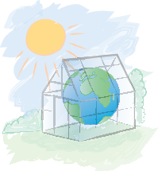
Figure 1 The greenhouse effect due to increasing concentrations of CO₂ and other greenhouse gases in the Earth’s atmosphere
View description - Figure 1 The greenhouse effect due to increasing concentrations of CO2 and other ...

This OpenLearn course is an adapted extract from the Open University course U116 Environment: journeys through a changing world.

Learning outcomes
After studying this course, you should be able to:
- explain the nature and extent of the carbon footprints of individuals and households within the national and global economy
- assess individual carbon footprints using a carbon calculator
- understand the main components of the carbon footprint of individuals and households, and the most effective actions for reducing the footprint
- explore options for reducing the carbon footprint.

1 What is the carbon footprint, and why is it important?
The carbon footprint is the annual amount of greenhouse gas emissions, mainly carbon dioxide, that result from the activities of an individual or a group of people, especially from their use of energy and transport and consumption of food, goods and services. It’s measured as the mass, in kilograms or tonnes per year, either of carbon dioxide (CO₂) emissions alone, or of CO₂ plus the mass of other greenhouse gas (GHG) emissions converted into their carbon dioxide equivalent (CO₂e) global warming effect.
The carbon footprint can also be calculated for an event such as a music festival, or for making and distributing a product such as a car or computer.
The carbon footprint is an environmental indicator – a way of measuring impacts on the environment, in this case mainly climate change. This means that the carbon footprint doesn’t measure other impacts, except sometimes indirectly. For example, driving a petrol or diesel car, as well as emitting CO₂, results in air pollution from nitrogen oxides (NO_{X}), especially the irritant gas nitrogen dioxide (NO₂) and other engine emissions; so the larger your carbon footprint from driving, the more air pollution you are creating.
There are many other environmental indicators that measure different impacts, including air and water pollution, loss of landscapes and biodiversity, and depletion of mineral and water resources. The UK Government, the European Union (EU) and the United Nations publish sets of ‘sustainable development indicators’ which – as well as measures such as economic growth, life expectancy and levels of inequality for different countries – include environmental indicators such as wildlife populations, pollution levels, recycling rates and annual GHG emissions. Another often used environmental indicator is the ecological footprint, which is based on the availability of land and sea to support a population (see Box 1).

Box 1 The ecological footprint
The ecological footprint (EF) is a measure of the environmental impact of a population (e.g. a household, city or nation) based on the area of land and sea theoretically required to indefinitely support its lifestyle at a given level of technology.
The ecological footprint measures the area of land and sea required to produce the population’s food and accommodate its roads, buildings, etc., as well as the forested area required to absorb the population’s CO₂ emissions. So the EF measures the carbon footprint component of a population’s environmental impact using land and sea area. Sometimes 10% land area is added to the ecological footprint for biodiversity conservation. The EF is the indicator used to show that about three planet Earths would be needed if everyone in the world tried to live the current lifestyle of an average European in the long term, which is clearly unsustainable.

1.1 Carbon dioxide and other greenhouse gases
CO₂ emissions are used as the basis for the carbon footprint because it is by far the main contributor to the enhanced greenhouse effect from human activity (mainly burning fossil fuels, clearing forests and making cement). Sometimes only the mass of CO₂ is counted in the carbon footprint. However, as noted earlier, for a complete carbon footprint the other human-generated greenhouse gases are converted into a CO₂ equivalent (in kilograms or tonnes CO₂e) in terms of their global warming effect and added to the footprint. The complete footprint is then expressed as kilograms or tonnes CO₂e per year.
The two main non-CO₂ greenhouse gases associated with human activity are methane (CH₄), mainly from cattle belching, manure spreading and decomposition, wet rice growing and decomposing waste, and nitrous oxide (N₂O), mainly from nitrogen fertilisers and industrial processes. One tonne of methane has the equivalent global warming potential of 21 tonnes of CO₂, while one tonne of nitrous oxide is equivalent to 310 tonnes of CO₂. But because the amounts of methane and nitrous oxide released are much smaller, their emissions together add about 16% to the UK’s contribution, and about 25% globally, to the enhanced greenhouse effect (ONS, 2015; IPCC, 2015). This means that other greenhouse gases should not be ignored when measuring a carbon footprint, although to simplify calculations they often are.
In this course, you will use the total CO₂ equivalent (CO₂e) effect of carbon dioxide plus other greenhouse gases whenever possible, but where only information on CO₂ is available, when discussing carbon footprints, only CO₂ emissions will be used.

1.2 The carbon footprint boundary
Depending on where you draw the boundary, the carbon footprint can apply to: an individual or household; an organisation, event or product; a city, region or country. In this course you will mainly be considering the footprints of individuals, households and the countries they inhabit.
But even then the boundary needs to be defined carefully. Sometimes the carbon footprint is taken to mean an individual’s or household’s direct CO₂ emissions, mainly from burning fossil fuels for home heating and car driving. But this leaves out their indirect CO₂ equivalent emissions arising from the production and distribution of the food, drink and other goods and services they consume, ranging from clothes and electronic products to banking, medical services and Open University modules.
Again depending on the boundary, these indirect emissions often include only those arising from the food, goods and services produced within the country where people live. But they may also include the emissions ‘embedded’ in imports; for example, the emissions produced by the ‘supply chain’ of mines, farms, factories, trucks and ships involved in making and transporting the food, cars and computers that Britain imports from the EU and China.
Whichever measure you choose, the ‘footprint’ image is used to suggest an individual or group treading on or occupying the Earth (Figure 2). It implies that the Earth can’t indefinitely support the lifestyle of that individual or group, and if they are to live sustainably, they’ll have to lighten their footprint.

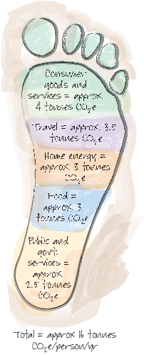
(adapted from Berners-Lee et al., 2011).
Figure 2 The footprint as a powerful image of treading on or occupying the Earth. A UK individual’s carbon footprint arises mainly from home energy use and personal travel, including flights, and from consumption of food, goods and services.
View description - Figure 2 The footprint as a powerful image of treading on or occupying the Earth. ...

1.3 Individual and household carbon footprints
There are different ways of measuring the carbon footprint. The production perspective counts the greenhouse gas emissions produced by the power stations, factories, transport services, farms, buildings, etc., in different sectors of a country’s economy – energy supply, manufacturing, transport, agriculture, construction, etc. From this perspective the producers of goods and services within each country are mainly responsible for that country’s emissions, while households are responsible for only a relatively small percentage (about a fifth) of the total.
The consumption perspective, on the other hand, considers that the purpose of a modern economy is to provide individuals and households with the energy, transport, food and other goods and services they need and want. So individuals and households, as final consumers of all these things, are ultimately responsible for triggering the emissions involved in producing and distributing them, whether at home or imported.
As the focus of this course is on the carbon footprint of individuals and households, and that’s what the carbon calculator, which you’ll be using later, measures, we will be looking at the consumption perspective. While individuals and households may be ultimately responsible for triggering most GHG emissions, they don’t directly control how much of those emissions are produced and so can’t be expected to reduce them unaided. There will be more about this later.
There are different ways in which this consumption-based carbon footprint is measured and broken down, which produce differing results. In this course it’s not the exact numbers that are important, but the general principles.
The official convention is that only the CO₂ from home heating and car driving is counted as an individual’s or household’s direct emissions. Everything else, including emissions from domestic electricity use, car manufacture and maintenance, public transport and personal flights is indirect because it arises from systems not directly controlled by individual consumers. But from an individual’s or householder’s perspective, all home energy use, including electricity, and all transport, including travel by public transport and air, may more logically be viewed as emissions arising directly from their actions. Meanwhile emissions from the production and supply of food and all other goods and services may be viewed as arising indirectly from the actions of others. Viewed from this perspective, Figure 3 shows a breakdown of direct emissions (DTI, 2007).

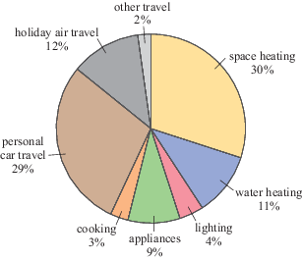
Figure 3 Breakdown of average direct carbon emissions of a UK inhabitant. Annual carbon emissions in 2005 = 1.16 tonnes carbon per person per year. (More recent studies (e.g. Preston et al., 2013) show a similar breakdown of direct emissions, although in less detail.) (DTI, 2007)
View description - Figure 3 Breakdown of average direct carbon emissions of a UK inhabitant. Annual ...

Study note: Pie charts
A pie chart shows different amounts as slices of a circular pie. The whole pie represents the total (100%) amount, so a pie chart is useful for displaying percentage breakdowns.

What does Figure 3 show?
- It is a pie chart and shows the percentage breakdown of the average annual direct carbon emissions of an individual living in the UK. Although this chart is based on 2004–5 data, recent studies show that this direct carbon footprint has not changed significantly.
- The emissions per person in the caption are given in tonnes of carbon (C) rather than carbon dioxide (CO₂). Carbon is just another unit for measuring GHG emissions. So always check whether emissions are given in kilograms or tonnes of C, CO₂ or CO₂e and convert if necessary (see Study note: Converting carbon to CO₂ (or CO_{e}) emissions).
- The pie chart is based on carbon dioxide emissions alone and doesn’t include other greenhouse gases. But as the emissions involved arise from burning fossil fuels for energy and transport, they consist mainly of CO₂. The chart therefore provides a realistic footprint breakdown.
If you look closely at Figure 3 you can see that:
- space (i.e. room) and water heating (41%) and personal car travel (29%), account for the biggest part of an UK individual’s average direct carbon footprint (70% of the total)
- other important carbon footprints arise from powering appliances, including electronic equipment, and lights (13%) and holiday air travel (12%) (25% of the total)
- cooking (3%) and other travel (public transport and motorcycles, 2%) create relatively minor average individual carbon footprints (5% of the total).
As you’ve seen, the direct carbon footprint given in Figure 3 (about 1.16 tonnes carbon or 4.25 tonnes CO₂ per person per year) covers only household energy use and personal travel. It doesn’t include the indirect footprint from consumption of food and other goods and services. You will look at the total footprint in Section 1.4.

1.3.1 Converting carbon to CO₂ (or CO₂e) emissions
This study note will explain how to convert carbon to CO₂ (or CO₂e) emissions.

Study note: Converting carbon to CO₂ (or CO₂e) emissions
You have to be careful when looking at GHG emissions data to be clear on units. Emissions are sometimes expressed in tonnes of carbon rather than carbon dioxide or CO₂ equivalents (CO₂e). This expresses emissions using just the mass of the carbon (C) atom rather than the whole carbon dioxide (CO₂) molecule or CO₂ and other GHG emissions converted into CO₂ equivalents (CO₂e).
Each chemical element has an atomic mass associated with it, but these would be tiny numbers for individual atoms if expressed in grams or kilograms. So these are usually given as the relative atomic masses, taking the mass of a carbon atom to be exactly 12 units (usually abbreviated ‘amu’ for ‘atomic mass units’). Using this convention, the relative atomic mass of hydrogen is close to 1, carbon 12, and oxygen about 16.
So a water molecule H₂O would have a mass of (2 × 1) + 16 = 18 amu. A carbon dioxide molecule (CO₂) would have mass 12 + (2 × 16) = 44 amu.
As a carbon atom has a mass of 12 amu, whereas each CO₂ molecule has mass 44 amu, the form in which emissions totals are given makes a great difference to the amounts recorded. So always check whether emissions are given in units of C, CO₂ or CO₂e, and convert if necessary (as shown below):
- 1 tonne carbon emissions = 1 tonne × 44/12 = 3.67 tonnes CO₂ (or CO₂e) emissions (the extra 2.67 tonnes came from the oxygen atoms in the molecule).
- 1 tonne CO₂ (or CO₂e) emissions = 1 tonne × 12/44 = 0.27 tonnes carbon emissions (the other 0.73 tonnes were oxygen).
OR
- 12 amu of carbon produces 44 amu of CO₂ emissions.
- So 12 tonnes of carbon produces 44 tonnes of CO₂ emissions.
- Therefore 1 tonne of carbon produces 44/12 × 1 = 3.67 tonnes of CO₂ emissions.
However, since the mass of carbon emissions is directly proportional to the mass of CO₂ or CO₂e emissions, the percentage breakdown (e.g. in Figure 3) is the same whether you measure the carbon footprint using C, CO₂ or CO₂e.

1.4 Total footprint
The UK Government publishes information on the country’s carbon footprint, covering both direct and indirect annual GHG emissions, including the emissions embedded in imports. This provides a comprehensive picture of the UK’s total carbon footprint from the consumption perspective (Figure 4).
You’ll notice that, where possible, for UK data publications from government departments such as DEFRA (Department for Environment, Food & Rural Affairs) and DECC (Department of Energy & Climate Change) have been used. The names and responsibilities of these departments can change in government reorganisations (e.g. in 2016, DECC became part of the Department for Business, Energy & Industrial Strategy) but remain an invaluable source of information and statistics.

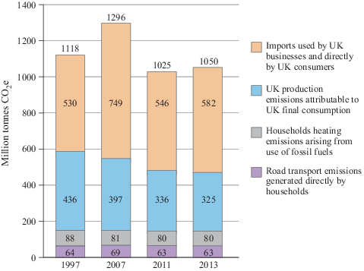
Figure 4 The UK carbon footprint: GHG emissions associated with consumption 1997 to 2013, including emissions embedded in imports but not exports (total = 1050 million tonnes CO₂e in 2013) (DEFRA, 2016)
View description - Figure 4 The UK carbon footprint: GHG emissions associated with consumption 1997 ...

Study note: Stacked bar charts
Figure 4 is a bar chart, another way of showing the breakdown of numerical information. This is a ‘stacked’ bar chart, in which the components that make up the total are shown within each bar.

Notice that in Figure 4 the direct carbon footprint of households (the purple and grey sections of each bar) is relatively small. This is because (unlike in Figure 3) this breakdown uses the official convention, mentioned earlier, in which household electricity for lighting and appliances, travel by public transport and holiday flights are considered as indirect sources of emissions. The total indirect carbon footprint (the blue and brown sections) includes these emissions plus the emissions arising from food, goods and services both produced in the UK and embedded in imports.
This and other studies have shown that about half the UK carbon footprint is the result of the GHG emissions embedded in imports, notably electronic products, clothing and motor vehicles from the EU and Asia. This means that the emissions from an individual’s consumption of imported goods and services have become a major part of their carbon footprint. This proportion is expected to increase, at the same time as the emissions arising from their consumption of energy, goods and services produced within the UK decrease (Barrett et al., 2011; Committee on Climate Change (CCC), 2013).
Also included in the total carbon footprint in Figure 4 are emissions from government activities, including public administration, health, education, defence and capital investment, for example, in railways. This residue, which arguably can’t be allocated to households, amounts to 10% to 20% of the total UK carbon footprint.
This means that consumption decisions by individuals and households are responsible for creating or triggering 80% to 90% of the UK’s carbon footprint (Barrett et al., 2011). This proportion is not unusual for a developed country where final consumption of energy, food, and other goods and services by individuals and households accounts for most economic output.
Now complete Activity 1 to test your understanding of the carbon footprint.

Activity 1 The carbon footprint
Allow about 10 minutes

- What is the carbon footprint?

Provide your answer...
View answer - Part

- Give three different ways of measuring the carbon footprint (in terms of how the mass of emissions is calculated).

Provide your answer...
View answer - Part

- Look at the caption for Figure 3 in Section 1.3. The average UK individual’s direct carbon (C) emissions are given as 1.16 tonnes per person per year. What is this mass expressed as CO₂ emissions?

Provide your answer...
View answer - Part

- What are the main components of an average carbon footprint of an individual living in the UK?

Provide your answer...
View answer - Part

1.4.1 Percentages and parts per million (ppm)
This study note will look at how to calculate percentages and percentage change, as well as parts per million (ppm).

Study note: Percentages and parts per million (ppm)
Percentages (%) indicate proportions and show the number of parts out of 100. For example, 30% is 30 out of 100 and 65.2% is 65.2 out of 100.
To find out the percentage of something, first convert the figures into a fraction and then multiply by 100. For example, if 42 people in a group of 70 vote for a political party, the percentage voting for that party is
42 divided by 70 multiplied by 100, or 42/70 × 100 = 60%.
If you already have a fraction and want to change it to a percentage, you multiply by 100. So three-quarters expressed as a percentage is
3/4 × 100 or 300/4 = 75%.
Similarly, to change a decimal to a percentage, you multiply by 100. For example, the decimal number 0.25 expressed as a percentage is 0.25 × 100 = 25%.
To change a percentage to a fraction, or to a decimal, the percentage is divided by 100. So for example, 30% expressed as a fraction is
30/100, or 0.30 as a decimal; and 65.2% is 65.2/100 or 0.652. Thus for example,

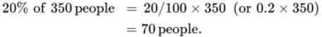
View alternative description - Uncaptioned Equation

Percentage changes
Repeated measurement of an environmental indicator makes it possible to assess change over time. Change between two given dates is often expressed as percentage change in which the figure at the later date is expressed as a percentage of the earlier one.
Calculation of percentage change is best done in stages. For example, if you wish to calculate the percentage increase of atmospheric CO₂ levels, which were 360 parts per million (ppm) in 1995 rising to 378 ppm in 2005, then:
- The increase is (378 – 360) ppm = 18 ppm.
- As a fraction of the original value, this is 18 ppm/360 ppm = 1/20 (or 0.05).
- As a percentage change, this becomes 0.05 (or 1/20th) × 100 = 5% increase.
Note that you always divide by the original (earlier) value regardless of it being numerically larger or smaller than the later one. If it is larger than the later value, then this would be a percentage decrease, which is sometimes written using a minus sign before the number e.g. –5%.
You can also use percentage change the other way round. Suppose you plan to reduce carbon emissions of 350 kg by 20%. What would the new value of emissions be?
There are two ways of tackling this question. Either:
- A 20% reduction leaves 80% of 350 kg of emissions to remain.
- 80% of 350 kg is 80/100 × 350 kg = 280 kg as the new reduced value.
Or:
- 20% of 350 kg is 20/100 × 350 = 70 kg.
- Subtract 70 from the original 350 to give the new reduced value of 280 kg.
Parts per million
Parts per million (ppm) is an alternative to percentages that can be useful for very small proportions. As the name implies, ppm represent the number of parts out of a million (1 000 000) instead of 100. For even smaller proportions, parts per billion (ppb) may be used.
Like percentages, ppm can be converted into a fraction or a decimal. For example, an atmospheric CO₂ level of 400 ppm can be written as 400/1 000 000. This can also be expressed as a decimal as 0.0004. The following sequence shows this conversion step by step.

View alternative description - Uncaptioned Equation

At each step, the top and bottom terms of the fraction are both divided by 10 so the overall value of the fraction does not change.
The fraction 400/1 000 000 that you started with has been simplified by dividing the top and bottom terms by the same number. This is called cancelling out. When you are working through a calculation by hand this is shown by crossing through the numbers that cancel each other out, like this:

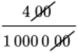
View alternative description - Uncaptioned Equation

Conventionally, fractions are written in their simplest form. In this case, you can simplify further because both top and bottom are divisible by 4 so this fraction can also be written as 1/2500. You can also see from the term 0.04/100 in the sequence above that this is equal to 0.04%.

Activity 2 Calculating percentages
Allow about 10 minutes

Figure 4 (repeated) The UK carbon footprint: GHG emissions associated with consumption 1997 to 2013, including emissions embedded in imports but not exports (total = 1050 million tonnes CO₂e in 2013) (DEFRA, 2016)
View description - Figure 4 (repeated) The UK carbon footprint: GHG emissions associated with consumption ...

Look at Figure 4 from Section 1.4 repeated again above.

- What percentage of the total UK carbon footprint of 1050 million tonnes CO₂e in 2013 is represented by household road transport emissions?

Provide your answer...
View answer - Part

- What is the percentage change in the total UK carbon footprint between 1997 and 2013?

Provide your answer...
View answer - Part

- If the UK managed to reduce its 1997 carbon footprint of 1118 Mt CO₂e by 35% by 2020, what would be the resulting footprint?

Provide your answer...
View answer - Part

1.5 Summary of Section 1
The main learning points from Section 1 are:
- The carbon footprint is the annual mass of ‘carbon’ emissions that result from the activities of an individual or a group, from an event or providing a product or service. To be complete, the carbon footprint should include the direct and indirect emissions of CO₂ and CO₂ equivalent including other GHGs (mainly methane and nitrous oxide). However, for simplicity, carbon footprints based on CO₂ emissions alone are often used.
- The carbon footprint is an environmental indicator that is concerned mainly with climate change. It measures other environmental impacts, such as water pollution, biodiversity and resource depletion, indirectly or not at all.
- Emissions embedded in imported food, goods and services are a major part of the carbon footprint of individuals and households in many developed countries, notably the UK where this proportion is expected to increase.
- From a consumption perspective, individuals and households are directly or indirectly responsible for creating or triggering 80% to 90% of the total carbon footprint of developed countries. Hence, reducing the carbon footprint arising from individual and household activities and consumption is very important in addressing climate change.
Next you will look at the variations in carbon footprints depending on factors such as where you live, the type of home you live in, income, values and lifestyle.

2 Not all footprints are equally heavy
You’ve just read some information about the average carbon footprint of a UK individual or household. But the footprint of a particular individual or household depends on the amounts and types of energy, food, and other goods and services they consume. This means that their carbon footprint depends on where they live, the type of home they live in, their income, values and lifestyle. Thus, carbon footprints of individuals and households vary widely within a country and also between different countries, but especially between rich, developed countries (e.g. the UK), newly industrialised countries (e.g. China), and poor developing countries (e.g. Uganda).
For individual or household carbon footprints, the average (or more correctly, the mean) footprint within a country is usually given (see Study note: Averages – mean and median). These average (mean) values show the variations in carbon footprints between different countries, but conceal the wide variations within each country.

2.1 The carbon footprint of UK individuals and households
The average (mean) carbon footprint of an individual living in the UK can be calculated by dividing total UK annual CO₂ equivalent emissions by the number of people in the country. Using the official government information in Figure 4, this produces a mean footprint of 16.4 tonnes CO₂ equivalent per person per year in 2013.
This provides a realistic mean footprint of a UK inhabitant on a consumption basis because it includes CO₂ and other GHG emissions, and takes the data on emissions embedded in imports into account. Before 2013, embedded emissions were under-counted, but with improved data on international trade, global deforestation, etc., more reliable information is available. The estimated mean UK carbon footprint (updated to 2016) is 14.6 tonnes CO₂e per person, per year – this is the figure used in the carbon calculator that you’ll be using later.
Several studies have attempted to provide a more detailed breakdown of this carbon footprint than given in Section 1 (e.g. Druckman and Jackson, 2010). Unfortunately, as they produce different results depending on the data sources, the methods used and how the breakdown is categorised, when writing this course a decision had to be made as to what to present from a number of studies and reports.
One useful study, which was drawn upon to develop the carbon calculator, breaks down an individual’s mean CO₂ equivalent emissions into a few high-level categories (Table 1).

Table 1 High-level breakdown of the mean UK carbon footprint per person
Sector | GHG emissions per person per year (tonnes CO₂e) | Percentage
Domestic energy and housing | 3.98 | 26.2
Transport | 3.78 | 24.9
Food | 2.07 | 13.6
Consumables (i.e. goods) | 1.83 | 12.1
Private services (e.g. banking) | 1.68 | 11.1
Public services | 1.78 | 11.7
Total emissions (incl. other) | 15.18 | 100.0
(Gough et al., 2012; Dawkins et al., 2010)

More detailed footprint breakdowns for the whole of the UK are difficult to find. But there are detailed studies at local authority level, such as a study of the carbon footprint of Greater Manchester residents (Figure 5).

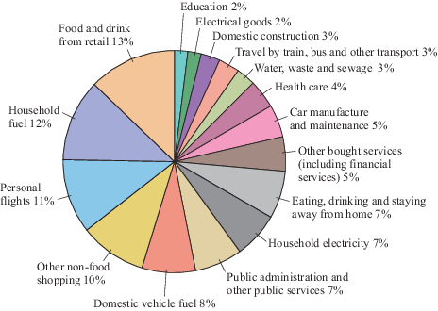
Figure 5 The carbon footprint of Greater Manchester residents, broken down by consumption category (CO₂e per person per year) (Berners-Lee et al., 2011). Note: the percentages add up to over 100% due to rounding (see Study Note: Rounding numbers, decimal places and significant figures).
View description - Figure 5 The carbon footprint of Greater Manchester residents, broken down by consumption ...

The annual carbon footprint of Greater Manchester residents is estimated at 41.2 million tonnes CO₂e. This makes a Manchester resident’s mean footprint 15.7 tonnes. Just over a quarter (27%) of the Manchester footprint is for personal transport (car fuel, flights, public transport and the carbon embedded in cars themselves). Fuel use in homes adds a further 19%. This means that household energy and transport make up almost half (46%) of the total carbon footprint. The rest of the footprint is a mixture of embedded carbon in food and other goods, a wide range of services (from hotel accommodation to financial services) and public services such as education, healthcare, defence and government. This is similar to the breakdown in Table 1 where domestic construction (housing) is combined with household energy use.

2.1.1 Averages – mean and median
In this study note you will look at two different types of averages – the mean and the median.

Study note: Averages mean and median
An average value is often used to provide a ‘typical’ value for a set of data. There are several ways of expressing a typical value, but the most common are the mean and the median.
Mean values
The mean value (commonly called the ‘average’, although it is just one type of average) is obtained by adding up all the values of a set of data and dividing by the number of items in the set. For example, if three individuals have carbon footprints of 13, 9 and 17 tonnes CO₂e per year, their total footprint is 13 + 9 + 17 = 39 tonnes CO₂e per year. Their mean footprint is the total divided by the number of individuals, i.e. 39/3 = 13 tonnes CO₂e per person per year.
The mean is also used when several values contribute to an overall value, as in the case of assignment marks. If you had the assignment marks 67%, 82%, 45%, 75%, 77%, 68%, and they all counted equally towards your final score, you could work out your overall mean percentage score by adding the six scores together and dividing by that number of scores, i.e.
(67 + 82 + 45 + 75 + 77 + 68)/6 = 69%.
To calculate the mean carbon footprint of a UK inhabitant (in 2013) using the information in Figure 4, you divide the total UK emissions of 1050 million tonnes CO₂e by the 2013 UK population of 64.1 million. The result is 16.380655. Rounded to one decimal place this is 16.4 tonnes CO₂e per person per year. (See Study Note: Rounding numbers, decimal places and significant figures at the end of this section.)
Median values
Although the example above gave a value for the amount of CO₂e emissions that could be attributed to each person on an equal basis, this may not represent a ‘typical’ person. This is because there may be a group of heavy emitters that have a larger effect on the total (and hence the mean) than the majority of more modest emitters. In this case the median is a better indication of a typical individual’s footprint.
So, if the carbon footprints of a sample of 11 individuals were 21, 6, 15, 16, 10, 9, 13, 25, 12, 11, 27 tonnes CO₂e per year, the mean footprint is 165/11 = 15 tonnes CO₂e per year.
The median footprint is obtained by arranging the data into ascending order, as follows:
6, 9, 10, 11, 12, 13, 15, 16, 21, 25, 27 tonnes CO₂e per year the median footprint is the middle value in the set = 13 tonnes CO₂e per year, i.e. the sixth value in the set, with five below and five above it.
If there are an even number in the sample, say 10 individuals with footprints of
9, 10, 11, 12, 13, 15, 16, 21, 25, 27 tonnes CO₂e per year
then the median is halfway between the two middle numbers (13 and 15), i.e. 14 tonnes CO₂e per year, again with five values below and five above.
Consider another example, the UK’s income distribution. Some people have very high incomes and some have low incomes, with the majority spread between the extremes. Figure 6 shows the official distribution of the UK population by household incomes (after tax and before deduction of mortgages and rents) in 2014–15. The mean household income in 2014–15 is £581 per week (£30 212 per year), calculated by adding up all the incomes and dividing by the number of individuals living in households whose incomes were measured.
The median income is the amount which divides the income distribution into two equal groups, half having an income above that amount, and half having an income below that amount. The median household income in 2014–15 is £473 per week (£24 596 per year), which is less than the mean and more representative of an ‘average’ or ‘typical’ household.

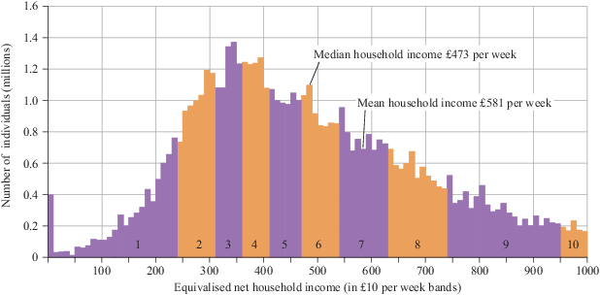
Figure 6 Distribution of the UK population by household incomes in 2014–15. Group 1 is the distribution of household incomes for the 10% of individuals living in the poorest households. Group 10 is the household incomes for the 10% of individuals living in the richest households (excluding 5.3 million individuals with a household income above £1000 per week). Equivalised means the incomes are adjusted to take account of the numbers of adults and children in a household (adapted from DWP, 2016).
View description - Figure 6 Distribution of the UK population by household incomes in 2014–15. Group ...

2.1.2 The effect of incomes and household types
The carbon footprints given in Section 2.1 are averages (means) for a UK inhabitant. But, as mentioned earlier, footprints differ considerably for different individuals and households.
A factor which has a major effect on the footprint is individual or household income (a distribution of which was shown in Figure 6). In general, the higher a person’s or household’s income is, the higher their carbon footprint will be. This is not just because wealthier people generally consume and travel more, but because, even if they save a lot, their savings will be invested to produce products and services for consumption, which indirectly adds to their footprint.
For example, the study that provided the Table 1 breakdown also showed how the footprint per person differed for ten groups, from households with the lowest 10% to households with the highest 10% of UK incomes (Figure 7).

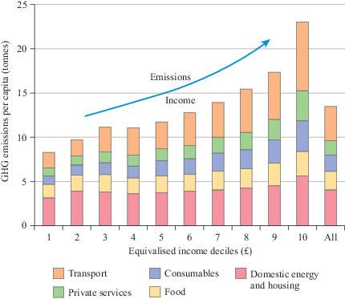
Figure 7 Mean carbon footprints (tonnes CO₂e per person per year) by emission categories for ten household income groups, excluding public services. (The income groups are categorised as in Figure 6.) (Gough et al., 2012)
View description - Figure 7 Mean carbon footprints (tonnes CO2e per person per year) by emission categories ...

Look carefully at Figure 7. Can you see that the carbon footprint per person for households with the highest 10% of incomes is about three times that of people living in households with the lowest 10%? This is true for all categories, but especially for consumables (goods), private services and transport.
A similar income-related pattern has been shown for the direct carbon footprint that just includes energy use and transport. The richest 10% of households have three times the footprint (including the emissions from energy use in the home and all personal travel by car, public transport and air) of the poorest 10% (Preston et al., 2013).
Thus wealthier people generally have a greater environmental impact than poorer people and so arguably have a greater responsibility for reducing their footprints.
The carbon footprint per person also varies with household size and composition. The Table 1 study also showed how the carbon footprint per person varied for different sizes and types of household (Figure 8).

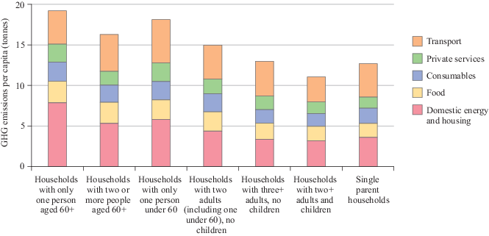
Figure 8 Mean carbon footprints (tonnes CO₂e per person per year) by household type (Gough et al., 2012)
View description - Figure 8 Mean carbon footprints (tonnes CO2e per person per year) by household type ...

Figure 8 shows that one-person households (bars one and three) generally have heavier footprints per person than those with two or more members, including children (especially bars five and six). This is because people living alone usually occupy and heat a bigger space per person and don’t share as many goods and services as larger households.
So, one of the barriers to reducing carbon footprints is the growing number of one-person households (now nearly a third of all UK households). Sharing your home, therefore, can be one of the most effective ways of reducing your individual footprint.

2.2 Household carbon footprints in other developed countries
Although the mean carbon footprints per person vary in different European and other developed countries, depending on their energy supply system and economy, the footprint breakdown is generally similar to that for the UK. You will now look at two major economies for a brief comparison: Germany and the USA.
A study of the carbon footprint of German households found that the mean footprint was 14.3 tonnes CO₂e per person per year. Housing (which in this study covered domestic fuel use, purchase of appliances and furniture, water use and rent) was responsible for the highest share of emissions (34%); followed by personal transport (24%), including car manufacture, fuel and maintenance, public transport and air travel; then food and drink (18%); goods such as clothing and shoes (15%); and services such as health and education (9%). As for the UK, the study found heavier carbon footprints were associated with higher household incomes and smaller household sizes (Miehe et al., 2015).
A US study (Weber and Matthews, 2008, updated by Hubacek, n.d.) found that the mean American carbon footprint was about 23.5 tonnes CO₂e per person per year. This is considerably heavier than mean European footprints, but its breakdown is similar, with the largest components again being personal transport, home energy use, food, and consumption of goods and services and, especially in the US context, private health services.
One difference in the carbon footprint breakdown is the result of the amounts of room heating and cooling required in different climates. In the USA, for example, 87% of homes had air conditioning in 2009, which used over 6% of all household energy (US EIA, 2013). In Britain, by comparison, few homes at present need or have air conditioning.
Earlier it was mentioned that the carbon footprint measures only CO₂ and other GHG emissions while other environmental impacts are included only indirectly or not at all. This was highlighted by an earlier American study (Brower and Leon, 1999) which showed that personal transport, food production and home energy use, as well as emitting large amounts of GHGs, were also major sources of toxic air and water pollution and damage to wildlife habitats.

2.2.1 Carbon footprint components
Now you have found out about the main components of the mean carbon footprint per person per year for the UK, USA and Germany, as well as more detailed components for a resident of Greater Manchester in the UK, complete Activity 3 which asks you to consider and compare these mean footprints.

Activity 3 The carbon heavyweights
Allow about 10 minutes

Figure 5 (repeated) The carbon footprint of Greater Manchester residents, broken down by consumption category (CO₂e per person per year) (Berners-Lee et al., 2011). Note: the percentages add up to over 100% due to rounding (see Study note: Rounding numbers, decimal places and significant figures).
View description - Figure 5 (repeated) The carbon footprint of Greater Manchester residents, broken ...

- Look at Figure 5, repeated above. What are the components of the carbon footprint of a Greater Manchester resident broken down into high-level categories (e.g. travel, food, home energy, goods and services)?

Provide your answer...
View answer - Part

- Look at Table 1 and this section. Is the personal footprint breakdown for the UK as a whole similar to that for other developed countries, such as Germany and the USA?

Provide your answer...
View answer - Part

2.3 International comparisons of carbon footprints
You’ve seen that the carbon footprint is a simple idea, but calculating it can be complicated. It depends on whether you count only CO₂ or all GHGs and whether you include the emissions embedded in imports and exports. It also depends on whether you include the emissions associated with changes in land use and forests and from international aviation and shipping which have not been mentioned until now.
This complexity means that international comparisons are usually based on the most widely available data, namely emissions of CO₂ alone arising within a country’s borders (so-called territorial CO₂ emissions).

2.3.1 Carbon footprints per person
The statistics clearly show huge differences between countries in carbon footprints per person. Table 2 shows the mean annual footprint per person for selected countries in 2011, when the latest reliable data for all countries were published by the United Nations (UN), plus estimated footprints for 2015 from another source. These footprints are for territorial emissions of CO₂ and so do not include imports and exports. Hence in Table 2 the mean carbon footprint for a UK inhabitant is 7.2 tonnes of CO₂ alone rather than 14 to over 16 tonnes of CO₂ equivalent GHG emissions discussed in previous sections. That’s because about half of the UK footprint is emissions embedded in imports.

Table 2 Mean annual territorial carbon footprint per person for selected countries (CDIAC, 2015; Global Carbon Atlas, 2016)
Country | CO₂ per person, tonnes per year (for 2011, rounded) | CO₂ per person, tonnes per year (estimates for 2015, rounded)
Saudi Arabia | 18.7 | 19
United States | 16.8 | 17
Australia | 16.2 | 17
Russian Federation | 12.6 | 11
Japan | 9.3 | 9.8
Israel | 9.2 | 8.9
South Africa | 9.2 | 8.5
Germany | 8.8 | 9.9
Ireland | 8.0 | 7.9
United Kingdom | 7.2 | 6.4
China | 6.6 | 7.5
Sweden | 5.5 | 4.3
France | 5.3 | 5.3
Thailand | 4.6 | 4.6
Turkey | 4.4 | 4.9
Romania | 3.9 | 3.8
Egypt | 2.8 | 2.4
Brazil | 2.2 | 2.5
India | 1.7 | 1.7
Pakistan | 0.9 | 0.9
Nigeria | 0.5 | 0.6
Uganda | 0.1 | 0.1
World average (mean) | 4.8 | 4.9

Figure 9 shows estimated footprints for more countries presented in graphical form for the year 2015.

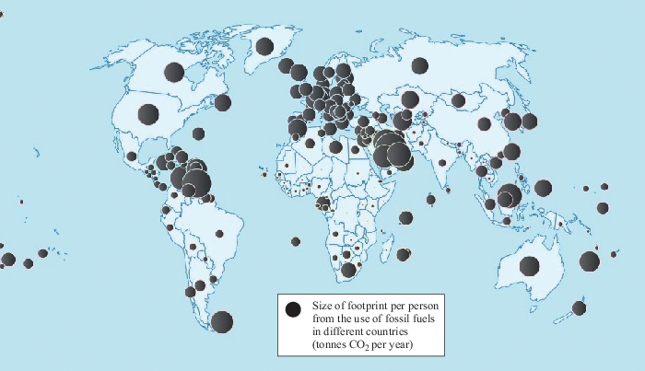
Figure 9 Estimated territorial CO₂ emissions per person in 2015. The bigger the black bubble, the bigger the footprint per person for the country indicated. (Global Carbon Atlas, 2016)
View description - Figure 9 Estimated territorial CO2 emissions per person in 2015. The bigger the black ...

Having reviewed Table 2 and Figure 9, now complete Activity 4.

Activity 4 International comparisons
Allow about 15 minutes

Look at the data for 2015 in Table 2.
How heavy is the mean territorial carbon footprint of a UK inhabitant (in tonnes CO₂ per person per year) compared to the mean footprints of inhabitants of the USA, China, Sweden, India, Uganda and the world mean? Round your answers to the most appropriate number of significant figures (see Study note: Rounding numbers, decimal places and significant figures).
Here’s an example. UK divided by Brazilian CO₂ emissions = 6.4/2.5 = 2.56 = 2.6 rounded to two significant figures. Thus, the mean carbon footprint of a UK inhabitant is over two and a half times heavier than the mean for a Brazilian.

Table 3 The carbon footprint of a UK inhabitant in 2015 relative to that of other countries
Country | Mean footprint per person (tonnes CO₂ per year) | UK mean footprint per person relative to other country’s mean footprint per person
UK | Provide your answer... | Provide your answer...
USA | Provide your answer... | Provide your answer...
China | Provide your answer... | Provide your answer...
Sweden | Provide your answer... | Provide your answer...
India | Provide your answer... | Provide your answer...
Uganda | Provide your answer... | Provide your answer...
World mean | Provide your answer... | Provide your answer...

View discussion - Activity 4 International comparisons

2.3.2 Total carbon footprints
The picture of carbon footprints changes again when you consider total CO₂ emissions for different countries rather than emissions per person. Table 4 shows that by 2011 China had become by far the greatest total emitter of CO₂, followed by the USA and India. In terms of consumption-based emissions too, the three greatest CO₂ emitters were China, the USA and India (CCC, 2013).

Table 4 Total territorial carbon dioxide emissions for selected countries (CDIAC, 2015; Global Carbon Atlas, 2016)
Country | Total CO₂ (2011), million tonnes per year (rounded) | Total CO₂ (2015 est.), million tonnes per year (rounded)
China | 9020 | 9680
United States | 5306 | 5561
India | 2074 | 2597
Russian Federation | 1808 | 1595
Japan | 1188 | 1232
Germany | 730 | 789
Saudi Arabia | 520 | 602
South Africa | 477 | 476
United Kingdom | 448 | 428
Brazil | 439 | 507
Australia | 369 | 382
France | 339 | 331
Turkey | 321 | 573
Thailand | 303 | 337
Egypt | 221 | 237
Pakistan | 164 | 168
Nigeria | 88.0 | 93.6
Romania | 84.8 | 72.6
Israel | 69.5 | 67.2
Sweden | 52.1 | 44.3
Ireland | 36.1 | 35.9
Uganda | 3.8 | 4.3
World average (mean) | 150.8 | (World total 36 292)
Note: the CO₂ emissions shown in Tables 2 and 4 are based on from burning fossil fuels, cement manufacture and gas flaring.
(CDIAC, 2015; Global Carbon Atlas, 2016)

Figure 10 shows more of the same information updated using estimations to 2015, when China, USA and India emitted half of the world’s CO₂.

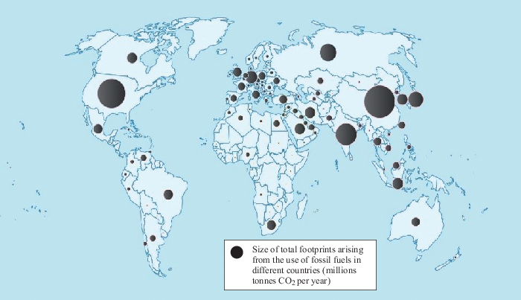
Figure 10 Estimated total territorial CO₂ emissions in 2015 (Global Carbon Atlas, 2016)
View description - Figure 10 Estimated total territorial CO2 emissions in 2015 (Global Carbon Atlas, ...

2.3.3 Differences between people and places
Mean individual and household carbon footprints for a country conceal the differences within that country. As you saw for the UK, these differences in carbon footprints are strongly related to income and can be very great.
For example:
- in India the 2015 mean carbon footprint of 1.7 tonnes CO₂ per person per year hides the differences between middle-class Indian households living in air-conditioned apartments and owning a television, refrigerator and motor scooter, or perhaps a car (Figure 11(a)), and the household of a subsistence farmer, whose only fuel is dried cow dung for cooking, and perhaps kerosene for a lamp (Figure 11(b))
- in Africa, the contrast between the elite, who may have a private swimming pool, and villagers who have to collect water for cooking and washing (Figures 11(c) and (d)) is not shown
- in China, where the lifestyles of the wealthier members of the very rapidly growing urban population still contrast with those of people living in China’s villages and rural areas (Figures 11(e) and (f)).

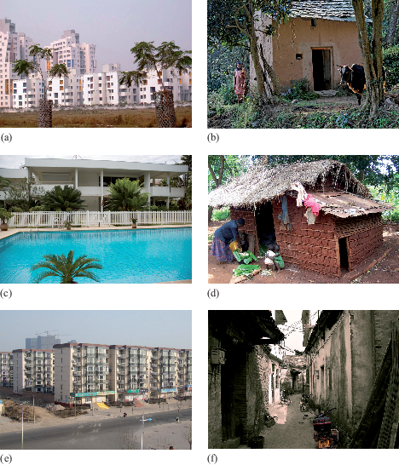
Figure 11 (a) Apartments, New Town, Kolkata, India, built for India’s fast-growing middle class; (b) Indian cattle farmer living on less than £1 per day; (c) government official’s house, Libreville, Gabon; (d) villager’s house, Jinja, Uganda; (e) typical apartment block, China; (f) village alley, near Yangshuo, China
View description - Figure 11 (a) Apartments, New Town, Kolkata, India, built for India’s fast-growing ...

2.3.4 Rounding numbers, decimal places and significant figures
In this study note you will look at decimal places, significant figures and rounding numbers, as well as how to choose what precision to give an answer.

Study note: Rounding numbers, decimal places and significant figures
Rounding numbers
Numbers are often ‘rounded up’ or ‘rounded down’ depending on how precise they need to be. Often a good approximation of a number is adequate, and this process is called ‘rounding’.
When rounding a number up or down you need to look at the digit immediately to the right of the digit you are rounding to. If this right-hand figure is between 0 and 4 (i.e. less than 5), then the digit you are rounding to stays the same, and if it is between 5 and 9 (i.e. 5 or greater), then it is raised to the next whole number. For example:
62 to the nearest 10 is 60, as the digit to the right of the 6 is 2, which is between 0 and 4, so the 6 remains the same;
2932 to the nearest 1000 is 3000, as the digit to the right of the 2 is 9, which is between 5 and 9, so the 2 is rounded up to a 3.
Decimal places and significant figures are two commonly used ways of rounding.
Decimal places
Decimals are often rounded to a given number of decimal places. Decimal places are those to the right of the decimal point, e.g. 5.368 has three decimal places. To round this to two decimal places: find the second decimal place (6) and look at the number to its right (8). As that number is between 5 and 9, the second decimal place is rounded up to the next whole number, which is 7. So 5.368 rounded to two decimal places is 5.37.
To round 5.3634 to two decimal places: the second decimal place is 6 and the figure to its right (3) is less than 5, so the 6 remains as it is. So, 5.3634 rounded to two decimal places is 5.36.
Significant figures
If you are dealing with very large or very small numbers, rounding to a number of decimal places is not convenient. Instead you need a way of rounding numbers that just considers the most important digits in each number. These are called significant figures and tell you roughly how big or how small the number is. The first significant figure in a number is the first non-zero digit on, or starting from, the left (ignoring the location of any decimal point).
For example, the first significant figure in 3 246 485 is the 3. It tells you that the number is between 3 and 4 million. The first significant figure in 0.00245 is 2, which tells you that the number is between 2 and 3 thousandths. You can round a value to any number of significant figures in a similar way to decimal places.
Here are two examples:
- Rounding 3174 to 2 significant figures (the abbreviation ‘sig. fig.’ or ‘s.f.’ is often used).
The first s.f. is 3 and the second is 1. The digit to the right of the 1 is 7; this is between 5 and 9, so the second s.f. is rounded up to 2, giving the answer: 3174 = 3200 (to 2 s.f.).

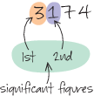
View description - Uncaptioned Figure

- Rounding 0.0446 to 1 s.f.
The first s.f. is 4. The digit to the right is 4; this is between 0 and 4, so the first s.f. remains as 4, giving the answer: 0.0446 = 0.04 (to 1 s.f.).

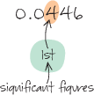
View description - Uncaptioned Figure

Choosing appropriate precision
When using data or measurements in a calculation, you may need to decide how much to round off the final result, especially if you use a calculator that shows many digits. The rule is that the final result shouldn’t be more precise than the data used to produce it, and this should be the number of significant figures in the answer.
For instance, in Activity 4 you compared UK mean carbon footprints with those of other countries. For India, the calculation was (6.4/1.7) = 3.764705882 tonnes on a calculator. The original data were given to 2 s.f., so it is appropriate to round the final result to 3.8 tonnes (to 2 s.f.).
If the original data are not all given to the same number of significant figures, then the least precise item limits the final precision. For instance, in Table 2, the ratio for UK/Uganda emissions is 6.4/0.1 = 64 tonnes. The Uganda value of 0.1 is given to only 1 s.f., so the answer should be 60 tonnes (to 1 s.f.).

2.3.5 Viewing and listening for a purpose
Videos can be a powerful medium for showing and explaining complex subjects. They can help you move away from static words to show the dynamics of events, interactions and processes. This study note will give advice on how to view a video effectively.

Study note: Viewing and listening for a purpose
To view video effectively, make sure you can watch without distractions, as when learning from text. Before you view, think about why you are watching a video. Is it to help you gain deeper understanding of a topic or to provide illustrative background material? Will you need to incorporate ideas from the video into an assignment? To learn effectively from viewing, read any notes supplied or the relevant sections of the course beforehand.
When viewing a video there’s a lot of information to take in at once. So after viewing, write down the main points. Don’t write down everything – key points reflecting the video’s purpose are most useful in triggering your memory and understanding. You may want to note down questions or links to things you’ve seen before. You can, of course, stop viewing to take notes or go through to the end – do what works best for you. Sometimes the material may be very rich, and you may feel it is worth viewing several times, but consider whether you have time for this.
If you use these techniques you should be able to use the many environmental TV, radio and online programmes more effectively to enhance your knowledge and understanding. A word of caution – words and images on video and TV are very engaging and may easily convince you. But they give only a version of events and, as with written materials, you should ask questions about the reasons behind the programme and whether alternative views may be just as valid.

Now watch the following video by statistician Professor Hans Rosling who explains why it is important to compare carbon dioxide emissions per person for different countries (as in Table 2 and Figure 9), rather than total emissions, in order to develop policies for tackling climate change on a fair basis. Then complete Activity 5.

Video content is not available in this format.
Video 1 Hans Rosling on carbon emissions
View transcript - Video 1 Hans Rosling on carbon emissions

Activity 5 Hans Rosling on carbon emissions
Allow about 10 minutes

- Why does Rosling say it is necessary to compare countries on emissions per person rather than total emissions?

Provide your answer...
View answer - Part

- From which groups of countries does Rosling say the main growth in emissions will come in the future?

Provide your answer...
View answer - Part

- What level does Rosling suggest different groups of countries aim for in reducing their emissions?

Provide your answer...
View answer - Part

- What does Rosling leave out of his analysis?

Provide your answer...
View answer - Part

2.3.6 Carbon footprint at home
The carbon footprint, as an indicator of how heavily people are ‘treading on the Earth’ and affecting the climate, is a rather abstract idea. Videos 2 and 3 are a collection of extracts from a BBC/OU TV programme, Can we save planet Earth?, which provides striking images of a household’s footprint as black blocks of carbon coming out of a house, car and power station. Although the programme was made in 2006, the issues it discusses are still relevant today, even though some of the information it presents has changed. For example, as you’ve seen, China has now overtaken the USA to become by far the world’s largest CO₂ emitter. Video 2 examines the carbon emissions of a fictional average suburban family – the Carbons – who live in a rich country, like the USA.

Video content is not available in this format.
Video 2 The Carbons
View transcript - Video 2 The Carbons

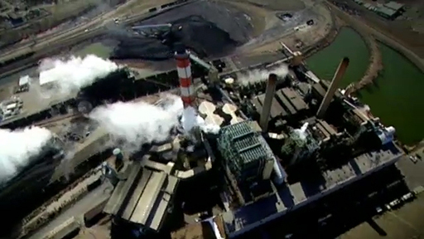

Now watch Video 3 which looks at the Tans, a fictional and upwardly mobile couple who are about to move into a new apartment block in a suburb of a Chinese city, mainly fuelled by carbon-heavy electricity from China’s coal-fired power stations.

Video content is not available in this format.
Video 3 The Tans
View transcript - Video 3 The Tans

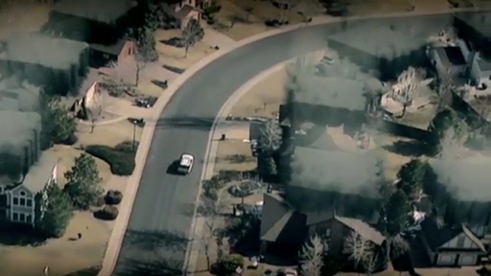

Activity 6 The Carbons and the Tans
Allow about 20 minutes

- According to the video, what are the main sources of CO₂ and other GHG emissions created by the Carbons’ and the Tans’ households?

Provide your answer...
View answer - Part

- What major source of emissions does the video not mention explicitly?

Provide your answer...
View answer - Part

2.4 Summary of Section 2
The main learning points from Section 2 are:
- There are different ways of calculating the carbon footprints of individuals and households. Excluding the emissions embedded in imports and exports, the mean territorial UK footprint is about 7 tonnes of CO₂ per person per year. But more realistically, including imports and exports and other GHGs, the mean consumption-based UK footprint is about 14 to 16 tonnes of CO₂ equivalent per person per year.
- The main components of individual and household carbon footprints in developed countries are: car and air travel; household gas and electricity use; the consumption of food and other goods; and the use of private and public services.
- The carbon footprints of individuals and households vary widely within countries, related especially to people’s incomes, household sizes and lifestyles. For example, the carbon footprint per person of people living in UK households with the highest 10% of incomes is about three times that of those with the lowest 10%.
- The carbon footprint also varies between countries, by amounts depending on how it is calculated. For example, the mean territorial carbon footprint of an inhabitant of China is now similar to that of someone living in the UK, but if the emissions embedded in imports and exports are included, then the mean UK footprint is about three times that of a Chinese person.
- There are wide variations in carbon footprints, especially between wealthy, middle-income and poorer people and countries.
- It is fairer to compare countries on mean carbon footprints per person than on total emissions, although this obscures the differences between the footprints of rich and poor people within each country.
Next you will measure your own carbon footprint.

3 How heavy is your footprint?
You’ve seen that individual and household carbon footprints vary widely both within and between countries. So, in this section you’ll be measuring your individual (i.e. personal) carbon footprint using a computer-based calculator.
The carbon calculator was specially developed for the Open University by drawing upon some of the studies and reports discussed in previous sections. The data from these were then updated using the latest available statistics.
In Section 2, you saw that household income and the number of people occupying the household usually have a big effect on individual carbon footprints. That’s why these questions are included in the carbon calculator.
The calculator will show you which consumption activities make large and small contributions to your carbon footprint. But because the calculator is a model of reality, a simplified representation of the real world, it can give you only an approximate measure of your carbon footprint and how it is broken down into: emissions arising from the energy you use for room and water heating; your travel by car and air; your typical diet, usual spending habits, and so on.
The results the calculator produces are only as good as the accuracy of the data, assumptions, equations and options within the model and the information you enter into it. For example, if you drive a medium-sized petrol-engine car, the calculator works out the carbon footprint of your personal car travel by multiplying your approximate annual car mileage (chosen from a drop-down list of options) by the mean CO₂ emissions per kilometre for medium (1.4 to 2 litre) petrol engines from official statistics adjusted for the number of people who typically occupy a household car when in use. The accuracy of the car footprint depends on how close your actual car mileage is to the options offered by the calculator, how close your actual car emissions are to the mean for 1.4 to 2 litre petrol-engine cars, and how typical your car occupancy actually is.
The calculator could, of course, provide a more accurate car travel footprint if it asked you for more detailed information, such as the make and model of your car, how many people usually travel in the car and your typical annual car mileage. But it could be time-consuming and laborious if this amount of detail were required for all the questions in the calculator. Carbon calculators therefore make compromises between the time and effort required to use them and their accuracy. This one tries to make the process fairly quick and easy, and focuses on the information that has the biggest effects, in order to provide an approximate, but realistic, individual carbon footprint.
The carbon calculator also enables you to try out the effects on your footprint of making changes; for example, to your home’s energy efficiency. Testing different changes without having to make them in reality is a form of computer modelling. In Section 4 you’ll be asked to reduce your footprint by modelling the effects of changes allowed by the calculator – such as driving or flying less or more, or changing your car, diet or spending behaviour. Because it uses the consumption-based perspective, the calculator assumes that most of the nation’s footprint arises from consumer demand and behaviour. The emissions generated by public services, business and non-governmental organisations are allowed for to some extent, but the main responsibility for reducing the footprint is given to individuals and households. However, in Section 5 you can try out the effects on your footprint of making changes beyond the household level, such as spending some of your income on ‘voluntary carbon offsets’ for carbon-saving projects overseas or agreeing to tax increases for national investments in low-carbon technologies.

3.1 Calculating your carbon footprint
How big is your carbon footprint? And what are the main contributors to your carbon footprint? You will now use the OU carbon calculator to work out an approximation of your individual footprint and identify your actions which contribute to it.

Activity 7 Your carbon footprint
Allow about 1 hour

a. Following the steps below, use the OU carbon calculator to work out your individual carbon footprint.
- Click on the following link to view the carbon calculator. Open the link in a new window or tab so you can easily find your way back to the course: OU carbon calculator.
- Select ‘Next’ on the Welcome screen to start.
- Answer the questions on the calculator’s tabs from ‘Your Household’ to ‘Goods’ for your existing situation. You’ll find that some questions are fairly general and don’t exactly fit your personal situation and there are options that require estimates (or even ‘guestimates’). So you’ll have to choose answers or values that fit your situation as closely as possible.
- Note that some questions refer to the whole household and some to you personally. If the question asks what do ‘you’ do (e.g. How many minutes do you spend in the shower?) it generally means you personally, unless it’s clear that all household members are involved (e.g. What main fuel do you use to heat your hot water?).
- Additional guidance and FAQs can be found here
As you answer the questions, the changes to your footprint will be shown on the ‘You’ bar chart and on the Summary screen, together with the UK Average individual footprint for comparison.
- When you are satisfied that you have the best estimate of your existing footprint; go to the Summary tab. Then name (e.g. ExistingFootprint1) and save a record of your footprint. You can make changes to your answers as many times as you like until you are satisfied you have the best estimate of your footprint.
Figure 12 below shows the OU carbon calculator ‘Summary’ footprint screen, with an example existing carbon footprint from a hypothetical student (in the left-hand column of the table and the left-hand bar chart) and the UK average (mean) carbon footprint (in the right-hand column of the table and the right-hand bar chart).

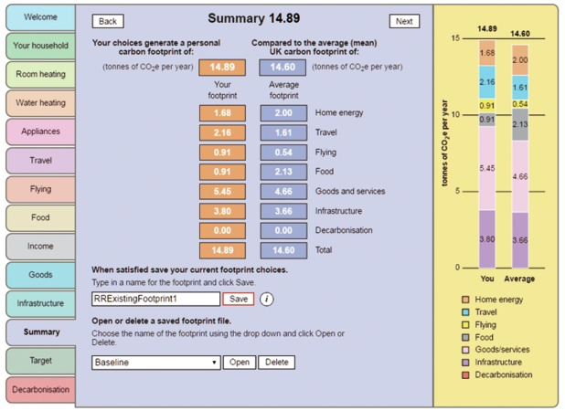
Figure 12 An example of the OU carbon calculator ‘Summary’ footprint screen. The student’s existing footprint is 14.89 tonnes CO₂e per year; this is greater than the UK national average of 14.60 tonnes CO₂e per person per year.
View description - Figure 12 An example of the OU carbon calculator ‘Summary’ footprint screen. The ...

b. The carbon calculator is a simplified computer model of the real world. Why is such a model useful, and what is the implication of it being based on the consumption perspective for measuring carbon footprints?

Provide your answer...
View answer - Activity 7 Your carbon footprint

3.2 Summary of Section 3
The main learning points from Section 3 are:
- Individual and household carbon calculators are models that use data, mathematical equations and assumptions to convert information that you provide about your home, travel, etc. into an approximate figure for your carbon footprint.
- The results provided by a carbon calculator can only be as good as the accuracy of the data, assumptions, equations and options within the model and the information entered into it. Carbon calculators have to make compromises between usability and accuracy.
- Carbon calculators allow you to model the effects on your carbon footprint of making changes (e.g. to your home’s energy efficiency, travel choices or diet), and so explore how best to reduce your footprint.
Now you know the extent of your carbon footprint, next you will look at ways of reducing it.

4 Reducing your carbon footprint
Calculating your individual carbon footprint using the OU carbon calculator gives you a good idea of the contribution to the total footprint made by your choices regarding energy, food, travel, etc. You’ll also know how your carbon footprint compares to that of the mean footprint per person for the UK or another country.
Unless you already live a very ‘green’ lifestyle, it’s unlikely that your footprint will be light enough (at 2 to 3 tonnes CO₂e) to be compatible with long-term environmental sustainability, or at least to help avoid dangerous climate change in the coming decades.
This section, therefore, discusses targets for reducing carbon footprints towards an environmentally sustainable level. At the end of the section, you’ll then use the carbon calculator again to explore options for reducing your footprint towards such targets.

4.1 Carbon reduction targets
The first international agreement to set carbon reduction targets was the 1997 United Nations Kyoto Protocol. This came into force in 2005 and required developed countries to reduce their human-generated GHG emissions by an average of just over 5% on 1990 levels between 2008 and 2012. The developing countries that signed up, including India and China, were not required to meet any reduction targets, and the USA never ratified the treaty to make it legally binding. The Kyoto Protocol was a modest first step and known to be inadequate to meet the challenges of climate change.
Since Kyoto, a series of UN climate change conferences have come into force, which have attempted to get international agreements on limiting GHG concentrations in the atmosphere to a ‘safe’ level. This level has been interpreted as the concentration that gives better than a two-thirds chance that the mean global temperature will not rise by more than 2 °C (and ideally no more than 1.5 °C) above pre-industrial levels this century (IPCC, 2015).
A sustainable carbon footprint, likely to avoid the worst effects of climate change (and other adverse environmental impacts), is calculated to be about 2 to 2.5 tonnes CO₂ equivalent for every person on the planet. This requires today’s total global GHG emissions to be at the very least halved by 2050 (IPCC, 2015). And for the UK to achieve a sustainable footprint, each inhabitant’s mean consumption-based carbon footprint of 14 to 16 tonnes CO₂e per year would have to be reduced by over 80% by 2050 (CCC, 2015). This level of cuts had been anticipated by the authoritative Stern Review (HM Treasury, 2006). Importantly, Stern calculated that the cost of taking the actions to achieve these reductions would be much less than the costs of not doing so; for example, dealing with storms, floods, and food and water shortages.
After very slow progress, the most successful UN climate conference to date was the one held in Paris in December 2015. It agreed on the need for drastic cuts in GHG emissions and was signed by most countries in April 2016.
For its part, the UK Government has exceeded its Kyoto target and in 2008 passed a pioneering Climate Change Act.
Under this Act the Committee on Climate Change was set up to advise the government on carbon budgets and associated emission reduction targets. The Committee recommended a cut of 35% in UK GHG emissions by 2020, 50% by 2025 and 57% by 2030 on the way to a reduction of at least 80% in the nation’s emissions by 2050, all compared to 1990 levels. These targets are legally binding, and by 2016 the UK had already exceeded its 2020 target. But in line with the UN’s Climate Convention, these targets are based on territorial GHG emissions and so don’t include the other half of the UK’s carbon footprint embedded in imports, which you learned about in Sections 1 and 2. Also, the reductions were mainly due to more electricity generated by renewables and less use of coal, while reductions from other sectors such as transport and housing had stalled. And the Paris Agreement would require even greater reductions in the UK’s emissions by 2050 than the current 80% target (CCC, 2016).
What might these targets mean for your individual carbon footprint?

Activity 8 Carbon footprint targets
Allow about 30 minutes

The mean territorial carbon footprint of a UK inhabitant in 1990 was 14.2 tonnes CO₂e per person per year (UNFCCC, 2015).
- What should be the mean carbon footprint of a UK inhabitant given the following targets?
  - The UK Government’s target of a 35% reduction in territorial GHG emissions on 1990 levels by 2020.
  - The government’s target of a 50% reduction by 2025.
  - The government’s target of an 80% reduction by 2050.
- On a consumption basis, including imports and exports, the 1990 UK footprint was approximately 15.7 tonnes CO₂e per person per year (CCC, 2013). What would be the footprints for the above reduction targets?
Spend 10–20 minutes on this first part of the activity before looking at the discussion below. See Percentages and parts per million (ppm) in Section 1 for how to calculate percentage reductions.

Provide your answer...
View discussion - Part

If you live outside the UK, find the mean CO₂ emissions per person for your country using the sources for Table 2 and Figure 9. Then work out your individual target footprint (e.g. using the EU countries’ target of 40% reduction by 2030 or by searching for ‘emissions reduction pledges, Paris 2015’).

4.2 Actions for lighter living

Nobody made a greater mistake than he who did nothing because he could only do little.
(Edmund Burke, 1729–97)

In this section, you will look at those actions or changes which are likely to have a big effect on your footprint and those with only a small effect. You will also look at some of the complexities in calculating these effects. This should help prepare you for Activity 11 at the end of this section.
Tables 5a–d provide examples of how different actions affect your carbon footprint and so what you could do or change to reduce it. But be aware that the effects of these actions depend on the assumptions and data sources used. For example, the CO₂ savings from filling cavity walls with insulation depend on: the house type and size (detached, terraced, etc.); its heating system (gas, electric, etc.); how the house is occupied; and more. So in Table 5a, instead of providing different savings for different types of household, an overall average of 240 kg CO₂e per year from a government survey of a large sample of UK homes on the actual savings from such energy efficiency measures (DECC, 2015a) has been used. You should therefore regard the information in Tables 5a–d as ‘ballpark’ figures rather than exact numbers. It also means that effects of changes you might make in the calculator may not exactly match those in the tables.
You can view Tables 5a–d in their full size by clicking on ‘View larger image’ beneath each table.

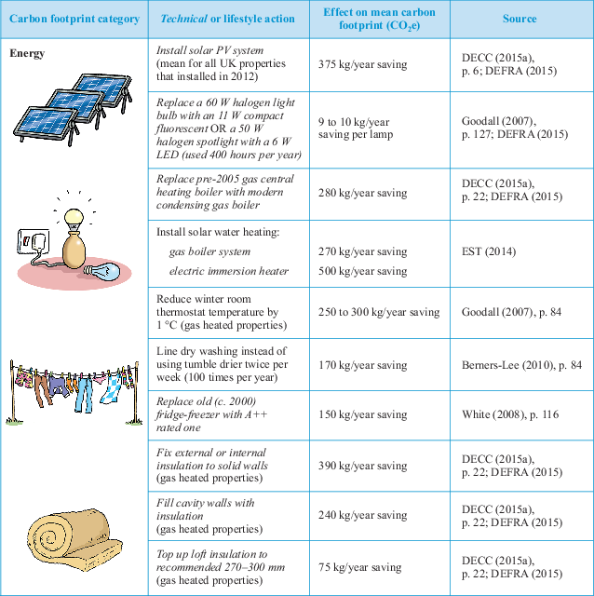
Table 5a Effects of individual or household actions on carbon footprint (Energy)

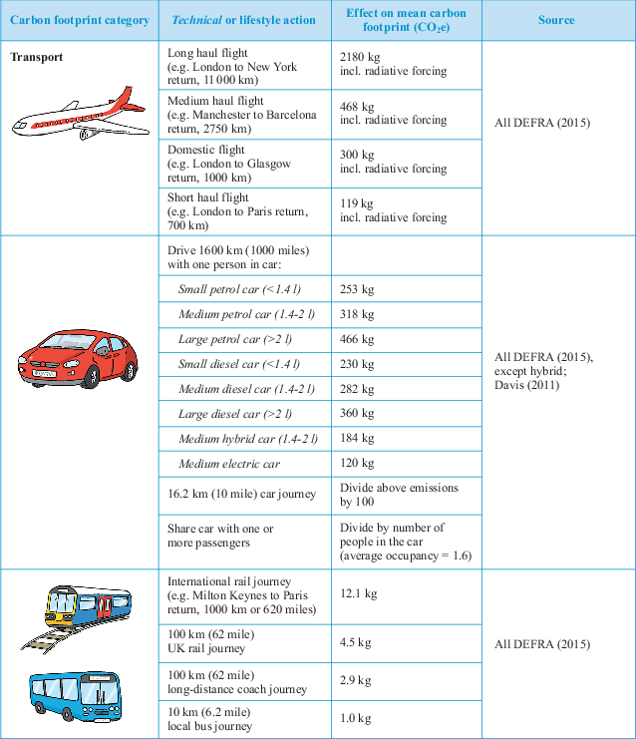
Table 5b Effects of individual or household actions on carbon footprint (Transport)

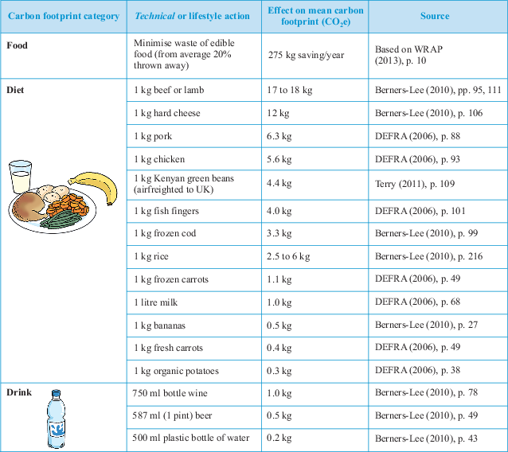
Table 5c Effects of individual or household actions on carbon footprint (Food)

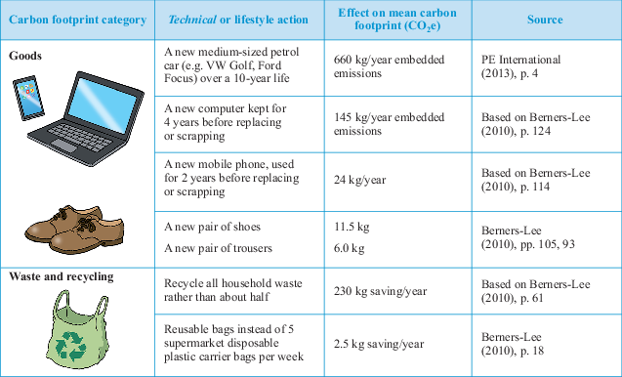
Table 5d Effects of individual or household actions on carbon footprint (Goods; waste and recycling)

Activity 9 Light carbon living
Allow about 10 minutes

Looking at Table 5a–d, what actions are most likely to substantially reduce your carbon footprint? And which seem to make only a small difference?
The actions fall into two broad groups – technical and lifestyle. For example, installing energy-saving lamps in your home is a ‘technical’ action, while switching lights off is a ‘lifestyle’ (or sometimes referred to as behavioural) action. Sort your list into technical (T) and lifestyle (L) actions.

Provide your answer...
View discussion - Activity 9 Light carbon living

4.2.1 Deciding what action to take
Although there are uncertainties involved in calculating the effects of different actions on your carbon footprint, some information is readily available. For example, you can check the CO₂ emissions per kilometre of different car models on government websites (VCA, 2016). But emissions from air travel depend on whether the additional radiative forcing effect on the upper atmosphere of the nitrogen oxides and water vapour in aircraft emissions is counted. Based on current science, the UK Government recommends multiplying CO₂ emissions from flights by 1.9 then adding the CO₂ equivalent emissions of other GHGs. This has been done for the flight emissions in Table 5b and also in the carbon calculator (DEFRA, 2015).
The CO₂e savings from changing diets or recycling materials are also difficult to calculate. Many of the figures quoted depend on life-cycle analysis, the results of which vary widely. For example, while cows and sheep produce large amounts of the powerful greenhouse gas methane when digesting their food, the effects of reducing meat and dairy consumption depend on what is substituted. If out-of-season, imported vegetables and rice are substituted, the footprint could be greater than for a diet with small amounts of locally produced beef and lamb fed on grass rather than imported grains.
Buying locally produced food can help to reduce emissions and food miles, especially if the food is imported by air. However, for most foods the main impacts arise from production and processing, and reducing food miles may not be the best option. For example, imported tomatoes grown outdoors in Spain have a lower carbon footprint than tomatoes grown in a heated greenhouse in the UK.
Table 5a–d showed the impacts of selected actions in terms of ‘ballpark’ GHG emissions. But other environmental impacts may be as, or more, important. A dramatic example was the scandal in 2015 when a major car manufacturer was shown to be concealing the amounts of unhealthy NO_{X} air pollution from its diesel cars, which previously had been considered ‘greener’ due to their lower CO₂ emissions than petrol cars (Porter, 2016).
There are many other cases where choosing between alternative environmental actions involves trade-offs and compromises. For instance, chickens reared indoors in cramped conditions are more efficient at converting their feed to meat than free-range birds. Intensively reared chicken therefore has a lower carbon footprint than free range, but at the cost of poorer animal welfare. While the carbon savings from avoiding plastic carrier bags may be negligible, the 150 million tonnes of plastic waste (mostly packaging) now in the oceans has become a major threat to marine life (World Economic Forum, 2016), a more important reason for reducing plastic waste.
Remember from Section 2 that household income and size also have a very big effect on individual carbon footprints. There may be little you can, or want to, do about your income, but you may have some control over how you spend it; for example, you could spend spare income on insulating your home, on holiday flights, or on ‘offsetting’ your emissions (see Section 5). The number of people in your household may also not be something you can change, but if you have spare room it is usually carbon efficient to occupy it.
That raises the highly sensitive issue of children. Having a child probably adds more to your carbon footprint than any other decision you might make (even if the child increases your household’s size). Berners-Lee (2010, p. 151) has calculated that the mean footprint of an extra child born in the UK is about 373 tonnes CO₂e over an average 79-year life. And that doesn’t take into account the fact that the child is likely to have children too. One estimate of the total effect of each extra female child born in the USA, including their offspring, is nearly 9500 tonnes CO₂ (Murtaugh and Schlax, 2009).

4.3 Lighter living costs and constraints
The costs of ‘light living’ actions need, of course, also to be considered. Some actions involve no cost or save money – for example, less flying, shopping or meat eating – or can even make money, such as letting out a spare room. Others are low cost with a rapid payback time. For example, replacing a halogen incandescent light bulb with a low-energy compact fluorescent lamp (CFL) or light emitting diode (LED) lamp should pay back the new lamp’s cost in lower electricity bills in about 6 to 12 months. Other measures may involve extra cost, for example taking the train instead of driving, or considerable investment, such as installing a rooftop solar photovoltaic system, which may take ten years to pay back. The big carbon-reduction benefits of such actions have to be weighed against affordability, cost and return.
Apart from cost, there are many other factors that may attract or deter you from acting. Travel behaviour is well known as one of the most difficult things to change. You may have little choice about using a car for commuting, shopping or ferrying children about. Looking forward to that foreign holiday may be the one thing that keeps you going.
As noted in Section 2, your needs, wants and social values are important too. For example, some people feel that travelling by bicycle or bus is only for people who can’t afford a car, and that flying to exotic destinations gives them social status. On the other hand, others find the idea of cutting their travel footprint in half, or making their home really ‘green’, exciting and challenging.
Most people’s lifestyles are only partly under their control or are what is considered ‘normal’ in society. So freedom to change is constrained by circumstances and the wider society. Even so, it’s important not to fall into the trap of thinking that only making changes with minor environmental benefits is enough. As the former government chief scientific advisor, Professor David McKay, observed, ‘If everyone does a little, we’ll achieve only a little’ (McKay, 2008, p. 3).

4.4 Moving towards a sustainable carbon footprint
In Section 4.1 it was noted that a globally sustainable carbon footprint was about 2 to 2.5 tonnes CO₂e per person per year, to be achieved by 2050. That would require the mean footprints per person in rich countries like Britain and Germany to be reduced by over 80%, while allowing the footprints of poorer developing countries to increase to give their growing populations a reasonable standard of living. On the way to an 80% reduction, the UK Government set a target of a 35% reduction in the country’s territorial carbon footprint by 2020 and 50% by 2025. In Activity 8, you calculated that that would be a mean annual footprint of, respectively, about 9 and 7 tonnes CO₂e per person (or 10 and 8 tonnes CO₂e per person, including imports and exports).
Such personal carbon footprint reductions should be achievable by individual and household actions. Next you will look at how one environmentally pioneering household has tried to do it.

4.4.1 Low-carbon living
This section considers how one couple, Mark and Alice, have significantly reduced their carbon footprints by ‘eco-renovating’ their three-bedroom mid-terraced house in Oxford, England, without losing the benefits of a normal developed society’s lifestyle.
As you study this section, consider the questions in Activity 10 and think about the technical and lifestyle changes this couple have made to reduce their carbon footprint, as well as addressing some other environmental impacts. Think about which (if any) of these changes you might consider yourself.

Box 2 Eco-renovating
Mark and Alice’s philosophy
Mark and Alice’s aim is to show how a modern family can make serious reductions in their environmental impact, while still having a standard of living most of us would recognise. Above everything their aim is to be practical, rather than offer solutions that few people are likely to adopt.
Energy
Mark and Alice started by commissioning an energy audit of their house. This showed that their house was built to pre-1982 UK Building Regulations standards. Their plan of action included:
- Replacing the ancient boiler with a modern condensing boiler and installing new heating controls and radiator valves.
- Because of its cost, the case for installing solar water heating is usually marginal, but as they were having the central heating upgraded they decided to go for it.
- Insulation is key in any eco-renovation. Mark and Alice noticed the biggest change when they had the cavity walls filled with mineral fibre. They put sheep’s wool insulation in the loft, 100 mm on top of the 70 mm of fibreglass, and insulated the walls and ceiling of the internal garage to stop heat leaking into the cold space.
- Mark and Alice’s house had single-glazed windows plus secondary glazing. They decided to install the best double-glazed windows, and then refit the secondary glazing – triple glazing for a fraction of the price.
- Building a conservatory, which helps to heat the house in spring and autumn and acts as a heat buffer in winter. The conservatory was the largest investment Mark and Alice made. It’s a great space for relaxing and growing plants, and also improves the environmental performance of the house.
- Building an insulated front porch to stop cold air entering in winter.
- Mark and Alice cook, heat and provide hot water from gas, which has half the emissions per kWh of electricity. Gas and electricity consumption is about 50% lower than when they first moved in.
Water
Mark and Alice try to save water. Lower hot water consumption also reduces energy use. Nationally, slightly more than a third of all domestic water is flushed down the toilet. A new UK toilet can use up to 9 litres a flush. They chose a Swedish design, which uses 2 or 4 litres a flush, but is indistinguishable from any other toilet.
Transport
Mark and Alice replaced their two cars with a (second-generation) Toyota Prius hybrid car. It cost little more than an average saloon, at the time about £17 500 minus a £1000 government grant, yet uses less than half the fuel of their previous cars. It has two engines, one petrol, the other electric, whose battery is charged when the petrol engine is running and by recovering energy when going downhill or braking. They get around 55 to 63 miles per gallon (5 to 4.5 litres per 100 km) of petrol, and it didn’t mean driving a really small car, or trading in comfort or safety.
They also decided to live close to the city centre and to public transport. They decided there was no point having an eco-house while having to travel long distances to and from work. They also got a couple of old bikes. These allow them to get around without always jumping into the car.
Mark and Alice have several relatives living in Canada and know that air travel produces very high emissions. If they travel to Canada about once every one to two years they know this can more than outweigh the CO₂ savings they’ve made from eco-renovating the house.
Food
Mark and Alice try to reduce their food impacts by: shopping in the local covered market for fresh, unpackaged food; using a box delivery of locally grown vegetables; growing fruit and vegetables on their allotment; buying local, ethically produced meat and eating it sparingly; and reducing consumption of imported and out-of-season fruit and vegetables.
Goods and services
Their house is small with no unoccupied rooms, which uses the available space and heating efficiently. Mark and Alice also like to keep the house uncluttered, which means not buying more goods than they really need or want and recycling unwanted items. As Mark says, ‘reduce first, reuse second, and recycle third’.
Beyond the household
Mark and Alice try to reduce their carbon footprint as much as they can, but recognise that there are limits to what people can do individually. They therefore help others to follow their example by providing information, if asked by friends or colleagues, and by contributing to eco-renovation open days and websites.
At the community level, Mark was chair of the Board of Westmill Wind Farm Co-operative from 2006 to 2015, which generates more than enough electricity to supply the demand of all the co-op’s 2500 members.
Mark and Alice also recognise that there are environmental issues that can be tackled only at government levels, such as local and regional planning and national energy, and transport policies. (Government responsibility for reducing emissions is discussed further in Section 5)
(Mark and Alice, personal communication and interviews, March/April 2008, updated 2016)

Figure 13 shows some images of Mark and Alice’s property and vehicle.

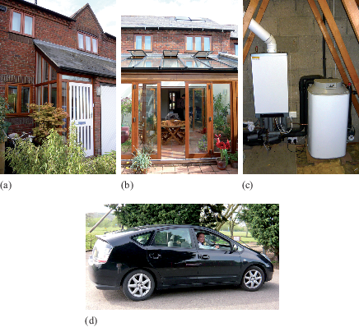
Figure 13 (a) The front of the house; (b) the rear conservatory; (c) the boiler and solar heat store; (d) Toyota Prius hybrid petrol–electric car
View description - Figure 13 (a) The front of the house; (b) the rear conservatory; (c) the boiler and ...

Activity 10 Low-carbon living
Allow about 10 minutes

- What approaches to saving energy for heating etc. were adopted by Mark and Alice in their Oxford house?
- What transport dilemmas have Mark and Alice faced in trying to live their low-carbon lifestyle?

Provide your answer...
View answer - Activity 10 Low-carbon living

Mark and Alice are better off than many families in Britain and so could afford some of the more costly changes to their home, travel and lifestyle. But many of the changes they made cost little and often save money. There are many websites that provide information and inspiration for home eco-refurbishment, lower carbon transport options and other green technologies and lifestyle changes. Some give the cost of different actions, available subsidies and the time to pay back any expenditure involved.

4.4.2 How can you reduce your carbon footprint?
Having seen how one couple managed to reduce their carbon footprint, you will now return to the carbon calculator to explore how you might be able to reduce your carbon footprint to a target level.

Activity 11 Reducing your carbon footprint
Allow about 1 hour 30 minutes

Use the carbon calculator to explore how to reduce your carbon footprint to your chosen target by following the steps below.
- Open the carbon calculator.
- With the calculator running and set on your existing footprint, which you made in Activity 7, select a footprint reduction target (you can open your existing footprint by selecting the Summary tab and open your existing footprint file).
- On the Target screen, select either a Personal OR a Government reduction target.
  - Personal target: first select the ‘Accept footprint’ button to set Your existing footprint value. Your footprint on the bar chart and Summary screen will appear in the box. Then in the box below type in a percentage reduction target on Your footprint.
  - Government targets: select a percentage reduction (30%, 46% or 54%) on the UK Average consumption-based footprint (approximately equivalent to reductions of 35%, 50% and 57% in the territorial footprint in 1990 on which UK carbon budgets are based).
- Use the calculator to explore how your existing footprint might be reduced to your chosen target level. Do this by selecting the calculator’s tabs and changing answers to the questions.
- When you are satisfied that you have reached – or done your best to reach – your target, save your reduced footprint using a different name (e.g. 30GovtFootprint1)
- Additional guidance and FAQs can be found here.

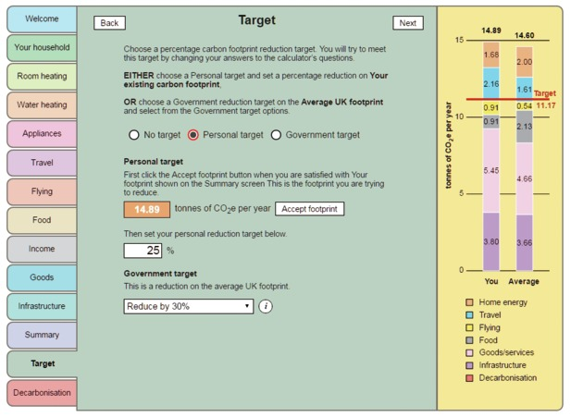
Figure 14 Target screen: My Existing Footprint 1 saved and a Personal target of a 25% reduction on that existing footprint set
View description - Figure 14 Target screen: My Existing Footprint 1 saved and a Personal target of a ...

If you haven’t managed to reach your target, you have the option of further reducing your footprint via non-household emission reduction measures paid towards by you but undertaken by government or others in Activity 13 in Section 5.

4.5 Summary of Section 4
The main learning points from Section 4 are:
- There are many national and international targets for reducing GHG emissions, especially CO₂.
- Increasingly, these targets are based on reductions in emissions necessary to give a reasonable chance of preventing the mean global temperature rising by more than 2 °C (and preferably 1.5 °C) compared to pre-industrial levels, in order to avoid dangerous climate change.
- A sustainable carbon footprint is likely to involve an eventual reduction of at least 80% in the mean carbon footprint of people living in rich, developed countries. Shorter-term individual or household footprint reductions of 35% to 50% should be possible without losing the benefits of a developed society’s lifestyle.
- Different technical and lifestyle changes have different effects on individual or household carbon footprints. The effects depend on personal circumstances, but the most cost-effective usually include:
  - reducing, or replacing, air and car travel; car sharing
  - upgrading home insulation
  - installing an efficient heating and hot water system
  - fully occupying homes, but keeping family size small
  - reducing consumption of meat and dairy products and air-freighted fruit and vegetables
  - reducing unnecessary purchases of high-carbon goods (e.g. new vehicles)
  - spending spare income on low-carbon or carbon-saving goods and services.
- People’s ability to radically reduce their footprint is constrained by their circumstances, such as their jobs, family, social pressures and willingness to change.
- A carbon footprint calculator is one way of exploring how to reduce individual or household footprints. However, it can provide only an approximate calculation of the effects of different technical and lifestyle actions.
The final section of this course will look at the role of individuals, households, communities and governments in reducing carbon footprints.

5 Who’s responsible for reducing carbon footprints?

We must abandon the conceit that individual, isolated, private actions are the answer. They can and do help. But they will not take us far enough without collective action.
(Gore, 2007)

There are some things that we can do as individuals: making this an energy-efficient house and making smart transport choices. Then there are things that we can do in our community ... I’m chair of a local community wind farm ... and work with Low Carbon West Oxford, a group of local residents ... And then there’s a third strand where it’s really much more to do with government.
(Mark and Alice (2008), former owners of the eco-renovated house, Oxford)

As mentioned earlier, viewed from the consumption perspective, individuals and households directly or indirectly generate the demand for most of the goods and services produced by the economy.
Does this mean that individuals and households are responsible for reducing the CO₂ and other GHG emissions from all their consumption? Or are the businesses and industries that produce the goods and services at home and abroad mainly responsible? In this section you’ll be considering who is responsible: ‘I’ (as an individual consumer or citizen), ‘we’ (my household, workgroup, community) or ‘they’ (the government, business, other countries, and so on).

5.1 The role of individuals and households
You’ve been considering how to reduce your carbon footprint to help tackle climate change and, to some extent, other environmental changes. To that extent, ‘I’ as an individual consumer has a role to play.
But unless you live alone, you share your household with other people, a group that could be called ‘we’. Within a household, there may be different views and priorities about what, if anything, should be done about reducing carbon footprints. Saving energy and other resources can involve some inconvenience or loss of comfort and often involves advance planning or careful thought. It may involve spending money on carbon-saving products or cutting down on some pleasurable activities. There may be social or cultural issues, or deep-rooted beliefs and habits, which differ. Not everyone in the household may agree that the actions are necessary or desirable, or worth even minor inconveniences. Others may be driven by their environmental or other values to live as sustainably as possible (see Box 3 for an example).

Box 3 My household
Here’s an example of how members of a household can have differing views and priorities when thinking about their carbon footprint:

Using the carbon calculator to explore how to reduce my carbon footprint reminded me that some of these issues occur in my own household. Regarding energy use, my partner and her daughter like the house kept nice and warm in winter and often turn up the thermostat or thermostatic radiator valves.
On transport, my partner and I run a small car. I try to car-share or cycle to work and usually take a train or coach for longer journeys. But my partner’s daughter likes driving her own, fairly powerful, car and rarely uses public transport. And while my partner and I have avoided flying in the past year (having flown three times for leisure in the previous year), my partner’s daughter has already enjoyed two holiday flights and is looking forward to a trip to Australia.
I would happily become a vegetarian, but my partner likes to eat meat at least once or twice a week.
Regarding consumption, while I prefer buying a few long-lasting goods, my partner’s daughter, and to some extent my partner too, like shopping for new things.
So while my own carbon footprint may be fairly light and could be lighter, the total household footprint is heavier than it could be. To lighten our footprint involves trade-offs and choices, and requires give and take among the household members.

You may be able to think of similar issues in your household. Does this mean that each member of the household has to be responsible for their own carbon footprint? Or are there shared activities about which compromises have to be made in order to reduce the household’s total footprint?
Of course, you may not be just part of a shared household: you are also a member of society. Even if you agree within your household about what to do, many others in society aren’t concerned about reducing carbon footprints. Is there any point in trying to reduce your footprint when others aren’t interested or willing to change? In economics this is an aspect of the ‘free rider’ problem in which others benefit from a public good – a reduced risk of dangerous climate change – without paying for it.
One view, argued by businessman and green politician Chris Goodall in How to Live a Low-carbon Life (2007), is that pioneering individuals should take responsibility for reducing their carbon footprints in an attempt to galvanise governments, businesses and other members of society into action. He admits that even a million individuals cannot tackle climate change alone, but if governments, businesses and others are unwilling to make the necessary changes, they have to be persuaded by being shown examples of low-carbon living (such as the Oxford couple in Section 4.4.1 ). His model is that of the abolition of slavery and votes for women, in which radical change was brought about by the actions of small groups of highly committed people.

5.2 The role of active citizens and communities
UK Government policy is that individuals and households have a role to play in reducing emissions, especially from home energy use and transport. However, policies have shifted over the past decade, with less emphasis on supporting individual and household action (e.g. with grants and subsidies for home insulation) and more on voluntary initiatives and what business and governments can do.
Part of the reason for this shift is that governments have become increasingly reluctant to try to change the lifestyles and consumption of millions of people, focusing instead on influencing business and other major decision-makers. So, for example, as noted earlier (Section 4.1), most of the UK’s recent reductions in GHG emissions are the result of shifts from coal to wind and solar electricity generation, while emissions from people driving and flying have increased.

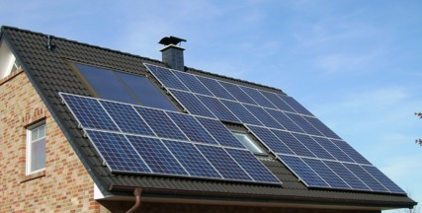
Figure 15 Solar panels
View description - Figure 15 Solar panels

As George Marshall (2014) has argued, from a psychological viewpoint, asking people to reduce their carbon footprint to help tackle climate change is a very difficult message to get across, as it may require immediate sacrifices in order to address an invisible long-term problem. Also, individuals don’t control many of the decisions that affect their carbon footprint, such as national energy and transport policies, town planning, food processing and retailing practices, overseas farming and manufacturing, and so on. In other words, while individuals and households are directly or indirectly responsible for most of the consumption of goods and services, they do not control their production and distribution.
So it is now recognised that while individuals and households can do much to reduce their carbon footprints, they can’t make the over 80% reductions needed to reach a sustainable footprint. That requires actions by communities, businesses, local and national governments, for example in developing a low-carbon energy supply system, improving the energy and materials efficiency of industry, and contributing to international efforts on climate change.
Another reason why people argue that others are responsible for environmental problems is that they often feel powerless in the face of all the complex decisions and big changes that seem necessary. However, even if they don’t directly control many economic activities and policy decisions, in a democracy at least, individual citizens can exert influence by voting in elections and political involvement.
Another way ‘we’ can help reduce carbon footprints is by joining with others in a pressure group such as WWF (World Wide Fund for Nature) or one of the voluntary groups that get together to help each other reduce their individual and household impacts. Such voluntary groups include: those set up through a charity called Global Action Plan; local groups in the Transition Network; and some 5000 community energy groups that have formed in Britain since 2010 to install renewable energy technologies and improve home energy efficiency (DECC, 2015b). The UK Government considers such community initiatives to be as – or more – effective, than individual action.
In the workplace, individuals can switch off lights and computers, recycle waste paper, and so on. But surveys show that individuals are less likely to save energy at work than at home, as they don’t have to pay the bills. However, by working with their colleagues, they can help each other to adopt green practices and also encourage their employer to adopt environmental policies, for example switching to a green electricity supplier, setting up recycling facilities, and establishing staff travel plans.

5.2.1 Voluntary carbon offsets
One of the ways that individuals can shift the responsibility for emission reductions from ‘I’ and ‘we’ to ‘they’ is by paying for so-called voluntary carbon offsets. A carbon offset is a reduction in emissions resulting from a carbon-saving project undertaken elsewhere – often in a developing country – voluntarily paid for by individuals to compensate for (offset) the carbon footprint arising from their activities. (Organisations, such as businesses, can also buy offsets.) For example, many airlines and other companies offer carbon offsets to compensate for the emissions from personal or business flights. One energy supply company is offering ‘green’ gas to consumers by including some methane biogas generated from waste and offsetting the remaining emissions by paying into carbon-saving projects such as efficient cooking stoves and biogas plants in developing countries.

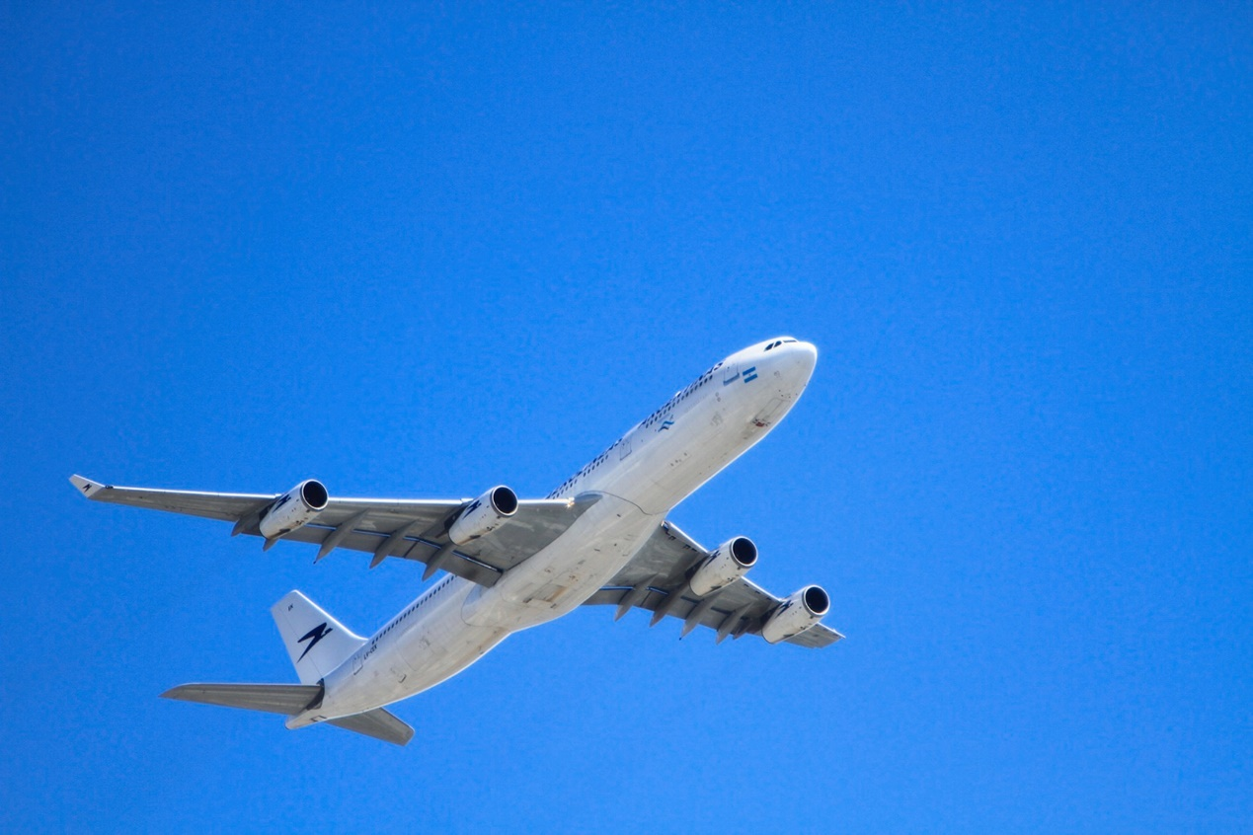
Figure 16 The carbon emissions from air travel are often offset by airlines
View description - Figure 16 The carbon emissions from air travel are often offset by airlines

However, the benefits of carbon offset schemes have been questioned. The small amount charged by airlines for offsetting the emissions of a flight, for example, bears little relationship to the actual cost of totally eliminating that amount of GHGs from the atmosphere. For example, delegates to the 2015 Paris Climate Change Conference were invited to offset their flights through UN certified carbon reduction schemes, costing from 50 US cents to $5 per tonne of carbon. It meant that a delegate flying return from New York to Paris could consider their flight ‘climate neutral’ for a mere 40 cents to $4.
Tree planting schemes have also been criticised, not least because it takes years for the trees to absorb the CO₂ emissions from, say, a flight made today. However, there are now some schemes that promise more worthwhile carbon offsets, as they approve only offsets which fund renewable energy and energy efficiency projects, and promote sustainable development for the local community where they take place. But whatever the type of project, a carbon offset is a payment to transfer the responsibility for reducing emissions from the person or organisation creating the emissions to someone else.
Despite such reservations, the carbon calculator allows you to offset some of your emissions, especially if you can’t reduce your footprint by individual or household actions. The amount you (theoretically) have to pay for this is based on a realistic price for eliminating each tonne of carbon emissions, not the unrealistically low offset prices charged by airlines, etc.

5.3 The role of governments and business
Despite all the possibilities for individual and group action to reduce carbon footprints, there will still be people, groups and organisations who won’t, or can’t, do much. Many individuals limit themselves to ‘every little bit helps’, with small effects on their carbon footprint, such as reusing plastic bags or recycling paper. This avoids having to consider more significant changes in car and air travel, home energy use, diet or shopping. Others will simply carry on producing and consuming to maximise their own personal or organisational benefit, even if they know this is to the detriment of everyone else and future generations.
This behaviour is what has been called the tragedy of the commons, a term popularised by an American ecologist Garrett Hardin (1968). The ‘tragedy’ is that for a time, each person, organisation or nation can gain an additional benefit by using or consuming a bit more of the commons (the Earth) until a resource is used up, or an irreversible environmental change has occurred. Then everyone suffers.
That’s where government support, taxation and regulation, business initiatives and international agreements to tackle climate change and other environmental problems come in. It’s what ‘I’ and ‘we’ can’t achieve unaided and only ‘they’ have the power to do.

5.3.1 Government taxation and subsidies
One of the things that governments can do is to tax fossil fuels, goods and services that create GHG emissions to encourage households or businesses to reduce those emissions. Or governments can provide grants and subsidies to encourage industry to develop low-carbon products and consumers to adopt them.
An example is transport taxation, in which cars with higher CO₂ emissions per kilometre pay a higher road tax than those with lower emissions. Another is the tax on petrol or diesel fuel intended at least partly to encourage people to change their travel behaviour.
Examples of grants and subsidies for emissions reduction include grants to low-income consumers for home insulation or to all consumers for buying electric cars, and the payments by energy companies to householders who have installed solar PV for the electricity generated, paid for through everyone’s electricity bills.

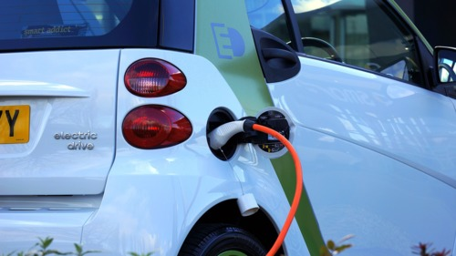
Figure 17 Low-carbon products, such as electric cars, have been incentivised through government grants and subsidies.
View description - Figure 17 Low-carbon products, such as electric cars, have been incentivised through ...

Taxes on emissions, such as a carbon tax on fossil fuels, are often not popular and they can hit poorer members of society harder than better-off ones. But by careful design to reduce undesirable consequences, such taxes and subsidies can be a very effective way of encouraging businesses, individuals and households to reduce their carbon footprint through financial penalties and incentives (Feng et al., 2010).
The carbon calculator allows you to decide whether to support an increase in taxes to fund national investments in decarbonising the economy and so reduce everyone’s personal, individual footprint.

5.3.2 Government, business and international actions
Other government, business and international actions to address climate change include, in no particular order:
- international treaties on reducing greenhouse gas emissions, perhaps even to negative emissions (i.e. absorbing more GHGs than are produced through, for example, replanting or creating new forests, or carbon capture and storage)
- national and international policies on increasing renewable and/or nuclear energy supply
- regulations on energy labelling of refrigerators, washing machines, etc.
- regulations on the energy performance of buildings
- urban and regional planning polices to encourage people to use public transport
- local authority home insulation and heating improvement schemes
- company programmes to save energy, avoid waste and reduce car commuting
- environmental education and information programmes.
Having now considered what the individual, household, community and government can do to help reduce the carbon footprint complete Activity 12 as a summary exercise.

Activity 12 I, we or they?
Allow about 15 minutes

- List five activities that ‘I’ could do as an active citizen, and what ‘we’ could do as a household, workgroup or community, to reduce your own and others’ carbon footprints.

What ‘I’ as an active citizen could do, or what ‘we’ as a household, community or workgroup could do to reduce our own and others’ carbon footprints:
1.
2.
3.
4.
5.
View answer - Part

- List five activities that are beyond the control of individual consumers, citizens, community and social groups.

What ‘they’ as governments, etc. can do to reduce carbon footprints of the nation, region or world:
1.
2.
3.
4.
5.
View answer - Part

5.3.3 Further reducing your carbon footprint
You have now assessed your existing individual carbon footprint and considered how changing your actions, such as changing eating habits, driving fewer miles or flying less, can reduce your footprint. You are almost at the end of this course and the final activity asks you to return to the carbon calculator to see what can be done to further reduce your footprint with some actions beyond the household.

Activity 13 Decarbonising your footprint
Allow about 45 minutes

This activity assumes that you have completed Activity 11 and have tried to reach a Government and/or Personal footprint reduction target.
If you haven’t managed to reach your target through individual or household (‘I’ or ‘we’) actions, there are some non-household (‘they’) actions by government or others on the carbon calculator’s ‘Decarbonisation’ screen that can contribute towards reducing your personal footprint by decarbonising the national or global economy. This is done via carbon dioxide emission reduction measures paid for through your taxes or voluntary carbon offset payments, but undertaken by government or others.
Even if you’ve reached your target, you can set a more challenging target to explore the effect of these actions, such as supporting taxes to fund investments in decarbonising the economy or paying for voluntary carbon offsets.
First open the Carbon calculator.
If you’ve reached your target in Activity 11:
- On the Target screen, starting from your reduced footprint file, set a more challenging target (as in Activity 11 above).
- Select the Decarbonisation tab. Try out the tax and offset options, which will produce emission reductions that subtract from your reduced footprint lowering it further. When you enter one or more decarbonisation option to reach a target already set, the red target line splits to show the target compared to the ‘You’ result, while the ‘Average’ bar shows the target line and its value in its pre-Decarbonisation position.
- You’ll find that, depending on your income, increased income tax or regular voluntary carbon offset payments, can produce quite large emission reductions.
If you haven’t reached your target in Activity 11:
- Starting from the footprint file which hasn’t reached your target, use the Decarbonisation tab (as above) to reach it.
In either case:
- When you have reached your target, save the new reduced footprint file using a different name (e.g. DecarbonisationFootprint1).
- Additional guidance and FAQs can be found here.

This final activity has helped you explore the impact on your carbon footprint of carbon dioxide emission reduction measures paid for through your taxes or voluntary carbon offset payments, but undertaken by government or others. Such measures can be difficult to implement in practice and are often politically sensitive.

5.4 Summary of Section 5
The main learning points from Section 5 are:
- There are limits to the ability of individuals and households to reduce their carbon footprints, because they don’t directly control decisions about the production and distribution of the goods and services they consume.
- Even so, individuals can take actions to help reduce emissions as citizens and/or as active members of community organisations, pressure groups or workgroups.
- There are still many actions concerning the environment and climate change beyond the control of individuals, households and communities (‘I’ and ‘we’). These require action by governments and business at local, national and international levels (‘they’).

Conclusion
This free course, Environment: treading lightly on the Earth, has shown you that much of the carbon footprint of an economy is due to use of energy and transport, and consumption of food, goods and services by individuals and households. Hence, what you can do as an individual consumer, citizen and/or household member to reduce your carbon footprint can be significant. But communities, business and governments also have a crucial role in tackling GHG emissions and climate change.
This OpenLearn course is an adapted extract from the Open University course U116 Environment: journeys through a changing world.

References
Barrett, J., Owen, A. and Sakai, M. (2011) UK Consumption Emissions by Sector and Origin, Report to the UK Department for Environment, Food & Rural Affairs by University of Leeds.
Berners-Lee, M. (2010) How bad are bananas?, London, Profile Books.
Berners-Lee, M., Hatter, W. and Hoolohan, C. (2011) The Total Carbon Footprint of Greater Manchester, Lancaster, Small World Consulting Ltd, Lancaster University.
Brower, M. and Leon, W. (1999) The Consumer’s Guide to Effective Environmental Choices, New York, Three Rivers Press.
CDIAC (Carbon Dioxide Information Analysis Center) (2015) Millennium Development Goals Indicators [Online]. Available at https://mdgs.un.org/unsd/mdg/Data.aspx (Accessed 1 April 2016).
CCC (Committee on Climate Change) (2013) Reducing the UK’s carbon footprint and managing competitiveness risks, London.
CCC (Committee on Climate Change) (2015) Setting a target for emission reduction [Online]. Available at https://www.theccc.org.uk/tackling-climate-change/the-science-of-climate-change/setting-a-target-for-emission-reduction/ (Accessed 1 April 2016).
CCC (Committee on Climate Change) (2016) Meeting carbon budgets – 2016 progress report to Parliament, Executive Summary, June [Online]. Available at https://www.theccc.org.uk/wp-content/uploads/2016/06/2016-CCC-Progress-Report-Executive-Summary.pdf (Accessed 1 July 2016).
Dawkins, E., Roelich, K. and Owen, A. (2010) A Consumption Approach for Emissions Accounting – the REAP Tool and REAP Data for 2006 [Online]. Available at https://www.sei-international.org/mediamanager/documents/Publications/Rethinking-development/SEI_Report_REAP_Documentation_2010.pdf (Accessed 22 November 2016).
DECC (2015a) Summary of analysis using the National Energy Efficiency Data-Framework (NEED), London, Department of Energy and Climate Change, June.
DECC (2015b) Community Energy Strategy Update, London, Department of Energy and Climate Change, March.
DEFRA (2015) Greenhouse gas reporting – conversion factors 2015 [Online]. Available at www.ukconversionfactorscarbonsmart.co.uk/ (Accessed 1 April 2016).
DEFRA (2016) UK’s Carbon Footprint 1997–2013 [Online]. Available at www.gov.uk/government/uploads/system/uploads/attachment_data/file/542558/Consumption_emissions_May16_Final.pdf (Accessed 1 April 2016).
Druckman, A. and Jackson, T. (2010) ‘An exploration into the carbon footprint of UK households’, RESOLVE Working Paper 02–10, University of Surrey.
DTI (2007) Meeting the energy challenge: a White Paper on energy, London, The Stationery Office.
DWP (2016) Households Below Average Income. An analysis of the income distribution 1994/95–2014/15 (United Kingdom), London, Department of Work and Pensions, Surveys Branch, June [Online]. Available at www.gov.uk/government/uploads/system/uploads/attachment_data/file/532416/households-below-average-income-1994-1995-2014-2015.pdf (Accessed 20 December 2016).
Feng, K., Hubacek, K., Guan, D., Contestabile, M., Ninx, J. and Barrett, J. (2010) ‘Distributional effects of climate change taxation’, Environmental Science and Technology, vol. 44, no. 10, pp. 3670–6.
Global Carbon Atlas (2016) CO2 emissions [Online]. Available at www.globalcarbonatlas.org/?q=en/emissions (Accessed 1 April 2016).
Goodall, C. (2007) How to live a low carbon life, London, Earthscan.
Gore, A. (2007) Nobel Lecture, 10 December [Online]. Available at www.nobelprize.org/nobel_prizes/peace/laureates/2007/gore-lecture_en.html (Accessed 22 November 2016).
Gough, I., Abdallah, S., Johnson, V., Ryan-Collins, J. and Smith, C. (2012) The distribution of total greenhouse gas emissions by households in the UK, and some implications for social policy, CASE/152, London, Centre for Analysis of Social Exclusion, London School of Economics.
Hardin, G. (1968) ‘The Tragedy of the Commons’, Science, vol. 162, no. 3859, pp. 1243–8.
HM Treasury (2006) Stern Review on the Economics of Climate Change, London, HM Treasury [Online]. Available at http://webarchive.nationalarchives.gov.uk/20130129110402, http://www.hm-treasury.gov.uk/stern_review_climate_change.htm (Accessed 1 April 2016).
Hubacek. K. (n.d.) Accounting for CO₂ emissions: UK, US, China and International Trade [Online]. Available at www.see.leeds.ac.uk/fileadmin/Documents/research/sri/Hubacek_Complexity_Economics_Seminar_2 pdf (Accessed 1 March 2016).
IPCC (2015) ‘Climate Change 2014: Synthesis Report Summary for Policymakers’, Intergovernmental Panel on Climate Change, Geneva [Online]. Available at www.ipcc.ch/report/ar5/syr/ (Accessed 1 April 2016).
Marshall, G. (2014) Don’t Even Think About It: Why Our Brains Are Wired to Ignore Climate Change, New York, Bloomsbury Books.
McKay, D. J. C. (2008) Sustainable Energy – without the hot air, Cambridge, UIT Cambridge Ltd.
Miehe, R., Scheumann, R., Jones, C. M., Kammen, D. M. and Finkbeiner, M. (2015) ‘Regional carbon footprints of households: a German case study’, Environment, Development and Sustainability [Online]. Available at http://link.springer.com/article/10.1007/s10668-015-9649-7 (Accessed 1 March 2016).
Murtaugh, P. A. and Schlax, M. G. (2009) ‘Reproduction and the carbon legacies of individuals’, Global environmental change, vol. 19, no. 1, pp. 14–20.
Office for National Statistics (ONS) (2015) Greenhouse Gas Emissions 2013, Cardiff, Office for National Statistics.
Porter, A. (2016) ‘What’s the truth behind car emissions claims?’, Which?, 20 January [Online]. Available at https://conversation.which.co.uk/motoring/vw-fuel-emissions-car-testing-petrol-diesel-hybrid/ (Accessed 1 July 2016).
Preston I., White, V., Thumim, J., Bridgeman T. and Brand, C., (2013) Distribution of carbon emissions in the UK: implications for domestic energy policy, York, Joseph Rowntree Foundation.
UNFCCC (2015) National greenhouse gas inventory data for the period 1990–2013, UN Framework Convention on Climate Change, November.
US Energy Information Administration (US EIA) (2013) Heating and cooling no longer majority of U.S. home energy use [Online]. Available at https://www.eia.gov/todayinenergy/detail.cfm?id=10271 (Accessed 1 March 2016).
Vehicle Certification Agency (VCA) (2016) Car fuel data, CO₂ and vehicle tax tools [Online]. Available at http://carfueldata.dft.gov.uk/default.aspx (Accessed 1 April 2016).
Weber, C. L and Matthews, H. C. (2008) ‘Quantifying the global and distributional aspects of American household carbon footprint’, Ecological Economics, vol. 66, nos 2–3, pp. 379–91.
World Economic Forum (2016) The New Plastics Economy: Rethinking the future of plastics [Online]. Available at http://www3.weforum.org/docs/WEF_The_New_Plastics_Economy.pdf (Accessed 22 November 2016).

Acknowledgements
This free course was written by Professor Robin Roy. It was first published in 2017 and updated in January 2019.
Grateful acknowledgement is made to the following sources. Every effort has been made to contact copyright holders. If any have been inadvertently overlooked the publishers will be pleased to make the necessary arrangements at the first opportunity.

Images/Videos
Course image: John Loo in Flickr made available under Creative Commons Attribution 2.0 Licence.
Figure 2: Adapted from Berners-Lee, M., Hatter, W. and Hoolohan, C. (2011) The Total Carbon Footprint of Greater Manchester, Small World Consulting Ltd, Lancaster University.
Figure 3: Department of Trade & Industry, Meeting the Energy Challenge: A White Paper on Energy’, May 2000, Crown copyright material is reproduced under Class Licence Number C01w0000065 with the permission of the controller of HMSO and the Queen’s Printer for Scotland.
Figure 4: Reproduced under the terms of the OGL, www.nationalarchives.gov.uk/doc/open-government-licence;
Figure 5: Adapted from Berners-Lee, M., Hatter, W. and Hoolohan, C. (2011) The Total Carbon Footprint of Greater Manchester, Small World Consulting Ltd, Lancaster University.
Figure 6: Department of Work and Pensions. Reproduced under the terms of the OGL, www.nationalarchives.gov.uk/doc/open-government-licence
Figure 7: Gough, I., Abdallah, S., Johnson, V., Ryan, J. (2011) 'The Distribution of Total Greenhouse Gas Emissions by Households in the UK'
Figure 8: Gough, I., Abdallah, S., Johnson, V., Ryan J. (2011) 'The Distribution of Total Greenhouse Gas Emissions by Households in the UK'
Figure 9: © Global Carbon Project;
Figure 10: © Global Carbon Project;
Figure 11(a): © Courtesy Arjjeet B/Flickr;
Figure 11(b): © imageBROKER / Alamy Stock Photo;
Figure 11(c): © www.flickr.com / innamoo;
Figure 11(d): © Courtesy of Gordontour / www.flickr.com;
Figure 11(e): © Courtesy Fozza / www.flickr.com;
Figure 11(f): © Daniel Gredecki / www.flickr.com;
Figures 13(a)-(c): © Robin Roy
Figure 15: From Pixabay. Covered under Creative Commons licence CC0 1.0 Universal (CC0 1.0) Public Domain Dedication
Figure 16: From Pixabay. Covered under Creative Commons licence CC0 1.0 Universal (CC0 1.0) Public Domain Dedication
Figure 17: From Pixabay. Covered under Creative Commons licence CC0 1.0 Universal (CC0 1.0) Public Domain Dedication
Video 1: Wingspan Productions
Video 2: BBC
Video 3: BBC
Carbon calculator: © 2018 The Open University. Developed by Peter Harper with Robin Roy from a calculator produced by Peter Harper for The Centre for Alternative Technology (CAT) with acknowledgments to CAT. Software and graphic design by Callum Lester and Vicky Eves, The Open University.
Don't miss out
If reading this text has inspired you to learn more, you may be interested in joining the millions of people who discover our free learning resources and qualifications by visiting The Open University – www.open.edu/openlearn/free-courses.

Solutions

Activity 1 The carbon footprint

Part

Answer
The carbon footprint is the total annual mass of ‘carbon’ emissions which result directly or indirectly from the activities of an individual or a group of people, from an event, or from providing a product or service.
Back to - Part

Part

Answer
‘Carbon’ emissions can be measured as the annual mass in kilograms or tonnes of either:
- carbon dioxide (CO₂) gas; or
- total GHGs converted to carbon dioxide equivalents (CO₂e) in terms of their global warming potential; or
- the carbon (C) content of CO₂ (or CO₂ converted to CO₂e).
Back to - Part

Part

Answer
Based on 2005 government information, the average direct carbon footprint of an individual living in the UK was 1.16 × 44/12 = 4.25 tonnes CO₂ per person per year. This footprint was unchanged in more recent studies (e.g. Preston et al., 2013).
Back to - Part

Part

Answer
The main components of a UK individual’s or household’s average carbon footprint are:
- home energy use, especially for room and water heating and running lights, electronics and appliances
- transport, especially driving and flying
- consumption of goods and services, produced at home and imported
- government activities and public services.
Back to - Part

Activity 2 Calculating percentages

Part

Answer
In Figure 4, household road transport emissions are 63 million tonnes (Mt) CO₂e. As a percentage this is 63/1050 × 100 = 6%.
Back to - Part

Part

Answer
The difference in emissions between 1997 and 2013 is a reduction of 1118 – 1050 = 68 Mt CO₂e.
As a fraction of the 1997 footprint this is a reduction of 68/1118.
As a percentage, this is a reduction of 68/1118 × 100 = 6.0829 = 6.1% (rounded to one decimal place). You will look in more detail at rounding numbers in Section 2.
Back to - Part

Part

Answer
A reduction of 35% means that 100 – 35 = 65% of the 1997 footprint remains in 2020.
65% of 1118 Mt CO₂e is 65/100 × 1118 = 726.7 Mt CO₂e.
Back to - Part

Activity 3 The carbon heavyweights

Part

Answer
From Figure 5, the mean carbon footprint of a Greater Manchester resident is made up of:
- travel by car, air, bus and train (vehicle fuel + car manufacture/maintenance + flights + public transport = 27%)
- food consumption (retail food and drink + eating, drinking and staying away from home = 20%)
- gas, electricity, etc. use (household fuel + electricity = 19%)
- consumption of goods (electrical goods + other non-food shopping + domestic construction = 15%)
- private and public services (financial, water, waste, health and education services, public administration, etc. = 21%).
(The percentages add up to over 100% due to rounding.)
Back to - Part

Part

Answer
The breakdown for the UK as a whole is similar to that for most other developed countries.
Back to - Part

Activity 4 International comparisons

Discussion
The mean carbon footprint of a UK inhabitant in 2015 relative to that of other countries was:

Table 3 The carbon footprint of a UK inhabitant in 2015 relative to that of other countries (completed)
Country | Mean footprint per person (tonnes CO₂ per year) | UK mean footprint per person relative to other country’s mean footprint per person
UK | 6.4 | —
USA | 17 | 0.38
China | 7.5 | 0.85
Sweden | 4.3 | 1.5
India | 1.7 | 3.8
Uganda | 0.1 | 60*
World mean | 4.9 | 1.3

* to 1 significant figure
How realistic are these comparisons? They show clearly that, because people in rich countries generally consume more and have more energy-intensive lifestyles than people in poorer countries, they have heavier mean carbon footprints. But it doesn’t mean that the inhabitants of a rich country inevitably have heavy footprints. The inhabitants of Sweden, for example, have only about a quarter of the mean footprint of Americans. This is at least partly because of the low-carbon electricity supplies in Sweden.
But remember that these are figures for territorial CO₂ emissions. This is because few countries publish consumption emissions that include imports and exports. On a consumption basis, the emissions embedded in Chinese exports to the UK, for instance, are counted as belonging to UK consumers rather than Chinese producers. So, more realistically, the mean footprint of a UK inhabitant is about twice that of an inhabitant of China, rather than a bit smaller (CCC, 2013).
Back to - Activity 4 International comparisons

Activity 5 Hans Rosling on carbon emissions

Part

Answer
Measuring mean emissions per person of rich countries is fairer, and so more likely to be politically acceptable, to middle-income and poor countries.
Back to - Part

Part

Answer
The main growth in emissions will be from newly industrialised countries (e.g. China) and other developing countries (e.g. Thailand) whose inhabitants earn between $10 and $100 per day on average.
Back to - Part

Part

Answer
Rich countries with high carbon emissions per person, like the USA and Australia, should reduce their emissions to the lower level of other rich countries like France and Sweden. Rapidly developing countries like China and Thailand should try to avoid the path of countries like the USA, the UK and Germany by preventing their emissions per person from growing as much.
Back to - Part

Part

Answer
Rosling does not include non-CO₂ GHG emissions or the emissions embedded in imports and exports in his analysis.
Back to - Part

Activity 6 The Carbons and the Tans

Part

Answer
The Carbons’ main GHG emission sources shown on the video are: electricity for household electronics and appliances; their cars; food distribution and consumption; decomposing waste; and flights. The Tans’ main emission sources are not detailed, but focus on building construction and electricity from coal-fired power stations.
Back to - Part

Part

Answer
The direct emissions from the fuel (probably gas or oil) used for heating the Carbons’ house and providing hot water, and the indirect emissions from the production and consumption of the goods and services to support the Carbons’ and Tans’ lifestyles, are not explicitly mentioned.
Back to - Part

Activity 7 Your carbon footprint

Answer
The carbon calculator is a useful model because it allows individuals to calculate their carbon footprint and explore options for changing it.
Being a consumption-based model, the calculator assumes that individual and household consumption is ultimately responsible for triggering most GHG emissions, so decisions by individuals could significantly reduce the nation’s footprint.
Back to - Activity 7 Your carbon footprint

Activity 8 Carbon footprint targets

Part

Discussion
- Considering only territorial emissions:
  - By 2020 the mean UK footprint should have fallen to 100% – 35% = 65% of the 1990 figure of 14.2 tonnes, namely 65/100 × 14.2 = 9.2 tonnes CO₂e per person per year (rounded to one decimal place).
  - By 2025 the mean UK footprint should have fallen to 100% – 50% = 50% of the 1990 figure of 14.2 tonnes, namely 50/100 × 14.2 = 7.1 tonnes CO₂e per person per year.
  - By 2050 the mean UK footprint should have fallen to 100% – 80% = 20% of the 1990 figure of 14.2 tonnes, namely 20/100 × 14.2 = 2.8 tonnes CO₂ equivalent per person per year (rounded, i.e. near to the sustainable level).
- Considering consumption emissions, including imports and exports:
  - By 2020 the mean UK footprint should have fallen to 0.65 × 15.7 = approx. 10 tonnes CO₂e per person per year (rounded).
  - By 2025: 0.5 × 15.7 = approx. 8 tonnes CO₂e per person per year.
  - By 2050: 0.2 × 15.7 = approx. 3 tonnes CO₂e per person per year.
For a UK inhabitant with a mean consumption-based carbon footprint of 14 to 16 tonnes per year, a 10 tonne (and even an 8 tonne) CO₂e per person footprint should be achievable by actions at the individual or household level, such as those that you can explore with the carbon calculator. A lighter footprint than these is likely to require actions by government (and business), and the calculator allows you to try the effect of some of these actions in Activity 11 in Section 5.
Back to - Part

Activity 9 Light carbon living

Discussion
The following actions in Table 5a–d are more likely than others to significantly reduce your carbon footprint:
- avoiding air travel as much as possible (L)
- reducing long car journeys (especially regular ones like commuting); car sharing and/or replacing driving with travel by bus, coach or train (L)
- improving home insulation (especially of older properties) (T) and, if possible, lowering room temperatures (L)
- installing a solar PV system (T)
- reducing consumption of meat (especially beef and lamb), dairy products, and air-freighted fruit and vegetables (L)
- keeping products rather than rapidly replacing or scrapping them (L) (unless a different product is much more efficient, e.g. a hybrid or electric car (T))
- not wasting edible food, and recycling household waste (L).
The following actions are likely to have only a relatively minor effect on your carbon footprint, but may address other important environmental impacts:
- not buying just one new pair of shoes or trousers (L)
- upgrading your mobile phone (L)
- avoiding bottled water and disposable plastic carrier bags (L).
Back to - Activity 9 Light carbon living

Activity 10 Low-carbon living

Answer
- The approaches to direct energy saving made by Mark and Alice include:
  - insulation – as much as possible
  - draught-proofing, secondary plus double glazing
  - installing an efficient gas condensing boiler and controls
  - building a solar conservatory and porch
  - low-energy lighting
  - solar water heating
  - efficient appliances and cooking with gas
  - a small house with no unoccupied rooms.
- Mark and Alice’s main transport dilemmas are:
  - wishing to visit their relatives in Canada about once every one to two years, which involves flights that more than outweigh the carbon savings they’ve made from improving the energy performance of their house
  - choosing low carbon transport for commuting, as the locations and requirements of their jobs change.
Back to - Activity 10 Low-carbon living

Activity 12 I, we or they?

Part

Answer
You may have suggested some of the following:
What ‘I’ as an active citizen could do to reduce others’ carbon footprints:
- try to educate or persuade other household members, including children, to adopt more environmentally responsible behaviour
- join an environmental pressure or support group, or community energy group
- lobby local or national politicians on environmental issues
- vote for a political party with the best environmental policies.
What ‘we’ as a community or workgroup could do to reduce our and others’ carbon footprints:
- try to save energy and resources at work
- avoid unnecessary commuting and business travel (e.g. by telephone or online communications)
- work with local schools etc. to adopt environmental teaching and policies
- work with our employer to adopt environmental policies.
Back to - Part

Part

Answer
You may have suggested some of the following:
What ‘they’ as governments, etc. can do to reduce carbon footprints of the nation, region or world:
- adopt policies to increase supplies of renewable and/or nuclear energy
- implement national, regional and international agreements and targets to reduce GHG emissions
- develop and implement plans to reduce a business organisation’s carbon footprint
- adopt and implement regulations to improve the energy performance of buildings and the fuel economy of vehicles
- introduce or increase carbon taxes, and/or grants and subsidies to individuals, communities and businesses, to help reduce emissions.
Back to - Part

Figure 1 The greenhouse effect due to increasing concentrations of CO2 and other greenhouse gases in the Earth’s atmosphere

Description
Figure 1 is a cartoon of Planet Earth inside an ordinary garden greenhouse, with the sun shining down on it. This image gives a highly simplified idea of how the greenhouse effect produces warming of the earth’s surface and its lower atmosphere.
Back to - Figure 1 The greenhouse effect due to increasing concentrations of CO2 and other greenhouse gases in the Earth’s atmosphere

Figure 2 The footprint as a powerful image of treading on or occupying the Earth. A UK individual’s carbon footprint arises mainly from home energy use and personal travel, including flights, and from consumption of food, goods and services.

Description
This figure is a sketch of a human footprint divided horizontally into five sections. The toe section represents the mass of carbon dioxide equivalent emissions arising from an average UK inhabitant’s purchase and use of UK produced and imported consumer goods and services, at about 4 tonnes CO2 equivalent per year. The ball of the foot section represents the mass of carbon dioxide equivalent emissions arising from an average UK inhabitant’s travel by car, air, public transport and bicycle, at about 3.5 tonnes per year. The upper arch of the foot section represents the mass of carbon dioxide emissions arising from an average UK inhabitant’s home energy use for heating, lighting, etc., at about 3 tonnes per year. The lower arch section represents the mass of carbon dioxide equivalent emissions arising from an average UK inhabitant’s consumption of food and drink, also about 3 tonnes per year. The heel section represents the mass of carbon dioxide equivalent emissions arising from an average UK inhabitant’s use of public and government services ranging from education and investment in roads to defence, at about 2.5 tonnes per year.
Back to - Figure 2 The footprint as a powerful image of treading on or occupying the Earth. A UK individual’s carbon footprint arises mainly from home energy use and personal travel, including flights, and from consumption of food, goods and services.

Figure 3 Breakdown of average direct carbon emissions of a UK inhabitant. Annual carbon emissions in 2005 = 1.16 tonnes carbon per person per year. (More recent studies (e.g. Preston et al., 2013) show a similar breakdown of direct emissions, although in less detail.) (DTI, 2007)

Description
This figure is a pie chart; a type of graph in which a circle is divided into sectors, like the slices of a pie, where each slice represents a proportion of the whole. This pie chart shows the percentage breakdown of the total carbon emissions that arise directly from the direct energy using actions of an average UK inhabitant. The breakdown is as follows. The biggest slice is for space (or room) heating at 30 per cent of the total; the second slice is 29 per cent for personal car travel; then 12 per cent for holiday air travel; 11 per cent for water heating; 9 per cent for appliances such as fridges and tvs; 4 per cent for lighting; 3 per cent for cooking; and 2 per cent for other travel. The total adds up to 100 per cent.
Back to - Figure 3 Breakdown of average direct carbon emissions of a UK inhabitant. Annual carbon emissions in 2005 = 1.16 tonnes carbon per person per year. (More recent studies (e.g. Preston et al., 2013) show a similar breakdown of direct emissions, although in less detail.) (DTI, 2007)

Figure 4 The UK carbon footprint: GHG emissions associated with consumption 1997 to 2013, including emissions embedded in imports but not exports (total = 1050 million tonnes CO2e in 2013) (DEFRA, 2016)

Description
Figure 4 is a set of four stacked bar charts, which show the total UK carbon footprint in 1997, 2007, 2012 and 2013, and its breakdown, as published by the government in 2016. Each bar shows the direct and indirect carbon dioxide equivalent emissions associated with the UK population’s consumption of energy, food and goods and services, including emissions embedded in imports. The total in 1997 was 1118 million tonnes CO2 equivalent, made up of 64 million tonnes of private road transport emissions (the bottom light green coloured section of the bar), 80 million tonnes of emissions from home heating (the second dark green section stacked on top of the bottom section); 436 million tonnes from production emissions arising in the UK from purchase of goods and services by UK consumers (the third blue section) ; and 530 million tonnes arising from imported goods and services purchased by UK consumers and businesses (the top grey section). By 2013 the total had fallen to 1050 million tonnes CO2 equivalent made up of 63 million tonnes of private road transport emissions, 80 million tonnes of emissions from home heating; 325 million tonnes from production emissions arising in the UK from purchase of goods and services by UK consumers and 582 million tonnes arising from imported goods and services purchased by UK consumers and businesses. So from 1997 to 2013 emissions from UK production and consumption fell while emissions from imports rose. The total carbon footprints for 2007 and 2012 were respectively 1296 and 1025 million tonnes carbon dioxide equivalent.
Back to - Figure 4 The UK carbon footprint: GHG emissions associated with consumption 1997 to 2013, including emissions embedded in imports but not exports (total = 1050 million tonnes CO2e in 2013) (DEFRA, 2016)

Figure 4 (repeated) The UK carbon footprint: GHG emissions associated with consumption 1997 to 2013, including emissions embedded in imports but not exports (total = 1050 million tonnes CO2e in 2013) (DEFRA, 2016)

Description
Figure 4 is a set of four stacked bar charts, which show the total UK carbon footprint in 1997, 2007, 2012 and 2013, and its breakdown, as published by the government in 2016. Each bar shows the direct and indirect carbon dioxide equivalent emissions associated with the UK population’s consumption of energy, food and goods and services, including emissions embedded in imports. The total in 1997 was 1118 million tonnes CO2 equivalent, made up of 64 million tonnes of private road transport emissions (the bottom light green coloured section of the bar), 80 million tonnes of emissions from home heating (the second dark green section stacked on top of the bottom section); 436 million tonnes from production emissions arising in the UK from purchase of goods and services by UK consumers (the third blue section) ; and 530 million tonnes arising from imported goods and services purchased by UK consumers and businesses (the top grey section). By 2013 the total had fallen to 1050 million tonnes CO2 equivalent made up of 63 million tonnes of private road transport emissions, 80 million tonnes of emissions from home heating; 325 million tonnes from production emissions arising in the UK from purchase of goods and services by UK consumers and 582 million tonnes arising from imported goods and services purchased by UK consumers and businesses. So from 1997 to 2013 emissions from UK production and consumption fell while emissions from imports rose. The total carbon footprints for 2007 and 2012 were respectively 1296 and 1025 million tonnes carbon dioxide equivalent.
Back to - Figure 4 (repeated) The UK carbon footprint: GHG emissions associated with consumption 1997 to 2013, including emissions embedded in imports but not exports (total = 1050 million tonnes CO2e in 2013) (DEFRA, 2016)

Figure 5 The carbon footprint of Greater Manchester residents, broken down by consumption category (CO2e per person per year) (Berners-Lee et al., 2011). Note: the percentages add up to over 100% due to rounding (see Study Note: Rounding numbers, decimal places and significant figures).

Description
Figure 5 is a pie chart showing the total carbon footprint of the residents of the large English city of Greater Manchester broken down by main consumption categories. The biggest slice of the pie (coloured dark blue) is total annual household gas and other heating fuel use at 12 per cent of the total footprint of over 41 million tonnes of CO₂ equivalent. The second biggest slice (coloured maroon) is domestic vehicle fuel use at 8 per cent of the total. The third biggest slices, respectively coloured dark green, red and light green, are household electricity use; eating and staying outside the home; and emissions arising from the residents’ use of public services, all at 7 per cent of the total. And so on. Car manufacture and maintenance and use of private services, such as banking, both at 5 per cent. Health care at 4 per cent. Travel by public transport; water, waste and sewage services; and domestic construction all at 3 per cent. And lastly purchase of electrical goods and use of education services both at 2 per cent of the total.
Back to - Figure 5 The carbon footprint of Greater Manchester residents, broken down by consumption category (CO2e per person per year) (Berners-Lee et al., 2011). Note: the percentages add up to over 100% due to rounding (see Study Note: Rounding numbers, decimal places and significant figures).

Figure 6 Distribution of the UK population by household incomes in 2014–15. Group 1 is the distribution of household incomes for the 10% of individuals living in the poorest households. Group 10 is the household incomes for the 10% of individuals living in the richest households (excluding 5.3 million individuals with a household income above £1000 per week). Equivalised means the incomes are adjusted to take account of the numbers of adults and children in a household (adapted from DWP, 2016).

Description
Figure 6 is a bar chart, which shows the official distribution of UK household incomes in 2013-14, after tax and adjusted to take account of the number of people in the household. The height of each bar shows the number of individuals who live in a household that has a particular weekly income from the lowest group (the four hundred thousand individuals with a household income of zero to ten pounds per week) to the highest (the nearly two hundred thousand individuals with a household income of £990 to £1000 per week). The chart notes, but doesn’t show, the 5.3 million UK individuals living in households with incomes of over £1000 per week. There is a note of the mean income of £581 per week and the median income of £473 per week with arrows pointing to the bars concerned. The 100 bars in the chart are also divided and numbered from 1 to 10 alternating dark and light blue sets representing the whole population divided into ten same-size or decile groups.
Back to - Figure 6 Distribution of the UK population by household incomes in 2014–15. Group 1 is the distribution of household incomes for the 10% of individuals living in the poorest households. Group 10 is the household incomes for the 10% of individuals living in the richest households (excluding 5.3 million individuals with a household income above £1000 per week). Equivalised means the incomes are adjusted to take account of the numbers of adults and children in a household (adapted from DWP, 2016).

Figure 7 Mean carbon footprints (tonnes CO2e per person per year) by emission categories for ten household income groups, excluding public services. (The income groups are categorised as in Figure 6.) (Gough et al., 2012)

Description
Figure 7 is a stacked bar chart, which shows how the CO₂ equivalent greenhouse gas emissions per person differ for ten groups according to household income; from the group whose members have the lowest 10% to the group with the highest 10% of UK household incomes. Each bar also shows how the total emissions for that group break down into emissions from domestic energy and housing; food production and consumption; purchase and use of consumable goods; use of private services such as banking; and transport. The emissions arising from an individual’s use of public services is omitted. The chart has an arrow above the stacked bars that shows the strong upward trend in this analysis; namely that the higher an individual’s household income, in general the higher their carbon footprint is likely to be.
Back to - Figure 7 Mean carbon footprints (tonnes CO2e per person per year) by emission categories for ten household income groups, excluding public services. (The income groups are categorised as in Figure 6.) (Gough et al., 2012)

Figure 8 Mean carbon footprints (tonnes CO2e per person per year) by household type (Gough et al., 2012)

Description
Figure 8 is a stacked bar chart similar to Figure 7 but which shows how the CO₂ equivalent greenhouse gas emissions per person differ for seven groups according to household size and composition. The seven groups include households with one person both under and over 60 years old; households with two or more people over 60; households with two adults, including one under 60; households with three or more adults; single parent households; and households with two or more adults and children. As in Figure 3.7 each bar also shows how the total emissions for that group break down into emissions from domestic energy and housing; food production and consumption; purchase and use of consumable goods; use of private services such as banking; and transport. The charts show that, in general, the smaller the household size the higher the emissions per person; that older people generate slightly higher emissions; and that adults tend to generate higher emissions than children.
Back to - Figure 8 Mean carbon footprints (tonnes CO2e per person per year) by household type (Gough et al., 2012)

Figure 5 (repeated) The carbon footprint of Greater Manchester residents, broken down by consumption category (CO2e per person per year) (Berners-Lee et al., 2011). Note: the percentages add up to over 100% due to rounding (see Study note: Rounding numbers, decimal places and significant figures).

Description
Figure 5 is a pie chart showing the total carbon footprint of the residents of the large English city of Greater Manchester broken down by main consumption categories. The biggest slice of the pie (coloured dark blue) is total annual household gas and other heating fuel use at 12 per cent of the total footprint of over 41 million tonnes of CO₂ equivalent. The second biggest slice (coloured maroon) is domestic vehicle fuel use at 8 per cent of the total. The third biggest slices, respectively coloured dark green, red and light green, are household electricity use; eating and staying outside the home; and emissions arising from the residents’ use of public services, all at 7 per cent of the total. And so on. Car manufacture and maintenance and use of private services, such as banking, both at 5 per cent. Health care at 4 per cent. Travel by public transport; water, waste and sewage services; and domestic construction all at 3 per cent. And lastly purchase of electrical goods and use of education services both at 2 per cent of the total.
Back to - Figure 5 (repeated) The carbon footprint of Greater Manchester residents, broken down by consumption category (CO2e per person per year) (Berners-Lee et al., 2011). Note: the percentages add up to over 100% due to rounding (see Study note: Rounding numbers, decimal places and significant figures).

Figure 9 Estimated territorial CO2 emissions per person in 2015. The bigger the black bubble, the bigger the footprint per person for the country indicated. (Global Carbon Atlas, 2016)

Description
Figure 9 is a world map with the continents and countries within them shown in outline. There are solid black circles superimposed over each country. The area of each circle represents the relative size of the estimated carbon footprint per person in 2015 from the use of fossil fuels within that country in tonnes of carbon dioxide per year. The map shows for example that by far the largest carbon footprints per person in the world occur in oil producing Arab counties like Qatar and Saudi Arabia and in some Caribbean islands. It shows that the carbon footprints per person of the United States, Canada and Australia are next in size and similar. Smaller in size and similar are the carbon footprints per person of Russia, Japan and South Africa. The carbon footprints per person of Ireland and China are smaller still and also similar, but slightly larger than that of the UK. The carbon footprint per person of developing countries like India and most African countries are very much smaller. The actual size of the carbon footprints per person can be found by hovering a cursor over online version of the map.
Back to - Figure 9 Estimated territorial CO2 emissions per person in 2015. The bigger the black bubble, the bigger the footprint per person for the country indicated. (Global Carbon Atlas, 2016)

Figure 10 Estimated total territorial CO2 emissions in 2015 (Global Carbon Atlas, 2016)

Description
Figure 10 is a world map with the continents and countries within them shown in outline. There are solid black circles superimposed over each country. The area of each circle represents the relative size of the estimated total carbon footprint in 2015 from the use of fossil fuels within that country in tonnes of carbon dioxide per year. The map shows for example that by far the largest total carbon footprint in the world is that of China, followed by the United States and India. Smaller in size and similar are the carbon footprints of Russia and Japan. The total carbon footprints of the UK, South Africa and Australia smaller still and also similar. The smallest total carbon footprints occur in many African developing countries. The actual sizes of the total carbon footprints can be found by hovering a cursor over online version of the map.
Back to - Figure 10 Estimated total territorial CO2 emissions in 2015 (Global Carbon Atlas, 2016)

Figure 11 (a) Apartments, New Town, Kolkata, India, built for India’s fast-growing middle class; (b) Indian cattle farmer living on less than £1 per day; (c) government official’s house, Libreville, Gabon; (d) villager’s house, Jinja, Uganda; (e) typical apartment block, China; (f) village alley, near Yangshuo, China

Description
Figure 11 is a group of six photographs arranged in three pairs to show the contrast between the homes of rich and poor people in India, Africa and China. The first pair (a and b) of India, show densely packed high-rise apartments with almost no surrounding vegetation compared with a simple hut surrounded by partially cleared vegetation with a single cow tethered outside. The second pair (c and d) of Africa, show a modern, two-storey white house with a large veranda, decorative shrubs and a large swimming pool compared with a simple, roughly thatched hut with two bare-foot children sitting outside and a woman at work preparing food using leaf-lined pots, the forest vegetation can be seen nearby in the background. The third pair (e and f) of China show high-rise apartments in rows giving the impression of a large development, with a tarmac road at the front, although most of the earth around the buildings is bare compared with a narrow alley between two rows of simple housing with a few mopeds and bicycles parked outside. The photos suggest, although not all explicitly illustrate, how increasing personal wealth generally involves greater use of resources and higher greenhouse gas emissions. For example, while a middle class Indian or an urban Chinese family might live in a new high rise apartment block with electricity, piped water, refrigerator, TV, etc. and a member of the African elite might have a large house with a swimming pool, a poor Indian or African villager might still live in a thatched hut without electricity or mains water and a rural Chinese family might live in a narrow street of small concrete dwellings. Similar contrasts can of course be shown between the homes of rich and poorer people in developed countries.
Back to - Figure 11 (a) Apartments, New Town, Kolkata, India, built for India’s fast-growing middle class; (b) Indian cattle farmer living on less than £1 per day; (c) government official’s house, Libreville, Gabon; (d) villager’s house, Jinja, Uganda; (e) typical apartment block, China; (f) village alley, near Yangshuo, China

Uncaptioned Figure

Description
The drawing shows the number 3174. An arrow labelled ‘1st significant figure’ points to the 3. A second arrow is labelled ‘2nd significant figure’ and points to the 1.
Back to - Uncaptioned Figure

Uncaptioned Figure

Description
The drawing shows the number 0.0446. An arrow labelled ‘1st significant figure’ points to the first 4 (the left-most).
Back to - Uncaptioned Figure

Figure 12 An example of the OU carbon calculator ‘Summary’ footprint screen. The student’s existing footprint is 14.89 tonnes CO2e per year; this is greater than the UK national average of 14.60 tonnes CO2e per person per year.

Description
This figure shows the Summary screen of the OU carbon calculator after a student has answered the questions to calculate their existing personal carbon footprint. On the far left are the fourteen tabs that access the calculator’s screens. From top to bottom the tabs are Welcome; Your household: Room heating; Water heating; Appliances; Travel; Flying; Food; Income; Goods; Infrastructure; Summary; Target; Decarbonisation.
In the upper centre panel of the screen is a two-column table. The left hand column shows the student’s existing personal carbon footprint of 14.89 tonnes carbon dioxide equivalent emissions per year and its components, such as Home energy at 1.68 tonnes carbon dioxide equivalent emissions per year; Travel at 2.16 tonnes carbon dioxide equivalent emissions per year; Food at 0.91 tonnes carbon dioxide equivalent emissions per year, and so on. The right hand column shows the personal carbon footprint of an average inhabitant of the UK at 14.60 tonnes carbon dioxide equivalent emissions per year and its components broken down in the same categories as the student’s footprint.
Below the table are two boxes. The first enables a user to name and save a record of the current footprint when satisfied with their answers to the calculator’s questions; in this case the student’s existing personal footprint. The second box enables a user to open a previously saved footprint record via a drop-down menu or to delete an unwanted footprint record.
On the right of the screen are two stacked bar charts that repeat the information in the table in graphical form. The left hand stacked bar, labelled You, shows the student’s existing carbon footprint and its components the broken down into the same categories as in the table (Home energy, Travel, Flying, Food, etc.). The right hand stacked bar, labelled Average, shows the same information for an average UK inhabitant.
Back to - Figure 12 An example of the OU carbon calculator ‘Summary’ footprint screen. The student’s existing footprint is 14.89 tonnes CO2e per year; this is greater than the UK national average of 14.60 tonnes CO2e per person per year.

Figure 13 (a) The front of the house; (b) the rear conservatory; (c) the boiler and solar heat store; (d) Toyota Prius hybrid petrol–electric car

Description
Figure 13 is a group of 4 photographs. The first three (a, b and c) are of the 1980s three bedroom, mid-terrace house in Oxford eco-renovated by Mark and Alice. The first shows the front view of two storeys of the house with its ground floor and first floor triple-glazed windows, the glazed front door leading into a new heat conserving porch and the door to the internal garage. The second is the rear view showing the south-facing conservatory with its wooden sliding doors that lead into the ground floor living room, the first floor triple-glazed bedroom windows and the solar water heating panels on the roof. The third is an interior shot of the energy efficient condensing, combination boiler and the solar heat store which are both installed in the loft of the house. The fourth is of Alice driving the fuel-efficient, second generation Toyota Prius hybrid petrol-electric car she and Mark own. It is a conventional-looking, black, family sized saloon car.
Back to - Figure 13 (a) The front of the house; (b) the rear conservatory; (c) the boiler and solar heat store; (d) Toyota Prius hybrid petrol–electric car

Figure 14 Target screen: My Existing Footprint 1 saved and a Personal target of a 25% reduction on that existing footprint set

Description
This figure shows the Target screen of the OU carbon calculator after a student has answered the questions to calculate their existing personal carbon footprint, and then decided on either a Government or a Personal target.
On the far left are the fourteen tabs that access the calculator’s screens. From top to bottom the tabs are Welcome; Your household: Room heating; Water heating; Appliances; Travel; Flying; Food; Income; Goods; Infrastructure; Summary; Target; Decarbonisation.
In the centre of the screen is the main panel with the heading ‘Target’. Under this some text reads: ‘Choose a percentage carbon footprint reduction target. You will try to meet the target by changing your answers to the calculator’s questions. Either choose a Personal target and set a percentage reduction on your existing carbon footprint. Or choose a Government reduction target on the ‘Average UK footprint’ and select from the Government target options.’
Under this text there are three radio buttons labelled: No target; Personal target; Government target. The student has chosen a Personal target to reduce their existing personal footprint by 25%. Under this there are options to set the Government target.
On the right of the screen are two stacked bar charts, the bar charts represent the student’s existing personal footprint (before they have amended the calculator entries to try and meet their reduction target) labelled You, and a footprint for an average UK inhabitant, labelled ‘Average’. The left hand stacked bar, labelled You, shows the student’s existing carbon footprint 14.89 tonnes of carbon dioxide equivalent emissions per year and its components, such as Home energy at 1.68 tonnes carbon dioxide equivalent emissions per year; Travel at 2.16 tonnes carbon dioxide equivalent emissions per year; Food at 0.91 tonnes carbon dioxide equivalent emissions per year, and so on. The right hand stacked bar, labelled Average, shows the same information for an average UK inhabitant. There is a red horizontal line to illustrate where the You footprint needs to be for a 25% personal reduction target. The red line also crosses the Average footprint bar chart for comparison.
Back to - Figure 14 Target screen: My Existing Footprint 1 saved and a Personal target of a 25% reduction on that existing footprint set

Figure 15 Solar panels

Description
This image shows one side of a roof of a house covered with solar panels.
Back to - Figure 15 Solar panels

Figure 16 The carbon emissions from air travel are often offset by airlines

Description
An aircraft in the sky. The photo has been taken from below. The background is blue and the aircraft is white.
Back to - Figure 16 The carbon emissions from air travel are often offset by airlines

Figure 17 Low-carbon products, such as electric cars, have been incentivised through government grants and subsidies.

Description
Image of a white electric car being charged
Back to - Figure 17 Low-carbon products, such as electric cars, have been incentivised through government grants and subsidies.

Video 1 Hans Rosling on carbon emissions

Transcript
PROFESSOR HANS ROSLING
How much energy do we humans use? How much fossil fuel do we burn every year in the world? Which country emits more or less carbon dioxide? I'm going to show you the key indicator to use. It's carbon dioxide emission per person. And I'm going to show you how to compare countries. But there's a trap here, and you don't want to fall into it. It's the difference between emission per country and emission per person. In other words, the total amount and the rate. But first have a look at this. I'm going to show how the emission in the whole world varies according to income, from the richest billion all the way down to the poorest billion.
I will show this, from the poorest billion to the richest billion, from the one who hardly can afford shoes to the one who fly with airplanes. Now, this shows the total amount of fossil fuel used in the world during one year, coal, oil, and natural gas. And it represent more or less the total emission of carbon dioxide. Now, how much of that is used by the richest billion? Half of it. Now, the second richest billion, half of what's left. And you understand what the third use, half of what left. And the others use hardly anything. This is rounded numbers, but it clearly shows that almost all the fossil fuel is used here by the one, two, three richest billions, more than 85% they use.
Now, the richest billion here at least have stopped increasing, but we are yet to see whether they will decrease. And in the coming decades, it's the economic growth of these two that will increase the fossil fuel use and the carbon dioxide emission, even if these ones over here come out of extreme poverty and get rich all the way to the motorbike, that doesn't contribute much to the emission of carbon dioxide.
This is a good website to find data on carbon dioxide emission. It's called UNdata. If you type carbon dioxide here and hit Search, you get a number of different indicators, which you can use to compare countries in different ways. First here is carbon dioxide emission in tonnes, that's total amount per country. Next is carbon dioxide emission per capita. That is per person in the country. And there is also a number of other indicators you can use to compare.
This chart shows the carbon dioxide emission in 2011, the latest data for all major countries in the world. Each bubble is a country. On this axis, income, 400, 4 000, 40 000 dollars per capita. On this axis, I show carbon dioxide emission per person, from a few tonne per year to 10 and 20 tonne per person in year. Now, the size of the bubble, the total area of the bubble, that represent the total amount of carbon dioxide emitted from that country. And you can see that China has the biggest area. They have the highest emission per country. Number two, United States. Number three, India.
But these countries are on very different emissions per person. So China and India, with a relatively low emission per person, have big bubbles because they have huge populations. United States, they have a big bubble because they're very high up. They have almost three times as much emission per person compared with China. It's obviously important what big countries do, but the discussion about carbon dioxide emission have sometimes got confused when it focus only on total emission of the country.
And some have blamed China for having the biggest emission when they have a relatively average emission per person. It's a little as if you would say that the Chinese population is more obese than the American population because the total population weigh more than the American. You have to estimate obesity calculating weight per person, and I find it rational to do the same thing with carbon dioxide. Governments must be held responsible for the emission per person in their countries.
There are two more things you can see on this chart. First is as countries get richer, they tend to have a higher carbon dioxide emission. Look here, Bangladesh, Pakistan, India, China, Russia, United States. The second thing you can see is that there's a huge difference in carbon dioxide emission per person among the richest countries. They all have a very high income per person, but up here, Saudi Arabia, Australia, United States, and Canada, with almost 18 to 20 tonne per person. Down here, France, Sweden, and Switzerland, with quite low, four to five tonne per person. And in the middle, Japan, Germany and United Kingdom. So being rich doesn't mean that you have to have a very high emission per person.
You can go yourself to this graph on the web and find out where is your country, and you can compare your country to other countries, how their emission per person have changed over time. I am personally very interested to follow this data year by year into the future. Will these bubbles, countries with huge population, will they turn upwards here and emitting more and more to follow in this direction, or will they follow countries who have found a way to live well at lower emission levels? Then they may land somewhere over here with the much smaller bubbles. This is the most crucial when it comes to what sort of climate change we will have in the future.
Back to - Video 1 Hans Rosling on carbon emissions

Video 2 The Carbons

Transcript
[MUSIC PLAYING]
SIR DAVID ATTENBOROUGH
We know that human activity on a large scale, massive deforestation, the near universal use of fossil fuels is changing the climate. But can anything that you or I do individually, can that have an effect? Well, over half the carbon dioxide produced by mankind comes from our domestic activities.
[MUSIC PLAYING]
Meet the Carbons. They're a fictional family living somewhere in the Western world.
They occupy an average suburban house outside an average city.
The Carbons depend on an average amount of electric power, it comes to them by an energy grid powered primarily by fossil fuels, coal, oil, and natural gas.
The Carbons are not bad people.
MR CARBON
Girls, do you want coffee, pancakes?
SIR DAVID ATTENBOROUGH
But as Westerners, they have one of the most energy-hungry lifestyles on the planet.
MRS CARBON
Girls
EMILY CARBON
What's for breakfast?
FEMALE SPEAKER 1
Yeah.
MR CARBON
Pancakes. Dad cakes.
MRS CARBON
Pancakes. What you want, a pancake?
FEMALE SPEAKER 1
Yeah.
MRS CARBON
Here you go.
MR CARBON
I'll call you from the airport.
EMILY CARBON
Over
MR CARBON
Bye.
MRS CARBON
Bye.
[CAR STARTING]
SIR DAVID ATTENBOROUGH
Mr. Carbon's car, like most, spews out a lot of carbon dioxide.
[DOG BARKING]
And the Carbon family has two cars. Every year between them they pump a staggering 20 tonnes of carbon dioxide into the atmosphere. Ten tonnes per car.
But it's not just the cars.
MRS CARBON
Emily.
SIR DAVID ATTENBOROUGH
Running the Carbon's family home, with all its comforts, uses almost as much energy as their vehicles do.
[ELECTRIC METER TURNING]
[KETTLE WHISTLING]
Every device, functional or fun, has a knock-on effect
[LOADING DISHWASHER]
at the power plant.
Scientists fear that at this rate these everyday emissions could, within 50 years, push our climate to a critical point where change is no longer gradual but sudden and extreme.
There's no threat of extinction in the Carbon's house. On the contrary, there is plenty of food here.
Often it will have crossed continents by the time it reaches their kitchen.
Transporting this food accounts for over a tenth of the carbons annual greenhouse emissions, and it doesn't end there.
[FILLING TRASHCAN]
More carbon dioxide is produced by the Carbon's rubbish.
[TAKING TRASH OUT]
[TRASH TRUCK PICKING UP TRASH]
Buried in a landfill, the rubbish heats up as it decomposes, releasing greenhouse gases into the air.
All the while, the carbon dioxide blanket surrounding the earth is getting thicker, pushing the planet's ecosystems closer to the point of no return.
[AIRPLANE FLYING]
Mr Carbon dreams of a tropical rainforest holiday, but today he's on a business trip.
When he flies, he's contributing to the fastest growing source of carbon dioxide.
Even with plans for more efficient engines, emissions from airplanes worldwide are set to double in the next 25 years.
Back to - Video 2 The Carbons

Video 3 The Tans

Transcript
[DRIVING IN CAR]
SIR DAVID ATTENBOROUGH
In cities all over the developed world, millions of ordinary households produce great quantities of carbon dioxide simply by going about their daily lives.
So far it's the Western world which has produced the majority of the greenhouse gases.
[RIDING BICYCLES]
But that is set to change.
Meet Mr and Mrs Tam.
They are a fictional couple living in an average Chinese suburb. At present, they use only a seventh of the energy consumed by the Carbon family.
But life for the Tams is changing fast.
And they, together with 1.3 billion Chinese, are heading for a more energy-intensive lifestyle.
Mr. Tam has got a new job, and it comes with a flat in the latest upmarket development, complete with state-of-the-art energy-hungry fittings.
To fuel their economic boom, China has one main cheap source of energy, coal.
Coal is the most carbon dioxide polluting source of energy we have.
Currently China is planning to build a large coal-fired power plant every week for the next seven years.
In as little as 20 years, China is likely to become the world's number one greenhouse gas emitter.
There is an explosion in energy consumption worldwide. And by 2050, we're on course to have doubled the amount we emit.
Back to - Video 3 The Tans

Uncaptioned Equation

Alternative description
multiline equation row 1 20 percent o times f postfix times 350 postfix times p times e times o times p times l times e postfix times equals 20 solidus 100 times prefix multiplication of 350 postfix times open o times r postfix times prefix times of 0.2 multiplication 350 close postfix times row 2 equation left hand side equals right hand side 70 postfix times p times e times o times p times l times e full stop
Back to - Uncaptioned Equation

Uncaptioned Equation

Alternative description
equation left hand side 400 divided by one postfix times 000 postfix times 000 postfix times equals right hand side equation left hand side 40 divided by 100 postfix times 000 equals right hand side equation left hand side four divided by 10 postfix times 000 equals right hand side equation sequence 0.4 divided by 1000 postfix times equals 0.04 divided by 100 equals equation left hand side 0.004 divided by 10 equals right hand side 0.0004
Back to - Uncaptioned Equation

Uncaptioned Equation

Alternative description
four times 00 divided by one postfix times 000 postfix times zero times 00
Back to - Uncaptioned Equation

