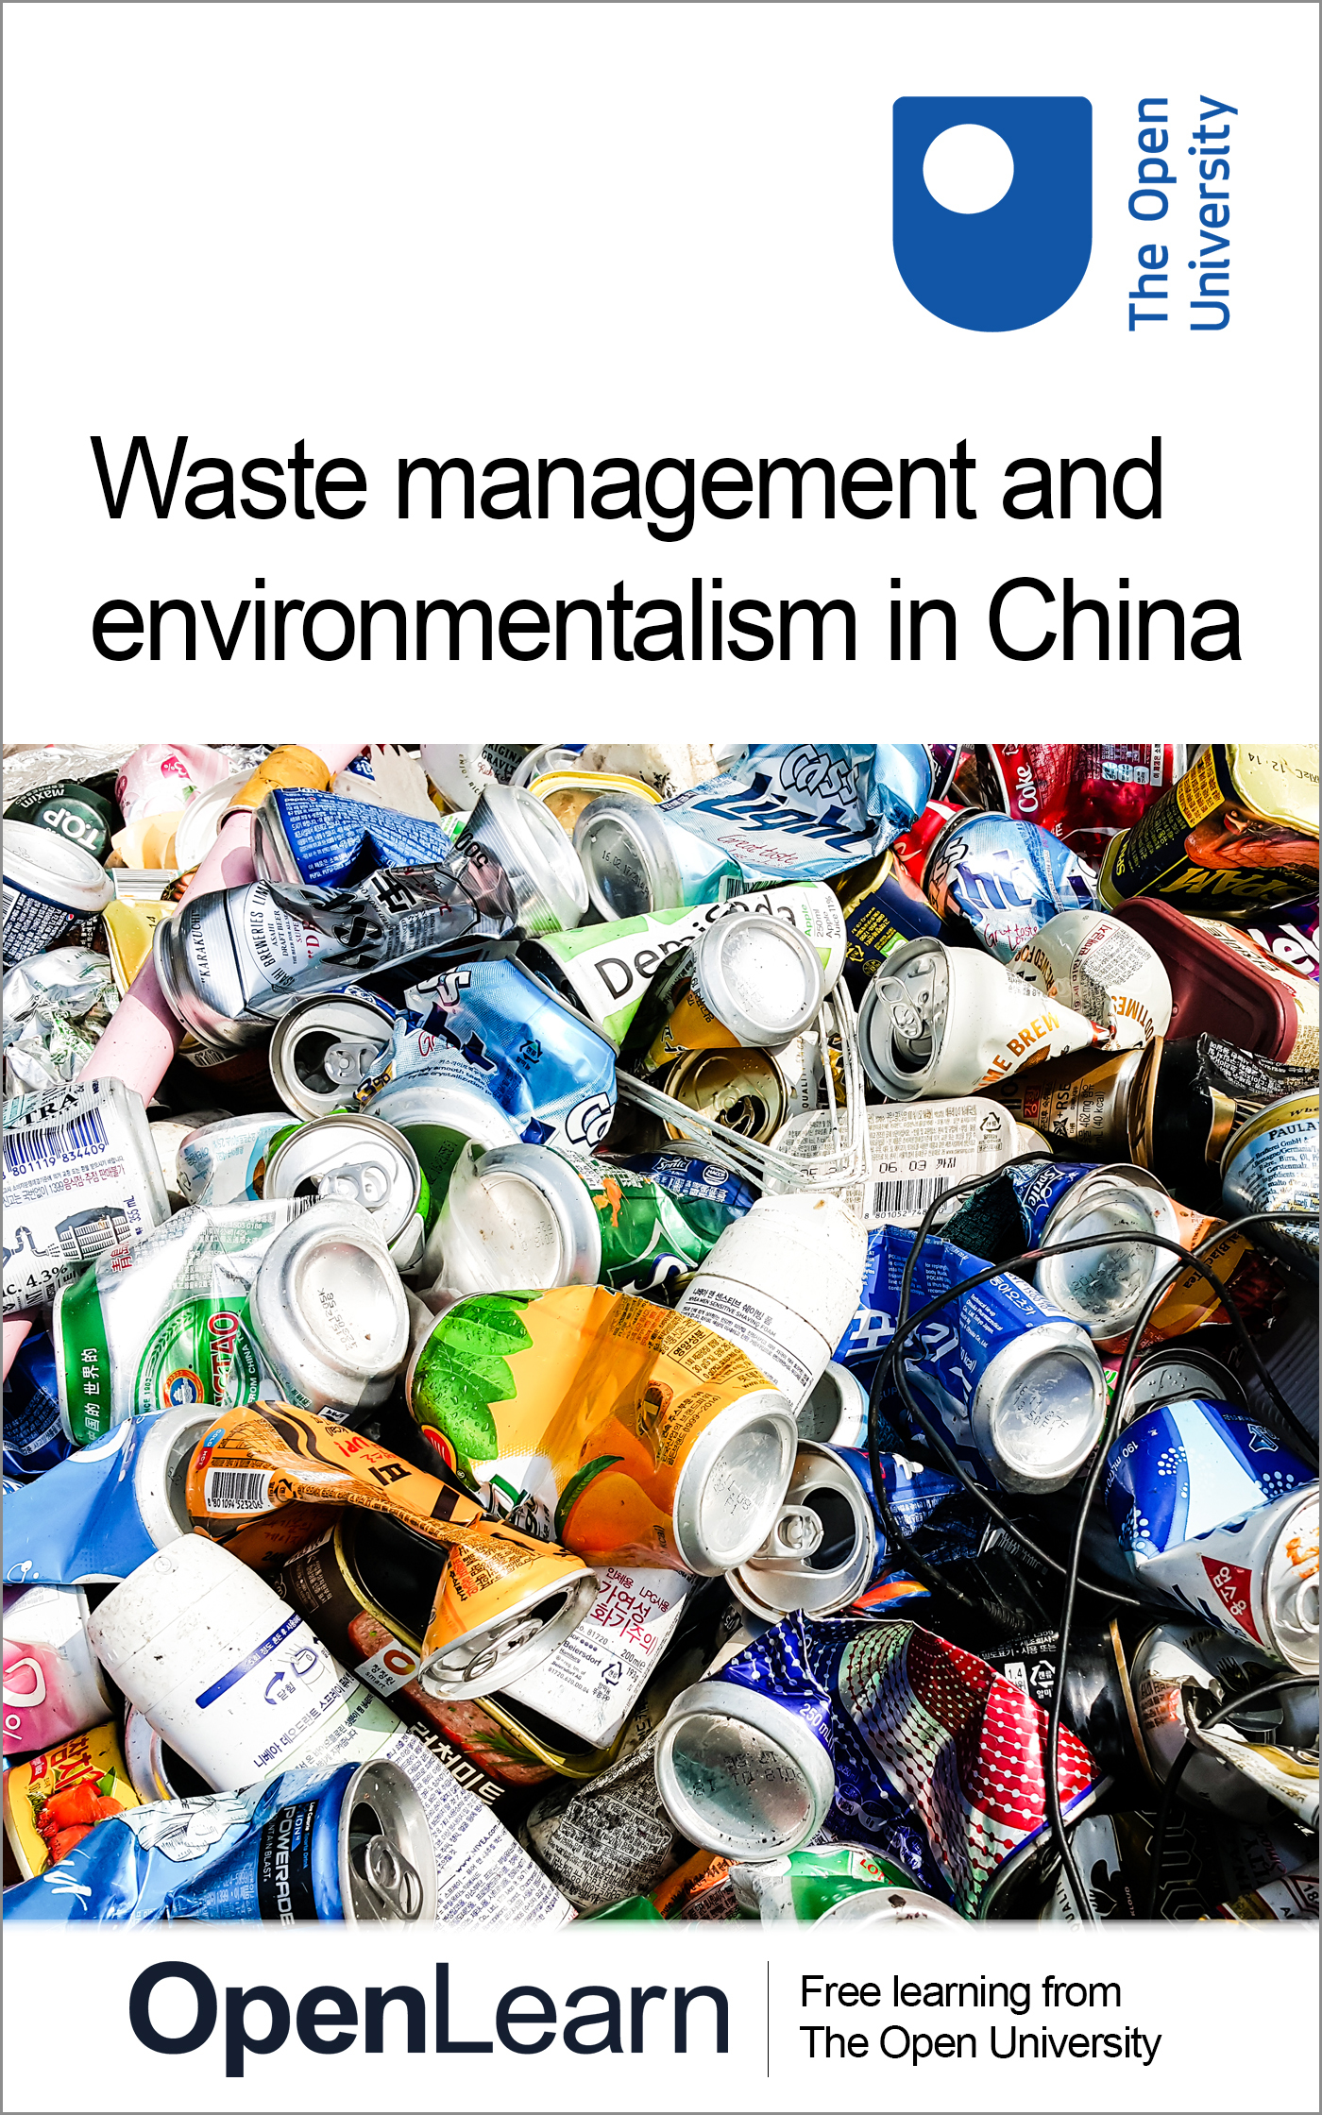

U116_4

Waste management and environmentalism in China
About this free course
This free course is an adapted extract from the Open University course U116 Environment: journeys through a changing world www.open.ac.uk/courses/qualifications/details/u116 .
This version of the content may include video, images and interactive content that may not be optimised for your device.
You can experience this free course as it was originally designed on OpenLearn, the home of free learning from The Open University – Waste management and environmentalism in China
Waste management and environmentalism in China
There you’ll also be able to track your progress via your activity record, which you can use to demonstrate your learning.
Copyright © 2018 The Open University
Intellectual property
Unless otherwise stated, this resource is released under the terms of the Creative Commons Licence v4.0 http://creativecommons.org/licenses/by-nc-sa/4.0/deed.en_GB. Within that The Open University interprets this licence in the following way: www.open.edu/openlearn/about-openlearn/frequently-asked-questions-on-openlearn. Copyright and rights falling outside the terms of the Creative Commons Licence are retained or controlled by The Open University. Please read the full text before using any of the content.
We believe the primary barrier to accessing high-quality educational experiences is cost, which is why we aim to publish as much free content as possible under an open licence. If it proves difficult to release content under our preferred Creative Commons licence (e.g. because we can’t afford or gain the clearances or find suitable alternatives), we will still release the materials for free under a personal end-user licence.
This is because the learning experience will always be the same high quality offering and that should always be seen as positive – even if at times the licensing is different to Creative Commons.
When using the content you must attribute us (The Open University) (the OU) and any identified author in accordance with the terms of the Creative Commons Licence.
The Acknowledgements section is used to list, amongst other things, third party (Proprietary), licensed content which is not subject to Creative Commons licensing. Proprietary content must be used (retained) intact and in context to the content at all times.
The Acknowledgements section is also used to bring to your attention any other Special Restrictions which may apply to the content. For example there may be times when the Creative Commons Non-Commercial Sharealike licence does not apply to any of the content even if owned by us (The Open University). In these instances, unless stated otherwise, the content may be used for personal and non-commercial use.
We have also identified as Proprietary other material included in the content which is not subject to Creative Commons Licence. These are OU logos, trading names and may extend to certain photographic and video images and sound recordings and any other material as may be brought to your attention.
Unauthorised use of any of the content may constitute a breach of the terms and conditions and/or intellectual property laws.
We reserve the right to alter, amend or bring to an end any terms and conditions provided here without notice.
All rights falling outside the terms of the Creative Commons licence are retained or controlled by The Open University.
Head of Intellectual Property, The Open University

Contents
- Introduction
- Learning outcomes
- 1 Waste in China
  - 1.1 Municipal solid waste in China
  - 1.2 Improving the treatment of MSW
  - 1.3 Managing waste from cradle to grave – life-cycle assessment
  - 1.4 Managing waste from cradle to cradle – circular economy
- 2 The growth of environmentalism
  - 2.1 The citizens mobilise
  - 2.2 Environmental pressure groups
- Conclusion
- References
- Acknowledgements

Introduction
As the Chinese have become more affluent they have consumed more goods and in turn the volume of waste produced has increased. This free course, Waste management and environmentalism in China, explores how the Chinese can deal with increasing volumes of waste, drawing parallels with the UK experience of waste management.
You will also consider the conceptual tools that can be used to make the cycle of material use and waste production and treatment more sustainable. The course ends with a brief examination of the growth of environmentalism in China.
This OpenLearn course is an adapted extract from the Open University course U116 Environment: journeys through a changing worldhttp://www3.open.ac.uk/study/undergraduate/course/l120.htm.

Learning outcomes
After studying this course, you should be able to:
- identify some of the environmental impacts of economic growth
- understand some concepts to more sustainably manage waste and resources
- identify some of the emerging social responses to China’s environmental problems
- assess your own waste management habits.

1 Waste in China
From their changing diet to owning more household objects, the Chinese are becoming great consumers. Production of consumer goods needs resources such as raw materials, energy, water, land and labour as inputs, to maintain production and sustain output. Manufacturing also produces many waste products, a large number of which, if not treated carefully, and emitted to the environment, are pollutants and may be hazardous to the local population.
An extreme example of the harm that can be done by the lax control of wastes is shown through China’s environment ministry’s acknowledgement of the existence of ‘cancer villages’, as shown in Figure 1.

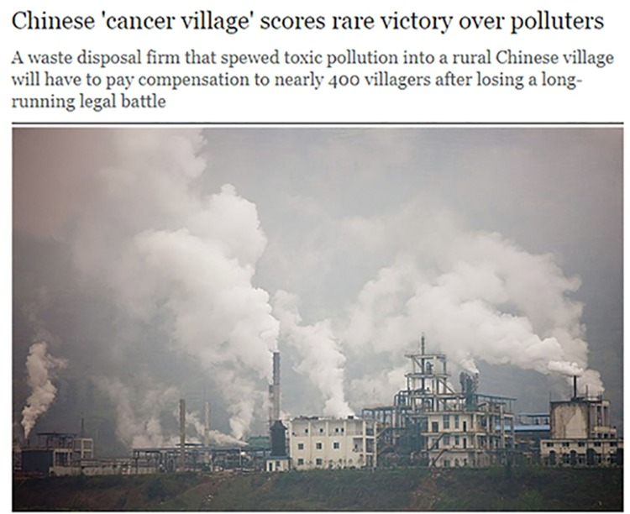
Figure 1 Industrial pollution in China
View description - Figure 1 Industrial pollution in China

A cancer village is one where the incidence of cases of cancer is higher than would be expected from the incidence in the general population. This may indicate that there is a hazard that villagers are exposed to. In the village of Liuchong in central China’s Hubei province, villagers have reported deaths from cancer and are concerned about phosphogypsum dumped in the area by a local company, shown in Figure 2. Phosphogypsum is a by-product of making fertiliser and it contains cancer-causing chemicals such as arsenic, uranium and radium.

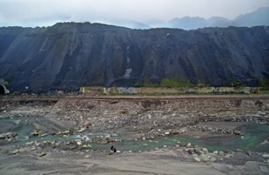
Figure 2 Phosphogypsum slag heap in Sichuan
View description - Figure 2 Phosphogypsum slag heap in Sichuan

Despite much publicity for their plight, the residents of Liuchong don’t seem to have had much official response from the provincial government and the environmental protection bureau or the factory concerned. Data collection on cancer rates in China have improved over recent years (Chen et al., 2016) and show that lung cancer is the most common cancer causing death. However, a considerable amount of evidence needs to be gathered before some hazardous chemical in the environment can be shown unequivocally to be the cause of increased cancers.

Activity 1 Pathways for hazardous chemicals
Allow about 10 minutes

- How might the toxic chemicals in the Liuchong dump get into the bodies of villagers?
- What other evidence might need to be gathered before the link between phosphogypsum and cancer is clearly established?

Provide your answer...
View discussion - Activity 1 Pathways for hazardous chemicals

1.1 Municipal solid waste in China
Solid waste produced by households is usually known as municipal solid waste (MSW). Definitions of what constitutes MSW vary but it usually compromises the waste from households together with some commercial wastes from shops and offices, street sweepings and some small businesses.
In cities such as Beijing, households can be diverse: from older, traditional ‘hutongs’ (a term which refers to an old alley or street normally lined with courtyard houses) to penthouse suites in modern high-rise, high-tech buildings. However, many hutongs are being cleared to make way for those higher-density modern high-rise buildings (Figure 3). As Chinese cities modernise and grow, the waste they produce increases and the composition changes, with more packaging, electronic waste and household appliances (Hoornweg et al., 2013).

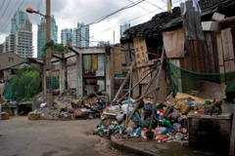
Figure 3 Old Shanghai hutong being cleared to make way for new high-rise buildings
View description - Figure 3 Old Shanghai hutong being cleared to make way for new high-rise buildings ...

At worst, high levels of waste can lead to ad hoc uncontrolled rubbish tips, which have no mechanisms for protecting the environment from the waste tipped into them. The liquids drained or ‘leached’ (the leachate) from rubbish sites can be very hazardous, and the methane gas generated from the decomposition of waste is both flammable and a greenhouse gas. If methane gas leaks out of rubbish dumps, there can be serious consequences. In 1986, a home in the UK was destroyed (Figure 4) by an explosion due to methane gas leaking from an old unregulated rubbish tip on adjacent land.

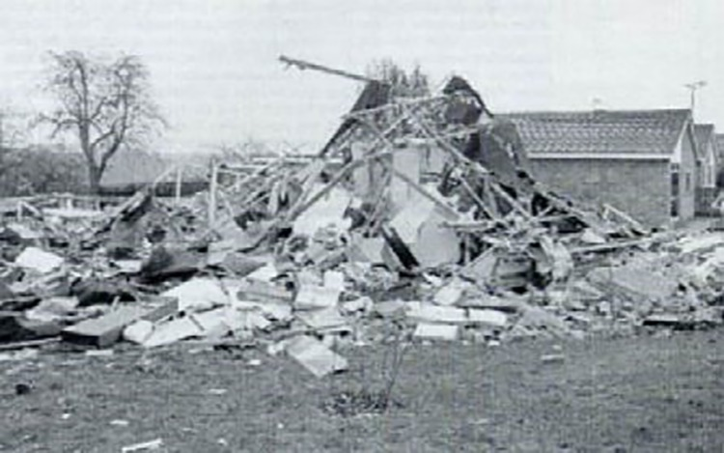
Figure 4 The remains of a home in Loscoe, Derbyshire after an explosion involving methane gas
View description - Figure 4 The remains of a home in Loscoe, Derbyshire after an explosion involving ...

Apart from risks from leachate and methane emissions, the quantity of waste dumped can also be a problem. At the end of 2015, a huge amount of construction waste dumped on a hillside in the industrial area of Shenzhen, one of the wealthiest cities in China, caused a massive landslide that destroyed many buildings and killed 73 people (Mathews and Tan, 2016).
Elsewhere in China, the example of Luoshui village shows how uncontrolled rubbish tips develop. The village used to be a pristine example of a mountain village in the Yunnan province. It has been studied by a Chinese academic from Beijing Normal University, Professor Tian Song, and his story is outlined in Box 1.

Box 1 A case study: garbage of Lugu Lake, Yunnan province
Lugu Lake (泸沽湖) is a great and beautiful lake at the boundary of Yunnan and Sichuan Province, Southeast of China. More and more tourists have visited there since the 1980s.
In October 2000, I visited Lige (里格), a small village on the shore of Lugu Lake, Yongning County, Yunnan Province, which is the habitation of the famous Mosuo people (摩梭人), or Nari people (纳日人), a branch of the Naxi ethnic group (納西族). To my surprise, I found a garbage can in the center of the village. I lived in some small villages in north-eastern China during my childhood and I never saw such things in a traditional area. In my memory, everything in villages comes from dust, and goes back to dust. Residual food could become food for chicken and pigs; garbage from home cleaning was dumped to pig beds and would later be dug out as fertilizer. I was confused by the garbage can in the village. I predicted that there must be a garbage dump outside the village, not too far, not too close. But with only a few hours to stay there, I could not ask questions such as, where do you dump your garbage?
In September 2003, I met Zhao Hua (赵化), an anthropological photographer. […] One month later, Zhao Hua called me to say that she found, and was astonished by, the garbage dumps of Lige and especially Luoshui (Figure 5). For the latter, a hill several hundred meters long was covered by six years of garbage including plastic bottles, drinking packages, shoes, glass bottles and batteries. Nobody in the village visited there, nobody in the village knew how severe the garbage problem was. In my opinion, the garbage there had two origins: firstly that left by tourists; and secondly that produced by themselves after their living standard was raised.

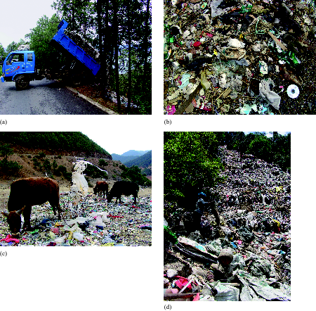
Figure 5 The waste waterfall in Lugu Lake, during the early 2000s: (a) Waste collection truck in Luoshui village; (b) a closer look at what is in the waste stream in Luoshui; (c) cattle grazing on rotting food and waste from the informal rubbish tip; (d) the effect of an informal waste tipping process on the land and its surroundings – at the bottom of the tip, an industrious person scours the hillside for materials which can be reused, while her baby waits nearby sitting on the tip.
View description - Figure 5 The waste waterfall in Lugu Lake, during the early 2000s: (a) Waste collection ...

When they made money they became richer and richer. They used more and more industrial products in their daily lives, such as washing powder, shampoo, plastic shoes, etc., which are signs of civilization, development, progress, and so on. As a consequence, more and more non-degradable garbage appeared. The villages are the bottom of the ‘downstream’ riverside; they can’t find their own location downstream for dumping their garbage, and can only dump their garbage in their own mountain. So, this case is a good illustration of my argument.
The pictures by Zhao Hua were seen by a China Central Television crew, and they asked me to help them produce a program. I hesitated at first and then agreed. Zhao Hua guided the production crew. I saw the program only when it was aired. They did not consider my explanation as given above, and still put it into a conventional pattern, that the garbage dumps were there because some officials were not dutiful. After the program was broadcast, the mayor of Lijiang government asked the county government to solve the problem. The garbage hill was closed for several days, and then, the garbage disappeared from the hill. Zhao Hua guessed that the garbage was burnt and then covered by earth. Later, interesting things happened. As for Luoshui, garbage was still produced every day, but officers dared not allow dumping in the original hill. They had to find a new place. At first, they wanted to dump the garbage in the mountain of another village, but the village refused to accept it. At last, they had to dig a place the size of a basketball court, on the land of the secretary of the village, as a temporary garbage dump. […] Since the Han dynasty, Nari people have lived around Lugu Lake. They drank lake water directly. But in 2000, I was told in Luoshui that the water close to shore was not drinkable, and people had to take a boat to the centre of the lake to draw drinkable water.
(Adapted from Song, 2012)

Informal waste collection
Although uncontrolled dumping in China is common, it is not the only means of managing waste. The removal of hutongs has resulted in large amounts of building rubble, much of which is sorted by people who work the streets for very low earnings. These people also travel around the city all day long collecting any type of waste that has a resale value. Items which can be resold include cardboard, foam, electronic goods, paper and other metal goods such as scrap metals or wires. These collectors then take these items to larger depots and sell them on to larger merchants, who then use the items to become inputs for future products or processes. This is an example of what you may recognise as recycling. Items such as wood, tiles, crockery, stone or bricks from torn down houses or abandoned sites attract less value, hence those people that collect these may be making just enough to survive.
All of the street-based recyclers are part of an informal system that has developed in response to a demand and a need for people to earn a living. Such systems are not heavily regulated and operate outside the normal and more formal market. Even though they may seem unorganised, these informal workers (shown in Figure 6) make a significant contribution to waste clearance, and those who have chosen to work in the cities after a rural migration may feel that they have a better life overall. A quote from Judy Li from Beijing’s China Sustainable Cities Program shows the scale of these informal enterprises: ‘Local waste experts and activists say that in Beijing alone there are around 200 000 informal collectors working seven days a week, collecting around 30% by weight of the total MSW’ (Li, 2015).

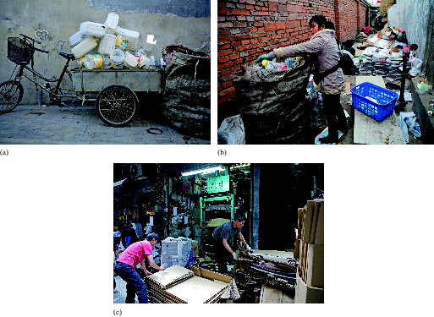
Figure 6 The contrasting views of informal waste collection of plastic bottles and other plastic materials with that of clean cardboard being collated for formal collection within a controlled industrial site in Hong Kong. (a) A tricycle about to be unloaded at an impromptu recycling depot in Beijing. The depot is collecting plastic bottles and other plastic items for recycling, and transporting them to the factory in very large plastic mesh bags (on the right). (b) Ad hoc recycling centre in an alley. This recycler is sorting items and weighing the plastics using the scale on the right-hand side of the picture. (c) A cardboard collection depot in Hong Kong.
View description - Figure 6 The contrasting views of informal waste collection of plastic bottles ...

1.2 Improving the treatment of MSW
Waste management systems have an overarching principle to protect public health. They rely on various strategies to minimise waste, to make best use of any waste that has a value, and to minimise any risk of pollution from waste management practices. The waste hierarchy lists the different ways of dealing with wastes according to what is best for the environment, starting with the most beneficial and working down to ‘disposal’, which is the least desirable way of getting rid of most wastes. Many versions of the hierarchy have been published, but they all present this same message. An example of the hierarchy is in Box 2.

Box 2 The waste hierarchy

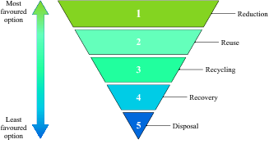
Figure 7 Diagrammatic representation of the waste hierarchy (OpenWash, 2016)
View description - Figure 7 Diagrammatic representation of the waste hierarchy (OpenWash, 2016)

Reduction: at the top of the hierarchy is waste reduction. This is the best option because the most effective way to limit the health effects and environmental impacts of waste is not to create waste in the first place.
Reuse: reuse can be defined as using a waste product without further transformation and without changing its shape or original nature. This is the second option in the waste hierarchy. Different types of solid wastes can be reused or used for a purpose similar to that originally intended, such as ‘upcycling’ clothes.
Recycling: this means that the waste material is reprocessed before being used to make new products.
Recovery: this is about finding other uses for wastes that enable some value to be extracted or recovered from them, usually by using them as a source of energy. Composting, the process where biodegradable organic wastes (food and garden waste) are converted into soil-like material (compost) in a natural biological process, is included within the recovery category.
Disposal: waste disposal processes aim to isolate the waste from people and the environment in a manner that causes no harm. This is most commonly done by using a tightly controlled and regulated landfill site, though very high temperature thermal processing may be used for hazardous waste.

The waste hierarchy has been developed to consider the environmental benefits of various types of waste treatment. It does not say anything about the cost of different options or how easy it may be to employ the best options of a particular kind of waste.
Waste reduction clearly helps in two key ways. First, the greenhouse gases associated with making products (materials, manufacturing and then distribution) are avoided, and second, society benefits by not having to dispose of or manage the waste that the products would have generated. However, the simple categories outlined in Box 2 are subject to debate and can be interdependent. For example, composting often needs added extra heat to speed up the process to create useful products more quickly. Similarly, if waste is incinerated with energy recovery, so that the energy recovered can be used for district heating schemes or fed into the electricity grid, then some form of disposal for the ash generated is needed. This is commonly disposed of in a very highly controlled landfill site.

Determining the size of the problem
Having a framework for best environmental options for waste management is, of course, all very well; putting such things into practice is another matter. In the UK, you may be familiar with the ‘3Rs’ – ‘reduce, reuse, recycle’ – often used in waste awareness and recycling campaigns to encourage people to change their behaviour, which may not always be easy or straightforward to achieve.
Before an environmentally acceptable system of waste management can be developed, the size of the problem needs to be determined. This should be followed by a formal collection system for MSW and then the best possible environmental option used for treating the waste.
A significant issue is that data are not systematically collected for China as a whole; the data are sketchy and patchy. But China is not exceptional in having poor waste data. In the UK, waste generation statistics were not always reliable even into the 1980s and even today, waste data are often described as ‘estimated’.
Data are difficult to collect and may not be collected every year, so while it may be several years old, it could still be the best available. Not only does the amount of waste to be collected and managed need to be ascertained, but its composition needs to be known as different strategies of waste management may be more appropriate for different parts of the diverse mix of material in household waste. Table 1 shows some estimates of MSW generated for a selection of countries.

Table 1 Weight of MSW generated for a selection of countries (adapted from UNSD, 2016 and World Bank, 2016)*
Country | Annual generation of MSW (million tonnes) | Population (millions) | Annual generation per capita (kg/person)
China | 171 | 1371 | Provide your answer...
Germany | 50 | 81 | Provide your answer...
South Korea | 18 | 50 | Provide your answer...
UK | 31 | 65 | Provide your answer...
USA | 228 | 321 | Provide your answer...
*Note that the column on the right-hand side has been left intentionally blank because you will calculate this information as part of Activity 2.

Activty 2 MSW generation per person
Allow about 10 minutes

Using the data in Table 1, calculate the annual generation of MSW per person for the countries shown and add these into the free response boxes in the table. Then summarise the data for China and the USA in a sentence or two.

View answer - Activty 2 MSW generation per person

Although waste data are poor and not systematically collected in China, there are some estimates which suggest that the rate of growth of MSW is unprecedented. Determining precise growth rates year on year is not possible without reliable data, but it is possible to estimate a trend over time using data published at specific points over the last few decades combined with some future projections.
MSW generation is estimated to have risen from around 30 Mt in 1980 to around 100 Mt at the turn of the century (Wang and Nie, 2001, cited in Zhang et al., 2010), almost doubling to just under 200 Mt by 2010 (Zhang et al., 2010). The World Bank projects China’s MSW to increase to over 500 Mt by 2025 (Figure 8), accounting for nearly one-quarter of the amount of MSW expected to be generated by the entire world (Hoornweg and Bhada-Tata, 2012).

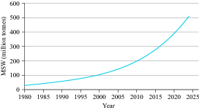
Figure 8 Estimated past and predicted annual growth of MSW in China in million tonnes per year from 1980 to 2025 (adapted from Zhang et al., 2010; Hoornweg and Bhada-Tata, 2012)
View description - Figure 8 Estimated past and predicted annual growth of MSW in China in million ...

Activity 3 Growth of MSW
Allow about 5 minutes

- What word would you use to describe the growth rate shown in Figure 8?
- What might be the daily production of MSW in 2025?

View answer - Activity 3 Growth of MSW

The current best estimates of how China manages its waste are shown in Table 2, with a comparison with the same selected countries as in Table 1.

Table 2 Percentage of MSW landfilled, incinerated, recycled or composted in a selection of countries (adapted from UNSD, 2016)
Country | Landfilled | Incinerated | Recycled | Composted | Year
China | 61.5 | 21.0 | no data | no data | 2012
Germany | 0.3 | 33.7 | 46.6 | 17.2 | 2014
South Korea | 15.6 | 25.3 | 58.7 | 0.4 | 2013
UK | 27.8 | 26.5 | 27.3 | 16.4 | 2014
USA | 53.8 | 11.7 | 26.0 | 8.5 | 2012

One of the first things that should strike you about Table 2 is that China appears to do little recycling. even if you assume that the 17.5% of ‘missing’ MSW is diverted into recycling. The picture presented is that China landfills or incinerates most of its solid waste. This shows the difficulty of assembling waste data when no one has full control over all the ways in which waste is managed.
So how might China ‘grow green’ in its management of MSW, and can it use the waste hierarchy better? Some possible strategies are outlined in the next sections.

Strategy 1: Formal collection
A formal system is one which is organised and regulated and in many cases instigated and facilitated through the municipal city council, and has to be the first step in improving the treatment of waste. The scale of the informal collection of waste for recycling in China, in practice, seems to be relatively efficient even if it reinforces social inequalities (Li, 2015). However, it does little to promote the regulation of recycling and best practice in treatment of waste, and Judy Li suggests that government cooperation with the informal sector would improve the sector as a whole and promote more equality for street recyclers.
There is no mandatory system for Chinese municipalities to collect and segregate MSW, though some cities such as Beijing, Shanghai and Guangzhou are beginning to set up schemes. Where a municipality has control of the whole scheme, it can impose regulations to ensure the safe handling of materials and protection of the environment.
Added to its own waste, China imports waste, and this waste can become part of the general problem. China produces significant quantities of electric and electronic equipment (EEE) both for its own use and for global exports. China has also been a primary destination for discarded products known as ‘e-waste’. Since 2000, ‘transboundary’ imports of e-waste – that is shipping across countries – are supposed to be banned, but licensed imports are allowed at Hong Kong ports and e-waste can be exported legally or illegally to mainland China. Some of this waste has been traced back to North America, Europe and Japan (Powell, 2013). Much of this e-waste contains high-value components such as various metals and has fed into the informal recycling sector. Poor environmental practices such as the dumping of e-waste (Figure 9) has led to health risks for workers, particularly in the town of Guiyu, just across the border from Hong Kong, and significant media coverage.

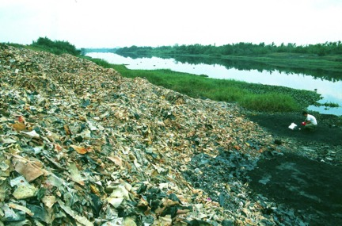
Figure 9 A pile of circuit boards dumped next to a river in China. The circuit boards were first treated with acid to remove metals; the acid flowed into the river and burned openly.
View description - Figure 9 A pile of circuit boards dumped next to a river in China. The circuit ...

Recently, however, China’s Ministry of Environmental Protection has made efforts to improve the situation and may even be guiding the rest of the world through links with the United Nations Development Agency and using innovative solutions (UNDP, 2016). For example, through a smartphone app, users can find out a price and recycle their electronic products using a legal and local e-waste pick-up depot. This avoids the use of illegal e-waste dumps. However, this solution needs other measures to work alongside it. The government has set up discount schemes for domestic consumers to buy new appliances when the old ones are taken to an accredited dismantling site, and is actively subsidising the safe recycling of 14 categories of e-waste, including smartphones and tablets (UNDP, 2016).

Strategy 2: Understanding the composition of waste
The need for a proper understanding of the nature of the components of MSW is essential if the right treatment for the waste is to be determined. Knowledge of the nature and size of the problem is needed before it can be solved by putting in place measures to promote reduction in waste. This is shown by the example of food waste in Box 3.

Box 3 Food waste
There are signs that the Chinese people are developing western eating habits – eating more, and eating more fast food and meat and dairy products – and there are concerns about China’s ability to feed its self in the future. But what about food as waste?
Food can be lost at all stages of production, from farm to table. In a 2013 interview, Ren Zhengxiao, head of the Chinese State Administration of Grain, said that 32 million tonnes of grain are lost annually during transportation, storage and processing. Poor storage facilities, which lead to deterioration and loss from scavengers, result in the loss of 18 million tonnes of food, while poor transportation methods and inadequate packaging result in the loss of about 7 million tonnes of grain (Wei, 2016).
Food can also be thrown away in the home and in catering establishments. Then, if it is mingled with other sorts of household waste, it can present various problems. For example:
- it can decompose, and if it does so in a landfill site in conditions where there is no oxygen, methane gas is generated
- it attracts vermin and flies and gives off a bad smell
- it generally has a high water content which makes it inefficient as a fuel for waste to energy plants
- it can contaminate other components of the waste, making them more difficult to separate out.
In a pilot study conducted across eight cities in China in 2008 food waste made up over half of MSW, as Table 3 shows.

Table 3 Quantity of food remnants and the share in MSW in eight sample cities in 2008 (adapted from Tai et al., 2011)
City | Food remnants  (tonnes/day) | Share in municipal solid waste (%)
Beijing | 725.84 | 66.19
Shanghai | 588.33 | 71.14
Shenzhen | 300.26 | 51.10
Guangzhou | 268.79 | 52.00
Nanjing | 137.65 | 70.59
Hangzhou | 129.85 | 53.00
Xiamen | 74.33 | 74.63
Guilin | 15.20 | 61.31

Food waste also represents a waste of the material resources, energy and labour that went into producing the food. It also presents a moral dilemma in that even in the most highly developed economies there are always people in need of more, and more nutritious, food. As economies become more affluent, food waste generally increases (Liu, 2014), but trends can vary globally. The quantities of food waste in commercial and household waste are not easy to measure as it can require sampling of individual rubbish bins.
Countries with more developed waste systems such as the UK have been looking to improve the way they manage food waste for a few decades, but consideration of food waste is in its infancy in China. In the UK, the highest proportion of food and drink waste in the food chain was wasted in households, and this is typical of Western countries. In the UK, 7.3 million tonnes of food was thrown away in households in 2015, of which 4.4 million tonnes was deemed avoidable (WRAP, 2015). In China, a large proportion of food wastage takes place in the catering sector. Chinese etiquette requires hosts to provide large amounts of food for their guests, and the problem of food waste is especially marked in large restaurants as they are used for business discussions and banquets (Liu, 2014).
It is not easy to reduce food waste from households or the catering trade. If the cost of food increases, then this may encourage less waste. Otherwise, publicity is an important tool. In 2012, the ‘clear your plate’ campaign was started by a small but diverse Beijing non-profit group through messages on social media. This community-level action gained official approval from Chinese President Xi Jinping a year later. The campaign focused on reducing food waste when dining in restaurants, encouraging diners to order less and take any leftover food home. President Xi Jinping also launched measures to stop corruption in the Communist Party and the giving of lavish banquets (Hatton, 2013). It remains to be seen if, by these measures, China can tackle its food waste problem effectively.
In the UK in the last ten years, campaigns such as ‘Love food, hate waste’ have tried to reduce food waste, endorsed by celebrity chefs such as Jamie Oliver. However, the best available data show that while between 2007 and 2010 food waste declined by 14%, since then there has been no further decrease (WRAP, 2015). Part of the solution to minimise food waste in both China and the UK rests not just with ‘they’ but also ‘us’ and changing our behaviours.
This leaves the possibility of collecting food waste separately and attempting to extract at least some value out of it. Knowing the composition of MSW and how much of it is food waste is the first step into putting this into practice. The use of anaerobic digesters for converting animal manure into usable energy is common in China and this technology is increasingly being used to extract energy from food waste.

Strategy 3: Improving technology
Burning or incinerating MSW dramatically reduces the volume of waste to be dealt with and is an important way of dealing with the waste problem in China. However, a modern plant should not be designed just with mass reduction in mind.
The technology has been developed worldwide to use the heat energy generated in an incinerator either to heat water that can be piped to homes and businesses or to generate electricity, such as is shown in Figure 10. Such incinerators are more properly called waste-to-energy (WtE) or energy-from-waste (EfW) plants. The outputs of burning, such as ash and gases, should be treated to render them as harmless as possible before they are emitted to the environment. For example, combustion conditions can be very tightly controlled to destroy harmful chemicals. Countries such as the UK, and in much of Continental Europe where EfW plants are widely used, operate under strict legal regulations concerning what they can emit to the atmosphere.

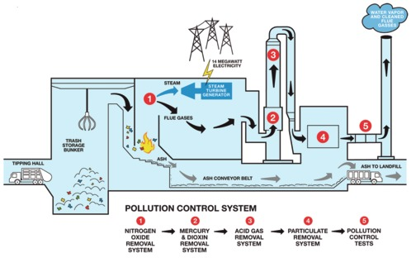
Figure 10 Diagram of an energy-from-waste (EfW) plant, showing energy generation and pollution control
View description - Figure 10 Diagram of an energy-from-waste (EfW) plant, showing energy generation ...

The need for pre-treatment of materials from the MSW stream can be further reinforced if energy from waste is a chosen treatment option. EfW plants are not incompatible with recycling, since materials can be taken out for recycling before burning (e.g. food waste), or before and after combustion (e.g. metals).
While landfill should be the last resort for the disposal of waste, it is widely used in China and there will always be types of waste – for example, the ashes from incineration, or materials that cannot be recycled – that will end up being landfilled.
The engineering of modern, well-run landfill sites is designed to prevent uncontrolled emissions of leachate and gas from the decomposition of waste, to the environment. This is mainly achieved through the use of an impermeable butyl or clay liner and engineering the collection of leachate which is treated. Landfills should be operated so that vermin are controlled by covering the waste every day and capping with an impermeable material when no longer in use. An example of how this can be done has been undertaken in Hangzhou. Hangzhou is a tourist destination celebrated for its beautiful mountains and old architecture, which now adds the Hangzhou Ecopark to its list of attractions. The local landfill site incorporates China’s first industrial landfill gas power plant, where gas from the anaerobic decomposition of waste is collected through a network of pipes and burned to generate electricity (Liu, 2011). This is part of the visitor attractions, which include sculpture made from recycled materials, and displays and games to encourage recycling (see Figure 11). The Ecopark is even marketed as a wedding venue.

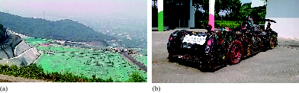
Figure 11 (a) The landfill site under construction for China’s first industrial landfill gas power plant at Hangzhou’s Ecopark; (b) visitor attractions at the park include sculptures made from recycled materials including this racing car
View description - Figure 11 (a) The landfill site under construction for China’s first industrial ...

There are efforts across China to develop more controlled landfill sites. Returning to Lugu Lake discussed in Box 1, Tian Song’s story has developed since the year 2000.

Box 4 A case study: garbage of Lugu Lake, Yunnan province (continued)
Much has changed at Lugu Lake as a new managed waste site nearby (Figure 12), which is now taking the waste on a regular basis, was established in 2006 about 30 km away. The land it was built on was previously owned by the county government and the system can be considered a formal one.

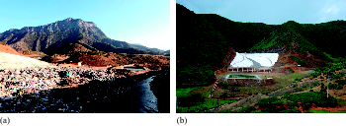
Figure 12 The waste dump during the 2008–12 period, showing the size and scale of the garbage problem near Lugu Lake. Note the landfill liner that isolates the rubbish from the environment.
View description - Figure 12 The waste dump during the 2008–12 period, showing the size and scale ...

However, Tian notes:

The dump was designed for a 20 year lifespan – meaning it can hold the capacity of that much municipal waste before it is full – when we consider that 2026 is not very far away in time it is rather worrying. The site takes rubbish from the hotel which runs nearby and local workers charge to burn some rubbish and compact the rest.
(Song, 2012)

Activity 4 Thinking about your own waste habits at home
Allow about 10 minutes

- How do you separate your waste for collection?
- Do you know how the separated waste is treated and where it goes?
- How does this fit with the waste hierarchy? Could you do more to reduce your waste?

Provide your answer...
View discussion - Activity 4 Thinking about your own waste habits at home

Strategy 4: Use of economic and legal instruments
Just like China, the UK had been over-reliant on landfilling waste of all kinds, including MSW. Landfill had been a cheap disposal method and the vast majority of waste up to the 1990s had been dumped in landfill rather than being seen as a resource for energy or recycling (Seely, 2009). The imposition and continuation of the landfill tax in 1996 is one of the reasons why UK recycling rates for MSW have risen from a low base in the 1990s to over 44% of MSW being recycled in 2015, with a target of over 50% recycled by 2020 (DEFRA, 2016). At present in China there is no system for taxation for MSW disposal through landfilling (Mian et al., 2016), and if an appropriate taxation system could be introduced, then this might encourage more recycling.
Apart from economic ways of changing behaviours, legal requirements are important tools. EU law, for example, requires member states to reduce the amount of biodegradable municipal waste, such as food and garden waste, that they landfill to 35% of 1995 levels by 2016 (for some countries by 2020) as part of plans to reduce greenhouse gas emissions (European Commission, 2016).
China appears to be moving forward in imposing legal requirements for environmental protection. China’s newly revised environmental law, which came into force on 1 January 2015, requires real-time disclosure of pollution discharge data from key industries. The law can also impose greater fines on polluters and crucially requires governments to respond to citizens’ (including non-governmental organisations) accusations against polluters. China’s local courts will now be instructed to hear cases brought by citizen groups. This will be an interesting area to watch in the future, as responses to grassroots environmental groups vary between government departments as well as between regions. Where environmental enforcement is already on the agenda, such as in developed regions along China’s coastline, citizen groups have an easier time making headway against polluters (McDonald, 2015).

1.3 Managing waste from cradle to grave – life-cycle assessment
The waste hierarchy provides some useful guiding principles for managing waste according to what is best for the environment. But does it always hold true? Imagine you have an old and energy-intensive appliance, say a clothes washing machine, but much more energy efficient washing machines are available to buy. Most appliances now come with some form of eco-labelling to indicate energy efficiency and help inform purchasers’ decisions (Figure 13).

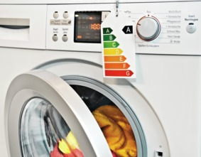
Figure 13 Modern washing machine with energy efficiency label
View description - Figure 13 Modern washing machine with energy efficiency label

Should you keep hold of your old energy-inefficient machine or buy a new energy-efficient one? Keeping it prevents it from becoming waste and seems like the most desirable option as it is at the top of the hierarchy. But this means you continue to use more energy than you need to. You could opt for reuse, the next best thing in the waste hierarchy, by passing your old machine on to someone else, but this will transfer the energy inefficiency elsewhere. The waste hierarchy, and the messages that flow from it, such as the ‘3Rs – reduce, reuse, recycle’ are not sufficient to help make this decision. What would also be helpful to understand is the energy use and other resource implications across the life cycles of the washing machines.
The life-cycle assessment (LCA, also known as ‘life-cycle analysis’) process considers all inputs and outputs that a product makes during its entire ‘life’ and is also sometimes informally referred to as cradle-to-grave analysis. It can be useful if you want to look at the possibilities of manufacturing products that are less harmful to the environment. A rigorous LCA would look at each stage of the product life, including raw materials acquisition, manufacturing, distribution and retail, use, reuse, maintenance, recycling, waste management and/or end-of-life phases (this is shown in Figure 14 for a new washing machine). The LCA process is particularly good for raising awareness of those additional undesirable outputs at each stage of the product life.
LCA is a systems approach in that it catalogues all of the environmental impacts for each stage of the life cycle. It starts from the impacts due to extraction of the raw materials and then continues to include the processing of these. Many manufacturers are acutely aware of the energy, materials and water required to make a product, and will attempt to reduce these inputs without sacrificing the function of the product. Reduction in manufacturing inputs makes good business sense, as lower inputs result in cost savings, which may result in higher profits for the firm, or lower prices for the public.
Next there is the in-use phase, which tends to have relatively high impacts, especially if the product requires energy, water or some other form of maintenance. The final phase is disposal and recycling. This phase may include dismantling for valuable components, depending on the item in question.
Many studies have shown that the LCA for the in-use phase of typical white goods attributes about 95% of the total impacts during the life cycle. Another 3–4% of the impacts occur for the assembly, and extraction and disposal each account for about 1%. Similar studies for many other goods have shown that the in-use phase accounts for the majority of emissions, especially if the item uses energy in some form, and for the majority of impacts produced. The in-use phase is sometimes called the operational phase, as the product should be working, being used or operated.

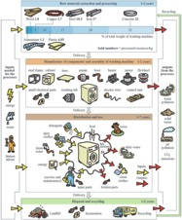
Figure 14 Environmental impacts of a typical washing machine throughout the four main stages of its life cycle
View description - Figure 14 Environmental impacts of a typical washing machine throughout the four ...

Carrying out a LCA can be far from straightforward. How do you allocate direct inputs such as electricity for operating machinery, lighting and warmth in a mass production factory to individual items or groups of products? Often this has to be a best guess as many factories do not measure electricity for each process or sub-process.
What about indirect inputs? Many large factories in China have accommodation, washing facilities, canteens and shops for their workers. All these require resources and create outputs in the form of waste food, packaging, waste water and sewerage. Should these indirect inputs and outputs be captured in the LCA?
What about indirect inputs in the operational phase? From the washing machine example above, should the emissions from the transport used by going to buy the detergent to use in the washing machine be included? This highlights one of the main LCA challenges, which is where to draw the boundary between what should and should not be included in the assessment.
Although it may be challenging to undertake, the advantage of a LCA is in identifying the environmental impacts of a product through all stages of its life. Once the impacts are known, initiatives to help reduce the impacts can be developed and implemented. LCA can also be used to compare different products and identify more environmentally-friendly ones. For example, LCA often underpins eco-labelling of products. Hence LCA can help improve the efficiency of the system, but the linear nature of the system remains the same – extraction, make, use, dispose – or ‘cradle-to-grave’. Although there can be reuse and recycling of some materials, this is after the in-use or operational stage. Critics argue that this linear system embeds the idea that these products were never ‘designed’ to be recycled, and as a result they tend to be recycled into poorer quality materials, which limits usability and maintains the linear flow (Ellen MacArthur Foundation, 2013).

1.4 Managing waste from cradle to cradle – circular economy
The circular economy is a way of thinking and doing that moves on from ‘cradle to grave’; it focuses on closed loops and designing waste out of the economy and is also referred to as ‘cradle to cradle’ (McDonough and Braungart, 2002).
It is difficult to trace the origins of the circular economy back to any one point in time or particular author. It is an evolution of ideas that first became popular in the 1960s and 1970s, with influences such as Rachel Carson’s book Silent Spring and James Lovelock’s work on the Gaia hypothesis, as well as ideas drawn from ecology, biology and economics about how the economy and environment should coexist in balance.
Given that the circular economy is the evolution of many ideas, it is not surprising that there is no one agreed definition. A key player in promoting the circular economy is the Ellen MacArthur Foundation, which sees the circular economy as ‘an industrial economy that is restorative or regenerative by intention or design’ (Ellen MacArthur Foundation, 2013, p. 14). Other definitions explicitly refer to the circular (or closed) flows of materials, meaning that materials are constantly reused rather than being discarded as waste, and this reuse focuses on the highest possible utility or value of materials (Webster, 2015). For example, in their analysis of developing the circular economy in China, Geng and Doberstein (2008, p. 231) describe the circular economy as the ‘realisation of a closed loop material flow in the whole economic system’.

The circular economy in China
Across the nation as a whole, China’s resource use is much less efficient than that of many other countries. It is estimated that it uses around five times more material inputs to generate the same amount of outputs when measured in terms of Gross Domestic Product (GDP) and compared against the average across many developed countries (Mathews and Tan, 2016). You have seen that China also produces colossal amounts of MSW that have risen at rapid rates, and is not as effective as many other countries in using principles of the waste hierarchy to manage the waste and turn it into a resource through reuse and recycling.
But China is starting to tackle these resource inefficiencies and is taking action to make some serious changes that it hopes will bring about long-term improvements. For several years, China has embraced the notion of the circular economy, particularly the elements of the circular economy that focus on industrial wastes and on turning the outputs from one manufacturer into the inputs of another.
In 2004, the circular economy concept was written into China’s 11th Five-Year Plan (for 2006–10) which made it an important target for social and economic development. In 2009, the Circular Economy Promotion Law of the People’s Republic of China was enacted. This helped to promote circular economy programmes and initiatives, including introducing eco-industrial parks to encourage mutually helpful and sharing relationships between manufacturers, involving utility supplies such as energy and water, electronics, food and beverages as well as reuse and recycling (Winans et al., 2017).
The circular economy concept was upgraded to a national development strategy in the 12th Five-Year Plan (for 2011–15) which included targets for reusing industrial solid wastes and increasing resource use productivity – ‘getting more out for what’s put in’. China has produced the first ever national strategy for achieving a circular economy, and the 13th Five-Year Plan (for 2016–20) extends the reuse, recycling and productivity targets, as well as renewable energy source targets.
Initiatives to implement the circular economy concept in China appear to be driven mainly by changing or redirecting flows of materials, to move away from the linear economy of ‘extract, make, use, dispose’ to a closed system of ‘extract, make, use, renew resource’, embedding the 3Rs principles of reduce, reuse and recycle. These contrasting strategies are shown in Figure 15. China sees these changes being enacted across different levels in society – individual enterprises (micro-level), clusters of geographically located firms (meso-level), and across industries, regions or at the national level (macro-level). The country has circular economy ambitions that reflect these different levels, based on a ‘10-100-1000’ plan to implement 10 major industrial waste recycling programmes, 100 circular economy demonstration cities, and 1000 demonstration enterprises or industrial parks nationwide (Mathews and Tan, 2016).

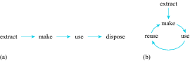
Figure 15 Diagrams showing: (a) the linear economy; (b) the circular economy
View description - Figure 15 Diagrams showing: (a) the linear economy; (b) the circular economy

One of the first eco-industrial parks to be approved by the Chinese Ministry of Environmental Protection as part of a national demonstrator programme was the development of Suzhou New District (SND). SND is a large industrial zone near Shanghai in southeast China, and is home to over 16 000 commercial enterprises and around 4000 manufacturing firms mainly in IT and electronics, but also includes biotechnology, chemical engineering, medical and pharmaceutical, iron and steel, and textile companies. Figure 16 gives a bird’s-eye view looking over SND.

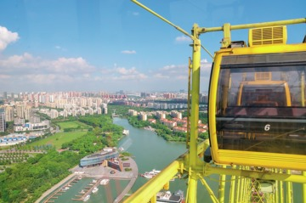
Figure 16 A Ferris wheel overlooking the Suzhou New District, one of the first industrial parks in China’s circular economy
View description - Figure 16 A Ferris wheel overlooking the Suzhou New District, one of the first ...

SND has several success stories of outputs from one manufacturing process being treated within the district and then used as inputs for another, including waste metals and reclaimed copper, clay and waste ammonia. SND claims a number of efficiencies from its circular economy initiatives, including reduced energy consumption, increased solid waste recycling and reduced emissions of pollutants. What is driving this is not just an environmental resource and impact issue, it is an economic one too. Locally regenerated and recycled materials are usually cheaper than externally sourced raw materials, which helps to increase profits.
Achieving the closed loop waste output to the resource input aim of eco-industrial parks is technically more straightforward for some industries than others, for example where waste outputs are uncontaminated and easily separated, such as waste metals. Reclaiming useful materials from mixed and contaminated waste such as industrial sludge is far more technically challenging. There can be behavioural challenges too: encouraging firms to work together may require incentives, but even then there can be geographical and logistical obstacles. Despite this, China is making progress. In 2012, there were 15 officially recognised eco-industrial parks with a potential 49 under construction (Bai et al., 2014). China is also well placed to develop further opportunities as more than half of its manufacturing base is geographically clustered in industrial parks. Being a relative newcomer to industrialisation may also have its advantages:

While it must be understood that China faces enormous obstacles in implementing the circular economy idea, and starts from a very low base in doing so, nevertheless it has certain latecomer and administrative advantages in putting its economy on a new, closed-loop footing, as compared with more advanced countries with established industrial systems.
(Mathews et al., 2011, p. 463)

The Ellen MacArthur Foundation
Dame Ellen MacArthur is a famous competitive sailor who first hit the headlines in 2001 when she raced single-handedly non-stop around the globe. She then rose to fame in 2005 when she became the fastest person to circumnavigate the globe single-handedly in just over 71 days. On her return she was honoured by the Queen in recognition of her achievements.
So what makes a successful competitive sailor retire from what she loves and start a charitable foundation that aspires to fundamentally change the way we do things? It doesn’t seem a logical step. Or does it?
Whilst spending several months alone on her boat speeding through the oceans, MacArthur survived on a limited supply of water, food and fuel. Her boat was her world, her life depended on it. When she stepped ashore she was struck by what it really meant to live with finite resources. She saw her boat as a metaphor for the world:

Never in my life had I ever translated that definition of finite that I had felt onboard to anything outside of sailing until I stepped off the boat at the finish line having broken that record. Suddenly I connected the dots. Our global economy is no different. It is entirely dependent on finite materials we only have once in the history of humanity.
(MacArthur, 2015)

In 2010, she set up the Ellen MacArthur Foundation, the world’s leading proponent of the circular economy.

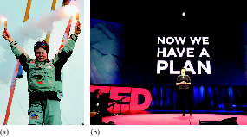
Figure 17 (a) Ellen MacArthur celebrating after becoming the fastest person to circumnavigate the globe single-handed; (b) Dame Ellen MacArthur delivering a TED (technology, entertainment and design) talk on the circular economy
View description - Figure 17 (a) Ellen MacArthur celebrating after becoming the fastest person to ...

Sharing economy
To bring about a circular economy requires governments and policymakers to implement supportive policies, and companies to deliver appropriate system redesign.
However, it is important not to lose sight of individual consumers or networks/communities of users. If the circular economy is about a new system of technologies, products and services that help design waste out of the system, then these will need to be engaged with, used and shared in order for the new system to be successful. This will entail changes in expectations, desires and behaviour of individual consumers. The move to a ‘sharing economy’ with an emphasis on access to goods and services rather than ownership is one such example.
You may be familiar with the term sharing economy. It is a broad term covering a range of activities and loosely refers to people having access to products and services rather than owning them. Sometimes called peer-to-peer lending, it is heavily reliant on online exchanges and can also include the sharing of knowledge and information. The renting out of products that you own, so others don’t have to, is also encompassed in the sharing economy, and examples include ride sharing, home lending, co-working, clothes renting, task exchanging and even renting driveways for parking spaces.
While sharing is nothing new, being able to connect and exchange online opens up opportunities not previously available. Although the sharing economy has become popular in recent years, it remains to be seen whether it will take hold on a wide scale and significantly replace ownership of ‘stuff’.

Activity 5 Linear vs. circular economy
Allow about 5 minutes

What makes the circular economy different from the linear economy when both can be concerned with promoting efficiencies in product life cycles as well as recycling and reuse?

View answer - Activity 5 Linear vs. circular economy

2 The growth of environmentalism
Pollution and waste has emerged as a main source of dissension in Chinese society. This is because it is a serious threat to health, particularly to the wellbeing of children, and is a national problem uniting citizens across the land – environmental problems are increasingly scrutinised by watchful Chinese ‘netizens’ (Grano, 2016).
Demanding more transparency from government on environmental issues is not perceived as a direct threat by the leadership, and is largely, although not always, tolerated. The vice-chair of the Chinese Society for Environmental Sciences, Yang Zhaofei, estimates that the number of environmental protests has increased by an average of 29% every year since 1996, while in 2011 the number of major environmental protests more than doubled compared with 2010 (Jianqiang, 2013). Some people have felt sufficiently agitated to join environmental non-governmental organisations (NGOs), which are seeking to bring about a change in public and government attitudes to encourage greater protection of the environment.
The ‘freeing up’ of Chinese society in the last decade has allowed public criticism of air pollution in particular. In the remainder of this course you will learn about how the growth of environmentalism has started in China and what these active citizens have managed to achieve in a relatively short amount of time. You will also read about some examples of pressure groups and how ‘science’ can be used to support various arguments and positions for these groups.
Those from China’s middle class have been the greatest beneficiaries of economic growth and have become major consumers. At the same time, they are at the forefront of protesting against the degradation of their environment. This is because once basic needs are met, and there is surplus giving security, people become concerned about the quality of their lives – having a clean environment is an important part of this. The rising middle class is beginning to promote environmental awareness and change to protect the environment.
The government’s focus on economic growth means that industrial output has been valued above natural ecosystem services, such as fresh air and clean water. But this does not go unchallenged. Many in Chinese society are unhappy with China’s development path, particularly the environmental destruction it has brought in its wake. As you found out previously in the Chinese Five-Year Plans, environmental concerns are beginning to have higher priorities along with the economy in China in such a way that this kind of destruction can no longer be ignored.

2.1 The citizens mobilise
Citizens, particularly the middle class, are at the forefront of holding polluting companies to account in the court of public opinion. Citizens are also becoming active critics of the government’s lack of control and motivation to tackle environmental degradation, first taking to the internet to pour out their disappointment, but more recently taking to the streets to protest. Smartphone applications and handheld devices allow citizens to monitor and track pollution levels in their neighbourhood, providing an alternative source to official monitoring and democratising environmental data. Some commentators have begun to talk of a nascent citizen science emerging in China, which is explained in Box 5.

Box 5 Citizen science in China
Citizen science is when citizens participate in scientific data collection. Their results can feed directly into scientific research, for example, climate models. These models can further engage the public by feeding back to them the results and uses of their data collection through public meetings. The interest in public data collection in China has been facilitated not only by smartphones and the internet, but also by the lack of transparency in the Chinese Government. In 2011, the US Embassy placed an air quality monitor on the roof of its Beijing Embassy in Chaoyang District, and each day tweeted the reading for levels of PM2.5 particulates (small enough to enter the lungs and even the bloodstream). This revealed that the air quality was much worse than the government was saying. This led many citizens to begin to monitor air quality themselves using equipment in backpacks, kites and smartphone apps. Citizen science brings climate science up close and personal, and enables people to become actively involved in environmental conservation.

Activity 6 Use of social media
Allow about 10 minutes

You can check out the latest tweet for the reading from the monitor on the roof of the US Embassy in Beijing: https://twitter.com/beijingair. Here’s an example of what it may look like.

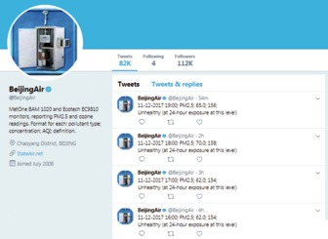
Figure 18 The Twitter feed for the air quality monitor on the roof of the US Embassy in Beijing (US Embassy, 2017)
View description - Figure 18 The Twitter feed for the air quality monitor on the roof of the US Embassy ...

Reading the first tweet in Figure 18:
- 11-12-2017 is the date, 12 November 2017 (remember, in the USA, the month is placed before the day)
- 19:00 is the Beijing time of day the reading was taken, using the 24-hour clock (i.e. 7 p.m.)
- PM_{2.5} is the pollutant being measured
- 65.0 is the PM_{2.5} reading in micrograms per cubic metre, µg/m³
- 156 is the Air Quality Index (AQI) which interprets the PM_{2.5} reading for health risk using Table 4 below
- ‘unhealthy’ is the AQI.

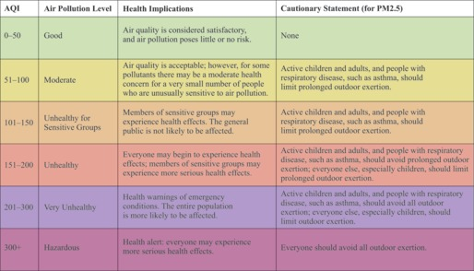
Table 4 US-EPA Air Quality Index values, health concerns and colour codes (World Air Quality, 2016)

- If you found yourself in Beijing when the AQI was hazardous, what could you do to protect yourself?
- Try searching for air quality information in your area. Use a search term such as ‘air quality index’.

Provide your answer...
View discussion - Activity 6 Use of social media

2.2 Environmental pressure groups
Environmental groups are a fairly new phenomenon in China. The first group, ‘Friends of Nature’, was formed in 1994, and protested against the loss of biodiversity. It worked with the Chinese media, and by means of education campaigns began to increase the Chinese people’s awareness of environmental issues. Championing biodiversity was a relatively safe topic as it did not directly criticise government and was therefore tolerated. But by the late 1990s, Chinese environmental non-governmental organisations (NGOs) began to be more assertive (Geall, 2013). A successful and energetic lawyer, Wang Canfa, established the Centre for Legal Assistance to Pollution Victims. This organisation prosecuted environmental pollution cases on behalf of pollution victims and represented a more confrontational style in contesting environmental degradation.
In 2015, there were over 700 registered environmental groups in China (The Guardian, 2015). These are growing in number and in influence, informing and educating widely on environmental issues. The Chinese Government, the judiciary, the media, the business sector and the fast-expanding Chinese middle class are increasingly expressing concern about the environmental impacts of rapid growth, in particular the energy-inefficient and dirty processes being used. Moreover, there is an emerging awareness that the environmental consequences of rapid economic growth could actually undermine the sustainability of the phenomenal development already achieved.

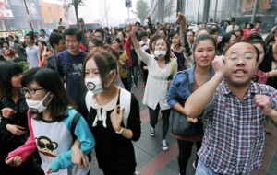
Figure 19 Citizen pollution protest in China
View description - Figure 19 Citizen pollution protest in China

The bigger Chinese environmental NGOs are listened to by central government. Indeed, Chinese environmental groups work closely with the Ministry of Environmental Protection (MEP) to propagate their message, and the ministry relies on them for information. However, their relationship with local government and regional officials is more ambivalent and it is this area they are seeking to improve. One way Chinese environmental groups are attempting to do this is by holding weekly or monthly seminars to which regional journalists are invited. The seminars address a particular environmental issue, are highly informative, and are presented with campaigning zeal. The journalists then write articles and features on the environmental issue, thereby educating the local citizens. The citizens in turn come to expect their local officials to act to safeguard their environment.

Pressure groups and politics
There is clear evidence that environmental NGOs are expanding the political space within which they operate. They are engaging with a growing number of environmental issues. These range from the relatively safe issue of air pollution to the more politically sensitive contesting of big hydroelectric dam projects to polluted water systems, contaminated soil, excessive noise or tainted drinking water. Environmental NGOs are facilitating citizens’ right to know, to debate and to contest environmental policy.
Environmental politics in China are encouraging public action and addressing people’s grievances. The environment is a relatively safe issue about which to become politically aware and active. But environmental politics could be helping to build a more active civil society.
Civil society is the arena where people come together to pursue shared interests, purposes and values. It largely operates in the space between the economy (the market) and the state (government). It is an instrument to inject the interests of people and society into a dialogue with the market and state sectors regarding how society is governed.
A new law on environment protection came into effect in 2015 in response to widespread protests over air quality (China Dialogue, 2016). The law assigns a role to environmental NGOs and civil society to act as watchdogs and start legal proceedings against companies and local governments violating the law. In 2016, the Chinese Supreme Court also granted environmental NGOs more power to use the courts to pursue those that flout environmental protection laws (The Guardian, 2015). They will also be allowed to sue firms or individuals across China, regardless of where the organisation is based. This demonstrates that central government is surrendering some political space to combat environmental degradation. How far a young civil society will open up Chinese politics is being keenly watched both within China and beyond.
The political inertia around environmental issues that characterises many regional governments is a major problem. Regional officials believe that as long as they are delivering on economic growth targets without too much local protest, they can expect to be considered for promotion by central government regardless of how polluted and degraded their regions are (Albert and Xu, 2016). Moreover, they often have close ties with the local businesses and factories that cause the pollution and degradation, which further compromises their willingness to act.
Central government has tried a range of strategies to encourage local officials to take environmental pollution more seriously, including revoking honorary titles, ruining career prospects, and naming and shaming offenders. However, many officials remain resistant to change (Graham-Harrison, 2008). More recently, central government has been encouraging more public participation in environmental management decision-making through the use of, for example, citizen juries (regarding the site of waste facilities) and so-called ‘green assessment’ techniques for citizen participation. Grano (2016) cites the use of the latter in resolving a tree-felling dispute in Nanjing where citizen participation actually distracted public opposition to the tree-felling possibly because citizens held a diverse array of views as to why trees should be saved. Central government has also tried to punish polluting companies by banning them from listing on the stock market, suspending their operations or shutting them down.

Intervention at Lake Taihu
Lake Taihu is an interesting example of a complex part-natural, part-human induced long-term environmental problem that has been approached using a wide range of interventions. It is one of China’s most notorious environmental disasters, which highlights the effects of political inertia and lack of administrative capacity.
In 2007, the choking of Lake Taihu, the country’s third largest freshwater lake, by a toxic algal bloom led to water supplies being contaminated for several days for over two million people (Figure 20). It sparked panic hoarding of bottled water as an alternative water supply and led China’s then premier, Wen Jiabao, to say: ‘The pollution of Taihu Lake has sounded the alarm for us.’ While he went on to call for cooperation between central and local governments, and for environmental workers and others to investigate the water crisis and devise a plan to tackle the contamination, the root of the problem was clear. The algae had flourished as a result of contaminants emitted from small factories and crab farms along the lake’s shore. However, there was little that the State Environmental Protection Agency (SEPA), the precursor to the Ministry of Environmental Protection, could do. As SEPA officials explained, they were in a bureaucratic stranglehold, as the crab farms fell under the Ministry of Agriculture, the wastewater treatment plants under local governments, and the lake itself under the Ministry of Water Resources (The Economist, 2008). This decentralisation of power is a legacy of Deng’s reforms of 1978. A lack of joined-up administration had resulted in environmental disaster.

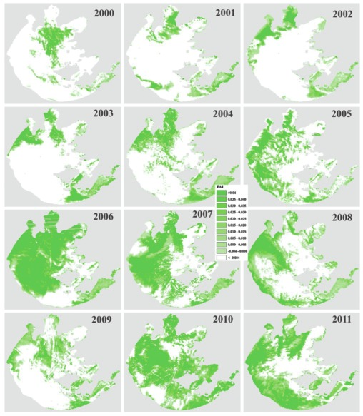
Figure 20 Development of the algal bloom coverage in Lake Taihu, 2000–11 (Duan et al., 2015)
View description - Figure 20 Development of the algal bloom coverage in Lake Taihu, 2000–11 (Duan ...

This situation is a typical example of the consequences of failing to take a broad, systems approach to a situation where different stakeholders have different perspectives. The industrialists and the Ministry of Agriculture saw it as an economic system, providing a source of raw material and a sink for waste products. The Ministry of Water Resources and local consumers saw it as a water supply system, while environmental groups saw it as providing the habitat within which all had to live, providing ecological services such as water and clean air, and aesthetic outputs such as landscape and wildlife. For the industrial users, the presence of algae in the lake was not part of their system, and therefore did not matter. While water consumers and the relevant ministry were concerned about water quality, they had no means of controlling the activities of industrial users, and while environmental groups’ concerns may have embraced all these aspects, they had no direct means of controlling others’ activities.
Duan et al. (2015) used satellite data to explore how different climate and catchment factors may have influenced the algal blooms over a 12-year period (2000–11). The results show annual variability in bloom coverage and an overall increased trend across the period (Figure 20).
Algal blooms are a ‘natural’ phenomenon. For example, El Niño affects patterns in wind and rain on Lake Taihu, and nutrients – when they become available in warm weather – can trigger algal growth. But the phenomenon can be seriously enhanced by industrial pollution and agricultural run-off. Despite sustained political attention, the problem of Lake Taihu’s algal blooms remains intractable and illustrates the difficulty of remediating challenging and compromised ecosystems.
In the wake of this and other disasters, the central government upgraded SEPA to a ministry in 2008 in the hope that the Ministry of Environmental Protection (MEP) would enable it to combat political inertia and the lack of administrative capacity more effectively. A combination of the successive greening of the 11th, 12th and 13th Five-Year Plans together with the establishment of the MEP is beginning to have measurable effects on local and regional environmental management across a number of indicators such as air quality, water quality and carbon dioxide emissions. There is also some evidence of particular progress around ecological indicators relating to forests and ecosystems (Ouyang et al., 2016).
Committing sufficient funds to clean up and safeguard China’s environment is a further concern. In 2015, the then environment minister Chen Jining estimated that China would need to spend 8–10 trillion Chinese yuan renminbi (around 1.4 trillion US$) over the next few years to address the problems (Zhou, 2015). However, it remains to be seen whether this will be distributed to existing government agencies without a more widespread shake-up of processes and approaches, which means that the conflict of interest is likely to continue. Meanwhile faith has to be placed in the march of citizen-led concern for the environment both in China and elsewhere in the world.

Conclusion
This free course, Waste management and environmentalism in China, has shown how the rapid growth in the production and consumption of goods in China has given rise to exceptional amounts of waste, and this trend is expected to continue. Historically, the management of many wastes has been uncontrolled and has led to environmental damage and health concerns. China has started to put in place better environmental strategies to collect and treat waste, but more progress needs to be made, particularly in bringing together informal and formal means of collecting and treating municipal solid waste (MSW).
Adopting a circular economy approach and developing eco-industrial parks have helped deliver some resource efficiencies and increase recycling of some industrial wastes. However, it is early days and it remains to be seen whether China will fully deliver a circular economy.
In addition, from a beginning of championing biodiversity, Chinese environmental groups have developed and nurtured a new generation of environmental activists who increasingly have social media tools at their disposal. Growing awareness and this kind of ‘soft’ political activism may not always translate into action, however, given the cumbersome nature of Chinese bureaucracy, tensions between local and national politics, and competition for funding.
This OpenLearn course is an adapted extract from the Open University course U116 Environment: journeys through a changing worldhttp://www3.open.ac.uk/study/undergraduate/course/l120.htm.

References
Albert, E. and Xu, B. (2016) ‘China’s Environmental Crisis: Backgrounder’, Council on Foreign Relations (CFR) [Online]. Available at www.cfr.org/backgrounder/chinasenvironmental-crisis (Accessed 23 August 2016).
Bai, L., Qiao, Q., Yao, Y., Guo, J. and Xie, M. (2014) ‘Insights on the Development Progress of National Demonstration Eco-industrial Parks in China’, Journal of Cleaner Production, vol. 70, pp. 4–14.
BBC News (2013) ‘China acknowledges “cancer villages”’, 22 February [Online]. Available at www.bbc.co.uk/news/world-asia-china-21545868 (Accessed 30 January 2017).
Chen, W., Zheng, R., Baade, P.D., Zhang, S., Zeng, H., Bray, F., Jemal, A., Qin Yu, X. and He, J. (2016) ‘Cancer statistics in China, 2015’, CA: A Cancer Journal for Clinicians, vol. 66, no. 2, pp. 115–32 [Online] Available at http://onlinelibrary.wiley.com/doi/10.3322/caac.21338/full (Accessed 1 November 2017).
China Dialogue (2016) ‘What’s in store for China and the environment in 2016?’, 8 January [Online]. Available at www.chinadialogue.net/article/show/single/en/8533-What-s-in-store-for-China-and-the-environment-in-2-16- (Accessed 6 August 2017).
DEFRA (2016) UK Statistics on Waste [Online]. Available at www.gov.uk/government/uploads/system/uploads/attachment_data/file/593040/UK_statsonwaste_statsnotice_Dec2016_FINALv2_2.pdf (Accessed 22 February 2017).
Duan, H., Loiselle, S.A., Zhu, L., Feng, L., Zhang, Y. and Ma, R. (2015) ‘Distribution and incidence of algal blooms in Lake Taihu’, Aquatic Sciences, vol. 77, no. 1, pp. 9–16 [Online]. Available at https://doi.org/10.1007/s00027-014-0367-2 (Accessed 6 August 2017).
Economist, The (2008) ‘Don’t drink the water and don’t breathe the air; Environmental protection in China’, The Economist, 24 January [Online]. Available at www.economist.com/node/10566907 (Accessed 22 November, 2017).
Ellen MacArthur Foundation (2013) Towards the Circular Economy, Vol. 1: Economic and Business Rationale for an Accelerated Transition [Online]. Available at www.ellenmacarthurfoundation.org/assets/downloads/publications/Ellen-MacArthur-Foundation-Towards-the-Circular-Economy-vol.1.pdf (Accessed 17 February 2017).
European Commission (2016) ‘Environment Biodegradable Waste’ [Online]. Available at http://ec.europa.eu/environment/waste/compost/ (Accessed 11 February 2017).
Geall, S. (2013) China and the Environment: The Green Revolution, London, Zed Books Ltd.
Geng, Y. and Doberstein, B. (2008) ‘Developing the Circular Economy in China: Challenges and opportunities for achieving “leapfrog development”’, International Journal of Sustainable Development and World Ecology, vol. 15, pp. 231–9.
Graham-Harrison, E. (2008) ‘China says pollution goals low as unveils ministry’, Reuters, 11 March [Online]. Available at https://uk.reuters.com/article/china-environment/update-1-china-says-pollution-goals-low-as-unveils-ministry-idUKSP25601120080311 (Accessed 22 November 2017).
Grano, S.A. (2016) ‘China’s changing environmental governance: Enforcement, compliance and conflict resolution mechanisms for public participation’, China Information, vol. 30, no. 2 [Online]. Available at https://doi.org/10.1177/0920203X16652869 (Accessed 6 August 2017).
Guardian, The (2015) ‘China encourages environmental groups to sue polluters’, The Guardian, 7 January [Online]. Available at www.theguardian.com/environment/2015/jan/07/china-encourages-environmental-groups-to-sue-polluters (Accessed 11 March 2017).
Hatton, C. (2013) ‘Operation Empty Plate: China’s Food Waste Campaigner’, BBC News, 9 March [Online]. Available at www.bbc.co.uk/news/world-asia-china-21711928 (Accessed 5 February 2017).
Hoornweg, D. and Bhada-Tata, P. (2012) ‘What a Waste. A Global Review of Solid Waste Management’, World Bank [Online]. Available at https://openknowledge.worldbank.org/handle/10986/17388 (Accessed 11 February 2017).
Hoornweg, D., Bhada-Tata, P. and Kennedy, C. (2013) ‘Waste production must peak this century’, Nature, vol. 502, pp. 615–17.
Jianqiang, L. (2013) ‘China’s environment ministry an “utter disappointment”’, China Dialogue, 7 March [Online]. Available at https://www.chinadialogue.net/article/show/single/en/5788-China-s-environment-ministry-an-utter-disappointment- (Accessed 12 January 2016).
Li, J. (2015) ‘Ways Forward from China’s Urban Waste Problem’, The Nature of Cities, 1 February [Blog]. Available at www.thenatureofcities.com/2015/02/01/ways-forward-from-chinas-urban-waste-problem/ (Accessed 5 February 2017).
Liu, C. (2011) ‘Turning Trash to Gold in China’, Scientific American, 1 June [Online]. Available at www.scientificamerican.com/article/turning-trash-to-gold-in-china/ (Accessed 5 February 2017).
Liu, G. (2014) ‘Food Losses and Food Waste in China: A First Estimate’, OECD Food, Agriculture and Fisheries Papers, no. 66, Paris, OECD Publishing [Online]. Available at http://dx.doi.org/10.1787/5jz5sq5173lq-en (Accessed 5 February 2017).
MacArthur, E. (2015) ‘The surprising thing I learned sailing solo around the world’, TED Talk [Online]. Available at www.ted.com/talks/dame_ellen_macarthur_the_surprising_thing_i_learned_sailing_solo_around_the_world?language=en#t-836201 (Accessed 22 February 2017).
Mathews, J.A. and Tan, H. (2016) ‘Lessons from China’, Nature, vol. 531, pp. 440–2.
Mathews, J.A., Tang, Y. and Tan, H. (2011) ‘China’s move to a Circular Economy as a Development Strategy’, Asian Business & Management, vol. 10, no. 4, pp. 463–84.
McDonald, K. (2015) ‘Building a Cleaner China from the Grassroots Up’, China–US Focus, 25 February [Online]. Available at http://www.chinausfocus.com/energy-environment/building-a-cleanerchina-from-the-grassroots-up (Accessed 5 February 2017).
McDonough, W. and Braungart, M. (2002) Cradle to Cradle: Remaking the Way We Make Things, New York, North Point Press.
Mian, M.M., Zeng, X., Nasry, A.N.B., Al-Hamadani, S.M.F.Z. (2016) ‘Municipal solid waste management in China: a comparative analysis’, Journal of Material Cycles Waste Management, vol. 19, no. 3, pp. 1127–35.
OpenWASH (2016) Urban Sanitation and Solid Waste Management, The Open University UK/World Vision Ethiopia/UNICEF.
Ouyang, Z., Zheng, H., Xiao, Y., Polasky, S., Liu, J., Xu, W. and Daily, G.C. (2016) ‘Improvements in ecosystem services from investments in natural capital’, Science, vol. 352, no. 6292, pp. 1455–9 [Online]. Available at https://doi.org/10.1126/science.aaf2295 (Accessed 6 August 2017).
Powell, D. (2013) ‘Finding Solutions to China’s E-waste Problem’ [Online]. Available at https://ourworld.unu.edu/en/assessing-and-improving-the-e-wasteproblem-in-china (Accessed 17 February 2017).
Seely, A. (2009) ‘Landfill tax: introduction & early history’, Library of the House of Commons, SN/BT/237 [Online]. Available at researchbriefings.files.parliament.uk/documents/SN00237/SN00237.pdf (Accessed 22 November 2017).
Schmitz, R. (2016) ‘Life and death inside a Chinese “cancer village”’, Marketplace, 19 May [Online]. Available at www.marketplace.org/2016/05/03/world/life-and-death-inside-chinese-cancer-village (Accessed 10 February 2017).
Song, T. (2012) ‘Global Warming as a Manifestation of Garbage’, in Sussman, H. (ed) Impasses of the post-global: theory in the era of climate change, Volume 2 [Online]. Available at http://quod.lib.umich.edu/o/ohp/10803281.0001.001/1:6/–impasses-of-the-post-global-theory-in-the-era-of-climate?rgn=div1;view=fulltext (Accessed 11 March 2017).
Tai, J., Zhang, W., Che, Y. and Feng, D. (2011) ‘Municipal solid waste source separated collection in China: a comparative analysis’, Waste Management, vol. 31, no. 8, pp. 1673–82.
United Nations Development Agency (UNDP) (2016) ‘Replicating China’s E-Waste Recycling Model’ [Online]. Available at www.cn.undp.org/content/china/en/home/presscenter/pressreleases/2016/06/02/replicating-china-s-e-waste-recycling-model.html (Accessed 17 February 2017).
United Nations Statistics Division (UNSD) (2016) ‘Municipal waste treatment’ [Online]. Available at http://unstats.un.org/unsd/environment/qindicators.htm (Accessed 11 February 2017).
US Embassy (2017) ‘Beijing Air Twitter’ [Online]. Available at https://twitter.com/BeijingAir?ref_src=twsrc%5Egoogle%7Ctwcamp%5Eserp%7Ctwgr%5Eauthor (Accessed and reading taken 12 November 2017).
Webster, K. (2015) The Circular Economy: a Wealth of Flows, Cowes, Ellen MacArthur Foundation.
Wei, X. (2016) ‘Tackling the food waste dilemma’, Asia Weekly, 24 June [Online]. Available at http://epaper.chinadailyasia.com/asia-weekly/article-8192.html (Accessed 11 February 2017).
Winans, K., Kendall, A. and Deng, H. (2017) ‘The History and Current Applications of the Circular Economy Concept’, Renewable and Sustainable Energy Reviews, vol. 68, pp. 825–33.
World Air Quality (2016) ‘Air Quality Index Scale and Colour Legend’ [Online]. Available at http://aqicn.org/scale/ (Accessed 12 November 2017).
World Bank (2016) World Population 2015 [Online]. Available at http://databank.worldbank.org/data/download/POP.pdf (Accessed 23 February 2017).
WRAP (2015) Household Food Waste in the UK [Online]. Available at www.wrap.org.uk/sites/files/wrap/Household_food_waste_in_the_UK_2015_Report.pdf (Accessed 9 February 2017).
Zhang, D.Q., Tan, S.K. and Gersberg, R.M. (2010) ‘Municipal Solid Waste Management in China: Status, problems and challenges’, Journal of Environmental Management, vol. 91, pp. 1623–33.

Acknowledgements
This free course was written by the Dr Christine Pearson and Dr Rachel Slater. It was first published in December 2018.
Grateful acknowledgement is made to the following sources. Every effort has been made to contact copyright holders. If any have been inadvertently overlooked the publishers will be pleased to make the necessary arrangements at the first opportunity.
Course image: © iStock / Getty Images Plus
Figure 1: © Tim Graham / Contributor / Getty Images;
Figure 2: © Wen Wenyu / Greenpeace;
Figure 3: Taken from http://landfill-gas.com/1980s-landfill-gas-explosions.html;
Figure 5(a): © Aixinjueluo Huaer;
Figure 5(b): © Aixinjueluo Huaer;
Figure 5(c): © Aixinjueluo Huaer;
Figure 5(d): © Aixinjueluo Huaer;
Figure 7: © Material reproduced with kind permission of the Open Wash Programme;
Figure 9: © Based Action Network 2013;
Figure 10: Adapted from https://media.licdn.com/mpr/mpr/AAEAAQAAAAAAAAhAAAAAJDQ4YTFiZGRkLTA2MGEtNDgzZi05MjQ4LTk0NWYyMGI2MDUyNQ.png;
Figure 11(a): Courtesy Jane Gilbert;
Figure 11(b): Courtesy Jane Gilbert;
Figure 12(a): © Aixinjueluo Huaer;
Figure 12(b): © Aixinjueluo Huaer;
Figure 13: © ironjohn / www.dreamstime.com;
Figure 16: © Yongsky / www.dreamstime.com;
Figure 17(a): © Julian Herbert / Staff / Getty Images;
Figure 17(b): © Photo taken at TED2015 by Joss Bleriot, Ellen MacArthur Foundation;
Figure 18: Taken from https://twitter.com/beijingair?lang=en;
Figure 19: © Newscom / Alamy Stock Photo;
Figure 20: Adapted from: Duan H., Loiselle S.A., Zhu L., Feng L., Zhang Y., Ma R., (2015) Figure 3, 'Distribution and Incidence of Algal Blooms in Lake Taihu', Springer;
Acknowledgements are due to Nick Sinclair, Professor Tian Song (Beijing Normal University), Dr Jane Gilbert (Carbon Clarity) and all those who helped contribute to the case studies.
Don't miss out
If reading this text has inspired you to learn more, you may be interested in joining the millions of people who discover our free learning resources and qualifications by visiting The Open University – www.open.edu/openlearn/free-courses.

Activty 2 MSW generation per person

Answer

Table 1 Weight of MSW generated for a selection of countries (adapted from UNSD, 2016 and World Bank, 2016)* (completed)
Country | Annual generation (million tonnes) | Population (millions) | Annual generation per capita (kg/person)
China | 171 | 1371 | 125
Germany | 50 | 81 | 617
South Korea | 18 | 50 | 360
UK | 31 | 65 | 477
USA | 228 | 321 | 710

Sample calculation for South Korea
The amount of waste in one year is 18 000 million kg, as there are 1000 kg in 1 tonne.
So

The data show that China generates a large amount of MSW annually, but it has the lowest per capita rate of the selected countries. On a per person basis, it has the lowest rate per capita of the countries selected. The USA generates the highest amount of MSW and it also has the highest per capita rate.
Back to Session 1 Activity 2

Activity 3 Growth of MSW

Answer
- It seems that China’s growth rate of MSW is also exponential.
- If the rate of growth of MSW depicted in Figure 8 continues, the annual production of MSW in China in 2025 can be estimated to be approximately 550 million tonnes. To estimate the amount of waste generated daily, this figure needs to be divided by the number of days in a year: 550/365 = 1.5 million tonnes per day.
Back to Session 1 Activity 3

Activity 5 Linear vs. circular economy

Answer
Some critics argue that the circular economy is just another way to describe recycling and reuse. Proponents argue that it is much more than that. It means designing waste out of the system. While efficiencies are important, it means moving away from our throwaway society where products are designed to be regularly replaced and updated to designing products for longevity and repairability, and to be easily dismantled and recycled. It also means different business models that move away from product ownership to product access through sharing, leasing, and trade-in and service packages.
Back to Session 1 Activity 5

Activity 1 Pathways for hazardous chemicals

Discussion
- There could be a variety of pathways by which materials in the dump could get into the bodies of local inhabitants:
  - Materials could be blown in the air and be inhaled or get onto skin. Similarly, material could be blown into soils and be taken up by fruit and vegetables that are produced and eaten locally.
  - Materials could dissolve in rainwater and drain or leach out of the dump, into local watercourses and groundwater. If these sources are part of the drinking water system, then villagers could drink contaminated water. If they are used for irrigation, then crops could be contaminated.
- The phosphogypsum waste would have to be analysed to determine the separate components in the mixture. Each of these components would have to undergo laboratory tests to determine whether they are taken up by animal tissues and what effect they have in these tissues and cells. These kinds of tests may use laboratory animals such as mice to simulate effects in humans or, where possible, computer modelling or other studies.
Back to Session 1 Activity 1

Activity 4 Thinking about your own waste habits at home

Discussion
An example answer:
- In my household there are five of us, all either working full-time or going to school full-time. Our city council uses three types of bin: a green composting one which can take all forms of food and garden waste, including bones and meat, and can also take a limited amount of cardboard and paper which does help reduce the fluid that accumulates in the bottom. There is also a blue recycling bin which takes mixed recycling including glass, metals, plastics, Tetra-Pak style cartons, styrofoam, paper and card/cardboard. The black bin is for all other items. The city operates a weekly collection, with odd weeks being ‘black’ only and even weeks being green and blue collections. The blue bin also has the capacity to accept batteries for recycling – these get looped over the handle in a specific clear bag provided by the operator.
- I looked on my local city council’s website which was very informative about where my waste goes. When the blue bin lorries are full, they take the recycling to the ‘Materials Recycling Facility’ (MRF) where items are separated further and sold to recycling plants. The contents of the green bins are taken to the ‘in-vessel’ composting plant; the resulting soil conditioner is sold for local agriculture and is available for anyone to buy for the garden. The contents of the black bins are taken to a Mechanical Biological Treatment plant (MBT). The MBT mechanically removes some items from the waste and then treats the rest in a huge treatment hall. This breaks down the waste as much as possible, helping to reduce methane and carbon dioxide emissions, before it is landfilled. I also noticed that the MRF, the MBT plant and the in-vessel composter are all owned and operated by the same privately-run company.
- I can see that my waste is being recycled via the blue bin system, and there is recovery from waste via the composting system for green and food waste, but the material recovered seems to be of low value. All this fits in with the waste hierarchy. In general, I think our overall waste is indeed reducing over time – but I also noticed an interesting thing about our green bin. With respect to garden waste, I used to compost my own in a small wooden box in the back yard but now with the green bin being so close by I tend to sweep up everything and put it in there. In other words, my waste habits have changed due to the introduction of different management systems.
Back to Session 1 Activity 4

Activity 6 Use of social media

Discussion
- The current advice for hazardous levels is that everyone should avoid all outdoor exertion. Advice may always be subject to change as medical knowledge is updated.
- Hopefully you were able to find the air quality index in your area. In Birmingham (UK) on 3 November 2017, the index band on the DEFRA website was low (3) and green.
The Chinese Ministry of Environmental Protection provides its own air quality data for cities throughout China and you should be able to find this information by using a search term such as ‘air quality Chinese cities’.
Back to Session 2 Activity 1

Figure 1 Industrial pollution in China

Description
Figure 1 shows a photograph of a range of old industrial buildings with many chimneys emitting plumes of water vapour and smoke. The picture is shown to illustrate newspaper article about Cancer villages. The article reads: ‘Chinese “cancer village” scores rare victory over polluters. A waste disposal firm that spewed toxi pollution into a rural Chinese village will have to pay compensation to nearly 400 villagers after losing a long-running legal battle.’
Back to Session 1 Figure 1

Figure 2 Phosphogypsum slag heap in Sichuan

Description
Figure 2 shows a photograph of a phosphogypsum dump. It is a bare grey, cliff faced mound of material with some derelict walls at the base and a wide, stony river bed in the foreground with only a small water filled channel within it
Back to Session 1 Figure 2

Figure 3 Old Shanghai hutong being cleared to make way for new high-rise buildings

Description
The photograph in Figure 3 shows an old Shanghai hutong being knocked down, or cleared in the language of developers. In the foreground many piles of waste have been neatly tidied in front of the individual homes. In the background there are various high rise buildings already constructed.
Back to Session 1 Figure 3

Figure 4 The remains of a home in Loscoe, Derbyshire after an explosion involving methane gas

Description
The photograph in Figure 4 shows the remains of a modern bungalow in Loscoe, Derbyshire after an explosion involving methane gas. It appears as a mound of rubble in the foreground with a row of bungalows behind it.
Back to Session 1 Figure 4

Figure 5 The waste waterfall in Lugu Lake, during the early 2000s: (a) Waste collection truck in Luoshui village; (b) a closer look at what is in the waste stream in Luoshui; (c) cattle grazing on rotting food and waste from the informal rubbish tip; (d) the effect of an informal waste tipping process on the land and its surroundings – at the bottom of the tip, an industrious person scours the hillside for materials which can be reused, while her baby waits nearby sitting on the tip.

Description
There are four photographs in Figure 5, which all describe different aspects of the informal waste tip described in the text. (a) Shows a medium sized dump-truck is tipping a load of rubbish down the hillside in a small gap in the trees. (b) Is a close-up of the waste in the tip, which shows items such as chopsticks, shoes, CDs, food packaging, plastic bags, bottles, and containers, as well as shampoo bottles. (c) Shows a small herd of cattle eating waste, and possibly small tufts of grass, at the edge of the tip; there is a copious amount of plastics which have built-up against the scrub trees and shrubs. The final picture (d) shows the full expanse of the waste tip from the view of the photographer looking up the hill which rises some 200–500 meters. There is a young lady apparently working on the tip emptying bags, or looking for items of value; her baby sits nearby waiting, wrapped warmly in a small blanket.
Back to Session 1 Figure 5

Figure 6 The contrasting views of informal waste collection of plastic bottles and other plastic materials with that of clean cardboard being collated for formal collection within a controlled industrial site in Hong Kong. (a) A tricycle about to be unloaded at an impromptu recycling depot in Beijing. The depot is collecting plastic bottles and other plastic items for recycling, and transporting them to the factory in very large plastic mesh bags (on the right). (b) Ad hoc recycling centre in an alley. This recycler is sorting items and weighing the plastics using the scale on the right-hand side of the picture. (c) A cardboard collection depot in Hong Kong.

Description
Figure 6 shows three photographs. The first (a) is of a very full load of plastic bottles on the recycler’s bike. The bottles are mostly 10–20 litre sized ones typically used for water coolers or vegetable oils. The second (b) is taken just to the right of the fully loaded bike in a side alley. It shows a young lady weighing a load of plastics on a large scale in order to calculate the value of a large bag of bottles. The third (c ) shows two men working in a cardboard collection and recycling facility. The man on the left is dismantling the boxes and then cutting them into similar sized pieces and re-stacking them neatly into a pallet sized shape. The man on the right, wearing gloves, ensures the pieces are then stacked very tightly and then compresses them by strapping them together with a machine.
Back to Session 1 Figure 6

Figure 7 Diagrammatic representation of the waste hierarchy (OpenWash, 2016)

Description
Figure 7 is a coloured triangle of the waste hierarchy, with shades of blue for least favoured to shades of green for most favoured option. The triangle has its tip at the bottom and is labelled 5 for disposal, then 4 for recovery, 3 for recycling, 2 for reuse and 1 at the top for reduction.
Back to Session 1 Figure 7

Figure 8 Estimated past and predicted annual growth of MSW in China in million tonnes per year from 1980 to 2025 (adapted from Zhang et al., 2010; Hoornweg and Bhada-Tata, 2012)

Description
Figure 8 is a line graph which shows the estimated past and predicted annual growth of MSW in China in million tonnes per year from 1980-2025. The x- axis scale is in five year intervals. The growth increases in a smooth curve from 25 million tonnes in 1980 to 510 million tonnes in 2025.
Back to Session 1 Figure 8

Figure 9 A pile of circuit boards dumped next to a river in China. The circuit boards were first treated with acid to remove metals; the acid flowed into the river and burned openly.

Description
This photograph shows a pile of circuit boards along the side of a river in in the 2000s in Guiyu China. It stretches the whole length of the river visible in the picture. A man is visible in the bottom right-hand corner kneeling working at a circuit board.
Back to Session 1 Figure 9

Figure 10 Diagram of an energy-from-waste (EfW) plant, showing energy generation and pollution control

Description
Figure 10 shows a cut-away diagram of a modern energy-from-waste plant, showing energy generation and pollution control. Municipal sold was is shown being tipped from a skip wagon on the left of the diagram in to a large trash storage bunker. A grabber then transfers the waste into a furnace where it is burnt. Ash falls onto an ash conveyor belt and out to a lorry on the right of the diagram to take it to a landfill. Flue gases form in the combustion chamber where nitrogen dioxide is removed (labelled 1 on the diagram). The flue gases are then shown travelling from the combustion chamber to raising steam in a turbine generator to power the grid which is indicated by schematic electricity pylons. Other flue gases travel through towers and pipework which sequentially remove mercury and dioxins (labelled 2 on the diagram) and acid gases (labelled 3 on the diagram). A box shows the particulate removal systems (labelled 4 on the diagram), and the flue gases flow through the testing and pollution control system (labelled 5 on the diagram). They then exit, as cleaned flue gases and water vapour, through a tall chimney on the right of the diagram to the atmosphere.
Back to Session 1 Figure 10

Figure 11 (a) The landfill site under construction for China’s first industrial landfill gas power plant at Hangzhou’s Ecopark; (b) visitor attractions at the park include sculptures made from recycled materials including this racing car

Description
The photograph in Figure 11(a) is looking down on a landfill site under construction for China’s first industrial landfill gas power plant at Hangzhou’s eco theme park. It shows a flat green area with forest covered hills in the background. Figure 11(b) shows a visitor attraction at the park, which is a sculpture of a racing car made from recycled materials.
Back to Session 1 Figure 11

Figure 12 The waste dump during the 2008–12 period, showing the size and scale of the garbage problem near Lugu Lake. Note the landfill liner that isolates the rubbish from the environment.

Description
The photograph in Figure 12(a) shows the waste dump near Lake Lugu during the period 2008-2012. The dump appears as a white area between forested hills. Figure 12(b) is a close up of the landfill site which shows rubbish in it with the plastic liner which isolates the surrounding environment from the rubbish visible at the edge. Mountains can be seen in the background.
Back to Session 1 Figure 12

Figure 13 Modern washing machine with energy efficiency label

Description
The photograph in Figure 13 shows a modern washing machine with its energy efficiency label visible. The label is colour coded and given a letter for the energy efficiency. In this case the rating is A and the colour black for the most energy efficient.
Back to Session 1 Figure 13

Figure 14 Environmental impacts of a typical washing machine throughout the four main stages of its life cycle

Description
Figure 14 is a cartoon diagram of the environmental impacts of a typical clothes washing machine throughout the life cycle using four distinct time periods each shown as a boxed drawing. The four steps are named raw material extraction and processing, manufacture of components and assembly of washing machine, distribution and use, and lastly disposal and recycling. In the first stage raw materials such as wood, copper, steel, iron, aluminium, plastic, and concrete are shown being collected together for use in the washing machine assembly. The cartoon also gives information about the typical weight of each of the materials, for example, concrete is 22 kilograms whereas copper consumes 2.7 kilograms per machine. In the manufacturing and assembly process the cartoon shows the individual components coming together to be constructed into a recognisable washing machine. The components include the steel frame, cabinet, base, pump, hose, heater, motor, clutch, control unit, washing tub, electrical wires and small electrical parts. After construction the white good is delivered either directly to the end user or via some intermediary channel such as a department store. During the in-use phase within a typical household the boxed cartoon shows the main inputs and outputs which create the majority of the life cycle impact as the washing machine requires the most energy and water during this period of approximately 5–7 years. Inputs shown in the cartoon include water, energy, detergents, dirty clothes, along with spare parts and servicing labour. Outputs include clean clothes, dirty water, and broken parts along with the less obvious motion, heat and noise. The fourth and final cartoon box shows the disposal and recycling of the worn-out washing machine. It shows that some components are recycled (such as steel) and are fed back into the washing machine life cycle in the raw materials processing in the first stage. Other parts are incinerated or dumped in a landfill.
Back to Session 1 Figure 14

Figure 15 Diagrams showing: (a) the linear economy; (b) the circular economy

Description
Figure 15(a) shows a horizontal list of arrows separated by words to demonstrate the linear economy. Starting with ‘extract’ an arrow points to ‘make’, then the arrow points to ‘use’ then the final arrow points to ‘dispose’. Figure 15(b) illustrates the circular economy. The word ‘extract’ followed by an arrow points to ‘make’. From ‘make’ a circle of arrows goes to ‘use’ and then ‘reuse’ and back to ‘make’. There is no ‘dispose’ stage.
Back to Session 1 Figure 15

Figure 16 A Ferris wheel overlooking the Suzhou New District, one of the first industrial parks in China’s circular economy

Description
Figure 16 is a photograph of a Ferris-wheel pod and the view from it of the Suzhou New District in the background. It shows a river, a marina with boats in it, a green area and then modern high rise buildings in the distance.
Back to Session 1 Figure 16

Figure 17 (a) Ellen MacArthur celebrating after becoming the fastest person to circumnavigate the globe single-handed; (b) Dame Ellen MacArthur delivering a TED (technology, entertainment and design) talk on the circular economy

Description
The photograph in Figure 17(a) shows Ellen MacArthur smiling and holding up two lit flares as she celebrates on her boat becoming the fastest person to circumnavigate the globe single-handed. Figure 17(b) is a photograph of Ellen MacArthur delivering a TED (technology, entertainment and design) talk on the circular economy. She is standing in front of a banner which says ‘Now we have a plan’.
Back to Session 1 Figure 17

Figure 18 The Twitter feed for the air quality monitor on the roof of the US Embassy in Beijing (US Embassy, 2017)

Description
Figure 18 contains a screenshot of the twitter feed for the air quality monitor on the roof of the US Embassy in Beijing. It gives the date, time, readings for pollutants and states whether the air quality is healthy or unhealthy (at 24-hour exposure at this level). For all four readings from December 2017 the readings are all unhealthy.
Back to Session 2 Figure 1

Figure 19 Citizen pollution protest in China

Description
Figure 19 shows a crowd of mainly younger people dressed in western style clothes on an orderly protest in a modern street in China. Some of the people have face masks with a hazard warning sign on them. One person in the background holds a placard with the same symbol on them.
Back to Session 2 Figure 3

Figure 20 Development of the algal bloom coverage in Lake Taihu, 2000–11 (Duan et al., 2015)

Description
Figure 20 shows the development of the algal bloom coverage in Lake Taihu, for the years 2000 to 2011. There twelve pictures that show the outline of Lake Taihu with areas that have an algal bloom on them coloured bright green. The extent of the algal bloom tend to increase year on year but the increase is not always smooth. For example the coverage in 2009 is fairly low and similar to that in 2004. The greatest coverage is shown in years 2006, 2007, 2010 and 2011.
Back to Session 2 Figure 4

