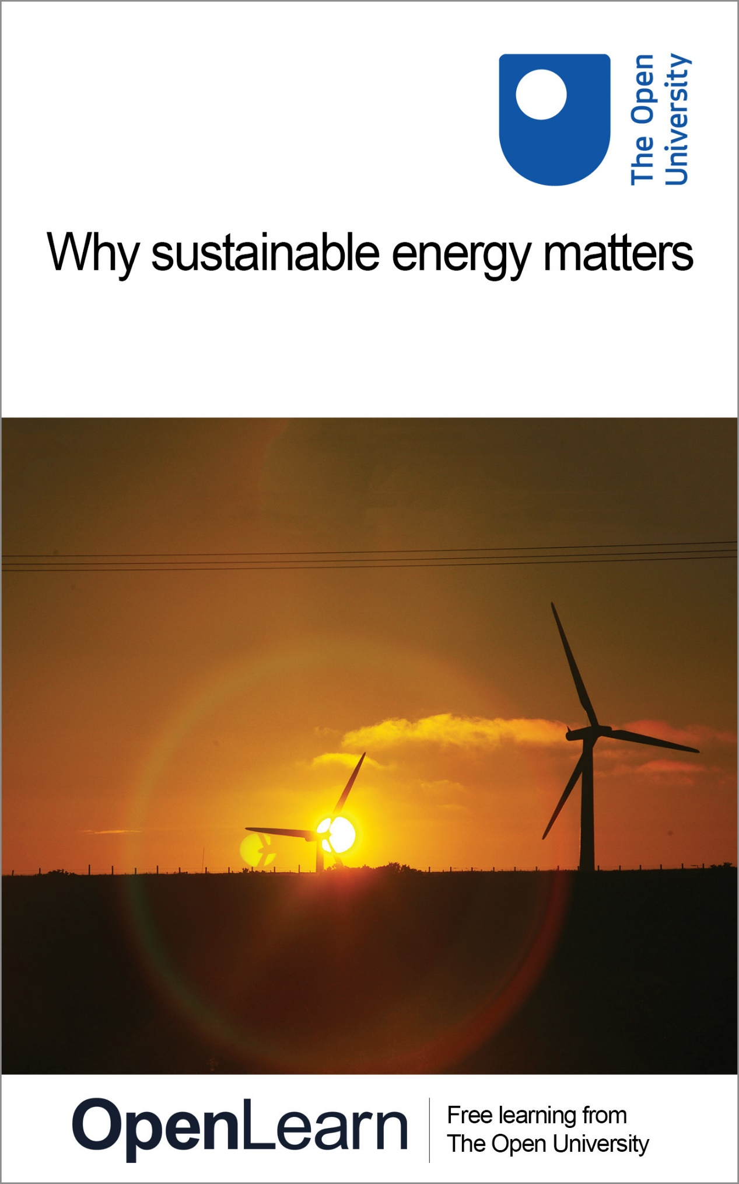

T206_1 Energy for a sustainable future

Why sustainable energy matters

About this free course
This free course provides a sample of level 1 study in Environment & Development http://www.open.ac.uk/courses/find/environment-and-development
This version of the content may include video, images and interactive content that may not be optimised for your device.
You can experience this free course as it was originally designed on OpenLearn, the home of free learning from The Open University: http://www.open.edu/openlearn/science-maths-technology/science/environmental-science/why-sustainable-energy-matters/content-section-0.
There you'll also be able to track your progress via your activity record, which you can use to demonstrate your learning.
The Open University, Walton Hall, Milton Keynes, MK7 6AA
Copyright © 2016 The Open University
Intellectual property
Unless otherwise stated, this resource is released under the terms of the Creative Commons Licence v4.0 http://creativecommons.org/licenses/by-nc-sa/4.0/deed.en_GB. Within that The Open University interprets this licence in the following way: www.open.edu/openlearn/about-openlearn/frequently-asked-questions-on-openlearn. Copyright and rights falling outside the terms of the Creative Commons Licence are retained or controlled by The Open University. Please read the full text before using any of the content.
We believe the primary barrier to accessing high-quality educational experiences is cost, which is why we aim to publish as much free content as possible under an open licence. If it proves difficult to release content under our preferred Creative Commons licence (e.g. because we can't afford or gain the clearances or find suitable alternatives), we will still release the materials for free under a personal end-user licence.
This is because the learning experience will always be the same high quality offering and that should always be seen as positive – even if at times the licensing is different to Creative Commons.
When using the content you must attribute us (The Open University) (the OU) and any identified author in accordance with the terms of the Creative Commons Licence.
The Acknowledgements section is used to list, amongst other things, third party (Proprietary), licensed content which is not subject to Creative Commons licensing. Proprietary content must be used (retained) intact and in context to the content at all times.
The Acknowledgements section is also used to bring to your attention any other Special Restrictions which may apply to the content. For example there may be times when the Creative Commons Non-Commercial Sharealike licence does not apply to any of the content even if owned by us (The Open University). In these instances, unless stated otherwise, the content may be used for personal and non-commercial use.
We have also identified as Proprietary other material included in the content which is not subject to Creative Commons Licence. These are OU logos, trading names and may extend to certain photographic and video images and sound recordings and any other material as may be brought to your attention.
Unauthorised use of any of the content may constitute a breach of the terms and conditions and/or intellectual property laws.
We reserve the right to alter, amend or bring to an end any terms and conditions provided here without notice.
All rights falling outside the terms of the Creative Commons licence are retained or controlled by The Open University.
Head of Intellectual Property, The Open University
Edited and designed by The Open University.
978-1-4730-1657-6 (.kdl)
978-1-4730-0889-2 (.epub)

Contents
- Introduction
- Learning outcomes
- 1 Why sustainable energy matters
  - 1.1 Energy sources and environmental impact
  - 1.2 Where do we get our energy from?
- 2 Definitions: energy, sustainability and the future
  - 2.1 What is energy?
- 3 Present energy sources and sustainability
  - 3.1 Fossil fuels
  - 3.2 Nuclear energy
  - 3.3 Bioenergy
  - 3.4 Hydroelectricity
  - 3.5 Summary
- 4 Renewable energy sources
  - 4.1 Solar energy
  - 4.2 Indirect use of solar energy
  - 4.3 Non-solar renewables
  - 4.4 Sustainability of renewable energy sources
- 5 Energy services and efficiency improvement
  - 5.1 Energy services
  - 5.2 Energy efficiency improvements
  - 5.3 The rebound effect
- 6 Energy in a sustainable future
  - 6.2 (a) 'Cleaning-up' fossil and nuclear technologies
  - 6.3 (b) Switching to renewable energy sources
  - 6.4 (c) Using energy more efficiently
  - 6.5 Changing patterns of energy use
  - 6.6 Long-term energy scenarios
- Conclusion
- Take the next step
- References
- Acknowledgements

Introduction
Access to safe, clean and sustainable energy supplies is one of the greatest challenges facing humanity during the twenty-first century. This course will survey the world's present energy systems and their sustainability problems, together with some of the possible solutions to those problems and how these might emerge in practice.
Throughout history, the use of energy has been central to the functioning and development of human societies. But during the nineteenth and twentieth centuries, humanity learned how to harness the highly concentrated forms of energy contained within fossil fuels. These provided the power that drove the industrial revolution, bringing unparalleled increases in affluence and productivity to millions of people throughout the world. As we enter the third millennium, however, there is a growing realisation that the world's energy systems will need to be changed radically if they are to supply our energy needs sustainably on a long-term basis.
This introductory overview aims to survey, in very general terms, the world's present energy systems and their sustainability problems, together with some of the possible solutions to those problems and how these might emerge in practice during the twenty-first century.
This OpenLearn course provides a sample of level 1 study in Environment & Development

Learning outcomes
After studying this course, you should be able to:
- demonstrate an awareness of the current sources of energy
- demonstrate an awareness of current solutions for energy sustainability problems.

1 Why sustainable energy matters
The world's current energy systems have been built around the many advantages of fossil fuels, and we now depend overwhelmingly upon them. Concerns that supplies will 'run out' in the short-to-medium term have probably been exaggerated, thanks to the continued discovery of new reserves and the application of increasingly advanced exploration technologies. Nevertheless it remains the case that fossil fuel reserves are ultimately finite. In the long term they will eventually become depleted and substitutes will have to be found.
Moreover, fossil fuels have been concentrated by natural processes in relatively few countries. Two-thirds of the world's proven oil reserves, for example, are located in the Middle East and North Africa. This concentration of scarce resources has already led to major world crises and conflicts, such as the 1970s 'oil crisis' and the Gulf War in the 1990s. It has the potential to create similar, or even more severe, problems in the future.

1.1 Energy sources and environmental impact

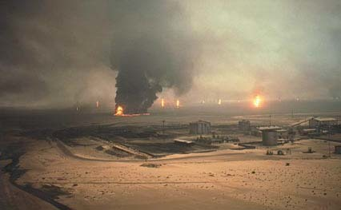
Figure 1: Oil wells on fire in Kuwait during the Gulf War in 1990–91

Substantial rises in the price of oil also can cause world-wide economic disruption and lead to widespread protests, as seen in the USA and Europe in 2000.

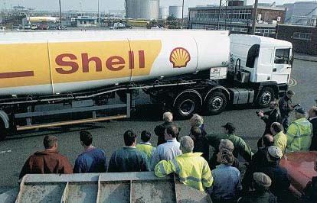
Figure 2: Tanker drivers block the entrance to a UK refinery in September 2000, to protest against high fuel prices

The exploitation of fossil fuel resources entails significant health hazards. These can occur in the course of their extraction from the earth, for example in coal mining accidents or fires on oil or gas drilling rigs.

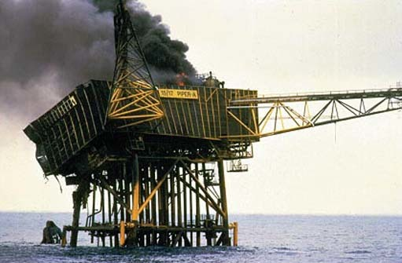
Figure 3: A fire on the Piper Alpha gas rig in the North Sea in 1988 killed 167 people

They can also occur during distribution, for example in oil spillages from tankers that pollute beaches and kill wildlife; or on combustion, which generates atmospheric pollutants such as sulphur dioxide and oxides of nitrogen that are detrimental to the environment and to health.

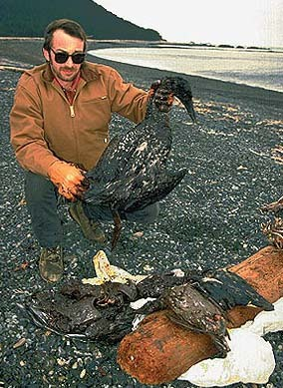
Figure 4: An oil spillage from the Exxon Valdez tanker in 1989 contaminated 2100 km of beaches in Alaska and caused extensive harm to wildlife. The cost of cleanup was estimated at some $3 billion

Fossil fuel combustion also generates very large quantities of carbon dioxide (CO₂), the most important anthropogenic (human-induced) greenhouse gas. The majority of the world's scientists now believe that anthropogenic greenhouse gas emissions are causing the earth's temperature to increase at a rate unprecedented since the ending of the last ice age. This is very likely to cause significant changes in the world's climate system, leading to disruption of agriculture and ecosystems, to sea level rises that could overwhelm some low-lying countries, and to accelerated melting of glaciers and polar ice.

Figure 5: Rising sea levels due to global warming could overwhelm some low-lying nations, such as Tuvalu, a group of nine coral atolls in the Pacific

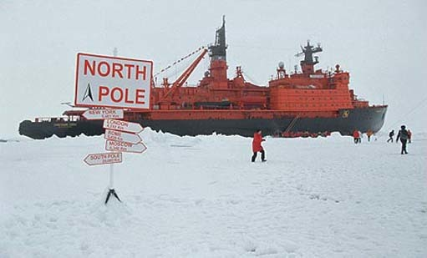
Figure 6: Rising global temperatures have already caused significant melting of ice around the North Pole, which is now accessible to ships at certain times of the year. This does not affect global sea levels, since most Arctic ice is floating. But if ice at the South pole, much of which is based on land, were to melt, this would cause very substantial rises in sea levels

Nuclear power has grown in importance since its inception just after World War II and now supplies some 7 per cent of world primary energy. A major advantage of nuclear power plants, in contrast with fossil fuelled plants, is that they do not emit greenhouse gases. Also, supplies of uranium, the principal nuclear fuel, are sufficient for many decades – and possibly centuries – of supply at current use rates. However the use of nuclear energy, as we shall see, gives rise to problems arising from the routine emissions of radioactive substances, difficulties of radioactive waste disposal, and dangers from the proliferation of nuclear weapons material. To these must be added the possibility of major nuclear accidents which, though highly unlikely, could be catastrophic in their effects. Although some of these problems may be amenable to solution in the longer term, such solutions have not yet been fully developed.
Extracting energy from fossil or nuclear fuels, in the course of providing energy-related services to society, generates significant environmental and social impacts. These impacts are greater than they need be because of the low efficiency of our current systems for delivering energy, converting it into forms appropriate for specific tasks, and utilising it in our homes, machinery, appliances and vehicles. An important way of mitigating the environmental impacts of current fuel use is therefore to improve the efficiency of these systems. Over the past few decades, significant efficiency improvements have indeed been made, but further major improvements are feasible technologically – and are, in many cases, attractive economically.

1.2 Where do we get our energy from?
Of course, not all energy sources are of fossil or nuclear origin. The renewable energy sources, principally solar energy and its derivatives in the form of bioenergy, hydroelectricity, wind and wave power, are increasingly considered likely to play an important role in the sustainable energy systems of the future. The 'renewables' are based on energy flows that are replenished by natural processes, and so do not become depleted with use as do fossil or nuclear fuels – although there may be other constraints on their use. The environmental impacts of renewable energy sources vary, but they are generally much lower than those of conventional fuels. However, the current costs of renewable energy sources are in many cases higher than those of conventional sources, and this has until recently retarded their deployment.
All these considerations suggest that in creating a sustainable energy future for humanity during the coming decades, it will be necessary:
- to implement greatly improved technologies for harnessing the fossil and nuclear fuels, to ensure that their use, if continued, creates much lower environmental and social impact;
- to develop and deploy the renewable energy sources on a much wider scale; and
- to make major improvements in the efficiency of energy conversion, distribution and use.
These three general approaches will be explored further, and in greater detail in the remaining sections of this course.

2 Definitions: energy, sustainability and the future

'Energy is Eternal Delight'
William Blake, 1757–1827 (1994)

What do we mean by 'energy'? What does the concept of 'sustainability' entail? And what, for that matter, do we mean by the 'future' in this context?

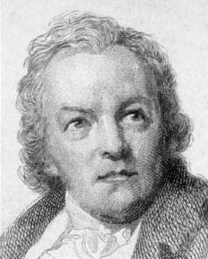
Figure 7: William Blake

The eighteenth-century poet and artist William Blake, quoted above, probably expressed our personal experience of energy as we feel it in our day-to-day lives more accurately than any scientific definition. Indeed, the word energy, when it first appeared in English in the sixteenth century, had no scientific meaning at all. Based on a Greek word coined by Aristotle, it meant forceful or vigorous language.
It was not until the early 1800s that the concept of energy in the modern sense was developed by scientists to describe and compare their observations about the behaviour of such diverse phenomena as the transfer of heat, the motion of planets, the operation of machinery and the flow of electricity. Today, the standard scientific definition is that energy is the capacity to do work: that is, to move an object against a resisting force.
In everyday language, the word 'power' is often used as a synonym for energy – and indeed in this course the two words may occasionally be used in this rather loose way merely as substitutes for each other. But when speaking scientifically, power is defined as the rate of doing work, that is, the rate at which energy is converted from one form to another, or transmitted from one place to another. The main unit of measurement of energy is the joule (J) and the main unit of measurement of power is the watt (W), which is defined as a rate of one joule per second.
The term 'sustainability' entered into common currency relatively recently, following the publication of the report Our Common Future by the United Nations' Brundtland Commission in 1987. The commission defined sustainability, and in particular sustainable development, as 'development that meets the needs of the present without compromising the ability of future generations to meet their own needs' (United Nations, 1987).

2.1 What is energy?
In the context of energy, sustainability has come to mean the harnessing of those energy sources:
- that are not substantially depleted by continued use;
- the use of which does not entail the emission of pollutants or other hazards to the environment on a substantial scale; and
- the use of which does not involve the perpetuation of substantial health hazards or social injustices.
This is, of course, a very broad ideal. Although a few energy sources can come close to fulfilling these conditions, most fall considerably short of the optimum. This means that, in practice, sustainability is a relative rather than an absolute concept. It is not so much that some energy sources are sustainable and others not; it is more that some energy sources, in certain contexts, are more sustainable than others. Determining the relative sustainability of one energy system vis-à-vis another is usually a complex process, involving detailed consideration of the specific processes and technologies proposed, the context in which they are being used and the differing values and interests of the various parties involved.
For example, suppose the Government of a country is proposing to construct a large hydro-electric power plant like the one shown in Figure 8 below. The villagers whose homes would be flooded by the associated reservoir would probably take a different view of the plant's sustainability to that taken by the city-based planners in the electricity utility proposing its construction, whose homes would be unaffected and whose careers would probably stand to benefit from such a major capital project.

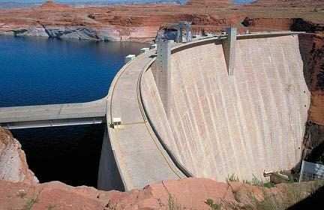
Figure 8: The large hydro-electric power plant at Glen Canyon Dam, Lake Powell, Arizona

When we speak of 'the future' in the context of a 'sustainable future', what do we mean? Next year? One or two decades hence? The end of the twenty-first century? The end of the third millennium? Forever?
Ideally, in view of the Brundtland Report's injunction that humanity should not compromise the needs of future generations, we should judge the sustainability of all energy systems on an indefinite time scale – far into the very distant future. In practice, however, this might be realistically interpreted as endeavouring to ensure that energy systems become sustainable (or at the very least, much less un-sustainable) over the next century or so – with the additional proviso that, even beyond that time horizon, few substantial difficulties can presently be envisaged. Future generations will be justified in blaming us for creating problems that were foreseeable; but they can hardly hold us responsible for eventualities that none of us could have anticipated.

3 Present energy sources and sustainability
So what are the principal energy systems used by humanity at present, and how sustainable are they?
Until quite recently, human energy requirements were modest and our supplies came either from harnessing natural processes such as the growth of plants, which provided wood for heating and food to energise human or animal muscles, or from the power of water and wind, used to drive simple machinery.

3.1 Fossil fuels
So what are the principle energy systems used by humanity at present, and how sustainable are they?
Until quite recently, human energy requirements were modest and our supplies came either from harnessing natural processes such as the growth of plants, which provided wood for heating and food to energise human or animal muscles, or from the power of water and wind, used to drive simple machinery.
But the nineteenth and twentieth centuries saw a massive increase in global energy use, based mainly on burning cheap and plentiful fossil fuels: first coal, then oil and natural gas. These fossil fuels now supply over 80 per cent of the world's current energy consumption (see Box 1).

Box 1: World Primary Energy Consumption
The population of the world rose nearly four-fold during the twentieth century, from 1.6 billion in 1900 to approximately 6.1 billion in 2000. However, world primary energy use increased at a much faster rate. Between 1900 and 2000, it rose more than 10-fold (Figure 9).

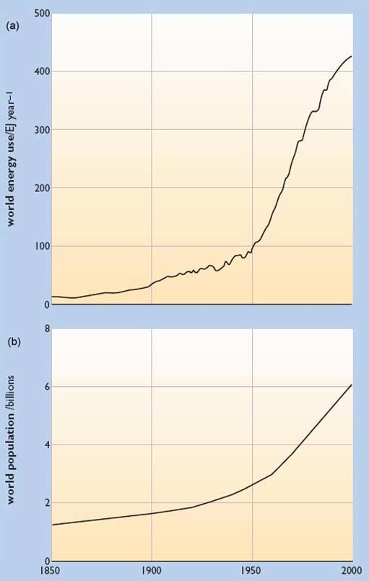
Figure 9: (a) Growth in world primary energy use, 1850–2000; (b) Growth in world population, 1850–2000

For most of the nineteenth century the world's principal fuel was firewood (or other forms of traditional 'bioenergy'), but coal use was rising fast and by the beginning of the twentieth century it had replaced wood as the dominant energy source. During the 1920s, oil in turn began to challenge coal and by the 1970s had overtaken it as the leading contributor to world supplies. By then, natural gas was also making a very substantial contribution, with nuclear energy and hydro power also supplying smaller but significant amounts.
As Figure 10 shows, total world primary energy use in 2000 was an estimated 424 million million million joules, i.e. 424 exajoules, equivalent to some 10,100 million tonnes of oil.

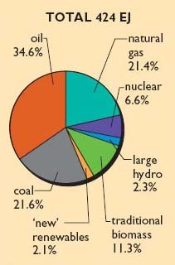
Figure 10: Percentage contributions of various energy sources to world primary energy consumption, 2000

Total consumption in 2000 was 424 exajoules, equivalent to just over 10,000 million tonnes of oil. The average rate of consumption was some 13.4 million million watts (13.4 terawatts). Note that the actual amounts of electricity produced by nuclear and hydro power were almost the same, but due to a statistical convention in the definition of primary energy, the nuclear contribution is multiplied by a factor of 3.

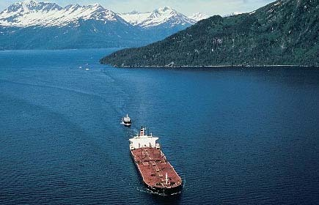
Figure 11: A typical supertanker used to ship oil around the globe. To transport the c.3500 million tonnes of oil used by the world in 2000 would require some 14,000 tanker journeys, assuming a typical tanker capacity of 250,000 tonnes. Total world primary energy use in 2000 was equivalent to the capacity of some 40,000 supertankers of this size

By the year 2000, oil was still the largest single contributor to world supplies, providing about 35 per cent of primary energy, with gas and coal supplying roughly equal shares at around 21–22 per cent, nuclear providing nearly 7 per cent and hydropower 2 per cent. In 2000, traditional biofuels still supplied an estimated 11 per cent, while more modern forms of 'bioenergy' provided around 2 per cent, with other 'new renewables' like wind power contributing a very small (though rapidly growing) fraction of world demand,
On average, world primary energy use per person in 2000 was about 70 thousand million joules (70 gigajoules), including non-commercial bioenergy. This is equivalent to about one and two-thirds tonnes of oil per person per year, or about 5 litres (just over one Imperial gallon) of oil per day.
But this average conceals major differences between the inhabitants of different regions. As Figure 12 illustrates, North Americans annually consume the equivalent of about 8 tonnes of oil per head (about 20 litres per day), whereas residents of Europe and the former Soviet Union consume about half that amount, and the inhabitants of the rest of the world use only about one-tenth.
World consumption per person has shown almost no growth over the past 20 years. North American consumption per capita is more than twice that of Europe and the former Soviet Union, and almost 10 times the level in the Rest of the World. Note that these figures include only commercially traded fuels (i.e. they exclude traditional biofuels).

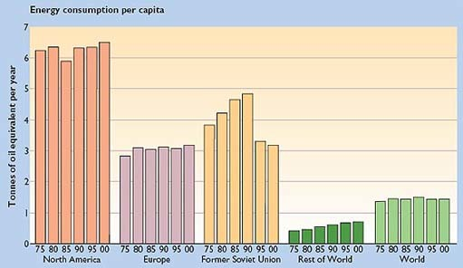
Figure 12: Per capita primary energy consumption, in tonnes of oil equivalent per year, for different regions of the world and for the world as a whole, 1975–2000

Fossil fuels are extremely attractive as energy sources. They are highly concentrated, enabling large amounts of energy to be stored in relatively small volumes. They are relatively easy to distribute, especially oil and gas which are fluids.
During the twentieth century, these unique advantages enabled the development of increasingly sophisticated and effective technologies for transforming fossil fuel energy into useful heat, light and motion; these ranged from the oil lamp to the steam engine and the internal combustion engine. Today, at the beginning of the twenty-first century, fossil fuel-based systems reign supreme, supplying the great majority of the world's energy.
The fossil fuels we use today originated in the growth and decay of plants and marine organisms that existed on the earth millions of years ago. Coal was formed when dead trees and other vegetation became submerged under water and were subsequently compressed, in geological processes lasting millions of years, into concentrated solid layers below the earth's surface. Oil and associated natural gas originally consisted of the remains of countless billions of marine organisms that slowly accreted into layers beneath the earth's oceans and were gradually transformed, through geological forces acting over aeons of time, into the liquid and gaseous reserves we access today by drilling into the earth's crust. The fossil fuels are composed mainly of carbon and hydrogen, which is why they are called hydrocarbons.

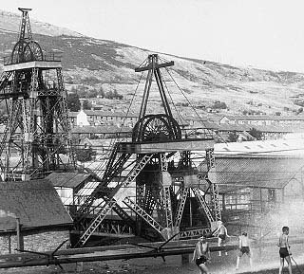
Figure 13: Parc Colliery in Cwm Park, Rhonda Valley, Glamorgan, South Wales, (photo, 1960)

Coal was the fuel that powered the industrial revolution. Its combustion produces relatively large amounts of carbon dioxide (CO₂) compared with other fuels. It also results in particulates (soot), and sulphur dioxide emissions, though these can be reduced by various techniques. The use of coal in UK homes and industry has now been largely superseded by natural gas, but it is still used for electricity generation. Huge world-wide coal reserves remain, enough for several hundred years' use at current rates.

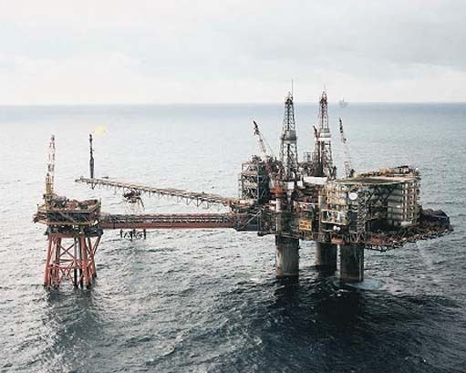
Figure 14: A North Sea oil drilling platform

Oil is the world's leading energy source. Its high energy density and convenience of use are particularly advantageous in the transport sector, where it is the dominant fuel. Oil combustion produces less CO₂ per unit of energy released than burning coal, but more CO₂ than burning natural gas. Proven world oil reserves are sufficient for about 40 years of use at current rates.

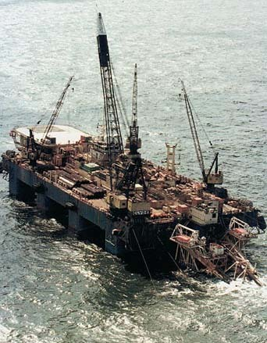
Figure 15: The offshore rig Semac 1, a natural gas pipelaying barge in the North Sea

Natural gas combustion produces significantly lower CO₂ emissions per unit of energy than the combustion of other fossil fuels. Emissions are also free from sulphur dioxide or particulates. The relative cleanliness and convenience of natural gas have made it the preferred fuel for heating and, increasingly, for electricity generation in Western Europe. Proven world gas reserves are sufficient for about 60 years of use at current rates.
Since the fossil fuels were created in specific circumstances where the geological conditions were favourable, the largest deposits of oil, gas and coal tend to be concentrated in particular regions of the globe (see Figure 16a, b, and c) – although less appreciable deposits are remarkably widespread. The majority of the world's oil reserves are located in the Middle East and North Africa, while the majority of our natural gas reserves are split roughly equally between the Middle East/North Africa and the former Soviet Union (BP, 2002). Although coal deposits are rather more evenly spread throughout the world, three-quarters of world coal reserves are concentrated in just four countries: Australia, China, South Africa and the United States of America (United Nations, 2000; BP, 2002) (Figure 16c).

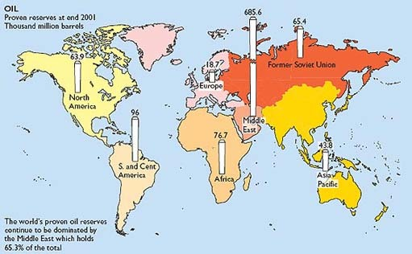
Figure 16: (a) Proven world fuel reserves, 2001: oil reserves

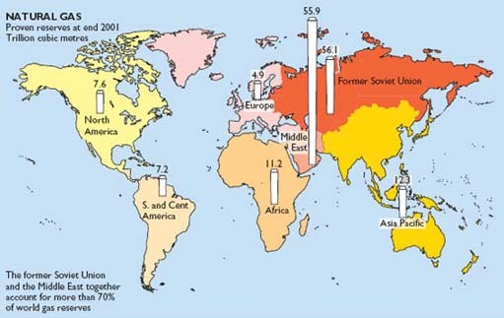
Figure 16: (b) Proven world fuel reserves, 2001: natural gas reserves

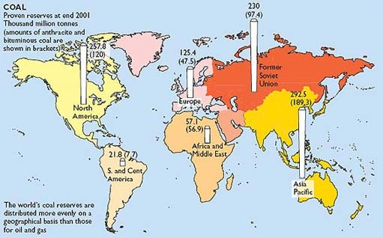
Figure 16: (c) Proven world fuel reserves, 2001: coal reserves

Although human society now consumes fossil fuels at a prodigious rate, the amounts of coal, oil and gas that remain are still very large. One simple way of assessing the size of reserves is called the reserves/production (R/P) ratio – the number of years the reserves would last if use continued at the current rate.
Coal has the largest R/P ratio. Present estimates suggest the world has more than 200 years' worth of coal left at current use rates. For oil, current R/P estimates suggest a lifetime of about 40 years at current rates. For gas, the R/P ratio is somewhat higher, at around 60 years (BP, 2002) (Figure 17).

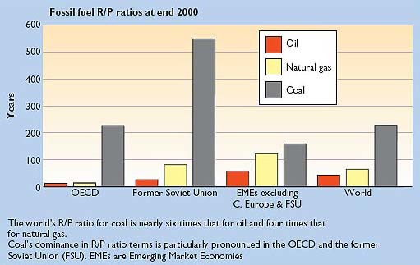
Figure 17: Reserves/production (R/P) ratios (in years) for oil, natural gas and coal, 2000, for various regions of the world and the world as a whole

Fossil fuel reserves/production ratios need to be interpreted with great caution, however. They do not take into account the discovery of new proven reserves, or technological developments that enable more fuel to be extracted from deposits or improve the economic viability of 'difficult' deposits.
Despite these developments, it seems likely that, at least in the case of oil from conventional sources, world production will reach a peak in the first decade of this century. From then on, although vast quantities of conventional oil will still remain, the resource will be on a declining curve (United Nations, 2000; Campbell and Laherrere, 1998). This seems likely to lead to increased instability and potential for conflict as the twenty-first century proceeds.
The massive use by our society of coal, oil and gas has, literally, fuelled enormous increases in material prosperity – at least for the majority in the industrialised countries. But it has also had numerous adverse consequences. As already mentioned, these include air and water pollution, mining accidents, fires and explosions on oil or gas rigs, conflicts over access to fuel resources and, perhaps most profoundly, the global climate change that is likely to be the result of increasing atmospheric carbon dioxide concentrations caused by fossil fuel combustion (see Box 2).

Box 2: The Greenhouse Effect and Global Climate Change
The greenhouse effect in its natural form has existed on the planet for hundreds of millions of years and is essential in maintaining the Earth's surface at a temperature suitable for life. Without it, we would all freeze.
The sun's radiant energy, as it falls on the earth, warms its surface. The earth in turn re-radiates heat energy back into space in the form of infra-red radiation. The temperature of the earth establishes itself at an equilibrium level at which the incoming energy from the sun exactly balances the outgoing infra-red radiation.
If the earth had no atmosphere, its surface temperature would be approximately minus 18°C, well below the freezing point of water. However our atmosphere, whilst largely transparent to incoming solar radiation in the visible part of the spectrum, is partially opaque to outgoing infra-red radiation. It behaves in this way because, in addition to its main constituents, nitrogen and oxygen, it also contains very small quantities of 'greenhouse gases'. Put simply, these enable the atmosphere to act like the panes of glass in a greenhouse, allowing the sun to enter but inhibiting the outflow of heat, so keeping the earth's surface considerably warmer than it would otherwise be. The average surface temperature of the earth is in fact around 15°C, some 33°C warmer than it would be without the greenhouse effect.

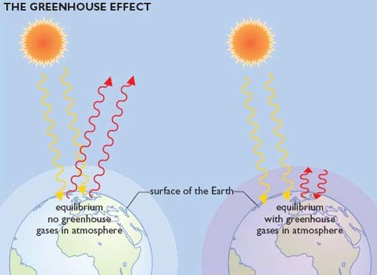
Figure 18: A simplified depiction of how the greenhouse effect raises the earth's temperature

The most important greenhouse gases are water vapour, carbon dioxide and methane, though other gases such as the chlorofluorocarbons (CFCs) also play significant but lesser roles.
Water vapour evaporating from the oceans plays a major part in maintaining the natural greenhouse effect, but human activities have very little influence on the vast processes through which water cycles between the oceans and the atmosphere.
Carbon dioxide (CO₂) is also primarily generated by natural processes. These include the process of respiration, in which organisms 'breathe out' carbon dioxide; and the emissions of CO₂ that occur when organisms die and the carbon compounds of which they are composed decay. But since the industrial revolution, the burning of fossil fuels by humanity has been adding substantial quantities of CO₂ to our atmosphere. The fossil fuels are essentially compounds of carbon and hydrogen. Coal consists mostly of carbon, the chemical symbol for which is C. Natural gas, the chemical name for which is methane, consists of carbon and hydrogen. Each carbon atom is surrounded by four hydrogen atoms, so in chemical shorthand its symbol is CH₄. Oil is a more complex mixture of many different hydrocarbon molecules. When any of these fuels is burned, carbon dioxide is produced, along with water.
The concentration of CO₂ in the atmosphere in pre-industrial times was around 280 parts per million by volume (ppmv) but levels have been steadily rising since then, reaching some 360 ppmv in 2000.

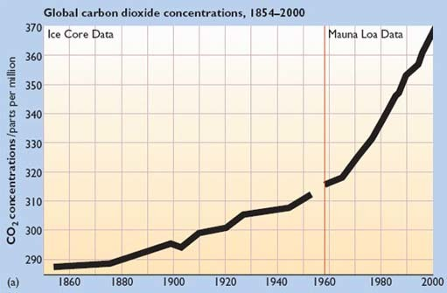
Figure 19: (a) Atmospheric concentrations of carbon dioxide (CO₂), 1854–2000. Carbon dioxide data from 1958 were measured at Mauna Loa, Hawaii; pre-1958 data are estimated from ice cores

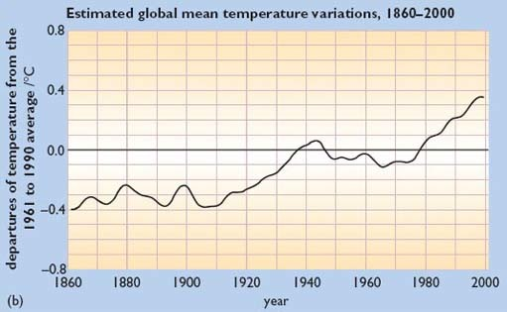
Figure 19: (b) Estimated global mean temperature variations, 1860–2000

The other main greenhouse gas, methane, is given off naturally when vegetation decays in the absence of oxygen – for example, under water. However various human activities, including increasing rice cultivation, which causes methane emissions from paddy fields, and leaks of fossil methane from natural gas distribution systems, have caused the levels of methane in the atmosphere to increase sharply. Concentrations have risen from about 750 parts per billion by volume (ppbv) in pre-industrial times to around 1750 ppbv in 2000.
These additional emissions of carbon dioxide and methane are the main causes of the so-called anthropogenic – that is, human-induced – greenhouse effect. Unlike the operation of the natural greenhouse effect, which is benign, the anthropogenic greenhouse effect is almost certainly the cause of a global warming trend that could have very serious consequences for humanity. Though a small minority dissents, the majority of scientists now believe that the anthropogenic effect, acting to enhance the natural processes, has already caused the mean surface temperature of the earth to rise by about 0.6°C during the twentieth century (Intergovernmental Panel on Climate Change, 2001). Moreover, if steps are not taken to limit greenhouse gas emissions, atmospheric CO₂ levels will probably rise by 2100 to between 540 and 970 ppmv (depending on the assumptions made). These levels would be between two and three times the pre-industrial CO₂ concentration, and would be likely to lead to rises in the earth's mean surface temperature of between 1.4 and 5.8°C by the end of the century. Such temperature rises would be unprecedented since the ending of the last major Ice Age, more than 10,000 years ago.
These temperature rises would be very likely to result in significant changes to the earth's climate system. Such changes would probably include more intense rainfall, more tropical cyclones, or long periods of drought, all of which would disrupt agriculture. Moreover, ecosystems might be damaged with some species unable to adapt quickly enough to such rapid changes in climate.
In addition, due to thermal expansion of the oceans, sea levels would be expected to rise by around 0.5 metres during the twenty-first century, sufficient to submerge some low-lying areas and islands. In the longer term, further sea level rises would result if the Antarctic ice sheets were to melt significantly.

3.2 Nuclear energy
Nuclear energy is based on harnessing the very large quantities of energy that are released when the nuclei of certain atoms, notably uranium-235 and plutonium-239, are induced to split or 'fission'. The complete fission of a kilogram of uranium-235 should produce, in principle, as much energy as the combustion of over 3000 tonnes of coal. In practice, the fission is incomplete and there are other losses, but nevertheless nuclear fuels are more highly concentrated sources of energy than fossil fuels.
The heat generated by nuclear fission in a nuclear power station is used to raise high-pressure steam which then drives steam turbines coupled to electrical generators, as in a conventional power station.

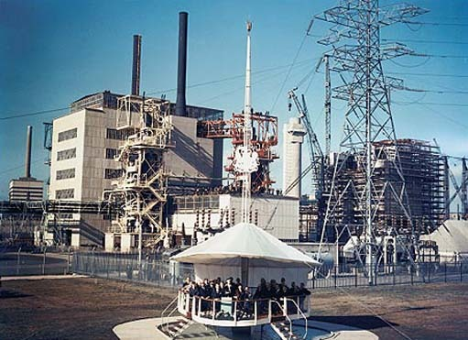
Figure 20: Queen Elizabeth II opening Calder Hall nuclear power station in Cumbria, 1956

The development of 'peaceful' nuclear electricity generation after its use for military purposes in World War II was initially heralded as ushering in a new era of virtually limitless, clean power that some predicted would be 'too cheap to meter'. In practice, however, nuclear electricity has proved to be more expensive than that from fossil fuels. Since the UK opened the world's first grid-connected nuclear power station at Calder Hall in Cumbria in 1956, nuclear electricity generation has expanded to a point where it now accounts for nearly 7 per cent of world primary energy, and for over 17 per cent of the world's electricity. In some countries, it is the principal source of electricity generation. France, for example, derives three-quarters of its electricity from nuclear power.

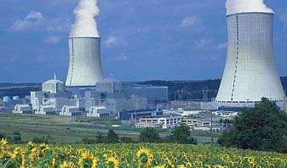
Figure 21: The Civaux Pressurised Water (PWR) nuclear reactor near Poitiers, Vienne, France. In 2000, France produced 77 per cent of its electricity from nuclear power

A major advantage of nuclear energy is that the operation of nuclear power plants results in no emissions of CO₂ or of other 'conventional' pollutants like sulphur dioxide. However, there are some emissions from the fossil fuel used in uranium mining, nuclear fuel manufacture, and the construction of nuclear power plants.
There seems little danger of the world 'running out' of nuclear fuel in the near future. Uranium reserves have been identified in many countries and are sufficient for many decades of use at current rates, and there are probably enough additional deposits to extend this to several centuries. Furthermore, advanced nuclear technologies such as the 'fast breeder reactor' (FBR) could enable uranium deposits to be used even more effectively, thus extending the lifetime of reserves. In an FBR, the plentiful but non-fissile isotope uranium-238 is transformed into fissile plutonium-239, which can then be used as reactor fuel. But the development of FBRs has been inhibited by substantial technical and safety problems, and by the low price of uranium which currently makes the technology un-competitive economically.
Although the majority of nuclear reactors in most countries have operated without serious safety problems, a number of major accidents, like those at Windscale in the UK in 1957, Three Mile Island in the USA in 1979 and Chernobyl in the Ukraine in 1986, have created widespread public unease about nuclear technology in general – despite the opinion of nuclear-industry experts who argue that such anxieties are irrational.

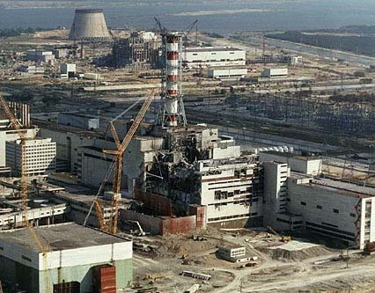
Figure 22: The Chernobyl nuclear power plant following the accident in 1986

Less spectacular are the continued releases of harmful radioactive by-products, in small but insidious and cumulative quantities, to the atmosphere and oceans during the routine operation of nuclear power plants and fuel manufacturing or reprocessing facilities.
There is also the problem of how, ultimately, to dispose of nuclear waste products, some of which remain hazardous for many thousands of years; and the problem of proliferation of nuclear materials such as plutonium-239 and uranium-235, which could fall into the hands of 'rogue states' or 'terrorists' capable of creating crude but devastating atomic weapons from them. Nuclear power stations and reprocessing facilities may themselves be vulnerable to terrorist attacks, which could result in the release of very large quantities of radioactive substances into the environment.
Despite these difficulties, the nuclear industry is attempting to develop more advanced types of nuclear reactor which, it claims, will be cheaper to build and operate, and inherently safer, than existing designs. These are being promoted as an improved technological option for generating the carbon-free electricity that will be required later in the twenty-first century if global climate change is to be mitigated.
Another potentially important nuclear technology is that of nuclear fusion. As its name implies, this involves the fusing together of atomic nuclei, in this case those of deuterium (so-called 'heavy' hydrogen). This process, similar to that underlying the generation of energy within the sun, also results in the release of very large amounts of energy. However, in order to create fusion on earth it is necessary to create conditions in which the nuclei of special forms (called isotopes) of hydrogen interact in an extremely confined space at extremely high temperatures, and so far scientists have only been able to make this happen for a few seconds.
Moreover, the energy required to power the process currently greatly exceeds the energy generated. Research into fusion power continues, with substantial funding, but most experts consider that the technology, even if eventually it can be demonstrated successfully, is very unlikely to become commercially available for many decades.

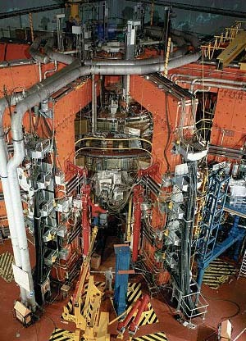
Figure 23: The Joint European Torus (JET) experimental nuclear fusion reactor, located at Culham, Oxfordshire, UK

3.3 Bioenergy
Not all fuel sources are, of course, of fossil or nuclear origin. From prehistoric times, human beings have harnessed the power of fire by burning wood to create warmth and light and to cook food.
Wood is created by photosynthesis in the leaves of plants. Photosynthesis is a process powered by solar energy in which atmospheric carbon dioxide and water are converted into carbohydrates (compounds of carbon, oxygen and hydrogen) in the plant's leaves and stems. These, in the form of wood or other 'biomass', can be used as fuels – called biofuels, which are sources of bioenergy.
Wood is still very widely used as a fuel in many parts of the 'developing' world. In some countries, other biofuels such as animal dung (ultimately also derived from the growth of plants) are also used. As described in Box 1, such traditional biofuels are estimated to supply some 11 per centof world primary energy, though the data are somewhat uncertain.
If the forests that provide wood fuel are re-planted at the same rate as they are cut down, then such fuel use should in principle be sustainable. When forests are managed sustainably in this way, the CO₂ absorbed in growing replacement trees should equal the CO₂ given off when the original trees are burned. However, this is only true when complete combustion of the wood occurs and all the carbon in the wood is released as carbon dioxide. Although near-complete combustion can be achieved in the best available wood stoves and furnaces, most open fires and stoves are not so efficient. This means that not only is carbon dioxide released (albeit in somewhat smaller quantities if the combustion is incomplete) but other combustion products are also emitted, some of which are more powerful greenhouse gases than CO₂. In particular, these can include methane, which on a molecule-for-molecule basis has 20 times the global warming potential of CO₂ over a 20-year-period. The incomplete combustion of wood can therefore release a mixture of greenhouse gases with a greater overall global warming effect than can be offset by the CO₂ absorbed in growing replacement trees. This suggests an urgent need to improve the efficiency of traditional wood-burning processes (Smith et al., 2000). However it should be stressed that the overall global effect of greenhouse gas emissions arising from incomplete biomass combustion in developing countries is probably much less than that of emissions from burning fossil fuels, which occurs mostly in the 'developed' countries.
A further problem is that in many 'developing' countries wood fuel is being used at a rate that exceeds its re-growth, which is not only unsustainable but also results in villagers having to travel ever-increasing distances, often involving great hardship, to gather sufficient firewood for their daily needs. Also, when it has been gathered, firewood is often burned very inefficiently in open fires – as was the case in Britain and many other 'developed' countries until quite recently. This not only results in excess greenhouse gas emissions, as we have seen, but also gives much less effective warmth than if an efficient stove were used. Moreover, it usually results in high levels of smoke pollution, with very detrimental health effects.
Not all bioenergy use is in the form of traditional biofuels. As noted in Box 1, a significant contribution to world supplies now comes from so-called 'modern' bioenergy power plants. These feature the clean, high-efficiency combustion of straw, forestry wastes or wood chips from trees grown in special plantations. The heat produced is either used directly or for electricity generation, or sometimes for both purposes.

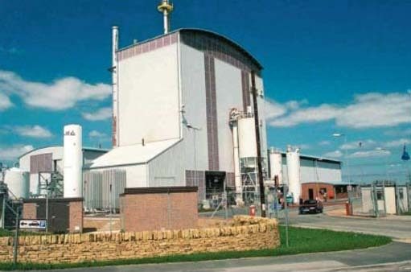
Figure 24: The 'Arbre' power station at Eggborough, Yorkshire, UK. Fuelled by wood chips, it has an electrical generating capacity of 10 MW

Municipal wastes, a large proportion of which are biological in origin, are also widely used for heat or electricity production. However, there is considerable controversy over whether or not energy from waste should be regarded as 'sustainable'. Waste-to-energy plants have been opposed by some environmental groups on the grounds that, in order to be economically viable, they need to be fed with a steady stream of waste over many years, which discourages better solutions to the waste problem, such as material re-use or recycling. There are further concerns over possible emissions of dioxins, which are carcinogenic, from the combustion of chlorine compounds present in municipal waste.
Another modern source of bioenergy is alcohol (ethanol) produced by fermenting sugar cane or maize, which is quite widely used in vehicles in Brazil and some states of the USA. The alcohol is often blended with conventional petroleum to form a mixture known as 'Gasohol'.

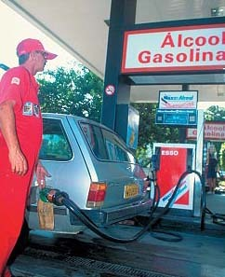
Figure 25: A substantial proportion of vehicles in Brazil are fuelled by alcohol derived from sugar cane

3.4 Hydroelectricity
Another energy source that has been harnessed by humanity for many centuries is the power of flowing water, which has been used for milling corn, pumping and driving machinery. During the twentieth century, its main use has been in the generation of hydroelectricity, and hydropower has grown to become one of the world's principal electricity sources. It currently provides some 2.3 per cent of world primary energy. However, the relative contribution of hydroelectric power (and of other electricity-producing renewables) is under-stated by a factor of about three in most national and international compilations of energy statistics. This is due to a convention whereby the heat produced by thermal power stations (both fossil and nuclear-fuelled) is included as part of their primary energy contribution, even though that heat is normally wasted. The annual electricity outputs of the world's hydro-and nuclear power plants are actually about the same, but due to this statistical convention the primary energy contribution of nuclear is calculated to be about 7 per cent whereas that of hydro is only about one-third of this. Hydropower in 2000 contributed over 17 per cent of world electricity.

Figure 26: The large hydroelectric power plant at Glen Canyon Dam, Lake Powell, Arizona, which has an electrical generating capacity of 1300 MW. Lake Powell was formed with the construction of the Glen Canyon Dam in 1963, on the Colorado River in Page, Arizona. It is the second largest man-made lake in the United States and is 187 miles long

The original source of hydroelectric power is solar energy, which warms the world's oceans, causing water to evaporate from them.
In the atmosphere, this forms clouds of moisture which eventually falls back to earth in the form of rain (or snow). The rain flows down through mountains into streams and rivers, where its flow can be harnessed using water wheels or turbines to generate power.
When harnessed on a small scale, hydropower creates few, if any, adverse environmental impacts.
However, many modern hydro installations have been built on a very large scale, involving the creation of massive dams and the flooding of extremely large areas. This often entails the re-location of many thousands of indigenous residents who are usually, to say the least, reluctant to move from their homes. Other impacts include adverse effects on fish and other wildlife, reductions in water-borne nutrients used in agriculture downstream, increases in water-borne diseases – and not least, the rare but catastrophic effects of dam failures. A further problem with large dams is that in certain circumstances trees and other vegetation trapped below water when a reservoir is flooded can decay 'anaerobically' (i.e. in the absence of oxygen). This produces methane which, as we have seen, is a more powerful greenhouse gas than the CO₂ that would have been produced if the tree had decayed normally in the presence of oxygen from the atmosphere.
However, the current consensus is that greenhouse gas emissions from hydropower generation are likely to be at least an order of magnitude lower than those from fossil-fuel-generated electricity (United Nations, 2000).

3.5 Summary
This section has described how fossil fuels provide the majority of the world's energy requirements, with bioenergy, nuclear energy and hydropower also making major contributions. The other 'renewable' energy sources currently supply only a small fraction of world demand, although the contribution of these 'renewables' seems likely to grow rapidly in coming decades, as we shall see in the following section.

4 Renewable energy sources
Fossil and nuclear fuels are often termed non-renewable energy sources. This is because, although the quantities in which they are available may be extremely large, they are nevertheless finite and so will in principle 'run out' at some time in the future.
By contrast, hydropower and bioenergy (from biofuels grown sustainably) are two examples of renewable energy sources – that is, sources that are continuously replenished by natural processes. Renewable energy sources are essentially flows of energy, whereas the fossil and nuclear fuels are, in essence, stocks of energy.
World-wide, there has been a rapid rise in the development and deployment of renewable energy sources during the past few decades, not only because, unlike fossil or nuclear fuels, there is no danger of their 'running out', but also because their use normally entails no (or few) greenhouse gas emissions and therefore does not contribute to global climate change.
Renewable energy sources range from solar power in its various forms, through bioenergy and hydro to wind, wave, tidal and geothermal energy (Figure 27).

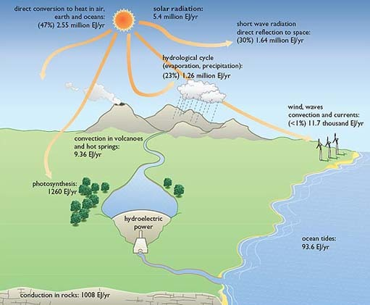
Figure 27: The various forms of renewable energy depend primarily on incoming solar radiation, which totals some 5.4 million Exajoules (EJ) per year. Of this, approximately 30 per cent is reflected back into space. The remaining 70 per cent is in principle available for use on Earth, as shown, and amounts to approximately 3.8 million EJ. This is some 10,000 times the current rate of consumption of fossil and nuclear fuels, which in 2000 amounted to some 360 EJ. Two other, non-solar, renewable energy sources are shown in the figure. These are the motion of the ocean tides, caused principally by the moon's gravitational pull (with a small contribution from the sun's gravity); and geothermal heat from the earth's interior, which manifests itself in convection in volcanoes and hot springs, and in conduction in rocks

The general nature and scope of the various 'renewables' can be briefly summarised as follows, beginning with the most important renewable source, solar energy.

4.1 Solar energy
Solar energy, it should firstly be stressed, makes an enormous but largely unrecorded contribution to our energy needs. It is the sun's radiant energy, as noted in Box 2, that maintains the Earth's surface at a temperature warm enough to support human life. But despite this enormous input of energy to our civilisation, the sun is virtually ignored in national and international energy statistics, which are almost entirely concerned with consumption of commercial fuels.

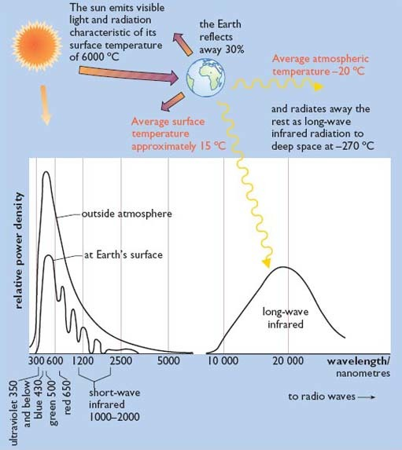
Figure 28: Radiation of energy to and from the earth

The sun has a surface temperature of 6000°C, maintained by continuous nuclear fusion reactions between hydrogen atoms within its interior. These nuclear reactions will gradually convert all of the hydrogen into heavier elements, but this is a relatively slow process and the sun should continue to supply power for another 5 billion years.
The sun radiates huge quantities of energy into the surrounding space, and the tiny fraction intercepted by the Earth's atmosphere, 150 million km away, is nonetheless equivalent to about 15,000 times humanity's present rate of use of fossil and nuclear fuels. Even though approximately one-third of the intercepted energy is reflected away by the atmosphere before reaching the earth's surface, this still means that a continuous and virtually inexhaustible flow of power amounting to 10,000 times our current rate of consumption of conventional fuels is available in principle to human civilisation.
Solar energy, when it enters our buildings, warms and illuminates them to a significant extent. When buildings are specifically designed to take full advantage of the sun's radiation, their needs for additional heating and for artificial lighting can be further reduced.
Solar power can also be harnessed by using solar collectors to produce hot water for washing or space heating in buildings.
Such collectors are in widespread use in sunny countries such as Israel and Greece, but are also quite widely used in less sunny places such as Austria. Even in cloudy Britain there are more than 40,000 roof-top solar water heating systems.

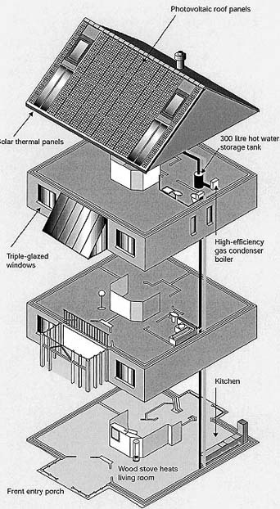
Figure 29: Schematic of solar powered house in Oxford, UK

The roof of this solar house in Oxford has a grid-linked 4 kW array of photovoltaic panels. These generate enough electricity to supply its annual requirements, plus a surplus which is used to provide part of the power to run a small electric car. The roof also incorporates a 5 m² array of solar water heating panels which provide three-quarters of the house's hot water requirements. The house is well-insulated and includes a conservatory that contributes 'passive' solar energy to space heating in Spring and Autumn, supplemented by a natural gas boiler and a small wood-burning stove used on very cold days.
In regions such as Southern California, where solar radiation levels are more than twice those of the UK and skies are clearer, the sun's rays are strong enough to make it practicable to generate high-temperature steam using arrays of concentrating mirrors. The steam can then be used to power a turbine that drives a generator to produce electricity (Figure 30).

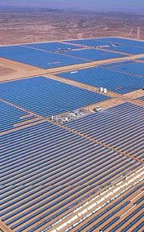
Figure 29a

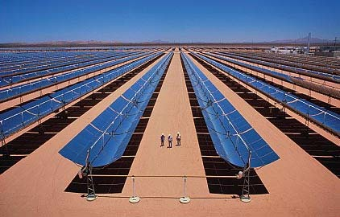
Figure 30: The largest 'solar thermal-electric' installation of its kind in the world, the Luz project in California's Mojave Desert, has a peak output of some 350 MW and occupies several square kilometres of land

Harnessing solar energy to provide electricity directly involves the use of a different and more sophisticated technology called solar photovoltaics (PV). Photovoltaic 'modules' are made of specially-prepared layers of semi-conducting materials (usually silicon) that generate electricity when photons of sunlight fall upon them. Arrays of PV modules are normally mounted on the roofs or facades of buildings, providing some or all of their electricity needs (Figures 29 and 31).
Photovoltaic technology is growing very rapidly and several countries have initiated major development and demonstration programmes. Germany, for example, plans to install 100,000 PV roofs and building facades by the end of 2003.

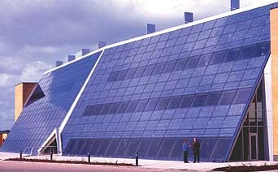
Figure 31: Solar-powered office building, Doxford International Business Park, near Sunderland, UK.

The 3500 m² solar office building at the Doxford International Business Park near Sunderland in the UK incorporates 646 m² of photovoltaic modules. These have a peak power output of 73 kW and generate some 55,000 kWh of electricity per year. The building is well insulated and uses passive solar design to maximise the use of natural daylight and to minimise space heating and air conditioning needs. It is also designed for natural ventilation and night-time cooling
Photovoltaics may well make a significant contribution to world needs in coming decades, but at present its share of world consumption is extremely small. This is mainly due to the very high cost of PV modules, which are currently produced in relatively small quantities. Studies have shown that if the annual output of the manufacturing plants that produce PV modules were increased by a factor of about 20, the cost of PV-generated electricity could be reduced to a point at which it would be competitive with electricity from conventional sources in many industrialised countries.

4.2 Indirect use of solar energy
The above examples illustrate the direct harnessing of the sun's radiant energy to produce heat and electricity. But the sun's energy can also be harnessed via other forms of energy that are indirect manifestations of its power. Principally, these are bioenergy and hydropower, already discussed in Section 3 above, together with wind energy and wave power.

4.2.1 Wind energy
When solar radiation enters the earth's atmosphere, because of the curvature of the earth it warms different regions of the atmosphere to differing extents – most at the equator and least at the poles. Since air tends to flow from warmer to cooler regions, this causes what we call winds, and it is these air flows that are harnessed in windmills and wind turbines to produce power.
Wind power, in the form of traditional windmills used for grinding corn or pumping water, has been in use for centuries. But in the second half of the twentieth century, and particularly in the past few decades, the use of modern wind turbines for electricity generation has been growing very rapidly. Installed wind generating capacity has doubled every two and a half years since 1991, and at the end of 2001 the world total was over 23,000 MW. (Windpower Monthly, 2002) Denmark derives more than 15% of its electricity from wind, and in other countries such as Germany, Spain and the United States of America turbines have in recent years been installed at a rate of more than a thousand megawatts per year.

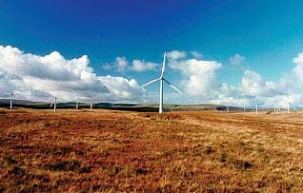
Figure 32: This wind farm, at Carno in mid-Wales, is one of the largest in Europe. It incorporates 56 wind turbines, each with a rotor diameter of 44 metres and a tower height of 31.5 metres. The total installed capacity is 33.6 MW, sufficient to provide power for some 25,000 homes

At present, most of these turbines have been installed on land. But several countries have ambitious plans to install thousands of wind turbines offshore. Denmark, for example, has three offshore wind farms and plans many more, as part of its aim of deriving 30 per cent of its electricity from wind by 2020 – though these plans are subject to future political approval.

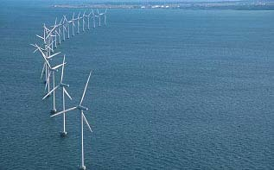
Figure 33: The Middelgrunden wind farm, completed in 2001, is located in the sea just off Copenhagen harbour in Denmark. It includes 20 two megawatt wind turbines, which provide 3 per cent of the electricity consumption of the Copenhagen municipality

The UK, too, has ambitious offshore wind power proposals. Britain's first two offshore wind turbines were installed off Blyth harbour in Northumberland in 2000, and sites have been identified for 13 offshore wind farms that could be built in the coming decade. These would have a total installed capacity of 1600 MW.

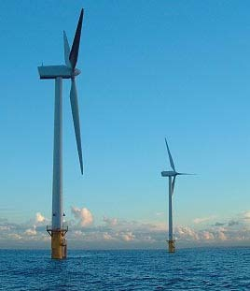
Figure 34: Britain's first offshore wind turbines, located 1 km away from the coast at Blyth harbour, Northumberland. The twin 2 MW turbines were installed in 2000 by a consortium including AMEC, Border Wind, Shell Renewables and the Dutch electricity utility Nuon

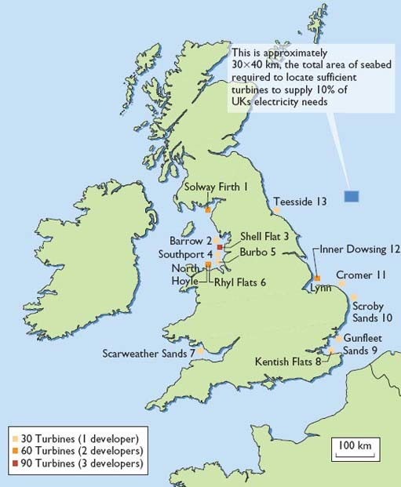
Figure 35: Proposed locations of Britain's first 13 offshore wind farms. Also shown is the area of the North Sea that would be needed for offshore wind farms to produce 10% of the UK's current annual electricity demand

4.2.2 Wave power
When winds blow over the world's oceans, they cause waves. The power in such waves, as they gradually build up over very long distances, can be very great – as anyone watching or feeling that power eventually being dissipated on a beach will know.
Various technologies for harnessing the power of waves have been developed over the past few decades, of which the 'oscillating water column' (OWC) is perhaps the most widely used. In an OWC, the rise and fall of the waves inside an enclosed chamber alternately blows and sucks air through a special kind of air turbine, which is coupled to a generator to produce electricity.

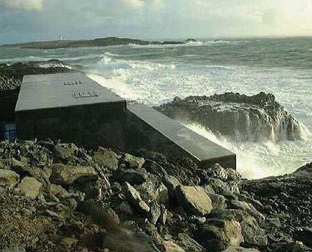
Figure 36: The 500 kW 'Limpet' wave energy plant installed in 2001 on the Scottish island of Islay

Wave energy technology is not as fully developed as wind power or photovoltaics, but its potential has recently been re-emphasised by several governments, including that of the UK. Rapid advances in developing and demonstrating the technology can be expected over the coming decade.
All of the renewable energy sources described above – solar, bioenergy, hydropower, wind and wave – are, as we have seen, either direct or indirect forms of solar energy. However there are two other renewable sources, tidal and geothermal energy, that do not depend on solar radiation.

4.3 Non-solar renewables

4.3.1 Tidal Energy
The energy that causes the slow but regular rise and fall of the tides around our coastlines is not the same as that which creates waves. It is caused principally by the gravitational pull of the moon on the world's oceans. The sun also plays a minor role, not through its radiant energy but in the form of its gravitational pull, which exerts a small additional effect on tidal rhythms.
The principal technology for harnessing tidal energy essentially involves building a low dam, or barrage, across the estuary of a suitable river. The barrage has inlets that allow the rising sea levels to build up behind it. When the tide has reached maximum height, the inlets are closed and the impounded water is allowed to flow back to the sea in a controlled manner, via a turbine-generator system similar to that used in hydroelectric schemes.
The world's largest tidal energy scheme is at La Rance in France, which has a capacity of 240 MW.

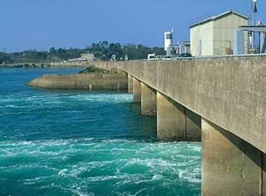
Figure 37: The 240 MW tidal barrage installed at the Rance Estuary in France

There are a few other, smaller, tidal plants in various countries, including Canada, Russia and China. The United Kingdom has one of the world's best potential sites for a tidal energy scheme, in the Severn Estuary. If built, its capacity would be around 8600 MW, much larger than any other single power plant, and it could provide about 6 per cent of current UK electricity demand. But the scheme has not yet been implemented, mainly due to its very high capital cost and concerns about the effects on wildlife in the Severn estuary.
Another, newer tidal energy technology involves the use of underwater turbines (rather like submerged wind turbines) to harness the strong tidal and oceanic currents that flow in certain coastal regions. A 10 kW prototype tidal current turbine was tested at Loch Linne, in Scotland, in 1994, and a larger, 300 kW prototype was tested off the Devon coast in 2002.
The technology is still under development, but its prospects are promising.

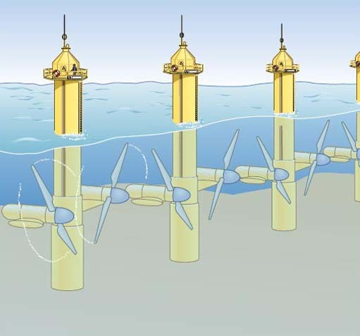
Figure 38: Artist's impression of an array of undersea tidal current turbines. The twin-rotor turbines can be raised to the surface to avoid the need for underwater maintenance

4.3.2 Geothermal energy
Geothermal energy is another renewable source that is not derived from solar radiation. As the name implies, its source is the earth's internal heat, which originates mainly from the decay of long-lived radioactive elements. The most useful geothermal resources occur where underground bodies of water called aquifers can collect this heat, especially in those areas where volcanic or tectonic activity brings the heat close to the surface. The resulting hot water, or in some cases steam, is used for electricity generation where possible, for example in Italy, New Zealand and the Philippines, and for direct heating use in more than 60 other countries. Geothermal energy is already making a minor but locally useful contribution to world energy supplies.

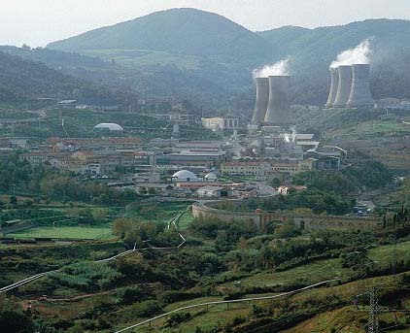
Figure 39: One of the geothermal power plants at Larderello, Italy, used to provide electricity and hot water

If geothermal heat is extracted in a particular location at a rate that does not exceed the rate at which it is being replenished from deep within the earth, it is a renewable energy source. But in many cases this is not so: the geothermal heat is in effect being 'mined' and will 'run out' locally in perhaps a few years or decades.

4.4 Sustainability of renewable energy sources
Renewable energy sources are generally sustainable in the sense that they cannot 'run out' – although, as noted above, both biomass and geothermal energy need wise management if they are to be used sustainably. For all of the other renewables, almost any realistic rate of exploitation by humans would be unlikely to approach their rate of replenishment by nature, though of course the use of all renewables is subject to various practical constraints.
Renewable energies are also relatively 'sustainable' in the additional sense that their environmental and social impacts are generally more benign than those of fossil or nuclear fuels. However, the deployment of renewables in some cases entails significant environmental and social impacts. Renewable energy sources are generally much less concentrated than fossil or nuclear fuels, so large areas of land (or building surfaces) are often required if substantial quantities of energy are to be collected. This can lead to a significant visual impact, as in the case of wind turbines.
Also, the monetary costs of many renewable sources are at present considerably higher than those of conventional fuels. Until this imbalance is reduced, either by reducing the costs of renewables or through increases in the costs of conventional sources, renewables may be unable to succeed in capturing a substantial fraction of the world market.
Renewables may seem attractive in many ways, but how large a contribution might they make to world energy needs in the future?

5 Energy services and efficiency improvement
Except in the form of food, no one needs or wants energy as such. That is to say, no one wants to eat coal or uranium, drink oil, breathe natural gas or be directly connected to an electricity supply. What people want is energy services – those services which energy uniquely can provide. Principally, these are: heat, for warming rooms, for washing and for processing materials; lighting, both interior and exterior; motive power, for a myriad of uses from pumping fluids to lifting elevators to driving vehicles; and power for electronic communications and computing.

5.1 Energy services
When Thomas Edison set up the world's first electric power station in New York in 1882, it was not electricity he sold, but light. He provided the electricity and light bulbs, and charged his customers for the service of illumination. This meant he had a strong incentive to generate and distribute electricity as efficiently as possible, and to install light bulbs that were as efficient and long-lasting as possible.

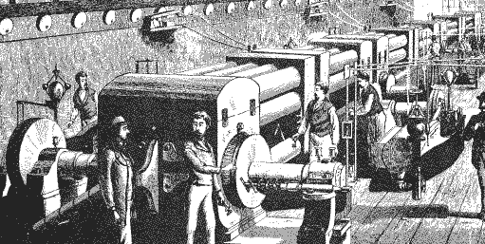
Figure 40: Dynamo Room of Edison's Electric Lighting Station, Pearl Street, New York, 1882

Unfortunately, the early Edison approach did not survive, and the regulatory regime under which most utilities operate today simply rewards them for selling as much energy as possible, irrespective of the efficiency with which it is used or the longevity of the appliances using it. In a few countries, however, governments have changed the way energy utilities are regulated by setting up mechanisms to reward them for providing energy services rather than mere energy. In this case, customers benefit by having lower overall costs, the utility makes as much profit as before, and the environment benefits through reduced energy wastage and the emission of fewer pollutants.

5.1.1 Linking supply and demand
But apart from these relatively few enlightened examples, the efficiency with which humanity currently uses its energy sources is generally extremely low. At present, only about one-third of the energy content of the fuel the world uses emerges as 'useful' energy, at the end of the long supply chains we have established to connect our coal and uranium mines, our oil and gas wells, with our energy-related needs for warmth, light, motion, communication, etc.

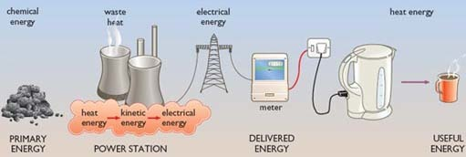
Figure 41: An example of one of the energy 'chains' linking primary energy with delivered energy and useful energy, via various energy transformations

The remaining two-thirds usually disappears into the environment in the form of 'waste' heat. One of the reasons for our continuing inefficiency in energy use is that energy has been steadily reducing in price, in real terms, over the past 100 years.

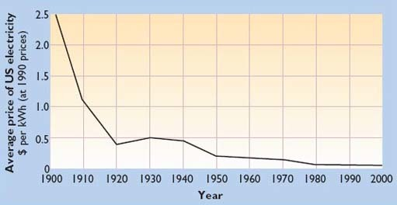
Figure 42: Average household rates for US electricity, 1900–2000, expressed in real terms, i.e. taking into account the effects of inflation (source: Smil, 2000)

Energy's decreasing cost means that our society has only a relatively weak financial incentive to use it more wisely.
The chains that link energy supplies with users' demands are lengthy and complex, as Figure 41 illustrates. Each link in the chain involves converting energy from one form or another, for example in the burning of coal to generate electricity; or distributing energy via some kind of transmission link or network, such as a national electricity grid or gas pipeline infrastructure.

5.2 Energy efficiency improvements

5.2.1 Supply-side measures
On the supply side of our energy systems, there is a very large potential for improving the efficiency of electricity generation by introducing new technologies that are more efficient than older power plant. The efficiency of a power plant is the percentage of the energy content of the fuel input that is converted into electricity output over a given time period. Since the early days of electricity production, power plant efficiency has been improving steadily. The most advanced form of fossil-fuelled power plant now available is the Combined Cycle Gas Turbine (CCGT).
CCGTs are more than 50 per cent efficient, compared with the older steam turbine power plant that is still in widespread use, where the efficiency is only about 30 per cent, and thus two-thirds of the energy content of the input fuel is wasted in the form of heat, usually dumped to the atmosphere via cooling towers.

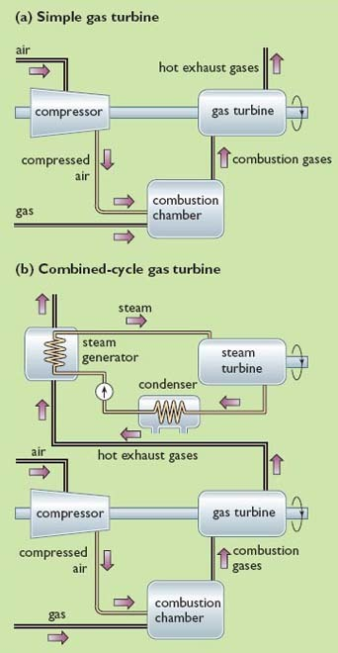
Figure 43: Diagram comparing the operation of a simple gas turbine power plant (a) with that of a combined cycle gas turbine plant (b). In the latter, the hot exhaust gases from the gas turbine are used to raise steam to power a steam turbine. The steam turbine and gas turbine are coupled to a generator to produce electricity. In a conventional, steam turbine-only power plant, the heat required to produce the steam comes from a boiler

CCGTs are more 'climate friendly' than older, coal-fired steam turbine plant, not only because they are more efficient but also because they burn natural gas, which on combustion emits about 40 per cent less CO₂ than coal per unit of energy generated. Overall, taking into account both the higher efficiency and natural gas's lower CO₂ emissions, when compared with traditional coal-fired plant CCGT-based power plants release about half as much CO₂ per unit of electricity produced. Most of the reductions that occurred in Britain's CO₂ emissions during the 1990s were due to the so-called 'dash for gas' as a substitute for coal in power generation.

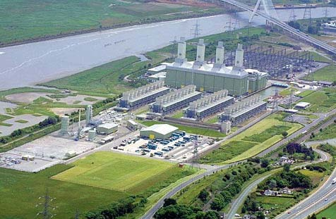
Figure 44: This combined-cycle gas turbine power station at Deeside in the UK was commissioned in 1994 and has an output of 500 MW

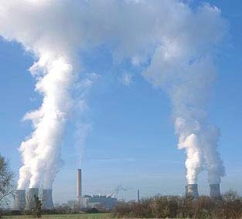
Figure 45: This coal-fired power station at Didcot, Oxfordshire, UK, was commissioned in 1972 and has a capacity of 2000 MW. Two-thirds of the energy content of the fuel burned in such power stations is dissipated by the cooling towers to the atmosphere in the form of steam

In some countries, the 'waste' heat from power stations is widely used in district heating schemes to heat buildings. In 2000, some 72 per cent of Denmark's electricity was produced in such 'Combined Heat and Power' systems.
After fuels have been converted to electricity, whether in CCGTs or steam turbine-only plant, further losses occur in the wires of the transmission and distribution systems that convey the electricity to customers. In the UK, these amount to around 8 per cent. Overall, this means that even when a modern, high-efficiency CCGT is the electricity generator, less than half the energy in its input fuel emerges as electricity at the customers‗ sockets. In the case of older power stations the figure is around one-quarter.
Clearly, there is room for further improvements in the supply-side efficiency of our electricity systems, by further increasing the efficiency of generating plant and by ensuring that whatever 'waste' heat remains is piped to where it can be used.
Coal, oil and gas, when they are used directly rather than for electricity generation, are also subjected to processing, refining and cleaning before being distributed to customers. Some energy is also lost in their distribution, for example in the fuel used by road tankers or the electricity used to pump gas or oil through pipelines. However, these losses are much lower, typically less than 10 per cent overall. This means that over 90 per cent of the energy content of coal, oil and gas, if used directly, is available to customers at the end of the processing and distribution chain. The scope for further supply-side efficiency improvements is obviously much more limited here than in the case of electricity.

5.2.2 Demand-side efficiency improvements
Let us now look briefly at what can be done to improve the efficiency of energy use at the demand side – that is, in our buildings, industries and vehicles.
Improving the sustainability of energy use by applying demand-side measures involves two distinct approaches, one technological, the other social.
The technological approach involves installing improved energy conversion (or distribution) technologies that require less input energy to achieve a given level of useful energy output or energy service.
The social approach involves re-arranging our lifestyles, individually and collectively, in minor or perhaps major ways, in order to ensure that the energy required to perform a given service is reduced in comparison with other ways of supplying that service.
For example, you may live in a densely populated town with shops, offices, schools and other amenities scattered evenly around. You may be able to do your shopping, go to work, and take the children to school without using a car, simply by walking relatively short distances. Or you may find it convenient to catch a bus, as bus services are usually more frequent and efficient in higher-density settlements.
On the other hand, you may live in a town with a similar population, but one that has been designed (as have many new towns) to have a low population density (i.e. fewer residents per hectare of land), with shops and offices concentrated in the town centre. In this case, you may well use a car for many of your local journeys, consuming fossil fuels and generating emissions of greenhouse gases and other pollutants. In both towns, the residents receive exactly the same levels of service: shopping, working, schooling, etc. But in the high-density town the residents can use energy services more sustainably than in the low-density town – all other things being equal.

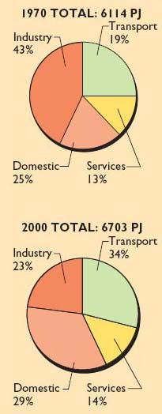
Figure 46: UK delivered energy, 1970 and 2000, by sector. Between 1970 and 2000, overall delivered energy use rose by just under 10 per cent. Transport energy use rose by 79 per cent, while energy use in the domestic and services sectors rose by 16 per cent and 8 per cent respectively. Industrial consumption, by contrast, fell by 47 per cent over the 30-year period

In government energy statistics, energy demand is usually broken down into four main sectors:
The Domestic Sector
This obviously consists of individual households, within which the main categories of energy use are for space heating, water heating, cooking, lighting and other electrical appliances.
The Commercial and Institutional Sector (often termed the Services Sector).
This consists of offices, shops, schools, hospitals, banks, etc. The energy requirements of this sector are very similar to those of the domestic sector: space heating, water heating, cooking, lights and appliances. Air conditioning, however, is more prevalent in this sector than in the domestic sector – at least in countries with temperate climates, like the UK. In this sector, as in the Domestic Sector, most of consumption is within buildings.
The main technological measures that can be taken to conserve energy and use it more efficiently within buildings include:
- improved levels of insulation in walls, roofs and floors, to reduce heat losses through these elements;
- energy-efficient windows, designed to allow less heat to escape whilst still admitting large amounts of sunlight;
- draught-proofing and heat recovery systems to reduce heat lost through ventilation whilst retaining sufficient fresh air within the building;
- more efficient boilers that require a smaller fuel input to achieve a given level of space or water heating, together with improved insulation of pipes to reduce heat losses;
- energy-efficient lights that require much smaller amounts of power to provide a given level of illumination;
- energy-efficient appliances, such as refrigerators, cookers, washing machines, dishwashers, TV sets and hi-fi equipment in the domestic sector; or more efficient computers, copiers and other business equipment in the commercial and institutional sector. These consume less energy whilst delivering the same level of service as their inefficient predecessors;
- improved control systems, to ensure that energy-consuming equipment is not switched on when not needed, and that power output levels match the requirements of users.

Figure 46a

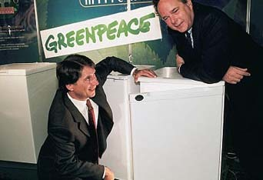
Figure 46b

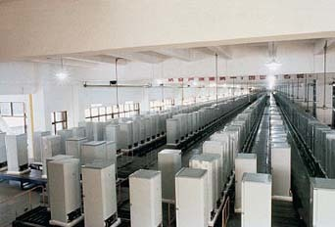
Figure 47: Energy-efficient appliances: fluorescent light-bulb and energy-efficient refrigerators

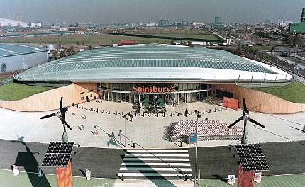
Figure 48: This supermarket in London is designed to use half the electricity of a conventional new food store

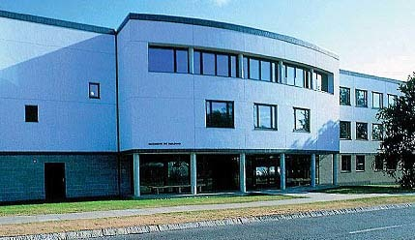
Figure 49: This building at the University of East Anglia consumes less than half the energy of an air-conditioned building of comparable size and function

The Industrial Sector
This sector mainly covers manufacturing industry, service industries being categorised under 'Services'. Much of industrial energy use also occurs within buildings, and consists of requirements for space heating, water heating, cooking, lights and appliances, as in the domestic and commercial and institutional sectors. But in addition, many industries, such as the steel industry, use substantial quantities of high-temperature heat and large amounts of electricity to power various specialised processes. These demands in many cases exceed those of the buildings where the activities are housed and of the people within them.
So apart from improving the energy efficiency of the buildings and appliances in the industrial sector, where the approaches are similar to those in the domestic and services sectors, there are other measures that apply specifically to industry. In particular, these include 'cascading' of energy uses, where 'waste' heat from a high-temperature process is used to provide energy for lower temperature processes; and the use of high-efficiency electric motors, pumps, fans and drive systems, with accurate matching of motors to the tasks they are required to perform, and accurate sizing of pipes and their associated pumps.
Dematerialisation
The measures that can be adopted by industry also include reductions in the material content of products, for example in car bodies or drinks cans, where thinner metals can be used without any reduction in the required strength; or the substitution of less energy-intensive materials, as in the use of plastics instead of steel for car bumpers.
These measures are one form of what has been termed 'dematerialisation' – a reduction in the material-intensity (and hence the energy-intensity) of production.
Another form of dematerialisation involves changes that are more social than technological. It occurs when the structure of a country's entire economy shifts towards less energy- and materials-intensive activities. For example, in the UK the steel industry today accounts for a much smaller share of the country's gross domestic product (GDP) than it did 20 years ago. By contrast, the UK services sector now constitutes a much bigger fraction of GDP than two decades ago. Since the service sector usually requires less energy than the steel industry for every pound's worth of production, Britain's overall energy demands have been less than they would otherwise have been. However, if the steel that was formerly manufactured in Britain is now manufactured abroad but still imported to the UK in similar quantities, all that has happened is that the energy input, with its associated CO₂ emissions and their implications for global warming, has been transferred to another country.
The Transport Sector
Motor vehicles (cars, vans, buses, trucks, motor cycles) dominate the transport sector in developed countries. But this sector also encompasses many other modes of transport, including rail, air and shipping, and non-motorised transport forms such as cycling and walking.
As can be seen from Figure 50, the various forms of transport vary enormously in their energy requirements per passenger-kilometre travelled. Cycling and walking, of course, require no fuel input apart from food.
In most developed countries there has been an enormous increase in transportation, measured in passenger-kilometres travelled annually, over the past few decades (Figure 51). Most of this has involved motorised transport, mainly fuelled by oil, and so energy use has also increased greatly, as have the associated CO₂ emissions.

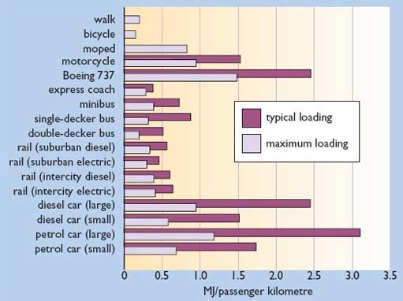
Figure 50: Energy efficiency of different modes of transport in the UK (source: Hughes, 1993)

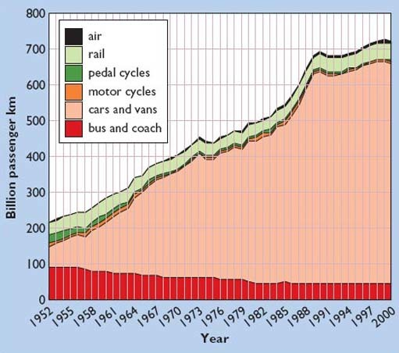
Figure 51: Annual passenger-kilometres travelled in the UK, 1952–2000, by transport mode. Note: air travel data refer to internal flights only (source: DTLR, 2001)

Transport Energy Demand Reduction: Social Measures
Clearly, one social way of reducing the energy required by the transport sector is to shift a proportion of people's journeys away from the energy-intensive modes and towards the more energy-frugal modes. This process is sometimes termed 'modal shift'.
This could be achieved without reducing the total number of journeys, or the overall distance travelled, so that the amenity or service enjoyed by the traveller would remain the same. If, for example, a greater proportion of long-distance journeys within Europe were made by inter-city train rather than by air, the overall energy demand involved could be reduced substantially. Or if urban commuters made more journeys to work by rail or bus instead of using their cars, the effects would be similar. And if householders walked to their local shops instead of taking their cars, no fossil fuels at all would be used for those journeys. Of course, if people are to undertake transport modal shifts of these kinds, they will need to be encouraged by fast, comfortable, efficient services – or penalised into switching by such measures as congestion charging, which is being implemented in central London and other major cities.
Transport Energy Demand Reduction: Technological Measures
In addition to such social measures, there are numerous technological options for improving the energy efficiency of transport energy use. Improving vehicle fuel economy is one obvious measure, and the average fuel economy (in miles per gallon, or litres per 100 km) of vehicles has indeed improved very substantially in most developed countries over the past few decades. However, this improvement has been largely offset (in the UK at least) by an increase in the total number of vehicle-miles travelled, and by increases in the average speeds of vehicles, both of which result in increased fuel consumption.
Nevertheless, manufacturers continue to introduce new models with steadily improving fuel economy, partially spurred by legislation requiring them to do so. New approaches include 'hybrid' petrol-electric cars such as the Toyota Prius (Figure 52).

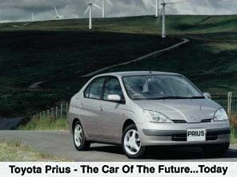
Figure 52: The Toyota Prius, a 'hybrid' petrol-electric car

In addition to such incremental improvements, there are also more radical possibilities, such as the 'Hypercar', proposed by engineers at the Rocky Mountain Institute in the USA (Figure 53).

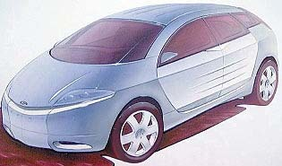
Figure 53: The 'Hypercar', designed by engineers at the Rocky Mountain Institute, Colorado, USA, would be streamlined and made of strong but ultra-light, composite materials

This approach involves the use of strong but ultra-lightweight composite materials such as carbon fibre or Kevlar, combined with a highly streamlined body shell. The drive system would be either the 'hybrid' type, consisting of a small gasoline-fuelled engine augmented by electric motors and a small battery store, or a more advanced system employing a fuel cell powered by hydrogen. Fuel cells are rather like conventional batteries, except that they are continuously re-charged by supplying fuel – usually hydrogen gas – that reacts electrolytically with oxygen from the atmosphere to produce an electric current. In the hypercar, the fuel cell would generate electricity for electric motors that provide power to the wheels. The hydrogen fuel would either be stored in tanks in its pure form, or generated on-board by 're-forming' fossil fuels. The oxygen would come from the surrounding atmosphere. Hypercars, their proponents claim, could achieve between three and five time the fuel economy of current models, with emissions levels approaching zero in the case of the hydrogen-fuel cell version.
Hypercars may still be some way off, but major manufacturers such as Daimler-Chrysler and Ford have recognised the need to make dramatic reductions in vehicle CO₂ emissions in the long term, and are investing many hundreds of millions of dollars in the production of fuel-celled vehicles (Figure 54).

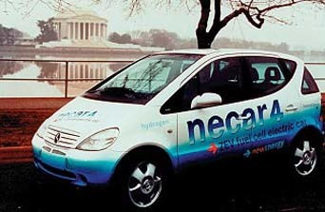
Figure 54: This Mercedes A-Class car is powered by a fuel cell running on hydrogen. The manufacturers, Daimler-Chrysler, and other car-makers such as Ford and General Motors, have announced plans to introduce similar cars on the market

5.3 The rebound effect
When individuals or organisations implement energy efficiency improvements, they usually save money as well as saving energy. However, if the money saved is then spent on higher standards of service, or additional energy-consuming activities that would not have otherwise been undertaken, then some or all of the energy savings may be eliminated. This tendency is sometimes known as the 'rebound effect'. For example, if householders install improved insulation or a more efficient heating boiler, they should in principle reduce their heating bills. However, if they instead maintain their homes at a higher temperature than before, or heat them for longer periods, the savings may be wholly or partly negated. Alternatively, they may decide to spend the money saved through lower heating bills by taking a holiday involving air travel. Since air travel is quite energy-intensive (see Figure 49) once again the energy savings will be offset by increased consumption, albeit of a different kind.
In devising national policies to encourage energy efficiency improvement, governments need to take the rebound effect into consideration. In some cases, it may mean that the energy savings actually achieved when energy efficiency measures are implemented are less than expected. Another policy implication is that citizens should be given incentives to spend any savings they make through implementing energy efficiency measures in ways that are energy-frugal rather than energy-intensive.

6 Energy in a sustainable future
So far, we have briefly introduced three key approaches to improving the sustainability of human energy use in the future. These are:
- (a) 'cleaning-up' fossil and nuclear technologies;
- (b) switching to renewable energy sources;
- (c) using energy more efficiently.

6.2 (a) 'Cleaning-up' fossil and nuclear technologies
This means mitigating some of the adverse 'environmental' consequences of fossil and nuclear fuel use through the introduction of new, 'clean' technologies that should substantially reduce pollution emissions and health hazards. These include 'supply-side' measures to improve the efficiency with which fossil fuels are converted into electricity in power stations; cleaner and more efficient combustion methods; the increasing use of 'waste' heat in combined heat-and-power schemes; and 'end of pipe' technologies to intercept and store pollutants before they enter the environment. This approach also includes 'carbon sequestration' (Box 3) and 'fuel switching' – shifting our energy use towards less-polluting fuels, for example from coal to natural gas. It may also be possible to 'clean up' nuclear power by adopting more advanced technologies that are safer and entail the emission of fewer radioactive substances over the entire nuclear fuel cycle.

Box 3: Carbon sequestration
One way of mitigating climate change that could be important is called 'carbon sequestration'. To sequester means to 'put away', and sequestration of carbon essentially involves finding ways of removing the carbon generated by fossil fuel burning and storing it so that it cannot find its way back into the atmosphere.
One way of sequestering carbon is to plant additional trees which 'soak up' CO₂ from the atmosphere while they are growing. However, whilst this could provide a partial response to the problem of rising CO₂ levels, the sheer magnitude of world emissions is now so great that sequestration in forests alone is probably impractical. It has been estimated that to sequester in trees the carbon produced by world fossil fuel combustion over the next 50 years would require the afforestation of an area the size of Europe from the Atlantic to the Urals (RCEP 2000). Also, when these trees eventually decayed and died, they would emit a similar quantity of CO₂ to that which they absorbed during growth, so it would be necessary to replace the old trees with new ones on an indefinite basis.
However wood fuel from fast-growing plantations, managed sustainably, could be harvested and used as a substitute for fossil fuels, instead of simply being allowed to grow to maturity and then decay. This would offset the carbon emissions that would otherwise have been generated by burning the fossil fuels.
Another approach to sequestering CO₂ is to extract it after combustion in, for example, a power station and store it in some suitable location. It appears to be technically possible to transport by pipeline large quantities of post-combustion CO₂ and store it indefinitely in disused oil or gas wells or in saline aquifers beneath the sea bed (Figure 55). Further research is required to confirm the feasibility, security, safety and economic viability of such techniques. They would only be a realistic option in the case of power stations or similar large installations: it would hardly be practicable to apply this approach to emissions from vehicles or homes.

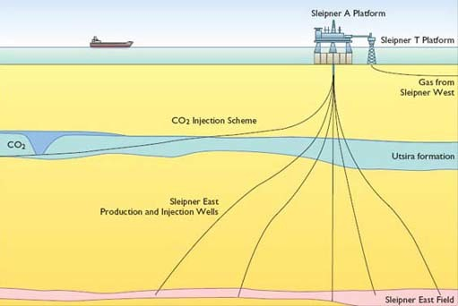
Figure 55: Norwegian Statoil's Sleipner field project. Gas from this field has a very high CO₂ content. Excess CO₂ is pumped into a saline aquifer, the Utsira formation, about 800 m below the sea bed. A million tonnes per year of CO₂ are 'sequestered' in this way

6.3 (b) Switching to renewable energy sources
The use of renewable energy usually involves environmental impacts of some kind, but these are normally lower than those of fossil or nuclear sources.
Approaches (a) and (b) are essentially 'supply-side' measures – applied at the supply end of the long chain that leads from primary energy production to useful energy consumption.

6.4 (c) Using energy more efficiently
This, as we have seen, involves a mixture of social and technological options, applied at the demand-side of the energy chain.
How might these three approaches to improving the future sustainability of our energy systems be combined in future? What are the various possibilities, and what are the main factors that will determine the ultimate outcomes?

6.5 Changing patterns of energy use
Before considering the feasibility, and the plausibility, of radical changes in patterns of energy production and consumption, of the kind that will be needed during the first half of the twenty-first century if we are to progress towards sustainability, it is useful to recall the profound changes that have already occurred in our energy systems during the latter half of the twentieth century.
In Britain just after World War II most homes and other buildings were heated by coal. Most electricity generation was coal-fired, and most rail transport was propelled by coal-burning steam engines. Coal combustion caused major pollution problems, including the notorious London 'smogs' which in most winters caused the premature deaths of hundreds (and occasionally thousands) of people until the introduction of the Clean Air Act in 1956.
Coal miners perished in their dozens, and sometimes hundreds, in mining accidents every year, and many others died slowly of lung diseases caused by inhaling coal dust. Open coal fires in most houses were so inefficient that, despite consuming large quantities of energy, they only heated a few rooms effectively whilst the rest remained cold.
Motor cars were still owned only by a minority and air travel was confined to a small elite. Most people travelled by bus, train, cycle or on foot. Journeys were relatively few, compared with today, and usually over quite short distances.
Since the late 1940s, the UK's energy systems have been transformed. Natural gas, which burns much more cleanly and efficiently, was introduced very rapidly to British homes and buildings from the 1970s, after its discovery beneath the North Sea, and has now replaced coal as the main heating fuel for buildings. Most homes now have gas-fired central heating systems which ensure that the whole house is maintained at a comfortable temperature.
Coal is still used for electricity generation, but flue gas desulphurisation and electrostatic precipitators now greatly reduce emissions of sulphur dioxide and particulates. In new power stations, coal is increasingly being replaced by gas, which can be burned very cleanly and efficiently using combined cycle gas turbines. Nuclear power, since its modest beginnings at Calder Hall in 1956, now contributes around one-quarter of UK electricity.
Cars are now owned by the majority, air travel overseas has become a mass market, railways are powered mainly by electricity, and travel overall, measured in passenger-kilometres, has tripled since the 1950s (Figure 51). Britain is currently a net exporter of oil, thanks to its large North Sea reserves, whereas before the 1970s all our oil was imported.
The dramatic changes that have occurred in Britain's energy systems during the past 50 years have, broadly, been paralleled in most 'developed' countries over the same period.
Given the scale and profundity of the changes over the past half-century, it does not seem unrealistic to suggest that equally profound changes could well occur over the next 50 to 100 years, as we attempt to improve the sustainability of our energy systems, nationally and globally.

6.6 Long-term energy scenarios
To begin to understand the range of long-term future possibilities, let us look briefly at two major studies of future sustainable energy options, the first addressing the UK situation, the second taking a world perspective.

6.6.1 The Royal Commission on environmental pollution scenarios
The UK's Royal Commission on Environmental Pollution produced (RCEP) its 22nd report Energy: the Changing Climate in June 2000. The Commission examined what changes would be needed in Britain's energy systems if, as suggested by the various reports of the Intergovernmental Panel on Climate Change (IPCC, 2001), it should prove necessary to reduce the country's emissions of greenhouse gases by about 60 per cent by 2050.
The Commission investigated the various possibilities very thoroughly and summarised them in four 'scenarios' for 2050. Scenarios are not predictions of what will happen, but plausible outlines of what could happen, under given conditions. In all four scenarios, the overall contribution from fossil fuels is reduced to approximately 40 per cent of current consumption, consistent with the 60 per cent reduction in fossil fuel use required to achieve a 60 per cent cut in CO₂ emissions.
The RCEP scenarios are summarised in Box 4. They demonstrate that it would be feasible for the UK to progress towards much greater sustainability (in terms of reducing CO₂ emissions) in its energy systems over the next 50 years. They also show that there are a number of ways in which this could be achieved.

Box 4: Four energy scenarios for the UK in 2050
Four scenarios were constructed to illustrate the options available for balancing demand and supply for energy in the middle of the twenty-first century if the UK has to reduce carbon dioxide emissions from the burning of fossil fuels by 60 per cent.
Scenario 1: no increase on 1998 demand, combination of renewables and either nuclear power stations or large fossil fuel power stations at which carbon dioxide is recovered and disposed of.
Scenario 2: demand reductions, renewables (no nuclear power stations or routine use of large fossil fuel power stations).
Scenario 3: demand reductions, combination of renewables and either nuclear power stations or large fossil fuel power stations at which carbon dioxide is recovered and disposed of.
Scenario 4: very large demand reductions, renewables (no nuclear power stations or routine use of large fossil fuel power stations).
The key parameters for these four scenarios are as follows:

 | Scenario 1 | Scenario 2 | Scenario 3 | Scenario 4
Percentage reduction in 1997 carbon dioxide emissions | 57 | 60 | 60 | 60
DEMAND (percent reduction from 1998 final consumption)
• low-grade heat | 0 | 50 | 50 | 66
• high-grade heat | 0 | 25 | 25 | 33
• electricity | 0 | 25 | 25 | 33
• transport | 0 | 25 | 25 | 33
• Total | 0 | 36 | 36 | 47
SUPPLY (GW) (Annual average rate)
• fossil fuels | 106 | 106 | 106 | 106
• intermittent renewables | 34 | 26 | 16 | 16
• other renewables | 19 | 19 | 9 | 4
• baseload stations (either nuclear or fossil fuel with carbon dioxide recovery) | 52 | 0 | 19 | 0
Source: Royal Commission on Environmental Pollution, 2000

The actual outcome over coming decades will depend on the extent to which we change our lifestyles and our technologies in order to conserve energy; how effective we are in generating and using it more efficiently; how rapidly we choose to develop and deploy renewable energy sources; how large a role we choose to give to nuclear power; and whether or not we decide to implement carbon sequestration and other technologies for 'cleaning-up' fossil fuels.

6.6.2 The World Energy Council scenarios
What are the possibilities for radical changes in our energy systems when viewed from a world perspective? There have been numerous studies of the various future options for the world's energy systems. One of the most recent and most comprehensive was produced in 1998 by the International Institute for Applied Systems Analysis (IIASA) and the World Energy Council (WEC), a version of which was published in 2000 as part of the United Nations' World Energy Assessment (United Nations Development Programme, 2000). IIASA is a leading 'think tank' based in Austria, whilst the WEC is a body that represents the world's main energy producers and utilities. For simplicity, we shall refer to their scenarios here as the World Energy Council (WEC) scenarios.

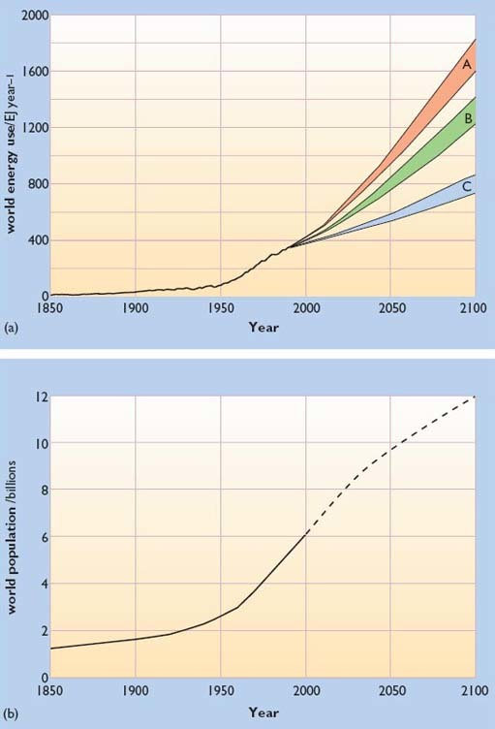
Figure 56: (a) Global primary energy requirements, 1850–1990, and projected requirements 1990–2100 in the three World Energy Council scenario 'cases', A, B and C. World energy use here includes commercially traded energy only; (b) World population, 1850–1990 and projected population, 1990–2100 (see text).

There are six WEC scenarios in all, and these have been grouped into three 'cases', A, B and C. Case B includes only one scenario, termed 'Middle Course'. Case A consists of three 'High Growth' scenarios, and case C includes two 'Ecologically Driven' scenarios.
Each scenario incorporates different assumptions about rates of economic growth and the distribution of that growth between rich and poor countries; about the choices that are made between different energy technologies and the rapidity with which they are developed; and regarding the extent to which ecological imperatives are given priority in coming decades. They all assume that world population will increase from its current (2000) level of around 6.1 billion to 10.1 billion by 2050 and 11.7 billion by 2100. (More recent UN projections, however, suggest that these figures may be over-estimates, with 9 billion as the new median population estimate for 2050 (United Nations, 2001). Other recent research also suggests that world population is likely to peak before the end of the twenty-first century and then begin to decline. (Lutz et al., 2001)).
The results of these assumptions are shown in Figure 56 which also shows world population growth from 1850 to 2000 alongside the various scenario projections to 2100.
In all three High Growth scenarios, the world's economy expands very rapidly, at an annual average rate of 2.5 per cent per annum – significantly faster than the historic growth rate of about 2 per cent per year. In all of them, primary energy intensity (the amount of primary energy required to produce a dollar's worth of output in the economy) reduces quite rapidly, reflecting a fairly strong commitment to energy efficiency measures and/or dematerialisation. The three scenarios differ mainly in their choices of energy supply technologies. One is based on ample supplies of oil and gas; another envisages a return to coal; and the third has an emphasis on non-fossil sources, mainly renewables with some nuclear. By 2100, the High Growth scenarios all envisage world primary energy consumption rising to 1859 exajoules, more than four times the 2000 level.
In the single Middle Course scenario, economic growth is lower than in the High Growth scenarios, averaging around 2.1 per cent per annum, close to the historic average rate. Primary energy intensity improves rather more slowly, reflecting a slightly lower world-wide emphasis on energy efficiency improvement. Energy supplies come from a wide variety of fossil, nuclear and renewable sources, and by 2100 total primary energy consumption has reached 1464 EJ, over three times the 2000 level.
In the two Ecologically Driven scenarios, world economic growth is 2.2 per cent per annum, slightly higher than in Middle Course, but there is a very high emphasis on improving energy efficiency, reflected in substantially lower primary energy intensity figures. Both scenarios feature a strong development of renewables, alongside a continued use of oil, coal and natural gas. In one scenario, nuclear energy is phased out by 2100 whereas in the other some nuclear power is retained. Overall primary energy consumption increases to 880 EJ by 2100, just over twice the 2000 level.
The WEC authors conclude that, judged in terms of their sustainability, one of the High Growth scenarios (the third) includes many elements favouring sustainable development, though the other two High Growth scenarios do not. The Middle Course scenario, however, falls short of fulfilling most of the conditions for sustainable development.
The Ecologically Driven scenarios, unsurprisingly, are much more compatible with sustainable development criteria, although one of them requires a more radical departure from current policies since it envisages a phasing-out of nuclear energy.
The overall message of the WEC scenarios, examining possible solutions at a world scale, is similar to that of the RCEP scenarios for Britain: that progress to much greater sustainability in our energy systems is feasible over the next 50–100 years; that there are a number of different paths to sustainability; and that some paths are probably better than others.

Conclusion
This free course provided an introduction to studying Environment & Development. It took you through a series of exercises designed to develop your approach to study and learning at a distance, and helped to improve your confidence as an independent learner.

Take the next step

If you enjoyed this course, why not explore the subject further with our paid-for short course, Science: the frozen planet?
Find out more about Science: the frozen planet.

References
Anon (2002) 'The Windicator', Windpower Monthly, January, p. 50.
Blake, William (1994) The Marriage of Heaven and Hell, Dover Publications.
Boyle, G. (1966, 2003) Renewable Energy, Oxford, Oxford University Press in association with the Open University.
BP (2002) BP Statistical Review of World Energy [online], BP. Available at http://www.bp.com/centres/energy2002/index.asp [accessed 15 Oct 2005].
Campbell, C.J., and Laherrere, J.H. (1998) 'The End of Cheap Oil', Scientific American, March, pp. 60–65.
Department of Trade and Industry (2001) Digest of UK Energy Statistics, 2000.
Department of Transport, Local Government and Regions (DTLR) (2001) Transport Statistics, Great Britain (27th edn), The Stationery Office, Table 9.1, p. 161.
Hughes, P. (1993) Personal Transport and the Greenhouse Effect: a Strategy for Sustainability, London, Earthscan.
Intergovernmental Panel on Climate Change (2001) Climate Change 2001: the Scientific Assessment, Cambridge University Press.
International Energy Agency (2000) Key World Energy Statistics from the IEA, Paris, International Energy Agency.
Lutz, W., Sanderson, W., and Scherbov. S. (2001) 'The End of World Population Growth', Nature pp. 412, pp. 543–5, August.
Royal Commission on Environmental Pollution (2000) Energy: the Changing Climate, London, Stationery Office.
Smil, V. (2000) 'Energy in the Twentieth Century: Resources, conversions, costs, uses, and consequences', Annual Review of Energy and the Environment, vol. 25, pp. 21–51.
Smith, K.R., Uma, R., Kishore, V.V.N., Zhang, J., Joshi, V., and Khalil, M.A.K. (2000) 'Greenhouse Implications of Household Stoves: An Analysis for India', Annual Review of Energy and the Environment, vol. 25, pp. 741–63.
United Nations (2001) World Population Prospects; the 2000 Revision, UN Population Division, Department of Economic and Social Affairs, 18pp.
United Nations Development Programme (2000) World Energy Assessment, New York, United Nations.
United Nations: World Commission on Environment and Development (1987) Our Common Future (the Brundtland Report), Oxford, Oxford University Press.

Acknowledgements
Cover image: Paul Wordingham in Flickr made available under Creative Commons Attribution-NonCommercial-ShareAlike 2.0 Licence.
The content acknowledged below is Proprietary (see terms and conditions) and is used under licence.
Grateful acknowledgement is made to the following sources for permission to reproduce material within this course.
Box 4: Four Scenarios for 2050, Royal Commission on Environmental Pollution, 22nd Report, Energy– The Changing Climate, June 2000. Crown copyright material is reproduced under class licence number C01W0000065 with the permission of the Controller of Her Majesty's Stationery Office and the Queen's Printer for Scotland.
2 © Ian Hodgson/Reuters/Popperfoto
3 © PA Photos
4 © Accent Alaska
5 © Tony Bennets/Lonely Planet Images
6 © Bryan & Cherry Alexander Photography
7 © Mary Evans Picture Library
11 © Greenpeace/Carr
12, BP Statistical Review of World Energy 2001
16 & 17 BP Statistical Review of World Energy 2002
13 © Mary Evans Picture Library
14 © Gerry Gibb Photography
15 © Peter Mueller/Reuters/Popperfoto
19 Used by permission from the Intergovernmental Panel on Climate Change
20 Courtesy of UKAEA
21 Courtesy of Framatome-ANP,C.Pauquet
22 © PA Photos/EPA
23 Courtesy of EFDA-JET
24 Courtesy of ARBRE Energy Ltd, www.arbre.co.uk
25 © Ecoscene/Joel Creed
26 © Ecoscene/Mike Maidment
29 Courtesy of Susan Roaf
30 © Hank Morgan/Science Photo Library
31 © Derek Taylor
32 Courtesy of National Wind Power Ltd
33 © Adam Schmedes/Lokefilm, www.lokefilm.dk
34 Courtesy of AMEC Wind
35 The Crown Estate/British Wind Energy Association
36 Courtesy of Wavegen Co.Uk, www.wavegen.com
37 © Martin Bond/Science Photo Library
38 Courtesy of Marine Current Turbines Limited
39 © Photo: Alinari
42 With permission, from the Annual Review of Energy and the Environment, Volume 25 © 2000 by Annual Reviews www.annualreviews.org
44 © North Wales Newspapers
45 © Ecoscene/Nick Hawkes
46 Digest of UK Energy Statistics Web site: www.dti.gov.uk, Department of Trade & Industry, Crown copyright is reproduced with the permission of the Controller of Her Majesty's Stationery Office
47 © Greenpeace/Visser; © Greenpeace/Hindle; © Greenpeace/Cobbing
48 Courtesy of Chetwood Associates (Architects)
49 The Elizabeth Fry Building: Courtesy of University of East Anglia
50 Blunden, J. and Reddish, A. (1991), 'Energy efficiency of different transport modes', figure 5.3, p. 40, Energy Resources and Environment, Hodder & Stoughton, by permission of the authors
51 Depart of Transport, Local Government and Regions (DTLR) 2001, Transport Statistics, Great Britain (27th edn.), Crown copyright material is reproduced by permission of the Controller of Her Majesty's Stationery Office
52 Courtesy of Toyota (GB) PLC
53 Reproduced with permission from Hypercar, Inc
54 Courtesy of Daimler-Chrysler
55 Courtesy of IEA Greenhouse Gas R & D Programme
56 World Energy Assessment: Energy and The Challenge of Sustainability, © 2000 UNDP
Don't miss out:
If reading this text has inspired you to learn more, you may be interested in joining the millions of people who discover our free learning resources and qualifications by visiting The Open University - www.open.edu/openlearn/free-courses

