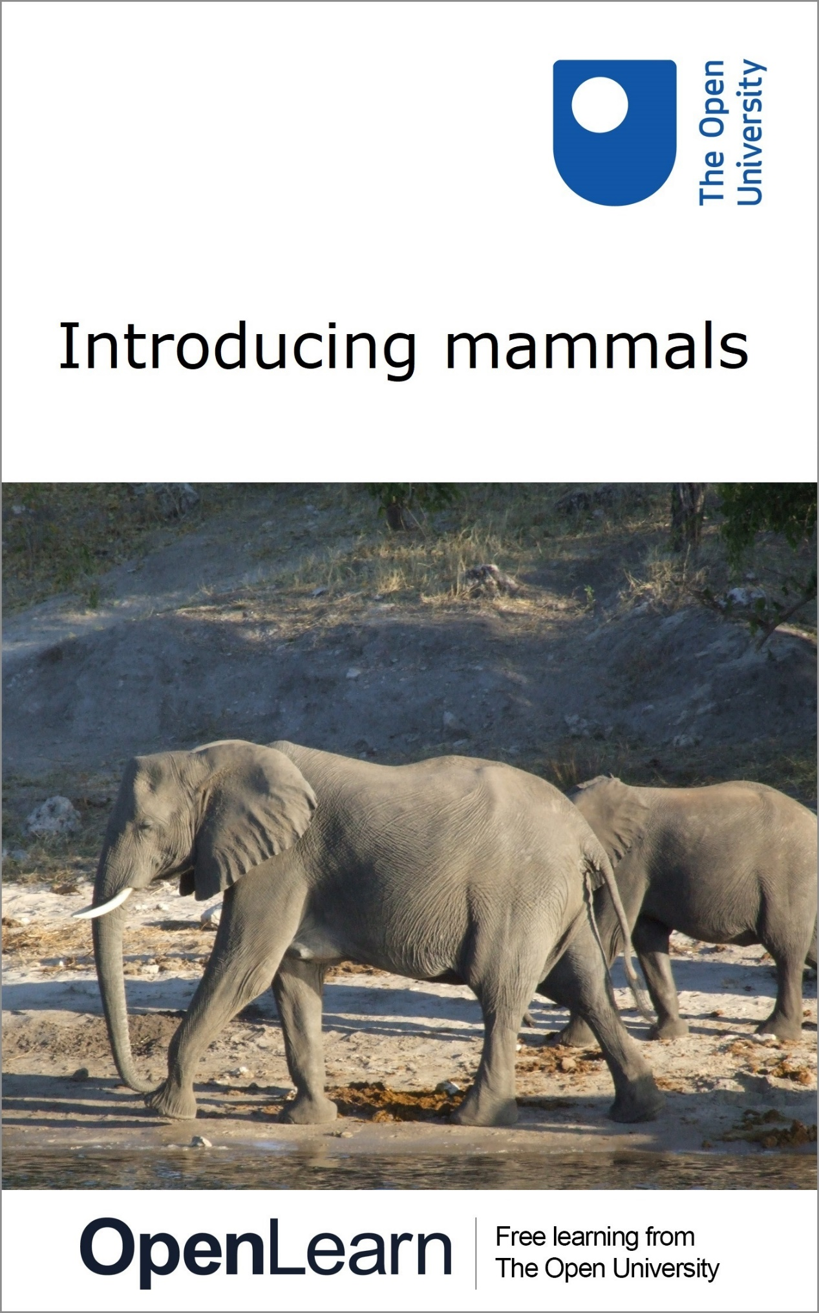

**s182\_12M**

**Introducing mammals**

**About this free course**

This free course provides a sample of level 1 study in Environment & Development [http://www.open.ac.uk/courses/find/environment-and-development](http://www.open.ac.uk/courses/find/environment-and-development?utm_source=openlearn&utm_campaign=ol&utm_medium=ebook)

This version of the content may include video, images and interactive content that may not be optimised for your device.

You can experience this free course as it was originally designed on OpenLearn, the home of free learning from The Open University: [https://www.open.edu/openlearn/nature-environment/introducing-mammals/content-section-0](https://www.open.edu/openlearn/nature-environment/introducing-mammals/content-section-0?utm_source=openlearn&utm_campaign=ol&utm_medium=ebook).

There you'll also be able to track your progress via your activity record, which you can use to demonstrate your learning.

The Open University, Walton Hall, Milton Keynes, MK7 6AA

Copyright © 2019 The Open University

**Intellectual property**

Unless otherwise stated, this resource is released under the terms of the Creative Commons Licence v4.0 <http://creativecommons.org/licenses/by-nc-sa/4.0/deed.en_GB>. Within that The Open University interprets this licence in the following way: [www.open.edu/openlearn/about-openlearn/frequently-asked-questions-on-openlearn](http://www.open.edu/openlearn/about-openlearn/frequently-asked-questions-on-openlearn). Copyright and rights falling outside the terms of the Creative Commons Licence are retained or controlled by The Open University. Please read the full text before using any of the content.

We believe the primary barrier to accessing high-quality educational experiences is cost, which is why we aim to publish as much free content as possible under an open licence. If it proves difficult to release content under our preferred Creative Commons licence (e.g. because we can't afford or gain the clearances or find suitable alternatives), we will still release the materials for free under a personal end-user licence.

This is because the learning experience will always be the same high quality offering and that should always be seen as positive - even if at times the licensing is different to Creative Commons.

When using the content you must attribute us (The Open University) (the OU) and any identified author in accordance with the terms of the Creative Commons Licence.

The Acknowledgements section is used to list, amongst other things, third party (Proprietary), licensed content which is not subject to Creative Commons licensing. Proprietary content must be used (retained) intact and in context to the content at all times.

The Acknowledgements section is also used to bring to your attention any other Special Restrictions which may apply to the content. For example there may be times when the Creative Commons Non-Commercial Sharealike licence does not apply to any of the content even if owned by us (The Open University). In these instances, unless stated otherwise, the content may be used for personal and non-commercial use.

We have also identified as Proprietary other material included in the content which is not subject to Creative Commons Licence. These are OU logos, trading names and may extend to certain photographic and video images and sound recordings and any other material as may be brought to your attention.

Unauthorised use of any of the content may constitute a breach of the terms and conditions and/or intellectual property laws.

We reserve the right to alter, amend or bring to an end any terms and conditions provided here without notice.

All rights falling outside the terms of the Creative Commons licence are retained or controlled by The Open University.

Head of Intellectual Property, The Open University

Designed and edited by The Open University

978-1-4730-1573-9 (.kdl)  
978-1-4730-0805-2 (.epub)

# Contents

* [Introduction](#Introduction1)
* [Learning outcomes](#LearningOutcomes1)
* [1 Defining mammals](#Session1)
* [2 Mammalian diversity](#Session2)
  + [2.1 Living mammals](#Session2_Section1)
* [3 The monotremes](#Session3)
  + [3.1 How should we think of monotremes?](#Session3_Section1)
* [4 Reproduction in marsupials](#Session4)
* [5 Milk production (lactation)](#Session5)
  + [5.1 Fat content of milk](#Session5_Section1)
  + [5.2 Lactation in marsupials](#Session5_Section2)
* [6 Metabolism and body temperature](#Session6)
  + [6.1 Warm-blooded vs cold-blooded](#Session6_Section1)
  + [6.2 Metabolism](#Session6_Section2)
  + [6.3 Heat from metabolism](#Session6_Section3)
  + [6.3.1 Comparing endothermic mammals with an ectotherm](#Session6_Section4)
  + [6.3.2 Endotherms compared with an ectotherm under natural conditions](#Session6_Section5)
  + [6.4 Coping with heat](#Session6_Section6)
* [7 Thermoregulation and mammalian fur](#Session7)
* [8 What’s special about placental mammals?](#Session8)
* [9 Studying mammals: a case study – platypus burrows](#Session9)
* [Conclusion](#Session10)
* [References](#References1)
* [Acknowledgements](#Acknowledgements1)
* [Solutions](#Solutions1)

## Introduction

Mammals come in a bewildering variety of shapes and sizes, and yet all species have some characteristics in common. Indeed, it’s the existence of these common features that justifies the inclusion of all such diverse types within the single taxonomic group (or class) called the Mammalia.

This free course, Introducing mammals, offers a starting point if your interest has been sparked by a TV series or you are going on to study animals or mammals in other courses.

Almost every environment that can support life has mammals amongst its fauna. Even in extreme environments it is possible for some mammals to survive. In the North Polar regions there are terrestrial mammals such as polar bears, arctic foxes, arctic wolves, hares and lemmings. Amongst the mammals in the Northern polar seas there are several species of whale.

Start of Figure

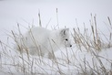

Figure 1 An arctic fox, Vulpes lagopus, hunting for lemmings in the snow

[View description - Figure 1 An arctic fox, Vulpes lagopus, hunting for lemmings in the snow](" \l "Description1)

End of Figure

A hot arid desert, where there is very little rainfall, is a hostile environment for animals, yet both small mammals, such as the kit fox and large mammals like the Dorcas gazelle inhabit such deserts.

Start of Figure

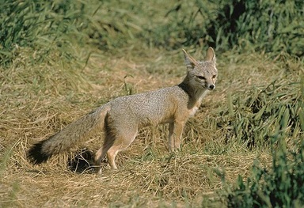

Figure 2 Kit fox, Vulpes macrotis

[View description - Figure 2 Kit fox, Vulpes macrotis](" \l "Description2)

End of Figure

Start of Figure

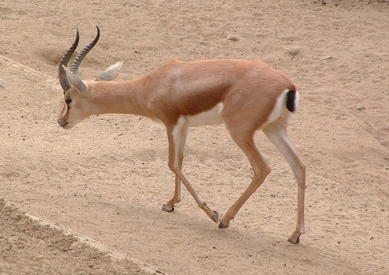

Figure 3 Dorcas gazelle, Gazella dorcas

[View description - Figure 3 Dorcas gazelle, Gazella dorcas](" \l "Description3)

End of Figure

Clearly these mammals are well adapted to the conditions that they live in.

If you think about all the mammals that you have encountered, as well as those you’ve seen in photos and TV programmes, it is apparent that mammals are very diverse in geographical range, in size, in form and in function. They have also been influenced by the presence of humans (another mammal) more than any other animal group. The study of mammals displays their rich diversity, but also highlights the common features that define the group.

This OpenLearn course provides a sample of level 1 study in [Environment & Development](http://www.open.ac.uk/courses/find/environment-and-development?utm_source=openlearn&utm_campaign=ol&utm_medium=ebook).

## Learning outcomes

After studying this course, you should be able to:

* explain the distinctive biological features of monotremes
* distinguish contrasting modes of reproduction in monotremes, marsupials and placental mammals
* describe the cellular basis of lactation and explain the benefits of an early diet of milk
* explain the significance of mammalian metabolic rate
* explain how and why the thermogenic response differs among species.

## 1 Defining mammals

Personal experience highlights the diversity of mammals. In this section you will learn about the features that they have in common which define them as mammals. Using your own experience or knowledge, can you identify any of these defining characteristics?

Start of SAQ

**Question 1**

Start of Question

On the basis of your knowledge of mammals, try to list up to three biological features that define mammals.

End of Question

*Provide your answer...*

[View answer - Question 1](" \l "Session1_Answer1)

End of SAQ

For much of this course, you will be concerned with exploring these diagnostic features of mammals in more detail. One issue that comes up a good deal is how we should best use the term ‘successful’ in describing mammals.

You may recall images from TV programmes of mammals flourishing in hostile environments. The fact that mammals are very widely distributed is an expression of their success as an animal group. Another useful measure might be numbers of species – though the 6495 or so species of mammal is dwarfed by the known number of insect species in the world, which some estimate to be as many as 10 million. Other expressions of the success of mammals that are worth considering include the degree of physiological sophistication of their systems (which can be difficult to assess), and the number of individuals of a particular species or broader group that exist in total.

Scientific data are often presented in the form of a table, with the data arranged in columns and rows. Table 1 below is a very simple example. You will study a more complex one later in the course.

Start of Table

Table 1 Number of species of mammals (figures from Burgin et al., 2018)

|  |  |
| --- | --- |
| Total | 6495 |
| Recently extinct | 96 |
| Living | 6399 |
| Living wild | 6382 |

End of Table

Mammals have been around for a long time. Fossils of the shrew-like Megazostrodon have been found in strata in southern Africa that are 200 million years old.

Start of Figure

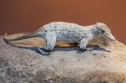

Figure 4 An early mammal, Megazostrodon

[View description - Figure 4 An early mammal, Megazostrodon](" \l "Session1_Description1)

End of Figure

Rather than shuffling along, with splayed-out limbs in the manner of many reptiles, this animal had limbs that were more erect and aligned under the body. Fossil evidence shows that the skulls of very early mammals have a distinctive lower jaw structure and sites on the skull for the attachment of chewing muscles. We can be confident that between 225 and 195 million years ago, mammal-like reptiles evolved into true mammals, though for the next 100 million years or so these unobtrusive animals, none larger than a pet cat, continued to coexist with the dinosaurs. Their diversification did not start until about 65 million years ago, during a period of geological time that witnessed the demise of the dinosaurs and their close relatives.

## 2 Mammalian diversity

The Cretaceous period lasted from 145 to 66 million years ago. The end of the period is marked by a mass extinction of both land and marine animals. About 75% of all the species on earth vanished. All the dinosaurs, except for birds, disappeared leaving environments that they had vacated available for mammals to exploit. The cause of this event is thought to be the impact of a comet or asteroid 10 to 15 kilometres wide that left a 180 km wide crater on the Yucatan peninsula. The impact caused a global catastrophe, the result of debris ejected into the atmosphere changing the climate.

Thus, the mass extinctions enabled the early mammals to expand into new habitats, producing an increase in diversity. The wide range of forms that we see today could be attributable to the asteroid impact that ended the age of the dinosaurs. However, recent genomic evidence (Liu et al., 2017) has suggested that mammalian diversification started before the end of the Cretaceous period, perhaps indicating that the asteroid impact was not the only driver for diversity.

## 2.1 Living mammals

The living mammals are divided into three groups, based on their origins from the early mammals of the Cretaceous period. The three groups are monotremes, marsupials and placentals, each a subclass of the class Mammalia. The three groups are distinguished by their differing modes of reproduction.

### 2.1.1 Monotremes

Monotremes diverged from the main group of early mammals in the Lower Jurassic period. There are only five species living today, of which four are echidnas. You will discover more about monotremes in Section 3.

Start of Figure



Figure 5 A duck-billed platypus, Ornithorhynchus anatinus (Tasmania, Australia)

[View description - Figure 5 A duck-billed platypus, Ornithorhynchus anatinus (Tasmania, Australia)](" \l "Session2_Description1)

End of Figure

Start of Figure

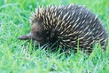

Figure 6 Short-beaked echidna, Tachyglossus aculeatus

[View description - Figure 6 Short-beaked echidna, Tachyglossus aculeatus](" \l "Session2_Description2)

End of Figure

Start of Figure

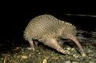

Figure 7 Eastern long-beaked echidna, Zaglossus bartoni (Papua New Guinea)

[View description - Figure 7 Eastern long-beaked echidna, Zaglossus bartoni (Papua New Guinea)](" \l "Session2_Description3)

End of Figure

### 2.1.2 Marsupials

Marsupials are mostly found in Australia and surrounding regions, but there also some species, such as the opossum (Figure 8), that occur in Southern North, Central and South America. At one time the marsupials were probably much more diverse than they are today. The marsupials that you are probably most familiar with are the kangaroos, wallabies and koalas.

Start of Figure

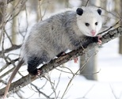

Figure 8 Virginia opossum, Didelphis virginiana

[View description - Figure 8 Virginia opossum, Didelphis virginiana](" \l "Session2_Description4)

End of Figure

Start of Figure

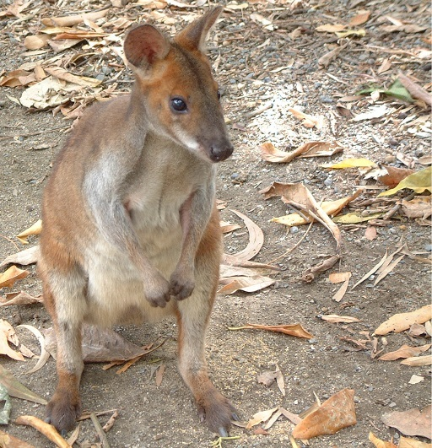

Figure 9 Wallaby (Queensland, Australia)

[View description - Figure 9 Wallaby (Queensland, Australia)](" \l "Session2_Description5)

End of Figure

Start of Figure

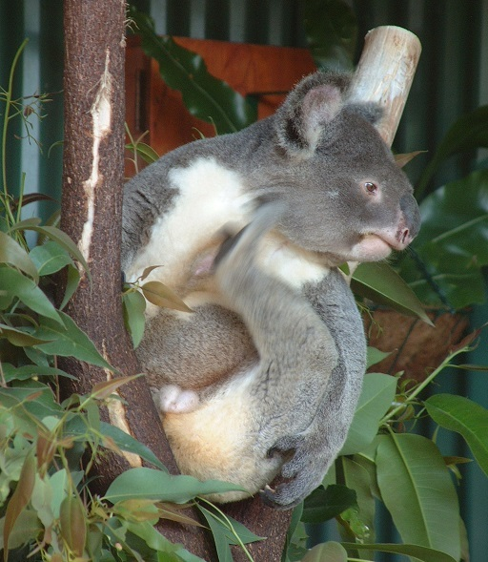

Figure 10 Koala bear, Phascolarctos cinereus (Queensland, Australia)

[View description - Figure 10 Koala bear, Phascolarctos cinereus (Queensland, Australia)](" \l "Session2_Description6)

End of Figure

There are marsupials that are very similar in habits and appearance to placental mammals, although not closely related. For example, here is a small burrowing marsupial that looks very similar to the European mole.

Start of Figure

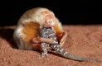

Figure 11 A marsupial mole, Notoryctes typhlops, eating a gecko

[View description - Figure 11 A marsupial mole, Notoryctes typhlops, eating a gecko](" \l "Session2_Description7)

End of Figure

The Tasmanian wolf, Thylacinus cynocephalus, is a top carnivore like the placental wolf, which it very closely resembles. The last Tasmanian wolf died in captivity in 1936 and it is assumed to be extinct, although there are persistent reports of sightings in remote areas of Queensland, Australia. You will read more about marsupials in Section 4.

Start of Figure

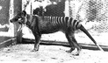

Figure 12 The last Tasmanian wolf, Thylacinus cynocephalus

[View description - Figure 12 The last Tasmanian wolf, Thylacinus cynocephalus](" \l "Session2_Description8)

End of Figure

### 2.1.3 Placentals

Most of the living mammals are in the subclass of placental mammals. Although there are 19 orders of placentals, most mammals belong to one of six orders, of which the largest is the rodents. One order has only one species, the aardvark. A simplified family tree of placental mammals, based on molecular evidence, is shown in Figure 14.

In this introductory course, the monotremes and marsupials are given particular focus. Although they are far less diverse than the placental mammals, their adaptations – particularly in the area of reproduction – are fascinating and informative.

Start of Figure

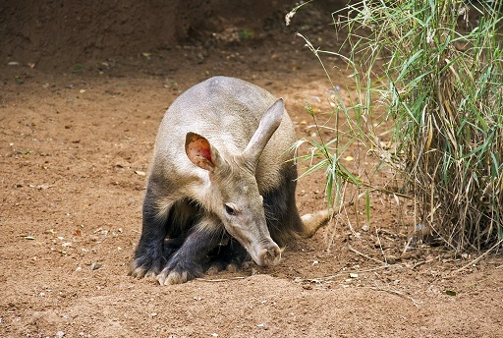

Figure 13 An aardvark, Orycteropus afer

[View description - Figure 13 An aardvark, Orycteropus afer](" \l "Session2_Description9)

End of Figure

Start of Figure

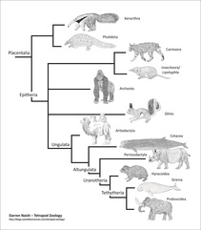

Figure 14 A simplified family tree of placental mammals based on molecular evidence

[View description - Figure 14 A simplified family tree of placental mammals based on molecular evide ...](" \l "Session2_Description10)

End of Figure

## 3 The monotremes

The echidna and the duck-billed platypus, which are the only egg-laying mammals, are so distinct that they are assigned to a discrete subclass, the Prototheria, which includes the order Monotremata, separate from the more familiar and well-studied placental mammals. These two animals are termed ‘part-reptile, part-mammal’, a phrase that will be examined more critically in Section 3.1.

Start of Figure

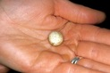

Figure 15 An echidna egg

[View description - Figure 15 An echidna egg](" \l "Session3_Description1)

End of Figure

An extraordinary feature of monotremes that no other modern mammal has retained is that they lay eggs. This echidna egg (Figure 15) is tiny, only about the size of a marble. Early mammals must have laid eggs in the same way, a feature that they inherited from their reptile ancestors.

The reptile embryo feeds on a supply of highly nutritious yolk and, by the time the embryo hatches, it is sufficiently well-developed to go looking for food on its own.

By contrast, the platypus and echidna are very different from their reptilian ancestors. Their eggs are smaller, containing only a limited amount of yolk, and their young hatch in a far less developed state. They need a lot more nourishment if they're going to grow and survive.

Platypus young develop without having to leave their mother's burrow. Four months after hatching, a youngster emerges from the burrow for the first time and already it has grown to almost full adult size. That is thanks to an amazing form of nourishment that is a defining feature of all mammals: milk.

Start of Box

Here are two National Geographic video clips with more information about the platypus and echidna. Make sure you open these links in a new tab or window, so you can easily return to this page.

The platypus is semi-aquatic and can be found in streams and rivers in Eastern Australia, from tropical rain forests in Queensland to the much colder highlands of Tasmania, which feature in this video.

[National Geographic: platypus video](https://www.youtube.com/watch?v=Ls5IU2x7Psg)

In this video of an echidna you can see the developing egg and the young echidna, called a puggle. The echidna is described in the video as ‘weird’, which is a description that is not really appropriate.

[National Geographic: echidna video](https://video.nationalgeographic.com/video/00000144-0a32-d3cb-a96c-7b3fb46f0000)

End of Box

Start of Activity

**Activity 1**

Allow about 10 minutes

Start of Question

Write down the mammalian features evident in monotremes. Is their egg-laying habit similar in all ways to that displayed by reptiles?

End of Question

*Provide your answer...*

[View answer - Activity 1](" \l "Session3_Answer1)

End of Activity

## 3.1 How should we think of monotremes?

Years ago, biologists often thought of the term ‘egg-laying mammal’ as synonymous with ‘reptile-like mammal’ or ‘primitive mammal’. Now, with our greater understanding of monotreme biology, these emotive terms are disapproved of, since these animals have so many authentic mammalian features. For example, if echidnas didn’t lay eggs, you might be forgiven for thinking of this animal as another species of hedgehog. However, the hedgehog is a placental mammal. Although the period of development within the egg is relatively brief, many aspects of reproduction and maternal care in the monotremes are distinctly mammalian.

It would be wrong to describe the monotremes as genuinely primitive or unsuccessful. They are specialist feeders; the platypus feeding on invertebrates (e.g. freshwater shrimp, insect larvae or small molluscs) living in the bottom of streams, while echidnas are terrestrial carnivores. The word ‘primitive’ implies a similarity with ancestral types, but in terms of lifestyle and anatomy, there’s not a lot to link monotremes with the ancestral mammals typified by Megazostrodon (shown earlier in Figure 4).

There are further reasons NOT to think of monotremes as ineffective species that haven’t quite ‘made it’ in an evolutionary sense. As part of their specialist form of feeding, the platypus has highly developed sense organs. It has eyes and ears but can cover these when it is underwater. It then relies on the sensory cells in its rubbery beak. One type of sense cell can detect touch. A second group of sensory cells is sensitive to the tiny electrical charges that are produced by living organisms. The platypus uses this remarkable sense organ as a scanner, looking for prey items on the bed of the river that is its home. If we think of numbers as a measure of an animal’s success, monotremes are certainly successful. Echidnas – at least the short-nosed species – are described as ‘quite common across their geographical range’. The platypus inhabits a particular type of environment (i.e. it occupies an environmental niche) that is threatened by human habitation, so numbers fell soon after the beginnings of European settlement in Australia in the 18th century. Recent conservation measures have meant that the species is no longer under severe threat.

And how long have monotremes existed? A platypus fossil found in Queensland is about 25 million years old, but the oldest monotreme fossil (a jaw bone) is over 100 million years old. Their evolution could therefore be described as conservative, with little evidence of major changes over time. However, biologists remain ignorant about what the ancestors of monotremes looked like and what historic relationship they had with the evolutionary lines that gave rise to marsupial and placental mammals.

## 4 Reproduction in marsupials

Start of Box

The study of mammals requires you to deal with measurements. This course assumes only that you can add, subtract, multiply and divide. This section uses units – grams and kilograms, abbreviated to g and kg, respectively – and asks you to calculate a percentage, for which you will probably need to use a calculator. If you wish to develop these kinds of skills further, you may like to study our badged course, [Mathematics for science and technology](https://www.open.edu/openlearn/science-maths-technology/mathematics-science-and-technology/content-section-overview).

End of Box

In contrast to monotremes, no marsupial lays a shelled egg. The embryo develops for a short period inside the uterus (or womb) before transferring to (in most species) a pouch; hence marsupials are sometimes termed ‘pouched mammals’. The newborn are tiny and very unlike the adult. The numbat is a marsupial that feeds on insects. The young are born live, but at a very early stage in their development and are tiny. They have no food reserves at all and must rapidly locate one of their mother’s teats hidden in her fur. Some do not succeed, and interestingly, the number of young exceeds the number of teats. The term ‘survival of the fittest’ seems apt here.

Start of Figure

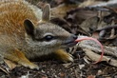

Figure 16 A young numbat, Myrmecobius fasciatus, showing its long, flexible tongue

[View description - Figure 16 A young numbat, Myrmecobius fasciatus, showing its long, flexible tong ...](" \l "Session4_Description1)

End of Figure

Many newborn marsupials are very small at birth. An adult female koala might tip the scales at about 8 kilograms (kg), but the newborn koala weighs just about half a gram, i.e. 0.5 g. Just how tiny this newborn is becomes clearer when you work out its weight as a percentage of the mother’s weight. But to compare ‘like with like’ you first need to express each measurement in the same units, in this case grams (g). 8 kg is equivalent to (8 × 1000) grams = 8000 g, so 0.5 g as a percentage of 8000 g is (0.5/8000) × 100. This calculation comes to a little over 0.006% – compared to the mother, the newborn koala is very small indeed!

Start of SAQ

**Question 2**

Start of Question

Suppose a human baby weighs 3.4 kg at birth. If the mother weighs 70 kg, express the newborn’s weight in relative terms, i.e. as a percentage of the mother’s weight, to the nearest whole number. Note your answer below.

End of Question

*Provide your answer...*

[View answer - Question 2](" \l "Session4_Answer1)

End of SAQ

Start of Activity

**Activity 2**

Allow about 10 minutes

Start of Question

Watch this video clip about the birth of a baby kangaroo, described by Sir David Attenborough.

Make sure you open this link in a new tab or window, so you can easily return to this page.

<http://www.bbc.co.uk/earth/story/20141001-newborn-baby-kangaroo>

Jot down some notes on the most striking points about the birth.

End of Question

*Provide your answer...*

[View answer -](" \l "Session4_Answer2) **[Activity 2](" \l "Session4_Answer2)**

End of Activity

Thinking of the marsupial method of reproduction as ‘primitive’ or inferior to that of placental mammals is misleading. What we see is a successful reproductive strategy (or rather a range of strategies, because the details vary between different marsupial species) that is very different from our own. What is biologically so interesting is that such a large fraction of the early development of the young occurs after birth, in the pouch.

In many kangaroos, females mate very soon after giving birth. In the event of conception, the tiny ball of dividing cells, called a blastocyst, stops developing after a few days and the process of attachment to the inner lining of the uterus is prevented. In most forms of mammalian reproduction, a blastocyst would undergo such implantation without significant delay – indeed, in humans it’s seen as marking the beginnings of true pregnancy. But in kangaroos the blastocyst remains ‘frozen in time’ in what is technically termed embryonic diapause. Sometime just before the youngster in the pouch is ready to leave, the blastocyst implants and development proceeds to the point of birth. At about that point, the mother actively encourages the older offspring to spend less time in the pouch and prepares the pouch for the new arrival. Soon after the birth, mating is likely to lead to a further conception, and so on.

It’s impossible to know for sure why embryonic diapause evolved, but there is a possible link with drought. During a severe drought, a suckling young in the pouch may be expelled and the heavy energetic demands of producing milk temporarily suspended. This reduced energy expenditure will make the minimum demand on the meagre pasture around her, and she has a fertile dormant egg within her womb ready to start its development just as soon as conditions improve.

## 5 Milk production (lactation)

One of the defining features of mammals is milk production. It is a remarkable and unique mammalian process technically called lactation, which only makes sense if we look inside mammals to find out how this life-sustaining substance is produced.

Milk is a very rich form of food. You’ve probably heard about some of the major constituents of milk – proteins, fats and carbohydrates. These large molecules have to be built up (synthesised) from the simpler chemicals that the mother obtains from her diet or from her body reserves. By looking at the structure of a typical mammary gland, you can see how this biological ‘production line’ is put together.

The term ‘gland’ is used for specialised structures that produce (or more technically secrete) one or more chemical products, and many glands have the type of structure that Figure 17 shows. (Glands are usually made up of different types of cells – a group of cells that have similar structure and function is often called a tissue.)

Start of Box

**Examining diagrams**

The first thing to do when you come to any diagram is to read the caption, which explains what it shows. Then look at the diagram itself, taking particular note of the scale, if there is one. You may find that the accompanying text ‘talks you through’ the diagram step by step, as it does here. Visualising three-dimensional objects from a two-dimensional diagram is a difficult skill and you should not expect to master it straight away, so don’t be concerned if you don’t immediately understand all aspects of Figure 17.

End of Box

Start of Figure

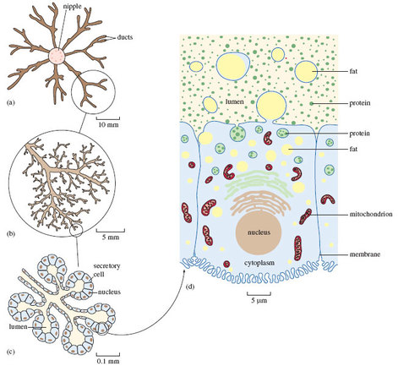

Figure 17 The structure of a mature mammary gland, at increasing magnification: (a)-(c) viewed under a light microscope, (d) with an electron microscope. (a) and (b) show the arrangement of the milk-carrying ducts and (c) the secretory cells. (d) is an image of a single cell, showing the structures involved in the processes of secretion. The different scales show the extent of magnification. (1 mm, i.e. one millimetre, is equivalent to 1000 μm, i.e. 1000 micrometres, and 0.1 mm = 100 μm)

[View description - Figure 17 The structure of a mature mammary gland, at increasing magnification: (a)-(c) ...](" \l "Session5_Description1)

End of Figure

Figure 17 shows different levels of detail at increasing magnification. The image labelled (a) shows that each mammary gland consists of a central teat or nipple, into which feed a number of channels (or ducts) that convey and temporarily store the milk, following its production by the great mass of cells that make up the bulk of the gland. Magnifying just one part of what’s shown in (a) gives you a better sense of the fine-detailed structure of the mammary gland. All of the ducts shown have much the same structure, but focusing on just one makes things clearer. (b) shows one representative part, around the blind ends of the finely branched ducts. At this magnification, the individual secretory cells aren’t visible; but you can make them out in (c), a higher-powered view of just one small part of (b). In (c) you can see these small groups of cells, shown in a schematic way in cross-section. In other words, it’s a ‘tidied up’ two-dimensional view of an imaginary slice though the gland. If you imagine these structures in three dimensions, (c) would resemble a bunch of grapes, with the stalks representing the ducts and each ‘grape’ a group of secretory cells surrounding a central space (or lumen), which would contain milky fluid.

The structure of each individual cell in (c) is much the same, resembling that of many other cells in the mammalian body. Each cell is roughly rectangular in cross-section, with a thin outer membrane. Towards the base of the cell is a small rounded nucleus, which contains most of the genetic material (the DNA), which has a key role in directing the workings of the cell.

Figure 17 (d) is a hugely magnified view of just one of the secretory cells shown in (c) – a single sample of the many millions of cells that comprise the mammary gland. Magnification on this scale requires the use of an electron microscope, as opposed to the less powerful optical light microscope used for (a)-(c). Here you can see the cell’s roughly rectangular shape and the rounded nucleus, as well as the cell membrane.

The identity and function of all the many different cellular components in (d) needn’t be covered in detail. There are many flattened, highly folded membranes, resembling stacked piles of plates. Two types of these are denoted here in different colours, just above the nucleus. The sausage-shaped structures are called mitochondria – these are often termed the powerhouses of the cell, because they deliver the energy that fuels the complex synthetic processes which will be explained further in a moment. Towards the upper part of the cell, closest to the lumen, there are a number of fluid-filled droplets (called vesicles), containing what look like small granules. They are mostly different types of protein – just one of a range of large molecules that make up the chemical constituents of all living material. In fact, even at this level of magnification, proteins would not be visually discernible, since they are soluble in the fluid that contains them. Milk contains many proteins and most of them are assembled into these complex structures from much simpler chemical building blocks (called amino acids) within the secretory cells like the one shown in (d). The proteins in milk are vital to the growth and wellbeing of the suckling and some, collectively called antibodies, help the youngster withstand infection.

## 5.1 Fat content of milk

Fat is another key constituent of milk. The fat content of milk can vary over time, and the variation in milk composition between species is even greater. For example, rhinoceros milk contains hardly any fat, while seal milk is almost 50% fat. In those species where milk production has been most thoroughly investigated, secretory cells in the mammary glands take up fats from the bloodstream. (They also synthesise fats from other nutrient molecules carried to them in the blood, such as sugars.) The basic constituents of milk fats are then assembled together, most of them in parallel stacks of folded membranes of the type shown in Figure 17 (d). Fat accumulates within the droplets evident in (d), in the process of migrating to the upper part of the cell. The fat droplet, itself wrapped in a membrane, merges with the cell membrane and is ‘budded-off’ – fat droplet plus its enveloping membrane – into the lumen.

Start of Figure

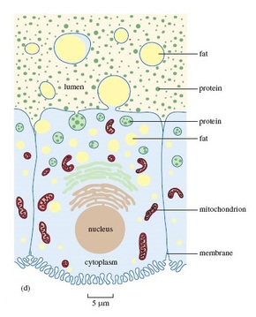

Figure 17d (repeated) A secretory cell from a mammary gland

[View description - Figure 17d (repeated) A secretory cell from a mammary gland](" \l "Session5_Description2)

End of Figure

## 5.2 Lactation in marsupials

Production of milk involves considerable biochemical activity within the secretory cells and this activity requires energy. These demands explain why lactation is a very considerable ‘investment’ by the mother in the wellbeing of her offspring. For animals on an unreliable or low-energy diet – the koala is a good example of the latter – synthesis of the constituents of milk can be a precarious operation. Given that the energy (fat) content of koalas’ milk is comparatively low, it’s not surprising that the period of lactation in koalas is unusually long, even by marsupial standards. At the age of five months, young koalas start to ingest eucalyptus leaves that have already been partly digested by the mother.

Start of Figure

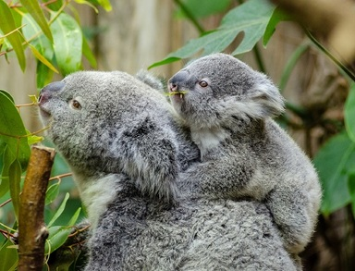

Figure 18 Mother koala and her young, Phascolarctos cinereus

[View description - Figure 18 Mother koala and her young, Phascolarctos cinereus](" \l "Session5_Description3)

End of Figure

Lactation in marsupials has a particular importance; for example, the newborn red kangaroo weighs less than a gram (much like the koala newborn mentioned earlier), or less than a lump of sugar. On complete emergence from the pouch, some eight months later, it weighs about four to five kilograms. It may then often double in weight before becoming fully independent of the mother’s milk (i.e. becoming weaned), which happens between four and eight months after leaving the pouch. The composition and flow of milk are tightly controlled; the synthesis of particular nutrients can become switched on as particular genes are activated. (Such genes comprise particular sections of DNA within the nucleus of secretory cells, so minute that not even the highest magnification level in Figure 17 can reveal them.) Towards the end of its time in the pouch, when the rate of the youngster’s growth is very high and the energy demands are greatest, the fat content of the milk in many species reaches a maximum.

At a stage in development where hair growth is important, the youngster’s production of the protein keratin has to be stepped up – keratin is the key ingredient of hair and hair-like structures. At such a time, the kangaroo’s milk contains large amounts of the particular types of amino acid that are essential for the synthesis of keratin.

Start of SAQ

**Question 3**

Start of Question

Kangaroos and wallabies generally have four teats within the pouch, though there is only one newborn at a time. Why does the possession of more than one teat make sense?

End of Question

*Provide your answer...*

[View answer - Question 3](" \l "Session5_Answer1)

End of SAQ

There’s no doubt that the evolution of lactation was crucial to the success of mammals. Of course, milk production is just one component of a ‘package’ of parental care measures shown by many mammals, so it’s perhaps risky to single out a particular feature, but it’s one that raises particular interest.

Start of SAQ

**Question 4**

Start of Question

Can you think of some advantages of the lactation habit in mammals?

End of Question

*Provide your answer...*

[View answer - Question 4](" \l "Session5_Answer2)

End of SAQ

## 6 Metabolism and body temperature

Metabolism is the technical name given to the sum of all the chemical transformations inside cells. Many such changes involve building up complex chemicals from simpler building blocks – for example, the proteins and fats for lactation that were described earlier. In animals, the energy that such ‘building-up’ processes require comes from the process of breaking down foodstuffs – the progressive breaking down in our bodies of the complex macromolecules that comprise our diet. The chemical reactions that take place in an animal are affected by temperature. The adaptations that enable a mammal to regulate body temperature form a key mammalian feature – the ability to maintain body temperature using internal body heat.

## 6.1 Warm-blooded vs cold-blooded

The processes of regulating the internal temperature in mammals contrast sharply with that of other animals, except birds, and a few others. Heat energy liberated during metabolism enables mammals to maintain a stable body temperature and occupy habitats where the external temperature may vary over a large range.

Reptiles get much of their energy directly from the sun as warmth, but when the sunlight fades at dusk the body temperature of a reptile falls and it becomes sluggish, lacking the energy to move. Very early in their history, mammals developed the remarkable ability to generate heat within their bodies by driving their metabolism at a much higher rate. As a consequence, it was necessary to feed more often in order to supply the extra fuel needed to maintain the high body temperature. Physiological processes that limited heat loss evolved.

Start of Activity

**Activity 3**

Allow about 10 minutes

Start of Question

Make a list of some benefits of ‘warm-bloodedness’ to mammals and some of the implications of this strategy.

End of Question

*Provide your answer...*

[View discussion -](" \l "Session6_Discussion1) **[Activity 3](" \l "Session6_Discussion1)**

End of Activity

The distinction between ‘warm and cold blooded’ animals is a shorthand that is useful in distinguishing between mammals and other animals, but it does not apply universally. Non-mammals can generate body heat, for example a python and some species of fish, such as tuna. A reptile basking in the sun can become as warm to the touch as a mammal and its lethal temperature may be higher than that of many mammals. If you’ve encountered a mammal during hibernation – perhaps a cautious investigation of a hedgehog – you’ll probably have found it surprisingly cold to the touch. So in describing what’s special about the body temperature of mammals, cold-blooded and warm-blooded are terms best avoided.

## 6.2 Metabolism

The chemical transformations that contribute to metabolism depend ultimately on the uptake of oxygen by the animal. In very simplified terms, oxygen is used in the mitochondria to complete the final stages of the breakdown of small energy-rich molecules – products of the chemical fragmentation of macromolecules mentioned earlier. In this process, usable energy is released, along with some heat.

Measuring how much oxygen is consumed by an animal over a period of time, such as a minute or an hour, is a pretty good measure of the intensity of metabolism (i.e. the metabolic rate). But when measuring and comparing oxygen consumption in two animals that are very different in size – say a mouse and an elephant – all you learn is that overall, an elephant consumes much more oxygen over a minute than a mouse does. This is simply because a massive elephant has so many more cells in which metabolism is whirring away. If your interest is in metabolic rate, you need to take size differences into account by calculating the volume of oxygen consumed for a particular amount (or mass) of animal.

Volumes of a gas such as oxygen would be measured in millilitres (ml), or the numerically equivalent unit, cubic centimetres (cm3). The mass of the animal would be measured in grams (g), or perhaps in thousandths of a gram, i.e. milligrams (mg). In practical terms, oxygen consumption by a mouse of known mass would be measured over a period of time, say 15 minutes, and the values recalculated as so many ‘cubic centimetres of oxygen per gram of mouse per hour’. (A more scientifically correct way of expressing the same thing is cm3 O2 g−1 h−1.) In principle, the calculation for the elephant would be done in the same way, though one suspects with a few practical problems along the way.

Start of Box

**Reading tables**

As mentioned earlier in the course, scientific data are often presented in the form of a table. Table 2 is a slightly more complex example. As with scientific diagrams, make sure to read any titles and labels carefully. Look at the headings of the rows and columns. The units in which the values are measured are usually given in the headings, rather than being written beside each value.

Take a look at Table 2, then answer Question 5 underneath.

End of Box

Start of Table

Table 2 Metabolic rate (expressed as volume of oxygen, O2, consumed, in cubic centimetres per gram of body mass per hour) in a range of animals, at rest and during maximum activity

|  |  |  |
| --- | --- | --- |
|  | **Metabolic rate / cm3 O2 g−1 h−1** | |
| **Species** | **at rest** | **at peak activity** |
| salmon | 0.08 | 0.60 |
| monitor lizard | 0.08 | 0.38 |
| turtle | 0.03 | 0.64 |
| hummingbird | 2.80 | 42.00 |
| mouse | 2.50 | 20.00 |
| dog | 0.33 | 4.02 |
| human | 0.23 | 3.20 |

You might notice from these few data an implication that small mammals, e.g. the mouse, have a higher metabolic rate than larger mammals, such as the human.

End of Table

Start of SAQ

**Question 5**

Start of Question

Look at Table 2, which shows the metabolic rates of a number of animals. What is the most striking difference between the values for mammals and those for fish, reptiles and a bird?

End of Question

*Provide your answer...*

[View answer - Question 5](" \l "Session6_Answer1)

End of SAQ

## 6.3 Heat from metabolism

The high rates of metabolism in mammals (and birds) mean that relatively large amounts of heat are produced as a by-product. But this heat is not wasted; it’s used in these animals to warm the body. The fact that a mammal (or bird) keeps its body temperature at a high level (37 °C for humans) ensures that metabolism proceeds at a high and efficient rate, allowing the sustained and elevated pace of life typical of mammals. Animals that depend on internally generated heat (i.e. metabolic heat) to maintain their body temperature are called endotherms. By contrast, ectotherms have a body temperature influenced most sharply by heat from external sources, i.e. from the immediate environment.

Start of Box

**Scientific shorthand**

You will notice the use of a type of scientific ‘shorthand’ in this section, where letters are used to represent words. The italic letter T is often used to represent ‘temperature’. Here both the temperature inside an animal’s body and the temperature of the surroundings are measured, so we need to differentiate them easily. This is done by adding an appropriate letter, usually subscripted and not italicised, immediately after the T. So here Tb stands for the body temperature of the animal, and Ta for the surrounding temperature. When you see the shorthand version, try to translate it in your head into its real meaning, reading Tb as ‘body temperature’ rather than as ‘tee-little-b’.

End of Box

## 6.3.1 Comparing endothermic mammals with an ectotherm

Suppose an ectotherm – say a small lizard – is placed in a container in which the air temperature can be varied (a useful alternative term for the temperature ‘outside’ is ambient temperature, Ta). The temperature of the animal’s body (Tb) can be measured while Ta is changed. A miniature temperature-measuring probe inserted into the animal’s cloaca (the common opening for the gut and the urinogenital system) provides a continuous readout of body temperature. An experiment of this type is illustrated in the following video.

This test would start with a comfortable ambient temperature (comfortable for a lizard, that is), say about 38 °C, recording the animal’s body temperature, before lowering the ambient temperature to 30 °C and then measuring the body temperature once more, after allowing the animal to settle down over a couple of hours in the changed conditions.

Start of Media Content

Video content is not available in this format.

Video 1 An experiment that shows that when presented with a choice of cold or warm environments, a lizard can shuttle between them to regulate Tb

[View transcript - Video 1 An experiment that shows that when presented with a choice of cold or warm ...](" \l "Session6_Transcript1)

Start of Figure

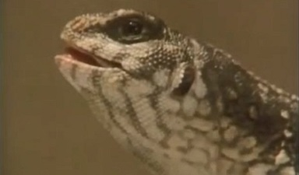

End of Figure

End of Media Content

Start of Box

**Reading graphs**

You’ll study two graphs in the rest of this section. Graphs are often used to display data in a way that makes trends easier to see than in a table. Simple graphs have two axes, one running horizontally, and the other vertically. They are labelled in the same way as the column headings of a table and the data points are then plotted.

End of Box

Start of Figure

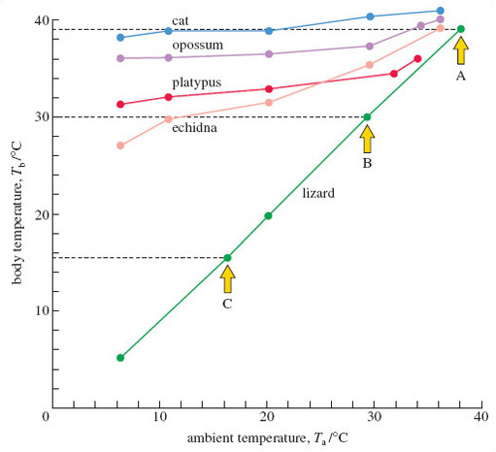

Figure 19 Graph of body temperature against ambient temperature for endothermic mammals and a lizard in laboratory studies, showing the better regulation in the cat (a placental mammal) compared with monotremes (echidna and platypus) and a marsupial (opossum). Tb was measured after 2 hours of constant exposure to each Ta

[View description - Figure 19 Graph of body temperature against ambient temperature for endothermic mammals ...](" \l "Session6_Description1)

End of Figure

Figure 19 shows the type of results this experiment would produce. Concentrate for the moment on the data for the lizard. In this graph, the horizontal axis measures ambient temperature, and the vertical axis measures body temperature. For a particular Ta, say 38 °C, there’s a corresponding measure of the lizard’s Tb – in this instance, it was 39 °C, which you can check by following the horizontal dashed line across to the vertical axis, where the value is identified by arrow A. At a Ta of 30 °C, the lizard’s Tb was also 30 °C, as identified by arrow B. For a Ta of 16 °C, the value of Tb was 15.5 °C, as identified by arrow C. Plotting these points accurately is a lot easier to do if you use graph paper. When the full range of ‘lizard’ values is plotted, a line is drawn between them – the lowest plotted values of Ta and Tb are 6 °C and 5 °C respectively.

The same procedure can be repeated for a placental mammal, such as the cat. Look now at the cat data in Figure 19 and check that you follow the plotted points; for example, at a Ta of 10 °C, Tb is 39 °C. Joining all the plotted points gives a more flattened but somewhat ‘jagged’ line over the measured range of ambient temperatures.

Start of SAQ

**Question 6**

Start of Question

What’s the most striking difference between the way in which the cat and the lizard respond to changes of ambient temperature?

End of Question

*Provide your answer...*

[View answer - Question 6](" \l "Session6_Answer2)

End of SAQ

So, the endothermic cat is able to maintain its body temperature – at a high and constant temperature (of about 39 °C), whereas in these conditions, the lizard has seemingly little option but to allow its body temperature to conform to that of its environment. As is typical of mammals, the cat is regulating its body temperature – more technically, it is demonstrating thermoregulation. On this evidence, the lizard is a conformer – body and ambient temperature change in step. But an ability to thermoregulate is not unique to mammals; birds do so very proficiently and even some fish (such as the tuna mentioned earlier) and a few insects do so, in a rather elementary fashion. You’ll notice from Figure 19 that monotremes (and the marsupial representative – the opossum) are also able to thermoregulate, though less precisely than the cat.

## 6.3.2 Endotherms compared with an ectotherm under natural conditions

But now suppose the body temperature of the ectotherm is recorded under sunny natural conditions, with the animal able to display its normal behaviour. Many lizards then have a body temperature considerably above that of the surrounding air, because they are able to bask in the sunshine. In sunny conditions, a modest-sized lizard – for example the common European lizard – can warm from 15 °C (close to the recorded air temperature) to 25 °C in about five minutes by basking side-on to the sun. By shuttling into the sun and back into the shade, this lizard can maintain a relatively even body temperature close to 30 °C, at least during the sunnier months of the year and during the day (Tb falls at night or on sunless days). So here thermoregulation is achievable by behavioural means.

By contrast, in mammals (and birds) thermoregulation can be achieved largely by physiological means – by internal adjustments within the body’s tissues and organs. Adjustments in metabolic rate are an especially important part of the process. Figure 20 helps to explain what’s involved. For the moment, concentrate on the line labelled ‘weasel’ – which, for convenience, can be thought of as a typical temperate mammal. Here, the vertical axis denotes metabolic rate. The horizontal axis is Ta, just as in Figure 19. When you've had a look at the graph, try answering the questions below.

Start of Figure

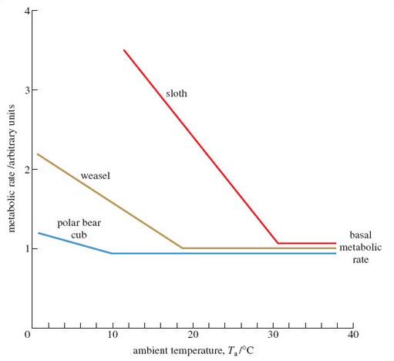

Figure 20 A simplified graph of metabolic rate against ambient temperature in contrasting types of mammal: a temperate mammal (a weasel), an arctic mammal (a polar bear cub), and a tropical mammal (a sloth). The basal metabolic rate (BMR) of all three mammal types is assumed to be about 1, for ease of comparison

[View description - Figure 20 A simplified graph of metabolic rate against ambient temperature in contrasting ...](" \l "Session6_Description2)

End of Figure

Start of SAQ

**Question 7**

Start of Question

What’s striking about the metabolic rate for the weasel between the ambient temperatures of 38 °C and 19 °C?

End of Question

*Provide your answer...*

[View answer - Question 7](" \l "Session6_Answer3)

**Question 8**

Start of Question

Describe what happens when the ambient temperature experienced by the weasel falls below 19 °C.

End of Question

*Provide your answer...*

[View answer - Question 8](" \l "Session6_Answer4)

**Question 9**

Start of Question

Why might this boost in metabolic heat production be important?

End of Question

*Provide your answer...*

[View answer - Question 9](" \l "Session6_Answer5)

End of SAQ

The type of elevation of metabolic rate seen in Figure 20 is termed a thermogenic response, and is one of the most important distinguishing features of mammals (and of birds too). The type and scale of the thermogenic response varies between mammals living in very different environments. When the metabolic rate in a tropical mammal like a sloth is measured against Ta, the BMR is evident over a much narrower range of Ta, and the rate of metabolism increases very sharply below about 31 °C.

Start of SAQ

**Question 10**

Start of Question

Using the correct technical terms and symbols, briefly explain the way in which metabolism in the arctic mammal changes as ambient temperature drops. You can use the formatting buttons in the answer box below for subscript/superscript and italics.

End of Question

*Provide your answer...*

[View answer - Question 10](" \l "Session6_Answer6)

End of SAQ

The slopes of the three lines in Figure 20 differ. The steepest such slopes are typical of tropical mammals, especially those that are unlikely to encounter low temperatures. They lose heat relatively rapidly from their surface and their metabolism has to be cranked up very substantially to compensate. By contrast, mammals adjusted to very cold conditions (a polar bear cub or the arctic fox) are much more proficient at conserving the heat they produce, largely because of their superb insulation. The arctic fox can maintain its BMR down to a Ta as low as -30 °C, while the tropical forest-dwelling sloth is obliged to raise its metabolism at any Ta below 30 °C.

How then do mammals raise their metabolic rate in the ways shown in Figure 20? Some behavioural tactics will probably be familiar to you. Increasing activity – e.g. the stamping of feet – reflects an increase in voluntary muscular activity; since the muscles are working harder, they produce more metabolic heat.

Another part of the explanation is shivering, where opposing sets of muscles contract in a high frequency mode. Rather than movement resulting – the usual effect of muscle contraction – these ‘inefficient’ tiny contractions produce large amounts of heat. Shivering can be temporarily blocked by drugs (notably curare, which prevents muscle contraction) but when such drugs are applied, they don’t entirely remove the ability that animals have to increase metabolism in the cold. This suggests that there’s another component at work in such responses. It’s now known that many mammalian tissues (such as the liver of species used to living in the cold) have the capacity to raise their metabolism and burn off more fuel in the mitochondria. There is a range of circumstances when ‘turning on’ heat production in this way is especially advantageous, which can’t be explored in this course. But from a brief look at mammals well-suited to life in the cold, what’s striking is that they don’t just have visible ‘on the surface’ adaptations, such as thick fur. They can display ‘inner’ adaptations – in their metabolism, for example – of the type that only measurements such as those in Figure 20 can reveal.

## 6.4 Coping with heat

Not only are there mechanisms to generate extra heat, but there are cooling mechanisms too, of which sweating is just one example.

Start of Activity

**Activity 4**

Allow about 10 minutes

Start of Question

Watch this video clip and briefly note the behavioural responses shown by red kangaroos struggling with hot, dry conditions.

Make sure you open this link in a new tab or window, so you can easily return to this page.

<https://www.youtube.com/watch?v=bbaX1yeSatQ>

End of Question

*Provide your answer...*

[View answer -](" \l "Session6_Answer7) **[Activity 4](" \l "Session6_Answer7)**

End of Activity

Spreading saliva onto the forelimbs achieves much the same effect as sweating; the evaporation of the fluid requires heat that comes from the skin surface. The effect is to cool the skin and the blood flowing through adjacent vessels. The flow of blood through and near the skin (i.e. the peripheral circulation) often increases, thereby augmenting the effect.

Behaviour plays an important part in promoting heat loss amongst animals that live in hot, dry environments. As you’ve just seen, shade seeking is one familiar example; wallowing in cooling mud is another. Echidnas live in some of the hottest environments on Earth, with temperatures often approaching 40 °C, and appropriate behaviour is crucial to their survival. No laboratory measurements (as seen in Figure 19) could do justice to the subtle and diverse ways in which these animals cope with heat or cold ‘in the field’. In the past, largely on the basis of laboratory studies, echidnas were thought to lack any physiological cooling mechanism. For them, a body temperature of above 38 °C is fatal, because it is at least 6 °C above their normal body temperature. In hot weather, echidnas become entirely nocturnal. They spend their days in caves or burrows, where temperatures are significantly cooler than outside, so their bodies can lose heat to their surroundings. But they also rest in hollowed-out logs where the inside temperature is seldom lower than that outside. The fact that body temperatures appear to stay reasonably constant (seldom more than 35 °C) in such very hot conditions suggests that echidnas may indeed have some physiological means of adjusting temperature, which may well include increasing peripheral circulation. Remaining inactive in such conditions helps reduce the amount of heat the animal produces internally. But echidnas may go one step further and actively reduce their rate of metabolism, entering a profoundly inactive state called torpor. Much the same device is used by echidnas to cope with cold conditions, though here their prolonged inactivity (two to three weeks) and their highly suppressed metabolism (20% of the normal resting value) is more like true hibernation, with Tb as low as 5 °C.

These findings have come from close observation in the field and, if confirmed by other scientists, they would be further evidence that echidnas are not at all primitive and physiologically inept; they have sophisticated control mechanisms in place. Much the same is true of marsupials, though they generally have a lower Tb and BMR than the placental mammals do. But far from being a primitive feature, this subtle metabolic adaptation may reduce the food requirement and ensure that food reserves last for longer during adverse conditions.

## 7 Thermoregulation and mammalian fur

A coat of profuse mammalian body hair is commonly called fur. Fur provides insulation, which is useful for mammals to help retain body heat. Fur is a unique and fundamental feature of mammals, though not all living species possess it.

Start of SAQ

**Question 11**

Start of Question

Can you think of one main shared characteristic among those tropical mammals that have little or no fur?

End of Question

*Provide your answer...*

[View answer - Question 11](" \l "Session7_Answer1)

End of SAQ

Start of Figure

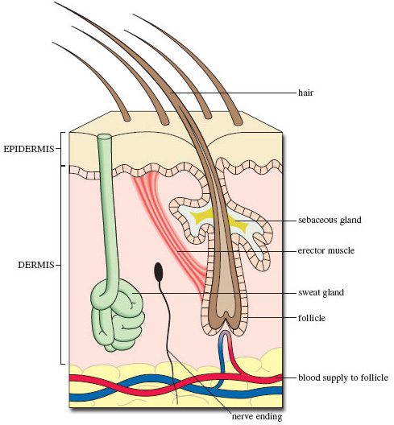

Figure 21 A vertical cross-section of the skin of a typical mammal. The upper (outer) epidermis consists of tough, dead cells. The inner dermis has glands and nerve endings that impart sensitivity to touch

[View description - Figure 21 A vertical cross-section of the skin of a typical mammal. The upper (outer) ...](" \l "Session7_Description1)

End of Figure

Figure 21 is a cross-section through the skin of a mammal, including a slice through a single hair. Its root is embedded deep within the inner layer of the skin, called the dermis. The sebaceous gland provides the oily secretion that helps keep the fur in good condition, while the contraction of the erector muscle makes the hair stand up; their combined action ‘fluffs up’ the fur, increasing its powers of insulation. In passing, note the sweat gland that is located deep within the dermis, and the blood vessels that supply the base of the hair with nutrients. This point is where cell division and growth of the hair occur and the newly formed hair shaft (rich in keratin, as mentioned earlier in Section 5.2) pushes upwards. The part of the skin that is visible is the overlying epidermis, which is composed of cells (now dead) that were initially produced by cell division within a growing area deep within the dermis.

This figure is a generalised view – different mammals show particular characteristics of skin structure. For example, the skin of the echidna would look very different from that shown in Figure 21, with a mix of ‘normal’ coarse hair – the length of which varies according to climate – and large single ‘hairs’, which are so well reinforced with keratin that they more closely resemble our own nails in hardness and chemical make-up.

The insulation provided by fur comes not from the hair itself, but largely from the layer of air trapped within the fur. Air is a very effective insulator, which is the same as saying it’s a poor conductor, i.e. it has a very limited ability to convey heat away from a warm surface, such as the epidermis. Calculations reveal that if a layer of still air of about five centimetres could be held in place close to the skin, it would provide the same level of insulation as the impressively dense winter coat of the arctic fox.

Start of Figure

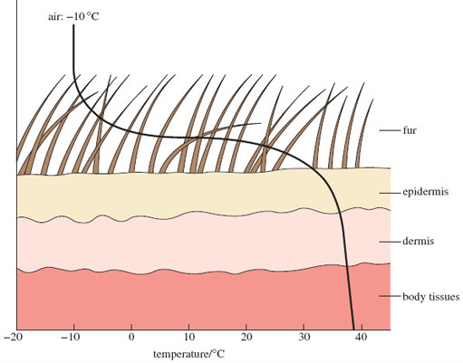

Figure 22 The temperature at different sites within and outside the fur of a mammal adapted to arctic life. The temperature at the surface of the epidermis is close to that of deeper tissues below the dermis, i.e. is close to what is called the core temperature. The close match between these measurements shows that nearly all the insulation is provided by fur, notably by the air trapped between the hairs

[View description - Figure 22 The temperature at different sites within and outside the fur of a mammal ...](" \l "Session7_Description2)

End of Figure

Figure 22 plots the temperatures within and beyond the skin surface when a well-insulated polar mammal (a wolf or an arctic fox) is exposed to an air temperature of -10 °C. Near the tips of the fur the temperature is -10 °C, but the surface of the epidermis is close to 30 °C. This is a temperature difference (or gradient) of about 40 °C across the six centimetre fur layer, due to the excellent insulating properties of the air contained within the long, fine and densely packed fur. Figure 22 also shows just how little insulation is offered by the epidermis and dermis. However, it’s a very different picture with the polar bear, which has coarse outer hair and dense underhair; its insulation relies more on blubber underlying the skin – an arrangement better suited to its amphibious existence.

You’ll appreciate by now that mammals that show a very small increase in metabolic rate as outside temperatures fall (as shown in Figure 20, repeated below) do so largely because of very effective insulation. Conductance is the name given to the flow of heat from one material to another, say from the skin to the outside air. An effective coat of fur ensures a very low level of conductance of heat; the flimsier coat of a tropical animal provides a higher conductance. So, the slope of the lines in Figure 20 is a measure of conductance – the steeper the slope, the greater the conductance.

Start of Figure



Figure 20 (repeated) A simplified graph of metabolic rate against ambient temperature in contrasting types of mammal: a temperate mammal (a weasel), an arctic mammal (a polar bear cub), and a tropical mammal (a sloth). The basal metabolic rate (BMR) of all three mammal types is assumed to be about 1, for ease of comparison

[View description - Figure 20 (repeated) A simplified graph of metabolic rate against ambient temperature ...](" \l "Session7_Description3)

End of Figure

The combination of endothermy and the ability to conserve the large amounts of body heat generated has contributed enormously to the success of mammals. What is remarkable is that fur has proved sufficiently versatile during the evolution of mammals to make physiological sense for the amphibious platypus, the cold-adapted arctic fox and the sun-baked red kangaroo alike.

## 8 What’s special about placental mammals?

Nearing the end of this introduction to mammals, it is important to stress the differences between marsupials and the placental mammals, by returning to the topic of mammalian reproduction.

In each mammalian type, pregnancy begins as the blastocyst becomes embedded in the tissues of the womb. In both marsupial and placental mammals, the developing tissues of the mother’s womb and the embryo lie in very close contact, such that oxygen, carbon dioxide, nutrients and waste materials can transfer between mother and offspring. In marsupials, this contact is loose and seldom any more than a very rudimentary kind of placenta. But in some marsupials, the contact between the two sets of tissues becomes more elaborate; in the koala, for example, the structure is considered by most experts to be a true placenta, albeit short-lived. The fact that a functional placenta evolved in at least a couple of marsupial species is a striking example of parallel evolution – the independent development of a structure in two distinct groups. Marsupials seem to be descended from a different ancestral group than placental mammals; they can’t be thought of as in any sense intermediate. Differing solutions to the problem of rearing young are developed independently, but sometimes, as with the marsupial ‘placenta’, the solutions have much in common.

The terms ‘marsupial’ and ‘placental’ were established in the late 18th century when mammals were first classified. ‘Marsupial’ is derived from the Latin word marsupium, meaning pocket. This feature is conspicuous in kangaroos and wallabies, but is not present in all marsupials. A need for renaming was even more evident once marsupials were found to briefly form a simple placenta. As a result, the terms Eutheria (= placental mammals), Metatheria (= marsupials) and Prototheria (= monotremes) were proposed instead. You may well come across these terms in any further reading, rather than the original and more familiar terminology that’s been used in this course.

What are the apparent benefits that the development of a more elaborate placenta can bring? In placental mammals, close and extensive contact of maternal and embryonic tissue reaches its peak; in the human placenta there is an estimated 40-50 kilometres of such fine-scale contact! And yet the bloods of mother and offspring never fully mix – to do so would risk the mother’s rejection of the embryo as a ‘foreign’ object. The transfer between the two blood systems is so extensive that the needs of the growing embryo can be met for a prolonged period. The net benefit is that the young of placental mammals are often born relatively mature after a prolonged pregnancy, with all the attendant benefits to their early wellbeing that size can bring. The efficiency of the mammalian placenta is another factor that helps explain the group’s biological success – an evolutionary flowering that has produced a diversity of forms over much of the planet, but that has also produced one species that could potentially end the age of the mammals – Homo sapiens.

## 9 Studying mammals: a case study – platypus burrows

As you will have realised as you worked through earlier sections, there is a lot that we don’t know about the life history of monotremes. Staff at the Healesville Sanctuary in Australia have been working with other scientists to investigate the ways in which juvenile platypus use burrows. The results of their work were published in 2019 (Thomas et al.).

Start of Figure

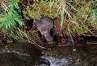

Figure 22 A Platypus, Ornithorhynchus anatinus, emerging from its burrow

[View description - Figure 22 A Platypus, Ornithorhynchus anatinus, emerging from its burrow](" \l "Session9_Description1)

End of Figure

Platypuses are semi-aquatic. They use burrows that they dig in riverbanks for shelter and sleeping during the day. They also have a second type of burrow, the nesting burrow. This burrow is excavated by a female and she uses it to lay eggs and incubate them. The young also live in the burrow while they’re dependant on the mother’s milk, a period that lasts around four months. When they first emerge from the nesting burrow, they are at about 70% of their adult weight, and they switch from milk to aquatic invertebrates as their food source. Whether the young continue to share the maternal burrow after weaning is not known. The period after the juveniles emerge is not well studied, so the team set out to fill in some of the gaps in our knowledge.

The team set nets at night along 3 km of Badger Creek in the grounds of Healesville Sanctuary. The nets were checked regularly during the night and any platypus netted could rapidly be freed and taken to a vehicle for assessment. Each platypus was checked for the presence of a microchip and if none was found, one was fitted to enable identification in the future.

Each juvenile was fitted with a radio transmitter weighing 13g. Compare this with the mass of the smallest juvenile in the study – 500g – and you can see that the transmitter was not likely to be a burden. Each platypus was radio tracked every day until the transmitter fell off. Once it fell off and 24 hours had passed with no motion, the transmitter signalled that it was motionless.

The results are summarised in Table 3, which shows sex, mass, transmitter attachment period and monitoring. The figure quoted for burrow range is the distance along the stream between the two furthermost burrows used by that individual, with all other burrows visited falling within that range.

Start of Table

Table 3

|  |  |  |  |  |  |  |  |  |
| --- | --- | --- | --- | --- | --- | --- | --- | --- |
| **Animal** | **Sex** | **Mass at capture (g)** | **Date of transmitter attachment** | **Transmitter attachment days** | **Approx. age at end of study (days)** | **Number of days located** | **Total number of burrows used** | **Burrow range (km)** |
| A | Female | 600 | 31 March 2015 | 80 | 231 | 71 | 19 | 1.26 |
| B | Male | 500 | 31 March 2015 | 43 | 194 | 42 | 9 | 1.33 |
| C | Female | 500 | 31 March 2015 | 37 | 188 | 35 | 7 | 1.55 |
| D | Male | 750 | 31 March 2015 | 132 | 283 | 107 | 17 | 0.76 |
| E | Male | 750 | 20 March 2016 | 14 | 154 | 14 | 4 | 0.65 |
| F | Female | 510 | 20 March 2016 | 34 | 174 | 32 | 14 | 2.26 |
| G | Female | 750 | 20 March 2017 | 110 | 250 | 101 | 4 | 0.49 |

End of Table

Some general findings:

* Along the 3 km stretch of creek, 74 burrow sites were identified.
* The maximum number of days that an individual used the same burrow was 53.
* The mean number of burrows used by an individual was 11±2.

Juveniles used multiple burrows within a small home range. They spent most of their time in frequent-use burrows, but the majority of burrows were single-use. The juveniles used between four and 19 burrows each in the 3 km stretch of creek. They routinely find new burrows within a night, displaying a degree of flexibility that might be highly advantageous. Streams are subject to seasonal changes in flow rate and flooding can occur. So, the ability to find another burrow rapidly is a valuable adaptation. The juveniles seem to keep within a narrow home range around the burrow that they were born in, until they are mature. At this point they disperse, and males establish territories for the breeding season. Keeping within a narrow and familiar home range may be of benefit to the juveniles as they need to keep clear of breeding males.

There is a lot more information in the original publication (Thomas et al., 2019), if you wish to explore the research further.

## Conclusion

During this course you have learnt how mammals are defined by a number of attributes, including: the possession of fur; lactation in females; and the ability to liberate heat energy through metabolism, as a means of thermoregulation. More than any other animal group, the mammals have been influenced by another species – humans. To conclude this course, watch this video clip, which compares humans and a domesticated mammal, the camel, in their abilities to live in hot desert conditions.

Start of Media Content

Video content is not available in this format.

Video 2 Camels and humans as desert dwellers

[View transcript - Video 2 Camels and humans as desert dwellers](" \l "Session10_Transcript1)

Start of Figure

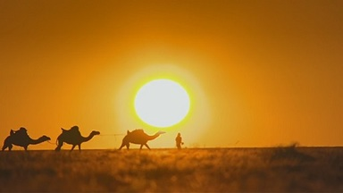

End of Figure

End of Media Content

This free OpenLearn course provided an introduction to studying level 1 courses in [Environment & Development](http://www.open.ac.uk/courses/find/environment-and-development?utm_source=openlearn&utm_campaign=ol&utm_medium=ebook). The series of exercises, designed to develop your approach to study and learning at a distance, should help to improve your confidence as an independent learner. The course functions as a general introduction to the topic, and you may be interested in other OpenLearn courses about mammals.

## References

Burgin, C. J., Colella, J. P., Kahn, P. L., Upham, N. S. (2018). ‘How many species of mammal are there?’, Journal of Mammalogy, 99(1): 1–14 [Online]. Available at https://doi.org/10.1093/jmammal/gyx147

Liu, L., Zhang, J., Rheindt, F. E., Lei, F., Qu, Y., Wang, Y., Zhang, Y., Sullivan, C., Nie, W., Wang, J., Yang, F., Chen, J., Edwards, S. V., Meng, J., Wu, S. (2017) ‘Genomic evidence reveals a radiation of placental mammals uninterrupted by the KPg boundary’, PNAS, 114 (35) E7282–E7290 [Online]. Available at www.pnas.org/cgi/doi/10.1073/pnas.1616744114

Thomas, J. L., Parrott, M. L., Handasyde, K. A., Temple-Smith, P. (2019) ‘Burrow use by juvenile platypuses (Ornithorhynchus anatinus) in their natal home range’, Journal of Mammalogy, 100(4): 1182-1190 [Online]. Available at https://doi.org/10.1093/jmammal/gyz078

## Acknowledgements

Except for third party materials and otherwise stated (see [terms and conditions](http://www.open.ac.uk/conditions)), this content is made available under a [Creative Commons Attribution-NonCommercial-ShareAlike 4.0 Licence](https://creativecommons.org/licenses/by-nc-sa/4.0/)

This free course was written by David Robinson. It was published in February 2020.

Grateful acknowledgement is made to the following sources for permission to reproduce material in this course:

The content acknowledged below is Proprietary and is used under licence.

**Images**

Course image: © David Robinson

Figure 1 © Richard Codington / Alamy Stock Photo

Figure 2 © Peterson B Moose, USFWS, https://pixnio.com/fauna-animals/foxes-and-wolves/san-joaquin-kit-fox-male

Figure 3 © David Robinson

Figure 4 © Theklan; https://creativecommons.org/licenses/by-sa/4.0/

Figure 5 © Dave Watts / Alamy Stock Photo

Figure 6 © Benjamin Davies / pixabay

Figure 7 © Auscape International Pty Ltd / Alamy Stock Photo

Figure 8 © Cody Pope; https://creativecommons.org/licenses/by-sa/2.5/

Figure 9 © David Robinson

Figure 10 © David Robinson

Figure 11 © Auscape International Pty Ltd / Alamy Stock Photo

Figure 12 © John Carnemolla / Corbis

Figure 13 © CucombreLibre; https://creativecommons.org/licenses/by/2.0/

Figure 14 © Darren Naish

Figure 15 © WILDLIFE GmbH / Alamy Stock Photo

Figure 16 © Auscape International Pty Ltd / Alamy Stock Photo

Figure 17 © The Open University

Figure 18 © Jean Beaufort; https://creativecommons.org/publicdomain/zero/1.0/

Figure 19 © The Open University

Figure 20 © The Open University

Figure 21 © Clutton-Brock, J. (2002) Mammals, Dorling Kindersley Limited, a Penguin Company;

Figure 22 © Willmer, P. et al. (2000) Environmental Physiology of Animals, Blackwell Publishers Ltd.

Figure 23 © Dave Watts / Alamy Stock Photo

**Don't miss out:**

If reading this text has inspired you to learn more, you may be interested in joining the millions of people who discover our free learning resources and qualifications by visiting The Open University - [www.open.edu/openlearn/free-courses](http://www.open.edu/openlearn/free-courses?utm_source=openlearn&utm_campaign=ol&utm_medium=ebook)

## Solutions

## Question 1

#### Answer

Mammals are distinguished by:

* the production of milk
* the possession of hair (or similar structures, e.g. bristles)
* the ability to regulate their body temperature, by utilising internal sources of heat.

[Back to - Question 1](" \l "Session1_SAQ1)

## Activity 1

#### Answer

* Both echidnas and the platypus have fur – though in the former, some of the hairs are thickened in the form of spines.
* Both animals produce milk – they have mammary glands, though well-defined nipples are not evident.
* Immature young hatch from their soft-shelled eggs after about 10 days; reptiles typically hatch in a much more mature state. Thereafter, a young monotreme, though no longer carried, remains dependent on the mother’s milk – for more than six months in the case of echidnas.

[Back to - Activity 1](" \l "Session3_Activity1)

## Question 2

#### Answer

Here the units are identical, so you just need to divide the baby’s weight by that of the mother, 3.4/70, and multiply by 100, which gives a value close to 5%. This is a great deal higher than the value for the koala, reflecting the greater relative maturity of the human newborn.

[Back to - Question 2](" \l "Session4_SAQ1)

## ****Activity 2****

#### Answer

This incredible journey from birth pore to pouch is very striking, and you may have made notes about the youngster’s ability to orientate itself and to move with the aid of well-developed forelimbs. (Though perilous, the journey is relatively brisk – three minutes in all.) You might have noted the importance of milk to the newborn, or the fact that the chemical composition of the milk changes during the newborn’s development.

[Back to - Activity 2](" \l "Session4_Activity1)

## Question 3

#### Answer

Such species have a unique and sophisticated system that allows the production of more than one type of milk, so they are capable of satisfying the varying demands of youngsters at different stages of development. The mechanisms in the mother’s body are not well understood but having separate ‘plumbing’ to each teat means each can act partially independently.

[Back to - Question 3](" \l "Session5_SAQ1)

## Question 4

#### Answer

Lactation provides nutritional care – the sucklings don’t have to find their own food. In that sense, it helps separate the infant from the vagaries of the environment. Given that feeding is relatively effortless, the youngster’s energy can be largely channelled into growth. It also seems that suckling is an excellent way of transferring immunity from mother to offspring. The early milk of many mammals, humans included, confers a special advantage – it’s especially rich in antibodies. The same is true in marsupials such as kangaroos.

[Back to - Question 4](" \l "Session5_SAQ2)

## ****Activity 3****

#### Discussion

Mammals are no longer at the mercy of the environment; by contrast, the body temperature of most reptiles, for example, is closely linked to outside temperatures. Thus the arctic fox which you met in the introduction (Figure 1) remains warm and active in very cold conditions. But being warm-blooded has a high energetic cost. In mammals, as much as 80-90% of the energy obtained from their food is needed to maintain body temperature.

[Back to - Activity 3](" \l "Session6_Activity1)

## Question 5

#### Answer

The metabolic rates for mammals (and the hummingbird) are much higher than those for the fish and reptiles. This is true of both the ‘at rest’ levels and the ‘peak activity’ values; the mouse, dog and human (and the hummingbird) values are higher than the others, often considerably so.

[Back to - Question 5](" \l "Session6_SAQ1)

## Question 6

#### Answer

The body temperature of the cat stays much the same when the ambient temperature falls. But in the lizard, the body temperature falls as ambient temperature drops.

[Back to - Question 6](" \l "Session6_SAQ2)

## SAQ

### Question 7

#### Answer

It’s constant, at what seems like the lowest possible value. Between these temperatures, there would be no change, therefore, in the amount of heat produced as a by-product of metabolism.

This minimum rate of metabolism is termed the basal metabolic rate (BMR). This would reflect the ‘at rest’ values recorded earlier for the mammals in Table 2.

[Back to - Question 7](" \l "Session6_Part1)

### Question 8

#### Answer

The metabolic rate increases steadily, which means that the amount of metabolic heat produced also increases. (The fact that it’s a straight line means that the metabolic rate increases by the same amount for a standard drop of ambient temperature, of say 5 or 10 °C.)

[Back to - Question 8](" \l "Session6_Part2)

### Question 9

#### Answer

When conditions become increasingly colder, the animal is likely to lose a greater amount of heat than it would in warmer temperatures. The extra heat production, therefore, might compensate for this increased loss, which helps explain why body temperature stays at a constant value in the way that we saw for the cat in Figure 19.

[Back to - Question 9](" \l "Session6_Part3)

## Question 10

#### Answer

As Ta falls, the BMR is maintained down to a Ta of about 10 °C, at which point metabolism increases comparatively slowly as Ta drops further.

[Back to - Question 10](" \l "Session6_SAQ4)

## ****Activity 4****

#### Answer

They seek shade and spread saliva onto the forelimbs.

[Back to - Activity 4](" \l "Session6_Activity2)

## Question 11

#### Answer

In general, they are very large animals – think of the rhinoceros and the elephant. Large animals have the advantage of warming up comparatively slowly in hot conditions, so delaying dangerous rises in body temperature. But for the same reason, they often have severe problems when they need to lose heat. So, for very large tropical animals the loss of fur is likely to have conferred a significant advantage.

[Back to - Question 11](" \l "Session7_SAQ1)

# Figure 1 An arctic fox, Vulpes lagopus, hunting for lemmings in the snow

## Description

An arctic fox, Vulpes lagopus, hunting for lemmings in the snow. The white fur is good camouflage in the snow.

[Back to - Figure 1 An arctic fox, Vulpes lagopus, hunting for lemmings in the snow](" \l "Figure1)

# Figure 2 Kit fox, Vulpes macrotis

## Description

A Kit fox, Vulpes macrotis.

[Back to - Figure 2 Kit fox, Vulpes macrotis](" \l "Figure2)

# Figure 3 Dorcas gazelle, Gazella dorcas

## Description

A Dorcas gazelle, Gazella dorcas.

[Back to - Figure 3 Dorcas gazelle, Gazella dorcas](" \l "Figure3)

# Figure 4 An early mammal, Megazostrodon

## Description

A reconstruction of a shrew-like early mammal, Megazostrodon, known only from fossils.

[Back to - Figure 4 An early mammal, Megazostrodon](" \l "Session1_Figure1)

# Figure 5 A duck-billed platypus, Ornithorhynchus anatinus (Tasmania, Australia)

## Description

A duck-billed platypus, Ornithorhynchus anatinus.

[Back to - Figure 5 A duck-billed platypus, Ornithorhynchus anatinus (Tasmania, Australia)](" \l "Session2_Figure1)

# Figure 6 Short-beaked echidna, Tachyglossus aculeatus

## Description

A short-beaked echidna, Tachyglossus aculeatus, in Australia.

[Back to - Figure 6 Short-beaked echidna, Tachyglossus aculeatus](" \l "Session2_Figure2)

# Figure 7 Eastern long-beaked echidna, Zaglossus bartoni (Papua New Guinea)

## Description

An Eastern long-beaked echidna, Zaglossus bartoni, in Papua New Guinea.

[Back to - Figure 7 Eastern long-beaked echidna, Zaglossus bartoni (Papua New Guinea)](" \l "Session2_Figure3)

# Figure 8 Virginia opossum, Didelphis virginiana

## Description

A Virginia opossum, Didelphis virginiana, in a snowy wood.

[Back to - Figure 8 Virginia opossum, Didelphis virginiana](" \l "Session2_Figure4)

# Figure 9 Wallaby (Queensland, Australia)

## Description

A wallaby in Queensland, Australia.

[Back to - Figure 9 Wallaby (Queensland, Australia)](" \l "Session2_Figure5)

# Figure 10 Koala bear, Phascolarctos cinereus (Queensland, Australia)

## Description

A koala bear, Phascolarctos cinereus, in Queensland, Australia.

[Back to - Figure 10 Koala bear, Phascolarctos cinereus (Queensland, Australia)](" \l "Session2_Figure6)

# Figure 11 A marsupial mole, Notoryctes typhlops, eating a gecko

## Description

A marsupial mole, Notoryctes typhlops, eating a gecko.

[Back to - Figure 11 A marsupial mole, Notoryctes typhlops, eating a gecko](" \l "Session2_Figure7)

# Figure 12 The last Tasmanian wolf, Thylacinus cynocephalus

## Description

The last Tasmanian wolf, Thylacinus cynocephalus, photographed in a zoo.

[Back to - Figure 12 The last Tasmanian wolf, Thylacinus cynocephalus](" \l "Session2_Figure8)

# Figure 13 An aardvark, Orycteropus afer

## Description

An aardvark, Orycteropus afer.

[Back to - Figure 13 An aardvark, Orycteropus afer](" \l "Session2_Figure9)

# Figure 14 A simplified family tree of placental mammals based on molecular evidence

## Description

A simplified family tree of placental mammals based on molecular evidence. In each group one typical animal is illustrated. Anteaters and pangolins form a group on their own, with all the other mammals grouped in the Epitheria. There are four branches: carnivores and insectivores, primates, squirrels and ungulates. The ungulates are sub-divided into 6 groups: camels, whales, rhinos, hyrax, manatees and elephants.

[Back to - Figure 14 A simplified family tree of placental mammals based on molecular evidence](" \l "Session2_Figure10)

# Figure 15 An echidna egg

## Description

An echidna egg resting in the palm of a human hand. The egg is spherical and the diameter is less than the width of a finger.

[Back to - Figure 15 An echidna egg](" \l "Session3_Figure1)

# Figure 16 A young numbat, Myrmecobius fasciatus, showing its long, flexible tongue

## Description

A young numbat, Myrmecobius fasciatus, showing its long, flexible tongue.

[Back to - Figure 16 A young numbat, Myrmecobius fasciatus, showing its long, flexible tongue](" \l "Session4_Figure1)

# Figure 17 The structure of a mature mammary gland, at increasing magnification: (a)-(c) viewed under a light microscope, (d) with an electron microscope. (a) and (b) show the arrangement of the milk-carrying ducts and (c) the secretory cells. (d) is an image of a single cell, showing the structures involved in the processes of secretion. The different scales show the extent of magnification. (1 mm, i.e. one millimetre, is equivalent to 1000 μm, i.e. 1000 micrometres, and 0.1 mm = 100 μm)

## Description

The structure of a mature mammary gland, at increasing magnifications. The diagram is described fully in the text that follows it.

[Back to - Figure 17 The structure of a mature mammary gland, at increasing magnification: (a)-(c) viewed under a light microscope, (d) with an electron microscope. (a) and (b) show the arrangement of the milk-carrying ducts and (c) the secretory cells. (d) is an image of a single cell, showing the structures involved in the processes of secretion. The different scales show the extent of magnification. (1 mm, i.e. one millimetre, is equivalent to 1000 μm, i.e. 1000 micrometres, and 0.1 mm = 100 μm)](" \l "Session5_Figure1)

# Figure 17d (repeated) A secretory cell from a mammary gland

## Description

A secretory cell from a mammary gland.

[Back to - Figure 17d (repeated) A secretory cell from a mammary gland](" \l "Session5_Figure2)

# Figure 18 Mother koala and her young, Phascolarctos cinereus

## Description

A mother koala and her young.

[Back to - Figure 18 Mother koala and her young, Phascolarctos cinereus](" \l "Session5_Figure3)

# Figure 19 Graph of body temperature against ambient temperature for endothermic mammals and a lizard in laboratory studies, showing the better regulation in the cat (a placental mammal) compared with monotremes (echidna and platypus) and a marsupial (opossum). Tb was measured after 2 hours of constant exposure to each Ta

## Description

This is a graph of body temperature (vertical axis) against ambient temperature (horizontal axis) for endothermic mammals and a lizard in laboratory studies. The plotted points for a lizard fall on a line that is at 45 degrees to the horizontal axis, increasing towards the right. The plot shows that body temperature in the lizard is linearly related to ambient temperature and body temperature tracks the change in ambient temperature. There is no evidence of regulation. Plots for three monotremes and a cat are at a shallower angle to the horizontal axis. The shallower the angle, the better the regulation of body temperature. All four animals show an ability to regulate. The plotted line for the cat is close to being horizontal, indicating a high degree of regulation.

[Back to - Figure 19 Graph of body temperature against ambient temperature for endothermic mammals and a lizard in laboratory studies, showing the better regulation in the cat (a placental mammal) compared with monotremes (echidna and platypus) and a marsupial (opossum). Tb was measured after 2 hours of constant exposure to each Ta](" \l "Session6_Figure2)

# Figure 20 A simplified graph of metabolic rate against ambient temperature in contrasting types of mammal: a temperate mammal (a weasel), an arctic mammal (a polar bear cub), and a tropical mammal (a sloth). The basal metabolic rate (BMR) of all three mammal types is assumed to be about 1, for ease of comparison

## Description

This is a simplified graph of metabolic rate (vertical axis) against ambient temperature (horizontal axis) in contrasting types of mammal: a temperate mammal (a weasel), an arctic mammal (a polar bear cub), and a tropical mammal (a sloth). Each plot shows the range of body temperature over which the metabolic rate does not change and the point at which metabolic rate starts to increase with decreasing temperature. For the sloth, the metabolic rate is constant from 38 degrees to 30 degrees and then starts to rise. For the weasel, the figures are 38 to 18 degrees and for the polar bear, 38 to 10 degrees.

[Back to - Figure 20 A simplified graph of metabolic rate against ambient temperature in contrasting types of mammal: a temperate mammal (a weasel), an arctic mammal (a polar bear cub), and a tropical mammal (a sloth). The basal metabolic rate (BMR) of all three mammal types is assumed to be about 1, for ease of comparison](" \l "Session6_Figure3)

# Figure 21 A vertical cross-section of the skin of a typical mammal. The upper (outer) epidermis consists of tough, dead cells. The inner dermis has glands and nerve endings that impart sensitivity to touch

## Description

A vertical cross-section of the skin of a typical mammal. The upper (outer) epidermis consists of tough, dead cells. The inner dermis is a much thicker layer and contains glands and nerve endings that impart sensitivity to touch. The hairs that protrude from the surface of the skin have their roots deep in the inner dermis. One of these surface hairs is shown in cross-section. There is an erector muscle attached to it, a sebaceous gland that is wrapped around the hair and a blood supply at the base. The inner dermis also contains sweat glands.

[Back to - Figure 21 A vertical cross-section of the skin of a typical mammal. The upper (outer) epidermis consists of tough, dead cells. The inner dermis has glands and nerve endings that impart sensitivity to touch](" \l "Session7_Figure1)

# Figure 22 The temperature at different sites within and outside the fur of a mammal adapted to arctic life. The temperature at the surface of the epidermis is close to that of deeper tissues below the dermis, i.e. is close to what is called the core temperature. The close match between these measurements shows that nearly all the insulation is provided by fur, notably by the air trapped between the hairs

## Description

The temperature at different sites within and outside the fur of a mammal adapted to arctic life. The diagram is a cross-section through the skin, showing the layer of fur, the epidermis, inner dermis and the body tissues. Plotted on this cross-section are the temperatures measured at intervals from the tissue layer to the air above the fur. The range is from 38 degrees in the tissue layer to minus ten degrees in the air above the fur.

[Back to - Figure 22 The temperature at different sites within and outside the fur of a mammal adapted to arctic life. The temperature at the surface of the epidermis is close to that of deeper tissues below the dermis, i.e. is close to what is called the core temperature. The close match between these measurements shows that nearly all the insulation is provided by fur, notably by the air trapped between the hairs](" \l "Session7_Figure2)

# Figure 20 (repeated) A simplified graph of metabolic rate against ambient temperature in contrasting types of mammal: a temperate mammal (a weasel), an arctic mammal (a polar bear cub), and a tropical mammal (a sloth). The basal metabolic rate (BMR) of all three mammal types is assumed to be about 1, for ease of comparison

## Description

This is a simplified graph of metabolic rate (vertical axis) against ambient temperature (horizontal axis) in contrasting types of mammal: a temperate mammal (a weasel), an arctic mammal (a polar bear cub), and a tropical mammal (a sloth). Each plot shows the range of body temperature over which the metabolic rate does not change and the point at which metabolic rate starts to increase with decreasing temperature. For the sloth, the metabolic rate is constant from 38 degrees to 30 degrees and then starts to rise. For the weasel, the figures are 38 to 18 degrees and for the polar bear, 38 to 10 degrees.

[Back to - Figure 20 (repeated) A simplified graph of metabolic rate against ambient temperature in contrasting types of mammal: a temperate mammal (a weasel), an arctic mammal (a polar bear cub), and a tropical mammal (a sloth). The basal metabolic rate (BMR) of all three mammal types is assumed to be about 1, for ease of comparison](" \l "Session7_Figure3)

# Figure 22 A Platypus, Ornithorhynchus anatinus, emerging from its burrow

## Description

A Platypus, Ornithorhynchus anatinus, emerging from its burrow.

[Back to - Figure 22 A Platypus, Ornithorhynchus anatinus, emerging from its burrow](" \l "Session9_Figure1)

# Video 1 An experiment that shows that when presented with a choice of cold or warm environments, a lizard can shuttle between them to regulate Tb

## Transcript

NARRATOR

This lizard is a desert iguana. As before, its temperature is measured using a thermistor inserted into its cloaca. The high temperature doesn’t seem to bother the lizard at first. But as its body temperature rises, notice the changes in posture that minimise contact with the hot surface – and gaping, another means of losing heat. But to avoid becoming too hot or cold, it must shuttle between the compartments.

[Back to - Video 1 An experiment that shows that when presented with a choice of cold or warm environments, a lizard can shuttle between them to regulate Tb](" \l "Session6_MediaContent1)

# Video 2 Camels and humans as desert dwellers

## Transcript

NARRATOR

The hot, dry conditions of the desert are inhospitable to most mammals, because they cause overheating and dehydration. Yet, these camels are desert dwellers, and compared to the men riding them, they’re well-suited to a desert environment. The camels in this desert patrol can travel up to 20 miles a day for 15 days without water. But their riders need to have regular stops for water and shade throughout the day.

Such different abilities to cope with heat stress must lie in their physiological makeup. One built-in advantage for the camel is the extensive insulation provided by its fur coat. The fur acts as a heat barrier, helping to slow down the transfer of radiant and convective heat from the outside to the inside.

To provide similar insulation, the men must wear suitable clothing. But they can’t always compensate for being ill-adapted to this environment. Consider what problems in relation to temperature humans face in the desert heat. Also, what other adaptations, besides insulation, might the camel display?

For instance, another advantage the camel has over human is revealed by a study of the fluctuations in body temperature throughout the day. The body temperature of a human rises to a critical level in only a few hours’ exposure to desert heat. To lower this temperature, the human begins to sweat as a means of losing heat.

The body temperature of the camel continues to rise past the human lethal limit, and the camel can sustain temperatures as high as 40 degrees centigrade without sweating. Not only does the camel have the ability to tolerate higher body temperatures than humans, but its larger size allows it to store a larger amount of heat.

The net effect is that it can postpone the onset of sweating, and in doing so, save a considerable amount of water. For the human to avoid losing too much water, the only alternative is to seek shade when it’s available. By allowing its body temperature to rise by six degrees centigrade, the camel saves as much as four litres, or seven pints, of water.

But if the heat load were maintained, then eventually the camel would have to sweat, and it too would become prone to dehydration. Dehydration is one of the major dangers facing mammals in the desert, and waterholes are essential stops on a journey.

As you might expect, desert-adapted animals tolerate dehydration very well, and can lose as much as 40% of their body weight without serious damage. But for a human, the upper limit of tolerance is only 15% before serious effects are seen to interfere with blood circulation.

Normally, the blood moves heat around the body, and exchanges heat to the outside of the skin's surface. Dehydration causes rapid loss of water from the blood. The volume of the blood falls, it becomes viscous, and the blood vessels contract. The result is that the heart has to work harder to pump the blood around the body.

The effort becomes so great that the circulation becomes sluggish, and it’s less efficient at moving heat to the skin’s surface. As less heat is lost to the outside, the body temperature rises explosively. The camel, even under severe dehydration, loses water mainly from its stomach and large intestines, so the volume of the camel’s blood changes very little, and is still able to transport and exchange heat efficiently.

At the end of the day’s journey, the camel’s body temperature will be relatively high. As it’s unloaded, the falling air temperatures of early evening give it the perfect opportunity to dump some of that heat that it’s stored during the day, and replenish itself with water.

And when water is available, it can rapidly take it on board. A deficit of about 20% of its body weight can be made good within 10 minutes. In this time, the camel is able to drink something like 70 to 100 litres of water. That’s equivalent to a man drinking 20 litres, or 30 pints.

Air temperatures in the desert at night can fall very low. And whereas humans try to keep warm, the camel starts dumping its heat. It stores heat in the day, and gives it up at night so that by morning, it starts with a relatively low body temperature.

So the secret of the camel’s tolerance of desert conditions has nothing to do with its infamous hump, where fat is stored, not water. As we’ve seen, its success as a desert dweller relies upon physiological adaptations to heat stress and to dehydration.

[Back to - Video 2 Camels and humans as desert dwellers](" \l "Session10_MediaContent1)