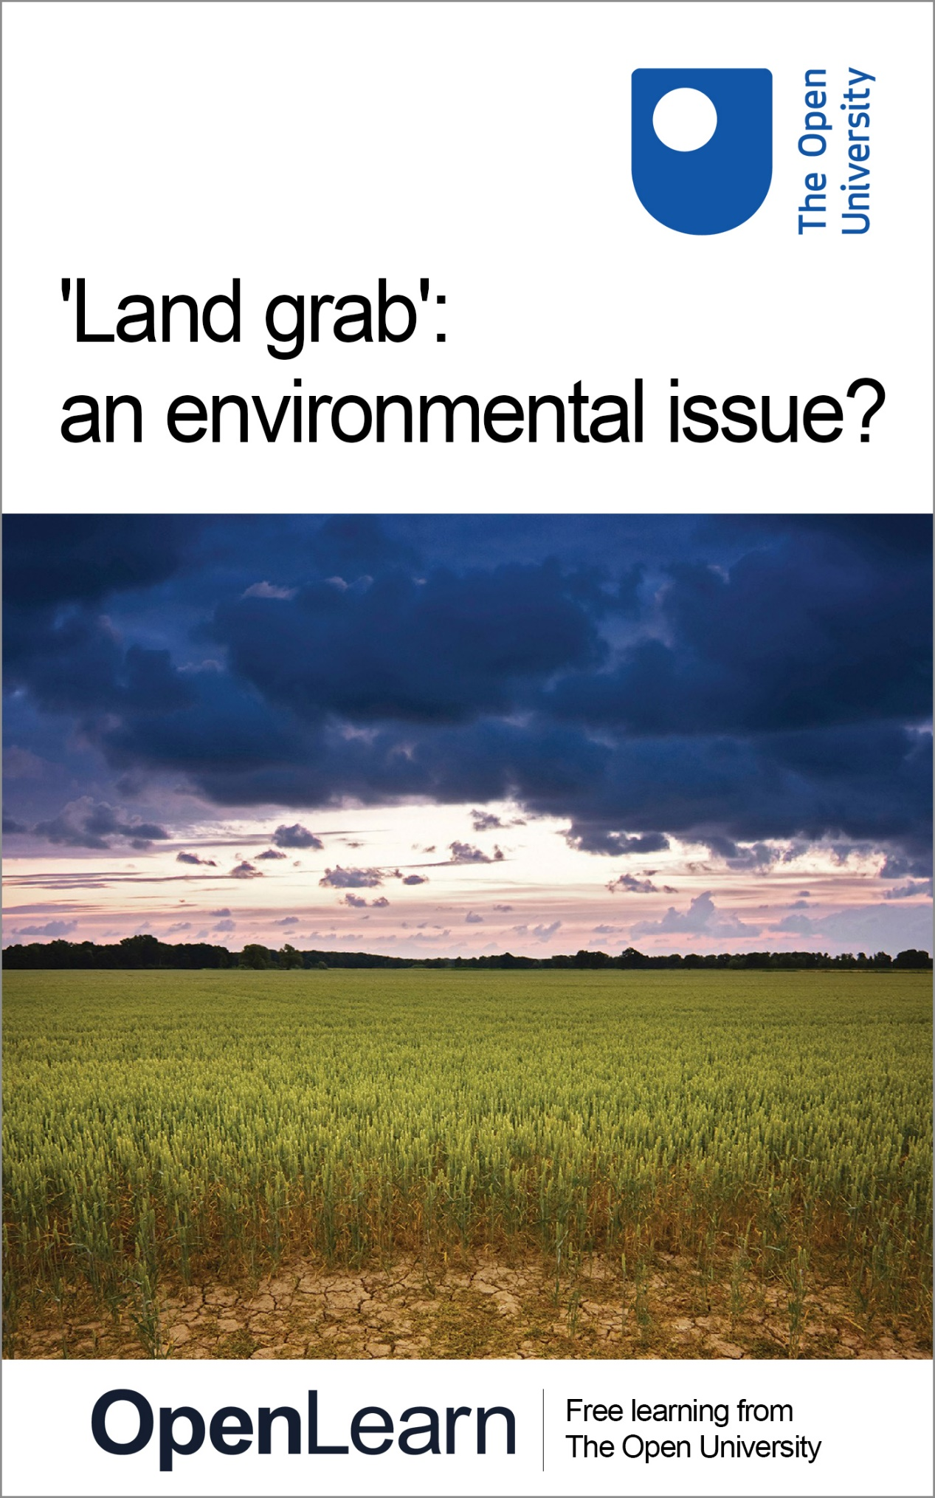

**DST206\_1**

**'Land grab': an environmental issue?**

**About this free course**

This free course is an adapted extract from the Open University course DST206 Environment: sharing a dynamic planet [www.open.ac.uk/courses/modules/dst206](http://www.open.ac.uk/courses/modules/dst206?LKCAMPAIGN=ebook_&amp;MEDIA=ou).

This version of the content may include video, images and interactive content that may not be optimised for your device.

You can experience this free course as it was originally designed on OpenLearn, the home of free learning from The Open University –

[www.open.edu/openlearn/nature-environment/land-grab-environmental-issue/content-section-0](http://www.open.edu/openlearn/nature-environment/land-grab-environmental-issue/content-section-0??LKCAMPAIGN=ebook_&amp;MEDIA=ol)

There you’ll also be able to track your progress via your activity record, which you can use to demonstrate your learning.

Copyright © 2017 The Open University

**Intellectual property**

Unless otherwise stated, this resource is released under the terms of the Creative Commons Licence v4.0 <http://creativecommons.org/licenses/by-nc-sa/4.0/deed.en_GB>. Within that The Open University interprets this licence in the following way: [www.open.edu/openlearn/about-openlearn/frequently-asked-questions-on-openlearn](http://www.open.edu/openlearn/about-openlearn/frequently-asked-questions-on-openlearn). Copyright and rights falling outside the terms of the Creative Commons Licence are retained or controlled by The Open University. Please read the full text before using any of the content.

We believe the primary barrier to accessing high-quality educational experiences is cost, which is why we aim to publish as much free content as possible under an open licence. If it proves difficult to release content under our preferred Creative Commons licence (e.g. because we can’t afford or gain the clearances or find suitable alternatives), we will still release the materials for free under a personal end-user licence.

This is because the learning experience will always be the same high quality offering and that should always be seen as positive – even if at times the licensing is different to Creative Commons.

When using the content you must attribute us (The Open University) (the OU) and any identified author in accordance with the terms of the Creative Commons Licence.

The Acknowledgements section is used to list, amongst other things, third party (Proprietary), licensed content which is not subject to Creative Commons licensing. Proprietary content must be used (retained) intact and in context to the content at all times.

The Acknowledgements section is also used to bring to your attention any other Special Restrictions which may apply to the content. For example there may be times when the Creative Commons Non-Commercial Sharealike licence does not apply to any of the content even if owned by us (The Open University). In these instances, unless stated otherwise, the content may be used for personal and non-commercial use.

We have also identified as Proprietary other material included in the content which is not subject to Creative Commons Licence. These are OU logos, trading names and may extend to certain photographic and video images and sound recordings and any other material as may be brought to your attention.

Unauthorised use of any of the content may constitute a breach of the terms and conditions and/or intellectual property laws.

We reserve the right to alter, amend or bring to an end any terms and conditions provided here without notice.

All rights falling outside the terms of the Creative Commons licence are retained or controlled by The Open University.

Head of Intellectual Property, The Open University

# Contents

* [Introduction](#Introduction1)
* [Learning outcomes](#LearningOutcomes1)
* [1 Analytical concepts used in this course](#Session1)
* [2 Securing food, sharing land](#Session2)
  + [2.1 The global demand for agricultural land](#Session2_Section1)
  + [2.2 Land acquisitions in Africa](#Session2_Section2)
* [3 Senegal and land acquisition/land grab](#Session3)
* [4 Power, agency and property rights](#Session4)
  + [4.1 Pressures on the land](#Session4_Section1)
* [5  Discourses and land grabs](#Session5)
  + [5.1 Land acquisition or land grab?](#Session5_Section1)
* [Conclusion](#Session6)
* [References](#References1)
* [Acknowledgements](#Acknowledgements1)
* [Solutions](#Solutions1)

## Introduction

The issue of wealthy investors taking control over land farmed by poor farmers clearly has political and economic implications. It is also an issue of justice. It is, perhaps, less obvious how it is an environmental issue. But, as you will discover, some of the main forces driving up farmland prices are tied to environmental challenges such as climate change, food insecurity, water shortages and the wish to diversify energy sources away from fossil fuels to biofuels.

Land acquisition, or ‘land grab’ as it is often called, offers important lessons about the way that environmental problems are entangled with economic and political issues at an increasingly global scale. The issue illustrates how everyday issues such as food prices are caught up in complex connections that link different places, different people and their livelihoods across the globe.

This free course, ‘Land grab’: an environmental issue?, aims firstly to explore the ways in which land acquisition, or ‘land grab’ should be understood as environmental issues. Secondly, the readings, films and activities will help you to evaluate the land acquisition/land grab debate. More specifically, you will:

1. explore the relationship between land acquisition, access to food and broader processes in the global economy
2. consider the relationship between economic uncertainty and environmental change
3. examine how social groups may respond to environmental change and uncertainty
4. appreciate how analytical concepts can be useful in making sense of the complexity of environmental issues; in this case the issues of right to land and food prices.

This OpenLearn course is an adapted extract from the Open University course [DST206 Environment: sharing a dynamic planet](http://www.open.ac.uk/courses/modules/dst206).

## Learning outcomes

After studying this course, you should be able to:

* understand why land acquisition can be considered an environmental issue and the particular environmental challenges that it presents
* recognise the need for an interdisciplinary approach to interpret and explain environmental issues
* discuss the relationship between economic uncertainty and environmental change
* appreciate the work that analytical concepts can do to make sense of complex environmental issues such as the issues of rights to land and food prices.

## 1 Analytical concepts used in this course

In this course you will touch on how three sets of analytical concepts – first, time and space; second, risk and uncertainty; and third, values, power, and agency – can help you focus on different aspects of the environmental implications of land acquisition. The box below offers brief definitions of each of these sets of concepts.

Start of Box

**Box 1 Analytical concepts: definitions**

* Geographers and Environmental Studies researchers use the concepts of time and space to think both about the fact that environmental change always touches down in particular places and at particular moments, and the fact that to understand the full impact of these changes we often need to look further afield.
* Geographers and Environmental Studies researchers use the concepts of risk and uncertainty to draw attention to the fact that decisions about environmental issues are almost always taken in light of imperfect, incomplete or unclear information.
* Geographers and Environmental Studies researchers use the concepts of values, power and agency to help understand key factors shaping environmental issues:
  + Values refer to what is of worth, merit, or importance. They include the principles, beliefs, and ethical standpoints of the various individuals and groups involved in environmental issues.
  + Power is difficult to define but can include the material resources that a given person or group can deploy in pursuit of their objectives, and the ability of individuals and groups to shape the discourses that people use when they communicate (and thus set agendas that others involved may accept as legitimate, fair and authoritative). A discourse in this sense may include a powerful idea or set of ideas, shared values and certain understandings that people come to accept.
  + Agency is the difference that a social actor – individual or group – makes to the world and is shaped both by power (what actors can achieve) and by values (what actors want to achieve).

End of Box

## 2 Securing food, sharing land

Who should own land and how may land be legitimately acquired? The video below, Land Prices in East Anglia, starts to answer these questions by visiting East Anglia.

Start of Activity

**Activity 1 Land prices in East Anglia**

Allow 1 hour 40 minutes for this activity

Start of Question

First, read the short article [‘Agricultural land prices hit record high’](http://www.theguardian.com/business/2011/apr/18/agricultural-land-prices-increase) (The Guardian, 2011) for some background information on land prices.

Then watch the video Land Prices in East Anglia and, as you watch, think about the questions below and note your answers in text boxes provided.

Start of Media Content

Video content is not available in this format.

Land Prices in East Anglia

[View transcript - Land Prices in East Anglia](" \l "Session2_Transcript1)

Start of Figure

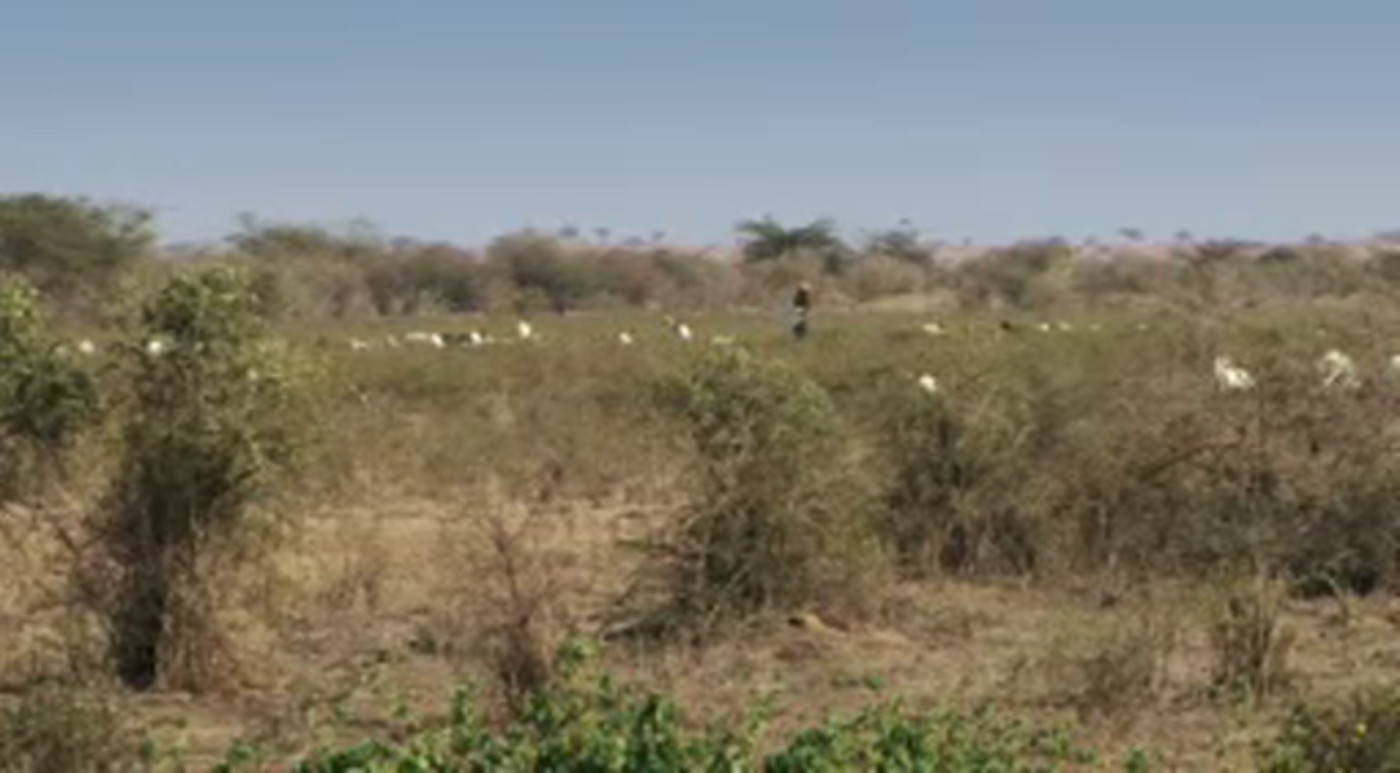

End of Figure

End of Media Content

End of Question

Start of Question

1. How much did the price of arable land increase between 2005 and 2012?

End of Question

*Provide your answer...*

[View answer - Part](" \l "Session2_Answer1)

Start of Question

2. What percentage of farmland in East Anglia has been bought by investment funds and large institutional investors?

End of Question

*Provide your answer...*

[View answer - Part](" \l "Session2_Answer2)

Start of Question

3. Why do institutional investors see agricultural land as an asset today?

End of Question

*Provide your answer...*

[View answer - Part](" \l "Session2_Answer3)

Start of Question

4. Why does having a portfolio of land in different countries spread risk?

End of Question

*Provide your answer...*

[View answer - Part](" \l "Session2_Answer4)

Start of Question

5. Why is the UK an attractive investment opportunity for farmland?

End of Question

*Provide your answer...*

[View answer - Part](" \l "Session2_Answer5)

Start of Question

6. How has institutional investment changed farming practices in East Anglia?

End of Question

*Provide your answer...*

[View answer - Part](" \l "Session2_Answer6)

End of Activity

## 2.1 The global demand for agricultural land

The practice of buying up farmland is not confined to East Anglia: it is a global phenomenon. Rather than rely on volatile food markets for the supply of food through trade, many food wholesalers are now taking control of food production by buying the land. Gaining access to agricultural land in other countries is one way of managing environmental insecurity for countries such as China and the states of the Persian Gulf; countries that are vulnerable to the effects of hotter – and in some cases, drier – weather than temperate countries.

Start of Figure

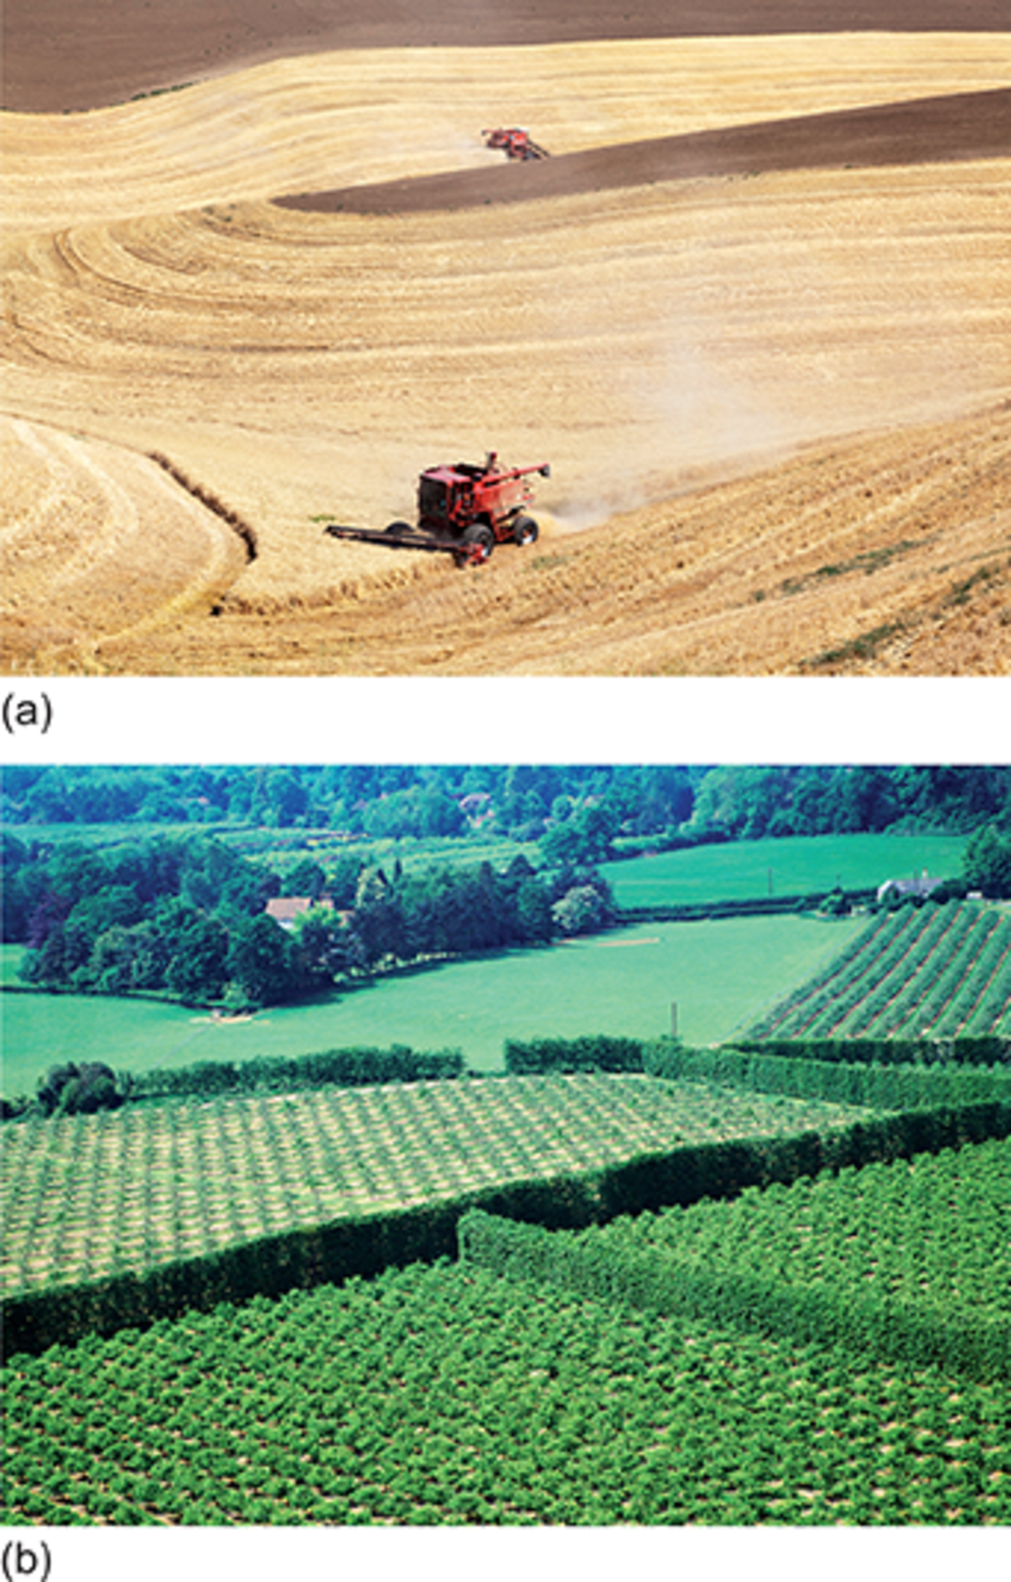

Figure 1 Fertile and agriculturally productive land is in demand from agricultural businesses. These images show (a) a combine harvester harvesting a wheat field in Washington, USA; (b) an orchard in Kent, England

[View description - Figure 1 Fertile and agriculturally productive land is in demand from agricultural ...](" \l "Session2_Description1)

End of Figure

There are a number of other related reasons for the increase of land acquisitions:

* Climate change and more extreme weather conditions mean harvests can fail, forcing up commodity prices because of diminished supply.
* The growing global human population, which is predicted to reach 10 billion by 2100, means more people to feed.
* Changing diets in fast-developing, populous countries such as China, where the consumption of traditional grains is falling as wealthier Chinese prefer meat and dairy products. Livestock farming requires large quantities of harvested feed, which in turn requires more land.
* The global financial crisis of 2008 led international companies to look to diversify their assets away from volatile and risky assets, e.g. with shares into more tangible assets such as land.
* Biofuel production needs land. Biofuels can help tackle climate change: they are made from plant mass, absorbing carbon dioxide as they grow and releasing it when the derived fuel is burned for energy. Biofuels, therefore, can be carbon neutral. They can contribute to energy security for countries by reducing dependence on fossil fuels – oil, gas and coal – which may otherwise have to be imported from another country.

The degree of economic uncertainty under which food and agricultural businesses operate in the global economy has thus heightened, along with the environmental risks resulting from climate change. This level of uncertainty requires a new and different approach to food production. Land acquisition appears to be central to this new approach.

## 2.2 Land acquisitions in Africa

While land acquisition is taking place in many parts of the world (New Zealand, China, across Latin America), the greatest volume of transactions is happening in Africa. This move to take control of farmland on a large scale is referred to as ‘land grab’ in many places, particularly in Africa.

Start of Activity

**Activity 2 Land grab in Africa**

Allow 30 minutes for this activity

Start of Question

Read the article [‘Analysis: Land grab or development opportunity?’](http://www.open.ac.uk/libraryservices/resource/link:37900) (BBC News, 2012), which gives an overview of the situation in Africa. Then answer the following questions.

End of Question

Start of Question

1. How might you distinguish between a legitimate land deal and a land grab?

End of Question

*Provide your answer...*

[View answer - Part](" \l "Session2_Answer7)

Start of Question

2. Why are many land deals seen as land grabs?

End of Question

*Provide your answer...*

[View answer - Part](" \l "Session2_Answer8)

Start of Question

3. Are there ways that local farmers can be supported and enabled to stay on the land?

End of Question

*Provide your answer...*

[View answer - Part](" \l "Session2_Answer9)

End of Activity

## 3 Senegal and land acquisition/land grab

Natural capital may be defined as those features of the natural environment that people rely on for food, livelihood and quality of life. Natural capital includes arable and grazing land, forests, water, fisheries and minerals. Natural capital is one of the most important productive assets in developing countries as it provides livelihoods for many of the poor as well as a foundation for economic development.

Start of Figure

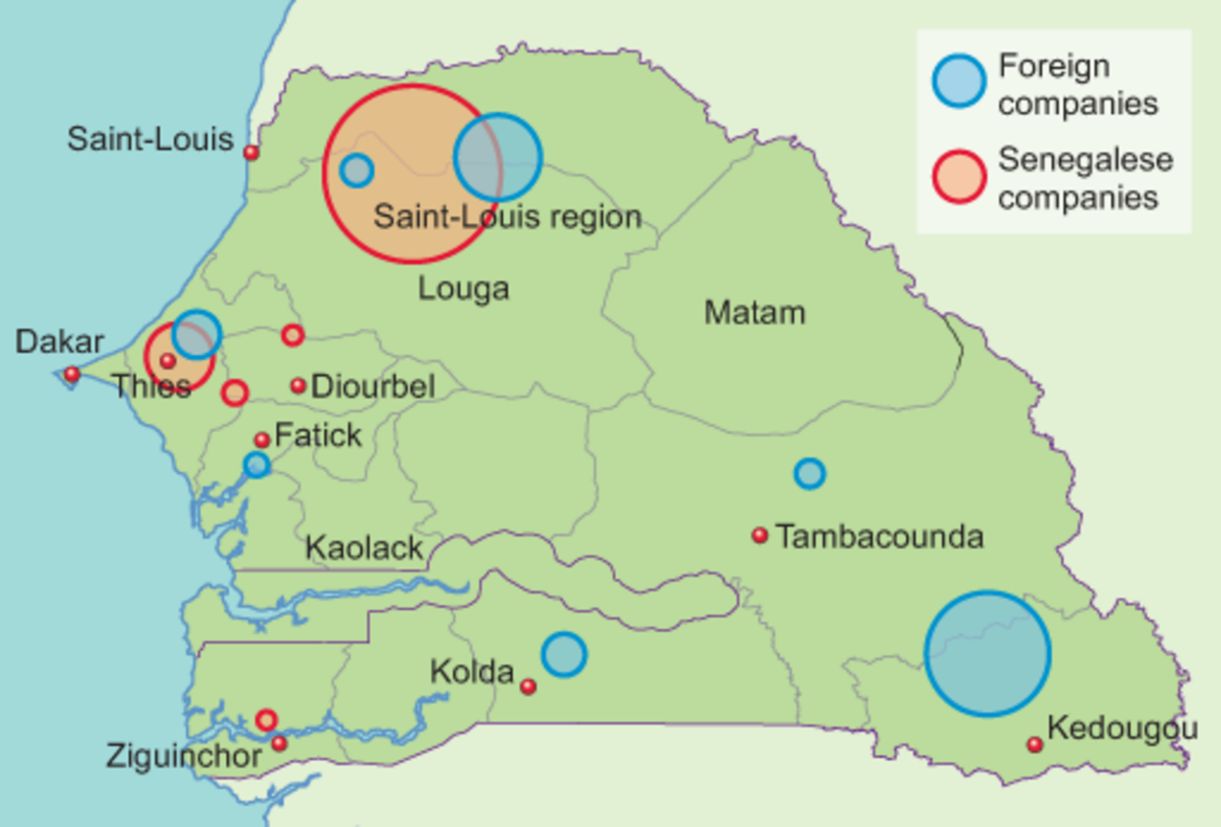

Figure 2 Land grab in Senegal, by company ownership

[View description - Figure 2 Land grab in Senegal, by company ownership](" \l "Session3_Description1)

End of Figure

Start of Figure

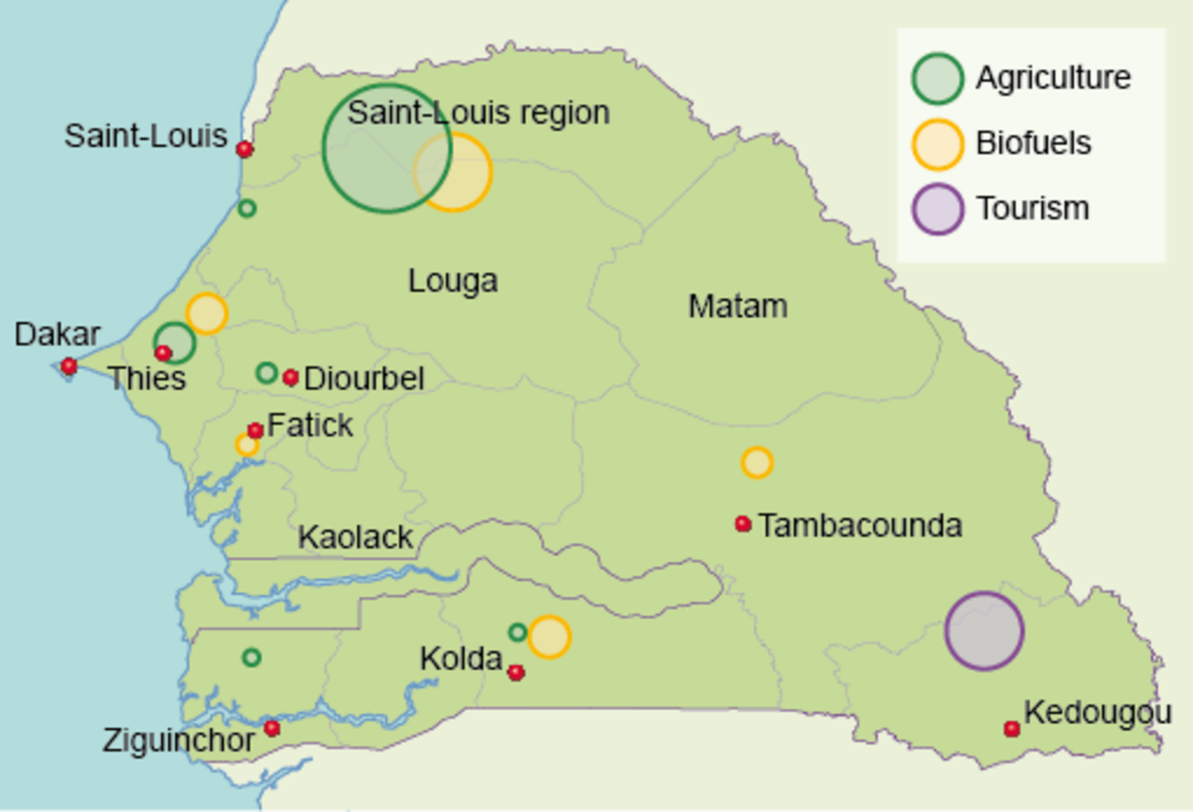

Figure 3 Land grab in Senegal, by sector

[View description - Figure 3 Land grab in Senegal, by sector](" \l "Session3_Description2)

End of Figure

Start of Activity

**Activity 3 Watching Land Grab in Senegal**

Allow 1 hour 30 minutes for this activity

Start of Question

Watch the following video, Land Grab in Senegal, which lets you look at this in the context of Senegal. Keep the questions below in mind when watching the film and answer them accordingly.

Note that at the beginning of the film (time 00:52) Professor Sidy Seck of Gaston Berger University near Saint-Louis holds up two maps. These maps are reproduced as Figures 2 and 3 above.

Start of Media Content

Video content is not available in this format.

Land Grab in Senegal

[View transcript - Land Grab in Senegal](" \l "Session3_Transcript1)

Start of Figure

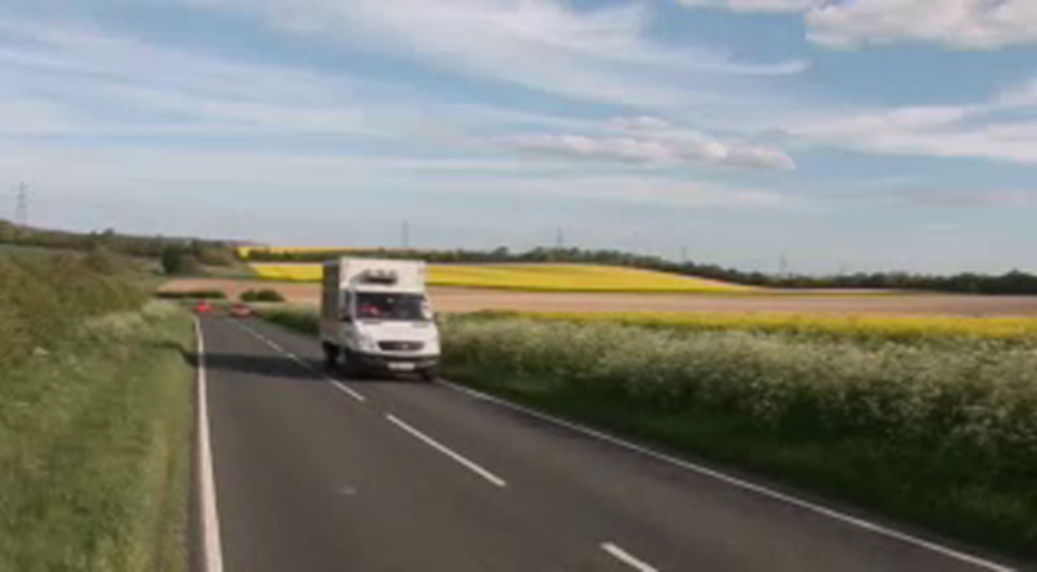

End of Figure

End of Media Content

Answer the following questions relating to the Land Grab in Senegal film.

End of Question

Start of Question

1. What percentage of the population is involved in farming in Senegal?

End of Question

*Provide your answer...*

[View answer - Part](" \l "Session3_Answer1)

Start of Question

2. What are the three purposes for which leased land is used?

End of Question

*Provide your answer...*

[View answer - Part](" \l "Session3_Answer2)

Start of Question

3. Which countries are most involved in land acquisition in Senegal?

End of Question

*Provide your answer...*

[View answer - Part](" \l "Session3_Answer3)

Start of Question

4. When villagers have been consulted by a rural council and foreign buyers in the use of land, what have they asked for?

End of Question

*Provide your answer...*

[View answer - Part](" \l "Session3_Answer4)

Start of Question

5. What evidence is there that rural councils are not an effective institution?

End of Question

*Provide your answer...*

[View answer - Part](" \l "Session3_Answer5)

Start of Question

6. How are villagers contesting their land being seized?

End of Question

*Provide your answer...*

[View answer - Part](" \l "Session3_Answer6)

End of Activity

## 4 Power, agency and property rights

Two types of property rights underlie many land rights conflicts in Senegal: customary land rights and private property rights.

Individuals, households, kinship groups, tribes, villages and communities claim customary land rights, which are based on tradition going back many generations in some cases. Historically, in many parts of Africa much land is held under customary tenure. Although there are many types of customary tenure this basically means that people claim a right to a piece of land because their families and ancestors have traditionally used it. Such communities and families rarely have a legal title or deed that says they own the land, so they cannot sell it. But nonetheless, because of their longstanding association with the land, the community feels a physical, emotional and spiritual attachment to it. Customary rights often come into conflict with the notion of property rights of the state. When African countries were granted independence from the colonial powers, any land not under private ownership was considered as belonging to the newly independent state, including land that communities considered to be their customary land. As well as farmland, customary land includes common resources such as forests and rivers.

Private property rights give legal title to a piece of land, which means it is owned by the actor holding that title and the law will protect the owner’s exclusive right to that land. The concept of private property rights developed alongside capitalism. Property rights apply to goods and services as well as land. These rights allow entrepreneurs to keep any profits deriving from a business. Private property rights, therefore, act as a stimulus to business and economic growth.

In Senegal, the government addressed the twin system of customary rights and modern land ownership through the 1964 National Domain Law. This law created elected rural councils to manage and allocate land. This law has periodically brought the Senegalese central and local governments into conflict with local communities. These conflicts have increased as the state has seized customary land to lease to foreign companies, leading to the eviction of local communities claiming customary rights. The capacity of the state and its allies to appropriate land from customary occupiers can be seen as an expression of uneven power relations.

At the end of the film you saw how, with help from civil society and non-governmental organisations (NGOs), villagers are contesting land grabs. Despite the uneven power relations between villagers and the national government and foreign companies, villagers are exercising their agency by contesting land grabs.

## 4.1 Pressures on the land

In the next activity you will deepen your understanding of land rights conflicts in Senegal and other countries and consider the growing social resistance to the appropriation of land.

Start of Activity

**Activity 4 Exploring the pressures**

Allow 1 hour for this activity

Start of Question

Read the following articles that explore the land pressures in Senegal and other countries and consider how villagers and farmers around the world are building a social movement to contest the loss of their lands. Then answer the questions that follow.

[‘Senegal: biofuels boost land-grab conflict in country’](http://www.open.ac.uk/libraryservices/resource/link:37898) (allAfrica, 2011)

[‘A global alliance emerges in West Africa’](http://www.open.ac.uk/libraryservices/resource/link:37903) (Food crisis and the global land grab, 2011)

[‘Peasant agriculture: a real solution to climate change’](https://viacampesina.org/en/peasant-agriculture-a-real-solution-to-climate-change/) (La Via Campesina, 2011)

End of Question

Start of Question

1. Why are violent protests occurring in Senegal?

End of Question

*Provide your answer...*

[View answer - Part](" \l "Session4_Answer1)

Start of Question

2. How can social movements mobilise in the face of uneven economic and power relationships?

End of Question

*Provide your answer...*

[View answer - Part](" \l "Session4_Answer2)

Start of Question

3. What does the Nyéléni Declaration of 2011 defend and call for?

End of Question

*Provide your answer...*

[View answer - Part](" \l "Session4_Answer3)

End of Activity

## 5  Discourses and land grabs

Discourses play a role in shaping the ideas that actors use to communicate and legitimise power relations. For example, the phrase ‘land grab’ (as opposed to ‘land acquisition’) contains certain assumptions. A ‘grab’ implies something that is done in haste and is inappropriate and unfair. The phrase ‘land grab’ is more likely to be used by those who regard the change of ownership of land in Senegal and elsewhere as wrong and unjust. Those actors who uphold the customary rights of communities are demonstrating resistance merely by using the term ‘land grab’. They wish the phrase to become well established in everyday vocabulary as it expresses understandings with which they agree. However, those who support the right of the state to enclose customary land and sell it to businesses will favour the phrase ‘land acquisition’, which implies a transfer of land ownership that is legal, orderly and reasonable.

The phrases ‘land grab’ and ‘land acquisition’ thus embody different values and understandings. They tend to be used by different actors with different interests. In short, the two phrases belong to different discourses. As you have seen, the first Forum on Food Sovereignty held in Nyéléni, Mali in 2011 played an important role in organising resistance against what it terms ‘land grab’. But the alternative discourse of ‘land acquisition’ argues that much African land is underutilised in agricultural terms. Supporters contend that, with mechanisation and inputs of fertilisers, the land could become more productive agriculturally.

So who is right? Is land grab/land acquisition necessarily a bad thing? It is necessary to be more critical and deepen your investigation.

Start of Figure

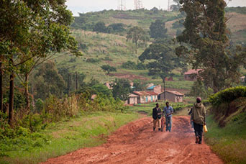

Figure 4 Who should have rights to the land? Local communities may claim that they have customary rights, but national governments may argue that they have legal rights. This image shows a village scene in Kyenjojo, Uganda

[View description - Figure 4 Who should have rights to the land? Local communities may claim that they ...](" \l "Session5_Description1)

End of Figure

## 5.1 Land acquisition or land grab?

The final activity in this course will help you to evaluate the land acquisition/land grab debate.

Start of Activity

**Activity 5 Land grab or land acquisition? Researching the debate**

Allow 2 hours 30 minutes for this activity

Start of Question

In this activity you will carry out some online research, reach your own conclusion and consider the following question:

Is what is happening in Africa land acquisition or land grab? Why do you think this?

This is quite a testing question. Do not worry if the question seems difficult at first. The process of carrying out some online research will help to clarify your thinking on the question.

This question asks you to consider which of the two discourses – land acquisition or land grab – you are most persuaded by, and why. You might be guided in your answer by considering whether the characteristics of land grab identified by the charity organisation Oxfam apply. In Oxfam’s definition, land grab:

* violates human rights, and particularly the equal rights of women
* flouts the principle of free, prior and informed consent of the affected land users, particularly indigenous peoples
* ignores the impacts on social, economic and gender relations, and on the environment
* avoids transparent contracts with clear and binding commitments on employment and benefit sharing
* eschews democratic planning, independent oversight, and meaningful participation (Oxfam, 2011).

By contrast, and as you have seen, the phrase ‘land acquisition’ implies a transfer of land ownership that is legal, orderly and reasonable.

As you undertake your research try to consider the question by thinking through the analytical concepts to which you were introduced at the beginning of the course. Here is a reminder:

* Use time and space to think about the history of land conflicts and where the various actors involved today are located
* Use risk and uncertainty to think about how the different actors involved are exposed to different kinds of risks and uncertainties
* Use values, power and agency to think about the different ways actors value the lands involved and the reasons for this; the power differentials between those actors; and how both values and power shape who has agency in these disputes.

Working with these concepts will help you to move from description of the problem to understanding.

**Resources**

We have suggested a few carefully selected resources for your research below. You are not restricted to these resources. Indeed, you may wish to do a little independent research. Regardless, be careful not to spend too much time on this, though, as the whole activity is only meant to take 2 hours 30 minutes. So you need to concentrate on finding what you consider to be the most relevant information and arguments. Here is an overview of the resources we have selected for you:

* [‘Land deals in Africa: what is in the contracts?’](http://www.open.ac.uk/libraryservices/resource/link:37901) (International Institute for Environment and Development, 2011). Chapters 3, 4, 5 and the discussion (pp. 16–46).

There are many references to particular contracts that form the basis of this study. The details do not need to concern you. What you are looking for is a selection of key points that speak to the question you are addressing, not exhaustive notes. Make no more than two pages of notes for this document as your brief is quite specific.

* [‘Land and power: the growing scandal surrounding the new wave of investments in land’](http://www.open.ac.uk/libraryservices/resource/link:37906) (Oxfam, 2011). Introduction, summary, chapters 1, 2 and 3 (pp. 2, 3, 5–29).

Skip the discussion of Indonesia, Honduras and Guatemala, as our focus is on Africa. As above, allow the concepts of time and space, risk and uncertainty, and values, power and agency to drive your note-taking.

* [‘David Hallam on FDI in agriculture’](http://www.open.ac.uk/libraryservices/resource/link:38413) (FAO, 2009).

Watch the film by David Hallam, Deputy Director of FAO’s Trade and Market Division. FDI stands for foreign direct investment. It is an investment made by an actor in one country directly into a business in another country. Hallam argues that foreign direct investments in land could be good news if the interests of land purchasers are reconciled with the investment needs of developing countries.

Make notes as you carry out your research. Then reach a conclusion to the question posed at the start of the activity:

Is what is happening in Africa land acquisition or land grab? Why do you think this?

Provide some reasoning on why you have reached your conclusion. Some points you may like to consider are:

* whether the changes of ownership in land in Africa are legal
* whether there is consultation with local people
* whether there are benefits for the economy of the country
* whether environmental protection is enhanced.

End of Question

[View discussion - Activity 5 Land grab or land acquisition? Researching the debate](" \l "Session5_Discussion1)

End of Activity

## Conclusion

In this free course, ‘Land grab’: an environmental issue?, you have seen how global economic forces impact on local people’s lives and livelihoods. You have examined changes of land ownership and use in East Anglia and Senegal. You have considered the tensions between customary land rights, the property rights of the state and private property rights where traditional and modern systems are in competition. You have also seen how people can mobilise in the face of uneven economic and power relationships. Finally, you carried out a piece of independent resource-led research to arrive at your own viewpoint on the land acquisition/land grab issue.

Contemporary land acquisition/land grab involves a range of actors, processes and commodities across spatial boundaries. By considering the complex dynamics of land acquisition/land grab using the analytical concepts of time and space, risk and uncertainty, and values, power and agency, you have seen how a complex problem can be divided up into more readily understood aspects. You can now go on to think about how these three sets of concepts can be applied to understanding other environmental issues. By using these concepts flexibly, you will be able to move from environmental issues you are familiar with into new fields of environmental contention.

This OpenLearn course is an adapted extract from the Open University course [DST206 Environment: sharing a dynamic planet](http://www.open.ac.uk/courses/modules/dst206).

## References

allAfrica (2011) Senegal: Biofuels boost land-grab conflict in country [Online]. Available at http://allafrica.com/stories/201110281172.html (Accessed 22 November 2012).

BBC News (2012) Analysis: Land grab or development opportunity? [Online]. Available at http://www.bbc.co.uk/news/world-africa-17099348 (Accessed 22 November 2012).

Cotula, L. (2011) Land deals in Africa: what is in the contracts?, London, International Institute for Environment and Development; also available online at http://pubs.iied.org/pdfs/12568IIED.pdf (Accessed 22 November 2012).

Food and Agriculture Organization of the United Nations (2009) Video: David Hallam on FDI in agriculture [Online]. Available at http://www.fao.org/economic/es-policybriefs/multimedia0/videodavidhallamonfdiinag/en/ (Accessed 22 November 2012).

Food crisis and the global land grab (2011) A global alliance emerges in West Africa [Online]. Available at http://farmlandgrab.org/post/view/19682 (Accessed 22 November 2012).

The Guardian (2011) Agricultural land prices hit record high [Online]. Available at http://www.theguardian.com/business/2011/apr/18/agricultural-land-prices-increase (Accessed 17 January 2017).

La Via Campesina (International Peasant’s Movement) (2011) Peasant agriculture: a real solution to climate change [Online]. Available at http://viacampesina.org/en/index.php?option=com\_content&view=article&id=1154:stop-land-grabbing-now&catid=23:agrarian-reform&Itemid=36 (Accessed 22 November 2012).

Oxfam (2011) Land and power: the growing scandal surrounding the new wave of investments in land [Online]. Available at http://www.oxfam.org/sites/www.oxfam.org/files/bp151-land-power-rights-acquisitions-220911-en.pdf (Accessed 22 November 2012).

## Acknowledgements

Except for third party materials and otherwise stated (see [terms and conditions](http://www.open.ac.uk/conditions)), this content is made available under a [Creative Commons Attribution-NonCommercial-ShareAlike 4.0 Licence](http://creativecommons.org/licenses/by-nc-sa/4.0/deed.en_GB).

The material acknowledged below is Proprietary and used under licence (not subject to Creative Commons Licence). Grateful acknowledgement is made to the following sources for permission to reproduce material in this free course:

## Images

**Course image** © Tobias Helbig/ iStockphoto

Figure 1 (a): © Curved Light USA/Alamy

Figure 1 (b): © Skyscan Photolibrary/Alamy

Figure 4: © Jake Lyell/Alamy

## Video

Activity 1: © The Open University and its licensor (BBC)

Activity 3: © The Open University

Every effort has been made to contact copyright owners. If any have been inadvertently overlooked, the publishers will be pleased to make the necessary arrangements at the first opportunity.

**Don't miss out**

If reading this text has inspired you to learn more, you may be interested in joining the millions of people who discover our free learning resources and qualifications by visiting The Open University – [www.open.edu/openlearn/free-courses](http://www.open.edu/openlearn/free-courses?LKCAMPAIGN=ebook_&MEDIA=ol).

## Solutions

## Activity 1 Land prices in East Anglia

### Part

#### Answer

In 2005, an acre of arable land in East Anglia cost £3000. In 2012, arable land cost about £8000 an acre.

[Back to - Part](" \l "Session2_Part2)

### Part

#### Answer

About 20 per cent of farmland in East Anglia has been bought by investment funds and large institutional investors.

[Back to - Part](" \l "Session2_Part3)

### Part

#### Answer

Agricultural land offers better returns than equities; rising food prices and increased food demands put pressure on agricultural land around the world; agricultural land is relatively cheap compared with development land and other assets.

[Back to - Part](" \l "Session2_Part4)

### Part

#### Answer

Buying land in different countries protects against regional uncertainties such as pestilence, political unrest and weather variations.

[Back to - Part](" \l "Session2_Part5)

### Part

#### Answer

The UK does not suffer from extreme climatic variations so harvests are generally reliable and the country is politically stable. It therefore offers good value for investors. However, this situation could change as climate change worsens.

[Back to - Part](" \l "Session2_Part6)

### Part

#### Answer

Farming has become more efficient through industrial mechanisation, larger fields and the amalgamation of small farms. Large farming businesses are taking over the running of farms with a more commercial rather than pastoral approach to farming.

The film suggests that in the wake of the food price crisis of 2007–08, there is growing insecurity over food supply. International investors are concerned to hedge risk by diversifying their investment portfolio. The result of both these processes is increased demand for farmland in East Anglia.

[Back to - Part](" \l "Session2_Part7)

## Activity 2 Land grab in Africa

### Part

#### Answer

The local context of the deal is very important, particularly the investor’s track record and the terms of the lease. Another important point is whether local landholders have been consulted and have had the opportunity to give their consent freely, and whether they have been offered any compensation for loss of land.

[Back to - Part](" \l "Session2_Part9)

### Part

#### Answer

The power imbalances between the international companies, host government and local landholders do not always encourage transparency and full consultation. This has led to accusations of land grab. Local farmers often have insecure titles to the land, which is a further issue leading to dispute. Where the land legally belongs to the government, local landholders may have no rights under the law, hence no legal recourse. But local communities may feel a sense of profound injustice at being evicted from land, especially when generations of the same families have lived on the land.

[Back to - Part](" \l "Session2_Part10)

### Part

#### Answer

International companies can support local farmers through the creation of cooperatives to boost productivity and improve access to markets. The government can also support family farms through public policies and investment in infrastructure.

[Back to - Part](" \l "Session2_Part11)

## Activity 3 Watching Land Grab in Senegal

### Part

#### Answer

About 60 per cent of the Senegalese population is involved in farming.

[Back to - Part](" \l "Session3_Part2)

### Part

#### Answer

Leased land is used for agriculture, biofuels and tourism.

[Back to - Part](" \l "Session3_Part3)

### Part

#### Answer

Saudi Arabia, France, Italy and Spain are the countries most involved in land acquisition in Senegal.

[Back to - Part](" \l "Session3_Part4)

### Part

#### Answer

Villagers have asked for the area of land leased to foreign interests to be reduced. They have also asked for jobs, schools and health clinics.

[Back to - Part](" \l "Session3_Part5)

### Part

#### Answer

Rural councils do not always consult villagers. Furthermore, a rural council may allocate a particular area of land but the foreign investor seizes a different area of land which is not subsequently challenged by the rural council.

[Back to - Part](" \l "Session3_Part6)

### Part

#### Answer

Villagers are contesting the seizure of land by taking down fences put up by foreign investors and organising protests.

[Back to - Part](" \l "Session3_Part7)

## Activity 4 Exploring the pressures

### Part

#### Answer

In 2007–08, violent protests occurred in Senegal because the price of imported rice increased, making it unaffordable for many. In 2011, riots occurred because of land leases for biofuel production.

[Back to - Part](" \l "Session4_Part2)

### Part

#### Answer

Social movements and grassroots groups seek to redress power inequities by pooling their power capabilities and working together. Working with each other, they pool their knowledge on land grabs and agree a shared strategy for resistance.

[Back to - Part](" \l "Session4_Part3)

### Part

#### Answer

The Nyéléni Declaration of 2011 defends food sovereignty, the commons and the rights of small-scale food producers to natural resources. It calls for better organisation so that communities and movements can reclaim and defend their rights. The declaration also advocates using the law to defend the rights of landholders and small-scale farmers, to put pressure on national governments and international institutions and to publicise the plight of those dispossessed of their land.

[Back to - Part](" \l "Session4_Part4)

## Activity 5 Land grab or land acquisition? Researching the debate

#### Discussion

Discussion using the three sets of analytical concepts defined at the beginning of this course.

## Time and space

Contemporary land acquisitions in Africa involve a range of actors, processes and commodities that stretch across spatial boundaries. Examples include land leased in Senegal by Saudi Arabia to grow rice to feed Saudi Arabian citizens and farming communities forging their own connections across spatial boundaries to contest land grabs.

Conflicts around land ownership stretch back to colonial times when the process began of overriding customary land rights to serve foreign interests. The terms of some land leases in Africa are 100 years. Such leases will have inter-generational consequences, impacting upon successive generations of farmers.

## Risk and uncertainty

In the wake of the food crises of 2007–08 and 2010–11, many wealthy countries with land and water constraints grew concerned about food security because of the risks and uncertainty of relying on world food markets to satisfy domestic food needs. They sought to mitigate these risks by purchasing or leasing agricultural land in developing countries to grow food.

Similarly, many African governments whose populations have suffered as a result of food price rises leading to riots needed agricultural investment to boost productivity. Foreign investment through land deals offered the possibility of meeting this need and mitigating the risk of further food riots. However, and as Oxfam has argued, land grabs may introduce greater risk and uncertainty for local communities whose land has been taken, leading to food insecurity.

Different actors, therefore, face very different risks and uncertainties.

## Values, power and agency

Different actors may have different values depending on where they live, their lifestyle and their beliefs. Land can be valued in different ways. Farmers in Africa have invested time and energy in the land for many generations. Specific areas of land may be important to the culture of some communities, which is why it has emotional and spiritual value beyond its use value. Government ministers may value land because of its potential for economic growth. Agricultural businesses may desire land because of the contribution it can make to profits and to increasing shareholder value.

There are power differentials between the foreign companies, the host government and local communities. Foreign companies have the economic resources to secure physical assets, for instance land and water access, in developing countries such as Senegal. They also have the power to frame the issue of land acquisition using a discourse of land deals rather than land grab.

Both host governments and foreign investors have power resources that they can bring to bear during negotiations on land. Each has something that the other wants: host governments are eager to encourage foreign direct investment in agriculture because of the potential development opportunities for the country, while investors need land. The IIED report Land Deals in Africa: What is in the Contracts? considers the benefits for host states of land contracts, and finds some contracts are worryingly short and vague. The 100-year term of most contracts seems to have been decided by investors. This suggests that investors tend to hold more power than host governments. Oxfam is concerned that some African countries are locked in a ‘race to the bottom’ where they are competing to attract foreign investors, which pushes down prices further and further. However, some countries such as Liberia have negotiated sophisticated and complex deals that are more likely to benefit the host government (IIED, 2011).

Other power differentials you might have noticed relate to land rental fees, infrastructure development, jobs, tax and independent auditing.

The actors with the least power are the local landholders or farmers. They often have to move off the land thus losing their livelihood, which undermines their food security. There is often no legal requirement to gain informed consent from the local landholders. Compensation can be paid, although not for the loss of land, because this is deemed to be the legal property of the state. Where international investors follow ethical practice, the compensation payments can be more generous than those required by local laws (IIED, 2011). However, references to environmental standards in many contracts are weak.

[Back to - Activity 5 Land grab or land acquisition? Researching the debate](" \l "Session5_Activity1)

# Figure 1 Fertile and agriculturally productive land is in demand from agricultural businesses. These images show (a) a combine harvester harvesting a wheat field in Washington, USA; (b) an orchard in Kent, England

## Description

1(a) A colour photograph of combine harvesters harvesting a field of yellow wheat. The previous tracks of the combine harvester can be seen in the wheat field. 1(b) A colour photograph of green fields separated by hedgerows with plants growing in ordered lines. There are trees in the background.

[Back to - Figure 1 Fertile and agriculturally productive land is in demand from agricultural businesses. These images show (a) a combine harvester harvesting a wheat field in Washington, USA; (b) an orchard in Kent, England](" \l "Session2_Figure2)

# Figure 2 Land grab in Senegal, by company ownership

## Description

A map showing land grab in Senegal by company ownership. The map has some labels for regions and cities, and blue and red circles of different sizes showing the comparative land grab of foreign companies and Senegalese companies respectively. This description provides an overview of the labelled cities and regions, then covers the foreign, then Senegalese land grab. The general impression from the map is that there is more land grab by foreign companies, with the exception of the large area of Senegalese land grab in the north near Saint-Louis.

In this description, the circles of land grab are described in rough size order within their categories of ‘Foreign’ or ‘Senegalese’.

The cities shown are, in order of North to South and West to East: Saint-Louis, Thies, Dakar, Diourbel, Fatick, Tambacounda, Kolda, Zinguinchor, Kedougou.

There are four labelled regions: in the north the Saint-Louis region is marked. To the south of the Saint-Louis region is Louga, and to the south east is Matam. South of Louga, and south of the cities of Diourbel and Fatick, the region of Kaolack is marked.

Land grab by foreign countries: one very large circle appears west of Saint-Louis; a smaller circle appears north east of Kedougou. Still smaller circles appear north east of Thies; north east of Kolda; west of Saint-Louis; north east of Tambacounda; south of Fatick.

[Back to - Figure 2 Land grab in Senegal, by company ownership](" \l "Session3_Figure1)

# Figure 3 Land grab in Senegal, by sector

## Description

A map showing land grab in Senegal by sector. This map is very similar to that described in Figure 2, and the cities and regions described are the same. On this map, there are green circles showing land grab by the agriculture sector, yellow circles showing biofuels land grab, and purple circles showing tourism land grab. The overall impression from the map is that the majority of the land grab has been by agriculture in the Saint-Louis region in the north.

In this description the circles of land grab are described in rough size order within their sector categories.

Land grab by agriculture: very large circle in the Saint-Louis region, west of Saint-Louis. Smaller circles appear around and to the north west of Thies; south of Saint-Louis; east of Diourbel; north of Kolda and north of Ziguinchor.

Land grab by biofuels: large circle between the Saint-Louis and Louga regions. Smaller circles appear north east of Kolda; north east of Thies; north of Tambacounda, and immediately south west of Fatick.

Land grab by tourism: one large circle north of Kedougou in the south west.

[Back to - Figure 3 Land grab in Senegal, by sector](" \l "Session3_Figure2)

# Figure 4 Who should have rights to the land? Local communities may claim that they have customary rights, but national governments may argue that they have legal rights. This image shows a village scene in Kyenjojo, Uganda

## Description

A colour photograph of a dirt road in among fields. There are a few single story houses in the background, and trees at the side of the road and in the background. In the far background of the photograph the bottom of electricity pylons can be seen. There are three men on the road, one is walking away from the camera and the other two are facing the camera.

[Back to - Figure 4 Who should have rights to the land? Local communities may claim that they have customary rights, but national governments may argue that they have legal rights. This image shows a village scene in Kyenjojo, Uganda](" \l "Session5_Figure1)

# Land Prices in East Anglia

## Transcript

NARRATOR:

East Anglia has some of the best farming land in the United Kingdom, with a wide diversity of crops and some of the largest and most profitable farms. In recent years, a significant shift has taken place in who owns this productive, arable land. Since the global food price crisis of 2007 and 2008, investors from around the world have been acquiring it as a profitable asset. Ben Taylor, a land agent based in Cambridgeshire, has hands-on experience of these recent changes.

BEN TAYLOR:

When I started practice seven years ago, back in 2005, the land market was at around about 3000 pounds an acre for a bit of arable land in where we are now in East Anglia. You could now put that at about 8000 pounds an acre. At the moment, around about 20 per cent of the buyers of farmland are from investment funds or institutional buyers who really are driving up the value.

CHRISTOPHER MILES:

The biggest change is the interest that investors now have in land in this different financial landscape that we’re in, that many of those people wouldn’t have dreamed of going and buying agricultural land because they hadn’t really thought of it as an asset. They’d bought companies. They’d traded shares or whatever. But that’s what’s mostly changed is, they see it is a solid asset.

NARRATOR:

Buyers have been keen to invest, in part because they’ve spotted the gap that’s been growing between the price of agricultural land and what’s classed as development land, generally used for building housing or commercial properties.

CHRISTOPHER MILES:

Land prices were pretty level for many years, up to around about 2005. When the rest of the economy would be doing very well, we saw development land massively increase in value. So the disparity between agricultural land and other assets was growing by the day.

And then suddenly, everyone realised that agricultural land seemed rather cheap compared to a lot of these other assets. So what’s happening in East Anglia with the investors is no different than what’s happening globally. There’s a lot of interest in buying land and for the future of agriculture as a viable business.

NARRATOR:

Increased food demands for a growing world population, as well as the unpredictability of many traditional investment havens, have made this acquisition of land a lucrative investment in almost every country around the world.

CHRISTOPHER MILES:

I think one of the factors that investors recognise - and they’re very savvy people, you know. They’ve made money because they’re not completely stupid. And they are tending to buy the best land that they can get, whether that’s in East Anglia or worldwide. And they’re looking for quality. And they are seeing agriculture as a tangible asset that they can buy and hold, and they’re seeing that the future of agriculture is pretty rosy worldwide with increasing populations.

NARRATOR:

In order to spread risk, international investors often have a portfolio of agricultural land in many different countries. This protects them against regional uncertainties, such as pestilence, political unrest and climatic variations.

BEN TAYLOR:

In terms of the global markets, obviously, the one great uncertainty is weather. And internationally, that can have a huge impact on how productive a country might be. And it only takes one dramatic piece of climate change in a country such as Russia, and all of a sudden, the Russian wheat supply is going to go down. And the natural economic rule is that, therefore, the price is going to go up.

NARRATOR:

Countries which have had a good harvest benefit when the crop fails elsewhere, as demand outstrips supply, pushing up the price. In a global market, affected by the ups and down of weather and harvest, the fact the Britain has a temperate climate and, therefore, offers reliable yields, makes it a safe and attractive bet for international investors.

BEN TAYLOR:

If you’ve got a country such as the UK, which is a very consistent producer with a fairly stable climate in the scheme of things, you’re generally going to benefit when there are international extremities of weather and political change. The UK is seen as, in international terms, as far as Northern Europe is concerned, remarkably good value.

CHRISTOPHER MILES:

Like many industries, farming is a completely global industry now. The commodity prices are linked to not what happens with a crop in East Anglia, as to whether there’s a drought or not. It depends on whether the whole of Russia is in drought or the crop’s frozen or whatever. So the influences are way beyond a British farmer in East Anglia. And that means having to be very efficient in terms of cost of production.

NARRATOR:

This desire for efficiency has led to changes in farming practices, including bigger field sizes and the amalgamation of smaller farms.

CHRISTOPHER MILES:

To make things efficient, you have to have a bigger acreage, in many cases. I’m not saying that all small farmers are inefficient, but that’s the way agriculture is going. The technology, the machinery, the size of the machinery - everything is geared to bigger production - to compete.

BEN TAYLOR:

What you’re seeing is a larger-scale mechanisation coming in. You’re seeing larger kit being used and farming done on a more industrial scale. It’s becoming more of a commercial activity, rather than the more pastoral practice that has been taking place in previous decades.

NARRATOR:

Fewer people are now directly involved in farming land they own. Investors buying up the land are farming at arm’s length.

BEN TAYLOR:

On the most part, investors don’t seek to farm the land themselves. They’d far rather take a contractor on to do it for them. And what we’re seeing is, with more investors coming into the market, they would rather these larger businesses take on the farming for them, rather than leaving it, perhaps, to the smaller-scale farmer that may be the actual person they’re buying the land from.

NARRATOR:

In this scenario, what we think of as traditional, owner-occupied farms are becoming more scarce.

CHRISTOPHER MILES:

A few decades ago, farming was more about lifestyle. It was slightly less of a business. It was more a way of life.

And prices were supported and guaranteed. And they were the days of food mountains, et cetera. People just produced and produced food with no real marketing in mind.

The world’s a very different place now. Farmers have to compete. They have to produce things that people want.

BEN TAYLOR:

With larger-scale farming businesses taking over, you are seeing more blanket cropping happening. You are seeing simpler rotations that are less precise in terms of using every square inch or every part, every different field type. It’s becoming more of a commercial activity, rather than the more pastoral practice that has been taking place in previous decades. And on that basis, you’re seeing mechanisation across the scale and the proliferation of very technologically advanced and very economically aggressive farming businesses coming into the fray.

[Back to - Land Prices in East Anglia](" \l "Session2_MediaContent1)

# Land Grab in Senegal

## Transcript

NARRATOR:

In the Ross-Bethio region of northern Senegal, 42,000 hectares of land have been bought up by private investors in recent years. This land, traditionally cultivated by local people, is now being used for large-scale agriculture. In a country where 60 per cent of people are involved in farming, this change in land use has significant implications for both the environment and the population.

SIDY SECK:

(Subtitles) In Senegal there have been, since 2007, land purchases in virtually all regions, particularly in the river region and the region of eastern Senegal.

Indeed, it was possible to make a map, you see, just to show the different areas that were acquired either by foreigners, acquired by foreigners or by nationals. Here they are in relation to their land use: agricultural, biofuel, tourism.

MARIAM SOW:

(Subtitles) This is a process that has long existed, whether it’s foreign companies, or Senegalese companies or individuals who have the means and the resources that today appropriate the land of peasants. There is an Italian company that is tenaciously seeking land in Senegal. According to information we’ve received Saudi Arabia is also looking for land in a valley to produce rice. 70 per cent would be exported to Saudi Arabia while 30 per cent would stay here in Senegal.

We also have Spanish companies that are appearing everywhere and that also seek or already have land.

NARRATOR:

A few miles outside Ross-Bethio, a French-owned multinational company is growing tomatoes for export. Before the land was taken, local villagers were using it during part of the year to grow their crops.

ARONA SOW:

(Subtitles) My farm was not far from the river. Where you have these new greenhouses I was growing on land there.

We were farming the land but we didn’t have any legal documents so the land was declared as national property and the government allocated it to a company rather than the village. I myself work there. We get paid only CFA 60,000 (£70) a month. It would be much better if it was our own land. Then we could feed our animals and ourselves and sell crops too. There you are working so much and the smallest mistake you make you are sacked.

YAMAR SOW:

(Subtitles) The company came and they gave them the land. At first they took a huge part of the village but we complained and the size of land was eventually reduced. The agreement was that the company would employ people from this village first. But since they started, they’ve employed people from far away in high positions, and the villagers are only employed in the lowest positions. None of the men in the village have a decent job there.

MARIAM SOW:

(Subtitles) The great excuse they use is to say it will create jobs, so this is the big reason. And at the same time as they promise investment, we will build you schools, we’ll drill a well, we will do this... for example, it’s like it was in the time of the settlers for buying slaves.

It’s obvious that this will be exploitation; young people who have no qualifications will become poorly paid workers in their own land.

SIDY SECK:

(Subtitles) Traditionally, the land belonged to families. It is the right of first occupiers, who came first to an area, who cut the trees; they were owners of the land. And these people could lend, rent or give it to other families who came. With colonisation came the introduction of French law with private property. This means that at independence, we had the two coexisting systems, the traditional common land and the modern system. And in 1964 the law on the national domain was created, which is a Senegalese legislation that in rural areas basically eliminates traditional rights and creates rural communities. And rural communities are headed by an elected council called the Rural Council and it is this Rural Council, which is responsible for managing and allocating land.

KADER FANTA NGOM:

(Subtitles) So in terms of the institutions involved, it’s the Rural Council that makes the decision, approved by a representative of the state, so that a decision can be applied. But the practice in rural communities is that many people own land without going through the normal course, the institutional framework, that is to say by the Rural Council.

MARIAM SOW:

(Subtitles) The state has agreed to release these lands. First, this is a liberal regime. Secondly, with the worldwide food and fuel crisis, there are also the policies of the international community, which today rely on land in Africa.

They think that Africa could respond by taking that land. And now the state is in this dilemma, instead of thinking of investing in agriculture to achieve self-sufficiency, they think it’s easier to give the land to other companies that promise to produce or give much more.

NARRATOR:

The Senegalese government is encouraging investors, saying it aims to boost the economy and ensure productivity of land. One such company is Millennium Challenge Account, funded by the US government. Its role is to prepare land for future investment.

IBRAHIM DIO:

(Subtitles) The private companies that are involved in agricultural production help the economy in two ways. The first is when they produce rice, to replace imports. And Senegal spends a lot of money importing rice.

Secondly, they contribute to exports. For example, we have companies that have set up here and that export vegetables and fruit abroad, as happens in the Delta.

This also produces a lot of fiscal revenue that comes from imports, so all this contributes to balance the balance sheet. They also create a lot of employment. And that contributes to consumption and increases the national economy too.

SIDY SECK:

(Subtitles) If we look at specific situations, there are cases when involving investors could be advantageous for the population. We have a case here in the delta of the Senegal River, not far away, where there is a company that has established itself, but consulted with the communities to access land. And in turn this company was able to recruit people from the village, it was able to build schools, set up public facilities for the population. So we must not say that the arrival of investors everywhere is a very bad thing. The whole problem is - how is it done?

IBRAHIM DIO:

(Subtitles) Often there are agreements, for example the investor should build rural roads, or invest in health because often the population ask for a health project.

What we have found out is little of the work is carried out. Even if in principle the agreements bind them to it, in reality it doesn’t always happen.

KORY FALL:

(Subtitles) Two Italian and one French company came here. The Rural Council gave them lots and lots of land. The foreigners promised the Rural Council they would do things for the population, for the children, roads, water, they promised work for local people. But that didn’t happen. They took people here - women, children. They start work 8 a.m. until 4 p.m. And they are paid CFA 2000 (£2.50). When they are sick they aren’t paid. The foreigners who came here, with the big farms, they use chemical products. It’s dangerous, because people fall ill because they breathe the chemicals in, even the animals, our cows, our sheep, they have become ill due to the foreigners who came here, who grow tomatoes and corn for exportation.

NARRATOR:

The legal framework around land ownership means that some land has been taken lawfully, but many cases are under dispute. In the district of Diokul, twelve men have been imprisoned and are awaiting trial after tearing down a fence around land they believe was taken from them illegally.

DIAL FALL:

(Subtitles) My husband was not guilty; he was put in prison because he was fighting to get his land back. Now he is in prison, and he was the only one to provide food so if this neighbour wasn’t helping us we would be starving.

MAN IN BLUE:

(Subtitles) How we learned that we had been deprived of our land was because one morning we saw lorries bringing equipment to put up the fence. We asked them what was happening and they said the land had been given to a company by the Rural Council. There was no consultation.

MODOU MBAYE:

(Subtitles) You can see in this document that 2070 hectares of land to the north of Kebemer has been given to a company called Mame Tola Wade. We realised that the land in the document is not in the same place as the land they have actually taken. The two don’t correspond. We appealed straight away to the authorities but after three months nothing had happened. It was that we realised if we didn’t solve the problem, nobody would, so we decided to come and remove the fence. This land belonged to our grand, grand, grand ancestors. Many generations have used this land. My father, his father, the grandfather of his father, all those generations have succeeded each other right here. The land’s been ours for generations. All we know is farming, we don’t have education or another trade. This land is the only place we can earn our living.

BIGUE FALL:

(Subtitles) In the past we had an abundance, especially of millet and the food would even last until the next season. We would have lots to eat. We could even sell a big part of our crops and give extra to people who needed it. Now we hardly have anything and we have to buy rice to eat.

MODOU MBAYE:

(Subtitles) Since they built the fence, the people who are using this land now are only breeding cattle here. They are not growing any crops. Everything we grew before has gone now.

IBA DIENG:

(Subtitles) The fence started here, it went for 3 km. When we decided to remove it, the farmer took the rest down and built it along here this side. He said he would lend the remaining land to us but we said “No we won’t accept that. This is our land”. Both that land and this land belong to us.

MARIAM SOW:

(Subtitles) At grassroots level, everywhere where the phenomenon has occurred, people have fought back. Local people have rebelled and have said “No” to land grabbing, thanks to the action of civil society, the NGOs, who have been pushing hard to sensitise people about the risks they are subjected to from the loss of these lands, from the degradation of the environment and biodiversity.

KADER FANTA NGOM:

(Subtitles) In fact, nowadays, it’s really a phenomenon that affects virtually all African countries. For example in 2009 the World Bank told us that there were 45 million hectares of land that were either in negotiation, or were already negotiated. That means 45 million hectares of land occupied in developing countries. So there’s not a single country, especially among developing nations, that has escaped this phenomenon. People have organised themselves. But for example, in our project, we are not for or against land grabbing. Our goal is that we ensure that the legal framework is respected. And the people themselves will have the tools. So when land grabbing does not follow the normal legal channels, people will now be equipped to fight against it in their various rural communities.

[MUSIC PLAYING]

[Back to - Land Grab in Senegal](" \l "Session3_MediaContent1)