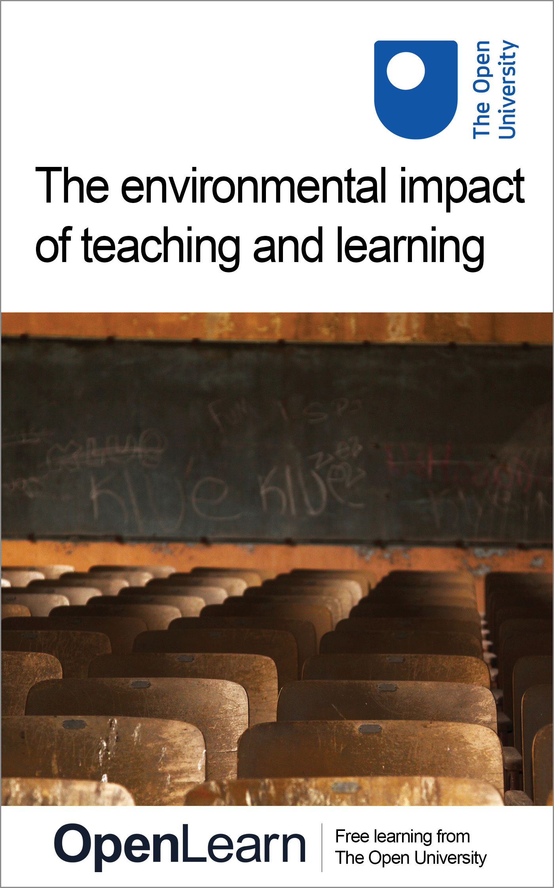

SusTEACH_1

The environmental impact of teaching and learning
About this free course
Find out more about studying with The Open University by visiting our online prospectus: www.open.ac.uk/courses
This version of the content may include video, images and interactive content that may not be optimised for your device.
You can experience this free course as it was originally designed on OpenLearn, the home of free learning from The Open University - www.open.edu/openlearn/nature-environment/the-environment/the-environmental-impact-teaching-and-learning/content-section-0.
There you’ll also be able to track your progress via your activity record, which you can use to demonstrate your learning.
Copyright © 2016 The Open University
Intellectual property
Unless otherwise stated, this resource is released under the terms of the Creative Commons Licence v4.0 http://creativecommons.org/licenses/by-nc-sa/4.0/deed.en_GB. Within that The Open University interprets this licence in the following way: www.open.edu/openlearn/about-openlearn/frequently-asked-questions-on-openlearn. Copyright and rights falling outside the terms of the Creative Commons Licence are retained or controlled by The Open University. Please read the full text before using any of the content.
We believe the primary barrier to accessing high-quality educational experiences is cost, which is why we aim to publish as much free content as possible under an open licence. If it proves difficult to release content under our preferred Creative Commons licence (e.g. because we can’t afford or gain the clearances or find suitable alternatives), we will still release the materials for free under a personal end-user licence.
This is because the learning experience will always be the same high quality offering and that should always be seen as positive – even if at times the licensing is different to Creative Commons.
When using the content you must attribute us (The Open University) (the OU) and any identified author in accordance with the terms of the Creative Commons Licence.
The Acknowledgements section is used to list, amongst other things, third party (Proprietary), licensed content which is not subject to Creative Commons licensing. Proprietary content must be used (retained) intact and in context to the content at all times.
The Acknowledgements section is also used to bring to your attention any other Special Restrictions which may apply to the content. For example there may be times when the Creative Commons Non-Commercial Sharealike licence does not apply to any of the content even if owned by us (The Open University). In these instances, unless stated otherwise, the content may be used for personal and non-commercial use.
We have also identified as Proprietary other material included in the content which is not subject to Creative Commons Licence. These are OU logos, trading names and may extend to certain photographic and video images and sound recordings and any other material as may be brought to your attention.
Unauthorised use of any of the content may constitute a breach of the terms and conditions and/or intellectual property laws.
We reserve the right to alter, amend or bring to an end any terms and conditions provided here without notice.
All rights falling outside the terms of the Creative Commons licence are retained or controlled by The Open University.
Head of Intellectual Property, The Open University
978-1-4730-0535-8 (.epub)
978-1-4730-1303-2 (.kdl)

Contents
- Introduction
- Learning outcomes
- Course overview
- Part 1: For students and lecturers or academic designers
  - 1.1 Why is it important to have more sustainable higher education teaching systems?
  - 1.2 Approaches undertaken by HE institutions to reduce carbon emissions
  - 1.3 Environmental impacts of teaching and learning activities
  - 1.4 Summary
- Part 2: For students
  - 2.1 Exploring tools to assess the carbon-based environmental impacts associated with learning activities in higher education
  - 2.2 Summary
- Part 3: For lecturers and academic designers
  - 3.1 Exploring tools to assess carbon-based environmental impacts of teaching and learning activities in higher education
  - 3.2 Summary
- Part 4: For lecturers and academic designers
  - 4.1 Examination of the carbon impacts associated with different systems and models of providing higher education teaching and learning
  - 4.2 New teaching models and how ICTs are changing higher education
  - 4.3 Types of teaching models used in higher education and their environmental impacts
  - 4.4 Exploration of tools to assess carbon-based environmental impacts of learning designs and teaching models in higher education
- What next?
- Conclusion
- Keep on learning
- Glossary
- References
- Acknowledgements

Introduction
This course examines and discusses the carbon-based environmental impacts of teaching and learning in higher education institutions. It introduces a typology for teaching models that use or do not use information and communication technologies (ICTs), and explains the factors and activities that need to be considered when assessing the carbon-based environmental impacts of different teaching models. Finally, it introduces a suite of innovative tools and resources that have been designed to help assess and identify ways to reduce these impacts.
We know that much of what we do uses energy that produces carbon dioxide and other greenhouse gases, and that we need to assess and reduce these impacts. This is covered more fully in the free course Environment: treading lightly on the earth.
We also know teaching and learning activities in higher education have a carbon impact. This is because staff and students consume energy when or if they:
- travel to and from campus, for all types of journeys, providing they don’t always travel on foot or by bicycle
- purchase and use educational materials and ICTs
- use campus facilities
- move to an additional residence away from their usual home.
This course examines the carbon-based environmental impacts of teaching and learning in higher education institutions, and a range of approaches that have been undertaken to reduce carbon emissions.
It introduces a classification of teaching models using ICTs and other teaching delivery methods for providing teaching and learning, and explains the factors and activities that need to be considered when assessing the carbon-based environmental impacts of different teaching models.
Finally, it introduces a suite of innovative tools and resources that have been designed to help assess and identify ways to reduce these impacts – first, if you are a student, and second, if you are a lecturer or academic designer in higher education (although you may also be interested in this if you teach adults in further education institutions and other settings).
This course is developed from the work of a Research and Development project at The Open University called SusTEACH (‘Sustainable Tools for the Environmental Appraisal of the Carbon Impacts of Higher Education Teaching Models.’). This work helps us to understand how different models of delivering teaching and learning affect our energy consumption and carbon impacts.
The course is UK-focused, mainly because the information on energy consumption and carbon and emissions that have been used within the project are derived from UK data sources. Students and lecturers from other countries will need to understand the UK context and compare that with the ones they are familiar with.
Find out more about studying with The Open University by visiting our online prospectus.

Learning outcomes
After studying this course, you should be able to:
- understand an overview of the factors that should be included in an assessment of the carbon-based environmental impacts of higher education (HE) – these are the main sources of energy consumption and carbon emissions in HE
- understand the types of teaching models used in higher education, how ICTs are changing them and their likely carbon impacts
- understand the likely carbon impacts associated with your studies on a higher education course or module
- apply a Carbon Calculator tool designed to assess the impacts of your study-related activities
- identify possible ways to change study-related activities to reduce carbon impacts.

Course overview

Part 1: For students, lecturers and academic designers
Part 1 introduces students, lecturers and academic designers to the key sources of energy consumption and carbon emissions in higher education, and the type of carbon reduction programmes that may be undertaken.

Part 2: For students
Part 2 provides students with an understanding of the environmental impacts associated with their learning activities.
You will explore the likely carbon impacts associated with your learning activities in higher education.
You will learn how to apply a Carbon Calculator tool that has been specifically designed to assess the impacts associated with course activities in a UK HE institution. This will help you to explore the key sources of your own carbon impacts, and how these impacts could be reduced by changing some aspects of your learning activities and use of materials.
You will be able to consider making changes to your activities to address sustainability issues.

Part 3: For lecturers and academic designers
Part 3 provides lecturers in higher education with an understanding of the environmental impacts associated with their teaching activities on courses, as well as the learning activities of their students.
You will explore the likely carbon impacts associated with your teaching activities in higher education. You will also be able to help students on your courses to explore the key sources of carbon impacts associated with their learning.
You will learn how to apply two Carbon Calculator tools that have been specifically designed to assess the impacts associated with course activities in a UK HE institution.
You will be able to consider how these impacts could be reduced by changing some aspects of your course-related activities and use of materials to address sustainability issues.

Part 4: For lecturers and academic designers
Part 4 examines the carbon-based environmental impacts associated with different systems and models of providing higher education teaching and learning.
It introduces a classification for HE teaching models that are using ICTs and other teaching delivery methods, and explains the factors that need to be considered when designing and developing more sustainable higher education teaching models.
It introduces a suite of innovative tools which have been designed to help you to explore and assess the likely carbon impacts associated with the teaching models underpinning your work on courses and qualification programmes.
You will be able to explore these tools and assess key sources of energy consumption and carbon impacts associated with your model of teaching in HE.
Using the tools will help you to identify how these impacts could be reduced with new teaching and learning designs and to develop your thinking about sustainability in higher education.

Part 1: For students and lecturers or academic designers

1.1 Why is it important to have more sustainable higher education teaching systems?
Greening higher education (HE) teaching systems is part of government strategies to reduce carbon emissions and meet the challenges of climate change (Higher Education Funding Council for England (HEFCE), 2010). Following the 2008 Climate Change Act, the UK government set demanding targets to reduce CO₂ and other greenhouse gas emissions by 34 per cent by 2020 and by 80 per cent by 2050 compared with 1990 levels (HM Government, 2009).
National strategies need to be translated into institutional targets. HE institutions are consequently required to monitor the energy consumption and carbon emissions associated with estates management on an annual basis and to return this data to the Higher Education Statistics Agency (HESA).
HE institutions are taking a variety of actions to reduce their sources of carbon emissions.

1.2 Approaches undertaken by HE institutions to reduce carbon emissions

SAQ 1

Can you think of some ways that your institution is tackling environmental impacts and trying to reduce sources of carbon emissions?

View answer - SAQ 1

The focus in HE has been mainly on greening campus buildings. This is achieved by, for example, improving buildings insulation and installing energy efficient lighting, heating systems, controls and other energy efficient equipment. It may also be achieved by installing renewable technologies, such as solar water heating, biomass boilers, photovoltaic (PV) panels and micro-wind turbine systems.
Sustainability programmes often cover more than simply greening buildings and technology. For example, here is a short video about The Open University’s carbon reduction programme, introduced by the Energy Manager, Mike Sackett.

Video content is not available in this format.
Carbon reduction programmes at The Open University
View transcript - Carbon reduction programmes at The Open University

Box 1 Carbon-reduction programmes at The Open University
The Open University (OU) is undertaking a programme of carbon-reduction schemes throughout its estate to meet government targets. This includes measures to improve the thermal insulation of buildings and the installation of microgeneration heating systems, such as a ground source heat pump system, and other efficient equipment to support the operation of ICT systems, such as chillers and compressors.
Some renewable technologies have been also been installed, such as PV (photovoltaic) panels that provide a small fraction of the OU’s electricity requirements. Another initiative replaced essential streetlights with LED (light-emitting diode) lighting and switched off non-essential car park lights. 'This alone reduced emissions by 112 tonnes of CO₂ over a year'.
Other sustainability initiatives have reduced water use, and the amount of waste sent to landfill has been significantly reduced as a result of the introduction of various waste management schemes.
The carbon reduction programme of initiatives is ongoing as the OU strives to achieve significant carbon reductions.

Many HE institutions, including The Open University, have sustainability policies that address wider sources of carbon impacts covering transport, procurement of products and services and ICT systems, and seek a wide engagement of staff and students with the implementation of sustainability initiatives. Such initiatives include the reduction of waste, energy and paper consumption, and the promotion of sustainable travel plans, as well as considering the different sources of energy.
There are a number of free courses covering these topics in details such as An introduction to sustainable energy and Why sustainable energy matters. For further reading on carbon reduction initiatives, see the Carbon Trust’s higher education case studies.
A big contribution from many HE institutions and colleges is the development of teaching about sustainability as part of some undergraduate and postgraduate programmes covering design, technology, science and engineering. This is also incorporated into staff development and training in some institutions. More details can be found in the Education for Sustainable Development initiative.
In this section, you have learned that HE institutions are engaged in carbon reduction programmes to:
- ‘green’ the buildings and technologies in campus estates
- establish and implement sustainability policies that cover transport, ICT systems, buildings and energy use, the procurement of products and services, and waste and water management
- engage staff and students with sustainability initiatives
- teach about sustainability in the curriculum.
A report from the Global University Network claims that the challenges of supporting the transition to sustainable higher education have not yet been fully addressed (Tilbury, 2011).
So what other measures may be taken to help achieve carbon reduction in higher education? To answer this we need to focus on one of its primary activities: teaching and learning.

1.3 Environmental impacts of teaching and learning activities
Carbon reduction begins with the actions of individuals. To help achieve carbon reduction, we need to explore and consider what actions may be taken by students and lecturers to reduce the impact of teaching and learning activities.

SAQ 2

List the main sources of the energy consumption and carbon emissions you think are associated with your teaching or learning activities.

View answer - SAQ 2

1.4 Summary
Part 1 has introduced you to the main sources of carbon emissions in higher education and some institutional approaches to carbon reduction programmes. You have learned to think about the contribution of your own learning and teaching activities to carbon emissions, and to consider types of actions that may be taken by students and lecturers to reduce energy consumption.

Part 2: For students

2.1 Exploring tools to assess the carbon-based environmental impacts associated with learning activities in higher education
Here we introduce a Carbon Calculator tool for students that you can use to explore and calculate the energy consumption and carbon impacts associated with your learning activities on a particular course or module. (The principles behind such calculators and related ecological foot printing tools are discussed in Environment: treading lightly on the earth which is also available via iTunes U.)
This Carbon Calculator was designed for the SusTEACH sustainable teaching and learning project at the OU and is part of the SusTEACH toolkit. It is based on a detailed environmental assessment methodology to examine the key sources of energy consumption and carbon impacts associated with learning activities, including travel, the purchase and use of ICT devices and educational materials, and choice of residential accommodation and the type of higher education system.
The SusTEACH calculator was developed following a review of the most up-to-date and well-researched studies to establish measures of the sources of energy consumption in megajoules (MJ), and carbon emissions in kilograms of carbon dioxide (kg CO₂).
Your energy consumption and carbon impact is measured against the CATS credits (or hours of study) that are applicable to a course and related to the duration of the course that you are taking. The Carbon Calculator measures the impacts of learning activities associated with a course on energy consumption and CO₂ emissions using a standard measure of energy consumption (MJ) and CO₂ emissions (kg) ‘per student per 10 CATS credits’ (equivalent to 100 study hours) for the course.
Before exploring this tool, first watch the video introducing The SusTEACH Carbon Calculator

Video content is not available in this format.
The SusTEACH Carbon Calculator
View transcript - The SusTEACH Carbon Calculator

SAQ 3

Explore the SusTEACH Carbon Calculator tool to calculate the energy consumption and carbon impacts of your own learning activities on a course.

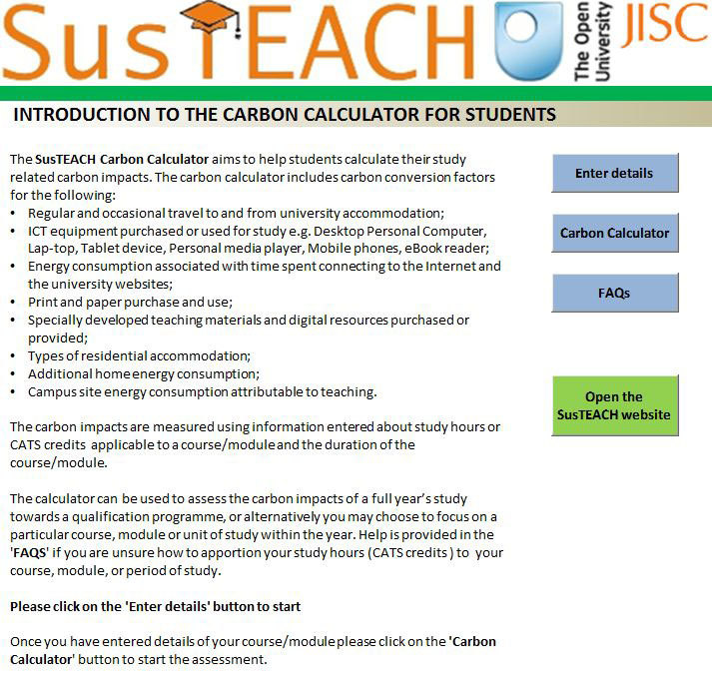
Figure 1

Download or open the SusTEACH Carbon Calculator for Students in Microsoft Excel to begin exploration.
You should find the tool easy to use but the user guide is available to help you to navigate through the tool if you need additional help.

View answer - SAQ 3

This example shows that there may be trade-offs between a decision to reduce residential energy consumption by living at home during studies and the consequences for travel-related impacts. This shows that when making changes to your learning-related activities, it is important to consider the trade-offs between decisions and the knock-on effects on carbon emissions.
You may like to explore the tool further to see what difference it makes if you decide to make any changes to your activities:
- Travel: What difference does it make if you reduce some of your journeys or use different modes of transport? You may be aware that different modes of travel have different carbon impacts. For example, diesel cars have lower carbon emissions per passenger mile than cars with equivalent-sized engines using petrol or LPG fuels. Travel by express coach has lower carbon emissions than rail travel per passenger mile.
- ICT devices: Does it make a difference if you purchase different ICT devices to support your learning activities? Using the calculator shows that the carbon emissions produced from using a tablet for 100 study hours based on lifecycle studies is a quarter of the emissions associated with using a desktop PC. You could also explore if reducing your use of ICT devices would make much difference to your overall impacts associated with your course activities.
- Paper and print: You may explore what difference it would make to your carbon impact if you reduced your use of paper for note-taking, printing or photocopying, or other educational materials.
- Residential energy use: What difference would it make if you stayed in your usual home during your course rather than moving to live in university accommodation or another additional residence? This would eliminate most of the energy consumption associated with a second home, although it may increase your regular travel impacts.
You can also use the calculator to explore the impacts of using different fuels and systems to heat your home. What difference would it make if your home was heated by oil compared with an efficient condensing boiler?
- Campus site operations: You can explore the impacts of studying at different types of HE institutions. The calculators use information based on the average energy consumption associated with campus-based and distance teaching institutions. Distance-teaching HE systems have higher numbers of students learning on each course, so this achieves efficiencies of scale, which results in lower carbon emissions per student in UK institutions.
When you have finished exploring the Carbon Calculator tool you should have some ideas for actions to lower the carbon emissions of your learning activities. For example, perhaps you could use less carbon-intensive modes of travel, reduce the number of journeys or consider sharing journeys to divide and reduce your individual carbon impacts. Try to think of some actions that you could take to reduce the energy consumption and carbon emissions of your learning activities.

2.2 Summary
Part 2 has given you an opportunity as a student to explore some of the environmental impacts associated with your learning activities in higher education.
You have considered the key sources of your own energy consumption and carbon impacts, and how these impacts could be reduced by changing some aspects of your learning activities, and use of ICT devices and materials. Your explorations of the Carbon Calculator tool have given you an opportunity to consider the effect of making a large number of changes to your learning activities, and to explore the consequences of doing different learning-related activities.
The SusTEACH Carbon Calculator for Students is available to support sustainability initiatives with students as part of institutional programmes to ‘green’ higher education systems and you may want to recommend its use to your fellow students or to your teachers. This tool may be used to support teaching about sustainability within the curriculum and is also useful for collecting data on the carbon impacts of learning activities within UK higher education.
As a student you have completed the learning provision that has been designed to teach you about the environmental impacts associated with learning in higher education. Parts 3 and 4 consider the environmental impacts of teaching activities and different higher education systems and teaching models, and are mainly aimed at lecturers and academic designers studying on this course.

Part 3: For lecturers and academic designers

3.1 Exploring tools to assess carbon-based environmental impacts of teaching and learning activities in higher education
Here we introduce two Carbon Calculator tools that you can use to explore and calculate the energy consumption and carbon impacts associated with your teaching activities and learning provision on a particular course. (The principles behind such calculators and related ecological foot printing tools are discussed in Environment: treading lightly on the earth which is also available via iTunes U.)
These are part of the SusTEACH toolkit, which was designed for the SusTEACH sustainable teaching and learning project at the OU.
This includes the Carbon Calculator presented to students in Part 2 of this course. The SusTEACH Carbon Calculator for Students is presented here as a resource for lecturers to help students to explore and calculate the key sources of energy consumption and carbon impacts associated with their learning activities on a course.
A second Carbon Calculator (the SusTEACH Carbon Calculator for Lecturers) is introduced with a similar design, aimed at lecturers teaching in higher education at undergraduate or postgraduate level in a campus-based university or with a distance learning provider.
Both of these tools could be used together to provide a full carbon-based environmental assessment of your course. If you would like to calculate the total carbon impacts associated with teaching and learning on your course/module, you could use these tools to collect data on your students’ impacts and your impacts as a lecturer. The calculators both use the ‘per student per 100 hours/10 CATS credits’ measure of energy consumption and carbon impacts, and this makes it easy to collect comparable data for review on an annual basis.

3.1.1 Background to the SusTEACH Carbon Calculators
The SusTEACH Carbon Calculators were developed from a detailed environmental assessment methodology to examine the key sources of energy consumption and the related carbon impacts associated with teaching and learning activities. The carbon calculation is based on information provided by lecturers and/or students on their course-related activities, including travel, the purchase and use of ICT devices and educational materials, and choice of residential accommodation and type of higher education system.
The Carbon Calculator for Lecturers requests additional details about teaching-related activities, such as the number of study hours (or CATS credits) planned for the course and its duration, the number of students that studied on the course during the previous academic year, and the proportion of time spent teaching the specific course as opposed to doing other teaching or work. The information that you provide is combined by the Carbon Calculator to apportion your impacts to the specific course.
The SusTEACH calculators were developed following a review of the most up-to-date and well-researched studies to establish measures of the sources of energy consumption in megajoules (MJ), and carbon emissions in kilograms of carbon dioxide (kg CO₂).
The calculators mainly use measures of delivered energy and direct greenhouse gas (GHG) emissions of fossil fuels at the point of use, derived from UK government sources (see AEA, 2011). The calculators also use measures derived from lifecycle studies of the embodied energy consumption and related carbon emissions of paper, printed materials and ICT equipment. (Further information is provided in The SusTEACH Methodology, which is a detailed resource on conducting a carbon-based environmental impact assessment of HE courses and modules.)
The calculators use information based on the average energy consumption associated with campus-based and distance teaching institutions to calculate the carbon impacts of campus operations. As a lecturer, you may have energy data that is specific to your institution that you would prefer to use instead for this part of the calculation.
The calculators measure energy consumption and carbon impact against the CATS credits (or hours of study) that are applicable to a course and related to the duration of a course. The Carbon Calculators measure the impacts of teaching or learning activities associated with a course on energy consumption and CO₂ emissions using a standard measure of energy consumption (MJ) and CO₂ emissions (kg) ‘per student per 10 CATS credits’ (equivalent to 100 study hours) for the course.
Before exploring this tool, first watch the video introducing the SusTEACH Carbon Calculators for Lecturers and for Students.

Video content is not available in this format.
The SusTEACH Carbon Calculator
View transcript - The SusTEACH Carbon Calculator

3.1.2 Exploring the SusTEACH Carbon Calculator for Students

SAQ 4

Explore the SusTEACH Carbon Calculator tool with your students to calculate the energy consumption and carbon impacts associated with their learning activities on a course.

Figure 2

Download or open the SusTEACH Carbon Calculators for students in Microsoft Excel to begin exploration.
Students should find the tool easy to use but the user guide is available to help to navigate through the tool.

View answer - SAQ 4

This example shows that there may be trade-offs between a decision to reduce residential energy consumption by living at home during studies, which could increase travel impacts. Equally there may be other trade-offs, such as between the use of paper and print and the option of reading and writing on screen using ICT devices.
You can help students to explore the impacts of making changes to learning-related activities and to consider the trade-offs between the decisions they make and the knock-on effects on carbon emissions.

3.1.3 Exploring the SusTEACH Carbon Calculator for Lecturers
Here you will explore the Carbon Calculator for Lecturers, which has a similar design to the Carbon Calculator for Students.

SAQ 5

Explore the SusTEACH Carbon Calculator for Lecturers to calculate the energy consumption and carbon impacts of your teaching activities on a course.

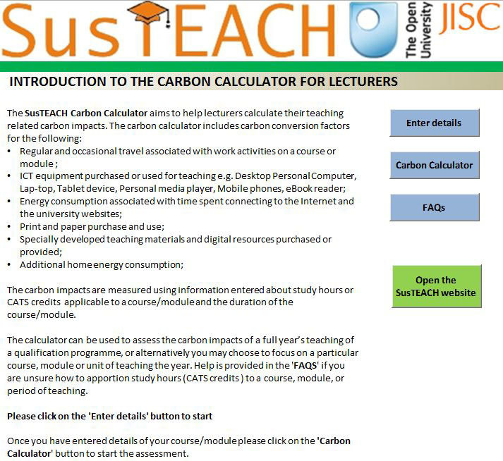
Figure 3

Download or open the SusTEACH Carbon Calculator for Lecturers in Microsoft Excel.
You should find the tools easy to use, but the user guide is available to help you to navigate through the tool if you need additional help.

View answer - SAQ 5

This example shows that it is important to consider the measures used in Carbon Calculators. The SusTEACH Carbon Calculator for Lecturers divides the lecturer’s energy consumption and carbon impacts by the number of students on a course to calculate the impacts using the ‘per student’ measure. This means that when there is a greater number of students on the course benefiting from the lecturer’s activities to deliver the teaching, learning and assessment provision, there are efficiencies of scale using the ‘per student’ measure.
As a lecturer, you may prefer to use a ‘per lecturer’ measure rather than the ‘per student’ measure, as this would allow you to see a greater difference to your carbon impacts if you decided to change some of your teaching-related activities. The ‘per student’ measure however, allows you to combine data collected from students and lecturers on a course. It also helps to consider the efficiencies of scale when there are larger numbers of students on courses which are also related to economies of scale.

3.1.4 Explore the tools further
You may like to explore the tools further yourself and with your students to explore what difference it makes if you or they decide to make any changes to teaching and learning activities:
- Travel: What difference does it make if you reduce some of your journeys or use different modes of transport? You may be aware that different modes of travel have different carbon impacts. For example, diesel cars have lower carbon emissions per passenger mile than cars with equivalent-sized engines using petrol or LPG fuels. Travel by express coach has lower carbon emissions than rail travel per passenger mile.
- ICT devices: Does it make a difference if you purchase different ICT devices to support your learning activities? Using the calculator shows that the carbon emissions produced from using a tablet for 100 study hours based on lifecycle studies is a quarter of the emissions associated with using a desktop PC. You could also explore if reducing your use of ICT devices would make much difference to your overall impacts associated with your course activities.
- Paper and print: You may explore what difference it would make to your carbon impact if you reduced your use of paper for note-taking, printing or photocopying, or other educational materials.
- Residential energy use: You may explore the impacts of using different fuels and systems to heat your home. What difference would it make if your home was heated by oil compared with an efficient condensing boiler?
Students in particular should explore the impacts associated with studying while living from their usual home compared with moving to live in university accommodation or another additional residence. This would eliminate most of the energy consumption associated with a second home, although it may increase regular travel impacts.
- Campus site operations: You can also explore the impacts of campus site operations associated with different systems of higher education and attributable to teaching. The calculators use information based on the average energy consumption associated with campus-based and distance teaching institutions. Distance-teaching HE systems have higher numbers of students learning on each course, so this achieves efficiencies of scale, which results in lower carbon emissions per student in UK institutions.
You can also explore whether any planned changes to reduce carbon-based environmental impacts would help to reduce financial costs, for both the individual student or lecturer and the academic institution.
When you have finished exploring the Carbon Calculator tools you should have some ideas for actions to lower the carbon emissions of your teaching and your student’s learning activities. For example, perhaps you could use less carbon-intensive modes of travel, reduce the number of journeys or consider sharing journeys to divide and reduce your individual carbon impacts. Try to think of some actions that you could take to reduce the energy consumption and carbon emissions of your teaching and learning activities. Planned changes need to be sustainable in the wider sense, in terms of environmental, economic and social sustainability.

3.2 Summary
Part 3 has given you an opportunity as a lecturer to explore some of the environmental impacts associated with teaching and learning activities in higher education, using Carbon Calculator tools to assess the impacts associated with course-related activities in higher education.
You have considered the key sources of carbon impacts, and how these impacts could be reduced by changing some aspects of teaching and learning activities, and use of ICT devices and materials.
Your explorations of the Carbon Calculator tools have given you an opportunity to consider the effect of making a large number of changes to teaching and learning activities, and to explore the consequences and trade-offs between different course-related activities.
Exploration of the Carbon Calculator for Lecturers shows that there are scale effects associated with larger numbers of students benefitting from a planned teaching, learning and assessment provision, resulting with carbon reductions per student.
Both Carbon Calculator tools are available to help with data collection on the carbon impacts associated with your course. This helps to begin to plan changes to the design of your teaching and learning provision to achieve carbon reductions associated with your own and your student’s activities.
The actions of individuals to reduce carbon emissions are limited by the way that teaching and learning is organised and provided by your HE institution. Part 4 considers the environmental impacts of different higher education systems and teaching models promoted within institutions.

Part 4: For lecturers and academic designers

4.1 Examination of the carbon impacts associated with different systems and models of providing higher education teaching and learning
Teaching and learning is the core business of higher education. And yet the design of teaching and learning in HE institutions can lock staff and students into making unnecessary carbon impacts.
It is notable that there have been few studies examining the carbon impacts of different systems and models of delivering higher education. This is partly due to the complexity in higher education systems of delivering teaching and learning that can make it difficult to carry out a carbon-based environmental assessment.
Such studies would help to understand the impacts of different learning designs and identify the key sources of energy consumption and carbon emissions associated with teaching and learning.
The first major quantitative study to assess the environmental impacts of different systems of delivering higher education in UK institutions was the Factor 10 Visions study of sustainable higher education (Roy et al., 2005). This developed a methodology to assess the energy consumption and carbon impacts of courses provided within campus-based and distance-taught higher education systems in the UK.
Historically, campus-based and distance teaching HE systems have been very different HE teaching systems and consequently might be expected to have different environmental impacts.

SAQ 6

Try to identify the main characteristics of different campus-based or distance-based HE teaching systems, and consider whether this is likely to have different environmental impacts.

View answer - SAQ 6

Here is a short video introduced by Professor Stephen Potter about the Factor 10 project and findings on the environmental impacts of different higher education systems.

Video content is not available in this format.
Environmental impacts of different higher education systems
View transcript - Environmental impacts of different higher education systems

The Factor 10 study found that on average the production and delivery of distance teaching consumed nearly 90% less energy and produced 85% fewer CO₂ emissions than campus-based HE courses and modules. Distance-teaching HE systems have higher numbers of students learning on each course, so this achieves efficiencies of scale, which results in lower carbon emissions per student. The much lower energy impacts of distance-taught courses was found to be mainly due to a large factor 10 reduction in student’s need to utilize campus site facilities, as well as their need to travel and use additional housing during their studies.
Since this study was conducted, UK higher education has been transformed by the use of ICTs such as the digital resources and technologies utilised for the preparation, administration, teaching and learning on courses. This is supported by the widespread deployment of ICT-based infrastructure, such as virtual learning environments (VLEs), local area networks, wireless networks and cloud computing services. This infrastructure includes the equipment and networks that support platforms housing educational content, tools and applications within learning systems, or hosted separately on ICT devices, including personal computers, laptops, tablet devices, smartphones and software etc. (If you want to learn more about ICT devices and learning then look at the free courses Living with the internet: learning online or ICTs in everyday life).
The next sections explore the types of teaching models used in higher education and how they are being transformed by the use of ICTs. This helps to consider the impacts of different educational designs and whether the greater use of ICTs in higher education teaching has a better or worse environmental impact compared with more traditional teaching models.

4.2 New teaching models and how ICTs are changing higher education
Experimentation with the use of ICTs has led to technology-enhanced teaching and learning provision (see Jisc). This is supported by VLEs that many HE institutions now have to support their qualification programmes. A typical VLE provides students with online access to materials in electronic format, such as lecture or tutorial documents, assignments, and timetables, and offers forums for discussions.
In addition, a wide range of ICTs may be used to support and/or transform:
- teaching, such as providing guidance, support and content
- learning, such as supporting student thinking, reflection, learning and work on assignments
- communication between staff and students, and between students on learning activities
- assessment of evidence and enabling demonstrations of students’ learning.

SAQ 7

Thinking about your experience of teaching and learning on a course or module, have you had experience of using ICTs to provide teaching, learning and assessment? Was this part of an educational programme to provide online teaching and learning? Can you give any specific examples of ICTs that were used to support this provision?

View answer - SAQ 7

ICTs such as these offer learners the type of personalised online learning experiences that were only previously available in the classroom, as well as the benefits of being able to learn flexibly by reducing the effect of temporal and location differences between teachers and students. Richer media allow students to go beyond simply accessing educational content to be able to produce and record their learning online and collaborate with others on learning activities. ICTs open opportunities for students to learn at any time, in any place, at any pace and using multiple ICT devices.
To find out more about potential applications of key emerging ICTs for teaching and learning, there are annual reviews in the New Medium Consortium Horizon reports (Johnson et al., 2012) and the Open University report Innovating Pedagogy (Sharples et al., 2012).

4.3 Types of teaching models used in higher education and their environmental impacts
So how is the use of ICTs changing teaching models in higher education? A teaching model is defined by the primary way that teaching, learning and assessment is delivered to students on a course or module within a qualification programme. The use of ICTs is changing teaching and leading to pedagogical innovation.
In some cases, traditional face-to-face and even distance teaching methods are being replaced with radically new online learning designs. For example, some institutions are publishing and/or developing courses based on openly licensed online education resources (OERs), such as much of the content on OpenLearn; other institutions are now offering the free-to-join massive open online courses (MOOCs) that support global online learning communities and help learners to contribute to producing educational resources and services. (The Open University is developing MOOCs in collaboration with several other UK universities through the Futurelearn platform).
Other, less radical, approaches blend online teaching with traditional approaches to create new hybrid teaching models.

SAQ 8

What type of teaching model broadly describes your experience of providing teaching, learning and assessment provision? Do you mainly use face-to-face teaching or distance teaching methods or ICTs for some of this provision? Or does it use a blend of these methods?

View answer - SAQ 8

The pervasiveness and potential applications for using ICTs in higher education raises questions about whether the greater use of ICTs for teaching and learning provision has better or worse environmental impacts than more traditional teaching models. This was why the SusTEACH project examined the role of ICTs in HE teaching models and their effect on carbon reduction. This study involved a carbon-based environmental assessment and data analysis of 30 courses across UK institutions, representing a range of teaching models.
You should now watch a short video with Dr Sally Caird that introduces the SusTEACH sustainable teaching and learning project.

Video content is not available in this format.
The SusTEACH project
View transcript - The SusTEACH project

The SusTEACH project collected and assessed data on the course-related activities of students and lecturers, using the approach to carbon assessment encapsulated in the Carbon Calculator tools (see Part 3). This covered the key sources of carbon impacts associated with higher education teaching, such as staff and student travel, the purchase and use of educational materials and ICT devices, residential energy consumption, and campus site operations.
This approach provided the average environmental impacts of a course, expressed using a standard measure of energy consumption (MJ) and CO₂ emissions (kg) ‘per student per 10 CATS credits’, which is equivalent to 100 study hours. Lecturers’ assessments were used to classify the different types of teaching delivery models to allow further analysis and comparisons of environmental impacts across a range of HE teaching models.

SAQ 9

Based on what you have already learned in this course, what would you expect the relative contributions of travel, residential energy consumption, campus-based operations, paper and print materials, and ICT devices to the energy consumption and carbon impacts of HE teaching and learning?

View answer - SAQ 9

Overall, SusTEACH found that the use of online and ICT-enhanced teaching delivery methods, as well as traditional distance teaching methods, reduced the key sources of energy consumption and therefore achieved significant carbon reductions. The lowest carbon emissions were achieved using an online teaching model and were on average 87 per cent lower than the face-to-face teaching model, which, compared with other teaching models, had the highest carbon impacts.
In the online teaching model the carbon impacts associated with the purchase and use of ICT devices were higher, as expected, although this was offset by lower overall impacts. The online teaching model had lower impacts associated with the reduced use of paper and printed materials and a dematerialisation effect of using ICTs, although this was not the main reason for the lower carbon impacts. The main reasons for the lower carbon impacts were due to:
- the reduced need for students to travel as part of their studies
- the reduced need for students to consume more energy in residences whilst living away from their usual home
- the reduced energy consumption per student associated with university site operations.
SusTEACH also found that distance education systems of HE teaching reduced these sources of energy consumption and therefore achieved an average of 83 per cent fewer CO₂ emissions than campus-based systems. These results were similar to the findings from the Factor 10 study (Roy et al., 2005).
The key challenges when designing sustainable education are to:
- reduce the requirement for students to travel to classrooms using carbon-intensive modes of travel
- take additional residential accommodation away from home
- use campus facilities most efficiently.
The use of online, ICT-enhanced and distance teaching methods can reduce these sources of energy consumption and therefore help to significantly reduce carbon emissions.

4.4 Exploration of tools to assess carbon-based environmental impacts of learning designs and teaching models in higher education
Here we introduce the SusTEACH Planning and Modelling Tools, which are designed to support the planning of more sustainable courses, modules and qualification programmes, and are part of the SusTEACH toolkit. These tools were developed by modelling the energy consumption and carbon impacts found in the SusTEACH study associated with specific teaching delivery methods, including face-to-face, online, ICT-enhanced and traditional print-based distance teaching methods.
The tools provide measures of the environmental impacts of teaching model designs using a standard measure of energy consumption (MJ) and CO₂ emissions (kg) ‘per student per 10 CATS credits’, which is equivalent to 100 study hours. Before exploring these tools, first watch the video introducing The SusTEACH Toolkit:

Video content is not available in this format.
The SusTEACH Toolkit
View transcript - The SusTEACH Toolkit

4.4.1 Exploring the online SusTEACH Planning Tool
The SusTEACH Planning Tool is a quick tool to use. It provides feedback on your proposed teaching model design, which it compares with the main findings from the SusTEACH project on the carbon impacts of HE teaching.

Explore the SusTEACH Planning Tool

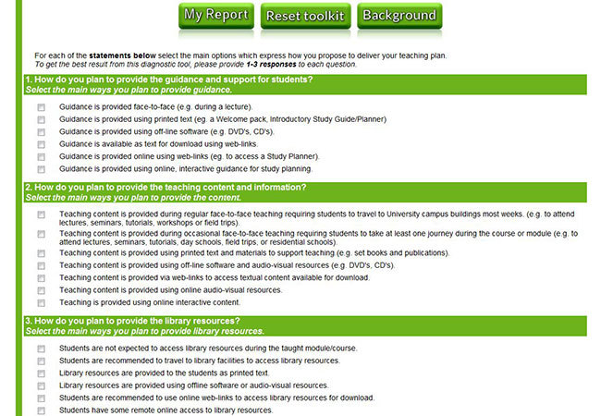
Figure 5

Explore the SusTEACH Planning Tool. [right click and select 'Open In New Window' to view this link]
How do you plan to provide teaching, learning, assessment and communication on a course? Use the Planning Tool to describe your teaching and learning design on a new or existing course, and consider the likely carbon impacts.

View answer - Explore the SusTEACH Planning Tool

You can also explore this tool further by varying your teaching and learning design, and seeing how changing the design affects the likely carbon impacts as estimated from the SusTEACH findings.
What difference would it make if you replaced some face-to-face teaching with an online learning provision? When planning the teaching provision it is important to note the impact of face-to-face teaching provision on the requirement for students to travel and establish residential accommodation during their studies which have significant carbon impacts. A higher face-to-face teaching provision usually creates greater energy demands on university site facilities as well.
Are there any changes you could make to the design of teaching and learning provision to reduce the requirement for students to make journeys, travel long distances and live away from their usual home during their studies?

4.4.2 Exploring the SusTEACH Modelling Tool
The SusTEACH project found considerable variation in the transport impacts of teaching models with a high face-to-face teaching component. This was explained by the significant impact of student travel by plane to attend courses. The findings consequently showed that there is not a clear mapping of the impacts of teaching delivery methods on energy consumption and carbon emissions.
The SusTEACH Modelling Tool allows more sensitive modelling of differences within a teaching model design based on the SusTEACH findings and estimates the likely associated energy consumption and carbon emissions. As a lecturer, academic designer or qualification director you can explore the two functions of this tool:
- You can model the energy impacts of a new or existing course by selecting your main teaching delivery methods to describe your teaching model and calculate the energy impacts associated with your course. You can also estimate the impacts of a full qualification programme of courses with similar teaching models and designs.
- You can model the energy impacts of a qualification programme that includes several courses with different teaching models.

SAQ 10

Explore the SusTEACH Modelling Tool. Estimate and model the likely energy consumption and carbon impacts associated with your design for a course, module or full qualification programme.

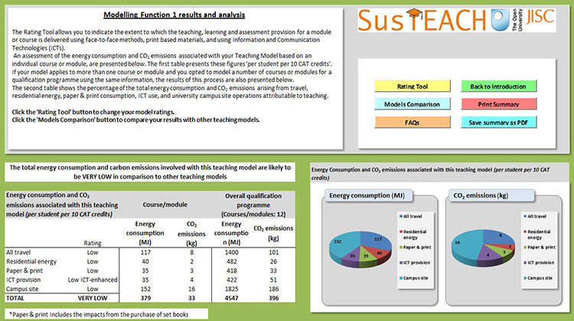
Figure 7

Download or open the SusTEACH Modelling Tool.
The user guide is available to help you to navigate through the tool if you need additional help.

View answer - SAQ 10

You can also explore this tool further by varying your teaching and learning design for a full qualification programme, and identify how changing this design affects the likely carbon impacts, as estimated from the SusTEACH findings.
What difference would it make if you designed a qualification programme to have more online courses to replace courses taught face-to-face or using distance teaching methods?
Are there any changes you could make to the design of teaching and learning provision to reduce the requirement for students to make journeys, travel long distances and live away from their usual home during their studies?

What next?
The SusTEACH toolkit is available to support sustainability initiatives with students and teachers as part of institutional programmes to ‘green’ higher education systems, and to develop more sustainable teaching and learning designs.
If you are a student, you may wish to:
- recommend the SusTEACH Carbon Calculator for Students to fellow students and compare the energy consumption and carbon impacts of your learning-related activities.
If you are a lecturer or academic designer, you may wish to:
- recommend the tools that compare the energy consumption and carbon impacts of teaching and learning models and activities to fellow lecturers
- use the Carbon Calculator to support teaching students about sustainability within the curriculum
- use the Carbon Calculators to support data collection on the carbon impacts associated with HE teaching and learning activities
- use the SusTEACH toolkit to continue exploring what type of changes to the design of higher education teaching models could make a significant contribution to the reduction of carbon impacts, while maximising the benefits of higher education for students
- use the SusTEACH Planning and Modelling Tools to examine the key issues in the design and delivery of teaching and learning on both courses and full qualification programmes – these tools could also be used to support teaching about sustainability on staff development and induction programmes
- suggest to your university’s senior management that they should investigate how the tools might be used to complement other sustainability measures.
Here is a short video about The Open University’s immediate plans for implementing the SusTEACH toolkit within a number of sustainability initiatives to support the ‘greening’ of qualification programmes, presented by Professor Andy Lane.

Video content is not available in this format.
Applications for the SusTEACH toolkit
View transcript - Applications for the SusTEACH toolkit

Conclusion
In Part 4 you have examined the carbon-based environmental impacts associated with different systems and models of providing higher education teaching and learning. You have been able to consider the transformative effect of using ICTs in HE teaching and learning, and have been introduced to a classification of HE teaching models using various teaching delivery methods, including ICT-enhanced and online methods as well as traditional face-to-face teaching and distance teaching methods.
You have been introduced to the SusTEACH research findings on the carbon impacts of HE teaching models and learned about the factors that need to be considered when designing and developing more sustainable higher education teaching models.
You have been able to explore and use the SusTEACH Planning and Modelling Tools to assess the likely energy consumption and carbon impacts associated with the teaching model underpinning your work on courses and qualification programmes. You have been able to use these tools to consider how these impacts could be reduced with changes to the design of teaching and learning in your HE institution.

Keep on learning



Study another free course
There are more than 800 courses on OpenLearn for you to choose from on a range of subjects.
Find out more about all our free courses.

Take your studies further
Find out more about studying with The Open University by visiting our online prospectus.
If you are new to university study, you may be interested in our Access Courses or Certificates.

What’s new from OpenLearn?
Sign up to our newsletter or view a sample.

For reference, full URLs to pages listed above:
OpenLearn – www.open.edu/openlearn/free-courses
Visiting our online prospectus – www.open.ac.uk/courses
Access Courses – www.open.ac.uk/courses/do-it/access
Certificates – www.open.ac.uk/courses/certificates-he
Newsletter – www.open.edu/openlearn/about-openlearn/subscribe-the-openlearn-newsletter

Glossary
CATS
The standard UK Credit Accumulation and Transfer Scheme (CATS) is a system of HE institutional arrangements for measuring student progression towards defined learning outcomes and qualifications. This provides a time-based measure of teaching and learning (see the Quality Assurance Agency for Higher Education). One CATS credit is equivalent to ten hours’ total study, including writing assignments, field work, etc. The CATS system calculates that 360 CATS credits are required for an undergraduate degree and 180 credits for a masters degree.
course
The terms ‘course’ and ‘module’ are used both within and across HE to refer to a set of modular, standardised, independent or interrelated teaching units that, when combined, construct a undergraduate or postgraduate degree qualification. Degree programmes may also be called ‘courses’ but to avoid confusion, the term ‘course’ is used hereafter in the first sense to refer to both courses and modules.
ICTs
Information and communication technologies (ICTs) refer to digital resources and technologies utilised for preparation, administration, teaching and learning on courses and modules that are supported by ICT infrastructure and devices, including personal computers, laptops, tablet devices, smart phones and software, etc.
sustainability
This refers to environmental sustainability, which includes the reduction of negative environmental impacts, including greenhouse gas emissions, consumption of natural resources, waste generation and the protection of biodiversity. The term ‘sustainability’ also has a wider use that covers economic and social success criteria that are also important for sustainable higher education.

References
AEA (2011) 2011 Guidelines to Defra/DECC’s GHG Conversion Factors for Company Reporting, Department of Energy & Climate Change (DECC) and the Department of Environment, Food and Rural Affairs (Defra).
Caird, S., Swithenby, E. and Lane, A. (2012) The SusTEACH Methodology: Assessment of the Environmental Impacts of Higher Education Teaching Models and Development of an Environmental Appraisal Toolkit, The Open University, June.
Higher Education Funding Council for England (HEFCE) (2010) Higher Education Funding Council for England: Carbon Reduction Target and Strategy for Higher Education in England, January. Available from: http://www.hefce.ac.uk/media/hefce1/pubs/hefce/2010/1001/10_01a.pdf (accessed 13 March 2013).
Higher Education Statistics Agency (2011) Estates Management Statistics: Environmental Information 2009/10.
HM Government (2009) Building a Low‐carbon Economy: Implementing the Climate Change Act 2008, HM Treasury, April. Available from: http://webarchive.nationalarchives.gov.uk/+/http:/www.hm-treasury.gov.uk/bud_bud09_carbon.htm (accessed 13 March 2013).
Johnson, L., Adams, S. and Cummins, M. (2012) The New Media Consortium Horizon Report: 2012 Higher Education Edition, Austin, Texas. Available from: http://www.nmc.org/pdf/2012-horizon-report-HE.pdf (accessed 13 March 2013).
Roy, R., Potter, S., Yarrow, K. and Smith, M. (2005) Towards Sustainable Higher Education: Environmental Impacts of Campus-based and Distance Higher Education Systems, Design Innovation Group/Factor 10 Visions Project, The Open University, March. Available from: http://www3.open.ac.uk/events/3/2005331_47403_o1.pdf (accessed 13 March 2013).
Sharples, M., McAndrew, P., Weller, M., Ferguson, R., FitzGerald, E., Hirst, T., Mor, Y., Gaved, M. and Whitelock, D. (2012) Innovating Pedagogy 2012: Exploring New Forms of Teaching, Learning and Assessment to Guide Educators and Policy Makers, Open University Innovation Report 1, The Open University. Available from: http://www.open.ac.uk/personalpages/mike.sharples/Reports/Innovating_Pedagogy_report_July_2012.pdf (accessed 13 March 2013).
Tilbury, D. (2011) ‘Sustainability in higher education: a global overview of commitment and progress’, in Higher Education in the World 4 – Higher Education’s Commitment to Sustainability: From Understanding to Action, GUNI. Available from: http://insight.glos.ac.uk/sustainability/Education/Documents/GUNI%20HE%20in%20the%20World%204%20HE's%20Committment%20to%20Sus.pdf (accessed 13 March 2013).

Acknowledgements
The SusTEACH team: Andy Lane, Sally Caird and Ed Swithenby.
The SusTEACH advisory group: Robin Roy, Stephen Potter and Carol Morris.
This course was developed by Dr Sally Caird and Professor Andy Lane with Ed Swithenby for OpenLearn.
The SusTEACH project was funded by the Joint Information Systems Committee (Jisc) under the Jisc Greening ICT Programme, and was a finalist in the Green Gown Awards 2012.
We would like to thank all those who have supported the SusTEACH project at Cranfield University, Loughborough University, The Open University and the University of Oxford.
Except for third party materials and otherwise stated (see terms and conditions), this content is made available under a Creative Commons Attribution-NonCommercial-ShareAlike 4.0 Licence.
The Susteach tools/toolkits and Susteach pdf papers are made available under Creative Commons non-commercial and non-derivative licence. http://creativecommons.org/licenses/by-nc-nd/3.0/ No alterations permitted.
Course image: jonathan lopez in Flickr made available under Creative Commons Attribution-NonCommercial 2.0 Licence.
The material acknowledged below is Proprietary and used under licence (not subject to Creative Commons Licence). Grateful acknowledgement is made to the following sources for permission to reproduce material in this course:
Video assets
Carbon reduction programmes at The Open University: Mike Sackett OU Energy Manager
The SusTEACH Carbon Calculator: Dr Sally Caird, Research Fellow, The Open University
Environmental impacts of different higher education systems: Professor Stephen Potter, The Open University
The SusTEACH project: Dr Sally Caird, The Open University
The SusTEACH Toolkit: Dr Sally Caird, The Open University
Applications for the SusTEACH toolkit: Professor Andy Lane, The Open University
Every effort has been made to contact copyright owners. If any have been inadvertently overlooked, the publishers will be pleased to make the necessary arrangements at the first opportunity.
Further information
The SusTEACH project
The SusTEACH toolkit
Jisc Greening ICT Programme
Green Gown Awards
Don't miss out:
If reading this text has inspired you to learn more, you may be interested in joining the millions of people who discover our free learning resources and qualifications by visiting The Open University - www.open.edu/openlearn/free-courses

SAQ 1

Answer
There are many possible ways, but the main ways that HE institutions are tackling environmental impacts include policies and initiatives that:
- improve the efficiency of new and existing buildings
- install more efficient equipment and systems and renewable technologies
- establish initiatives promoting more sustainable transport, procurement of products and services, energy use behaviours, waste recycling and reduction, and water management
- teach students and staff about sustainability.
You may already know what your HE institution is doing – but if not, a quick search on its website should provide you with a more comprehensive picture of what is happening. You could also try to find out about some of these carbon reduction schemes.
Back to Session 2 SAQ 1

SAQ 2

Answer
You may have identified some of the following sources of energy consumption and carbon emissions.
- Transport: This would include any travel to and from places where teaching or learning takes place. You would need to consider all types of trips, your choice of transport mode, the number of trips and the distance travelled. You would need to think about your regular and occasional travel, as well as any journeys made at the beginning and end of the term or semester between your term-time residence and main home.
- ICT devices: This includes the purchase and use of ICT devices, such as desktop personal computer (PC), laptops, tablet device, and other portable technologies, such as personal media players and mobile phones. You would need to consider the time you spend using ICT devices for connecting to university and other websites for work or study on a course, as well as the time using ICTs offline.
You need to take some account of the energy consumed during the lifecycle of any ICT devices and software purchased and used on a course. This is the embodied energy consumed during the extraction of materials, production, distribution, use and disposal of ICT devices. Some proportion of this energy consumption and carbon emissions is attributable to your teaching and learning activities.
- Educational materials: This includes the purchase and use of paper, printed publications and other educational resources, including content available on a CD or DVD.
You would need to consider how much paper you use for printing and photocopying and books and publications purchased for the course. Sometimes lecturers prepare hand-outs for students or have educational materials specifically produced to support teaching and learning; this is typical of traditional distance teaching models. You need to consider the impacts associated with the production and transportation of educational materials.
- Waste: This includes waste paper, equipment and materials (e.g. laboratory waste) that need to be disposed of as part of your teaching and learning activities. The management of this waste affects the impact: if waste goes straight to landfill, it may have a higher carbon impact than if it is recycled or re-used.
You may also consider if your course-related activities lead you to purchase and dispose of everyday goods and services differently, which could have better or worse carbon impacts than usual.
- Residential energy use: The size of the carbon impact associated with residential energy use depends on the energy efficiency of the dwelling, and your use of energy for heating, lighting and electrical appliances. You could consider if your course-related activities lead you to use more heating, electricity and lighting than usual. You should also consider whether other residents are sharing the dwelling and consequently dividing the energy consumption and carbon emissions with you.
If you need to live somewhere away from your usual home during your HE course, then this has a carbon impact, whether it is overnight accommodation in a hotel or for a longer period in university housing or other types of residential accommodation. This is an additional carbon impact, because many people find that the energy consumption in their main home does not change significantly as long as it remains occupied by somebody, even if they are not permanently in residence. You could check it out! If you have two residences, you could check if the fuel consumption has reduced in your main home since you moved to pursue your learning or teaching activities.
- Campus operations: This refers to the consumption of energy to support campus facilities and operations. This energy may directly support your course activities, such as the use of computing and laboratory equipment, and the lighting and heating of facilities. You should also consider the wider system of campus operations that support your teaching and learning activities.
Back to Session 2 SAQ 2

SAQ 3

Answer
The SusTEACH Carbon Calculator for Students helps you to calculate the energy consumption and carbon impacts associated with your learning activities on a course using the measure per student per 100 study hours/10 CATS credits.
You can compare your impacts with the students in the SusTEACH study as a useful comparison.
You can compare your impacts with modes and levels of travel or ICT use that would result in similar impacts.
You can also compare your results with an example in Box 2.

Box 2 Using the Carbon Calculator to assess carbon impacts associated with learning activities on a course
Tavish is a full-time student on a course at a campus-based university that has a planned provision for 100 study hours (10 CATS credits), which takes place over a ten-week period. During the term he lives away from home in a university residence on campus. He cycles for all regular and occasional journeys with the exception of making one return journey of 100 miles by car (with a 1.3–1.6 litre petrol engine) between his term-time residence and usual home during a three-month period.
He purchased a laptop and uses this for five hours in a typical week for course-related learning, and spends three hours of this connected to the Internet. He did not buy any books or have educational materials provided by lecturers; although he used ten sheets for printing and five pages for photocopying in a typical week.
Using the calculator, the carbon impacts associated with his learning activities are estimated at 226 kg CO₂ per 100 hours/10 CATS credits. This is slightly lower than the average student’s impacts found in the SusTEACH research project, and is quite typical for a student studying at a campus-based university.
Tavish is considering whether he could lower his carbon impacts, by living at home rather than living between two residences. This would mean that he would have to travel the 100-mile round trip to the campus every day, which he could do by rail. Using the calculator to process these details, his carbon impacts are estimated at 191 kg CO₂ per 100 hours/10 CATS credits.
His impacts are lower because he has reduced the residential energy use associated with living in a university residence and because he has chosen to travel by rail. When students travel from home to attend classes this eliminates the energy impacts associated with living in university accommodation or shared houses or flats away from their usual home.
This seems to be a good idea for reducing carbon impacts but is it a sustainable approach? Tavish may decide that travelling such distances daily by train is too time-consuming and decide to drive a car (with a 1.3-1.6 litre petrol engine) instead to the campus. In this case, his carbon impacts associated with learning on the course would be estimated at 1515 kg CO₂ per 100 hours/10 CATS credits.
This huge increase is because public transport is a less carbon-intensive mode of travel and sharing public transport helps to divide the CO₂ emissions per passenger mile.Travelling by rail has a significantly lower carbon impact per passenger mile than travelling by petrol car with this engine size, and is only 5 per cent of equivalent travel by petrol car.
Overall, Tavish’s decision to live at home rather than at a second residence may lead to lower carbon impacts providing care is taken to use less carbon-intensive modes of travel, or to reduce the frequency or distance of journeys taken.

Back to Session 3 SAQ 1

SAQ 4

Answer
The SusTEACH Carbon Calculator for Students helps to calculate the energy consumption and carbon impacts associated with learning activities on a course using the measure ‘per student per 100 study hours/10 CATS credits’.
Students can compare their impacts with the students in the SusTEACH study as a useful comparison. They can also compare their impacts with modes and levels of travel or ICT use that would result in similar impacts.
Box 3 presents an example of using the student calculator to calculate carbon impacts and identify actions to reduce carbon impacts.

Box 3 Using the Carbon Calculator to assess carbon impacts associated with learning activities on a course
Tavish is a full-time student on a course at a campus-based university that has a planned provision for 100 study hours (10 CATS credits), which takes place over a ten-week period. During the term he lives away from home in a university residence on campus. He cycles for all regular and occasional journeys with the exception of making one return journey of 100 miles by car (with a 1.3–1.6 litre petrol engine) between his term-time residence and usual home during a three-month period.
He purchased a laptop and uses this for five hours in a typical week for course-related learning, and spends three hours of this connected to the Internet. He did not buy any books or have educational materials provided by lecturers; although he used ten sheets for printing and five pages for photocopying in a typical week.
Using the calculator, the carbon impacts associated with his learning activities are estimated at 226 kg CO₂ per 100 hours/10 CATS credits. This is slightly lower than the average student’s impacts found in the SusTEACH research project, and is quite typical for a student studying at a campus-based university.
Tavish is considering whether he could lower his carbon impacts, by living at home rather than living between two residences. This would mean that he would have to travel the 100-mile round trip to the campus every day, which he could do by rail. Using the calculator to process these details, his carbon impacts are estimated at 191 kg CO₂ per 100 hours/10 CATS credits.
His impacts are lower because he has reduced the residential energy use associated with living in a university residence and because he has chosen to travel by rail. When students travel from home to attend classes this eliminates the energy impacts associated with living in university accommodation or shared houses or flats away from their usual home.
This seems to be a good idea for reducing carbon impacts but is it a sustainable approach? Tavish may decide that travelling such distances daily by train is too time-consuming and decide to drive a car (with a 1.3-1.6 litre petrol engine) instead to the campus. In this case, his carbon impacts associated with learning on the course would be estimated at 1515 kg CO₂ per 100 hours/10 CATS credits.
This huge increase is because public transport is a less carbon-intensive mode of travel and sharing public transport helps to divide the CO₂ emissions per passenger mile.Travelling by rail has a significantly lower carbon impact per passenger mile than travelling by petrol car with this engine size, and is only 5 per cent of equivalent travel by petrol car.
Overall, Tavish’s decision to live at home rather than at a second residence may lead to lower carbon impacts providing care is taken to use less carbon-intensive modes of travel, or to reduce the frequency or distance of journeys taken.

Back to Session 4 SAQ 1

SAQ 5

Answer
The SusTEACH Carbon Calculator for Lecturers helps you to calculate the energy consumption and carbon impacts associated with your teaching activities on a course using the measure per student per 100 study hours/10 CATS credits.
You can compare the results of your calculation with an example in Box 4.

Box 4 Using the Carbon Calculator to assess carbon impacts associated with teaching on a course
Emma is a lecturer on a course that provides 100 study hours (10 CATS credits) to 100 students at a campus-based university, and this takes place over a ten-week period. During an academic year she spends 20 per cent of her time on the preparation, administration, teaching and assessment of this course.
She makes 27 regular journeys from her home residence, covering a round trip distance of 25 miles to the university campus using a diesel car (with a 1.3–1.6 litre engine). She also makes two journeys on field trips, covering a round trip distance of 40 miles by express coach. All of this travel is associated with the course rather than other work activities.
Emma purchased a laptop and uses this for seven hours per week for course-related work. She did not use the laptop outside the campus building; consequently, all of the energy consumption associated with that use is separately captured in the energy data associated with campus site operations. She also buys one book and uses 100 sheets of paper in a typical week to support course preparations, administration, teaching and tutoring.
Using the calculator, Emma’s carbon impacts as a lecturer are estimated at 1 kg CO₂ per student per 100 hours/10 CATS credits. This relatively low impact is mainly due to the large number of students taking the course. If the student numbers were quartered to 25 students, then her carbon impacts using the ‘per student’ measure would be quadrupled.

Back to Session 4 SAQ 2

SAQ 6

Answer
Compare your description of the main characteristics of campus-based or distance HE teaching systems with the example in Box 5.

Box 5 Main characteristics of campus-based and distance HE teaching systems
Campus-based teaching systems are characterised by a single or multi-site campus sites offering face-to-face teaching to students living either in temporary accommodation or at home, from where students commute to and from the campus to attend lectures, use libraries, laboratories, etc. For students in temporary accommodation there is also travel between their main or usual ‘home’ and term-time/semester residences.
In the campus-based system, teaching staff plan the course/module and present lectures and tutorials to relatively small numbers of students (usually fewer than 100), with some amount of face-to-face teaching, and travelling from home to the campus and to other sites as required (for example, to off-campus field trips).
Distance teaching systems are designed to offer openness and flexibility in education and to reach significantly larger numbers of students. Specially developed educational material is prepared by an academic production team and delivered online or by mail to students for part-time study mainly in their homes. So the distance teaching system has a specific infrastructure to support the production, presentation and transportation of teaching materials.
Some distance teaching systems offer supported learning – such as The Open University, which offers tutorials, day schools or residential schools supported by tutors called Associate Lecturers. Nowadays tutorials may be held online using software such as Elluminate and Blackboard Collaborate, or face-to-face in regional study centres. Further support is offered via email, computer conferencing, mail and telephone.
(Updated from Roy et al., 2005, p. 12)

Back to Session 5 SAQ 1

SAQ 7

Answer
You can compare your list with the following examples of ICTs used for teaching, learning and assessment provision that you may have experienced:
- Examples of ICTs for teaching provision:
  - educational software (e.g. DVDs, CDs)
  - structured content is online educational content provided using a defined template or schema for ‘structured authoring’ for website display (e.g. eXtensible Mark-up Language (XML))
  - podcasts – an audio/video file that learners watch, facilitated by online streaming from a website
  - electronic books, which are read using an ebook reader or via an application on an ICT device; enhanced ebook technology offers additional functionality, including embedded tutoring and supporting collaborative learning
  - digital library resources such as electronic journals and ebooks are accessible online and may be integrated and easily accessed on online educational programmes (e.g. RefWorks)
  - VLE study tools, such as an online planner provide guidance for students.
  - interactive multimedia (e.g. Flash animation) is a responsive media allowing a two-way interaction between learners and media
  - mobile applications (‘apps’) are available for download on ICT devices and provide access to digital educational resources
  - smart objects communicate 3D information online about the workings and interactions of objects – the ‘internet of things’ is a new generation of smart objects that derive data from objects with embedded sensors that is communicated and connected online, thereby allowing communication between objects, with each other and between learners and objects.
- Examples of ICTs used for learning provision:
  - electronic portfolios are personal online spaces where internet-based resources can be created, collected and shared (e.g. ePortaro, Dropbox).
  - social bookmarking links to online resources that can be saved and shared (e.g. Delicious, Diigo)
  - digital presentation-sharing websites that support uploading, hosting, sharing and publication of slides and presentations (e.g. SlideShare, Prezi), photos (e.g. Flickr, Picasa) and videos (YouTube)
  - virtual reality worlds – computer simulations of real or imagined worlds where users navigate via an avatar (e.g. Second Life)
  - game-based learning, which builds on the potential of videogames to provide feedback on individual and collaborative activities to achieve learning goals (e.g. 3D GameLab Guildsite)
  - gesture-based computing, which allows learners to control ICT devices using physical movements or gestures to support interactive learning at an individual pace
  - online laboratories that include the opportunity to work in three-dimensional, immersive environments with virtual control instrumentation (e.g. eSTEeM)
  - wikis, which are websites that can be edited easily by users and are useful tools for collective authoring. (e.g. Wikispaces)
  - synchronous videoconferencing that allows online audio-visual communication and text messaging in real time (e.g.Skype)
  - online tutorial environments that allow teaching and interaction between a number of staff and students in several locations with options for audio-visual communication and sharing educational materials (e.g. Blackboard Collaborate)
  - mobile learning (or m-learning), supported by digital content, tools and applications hosted on mobile technologies, e.g. smartphones, tablets, laptops, etc.
- Examples of ICTs used to support communication:
  - VLE feedback tools allow students to provide feedback, e.g. with voting tools
  - asynchronous text communication allows messages to be sent over the internet and read by recipients when they next log in
  - asynchronous conferencing, such as on VLE forums, allows students and tutors to text each other in group discussions held in online group spaces
  - blogs and microblogs allow publishing of personal or topic-based views and news known as ‘posts’ or ‘tweets’ on websites shared with an online community (e.g. Twitter, Plurk)
  - synchronous communication is instant messaging using the internet, or via phone networks using mobile devices (e.g. Skype)
  - Social networking sites allow learners to develop relationships and share resources. (e.g. Facebook, Ning, Myspace).
- Examples of ICTs used for assessment provision:
  - plagiarism-detection tools support assessment of learning (e.g. Turnitin)
  - VLE tools that support formative assessment, e.g. quizzes, questionnaires and summative assessment of uploaded assignments
  - computer-marked assessment or e-assessment can support interactive assessment and detailed reports about students’ performance (e.g. OpenMark examples)
  - certification of learning outcomes can be provided online (e.g. Questionmark) – online ‘badge’ award systems allow learners to build accreditation towards qualifications
  - learning analytics, together with diagnostic testing technology and rapid real-time feedback, supports individualised learning pathways (e.g. Learning Catalytics).
Back to Session 5 SAQ 2

SAQ 8

Answer
You can compare your own thoughts with the classification developed within the SusTEACH project and the list below to describe the main approach to delivering teaching, learning and assessment.
Here is a simplified classification of teaching models used in HE, based on the primary teaching delivery methods:
- The face-to-face teaching model uses mainly face-to-face teaching methods with no ICT enhancement.
- The ICT-enhanced face-to-face teaching model uses face-to-face teaching methods enhanced by some use of ICTs, e.g. to provide online links to downloadable resources.
- The distance teaching model uses mainly traditional distance teaching methods such as using printed educational materials with supported learning, and has little or no ICT enhancement.
- The ICT-enhanced distance teaching model uses traditional distance teaching methods enhanced by some use of ICTs, e.g. to provide online links to downloadable resources or audio-visual digital resources such as CDs or DVDs.
- The online teaching model provides mainly online teaching, learning and assessment, available on the course or module’s VLE. The model may include some face-to-face teaching (such as attending day schools), but it is mainly an online provision.
Back to Session 5 SAQ 3

SAQ 9

Answer
SusTEACH found that the main sources of carbon impacts in HE Teaching Models were travel (40 per cent), residential energy consumption (16 per cent) and campus site operations (31 per cent). The impact of educational paper and print materials (7 per cent) and the purchase and use of ICTs (6 per cent) were lower.

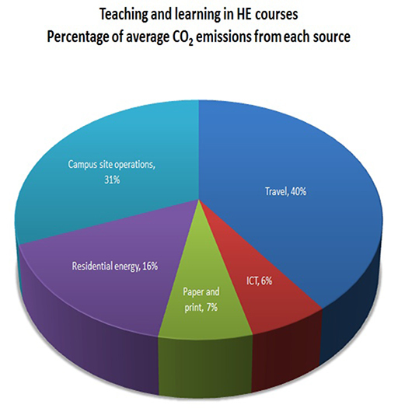
Figure 4 Source of CO₂ emissions (%) associated with HE courses.

Back to Session 5 SAQ 4

Explore the SusTEACH Planning Tool

Answer
When you have completed your responses and selected ‘My report’, you should receive personalised feedback based on your proposed teaching delivery methods and the likely associated carbon impacts. You can compare your impacts with modes and levels of travel or ICT use that would result in similar impacts as a useful comparison.
This tool also allows you to compare your results with the carbon impacts associated with different teaching delivery models. You can also explore the sustainability in HE teaching models further in the context of carbon reduction targets for the UK.
Compare your result with the examples in Boxes 6 and 7.

Box 6 Using the Planning Tool to estimate the carbon impacts associated with a course in informatics
Let’s take an example of a new postgraduate module in informatics:
- Teaching: The teaching is provided face-to-face and students need to travel to library facilities to access resources. Some of the guidance is provided online and is accessible using weblinks. Some of the teaching content is also provided using online audio-visual resources.
- Learning: Student learning activities are provided as part of face-to-face teaching, e.g. at seminars, tutorials, workshops, field trips, day schools or residential schools. Some learning opportunities are provided using specially developed printed teaching materials and using online links to access website materials.
- Communication: The provision for communication and collaborative learning is mainly face-to-face in the classroom, and is supported using email.
- Assessment: Students are required to submit assignments and projects online and are required to travel to exam theatres for assessment.
The tool summarises the methods used to deliver teaching on this course, which include a high use of face-to-face teaching, a low use of use of printed teaching materials and a low use of ICTs and online methods. This is classified as the ICT-enhanced face-to-face teaching model.
The Planning Tool estimates that the average carbon impacts for this teaching model would be 252 kg CO₂ per student per 100 study hours/10 CATS credits. To understand whether this is high or low, the tool produces a number of comparisons.
This impact can be compared with modes and levels of travel or ICT use that would result in similar impacts. This carbon impact is equivalent to:
- driving 740 miles by car (with a petrol engine of between 1.6 to 2 litres)
- flying for 1390 passenger air miles
- using a typical laptop for 749 days
- using a high-powered PC for 218 days
- using a tablet computer for 29 years.
Comparison with other teaching delivery models shows that this carbon impact is comparatively high, although typical for this type of teaching model. This is because face-to-face teaching typically requires a student to travel to attend classes and use university site energy, and can oblige students to take temporary accommodation for the duration of their studies.

Box 7 Using the Planning Tool to estimate the carbon impacts associated with a course in design
Let’s take an example of a new undergraduate module in design:
- Teaching: The teaching is provided mainly online, hosted via the university website (VLE). There are specific computing and hardware requirements for students that include a broadband internet connection and access to other technologies. Students receive a small printed welcome pack and most of the guidance is online and interactive. The teaching content and library resources are also provided online.
- Learning: Student learning activities are provided during online tutorials using Elluminate software. There is a small face-to-face provision for student learning activities during four day schools that students travel to in order to attend. In additio,n there are opportunities for students to record their learning and to collaborate with other students online to support reflection and learning.
- Communication: The provision for communication and collaborative learning is mainly during online tutorials and via internet forums and email.
- Assessment: Students are required to submit assignments and projects online, and to complete some online formative and summative assessments that are assessed as interactive computer-marked examinations.
The tool summarises the methods used to deliver teaching on this course, which include a low use of face-to-face teaching, a low use of use of printed teaching materials and a high use of ICTs and online methods. This is classified as the online teaching model.
The Planning Tool estimates that the average carbon impacts for this teaching model would be 47 kg CO₂ per student per 100 study hours/10 CATS credits. To understand whether this is high or low, the tool produces a number of comparisons.
This impact can be compared with modes and levels of travel or ICT use that would result in similar impacts. This carbon impact is equivalent to:
- driving 138 miles by car (with a petrol engine of between 1.6 to 2 litres)
- flying for 259 passenger air miles
- using a typical laptop for 139 days
- using a high-powered PC for 41 days
- using a tablet computer for five years.
Comparison with other teaching delivery models shows that this carbon impact is comparatively low, although typical for this type of teaching model. The online teaching model has lower energy consumption and carbon impacts because students are supported to learn while living at home, which reduces the need to travel to university sites, take additional residential accommodation and utilise campus site facilities. Because students don’t need to be physically on campus, this model can also support increased student numbers without increasing energy consumption on university sites.

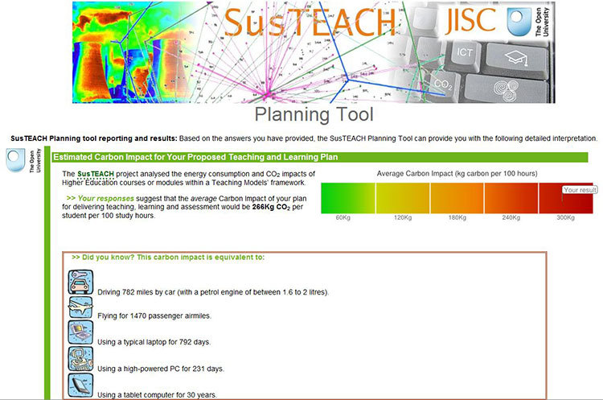
Figure 6

Back to Session 5 SAQ 5

SAQ 10

Answer
Let’s take the same examples explored in Boxes 6 and 7 with the Planning Tool. This will help you to understand the additional functionality offered by the SusTEACH Modelling Tool.
Compare your result with the examples in Boxes 8 and 9.

Box 8 Using the Modelling tool to estimate the carbon impacts associated with an informatics course and full qualification programme
We know that the postgraduate module in informatics has high face-to-face teaching and that this usually requires students to travel and to live close to the campus in temporary university accommodation.
Beginning with Function 1, which is carried out from the Rating tool screen, you would expect term-time travel to be rated as high. It is also expected that at least 50 per cent of the registered students will travel by plane from their home abroad, so travel between home and term-time accommodation should also be rated high. Accommodation should also be rated as high, because students will be required to use temporary residential accommodation to attend face-to-face teaching.
Some learning opportunities are provided using specially developed printed teaching materials, but because this is likely to be less than 250 sheets/pages per student per 100 study hours/10 CATS credits, the rating for print-based teaching should be low. Some of the teaching and learning provision is ICT-enhanced, but the main teaching delivery method is face-to-face teaching, so the rating for ICT provision is low.
The results of Modelling Function 1 estimates that the average carbon impacts for this teaching model would be an average of 257 kg CO₂ per student per 100 study hours/10 CATS credits, which is a very similar result to the estimate provided by the Planning Tool.
But what if fewer than 30 per cent of the registered students travel by plane from their home abroad? The rating for travel between home and term-time accommodation would then need to be changed to average. The results of Modelling Function 1 would be reduced to an estimated average of 224 kg CO₂ per student per 100 study hours/10 CATS credits for this teaching module. This shows that student travel can make a significant difference to the carbon impacts attributable to a course.

Modelling a qualification programme
Via the Rating tool screen you can estimate the impacts of a full qualification programme of courses with a similar teaching model using the same information.
If there are eighteen similar courses offering 100 study hours/10 CATS credits in a typical postgraduate qualification programm,e the average carbon impacts for a full qualification programme can be scaled up to produce an estimated 4646 kg CO₂ per student per 100 study hours/10 CATS credits.
But what if you decided to change the design of courses within the qualification programme to have different teaching models, some of which would have lower carbon impacts than others? This can be modelled using the Qualification Programme Teaching Models panel (Function 2). If ten courses were taught with a face-to-face model, four with a print-based distance teaching model and four with an ICT-enhanced face-to-face teaching model, this would reduce the carbon impacts to an average 3960 kg CO₂ per student per 100 study hours/10 CATS credits. The impacts could be further reduced with the use of more online and ICT-enhanced teaching models in the design of a qualification programme.

Box 9 Using the Modelling tool to estimate the carbon impacts associated with a design course and full qualification programme
We know that the undergraduate module in online design provides the teaching mainly online.
Beginning with Function 1, which is carried out from the Rating Tool screen, you would expect the rating for to be rated as low because the students typically live at their permanent home during their studies and only travel to study sites to attend a few day schools. Travel between home and term-time accommodation is not applicable and Accommodation should be rated as low because students will typically live in their main home whilst studying.
Some guidance for students is printed, but because this is likely to be less than 250 sheets/pages per student per 100 study hours/10 CATS credits, the rating for print-based teaching should also be low. Teaching, learning and assessment is mainly provided online using ICTs and digital resources available on the university websites and VLE; therefore, the rating for ICT-provision is high.
The results of Modelling Function 1 estimates that the average carbon impacts for this teaching model would be 42 kg CO₂ per student per 100 study hours/10 CATS credits, which is a very similar result to the estimate provided by the Planning Tool.
It is interesting to note that this impact is less than a fifth of the carbon emissions produced by the Informatics course (Box 8).

Modelling a qualification programme
Via the Rating Tool screen you can estimate the impacts of a full qualification programme of courses with a similar teaching model using the same information. If there are thirty-six similar courses offering 100 study hours/10 CATS credits in a typical undergraduate qualification programme, the average carbon impacts for a full qualification programme can be scaled up to produce an estimated 1500 kg CO₂ per student per 100 study hours/10 CATS credits.
But what if you decided to change the design of courses within the qualification programme to have different teaching models, some of which would have lower carbon impacts than others? This can be modelled using the Qualification Programme Teaching Models panel (Function 2). If twenty courses were taught with an online model, eight with an ICT-enhanced distance teaching model, four with a face-to-face teaching model and four with an ICT-enhanced face-to-face teaching model, this would increase the carbon impacts to an average 3171 kg CO₂ per student per 100 study hours/10 CATS credits. The impacts could be reduced with the use of more online teaching models in the design of the qualification programme.
Please note that the contribution of each course to the qualification impacts will be calculated per 100 study hours/10 CATS credits. The guide provides further guidenace on making adjustments for courses with a larger or smaller learning provision.

Back to Session 5 SAQ 6

Carbon reduction programmes at The Open University

Transcript
The OU has undertaken a programme of carbon reduction measures throughout its estate to meet Government targets. These measures involve all staff and include the implementation of policies on sustainable procurement, transport and ICT systems. We have also improved the thermal insulation of our buildings, improved the efficiency of our heating systems, with for example this Ground Source Heat Pump system here and reduced electricity consumption by installing LED lighting, more efficient equipment and some renewable technologies, such as photovoltaic panels. Presenter: Mike Sackett, Energy Manager, The Open University
Back to Session 2 MediaContent 1

The SusTEACH Carbon Calculator

Transcript
[Screen capture -Introduction to using the SusTEACH carbon calculator] The SusTEACH Carbon Calculator aims to help students to explore and calculate their energy consumption and carbon impacts associated with a particular course or module. To use this calculator you need to know the number of study hours (or CATS credits) that your course or module is expected to cover. Using the CARBON Calculator Button, the next step is to enter details about your study-related activities, including travel, purchase and use of ICT devices and educational materials, and choice of residential accommodation and campus. Scrolling up to click the RESULTS button, you may then view a report about your study-related carbon impacts and how this compares with the students in the SusTEACH study. The Calculator for lecturers operates similarly and both tools have user guides. Presenter: Dr Sally Caird, The Open UniversityFurther information: www.open.ac.uk/blogs/susteach/ The SusTEACH project team: Andy Lane, Sally Caird, Ed Swithenby
Back to Session 3 MediaContent 1

The SusTEACH Carbon Calculator

Transcript
[Screen capture -Introduction to using the SusTEACH carbon calculator] The SusTEACH Carbon Calculator aims to help students to explore and calculate their energy consumption and carbon impacts associated with a particular course or module. To use this calculator you need to know the number of study hours (or CATS credits) that your course or module is expected to cover. Using the CARBON Calculator Button, the next step is to enter details about your study-related activities, including travel, purchase and use of ICT devices and educational materials, and choice of residential accommodation and campus. Scrolling up to click the RESULTS button, you may then view a report about your study-related carbon impacts and how this compares with the students in the SusTEACH study. The Calculator for lecturers operates similarly and both tools have user guides. Presenter: Dr Sally Caird, The Open UniversityFurther information: www.open.ac.uk/blogs/susteach/ The SusTEACH project team: Andy Lane, Sally Caird, Ed Swithenby
Back to Session 4 MediaContent 1

Environmental impacts of different higher education systems

Transcript
Introduction - What are the environmental impacts of different systems of delivering higher education? How do distance education systems, such as the Open University, compare with conventional campus-based systems of higher education in the UK? The first major quantitative study to assess the energy consumption and carbon impacts of campus-based and distance higher education systems was the Factor 10 Visions study ‘Towards Sustainable Higher Education’ led by Robin Roy and Stephen Potter. The study found that on average the production and delivery of distance teaching consumed nearly 90% less energy and produced 85% fewer CO2 emissions than campus-based higher education courses and modules. The much lower impacts of distance learning was found to be mainly due to a major reduction in the amount of student travel, economies of scale in utilization of the campus site, and the elimination of much of the energy consumption associated with students’ housing. Presenter: Professor Stephen Potter, The Open UniversityFurther information: The Factor 10 project team: Robin Roy, Stephen Potter, Karen Yarrow and Mark Smith
Back to Session 5 MediaContent 1

The SusTEACH project

Transcript
In recent years, the use of Information and Communication Technologies or ICTs has become increasingly pervasive leading to more innovative, online models of teaching and learning across higher education. This raises questions about whether the greater use of ICTs in higher education teaching has better or worse environmental impacts than more traditional face-to-face and distance teaching models?
The SusTEACH project examined the role of ICTs in Higher Education Teaching Models and their effect on carbon reduction. This involved a carbon-based environmental assessment and data analysis of 30 courses and modules across UK institutions representing a range of teaching models. We conducted an environmental assessment of the key sources of carbon impacts associated with higher education teaching and learning. This included staff and student travel; purchase and use of educational materials and ICT devices; residential energy consumption; and campus site operations.
As with the Factor 10 study we found that the main sources of carbon impacts were associated with travel, residential energy consumption and campus site operations. However, the use of online and ICT-enhanced teaching delivery methods as well as traditional distance teaching methods reduced these sources of energy consumption and therefore achieved significant carbon reductions.
Building on the findings and methodology, we developed the innovative SusTEACH toolkit, which is designed to support the planning of more sustainable courses, modules and qualification programmes.
Presenter: Dr Sally Caird, The Open University
Further information: SusTEACH toolkit http://www9.open.ac.uk/SusTeach/
The SusTEACH project team: Andy Lane, Sally Caird and Ed Swithenby
Back to Session 5 MediaContent 2

The SusTEACH Toolkit

Transcript
Screen capture -Introduction to the SusTEACH Toolkit
The online SusTEACH Planning Tool asks lecturers and academic designers to consider how they plan to deliver teaching, learning, assessment and communication on a new or existing course or module and provides an assessment of the likely carbon impacts associated with this plan. When you have completed your responses select ‘MY REPORT’ and this produces personalised feedback based on your proposed teaching delivery methods, which may involve the use of face-to-face teaching, print-based distance teaching and ICT-based and online teaching methods, and the likely associated carbon impacts.
You can also explore the toolkit further online by clicking on the ‘TOOLKIT’ button. The toolkit includes The SusTEACH Methodology which is a detailed resource on conducting a carbon-based environmental impact assessment of courses and modules in UK Higher Education.
The toolkit also includes The SusTEACH Modelling Tool, an operational desk tool for lecturers and qualification directors that allows the modelling of courses, modules and full qualification programmes to estimate the energy consumption and carbon impacts associated with different teaching models. With this tool you can choose Function 1 to model the impacts of one or more courses or modules with the same design. You can choose Function 2 to model the impacts of several different courses or modules and extrapolate this to estimate the impacts of a qualification programme. By clicking the RATING TOOL button you can model the carbon impacts of courses or modules, using the guidance to consider your expectations about student travel, accommodation and purchases of books and your proposed teaching methods. Select the number of courses or modules. The RESULTS button provides an estimate of the energy consumption and carbon impacts associated with your course or module design. The ‘MODELS COMPARISON’ button allows comparison between your modelling and the impacts of different teaching models. (PRINT SUMMARY) You may SAVE and print your report to pdf.
Presenter: Dr Sally Caird, The Open University
Further information: SusTEACH toolkit http://www9.open.ac.uk/SusTeach/
The SusTEACH project team: Andy Lane, Sally Caird and Ed Swithenby
Back to Session 5 MediaContent 3

Applications for the SusTEACH toolkit

Transcript
The SusTEACH toolkit is going to be used across the university in a number of qualifications and programmes. We are going to look at it in the BSc in Environmental Management and Technology. We are also going to use the carbon calculator in a number of modules and other qualifications. This is a good example of where sustainability inn higher education extends not just beyond the campus and the way we do things on the campus, but relates to the way we do teaching and learning.
SusTEACH has developed our understanding of the sustainable teaching and learning systems needed in higher education. The toolkit is available to support sustainability initiatives with students and teachers as part of institutional programmes to ‘green’ higher education systems.
Presenter: Professor Andy Lane, The Open University
Further information: SusTEACH toolkit http://www9.open.ac.uk/SusTeach/
The SusTEACH project team: Andy Lane, Sally Caird and Ed Swithenby
Back to Session 6 MediaContent 1

