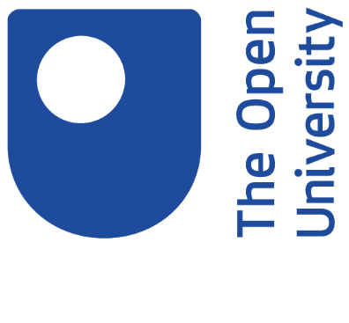

Time to Think
Open University Journeys in British and Irish prisons during the years of conflict, 1972-2000

Important
Every effort is made to ensure the accuracy of this transcript, however no transcript is an exact translation of the spoken word, and this document is intended to be a guide to the original recording, not replace it.

In some cases, interviewees may have made changes to the transcript.

Personal/sensitive information regarding individuals who may be living has been removed from transcripts where necessary.

Copyright and Permissions

Rights owned or controlled by The Open University.
All use of this transcript in part or in full requires prior permission from The Open University Archive.

This transcript must not be shared beyond Open University Staff without prior permission from The Open University Archive.

Please contact university-archive@open.ac.uk to discuss possible use of the content.

This audio appears in the OpenLearn course, Coping with isolation: Time to Think: https://www.open.edu/openlearn/health-sports-psychology/coping-isolation-time-think/content-section-overview

Session 3 audio

Interviewer

And what was it like to study in the prison for you in that first year?

Jackie McMullan

It was great because throughout the five years that we were on protest and weren’t allowed books or any reading material at all, a great hunger for knowledge had built up and we used to talk about books all the time and used to have conversations about our favourite books. People used to relate books that they had read out the doors, so as I say there was a great thirst for knowledge and starting the OU, I can remember being excited about it, looking forward to it.

