On your marks
Jim Sweetman reports on the changes to education that parents of primary schoolchildren are starting to encounter.

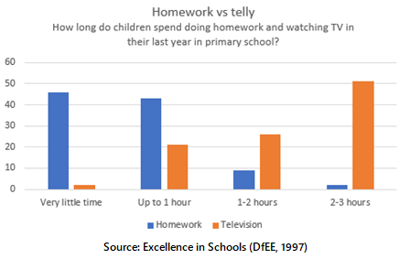
New governments spend their time saying what they plan to do and preparing the legislation to make it happen. So it is only now, after a year in office, that Labour is beginning to make its mark on schools in ways that directly affect parents and children.
Parents with very young children are coming to terms with free nursery education for all four-year-olds. The biggest change is that the education authorities are responsible, so all the information should be available through primary schools. The choice of whether to take up the offer from there, or offers from state-run nurseries, independent nursery schools (there may be top-up fees!) and playgroups is up to parents, so it is important to plan ahead. There have been murmurs that some primary heads will only guarantee school places to parents taking up their offers of nursery places – but they have no right to do this.
Once a child is in primary school, the new baseline assessment looms. This is a simple test of reading and maths carried out by the reception class teacher. Parents are asked not to practise for this or even to tell the child what is going to happen but natural human competitiveness and the desire for one’s child to make a good impression will probably encourage many to do the opposite.
Interestingly, when such tests were introduced in the US, researchers noticed that the children who did best were not the cleverest but those who realised a test was taking place. The results are important to schools because there is a strong emphasis on trying to measure what schools add to children’s performance.
Comparing a baseline assessment with a set of key stage 1 test results at age seven will give a “value-added” measure of the work of a school. Parents can easily see that if children give an average performance on baseline assessment but above average at key stage 1, the school will appear to have done its job well, but if parents practise so that their children do unexpectedly well on baseline assessment, the opposite effect occurs!
From all the announcements, many parents may be expecting to find their child in a class with fewer than 30 pupils from September. Whether that happens depends partly on luck and partly on where you live. So far, about half of all local education authorities have been given funding to achieve this. Some are moving quickly; others have been much slower. The Government has made plain to local authorities that they must not reduce class sizes in popular schools by limiting choice and diverting children to unpopular schools with places available. The cash must be used to provide more teachers and more classes in successful schools.
For children in primary schools, the introduction of the national literacy and numeracy strategies will bring changes to the structure of their school day and their lessons. The national curriculum has been changed so that there is no compulsory list of what must be taught in science, design and technology, history and geography. The subjects will still be taught but given less attention to allow a new – and much increased – stress on reading and basic maths. Each of these should be taught for around an hour a day with lots of formal class teaching – led by the teacher from the front – followed by group work.
The changes are intended to raise national standards of literacy and numeracy over the next four years to the level of our international competitors and every local authority and every school will have its own targets to meet to make this happen. Experience shows that bright, outgoing children have little to fear. However, the challenge for the teacher is to make space for the average and below-average pupils, for those with special needs and those who are naturally reticent any shy about speaking out. Skilful teachers can do this well but many teachers may struggle at first with a new programme and changed ways of working.
Homework is another new concern for the Government. The fact that 70 per cent of children in their last year of primary school do less than half an hour’s homework but watch well over two hours of television a night has to be a concern for parents, especially when there is research evidence that the pupils who do most homework are those that do best at school. It is likely that the Government will publish guidelines on homework later in the year but, in the short-term, it expects to see many schools asking pupils to do more from September and trying to involve parents in their homework programmes.

Jim Sweetman
Guardian Education
19 May 1998

