# Practice

## Activities

*Write the following words in Greek:*

*anthrо̄pos* (= man) ____________________________



*didaskalos* (= teacher) ____________________________

*potamos* (= river) ____________________________



*stratēgos* (= a general) ____________________________



*phо̄nē* (= voice) ____________________________



*Write the names of the Olympian gods in Greek. Start with an initial capital and use a breathing if necessary.*

***Part 1***

Artemis ____________________________

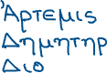

Dēmētēr ____________________________

Dionysos ____________________________



Zeus ____________________________



Hēra ____________________________



Poseidо̄n ____________________________



***Part 2***

Athēnē ____________________________



Apollо̄n ____________________________

Arēs ____________________________



Aphroditē ____________________________

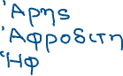

Hēphaistos ____________________________



Hermēs ____________________________

