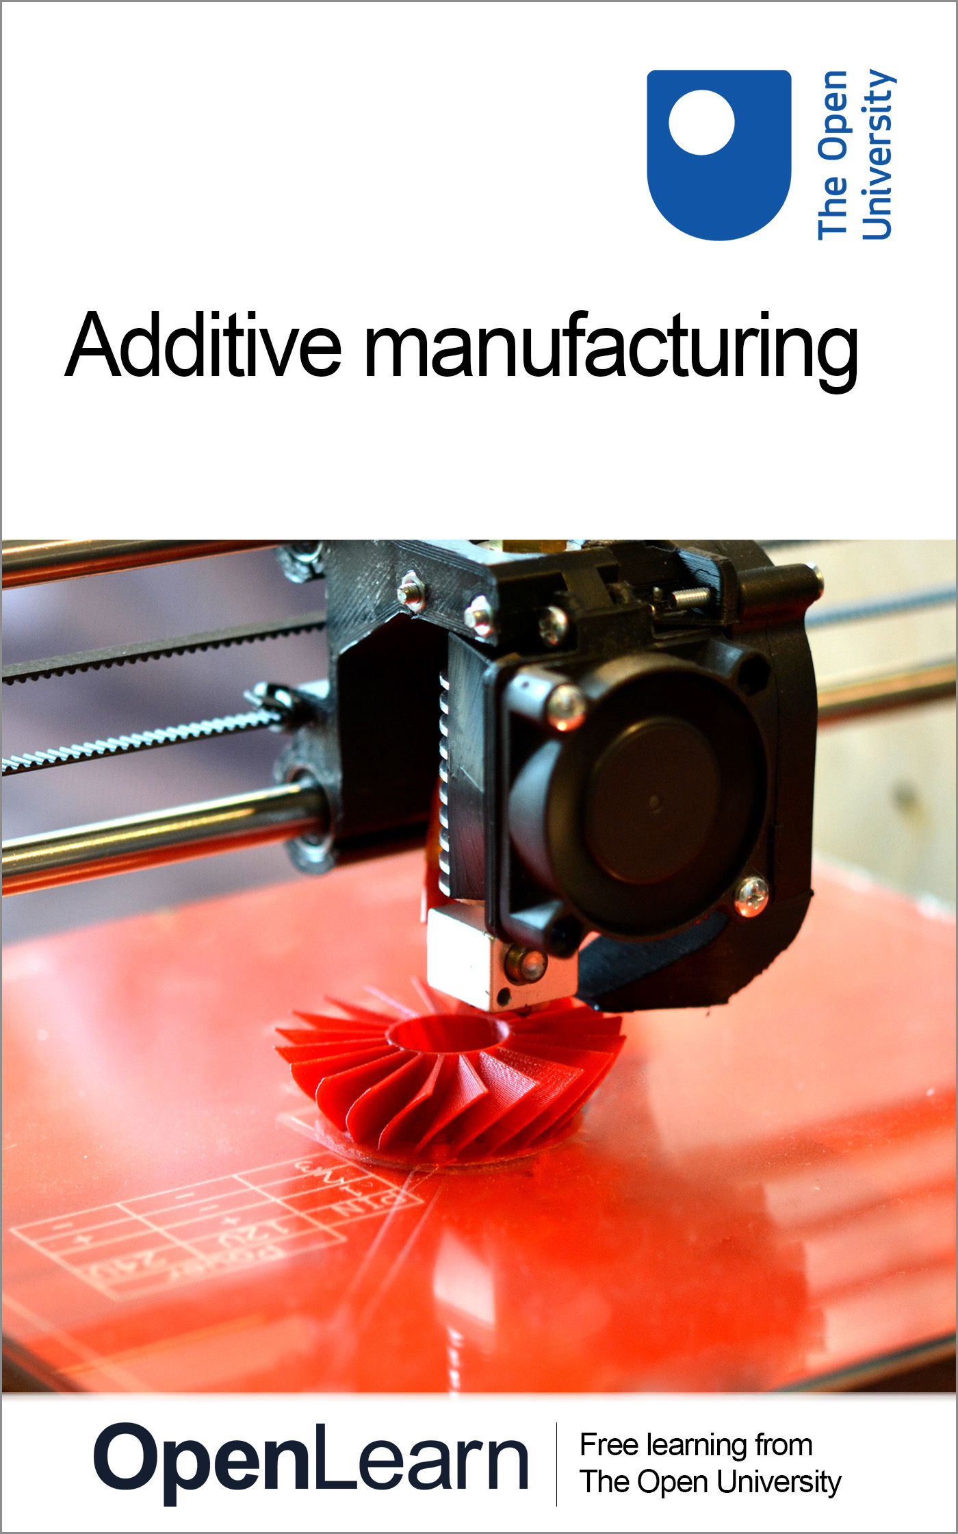

T805_1

Additive manufacturing
About this free course
This free course is an adapted extract from the Open University course T805 Manufacture materials design – http://www.open.ac.uk/postgraduate/modules/t805 .
This version of the content may include video, images and interactive content that may not be optimised for your device.
You can experience this free course as it was originally designed on OpenLearn, the home of free learning from The Open University – https://www.open.edu/openlearn/science-maths-technology/additive-manufacturing/content-section-0
There you’ll also be able to track your progress via your activity record, which you can use to demonstrate your learning.
Copyright © 2015 The Open University
Intellectual property
Unless otherwise stated, this resource is released under the terms of the Creative Commons Licence v4.0 http://creativecommons.org/licenses/by-nc-sa/4.0/deed.en_GB. Within that The Open University interprets this licence in the following way: www.open.edu/openlearn/about-openlearn/frequently-asked-questions-on-openlearn. Copyright and rights falling outside the terms of the Creative Commons Licence are retained or controlled by The Open University. Please read the full text before using any of the content.
We believe the primary barrier to accessing high-quality educational experiences is cost, which is why we aim to publish as much free content as possible under an open licence. If it proves difficult to release content under our preferred Creative Commons licence (e.g. because we can’t afford or gain the clearances or find suitable alternatives), we will still release the materials for free under a personal end-user licence.
This is because the learning experience will always be the same high quality offering and that should always be seen as positive – even if at times the licensing is different to Creative Commons.
When using the content you must attribute us (The Open University) (the OU) and any identified author in accordance with the terms of the Creative Commons Licence.
The Acknowledgements section is used to list, amongst other things, third party (Proprietary), licensed content which is not subject to Creative Commons licensing. Proprietary content must be used (retained) intact and in context to the content at all times.
The Acknowledgements section is also used to bring to your attention any other Special Restrictions which may apply to the content. For example there may be times when the Creative Commons Non-Commercial Sharealike licence does not apply to any of the content even if owned by us (The Open University). In these instances, unless stated otherwise, the content may be used for personal and non-commercial use.
We have also identified as Proprietary other material included in the content which is not subject to Creative Commons Licence. These are OU logos, trading names and may extend to certain photographic and video images and sound recordings and any other material as may be brought to your attention.
Unauthorised use of any of the content may constitute a breach of the terms and conditions and/or intellectual property laws.
We reserve the right to alter, amend or bring to an end any terms and conditions provided here without notice.
All rights falling outside the terms of the Creative Commons licence are retained or controlled by The Open University.
Head of Intellectual Property, The Open University
978-1-4730-2926-2 (.kdl)
978-1-4730-2927-9 (.epub)

Contents
- Introduction
- Learning outcomes
- 1 Additive manufacturing: an overview
  - 1.1 History
  - 1.2 Why is this course not called 3D printing?
- 2 Fundamentals of the process
  - 2.1 Making shapes and structures
  - 2.2 Why additive manufacturing?
  - 2.3 Application of additive manufacturing
- 3 Creating a model and building an artefact
  - 3.1 Computer-aided design model
  - 3.2 Model produced by laser scanning
  - 3.3 Model produced by computer-aided design
  - 3.4 Machine positioning and control
  - 3.5 Build
  - 3.6 Final components
- 4 Materials and techniques
  - 4.1 Polymer materials
  - 4.2 Metallic materials
  - 4.3 Other materials
- 5 Design implications
  - 5.1 Custom parts
- 6 Finished parts
  - 6.1 Surface finish and feature quality
  - 6.2 Microstructural properties
  - 6.3 Residual stress
- Conclusion
- References
- Further reading
- Glossary
- Acknowledgements

Introduction
Additive manufacturing (AM) is a group of manufacturing techniques that rely on the addition of material to form a new component or addition of some material to an existing component. It is a rapidly developing field of processing. Attention-grabbing innovations appear regularly in the media and there is a great deal of excitement about the possibilities that additive manufacturing opens up for new ways of making products.
In this free course, Additive manufacturing, you will see how product designs are captured digitally in ways that allow the product to be created by depositing material incrementally. You will be introduced to the principles that underpin additive manufacturing so that you are equipped to make sense of future developments in this field and to decide when or if AM is a viable manufacturing approach for a given product.
This OpenLearn course is an adapted extract from the Open University course T805 Manufacture materials design.

Learning outcomes
Having completed this course, you should be able to:
- describe additive manufacturing and explain its advantages and disadvantages
- explain the processes used in additive manufacturing for a range of materials and applications
- understand the role of additive manufacturing in the design process and the implications for design
- describe the effects of surface finish and microstructural properties on behaviour for components produced using additive manufacturing
- display an awareness of residual stresses that may occur during additive manufacturing and their effects.

1 Additive manufacturing: an overview
Traditional methods of manufacturing typically involve either removal of material from a piece of stock material or the joining of several pieces of material together. Another option is casting, moulding or extruding, where the final geometry is made using a die or mould of some kind. In these methods the final geometry is only produced after a combination of processes.
Additive manufacturing, on the other hand, produces a component by the addition of material to create the final geometry in a single process.
The fundamental idea behind AM is not in any way new. Think about how bricks create a building or how dry stone walls are created (Figure 1a). The application of these ideas to manufacturing in an engineering sense came to fruition only at the turn of this century (Figure 1b).

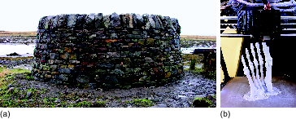
Figure 1 (a) Curved dry stone wall (Isle of Skye, Scotland). (b) 3D printing of a foot skeleton.
View description - Figure 1 (a) Curved dry stone wall (Isle of Skye, Scotland). (b) 3D printing of a ...

1.1 History
In modern times it is relatively rare that an entirely new type of manufacturing is developed, but in the past 20 years, AM has been the process to buck the trend.

Activity 1 Bucking the trend
Allow about 10 minutes

First consider the idea that AM has bucked the trend by being a new manufacturing technology. Then spend a few minutes searching for technologies that have helped AM develop as a viable manufacturing option. Make some notes on a few reasons or related technological advances that have helped this development.

Provide your answer...
View discussion - Activity 1 Bucking the trend

The concepts and technologies used in additive manufacturing are not new. They started being developed in the 1980s. But it’s only since the early years of this century that they have reached a maturity that allows them to be considered as part of mainstream manufacturing.
The language used to describe the technology has evolved over that period along with the techniques. In the early days it was generally described as rapid prototyping (RP). That was because it was first used as a way of creating prototype models of designers’ concepts. As the range of applications and the level of sophistication increased, people began to talk of rapid manufacturing.
AM, as a process for producing fully functional components, has become possible owing to advances in the quality of the output produced by machines originally designed for RP (Figure 2). Many parts are now in fact produced in a fully functional, final state and are therefore not prototypes, despite being produced using machines recognisable as rapid prototypers.

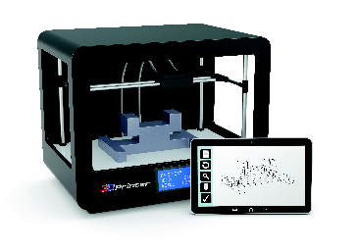
Figure 2 Example of a latest-generation (in 2015) rapid prototyping machine
View description - Figure 2 Example of a latest-generation (in 2015) rapid prototyping machine

The basic principles of AM consist of the ability to produce components directly from a computer-aided design (CAD) model, without the need to process or determine the method by which the component can be created. This is generally achieved by slicing a CAD model into layers that are sequentially deposited. The advent of off-the-shelf computing equipment that is capable of slicing a CAD model is a precursor for the adaptation of AM into full-scale manufacturing processes.

1.2 Why is this course not called 3D printing?
This is a contentious point. Should engineers and designers talk about AM or 3D printing? Does it depend on who they are talking to?
Additive manufacturing and the manufacturing techniques that fall under the umbrella of AM are commonly referred to by a number of terms. More significant than the label ‘rapid prototyping’ has been the adoption of ‘3D printing’ as a blanket label for all AM techniques. ‘3D printing’ is technically incorrect because it is a specific technology using print heads to deposit polymer in a 3D fashion and not a term that should be used for all AM techniques.
The mass media has adopted the term 3D printing because of the similarities with consumer technologies, and so it can be visualised by the general public. Other labels and brand names coined in the infancy of AM have lingered but to a lesser extent.
However, engineers need a more robust terminology. In this course, additive manufacturing has been chosen as the term to use for two reasons:
- It is the term which satisfactorily describes the sector of manufacturing described in this course.
- A committee set up by the American Society for Materials and Testing (ASTM) agreed – in standard ASTM F2792-12a Standard Terminology for Additive Manufacturing Technologies (ASTM, 2012) – that additive manufacturing would be the umbrella term.

Activity 2 News story, research paper, web page
Allow about 20 minutes

There is a lot of hype about AM. Although some publications have very little scientific and engineering rigour, some are informative. Do a quick internet search to find a publication about AM as a technique for the production of fully functional components. Find an example of each of the following:
- news story
- research paper
- web page.
Write down a few sentences on each piece of information in the box below. Comment on how the information would have been written differently if it had been written for a different audience – for example, how would the news story be rewritten for a scientific paper, and vice versa.

Provide your answer...
View discussion - Activity 2 News story, research paper, web page

2 Fundamentals of the process
There are several steps to consider when using AM that differs from traditional manufacturing methods. The following sections outline details specific to AM.
For information on ‘traditional’ manufacturing processes see the Further reading section of this course.

2.1 Making shapes and structures
Unlike casting, forming or powder processing, AM does not require a mould or tool to shape the surfaces of an object, and unlike cutting, AM does not involve the removal of material. However, AM does have some similarities to certain joining processes, as you will see later in the course.
To illustrate the ideas of AM, parallels are often drawn between these techniques and creating a model out of Lego. In both cases complex shapes are approximated using a simple shape (Figure 3). In the case of Lego, rectangular polymer bricks are used. In the case of AM, layers of deposited material are used.

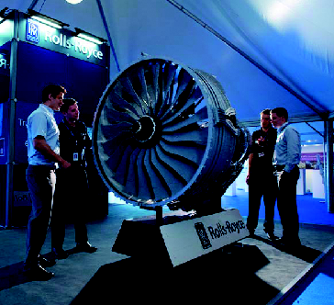
Figure 3 A model of a Rolls-Royce aircraft engine built from Lego bricks to inspire children to learn more about engineering
View description - Figure 3 A model of a Rolls-Royce aircraft engine built from Lego bricks to inspire ...

Activity 3 Manufacturing a household product using AM
Allow about 30 minutes

Pick a household product that would normally be made of several separate parts joined together. Write some notes on:
- how you could use an AM approach to make manufacturing of the product simpler or more efficient
- whether there would be little benefit from doing so.

Provide your answer...
View discussion - Activity 3 Manufacturing a household product using AM

2.2 Why additive manufacturing?
AM is an attractive way to manufacture components for several reasons.
- The near-net-shape technique produces an artefact that is close to a final (net) shape. This reduces the need for surface finishing and significantly reduces cost and time.
- It is a rapid process. It is not just the short time needed for a component to be constructed, but also the streamlining of the entire design and manufacturing process. There is a potential cost and energy saving in addition to time saving.
- The most exciting reason is the added dimension given to design. For instance, internal structures and features that were formerly impossible can be realised. Furthermore, components that would usually have been made from several parts can be created in a single process.
Obviously the financial or environmental implications of a technique are important. However, the opportunities AM offers in terms of flexibility of design significantly outweigh the financial benefits.

2.3 Application of additive manufacturing
AM has a prototyping heritage, and with the advent of techniques that enable functional parts to be made, prototypes are becoming ever more functional.
Some of the most exciting applications are those for bespoke medical devices. For instance, facial and dental reconstructions created directly from 3D body scans (Figure 4).

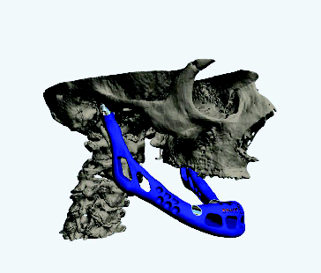
Figure 4 Medical scans make the reconstruction of artificial bones possible, such as this jawbone
View description - Figure 4 Medical scans make the reconstruction of artificial bones possible, such ...

There are also applications in the area of repair. Jet and gas turbine blades are routinely damaged but are expensive to replace. AM has been used to repair just the tip of these blades, saving a considerable amount of money (Figure 5).

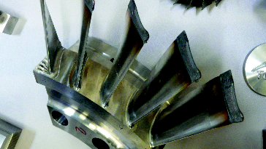
Figure 5 Gas turbine blades with tip repairs
View description - Figure 5 Gas turbine blades with tip repairs

These kinds of specialist repairs are where the initial interest in AM was established. As the techniques become better understood and cheaper to implement, they will be used for increasingly routine applications.

3 Creating a model and building an artefact
There are often parallels drawn between AM and construction methods such as building a house out of bricks, the building of the pyramids or even creating a Lego model. These parallels are easy to see. For example, constructing a Lego model is in essence an additive process. The factor that makes AM different is the requirement for a direct link between the design modelling process and the manufacturing process (Figure 6).

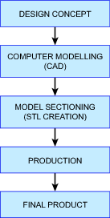
Figure 6 Flow diagram of typical additive manufacturing operations
View description - Figure 6 Flow diagram of typical additive manufacturing operations

There is no need to invest money in tooling. Nor is there a need to create prototypes. In the past, AM would have required a design to be converted into a CAD file format as a separate step. However, it is now commonplace for the design process to be completely contained within a CAD system, meaning no further step is required.

3.1 Computer-aided design model
All AM products must start with a digital model of the external physical shape of the final component. The term external not only refers to the outward-facing surfaces but also to the internal surfaces. You can think of it as any boundary between material and air.
A digital model can take a number of forms. It could be a professional engineering drawing of a component done with proprietary CAD software; it could be a model created with consumer software such as Google SketchUp; or it could even be a 3D laser scan of a physical object (Figure 7).

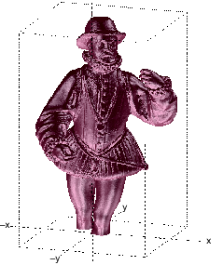
Figure 7 Three-dimensional model of an intricate figure
View description - Figure 7 Three-dimensional model of an intricate figure

The model data is used to create a file with stereolithography data (an STL file). STL files were originally implemented in software created by a company called 3D Systems. The company needed to provide its RP machines with a digital representation of each layer to be added. For the purpose of this course, a knowledge of the intricacies of the STL file format is not necessary.

3.2 Model produced by laser scanning
A structure that has been scanned using a laser scanner will have an array of measurement points taken from its surface. The location of these discrete points is known, but any location in between them will not be known. However, digitisation will ensure that points between measurements are interpolated. With the measured points and the interpolated points, layers can be defined for input into the AM apparatus.

3.3 Model produced by computer-aided design
A CAD model is converted into a digital representation so that each layer can be defined for input into the AM apparatus.
It would be feasible to define each layer to be manufactured as a series of polygons, essentially a separate CAD model for each layer. However, AM equipment has the function to vary the layer thickness, which affects the build rate and finish quality.
The key feature of the STL file format was that only a single CAD representation was required, which could be easily exported into a digital representation of the layers. To achieve this, data needs to define locations on the surface at any location. This is trivial for a simple shape such as a cube. It is more complex for a shape with a curved surface.
STL files simplify a complex shape into a 3D set of triangles, enabling a surface to be approximated. By knowing the location of a triangle it is possible to calculate the position of any of the edges of the triangle.
Figure 8 shows a cube surface divided into triangles. This can be done by using two triangles for each face, making a total of 12 triangles for six faces. The definition of the square face by the triangles is complete – there is no discrepancy between the model and reality.

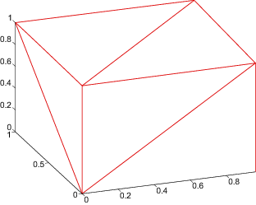
Figure 8 Cube surface can be defined by triangles
View description - Figure 8 Cube surface can be defined by triangles

Figure 9 shows three versions of a sphere surface made of triangles. A sphere can never be perfectly defined by triangles, but the more triangles that are used, the closer the shape is to a true spherical surface – and the more data that is needed. Figure 10 shows a real component defined by triangles.

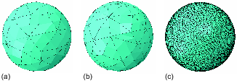
Figure 9 (a) Sphere surface built from triangles. (b) Sphere surface built from more triangles than in (a). (c) Sphere surface built from triangles but appears smooth.
View description - Figure 9 (a) Sphere surface built from triangles. (b) Sphere surface built from more ...

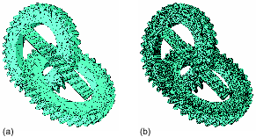
Figure 10 Gear components. (a) Triangles connect to build the surfaces. (b) Same objects but with the triangles invisible and a realistic shading applied.
View description - Figure 10 Gear components. (a) Triangles connect to build the surfaces. (b) Same ...

Now contemplate the complexity of the reconstructed jawbone shown in Figure 4. It isn’t hard to imagine that a high number of triangles need to be defined in order to approximate its shape. If one line of computer code defines a corner of one triangle, it isn’t difficult to imagine that creating an STL file for a complex shape can be computationally intensive.
The advent of computers capable of creating STL files complex enough to define engineering components is one of the factors aiding the uptake of AM techniques.

3.4 Machine positioning and control
An STL file only describes the surface geometry of an object and does not include any scale information. The STL file needs to be processed by a piece of software called a slicer. The digital output from the slicer is a series of thin layers in the form of two-dimensional contours the AM machine will use.
The thickness of the layers is controlled and the dimension of this thickness is normally assumed to be in the z direction (the vertical plane). Because the STL file contains information of all the surfaces, the boundaries of each layer can easily be defined and used as input to control the machine. Furthermore, the z direction can be altered so that the layer thickness best suits the shape.

If you are unsure what is meant by x, y and z directions, have a look at Cartesian coordinate system (Wikipedia, 2016) in the Further reading section of this course.

There are two standard methods of controlling the layering of material:
- the build (object being built) stays stationary and the delivery method of material moves – laser beam, print head, and so on
- the material delivery method stays stationary and the build moves.
In both cases the machine uses computer-numerical-control (CNC) for positioning and is fed with the layer data in the STL file.

3.5 Build
The build process often consists of several substeps:
- producing a consumable in the form of a powder, wire or resin
- delivering this material to the substrate (the surface the build is resting on)
- consolidating the new material by curing or melting and freezing into a solid.

Consumables
Material needs to be added to the substrate in some form. Depending on the specific AM technique, the method of adding material varies. The most common forms of consumables are wires, resins and powders. The basic requirement is that a small, well-controlled amount of consumable needs to be delivered to a specified position.
For most techniques the consumable needs to be produced specially – you can’t simply use any powder or wire. The choice of consumables can have a considerable influence on the final properties of a part. For instance, the shape and size of the grains of metal have been found to influence the melting properties of the powder. The interaction of a laser with a spherical powder grain is different to that with an irregular-shaped grain.
Figure 11 shows some example consumables.

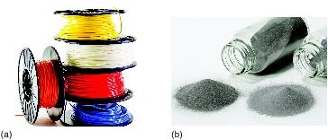
Figure 11 Consumables. (a) Fused deposition filament. (b) Titanium powder for selective laser melting.
View description - Figure 11 Consumables. (a) Fused deposition filament. (b) Titanium powder for selective ...

Material delivery and consolidation
As material is delivered, it is consolidated in some way. This can be a melting and solidification process, or a curing process in the case of polymeric systems. Quite often, when melting is required, lasers are used because of the high-energy input and narrow beam. The delivery and consolidation of material is specific to the technology being used. Figure 12 gives an overview of the methods used to consolidate different kinds of consumables.

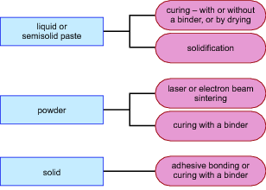
Figure 12 Consumables and the associated methods of consolidation
View description - Figure 12 Consumables and the associated methods of consolidation

Terminology derived from rapid prototyping (RP) defines a system as either a one-dimensional (1D) or two-dimensional (2D) system depending on how the new material is added. All modern AM machines use a 1D system, delivering points of material to create a layer of material in the desired contour.
Two-dimensional systems were common in RP, where entire layers were created in a single step – for instance with a paper or plastic sheet. In 2018, none of the 2D RP systems had been commercially developed adequately to be considered as AM systems. Therefore, only 1D systems will be considered in the rest of this course – but you should appreciate the general situation.

3.6 Final components
It is common to hear of AM processes referred to as net-shape manufacturing. This means after the process is completed, the final product does not require any further processing or machining. With RP this was normally the case.
However, as AM is used more for functional parts and the emphasis of performance moves from aesthetic performance to functional performance, the requirement for further processing becomes greater.
After construction is complete, manufacturing engineers need to consider additional processes such as heat treatment, removal of support structures, additional curing or final surface machining. This might sound disappointing because a feature of AM is that it only requires a single process. This is still largely the case in that a mould is still not required and a part can be created in a single step from the design, but further processes are required to finish off the part.

Activity 4 Redesigning and using additive manufacturing
Allow about 10 minutes

With the household product you chose for Activity 3, produce a step-by-step plan to redesign part or all of it for AM.
There are many considerations that need to be made. You need to think not just about making each component, but also making it in a more effective and efficient way.
For example, combining several components into a single one is an option with AM that can make the component more effective and its manufacture more efficient. But the capabilities of many AM processes also allow each part of the product to be reimagined so that material is only placed where it is absolutely necessary. This provides even greater overall efficiency in the production system.

Provide your answer...
View discussion - Activity 4 Redesigning and using additive manufacturing

4 Materials and techniques
AM is a rapidly changing field of manufacturing. The current state-of-the-art for AM is unlikely to be the standard in the future. Therefore, in this section, only the fundamentals of certain specific techniques will be discussed.
As a general rule, AM systems can be divided into three categories based on the materials they are designed to use:
- polymer materials
- metallic materials
- ceramic, biological and functional materials.

4.1 Polymer materials
Figure 13 shows a generic printer head, such as you might find in an office inkjet printer. As the print head moves across the paper, a signal from the microprocessor controller in the printer causes droplets of ink to be fired at the paper in appropriate places. The print head moves back and forth as the paper advances under the head.

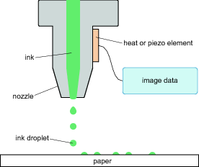
Figure 13 Printer head
View description - Figure 13 Printer head

Now imagine printing a document using an ink that deposits on the paper as a thick layer when it is dried. Once the first layer is finished and dried, the same paper could be put back into the printer and another layer added. This will result in the deposition of more ink on top. By repeating the process, and maybe altering the design of each layer a little from its predecessor, it should be possible to create a print with a built-up surface.
Some adaptation to the printer would obviously be needed to allow the layers to build-up under the print head. This is the principle for a basic 3D printing machine (Figure 14). However, not all AM is done like this.

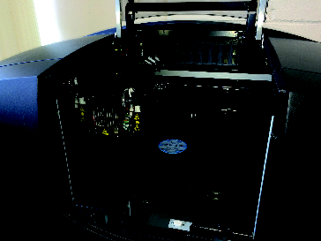
Figure 14 Laser 3D printing equipment
View description - Figure 14 Laser 3D printing equipment

Stereolithography (SLA) is an additive process in which an ultraviolet laser beam is used to set off a chemical reaction in a bath of a liquid ultraviolet-sensitive resin (a liquid polymer) that causes the polymer to solidify at one pinpoint position (Figure 15).

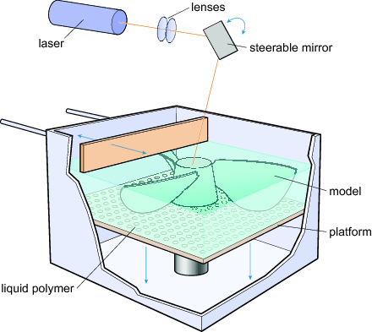
Figure 15 Stereolithography process
View description - Figure 15 Stereolithography process

The laser beam traces out the shape of each layer of the object on the surface of a pool of resin above a moving platform. Once the first layer is formed, the platform moves down by the depth of one layer. The next layer is deposited directly on the previous layer. Repetition of the process results in a 3D object being built up. The entire geometry of the machine can also be inverted so that the developing part is raised out of the reservoir of liquid rather than lowered into it (Figure 16).

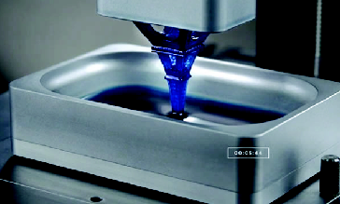
Figure 16 Model of the Eiffel Tower being made by SLA
View description - Figure 16 Model of the Eiffel Tower being made by SLA

After building, the object will be rinsed in a solvent to remove excess resin. Curing can be carried out in a UV furnace.
Materials suitable for SLA are limited to specialised polymers, so this process can only be used for models or components that are not meant to have mechanical or structural purpose.
One other limitation is that the liquid resin cannot support isolated islands of solid material. So, a complex shape like the propeller shown in Figure 15 would need additional supports added to the design. The supports are often referred to as scaffolding, which would be removed after building.
Fused deposition modelling (FDM) is another process which involves the application of semisolid polymer beads, almost analogous to laying lengths of toothpaste on top of each other (Figure 17).

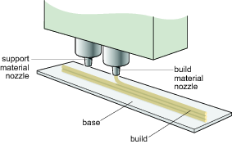
Figure 17 Fused deposition modelling
View description - Figure 17 Fused deposition modelling

FDM is probably a technique that should be categorised as RP because it is limited in resolution and detailed finishing. Furthermore, because of the surface tension of semisolid polymer, wetting angles are relatively high, resulting in pores and defects. However, because the technique is relatively simple and does not rely on complex chemistry or lasers, the technique has found applications where mechanical performance isn’t critical. Children’s toys are a common application (Figure 18).

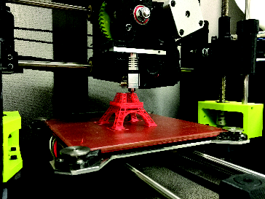
Figure 18 Model of the Eiffel Tower being made by FDM
View description - Figure 18 Model of the Eiffel Tower being made by FDM

4.2 Metallic materials
Powder-bed systems are designed to be used with metallic materials. Figure 19 shows a powder-bed system. Powder is added to the workpiece in a thin layer using a roller or rake. The layer is then consolidated. A metal is usually fully melted but sometimes it is only sintered (compacted and heated). Lasers are the most common choice for an energy source because of the powers and wavelengths available, but electron beams have also been used. Electron beams require a high vacuum though and are therefore less popular.

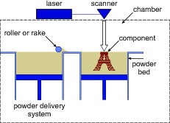
Figure 19 Powder-bed system
View description - Figure 19 Powder-bed system

The powder-feed system shown in Figures 20 and 21 delivers material through a powder nozzle directing a stream of powder into the path of a laser or electron beam. A wire can be used instead of the powder stream.

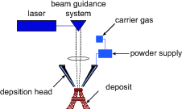
Figure 20 Powder-feed system
View description - Figure 20 Powder-feed system

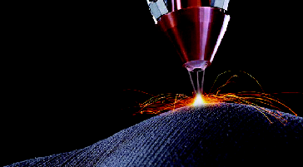
Figure 21 A powder-feed system in operation. The powdered metal feedstream, confined and protected against oxidation with a surrounding jet of inert shielding gas, is fused by a laser focused through a central bore in the head.
View description - Figure 21 A powder-feed system in operation. The powdered metal feedstream, confined ...

Both powder-bed and powder-feed systems have benefits and drawbacks (Table 1).

Table 1 Benefits and drawbacks of powder-bed and powder-feed systems
System | Benefits | Drawback | Potential applications
Powder bed | No powder is lost  Precise layer thickness | Constrained to the three-axis system | Semibulk production  Production line integration
Powder feed | Freedom to change z direction  System can be taken to existing components – deposition in situ | Powder usage efficiency is low  As component grows, variations in layer height may occur | Repair of damaged components  Addition of detail to large structures

4.3 Other materials
Other types of material can be used in AM – ceramic materials, biological materials, microscale materials, electronics and MEMS (microelectromechanical systems). The actual techniques do not differ much from those for polymers and metals, but they are applied in slightly different ways.
These other techniques do not open up any significant issues. The main point is for you to appreciate the breadth of applications AM can be applied to.

5 Design implications
The realisation of a design is limited by the ability to create or construct that design. For a moment, think about the design process and how AM can realise the design more quickly and where it would not otherwise have been possible.
The flexibility of AM means more complex designs, and designs that once were considered impossible or impractical, can be realised. Additionally, because of the freedom from tooling, the start-up costs for a new design can be minimal.
For example, consider the production of children’s toys, action figures for instance. Most children’s action figures are made by injection moulding, involving considerable investment in tooling for each toy. A decision needs to be made by a manufacturer about the profitability of investing in a new mould design, however, because there is a chance that children will not want the planned toy and sales will be low.
AM can be used to produce small product runs for each toy, to create one-off toys and highly collectable special editions. This kind of freedom goes against most manufacturing norms, and to be fully embraced, an entire shift in the way design and manufacturing interface needs to happen.

5.1 Custom parts
One of the most exciting opportunities AM offers is for the production of custom components, specifically for medical applications. Figure 4 in Section 2.3 is a picture of a jawbone reconstruction specifically made for the patient in question. But other applications exist – see the examples in Figure 22.


Figure 22 Additive manufacturing used for making or repairing human tissue and organs. (a) Skull repair. (b) Jawbone reconstruction. (c) Broken bone support cast. (d) Custom dental work.
View description - Figure 22 Additive manufacturing used for making or repairing human tissue and organs. ...

The key point is that once the design is finalised, the cost and effort required to make a single instance of that design versus a large batch are similar. This is almost unheard of in manufacturing and could be called a paradigm shift.

6 Finished parts
The advent of AM was essentially the improvement of RP to produce a functional part. RP engineers were essentially only interested in the shape, form and aesthetics of their products. If function is to be considered, factors like microstructure, porosity, surface crack initiation sites, variations in density and residual stress become important.
These topics are being researched within universities and by machine manufacturers, and the issues are a long way from being solved. An appreciation of these issues, but not necessarily knowledge of how to solve them, is important.

6.1 Surface finish and feature quality
Surface finish is important for the aesthetics of a structure. The link between surface finish and machine properties is probably better understood than any other AM issues because of the historical development undertaken for RP systems. Users of RP systems care most about the aesthetics of a component.
Surface finish is linked with layer thickness and therefore deposition rate. This is because each layer boundary inherently introduces imperfections at the surface. Although this is the case for many techniques, it is not necessarily the rule.
Surface finish is often used to describe the precision of an AM component but it is not an adequate description. Surface finish only relates to the roughness (or smoothness) of a surface. However, the ability to produce features, such as corners and angles, is also important. The term ‘feature quality’ is a more inclusive idea that encapsulates the precision by which any feature is produced, including a flat surface.
Figure 23 shows the kind of trend you can expect from a metallic blown powder system. As you increase the laser power, the melt pool size increases and, therefore, the amount of material that can be added in each layer also increases. So there is a correlation between build rate and laser power. However, as the layer thickness increases, the feature quality or precision drops.

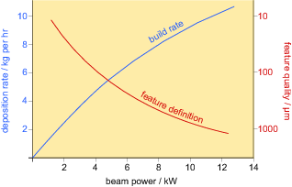
Figure 23 Relationship between laser beam power, deposition rate and feature quality for a metallic blown powder system
View description - Figure 23 Relationship between laser beam power, deposition rate and feature quality ...

Think of Lego bricks and the much larger Duplo bricks and consider building one pyramid out of Lego and one out of Duplo. It will take considerably longer to make the pyramid out of Lego (lower build rate) but the feature precision will be considerably higher (Figure 24).

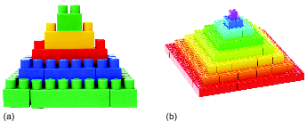
Figure 24 (a) Duplo pyramid with large bricks, (b) Lego pyramid with small bricks.
View description - Figure 24 (a) Duplo pyramid with large bricks, (b) Lego pyramid with small bricks. ...

There is one further consideration. If the link between surface precision and build rate holds up, there will also probably be a link between surface precision and financial viability, because production will become more expensive with increase in precision.

Activity 5 Boundary precision and surface roughness
Allow about 30 minutes

A key aspect of creating near-net-shape components is the surface finish. If you need to machine the component after construction, the cost will increase.
Consider two additive manufacturing techniques. It is recommended that one relies on solidification and one doesn’t. What parameters and factors inherent to the technique you have chosen govern the boundary precision and surface roughness? Make some notes on the factors you identify and include links to the evidence you have found.

Provide your answer...
View discussion - Activity 5 Boundary precision and surface roughness

6.2 Microstructural properties
The microstructure of most engineering components has been reached through a sequence of separate processing steps. Quite often these steps involve a combination of deformation, heating and cooling. This results in a unique microstructure, either deliberately or as a consequence of the process sequence. In turn the performance of the product is influenced by the microstructure.
It isn’t generally possible to replicate conditions such as to go from raw material to finished product in a single step with AM, or even to have much control over the thermal history of the component. The performance of an AM component is therefore likely to be rather different from that of an identical component made by traditional processes.
As an example consider the turbine disc of an aircraft gas-turbine engine (Figure 25). The normal alloy materials used in aerospace turbine discs are either nickel-base alloys or titanium alloys. Both are expensive and therefore using AM may well be a desirable manufacturing route if it leads to a reduction in waste material.

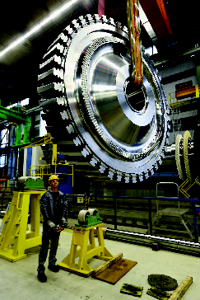
Figure 25 Worker with a disc for a gas turbine at the Siemens manufacturing plant
View description - Figure 25 Worker with a disc for a gas turbine at the Siemens manufacturing plan ...

However, a considerable amount of the alloy costs are not from the raw materials but from the subsequent processing the alloy undergoes. Forging, heating and quenching are used to develop a fine-grain structure, followed by further heating to remove inclusions and to nucleate and grow beneficial strengthening particles. The kind of control needed to develop these structures is not possible using a single AM process.
Figure 26(a) shows an example of the microstructure of wrought Inconel 718 and Figure 26(b) shows an example of the microstructure of Inconel 718 produced using a blown-powder deposition system. As you can see, the difference is quite marked. In terms of mechanical properties this could be a critical difference in materials’ performance.

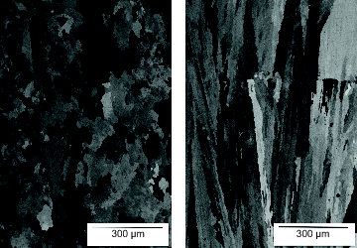
Figure 26 Microstructure of Inconel 718. (a) Wrought. (b) Produced using a blown powder deposition system.
View description - Figure 26 Microstructure of Inconel 718. (a) Wrought. (b) Produced using a blown ...

You may be able to see the similarities between the structures shown here and those shown for fusion-welded joints, and this is because they are essentially a result of the same phenomenon. Grains are growing in an uncontrolled manner owing to the relatively uncontrolled solidification of material occurring during building. This phenomenon of grain growth has actually been exploited to additively manufacture single-crystal material on single-crystal substrates.
In most cases, however, metallic systems benefit from having a fine-grain structure because of the relationship between grain size and material yield strength . It is clear from Figures 26 (a) and (b) that a fine grain size is not always achievable – and with a grain size several orders of magnitude greater than that, that can be achieved by forging or extruding, the resulting material properties will be different.
This is just one example of how AM material can have different microstructures to traditionally processed material. Because of the wide range of techniques under the AM umbrella, understanding the microstructural nuances of each technique is not necessary. However, you should appreciate that many AM techniques may not produce a microstructure comparable to other techniques.

6.3 Residual stress
Residual stresses are those that reside in a component or structure in the absence of an applied load. They generally form as a result of a local mismatch in shape, such as thermal gradients or local deformation. When considering the structural integrity or mechanical performance of a component, residual stresses act in addition to applied loads. Therefore, residual stresses should be treated in the same way as applied stresses when assessing a component's fitness for purpose.
Most of the AM techniques include some form of local thermal gradient and, if not, local phase or volume change may well be occurring. As a result, residual stress is a problem with most AM techniques. This is not a new problem because it was a problem for RP systems, however although significant research went into trying to solve it, little has been achieved.
To illustrate the issue with residual stress, take FDM as an example. Assume you are trying to produce a tall, thin wall consisting of a single bead of polymer. Half-way through the process you will have something that resembles Figure 27.

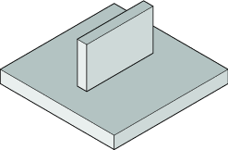
Figure 27 Ideal structure, half-done
View description - Figure 27 Ideal structure, half-done

Assume the uppermost layer has cooled to room temperature. As a new, hotter layer is deposited onto the cooler layer, there is a temperature difference and therefore a difference in density. However, because the new layer is laid across the entire previous layer and is fused, its contraction will now be constrained (Figure 28). The contraction results in the generation of residual tensile stress.

Interactive content is not available in this format.
Figure 28 Build-up of residual stress
View description - Figure 28 Build-up of residual stress

Click on ‘View interactive version’ on Figure 28 to compare what happens to a new layer that does fuse and one that doesn’t fuse when the temperature decreases.
This example of a thin wall is considerably simpler than most true applications. It is easy to imagine more complex stress fields with a more complex part. Several attempts have been made by different manufacturers to mitigate the formation of residual stress. Evidence of the effectiveness of these processes is limited and complete mitigation of residual stress is unlikely. Whenever there is a local change in temperature, material or phase, it is almost certain there will be a residual stress.

Conclusion
This free course, Additive manufacturing, has shown how AM is as much an interesting way of thinking about manufacturing as it is a new way of constructing components. As computing systems have become more powerful, the availability of software to ‘slice’ CAD models for layer-by-layer construction has paved the way for AM to thrive.
A material processed by AM will often have very different properties compared with the same material processed using a traditional method. Furthermore, residual stress is an issue for all processes that experience large variations in temperature; additively manufactured components are no exception.
This OpenLearn course is an adapted extract from the Open University course T805 Manufacture materials design.

References
ASTM (2012) ASTM F2792-12a, Standard Terminology for Additive Manufacturing Technologies (Withdrawn 2015), West Conshohocken, PA, ASTM International.

Further reading
3D Systems – manufacturer of printing systems 3D Systems (2016) ‘About 3D Systems’ [Online]. Available at www.3dsystems.com/about-us (Accessed 6 June 2016).
Cartesian coordinate system Wikipedia (2016) ‘Cartesian coordinate system’, 31 May [Online]. Available at https://en.wikipedia.org/wiki/Cartesian_coordinate_system (Accessed 8 June 2016).
To find out more about the ‘traditional’ manufacturing processes, try the OpenLearn course on Manufacturing.

Glossary
Additive:
Something that is added to another. In materials science, it describes a substance that is added to another substance to improve it.
Additive manufacturing:
Additive manufacturing is when products are made by adding on material sequentially, usually in layers, as in techniques like 3D modelling or rapid prototyping.
Aerospace:
Technology dedicated to aircraft or spacecraft.
Aesthetics:
In design, aesthetics covers the look of the product in terms of style, beauty or attractiveness.
Alloy:
A metallic substance composed of two or more elements.
Boundary:
An extent or constraint that forms a border. Examples of usage include boundary conditions and systems boundary. The perimeter of a material grain (crystal) is referred to as its grain boundary.
Casting:
A fabrication process where molten material is poured into a mould cavity and allowed to solidify, taking the shape of the mould. Compacted sand is often used as the mould material. Materials made by casting include metals, polymers and, less commonly, ceramics.
Ceramic:
Brittle materials made up of both metallic and non-metallic elements. Ceramics exhibit strong ionic and/or covalent bonding, resulting in properties such as high hardness and stiffness, low ductility and low thermal and electrical conductivity. This category covers a diverse range of materials, including traditional ceramics such as clay-based pottery, tiles, linings for furnaces and kilns, etc., through to industrial ceramics such as insulators for electronic components, and cutting tools and knives.
Component:
A part, often in a system of parts. The system could be mechanical, for example a girder in a bridge or a shaft in a gearbox. Or it could be electrical – a resistor in an electronic circuit – or chemical – an element in an alloy system.
Computer-aided design:
A computer-assisted method of producing 2D drawings and 3D models for design and manufacture. 3D CAD models are digital representations of forms or products.
Cost:
Expenses, overheads or the price of a product or service.
Crystal:
A solid material composed of a lattice of atoms arranged in a regular and symmetrical pattern.
Cutting:
The separation of something into two parts with the aid of a sharp blade or other tool. A manufacturing process that includes procedures such as milling, grinding and machining. Cutting can be done using knife blades, cutting tools or instruments, lasers and ion beams.
Deformation:
Deformation occurs when a material under stress changes shape, either temporarily (elastically) or permanently (plastically). The amount of deformation a material experiences depends on the level of stress being applied. If a material is stressed to a point under its yield strength, it undergoes elastic deformation and the original shape is recoverable once the load is removed. If the material is stressed to a point beyond its yield strength, it experiences plastic deformation and the material remains permanently deformed, even after the stress is removed.
Density:
A material property of solids, liquids and gases. Density is a measure of the mass of the material per unit volume (kg/m³).
Deposition:
A term used in surface engineering to describe the application of a deposit onto a surface. For example, a coating or surface finish to solids, a physical vapour deposition or plasma coating.
Design:
The origination and planning involved in creating a new product, system or procedure, taking into account form, fit and function, including aesthetics and ergonomics. Other contributing factors to be considered when designing are related to innovation, market forces and costings, to name but three.
Die:
Another word for a mould or casting. Also used to describe the metal block used in ‘punch and die’ forming of sheet metal.
Drawn:
A description of something having been pulled through, as in drawing a metal rod through a die to reduce its cross section. Generally applied to the output from any process known as ‘drawing’.
Electron:
A low-mass sub-atomic particle that encircles the nucleus. Electrons carry a negative electrical charge. In materials that are good conductors of electricity, such as metals, electrons can exist independently of atoms. These are known as free or valence electrons.
Energy:
The capacity of a body to do work. Measured in joules (J). Types of energy include kinetic, potential, thermal, electrical, chemical and nuclear.
Forging:
A manufacturing process that involves using hammers or hydraulic presses to form malleable metals. Most forging is done under extreme heat at temperatures up to 1250°C, although cold forging is also carried out, as is open die forging, closed die forging and impression die forging.
Forming:
A manufacturing process that changes material in the solid state into a required shape, such as sheet, rod or bar. The choice of forming process is dependent on the geometry and microstructure of the material. Examples of forming processes are rolling, extruding, drawing and forging.
Function:
The purpose or main use of a product or service. In mathematics, a function describes an expression or rule that defines a relationship between one variable and another, as is shown on the x and y axes of a graph.
Functional:
Something working as it is meant to. Fit for purpose. The term functional is also used to describe an item or operation as practical or utilitarian, rather than attractive.
Geometry:
The shape and relative arrangement of constituent parts. The study of the relationship between points, lines, areas and volumes in shapes of two or three dimensions.
Grain:
An individual crystal in the microstructure of a polycrystalline material. The structure and size of grains have an influence on the properties of a solid material. Can also be a single grain of powder or sand. In the structure of wood, ‘the grain’ describes the direction in which the fibrils are growing.
Grain growth:
The final stage of annealing in metals, in which stress-free recrystallised grains expand to replace the remaining distorted grains within the microstructure, resulting in maximal softening of the material.
Inclusions:
Discrete particles of impurities within a solid metal alloy, most often introduced during previous melting and casting. Inclusions of metal oxides and sulphides are often clearly visible under the optical microscope, especially when examining specimens in the unetched state. Inclusions may have an adverse effect on the mechanical properties of a material in service, so levels of inclusions are minimised where possible during manufacture. Certain inclusions, such as manganese sulphide or lead, are deliberately created in some alloy grades in order to enhance machinability.
Injection:
An insertion or inoculation. A substance is inserted under pressure through a small orifice, as in an injection moulding process or a medical vaccination.
Joining:
Mechanical processes that involve connecting two or more solid parts together. Examples include welding, brazing, soldering, gluing and fastening.
Laser:
An acronym for Light Amplification by Stimulated Emission of Radiation. A term used to describe a device that emits a narrow beam of coherent light.
Liquid:
One of the three principal states of matter, it is the state between a solid and a gas. A liquid flows and, when contained, conforms to the shape of its container. A liquid is generally incompressible.
Load:
Mechanical force applied to a body
Manufacturing process:
The range of processes that an item might undergo during its production, before it reaches its final form as a finished, marketable product. Physical manufacturing processes used during production might include cutting, forming, extrusion, casting, injection moulding, joining, painting, etc. The term can also be used to describe how production will be handled in terms of which manufacturing system will best suit the volume of products and the budget, e.g. bespoke, batch, line or continuous.
Material:
Matter. A substance or substances out of which something can be made. Man-made materials include metals, ceramics, polymers, composites and fabrics. Organic materials include wood, stone, bone and leather.
Measurement:
The act of determining the size, amount or value of something with an appropriate instrument.
Melting:
When a material exposed to an increase in temperature turns from a solid to a liquid.
Metals:
Materials comprising elements in the periodic table that have loosely bound electrons in their outermost atomic shell. These mobile electrons serve to bond metal atoms together, while conferring the characteristic metallic properties of high thermal and electrical conductivity. Metals can be mixed with other metals and non-metals to make alloys.
Microstructural:
Describes a material structure at microscopic scale.
Microstructure:
The structural features of an item or a material at a scale that cannot be seen by eye, but can be easily viewed under a microscope, i.e. a scale at which material grains and phases can be observed.
Mould:
Receptacle into which liquid is poured pending subsequent solidification.
Moulding:
A form or structure that has been moulded or cast in a mould or die. Examples of moulding processes are injection moulding, compressive moulding, vacuum-sealed moulding, blow moulding rotational moulding and transfer moulding. Term most often applied to polymers and glass.
Nickel:
A hard corrosion-resistant metal often used to plate other metals giving a protective coating. Also used in the alloying of stainless steel. Widely used in the manufacture of superalloys for turbine blades operating at high temperatures. Also used in the manufacture of batteries and coins. Traces in glass lend it a green colour.
Phase:
A stage or a step in a process. In materials science, phase can refer to a state of matter, as in liquid phase, solid phase and gas phase. Phase diagrams show different material phases as a function of composition and temperature.
Plane:
A flat surface where the radius of curvature is infinite at all points.
Plastic:
The word plastic can be used to describe the type of irreversible material deformation that occurs once a material is beyond its yield point. As in plastic deformation, plastic strain and plastic flow. Plastic is also a generic term for man-made polymeric materials such as thermoplastics and thermosetting polymers. Examples include polyethylene, polypropylene, polystyrene, polycarbonates, polyesters and polyurethanes.
Polymer:
Substance that has a structure of many molecules bonded together in repeated linked units or chains. Polymers can be organic, synthetic or a mix of the two. Synthetic thermoplastic polymers consist of long chains of molecules, while thermoset polymers are composed of 3D networks of molecules. Other synthetic polymer groups include elastomers and fibres. Some polymers occur naturally, such as the polysaccharide cellulose, and proteins, which are formed from amino acids.
Pores:
Holes, gaps or voids in a solid material. Pores can occur on the surface as well as within the bulk of a material. Liquid and gas can enter via pores. See porosity.
Porosity:
Holes, open pores or void spaces within the microstructure of a solid make a material porous, and therefore prone to absorption of liquid or gas. Porosity is the measure of how porous a material is, as defined by the volume of pores per unit volume of material. It is generally an undesirable property, as it can promote oxidation and corrosion and the pores can act as crack nucleation points. Porosity can occur in both metals and polymers during casting. In powder processing, pores can exist between the powder particles prior to compaction, and it is common for some residual porosity to remain even after densification.
Powder:
Loose particles of dry, granular, solid material.
Power:
n physics, power is the rate of doing work (energy used/time). The SI unit for power is the watt (W); one watt is equivalent to a work rate of 1 Joule per second. In mathematics, a power (exponent) defines how many times the base number should be multiplied by itself, e.g. ten to the power two equals 100 (10² = 100).
Precision:
High levels of accuracy. Finely tuned. Has the quality of being precise or exact. Precision engineering involves the design and manufacture of components and assemblies with high accuracy and tight tolerances on dimensions. Mathematically, increasing precision is commonly associated with an increased number of decimal places.
Principles:
A code of ethics or standards applied. For instance, in scientific research, there are unwritten scientific principles that involve acting with honesty and integrity within the field of research.
Process:
Another word for a procedure, an operation or an activity. The term process control refers to keeping all processes under control and within set limits. This control could be in terms of output levels, temperature, pressure and flow.
Product:
Something that is produced. It might be a commodity, a physical item that has been manufactured, an idea or a service or any combination. A product can also refer to something that has evolved or resulted from something else, for example ‘Siliceous stones such as granite and basalt are the direct product of high-temperature geological processes below the earth's crust’.
Prototype:
An early model or first build of a product design. From a prototype, a product can be tested, evaluated or even promoted, prior to formal manufacture.
Quenching:
An important hardening process for steels or metal alloys. Quenching is the rapid cooling of heated metal in a cooling agent, usually water, but can be in air, oil or brine. When steel is cooled rapidly, the carbon atoms do not have time to form the equilibrium phase, cementite, instead causing the austenite to undergo a shear transformation to martensite, preventing the movement of dislocations, hardening the metal and making it brittle.
Raw material:
Unprocessed feedstock. Anything that can be sourced and, often together with other raw materials, converted into a product.
Resin:
A widely used term to describe a viscous liquid or a solid non-crystalline polymer. There are two main classes of synthetic resins, thermoplastic resins, which can be softened and reformed by heating, and thermosetting resins, which remain in the solid state when heated. Natural organic resins are extracted as fluid secretions from trees, particularly pine and firs. They are commonly used in medical balsams and toiletries such as soap. Synthetic resins, sometimes mixed with natural resins, are used in industrial solvents, varnishes, lacquers and adhesives.
Roughness:
Roughness is not always a disadvantage; a rough surface can promote adhesion, for example to help paint grip to the surface or to provide traction in moving parts. Roughness is distinguished from waviness by its shorter wavelength.
Sheet:
An object displaying large dimensions in two orthogonal directions, but a comparatively small dimension in the third mutually orthogonal direction. An object with a continuous thin cross section. In metal production, sheet is generally much thinner than plate, exhibiting a level of flexibility that permits it to be coiled.
Solid:
State of matter that retains its shape and volume when acted upon by external forces. Solids do not generally flow like liquids or diffuse like gases. Solids can be cut or shaped. Solids include powders and solid particles of materials like salt and sand.
Solidification:
The process in which a liquid transforms into a solid upon cooling, often involving steps of nucleation and growth.
State:
A condition or circumstance. The four physical states of matter comprise solid, liquid, gas and plasma.
Stereolithography:
A process that starts from a digital 3D image. In a bath of liquid polymer, the 3D part itself is built up in layers and incrementally solidifies when it is struck by an ultraviolet laser beam. Stereolithography is an example of additive manufacturing.
Stress:
Defined as a measure of force per unit area (σ = F/A). There are different types of stress. Examples include compressive stress, tensile stress and shear stress. Stresses locked into a component or assembly, subsequent to manufacturing processes such as welding or shot-peening, are known as residual stresses. Limiting values of stress may be defined for a material, such as yield stress and ultimate tensile stress.
Substrate:
An underlying substance or layer. The bulk material that lies directly underneath a thinner applied coating. Can also refer to the base material from which oxide layers grow, as in the corrosion process affecting certain metals; the bulk metal is termed the substrate, while the oxide layer forms on top.
Surface:
The outside part or uppermost layer of something. A boundary between one phase and another.
Temperature:
The degree or intensity of heat in a substance or an object. Temperature can be measured in degrees Fahrenheit (°F), degrees Celsius (°C) or Kelvin (K). Readings are taken from a thermometer.
Tensile:
Under tension; being pulled apart. Being elongated or stretched.
Thermal:
Related to heat. Thermal energy comes from heat generated by the movement of particles inside a substance.
Titanium:
A low-density refractory metal with a high strength-to-weight ratio and excellent resistance to corrosion, making it ideal for use in aqueous environments. Used in aerospace and ship-building applications. Titanium is the material most often used in biomedical applications, such as in the manufacture of prosthetics. Also used as a minor alloying element in some stainless steels.
Tool:
A physical device or instrument that makes it easier to carry out a mechanical procedure or to alter or make something. A mechanical tool can be hand-held, like a screwdriver or hammer, or machine-driven, like a milling machine or an automated cutting machine. Non-mechanical tools could relate to anything that makes a process easier, for example analytical tools and software tools.
Turbine:
A machine made from contoured propeller type blades, fins, vanes or sails fixed to a rotating shaft or axis (rotor). The rotating blades of a turbine work to convert kinetic energy, from moving water or air, into power. Examples of turbines range from traditional windmills and watermill wheels that provide energy to drive attached grain mills, through to the turbines used to operate hydroelectric power generators or the gas turbines that power jet engines. Modern-day wind turbines and water turbines help to produce renewable energy.
Vacuum:
A region or space that is entirely free of matter. An approximation to such a vacuum is a region in which the gaseous pressure is much lower than atmospheric pressure. High vacuum is characterised by pressures in the range 10⁻⁵ to 10⁻⁹ mbar. Ultrahigh vacuum has pressures lower than 10⁻⁹ mbar.
Wetting:
Wetting is used to describe how much wettability a solid material has, according to how much surface tension exists at the solid’s surface. Using the example of a droplet of liquid (including adhesives) on a perfectly flat surface, the degree of wetting is calculated from the wetting angle (α), taken from the intersection point where the liquid, solid surface and air meet. The angle is formed between the horizontal surface of the solid, and an imaginary line at a tangent with the curved surface of the droplet. The diagram below shows the concept and loosely describes how the wetting angle relates to a material’s wettability. Furthermore, the surface tension or surface free energy can also be calculated from the wetting angle by using Young’s equation. In casting, penetration of the molten material into the mould material is also called wetting. It reflects a surface reaction between the hot liquid and the sand used to make the mould or core. This makes it difficult to remove the solidified cast from the mould, and gives a poor surface finish.
Workpiece:
A piece being worked on. It is used to describe an item or component undergoing a manufacturing process, such as parts being welded or machined.
Yield:
When a material under increasing applied stress reaches a point where elastic strain is supplemented by irreversible plastic strain, the material may be said to have yielded. In manufacturing, the yield of a process refers to an output of production or supply and can be quantified as the ratio of (materials output as acceptable product) ÷ (materials input) × 100 %.

Acknowledgements
This free course was written by Matthew Moorcroft from material by Richard Moat. It was first published in July 2019.
Except for third-party materials and otherwise stated (see terms and conditions), this content is made available under a Creative Commons Attribution-NonCommercial-ShareAlike 4.0 Licence.
The material acknowledged below is Proprietary and used under licence (not subject to Creative Commons Licence). Grateful acknowledgement is made to the following sources for permission to reproduce material in this free course:
Course image: MarinaGrigorivna / www.shutterstock.com
Figure 1a: Courtesy of Shona McLeod at www.skye-stones.co.uk
Figure 1b: © Suljo / www.istockphoto.com
Figure 2: © lucadp / www.shutterstock.com
Figure 3: © Rolls-Royce Singapore Pte Limited
Figure 4: Taken from: www.arixonahealthspot.org
Figure 5: © Deutsche Welle
Figure 11a: © Bluehill75 / www.iStock.com
Figure 11b: Taken from: http://www.tohotec.co.jp/english/powder.html
Figure 16: © Aleph Objects - Makers of LulzBot 3D Printers This file is licensed under the Creative Commons Attribution-Noncommercial-ShareAlike Licence http://creativecommons.org/licenses/by-sa/4.0/
Figure 17: Adapted from: Kauful V., Hernandex W & A., ( 2012 ), 'A Review of Additive Manufacturing', ISRN Mechanical Engineering
Figure 18: Aleph Objects - Makers of LulzBot 3D Printers This file is licensed under the Creative Commons Attribution-Noncommercial-ShareAlike Licence http://creativecommons.org/licenses/by-sa/4.0/
Figure 19: Adapted from: Frazier W. E., (2014), 'Metal Additive Manufacturing: A Review', Figure 1, Journal of Materials Engineering and Performance, Springer Nature Switzerland AG
Figure 21: © www.extremetech.com
Figure 22a: Taken from: http://singularityhub.com/2013/03/28/patient-receives-3d-printed-implant-to-replace-75-percent-of-skull/Nature Switzerland AG
Figure 22b: Taken from: http://wonderfulengineering.com/high-strength-3d-printed-bone-technology-now-a-reality/
Figure 22c: Taken from: http://www.wired.com/2013/07/is-this-cast-the-future-of-healing-broken-bones/
Figure 22d: Courtesy Electro Optical Systems
Figure 23: Adapted from, Frazer W.E., (2014), ‘Metal Additive Manufacturing: A Review, Journal of Materials Engineering and Performance’, June 2014, Volume 23, Issue 6, pp 1917-1928.
Figure 24a: © Sergiy Kuzmin / www.shutterstock.com
Figure 24b: © timquo / www.shutterstock.com
Figure 25: © Siemens AG, Munich/Berlin
Every effort has been made to contact copyright owners. If any have been inadvertently overlooked, the publishers will be pleased to make the necessary arrangements at the first opportunity.
Don't miss out
If reading this text has inspired you to learn more, you may be interested in joining the millions of people who discover our free learning resources and qualifications by visiting The Open University – www.open.edu/openlearn/free-courses.

Activity 1 Bucking the trend

Discussion
Your answer may include consideration of technologies such as:
- CAD and modelling for creating virtual shapes (i.e. digital modelling)
- materials that can be formed into liquid droplets, wire or powder to create the object
- a digital control system to lay the material/s layer-by-layer.
Back to Session 1 Activity 1

Activity 2 News story, research paper, web page

Discussion
There are many news stories, research papers and web pages on AM. Consideration of the audience is important when deciding the type of publication to use and the tone and language to adopt.
- New stories: these should be made accessible to the general public so there should be background information, as well as examples and illustrations, to help people understand what is being presented. They may have little knowledge of the subject and may not understand specialised terminology. The articles should not be over long.
- Research papers: an academic paper might address people within a particular field or profession. If they are professional peers you can assume they know the jargon and terminology common to that field. They may also expect the paper to be written in an academic style and at length.
- Web pages: these readers may have a general interest, a commercial interest or a technical interest and therefore web pages may be multi-layered with the ability to ‘dig deeper’ or contact others for more details. Like new stories, some background information, as well as examples and illustrations should be provided.
Back to Session 1 Activity 2

Activity 3 Manufacturing a household product using AM

Discussion
The answer to this activity will be very product specific. It may be beneficial to examine products and ascertain how they are manufactured. Additive manufacturing is most suitable for small productions of high added-value pieces and for customized complex components. Many domestic products include mass-produced, simple shapes and additive manufacture may not be the best option.
Back to Session 2 Activity 1

Activity 4 Redesigning and using additive manufacturing

Discussion
In Figure 6 at the start of Section 3 a flow diagram of typical additive manufacturing operations is presented. At each of the stages described there is a design element and all the preceding stages must be effectively carried out. The wrong concept cannot be improved by the following steps although it is possible to revisit stages. You should consider each stage in sequence to carry out a redesign.
Back to Session 3 Activity 1

Activity 5 Boundary precision and surface roughness

Discussion
Near-net-shape is an industrial manufacturing technique where the initial production of the item is very close to the final shape This reduces the need for surface finishing. Reducing traditional finishing (grinding, machining, polishing) reduces costs significantly (50%+). The surface roughness on an AM part varies over the part and is dependent on the orientation of each facet in the build, the material used, the layer thickness and machine settings used to produce the part.
Back to Session 6 Activity 1

Figure 1 (a) Curved dry stone wall (Isle of Skye, Scotland). (b) 3D printing of a foot skeleton.

Description
Figure 1(a) shows a curved wall or small tower created from Jurassic limestone. Wall is built up fom a range of stones. Figure 1(b) shows foot bones protuding from the floor. The bones have been printed in plastic.
Back to Session 1 Figure 1

Figure 2 Example of a latest-generation (in 2015) rapid prototyping machine

Description
Figure shows a 3D printer which is a box frame with internal bars and a printing head.
Back to Session 1 Figure 2

Figure 3 A model of a Rolls-Royce aircraft engine built from Lego bricks to inspire children to learn more about engineering

Description
Figure appears to be a Rolls-Royce aircraft engine with engineers looking at it. Closer inspection indicates it is fabricated from lego.
Back to Session 2 Figure 1

Figure 4 Medical scans make the reconstruction of artificial bones possible, such as this jawbone

Description
Figure shows a 3D image of a skull with no jawbone. A jawbone is added which is coloured blue and represents a printed component.
Back to Session 2 Figure 2

Figure 5 Gas turbine blades with tip repairs

Description
Figure shows five blades from a small gas turbine. The emphasis is on their tips which are stated to have been repaired.
Back to Session 2 Figure 3

Figure 6 Flow diagram of typical additive manufacturing operations

Description
Flow diagram is from Design Concept to Computer modelling (CAD) to Model sectioning (STL creation) to Production to Final product.
Back to Session 3 Figure 1

Figure 7 Three-dimensional model of an intricate figure

Description
Figure shows a printed detailed Shakespearean figure placed in a cartesion coordinate system.
Back to Session 3 Figure 2

Figure 8 Cube surface can be defined by triangles

Description
Figure shows a cube with each face made up of two triangles forming a rectangle.
Back to Session 3 Figure 3

Figure 9 (a) Sphere surface built from triangles. (b) Sphere surface built from more triangles than in (a). (c) Sphere surface built from triangles but appears smooth.

Description
Figure 9(a) shows a sphere with the surface made up of triangles; the surface is not smooth. Figure 9(b) shows a sphere similar but it has more details and a greater number of triangles. The surface is smoother. Figure 9(c) once again has more details than 9(b) as a result the surface is smoother.
Back to Session 3 Figure 4

Figure 10 Gear components. (a) Triangles connect to build the surfaces. (b) Same objects but with the triangles invisible and a realistic shading applied.

Description
Figure 10(a) shows three interconnecting gear wheels with surfaces made from triangles. Figure 10(b) also shows three interconnecting gear wheels with rendered shaded surfaces.
Back to Session 3 Figure 5

Figure 11 Consumables. (a) Fused deposition filament. (b) Titanium powder for selective laser melting.

Description
Figure 11(a) shows five spools of filament of varying colours. Figure 11(b) shows two containers of titanium powder of different grades
Back to Session 3 Figure 6

Figure 12 Consumables and the associated methods of consolidation

Description
Diagram showing consumables and the associated methods of consolidation. For liquid or semi solid paste, the associated methods are curing – with or without a binder, or by drying; or solidification. For powder the associated methods are laser or electron beam sintering or curing with a binder. For a solid, the associated methods are adhesive bonding or curing with a binder.
Back to Session 3 Figure 7

Figure 13 Printer head

Description
This figure shows a printer head. Ink flows through a heated nozzle and droplets are transferred to paper in accordance with image data instructions.
Back to Session 4 Figure 1

Figure 14 Laser 3D printing equipment

Description
Figure shows a 3D laser printer.
Back to Session 4 Figure 2

Figure 15 Stereolithography process

Description
Figure shows a laser being focused using lenses and a steerable mirror to create a model fropm liquid polymer on a platform.
Back to Session 4 Figure 3

Figure 16 Model of the Eiffel Tower being made by SLA

Description
Figure shows a small inverted model of the Eiffel tower being formed.
Back to Session 4 Figure 4

Figure 17 Fused deposition modelling

Description
Figure shows material being deposited into a base from two nozzles - a build material nozzle and a support material nozzle.
Back to Session 4 Figure 5

Figure 18 Model of the Eiffel Tower being made by FDM

Description
Figure shows a model of the Eiffel tower in red being created by deposition.
Back to Session 4 Figure 6

Figure 19 Powder-bed system

Description
Figure is a sketch showing a laser and scanner forming a component in a powder bed.
Back to Session 4 Figure 7

Figure 20 Powder-feed system

Description
Figure is a sketch showing a laser and beam guidance system forming a component from deposited material delibered by deposition heads.
Back to Session 4 Figure 8

Figure 21 A powder-feed system in operation. The powdered metal feedstream, confined and protected against oxidation with a surrounding jet of inert shielding gas, is fused by a laser focused through a central bore in the head.

Description
This figure shows the laser for a powder feed system
Back to Session 4 Figure 9

Figure 22 Additive manufacturing used for making or repairing human tissue and organs. (a) Skull repair. (b) Jawbone reconstruction. (c) Broken bone support cast. (d) Custom dental work.

Description
Figure 22(a) shows a skull with part of the skull formed from a printed component. Figure 22(b) shows a jawbone formed from a printed component. Figure 22(c) shows a broken bone support cast from a printed component. Figure 22(d) shows teeth and part of a jaw formed from a printed component.
Back to Session 5 Figure 1

Figure 23 Relationship between laser beam power, deposition rate and feature quality for a metallic blown powder system

Description
Figure 23 is a plot of deposition rate (kg per hour) against beam power (kW) and feature quality (μm) against beam power (kW). It indicates that high power increases build speed but at the cost of reduced quality.
Back to Session 6 Figure 1

Figure 24 (a) Duplo pyramid with large bricks, (b) Lego pyramid with small bricks.

Description
Figure 24(a) shows a pyramid built of Duplo. Figure 24(b) also shows a pyramid but this time it is made of Lego (smaller blocks than duplo).
Back to Session 6 Figure 2

Figure 25 Worker with a disc for a gas turbine at the Siemens manufacturing plant

Description
This figure shows a worker standing next to a gas turbine disc hanging from above. The gas turbine disc is considerably larger than the worker.
Back to Session 6 Figure 3

Figure 26 Microstructure of Inconel 718. (a) Wrought. (b) Produced using a blown powder deposition system.

Description
Figure 26(a) shows microstructure of wrought inconel 718. Structure shows multiple irregular grains but there is a definite directionality. Fgrains are long and thin. Figure 26(b) also shows a microstructure of wrought inconel 718. Structure shows multiple irregular grains but there is no directionality.
Back to Session 6 Figure 4

Figure 27 Ideal structure, half-done

Description
This figure is a sketch of a structural rin formed on a bed.
Back to Session 6 Figure 5

Figure 28 Build-up of residual stress

Description
This figure is an animation showing the effect of fusing on stress. If the layer fuses and there is significant shrinkage due to cooling from an elevated temperature, residual stresses are high.
Back to Session 6 MediaContent 1

