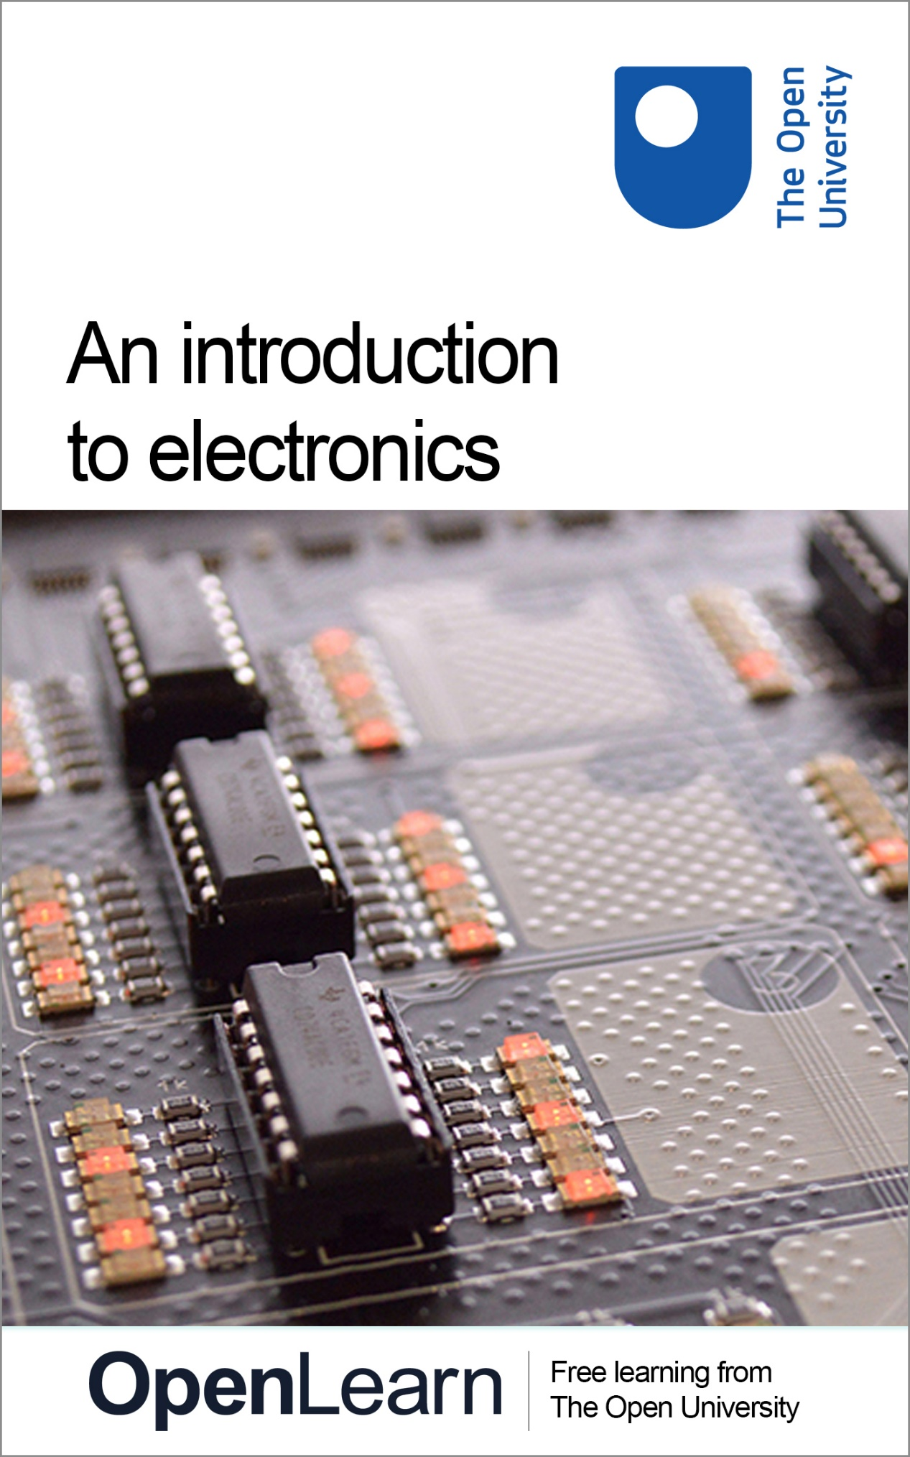

T212_1

An introduction to electronics

About this free course
This free course is an adapted extract from the Open University course T212 Electronics: sensing, logic and actuation: www.open.ac.uk/courses/modules/t212.
This version of the content may include video, images and interactive content that may not be optimised for your device.
You can experience this free course as it was originally designed on OpenLearn, the home of free learning from The Open University –
www.open.edu/openlearn/science-maths-technology/introduction-electronics/content-section-0
There you’ll also be able to track your progress via your activity record, which you can use to demonstrate your learning.
Copyright © 2017 The Open University
Intellectual property
Unless otherwise stated, this resource is released under the terms of the Creative Commons Licence v4.0 http://creativecommons.org/licenses/by-nc-sa/4.0/deed.en_GB. Within that The Open University interprets this licence in the following way: www.open.edu/openlearn/about-openlearn/frequently-asked-questions-on-openlearn. Copyright and rights falling outside the terms of the Creative Commons Licence are retained or controlled by The Open University. Please read the full text before using any of the content.
We believe the primary barrier to accessing high-quality educational experiences is cost, which is why we aim to publish as much free content as possible under an open licence. If it proves difficult to release content under our preferred Creative Commons licence (e.g. because we can’t afford or gain the clearances or find suitable alternatives), we will still release the materials for free under a personal end-user licence.
This is because the learning experience will always be the same high quality offering and that should always be seen as positive – even if at times the licensing is different to Creative Commons.
When using the content you must attribute us (The Open University) (the OU) and any identified author in accordance with the terms of the Creative Commons Licence.
The Acknowledgements section is used to list, amongst other things, third party (Proprietary), licensed content which is not subject to Creative Commons licensing. Proprietary content must be used (retained) intact and in context to the content at all times.
The Acknowledgements section is also used to bring to your attention any other Special Restrictions which may apply to the content. For example there may be times when the Creative Commons Non-Commercial Sharealike licence does not apply to any of the content even if owned by us (The Open University). In these instances, unless stated otherwise, the content may be used for personal and non-commercial use.
We have also identified as Proprietary other material included in the content which is not subject to Creative Commons Licence. These are OU logos, trading names and may extend to certain photographic and video images and sound recordings and any other material as may be brought to your attention.
Unauthorised use of any of the content may constitute a breach of the terms and conditions and/or intellectual property laws.
We reserve the right to alter, amend or bring to an end any terms and conditions provided here without notice.
All rights falling outside the terms of the Creative Commons licence are retained or controlled by The Open University.
Head of Intellectual Property, The Open University
n9781473025608 n9781473025615

Contents
- Introduction
- Learning outcomes
- 1 Electronics everywhere
  - 1.1 Autonomous systems
  - 1.2 The sensing–logic–actuation cycle in practice
- 2 Basic theory of electrical circuits
  - 2.1 Basic electrical quantities
  - 2.2 Relationships between quantities
  - 2.3 Ohm’s law and Kirchhoff ’s laws
  - 2.4 Colour coding and standard resistor values
- 3 Some fundamental circuits
  - 3.1 Voltage dividers
  - 3.2 The Wheatstone bridge
  - 3.3 Operational amplifier circuits
  - 3.4 Designing a sensor circuit
- 4 Signals and signal processing
  - 4.1 High-fidelity sound reproduction and electronics
  - 4.2 Recording sounds
  - 4.3 Recording and analysing speech
  - 4.4 Signals and sine waves
  - 4.5 Making signals from combinations of sine waves
  - 4.6 From the time domain to the frequency domain
  - 4.7 Signals and noise
  - 4.8 Filtering
  - 4.9 Amplifying signals
- Conclusion
- Acknowledgements
- Solutions
- Descriptions

Introduction
Electronics is fundamental to modern life. Using a variety of teaching material, including videos, self-assessment questions (SAQs) and interactive activities, this free course will show you how electronic devices and systems pervade everything we do, and explain some of the fundamental ideas underlying their operation.
Note that the interactive activities have been designed to work in the Firefox and Chrome browsers, so you will need to use one of these browsers if you want to access the interactive content.
This OpenLearn course is an adapted extract from the Open University course T212 Electronics: sensing, logic and actuation.

Learning outcomes
After studying this course, you should be able to:
- recognise a variety of exciting high-tech products and systems enabled by electronics
- manipulate voltages, currents and resistances in electronic circuits
- demonstrate familiarity with basic electronic components and use them to design simple electronic circuits
- see how signals can be represented in the time and frequency domains for Fourier analysis
- record, analyse and filter audio signals to improve their fidelity.

1 Electronics everywhere
Electronics is the art of controlling the movement of electrons in order to design components and circuits that are put together to create the technology of the modern world. Increasingly electronics is at the cutting edge of technology, as illustrated in the following video.

Video content is not available in this format.
Electronics at the cutting edge
View description - Electronics at the cutting edge
View transcript - Electronics at the cutting edge

To get an insight into the central role that electronics plays in society, watch the video below.

Video content is not available in this format.
One day in the life of electronics
View description - One day in the life of electronics
View transcript - One day in the life of electronics

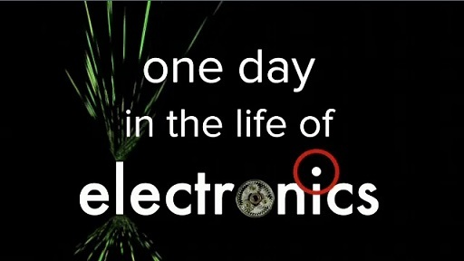

This section of the course will introduce you to the sensing–logic–actuation cycle, the three aspects of which form the basis of understanding electronics.

1.1 Autonomous systems
Any autonomous system has three fundamental aspects: sensing the environment using sensors, reasoning through logic and information processing, and then interacting with the environment through actuators. Together, these are known as the sensing–logic–actuation cycle, as shown in Figure 1.

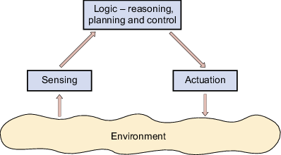
Figure 1 The sensing–logic–actuation control cycle for autonomous systems
View description - Figure 1 The sensing–logic–actuation control cycle for autonomous systems

Each of the three aspects of the sensing–logic–actuation cycle will be discussed briefly here.

Sensing
Electronic devices can sense the world, converting a wide variety of physical phenomena into electrical signals that communicate useful information. Such devices have capabilities similar to the five human senses: hearing (microphones), seeing (cameras), touch (piezoelectrics), and smell and taste (chemical sensors), although sometimes our human senses are better. However, electronic devices can sense things we cannot. For example, Figure 2 shows how ultrasound allows us to ‘see’ inside our bodies, infrared images allow us to ‘see’ patterns of heat and terahertz images allow us to see through opaque coverings.

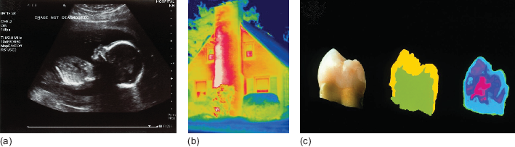
Figure 2 Electronics allows us to perceive things beyond the human senses: (a) ultrasound image of an unborn baby; (b) infrared image of a house; (c) terahertz image of a tooth
View description - Figure 2 Electronics allows us to perceive things beyond the human senses: (a) ultrasound ...

The electrical signals generated by sensors can be processed in many useful ways. For instance, there are many sensors in modern cars linked to displays and alarms that inform the driver of the engine speed and temperature, whether or not the doors are properly shut, if all the passengers are wearing seatbelts, of the proximity of other vehicles when parking, and so on (Figure 3).

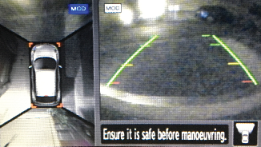
Figure 3 Distance sensors used in a car parking system
View description - Figure 3 Distance sensors used in a car parking system

Logic
Sometimes the information from sensors is fed directly to a human being to act on, as in the car example. However, in many cases that information is unseen by humans and is used to control systems automatically. To do this requires the functions of reasoning and logic, which are usually carried out by logic circuits or programmable microprocessors (Figure 4). These decide what to do from one moment to the next and control the behaviour of the system.

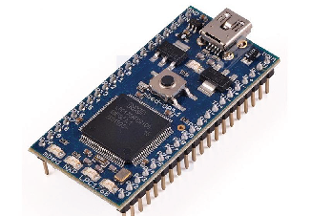
Figure 4 A board with a microprocessor capable of many millions of logical operations per second
View description - Figure 4 A board with a microprocessor capable of many millions of logical operations ...

Actuation
Actuators are components that control the movement in an autonomous system. In many systems, actuators of various kinds are controlled to give the desired behaviour. These include electric motors of various kinds, and other means of motion such as pistons driven by compressed air.
For example, the Oxboard shown in Figure 5 has two motors. You will learn more about the Oxboard in Section 1.2.

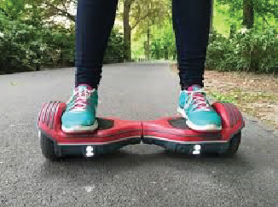
Figure 5 The Oxboard has two motor-wheel actuators
View description - Figure 5 The Oxboard has two motor-wheel actuators

1.2 The sensing–logic–actuation cycle in practice
Watch the video below, which is a promotional video for Oxboard showing a child riding one of their two-wheeled devices. It is remarkable how the board responds to the way the rider moves his feet and body, and how controllable it is.

Video content is not available in this format.
A child riding an Oxboard
View description - A child riding an Oxboard
View transcript - A child riding an Oxboard

Figure 6 gives some of the details of the Oxboard’s construction and use.

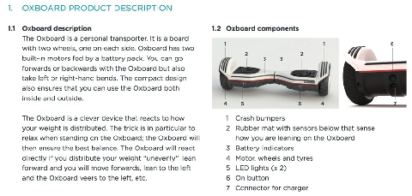
Figure 6 The Oxboard product description
View description - Figure 6 The Oxboard product description

Think about the sensing–logic–actuation cycle for the Oxboard transporter system. The board has sensors to detect the way the rider moves his feet and body. It uses logic to compute all the complicated forces associated with the motion; based on that information, it controls the two actuators (motor-driven wheels) to transport the rider in his desired direction.

SAQ 1

Draw a sensing–logic–actuation cycle for the Oxboard transporter using Figure 1 as a template.

View answer - SAQ 1

2 Basic theory of electrical circuits
Now that you have seen some of the applications of electronics through the sensing–logic–actuation cycle, let’s return to fundamentals.
In what follows, you will look at one of the most important components in electronics: the resistor. This is an example of a passive component – a component that does not supply its own electricity. First, however, let’s review some basic electrical quantities.
Note that the term DC means direct current such as that in a circuit powered by a battery. In contrast, the term AC means alternating current as provided by electrical mains suppliers.

2.1 Basic electrical quantities
The international standard units, Système international d'unités (SI units), that are commonly used for electrical quantities include coulombs, amperes, volts, ohms, watts and joules.
The fundamental unit of electricity is the negative charge of the electron or the positive charge of an ionised atom that has lost a single electron (resulting from the positive charge on the protons in the nucleus outnumbering that of the remaining electrons).
Electrical charge is measured in coulombs (symbol C). The charge on a proton is approximately 1.6 × 10⁻¹⁹ C, while the charge on an electron is the same magnitude but has the opposite sign (approximately −1.6 × 10⁻¹⁹ C). An electrical current is a flow of electric charge, measured in amperes (symbol A), where a current of one ampere is a total charge of one coulomb flowing in one second. Ampere is often abbreviated to amp.
In a circuit, positive and negative electric charges typically flow in the opposite direction to each other, as shown in Figure 8. This course will use conventional current flow, the predominant convention in the electronics industry, which is indicated in the direction taken by positive charges. In metal wires, the current is carried by electrons, which move in the opposite direction. This was not known at the time the convention was established.

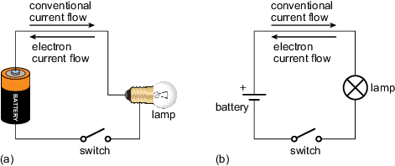
Figure 8 Current flow in an example circuit showing a light bulb (lamp) powered by a battery: (a) schematic using pictures to represent the components; (b) the same circuit using standard circuit schematic symbols. By convention, current flows in the opposite direction to the flow of electrons.
View description - Figure 8 Current flow in an example circuit showing a light bulb (lamp) powered by ...

A quantity closely related to current is voltage. Voltage is a measure of the potential difference between two points. A potential difference of one volt (symbol V) will drive a coulomb of charge through a resistance of one ohm every second. Note that we usually refer to current flowing through a component such as a resistor, but to the voltage being across the component (because two points are required to define the voltage). Voltage can be expressed as the energy per coulomb of charge (J C⁻¹).

2.2 Relationships between quantities
For many materials, current and voltage are directly proportional to each other over a wide range of values, with the resistance as the constant of proportionality, so
voltage = current × resistance
Such materials are said to obey Ohm’s law and are said to be ohmic. However, not all materials are ohmic in nature.
As current flows through a circuit, it transfers energy. When it flows through a material that has a non-zero resistance, this energy is used (for instance, to light a bulb or run a motor) or dissipated as heat (which is why electronics circuits sometimes feel warm, and why computers need cooling fans). As in every other context, the rate of change of energy is known as power, and can be measured in watts (symbol W).
In the context of an electrical current flowing through a resistor, the power used or dissipated can be calculated by multiplying the current flowing through it by the potential difference across the resistor, giving
power (watts) = current (amps) × potential difference (volts)
Before you move on, Table 1 recaps the electrical quantities mentioned so far, their units and how they relate to each other.

Table 1 Electrical quantities and their units
Quantity | Unit | Equation
energy | joules, J
voltage (potential difference) | volts, V  or  energy per charge, joules per coulomb, J C⁻¹
current | amps, A  or  charge per second, coulombs per second, C s⁻¹
power | watts, W  or  energy per second, joules per second, J s⁻¹ | power = voltage × current
resistance | ohms, Ω | resistance = voltage ÷ current

All the quantities listed in Table 1 can be measured in larger or smaller multiples of their standard unit using SI prefixes, which make it easier to read values at a glance. Some of these are listed in Table 2.

Table 2 Common prefixes for SI units
Prefix | Symbol | Multiple of standard unit |  | Example
micro | µ | one millionth | 10⁻⁶ | microamp, µA
milli | m | one thousandth | 10⁻³ | millivolt, mV
kilo | k | one thousand | 10³ | kilo-ohm, kΩ
mega | M | one million | 10⁶ | megawatt, MW

As you gain experience in electronics, try to notice the values of currents, voltages and other quantities for the components you see, and note the associated effects they are having on the circuit. This will help you to choose values when you design, and to troubleshoot when designs or circuits do not work.

2.3 Ohm’s law and Kirchhoff ’s laws
Circuit behaviour follows some fundamental laws that allow you to calculate the expected values of voltage, current and resistance at any point in a circuit. These laws will now be explored mathematically.

Ohm’s law
Ohm’s law states that . This can also be written as

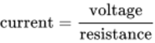
View alternative description - Uncaptioned Equation

or, in symbols,

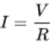
View alternative description - Uncaptioned Equation

The algebraic symbol for current, , comes from the French word intensité.

Kirchhoff ’s laws

Kirchhoff ’s first law (the current law)
At any junction, or node, in an electrical circuit, the sum of the currents flowing into the node is equal to the sum of the currents flowing out of the node.
This is the same as saying that charge can neither be stored at, nor dispensed from, these nodes. This is a useful rule of thumb – it helps when thinking about problems to be able to distinguish between places where energy can and cannot be stored.
This law is illustrated in Figure 9, where the sum of the currents in the inputs to the node equals the current out.

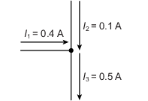
Figure 9 Kirchhoff’s first law
View description - Figure 9 Kirchhoff’s first law

Kirchhoff ’s second law (the loop or mesh law)
When direction is taken into account, the sum of the potential differences around any closed circuit or network is zero. This is illustrated in Figure 10, which is a screenshot taken from an online circuit simulation package called Multisim Live. Here, starting with the battery, the voltages around the circuit are 6.0 V − 1.0 V − 3.0 V − 2.0 V = 0 V.

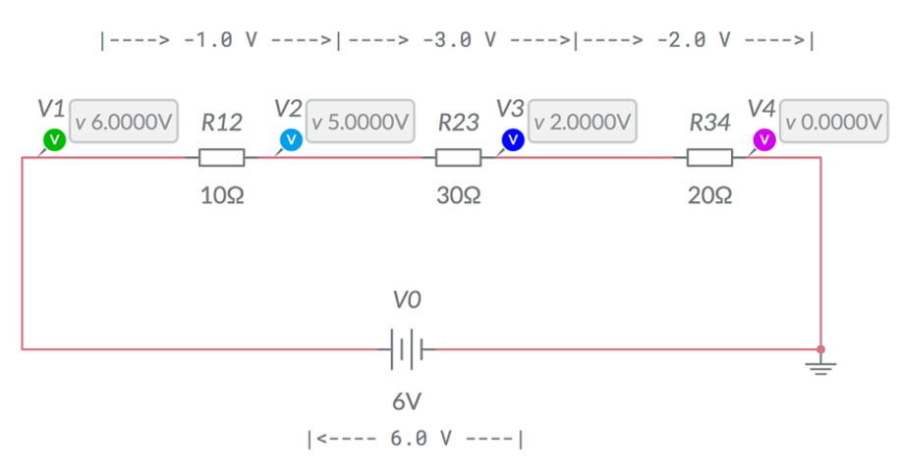
Figure 10 Illustration of Kirchhoff’s second law (screenshot from Multisim Live)
View description - Figure 10 Illustration of Kirchhoff’s second law (screenshot from Multisim Live)

Series and parallel networks (combining the laws)
The ordering of the components, and how they are connected, is important in a circuit. For example, two components (here resistors) can be arranged in two different ways, as shown in Figure 11. A circuit in which the current must take a single path, going through first one component and then the other in series, is shown in Figure 11(a); a circuit in which the current splits and takes two parallel paths at the same time is shown in Figure 11(b).

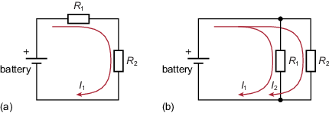
Figure 11 Circuit schematics showing two resistors arranged in (a) series and (b) parallel
View description - Figure 11 Circuit schematics showing two resistors arranged in (a) series and (b ...

By combining Ohm’s and Kirchhoff’s laws, it can be shown that:
- the total resistance of resistors in series is given by

View alternative description - Uncaptioned Equation

- the total resistance of resistors in parallel is given by

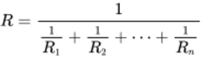
View alternative description - Uncaptioned Equation

SAQ 2

In Figure 11, let and . To three significant figures:
- What is their resistance in series?
- What is their resistance in parallel?

View answer - SAQ 2

2.4 Colour coding and standard resistor values
Conventional fixed resistors have coloured bands showing their value. These can be decoded using Table 3. For example, a resistor with four bands where the coding is yellow (4), violet (7), red (× 100) and brown (1%) has a resistance of
(47 Ω × 100) ± 1% = 4700 Ω ± 47 Ω
There is a similar five-band scheme where there are three instead of two digits in the resistance value, and a six-band scheme that also gives temperature information. Sometimes it can be hard to see these colour values on the resistors and a multimeter is used to check them.
Table 3 The four-band colour-coding scheme for resistors

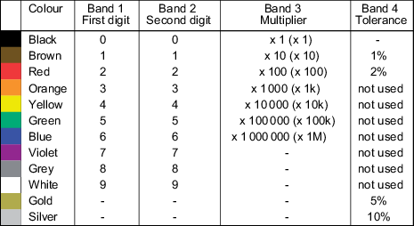
View description - Uncaptioned Figure

Resistors are required across a range of millions of ohms. To keep costs low, manufacturers have defined ‘standard’ sets of resistor values such as those shown in Table 4 for resistors with a tolerance of ±5%.
Table 4 Standard resistor values in ohms (±5%)

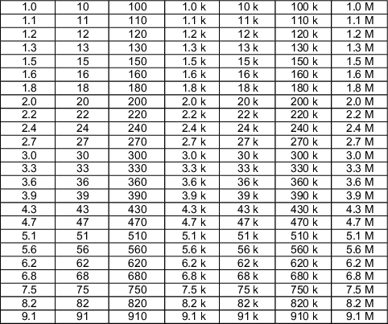
View description - Uncaptioned Figure

The standard or preferred values shown in Table 4 are chosen such that whatever value resistance is required, there is one within 5% of the specified value. Fixed resistors’ costs are usually very low.

3 Some fundamental circuits
By combining resistors in different ways, some circuits can be created that are very important in electronics. This section will look at two of these, the voltage divider and the Wheatstone bridge, before introducing a new component in the form of an operational amplifier (op-amp).

3.1 Voltage dividers
Voltage dividers are widely used in electronic circuits to create a reference voltage, or to reduce the amplitude of a signal. Figure 12 shows a voltage divider. The value of can be calculated from the values of , and .

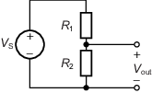
Figure 12 A voltage divider circuit
View description - Figure 12 A voltage divider circuit

In the first instance, let’s assume that is not connected to anything (for voltage dividers it is always assumed that negligible current flows through ). This means that, according to Kirchhoff’s first law, the current flowing through is the same as the current flowing through . Ohm’s law allows you to calculate the current through . It is the potential difference across that resistor, divided by its resistance. Since the voltage is distributed over two resistors, the potential drop over is .
The current through () is given by

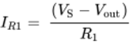
View alternative description - Uncaptioned Equation

Similarly, the current through is given by

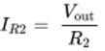
View alternative description - Uncaptioned Equation

Kirchoff’s first law tells you that , and therefore

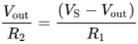
View alternative description - Uncaptioned Equation

Multiplying both sides by and by gives

View alternative description - Uncaptioned Equation

Then multiplying out the brackets on the right-hand side gives

View alternative description - Uncaptioned Equation

This can be rearranged to

View alternative description - Uncaptioned Equation

giving

View alternative description - Uncaptioned Equation

and therefore the fundamental result is obtained:

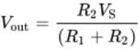
View alternative description - Uncaptioned Equation

SAQ 3

Suppose = 24 V and = 100 Ω. You want = 6 V. What value of do you need?

View answer - SAQ 3

3.2 The Wheatstone bridge
Originally developed in the nineteenth century, a Wheatstone bridge provided an accurate way of measuring resistances without being able to measure current or voltage values, but only being able to detect the presence or absence of a current. A simple galvanometer, as illustrated in Figure 13, could show the absence of a current through the Wheatstone bridge in either direction. The long needle visible in the centre of the galvanometer would deflect to one side or the other if any current was detected, but show no deflection in the absence of a current.

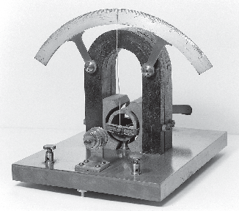
Figure 13 An early galvanometer showing magnet and rotating coil
View description - Figure 13 An early galvanometer showing magnet and rotating coil

Figure 14(a) shows a circuit made of four resistors forming a Wheatstone bridge. Its purpose here is to show whether there is any current flowing between and . Figure 14(b) shows an equivalent way of drawing the circuit.

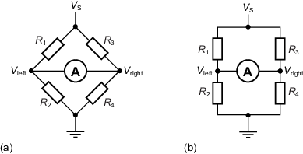
Figure 14 Equivalent examples of a Wheatstone bridge
View description - Figure 14 Equivalent examples of a Wheatstone bridge

The bridge is said to be balanced (that is, no current flows through the bridge and the needle of the galvanometer shows no deflection) if the voltages and are equal. It can be shown that the bridge is balanced if, and only if, 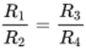, as follows.
When then . Then the Wheatstone bridge can be viewed as two voltage dividers, and on the left and and on the right. Applying the voltage divider equation gives 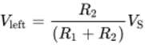 and 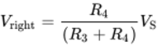.
So

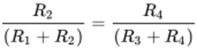
View alternative description - Uncaptioned Equation

and

View alternative description - Uncaptioned Equation

Multiplying out the brackets gives

View alternative description - Uncaptioned Equation

which simplifies to

View alternative description - Uncaptioned Equation

and

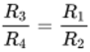
View alternative description - Uncaptioned Equation

So, if were unknown, , and could be chosen so that the needle of a galvanometer showed no deflection due to the current. Then

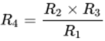
View alternative description - Uncaptioned Equation

SAQ 4

Assume the Wheatstone bridge shown in Figure 14 is balanced. If , and , what is the resistance of ?

View answer - SAQ 4

3.3 Operational amplifier circuits
Operational amplifiers are a fundamental component in electronics. This section focuses on a classic amplifying device, the 741 op-amp.
As shown in Figure 15(a), the op-amp symbol has five terminals. The terminals V₊ and V₋ are used for the input and they control the output, usually as an amplified signal on V_{out}. The op-amp is built using several resistors and other components called transistors. All these transistors and resistors are packed inside the very small package you can see in Figure 15(b). A dot and a dent on top of the package are generally used to identify the orientation of the package and therefore the pin number. You can also see these marked on the configuration diagram shown in Figure 15(c).

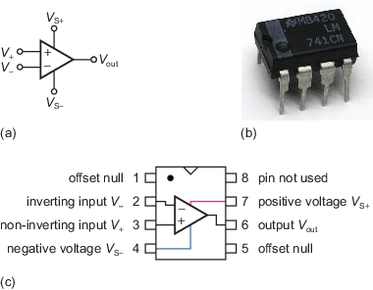
Figure 15 (a) Symbol for an op-amp; (b) the 741 op-amp package; (c) top view of an LM741 dual inline package (DIL), showing internal configuration and pin connections
View description - Figure 15 (a) Symbol for an op-amp; (b) the 741 op-amp package; (c) top view of an ...

Dual power supplies
On the op-amp symbol, the vertical lines marked V_{S+} and V_{S−} are very important, since, as already mentioned, they are the op-amp’s connection to a power supply. However, when there is no room for confusion, the two vertical lines leading to the power source (V_{S+} and V_{S−}) are sometimes omitted from the symbol.
Often a mains dual power supply provides the positive and negative voltages required for an op-amp. Alternatively, you could decide to use batteries to power the op-amp. Since batteries always give a positive voltage, how can they deliver a negative voltage? Figure 16 shows how two batteries can be connected to an op-amp to deliver positive and negative voltages.

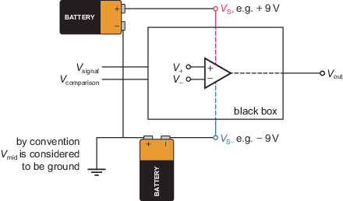
Figure 16 Black box representation of the 741 op-amp, showing the power supplies
View description - Figure 16 Black box representation of the 741 op-amp, showing the power supplies

3.4 Designing a sensor circuit
Figure 17 is a screenshot taken from Multisim Live, showing a circuit with four parts. On the right is a light-emitting diode (LED) and a 470 Ω resistor, . On the left there is a device called a light-dependent resistor (LDR). This is labelled and forms a voltage divider with a fixed resistor . The resistance of the LDR has been measured as 380 Ω in full ambient light and 1.5 kΩ in the dark. We want the LED to switch on when the environment begins to darken and the resistance of is 680 Ω or more. (Note that is the label that Multisim Live gives to the op-amp.)

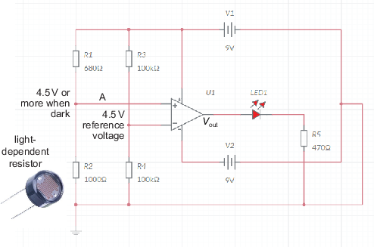
Figure 17 Circuit diagram for an open-loop op-amp switching an LED (screenshot from Multisim Live)
View description - Figure 17 Circuit diagram for an open-loop op-amp switching an LED (screenshot from ...

The resistors and form another voltage divider, which will provide a ‘reference’ signal. Both and have resistance 100 kΩ. Battery provides 9 V, so the reference voltage is

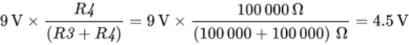
View alternative description - Uncaptioned Equation

If is set to 680 Ω and variable resistor is also 680 Ω, the voltage at A will be the same as the reference voltage, because

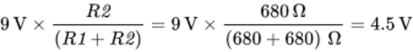
View alternative description - Uncaptioned Equation

As it gets darker, this voltage will increase.
This circuit is shown implemented as a breadboard in Figure 18. When it gets dark and the sensor receives less light, the LED illuminates as required.

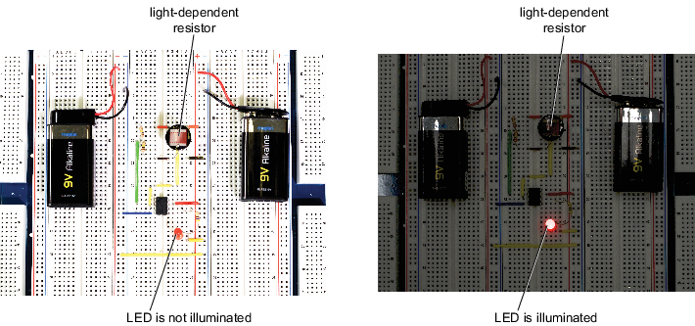
Figure 18 Breadboard circuit for the open-loop op-amp: (a) in light conditions, the LED is not illuminated; (b) when it gets dark, the LED is illuminated
View description - Figure 18 Breadboard circuit for the open-loop op-amp: (a) in light conditions, the ...

4 Signals and signal processing
The last section in this course focuses on signals, in particular sound signals. You will investigate how sounds can be recorded, analysed and reproduced. By the end of the section, you will return to the op-amp and see how it can be used to amplify a sound or other signal.

4.1 High-fidelity sound reproduction and electronics
Recording and reproducing sound has been one of the great drivers for innovation in electronics. What we perceive to be sound is vibrating air causing our eardrums to vibrate. For example, consider a guitar string vibrating 440 times per second, causing 440 high–low pressure waves to be transmitted through the air. This wave causes your eardrum to vibrate 440 times per second, which your brain interprets as the note A.
A device such as a microphone converts the highs and lows of the air pressure wave into a high and low voltage wave that represents the sound wave as an electrical analogue, oscillating between high and low voltages 440 times per second. When that electrical wave becomes the input to a loudspeaker, the speaker’s cone vibrates back and forth 440 times per second, creating a sound wave that you would hear as the note A.
In a perfect world, the sound made by a loudspeaker would be exactly the same as the original sound, with perfect fidelity. In practice, converting the sound to voltages and back to sound is an imperfect process, and some distortion or extraneous noise is inevitable. This is particularly notable with telephones, which usually have relatively low fidelity and distort the sound of our voices. For reproducing music, engineers try to make the fidelity as high as possible – and some people are prepared to pay a lot of money for high-fidelity equipment, or hi-fi systems as they are called. This aesthetic demand has driven much electronics research for nearly a century. Miniaturisation, low power consumption and computational load are also drivers of innovation, as can be seen with increasingly powerful and smaller mobile phones that last longer and longer between charges.

4.2 Recording sounds
Interactive 1 will allow you to see what ‘real’ sounds that you make yourself look like as waves. To get started, click on the large microphone symbol at the centre of the interactive. The first time you do this, you may see a pop-up window asking for permission to use your microphone – click on the appropriate button to allow this. Then try making some sounds. You will see a pink line moving.

Interactive content is not available in this format.
Interactive 1 Recording and viewing a sound
View description - Interactive 1 Recording and viewing a sound

To record a sound, click on the record button (the circle) at the bottom left of the interactive. As an example, Figure 19 shows the wave produced by humming a low note.

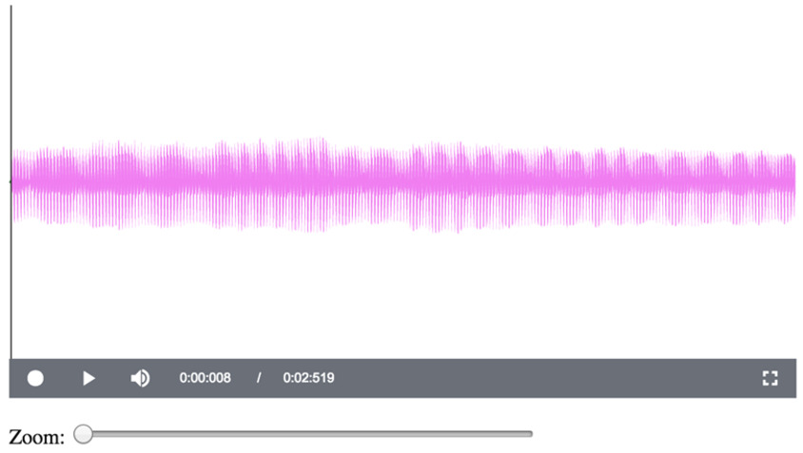
Figure 19 Voltage wave produced by humming a low note
View description - Figure 19 Voltage wave produced by humming a low note

To make the picture, the microphone on the computer ‘sampled’ the sound 44 100 times per second and drew a pink line from 0 V to the value sampled. Because there are so many samples and the screen has limited resolution, some of the lines get overdrawn by others and merge to form solid blocks of colour.
It is quite hard to see the details of the wave at this resolution, but the interactive allows you to click on the wave and move the ‘zoom’ slider from left to right. Figure 20 shows the result of doing this to the wave in Figure 19. Notice that at the bottom of the wave, there are 24 long downward spikes with a shorter downward spike in between each pair. The long spike represents what is called the fundamental frequency of the recorded voice, and the shorter spike is what is called a harmonic.

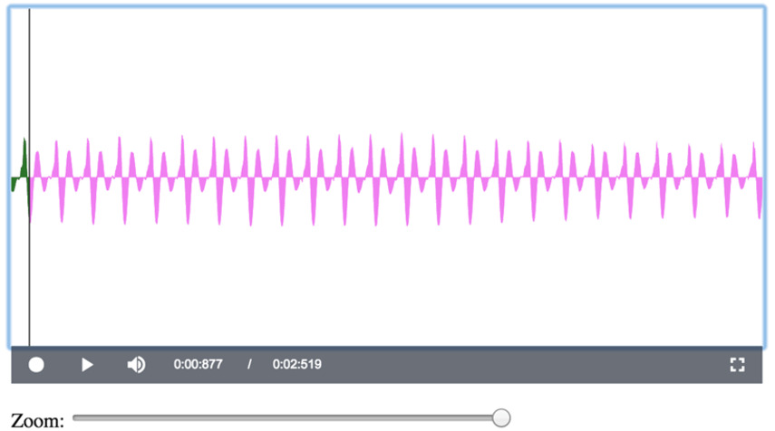
Figure 20 Zooming in to the wave from Figure 19
View description - Figure 20 Zooming in to the wave from Figure 19

The interactive can also be used to measure the time between the spikes and therefore calculate the frequencies. To do this, click your mouse on the tip of the leftmost spike and note the numbers at the bottom of the interactive to the right of the loudspeaker icon. The first of these numbers is the time that the spike was recorded. Then click on the tip of the rightmost spike and note this number again. The difference between the two times divided by the number of gaps between the spikes gives you the time period between any pair of spikes, from which you can calculate the frequency.
For example, you can see from Figure 20 that clicking on the leftmost spike shows the numbers 0:00:877 / 0:02:519 at the bottom of the interactive. Therefore that spike was recorded at 0:00:877. Clicking on a spike at the right of the interactive, as shown in Figure 21, shows that it was recorded at 0:01:099. There are 22 gaps between the long spikes in this example, so the time period between any pair of spikes is (0:01:099 − 0:00:877)/22 = (1.099 − 0.877)/22 = 0.01 seconds. Thus, since the period for one oscillation of the long spikes is 0.01, there are 1/0.01 = 100 spikes per second and the frequency is 100 vibrations per second. Engineers use the term hertz (Hz) for ‘times per second’, so the fundamental frequency of this recorded hum is 100 Hz.

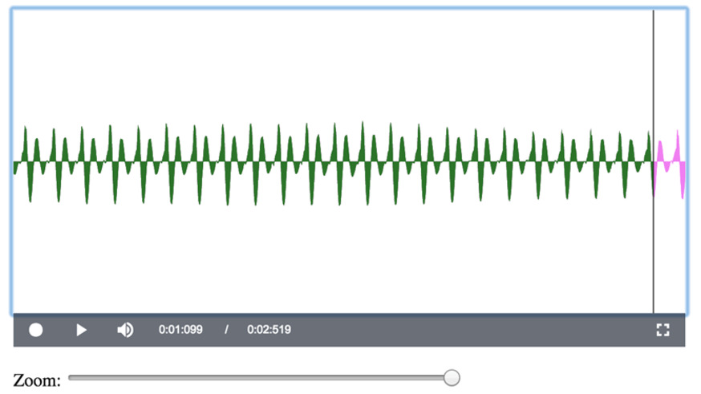
Figure 21 Calculating the fundamental frequency
View description - Figure 21 Calculating the fundamental frequency

SAQ 5

A recording of an electric toothbrush shows the time at the top of a peak on the left as 0.219 seconds (Figure 22(a)) and the time at the top of a peak on the right as 0.452 seconds (Figure 22(b)). How many gaps between peaks occur between these two times? What is the period of this wave (that is, the length of time between any two consecutive peaks)? What is the frequency of vibration of this electric toothbrush?

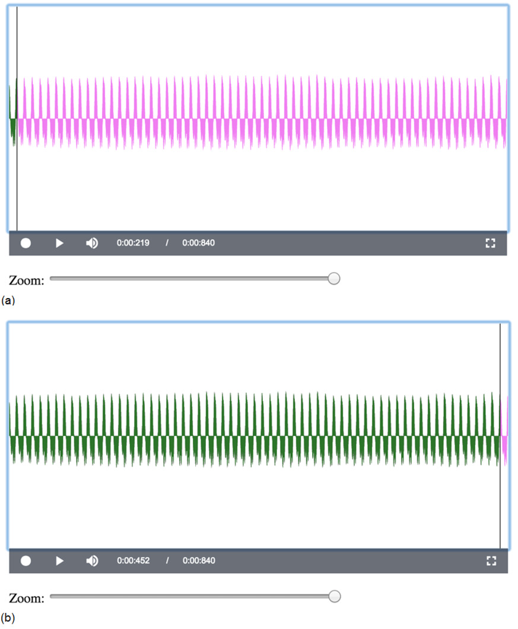
Figure 22 Recording of an electric toothbrush: time at the top of a peak on (a) the left and (b) the right
View description - Figure 22 Recording of an electric toothbrush: time at the top of a peak on (a) the ...

View answer - SAQ 5

Keep the interactive open, because you will need it in the next section.

4.3 Recording and analysing speech
Generally, sound waves are much more complicated than a wave made by humming a single note or the sound made by an electric toothbrush. For example, Figure 23 shows the waveforms generated by someone saying ‘yes’ followed by ‘no’. Let this be called Recording A.

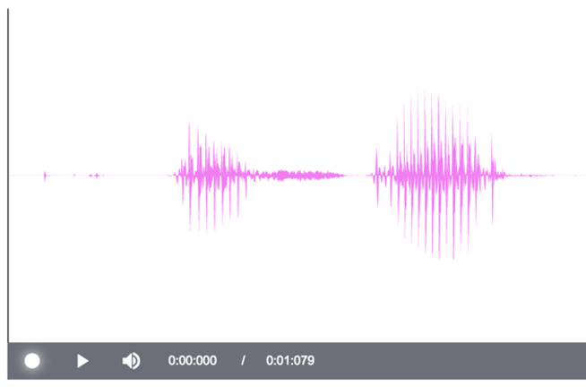
Figure 23 Recording A: ‘yes’ followed by ‘no’
View description - Figure 23 Recording A: ‘yes’ followed by ‘no’

SAQ 6

Each of the bursts of sound shown in Figure 24 is another recording of a person saying either ‘yes’ or ‘no’. Let this be called Recording B. Comparing Recording B with Recording A, which of the bursts of sound in Recording B is ‘yes’ and which is ‘no’?

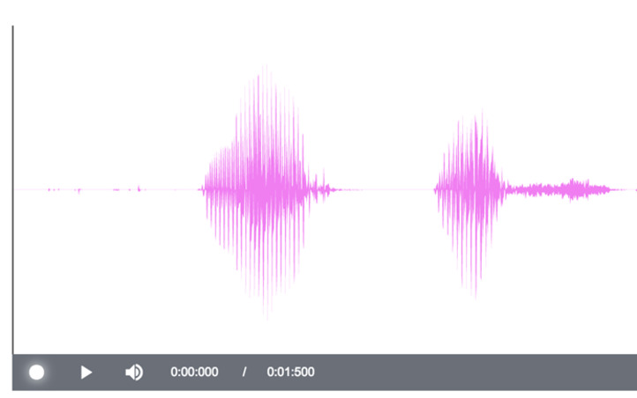
Figure 24 Recording B
View description - Figure 24 Recording B

View answer - SAQ 6

The fact that different words result in different wave patterns underlies the technology of speech recognition. This technology has evolved to a high performance level over the last half century, but it has overcome some formidable problems. For example, are one person’s speech patterns the same as another’s?
Return to Interactive 1 (which you should still have open in a separate tab) and spend five or ten minutes experimenting by making your own sounds. If you hum a low note, are you able to calculate its frequency? Can you distinguish the patterns when you say ‘yes’ and ‘no’? Are your ‘yes’ and ‘no’ wave patterns similar to those shown in Figure 23?
When you have finished, close the interactive.

4.4 Signals and sine waves
Interactive 2 shows a signal based on a sine wave, sin(2πft), where f is the frequency of the wave and t is time. Here the frequency of the wave is f = 200 Hz. The period of the wave, T, is the time between successive peaks; in this case, T = 5 ms (milliseconds). As would be expected, T = 1/f = 1/200 = 0.005 s. Similarly, f = 1/T = 1/0.005 = 200 Hz.
The signal is written as
s(t) = A sin(2πft + ϕ)
where A is called the amplitude of the wave, i.e. the largest value of the wave above or below the horizontal axis. Here it is set to A = 0.5.
ϕ is the phase of the wave, which means how far the wave is shifted to the left or the right. Here it is set to 0, since the wave goes through the origin and is not shifted either left or right.
Right-click on the image below to open the interactive in a new tab, then press the loudspeaker button to hear what the signal sounds like.

Interactive content is not available in this format.
Interactive 2 Investigating a sine wave
View description - Interactive 2 Investigating a sine wave

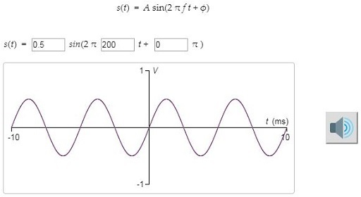

SAQ 7

- Change A to 1.0 and play the sound. What do you observe?
- Change f to 400 and play the sound. What do you observe?
- Change ϕ to π/2 and play the sound. (You can enter a phase of π/2 into the interactive as 90 degrees.) What do you observe?

View answer - SAQ 7

4.5 Making signals from combinations of sine waves
Right-click on the image below to open Interactive 3 in a new tab, then change the values for the top two waves so that the frequency of the first is 440 Hz and the frequency of the second is 660 Hz. Make the amplitude of both 0.5.
The wave at the bottom is formed by combining these two waves, by adding their values for each value of t.
Click on the loudspeaker button for each of the top two waves and listen to the resulting sounds. Then click on the loudspeaker button for the bottom wave and listen to its sound.

Interactive content is not available in this format.
Interactive 3 Combining sine waves
View description - Interactive 3 Combining sine waves

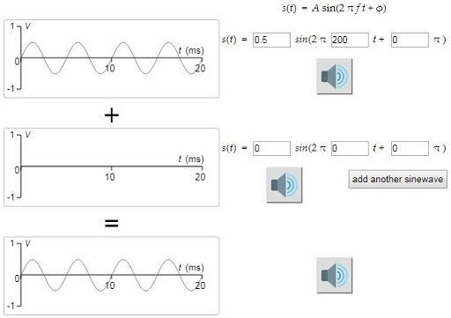

SAQ 8

- Is the composite signal at the bottom a sine wave?
- What is the ratio of the frequencies of the sine waves at the top?
- Does the combined signal sound pleasant with the single sine waves in harmony?
- Do you think there is any relationship between the ratio of the frequencies and the notes harmonising?

View answer - SAQ 8

SAQ 9

Keep the frequency of the first wave at 440 Hz and its amplitude at 0.5. Change the frequency of the second wave to 880 Hz and change its amplitude to −0.17 (don’t overlook the minus). What is the shape of the resulting wave?

View answer - SAQ 9

Keep the interactive open, because you will need it in the next section.

The square wave challenge
The wave shown in Figure 26 approximates what is called a ‘square’ or ‘rectangular’ wave. The challenge is to design this wave using sine waves as components.

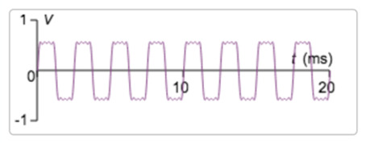
Figure 26 Approximation to a square wave
View description - Figure 26 Approximation to a square wave

To make this wave using Interactive 3 (which you should still have open in a separate tab), start with two sine waves, the first having A = 0.7 and f = 400 Hz, and the second having A = 0.2 and f = 1200 Hz. This will give something similar to the wave shown in Figure 27, which is a good start.

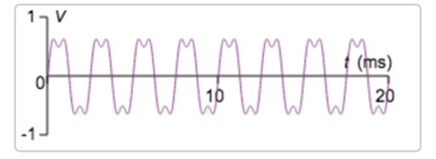
Figure 27 Combination of two sine waves
View description - Figure 27 Combination of two sine waves

To make the top and bottom smoother requires sine waves with other frequencies. To get another sine wave, click on the ‘add another sine wave’ button below the second sine wave. Set the frequency of this to f = 2000 Hz.

SAQ 10

Suggest an appropriate value of A for the wave with frequency f = 2000 Hz.

View answer - SAQ 10

To finish this challenge requires one more sine wave. Click again on the ‘add another sine wave’ button to get a fourth sine wave. Set its frequency to f = 2800 Hz.

SAQ 11

Suggest an appropriate value of A for the wave with frequency f = 2800 Hz.

View answer - SAQ 11

You can now close the interactive.
In the square wave challenge, the shape of the wave was made closer to that required by adding higher frequencies with decreasing amplitudes. This is a general principle behind a very powerful theory for representing and processing signals.

4.6 From the time domain to the frequency domain
In the previous sections, you saw that complicated waveforms can be created by combining simple sine waves in a systematic way. Remarkably, any waveform can be represented as a combination of sine waves of appropriately chosen amplitude (loudness), frequency (pitch) and phase. This result, demonstrated by the French mathematician and physicist Joseph Fourier (1768–1830), lies at the heart of the design of electronic systems to reproduce high-fidelity sound.
The most familiar representation of waves is in what is called the time domain, i.e. the changing value of the signal through time. As you have seen, complicated waves can be formed from combinations of sine waves of given frequency and amplitude. This allows another representation in what is called the frequency domain. To see this, enter the following waves into Interactive 4:
- Wave 1: A = 0.7, f = 110 Hz
- Wave 2: A = 0.2, f = 330 Hz
- Wave 3: A = 0.1, f = 550 Hz
- Wave 4: A = 0.05, f = 770 Hz.

Interactive content is not available in this format.
Interactive 4 Waves represented in the time domain and the frequency domain
View description - Interactive 4 Waves represented in the time domain and the frequency domain

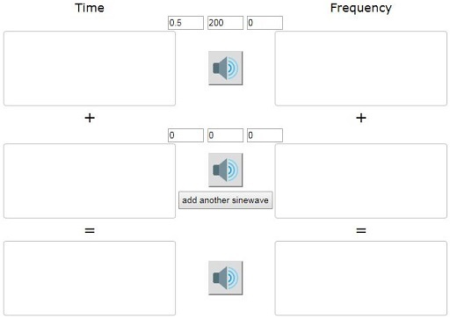

SAQ 12

- What is the shape of the combined waveform?
- What do you see to the right of the combined waves, in the ‘frequency domain’?

View answer - SAQ 12

Figure 30 shows the composite wave formed from the four sine waves listed above. On the right of this is a graph showing amplitude against frequency. There is a vertical line of height A = 0.7 corresponding to frequency f = 110 Hz, a vertical line of height A = 0.2 corresponding to f = 330 Hz, a vertical line of height A = 0.1 corresponding to f = 550 Hz and a vertical line of length A = 0.05 corresponding to f = 770 Hz. This set of lines is called the frequency spectrum of the signal on the left.

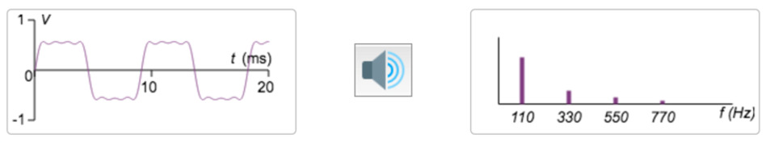
Figure 30 Transforming a signal in the time domain into the frequency domain
View description - Figure 30 Transforming a signal in the time domain into the frequency domain

One of the many problems with reproducing sound is that the desired sound may be contaminated by noise. For example, if you record a video and commentary on your phone in a crowded place, you will record what you want (you speaking) but also what you may not want (the hubbub surrounding you). Engineers talk about the part of the recording that is wanted as the signal and the part that is not wanted as noise.
For example, suppose you are recording yourself playing the piano and an emergency vehicle goes past with its high-pitched siren blaring. By using electronics, it may be possible to filter out that unwanted noise, or at least make it a lot less intrusive.
To represent noise, add a fifth sine wave to your signal with A = 0.3 and f = 935 Hz. This distorts the signal, as shown in Figure 31. Click on the loudspeaker button and you will hear that the sound is now quite discordant. It is not very clear what the noise is doing in the time-domain representation on the left, but the rogue frequency of 935 Hz can be seen clearly as a vertical bar of length 0.3 in the frequency-domain representation on the right. Now it is easy to imagine that one could take a pair of scissors and snip out that unwanted part of the composite signal in the frequency domain, before reassembling everything as the ‘cleaned’ signal in the time domain.

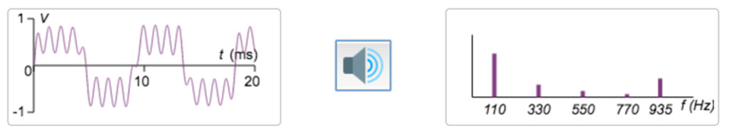
Figure 31 Noise with frequency f = 935 Hz shows clearly in the frequency domain
View description - Figure 31 Noise with frequency f = 935 Hz shows clearly in the frequency domain

Apart from removing unwanted noise, Fourier’s theory can also be used to manipulate signals in the frequency domain to give interesting new aesthetic results when the signals in the time domain are played through a loudspeaker. This has stimulated research and technology that has been widely used in the music industry for more than half a century, since the invention of the electric guitar.

4.7 Signals and noise
In this section, you will see some remarkable applications of the ideas in the preceding sections. To get going, right-click on the link below the image to open Interactive 5 in a new tab, then – if necessary – click on the microphone icon to enable the interactive to use your computer’s microphone.
If there is a tick in the ‘Use logarithmic Y scale on FFT’ box, click on it to remove it.
If there is a tick in the ‘Add noise tone’ box beneath the ‘zoom’ slider, click on the box to remove it.

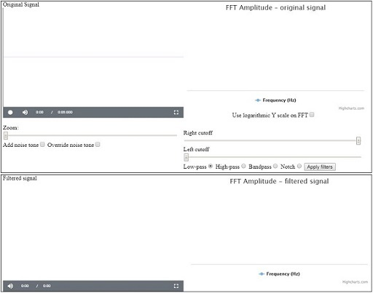
Interactive 5 Recording sounds and adding noise (Ctrl+right-click to open this link in a new window).
View description - Interactive 5 Recording sounds and adding noise (Ctrl+right-click to open this link ...

When you are ready, press the record button (the circle), say the word ‘yes’, then click on the square button to stop recording. Your screen should now be similar to Figure 32.

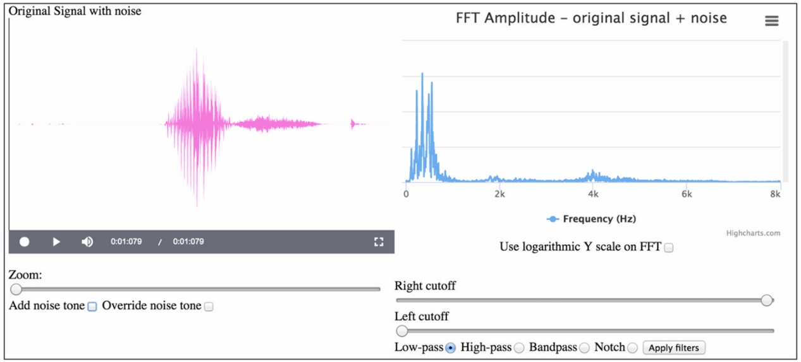
Figure 32 A recording of ‘yes’ in the time domain, transformed into the frequency domain
View description - Figure 32 A recording of ‘yes’ in the time domain, transformed into the frequency ...

Tick the ‘Add noise tone’ box by clicking on it. Also tick the ‘Override noise tone’ by clicking on it. This will give a ‘Noise frequency’ slider. Move this to the right until the figure in the box is about 1200 Hz. This will add a sine wave with this frequency as noise to your sound. Look at the frequency spectrum on the right and you will see a peak close to 1200 Hz. Note that as you move the slider, the position of this peak will change, but for the moment make sure it is set at around 1200 Hz.
Now click on the play button (the triangle) and you will hear your ‘yes’ played back with a whistling noise in the background. Your screen should be similar to that shown in Figure 33.

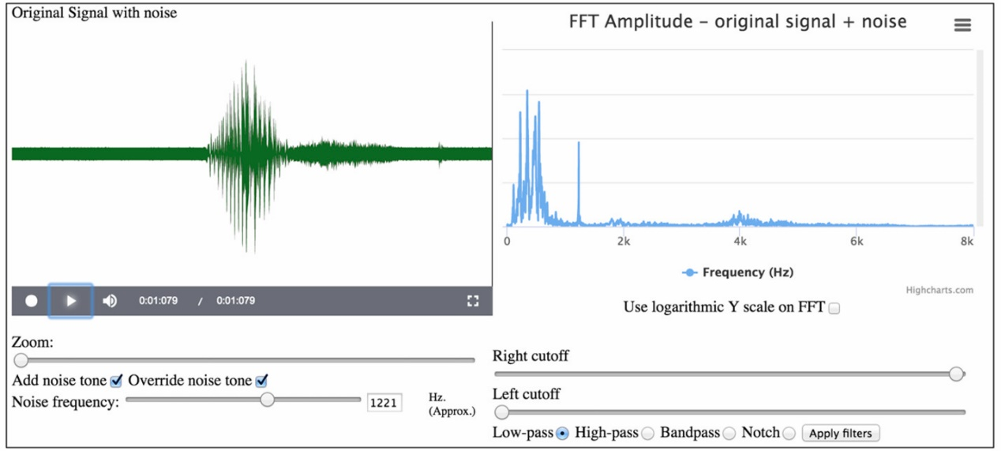
Figure 33 ‘Yes’ with a rogue component at 1221 Hz acting as noise
View description - Figure 33 ‘Yes’ with a rogue component at 1221 Hz acting as noise

Keep the interactive open with your ‘yes’ recording in it. In the next section, you will see how the noise you added can be ‘clinically’ removed, restoring the signal to almost exactly what it was without the noise.

4.8 Filtering
Filtering is the art of removing parts of a signal that are not required and retaining those parts that are required. The four main kinds of filter are shown in Figure 34. For example, a notch filter will remove the noise at the 1200 Hz peak.

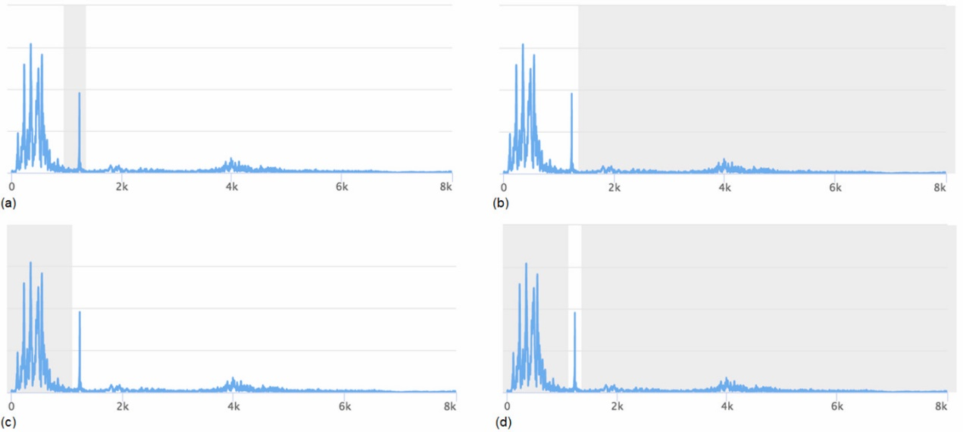
Figure 34 Types of filter: (a) notch filter – the frequencies in the shaded area are removed; (b) low-pass filter – high frequencies (in the shaded area) are removed, low frequencies are ‘passed’; (c) high-pass filter – low frequencies (in the shaded area) are removed, high frequencies are ‘passed’; (d) band-pass filter – low and high frequencies (in the shaded area) are removed, those in the remaining band are ‘passed’
View description - Figure 34 Types of filter: (a) notch filter – the frequencies in the shaded area ...

You should still have Interactive 5 open in a separate tab, containing your recording of the word ‘Yes’ with an added noise tone of 1200 Hz. Select the ‘Notch’ button and use the ‘Right cutoff’ and ‘Left cutoff’ sliders to create a notch filter, as shown in Figure 34(a). Then click on the ‘Apply filters’ button next to the ‘Notch’ button.
Your result should be similar to that shown in Figure 35. As you can see, the noise has been removed without doing too much damage to the original signal.

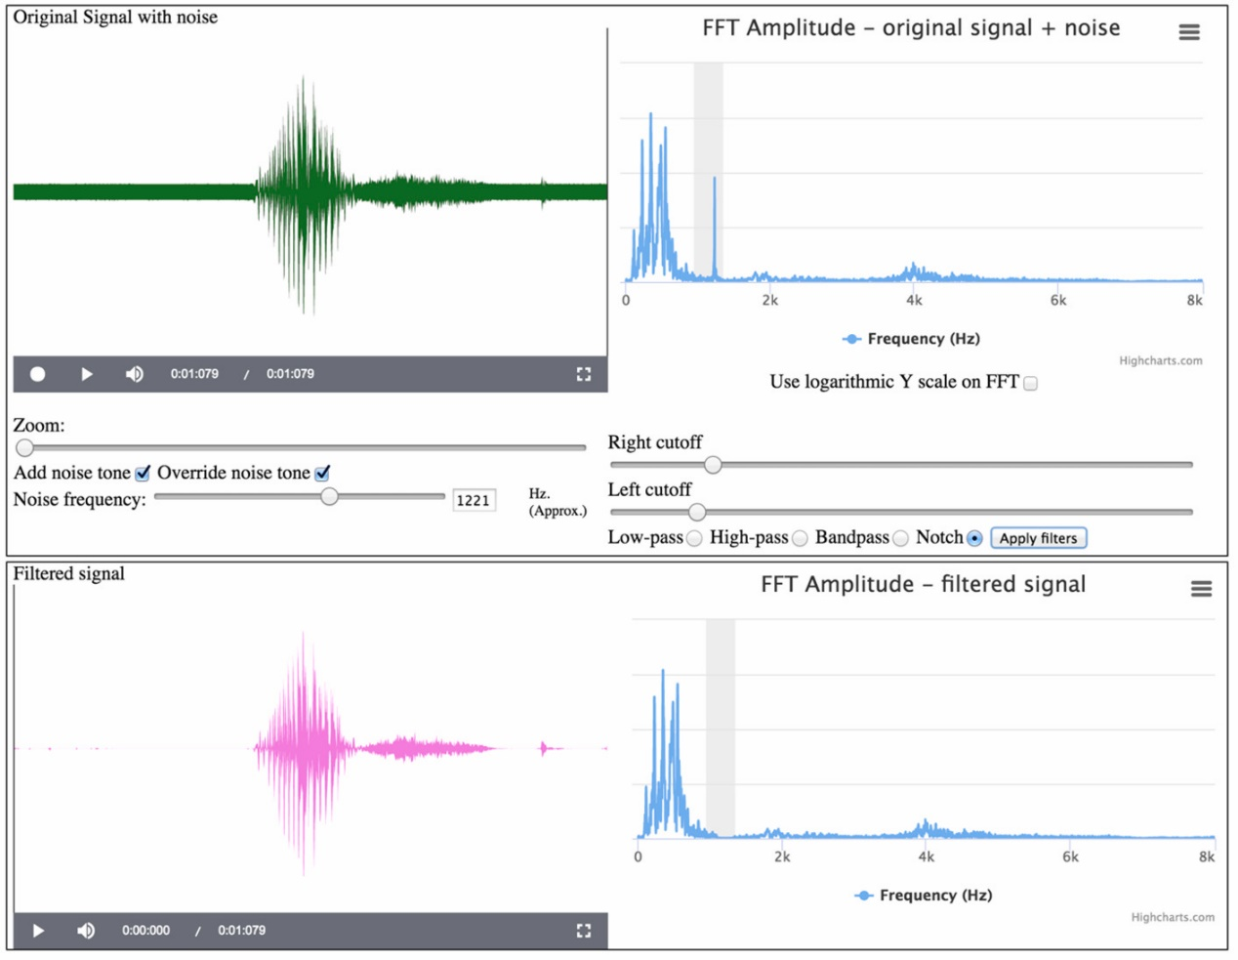
Figure 35 ‘Yes’ plus rogue 1221 Hz component, with notch filter applied
View description - Figure 35 ‘Yes’ plus rogue 1221 Hz component, with notch filter applied

SAQ 13

Click on the play button (the triangle) at the bottom left of the interactive to play the filtered signal.
- Was the noise removed as you listened to your signal?
- Was the signal damaged, giving low-fidelity reproduction?

View answer - SAQ 13

SAQ 14

Click on the ‘Bandpass’ button and then click on the ‘Apply filters’ button. What do you see and hear now?

View answer - SAQ 14

SAQ 15

Click on the ‘Low-pass’ button and then click on the ‘Apply filters’ button. What do you see and hear now?

View answer - SAQ 15

SAQ 16

Click on the ‘High-pass’ button and then click on the ‘Apply filters’ button. What do you see and hear now?

View answer - SAQ 16

SAQ 17

Select ‘High-pass’ and change the left cutoff to about 3 kHz. Click on ‘Apply filters’. Does this filter in or out any discernible part of the ‘yes’ sound?

View answer - SAQ 17

When you first looked at the recordings of ‘yes’ and ‘no’ on this course, it was noted that they have different shapes in the time domain and that this might be useful for speech recognition. As can be seen in Figure 36, ‘yes’ and ‘no’ also have different patterns in the frequency domain and this too is useful for speech recognition.

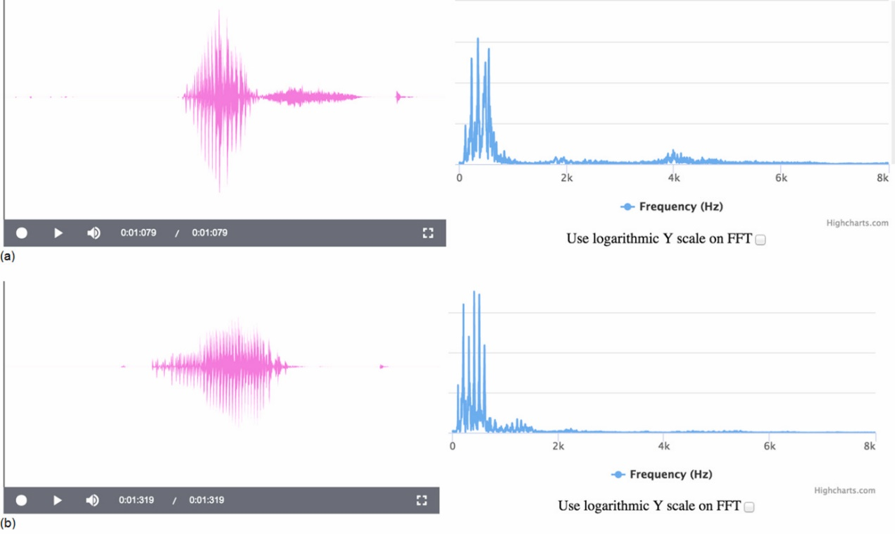
Figure 36 ‘Yes’ and ‘no’ in the frequency domain: (a) ‘yes’ has a pattern with many high-frequency components; (b) ‘no’ has a pattern with few high-frequency components
View description - Figure 36 ‘Yes’ and ‘no’ in the frequency domain: (a) ‘yes’ has a pattern with many ...

You can now close the interactive.

4.9 Amplifying signals
Most of the electrical signals that record sounds are very weak. For example, a guitar pickup generates electricity as the metal string vibrates in a magnetic field. The amount of electricity that can be generated in this way is limited and typical voltages are in the order of 100 mV. To become useful, this signal needs to be amplified. This means, literally, that the amplitude of the signal has to be increased.
One way to amplify a signal is to use an operational amplifier (op-amp) with two resistors connected to form an amplifying feedback circuit, as shown in Figure 37.

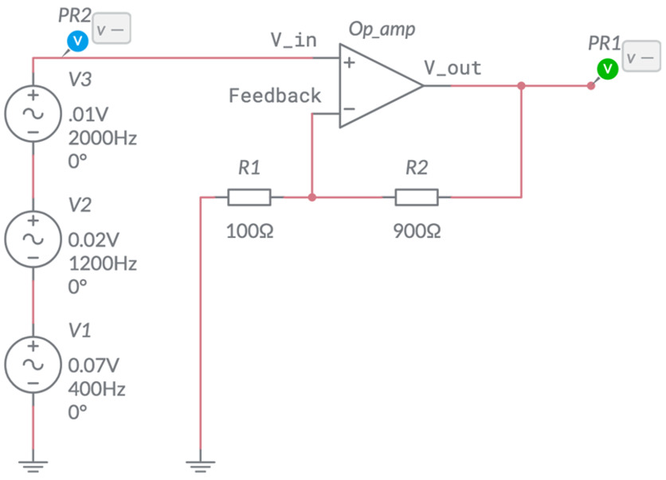
Figure 37 Circuit to generate and amplify a weak signal (screenshot from Multisim Live)
View description - Figure 37 Circuit to generate and amplify a weak signal (screenshot from Multisim ...

The gain of the amplifier is defined to be

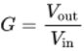
View alternative description - Uncaptioned Equation

where is the input voltage and is the output voltage. For this kind of circuit, the gain is given by the formula

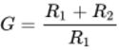
View alternative description - Uncaptioned Equation

The circuit in Figure 37 is made using the Multisim Live simulation package. The three circular objects on the left are here used to generate a signal. V1 generates a voltage sine wave with amplitude 0.07 V and frequency 400 Hz. V2 generates a voltage sine wave with amplitude 0.02 V and frequency 1200 Hz. V3 generates a voltage sine wave with amplitude 0.01 V and frequency 2000 Hz. Together, they generate the very weak signal shown in Figure 38.

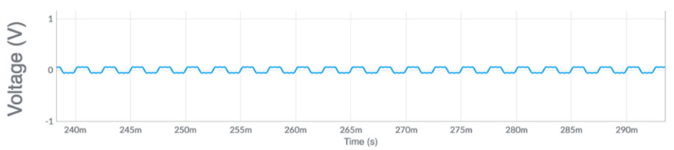
Figure 38 The waveform to be amplified (screenshot from Multisim Live)
View description - Figure 38 The waveform to be amplified (screenshot from Multisim Live)

SAQ 18

- What is the gain for the circuit shown in Figure 37?
- What would the resistor have to be to make the gain 100?

View answer - SAQ 18

The original circuit shown in Figure 37 gives the result shown in Figure 39.

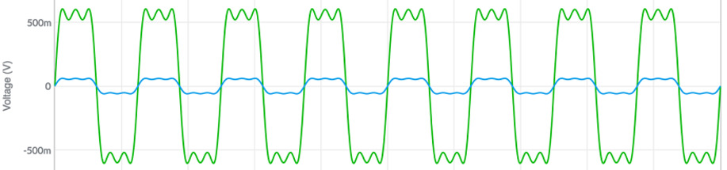
Figure 39 The signal (blue) and the amplified signal (green) (screenshot from Multisim Live)
View description - Figure 39 The signal (blue) and the amplified signal (green) (screenshot from Multisim ...

Op-amps are able to amplify signals many thousands of times. Here the amplification is by a gain factor of 10 so that the signal and the amplified signal can both be seen on the same scale. Typically a signal of 100 mV would be amplified by a factor of 50 or more to bring the result to the order of magnitude ±5 V. Some signals from sensors are much weaker and may require a gain in the order of hundreds or even thousands.
This concludes your lightning visit to the world of electronic signals and filtering. You have seen how effectively noise can be removed from a signal, and how different sounds (such as ‘yes’ and ‘no’) appear in both the time and the frequency domain. As well as investigating the theoretical properties of signals, you have seen how they can be amplified using op-amps. If you are interested in going further, a version of the Multisim Live simulator can be used online at no cost – see www.multisim.com.

Conclusion
In this free course, ‘An introduction to electronics’, you have been introduced to some of the fundamental ideas underlying electronics. You have considered the many ways in which electronics impinges on our lives, and looked into some of the technicalities. These included the basics of electrical and electronic circuits, including the use of voltage dividers and Wheatstone bridges to make sensor circuits. You also made a brief journey into the world of signals and signal processing, where electronics plays such a dominant role. Inevitably this course has only scratched the surface, but hopefully you have been inspired to continue your studies and learn more about this fascinating subject.
This OpenLearn course is an adapted extract from the Open University course T212 Electronics: sensing, logic and actuation.

Acknowledgements
This free course was written by Jeff Johnson. The interactives were created by Jane Bromley and Gareth Morgan. It was edited by Anna Edgley-Smith.
Except for third party materials and otherwise stated (see terms and conditions), this content is made available under a Creative Commons Attribution-NonCommercial-ShareAlike 4.0 Licence.
The material acknowledged below is Proprietary and used under licence (not subject to Creative Commons Licence). Grateful acknowledgement is made to the following sources for permission to reproduce material in this free course:
Every effort has been made to contact copyright owners. If any have been inadvertently overlooked, the publishers will be pleased to make the necessary arrangements at the first opportunity.
Figures
Course image © The Open University
Figure 2(a): GagliardiImages / www.shutterstock.com.
Figure 2(b): Ted Kinsman / Science Photo Library.
Figure 2(c): James King Holmes / Toshiba Research Europe / Science Photo Library.
Figure 4: © Littlebird Electronics.
Figures 5 and 6: Courtesy of Oxboard BV.
Figure 10: Screenshot from Multisim Live, © 2017 National Instruments Corporation. All rights reserved.
Figure 13: © Wellcome Images / https://commons.wikimedia.org. This file is licensed under the Creative Commons Attribution Licence, http://creativecommons.org/licenses/by/4.0/.
Figure 15(b): Olli Niemitalo. Used under Creative Commons licence CC0 1.0 Universal (CC0 1.0) Public Domain Dedication.
Figure 17: Screenshot from Multisim Live, © 2017 National Instruments Corporation. All rights reserved. Photograph of LDR taken from https://www.kitronik.co.uk/c3515-standard-ldr.html.
Figures 37, 38 and 39: Screenshots from Multisim Live, © 2017 National Instruments Corporation. All rights reserved.
Videos
Section 1 video 1: This video contains footage from the following sources. Transistor image: reused with permission of Nokia Corporation. Stargazing Live 2013, Episode 1: © BBC. Hyper Evolution: Rise of the Robots, Episode 1 ‘Technology’: A Windfall Films Production for BBC and Open University. Windfall is part of the Argonon Group. ‘Atlas’ – Robot Walking Demonstration: © Boston Dynamics. Integrated circuit image: courtsey of Texas Instruments Incorporated. BBC News – Robot Surgeon: © BBC. Stunning Aurora Borealis from Space in Ultra-High Definition: © NASA, https://youtu.be/PBJAR3-UvSQ. Building the Universe (The Cosmos: A Beginner’s Guide): © BBC. City in the Sky, Episode 2 ‘Airborne’: © BBC. Mini Car Factory B-Roll – Robot Conveyor Belt: © MINI. Stargazing Live, Series 6, Episode 4: © BBC. Inside an integrated circuit foundry (Foxconn): © BBC. Elektro the Robot Demonstration: public domain.
Section 1 video 2: Image of gears © iStock.com / tuchkovo. Wii Fit Plus footage © 2009 Nintendo. Animated binary matrix grid © iStock.com / lutjo1953. All music tracks courtesy of Apple iLife. Note that brands are being used for pedagogical or teaching purposes only and they are not intended to be endorsement.
Section 1.2 video: Used with permission from Oxboard, www.OXBOARD.eu.
Don't miss out
If reading this text has inspired you to learn more, you may be interested in joining the millions of people who discover our free learning resources and qualifications by visiting The Open University – www.open.edu/openlearn/free-courses.

Solutions

SAQ 1

Answer
A possible answer is shown in Figure 7.

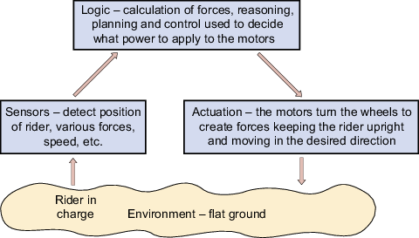
Figure 7 The sensing–logic–actuation control cycle for the Oxboard transporter
View description - Figure 7 The sensing–logic–actuation control cycle for the Oxboard transporter

Back to - SAQ 1

SAQ 2

Answer
- In series, the combined resistance is.
- In parallel, the combined resistance is
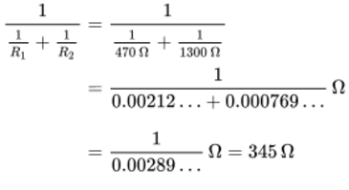
to three significant figures.
Alternatively, note that for two resistors in parallel,
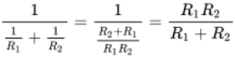
so the resistance in parallel can be written simply as
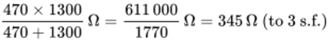
Back to - SAQ 2

SAQ 3

Answer
Rearranging the equation for gives

View alternative description - Uncaptioned Equation

and therefore

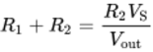
View alternative description - Uncaptioned Equation

which means the equation for is

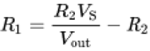
View alternative description - Uncaptioned Equation

Substituting in the values given,

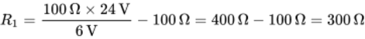
View alternative description - Uncaptioned Equation

Back to - SAQ 3

SAQ 4

Answer
By the formula given in the text,

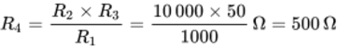
View alternative description - Uncaptioned Equation

Back to - SAQ 4

SAQ 5

Answer
There are 61 inter-peak gaps between the two measured times, so the period for one vibration of the electric toothbrush is (0.452 − 0.219)/61 = 0.003820 seconds. The frequency is the reciprocal of this, 1/0.003820 = 262 Hz. So the toothbrush vibrates 262 times per second.
Back to - SAQ 5

SAQ 6

Answer
The left sound burst in Recording A has a long tail, presumably caused by the long ‘s’ sound at the end of ‘yes’. The right sound burst does not have this tail. In Recording B, the right sound burst has a tail but the left sound burst does not. From this, it can be guessed (correctly) that the left sound burst in Recording B is ‘no’ and the right sound burst is ‘yes’.
Back to - SAQ 6

SAQ 7

Answer
- The wave is displayed with twice the height and the sound is louder.
- The wave is displayed with the lines much closer vertically, and the sound is at a higher pitch (it is an octave higher than before).
- The wave is moved along by a quarter of its period. Now it has the highest value at t = 0, where previously it was 0 at t = 0. However, it sounds the same.
Back to - SAQ 7

SAQ 8

Answer
- No, the combined signal is not a sine wave. It has a more complicated shape.
- The ratio of the frequencies is 440:660 or 2:3.
- This is a subjective question, but you may agree that it sounds as if the individual waves do combine to make a harmonised sound.
- Generally, in music, notes with frequencies in simple proportions harmonise with each other.
Back to - SAQ 8

SAQ 9

Answer
The resulting wave has a triangular shape, as shown in Figure 25. This could be called a ‘sawtooth’ wave.

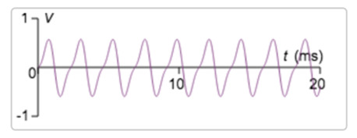
Figure 25 Sawtooth wave
View description - Figure 25 Sawtooth wave

Back to - SAQ 9

SAQ 10

Answer
Setting A = 0.1 gives the wave shown in Figure 28. This is closer to what is desired.

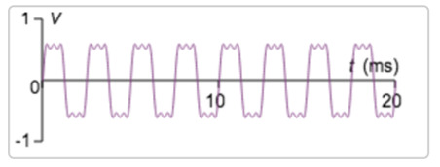
Figure 28 Combination of three sine waves
View description - Figure 28 Combination of three sine waves

Back to - SAQ 10

SAQ 11

Answer
Setting A = 0.05 gives the wave shown in Figure 29. This is even closer to the desired square wave.

Figure 29 Combination of four sine waves
View description - Figure 29 Combination of four sine waves

Back to - SAQ 11

SAQ 12

Answer
- The shape approximates a square wave, as shown in the previous section.
- Read the following.
Back to - SAQ 12

SAQ 13

Answer
- You should have found that the noise added to the signal was removed completely.
- The filtered version of your signal should sound exactly the same as the original, or very close to it.
If this experiment did not work well for you, please try it again. It should work robustly and the results can be remarkable.
Back to - SAQ 13

SAQ 14

Answer
In the time-domain representation of the filtered sound, you are likely to see only a solid band of noise. When you click on the play button, you should hear only the noise – your ‘yes’ should have been completely filtered out.
Back to - SAQ 14

SAQ 15

Answer
In the time-domain representation of the filtered sound, you should see everything below the right cutoff filtered in, including the noise. This time the ‘yes’ will be muffled because the higher frequencies were lost.
Back to - SAQ 15

SAQ 16

Answer
In the time-domain representation of the filtered sound, you should see everything above the left cutoff filtered in, including the noise. This time the ‘yes’ will be muffled because the lower frequencies were lost.
Back to - SAQ 16

SAQ 17

Answer
The high-pass filter should remove the noise and most of the ‘yes’ sound, but you may find that the ‘s’ part can still be heard clearly. This supports the earlier conjecture that the tail of the ‘yes’ sound is the relatively high-frequency ‘sss’ as the word ends.
Back to - SAQ 17

SAQ 18

Answer

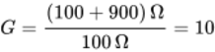
View alternative description - Uncaptioned Equation

- Rearranging the equation for in terms of gives

View alternative description - Uncaptioned Equation

So for a gain of 100, with = 100 Ω,

View alternative description - Uncaptioned Equation

Back to - SAQ 18

Descriptions

Electronics at the cutting edge
While the speakers are talking, images representing the different scientific fields and advances they refer to are shown on screen. These include a robot walking down steps, scientists investigating DNA, jets in an aerial display, people flying using jetpacks, people using smart phones, the manufacture of tablet devices, a satellite orbiting the Earth, racks of servers, a computer-aided design package, a surgeon controlling robotic arms to perform an operation, the International Space Station, astronauts fixing equipment out in space, visualisations of particles in the Large Hadron Collider, a factory containing a vast amount of robotic manufacturing equipment and a self-driving car.
Back to - Electronics at the cutting edge

One day in the life of electronics
This video shows a person going about their day and interacting with a variety of everyday household objects that contain electronics. These objects include an illuminated alarm clock with a digital display, a radio, a nightlight, an electric toothbrush, an electric shower, a refrigerator, a light switch, a microwave, a coffee machine, a toaster, a smoke alarm, a washing machine, a tumble dryer, a car, a sat nav, traffic lights, speed cameras, a level crossing, a train, a keypad, automatic doors, gym equipment, a robotic floor cleaner, security barriers, a tablet device, an art installation, a webcam, a laptop, an oven, a supermarket self-scanner, weighing scales, headphones, printers, a smart phone, a QR code and associated app, a dishwasher, a television, a Wii Fit game with balance board, a remote-controlled fire, a desk lamp and a robot.
Back to - One day in the life of electronics

Figure 1 The sensing–logic–actuation control cycle for autonomous systems
At the bottom of this diagram is a narrow irregular horizontal shape representing the environment. Above it are three boxes, with the first one on the left, the third one on the right and the second one above and centred on the other two. The first box is labelled ‘Sensing’, the second box is labelled ‘Logic – reasoning, planning and control’, and the third box is labelled ‘Actuation’. Arrows connect the three boxes and the environment to form a continuous clockwise cycle from the environment to the sensing box to the logic box to the actuation box, and back to the environment again. This is the sensing–logic–actuation control cycle.
Back to - Figure 1 The sensing–logic–actuation control cycle for autonomous systems

Figure 2 Electronics allows us to perceive things beyond the human senses: (a) ultrasound image of an unborn baby; (b) infrared image of a house; (c) terahertz image of a tooth
Part (a) is a black-and-white ultrasound image of a baby in the womb.
Part (b) is a false colour picture of a house where the chimney and windows are red, showing areas of high heat loss, and the roof is blue, indicating low heat loss (presumably the roof is well insulated).
Part (c) consists of three images of a tooth. On the left is a photograph of the tooth, while on the right are two false colour images showing internal features of the tooth.
Back to - Figure 2 Electronics allows us to perceive things beyond the human senses: (a) ultrasound image of an unborn baby; (b) infrared image of a house; (c) terahertz image of a tooth

Figure 3 Distance sensors used in a car parking system
On the left is a photograph of a car taken from above. On the right is a screen showing the scene behind the car to aid reversing.
Back to - Figure 3 Distance sensors used in a car parking system

Figure 4 A board with a microprocessor capable of many millions of logical operations per second
This is a photograph of a circuit board about 5 centimetres by 10 centimeters, with a large 3 centimetre square microprocessor chip.
Back to - Figure 4 A board with a microprocessor capable of many millions of logical operations per second

Figure 5 The Oxboard has two motor-wheel actuators
This is a photograph of the legs and feet of a person riding an Oxboard, showing the Oxboard in action from the front. The Oxboard has two wheels, one at either side, with each wheel connected to a small platform of appropriate size for a person’s foot. The board is narrower in the middle where the two platforms meet.
Back to - Figure 5 The Oxboard has two motor-wheel actuators

A child riding an Oxboard
This video shows a child riding an Oxboard. He stands on the board with his hands behind his back. The board moves smoothly around people and obstacles in response to the rider’s smallest movements.
Back to - A child riding an Oxboard

Figure 6 The Oxboard product description
On the left of this image is a description of the Oxboard, as follows:
The Oxboard is a personal transporter. It is a board with two wheels, one each side. Oxboard has two built-in motors fed by a battery pack. You can go forwards or backwards with the Oxboard but also take left or right-hand bends. The compact design also ensures that you can use the Oxboard both inside and outside.
The Oxboard is a clever device that reacts to how your weight is distributed. The trick is in particular to relax when standing on the Oxboard; the Oxboard will then ensure the best balance. The Oxboard wil react directly if you distribute your weight ‘unevenly’; lean forward and you will move forwards, lean to the left and the Oxboard veers to the left. etc.
On the right is a photograph of the Oxboard with the following components labelled: crash bumpers; rubber mat with sensors below that sense how you are leaning on the Oxboard; battery indicators; motor, wheels and tyres; LED lights; on button; connector for charger.
Back to - Figure 6 The Oxboard product description

Figure 7 The sensing–logic–actuation control cycle for the Oxboard transporter
This is a sensing–logic–actuation cycle for the Oxboard. The sensing box contains the words ‘Sensors – detect position of rider, various forces, speed, etc.’ The logic box contains the words ‘Logic – calculation of forces, reasoning, planning and control used to decide what power to apply to the motors’. The actuation box contains the words ‘Actuation – the motors turn the wheels to create forces keeping the rider upright and moving in the desired direction’. The environment shape at the bottom contains the words ‘Environment – flat ground’ and ‘Rider in charge’, meaning that the rider is in the environment of the machine, and that the machine responds through its sensors to how the rider leans his body.
Back to - Figure 7 The sensing–logic–actuation control cycle for the Oxboard transporter

Figure 8 Current flow in an example circuit showing a light bulb (lamp) powered by a battery: (a) schematic using pictures to represent the components; (b) the same circuit using standard circuit schematic symbols. By convention, current flows in the opposite direction to the flow of electrons.
Part (a) shows a schematic circuit with a battery, lamp and switch.
Part (b) shows the same circuit but with symbols for the components.
The battery, lamp and switch are connected together by straight lines representing wires.
The symbol for a battery is two parallel lines, one longer than the other, oriented at right angles to the wire connections. The longer line represents the positive terminal and the shorter line the negative terminal.
The symbol for a lamp is a large circle containing a cross that looks like an X.
The symbol for a switch is two small circles with a gap between them. A straight line starts at the left circle and ends at a point above the right circle, showing the switch is open. If ‘pushed down’, this line would close the switch and complete the circuit.
Both (a) and (b) show electrons flowing from the negative to the positive battery terminal, and current flowing the other way.
Back to - Figure 8 Current flow in an example circuit showing a light bulb (lamp) powered by a battery: (a) schematic using pictures to represent the components; (b) the same circuit using standard circuit schematic symbols. By convention, current flows in the opposite direction to the flow of electrons.

Uncaptioned Equation
current equals voltage divided by resistance
Back to - Uncaptioned Equation

Uncaptioned Equation
cap i equals cap v divided by cap r
Back to - Uncaptioned Equation

Figure 9 Kirchhoff’s first law
This shows a node in a circuit where the sum of the currents on the two wires going into the node is equal to the current on the wire coming out.
Back to - Figure 9 Kirchhoff’s first law

Figure 10 Illustration of Kirchhoff’s second law (screenshot from Multisim Live)
This is a circuit diagram showing a 6 volt battery connected to three resistors in series. The resistors have the values 10 ohms, 30 ohms and 20 ohms in that order. Voltage probes show that the voltage before the first resistor is 6 volts; between the first and second resistors it is 5 volts; between the second and third resistors it is 2 volts; and after the third resistor it is 0 volts. Thus the potential difference across the battery is 6 volts, the potential difference across the first resistor is minus 1 volt, the potential difference across the second resistor is minus 3 volts, and the potential difference across the third resistor is minus 2 volts.
Back to - Figure 10 Illustration of Kirchhoff’s second law (screenshot from Multisim Live)

Figure 11 Circuit schematics showing two resistors arranged in (a) series and (b) parallel
Part (a) shows a circuit where two resistors are connected in series so that all the current must pass through each one in turn.
Part (b) shows a circuit where there are two possible paths in parallel, each including one of the two resistors, so that some of the current passes through one resistor and some passes through the other.
Back to - Figure 11 Circuit schematics showing two resistors arranged in (a) series and (b) parallel

Uncaptioned Equation
cap r equals sum with variable number of summands cap r sub one plus cap r sub two plus ellipsis plus cap r sub n
Back to - Uncaptioned Equation

Uncaptioned Equation
cap r equals one divided by sum with variable number of summands one divided by cap r sub one plus one divided by cap r sub two plus ellipsis plus one divided by cap r sub n
Back to - Uncaptioned Equation

Uncaptioned Figure
This table contains five columns. The first column gives a colour. The other four columns describe what that colour means in each of the four band positions.

Colour | Band 1  First digit | Band 2  Second digit | Band 3  Multiplier | Band 4  Tolerance
Black | 0 | 0 | × 1 (× 1) | –
Brown | 1 | 1 | × 10 (× 10) | 1%
Red | 2 | 2 | × 100 (× 100) | 2%
Orange | 3 | 3 | × 1 000 (× 1k) | not used
Yellow | 4 | 4 | × 10 000 (× 10k) | not used
Green | 5 | 5 | × 100 000 (× 100k) | not used
Blue | 6 | 6 | × 1 000 000 (× 1M) | not used
Violet | 7 | 7 | – | not used
Grey | 8 | 8 | – | not used
White | 9 | 9 | – | not used
Gold | – | – | – | 5%
Silver | – | – | – | 10%

Back to - Uncaptioned Figure

Uncaptioned Figure
This table lists standard resistor values in ohms. The first column contains the values 1.0, 1.1, 1.2, 1.3, 1.5, 1.6, 1.8, 2.0, 2.2, 2.4, 2.7, 3.0, 3.3, 3.6, 3.9, 4.3, 4.7, 5.1, 5.6, 6.2, 6.8, 7.5, 8.2 and 9.1. Then the values in each of the subsequent six columns are those in the previous column multiplied by 10. So the second column contains the values 10 to 91, the third column contains the values 100 to 910, and so on, until the last column contains the values 1 million to 9.1 million.
Back to - Uncaptioned Figure

Figure 12 A voltage divider circuit
This shows a voltage divider circuit, consisting of a voltage source V_{S} and two resistors in series, R₁ and R₂. V_{out} is measured between the two resistors.
Back to - Figure 12 A voltage divider circuit

Uncaptioned Equation
cap i sub cap r times one equals left parenthesis cap v sub cap s minus cap v sub out right parenthesis divided by cap r sub one
Back to - Uncaptioned Equation

Uncaptioned Equation
cap i sub cap r times two equals cap v sub out divided by cap r sub two
Back to - Uncaptioned Equation

Uncaptioned Equation
cap v sub out divided by cap r sub two equals left parenthesis cap v sub cap s minus cap v sub out right parenthesis divided by cap r sub one
Back to - Uncaptioned Equation

Uncaptioned Equation
cap r sub one times cap v sub out equals cap r sub two postfix times left parenthesis cap v sub cap s minus cap v sub out right parenthesis
Back to - Uncaptioned Equation

Uncaptioned Equation
cap r sub one times cap v sub out equals cap r sub two times cap v sub cap s minus cap r sub two times cap v sub out
Back to - Uncaptioned Equation

Uncaptioned Equation
cap r sub one times cap v sub out plus cap r sub two times cap v sub out equals cap r sub two times cap v sub cap s
Back to - Uncaptioned Equation

Uncaptioned Equation
left parenthesis cap r sub one plus cap r sub two right parenthesis times cap v sub out equals cap r sub two times cap v sub cap s
Back to - Uncaptioned Equation

Uncaptioned Equation
cap v sub out equals cap r sub two times cap v sub cap s divided by left parenthesis cap r sub one plus cap r sub two right parenthesis
Back to - Uncaptioned Equation

Uncaptioned Equation
cap v sub out times left parenthesis cap r sub one plus cap r sub two right parenthesis equals cap r sub two times cap v sub cap s
Back to - Uncaptioned Equation

Uncaptioned Equation
cap r sub one plus cap r sub two equals cap r sub two times cap v sub cap s divided by cap v sub out
Back to - Uncaptioned Equation

Uncaptioned Equation
cap r sub one equals cap r sub two times cap v sub cap s divided by cap v sub out minus cap r sub two
Back to - Uncaptioned Equation

Uncaptioned Equation
cap r sub one equals 100 postfix times normal cap omega multiplication 24 postfix times cap v divided by six postfix times cap v minus 100 postfix times normal cap omega equals 400 postfix times normal cap omega minus 100 postfix times normal cap omega equals 300 postfix times normal cap omega
Back to - Uncaptioned Equation

Figure 13 An early galvanometer showing magnet and rotating coil
This is a photograph of an early galvanometer. A long needle extends from the centre to a curved measurement scale, allowing the deflection of the needle in either direction to be measured.
Back to - Figure 13 An early galvanometer showing magnet and rotating coil

Figure 14 Equivalent examples of a Wheatstone bridge
This is a Wheatstone bridge with four resistors in a diamond configuration next to an equivalent version with the resistors arranged in a vertical rectangle. In each case, resistors R₁ and R₂ are connected in parallel to resistors R₃ and R₄. The voltage between R₁ and R₂ is denoted V_{left} and the voltage between R₃ and R₄ is denoted V_{right}. These two points are connected across the centre of the bridge via an ammeter.
Back to - Figure 14 Equivalent examples of a Wheatstone bridge

Uncaptioned Equation
cap r sub two divided by left parenthesis cap r sub one plus cap r sub two right parenthesis equals cap r sub four divided by left parenthesis cap r sub three plus cap r sub four right parenthesis
Back to - Uncaptioned Equation

Uncaptioned Equation
cap r sub two times left parenthesis cap r sub three plus cap r sub four right parenthesis equals cap r sub four times left parenthesis cap r sub one plus cap r sub two right parenthesis
Back to - Uncaptioned Equation

Uncaptioned Equation
cap r sub two times cap r sub three plus cap r sub two times cap r sub four equals cap r sub four times cap r sub one plus cap r sub four times cap r sub two
Back to - Uncaptioned Equation

Uncaptioned Equation
cap r sub two times cap r sub three equals cap r sub four times cap r sub one
Back to - Uncaptioned Equation

Uncaptioned Equation
cap r sub three divided by cap r sub four equals cap r sub one divided by cap r sub two
Back to - Uncaptioned Equation

Uncaptioned Equation
cap r sub four equals cap r sub two multiplication cap r sub three divided by cap r sub one
Back to - Uncaptioned Equation

Uncaptioned Equation
equation sequence part 1 cap r sub four equals part 2 cap r sub two multiplication cap r sub three divided by cap r sub one equals part 3 10 postfix times 000 multiplication 50 divided by 1000 postfix times normal cap omega equals 500 postfix times normal cap omega
Back to - Uncaptioned Equation

Figure 15 (a) Symbol for an op-amp; (b) the 741 op-amp package; (c) top view of an LM741 dual inline package (DIL), showing internal configuration and pin connections
Part (a) shows the symbol for an op-amp. This is a large triangle with two input wires entering one side. One input terminal is labelled with a + sign and the other with a − sign. An output wire exits the apex of the triangle opposite to the input side. Finally, two more wires enter the other two sides of the triangle, with a direction parallel to the input side. These are the wires that provide power from the power supply.
Labels have been added to the symbol to indicate the names that are generally used for the potentials. The input wires bring potentials V₊ (for the + input) and V₋ (for the – input). The output wire provides a potential V_{out}. The power wires bring potentials V_{S+} and V_{S−}.
Part (b) is a photograph of an op-amp in a package. It is a small black box with eight metallic legs (or pins), like a little bug with two extra legs. The rectangular top of the package has an indentation on one short side and a small circle in one corner near this indentation. Text on the package reads ‘M8420, LM, 741CN’.
Part (c) shows the diagram that we can use to understand the correspondence between the pins and the op-amp terminals. It is a rectangle with a triangular indentation marked on the top edge and a black dot in the top left-hand corner. This is used to orient the diagram with respect to the real package.
The four pins on the left are labelled, from top to bottom:
1 offset null
2 inverting input V₋
3 non-inverting input V₊
4 negative voltage V_{S−}
The four pins on the right are labelled, from top to bottom:
8 pin not used
7 positive voltage V_{S+}
6 output V_{out}
5 offset null
Inside the rectangle there is an op-amp symbol, and the wires are shown connecting the pins to the appropriate op-amp terminals. In this case, the – input is shown above the + input in the op-amp symbol.
Back to - Figure 15 (a) Symbol for an op-amp; (b) the 741 op-amp package; (c) top view of an LM741 dual inline package (DIL), showing internal configuration and pin connections

Figure 16 Black box representation of the 741 op-amp, showing the power supplies
This shows two rectangular 9 volt batteries arranged so that their terminals are on the right. The batteries are placed one above the other so that the terminals from top to bottom read + (1), − (2), + (3), − (4). The − (2) and + (3) terminals (that is, the negative terminal of one battery and the positive terminal of the other) are connected to each other and the potential of the node is called V_{mid}. By convention, this is considered to be ground.
The top + (1) battery terminal is connected to the positive power supply terminal of an op-amp. This connection is called V_{S+} and is shown to have a positive voltage (9 volts) with respect to V_{mid}. The bottom − (4) battery terminal is connected to the negative power supply terminal of the same op-amp. This connection is called V_{S−} and is shown to have a negative voltage (minus 9 volts) with respect to V_{mid}.
Back to - Figure 16 Black box representation of the 741 op-amp, showing the power supplies

Figure 17 Circuit diagram for an open-loop op-amp switching an LED (screenshot from Multisim Live)
This is a circuit drawn in Multisim Live. On the left, it shows a Wheatstone bridge with a light-dependent resistor (LDR). The resistances are as follows:
top left, R1 = 680 Ω
bottom left, R2 = 1000 Ω (this is the LDR)
top right, R3 = 100 kΩ
bottom right, R4 = 100 kΩ.
An op-amp is connected to the terminals of the Wheatstone bridge. The connection node with the LDR (between R1 and R2) says ‘4.5 V or more when dark’, while the connection node with resistors (between R3 and R4) says ‘4.5 V reference voltage’. So the voltage that will vary is on the branch containing the LDR. The op-amp is powered by two constant voltage sources of 9 V each. They are arranged as shown in Figure 16. The output of the op-amp is connected in series with an LED (which appears to be lit) and a resistor with label R5 = 470 Ω. The resistor is connected to ground.
Back to - Figure 17 Circuit diagram for an open-loop op-amp switching an LED (screenshot from Multisim Live)

Uncaptioned Equation
nine postfix times cap v prefix multiplication of cap r times italic four divided by left parenthesis cap r times italic three plus cap r times italic four right parenthesis equals nine postfix times cap v prefix multiplication of 100 postfix times 000 postfix times cap omega divided by left parenthesis 100 postfix times 000 plus 100 postfix times 000 right parenthesis postfix times cap omega equals 4.5 postfix times cap v
Back to - Uncaptioned Equation

Uncaptioned Equation
nine postfix times cap v prefix multiplication of cap r times italic two divided by left parenthesis cap r times italic one plus cap r times italic two right parenthesis equals nine postfix times cap v prefix multiplication of 680 postfix times cap omega divided by left parenthesis 680 plus 680 right parenthesis postfix times cap omega equals 4.5 postfix times cap v
Back to - Uncaptioned Equation

Figure 18 Breadboard circuit for the open-loop op-amp: (a) in light conditions, the LED is not illuminated; (b) when it gets dark, the LED is illuminated
This is a photograph of a breadboard on which the circuit shown in Figure 17 has been constructed. The op-amp is a black rectangle with eight pins. The resistors are small beige components with stripes to show their value (as described in Table 3), and the light-dependent resistor is a circular component with a red photosensitive stripe on the top surface. The LED is a small red cylinder.
Two photos of the breadboard are shown, one in light conditions (where the LED is not illuminated) and one in dark conditions (where it is).
Back to - Figure 18 Breadboard circuit for the open-loop op-amp: (a) in light conditions, the LED is not illuminated; (b) when it gets dark, the LED is illuminated

Interactive 1 Recording and viewing a sound
This is an interactive that can be used to record sound and display a visual representation of it on the screen. The recorded sound is shown as what looks like a series of vertical pink lines between positive and negative voltages, representing the sound amplitude. (In fact it is a horizontal pink line that undulates between positive and negative voltages over time, but this is hard to see without zooming in to a low-frequency tone.) The horizontal bunching of these lines represents frequency. Below the display is a control bar with Record and Play buttons on the left, followed by a volume control and then some numbers that show the position of the cursor and the total length of the recording. At the right of the control bar is a Full Screen button. Below the control bar is a Zoom slider. Because this interactive changes visually according to the nature of the recorded sound, you may need a sighted helper to describe the results to you.
Back to - Interactive 1 Recording and viewing a sound

Figure 19 Voltage wave produced by humming a low note
This is a screenshot from Interactive 1, showing a recorded sound on screen. It shows many vertical pink lines bunched closely together. Near the horizontal axis there are so many lines that they appear as a solid block of colour. Above and below the axis, it can be seen that the length of the pink lines rises and falls to give the impression of a series of small bumps.
Back to - Figure 19 Voltage wave produced by humming a low note

Figure 20 Zooming in to the wave from Figure 19
This is a screenshot from Interactive 1, showing what happens when the user zooms in to the visual representation of the recorded sound in Figure 19. It shows a sine-like waveform with peaks and troughs above and below zero volts. There are equally spaced longer spikes at the fundamental frequency, with smaller spikes in between as the first harmonic. An upward spike is followed by a downward spike, making one oscillation of the wave. There are 23 of these oscillations across the window. The cursor is positioned on the leftmost downward spike and the numbers on the control bar read 0:00:877 / 0:02:519.
Back to - Figure 20 Zooming in to the wave from Figure 19

Figure 21 Calculating the fundamental frequency
This is a screenshot from Interactive 1, showing the same zoomed-in sound as Figure 20. Now the cursor is positioned on a downward spike towards the right of the screen and the numbers on the control bar read 0:01:099 / 0:02:519.
Back to - Figure 21 Calculating the fundamental frequency

Figure 22 Recording of an electric toothbrush: time at the top of a peak on (a) the left and (b) the right
This is two screenshots from Interactive 1, showing a zoomed-in recording of a new sound. In screenshot (a) the cursor is positioned on an upward peak at the left of the screen and the numbers on the control bar read 0:00:219 / 0:00:840. In screenshot (b) the cursor is positioned on an upward peak at the right of the screen and the numbers on the control bar read 0:00:452 / 0:00:840. There are 62 spikes and 61 gaps between them.
Back to - Figure 22 Recording of an electric toothbrush: time at the top of a peak on (a) the left and (b) the right

Figure 23 Recording A: ‘yes’ followed by ‘no’
This is a screenshot from Interactive 1, showing the wave pattern for the spoken word ‘yes’ followed by ‘no’. ‘Yes’, on the left, has a group of spikes that look like a ball, followed by a ‘tail’ of small, bunched-together lines (probably the high-frequency hiss at the end of ‘yes’). On the right, the vertical lines for ‘no’ make a ball with no tail. Their amplitude is greater, possibly because ‘no’ is more emphatic than ‘yes’ and we say it louder.
Back to - Figure 23 Recording A: ‘yes’ followed by ‘no’

Figure 24 Recording B
This is another screenshot from Interactive 1. The burst of sound on the left looks like a ball. The burst of sound on the right looks like a smaller ball with a tail.
Back to - Figure 24 Recording B

Interactive 2 Investigating a sine wave
This is an interactive that may be used to display a visual representation of a sine wave on the screen and also hear it as a pure tone. At the top is the sine wave equation, s(t) = A sin(2πft + ϕ), but A for amplitude, f for frequency and ϕ for phase have been replaced by type-in text boxes into which values can be entered or selected by using the up and down arrows on the right of each box. Below this is a graph showing voltage in volts against time in milliseconds. The sine wave described by the specific values entered into the equation is displayed. To start with, because the default values of the interactive are an amplitude of 0.5, a frequency of 200 and a phase of 0, the sine wave varies between 0.5 and minus 0.5 volts, and completes one cycle in 5 milliseconds. The wave starts at the origin, rises to the maximum, falls to the minimum and then returns to 0. This part of the interactive changes according to the parameters you enter and therefore you may need a sighted helper to describe the waveforms to you. Beside the graph is a loudspeaker button; if you click on this, you will hear the sine wave shown on the graph as a pure tone.
Back to - Interactive 2 Investigating a sine wave

Interactive 3 Combining sine waves
This is an interactive that may be used to add two or more sine waves together, display a visual representation of the result and also hear its sound. To start with, three graphs are shown in a vertical column on the left. Each one displays voltage between minus 1 and 1 volts against time between 0 and 20 milliseconds. Beside each of the three graphs is a loudspeaker button. To the right of each of the top two graphs is its corresponding sine wave equation, with type-in text boxes to change the amplitude, frequency and period. Finally, an ‘add another harmonic’ button is positioned to the right of the loudspeaker button belonging to the second graph.
When values are input to the sine wave equations beside the top two graphs, a visual representation of the sine wave is shown on the graph and you can also listen to it by clicking on the loudspeaker button. In addition, the result of adding the two sine waves is shown on the bottom graph and this can also be listened to by clicking on the corresponding loudspeaker button. Clicking on the ‘add another harmonic’ button inserts another graph with sine wave parameters above the bottom graph, allowing you to sum three sine waves instead of two, and so on.
This interactive changes according to the parameters you enter and therefore you may need a sighted helper to describe the waveforms to you.
Back to - Interactive 3 Combining sine waves

Figure 25 Sawtooth wave
This is a screenshot from Interactive 3, showing just the bottom wave. As usual, the horizontal axis shows time from 0 to 20 milliseconds and the vertical axis shows voltage from minus 1 to 1 volt. The wave looks like a zig-zag that starts at 0, rises diagonally up to a maximum of approximately 0.6 volts and then falls diagonally down to a minimum of approximately minus 0.6 volts, before rising diagonally back up to 0 and repeating. This cycle occurs just under 9 times. The diagonal lines have a slight ‘wobble’ to them, but this is a reasonable approximation to a sawtooth wave.
Back to - Figure 25 Sawtooth wave

Figure 26 Approximation to a square wave
This is a screenshot from Interactive 3, showing just the bottom wave. As usual, the horizontal axis shows time from 0 to 20 milliseconds and the vertical axis shows voltage from minus 1 to 1 volt. There are 8 oscillations of a ‘rectangular’ shaped wave in which the ‘flat’ tops and bottoms of the wave have small ripples corresponding to the high-frequency components. The vertical sides of the rectangles slope left to right a bit as they go down from 0.6 volts to minus 0.6 volts, and slope the other way as the graph rises from minus 0.6 volts to 0.6 volts. This is quite a convincing approximation to a rectangular wave.
Back to - Figure 26 Approximation to a square wave

Figure 27 Combination of two sine waves
This is another screenshot from Interactive 3, showing just the bottom wave. As usual, the horizontal axis shows time from 0 to 20 milliseconds and the vertical axis shows voltage from minus 1 to 1 volt. Figures 27 to 29 show how the ‘rectangular’ wave is made by adding higher-frequency sine waves.
Here there are two sine waves. The second, higher-frequency wave causes depressions in the tops and bottoms of the lower-frequency wave, effectively ‘chopping’ a bit off the bottom and top to make it more rectangle-like.
Back to - Figure 27 Combination of two sine waves

Figure 28 Combination of three sine waves
Following on from Figure 27, here there are three sine waves. The third wave chops a bit more off the tops and bottoms of the lower-frequency waves. The overall wave is getting flatter at the top and bottom.
Back to - Figure 28 Combination of three sine waves

Figure 29 Combination of four sine waves
Following on from Figure 28, here there are four sine waves. The fourth wave makes the tops and bottoms even flatter. This is now a good approximation to the rectangular wave.
Back to - Figure 29 Combination of four sine waves

Interactive 4 Waves represented in the time domain and the frequency domain
This is an interactive that may be used to add two or more sine waves together, display a visual representation of the result in the time and frequency domains, and also hear its sound.
To start with, three pairs of two graphs are shown in a vertical column. The left-hand graph in each row is the representation in the time domain. It displays voltage between minus 1 and 1 volts against time between 0 and 20 milliseconds. The right-hand graph in each row is the representation in the frequency domain. It displays amplitude against frequency in hertz.
Between each pair of graphs is a loudspeaker button. Above each of the top two pairs of graphs is its corresponding sine wave equation, with type-in text boxes to change the amplitude, frequency and period. Finally, an ‘add another sine wave’ button is positioned below the loudspeaker button belonging to the second pair of graphs.
When values are input to the sine wave equations above the top two pairs of graphs, a visual representation of the sine wave in the time and frequency domains is shown on the graphs, and you can also listen to it by clicking on the loudspeaker button. In addition, the result of adding the two sine waves is shown on the bottom graphs, and this can also be listened to by clicking on the corresponding loudspeaker button. Clicking on the ‘add another sine wave’ button inserts another pair of graphs with sine wave parameters above the bottom pair, allowing you to sum three sine waves instead of two, and so on.
This interactive changes according to the parameters you enter and therefore you may need a sighted helper to describe the waveforms to you.
Back to - Interactive 4 Waves represented in the time domain and the frequency domain

Figure 30 Transforming a signal in the time domain into the frequency domain
This is a screenshot from Interactive 4. On the left, the time-domain graph shows a wave like those seen previously – in this case, approximating a square wave. On the right, the frequency-domain graph shows lines of decreasing height (amplitude) at frequencies 110, 330, 550 and 770 hertz. The sound of the wave when the loudspeaker button is pressed is relatively harmonious.
Back to - Figure 30 Transforming a signal in the time domain into the frequency domain

Figure 31 Noise with frequency f = 935 Hz shows clearly in the frequency domain
This is a screenshot from Interactive 4 showing the same graphs as Figure 30, but this time a ‘noise’ wave has been added. This is shown in the frequency domain as a vertical line at 935 hertz that is between the first two lines (110 and 330 hertz) in height. On the left, the wave has been disrupted from its almost square appearance and now has lots of large high-frequency peaks and troughs. This time when the loudspeaker button is pressed, the high-frequency ‘noise’ is heard as background to the harmonious square wave.
Back to - Figure 31 Noise with frequency f = 935 Hz shows clearly in the frequency domain

Interactive 5 Recording sounds and adding noise (Ctrl+right-click to open this link in a new window).
This is an interactive that can be used to record sound and display a visual representation of it in both the time and frequency domains. It can also be used to add a noise tone to the sound and then apply filters to remove it again. Because this interactive changes visually according to the nature of the recorded sound, you may need a sighted helper to describe the results to you.
The top half of the interactive contains the recorded signal in the time and frequency domains. On the left is the original signal. Similar to the interactives in previous weeks, this is displayed on a graph of amplitude against time, and looks like a series of pink vertical lines. The Record, Play and volume control buttons and time details are below the graph, with the Zoom slider underneath. At the bottom are two tick boxes labelled ‘Add noise tone’ and ‘Override noise tone’.
On the right is the amplitude plot of the fast Fourier transform of the original signal. This is displayed on a graph of amplitude against frequency, with the frequency ranging from 0 to just under 7 kilohertz. Below the graph is a tick box labelled ‘Use logarithmic Y scale on FFT’. Underneath this are two sliders, the right cutoff and the left cutoff, and at the bottom is a series of radio buttons labelled ‘Low-pass’, ‘High-pass’, ‘Bandpass’ and ‘Notch’. Next to these radio buttons is a button labelled ‘Apply filters’.
The bottom half of the interactive contains the filtered signal, and only displays any content once the ‘Apply filters’ button has been clicked. On the left is a graph of amplitude against time, and on the right is a FFT plot. These graphs use the same scale and colouring as the top two graphs, and show the effect of the chosen filter on the original signal.
Back to - Interactive 5 Recording sounds and adding noise (Ctrl+right-click to open this link in a new window).

Figure 32 A recording of ‘yes’ in the time domain, transformed into the frequency domain
This is a screenshot from Interactive 5, showing a recording of the word ‘yes’. This appears on the left-hand graph as a set of fuzzy pink lines in an ellipse shape, followed by a dense, lower-amplitude tail corresponding to the hiss in ‘yes’.
On the right-hand graph (the frequency-domain representation) is a series of vertical blue lines. These are quite high for the lower frequencies, to about 1 kilohertz, but there are smaller vertical blue lines (about one-eighth the amplitude of the lower-frequency waves) for all the frequencies, with the largest bunched around 4 kilohertz.
Back to - Figure 32 A recording of ‘yes’ in the time domain, transformed into the frequency domain

Figure 33 ‘Yes’ with a rogue component at 1221 Hz acting as noise
This is the same as Figure 32 except that noise has been added at 1.221 kilohertz. This shows as a thick band of colour around the horizontal axis on the time-domain graph on the left, and as a blue spike at 1.221 kilohertz on the frequency-domain graph on the right. It is clear that the noise gets mixed up with the signal in a way that is hard to see in the time domain, but it emerges as a clear, isolated vertical line in the frequency domain.
Back to - Figure 33 ‘Yes’ with a rogue component at 1221 Hz acting as noise

Figure 34 Types of filter: (a) notch filter – the frequencies in the shaded area are removed; (b) low-pass filter – high frequencies (in the shaded area) are removed, low frequencies are ‘passed’; (c) high-pass filter – low frequencies (in the shaded area) are removed, high frequencies are ‘passed’; (d) band-pass filter – low and high frequencies (in the shaded area) are removed, those in the remaining band are ‘passed’
This is four repeats of the frequency-domain representation from Figure 33. In each case, part of the graph is shaded to show what would be removed by the filter.
In part (a), a small vertical section is shaded around the 1.221 kilokertz line.
In part (b), everything at a higher frequency than just above the 1.221 kilohertz line is shaded.
In part (c), everything at a lower frequency than just below the 1.221 kilohertz line is shaded.
In part (d), everything is shaded except for a small vertical section around the 1.221 kilokertz line.
Back to - Figure 34 Types of filter: (a) notch filter – the frequencies in the shaded area are removed; (b) low-pass filter – high frequencies (in the shaded area) are removed, low frequencies are ‘passed’; (c) high-pass filter – low frequencies (in the shaded area) are removed, high frequencies are ‘passed’; (d) band-pass filter – low and high frequencies (in the shaded area) are removed, those in the remaining band are ‘passed’

Figure 35 ‘Yes’ plus rogue 1221 Hz component, with notch filter applied
This is a screenshot from Interactive 5, showing the recording of the word ‘yes’ with noise added from Figure 33. A notch filter has been applied to the signal, indicated by the grey shading of a small vertical section around the 1.221 kilohertz line in the frequency domain.
Below the original two graphs are the time and frequency representations of the filtered signal. In both time and frequency domains, the signal looks almost identical to the original signal in Figure 32.
Back to - Figure 35 ‘Yes’ plus rogue 1221 Hz component, with notch filter applied

Figure 36 ‘Yes’ and ‘no’ in the frequency domain: (a) ‘yes’ has a pattern with many high-frequency components; (b) ‘no’ has a pattern with few high-frequency components
This is two screenshots from Interactive 5. Part (a) show ‘yes’ in the time and frequency domains, while part (b) shows ‘no’. ‘Yes’ clearly has more high-frequency components than ‘no’.
Back to - Figure 36 ‘Yes’ and ‘no’ in the frequency domain: (a) ‘yes’ has a pattern with many high-frequency components; (b) ‘no’ has a pattern with few high-frequency components

Figure 37 Circuit to generate and amplify a weak signal (screenshot from Multisim Live)
The electrical circuit to create a weak wave has three alternating current generators vertically in series on the left. From bottom to top, these are labelled V1, V2 and V3. They have frequencies of 400, 1200 and 2000 hertz, and corresponding amplitudes of 0.07 volts, 0.02 volts and 0.01 volts. These waves combine to form a more complicated wave that approximates a square wave.
On the right is an op-amp in a non-inverting amplifier circuit, with the wave created by the alternating current generators providing V_{in}. The feedback resistors are set to R1 equals 100 ohms and R2 equals 900 ohms. The output of the amplifier, V_{out}, is on the right with a green voltage probe attached. The input to the amplifier circuit has a blue voltage probe attached after the three AC voltage generators and before the op-amp input.
Back to - Figure 37 Circuit to generate and amplify a weak signal (screenshot from Multisim Live)

Uncaptioned Equation
cap g equals cap v sub out divided by cap v sub in
Back to - Uncaptioned Equation

Uncaptioned Equation
cap g equals cap r sub one plus cap r sub two divided by cap r sub one
Back to - Uncaptioned Equation

Figure 38 The waveform to be amplified (screenshot from Multisim Live)
This is a Multisim Live graph showing the input to the op-amp, V_{in}, as recorded by the blue voltage probe in Figure 37. The wave approximates a square wave and has a very small amplitude, oscillating around zero volts.
Back to - Figure 38 The waveform to be amplified (screenshot from Multisim Live)

Uncaptioned Equation
equation sequence part 1 cap g equals part 2 left parenthesis 100 plus 900 right parenthesis normal cap omega divided by 100 postfix times normal cap omega equals part 3 10
Back to - Uncaptioned Equation

Uncaptioned Equation
equation sequence part 1 cap r sub two equals part 2 cap g times cap r sub one minus cap r sub one equals part 3 cap r sub one times left parenthesis cap g minus one right parenthesis
Back to - Uncaptioned Equation

Uncaptioned Equation
cap r sub two equals 100 postfix times normal cap omega multiplication left parenthesis 100 minus one right parenthesis equals 9900 postfix times normal cap omega
Back to - Uncaptioned Equation

Figure 39 The signal (blue) and the amplified signal (green) (screenshot from Multisim Live)
This is a Multisim Live graph showing the input and output of the op-amp, V_{in} and V_{out}, as recorded respectively by the blue and green voltage probes in Figure 37. The blue wave is the same as the one shown in Figure 38. It approximates a square wave and has a very small amplitude, oscillating around zero volts. The green (amplified) wave has a much greater amplitude. It approximates a rectangular wave, having small wiggles on the top and bottom where it should be flat.
Back to - Figure 39 The signal (blue) and the amplified signal (green) (screenshot from Multisim Live)

Electronics at the cutting edge

Transcript
TIM DRYSDALE
Electronics has come a long way in seven decades. Even more importantly, it’s helped the world develop at a pace that is unprecedented in human history.
BERNIE CLARK
Ray Kurzweil estimates the next 100 years will bring a rate of change equal in impact to the last 20 000 years.
PHIL PICTON
Electronics is behind this rapid pace of change. It powers computers that allow us to design, communicate and investigate.
ARMANDO MARINO
The internet can connect us to friends and relatives anywhere on the planet.
JEFF JOHNSON
Computer-aided design processes have advanced many fields of engineering.
TIM DRYSDALE
Medical technology has benefited from 3D imaging techniques that see safely inside the body using light, sound and magnetic fields.
BERNIE CLARK
Electronic equipment is vital to the satellites that allow us to explore the deepest reaches of space.
ARMANDO MARINO
It is essential to keeping humans alive and well in the International Space Station for long periods of time.
TIM DRYSDALE
Our understanding of the world has moved on dramatically through scientific endeavours.
PHIL PICTON
Large-scale investigations of the so-called God particle at the Large Hadron Collider are only possible with the aid of electronics to control the equipment.
BERNIE CLARK
From the smallest GPS trackers used by polar explorers to the largest of facilities on the planet …
JEFF JOHNSON
… the smart vehicles that criss-cross the surface of the Earth, running on autopilot …
ARMANDO MARINO
… to the vessels that explore the deepest reaches of space …
PHIL PICTON
… electronics is everywhere, and underpins the unprecedented rate of technological change.
TIM DRYSDALE
We learn electronics to gain insight into the technologies that touch at the heart of almost every human endeavour.
Back to - Electronics at the cutting edge

One day in the life of electronics

Transcript
[MUSIC PLAYING]
[BEEPING]
[BUZZING]
[MUSIC PLAYING]
[BEEPING]
[BEEPING]
[MUSIC PLAYING]
[BEEPING]
MAN: Oh, hello, [INAUDIBLE]. Was not expecting your phone call.
[MUSIC PLAYING]
[BEEP]
[MUSIC PLAYING]
Back to - One day in the life of electronics

A child riding an Oxboard

Transcript
[BACKGROUND NOISES]
[MUSIC PLAYING IN BACKGROUND]
[BACKGROUND NOISES]
[GIGGLING]
[CHILD SPEAKING]
[MUSIC PLAYING IN BACKGROUND]
[BACKGROUND NOISES]
[BELL RINGING]
[MUSIC PLAYING IN BACKGROUND]
[BACKGROUND NOISES]
Back to - A child riding an Oxboard

