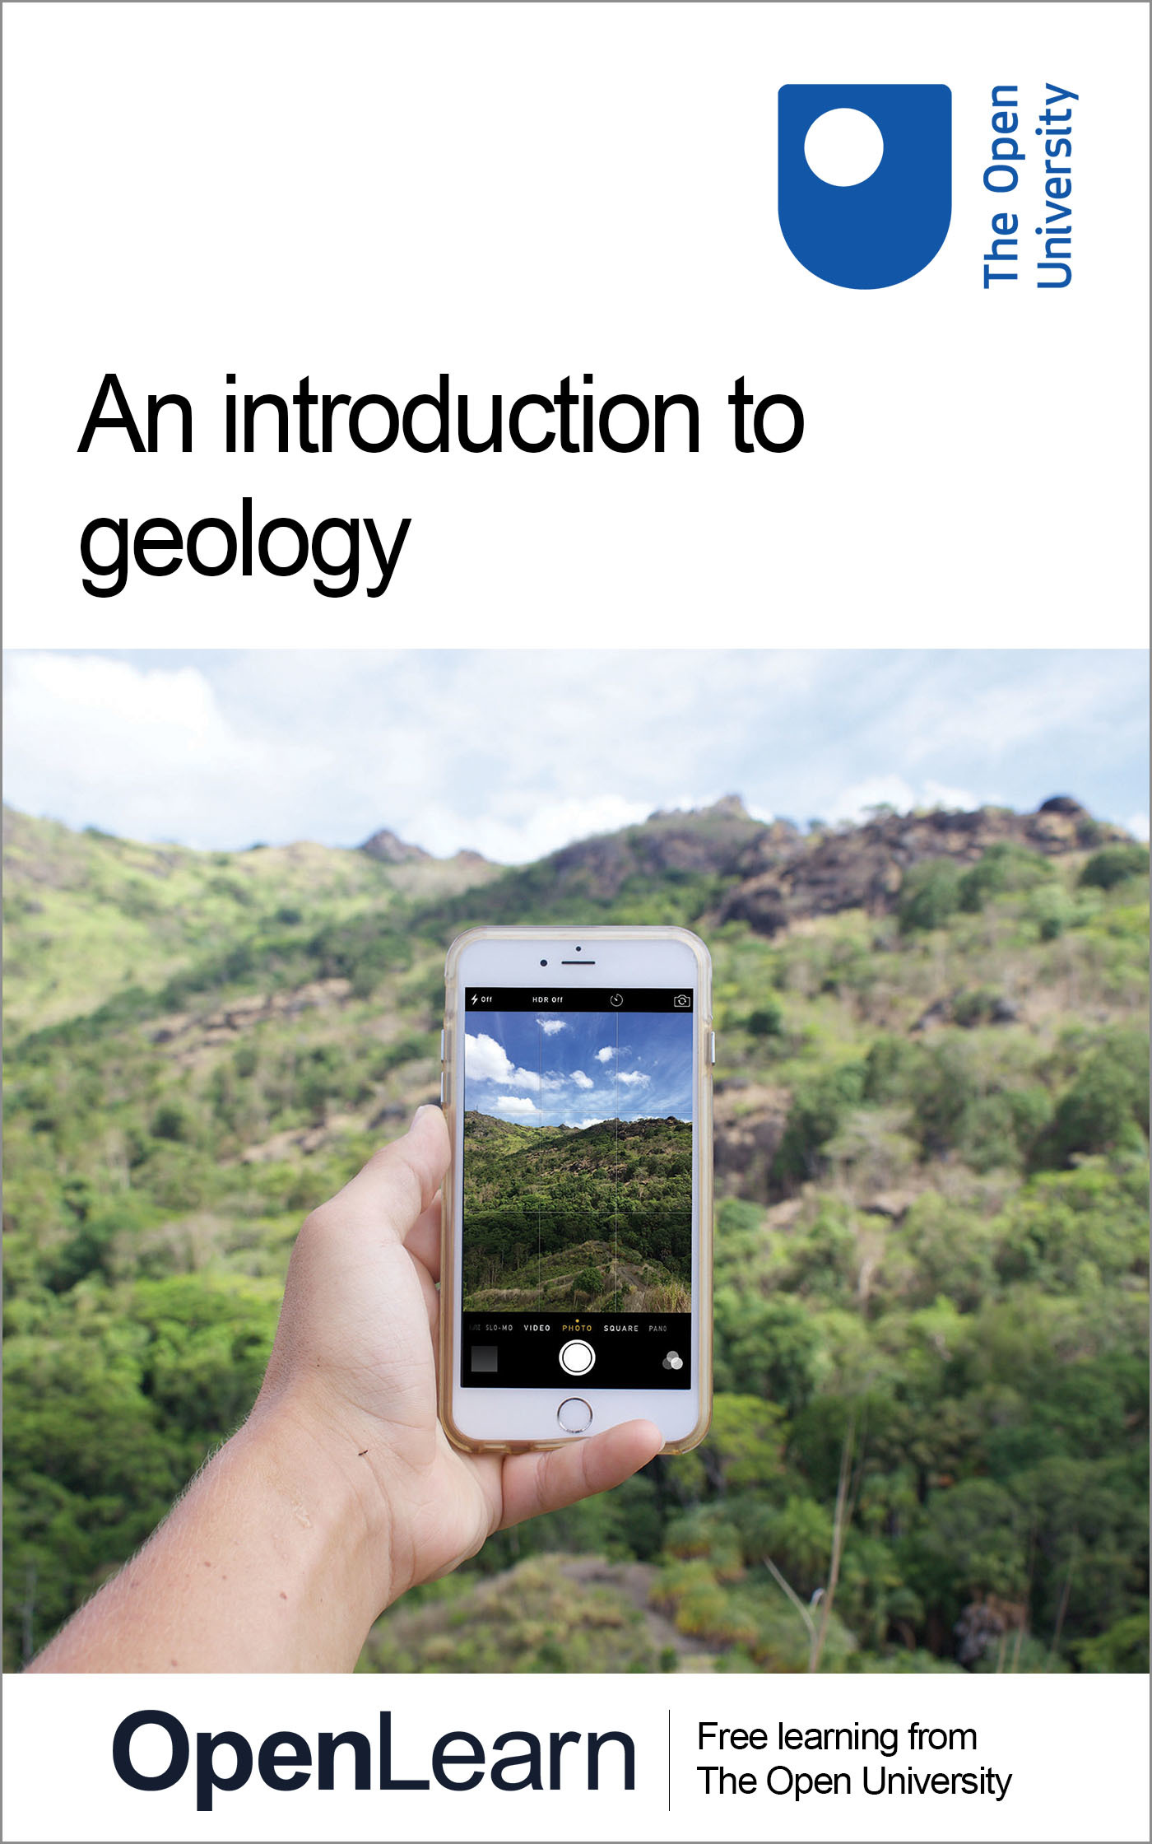

ALT_1 An Introduction to Geology

An Introduction to Geology
About this free course
This free course is an adapted extract from the FutureLearn course The Earth in My Pocket: An Introduction to Geology.
This version of the content may include video, images and interactive content that may not be optimised for your device.
You can experience this free course as it was originally designed on OpenLearn, the home of free learning from The Open University –https://www.open.edu/openlearn/science-maths-technology/introduction-geology/content-section-overview
There you’ll also be able to track your progress via your activity record, which you can use to demonstrate your learning.
Copyright © 2019 The Open University
Intellectual property
Unless otherwise stated, this resource is released under the terms of the Creative Commons Licence v4.0 http://creativecommons.org/licenses/by-nc-sa/4.0/deed.en_GB. Within that The Open University interprets this licence in the following way: www.open.edu/openlearn/about-openlearn/frequently-asked-questions-on-openlearn. Copyright and rights falling outside the terms of the Creative Commons Licence are retained or controlled by The Open University. Please read the full text before using any of the content.
We believe the primary barrier to accessing high-quality educational experiences is cost, which is why we aim to publish as much free content as possible under an open licence. If it proves difficult to release content under our preferred Creative Commons licence (e.g. because we can’t afford or gain the clearances or find suitable alternatives), we will still release the materials for free under a personal end-user licence.
This is because the learning experience will always be the same high quality offering and that should always be seen as positive – even if at times the licensing is different to Creative Commons.
When using the content you must attribute us (The Open University) (the OU) and any identified author in accordance with the terms of the Creative Commons Licence.
The Acknowledgements section is used to list, amongst other things, third party (Proprietary), licensed content which is not subject to Creative Commons licensing. Proprietary content must be used (retained) intact and in context to the content at all times.
The Acknowledgements section is also used to bring to your attention any other Special Restrictions which may apply to the content. For example there may be times when the Creative Commons Non-Commercial Sharealike licence does not apply to any of the content even if owned by us (The Open University). In these instances, unless stated otherwise, the content may be used for personal and non-commercial use.
We have also identified as Proprietary other material included in the content which is not subject to Creative Commons Licence. These are OU logos, trading names and may extend to certain photographic and video images and sound recordings and any other material as may be brought to your attention.
Unauthorised use of any of the content may constitute a breach of the terms and conditions and/or intellectual property laws.
We reserve the right to alter, amend or bring to an end any terms and conditions provided here without notice.
All rights falling outside the terms of the Creative Commons licence are retained or controlled by The Open University.
Head of Intellectual Property, The Open University

Contents
- Week 1: Building stone
  - Introduction to Week 1
  - 1.1 What is a rock?
    - 1.1.1 Igneous rocks
    - 1.1.2 Sedimentary rocks
    - 1.1.3 Metamorphic rocks
  - 1.2 Watch out for concrete
  - 1.3 Rock textures
  - 1.4 Identifying rock textures
  - 1.5 Identifying rocks: going into the ‘field’
  - 1.6 The rock cycle and plate tectonics
  - 1.7 So, how old is the Earth?
  - 1.8 And how do we know that?
    - 1.8.1 Relative dating
    - 1.8.2 Absolute dating
  - 1.9 What is plate tectonics? Continental drift and sea floor spreading - part 1
  - 1.10 What is plate tectonics? Continental drift and sea floor spreading - part 2
  - 1.11 Plate tectonics – part 1
  - 1.12 Plate tectonics – part 2
  - 1.13 Week 1 quiz
  - 1.14 Summary of Week 1
- Week 2: Metals, metals everywhere
  - Introduction to Week 2
  - 2.1 Opening up a smartphone
  - 2.2 Where do the metals come from?
  - 2.3 Pegmatite
  - 2.4 Bauxite – amazing things that a lot of rain can do
  - 2.5 From soil to soda cans
  - 2.6 Getting bauxite from soda cans
  - 2.7 Another source of Al
  - 2.8 Sand, sandstone and quartzite
  - 2.9 The geological sorting hat
  - 2.10 From sands into sandstone and quartzite
  - 2.11 Copper
  - 2.12 Porphyry ore deposits
  - 2.13 Bursting balloons of copper mineralisation
  - 2.14 Porphyry copper ring of fire
  - 2.15 Under ancient seas
  - 2.16 What type of rock is oceanic crust?
  - 2.17 Hydrothermal vents
  - 2.18 Black smokers
  - 2.19 How much ore for a metre of Cu cable?
  - 2.20 Zones at Parys Mountain
  - 2.21 Ancient people and metals
  - 2.22 From ancient peoples to modern mines
  - 2.23 Mineral maps
  - 2.24 Week 2 quiz
  - 2.25 Summary of Week 2
- Week 3: Ubiquitous petroleum
  - Introduction to Week 3
  - 3.1 Oil comes from the ground
  - 3.2 Plastics and transport fuel
  - 3.3 Fertilisers
  - 3.4 What is oil?
  - 3.5 Where does it come from?
  - 3.6 Why doesn’t it just rot?
  - 3.7 It’s a trap!
  - 3.8 If it’s buried, how do we find it?
  - 3.9 Seismic exploration – part 1
  - 3.10 Seismic exploration – part 2
  - 3.11 Biostratigraphy
  - 3.12 Economics of oil production
  - 3.13 More economics of oil
  - 3.14 Week 3 quiz
  - 3.15 Summary of Week 3
- Week 4: Breaking and fixing our planet
  - Introduction to Week 4
  - 4.1 Breaking and fixing our planet
  - 4.2 Geological (extraction) in your pocket
  - 4.3 Ice ages build the modern world
  - 4.4 Aggregate extraction
  - 4.5 Impact of dredging
  - 4.6 Rare earth elements
  - 4.7 Extraction and processing
  - 4.8 Geoengineering: crazy ideas or will they save the planet?
  - 4.9 The atmospheric bath tub
  - 4.10 Interviews on Leverhulme centre for climate change remediation
  - 4.11 What’s wrong with Dave Beerling’s big idea?
  - 4.12 Small bugs solve a lot of problems
  - 4.13 Toxic waters escape, but toxic conditions remain
  - 4.14 Geology to the rescue!
  - 4.15 Bioremediation – what survives, thrives
  - 4.16 Week 4 quiz
  - Final conclusion and goodbye
- References
- Further reading
- Acknowledgements

Week 1: Building stone

Introduction to Week 1
In this free course, An introduction to geology, you will discover how your mobile phone is linked to the ocean floor and volcanoes, how the plastics industry makes use of tiny marine plants and animals, and why your kitchen worktop’s appearance is influenced by colliding continents.
Start by watching the video below, where course authors Anne Jay and Marcus Badger go into more detail about the material you will study.

Video content is not available in this format.
Video 1.1 Introducing the course
View transcript - Video 1.1 Introducing the course

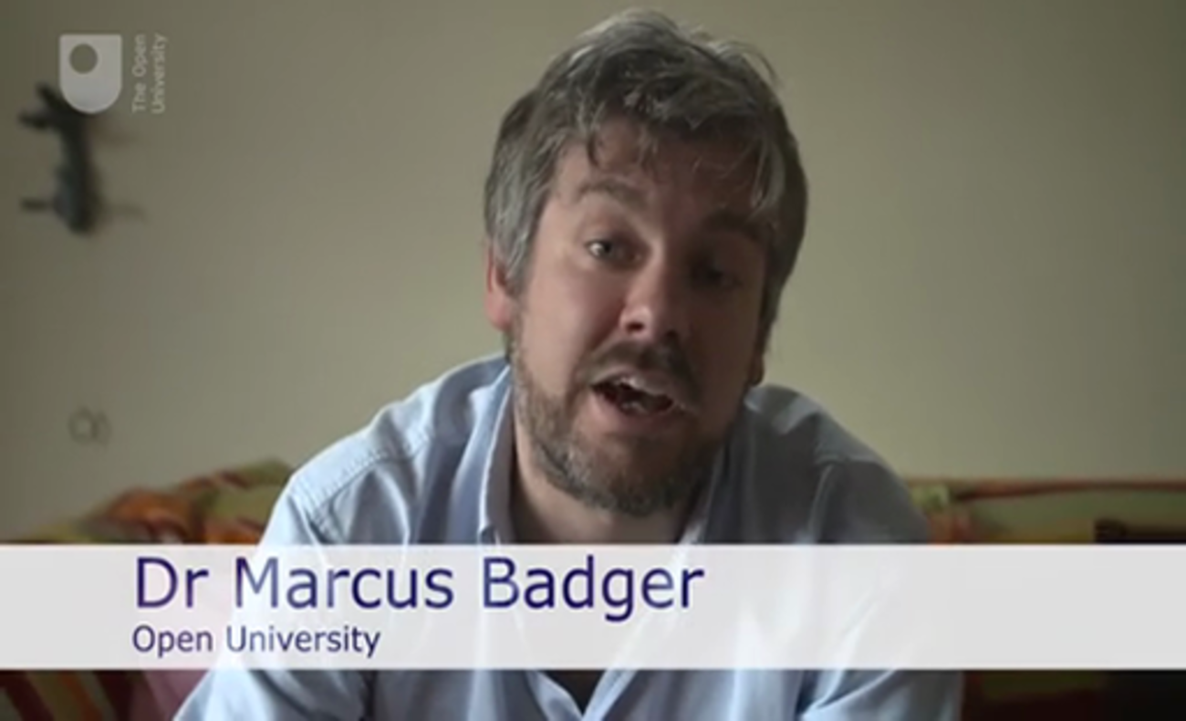

In this first week of the course, you will learn about different types of rock, before finding and identifying some rocks near you. You’ll finish the week by looking at the rock cycle and plate tectonics.

1.1 What is a rock?
What is a rock? This might seem like a simple question – rocks are hard things that are found in the ground and that mountains are made of – but unsurprisingly, it is more complicated than that. Basalt isn’t just made up of stuff called basalt and, believe it or not, there are lots of different things that can make up a sandstone. The following video explores this in more detail.

Video content is not available in this format.
Video 1.2 Three types of rock
View transcript - Video 1.2 Three types of rock

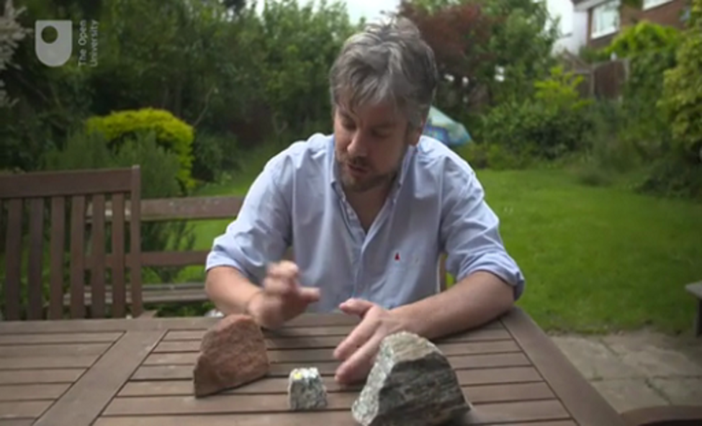

So, there are three different types of rock: igneous, sedimentary and metamorphic. These three types are formed in different ways. This means that they have different properties that, to the trained eye, usually make them easy to tell apart. But, what is a rock? A rock is an aggregate, or combination, of minerals. These can be all the same mineral, as seen in limestone, or more often, lots of different minerals, as seen in granite. So what is a mineral? Well, a mineral is defined as any naturally occurring element or compound which has a characteristic chemical composition, physical properties and, importantly, crystal form.

1.1.1 Igneous rocks

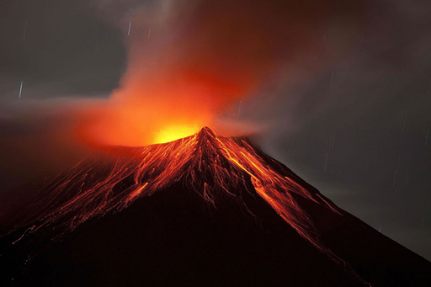
Figure 1.1 Igneous rocks
View description - Figure 1.1 Igneous rocks

Igneous rocks are defined as having formed from a molten state; that is, when liquid rock (called ‘magma’) cools to form a solid rock. Cooling of magma can happen deep inside huge mountain chains such as the Andes, where granite might form. When the magma rises towards and through the Earth’s surface, to produce a volcanic eruption, rocks such as basalt, rhyolite (volcanic glass) and even pumice can be produced.

1.1.2 Sedimentary rocks

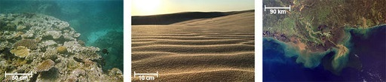
Figure 1.2 Sedimentary rocks
View description - Figure 1.2 Sedimentary rocks

Sedimentary rocks are made up of little bits of material, called ‘clasts’, which have been cemented together. They form in places where material is moved around and deposited, like rivers, deserts, lakes and oceans. Quite often, sedimentary rocks will either include, or be entirely made up of, the remains of living organisms. Once the sand or shells have been deposited they are covered by layers and layers of more sediment. Gradually, over time, the pressure of all this material on top squeezes the clasts together and they become more stuck together, so they are no longer soft mud or sand, but a hard mudstone or sandstone. Sometimes the grains cement themselves together and sometimes the grains are stuck together by another material.

1.1.3 Metamorphic rocks

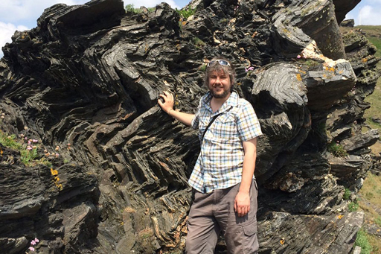
Figure 1.3 Metamorphic rocks
View description - Figure 1.3 Metamorphic rocks

Metamorphic rocks are formed when other rocks, usually buried deep inside the Earth, are exposed to heat and pressure, but NOT melted (as then they’d be igneous). Metamorphic rocks can be formed from sedimentary rocks, igneous rocks, or even other metamorphic rocks.
In the next section, you’ll be asked which of these types of rocks concrete resembles.

1.2 Watch out for concrete
Having learned about the three different types of rocks, complete the activity below.

Activity 1.1 Concrete
Allow about 2 minutes

Concrete is a building material that has been used since pre-Roman times. It is a mixture of sand and gravel held in a matrix of cement. Sound familiar? It should do, but which type of naturally occurring rock does concrete resemble?

sedimentary rock
metamorphic rock
igneous rock
View discussion - Activity 1.1 Concrete

1.3 Rock textures
Due to how the three sorts of rock are formed, they appear quite different when you look at them closely. All rocks are formed of smaller parts, called ‘grains’.

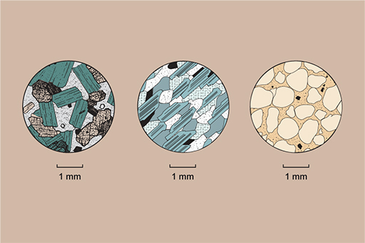
Figure 1.4 From left to right, igneous, metamorphic and sedimentary rocks
View description - Figure 1.4 From left to right, igneous, metamorphic and sedimentary rocks

As igneous rocks begin to cool down from the molten state, the grains are crystals which grow together to form an interlocking texture, with the crystals touching each other.
The grains in metamorphic rocks are made up of crystals too, but because they are usually formed under pressure, the crystals are often aligned in one direction and form bands of different colours or shapes of crystal.
As sedimentary rocks are formed of bits of other things stuck together, they look just like that, with individual grains (called ‘clasts’ in sedimentary rocks) cemented together.

1.4 Identifying rock textures
Take a look at a hand specimen and a thin section of each of these rocks:
(open the links in a new window so you can come back to this page more easily)
- gneiss (pronounced ‘nice’)
- conglomerate
- gabbro
When you've taken a good look at the rocks, complete the quiz below.

Activity 1.2 Rock specimen quiz
Allow about 10 minutes

You may take as many attempts as you wish to answer each question, and you can skip questions and come back to them later if you wish.
1. Select all the correct observations of each textural feature of gneiss:

Interlocking crystals
Rounded grains
Randomly oriented crystals/grains
Crystals/grains showing banding or alignment in one preferred direction

2. Select all the correct observations of each textural feature of conglomerate:

Interlocking crystals
Rounded grains
Randomly oriented crystals/grains
Crystals/grains showing banding or alignment in one preferred direction

3. Select all the correct observations of each textural feature of gabbro:

Interlocking crystals
Rounded grains
Randomly oriented crystals/grains
Crystals/grains showing banding or alignment in one preferred direction

4. Gneiss has a banded crystalline texture and is therefore …

sedimentary
metamorphic
igneous

5. Conglomerate has a fragmental texture and is therefore …

igneous
metamorphic
sedimentary

6. Gabbro has a crystalline texture and lacks mineral alignment or banding and is therefore …

sedimentary
igneous
metamorphic

1.5 Identifying rocks: going into the ‘field’
You will now have the chance to locate and identify your own rocks.

Activity 1.3 Finding and identifying rocks
Allow about 10 minutes

Part 1

First, watch the following video. In this video, Anne and Marcus identify a variety of rock types in the building stone at Milton Keynes shopping centre. Pay particular attention to the indicators they use to distinguish between igneous, metamorphic and sedimentary rocks, as your next task will be to go out and find your own rock sample.

Video content is not available in this format.
Video 1.3 Identifying rocks: going into the field
View transcript - Video 1.3 Identifying rocks: going into the field

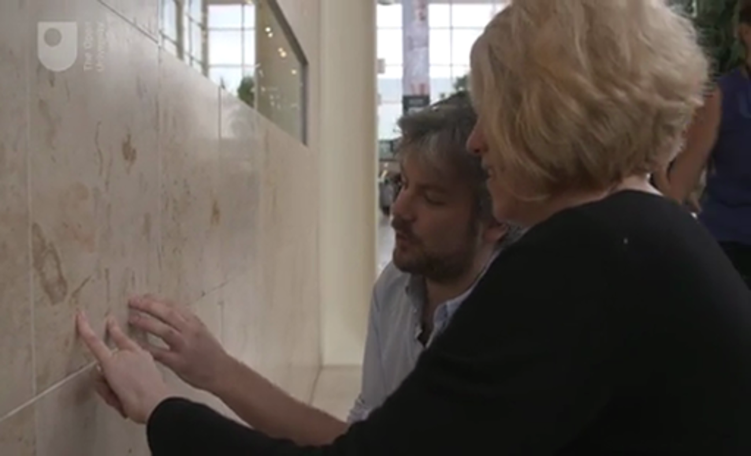

Part 2
Allow about 60 minutes

Now go and examine some rocks in your local area. You don’t have to go far; you could have a look in your local shopping centre, high street or even a kitchen work surface.
When examining each rock, look up close and from different angles to check for grain shape, evidence of interlocking grains, fragmental texture and layering. You could take advantage of your camera’s magnification slider to look more closely.
Don’t worry if you’re not sure what something is. Rocks aren't always so easily categorised – sometimes even a trained geologist will need some quite fancy analyses to figure out what they are.
If you can’t go outside or live far away from any rocks, you could potentially use Google Street View to locate a sample.

1.6 The rock cycle and plate tectonics
Ever wondered why mountains are found in certain places on the Earth and not others? In this section you will learn about how the Earth recycles rocks and how this affects the Earth’s crust.

The rock cycle – one turns into another
You have already tried to identify rocks that are used in your local area as either igneous, sedimentary or metamorphic, but have you ever thought about how rocks end up in these categories? Or, if rocks are broken down into clasts, will we ever run out of rock to form sedimentary rocks with? Luckily, the answer to the last question is no – this section will investigate how rocks change between these three categories. It is described by a conceptual system called the ‘rock cycle’ and one of the main processes involved is plate tectonics. These two topics are what you’ll be studying for the rest of this week.
All three sorts of rocks are continually being created, modified and destroyed by many different geological processes, operating at all scales of both length and time. This can be a single crystal grain decomposing during weathering, to the ocean being formed as a result of the long strings of volcanoes that exist along the ocean floors (more on that later). A good way of viewing how different types of rock may be connected by processes that form and re-form them is through a conceptual system known as the rock cycle.

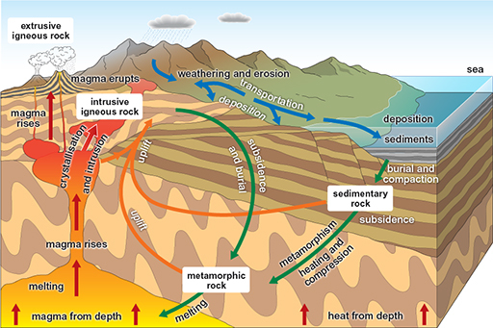
Figure 1.5 The rock cycle
View description - Figure 1.5 The rock cycle

The rock cycle not only sets the three main groups of rocks into a spatial context, it also links them through processes of formation and transformation.
Processes that take place at the surface of the Earth include weathering, transportation and deposition, as well as biological processes such as the growth of some of the animals and their shells or skeletons, which form parts of sedimentary rocks.
Inside the Earth, processes include burial and subsidence, which may lead to metamorphism as pressure and heat builds up, and then potentially to melting and the first step to forming the next igneous rock.
As you can see in the diagram, there are many routes around the rock cycle. The most direct route through the cycle is probably:
- An igneous rock is weathered and eroded, the bits are transported somewhere where they build up to form sediments. These undergo burial and are compacted to form a sedimentary rock.
- The sedimentary rock is heated during deep burial. The heat and pressure may first form a metamorphic rock, but this may never see the surface of the earth before it is melted to form a magma – hot liquid rock.
- The magma rises up and cools, forming a new igneous rock, and the cycle starts again.
Can you find any of the other routes around the rock cycle?

1.7 So, how old is the Earth?
The rock cycle is a fairly simple scheme, but it may seem rather complicated because of the variety of routes rock materials can take to be transformed. Many of these stages, such as the formation of a metamorphic rock, can take vast amounts of time. Other rock-forming processes, like the eruption of a volcano, can form new rock almost instantaneously.
This brings us to an important point – the vast amount of time that some geological processes can take. The amount of time taken for a whole mountain range to be eroded flat is almost unimaginable, but the evidence from the rock record of sedimentary rocks that made up bits of that mountain range, and of the metamorphic roots of those mountains found at the surface, show that it must have happened. And more than that, the evidence suggests it’s happened time and time again – with material repeatedly moving around the rock cycle.
That’s because although some of these processes take a really long time, the Earth is so old that it’s possible for it to have happened over and over again.
In this video, Marcus discusses the essential events in earth history as if they took place over the course of a single day.

Video content is not available in this format.
Video 1.4 The Earth's history in a day
View transcript - Video 1.4 The Earth's history in a day

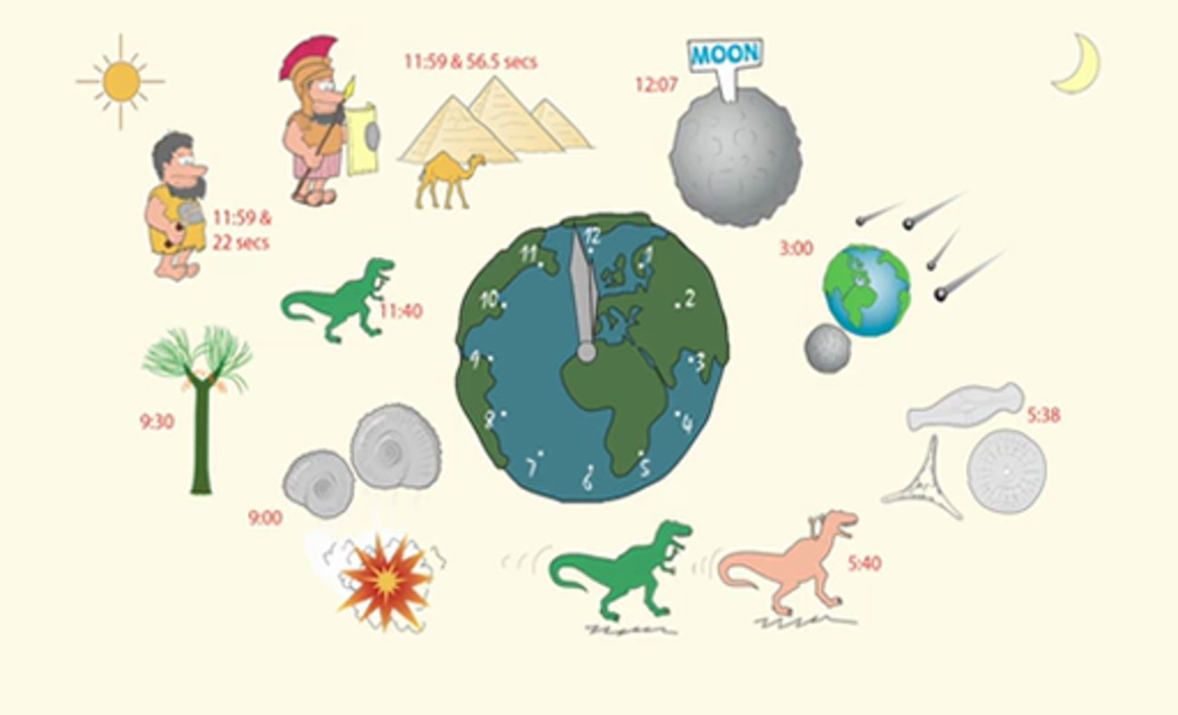

1.8 And how do we know that?
Geologists have a few ways of dating rocks, and they are split into relative and absolute methods.

1.8.1 Relative dating
Relative dating is simply figuring out which rock came first. In some circumstances that’s pretty simple, like knowing that the sandstone in the cliff below must have been there before the igneous intrusion that has been forced into it.

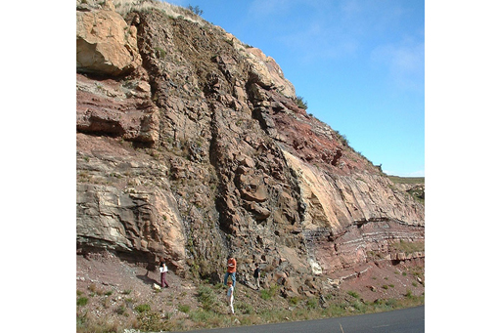
Figure 1.6 Dyke cross cutting sandstone
View description - Figure 1.6 Dyke cross cutting sandstone

However, sometimes what looks straightforward can be quite complicated. As discussed earlier this week, sediments are laid down on top of each other, one after the other like the pages of a book, so you might think that in this picture the rock on the top should be younger than the rock at the bottom.

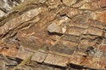
Figure 1.7 Nappe fold zoomed in
View description - Figure 1.7 Nappe fold zoomed in

In this case, however, something else has happened – the whole pile has been inverted by processes during plate tectonics, and from further away, you can see that the whole lot has been folded over.

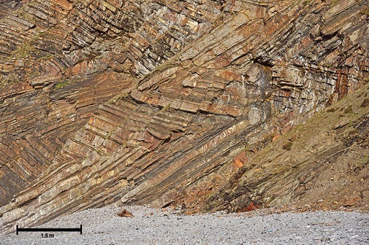
Figure 1.8 Nappe fold
View description - Figure 1.8 Nappe fold

1.8.2 Absolute dating
The other sort of dating is absolute dating. This tells us a numerical age for the rocks, usually based on the radioactive decay of isotopes within the rock. Radioactive isotopes decay at a very regular rate, called the half-life. By measuring the amounts of the original parent and new daughter isotopes in a rock, the age of the rock can be determined. This only works for rocks that contain the right sort of isotopes.

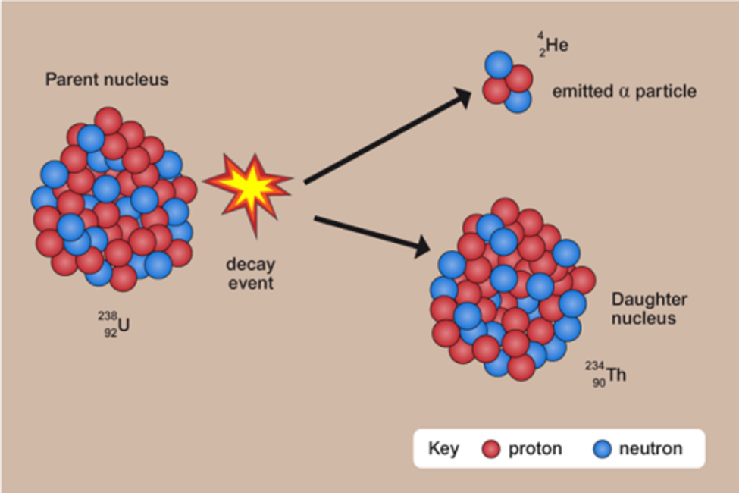
Figure 1.9 Radioactive decay
View description - Figure 1.9 Radioactive decay

Few of the rocks on the surface of the Earth are anywhere near as old as the Earth is. In fact, it’s really difficult to get an idea of how old the Earth is from dating Earth rocks, as rocks that are old enough are so incredibly hard to find (like the ~4 billion year old Acasta gneiss, pictured).

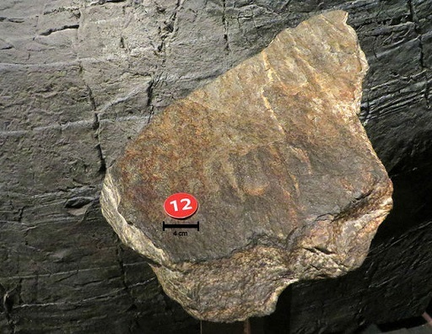
Figure 1.10 Acasta gneiss specimen
View description - Figure 1.10 Acasta gneiss specimen

To get an idea of the age of the Earth, we date specific meteorites, which are left over from the formation of the solar system. Difficulty arises because the surface of the Earth is constantly churned up and reworked by a process known as ‘plate tectonics’.

1.9 What is plate tectonics? Continental drift and sea floor spreading - part 1
Have you ever looked at a map of the Atlantic Ocean and thought that the coasts of Africa and South America look like they could fit together like a jigsaw?

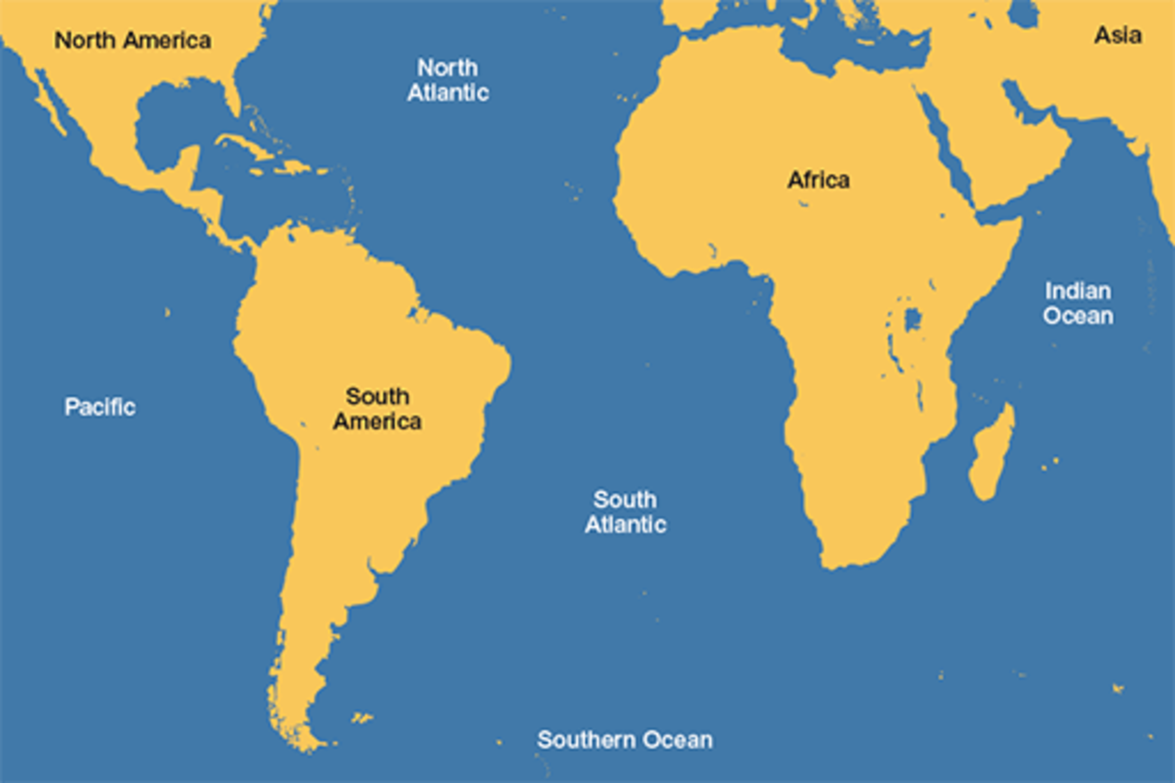
Figure 1.11 Map of the Atlantic Ocean
View description - Figure 1.11 Map of the Atlantic Ocean

You wouldn’t be the first. In fact, the similarity was written about by a Königsberg Professor of Theology, Theodor Christoph Lilienthal, as early as 1756. Later, in 1845, the explorer Alexander von Humboldt wrote about the similarity of both the shape of the coastlines and the rocks on either side of the Atlantic.
The reason for the similarity is because they did fit together once, as depicted below.

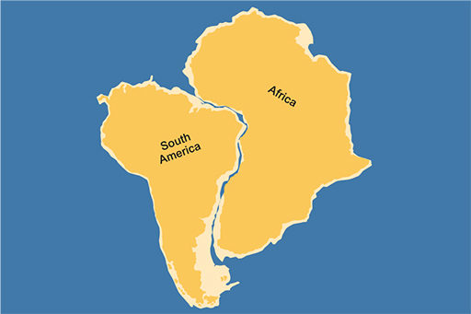
Figure 1.12 South America and Africa realigned
View description - Figure 1.12 South America and Africa realigned

So what makes the continents move about? The other side to continental drift is sea floor spreading.
Figure 1.12 above suggests that the Atlantic Ocean (both the North and South parts) hasn’t always been there, so is that true?
As you learned earlier this week, there are a few different ways of finding the ages of different rocks. When applied to rocks all over the Earth, one thing stands out in particular – that the rocks at the bottom of the oceans are usually younger than the continents. And in this case, even the oldest rocks that make up the bottom of the Atlantic are much younger than most of the rocks that make up the continents on either side. This makes sense if the continents were once there, but the ocean now in between them wasn’t.
Another clue was found during the late 1950s and early 1960s. During this time, a lot of money was being spent on research and surveying of the sea floor – in part because of the amount of submarine activity during the Cold War. What was discovered was a series of strange, symmetrical disturbances in the magnetic field within the rocks on the sea floor.

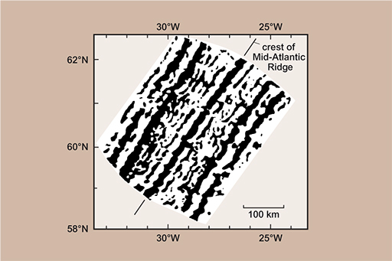
Figure 1.13 Sea floor magnetic stripes
View description - Figure 1.13 Sea floor magnetic stripes

So, what caused the stripes? The rocks on the sea floor are igneous – as you learned before, this means that they are formed when liquid magma cools and solidifies into rock. As that happens, parts of certain minerals in the rocks align with the Earth’s magnetic field like little compass needles – we call this magnetisation, because they form very weak magnets. Geoscientists can measure that magnetisation using sensitive instruments called magnetometers, and that’s what’s shown as the stripes in the picture.
The other piece of the story is that the Earth’s magnetic field hasn’t always been the way round that it is today. If you were standing on the Earth 800,000 years ago your compass wouldn’t point to the North Pole, but to the South Pole! If you went back further to 1 million years ago, it would be pointing north again, and further still to 4 million years ago it would be pointing south. These switches in the Earth’s magnetic field are called ‘magnetic reversals’ and they happen every million years or so. This is actually another way that rocks can be dated – by looking for the evidence of these reversals.

1.10 What is plate tectonics? Continental drift and sea floor spreading - part 2
As you saw in the previous section, the stripes in the sea floor are caused because some of the rocks cooled at times when the magnetic field was reversed, and the stripes are symmetrical because as new rock is formed in the centre, it pushes the rest of the sea floor out of the way. This is shown in the video below (note: this video has no sound).

Video content is not available in this format.
Video 1.5 Magnetic reversal stripes

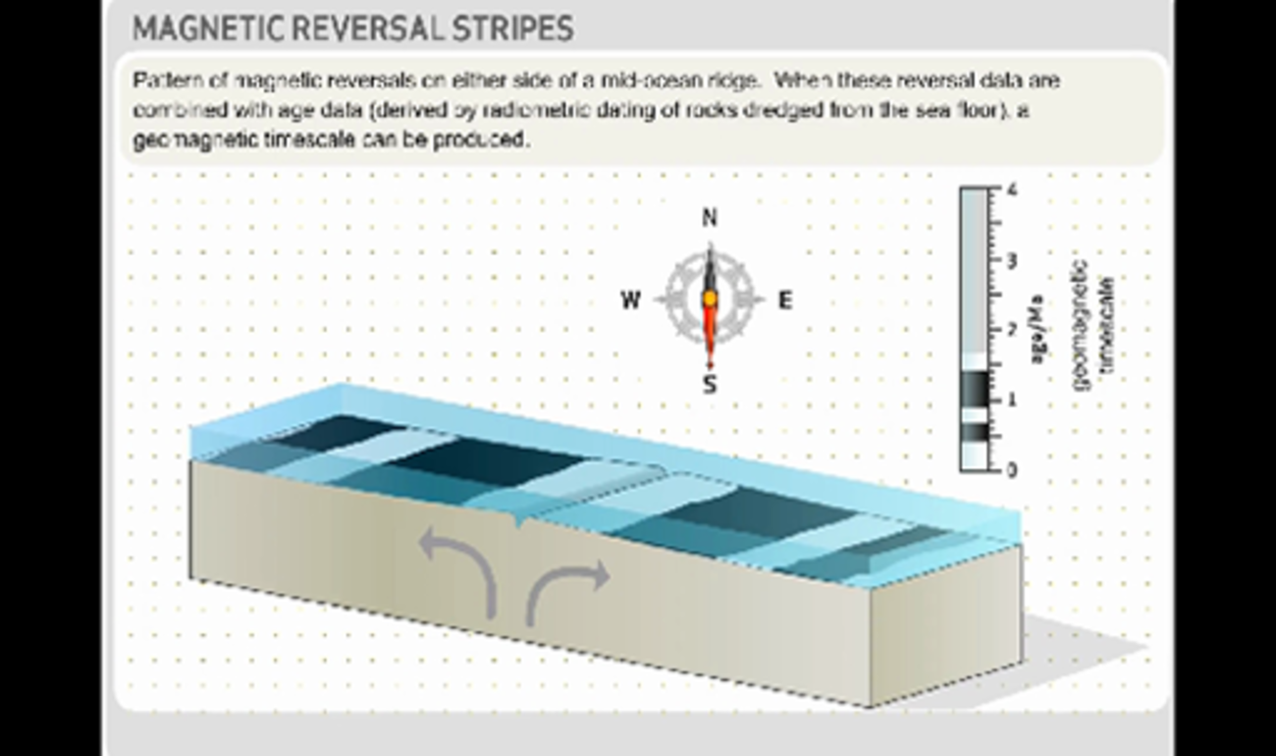

This is how the continents moved apart. New sea floor is created, which pushes the continents apart. This isn’t just happening in the middle of the Atlantic, but all over the world’s oceans, in areas called ‘mid-ocean ridges’.

1.11 Plate tectonics – part 1
If the sea floor spreading discussed in the previous section were to go on, you might expect that the world would just keep getting bigger and bigger, but this doesn’t happen as the sea floor is destroyed in some places. In this way the continents are moved across the face of the planet.
Continental drift and sea floor spreading combine as two parts of the same theory, ‘plate tectonics’, which sees the whole world as a series of segments, or plates arranged together. Some are continental and oceanic whilst others are purely oceans.

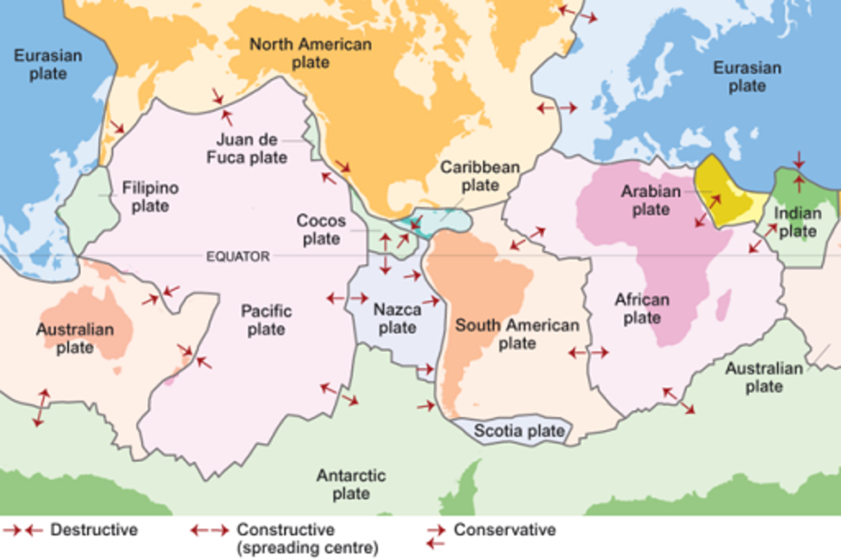
Figure 1.14 Plate boundaries and boundary types
View description - Figure 1.14 Plate boundaries and boundary types

At the boundaries of these plates one of three things can happen. Plates are either being created, destroyed, or just slide past each other. We call these three types of plate margins ‘constructive’, ‘destructive’ and ‘conservative’. If you were to look at the plate margins in cross-section, you would see some of the processes that occur at each place.

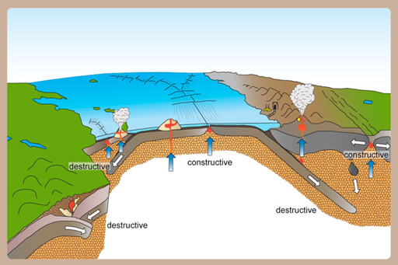
Figure 1.15 Cross section of plate tectonics
View description - Figure 1.15 Cross section of plate tectonics

At some places new rocks are being formed, while in other places rocks are being buried. Where plates are pushing together, huge pressures build up. You may be beginning to see how these could relate to the places where the igneous, sedimentary and metamorphic rocks that were introduced earlier this week form.

1.12 Plate tectonics – part 2
In the previous section you looked at the different plates of the world. You will revisit this in the activity below.

Activity 1.4 Tectonic plates
Allow about 5 minutes

Looking at the map, can you see which plate you live on? What’s the closest plate margin to your home and what sort is it – constructive, destructive or conservative? Makes some brief notes below.

Figure 1.14 (repeated) Plate boundaries and boundary types

Provide your answer...

1.13 Week 1 quiz
If you'd like to test and apply your knowledge of the material in Week 1 with a few questions, click the link below. Note: this is not a requirement in order to continue studying, or to complete the course.

Complete the Week 1 quiz here.
Open the quiz in a new window or tab then come back here when you’re done.

1.14 Summary of Week 1
You’ve reached the end of Week 1, and have looked at how rocks form: sedimentary rocks in a depositional environment; igneous rocks from molten rock; and metamorphic rock within the Earth’s crust where temperatures and pressures are higher than at the surface. You also looked at how you can identify these rock types based on their structure.
You watched a video where Anne and Marcus went into the field to find rock types used to construct buildings, and you may have tried to identify different types of rocks in your local area.
You then looked at the rock cycle, and how rocks can be formed and reformed many, many times. This could occur as an igneous rock is weathered and reforms as part of a sedimentary rock, which is eventually buried, where the heat and pressure cause it to undergo metamorphic processes.
Finally, you were briefly introduced to sea floor spreading and the theory of plate tectonics. Next week you will explore some of the geology in your pocket – the geology that goes into making a mobile phone.

Week 2: Metals, metals everywhere

Introduction to Week 2
So far, this course has explored different rock types and how they are formed, before briefly introducing you to tectonic plate theories.
Studying things that occur over timescales of hundreds of thousands or even millions of years at the bottom of the oceans or in volcanoes can feel slightly abstract. This week shows how geology affects your daily life, by looking at the geology that goes into your smartphone.

2.1 Opening up a smartphone
What’s your smartphone made of? How do we extract the minerals we need from the Earth? This week, you’ll find out about the natural geological sources, and the man-made processes that are involved.
Luckily, there's no need to dismantle anything yourself – watch this video clip Marcus as takes apart his old smartphone.

Video content is not available in this format.
Video 2.1 The anatomy of a smartphone
View transcript - Video 2.1 The anatomy of a smartphone

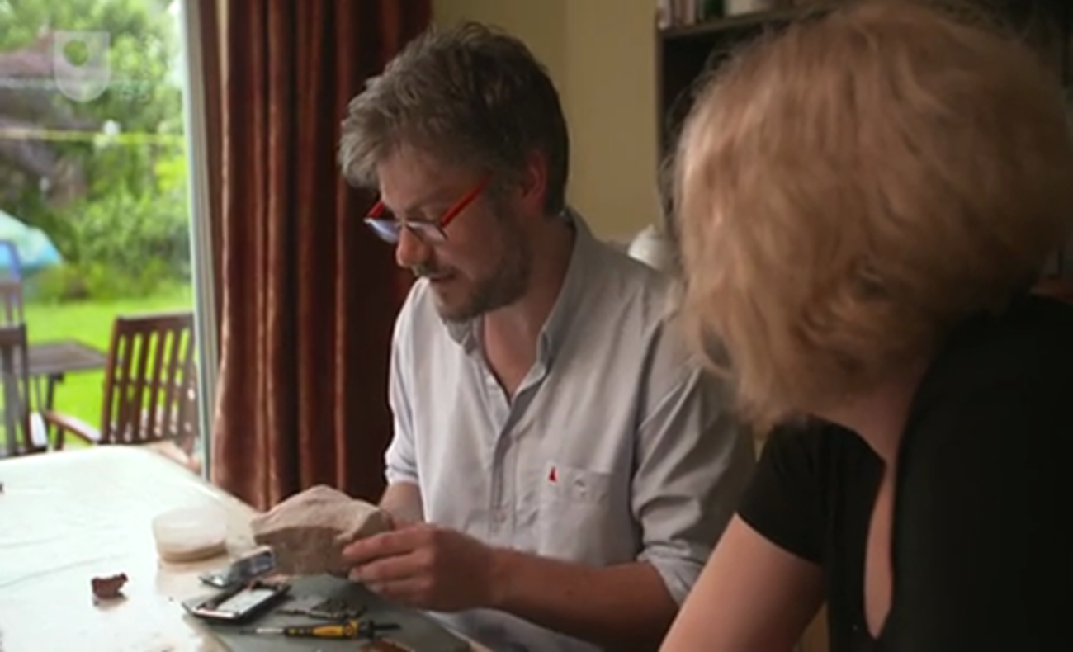

2.2 Where do the metals come from?
The mobile phone contained lots of metals, so the next part of this course will be spent looking at where those come from. But first, a more general question – where do the metals we use come from? And what determines where we get them from?
You may be surprised to find out that almost any rock that you pick up contains just about every natural chemical element there is. Many elements, however, may only be present in vanishingly small, trace amounts – perhaps only one atom in a million, or one in a billion. Extraction of elements that only exist in such low concentrations would be very expensive. To extract any element from a rock, it is essential to take advantage of the geological processes that have concentrated chemical elements that you want in certain rocks. More than that, to be a viable source of any metal, a rock must not only contain a large amount of what you want, but the metal must also be in a form and in a quantity that makes financial sense to dig up, process and purify. A rock from which metal can be extracted easily enough to make money is called an ore.
So, in what forms do metal ores exist? Only a few metals (like copper and gold) are found in what is called their ‘native’ form, where they aren’t combined with other elements. Most metals are combined with other elements in minerals, which are then (usually) combined with other minerals in rocks.
The places that ores are found and being formed today are determined by geological processes, which are in turn linked to the rock cycle and plate tectonics. You’ll learn now about a few of those ore-forming processes, which take place in the locations indicated on the schematic of plate tectonics that you first saw in Week 1.

Figure 2.1 Cross section of plate tectonics
View description - Figure 2.1 Cross section of plate tectonics

2.3 Pegmatite
Pegmatites are igneous rocks with very large crystals – usually, most of the crystals will be greater than 1 cm in length. In igneous rocks, the presence of large minerals tells us that the rocks cooled very slowly from their molten state to what we see today. The slow cooling is because they form deep within the crust where it takes a very long time for the heat to escape (as opposed to lava at the surface, which cools very quickly).

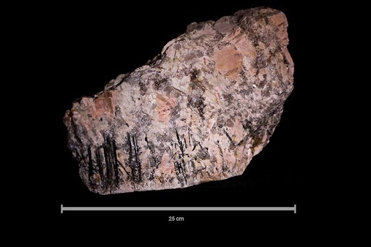
Figure 2.2 Pegmatite specimen
View description - Figure 2.2 Pegmatite specimen

Pegmatites form deep within the continental crust in vast magma chambers – the same sort of places as the granites that you saw on the buildings last week. However, what makes pegmatites special is that they form very late in the process, and they’re sort of like the vacuum cleaner of igneous processes – they collect up all of the leftover elements that don’t fit into the crystal lattice of the more common igneous minerals (like quartz and plagioclase feldspar).
The odd way that pegmatites form means some elements usually found in low concentrations in many igneous rocks end up being very highly concentrated in pegmatites. This makes them a valuable ore resource for certain elements. The pegmatite deposits aren’t usually that large, so, even though the ore is quite valuable, they are not always worth mining.
One unusually large pegmatite in Western Australia (the Greenbushes pegmatite) is mined for lithium which is found in a mineral called spodumene. Lithium is an important component in a lot of batteries, including the one likely to be in your phone right now, or the laptop you may be reading this on. Another large pegmatite in Manitoba, Canada (the Tanco pegmatite) is mined for tantalum and niobium, which are used in some of the electronics in your phone.

2.4 Bauxite – amazing things that a lot of rain can do
Sometimes weather is all it takes to form an ore, so long as the weather is intense enough and you give it enough time!

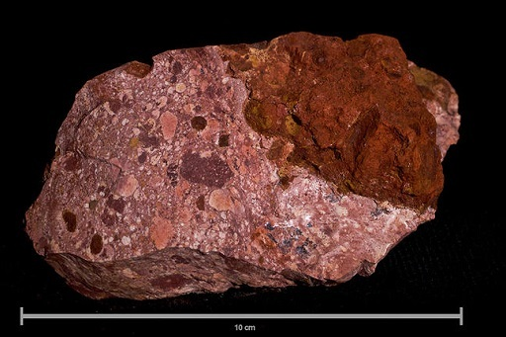
Figure 2.3 Bauxite
View description - Figure 2.3 Bauxite

Bauxite is an aluminium ore that forms just from the weathering of rocks. Weathering is what happens when rocks are left out in the rain, and comes in three forms: physical, chemical and biological. Physical weathering is when bits of rock are attacked by wind, or water, or sometimes just gravity during rock falls. Chemical weathering is when rocks slowly dissolve – rainwater is naturally ever so slightly acidic, and that acid will slowly dissolve the rocks. The third sort of weathering is biological, where rocks are attacked (chemically or physically) by living things.

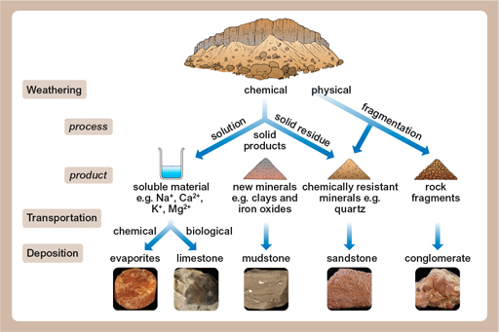
Figure 2.4 Weathering processes
View description - Figure 2.4 Weathering processes

For bauxite to form, the important factor is chemical weathering under very specific conditions. Aluminium is the third most abundant element in the Earth’s crust (after oxygen and silicon) and, at 8.4%, the most abundant metal. Aluminium is usually combined very tightly with other elements in some very common minerals, so although there’s a lot of it almost everywhere, it’s very expensive to extract.
Fortunately, the chemical weathering of one of those minerals, feldspar (found in lots of igneous and metamorphic rocks), forms kaolinite, a clay mineral. This process increases the amount of aluminium oxide from less than 28% (in feldspar) to 40% – but that’s still not enough for it to be worthwhile to extract it. However, in really warm climates (like the tropics), the kaolinite is chemically weathered even more, forming minerals like gibbsite, which has high enough concentrations to be worthwhile to mine and process.
The essential thing in the formation of bauxite is that all of the other things which aren’t wanted (like silica – silicon dioxide, quartz, is its best known form) can, in tropical conditions, stay dissolved in the rainwater and be carried away, leaving the aluminium in place. This effect is shown in the figure below – showing the solubility of the aluminium oxide (Al₂O₃) and silica (SiO₂) at different pH levels (a measure of acidity). This means that given enough time, enough starting material and enough weathering, you can go from having a lot of rock with not very much aluminium in it to having not much rock with a lot of aluminium in it!

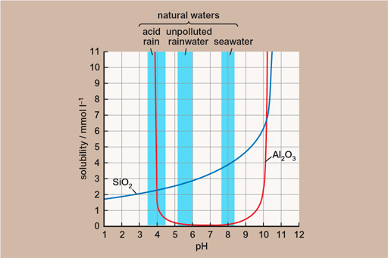
Figure 2.5 Solubility at different pH levels
View description - Figure 2.5 Solubility at different pH levels

2.5 From soil to soda cans
An aluminium drinks can is made of about 15 g of aluminium. Aluminium is the third most abundant element in the Earth’s crust (the bit we can ‘get at’) after oxygen and silicon, but is only about 8.4% of the material. If you wanted to extract the necessary aluminium from the Earth's crust, you would need to grind up 178 g of material to get enough aluminium to make one can:

How about a fairly typical rock, like a granite?
Well, granite is ~ 14% alumina (Al₂O₃). First you need to convert this to % aluminium, which we do by multiplying the percentage of Al₂O₃ by the percentage of Al in Al₂O₃:
The atomic mass of Al is 27. The atomic mass of O is 16.

So you’d actually need more granite to get the necessary aluminium than if you just ground up the crust.
Don't worry if this seems a bit too complicated – this video clip reiterates the above material and explores the maths a bit more closely.

Video content is not available in this format.
Video 2.2 Extracting enough aluminium
View transcript - Video 2.2 Extracting enough aluminium



What about bauxite? Bauxite is formed from rocks like granite – how effective is the geological process in concentrating the aluminium? Test your understanding with the next activity.

2.6 Getting bauxite from soda cans
A typical bauxite ore is 50% Al₂O₃. Remember, Al has an atomic mass of 27, O is 16, so bauxite is 26.5% Al. Using this information, see if you can complete the activity below. Again, don't worry if you have some difficulty with this – it takes some practice.

Activity 2.1 Extracting Al from bauxite
Allow about 10 minutes

How much bauxite do you need to make a 15 g soda can?

134 g
56.7 g
30.1 g
View answer - Activity 2.1 Extracting Al from bauxite

2.7 Another source of Al
Bauxite isn’t the only thing that goes into making an Al can. To find, mine, transport and purify bauxite into Al takes an enormous amount of energy.

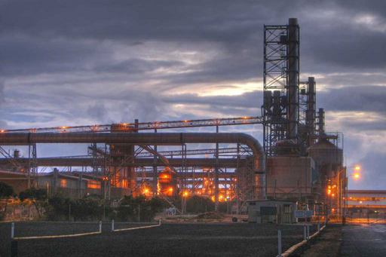
Figure 2.6 Smelting plant
View description - Figure 2.6 Smelting plant

The cost of the electricity used to split the bond between aluminium and oxygen in alumina makes up somewhere between one and two fifths (20–40%) of the total cost of aluminium. In fact, Al smelting plants use so much power that they are usually sited right next to power stations, in order to reduce the loss of power during the transmission of electricity over longer distances. There is, however, another way: recycling.
We already have a lot of pure aluminium hanging around – it’s in the coke cans, the car chassis and cooking foil that we use every day. Recycling this aluminium uses significantly less energy – around 5% of the energy required for mining, transporting and refining new aluminium.
This means that with the energy it takes to make one new Al can, we could make 20 recycled ones.

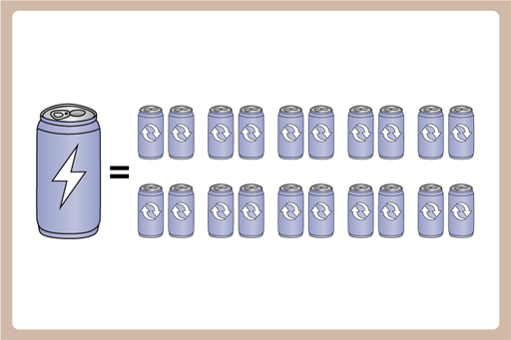
Figure 2.7 One new can = 20 recycled cans
View description - Figure 2.7 One new can = 20 recycled cans

2.8 Sand, sandstone and quartzite
The glass in the screen of your phone is made of silicon, just like the silicon found in the chips that make it run. In the chips, it is in its purest form as silicon, whereas in glass, it is silicon dioxide, SiO₂, which geologists refer to as silica. Besides your phone screen, silica also makes up the glass that’s all around us. But where does it come from?
Silicon dioxide is quartz – a very common, grey/translucent rock-forming mineral in igneous and metamorphic rocks. It’s also very hard.
Just like with the other ores, we use geological processes to do a lot of the work of purifying the silica for us. Because quartz is very hard, when a lot of rocks are weathered and broken down into their constituent parts, quartz tends to survive the longest. This hardness also means that it can be transported by water and wind, without breaking down into very small pieces or being dissolved and going into solution.
So if you start with a rock that has lots of different minerals in it, weather it, and transport the bits, quartz tends to be the mineral that you end up with. This is why beaches are so often made of quartz sand – the power of the waves breaks down everything that isn’t quartz and takes it away, doing a great job of purifying the quartz.

2.9 The geological sorting hat
The breaking down and winnowing of material as rocks are weathered and transported is an important sedimentary process, and introduces two important concepts for geologists – sorting and roundness.
As sedimentary materials are transported and deposited, usually by water and wind in the case of sands, there’s a tendency for the particles to be sorted into different sizes. This degree of sorting depends mainly on how particles of different size and density settle through the current carrying them along (whether wind or water). The more uniform the conditions in the environment of deposition, the better sorted the sediment will be.
This is due to two important factors – water and wind only have the power to transport material up to a certain mass. What’s left behind is the material which is right on the limit of what the fluid can carry – any lighter and it will be carried away, and any heavier and it won’t be there in the first place.
In sedimentary systems, the grain size of the material left behind can tell us how much energy was in the fluid at the time of deposition, and how well sorted the material is tells us whether the deposition happened quickly, or slowly.
Figure 2.8 shows two different sorts of sediment. The well sorted sediment in the upper image has lots of grains of the same size which might result from a long period of gentle washing back and forth, caused by low-energy waves on a beach or by desert sand being blown by a steady wind. A poorly sorted sediment like the one in the lower image has grains of lots of different sizes, which are jumbled together. This tends to happen when sediments have been deposited in very variable conditions or very quickly, like in a landslide or a flash flood.

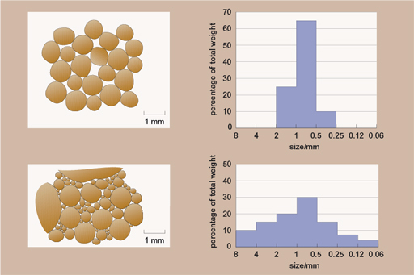
Figure 2.8 Two different sorts of sediment
View description - Figure 2.8 Two different sorts of sediment

The other thing that happens during transport is that the grains collide with each other. They might start out as perfectly formed crystals in an igneous or metamorphic rock, but as they are transported the corners can be knocked off, pits gouged into them and the surfaces of the grains pitted. Geologists can look at sedimentary rocks and define the roundness of the grains, which can tell us things about how far and for how long material has been transported, and by what means. For example, the air in a desert doesn’t cushion the grains nearly as well as water can, so sands which form in deserts tend to have much better-rounded grains than those that are transported by rivers. Figure 2.9 shows some of the sorts of terms geologists use to describe the different shapes of grains, and shows how different they can be.

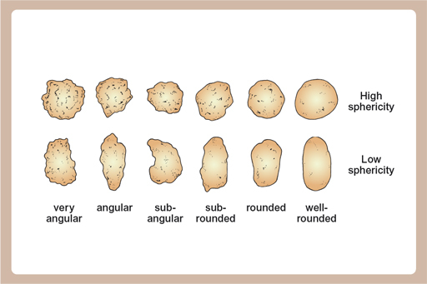
Figure 2.9 Grain shapes
View description - Figure 2.9 Grain shapes

The deposition leaves other clues about the environment in the rock record. This can be things like bedding, flat lines, which show how layer upon layer of material has been laid down over time, or ripples, just like the ones you see on a beach or river bed today, preserved for millions of years. Fossils can also be left behind – either evidence like burrows, which tell us that something used to live in the sand, or fossilised shells, which can give us important clues about what it was like when the sands were deposited.

2.10 From sands into sandstone and quartzite
Once transported, quartz sands can be deposited on beaches, in rivers and deserts, and eventually they can be buried and compacted. As that happens, and as fluids flow through the material, they can be cemented together. This transforms the sand into sandstone. If you continue that process with more heat and more pressure, eventually the impurities between the grains – and even within the grains – can be squeezed out. This happens deep inside mountain belts and transforms the sedimentary sandstone into metamorphic quartzite.

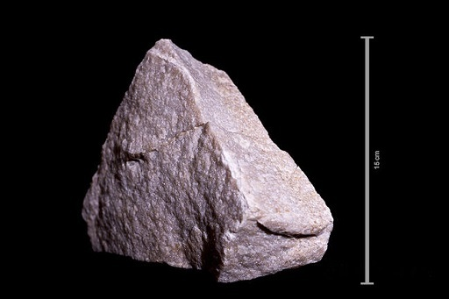
Figure 2.10 Quartzite
View description - Figure 2.10 Quartzite

This process of winnowing during transport and deposition takes a parent rock containing many different minerals and leaves a purified quartz, which can form a pure white sand or sandstone pure enough to supply the silica that makes glass – typically to about 95% silica. However, in order to make the silicon chips, which are the heart of the processing capabilities in your phone, you need the silica to be purer still. Exactly where companies get their silicon from is a trade secret, but it's pretty certain that they use geological processes to do a lot of the work for them.

2.11 Copper
In this section, you will focus on one of the elements found in your mobile phone, copper, and find out why it is one of the most important metals used in the modern world.
In a world dominated by electronics, copper is a hugely important element. Copper (Cu) is used as a conductor in cabling and electronics due to its excellent:
- electrical conductivity
- tensile strength
- ductility and malleability (meaning it bends rather than snaps)
- resistance to corrosion
- low thermal expansion
- high thermal conductivity.
It is therefore found in almost all electronic devices (including whatever you’re using to read this) and is a very important part of your mobile phone.
There are two main geological sources for the main copper deposits:
- porphyry ore deposits
- submarine massive sulphide deposits.

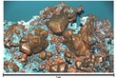
Figure 2.11 Copper crystals
View description - Figure 2.11 Copper crystals

You’ll learn about both types in the next few sections.

2.12 Porphyry ore deposits
Porphyry is a textural term, describing an intrusive igneous rock that has large crystals, which are themselves surrounded by smaller crystals. Remember, an igneous rock is one that has cooled down from a molten (liquid) state, and an intrusive igneous rock is one that has cooled down within the earth, surrounded by other rocks. In a case like this, the smaller crystals are called the matrix or groundmass.

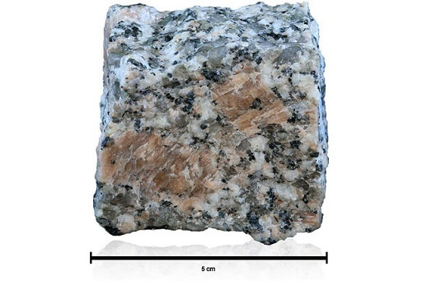
Figure 2.12 Granite, an igneous rock with large crystals
View description - Figure 2.12 Granite, an igneous rock with large crystals

Porphyry ore deposits are low grade – meaning that the amount of the element that you want (in this case, copper) isn’t very high. Porphyry deposits can, however, be very large, so by extracting and processing very large amounts of low grade ore, enough copper can be found for it to be economically worthwhile.
The need to remove very large amounts of very hard igneous rocks means that porphyry ore deposits weren’t mined at all until 1905, when powered shovels and rail transport for the unprocessed ore made them viable. Figure 2.13 shows the Bingham Canyon open pit mine in Utah – you certainly wouldn’t have wanted to dig such a big hole with only shovels and picks!

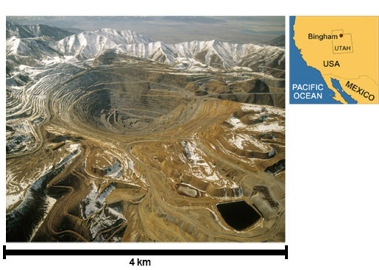
Figure 2.13 Bingham Canyon
View description - Figure 2.13 Bingham Canyon

The Bingham Canyon mine was one of the first porphyry copper deposits to be mined, and it’s still one of the largest known ore deposits in the world. The ore body is about 2.5 km long, 1.7 km wide and over 1 km deep. More than a billion tonnes (that’s 1,000,000,000,000 kg – a petagram!) of ore has been mined, with an average yield of only 0.9% copper. This means that 9 billion kg of copper has been extracted from the Bingham Canyon mine so far.
They’re not even half way – there’s a reserve of 1.7 billion tonnes still to go, which has enough copper to be economically worthwhile (the lower limit at Bingham is about 0.7% for it to be worth extracting).

2.13 Bursting balloons of copper mineralisation
Porphyry copper deposits are usually formed by small igneous intrusions – formed by hot, molten rock forcing their way through existing rocks. The ore minerals that contain the copper are mainly copper sulphides like chalcopyrite (CuFeS₂) and bornite (Cu₅FeS₄), and they’re found in networks of veins called stockwork. Each of the veins are only a few mm across, so you can imagine why it isn’t efficient to try to remove just the copper minerals.

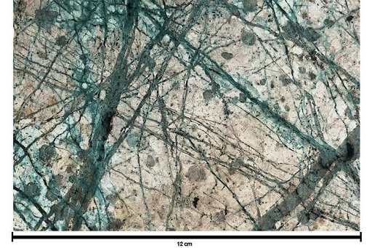
Figure 2.14 Mineral grains called stockwork
View description - Figure 2.14 Mineral grains called stockwork

The minerals in the veins are deposited by water being forced through the rocks. As the magma rises through the earth, it cools and solidifies first at the edges, where the hot magma is in contact with the cold rock which it is being forced through. It rises up like a balloon because it is hotter and less dense than the rocks that surround it, just like a hot air balloon.
The magmas which form the ores also contain water, not a lot – probably only about 3% – but still enough to be important. Bubbles of hot water dissolve elements (like copper) which don’t go into the minerals forming as the magma solidifies. The super-heated copper-laden water is even less dense than the surrounding magma and so rises to the top of the balloon of magma. The water starts to expand and form steam, and the overpressure cracks the balloon of solidifying magma, allowing the copper-filled water to burst out, forcing open cracks in the rocks as it goes. As the water reaches cooler rock, it cools down and can no longer keep the copper dissolved, so it’s deposited along the cracks that it’s formed.

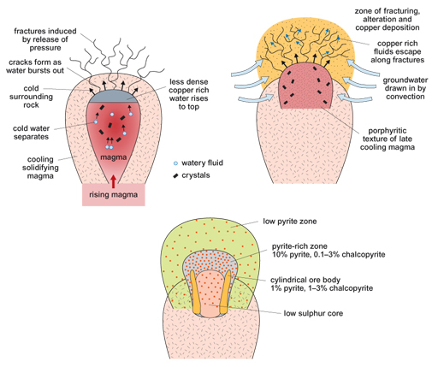
Figure 2.15 Copper deposition
View description - Figure 2.15 Copper deposition

2.14 Porphyry copper ring of fire
Now complete the activity below.

Activity 2.2 Porphyry copper and molybdenum
Allow about 5 minutes

The red dots on this image show the location of porphyry copper and molybdenum deposits. What do you notice about the locations of the sites of these deposits?

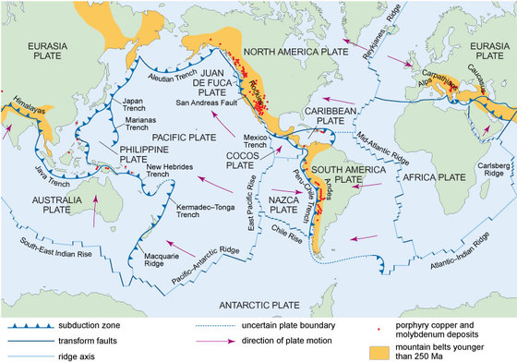
Figure 2.16 Deposit locations
View description - Figure 2.16 Deposit locations

2.15 Under ancient seas
The second main type of ore for copper is submarine sulphide deposit like that formed at Parys Mountain.

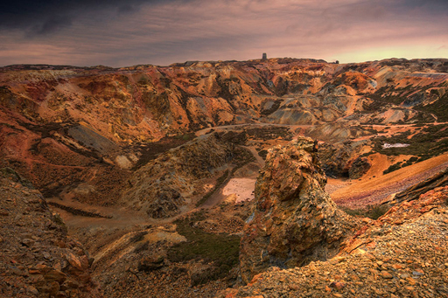
Figure 2.17 Parys Mountain
View description - Figure 2.17 Parys Mountain

The Parys Mountain metal deposits on Anglesey in North Wales have been mined for almost 4000 years, but the formation of the deposits date back much, much further, to the Ordovician, over 443 million years ago. At that time, the area that we now call Anglesey was underwater, part of an ancient ocean called Iapetus, and south of the equator.
The deposits that now make up the ores at Parys, and at many copper deposits worldwide, were produced in volcanoes. But not the sort of volcano you might automatically think of – subsea volcanoes.
Most of the world’s volcanoes aren’t the cone shaped mountains with lava bursting out of them that you might imagine. Most volcanoes are under the oceans, in long ridges which span the globe.
These volcanoes make new oceanic crust at ‘spreading centres’ distributed (mostly) from the centre of the world oceans. These are the constructive plate margins and where all new sea floor is made.

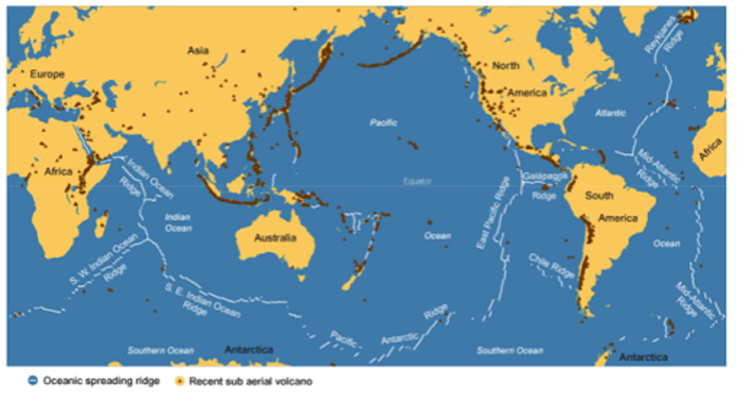
Figure 2.18 Submarine volcanoes map
View description - Figure 2.18 Submarine volcanoes map

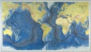
Figure 2.19 World ocean floor map by Tharp and Heezen, 1977
View description - Figure 2.19 World ocean floor map by Tharp and Heezen, 1977

2.16 What type of rock is oceanic crust?
See if you can answer this question by completing the activity below.

Activity 2.3 Oceanic crust
Allow about 2 minutes

Is oceanic crust igneous, metamorphic or sedimentary?

igneous
sedimentary
metamorphic
View discussion - Activity 2.3 Oceanic crust

2.17 Hydrothermal vents
Having very hot rocks, at spreading centres, sitting directly below very cold ocean water leads to interesting geological processes – a hydrothermal (literally, water–heat) system develops. These are, at their very simplest, just systems where you have very hot water in contact with rocks.

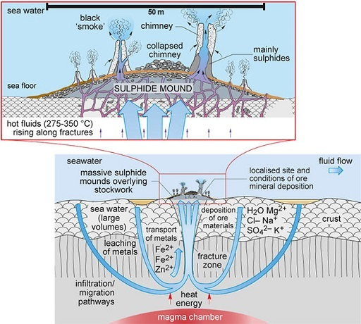
Figure 2.20 Hydrothermal system
View description - Figure 2.20 Hydrothermal system

This happens in the oceans when seawater which has percolated into the rocks meets rock heated by molten magma at the mid-ocean ridge. This superheats the water, and very hot water has the power to dissolve and transport certain elements from the rocks. Usefully, some of the elements which become dissolved in the hot water are elements that we want, like copper, iron, zinc, silver and gold.
The water travels through fissures in the rocks and moves back towards the cold ocean waters. As it’s only the heat of the water which keeps these elements in solution, when they cool down again, the metals fall out of solution and are deposited along the outside of the fissures through which the fluids are travelling.

2.18 Black smokers
If the hot hydrothermal fluids make it back to the sea floor, the elements dissolved come out of solution very rapidly, forming plumes of black material which look like smoke appearing from a chimney, giving these features the name ‘black smokers’. The video below shows an example.

Video content is not available in this format.
Video 2.3 Black smokers
View transcript - Video 2.3 Black smokers

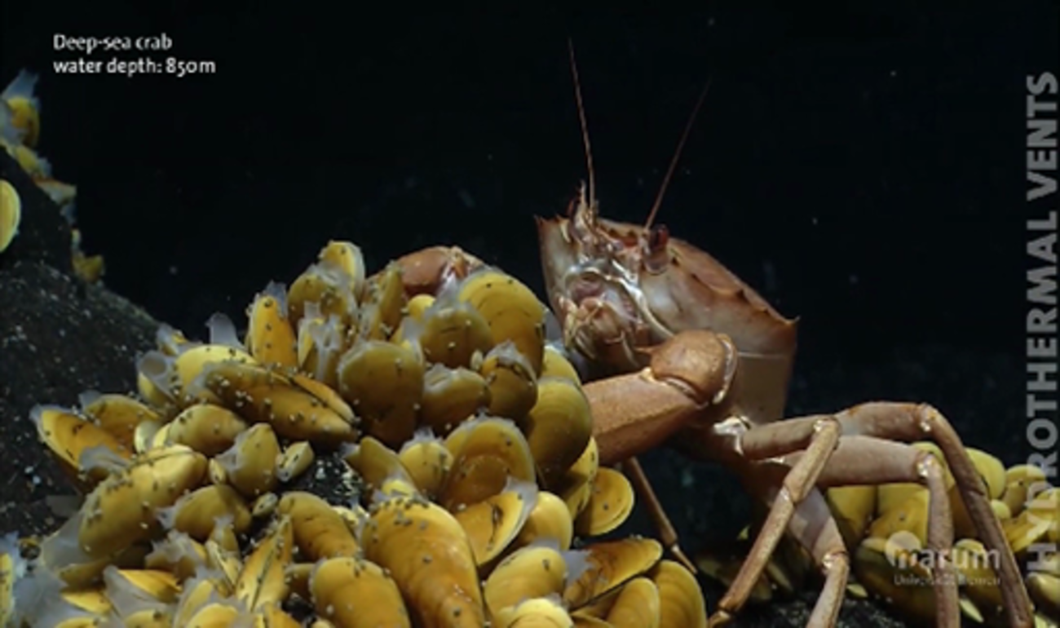

Their existence was only discovered in the late 1970s when we had developed the technology to send cameras down to the sea floor. The water emerging is still super-heated – it can reach temperatures greater than 300 °C. So hot, in fact, that there is a (perhaps apocryphal) story that the first temperature probes put into the plumes melted!
The material that forms the plume ‘rains’ down on the sea floor around the chimney, and is deposited as a metal-rich sediment. The chimneys themselves are formed of the same sorts of material, and eventually these will collapse, adding further to a mound of metal-rich material. It’s this mound, preserved and then uplifted, that, along with the filled fissures and cracks, forms the ore body at Parys Mountain.

Gangue and ore minerals
Where do the metals come from? Well, in a black smoker-type hydrothermal system, they come from the surrounding oceanic crust. The water percolates through cracks and fissures formed when the igneous oceanic crust forms at the sea floor volcanoes. The rocks that form have copper, silver, zinc and gold in them, but only in very low concentrations. The hydrothermal fluids take those metals out from a very large volume of rocks, and then redeposit them in a much smaller volume of rock, and so at much higher concentration. This geological concentration of elements makes for very good ores.

2.19 How much ore for a metre of Cu cable?
How much copper ore do you need for 100 m of cable? 100 m of typical 3-core copper cable for electrical wiring weighs about 2 kg. Using this information, complete the activity below.

Activity 2.4 Cu cable
Allow about 5 minutes

At the Parys mine there is about 3,031,000 tonnes of copper ore, and there is 10.1 g copper per kg of ore (1.01%). How much ore from Parys Mountain needs to be mined to make a 100 m cable?

198 kg
20.2 kg
267 kg
View discussion - Activity 2.4 Cu cable

2.20 Zones at Parys Mountain
Parys Mountain mine is actually divided into multiple zones, which have very different amounts of copper in each zone, and not just copper but other useful elements too. Look at the table and then complete the activities below.

Table 2.1 Parys Mountain copper
Zone | Tonnes | Cu % |  | Pb % |  | Zn % |  | Ag | Au
 |  | % | g/kg | % | g/kg | % | g/kg | g/t | g/t
Engine | 489,000 | 1.38 | 13.8 | 2.61 | 26.1 | 4.99 | 49.9 | 92.8 | 0.5
Deep Engine | 618,000 | 1.95 | 19.5 | 1.9 | 19 | 4.22 | 42.2 | 23 | 0.2
White Rock | 1,625,000 | 0.34 | 3.4 | 2.05 | 20.5 | 3.84 | 38.4 | 33 | 0.5
Garth Daniel | 299,000 | 2.06 | 20.6 | 3.07 | 30.7 | 6.43 | 64.3 | 75 | 0.2
Total | 3,031,000 | 1.01 | 10.1 | 2.21 | 22.1 | 4.36 | 43.6 | 46 | 0.5

Activity 2.5 Questions about Parys Mountain
Allow about 10 minutes

How would these varying levels of copper affect which areas are mined (and when)?

Provide your answer...

You can see that silver (Ag) and gold (Au) are there in much lower concentrations. Why is it ever worth mining them at Parys Mountain?

Provide your answer...

2.21 Ancient people and metals
Finding the correct rocks to dig out of the ground does not happen by accident. In this section you will look at how ancient and modern humans have found the metals they need.
Have you ever wondered how geologists find minerals and work out where mines should go? And how did ancient people like those of the Bronze Age find metals?
Copper was the first metal to be worked by humans. In northern Iraq, 8000-year-old copper beads have been found. Then, 6000 years ago, gold was used in burial sites in Bulgaria, and apart from a lead bracelet that is 5500 years old, the only metals humans used for over 4000 years were gold and copper. But why?
The simple answer is that these metals, and a few others, occur in their ‘native forms’ – as a naturally occurring piece of metal, not combined with other elements to form a mineral. These ancient people wouldn’t have had to extract it from the rock themselves. They probably found them as nuggets in rivers, just like people do today if they go panning for gold (if they are lucky!). Later, they would have found layers of the native metals in the rocks (we call these ‘veins’) and mined those.

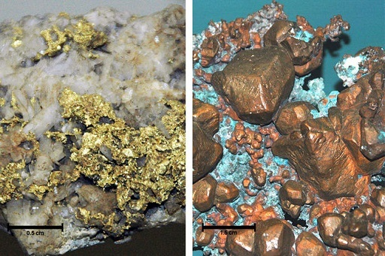
Figure 2.21 Native gold and copper
View description - Figure 2.21 Native gold and copper

Once the majority of these nuggets had been exhausted, new sources of these metals had to be found. The main reason copper was used a lot was because its ore minerals (minerals that contain metals) are easy to find because of their amazing colours.
Do you know the colour most typically associated with copper (apart from the coppery orange–brown colour of the native metal)? It’s a blue–green colour. You may have seen it on buildings or statues and not actually known it was copper. The copper oxidises when exposed to the ‘wet’ atmosphere, producing a pigmentation commonly known as verdigris. The most famous example of a copper object showing this colour is probably the Statue of Liberty in the USA.


Figure 2.22 Statue of Liberty
View description - Figure 2.22 Statue of Liberty

Natural copper minerals also have blue–green colours, such as malachite and chalcopyrite, so these were easy for ancient humans to find.
Can you think of any other buildings or statues near you that are the same colour as the Statue of Liberty?

2.22 From ancient peoples to modern mines
But what about modern mines?
Finding sources of metals can be done in a number of ways. Geologists can recognise minerals or specific rock types that they know contain the metal or element they are looking for. This can involve many weeks or months of studying aerial or satellite photographs, and then going out into the countryside (or ‘the field’, as geologists call it) to hunt for evidence and collect rock samples. These are then brought back to the laboratory for analysis and the percentage of different elements can be worked out.
But normally it is a combination of methods. There are more indirect routes that don’t look at the elements in the rocks themselves but measure them in the water of streams and rivers.
The ‘concentration’ (amount per unit volume or mass) of metals that are found dissolved in stream and river water will increase as you get closer to the source rock which contains them. This means that geologists can plot maps showing these concentrations that tell us where might be the best place to find metals.

2.23 Mineral maps
The following activity uses a geological and elemental map of Anglesey and North Wales, covering the area of Parys Mountain and Great Orme.
This map will give you the opportunity to see the concentrations of copper, found in streams and sediment samples. The data has been collected by the British Geological Survey. Most countries have their own geological surveys, so if you are interested in the geology near you and you live outside the UK, you may want to have a look online and see what data is available for where you live.

Activity 2.7 Anglesey and North Wales
Allow about 10 minutes

Part 1

Look at the map. It shows the rocks divided up into igneous (pink), sedimentary (blue) and metamorphic (green). The symbols show the concentrations of copper, lead and zinc found in streams and river samples.

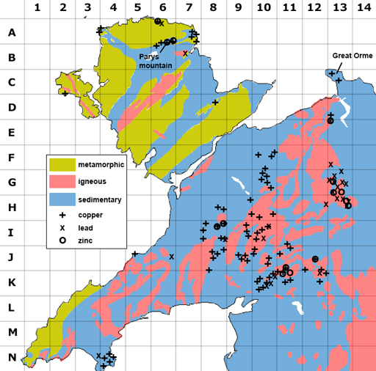
Figure 2.23 Geological and elemental map
View description - Figure 2.23 Geological and elemental map

The area covered by Parys Mountain mines is only 3 km², but on the map the area with high copper concentrations is much larger? Why is this?
Do the different mine types correspond to any particular rock type?

Provide your answer...

Part 2

The map is gridded with 1 to 14 across the top going west to east and A to N going north to south.
If you want to tell somebody a location on the map, you can use these grid numbers and letters to give a grid reference. By convention the east–west is given first, followed by the north–south, for example the two crosses labelled Great Orme are in grid 13C.
1. Can you provide the two grid references that cover the four crosses in the Parys Mountain area?

6 A
6 B
13 C
10 F

2. Which metals were mined at Parys Mountain?

Zinc
Lithium
Copper
Aluminium

2.24 Week 2 quiz
If you'd like to test and apply your knowledge of the material in Week 2 with a few questions, click the link below. Note: this is not a requirement in order to continue studying, or to complete the course.

Complete the Week 2 quiz here.
Open the quiz in a new window or tab then come back here when you’re done.

2.25 Summary of Week 2
This week you have learned about some smartphone components, and some of the materials that are used to make them. You then learned about the origins of these materials, for example, how pegmatites around magma chambers provide the lithium for your phone battery, and how intense tropical weathering concentrates aluminium so that it is economically viable to extract.
You have also used your arithmetic skills and calculated how much bauxite is needed to make a soda can. You have learned how wind and water can break down a mountain and create quartz pure enough to make glass, and how copper is formed in pegmatites and at mid-ocean ridges. You have also looked at some other methods used for finding prospective mines, and have used map-reading skills when looking at Anglesey.
Next week, you will learn about oil: how it is formed, how it is found and how its by-products permeate every part of our lives, every day.

Week 3: Ubiquitous petroleum

Introduction to Week 3
Welcome to Week 3 of the course!
This week you will be looking at oil. Oil is an essential part of modern society, it is all around us, from the obvious use as a transport fuel, to less obvious uses in plastics and food production.
This week, you’ll learn the uses of oil and what it is.

3.1 Oil comes from the ground
This week you will learn about where we use oil and its products, what it really is, and how the geology of oil allows us to understand, discover and extract what has become one of the most important resources of the last 150 years. Watch the following video, which introduces the topic this week.

Video content is not available in this format.
Video 3.1 Introducing oil
View transcript - Video 3.1 Introducing oil

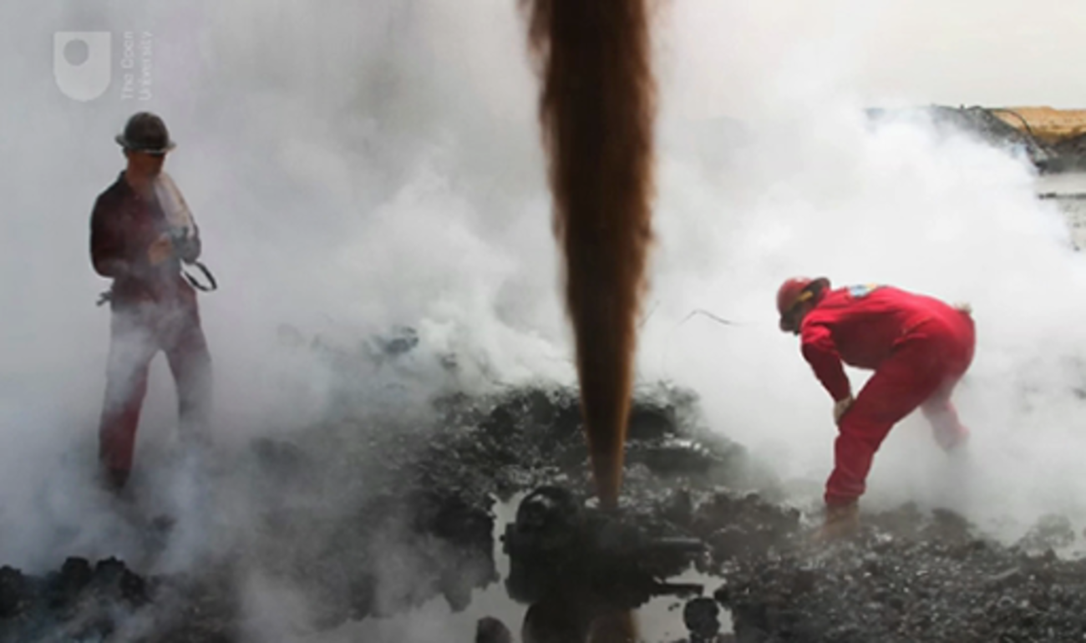

3.2 Plastics and transport fuel
Oil is all around us, whether you realise it or not. You will now look at some of the everyday uses for oil.

Plastics
Looking around Marcus’s desk in Figure 3.1, the pervasion of oil products really comes to life. His water bottle, screen, keyboard, telephone, pens, stickers, headphones, laminated desktop, book covers, coaster, key fobs and picture frame are all made of, or contain a significant amount of plastic.

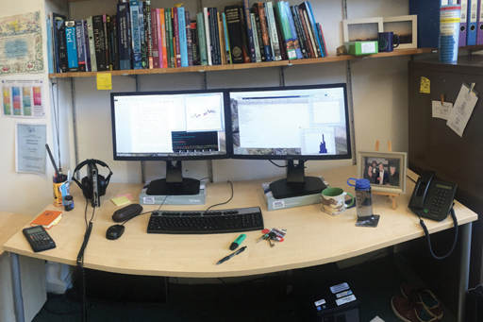
Figure 3.1 Marcus’ desk
View description - Figure 3.1 Marcus’ desk

Plastics are all (or at least, almost all – some of you may be lucky enough to have bioplastics around you) made from oil derivatives. It isn’t just Marcus’s desk either, he wears shirts made of a cotton–polyester blend, and shoes that have a sole made of synthetic rubber, another oil product. ‘Embedded’ in all of those products is the oil used to transport the products to market, and to transport the components from production to manufacture site.
For example, his shirt was manufactured in Bangladesh, and although the cotton may not be directly made from petroleum (unlike the 92% polyester), it would most likely have been imported to Bangladesh using oil-based fuels and, inevitably, the shirt had to be transported from Bangladesh to his house in Warwickshire.

Transport fuel
One of the most obvious uses for oil is as a transport fuel. Purified and transformed into gasoline, it powers our cars, buses, planes and (some) trains. In a Western country like the UK, a huge amount of oil is used for transport every single day. In 2015, the UK consumed 48,427,000 tonnes of oil for transport. It’s difficult to get a handle on big numbers like that, so let’s break that down a little. Crude oil has a density of around 870 kg/m³, and a tonne is 1000 kg, so that 48,427,000 tonnes is about 55.7 million m³ of oil. One cubic metre of oil is the same as 1000 litres of oil.

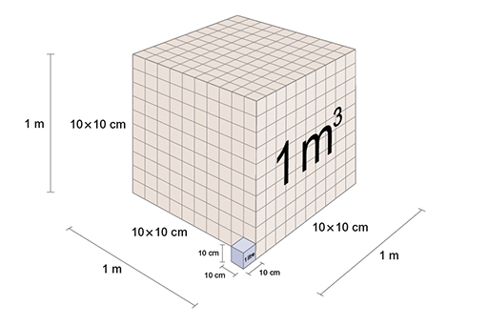
Figure 3.2 10 x 10 x 10 cube of litres into 1m³
View description - Figure 3.2 10 x 10 x 10 cube of litres into 1m3

So, in 2015 the UK consumed 55.7 billion litres of oil. There were 64.5 million people in the UK in 2015, so each person in the UK, on average, used something like 863.6 litres of oil, or 2.4 litres a day.
If you include non-transport use (in the UK that’s mainly domestic heating and industrial use, and plastic manufacture), then it works out as about 3 litres per person per day.
So, in a Western country like the UK, you’ll likely consume as much oil as water every single day.
The prevalence of ‘embedded’ oil in imported products (how many of the plastics around you right now say ‘Made in China’ on them?) means that even for a country like the UK where excellent statistical information on oil consumption is easily available, it’s almost impossible to truly know how much oil we consume in the West.

3.3 Fertilisers
For most of you, the food you eat also relies on the oil (and gas) industry. In the developed world, our diets rely on cheap food transported significant distances. How far food has been transported depends hugely on the choices we make – whether it’s the intensively reared meat flown in from the other side of the world, or the organic farm produce driven from just a few tens of miles away, both require transport, and currently most of that transport relies on oil-based fuels.

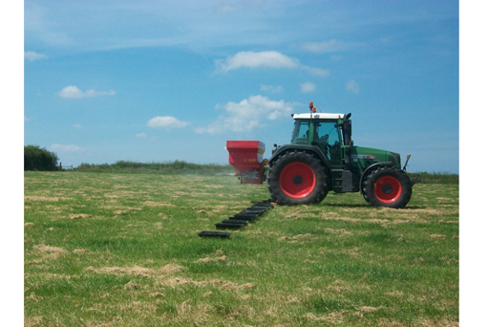
Figure 3.3 Tractor spreading fertiliser
View description - Figure 3.3 Tractor spreading fertiliser

It isn’t just transport from farm to consumer either – since the beginning of the mechanisation of agriculture (using petroleum-powered tractors), a significant amount of oil-based fuels are used during the farming and processing of crops, meat, fish and related products.
Beyond just moving food crops around, fertilisers are (currently) produced using natural gas from the same geological reservoirs as liquid oil (more on that later). Something like 50% of all global food production relies on nitrogen-based fertilisers.
Nitrogen (N) is critical to plant growth, mainly because it is an essential component of amino acids, which go on to form proteins. Although nitrogen makes up 78% of the atmosphere, getting it into a form which can be taken up into plants is tricky. For that to happen, it has to be ‘fixed’ into a form such as anhydrous ammonium nitrate (NH₄NO₃) or urea (CO(NH₂)₂).

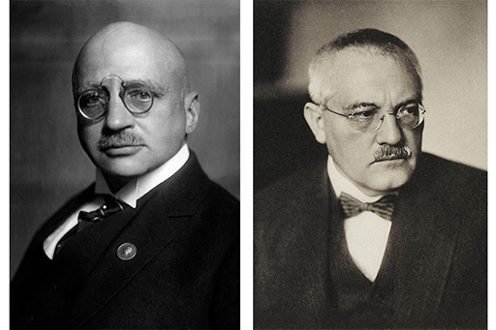
Figure 3.4 Photograph of Fritz Haber and Carl Bosch
View description - Figure 3.4 Photograph of Fritz Haber and Carl Bosch

Enter Fritz Haber, who, along with Carl Bosch developed the Haber–Bosch process to mass produce fixed nitrogen in the form of ammonia (NH₃), from which many nitrogen-based fertilisers are made.

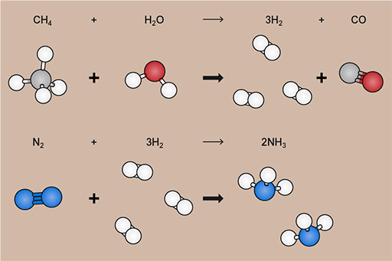
Figure 3.5 The two stages of Haber Bosch for CH₄
View description - Figure 3.5 The two stages of Haber Bosch for CH4

The Haber–Bosch process itself takes nitrogen and hydrogen, under high pressure and temperature and in the presence of a sequence of catalysts, and converts them into ammonia. The nitrogen can be taken from the air, but the hydrogen comes from breaking down methane (CH₄) into hydrogen (H₂) and carbon monoxide (CO) using water in a process called steam reforming.
The methane currently comes from natural gas (predominantly, it can also be sourced from coal, but that’s less common now), which, as you’ll see later this week, comes from the same sort of geological formations as the liquid oil.

3.4 What is oil?
Perhaps this week should have started with this point, but what is really meant by ‘oil’?
To a chemist, an oil is any thick liquid that doesn’t mix (is immiscible) with water. In everyday language, and throughout this course, oil is used to mean liquid petroleum (crude oil) which is, indeed, a thick liquid which won’t mix with water.

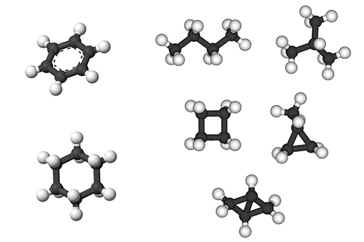
Figure 3.6 Models for hydrocarbons
View description - Figure 3.6 Models for hydrocarbons

But what makes up oil? It’s a mix of hydrocarbons – compounds which contain nothing but hydrogen and carbon atoms bonded together in long chains (alkanes) or ring structures (cycloalkanes), along with other aromatic hydrocarbons and various organic compounds which include sulphur, nitrogen and oxygen. Petroleum is just a mix of lots of different hydrocarbons.

With oil comes gas (sometimes)
In liquid petroleum (crude oil), it’s mostly compounds ranging from pentane which has 5 carbon atoms and 12 hydrogen atoms (C₅H₁₂) to hexadecane which has 16 carbon atoms and 34 hydrogen atoms (C₁₆H₃₄). Bigger hydrocarbons are also present, and these (often quite complex) molecules tend to form solids like bitumens and tar. In petroleum it’s the size of the molecule, and the number of carbons that it contains, that determines whether it’s solid or liquid under ambient conditions.

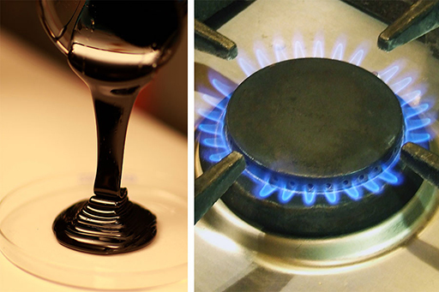
Figure 3.7 Bitumen (left) and natural gas (right)
View description - Figure 3.7 Bitumen (left) and natural gas (right)

Sometimes (quite a lot of the time, actually) petroleum also contains much smaller molecules with fewer carbon atoms. These are things like butane (C₄H₁₀), propane (C₃H₈), ethane (C₂H₆) and methane (CH₄). All of these, because of their small size, have boiling points below 0 °C, and so are gases under ambient conditions. These are what make up ‘natural gas’. It’s called natural gas to distinguish it from gas manufactured from coal, which was common in many countries prior to the development of large scale oil production.
Natural gas is an incredibly versatile fuel. It has a high calorific value, meaning you get a lot of energy from burning it. It also burns fairly cleanly (producing just water vapour and carbon dioxide) and, unlike coal gas, it doesn’t contain poisonous carbon monoxide. It is also, as mentioned previously, a useful starting point for creating the hydrogen needed in the Haber–Bosch process to make nitrogen-based fertilisers.

3.5 Where does it come from?
Oil comes from the ground, but how does it get there? In this section, you’ll be learning how oil forms and how it becomes trapped in the rocks ready for us to exploit it.

Biological sources of oil
You may have heard of oil being described as ‘fossil fuel’ – that’s because it’s made up of the remains of living organisms which died millions of years ago.
During life, plants, algae and some bacteria use energy from the sun to turn carbon dioxide and water from their environment into organic matter. This process locks the energy from the sun into the bonds in organic molecules. This is what photosynthesis, at its simplest level, is doing.
Most of the organisms that don’t use the energy from the sun directly still rely on the sun as their primary energy source – by eating things like plants that photosynthesise, and getting their energy from breaking down those molecules and releasing the stored energy.
Upon death, the remains of living things are usually broken down by things feeding on them, whether it’s scavengers eating the remains or bacteria and fungi breaking them down. Again, this is to release that stored energy from the sun and use it to provide the energy for more life.
Under some circumstances, organic matter isn’t broken down after death – instead it is preserved and survives into the rock record. With it goes all that stored energy, preserved within the bonds between molecules. Once it’s in the rock record, the right amount of heat and pressure transforms the complex organic matter into much simpler compounds, and that’s how oil is formed.
The rock that contains the preserved organic matter which ends up being oil is called the source rock. What sort of rock makes a good source rock? The rock has to contain the remains of living organisms which have been deposited, so first of all, thinking back to Week 1, what sort of rock will it be – sedimentary, igneous or metamorphic? As a source rock contains the remains of organisms which have been deposited and preserved, a source rock is always sedimentary.
Where would a good source rock form? A lot of sedimentary rocks contain some amount of organic matter. In the sort of environments where sediments form, there are usually some organic remains (dead things) that are preserved as well. However, for oil to form there needs to be a lot more organic matter than usual.
First of all you need a rock formed in a place where lots of life happens. For oil formation, the perfect place for that is in lakes, oceans and shallow seas. (You may think that somewhere like a forest would be a good place too – it turns out that forests and swampy or marshy land do store the sun’s energy, but in the rock record that ends up being coal rather than oil.)
Figure 3.8 shows a bloom of algae off the coast of California in September 2004. The image on the right is a false colour image produced from the SeaWIFS instrument on the OrbView-2 satellite platform in which the photosynthesising algae have been highlighted. If you look carefully at the image on the left, which is natural colour as seen by the same satellite, then you can just see the green–blue algal bloom. This is made up of an unfathomably large number of individual, single-celled algae (probably a species of phytoplankton called Emilliana huxleyii in this image). Productive areas of ancient oceans (like this modern example) provided the organic matter that became the fuel in your car, the plastic in your computer and helped to fix about 50% of the nitrogen in you right now.

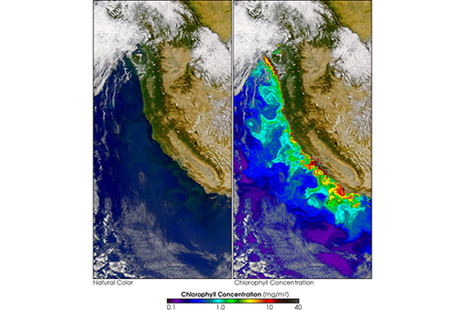
Figure 3.8 Coccolith bloom (left) and chlorophyll (right)
View description - Figure 3.8 Coccolith bloom (left) and chlorophyll (right)

3.6 Why doesn’t it just rot?
Most organic matter just rots. So what’s special about the organic matter that went on to become oil?
Most organic matter breakdown happens because scavengers and bacteria use oxygen to transform the organic matter back into carbon dioxide and water, releasing the stored energy along the way. However, if you don’t have that oxygen, then things that eat dead remains can’t survive, and neither can most bacteria.
At the bottom of some oceans, seas and lakes the water doesn’t contain enough oxygen to support the life that would otherwise break down the organic matter. It’s therefore preserved.
When this happens you end up with dark, organic-rich sediments which go on to become dark, organic-rich rocks, like the shale in Figure 3.9.

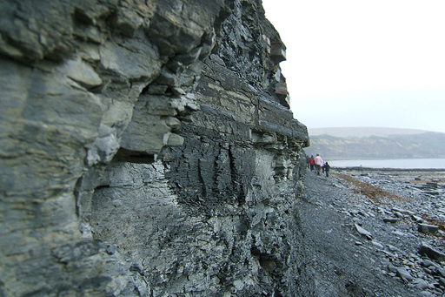
Figure 3.9 A finely laminated shale outcrop
View description - Figure 3.9 A finely laminated shale outcrop

Once you have all the necessary ingredients, the organic matter needs to be cooked just the right amount. This happens when the source rocks are buried. Temperatures naturally rise the deeper you go into the earth. Oil starts to form from organic matter at about 50 ˚C, with optimal conditions for oil formation being temperatures of around 60–150 ˚C.
The heat breaks down the complex organic compounds into the much simpler hydrocarbons that make up oil. However, just like with your favourite cake, you have to keep an eye on the temperature. Too much heat will break down the hydrocarbons even further, first into small molecules like ethane, methane and butane that make up natural gas (which is useful), but with too much heat the hydrocarbons will break down completely.

3.7 It’s a trap!
The oil doesn’t stay in the source rock all that long. When the source rock is buried it’s not just temperatures that rise, but also the pressure, as hundreds and thousands of tonnes of other rock builds up on top.
The pressure squeezes the liquid oil out of the source rock (this is called ‘primary migration’) and into any other permeable and porous rock that’s nearby. The porous and permeable rock which the oil is squeezed into is called the ‘reservoir’ rock. It has to be a rock which has lots of space in between the grains for the oil to be squeezed into, so sandstones are quite good reservoir rocks.

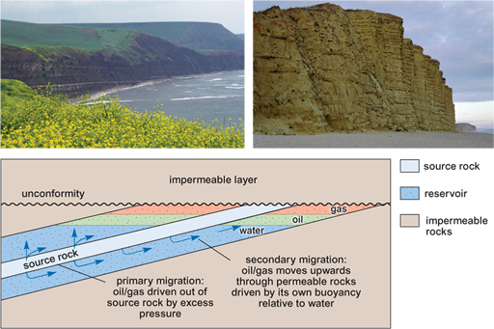
Figure 3.10 The migration of oil and gas through rock: the tilted and faulted sandstone cliffs can make excellent reservoir rocks
View description - Figure 3.10 The migration of oil and gas through rock: the tilted and faulted sandstone ...

Because it’s less dense than the rock and any water that may be in the reservoir rock as well, the oil floats to the top (‘secondary migration’). If there’s nothing to stop it, then the oil will continue to migrate upwards until it reaches the surface. This is what’s happening at the La Brea Tar Pits and several oil seeps on the south coast of Dorset in the UK.
However, some rocks aren’t permeable and don’t allow the oil to pass through, trapping the oil in whatever rock it’s made it to. This impermeable rock is called the ‘cap rock’ as it’s found at the top of an oil reservoir. The impermeable cap rock can be another sedimentary rock like a mudstone, which has very fine grains that are very close together, or a salt. Because salt is also much less dense than other rocks, sometimes it too tries to float up to the surface, making some quite interesting structures.
The combination of a source rock, reservoir rock and cap rock are, together, called a ‘trap’. All three are needed, as well as just the right temperature and pressure history, to transform dead things into oil.

Types of traps
Sedimentary rocks form lots of different types of trap. Looking at Figure 3.11 below: A is an anticline trap caused by the folding; B is a fault that juxtaposes a reservoir against a seal; C are traps caused by a salt dome (either directly or because of folding derived from the buoyant migration of salt); D is called a ‘subtle trap’ caused by lateral variation in sedimentary systems, and E is a ‘combination trap’ where the combination of uplift, erosion and folding has abutted reservoir and seal rocks.

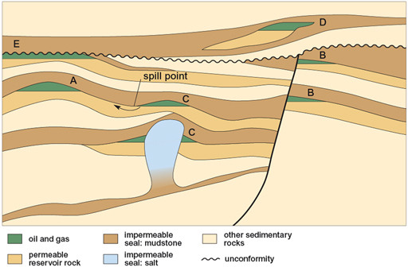
Figure 3.11 Types of trap
View description - Figure 3.11 Types of trap

Where’s the gas?
Natural gas is formed in the same way, it’s just been cooked slightly hotter or longer than oil. It’s lighter than oil, so floats to the top of the oil in a trap structure.

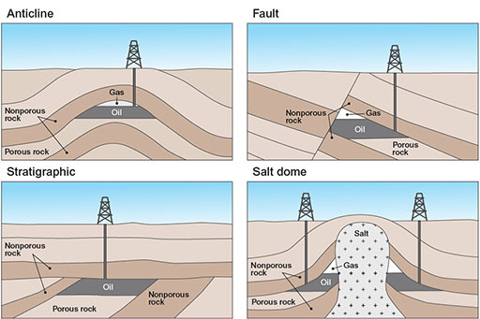
Figure 3.12 Trap structure with gas on top
View description - Figure 3.12 Trap structure with gas on top

3.8 If it’s buried, how do we find it?
In this section, you’ll learn how geologists find and extract the oil once it’s been stored in a geological reservoir.

How do we know where it is? Geological mapping
Because of the pressure that builds up below oil traps, often all you need to do to find oil is drill a hole in the ground. Once you hit the oil, it’ll come up pretty fast.
Drilling random holes all over the place would be a very inefficient (and expensive) way to find oil. Before we had such a good understanding of the geology of oil fields, they were discovered because of quite obvious seeps of oil coming out of the surface. Most of those easy targets have now been exploited (although some are still found from time to time – the Earth is a big place), so new oil discovery now relies on our understanding of where oil is likely to be, based on our understanding of the geology.
This relies on us having an understanding of the geology beneath our feet. The first step towards this is mapping what rocks are where.

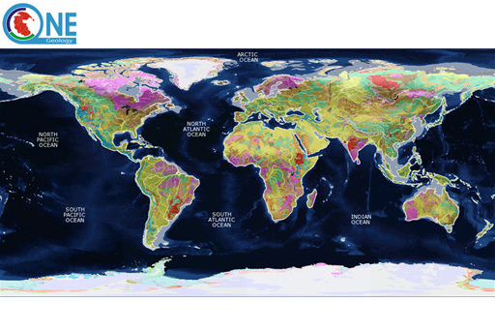
Figure 3.13 Global geology
View description - Figure 3.13 Global geology

Some of the first geological maps were made not to find oil or resources, but to help with cutting canals through the rocks. William Smith, an English geologist and surveyor, produced the first geological map of an area in 1799, based on his time working as a canal surveyor (the first geological map of a nation had to wait until 1815 for publication). He was able to map the rocks by travelling the country and looking at what rocks were where. Today, with satellite and aerial photography, geological mapping uses different technologies than Smith’s pencil and paper, but geologists still need to get their nose to the rocks to see what they really are.

3.9 Seismic exploration – part 1
Understanding which rocks are at the surface certainly helps with finding the sort of rocks that are hiding oil. But oil is in the ground, and so technologies need to be deployed which allow us to look into the ground in order to find it.
The key technology for that is seismic exploration, which uses the transmission of sound waves through the ground to gather information about oil location. In this video, Dr Rebecca Bell explains how we generate the data used to find oil.

Video content is not available in this format.
Video 3.2 Seismic exploration (1)
View transcript - Video 3.2 Seismic exploration (1)

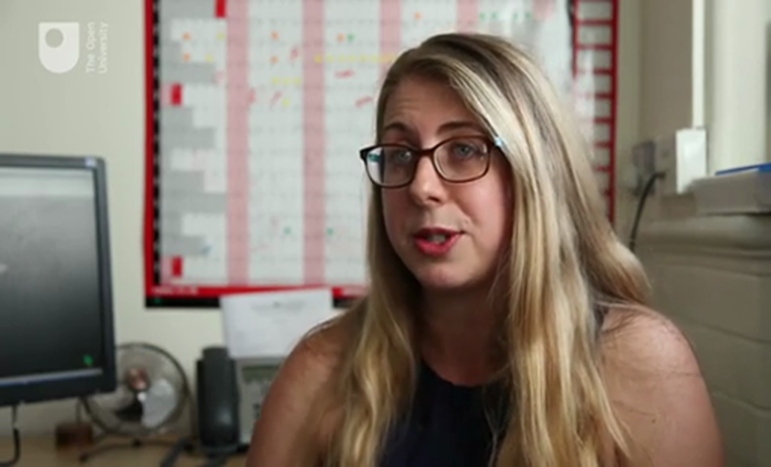

3.10 Seismic exploration – part 2
In this video, Dr Rebecca Bell explains why we need seismic exploration.

Video content is not available in this format.
Video 3.3 Seismic exploration (2)
View transcript - Video 3.3 Seismic exploration (2)

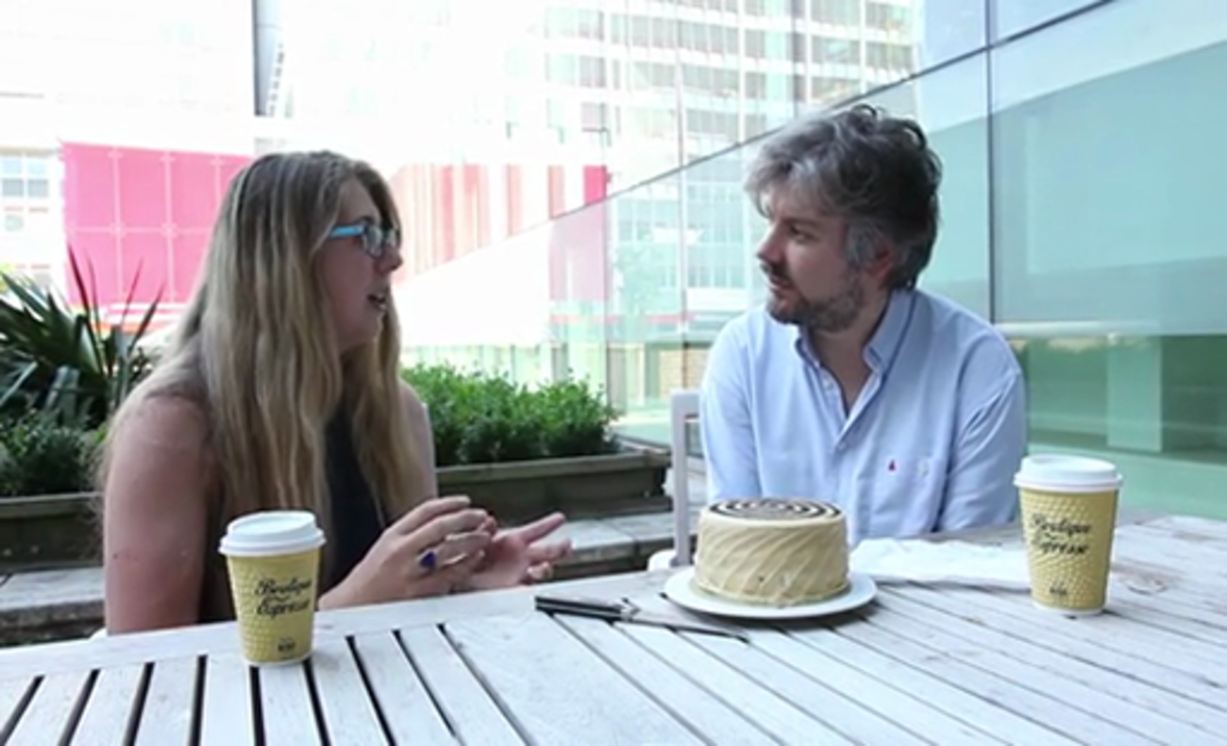

3.11 Biostratigraphy
Back in Week 1, you learned about the importance of geological time and a few of the ways we have of figuring out which rock is older than another rock.
One way of figuring out the relative and absolute ages of rocks in the ground is the fact that different age rocks have different fossils in them.
For example, you never find fossilised humans (Homo sapiens) and fossilised dinosaurs in the same rock. The dinosaurs were wiped out 66 million years ago, whereas the earliest humans only appear 195,000 years ago. So, if you find a rock with a dinosaur in it, then you know it’s older than 66 million years old, whereas if you find Homo sapiens fossils, you can be sure that the rock is younger than 195,000 years old. This concept is known as biostratigraphy, and these two sorts of markers (or ‘datums’) described here are the last occurrence (LO) for the dinosaurs and the first occurrence (FO) for the human bones.

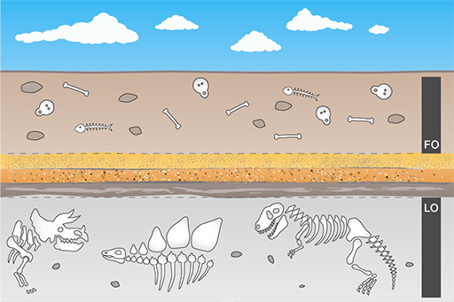
Figure 3.14 Biostratigraphy through time, showing the last occurrence (dinosaurs) and the first occurrence (humans)
View description - Figure 3.14 Biostratigraphy through time, showing the last occurrence (dinosaurs) ...

Why does any of this matter for oil exploration? Well, once you have an idea of the structure of an area from seismic exploration (and therefore know where oil and gas might be trapped), you need to know whether the rocks are likely to be the sort of rocks which are known (from elsewhere) to form good source, reservoir or trap rocks. One way you can figure that out is by knowing their age.
The kind of holes you can drill from an oil rig are too small to bring up whole dinosaur bones, but fortunately there are useful, tiny microfossils which are only a few tenths of a millimetre in size, hundreds of which can be seen in the drill cuttings which are recovered during drilling.

3.12 Economics of oil production
Oil production and use drives a huge amount of the global economy, and, in turn, it is economic factors that drive a lot of oil production and exploration. Finding new supplies of oil is expensive: commissioning and interpreting large seismic surveys; drilling test wells; paying governments for the right to explore in their territory; and putting in place infrastructure to extract, refine and transport oil all costs vast sums of money.
The price of oil changes with supply and demand, and can fluctuate wildly in times of global economic crisis and war. As increasing oil production and finding new oil reserves takes time, increases in demand (during an economic boom) will drive steep increases in the price of oil. Some proportion is also politically controlled, with consortiums like OPEC (Organization of the Petroleum Exporting Countries) acting to restrict or increase oil supply to stabilise and manage the oil price.

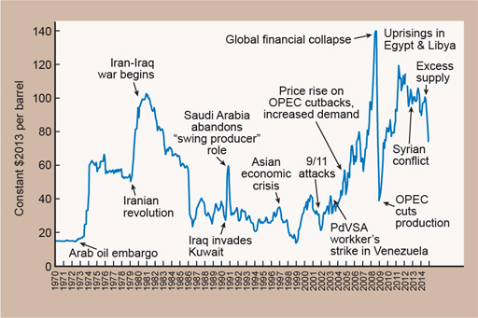
Figure 3.15 Graph showing oil price per barrel ($) annually from 1970 to 2014, and major events that impacted on oil production
View description - Figure 3.15 Graph showing oil price per barrel ($) annually from 1970 to 2014, and ...

The oil that is ‘easy’ to find and extract is also beginning to dwindle. As you learned at the start of this week, early oil discoveries were from places where oil was seeping out of the ground. Days of such easy oil discoveries are now (mostly) long gone. Decades of production also means that some large oil fields are beginning to run dry. New oil extraction is therefore increasingly being made in more difficult and expensive places, like the deep sea and polar regions. As the oil price increases, these more expensive-to-extract reserves of oil become economically viable. At times when the price of oil is high, smaller pockets of oil in larger oil fields also become viable. As Dr Bell said in the video about seismic exploration, this is why it’s important to know how much oil is present in any reservoir before attempting to extract it. Modern 3D seismic surveys and advances in drilling technology to extract the oil make it more feasible for smaller reserves to be extracted, but it’s still expensive, and relies on a high oil price to make small oil reservoirs possible.

Unconventional oil
High oil prices also make expensive-to-produce ‘unconventional oils’ economically viable. These unconventional oils aren’t like the normal oil reserves described so far.

Oil sands
Oil sands (or tar sands) are formed where oil formed at depth (in the same way as described above) reaches the near surface and becomes trapped in sands. Near-surface exposure of the oil means it begins to degrade as it reacts with oxygen, and the smaller, lighter hydrocarbon molecules are preferentially lost. Oil in oil sands are therefore usually very viscous, and very difficult (and dirty) to extract and process. As they are found at the surface and the oil is so thick that it can’t be pumped out like in a normal oil reservoir, huge amounts of oil-rich sand are mined and treated chemically and thermally to remove the oil.
In areas where the sands are too deep to dig out, large amounts of steam and carbon dioxide are pumped into the sands until the oil is made runny enough to pump out.
Both processes are hugely energy and resource intensive, and are therefore hugely expensive, even compared to normal oil extraction. Oil sands have only recently been made economically viable in large quantities due to the high oil price, and are now extracted extensively in parts of Canada.

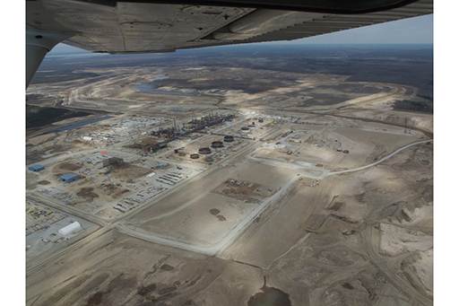
Figure 3.16 Oil sand production in Alberta, Canada
View description - Figure 3.16 Oil sand production in Alberta, Canada

The mining and extraction processes do also produce large amounts of chemical and water waste, and the strip mining of sands destroys habitats, so it’s generally thought of as one of the dirtiest ways of getting oils.

Shale oil
Oil shales are organic rich, fine grained rocks. With significant chemical and thermal treatment, the organic matter within the oil shales can be converted to synthetic oil. This is effectively shortcutting the process which produces conventional oil, as oil shales would make very good source rocks.
There are vast quantities of oil shale on earth – enough in the USA alone to produce 2 trillion barrels of oil. But the high energy costs in extracting the oil mean that it is only a minor source of oil today, and will likely stay that way for some time.

3.13 More economics of oil

Heavy oils
Like the oil in oil sands, heavy oil is thick and viscous and difficult to extract – usually because heat and pressure have cooked the organic matter a little too much.
Heavy oils are found in normal oil reservoirs but won’t flow to the surface on their own, and so they need a similar energy and water input as oil sands do to extract and process. There are very large reserves of heavy oils, of which most of those known reserves are found in Venezuela. If high oil prices return and stabilise, it is likely that these very dirty, energy intensive oils will become economically viable to extract on a large scale.

Deep-water and polar oils
These two are different because the formation and storage characteristics of both deep-water and polar oil are identical to conventional oil, but their current location makes them difficult, expensive and more dangerous to extract, which puts them in the ‘unconventional’ grouping traditionally.
Most marine oil fields exist in fairly shallow waters – shallow seas like the North Sea and Persian Gulf where anchoring and recovering oil from the sea floor is aided by the shallow water. Oil reserves are also present in deep water too – but at depths greater than about 150 m it becomes technically much more difficult. Anchoring oil platforms is more of a challenge, as is access to drill heads for maintenance. The pressures at these sorts of depths also pose challenges for oil extraction.
High oil prices made deep water oil exploration and production viable, and large production areas in the Gulf of Mexico have begun at depths > 150 m. However, the Deepwater Horizon accident in 2010, which demonstrated just how difficult it can be to control oil wells in deep water (this well was very deep, at 1600 m), may affect how widespread deep water oil extraction becomes.
Polar oil fields have similar challenges – the water depth isn’t necessarily that great (especially in the Arctic), but the added difficulties with extraction where icebergs and large storms can be encountered, the distance from large ports and the increased fragility of polar ecosystems mean oil extraction in polar regions is particularly expensive and controversial. At the time of writing (2016), large scale oil extraction in polar regions hasn’t really begun – but if high oil prices return and summer sea ice continues to dwindle, the Arctic could be the next major oil extraction frontier.

Life without oil?
Oil is a fossil resource; it takes much longer to form (millions of years) than it takes for us to extract it. So are we going to run out? The large reserves of unconventional oil mean that it is unlikely we will actually run out of oil, it will just become progressively more expensive and difficult to extract. There is more than 500 billion barrels of technically recoverable heavy oil in the Venezuelan Orinoco alone. If we were to continue to extract as much oil as we can (and climate change, more on which next week, makes that unlikely), there would likely come a point where the oil remaining in geological reserves is too expensive to extract.
So will we run out of oil? Probably not, but there will come a point when the remaining oil reserves are too expensive, economically or environmentally, to extract. When that point will come, nobody currently knows.

3.14 Week 3 quiz
This quiz allows you to test and apply your knowledge of the material in Week 3.

Complete the Week 3 quiz now.
Open the quiz in a new window or tab then come back here when you’re done.

3.15 Summary of Week 3
This week you’ve learned what oil really is, some of the different (and possibly unexpected) uses we have for oil as a society, and the geological processes which act together to form oil. You’ve learned about how 3D seismic surveys enable us to pinpoint exactly where oil is in the earth, and how economics mean it’s unlikely we’ll ever truly run out of oil.
Next week you’re going to look at the other side of the topics covered in the course so far – the environmental impacts and possible geological solutions that come from using the Earth’s geological resources.

Week 4: Breaking and fixing our planet

Introduction to Week 4
Welcome to Week 4, the final week of this course.
Over the last three weeks you’ve learned about the amazing geological resources that can be obtained from the Earth. You’ll start this week by learning about some of the environmental impacts of extracting those resources.

4.1 Breaking and fixing our planet
Most of us have heard of global climate change. The overriding consensus is that the burning of fossil fuels, such as oil and gas (that you looked at in Week 3), releases greenhouse gases which are warming up our planet.
But what about the effects of other types of Earth resources?
In this final week you are going to look at this in more depth. Watch the following video, which introduces this week.

Video content is not available in this format.
Video 4.1 Introducing environmental impact
View transcript - Video 4.1 Introducing environmental impact

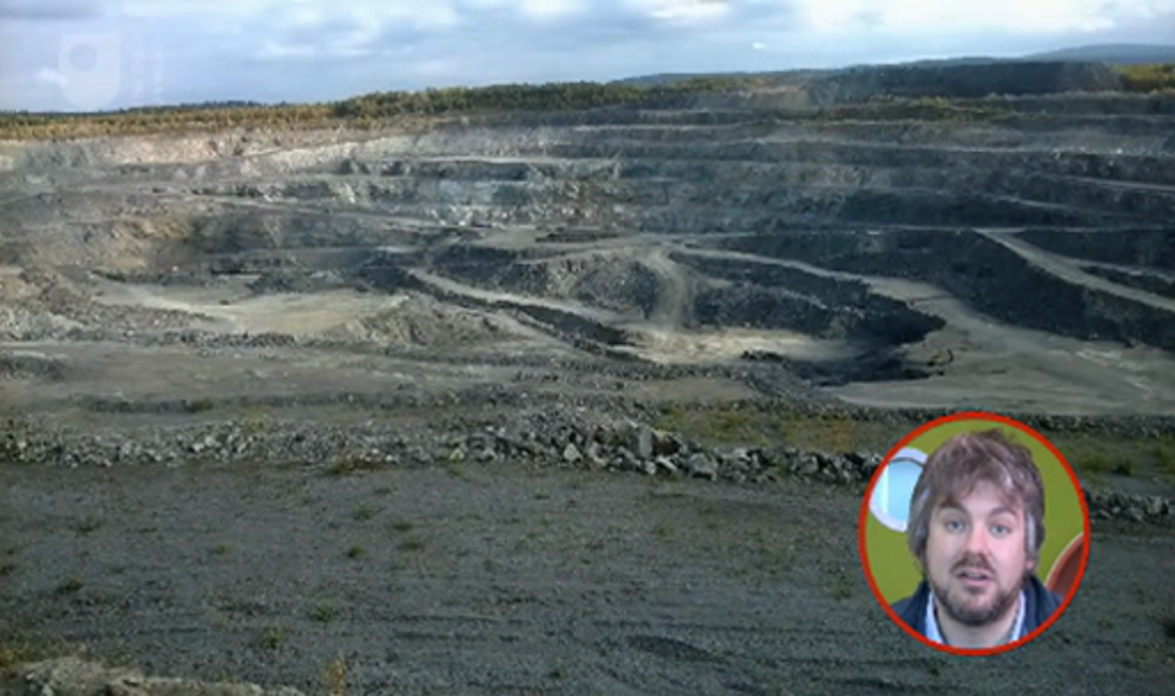

4.2 Geological (extraction) in your pocket
You looked at how we extract rocks and minerals in Week 2. In the first part of this week, you are going to look at something slightly different – the aggregate industry. This is sand, gravel and crushed stone, and it’s quite understandable if this is something you’ve not thought about too much before. All the concrete in the world has to have gravel and sand within it, and it has to come from somewhere. Globally, twice as much concrete is produced as plastic, steel, aluminium and wood combined, and over 70% of the world’s population lives in concrete buildings.

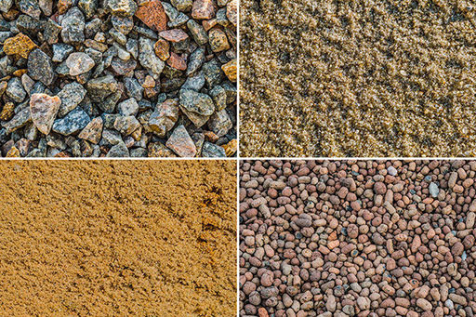
Figure 4.1 Sand, gravel and stone
View description - Figure 4.1 Sand, gravel and stone

Now, you may be wondering what the difference between gravel and crushed stone is. Well, gravel is naturally occurring small stones, whereas crushed stone has been created by breaking up larger pieces of rock. Generally, gravel clasts will be slightly more rounded than crushed stone, and will also often contain many different types of rock, while crushed stone is normally one type of rock that has been broken up.

Activity 4.1 Gravel and sand
Allow about 5 minutes

Think about where gravel and sand could come from. Make some quick notes below if anything comes to mind. In the next section, you will look at this further.

Provide your answer...

4.3 Ice ages build the modern world
The Earth has gone through a number of ice ages. In fact, we are in an ice age at the moment. An ice age just means that there is ice all year round at the North and South Pole, but many of us think of ice ages as times when huge ice sheets, kilometres thick, covered much of northern Europe, Russia and North America. The last ice age like this finished about 12,000 years ago.

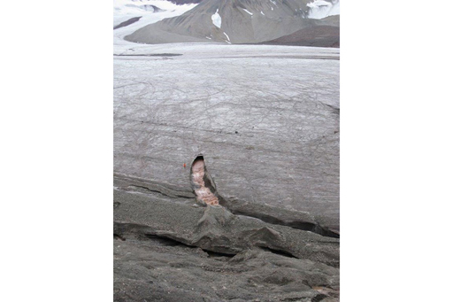
Figure 4.2 Outwash channel from a glacier on Svalbard, carrying a lot of gravel. Person in orange, next to channel, for scale
View description - Figure 4.2 Outwash channel from a glacier on Svalbard, carrying a lot of gravel. ...

When these huge ice sheets move across the ground they tear and rip up rocks. At the melting edges of these ice sheets, huge amounts of water come rushing out, carrying some of the rocks with it. When the ice sheets started to melt for the final time and retreated northwards towards the poles, all the rocky material that was stored within them was deposited on the ground. In vast areas of North America and northern Europe, the geology is covered with material deposited by these huge ice sheets. On a geological map this is called ‘drift’.

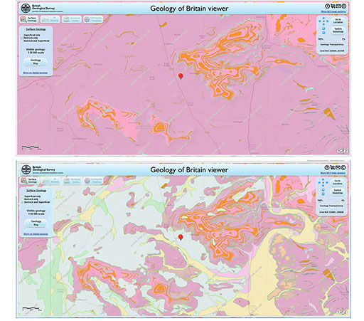
Figure 4.3 The top geological map shows bedrock or solid geology only. The lower map is of the same area, but shows where all the superficial material, called drift (that was deposited during ice ages and more recently by rivers), covers the solid geology
View description - Figure 4.3 The top geological map shows bedrock or solid geology only. The lower ...

4.4 Aggregate extraction
If you live in an area where gravel or sand extraction has occurred, you will know that large areas of land are dug up and huge holes created. Once extraction has ceased, they are allowed to fill with water and can become recreational areas and wildlife parks.

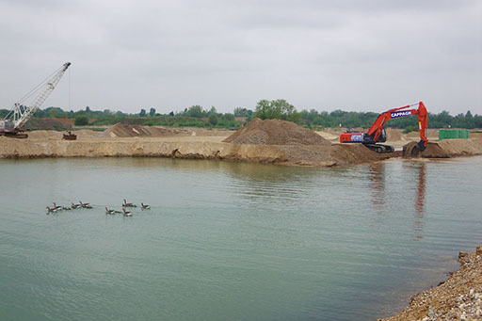
Figure 4.4 Onshore gravel extraction
View description - Figure 4.4 Onshore gravel extraction

However, in densely populated areas like those found in northern Europe, people do not want their valuable farmland, towns and villages to be dug up for gravel, so much of the extraction occurs in places where people don’t live, so they can’t see the huge scars in the landscape. One of these places is under the sea, whether that is just a few metres offshore, or more usually from a few hundred metres to kilometres offshore.
This sort of extraction occurs in the Atlantic Ocean, North Sea, English Channel, Baltic Sea and Irish Sea. These areas were dry during the glaciations so all the gravel that is found on land is also found under the sea. Although this saves our visible landscape, just because we can’t see it doesn’t mean it isn’t causing environmental damage.
This process of extracting sand and gravel from under the sea is called dredging. There are two main types of dredgers: mechanical dredgers, which rely on some kind of grab or bucket to raise material to the surface; and hydraulic dredgers, which suck a suspension of aggregate and water to the surface. Dredgers can also be stationary or moving. This will determine the area an individual dredging event can affect.

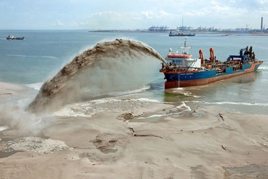
Figure 4.5 Photograph of a ship dredging
View description - Figure 4.5 Photograph of a ship dredging

Gravel extraction can have a variety of effects on the marine environment. Damage to habitats is one of the first to come to mind. This leads to biodiversity loss; that is, plants and animals not living where they once did.
There are other problems too:
- Removing sediment from the sea floor can take away a source of material for beach and coastal features, thus increasing coastal erosion.
- Sorting the sediment to remove only gravel and return sand can cause murky waters, reducing light penetration for marine photosynthetic organisms and suffocation of filter feeders.
- Unknown archaeological material could be destroyed.
- Disagreements between the fishing industry and aggregate extraction industry over rights.
- Noise pollution for marine organisms, such as whales and dolphins.
In the next section, you will look at the impacts of dredging in more detail.

4.5 Impact of dredging
Many countries are beginning to understand the impact of dredging on the marine environment.
In the UK, for example, the British Marine Aggregate Producers Association has drawn up a biodiversity framework that its members must work to, while other governments around the world are implementing biodiversity action plans. Areas that are dredged can be monitored by ensuring that vessels dredging with production licences have an electronic monitoring system. This ensures extraction is limited to the areas defined in the licence and avoids fishing areas or areas with vulnerable habitats. If dredging is taking place close to the shore, detailed studies can be carried out analysing waves and currents to ensure sediment routes to beaches and coastlines are not disrupted.

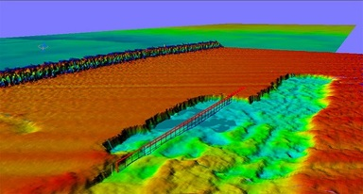
Figure 4.6 A sonar image showing the effect of dredging on the sea bed. Red is shallow, blue is deep
View description - Figure 4.6 A sonar image showing the effect of dredging on the sea bed. Red is shallow, ...

Studies have been carried out on the re-colonisation of dredged sea bed, and the length of time they take to recover varies depending on the intensity of dredging. Studies have shown that it takes from one month to about five years for a sea bed to show complete recovery (Desprez, 2000). If areas of undisturbed seabed are maintained between dredge sites, there is a higher possibility of rapid re-colonisation. However, if the dredging has altered the material on the sea floor, for example, changing it from gravel to sand, it may not be possible for the organisms living on adjacent sea floor to migrate, as they require different material to live on. If that is the case, it may take longer for re-colonisation to occur, as organisms – or, more likely, their planktonic larvae – must migrate from further afield.
Even though re-colonisation may occur, the marks left from dredging often remain. The topography is permanently altered and the material on the sea floor is often changed. The most obvious change is increased water depth as material is removed. The infilling of pits, once dredging has stopped, is difficult as it depends on the ability of water currents to transport material to infill the holes. Only in areas dominated by mobile sand does the sea floor recover quickly. It is very rare that a current is strong enough to move gravel-sized pieces, so dredging holes and furrows are often infilled by fine sediment. Furrows only 30 cm deep when formed are still present several years later (Desprez, 2000).
So, you can see that as long as aggregate extraction is controlled by enforced regulation and given time, the marine ecosystem can recover from dredging. The physical effects of dredging determine the organisms that re-colonise the sea floor, as it can change the material that it is made of and these physical effects can be long-lasting.

4.6 Rare earth elements
Dredging isn’t the only cause for concern when it comes to extracting minerals from the Earth. Cast your minds back to the mobile phone in Week 2. Do you recall the term ‘rare earth elements’ (REE)? They are a group of elements that aren’t that rare in the Earth’s crust, but there are not many places where they occur in concentrations great enough to exploit economically and they are difficult to separate from each other.
REE are not found as native metals like copper and gold, but bound up in minerals. Often they are found in low concentrations in some common minerals, but in higher concentrations they can form their own minerals. The most economically viable being the interestingly named bastnäsite, monazite and xenotime. These minerals contain many other elements in addition to the REE, many of them toxic, such as arsenic, and radioactive, such as thorium.

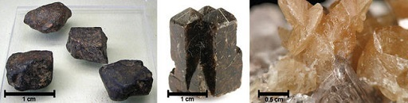
Figure 4.7 Bastnäsite, xenotime, monazite
View description - Figure 4.7 Bastnäsite, xenotime, monazite

REE are found in igneous, metamorphic and sedimentary rocks and you will look briefly at each, as their origin determines the way that they are mined and the environmental impact.
In igneous rocks, REE are most abundant in the veins and pegmatites (igneous rocks made of large crystals, seen in Week 1) around magmatic intrusions, especially in areas where continental crust is being pulled apart, a modern example being the East African Rift Valley. Here, we find rocks with unusual chemistries, rich in alkali elements such as sodium, potassium and calcium, and even carbonate igneous rocks called carbonatites, where instead of being dominated by silica they are over 50% carbonate. A modern carbonatite volcano is Ol Doinyo Lengai in Tanzania.
There are also REE not associated with alkali igneous rocks and carbonatites, they are often associated with iron and the REE are extracted as by-products of the iron industry.
The above examples are called primary deposits because the REE are mined from the location that they were originally emplaced. Secondary deposits are where an economically viable mineral has been transported and redeposited, and is mined from there. The most common source of REE deposits are placer deposits, over 350 of which have been identified worldwide. Placer deposits are where minerals that are denser than the surrounding grains (normally quartz) are concentrated by winnowing, by wind or water. These deposits are either mined using diggers or, if the deposit is underwater, they are dredged like aggregates.

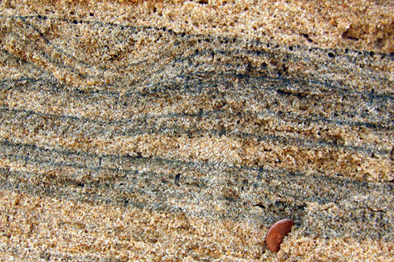
Figure 4.8 Placar deposit
View description - Figure 4.8 Placar deposit

Another secondary deposit is bauxite, the ore of aluminium, that you looked at in Week 2. If the parent rock was rich in REE, the bauxite is too. In fact, just like the aluminium, the weathering process concentrates the REE from perhaps 0.1–0.2% REE to up to 40%, as is found in the Mount Weld deposit, Australia.
The final and still unexploited sources are deep sea muds. Two areas of the Pacific Ocean are reported to contain high concentrations of REE, which is thought to come from mid-ocean ridge hydrothermal activity.
Almost all REE are actually a by-product of mining for other materials. Only Mountain Pass, California (which is currently not in production) is mined solely for REE.

4.7 Extraction and processing
One of the main pollutant issues with REE is that they are often found with radioactive elements, such as uranium and thorium. In Malaysia, xenotime from placer deposits contains 2% uranium and 0.7% thorium. Monazite can contain up to 30% thorium and, as a result, processing beach sands containing monazite is banned in Australia, China and Europe.

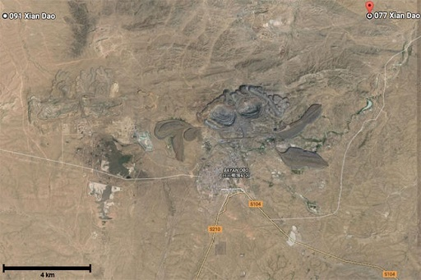
Figure 4.9 Map showing location of Bayan Obo in China
View description - Figure 4.9 Map showing location of Bayan Obo in China

Open cast rare earth mines, such as Bayan Obo in China (Figure 4.9), are bastnäsite and monazite rich, originating from carbonatite igneous rocks. In addition to REE, these often contain toxic metals including arsenic and lead. During the open cast mining and extraction process, dust containing these are allowed into the open air and pollute the air, land and water.
To extract the REE, the rock must be pulverised and then treated in a number of steps, using strong acids and materials such as cyanide and mercury. This produces a large quantity of toxic liquid and solid waste that must be stored in a way that can prevent it escaping into the environment. Unfortunately, this is often not the case. In Mountain Pass, California, it was discovered that about 60 leaks had occurred from the waste-water pipe between 1984 and 1998, spilling approximately 225,000 litres of radioactive and other hazardous waste.
Not all deposits have to be mined for their REE. In-situ techniques have been developed by Jianxi South Rare Earth Hi-Tech, where holes 1.5–3 m deep with a diameter of 0.8 m are drilled into the deposit. Ammonium sulphate is then poured into the top where it leaches through the rock, extracting the REE, and a stream of rare earth enriched liquid is collected at the bottom for further processing.
If detailed geological and hydrogeological studies are carried out on each mining site, it is thought that this leaching technology is better than previous methods. However, serious environmental issues have been identified, such as pollution of ground water and surface water with REE and ammonium sulphate, causing a reduction in biodiversity, both of which persist after extraction has ceased. In addition, the leaching and destruction of forests has led to flooding and many fatal landslides. To reduce the impact of this method of extraction, it is essential that government regulations are enforced. Continued illegal, unregulated leaching methods have caused long lasting environmental, ecological and health damages in southern China (Yang et al., 2013).
Ironically, many REE are used for so-called ‘cleantech’ applications such as renewable energy or green transportation, moving us away from an economy driven by energy with a high carbon footprint, and because of this they are thought of as green. However, we have seen in this section that current REE production is a big environmental pollutant, but with increased enforced environmental regulation, and the recycling of appliances containing REE, it will be possible to have cleaner technology.
That’s enough doom and gloom. In the following sections, you are going to look at some innovative methods humans have come up with to undo some of the problems created by the modern world.

4.8 Geoengineering: crazy ideas or will they save the planet?
Geoengineering is large-scale, deliberate intervention in the Earth’s climate. Later in this section, you will hear from Dr Neil Edwards about increasing the size of the plug hole in the atmospheric bath tub.

We need to talk about carbon dioxide
The oil that drives much of our modern society has an unfortunate side effect, and that’s climate change. The CO₂ released from burning all that oil and gas that we’ve found, extracted and processed (along with burning coal, other industrial processes, and land use changes) is changing the climate of the planet, and we need to take action.
Studying the geological past has shown us that the climate has changed naturally in the past, with much warmer periods of Earth’s history associated with (naturally) higher CO₂, and colder times, like our most recent ice ages, associated with much lower levels of atmospheric CO₂. Understanding what has caused those natural variations in CO₂ has given us some ideas about how we might be able to reduce the CO₂ in the atmosphere in the future.

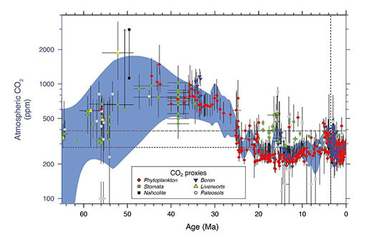
Figure 4.10 Atmospheric CO₂ changes through geological time
View description - Figure 4.10 Atmospheric CO2 changes through geological time

Figure 4.10 shows reconstructions of CO₂ over the last 65 million years of Earth history. The different symbols are for different methods of reconstructing CO₂. We know from other methods that the interval of time before 30 million years ago was much warmer than today.
One of the main principles of geology is that the present is the key to the past – that by understanding processes happening today on earth, we can understand what the geological record is telling us. Looking into the future, we can turn that on its head and see that the past might be the key to the future.

4.9 The atmospheric bath tub
The natural changes in atmospheric CO₂ are because of changes in the balance between the amount of CO₂ that goes into the atmosphere (from volcanoes, changes in the oceans, changes in biological activity on large scales) and the amount that is removed.
You can think of the atmosphere as a bath tub, with the taps always on and the plug hole always open. The amount of CO₂ is the water level in the tub. If water leaves through the plug hole at the same rate that it’s coming in from the taps, then the level doesn’t change. But if you turn the tap up or down, or make the plug hole bigger or smaller, then the level will not stay the same.

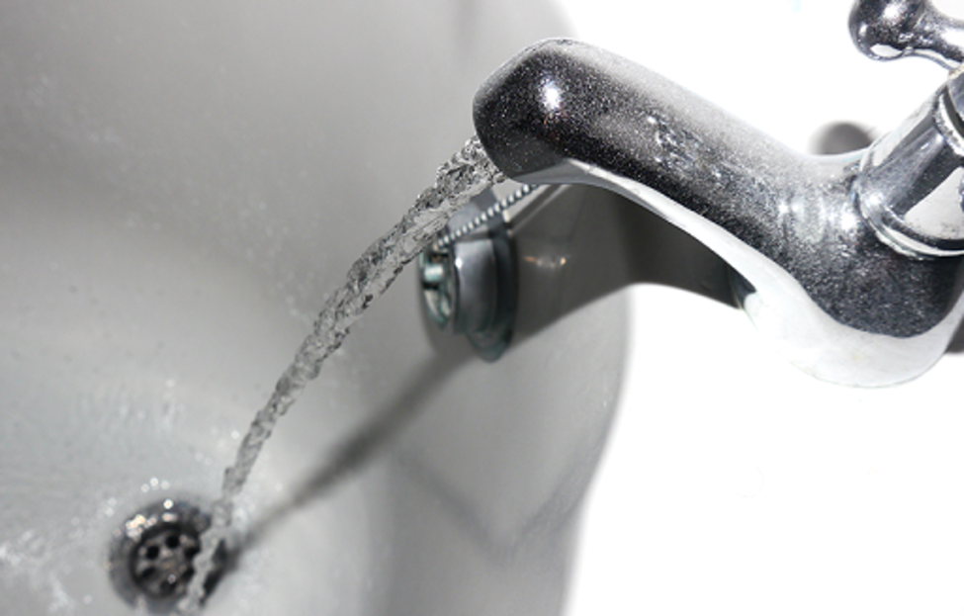
Figure 4.11 The atmospheric bath tub
View description - Figure 4.11 The atmospheric bath tub

On a geological timescale, what humanity has done over the last 150 years or so is like taking a bucket of water and pouring it straight into the tub, so the water level (and so level of CO₂) has gone up dramatically. Possibly faster than ever before in earth history, at least as far as we can tell.
So what controls the size of the plug hole?
In the Earth system, one way that CO₂ is removed from the atmosphere is through the weathering of certain types of rocks which contain a lot of silicon – called silicate rocks. A lot of igneous rocks are silicates.
Silicate rocks are weathered when CO₂ from the atmosphere combines with water to produce a very weak acid – carbonic acid (this is natural acid rain). There are lots of different sorts of silicate rocks, but we can simplify what’s going on by saying that they’re all essentially CaSiO₃ (which is the mineral wollastonite).

2 x carbon dioxide + 3 x water + silicate rock = calcium ions + 2 x bicarbonate ions + silicic acid.
The products of this reaction travel in rivers and through groundwater to the sea, where organisms use the calcium and the bicarbonate to make calcite shells (like chalk):
calcium ions + 2 x bicarbonate ions = calcium carbonate + carbon dioxide + water.
While other organisms (like diatoms) use the silicic acid to make shells of silica:

silicic acid = silica + 2 x water.
Then, when the organisms die, a lot of the material that made up the skeletons ends up being buried.
The important thing about the production of the calcium carbonate is that, although it takes two molecules of CO₂ to dissolve the silicate rock, only one molecule of CO₂ is released when the calcium carbonate is made. (No CO₂ is involved in the silica part, but it’s nice to be neat and see where all the products go.)
So when the calcite skeletons are buried, they take CO₂ with them.
In theory, therefore, if we can increase the amount of silicate weathering occurring on Earth, we can increase the amount of CO₂ being removed from the atmosphere – increasing the size of the plug hole and perhaps going some way to draining that bucket of CO₂ we’ve dumped in.

4.10 Interviews on Leverhulme centre for climate change remediation
Increasing the size of the plug hole in the atmospheric bath tub might sound like quite an audacious plan, but there’s serious research looking at doing just that.
Watch the following two videos featuring Dr Neil Edwards. In the first video, Anne speaks to Dr Edwards about the Earth system and why it is important to understand it.

Video content is not available in this format.
Video 4.2 The Earth system
View transcript - Video 4.2 The Earth system

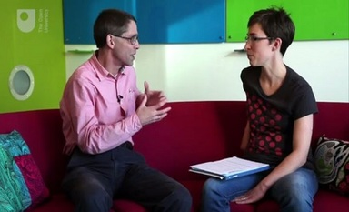

In the next video, Anne talks to Dr Edwards about what’s involved in the plan.

Video content is not available in this format.
Video 4.3 Rock weathering
View transcript - Video 4.3 Rock weathering

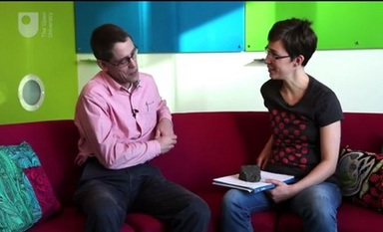

4.11 What’s wrong with Dave Beerling’s big idea?
Are the plans from the Leverhulme Centre for Climate Change Remediation a good idea? What could be some of the downsides of geoengineering projects like this?
There’s a lot more information about projects like this and other geoengineering proposals online. To read more, you may be interested in:
- What is geoengineering? from the Oxford Geoengineering Programme
- Geoengineering – an experiment too far? from The Geological Society
- The Planet Remade reviewed by The Geological Society
- What Is Geoengineering and Why Is It Considered a Climate Change Solution? from Scientific American
- Geoengineering the climate: science, governance and uncertainty from The Royal Society.

4.12 Small bugs solve a lot of problems
Mining not only produces a blot on the landscape, but a lot of water, which is often very acidic. In this section, you will investigate how bacteria could be used to solve many of the problems associated with mines.

What a fine mess
Mining has brought us some amazing things, without which we would not have progressed as a civilisation to where we are now. There are, however, unfortunate consequences to extracting from the Earth the materials needed to build the shopping centres from Week 1 and the mobile phones from Week 2.
Fortunately, though, with knowledge of the interactions between rocks and biology, there may be solutions to many of those problems.
The beautiful colours in the Parys Mountain opencast mine are caused by the mobilisation and oxidation of iron, the different colours being due to the different oxidation states of iron.

Figure 4.12 The Parys mountain opencast mine
View description - Figure 4.12 The Parys mountain opencast mine

The mobilisation of the iron occurred when the sulphur-rich ores and gangue material were exposed to rain water and the air, causing weak sulphuric acid to be formed. That makes many of the pools of water on the site weakly acidic – effectively they are pools of dilute sulphuric acid.
Having pools of weak sulphuric acid in the environment is quite a hazard, but the main problem with the acids formed at mine sites like Parys isn’t the acid water itself, but what the acid water can do.

4.13 Toxic waters escape, but toxic conditions remain
Just as it has mobilised and deposited the iron over the opencast site, the acidic water can also dissolve and move elements off the site of the mine and into the wider environment. It is this Acid Mine Drainage (AMD) which can cause a lot of problems, concentrating and releasing potentially toxic elements like iron, lead, manganese and arsenic away from the containment of the mine.

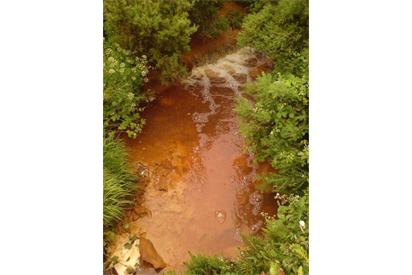
Figure 4.13 The copper stream at Amlwch
View description - Figure 4.13 The copper stream at Amlwch

The stream in Figure 4.13 runs through the village of Amlwch near to the Parys Mountain mine. The red colouration in the bed of the stream is due to the iron, which the acidic waters have allowed to leave the opencast.

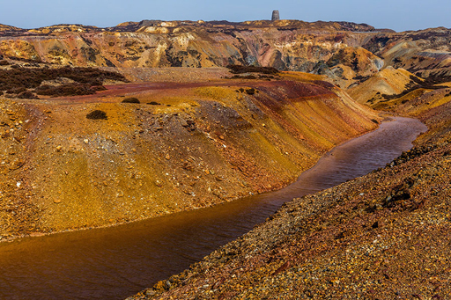
Figure 4.14 Stream at Parys mountain and the lack of vegetation at the mine
View description - Figure 4.14 Stream at Parys mountain and the lack of vegetation at the mine

As well as allowing toxicity to leave the mine site, the acidic conditions and toxic metals that remain within a mine site also cause problems for biology within the mine. The opencast has been out of use for many years, but little vegetation has grown back over the spoil heaps – that’s largely because very little can grow in the acidic, toxic conditions left behind.

4.14 Geology to the rescue!
It’s not all doom and gloom though. As we understand what the cause of the problem is, we can apply our geological knowledge to solve the problem, and there are a number of options for fixing (‘remediating’) the problems of acid mine drainage.
The simplest options (at least theoretically) involve neutralising the acid waters by addition of an alkali like limestone (CaCO₃) or quicklime (CaO). By neutralising the water with other rocky material, the water loses its ability to transport the toxic material off site. The problems lie with collecting the water in the first place, and what to do with the toxic sludge that results. Neutralising the acidic water means that whatever toxic metals are in the water when it’s intercepted quickly precipitate out into a toxic sludge. How you deal with that sludge is a new problem, but at least it is contained, and can be safely taken away for further treatment or storage, rather than being released into the environment.
Another problem for neutralisation is what to use to do the neutralising – the types of mine sites which are formed from sulphide deposits where AMD is a real problem rarely have handy deposits of limestone close by.
By-products of other industries, like calcium silicates from reprocessed steel slag, have been used with some success – and using the by-product of one industrial process to solve the problems created by another industrial process kills two birds with one stone (or hopefully, no birds at all).

4.15 Bioremediation – what survives, thrives
In Section 4.13, you were told that nothing survives in the toxic, acidic conditions of Parys Mountain, but that’s not quite right. Some organisms really thrive. They’re quite odd bacteria that can survive in the extreme conditions (hence they’re part of a group called extremophiles) that are found there, and they do that by utilising the acidic conditions and high levels of dissolved metals to live. They live naturally in places like the streams that leave Parys Mountain and, as a by-product of their lifecycle, they actually reduce the acidity of the water and strip out the toxic metals.
There is ongoing work that looks at using the sorts of bacteria that thrive in mine sites to treat the waters that leave the sites. They have many advantages over neutralisation – not least that as they reproduce themselves, constant addition of neutralising materials isn’t required. There’s real hope that bioremediation can really solve a lot of AMD problems.

4.16 Week 4 quiz
This quiz allows you to test and apply your knowledge of the material in Week 4.

Complete the Week 4 quiz now.
Open the quiz in a new window or tab then come back here when you’re done.

Final conclusion and goodbye
Hopefully you have enjoyed learning about the geology that is all around us, and this short course has helped you to understand how many of the things we take for granted in our everyday lives originate from the Earth. Who knew that shopping centres, kitchen worktops and the inside of mobile phones had so much geology inside them? You do now! In the last video, Marcus sums up the topics of the course and what you have learned.

Video content is not available in this format.
Video 4.4 Course summary
View transcript - Video 4.4 Course summary

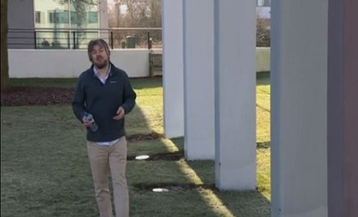

If you have enjoyed this course and would like to explore similar topics, you can continue your learning on OpenLearn. You might be particularly interested in our courses on Science, Maths and Technology.
You might also be interested in exploring this free resource on OpenLearn: Geology toolkit, which features a geology timeline, rock analyser, rock cycle, landscape features and safety tips.

References
Desprez, M. (2000) ‘Physical and biological impact of marine aggregate extraction along the French coast of the Eastern English Channel: short-and long-term post-dredging restoration’, ICES Journal of Marine Science: Journal du Conseil, vol. 57, no. 5, pp. 1428–38.
Yang, X. J., Lin, A., Li, X-L., Wi, W., Zhou, W., Chen, Z. (2013) ‘China’s ion-adsorption rare earth resources, mining consequences and preservation’, Environmental Development, vol. 8, pp. 131-136.

Further reading
The Geological Society – plate margins
The chemical elements of a smartphone
How sand becomes silicon
Virtual microscope: shap granite
Mindat: Mindat has information on minerals from all around the world. Try searching there for chalcopyrite and bornite.
The Haber-Bosch process (BBC World Service)
OneGeology Portal
William Smith’s map is on display at the Geological Society in London, where you can visit it during office hours without an appointment: Visiting the William Smith Map
You can find out more about oil, and the possibilities for living without oil, in another short OpenLearn course: Living without oil
If you are interested in finding out more about Oldoinyo Lengai, YouTube has some fascinating videos showing the low viscosity carbonatite lava erupting: Oldoinyo Lengai
For an even more detailed insight into REES, visit the British Geological Surveys website: British Geological Surveys - rare earth elements

Acknowledgements
This free course was written by Anne Jay and Marcus Badger.
Except for third party materials and otherwise stated (see terms and conditions), this content is made available under a Creative Commons Attribution-NonCommercial-ShareAlike 4.0 Licence.
The material acknowledged below is Proprietary and used under licence (not subject to Creative Commons Licence). Grateful acknowledgement is made to the following sources for permission to reproduce material in this free course:
Every effort has been made to contact copyright owners. If any have been inadvertently overlooked, the publishers will be pleased to make the necessary arrangements at the first opportunity.

Week 1
Course image: Carlina Teteris; Getty Images
Figure 1.1: Diariocritico de Venezuela in Flickr. https://creativecommons.org/licenses/by/2.0/
Figure 1.2: left to right:
Jorge Láscar in flickr.com. https://creativecommons.org/licenses/by/2.0/;
Unsplash: from www.pixabay.com. https://creativecommons.org/publicdomain/zero/1.0/deed.en,
Image: courtesy Liam Gumley, Space Science and Engineering Center, University of Wisconsin-Madison and the MODIS science team via NASA.
Figure 1.3: courtesy Dr Marcus Badger.
Figure 1.6: courtesy Dr Anne Jay.
Figure 1.7 and 1.8: Paul Martin / Alamy Stock Photo.
Figure 1.10: Eden, Janine and Jim in Flickr https://creativecommons.org/licenses/by/2.0/.
Figure 1.14: Blatant World in flickr https://creativecommons.org/licenses/by/2.0/
Figure 1.15: courtesy Dr Frances Jenner. – adapted with permission.
If reading this text has inspired you to learn more, you may be interested in joining the millions of people who discover our free learning resources and qualifications by visiting The Open University – www.open.edu/openlearn/free-courses.
Video 1.1: Introducing the course: © The Open University
Video 1.2: Three types of rock: © The Open University
Video 1.3: Identifying rocks: going into the field: © The Open University https://creativecommons.org/licenses/by-nc-nd/3.0/
Video 1.4: The Earth's history in a day: © The Open University
Video 1.5: Magnetic reversal stripes: © The Open University

Week 2
Figure 2.1: courtesy Dr Frances Jenner – adapted with permission.
Figure 2.6: David Clarke https://creativecommons.org/licenses/by-nc-nd/2.0/
Figure 2.7: Norsk Hydro ASA
Figure 2.11: James St. John. http://creativecommons.org/licenses/by/2.0/
Figure 2.14: Peter Webb, The Open University.
Figure 2.17: Kris Williams; https://creativecommons.org/licenses/by-nc-sa/3.0/
Figure 2.18: Eric Gaba. http://creativecommons.org/licenses/by-sa/2.5/
Figure 2.19: Woods Hole Oceanographic Institution.
Figure 2.21: James St. John. http://creativecommons.org/licenses/by/2.0/
Figure 2.22: Sue Waters. http://creativecommons.org/licenses/by-sa/2.0/
Figures 2.23: Data © British Geological Survey.
Video 2.1: Anatomy of a smartphone: © The Open University
Video 2.2: Extracting enough aluminium: © The Open University
Video 2.3: Black Smokers: clips:
(1) Highlights from Galapagos Nautilus Live https://www.youtube.com/watch?v=KtFFmDGIsa4 OET / NautilusLive courtesy www.nautiluslive.org;
(2) Hydrothermal vents in the deep sea https://www.youtube.com/watch?v=rTR6gGDWcJk courtesy © Marum

Week 3
Figure 3.1: Dr Marcus Badger
Figure 3.3: Natural England (photographer Steve Marsden) https://creativecommons.org/licenses/by-nc-nd/2.0/
Figure 3.4.(left) Haber photograph: © ullstein bild / Getty Images, (right) Bosch photograph: © Chronicle / Alamy Stock Photo
Figure 3.6: By Fvasconcellos;taken from: https://commons.wikimedia.org/wiki
Figure 3.7: left: Syncrude Canada https://creativecommons.org/licenses/by-nc-nd/3.0/; right: Colin Howley – https://creativecommons.org/licenses/by-nc-nd/3.0/
Figure 3.8: NASA images courtesy the of SeaWiFS Project, Goddard Space Flight Center, and ORBIMAGE.
Figure 3.9: Andrew Skudder. http://creativecommons.org/licenses/by-sa/2.0/.
Figure 3.13: Reproduced with the permission of the OneGeology. All rights Reserved.
Figure 3.16: jasonwoodhead 23 http://creativecommons.org/licenses/by-sa/2.0/
3.1 Oil comes from the ground: © The Open University and its licensors
3.2 Seismic Exploration Part 1: © The Open University and its licensors
Thanks to Schlumberger for provision of Petrel software licences to Imperial College London.
Geoscience Australia and the Department of Mines and Petroleum are thanked for providing seismic data. Seismic is available from the WAPIMS.
Thanks to Prof. Chris Jackson, Imperial College London for mapping of the near Top Mungaroo horizon and Dr Craig Magee, Imperial College London for dataset compilation.
3.3 Seismic Exploration Part 2: © The Open University and its licensors

Week 4
Figure 4.1: N-sky; iStockphoto
Figure 4.2: Dr Matthew Balme.
Figure 4.3: Contains British Geological Survey materials © NERC 2016. Base mapping is provided by ESRI.
Figure 4.4: Wessex Archaeology. http://creativecommons.org/licenses/by-nc/2.0/.
Figure 4.5: Van Oord Dredging and Marine Contractors.
Figure 4.6: Mercator Media 2007.
Figure 4.7: Bastnäsite: Ra’ike https://creativecommons.org/licenses/by-sa/3.0/deed.en; Xenotime: Rob Lavinsky, iRocks. https://creativecommons.org/licenses/by-sa/3.0/; Monazite: Rob Lavinsky, iRocks. https://creativecommons.org/licenses/by-sa/3.0/
Figure 4.8: Mark A. Wilson (Department of Geology, The College of Wooster).
Figure 4.9: DigitalGlobe 2016 / Google Earth.
Figure 4.10: Source: Intergovernmental Panel on Climate Change (2013) Climate Change 2013: Rhe Physical Basis. IPCC.
Figure 4.11: Samuel Barnes. http://creativecommons.org/licenses/by-nc-nd/2.0
Figure 4.12: Kris Williams; http://creativecommons.org/licenses/by-sa/3.0/
Figure 4.13: Cls14. http://creativecommons.org/licenses/by-sa/3.0/.
Figure 4.14: Adrian Kingsley-Hughes. http://creativecommons.org/licenses/by-nc-nd/2.0/.
Video 4.1: Video: Breaking and fixing our planet © The Open University and its licensors:
Thanks to Schlumberger for provision of Petrel software licences to Imperial College London. Geoscience Australia and the Department of Mines and Petroleum are thanked for providing seismic data. Seismic is available from the WAPIMS. Thanks to Prof. Chris Jackson, Imperial College London for mapping of the near Top Mungaroo horizon and Dr Craig Magee, Imperial College London for dataset compilation.
Emily Chen, NASA; Andrew M. Meyers, Van Oord Dredging and Marine Contractors, kaband, curraheeshutter’s, Jami Dwyer, PhotoStock10, RefDr/David Clarke, Samuel Barnes http://creativecommons.org/licenses/by-nc-nd/2.0; Mike Beauregard; https://creativecommons.org/licenses/by/2.0; Billy Hicks https://creativecommons.org/licenses/by-sa/4.0/.
Videos 4.2, 4.3 and 4.4: © The Open University.

Activity 1.1 Concrete

Discussion
Some concrete really can look like a rock, so be careful when you go out and find your own rocks to identify later in the course.
Back to - Activity 1.1 Concrete

Activity 2.1 Extracting Al from bauxite

Answer
Right:
56.7 g
Wrong:
134 g
30.1 g
The answer is 56.7 g bauxite:
50% bauxite is 50% Al₂O₃.
So it’s around four times more efficient to use bauxite as a source of Al than a typical igneous rock like granite – and that’s because the geological process, in this case weathering, does a lot of the work for us.
Back to - Activity 2.1 Extracting Al from bauxite

Activity 2.3 Oceanic crust

Discussion
The answer is igneous. It’s all made in volcanoes at the spreading centres, and cools from a molten state (the definition of igneous). The sea floor does get covered in sediment over time which is sedimentary, but the oceanic crust that it forms on is always igneous.
Back to - Activity 2.3 Oceanic crust

Activity 2.4 Cu cable

Discussion
The answer is 198 kg. The calculation required for this is:
Back to - Activity 2.4 Cu cable

Figure 1.1 Igneous rocks

Description
A photograph of an erupting volcano.
Back to - Figure 1.1 Igneous rocks

Figure 1.2 Sedimentary rocks

Description
A triptych of photographs, the first showing rocks under water, the second showing a desert, and the third showing an aerial view of a coast.
Back to - Figure 1.2 Sedimentary rocks

Figure 1.3 Metamorphic rocks

Description
A photograph of a man standing by some metamorphic rock in the countryside.
Back to - Figure 1.3 Metamorphic rocks

Figure 1.4 From left to right, igneous, metamorphic and sedimentary rocks

Description
This is a diagram showing the microscopic structure of each type of rock. They look as described in the text below.
Back to - Figure 1.4 From left to right, igneous, metamorphic and sedimentary rocks

Figure 1.5 The rock cycle

Description
This diagram shows the various processes that form the rock cycle. The typical sorts of terrain involved in these processes are seen in a cross-section diagram of earth. At the top there are mountains with rainclouds above them, and a blue arrow indicating ‘weathering and erosion’, leading downhill to ‘transportation’, ‘deposition’. This leads to a sea bed where the deposition of sediments causes ‘burial and compaction’ (green arrow). This leads to sedimentary rock. Beneath this are green arrows labelled ‘subsidence’ and ‘metamorphism’, ‘heating and compression’, leading to metamorphic rock. Both sedimentary and metamorphic rock also follow orange arrows that lead back up to the surface, labelled ‘uplift’. And from here, the green arrow ‘subsidence and burial’ leads back down to metamorphic rock. From metamorphic rock, the green arrow ‘melting’ leads to underground magma. This is the deepest section displayed on this diagram. Along the bottom are ‘magma from depth’ and ‘heat from depth’, with short red arrows that point upwards. A red arrow in the magma, also marked ‘melting’ leads back up, where it's then labelled ‘magma rises’, and here the magma branches off. The first branch continues with ‘magma rises’ as it leads to a volcano. At this point ‘magma erupts’ and leads to extrusive igneous rock. The second branch is labelled ‘crystallisation and intrusion’ and leads to intrusive igneous rock.
Back to - Figure 1.5 The rock cycle

Figure 1.6 Dyke cross cutting sandstone

Description
A photograph of a large sandstone cliff with an igneous rock intrusion.
Back to - Figure 1.6 Dyke cross cutting sandstone

Figure 1.7 Nappe fold zoomed in

Description
A close-up photograph of a nappe fold
Back to - Figure 1.7 Nappe fold zoomed in

Figure 1.8 Nappe fold

Description
This photograph shows the same rocks as Figure 1.7, but seen from further away.
Back to - Figure 1.8 Nappe fold

Figure 1.9 Radioactive decay

Description
This diagram demonstrates the radioactive decay of uranium-238. On the left of the diagram is the 'parent nucleus', uranium, mass number 238, proton number 92. Beside this is a small 'explosion' graphic labelled as the 'decay event'. Two arrows lead away from the parent nucleus and decay event. One arrow leads to 'daughter nucleus', thorium, mass number 234, proton number 90. The second arrow leads to 'emitted α (alpha) particle', helium, mass number 4, proton number 2.
Back to - Figure 1.9 Radioactive decay

Figure 1.10 Acasta gneiss specimen

Description
A photograph of the Acasta gneiss specimen.
Back to - Figure 1.10 Acasta gneiss specimen

Figure 1.11 Map of the Atlantic Ocean

Description
A partial world map diagram, showing North America, South America, Africa and part of Asia, and the surrounding oceans.
Back to - Figure 1.11 Map of the Atlantic Ocean

Figure 1.12 South America and Africa realigned

Description
A diagram showing South America and Africa realigned, demonstrating visually that the continents were once joined together.
Back to - Figure 1.12 South America and Africa realigned

Figure 1.13 Sea floor magnetic stripes

Description
This chart represents the magnetic alignment of rocks along the sea floor, shown by plotting °W against °N on the axes. A thick central stripe is labelled as being along the crest of the the Mid-Atlantic ridge, and and there are many stripes that run parallel to this. The scale bar on the diagram indicates that the patterns shown here run for hundreds of kilometres along the sea floor.
Back to - Figure 1.13 Sea floor magnetic stripes

Figure 1.14 Plate boundaries and boundary types

Description
This diagram shows the tectonic plates that make up the Earth's structure: Eurasian plate, North American plate, Filipino plate, Pacific plate, Juan de Fuca plate, Cocos plate, Nazca plate, Caribbean plate, South American plate, Scotia plate, African plate, Arabian plate, Indian plate, Australian plate, Antarctic plate. The plate boundaries are all marked with arrows according to whether they are destructive, constructive (spreading centre), or conservative.
Back to - Figure 1.14 Plate boundaries and boundary types

Figure 1.15 Cross section of plate tectonics

Description
This is a diagram of a landscape in cross-section, showing various meeting points between constructive and destructive plate margins. At some places new rocks are being formed, while in other places rocks are being buried.
Back to - Figure 1.15 Cross section of plate tectonics

Figure 2.1 Cross section of plate tectonics

Description
This is a diagram of a landscape in cross-section, showing various meeting points between constructive and destructive plate margins. At some places new rocks are being formed, while in other places rocks are being buried.
Back to - Figure 2.1 Cross section of plate tectonics

Figure 2.2 Pegmatite specimen

Description
A photograph of a pegmatite specimen.
Back to - Figure 2.2 Pegmatite specimen

Figure 2.3 Bauxite

Description
A photograph of a bauxite specimen.
Back to - Figure 2.3 Bauxite

Figure 2.4 Weathering processes

Description
A tree diagram of various rock weathering processes, along with its products and depositions. The first branch separates into ‘chemical’ and ‘physical’ weathering. Following the ‘chemical’ branch first, it's broken down in several ways. Firstly an arrow labelled ‘solution’ leads to text ‘soluble material e.g. Na⁺, Ca²⁺, K⁺, Mg²⁺’, from which an arrow then breaks down to ‘chemical’ and ‘biological’, leading to ‘evaporites’ and ‘limestone’ respectively. Secondly, the label ‘solid products’ leads to text ‘new minerals e.g. clays and iron oxides’ leading to ‘mudstone’. Thirdly, the label ‘solid residue’ leads to text ‘chemically resistant minerals e.g. quartz’, leading to ‘sandstone’. Beginning again from the top of the diagram, the ‘physical’ branch is labelled ‘fragmentation’ which then breaks into two arrows. The first arrow leads to the same text seen in the ‘chemical’ branch, ‘chemically resistant minerals e.g. quartz’, leading to ‘sandstone’. The second arrow leads to text ‘rock fragments’, leading to ‘conglomerate’.
Back to - Figure 2.4 Weathering processes

Figure 2.5 Solubility at different pH levels

Description
This graph shows pH (1–12) plotted against solubility / mmol l⁻¹ (0–11). The pH bracket from about 3 to 8.5 is labelled as 'natural waters'. Within this, several segments are highlighted in blue, measured approximately as follows: 3.5–4.5 is labelled ‘acid rain’, 5.1–6 is labelled ‘unpolluted rainwater’, 7.6–8.3 is labelled ‘seawater’. The solubility of SiO₂ and Al₂O₃ are plotted on this graph. Aluminium oxide is highly soluble at low pH (4) and high pH (10) – its curve on the graph is roughly parabolic and it rises very steeply in solubility to 11 mmol l⁻¹ at these pHs. Between pH 4.5–9, it is much less soluble, at less than 1 mmol l⁻¹. Silica, on the other hand, is not very soluble at low pH, gradually rising from 1.7–2.3 mmol l⁻¹ between pH 1–4. At this point, while silica's solubility curve continues rising, it intersects with the plummeting aluminium oxide curve, indicating that silica is more soluble between pH 4–10. At around pH 9.5, silica solubility starts to increase expontentially, and the curves cross again, as both materials are very soluble at pH 10.
Back to - Figure 2.5 Solubility at different pH levels

Figure 2.6 Smelting plant

Description
A photograph of a smelting plant.
Back to - Figure 2.6 Smelting plant

Figure 2.7 One new can = 20 recycled cans

Description
A diagram showing that one new can equals 20 recycled cans. It shows one large can with a lightning bolt drawn on it, to signify it as the new can, with an equals sign equating it to 20 much smaller cans with a recycling symbol drawn on them.
Back to - Figure 2.7 One new can = 20 recycled cans

Figure 2.8 Two different sorts of sediment

Description
This figure shows two diagrams, with associated bar charts. Each bar chart shows 'size/mm' along the x axis, ranging from 8 to 0.06mm, and 'percentage of total weight' along the y axis. The first diagram shows a number of similarly sized and shaped grains. The bar chart beside it shows that all grains are between 2 and 0.25 mm. Approximately 65% of all grains are between 0.5–1mm. This demonstrates the consistency of grain size in this sediment. The second diagram shows a much greater variety in grain size and shape. The bar chart reinforces this observation, as around 30% of the grains are between 0.5–1mm, and there are grains of every size listed.
Back to - Figure 2.8 Two different sorts of sediment

Figure 2.9 Grain shapes

Description
This diagram shows a variety of a different grain shapes, 12 in total. These are aligned in two rows of six. The top row is labelled ‘high sphericity’. The bottom row is labelled ‘low sphericity’. Each two-grain column is also labelled. These labels are, from left to right, ‘very angular’, ‘angular’, ‘sub-angular’, ‘sub-rounded’, ‘rounded’, ‘well-rounded’.
Back to - Figure 2.9 Grain shapes

Figure 2.10 Quartzite

Description
A photograph of a quartzite specimen.
Back to - Figure 2.10 Quartzite

Figure 2.11 Copper crystals

Description
A photograph of copper crystals in rock.
Back to - Figure 2.11 Copper crystals

Figure 2.12 Granite, an igneous rock with large crystals

Description
A photograph of granite.
Back to - Figure 2.12 Granite, an igneous rock with large crystals

Figure 2.13 Bingham Canyon

Description
This figure shows two images. The first is an aerial photograph of the Bingham Canyon open pit mine. Then a small map diagram is arranged beside the photograph, showing the location of Bingham towards the north of Utah, a state in the western United States.
Back to - Figure 2.13 Bingham Canyon

Figure 2.14 Mineral grains called stockwork

Description
A close-up photograph of the blue-green stockwork in a rock specimen.
Back to - Figure 2.14 Mineral grains called stockwork

Figure 2.15 Copper deposition

Description
Three diagrams showing the magmatic stages in the formation of a porphyry ore deposit. The first diagram shows emplacement and crystallization of hydrous granodioritic magma and separation of watery fluid. Consequent expansion produces fracturing and escape of fluids. At a high level, transformation of the fluid to steam gives rise to explosive fracturing. The second diagram shows rapid crystallization of the porphyritic intrusion and the escape of aqueous magmatic fluids through fracture zones. Heat from the intrusion convects hydrothermal fluids derived from the magma itself and from meteoric groundwater drawn in from surrounding rocks. The final diagram shows the distribution of sulphide mineralization typical of a porphyry copper deposit.
Back to - Figure 2.15 Copper deposition

Figure 2.16 Deposit locations

Description
This diagram shows the tectonic plates, marked with subduction zones, transform faults, ridge axes, uncertain plate boundaries, directions of plate motion, porphyry copper and molybdenum deposits, and mountain belts younger than 250 Ma.
Back to - Figure 2.16 Deposit locations

Figure 2.17 Parys Mountain

Description
A photograph of Parys Mountain on Anglesey.
Back to - Figure 2.17 Parys Mountain

Figure 2.18 Submarine volcanoes map

Description
This world map shows the locations of oceanic spreading ridges, and recent sub aerial volcanoes.
Back to - Figure 2.18 Submarine volcanoes map

Figure 2.19 World ocean floor map by Tharp and Heezen, 1977

Description
This is a world map of the ocean floor, very prominently displaying the oceanic ridges, painted by Heinrich Berann in collaboration with geologists Marie Tharp and Bruce Heezen.
Back to - Figure 2.19 World ocean floor map by Tharp and Heezen, 1977

Figure 2.20 Hydrothermal system

Description
These are two diagrams of a hydrothermal system. One diagram shows a wide view of the system, and the second diagram takes a closer look at the localised site and conditions of ore mineral deposition. The wider diagram shows the magma chamber at the bottom, with heat energy rising upward. The diagram shows the infiltration/migration pathways, the leaching and transport of metals, and deposition of ore materials. The close-up diagram shows hot fluids (275-350 °C) rising along fractures in the sulphide mound. Material rises through the chimneys and is emitted as black 'smoke' out into sea water.
Back to - Figure 2.20 Hydrothermal system

Figure 2.21 Native gold and copper

Description
A composite of two photographs. The first shows native gold in rock. The second is repeated from Figure 2.11, showing copper crystals in rock.
Back to - Figure 2.21 Native gold and copper

Figure 2.22 Statue of Liberty

Description
A photograph of the Statue of Liberty.
Back to - Figure 2.22 Statue of Liberty

Figure 2.23 Geological and elemental map

Description
This is a gridded map (running from A1 to N14) showing the rocks and metal deposits around Parys Mountain and Great Orme.
Back to - Figure 2.23 Geological and elemental map

Figure 3.1 Marcus’ desk

Description
This is a photograph of a desk. On it is a computer and a number of other items such as a water bottle, telephone, pens, stickers, headphones and books.
Back to - Figure 3.1 Marcus’ desk

Figure 3.2 10 x 10 x 10 cube of litres into 1m3

Description
This shows a cube of 1m³
Back to - Figure 3.2 10 x 10 x 10 cube of litres into 1m3

Figure 3.3 Tractor spreading fertiliser

Description
This is a photograph of a tractor spreading fertiliser in a field.
Back to - Figure 3.3 Tractor spreading fertiliser

Figure 3.4 Photograph of Fritz Haber and Carl Bosch

Description
This shows photographs of Fritz Haber and Carl Bosch.
Back to - Figure 3.4 Photograph of Fritz Haber and Carl Bosch

Figure 3.5 The two stages of Haber Bosch for CH4

Description
This is a diagram showing the two stages of the Haber–Bosch process.
Back to - Figure 3.5 The two stages of Haber Bosch for CH4

Figure 3.6 Models for hydrocarbons

Description
This is an illustration showing a number of models for hydrocarbons.
Back to - Figure 3.6 Models for hydrocarbons

Figure 3.7 Bitumen (left) and natural gas (right)

Description
The photograph on the left shows Bitumen (a liquid). The photograph on the right shows a gas ring on the hob of an oven.
Back to - Figure 3.7 Bitumen (left) and natural gas (right)

Figure 3.8 Coccolith bloom (left) and chlorophyll (right)

Description
This shows two aerial photos of California.
Back to - Figure 3.8 Coccolith bloom (left) and chlorophyll (right)

Figure 3.9 A finely laminated shale outcrop

Description
This is a photograph of a side of a rock face.
Back to - Figure 3.9 A finely laminated shale outcrop

Figure 3.10 The migration of oil and gas through rock: the tilted and faulted sandstone cliffs can make excellent reservoir rocks

Description
This is made up of three separate figures. The first two are of rock faces. The second is a diagram showing underneath a rock.
Back to - Figure 3.10 The migration of oil and gas through rock: the tilted and faulted sandstone cliffs can make excellent reservoir rocks

Figure 3.11 Types of trap

Description
This is a diagram showing different types of trap within a rock.
Back to - Figure 3.11 Types of trap

Figure 3.12 Trap structure with gas on top

Description
This is an illustration of a trap structured with gas on top.
Back to - Figure 3.12 Trap structure with gas on top

Figure 3.13 Global geology

Description
This is a map of the world.
Back to - Figure 3.13 Global geology

Figure 3.14 Biostratigraphy through time, showing the last occurrence (dinosaurs) and the first occurrence (humans)

Description
This is an illustration showing dinosaur and human remains buried.
Back to - Figure 3.14 Biostratigraphy through time, showing the last occurrence (dinosaurs) and the first occurrence (humans)

Figure 3.15 Graph showing oil price per barrel ($) annually from 1970 to 2014, and major events that impacted on oil production

Description
This is a graph showing oil price per barrel ($) annually from 1970 to 2014
Back to - Figure 3.15 Graph showing oil price per barrel ($) annually from 1970 to 2014, and major events that impacted on oil production

Figure 3.16 Oil sand production in Alberta, Canada

Description
This shows Alberta, Canada from the air.
Back to - Figure 3.16 Oil sand production in Alberta, Canada

Figure 4.1 Sand, gravel and stone

Description
This shows four images of sand, gravel and stone.
Back to - Figure 4.1 Sand, gravel and stone

Figure 4.2 Outwash channel from a glacier on Svalbard, carrying a lot of gravel. Person in orange, next to channel, for scale

Description
Photograph showing glacial meltwater at the front of an ice sheet.
Back to - Figure 4.2 Outwash channel from a glacier on Svalbard, carrying a lot of gravel. Person in orange, next to channel, for scale

Figure 4.3 The top geological map shows bedrock or solid geology only. The lower map is of the same area, but shows where all the superficial material, called drift (that was deposited during ice ages and more recently by rivers), covers the solid geology

Description
The top geological map shows bedrock or solid geology only. The lower map is of the same area, but shows where all the superficial material, called drift (that was deposited during ice ages and more recently by rivers), covers the solid geology
Back to - Figure 4.3 The top geological map shows bedrock or solid geology only. The lower map is of the same area, but shows where all the superficial material, called drift (that was deposited during ice ages and more recently by rivers), covers the solid geology

Figure 4.4 Onshore gravel extraction

Description
This is a photograph of an onshore gravel extraction taking place.
Back to - Figure 4.4 Onshore gravel extraction

Figure 4.5 Photograph of a ship dredging

Description
This is a photograph of s hip dredging.
Back to - Figure 4.5 Photograph of a ship dredging

Figure 4.6 A sonar image showing the effect of dredging on the sea bed. Red is shallow, blue is deep

Description
This is a sonar image showing the effect of dredging on the sea bed
Back to - Figure 4.6 A sonar image showing the effect of dredging on the sea bed. Red is shallow, blue is deep

Figure 4.7 Bastnäsite, xenotime, monazite

Description
This is made up of three photographs of Bastnäsite, xenotime and monazite.
Back to - Figure 4.7 Bastnäsite, xenotime, monazite

Figure 4.8 Placar deposit

Description
This is an image of a placar deposit.
Back to - Figure 4.8 Placar deposit

Figure 4.9 Map showing location of Bayan Obo in China

Description
This is a map showing the location of Bayan Obo in China.
Back to - Figure 4.9 Map showing location of Bayan Obo in China

Figure 4.10 Atmospheric CO2 changes through geological time

Description
This is a graph showing atmospheric CO₂ changing through geological time
Back to - Figure 4.10 Atmospheric CO2 changes through geological time

Figure 4.11 The atmospheric bath tub

Description
Photograph of a bath tub with the tap running and the plug open.
Back to - Figure 4.11 The atmospheric bath tub

Figure 4.12 The Parys mountain opencast mine

Description
This is a photograph of the Parys mountain opencast mine.
Back to - Figure 4.12 The Parys mountain opencast mine

Figure 4.13 The copper stream at Amlwch

Description
Photograph of the copper stream at Amlwch. The water is orange in colour.
Back to - Figure 4.13 The copper stream at Amlwch

Figure 4.14 Stream at Parys mountain and the lack of vegetation at the mine

Description
Photograph of the stream at Parys mountain and the lack of vegetation at the mine
Back to - Figure 4.14 Stream at Parys mountain and the lack of vegetation at the mine

Video 1.1 Introducing the course

Transcript
ANNE JAY:
I don’t see any fossils in here. Do you?
MARCUS BADGER:
No, I don’t either.
ANNE JAY:
You can see, here, the tiny, little needle-like little bits of, possibly, creedite?
MARCUS BADGER:
This is glass. Glass is made from sand, sand just like …
MARCUS BADGER:
… some sort. So, what are they?
ANNE JAY:
We’re going to go on a journey of discovery, digging out the geology of the world around us. And, whilst we do that, we are going to find out some amazing things about the Earth.
MARCUS BADGER:
Everything around us that hasn’t been grown either relies on or contains material that had to be found by a geologist.
ANNE JAY:
In this course, we’re going to look at ocean floors, volcanoes, and how they’re linked to your mobile phone.
MARCUS BADGER:
We’re going to learn how colliding continents and mountain-building processes influence the appearance of many buildings and some kitchen worktops.
ANNE JAY:
And we’re going to look at natural resources and how they impact the environment and the economy.
Whether you’re in an ordinary house like this or out in the wilderness, geology is all around us. And the materials that are sourced by geoscientists are found there, as well.
So come and have a look at this. This is a great rock. So this is what we call an "igneous" rock. And although pretty hard now, it was actually molten, at one point, deep inside the Earth.
Now we can see little crystals, little needle-like crystals, in here. Now this tells us that it wasn’t erupted like a lava from a volcano. It cooled deep inside the ground and was then mined out to become my fireplace.
MARCUS BADGER:
So, if we come out here, we’ve got glass. Glass like this, it’s from sand, just ordinary sand that would be, like, on a beach. And that’s the sediment. And that’s what forms sedimentary rocks. So this is basically just rocks formed from bits of other rocks.
ANNE JAY:
Come on, let’s see what we can find in the bathroom. This is great. So, talcum powder that a lot of us have around. The main ingredient is talc, hence it’s called ‘talcum powder’, and that’s a metamorphic rock.
So the way that actually forms is, in the Earth you have plates. One goes down underneath the other one. In this zone where it goes down, you get lots of pressure, not too much temperature, and that’s just the place that talc forms.
MARCUS BADGER:
So, in this room, one thing that stands out is this vacuum. That’s made of plastic. So, plastics are oil derivatives. And hundreds of millions of years ago this would have been little, tiny bugs, billions of them, swimming around in the sea. But now that’s been turned into oil, and we’ve turned it into plastics. And we’re going to do a lot more on oil derivatives later in the course.
Back to - Video 1.1 Introducing the course

Video 1.2 Three types of rock

Transcript
MARCUS BADGER:
So here we have the three fundamental types of rock. We’ve got a sedimentary rock, an igneous rock, and this metamorphic rock.
GAIL:
And how do I tell the difference?
MARCUS BADGER:
Well, the easiest place to start is to tell the difference between the sedimentary rock and the other two. And the way we can do that is look really carefully at the grains, the little bits that were in the rocks. So if you look at this one, it looks kind of like lots of little bits of stuff stuck together, and that’s because that’s basically what a sedimentary rock is, whereas if we look at the other two, they both look like they’ve got crystals – individual crystals which look like they’ve kind of grown together, and they’re all interlocking.
The next thing is, how do we tell the difference between the igneous rock and this metamorphic? And in these two examples, I hope it’s pretty obvious that here, in the metamorphic rock, we’ve got this banding. We’ve got really obvious layering, whereas in this igneous rock, there’s no obvious orientation of the grains. There’s no layering or banding that we can see.
GAIL:
And how did those differences come about?
MARCUS BADGER:
Well, the difference between these two is the banding that we see here in this metamorphic rock. And that difference has come about because when this one was formed, it was exposed to some kind of pressure. And in this case, the pressure probably came from the sides like this – that kind of direction. And that causes the alignment of the minerals and that banding that we see.
GAIL:
Cool.
ANNE JAY:
Learning how to differentiate between these three different types of rock is a key skill for geologists. And you’re going to learn how to do that in the next part of the course.
Back to - Video 1.2 Three types of rock

Video 1.3 Identifying rocks: going into the field

Transcript
MARCUS BADGER:
Marble is metamorphosed limestone.
ANNE JAY:
If you look, you can even see quite big shells here.
MARCUS BADGER:
We’re going to go on a field trip in Milton Keynes shopping centre.
ANNE JAY:
It’s not the first place you’d think of for geological wonders, but it is amazing what you can find in a shopping mall.
MARCUS BADGER:
Banks use rocks to convey a sense of reliability and permanence.
ANNE JAY:
And local authorities use attractive building stones to put on their public buildings and in public spaces.
MARCUS BADGER:
Sometimes retailers will use rocks to convey subtle messages about the quality of their wares. Let’s go see what we can find.
ANNE JAY:
Come on! Come and have a look at this. So, this is a beautiful igneous rock. So what "igneous" means is that the rock was actually molten. This rock was once a liquid. And it cooled and crystallised and formed like this.
You can see here there are some bigger crystals, these orangey ones – browny-orangey ones – sort of stand out as being better formed than the ones in between. And what often happens in an igneous rock is that there’s always a first crystal to crystallise out. And it’s often something called a ‘feldspar’.
Now, I’m guessing that this is what these are. It can be quite hard to tell, when you look at something in hand specimen, which is what we call looking at a big rock. But I’d say they probably are. So these crystals were formed first. And that’s why they have quite a good shape. You know, they have quite a sort of round, maybe slightly oblongy shape. This one’s even got a slightly pointed end.
And the other ones, they actually formed later, so they tend to fill in the gaps in between. So here we’ve got, probably, but I’m not 100% sure, this could well be quartz, this grey one. And then the black one could well be mica. But it might be another dark mineral. And these tend to form later, at slightly cooler temperatures, and fill in the gaps between these bigger ones.
GAIL:
So, they’ve squeezed into the space left behind.
ANNE JAY:
Yeah, exactly. And so, when you’ve got the big one ones, you’ll have, I suppose you could call it, like, a crystal mush. And it’ll have solid bits and liquid bits. And then gradually the amount of liquid gets less and less and less, filling in the little spaces, until at last you’ve got maybe these tiny, weeny bits.
And that’s something about igneous rocks. That’s why they have quite an interlocking texture, because they all grow together but they fill in the gaps one by one until there’s no space at all.
MARCUS BADGER:
So, this looks pretty promising. So, what have we got? We’ve got lots of large crystals. If we look at them, they look like they’re all touching each other. They look like they’re interlocking. There doesn’t appear to be any kind of cement in between them.
So, that tells us this is igneous or metamorphic. If we stand back, I can’t see any kind of lineation, so there doesn’t seem to be any order or any structure in how the crystals are arranged. So, that tells us that this is almost certainly an igneous rock.
And, if we look a bit closer, we can see that the difference between this igneous rock and theone Anne was showing earlier is the colour, basically. This is much lighter in colour. And that’s just because some of these minerals are much whiter than was in the igneous rock that Anne was showing us earlier.
GAIL:
So, does that reflect different materials, or different conditions?
MARCUS BADGER:
Different materials, probably. So, slightly different chemical makeup of the magma from which this crystallised. And another nice thing about this one is you’ve got some really big crystals in this one. You can probably see some crystal faces on this. And that might suggest that these were the first things to start crystallising. And then the rest of the material has kind of grown around it.
ANNE JAY:
If we look at this one carefully, can you see, it’s made up of lots of different pieces, little bits – fragments, I suppose. This is a sedimentary rock. So, a sedimentary rock is made up of bits of other rocks. And that can be bits of, say, quartz grains, to make a sandstone.
This is actually made up of shells and possibly some bits of limey sand. But there’s huge numbers of shells in here, forming bands as they go. Some are coarser-grained big bits, and some are much finer bits.
But there’s huge numbers of shells in here, forming bands as they go. Some are coarser-grained big bits, and some are much finer bits. But this would have been laid down probably in a sea. So, some of the shells that we have here, you’d even find on the beach if you went today. So you’ve got this beautiful big shell here, which is one that hasn’t actually been broken up, which is quite amazing.
And then we’ve got the layers, here, of the sort of coarser grain and finer grain. And sedimentary rock is just where you’ve got layers of rock building up over time, one on top of another.
GAIL:
So you can almost see the passage of time.
ANNE JAY:
Yeah, you really can. It’s amazing.
MARCUS BADGER
So, what have we got over here?
GAIL:
That looks like something, doesn’t it?
MARCUS BADGER:
Yeah, definitely. So, if we take a look at this, what do we see? So, it’s obviously quite fine grain. You can’t really see the individual grains, for most of it. But there are these little bits and pieces all over the place.
There’s things like this. And that, there, don’t know what that is. So let’s have a look around on this. I mean, there’s something here. That looks like it might be part of a shell or something. But then, down here, I mean, this is really obvious. So this looks like an ammonoid of some sort.
GAIL:
Oh, that’s amazing!
MARCUS BADGER:
So, really, really big fossils. But this would’ve been bobbing around in an ocean, 139 to 400 million years ago. So, even if you’ve got this kind of really fine-grained stuff, where you can’t see the relationship between the clasts, if you’ve got something as obvious as this, then you can be really confident that that’s a sediment.
ANNE JAY:
And this one is actually made of something similar to what you find in your kettle. So, you have hot water that’s at pressure, underground, and it’s going through limestone that’s already there. When it reaches the surface, you get a drop in pressure and a drop in temperature. And the calcium carbonate that’s in the water precipitates out. It comes out of the water and forms a layer of this calcium carbonate.
MARCUS BADGER:
Yeah. Immediately, you can look at it, and it looks like it’s grains which are interlocking. They’re all touching each other. We can see a few different minerals in here, too.
You can see these red things that really stand out. Maybe some white stuff, some greyer material, and then this black speckledy stuff. So that tells us it’s probably igneous or metamorphic, straight off, just because of the way the crystals are interlocking together.
If we look at it from a distance, you can start to see that there’s some kind of organisation in the way that the grains are ordered. So, these kind of bands, maybe. And over here, too, you can see these darker areas, and then these lighter areas. And they seem to be organised in some kind of way.
And actually, looking behind you, there’s some really great banding over here. So, you’ve got these bands of dark minerals, and then this lighter stuff, and then this kind of darker stuff again. And the other thing that immediately catches your eye about this rock is these red minerals. And I think these are probably garnets.
A lot of the minerals in here, we’d have to have a look a lot more detailed, and maybe under a microscope, to see what they really were. But these, if they are garnets, that’s really diagnostic of a metamorphic rock.
MARCUS BADGER:
Now it’s your turn. We want you to go out and find some interesting rocks of your own. It might be in the floor of your bank. It could be in your local shopping centre. Or it might just be in your garden wall. You shouldn’t have to go far to find something interesting.
ANNE JAY:
Remember to find something with quite big grains, so you can see how they fit together.
MARCUS BADGER:
We want you to have a go at identifying whether your rock is igneous, metamorphic, or sedimentary.
ANNE JAY:
Now, your sedimentary rocks will be little pieces of other rocks, stuck together with some kind of cement. Your igneous and metamorphic rocks will have the grains actually interlocking. And your metamorphic rocks might have some kind of alignment, but you’ll often have to step back to see it. Good luck, and happy hunting!
Back to - Video 1.3 Identifying rocks: going into the field

Video 1.4 The Earth's history in a day

Transcript
MARCUS BADGER:
The Earth is around 4.6 billion years old. That’s 4,600,000,000 years. That’s such a huge number that it’s difficult to appreciate how long that really is.
If we think about that in terms of a single 24-hour day, then the moon was formed at about seven minutes past midnight. That’s about 23 million years after the Earth was formed. Until about 3:00 AM, or 550 million years after the Earth formed, the Earth and moon continued to be bombarded by the remains from formation of the solar system. That meant that there wasn’t much chance for life to get a start.
It wasn’t until 4:30 AM that we see the earliest evidence for life on Earth. And it’s not until 5:38 that we actually have any good fossils. And even these are microscopic. Sometime around dawn, life started to produce enough oxygen from photosynthesis that oxygen started to become important in the atmosphere.
Then not a lot happened for more than a billion years. Well, apart from the advent of sexual reproduction, which is thought to have started around 20 to 6:00, not long before teatime. The real excitement doesn’t happen until gone 9:00 PM, when the Cambrian explosion led to an extraordinary increase in our diversity of life on Earth, and the development of hard skeletons, which makes them much easier to find.
Land plants didn’t appear until not long before bedtime, at around 9:30 PM, followed a little later by land animals, which likely fancied eating those plants. Dinosaurs may have had 164 million years on the planet, but on this timescale, that’s a little under an hour, with their extinction happening just 20 minutes before midnight.
The first hominids, the early ancestors of humans, arrive late to the party with just 38 seconds to go, whilst the whole of human civilisation, the Romans, the pyramids, right back to the oldest known homo sapiens, takes just the 3 and 1/2 seconds before midnight.
Geologists like to divide time into packages based on similar sorts of rocks and, once they exist, fossils, which are formed at the different times. Some you might have heard of, like the Jurassic and the Cretaceous. As so much happens in more recent times, at least as far as we can tell – more on that later – we’ve ended up with more divisions in the later part of our clock, with the Cenozoic, Mesozoic and Paleozoic taking up less time combined than some you might not know so well, like the Proterozoic, Archean, and Hadean, individually.
The rock cycle is a fairly simple scheme, but it may seem rather complicated because of the variety of route the rock materials can take to be transformed. Many of these stages, such as the formation of metamorphic rock, can take vast amounts of time. Other rock-forming processes, like the eruption of a volcano, can form new rock almost instantaneously.
This brings us to an important point – the vast amount of time that some geological processes can take. The amount of time taken for whole mountain ranges to be eroded flat is almost unimaginable. But the evidence from the rock record of sedimentary rocks that are made up of bits of that mountain range, and of the metamorphic roots that those mountains found at the surface, shows it must have happened.
And more than that, the evidence suggests it’s happened time and time again, with material repeatedly moved around the rock cycle. That’s possible, because although some of these processes take a really long time, the Earth is so old that it’s possible for it to have happened over and over again.
Back to - Video 1.4 The Earth's history in a day

Video 2.1 The anatomy of a smartphone

Transcript
MARCUS BADGER:
So, this week we’re going to truly look at the geology that’s in your pocket. We’re going to look at one of these. This is my old iPhone, and it’s crammed full of technology. Now, a lot of the things that go into that technology came from the Earth, so that means it’s also crammed full of geology.
So, the first thing we’ve got out is the screen. And, like a lot of things we’ve seen so far in the course, the screen’s just glass. Glass is made of quartz – silicon dioxide – just ordinary sand. But, like a lot of modern iPhones, this glass has also been strengthened. And to do that, they add a few things. One of them is aluminium oxide. And that comes from bauxite – this kind of stuff. And this is a heavily weathered rock that you find in a lot of tropical places. If we turn it over on the back again, we’ve got bits like this. This, again, more aluminium. This is some of the shielding that prevents electromagnetic interference. More bauxite.
But if we keep going deeper …
So, this next bit’s a little bit fiddly, but let’s see if we can get off this shield.
GAIL:
What’s that shield for?
MARCUS BADGER:
So, this shield prevents the chips inside, where the computing happens, being damaged by electromagnetic interference. And that’s the kind of thing that the phone itself gives up when you’re making calls, browsing the internet. Actually, that’s mostly happening during the power-up sequence. OK. So this is a main logic board. This is where everything happens. Behind these plastic bits of protection are the silicon chips. Now, it’s silicon dioxide, so, in many ways, it’s a lot like the material that comes in the screen. But, for the chips, that silicon dioxide has to be thousands of times purer. And so, in order to get that pure silica, instead of using sand from a beach they use this kind of material.
This is a quartzite. And this is so much purer, because heat and pressure has forced out a lot of those impurities during the process of its formation.
GAIL:
Did that start off as sand?
MARCUS BADGER:
Yes. So, this would originally have been sandstone and, before that, sand, probably on a beach. And then it’s been metamorphosed into this quartzite. So this is really a metamorphic rock. Of course, we don’t actually really know where the silicon dioxide for the chips come from. It’s a little bit of a trade secret. But we’re pretty sure it’s stuff like that.
Also in the chips, safely buried underneath the plastic, are oxygen from the air, arsenic, phosphorus, gallium. And that all goes into making a semiconductor.
Holding the chips in, and a lot of these components, is solder. And that’s a bimetallic material. It’s usually made from a couple of metals. Traditionally, it’d be made out of tin. And tin comes from cassiterites, like this one from Cornwall, in the southwest of England. And again, traditionally, solder would usually have quite a lot of lead from things like this beautiful piece of galena. But because of some of the dangers of lead, a lot of technology, including actually this iPhone, now replace the lead with other metals, like silver.
So, if we keep going down, the next thing we come to is the battery. And so this is packed full of lithium. And lithium is sourced from a couple of sources, at the moment, in the world. One of the main ones is lithium brine. And that’s basically just really salty water, a bit like this.
GAIL:
So, is that seawater?
MARCUS BADGER:
This, once upon a time, would have been seawater, in a very ancient sea. But the lithium, along with a lot of other elements, get locked into evaporites, and then, at various points, have gone back into solution. One of the other sources for the lithium is pegmatites, like this beautiful sample here. Now, pegmatites are these wonderful igneous rocks produced deep within the earth’s crust. And you can see a lot of the minerals. And these are probably stuffed full of a lot of rare earth elements, lithium also one of them.
Now, if we go even further in, you can see things like this bit, here. This is the vibration unit. This is what makes your phone buzz in your pocket. And that’s stuffed full of rare earth elements – which actually aren’t that rare in the earth. But also things like neodymium, which makes the magnets. And again, many of those rare earth elements and the neodymium are likely sourced from things like this pegmatite.
So, what holds a lot of the components together and connects them up, and things like these contacts which connect one part of the phone to the other, they’re made of copper. Copper comes from rocks like this. This is a chalcopyrite. And you can see some of the beautiful minerals gleaming on this one. There’s also, in those contacts and in some of the wiring, other things like gold, silver, as well. And, in fact, some of the copper would originally have been produced and found as native copper. So, this is a piece of almost pure copper that would have been found in rocks, very early on.
GAIL:
And ‘native’ means?
MARCUS BADGER:
‘Native’ just means it’s present as the metal itself, rather than as another mineral. And, holding all of these things together, and making up the case, is plastic. And, as we know, that’s oil. And here’s some now. So, crude oil like this is made up of the squished and heated bodies of billions and billions of microorganisms that lived millions of years ago.
So, as we’ve seen, there’s a lot of geology in a phone. And we’ll spend the rest of this week looking at some of the geological processes that go into forming the minerals that make up the technology you carry around in your pocket.
Back to - Video 2.1 The anatomy of a smartphone

Video 2.2 Extracting enough aluminium

Transcript
SPEAKER:
How much material does it take to make a soda can? An aluminium drinks can is made of about 15 grams of aluminium. Aluminium is one of the most abundant elements in the Earth’s crust. This is the bit that we can actually get at. Aluminium is the third-most abundant element after oxygen and silicon, but it’s still only 8.4% of the material.
If we were to remove all the crust from the Earth, grind it up, and extract the aluminium, you would need – 15 grams of aluminium divided by 8.4% over 100 equals 178 grams of material to make one can. In this scenario, you would also need to deal with the fact that the world would no longer have a crust. Oh, well.
Now, how about a fairly typical rock like a granite? Well, granite is about 14% alumina. Alumina is Al₂O₃. First, you need to convert this to a percentage, aluminium, which we do by multiplying the percentage of alumina by the percentage of aluminium in alumina. To do this, we need to use the atomic masses of aluminium, which is 27, and oxygen, which is 16. The atomic masses are just the mass of each molecule of each element in a handy unit, the atomic mass unit, which makes the numbers easy to handle. So going through the maths, aluminium atomic mass is 27. Oxygen atomic mass is 16.
In alumina, from the chemical formula, we know that there are two molecules of aluminium and three of oxygen, so we can work out the percentage of alumina which is aluminium. That works out as 53%, and use that to calculate that granite is 7.4% aluminium. So let’s look at that maths in detail. You have 2 times aluminium plus 3 times oxygen in alumina, and that gives you 102. 2 times aluminium is 54, so 14% of Al₂O₃ times 54 over 102 gives us the answer that granite is 7 and 7/17% aluminium. That’s 7.4% aluminium. If we expand that out and look at the mass, 15 grams of aluminium over 7 and 7/17 divided by 100 gives you 202 and 8/21 of granite.
So that all figures out that to make a soda can from granite alone, you need 202.4 grams of granite, so you’d actually need more granite than if you just ground up the whole crust.
Back to - Video 2.2 Extracting enough aluminium

Video 2.3 Black smokers

Transcript
[TEXT ON SCREEN] Nautilus Live: Highlights from Galapagos
WOMAN:
Oh my God. It’s like maybe 12 layers.
MAN:
We have to be careful, because we can melt things on our …
MAN 2:
Yes, you can.
MAN 3:
All right.
MAN:
Let’s get some overheads here.
MAN 2:
Wow.
WOMAN:
Wow, that’s magnificent.
MAN 3:
Awesome. All right, guys, huh? It was worth the wait.
MAN:
It’s amazing.
MAN 2:
Yes.
WOMAN:
Oh, yeah.
MAN 3:
There it is.
MAN 2:
Wow.
WOMAN:
Oh, my god.
MAN 3:
The iconic structure of oceanography.
WOMAN:
That is so cool.
MAN:
It looks like a little beehive up there, huh?
MAN 3:
It does, doesn’t it?
MAN:
It is a beehive.
MAN 3:
Unbelievable.
MAN:
Wow.
WOMAN:
How long have we known-- when was the first vent discovered?
MAN:
The first vents were discovered in seventy-seven.
MAN 3:
… Seventy-seven.
MAN:
The first black smokers were …
MAN 2:
The first smokers in eighty-two. That crab on the right …
MAN:
Oh, yeah, look at that.
MAN 2:
… may be praedator.
MAN 3:
That’s pretty cool, right?
MAN 2:
Cyanagraea.
Back to - Video 2.3 Black smokers

Video 3.1 Introducing oil

Transcript
MARCUS BADGER:
Oil comes from the ground. In some places, like the La Brea Tar Pits in Los Angeles, it comes out rather gently, whilst in other places, it gushes out rather dramatically as soon as you dig a hole that’s deep enough. The penetration of oil into our everyday lives is enormous. From the fuels we use for transport, electricity generation, heating, cooking, to the huge number of products that are made from petroleum derivatives, oil affects almost everything we do. The macroeconomics based on the discovery, extraction, buying, and selling of oil has caused the rise and fall of civilizations. And the CO₂ from the last two centuries of burning oil threatens our very survival as a species.
You’ll spend this week learning about where we use oil and its products, what it really is, and how the geology of oil allows us to understand, discover, and extract what has become one of the most important resources of the last 150 years.
Back to - Video 3.1 Introducing oil

Video 3.2 Seismic exploration (1)

Transcript
REBECCA BELL:
My name is Dr. Rebecca Bell, and I'm a lecturer in geology and geophysics here at Imperial College. My key research interest is in the use of subsurface data, so data which lets us see what's going on under the Earth’s surface, to explore both for oil and gas, but also to look for faults which might be seismically active and could cause earthquakes. So there’s that. I've got a kind of industry element to my research, and also a kind of seismic hazard aspect as well.
So you can collect seismic data both on land and at sea. And it’s maybe a bit counter-intuitive, but it's actually a lot easier to collect seismic data at sea than it is on land, the reason being on land, you have to put out all of your equipment, dig holes to put the equipment in, dig it up, move it on, dig holes again, and it's really quite laborious, whereas at sea, we can just pull all of the equipment behind a ship behind us. So what the oil industry will typically use is something called an air gun. When we're ready to fire a shot, gates are released. The air comes out of the air gun into the water and produces a giant air bubble.
That air bubble then produces a pressure wave, basically a sound wave, otherwise known as a seismic wave, which is where this method gets its name. And that sound wave then travels through the water, and the very first thing it encounters then is the seabed. So the seabed has really different properties to water. It’s got different density, and the speed that sounds travel through it is much different as well. So we've got differences in density, differences in velocity, and that causes the sound to get reflected. It basically echoes off the seabed, like, if you were to shout in an empty room, you get an echo. Those reflections are then detected by a string of hydrophones, which are basically underwater microphones.
Because the sound is so energetic, though, it doesn't just stop at the seabed. It also travels down into the rock. Whenever it meets rock layers of different types, which have different density and velocity, we also get reflection and an echo, which we can detect. So depending on the time it takes for these reflections to be returned, we can start to build up a picture of what the Earth looks like in terms of that time, the idea being the longer it takes the reflection to reach the hydrophone, the deeper that particular rock layer. So it’s exactly the same way that bats figure out the back of their cave. They set off a high-frequency pulse and wait to see how long that pulse takes to return. If it's very quick, the back of the cave’s close. If it takes a long time, it’s much, much further away.
Seismic data first became commonly used by the oil industry really back in the sixties, and back then, they were limited to only collecting data in two dimensions. So they would literally get a cross-section through the Earth in one particular location. That has lots of issues, though, because if you get reflections from any geological feature slightly off of that one profile, those reflections end up coming into your 2-D line, so you end up with really quite poor imaging.
So in the eighties, nineties, we then started to collect 3-D seismic data. So that was a major, major leap forward, and that also allowed the oil industry to start really being able to target exactly where the best places to drill would be, rather than doing a potshot drill, if you didn’t have any seismic data, or being forced to drill on your 2-D profile, if that's all you had. So that was a really, really large step forward.
Back to - Video 3.2 Seismic exploration (1)

Video 3.3 Seismic exploration (2)

Transcript
MARCUS BADGER:
Oil is a massively important product in today's society. We use it for fuel. It's in plastics. It's all around us. So this week we've come here, to Imperial College School of Mines, to talk to Dr. Rebecca Bell about how we find it.
MARCUS BADGER:
So, Becky, uh …
REBECCA BELL:
[LAUGHS]
MARCUS BADGER:
…why have you bought us a cake?
REBECCA BELL:
So, a cake actually provides a really good way to demonstrate what seismic data is and why we need it. So, going to an area of hydrocarbon exploration without seismic data is rather like having a cake like this, covered with icing, and trying to guess what flavour the cake is, how many layers the cake has, if it's got jam or cream in the middle. It would be very difficult. Take a guess?
MARCUS BADGER:
I'm going to go with coffee and walnut.
REBECCA BELL:
OK, coffee and walnut. Seismic data, though, provides us with the means to have a kind of – to take a virtual cross-section through the earth, to take a look at the layering of the rock, get some idea or some sense what the lithologies might be, if there are any structures, and, on the rare occasion, actually be able to see the hydrocarbons directly. So acquiring seismic data is rather like cutting through this cake. So we can then expose what the layers in the Earth looks like.
So we can now see that we've got three different layers. We’ve got the brown one, a kind of beigey one, and a white one, separated by some white stuff, and then some brown layering at the bottom. At the moment, though, we don’t know if this one is chocolate or if this one is caramel or this one's vanilla. We can make a hypothesis, but we don't know for sure until we taste it. Seismic data is exactly the same. So, seismic data has limitations. It’s really useful to see the different layers in the earth, get some sense if there are folds or faults. We can start to make some hypotheses about what the rocks are. You might be able to hypothesise that maybe the bottom layer is chocolate, but you don't know before you eat it.
MARCUS BADGER:
Right.
So seismic data really works best where we have a well drilled into the rock, where we can take core, and then we know exactly what the rock types are. But the seismic data allows us to decide exactly where would be the best place to drill.
MARCUS BADGER:
OK!
Should we go ahead and …
REBECCA BELL:
Taste it now. Sure!
MARCUS BADGER:
… look at some real data?
REBECCA BELL:
Let's do that, after our cake.
MARCUS BADGER:
OK.
REBECCA BELL:
[LAUGHS]
REBECCA BELL:
So, my job involves mainly interpreting seismic data. So, seismic data is data that's collected using sound waves, where we produce sound waves which travel through the earth. They get reflected off rock types. We detect those reflections, and we start to build up a picture of what the earth looks like beneath our feet. Depending on the time it takes those reflections to be detected, we could start to build up a picture of all of the different layers, based on the time they take to come back to us. So that gives us an approximate image of what the earth looks like.
MARCUS BADGER:
So what are we looking at here?
REBECCA BELL:
OK. So what we're looking at are different reflections from different rock layers. So, wherever you see a blue or a red line, that means we've got a boundary between a rock which has a different density and velocity from the one above or below it.
So don't think of this data as just a series of 2D lines. We actually have 3D data everywhere within the volume. So we can, in fact, scroll through this data set any way that we like to take a look at the structure.
MARCUS BADGER:
And we're actually looking inside the earth, here.
REBECCA BELL:
We are, here, yes. So this is the seabed, this top reflection. And we're going down, here, to about six kilometres' depth – something like that.
MARCUS BADGER:
So these are different layers of rock within the earth.
REBECCA BELL:
Exactly. So don't think of these as individual rock units. This isn't a rock unit, it's the boundary between two different rocks. So, can you see where the faults are?
MARCUS BADGER:
So that's these bits, here, where the different layers are offset, right?
REBECCA BELL:
Exactly. Yeah. So you can see this really bright red is clearly that bright red. They look the same. But it's been dropped down by probably about 100 metres maybe, maybe more. On this side of the fault, the stratigraphy's been tilted backwards. So you can see everything dipping to the right of this image. But, very curiously, we've then got this horizontal feature which completely crosscuts that dipping stratigraphy, which is a little bit strange. So probably, in this environment the most likely explanation for that is that horizontal feature is a fluid contact.
MARCUS BADGER
So we're actually seeing the oil in the earth, right here.
REBECCA BELL:
Yeah, this is a fairly rare situation where we have what's called a "direct hydrocarbon indicator".
So the next step is that we need to try and characterise how big this reservoir could be. Is it big enough to actually be worthwhile getting all of our drilling equipment, paying millions of dollars to actually go and bother to drill? Or is it just too small and pathetic and not worth it? Just because we see a flat spot doesn't mean it's economically viable. What we would need to do, firstly, is to interpret the top of that reservoir. So, trace that reflector out throughout the entire 3D data set, so we can start to see its 3D geometry.
And this is what we've done on this map. So we saw that there was a nice flat spot here. And now we've interpreted that top reservoir horizon, we can see very nicely that we've got this area where the contours are all closed. And this is called a "four-way closure". So we're effectively making a kind of bowl shape with the top of the reservoir. So any gases that exist here will end up travelling upwards. They want to go as shallow as they can, because they're light and they rise. And they'll all end up accumulating in this bowl. So looking for these four-way closures is really key to working out where would be the optimal place to drill your well.
MARCUS BADGER:
And have these been drilled?
REBECCA BELL
They have been drilled, yep. So there has been a well drilled, in fact, exactly into this location.
Particularly with 3D data, now we're not restricted to just drilling on the location where we have data, we can actually map and make a geological model and decide exactly where is the best place to target. And since the advent of 3D data, there have been far less dry wells.
Back to - Video 3.3 Seismic exploration (2)

Video 4.1 Introducing environmental impact

Transcript
MARCUS BADGER:
We’ve heard about global climate change. The overwhelming consensus is that by burning fossil fuels like oil and gas, we release greenhouse gases into the atmosphere that are warming our world. We did quite a lot on oil and gas in week three, but what about other resources that we take from the Earth? How do these impact the environment? As a species, Homo sapiens – that’s us – we haven’t been very good at looking after the world that we live in. A lot of what we’ve done as we’ve looked for and exploited natural resources has caused problems, and if we don’t think about the potential environmental impact of what we do, then we’re going to continue to cause damage.
So this week, we’re going to look at some of the big problems and some of the big solutions. So start to think about how we might deal with global climate change, what happens when we extract gravel and sand and building materials from the Earth, and how we actually process the minerals from a rock into the metals that go into your cell phone. Through the course, you’ve learned about some of the know-how that geoscientists need in order to find and exploit these resources. But how can we, as geoscientists, help to deliver sustainability for the environment, for natural resources, and for the global economy?
Back to - Video 4.1 Introducing environmental impact

Video 4.2 The Earth system

Transcript
ANNE JAY:
We are a bit hooked on oil, aren’t we?
NEIL EDWARDS:
We are a bit hooked on oil, indeed. So, the question now is, can we get off that addiction quick enough to save the planet, basically?
ANNE JAY:
So, if we can’t get off the oil, is there anything that we can do to tweak the climate, change the atmosphere, that might actually reduce the CO₂ around the place?
NEIL EDWARDS:
So there are various possibilities being discussed of how to remove carbon from the atmosphere. And the one that we’re interested in is actually something that the Earth system does all the time. So all the time, plants are taking carbon out of the atmosphere, carbon is being drawn down, reacting with rocks and the landscape, and that’s part of the natural carbon cycle. So the question is, can we accelerate that natural carbon cycle and make this carbon drawdown happen faster than it naturally would?
ANNE JAY:
I have heard something about my favourite type of volcano being used. I study a type of volcano called a large igneous province. And these are massive. The one I study covers a quarter of the peninsula of India. And I have a bit of it here. Are you going to take it away?
NEIL EDWARDS:
Well, that’s a good question. So those rocks are actually very important to this proposal of what we call enhanced weathering.
Back to - Video 4.2 The Earth system

Video 4.3 Rock weathering

Transcript
NEIL EDWARDS
Rock weathering is the process that takes carbon out of the atmosphere on very long geological timescales, tens of millions of years. So what happens in rock weathering is basically, the rain falling on rocks causes the rocks to dissolve, the carbonic acid that’s in the rainwater because of the carbon in the atmosphere. It dissolves the rock. That dissolves the minerals in the rock. And if they’re silicate minerals, then the products of that dissolution eventually flow into the ocean. And some of the carbon that’s taken out of the atmosphere gets permanently removed into the ocean sediments.
ANNE JAY:
OK. So if that’s what happens naturally, what are they hoping to do to my volcano that’s a bit quicker? Because obviously, we haven’t got geological timescales to fix this problem.
NEIL EDWARDS
We don’t have geological time, exactly. So what we need to do is accelerate that process somehow. And the quickest way – the easiest way – to accelerate it is, instead of taking this massive clump of rock, we basically cut it down into much smaller pieces.
ANNE JAY
Something a bit more like this?
NEIL EDWARDS
Something a bit more like that, indeed.
ANNE JAY
This is a nice, powdered rock that I used for some chemistry quite a long time ago. But it’s kind of like flour now. Is that about right?
NEIL EDWARDS:
Exactly. So basically when you powder something, when you powder a rock, the amount of surface area relative to the amount of rock increases. So the smaller the size of the particles, the larger the amount of surface area compared to the mass of the rock.
ANNE JAY:
So what are they gonna do with it?
NEIL EDWARDS:
So the idea is to spread basalt, in this case. Any silicate mineral, in principle, would do. But basalt, there’s lots of it, as you say. If you spread basalt on vegetated areas – if it’s powdered like that, so it has more surface area, and that surface area is where the reactions occur, so that means a more reactive surface – that, basically, will enhance the process of weathering.
ANNE JAY:
So are we going to get farmers in India to sprinkle basalt over their fields?
NEIL EDWARDS:
Well, that’s the suggestion. The question is, can it be done at the scale that’s needed to actually make a difference?
ANNE JAY:
How much is this rock project going to cost?
NEIL EDWARDS:
OK, well, that’s the $64 million question – or even the $60 trillion question. We don’t really know. But we do know that it’s a lot of money, because we’re basically talking about a process that’s going to be carried out over a large proportion of the Earth’s surface area. So, if you imagine spreading a kilogram of rock per square metre over your back garden, that might cost a certain fraction of your gardening budget for the year. If you multiply that by 20 billion people, you’re talking about a major cost. What we do know, though, is that the costs are dominated by the grinding and pulverising of the rock.
But there are other options there, because we know there are large amounts of volcanic ash, glacial tills, and also residues from mine-- waste products from mining that could be used instead. So that’s another issue. Would that make it a lot cheaper? And the answer is probably yes.
ANNE JAY:
So, Neil, what’s your role in this rock scattering exercise?
NEIL EDWARDS:
OK. Well, our role in this rock scattering exercise is to use computer models to study the interaction between the different components of the Earth system. But in particular, what we’re interested in is the interaction between the natural Earth system and what you might call a socioeconomic Earth system. The agricultural economy is involved, so there’s the issue of how the agricultural economy responds to changes in how we use the land surface, and how plants respond in terms of the biogeochemistry of plant growth.
ANNE JAY:
Well, thank you very much Neil.
NEIL EDWARDS:
Thank you.
Back to - Video 4.3 Rock weathering

Video 4.4 Course summary

Transcript
MARCUS BADGER:
Over the past four weeks, we’ve learnt how geology impacts everyday life. We’ve learned that almost everything we produce comes from the Earth, from the obvious things, like building stones, to more hidden geology, in things like plastic water bottles and fertilisers. You can tell the difference between igneous, metamorphic, and sedimentary rocks in the real world, and you know how they’re formed. We found out how we can exploit the processes that go on when new ocean crust is formed, when mountains are weathered, to make it easier for us to find the metals we need to make things like soda cans and cell phones.
We’ve discovered that the oil that powers our transport system came from geological processes that cooked ancient life from millions of years ago just the right amount. We’ve also learned that we might need to use some of those geological processes to remove some of the resulting CO₂ from the atmosphere.
More than all that, hopefully you’ve learned that the Earth is hugely important to everything we do and every aspect of our lives.
Back to - Video 4.4 Course summary

