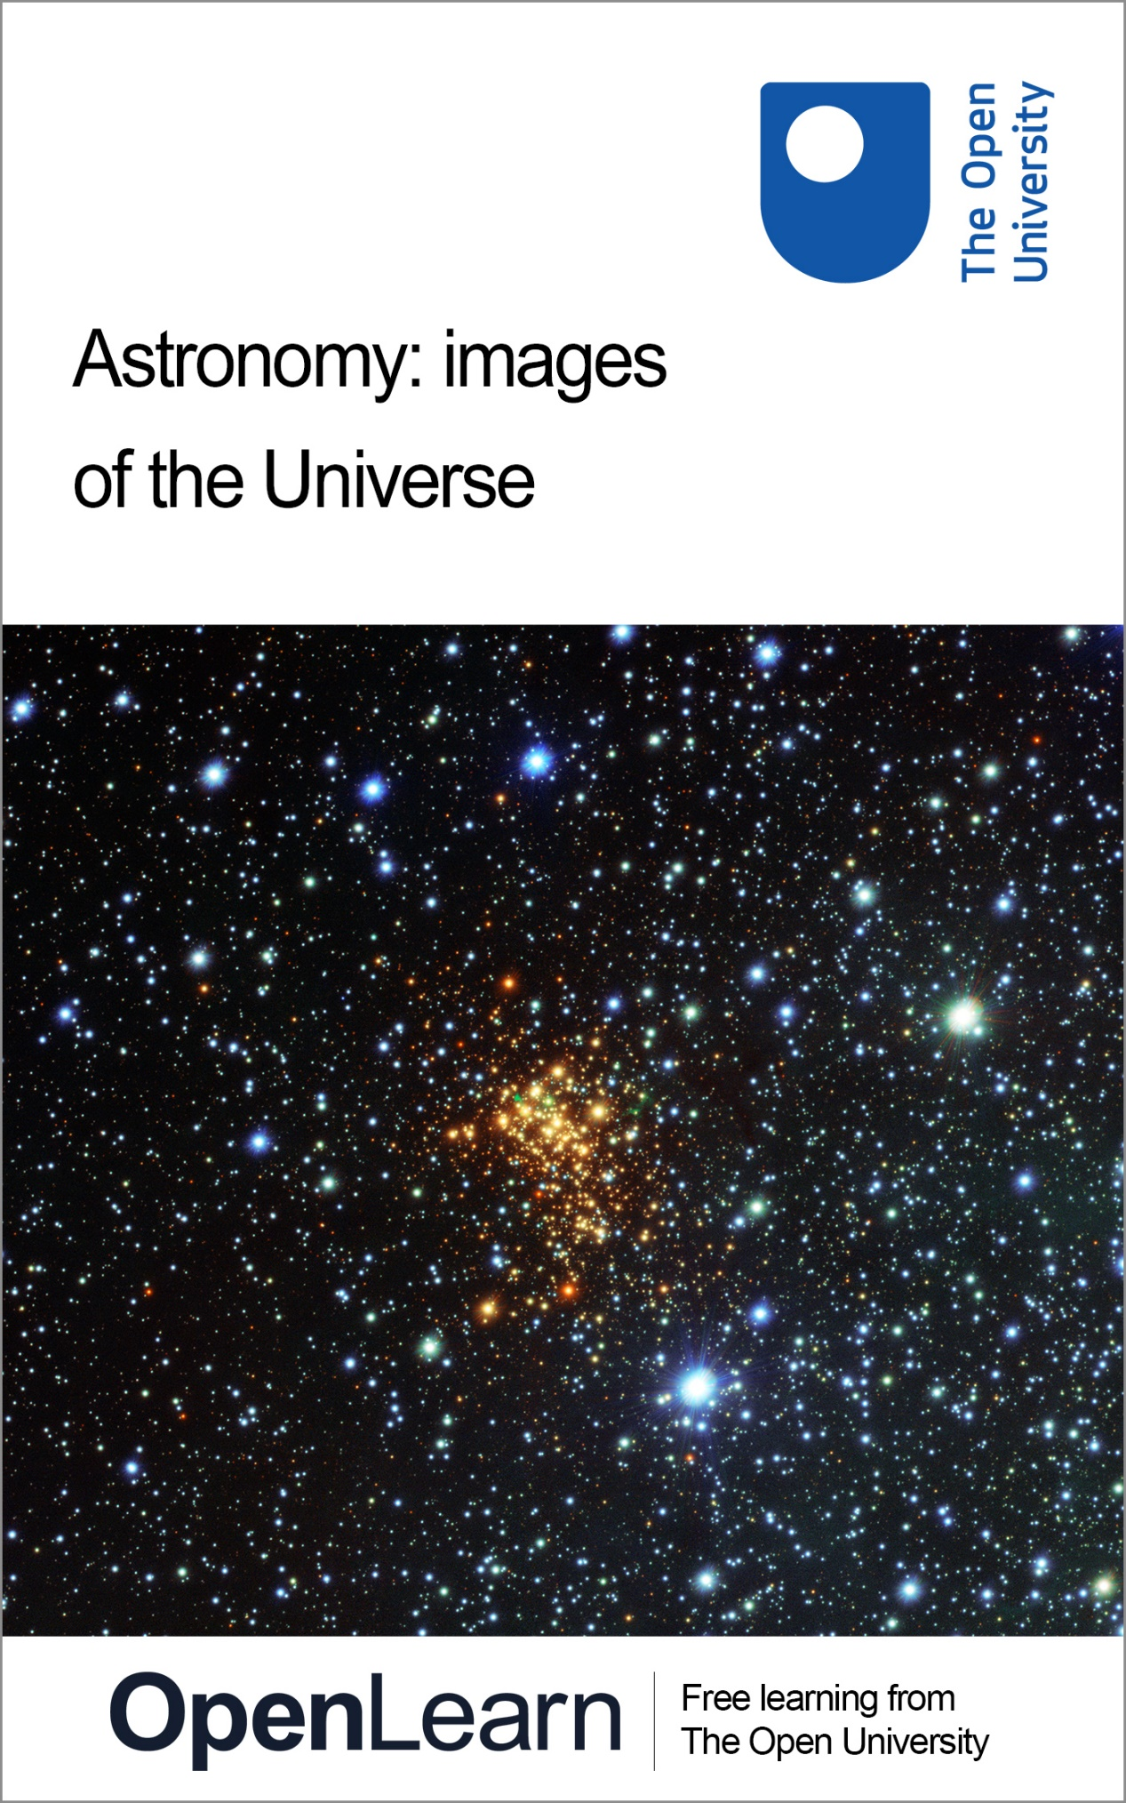

S284_1 Astronomy: images of the Universe

Astronomy: images of the Universe

About this free course
This free course is an adapted extract from the Open University course S284 Astronomy www.open.ac.uk/courses/modules/s284.
This version of the content may include video, images and interactive content that may not be optimised for your device.
You can experience this free course as it was originally designed on OpenLearn, the home of free learning from The Open University – https://www.open.edu/openlearn/science-maths-technology/astronomy-images-the-universe/content-section-0
There you’ll also be able to track your progress via your activity record, which you can use to demonstrate your learning.
First published 2024.
Unless otherwise stated, copyright © 2024 The Open University, all rights reserved.
Intellectual property
Unless otherwise stated, this resource is released under the terms of the Creative Commons Licence v4.0 http://creativecommons.org/licenses/by-nc-sa/4.0/deed.en_GB. Within that The Open University interprets this licence in the following way: www.open.edu/openlearn/about-openlearn/frequently-asked-questions-on-openlearn. Copyright and rights falling outside the terms of the Creative Commons Licence are retained or controlled by The Open University. Please read the full text before using any of the content.
We believe the primary barrier to accessing high-quality educational experiences is cost, which is why we aim to publish as much free content as possible under an open licence. If it proves difficult to release content under our preferred Creative Commons licence (e.g. because we can’t afford or gain the clearances or find suitable alternatives), we will still release the materials for free under a personal end-user licence.
This is because the learning experience will always be the same high quality offering and that should always be seen as positive – even if at times the licensing is different to Creative Commons.
When using the content you must attribute us (The Open University) (the OU) and any identified author in accordance with the terms of the Creative Commons Licence.
The Acknowledgements section is used to list, amongst other things, third party (Proprietary), licensed content which is not subject to Creative Commons licensing. Proprietary content must be used (retained) intact and in context to the content at all times.
The Acknowledgements section is also used to bring to your attention any other Special Restrictions which may apply to the content. For example there may be times when the Creative Commons Non-Commercial Sharealike licence does not apply to any of the content even if owned by us (The Open University). In these instances, unless stated otherwise, the content may be used for personal and non-commercial use.
We have also identified as Proprietary other material included in the content which is not subject to Creative Commons Licence. These are OU logos, trading names and may extend to certain photographic and video images and sound recordings and any other material as may be brought to your attention.
Unauthorised use of any of the content may constitute a breach of the terms and conditions and/or intellectual property laws.
We reserve the right to alter, amend or bring to an end any terms and conditions provided here without notice.
All rights falling outside the terms of the Creative Commons licence are retained or controlled by The Open University.
Head of Intellectual Property, The Open University

Contents
- Introduction
- 1 Images and measurements
  - 1.1 Understanding brightness
  - 1.2 Measuring brightness
  - 1.3 Measuring sizes
  - 1.4 Measuring shapes
- 2 Structure in images
  - 2.1 From point-like stars to diverse nebulae
  - 2.2 Exploring the Messier catalogue
  - 2.3 Types of extended objects
- 3 Colour in astronomy images
  - 3.1 Broadband images
  - 3.2 Multiwavelength images
  - 3.3 Narrow-band images
- 4 Mapping the sky
  - 4.1 The Milky Way and the Galactic plane
  - 4.2 Surveying beyond the Milky Way
  - 4.3 Surveying the variable Universe
- Conclusion
- Acknowledgements
- Glossary
- Solutions
- Descriptions

Introduction
The purpose of astronomical images is straightforward: by recording images of particular regions of the sky, we can identify what objects are out there in the Universe and where they are located. Imaging the Universe enables us to understand its structure and contents. Images provide a wider context within which astronomers can use tools like spectroscopy to investigate the detailed physics and chemistry of individual objects.
In this course, you will explore how astronomers use images to measure the properties of stars and galaxies. You will also examine different types of images used by astronomers, from detailed images of the structure of a nearby star cluster to maps of the entire northern sky, and from visible light to images in other parts of the electromagnetic spectrum.
This OpenLearn course is an adapted extract from the Open University course S284 Astronomy.

1 Images and measurements
Astronomical images record distributions of brightness, and how that depends on an object’s position on the sky. For optical astronomy this is now usually done using CCD (charge-coupled device) detectors. These are similar to cameras in modern mobile phones, although typically larger and/or more sophisticated.
Making images in parts of the electromagnetic spectrum beyond visible light can require less intuitive methods, such as interfering electric signals together from multiple antennae to produce radio wavelength images. But however an image is made, the basic end result – as shown in Figure 1 – is a two-dimensional (x, y) array of pixels: a grid that records the brightness at related locations on the sky.

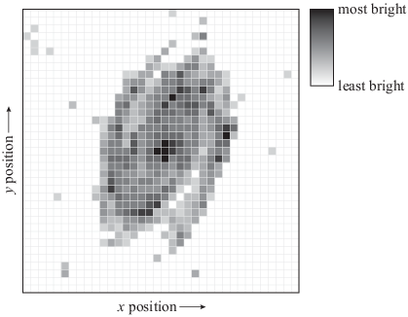
Figure 1 How information is stored in a simple (greyscale) astronomical image. The data are stored as an x, y grid, where each pixel has an associated brightness.
View description - Figure 1 How information is stored in a simple (greyscale) astronomical image. The ...

Additional information, such as the astronomical coordinate system and details of when the observation was made, is typically stored within the image file as metadata.
We need to employ careful methods to make measurements from images such as Figure 1 if we are to make reliable inferences about stars and galaxies. In this section, you will examine how these measurements are made, and what they can tell us.

1.1 Understanding brightness
The ultimate aim of an astronomical observation is usually to answer a question about the intrinsic properties of an astronomical object. For example, we might want to understand how much energy a star is producing, or perhaps how many stars are likely to be present in a distant galaxy.
Astronomers refer to the brightness of astronomical objects in several ways. When referring to how bright a star or galaxy appears to be, astronomers use the concept of apparent magnitude. The brightest objects in the night sky have apparent magnitudes of around 1, whereas the faintest that can be seen with the naked eye have apparent magnitudes of around 6. Because of the way in which human eyes work, objects with magnitude 6 are in fact about 100 times fainter than those with magnitude 1: each decrease of one magnitude corresponds to roughly a 2.5 times reduction in brightness. Using a large telescope, objects as faint as magnitude 25 may be detected. A 25th magnitude star is around a hundred million times fainter than those near the limit of perception for unaided human eyes.

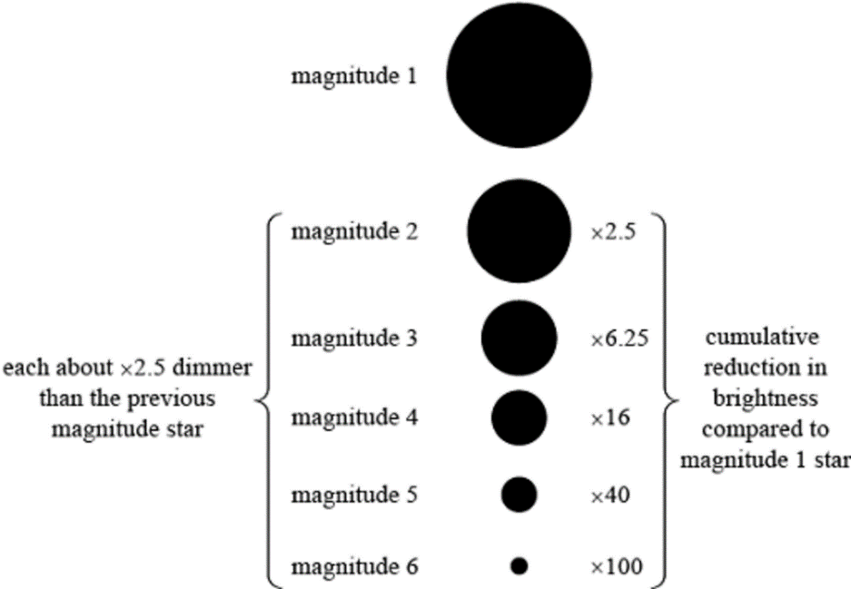
Figure 2 An illustration of apparent magnitudes. Note that although stars of different magnitude are conventionally indicated as having different sizes, as they are here, in reality almost all stars appear to us as pinpoints of light.
View description - Figure 2 An illustration of apparent magnitudes. Note that although stars of different ...

There are two reasons why different stars may have different apparent magnitudes: they may emit different amounts of light or they may be at different distances away from us. Two identical stars situated at different distances from us will have different apparent magnitudes, purely because the light emitted by the more distant star is spread out over a larger area by the time it reaches us. In order to allow comparison between the brightness of stars at different distances, the concept of absolute magnitude is required. The absolute magnitude of a star is (arbitrarily) the value of its apparent magnitude if it were placed at a standard distance away of 10 parsecs (about 3 x 10¹⁷ m). The absolute magnitude of a star therefore gives a measure of its intrinsic brightness, or the amount of energy it emits per unit of time.
While apparent and absolute magnitudes are a useful convenience for astronomers, it is often helpful to use more conventional measurements of brightness when measuring stars and galaxies. We may therefore distinguish between the flux of light from a star or galaxy and its luminosity. Luminosity is a measure of how much energy in the form of light (or other electromagnetic radiation) is emitted by a star or galaxy in a given time interval. It is an intrinsic property of the star or galaxy itself and may be measured in the SI unit of power, which is watts (W) or equivalently joules per second (J s⁻¹). Luminosity can be related to absolute magnitude. On the other hand, flux is a measure of how much energy in the form of light (or other electromagnetic radiation) we observe from a star or galaxy in a given time interval. It therefore depends both on the luminosity of the star or galaxy in question and on its distance away from us. It is measured in the SI unit of power per unit area, which is watts per square metre (W m⁻²). Flux can be related to apparent magnitude.

1.2 Measuring brightness
In this section so far you’ve encountered several astronomical quantities associated with the brightness of objects: specifically, apparent and absolute magnitude, flux, and luminosity. Importantly, the brightness we measure from an image does not, on its own, tell us anything about the physics of the star or galaxy. Until we know how far away it is, we are only measuring how bright it looks to us on the sky. Sometimes we can make beautiful images of the sky from which it is quite difficult to draw conclusions about the science of what we’re looking at, because it is not possible to measure accurate distances.
In principle it is easy to measure the apparent magnitude – or flux received – from an astronomical object in an image:
- first, identify which pixels in the image correspond to the object of interest
- then, sum up the brightness measured in each pixel.
Figure 3 shows two images with photometric apertures drawn on them. These are regions (defined by the astronomer analysing the image) within which the brightness of each individual pixel is added together. The sum of the brightness of each pixel within the circular aperture is the total brightness for each star or galaxy.

Figure 3 Photometric apertures (dashed circles) placed on images to measure the flux of (a) two stars of different magnitudes and (b) an extended galaxy.
View description - Figure 3 Photometric apertures (dashed circles) placed on images to measure the flux ...

It is not necessarily straightforward to decide how big to make the aperture. The blurring effects of the atmosphere and telescope optics, and the underlying shape of the light distribution from large objects such as galaxies, mean that defining the aperture size can be tricky. A large aperture will include a greater proportion of the source flux, but may also suffer from higher contamination from the surrounding background flux (the grey ‘noise’ between the darker stars and galaxies in Figure 3).
Figure 4a shows how the surface brightness of a star (its flux or magnitude per unit area) is measured to decrease with distance from its centre. Such plots can be referred to as radial surface brightness profiles. The light is spread out over a number of pixels, despite the true angular size of the star being smaller than one image pixel. The way that light from a star is distributed across multiple pixels by a particular telescope is known as the telescope’s point-spread function (PSF).

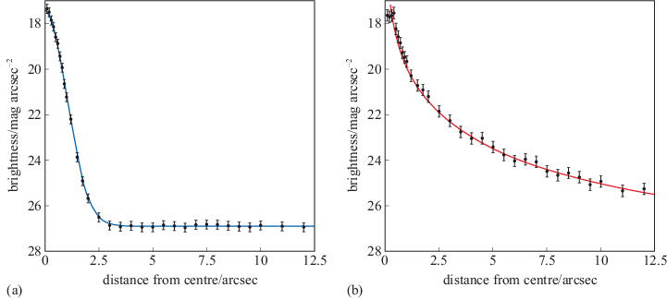
Figure 4 The radial surface brightness profiles of (a) a star (i.e. a point source) and (b) a galaxy (an extended source).
View description - Figure 4 The radial surface brightness profiles of (a) a star (i.e. a point source) ...

Figure 4b shows the radial surface brightness profile for a galaxy. To make these graphs, the surface brightness is measured in circular ‘annuli’ (rings) centred on the source. Such profiles for bright stars in the field can be used to determine the shape of the PSF for your observation – in other words, they enable careful measurement of the degree to which the light emitted by the star is being blurred across a wider area in the image we see. This allows aperture sizes to be chosen that optimise the quality of the measurements.
For sources whose true angular size is larger than a single image pixel, such as the galaxy in Figure 4b, the radial brightness profile is broader than the PSF, and follows a characteristic shape based on the distribution of stars. Model galaxy profiles can be used to help determine the best aperture size, and/or correct for missing flux beyond the chosen aperture radius.

1.3 Measuring sizes
With a few exceptions (the Sun, and a few nearby red giant stars), we cannot measure the sizes of individual stars. The observed size of a star in an image is determined by the PSF and is typically much larger than the true size. But much of our knowledge of systems of stars – binary stars and stellar clusters, star-forming regions and galaxies – is built on measurements of their sizes, as calculated from astronomical images.
The size measured directly from an image does not on its own tell us about its true physical size. We initially measure angular size, the angle the object spans on the sky, but we need to know its distance to determine how big it is in kilometres or parsecs.
Figure 5 shows two images taken by the same telescope as part of the Digitized Sky Survey project. On the left is a globular cluster and on the right is a nearby galaxy. The two objects span a similar number of pixels on the Survey’s CCD detector.

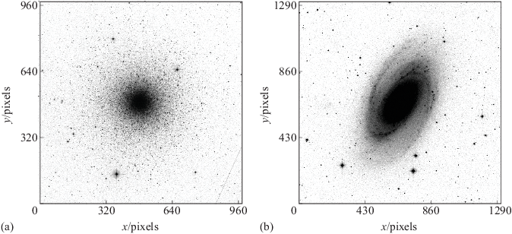
Figure 5 Images of (a) a globular cluster and (b) a galaxy.
View description - Figure 5 Images of (a) a globular cluster and (b) a galaxy.

- Using an astronomy software tool, the star cluster and galaxy are measured to span 540 pixels and 900 pixels, respectively. What additional information would you need in order to compare the true sizes of the two astronomical objects?
- You would need a way to convert between pixels and angle on the sky. You also need to know the distances to each of the two objects.

The conversion factor between pixels and angular size or separation in arcseconds or arcminutes will be different for different telescopes. It is known as the telescope’s pixel scale.

Example 1
Imagine that you read the documentation for the Digitized Sky Survey 2, the source of these images, and find that the pixel scale is 0.0170 arcmin pix⁻¹. Calculate the angular size of the globular cluster.

Solution
The angular size is given by multiplying the size measured in pixels by the pixel scale of the telescope detector. The angular size is therefore:

540 pixels × 0.0170 arcmin pix⁻¹ = 9.18 arcmin
View alternative description - Uncaptioned Equation

The globular cluster has an angular size of 9.18 arcminutes.

- Repeat the calculation in relation to Example 1 to determine the angular size of the galaxy in Figure 5b.

900 pixels × 0.0170 arcmin pix⁻¹ = 15.3 arcmin
View alternative description - Uncaptioned Equation

The galaxy has an angular size of 15.3 arcminutes.

You research the star cluster and the galaxy (e.g. by looking up their names on the SIMBAD astronomical database), and discover that the cluster is at a distance of 10.4 kpc (it is within the Milky Way), while the galaxy is at a distance of 2.6 Mpc.
Converting an angular size of an object into a physical size is a straightforward trigonometrical calculation, as long as we know the distance to the objects. The equation relating these quantities is

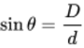
View alternative description - Uncaptioned Equation

Where is the angular size, D is the physical size and d is the distance to the object. It is also useful to recognise that, for small angles measured in radians, .

- Now calculate the physical sizes of the two objects, and compare them. (Hint: if you are stuck, you may wish to review the information above this question.)
- The cluster’s angular size in radians is

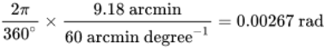
View alternative description - Uncaptioned Equation

The small-angle approximation discussed previously (, where ) applies both to angular separations and angular sizes. Hence the cluster’s physical size () is related to its angular separation () and its distance () by

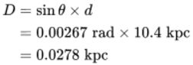
View alternative description - Uncaptioned Equation

A similar calculation for the galaxy gives a physical size of 11.6 kpc. Therefore the galaxy is around 400 times larger than the star cluster.

1.4 Measuring shapes
As well as measuring the brightnesses and sizes of astronomical objects, images allow us to measure and interpret their shapes and structures.
Stars are simple objects that are usually close to spherical. In most cases we cannot obtain information about their shapes and structure from images (deviations from a spherical shape can sometimes be identified by other means, e.g. variability). But the shapes and structure of a diverse range of other astronomical systems – for example, star-forming regions, galaxies and their sub-components, jets of material produced by stars and black holes – can be examined using images across the electromagnetic spectrum.
Remember that our images show the distribution of light as it is recorded by our telescope detector, which is located at a particular position in space. The detector records a two-dimensional image, but the light originates from a three-dimensional object.
We are used to 2D images of 3D scenes from ordinary cameras. However, to interpret a photo of a landscape, or a group of people at a party, we have a wealth of extra information – from lighting, shadows, and our own intuition about the contents of the picture – to help our brains interpret the photo as a three-dimensional scene. Astronomical images often have fewer clues available to help us work out the underlying three-dimensional shapes, as shown in Figure 6.
Figure 6a shows an astronomical object shaped like a dinner plate (perhaps a galaxy) as viewed from three different directions. This scene depicts the effect of projection, where the object is tilting away from the plane of the sky. Note that this situation is mathematically similar to an inclined elliptical orbit.
Figure 6b shows the effect of orientation on the inferred length of a linear extended structure (perhaps an extended gas cloud or a jet-like feature).

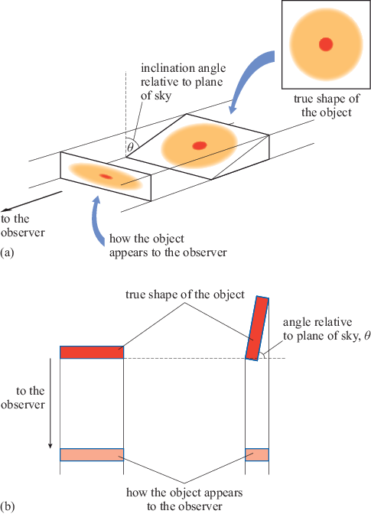
Figure 6 The effects of orientation on measured sizes and shapes of astronomical objects: (a) a disc-shaped object, and (b) a rod-shaped object.
View description - Figure 6 The effects of orientation on measured sizes and shapes of astronomical ...

- At what angle relative to the plane of the sky will the linear object appear shortest in an image?
- The greater the angle away from the plane of the sky, the shorter the structure appears when observed in an image. The object will therefore appear shortest at an angle of 90 degrees to the plane of the sky.

For a circular disc-like object, the observed major axis (i.e. twice the semimajor axis) corresponds to the true diameter of the disc, and the inclination angle (tilt, ) relative to the plane of the sky is given by

(Equation 1)
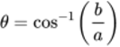
View alternative description - Uncaptioned Equation

where is the measured semimajor axis and the measured semiminor axis.
If a linear object is projected at an angle of to the plane of the sky, then its true length, , is related to its measured length, , by

(Equation 2)
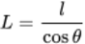
View alternative description - Uncaptioned Equation

Example 2
You want to measure the shape of a galaxy that an image shows to have an ellipse shape, but you believe is in fact a disc (round dinner-plate shape) that is inclined relative to the observer, as in Figure 6a. The angle by which the galaxy is tilted, , is not known.
The semimajor and semiminor axes are measured from the image to be 20 arcmin and 13 arcmin, respectively. Calculate the angle of inclination, .

Solution
The longer axis tells us the true radius of the disc. The angle can then be calculated using Equation 1

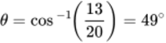
View alternative description - Uncaptioned Equation

- A jet of gas is observed emerging from a young star. The length of the jet is measured to be 2.5 pc and the width is 0.3 pc. If the jet is cylindrical, and oriented at an angle of 30 degrees relative to the plane of the sky, what is its true length and ratio of its length to width (i.e. the ‘aspect ratio’)?
- Using Equation 2, the observed length is related to the true length via . Hence the true length is

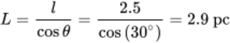
View alternative description - Uncaptioned Equation

and the aspect ratio is

MathJax failure: MathML - MathML must be formed by a single element
View alternative description - Uncaptioned Equation

In other words, the object is in reality more elongated than it appears in our images.

The conclusion to draw from these calculations is that frequently in astronomy we cannot be certain of the true shape or dimensions of objects. If you had not assumed the galaxy in the example was a circular disc, you could not have obtained the inclination angle.
Sometimes the problem can be solved by using additional information, such as that obtained from the spectrum of an object. The shift of spectral lines, or their broadened widths, may be caused by the Doppler effect which can provide clues about the motion or rotation of the object concerned. If we are studying very large samples, we sometimes expect that overall the orientations are random, which enables the use of statistical methods or computer simulations to determine the overall size and shape distributions of a set of objects. However, unknown orientation angles remain a major uncertainty in many astronomical studies.

2 Structure in images
You’ve now examined the basic quantitative information that astronomers can obtain from images: measurements of the brightness, sizes and shapes of astronomical objects.
Combining this information together tells us about the structure of the Universe: how individual stars, stellar systems, galaxies and their components relate to each other. Mapping out the structure of astronomical systems, both small and large, is an essential step in building our understanding of how stars and galaxies are born, live their lives (whether stable and unexciting or short-lived and dramatic), and eventually die.
In this section, you will explore the diverse types of spatial structure that emerge in astronomical images, setting the scene for more precise classifications of astronomical objects.

2.1 From point-like stars to diverse nebulae
Stars are fascinating and complicated objects, but for the most part this complexity does not reveal itself in individual images of single stars. Most stars are unresolved to our telescopes (i.e. their light is contained within a region smaller than the size of details we can distinguish).
To understand the structure of stars, astronomers have had to construct models based on information from spectroscopy, studies of binary star systems, and tools such as asteroseismology. However, there are a few exceptions.
We have exquisite structural information about the surface of the Sun (Figure 7a), from space missions such as the Solar and Heliospheric Observatory (SOHO) and Solar Orbiter. This information has enabled astronomers to understand the interplay of energy transport and magnetic fields in our nearest star. We also have a small number of resolved images of nearby giant stars. An example is Gruis (Figure 7b), which shows similar convective structure on its surface to that of the Sun.

Figure 7 Stars as extended astronomical objects: (a) the Sun, taken by the SOHO mission, and (b) the nearby giant star Gruis.
View description - Figure 7 Stars as extended astronomical objects: (a) the Sun, taken by the SOHO mission, ...

For unresolved objects such as stars, the main properties that can be measured from images alone are location, brightness, and colour. But astronomers have known for several centuries that there are objects in the sky that are not point-like – they show extended and varied structure in images. (Extended astronomical objects are defined as those that have an angular size larger than the PSF of an image.) Identification of such fuzzy, ‘cloud-like’ astronomical objects dates back as far as early tenth-century Islamic astronomy.
Early astronomers classified these extended objects as nebulae: nebula being the Latin word for a cloud or fog. The term became used to describe any object that had a fuzzy appearance, rather than the sharper form of a star.
In modern astronomy, the term nebula is now used in a more precise way. However, until the early twentieth century the physical nature of many of the ‘fuzzy’ extended objects in the sky was not well understood, and so the class of nebulae provided a useful distinction between unresolved (point-like) and resolved (extended) structures.
Figure 8 shows some hand-drawn sketches of nebulae dating to the early nineteenth century. It is apparent that they do not all show the same structure: there are various different types of fuzzy, extended – and in some cases a little peculiar – objects visible in the night sky.

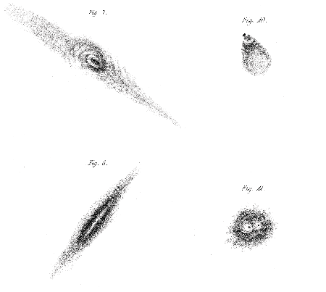
(Source: The Earl of Rosse (1805) ‘Observations on the nebulae’, Philosophical Transactions of the Royal Society of London, 140(499), pp. 499–514, www.jstor.org/stable/108449)
Figure 8 Images of nebulae, as viewed by the most powerful telescope of the nineteenth century, the Leviathan of Parsonstown, and hand-sketched by William Parsons, 3rd Earl of Rosse.
View description - Figure 8 Images of nebulae, as viewed by the most powerful telescope of the nineteenth ...

2.2 Exploring the Messier catalogue
The catalogue of Charles Messier provides an ideal starting point for exploring the variety of extended objects visible in the sky. More than 250 years after publication of the first part of his catalogue, it remains a treasure trove for amateur astronomers and astrophotographers looking to observe and make images of some of the most beautiful, complex and interesting deep-sky objects that can be observed without access to professional observatories.
In the following activity you will explore the range of objects that Messier found.

Activity 1 Exploring the Messier catalogue
Allow around 15 minutes

Task 1
Visit the Wikipedia page for ‘Messier object’ to find a full list of deep-sky, extended astronomical objects. (Make sure to open the link in a new tab/window so you can easily return here.)
Choose an object that sounds interesting, then look around online for a few different images of it, and some background information about what type of object it is. In most cases you should be able to find pictures from both professional observatories and amateur astronomers/astrophotographers. Indeed, if you are familiar with Messier objects (or even have your own collection of photographs), you may already have a favourite to select.

Task 2
Write a short paragraph (50–150 words) describing the appearance of your chosen Messier object, what type of astronomical object it is, and any facts you found interesting.

Provide your answer...

2.3 Types of extended objects
In your research for Activity 1, you will have probably come across several different types of extended objects. Optical astronomers now recognise five main classes of deep-sky object, shown in Figure 9. Here you will consider each of these in turn, focusing on the image structure they show.

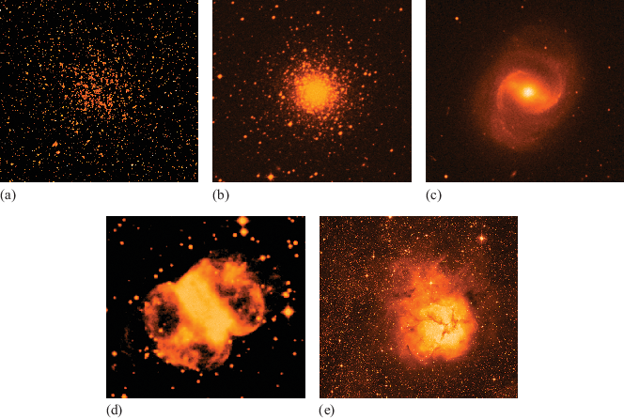
Figure 9 R-band images of the five main types of extended objects seen in optical images: (a) open cluster, (b) globular cluster, (c) galaxy, (d) planetary nebula and (e) diffuse nebula.
View description - Figure 9 R-band images of the five main types of extended objects seen in optical ...

Open cluster
Figure 9a shows M11, an example of an open cluster of stars. With modern telescopes, you can make out individual stars in the cluster, but at low image resolution the light from the stars blurs together to form a fuzzy, nebula-like appearance.

Globular cluster
Figure 9b shows M75, a globular cluster. Like M11 this is a collection of many stars, but its spatial structure is different. This cluster has a round shape and more regular appearance, and it is brighter in the centre and fainter at the edges. The stars are packed closely together in the cluster centre but are more spread out at larger distances.

Galaxy
Figure 9c shows M91, which is a galaxy. Like M11 and M75, M91 is a collection of stars, but its structure is very different. We cannot identify individual stars, but you can see a spiral structure. The smooth, diffuse nature of the light tells us that it comes from a much larger number of stars than is the case for star clusters.

Planetary nebula
This class of nebulae show extremely diverse structures – the example in Figure 9d is M76 (the Little Dumbbell nebula). Planetary nebulae have nothing to do with planets; they are the debris of a Sun-like star that has reached the end of its life. The name comes from their coloured, disc-like appearance in early images.
Some planetary nebulae have round circularly symmetric structures, while others are ‘bipolar’, showing butterfly-like linear symmetry.

Diffuse nebula
Figure 9e shows M20, an example of a diffuse nebula. This final category encompasses objects where images show a smooth light distribution not made up of individual stars, which is less regular in structure than the planetary nebulae. The light from diffuse nebulae comes from warm, glowing gas and dust associated with star-forming regions.
In the next activity, you will further compare these examples of the five types of extended objects.

Activity 2 Comparing the scales of Messier objects
Allow around 15 minutes

The Scales Tool plots the sizes and distances of all the Messier catalogue objects, including the five Messier objects shown in Figure 9 (M11, M75, M91, M76 and M20).

Interactive content is not available in this format.
The Scales Tool

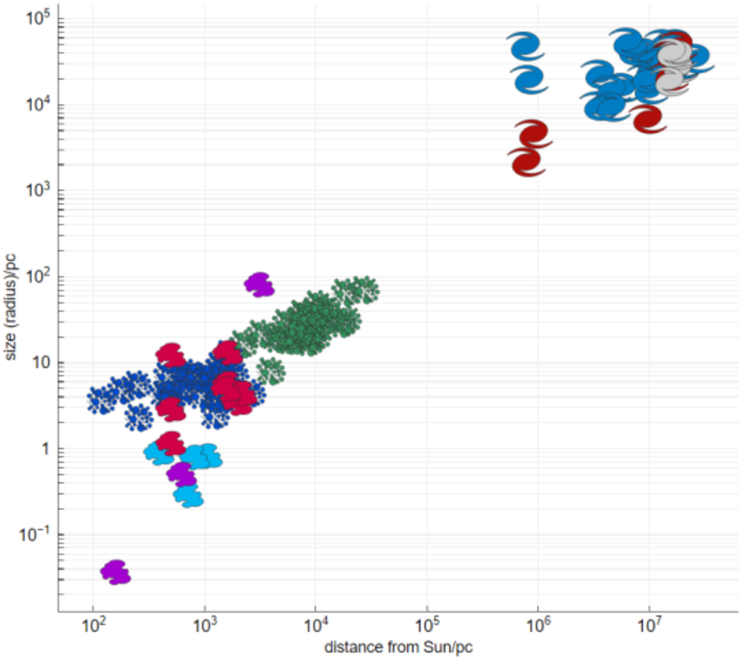

Use the tool to investigate the properties of the five objects from Figure 9 and to determine the following information. Note that it is likely to be helpful to use the ‘Messier object types’ key at the top to show only the relevant categories of object when searching for a particular Messier object on the distance–size graph.
- List the five objects in order from smallest to largest, and then again from nearest to most distant.
- Note how much larger the largest of these Messier objects is than the smallest.
- Note how much further away the most distant of the objects is than the nearest.
- Find the Messier object you studied in Activity 1, and note how it compares to the five in Figure 9.

Provide your answer...
View discussion - Activity 2 Comparing the scales of Messier objects

3 Colour in astronomy images
So far you have focused on brightness, size, shape and structure in astronomy images, but have neglected one of the most important methods for obtaining physical insights from images: the use of colour information. The colour of starlight encodes information about the temperature of a star. Indeed, colour provides clues to a range of physical processes of interest to astronomers.
This section will explore how telescopes record colour in the visible part of the spectrum, and how we can use that information. It will also examine the full range of light information astronomers can access, from radio waves to X-ray and gamma ray images.

3.1 Broadband images
To compare astronomical measurements of brightness for different objects reliably, and to make physical interpretations (e.g. estimate the temperature of stars, understand the effect of dust obscuring our measurements), we require precise information about the range of wavelengths of light that are recorded in an image. Telescope filters provide us with a way to do this.
By using a filter that only allows red light – from a specific range of wavelengths – to pass through, brightness and colour information can be recorded in a standardised way. Other astronomers will be able to reproduce exactly the same observation, and should measure the same amount of red light from the same object (unless it is variable).
The standard optical U, B, V, R and I filters are referred to as ‘broadband filters’, although they typically encompass considerably narrower wavelengths than broadband spectra. Each of these filters spans a wavelength range of a few hundred nanometres. The U filter passes light in the near-ultraviolet (near-UV) range of the spectrum; the B filter passes blue light; the V filter passes green–yellow light; the R filter passes red light, and the I filter passes light in the near-infrared (near-IR) part of the spectrum.
Most of the astronomical images we see in news stories, press releases, and astrophotography exhibitions are in colour, but it is important to emphasise that these rarely represent exactly what our eyes would see (if they were as sensitive as a telescope). Colour images are usually made by combining together images taken in three, or sometimes more, different filters. Each image on its own is simply a record of the brightness in each pixel, so might best be represented by a greyscale image.
Video 1 initially shows such a greyscale image from one filter. The images recorded through three different filters are then assigned (typically) red, green and blue colour ranges, and then added together to form a multicolour image that shows which parts of the object have redder or bluer light.

Video content is not available in this format.
Video 1 The process of making a colour image from optical telescope data. (Note: this video has no sound.)

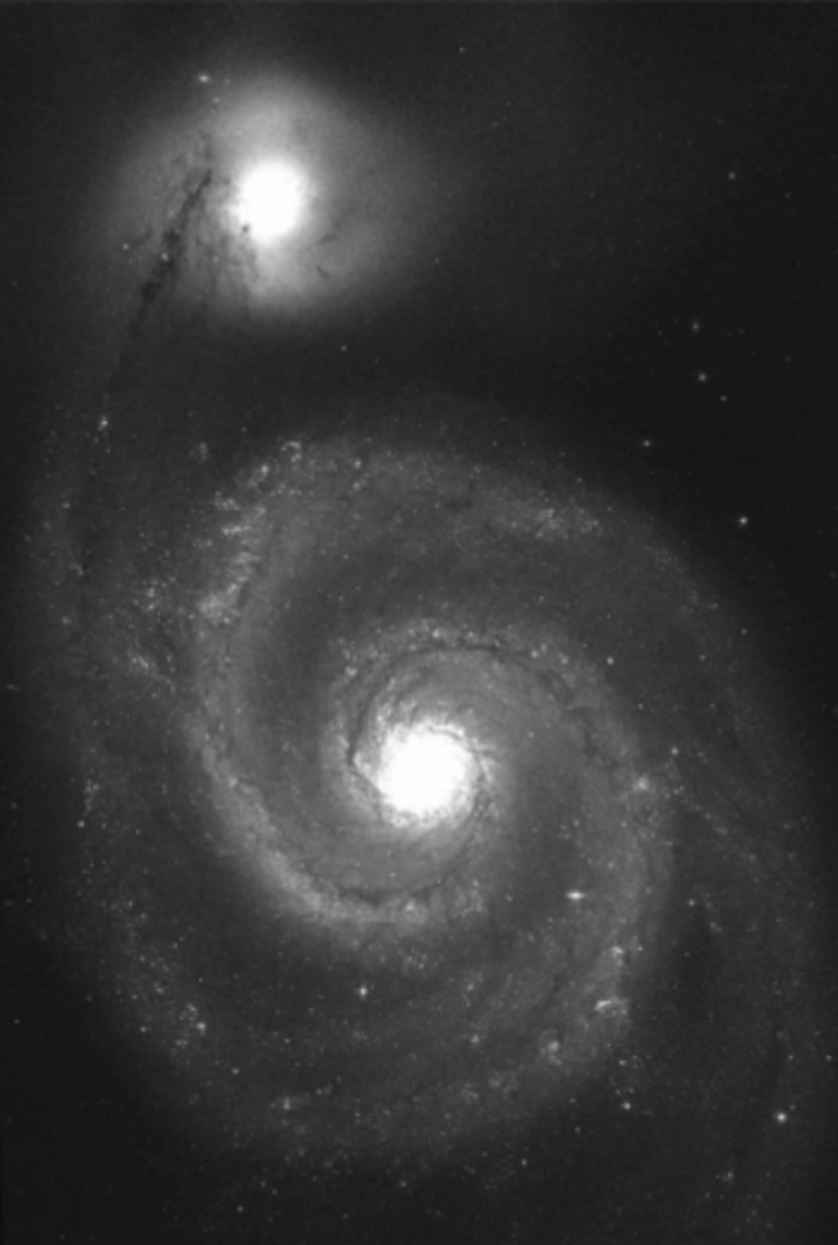

But telescope filters typically do not match the response of our eyes to light very closely, and various decisions need to be taken in combining different filters together. So there is no single ‘right answer’ to the question ‘what does this astronomical object look like in colour?’
Colour images are useful visualisations to help understand the structure of objects, but if we want to draw scientific conclusions from them it’s important to keep a careful record of the properties of the telescope filters and how the images were combined together.
Quantitative measurements of colour involve taking the difference in brightness as measured by two different filters (e.g. ()). Colour index is measured by doing photometry (recall Section 1.2 of this course) separately on images from two filters and then subtracting the magnitudes.

- If working with colour indices, why is it essential to use standard telescope filters with known wavelength ranges?
- As with comparing brightness measurements of stars or galaxies, it is only possible to make reliable comparisons between colour measurements for different astronomical objects and/or measurements taken with different telescopes if exactly the same ranges of light are being compared.

3.2 Multiwavelength images
Modern astronomers can carry out observations using light with wavelengths spanning a range from a few metres to 10⁻²⁰ m. This means we can now work with broadband images made across this full range of wavelengths.
Figure 10 shows images of a supernova remnant (the debris of an exploding star), the Crab nebula. These images were obtained by telescopes spanning the radio to the gamma ray regimes – a factor of more than 10¹⁸ in wavelength!

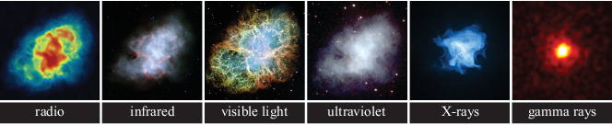
Figure 10 The Crab nebula viewed across the extremes of the electromagnetic spectrum.
View description - Figure 10 The Crab nebula viewed across the extremes of the electromagnetic spectrum. ...

An important point that these multiwavelength images should help you to grasp is that the distribution of light on the sky (whatever wavelength we’re using to look) doesn’t always directly map the distribution of underlying matter that is producing the light. For example, in Figure 11 the left image shows an optical view of the nearby Andromeda galaxy, while the right image shows an infrared view of the same part of the sky.

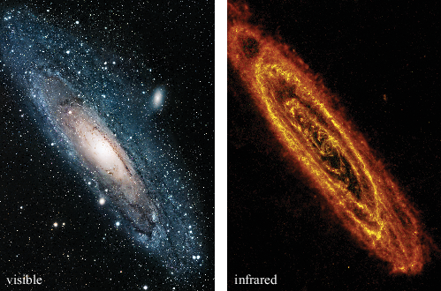
Figure 11 The Andromeda galaxy in optical (left) and infrared (right) emission.
View description - Figure 11 The Andromeda galaxy in optical (left) and infrared (right) emission.

- What do you notice that is different about the appearance of the Andromeda galaxy in the optical and infrared images?
- Regions that are dark in the optical image are lit up in the infrared image – the two wavelength regimes seem to be tracing different underlying matter.

Similarly, in Figure 12 the left image shows another galaxy, NGC 6964, in optical light, while the right image shows a radio map (with the same scale).

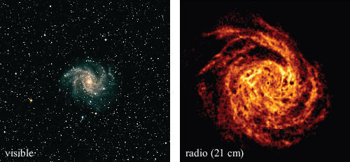
Figure 12 The galaxy NGC 6964 in optical (left) and radio (right) emission.
View description - Figure 12 The galaxy NGC 6964 in optical (left) and radio (right) emission.

You might be wondering, for both Andromeda and NGC 6964: which of the two images in the set is better at telling us where the matter is located in the galaxy? How can we tell?
In the case of Andromeda, the optical light indicates where the stars are. However, some of the dark regions are dark not because there are no stars, but because dust obscures the stars and prevents their light from reaching us. In contrast, the infrared light is tracing the locations of warm dust, which glow because of its heat. The two images are thus tracing different forms of matter, and we will only be able to build a true picture of where all the matter is in Andromeda by combining together images at different wavelengths.
Similarly with NGC 6964, the optical and radio light look different: the galaxy appears much larger at radio wavelengths than in the optical. The reason for this is that the radio light does not come from the stars. It comes from atomic (neutral) hydrogen gas () via the 21 cm emission line. In this particular galaxy the gas is spread over a much larger region than most of the stars. Without the extra information from the radio image we would not have a true picture of where all of the matter is located.

3.3 Narrow-band images
The radio image of NGC 6964 you’ve just examined is an example of a particular type of astronomical image that can be extremely scientifically useful. It is a narrow-band image, which means that the filter used to record the light spans only a very narrow range in wavelengths.
The atomic composition of astronomical objects leads to emission and absorption features that provide us with information about physical conditions (e.g. temperatures, densities, and chemistry). This is why spectroscopy is one of the most powerful tools available to astronomers. However, we can also use image methods to study these emission lines, by filtering out all of the light coming from the continuum and making an image of just the brightness of light produced by a single emission line.
The radio astronomy technique of mapping at 21 cm is an example of this, but it is used across the full electromagnetic spectrum. A common example in the optical part of the spectrum also relates to emission from hydrogen.
The emission line (the first of the Balmer series) is produced in regions that have high temperatures. Figure 13 shows some examples of images, and the sort of details that they can reveal. A typical filter spans a wavelength range of 0.07 nm, which is over 1000 times narrower than typical broadband filters.

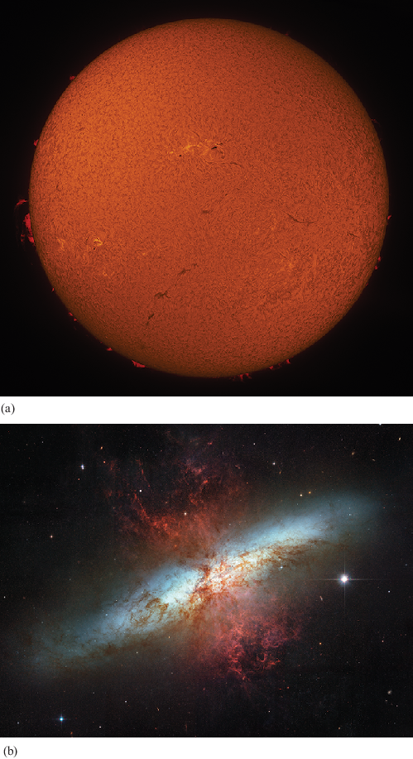
Figure 13 Examples of narrow-band images: (a) the structure of the Sun’s surface, including prominences – luminous streams of gas; (b) a red image superimposed on an ordinary optical image, revealing glowing hydrogen gas that has been blown out of the starburst galaxy M82.
View description - Figure 13 Examples of narrow-band cap h sub alpha images: (a) the structure of the ...

Other emission lines that are studied in the visible light range using narrow-band images include:
- the [] 500.7 nm emission line, which is produced in planetary nebulae and active galaxies
- methane features, which are particularly interesting for studying planets because of methane’s association with biological and/or geological activity.
The Hubble Space Telescope currently has more than 25 different narrow-band optical filters available to carry out different types of scientific investigations. While examining spectra is very powerful, for extended objects narrow-band images provide an invaluable method for exploring which regions are producing particularly strong emission lines, as in Figure 13b.
In the X-ray part of the spectrum, narrow-band images can be particularly powerful, because many heavier elements such as sulfur, silicon, magnesium and iron produce strong emission lines at X-ray wavelengths. These can be used to provide detailed information about the atomic composition of gas in regions as diverse as supernova remnants and clusters of galaxies. Most importantly, they trace the temperature of the gas really closely, so they can provide information about the thermodynamics of energetic behaviour in the Universe.

4 Mapping the sky
A driving force behind improving telescope technology over hundreds of years has been the desire to make sharper, more detailed images. In other words, to improve the spatial resolution with which we can measure the sky, allowing us to obtain these detailed views of individual objects. But in parallel with these precision views, astronomers have developed the ability to map structure in the sky on scales much larger than individual stars and distant galaxies.
In this section, you will explore astronomical images that span these large areas of sky, allowing us to consider some broader questions about our cosmic surroundings.

4.1 The Milky Way and the Galactic plane
What does our own Galaxy look like? Figure 14 shows one perspective. If you are lucky enough to find yourself on a clear night in a very dark location, you will be able to see a smooth band of light stretching across the sky, with dark clumpy regions caused by clouds of gas and dust that block starlight from reaching us.

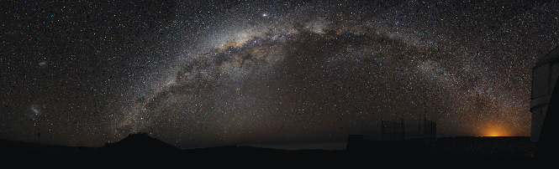
Figure 14 The Milky Way, as viewed in a panoramic image from a particularly dark Southern Hemisphere site (the location of the European Southern Observatory telescopes in Chile).
View description - Figure 14 The Milky Way, as viewed in a panoramic image from a particularly dark ...

The following activity allows you to view our Galaxy from some other perspectives.

Activity 3 Exploring the multiwavelength Milky Way
Allow around 20 minutes

Astronomers at Cardiff University have produced a web tool called Chromoscope, used for exploring maps of our Galaxy taken in many different parts of the spectrum. You will use this tool to complete this activity.
First, open the Chromoscope website in a separate browser tab or window, so that you can return to the instructions here. The default view is a visible light image of our Milky Way, which you can pan round and zoom in on. The full image spans an area of 186 × 20 degrees: a section of sky hundreds to thousands of times larger than the images of individual stars, galaxies and diffuse objects seen in this course. It was made by astrophotographer Nick Risinger, who carefully sewed together over 37 000 individual exposures.
A menu allows you to view this same field in images captured using light from different parts of the electromagnetic spectrum. Alternatively, there are keyboard shortcuts, which you can find more about by pressing ‘h’ for ‘Help’ (or from the ‘Help’ link in the bottom-left corner of the website).

Task 1
Explore the visible light image of the Milky Way and comment on any differences between this map compared to the image in Figure 14. Why do you think it has a different shape?

Provide your answer...
View discussion - Part

Task 2
Now switch between the visible and X-ray images. Note what happens to the dark regions near to the Galactic equator when you switch between the two views. Suggest an explanation for any similarities or differences between the two images.

Provide your answer...
View discussion - Part

Task 3
Now look at the near-infrared, far-infrared and images. Note how the infrared images differ from the visible (and X-ray) images – why do you think this is? What features can you identify in the image that are not present in the others?

Provide your answer...
View discussion - Part

4.2 Surveying beyond the Milky Way
The Milky Way spans a large region of the night sky, but the Milky Way images explored in the previous section are not the only type of ‘wide-area’ sky images we can examine.
Deep images of areas of sky away from the path of the Milky Way (often referred to as the ‘extragalactic’ sky) reveal very large numbers of galaxies beyond our own. Figure 15 shows a single deep galaxy image, which is roughly 2.6 arcmin on each side, or around one-tenth of the angular size of the full Moon.

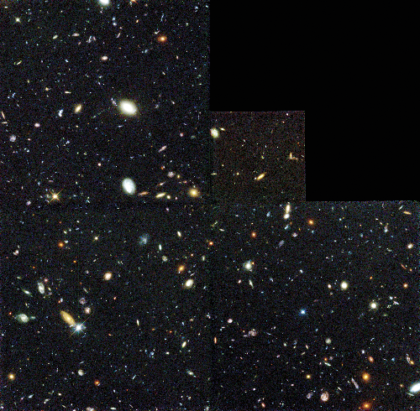
Figure 15 Deep survey by the Hubble Space Telescope of a very small area of sky, showing around 1000 distant galaxies.
View description - Figure 15 Deep survey by the Hubble Space Telescope of a very small area of sky, ...

Astronomers have also undertaken enormous efforts to map out the locations of galaxies across larger areas of the sky, as well as the three-dimensional neighbourhoods and environments of galaxies. Galaxy surveys compile together thousands of individual images to map large areas of sky. An example is shown in Figure 16, where around 60 000 images of the Northern and Southern Hemispheres have been combined to produce a map that charts the positions of millions of galaxies.

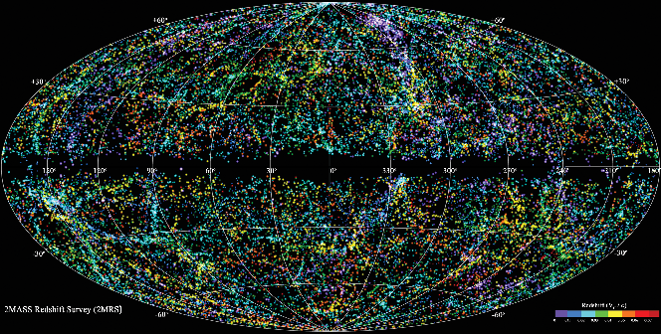
Figure 16 The positions of millions of galaxies from the Two Micron All Sky Survey (2MASS).
View description - Figure 16 The positions of millions of galaxies from the Two Micron All Sky Survey ...

Figure 17 shows an even more zoomed-out region of a galaxy survey, projected using redshift information to form a three-dimensional map. The radial coordinate is redshift – so the centre of the diagram is nearby and the outer parts more distant – while the angular coordinate is right ascension. Each dot is an entire galaxy, containing hundreds of billions of stars!

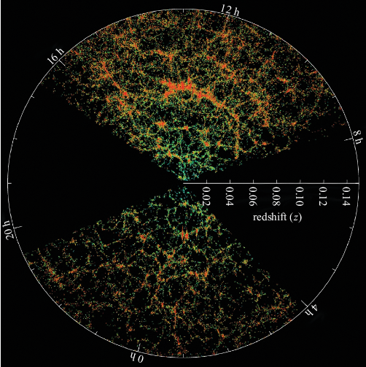
Figure 17 A 3D map of the sky made from a galaxy redshift survey.
View description - Figure 17 A 3D map of the sky made from a galaxy redshift survey.

- What do you notice about the way that galaxies are distributed on the sky? Is the structure random?
- The distribution of galaxies is not random. There are bright clumps where large numbers of galaxies cluster together – for example in a band running approximately from 11 h to 14 h of RA at a redshift of 0.06 – and emptier gaps in between them.

Together the locations of these galaxies form a map of what is known as the cosmic web. The brightest points in the web are galaxy clusters, where many galaxies cluster together. These brighter regions are connected together by filaments, and void regions where there are far fewer galaxies.
The ‘large-scale structure’ of the Universe, this cosmic web visible in Figures 16 and 17, is a consequence of the influence of gravity. Evidence suggests that galaxies and larger structures are built up over the history of the Universe, with smaller clumps being pulled together by gravity to form larger ones.
Astronomers have carried out many different surveys, which have investigated different parts of the Universe. In the following activity you will compare two important recent galaxy surveys.

Activity 4 Comparing astronomy surveys
Allow around 20 minutes

Figure 18 shows the distribution of galaxies in terms of:
- their position on the sky
- their distance from Earth.
The plotted data are taken from two modern galaxy surveys – the Hubble Deep Field (HDF, shown in Figure 15), and the Sloan Digital Sky Survey (SDSS) – together with the galaxies included in Edwin Hubble’s famous 1929 paper that demonstrated what we now know as the Hubble–Lemaître law (the relationship between distance and recession speed: redshift).

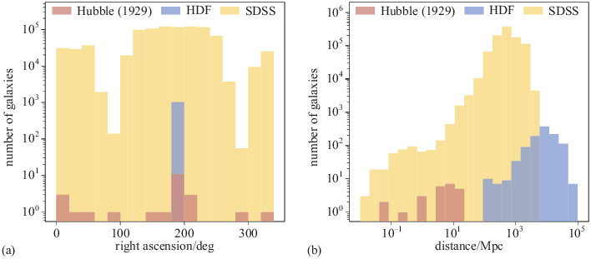
Figure 18 Galaxy data taken from several astronomical surveys: (a) the distribution of each sample of galaxies on the sky; (b) the distribution of their distances.

Examine the two graphs, and answer the following questions to compare what we can learn from different types of galaxy survey.

a. The SDSS is a wide-area sky survey. With reference to the two plots, can you suggest some advantages of wide-area surveys?

Provide your answer...
View discussion - Part

b. The HDF is a deep-sky survey, which is very sensitive to faint objects. With reference to the two plots, what do you think is the main advantage of a deep-sky survey?

Provide your answer...
View discussion - Part

c. Once more with reference to the two graphs, can you think of any limitations of wide-area sky surveys, such as SDSS, that it might be important to consider when analysing their results?

Provide your answer...
View discussion - Part

d. Finally, in light of these graphs, can you think of any limitations of deep-sky surveys, such as the HDF, that it might be important to consider in analysing their results?

Provide your answer...
View discussion - Part

4.3 Surveying the variable Universe
Once astronomers have made a detailed map of the sky you might imagine it is ‘job done’, and the survey telescope could be dismantled. Happily this is not the case, because the objects in the night sky are not constant and unchanging – there is much work for astronomers in mapping astronomical objects whose appearance can change from one observation to another.
Figure 19 shows two images of a galaxy taken 41 days apart. Can you spot the difference? It shouldn’t be difficult to spot the presence of a very bright ‘star’ in the second image, which has been further highlighted by a position indicator (a vertical and a horizontal bar). This is a supernova: the light comes from the explosion of one of the galaxy’s stars.

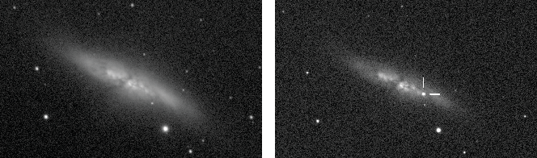
Figure 19 Spot the difference: two images of the same galaxy taken 41 days apart, with the location of a supernova highlighted by the white lines in the right-hand image.
View description - Figure 19 Spot the difference: two images of the same galaxy taken 41 days apart, ...

In some cases a supernova can briefly outshine all of the other stars in its galaxy, before fading away and the galaxy returning to its usual appearance.
There are many ‘spot the difference’ astronomy surveys underway, comparing images of the same stars or galaxies taken at different times to identify any changes. Finding supernovae is one of the aims of projects such as the Legacy Survey of Space and Time (LSST). The LSST, carried out by the Vera C Rubin Observatory, will survey the sky all night, every night, through six broadband filters. It will cover the entire visible sky twice per week, and so build up light curves of billions of stars and galaxies, each spanning ten years. It will also detect huge numbers of transient and variable objects whose brightness varies with time. But there are many other types of variable objects in the sky, including binary star systems and active regions associated with black holes in the centre of galaxies.
Time-domain surveys (i.e. surveys that image the same area of sky many times to look for changes) can be used to study all of these things. Indeed, modern time-domain surveys are able to look across a large area of sky for both periodically varying objects and ‘transients’ – objects such as supernovae that appear and then disappear over a relatively short timescale.
The ESA Gaia survey is another example of a time-domain survey, which has exceptional ability to pinpoint changes in the positions of stars so as to determine their distances through parallax. It can also be used to study changes in brightness, rather than position, including discovering supernovae.

Conclusion
The focus of this course has been on how astronomers use images to make measurements and map the contents of the Universe. These were some of the key learning points:
- An image consists of a two-dimensional array of information, recording brightness as a function of position. In the visible part of the spectrum (and some other wavelength regimes), images are typically made using CCD detectors.
- The main measurements obtained directly from images are observed quantities that reflect the light signal measured at the Earth, rather than the intrinsic properties of the source. These include flux or apparent magnitude, angular size, and surface brightness.
- Brightness measurements are obtained via photometric apertures, and surface brightness profiles can be used to optimise the size of the aperture used. Profiles can trace the point-spread function (PSF): the blurring due to telescope optics and atmospheric seeing.
- Angular sizes are measured in units of pixels from an image, and must then be converted to units of arcsec, arcmin or degrees using the pixel scale appropriate for the detector. Angular size can then be converted to physical size (in units of metres, or pc, kpc, Mpc) if the distance to the astronomical source is known. However, the effects of orientation must also be considered.
- For non-spherical objects, the shapes measured on an image may not reflect their true shape, due to the effects of orientation and 2D projection of a 3D object. If the inclination relative to the line of sight is known, then true proportions, and hence shapes, can be obtained. In some cases, particularly for more complex and irregular objects, there is insufficient information to determine the underlying three-dimensional shape.
- For a circular disc-like object, the observed major axis corresponds to the true diameter of the disc, and the inclination angle (tilt, ) relative to the plane of the sky is given by

(Equation 1)
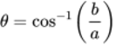
View alternative description - Uncaptioned Equation

where is the measured semimajor axis and the measured semiminor axis.
- If a linear object is projected at an angle of to the plane of the sky, then its true length, , is related to its measured length, , by

(Equation 2)
View alternative description - Uncaptioned Equation

- Astronomical objects can appear in images as point-like or extended, depending on whether they are resolved by the telescope. Extended objects have angular sizes larger than the image’s point-spread function.
- There are five main types of extended astronomical object in visible light images: open clusters, globular clusters, galaxies, planetary nebulae, and diffuse nebulae.
- Astronomical images taken with different telescope filters, spanning different wavelength ranges, can be combined to produce colour images. Quantitative measurements, such as colour index, are usually made by carrying out photometry separately on images from individual filters and then combining the measurements.
- Narrow-band images can be made using filters that allow through only light associated with a particular emission line. One of the most commonly used examples is , which highlights the locations of regions of hot gas.
- Images are also made across the electromagnetic spectrum. Multiwavelength astronomy involves using images spanning a wide range in wavelength, from radio waves to gamma rays, which highlight different regions and features.
- Images from small areas of sky can be combined together to make sky maps. The Milky Way spans a large area of sky and has been mapped in detail at many wavelengths. Surveys are also made of the extragalactic sky, producing wide-area images and maps of the locations of millions of galaxies beyond our own. Time-domain surveys compare images taken at different times to identify variable phenomena.
This OpenLearn course is an adapted extract from the Open University course S284 Astronomy.

Acknowledgements
This free course was adapted from S284 material written by Judith Croston. It was edited for OpenLearn by Andrew Norton.
Except for third party materials and otherwise stated (see terms and conditions), this content is made available under a Creative Commons Attribution-NonCommercial-ShareAlike 4.0 Licence.
The material acknowledged below is Proprietary and used under licence (not subject to Creative Commons Licence). Grateful acknowledgement is made to the following sources for permission to reproduce material in this free course:
Figures
Course image: ESO / VPHAS+ Survey / N. Wright, https://commons.wikimedia.org/wiki/File:Surprise_Cloud_Around_Vast_Star.jpg, This file is licensed under the Creative Commons Attribution 4.0 International license, https://creativecommons.org/licenses/by/4.0/deed.en
Figure 1 How information is stored in a simple (greyscale) astronomical image: adapted from an image by George J. Bendo http://www.jb.man.ac.uk/~gbendo/home.html. This file is licensed under the Creative Commons Attribution 4.0 International (CC BY 4.0) licence, https://creativecommons.org/licenses/by/4.0/
Figure 2 An illustration of apparent magnitudes: adapted from SpaceFM
Figure 3 Photometric apertures (dashed circles) placed on images to measure the flux of (a) two stars of different magnitudes and (b) an extended galaxy: adapted from https://www.spacetelescope.org/projects/fits_liberator/m35data/. This file is licensed under the Creative Commons Attribution 4.0 International (CC BY 4.0) licence, https://creativecommons.org/licenses/by/4.0/
Figure 5 Images of (a) a globular cluster and (b) a galaxy: adapted from images by http://archive.eso.org/dss/dss. This file is licensed under the Creative Commons Attribution 4.0 International (CC BY 4.0) licence, https://creativecommons.org/licenses/by/4.0/
Figure 7 Stars as extended astronomical objects: (a) the Sun, taken by the SOHO mission and (b) the nearby giant star, Gruis: (a) © courtesy of SOHO/[instrument] consortium. SOHO is a project of international cooperation between ESA and NASA; (b) © ESO/José Francisco (josefrancisco.org), https://www.eso.org/public/unitedkingdom/images/eso1741a/. This file is licensed under the Creative Commons Attribution 4.0 International (CC BY 4.0) licence, https://creativecommons.org/licenses/by/4.0/
Figure 8 Sketches by Lord Rosse: out of copyright. Adapted from The Earl of Rosse (1805) ‘Observations on the Nebulae’, Philosophical Transactions of the Royal Society, 150(499), pp. 499–514. Available at: https://www.jstor.org/stable/108449
Figure 9 R-band images of the five main types of extended objects seen in optical images: images adapted from Digitized Sky Survey, https://archive.stsci.edu/dss/acknowledging.html
Figure 10 The Crab nebula viewed across the extremes of the electromagnetic spectrum: © Cherenov Telescope Array CTA, https://www.cta-observatory.org/science/gamma-rays-cosmic-sources/. This file is licensed under the Creative Commons Attribution 4.0 International (CC BY 4.0) licence, https://creativecommons.org/licenses/by/4.0/
Figure 11 The Andromeda galaxy in optical (left) and infrared (right) emission: left image (optical): © Robert Gendler, http://www.robgendlerastropics.com; right image (infrared): © ESA/Herschel/PACS/SPIRE/J. Fritz, U. Gent.
Figure 12 The galaxy NGC 6964 in optical (left) and radio (right) emission: © Prof. Dr. Tom Oosterloo.
Figure 13 Examples of narrow-band images: (a) © Michael Borman; (b) © NASA and the Space Telescope Science Institute (STScI).
Figure 14 The Milky Way, as viewed in a panoramic image from a particularly dark Southern Hemisphere site: © Bruno Gilli and ESO, https://www.eso.org/public/unitedkingdom/images/milkyway/. This file is licensed under the Creative Commons Attribution 4.0 International (CC BY 4.0) licence, https://creativecommons.org/licenses/by/4.0/
Figure 15 Deep survey by the Hubble Space Telescope of a very small area of sky: © NASA; ESA; G. Illingworth, D. Magee, and P. Oesch, University of California, Santa Cruz; R. Bouwens, Leiden University; and the HUDF09 Team.
Figure 16 The positions of millions of galaxies from the Two Micron All Sky Survey (2MASS): © Smithsonian Astrophysical Observatory.
Figure 17 A 3D map of the sky made from a galaxy redshift survey: © Sloan Digital Sky Survey, www.sdss.org. This file is licensed under the Creative Commons Attribution 4.0 International (CC BY 4.0) licence, https://creativecommons.org/licenses/by/4.0/
Figure 19 Spot the difference: two images of the same galaxy taken 41 days apart: © UCL and University of London Observatory 2014, all rights reserved. Credit: Steve Fossey, Ben Cooke, Guy Pollack, Matthew Wilde and Thomas Wright.
Every effort has been made to contact copyright owners. If any have been inadvertently overlooked, the publishers will be pleased to make the necessary arrangements at the first opportunity.
Don't miss out
If reading this text has inspired you to learn more, you may be interested in joining the millions of people who discover our free learning resources and qualifications by visiting The Open University – www.open.edu/openlearn/free-courses.

Glossary
absolute magnitude
(Symbol, M.) A numerical measure of the intrinsic brightness of a star, equal to the apparent magnitude (m) the star would have if observed from a standard distance of 10 parsecs, in the absence of interstellar absorption. The absolute magnitude provides a measure of the star’s luminosity.
absorption
The process by which a photon is absorbed by an ion, atom or molecule resulting in an increase in energy of the ion, atom or molecule.
angular separations
How far apart two astronomical objects appear to be, calculated as the difference between the coordinates of their positions on the sky.
angular size
How big an astronomical object appears to be, calculated as the difference between the coordinates of the extremities of the extended object.
apparent magnitude
(Symbol, m.) A numerical measure of the apparent brightness of a body. For a star, it is a measure of the flux received.
asteroseismology
The study of stellar interiors from observations of global oscillations of their photospheres.
Balmer series
The series of electronic transitions in the hydrogen atom that involve a change to or from the n = 2 state, associated with spectral lines mostly in the visible.
bar
An approximately linear extension to the central bulge seen in some spiral galaxies, from which the spiral arms emanate.
binary stars
A situation where two stars orbit each other.
black holes
A region of space in which matter is sufficiently dense that the action of gravity prevents both matter and electromagnetic radiation from escaping. Black holes may be classified as either ‘stellar mass’ (up to tens of solar masses) or as ‘supermassive’ (in excess of 10⁶ solar masses) and characterised further by their Schwarzschild radius.
bulge
The region around the centre of a spiral galaxy, where the galaxy is thicker and brighter and the concentration of matter is greater than elsewhere. Its outer parts are dominated by the light of old stars, but towards the centre it may contain material associated with the inner parts of the disc, including sites of star formation.
colour
The difference, measured in magnitudes, of the brightness of an object in two specified wavebands (e.g. in the blue ‘B’ and red ‘R’ wavebands, in which case the difference is denoted m_{B} – m_{R} or simply B – R). Sometimes referred to as colour index.
colour images
Images that incorporate information from multiple telescope filters, so that variation in colour represents the relative variation in the proportions of emitted light at different wavelengths.
computer simulations
Numerical models within a computer used to model star or galaxy formation.
convection
A process of energy transfer in which a fluid in a gravitational field is heated from below to the point where the hotter, less dense fluid rises upwards, displacing the cooler, denser fluid downwards.
cosmic web
The largest-scale strucure of galaxy clusters and filaments comprising the Universe.
deep images
Images that are sensitive to the very faintest emission that our telescopes can detect. The ‘deepest’ existing astronomical images are produced using very long exposures by space-based or very large ground-based professional observatories.
degrees
Units of angular measure. There are 360 in a complete circle.
disc
The flat, circular region in a spiral or lenticular galaxy in which most of the ongoing star formation is located, including spiral arms, if present. Disc-shaped structures are common in astronomy, also existing around protostars, and sometimes around stellar remnants.
Doppler effect
The effect whereby wavelengths are shifted to longer or shorter values as a result of relative movement between the source and the observer.
dust
Small solid particles, around 10⁻⁷ or 10⁻⁶ m across, found mixed with interstellar gas. Dust grains are predominantly composed of carbonaceous material and silicates, but may be surrounded by an icy mantle. Dust is very effective at absorbing and scattering ultraviolet and visible light.
electromagnetic radiation
A form of radiation in which the transfer of energy from place to place may be attributed to the passage of wave-like disturbances in the electric and magnetic fields between those places (i.e. electromagnetic waves), or to the passage of photons from one place to the other. The wavelength or frequency of the waves (or the energy of the photons) may be used to assign particular kinds of electromagnetic radiation to specific parts of the electromagnetic spectrum, resulting in their classification as light, radio waves, X-rays, etc.
emission line
A narrow wavelength or frequency range in a spectrum where the spectral flux density is greater than at adjacent wavelengths (or frequencies).
extended
An astronomical source of light whose angular size is larger than the point-spread function of a particular telescope.
far-infrared
The longest wavelength part of the infrared region of the electromagnetic spectrum. Far-infrared emission traces dusty regions, including planet-forming discs and distant protogalaxies.
filaments
In the context of star formation, a filament is a linear region of denser material. They result from the partial collapse of a molecular cloud. Material streams along them and stars typically form at their intersections. In the context of galaxy structures, filaments are thread-like structures comprising hundreds or thousands of gravitationally bound galaxies as part of the cosmic web.
flux
(Symbol, F.) A quantity describing the rate at which energy transferred by radiation is received from a source, per unit area facing the source. The SI unit of flux is the watt per square metre (W m⁻²).
Galactic coordinates
A celestial coordinate system, whose two elements are Galactic longitude l, and Galactic latitude b, resembling longitude and latitude on the Earth. The orientation of the coordinate system is defined to make it useful for describing the locations of objects in the Galaxy from the viewpoint of the Sun. The Galactic equator is chosen to coincide with the Galactic plane, the direction (l, b) = (0°, 0°) is in the direction of the Galactic centre.
galaxy
A collection of luminous stars, non-luminous dark matter, and in the case of spiral and irregular galaxies some amount of gas and dust that are gravitationally bound to one another, and are separated from other similar structures usually by distances of tens of kiloparsecs or more. Various categories of galaxies may be defined based on their appearance, such as spiral galaxies (barred or normal), elliptical galaxies, lenticular galaxies and irregular galaxies.
galaxy clusters
A collection of hundreds or thousands of galaxies that are bound together by gravity.
gamma ray
The highest-energy form of electromagnetic radiation, produced in energetic processes like nuclear fusion.
globular cluster
Clusters of 10⁵ to 10⁷ very old stars, tightly bound by gravity into a spherical region of space less than about 50 pc in diameter. The 150 or so globular clusters associated with the Milky Way are found in a spherical distribution about the centre of our Galaxy. Similar distributions are seen in other galaxies.
Hubble–Lemaître law
A relationship between the apparent speed at which a galaxy is receding from us and its distance away.
inclinations
The angle between the plane of an orbital system and the plane of the sky.
jets
A long narrow linear feature emanating from an active galactic nucleus, seen in many radio galaxies and quasars, most often via its radio synchrotron emission but sometimes also at optical and X-ray wavelengths. Jets are also present in a small number of X-ray binaries and believed to be present in gamma ray bursts.
light curves
A diagram showing the variation of brightness (e.g. magnitude, flux or luminosity) with time, for a celestial object.
luminosity
(Symbol, L.) A quantity describing the rate at which energy is carried away from a luminous object by electromagnetic radiation. The SI unit of luminosity is the watt (W), where 1 W = 1 J s⁻¹.
magnetic fields
The quantity, specified throughout some region of space, that determines the magnetic force that would act on a particle of given electric charge moving with given velocity through any point within that region. At each point in the region, the magnetic field possesses a strength and a direction. The magnetic field in a region may be produced by magnets or by moving charged particles (e.g. electric currents), but is deemed to exist irrespective of whether there are any other moving charged particles or magnets present to ‘feel’ its effect.
multiwavelength astronomy
Astronomy that makes use of images, spectra and light-curves made in multiple regions of the electromagnetic spectrum.
narrow-band image
An image made using a narrow-band telescope filter through which only light within a small range of wavelength can pass.
near-infrared
The shortest wavelength part of the infrared region of the electromagnetic spectrum.
nebulae
Extended astronomical objects having a fuzzy or cloud-like appearance in small telescopes.
neutral
With reference to an atom or molecule: not ionised; having no net electric charge.
open cluster
Clusters of up to a few thousand stars, loosely bound by gravity, that were formed from the same giant molecular cloud and so have roughly the same age. There are more than 1000 open clusters in the Milky Way, confined to the disc of the galaxy.
parallax
The phenomenon whereby the apparent position of an object changes when seen from different viewpoints.
parsecs
The distance to a celestial body that has an annual parallax of one arcsecond: 1 pc = 3.09 × 10¹³ km, or just over 3 light-years.
photometric apertures
A region (often circular) superimposed on an astronomical image within which the brightness values of individual pixels are added together in order to determine the total brightness of a particular astronomical object.
photometry
The science of the measurement of the brightness (magnitude, flux or luminosity) of astronomical objects.
photons
The particle of electromagnetic radiation in the photon model of light. The photon energy, E, is proportional to the frequency, f, of the associated radiation: E = hf, where h is Planck’s constant.
pixel scale
The conversion factor between image pixels and angular separation for images from a particular telescope or instrument set-up.
planetary nebulae
The gaseous remains of the outer envelope of a low-mass star, which is illuminated by a luminous central white dwarf.
point-like
An astronomical source of light whose angular size is smaller than the point-spread function of a particular telescope.
point-spread function (PSF)
A mathematical description of the blurring effect caused by the telescope optics and atmospheric effects, so that light from a point-like source such as a star is spread over multiple pixels of an image.
projection
The shape that a 3-dimensional object produces when viewed in a 2-dimensional image, which may depend on its orientation.
protostar
A molecular cloud that has begun the process of collapsing into a star and has become opaque to radiation but which has not yet started nuclear fusion.
radians
Unit of angular measure. There are radians in a complete circle.
radio astronomy
Astronomy carried out using images and spectra in the radio part of the electromagnetic spectrum, consisting of radiation with the lowest frequencies/longest wavelengths.
red giant
A large star with a photospheric temperature less than about 6000 K. Main sequence stars with masses of less than about 11 M⊙ evolve to become red giants.
redshift
The increase in the observed wavelength of radiation relative to the wavelength at which the radiation was emitted (the frequency is correspondingly decreased). This can be due to either the Doppler effect arising from motion through space or the expansion of the Universe.
resolution
A measure of the smallest angular separation for which a particular telescope can distinguish two separate sources of light without them blurring together.
resolved
Indicating that a particular telescope can distinguish two separate sources of light without them blurring together.
right ascension
In the equatorial coordinate system, one of the coordinates used to define the positions of objects on the celestial sphere, analogous to terrestrial longitude. Often abbreviated to RA. It is measured in hours, minutes and seconds such that 1 hour of RA is equal to 15 degrees along the celestial equator.
seeing
The effect of atmospheric blurring which often characterises the resolution limit of ground-based astronomical telescopes.
semimajor axis
A distance equal to half the longest axis of an ellipse or elliptical orbit.
sky maps
Either an image or plot of catalogued positions that covers a large area of the celestial sphere.
spatial resolution
A measure of the ability of a telescope to distinguish between closely spaced features in an image.
spectroscopy
The range of electromagnetic radiation that is emitted, absorbed or reflected by an object, dispersed according to its constituent wavelengths, frequencies or energies is called a spectrum (plural spectra). The study of such spectra is referred to as spectroscopy.
spiral galaxy
A member of the Hubble class of galaxies that is characterised by having a disc and spiral arms. Membership of this class is indicated by the letter S, or SB in the case of a barred spiral galaxy.
stars
A ball of matter which, at some stage in its life, is self-luminous as a result of energy released by nuclear reactions in its core.
star cluster
A group of stars with more than a few members in a relatively small volume of space.
star-forming regions
A region of gas within the interstellar medium of a galaxy in which stars are in the process of forming.
supergiant
A star that lies along the top of the Hertzsprung–Russell diagram, i.e. the stars with the greatest luminosity. Main sequence stars with masses greater than about 11 M⊙ evolve to become supergiants. Later, such stars become Type II supernovae.
supernova remnant
The gaseous remains of a stellar explosion, which may be caused by collapse of a massive star or thermonuclear explosion of a white dwarf. The explosion sends a shock wave into the interstellar medium, causing it to radiate in multiple parts of the electromagnetic spectrum. Often abbreviated to SNR.
surface brightness
A quantity that describes the brightness at a particular position on an extended object, such as a galaxy. The surface brightness at any chosen point is the amount of radiant flux that would reach 1 m² at Earth from a small, uniformly bright, square region, of angular area 1 arcsec², surrounding the chosen point. A common SI unit of surface brightness is W m⁻² arcsec⁻².
surface brightness profiles
Plots of the surface brightness of extended astronomical objects as a function of radial distance from its centre.
time-domain surveys
An astronomical survey that records images or other measurements at the same locations at multiple points in time, so as to record information about how positions and brightness of objects change.
unresolved
In relation to an astronomical image, an object whose light is contained within a region smaller than the size of details that may be distinguished.
voids
Under-dense regions of the cosmic web between the filaments and galaxy clusters.
wavelength
The distance over which a periodic wave repeats itself, e.g. the distance from one peak of the wave to the next.

Solutions

Activity 2 Comparing the scales of Messier objects

Discussion
- Smallest to largest: M76, M11, M20, M75, M91 (planetary nebulae are larger than stars, but typically smaller than diffuse nebulae and star clusters, which in turn are much smaller than galaxies). Nearest to most distant: M76, M20, M11, M75, M91.
- The Messier objects span a very wide range of sizes. The largest object, the galaxy M91, is around 35 000 times larger than the smallest, M76.
- M91 is also the most distant of the objects in Figure 9, and M76 is the nearest. M91 is around 19 000 times more distant than M76.
- Your findings will depend on your choice of Messier object, but this activity should have given you a sense of the varied sizes and appearances of extended objects in the night sky.
Back to - Activity 2 Comparing the scales of Messier objects

Activity 3 Exploring the multiwavelength Milky Way

Part

Discussion
The Milky Way appears as a straight line across the centre of the image, rather than as a curved line across the sky. The images here are projected into Galactic coordinates, which means that all positions along the Milky Way’s disc have a latitude of zero and so fall on a line. Whereas the curve in Figure 14 comes from a different mapping to a 2D image of the curved surface of the ‘celestial sphere’.
Back to - Part

Part

Discussion
The dark regions remain dark in the X-ray image. This tells us that gas and dust clouds that absorb and block starlight in the visible image are blocking the X-ray light as well as the optical. Absorption of X-ray light can be a useful tool for studying gas and dust.
You may have noticed some large dark stripes in the X-ray images: these are areas of sky where there is no usable data to make the image.
Back to - Part

Part

Discussion
The Galactic equator glows very strongly in infrared light. The dark features seen in visible and X-ray light have disappeared. This is because the gas and dust clouds that produce them are warm and glow in infrared light, rather than absorbing it.
There are a number of bright swirly regions in the image not visible at other wavelengths (they are slightly visible in the optical image – this is because the filter is contained within the R wavelength band and the R band is one of several visible light filters). These are star-forming regions, full of young stars that are ionising the surrounding gas.
Back to - Part

Activity 4 Comparing astronomy surveys

Part

Discussion
By surveying a large area of sky (see the wide range in right ascension shown in panel (a)), the total number of galaxies included is very large. This means that the survey is likely to include examples of rare or unusual galaxies, and is also less affected by any biases due to the structure that might be present in one particular sky direction (see, for example, the uneven distribution of galaxies in Figure 16).
Back to - Part

Part

Discussion
The sensitivity of such surveys to faint objects means that it is possible to include galaxies at much larger distances (compare the upper boundary of distances for the HDF data to that of the other two surveys in (b)). This is useful for studying how galaxies evolve.
Back to - Part

Part

Discussion
Wide-area surveys cannot usually observe galaxies to distances as large as single deep images (again, see the differences in the data returned by the various surveys in (b)).
Going beyond the data in the figure, on a more practical level, such surveys are made up of many individual telescope observations, and therefore require a lot of telescope observing time. This means that they take a long time to complete. They also require a large amount of scientific processing and analysis work to produce large catalogues of galaxy information – they are ‘big data’ projects.
Back to - Part

Part

Discussion
A deep image of a small patch of sky – for example, the narrow range of right ascension of the HDF data shown in Figure 18a – may not be representative of the overall properties of the Universe. As an example, the number of galaxies per square degree will depend on which part of the cosmic web is being looked at: a deep image of a void, a cluster or a filament would give quite different results.
In contrast, overall numbers inferred from a wide-area survey like SDSS will provide a better big-picture ‘overview’ of the contents and structure of the Universe, although out to smaller distances.
Back to - Part

Descriptions

Figure 1 How information is stored in a simple (greyscale) astronomical image. The data are stored as an x, y grid, where each pixel has an associated brightness.
The figure shows a graph with two axes, labelled x position and y position. Each axis is marked at regular intervals, so that a regular grid of squares is defined that covers the entire graph.
The contents of each grid square are the pixels in the image. These pixels are shaded from dark to light, with the darker pixels forming the shape of a spiral galaxy. The colour scale to the right of the graphs shows that this image is a negative, so that light pixels show areas of least brightness, while dark pixels show the areas of greatest brightness.
Back to - Figure 1 How information is stored in a simple (greyscale) astronomical image. The data are stored as an x, y grid, where each pixel has an associated brightness.

Figure 2 An illustration of apparent magnitudes. Note that although stars of different magnitude are conventionally indicated as having different sizes, as they are here, in reality almost all stars appear to us as pinpoints of light.
The image shows six circles of various sizes running from top to bottom. The uppermost one is the largest, and the circles become ever smaller running to the lowermost one which is the smallest. The largest circle is labelled as magnitude 1, the next is labelled magnitude 2, and so on to the smallest which is labelled as magnitude 6. On the left of the image is text which reads ‘each about 2.5 times dimmer than the previous magnitude star’. Down the right side of the image the second star is labelled as times 2.5, the third star as times 6.25, the fourth star as times 16, the fifth star as times 40 and the sixth star as times 100. On the right of the image is text which reads ‘cumulative reduction in brightness compared to magnitude 1 star’.
Back to - Figure 2 An illustration of apparent magnitudes. Note that although stars of different magnitude are conventionally indicated as having different sizes, as they are here, in reality almost all stars appear to us as pinpoints of light.

Figure 3 Photometric apertures (dashed circles) placed on images to measure the flux of (a) two stars of different magnitudes and (b) an extended galaxy.
The two panels of this image show black-and-white photographs of small, typical regions of the night sky, taken through a telescope and shown in negative colours. Both images show numerous stars. In the left-hand image, small circles have been drawn around two stars. In the right-hand image, a larger circle has been drawn around a prominent galaxy. The number of photons falling within these circles can be counted to give the flux of light from each star or galaxy, as described in the main text.
Back to - Figure 3 Photometric apertures (dashed circles) placed on images to measure the flux of (a) two stars of different magnitudes and (b) an extended galaxy.

Figure 4 The radial surface brightness profiles of (a) a star (i.e. a point source) and (b) a galaxy (an extended source).
Two graphs are shown, indicating how the amount of light falling on the detector changes with the distance from the centre of the light source. In each graph, the horizontal axis shows the distance in arcseconds, from 0 to 12.5. The vertical axis shows the brightness, in magnitudes per square arcsecond, from 17 at the top to 28 at the bottom.
The left-hand graph shows the distribution for a star like that in the left-hand panel of Figure 3. Although the star is a point source, the graph doesn’t drop to faint magnitudes immediately, but does so after about 2 arcseconds, because of the blurring effects of the telescope and atmosphere, as mentioned in the text.
The right-hand graph shows a similar figure for an extended source, similar to the galaxy in Figure 3. Its brightness also decreases with distance, but much more slowly, so that it is still brighter than the background of the image by the right-hand edge of the graph, at 12.5 arcseconds from the centre.
Back to - Figure 4 The radial surface brightness profiles of (a) a star (i.e. a point source) and (b) a galaxy (an extended source).

Figure 5 Images of (a) a globular cluster and (b) a galaxy.
Two astronomical images are shown. The left-hand image shows a globular cluster, in which individual stars can be seen, clustered around a central concentration. The image is square, with the axes indicating it is 960 pixels in each direction. The right-hand image shows a spiral galaxy, in which the individual stars cannot be discerned. The image is square, with the axes indicating it is 1290 pixels in each direction.
Back to - Figure 5 Images of (a) a globular cluster and (b) a galaxy.

Uncaptioned Equation
Back to - Uncaptioned Equation

Uncaptioned Equation
Back to - Uncaptioned Equation

Uncaptioned Equation
sine of theta equals cap d divided by d
Back to - Uncaptioned Equation

Uncaptioned Equation
two times pi divided by 360 degree multiplication 9.18 arcmin divided by 60 arcmin degree super negative one equals 0.00267 rad
Back to - Uncaptioned Equation

Uncaptioned Equation
multiline equation line 1 cap d equals sine of theta multiplication d line 2 equals 0.00267 rad multiplication 10.4 kpc line 3 equals 0.0278 kpc
Back to - Uncaptioned Equation

Figure 6 The effects of orientation on measured sizes and shapes of astronomical objects: (a) a disc-shaped object, and (b) a rod-shaped object.
The effect of projection on astronomical objects is shown using two illustrations.
The top panel, Figure 6a, shows the projection of a disc-like structure, perhaps a galaxy or protostar. An inset in the top-right shows that the true shape of the object is circular.
The remainder of this panel shows how this circle is oriented compared to the plane of the sky. In the middle of the panel, a wedge is shown, onto which the circle has been placed. The wedge is inclined from the plane of the sky by an angle theta, such that if theta is zero the circle’s face is presented to the observer, while if theta is 90 degrees, the circle’s edge is presented to the observer.
At the left-hand edge of the figure, a third image is shown, representing how the projected circle appears to the observer. It is flattened along the axis of the wedge, so that it appears to the observer as an oval. The oval has been placed in a box, representing the observer’s camera, and diagonal lines connect the corners of this box back to the corners of the wedge, to indicate how the height of the wedge changes the flattening of the oval.
The bottom panel, Figure 6b, shows the projection of a rod-like structure, perhaps a filament in a gas cloud. Two different inclinations are shown. In the left-hand image, the rod is horizontal, indicating zero inclination to the plane of the sky. Lines are drawn straight down from the edges of this rod. At the bottom of these vertical lines, a second, identical rod is shown, with a description indicating that this is how the rod appears to the observer: i.e., the full length of the rod can be seen.
The right-hand image shows the rod being rotated by an inclination angle theta, so that it lies diagonally on the page. When lines are drawn straight down from this rod, towards the observer, the lines are much closer because of this rotation. A second, horizontal rod drawn between these lines is therefore much shorter. This is how the inclined rod appears to the observer, foreshortened because of the rod’s inclination.
Back to - Figure 6 The effects of orientation on measured sizes and shapes of astronomical objects: (a) a disc-shaped object, and (b) a rod-shaped object.

Uncaptioned Equation
theta equals cosine super negative one of b divided by a
Back to - Uncaptioned Equation

Uncaptioned Equation
cap l equals l divided by cosine of theta
Back to - Uncaptioned Equation

Uncaptioned Equation
equation sequence part 1 theta equals part 2 cosine of super negative one times left parenthesis 13 divided by 20 right parenthesis equals part 3 49 degree
Back to - Uncaptioned Equation

Uncaptioned Equation
equation sequence part 1 cap l equals part 2 l divided by cosine of theta equals part 3 2.5 divided by cosine of 30 degree equals part 4 2.9 pc
Back to - Uncaptioned Equation

Uncaptioned Equation
Back to - Uncaptioned Equation

Figure 7 Stars as extended astronomical objects: (a) the Sun, taken by the SOHO mission, and (b) the nearby giant star pi super one Gruis.
The left-hand image (a) shows a picture of the Sun, taken through an ultraviolet filter that makes particular features clearer. The surface appears highly mottled due to convection cells. Several bright spots are visible from active regions. On the edge of the Sun’s disc, several pillars can be seen, as well as a large arch on the Sun’s top-right.
The right-hand image (b) shows a picture of the distant red supergiant star Gruis. The image is blurry, but still shows a circular disc. Dark lines can be seen on this image, indicating what are thought to be large convective cells. A bright spot is seen in the lower-right of the disc.
Back to - Figure 7 Stars as extended astronomical objects: (a) the Sun, taken by the SOHO mission, and (b) the nearby giant star pi super one Gruis.

Figure 8 Images of nebulae, as viewed by the most powerful telescope of the nineteenth century, the Leviathan of Parsonstown, and hand-sketched by William Parsons, 3rd Earl of Rosse.
Four pencil drawings of astronomical objects are shown. The drawings are negative, so that darker shading indicates a brighter source. The nature of each object is not indicated.
The top-left image shows an elongated, asymmetric object, with rings that become more prominent in the middle.
The top-right image shows a cone-shaped object. A section at the point of the cone appears separated by a waist, and a dark spot is visible at its apex.
The bottom-left image shows an elongated structure that becomes progressively darker in the middle, before becoming lighter again.
The bottom-right image shows a circular structure with bands or rings, with rays emanating from its edges. Two large holes appear in its centre in which points are drawn.
Back to - Figure 8 Images of nebulae, as viewed by the most powerful telescope of the nineteenth century, the Leviathan of Parsonstown, and hand-sketched by William Parsons, 3rd Earl of Rosse.

Figure 9 R-band images of the five main types of extended objects seen in optical images: (a) open cluster, (b) globular cluster, (c) galaxy, (d) planetary nebula and (e) diffuse nebula.
Five astronomical images are shown, labelled from top-left to bottom-right as ‘a’, ‘b’, ‘c’, ‘d’ and ‘e’. They are taken with a black-and-white camera, but displayed in an orange filter. The contents of the images are described in the main text.
Back to - Figure 9 R-band images of the five main types of extended objects seen in optical images: (a) open cluster, (b) globular cluster, (c) galaxy, (d) planetary nebula and (e) diffuse nebula.

Figure 10 The Crab nebula viewed across the extremes of the electromagnetic spectrum.
Six images of the Crab nebula are shown, each showing how it appears using different wavelengths of light. From left to right, the captions read ‘radio’, ‘infrared’, ‘visible light’, ‘ultraviolet’, ‘X-rays’ and ‘gamma rays’.
The visible light image is dominated by an irregular, honeycomb-like structure. A diffuse cloud lies hidden within this structure. In the infrared and ultraviolet images, this cloud can be more easily seen.
The radio image is shown in false colour, where blacks and blues show faint emission, and yellows and reds show strong emission. The full nebula can be seen here, but the central cloud shines brightly.
The X-ray image shows an inclined disc, made up of several rings. At the centre is a bright point, out of which jets are appearing. Swirls of emission surround these features. These features are barely visible in the ultraviolet images, and cannot be seen in other wavelengths.
Finally, the gamma ray image shows only a point source at the centre of the nebula.
Back to - Figure 10 The Crab nebula viewed across the extremes of the electromagnetic spectrum.

Figure 11 The Andromeda galaxy in optical (left) and infrared (right) emission.
The image shows two images of the Andromeda galaxy, captured at different wavelengths.
The left-hand image shows the galaxy in visible light. This shows the bright, white bulge of the galaxy, and the surrounding blue disc. Dark dust lanes from the spiral arms wrap around the galaxy’s core. Satellite galaxies and foreground stars are also visible. A label reads ‘visible’.
In the infrared counterpart to this (on the right-hand side), the bulge, the satellite galaxies and the foreground stars are almost entirely invisible. Instead, the emission is concentrated in the spiral arms. The dust, which was dark in the optical view, shines in the infrared. A label reads ‘infrared’.
Back to - Figure 11 The Andromeda galaxy in optical (left) and infrared (right) emission.

Figure 12 The galaxy NGC 6964 in optical (left) and radio (right) emission.
The image shows two images of the galaxy NGC 6964, captured at different wavelengths.
The left-hand image shows the galaxy in visible light. A label reads ‘visible’. It shows a well-defined, face-on spiral structure, with a bright core at its centre. A large expanse of dark sky surrounds the galaxy, which is dotted with foreground stars from the Milky Way.
The counterpart image (on the right-hand side) is labelled ‘radio (21 cm)’. The emission is dominated by the spiral structure of the galaxy. However, this spiral structure extends far beyond what can be seen in the optical image, into the regions where the optical image is dark.
Back to - Figure 12 The galaxy NGC 6964 in optical (left) and radio (right) emission.

Figure 13 Examples of narrow-band cap h sub alpha images: (a) the structure of the Sun’s surface, including prominences – luminous streams of gas; (b) a red cap h sub alpha image superimposed on an ordinary optical image, revealing glowing hydrogen gas that has been blown out of the starburst galaxy M82.
Figure 13a shows a hydrogen-alpha image of the Sun. Many more features can be seen compared to a white-light image of the solar disc. These include a number of bright spots, and dark lanes which cross the Sun. These bright lanes are revealed on the edges of the solar disc as prominences: bright regions that stick up above the surface of the Sun in pillars, arcs or arches.
Figure 13b shows an optical image of the galaxy M82. Seen as an edge-on disc, the galaxy takes on a very flattened, cigar-like shape as seen from Earth. Superimposed is an image of hydrogen gas. Highly clumped, fan-like structures of hydrogen can be seen emanating from the galaxy, perpendicular to the disc, in regions where there is no emission in the optical image.
Back to - Figure 13 Examples of narrow-band cap h sub alpha images: (a) the structure of the Sun’s surface, including prominences – luminous streams of gas; (b) a red cap h sub alpha image superimposed on an ordinary optical image, revealing glowing hydrogen gas that has been blown out of the starburst galaxy M82.

Figure 14 The Milky Way, as viewed in a panoramic image from a particularly dark Southern Hemisphere site (the location of the European Southern Observatory telescopes in Chile).
Figure 14 shows a wide-angle photograph of the night sky as seen from an observatory. The observatory buildings and nearby mountains can be seen silhouetted in the bottom of the image. A small patch of orange glow from a distant light source can be seen on the right. The night sky is dominated by a curved band of light that stretches across most of the sky: the Milky Way. Etched into the bright band of light are dark dust lanes, which show a variety of complex, filamentary structures.
Back to - Figure 14 The Milky Way, as viewed in a panoramic image from a particularly dark Southern Hemisphere site (the location of the European Southern Observatory telescopes in Chile).

Figure 15 Deep survey by the Hubble Space Telescope of a very small area of sky, showing around 1000 distant galaxies.
This figure shows a small region of space, largely devoid of stars. Deep imaging reveals countless galaxies of many different shapes, sizes and colours scattered randomly across the image. Some can be resolved into their individual shapes, but most are simply points of light. The upper-right hand corner of the image is black due to the shape of the detectors on the Hubble Space Telescope.
Back to - Figure 15 Deep survey by the Hubble Space Telescope of a very small area of sky, showing around 1000 distant galaxies.

Figure 16 The positions of millions of galaxies from the Two Micron All Sky Survey (2MASS).
This image shows the entire sky, projected onto an oval-shaped map. A circle surrounds the map and a grid of co-ordinates is overlain. Millions of points are shown on this image, each of which represents a galaxy. Those galaxies are colour-coded by redshift: nearby, low-redshift galaxies are shown in purple, blue and green; distant, high-redshift galaxies are shown in yellow, orange and red. While the galaxies are distributed across the sky in a mostly uniform manner, filaments are visible where galaxies are most common. Galaxies in these filaments have similar redshifts. A dark band across the centre of the image shows the plane of the Milky Way, through which galaxies are not visible.
Back to - Figure 16 The positions of millions of galaxies from the Two Micron All Sky Survey (2MASS).

Figure 17 A 3D map of the sky made from a galaxy redshift survey.
This image shows a top-down view of galaxies in the part of the Universe closest to the Milky Way. The image is presented in polar co-ordinates, so that the Milky Way is at the centre. A redshift scale is shown to the right, ranging from redshift zero at the centre to redshift 0.15 at the edge. A scale in right ascension runs around the edge, beginning at 7 hours where the axes intersect to the image’s right, and proceeding anti-clockwise around the full 24 hours of the sky; 0 hours right ascension is at the bottom.
The circle these axes define is divided approximately into quarters. Two quarters are empty, because the survey did not cover them. The other two quarters show the positions of the galaxies at that right ascension and at that redshift. Many overlapping filaments can be seen, defining the bubble-shaped voids that permeate the Universe and form the cosmic web.
Back to - Figure 17 A 3D map of the sky made from a galaxy redshift survey.

Figure 19 Spot the difference: two images of the same galaxy taken 41 days apart, with the location of a supernova highlighted by the white lines in the right-hand image.
Two images of the same galaxy are shown. The galaxy is visible as a cigar-shaped blob, running diagonally across the image. Several foreground stars are also visible. In the right-hand image, a point of light can be seen that is not on the left-hand image. This is the supernova. It is marked by short vertical and horizontal white lines.
Back to - Figure 19 Spot the difference: two images of the same galaxy taken 41 days apart, with the location of a supernova highlighted by the white lines in the right-hand image.

Uncaptioned Equation
theta equals cosine super negative one of b divided by a
Back to - Uncaptioned Equation

Uncaptioned Equation
cap l equals l divided by cosine of theta
Back to - Uncaptioned Equation

