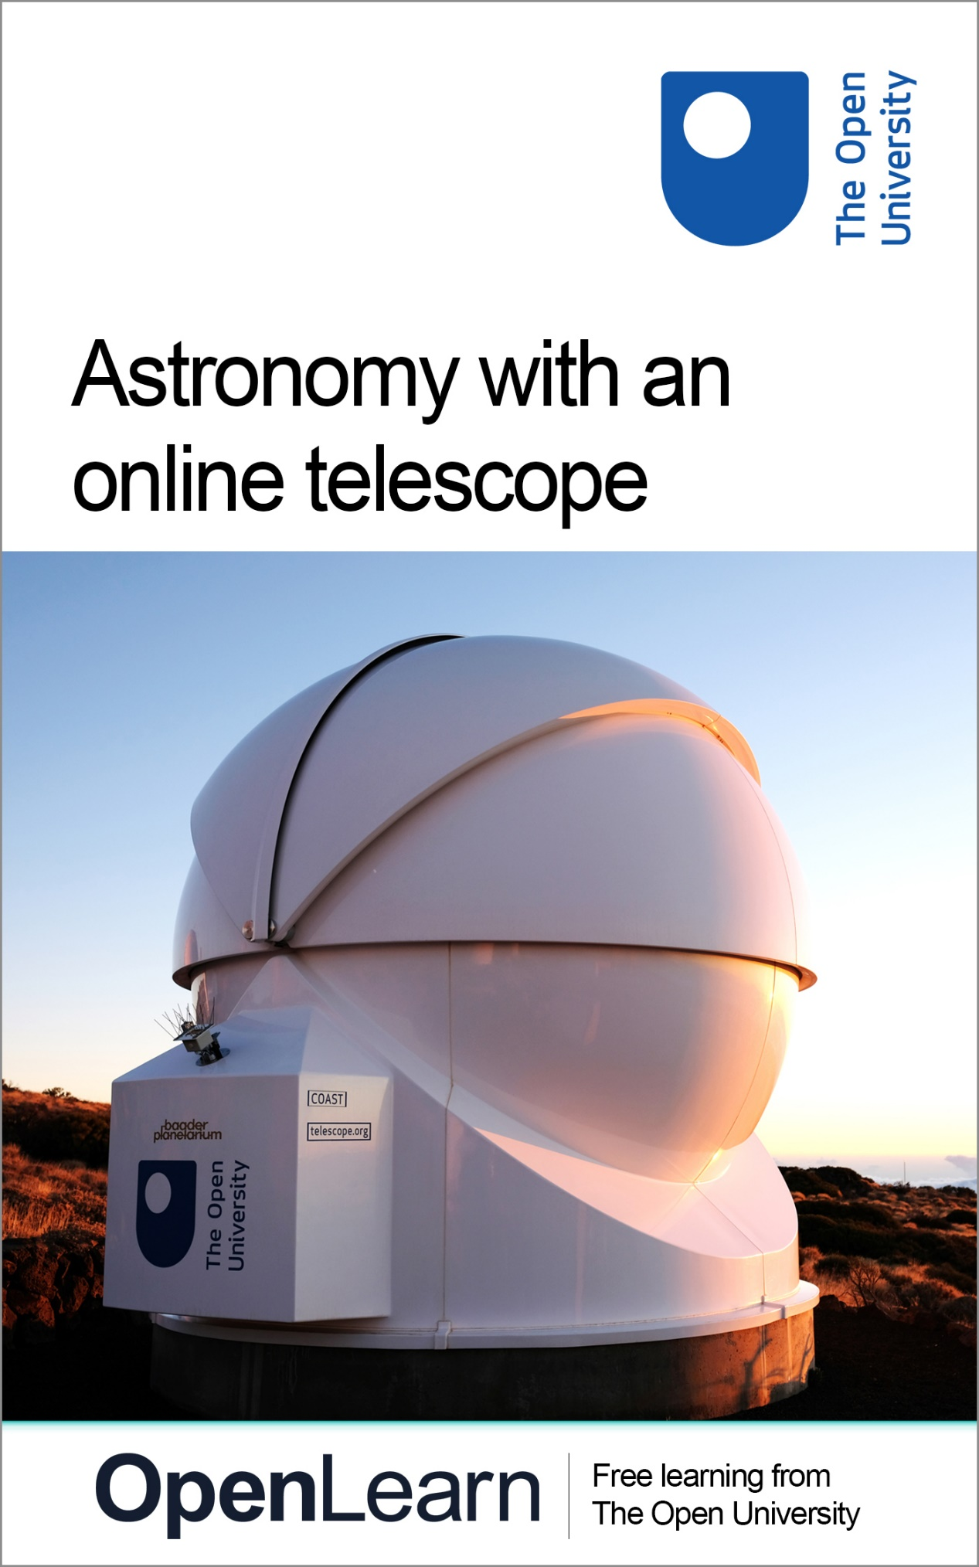

AOT_2

Astronomy with an online telescope

About this free course
This free course provides a sample of level 1 study in Health and wellbeing
www.open.ac.uk/courses/find/health-and-wellbeing
This version of the content may include video, images and interactive content that may not be optimised for your device.
You can experience this free course as it was originally designed on OpenLearn, the home of free learning from The Open University:
www.open.edu/openlearn/health-sports-psychology/exploring-sport-coaching-and-psychology/content-section-overview.
There you’ll also be able to track your progress via your activity record, which you can use to demonstrate your learning.
Copyright © 2017 The Open University
Copyright © 2017 The Open University
Intellectual property
Unless otherwise stated, this resource is released under the terms of the Creative Commons Licence v4.0 http://creativecommons.org/licenses/by-nc-sa/4.0/deed.en_GB. Within that The Open University interprets this licence in the following way: www.open.edu/openlearn/about-openlearn/frequently-asked-questions-on-openlearn. Copyright and rights falling outside the terms of the Creative Commons Licence are retained or controlled by The Open University. Please read the full text before using any of the content.
We believe the primary barrier to accessing high-quality educational experiences is cost, which is why we aim to publish as much free content as possible under an open licence. If it proves difficult to release content under our preferred Creative Commons licence (e.g. because we can’t afford or gain the clearances or find suitable alternatives), we will still release the materials for free under a personal end-user licence.
This is because the learning experience will always be the same high quality offering and that should always be seen as positive – even if at times the licensing is different to Creative Commons.
When using the content you must attribute us (The Open University) (the OU) and any identified author in accordance with the terms of the Creative Commons Licence.
The Acknowledgements section is used to list, amongst other things, third party (Proprietary), licensed content which is not subject to Creative Commons licensing. Proprietary content must be used (retained) intact and in context to the content at all times.
The Acknowledgements section is also used to bring to your attention any other Special Restrictions which may apply to the content. For example there may be times when the Creative Commons Non-Commercial Sharealike licence does not apply to any of the content even if owned by us (The Open University). In these instances, unless stated otherwise, the content may be used for personal and non-commercial use.
We have also identified as Proprietary other material included in the content which is not subject to Creative Commons Licence. These are OU logos, trading names and may extend to certain photographic and video images and sound recordings and any other material as may be brought to your attention.
Unauthorised use of any of the content may constitute a breach of the terms and conditions and/or intellectual property laws.
We reserve the right to alter, amend or bring to an end any terms and conditions provided here without notice.
All rights falling outside the terms of the Creative Commons licence are retained or controlled by The Open University.
Head of Intellectual Property, The Open University

Contents
- Introduction and guidance
  - Introduction and guidance
    - Telescope upgrade 2021
    - What is a badged course?
    - How to get a badge
- Week 1: The night sky
  - Introduction
  - 1 Finding your way around the sky using Stellarium software
    - 1.1 Installing Stellarium and getting started
    - 1.2 Setting your location
    - 1.3 Controlling how Stellarium displays the sky
  - 2 The apparent motion of objects in the night sky
    - 2.1 Our changing view of the sky
    - 2.2 First observations from Tenerife – the All-Sky camera
    - 2.3 Using Stellarium to understand the apparent motion of the sky
    - 2.4 Understanding how the sky changes with the seasons
  - 3 Mapping the night sky
    - 3.1 Two coordinate systems
    - 3.2 The Altitude-Azimuth system
    - 3.3 Equatorial celestial coordinates – right ascension and declination
    - 3.4 Using equatorial coordinates to locate objects
  - 4 This week’s quiz
  - 5 Summary of Week 1
- Week 2: Telescopes and visual observing
  - Introduction
  - 1 Observing with the naked eye
    - 1.1 Understanding dark adaptation
    - 1.2 Testing your own dark adaptation
    - 1.3 Observing the night sky with dark-adapted eyes
  - 2 Observing with optical instruments
    - 2.1 Binoculars
    - 2.2 Telescopes
  - 3 Observing from the Earth
  - 4 The COAST facility
  - 5 This week’s quiz
  - 6 Summary of Week 2
- Week 3: Stellar magnitudes
  - Introduction
  - 1 Brightness of the stars
    - 1.1 The magnitude scale
    - 1.2 Exploring the magnitude scale
    - 1.3 Estimating magnitudes by comparing stars
  - 2 Magnitude limits
    - 2.1 Magnitude limits and choice of observing site
    - 2.2 Estimating magnitudes from an image
  - 3 Your limits
  - 4 This week’s quiz
  - 5 Summary of Week 3
- Week 4: Imaging Messier objects with COAST
  - Introduction
  - 1 Messier objects
    - 1.1 The Messier catalogue
    - 1.2 The different types of Messier objects
    - 1.3 Messier objects in Stellarium
  - 2 Requesting your first image
    - 2.1 Planning your observations
    - 2.2 Register with COAST
    - 2.3 Requesting an image from COAST
  - 3 Collecting your first image
  - 4 This week’s quiz
  - 5 Summary of Week 4
- Week 5: The Sun and the stars
  - Introduction
  - 1 Continue observing with COAST
  - 2 The Sun as an ordinary star
    - 2.1 The Sun – some facts and figures
    - 2.2 The energy output of the Sun
    - 2.3 The mass, composition and structure of the Sun
    - 2.4 The age of the Sun
    - 2.5 Summary – properties of the Sun
  - 3 What powers the Sun and stars?
    - 3.1 The most famous equation in the world
    - 3.2 Nuclear fusion – the source of the Sun’s energy
    - 3.3 Estimating the Sun’s lifetime
    - 3.4 Midweek summary
  - 4 Comparing the Sun with other stars
  - 5 This week’s quiz
  - 6 Summary of Week 5
- Week 6: Classifying the stars
  - Introduction
  - 1 Refine and edit your COAST images
  - 2 Classifying stars – the Hertzsprung-Russell diagram
    - 2.1 The differing colours of stars
    - 2.2 Building the HR diagram
    - 2.3 Understanding the main sequence
  - 3 The masses of stars
    - 3.1 Measuring the masses of stars
    - 3.2 How the mass of a star affects its luminosity
  - 4 The lifecycles of stars
    - 4.1 The main sequence
    - 4.2 Stellar lifetime as a function of mass
    - 4.3 After the main sequence
  - 5 This week’s quiz
  - 6 Summary of Week 6
- Week 7: Variable stars
  - Introduction
  - 1 Stellar evolution after the main sequence
    - 1.1 Helium as a nuclear fuel
    - 1.2 Expansion and the red giant branch
    - 1.3 Tracks on the HR diagram
    - 1.4 The instability strip
  - 2 Variable stars
    - 2.1 Pulsating variables and their light curves
    - 2.2 Eclipsing variables
    - 2.3 Supernovae and cataclysmic variables
  - 3 Collaboration in observing
  - 4 Plan your own variable star observations using COAST
  - 5 This week’s quiz
  - 6 Summary of Week 7
- Week 8: Building a light curve
  - Introduction
  - 1 Retrieving your images
    - 1.1 File formats
    - 1.2 Save images in FITS format
  - 2 Measuring the brightness of your variable star
    - 2.1 Aperture photometry
    - 2.2 Reference stars
    - 2.3 Using finder charts to identify target and reference stars
    - 2.4 Aperture photometry
  - 3 Building the light curve
    - 3.1 View your results on the light curve
    - 3.2 Interpreting the light curve
    - 3.3 Request further images
  - 4 This week’s quiz
  - 5 Summary of Week 8
  - 6 Concluding thoughts
    - Tell us what you think
- References
- Acknowledgements
- Solutions

Introduction and guidance

Introduction and guidance
The Universe is filled with amazing objects, from stars and planets to distant galaxies, remnants of dead stars, and places where new stars and new solar systems are being formed. In this badged course, Astronomy with an online telescope, you will learn about some of these celestial objects and have the opportunity to take spectacular images using the remotely-operated COAST telescope facility in Tenerife. You will find out how telescopes and astronomical imaging equipment works, and learn how to get the most out of your own night-adapted vision. Finally, you will use your new skills to make scientific measurements of variable stars.
The course lasts 24 hours, with 8 ‘weeks’ of study. You can work through the weeks at your own pace, so if you have more time one week there is no problem with pushing on to complete a further study week. The eight weeks are linked to ensure a logical flow through the course and it will develop your confidence and skills for online study, whether this is to explore similar topics or part of your preparation for other study.
There will be weekly interactive quizzes, of which Weeks 4 and 8 will provide you with an opportunity to earn a badge to demonstrate your new skills. You can read more on how to study the course and about badges in the next sections.
After completing this course, you will be able to:
- understand how the apparent motion of the night sky is caused by the rotation of the Earth and the movement of the Earth in its orbit around the Sun
- understand how the human eye adapts to dark conditions and how to use dark adapted vision to its best effect when observing the night sky
- have an understanding of the different types of telescopes and the advantages of an observatory location at a remote site such as Tenerife
- understand how the positions of celestial objects are specified and be able to use this knowledge to predict when a given object will be visible in order to plan observations and make and collect images from the COAST telescope in Tenerife
- understand the processes by which stars shine and how they evolve and the causes of variability in stars.

Moving around the course
In the ‘Summary’ at the end of each week, you will find a link to the next week. If at any time you want to return to the start of the course, click on ‘Full course description’. From here you can navigate to any part of the course.
It’s also good practice, if you access a link from within a course page (including links to the quizzes), to open it in a new window or tab. That way you can easily return to where you’ve come from without having to use the back button on your browser.
The Open University would really appreciate a few minutes of your time to tell us about yourself and your expectations for the course before you begin, in our optional start-of-course survey. Participation will be completely confidential and we will not pass on your details to others.

Telescope upgrade 2021
Following an upgrade in the summer of 2021, the COAST telescope is now a 17 inch instrument as shown in Figure 1.

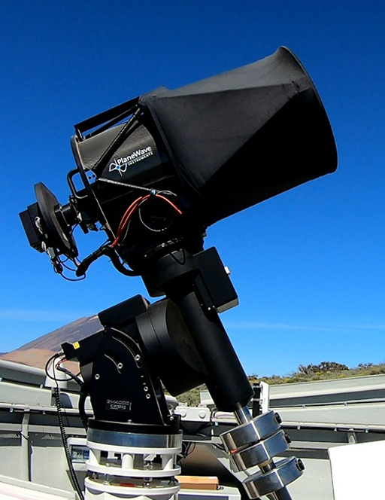
Figure 1 The upgraded COAST telescope and counterbalanced equatorial mount. The filter wheel and CCD camera attached to the back of the telescope can be seen on the left
View description - Figure 1 The upgraded COAST telescope and counterbalanced equatorial mount. The filter ...

The main optical component of COAST is a PlaneWave Instruments CDK17 17 inch (430 mm) f/6.8 Corrected Dall-Kirkham Astrograph telescope with a focal length of 2939 mm (https://planewave.com/product/cdk17-ota/). This optical design is optimised for imaging with a large format CCD (Charge Coupled Device) producing stunning images of extremely high quality.
Prior to the upgrade in 2021, COAST was fitted with a smaller 14 inch telescope of a slightly different design. As this is a recent upgrade, some of the images and videos in this course still show the original COAST telescope. Where relevant, text and technical details have been updated, but until they can be re-shot, the videos may refer to the previous telescope. This does not however affect any of the activities in the course itself.
More detailed technical information on the COAST telescope is available on the telescope.org website, which you will be introduced to in Week 4 of the course.

What is a badged course?
While studying Astronomy with an online telescope you have the option to work towards gaining a digital badge.
Badged courses are a key part of The Open University’s mission to promote the educational wellbeing of the community. The courses also provide another way of helping you to progress from informal to formal learning.
Completing a course will require about 24 hours of study time. However, you can study the course at any time and at a pace to suit you.
Badged courses are available on The Open University’s OpenLearn website and do not cost anything to study. They differ from Open University courses because you do not receive support from a tutor, but you do get useful feedback from the interactive quizzes.

What is a badge?
Digital badges are a new way of demonstrating online that you have gained a skill. Colleges and universities are working with employers and other organisations to develop open badges that help learners gain recognition for their skills, and support employers to identify the right candidate for a job.
Badges demonstrate your work and achievement on the course. You can share your achievement with friends, family and employers, and on social media. Badges are a great motivation, helping you to reach the end of the course. Gaining a badge often boosts confidence in the skills and abilities that underpin successful study. So, completing this course could encourage you to think about taking other courses.

How to get a badge
Getting a badge is straightforward! Here’s what you have to do:
- read each week of the course
- score 50% or more in the two badge quizzes in Week 4 and Week 8.
For all the quizzes, you can have three attempts at most of the questions (for true or false type questions you usually only get one attempt). If you get the answer right first time you will get more marks than for a correct answer the second or third time. Therefore, please be aware that for the two badge quizzes it is possible to get all the questions right but not score 50% and be eligible for the badge on that attempt. If one of your answers is incorrect you will often receive helpful feedback and suggestions about how to work out the correct answer.
For the badge quizzes, if you’re not successful in getting 50% the first time, after 24 hours you can attempt the whole quiz, and come back as many times as you like.
We hope that as many people as possible will gain an Open University badge – so you should see getting a badge as an opportunity to reflect on what you have learned rather than as a test.
If you need more guidance on getting a badge and what you can do with it, take a look at the OpenLearn FAQs. When you gain your badge you will receive an email to notify you and you will be able to view and manage all your badges in My OpenLearn within 24 hours of completing the criteria to gain a badge.
Get started with Week 1.

Week 1: The night sky

Introduction
Welcome to Astronomy with an online telescope. If you have ever looked up at the night sky and wanted to know more about the stars, galaxies and other celestial objects in the universe, then this course will help you to find your way around and develop a deeper understanding.

Video content is not available in this format.
View transcript - Uncaptioned interactive content

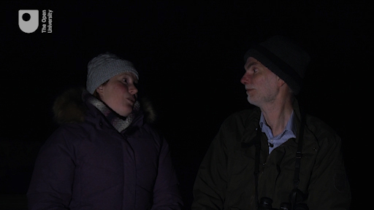

During the course you will have the opportunity to use a powerful telescope located in Tenerife to take your own images of some of these objects. This telescope, known as COAST, is one of two telescopes in Tenerife that form part of the Open University’s OpenScience Observatories.

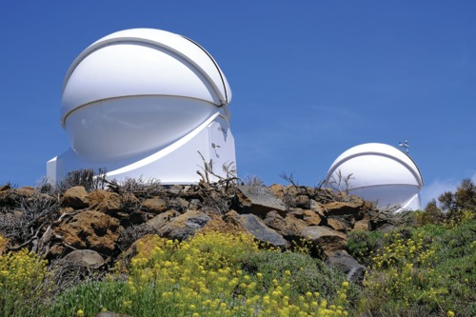
Figure 1 The COAST dome on Tenerife. This houses the 17-inch telescope that you will use in this course, requesting images remotely. The dome visible in the background houses PIRATE, another OpenScience Observatory telescope. Behind this second dome can be seen the top of the mast holding the all-sky camera and a number of other weather sensors and instruments.
View description - Figure 1 The COAST dome on Tenerife. This houses the 17-inch telescope that you will ...

The COAST telescope that you will be using sits alongside many professional instruments from around the world at the Observatorio del Teide in Tenerife. Dr Miquel Serra-Ricart, an astronomer from the Instituto de Astrofísica de Canarias (IAC) and administrator of the Teide observatory, gives an introduction to the site and to the various telescopes and facilities there.

Video content is not available in this format.
View transcript - Uncaptioned interactive content

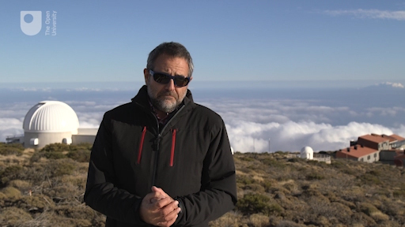

Throughout history people have studied the heavens, first with simple visual observation and then with the aid of optical instruments such as telescopes and binoculars. In recent times, computers and imaging technology have extended our ability to reach further into the Universe. You will learn to use all of these techniques as you work through this short course.
In this first week of the course you will start to find your way around the night sky with the aid of a powerful software package called Stellarium. This is a free-to-use program that provides a detailed representation of the night sky as seen from any location in the world. Using this software you will be able to identify the patterns of the constellations, understand the apparent movement of the sky with the seasons and throughout the night, and use the system of celestial coordinates to find and specify the position of individual objects in the night sky.
By the end of this week you will be able to:
- use Stellarium to identify a number of prominent stars and constellations
- use Stellarium to identify which celestial objects are visible from your location at any given time and date
- use Stellarium to identify which objects are visible from the location of the COAST telescope in Tenerife in order to plan your observations
- understand the use of celestial coordinates to find objects in the night sky and understand how these coordinates will be used later in the course to control the pointing of the telescope.

Course forum
Each week of this course has its own forum allowing you to communicate with the course authors and fellow participants to make connections, share ideas and ask questions.

1 Finding your way around the sky using Stellarium software
Stellarium is an extremely useful software package that contains information about thousands of stars together with other celestial objects such as planets, galaxies, the Sun and the Moon, and uses this information to display a realistic representation of the night sky as seen from any point on Earth at any specified date and time. Packages like Stellarium, which produce a display on your computer screen similar to that in a planetarium dome, are often referred to as planetarium software.

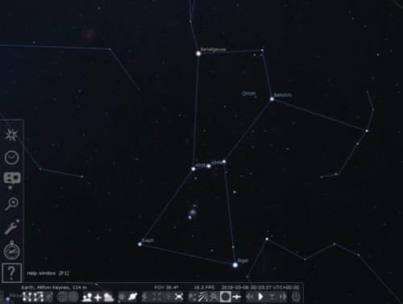
Figure 2 The Stellarium main screen, showing the two menu bars which can be made to appear by moving the cursor to the left side or bottom edge of the screen at the lower left corner. Credit: https://stellarium.org
View description - Figure 2 The Stellarium main screen, showing the two menu bars which can be made ...

Stellarium is produced by an independent team of developers and is free to install on most types of desktop and laptop computers. Versions are available for most popular operating systems without cost. There are also mobile versions for use on smartphones and other mobile devices, although there is a small charge for these.
In keeping with good practice in the software industry, Stellarium is updated frequently. The instructions in this course are based on Version 0.18.0. If you are using a later version, you should be aware that some of the controls and details may have changed – you can refer to the user guide supplied with Stellarium for details.

1.1 Installing Stellarium and getting started
Stellarium can be obtained from the main Stellarium website:
https://www.stellarium.org
This contains links to a selection of downloadable installation packages. Select the link that corresponds to your computer and operating system, and save the installation file to a known location on your computer. You should also download the user guide from the website – this is a PDF document containing detailed instructions on installing and running Stellarium.
Once downloaded, run the installer in the usual way for your computer. Follow the instructions on-screen. If you need further assistance with the installation, refer to the instructions in the Stellarium user guide.
Once installed, you will find a Stellarium icon on your desktop or in your Start or application menus, depending on your operating system. Use this in the usual way to start the Stellarium program. Again, you can refer to the User Guide for detailed instructions if needed.
When the program starts, you will see a full-screen display. Depending on the time of day, this will be a daytime scene or a night sky. To close the program and return to your desktop at any time you can use the Ctrl-Q or Command-Q key combinations depending on your operating system.
[ To obtain Stellarium for a smartphone or mobile device, visit your device’s app store. You should be aware that there is a small charge for the mobile version of Stellarium. ]

1.2 Setting your location

Video content is not available in this format.
View transcript - Uncaptioned interactive content

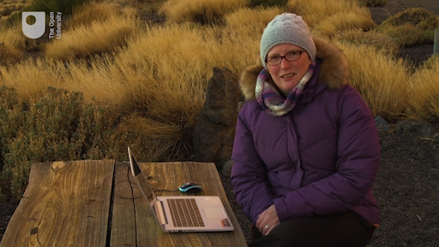

Stellarium can show what the sky will look like from any position on the Earth. From different points on the Earth’s surface, an observer would be looking in different directions out into space, meaning that the sky will look very different in Australia for example than it does in the United Kingdom. In order to get a view on the screen that corresponds to the sky where you are (or in Tenerife, where the COAST facility is located) it is important to specify the location.
Important: When started, the Stellarium software takes up the entire screen, covering up any other windows you may have open (including this website). On a desktop or laptop computer, you can use the F11 key to switch between full-screen and a windowed view of Stellarium. Alternatively, or if you are working on a mobile device, you may want to make separate notes or print out the instructions for each activity so that you can continue to work while the screen is filled with the Stellarium display.
Having started the software, the location you wish to use can be specified using the Location window.

Activity 1 Setting your location
Allow approximately 5 minutes

If you are planning to look at the night sky where you are, it would be best to set the location to your own home town or location.
For the main part of this module you will be planning and making observations using the COAST telescope in Tenerife. For this purpose it makes sense to set the location to Tenerife, as follows:
- Move your mouse to the lower left-hand side of the Stellarium screen. The main menu, consisting of a vertical line of icons, will appear.
- Click on the icon at the top of this menu (an eight-pointed symbol representing a compass rose) to open the Location window.

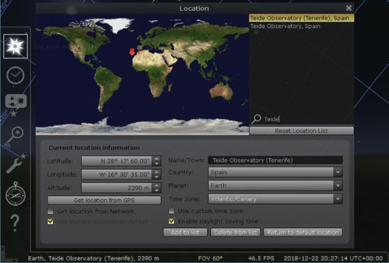
Figure 3 The Location window
View description - Figure 3 The Location window

- The right-hand side of the Location window contains a list of pre-set locations. To set the location of the COAST telescope, type ‘Teide’ into the search box (indicated by a magnifying glass symbol) and then select ‘Teide Observatory (Tenerife), Spain’ from the resulting list.
- Tick the box labelled ‘Use current location as default’ at the bottom left of the Location window. You can now close the location window using the ‘x’ at the top right.
Stellarium will remember the location and use it each time the program is started. Of course, you can also change the location as often as you like so when not working with COAST you may want to set the location to your home or favourite observing location instead.
Note: if you are using Stellarium on a mobile device some of these controls will be in a different place. Start by tapping on the six white squares in the lower left corner of the screen, and then the three-bar menu. This brings up the Settings menu from which you can adjust the location.

1.3 Controlling how Stellarium displays the sky
With your location set you can now start to take a look around you in the virtual world of the night sky. Using the Stellarium controls you can reveal the stars and constellations and experience the vibrant imaginations of the Ancient Greeks and the people, animals and objects that they devised.
To do this you can use the icons in the main toolbar at the bottom of the Stellarium screen.

Activity 2 Exploring the Stellarium display options
Allow approximately 5 minutes

You can configure the way that Stellarium displays the night sky by using the toolbar icons to switch various displays and overlays on and off.
- If the display shows a daytime scene, first adjust the time using the clock icon on the left-hand menu (directly below the Location window icon) until the night sky is shown.
- Move your mouse to the small strip of writing at the bottom of the Stellarium screen. The main toolbar, consisting of a horizontal line of icons, will appear.

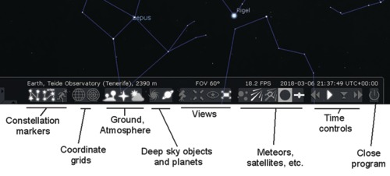
Figure 4 Main Toolbar
View description - Figure 4 Main Toolbar

- The first three icons on the left can be used to switch on displays of constellation lines, names of constellations, and artwork depicting the mythical creature or person representing each constellation. Each display can be switched off again by clicking the icon a second time.
- The next two icons control the display of grid lines for the two types of coordinate systems used to locate objects. These will be covered in detail later in the course.
- The three icons to the right of the grid line icons allow you to switch off the display of the ground, the cardinal points ((‘N, S, E, W’ labels) and to remove the simulated effects of the atmosphere. These can be useful for locating objects, but for most purposes you would probably want to leave these switched on.
Take a few moments to explore these options and how they affect the display. There are a number of other options further to the right of these, some of which you will explore later in the course.
Note: if you are using Stellarium on a mobile device some of these controls will be in a different place. Start by tapping on the six white squares in the lower left corner of the screen. This will bring up a selection of icons, including the ones described above.

2 The apparent motion of objects in the night sky
If you have ever spent any length of time looking up at the night sky you may have noticed that objects in the sky appear to move over time. Just as the Sun rises and sets during the course of the day, celestial objects such as the Moon, planets and stars will change position during the course of an evening.
In this section you will explore how our view of the sky changes with the daily rotation of the Earth and with its annual orbit around the Sun, using your own observations, Stellarium, and the All-Sky camera, which is part of the COAST installation in Tenerife.

2.1 Our changing view of the sky
The apparent motion of objects in the night sky is caused by the rotation of the Earth, which turns on its axis once every 24 hours. As a result of this rotation, the Moon and other objects as seen from the northern hemisphere will rise on the eastern side of the sky, reach their highest point in the south, and set towards the west.

Video content is not available in this format.
View transcript - Uncaptioned interactive content

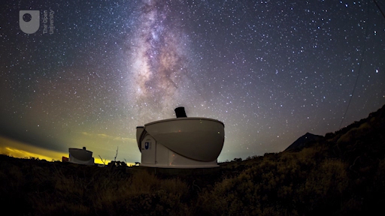

If you are lucky enough to have a clear view of the night sky from home or nearby, you may like to observe this motion by looking out at hourly intervals during a clear evening and noting the positions of a bright object such as the Moon or a bright star over a period of a few hours and follow its motion across the sky.
The Earth also moves in its orbit around the Sun, causing a slower change in our view of the night sky with the seasons. Each month, the side of the Earth facing away from the Sun faces out in a different direction into space. Over the course of a year objects will rise slightly earlier each evening, with the whole pattern of constellations taking twelve months to go through one complete cycle.

To view larger versions of diagrams on the course click ‘View larger image’ located underneath the figure on the left-hand side.

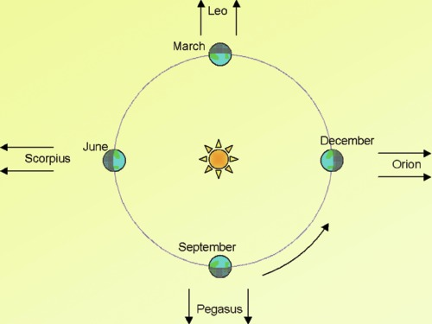
Figure 5 The Earth in orbit around the Sun. Different constellations will be visible at different times of year as the night side of the Earth looks out in different directions into space. Orion, for instance, will be visible in the winter months, but not in the summer.
View description - Figure 5 The Earth in orbit around the Sun. Different constellations will be visible ...

Of course not everyone will have access to a good viewing site, and the weather can also make observing difficult. Fortunately, much of the observing that you will be doing on this course will be done from the COAST observatory, which is high up and has a much higher likelihood of clear skies. It’s time for our first visit to Tenerife!

2.2 First observations from Tenerife – the All-Sky camera
For your first observations from Tenerife you will be using the Open University’s All-Sky camera located close to the dome that houses the COAST telescope itself. This camera is mounted on a pole, together with a number of other weather instruments that are used to assess the quality of the sky and weather in order to determine when it is safe to open the telescope dome. There are also webcams showing views of the site and of the telescopes inside the COAST and PIRATE domes.

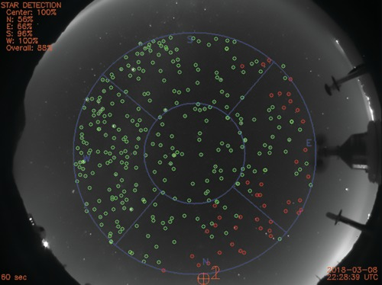
Figure 6 The All-Sky camera. Stars that are visible are marked in green. The red circles indicate stars that are not visible, perhaps because of cloud or mist towards the northern and eastern horizons.
View description - Figure 6 The All-Sky camera. Stars that are visible are marked in green. The red ...

As you can see from the image above, the All-Sky camera gives a rather odd view of the night sky. Because it uses a fisheye lens giving a very wide angle of view, the image from the camera captures the horizon all the way around the edge of the circular image and the sky directly overhead in the middle.
Marked in blue you can see the cardinal points – north, south, east and west - and you can check that the image is live by looking at the time and date noted in the bottom-right corner. The image updates every few minutes. Using these images, the observatory counts the number of stars it can see – marked by green circles – and gives a star detection percentage in the top-left of the screen for each region of the sky as defined by the blue lines.
In later weeks you can return to these webcams to check the weather and observing conditions for when you plan to take images. For now, you can use the All-Sky camera view to observe the apparent motion of the sky. As the Earth rotates, objects in the sky will move from right to left (or east to west) across the image during the course of a night.

Activity 3 Observing the apparent motion of the sky using the All-Sky camera
Allow approximately 5 minutes initially and then aim to follow up at hourly intervals during an evening

You can view a live image from Tenerife by visiting the telescope.org website. This is the website that you will also use later to request and collect images from the COAST telescope. For now you are going to look at the webcam feeds, which can be done without logging in or creating an account.
- Use the telescope.org link to visit the webcams page.
- On this page there are four webcam feeds, which can be selected using the Cameras panel below the main image. Click on each of the four cameras in turn to see live images from the site. Note that the view from the PIRATE and COAST internal cameras may appear dark as the telescopes inside the domes are not illuminated for much of the time.
- If you are viewing during the daytime in Tenerife the All-Sky camera view will not show any stars. You should aim to return after dark, preferably when you have time to check back several times during an evening.
- If the sky is clear, you should see green circles indicating stars that the camera has identified. Make a note of any clearly identifiable stars or patterns of stars so that you can check back later to see how they have moved. One way to do this would be to take a copy of the webcam image, which you can do by right-clicking on the image and selecting Save image as . . . Give the image a meaningful name and make a note of where you have saved it, so that you can find it later.
Come back to the webcam page at hourly intervals and repeat Step 4, noting how the pattern of stars has changed. If the sky has remained clear you should see a general movement from East to West, with some stars setting in the West and new stars rising in the East.

2.3 Using Stellarium to understand the apparent motion of the sky
You can also explore the nightly and the seasonal motions of the night sky using Stellarium. This is a useful exercise, as it will help you to understand how the objects in the sky move over the course of a night or from one night to the next so you can plan your telescope observations.
First, let’s look at how our view of the sky changes during the course of one night.

Activity 4 Basic navigation in Stellarium – space and time
Allow approximately 5 minutes

Within Stellarium you can navigate around the sky by simply clicking and dragging with the mouse (or with a finger if you are using a mobile or touchscreen device). As you do so, take note of the cardinal points marked in red on the horizon (‘N, S, E, W’) which denote the direction of view – north, south, east or west.
This clicking and dragging around the screen does not alter time, just your viewing direction. Time is actually already passing in Stellarium from the moment you start the program (you can see this in the information presented at the bottom of the screen). By default the program will initially display a view of the sky at the current time, so you may therefore have a daytime view if you are carrying out this activity during the hours of daylight in Tenerife.
To change the display to show the view of the sky at a different time:
- Move your mouse to the lower left-hand side of the Stellarium screen. The main menu, consisting of a vertical line of icons, will appear.
- Select the clock icon on the left hand menu and adjust the time in the resulting Date and timewindow until the night sky is shown. [ On a mobile device, select the three-bar menu and then the Date and time option.]

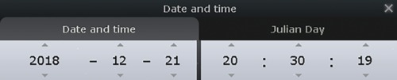
Figure 7 The Date and time window. This shows the year, month and day in the left-hand box and time in hours, minutes and seconds in the right-hand box. You can ignore the caption on the right that reads Julian Day.
View description - Figure 7 The Date and time window. This shows the year, month and day in the left-hand ...

- Using the Date and time window it is possible to adjust the year, month, day, hour, minute and second. Start by increasing the time in steps of one hour to see how the objects in the sky move during the course of an evening. Note where objects are rising or setting. How does this view compare with what you saw on the COAST All-Sky camera ?
- Try setting the date and time to midnight on the day you were born. Was there anything interesting in the sky?

2.4 Understanding how the sky changes with the seasons
In the previous activity, you looked at how the view of the sky changes during one night. This apparent motion of the sky is caused by the rotation of the Earth on its axis, once every 24 hours. As the Earth turns, you are looking in different directions out into space.
Now imagine a straight line drawn from the Sun through the Earth and extending out into space. Looking along this line out into space from the side of the Earth facing away from the Sun determines which part of the sky will be seen at midnight. As the Earth orbits around the Sun the direction of this line will change. This change is very gradual over one day, but in a month the direction changes significantly – by one-twelfth of a circle– and during the course of a whole year our view of the night sky will continue to shift, eventually coming back to the same view one year later – as was shown earlier.
You can use Stellarium to explore this seasonal change of the night sky.

Activity 5 Moving through the seasons
Allow approximately 10 minutes

Open Stellarium and set the time as before to give a night-time view of the sky. Note the position of a prominent constellation.
- Now use the Date and time window to move forward first by one day at a time, and note what happens to your chosen constellation.
- Next, use the Date and time window to move the view forward one month at a time. Note how the view changes month by month.
How many months does it take for the view to return to the position you first noted?

View answer - Part

- Use the Date and time window to change the date by one month. Note how the view changes. Then go back to the original date and change the time forward or backward hour by hour within one evening.
Within one evening how many hours does it take for the view to change by the same amount as it does when changing the date by one month?

View answer - Part

In this activity, you have seen how the view of the night sky changes with the time of night and the time of year. In the next section, you will look at two systems of coordinates that can be used to map the sky and locate objects precisely.

3 Mapping the night sky
With so many objects in the night sky, it will be useful to have a way of locating individual objects and describing where a particular object can be found.
This can be done using a coordinate system. You will probably be familiar with this idea when navigating on the ground where map coordinates or latitude and longitude can be used to specify a unique position on a map or on the Earth’s surface.
Celestial coordinate systems work on a similar principle, but also need to take account of the apparent motion of the night sky caused by the rotation and orbital motion of the Earth.

Video content is not available in this format.

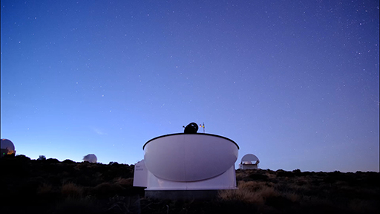

The apparent motion of the northern night sky seen above the PIRATE telescope. As the Earth turns on its axis the sky appears to rotate about the north pole star. This time-lapse sequence was shot over a period of three hours.

3.1 Two coordinate systems
The coordinate system that you will primarily use in this course is the Equatorial coordinate system. This is based on the concept of a celestial sphere which is attached to the sky rather than to the surface of the Earth. This equatorial system has coordinates known as Right ascension and Declination and is used for controlling advanced telescopes such as COAST and for specifying an object’s position uniquely.
We will also briefly consider a second system: the Altitude–Azimuth (Alt-Az) system. This is mostly used when working with simple telescopes but it is also useful for determining when an object is well placed for viewing from a given location. It is important to understand both systems as they serve different purposes, so we will look briefly at this Altitude-Azimuth system before considering the Equatorial system in more detail.

Why would it not be possible to use ground-based latitude and longitude coordinates to specify positions of celestial objects?

View answer - Activity

3.2 The Altitude-Azimuth system
Simple telescope mounts often operate in much the same way as a camera tripod, using a combination of side-to-side (horizontal) and up-and-down (vertical) movements. With these two motions it is possible to point a telescope in any direction in the sky.
The Altitude-Azimuth (or Alt-Az) system of coordinates works on this principle, assigning angles to these horizontal and vertical movements.
The altitude refers to the height of an object above the horizon, measured as an angle. If the object is on the horizon it has an altitude of zero degrees. If it is directly overhead (a point referred to as the zenith) then it has an altitude of 90 degrees.
The other coordinate is azimuth and this refers to the angle of an object moving clockwise from north around the cardinal points east, south and west back to north.

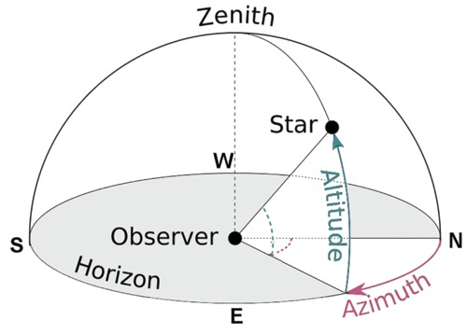
Figure 9 The Altitude-Azimuth system of coordinates specifies the position of an object in terms of two angles – the altitude above the horizon and the azimuth, which is the angle clockwise from north.
View description - Figure 9 The Altitude-Azimuth system of coordinates specifies the position of an ...

A good way to get a feel for the Alt-Az coordinate system is to display the coordinates in Stellarium. This can be done using the Azimuthal grid icon in the lower toolbar (look for a circular icon that looks a little like a dartboard).

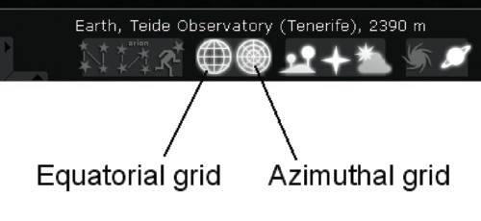
Figure 10 The Equatorial and Azimuthal grid icons in the Stellarium toolbar. Normally, you will want to have only one of these switched on at any time.
View description - Figure 10 The Equatorial and Azimuthal grid icons in the Stellarium toolbar. Normally, ...

In addition to being easy to use, one of the main benefits of the Alt-Az coordinate system is that it is very useful in deciding when an object is well-placed for viewing, since one of the coordinates (altitude) describes the height of an object above the horizon. The conditions for astronomical viewing are best when an object is at least 30 degrees above the horizon, clear of any haze and turbulence. The Altitude-Azimuth system makes it easy to determine this.

3.3 Equatorial celestial coordinates – right ascension and declination
While the Alt-Az system of coordinates has certain benefits and uses, it also has the disadvantage that the coordinates of a given object are not fixed – they change with time as the Earth rotates and will also be different for observers in different locations. This is because the Alt-Az grid is fixed relative to the ground at a particular location.
To describe the position of an object uniquely we need a system of coordinates that is fixed relative to the objects in the sky, rather than to a point on the Earth’s surface. This can be done using a system of celestial coordinates known as the Equatorial system. This system uses coordinates called right ascension and declination (often abbreviated to RA and Dec).
To find out about this system, let’s go back to Alan in Tenerife…

Video content is not available in this format.
View transcript - Uncaptioned interactive content

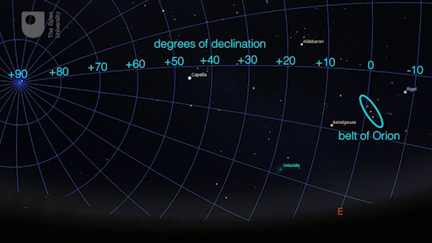

One way to visualise this system is to imagine the Earth at the centre of a great sphere on which all of the objects in the night sky and the RA – Dec grid system are drawn. This is known as the celestial sphere. In other words, rather than having a grid fixed relative to the observer, it is fixed relative to the objects in the sky and thus moves with them.

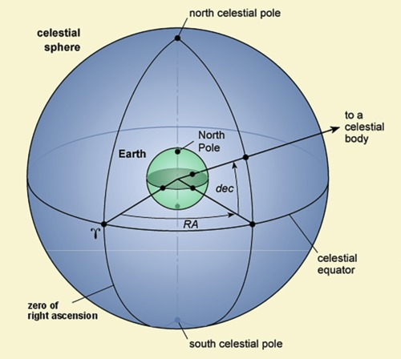
Figure 11 The celestial sphere. The RA and Dec coordinates specify the unique position of each celestial object. Importantly, these coordinates are defined relative to the sky and not the surface of the Earth, and so do not change as the Earth rotates.
View description - Figure 11 The celestial sphere. The RA and Dec coordinates specify the unique position ...

This system has the tremendous advantage of describing the location of an object in the sky to another observer in a way that will never change regardless of when or where they are looking at the time or location of observation. As before, you can explore this using Stellarium.

Activity 6 Equatorial coordinates
Allow approximately 5 minutes

Open Stellarium and set the time as before to give a night-time view of the sky. Turn off the Azimuthal grid by clicking the icon again and switch on the Equatorial grid using the icon immediately to the left of it.
- Select a bright star near the Eastern horizon. Although any star will do, try to pick one that has the name next to it (e.g. Altair or Aldebaran) – this will make it easier to follow as it moves across the sky.
- Now click on the star (or tap if you are using a touchscreen device). This will highlight the star and will also display information about it as text in the upper left hand corner of the screen. [On a mobile device the information will appear at the top of the screen: you may have to tap the triangular down-arrow to open up the full information.]
- Find the RA and Dec coordinates (look for a line beginning “RA/Dec (J2000.0)” or on a mobile device ‘RA/DE (of date)’.
- The ‘h’ and ‘m’ in the RA coordinate refer to hours and minutes of Right ascension. The ‘°’ and ‘ symbols in the Dec coordinate refer to degrees and arcminutes. There are 60 arcminutes in one degree, just as there are 60 minutes in one hour. In each case you can disregard the figures after these, which represent even smaller divisions.
- Watch for a few moments. You will notice that the coordinates do not change as time passes.
- Step forward one hour at a time and note what happens to the coordinates as the object moves across the sky.

In completing Activity 6 you will have found that the coordinates of your chosen celestial object do not change. The coordinate grid moves with the object, meaning that each object in the night sky has its own unique position described by the RA and Dec coordinates that is independent of where on the Earth or at what time it is observed.
This equatorial grid system based on the concept of a celestial sphere is therefore the one most commonly used in astronomy and is used on star charts and in astronomical catalogues, where each object will be listed with its own unique RA and Dec coordinates. This is also the coordinate system used to control telescopes such as COAST.
One minor exception to be aware of is that while the positions of stars and other distant objects such as nebulae and galaxies are fixed in the equatorial system, the coordinates of objects within our own solar system (such as the Moon, planets, comets and asteroids) will change as they orbit around the Earth or the Sun.

3.4 Using equatorial coordinates to locate objects
In addition to giving you an accurate view of the sky from any location, on any date and at any time, Stellarium is fundamentally a map of the night sky or a star chart.
You can therefore use Stellarium to find a specific object that you are interested in observing, and to determine whether it is visible or observable when you want it to be. This will be useful in planning your observations with COAST.
If you know the RA and Dec coordinates of a particular object, you can use the Equatorial grid in Stellarium to locate it. As an example, let’s try to find the Great Orion Nebula. This has a right ascension (RA) coordinate of 5h 35m and a declination (Dec) coordinate of – 5° 23’ (the negative value of the Declination coordinate indicates that the nebula is below the celestial equator).

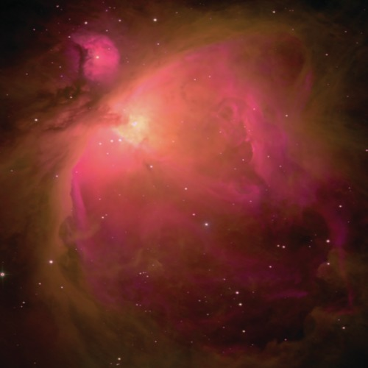
Figure 12 The Great Nebula in Orion, M42. This image was taken using the PIRATE telescope.
View description - Figure 12 The Great Nebula in Orion, M42. This image was taken using the PIRATE ...

Activity 7 Locating objects using equatorial coordinates
Allow approximately 5 minutes

Open Stellarium and set the time and date to 20:00 on 21st December. Make sure that you have the location set to the Teide observatory.
- Adjust the display by dragging until you are looking east (red ‘E’ cardinal point marker on the horizon).
What constellation can you see directly above the Eastern horizon?

View answer - Part

- To locate the nebula, turn on the equatorial grid and look for the RA lines labelled ‘5h’ and ‘6h’. You may need to zoom in a bit to see the labels. You can zoom using the + and – keys or the mouse wheel. On the mobile version, there are circular + and – buttons that you can use to zoom in and out.
- Since the nebula has an RA coordinate of 5h 35m it will lie approximately half-way between the ‘5h’ and “‘6h’ lines. Now look for the Declination line labelled “-5°” and follow it until it crosses the zone between the ‘5h’ and ‘6h’ lines. Since the Declination coordinate of the nebula is –5° 23’ it will be just below the -5° line.
- Once you have located the correct area, zoom in using the + key or button to find the nebula. More coordinate lines will appear as you zoom in, allowing you to pinpoint the exact location.

The desktop (and laptop) computer version of Stellarium also has a search tool that is really useful if you have the name or catalogue number of an object that you are interested in.
The search tool is in the main menu that appears when you move your mouse to the far left of the screen and is represented by a magnifying glass. In the Search window that appears type the name of the object you are looking for and press the magnifying glass symbol.
Stellarium will then take you to the object you are looking for and centre it on the screen.
[The search option may not be available on mobile versions of Stellarium but you can still find an object by using its equatorial RA and Dec coordinates.]

4 This week’s quiz
Well done – you have reached the end of Week 1 and can now take the weekly quiz to test your understanding.
Week 1 practice quiz
Open the quiz in a new tab or window (by holding ctrl [or cmd on a Mac] when you click the link) and come back here when you are done.

5 Summary of Week 1
In this first week:
- you have installed the Stellarium software and explored its displays and options
- you have used Stellarium to understand the apparent motion of the night sky
- you have learned about the two celestial coordinate systems (Alt-Az and RA/Dec) and the benefits and applications of each
- you understand how to use celestial coordinates to find an object and to know when a particular object is suitably placed for observation from your location or from the Teide observatory.
Next week you will have the opportunity to put some of your new observing skills to the test, to consider why and how telescopes are used to study the night sky and to take a first detailed look at COAST, our telescope on Tenerife.
You can now go to Week 2.

Week 2: Telescopes and visual observing

Introduction
We hope you enjoyed studying the first week of Astronomy with an online telescope. Course author Alan Cayless will now introduce the topics you’ll be studying in Week 2 of of the course...

Video content is not available in this format.
View transcript - Uncaptioned interactive content

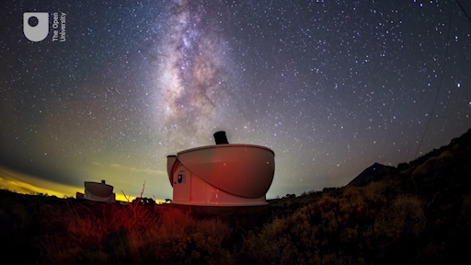

Now that you have installed the Stellarium software and started to navigate your way around the night sky it is time to consider the equipment that you can use to observe, and fully experience, some of the stunning objects the Universe has on offer.
The human eye is itself a remarkable optical system capable of amazing sensitivity under the correct conditions. You will therefore begin by considering how to make the most of your unaided vision for night-time observing. Some celestial objects are best experienced with the naked eye, but fainter objects will benefit from the use of binoculars or a telescope.
Whatever equipment you are using, one thing is certain: it is important to find the right place from which to observe the night sky. This week you’ll explore what makes a great observing site and you will get your first detailed look at the COAST facility on Tenerife.
By the end of this week you will be able to:
- understand how the human eye adapts to dark conditions and how to make the most of your dark-adapted vision for astronomical observations
- understand the need for telescopes with larger apertures and more sensitive detectors in order to collect more light and observe objects fainter than those that can be seen with the eye alone
- explain how telescopes work and how the primary element of a telescope captures and focuses light to produce an image that can be magnified by an eyepiece or captured using a camera or sensor
- understand how the Earth’s atmosphere can affect the quality of images formed by telescopes on the Earth’s surface and how the right choice of observing site can minimise these atmospheric effects
- understand the purpose of COAST’s size and location.

Course forum
Each week of this course has its own forum allowing you to communicate with the course authors and fellow participants to make connections, share ideas and ask questions.

1 Observing with the naked eye
The human eye is an amazing optical system which has evolved to operate in a wide range of conditions. Human vision is good at picking out moving objects at both high and low light levels. In bright daylight conditions the human eye also has an excellent ability to distinguish between subtle colour and brightness differences and to detect small objects. As light levels fall however, the eye needs to adapt to work in darker conditions, with less total light available to form an image.
In this section you will learn how your eyes adapt to dark conditions and how to use your adapted vision to its best effect for astronomical observing.

1.1 Understanding dark adaptation
By its very nature, astronomical observing takes place in darkness and many of the objects that you wish to view will be very faint, even when seen with the aid of a telescope or binoculars. It is therefore important to understand how your eyes adapt to these conditions and to know how to make the most of your night-adapted vision to get the best possible view of the night sky and the objects visible in it.
When light levels fall your eyes will respond in two ways: the first and more visible of these is that the pupil in your eye expands in order to admit more light. The second change takes place in the retina.

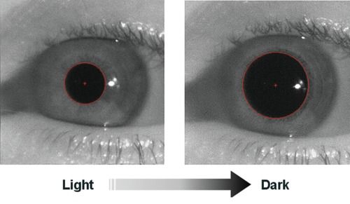
Figure 1 Comparing the size of the human pupil in bright and dark conditions. In these images from a medical scanner the pupil is outlined in red. In daylight the pupil is typically around 2 mm in diameter. In dark conditions the pupil expands to a diameter of approximately 5 mm in older adults and up to 7 mm in younger people, increasing the amount of light entering the eye by a factor of approximately ten times.
View description - Figure 1 Comparing the size of the human pupil in bright and dark conditions. In ...

The expansion of the pupil takes place quite rapidly – typically in a few seconds. If you remain in dark conditions for long enough a second, slower change takes place, this time in the retina, which is the light-sensitive surface inside your eye. Over time the retina responds by producing more of the light-sensitive chemicals, increasing its sensitivity to light. It can take up to 20 minutes for this process to happen so it is important to be patient and allow time for your eyes to become fully dark-adapted.
Once in this dark-adapted state your eyes can be up to 10,000 times more sensitive to light than in normal daylight conditions. Given that it takes this long for your eyes to fully dark adapt it is important to be careful with your night vision. In particular, exposure to bright light will rapidly reverse the adaptation, so to avoid spoiling your night-adapted vision and having to go through the process all over again, it is a good idea to pick an observing site away from roads and bright street lights.
For the same reason, you should avoid using a bright light to read your star charts or notes. Astronomers are familiar with the idea that red light affects your dark adaptation far less than white light, and for this reason it is a good idea to use a red-light torch to help you move around and read your star chart. A red rear bicycle light makes an excellent astronomy light, or you could fit a red filter over an ordinary torch.
For similar reasons you should also avoid looking at a bright computer or a mobile screen while observing. Turning the brightness down as much as you can will help, and Stellarium has a night mode function which turns the screen red to protect your night vision. You can turn this mode on and off using the ‘starry eye’ symbol in the secondary menu.

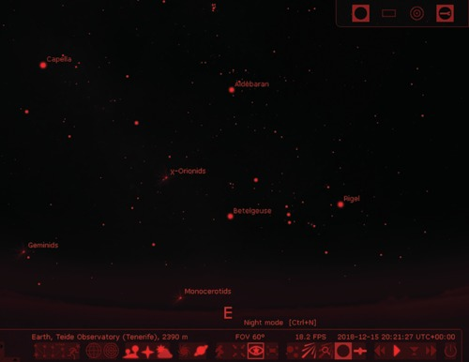
Figure 2 Stellarium in red night mode. The ‘starry eye’ icon used to activate this mode is highlighted.
View description - Figure 2 Stellarium in red night mode. The ‘starry eye’ icon used to activate this ...

Activity 1 Bright object in the sky
1 minute

What bright object in the night sky could affect your ability to see faint stars?

View answer - Activity 1 Bright object in the sky

1.2 Testing your own dark adaptation
With this understanding of how your eyes adapt to dark conditions you are now ready to try to make use of your night vision and to prepare for some observing. Firstly, there is a simple exercise that you can do at home on any dark evening.

Activity 2 Dark adaptation
Allow approximately 20 minutes

Before venturing outside to look at the night sky, you can try out the effects of dark adaptation in the comfort (and warmth) of your own home.
- First, find a room where you can sit comfortably without being disturbed for half an hour or so. Take a book and, if you have one, a red light torch.
- After dark, close any curtains and shut the door. Turn off any television and computer screens. With the lights on, read your book for a few moments. Your eyes are now in their normal daytime state.
- Now turn off all the lights and note how much you can see immediately after the lights go out. Until you can see clearly, it will be best to sit quietly to avoid tripping over or bumping into things (this is also a hazard to be aware of when working in telescope domes).
- Sit quietly for 10 to 15 minutes. Look around from time to time. You should find that you are able to see more as time progresses. Try reading your book – you may be surprised at how much your vision has improved. After 20 minutes your eyes should be fully dark adapted.
- Be prepared when switching the lights back on – they may initially seem very bright to fully dark-adapted eyes.

This exercise should have given you an idea of the power of dark adaptation and a little more confidence in your night vision for when you venture outside to look at the night sky. As long as you are patient to let your night vision develop and are careful to preserve it by avoiding bright lights, you should find that you are able to work quite effectively in much darker conditions than you may have previously supposed.

1.3 Observing the night sky with dark-adapted eyes

Video content is not available in this format.
View transcript - Uncaptioned interactive content

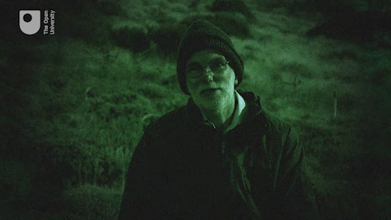

Now that you have a feel for how long it takes your eyes to adapt, it is time to take a look at the night sky. This activity involves a night-time observing session at a dark site.

Activity 3 Observing the night sky outdoors
Allow approximately 30 to 45 minutes plus travel time if necessary

A great way for you to test how good a particular observing site is and to directly see the effects of dark adaption on your vision is to count stars in a defined patch of sky.
Important: As with any outdoor activity, your safety is the most important consideration. If you are travelling to an observing site, take someone with you and make sure that someone else knows where you have gone and when you plan to return. This activity is optional and you should do it only if you have access to a site that is safe for you to use and that you are able to travel to and from safely.
- Your first challenge is to identify a good observing site, away from bright street and urban lighting. This might be your own garden or near your home but if you live in a large town or city you may need to go further afield.
- You may want to try the website: www.lightpollutionmap.info to help you to select a suitable site. By setting the ‘Light pollution overlay’ (in the top-right of the screen) to ‘VIIRS 2018’ you can see a great deal of localised detail for most areas of the world.
- Remember to think about how safe the location is. In addition to being safer, it can be more fun to go with friends. Avoid being near roads and consider whether you need to take some warm clothes, strong footwear and maybe a nice warm drink with you. Take care when moving about the site in the darkness. (All of this applies even if the site is your own garden!).
- Once you are at your chosen location identify a patch of sky to study. Depending on where you are and what time of year it is, different patches of sky will be visible but the area contained by Orion’s body or within the wing span of Cygnus are good examples. Remember, you can always use Stellarium ahead of time to help you to plan where to look.
- With your patch of sky identified make yourself comfortable. At five-minute intervals and for at least 30 minutes (so at least seven times) make a count of how many stars you can see in that patch. While waiting between counts remember to preserve your night vision by avoiding bright lights.
- You should find that you are steadily able to see more and more stars in your chosen patch of sky. This is evidence of your eyes undergoing the dark-adaption process. You may find it interesting to compare your star counts with the number of stars shown in the Stellarium display for the same part of the sky.

Now that you know how to get the best out of your own eyesight and to find a good observing site, it is time to think about other ways of improving your view of the night sky. As you shall see in the next section, this can be done by using optical instruments such as telescopes and binoculars to increase the amount of light gathered.

2 Observing with optical instruments
Optical instruments such as telescopes and binoculars work primarily by using lenses or mirrors with large apertures to collect more light than can pass through the opening of the pupil in your eye. Having more light to work with makes it possible to see fainter objects and also to magnify the image.
In this section you will consider the different types of optical instruments used for astronomy and look at the different types of telescope, including the COAST telescope itself. You will also look at astronomical imaging cameras and sensors, which are used for their improved sensitivity over that of the human eye.

2.1 Binoculars

Video content is not available in this format.
View transcript - Uncaptioned interactive content

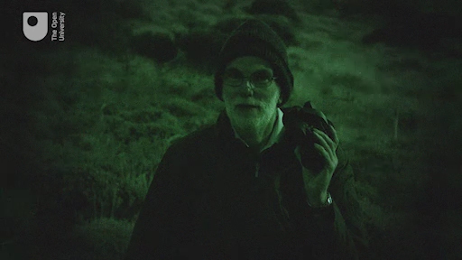

As mentioned in the video, a simple and cost-effective way of taking a big step forward is to use binoculars. You may already have a pair for sports or nature activities, or can perhaps borrow some from a friend or relative. Binoculars are often described in terms of their magnification and aperture (i.e. the diameter of the main objective lens). A typical pair may have a specification ofof 10 × 50, with the ‘10’ meaning that they magnify the image 10 times, and the ‘50’ indicating that the aperture of the objective lens on each side is 50 mm.

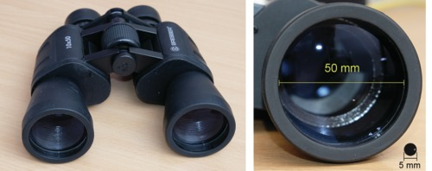
Figure 3 Left: a typical pair of 10 × 50 binoculars. Right: comparison between the 50 mm objective lens of the binoculars and the 5 mm pupil of a typical eye. With ten times the diameter, the binocular lens has 100 times the area of the pupil, capturing 100 times as much light as the eye.
View description - Figure 3 Left: a typical pair of 10 × 50 binoculars. Right: comparison between the ...

Activity 4 Observing with binoculars
Allow approximately 30 to 45 minutes plus travel time if necessary

If you have (or can borrow) a pair of binoculars then you can see the huge difference they make to your view of the sky. You will see far more detail when looking at any part of the sky, but for best results try scanning along the section of the sky that is visible through the thickest part of our own galaxy the Milky Way. As with Activity 2, the same safety considerations apply.
- To plan your observations, set Stellarium to your location (Activity 1 of Week 1 will remind you how to do this) by finding your nearest town or city in the list of preset locations or by using your latitude and longitude if you know them.
- Set the date and time to the time you plan to observe, then identify which of the following constellations Stellarium shows as being visible at that time: Auriga, Cassiopeia, Cygnus, Aquila, Scorpius, Crux, Vela and Monoceros. The Milky Way passes through all of these constellations so make a note of which ones are visible and where to find them in the sky.
- Now head back out to your chosen observing site and identify those constellations in the sky. If your site is dark enough and you allow your eyes time to become dark-adapted you may even be able to see the faint band of the Milky Way with your naked eyes.
- Now try looking at the same part of the sky with your binoculars – you should see many more stars than with your eyes alone.

Take a few moments to compare your views of your chosen areas of sky – using your eyes and with binoculars. What differences do you notice?

View answer - Part

2.2 Telescopes
The next obvious step up from binoculars is a telescope and these come in a wide variety of sizes and types as well as in different combinations of mirrors, lenses and mounting systems. The next video gives a brief introduction to the three most common types of telescope optics.

Video content is not available in this format.
View transcript - Uncaptioned interactive content

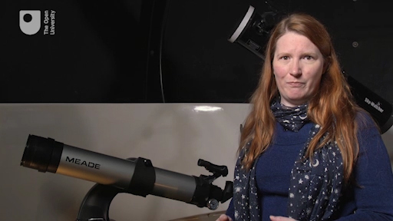

The main part of any telescope is the primary lens or mirror, often referred to as the ‘objective’. As Jo explains in the video, small telescopes often use a primary lens but larger telescopes, including COAST, use a curved mirror to collect and focus the light. This is because mirrors have numerous advantages: they are lighter and easier to manufacture than large diameter lenses; and they do not split the light into different colours, avoiding the problem of coloured fringes around bright objects (chromatic aberration) which can happen with glass lenses. The Hubble Space Telescope and all large observatory telescopes use mirrors rather than lenses for these reasons.
Whether a lens or a mirror, the purpose of the primary element of a telescope is to take all of the light coming into the telescope and focus it into a small area to form an image. For visual observing, this image is viewed through an eyepiece, and for capturing images the light will be focused onto an imaging sensor, which could be a digital camera or a specialised astronomical imaging device (often referred to as a CCD or Charge Coupled Device – essentially a very sensitive imaging sensor). Increasing the exposure time also increases the sensitivity: the photo-sensitive cells in the human eye collect light for only a fraction of a second before the signal is sent to the brain, whereas the pixels in a CCD can collect light over a much longer time, increasing the ability to detect very faint objects.

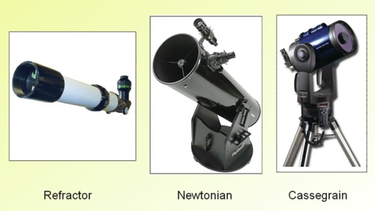
Figure 4 Some typical refracting and reflecting telescope designs.

Figure 4 shows some common telescope designs. In a lens-based (refracting) telescope the light is focused by a lens at one end of a tube, forming an image at the other end of the tube which can be viewed directly with an eyepiece or imaged with a camera or CCD sensor. In a reflecting telescope, the objective is a curved mirror, usually at the lower end of the tube. This mirror collects light entering the telescope and again focuses it to form an image. A second, smaller mirror (the secondary mirror) is often used to direct light into a camera or eyepiece, although in some cases an imaging sensor is placed inside the tube at the prime focus of the main mirror, where it receives the image directly.
The COAST telescope is of the Dall-Kirkham type, an advanced reflecting design where the secondary mirror directs the light back through a hole in the centre of the primary mirror and onto the imaging CCD, which sits at the back of the telescope.

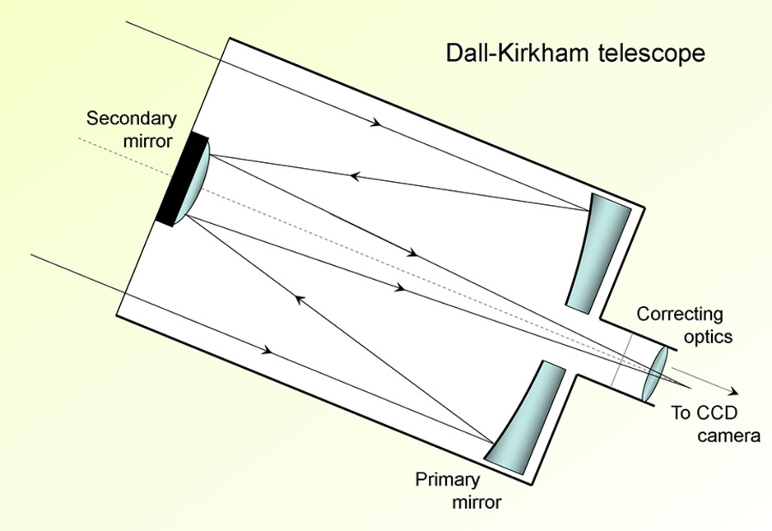
Figure 5 The Dall-Kirkham telescope. In this type of telescope a curved secondary mirror at the front of the telescope reflects light back through a hole in the main primary mirror where additional optics deliver a highly-corrected image to a camera fitted at the rear of the telescope.
View description - Figure 5 The Dall-Kirkham telescope. In this type of telescope a curved secondary ...

Whatever the design of the telescope, remember that the main purpose is to collect as much light as possible in order to view or take images of very faint objects. In the quest to observe ever fainter and more distant objects telescopes of ever increasing apertures are being constructed and planned, with the largest land-based optical telescopes having mirrors of up to ten metres in diameter!

3 Observing from the Earth
By now you will have had the chance to see for yourself the importance of waiting for your eyes to adapt to the dark and the benefits of getting away from light pollution. You may also have seen the effect that binoculars have on your ability to observe fainter objects and therefore to see more objects in the sky.
But these are not the only considerations in obtaining the very best view of the stars. The Earth’s atmosphere is an equally important part of the overall optical system from object to telescope to eye or camera. On its journey from a distant object such as the Orion nebula, light may travel for hundreds or thousands of year through empty space with very little disturbance, but on the last few tens of kilometres of its journey it has to pass through the Earth’s atmosphere on its way to your eye or your telescope.
Sometimes clouds in the atmosphere can prevent us from seeing the stars at all, but even on a clear night you have probably sometimes noticed the twinkling of the stars. This is the result of non-uniformities and turbulence in the air deflecting the light slightly. Through a telescope these small deflections are magnified, causing the image to appear to shimmer and move about. The atmosphere is also never completely transparent – dust and water vapour in the air can absorb some of the light, reducing the brightness and contrast of the image.
In order to avoid interference from light pollution and the disturbances of the atmosphere almost all professional telescopes are sited well away from populated areas and high up mountains or, in the case of COAST, on a volcano, as Miquel Serra-Ricart, administrator of the Teide Observatory explains.

Video content is not available in this format.
View transcript - Uncaptioned interactive content

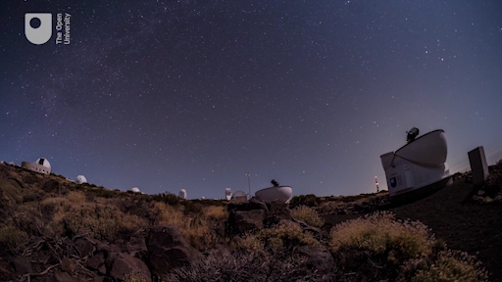

4 The COAST facility

Video content is not available in this format.
View transcript - Uncaptioned interactive content

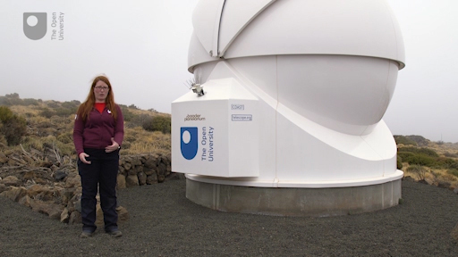

As Jo describes in the video, the Open University has two telescopes supported by other instruments at the Teide Observatory. The weather station is by far the most important of these supporting facilities. With no one on site, it is important to know what the weather conditions are at the observatory and to determine when it is safe to open the domes and allow the telescopes to take observations and when to protect them in adverse weather.
The weather station itself monitors the outside weather conditions (temperature, humidity, wind speed, wind direction, cloud base, rain and light level) as well as the temperature and humidity inside both the PIRATE and COAST observatory domes. All of these parameters ensure that the telescopes and their associated equipment are kept in safe conditions and allow the automated system to protect equipment should it start to rain. Other factors such as humidity and wind speed are also monitored and the domes will close should these exceed safe limits. The system is also programmed to open the domes only during the hours of darkness.
As Jo explains, the larger of the two telescopes at our site is PIRATE – a reflecting telescope with a 24-inch (610 mm) primary mirror mounted inside a 4.5-m clam-shell dome. The telescope you shall use in this course is the slightly smaller COAST, which has a 17-inch (430 mm) main mirror and is installed inside a 3.5-m clam-shell dome. Both of these telescopes are equipped with sensitive CCD cameras allowing imaging of very faint objects. Collectively these telescopes, domes and other equipment are known as the OpenScience Observatories.
Both telescopes are mounted on computerised equatorial mounts, which can be controlled precisely to point with extreme accuracy to any part of the night sky and track the motion of objects across the sky as the Earth rotates, making long exposure images possible. Being remotely operated over the internet, all of the operations of pointing, tracking and imaging can be controlled through a website interface. In the next two weeks you will learn how to use the telescope.org website to operate the COAST telescope and be able to take your first images.

5 This week’s quiz
Well done – you have reached the end of Week 2 and can now take the weekly quiz to test your understanding.
Week 2 practice quiz
Open the quiz in a new tab or window (by holding ctrl [or cmd on a Mac] when you click the link) and come back here when you are done.

6 Summary of Week 2
This week you have learned about how your eyes can adapt to the dark and how to use the sensitivity of your night vision to best effect in observing the night sky. You have also discovered how using optical instruments to collect more light can allow you to see more and fainter objects.
You have seen how telescopes work, and understand why mirrors rather than lenses are used as the primary imaging elements in large telescopes such as COAST.
Finally, you have learned about the effects of the Earth’s atmosphere in order to understand why telescopes such as COAST are often located at remote sites above the most turbulent layers of the atmosphere.
Next week you will look in more detail at how to plan your observations and in particular at how the brightness of objects is measured so that you can tell whether you need just your eyes, binoculars or a telescope to observe them. You will then have everything you need to move forward and use the COAST telescope for the first time.
You can now go to Week 3.

Week 3: Stellar magnitudes

Introduction
Last week discussed the importance of waiting for your eyes to dark adapt when you observe the night sky and also the importance of a good observing site for getting the best out of your view. You also saw how using optical equipment such as a pair of binoculars or a telescope to collect more light can greatly add to the number of objects you can see.
This week you will explore how the brightness or (in astronomical terms) the magnitude of an object affects your ability to see it with your eyes, and with binoculars and telescopes. This knowledge will be really useful in planning the imaging that you will undertake next week with COAST as it will help you to determine exposure times and decide which objects to target in order to obtain your own beautiful astronomical images.

Video content is not available in this format.
View transcript - Uncaptioned interactive content

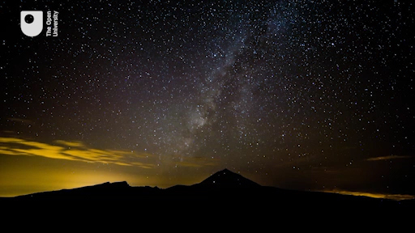

By the end of this week you will be able to:
- understand the astronomical magnitude scale and how it relates to the brightness of stars as viewed from Earth
- analyse the magnitude limits of COAST and other instruments
- discuss the faintest object you can observe with the naked eye.

Course forum
Each week of this course has its own forum allowing you to communicate with the course authors and fellow participants to make connections, share ideas and ask questions.

1 Brightness of the stars
One of the first things that you may have noticed when looking at the stars is that some are brighter than others.
The brightness of a star is referred to as its magnitude and uses a scale based on a classification initially devised by the ancient Greek astronomer Hipparchus who produced one of the first star catalogues. Hipparchus grouped the stars into six categories, from the brightest visible to the naked eye to the faintest. The brightest stars he classified as first magnitude, the next group of slightly fainter stars as second magnitude, and so on down to sixth magnitude for the faintest stars visible to the naked eye. This system was later refined by Ptolemy and by Galileo and is still in use today, having been extended to include far fainter objects visible only in telescopes.

1.1 The magnitude scale
If you have been able to make your own observations of constellations such as Orion you will have seen the main outlines of the constellation marked out by first and second magnitude stars, which are bright enough to be seen even from a site with some light pollution. In order to see the far fainter fifth and sixth magnitude stars in the constellation, you would need to be located at a good dark observing site with clear skies and to have your eyes fully dark adapted. Faint stars are more numerous than bright stars in the sky, and at a really dark site such as the observatory at Tenerife, so many stars are visible on a clear night that it can actually be difficult to make out the constellations!

To view larger versions of images on the course click ‘View larger image’ located underneath the figure on the left-hand side.

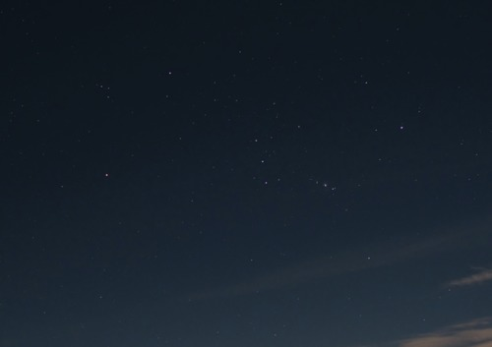
Figure 1 The constellation of Orion, as seen from the Teide observatory. The four bright stars at each corner and the three stars of Orion’s belt range from magnitude 0.15 (Rigel) to magnitude 2.4 (Mintaka). Many fainter stars can be seen within and around Orion, with brightnesses ranging from third to sixth magnitude.
View description - Figure 1 The constellation of Orion, as seen from the Teide observatory. The four ...

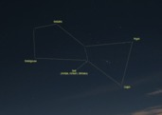
Figure 1a An annotated diagram of the constellation of Orion
View description - Figure 1a An annotated diagram of the constellation of Orion

The original scale of magnitudes devised by Hipparchus was a simple classification into six groups of bright, fainter and faintest visible stars. Today, telescopes and scientific instruments can be used to measure the actual brightness of each star very precisely and so the magnitude scale has been given a mathematical basis and extended to cover objects far fainter than can be seen with the naked eye. On this numerical scale magnitude 1 stars are very bright and magnitude 6 stars very faint, as before. With accurate measurement stars can be given values in between, such as magnitude 2.7 for a star that is fainter than magnitude 2 but brighter than magnitude 3. (This may at first seem the wrong way round, with brighter stars having smaller magnitude numbers than fainter ones but as you get familiar with the scale you will soon get used to it.)
How bright a star appears as seen from the Earth depends on two things: the intrinsic brightness of the star (in other words, its total light output) and how far away the star is. A star of a particular intrinsic brightness further away from the Earth will appear fainter than a star of the same intrinsic brightness closer to the Earth because of the extra distance.
This course is concerned mainly with brightness as seen from the Earth which is referred to as the apparent magnitude, because it includes the effect of distance.
As one of the first people to use a telescope good enough for astronomical observations, Galileo extended the scale to include stars too faint to see with the unaided eye. Faint stars visible only in telescopes have magnitudes of +7, +8, and so on, with large telescopes such as COAST able to detect very faint stars of magnitudes up to +16. Larger observatory telescopes such as the Gran Telescopio Canarias and the Hubble telescope are able to go even fainter.
The scale has also been extended in the other direction – when placed on an accurate numerical scale some very bright stars turn out to be brighter than magnitude +1, and have been given values of zero or even negative magnitude values! On this scale Sirius, the brightest star in the sky, has a magnitude of –1.45.

Activity 1 Brightness of Sirius
Allow approximately 5 minutes

What reasons can you think of to explain why Sirius appears so bright as seen from Earth?

View answer - Activity 1 Brightness of Sirius

1.2 Exploring the magnitude scale
To explore the magnitude scale in more detail, let’s take a look at where some familiar objects appear on the scale.

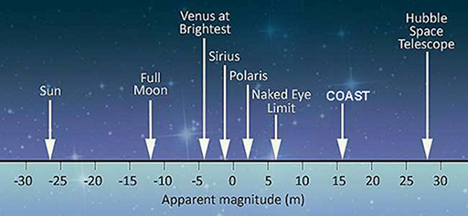
Figure 2
View description - Figure 2

In Figure 2, the magnitude scale has been extended to include objects far brighter than the stars – including Venus, the Moon and the Sun. Being extremely bright, these have very large negative magnitude numbers.
In order to cover such a wide range of brightness, the magnitude scale works on a logarithmic principle. This is a mathematical term meaning that each step along the scale multiplies the brightness by a certain amount, rather than simply adding a fixed amount. Specifically, a change of five magnitudes represents an increase or decrease of 100 times in the brightness – so that for example, a magnitude +1 star is one hundred times brighter than a magnitude +6 star.
Breaking this down into individual steps along the scale a change of one magnitude is equal to an increase or decrease of approximately 2.5 times in brightness.
[Many other scales work on this logarithmic principle in order to cover a wide range – the Richter scale for earthquakes and the decibel scale for intensity of sound are two other examples of logarithmic scales. In both cases, each step along the scale represents a multiplication in the value being measured.]

Activity 2 Caculating the difference in brightness of stars
Allow approximately 5 minutes

Two stars have magnitudes of +2.0 and +4.5 – a difference of 2.5 magnitudes.
How many times brighter is the magnitude +2.0 star than the magnitude +4.5 star ?

View answer - Activity 2 Caculating the difference in brightness of stars

1.3 Estimating magnitudes by comparing stars
Although they are harder to see there are far more faint stars in the night sky than bright ones, as you may have noticed when out under the stars with dark-adapted eyes.
While there are only a handful of stars of magnitude +1 or brighter (including Sirius) there are many thousands of fainter stars. Including stars up to magnitude +6, there are approximately 5000 stars visible to the naked eye across the whole of the night sky. Since these are spread across the whole sky, perhaps half of these will be visible at any given time and location.

Activity 3: Estimating magnitudes
Allow approximately 30 to 45 minutes plus travel time if necessary

Although magnitudes can be measured precisely using sensitive detectors and instruments it is relatively easy to estimate magnitudes visually by comparing stars. If you are able to get out to a dark observing site, you can try this for yourself. If not, you can use the image of Orion in Figure 1 to do a similar thing following the same steps to estimate the magnitudes of stars in the image before checking the exact values reported by Stellarium.
- First, use Stellarium to select a prominent constellation that will be visible at the time you intend to do this activity.
- Click (or tap) on each of the main stars in the constellation in turn and make a note of the magnitude value reported by Stellarium. These will be your reference stars.
- Now head out to your observing spot, remembering to stay safe, and to use a red torch to look at your notes! Make sure that you can see your chosen constellation and identify the reference stars whose magnitudes you have noted.
- Now pick another star nearby whose magnitude you wish to estimate. Compare the brightness of this star with your reference stars – is it brighter, or fainter? Ideally, you will want to compare against two references – one brighter and one fainter, although this is not always possible. [If you are not able to go outside you can do this and the subsequent steps in the same way using Stellarium and the Orion image from Fig 1 – pick a target star in the image and compare with your reference stars, then check the value against your estimate.]
- If you have a comparison star either side you can refine your estimate by deciding whether your target star is midway in brightness between the two, or whether it is closer in brightness to that of the brighter or the fainter star. For instance, if you had comparison stars at +3 and +4 magnitudes and you felt that the target star was two-thirds of the way from the fainter star to the brighter, this would give an estimated magnitude for your target star of about +3.3.
- Check your estimated magnitude in Stellarium by clicking on your target star. Don’t worry if you haven’t got it exactly right - this technique takes some practice but is a very useful skill to have for observing with the naked eye, through binoculars or with a telescope. If you have time and can try a few more you should find that your estimates improve with practice.

Until the development of photography and digital imaging magnitudes were always estimated by eye in this way. Using modern technology the brightness of stars can be measured very accurately from digital images or with sensitive instruments, and magnitudes determined very precisely.

2 Magnitude limits
The concept of a magnitude limit is a numerical means of assessing the quality of the sky and the capabilities of the equipment you are using.
In theory instruments such as binoculars and telescopes with increasingly larger apertures collect more light allowing them to detect fainter and fainter objects.
However, as you have seen the Earth’s atmosphere forms an important part of the overall imaging system and the quality of the sky – in particular the transparency of the air and amount of stray light at a particular site – can limit the ability to see and to detect very faint objects. This can vary with height above sea level and also with the weather conditions on any particular observing evening.
In this section you will explore what makes Tenerife such a good observing site, explore the capabilities of the COAST telescope and imaging sensor (CCD camera), and find out how to estimate magnitudes of stars from astronomical images.

2.1 Magnitude limits and choice of observing site
Taking factors such as stray light and transparency of the air into account, the magnitude of the faintest object that can be detected using a particular instrument at a particular location is referred to as the limiting magnitude for that site. This goes some way to explaining the choice of a mountainside on Tenerife as the site for COAST; being 2400-m above sea level means that COAST is above a large part of the Earth’s atmosphere. A telescope the size of COAST can see fainter objects from a clear site like the observatory in Tenerife than it would at ground level – in other words, it has a fainter limiting magnitude.
In this next video Alan reminds us of the importance of dark adaptation and a clear observing site and compares what can be seen with dark-adapted eyes and with binoculars, before considering the benefits of larger instruments such as COAST. (Note: since this video was shot, COAST has been upgraded. The new dimensions are stated in the paragraph below. )

Video content is not available in this format.
View transcript - Uncaptioned interactive content

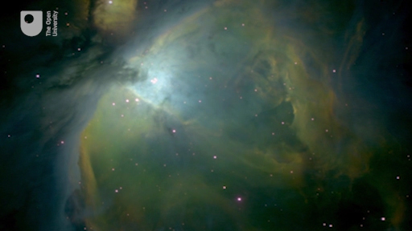

The theoretical magnitude limit of any instrument can be calculated providing you have knowledge of the diameter of the mirror or lens. However, as noted earlier, the actual limiting magnitude also depends on the conditions at the observing site.
For COAST with a primary mirror aperture of 430 mm the theoretical limiting magnitude would be approximately +16 if fitted with an eyepiece for visual observing. However, COAST is fitted with a sensitive CCD camera which by using long exposure times can collect more light and detect even fainter objects than this.

2.2 Estimating magnitudes from an image
In the previous activity you estimated magnitudes visually by looking at stars in the real sky or using the image of Orion in Figure 1. This time the challenge is to match stars in an image against Stellarium and to estimate the magnitude of the faintest stars that you can identify. To do this, you will be taking our first look at an actual image from COAST.

Activity 4: Estimating magnitudes from a COAST image
Allow approximately 20 minutes

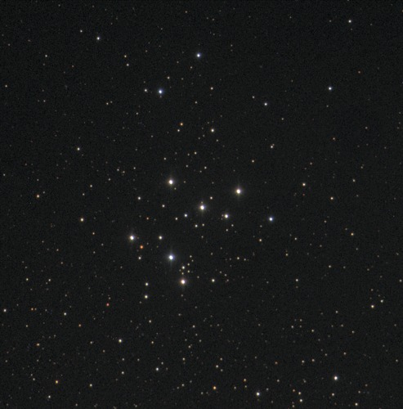
Figure 3 An image of Open Cluster M29 from COAST.

- In this image you can see a group, or cluster, of stars referred to as Messier 29 or M29. This is an open star cluster so the stars are well separated, allowing you pick out individual stars.
- The aim of this activity is to identify a number of prominent stars in the image and to find their magnitudes using Stellarium and then to use these as a reference to estimate the magnitudes of other stars in the image.
- First, to find the cluster, start up Stellarium and set the date and time to 20:00 on the 21 December, making sure that you have the location set to the Teide observatory. Now use Stellarium’s search function to find M29, and zoom in until the field of view (FOV) displayed at the bottom of the screen indicates a field of view of about 0.4°
- Adjust the zoom, keeping the cluster of stars in the centre of the screen, until the separation and distribution of the brightest stars approximately matches that in the image above. By clicking on stars in the Stellarium image you will find that detailed information is available for nine of the cluster’s stars. Check that you can identify each of the nine brightest stars in both the Stellarium display and the COAST image, in each case finding the corresponding star in both images.
[You may notice that the Stellarium display only shows a detailed image for the central part of the cluster. In the outer part of the cluster the COAST image is more detailed, showing more of the fainter stars than Stellarium. If you are using a tablet or mobile phone you may see fewer than nine stars.]
- Now look at the COAST image and try to decide which of your nine sample stars is the brightest and which is the faintest. Make a note of these. How hard is it to put them in order from brightest to faintest? What do you notice about the colour of these stars? If you have a good computer monitor, can you say which of the sample stars are bluer and which appear a little more red?
- Once you are comfortable with your own assessment of the sample stars in the COAST image, go back to the image in Stellarium and make a note of the magnitude values it gives for each star. What was the difference in magnitude between the brightest and faintest stars ? Is the star with the smallest magnitude the one which you identified as brightest in the COAST image? Don’t worry if your ordering of the sample stars using the naked eye does not exactly agree with the given values.
- Note that Stellarium only shows data for stars up to about magnitude 10. The COAST image contains many far fainter stars, indicating that COAST’s sensitivity goes well beyond magnitude 10. You may also have noticed that the colours of the stars are clearer in the COAST image.
You have now reached the limits of what can be done in Stellarium in terms of measuring fainter stars. In the second half of this course (Weeks 5 to 8) you will learn to use some additional tools in order to analyse COAST images in more detail as part of the variable star investigation, but for now you have seen how to match stars in an image from the telescope against those displayed in a reference image and carried out your first analysis of a real image from COAST.

3 Your limits
It is also important to be able to understand and measure your own limiting magnitude when observing with the naked eye and with any equipment you may own. So, for the final activity this week you will have the opportunity to design your own experiment.

Activity 5: Estimating your limiting magnitude
Allow approximately 30 to 45 minutes

Your objective for this activity is to:
- determine your limiting magnitude when observing with the naked eye from a variety of locations.
- (as an extension activity) determine your limiting magnitude when observing with binoculars and / or a telescope from a variety of locations.
If you have access to a safe observing site and clear weather, try to estimate the magnitude of the faintest stars that you can see. Use your knowledge of dark adaption, what makes a good observing site, how to compare stellar magnitudes and how to match objects with Stellarium to determine their magnitude in order to help you determine your limiting magnitude.
You may find it useful to try a few different locations on a few different nights to see how light pollution and sky quality affect your ability to see faint objects. Remember to make notes of your results as they will be useful to you throughout this course and beyond, as you do more observing.
If you are lucky enough to have access to a really dark observing site, give your eyes time to fully dark adapt and try to look for the Milky Way.
If you are not able to get outside, try estimating the magnitude of the faintest stars that you can see in the image of Orion from Figure 1, matching each star up with the same star displayed in Stellarium to check its magnitude.

4 This week’s quiz
Well done – you have reached the end of Week 3 and can now take the weekly quiz to test your understanding.
Week 3 practice quiz
Open the quiz in a new tab or window (by holding ctrl [or cmd on a Mac] when you click the link) and come back here when you are done.

5 Summary of Week 3
This week was the final piece of the puzzle you needed to enable you to go on and take some of your own images with COAST. Over the last three weeks you have learned how to use Stellarium, discovered how the sky is mapped and understood how the rotation of the Earth causes the apparent motion of the sky. You’ve looked at different types of telescope, met COAST and thought about why telescopes and particular observing locations are used. This week has introduced you to the concept of magnitudes and how to determine the limiting magnitude of your eyes and other pieces of optical equipment.
With this knowledge, you can now progress to Week 4 with all the skills you need to plan and make your own observations with COAST. You are now ready to obtain your own beautiful images of celestial objects.
You can now go to Week 4.

Week 4: Imaging Messier objects with COAST

Introduction
Having spent the last three weeks building up your skills with Stellarium and knowledge of the night sky and telescopes it is now time to start using COAST and the telescope.org website to take your first astronomical images.
This week you will take a look at the Messier catalogue – this is a collection of some of the most spectacular objects that you can see in the night sky. You will learn about the different types of objects mentioned by Alan in the video and select one of these Messier objects to be the first image that you will take with COAST.
To take your image you will submit an observation request to COAST and, sometime later when the request has been completed, collect that image. We hope that you are excited as we are to see what you achieve with your first use of COAST.

Video content is not available in this format.
View transcript - Uncaptioned interactive content

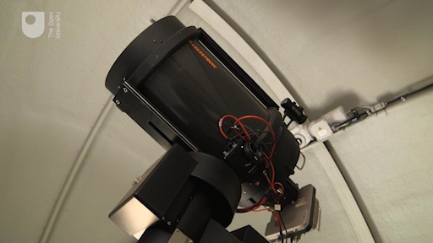

By the end of this week you will be able to:
- distinguish between the various types of Messier objects
- request an image from COAST using the telescope.org interface
- collect and view your images from COAST using the telescope.org interface.

Course forum
Each week of this course has its own forum allowing you to communicate with the course authors and fellow participants to make connections, share ideas and ask questions.

1 Messier objects
Over the years, many astronomers have compiled catalogues of astronomical objects. One of the most well-known of these is the catalogue of Messier objects. This is a list of 110 objects visible from the Northern hemisphere using a small telescope, compiled between 1758 and 1782 by French comet-hunter Charles Messier.

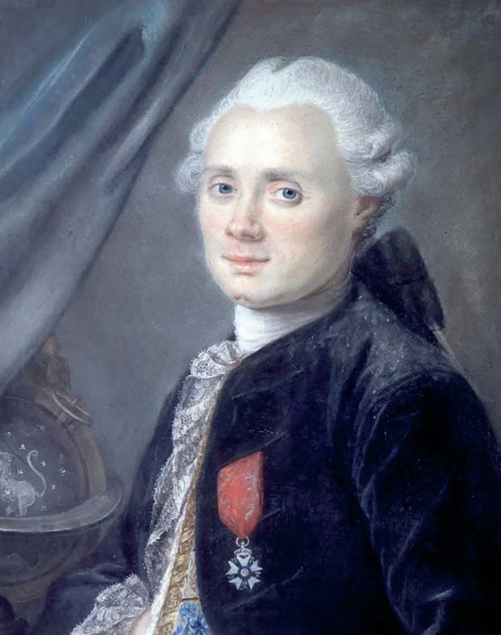
Figure 1 French astronomer and comet-hunter Charles Messier (1730-1817)
View description - Figure 1 French astronomer and comet-hunter Charles Messier (1730-1817)

1.1 The Messier catalogue
During his career, Messier discovered 13 comets and observed many others. In scanning the skies for comets Messier frequently came across other objects that looked similar to comets but which in fact turned out to be something else. Through a small telescope such as the one Messier used (a 100 mm refractor) many of these objects appeared as faint patches of light, not easy to tell apart from the comets he was looking for.
One of the main ways of distinguishing between genuine comets and these false alarms was to watch them over a number of nights and see if they moved. Comets are in orbit around the Sun, and they therefore change position against the background stars – in a similar way to the motions of other solar system objects such as asteroids and planets. Whenever Messier observed an object that did not move in this way, this was a good indication that it was not a comet but something far more distant. Fortunately, this made it easy to avoid them. Since they were always in the same place, Messier started to make a list of these objects, recording their positions using the RA and Dec coordinate system that you saw in Week 1. That way, Messier or anyone else spotting a possible comet could refer to the list to quickly exclude these known objects in fixed positions.

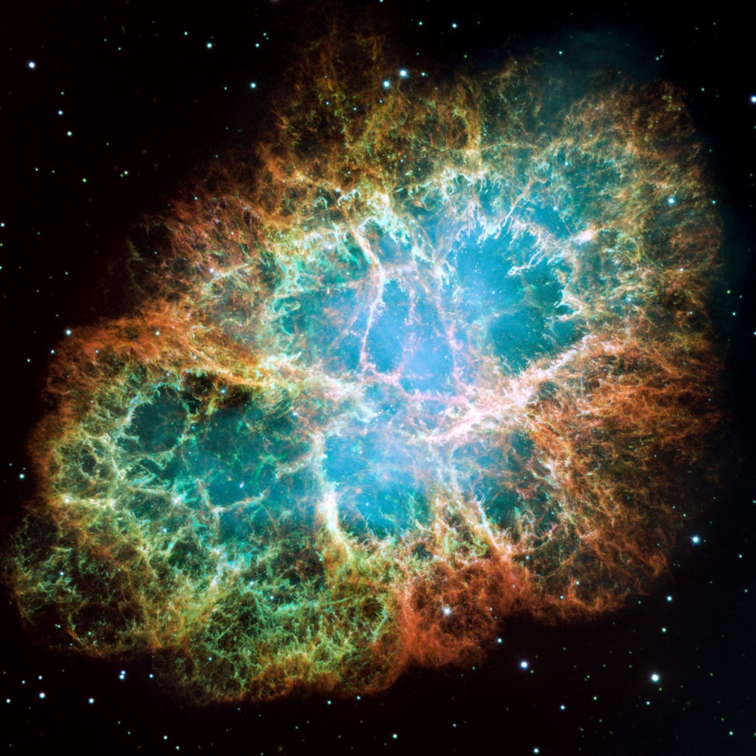
Figure 2 The Crab nebula – This was the first object in Messier’s catalogue and is designated M1. The nebula is the remains of a supernova (an exploding star) that was recorded by Chinese astronomers in the year 1054.
View description - Figure 2 The Crab nebula – This was the first object in Messier’s catalogue and ...

As Messier expanded his list, each object he added was given a serial number. The objects in the Messier catalogue are often referred to using these ‘M’ numbers: M1 for the Crab nebula, M31 for the Andromeda galaxy, M45 for the Orion nebula – each number indicating the order in which it was added to the catalogue. In the video at the start of this week Alan also introduced you to a few Messier objects that he imaged with COAST.
Over time the Messier catalogue became a useful reference list of astronomical objects in its own right, and although Messier discovered many comets he is today most famous for his list of objects that he was trying to avoid!
The Messier catalogue is of particular interest to us, since many of the 110 objects on the list are ideal candidates for imaging with COAST. There are four main types of object in the catalogue: open star clusters, globular star clusters, nebulae and galaxies. In the next section, you will learn more about these types of object, before going on to find them using Stellarium and then using COAST to take images of objects that you select.

1.2 The different types of Messier objects
To Messier most of the objects appeared as faint patches of light when viewed through his small telescope. With the development of larger and more powerful telescopes it was possible to see more details and structure within each object, and it became clear that the Messier catalogue in fact contained a collection of several different types of object.
There are four main types of object in the Messier catalogue: open star clusters, globular star clusters, nebulae and galaxies.

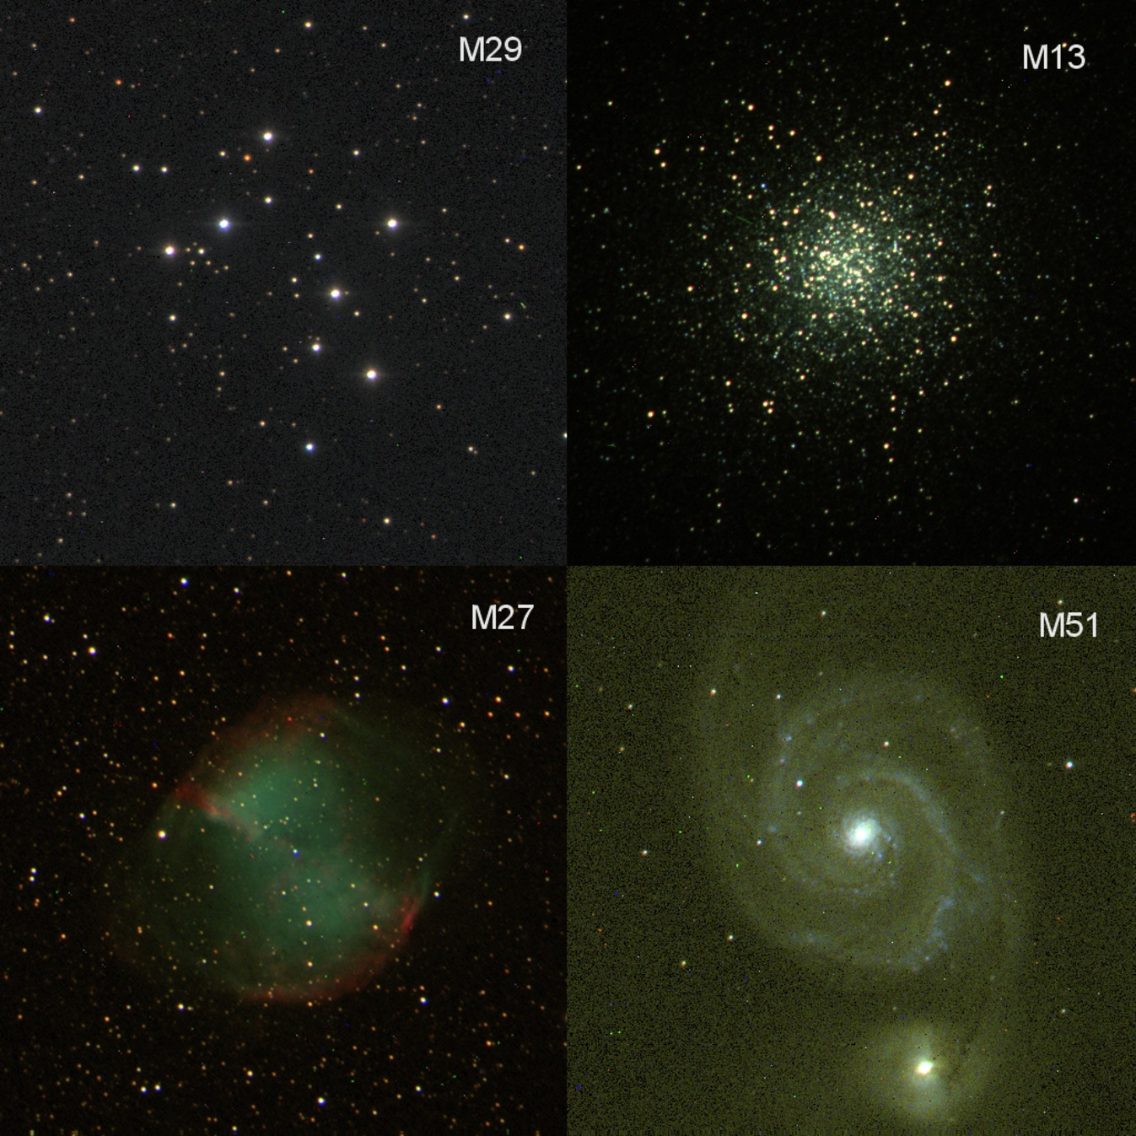
Figure 3 Examples of the four main types of Messier object. Open cluster M29, Globular cluster M13, M27 The Dumbbell nebula, and M51 the Whirlpool galaxy. These images were all taken with COAST.
View description - Figure 3 Examples of the four main types of Messier object. Open cluster M29, Globular ...

Open star clusters are collections of newly-formed stars within our own galaxy (the Milky Way). These tend to have a large proportion of bright blue-white stars.
Globular clusters are much larger, approximately spherical collections of older stars, found mostly in the outer parts of the galaxy. These tend to have fewer young, bright, stars.
Nebulae are clouds of glowing gas and dust. There are two main types: some are remnants of old stars that have exploded, and other nebulae (such as the Orion nebula, M45) are places where new stars are being formed.
Finally, galaxies are complete star systems far beyond our own galaxy. These have different forms, such as spiral, elliptical and irregular. The most prominent of these, the Andromeda galaxy M31, which is a spiral galaxy very similar to the Milky Way.
In the next activity you will explore some online sources of information to learn more about the different types of Messier object.

Activity 1 Exploring the Messier catalogue
Allow approximately 30 minutes

In this activity you will use two websites to find information on Messier objects. The first of these is SEDS (Students for the Exploration and Development of Space) and the second is NASA’s website containing a complete set of images of Messier objects taken by the Hubble SpaceTelescope.
- Visit the Messier page of the SEDS website. Here you will find links to lists of the objects with images of each object and other information, plus a biography of Messier himself.
- Follow the links to look for examples of each of the four types of object: open clusters, globular clusters, nebulae and galaxies. Read the descriptions of each example object.
What other information that might be useful for planning observations does the SEDS website list for each object?

View answer - Part

- Now visit the Hubble’s Messier Catalog. There is a biography of Messier at the top of this page. Scroll down to find clickable images of most of the Messier objects. Click on the objects you are interested in to obtain an image and description.
Important – when looking at the images on this site, you should remember that they were taken with the Hubble Space Telescope. The images that you will take with COAST will not be as detailed as these so you will need to have realistic expectations – but importantly they will be your own images!
- There are many other websites that you can use to find information about the objects in the Messier catalogue: two that you might try are MessierObjects.com and NASA’s Astronomy Picture of the day.

1.3 Messier objects in Stellarium
Stellarium can be set up to display the Messier objects so that you can see where they are in the sky. Also, for many of the objects you will be able to zoom in and see an image of the object.
To make sure that you have the correct settings enabled, select the third icon down in the left-hand menu (this looks like a star with a speech bubble containing different objects). This opens the Sky and Viewing Options window.

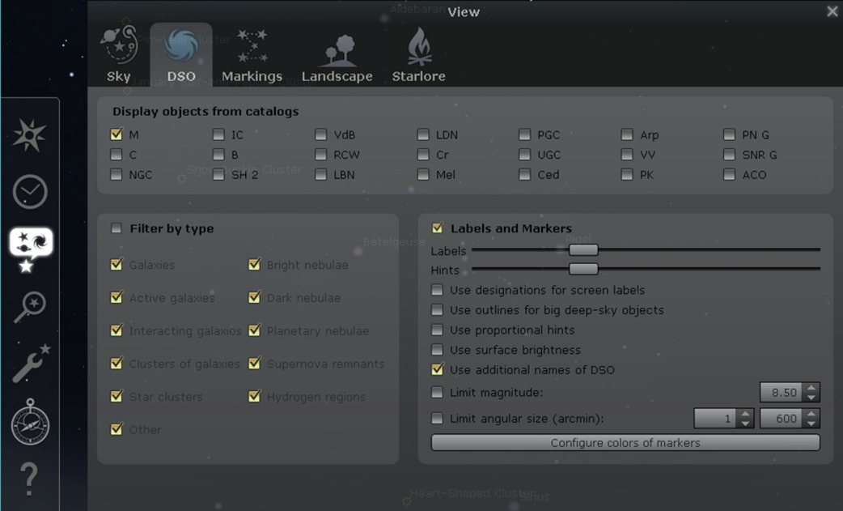
Figure 4 The sky and viewing options window in the desktop version of Stellarium. Mobile and tablet versions may vary.
View description - Figure 4 The sky and viewing options window in the desktop version of Stellarium. ...

Within this window select the DSO tab marked by a swirling galaxy icon (DSO stands for Deep Sky Objects). On this tab, make sure that ‘M’ for Messier objects is selected. You can also experiment with the two sliders marked Labels and in the Labels and Markers section to control the amount of information displayed on screen (you may need to be careful as displaying too much information can result in a screen that is very cluttered with symbols and names).
Close this window and return to the night sky view in Stellarium. You should now see all of the usual stars but also a variety of different symbols labelled with Messier numbers. As usual you can move around the sky and click on these objects to see more information about them.
You can also click on your chosen Messier object and press the forward slash key [‘/’] to zoom in and take a closer look at that highlighted object. What you see is a photograph (from a variety of sources) of that object taken through a telescope. When you're ready to go back to your original view of the sky, press the back slash key [‘\’].
[Note: on the mobile versions of Stellarium the display of Messier objects is enabled automatically, so you can simply use the search box to find an object and use the ‘+’ button to zoom in to see the image.]

Activity 2 Messier objects in Stellarium
Allow approximately 10 minutes

Having set the options as described, use the Search function in Stellarium to look for a variety of Messier objects.
- Search for the following objects:
M31 – The Andromeda galaxy
M42 – The great Orion nebula
M66 – Spiral galaxy in Leo
M11 – The Wild Duck cluster
- In each case, note what happens – in particular the height of each object above the horizon.
What do you notice about the display of each object?

View answer - Part

Why might an object not be visible in Stellarium?

View answer - Part

In the next section you will learn how to use the RA and Dec coordinates of an object to work out whether it will be visible on any given date and determine what would be the best time of year to observe any particular object.

2 Requesting your first image
You are now ready to start taking astronomical images using COAST. In this section you will learn how to determine when an object is well placed for viewing, how to plan your observations, and prepare to obtain your first images of Messier objects.

2.1 Planning your observations
As you have seen in the previous section, not all of the Messier objects are visible at the same time. Different objects will be visible at different times of the year. Depending on its position in the sky, any given object will be best placed for viewing during certain months of the year and poorly placed or not visible at other times.
To understand this in more detail, you need to think about the Earth’s orbit around the Sun.

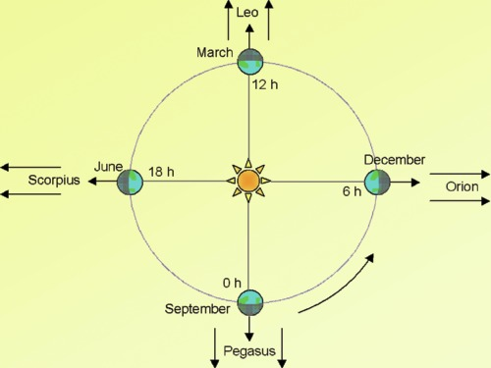
Figure 5 The Earth in orbit around the Sun. In any given month, the night side of the Earth (the side facing away from the Sun) looks out in a different direction into space, meaning that different objects will be visible in the night sky at different times of the year.
View description - Figure 5 The Earth in orbit around the Sun. In any given month, the night side of ...

Figure 5 shows how the system of right ascension (RA) coordinates relates to the Earth’s position in its orbit at different times of the year. Starting in autumn, a line from the Sun to the Earth on 21 September defines a right ascension of zero. Objects with an RA of zero hours will be highest in the sky at midnight on 21 September. As the Earth moves around the Sun, the angle of the line joining Earth to Sun changes by 30 degrees every month, and this corresponds to a change of two hours of right ascension every month (since there are 12 months in a year and 24 hours in one day).
By the 21 December, objects with an RA of +6 hours are highest at midnight and visible all night. On 21 March, objects with an RA of +12 will be visible all night, and in the summer, on 21 June, objects with an RA of +18 will be visible all night.
Of course, objects with an RA within a few hours either side of these values will also be visible for most of the night and any given object will be visible for a month or two either side of its best position, at least for part of the night.

Activity 3 Predicting visibility
Allow approximately 15 minutes

- Think about the objects that you looked at in the last exercise:
M31 – The Andromeda galaxy
M42 – The great Orion nebula
M66 – Spiral galaxy in Leo
M11 – The Wild Duck cluster
- In each case, look up the RA and Dec values on the SEDS website that you looked at in Activity 1. Note the RA value and, using Figure 4, decide at what time of year the object would be best placed for imaging with the COAST telescope (remember that COAST is a robotic telescope so can operate for the whole night, from dusk through midnight and on to dawn).
For each object, what is the best time of year to plan to observe using COAST?

View answer - Part

- COAST operates all night, but (unless you are a dedicated astronomer) most of us would prefer to observe in the evening rather than at midnight or in the early hours of the morning.
Remembering that any given object rises two hours earlier each month, if an object such as the Orion nebula is at its highest point at midnight in December, in which month would it be best placed for visual observing at 20:00 (8 pm)?

View answer - Part

You can of course check all of this by searching for a particular object in Stellarium, noting its RA coordinate and then adjusting the date and time to find when it is at its highest altitude.

2.2 Register with COAST
You are now almost ready to request your first images from COAST. Before you start, you will need an account on telescope.org – the website that is used to control COAST, to request images and to view and download your images when they have been acquired.
To register, if you haven’t done so already, you will first need to have enrolled on this course by clicking the ‘Enrol now’ button at the top of this page. Having done this, follow this link to the Open University’s Open Science Laboratory for instructions on how to create a telescope.org account:
Once your account is set up, make a note of the login information that you have created. You will need this in the next section to request your images.

2.3 Requesting an image from COAST
Using what you have learned about how to use the RA of an object to determine its visibility, you are now in a position to pick a suitable object and plan your first observations with COAST.
In this video Alan will give you an example of how to request an image, which you will be doing for your own image in Activity 4. Jo will then follow the progress of that image request with COAST on Tenerife.

Video content is not available in this format.
View transcript - Uncaptioned interactive content

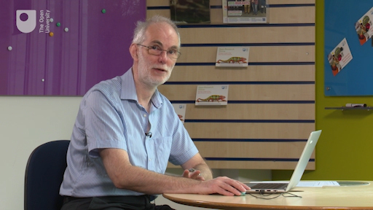

Activity 4 Requesting an image from COAST
Allow approximately 15 minutes

- First decide which of the Messier objects you want to observe. Use what you have learned about how the RA determines the visibility of objects at different times of year to choose an object that will be well placed for observing with COAST during the month in which you are doing this activity.
- Log in to the telescope.org website using the login information that you have created.
- Select Use telescope from the menu on the left hand side. In the Select Target box, enter the ‘M’ number of the object you wish to observe. For example, in the video, Alan enters ‘M42’ for the Orion nebula.
- Confirm that the details match what you expected. As shown in the video, telescope.org will confirm the visibility of the object. Check that this matches what you worked out in Step 1 of this activity.
- Next, you will be asked to select your Filter Options and Exposure Time. You will learn more about these options when you do some more advanced imaging later in the course. For now choose the Colour filter and accept the recommended exposure time. Click Next.
- The next screen headed Confirm Request lists the details of the image that you have requested. As shown in the video, if you have requested a colour image the Filter will be shown as BVR, and on this screen the exposure time is given in milliseconds so don’t be alarmed if it appears to have some extra zeros! (In the video, the requested exposure time of 180 seconds (three minutes) is shown as 180 000 ms).
- Once you are happy with all of the information, press Submit to complete your request. You will see a confirmation screen stating Request Submitted.
Congratulations! Your request is now in the queue. When it reaches the top of the queue the image you have requested will be taken the next time that COAST has clear skies. Depending on the weather in Tenerife and how many other images are in the queue it may take a few days before your image is taken, so please be patient and check back from time to time to see if your request has completed.

3 Collecting your first image

Video content is not available in this format.
View transcript - Uncaptioned interactive content

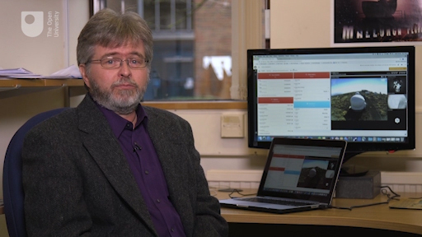

By now, if the weather has been clear in Tenerife, your image along with many others that have been requested will have worked its way up the queue and you may already have received a message to tell you that your image is ready.
If not, don’t worry: As Ulrich explains in the video, the weather is not always clear in Tenerife; sometimes it can be misty or cloudy, in which case it may take a little longer before COAST can take your image.
Once it has been taken, your image will be stored along with many others taken on the same evening. The video shows the many different objects that COAST will have taken images of – galaxies, nebulae and star clusters – depending on the requests sent in by different users. Among these will be your image, and this will be waiting for you when you next log on to telescope.org.

Activity 5 Retrieving your completed image
Allow approximately 15 minutes

- To retrieve your image, log in to the telescope.org website using the login information that you have been given.
- Look for the announcement ‘You have new images’ on the right-hand side of the telescope.org page. Click here to view a list of your completed images. You can also get to this list by clicking ‘Your requests’ on the left-hand side.
- On the list any images that have been taken will show as ‘Complete’. Any images still in the queue and not yet taken will be shown as ‘Waiting’. You will need to check back later to see if these have been completed.
- Click on one of the completed images to view it. This takes you to a ‘View’ window.
- To save your image, click on ‘edit’ at the top of the viewing window, then click on the floppy disk icon top right. Select ‘image’ and then ‘save file’ to save a copy of the image to your computer. Remember to keep a note of where you have saved it,as well as the filename of the image. (It would be a good idea to set up a work folder for all of your images so that you can find them easily).
- If you have requested more than one image, click on each one in turn to view in the same way.
- If you are happy with your images, then you are done! However, as Alan mentioned in an earlier video, you can often use the results from your first image to improve things. If you have time you may want to experiment with the settings. For instance, to adjust the exposure: if your images are quite dark you could try requesting more images with longer exposures. If your first images are too bright, you could try shorter exposures. As you refine your technique you should find that your images improve, each time using what you have learned from one set of images to help you plan for the next ones.
There are a number of other options in the ‘edit’ window, which you will look at later in the course. For now, you have your first image of a Messier object!

4 This week’s quiz
Now it’s time to complete the Week 4 badge quiz. It is similar to previous quizzes, but this time, instead of answering 5 questions, there will be 15.
Week 4 compulsory badge quiz
Remember, this quiz counts towards your badge. If you’re not successful the first time, you can attempt the quiz again in 24 hours.
Open the quiz in a new tab or window (by holding ctrl [or cmd on a Mac] when you click the link) and come back here when you are done.

5 Summary of Week 4
This week you have learned about the objects in the Messier catalogue and used your knowledge of the equatorial coordinate system to decide which object to image, depending on the time of year.
Using this information you have programmed COAST to take an image or images of your chosen object. If the weather in Tenerife has been fine, you should by now have your first astronomical image! (If not, your image will be taken as soon as the weather allows. Please be patient and check back in another day or so.)
This completes the first half of this course. In the next four weeks you will learn more about the life cycles of the stars and how they are classified, and build on your imaging skills in order to use COAST to investigate variable stars, combining your results with others to form a light curve.
You are now halfway through the course. The Open University would really appreciate your feedback and suggestions for future improvement in our optional end-of-course survey, which you will also have an opportunity to complete at the end of Week 8. Participation will be completely confidential and we will not pass on your details to others.
You can now go to Week 5.

Week 5: The Sun and the stars

Introduction
In the first half of the course you familiarised yourself with the Stellarium software and started to learn your way around the night sky. You also discovered how telescopes work and how to use the magnitude scale for measuring and comparing the brightness of stars. And last week you took your first image with COAST.
Having used COAST to image some Messier objects, this second half of the course looks in more detail at the stars – how they work, what makes them shine and how they live out their life cycles. Over the next three weeks we will be looking at exactly what stars are, and the physics involved in producing their light and heat. You will also learn about how and why some stars vary over time and the implications of this behaviour. In the final week you will finish the course by making your own observations of variable stars.
This week starts with our own Sun, which is in fact a typical star. We won’t be imaging the Sun using COAST, but as you work through the next two or three weeks you can continue to use COAST to take further images of Messier objects and refine your images (as Alan explains):

Video content is not available in this format.
View transcript - Uncaptioned interactive content

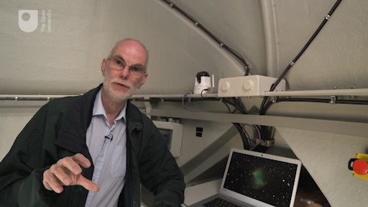

By the end of this week you will be able to:
- describe the basic physical properties of the Sun
- describe the physical process that causes stars to shine
- compare our nearest star – the Sun – to other stars.

1 Continue observing with COAST
As mentioned in the introduction to this week, this first activity reminds you to keep taking images with COAST.

Activity 1 Continue and refine your COAST images
Allow approximately 30 minutes

As you work through the material this week, schedule some more observations with COAST.
- Review the images you have already obtained, and think about how you would improve them.
- Experiment with different filters or exposure times. Use the information you have from each new image to help you decide what to change.
- Try out the image editing options in telescope.org. Select an image to view, and then click on the Edit tab. There are options to zoom in, to adjust brightness and contrast, and to adjust the colours. You can save the edited image when you are happy with the adjustments that you have made.
- Perhaps have a go at some different objects.
- You can continue to study the rest of this week’s material while waiting for your images to come back.

2 The Sun as an ordinary star
So far, you have looked at Messier objects and stars, and learned about the magnitudes and positions of stars in the night sky. This week, you will concentrate on a daytime object – the Sun.
Our own Sun is in fact also a reasonably normal star and looks very different only because it is much closer to the Earth. If you imagine looking back at our solar system from a vast distance (such as from a planet orbiting another star), the Sun would appear as a tiny point of light – one more star among the many other stars making up the constellations.
The distance between stars is immense – Alpha Centauri, the next nearest star to our Solar System, is approximately 270 000 times further away than the distance from the Earth to the Sun. Being relatively so close to us means that the Sun is the one star that we can study in detail.
Although the stars vary greatly in properties – such as size, brightness, age and temperature – the Sun is actually a fairly typical star in the stable middle part of its life. This means that by studying the Sun and finding out how it works we can learn a lot about the processes that make all of the stars shine.

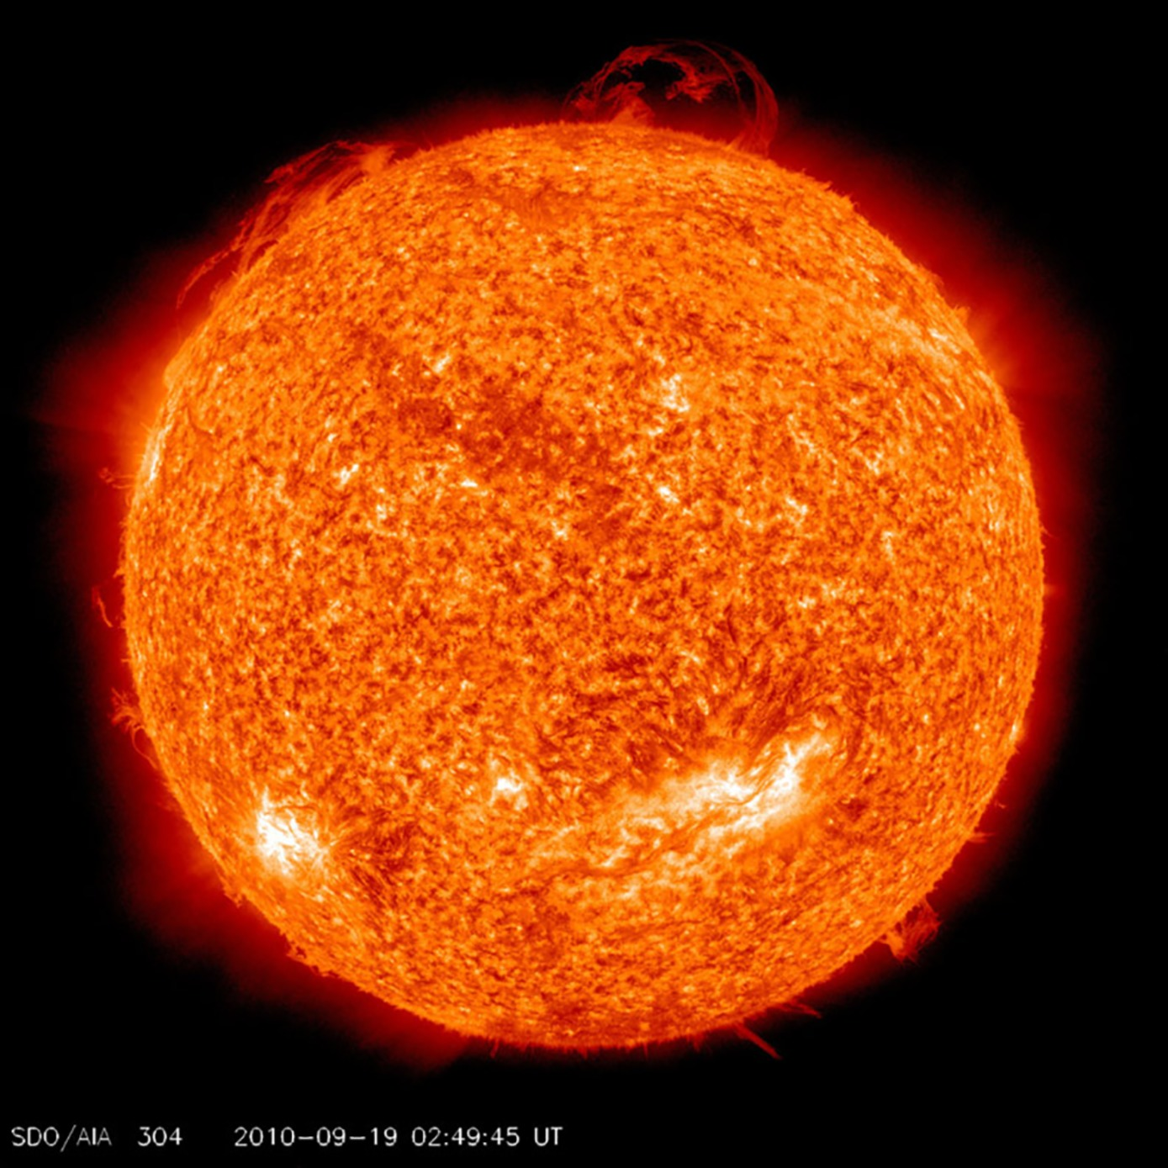
Figure 1 The Sun as a flaming ball of gas: in this image of the Sun, taken in 2010 by the NASA Solar Dynamics Observatory (SDO) satellite, prominences can be seen erupting from the hot surface of the Sun. For more information about this image, and a film showing the twisting strands of hot gas and plasma erupting from the surface of the Sun, visit the NASA SDO website: https://sdo.gsfc.nasa.gov/gallery/main/item/33.
View description - Figure 1 The Sun as a flaming ball of gas: in this image of the Sun, taken in 2010 ...

Safety – never look directly at the Sun
In this course you will not be asked to make any visual observations of the Sun.
It is never safe to look directly at the Sun because the intense light and heat could injure or permanently damage your eyes. For this reason you should avoid looking directly at the Sun, even for an instant, and you should never look at the Sun through any kind of optical instrument such as a telescope, binoculars or a camera.

2.1 The Sun – some facts and figures
As a first step towards understanding the Sun and how it works, let’s start by looking at some of the Sun’s vital statistics.

Activity 2 What do you know about the Sun ?
Allow approximately 5 minutes

As a first step to answering this question take 10 minutes to list any properties of the Sun you can think of. Think about how hot it is, how far away and how large it is.
How would you describe the Sun to someone from another world?
Once you have thought about these questions, scroll down to see how your list compares to ours. Notice that we have broken the list up into two parts. The first details those properties that we can directly observe, while the second is made up of properties of the Sun that can be inferred from observations of both the Sun and other objects within the solar system.

The size and distance of the Sun
The Sun is big. In fact it is more than 100 times the diameter of the Earth (the Sun is approximately 1.4 million km in diameter, compared to Earth’s 12 700 km. To put this in context, if you could somehow fly a typical airliner around the Sun it would take you about 203 days to return to your starting point.
The Sun is approximately 150 million km from the Earth – this is about 400 times further than the distance from the Earth to the Moon. One way to appreciate astronomical distances is to think about the time it takes for light to travel. Light from the Moon takes just over one and a quarter seconds to reach the Earth, but light from the Sun takes nearly eight and a half minutes to reach us. The distance from the Earth to the Sun is often referred to as an Astronomical Unit (AU); this can be handy when comparing distances to other planets in the Solar System.

The temperature of the Sun
The Sun is hot. We know this intuitively in the same manner we know a fire or electric heater is hot because we can feel (or detect) the radiation that it emits because it is hot on our skin. In fact the surface of the Sun is approximately 5600 degrees Celsius (or more than three times the temperature of molten iron), but at its core the temperature reaches an amazing 15 million degrees Celsius.
Of course, it isn’t possible to measure this temperature directly with a thermometer, but it turns out that the colour of light emitted by the Sun allows us to estimate its temperature. If you have ever seen a rainbow you will know that in actual fact the Sun emits light with a range of colours which, when combined together, appears yellowish-white. This combination of wavelengths, or colours, is known as a spectrum. The spectrum of light emitted by any heated object depends on its temperature. Specifically, the cooler the object the redder the light and the hotter the object the bluer the light. You can see this in Figure 2, where a metal ball is heated to ever increasing temperatures. As this happens the ball starts to emit a dull red-orange light which progressively becomes yellower (and brighter) as it heats up. If we could heat the ball to higher temperatures without it melting, the light would start to take on a blue-white tinge.

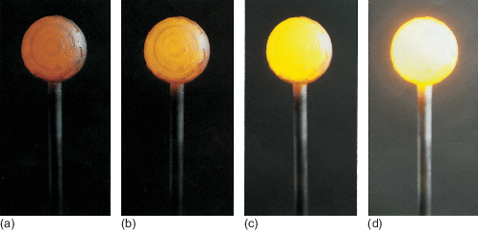
Figure 2 Sequence of four images showing a metal ball being heated, with temperature increasing from left to right.
View description - Figure 2 Sequence of four images showing a metal ball being heated, with temperature ...

So, by accurately measuring the colour of the light the Sun emits – or more precisely (and in scientific terms) the wavelength at which the intensity of emitted light is at its strongest – it is possible to work out the temperature of its visible surface layers.

- Can you think why we don’t see light emitted from everyday objects such as cars, tables and even our own bodies?
- All these objects do emit light, but being much cooler than the Sun, they emit in the infrared, which is wavelength that our eyes are not sensitive to. Infrared can be detected using special cameras, and this is used for example in search and rescue to detect human survivors.

2.2 The energy output of the Sun
The Sun radiates a lot of energy. Think about the warmth of the Sun on a bright summer day; the energy reaching us from the Sun has travelled 150 million km through space, spreading out in all directions.

The Sun as a source of energy
To provide this amount of warmth at such a great distance, the Sun must generate and emit huge quantities of energy every second. But precisely how much? Figure 3 shows the largest power station in the UK, which generates roughly 7% of all the electricity we use.

Figure 3 The coal-fired Drax power station in Yorkshire, United Kingdom
View description - Figure 3 The coal-fired Drax power station in Yorkshire, United Kingdom

By way of comparison you would need one hundred thousand million million (or 100 000 000 000 000 000) such power stations to produce the same energy output as the Sun.

The Sun as an active star
Fortunately for life on Earth the overall energy output of the Sun is relatively stable. However, when looked at in more detail the Sun is a highly active and dynamic place.
Satellite telescopes such as NASA’s SDO have revealed the outer atmosphere of the Sun to be in constant turmoil and motion, with vast magnetic fields ejecting millions of tonnes of hot gas and plasma into space. Moreover, the interior of the Sun is thought to be in constant motion, which is revealed to us by regions of the surface layers of the Sun rhythmically pulsating up and down.
If you followed the link to the NASA video in Figure 1, you will have seen images of the churning outer atmosphere of the Sun. In the following activity, you will see more stunning images of the Sun taken using a range of different filters.

Activity 3 Activity on the surface of the Sun
Allow approximately 10 minutes

Video content is not available in this format.

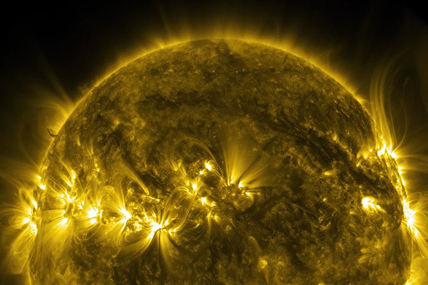
Thermonuclear art – the Sun in ultra-high definition (4K), NASA 2017

This video was produced by NASA from data obtained by their Solar Dynamics Observatory (SDO). It captures images of the Sun in ten different wavelengths of light, each of which helps to highlight a different temperature of solar material and in this video is artificially coloured by visible light to enable us to see it. This video shows the first five minutes, but you can also view NASA’s full video if you so wish.

Later, in Weeks 7 and 8 you will look at variable stars, whose energy output and hence luminosity vary in a more dramatic way.

2.3 The mass, composition and structure of the Sun
The Sun is massive. We can work out the mass of the Sun by measuring the size and period of the orbit of a planet such as Jupiter or the Earth. Sir Isaac Newton’s laws of gravity can then be used to calculate just how heavy the Sun would need to be to keep the planet moving around its orbit. And when you do this you find that the Sun is incredibly massive – over 1 000 times the mass of Jupiter, the biggest planet in the solar system, and about 330 000 times the mass of the Earth.
Although the Sun is very massive indeed, it is also very large. Remembering that the Sun is approximately 100 times the diameter of the Earth, this means that it has one million times the volume. If it were made of the same type of materials as the Earth the Sun’s mass would also be one million times greater, but in fact it is only one-third of this, meaning that the density of the Sun is more similar to that of Jupiter – a gas giant made up of mostly hydrogen and helium.

- What do you think this tells you about the composition of the Sun?
- The fact that Jupiter and the Sun have similar densities suggests that the Sun is made up of gases such as hydrogen and helium, rather than the rocks and metals that make up the Earth. By looking in detail at the spectrum of light that the Sun emits, astronomers can detect the unique signature of the elements that make it up. Indeed the element helium is so named because it was first discovered in the Sun’s atmosphere by spectral analysis.

Viewing the Sun in different wavelengths can also reveal remarkable details of the surface structure. The following video shows images of the Sun taken in different wavebands, including visible light, ultraviolet and X-rays. For more information, visit the NASA SDO website at: https://sdo.gsfc.nasa.gov/gallery/main/item/785

Video content is not available in this format.

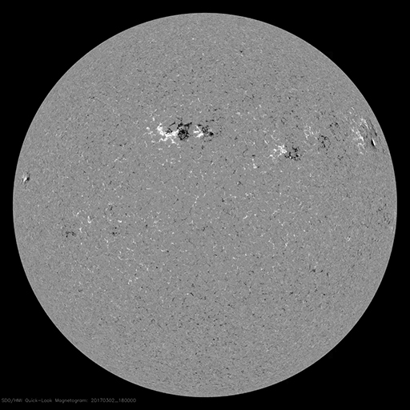

This rich surface structure and the activity that you saw in Activity 3 suggest that the interior of the Sun also has a complex and dynamic structure. This NASA image shows a cutaway view of the internal structure of the Sun.

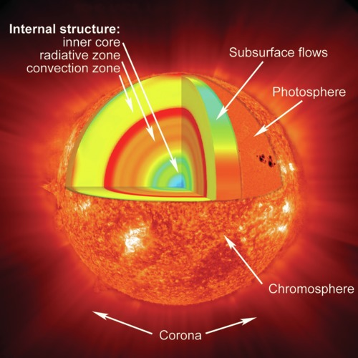
Figure 4 An artist’s drawing of the internal structure of the Sun, showing surface features and internal layers. As you shall see in Section 3, the core of the Sun is at a very high temperature and pressure, sufficient to sustain the nuclear reactions that power its energy output. (NASA)
View description - Figure 4 An artist’s drawing of the internal structure of the Sun, showing surface ...

Full resolution image available here

2.4 The age of the Sun
Finally, the Sun is old. It is reasonable to assume that the Earth and Sun formed at more or less the same time, or at the very least that the Earth cannot be older than the star that it is orbiting. If we can determine the age of the Earth, then it follows that the Sun cannot be younger than this. As a consequence geologists have spent much effort trying to find the oldest bits of the Earth. Currently the record holders are rocks from the north-west of Canada (a sample of which is shown in Figure 5), which appears to be over four billion years old (four thousand million years). In actual fact astronomers and geologists have determined that the Sun is slightly older than this, at 4.6 billion years, after studying meteorites known to have formed at the same time as the Sun and the solar system.

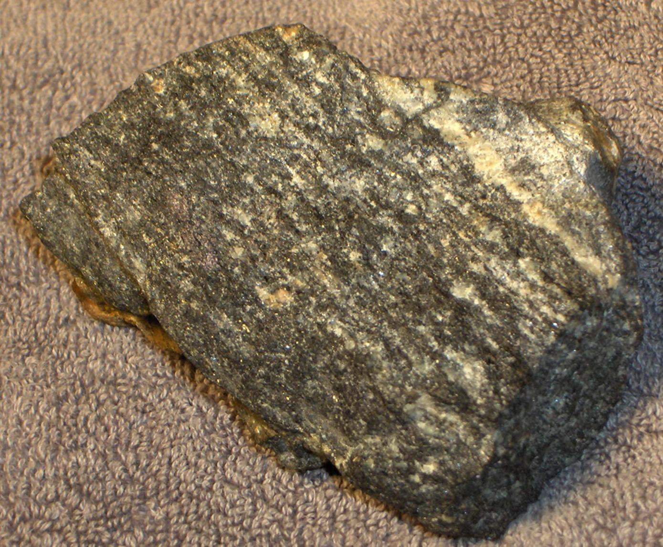
Figure 5 A sample of the oldest rock yet discovered on Earth. Found in Canada, this Acasta Gneiss is over four billion years old.
View description - Figure 5 A sample of the oldest rock yet discovered on Earth. Found in Canada, this ...

2.5 Summary – properties of the Sun
As you have learned, just a few observations can tell us a lot about the properties of the Sun. Compared to planets such as the Earth and even Jupiter (the largest planet in the solar system) the Sun is huge in terms of its physical size and mass. Despite its vast size, the Sun is mostly composed of the lightest elements – hydrogen and helium. It is also ancient; with an age of about 4.6 billion years it has been around for a third of the age of the Universe. Despite its age the Sun is still very active; both its surface and interior are in constant motion. Most importantly, the Sun is very hot and as a consequence emits a vast amount of energy every second. It is this radiation that heats the surface of the Earth and allows liquid water, and hence life, to exist.
In the remainder of your study for this week you will attempt to answer two questions that naturally arise from these observational facts:
- Since the Sun has existed for over four billion years, what physical process, and fuel, has powered it for this length of time?
and
- Given that the Sun is a star, how does it compare to the billions and billions of other stars in the Universe?

3 What powers the Sun and stars?
As noted at the end of the previous section, an obvious question to ask is: What powers the Sun and indeed all stars? Given that the prodigious energy output of the Sun has been continuing at a relatively constant level for over four billion years, it must have a huge source of energy to sustain this for such a long period of time.
In Section 2, the energy of the Sun was compared to the output of a coal-fired power station. A quick calculation based on the mass of the Sun shows that chemical reactions, such as burning coal or hydrogen, would not be sufficient to maintain the current solar energy output for more than a few thousand years, and so cannot be the source of the Sun’s energy.
Another possibility considered in the past was whether the Sun might be powered by gravitational energy, emitting heat as it gradually contracted. This can also be discounted, as the energy available from this source would last no more than a few tens of millions of years – much less than the known age of the solar system.
The only source of energy powerful enough to maintain the Sun’s energy over billions of years is nuclear energy. As shown in Figure 4 earlier, the Sun is a giant nuclear fusion reactor, converting hydrogen into helium in its incredibly hot and dense core.

3.1 The most famous equation in the world

Figure 6 Albert Einstein, who in 1905 formulated the theory of relativity.
View description - Figure 6 Albert Einstein, who in 1905 formulated the theory of relativity.

Perhaps the most famous and well-known equation in the whole of physics is Albert Einstein’s .
This simple-looking equation holds the key to the source of the Sun’s energy. The equation is a direct consequence of Einstein’s theory of relativity and essentially states that energy and mass are equivalent and that under certain circumstances, such as during nuclear reactions, an amount of matter can be converted into energy.
The other term in the equation, , sets an exchange rate for this conversion. The here is the speed of light: at 300 000 km per second this is already a very large number and in Einstein’s equation it is squared – multiplied by itself – making a vast number. This huge conversion factor means that a small amount of mass is equivalent to an extremely large amount of energy.
As a result of this conversion factor, nuclear reactions are immensely more powerful than chemical reactions. The Drax power station that you saw in Section 2 consumes over 9 million tonnes of coal every year, yet nuclear power stations such as Sizewell B run on just 30 to 40 tonnes of nuclear fuel. Even in nuclear reactions, only a small fraction of the mass of the fuel is converted into energy using . Of the 30 to 40 tonnes of nuclear fuel used at Sizewell every year, just over one kilogram of that mass is converted to energy.

3.2 Nuclear fusion – the source of the Sun’s energy
Current nuclear power stations run on uranium or plutonium as nuclear fuel, but as you have seen the Sun is made up of mostly hydrogen and helium, so the Sun runs on a different type of nuclear reaction.
The type of nuclear reaction taking place in the core of the Sun is known as nuclear fusion and involves hydrogen nuclei combining together to form helium. In the process, a small amount of mass (just under one per cent) is released as energy, and this makes its way to the Sun’s surface before beaming out into space. The outward pressure of all this energy flowing out from the core to the surface helps to support the Sun against the force of gravity, preventing collapse and keeping it stable over a long period of time.

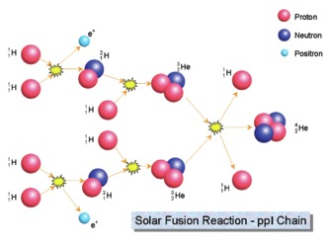
Figure 7 The main nuclear reaction taking place in the core of the Sun. Known as the ppI chain, the overall result of this reaction is the conversion of four hydrogen nuclei into one helium nucleus. The yellow flashes indicate energy being released at each stage.
View description - Figure 7 The main nuclear reaction taking place in the core of the Sun. Known as ...

Full resolution image available here
Figure 7 illustrates the nuclear fusion process taking place in the core of the Sun. The nucleus of a hydrogen atom consists of a single proton; the helium nucleus is made up of two protons and two neutrons. The process takes place in several stages with nuclei combining at each stage to form larger nuclei. The overall result of this chain is that four protons are combined to form one helium nucleus. During this chain, two of the protons turn into neutrons so that the final helium nucleus contains two protons and two neutrons.
Because the protons each have a positive electric charge they would normally repel each other. Tremendous temperatures and pressures are required to force the protons close enough together for the fusion process to take place so these reactions can only occur in the core of the Sun where the temperature reaches up to 15 million degrees, and not in the outer layers.
Crucially, the mass of the helium nucleus produced in this chain of reactions is ever so slightly lower than the mass of the four protons that we started with. The difference is only slight – less than one per cent of the mass – but this releases a significant amount of energy. Untold billions of these reactions convert over 4 million tonnes of matter to energy every second, producing the overall energy output of the Sun.

3.3 Estimating the Sun’s lifetime
In the last section, you saw that nuclear reactions in the core of the Sun result in the conversion of 4.3 million tonnes of matter into energy every second. While this may seem like a staggering amount, it should be taken in the context of the enormous mass of the Sun itself – there is no danger of the Sun running out of nuclear fuel any time soon. In fact, we can use this rate of consumption together with our knowledge of the structure and composition of the Sun to make an estimate of how long the supply of hydrogen in the Sun will last.

Activity 4 Estimating the lifetime of the Sun
Allow approximately 10 minutes

In this optional activity, if you are familiar with working with large numbers expressed in scientific notation, you can try working out the lifetime of the Sun based on the following facts and figures.
If you are not confident with the calculation, you can still follow the chain of reasoning and then click to reveal the answer below.
First, you can calculate the amount of mass available in the core of the Sun that can be converted into energy. You can do this by starting with the total mass of the Sun and narrowing it down as follows:
- The total mass of the Sun is
- 75% of this mass is hydrogen
- 12.5% of this is in the core and is able to take part in nuclear fusion
- only 0.73% of this mass is released as energy in the ppI chain reaction
This gives a mass that would have been available for conversion into energy at the start of the Sun’s life.
Although the Sun’s luminosity (energy output) has actually varied slightly during its lifetime, for the purposes of estimating how long this supply of mass for conversion into energy will last, it is reasonable to use the present value of 4.3 million tonnes () per second as a constant average value.
Remembering that there are 60 seconds in a minute, 60 minutes in an hour, 24 hours in a day and 365.25 days in a year, calculate the lifetime of the Sun by working out how long (in years) the available mass of would last at this rate of consumption.

View answer - Activity 4 Estimating the lifetime of the Sun

3.4 Midweek summary
You have met the most famous equation in the world and what it means in practice. You have also learned about the physical process of nuclear fusion that powers the Sun.
you have also looked at precisely how stars release their energy – in the process converting their constituent gas from one chemical element (hydrogen) to another (helium). As you shall learn later, larger and older stars at later stages of their lifetimes may have additional types of fusion reactions taking place, but this process of conversion from hydrogen to helium is the principal reaction powering most stars in the stable part of their lifetimes.
In the next section you will consider where in the stellar hierarchy the Sun fits and how it compares with other stars in terms of size, temperature and energy output.

4 Comparing the Sun with other stars

Video content is not available in this format.

The night sky as seen from Tenerife. The band of light passing behind the COAST telescope in the foreground is the Milky Way, our home galaxy

Full resolution video here
This time-lapse sequence, shot over three hours, shows the Milky Way setting behind the COAST telescope dome. The telescope itself can be seen moving as it takes images of different selected targets.
The Milky Way contains some two hundred billion stars and, as you can see in the footage above, they are very diverse, with a wide range of colour and brightness. Some of the difference in brightness comes about because the stars are at very different distances (all else being equal, stars further away will appear fainter than stars close by) – but stars also vary significantly in their intrinsic brightness, from stars much less luminous than the Sun to stars many thousands of times brighter.

Activity 5 Properties of stars
Allow approximately 10 minutes

Bearing in mind what you have learned this week, and after watching the video, make a list of all the ways you think stars might differ from one another. When you have completed this, click below to view our list.

View answer - Part

What do you notice about the colours and various levels of brightness of the stars in this image ?

View answer - Part

The answer to Activity 5 suggests that there is a relationship between the colour of stars in the cluster and their intrinsic luminosity, or brightness. As you have seen in Section 2, the colour of a star is related to its temperature, with hotter stars appearing whiter and bluer, and cooler stars appearing yellower and redder. This is a really important observation as it suggests that the temperature and luminosity of stars are related to one another. In other words these properties are correlated. you will explore this relationship further next week.

5 This week’s quiz
Well done – you have reached the end of Week 5 and can now take the weekly quiz to test your understanding.
Week 5 practice quiz
Open the quiz in a new tab or window (by holding ctrl [or cmd on a Mac] when you click the link) and come back here when you are done.

6 Summary of Week 5
This week you have taken your first steps in understanding what stars are and how they work using the nearest example – our own Sun – as a template. In doing so you have found out that stars are huge balls of gas, much larger and more massive than any planet.
You have learned that the colour of light they emit is related to their temperature, and explored the physical processes of nuclear fusion taking place in the core. Stars produce and release colossal amounts of energy every second and, using your knowledge of the nuclear reactions and Einstein’s famous equation, , you were able to calculate that the Sun has done so for billions of years and will continue to shine for billions more.
Finally, you have taken a first look at how stars are related in terms of their properties, finding that there is a relationship between the temperature and the luminosity of stars in a cluster. You will explore this relationship in greater detail next week.
You can now go to Week 6.

Week 6: Classifying the stars

Introduction
Last week you started to look at what stars are, using the Sun as a template. We discussed the basic properties of the Sun (and indeed other stars), finding that they are essentially massive balls of hot gas. At their core, temperatures rise high enough to permit the fusion of hydrogen nuclei to form helium nuclei. Using Einstein’s famous equation you were able to understand how the vast number of such reactions occurring every second is sufficient to power the Sun for billions of years. Finally, we started looking at how the Sun fitted into the wider population of stars by looking at the properties of stars in clusters, comparing their colour and luminosity.
This week, you will continue to explore the relationship between the colour and luminosity of stars, finding that the colour of a star depends on its temperature and that there is a correlation between temperature and luminosity. Plotting these two properties against each other produces the Hertzsprung-Russell diagram – one of the most famous diagrams in astronomy. you will explore this diagram and find out what it tells us about the lifecycles and eventual fate of the stars, as Jo explains:

Video content is not available in this format.
View transcript - Uncaptioned interactive content

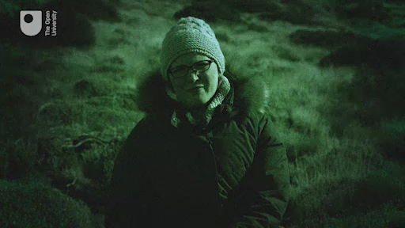

In the video, Jo also mentions the images that you have taken using COAST. As you work through the material this week, you can continue to enhance and improve your COAST images using the editing tools in telescope.org.
By the end of this week you will be able to:
- edit COAST images in telescope.org and save the resulting image
- understand the relationship between stellar temperature and luminosity and how this is used to classify stars on the Hertzsprung-Russell diagram
- identify the main features of the Hertzsprung-Russell diagram and associate these with different stages in a star’s lifetime
- understand how the temperature and luminosity of a star depend on the mass of a star and how this ultimately determines the star’s lifetime
- understand the lifecycles of stars and the processes taking place at different stages of a star’s life, including the reasons for instability and how this produces certain types of variable star.

Course forum
Each week of this course has its own forum allowing you to communicate with the course authors and fellow participants to make connections, share ideas and ask questions.

1 Refine and edit your COAST images
As mentioned last week, there are editing options on the telescope.org website that allow you to fine-tune the images you have taken with COAST. You may already have tried some of these options, and this week you can continue to experiment with them to produce the most pleasing images using these more detailed instructions.

Activity 1 Use the online editing tools to further refine your COAST images
Allow approximately 30 minutes

As you work through the material this week, you can also learn to use the editing options on the telescope.org website by following these steps:
- Log in to your telescope.org account and select one of your Messier object images. Think about how it looks and how you might want to change it.
- Go to the Your Requests section on the website and click on the image that you want to work with. This takes you to the View tab.
- To try out the image editing options, click on the Edit tab.
- On the Edit tab, there are options to zoom in, to adjust brightness and contrast, and to adjust the colours.

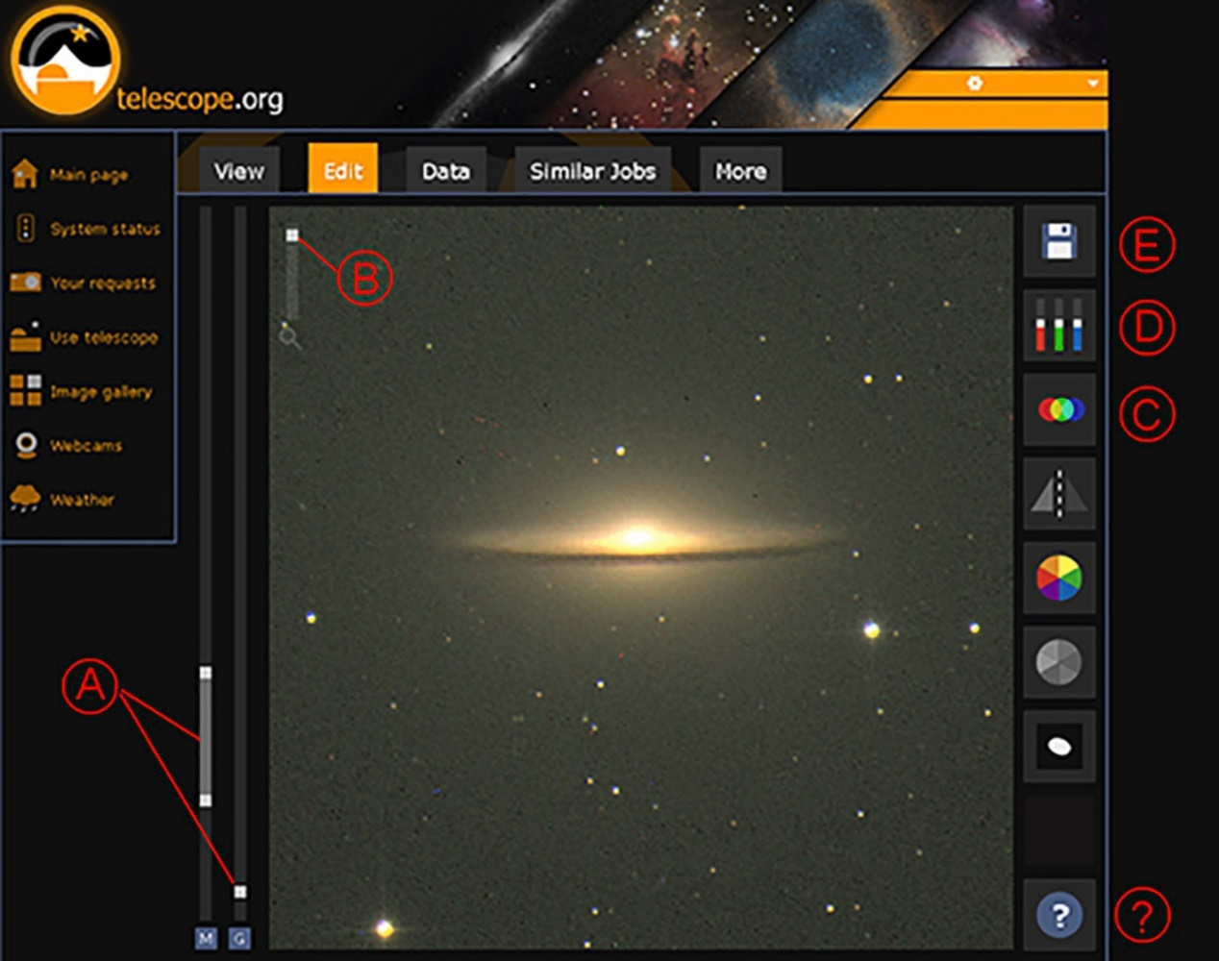
Figure 1: The Edit tab in telescope.org
View description - Figure 1: The Edit tab in telescope.org

- Figure 1 shows the various editing controls. The Help button (?) at bottom right shows us a short video describing how to use these controls, so you may want to start by watching this.
- Use the sliders on the left (A) to adjust the brightness and contrast of your image. You can also zoom in using slider (B).
- If you have taken a colour image, this will be made up of three layers taken through red, green and blue filters. Sometimes these don’t line up exactly and if this happens you may notice that some of the stars have coloured outlines or borders. To correct this you can use the colour shift tool (C). Use the arrows to shift the individual colour layers up and down or left to right, until all the colours are aligned.
- Use the colour balance tool (D) to adjust the overall colour of your image – there are individual sliders for red, green and blue. You can use these to remove a colour cast from your images. Try experimenting until you get the effect that you want.
- You can save the edited image when you are happy with the adjustments that you have made.
- To save your edited image, click on the floppy disk icon top right (E). Select Image and then Save File to save a copy of the image to your computer. Remember to keep a note of where you have saved it and the filename of the image.
In the final week of the course, you will use the Save option on this Edit tab to export your images of a variable star in a format that will allow further detailed analysis using two other online image processing tools.

2 Classifying stars – the Hertzsprung-Russell diagram
At the end of last week you saw that stars have different colours and levels of brightness. Comparing stars within the open cluster M29, all of which are at the same distance, allowed us to see the beginnings of a relationship between the colour and the brightness of the stars. In this cluster, the brightest stars were white with even a bluish tint, and the fainter stars were orange or red. As you learned in Week 5, the colour of a star is related to its temperature, with hot stars being white and cooler stars being orange and red. Average stars, such as our own Sun, have an intermediate temperature and brightness and a yellowish-white colour.
Taking all of this together suggests that there is a relationship between the temperature and the brightness of stars, and this gives us a way of organising and classifying stars – the Hertzsprung-Russell (HR) diagram. In this and the following sections you will explore this relationship in more detail and find out how the HR diagram helps us to understand the lifecycles of the stars.

2.1 The differing colours of stars
Earlier in the course, you studied the constellation of Orion, first in Stellarium during Week 1 and then as an image taken from Tenerife in Week 3. Let’s now take another look at Orion, this time concentrating on the colours of the two brightest stars, Rigel and Betelgeuse.

Activity 2 Colours in Orion
Allow approximately 10 minutes

In this exercise you will compare the colours of stars in this image of Orion. The exercise will also allow you to practise matching up stars using an image in Stellarium or on a star chart, a skill that you will need for the variable star activity in later weeks.

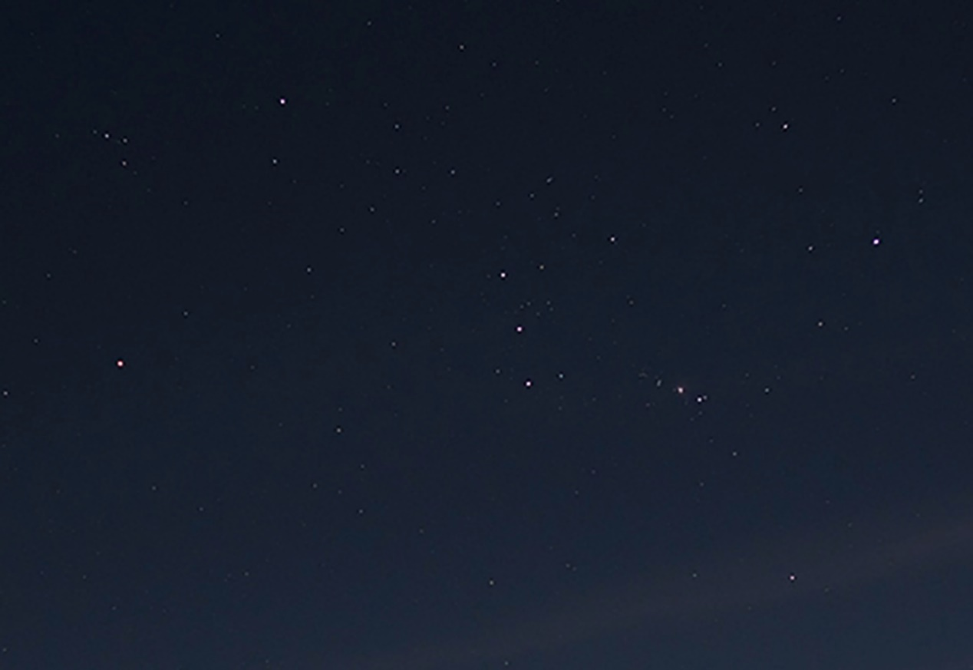
Figure 2 The constellation of Orion, as seen from the Teide observatory.
View description - Figure 2 The constellation of Orion, as seen from the Teide observatory.

Full resolution image here
- First, look at the four bright stars forming the approximately rectangular outline of the main body of Orion.

What do you notice about the colours? Is one of the stars different from the others?

View answer - Part

- Now identify the two brightest of these stars: Rigel, at the top right of the rectangle, and Betelgeuse, which is the leftmost of the four bright stars making up the main rectangle of the constellation.
- To help you identify these two stars correctly, open Stellarium and make sure that the location is still set to Tenerife. Find Orion and adjust the view so that it approximately matches the image above (to help you set the date and time correctly, note that the image in Figure 2 was taken from Tenerife in early November, facing east, at just before midnight).
- Using the Stellarium display, make sure that you have identified which star is Rigel and which is Betelgeuse in Figure 2.
- Compare the colours of these two stars in the Stellarium display and in the image.

Now that you are certain that you are looking at the correct stars, what do you notice about the colours of Rigel and Betelgeuse? What does this tell you about the temperatures of these stars?

View answer - Part

2.2 Building the HR diagram
From looking at stars in the cluster M29 and in the constellation Orion, we have learned that stars have different colours related to their temperatures, and that the brightness of each star is also related to the colour and temperature.
We are now in a position to put all this together. In science, one way of seeing how properties are related is to look for patterns by plotting one quantity against another on a chart or diagram. In this video, Jo and Alan explore the diagram that results from comparing the temperatures and luminosities of a large number of stars.

Video content is not available in this format.
View transcript - Uncaptioned interactive content

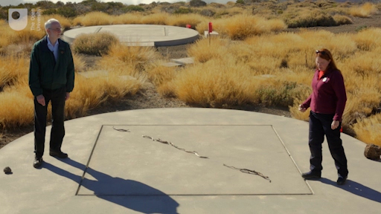

This plot of the surface temperature of a star against its luminosity is called a Hertzsprung-Russell diagram after the astronomers Ejnar Hertzsprung and Henry Norris Russell who first plotted it in the early 1900s. This diagram makes it easy to see the patterns and correlations between the two parameters. In particular, most stars lie on the Main Sequence – a band running from the top left to the bottom right of the diagram. Within this main sequence, which represents the stable part of a star’s lifetime, the hotter a star is the more luminous it is (and hence the cooler a star is the less luminous it is). Temperatures on this diagram are measured in Kelvins (K). On the Kelvin scale, the freezing point of water is 273 K and the boiling point 373 K. To convert from Kelvins to degrees Celsius, subtract 273.
This diagram can also be used to answer the question – posed towards the end of last week – of how the Sun compares to other stars. As explained in the video the Sun is entirely average – with a modest luminosity and a yellowish-white colour, the Sun is not among the hottest, most luminous stars and it is not among the faintest and coolest stars either. Jo placed the Sun directly on the main sequence, slightly to the right of centre, indicating that it is indeed a fairly small and average star.
As you shall see later this week when thinking about stellar lifetimes, the fact that the Sun is such a relatively modest star is actually a very good thing for life on Earth.
While the main sequence represents the stable main part of a star’s lifetime, there are other groupings on the diagram representing different phases of a star’s evolution. In particular, many stars expand and cool to form red giants as their nuclear fuel runs out towards the end of their lifetimes, and in the process can become unstable and variable. Stars similar to our own Sun will eventually collapse to become white dwarfs – very hot but very compact bodies, seen at the bottom left of the diagram.

2.3 Understanding the main sequence
Figure 3 shows a schematic version of the HR diagram that we constructed in the video in the previous section, with the main sequence highlighted.

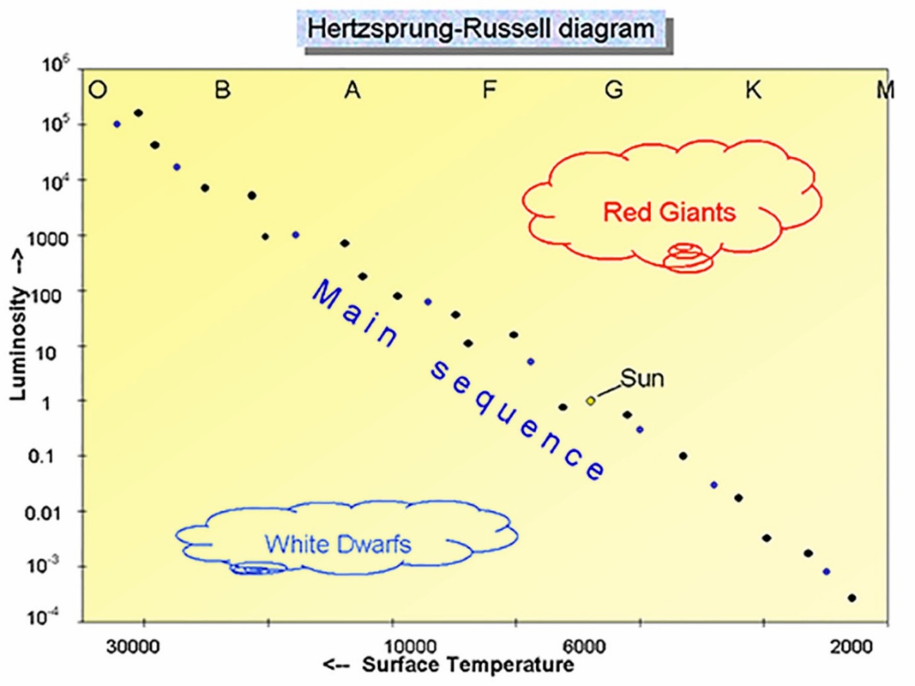
Figure 3 The HR diagram showing the main sequence. The letters at the top indicate the spectral class of the stars, with O and B representing the brightest and hottest stars, and K and M at the other end representing the faintest and reddest stars. The Sun, indicated with the yellow circle, is a G-class star with average brightness and temperature. Temperatures on this diagram are in Kelvins (K).
View description - Figure 3 The HR diagram showing the main sequence. The letters at the top indicate ...

Full resolution image here
In this section you concentrate on the main sequence, which is a broad strip running from the top left to bottom right of the diagram, and which contains about 90% of all of the stars in our Galaxy. There are three main conclusions to draw from this plot:
- Firstly, stars span a huge range of temperatures and luminosities. The temperature ranges from about 2000 K for the coolest stars, to 30 000 K for the hottest. And in terms of luminosity, stars range from 10 000 times fainter than the Sun to a million times brighter. This is a huge range – much wider than the range of temperatures.
- Secondly, not all combinations of temperatures and luminosities are equally likely. The vast majority of stars lie on this main sequence, with other regions for giants and white dwarfs, but some parts of the diagram are more or less empty, indicating that those particular combinations of brightness and temperature do not occur.
- Finally, the stars on the main sequence show a strong correlation between temperature and luminosity, becoming more luminous as their temperature rises.
In order to understand these ranges of temperatures and luminosities and the relationship between them that defines the main sequence, we need to look at the physical reasons behind how the stars emit their energy.
In Week 5 you learned that increasing the temperature of any object results in the colour of light it emits becoming bluer (or in scientific terms the peak in the emitted spectrum at which the most energy is emitted shifts to shorter wavelengths). It turns out that there is another, related, effect – that the hotter an object is, the more energy it emits, which is another way of saying that it becomes more luminous. And this is exactly what we see for stars.
In fact the energy output (or luminosity) of a heated object such as a star is a very sensitive function of its temperature. If you remember back to Figure 2 in Week 5 with the heated metal balls – the hottest one on the right was very much brighter than the others. It turns out that if you increase the temperature of an object by a factor of two the object emits sixteen timesas much energy. The mathematical relationship is that the amount of energy emitted depends on the fourth power of the temperature all other things being equal.

- How much would the energy output of a body increase if its temperature increased by a factor of 10?
- The mathematical formula means that the temperature is multiplied by itself four times. . Another way to calculate this is to square the number and then square it again. In this case, if the temperature increases by a factor of 10, the luminosity (energy output) would increase by 10⁴ – or 10 000 times.

The answer to this question explains in part why the hotter stars are more luminous. Yet the range in luminosities on the HR diagram is far greater than the factor of alone would suggest. The temperature scale on the diagram covers a range of 2000 to 30000 degrees – a factor of 15. Taken alone, this would suggest a range of approximately 50 000 in energy output , yet the luminosity scale is far more wider-ranging than this – from one-thousandth of the brightness of the Sun to more than a million times. This suggests that the stars on the main sequence must differ in ways other than temperature alone.

- What additional factor could influence the luminosity of a star?
- The size of the star will also affect the luminosity. A large star will radiate more energy than a smaller star of the same temperature, simply because it has a larger surface area. To explain the wide range of luminosities, the brighter stars on the main sequence must be larger in diameter as well as hotter.

3 The masses of stars
In the previous section, you saw that the overall luminosity of a star depends primarily on two factors: its temperature and its size. In order to explain the wide range of luminosities along the main sequence on the HR diagram, the more luminous stars must be hotter and larger, and the less luminous stars correspondingly cooler and smaller. This starts to provide a clue as to why the temperatures and luminosities of stars vary in the first place.
The answer lies in the mass of the star. As stars form from clouds of condensing gas, different amounts of material collapse down to form each star. Some contain more material and are heavier (more massive) and some contain less material and are lighter (less massive). In this section, you explore how the mass of a star influences its temperature and luminosity.

3.1 Measuring the masses of stars
In Week 5 you learned that the Sun has a mass of . To avoid having to work with such huge numbers and make it easier to compare the masses of stars, we can consider their masses as multiples of the Sun’s mass (the solar mass). On this scale, the Sun would have a mass of 1 solar mass, and a star with ten times the mass of the Sun would be 10 solar masses, and so on.

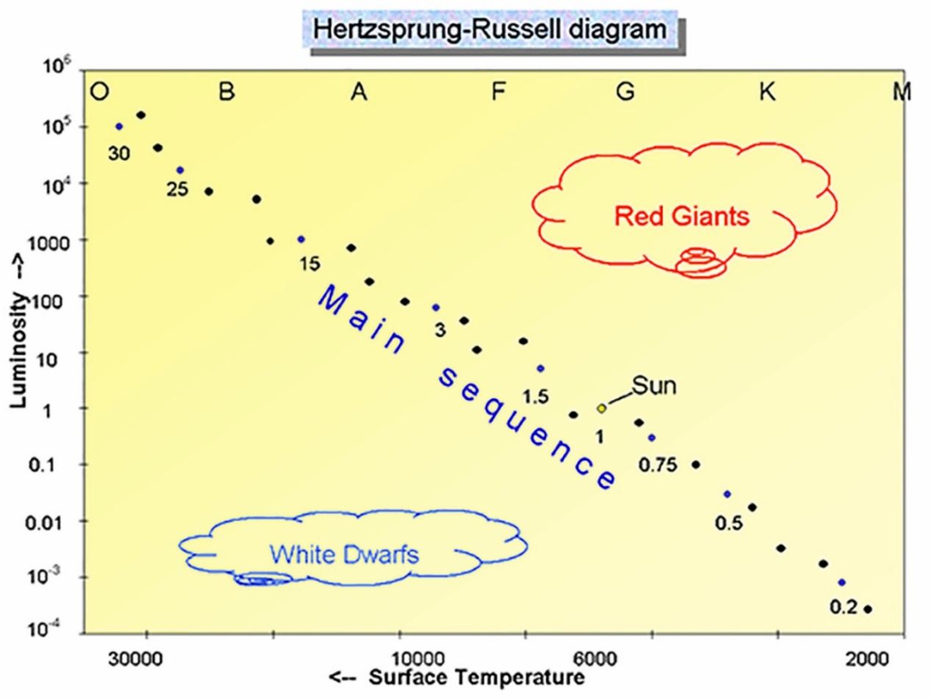
Figure 4 The HR diagram, showing the mass of stars along the main sequence as multiples of the Sun’s mass. The letters at the top indicate the spectral class of the stars, with O and B representing the brightest and hottest stars, and K and M at the other end representing the faintest and reddest stars.
View description - Figure 4 The HR diagram, showing the mass of stars along the main sequence as multiples ...

Full resolution image here
Here is the HR diagram again, this time with numbers indicating the masses of selected stars along the main sequence as multiples of the Sun’s mass. These range from small red K and M stars, much smaller than the Sun, to hot luminous O and B stars up to 30 times more massive than the Sun.
How do we know the masses of these stars? You have already seen how the colour (and hence temperature) of a star can be measured from the shape of its spectrum, and how the luminosities of stars can be compared and measured using stars in a cluster to eliminate the distance factor. Both of these techniques have involved a certain degree of ingenuity in addition to straightforward measurement. To find the masses of stars requires an equal amount of ingenuity and thought.
In Section 2.3 of Week 5 you saw how you can work out the mass of the Sun by measuring the size and period of the orbit of a planet such as Jupiter and applying Newton’s laws of gravity. One technique for determining the masses of stars uses a very similar principle, together with the fact that many stars occur as binary stars – two stars orbiting one another. Given that stars often form in clusters from a cloud of collapsing gas, this is actually relatively common, as many stars are formed close to one another at the same time, and some of these will pair up to form binary systems.

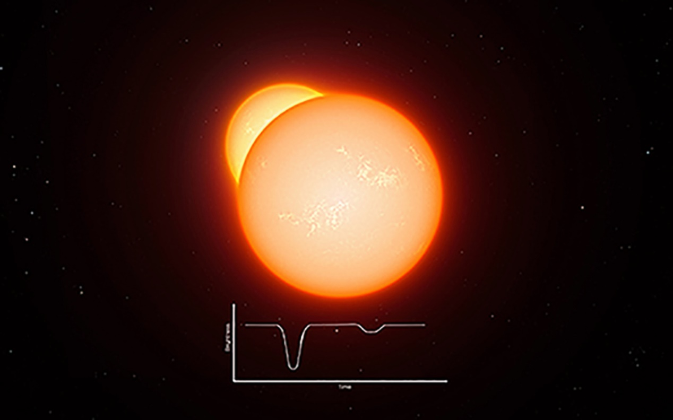
Figure 5 Artist’s impression of eclipsing binary stars. The light curve below shows how the brightness as seen from Earth dips on a regular basis as one star passes in front of another. (ESO.org)
View description - Figure 5 Artist’s impression of eclipsing binary stars. The light curve below shows ...

You will learn a lot more about binary stars next week, but for now the important point is that it is possible to measure the period of orbit for some of these stars around one another, and in doing so to find their masses in the same way that we did for the Sun, using the period of Jupiter’s orbit. Figure 5 shows one such type of binary system, where one star passes in front of another, causing a drop in the light seen from Earth. The time between these dips tells us the period of the orbit; from this the masses of the stars can be calculated. Of course, not all stars are binaries, but it turns out that binary stars fit on the main sequence exactly alongside single stars and so there is every reason to suppose that their masses will be typical of stars of the same spectral type.

3.2 How the mass of a star affects its luminosity
Last week, in understanding the structure and energy source of the Sun, you learned that nuclear reactions take place in the core of the Sun and that as the energy from these reactions makes its way out from the core to the surface it exerts a pressure that helps to support the Sun against the force of gravity, preventing collapse and keeping it stable over a long period of time.

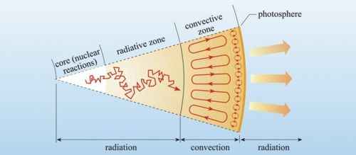
Figure 6 A section of the Sun. Energy from nuclear reactions in the core flows out to the surface, supporting the Sun against the inward force of gravity. Other stars on the main sequence are supported in the same way, making them stable..
View description - Figure 6 A section of the Sun. Energy from nuclear reactions in the core flows out ...

Figure 6 shows a slice through the Sun. Because of the extremely high temperatures, the hydrogen and helium in the Sun exist in an ionised state called plasma, in which electrons and nuclei are split apart.
The energy produced by the nuclear reactions in the core supports the Sun against gravity in two ways. The first of these is kinetic pressure, which is simply the pressure caused by the high temperatures and dense material. The second type of pressure is radiation pressure. This is pressure exerted by energy travelling outwards towards the surface. The zigzag line in the inner layers shows the radiation colliding many times with charged particles in the plasma, resulting in an outward force.
The same processes in other stars keep them stable throughout their main-sequence lifetimes, maintaining an equilibrium between the inward pressure of gravity and the outward kinetic and radiation pressure as long as energy continues to be produced at a constant rate.
This helps us to understand the role of mass in determining the overall luminosity of a star. Stars on the main sequence are stable. For such a star to remain in equilibrium, with a constant temperature and luminosity, the rate at which energy is radiated from its surface has to be equal to the rate at which energy is being produced in the core (otherwise it would heat up or cool down). The luminosity therefore depends on conditions in the core, which in turn depend on the mass of the star.
In more massive stars the greater inward force of gravity produces higher temperatures and pressures, requiring a higher rate of energy production to support the star. The nuclear reactions of the ppI chain are extremely sensitive to conditions in the core, running faster as the temperature and pressure increase. This means that stars of different masses can be stable, with more massive stars having a higher luminosity and consuming nuclear fuel at a higher rate in order to be supported against the extra gravity.
The increase in luminosity is striking (as Figure 4 shows). Stars of just a few solar masses can have luminosities hundreds or even thousands of times more than the Sun. In addition to higher temperatures at the surface, more massive stars are also larger, and both of these factors contribute to the overall luminosity. At the top end of the scale, extreme conditions in the cores of heavy stars enable additional types of nuclear reaction to take place, converting hydrogen to helium at an even higher rate, meaning that stars of 30 solar masses have energy outputs of around 100 000 times that of the Sun.

4 The lifecycles of stars
The Hertzsprung-Russell diagram has so far allowed us to classify the stars according to temperature and luminosity, and has also shown a pattern in the masses of stars, with more massive stars being hotter and more luminous, and smaller stars being relatively cooler and less luminous.
The diagram is also helpful in understanding the lifecycles and evolution of stars. You will start by taking a closer look at the main sequence, which is the central diagonal band running the length of the diagram, and is the part of the diagram occupied by stars in the main, stable part of their lifetime.

4.1 The main sequence
The main sequence is the most prominent feature on the diagram precisely because most stars spend the vast majority of their lifetime in this stable state. Any large and random sample of stars will contain mostly main-sequence stars, with relatively fewer in the other, shorter-lived, phases of their lifecycles.
This stability is the result of the nuclear reactions in the cores of main-sequence stars. Whatever their mass, temperature or luminosity, all main-sequence stars are powered by the conversion of hydrogen into helium by nuclear fusion. The equilibrium between gravity and the outward pressure of energy production in the core can be maintained as long as there is sufficient hydrogen available to fuel the reactions. For most of the main-sequence life of a star these reactions run at a steady rate, but eventually the hydrogen will run out and the star will come to the end of its stable existence on the main sequence.

4.2 Stellar lifetime as a function of mass
At the end of last week, you calculated the lifetime of the Sun based on the mass of hydrogen available and the rate at which it is being used up to sustain its luminosity and stability. This resulted in a lifetime of about 10 billion years. We are now in a position to see how the lifetimes of stars of other masses compare to this figure.
Although stars more massive than the Sun have more hydrogen available to use as fuel they also have much higher luminosities, meaning that the hydrogen is used up at a greater rate. As you have seen in Figure 4, the luminosity increases much more rapidly than the mass, meaning that heavier stars will actually have shorter lifetimes.
This is illustrated in the following table, which calculates the lifetimes of stars compared to that of the Sun:

Table 1: Main sequence lifetimes of stars of different masses. Heavier stars have shorter lifetimes.
Mass (solar masses) | Luminosity (Sun = 1) | Lifetime in years
0.5 | 0.03 | 180 billion
0.75 | 0.3 | 30 billion
1.0 | 1 | 10 billion
1.5 | 5 | 3.3 billion
3 | 60 | 550 million
15 | 17 000 | 10 million
25 | 80 000 | 3.4 million

The life of a star depends on the amount of hydrogen fuel available and the rate at which it is used up. As shown in the table, the luminosity increases much more rapidly than the mass. A star of just three solar masses has 60 times the luminosity. It has three times as much fuel available, but at 60 times the rate of consumption it will all be used up in one-twentieth the time – just 550 million years. Even heavier stars with luminosities many thousands of times more than the Sun have lifetimes of just a few million years. The smaller K and M stars however – those with less mass than the Sun – use up their fuel at a very slow rate, giving them projected lifetimes of many tens or even hundreds of billions of years – longer than the current age of the universe.
From this table you can also see that it is very fortunate for life on Earth that our Sun is a relatively small, average star, fairly low down on the main sequence and the scale of luminosity. Given that the Earth is 4.6 billion years old, a star just a bit larger than our own Sun at 1.5 solar masses would have expired by now, but luckily our own Sun is only about halfway through its main sequence life.
This naturally leads us to think about what happens to a star when the hydrogen in its core does run out, and you will conclude this week by considering this.

4.3 After the main sequence

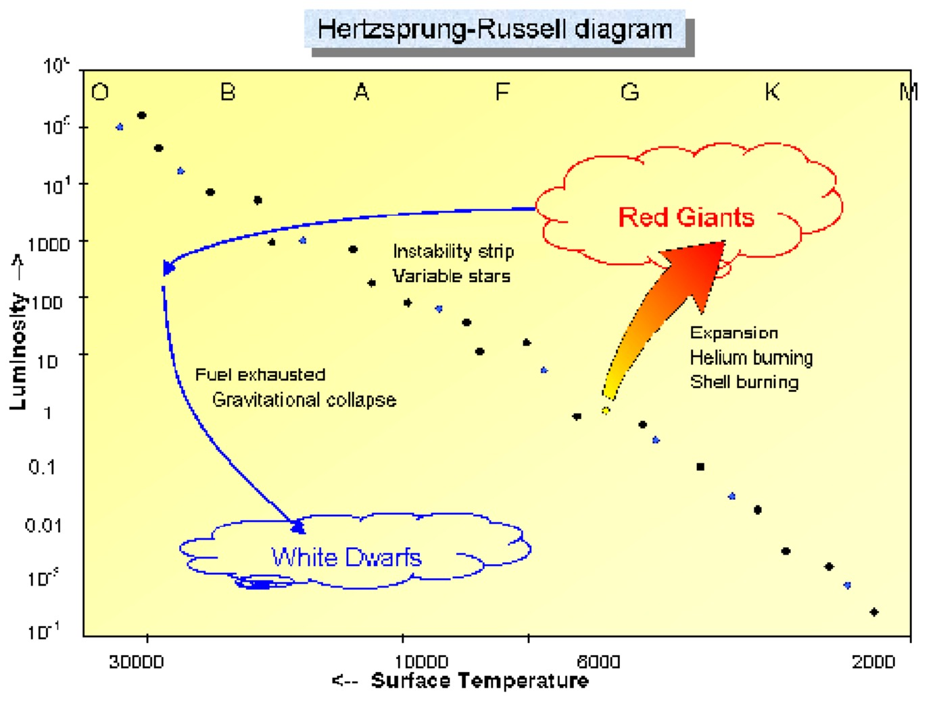
Figure 7 The Hertzsprung-Russell diagram showing the evolutionary path of a star such as our Sun after it leaves the main sequence. First the star will expand to form a red giant before collapsing eventually to form a white dwarf. On their way to becoming red giants, some stars will pass through the instability strip, becoming variable stars. Heavier stars, further up the main sequence, may pass through this region more than once.
View description - Figure 7 The Hertzsprung-Russell diagram showing the evolutionary path of a star ...

Full resolution image here
Whatever the mass of a star, sooner or later its supply of hydrogen for nuclear reactions will run out. When this happens, the equilibrium between gravity and energy production in the core will no longer be sustainable and the star will reach the end of its stable main-sequence lifetime. The HR diagram is extremely useful in visualising what happens next; you can view the subsequent evolution of the star as a path on the diagram.
If the energy production simply came to an end, the star would eventually simply collapse under gravity. Before this can happen though, further nuclear reactions come into play, converting helium into heavier elements. This results in a burst of energy that causes the outer layers of the star to expand. As the star becomes larger, the outer layers cool – it becomes redder, moving to the right on the diagram. Although cooler, the larger surface area of the star as it expands means that the total luminosity increases, moving it upwards on the diagram. The large yellow-orange arrow on the diagram illustrates this expansion for a star of one solar mass as it expands to become a red giant.
The helium fusion reactions taking place in this stage of a star’s life are far less efficient than the fusion of hydrogen to helium, and so this phase does not last as long as the main sequence part of a star’s life. Eventually, the helium and heavier elements will also run out and the star follows the blue arrow to the left, first becoming hotter as it starts to collapse and eventually fading as it gets even smaller, moving down the diagram to form a white dwarf at the bottom left.
Along the way, some stars pass through the instability strip mentioned in the video from Section 2, becoming pulsating variable stars. You will look at these and other types of variable stars in more detail next week.

5 This week’s quiz
Well done – you have reached the end of Week 6 and can now take the weekly quiz to test your understanding.
Week 6 practice quiz
Open the quiz in a new tab or window (by holding ctrl [or cmd on a Mac] when you click the link) and come back here when you are done.

6 Summary of Week 6
This week you have learned about the Hertzsprung-Russell diagram, which is a way of classifying stars according to their temperature and luminosity, and illustrates a powerful scientific technique of plotting one property of an object against another and looking for patterns.
In the case of stars, the HR diagram shows that most stars spend a substantial part of their lifetime in a stable state on the main sequence, in which gravity and nuclear energy are in equilibrium. The position of a star on the main sequence is largely determined by the mass of the star, with heavier stars being hotter and more luminous, and stars smaller than the Sun being cooler and fainter.
The balance between nuclear reactions and energy output and the amount of hydrogen available determines the lifetime of the star, and the combination of mass and luminosity on the diagram shows that heavier stars use up their fuel at a highly accelerated rate, giving them much shorter lifetimes than less massive stars.
The diagram also allows us to visualise what happens at the end of a star’s lifetime for a star of similar size to the Sun expanding first to a red giant and then collapsing to form a white dwarf. Heavier stars may have an even more dramatic fate, as you shall see next week when you explore the different types of variable stars.
You can now go to Week 7.

Week 7: Variable stars

Introduction
In recent weeks you have learned how stars are powered by nuclear reactions in their cores and seen how classifying stars on the Hertzsprung-Russell (HR) diagram allows us to visualise their characteristic groupings, in particular the main sequence on which most stars typically spend a large part of their stable lifetime.
This week we will look at how stars evolve once their main sequence lifetime comes to an end, and in particular at the instability strip on the HR diagram and the reasons why some stars become variable at certain stages in their lifetime.

Video content is not available in this format.
View transcript - Uncaptioned interactive content

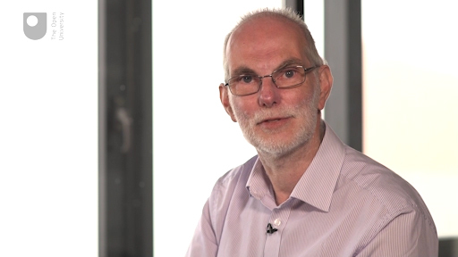

At the end of this week you will use COAST to start taking your own images of a variable star in order to measure how its brightness changes. Next week, you will combine your measurements with those taken by others at different times to produce a light curve which shows the variation of your star over time.
By the end of this week you will be able to:
- understand more about the life cycles of stars, in particular what happens to stars of differing masses when they reach the end of their main sequence lifetime
- understand how the mass of a star will determine its eventual fate
- understand the three main types of variable stars: pulsating stars, eclipsing binaries and cataclysmic variables
- be able to identify a suitable target star from a list of known variables and schedule your own observations with COAST.

Course forum
Each week of this course has its own forum allowing you to communicate with the course authors and fellow participants to make connections, share ideas and ask questions.

1 Stellar evolution after the main sequence
During the main part of their lifetime on the main sequence most stars are relatively stable, with nuclear reactions in their cores converting hydrogen into helium at a steady rate. As long as there is sufficient hydrogen available to sustain these reactions a star will remain in an equilibrium state with the energy produced in the core supporting the star against the inward pull of gravity. On reaching the surface, the energy radiates out into space maintaining the star’s luminosity.
This flow of energy keeps the star in equilibrium; while the rate of energy production in the core matches the rate of energy leaving the surface, then conditions such as temperature and pressure within the star will remain stable.
However, gravity is always at work waiting and sooner or later the supply of hydrogen in the core will run out. As we have seen for our own Sun, this will not happen for several billion years, but for heavier stars the supply of hydrogen is used up more quickly. Eventually, all stars will run out of hydrogen and when this happens, things will start to change – energy production and gravity will no longer be in equilibrium and the star will no longer be stable.
What happens next depends on the mass of the star and its position on the main sequence of the HR diagram.

1.1 Helium as a nuclear fuel
As a star approaches the end of its main sequence lifetime, the rate of energy production from hydrogen fusion in the core will begin to drop as the available hydrogen runs out. When this happens, the flow of energy will no longer be sufficient to support the star against gravity and the equilibrium will be lost.
Unless the star can find an alternative source of energy it would begin to collapse under the ever-present pull of gravity. In Activity 1 you will explore a potential source of energy that can – at least temporarily – replace the exhausted supply of hydrogen.

Activity 1 Helium fusion
Allow approximately 20 minutes

During the time that a star spends on the main sequence, hydrogen fusion in the core converts hydrogen into helium. When the star reaches the end of its main sequence lifetime, the core will be rich in helium and low in hydrogen.
In this activity you will explore the possibility of helium fusion and the question of whether, and for how long, this might be able to replace the supply of energy needed to keep the star from collapsing under gravity.
We’ll start by looking at a nuclear reaction involving helium fusion:

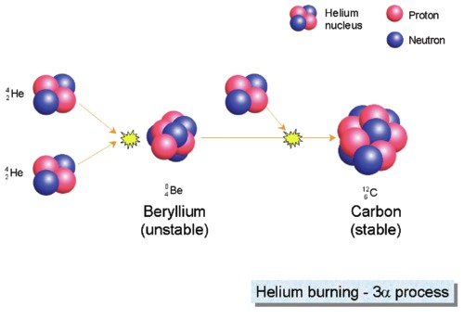
Figure 1 The triple alpha (3α) process, which converts helium into carbon. While this can sustain a star for a short period of time after the main sequence, it is less efficient than hydrogen fusion.
View description - Figure 1 The triple alpha (3α) process, which converts helium into carbon. While ...

In this process helium nuclei, also known as alpha particles (α-particles), fuse together to form heavier nuclei.

What is the overall effect of this triple alpha process? Think about what goes into the reaction and what comes out.

View answer - Part

Based on what you learned earlier about the ppI chain, what conditions of temperature and pressure do you think will be required for this triple alpha process, compared to the conditions required for hydrogen fusion?

View answer - Part

The triple alpha process releases far less energy than the hydrogen fusion of the ppI chain. Given that the mass of the core is the same, how long will the energy from helium fusion be able to support the star?

View answer - Part

1.2 Expansion and the red giant branch
Your answers to Activity 1 will have told you two things: that helium fusion requires more extreme conditions in the core of a star than hydrogen fusion, and that it can only provide a brief respite against the eventual gravitational collapse of the star.
This is clearly going to be a much less stable phase of the star’s life than its previous existence on the main sequence. Perhaps curiously, the star does not immediately start to contract under gravity, and in fact the outer layers of the star will continue to be supported for a while and will eventually expand.
To understand this, think back to the zigzag path that radiation takes on its way out from the core as shown in Figure 6 last week. The multiple collisions between the outgoing radiation and charged particles in the dense material in the star’s interior provide the radiation pressure that helps to support the star. These repeated collisions also slow the progress of the energy; in a star such as the Sun it can take up to a million years for the radiation to work its way from the core to the surface. This means that the outer layers can still be supported by radiation pressure for a significant time after the supply of energy in the core dies down. While the last gasps of this energy are still holding up the outer layers, the core of the star will be the first part to start collapsing, as shown in Figure 2.

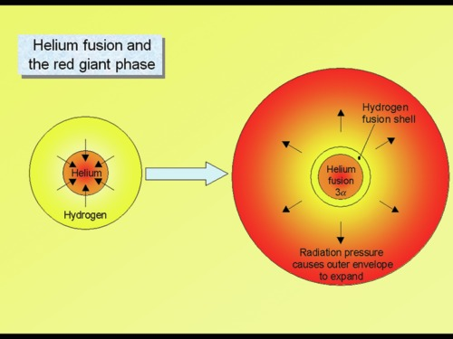
Figure 2 Helium fusion in a post main sequence star. On the left we see the core collapsing, and on the right the outer layers expanding as a result of energy released by helium fusion in the collapsed core.
View description - Figure 2 Helium fusion in a post main sequence star. On the left we see the core ...

As the core starts to contract, gravitational energy is released. This causes the core temperature and pressure to increase as it becomes more compressed. The first consequence of this is that further hydrogen fusion will be triggered, both in the core – as any remaining hydrogen is subjected to these more extreme conditions – and in a thin shell of unused hydrogen around the core that is now heated enough to undergo fusion. The energy released by this new burst of fusion increases the radiation pressure on the outer layers, causing them to start expanding and taking the star from point A to D on the HR diagram in Figure 3.

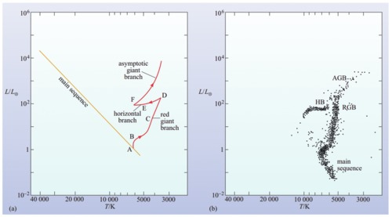
Figure 3 The post main sequence evolution of a star like the Sun. The right-hand diagram shows a sample of stars from a globular cluster such as M13. Because globular clusters are old, the more massive stars have already left the main sequence to become red giants. Only the lower portion of the main sequence, containing stars of similar mass to the Sun and smaller, is still intact. These less massive stars have longer lifetimes so have not yet left the main sequence.
View description - Figure 3 The post main sequence evolution of a star like the Sun. The right-hand ...

At point D, the core has become sufficiently compacted for helium fusion to start – particularly for smaller stars this is a very unstable process and can take place very rapidly in a runaway reaction known as the helium flash. This heats the star further, taking it from E to F on the diagram. After point F, helium fusion starts in a shell surrounding the core, much as it did for hydrogen, resulting in further expansion of the outer envelope, which cools as it expands, moving the track upward and to the right on the diagram. The star is well on its way to becoming a red giant.

1.3 Tracks on the HR diagram
After a long period of stability on the main sequence, these later stages of a star’s evolution are dramatically less stable, with rapid changes in a star’s diameter, temperature and luminosity as different phases of hydrogen and helium fusion are triggered in different regions in and around the star’s collapsing core.
As you saw at the end of last week, the HR diagram provides a very useful way of visualising the progress of these changes as tracks on the diagram.

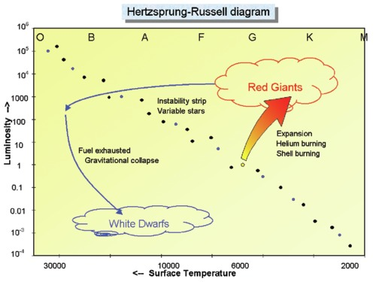
Figure 4 The Hertzsprung-Russell diagram showing the evolutionary path of a star such as our Sun after it leaves the main sequence.
View description - Figure 4 The Hertzsprung-Russell diagram showing the evolutionary path of a star ...

Figure 4 shows the evolution of a star of the same mass as our own Sun after leaving the main sequence, first expanding to form a red giant, powered by helium fusion and hydrogen shell fusion. Eventually though, the supply of helium will also be exhausted.

Activity 2 Lifetime of the red giant
Allow approximately 5 minutes

Since helium fusion is less efficient than hydrogen fusion, the lifetime of the red giant phase will be less than the star’s main sequence lifetime. What other factor shown on the diagram will also shorten the time spent as a red giant?

View answer - Activity 2 Lifetime of the red giant

For low-mass stars such as the Sun, helium fusion is the last available source of energy. When the helium runs out gravity takes over once more and the star collapses, eventually forming a white dwarf, which is an extremely dense object approximately the same size as the Earth. Initially, the gravitational energy released as it collapses makes the white dwarf very hot, but with a low overall luminosity because of its small size, placing it on the lower left of the HR diagram. With no further nuclear reactions, this white dwarf will eventually cool and fade, although this can take a very long time.
More massive stars than our Sun have a more interesting fate, with some of them – for a short time – becoming periodic variable stars. You will learn more about these in the next section.

1.4 The instability strip

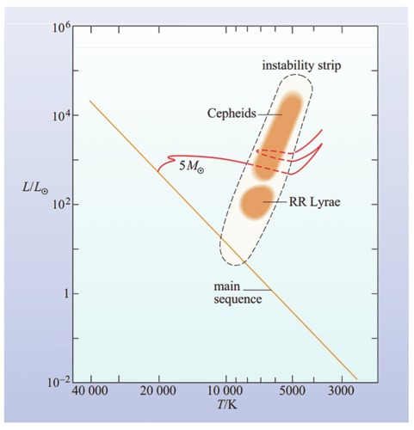
Figure 5 The path of a five solar mass star after leaving the main sequence.
View description - Figure 5 The path of a five solar mass star after leaving the main sequence.

When a star more massive than the Sun leaves the main sequence, its track on the HR diagram starts out approximately horizontal. During the course of its expansion to a red giant it can move back and forth on the diagram several times as different phases of core and shell fusion start up. At certain stages in this process, the star can undergo regular pulsations as it struggles to achieve equilibrium between gravity and radiation pressure. Instead of reaching a stable state, the star oscillates between contraction and heating – which speeds up the nuclear reactions – and expansion and cooling – which slows them down again. This results in periodic variations in the star’s luminosity. Figure 5 shows the track of a five solar mass star (i.e. five times the mass of the Sun) as it goes through this process.
The region on the HR diagram where these pulsations happen is called the instability strip. Stars passing through this strip are classified into different types, such as Cepheid and RR Lyrae stars, which result from stars of differing initial masses and which pulsate at different rates. However, all share the characteristic of a regular pattern to the variations in their luminosity.
Pulsating variables are one kind of variable star; in the next section you will learn about different types of variables, and this will help us to understand the eventual fate of stars.

2 Variable stars
In this video, Jo explains three different causes of variability: pulsating stars, such as those passing through the instability strip; eclipsing binary stars; and finally even more dramatic exploding stars.

Video content is not available in this format.
View transcript - Uncaptioned interactive content

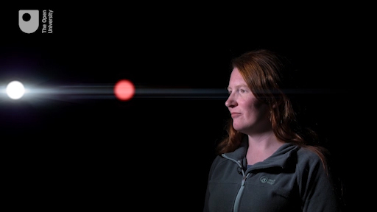

In the next sections, you will look at each type of variable in turn.

2.1 Pulsating variables and their light curves
Stars in the instability strip fall into two different but closely related groups, RR Lyrae and Cepheid variables, both of which pulsate on a regular basis. Of these, the Cepheid variables are of particular interest for a couple of reasons. First, their behaviour is consistent with our current theories of how stars work, giving us confidence that we understand the inner properties and workings of stars. Secondly, their pulsations are useful because they have a specific property – that is, the pulsation period depends precisely on the average luminosity of the star (the more luminous a Cepheid variable, the longer the period). This is known as the period-luminosity relationship. This relationship was discovered in 1912 by American astronomer Henrietta Swan Leavitt [Fig 6] and later used by Edwin Hubble in confirming the expansion of the Universe.

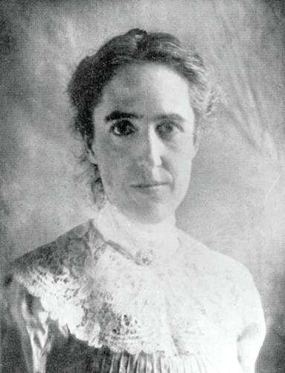
Figure 6 American astronomer Henrietta Swan Leavitt.
View description - Figure 6 American astronomer Henrietta Swan Leavitt.

There are two main classes of Cepheid variables. Classical Cepheids are relatively large and luminous, typically resulting from stars much more massive than the Sun and having relatively long periods (a few days to a few weeks). Type II Cepheids are smaller with shorter periods. The RR Lyrae stars are typically older, less massive than the Sun and have shorter periods measured in hours.

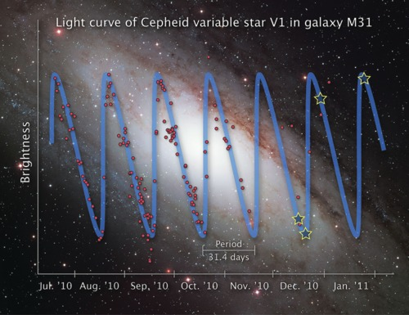
Figure 7 The light curve of a Cepheid variable in the Andromeda galaxy (M31). The red dots indicate measurements made by amateur astronomers and used by NASA to make observations with the Hubble telescope at the predicted dimmest and brightest points in the cycle, as indicated by the blue/yellow stars on the curve.
View description - Figure 7 The light curve of a Cepheid variable in the Andromeda galaxy (M31). The ...

Credit: Illustration Credit: NASA, ESA and Z. Levay (STScI). Science Credit: NASA, ESA, the Hubble Heritage Team (STScI/AURA) and the American Association of Variable Star Observers
By taking repeated measurements of the brightness of a Cepheid variable over a period of time and plotting its light curve it is possible to determine its period. Once the period is known, the period-luminosity relationship for Cepheids can be used to work out how intrinsically luminous it is. From telescopic images the apparent luminosity can be measured. Combining these two pieces of information and remembering that the apparent luminosity depends on the intrinsic brightness of the star and its distance, it is possible to determine how far away the star is. Because the Cepheid variables have relatively high luminosities they can even be seen in other galaxies.
This is absolutely crucial information as it allows distance determinations not only of individual Cepheid variable stars, but by extension any star cluster or galaxy that the Cepheid belongs to. The distance to our neighbouring Andromeda galaxy (M31), measured in this way, is 2.2 million light years using the light curves of variables such as the one shown in Figure 7. In turn it has been possible to use the measurement of distances provided by Cepheids as an essential first step in determining a number called Hubble’s constant – a measure of how quickly the Universe is expanding and evidence for the Big Bang. In this way, pulsating stars such as Cepheids not only allow us to test our predictions of how stars work, but are also critical in helping us to understand the very nature and origins of the whole Universe.

2.2 Eclipsing variables
The second type of variable star mentioned by Jo in the video is the eclipsing binary. This type of system consists of two stars orbiting one another closely in such a way that one star passes in front of the other as seen from the Earth. As this happens, the light from the more distant star is blocked, causing a dip in the overall brightness of the system as measured here on Earth. you have already seen in Week 6 how the periods of these eclipsing binary stars can be used to work out their masses. Here you will look at the light curve in more detail:

Video content is not available in this format.

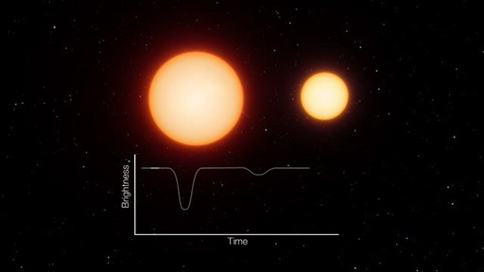
View description - Uncaptioned Figure

The light curve of such a system is very characteristic, having two dips in brightness per orbit. If the two stars are of similar size and brightness then the dips will be similar in size. In many systems, however, the stars are of very different brightness – in this case, there will be a small dip when the light from the fainter star is blocked and a larger dip when the fainter star passes in front, blocking light from the brighter one.
By analysing the light curves of these eclipsing binary stars, it is possible to learn a lot about the two component stars, even if they are too close to be seen separately. In your observing project next week, you will use COAST to make measurements of an eclipsing binary star and combine your results with measurements made by others to produce an overall light curve for the system.
A related type of system is the transiting exoplanet in which the light from a distant star is blocked by a planet orbiting around it, again producing a dip in the light curve. As you can imagine, the reduction in light is very small (perhaps less than 1%) but with modern detectors, these small changes in light can be detected even using small telescopes, as you shall see in a later section.

2.3 Supernovae and cataclysmic variables
In the final segment of Jo’s video she describes the explosion of a supergiant star, such as Betelgeuse. These massive stars end their lives in a colossal explosion triggered by the collapse of the core when all nuclear fuel is exhausted. In the process most of the star is destroyed, with material rich in heavier elements thrown off into the interstellar medium. Only a small inner core remains, eventually collapsing to form a neutron star or even a black hole. The expanding cloud of gas thrown off in these supernova explosions forms a nebula known as a supernova remnant. The Crab Nebula (M1) that you first saw in Week 4 is a classic example of a supernova remnant.
While a supernova is a one-off and very catastrophic explosion, the term cataclysmic variable primarily refers to a type of binary system in which one component is a white dwarf, in orbit with a low-mass main sequence companion star.

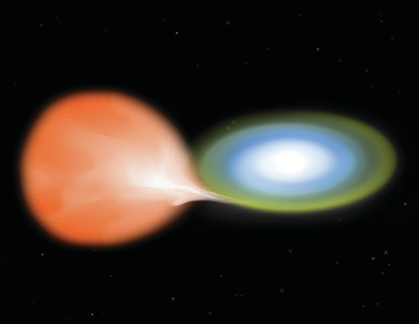
Figure 8 An artist’s impression of accreting binary star Nova Aquilae, consisting of a white dwarf in orbit with a low-mass main sequence companion star. Material from the larger star is transferred and falls onto the surface of the white dwarf, causing repeated explosive events. (Credit: NASA/CXC/M.Weiss)
View description - Figure 8 An artist’s impression of accreting binary star Nova Aquilae, consisting ...

In this type of system, material from the outer layers of the companion star falls onto the surface of the white dwarf, building up density and pressure. Since this material contains a lot of hydrogen the increase in density, temperature and pressure eventually triggers an outburst of nuclear fusion, producing an explosion that can cause the brightness of the binary system to briefly increase by hundreds of thousands of times (a classical nova). In some systems the process of accretion and explosion can occur repeatedly, producing a cataclysmic variable star with periodic, if perhaps irregular, outbursts. These are known as recurrent novae.

Activity 3 Hydrogen in companion star
1 minute

Why is the accreting material from the companion star rich in hydrogen ?

View answer - Activity 3 Hydrogen in companion star

3 Collaboration in observing
Observing and making measurements on your own can be fun, challenging and very rewarding – as we hope you are finding – but there are definite advantages in science to working collaboratively with others. As well as having access to more advanced equipment like COAST, working with others allows you to combine your results and find out much more than any one person working individually. In this section you will look at some collaborative projects involving The Open University (OU).
Earlier this week we looked at results on pulsating stars obtained from some of the largest and most advanced telescopes, such as the Hubble telescope. But smaller telescopes, such as COAST, are also perfect for studying such stars within our Galaxy, and even for more luminous examples in nearby external galaxies such as Andromeda. The reason for this is the development of very sensitive imaging detectors which, when coupled with even moderately sized telescopes, are ideal for obtaining very accurate measurements of a very large number of stars within the Galaxy. And this is precisely what is needed to determine the orbital or pulsational period of a star, or indeed to make observations of a very large number of variable stars to determine the regions of the HR diagram (or combinations of stellar temperature and luminosity) in which pulsating stars are to be found.
One particular example that the OU has been heavily involved with is a novel robotic telescope called SuperWASP (Wide Angle Search for Planets). Originally designed to detect the very small minute decrease in the light from a star as a planet orbiting it passes in front of it, this instrument consists of eight large aperture telephoto camera lenses backed with high-quality CCD detectors (Figure 10). This combination means that SuperWASP can map very large areas of the night sky in a single exposure – ideal for very large surveys of moderately bright stars.

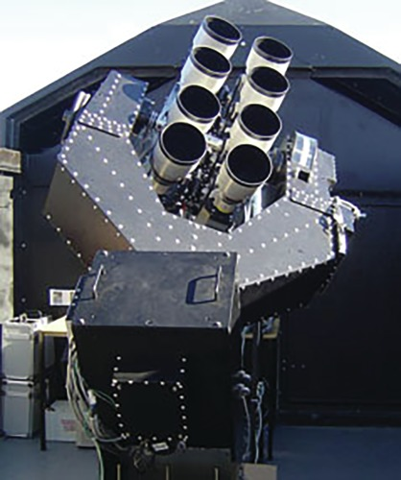
Figure 9 The SuperWASP telescope on the island of La Palma in the Canaries.
View description - Figure 9 The SuperWASP telescope on the island of La Palma in the Canaries.

The planet-finding survey with SuperWASP began in 2004 and as of 2016 had discovered 118 planetary systems. As well as looking for transiting exoplanets, SuperWASP has also identified large numbers of pulsating variables and eclipsing binary stars which have subsequently been followed up via dedicated observational programmes on other telescopes. This shows the real advantage that small, custom-designed, robotic telescopes have for these types of scientific investigations. Very large telescopes are best used when looking at very faint or distant targets, while smaller telescopes are much better suited to looking at bright targets, or many different objects at the same time in large surveys designed to identify variable stars.
Another example of collaboration is where researchers have access to data from space-based observatories and telescopes. In this video, OU astronomer Meredith Morrell explains how he makes use of data from the ESA satellite GAIA to plan and make follow-up observations using PIRATE, COAST’s companion telescope in Tenerife.

Video content is not available in this format.
View transcript - Uncaptioned interactive content

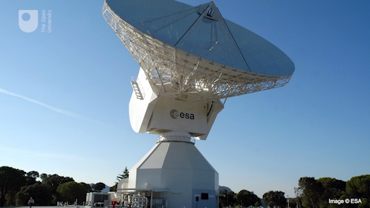

Finally, in this video Nayra Rodriguez Eugenio from the IAC (Instituto de Astrofísica de Canarias) describes some of the collaborative projects being carried out between Spain and the UK using COAST, including a search for variable stars very similar to the project that you will carry out.

Video content is not available in this format.
View transcript - Uncaptioned interactive content

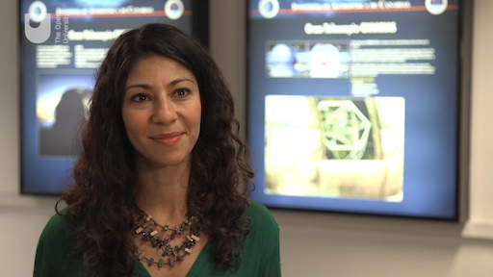

4 Plan your own variable star observations using COAST
In the final observing project for this course, you will make observations of a periodic variable star chosen from a list of eclipsing binary stars identified by SuperWASP. These are suitable for a one-week project as the periods are short (between three and five days) and the stars have not been previously studied in any great detail; by contributing data points to the light curve you will be making a valuable addition to the body of scientific knowledge about these objects

Activity 4 Request observations of SuperWASP eclipsing binary
Allow approximately 40 minutes

In this exercise you will use the knowledge and experience that you have gained from your observations of Messier objects in earlier weeks to help you to plan your observations of the eclipsing binary star.
1. Select target and plan observations
The table below gives a list of potential eclipsing binary stars identified by SuperWASP. Just as with the Messier objects that you observed in Week 4, these are located in different parts of the sky, and so different objects in this list will be best placed for observing at different times of the year.

Object | RA | Dec
EW1 | 05h 48m 29.96s | +33° 48’ 18.5’’
EW2 | 05h 28m 55.47s | +38° 19’ 15.3’’
EB1 | 03h 58m 52.20s | +41° 07’ 06.0’’
EB2 | 20h 43m 00.15s | +38° 27’ 21.4’’
EB3 | 20h 11m 08.31s | +13° 16’ 30.2’’
EB4 | 20h 43m 20.70s | +12° 18’ 19.2’’
EA1 | 17h 40m 38.44s | +11° 36’ 23.9’’
EA2 | 17h 15m 18.34s | +35° 45’ 41.7’’
EA3 | 12h 37m 39.00s | +09° 47’ 13.9’’
EA4 | 09h 11m 17.71s | +39° 15’ 50.0’’

The celestial coordinates (RA and Dec) are listed alongside each object. Using your knowledge of how the RA determines when an object is well placed for observation, select a target from this list that will be observable over the next week. You may wish to refer back to Section 2.1 of Week 4 to help you with this. You can also use Stellarium to check – it will be difficult to identify the individual stars from this list and they may not be shown at all, but you can still check that the coordinates are visible at night during the week that you will be observing.
2. Request images from COAST
Log in to the telescope.org website and select Use telescope from the menu on the left hand side. Previously, you selected Messier objects from a list, but this time you will enter the coordinates of your chosen target directly. Select or click here to enter coordinates under the Enter the name or catalogue ID box. This brings you to a screen where you can enter the RA and Dec coordinates from the table. Enter the coordinates carefully as shown in this example:

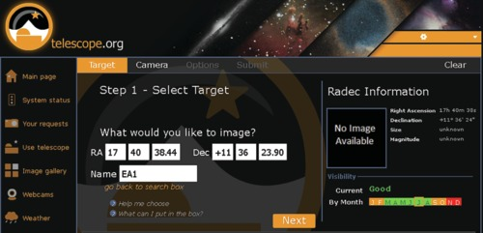
Figure 10 Entering RA and Dec coordinates in telescope.org. The example shown here is for target EA1. Check the visibility pane on this screen to confirm that your target is visible at this time of year.
View description - Figure 10 Entering RA and Dec coordinates in telescope.org. The example shown here ...

Enter the name of your target in the Name box that appears below the coordinates and click Next to take you to the Step 3 – Customize screen.
3. Filter selection
In order to compare results, it is important that all measurements are made using the same filters. For this investigation we will use the green (V) filter. This is a standard filter for this type of work as it covers the middle part of the visible spectrum. On the Step 3 – Customize screen, select the (V) filter option under pick a filter (advanced) on the right-hand side.
4. Exposure bracketing
As part of your imaging request you will need to select an exposure time. In order to determine the correct exposure, you should request several images with a wide spread of different exposure times: for instance 15, 30, 60 and 120 seconds. This technique of doubling the exposure each time is known as exposure bracketing. When you get this first set of images back you can choose the image with the correct exposure and use this exposure time for any further images you want to request. This is another example of using information from one set of observations to help you plan subsequent observations.
For each image, confirm your request by pressing Submit on the Confirm request screen.
You are now ready for the final phase of the project. When your images of your chosen target come back you will be able to measure the brightness of the variable star and add your results to the light curve by following the instructions given next week.

5 This week’s quiz
Well done – you have reached the end of Week 7 and can now take the weekly quiz to test your understanding.
Week 7 practice quiz
Open the quiz in a new tab or window (by holding ctrl [or cmd on a Mac] when you click the link) and come back here when you are done.

6 Summary of Week 7
This week you have learned about the life cycles of stars and how the mass of a star determines its evolution after the main sequence and its eventual fate. You have seen the importance of the instability strip on the HR diagram.
You have learned about three different types of variable star: pulsating variables such as Cepheids, eclipsing binaries and cataclysmic variables.
In a section on collaboration in science you have seen the advantages of working with others and how large projects can give you access to advanced equipment and large volumes of data, including recent discoveries.
Finally, using skills that you have developed earlier in the course, you have prepared your first observations of an eclipsing binary star, ready for the final phase of the investigation next week in which you will analyse your results and submit them to be added to the light curve for your chosen object. By combining your results with those of others you will be following up on the discoveries of SuperWASP and contributing to the advancement of scientific knowledge.
You can now go to Week 8.

Week 8: Building a light curve

Introduction
At the end of last week you selected a target star from a list of eclipsing binary stars identified by SuperWASP, and requested your first images of this variable star. In this video, Alan reviews the skills that you have developed and explains how your results will be combined with those of other people taking this course.

Video content is not available in this format.
View transcript - Uncaptioned interactive content

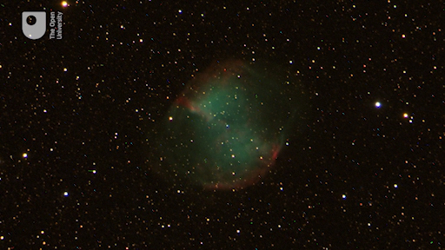

This week you will retrieve the images acquired by COAST and use the information from these to select the best exposure when requesting further images. You will learn how to identify your target star in your images and how to measure the brightness using an online aperture photometry tool. Provided the weather is clear you may be able to get images from several different nights and start to see the variation in brightness in your own observations.
Finally, you will combine your results with those of others to plot an overall light curve for your chosen target. You will be able to identify which data points on this curve are yours and see how they fit with the measurements submitted by other participants on this course in a collaborative scientific investigation.
By the end of this week you will be able to:
- retrieve images from telescope.org in astronomical FITS (Flexible Image Transport System) format
- identify target and reference stars using a finder chart
- assess images for exposure and select the best exposure value for further observations
- use an aperture photometry tool to measure the brightness of your chosen target star
- combine your results to plot the light curve for your chosen target star.

Course forum
Each week of this course has its own forum allowing you to communicate with the course authors and fellow participants to make connections, share ideas and ask questions.

1 Retrieving your images
By now (and provided the weather has been clear) you should find that the first set of images of your selected variable star are ready.
In order to measure the brightness of this variable star and add the data to the light curve, you first need to retrieve your images from COAST in a format that is suitable for further processing. In this section you will learn about the different file formats and the steps needed to retrieve your images.

1.1 File formats
So far, this course has been primarily interested in producing visually pleasing images. In Week 6 you learned how to edit your images, making adjustments to brightness, contrast and colour balance to produce the best effect.
Files for this type of image are usually saved in a format such as .jpg or .png, which are suitable for display on a computer screen. The COAST images that you have saved so far are in the .png format.
In this week’s activities you will be making scientific measurements from your images and this involves saving them in a different format which contains more information.

- Why might images saved after editing not be suitable for scientific analysis?
- Adjustments such as contrast and brightness made to the images could change the results of any measurements made from them. In order to make scientific measurements, and especially in order to compare results taken from different images, it is important to look at raw data, before any adjustments for visual effect have been made.

Another reason for using a standard scientific format is so that astronomers can compare results from images taken using different telescopes and different imaging system.

- What information about an image might be useful to astronomers when exchanging images? Think about all the things that you specify when requesting an image.
- As well as the raw data, it would be useful to know the celestial coordinates, the date and time that the image was taken, the exposure time, and what filter was used.

For this reason, astronomers use an astronomical data format called FITS (Flexible Image Transport System). This format allows astronomical imaging software to store information about the image together with the raw data making up the image in a single file, known as a FITS file. When exchanging images, all the information is kept with the image in this single file which saves having to keep separate notes of filters, coordinates and exposure times. If you receive a FITS file from another astronomer it is possible, by looking in the FITS header, to find out all the information about when it was taken, where the telescope was pointing and all the exposure and filter details.
Another consideration for making scientific measurements is the quality and amount of detail in the numerical values. Digital images are made up of individual pixels, with the brightness of each pixel represented by a number. Most frequently, zero represents pitch black and the highest numbers on the scale represent white, with numbers in between denoting different levels of grey.
In normal image files such as .jpg or .png each pixel is represented by an 8-bit number which can represent one of 256 different brightness levels. FITS images store the brightness of each pixel as a 16-bit number, which allows a much wider range of 65 536 different brightness levels. This is known as the bit depth of the image.
FITS files have a bit depth of 16. Being able to cover such a wide range of brightness levels is especially important for astronomical images, which typically have very bright objects such as stars (represented by high values in each pixel) against a very dark background (represented by pixels with very low values).
FITS files are also uncompressed, meaning that a full 16 bit value is saved for each pixel in the image. This can result in much larger files than compressed images such as .jpg files, but it means that all of the information is available for scientific measurements.
For all of these reasons, most astronomical image processing software is designed to work with FITS image files, including the software that you will use to measure the brightness of your variable star.
Fortunately, COAST has the option to save images in this FITS format, which is ideal for the processing that you are about to do.

1.2 Save images in FITS format
This short video clip talks you through the process of retrieving your COAST images and saving them to FITS format. Detailed instructions are given in the activity that follows.

Video content is not available in this format.
View transcript - Uncaptioned interactive content

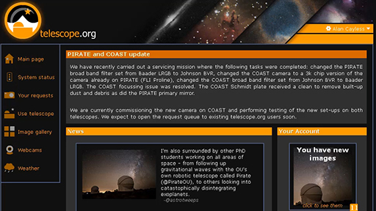

Activity 1 Retrieve your COAST images in FITS format
Allow approximately 20 minutes

- Log in to your telescope.org account and go to the Your requests section of the website to select one of your variable star images. Remember, any images that have been taken will show as Complete. Any images that are still in the queue will be shown as Waiting – you will need to check back later to see if these have been completed.
- From the list, click on the first completed image that you want to work with. This takes you to the View tab.
- To confirm any details about the image, such as filter and exposure time, click on the Data tab. This lists some of the information from the FITS header. You may wish to make a note of these details, although they will also be in the header of the saved FITS file.
- Click on the Edit tab. You do not need to make any adjustments to the image, as the FITS format will store the raw data.
- To save your image, click on the floppy disk icon top right (E). Select fits and then Save File to save a copy of the image to your computer. Remember to keep a note of where you have saved it and the filename of the image.
- Repeat for each of the images that you want to save. If you have used exposure bracketing you should have four images with exposure times of 15, 30, 60 and 120 seconds. Save all four.
Having saved all of your images as FITS files you will probably find that you cannot view them directly on your computer. FITS files are designed to work in specialised astronomical analysis software so don’t worry if your computer doesn’t recognise them.

In the next section you will learn how to use a web-based astronomical data processing tool to make the measurements that you need.

2 Measuring the brightness of your variable star
Now that you have saved your images in FITS format, the next step is to measure the brightness of the variable star. This is done using a technique known as aperture photometry in which the brightness of a star in the image is measured against the background of the image, and by using a non-variable reference star as a comparison.
In the following sections you will look at how this technique works and how to identify the correct stars in your images.

2.1 Aperture photometry
In discussing the FITS file format you have already seen that every pixel in an image has a value – a number that corresponds to the brightness of that pixel. However, measuring the brightness of a star in an image involves a little more than looking at one number in one pixel.

- Open one of your images in telescope.org and use the zoom slider on the Edit page to zoom in as far as you can on one of your images. Comparing one of the brighter stars with one of the fainter ones in your image, what do you notice about the star images?
- The brighter stars appear larger. This is because each star image is spread over several pixels. As well as having brighter pixels, the brightest stars appear larger on the image, with their light covering more pixels.

A technical way of describing this is that the resolution of the detector is greater than the point spread of the star images; in other words, the pixels on the detector are smaller than the star images. This means that to measure the brightness of a star, it is important to add up the counts from all of the pixels making up the image of the star.
One way of doing this is shown in Figure 1. A circle (the central aperture) is drawn around the star image, and the values of all the pixels within that circle are added together.

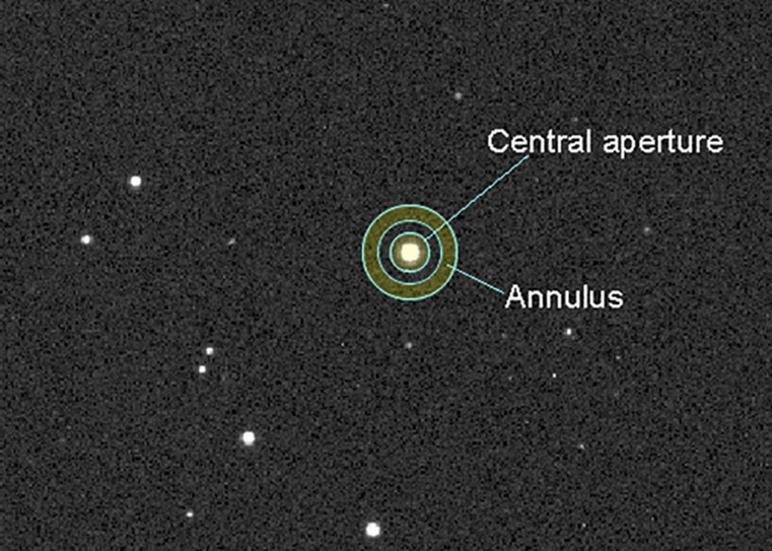
Figure 1 Aperture photometry showing the central circular aperture and the annulus, or ring, surrounding it and used to subtract the background. To make sure that the background is separate from the star, there is a gap in between the aperture and the annulus.
View description - Figure 1 Aperture photometry showing the central circular aperture and the annulus, ...

As you may have noticed when looking at your images, the background is dark but may not be completely black. This is especially obvious when adjusting the sliders for brightness and contrast, and can be seen in Figure 1 – the background pixels are a dark grey, rather than completely black. This means that their pixel values are not exactly zero. Even at the very darkest sites there is always some background light, as well as instrumental noise in the detector, and this must be subtracted off.
An important principle in measuring anything is to make sure that you are measuring only the thing that you are interested in. In this case, you need to subtract any background counts to leave only the counts that are from the star itself. This is done by drawing a ring (annulus) around the central circle, covering only dark sky away from the star. The average count from pixels in this ring is subtracted from each pixel in the central zone, leaving only the values for the brightness of the star itself.
This can be done using aperture photometry software, which accepts a FITS file image and allows you to position the aperture and annulus. The software then does the necessary calculations for the overall count and the background subtraction.

2.2 Reference stars
Another important consideration in making scientific measurements is to eliminate any external factors that could affect your measurement. In order to look for variation in a star, you need to make measurements over a period of time, perhaps hours or days. The brightness of the star in your image will depend on a number of things that remain constant, such as the distance to the star, the size of the telescope and the sensitivity of the detector. There will also be some factors that vary from one image to the next.

- What factors can you think of that may vary from one image to the next?
- The transparency of the atmosphere may change, especially if taking images from one evening to the next. Also, for images taken at different times, the height (altitude) of the star above the horizon will be different each time, again resulting in different amounts of absorption and affecting the brightness of the star’s image.

Another source of variation between images would be if we wanted to combine results from different observers, perhaps stationed in different parts of the world and using telescopes of different sizes.
Fortunately, there is a powerful technique that we can use to eliminate all of these factors, leaving only the variation of the star itself. This is centred around the use of a reference star – a second star in the image that is known not to be variable (i.e. whose brightness is constant). Within any single image, factors such as atmospheric absorption will be the same for all stars in the image, so by comparing the brightness of the target star against that of the reference each time, these factors can be eliminated since both target and reference will be affected equally.
Any change seen in the brightness of the target star relative to the reference will then indicate a variation in the star itself.
This technique of using a reference is so powerful that it can even account for different observers using different equipment, provided each observer uses the same reference star. If one observer uses a larger telescope, making the image of the target star brighter, the brightness of the reference star will be increased by the same amount, but the relative brightness would be the same – for instance, if the target is twice as bright as the reference in an image from one telescope, it will still be twice as bright as the same reference star in an image taken at the same time on a different telescope.

2.3 Using finder charts to identify target and reference stars
The first thing you will have noticed about your image is that it contains a large number of stars. Before you can make the aperture photometry measurements it is important to make sure that you are measuring the correct stars.
In each image you will need to identify which star is the target (your chosen variable star) and which star is the reference star. This is especially important when combining results, as you will do in order to make the light curve; for the results to be consistent, everyone needs to use the same reference star!
If the telescope has moved exactly to the coordinates that you specified, the variable star you have chosen should be in the very centre of the image. Sometimes there are minor variations in the telescope drive and the target may not be exactly in the centre, so it is important to be sure that you are measuring the correct star. The reference will be another star in the same image, not necessarily near the centre.
To help you to identify these stars in your images we have produced finder charts for each of the variable star targets listed at the end of Week 7.

Interactive content is not available in this format.

From the list, select the chart that corresponds to the variable star that you are investigating and save a copy to your computer. You may want to print this out and work from a paper copy.
One thing that you will notice about the finder charts is that they are negative images, with black stars on a white background. This makes them easier to use when printed out.
First, take a look at the finder chart and image in Figure 2 and see if you can identify the target and reference stars:

Interactive content is not available in this format.
Figure 2: Example of a finder chart. The chart on the left shows approximately the same field of view as the COAST image on the right. The target and the reference are marked on the finder chart. See if you can identify the corresponding stars in the right-hand image, then click on the button to check your answer. Full resolution image here

This short video goes into more detail on how to match up the stars in your images with those on the finder charts by looking for patterns in the stars near the target and the reference.

Video content is not available in this format.
View transcript - Uncaptioned interactive content

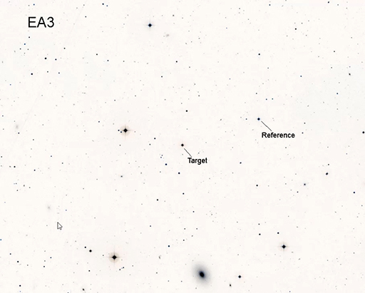

Now do the same with your own image and the corresponding finder chart from the list. Having identified the correct stars in your image, you are now ready for the next step – the aperture photometry.
Because of the way that the telescope moves, sometimes the images from COAST are rotated by 180 degrees compared to the finder chart. If this has happened to one of your images, use the Flip X and Flip Y options in the telescope.org Edit window and in the photometry tool (on the Image tab) as needed to make the pattern of stars in your image match the pattern in the finder chart.

2.4 Aperture photometry
This short video and the following activity explain how to carry out aperture photometry on your own images.

Video content is not available in this format.
View transcript - Uncaptioned interactive content

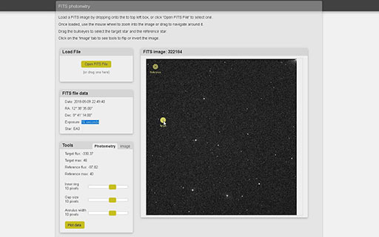

Activity 2 Aperture photometry
Allow approximately 40 minutes

Open the photometry tool and upload images
- To use the photometry tool, go to the Astronomy with an online telescope page in the OpenScience Laboratory:
Follow the link FITS photometry. This takes you to the photometry tool. The page has some brief instructions on how to use the tool.
- Upload the FITS images of your variable star as shown in the video. Check that the information in the FITS file data window is correct (date and time and name of variable star).
Check exposure
- The first step is to check the exposure of your images. For the photometry to work correctly it is important that you take measurements from an image that is correctly exposed – neither overexposed nor underexposed. For your first set of images you should have bracketed exposures of 15, 30, 60 and 120 seconds and you should check each of these in turn.
- Set the aperture and ring sizes as shown in the video (Inner ring 10, Gap size 10, Annulus width 10). Adjust these as necessary depending on the size of the stars in your image.
- For each image place the aperture over the star that you have identified as your target star and note the maximum pixel value (labelled "Target max"). Repeat for the reference star. An image is correctly exposed if this maximum value is between 10 000 and 50 000 for both stars. If you have more than one image in which both stars are in this range, select the image with the longer exposure.
- When you have found which of your images has the correct exposure, make a note of the exposure time (this is shown in the FITS file data window). You can use this same value for the exposure when requesting further images of the same target.
Make the measurement
- You are now ready to do the aperture photometry itself. Open the image that you have selected as having the correct exposure.
- Place the aperture over the target star and note the Intensity value (labelled "Target flux"). This is a measure of the overall brightness of the star, made by adding up the brightness of all the pixels in the central aperture and subtracting the background from the annulus.
- Place the aperture over the reference star and note the Intensity (Target flux) value.
- You now have all of the information that you need to plot your observation on the light curve. Click Plot data to send your data to the variable star plotter. This will give you a choice to view the light curve straight away by clicking View plot, or you can simply click OK and view the light curve later from the Astronomy with an online telescope page in the OpenScience Laboratory.

3 Building the light curve
Having made your aperture photometry measurements and added them to the light curve you have now completed your first variable star observations. .
In this video, Jo explains how your results will be combined with observations made by others to build up the whole light curve.

Video content is not available in this format.
View transcript - Uncaptioned interactive content

3.1 View your results on the light curve
This short video and the following activity explain how to review the light curve with your results.

Video content is not available in this format.
View transcript - Uncaptioned interactive content

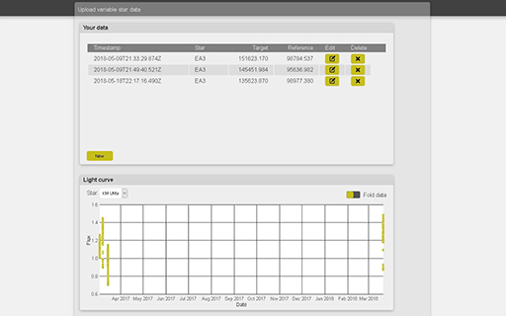

After watching the video, submit your own results to be added to the light curve by following the steps in Activity 3.

Activity 3 Reviewing the light curve
Allow approximately 20 minutes

Open the light curve plotting tool
- Go to the Astronomy with an online telescope COAST webpage:
and select the link Variable star light curve. This takes you to the light curve plots for all of the variable stars being investigated at different times of the year by participants on this course.
Check your data
- In the upper half of the variable star plotter is a box labelled Your data. The results that you added in Activity 2 should be listed there. Check that the date and time and name of the variable star are correct.
- If necessary you can edit the values, change the name of the variable star or delete any data point using the Edit and Delete controls on the right hand side.
View the plot
- To view the light curve, select your star from the dropdown list in the Light Curve pane in the lower half of the display.
- Your data points will be shown in red, together with data points contributed by other participants which are shown in green.
- By default each observation is plotted in date order, meaning that observations made over a period of time may be spread out over many orbits of the binary star. To make the pattern of the curve easier to see, select Fold data by moving the slider at the top right of the light curve graph to the right. This combines data points from different orbits so that the graph represents a single orbit of the binary pair.

3.2 Interpreting the light curve
In working through this section you may want to refer back to Section 2.2 in Week 7 and the animation in Figure 8 in that section.
As more points are added to the light curve it should be possible to see a pattern emerging. Use the Fold data option to make the pattern easier to see.
Having produced the light curve, what can be learned from it? The light curve can be used to determine a number of important properties of the binary system:
The period of the binary star
- The most obvious property of the system is the period of the orbit. The light curve of a binary star repeats itself on a regular basis as the stars orbit one another, typically with two dips per orbit as first one star, then the second star passes in front of the other. The time between these pairs of dips tells us the period. This information is used in folding the light curve as described above, by overlaying points from different orbits to give a single curve covering one orbital period.
The masses of the stars
- As described in Week 6 and Week 7 the period of the binary system, combined with Newton’s laws of gravity, can be used to work out the masses of the stars. This is one of the primary methods of determining the masses of stars on the Hertzsprung-Russell diagram.
The relative sizes and brightness of the stars
- The size of each dip in the light curve provides information about the size and brightness of the stars in the binary system. Two identical stars would produce dips of equal sizes and shapes. If the stars are different in luminosity then there will be a small dip when the fainter star is eclipsed, and a larger dip when the fainter star passes in front of the brighter star. The shapes of the dips can be used to work out the sizes of the stars.
As you can see, there is a wealth of information in the light curve. In this investigation we have looked at binary stars, but the same techniques taken to extremes can also be used to detect the very tiny dips in brightness caused by a planet orbiting a distant star. To date, several thousand exoplanets have been discovered in this way.

3.3 Request further images
If you have time this week you can add additional data points to the light curve by requesting further images using the exposure time that you determined in Activity 2. When these return from COAST, process them in the same way. This will give you another observation of the variable star on a different date and time, which you can add to the light curve.
You may also want to check back from time to time to see if other participants have added any new points. As more data points are added, the light curve will continue to build up.

4 This week’s quiz
Congratulations on getting to the end of the course successfully.
Now it’s time to complete the Week 8 badged quiz. It is similar to the badged quiz that you took after Week 4, with 15 questions in total.
Week 8 compulsory badge quiz
Open the quiz in a new tab or window (by holding ctrl [or cmd on a Mac] when you click the link) and come back here when you are done.

5 Summary of Week 8
This final week of the course has been slightly different to the previous weeks, as it has consisted largely of data-processing steps rather than learning new material. This is typical of astronomical investigations and indeed scientific investigations in general. Instruments such as the COAST telescope are capable of producing vast quantities of data and a large part of the work of astronomers is taken up with processing images and data, and digesting the information into a meaningful form.
In this case, you have learned how to use astronomical aperture photometry to measure the brightness of your selected variable star. Along the way you have encountered some powerful techniques, such as the use of background subtraction and a reference star, to eliminate external factors and isolate the variability of interest. Part of the skill of being a scientist lies in learning such techniques and thinking of new and creative ways of applying them in other situations. You now have these methods as a part of your scientific abilities and we hope that you will find new ways to use them in other investigations.
Finally, you have published your results, combining them with others to extend our knowledge of this variable star. In this way you have taken part in a collaborative scientific investigation, going through the same steps of planning an investigation, building on previous knowledge, careful and detailed analysis, and finally sharing and publication.

6 Concluding thoughts
You have now reached the end of this short course on Astronomy using an online telescope.
During the past eight weeks you have used a remotely operated telescope located thousands of miles away in Tenerife to take images of objects hundreds, thousands and even millions of light years away. In the first four weeks of the course you learned your way around the night sky and found out about optical systems, including telescopes and how to use your own night-adapted vision to best effect when observing. Using your knowledge of celestial coordinates you were able to plan your observations of Messier objects and program the COAST telescope to obtain spectacular images of one or more of these interesting objects.
In the second half of the course you have made some first steps into the field of astrophysics, learning about the nuclear reactions that produce energy in the core of the Sun and other stars. Using Einstein’s famous equation you were able to calculate the expected lifetime of the Sun, and extending this to other stars, to see how the life cycles and evolution of stars are determined by the nuclear processes in their cores. In this way, astrophysics shows us how the physics of the very small is intricately linked to the physics of the very large.
At certain stages of their life cycles some stars become variable, and some binary stars appear variable if the two stars eclipse each other as seen from Earth. In the final part of the course you have used COAST to study one such eclipsing binary system, building on results from SuperWASP, and combining your results with those of other observers to form a light curve.
In completing the variable star investigation you have made use of knowledge and skills developed in the earlier part of the course, applying these to a more challenging investigation. As you continue in a career in science you will continue to build on previous experience in the same way, using information and experience that you have gained to take you ever further. As you have seen, working with others is also central to scientific investigation, allowing you to become part of a community, to make use of facilities such as COAST and to contribute to the growing body of scientific knowledge. And now here’s a final message from course co-author Jo:

Video content is not available in this format.
View transcript - Uncaptioned interactive content

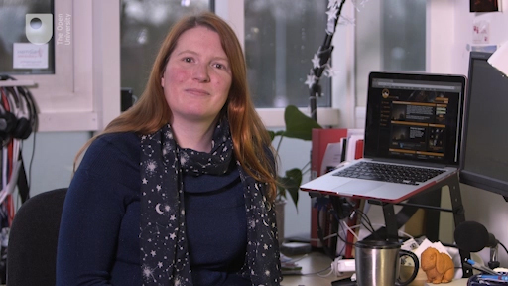

Learn more
We very much hope that your investigations on this course have inspired you to want to find out more about astronomy, astrophysics and scientific investigation. To find out more about taking your studies further with The Open University, please visit OpenLearn at:
http://www.open.edu/openlearn/ and the main Open University website at:
http://www.open.ac.uk/courses/find/astronomy-and-astrophysics where you will find information on courses leading to certificates, diplomas and degrees.
Thank you for taking part in this online course, and we wish you every success in your future studies.

Tell us what you think
Now you’ve come to the end of the course, we would appreciate a few minutes of your time to complete this short end-of-course survey (you may have already completed this survey at the end of Week 4).

References
Chereau, F., Wolf, A., Zotti, G (2001) Stellarium [Online]. Available at https://www.stellarium.org (Accessed June 2019).
Jackson G. R., Owsley, C., and, McGwin Jr, G. (1999). ‘Aging and dark adaptation’,.Vision Research,. vol. 39, no. 23, pp. 3975–82. [Online]. DOI:10.1016/s0042-6989(99)00092-9. PMID 10748929 (Accessed 13 April 2018).
Kalloniatis, M. and Luu, C. (2018). ‘Webvision – Light and Dark Adaptation ’, Webvision [Online]. Available at //webvision.med.utah.edu/book/part-viii-gabac-receptors/light-and-dark-adaptation/ (Accessed 1 March 2019).
MacRobert, A. (2006). ‘The Stellar Magnitude System’, Sky and Telescope [Online]. Available at 2006 http://www.skyandtelescope.com/astronomy-resources/the-stellar-magnitude-system/ (Accessed Mar 13 April 2018).
Frommert, H. and Kronberg, C. (2006) ) ‘Timeline of Charles Messier’, seds.org [Online]. Available athttp://www.messier.seds.org/xtra/history/timeline.html (Accessed 12 March 2019).
Frommert, H. and Kronberg, C. (2006) ‘Charles Messier’s Comets’, seds.org [Online]. Available at http://www.messier.seds.org/xtra/history/m-comets.html.Accessed 12 March 2019).
Frommert, H. and Kronberg, C. (2006) ‘List of The Messier Objects Catalog’, seds.org [Online]. Available at http://www.messier.seds.org/. (Accessed 12 March 2019).
Frommert, H. and Kronberg, C. (2006) ‘Twelve Months Tour of the Messier Catalog’, seds.org [Online]. Available at http://www.messier.seds.org/xtra/12months/12months.html (Accessed 12 March 2019).
Bonnell, J. and Nemiroff, R. (2018) ‘Astronomy Picture of the Day Index – Messier Objects’, www.nasa.gov [Online]. Available at https://apod.nasa.gov/apod/messier.html (Accessed 12 March 2019).
Garner, R. (2019) ‘Hubble’s Messier Catalog’, www.nasa.gov [Online]. Available at https://www.nasa.gov/content/goddard/hubble-s-messier-catalog (Accessed 12 March 2019).

Acknowledgements
This free course was first published in July 2019. It was written and produced by:
Authors and presenters; Jo Jarvis, Alan Cayless, Simon Clark, Stella Bradbury, Ulrich Kolb, Meredith Morrell, Colin Snodgrass.
Programmers; Geoff Austin, James Smith.
Contributors; thanks to Helen Fraser for advice and guidance
Contributors; Angela Lamont and Andrew Rix – filming and video production.
IAC/ODT; Miquel Serra-Ricart, Nayra Rodrigues-Eugenio, Rafael Rebolo.
With thanks to the staff and facilities of the IAC and ODT for their support and cooperation in the filming and production of this Badged Open Course.
Stellarium: https://www.stellarium.org GNU General Public License (GPL).
Sybilla Technologies (AstroDrive)
OpenScience Laboratory
This course has made use of the VizieR catalogue access tool, CDS, Strasbourg, France.
COAST telescope: Sybilla Technologies
Videos Section 2.2 and 2.3: NASA Solar Dynamics Observatory (SDO).
Except for third party materials and otherwise stated (see terms and conditions), this content is made available under a Creative Commons Attribution-NonCommercial-ShareAlike 4.0 Licence.
The material acknowledged below is Proprietary and used under licence (not subject to Creative Commons Licence). Grateful acknowledgement is made to the following sources for permission to reproduce material in this free course:

Images
Course image: © Alan Cayless
Week 1
Figures 1, 5 and 12: © Alan Cayless
Figures 2, 3, 4, 7 and 10: © Stellarium: http://stellarium.org
Figure 9: TWCarlson; https://creativecommons.org/licenses/by-sa/3.0/deed.en
Week 2
Figure 1, 3, 4 and 5: © Alan Cayless
Figure 2: © Stellarium: http://stellarium.org
Week 3
Figure 1 and 1a: © Alan Cayless
Week 4
Figure 1: taken from: https://en.wikipedia.org/wiki/Charles_Messier
Figure 2: NASA, ESA, J. Hester and A. Loll (Arizona State University)
Figure 3 and 5: © Alan Cayless
Figure 4: © Stellarium: http://stellarium.org
Week 5
Figure 1: © NASA
Figure 2: Courtesy of NASA/SDO and the AIA, EVE, and HMI science teams
Figure 3: Alamy
Figure 4: © NASA
Figure 5: taken from: https://upload.wikimedia.org/wikipedia/commons/f/f9/4%2C030%2C000%2C000_Years_Acasta_Gneiss.jpg
Figure 6: taken from: https://commons.wikimedia.org/wiki/Albert_Einstein#/media/File:Albert_Einstein_Head.jpg
Figure 7 and 8: © Alan Cayless
Week 6
Figure 1: © Stellarium: http://stellarium.org
Figures 2, 3, 4 and 7: © Alan Cayless
Figure 5: ESO; https://creativecommons.org/licenses/by/4.0/
Week 7
Figure 1, 2, 4 and 10: © Alan Cayless
Figure 6: taken from: https://commons.wikimedia.org/wiki/File:Leavitt_aavso.jpg;
Figure 7: © NASA, ESA and Z.Levay (STScl); Science Credit: NASA, ESA, the Hubble Heritage Team (STScI/AURA) and the American Association of Variable Star Observers
Figure 8: © NASA/CXC/M.Weiss
Figure 9: © David Anderson; https://creativecommons.org/licenses/by/2.5/
Figure 10: Telescope.org
Week 8
Figure 1, 2: © Alan Cayless

Videos
Week 5
Video 2: Activity 3; NASA's Goddard Space Flight Center; The Sun in Ultra-High Definition (4k) Video; https://svs.gsfc.nasa.gov/12034
Video 3: © NASA,SDO
Video 4: © Alan Cayless
Week 6
Video 1: The Open University
Week 7
Video 3: ESO; https://www.eso.org
Thanks also to:
NASA Hubble Heritage Team (STScI/AURA)
American Association of Variable Star Observers (AAVSO)
European Southern Observatory (ESO)
Week 8
Video 3: © Alan Cayless; Stellarium: http://stellarium.org
Every effort has been made to contact copyright owners. If any have been inadvertently overlooked, the publishers will be pleased to make the necessary arrangements at the first opportunity.
Don't miss out
If reading this text has inspired you to learn more, you may be interested in joining the millions of people who discover our free learning resources and qualifications by visiting The Open University – www.open.edu/openlearn/free-courses.

Solutions

Activity 5 Moving through the seasons

Part

Answer
You should have noticed that it takes twelve months for the view to cycle round completely back to the original view. This is because the Earth has completed one full orbit around the Sun and returned to the position it started from, meaning that the view of space from the night-time side of the Earth is the same as it was one year earlier.
Back to - Part

Part

Answer
You should find that the view changes by the same amount in two hours of one evening as it does when changing the date by one month. This makes sense because it is one-twelfth of a complete rotation, just as one month is one-twelfth of a year. The Earth turns on its axis once every 24 hours, so in two hours it rotates through the same angle (30 degrees) as the Earth’s position in its orbit changes in one month.

To view larger versions of diagrams on the course click ‘View larger image’ located underneath the figure on the left-hand side.

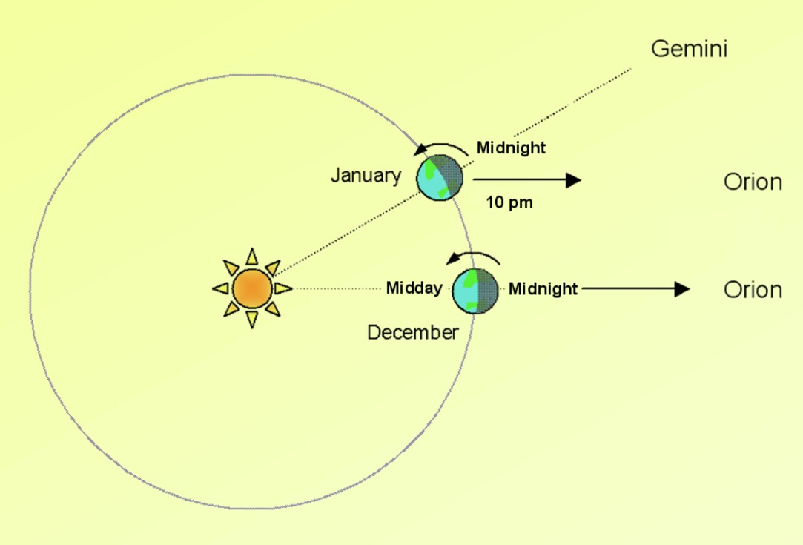
Figure 8 Changing view of the constellations. In December, Orion is at its highest point due South at midnight. One month later in January, Orion will be at the same position two hours earlier, at 22:00, and the constellation of Gemini will be due south at midnight.
View description - Figure 8 Changing view of the constellations. In December, Orion is at its highest ...

Back to - Part

Activity

Answer
Because the Earth is rotating a given celestial object will not always be directly above the same point on the Earth’s surface. For astronomical purposes a system of coordinates attached to fixed directions in space rather than to fixed points on the Earth is required.
Back to - Activity

Activity 7 Locating objects using equatorial coordinates

Part

Answer
You should see the constellation of Orion. As viewed from Tenerife, Orion appears tilted on its side with the belt of three stars forming a more or less vertical line.
Back to - Part

Activity 1 Bright object in the sky

Answer
The full Moon is bright enough to prevent your eyes becoming fully dark-adapted and its light will also obscure any faint objects nearby. For this reason it is best to avoid the few days around the full Moon each month when planning astronomical observing either by eye or using a telescope (unless, of course, the Moon is the object you wish to observe).
Back to - Activity 1 Bright object in the sky

Activity 4 Observing with binoculars

Part

Answer
Although you can see many more stars through the binoculars, you have probably also noticed that it is very difficult to hold the image still. This is because the binoculars magnify any small movements of your hands, as well as magnifying the image. Another effect of the magnification is that it is much harder to identify exactly where you are looking, as the magnified view through the binoculars is of only a very small part of the sky. Both of these factors will be of great importance when observing with larger telescopes. As you will now appreciate, a solid and steady mount together with an accurate means of pointing in a specific direction will be required.
Back to - Part

Activity 1 Brightness of Sirius

Answer
Sirius is intrinsically quite a bright star, but importantly it is also relatively close to the Earth (only 8.6 light years away). Being so close means that it appears much brighter than many similar stars that are further away from the Earth.
Back to - Activity 1 Brightness of Sirius

Activity 2 Caculating the difference in brightness of stars

Answer
The stars differ in brightness by a factor of 10. To work this out, remember that a difference of 5 magnitudes multiplies the brightness by a factor of 100. Two steps of 2.5 makes a total change of 5 magnitudes, so each step of 2.5 magnitudes must multiply the brightness by 10. In this way, two steps of 2.5 gives a change of 10 × 10, which is 100.
Back to - Activity 2 Caculating the difference in brightness of stars

Activity 1 Exploring the Messier catalogue

Part

Answer
The page for each object lists its RA and Dec coordinates.
Back to - Part

Activity 2 Messier objects in Stellarium

Part

Answer
You will probably have noticed that some of the objects are high in the sky, while others are low down or close to the horizon. In some cases the screen may appear to go blank. Don’t worry if this happens: take a moment to think about why this might be.
Back to - Part

Part

Answer
On any given date and time, only some of the Messier objects are visible from Tenerife. The 110 objects in the catalogue are distributed across the whole sky, and some will be visible at different times of year to others, depending on where the Earth is in its orbit around the Sun. If Stellarium shows a blank screen, this is probably because the object you have searched for is below the horizon at the selected date and time and so is not visible. The four objects in this exercise were chosen because each is visible at a different time of year: M31 is best placed for viewing in the autumn, M42 in winter, M66 in the spring and M11 in summer.
Back to - Part

Activity 3 Predicting visibility

Part

Answer
As noted in Activity 2, M31 is best placed for imaging with COAST in the autumn, M42 in winter, M66 in the spring and M11 in summer.
Back to - Part

Part

Answer
To observe Orion at its highest four hours earlier than midnight the best time would be two months later, so in February.
Back to - Part

Activity 4 Estimating the lifetime of the Sun

Answer
First, we find the number of seconds that the nuclear fuel will last by dividing the available mass by the mass used per second:

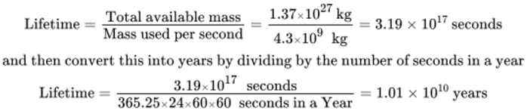
View alternative description - Uncaptioned Equation

Our estimate of the lifetime of the Sun is therefore 10 billion years. Since we know that the Sun is approximately 4.6 billion years old, the Sun is currently just under halfway through its stable lifetime. There is plenty of time left for the Earth and the Solar System.
Back to - Activity 4 Estimating the lifetime of the Sun

Activity 5 Properties of stars

Part

Answer
Differences between stars could include (intrinsic) brightness or luminosity, colour (or temperature), mass, size (or radius), age, density, their composition and their degree of variability.
One way of separating out the intrinsic properties of stars from other effects – such as distance – is to compare stars within a cluster, such as one of the Messier clusters you may have taken an image of with COAST. The advantage of studying clusters is that they are fairly compact so, to a good degree of approximation, all the stars in the cluster are at the same distance from Earth. This makes clusters the perfect place to study stars for three reasons:
- All the stars within a single cluster being at the same distance means that any differences in brightness as seen from Earth must be caused by differences in the intrinsic brightness of the stars, and not by distance effects.
- All the stars were formed at the same time and so are of the same age.
- All the stars were formed from the same cloud of material and so their chemical compositions should be similar.
Look at this image of the open cluster M29, taken with COAST:

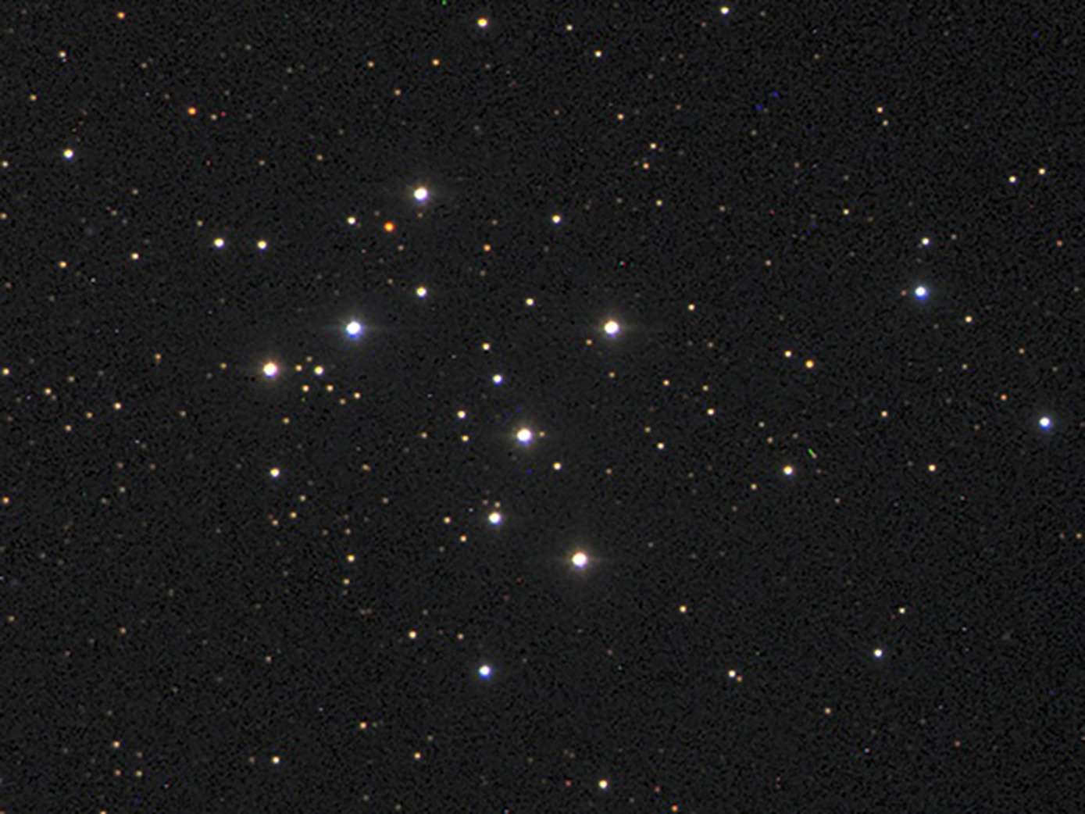
Figure 8 – Open cluster M29
View description - Figure 8 – Open cluster M29

Back to - Part

Part

Answer
The brighter stars in the cluster are white, with the brightest ones having a bluish tinge. The medium brightness stars are yellower with some of the fainter stars having an orange or even reddish tint. If it were a member of this cluster our own Sun, with its yellow colour, would be neither the brightest nor the faintest star in the range – it is a fairly typical star of modest temperature and brightness.
Back to - Part

Activity 2 Colours in Orion

Part

Answer
Three of the stars are a similar white colour, but the leftmost star in the rectangle is a more orange-red colour.
Back to - Part

Part

Answer
Rigel is a blue-white star, meaning that it is very hot, whereas Betelgeuse is a reddish-orange colour, indicating that it is relatively much cooler. Betelgeuse is in fact an example of a red giant star and you will learn more about these in the next section. It is also an example of a variable star, and these will be examined in more detail next week.
Back to - Part

Activity 1 Helium fusion

Part

Answer
The overall effect is to convert three helium nuclei into one carbon nucleus, releasing energy in the process (as in the ppI chain, energy release is indicated by the yellow flashes). Each helium nucleus contains four particles – two neutrons and two protons. Three of these helium nuclei combine to form one carbon nucleus with six protons and six neutrons – a total of 12 particles.
Now think about the conditions required for this process to take place.
Back to - Part

Part

Answer
Each helium nucleus contains two positively charged protons, so these nuclei will repel each other much more strongly than the protons in the ppI chain. To force them together against this stronger repulsion requires higher temperatures and pressures than for hydrogen fusion. The core must be compressed and heated more than in a main sequence star for the triple alpha reactions to take place.
Finally, think about how long the energy produced by these reactions would last.
Back to - Part

Part

Answer
Since the energy produced is less, helium fusion will not be able to support the star for anywhere as long; this phase of a star’s life will be much shorter and less stable than the main sequence life of the star.
Back to - Part

Activity 2 Lifetime of the red giant

Answer
The luminosity of a red giant is more than the luminosity of the star when it was on the main sequence. Taken together these factors mean that a star the size of our Sun will spend no more than 1000 million years as a red giant – less than 10% of its main sequence lifetime. Stars considerably heavier than our Sun may have red giant lifetimes of no more than a few million years.
Back to - Activity 2 Lifetime of the red giant

Activity 3 Hydrogen in companion star

Answer
This material is from the outer layers of the companion star. Nuclear fusion normally only occurs in the cores of stars, so although the main sequence companion is converting its core hydrogen to helium, the outer layers still contain a significant quantity of unused hydrogen.
Back to - Activity 3 Hydrogen in companion star

Figure 1 The upgraded COAST telescope and counterbalanced equatorial mount. The filter wheel and CCD camera attached to the back of the telescope can be seen on the left

Description
The upgraded COAST telescope and counterbalanced equatorial mount shown from side-on. The telescope is black in colour with a silver and white, metalic base. The filter wheel and CCD camera attached to the back of the telescope can be seen on the left.
Back to - Figure 1 The upgraded COAST telescope and counterbalanced equatorial mount. The filter wheel and CCD camera attached to the back of the telescope can be seen on the left

Figure 1 The COAST dome on Tenerife. This houses the 17-inch telescope that you will use in this course, requesting images remotely. The dome visible in the background houses PIRATE, another OpenScience Observatory telescope. Behind this second dome can be seen the top of the mast holding the all-sky camera and a number of other weather sensors and instruments.

Description
The COAST telescope dome. The image shows the 3.5-metre diameter white fibreglass dome of the COAST telescope against a blue sky. Volcanic rocks and plants with yellow flowers are in the foreground. The larger dome of sister telescope PIRATE can be seen in the background. Both domes consist of a number of segments, rather like segments of an orange, arranged horizontally. These segments open up when the domes are opened to give the telescopes an uninterrupted view of the night sky. Behind this second dome can be seen the top of the mast holding the all-sky camera and a number of other weather sensors and instruments.
Back to - Figure 1 The COAST dome on Tenerife. This houses the 17-inch telescope that you will use in this course, requesting images remotely. The dome visible in the background houses PIRATE, another OpenScience Observatory telescope. Behind this second dome can be seen the top of the mast holding the all-sky camera and a number of other weather sensors and instruments.

Figure 2 The Stellarium main screen, showing the two menu bars which can be made to appear by moving the cursor to the left side or bottom edge of the screen at the lower left corner. Credit: https://stellarium.org

Description
The Stellarium main screen, showing the two menu bars which can be made to appear by moving the cursor to the left side or bottom edge of the screen at the lower left corner.
Back to - Figure 2 The Stellarium main screen, showing the two menu bars which can be made to appear by moving the cursor to the left side or bottom edge of the screen at the lower left corner. Credit: https://stellarium.org

Figure 3 The Location window

Description
The Stellarium location window. This shows a map of the world, together with a dialog box displaying the latitude and longitude of the selected location. The location on which the Stellarium display is based can be chosen by clicking on the map or selected from a drop-down list of predefined locations. The screen shows the location being set to Teide observatory (Tenerife), with a latitude of 28 degrees 17 minutes North and a longitude of 16 degrees 30 minutes West, and an altitude of 2390 metres.
Back to - Figure 3 The Location window

Figure 4 Main Toolbar

Description
The main toolbar
Back to - Figure 4 Main Toolbar

Figure 5 The Earth in orbit around the Sun. Different constellations will be visible at different times of year as the night side of the Earth looks out in different directions into space. Orion, for instance, will be visible in the winter months, but not in the summer.

Description
The Earth in orbit around the Sun. Different constellations will be visible at different times of year as the night side of the Earth looks out in different directions into space. Orion, for instance, will be visible in the winter months, but not in the summer.
Back to - Figure 5 The Earth in orbit around the Sun. Different constellations will be visible at different times of year as the night side of the Earth looks out in different directions into space. Orion, for instance, will be visible in the winter months, but not in the summer.

Figure 6 The All-Sky camera. Stars that are visible are marked in green. The red circles indicate stars that are not visible, perhaps because of cloud or mist towards the northern and eastern horizons.

Description
The All-Sky camera. Stars that are visible are marked in green. The red circles indicate stars that are not visible, perhaps because of cloud or mist towards the northern and eastern horizons.
Back to - Figure 6 The All-Sky camera. Stars that are visible are marked in green. The red circles indicate stars that are not visible, perhaps because of cloud or mist towards the northern and eastern horizons.

Figure 7 The Date and time window. This shows the year, month and day in the left-hand box and time in hours, minutes and seconds in the right-hand box. You can ignore the caption on the right that reads Julian Day.

Description
The Date and time window. This shows the year, month and day in the left-hand box and time in hours, minutes and seconds in the right-hand box. You can ignore the caption on the right that reads ‘Julian Day’.
Back to - Figure 7 The Date and time window. This shows the year, month and day in the left-hand box and time in hours, minutes and seconds in the right-hand box. You can ignore the caption on the right that reads Julian Day.

Figure 8 Changing view of the constellations. In December, Orion is at its highest point due South at midnight. One month later in January, Orion will be at the same position two hours earlier, at 22:00, and the constellation of Gemini will be due south at midnight.

Description
Changing view of the constellations. In December, Orion is at its highest point due South at midnight. One month later in January, Orion will be at the same position two hours earlier, at 22:00, and the constellation of Gemini will be due south at midnight.
Back to - Figure 8 Changing view of the constellations. In December, Orion is at its highest point due South at midnight. One month later in January, Orion will be at the same position two hours earlier, at 22:00, and the constellation of Gemini will be due south at midnight.

Figure 9 The Altitude-Azimuth system of coordinates specifies the position of an object in terms of two angles – the altitude above the horizon and the azimuth, which is the angle clockwise from north.

Description
The Alt-Azimuth system of coordinates specifies the position of an object in terms of two angles – the ‘altitude’ above the horizon and the ‘azimuth’, which is the angle clockwise from north.
Back to - Figure 9 The Altitude-Azimuth system of coordinates specifies the position of an object in terms of two angles – the altitude above the horizon and the azimuth, which is the angle clockwise from north.

Figure 10 The Equatorial and Azimuthal grid icons in the Stellarium toolbar. Normally, you will want to have only one of these switched on at any time.

Description
The Equatorial and Azimuthal grid icons in the Stellarium toolbar. Normally, you will want to have only one of these switched on at any time.
Back to - Figure 10 The Equatorial and Azimuthal grid icons in the Stellarium toolbar. Normally, you will want to have only one of these switched on at any time.

Figure 11 The celestial sphere. The RA and Dec coordinates specify the unique position of each celestial object. Importantly, these coordinates are defined relative to the sky and not the surface of the Earth, and so do not change as the Earth rotates.

Description
The celestial sphere. The RA and Dec coordinates specify the unique position of each celestial object. Importantly, these coordinates are defined relative to the sky and not the surface of the Earth, and so do not change as the Earth rotates.
Back to - Figure 11 The celestial sphere. The RA and Dec coordinates specify the unique position of each celestial object. Importantly, these coordinates are defined relative to the sky and not the surface of the Earth, and so do not change as the Earth rotates.

Figure 12 The Great Nebula in Orion, M42. This image was taken using the PIRATE telescope.

Description
The Great Nebula in Orion, M42. This image was taken using the COAST telescope.
Back to - Figure 12 The Great Nebula in Orion, M42. This image was taken using the PIRATE telescope.

Figure 1 Comparing the size of the human pupil in bright and dark conditions. In these images from a medical scanner the pupil is outlined in red. In daylight the pupil is typically around 2 mm in diameter. In dark conditions the pupil expands to a diameter of approximately 5 mm in older adults and up to 7 mm in younger people, increasing the amount of light entering the eye by a factor of approximately ten times.

Description
Comparing the size of the human pupil in bright and dark conditions. In these images from a medical scanner the pupil is outlined in red. In daylight the pupil is typically around 2 mm in diameter. In dark conditions the pupil expands to a diameter of approximately 5 mm in older adults and up to 7 mm in younger people, increasing the amount of light entering the eye by a factor of approximately ten times.
Back to - Figure 1 Comparing the size of the human pupil in bright and dark conditions. In these images from a medical scanner the pupil is outlined in red. In daylight the pupil is typically around 2 mm in diameter. In dark conditions the pupil expands to a diameter of approximately 5 mm in older adults and up to 7 mm in younger people, increasing the amount of light entering the eye by a factor of approximately ten times.

Figure 2 Stellarium in red night mode. The ‘starry eye’ icon used to activate this mode is highlighted.

Description
Stellarium in red night mode. The ‘starry eye’ icon used to activate this mode is highlighted.
Back to - Figure 2 Stellarium in red night mode. The ‘starry eye’ icon used to activate this mode is highlighted.

Figure 3 Left: a typical pair of 10 × 50 binoculars. Right: comparison between the 50 mm objective lens of the binoculars and the 5 mm pupil of a typical eye. With ten times the diameter, the binocular lens has 100 times the area of the pupil, capturing 100 times as much light as the eye.

Description
Left: a typical pair of 10 × 50 binoculars. Right: comparison between the 50 mm objective lens of the binoculars and the 5 mm pupil of a typical eye. With ten times the diameter, the binocular lens has 100 times the area of the pupil, capturing 100 times as much light as the eye.
Back to - Figure 3 Left: a typical pair of 10 × 50 binoculars. Right: comparison between the 50 mm objective lens of the binoculars and the 5 mm pupil of a typical eye. With ten times the diameter, the binocular lens has 100 times the area of the pupil, capturing 100 times as much light as the eye.

Figure 5 The Dall-Kirkham telescope. In this type of telescope a curved secondary mirror at the front of the telescope reflects light back through a hole in the main primary mirror where additional optics deliver a highly-corrected image to a camera fitted at the rear of the telescope.

Description
The Dall-Kirkham telescope. In this type of telescope a curved secondary mirror at the front of the telescope reflects light back through a hole in the main primary mirror where additional optics deliver a highly-corrected image to a camera fitted at the rear of the telescope.
Back to - Figure 5 The Dall-Kirkham telescope. In this type of telescope a curved secondary mirror at the front of the telescope reflects light back through a hole in the main primary mirror where additional optics deliver a highly-corrected image to a camera fitted at the rear of the telescope.

Figure 1 The constellation of Orion, as seen from the Teide observatory. The four bright stars at each corner and the three stars of Orion’s belt range from magnitude 0.15 (Rigel) to magnitude 2.4 (Mintaka). Many fainter stars can be seen within and around Orion, with brightnesses ranging from third to sixth magnitude.

Description
The constellation of Orion as seen from Tenerife. The four bright stars at each corner and the three stars of Orion’s belt range from magnitude 0.15 (Rigel) to magnitude 2.4 (Mintaka). Many fainter stars can be seen within and around Orion, with brightnesses ranging from third to sixth magnitude.
Back to - Figure 1 The constellation of Orion, as seen from the Teide observatory. The four bright stars at each corner and the three stars of Orion’s belt range from magnitude 0.15 (Rigel) to magnitude 2.4 (Mintaka). Many fainter stars can be seen within and around Orion, with brightnesses ranging from third to sixth magnitude.

Figure 1a An annotated diagram of the constellation of Orion

Description
The constellation of Orion as seen from Tenerife. The main stars are labelled in yellow and lines outlining the shape of the constellation join these bright stars. At the centre of the constellation are three stars (Alnitak, Alnilam and Mintaka) in a vertical line, forming the belt of Orion. To the left is the bright red star Betelgeuse, with a bluer star Bellatrix above and to the right. These two stars form Orion's shoulders. To the right of the belt is the bright star Rigel, with the slightly fainter star Saiph below – these two stars form Orion's knees. Between the belt and these two stars a small line of three stars form the sword of Orion. A faint nebulosity can be seen around the centre of these three stars – this is the great Orion nebula.
Back to - Figure 1a An annotated diagram of the constellation of Orion

Figure 2

Description
The magnitude scale, showing the full range of brightness and the limits of various telescopes
Back to - Figure 2

Figure 1 French astronomer and comet-hunter Charles Messier (1730-1817)

Description
Portrait of French astronomer and comet hunter Charles Messier. He is shown in period costume with a powdered wig, wearing a blue jacket decorated with a medal on a red ribbon. A celestial sphere (globe with star charts) can be seen in the background.
Back to - Figure 1 French astronomer and comet-hunter Charles Messier (1730-1817)

Figure 2 The Crab nebula – This was the first object in Messier’s catalogue and is designated M1. The nebula is the remains of a supernova (an exploding star) that was recorded by Chinese astronomers in the year 1054.

Description
The Crab nebula – This was the first object in Messier’s catalogue and is designated M1. The nebula is the remains of a supernova (an exploding star) that was recorded by Chinese astronomers in the year 1054. [ Image from NASA ]
Back to - Figure 2 The Crab nebula – This was the first object in Messier’s catalogue and is designated M1. The nebula is the remains of a supernova (an exploding star) that was recorded by Chinese astronomers in the year 1054.

Figure 3 Examples of the four main types of Messier object. Open cluster M29, Globular cluster M13, M27 The Dumbbell nebula, and M51 the Whirlpool galaxy. These images were all taken with COAST.

Description
Examples of the four main types of Messier object. Open cluster M29, Globular cluster M13, M27 The Dumbbell nebula, and M51 the Whirlpool galaxy. These images were all taken with COAST.
Back to - Figure 3 Examples of the four main types of Messier object. Open cluster M29, Globular cluster M13, M27 The Dumbbell nebula, and M51 the Whirlpool galaxy. These images were all taken with COAST.

Figure 4 The sky and viewing options window in the desktop version of Stellarium. Mobile and tablet versions may vary.

Description
The sky and viewing options window.
Back to - Figure 4 The sky and viewing options window in the desktop version of Stellarium. Mobile and tablet versions may vary.

Figure 5 The Earth in orbit around the Sun. In any given month, the night side of the Earth (the side facing away from the Sun) looks out in a different direction into space, meaning that different objects will be visible in the night sky at different times of the year.

Description
Back to - Figure 5 The Earth in orbit around the Sun. In any given month, the night side of the Earth (the side facing away from the Sun) looks out in a different direction into space, meaning that different objects will be visible in the night sky at different times of the year.

Figure 1 The Sun as a flaming ball of gas: in this image of the Sun, taken in 2010 by the NASA Solar Dynamics Observatory (SDO) satellite, prominences can be seen erupting from the hot surface of the Sun. For more information about this image, and a film showing the twisting strands of hot gas and plasma erupting from the surface of the Sun, visit the NASA SDO website: https://sdo.gsfc.nasa.gov/gallery/main/item/33.

Description
The Sun as a flaming ball of gas: in this image of the Sun, taken in 2010 by the NASA Solar Dynamics Observatory (SDO) satellite, the granular structure of the surface of the Sun is shown in orange and red with brighter regions picked out in white. Prominences can be seen as red arcs erupting from the hot surface of the Sun.
Back to - Figure 1 The Sun as a flaming ball of gas: in this image of the Sun, taken in 2010 by the NASA Solar Dynamics Observatory (SDO) satellite, prominences can be seen erupting from the hot surface of the Sun. For more information about this image, and a film showing the twisting strands of hot gas and plasma erupting from the surface of the Sun, visit the NASA SDO website: https://sdo.gsfc.nasa.gov/gallery/main/item/33.

Figure 2 Sequence of four images showing a metal ball being heated, with temperature increasing from left to right.

Description
A sequence of four images showing a metal ball being heated, with temperature increasing from left to right. This illustrates how both the colour and the brightness of a star depends on the temperature. The left hand ball glows a dull red – the second, slightly hotter ball is a brighter orange. The third ball is glowing bright yellow and the fourth, and hottest, ball is an even brighter yellow-white colour.
Back to - Figure 2 Sequence of four images showing a metal ball being heated, with temperature increasing from left to right.

Figure 3 The coal-fired Drax power station in Yorkshire, United Kingdom

Description
The coal-fired Drax power station in Yorkshire, United Kingdom. This aerial photograph shows the power station with six conical cooling towers in the foreground, a tall chimney, and five smaller cooling towers in the background, surrounded by smaller buildings. Steam can be seen rising from the cooling towers.
Back to - Figure 3 The coal-fired Drax power station in Yorkshire, United Kingdom

Figure 4 An artist’s drawing of the internal structure of the Sun, showing surface features and internal layers. As you shall see in Section 3, the core of the Sun is at a very high temperature and pressure, sufficient to sustain the nuclear reactions that power its energy output. (NASA)

Description
A cutaway drawing showing the surface and the inner layers of the Sun. The innermost layers are depicted in false colour, and labelled as the inner core, surrounded by the radiative zone, and then further out, the convective zone. The photosphere forming the visible surface of the Sun is illustrated as a thin layer of orange and red granulations with sunspots. Subsurface flows are labelled just below the photosphere. Above the photosphere are the chromosphere, a thin shell of hot gas, and above that the corona, depicted as red steamers radiating out into space.
Back to - Figure 4 An artist’s drawing of the internal structure of the Sun, showing surface features and internal layers. As you shall see in Section 3, the core of the Sun is at a very high temperature and pressure, sufficient to sustain the nuclear reactions that power its energy output. (NASA)

Figure 5 A sample of the oldest rock yet discovered on Earth. Found in Canada, this Acasta Gneiss is over four billion years old.

Description
A sample of the oldest rock yet discovered on Earth. Found in Canada, this Acasta Gneiss is over four billion years old. The image shows a rock with an angular appearance and a grey, granular surface with striations of lighter coloured material.
Back to - Figure 5 A sample of the oldest rock yet discovered on Earth. Found in Canada, this Acasta Gneiss is over four billion years old.

Figure 6 Albert Einstein, who in 1905 formulated the theory of relativity.

Description
Black and white photograph of Albert Einstein, who in 1905 formulated the theory of relativity. The photograph shows an older Einstein with his characteristic moustache, lined and thoughtful face, and wild white hair.
Back to - Figure 6 Albert Einstein, who in 1905 formulated the theory of relativity.

Figure 7 The main nuclear reaction taking place in the core of the Sun. Known as the ppI chain, the overall result of this reaction is the conversion of four hydrogen nuclei into one helium nucleus. The yellow flashes indicate energy being released at each stage.

Description
Diagrammatic representation of the ppI (p-p-one) chain, which is the main nuclear reaction taking place in the core of the Sun. To the left, four protons (Hydrogen nuclei) are shown coming together in pairs to form two deuterium nuclei, each consisting of a red proton and a blue neutron. An electron (shown in light blue) and a yellow flash of energy are emitted from each nucleus as it is formed. In the centre, an additional proton is added to each of the two nuclei, to form two nuclei of Helium-3 (each consisting of two protons and one neutron). A yellow flash again indicates emission of energy during this process. Finally, on the right, the two Helium-3 nuclei combine to form a single Helium-4 nucleus, consisting of two protons and two neutrons. Two protons and a yellow flash of energy are emitted as this final nucleus is formed. The overall result of this reaction is the conversion of four hydrogen nuclei into one helium nucleus. The yellow flashes indicate energy being released at each stage.
Back to - Figure 7 The main nuclear reaction taking place in the core of the Sun. Known as the ppI chain, the overall result of this reaction is the conversion of four hydrogen nuclei into one helium nucleus. The yellow flashes indicate energy being released at each stage.

Figure 8 – Open cluster M29

Description
Photograph of open cluster M29, taken with COAST. The image shows four bright stars in an approximately rectangular configuration near the centre. These stars are a bright bluish-white colour. These are surrounded by about half a dozen slightly fainter stars and then by an increasing number of ever fainter stars. The fainter stars are more yellowish in colour than the brighter stars.
Back to - Figure 8 – Open cluster M29

Figure 1: The Edit tab in telescope.org

Description
The Edit tab on telescope.org. This shows an image of the Sombrero galaxy, with editing controls to the left and right. Two sliders, labelled A to the left allow adjustment of brightness and contrast. A zoom slider top left is labelled B. To the right are a number of labelled control buttons. The colour shift tool labelled C allows alignment of the red, green and blue layers of the image that were taken through different filters. The colour balance tool (labelled D) allows adjustment of the strength of the individual red, green and blue components. There is a Save button labelled E and depicting a floppy disk at top right. There are a number of additional tools below these, having functions such as reflecting or inverting the image, and converting to black and white. At bottom right is a Help button labelled with a question mark.
Back to - Figure 1: The Edit tab in telescope.org

Figure 2 The constellation of Orion, as seen from the Teide observatory.

Description
The constellation of Orion as seen from Tenerife. The four bright stars at each corner and the three stars of Orion’s belt range from magnitude 0.15 (Rigel) to magnitude 2.4 (Mintaka). Many fainter stars can be seen within and around Orion, with brightnesses ranging from third to sixth magnitude. At the lower left is the bright star Betelgeuse which is reddish in colour, with a bluer star Bellatrix above and to the right. These two stars form Orion's shoulders. To the right of the belt is the bright blue-white star Rigel, with the slightly fainter star Saiph below. Saiph and the three stars of the belt are more neutral in colour.
Back to - Figure 2 The constellation of Orion, as seen from the Teide observatory.

Figure 3 The HR diagram showing the main sequence. The letters at the top indicate the spectral class of the stars, with O and B representing the brightest and hottest stars, and K and M at the other end representing the faintest and reddest stars. The Sun, indicated with the yellow circle, is a G-class star with average brightness and temperature. Temperatures on this diagram are in Kelvins (K).

Description
The Hertzsprung-Russell diagram is a plot of stars classified according to their surface temperature and their intrinsic luminosity. The horizontal axis is labelled with temperature ranging from 2000 degrees on the right, to 30 000 degrees on the left. The brightness scale runs from solar luminosities at the bottom left to solar luminosities at the top left. The Main Sequence runs diagonally from top left to bottom right, depicting stars in the main part of their lifetime. The Sun is identified approximately two thirds of the way down this main sequence, with a surface temperature of approximately 6000 degrees and a luminosity of 1. A red cloud at top right identifies red giant stars, and white dwarfs are labelled in blue at the lower left of the diagram. The letters O B A F G K M along the top of the diagram identify the spectral classes of the stars – from the hottest and brightest blue-white 'O' class stars at the top left to the cool and faint red 'M' class stars at the bottom right.
Back to - Figure 3 The HR diagram showing the main sequence. The letters at the top indicate the spectral class of the stars, with O and B representing the brightest and hottest stars, and K and M at the other end representing the faintest and reddest stars. The Sun, indicated with the yellow circle, is a G-class star with average brightness and temperature. Temperatures on this diagram are in Kelvins (K).

Figure 4 The HR diagram, showing the mass of stars along the main sequence as multiples of the Sun’s mass. The letters at the top indicate the spectral class of the stars, with O and B representing the brightest and hottest stars, and K and M at the other end representing the faintest and reddest stars.

Description
The HR diagram from Figure 3, with additional labelling showing the masses of stars on the Main Sequence. The masses run from 30 solar masses at the top left for the hottest and brightest 'O' class stars, down to 0.2 solar masses for the faintest 'M' class stars at the bottom right. The Sun has a mass of 1.
Back to - Figure 4 The HR diagram, showing the mass of stars along the main sequence as multiples of the Sun’s mass. The letters at the top indicate the spectral class of the stars, with O and B representing the brightest and hottest stars, and K and M at the other end representing the faintest and reddest stars.

Figure 5 Artist’s impression of eclipsing binary stars. The light curve below shows how the brightness as seen from Earth dips on a regular basis as one star passes in front of another. (ESO.org)

Description
The light curve of eclipsing binary stars. The main image shows a large, orange-coloured star, with a smaller but hotter and brighter star, yellow in colour passing behind it. The curve below shows a large dip as the hotter and brighter star passes behind the larger but cooler star, and a smaller dip as the smaller star passes in front of the cooler star.
Back to - Figure 5 Artist’s impression of eclipsing binary stars. The light curve below shows how the brightness as seen from Earth dips on a regular basis as one star passes in front of another. (ESO.org)

Figure 6 A section of the Sun. Energy from nuclear reactions in the core flows out to the surface, supporting the Sun against the inward force of gravity. Other stars on the main sequence are supported in the same way, making them stable..

Description
Diagram showing radiation transport in the Sun. A segment of the Sun is shown in cross-section (rather like a pizza slice). Labelling indicates the core, where nuclear reactions are taking place, surrounded first by the radiative zone, and then the outer convective zone just below the photosphere. Zigzag red lines in the core and radiative zone indicate the path of photons as they progress outwards through multiple collisions with charged particles. In the convective zone, coloured loops indicate the circulation of hot plasma in convective cells. Above the photosphere, arrows indicate energy radiated out into space. Labelling below the diagram indicates the main energy transport process in each zone – radiation in the core and radiative zone, convection in the convective zone, and radiation again beyond the photosphere.
Back to - Figure 6 A section of the Sun. Energy from nuclear reactions in the core flows out to the surface, supporting the Sun against the inward force of gravity. Other stars on the main sequence are supported in the same way, making them stable..

Figure 7 The Hertzsprung-Russell diagram showing the evolutionary path of a star such as our Sun after it leaves the main sequence. First the star will expand to form a red giant before collapsing eventually to form a white dwarf. On their way to becoming red giants, some stars will pass through the instability strip, becoming variable stars. Heavier stars, further up the main sequence, may pass through this region more than once.

Description
Annotated Hertzsprung-Russell diagram showing the paths of stars as they leave the Main Sequence at the end of their lifetimes. A red arrow from the position of the Sun leads up to the Red Giant area at top right, labelled to indicate processes of Expansion, Helium burning and Shell burning. From the Red Giant area, a blue arrow leads first to the left, with labels indicating the Instability strip and Variable stars above the central part of the Main Sequence. The blue arrow then crosses the Main Sequence at top left and heads downwards and rightwards to the White Dwarf region. This part of the track is labelled as Fuel exhausted and Gravitational collapse.
Back to - Figure 7 The Hertzsprung-Russell diagram showing the evolutionary path of a star such as our Sun after it leaves the main sequence. First the star will expand to form a red giant before collapsing eventually to form a white dwarf. On their way to becoming red giants, some stars will pass through the instability strip, becoming variable stars. Heavier stars, further up the main sequence, may pass through this region more than once.

Figure 1 The triple alpha (3α) process, which converts helium into carbon. While this can sustain a star for a short period of time after the main sequence, it is less efficient than hydrogen fusion.

Description
Diagram depicting the three-alpha process, in which three Helium nuclei fuse to form a Carbon nucleus. To the left, two Helium nuclei, each consisting of a two blue neutrons and two red protons, fuse together to form a Beryllium nucleus (labelled as unstable). A third Helium nucleus is then added, forming a Carbon nucleus on the right, consisting of six neutrons and six protons. Yellow flashes at each stage indicate energy released as the nuclei fuse together.
Back to - Figure 1 The triple alpha (3α) process, which converts helium into carbon. While this can sustain a star for a short period of time after the main sequence, it is less efficient than hydrogen fusion.

Figure 2 Helium fusion in a post main sequence star. On the left we see the core collapsing, and on the right the outer layers expanding as a result of energy released by helium fusion in the collapsed core.

Description
Diagram showing Helium fusion and expansion in a post-main sequence star. On the left, a cross section of a star is shown with an orange core labelled as containing Helium, surrounded by yellow outer layers containing Hydrogen. Six inward-pointing arrows around the core indicate inward collapse. On the right is a larger start with red outer layers, labelled 'Radiation pressure causes outer envelope to expand' (the red colour indicates that these outer layers cool during the expansion). Outward facing arrows depict this expansion. In the centre is a hot core labelled 'Helium fusion 3 – alpha' surrounded by a thin circular yellow zone labelled 'Hydrogen fusion shell'.
Back to - Figure 2 Helium fusion in a post main sequence star. On the left we see the core collapsing, and on the right the outer layers expanding as a result of energy released by helium fusion in the collapsed core.

Figure 3 The post main sequence evolution of a star like the Sun. The right-hand diagram shows a sample of stars from a globular cluster such as M13. Because globular clusters are old, the more massive stars have already left the main sequence to become red giants. Only the lower portion of the main sequence, containing stars of similar mass to the Sun and smaller, is still intact. These less massive stars have longer lifetimes so have not yet left the main sequence.

Description
Two Hertzsprung – Russell diagrams showing the evolution of a star of similar mass to the Sun after leaving the Main Sequence. The left hand diagram is a schematic with a diagonal orange line from top left to bottom right depicting the Main Sequence. From the lower right of the Main Sequence is a red line leading at first upwards and to the right. This part of the track is labelled with letters A, B, C, and D, and 'red giant branch'. The track then heads to the left, labelled D – E – F and 'horizontal branch, before heading upward and to the right again, labelled 'asymptotic giant branch'. The track ends at the top right of the diagram in the red giant area. On the right is the HR diagram of a globular cluster, with individual stars indicated by dots. Only the lower right section of the Main Sequence contains stars. The pattern of stars then extends upwards and to the right, following the track of the red path indicated on the left hand plot. The upper parts of the plot are labelled HB (Horizontal Branch), RGB (Red Giant Branch) and AGB (Asymptotic Giant Branch) corresponding to the labels on the left hand diagram.
Back to - Figure 3 The post main sequence evolution of a star like the Sun. The right-hand diagram shows a sample of stars from a globular cluster such as M13. Because globular clusters are old, the more massive stars have already left the main sequence to become red giants. Only the lower portion of the main sequence, containing stars of similar mass to the Sun and smaller, is still intact. These less massive stars have longer lifetimes so have not yet left the main sequence.

Figure 4 The Hertzsprung-Russell diagram showing the evolutionary path of a star such as our Sun after it leaves the main sequence.

Description
Annotated Hertzsprung-Russell diagram showing the paths of stars as they leave the Main Sequence at the end of their lifetimes. A red arrow from the position of the Sun leads up to the Red Giant area at top right, labelled to indicate processes of Expansion, Helium burning and Shell burning. From the Red Giant area, a blue arrow leads first to the left, with labels indicating the Instability strip and Variable stars above the central part of the Main Sequence. The blue arrow then crosses the Main Sequence at top left and heads downwards and rightwards to the White Dwarf region. This part of the track is labelled as Fuel exhausted and Gravitational collapse.
Back to - Figure 4 The Hertzsprung-Russell diagram showing the evolutionary path of a star such as our Sun after it leaves the main sequence.

Figure 5 The path of a five solar mass star after leaving the main sequence.

Description
Annotated HR diagram showing the path of a five solar mass star as it leaves the Main Sequence. The Main Sequence is indicated by a diagonal orange line running from top left to bottom right. From the centre of the main sequence an elliptical white zone with a dotted outline extends towards the upper right of the diagram. This outer zone is labelled as the Instability strip. Two smaller zones within the instability strip are highlighted in orange – a smaller zone towards the bottom labelled 'RR Lyrae' and a larger elliptical zone at the top labelled 'Cepheids'. The path of a five solar mass star is shown as a red line extending horizontally to the right from a point about three-quarters of the way up the Main Sequence towards the centre of the Instability strip. This red line passes back and forth through the lower part of the orange Cepheid region before continuing towards the upper right, red giant area of the diagram.
Back to - Figure 5 The path of a five solar mass star after leaving the main sequence.

Figure 6 American astronomer Henrietta Swan Leavitt.

Description
Black and white photograph of astronomer Henrietta Swan Leavitt. She is shown as a youngish woman in period dress with long hair tied back.
Back to - Figure 6 American astronomer Henrietta Swan Leavitt.

Figure 7 The light curve of a Cepheid variable in the Andromeda galaxy (M31). The red dots indicate measurements made by amateur astronomers and used by NASA to make observations with the Hubble telescope at the predicted dimmest and brightest points in the cycle, as indicated by the blue/yellow stars on the curve.

Description
Diagram depicting the light curve of a Cepheid variable in the Andromeda galaxy (M31). Plotted against a background image of the spiral Andromeda galaxy, a blue curve continues through seven cycles, each time rising sharply and falling rather more slowly. Red dots on the first five cycles from the left indicate individual measurements made by amateur astronomers, and blue/yellow stars on the two cycles at the right indicate predicted values used to guide Hubble telescope observations made by NASA. The vertical scale on the left is labelled as brightness, with the horizontal axis labelled with the dates of observation from July 2010 on the left, to January 2011 on the right.
Back to - Figure 7 The light curve of a Cepheid variable in the Andromeda galaxy (M31). The red dots indicate measurements made by amateur astronomers and used by NASA to make observations with the Hubble telescope at the predicted dimmest and brightest points in the cycle, as indicated by the blue/yellow stars on the curve.

Uncaptioned Figure

Description
Still image from video of eclipsing binary. The main image shows a large, orange-coloured star, with a smaller but hotter and brighter star, yellow in colour passing behind it. The curve below shows a large dip as the hotter and brighter star passes behind the larger but cooler star, and a smaller dip as the smaller star passes in front of the cooler star.
Back to - Uncaptioned Figure

Figure 8 An artist’s impression of accreting binary star Nova Aquilae, consisting of a white dwarf in orbit with a low-mass main sequence companion star. Material from the larger star is transferred and falls onto the surface of the white dwarf, causing repeated explosive events. (Credit: NASA/CXC/M.Weiss)

Description
Artist’s impression of accreting binary star Nova Aquilae. Against a black background, the larger and cooler star is shown on the left as a slightly elliptical red-orange shape, with a lobe extending to the right. On the right is a white ellipse surrounding the white dwarf star. The elliptical shape depicts a circular disk of swirling material, seen at an angle, surrounding the white dwarf. The central part of this accretion disk is shown in white with the colour changing first to blue and then to yellow-green moving outwards. A trail of material extends from the red-orange companion star, depicting material being transferred from the outer envelope of the larger star on the left to join the accretion disk on the right.
Back to - Figure 8 An artist’s impression of accreting binary star Nova Aquilae, consisting of a white dwarf in orbit with a low-mass main sequence companion star. Material from the larger star is transferred and falls onto the surface of the white dwarf, causing repeated explosive events. (Credit: NASA/CXC/M.Weiss)

Figure 9 The SuperWASP telescope on the island of La Palma in the Canaries.

Description
Photograph showing the SuperWASP telescope. Eight telephoto lenses are mounted in two vertical banks of four, within a horseshoe-shaped mount made of riveted metal.
Back to - Figure 9 The SuperWASP telescope on the island of La Palma in the Canaries.

Figure 10 Entering RA and Dec coordinates in telescope.org. The example shown here is for target EA1. Check the visibility pane on this screen to confirm that your target is visible at this time of year.

Description
Image request form from the telescope.org website. In the telescope.org colours of orange on black, the form shows the Step 1 – Select Target screen. There are white fields for entering RA and DEC coordinates, and below these another white field labelled Name and containing the name 'EA1'. To the right is a box labelled RA DEC information with a horizontal coloured bar labelled Visibility – By Month. This bar is divided into twelve segments labelled with the months of the year and coloured red, orange or green to indicate visibility of the object. November and December are coloured red to indicate that the object is not visible in those months. The months from March to August are coloured green to indicate good visibility and the remaining months either side of the green zone are coloured orange indicating poor visibility. The month of July is highlighted to indicate the date of observation with the legend 'Current: Good' confirming good visibility at this time.
Back to - Figure 10 Entering RA and Dec coordinates in telescope.org. The example shown here is for target EA1. Check the visibility pane on this screen to confirm that your target is visible at this time of year.

Figure 1 Aperture photometry showing the central circular aperture and the annulus, or ring, surrounding it and used to subtract the background. To make sure that the background is separate from the star, there is a gap in between the aperture and the annulus.

Description
Aperture photometry showing the central circular aperture and the annulus, or ring, surrounding it and used to subtract the background. To make sure that the background is separate from the star, there is a gap in between the aperture and the annulus.
Back to - Figure 1 Aperture photometry showing the central circular aperture and the annulus, or ring, surrounding it and used to subtract the background. To make sure that the background is separate from the star, there is a gap in between the aperture and the annulus.

Uncaptioned interactive content

Transcript
JO JARVIS:
We've got a lovely clear sky tonight.
ALAN CAYLESS:
We have. It's pretty cold, but then, the best nights for astronomy often are.
JO JARVIS:
That's very true. I'm Jo Jarvis, I'm public engagement officer for the School of Physical Sciences at the Open University.
ALAN CAYLESS:
I'm Alan Cayless, and I'm a physicist an astronomer at the Open University.
JO JARVIS:
During this first week of the course, we're hoping to guide you around the night sky and prove that you don't have to have a telescope to learn your way around. In fact, Alan, you started off with binoculars, didn't you?
ALAN CAYLESS:
That's right, yes. The important thing is to find your way around the night sky so that you know what you're looking at. And there's a lot that you can see just with a simple pair of binoculars. So as long as you know where to find the objects that you're interested in, there's always something fascinating to look at in the night sky.
JO JARVIS:
So let's go for it. Let's see what we can find in the night sky.
Back to - Uncaptioned interactive content

Uncaptioned interactive content

Transcript
NARRATOR:
The Teide Observatory belongs to Canarian Observatories and managed by the Institute Office of the Canaries. We have a lot of different countries here in the Teide and also in the Roque. Here, for instance, we have installations, telescopes from the United States. Las Cumbres robotic telescopes.
Here also are robotics telescope from Qatar. Our Qatar telescope, this is also robotic. Open University from England. We have also from Russia also MASTER telescope. It's another robotic telescope from Russia.
We have also solar installations, not only night telescopes. We have the largest telescopes in the world here. Many from Germany and from France. Taiwan. Danish, you have a Danish telescope. OK. You have a lot of different installations from different countries.
Back to - Uncaptioned interactive content

Uncaptioned interactive content

Transcript
INSTRUCTOR:
As I hope you're realising, the Stellarium programme is an extremely powerful piece of software. It's essentially a planetarium in your computer. And I very much encourage you to explore the full functionality that it has. For now, we'll guide you through some of the basics of that functionality. We have a menu down at the bottom that will allow you to select which objects you actually see on the screen. So you can decide to have a starry field, or you can decide to have a starry field that is entirely labelled for you with the constellations marked out. And you can even show the constellation art, if you into the ancient Greek mythology, or indeed, mythology of any other culture.
But the most powerful aspect of Stellarium, when it comes to planning your observations, is your ability to wind forwards and backwards through time. You'll be able to have a look at when an object you're interested in is visible, when it's above the horizon, when it reaches its zenith-- which, of course, is the ideal moment to observe it. And you can very quickly and easily match what you have on your screen to the night sky above you, or of course, when you're planning your observations for Coast, to the night sky that Coast will be seeing. So make sure you set your location correctly within Stellarium.
Back to - Uncaptioned interactive content

Uncaptioned interactive content

Transcript
INSTRUCTOR:
As the sun sets behind Mount Teide, we're reminded that the apparent motion of the sun across the sky is actually caused by the rotation of the Earth. As the planet turns on its axis, the sun first rises in the east, comes to a highest point in the south, and then sets here in the west.
Now, after dark, of course, the Earth keeps turning. And so the moon and all of our celestial objects will follow a similar path across the sky, from the east, to a highest point in the south, and setting in the west. Looking to the north, that's the north celestial pole. And that's the one fixed point in the sky. And the entire celestial sphere appears to rotate about this point.
This is all crucial to planning your observations with Coast, because it's important to know when a particular object is going to be visible, where to find it in the night sky, and what's the best time to observe it. So for instance, if the object you're interested in is in the western part of the sky as the sun's setting, that means the object's going to be setting as well soon after dark. So you should plan to observe that one early on in the evening. Whereas if an object's in the eastern part of the sky, that means it's rising. So you can plan to observe that one later in your observing session when it's nice and high.
Back to - Uncaptioned interactive content

Uncaptioned interactive content

Transcript
INSTRUCTOR:
For more detailed planning, it's helpful to have a celestial coordinate system. And in astronomy, we use coordinates of right ascension and declination. These work in a similar way to latitude and longitude for defining positions on the surface of the Earth, with the added twist caused by the rotation of the Earth.
So to find a way around, we start again at the north celestial pole. And this is marked by the pole star, Polaris, which is nearby. And here in Teneriffe, we're 28 degrees north. So the north celestial pole in the sky here is 28 degrees above the horizon.
Coming down from the celestial pole 90 degrees, we have the celestial equator. And that sits out in space directly above the Earth's equator. To specify the position of an object north or south of the celestial equator, we use degrees of declination. And these work in exactly the same way as degrees of latitude. So an object that's north of the celestial equator will have positive degrees of declination. An object south of the equator of the coordinates will be negative degrees of declination. So for example, an object that's on the equator, such as the Belt of Orion, would be 0 degrees of declination. An object that's up at the pole would be 90 degrees of declination.
To specify the east and west position relative to the celestial equator is a little bit more tricky because of the rotation of the Earth. So to sort this out, let's remember that the Earth rotates once every 24 hours. So 360 degrees in 24 hours is 15 degrees every hour. So the sky will turn 15 degrees every hour. So we can mark out the celestial equator into 24 equal zones of 15 degrees each. And we call these hours of right ascension. And it makes sense to do it that way, because this helps us with the timing of our objects.
So, two objects that are the same declination and 15 degrees apart east to west, their right ascension coordinates will differ by exactly one hour. And that means that as the Earth turns, those two objects will be in the same position in the sky exactly one hour apart. So these celestial coordinates can also be used for controlling the telescope. So you can programme the telescope with the right ascension and declination coordinate for a given object. And the telescope will then go and track that object.
And in catalogues of celestial objects, such as the Messier objects, you'll always find the right ascension and declination coordinates listed alongside each particular object. So, as you become more familiar with this system, you'll be able to use these in planning your observations with Coast. And you'll also have a much better feel for how objects move across the night sky during the course of an evening and with the seasons.
Back to - Uncaptioned interactive content

Uncaptioned interactive content

Transcript
INSTRUCTOR:
By now, I hope you're all getting used to using Stellarium, finding your way around the night sky, and learning some of the more prominent constellations. And I hope that some of you have had the opportunity to get outside and match those up what you've seen on the screen with the night sky outside. Now, at this stage, you don't need a lot of equipment. You don't need expensive telescopes.
There's an awful lot that you can do in astronomy just with your own eyes, and perhaps with a simple pair of binoculars. And in fact, when I started out in astronomy, for a long time, I just used a pair of binoculars. And it was some time before I started acquiring my first telescope which you need for photography, and so on.
As those of you who've had a look at the night sky from outside have probably found by now, more important is to find yourself a site that's nice and dark, away from streetlights, and finding clear weather can be a challenge as well. So, a good observing site at this stage is more important than equipment. And a particularly good choice is up the mountain side.
So here at Mount Teide, we're 2,400 metres up. We're well above the cloud layer. We've got beautiful clear air, and we're well away from the cities and any light pollution. So when night falls, we've got beautiful, clear, dark skies which are perfect for astronomy. And that's the reason that we've chosen this site for our COAST and PIRATE telescopes. And we're not the only ones who think this is a great place for an astronomical observatory.
[MUSIC PLAYING]
Back to - Uncaptioned interactive content

Uncaptioned interactive content

Transcript
INSTRUCTOR:
By now, I hope you've had some clear weather, and been able to get outside and start identifying some constellations. Now if you're in a built up area, you've probably found that you can pick out the main stars of whatever constellation you're observing, but it's quite difficult to make out more details.
And to do better than that, you need to get away from the street lights and any surrounding bright lights and find yourself a dark site that's safe to observe. Perhaps out in the countryside where you're away from the city lights. And then immediately, you'll be able to see more details.
If you've spent any time outside in the dark, you'll also probably have noticed that initially, you can see just the brighter stars. But after a short period of time, you'll find that you can start to see more and more. And what's happening is that your eyes are becoming more sensitive to the light. They're becoming dark-adapted. And there are two changes that take place.
First of all, the pupil in your eye reacts to light. It expands and contracts. And if you're spending time in a dark location, the pupil in your eye will expand to admit more light. That happens quite rapidly. And then over the next 10 or 15 minutes, your eyes will gradually become more sensitive to the light as the retinas in the back of your eye develop more sensitivity. We call it dark adaptation.
For this reason, once you begin to understand how your own visual system works, then you'll be able to see more and more. And as astronomers, we're careful to preserve our night vision, so we'll always use a dim red torch to look at our star charts. We won't use any bright lights, because then we'd have to spend more time redeveloping that dark adaptation.
Back to - Uncaptioned interactive content

Uncaptioned interactive content

Transcript
INSTRUCTOR:
If you want to see more detail in fainter objects, then the next step is to collect more light. So in dark conditions, if you're lucky enough to be quite young, the pupil in your eye will delight to about 7 millimetres diameter. For someone my age, it'll probably open up just to about 5 millimetres or so diameter. That area, that aperture in your eye, is the amount of light that you can collect.
So, to do better than that, you can use a simple pair of binoculars with a larger lens to collect more light. So a typical pair of binoculars, 7 by 50 binoculars, will have a 50 millimetre objective lens. So that's 10 times the diameter of your pupil-- 5 millimetres to 50 millimetres. And of course, it's the area that's important for the light collection. So 10 times increase in diameter is 100 times increase in light collecting ability.
So immediately, with a pair of binoculars, you'll be able to see an incredible amount more detail, simply by collecting more light to see the fainter objects. Of course, there's a small amount of magnification involved as well. So you'll be able to see more detail that way. But the primary reason for using larger lenses and mirrors is to collect more light. The more light you've collected, the more you can do with your image.
Back to - Uncaptioned interactive content

Uncaptioned interactive content

Transcript
INSTRUCTOR:
So as you learn more about the night sky looking around just with your eyes, you might start thinking about some equipment to use. Binoculars are the first obvious thing, but there's also a huge variety of telescopes out there. And choosing which one can be quite a difficult choice. It's worth having a go with lots and lots of different types.
The first type of telescope that was developed, and one of the most common, is a refractor. And this particular type of telescope's nice that simple. You've got a lens up at the front here. The light passes down the telescope itself, and then the eyepiece that you're looking in is down at the back here. So simple, but very, very effective.
Your next step up is then a Newtonian style reflector. So this style of telescope, again, your light is obviously coming in at the front. But this time, it's travelling all the way down the tube to the main mirror that's all the way down here at the back. The light then comes back up, bounces off the little mirror mounted in the tube here at a 45 degree angle, and out to your eyepiece here.
So these are the two most common types. But telescopes are progressing very, very rapidly with their technology, just as the rest of astronomy is. And so there's various different combinations now that use both mirrors and lenses. And we've got one of those combinations here. This is what's referred to as a Schmidt-Cassegrain. You've actually got a lens right at the front, but then your large primary mirror at the back. And that primary mirror actually has a hole in it. So as your light bounces up and down the tube, your eyepiece again is down on the back here.
On this particular telescope, we either have an eyepiece on the back of it, or we quite often attach a camera, because we're here today in the George Abell observatory actually on campus in Milton Keynes at the Open University. So you don't have to do all of your astronomy from Teneriffe. You can do a lot from the UK as well.
Back to - Uncaptioned interactive content

Uncaptioned interactive content

Transcript
INSTRUCTOR:
If you want to observe the cosmos, to see the stars, you need three things-- three fundamental things. One is to have clear skies. The second is to have very, very low light pollution. And the third one is to have a very reduced low turbulence. And the best observatory will be a column, a pillar in the centre of the horizon.
And the volcanic island are very similar to these to these pillars, to these column. Tenerife, for instance, is nearly 4,000 metres. But the island, the diameter is around 50 kilometres. So this is very similar to this column,
Here, in this observatory, we have around 85% of the days of the nights clear. The light pollution is very low because we have special rules to protect the lights of the cities and towns. For me, the more important thing is the turbulence. Here, you have this wind. This is the easy wind. And this wind stabilised the atmosphere, so some nights, we have a hole in the atmosphere. And our observations are similar to space observations, to Hubble observations. So this is the main property of our observatory, the very low, low turbulence. So to be here, to be here near the mountain is similar some nights in the space, near to the Hubble telescope.
Back to - Uncaptioned interactive content

Uncaptioned interactive content

Transcript
INSTRUCTOR:
So, though the top of Mount Teide is an excellent observing site, we are still at the mercy of the weather. And as you can see by the clouds gathering around me, it's an important thing for us to monitor. It may not look like much, but at the top of this pole is our weather station. We can monitor here humidity, the amount of rainfall, the wind speed, the wind direction, and various other parameters that allow us to keep the observatory safe.
We've also got, at the top of this pole, they all sky camera that you were looking at images from earlier. We also have the webcam, which if you're on the telescope.org website, you'll be able to use to have a look at facilities. The Open University has two observatories here on Teide. The furthest one from me is COAST, but right next to me, we have PIRATE.
PIRATE is the largest facility we have on site. It's exclusively used for research and by our undergraduate students. But as part of this course, you'll be using COAST. So the COAST telescope is housed inside a clam shell-style dome. Because the dome drops completely out of the way, we can observe one object after another without having to worry about rotating the dome at all. It's also a very robust style dome, which is great for protecting the telescopes. Let's have a look inside.
So here, we have the COAST telescope housed inside its clam shell dome, which-- don't forget-- with the aid of the weather station, will automatically shut should should the weather get bad, to protect the telescope. So don't worry, you can't break it. The slightly unusual looking mount that we have here is because it's in equatorial mount. This axis is aligned to the north celestial pole and allows us to track objects across the sky without moving into many other dimensions with the telescope. So we can do some nice long exposure photographs.
What we use for those photographs is the telescope itself mounted at the top here. We also have the camera on the back, and the coloured filters here. And if you want to watch COAST taking your observations via the telescope.org website, you can take a look through the webcam that we've got hiding up here.
Back to - Uncaptioned interactive content

Uncaptioned interactive content

Transcript
INSTRUCTOR:
Welcome to week three. I really hope that your confidence is building now that you've had a chance to use Stellarium, and you've had a chance, I hope, to have a good study of the COAST telescope, as we did last week.
Next week, you'll be taking your first observations with the telescope. So this week, we really want to think about how we build up our observing plans. And think about the different objects that we can see in the night sky and the magnitudes that they have, how bright they are.
Personally, I really enjoy having a look at the Milky Way. It's a fantastic area of the sky to study. And you get a huge range of different objects that become visible to you as you look at it with the naked eye, with binoculars, and with a telescope. So I really hope that you take the opportunity to go and have a look at the Milky Way for yourself, certainly, with the naked eye. But if you've got a pair of binoculars, I really encourage you to get out there and have a good look
Back to - Uncaptioned interactive content

Uncaptioned interactive content

Transcript
INSTRUCTOR:
Here at Tenerife, I was out the other night, and a constellation that's prominent at the moment here is Orion. And this is what I could see just with my own dark-adapted eyes at this nice, clear observing site.
So we've got the four main stars of Orion. Rigel, Saiph, Bellatrix, and Betelgeuse. We've got the three stars of Orion's belt. And I can just about make out the sword and a faint fuzzy patch in the middle of Orion's sword. That's the Orion Nebula. With binoculars, immediately I can see the detail of the individual stars in the sword, and as well as that, begin to see the structure of the nebula itself.
So taking this process one step further, we can use the 350-millimetre aperture of COAST to collect yet more light, seven times more aperture than the binoculars. So collecting about 50 times as much light to see those ever fainter objects.
The other advantage that we've got with COAST is that instead of the retina of my eye, we're using a sensitive CCD camera, which can also collect light over a period of time in a time exposure. So again, we're increasing the light collecting ability of our equipment.
So with COAST, we can again increase the magnification and the resolution, but the primary purpose of building bigger and bigger telescopes is this increase in light collection power. And these are the kind of results that you can achieve with a telescope of the size of COAST. And you can see now the incredible amount of detail that we've got in the Orion Nebula here.
So we can take this process to extremes and go up into space with the 2.4-metre main mirror of the Hubble Space Telescope. But as you're about to find out, you'll be able to achieve some amazing images using the 350-millimetre main mirror of the COAST telescope here at this wonderful observing site on the mountainside at Tenerife.
Back to - Uncaptioned interactive content

Uncaptioned interactive content

Transcript
INSTRUCTOR:
This week, we’re going to be taking images using COAST. And I've got some examples here. I requested these images just the other night. And it’s always exciting to come back the following day and see what's happened. So let's take a look.
The first one that I’ve got here is M13. It’s a Messier object. This is the great globular cluster in Hercules. And these globular clusters are ancient conglomerations of stars in the halo of our own galaxy, hundreds of thousands of stars in this roughly spherical cluster.
The next object that I requested is the spiral galaxy M51, another Messier object. And this is known as the Whirlpool Galaxy with the spiral arms clearly seen, the bright blue areas of star formation, dust trails in between, and even a small companion galaxy.
And then the third object that I looked at was a nebula. This is within our own galaxy. This is the Dumbbell Nebula, M27. And this is a star that's come to the end of its lifetime and has thrown off an expanding shell of gas. So the original object is this star in the middle, and it's thrown off this shell of gas, which is emitting light in the various colours. Some hydrogen there and some other elements in that cloud of gas.
So these are all objects that I've taken using COAST. And I just want to think for a moment about resolution and fields of view with telescopes. So I'm going to compare with an image of the same object that I took with PIRATE. That's the larger of the two telescopes that we have here in Tenerife.
So this is the same object, M27, imaged with PIRATE. And the first thing that you'll notice is that the image is slightly smaller in the frame. That's because Pirate has a larger field of view. The field of view of COAST is about the size of the full moon. PIRATE field of view is about half as big again.
The other thing you'll notice, PIRATE being a slightly larger telescope is that the resolution is slightly higher on this second image. But I think you'll agree that the image quality that we can get with COAST is quite impressive. And now it's your turn. You'll be taking your own images with COAST this week, and we're very excited to find out how you get on.
Back to - Uncaptioned interactive content

Uncaptioned interactive content

Transcript
MALE INSTRUCTOR:
This week, you'll be requesting your first images from COAST. So I'm now back at Milton Keynes, at my desk. And it's a horrible, grey day. But I'm going to be requesting my images the same way that you're going to request them, using the telescope.org interface web page.
So here I am on telescope.org. I'm on the main page. And to request some images, I'm going to come down to Use Telescope on the menu on the left-hand side. So in Use Telescope, it's asking me to select a target. And the object that I'm interested in is the Great Orion Nebula. And I've got my notes here. And that's telling me that the Orion Nebula is Messier object 42, M42.
So I can go ahead and enter that. And COAST knows about the common Messier objects and the common objects. So I can just enter that by name. If you're interested in a different object, then we can click to enter the coordinates explicitly of any object to tell the telescope to point to a specific right ascension and declination coordinate. But for the Orion Nebula, that's such a well-known object, I don't need to worry about the exact coordinates. I can go back to enter the name, M42, which I'll go ahead and do it now. And it'll tell me this is Messier 42, the Great Orion Nebula. So COAST knows about that.
And I've got, on the right-hand side, a confirmation of the coordinates. So I can check that those are correct. And I've also got confirmation on the little calendar down here that this is a good time of year to observe that particular object. So I know it'll be well-placed in the sky.
So I've selected my object. Next, I'm going to go and just refine exactly what images I want. So we're on COAST. That's correct. And now I can select some different options for my images. So I can select what filters that I want and, most importantly, what exposure time we're going to use. And COAST will recommend for each object a recommended exposure time, which I'm going to use now. You may want to experiment with these exposures to get different effects. But to start with, there's a recommended value.
So for filters, I can select individual filters-- red, green, and blue-- or I can request a colour image, which is the first image I'm going to request. So COAST will then take the individual red, green, and blue images and combine them to form a colour image. And the other thing that COAST will do automatically is to take the calibration frames and apply those to the image. So I'm going to select a colour image, click on Next, and that's now selected. It's just confirming all the parameters that I want to image. Press on Submit to send that through to the queue.
So now I can go and view the images that I've requested. We can see I've got a whole bunch of ones that have already been completed. And here is my image of the Great Orion Nebula that's new on the queue. That will then go off into the overall COAST queue, where it'll be combined with everybody else's requests. And the next time the weather is clear, on a clear night, and my request comes to the top of the queue, then that image will be taken and will be waiting for me the next time I check back. So we'll check back in a day or two and see what's happened.
FEMALE INSTRUCTOR:
So back on the mountain, let's see what happens to Alan's observing request when it gets to the top of COAST's queue.
Oh, so we've got a nice, cold night out there, which is exactly what we need for observations. COAST will be looking at the weather conditions right now and trying to decide is it raining or not, is it too windy, is the humidity too high. And if it feels that the conditions are right, it will open the dome, which hopefully it will do any moment.
So as the dome opens up, the telescope will be busy as well. Its temperature will be adjusting to the cold air outside and the slightly increased in humidity. And the camera will be cooling itself on the back. It will also be looking through the list of objects that it needs to be targeting tonight to take your observations, and hopefully those of Alan as well. So we'll see what it goes for first.
So it's clearly picked its first target. We better turn the lights out.
MALE INSTRUCTOR:
It's now a couple of days since I requested my images. And I've been keeping an eye on the weather over in Tenerife. It seems there's been a couple of clear nights. So I'm going to come back to telescope.org now to see whether my images already.
So here we are, logged back into telescope.org on the main page. And I can see now on the dashboard that I've got an announcement, "You have new images." So the same thing will happen when you come to see your own images when your own images have been taken. So let's click on that and see what's happened. So here's my list of images. Click on the image there-- takes a moment to come up. Brilliant. Look at that. Fantastic.
Back to - Uncaptioned interactive content

Uncaptioned interactive content

Transcript
INSTRUCTOR:
Congratulations to your first image with COAST. I hope the image is in focus and came out as you wanted it to be. Chances are, I saw your image before you did. Because here at headquarters, we have control of the Open Science observatory facilities, including PIRATE and COAST. And in fact, let's have a quick look at the sort of interfaces we use on a daily basis to make sure that the facilities run as they are meant to do.
So on screen, I have a shot of the site using the webcam. And this is live. We can see currently, the weather isn't too kind. There's clouds passing through. We see on the webcam, the PIRATE down in the foreground, and COAST in the background here. The sensors are telling me when they are blue, that all is safe. And when they are red, it's not. And of course, now, during daytime, it's not safe to observe.
Now, more interestingly, perhaps for you is to note I can see all the images that were taken last night, or at any night. And that's just a collection of data and images taken a few days ago, when the weather was indeed very good all night long. And it is a mix of nebulae, galaxies, star fields, and the like. And this is our way of detecting any problems and technical issues. But of course, a more detailed analysis has to be done by the author of the images, by yourself. You can download and look at them and analyse them, or just play with them as you wish.
Now, PIRATE and COAST are our primary facilities of the Open Science observatories. They are in Teneriffe, and they are there for a good reason, because we identified Teneriffe as a prime observing site for doing astronomical work. We, at the Open University, have invested heavily to bring the best of technology available today to you, and for you to use. So our facilities are very versatile. They are for professional use in research projects. They work for amateur astronomers who really wanted to get the best colour images of star fields and galaxies and nebula. And they are for anyone who would like to have their own shot of an interesting target on the sky.
Back to - Uncaptioned interactive content

Uncaptioned interactive content

Transcript
INSTRUCTOR:
By now, you'll have your first images back from Coast And we hope you're happy with them. Of course, we're not expecting them to look like this straightaway. And indeed it took me quite a lot of work to get this image of M27 that we looked at last time to get it looking like this, the way that I was completely happy with. There was quite a lot of repetition and experimentation involved until I got it to this stage.
There are certain adjustments you can make. So within Coast, you can adjust the contrast of your images. You can adjust the colour balance. And in a colour image, you can make adjustments of the alignment between the red, green, and blue frames to get the image looking the best that it can.
Now, you'll have the opportunity to go back and collect more images this week. And now you'll have the benefit of what you've learned from the images that you've already got. So you might want to try some different exposures. And you can use the images you already have to decide what exposures to use, maybe to decide which filters you want to try.
And what you'll find, just as I found in processing this image, is that each stage, as you use the information you've already got from the images you've already taken to repeat and refine and practise, that your images will get better and better, and they'll improve. So as you go through this week, keep taking images. Keep using what you've learned to improve them. And we'll look forward to seeing the results at the end of this week.
Back to - Uncaptioned interactive content

Uncaptioned interactive content

Transcript
INSTRUCTOR:
So this week, you need to think back to those beautiful, Messier object images that you took using COAST back in week four. Whether you realised it or not, the image that you took, if it was a nebula, was a beautiful cloud of gas and dust that can represent either the very beginning or the very end of a star's life.
This week, we're going to be looking through that entire process of stellar evolution from a cloud of gas and dust right at the beginning through the star's life cycle, its expansion, its contraction, and then finally, possibly, to an explosion producing yet another cloud of gas and dust at the other end. So as we study our way through this process, make sure that you keep that image that you took using COAST in mind.
Back to - Uncaptioned interactive content

Uncaptioned interactive content

Transcript
INSTRUCTOR:
So we've spent some time looking at the constellation of Orion, and we're seeing that the stars in that constellation are different colours. Those colours directly relate to temperature. And temperature, along with luminosity, are the two variables that we can measure for a star.
If we plot those variables out on a diagram, we get a very distinct relationship between the two. This diagram is called the Hertzsprung-Russell diagram. And the horizontal axis at the bottom here, we have temperatures ranging from about 2,000 degrees at this end all the way up to about 30,000 degrees at this end.
INSTRUCTOR 2:
Now our second variable is luminosity, and that's plotted on this axis here, the vertical axis. And we start with the faintest stars at this end, thousands of times less bright than our own sun, and coming all the way up to the brightest stars at this end, maybe a million times brighter than our own sun.
INSTRUCTOR 1:
So what we then have running diagonally across the middle of our diagram is what we call the main sequence. Down in the bottom corner here, we have our very, very faint and very, very cool stars, and we call them red dwarfs.
INSTRUCTOR 2:
And as we come up the main sequence, we've got progressively hotter and more luminous stars coming all the way to the top, until we've got the very brightest blue, very hot stars like Rigel in the constellation of Orion. So where would our own sun fit on this main sequence?
INSTRUCTOR 1:
Well, our sun is a lot cooler and a lot fainter than Rigel is. In fact, it's considered a bit of an average star, really. So I'm going to pop it much lower down on the main sequence there.
INSTRUCTOR 2:
OK. So that completes our main sequence. And this is where stars will spend the majority of their lifetime in this stable main sequence. So now let's think about what's going to happen at the end of that lifetime.
INSTRUCTOR 1:
So when stars move off the main sequence and evolve into their old age, they will all come up to this area of the diagram. So they're getting cooler, but they're also getting brighter. Exactly where they go depends upon where they started on the main sequence.
But generally speaking, we're going to get some that will go up to giant stars, which will sit around there on the diagram, and we'll get some that will go even further. So we have these supermassive stars that come and sit right at the top here.
And complete top of the diagram there. These can get quite unstable.
INSTRUCTOR 2:
So our stars have expanded to form these red giants and red super giants, but this is a much shorter phase of the stars' lifetime, and they're not going to stay in that place for very long. Eventually, they're going to collapse down and travel all the way down to this lower corner of the diagram and become white dwarfs.
So our own sun will end up somewhere here on the diagram, being a white dwarf star. The more massive stars could have an even more dramatic fate, becoming a supernova and collapsing down, finally to form a neutron star or possibly even a black hole for the very most massive stars.
INSTRUCTOR 1:
Now quite a few stars in the process of evolving their way around this diagram will go through a phase where they become quite unstable. And we have what's called an instability strip sitting about here on the diagram. And it's these unstable stars that make up a lot of the variable stars that we're going to start to look at next week.
Back to - Uncaptioned interactive content

Uncaptioned interactive content

Transcript
NSTRUCTOR:
Well, the clouds have rolled in here on the Tenerife mountainside, so we've moved indoors for the moment. As we've seen from the Hertzsprung-Russell diagram, stellar evolution is generally a fairly slow process. Most stars spend a significant portion of their time on the main sequence, where their output is relatively stable. Our own sun is on the main sequence at the moment. And that's probably just as well for life here on Earth.
In other phases of a star's lifetime, things can change on much shorter timescales. And many professional and amateur astronomers are drawn to studying variable stars whose brightness varies on a regular basis. We’ve already mentioned the instability strip on the HR diagram, and we'll find that this is where pulsating stars vary their output as they expand and contract. This type of variability can be used for measuring interstellar distances or for mapping the scale of the galaxy.
Another type of variability is where one object passes in front of another, as with orbiting binary stars. And in recent years, exciting developments have enabled us to detect ever smaller changes, which leads us directly to the search for planets beyond our own solar system, which we'll find out more about this week.
Back to - Uncaptioned interactive content

Uncaptioned interactive content

Transcript
INSTRUCTOR:
Suzanne mentioned at the beginning of this week there are a variety of reasons why a star could be varying in luminosity. One of those is if it's a pulsating star. It's physically getting bigger and smaller in size, and therefore its brightness is getting greater and lesser. This can happen over a period of a fraction of a day all the way up to many thousands of days. But the variation is generally quite small. It's only a couple of magnitudes.
A second common reason that a star might be varying in luminosity is if it's a transiting star. It's physically got something passing between that star and you as the observer. This particular area of science is very much at the forefront, because it's the method with which we are finding an awful lot of transiting exoplanets. But the most common scenario is that you have one star passing in front of another where one star is much fainter than the other. This gives you a momentary dip in the amount of light that you see from the system overall.
The final type is a cataclysmic variable star. These stars quite often don't survive the process, so they are by far the most dramatic variation in luminosity that you will see, in excess of 20 magnitudes. Smaller stars might survive the process. But a large star, such as Betelgeuse in Orion, will almost certainly explode to such an extent that it would destroy the star completely. This is likely to happen relatively soon in astronomical terms. And there are many scientists that have spent a lot of time trying to work out exactly when this is going to happen, but it's extremely unpredictable.
Back to - Uncaptioned interactive content

Uncaptioned interactive content

Transcript
INSTRUCTOR:
The GAIA mission sent a satellite out to the Lagrange 2 point of the Earth-Sun system, which is beyond the moon. Now, this satellite is always observing the night sky. And over time, it builds up a pattern of how the whole sky looks. In particular, it records the brightness of each star that it looks at and sends the data down to Earth to radio telescopes. And then the data is then stored in Cambridge.
Now, this is a huge amount of data. Every single star that it can see has data points over time, which is then sifted through by the GAIA alerts team which is based in Cambridge and Warsaw. They look for anything interesting, any interesting patterns in the brightness of these stars over time to see if something interesting is happening. And then they send out the data for anything they find interesting to the general public and to people like me who might be able to do something interesting with it.
Now, what I do with PIRATE is look through these GAIA alerts for anything which I might find interesting and then have PIRATE follow it up. In particular, I'm trying to automate as much of the process as possible. So these alerts are looked through automatically and then sent to PIRATE if they're interesting.
The point where I step in is to look at these targets after they've been observed for a few nights and decide whether I want to carry on observing them or to stop observing them. If I carry on, after a short time, I try to look for patterns in the data which might determine what kind of variable this star is. In particular, I'm interested in transient events such as supernovae, which only occur once, as opposed to periodic variables, which occur over a long period of time continuously.
Back to - Uncaptioned interactive content

Uncaptioned interactive content

Transcript
NAYRA RODRIGUEZ EUGENIO:
I am Nayra Rodriguez Eugenio. And I am the coordinator of the educational project with robotic telescopes here at the IAC. I also work on communication and public engagement projects. So the advantage of having here robotic telescopes from other institutions, like The Open University, is that we can have observing time on those telescopes. And we can also collaborate and join efforts to do educational projects together in our Spanish educational community and in other communities, in the UK, for example.
We are working together in the first project, which is about variable stars, the same, probably very similar to the one that you are going to work with. And the idea is that students can discover new variable stars and be the first one, be the first ones to identify those stars as variable ones and make a discovery. One of the great things of this kind of projects is that normal people can use professional telescopes that are tools that, in the past, were only available for professional astronomers. So now you can see the universe with the same tools that we have done for the last 20 or 30 years and also contribute to real science projects and contribute to science in the end.
Back to - Uncaptioned interactive content

Uncaptioned interactive content

Transcript
INSTRUCTOR:
OK, so by this stage in the course, you've learned a lot about the night sky and developed plenty of new skills for yourself. So you've learned your way around the night sky. You've started to use software like Stellarium for planning your observing sessions. And you've taken your own images of celestial objects using COAST.
In the past week, you've learned about variable stars. And you're about to put that knowledge to scientific use by doing some more imaging with COAST. You’ll be doing this in the spirit of citizen science, in the sense that the scientific results that you’ll be producing from these different types of objects, the variable stars, will be put together with the results of others to produce the overall light curve. In this way, you'll be contributing to the body of scientific knowledge.
By now, you’re probably coming to the conclusion that scientific investigations can be challenging, but also incredibly rewarding and fulfilling. New technologies and new techniques are allowing us to probe ever deeper into the universe. The universe is vast. But as you develop your skills, you'll find that wherever you look, there’s always something amazing and interesting to investigate. And of course, there's always the exciting possibility of discovering something completely new and unexpected.
Back to - Uncaptioned interactive content

Uncaptioned interactive content

Transcript
INSTRUCTOR:
OK. So here I am logged into telescope.org, ready to retrieve some of my variable star images for using the aperture photometry. And the first thing I'm going to do is to go to the Your Requests page. And here I've got a list of all the images that I've requested, the various objects. I've got some requests for EA2 and EA1. Those images haven't been taken yet, so they've just been listed as waiting.
But further down, I've got some images of variable star EA3 from our list. Those are shown as complete, so those are ready for me to go ahead and collect. I've got a number of these because I've been bracketing my exposures. I'm going to go ahead and choose this one. Click on that, it'll take me to the view page. There's not an awful lot to see at the moment, but I'm going to fix that up in a moment.
First of all, I'm going to go to the Data tab, just to confirm that this is the image I wanted. So I can check on this tab, I can check the exposure. 30 seconds. That's right. That's one of my bracketed exposures. And the green filter. So that is indeed the image that I wanted.
And so I can then go across to the Edit tab. And this time my image is loading here, and the software is going to adjust the contrast and the brightness so that we can see what's going on. I've got a nice image here, with plenty of stars in the field of view. And I can even go ahead and adjust the contrast a little bit more to darken the background, make it very easy to see what's going on.
Now, I'm fairly confident in this image that this star here, close to the centre, is the variable star that I'm interested in. If I've entered my coordinates correctly and the telescope has gone to those coordinates, the target star should be at or very close to the centre of the frame, the centre of the field of view. And I can even zoom in a little bit using the zoom slider. I'm fairly confident this is the star that I'm interested in, but of course, we're going to use the Finder charts later on to absolutely confirm that that's the correct star.
For now, I'm going to go ahead and save my image. And when I do that, I'll be saving it in the FITS astronomical data format, which is a sort of raw data format. So it will save. It won't save any of the changes that we've made to brightness and contrast. It'll just save the raw data.
So to do that, I'll go ahead to the Save icon on the floppy disc. And this time I'm selecting FITS. Save file. And I've already got a location set up where I want to save all my coast images. So I'll just go ahead and save the image in there. And that's my image saved, ready for the next step, which will be the aperture photometry itself.
Back to - Uncaptioned interactive content

Uncaptioned interactive content

Transcript
ALAN:
Let's take a closer look at how to match up stars on the finder chart with stars on the images that you're getting back from COAST. Here I've got a nice finder chart for variable star EA3. It's a negative image with black stars on a white background. And I've got a target and a reference star marked here. So the target is the variable star that we're interested in, and the reference is the one we're going to compare with. And my task is to identify the same two stars on the image from COAST which is the other way around, it's white stars on a black background.
But the first thing to note is that we can see we're looking at the same field of view. I've got bright stars in the same places on both images. And I've got a nice galaxy down here in both fields of view. So that means we are looking at the same part of the sky. And I'm reasonably confident that this target star here in the centre is this one in the centre of the image.
But to confirm that, what we can do is to look for distinctive patterns in both images in and around the stars that we're interested in. So the main thing to note here is that the target star has a brighter star slightly above and to the left of it here. And that star is at the end of a line of three stars here. There's a fainter one in the middle.
And then there's another line of stars below making a sort of narrow V shape here with the bright star at the apex and the target star, the variable star, at the end of this upper line of three stars here. And if I go to the COAST image, we can see we've got exactly the same pattern here. We've got the line of three stars, the narrow V shape. So that confirms that this is the target, the variable star, that we're interested in.
Now coming back to the finder chart, we can do the same thing for the reference, looking for a distinctive pattern in and around the reference star. So I've got a faint star just to the left of it. And then I've got a little group, a curved line of three fainter stars above the reference star here, very distinctive. And so we can look for that same distinctive pattern on the COAST image.
And we can see here I've got the faint star to the left, same distinctive pattern of three stars above it, confirming that this is my reference star here. And so by comparing patterns on both images we've confirmed that this is the target star here, the variable star EA3, and this is the reference star that we're going to compare with. And so we've now identified the stars on this image, ready to go to the aperture photometry software.
Back to - Uncaptioned interactive content

Uncaptioned interactive content

Transcript
ALAN:
Here we are in the FITS photometry tool. I've got some instructions at the top. And the first thing that I need to do is to open one of the FITS images that I've downloaded from telescope.org.
So I can do that from the Load File window. I can drop an image on here. Or I'm going to click Open FITS file and select the file from a list. So here are my images of variable star EA3. I'm going to open this one, 322184.
And here I've got my image in the viewing window. I've got some information about the image, which I can check here. The date and time, make sure that's what I expected, the coordinates of the star. And importantly, the exposure of the image, 16 seconds for this image, which corresponds to what I expected.
And this is for variable star EA3, which we might recognise from the finder charts is this star here in the centre with this V-shaped formation of stars, easily recognisable. And the reference star over here. And I can use the scroll wheel to zoom in if I want to do that just to confirm. Here's my target star and here's my reference.
Now in order to measure the brightness, I'm going to move these little selection targets, one for the target, one for the reference star, onto the appropriate stars. And again, let me just zoom in here. We can see that for the target I've got the little rings. The software is going to measure the brightness of all the pixels in the central ring and subtract off the background in this outer annulus here, this outer ring.
So I can change the size of these rings. I can change the inner ring. I can change the size of the gap between the inner and outer rings. Or I can change the width of the annulus.
And for this image, I found that values of 10 for each work quite well. You may need to adjust those depending on how large the stars are in your image. So I'm going to move the target rings onto the target star, which is this one, the top of the line of three here, the right-hand one of those.
So I'm going to move the target onto there until the star is centred in the central ring. And the first thing I want to check is that the exposure of my image is OK, which I can do over here by looking at the maximum value 27,637. So that's absolutely fine. It's between 10 and 50,000. So that's OK.
And now I've positioned the target. I've got a readout of the brightness of my target star here, target flux. So all we need to do now is to position the other selection rings onto our reference star, which we'll remember is this one with a fainter star next to it, and this pattern of three stars above it.
And so, I'm just going to move the reference rings until that's centred on the reference star like that. And now I've got a value for the ref flux of the reference star as well. And the maximum value, again, is between that 10 and 50,000. So that's all correctly exposed. The exposure is absolutely fine.
So I'm now going to go ahead and record my observation by selecting Plot Data. And this will send the data to the star plotting software. So I just click on Plot Data, and that gives me an option there.
The data have been added to the light curve plot. I can go to view the plot straight away, or I can press OK and view the plot at a later date, which is what I'm going to do now. And that's the measurement made for this image.
Back to - Uncaptioned interactive content

Uncaptioned interactive content

Transcript
INSTRUCTOR:
So the data points that you've been collecting might not look like much on their own. But when you put your data together with that of all the other people doing this course, we can start to build up something very special. You're now a citizen scientist. Whether you realise it or not, your data, when combined with many, many other citizen scientists, will help professional scientists push their work forward.
We know that there are a huge number of stars out there that must be varying in their magnitude, but we don't know by how much and over what period of time. So as you slowly add to your data points, we can start to fill in those light curves. We can start to build up that pattern to study the magnitude change and to study the period of time over which that change happens.
The contributions that you are making to science is increasingly being known as citizen science or collaborative science. The contribution that any one individual can make is small, but extremely significant when combined with the contribution of many others. So you can see now that though each individual data point didn't show us much, combined with many hundreds of other data points from fellow scientists working on this project, we can build up an entire light curve. And this is true of all citizen science projects.
So if you've enjoyed taking part in this citizen science experiment, you can, of course, add more to this. But why not add to the many other citizen science projects that are out there? If you have a look at the Zooniverse platform, for example, you'll find many, many projects on there in all areas of science and beyond. So you, as a citizen scientist working with many, many others, can contribute to the work of professionals doing real science and making real contributions.
Back to - Uncaptioned interactive content

Uncaptioned interactive content

Transcript
PROFESSOR:
OK, I'm now in the variable star plotting tool. And my results have been sent through. So the image that we've just analysed is this one here. Is the central one, EA3, image taken on this date. And the results that we had from the aperture photometry have been sent through to the plotting tool.
So I've got results from two other images already in the plotting tool. These were images that I'd taken on different dates. So I've now got three data points in the variable star plotter. So in order to look at those, what I need to do is to go down to the light curve box and make sure that I've selected the correct star. So the one that we're looking at, remember, was EA3. That's the one that we measured with the aperture photometry tool. So if I select EA3, I can see that my three measurements are highlighted in red here taken on these dates. And then there's a bunch of other measurements taken by other people in green here showing the light curve on different dates.
So at the moment, it's quite difficult to make out any sort of pattern. So what I can do is press Fold Data. And that combines all the results onto a single period of the object. And here we can see now I've got my light curve-- all of the green measurements made by other people combined with my red measurements, showing something interesting going on with the star here and then continuing on. So my measurements have been added to those made by other people. And just as Jo described, as people continue to add their results to the light curve, this will build up to form a complete picture of the behaviour of this variable star.
Back to - Uncaptioned interactive content

Uncaptioned interactive content

Transcript
JO:
So I hope you’ve enjoyed this course just as much as we have making it. I hope you feel that you’ve gained a whole new appreciation for astronomy and for the telescopes and facilities that we use in order to undertake that research. I hope you've enjoyed taking your pretty picture with COAST and that you will treasure it forevermore. And I hope you’ve really enjoyed adding to the citizen science experiment as well.
But remember, this is far from the end. You can keep adding to that citizen science experiment. You have the option, of course, of continuing to use COAST into the future. Just take a look at telescope.org and the subscription service that's available there. Or, of course, there's further study that you could do with the Open University. Unlike many other universities, you don't need particular qualifications to study with us. So do take a look at the options that you've got available there.
But for now, thank you very much. And keep looking up.
Back to - Uncaptioned interactive content

Uncaptioned Equation

Alternative description
multiline equation line 1 equation sequence part 1 Lifetime equals part 2 Total available mass divided by Mass used per second equals part 3 1.37 multiplication 10 super 27 postfix times k times g divided by 4.3 multiplication 10 super nine postfix times kg equals part 4 3.19 multiplication 10 super 17 times seconds line 2 and then convert this into years by dividing by the number of seconds in a year line 3 equation sequence part 1 Lifetime equals part 2 3.19 multiplication 10 super 17 postfix times seconds divided by 365.25 multiplication 24 multiplication 60 multiplication 60 postfix times seconds in a Year equals part 3 1.01 multiplication 10 super 10 times years
Back to - Uncaptioned Equation

