ALT_1

Basic science: understanding experiments

This content was created and adapted within The Open University and originally published as an open educational resource on the OpenLearn website – http://www.open.edu/openlearn/. This content may include video, images and interactive content that may not be optimised for your device. To view the original version of this content please go to OpenLearn – http://www.open.edu/openlearn/.
If reading this text has inspired you to learn more, you may be interested in joining the millions of people who discover our free learning resources and qualifications by visiting The Open University – http://www.open.ac.uk/choose/ou/open-content.
Copyright © 2015 The Open University
Except for third party materials and/or otherwise stated (see terms and conditions – http://www.open.ac.uk/conditions) the content in OpenLearn and OpenLearn Works is released for use under the terms of the Creative Commons Attribution-NonCommercial-ShareAlike 4.0 Licence – http://creativecommons.org/licenses/by-nc-sa/4.0/deed.en_GB.
In short this allows you to use the content throughout the world without payment for non-commercial purposes in accordance with the Creative Commons non commercial sharealike licence. Please read this licence in full along with OpenLearn terms and conditions before making use of the content.
When using the content you must attribute us (The Open University) (the OU) and any identified author in accordance with the terms of the Creative Commons Licence.
The Acknowledgements section is used to list, amongst other things, third party (Proprietary), licensed content which is not subject to Creative Commons licensing. Proprietary content must be used (retained) intact and in context to the content at all times. The Acknowledgements section is also used to bring to your attention any other Special Restrictions which may apply to the content. For example there may be times when the Creative Commons Non-Commercial Sharealike licence does not apply to any of the content even if owned by us (the OU). In these stances, unless stated otherwise, the content may be used for personal and non-commercial use. We have also identified as Proprietary other material included in the content which is not subject to Creative Commons Licence. These are: OU logos, trading names and may extend to certain photographic and video images and sound recordings and any other material as may be brought to your attention.
Unauthorised use of any of the content may constitute a breach of the terms and conditions and/or intellectual property laws.
We reserve the right to alter, amend or bring to an end any terms and conditions provided here without notice.
All rights falling outside the terms of the Creative Commons licence are retained or controlled by The Open University.
Head of Intellectual Property, The Open University

Contents
- Week 1: Water content of everyday goods
  - Introduction
  - 1.1 Keeping a study journal
  - 1.2 Introducing the experiment
  - 1.3 Drawing graphs
  - 1.4 Experiment 1: Potato experiment
    - 1.4.1 What's in your graph?
    - 1.4.2 Why does it matter?
  - 1.5 Experiment 2: Cucumbers and osmosis
    - 1.5.1 Sharing your results
    - 1.5.2 Osmosis explained
    - 1.5.3 Why does it matter?
  - 1.6 Week 1 quiz
  - 1.7 Week 1 summary
- [Untitled]
  - Introduction
  - 2.1 Experiment 3: Ice tray experiment
    - 2.1.1 The experiment
    - 2.1.2 Discussing your results
    - 2.1.3 Ice tray experiment explained
  - 2.2 What if ice was denser than water?
  - 2.3 Week 2 quiz
  - 2.4 Week 2 summary
- Week 3: Sugar, yeast and life
  - Introduction
  - 3.1 Experiment 4: Yeast experiment
    - 3.1.1 The experiment
    - 3.1.2 What were your results?
    - 3.1.3 Yeast experiment explained
  - 3.2 Altering variables
  - 3.3 Yeast – who needs it?
  - 3.4 Week 3 quiz
  - 3.5 Week 3 summary
- Week 4: DNA
  - Introduction
  - 4.1 Experiment 5: Kiwi experiment
    - 4.1.1 The experiment
    - 4.1.2 What were your results?
  - 4.2 Why does it matter?
  - 4.3 Week 4 quiz
  - 4.3 The beginning of your scientific career
- Acknowledgements

Week 1: Water content of everyday goods

Introduction

Video content is not available in this format.
View transcript - Uncaptioned interactive content

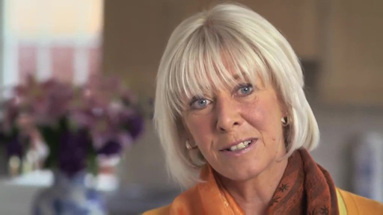

Janet Sumner is your guide through this course. She is a Media Fellow at The Open University with a specialist interest in volcanoes. Janet will appear at the start of each week to tip you off about the coming highlights and challenges, to remind you what you’ve learned and to help you make the most of these four weeks of scientific discovery.
Over the next four weeks you will carry out a series of hands-on experiments. These experiments are designed to get you to:
- start thinking in a rigorous and scientific way
- recognise the influence of experiment design and variables
- think about how the world around you works.
This course is going to assume that you are new to studying science, so don’t worry if you haven’t conducted any experiments before.
The experiments start off simply, but by Week 4 you will be isolating and extracting the DNA of a kiwi fruit! This week, you’ll be focusing on why water is so important to all living organisms and carrying out two different experiments – baking a potato to destruction and examining the process of osmosis in cucumbers.
To test your knowledge you can try the end-of-week and an end-of-course quizzes.
There are plenty of opportunities to communicate with other learners. There are forum threads for activities in each week. Please join in!
Before you start, The Open University would really appreciate a few minutes of your time to tell us about yourself and your expectations of the course. Your input will help to further improve the online learning experience. If you’d like to help, and if you haven't done so already, please fill in this optional survey.

What you'll need
All of the experiments can be carried out with items you would find in a typical kitchen, but before you start, you should probably make sure you have the following:

Shopping list
- a cucumber
- a kiwi
- methylated spirits (or a bottle of vodka!)
- olive oil
- a potato
- salt
- sugar
- washing-up liquid
- yeast
- distilled water.

Equipment list
- cling film
- oven gloves
- a freezer
- an ice cube tray
- kitchen scales
- a marker pen
- a microwave or oven
- a paper clip
- a printer
- a ruler
- a vegetable peeler
- drinking glasses
- knife.

Advice for younger learners and homeschoolers
We would like to take this opportunity to remind you of the Conditions of use of Open University websites. To enrol on an OpenLearn course and participate in the forums, you must be aged 16 or over. Adults can use their own OpenLearn account to supervise under 16s on the course, posting comments on their behalf, and assisting with the experiments.
Remember, do not share any personal details such as your home address, email or phone number in any comments you post. You can read more in the OpenLearn FAQs.

1.1 Keeping a study journal

Video content is not available in this format.
View transcript - Uncaptioned interactive content

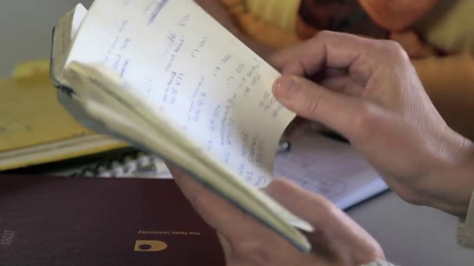

Keeping a study journal, lab notebook or field notebook is a vital skill for any scientist – beginners to the subject often underestimate their importance.
In the video, Janet Sumner and Hazel Rymer, Dean of Science at The Open University, discuss why your notes are so important. Download the activity booklet for this course, it includes everything you’ll need to make your personal notes on the experiments. If you would rather use your own journal, that’s fine – the type of record that you keep of your experiments is less important than the clarity and detail of your notes.
A good rule of thumb is that your notes should contain enough information that someone else could use them to duplicate your work, or that you could read through them years later and remind yourself of the exact procedures that you followed. It is always far better to have recorded too much information and not need it, than to not record enough and find that a vital piece of information is missing.

1.2 Introducing the experiment

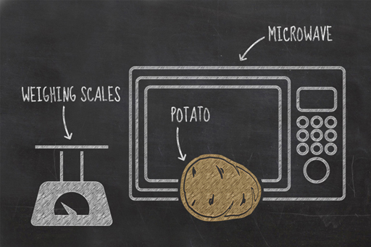
Figure 1

One of the best ways to start thinking more scientifically is by looking at everyday items and experiences in more detail. Your first experiment will be based on an everyday process – cooking.
You will be looking at the relationship between heat and the water content of a potato, measuring the change in water content as heat is transferred to a potato during the cooking process.
If you have ever microwaved a potato before, you will have noticed that steam is expelled during the process. By cooking the potato to destruction you are aiming to drive off all of the water contained within it, enabling you to calculate its water content.
To conduct this experiment, you will need:
- a potato
- oven gloves
- scales (digital scales will give a clearer reading)
- your activity booklet
- a pen
- a ruler
- a microwave or conventional oven.
If you do not have a microwave oven and wish to use a conventional oven, you will need to have longer cooking times with longer intervals between readings.
Although it can reasonably be expected that most people will have similar results, there will be small differences based on the type of oven used, the type of potato, and the length of the cooking. These are the experiment variables; they are the parts of an experiment that can be controlled, changed or measured. Variables, and their importance in experiments, will be discussed throughout the course.

1.3 Drawing graphs
This experiment requires you to plot your results on a graph. Before we move on to the actual experiment, here is a quick refresher on how to plot line graphs.
Graphs are a great way of presenting numerical data visually; they are used to illustrate clearly the relationship between quantities. There are several different types of graph, but for this course you will only be focussing on how to use a line graph.

The x-axis and the y-axis
The axes on a graph are your reference lines; they carry the scale of your graph and help you locate where to plot each piece of data. They also tell you what variables your graph is illustrating a relationship between.
Line graphs are commonly used to show data that change over a period of time. A simple line graph is drawn with two axes: an x-axis that is drawn left to right across the page, and a y-axis that is drawn up the page.

Figure 2

Scientists like consistency and it is standard practice to put the thing you’re measuring on the y-axis. So, as the change in weight of a potato is what you will be measuring in this experiment, this will be the data plotted on your y-axis. Because you are measuring the change in the potato’s weight over time, the time will be the data illustrated by your x-axis. The graph will therefore show the relationship between cooking time and potato weight.
Once you have drawn the axes of your graph, remember to write alongside them both what they represent and the units they are displayed in, i.e., time (in minutes) and weight (in grams).

Figure 3

Setting the scale of your graph
When drawing your axes, you need to number them appropriately for the experiment you are carrying out, so your y-axis should range from zero to a number just a bit larger than the weight of your potato. Your x-axis should be labelled with the number of minutes of cooking time, probably from zero to about 10 to 15 minutes if using a microwave oven, and zero to maybe 100 minutes if you are using a conventional oven.

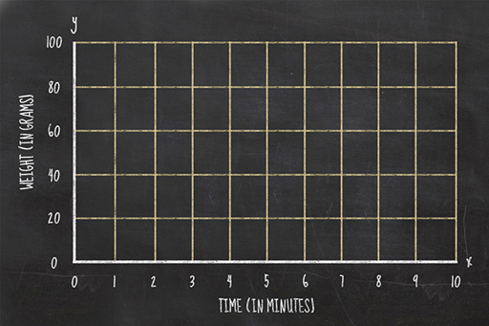
Figure 4

Plotting your data
When you obtain a measurement, you write down the weight and the cooking time. To plot this on a graph, you need to find where those two values intersect. For example, if your potato weighed 90 grams at zero minutes, then you would plot your first data point as a dot at the intersection between those two lines.

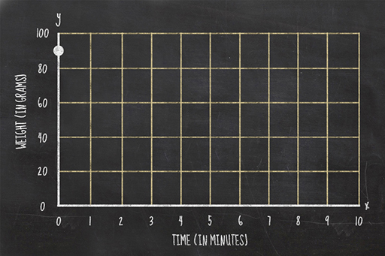
Figure 5

Once you have all your data plotted on a graph you should join the consecutive points with a line.

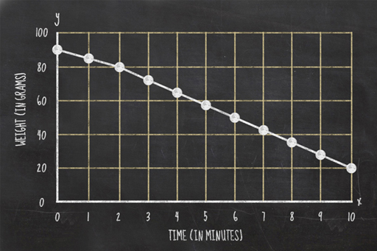
Figure 6

1.4 Experiment 1: Potato experiment
Follow Janet’s instructions in the video (or use your activity booklet PDF) to conduct the experiment. Don’t forget to prick a few holes in your potato and to use oven gloves when handling your hot potato!

Video content is not available in this format.
View transcript - Uncaptioned interactive content

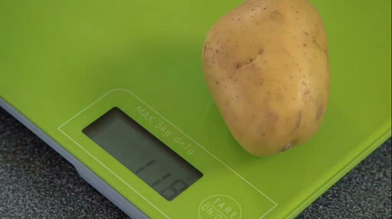

It is possible to go too far during the cooking process and cause your potato to smoke and potentially catch fire, so watch the potato during the experiment, and as soon as you see smoke coming from it, or smell burning, you should bring the experiment to a halt immediately.
This is your first opportunity to document an experiment. Remember the advice in the previous sections and record all your observations and results carefully.
You will have the opportunity to discuss your results in the next section.

1.4.1 What's in your graph?

Figure 7

You should now have completed this week’s experiment and should be ready to share your findings with your fellow learners. It is very likely that each of your experiments will have produced different results, but you may be able to find general patterns of agreement.

Activity 1.1 Experiment 1
Allow about 30 minutes

What was the water content of your potato? To work this out, you just need to subtract the weight of your potato at the end of your experiment from its starting weight. The difference in the starting and finishing weights is the actual weight of the water that was in your potato.
To compare your results with those of other learners easily, you can express your potato’s water content as a percentage. To do this, divide the weight of water in your potato by the potato’s starting weight and multiply the answer by 100. It is likely to come out to about 80%.
Post your results in the course forum thread for this activity and compare your findings with those posted by other learners. Discuss why you think any differences came about. Consider the variety of potato you used. Does it make a difference? Do waxy potatoes have a higher water content than floury ones? Maybe drying in a microwave is different from drying in a conventional oven?
It might be useful to provide an image of your graph. You can do this by photographing or scanning your graph and attaching the photograph file with your forum post.

Discussions with other people are crucial parts of the scientific process. It isn’t enough to obtain your results and then hide them away; they must be shared and discussed among your peers. Scientists usually do this by having their work critically examined by other scientists to see if it is ready for publication, then publishing their results in scientific journals, where anyone and everyone can examine them. If other people disagree with those results they can carry out research, obtain findings, and publish papers which argue a different case. This is why science produces such a robust body of knowledge. Other people are always trying to spot the flaws in your ideas, and if flaws are there, they are usually found pretty rapidly. A good scientist must always be ready to be corrected.

1.4.2 Why does it matter?

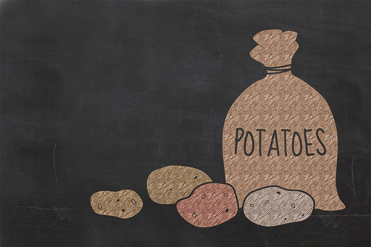
Figure 8

Potatoes originated in South America, and have become a staple food for much of the world’s population. About 4000 to 5000 varieties exist, but most of these are only found in the Andes. In the UK, only about 80 varieties are grown, and only a handful of those are sold by the major supermarket chains.
The amount of water required to grow different crops affects which ones are better suited to drier regions, and which ones are better suited to wetter areas. With drought conditions widespread over many parts of the globe, it is better for farmers in those regions to grow crops more suited to drier conditions and crops that require less water to develop are the preferred choice.
This type of farming even has a name: dryland farming. It is common in the Great Plains of the USA, the deserts of Mexico and the south-western USA, the steppes of Eurasia, Australia, and parts of South America.
This table shows some of the thirstier crops in production around the world. Do any of these numbers surprise you?

Water-intensive crops | Typical water needs (in litres per kg of crop)
Cotton | 7,000 to 29,000
Rice | 3,000 to 5,000
Sugar cane | 1,500 to 3,000
Soya | 2,000
Wheat | 900
Potatoes | 50

1.5 Experiment 2: Cucumbers and osmosis

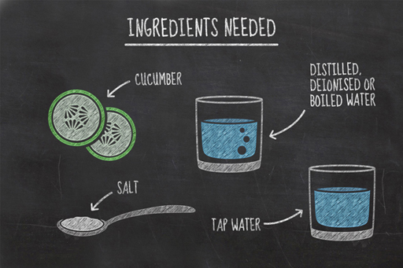
Figure 9

In the previous experiment, you determined the water content of a potato and illustrated the rate at which the water is driven off in your graph. You also developed skills in carrying out an experiment. You’re now going to carry out a second experiment looking at the way water gets in and out of cells.
In this experiment, you will be measuring changes in the water content of two slices of cucumber as they are left in two different liquids; distilled water and salty water.
To carry out this experiment, you will need:
- two slices of cucumber
- two glasses
- a knife
- a peeler
- tap water
- distilled, deionised or boiled water
- two tablespoons of salt.
It is best to use distilled water for this experiment, available from most petrol stations and car spares shops. Distilled water is simply water that has had most of its impurities removed by boiling it, then collecting the steam and condensing it in a clean container. An alternative is deionised water, sometimes called demineralised water. This is similar to distilled water, but the manufacturing process does not significantly get rid of organic molecules, viruses or bacteria. If you can’t get hold of either of these, you can use boiled water that has been left to cool to room temperature instead.
While it’s okay to drink small quantities of distilled and de-ionised water, we don’t recommend it. Why do you think the purest form of water might not be good for you? Perhaps you’ll be able to see why at the end of the experiment.
Follow Janet’s instructions in the video (or use your activity booklet PDF) and remember to keep clear and accurate notes in your journal. Once again, think about the variables that could affect your results.

Video content is not available in this format.
View transcript - Uncaptioned interactive content

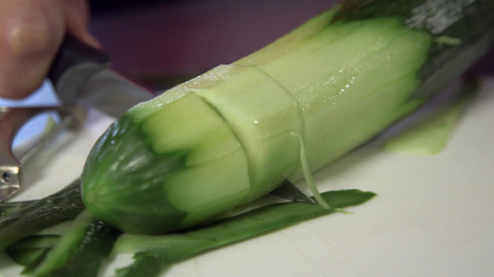

Based on her initial findings, Janet decided to change the parameters of her experiment and leave her cucumber slices overnight. You may find that you have to do the same. If so put the experiment somewhere where no-one can knock it over, and no pets try and drink it.
You’ll have the opportunity to discuss your findings in the next section.

1.5.1 Sharing your results

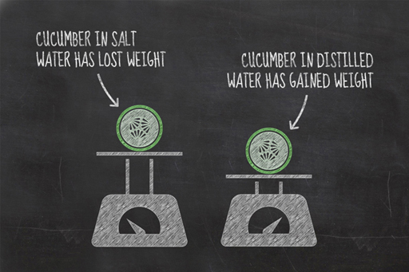
Figure 11

Now that you have completed your second experiment, you will have a new set of results to discuss. Hopefully the results of your experiment were broadly similar to those seen in the video. The cucumber slice in the salt water should have lost weight, while the one in the distilled water should have gained weight.

Activity 1.2 Experiment 2
Allow about 15 minutes

Post your results and observations in the course forum thread for this activity:
- Did the experiment perform as you expected?
- What do you think caused your cucumber slices to change in the way that they did?
- If your cucumber slices haven’t behaved in the same way as Janet’s did, can you think of a reason why your results might be different?
Photographs can be really useful for comparing your results, so do add an image to your forum post if you can.

Remember, if your results were unusual this does not make them bad – some of the most significant scientific discoveries have stemmed from mistakes or surprises.

1.5.2 Osmosis explained

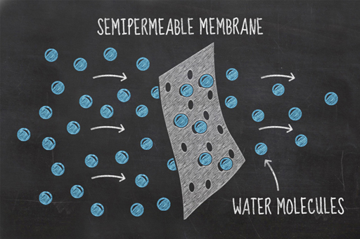
Figure 12

You’ve seen the results of your experiment and it should be clear that water is somehow moving in and out of your cucumbers – this process is known as osmosis.
Imagine two solutions of different concentrations, divided by a partition which allows small particles through it, but not large particles. This type of boundary is known as a partially permeable membrane. In this environment, the process of osmosis will occur spontaneously because the concentrations of water molecules on either side of the partition, or membrane, naturally try and equalise.
In your experiment, the water in the glass and the fluid inside the cucumber’s cells are separated by the cucumber’s cell walls which are partially permeable membranes. Salt cannot pass through these membranes, but water can. By adding salt to the water, you made its salt concentration higher and therefore lowered the concentration of water in the mixture. This gives the cucumber cells a relatively higher water concentration than that in the glass. The water in the cucumber cells tries to equalise these different concentrations by moving from the cells to the saltwater solution. As a result, the cucumber loses water and becomes a bit squishy. This environment is referred to as hypertonic.
In your other glass, containing the distilled water, the opposite effect was seen. Water flowed from the pure water (a higher concentration region) into the cucumber cells (which have a lower concentration of water). In this hypotonic environment, the water tries to equalise by moving into the cucumber cells, inflating them, and causing the cells to become firm. This is known as turgor, and it is the turgor pressure in plant cells that keeps them rigid. Without it, plants wilt and their cellular functions will begin to decline.
When the concentrations on either side of the membrane are equal, the condition is known as isotonic, and water moves randomly from one side of the membrane to the other, but with no pressure gradient to drive it, the rate is the same in both directions.

1.5.3 Why does it matter?

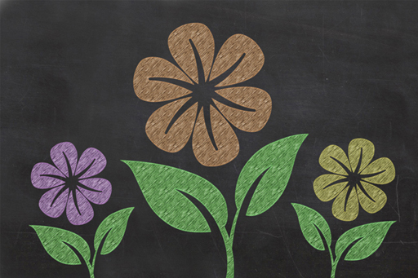
Figure 13

You now know what osmosis is and that it’s the process that keeps plants firm but, other than keeping your flowers from wilting, are there any other examples of osmosis in the natural world? Unsurprisingly, the answer is yes, there are many, and here are just a few:
- As well as keeping plants rigid, osmosis is also the way that plants draw water and nutrients into their roots.
- If you’ve ever stayed in the bath too long and seen your fingers turn a bit ‘pruney’, it’s because your fingertips have absorbed water through osmosis and become bloated, making them wrinkly.
- Ever had salted fish? The fish is covered with salt to preserve it. Osmosis is the process whereby the salt draws water from the fish’s cells, drying it out. This, gruesomely, is the same thing that happens when slugs encounter salt.
- If you have soaked raisins overnight in alcohol for a recipe, the liquid soaked into the fruit by osmosis.
- Cholera is rare in developed countries, due to clean water supplies and good healthcare, but it used to be one of the most feared diseases in the world. Cholera damages our intestines in such a way to cause osmosis to happen in an unwanted direction. The cells of the intestine become unable to absorb water and instead it flows from the rest of the body into them, causing diarrhoea, dehydration and often death.
- Industrially, osmosis is used to purify water, at desalination plants where seawater is turned into drinkable water.
- Osmosis is also used in modern medicine. When patients are treated with dialysis to replace lost kidney function, osmosis is the process which is used to filter waste materials and excess water from the blood.
Now, you may remember that Janet mentioned a green energy source in this week’s guide video. Well, this relates to the use of osmosis to generate electricity. Where rivers flow into the ocean, freshwater and saltwater naturally meet, resulting in a natural mixing of waters of different salinity. Construction of a power plant at such a site allows freshwater and saltwater to be guided into separate chambers, divided by an artificial membrane. At the membrane, the freshwater is drawn towards the seawater. This flow puts pressure on the side of the seawater and that pressure can be used to drive a turbine, producing electricity that produces no greenhouse gases. The only waste product is brackish water (a mixture of saltwater and freshwater), which can be pumped out to sea.
Power plants that utilise osmosis in this way have been trialled, but only as prototypes, as the technology is still relatively new. The first was in Norway, where it generated up to 4 KW; barely enough to keep a couple of houses supplied with power, and the company shelved their development plans. However the technology can still be developed further, if improvements in the efficiency and cost of the membrane can be achieved.
Those are just a few examples of osmosis in real life, can you find some more? .

1.6 Week 1 quiz
Check what you’ve learned this week by taking this end-of-week test.

Complete the Week 1 quiz now.
Open the quiz in a new window or tab then come back here when you're done.

1.7 Week 1 summary

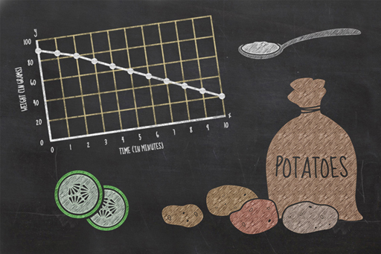
Figure 14

Congratulations, you have completed Week 1 and carried out two different science experiments. You should be starting to get a taste for practical science and sharing data; hopefully you have learned some new things too!
During the week you have covered scientific techniques such as making precise measurements, recording data and observations, plotting graphs, and interpreting results. These are all essential skills for a scientist and you will use them throughout this course.
We hope that you have enjoyed this first week and you should now be ready to tackle Week 2, where you will investigate some properties of different liquids.
To conduct next week’s experiment, you will need:
- an ice cube tray
- fresh water
- salt water (approximately 2 tablespoons of salt added to 500 ml of water)
- olive oil
- another liquid of your choice – be creative here, but avoid substances which might be hazardous!
- four glasses
- your activity booklet
- a freezer.
You can now go to Week 2.

[Untitled]

Introduction

Video content is not available in this format.
View transcript - Uncaptioned interactive content

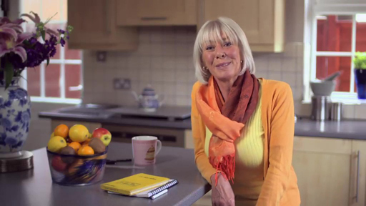

This week, you are going to perform an experiment to investigate how the physical properties of common liquids change when they are frozen.
Like last week, this simple experiment can be performed in your kitchen, but the science behind your results goes far beyond it. In fact, the physical properties of one of the liquids you will freeze are fundamental to life on our planet.
As you work through this week, try and remember the scientific techniques you covered last week, such as making precise measurements, recording data and observations and interpreting any results.
So, clear some space in your freezer and get started!

2.1 Experiment 3: Ice tray experiment

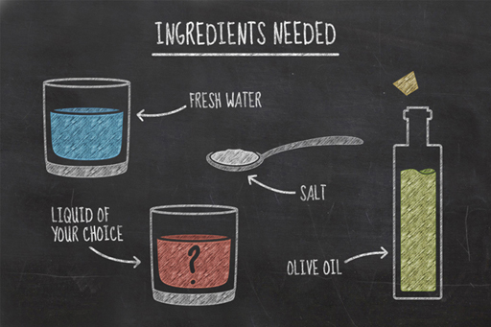
Figure 1

Solids, liquids and gases have very different properties that you will already be aware of on a practical level. For example:
- solids can typically be held and keep their shape
- liquids can flow, changing their shape to fill the space provided but without changing their volume
- gases are often invisible and change their shape and volume to fill whatever space is available.
The reason these states of the same material differ is to do with the behaviour of the particles (atoms and/or molecules) from which they are comprised:
- Particles in solids are packed together closely, held by strong forces called bonds. The particles can vibrate but they cannot move around freely, so a solid holds its shape.
- Particles in liquids are arranged randomly and are still held together by bonds, but the bonds are weak enough to allow the particles to move around each other.
- Particles in gases are further apart and are not held together by bonds. This allows the gas particles to move freely in all directions, expanding to fill the space they occupy.
Under special conditions, things can exist in all three states at the same time. Mostly though, only one or two states are seen at the same time. The most obvious example is for water, which, at standard pressure is a liquid at room temperature but a solid (ice) at temperatures below 0 °C, and a gas (steam) above 100 °C.
This week’s experiment is all about the physical properties of different household liquids and how they change when they are frozen. You will also investigate whether or not the frozen liquid sinks or floats when placed into its own liquid form at room temperature.
Many of you will have performed part of this experiment already, perhaps adding an ice cube or two to a glass of water to cool it down. What happens when you add these ice cubes to your glass of water? Does the ice cube sink or does it float?
To conduct this experiment, you will need:
- an ice cube tray
- fresh water
- salt water (approximately 2 tablespoons of salt added to 500 ml of water)
- olive oil
- another liquid of your choice – be creative here, but avoid substances which might be hazardous!
- four glasses
- your activity booklet
- a freezer.
Before beginning an experiment scientists often use their previous experiences or preconceptions to hypothesise about the results of an experiment. For example, we know that ice floats on water, so a scientist might then hypothesise that the solid state of all the other substances will also float on their liquid counterparts.
You will notice that we have only specified three liquids (water, salt water and olive oil); however, you should choose a fourth liquid yourself. This is a chance for you to be creative. Look around your home and see what you can find.
What other liquid are you going to test? And what hypothesis can you make? Did you use any previous experiences or preconceptions to make this hypothesis? Post your ideas below. Scientists are curious folk with lots of ideas and interests, so explore your inner scientist.

2.1.1 The experiment
Have you got all the equipment you need? Follow Janet’s instructions in the video (or use your activity booklet PDF) to conduct the experiment.

Video content is not available in this format.
View transcript - Uncaptioned interactive content

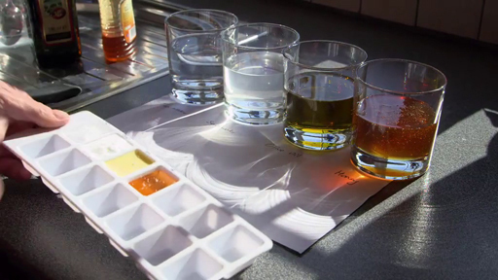

As with any science experiment, it is important to keep detailed notes and to label your ice tray and glasses so you can keep track of the different parts of your experiment. Your activity booklet has a diagram of the ice cube tray to help you with recording this information.
Last week, you learned that variables are the factors than can be controlled, changed or measured in an experiment. What variables can you think of that might alter these results? Write these down, they might be useful later. Remember, this is an observational experiment – try taking photographs of your experiment. This will help you to remember the results later and allows you to share your results with your fellow learners.
You will have the opportunity to discuss your results in the next section.

2.1.2 Discussing your results

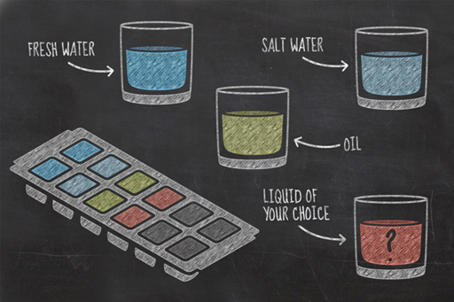
Figure 2

You should have now completed this week’s experiment and be ready to share your findings with your fellow learners.

Activity 2.1 Experiment 3
Allow about 15 minutes

Post your results and findings in the course forum thread for this activity. If you would like to share an image of your experiment, you can do this by photographing or scanning your graph and attaching the photograph file with your forum post.
- Did the water, salt water and oil behave the same way as Janet’s did?
- Did the liquid you chose yourself perform how you expected?
- Can you think of any other substances where the solid state would float on top of the liquid state, like water?
- Why do you think the ice floated, while the frozen oil did not?

Remember, science is often about collaboration – did other learners have broadly similar or vastly different results? Why do you think that might have been?

2.1.3 Ice tray experiment explained

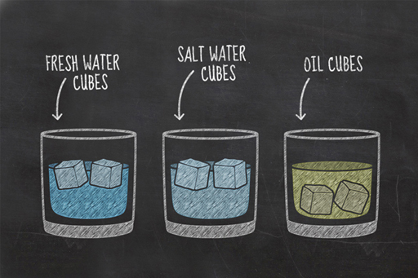
Figure 3

The simple experiment you performed this week has revealed some interesting properties about different liquids. You will probably have seen that the water-based cubes floated, while your other choices sank. While you might be more familiar with water ice floating on liquid water, this is actually a very unusual physical property, and our guess is that whatever liquid you froze for your fourth glass, like the oil, sank within its liquid form.
To understand these results, we first need to understand the physics behind whether objects float or sink at all. This relates to the object’s density.
Density is a concept that sometimes confuses people, but it is simply the amount (mass) of something that is contained within a certain volume of space. For example, if you have one person in an elevator, it is not densely packed, but if you try and squeeze ten people in, things are going to get a bit tight. In this case the number of people is the amount, or mass, while the elevator is the volume of space. Mass is typically measured in grams, or kilograms, while volume is typically measured in cm³ or m³, so the units for density are usually g/cm³, or kg/m³.
It is the contrast between the density of the liquid and the density of the frozen cube which is important in determining whether that cube floats or sinks.
Earlier this week, you learned about the differences between solids, liquids, and gases. When most liquids freeze the individual atoms and molecules move closer together, allowing more to fit into a given volume. As a result, these substances are more compact in their solid state than in their liquid state, in other words, their density increases.
This is why the frozen oil and frozen honey sank in Janet’s experiment. What is it about water that made it behave differently?
When water freezes, the molecules of water stick together in an unusual hexagonal structure which spaces them further apart as a solid than as a liquid. This makes ice less dense than water, and is why ice floats. Very few liquids are denser than their solids. Gallium, bismuth, antimony and germanium are four other examples, but they’re not very common. This is why we felt safe to assume that whatever liquid you froze for your fourth glass also sank.

2.2 What if ice was denser than water?

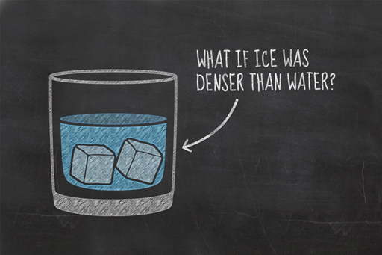
Figure 4

You’ve seen that water’s unusual property of being less dense as a solid than as a liquid leads to ice floating on water.
Think about how surface ice might affect things like aquatic life, water temperature, oxygen levels and circulation patterns.
Imagining a world where ice was denser than water and sank, rather than floated, consider these questions:
- What might the consequences be for aquatic life?
- How might denser ice affect small-scale bodies of water, like ponds and lakes?
- How might denser ice affect oceans?
- Could denser ice have far-reaching effects on the evolution of life?

2.3 Week 2 quiz
Check what you’ve learned this week by taking this end-of-week test.

Complete the Week 2 quiz now.
Open the quiz in a new window or tab then come back here when you're done.

2.4 Week 2 summary

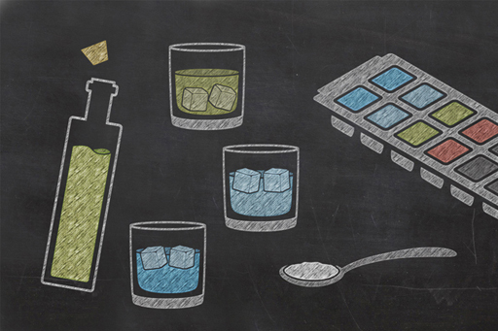
Figure 5

Congratulations on completing Week 2. Many of you will have certainly added ice cubes to your drink on a warm summer day and noticed that your ice cubes float at the top of your glass. As such, the starting point of this experiment was probably not much of a surprise. In carrying out this experiment, you became a real scientist and tested the hypothesis that other liquids will also behave in this fashion. Like a real scientist, you may have been confronted by results which proved your theory wrong and led you to question why that might be.
Hopefully you have learned that many experiments are observational and do not involve numbers, but both require detailed notes along the way. You should have also learned some science too, and be able to answer scientific questions, such as:
- Why do things sink or float?
- Why does ice behave differently from other common liquids in their solid state?
- Why is this weird property of water important to life itself?
Next week, you will be investigating the conditions required for living organisms to survive. It is simply amazing that scientific investigations, which are so important to Earth and life as we know it, can be investigated in the safety of your home, using everyday equipment and ingredients you can find in your local supermarket.
To conduct next week’s experiment, you will need:
- four glasses
- four sachets of baker’s yeast
- sugar
- water
- a kettle
- a marker pen
- cling film
- your activity booklet.
You can now go to Week 3.

Week 3: Sugar, yeast and life

Introduction

Video content is not available in this format.
View transcript - Uncaptioned interactive content

Welcome to Week 3. This week, you will be conducting experiments using living organisms. You might be wondering if you need special licences or ethics committee approval, but as the organisms involved are only single-celled fungi, you don’t need to worry. This week, you will be experimenting on yeasts.
As single-celled organisms, yeasts are tiny; only a few, to a few tens, of micrometres (10⁻⁶ m) across. Yet despite their size, they have had a huge impact on our culture, having been used for thousands of years in the manufacture of leavened bread, beer and wine (although some of us think it reached its culinary peak in the manufacture of Marmite).
The uses we have put yeasts to might seem trivial, but for many centuries throughout the history of human culture, water supplies were often unsafe to drink, due to the presence of pathogens. It was often the case that the only safe beverage to drink was beer or wine, so the use of yeasts has been pivotal in lowering mortality rates.

3.1 Experiment 4: Yeast experiment

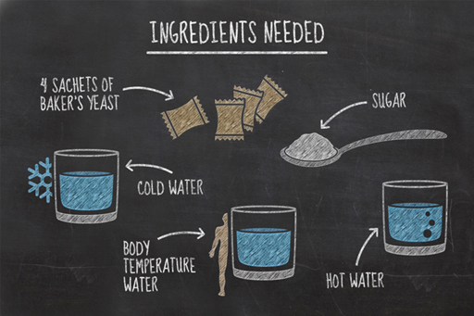
Figure 1

Living organisms, like yeasts, need food and oxygen in order to survive and thrive. In this experiment, you will test some conditions that can affect their growth. What variables might you be able to change in this experiment?
You will add the living yeast organisms to sugary solutions at different temperatures. You will also cover one glass of your sugary solution with cling film.
To carry out this experiment, you will need:
- four glasses
- four sachets of baker’s yeast
- sugar
- water
- a kettle
- a marker pen
- cling film
- your activity booklet.
As with experiments in the previous weeks, you will want to carry this out somewhere that it won’t be disturbed by family members or pets. The experiment shouldn’t take more than half an hour or so to carry out, so you won’t need to be vigilant for too long.
What results do you expect to see in this experiment? Try to write down a hypothesis that you will be testing.

3.1.1 The experiment
Follow Janet’s instructions in the video (or use your activity booklet PDF) to conduct the experiment. You will need about 1 tablespoon of sugar and approximately 200 ml of water in each large glass. This sugar will act as food for your yeasts to consume.

Video content is not available in this format.
View transcript - Uncaptioned interactive content

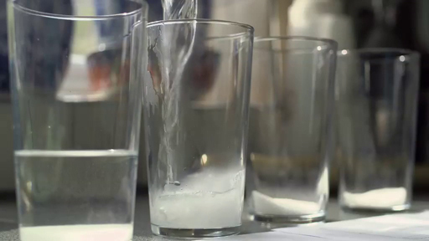

Take care to label your glasses with which variables you’ve changed – you don’t want to get them mixed up. If the environmental conditions are suitable, the yeasts will grow and multiply quite quickly – you shouldn’t need more than 30 minutes to complete this experiment. Remember that boiling water can crack glassware, so be careful to let the water cool a bit first.
Carefully observe and record which glasses have conditions suitable for the yeasts to grow and which ones have conditions that restrict its growth.
You will have the opportunity to discuss your results in the next section.

3.1.2 What were your results?

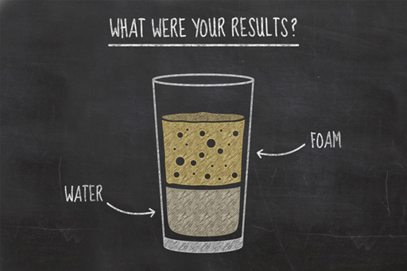
Figure 2

You should now have completed this week’s experiment and be ready to share your findings with your fellow learners.

Activity 3.1 Experiment 4
Allow about 15 minutes

Post your results and findings in the course forum thread for this activity
- Were your results similar to Janet’s or were there any differences?
- Which environments promoted yeast growth and what environments hindered yeast growth?
- How do the results of your two experiments at body temperature conditions compare?
- Did you notice any changes with time? If you needed to, how could you display these results?

While it is nice when an experiment goes according to plan, it is often more interesting from a scientific point of view when something odd and unexpected happens. It usually means that there is something exciting going on, or that you need to think about ways to tighten up your experimental skills – both of which are good things. Never feel bad if an experiment goes a bit wonky, that is where the cutting edge stuff happens!

3.1.3 Yeast experiment explained

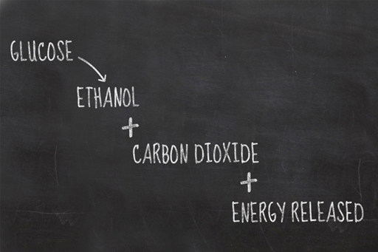
Figure 3

You’ve seen the results of the yeast experiment, but what do these results mean?
Yeasts are microscopic, single-celled organisms, and are a type of fungus that is found all around us, in water, soil, on plants, on animals and in the air. Like all organisms, when yeasts are put in the right type of environment they will thrive; growing and reproducing.
Your experiments were designed to help you identify which environment promotes the most yeast growth. The first three glasses in your experiment contained different temperature environments (cold water, hot water and body temperature water). At very low temperatures the yeast simply does not grow but it is still alive – if the environment were to warm up a bit, it would gradually begin to grow. At very high temperatures the cells within the yeast become damaged beyond repair and even if the temperature of that environment cooled, the yeast would still be unable to grow. At optimum temperatures the yeast thrives.
Your third and fourth glasses both contained environments at optimum temperature (body temperature) for yeast growth, the difference being, the fourth glass was sealed. The variable between these two experiments was the amount of available oxygen. You may have been surprised by your results here, thinking that a living organism in an environment without oxygen cannot survive? However, you should have found that yeast grew pretty well in both experiments.
To understand why yeast was able to thrive in both conditions we need to understand the chemical process occurring in each glass during the experiment. In the three open glasses, oxygen is readily available, and from the moment you added the yeast to the sugar solution it began to chemically convert the sugar in the water and the oxygen in the air into energy, water, and carbon dioxide in a process called aerobic respiration.
Yeast is a slightly unusual organism – it is a ‘facultative anaerobe’. This means that in oxygen-free environments they can still survive. The yeast simply switches from aerobic respiration (requiring oxygen) to anaerobic respiration (not requiring oxygen) and converts its food without oxygen in a process known as fermentation. Due to the absence of oxygen, the waste products of this chemical reaction are different and this fermentation process results in carbon dioxide and ethanol.
Depending on how long you monitored your experiment for and how much space your yeast had to grow you may have noticed that, with time, the experiment sealed with cling film slowed down. This is for two reasons; firstly because less energy is produced by anaerobic respiration than by aerobic respiration and, secondly, because the ethanol produced is actually toxic to the yeast. As the ethanol concentration in the environment increases, the yeast cells begin to get damaged, slowing their growth.
The ethanol produced is a type of alcohol, so it is this process that allows us to use it to make beer and wine. When used in bread making, the yeast begins by respiring aerobically, the carbon dioxide from which makes the bread rise. Eventually the available oxygen is used up, and the yeast switches to anaerobic respiration producing alcohol and carbon dioxide instead. Do not worry though; this alcohol evaporates during the baking process, so you won’t get drunk at lunchtime from eating your sandwiches.

3.2 Altering variables

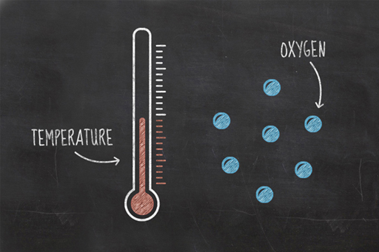
Figure 4

You have now conducted another experiment, one which had several different variables. Variables are parts of an experiment that can be kept the same, or changed in order to test different outcomes.
In the yeast experiment, you actually performed two separate tests at the same time; one regarding the temperature and another regarding available oxygen. Note that in each case you only altered one variable (either temperature or oxygen availability).
You could repeat the yeast experiment, keeping both temperature and oxygen availability constant but altering a different variable, i.e., fixing a previously changing variable and changing a previously fixed variable. By performing a combination of these experiments the optimum conditions for yeast growth can be determined.
You should now be starting to think like an experimental scientist and considering ways that an experiment can be altered so that different hypotheses can be tested.
Takes some time now to think which other variables you could test and why.

3.3 Yeast – who needs it?

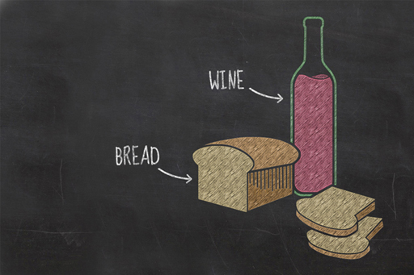
Figure 5

You’ve seen yeast in action and had a look at the science behind it, but where has it come from? Human society has used it for at least 7000 years. Its use in brewing is first thought to have taken place in ancient Iran and possibly even earlier in China. The oldest surviving beer recipe dates back to a 3900-year-old Sumerian poem.
The earliest brewing may well have been accidental, as wild yeasts in the air and on the ground may have contaminated cereal crops, causing them to undergo spontaneous fermentation, possibly in leftover pots of gruel. As time passed these brews would have been replicated and, to a degree, standardised.
Without fermented beverages, historical populations might have been afflicted with more waterborne diseases than are recorded, due to the boiling step in the production process.
Around the same time yeasts were being used in brewing, they began to be used as raising agents in bread making. As far back as 30,000 years ago, humans were crushing up cereal crops and baking them as flatbreads, but records show that from a few thousand years ago the ancient Egyptians began using yeasts to leaven bread, although the extent to which their rather dense loaves actually rose is uncertain.
The Romans, Greeks, Gauls, and Iberians are all recorded as making leavened breads. By the Middle Ages bread had become a staple across Europe, not only as food, but also as a type of plate, known as a trencher. These trenchers were made from a slice of stale bread, on which the food was placed. The trencher would soak up the juices to be eaten later or given to the poor.
In modern times, bread comes in a dizzying array of types, light to dark, pure and refined, coarse and grainy, sliced and unsliced to name but a few. Interestingly, sliced bread is a fairly recent invention.
Early attempts to pre-slice bread were met with doubt as it was thought that the bread would go stale too quickly. In 1928, Otto Rohwedder sold his latest invention to a bakery in Chillicothe, Missouri, a device to slice and wrap loaves of bread. In 1928, an advert was run on the back page of the local newspaper proclaiming it to be ‘the greatest forward step in the baking industry since bread was wrapped’. This may be the origins of the phrase, ‘the best thing since sliced bread’, suggesting that the best thing prior to sliced bread was wrapped bread!

3.4 Week 3 quiz
Check what you’ve learned this week by taking this end-of-week test.

Complete the Week 3 quiz now.
Open the quiz in a new window or tab then come back here when you're done.

3.5 Week 3 summary

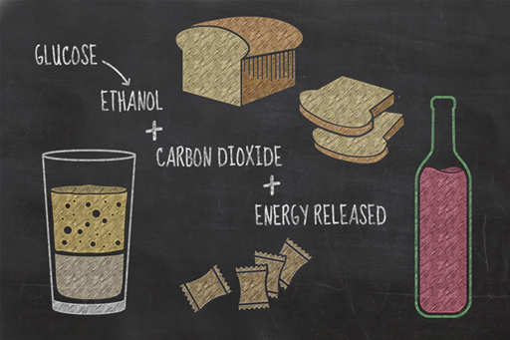
Figure 6

Congratulations on completing Week 3. Who knew yeast was so important in human history?
While the experiments you’ve carried out over the last three weeks have been necessarily simple enough for you to perform at home, with little risk of accidentally constructing a doomsday device or incinerating your pets or family, they are important experiments in explaining how the world around us works. Hopefully, you’ve also developed skills in carrying out scientific experiments and how you can identify and alter variables to test a hypothesis further.
In the final week of the course, the difficulty level ramps up a notch, as you will be using some household items to separate and extract the DNA from a living organism!
To conduct next week’s experiment, you will need:
- kiwi fruit (or another fruit of your choice)
- methylated spirits, chilled in freezer for 30 minutes (or vodka or strong white rum)
- fine sieve or filter paper
- salt
- washing-up liquid
- measuring beaker
- a paperclip.
Remember, methylated spirits are extremely hazardous and should only be used with adult supervision.
You can now go to Week 4.

Week 4: DNA

Introduction

Video content is not available in this format.
View transcript - Uncaptioned interactive content

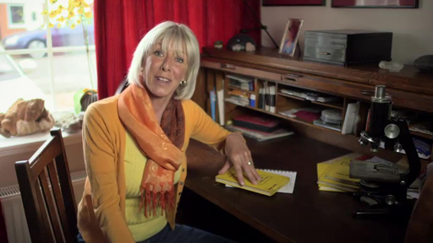

Welcome to Week 4. This week, you are going to use some fairly common household chemicals to isolate and observe the DNA (deoxyribonucleic acid) from the nucleus of a kiwi fruit.
DNA was first isolated as far back as 1869, but it wasn’t until 1928 that scientists realised that it carried genetic information. In 1953, the structure of the molecule was discovered by Francis Crick and James D. Watson and other colleagues, while working at Cambridge University.
DNA is a molecule containing sequences of chemicals in very specific arrangements. The shape of the molecule is like a twisted ladder, known as a ‘double helix’, which contains stretches of chemicals, known as genes, which code for certain biological traits and functions. In other words, DNA contains the instructions by which organisms build and maintain their existence.

4.1 Experiment 5: Kiwi experiment

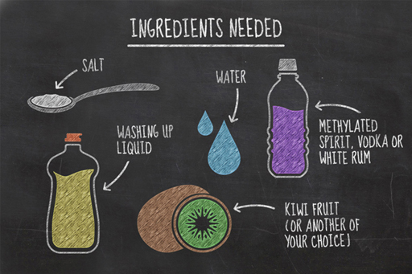
Figure 1

In humans, the DNA molecule is very long and thin. It is about 2.5×10−9m across, yet if it were stretched out, it would reach up to 2 or 3 metres in length. Within the cell, the molecule is twisted and coiled, like earphone cables kept in a coat pocket. In fact, there is enough DNA in your cells to reach to the Sun and back about 65 times.
Fortunately for us, this experiment won’t require you to build a spaceship and test that fact. For this experiment, you are going to use some fairly common materials to extract the DNA from the cells of a kiwi fruit. Once the DNA is isolated and clumped together, there will be enough for you to see without microscopes or high-tech equipment and it can also be carefully removed with nothing more than a paper clip.
We will keep referring to a kiwi fruit throughout the week, as this is an easy example to obtain and to work with, but you can use other soft fruits if you wish. Remember, you will then be altering a variable, and should be ready to discuss how it affects your results.
To carry out this experiment, you will need:
- a kiwi fruit (or another fruit of your choice)
- a peeler/knife (to remove the skin/peel)
- a fork
- methylated spirits, chilled in freezer for 30 minutes (or vodka/strong white rum)
- a fine sieve or filter paper
- a couple of bowls
- salt
- tap water
- warm water
- washing-up liquid
- teaspoon
- measuring beaker
- a couple of glasses
- a paperclip.
Remember, methylated spirits are extremely hazardous and should only be used by adults or with adult supervision.

4.1.1 The experiment
Have you chosen which fruit you’re going to extract DNA from? Follow Janet’s instructions in the video (or use your activity booklet) to conduct the experiment.

Video content is not available in this format.
View transcript - Uncaptioned interactive content

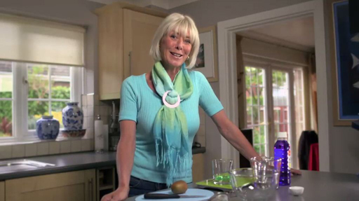

Remember that vodka and rum are strongly alcoholic and, in the case of methylated spirits, also highly toxic. The ethanol in them is also highly flammable. You should also take care when you peel and chop your kiwi fruit: you don’t want any bits of finger mixed in with the fruit!
Although you are performing this experiment in your home, it actually follows the same basic principles as more advanced lab-based DNA extraction procedures, so you are, in effect, doing something that scientists in labs do every day.
The procedures you are going to carry out are:
- the mechanical and thermal disruption of the cells
- the liberation of the DNA with an extraction buffer
- the precipitation of the DNA.
As you perform the experiment, you should recognise each of these stages taking place. The mashing and heating of the kiwi mixture represents the mechanical and thermal disruption of the cells. The washing-up liquid and salt water mixture forms your extraction buffer and both work to liberate the DNA, in other words remove it from the cells. The detergent works just like it does on your dishes and dissolves the lipids (fats) in the cell membranes and nucleus where the DNA currently resides.
DNA is highly soluble in water but not soluble in ethanol (alcohol). When you add the alcohol to the top of your kiwi mixture, the DNA precipitates (or deposits in a solid form) at the interface between the water and the alcohol. The salt that you added earlier helps encourage the DNA to clump together by neutralising the negatively charged phosphate groups that exist within the DNA structure.
When you have finished the experiment and extracted the DNA, move to the next section to discuss your results.

4.1.2 What were your results?

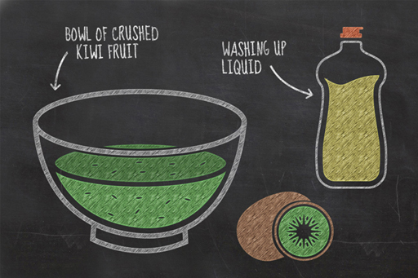
Figure 2

You should now have completed this week’s experiment and be ready to share and discuss your findings with fellow learners.
Each glob of the white goo in your glass contains millions of DNA strands, clumped together. If you had your own research laboratory, you would be able to analyse the goo and show that this is in fact DNA. Unfortunately, research laboratories are not commonly found at home so you will just have to take our word for it!

Activity 4.1 Experiment 5
Allow about 15 minutes

Post your results and findings in the course forum thread for this activity. Photographs can really help here, so take advantage of being able to attach images to your forum post.
- Did the experiment work in the way that you expected?
- Did you try a different fruit or alcohol to Janet? How did this affect your results?

4.2 Why does it matter?

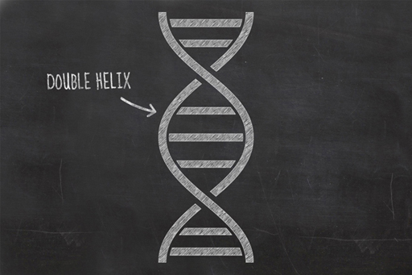
Figure 3

You’ve now extracted DNA from an organism, but why is this important? In carrying out this experiment, you have taken the first step in all experiments that work with DNA. While you are limited in the types of DNA research you can perform in your kitchen, it is possible to take this much further with a fully equipped laboratory. For example, once scientists have isolated the DNA from an organism, they can use it to clone a sheep, solve a murder, test for paternity, create an insect-resistant crop or cure a disease.
An important line of DNA research is pharmacogenomics, which concentrates on the role of genetics in drug response because different people respond differently to the same medical treatments. It is hoped that if a treatment can be tailored to our genetic signature, it will be more effective at curing whatever ails us and have fewer adverse side-effects. For example, a common chemotherapy treatment for cancer involves the chemical mercaptopurine, which kills tumour cells, but the side-effect is that mercaptopurine is toxic. This is not usually too much of a problem as patients produce an enzyme called TPMT (thiopurine methyltransferase), which breaks down the mercaptopurine before the levels in the blood get too high. A tiny percentage of patients produce TPMT too slowly, and suffer toxic side-effects to the drug. By studying the DNA of a patient, doctors can attempt to determine how extreme a reaction they will have to the drug and can prescribe a more appropriate dose.
Aside from using genetic information to assist in choosing the most appropriate treatment, doctors can also look at a patient’s DNA to identify risk factors to particular diseases and conditions in order to advise the patient in taking suitable preventative measures.
Many other types of scientific research revolve around the use of DNA. These include:
- Forensic science, where the identification and analysis of DNA from crime scenes is used to identify and exclude suspects.
- The genetic modification of organisms, most commonly in agriculture where the goal is to improve yields.
- Paternity testing, where DNA is used to identify the real father or exclude other possible fathers.
- Food safety, in relation to the correct labelling of meat products.
- Artificial cloning, most famously Dolly the sheep, but many other mammals and amphibians have been cloned.
Jurassic Park brought the subject of artificial cloning to attention of the population at large through Lord Richard Attenborough’s character who created a dinosaur theme park. It turns out that the story contained a certain amount of ‘poetic license’; DNA simply doesn’t survive that long. In fact, even under ideal preservation conditions, it has been calculated that the absolute maximum time after death that DNA can be successfully extracted from a deceased organism is about a million years. Jurassic Park may be a fantasy, but there is a very remote possibility that woolly mammoths could be brought back to life through the process of cloning, as the last of these died out only a few thousand years ago.

4.3 Week 4 quiz
By taking this end-of-course quiz you can check what you’ve learned across all four weeks of the course.

Complete the End-of-course quiz now.
Open the quiz in a new window or tab then come back here when you're done.

4.3 The beginning of your scientific career

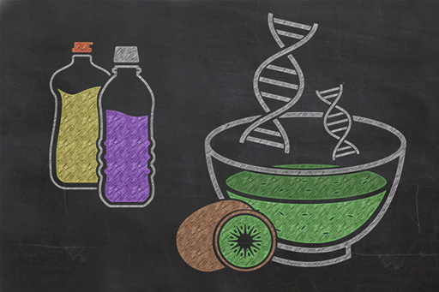
Figure 4

Well done for completing this four-week course on understanding experiments! Over the past four weeks you’ve looked at:
- the process of osmosis how density changes between liquid and solid states of household substances
- how aerobic and anaerobic respiration works in yeast
- how to extract DNA from fruit using equipment you find in your kitchen
- the importance of keeping a scientific journal.
We’ve created an area on OpenLearn allowing you to take your study of experiments in science further.
Now you've completed the course we would again appreciate a few minutes of your time to tell us a bit about your experience of studying it and what you plan to do next. We will use this information to provide better online experiences for all our learners and to share our findings with others. If you’d like to help, please fill in this optional survey.

Acknowledgements
This course was written by Hazel Rymer.
Except for third party materials and otherwise stated in the acknowledgements section, this content is made available under a Creative Commons Attribution-NonCommercial-ShareAlike 4.0 Licence.
Course image: alinakvaratskhelia /
www.123rf.com <http://www.123rf.com>.
Every effort has been made to contact copyright owners. If any have been inadvertently overlooked, the publishers will be pleased to make the necessary arrangements at the first opportunity.
Don't miss out:
1. Join over 200,000 students, currently studying with The Open University – http://www.open.ac.uk/choose/ou/open-content
2. Enjoyed this? Find out more about this topic or browse all our free course materials on OpenLearn – http://www.open.edu/openlearn/
3. Outside the UK? We have students in over a hundred countries studying online qualifications – http://www.openuniversity.edu/ – including an MBA at our triple accredited Business School.

Uncaptioned interactive content

Transcript
JANET SUMNER
Hello, and welcome to science experiments. I'm Janet Sumner, and I'll be your guide over the next four weeks. In this course, you're going to be doing some science experiments in your own kitchen and learning some exciting physics, biology, and chemistry on the way.
But this course is not just about doing experiments. It's about developing some of the key skills that it takes to be a successful scientist. These include careful observation, systematic note taking, looking at and discussing your data, and great experimental design. These skills may not sound important or complicated, but fundamentally, they are the root of all the scientific advances we have ever made.
Each week, there'll be an experiment for you to follow. They're all relatively straightforward, but they teach us some key science and reveal some surprises about things that you know, but maybe have never really thought about. Because there are lots of areas of discussion, we hope you'll join us in the course forums to talk about your experiments and to compare results.
One of the key features of a science experiment is the way we make and record our scientific observations. So beginning this week, you'll be starting your own science journal. And to help you with that, we have a PDF template which you can download.
So Week 1. For our first experiment, you're going to work out how much water an everyday food item contains. Now, food stuffs such as potatoes and apples contain water, but have you ever wondered how much? The answer may surprise you, and it has huge significance in how we think about the problems cause, for example, by regional droughts.
Our second experiment involves dropping some cucumber into salty water. By recording what happens over time, you'll learn about an important process called osmosis, which may lead to an alternative green energy source in the future. Good luck with your first experiments. And remember to enjoy the discussion and interpretation of your results in the forums. And I look forward to seeing you again next week.
Back to - Uncaptioned interactive content

Uncaptioned interactive content

Transcript
JANET SUMNER
Hazel, we're asking the learners on the science experiment course to keep a study journal. And I thought I'd ask you - as dean of science - why taking detailed written notes is good scientific practice.
HAZEL RYMER
Well the thing is it's just like the rest of life. It's really obvious that day what those measurements or observations or whatever, what they were for, what you've achieved, what happened. Next day, next week, next month, certainly next year, you have long since forgotten. And that's really why. Just so that you understand how the thought processes is and everything else worked out. What the things were that were affecting the experiment that day.
JANET SUMNER
So what kind of things do scientists write down then? What have you got in your notebooks?
HAZEL RYMER
Oh, in my notebooks.
JANET SUMNER
So this is a bit tatty.
HAZEL RYMER
Well you know, these are real field notebooks. They've got wet, they've been thrown in the mud and everything else, and they're held together with duct tape. Do you know, this is the most important piece of field equipment, is the roll of duct tape.
So the sorts of things - oops - that we would note in the book. Well, we've got phone numbers of local people that are helping us for example. Here I've got the name of a station, it's one of the places I make my measurements. And I've explained how to get there. By the can on the right of the road, two kilometres from the turning of the lake. That sort of thing.
JANET SUMNER
So with that kind of information in it, that means that you could pass this notebook on - say to one of your students - so they've got the local contacts and the locations to go to.
HAZEL RYMER
Exactly. So for field science, there's no point keeping your data hidden away in the notebook just for your own use. In some cases, other people want to go back to that precise location.
Of course these days you can use GPS, but there are other things that you need to note down. Say for example, you might be able to precisely locate a point using GPS, but you would need to know whether the measurement that you were making was up on the top of a boulder, or the bottom, or just around, or whatever it is. So you would have pictures, and you would have a detailed description. So that anybody could then come along and precisely make that same measurement.
JANET SUMNER
So apart from those kind of notes, I'm guessing most of your notebooks are full of numbers.
HAZEL RYMER
They are. They are very nerdy looking notebooks. So these are the sorts of measurements I would make.
I'd say what date it was. I'd say what the measurements were, and here are the numbers, and some other notes about them. And yes it's just numbers, numbers, numbers.
But every now and then, I've got comments such as, instruments fell over, or instrument knocked, or something like that. Because that's what happened, and that could affect the numbers that you make. And also it helps you to remember it.
Because if it's just a string of numbers, you come back next week, next year, it's just a string of numbers. But if you've said, this was where Bill fell over, you think 'Oh yeah, I remember that'. And you can remember what happened. You remember whether it was raining or whatever.
JANET SUMNER
Now it's interesting because we're both volcanologists. We both work on volcanoes. And this just shows how personal every scientist's notebooks are. Because yours are full of numbers, and mine are full of pictures.
HAZEL RYMER
Wow. I must say, yours is very pretty.
[LAUGHTER]
JANET SUMNER
Well I think it just depends on the type of research that you're doing. This is essentially a log through layers of rock. I'm quite fussy because I always have a line down one side of my notebooks. And that's where I record the sample that I've taken, next to the layer that I've taken it from. So I'm guessing that everybody's notebooks are going to be different according to the type of scientific data that you want to record.
HAZEL RYMER
Well that's absolutely right. And do you know the thing is that you can't say that's right and that's wrong or the other way around. It depends.
So long as it does the job, so long as this reminds you of- in this case-- where you collected the samples and what the strata looked like-- what types of things you were seeing-- that's doing its job. And of course, you could hand that over to anybody else. They could go to that locality, and they would be able to identify where to go and collect those same rocks. So the job is to remind you and to be able to help somebody else.
JANET SUMNER
And I guess nowadays with digital photographs, there's a tendency to people to think, well I'm not going to write it all down in this terribly painstaking way. I'm just going to take a photograph. But photos just don't work as well, do they?
HAZEL RYMER
Actually it sounds really old fashioned, but no, I don't think they do work as well. I don't think it's a case of either or, I think you can use both. But there's nothing like a field notebook actually.
Some people record things on their phone, and of course you can write onto your phone as well and do all that at the same time. And then you can email it or whatever to lots and lots of people. But there's something about writing it chronologically through the notebook like this, that does help it somehow to keep it into your mind in a better way.
JANET SUMNER
Yeah. And it's interesting because I've got one as well, that I did for my followup experiments. And I've written down the number of the experiments-- and as you say-- the date and time, and of various conditions and things. But I've got one here that says failed.
[LAUGHTER]
JANET SUMNER
But that's equally as important, isn't it?
HAZEL RYMER
Absolutely it is. A failed experiment is not a failure. So what you were expecting didn't happen, but that's just as important.
And then really, really importantly, you never cross out anything in a notebook, do you? You underline it, or you say not to use or something in your final analysis. But you've written it in the notebook, and it must stay in the notebook. That's a perfectly valid note, whether or not the data turn out to be valid.
JANET SUMNER
Now our books are pretty complicated and pretty detailed. What we're asking the learners to do is a very simple study journal. But that's of equal value, isn't it?
HAZEL RYMER
Absolutely. It's very important to note - as we've said - the time and the date, and so on, where you are, whatever. Environmental conditions. So if you were outside doing an experiment for example - and it was raining - you might get different results from if it was sunny.
All sorts of things can affect an experiment. And sometimes you don't even know what those are until you happen to have noted them all down. Then you can perhaps find variations.
And you can say, Oh actually look, the conditions here were different from this other time. And the two times that you've made those experiments might have been years apart depending on what you're doing. And you wouldn't remember that it was bright and sunny or raining or whatever, unless you'd written it down.
JANET SUMNER
You might even note down at the end the experiment, don't do this next time. Try changing so and so or something.
HAZEL RYMER
Yes. And if you've written it down, you're more likely to remember it. The other thing of course, is it might have been a failed experiment in terms of what you were trying to do at the time. But you've still got those measurements. You've still got those results.
And it might be that another time, what you were actually looking for was whatever happened this time. That you thought was a failure one time, might not actually turn out to be. Some of the fantastic results that have been observed through the history of science, have actually been apparent fail--
JANET SUMNER
People's mistakes?
HAZEL RYMER
--People's mistakes, yes. I accidentally mixed this with that, and 'Oh look what I got'.
JANET SUMNER
What we're asking the learners to do now - in keeping a study journal - could be the start of something big going forward into the future.
HAZEL RYMER
Beginning of their scientific careers
Back to - Uncaptioned interactive content

Uncaptioned interactive content

Transcript
JANET SUMNER
Now it's time to do your first practical science experiment. You don't need much equipment. You need a microwave or a conventional oven, a set of scales, a potato, and a piece of graph paper printed off from your study journal.
It's a very simple experiment. We're basically going to bake a potato to destruction. But it's all about understanding how to set up, observe, and record in a scientific manner. So the first thing is I'm going to weigh my potato and note down the start weight in grams. It's 103 grams.
And now I'm going to stick it in the microwave. Right, in it goes. And I'm going to set the timer for one minute. Now, you can do this in a conventional oven, but obviously it's going to take a lot longer, and you'll probably need to do the measurements every 10 or 15 minutes or so.
[DING]
Right, time's up, so I'm going to take it out and weigh it again, usual health and safety with hot objects. OK, so let's see. And the weight's gone down to 98 grams. So I'll record that. After one minute, 98 grams.
Now I'll pop it back in and give it another minute.
[DING]
That's another minute up, so I'll do another measurement. It now weighs, oh, 84 grams. I'm just going to give it one more minute and see if the weight continues to fall.
[DING]
Weight 74 grams. Now, you're probably going to have to do this seven or eight more times to get an original data set. But what we need to think about next is how you're going to present this data in a way that's meaningful.
One of the most visual ways to do this is with a graph, which is where this comes in. So we have two variables that we're measuring, the weight of the potato in grams, which is changing over the amount of time in minutes that it spends in the microwave or the oven. And I can use this graph paper to show those two variables.
This is the vertical axis, which I'm going to mark weight in grams, and then the horizontal axis, which is going to be my time in minutes. Now I have to decide what scale to put on these axes. So the start weight of my potato was 103 grams. So if I start from naught and mark off every centimetre as 10 grams, then I should have enough space to fit in my weight measurements.
So that's 10, 20, 30, 40, 50, 60, 80, 90, 100, and 110 grams. And then for the time, I probably don't want to microwave a potato of this size any longer than 10 minutes. So I'll make 10 minutes my maximum, and every centimetre on my horizontal axis I'll mark out as a minute.
One, two, three, four, five, six, seven, eight, nine, 10. Now I can start plotting my data and see if a trend emerges. So the start weight at zero minutes was 103 grams about there. Then after one minute, it's gone down to 98. So I move along the horizontal axis to one minute, and then I go up to 98 grams.
Then two minutes, I'm at 84, so up from two minutes to 84. And then finally at three minutes, we're down to 74, which is about there. And I can join up my data points, and you can see I've got a trend starting to emerge.
So what we'd like you to do is finish the experiment. I'm going to do another four or five measurements and plot them. Don't forget to give your graph a title, Potato Experiment, and note whether it was done in the microwave or the oven.
You've done the observation and the recording of the data. Now it's time to do the interpretation of the data by joining in the discussion.
Back to - Uncaptioned interactive content

Uncaptioned interactive content

Transcript
JANET SUMNER
This experiment is all about investigating the weird and wonderful properties of water and understanding why water is so vital to life. To investigate one of these life-giving properties, you're going to need one of these-- a cucumber. Now the average adult human body is 50 to 65% water. This cucumber is 95% water. But why is the water in living things so important? Well we're going to use this cucumber to reveal one of the crucial processes of life that's going on in our cells all of the time and in all other living things.
So the first thing to do is to peel the skin off the cucumber. And then you're going to cut two slices, and try and get them as equal in size as you can. Next you're going to need two glasses of water. This one's just filled with ordinary tap water, but I'm going to add two spoons of ordinary salt to make a saline solution.
And this one I'm going to fill with distilled water. Now if you can't get distilled water, you can always use boiled water from the kettle. It's not identical, but it's close enough. But obviously, make sure it's cooled down before you use it. Don't forget to label which glass is which. I've printed this out from the study journal, so I'm going to label this one salt water and this one distilled water.
Now I'm going to weigh the cucumber slices. That one's 26 grams, and that one is 22 grams. I'm going to drop them in the water. Make a note of the start time. That's 4:00 PM. And then I'm going to come back in an hour, weigh them again, and see if anything's happened.
Well that's an hour up, so I'm going to take out the slices, pat them very gently dry without squashing them, and weigh them again. Right. That's the one from the salt water, and that's actually gone down to 24 grams. This is the one in the distilled water, and that has gained weight and gone up to 23 grams. Now I think it's too early to infer anything from these first two sets of measurements, so I'm going to give the experiment another hour, come back, and make another measurement.
Right. That's the two hours up, and the cucumber in the salt water, its weight has decreased to 23 grams, which means in the two hours it's lost three grams. And the one in the distilled water has increased to 24 grams, which means in the two hours, it's gained two grams. So something's happening, but it's clearly happening very slowly, which makes me think that I'm probably going to have to change the parameters of this experiment. Now scientifically that's perfectly acceptable. I've got some early indications that something is happening, but I need to run the experiment for much longer. So I'm just going to make a note of that. And I'm going to leave this experiment running over night and come back in the morning and see if there's an appreciable difference.
Well it's 14 hours later, and I've just done the final measurements. The salt water cucumber has gone down to 21 grams, and it feels quite sort of squishy and flabby. But the distilled water cucumber has gone up to 30 grams. And that feels really firm and turgid, like it's full of water. So this one has lost five grams, and this one has gained eight grams. So clearly something is happening here that has to do with the water solutions that the cucumber slices have been sitting in.
To find out what's happened in this experiment and why it's important to life itself, you'll need to join in the online discussion.
Back to - Uncaptioned interactive content

Uncaptioned interactive content

Transcript
JANET
Welcome to Week 2. Your experiments so far have shown us two important things-- water can make up a large amount of the content of an everyday food, and water can pass through semipermeable barriers such as cell walls. That means that the water content of, in our case, a cucumber is not necessarily constant over time.
Now you were probably aware of those things, but the implications are massive. Personally, I find it amazing that very small scale physical processes such as osmosis have the potential to be an energy source in the future. On the way, you've also learned how to make and record observations in a systematic way, how to plot graphs, and how to interpret your data.
Now, both of the experiments revealed some important facts about water. And this week, you're going to do another simple experiment that will reveal something astonishing. You're going to freeze some common liquids to see how their properties differ when they change their physical state from liquid into a solid.
It's straightforward and I'm sure you can guess at least some of the results in advance. But as you will see, the implications of two of the results are amazing. In fact, it's not an exaggeration to say to the experiment reveals that the physical properties of one of the liquids you will freeze are fundamental to life on our planet, and perhaps even to life on the other planets in the universe. As you untangle and interpret what your observations and results mean, you'll learn about the three main states of matter-- solids, liquids, and gases. So without more ado, let's get started.
Back to - Uncaptioned interactive content

Uncaptioned interactive content

Transcript
JANET SUMNER
In this experiment, we're going to investigate the properties of liquids and observe how they behave under different circumstances. Now, we all know what happens when you drop an ice cube into a drink. It floats. But is this the same reaction that happens with all liquids?
That's what we're going to find out. For this experiment, you're going to need your freezer, an ice cube tray, and a selection of liquids. Now, there are three compulsory liquids that we're all going to test. That's plain ordinary tap water straight out of the tap, salt water, which again is just tap water but I've added a couple of tablespoons of salt to make a saline solution, and olive oil.
But we're also going to ask you to test a fourth liquid of your choice. Now, you can be as creative as you'd like. I did think about maybe milk or washing up liquid. But I've actually chosen runny honey because it seems to have a similar consistency to the olive oil, so I want to find out if it's going to behave in the same sort of manner.
Before you start the experiment, make sure you print off the ice cube tray diagram from your study journal. And then label very carefully which liquid is going into which section of the ice cube tray. So I've got water, salt water, olive oil, and honey. And I'm actually going to label my ice cube tray as well.
So now I'm going to fill up the individual compartments within the liquids, first the tap water. I overfilled that a bit. Just let it out. Then the salt water. Now the olive oil. And finally, going to do my last one with the honey. And this will then go into the freezer.
I'm also going to fill four glasses with the same liquids and make sure that they're clearly labelled as well. I've got a sheet of plain paper. Do them in the same order, tap water, salt water, olive oil, and honey.
And I'm going to fill the glasses up now. So some tap water. Salt water. Add the olive oil. And the honey.
Well, this has been in the freezer overnight, and they all seem to be frozen, even the salt water and the honey, which I'm surprised about. But we can comment on that in the discussion afterwards. So now I'm going to remove the frozen cubes and drop them in the same liquid, if I can get them out, and see what happens.
So that's the tap water into tap water, and that floats. Well, that was expected. Now let's do salt water into salt water. Oh, and that floats as well. Now the olive oil. It's a bit more difficult to get out. There it is.
And I'm going to drop the frozen olive oil into the liquid olive oil. Oh, and that's sinking right to the bottom of the glass. So that's a different reaction. Right, now let's try the honey last of all. Now, if I can get the honey cube out, [GROAN]. It's really sticky, but it's coming out.
All right, see if I can pull it out. It is frozen, mostly. OK, let's see what happens when the honey goes into the honey. Well, that seems to be sinking as well, but much more slowly than the olive oil. But I think that's because the honey is much stickier and more viscous. But it is sinking very slowly.
Well, that's my observations recorded. Now it's time to join the online discussion. Share your results, and we'll interpret and understand what we've just seen.
Back to - Uncaptioned interactive content

Uncaptioned interactive content

Transcript
JANET SUMNER
Hello and welcome to Week 3. Over the last two weeks you've investigated the physical properties of some materials, both solid and liquids. And you've also investigated how water can move through a cell wall, which showed us one of the molecular properties.
This week your simple experiment is going to look at something more complicated, something biological. You're going to do an experiment using a living organism and investigate the conditions under which that organism grows the best. We're going to investigate the growth of yeast, the substance responsible for making bread rise and turning water into beer.
Yeast is an organism called a fungi and it sits in the same group of living things as mushrooms, toad stools, and moulds, and obviously it's hugely important to humans. By looking at the growth of yeast you will learn about how to control an experiment, and about the biological process called respiration. This is when living things consume food to grow.
We look forward to you joining the discussion about your experimental results in the forums.
Back to - Uncaptioned interactive content

Uncaptioned interactive content

Transcript
[MUSIC PLAYING]
JANET SUMNER
In this experiment we're going to look at life in action and investigate some of the ingredients that make life work. Now most organisms need air to breathe and some kind of energy source to live. And by energy, we usually mean food.
But in order to thrive and multiply, conditions need to be just right. And that's what we're going to investigate. We're going to use a very simple form of life.
This is baker's yeast, and it's alive. It's a tiny single celled kind of a fungus. And given food and air, it will grow and multiply.
But we're going to see which kind of conditions it likes best. And to do that, I'm going to make up a series of sugar solutions. Before you start, print off the glass diagram from your study journal so that you can record which sugar solution is which.
I've got four glasses each with a spoonful of sugar in, and I'm going to add the same amount of water to each. So this first one, I'm going to add cold water.
In the next one, I'm going to put in the same amount of just boiled water from the kettle, but be careful you don't crack the glass. In the final two, I'm going to put the same amount of water that's at body temperature or blood temperature. So I've just tested that with my finger.
Now give them a quick stir. Cold water. Boiling water. Blood warm, and blood warm.
So now I'm going to add a sachet of yeast to each glass. Then I'm going to mark off the level of the water on the side of the glass. Now this last glass, I'm going to cover with cling film to restrict the amount of air that the yeast has to work with.
Set your experiment up in the same way, so we can compare results. I'm going to give this five minutes and see if anything's happened.
[MUSIC PLAYING]
Well that's five minutes up and the yeast is clearly sprung into action because it started to produce a foam. This foam is the result of the yeast using the oxygen in the air to digest the sugar. It's producing a gas as a waste or byproduct.
In this particular case, it's carbon dioxide. And that's the process that makes bread rise in the same way as its doming and making the cling film rise here. Now to monitor the experiment - and keep track of the process - I'm going to measure the thickness of the foam and record how it changes over time.
So this one is 2 centimetres thick after five minutes. And this one is 2 centimetres thick. I'll give that another five minutes, and then I'll come back and make another measurement.
[MUSIC PLAYING]
Well that's 10 minutes up, and this one - which was the boiling water - doesn't seem to be doing very much at all. This one - which was the cold water - appears to be just starting to produce a very thin layer of foam. And these two are still doing really well, and producing more foam.
I'm just going to measure the thickness again. This foam has gone up to 6 centimetres. And this one is 5 centimetres. Now to find out what these observations mean and to interpret the results, you'll need to join in with the online discussion.
Back to - Uncaptioned interactive content

Uncaptioned interactive content

Transcript
JANET
Hello, and welcome to the final week of the science experiments course. We hope you've enjoyed it so far. The experiments you did last week taught us about the important biological process of respiration. This process is happening in cells only about 100th of a millimetre long, and that's something far too small for us to observe directly without a powerful microscope. But you could get an idea of the strength of the process by measuring the bubbles, which indicate the carbon dioxide being given off by the reaction.
Now, we don't always have to look at very small things using indirect methods. We can be more direct. So this week, you're going to do an experiment which will enable you to look directly at the contents of the nucleus of a cell. You're going to extract and observe DNA-- the material which carries the genetic instructions for the growth and development of life.
All living things contain DNA. And you've probably heard that each person has a DNA code which is unique to them, except for identical twins, who have the same DNA. This uniqueness has led to incredible advances across many areas of science, from our understanding of the evolution of life on earth through to the development of new medical interventions. DNA can even be used to solve crimes.
Your experiment will extract and directly observe the DNA contained inside the cells of a kiwi fruit. Now, you could look at the DNA for many living things, even yourself. But kiwi fruits are simple and straightforward to work with. And on the way, you will learn about how the instructions for life are encoded and passed on. We look forward to discussing your experiment, the science, and even the ethical implications in the forums.
Back to - Uncaptioned interactive content

Uncaptioned interactive content

Transcript
JANET SUMNER
You've probably all heard of DNA. It's usually referred to as the blueprint of life. Now DNA is in all the cells of all living things, including ourselves. But it's kind of difficult to comprehend because you can't see it.
Well it turns out that with a very simple kitchen experiment, you actually can see DNA. And that's what we're going to do now. I'm going to extract the DNA from this kiwi fruit.
Now it doesn't have to be a kiwi. You can use an onion, or strawberries. Raid the fruit bowl and pick what you fancy. You can even use defrosted frozen peas if you haven't got anything fresh.
You're also going to need some ice cold alcohol. I'm using methylated spirits, and it needs to be in the freezer for half an hour before you start the experiment. You could try something like vodka or very strong white rum as well.
And you're going to need a fine sieve, or you could use coffee filter paper. I'm just using a tea strainer. The first thing I'm going to do is peel the skin off the kiwi. And that's because it's mostly dead, and it hasn't got very much DNA in it anyway.
So now I'm going to chop it up into small pieces. And then I'm going to start mashing it. This is to start breaking up the cells and to give us a bigger surface area to extract the DNA from.
The next thing you need to do, is mix together two grams of salt with 100 millilitres of water. Add this to five gram of washing up liquid. So mix the three things together. Try and do it quite gently because you don't want loads of foam and bubbles. But you do need to stir until the salt's dissolved.
This is called an extraction buffer. It doesn't really matter about the terminology. It's basically going to help to break up the cells even further, and stop the DNA from degrading. Next you're going to add this to your kiwi mix.
Keep mashing because the more you mash, the more DNA you will get. The final step is just to warm up the kiwi mix. To do that, I'm just using a bowl of warm water.
I've used boiling water from the kettle, added some cold, so it's lukewarm. I'm going to leave that sitting in there for 15 minutes. And again, this is just to help release more of the DNA.
Well that's the 15 minutes up. The next thing is to strain the kiwi mix. Oh, I'm spilling a bit of it. Now this lovely green liquid has got our kiwi DNA in it. But we still can't see it, which is where the alcohol comes in.
Well that's well and truly ice cold. Now pour the alcohol very gently down the side of the glass. It should float out over the surface of the kiwi mix because it's actually less dense.
You need to look very carefully at the join between the two liquids, and you'll see tiny white strands and filaments forming. That's the kiwi DNA. And I can just very carefully use a paper clip to start hooking come of it out. And that is DNA. The blueprint of life. Now to find out more about DNA-- what it does and why it's important-- you need to join in with the online discussion.
Back to - Uncaptioned interactive content

