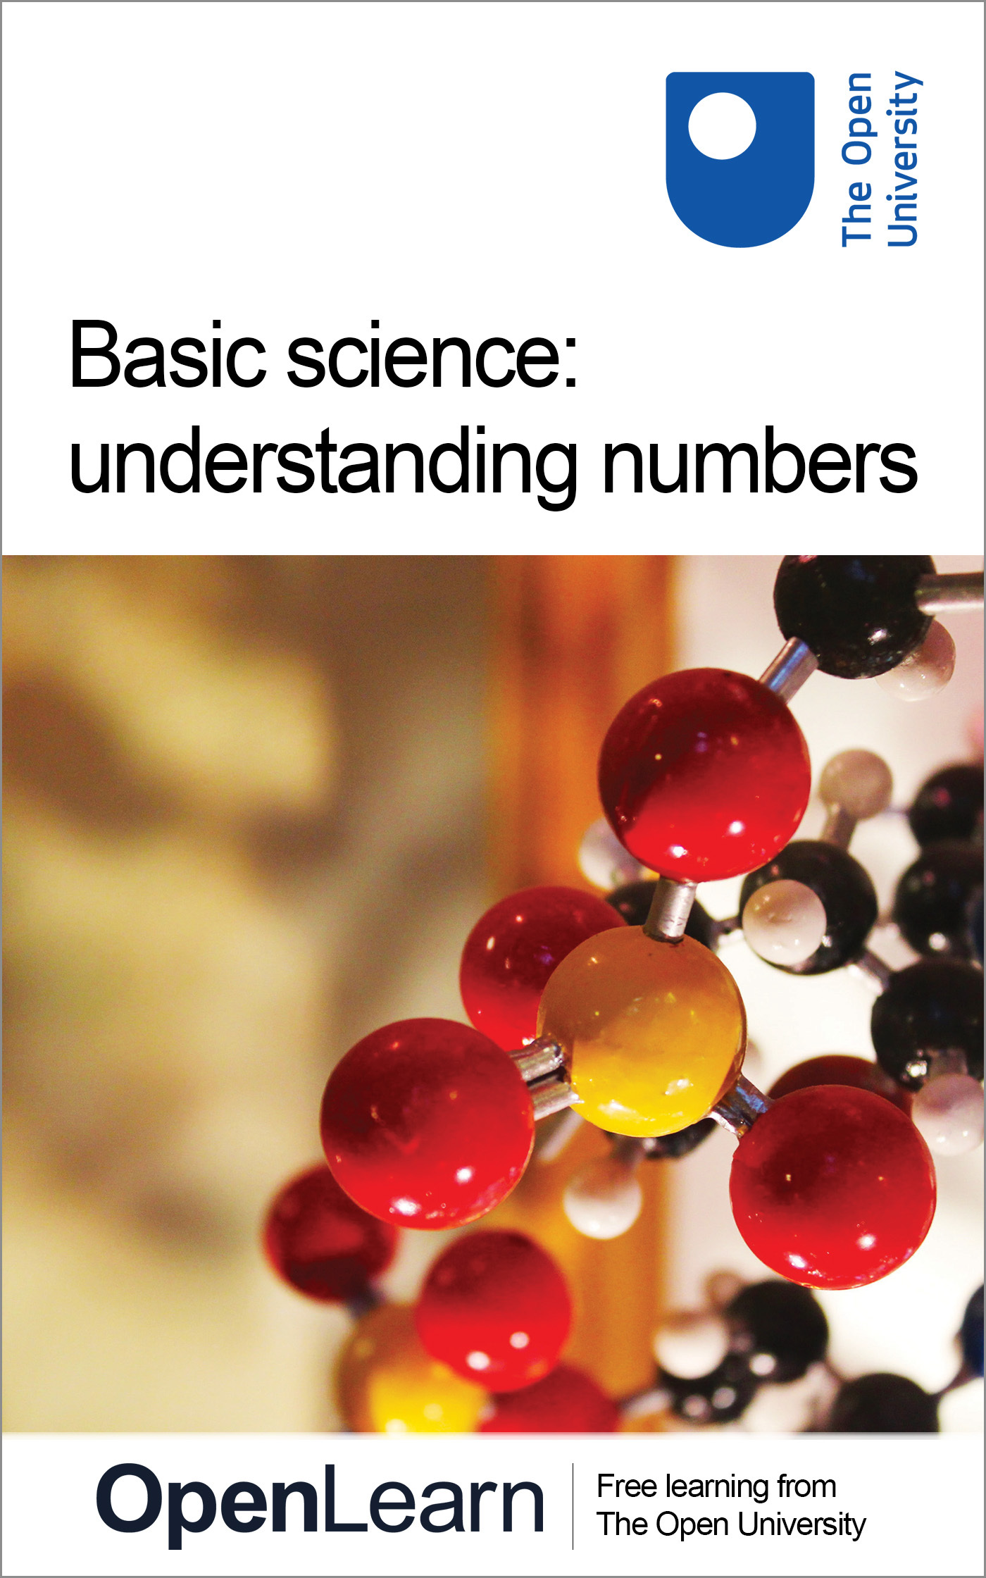

BSCI_2 Basic science: understanding numbers

Basic science: understanding numbers
This content was created and adapted within The Open University and originally published as an open educational resource on the OpenLearn website – http://www.open.edu/openlearn/. This content may include video, images and interactive content that may not be optimised for your device. To view the original version of this content please go to OpenLearn – http://www.open.edu/openlearn/.
If reading this text has inspired you to learn more, you may be interested in joining the millions of people who discover our free learning resources and qualifications by visiting The Open University – http://www.open.ac.uk/choose/ou/open-content.
You can experience this free course as it was originally designed on OpenLearn, the home of free learning from The Open University – http://www.open.edu/openlearn/science-maths-technology/basic-science-understanding-numbers/content-section-overview
Copyright © 2014 The Open University
Except for third party materials and/or otherwise stated (see terms and conditions – http://www.open.ac.uk/conditions) the content in OpenLearn and OpenLearn Works is released for use under the terms of the Creative Commons Attribution-NonCommercial-ShareAlike 4.0 Licence – http://creativecommons.org/licenses/by-nc-sa/4.0/deed.en_GB.
In short this allows you to use the content throughout the world without payment for non-commercial purposes in accordance with the Creative Commons non commercial sharealike licence. Please read this licence in full along with OpenLearn terms and conditions before making use of the content.
When using the content you must attribute us (The Open University) (the OU) and any identified author in accordance with the terms of the Creative Commons Licence.
The Acknowledgements section is used to list, amongst other things, third party (Proprietary), licensed content which is not subject to Creative Commons licensing. Proprietary content must be used (retained) intact and in context to the content at all times. The Acknowledgements section is also used to bring to your attention any other Special Restrictions which may apply to the content. For example there may be times when the Creative Commons Non-Commercial Sharealike licence does not apply to any of the content even if owned by us (the OU). In these stances, unless stated otherwise, the content may be used for personal and non-commercial use. We have also identified as Proprietary other material included in the content which is not subject to Creative Commons Licence. These are: OU logos, trading names and may extend to certain photographic and video images and sound recordings and any other material as may be brought to your attention.
Unauthorised use of any of the content may constitute a breach of the terms and conditions and/or intellectual property laws.
We reserve the right to alter, amend or bring to an end any terms and conditions provided here without notice.
All rights falling outside the terms of the Creative Commons licence are retained or controlled by The Open University.
Head of Intellectual Property, The Open University
978 1 4730 1264 6

Contents
- Basic science: understanding numbers
  - Introduction
  - 1.1 Water, water everywhere
  - 1.2 Reflecting on numbers
  - 1.3 We’re all scientists now
  - 1.4 How do numbers help test scientific hypotheses?
  - 1.5 Is homeopathy science?
  - 1.6 SI units
  - 1.7 Scientific notation
  - 1.8 Big things, big numbers
  - 1.9 Small things, small numbers
  - 1.10 Week 1 quiz
  - 1.11 Week 1 summary
- Week 2: Using numbers for science
  - Introduction
  - 2.1 Calculators through the ages
  - 2.2 Calculating areas
    - 2.2.1 Area of the Greenland ice sheet
  - 2.3 Calculating volumes
    - 2.3.1 Volume of the Greenland ice sheet
  - 2.4 Density of water
    - 2.4.1 Density of the Greenland ice sheet
  - 2.5 Week 2 quiz
  - 2.6 Week 2 summary
- Week 3: Learning to ‘talk the talk’
  - Introduction
  - 3.1 Absolute numbers don’t tell you everything
  - 3.2 Rounding
    - 3.2.1 Rounding to decimal places
  - 3.3 Can you eat sig figs?
  - 3.4 Fractions and Percentages
  - 3.5 Negative numbers
  - 3.6 Week 3 quiz
  - 3.7 Week 3 summary
- Week 4: Presenting numbers
  - Introduction
  - 4.1 How do people ‘get’ science numbers?
    - 4.1.1 Using graphs
  - 4.2 Averages
    - 4.2.1 Types of average
    - 4.2.2 Using averages
  - 4.3 Types of graph and drawing graphs
    - 4.3.1 Interpreting graphs
  - 4.4 Correlation, causation and coincidence
  - 4.5 Create and share your own graph
  - 4.6 End-of-course quiz
  - 4.7 Congratulations – you’re a scientist!
- References
- Acknowledgements

Basic science: understanding numbers

Introduction

Video content is not available in this format.
View transcript - Uncaptioned interactive content

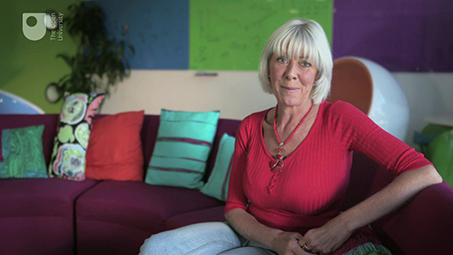

Janet Sumner is your guide through this course. She is a Media Fellow at The Open University with a specialist interest in volcanoes. Janet will appear at the start of each week to tip you off about the highlights and challenges, to remind you what you’ve learned and to help you make the most of these four weeks of scientific discovery.
Over the next four weeks you will look at how scientists:
- communicate with each other
- calculate area, volume and density and what this means for the Greenland ice sheet
- present numbers using significant figures, decimal places, fractions and percentages
- use different types of averages, draw and interpret graphs and find correlations in data.
This course is going to assume that you are new to studying science, so don’t worry if you haven’t studied science before.
The course starts off simply, but by Week 4 you will be calculating the density of the Greenland ice sheet! This week, you’ll be focusing on how numbers are used in science.
To test your knowledge you can try the end-of-week quizzes and there’s a final end-of-course quiz.
There are plenty of opportunities to communicate with other learners. There are forum threads for activities in each week. Please join in!
Before you start, The Open University would really appreciate a few minutes of your time to tell us about yourself and your expectations of the course. Your input will help to further improve the online learning experience. If you’d like to help, and if you haven't done so already, please fill in this optional survey.

Advice for younger learners and homeschoolers
We would like to take this opportunity to remind you of the Conditions of use of Open University websites. To enrol on an OpenLearn course and participate in the forums, you must be aged 16 or over. Adults can use their own OpenLearn account to supervise under 16s on the course, posting comments on their behalf, and assisting with the experiments.
Remember, do not share any personal details such as your home address, email or phone number in any comments you post. You can read more in the OpenLearn FAQs.

1.1 Water, water everywhere

Video content is not available in this format.
View transcript - Uncaptioned interactive content

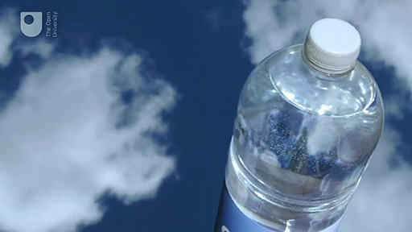

In this video, the issues surrounding bottled water are discussed along with many, many, MANY numbers.
The video also makes some assertions about contamination of bottled water by PET in plastic bottles, which were raised as a possible danger to health a few years ago. However, no convincing scientific evidence has been produced to prove this effect. We’ve left the section on plastics in the video because it’s important to understand that science advances by testing hypotheses. This is a process which includes scientific study and debate, and can take several years, during which time scare stories continue to circulate. The Cancer Research UK website has a good explanation of the situation concerning the plastic bottles.
As you watch the video, focus on how important the numbers are to the story that the narrators are conveying. How do the narrators try to help the viewer to comprehend the numbers?

1.2 Reflecting on numbers

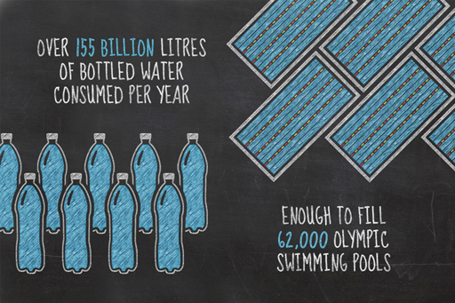
Figure 1 Without numbers, how would we know how many swimming pools we could fill?

What did you learn from the video in the previous section? What do you remember about it? Did you retain any of the numbers?
Numbers were central to the video, and some numbers were so large that they weren’t easy to visualise. You probably remember something about swimming pools. That was when the narrator said that the worldwide consumption of bottled water was over 155 billion litres per year, and that this was enough to fill 62,000 swimming pools – not that it is much easier to visualise that many swimming pools, nor how much water it would take to fill them!
Why does the video use numbers? Would it be as impressive if the narrator had said we consume a huge amount of bottled water? Or a really huge amount? Or a massively, enormously, colossally titanic amount of bottled water?
Without numbers, we can’t quantify the world. For example, how would you determine if the narrator in a ‘numbers-free’ bottled water video was talking about enough bottled water to fill a single swimming pool, let alone 62,000 swimming pools? Quantifying things is a way to test your experience against others, and to comprehend the world. You don’t have to be a maths wizard who sees numbers when they close their eyes at night to be a good scientist. Working with numbers is about practice, and familiarity with a few basic concepts. It will get easier if you spend time with some simple number-based tasks.
So if you think you’re not good with numbers, quickly answer these questions:
- Did you understand the video ‘Water, water everywhere’?
- Can you follow a recipe to bake a loaf of bread?
- Can you read a thermometer (or more likely, the app on your smartphone)?
- Can you figure out how many bars of chocolate you can buy with the loose change down the back of the sofa?
Did you answer ‘yes’? You’re a natural scientist.
So, let’s get started by kicking off with a forum discussion.

Activity 1.1 How do you use numbers?
Allow about 15 minutes

Try counting how many days there are until the Saturday after next. What do you see? Close your eyes and try it.
Do you see the numbers behind your eyes? Do you have any tricks for remembering things, such as your times tables? Post your method to the forum thread for this activity and see if others use the same method. Remember, even if some of the posts may seem odd to you, there is no right answer, it’s just what works for you.

1.3 We’re all scientists now

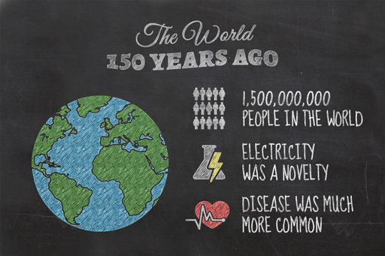
Figure 2: What was the world like 150 years ago?

Consider how the world was 150 years ago. You could probably have lived quite well without understanding numbers beyond 100 (although there were 12 pence to the shilling and 20 shillings to the pound, so it wasn’t all easy maths in those days), but you might have been better informed if you had known a few numbers.
That was a world of about one and a half billion people (1,500,000,000, a number that you’ll be able write in scientific notation later this week), compared to over seven billion people (7,000,000,000) today. Infant mortality was high, with somewhere between 10 and 15 out of every 100 babies dying before their first birthday. Disease was much more common, and even just over 150 years ago in 1854, over 600 people died in an outbreak of cholera in Soho, London, at a time when science didn’t understand what caused disease. Perhaps more impressive and deadly was the influenza outbreak of 1918 that killed at least 50 million people (50,000,000), which was 3% of the world’s population at the time.
A lot has changed since then. Most of our modern comforts and some amazing scientific discoveries have come about through the application of scientific thinking in medicine, engineering, food science and electronics. While this is marvellous for us, there is a risk involved, as described by the astronomer, Carl Sagan:

We live in a society exquisitely dependent on science and technology, in which hardly anyone knows anything about science and technology.
(Sagan, 1990)

Numbers are everywhere, not just to count from 1 to 10, or even to 100, but to describe the electric charge carried by electrons, the basis of electricity, or the amount of water in the world’s oceans. Numbers appear in the media, in our jobs, and even just in our daily lives, whether in relation to an environmental crisis, the outcomes of a medical trial, or the special offer on cheese at your local supermarket.
Numbers matter, and scientists expend a lot of effort quantifying the world in order to understand it. As an example, numbers tell us a lot about life, or rather the difference between different forms of life. How many genes are there in human DNA compared with the number of genes in fruit fly DNA, or yeast DNA? The number of genes doesn’t describe everything, it’s their interactions which produce the final result, but it is a start. Are you wondering about that? How to test it? What numbers might mean? Now, you’re a scientist.

1.4 How do numbers help test scientific hypotheses?

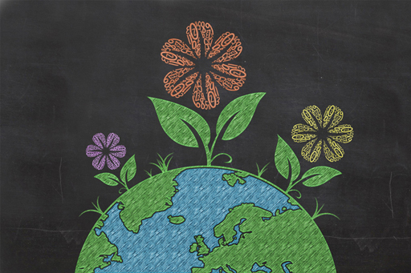
Figure 3

You probably think about numbers most often when you need to buy something, or estimate the time to get to a destination. Numbers are also very commonly used to engage our support for some cause or another, whether that’s to make a political point such as the money spent by a previous administration on the National Health Service in the UK; to describe a new product that is faster, shorter or longer than previous products; or describe how your favourite sports team just bought a new player for many, many times your ticket price.
One of the most important ways of testing what you are being told is to work through the numbers yourself. A basic understanding of numbers will improve your understanding and wonder at the natural world, but also will help you protect yourself from being deceived by believing everything you see on the internet or on television.

Activity 1.2 Numbers and scientific developments
Allow about 10 minutes

Numbers are key to science and scientific developments. For example, the development of techniques to determine the ages of rocks and minerals changed ideas about the age of the Earth. Try to think of other examples where science has advanced when new measurements have tested scientific hypotheses, and note down your answers.

View discussion - Activity 1.2 Numbers and scientific developments

1.5 Is homeopathy science?

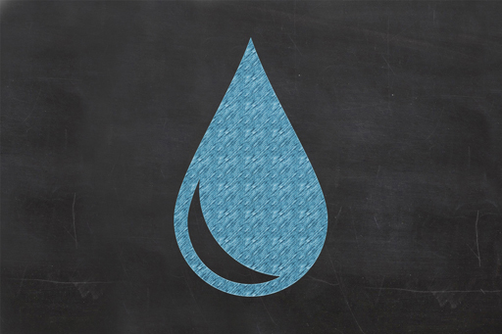
Figure 4

Consider the numbers in homeopathy, a medical system that was devised by a German physician in 1796. Homeopathy was based on two ideas: firstly, that a substance that causes certain symptoms can also be used to cure those same symptoms, in other words ‘like cures like’, and secondly, that diluting a substance to minuscule levels increases its effectiveness. In the late eighteenth century, mainstream medical practice was much less effective than it is today; indeed, it was highly dangerous, with treatments often making patients worse. As such, it is easy to see why a non-invasive system like homeopathy gained popularity.
Let’s explore the methods by which homeopathic preparations are made, by examining a homeopathic preparation marketed for the treatment of flu-like symptoms. It has the rather long name of oscillococcinum and the basic preparation principles hold true for all homeopathic preparations.
Oscillococcinum was introduced after the influenza epidemic of 1918. A French physician thought he saw a type of oscillating bacteria in the blood of flu patients and, thinking it might be causing the flu, tried to find it in other animals. Eventually he thought he had found it in some diseased duck liver. Taking a sample from the liver, he diluted it in either pure water or alcohol to 1 part in 100. Then he took 1 part of that diluted mix and again diluted it to 1 part in 100. He repeated this process a total of two hundred times and marketed the end product as a treatment for influenza.
By the final stage, the duck liver is extremely diluted, but by how much? If we take the first dilution then we have a ratio of 1 part in 100. If we look at the second stage in the dilution process, when this dilute mixture has itself been diluted to 1 part in 100, we have a new ratio of duck liver to water of 1 part in 10,000, or one hundred times one hundred. A third step would make a dilution of 1 part in a 1,000,000, or one hundred times one hundred times one hundred.
By the time it has been diluted 200 times in this way it has a ratio of (deep breath!) one part in a hundred times a hundred times a hundred times a hundred times a hundred times a hundred times a hundred times a hundred times a hundred times a hundred times a hundred times a hundred times a hundred times a hundred times a hundred times a hundred times a hundred times a hundred times a hundred times a hundred times a hundred times a hundred times a hundred times a hundred times a hundred times a hundred times a hundred times a hundred times a hundred times a hundred times a hundred times a hundred times a hundred times a hundred times a hundred times a hundred times a hundred times a hundred times a hundred times a hundred times a hundred times a hundred times a hundred times a hundred times a hundred times a hundred times a hundred times a hundred times a hundred times a hundred times a hundred times a hundred times a hundred times a hundred times a hundred times a hundred times a hundred times a hundred times a hundred times a hundred times a hundred times a hundred times a hundred times a hundred times a hundred times a hundred times a hundred times a hundred times a hundred times a hundred times a hundred times a hundred times a hundred times a hundred times a hundred times a hundred times a hundred times a hundred times a hundred times a hundred times a hundred times a hundred times a hundred times a hundred times a hundred times a hundred times a hundred times a hundred times a hundred times a hundred times a hundred times a hundred times a hundred times a hundred times a hundred times a hundred times a hundred times a hundred times a hundred times a hundred times a hundred times a hundred times a hundred times a hundred times a hundred times a hundred times a hundred times a hundred times a hundred times a hundred times a hundred times a hundred times a hundred times a hundred times a hundred times a hundred times a hundred times a hundred times a hundred times a hundred times a hundred times a hundred times a hundred times a hundred times a hundred times a hundred times a hundred times a hundred times a hundred times a hundred times a hundred times a hundred times a hundred times a hundred times a hundred times a hundred times a hundred times a hundred times a hundred times a hundred times a hundred times a hundred times a hundred times a hundred times a hundred times a hundred times a hundred times a hundred times a hundred times a hundred times a hundred times a hundred times a hundred times a hundred times a hundred times a hundred times a hundred times a hundred times a hundred times a hundred times a hundred times a hundred times a hundred times a hundred times a hundred times a hundred times a hundred times a hundred times a hundred times a hundred times a hundred times a hundred times a hundred times a hundred times a hundred times a hundred times a hundred times a hundred times a hundred times a hundred times a hundred times a hundred times a hundred times a hundred times a hundred times a hundred times a hundred times a hundred times a hundred times a hundred times a hundred times a hundred times a hundred times a hundred times a hundred times a hundred times a hundred times a hundred times a hundred times a hundred!
Or written another way, this is 1 in 10,000,000,000,000,000,000,000, 000,000,000,000,000,000,000,000, 000,000,000,000,000,000,000,000, 000,000,000,000,000,000,000,000, 000,000,000,000,000,000,000,000, 000,000,000,000,000,000,000,000, 000,000,000,000,000,000,000,000, 000,000,000,000,000,000,000,000, 000,000,000,000,000,000,000,000, 000,000,000,000,000,000,000,000, 000,000,000,000,000,000,000,000, 000,000,000,000,000,000,000,000, 000,000,000,000,000,000,000,000, 000,000,000,000,000,000,000,000, 000,000,000,000,000,000,000,000, 000,000,000,000,000,000,000,000, 000,000,000,000,000,000.
That is a 1 followed by 400 zeroes, which is a very large number and it’s a bit absurd to have to write it down like this, but don’t worry, you will be learning about scientific notation very soon. For now, let’s consider what a dilution like this is equivalent to.
Is it, for example, like putting one drop into a swimming pool? Well, no. At just six dilution steps, or one drop in a hundred times a hundred times a hundred times a hundred times a hundred times a hundred (or 1 in 1,000,000,000,000), you have already reached a dilution of one drop in eight Olympic-sized swimming pools. After 13 steps (or 1 in 100,000,000,000,000,000,000,000,000) of the process, the dilution is the equivalent of one drop in all the Earth’s oceans. After 16 steps, it is roughly the same as one drop in a sphere of water the size of the Earth. After 26 steps, the dilution is roughly the same as a sphere of water with the same diameter as the Milky Way galaxy.
So what of the oscillococcinum remedy? At 200 dilution steps (or a 1 followed by 400 zeroes) it means that it is diluted far, far beyond the more typical homeopathic preparations. Estimates of the number of atoms in the observable universe are about 100,000,000,000,000,000,000,000, 000,000,000,000,000,000,000,000, 000,000,000,000,000,000,000,000, 000,000,000, or a 1 followed by 80 zeroes, making the odds of getting a single particle from the diseased duck liver roughly the same as the odds of finding one diseased duck liver particle in 10³²⁰ universes containing nothing but water.
At the time that homeopathy was first developed it relied on ideas that had not been scientifically tested. To believe it could work now would require an almost complete discarding of major fields of chemistry, biology and physics. And finally, what of the vibrating oscillococcus bacterium? We now know that influenza is a viral disease, not a bacterial one, and the oscillococcus bacterium was merely a figment of the French physician’s imagination; it doesn’t actually exist. Unfortunately, preventing and curing the rapidly mutating influenza virus is still challenging modern science.

1.6 SI units

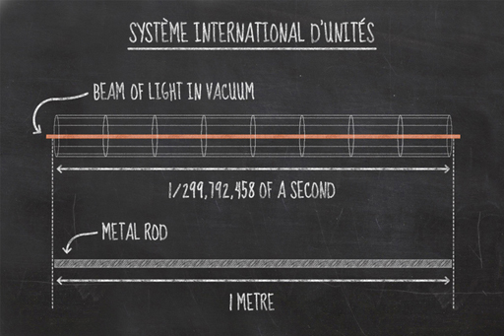
Figure 5 How does a metre relate to the speed of light?

SI units (from the French, Système International d’Unités) are the internationally agreed units of measurement used in most countries, and in the different branches of science.
The system arose during the French Revolution of the 1790s with the kilogram and the metre, but was not completed until the 1960s. Standard units of measurement were agreed to describe things like weights and distances, based on multiples of ten. Before this, people measured things in many different ways and this caused confusion and mistakes. For example, the ways of measuring length were most commonly based on things which come to hand; there were hands, spans, feet, inches, yards, chains, furlongs, miles, leagues, fathoms, cables, links and rods. While these measurements are easy to use at one level, combining them can be haphazard: for example, most people know there are 12 inches in a foot, but how many know how many feet there are in a chain?

Length
For length, the SI unit was chosen to be the metre. For many years a metal rod was used as the base for all measurements of the metre, but more recently such measurements have been based on natural phenomena. The metre is defined relative to the speed of light. A beam of light travels 299,792,458 metres in one second, so a metre is the distance that light travels in 1/299,792,458 of a second. But why change to this definition? Why would a metal rod not be good enough? The main issue is that all metals expand and contract depending on temperature so if we use a real metal rod as the definition of a metre, then a metre at room temperature would be different to a metre on an icy morning.
The SI system has seven base units from which all other units can be derived. To make units bigger or smaller, rather than coming up with a different name, as with inches, feet and yards, a prefix is added to the base unit. The prefix ‘centi’ means one hundredth, so a centimetre is one hundredth of a metre. ‘Milli’ means one thousandth, so a millimetre is one thousandth of a metre. A thousand metres are known as a kilometre, as ‘kilo’ comes from a Greek word meaning a thousand. So we have millimetres, centimetres, metres and kilometres, and this same approach can be applied to other units, for example, milligrams, grams, kilograms etc.

Time
The base unit of time is the second. It is defined by the vibrations of an atom of caesium. In fact, a second is defined as 9,192,631,770 vibrations of a caesium-133 atom. The vibrational rates of atoms are extremely regular. This has led to atomic clocks which keep time to an accuracy of 1 second in 300 million years. You might think that that is needlessly accurate, but this accuracy has everyday applications in telecommunications: GPS clocks need to be this accurate in order to measure a position with precision, while many applications of the internet require high-accuracy time standards.

Mass
For mass, the system is slightly odd, as it’s the only one to already include a Greek prefix in the name of the base unit, the kilogram. It is also the only one still defined by a physical object; the International Prototype Kilogram, a metal cylinder stored in a vault in Paris, and all means of measuring an object’s mass can be traced back to this.

Temperature
Temperature uses a unit called the kelvin, named after the British scientist, Lord Kelvin. In everyday life we generally use Celsius (or as it is sometimes known, centigrade). The Celsius scale is defined with 0 °C (degrees Celsius) and 100 °C as the temperatures where water changes its state between ice, water and steam. The kelvin scale has units of the same size, but uses the coldest possible temperature as its lower limit. Heat is the measure of the motion of atoms in a substance. At zero on the kelvin scale, all motion in atoms ceases, it’s not possible to be any colder. This is referred to as absolute zero. This temperature corresponds to about -273 °C (to the nearest degree). So 0 °C is equivalent to 273 K. The coldest places in the universe reach as low as 2.7 K, nowhere is absolute zero.
Remember that units are important descriptors. Five kilograms isn’t the same as 5 metres, or 5 kelvin, so always add units if you’re describing natural phenomena.

1.7 Scientific notation

Video content is not available in this format.
View transcript - Uncaptioned interactive content

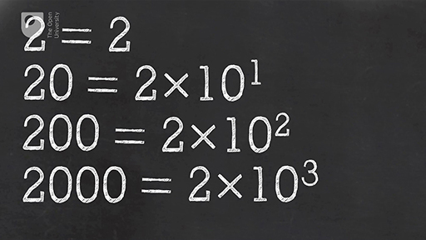

Activity 1.3 Trying out scientific notation
Allow about 15 minutes

This video introduces scientific notation – the way scientists write very big and very small numbers. Try to think of large or small science-related things and practise writing them in scientific notation by posting them in the forum thread for this activity.
There’s an additional challenge in this activity … how do you write the superscripts? When you compose your post, you should see a button which looks like this: X². To make a number superscript, highlight it using your mouse and then press this button.
Try it for yourself by posting a large number using scientific notation.

1.8 Big things, big numbers

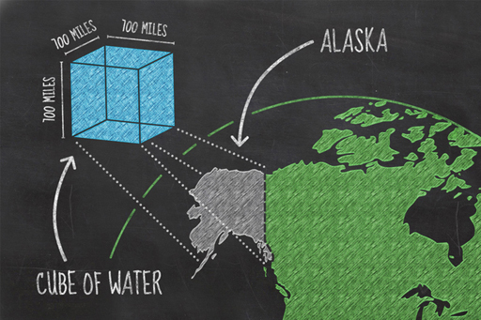
Figure 6 If you gathered all the water from the world and shaped it into a cube, how big would it be?

Scientific notation helps express large numbers but sometimes it’s difficult to imagine such large things. The best way to grasp the size of something you can’t see is to compare it with something you already know – can you remember how many swimming pools full of bottled water we drink per year?

Big things
Most of the Earth’s water is found in the oceans, about 97% of it; 3% of the remaining water is frozen in glaciers and icecaps, some is in the ground, and in lakes, swamps and rivers. A satellite image of the Earth shows that some two-thirds of the surface is covered in water. But that area (361,132,000 km² or 3.61 × 10⁸ km², incidentally) can mislead you as to how much water there really is. If you could gather all of the water on Earth, from the oceans, the icecaps, the lakes and rivers, and create one huge cube, how big do you think that cube would be?
It turns out that it would be a cube about 1135 km (or 700 miles) along each side. To give that some context, it could sit on the footprint of Alaska, which covers around 0.3% of the surface of the Earth. So, now you have a mental image of the volume of the Earth’s water, and also the means to work out the depth of the oceans. Not feeling like it? Don’t worry, it’s coming up next week anyway, so you can sit back and wait.

Big numbers
Large numbers are required to discuss large things. The total amount of water on the Earth is a large number, it’s estimated to be 1.46 × 10²¹ litres or written out in full, that is 1,460,000,000,000,000,000,000 litres.
Well, we have been given a number in units of litres, but litres are quite small in comparison to the world’s oceans, so it would be useful to convert them to a unit that is more useful, such as cubic kilometres. A cubic kilometre is a cube with dimensions of 1 km × 1 km × 1 km.
Given that a litre of water occupies the space of a 10 cm × 10 cm × 10 cm cube (neat how SI units make the maths easier, isn’t it?), you can first work out how many litres are in a cubic metre, that is, a volume with dimensions of 1 m × 1 m × 1 m (or, to put it another way, 100 cm × 100 cm × 100 cm).
If you imagine laying litre-sized (10 cm × 10 cm × 10 cm) blocks on the floor in a row, lining ten one litre cubes in a row, then another line of ten, then another, and so on, you would cover the bottom layer of a one metre cube with ten rows of ten, a total of a hundred of them.
You would then need to build another layer of a hundred cubes on top of that, then again for a total of ten times to completely build up a cube with dimensions of 1 m × 1 m × 1 m. This would require 1,000 × 1 litre cubes. To put this in scientific notation, 1 m³ = 1000 or 1 × 10³ litres.
The original 1,460,000,000,000,000,000,000 (or 1.46 × 10²¹) litres on the Earth can also be written as 1,460,000,000,000,000,000 (or 1.46 × 10¹⁸) cubic metres.
You can repeat this to work out how many cubic metres it will take to fill a cube that is 1 kilometre on each side. This time, you need a row of 1,000 at the bottom of the larger cube, and the bottom layer will be 1,000 rows of 1,000 cubic metres. It will take a further thousand similar layers to fill the larger cube. You can see that it takes 1,000 × 1,000 × 1,000 cubic metres to fill a cubic kilometre. 1,000 × 1,000 × 1,000 is 1,000,000,000, or 10⁹.
You can now convert our 1,460,000,000,000,000,000 (or 1.46 × 10¹⁸) cubic metres to 1,460,000,000 (or 1.46 × 10⁹) cubic kilometres. As before we can just subtract the superscript number or power, 18 - 9 = 9.
It turns out that a cube with dimensions of 1135 km × 1135 km × 1135 km comes pretty close to this volume, which brings us back to Alaska, and in truth this only covers the mainland of Alaska, which includes several of the Aleutian Isles and a long thin stretch of coastline on the western margin of Canada. Like all analogies it only goes so far, but you get the idea.

1.9 Small things, small numbers

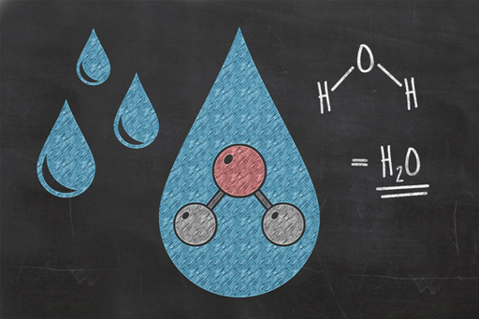
Figure 7 Water molecules are made up of two hydrogen atoms and one oxygen atom – but how big are they?

You’ve seen how we can use numbers to describe large things, like the world’s oceans, but what about small things? The same issue arises: how do you visualise something you can’t see? This is particularly important for science since all the matter that makes up the world around you is made of extremely small units, atoms that you’ll never see.

Small things
Atoms come in many different elements: oxygen, hydrogen, carbon, gold, uranium, etc. An individual atom is far too small to be seen with an ordinary microscope, but if you get enough atoms in one place, you will have something you can see. For example, there are around 100,000,000,000,000,000,000 (10²⁰) atoms in a grain of sand.
We can see objects smaller than a grain of sand or a drop of water, a human hair, for example, is about a tenth of a millimetre across, or one ten-thousandth of a metre, or in scientific notation, 10⁻⁴ m (we missed off the ‘1 ×’ at the beginning of this which is a common and quick way of writing it and is a part of normal science communication). Depending on how thick the hair is, it might be 300,000 to 1,000,000 atoms from one side to the other. This is also about the limit of what the human eye can see, any smaller and we will need a microscope.

Small numbers: microns
The cells in your blood, which carry oxygen from your lungs to all the other cells in your body, are smaller than a human hair, they are around 7 × 10⁻⁶ m, or 0.000007 m across, otherwise referred to as 7 micrometres, or ‘microns’ (millionths of a metre). Micro is the scientific abbreviation for 10⁻⁶ or a millionth. Now we’re getting close to the world on the scale of bacteria. Bacteria come in a range of sizes but are typically between half a micron and several microns long. An individual bacterium might be made of several hundred trillions of atoms. A trillion is 1,000,000,000,000 or 10¹².
At a factor of 10 smaller than bacteria, we enter the world of the virus. These non-living infectious agents, such as HIV or hepatitis B, are typically 10⁻⁷ m, or 0.0000001 m, or 0.1 microns across and are at the very limits of optical microscopes which depend on visible light wavelengths around 0.4 to 0.7 microns.

Nanometers
Deoxyribonucleic acid or DNA, the famous ‘double helix’, which holds the genetic instructions for building an organism is about a hundred times smaller than a virus, it has a width of 3 × 10⁻⁹ m, or 3 nanometres. You might imagine that there is not much smaller than this, but a single strand of DNA still contains a couple of hundred billion atoms.
At 10⁻⁹ m, or 0.000000001 m across we enter the ‘nano’ world. This world is the world of atomic engineering; building carbon nanotubes and engineering structures by moving individual atoms around, with applications in medicine, cosmetics, food packaging, disinfectants, textiles, and as fuel catalysts. Biotechnology is at the cutting edge of several new industries and is likely to be a growth industry in the coming decades, although it is also controversial because, as you can probably imagine, nano particles are much smaller than, and have the capability to pass through, cells such as blood cells. The water molecule mentioned earlier is about 2.8 x 10⁻¹⁰ m or 0.28 nanometres across. You can see now how easy it is to fit 10²⁰ molecules of H₂O into a single tiny drop.

Subatomic particles
As we go even smaller, we pass the limits of all kinds of microscopes and enter the subatomic world. At about 10⁻¹⁴ m, we are at the scale of the atomic nucleus. This is 0.00000000000001 of a metre across. Another ten times smaller and we are at the scale of the protons and neutrons that make up an atomic nucleus.
Another ten times smaller, at scales of 0.0000000000000001 of a metre, or 10⁻¹⁶ m, our understanding of the universe gets a little uncertain and the sizes are just estimates. For example, scientists think the weak nuclear force, which is responsible for the decay of radioactive particles, operates on scales of 10⁻¹⁷ m, or 0.00000000000000001 m. The quarks that are thought to make up protons and neutrons are thought to be on the scale of 10⁻¹⁸ m, or 0.000000000000000001 m.
One of the most common subatomic particles in the universe is the neutrino. It is thought to have a size of about 10⁻²⁴ m, or 0.000000000000000000000001 m. Neutrinos are produced in the nuclear reactions that make stars, like our Sun, shine. Billions of them pass through you every second, but they very rarely interact with other types of matter, so you never notice them. Scientists have constructed very large neutrino detectors underground to try to learn more about these odd particles.
It’s difficult to conceive of an object smaller than a neutrino, but the smallest measurable length is called the Planck length (which is 1.616 × 10⁻³⁵ m or 0.00000000000000000000000000000000001616 m). Due to various universal limits, it is impossible to measure anything smaller than this. This may seem a little weird, but the universe is weird at these scales.

1.10 Week 1 quiz
Check what you’ve learned this week by taking this end-of-week quiz.
Week 1 quiz.
Open the quiz in a new window or tab then come back here when you’ve finished.

1.11 Week 1 summary

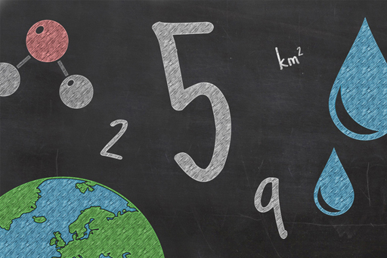
Figure 8

In this first week, you’ve covered several basic science topics including just why numbers, particularly massive and tiny ones, are important to understanding science. You were introduced to SI units which are the basis of scientific measurements and also to scientific notation which allows scientists to handle the largest and smallest numbers in the universe with equal ease.
Hopefully you enjoyed the first week and the quiz went well. You should now be ready to delve deeper into numbers next week, where you will learn all about areas, volumes and sea level change.

Go to Week 2.

Week 2: Using numbers for science

Introduction

Video content is not available in this format.
View transcript - Uncaptioned interactive content

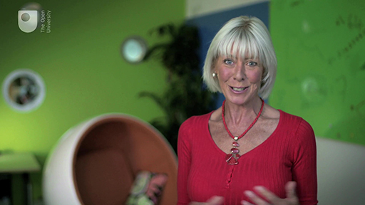

Your guide, Janet, is back to introduce Week 2 of Basic science: understanding numbers.
This week, you’ll be looking at area, volume and density, and how this relates to rising sea levels if the Greenland ice sheet was to melt.

2.1 Calculators through the ages

Video content is not available in this format.
View transcript - Uncaptioned interactive content

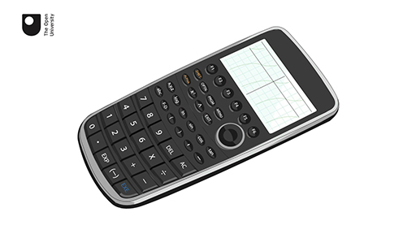

Since numbers first emerged, people have used their fingers and toes, abacuses, electronic calculators and mobile phone apps to make calculations. This video considers how calculators have changed through time.

2.2 Calculating areas
Last week you discussed the SI unit for measuring length, the metre. In fact, you also discussed areas without paying too much attention to them – the area of the Earth, or of Alaska, for example. So, let’s talk more about areas and how to calculate them.

Simple shapes
The areas of shapes like rectangles (and squares, which are a special type of rectangle) can be worked out by simply multiplying the two side lengths together. A rectangular room that is 3 metres long by 4 metres wide has an area of 3 multiplied by 4. The units for area are simply metres multiplied by metres, or as it is normally written, m² (pronounced ‘metres squared’). So the area of the room is 12 m², or twelve square metres.

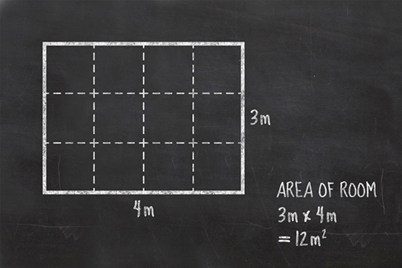
Figure 1 Calculating the area of a rectangular room

Areas of squares and rectangles are fairly easy, but what about other shapes? It turns out that for a lot of simple shapes, there are some very simple methods that have already been shown to work. You can make a triangle by folding a square down the diagonal between two opposite corners. This square has an area of 4 m × 4 m = 16 m² so each of the triangles is half that area or 8 m².

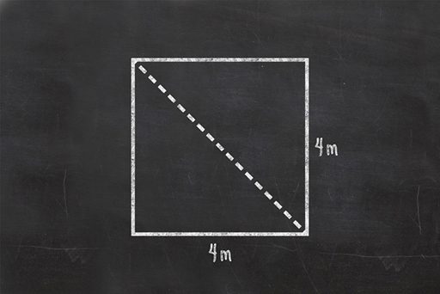
Figure 2 Folding a square down the diagonal between two opposite corners

All triangles can be split by a line that makes the two parts either half of a square or rectangle, or one of each.

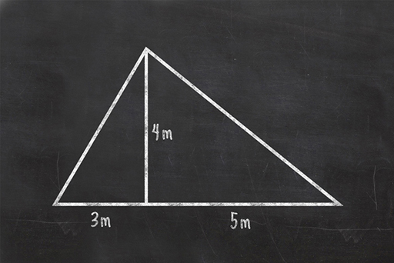
Figure 3 A triangle that can’t be folded from a square or rectangle can be divided into smaller triangles that can

Since the area of each smaller triangle is easy to work out, being half of the ‘whole’ rectangle or square, the area of the larger triangle is also easy to work out, as it is just those two areas added together. If you are thinking ahead, you will have worked out that the end result of this is the same as multiplying the total base (3+5) by the height (4) and dividing that answer in half. So the area of a triangle is half of the base times the height.
Circles are a bit different but have their own method. The distance across a circle is called the diameter. Half of the diameter is the radius. The distance around the outside of a circle is called the circumference.

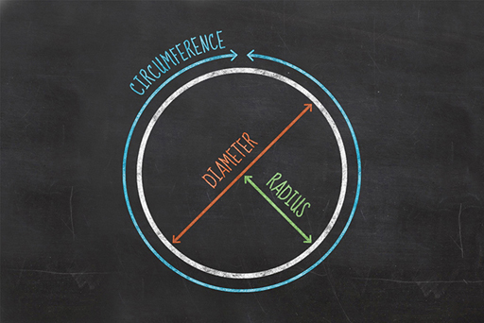
Figure 4 The diameter, radius and circumference of a circle

The circumference of any circle is always 3.14 times its diameter … well roughly that. It is actually an unending string of numbers after the decimal point: 3.141592653589793238462643383279502884197169399375105820974944 … . It has so many numbers in it that we make life easier by giving it a name instead. We call it pi, which is a Greek letter that is often written as π.
The rule for working out the area of a circle is pi times the radius times the radius, or πr². So, if the circle is 4 metres across (i.e. the radius is 2 metres), then the area is roughly 12.5 m².

Complex shapes
If you want to calculate the area of a country, you might think it is a horribly complicated process with all kinds of complex maths, but it can be done with a very simple, albeit long-winded method. All you need to do is divide the country into lots of small triangles and work out the total of all of their individual areas. Modern computing can do this in the blink of an eye from satellite images.

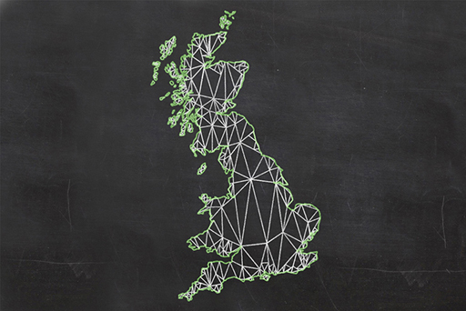
Figure 5 Calculating the area of the United Kingdom by dividing it into triangles

2.2.1 Area of the Greenland ice sheet
In the next section, you will look at how much ice there is locked up in the Greenland ice sheet, so let’s begin with the area of ice. The Greenland ice sheet is second only in size to the ice sheet covering Antarctica. It has an area of 1,710,000 km² or 1.7 × 10⁶ km² and at its deepest, the ice sheet is over 3,000 m deep. Greenland itself has an area of 2,166,086 km² or 2.2 × 10⁶ km². The ice covers about 79% of the island and one of the key issues for climate scientists is how long Greenland will continue to be covered in ice and what will happen to all that water if it slips off into the sea.

2.3 Calculating volumes

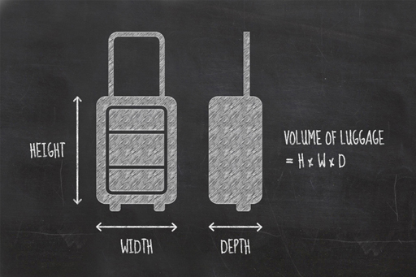
Figure 6 Why not work out the volume of your own suitcase?

The volume of something is the amount of space it takes up or contains. A mug can hold a around 0.3 litres of tea, for example. If you take hand luggage onto a flight, you will probably have to check that it fits inside a guide frame.
In the last section, you saw how areas of squares and rectangles are just their two side lengths multiplied together. Similarly, the volume of a cube or cuboid is the lengths of the three sides multiplied together. The units for volume are simply metres multiplied by metres multiplied by metres, or as it is normally written, m³, pronounced ‘metres cubed’.
A rectangular room 3 metres long by 4 metres wide has an area of 12 m², if the room is 2 metres high, it has a volume of 3 multiplied by 4 multiplied by 2, or 24 m³.
So you can see that there is a pattern:
- Length has one dimension and is measured in m.
- Area has two dimensions and is measured in m².
- Volume has three dimensions and is measured in m³.

2.3.1 Volume of the Greenland ice sheet
Previously, you were given the area for the Greenland ice sheet. To work out the volume, you will need to have an idea of how thick it is. We don’t know exactly how thick it is at every location, but you can work out a fairly good estimate.
You can work out an upper limit for the volume by knowing that it is about 3,000 m, or 3 km, thick at its thickest, so multiplying the area (1,710,000 km²) by the thickness (3 km) gives a maximum volume of 5,130,000 km³for the ice on Greenland.
But the ice is thinner in places, so what is the lower limit? At the edges of the ice sheet, the thickness of the ice tails off to a few tens of metres. If you assume a minimum thickness of 50 metres, or 0.05 km, you get a value of 1,710,000 multiplied by 0.05, or 85,500 km³ as the lowest estimate of the volume of the ice. This is still a lot of ice!
You can get a much better idea of the volume of ice, however, by using the average thickness. This has been worked out, from borehole drilling and radar measurements, to be about 1,500 m, or 1.5 km.

Activity 2.1 Calculating the volume of the Greenland ice sheet
Allow about 15 minutes

If you multiply the area of 1,710,000 km² by 1.5 km, you get a value of 2,565,000 km³ for the volume of the ice on Greenland. Use the internet to look up official estimates of the volume of ice on Greenland and share them in the forum thread for this activity. How do you think we did using the simple area and average thickness? Discuss this point with your fellow students.

In the next section, you will look at why ice floats on water, when you discuss density.

2.4 Density of water

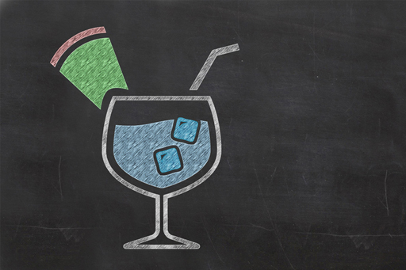
Figure 7

In the last two sections you have considered areas and volumes, using the Greenland ice sheet as an example. Our estimate of the volume of ice contained in the ice sheet was 2,565,000 km³. You’re now going to look at density.

What is density?
Density is the amount of matter within a given volume. It is, if you like, a measure of how tightly packed a substance is. A cubic metre of lead weighs more than a cubic metre of water, because the mass of the lead atoms is greater than that of the water molecules. The SI unit for density is kilograms per cubic metre, or kg/m³.
But density is not just about different substances. The same substance can have different densities under different conditions. When discussing SI units in Week 1, you saw that heat is the measure of the motion of atoms in a substance. The hotter the substance, the more the atoms are moving about. Hot air has faster atoms in it than cold air, moving about more rapidly, so they become more spread out, and take up more room. For any given volume, hot air has fewer molecules than cold air. That volume of hot air, having fewer molecules in it, weighs less than the cold air and floats up through it. We say that hot air is less dense than cold air. This is why hot-air balloons rise into the sky.
When water cools enough to freeze solid, it forms ice. You might expect that, being colder, it would be denser, and for most substances you would be right, but water has a very peculiar property. Due to the special way the molecules of water stick together as they freeze, they are spaced further apart as a solid than as a liquid. This makes ice less dense than water, and is why ice cubes float on the top of your drink. It is also the main reason why icebergs float in the ocean when ice breaks off an ice sheet (the other reasons being that they contain air bubbles trapped in the ice, and salty seawater is denser than the fresh water from which the land ice forms).
You’ll learn a lot more about density in our sister course, Basic science: understanding experiments.

2.4.1 Density of the Greenland ice sheet

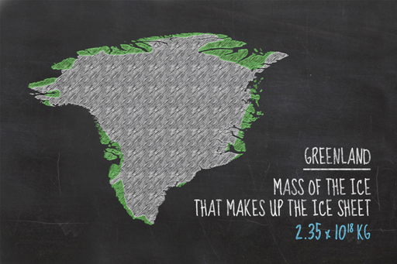
Figure 8 What would happen if this much ice were to melt?

Since density is the amount of mass in a given volume, it follows that the mass of an object can be calculated if you know the density and the volume. We have already estimated the volume of the Greenland ice sheet previously. It turned out to be 2,565,000 km³. The density of ice is 917 kg/m³, so you can now calculate the mass of ice.
If you start with just one cubic kilometre: 1 km³ contains 1,000,000,000 (or 1 × 10⁹, or a billion) cubic metres, each with a mass of 917 kilograms, so 1 km³ weighs 917,000,000,000 kg. This can also be written, you remember, as 9.17 × 10¹¹ kg. This is the mass of each cubic kilometre of ice.
But there are 2,565,000 cubic kilometres of ice in the ice sheet, so you must multiply your answer by this number to get the total. 2,565,000 × 917,000,000,000 gives us a value of 2,352,105,000,000,000,000, or in scientific notation, 2.35 × 10¹⁸ kg of ice.

Why the Greenland ice sheet matters to us

Figure 9 What would happen if this much ice were to melt?

In the previous sections, you’ve seen how areas, volumes and density are calculated, using the Greenland ice sheet as an example. You saw that the mass of the ice that makes up the ice sheet is about 2.35 × 10¹⁸ kg.
If the Greenland ice sheet were to completely melt, the water would flow into the oceans and add to them. If enough water is added, sea levels will rise noticeably. How much they will rise is something you can now work out using what you have learned so far.
The oceans cover about 70.9% of the Earth and the Earth has an area of about 510,082,000 km². You will learn more about percentages later in the course, so for now we’ll tell you that 70.9% of 510,082,000 is 361,650,000 km². (We’ve rounded this number – you’ll also learn about rounding later in the course.)
So, you have a figure for both the area of the oceans and the mass of ice. You now need to convert that mass of ice into a volume of water.
Water and ice have different densities; remember that ice is less dense? But the mass remains the same, so the mass of the water is the same as the mass of the ice.
Water has a density of 1000 kg/m³. The mass of water is 2.35 x 10¹⁸ kg, so that gives a volume of 2.35 × 10¹⁵ m³ or 2,352,105,000,000,000 cubic metres. You could work it all out in cubic metres but cubic kilometres makes more sense for such a large volume. Remember that there are 1,000,000,000 (10⁹) cubic metres in a cubic kilometre, so if you convert the volume of water to cubic kilometres it becomes a billion times smaller, or 2,352,105 km³.
You now have all you need to work out an estimate for the rise in sea level from the melting of the Greenland ice sheet. The change in sea level is just the volume of water added to the oceans divided by the surface area of those oceans.
2,352,105 km³ divided by 361,650,000 km² is 0.0065 km, or 6.5 metres. The official estimate is influenced by other factors – for example, the oceans get bigger when sea levels rise, which we haven’t accounted for – but 6.5 metres will be pretty close – try searching the internet for the official estimate.
Is the official estimate more or less than you were expecting? How would this affect coastal areas you have visited?

2.5 Week 2 quiz
Check what you’ve learned this week by taking this end-of-week test.
Week 2 quiz
Open the quiz in a new window or tab then come back here when you’ve finished.

2.6 Week 2 summary

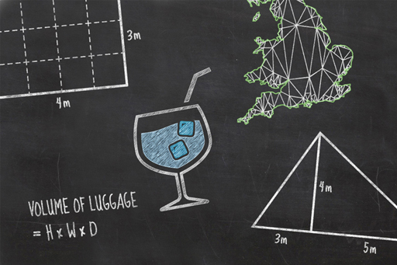
Figure 10

So you’ve reached the end of the second week, and you’ve covered area, volume and density. You’ve advanced to the stage of understanding the calculation of sea level rise that might be caused by melting the ice currently sitting on Greenland. That’s science, isn’t it?
The quiz should have been just that little bit more challenging this week. Hopefully you’ve managed it and you’re ready for Week 3, which is about presenting numbers and why you don’t need to understand fractions to be a scientist.

Go to Week 3.

Week 3: Learning to ‘talk the talk’

Introduction

Video content is not available in this format.
View transcript - Uncaptioned interactive content

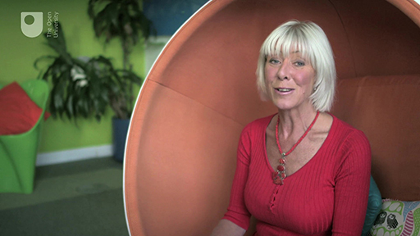

Your guide, Janet, is back to introduce Week 3 of Basic science: understanding numbers.

3.1 Absolute numbers don’t tell you everything

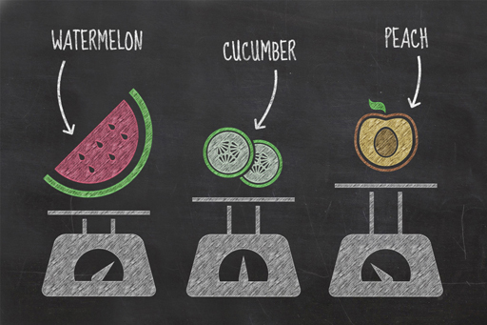
Figure 1

The previous two weeks have shown the important role numbers play in our lives, and their use in scientific investigations, such as estimating the impact of the Greenland ice sheet melting. Sometimes, just presenting the number is not particularly useful, and can lead to long-winded analogies, such as how many swimming pools of bottled water we drink each year – have you remembered that number yet? However, there are some ways of presenting numbers that help show results in a more meaningful way.
Let’s imagine a scientist is interested in the water content of three different fruits: watermelon, cucumber and peach. The experiment involves measuring the initial weights of the fruits, then slowly drying each one out in an oven and measuring the final weights. Assuming that the fruits didn’t burn, only water is lost during the drying process. The difference between the start and end weights tell the scientist how much water the fruits contained.
The scientist wrote the results down in a table:

Table 1 The water content of different fruits (g)
Fruit | Weight before (g) | Weight after (g) | Water contained in fruit (g)
Watermelon | 160.156 | 16.295 | 143.861
Cucumber | 127.751 | 7.472 | 120.279
Peach | 64.375 | 8.681 | 55.694

The amount of water in each fruit has been correctly determined and technically there is nothing wrong with these results. It is clear to see that the watermelon contained the most water, while the peach contained the least water. However, because their starting weights were different it is less easy to tell which of the three fruits contained the largest proportion of water, which is the number that would actually help us understand the results best.
This week is all about learning how to talk about numbers, and how to present them in a way that makes the meaning and implication clear. You will be shown how our scientist’s results can be presented in ways that make sense. The topics in this week are all tools to help convert numbers into a more useful and meaningful format.
All of the topics covered are widely used and have applications in both everyday life and in further scientific study.
As you work through this week, think about where you may have used these techniques or seen numbers presented in these ways. Did you realise what the numbers meant or how they were obtained? Think about where these techniques could be useful and whether you would now be more confident using them.

3.2 Rounding

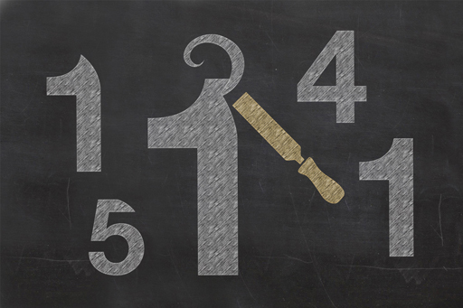
Figure 2

So far in this course, we’ve used terms such as ‘almost’, ‘about’ and ’around’ to describe numbers. They’re approximations, or estimates, which have been simplified, or ‘rounded’, sometimes to the nearest whole number, or sometimes to the nearest 10, or 0.1, in order to report the number appropriately. This is one of the main ways scientists communicate the level of confidence in a number’s accuracy.
For example, if you took out a tape measure and measured the size of the room discussed in Week 2 as 3.1 m × 4.1 m × 1.9 m, the volume would be 24.149 m³. But would you really be confident you knew the size of the room to within 0.001 m³? The tape measure may not have been marked off in very small units, so your measurements may have been to the nearest 10 cm instead, but multiplying numbers tends to increase the number of digits. If you wanted to communicate your confidence in the final number, a more appropriate answer would be 24.1 m³ or even 24 m³. Both of these figures are approximations rounded in two different ways, the first was rounded to ‘numbers after the decimal place’, the second was rounded to a number of ‘significant figures’. Both are valid approaches, and they reflect the level of confidence in the final answer. The next section discusses rounding to decimal places.

3.2.1 Rounding to decimal places
Often when you use your calculator to do calculations, you will obtain an answer with many numbers following the decimal point. The numbers after the decimal point are referred to as decimal places. For example, consider the number 155.76403. There are five numbers after the decimal point, so you would say the number is given to ‘five decimal places’. The number of decimal places you see may depend on your calculator, although usually calculators can show at least seven decimal places.
Although it may be tempting to give this entire number as your answer, it may not reflect its real accuracy, so the number needs to be rounded. This also makes the number easier to read, write and understand.
When rounding a number, you need to decide to how many decimal places you are confident in your answer. If you are confident of the answer to two decimal places, you would round to 155.76. Before you discard the rest of the numbers, you need to work out whether to round the final digit up or down. If the first digit that you intend to discard is a 0, 1, 2, 3 or 4 then you can go ahead and discard them. If the first digit that you intend to discard is a 5, 6, 7, 8 or 9, then you have to increase your final digit by one. For example, if the number 155.76403 is to be rounded to one decimal place, you must look at the second decimal place, which is a six, and then round the first decimal place up by one, so the answer is 155.8
Earlier in this week, you were introduced to an experiment to find the water content of different fruits. The initial weight of each fruit was measured in grams and presented to three decimal places with the watermelon weighing 160.156 grams, the cucumber weighing 127.751 grams and the peach weighing 64.375 grams.
If you were working with these fruits in a recipe, for example, it might be more appropriate to report the weights as whole numbers, with no decimal places. So, in this example, the first decimal place immediately follows our chosen cut off, and is the value we use to round our answer. For the watermelon it’s a 1, for the cucumber it’s a 7 and for the peach it’s a 3.
Only the cucumber has a first decimal place with a value over 5, so the last remaining digit needs to be rounded up. As for the watermelon and the peach, their numbers are less than 5, so they aren’t rounded up. The weights of these three fruits can therefore be written as 160, 128 and 64 grams.
Last week, we calculated that 361,648,138 km² of the Earth’s surface is covered by oceans. To simplify things we rounded this number to 361,650,000. Hopefully you can now understand how we obtained this rounded number. The next section covers rounding to significant figures, which is more commonly seen in science.

3.3 Can you eat sig figs?


Figure 3

The last section discussed rounding to decimal places, one of the ways in which scientists communicate their level of confidence or the precision of a number. In this section you will look at rounding to significant figures. While both approaches are valid, rounding to significant figures is a more common approach in science.
The word significant means having meaning, and the significance of an individual digit within a number depends on its position. For example, the initial weight of the peach presented earlier was 64.375 g. This number has been presented to 5 significant figures. The 6 at the beginning of the number is the most significant figure because it tells you that the number is sixty-something. It then follows that the 4 is the next significant figure, and so on until all the digits are accounted for.
Zeros are also important because their significance varies depending on their position in the number. For example, a raindrop has a volume of 0.034 cm³. Despite the first two zeros, the most significant digit in this number is actually the 3. So here, where zeros are at the start of a number, they are largely ignored. In contrast, following a twenty minute shower, a puddle may have a volume of 108.472 cm³. Here, unsurprisingly, the most significant figure is the 1, however the zero is also a significant figure in this number and its presence doesn’t mean that all the digits to the right can be ignored. The same rules apply for zeros situated at the end of a number and can be used to indicate the confidence in the number. For example, if we really knew the volume of the raindrop to more decimal places, the number could be reported as 0.0340. This would indicate that we are confident of the volume to the fourth number after the decimal point.
You can use the same rounding rules that were introduced previously to round a number to a specified number of significant figures. For example, if you rounded the weights of the three fruits presented in the earlier section to three significant figures, this is what your results would be:

Table 2 The water content of different fruits to three significant figures
Fruit | Weight before (g) | Weight rounded to 3 sig figs (g)
Watermelon | 160.156 | 160
Cucumber | 127.751 | 128
Peach | 64.375 | 64.4

Can you see how you would come to these figures? While rounding to a number of figures after the decimal produces slightly different results for rounding to sig figs, both are valid and reflect confidence in the result.
You probably round things more often than you realise, most likely when you are shopping. Most people automatically round up (or down) the price of an item so that it is easier to remember or combine with other item prices. However, human perception isn’t always that accurate. You’ve probably seen prices carefully set to appear lower. For example, a new phone or a spectacular pair of shoes can look like a bargain if priced at £199, but don’t be fooled into thinking that it’s meaningfully less than £200.

3.4 Fractions and Percentages

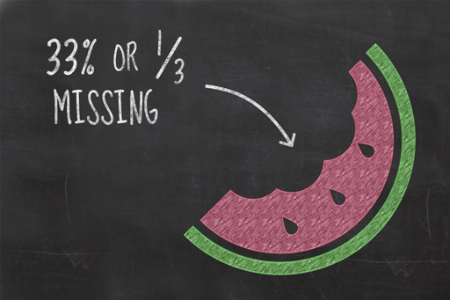
Figure 4

This week, you’ve seen how you may need to manipulate the bare numbers you obtain from an experiment in order to put them into a more useful format. As you saw in the bottled water video in Week 1, fractions and percentages are often used to communicate numbers in print, online and other audio-visual media. These are two simple techniques that you can use to make numbers more meaningful and they are not difficult to use.

Fractions
Fractions are something which spark fear in a great number of people, yet simple fractions like a half (½) or a quarter (¼) are used every day. Numerically these two fractions are telling you how many of something you have (top number, or numerator) out of the total (bottom number, or denominator). For example, one out of every two hospital beds around the world is estimated to be occupied by someone suffering from a water-related illness. Using a fraction here provides much more context than an absolute number of beds occupied by those suffering from water-related illnesses without knowing the total number of beds.
Fractions do not need to be any more complicated than this. The thing that complicates fractions is that they are typically reported in their simplest form, meaning that they are converted such that their top and bottom numbers are as small as they can be while maintaining their proportions. This is so that they are easier to comprehend. For example, if a jar contained 900 sweets of which 300 were blue, this could be expressed as 300/900. Although this is correct, it’s common practice to reduce this to smaller numbers – otherwise known as ‘cancelling down’. In this example, both the top and bottom number can be dived by 300 resulting in the fraction ⅓ (called a ‘third’).
Scientists rarely present their results as a fraction because they can be fiddly to reduce to their smallest parts, and even when this is achieved the bottom number may differ, making it more difficult to compare like with like. Instead scientists commonly write fractions out as decimal numbers or percentages to communicate numbers as a proportion of the whole.

Percentages
Take our example from earlier, where the scientist measured the amount of water in three different fruits. Their results indicated that 160 g of watermelon contained 144 g of water, 128 g of cucumber contained 120 g of water and 64 g of peach contained 56 g of water. Note that these weights have been rounded to the nearest whole number.
Percentages are calculated by dividing the number of parts you are interested in by the total number of parts available and multiplying the answer by 100. So, in the fruit example you might want to find out what percentage of the fruit is water. For a watermelon, you need to divide 144 by 160 and multiply the answer by 100. Try using your calculator to find the percentage. You should find the answer to be 90%.

Activity 3.1 Calculating a percentage
Allow about 5 minutes

Try calculating the percentage of water contained in the cucumber and the peach. Which of the fruits has the highest percentage of water content?

Percentages are not just used in science. You will have met percentages in other contexts – if you have received a 3% pay rise or seen an advert for a 20% off sale, for example. The same principles apply to these numbers as the fruit. For example, to calculate your pay following a 3% pay rise, you first calculate 3/100 of your income, and then add this result to your current annual income.
You can also think of this as 103% of your current salary. To work this out using your calculator or smartphone, multiply your current salary by 1.03. (Remember, your base salary is 100%.)
Some calculators and smartphones have a % button and you may have noticed that we haven’t used it during this section. That might seem a little odd but the reality is that we’re not sure that all % buttons operate consistently and we ultimately don’t understand how some of them work. As a result, it is far easier to simply ignore the existence of the % button entirely and just work out the percentage yourself.
Finally, the really scary stuff is when you try to add, subtract, multiply and divide fractions. The honest truth is scientists just convert these to decimal numbers and use a calculator.

3.5 Negative numbers

Video content is not available in this format.
View transcript - Uncaptioned interactive content

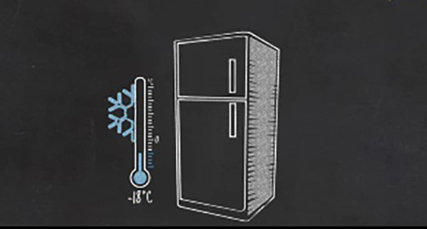

Intuitively you might consider zero as the lowest possible number, there can’t be anything less than nothing, right? Numbers below zero seem unnatural, or complicated to understand.
The video uses temperature to illustrate that negative numbers are not uncommon and are used all the time. Negative numbers are written with a minus symbol in front of them. For example, a normal household freezer is often set to -18 ˚C (or 18 degrees below zero).

Activity 3.2 Temperatures and negative numbers
Allow about 15 minutes

There is a wide range of temperatures that might be experienced by visiting different countries. The temperatures of the five countries in the video were all different, with two below 0 ˚C. Post your response to these questions in the forum thread for this activity and discuss with your fellow students:
- How hot or cold does it get where you live?
- Where are the hottest and coldest places you’ve visited?
- Can you think of any other everyday situations where you use negative numbers?

3.6 Week 3 quiz
Check what you’ve learned this week by taking this end-of-week test.
Week 3 quiz
Open the quiz in a new window or tab then come back here when you’ve finished.

3.7 Week 3 summary

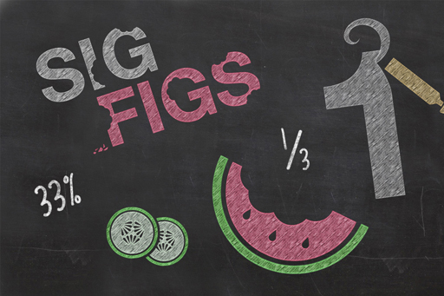
Figure 5

You’ve nearly made it through the course, and you’ve examined how you can present numbers as fractions or percentages and you’ve also considered when and why you should round numbers.
Hopefully you enjoyed the video on negative numbers, and perhaps it gave you some ideas on where to go (or where to avoid) next time you start planning a holiday!
Next week you’ll be looking at averages, correlation and interpreting graphs before taking the end-of-course quiz to see what you’ve learned.

Go to Week 4.

Week 4: Presenting numbers

Introduction

Video content is not available in this format.
View transcript - Uncaptioned interactive content

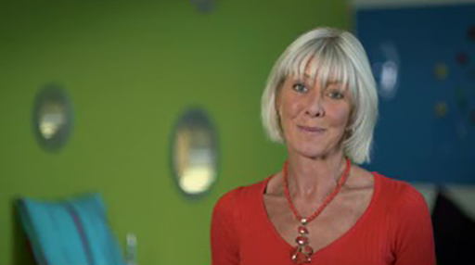

Your guide, Janet, is back to introduce Week 4 of Basic science: understanding numbers.

4.1 How do people ‘get’ science numbers?
Communicating science through numbers, particularly in the media, is often in the form of simple graphs. Scientists also communicate results in graphical form, so creating and interpreting graphs is a very important skill for a scientist.
When you pick up a newspaper or magazine do you open it and immediately start reading, or do you flick through the pages, pausing at those with images that catch your eye to read those articles first?
Consider the bottled water video from Week 1. It uses graphs, like the one below, to present science numbers. But is this really a graph or is it just a graphic intended to illustrate the doubling of the bottled water industry?

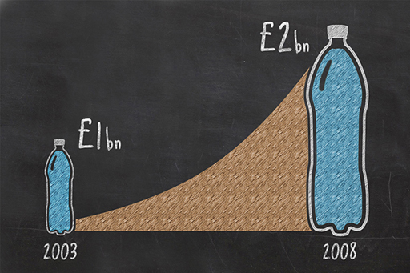
Figure 1 Is this a graph or graphic? View this graph on infogr.am

Numbers are used in articles designed for the public, as well as being an invaluable tool for scientists, economists and many others, not just to present data, but to analyse data and identify patterns and trends.

4.1.1 Using graphs
Media graphics and graphs come in many forms. This is a bar chart presenting the absolute numbers of children in families (not fractions or percentages). These charts can be drawn with the bar displayed either horizontally or vertically. When the bar extends horizontally, they may also be known as ‘row charts’ and when the bar extends vertically, they may be known as ‘column’ charts’.

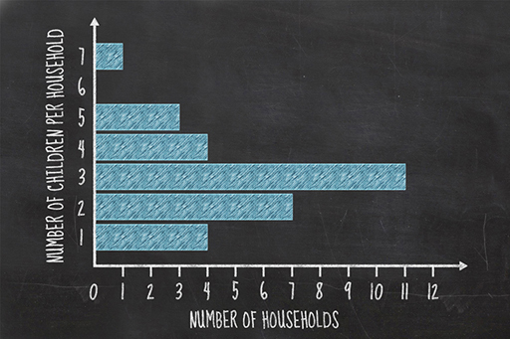
Figure 2 An example of a row bar chart View this graph on infogr.am

This is another type of graph (a pie chart) commonly used in media, categorising the average family’s expenditure on food and drink. Is it possible to judge whether your own family is similar? What further data do you need to help you do that?

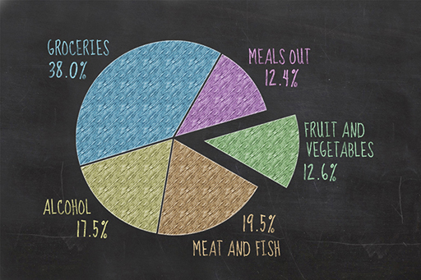
Figure 3 An example of a pie chart View this graph on infogr.am

Time series graphs are also commonly used in the media. They can be used to identify a trend, and often imply some outcome in the future. For example, using this graph, who do you think won the UK election in 1997?

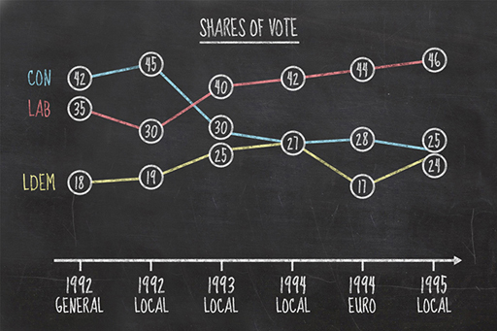
Figure 4 An example of a time series graph View this graph on infogr.am

Finally, some graphs cross the boundary between presentations for fellow scientists and those intended for public consumption in the media. The graph shows the range of global average temperature from 1860 to 2000. Why does the graph not extend further back in time than it does? What does the graph show overall? Is the flat zone between 1940 and 1960 important? Is the recent temperature rise faster and sustained? The line appears to flatten in the late 1990s – does this mean that global temperatures have plateaued?

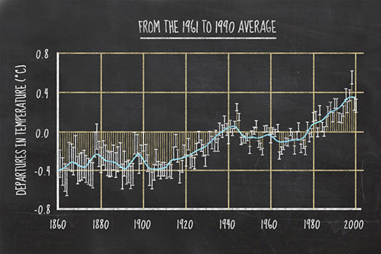
Figure 5 An example of a line graph View this graph on infogr.am

Pay attention to the news today, either on television, in papers or on the internet. How many visual graphical techniques do you notice? Think about whether these are good, bad or even dangerous.

4.2 Averages

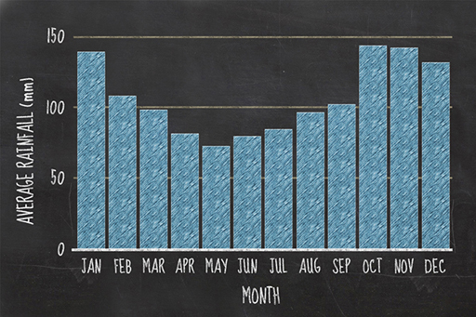
Figure 6 An example of a bar chart showing average rainfall

Many numbers presented in the media are averages, commonly used in statements like ‘the average temperature rise due to climate change since 1860 was 0.8 °C’, or ‘rainfall was 40% above average for June’. But what does ‘average rainfall’, or ‘average temperature’, actually mean?
The word ‘average’ is often used to mean ‘ordinary’, ‘typical’ or ‘normal’. This is fine in everyday contexts, but, in scientific contexts, average also has a mathematical meaning. It is used to report the typical value within a set of data, sometimes with an associated range indicating the spread of the data. This makes averages useful when presenting data because, instead of describing each value in the dataset, you can present just one value which approximates your whole set.

4.2.1 Types of average
There are three main types of average: mean, median and mode. Each of these techniques works slightly differently and often results in slightly different typical values.
The mean is the most commonly used average. To get the mean value, you add up all the values and divide this total by the number of values. For example, if you wanted to find the mean of 11, 14 and 17, you would add them to give a total of 42, then divide that by the number of values you have, which is 3. So the mean of 11, 14 and 17 is 42/3 = 14.
The other types of average are:
- The median, which places all your values in order from smallest to highest and finds the one in the middle. For example, the median of the values 3, 3, 4, 5, 9, 11 and 16 is 5.
- The mode is the most commonly occurring value. For example, the modal value of 1, 3, 6, 6, 6, 6, 7, 7, 12, 14 and 24 is 6 because it appears the most times.

4.2.2 Using averages
When the average of a dataset is presented to you, you need to consider which type of average has been used. Consider the average number of feet a person has. Most people in the world have two feet, so the modal value will be two. Similarly, if you were to use the median average, you would also find the answer to be two, as a very small minority of people have fewer than two feet, so two would remain the middle number.
However, if you were to calculate the mean, you would find that the answer is no longer two. There are a minority of people with fewer than two feet, for a variety of reasons, but this is enough to reduce the mean ever so slightly. As a result, almost everyone has more than the mean number of feet.
That’s enough about feet. Let’s instead consider the average of a scientific dataset. Average monthly rainfall is worked out from the recorded rainfall for that month over a specified number of years. The numbers below are the recorded January rainfall (in millimetres) for London, UK over 10 years. For simplicity these are arranged in order of smallest to highest.
17, 19, 51, 56, 69, 72, 72, 74, 75, 77
The data show that January rainfall has ranged from 17 mm to 77 mm in the ten years that this dataset covers. The mean average rainfall is 58 mm to 2 sig figs. Do you agree that the average rainfall should be reported to 2 sig figs?
The median rainfall is the middle value in this list. Because there are an even number of years in the sample, there is not a single middle value. Instead, both 69 and 72 are the middle numbers. The median is calculated as the number midway between these two numbers and is therefore 71 mm to 2 sig figs. The mode is the most common value, which is 72 mm.
This demonstrates perfectly the sensitivity of the mean average to extreme values. The mean average is lower than the median or mode averages due to the two very dry Januarys, which experienced only 17 and 19 mm of rain.
You will return to average rainfalls later this week when you look at plotting and interpreting graphs.

4.3 Types of graph and drawing graphs

Video content is not available in this format.
View transcript - Uncaptioned interactive content

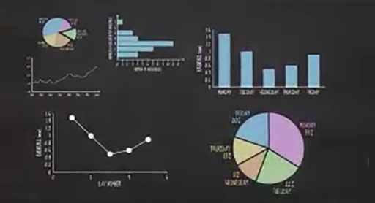

So, you’ve seen how the same data can be presented using different types of graph, but how will you decide which type of graph to use for a given situation?

4.3.1 Interpreting graphs
It is often said that ‘a picture paints a thousand words’, but how many words can be painted by a graph? Once you know how to interpret graphs, they can be just as thought-provoking as a picture. This section uses bar graphs, line graphs and pie charts to assess how the monthly average rainfall for the United Kingdom varies throughout the year, and compares this with the same data for India. The data used here (from the Climatic Research Unit of the University of East Anglia) is a mean average for the years 1990 to 2009.
Each of these graphs and charts can also be viewed on infogr.am. Infogr.am is designed for creating interactive infographics and is a quick and easy tool for plotting colourful and varied graphs and charts, which can then be saved and shared with others. You’ll get the opportunity to create your own graphs later in the week.

Using graphs to view data
This first graph is a bar chart of average rainfall per month in the UK. The height of each bar represents the average rainfall (in mm) in each month. The graph shows that, on average, the driest month in the UK is May, while October is the wettest month. You can also see the UK’s seasonal cycle, with the autumn and winter months (September–February) being wetter than the spring and summer months (March–August).

Figure 7 Average rainfall per month in the UK (mm) View this chart on infogr.am

Using graphs to compare data
To compare the rainfall of the UK with that of India, you could plot the data for India on a bar chart and compare the two charts next to each other. However, a line graph plotted with one line for each country’s rainfall allows both to be compared on one graph.

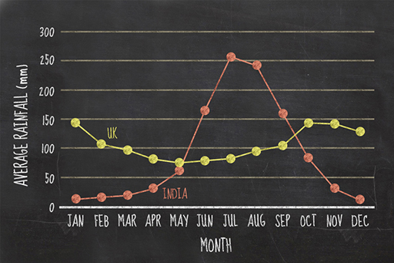
Figure 8 Average rainfall per month in the UK and in India (mm)View this chart on infogr.am

On this graph, the yellow line represents the average rainfall in the UK, while the red line represents the average rainfall in India. Between October and April in India, rainfall is on average lower than in the UK, but the summer months in India coincide with the Indian monsoon season, so these months are considerably wetter. Perhaps a graph like this might help you decide when and where to go on your next holiday!
It is difficult to determine which country is wetter overall from the line graph. The UK is generally wet throughout, but India has such a dramatic monsoon season that it might counterbalance the drier months earlier in the year. Using a pie chart can illustrate this very effectively.

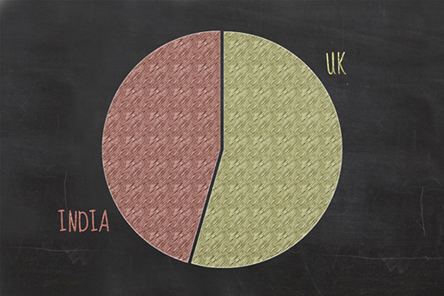
Figure 9 Comparison of the total average rainfall for the UK and India View this chart on infogr.am

The UK slice of the pie chart forms a greater proportion of the whole, meaning that on average the UK is wetter than India, although the difference between the two is perhaps less than you might have expected. In fact, this is one of the things that make them an interesting comparison, two countries, each with a very different climate but similar total rainfall. If you calculate each as a percentage, you can see that the UK makes up 55% of the graph, whereas India makes up the remaining 45%. This chart is a perfect example of how graphs can be used to mislead an audience – the rainfall of the UK and India are not dependent on one another.

Interpreting graphs
This section is intended to help you on the way to interpreting different kinds of graph. The three main types of graph can provide lots of information and it’s worth spending a few minutes thinking through the implications and insights for each of them. Remember that the most important information is:
- the height of the columns in bar graphs
- the x and y values for line graph
- the proportion represented by each category for pie charts.
Finally, scientists often have to read numbers from a graph, and this can be an important way to gather information. Look at this graph of the same Indian and UK rainfall data with the data point markers removed, and the curves smoothed. Smoothing is quite commonly used to emphasise trends in data. However it also has the potential to be misleading.

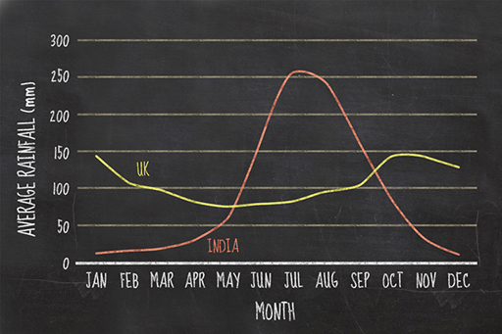
Figure 10 Average rainfall per month for the UK and India View this chart on infogr.am

In this graph, without the clear data markers indicating monthly values, the graph appears to show an almost continuous set of rainfall measurements. Compare the highest rainfall value for India on this graph and the previous one. To do this, identify the highest point on the curve and read the monthly value on the bottom axis and the rainfall value on the side axis.
Both the date and the peak rainfall value appear to be different in the two graphs even though they are based on the same data. On the first graph, the peak rainfall value for India was 255 mm in July, but on the smoothed curve without markers, the peak rainfall appears to be around 265 mm sometime in the first half of July. Is this second interpretation correct? Or are there lessons to be learned about interpreting line graphs of scientific data?

4.4 Correlation, causation and coincidence
Graphs are a great tool for presenting complicated results: they can help communicate the relationship between two or more variables.

Correlation
A striking example of this is the recognition of a correlation between smokers and lung cancer patients. Lung cancer used to be a rare disease, with only 1% of autopsies performed by the Institute of Pathology of the University of Dresden in 1878 showing malignant lung tumours. Unfortunately, lung cancer did not remain rare and, over the following 50 years, this figure rose to more than 14%.

Causation
A particularly observant scientist, Franz Müller from Cologne Hospital, published a study in 1939, identifying the correlation between tobacco smoke and lung cancer. The study compared 86 lung cancer cases and a similar number of cancer-free controls, showing that the people who smoked were far more likely to suffer lung cancer.

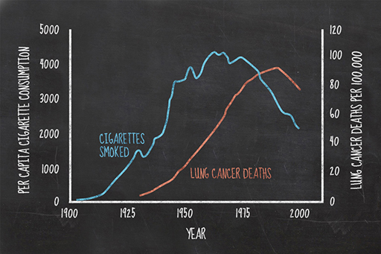
Figure 11 A graph displaying per capita cigarette consumption and lung cancer deaths per 100,000 between 1900 and 2000

However, while a correlation between two sets of observations or measurements can point to a causal relationship between them, correlation does not always imply causation. This was part of the basis for the long running debate about smoking and lung cancer, but it was some decades later before this link was accepted following the emergence of scientific evidence for the cause.

Coincidence
Consider this odd correlation between worldwide launches of non-commercial space missions and the number of sociology doctorates awarded in the USA. The graph shows how both of these variables rise and fall together, as if connected in some way. You might wonder if the sociology graduates work on the space missions? However, this is not the case, with sociology doctorates usually working in the field that they are actually trained in and not turning their hands to physics or space engineering. This correlation, as real as it is, is a coincidence. It is also not a freak occurrence; a quick internet search of ‘spurious correlations’ will bring up a whole host of correlations that are purely coincidental.

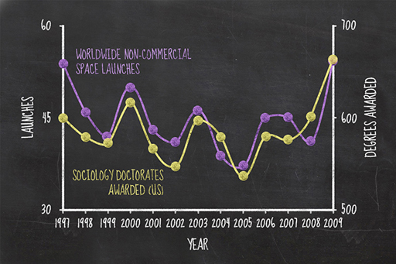
Figure 12 A graph showing the number of sociology doctorates awarded each year in the US compared to worldwide non-commercial shuttle launches by year

The role of a scientist is to critically assess correlations encountered in their results. There are several criteria scientists use to test the validity of correlations and their significance. The detail is beyond the scope of this course, but they are a crucial science skill. Ways of testing correlations include the goodness of fit, in other words, working out how good the correlation is, and whether it can be reproduced and examined further.
What about the apparent correlation in the graph of space missions and sociology graduates? A scientist might ask why the graph is only plotted between the years 1997 and 2009, since both space missions and sociology graduates were around before and after those dates – did the person plotting the data avoid those earlier and later dates because the correlation breaks down?
Despite the precaution such as goodness of fit and reproducibility, sometimes scientists get it wrong and over interpret a correlation or apply causal mechanisms to coincidences. Can you think of any examples where this has been the case?

4.5 Create and share your own graph
As a scientist, it is important both to be able to present numbers clearly and in a way which emphasises the significant results, and to interpret graphs to extract the essential data. This week, you’ve concentrated on how science numbers are presented, focusing on bar graphs, pie charts and line graphs. In this section, you should take the opportunity to make your own graphs. You will have the opportunity to share and discuss them in the next section.

Activity 4.1 Your own graph
Allow about 30 minutes

Part 1 Creating your graph

Download the Rainfall data and the Instructions for Infogr.am.
Use the data to plot different kinds of rainfall graphs for a range of countries over the period 1990–2009. Think carefully about which type of graph will best demonstrate your results.
We recommend that you use infogr.am, which is designed for creating interactive infographics. It is a quick and easy tool for plotting colourful and varied graphs and charts which can then be saved and shared with others. The site is free to use – you do not need to register for any paid-for premium account.
If you prefer you may also plot your graphs by hand or by using a program like Excel or Google Sheets and share a photo via social media (don’t forget to use the course hashtag #OLSciNum).

View discussion - Part 1 Creating your graph

Part 2 Sharing your graph

Go to the forum thread for this activity and share the graph you created, either as a link to an infogr.am or a link to an image shared via social media or via an image hosting site.
Do the countries you are comparing have similar rainfall or are they very different? What time of year would you choose to visit those countries? Discuss these points with your fellow students.

4.6 End-of-course quiz
Check what you’ve learned during the course by taking this End-of-course quiz.
End-of-course quiz
Open the quiz in a new window or tab then come back here when you’ve finished.

4.7 Congratulations – you’re a scientist!

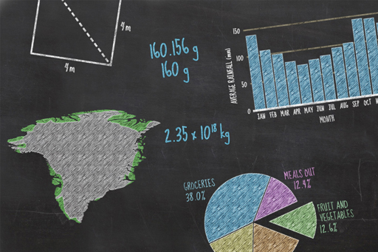
Figure 14

Well done for completing this four-week course on understanding numbers! Over the past four weeks you’ve looked at how scientists:
- communicate with each other
- calculate area, volume and density and what this means for the Greenland ice sheet
- present numbers using significant figures, decimal places, fractions and percentages
- use different types of averages, draw and interpret graphs and find correlations in data.
If you would like to take your study of science further, why not take the sister course, Basic science: understanding experiments. It will help you think like a scientist by carrying out experiments at home and making your own observations.
We’ve also created an area to enable you to take your study of numbers in science further.
We would love to know what you thought of the course and what you plan to do next. Whether you studied every week, dipped in and out or jumped straight to the conclusion, please take our Open University end-of-course survey. Your feedback is anonymous but will have massive value to us in improving what we deliver.

Return to course progress page

References
Week 1
Sagan, C. (1990), 'Why We Need To Understand Science', Skeptical Inquirer, vol. 14, no. 3 [Online]. Available from http://www.csicop.org/si/show/why_we_need_to_understand_science. Accessed 12 October 2015.

Acknowledgements
This course was written by Leanne Gunn, Sion Hughes and Simon Kelley.
Except for third party materials and otherwise stated in the acknowledgements section, this content is made available under a Creative Commons Attribution-NonCommercial-ShareAlike 4.0 Licence.
Every effort has been made to contact copyright owners. If any have been inadvertently overlooked, the publishers will be pleased to make the necessary arrangements at the first opportunity.
Don't miss out:
1. Join over 200,000 students, currently studying with The Open University – http://www.open.ac.uk/choose/ou/open-content
2. Enjoyed this? Find out more about this topic or browse all our free course materials on OpenLearn – http://www.open.edu/openlearn/
3. Outside the UK? We have students in over a hundred countries studying online qualifications – http://www.openuniversity.edu/ – including an MBA at our triple accredited Business School.

Activity 1.2 Numbers and scientific developments

Discussion
This is what science is. It is a way of thinking about the world around us in a logical and rational manner, suggesting an idea (a hypothesis), and testing it rigorously – most commonly by measuring things or putting numbers on them, and discarding the hypotheses that don’t stand up to scrutiny. To paraphrase the physicist Richard Feynman, ‘it is a way of not fooling ourselves.’
Back to Unit 1 Session 4 Activity 1

Activity 4.1 Your own graph

Part 1 Creating your graph

Discussion
We plotted the rainfall in Spain and Australia, because both are relatively dry but in opposite hemispheres of the world, so would they have similar or different patterns?

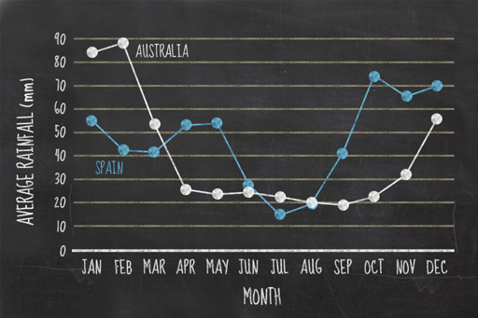
Figure 13 View this chart on infogr.am

In fact, as you can see from the plot, both countries are dry and wet in the same annual pattern despite being in different hemispheres. While Spain had the pattern we expected, dry in summer and wet in winter, Australia appears to be dry in the winter and wet in the summer.
Back to Unit 4 Session 6 Part 1

Uncaptioned interactive content

Transcript
JANET SUMNER
Hello, and welcome to Basic science: understanding numbers. I'm Janet Sumner from The Open University. Over the next four weeks, you will gain a better appreciation and understanding of numbers, and how they're used in science.
Numbers are everywhere in our lives and, more than ever before, it's important to understand them. They're used in everything from news reports of climate change and banking crisis, to real science experiments, such as in the sister course, Understanding Experiments. This course isn't about maths, so you won't have to carry out any complicated calculations. But you will be introduced to some of the more common concepts, such as how large numbers are represented, how to work out an average or area, and how to read a graph. We'll also show you why you don't need to understand fractions, and warn you about the percent button on calculators.
OK, here we go. In week one, you learn about some basic concepts for numbers, including the way scientists write very big or very small numbers. You'll also cover units of measurement, like kilogrammes, metres, and litres, and how they came about. This week starts with a video about bottled water consumption. It's a short, documentary-style video from the Open University, which uses numbers in a similar way to news programmes and other documentaries.
I hope you'll enjoy the next four weeks, and don't forget to get stuck into the discussions. You'll find people on there with all levels of expertise. I'll be back to catch up with you next week.
Back to Unit 1MediaContent 1

Uncaptioned interactive content

Transcript
NARRATOR 1
Bottled water is ubiquitous in our daily lives. Every year in the UK, we each consume some 70 litres of purchased bottled water, whether it's fizzy, mineral, or just purified tap water under a different name.
The market for bottled water in the UK alone has grown to over 2 billion litres a year. Worth over a billions pounds in 2003, by 2008, the market had more than doubled.
NARRATOR 2
In China, market growth has been even more spectacular. From a relatively tiny 400 million litres in 1991, to over 15 billion litres in 2007. Growing income levels, particularly in urban China, are leading to changing consumer behaviour. While most rural people still drink boiled water, the majority of urbanites now drink bottled water. Most people have water dispensers in their apartments and offices, and smaller bottles of water are on sale everywhere, from cities to the smallest villages.
NARRATOR 1
Worldwide consumption is estimated at over 155 billion litres a year-- enough water to fill 62,000 Olympic swimming pools.
NARRATOR 2
That's amazing for a product that didn't really exist 30 years ago. But there's more to bottled water the meets the eye.
NARRATOR 1
A bottle of water is a plastic bottle, a plastic lid, a label, some water from a specified source, and quite a bit of embodied energy, besides. Let's start with the water. Where does it originate?
NARRATOR 2
Every bottle carries a date code stamp from the production facility where it was bottled. This code shows the best before date as well as the production lot code of the process batch when it was bottled along with many other thousands of bottles which were filled during that shift. The water may have come from a glacier or been filtered through rocks over thousands of years, but now it's likely to be extracted from a well, spring, lake, or in some cases, a tap, all of which involves energy consumption for pumping, filtering, and so on.
NARRATOR 1
After bottling, it travels to a warehouse, and then on to wherever you might have bought it. By this time, a simple bottle of water may have traveled over 1,000 kilometres and taken on a lot more embodied energy.
NARRATOR 2
The lid, bottle, and label are all derived from petroleum, which we see as plastics. The bottle might be PET or some other plastic. The lid is made of another type of plastic, and the label is made of a kind of heat-sensitive shrink plastic. Producing a kilo of virgin PET releases about three kilogrammes of CO2 into the atmosphere.
NARRATOR 1
The newly filled bottles get packaged in plastic, piled on a pallet, wrapped in shrink wrap-- more plastic, about five kilogrammes worth-- and lifted by a compressed gas forklift truck to the edge of the factory site. Each of these processes adds more embodied energy and releases more CO2.
NARRATOR 2
The long distance delivery gets made by truck, train, boat, or even plane to a big warehouse, and ultimately, onto another truck to whatever retail outfit you purchase it from. The bottle of water is now about 18 days old, even though the water itself is much, much older.
NARRATOR 1
Eventually, this bottle of water gets into your house, and maybe you even put it in your fridge to cool it down. By now, it has accumulated some serious mileage and has a big carbon footprint.
NARRATOR 2
Of course, you may drive a hybrid car, so that reduced the energy consumption a little bit it, didn't it? Well, not really. Most of the embodied energy in a bottle of water is due to transporting the water.
NARRATOR 1
Take a major brand of bottled alpine water, for example, which is exported all over the world. You can imagine that transport accounts for most of the final total of its energy footprint. When one bottle of alpine water gets to China, where it's become a popular prestige product, it's released some 250 grammes of CO2 in its travels. About 95 grammes is from the plastic manufacture in China, another five grammes or so for the empty bottle's trip from China to Europe, and another 150 grammes for shipping the full bottle back to China.
NARRATOR 2
So then you drank it. It was cold, clean, crisp, and ever so fresh. But so is tap water, once you cool it down a bit. But it's not the same, say your guests. And it's still not the end of the road for the empty bottle.
NARRATOR 1
Up to this point, there's enough oil used in the production process of bottled water in the UK to heat 32,000 homes for a year. Quite an opportunity cost for a product that you don't really need, and another 45,000 tonnes of CO2 released into the atmosphere.
NARRATOR 2
But that's still not the whole story. You may reuse a few bottles. We're always refilling them. But reusing them continuously isn't a great idea, as toxins eventually leach out of the plastic.
NARRATOR 1
Most end up in the wheelie bin, destination either landfill-- a finite resource which is rapidly becoming exhausted, is unsustainable, costly, and where the empty bottles will stay buried for millennia or increasingly, they will be sent for incineration, leading to more pollution and more CO2.
NARRATOR 2
Even if you're conscientious and recyclable your bottle, only about one in four water bottles actually end up being recycled, and quite possibly being crushed and chipped and making their way back to China for rebirth as furnishings, fleeces, and other plastic stuff.
NARRATOR 1
But sadly, all too many bottles never really die. They somehow end up in the sea, floating around until they are washed up on a beach somewhere for you to moan about on your holiday.
NARRATOR 2
Bottled water--
NARRATOR 1
Who needs it?
Back to Unit 1 Session 1 MediaContent 1

Uncaptioned interactive content

Transcript
TEACHER
Big numbers like this are cumbersome and difficult to read. Just watch all those zeros going by. Lots of them, aren't there?
If scientists had to read or write them out in full when they were discussing things like the molecules of water in a swimming pool or the distance to the Orion nebula, it would take up pages of books. The same is true of very small numbers like this one. And it's an important number-- the charge on a single electron. But you could spend so much time counting the zeros you lose track of what the number was about.
So, how do scientists solve the problem of very big and very small numbers? In fact, scientists use a really simple device called scientific notation that allows them to abbreviate these numbers so that they're easy to write down and work with. The numbering system we use works in tens. That's the basis of our counting system.
So 2, 20, 200, and 2,000 are increasingly large numbers. They're also each 10 times larger than the previous number. You could think of that set of numbers as 2, 2 multiplied by 10, 2 multiplied by 100, and 2 multiplied by 1,000. But that doesn't help much for very large numbers.
The same numbers could also be written as 2, 2 times 10, 2 times 10 times 10, and 2 times 10 times 10 times 10. Think of that as 2, 2 times 10 one time, 2 times 10 two times, and 2 times 10 three times. Scientists write that with a superscript and describe it as 'to the power of'. This last number is, therefore, 2 times 10 to the power three. This is scientific notation.
You can write any number like this, and they're all roughly the same length, even 2 times 10 100 times. The basic form of scientific notation is a number. Let's call this number A multiplied by 10 to the power of another number. Let's call this number B. B tells you how many times 10 shall be multiplied by itself.
Let's start with the number 500. You can visualise the process of scientific notation by focusing on the decimal point of the number and imagining it hopping over digits until there's only one digit left in front of it. Also note that the number left in front of the decimal needs to be greater than 0 and 1 less than 10. This is an important point which we'll get to later.
So, for 500, the action number could also be written 5 times 10 times 10. Another way to think about that is that the decimal point is at the right hand end and it needs to hop over two digits until there's only one digit remaining in front of it. The number of hops is two, which is, therefore, the number B. So the number 500 is written as 5 times 10 to the power of 2 in scientific notation.
How about writing the number 7,500 in scientific notation? This time, the decimal point hops over three digits so the number B is a 3. If we remove the zeros that the decimal point hopped over, we're left with 7.5. So the number A is replaced by 7.5. The number, 7,500, can be written in scientific notation as 7.5 times 10 to the power of 3.
We can check that this is correct by working out the individual components. 10 times 10 times 10 equals 1,000. And 7.5 times 1,000 gives us our original number of 7,500.
Small numbers can be written in a very similar way. Let's start with the number 0.05. The only number here greater than 0 is the 5 at the right hand end of the number. This means that the decimal point needs to hop over digits to the right until the 5 is in front of it. To do this, the decimal point hops over two numbers. Again, the number B is replaced by a 2.
However, because we've moved towards the right, we're moving toward smaller numbers. And therefore, a minus sign is required before the 2.
If we remove all the zeros that we hopped over and the one that was before the decimal place, we're left with the number 5. This becomes our number A. So the number 0.05 can be written in scientific notation as 5 times 10 to the power of minus 2. Again, we can check that this is correct by working out the individual components. 10 to the power of minus 2 is actually 0.1 times 0.1 which equals 0.01. And 0.01 multiplied by 5 results in 0.05.
You should now be able to write our original very large number and very small number in scientific notation. For the large number, the decimal point hops over 22 digits and is left with a 1 in front of it. Don't worry, you won't have to do this very often. Most numbers like this are normally already written in scientific notation. In scientific notation, this number is 1 times 10 to the 22.
For the very small number, the decimal point needs to hop right over 19 digits and leaves us with 1.6. In scientific notation, this is written as 1.6 times 10 to the minus 19, which is the electric charge of a single electron. It's an important number that's much easy to remember in scientific notation.
Back to Unit 1 Session 7 MediaContent 1

Uncaptioned interactive content

Transcript
JANET SUMNER:
Hello, and welcome to Week two of Understanding numbers. See? I told you there wouldn't be any maths, just some numbers and a bit of science.
We'll start this week with a video about calculators. I don't know about you, but I just use the app on my phone. Later in the week, you'll learn about area, volumes, and density. And gradually work out what would happen to sea level if the Greenland ice sheet were to melt. Greenland hasn't always been covered in ice. In fact, it's only about 100,000 years old. That's 10 to the power of 5, for those of you who took scientific notation to heart last week. Did you know that just less than 80% of Greenland is covered in ice? Ooh, sorry! Percentages are coming up.
So let's get started, and I'll see you next week.
Back to Unit 2 Session 1 MediaContent 1

Uncaptioned interactive content

Transcript
TEACHER:
The earliest forms of calculators were a series of trays and pebbles. These were very early abacuses, which developed around 4,000 years ago into the more traditional style of beads threaded onto rods and set into a frame. Abacuses are still used in the Far East and Africa and taught in schools in Japan and China. But for many people, this basic tool is something of the past.
In the 17th, 18th, and 19th centuries, many mechanical calculators were developed, though with little success until the arrival of the arithmometer, a portable and reliable mechanical device that could add, subtract, multiply, and divide numbers. Next came the adding machine, a bookkeeping machine that was commonplace in offices until the 1970s.
Soon, electronic components began to shrink. And the early electronic calculators were developed. The first was the Casio 14a, still so large that it required fitting into a desk. In the 1970s, the components reduced in size again, and in came the pocket calculators with red or green LED displays. At first, these were chunky devices, some needing mains power to operate. But they will portable and could perform basic tasks like adding, subtracting, dividing, and multiplying.
In the 1980s, the displays changed from LEDs to LCDs, and the calculators got thinner, solarpowered, and some no larger than a credit card. The improved computing power of this time enabled calculators to add more strings to their bow. And with this, the scientific calculator was born. These beasts can work with scientific notation, logarithmic and trigonometric calculations, exponential functions, roots and powers, and other long complicated mathematical terms that many people have never even heard of.
By the 1990s, these calculators had larger screens and were able to solve equations and even plot graphs. Many of us still have a calculator lying around, forgotten in the drawer collecting dust. Why? Because the late 1990s through to the present day has seen a rise in other electronic devices such as the personal computer and the mobile phone, each with a built-in calculator just a few clicks away or resting in your pocket.
Perhaps you don't realise just how powerful your phone calculator is. Many smartphone calculator scan become high powered scientific calculators when tipped on their side. Try it now. Did it work?
One final thing, both simple and scientific calculators often contain a percent button. This simple button first appeared on the pocket calculators of the 1970s. Yet, few people ever worked out how this button worked. And the order that you press the numbers varies from calculator to calculator. We'll discuss percentages in this course, but we'll never use this button. We feel that it's best left well alone.
Back to Unit 2 Session 2 MediaContent 1

Uncaptioned interactive content

Transcript
JANET SUMNER:
Welcome to the third week of Understanding numbers. And congratulations. You're over half-way through the course. This week, you'll really sink your teeth into using numbers for science. You'll learn how scientists present numbers to each other and the general public so that they make sense. You'll also learn that rounding numbers helps to both understand very long numbers and also gives a clue as to how confident a scientist is in the number. This week, you'll also learn how fractions and percentages are connected. The lead educator, Simon Kelley, has assured me you don't need to understand fractions nowadays to do basic science. You just need a calculator app on your phone and you need to stay away from the Percent button. There's also a video this week about negative numbers. And if you think you don't know about negative numbers then just consider the temperatures last winter. Next week is the last one for this short course so I'll see you then..
Back to Unit 3 Session 1 MediaContent 1

Uncaptioned interactive content

Transcript
numbers_negative_final_platform
The Celsius scale, also known as the centigrade scale, is commonly used to measure temperatures. The scale is based on the temperatures which control the physical state of water, with zero degrees Celsius being the temperature that ice melts. In other words, when water changes from a solid to a liquid state. And 100 degrees Celsius being the temperature at which water boils, and therefore changes into a gas state.
However, the Celsius scale is not limited to this range. For example, the temperature of the Sun is about 5,500 degrees Celsius. And most home freezers are set to around minus 18 degrees Celsius. This means that the temperature of your freezer is 18 degrees less than zero.
The range of temperatures of Earth varies greatly, from warm desert areas around the Equator, to frozen continents at the poles. The tourist, travelling to some iconic places around the globe, might experience temperatures like 10 degrees Celsius in London, England, minus five degrees Celsius at Niagara Falls in Canada, 40 degrees Celsius at the pyramids in Egypt, minus 30 degrees Celsius in Antarctica, and five degrees Celsius in Machu Picchu in Peru. Our tourist experienced a total range of 70 degrees Celsius during his trip, from minus 30 degrees in Antarctica to 40 degrees in Egypt.
These temperatures are not even the hottest or coldest ever recorded on Earth. On the 10th of July, 1913, Furnace Creek in California reached a sweltering 57 degrees Celsius, making it the highest recorded temperature on Earth. And in August 2010, a satellite recorded that the temperature in Antarctica had reached a chilly minus 94.7 degrees Celsius.
Back to Unit 3 Session 6 MediaContent 1

Uncaptioned interactive content

Transcript
Welcome to week four, the final week of Understanding numbers.
Last week you covered some of the basics of presenting numbers so they make sense, like rounding and percentages. This week, you'll learn about graphs, plotting them and interpreting them.
Graphs appear everywhere, and there is a reason for that. They’re often the key to understanding a science experiment or an issue, like changing rainfall patterns. A table of numbers can be difficult to decipher, but a graph tells the story visually, in a second. So you’ll spend quite a bit of this week looking at and plotting graphs.
And finally, there’s the End-of-Course Test. Please have a go. It will remind you of the many topics that you've encountered in this course. So enjoy the last week, and good luck with the test.
Back to Unit 4 Session 1 MediaContent 1

Uncaptioned interactive content

Transcript
Drawing graphs and types of graph
SPEAKER:
Graphs are a simple and effective way of presenting numerical data. Such visual representationsenable usersto identify patterns easily, and are a powerful tool in illustrating the relationship between two quantities. Today, graphs are used almost everywhere, from news articles to television adverts, and we'll demonstrate how some common graph types are plotted.
Line graphs have two axes, an x-axis, which goes across the page, and a y-axis, which is vertical. These are your reference lines which carry the scale of the graph, and help you to locate where to plot each piece of data. Scientists like consistency, and it's standard practice to put the thing you're measuring on the y-axis.
For example, if you're interested in the amount of rainfall per day for five days, you'd put rainfall on the y-axis, and the number of days on the x-axis, making sure that you include the units that each axis is measured in. You'd plot each piece of data in turn, starting with the day, and then the rainfall. For example, the first point goes at the intersection between day one and 1.5 millimetres of rain, the second, at the intersection between day two and one millimetre of rain, and so on until all the points are in place. And because this is a line graph, consecutive points are then connected with a line.
Bar graphs are similar in their structure, also having an x and a y-axis. Bar graphs are most commonly used to plot the frequency of something in specific categories. If we use the same data as the previous example, the day would be the category, plotted on the x-axis, and the rainfall represents frequency, which is plotted on the y-axis. This time, instead of the point of intersection, each day category has a bar or column, with its height reflecting the rainfall experienced on that day.
The final type of graph, commonly presented in newspapers or during news articles on TV, are pie charts. Like bar graphs, these also use categorical information. They begin with a circle which is then divided into sectors, the size of which represents the relative size of each value. Once complete, your graph would look like this. To calculate the size of each sector, it's easiest to calculate each category's value as a percentage. However, these graphs are more difficult to plot 1 by hand than the other examples, and are often plotted on a computer which works out this step for you.
The graphs you see in magazines, newspapers, or advertisements take many forms. However, they mostly revolve around the three basic graphs you've seen here. Next time you see a graph, think about which graph type it is. Could the information have been presented better in a different graph type?
Back to Unit 4 Session 4 MediaContent 1

