

S173_1

Biofuels

About this free course
This free course provides a sample of level 1 study in Science http://www.open.ac.uk/courses/find/science
This version of the content may include video, images and interactive content that may not be optimised for your device.
You can experience this free course as it was originally designed on OpenLearn, the home of free learning from The Open University: http://www.open.edu/openlearn/science-maths-technology/science/biofuels/content-section-0.
There you'll also be able to track your progress via your activity record, which you can use to demonstrate your learning.
The Open University, Walton Hall, Milton Keynes, MK7 6AA
Copyright © 2016 The Open University
Intellectual property
Unless otherwise stated, this resource is released under the terms of the Creative Commons Licence v4.0 http://creativecommons.org/licenses/by-nc-sa/4.0/deed.en_GB. Within that The Open University interprets this licence in the following way: www.open.edu/openlearn/about-openlearn/frequently-asked-questions-on-openlearn. Copyright and rights falling outside the terms of the Creative Commons Licence are retained or controlled by The Open University. Please read the full text before using any of the content.
We believe the primary barrier to accessing high-quality educational experiences is cost, which is why we aim to publish as much free content as possible under an open licence. If it proves difficult to release content under our preferred Creative Commons licence (e.g. because we can't afford or gain the clearances or find suitable alternatives), we will still release the materials for free under a personal end-user licence.
This is because the learning experience will always be the same high quality offering and that should always be seen as positive - even if at times the licensing is different to Creative Commons.
When using the content you must attribute us (The Open University) (the OU) and any identified author in accordance with the terms of the Creative Commons Licence.
The Acknowledgements section is used to list, amongst other things, third party (Proprietary), licensed content which is not subject to Creative Commons licensing. Proprietary content must be used (retained) intact and in context to the content at all times.
The Acknowledgements section is also used to bring to your attention any other Special Restrictions which may apply to the content. For example there may be times when the Creative Commons Non-Commercial Sharealike licence does not apply to any of the content even if owned by us (The Open University). In these instances, unless stated otherwise, the content may be used for personal and non-commercial use.
We have also identified as Proprietary other material included in the content which is not subject to Creative Commons Licence. These are OU logos, trading names and may extend to certain photographic and video images and sound recordings and any other material as may be brought to your attention.
Unauthorised use of any of the content may constitute a breach of the terms and conditions and/or intellectual property laws.
We reserve the right to alter, amend or bring to an end any terms and conditions provided here without notice.
All rights falling outside the terms of the Creative Commons licence are retained or controlled by The Open University.
Head of Intellectual Property, The Open University
Designed and edited by The Open University
978-1-4730-1963-8 (.kdl)
978-1-4730-1195-3 (.epub)

Contents
- Introduction
- Learning outcomes
- 1 What are biofuels?
- 2 Energy from plants and climate change
  - 2.1 Photosynthesis
  - 2.2 The link between energy and biofuels
- 3 Wood as an energy source
- 4 Grasses as an energy source
- 5 Transport biofuels: biodiesel and bioethanol
- 6 Biogas
- 7 Biofuels: some of the issues
- Conclusion
- Acknowledgements
- Solutions

Introduction
This course looks at biofuels, which are sources of energy that come from material that was recently living. This energy is derived from the process of photosynthesis where the plant uses the energy from sunlight to allow it to take carbon dioxide gas from the atmosphere and convert it into sugars and into the carbon containing structures within the plant. These structures can, for instance, be burned to release the energy they contain. Therefore, burning a biofuel releases carbon dioxide that was trapped only a few years beforehand and so is said to be 'carbon neutral', whereas burning a fossil fuel releases both the energy and carbon dioxide that was trapped millions of year before and can lead to global warming. Wood and certain types of grass can be used as biofuels. Plants that contain large amounts of sugar or oil can be used to produce bioethanol or biodiesel, which are important transport biofuels.
This OpenLearn course provides a sample of level 1 study in Science

Learning outcomes
After studying this course, you should be able to:
- demonstrate general knowledge and understanding of some of the basic facts, language, concepts and principles relating to plants, in particular the composition and properties of plants and the different ways in which plant products have been utilised by humans
- demonstrate an understanding of the contribution that science can make to informed debate on issues arising from the use of plants and the threats posed to plants and their habitats
- make sense of information presented in different ways, including textual, numerical, graphical, multimedia and web-based material.

1 What are biofuels?
The use of biological material (biomass) as a fuel or lighting material is not new; the earliest evidence for humans using wood for fires is at Gesher Benot Ya'aqov in Israel, 790,000 years ago. However, concern over the impact that the burning of fossil fuels is potentially having on the climate has resulted in renewed interest in biofuels. The difference between fossil fuels and biofuels is that fossil fuels were produced millions of years ago when plants and other organisms died, became buried and were subjected to high temperatures and pressures forming coal, oil or natural gas. Biofuels, on the other hand, are produced from biological material that has been living recently. There are a number of ways in which biofuels can be produced.

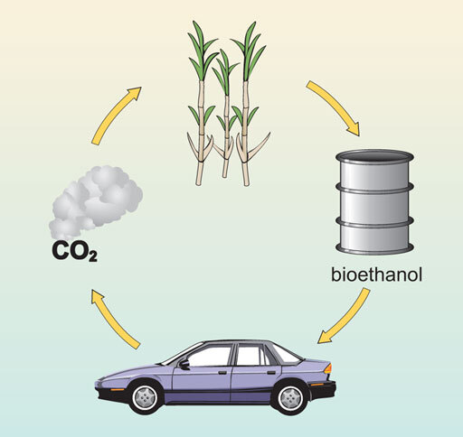
Figure 1 General principle of biofuel production.

Some biofuels can be produced from waste material, such as recycled plant oils, whilst others can be produced from plants specially grown for the purpose. Both liquid and gaseous forms of biofuels can be produced from crops that either have a high sugar content, such as sugar cane or sugar beet, or contain starch that can be converted into sugars, such as maize. Plants containing high levels of plant oils, such as oil palm or soybean, can also be used. Wood and its by-products can be converted into a variety of biofuels.
In this course you will learn about how plants are used to provide energy for use by humans.

Question 1

What are the main ways in which humans use energy?

View answer - Question 1

Question 2

Which fuels provide this energy?

View answer - Question 2

Question 3

What are the properties of a good fuel?

View answer - Question 3

Question 4

List the uses that you personally make of different fuels.

View answer - Question 4

2 Energy from plants and climate change
Plants capture carbon dioxide (CO₂) during photosynthesis and store it in their tissues in a variety of carbon compounds (including both carbohydrates and oils). These are often energy stores for the plant but they can also be harvested and processed to provide energy for human use.

Table 1 Comparison of the energy content of plant products
Energy store | Energy (megajoules per kilogram)
Plant oil | 37
Coal | 24
Carbohydrates (including sugars) | 17
Wood (dry) | 16

1 megajoule is roughly the amount of energy that a one-bar electric fire would emit in 15 minutes. (Note that if wood has not been seasoned to remove excess water, less energy is obtained because some of the energy is used to heat and evaporate the water.)

Question 5

From Table 1, which of the energy stores releases the most energy and which the least energy per kilogramme?

View answer - Question 5

At present, most of our energy comes from fossil fuels which originate from CO₂ 'locked up' in plants by photosynthesis millions of years ago. When fossil fuels are burnt, CO₂ is released into the atmosphere adding to the levels already present. Since the industrial revolution, there has been an acceleration in the burning of fossil fuels. The levels of CO₂ in the atmosphere are monitored by the Mauna Loa Observatory in Hawaii and are estimated to have risen from 280 parts per million (p.p.m.) in 1800 to 387 p.p.m. today (i.e. in 2009). The increase in CO₂ in the atmosphere has been linked to global warming (the increase, of around 0.5°C, in the average temperature of the Earth since around 1920). CO₂ is known as a 'greenhouse' gas and it acts with other greenhouses gases in the atmosphere (water vapour, ozone, nitrous oxide and methane) to insulate the Earth. Increases in these greenhouse gases increase this insulation and result in rises in the Earth's temperature. The predicted dire consequences include extreme weather conditions and melting of ice sheets and glaciers, resulting in rising sea levels and hence coastal flooding.

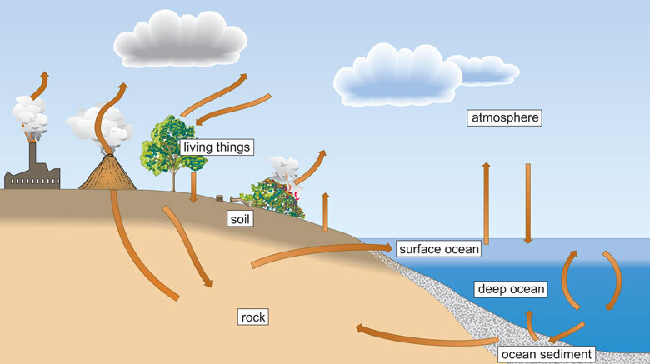
Figure 2 Simple representation of the carbon cycle. All living organisms, not just plants, have structural components that are based on carbon. The pictorial presentation of a carbon cycle illustrates how carbon moves between the reserves found in living things (plants and animals), soil (decomposing organic matter), rocks (including fossil fuels), the atmosphere and the oceans.

Question 6

In Figure 2 there is an arrow pointing from the atmosphere to the tree (living things). What carbon-containing compound do you think this arrow relates to?

View answer - Question 6

In Figure 2 there are many arrows depicting movement of carbon compounds from one place to another. For instance, when plants and animals die they may get buried in soil and eventually as more material is deposited on top of them, they are buried deep enough to be considered part of the rocks beneath our feet. Thus the carbon has been transferred from the atmosphere to the rock, via animals, plants and soil. This is exactly what happened when fossil fuels such as oil, coal and gas were formed millions of years ago.
The Kyoto Protocol from the United Nations Framework Convention on Climate Change, which came into force in 2005, legally commits countries that signed the protocol to reduce emissions of four greenhouse gases, including CO₂. One of the ways in which this could occur is by a shift away from fossil fuels to biofuels, although this view is contentious for reasons indicated shortly. Another is by the process known as carbon offsetting, whereby the amount of carbon released into the atmosphere by burning fossil fuels is balanced, for example by planting a certain number of trees to take up the equivalent amount of CO₂ by photosynthesis - so-called carbon sequestration. This has led to the currently used terms 'carbon neutral' (where the amount of CO₂ that is produced by an individual or a population is balanced by the amount of CO₂ that can be absorbed through various measures taken) and 'achieving a zero carbon footprint' (where the net amount of CO₂ released by a person, or by an object such a house, is zero).

Activity 1
20 minutes

In this activity you should listen to the nine-minute audio clip in which Professor Chris Somerville, a global leader in biofuel research, discusses the potential of biofuels, and then answer the following questions.
[You may find it helpful to listen to the clip once, then read the questions before going back to listen to the clip again, pausing where appropriate to make notes.]

Audio content is not available in this format.
Audio 1
View transcript - Audio 1

- What crops did Prof. Somerville think would have the biggest potential for acting as biofuels?
- In his view what are the biggest misconceptions about biofuels?
- What percentage of land worldwide is currently (as of 2010) used for agriculture and what percentage for biofuel production?
- What percentage of their transportation fuel do Brazilians obtain from biofuel sources?
- If the Brazilians scaled up their biofuel production, by intensifying the land used for cattle production, what percentage of the world's transportation fuels does Prof. Somerville estimate that Brazil could produce?
- What is his 'take home' message about the advantages of biofuels over fossil fuels?
- Did Prof. Somerville feel that biofuels are the single answer to the world's diminishing fuel availability, and if not, why not?

View answer - Activity 1

2.1 Photosynthesis

Box 1 Photosynthesis in plants
Photosynthesis is a complex process that involves the plant using energy from sunlight to combine carbon dioxide gas with water to make sugar. The reaction can be expressed in words as follows:
water + carbon dioxide → sugar + oxygen
The sugar is typically in the form of glucose, but it could be other kinds of sugar, or indeed sugar alcohols. The oxygen that is a by-product of the reaction is essential for all plant and animal life. Photosynthesis occurs inside chloroplasts, which are found in the leaves (and other green parts) of the plant. Chloroplasts contain molecules of chlorophyll, a green pigment that captures energy from sunlight and harnesses it to enable the sugar to be produced. Chemically, plant tissue is mostly made up of compounds containing carbon (known as organic compounds), which are made by a very complex set of chemical reactions from the sugar produced during photosynthesis. Around 44% of the dry weight (that is, weight excluding water) of a living plant is carbon, captured from the air during photosynthesis.

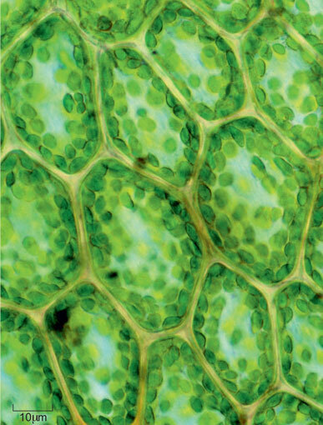
Figure 3 Cross-section through a leaf observed with a light microscope. Seven complete cells can be seen, each of which contains many round, dark green structures known as chloroplasts.

Why are plants green?
An isolated extract of chlorophyll is dark green in colour. Sunlight (white light) comprises all the colours of the rainbow. Chlorophyll absorbs much of the blue and red light that falls on it, but most of the green light is reflected and so can be detected by our eyes. This is why chlorophyll itself and the vast majority of plant leaves appear green. Interestingly, if the photosynthetic pigments absorbed all the colours of light the leaves would appear black and, as black surfaces absorb heat particularly efficiently, plants would probably overheat.

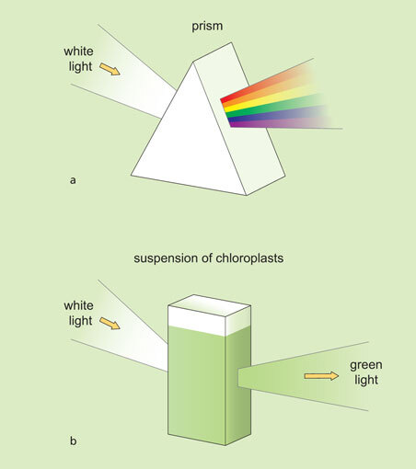
Figure 4 (a) The different colours in white light can be seen when light is shone through a prism. (b) When white light is shone through a suspension of chloroplasts, the chloroplasts absorb all the colours with the exception of the green light.

Question 7

On the basis of what you have read so far, summarise the process of photosynthesis in your own words in one or two sentences.

View answer - Question 7

Plants contain special chemicals called photosynthetic pigments that allow the plant to harvest the light energy.

Question 8

Which of these pigments have you already met?

View answer - Question 8

Only a small proportion, around 5%, of the light that falls on a leaf is actually used for photosynthesis. To understand why, Box 2 briefly explains the nature of light.

Box 2 The electromagnetic spectrum
Visible light is composed of a spectrum of colours, as in a rainbow. It is one form of electromagnetic radiation, which is defined as energy in the form of waves that have both electrical and magnetic properties. The electromagnetic spectrum is defined as a series of different forms of radiation which have different wavelengths. Figure 5 illustrates the range of the electromagnetic spectrum and the some of the different ways in which the different forms of radiation within the spectrum have been used. You can see that the range for visible light used for photosynthesis is only a very small part of the overall spectrum.

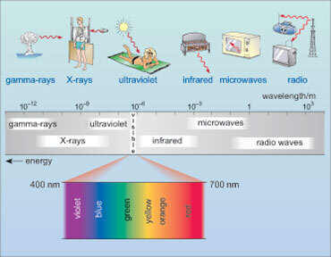
Figure 5 The electromagnetic spectrum and some of the uses the radiation.

In Figure 5, the value of the wavelength of the electromagnetic radiation is between about 10⁻¹² m and 10³ m (that is between 0.000 000 000 001 and 1000 metres).

Question 9

From Figure 5, how does the energy of the radiation vary with its wavelength?

View answer - Question 9

Question 10

Using the information in Figure 5 arrange the following colours of visible light in order of increasing energy: violet, red, orange and green.

View answer - Question 10

Question 11

From Figure 4, which colour of visible light is not absorbed by plants?

View answer - Question 11

Question 12

If you have a blue flower, which wavelengths of light are absorbed and which are reflected?

View answer - Question 12

The photosynthetic pigments in plants absorb best in certain areas of the electromagnetic spectrum - generally speaking those areas corresponding to visible light and, in particular, the blue and red portions of the visible spectrum.

2.2 The link between energy and biofuels
You may be wondering why there is this emphasis on the electromagnetic spectrum and light absorption by plants in a unit on biofuels. The sugars that the plants produce from carbon dioxide and water are a concentrated form of energy. Energy cannot be created - it can only be converted from one form to another. The energy in sugars comes from the energy in visible light - sunlight. The plant uses the sugars it produces to form other compounds within its tissues and it is these compounds that can be used as biofuels. Box 3 provides describes in more detail the process of photosynthesis.

Box 3 The reactions involved in photosynthesis

Question 13

From what you have learnt so far, where in the plants cells does photosynthesis take place?

View answer - Question 13

The absorption of light takes place within specialised membranes within the chloroplasts called the thylakoid membranes (see Figure 6). In order to pack more closely together the thylakoid membranes can form flattened stacks called grana (singular granum).
The reactions of photosynthesis take place in two phases; the absorption of light takes place in the first phase and the second phase occurs in the watery fluid, the stroma, which surrounds the thylakoid membranes. The chloroplast itself is bounded by two membranes that are situated very close together and called the chloroplast envelope (Figure 6).

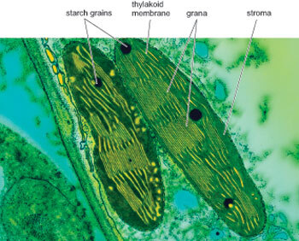
Figure 6 Cross-section of two plant chloroplasts showing the stacks of thylakoid membranes within them. Sugar produced by the chloroplast can be stored as starch grains within the chloroplast.

Photosynthesis can be summarised in the simple word equation:
water + carbon dioxide → sugar + oxygen
But this hides the fact that the process consists of two main stages: the so-called 'light reactions' and the 'light independent or dark reactions'.
In the series of very complicated light reactions the energy from sunlight is used to produce two main compounds ATP (which stands for adenosine triphosphate) and NADP.2H (a complicated chemical called nicotinamide adenine dinucleotide). (Don't worry about the names of these two compounds; they are always referred to by their initials.) ATP and NADP.2H are used to convert carbon dioxide, via a complex series of reactions, to sugars - the end point of photosynthesis; these reactions are the dark reactions which take place in the stroma.

Question 14

Why do you think the dark reactions are so called?

View answer - Question 14

Question 15

How does carbon dioxide enter the plant?

View answer - Question 15

The carbon dioxide gas moves (the scientific term for random gas movement is 'diffuses') from a stoma to a chloroplast. There, in a series of reactions that use ATP and NADP.2H, the carbon dioxide binds to a protein called Rubisco (ribulose 1, 5 bisphosphate carboxylase oxygenase) and eventually sugar is produced. Different plants will produce different kinds of sugar but most commonly it is glucose. These processes are summarised in Figure 7. The sugar can then be moved throughout the plant to wherever it is required.

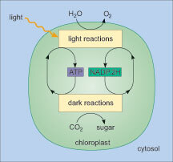
Figure 7 Outline summary of the two main stages of photosynthesis.

It is worth noting that, as photosynthesis is such a widespread process and Rubisco is so central to it, the amount of Rubisco present in plants worldwide has been estimated to be 25% of all protein globally. You shouldn't have any doubts now as to the importance of the photosynthetic process!

3 Wood as an energy source
The use of wood as fuel for cooking and heating has a long history. In developing countries, 50-90% of fuel used for such purposes comes from either wood or other plant biomass. However, wood is increasingly providing a fuel for electricity generation. The burning of wood is considered to be carbon neutral as it does not release more CO₂ into the atmosphere than if the wood were to decompose naturally, although this CO₂ is released in a very short space of time.
Woodlands can be managed sustainably to allow appropriate harvesting and replanting; this also provides some local employment and creates a pleasant and enjoyable place to visit. Woodlands also perform a useful function by temporarily storing rainwater, thereby preventing excessive water from entering streams and rivers too quickly. Wood burning also provides an outlet for wood residues from forestry activities which would otherwise end up in landfill sites. There is concern, however, that there will not be enough material to sustain increasing demand for woodfuels.
The process of producing heat and electricity from woodfuel is complex. First, the wood has to be dried, then it undergoes pyrolysis (heating in the absence of oxygen) to produce gases. The gases are then purified and burnt to generate electricity. The ash created during pyrolysis contains nutrients which potentially could provide a plant fertiliser, though it is possible the ash may contain contaminants from the soils in which the trees had originally been growing.
Potential sources of woodfuel are many and include early thinnings from commercial plantations, the residues from timber harvesting and arboricultural activities, coppicing and sawmills. In addition, wood pellets made from highly compressed waste sawdust are gaining in popularity as domestic fuels in the USA and various Scandinavian countries.
Some wood harvesting systems use the whole tree for chipping, while others utilise only the stem wood. In 'short rotation forestry', fast-growing trees are cultivated and grown until they reach what is considered an economically optimum size; the time this takes varies depending on the tree species. The trees are then either harvested or coppiced. Harvesting involves completely cutting down the trees, possibly removing the roots, and then replanting with saplings. In coppicing, the young stems are cut back to encourage a number of new stems to grow from the 'coppice stool'. This can help increase levels of carbon dioxide uptake (carbon sequestration) as the coppice stool re-grows.

Box 4 Short rotation coppice: willow and poplar
Willow (Salix species) and poplar (Populus species) are fast-growing trees, and because they can be densely planted, they give a high yield of wood in a relatively small area. Stems can be coppiced every three to five years and the coppice stools remain productive (produce new stems) for up to 30 years before the root stocks need to be replenished. There is much research interest in short rotation coppicing and the collaborative 'Biomass for Energy Genetic Improvement Network (BEGIN)' have undertaken a number of trials to find varieties and cultivars of willow and poplar species that offer high stem yields, increased growth rates, increased pest and disease resistance and high energy output when burnt.
Establishing willow or poplar plantations has other benefits, such as creating a method of diversification for agricultural land use, increasing biodiversity and providing shelter or screens both for wildlife and against pollution. Willow, in particular, is very good at taking pollutants, including excess nitrate from fertilisers, out of the soil (a process known as phyto-remediation) but this can lead to a high risk of contaminants in the wood.

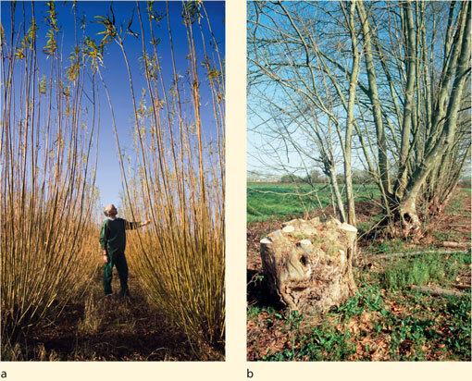
Figure 8 (a) A farmer inspects his plantation of fast-growing willow (Salix). (b) A newly coppiced oriental plane tree (Platanus orientalis).

The reason why coppicing works is explained in Box 5.

Box 5 Coppicing
The growth of plants is regulated by various chemical compounds that the plant produces naturally. One such group of compounds are the auxins (plant growth regulators, sometimes called plant hormones). You may have come across 'auxins' as they form the active ingredient in hormone rooting powders that gardeners use to speed up the rate of root production when they have taken cuttings. Auxins are normally produced in the very tip of the shoot and one of their main effects is to prevent side shoots from growing so that all the growth effort of the plant is focused in one main shoot. If the main shoot is damaged or cut off, the source of auxin production is removed so side shoots will then grow. This is exactly what happens when a tree is coppiced, the main shoot (the trunk) is cut off and side shoots (new branches) form. The coppiced stems tend to grow long and straight, mainly because coppiced trees are planted in dense groups or stands (see Figure 8a), and the coppiced side shoots will grow straight up to try and reach the light.

Question 16

If you were planting a species of tree for use as coppice, what characteristics would you be looking for in the tree species you use?

View answer - Question 16

4 Grasses as an energy source
There is increasing interest in using grasses as a biofuel source. Grasses grow quickly, produce a large amount of biomass per unit growing area and leave only small amounts of residue when they are burned. Typically, grasses are burned to produce heat and steam to power turbines in conventional power plants. The largest power station in the UK, Drax, currently burns 300,000 tonnes of Miscanthus x giganteus annually, alongside its usual coal supplies. Another advantage of using grasses is that many of them multiply by underground rhizomes, which means they spread quickly and generate new shoots easily. However, this can also make them invasive and difficult to control and eradicate, so they are considered by some to be weeds.

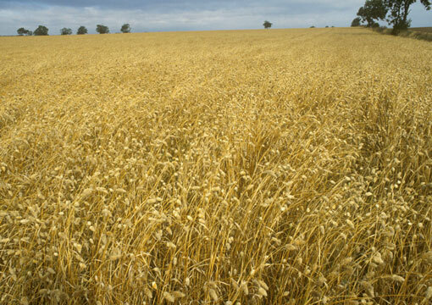
Figure 9 Canary grass (Phalaris canariensis) originated in the Mediterranean region but has been cultivated and grown in the Middle East, Europe and parts of Argentina. It was formerly cultivated primarily for the production of bird seed but is now being considered as a biofuel due to its high yields and ability to thrive in temperate regions. Breeding programmes have selected varieties which have a particularly high carbon content in their cell walls, giving a potentially greater energy output when burned.

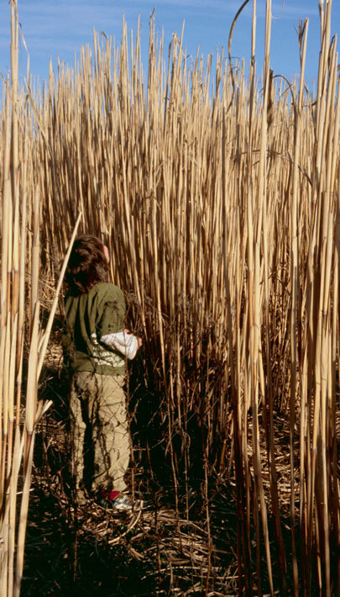
Figure 10 Miscanthus x giganteus is a large perennial grass that can grow to a height of over four metres. It is grown in the UK and elsewhere in Europe and for several years there has been intense research into its potential as a biomass crop. It reproduces by underground stems (rhizomes) and is considered to be an environmentally friendly crop due to its large root system, which captures nutrients, and its stems, which provide wildlife cover.

There has been interest in using mixtures of a number of plant species, including grasses, together to produce biofuel. These mixtures allow the maximum interception of light as the different plants grow at different rates. They are considered to be carbon neutral as they are perennials, which do not require re-sowing each year, and, most importantly, they can be sown on degraded agricultural land so food production is not jeopardised.

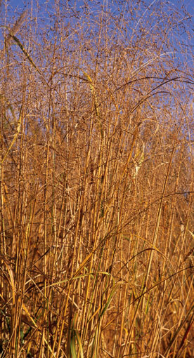
Figure 11 Switch grass (Panicum virgatum) is a dominant species of the tallgrass prairies in North America and is commonly used as an ornamental grass in gardens. It thrives in harsh conditions, needing only poor soil with a low nutrient content, and undergoes rapid growth. These characteristics make it a strong candidate for biomass production.

Question 17

Summarise why grasses are particularly suitable for biofuel.

View answer - Question 17

Grasses which grow year on year are called perennials. Harvesting of perennial grasses for biofuel can take place anytime from late November to April. The moisture content of the leaves is highest in November meaning that the grass cannot be baled and needs to be chopped into smaller pieces which dry more easily. As time passes from November to April the grass loses leaves, thus reducing the harvestable biomass, but harvesting in April means it can be baled which costs less than chopping the grass up during harvest. Many burners used to generate heat or electricity from wood fuel can also combust bales of grass or straw. Various studies have revealed that it becomes uneconomic to transport grasses for burning as biofuels more than about 80 kilometres.

5 Transport biofuels: biodiesel and bioethanol
Biodiesel is an alternative fuel to diesel, and bioethanol can be used in place of petrol. Biodiesel cannot be used on its own in traditional internal combustion engines but can be blended with traditional petroleum fuel. Bioethanol can be used on its own or in a blend. Overall, biofuels make up 5% of the petroleum blend in the UK. The UK Government set a target that 5% of road transport fuel should be from renewable (non-fossil fuel) sources by 2010.

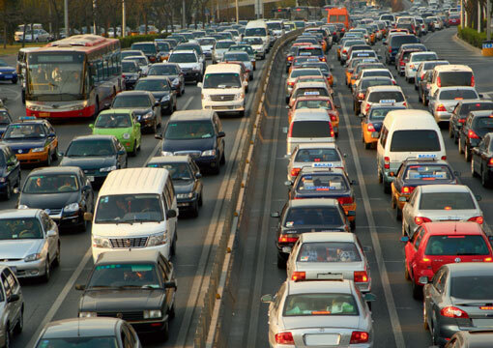
Figure 12 Due to increasing demand for transport fuel, alternatives to petrol and diesel are under scrutiny.

Biodiesel is produced from oil-seed crops, such as oilseed rape, sunflower oil, palm oil and soybean oil. Oilseed rape is the main oil crop in the UK and yields approximately 1300 litres of biodiesel per hectare planted. The fuel is synthesised from the oil seeds by mixing them with two industrially sourced chemicals, methanol and either sodium hydroxide or potassium hydroxide. This reaction causes the formation of fatty acids and glycerol, with the fatty acids reacting further to produce biodiesel. Most biodiesel production is currently in Europe, but it is not limited to the developed world. Tanzania, for example, has started producing biodiesel from the nuts of the croton tree (Croton megalocarpus), a plant native to Africa. Several countries, notably India, are using biodiesel obtained from Jatropha curcas oil as a fuel; indeed the trains that run between Mumbai and Delhi now use diesel that contains 15% biodiesel obtained from Jatropha. This plant has several advantages as a source of biofuel: it can tolerate drought conditions, and it grows on poor land that is unsuitable for agriculture and so does not compete with food production.

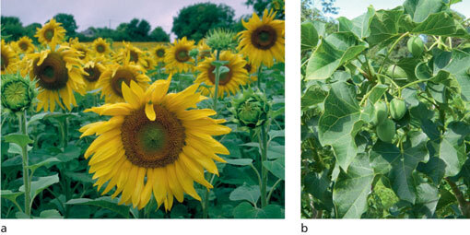
Figure 13 (a) Sunflowers are just one oil crop that is being investigated as a potential biofuel. (b) Tropical plant species, such as Jatropha curcas, could also be a potential source.

Germany used significant quantities of bioethanol as a biofuel during the Second World War, but recently interest in this fuel source has spread. Currently, countries using bioethanol include Brazil, France, the USA, the UK, Argentina and South Africa. In Brazil use has been particularly widespread; however, this has been at the expense of large tracts of natural vegetation including rainforests. It is estimated that one-third of cars in Brazil run entirely on bioethanol and the remaining two-thirds use a mixture of bioethanol and petrol (gasoline). Bioethanol is produced by fermenting plant sugars, or it can be made by taking starch-rich plant material, treating it to convert the starch to sugars, and then fermenting them. A third, less productive, method is to take stems or leaves and convert the tough cellulose from cell walls into sugars for fermentation; but this requires additional steps, including treating the plant material with sulphuric acid and heating to convert the cellulose into sugars, or using enzymes to do this. Both sulphuric acid and the necessary enzymes have to be produced by industrial means and this incurs an extra cost.

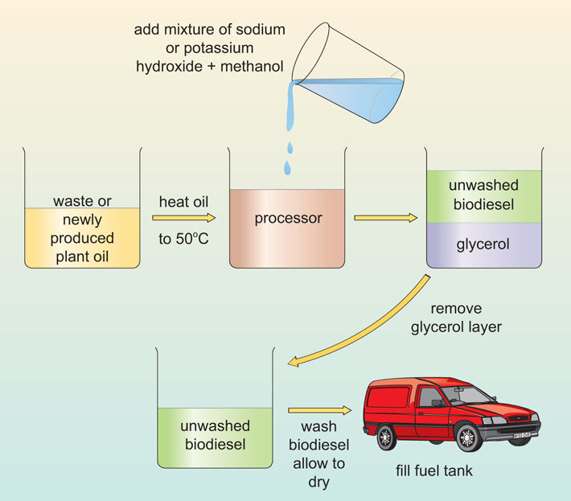
Figure 14 The production of biodiesel from waste cooking oil or newly produced plant oil is increasingly gaining favour in the developed world. However, the amounts produced are currently very small compared with conventional petroleum.

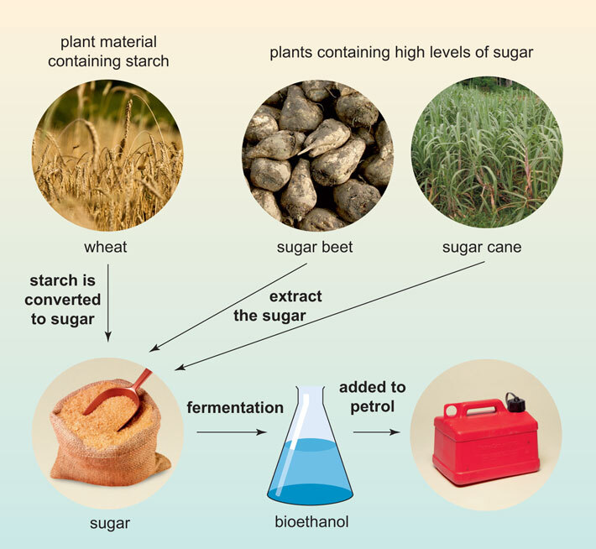
Figure 15 The steps involved in the production of bioethanol.

Question 18

List some of the crops used for biodiesel production.

View answer - Question 18

Question 19

Figure 14 shows the stages involved in making biodiesel, summarise these stages in your own words.

View answer - Question 19

Question 20

In Figure 15, there is a step labelled fermentation, what is the product of this step?

View answer - Question 20

Bioethanol is currently produced by the fermentation of sugar by microbes. Microbes use the sugar as a food source and convert it to ethanol. In order for the ethanol to be used as fuel it needs to be separated from the other components of the fermentation reaction, usually by the process of distillation. Typically the mixture is heated and, as the ethanol boils at a lower temperature than the other components, it is transformed into a gas first and this gas can be collected and then condensed (transformed back to liquid bioethanol). The purified and bioethanol can be mixed with petrol for use in car engines.

6 Biogas
Biogas is mainly a mixture of methane and carbon dioxide produced through the breakdown of organic materials by micro-organisms in the absence of oxygen (that is, under anaerobic conditions). Organic materials can include municipal waste, food and animal waste, sewage, and biomass crops such as switch grass and Miscanthus. Biogas produced in sewage treatment works can be used to generate the electricity to power the works.

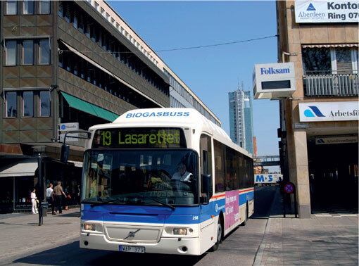
Figure 16 A public bus running on biogas, in Vasteras city centre, Sweden.

Production of biogas from food waste reduces the amount of this waste that reaches increasingly scarce landfill sites; once the gas has been produced any remaining residue can be used as agricultural fertiliser. Biogas also enables a country to produce its own fuel, rather than being dependent on foreign imports. Sweden is currently the world leader in the use of biogas, having the world's first biogas-powered train which runs the 100 kilometre route from Linkoeping to Vaestervik. Although it is powered by biogas produced from animal waste, there is no reason why in the future such transport could not be powered by biogas produced from plant sources. Buses and rubbish trucks in several Swedish towns also run on biogas.

Question 21

Which of the three biofuels mentioned - biodiesel, bioethanol and biogas - requires the least processing in order to produce it?

View answer - Question 21

7 Biofuels: some of the issues
There are many issues to be considered and weighed up regarding the use of biofuels. The following points will help you to consider further the various implications of using trees, food crops and grasses as fuels.

How does the cost of biofuels compare with that of conventional fuels?
At present, the cost of producing biodiesel and bioethanol is approximately double that for conventional fossil fuels. The UK offers tax incentives to encourage fuel producers to make biofuel and there is also an incentive for consumers: the duty on petrol with 5% biofuel is, at the time of writing (2009), 20 p/litre less than that on ultra-low sulphur petrol.
A recent review has shown that biofuel production is a high-cost process overall; only the production of bioethanol from sugar cane was considered to be cost-effective. If, however, the price of crude oil rises then biofuels may start to become more competitive, although this would depend on fertiliser, and hence biofuel feedstock, prices remaining stable.

Does growing crops for fuel create higher food prices?
One point of view is that using land to grow crops for fuel rather than for food has led to increased food prices, which in turn impacts most on those in developing countries who have to spend a relatively large proportion of their income on food. In 2007, the United Nations Food and Agriculture Organisation (FAO) and the International Food Policy Research Institute (IFPRI) both released reports suggesting that rising food prices were due to theconversion of agricultural land from food to biofuel crops. Subsidies for the biofuel industry, quoted to be in the region of £5.6-6.1 billion per year (FAO), are believed to incentivise farmers to grow biofuel rather than food crops. However, those supporting biofuels hold the view that better production methods, which will use parts of the plant currently wasted in biofuel production, may be able to increase the efficiency of biofuel production.

Does growing biofuel crops result in more fertiliser and pesticide input?
The amount of fertiliser and pesticide input depends on the crop species grown; one criterion for a suitable biomass crop is that it has a low requirement for nutrients. Switch grass, for example, grows well in poor soil conditions and requires around two-thirds less fertiliser input than a food crop such as maize.

Is there a potential loss of biodiversity?
In some cases, the use of biofuels could increase biodiversity (the number of different species found within a given area), for example, by harvesting woodfuel and then replanting with mixed woodlands. Conversely, the increased use of soybeans for biofuel in the USA has caused soybean production to be increased in South America at the expense of Amazonian rainforest, which has been cut down to give more agricultural land. This has the potential to reduce biodiversity. Also, trees in rainforests help absorb CO₂ (albeit not at the rate of newly planted forests) and so are believed to play a part in offsetting global warming.

Is the energy output greater than the energy input?
The overall energy balance, that is the net energy output compared to the input needed, is dependent on both the species of biomass crop and the type of biofuel being produced. The inputs to a biofuel crop include both the direct costs of growing, such as fertiliser, cultivation, harvest and labour, and the indirect costs, such as storage of the harvested crops. Processing inputs include pre-treatments, processing for energy release and the removal or reuse of residual waste. Ideal crops are being investigated that require low maintenance, need only low nutrients, grow quickly and can tolerate poor soil conditions. Switch grass is one such plant, and interestingly it has been shown that it is only energy efficient if it is used as a pelleted biomass for fuel rather than for bioethanol production.

Do biofuels reduce carbon emissions?
Burning biofuels does release CO₂, but this is CO₂ that has been removed from the atmosphere relatively recently, unlike the carbon in fossil fuels which has been removed from the atmosphere for many millions of years. Hence, biomass energy crops are deemed carbon neutral. However, some argue that nitrous oxide, which is 240 times more powerful as a greenhouse gas than CO₂, is produced in greater quantities during the production of biogas than during the burning of fossil fuels. Also, biofuel production generates CO₂ through the use of agricultural and haulage vehicles for growing and transporting the crop.

Question 22

At the start of this course you were introduced to the terms 'carbon offsetting' and 'carbon neutral'. Now that you have finished reading the course, explain in your own words the difference between the terms 'carbon offsetting' and 'carbon neutral' in the context of biofuels.

View answer - Question 22

Activity 2
45 minutes

Task 1

In this activity you will listen to the audio slidecast in which Dr Angela Karp from Rothamsted Research discusses some of the issues relating to the use of biofuels in the UK.
Dr Angela Karp works at Rothamsted Research International, the largest horticultural research establishment in the UK. Her research group is particularly interested in looking at those plants species that grow well in the UK but which are not used as agricultural crops. They are investigating the ways of optimising how such crops can be utilised for use as liquid biofuels. Listen to the slidecast and then answer the following questions.
(You may find it helpful to listen all the way through once, then read the questions before going back to listen again, pausing where appropriate to make notes.)

Video content is not available in this format.
Video 1
View transcript - Video 1

Question 1

- What type of research is Angela Karp's group doing?
- What are the main difficulties in using woody crops as biofuels?
- Which polymers within the cell wall contain the sugars? What other component of the cell wall makes it particularly difficult to access the sugar-containing polymers?

View answer - Question 1

Conclusion
Biofuels can be used for heating, lighting, power and transport.
Photosynthesis occurs in the chloroplasts of cells and the process consists of two stages: light and dark reactions.
There are a number of biological products that can be used as biofuels, including wood, grasses, oils, sugars and starches.
Wood and grasses are good biofuels because they grow relatively quickly.
Biodiesel is produced from oil crops, bioethanol is produced from crops with a high sugar content and biogas is produced from the breakdown of organic matter.

Acknowledgements
Course image: Steven Severinghaus in Flickr made available under Creative Commons Attribution-NonCommercial-ShareAlike 2.0 Licence.
Grateful acknowledgement is made to the following sources for permission to reproduce material in this course.
Parts of this text come from Chapter 4 of Why People Need Plants: © 2010 The Board of Trustees of the Royal Botanic Gardens, Kew and The Open University.
Fig. 8a © James King-Holmes/Science Photo Library.
Fig. 8b © Brian Gadsby/Science Photo Library.
Fig. 9 © Dr Rob Stepney/Science Photo Library.
Fig. 10 © Nigel Cattlin/Alamy.
Fig. 11© Andrew Lawson/www.garden-collection.com.
Fig. 12 © Zhang Liwei/Dreamstime.com.
Fig. 13 © Andrew McRobb / RBG Kew.
Fig. 15 (wheat) © George Mastoridis/Dreamstime.com.
Fig. 15 (sugar beet) © Wessel Cirkel/Dreamstime.com.
Fig. 15 (sugar cane) © Andrew McRobb/RBG Kew.
Fig. 15 (sugar) © foodfolio/Alamy.
Fig. 17 © Howard Davies/Alamy.
Every effort has been made to contact the copyright holders. If any have been inadvertently overlooked the publishers will be pleased to make the necessary arrangements at the first opportunity.
Don't miss out:
If reading this text has inspired you to learn more, you may be interested in joining the millions of people who discover our free learning resources and qualifications by visiting The Open University - www.open.edu/openlearn/free-courses

Solutions

Question 1

Answer
Energy is needed for heat, light, power and transport.
Back to - Question 1

Question 2

Answer
Coal, oil, gas, petrol, diesel, wood, peat and uranium (for nuclear power); other than uranium, all these fuels are derived directly or indirectly from plants.
Back to - Question 2

Question 3

Answer
First and foremost it should be capable of providing lots of energy and be relatively cheap. Factors which affect the cost of the fuel include: the ease of transport, for instance it is much easier to transport liquids (petrol, oil and diesel) and gases (natural gas) than it is solids (such as coal); the ease of extraction and the processing costs.
Back to - Question 3

Question 4

Answer
You may use petrol or diesel to power a car, natural gas or electricity to cook with or to heat your home, wood burnt in an open fire and electricity for lighting. The chances are that the electricity you use was generated by burning coal or from nuclear power.
Back to - Question 4

Question 5

Answer
Most: Plant oil (37 megajoules per kilogram)
Least: Wood (dry) (16 megajoules per kilogram)
Back to - Question 5

Question 6

Answer
The compound is gaseous carbon dioxide and it is used by the tree for photosynthesis.
Back to - Question 6

Activity 1

Answer
- Perennial crops such as Miscanthus or switchgrass which can produce a large amount of biomass but in a sustainable way. He also has an interest in agave species that are very water efficient, can produce large amounts of sugar and can be grown on land that is too dry for agricultural crops.
- The biggest misconceptions are:
  - The net energy return (amount of energy required to grow and process the crop) is greater than the energy that is returned when the fuel is burned.
  - Growing some biofuels might actually increase the net amount or carbon dioxide (a greenhouse gas) being released to the environment whilst growing other biofuels might help reduce the amount.
  - Also the amount of land that is available and which might be used for growing biofuel crops could threaten food production (which Professor Somerville thinks is entirely wrong).
- About 12% for agricultural use and a tiny (fraction) percentage '0.00 something' % for biofuels.
- About 40%.
- About one third of the transportation fuel (33%).
- They are sustainable and they can have a net positive greenhouse gas effect (take in more carbon dioxide gas than is released when they are burned).
- No. He felt that the world could perhaps get 30% of their transportation fuel through biofuels. However, he felt that a number of other renewable energy sources needed to be used alongside biofuels.
If you are interested in how Professor Somerville became interested in plants and what he does now, you can listen to another (four-minute) audio clip.

Audio content is not available in this format.
Audio 2
View transcript - Audio 2

Back to - Activity 1

Question 7

Answer
Photosynthesis is the process by which plants {and also algae and some bacteria} are able to use light energy (from the Sun) to convert carbon dioxide into sugar (carbohydrate) which can then be stored as starch in the plant. The reactions take place within the green parts of the plant, mainly the leaves, which use cells containing chloroplasts.
Back to - Question 7

Question 8

Answer
Chlorophyll, the green pigment in chloroplasts.
Back to - Question 8

Question 9

Answer
The radiation with the shortest wavelength has the highest energy. Gamma-rays (wavelength 10⁻¹² m) are very high energy while radio waves (wavelength 1-10³ m) are very low energy.
Back to - Question 9

Question 10

Answer
The colour with the lowest energy is red, then orange, then green and finally violet.
Back to - Question 10

Question 11

Answer
Green light is not absorbed but is reflected, which, as you may remember, is the reason that we can see it and why plants look green.
Back to - Question 11

Question 12

Answer
In order to appear blue, blue light must be reflected and not absorbed - and the other colours of the spectrum including orange, yellow, green and red must be absorbed
Back to - Question 12

Question 13

Answer
In the chloroplasts.
Back to - Question 13

Question 14

Answer
Because the plant does not need the presence of light for these reactions to occur, hence their alternative name - light independent reactions.
Back to - Question 14

Question 15

Answer
Through small pores called stomata on the leaf surfaces.
Back to - Question 15

Question 16

Answer
You would want the trees to be fast growing, capable of growing well when planted closely together and to require little in the way of fertiliser application (which would keep costs down).
Back to - Question 16

Question 17

Answer
Grasses grow quickly, they can produce a large amount of biomass in the area in which they are grown and when they are burnt they leave behind relatively small amounts of ash. They are also perennials that spread easily and can grow on poor soil.
Back to - Question 17

Question 18

Answer
Oilseed rape, sunflower, palms, soybean, croton tree nuts and Jatropha curcas.
Back to - Question 18

Question 19

Answer
Oil is extracted from the crops and heated to 50 °C in a processor before being mixed with sodium or potassium hydroxide and methanol. The oil is allowed to separate into unwashed biodiesel and glycerol and the glycerol layer is then removed. The biodiesel is washed with water and allowed to dry. The washed biodiesel is stored until it is used.
Back to - Question 19

Question 20

Answer
The product is bioethanol.
Back to - Question 20

Question 21

Answer
Biogas requires very little processing, whereas the production of both biodiesel and bioethanol requires several processing steps each of which incurs a financial cost.
Back to - Question 21

Question 22

Answer
When biofuels are grown they take up a certain amount of carbon dioxide from the atmosphere and convert it into stored carbon compounds. When the biofuel is later burnt the carbon in these compounds is converted back into carbon dioxide which is released back into the atmosphere. The amount of carbon dioxide released during combustion is the same as that absorbed during plant growth so on the timescale of years biofuels do not change the amount of carbon dioxide in the atmosphere and so are said to be 'carbon neutral'.
The burning of fossil fuels releases into the atmosphere CO₂ that was taken up by plants millions of years ago so increases the total amount of CO₂ in the atmosphere. It is possible to calculate the number of new trees that would have to be planted to take up the equivalent amount of CO₂ by photosynthesis. Funding the planting of these trees is said to 'offset' the amount of carbon that has been burnt by the use of fossil fuels. For example, when purchasing an airline ticket in 2010, it is possible to offset the carbon cost of the flight by paying for some trees to be planted.
Back to - Question 22

Activity 2

Question 1

Answer
- It is investigating woody crops (i.e. non-food crops) to see what their potential is for using as liquid transport biofuels. She is particularly interested in using different types of willow trees and researching how they use the sugar from photosynthesis to produce cell walls.
- The sugars contained within woody crops are locked away as components of the plant cell wall and this can make them difficult to access and to liberate.
- Both cellulose and hemicellulose (which is another type of cellulose) are polymers containing sugars (these sugars are composed of glucose monomers. Lignin is the polymer that made it difficult to access the sugar-containing polymers.
If you would like to know how Angela Karp became interested in plants, you can listen to another short audio clip.

Audio content is not available in this format.
Audio 3
View transcript - Audio 3

Back to - Question 1

Audio 1

Transcript
Interviewer
So in terms of say the basic person on the street that was coming into science with sort of very limited knowledge, how would you define what a biofuel is?
Chris Somerville
Well of course the term generally refers to two types of material. The most common type is woody biomass or woody materials that are generally just burned directly for heat. And the other type are gases or liquids such as biogas or ethanol, biodiesel that are made from biomaterials. So actually I think it's one of the difficulties of discussing the area, is that there's many types of biofuels and there's many different ways to produce them so there's a vigorous public discourse about biofuels but actually much of it is not very correct in some way because it - the discourse - tries to treat it as though it's a single subject but actually there's many different subjects. For example, there's many ways to produce ethanol. Some are environmentally positive. Some may be environmentally negative. And so inevitably in these discussions what happens is one side of the argument picks one scenario and the other side picks another scenario and they end up talking past each other.
I
That's an interesting point and one of the questions we've got down is what is the biggest misconception about biofuel production or usage?
CS
The kinds of issues that are, I think, there's a lot of misunderstanding about is like the net energy return. Some types of biofuels, I think, don't have a positive net energy return, that is the amount of energy it takes to grow and process the material to a fuel. But certainly other types of biofuels look to us like they're very net energy positive. And so similarly the same things are true for greenhouse gas emissions. I think there are some types of so-called biofuels that could be very negative for greenhouse gas emissions. Partially through kind of indirect effects, that is, if you grow biofuels on a drained swamp in Malaysia that's gonna be very negative because as soon as you drain a swamp the greenhouse gas emissions out of that swamp will dwarf the rate at which the plants that you plant can possibly take up the CO₂ for a century or more. And I think there is also a sense that there is not enough land for food production which is really strongly wrong. There is a tremendous amount of land. We use 12% of the land worldwide roughly for food production.
I
And what percentage do we currently use for biofuels?
CS
Oh it's a tiny fraction. It doesn't show up. It's like point zero zero something per cent.
I
So I guess there is a lot of scope to increase significantly if people think that's a reasonable thing to do?
CS
Yeah. Let me give you an example where I think the public discourse is not very clear on the matter. So in Brazil the Brazilians now get about 40% of their transportation fuels by fermenting sugars from sugar cane. And the amount of acreage required to do that is about four million hectares. Now that may seem like a lot if you're living in Great Britain but to put it in perspective there's 234 million hectares used to grow cattle, with about 1.4 cows per hectare, so way below the carrying capacity of the land. So the Brazilian government has calculated that with the small intensification of the cattle they could free up 57 million hectares for sugar cane production. So from the 4 that's currently used for fuels, there's 4 for food as well, so 4 for food, 4 for fuel. If they expanded it to 57 million hectares and used both the cellulosic material as well as the sugar, our estimate is that could produce almost a third of the fuel in the world - transportation fuel. So that's just in one country. So when we look at how much is possible worldwide, it certainly seems to us like quite a large amount. Around the world there is a billion acres that's been abandoned to agriculture and this is all land that at one time did grow crops.
I
And I guess that there is always an argument that some of the land that is being used for biofuel could be used for food production.
CS
Yes and that's certainly true but of course you must be aware that in the last two generations the major problem in food production has been over production in the developed world so we pay farmers mostly not to produce. The numbers for the subsidies in Europe and North America to keep farming out of production, I believe it's more than 100 billion dollars a year. And in Africa the average crop yield is about one-third of what it does in the developed world? Because of lack of investment we live in a world economy now where I think we are going to have to use the regions of the world that do have abundant land to provide the food and fuel.
I
What crops in your view have the greatest potential for acting as biofuels?
CS
We are particularly interested in perennial species that can be used to produce large amounts of total biomass in a sustainable way with net energy and greenhouse gas benefits. So the best species because of their high water use efficiency are types of grasses like miscanthus and switchgrass, so we are certainly investing in those. But we're also very interested in even more water efficient plants types of species called agaves - they're a kind of cactus like material - some agaves have higher sugar content than sugar cane. There's many species. So in Africa Agave sisalana has been grown on millions of hectares to produce sisal which is used for rope. Some of these species have ten times the water use efficiency of a plant like wheat or rice meaning that for one unit of water input they can produce ten times more dry biomass than a plant like wheat or rice and they're very, very drought hardy so we're interested in those for the semi-arid areas. There's a couple of billion acres worldwide that are too arid for agriculture but might be quite suitable for these kinds of highly water efficient, drought hardy species.
I
What is the biggest take home message about the potential benefits of biofuels compared to use of fossil fuels?
CS
Oh well obviously they are sustainable and if done right they can have a net positive greenhouse gas effect, I think. We can dramatically reduce the amount of greenhouse gas emissions associated with producing fuels by doing it right. You know if you track the discoveries of new oilfields they're relatively infrequent since there's been any major find and there's every reason to believe that it will eventually run out. It's probably in the case of oil and gas in the 50-60 year time frame. Let me give you a number that's easy to understand to see what the challenge is. World energy use is currently expanding by about one billion watts, or so-called gigawatt, every 1.6 days. That's so you know I guess everybody knows what a watt is from a light bulb so think about a 100 watt light bulb well a billion watts is the size of a large nuclear power plant. One way of thinking about it is that energy use is expanding worldwide by about the output of one nuclear power plant every 1.6 days. So as an American - a profligate energy user, you know the United States uses 25% of world energy - my view is we need to get our country in order first. We've got to get a grip on our own energy production. We've got to clean it up and get energy efficient and then hopefully some of the technologies that we develop to accomplish that, they'll become available to other countries and hopefully those countries will feel the same imperative eventually to become energy efficient and put in place all the renewable systems.
I
So if I had to put you on the spot and give you a statement and just to see whether you would go along with it, so would you say that the future was and if not what is it?
CS
Oh no. I don't believe in a single future. I think can make a component, you know. I believe we could get 30% of our transportation fuels from biomass so it maybe in 25 years roughly 6% of our energy use might come from. Long run we will probably see some improvements in solar technologies maybe solar thermal maybe some improvements in photovoltaic manufacturing and hopefully some big improvements in photoelectric chemistry. But they are pretty far away. I hope we will see more geothermal, wind of course is ready and I think we need to see a lot of wind. One of the challenges will be to also develop better storage so I hope we will see some battery improvements that would allow us to you know store energy better.
I
So I'm picking up that biofuels is part of the answer and the answer itself is quite complicated and it's a whole combination of different things working together?
CS
Yes it's a combination of things. We need to use every - every renewable technology we possibly can to make change. Many students ask me how they can work on bioenergy. And while it's certainly possible there's many ways to work on plants in that context, I actually think it's important to remember that ultimately the land that we need to produce biofuels, you know, there's a finite supply and everything we can possibly do to improve agriculture will contribute ultimately to as well as the larger context of human well being. We need many other things besides energy. We need materials and fibres and fuels and feed and so I would say almost anything that anybody can do to improve plant productivity in a sustainable paradigm will contribute ultimately to the - the energy climate matter.
Back to - Audio 1

Audio 2

Transcript
Interviewer
Can you recall what your first memories of plants were and why you became interested in plants?
Chris Somerville
Yes well I grew up in a farming community in Northern Canada where my father is a veterinarian so I spent a lot of time on farms and I worked on farms during the school holidays and then when I went to university I worked in the forest service for five years, actually while I was an undergraduate, fighting fires.
I
So what did you do when you did your first degree - what subject was that in?
CS
Well I started in physics because I was curious about the basis of many physical phenomena but I switched to mathematics in my first year because I was intrigued by the power of mathematics to provide formulae that provide concise representations of principles. And then after my maths degree I was recruited by a professor in genetics to work on a research project involving human population dynamics.
I
Was that the point at which you first started working on plants then?
CS
No after getting several courses in chemistry and biology I became intrigued by bacterial molecular genetics so I did my PhD in the molecular genetics of bacteria. In the course of that I then married a plant breeder who had really introduced me to the issues in plants and she was very concerned and conveyed that to me that the world was unsustainable. So we sort of formulated the idea that we should collaborate and try and bring modern molecular methods to agriculture.
I
That's excellent. One of the first areas you worked on was photosynthesis and that plays a key role in terms of biofuels and I think it would be helpful if you could just say what your current job is and what does that actually entail.
CS
Yes, well most of my career I've been interested in how plants build their bodies and the bodies of plants are made mostly of polysaccharides and lipids and lignins - the three main components and my group works on identifying the enzymes that make these major components and understanding how they're regulated. But a few years ago I realised that my knowledge of how plants build their bodies could be useful in sort of examining the possibility of developing a large-scale biofuels industry. So about 5 years ago I sort of turned my research towards understanding the biofuels option and that really led to an engagement with a new community for me that is the community that's trying to address renewable energy issues and I moved to Berkeley a few years ago so we had people working on photovoltaic's and wind and photoelectric chemistry and biofuels and renewable energies - everything all wrapped into a big programme and so we now have I estimated about 1000 scientists altogether working on those topics here. Anyway we eventually needed money to support our research and we were able to attract several large grants, one from the energy company BP and one from the US Department of Energy that allowed us to fund several large centres here that work on these topics. And now I lead one of those centres, that's funded by BP with a focus on what we call energy biosciences, that is the application of modern biological sciences to the energy sector. So we are trying examine where the opportunities are to do that. And biofuels - cellulosic biofuels are one of those areas but we are looking for other topics as well.
I
So I guess in terms of having 1000 people working within the area of plant science, that's a massive group of people working on related projects.
CS
Actually they are not all working on plant science so in my institute, which is about 300 of the 1000, while we have economists, ecologists, environmental scientists, mechanical engineers, chemical engineers, chemists, biochemists, agronomists, meteorologists. These topics are very multidimensional. Cellulosic biofuels in particular is very multidimensional because it involves the intersection of chemical engineering and chemistry on the production side you may say with the environment and in land use and the impact on the environment. So we're trying to take a whole system approach to understanding the issues.
Back to - Audio 2

Video 1

Transcript
Interviewer
We are at Rothamsted which is an agricultural research station located just north of London and today we are going to be visiting Dr Angela Karp who is the Director of the Centre for bioenergy and climate change and she is a UK expert on the use of biofuels.
So Angela the work that your group now undertakes here at Rothamsted - can you just outline what that involves and the kind of areas that you're looking at.
Angela Karp
Yes. So what our group essentially is trying to do is to look at how we can use woody crops, non-food crops, foods that aren't used for normal agriculture products, to go into the liquid transport industry.
I
You can create biofuels from food crops and in some ways it's an easier step in terms of just fermenting the sugars to produce ethanol. But there is obviously a problem with doing that isn't there?
AK
Yeah that's right. These woody plants don't store their sugars in an easy form. They don't store them in the starch or sugar. It's locked up in the cell wall. It's a structural component.
I
And a cell wall is a very complicated material isn't it? People say just cell wall - it sounds like a brick wall - something very simple. But it's much more complicated than that.
AK
Imagine more, if you like, a fence made of wire netting except you don't have one wire, you have five or six different types of wire, all interlaced. And those wires are locked together. So some of them you can't tease apart from one another very easily because they are locked together by careful bonding.
I
And the whole idea is to give the plant strength so that it's able to remain upright.
AK
Strength and resistance. The cell wall is actually a very clever structure. But for us it's difficult because it means that we have a complex series of fibres which are all kind of interlaced and locked together. And in order to get the one fibre we want, we have to be able to unlock them and then release just those fibres out of the cell wall. Hence the sugars. And the sugars are in what's called a cellulose or hemicellulose component of the cell wall. And the other components are the lignin I talked about before. Very high calorific value.
I
That means it's got lots of energy.
AK
Lots of energy. So lignin as a polymer is higher than coal and that's the reason why you can burn these. But for us the lignin is a problem because it's the polymer which gets in the way of getting the sugars. So a lot of the research which is going on is how we can break down the cell wall in a way that releases the sugars and allows us to make the fuel.
So we are starting to screen through the willows and asking, you know, if put through a test where you try to make sugars out of willow, can we identify some which are better at doing that than others. We are also beginning to understand where does the plant put its sugars. It creates sugar by photosynthesis and can we understand how it makes the cell wall from those sugars. Can we try to select plants which make the cell wall in a way that's more easy to break down. So it's still resistant, it still keeps off water but it's easier for us to break it down.
Back to - Video 1

Audio 3

Transcript
Interviewer
So Angela, could you recall your first memory of plants and how you became interested in them?
Angela Karp
Well interestingly I did do plants at school but I didn't go to do plants at university. I went to do work on animals because I've always been very interested in animals. But in my first year of university, for the first time I really understood genetics. I just did not get it at school. And I think because of that I then became very fascinated by what one could do with genetics and it was much easier to experiment with plants than animals. So at that point I shifted my attention to plants, became much more interested in plants and crops and the importance of food and agriculture. And I went along that path.
I
And who fired your enthusiasm then in terms of the genetics and allowing you to understand it?
AK
I think I just had a really good lecturer. I was at London University Queen Mary College and I had a really good lecturer in genetics and he just inspired me. And I think most importantly I understood the concept which I just hadn't got at school. But I did well in my A level biology but I just hadn't got the concept. And suddenly understood it and I think with that comprehension I became very interested in how we could apply it, particularly for agriculture.
I
And often that's the way. You just need that one person to fire your enthusiasm and you're off then. So was your degree actually in plant science?
AK
Actually, no. So what happened was I was at university in London and they did a lot of course units. And it ended up that I had so many course units in genetics - so I did for example developmental genetics, fungal genetics, all in genetics - that I actually ended up with a BSc in genetics. And I was one of the few people who graduated with a BSc in genetics. Most people came out with Biological Sciences, which is much more typical.
I
More general in many ways.
AK
That's right.
I
So that's the kind of area that you are still working in. So how did your career progress from that point onwards?
AK
Well I went on to do a PhD and at the time there were not that many places that offered PhDs in agricultural sciences and agricultural departments were quite few. So Reading, for example, Aberystwyth - there was a few in the country. I was fortunate to get a good PhD in Aberystwyth, which is one of those well-known departments. And again they had a very strong genetics slant in the way they worked so that suited my sort of interest, if you like. So I did my PhD in Wales and that gave me a break from London so it was quite a contrast - extreme contrast from being in a city to Wales. And then I was fortunate to see the position offered here at Rothamsted. And I went for that and you know I was very fortunate to get that straight out of my PhD.
I
Because normally people have to spend a little bit more time doing post-doctoral research or whatever before they are able to get a position like that.
AK
That's right. Normally have two posts. But I was fortunate because they were specifically looking for somebody who was a geneticist and who could apply genetics to agriculture. So I guess I was just lucky that opening came up at the time when I was finishing my PhD.
I
So when did you come to Rothamsted?
AK
In 1981 so I've been in the Institute for all that time.
Back to - Audio 3

