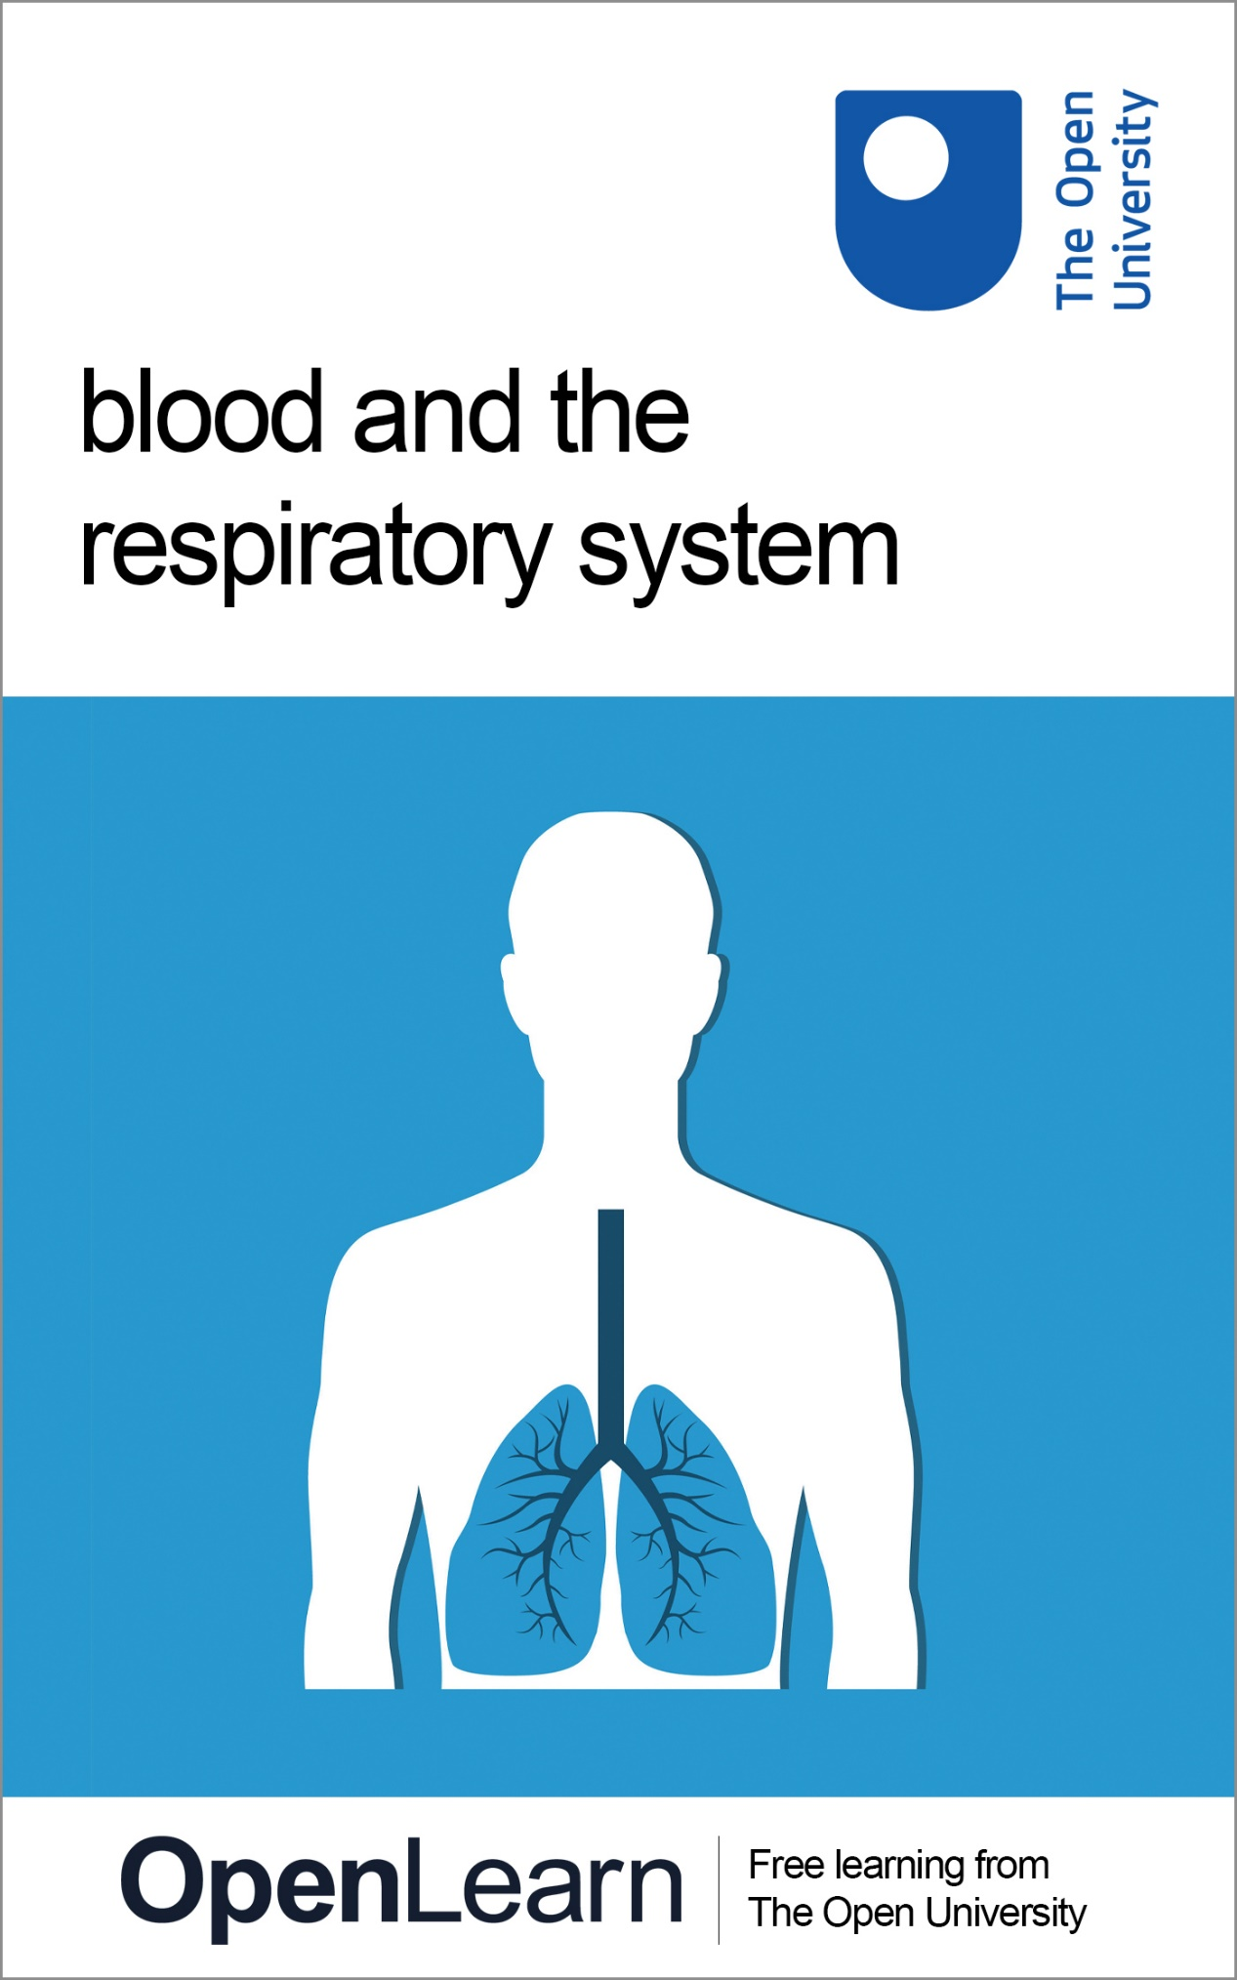

SK299_1 Human Biology

Blood and the respiratory system

This publication forms part of the Open University module SK299 Human biology. Details of this and other Open University modules can be obtained from Student Recruitment, The Open University, PO Box 197, Milton Keynes MK7 6BJ, United Kingdom (tel. +44 (0) 300 303 5303; email general-enquiries@open.ac.uk).
Alternatively, you may visit the Open University website at www.open.ac.uk where you can learn more about the wide range of modules and packs offered at all levels by The Open University.
The Open University,
Walton Hall, Milton Keynes
MK7 6AA
First published 2017.
Copyright © 2017 The Open University
All rights reserved. No part of this publication may be reproduced, stored in a retrieval system, transmitted or utilised in any form or by any means, electronic, mechanical, photocopying, recording or otherwise, without written permission from the publisher or a licence from the Copyright Licensing Agency Ltd. Details of such licences (for reprographic reproduction) may be obtained from the Copyright Licensing Agency Ltd, Saffron House, 6–10 Kirby Street, London EC1N 8TS (website www.cla.co.uk).
Open University materials may also be made available in electronic formats for use by students of the University. All rights, including copyright and related rights and database rights, in electronic materials and their contents are owned by or licensed to The Open University, or otherwise used by The Open University as permitted by applicable law.
In using electronic materials and their contents you agree that your use will be solely for the purposes of following an Open University course of study or otherwise as licensed by The Open University or its assigns.
Except as permitted above you undertake not to copy, store in any medium (including electronic storage or use in a website), distribute, transmit or retransmit, broadcast, modify or show in public such electronic materials in whole or in part without the prior written consent of The Open University or in accordance with the Copyright, Designs and Patents Act 1988.
Edited and designed by The Open University.

WEB 05250 9
1.1

Contents
- Introduction
- Learning outcomes
- 1 Respiratory structures and ventilation
  - 1.1 Structure of the respiratory system
  - 1.2 Muscles of ventilation
  - 1.3 Mechanics of inhalation and expiration
  - 1.4 Non-respiratory functions
- 2 Factors affecting pulmonary ventilation
  - 2.1 Atmospheric pressure
  - 2.2 Partial pressure
  - 2.3 Decompression sickness
  - 2.4 Surface tension
  - 2.5 Compliance and airway resistance
- 3 Lung function
  - 3.1 Spirometry
  - 3.2 Lung function impairment
- 4 Gas exchange
  - 4.1 O₂ and CO₂ transport in the blood
  - 4.2 Haemoglobin
  - 4.2.1 Influencing the curve
  - 4.3 Bicarbonate
- 5 Inherited disorders of haemoglobin
  - 5.1 Sickle cell anaemia
  - 5.2 Thalassaemia
- 6 Control of respiration
  - 6.1 Central chemoreceptors
  - 6.2 Peripheral chemoreceptors
  - 6.3 Additional neuronal control
  - 6.4 Sleep apnoea
- Conclusion
- References
- Further reading
- Acknowledgements
- Glossary
- Solutions
- Descriptions

Introduction
At some point in your life, you have probably tried to see how long you could hold your breath. It most likely took about 30 seconds before you felt the need to breathe. Free-divers, people who descend deep underwater without any breathing equipment, can hold their breath for much longer. In July 2016, William Trubridge set a world record in unassisted free-diving by going down 102 metres (334 feet) into Dean’s Blue Hole, a large marine sinkhole in the Bahamas. He did so on a single breath that he held for more than 4 minutes, as you can see in the following video. (Make sure to open the link in a new window/tab so you can easily navigate back to this page.)
Link to Video 1 – William Trubridge’s record free-diving descent.
Exchange of gases between the body and the atmosphere involves a complex and finely tuned series of mechanical and cellular events.
In this free course, Blood and the respiratory system, you will learn about the structure of the respiratory system, how the lungs contract and expand, as well as the factors that affect pulmonary ventilation. In addition, you will explore how gases are transported between the lungs and other tissues, how the respiration rate is controlled and look at examples of genetic diseases that affect respiration.
This OpenLearn course is an adapted extract from the Open University course SK299 Human biology.

Learning outcomes
After studying this course, you should be able to:
- describe and illustrate the main anatomical structures of the respiratory system and the mechanics of inspiration and expiration
- discuss the factors that affect pulmonary ventilation
- outline the mechanisms of O₂ and CO₂ transport in the blood
- describe diseases resulting from mutations in haemoglobin
- demonstrate an understanding of the control of the respiration rate.

1 Respiratory structures and ventilation
Oxygen (O₂) is a critical component for human life and is needed for the homeostatic maintenance of all the body’s tissues and organs.
Cellular respiration, the process by which energy is made, is dependent on a constant supply of O₂. At the same time, this process generates the waste product carbon dioxide (CO₂), which must be continuously removed. The process by which O₂ and CO₂ are exchanged between the body and the environment is termed external respiration. On average, an adult takes between 12 and 18 breaths a minute at rest, exchanging more than 8000 litres of air per day.

Using the glossary
This course includes a glossary, as demonstrated by the terms ‘cellular respiration’ and ‘external respiration’ highlighted in the paragraph above. You can hover over these for a preview, and click on the words to be taken to the full definition in the glossary.

Over the course of this section, you will learn how physical forces such as pressure, surface tension, resistance and compliance determine the amount of airflow through the respiratory and conduction zones of the respiratory system.

1.1 Structure of the respiratory system
Pulmonary ventilation, the movement of air into and out of the lungs, involves the main structures of the respiratory system (Figure 1). They include:
- the lungs
- a system of airways that deliver the air to the blood vessels of the lungs
- the musculoskeletal system that ventilates the lungs
- the central and peripheral nervous system that controls the rate and depth of breathing.

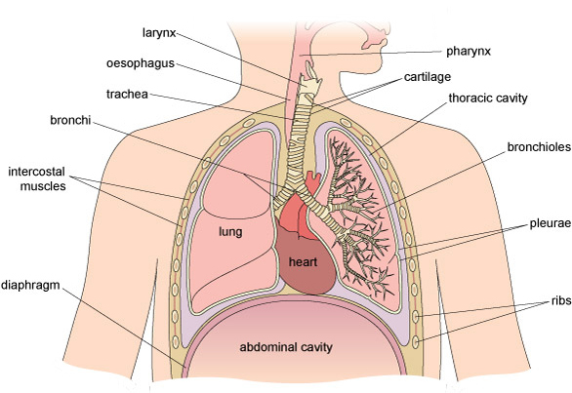
Figure 1 Cross-section through the structures of the respiratory system.
View description - Figure 1 Cross-section through the structures of the respiratory system.

1.1.1 Upper respiratory tract
Air enters the body through the nostrils and passes into the nasal cavities (Figure 2). Cilia (hair-like organelles) within the nasal mucosa provide a continuous beating movement to move air particles along the nasal cavities, where they are warmed and moistened. This action helps in the detection of smells and traps potentially harmful particles, preventing them from entering the rest of the respiratory system.
From the nasal cavities, the air passes to the pharynx (throat) at the back of the mouth where it is joined by air that has entered the system through the mouth.

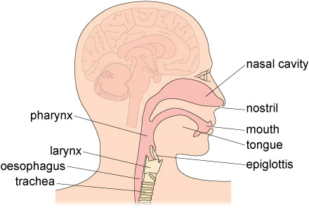
Figure 2 Structures of the upper respiratory tract.
View description - Figure 2 Structures of the upper respiratory tract.

At the base of the pharynx are two openings:
- One leads to the larynx (which contains the voice box and Adam’s apple), from which air passes into the trachea or windpipe, a hollow tube kept permanently open by rings of cartilage (Figure 2).
- The other opening is to the entrance of the oesophagus, near the beginning of the digestive tract.
Food is normally prevented from getting into the trachea by the movement of the epiglottis, a small flap of tissue that closes the larynx during swallowing. If you have ever had food go down ‘the wrong pipe’ (i.e. into the respiratory system), you know that the immediate response is to cough in an effort to expel the foreign material from the lungs.

Question 1 A situation

John and Mary are celebrating their 25th wedding anniversary with a roast chicken dinner. Halfway through the meal, John begins choking on a piece of chicken and is rushed to hospital. Airflow to the lungs must be re-established as quickly as possible. Which of the respiratory tract structures shown in Figure 2 (above) should doctors target to do so?

trachea
nasal cavity
mouth
pharynx
oesophagus
View answer - Question 1 A situation

The nasal cavities, pharynx and larynx form the upper respiratory tract and are the areas that are usually affected by the common cold virus.

1.1.2 Lower respiratory tract
The trachea divides into two branches called bronchi (Video 2). These serve the left and right lungs. Like the trachea, the walls of the bronchi contain cartilage, which prevents their collapse. Each main bronchus divides into smaller and smaller tubes, finally ending in terminal bronchioles. Bronchioles also contain cilia that help to keep the airways clean by moving mucus and particles from the lower respiratory tract up to the pharynx to be expelled.

Video content is not available in this format.
Video 2 3D model of the trachea, bronchi and bronchioles. (Please note, this video has no audio.)
View description - Video 2 3D model of the trachea, bronchi and bronchioles. (Please note, this video ...

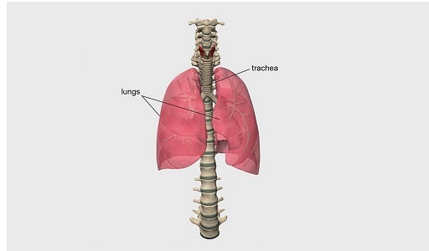

The lungs are organised into lobes (the left lung comprises two lobes and the right lung has three lobes). Two thin membranes, the visceral and parietal pleura, cover the lungs and keep them attached to the thoracic wall. The base of each lung is concave and rests on the diaphragm (more on that in Section 1.2), whereas the heart sits within the cardiac impressions, or grooves, in each lung (Figure 1, repeated).

Figure 1 (repeated) Components of the respiratory system.
View description - Figure 1 (repeated) Components of the respiratory system.

Because they act as a conduit for air to move into and out of the lungs, the nasal passages, pharynx, larynx, bronchi and bronchioles are collectively referred to as the conduction zone of the respiratory system.
Air then passes into progressively smaller structures deep in the lungs where gas exchange actually takes place in the respiratory zone, which you will explore in the next section.

1.1.3 Respiratory zone
The terminal bronchioles each divide a further seven times into respiratory bronchioles, then alveolar ducts and finally into alveolar sacs (alveoli; singular, alveolus) that contain holes in their walls called alveolar pores (Figure 3).

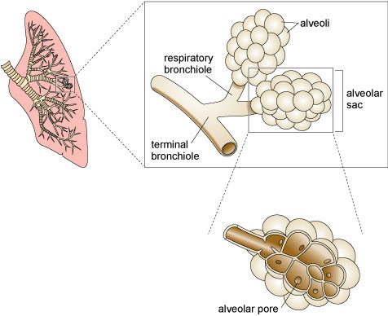
Figure 3 Terminal bronchioles further divide within the lungs.
View description - Figure 3 Terminal bronchioles further divide within the lungs.

Similar to other organs in the body, the organisation of the bronchioles and alveoli allows a large surface area of cells to be contained within the tight space of the thoracic (chest) cavity. This large respiratory surface, which is about 140 m² in the adult human (roughly the size of a tennis court), enhances the lungs’ capacity to exchange CO₂ for O₂. This exchange occurs in the respiratory bronchioles, alveolar ducts and alveoli, which collectively form the respiratory zones deep in the lungs.
Alveoli are surrounded by a network of pulmonary capillaries that carry the blood (Video 3). Deoxygenated, CO₂-rich blood coming into the lungs from the heart exchanges CO₂ for O₂ by diffusion, and oxygenated blood then leaves the lungs, returning to the heart to be pumped around the body. The walls of an alveolus and a pulmonary capillary are each only one cell thick, which allows diffusion of O₂ and CO₂ to occur very quickly (Figure 4).
Because haemoglobin, the molecule that carries O₂ in the blood (explored further in Section 4.2), changes colour when bound by O₂, oxygenated blood is often depicted as bright red, whereas deoxygenated blood is shown as blue in colour. This course doesn't explore how blood circulates around the body, but it is important to note that the lungs differ from other organs in that deoxygenated blood is carried to the lungs via arterioles (and larger arteries), whereas oxygenated blood leaves the lungs along venules (and larger veins).

Video content is not available in this format.
Video 3 Exchange of CO₂ and O₂ carried by blood in the pulmonary capillaries within the alveoli of the lungs. (Please note, this video has no audio.)
View description - Video 3 Exchange of CO2 and O2 carried by blood in the pulmonary capillaries within ...

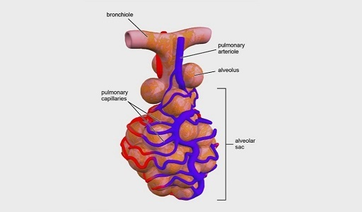

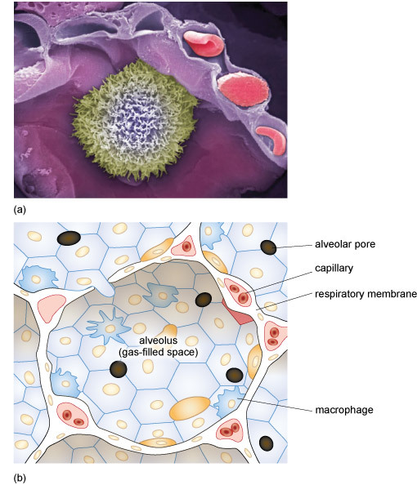
Figure 4 (a) Electron micrograph and (b) schematic showing a cross-section of an alveolus (purple), with red blood cells (red) in the surrounding intertwining capillaries and a pulmonary macrophage (green) inside the alveolus.
View description - Figure 4 (a) Electron micrograph and (b) schematic showing a cross-section of an ...

Activity 1 Ordering the air flow
Allow about 5 minutes

To test your understanding so far, order the steps involved in the flow of air from the conduction zone through to the respiration zone.

1
2
3
4
5
Air is taken in through the nasal cavities.
Air passes down the back of the pharynx, past the epiglottis and into the larynx.
From the larynx, air travels into the trachea, and into the bronchi.
Air moves through the terminal bronchioles and into the respiratory bronchioles.
Air passes into the alveolar ducts and into the alveolar sacs.
View answer - Activity 1 Ordering the air flow

In the next section, you will explore the muscles that are involved in the expansion and contraction of the lungs.

1.2 Muscles of ventilation
The expansion and contraction of the lungs is controlled mechanically by the diaphragm and the intercostal muscles (Figure 1, repeated).

Figure 1 (repeated) Components of the respiratory system.
View description - Figure 1 (repeated) Components of the respiratory system.

- The diaphragm is a dome-shaped muscle that sits underneath the lungs and separates the thoracic cavity from the abdominal cavity. It is innervated by the phrenic nerve, which originates in the medullary respiratory centre in the medulla of the brain.
- The intercostal muscles are located in the ribcage. They receive neuronal inputs from intercostal nerves that arise from the thoracic nerves of the spinal cord.
The bronchi and bronchioles are also surrounded by smooth muscle cells that contract and dilate to regulate the amount of air that passes down to the alveoli.

Activity 2 Diaphragm and intercostal muscles
Allow about 20 minutes

Part 1

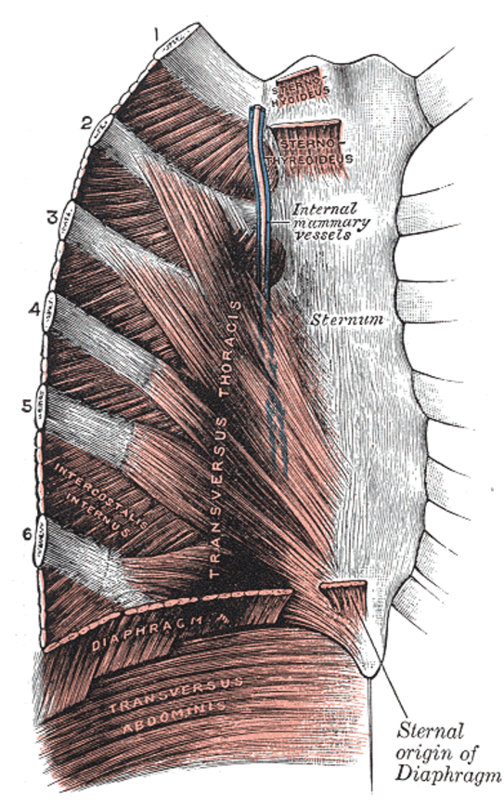
Figure 5 Diaphragm and intercostal muscles.
View description - Figure 5 Diaphragm and intercostal muscles.

To explore the location and function of the diaphragm and intercostal muscles, take a look at the anatomical information and diagrams on this site (open the links in a new tab/window so you can easily return to this page):
- Diaphragm
- Intercostal muscles

Provide your answer...

Part 2

Now try matching each of these statements with the correct muscles.

diaphragm
external intercostal muscles
internal intercostal muscles
innermost intercostal muscles
flatten(s) when contracted to expand the size of the thoracic cavity and decrease the size of the abdominal cavity, generating a pressure gradient within the thoracic cavity
draw(s) the ribs upwards and outwards; most active during inhalation
draw(s) the ribs downwards and inwards; most active during forced exhalation
stiffen(s) the chest wall during respiration; most active during forced exhalation
View answer - Part 2

1.3 Mechanics of inhalation and expiration
Movement of the diaphragm and intercostal muscles acts to expand and decrease the size of the thoracic cavity, creating pressure gradients that draw air into and force air out of the lungs, as described in Video 4.

Video content is not available in this format.
Video 4 Mechanics of inhalation and expiration.
View transcript - Video 4 Mechanics of inhalation and expiration.

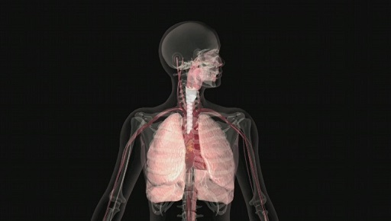

Expiration is generally a passive event brought about by relaxation of the diaphragm and external intercostal muscles. The ribcage, diaphragm and lung tissue itself return by elastic recoil to their original pre-inspiratory positions. The consequent retraction of the chest wall forces air out of the lungs. Forced expiration is mainly achieved by contraction of the internal intercostal muscles, aided to some extent by contraction of the abdominal muscles.
Most of the time, you will be unaware of the contraction and relaxation of the muscles that control respiration. They become much more noticeable when you cough or develop a bout of hiccups. In fact, hiccups are caused by a spasm of the diaphragm and intercostal muscles in response to increased activity of the phrenic nerve and vagus nerve (which innervates the muscles of the abdomen). The spasms cause the floor of the thoracic cavity to drop suddenly, which pulls air quickly and forcefully into the airways. Movement of the air past the closed vocal cords creates the characteristic ‘hic’ sound.

Activity 3 Lung in a bottle
Allow about 1 hour

You can explore the relationship between movement of the diaphragm and lung volume directly by making your own ‘lung in a bottle’ as shown in Video 5.

Video content is not available in this format.
Video 5 ‘Lung in a bottle’ experiment.
View transcript - Video 5 ‘Lung in a bottle’ experiment.

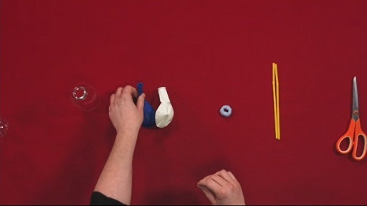

According to the video, what factors are responsible for the inflation and deflation of the balloon ‘lung’ inside the bottle?

Provide your answer...
View answer - Part

1.4 Non-respiratory functions
The respiratory system also performs important non-respiratory functions, for example:
- Vocalisation including speech and singing. The two bands of elastic tissue that lie across the opening of the larynx, called the vocal cords, can be stretched and positioned into different shapes by the laryngeal muscles. As air is passed over the vocal folds, they vibrate to produce characteristic patterns of sound.
- Detection of smells from airborne chemicals.
- Water loss and heat elimination. Inspired atmospheric air can be humidified and warmed by the respiratory airways; this is essential to prevent the alveolar membranes from drying out, which would significantly reduce diffusion of O₂ and CO₂.
- Facilitation of blood flow around the body. During inspiration, there is a fall in pressure in the chest cavity, which reduces the resistance of blood vessels. In a similar way, respiratory movements also aid the movement of lymph through the lymphatic system.
- Defence against foreign particulates or airborne infectious diseases via nasal hair and cilia lining the airways, and mechanisms including coughing and sneezing.

2 Factors affecting pulmonary ventilation
The previous section outlined the anatomical structures that are involved in ventilation. In this section, you will examine the factors that regulate pulmonary ventilation, including pressure gradients, surface tension, airway resistance and compliance of the lungs.

2.1 Atmospheric pressure
If you have recently taken a flight on a commercial airline, you will be familiar with the instructions that are given in the event of a change in cabin pressure, such as in Video 6 below.

Video content is not available in this format.
Video 6 An Open University airline safety video.
View transcript - Video 6 An Open University airline safety video.

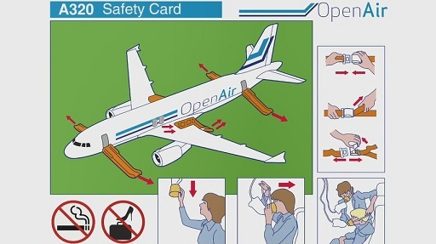

These safety measures highlight the importance of pressures for gas exchange in the lungs. To understand this relationship, it is helpful to use Boyle’s law, which states that at a constant temperature (k), an increase in pressure (P) causes a proportional decrease in volume (V). Watch Boyle’s law in action in Video 7 below. (Make sure to open the link in a new window/tab so you can easily navigate back to this page.)
Link to Video 7 – The effect of increasing pressure on volume.

Question 2 Increasing pressure

By how much did the volume of air in the cylinder decrease when the surrounding water pressure increased from 1 bar to 2 bar?

it did not change
by ¼
by ½
by ¾
View answer - Question 2 Increasing pressure

In physiology, the unit of pressure is conventionally measured as millimetres (mm) of mercury (Hg). ‘Millimetres of mercury’ (mmHg) refers to the height of a column of mercury attached to an instrument that detects pressure (e.g. a sphygmomanometer). Other units of pressure, such as that used in Video 7, include bar, pounds per square inch (psi) and pascals (Pa). All units of pressure can be interconverted, so 1 bar = 14.5 psi, 1 psi = 51.7 mmHg and 1 mmHg = 133 Pa.

At sea level, the atmospheric pressure (i.e. the pressure exerted by the gases in the Earth’s atmosphere) is about 760 mmHg. During inhalation, the volume of the lungs increases and the pressure inside the lungs decreases below that of atmospheric pressure. This creates a pressure gradient that draws air into the lungs. During exhalation, the lungs return to their original size, pressure in the lungs rises compared with the atmospheric pressure and air moves out.

Question 3 Boyle's law

Boyle's law is described by the following formula:
PV = k.

Part 1

How would you rewrite the formula to calculate pressure (P)?

Provide your answer...
View answer - Part 1

Part 2

i) If k = 1, what will be the pressure of the gases if the volume of the lungs is 6 litres?

0.167 mmHg
6 mmHg
16 mmHg
View answer - Part 2

Part 3

ii) If k = 1, what will be the pressure if the volume is 3 litres?

0.333 mmHg
3 mmHg
13 mmHg
View answer - Part 3

Part 4

Is the pressure in the lungs higher during exhalation or inhalation?

Exhalation
Inhalation
Neither, it is constant
View answer - Part 4

If you are unfamiliar with rearranging equations you might find our Mathematics for science and technology course helpful for brushing up.

Returning to the example of the aeroplane, the atmospheric pressure at cruising altitude (e.g. 243 mmHg at 30 000 feet or 9100 metres) is much lower than that at sea level (760 mmHg). If you were exposed to that same pressure as a passenger, the pressure in your lungs would be greater than that of the atmosphere, and you would be unable to draw a breath.
In the next section, you will learn how differences in pressures of gases in the atmosphere versus pressures of those gases in the lungs also drive O₂ and CO₂ exchange.

2.2 Partial pressure
Pressure is an important factor in O₂ and CO₂ exchange in the alveoli. The pressure of each individual gas in the atmosphere is described as its partial pressure.
Partial pressure is calculated by multiplying the percentage of the particular gas in the atmosphere by the total atmospheric pressure. For example, O₂ accounts for about 21% of the Earth’s atmosphere so the partial pressure of O₂ (PO₂) in the atmosphere is 0.21 × 760 mmHg = 160 mmHg. CO₂ is present only in trace amounts, so the partial pressure of CO₂ (PCO₂) in the atmosphere is roughly 0.3 mmHg.

Question 4 Nitrogen

Nitrogen (N₂) comprises 78% of the Earth’s atmosphere. What is the partial pressure of nitrogen (PN₂)?

Provide your answer...
View answer - Question 4 Nitrogen

The difference in PO₂ and PCO₂ between fresh air and the blood drives the diffusion of O₂ and CO₂ down their respective concentration gradients, as described in Video 8.

Video content is not available in this format.
Video 8 PO₂ and PCO₂ in lung and tissues.
View transcript - Video 8 PO2 and PCO2 in lung and tissues.

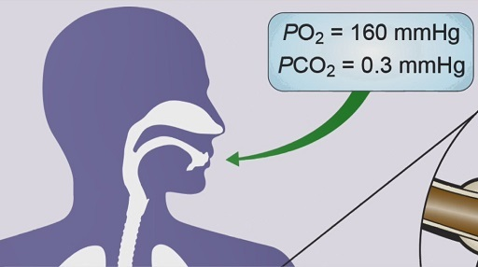

Activity 4 O₂ movement
Allow about 5 minutes

Interactive content is not available in this format.

2.3 Decompression sickness
If you think back to William Trubridge and his free-diving record in the Introduction, you will recall that he swam up from a depth of 102 metres in just over 2 minutes, a rate of 51 m min⁻¹, without suffering any ill effects on his return to the surface. By contrast, scuba divers are advised not to ascend faster than 9 m min⁻¹ to avoid developing decompression sickness (‘the bends’).
This discrepancy between free-divers and scuba divers lies in the differences in partial pressures of gases that are inhaled under atmospheric pressure and under compression. When you breathe from a scuba tank, the air has the same pressure as the pressure of water at that depth. The pressure of water is much higher than air; for example, at 20 m below the surface of the water, the pressure exerted by water on the body is about three times that experienced on dry land.
The high pressure can cause some of the N₂ gas in the air to dissolve into the blood. As the diver swims back up to the surface, the PN₂ in the blood is higher than in the surrounding water, so N₂ will be released from the blood and into the alveoli to be exhaled. If the change in pressure happens too quickly, the N₂ will not have time to be exhaled and instead will form air bubbles (similar to what happens when you open a shaken can of fizzy drink). These bubbles can cause severe pain in joints and muscles and in extreme cases, death due to embolism.
Free-divers experience the same effects of PN₂ as scuba divers at deep depths. However, because free-divers are not breathing pressurised air as they dive, their lungs actually get compressed (down to a quarter of their original size) by the high pressure of the water. As the divers ascend, their lungs will slowly expand back to their original volume.

Question 5 Pressure in the lungs

According to Boyle’s law, what will happen to the pressure in the lungs as the free-divers ascend (see Section 2.1)

it will increase
it will stay the same
it will decrease
View answer - Question 5 Pressure in the lungs

So, as the divers return to the surface, the PN₂ in the lungs decreases relative to the PN₂ in the blood and N₂ diffuses into the alveoli, thereby decreasing the chances that it will form bubbles in the tissue.

2.4 Surface tension
In the previous section, you saw how partial pressure gradients drive the exchange of O₂ and CO₂ between the blood and the alveoli. Diffusion of the gases at this air–liquid interface is facilitated by a thin layer of water that coats the inner surface of the alveoli. Condensation of the water vapour that is exhaled when you breathe out is the reason why you ‘see’ your breath in cold weather.

Individual molecules of water (H₂O) bind together because hydrogen and oxygen atoms are strongly attracted to each other. This is why your hair sticks together when it’s wet. This force is called hydrogen bonding.

Because hydrogen bonds are quite strong, when water molecules come into contact with each other, they will be held together tightly. This tight packing creates a surface tension in the water that forces it to adopt the smallest shape possible (e.g. a droplet) (Figure 6).

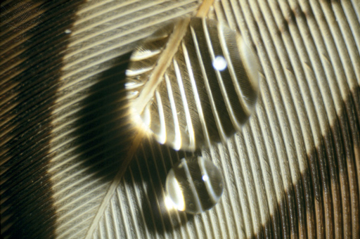
Figure 6 Surface tension of water holds it in a droplet form.
View description - Figure 6 Surface tension of water holds it in a droplet form.

However, because the alveoli are round in shape, the surface tension that holds the water molecules together also puts an inward pressure on the inside of the alveolus (Figure 7).

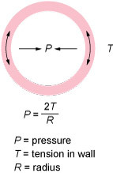
Figure 7 Surface tension (T) created by hydrogen bonding of water puts pressure on the inside of the alveoli, which have a small diameter or radius (R).
View description - Figure 7 Surface tension (T) created by hydrogen bonding of water puts pressure on ...

As you have just learnt, if the pressure in the alveolus is higher than the atmospheric pressure, air from the atmosphere will not enter and the alveolus will collapse (a medical condition called atelectasis). How does the lung combat the surface tension of water to ensure that the alveoli can expand with each breath? Cells within the alveoli secrete surfactant, a substance that attaches to the water molecules and prevents them from interacting with each other. This reduces the surface tension in the alveolus to near-zero levels. This effect is nicely demonstrated in Video 9. Why not try this experiment yourself at home?

Video content is not available in this format.
Video 9 Surface tension broken by surfactant.
View transcript - Video 9 Surface tension broken by surfactant.

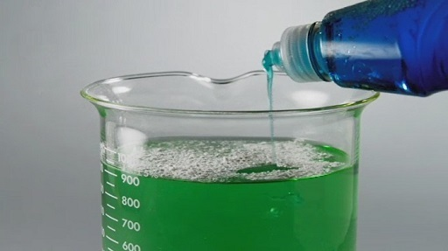

Surfactant also serves to prevent the collapse of the alveoli of newborn babies when they take their first breaths. Premature babies born before their surfactant production system is fully functional suffer from respiratory distress syndrome (RDS). Surface tension in the lungs of these babies is high and many alveoli fail to expand. Failure to produce enough surfactant may also be a problem in adult life; for example, surfactant production in the lungs of smokers is greatly reduced, increasing the likelihood of breathing difficulties compared to non-smokers.

2.5 Compliance and airway resistance
The ease with which the lungs and pleura expand and contract based on changes in pressure is called compliance. Low lung compliance means that the lungs and alveoli are ‘stiff’, so a higher-than-normal pressure gradient is needed to get the lungs to expand and contract. It can result from insufficient amounts of surfactant or fibrosis of the lungs due to prolonged inhalation of small particles such as asbestos or coal (e.g. black lung) (Figure 8).

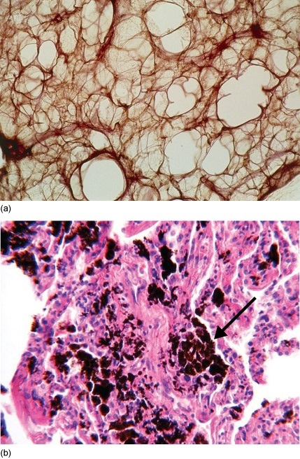
Figure 8 (a) Cross-section through a healthy lung showing the air-filled alveoli. (b) Cross-section of a diseased lung showing deposits of coal particles (arrow).
View description - Figure 8 (a) Cross-section through a healthy lung showing the air-filled alveoli. ...

High compliance results when the lungs are too pliable and move in response to small changes in pressure. This makes exhalation difficult because the elastic recoil of the lungs (i.e. their ability to ‘snap back’ after inhalation) is decreased. High lung compliance is a characteristic of chronic obstructive pulmonary disease (COPD), a general term for a collection of diseases that are associated with lung damage, such as emphysema and chronic bronchitis, which are often associated with smoking (Figure 9).

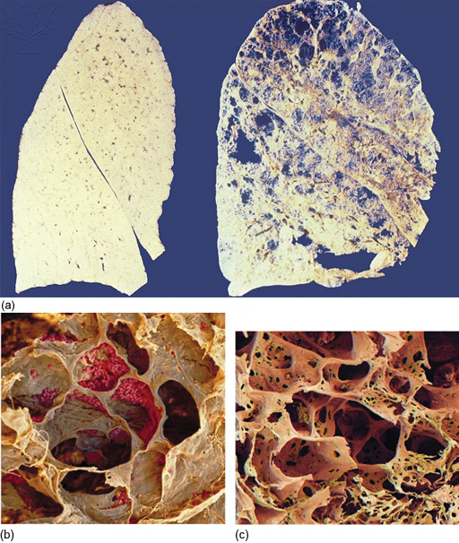
Figure 9 (a) Cross-section through a healthy lung (left) and a lung from a smoker (right). (b) and (c) Scanning electron microscope images showing alveoli in the lungs of (b) a healthy individual and (c) a person with COPD.
View description - Figure 9 (a) Cross-section through a healthy lung (left) and a lung from a smoker ...

Activity 5 Comparing tissues
Allow about 10 minutes

Compare the tissue sections in Figure 9. List the differences you observe between:
- 1. the healthy lung versus the smoker's lung

Provide your answer...
View answer - Part

- 2. the healthy alveoli versus the COPD alveoli

Provide your answer...
View answer - Part

Pulmonary ventilation is also affected by the resistance of the airways to the flow of air. This resistance is caused by the friction that is generated when the air passes along the structures in the conduction and respiratory zones. Because the airways are made up of a series of tubes, resistance is largely affected by the diameter of the trachea, bronchi and bronchioles. Resistance is inversely proportional to radius, so structures with a small diameter have a higher resistance.

Question 6 Airflow resistance

Is the airflow resistance in a bronchiole higher or lower than in a bronchus?

higher
lower
neither, they are the same
View answer - Question 6 Airflow resistance

During an asthma attack, the airway resistance increases because the bronchial smooth muscle cells contract and reduce the diameter of the bronchi and bronchioles. This results in the characteristic wheezing, coughing and shortness of breath. Fast-acting reliever inhalers release drugs that relax the smooth muscle cells and thereby increase airflow.
In the next section, you will see how lung capacity and function are measured and used as a guide for overall lung health.

3 Lung function
Changes in the compliance and resistance of the lungs can affect the capacity of the lungs to hold and exchange air. Lung capacity is calculated from the volume of air that is exchanged during normal and forceful breathing. The volumes that are used to calculate total lung capacity are described in Video 10.

Video content is not available in this format.
Video 10 Calculating lung capacity.
View transcript - Video 10 Calculating lung capacity.

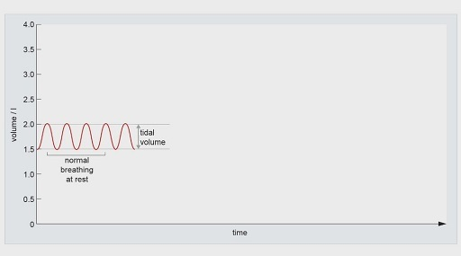

Activity 6 Lung capacity
Allow about 10 minutes

Part 1

Match the volume with the corresponding definition:

extra volume breathed out during forceful exhalation
extra volume breathed in during forceful inhalation
amount of air left in the lungs in addition to the expiratory reserve volume
amount of air entering or leaving the lungs in a single resting breath
expiratory reserve volume
inspiratory reserve volume
residual volume
tidal volume
View answer - Part 1

Part 2

Which of the volumes are NOT used to calculate the vital capacity of the lungs? Select all that apply.

tidal volume
inspiratory reserve volume
residual volume
expiratory reserve volume
View answer - Part 2

3.1 Spirometry
Lung function can be measured using spirometry. A typical test involves blowing out into a spirometer as hard as possible until the lungs are empty (Figure 10). The forced vital capacity (FVC) is calculated as the total volume of air that can be forcefully blown out. Peak expiratory flow (PEF) measures the maximum speed at which air is forcefully expired (litres per second). The forced expiratory volume 1 (FEV₁) is the amount of air that is forcibly blown out within the first second of the test.
Plotting the FVC and PEF values generates a spirograph similar to the one shown in Video 7. The FEV₁/FVC ratio (also calculated as a percentage) is used to evaluate lung function. In healthy individuals, the FEV₁/FVC ratio is approximately 0.8, meaning that 80% of total volume of air is blown out within the first second.

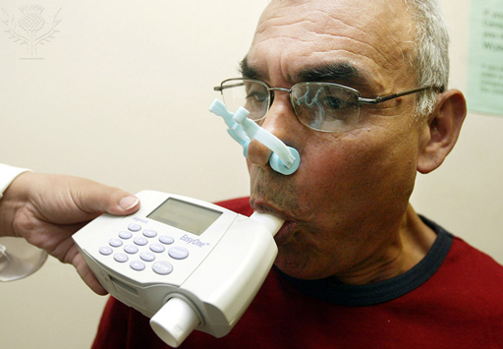
Figure 10 Portable spirometer used to measure lung function.
View description - Figure 10 Portable spirometer used to measure lung function.

It is important to note that normal lung function is dependent on an individual’s age, height, sex, ethnicity and general fitness. An example of the predicted FEV₁/FVC ratios for particular groups of men and women is shown in Table 1.

Table 1 Predicted FEV₁/FVC ratios for asymptomatic, lifelong non-smoker Caucasian men and women over the lifespan.
FEV₁/FVC (%) Male
Age | 20 | 25 | 30 | 35 | 40 | 45 | 50 | 55 | 60 | 65 | 70 | 75 | 80
All heights | 83.9 | 82.9 | 81.9 | 80.8 | 79.8 | 78.8 | 77.7 | 76.7 | 75.7 | 74.6 | 73.6 | 72.6 | 71.5
FEV₁/FVC (%) Female
Age | 20 | 25 | 30 | 35 | 40 | 45 | 50 | 55 | 60 | 65 | 70 | 75 | 80
All heights | 86.6 | 85.5 | 84.4 | 83.4 | 82.3 | 81.2 | 80.2 | 79.1 | 78.1 | 77.0 | 75.9 | 74.9 | 73.8

Question 7 Lung function across ages

Looking at Table 1, what happens to lung function with age in both men and women?

It stays the same across all ages.
It increases with age.
It decreases with age.
View answer - Question 7 Lung function across ages

3.2 Lung function impairment
When lung function is impaired, the PEF, FEV₁, FVC and FEV₁/FEC values can be used to help determine the cause of the dysfunction; for example, decreased lung volume due to fibrosis or increased airway resistance due to asthma.

Activity 7 Spirometry experiment
Allow about 2 hours

In this activity, you will use the spirometer application in the Open Science Laboratory to measure changes in FEV₁/FEC over time between smokers and non-smokers. Here's the link to the application – open it in a new window or tab, so you can return to this page easily.
- Link to Spirometer application
Before you begin collecting data, watch the video in the Introduction tab of the spirometer to familiarise yourself with the application.
Research studies that look at relationships between different groups of people can be categorised into cross-sectional or longitudinal studies. Cross-sectional studies compare different groups of people at one moment in time. Longitudinal studies analyse the same group of people across different points in time.
Now go to the Spirometer tab in the application and set the following parameters:
- age: 20
- male
- height: 180 cm
- non-smoker
- Start the measurement and record the output of the FEV₁, FVC and FEV₁/FVC (%) using the ‘Record data’ button. Repeat this measurement three times, remembering to record the data each time.
- Repeat the data collection for the same male individual at ages 40 and 80. Repeat both measurements three times, remembering to record the data each time.
- Then select the same parameters for age, sex and height, but choose ‘smoker’. This group smoked one pack of 20 cigarettes each day from the age of 20. Collect data for three ages – 20, 40 and 80 – repeating and recording the measurement three times.
- Select the ‘Export data’ button then copy and paste the results into a spreadsheet program such as Excel.
- Determine the mean (average) of the three values that you collected of FEV₁/FVC (%) at each age for the non-smoker and smoker conditions.
- Plot a computer-generated x–y graph showing the mean FEV₁/FVC (%) of the smoker and non-smoker at 20, 40 and 80 years of age. Make sure to plot this in chronological order.

4 Gas exchange
In this section, you will examine the chemical changes that underlie exchange of O₂ and CO₂ between peripheral tissues and the lungs. You will also learn about genetic mutations of haemoglobin and how the body senses and responds to changes in O₂ and CO₂ levels to maintain homeostasis.

4.1 O₂ and CO₂ transport in the blood
You've seen how gradients between PO₂ and PCO₂ drive gas exchange in the alveoli. But how are these gases carried in the blood? Small amounts of O₂ (~0.3%) and CO₂ (~3%) dissolve directly into the plasma. However, such concentrations are not sufficient to fulfil the metabolic demands of the body. The main transport of O₂ and CO₂ in the blood is mediated via haemoglobin molecules and bicarbonate ions, respectively.

4.2 Haemoglobin
Most O₂ is carried in the blood by erythrocytes (red blood cells) which contain haemoglobin (Hb). In adults, Hb is a protein formed of four polypeptide chains, called globins – there are two alpha and two beta chains (Figure 11). Attached to the interior of each globin chain is a small non-protein structure known as a haem group. The haem group has at its centre an iron ion (Fe²⁺) that binds to one O₂ molecule. As there are four globin chains and four haem groups, each with one Fe²⁺, one Hb molecule can carry four O₂ molecules.

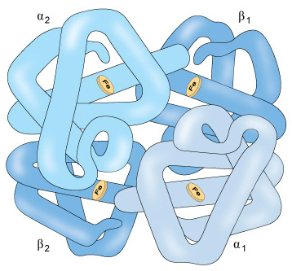
Figure 11 Schematic of the haemoglobin protein, comprising two alpha and two beta chains and four haem groups.
View description - Figure 11 Schematic of the haemoglobin protein, comprising two alpha and two beta ...

When O₂ is bound to Hb, the Hb is said to be oxygenated and the complex formed is called oxyhaemoglobin. Oxygenation occurs where there is a plentiful supply of O₂; that is, in the capillaries surrounding the alveoli of the lungs.
O₂ binding to Hb is governed by positive cooperativity, meaning that once one haem group binds O₂, it becomes progressively easier for the other haem groups to also bind O₂. This ensures that the Hb molecule can become quickly saturated (i.e. with four O₂ molecules bound). Oxygen saturation levels (‘sats’) are used by doctors to detect respiratory distress or illness.
Binding of O₂ to Hb is reversible, meaning that when oxyhaemoglobin reaches the capillaries within the tissues, where O₂ is being consumed and the PO₂ is low, the O₂ is released and diffuses into the tissues. Hb that is not bound to O₂ is termed deoxyhaemoglobin.

Question 8 Pulmonary arteries

Which form of Hb is predominant in the blood carried by the pulmonary arteries? (see Section 1.1.3)

oxyhaemoglobin
deoxyhaemoglobin
View answer - Question 8 Pulmonary arteries

The binding and dissociation of O₂ to and from haemoglobin is dependent on the PO₂. This is not surprising, because as you saw in Section 2.2, differences in partial pressures between tissue capillaries and pulmonary capillaries drive the exchange of O₂ and CO₂. However, if you look at the oxygen–haemoglobin dissociation curve in Activity 8, you will see that O₂ binding to haemoglobin is not a linear relationship. Rather, the amount of Hb bound to O₂ over a range of PO₂ has a sigmoidal ‘S’-shaped curve.

Note on Activity 8
Please note that this activity will only display properly in the Firefox web browser. It is not essential to completing the course, so if you’re not able to view the activity it can be skipped.

Activity 8 Oxygen–haemoglobin dissociation curve
Allow about 5 minutes

Take a look at this dissociation curve, then place the marker as directed and click ‘Enter answer’. If you place it correctly, one more question will then be posed to you.

Interactive content is not available in this format.
View description - Uncaptioned interactive content

4.2.1 Influencing the curve
A number of biological factors influence the oxygen–haemoglobin dissociation curve and shift it to the right or left. These factors are summarised in the following video.

The term ‘affinity’ refers to the strength of binding between two particles or proteins. Low affinity means that the binding is weak and the particles can be easily separated. High affinity means that the binding is strong. In the context of Hb and O₂, low affinity means that the O₂ binds weakly to the Hb and is therefore easily transferred to the tissues.

Video content is not available in this format.
Video 11 Factors influencing the oxygen–haemoglobin dissociation curve.
View transcript - Video 11 Factors influencing the oxygen–haemoglobin dissociation curve.

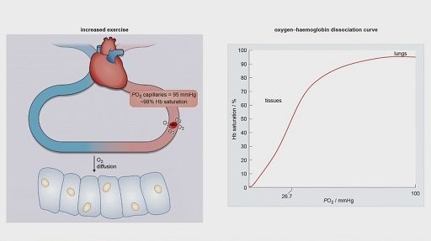

Question 9 Biological factors

Having watched Video 11, note down the biological factors that affect the affinity of Hb binding of O₂.

Provide your answer...
View answer - Question 9 Biological factors

4.3 Bicarbonate
In the previous section, you saw how the affinity of Hb for O₂ decreases in the presence of elevated CO₂ and acidity. This is known as the Bohr effect. This is due to the chemical reaction that takes place between CO₂ and water (H₂O) to generate bicarbonate (HCO₃⁻) and protons (H⁺). This reaction is represented by the equation:

View alternative description - Uncaptioned Equation

In chemistry, the ⇌ arrow represents a reversible reaction, meaning it can go in the right or the left direction. In this case, adding more CO₂ will push the reaction to the right and generate more H⁺ and HCO₃⁻ ions. H⁺ ions decrease the pH of a solution (make it more acidic) whereas HCO₃⁻ ions increase the pH and make it more basic.

The reversible nature of this reaction is critical in allowing the body to transport CO₂ from the tissues and be exhaled in the lungs. This process is detailed in Video 12.

Video content is not available in this format.
Video 12 Bicarbonate buffering.
View transcript - Video 12 Bicarbonate buffering.

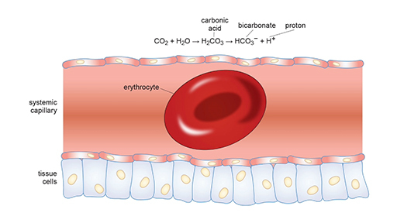

In Video 12, you saw that protons (H⁺) generated during bicarbonate buffering of CO₂ bind to Hb in the erythrocytes to form protonated haemoglobin (HbH⁺). This binding decreases the affinity of Hb for O₂, thereby facilitating O₂ diffusion into tissues, as described by the following equation:

View alternative description - Uncaptioned Equation

At the same time, CO₂ that has not been converted into HCO₃⁻ (~30% of total CO₂ in the blood) binds with high affinity to deoxyhaemoglobin to form carbaminohaemoglobin (HbCO₂). This complex is then carried to the lungs (Figure 12).
In the alveoli, binding of O₂ to HbH⁺ results in the release of free H⁺ ions.

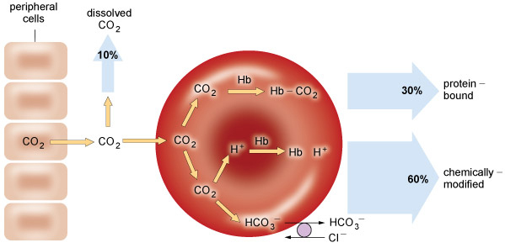
Figure 12 Mechanisms by which CO₂ is carried in the blood.
View description - Figure 12 Mechanisms by which CO2 is carried in the blood.

Question 10 Higher H⁺

In what direction will the higher concentration of H⁺ push the equilibrium reaction?

View alternative description - Uncaptioned Equation

left, towards increased CO₂ production
right, towards HCO₃⁻ production
neither, the reaction will stay in equilibrium
View answer - Question 10 Higher H⁺

In parallel, carbaminohaemoglobin loses its affinity for CO₂ as it becomes reoxygenated. Collectively, these actions increase the PCO₂ at the alveoli. The phenomenon by which O₂ influences CO₂ concentrations is known as the Haldane effect.
The capacity of the blood to carry O₂ is also greatly reduced by carbon monoxide (CO), a gas emitted by car exhausts and faulty gas appliances. CO competes with O₂ for binding to Hb. Because the affinity of Hb for CO is higher than its affinity for O₂, CO molecules will bind preferentially and irreversibly to form carboxyhaemoglobin (HbCO), which is cherry red in colour. Inhaling CO will therefore progressively reduce the amount of Hb available to bind O₂ and lead to CO poisoning. If the source of CO is not removed, death could result due to the total lack of oxygen (asphyxiation).

5 Inherited disorders of haemoglobin
In the previous section, you saw that erythrocytes and the haemoglobin they contain play a crucial role in mediating exchange of both O₂ and CO₂ between the tissues and the lungs. This section will use two examples, sickle cell anaemia and thalassaemia, to illustrate how genetic disorders of haemoglobin can affect gas transport and exchange in the body.

5.1 Sickle cell anaemia
Sickle cell anaemia gets its name from the abnormal shape of the erythrocytes, which resemble that of an old farming tool, the sickle (Figure 13). This shape is due to a single nucleotide substitution (A to T) that converts a glutamic acid codon (GAG) into a valine codon (GUG) in the beta chains of Hb.

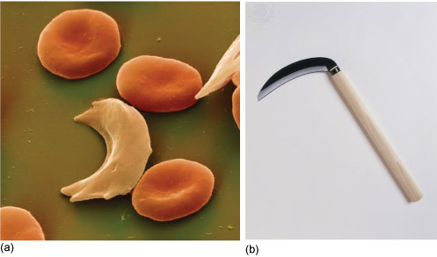
Figure 13 Sickle cell erythrocytes.
View description - Figure 13 Sickle cell erythrocytes.

Activity 9 RNA codon wheel
Allow about 15 minutes

Take a look at this interactive RNA codon wheel. If you click on an amino acid, the diagram will highlight the corresponding nucleotides. You can view some further information and chemical structures for each amino acid. When you’ve done this, use the diagram to answer the question underneath.

Interactive content is not available in this format.
View description - Uncaptioned interactive content

Which nucleotide substitution would still result in a functional Hb protein?

GAG → GCG
GAG → GAA
GAG → CAG
View answer - Activity 9 RNA codon wheel

Sickle Hb is denoted as HbS. Because glutamic acid is negatively charged, these amino acids would normally repel each other and help the Hb retain its shape. However, these repulsive forces are absent in the HbS because valine is uncharged.
HbS is able to bind O₂ normally in the lungs and carry it to the tissues. However, as the HbS becomes deoxygenated, the valine amino acids are exposed and start to bind to each other, forming long chains of deoxyHbS. These chains distort the cell and cause it to bend out of shape. As more and more deoxyHbS molecules come in contact with each other, they can result in the formation of a chain of sickled erythrocytes, which clump together and get stuck in the capillaries (Figure 14).

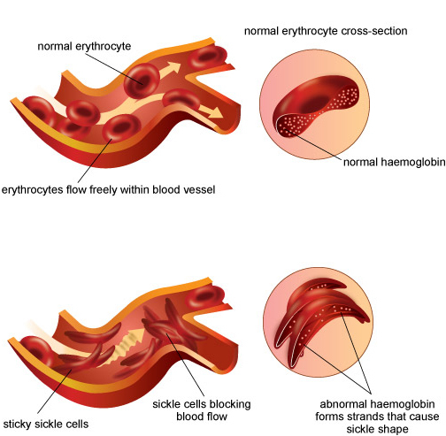
Figure 14 Misshapen erythrocytes carrying the HbS mutation can aggregate and get stuck in tissue capillaries.
View description - Figure 14 Misshapen erythrocytes carrying the HbS mutation can aggregate and get ...

Sickled erythrocytes that return to the alveoli will regain their biconcave disc shape as they once again become oxygenated. Note that erythrocytes carrying normal Hb maintain this biconcave shape regardless of their O₂ saturation levels.
The repeated episodes of polymerisation and depolymerisation of HbS as it travels between the lungs and tissues damages both the haemoglobin molecules and the erythrocyte itself, making it rigid and unable to move through the small-diameter capillaries.
Amplified many times, blockage of the capillaries can produce tissue hypoxia (i.e. low levels of oxygen), resulting in tissue pain and damage. In addition, the sickled erythrocytes are more fragile and die on average after 20 days in circulation, compared with normal erythrocytes that live for 120 days. Loss of erythrocytes leads to the anaemia (low red blood cell count) of sickle cell disease.
Symptoms of sickle cell anaemia include episodes of pain (called sickle cell crises) in tissues and bones, swelling of hands and feet, frequent infections, delayed growth and problems with vision. In addition, chronic pulmonary complications are common in individuals with sickle cell disease, including asthma, pulmonary fibrosis, decreased FEV₁ values and sleep apnoea (which is further explored later in the course).
Sickle cell anaemia is a recessive disorder, meaning that in order for an individual to develop the disease, they must inherit two HbS alleles.

5.2 Thalassaemia
Thalassaemias are a group of inherited autosomal recessive disorders that cause anaemia because of the decreased or absent synthesis of a globin chain (Muncie and Campbell, 2009). Alpha thalassaemia is the result of either deficient or absent production of the alpha globin chain, which is then replaced by extra beta globin chains. Production of the alpha globin protein is slightly more complicated because it is controlled by two genes, both located on chromosome 16. This means that disease susceptibility is dependent on the inheritance pattern of four alleles – two inherited from the mother and two from the father. Alpha thalassaemia is usually due to the deletion of one of these alleles and the severity of the disease corresponds to the number of deletions:
- one deletion is silent and asymptomatic
- two deletions result in mild anaemia
- three deletions cause haemoglobin H disease and moderate to severe anaemia
- four deletions cause alpha thalassaemia major, a fatal condition.

Activity 10 Inheritance pattern of alpha thalassaemia
Allow about 20 minutes

In this activity, you will predict the phenotype and pattern of inheritance of alpha globin genes in a family affected by alpha thalassaemia. Click below to reach the full activity.

Interactive content is not available in this format.

Beta thalassaemia results from deficient or absent production of the beta globin chains, leading to excess alpha chains in the Hb molecules (Figure 15).

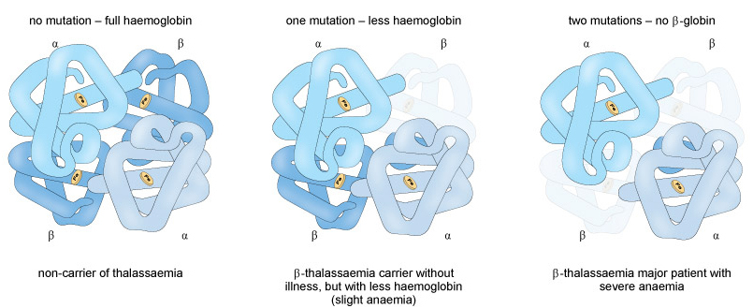
Figure 15 The severity of disease related to beta thalassaemia is dependent on the number of beta globin chains that are functional.
View description - Figure 15 The severity of disease related to beta thalassaemia is dependent on the ...

Unlike alpha thalassaemia, beta thalassaemia is usually due to a point mutation (more than 200 of which have been identified to date) in the gene that codes for beta globin. Again, the degree of disease symptomology is dependent on how many beta globin chains are functional. Beta thalassaemia minor is asymptomatic whereas beta thalassaemia major causes growth retardation, skeletal abnormalities and jaundice, and requires lifelong blood transfusions to treat.
The overall effect of either alpha or beta thalassaemia is haemolysis, the rupture and destruction of the erythrocytes. Because of this, people with thalassaemia are at risk of developing pulmonary hypertension, a higher than normal pressure in the arteries that carry blood to and from the lungs. This can cause dizziness, shortness of breath and damage to the heart.

Question 11 Hb mutations

Why do you think Hb mutations that cause potentially fatal anaemias continue to exist in the human genome?

Provide your answer...
View answer - Question 11 Hb mutations

6 Control of respiration
Generally, respiration is an involuntary, automatic event. You are probably not aware it is happening unless you exert voluntary control over it by holding your breath, or breathing deeply. The rate and depth of your respiration adjusts automatically according to the metabolic needs of the tissues in the body. For example, athletes will breathe much more quickly and deeply during bouts of exercise to accommodate increased aerobic activity of their muscles, as discussed from 2:13 onwards in this video about Olympic rowing. (Make sure to open the link in a new window/tab so you can easily navigate back to this page.)
Link to Video 13 – Anatomy of a rower.
How does the body sense and respond to changes in metabolic rate? This function is mediated by peripheral chemoreceptors in the blood vessels and heart, and central chemoreceptors in the brain that detect changes in O₂ and CO₂ levels in the blood. Although changes in the partial pressures of both gases are involved in the regulation of respiration, alteration in PCO₂ is the principal driver of respiration rate in humans.

6.1 Central chemoreceptors
Changes in PCO₂, and therefore in pH, are detected largely by chemoreceptors within the respiratory centres of the brain (Figure 16). During increased metabolic activity, such as exercise, the PCO₂ in the arterial blood increases.

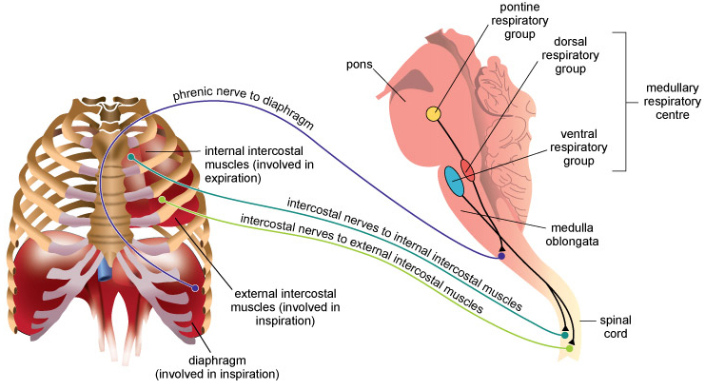
Figure 16 Neurons in the pontine and medullary respiratory centres of the brain synapse onto the diaphragm and intercostal muscles to regulate breathing rate.
View description - Figure 16 Neurons in the pontine and medullary respiratory centres of the brain synapse ...

Question 12 Increased exercise

What happens to the P50 (the PO₂ at which 50% of Hb molecules are saturated with O₂) of the oxygen–haemoglobin dissociation curve during increased exercise? (see Section 4.2)

it increases
it decreases
it stays the same
View answer - Question 12 Increased exercise

As CO₂-rich blood reaches the brain, CO₂ diffuses across the blood–brain barrier into the interstitial fluid and cerebrospinal fluid that surrounds the medulla.

Activity 11 Reaction components
Allow about 10 minutes

Part 1

Enter the components represented by x and y that complete the formula below.

View alternative description - Uncaptioned Equation

There are superscript and subscript buttons in the formatting bar. Make sure to use these to enter the correct chemical formula, including the associated positive and negative charges:

x = y =
View answer - Part 1

Part 2

Using the completed formula above, what will happen to levels of H⁺ in the brain as CO₂-rich blood reaches the medulla?

levels of H⁺ will increase
levels of H⁺ will decrease
levels of H⁺ will stay the same
View answer - Part 2

Neurons within the medullary and pontine respiratory centres will fire action potentials in response to the change in pH, via activation of receptors that are sensitive to protons (Guyenet and Bayliss, 2015). These neurons synapse onto the phrenic and intercostal nerves which innervate the diaphragm and intercostal muscles (see Section 1.2) and stimulate increased breathing (Figure 16).
As the pH returns to homeostatic levels, the chemoreceptors stop being activated and the breathing rate returns to normal. Therefore, the respiratory centres act as the ‘pacemakers’ of respiration during both resting and stimulated conditions, via communication with the muscles that control the expansion and contraction of the lungs (McKay et al., 2003). Fine-tuning of the breathing pattern is controlled by inputs from the pontine respiratory group (Figure 16). Information from stretch receptors in the lungs is also used by the respiratory centres to determine when the lungs have expanded to full capacity.
Some neurodegenerative diseases, such as motor neurone disease, are characterised by respiratory problems that are caused by the gradual loss of innervation to the diaphragm and intercostal muscles, despite the fact that the respiratory centres are intact. In other cases, when the respiratory centres of the medulla are damaged, individuals may require artificial ventilation of the lungs to regulate their breathing rate.

6.2 Peripheral chemoreceptors
Before the blood reaches the chemoreceptors in the brain, changes in PO₂ are detected by specialised cells – called type 1 glomus cells – that are located in the carotid artery (carotid bodies) and aorta (aortic bodies) of the heart.
Glomus cells are derived from the same tissue as neurons and therefore have similar properties, including electrical excitability and release of neurotransmitters. The cells express O₂-sensitive potassium channels; when the PO₂ falls, the K⁺ channels close and the resting potential of the cell becomes less negative.
Glomus cells release dopamine across the neuromuscular junction, which causes the postsynaptic sensory neurons to send an afferent signal to the medullary respiratory centres. The respiratory centres will then send action potentials to the phrenic and intercostal nerves to increase the respiration rate.

6.3 Additional neuronal control
The lungs also receive innervation from the autonomic nervous system (Figure 17). The sympathetic innervation originates from the thoracic portion of the spinal cord and synapses onto the bronchiolar smooth muscle. Stimulation of these nerves causes bronchodilation.

Question 13 Bronchodilation

What happens to airway resistance during bronchodilation?

it increases
it decreases
it stays the same
View answer - Question 13 Bronchodilation

In parallel, the vagus nerves (or cranial nerve X) synapse onto the bronchi and pulmonary blood vessels as part of the parasympathetic innervation. Activity of these neurons counterbalances the sympathetic response by stimulating constriction of the bronchi. Activation of these pathways is involved in the ‘fight or flight’ response.

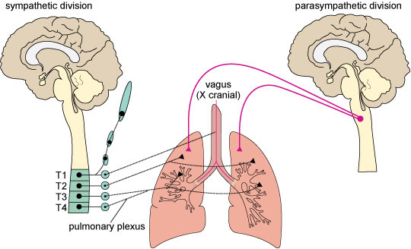
Figure 17 Innervation of the lungs by the autonomic nervous system.
View description - Figure 17 Innervation of the lungs by the autonomic nervous system.

Question 14 Hyperventilation

Sarah has a panic disorder and frequently experiences panic attacks that cause her to hyperventilate (i.e. breathe more rapidly than normal) and feel dizzy. What branch of the autonomic nervous system is activated during the panic attack?

parasympathetic
sympathetic
enteric
View answer - Part

What will happen to the PCO₂ levels in the alveoli during hyperventilation?

they will drop
they will increase
they will stay the same
View answer - Part

Sarah finds that if she breathes into a paper bag during hyperventilation, her breathing returns to normal more quickly than when she just waits for the attack to pass. Why do you think this is?

Provide your answer...
View answer - Part

Finally, if you play a musical wind instrument, you know that some aspects of breathing can be controlled voluntarily. This ‘override’ of the autonomic breathing system involves the motor cortex, thalamus and cerebellum, which are also involved in breath control during speech and behavioural tasks that modify breathing by learning and experience.

6.4 Sleep apnoea
Sleep apnoea occurs when airflow is disrupted during sleep. It can arise due to abnormalities in the medullary respiratory centres that result in a failure to regulate the contraction of the diaphragm and intercostal muscles (called central apnoea).
However, the most common form of sleep apnoea is caused by an obstruction of the pharynx (termed obstructive sleep apnoea) by the muscles and soft tissues in the throat, which relax during sleep. A reduction in airflow (due to increased airway resistance) is termed hypopnoea, whereas a complete blockage of airflow (interruption for more than 10 seconds) is called apnoea. Symptoms of obstructive sleep apnoea include snoring (caused by the vibration of the soft tissues in the pharynx), struggling to breathe (or cessation of breathing) during sleep, and fatigue or falling asleep in the daytime. An instance of apnoea is shown in Video 14 below.

Video content is not available in this format.
Video 14 Obstructive sleep apnoea.
View transcript - Video 14 Obstructive sleep apnoea.

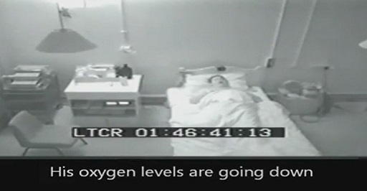

Some people may be completely unaware that they stop breathing at night and therefore are only conscious of feeling very tired despite having slept ‘well’. The fatigue occurs because during the apnoea, the response of the respiratory neurons to the rising PCO₂ of the blood causes the brain to come out of REM sleep. In people with severe obstructive sleep apnoea, such interruptions can occur more than 30 times in an hour, leading to very poor quality sleep.
Treatments for sleep apnoea typically involve lifestyle changes that result in physiological changes (e.g. weight loss, cessation of smoking), mandibular advancement mouthpiece devices that keep the jaw open, and wearing continuous positive airway pressure (CPAP) masks that push pressurised air into the airway (Figure 18).

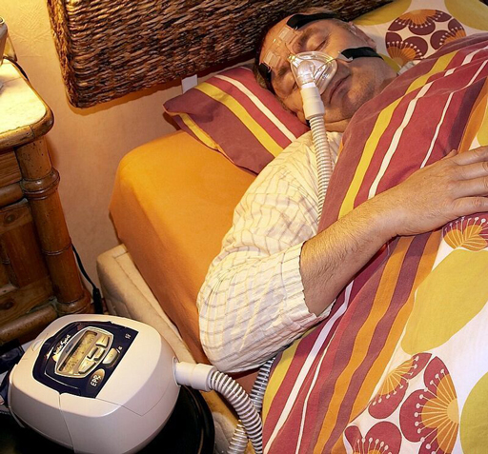
Figure 18 Use of a CPAP device for treatment of sleep apnoea.
View description - Figure 18 Use of a CPAP device for treatment of sleep apnoea.

Conclusion
In Act 1, Scene 3 of William Shakespeare’s The Merchant of Venice, Shylock asks Antonio:

… shall I bend low, and in a bondman’s key with bated breath and whisp’ring humbleness say this: “Fair sir, you spet on me on Wednesday last… and for these courtesies I’ll lend you thus much moneys”?
(Shakespeare, 1605, p.28)

Shylock is mockingly implying that he is holding his breath in eager anticipation of lending Antonio money. Although written many years before the physiology of respiration was understood, Shakespeare recognised that breathing is a dynamic process that responds to changes in the environment.
In this course, you have learnt how exchange of O₂ and CO₂ is mediated by physical factors such as pressure gradients and chemical changes such as bicarbonate buffering and pH. The airways, musculoskeletal system, lungs and nervous system act in concert to make sure that adequate levels of O₂ are maintained throughout the body.
Here is a summary of the main points that have been covered in this course:
- The respiratory system comprises structures that conduct air into and out of the lungs. The conduction zone includes the nasal passages, pharynx, larynx, bronchi and bronchioles. Gas exchange occurs in the respiration zone of the bronchioles, alveolar ducts and alveoli.
- Exchange of O₂ and CO₂ is influenced by pressure (atmospheric and partial), surface tension, lung compliance and airway resistance. These factors are altered by respiratory disorders such as asthma, smoking and COPD, which also influence lung capacity.
- The majority of O₂ is carried in the blood bound to haemoglobin that is present in erythrocytes. Most of the CO₂ is carried in the blood as bicarbonate, whereas a smaller percentage also binds to haemoglobin.
- Recessive polymorphisms in the haemoglobin genes can cause anaemias such as sickle cell anaemia and thalassaemia, but may confer protection against infectious disease.
- Changes in PCO₂ and PO₂ are detected by chemoreceptors located in the heart, blood vessels and brain. Respiratory centres in the medulla communicate via the peripheral nervous system with the muscles that control ventilation.
This OpenLearn course is an adapted extract from the Open University course SK299 Human biology.

References
Guyenet, P. G. and Bayliss, D. A. (2015) ‘Neural control of breathing and CO₂ homeostasis’, Neuron, vol. 87, no. 5, pp. 946–61.
McKay, L. C., Evans, K. C., Frackowiak, R. S. J. and Corfield, D. R. (2003) ‘Neural correlates of voluntary breathing in humans’, Journal of Applied Physiology, vol. 95, no. 3, pp. 1170–8.
Muncie Jr., H. L. and Campbell, J. S. (2009) ‘Alpha and beta thalassemia’, American Family Physician, vol. 80, no. 4, pp. 339–44.
Shakespeare, W. (1605) The Merchant of Venice, Brown, J. R. (ed), Bungay, Suffolk, Methuen Publishing Ltd. (this edition 1955).

Further reading
Berg, J. M., Tymoczko, J. L. and Stryer, L. (2002) Biochemistry, 5th edn, New York, W. H. Freeman.
Johns, D. P. and Pierce, R. (2008) Spirometry Handbook (Spirometry: The Measurement and Interpretation of Ventilatory Function in Clinical Practice), National Asthma Council Australia [Online]. Available at https://www.nationalasthma.org.au/uploads/content/211-spirometer_handbook_naca.pdf (Accessed 27 October 2017).
Pittman, R. N. (2011) Regulation of Tissue Oxygenation, San Rafael, CA, Morgan & Claypool Life Sciences.

Acknowledgements
This free course was written by Cheryl Hawkes.
Grateful acknowledgement is made to the following sources:
Images
Course image © robuart / s123RF
Figure 1 © The Open University
Figure 2 © The Open University
Figure 3 © The Open University
Figure 4a © Science Photo Library / Universal Images Group
Figure 4b Adapted from BC Open Textbooks. Anatomy and Physiology
Figure 5 From Gray's Anatomy 1918 (public domain)
Figure 6 © Paul Silverman / Fundamental Photographs / Universal Images Group
Figure 7 Adapted from https://courses.washington.edu/conj/heart/laplace.gif
Figure 8a © Warren Rosenberg / Fundamental Photographs / Universal Images Group
Figure 8b © Science Photo Library / Universal Images Group
Figure 9a © Science Photo Library / Universal Images Group
Figure 9b © Eye of Science / Photo Researchers / Universal Images Group
Figure 9c © Dr Tony Brain / Science Photo Library / Universal Images Group
Figure 10 © Mario Tama / Getty Images News / Getty Images / Universal Images Group
Figure 11 Adapted from Encyclopaedia Britannica / Universal Images Group
Figure 12 Adapted from www.pathwaymedicine.org
Figure 13a © Eye of Science / Photo Researchers / Universal Images Group
Figure 13b © Frank Greenaway / Dorling Kindersley / Universal Images Group
Figure 14 © Emaze.com
Figure 15 Adapted from Thalassaemia Society of NSW
Figure 16 © The McGraw Hill Companies Inc.
Figure 17 © The Open University
Figure 18 © Science Photo Library / Universal Images Group
AV
Video 1 © William Trubridge
Video 2 © scyrus / TurboSquid
Video 3 © scyrus / TurboSquid
Video 4 © Flix Productions Medical Animation / Science Photo Library
Video 5 © The Open University
Video 6 © The Open University
Video 7 © Guille 8001500
Video 8 © The Open University
Video 9 © Martin Shields / Science Photo Library
Video 10 © The Open University
Video 11 © The Open University
Video 12 © The Open University
Video 13 © Olympic
Video 14 © British Lung Foundation
Every effort has been made to contact copyright holders. If any have been inadvertently overlooked the publishers will be pleased to make the necessary arrangements at the first opportunity.

Glossary
alveolar sacs
Part of the respiratory zone structures, located at the end of the alveolar duct.
apnoea
A temporary cessation of breathing.
Bohr effect
Influence of CO₂ and acidity on the affinity of haemoglobin for oxygen.
bronchi
The two main branches of the windpipe or trachea, leading to the lungs (singular, bronchus).
carbaminohaemoglobin
Haemoglobin that is bound to carbon dioxide (HbCO₂).
cellular respiration
The metabolic process in which living cells obtain energy (in the form of adenosine triphosphate, ATP) from the breakdown of molecules, particularly glucose.
central chemoreceptors
Receptors located on neurons within the medullary and pontine respiratory centres of the brain that detect differences in blood pH.
compliance
The ease with which the lungs and pleura expand and contract based on changes in pressure.
conduction zone
The parts of the lungs that conduct gas to and from the external environment.
deoxyhaemoglobin
Haemoglobin that is not bound to oxygen.
diaphragm
A muscular wall involved in lung ventilation, separating the chest (thoracic) cavity from the abdominal cavity.
external respiration
Exchange of gases in the lung between the blood and the external environment.
forced expiratory volume 1
The amount of air that is forcibly blown out within the first second of a spirometry test.
forced vital capacity
Total volume of air that can be forcefully blown out.
haemoglobin
A globular iron-containing protein present in red blood cells, which binds oxygen at the lungs and transports it to the tissues. Some of the carbon dioxide transported from the tissues to the lungs is also carried by haemoglobin.
Haldane effect
Influence of oxygen on haemoglobin transport of carbon dioxide.
hypopnoea
Reduction in airflow.
intercostal muscles
External and internal muscles between the ribs that are involved in the movement of the ribcage during breathing.
intercostal nerves
Nerves that innervate the intercostal muscles.
lungs
The respiratory organs that are located in the chest cavity; consisting of two elastic sacs with branching airways that allow air to be drawn into the body and expelled by a combination of muscular action and elastic recoil. They provide a large surface area where gaseous exchange occurs between the blood and the air.
nasal cavities
Part of the upper respiratory tract by which air enters and leaves the body.
oxygen–haemoglobin dissociation curve
'S'-shaped curve that dictates how the affinity of haemoglobin for oxygen changes with different partial pressures of oxygen.
oxyhaemoglobin
Haemoglobin bound to oxygen molecules. Oxyhaemoglobin transports oxygen from blood vessels in the lungs to the cells in the rest of the body,
partial pressure
The pressure that one component of a mixture of gases would exert if it were alone in a container.
peak expiratory flow
The maximum rate at which air is forcefully expired (litres per second).
peripheral chemoreceptors
Receptors in the carotid artery (carotid bodies) and aorta (aortic bodies) of the heart that detect and respond to changes in partial pressure of oxygen.
pharynx
The opening at the back of the throat that serves as a common passageway for the digestive and respiratory systems.
phrenic nerve
Nerve originating in the medulla of the brain that innervates the diaphragm.
pleura
The thin membranes lining the fluid-filled cavity (the pleural cavity) between the lungs and the inside of the thoracic (chest) wall (singular, pleura).
resistance
The friction that is generated when the air passes along the structures in the conduction and respiratory zones.
respiratory centres
The areas of the medulla region in the brain that integrate sensory information from chemoreceptors monitoring the level of oxygen and carbon dioxide in the blood. The respiratory centres send out appropriate signals to regulate the rate of contraction of the respiratory muscles (including the diaphragm and intercostal muscles).
respiratory zones
Composed of the bronchioles, alveolar ducts and alveoli in which gas exchange takes place during respiration.
sickle cell anaemia
A genetic disorder linked to abnormal haemoglobin. A point mutation has replaced the amino acid glutamic acid with valine, disrupting the structure of haemoglobin. The abnormal haemoglobin crystallizes when deoxygenated, forming sickle-shaped red blood cells that tend to block capillaries.
spirometry
A test used to measure lung function.
surface tension
Chemical forces that hold liquids in their smallest surface area possible.
surfactant
A phospholipid substance that breaks surface tension of water by attaching to the water molecules and preventing them from interacting with each other.
thalassaemias
A group of inherited autosomal recessive disorders that cause anaemia because of the decreased or absent synthesis of a globin chain of haemoglobin.
trachea
A tube that connects the throat (pharynx) and voice box (larynx) to the lungs, allowing the passage of air. Also known as the windpipe.

Solutions

Question 1 A situation

Answer
Right:
trachea
Wrong:
nasal cavity
mouth
pharynx
oesophagus
The chicken is likely to be stuck in John's trachea and is obstructing the air in the pharynx from reaching the lungs. Targeting the nasal cavity, mouth or pharynx will not help to restore airflow because these structures are all upstream of the trachea. Doctors will attempt to remove the obstruction and if unsuccessful, will probably make a small hole in the trachea below the obstruction (a procedure called a tracheotomy) and insert a tube that will allow air to flow directly into the lungs.
Back to - Question 1 A situation

Activity 1 Ordering the air flow

Answer
The correct matches are:
1
Air is taken in through the nasal cavities.
2
Air passes down the back of the pharynx, past the epiglottis and into the larynx.
3
From the larynx, air travels into the trachea, and into the bronchi.
4
Air moves through the terminal bronchioles and into the respiratory bronchioles.
5
Air passes into the alveolar ducts and into the alveolar sacs.
Back to - Activity 1 Ordering the air flow

Activity 2 Diaphragm and intercostal muscles

Part 2

Answer
The correct matches are:
diaphragm
flatten(s) when contracted to expand the size of the thoracic cavity and decrease the size of the abdominal cavity, generating a pressure gradient within the thoracic cavity
external intercostal muscles
draw(s) the ribs upwards and outwards; most active during inhalation
internal intercostal muscles
draw(s) the ribs downwards and inwards; most active during forced exhalation
innermost intercostal muscles
stiffen(s) the chest wall during respiration; most active during forced exhalation
Back to - Part 2

Activity 3 Lung in a bottle

Part

Answer
Pulling down on the blue balloon ‘diaphragm’ caused the air pressure in the ribcage to drop lower than the air pressure in the atmosphere. This drove air to flow down its pressure gradient into the balloon, causing it to inflate. Pressing up on the diaphragm increased the air pressure in the ribcage, driving air out of the balloon lung and causing it to collapse.
Back to - Part

Question 2 Increasing pressure

Answer
Right:
by ½
Wrong:
it did not change
by ¼
by ¾
As the pressure increased by a factor of 2, the volume of the air decreased by ½, from 1 litre to 0.5 litre.
Back to - Question 2 Increasing pressure

Question 3 Boyle's law

Part 1

Answer
P = k/V. To calculate pressure (P), divide the constant (k) by the volume (V).
Back to - Part 1

Part 2

Answer
Right:
0.167 mmHg
Feedback
Wrong:
6 mmHg
16 mmHg
Back to - Part 2

Part 3

Answer
Right:
0.333 mmHg
Feedback
Wrong:
3 mmHg
13 mmHg
Back to - Part 3

Part 4

Answer
Right:
Exhalation
Wrong:
Inhalation
Neither, it is constant
As the volume of the lungs shrinks during exhalation, the pressure in the lungs increases above that of atmospheric pressure and air moves out of the lungs down the pressure gradient.
Back to - Part 4

Question 4 Nitrogen

Answer
The PN₂ in the atmosphere is 0.78 × 760 mmHg = 593 mmHg.
Back to - Question 4 Nitrogen

Question 5 Pressure in the lungs

Answer
Right:
it will decrease
Wrong:
it will increase
it will stay the same
It will decrease. According to Boyle’s law, P = k/V, so as the volume gets bigger, the pressure gets smaller.
Back to - Question 5 Pressure in the lungs

Activity 5 Comparing tissues

Part

Answer
The tissue from the healthy lung is uniform and pale in colour throughout. The lung from the smoker is bigger and contains large holes and has black-brown discolourations (probably due to tar and other particulates contained in cigarette smoke).
Back to - Part

Part

Answer
The alveoli in the healthy lung are well defined and interconnected. The alveoli in the lung affected by COPD have incomplete and thinner walls, do not make as many connections with other alveoli and have larger air spaces that reduce the respiratory surface.
Back to - Part

Question 6 Airflow resistance

Answer
Right:
higher
Wrong:
lower
neither, they are the same
The radius of a bronchiole is smaller than that of a bronchus. A smaller radius results in higher resistance. Therefore, the resistance to airflow is higher in the bronchiole compared with the bronchus.
Back to - Question 6 Airflow resistance

Activity 6 Lung capacity

Part 1

Answer
The correct matches are:
extra volume breathed out during forceful exhalation
expiratory reserve volume
extra volume breathed in during forceful inhalation
inspiratory reserve volume
amount of air left in the lungs in addition to the expiratory reserve volume
residual volume
amount of air entering or leaving the lungs in a single resting breath
tidal volume
Back to - Part 1

Part 2

Answer
Right:
residual volume
Feedback
Correct. The vital capacity is the sum of the tidal volume, inspiratory reserve volume and expiratory reserve volume.
Wrong:
tidal volume
inspiratory reserve volume
expiratory reserve volume
Back to - Part 2

Question 7 Lung function across ages

Answer
Right:
It decreases with age.
Wrong:
It stays the same across all ages.
It increases with age.
Correct. Lung function, as measured by the FEV₁/FVC percentage, decreases with age in both men and women.
Back to - Question 7 Lung function across ages

Question 8 Pulmonary arteries

Answer
Right:
deoxyhaemoglobin
Wrong:
oxyhaemoglobin
Pulmonary arteries carry blood coming from the peripheral organs into the lungs where CO₂ will be exchanged for O₂, so they carry CO₂-rich blood. Therefore, the predominant form of Hb in the pulmonary arteries will be deoxyhaemoglobin.
Back to - Question 8 Pulmonary arteries

Question 9 Biological factors

Answer
- CO₂
- acidity
- 2,3-DPG
- exercise
- temperature
Back to - Question 9 Biological factors

Question 10 Higher H⁺

Answer
Right:
left, towards increased CO₂ production
Wrong:
right, towards HCO₃⁻ production
neither, the reaction will stay in equilibrium
The answer is left. It will help drive the diffusion of CO₂ out of the blood and into the alveoli to be exhaled.
Back to - Question 10 Higher H+

Activity 9 RNA codon wheel

Answer
Right:
GAG → GAA
Feedback
Correct. Both GAG and GAA are codons for glutamic acid. Therefore, substitution of G by A will still produce a functional Hb protein.
Wrong:
GAG → GCG
Feedback
Incorrect. Substitution of A by C will produce the codon GCG which codes for the amino acid alanine.
GAG → CAG
Feedback
Incorrect. Substitution of G by C will produce the codon CAG which codes for the amino acid glutamine.
Back to - Activity 9 RNA codon wheel

Question 11 Hb mutations

Answer
The rates of both sickle cell anaemia and thalassaemias are higher in people of African, Southeast Asian and Mediterranean descent. It is not a coincidence that these are also regions where the malaria parasite is highly prevalent. Heterozygous carriers of the HbS gene or thalassaemia mutations are less likely to be infected with the Falciparum malaria parasite than people with the normal copies of those genes. Malaria can cause serious illness and over one million people die from the infection every year. Therefore, mutations in Hb lead to a trade-off between increased risk of anaemia and decreased risk of death from malaria. Malaria is a good example of how parasites (and other infectious organisms) exert evolutionary pressure on the human genome to adopt multiple polymorphisms that protect against severe disease.
Back to - Question 11 Hb mutations

Question 12 Increased exercise

Answer
Right:
it increases
Wrong:
it decreases
it stays the same
Increasing exercise will shift the oxygen–haemoglobin dissociation curve to the right, so the P50 will increase.
Back to - Question 12 Increased exercise

Activity 11 Reaction components

Part 1

Answer

View alternative description - Uncaptioned Equation

View alternative description - Uncaptioned Equation

giving:

View alternative description - Uncaptioned Equation

Back to - Part 1

Part 2

Answer
Right:
levels of H⁺ will increase
Wrong:
levels of H⁺ will decrease
levels of H⁺ will stay the same
Adding more CO₂ will increase the production of H⁺ and HCO₃⁻. Increased H⁺ will make the tissue more acidic, meaning that the pH will decrease.
Back to - Part 2

Question 13 Bronchodilation

Answer
Right:
it decreases
Wrong:
it increases
it stays the same
It decreases. Dilation will increase the diameter of the bronchioles, so the resistance to airflow will decrease.
Back to - Question 13 Bronchodilation

Question 14 Hyperventilation

Part

Answer
Right:
sympathetic
Wrong:
parasympathetic
enteric
Activation of the sympathetic nervous system will cause the bronchioles to dilate to meet the demands of increased inspiration and expiration.
Back to - Part

Part

Answer
Right:
they will drop
Wrong:
they will increase
they will stay the same
They will drop. The rapid breathing causes more CO₂ to be expired, so the PCO₂ in the alveoli will be lower than normal.
Back to - Part

Part

Answer
During hyperventilation, PCO₂ in the alveoli will be lower than normal. Decreased CO₂, in combination with the decreased acidity of the blood, will shift the oxygen–haemoglobin dissociation curve to the left, increasing the affinity of Hb for O₂ and making it harder for O₂ to diffuse into the tissue (which partly explains why she feels dizzy).
Breathing into a bag concentrates the gases that are breathed out, including CO₂. Re-breathing the expired, concentrated CO₂ will lower the pH, reduce the activity of the respiratory neurons and restore the homeostatic breathing rate.
Back to - Part

Descriptions

Figure 1 Cross-section through the structures of the respiratory system.
Pink silhouette of the lower head and the thorax of a human.
The thoracic cavity is shown bounded by yellow ribs (in cross-section) with intercostal muscles between the ribs. Inside the ribs is the thoracic cavity in pale blue. At the base of the thoracic cavity is the diaphragm, coloured purple, and displayed as an inverted U-shape, with the abdominal cavity below.
Two lungs, coloured pink are on the right and left sides of the thoracic cavity; the lungs are covered with pleurae, shown as a white layer covering the lungs. The lobes of the lung are shown on the right lung.
The mouth and nasal cavities proceed to the pharynx in the neck; this leads to the oesophagus, all coloured pink. From the top of the oesophagus proceeds the trachea (coloured yellow) with darker yellow cartilage rings stiffening and supporting it; at the top of the trachea is shown the box-like larynx in pale yellow. The trachea branches to lead to two bronchi, one leading into each of the right and left lungs. The left bronchus is traced into the left lung, showing extensive branching into ramifying bronchioles, stiffened with cartilage.
The heart is shown in dark red between the base of the lungs; the trunks of major arteries are shown proceeding from the heart.
Back to - Figure 1 Cross-section through the structures of the respiratory system.

Figure 2 Structures of the upper respiratory tract.
Pink silhouette of the head and neck of a human. The mouth (with the tongue) and the nasal cavities (with a nostril) proceed to the pharynx in the neck; this leads to the oesophagus, all coloured pink. From the top of the oesophagus proceeds the trachea (coloured yellow) with darker yellow cartilage rings stiffening and supporting it; at the top of the trachea is shown the box-like larynx in pale yellow. Above the larynx is a flap, hinged at the front – this is the epiglottis.
Back to - Figure 2 Structures of the upper respiratory tract.

Video 2 3D model of the trachea, bronchi and bronchioles. (Please note, this video has no audio.)
This is a “moving” picture, giving a rotating, stereoscopic-effect view of the lungs, bronchi and vertebral column.
First view shows two pink lungs, viewed from the front. Between the lungs at their tops is the trachea (in yellow-grey) with stiffening cartilaginous rings. About one third the way down the lungs the trachea branches into the right and left bronchi. The vertebral column (in grey) lies behind the respiratory organs. The illustration rotates clockwise.
Subsequent views show the lungs from the right and left sides, with the trachea entering between the lungs, and the vertebral column lying behind the respiratory organs.
In a final view the lungs are removed to show the trachea, bronchi and the bronchi branching (in what would be within the lungs) in a ramifying system of bronchioles with smaller and smaller branches.
Back to - Video 2 3D model of the trachea, bronchi and bronchioles. (Please note, this video has no audio.)

Figure 1 (repeated) Components of the respiratory system.
Pink silhouette of the lower head and the thorax of a human.
The thoracic cavity is shown bounded by yellow ribs (in cross-section) with intercostal muscles between the ribs. Inside the ribs is the thoracic cavity in pale blue. At the base of the thoracic cavity is the diaphragm, coloured purple, and displayed as an inverted U-shape, with the abdominal cavity below.
Two lungs, coloured pink are on the right and left sides of the thoracic cavity; the lungs are covered with pleurae, shown as a white layer covering the lungs. The lobes of the lung are shown on the right lung.
The mouth and nasal cavities proceed to the pharynx in the neck; this leads to the oesophagus, all coloured pink. From the top of the oesophagus proceeds the trachea (coloured yellow) with darker yellow cartilage rings stiffening and supporting it; at the top of the trachea is shown the box-like larynx in pale yellow. The trachea branches to lead to two bronchi, one leading into each of the right and left lungs. The left bronchus is traced into the left lung, showing extensive branching into ramifying bronchioles, stiffened with cartilage.
The heart is shown in dark red between the base of the lungs; the trunks of major arteries are shown proceeding from the heart.
Back to - Figure 1 (repeated) Components of the respiratory system.

Figure 3 Terminal bronchioles further divide within the lungs.
A drawing of a lung (pink) with a bronchus and branching bronchioles within the lung.
The ends of two of the bronchioles are shown in greatly expanded form. A terminal bronchiole is shown with a respiratory bronchiole, branching into two, leading from it. Around the ends of the respiratory bronchioles are alveolar sacs (looking like bunches of grapes), each comprising many spherical alveoli.
An alveolar sac is shown in expanded form. The sac is cut open to shown alveoli, also cut open, spherical units each with an alveolar pore.
Back to - Figure 3 Terminal bronchioles further divide within the lungs.

Video 3 Exchange of CO2 and O2 carried by blood in the pulmonary capillaries within the alveoli of the lungs. (Please note, this video has no audio.)
This is a “moving” picture, giving a rotating, stereoscopic-effect view of a respiratory bronchus, an alveolar sac and associated pulmonary capillaries.
The figure shows a horizontal pink tube, a terminal bronchiole, with a respiratory bronchiole leading down from it into an alveolar sac (looking like a bunch of grapes), each alveolus being spherical. Over one side of the alveolar sacs are branching, bright red capillaries and on the other side (seen as the figure rotates clockwise) are bright blue capillaries.
Back to - Video 3 Exchange of CO2 and O2 carried by blood in the pulmonary capillaries within the alveoli of the lungs. (Please note, this video has no audio.)

Figure 4 (a) Electron micrograph and (b) schematic showing a cross-section of an alveolus (purple), with red blood cells (red) in the surrounding intertwining capillaries and a pulmonary macrophage (green) inside the alveolus.
(a) shows an artificially coloured electron micrograph of an alveolus with purple walls; cavities in the walls show capillaries in cross-section, some of them containing erythrocytes coloured red. Within the alveolus is a large pulmonary macrophage (coloured pale green) with many processes.
(b) is a diagram based on (a) above. The alveolus is shown as a half of a hollow sphere with pale blue epithelial cells lining it. Darker blue macrophages with branching processes are seen on the alveolar walls. Also in the alveolar walls black alveolar pores are shown. Within the wall of the alveolus, comprising the respiratory membrane, capillaries are seen in cross-section, containing erythrocytes (red blood cells).
Back to - Figure 4 (a) Electron micrograph and (b) schematic showing a cross-section of an alveolus (purple), with red blood cells (red) in the surrounding intertwining capillaries and a pulmonary macrophage (green) inside the alveolus.

Figure 1 (repeated) Components of the respiratory system.
Pink silhouette of the lower head and the thorax of a human.
The thoracic cavity is shown bounded by yellow ribs (in cross-section) with intercostal muscles between the ribs. Inside the ribs is the thoracic cavity in pale blue. At the base of the thoracic cavity is the diaphragm, coloured purple, and displayed as an inverted U-shape, with the abdominal cavity below.
Two lungs, coloured pink are on the right and left sides of the thoracic cavity; the lungs are covered with pleurae, shown as a white layer covering the lungs. The lobes of the lung are shown on the right lung.
The mouth and nasal cavities proceed to the pharynx in the neck; this leads to the oesophagus, all coloured pink. From the top of the oesophagus proceeds the trachea (coloured yellow) with darker yellow cartilage rings stiffening and supporting it; at the top of the trachea is shown the box-like larynx in pale yellow. The trachea branches to lead to two bronchi, one leading into each of the right and left lungs. The left bronchus is traced into the left lung, showing extensive branching into ramifying bronchioles, stiffened with cartilage.
The heart is shown in dark red between the base of the lungs; the trunks of major arteries are shown proceeding from the heart.
Back to - Figure 1 (repeated) Components of the respiratory system.

Figure 5 Diaphragm and intercostal muscles.
Diagram of thoracic muscles featuring the diaphragm. From Gray's Anatomy 1918.
Back to - Figure 5 Diaphragm and intercostal muscles.

Figure 6 Surface tension of water holds it in a droplet form.
Colour photograph of the surface of a plant leaf, with two droplets of water, both spherical in shape, due to surface tension.
Back to - Figure 6 Surface tension of water holds it in a droplet form.

Figure 7 Surface tension (T) created by hydrogen bonding of water puts pressure on the inside of the alveoli, which have a small diameter or radius (R).
A pink circle with thick walls. Bidirectional arrows, pulling away at 3 o’clock and 9 o’clock in the wall. P in the centre of the circle with arrows pointing towards the P from the right and from the left. T on the outside the wall.

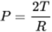
View alternative description - Uncaptioned Equation

Where P = pressure; T = tension in the wall; R = radius.
Back to - Figure 7 Surface tension (T) created by hydrogen bonding of water puts pressure on the inside of the alveoli, which have a small diameter or radius (R).

Uncaptioned Equation
cap p equals two times cap t divided by cap r
Back to - Uncaptioned Equation

Figure 8 (a) Cross-section through a healthy lung showing the air-filled alveoli. (b) Cross-section of a diseased lung showing deposits of coal particles (arrow).
Coloured light micrographs of lung sections.
(a) Alveoli and capillaries in cross-section, with extensive white spaces – alveolar cavities.
(b) Cross-section of a diseased lung, with relatively dense pink tissue and with blue-staining nuclei. Extensive accretions of black carbon (coal) particles present throughout the section.
Back to - Figure 8 (a) Cross-section through a healthy lung showing the air-filled alveoli. (b) Cross-section of a diseased lung showing deposits of coal particles (arrow).

Figure 9 (a) Cross-section through a healthy lung (left) and a lung from a smoker (right). (b) and (c) Scanning electron microscope images showing alveoli in the lungs of (b) a healthy individual and (c) a person with COPD.
(a) Photographs of lung sections from a healthy person showing dense, spongy lung tissue (left) and from a smoker showing a larger lung, extensive cavitation in the lung and black-brown tar deposits (right).
(b) Artificially-coloured scanning electron-micrograph image of alveoli in a healthy lung showing intact, well-defined alveoli as sections of spherical hollows.
(c) Artificially-coloured scanning electron-micrograph image of alveoli from the lung of a person suffering from COPD (chronic obstructive pulmonary disease) showing damaged alveoli with thinner walls and larger air spaces.
Back to - Figure 9 (a) Cross-section through a healthy lung (left) and a lung from a smoker (right). (b) and (c) Scanning electron microscope images showing alveoli in the lungs of (b) a healthy individual and (c) a person with COPD.

Figure 10 Portable spirometer used to measure lung function.
Colour photograph of a man wearing a nose clip and breathing (through his mouth) into a spirometer (which looks like a white box) by another person.
Back to - Figure 10 Portable spirometer used to measure lung function.

Figure 11 Schematic of the haemoglobin protein, comprising two alpha and two beta chains and four haem groups.
A diagram of a haemoglobin molecule showing four globin chains, here conventionally arranged at the four corners of a square. Each globin chain is a folded, elongated “sausage” in a different shade of blue. Attached to each globin chain is a haem moiety, shown as a yellow disc with “Fe” (iron) on it. The globin chains are labelled α₁, α₂, β₁ and β₂.
Back to - Figure 11 Schematic of the haemoglobin protein, comprising two alpha and two beta chains and four haem groups.

Uncaptioned interactive content
Line graph showing percent of haemoglobin (Hb) saturated with oxygen (on a scale from 0% – 100%) on the vertical axis, and PO₂ in mmHg from 0 – 100 mmHg on the horizontal axis.
The oxygen dissociation curve is shown as a red line starting from the origin for both axes, rising to give a 70% Hb saturation at PO₂ of 40 mmHg; the curve then rises less steeply, almost to plateau at about 95% Hb saturation at PO₂ of about 90 mm Hg.
At 30 mmHg an arrow notes that there is a low PO₂ in tissue: less oxygen is attached to the Hb; at 78 mmHg an arrow notes that there is a high PO₂ in the alveoli: lots of oxygen is attached to the Hb.
The student is invited to drag a marker to the point in the curve where 50% of the Hb is saturated with O₂.
Back to - Uncaptioned interactive content

Uncaptioned Equation
cap h sub two times cap o plus cap c times cap o sub two right harpoon over left harpoon cap h sub two times cap c times cap o sub three right harpoon over left harpoon cap h super plus plus cap h times cap c times cap o sub three times super minus
Back to - Uncaptioned Equation

Uncaptioned Equation
cap h times b times cap o sub two plus cap h super plus right harpoon over left harpoon cap h times b times cap h super plus plus cap o sub two
Back to - Uncaptioned Equation

Figure 12 Mechanisms by which CO2 is carried in the blood.
A schematic diagram. On the left-hand side of the diagram is a vertical row of five, pink, rectangular peripheral cells, one of which has CO₂ written within it.
A yellow arrow shows CO₂ leaving this cell; 10% of it is shown (by a blue arrow) as dissolved CO₂ in the blood and tissue fluids. The remaining CO₂ is shown as entering a stylised red blood cell. Yellow arrows within the cell show CO₂ movement.
At the top of the red cell CO₂ is shown binding to Hb (haemoglobin) to give Hb−CO₂. At the bottom of the red cell CO₂, after its combination with water and dissociation to give H⁺ and HCO₃⁻, is shown as H⁺ with Hb to give protonated haemoglobin, Hb−H⁺, and HCO₃⁻ is shown leaving the cell, passing over a mauve circle which shows Cl⁻ moving in the opposite direction. Blue arrows to the right of the diagram indicate that 30% of the CO₂ is protein bound and 60% of the CO₂ is chemically modified.
Back to - Figure 12 Mechanisms by which CO2 is carried in the blood.

Uncaptioned Equation
cap h sub two times cap o plus cap c times cap o sub two right harpoon over left harpoon cap h sub two times cap c times cap o sub three right harpoon over left harpoon cap h super plus plus cap h times cap c times cap o sub three times super minus
Back to - Uncaptioned Equation

Figure 13 Sickle cell erythrocytes.
(a) An artificially-coloured scanning electron micrograph showing orange, normal biconcave disc erythrocytes (red blood cells) and yellowish, sickled erythrocytes.
(b) A colour photograph of an agricultural sickle.
Back to - Figure 13 Sickle cell erythrocytes.

Uncaptioned interactive content
Three concentric circles. The innermost divided into four equal sectors: G, U, A and C. Outside this circle is a second circle, with sixteen sectors, divided four times into U, C, A and G, for each of the inner circle U, C, A and G respectively. The outermost circle indicates pairs, triplets or quartets of nucleotides: outside of the circles each pair or trio or quartet of nucleotides in the outermost circle is matched with the name of an amino-acid.
Back to - Uncaptioned interactive content

Figure 14 Misshapen erythrocytes carrying the HbS mutation can aggregate and get stuck in tissue capillaries.
The top picture shows an illustration of a branching capillary with normal, biconcave disc erythrocytes moving freely through it, as shown by yellow arrows. Beside it is a cross-section of a normal, biconcave disc erythrocyte with normal haemoglobin shown as yellow dots within the erythrocyte.
The lower picture shows an illustration of the same branching capillary with some “sticky” sickle cell erythrocytes stuck in the capillary and blocking the blood flow (indicated by a corrugated yellow arrow). Beside it is a cross-section of several sickled erythrocytes with abnormal haemoglobin forming strands that cause the sickle shape, shown as strands of yellow dots within the erythrocyte.
Back to - Figure 14 Misshapen erythrocytes carrying the HbS mutation can aggregate and get stuck in tissue capillaries.

Figure 15 The severity of disease related to beta thalassaemia is dependent on the number of beta globin chains that are functional.
Three diagrams of haemoglobin molecules.
Left – no mutation, full haemoglobin. A non-carrier of thalassaemia. A diagram of a haemoglobin molecule showing four globin chains, here conventionally arranged at the four corners of a square. Each globin chain is a folded, elongated “sausage” in a different shade of blue. Attached to each globin chain is a haem moiety, shown as a yellow disc with “Fe” (iron) on it. Two of the globin chains are labelled α, and two β.
Centre – one mutation – less haemoglobin. β-thalassaemia carrier without illness, but with less haemoglobin (slight anaemia). A diagram of a haemoglobin molecule as in (left) above, but with one of the β-globin chains missing.
Right – two mutations – no β-globin. β-thalassaemia major patient with severe anaemia. A diagram of a haemoglobin molecule as in (left) above, but with both β-globin chains missing.
Back to - Figure 15 The severity of disease related to beta thalassaemia is dependent on the number of beta globin chains that are functional.

Figure 16 Neurons in the pontine and medullary respiratory centres of the brain synapse onto the diaphragm and intercostal muscles to regulate breathing rate.
On the left a drawing of the ribcage with the diaphragm within the base of the cage, and intercostal muscles between the ribs.
On the right a diagram of part of the hind-brain (pink) with the pons at the top and the medulla oblongata below, leading down to the spinal cord. Within the pons is a yellow dot, the pontine respiratory group; at the top of the medulla is a red dot, the dorsal respiratory group, and a blue dot, the ventral respiratory group; the dorsal and ventral respiratory groups form the medullary respiratory centre.
A black line (representing neuronal links) from the pontine respiratory group to the dorsal respiratory group and thence to a synapse at the base of the medulla oblongata links to a dark blue line to the diaphragm from the lower end of the medulla oblongata; this represents the phrenic nerve to the diaphragm.
A black line from the ventral respiratory group to synapse at the base of the medulla oblongata links to a light blue line (intercostal nerves) to internal intercostal muscles (involved in expiration), and to a green line (intercostal nerves) to external intercostal muscles (involved in inspiration).
Back to - Figure 16 Neurons in the pontine and medullary respiratory centres of the brain synapse onto the diaphragm and intercostal muscles to regulate breathing rate.

Uncaptioned Equation
x plus cap c times cap o sub two right harpoon over left harpoon cap h sub two times cap c times cap o sub three right harpoon over left harpoon y plus cap h times cap c times cap o sub three times super minus
Back to - Uncaptioned Equation

Uncaptioned Equation
x equals cap h sub two times cap o
Back to - Uncaptioned Equation

Uncaptioned Equation
y equals cap h super plus
Back to - Uncaptioned Equation

Uncaptioned Equation
cap h sub two times cap o plus cap c times cap o sub two right harpoon over left harpoon cap h sub two times cap c times cap o sub three right harpoon over left harpoon cap h super plus plus cap h times cap c times cap o sub three times super minus
Back to - Uncaptioned Equation

Figure 17 Innervation of the lungs by the autonomic nervous system.
On the left and on the right are drawings of a sagittal section of the brain and upper spinal cord. In the centre is a drawing of the lungs with trachea and bronchi / bronchioles.
Sensory neurons from the trachea pass to the T1 segment of the spinal cord (shown in blue on the left-hand diagram). Sensory neurons from the lungs pass, via the pulmonary plexus, to segments T2, T3 and T4 of the spinal cord (all shown in blue, as are the cell bodies of the sensory neurons outside of the spinal cord).
Motor neurons (shown as purple lines) from centres (shown as a purple dot) at the base of the medulla oblongata (shown in the right-hand diagram) pass to the lungs – these form fibres in the vagus nerve (cranial nerve X).
Back to - Figure 17 Innervation of the lungs by the autonomic nervous system.

Figure 18 Use of a CPAP device for treatment of sleep apnoea.
Colour photograph of a man asleep in bed; he is wearing a respiratory mask over his mouth and nose, connected to air-tubing linked to a white box – a positive airway pressure device.
Back to - Figure 18 Use of a CPAP device for treatment of sleep apnoea.

Video 4 Mechanics of inhalation and expiration.

Transcript
NARRATOR
During inhalation, the diaphragm contracts, causing it to flatten out and move downwards. At the same time, the ribs are moved upwards and outwards by contraction of the external intercostal muscles. Contraction of the diaphragm and the external intercostal muscles increases the volume within the ribcage so that there is a larger area for the lungs to expand into. This creates a pressure gradient within the thoracic cavity that draws air into the lungs.
Back to - Video 4 Mechanics of inhalation and expiration.

Video 5 ‘Lung in a bottle’ experiment.

Transcript
CHERYL HAWKES
Today I’m going to show you how you can make your own lung in a bottle to better understand how changes in pressure drive air into and out of the lungs. For this activity, you will need a clear plastic bottle, about 500 millilitres, two balloons, some Blu-Tack with a hole in the middle, two small straws, or one large straw, and one pair of scissors. The first thing to do is to cut your bottle in half with the scissors, which can be a little bit fiddly, so I’ve made one already. And we’re going to use the top of it to make our model.
And next, take one of your balloons and cut the top of it off. I’m going to take this part of the balloon and wrap it around the base of the bottle. Next, we’re going to take the second balloon and insert it into the bottle.
And then wrap the lip of the balloon around the top of the bottle. Then, you take the two straws and cut them about a quarter of the way down. Next, we’ll insert the straws into the hole in the Blu-Tack, and put both of these into the mouth of the balloon. And then squeeze the Blu-Tack down over the straws and the lip of the bottle just to make sure that you seal off the bottle completely.
So here we have the model of the lung in the bottle where the straws represent the trachea, the balloon inside represents the lungs, the plastic represents the ribs and intercostal muscles, and the balloon at the bottom represents the diaphragm. Watch what happens when I pull up and down on the diaphragm-- you see that the balloon lung inside inflates as I pull down on the diaphragm. And that’s because when you do that the air pressure inside the lung is lower than the air pressure outside. And so the air flows down into the lungs.
When you press the diaphragm inwards, the balloon collapses, because the pressure inside the ribs is higher than the pressure outside. And this drives the air out of the lungs. So there you have it, your very own model of a lung in a bottle.
Back to - Video 5 ‘Lung in a bottle’ experiment.

Video 6 An Open University airline safety video.

Transcript
FLIGHT ATTENDANT
Welcome to OpenAir flight 299, en route to Milton Keynes. Please pay attention to the safety features of this Airbus 320, which are shown on the flight card in the seat pocket in front of you.
In the event that the airplane loses cabin pressure, oxygen masks will drop down automatically. Remain seated with your seat belt fastened, pull down on the mask, and place it over your nose, using the elastic band to secure it to your head. Continue to breathe normally as oxygen will follow automatically into the bag. Remember to secure your own mask before assisting someone else.
Thank you for choosing OpenAir. We wish you a safe and pleasant flight.
Back to - Video 6 An Open University airline safety video.

Video 8 PO2 and PCO2 in lung and tissues.

Transcript
SPEAKER
Air that enters the lungs contains both oxygen and carbon dioxide that are present in the atmosphere. The partial pressure of oxygen as it enters the body, abbreviated as PO₂, is around 160 millimetres of mercury. Within the moist environment of the alveoli, the PO₂ decreases to 104 millimetres of mercury.
The partial pressure of carbon dioxide as it enters the body, abbreviated as PCO₂, is around 0.3 millimetres of mercury. The carbon dioxide delivered to the lungs from the blood raises the PCO₂ in the alveoli to about 40 millimetres of mercury. De-oxygenated blood from the systemic tissues is carried to the lungs by the pulmonary arteries and has a PO₂ of 40 and a PCO₂ of 45 millimetres of mercury.
As the blood enters the alveoli, the higher PO₂ in the lungs drives oxygen shown in red out of the alveoli and into the blood. At the same time, the slightly higher PCO₂ in the blood drives carbon dioxide, shown in blue, out of the blood and into the alveoli. Because this diffusion is fast, the PO₂ and PCO₂ of the blood rapidly matches the PO₂ and the PCO₂ of the air in the alveoli, at which point there is no more net movement of oxygen and carbon dioxide.
Oxygenated blood is now carried by the pulmonary veins to the heart where it will be pumped out to the systemic tissues. Within the tissues, metabolically active cells consume oxygen and produce carbon dioxide. This results in a PO₂ of about 20 millimetres of mercury and a PCO₂ of about 46 millimetres of mercury in the cells.
Within the surrounding tissue fluid, the PO₂ is approximately 40, and the PCO₂ is around 45 millimetres of mercury. Because the PO₂ is highest in the blood, oxygen will diffuse from the blood into the tissue fluid and then into the cells. In parallel, carbon dioxide, whose partial pressure is highest in the cells, will diffuse down its pressure gradient from the cells into the tissue fluid and then into the blood.
Again, this process occurs quickly so blood that is carried by the systemic veins has the same PO₂ and PCO₂ as that in the tissue fluid. And at this point, there is no more net movement of oxygen and carbon dioxide. De-oxygenated blood is now returned to the heart to be pumped out to the lungs, and the cycle of oxygen and carbon dioxide exchange between the tissues, blood and lungs begins again.
Back to - Video 8 PO2 and PCO2 in lung and tissues.

Video 9 Surface tension broken by surfactant.

Transcript
SPEAKER
When powder is sprinkled onto a beaker of green coloured water, it floats because of the surface tension of the water. A squirt of dish detergent acts as a surfactant, breaking the surface tension of the water and allowing the powder to sink.
Back to - Video 9 Surface tension broken by surfactant.

Video 10 Calculating lung capacity.

Transcript
SPEAKER
Lung capacity is calculated from the volume of air that is exchanged during normal and forceful breathing. Resting tidal volume refers to the amount of air entering or leaving the lungs in a single normal breath, and is about half a litre in adults.
If you take a deep breath in, the extra volume of air inspired is called the inspiratory reserve volume. Likewise, if you breathe out for as long as you can after a normal intake of breath, the extra volume breathed out is the expiratory reserve volume.
The average inspiratory volume for an adult is about 2 to 3 litres, while the expiratory reserve volume is about 1 litre. There is always a small amount of air left in the lungs in addition to the expiratory reserve volume. And this is known as the residual volume.
Vital capacity is the sum of the tidal, inspiratory and expiratory volumes. Total lung capacity is the sum of all the volumes, including the residual volume. Total lung capacity represents the maximum amount of air that the lungs can hold.
Back to - Video 10 Calculating lung capacity.

Video 11 Factors influencing the oxygen–haemoglobin dissociation curve.

Transcript
SPEAKER
Where the partial pressure of oxygen is high, such as in the pulmonary capillaries of the lungs, oxygen binds readily to haemoglobin. Here, the haemoglobin is almost 100% saturated, meaning that each molecule of haemoglobin contains four molecules of oxygen. As oxygenated haemoglobin moves through the tissue capillaries, it encounters decreasing partial pressures of oxygen and the affinity, or strength of binding between haemoglobin and oxygen, decreases.
As a result, the percentage of haemoglobin saturated with oxygen falls as oxygen diffuses into the tissues. The partial pressure of oxygen, at which there is 50% saturation of haemoglobin, is called the P50, and under resting conditions is about 26.7 millimetres of mercury. The affinity of haemoglobin for oxygen increases and decreases to maintain homeostatic delivery of oxygen to cells depending on several biological factors.
For example, during exercise, muscle cells become more active and produce more carbon dioxide and heat which, in turn, increase the acidity and content of the haemoglobin protein 2,3-diphosphoglyceric acid, or DPG. The active cells will also be using more oxygen. So the partial pressure of oxygen in the cells will drop.
To meet the increased demands for oxygen, the affinity of haemoglobin for oxygen will decrease as the partial pressure of oxygen drops. This effectively shifts the P50 to the right, and means that haemoglobin becomes desaturated more quickly. Notice in this example how under conditions of increased exercise the same partial pressure of oxygen results in less haemoglobin saturation, as oxygen diffuses more easily into the active cells. Conversely, when levels of carbon dioxide are low, such as in the capillaries of the lungs, the affinity of haemoglobin for oxygen increases.
This effectively shifts the P50 to the left, and means that oxygen diffusing from the alveoli binds tightly to the haemoglobin entering the lungs. This helps to keep oxygen bound to haemoglobin as it leaves the lungs to be carried to the peripheral tissues. An easy way to remember how the oxygen–haemoglobin dissociation curve changes based on metabolic demand is to use the mnemonic CADET face right, meaning that increasing the levels of CO2, Acidity 2,3-DPG, exercise and temperature will shift the P50 to the right, and vice versa.
Back to - Video 11 Factors influencing the oxygen–haemoglobin dissociation curve.

Video 12 Bicarbonate buffering.

Transcript
SPEAKER
Tissue cells that are metabolically active produce carbon dioxide that diffuses into erythrocytes in the systemic capillaries. Carbon dioxide combines with water in the erythrocytes to produce a weak acid called carbonic acid. This reaction is facilitated by the enzyme carbonic anhydrase, which acts to speed up the reaction. Carbonic acid dissociates into a bicarbonate ion and a proton. The proton binds to haemoglobin, forming protonated haemoglobin, or HHb. The bicarbonate ion diffuses down its concentration gradient into the blood, taking along its negative charge.
To balance the charge in the erythrocyte, chloride ions, which are also negatively charged, move into the erythrocytes from the blood in a process known as the chloride shift. The reverse chemical reaction takes place in erythrocytes that move into the capillaries of the lungs. Bicarbonate from the blood moves into the erythrocyte and chloride leaves to balance the charge.
Haemoglobin donates a proton, which combines with bicarbonate ions to produce carbonic acid. Carbonic anhydrase catalyses the conversion of carbonic acid into carbon dioxide and water, allowing the reaction to take place quickly. Carbon dioxide then diffuses down its concentration gradient across the alveolar walls and is exhaled.
Back to - Video 12 Bicarbonate buffering.

Video 14 Obstructive sleep apnoea.

Transcript
TEXT ON SCREEN
0:01: The following video is of a middle-aged man who operates dangerous machinery at work. The video shows him having an apnoea (stopping breathing) while asleep. This happened all through the night, leaving him sleepy at work.
0:24: The man stops breathing here
0:43: His oxygen levels are going down
0:51: His heart rate is going up
1:06: The man starts breathing again here
1:14: A total of 40 seconds without breathing
1:21: This man is now receiving CPAP treatment, is alert at work, and is able to function normally. For more information visit www.lunguk.org
Back to - Video 14 Obstructive sleep apnoea.

