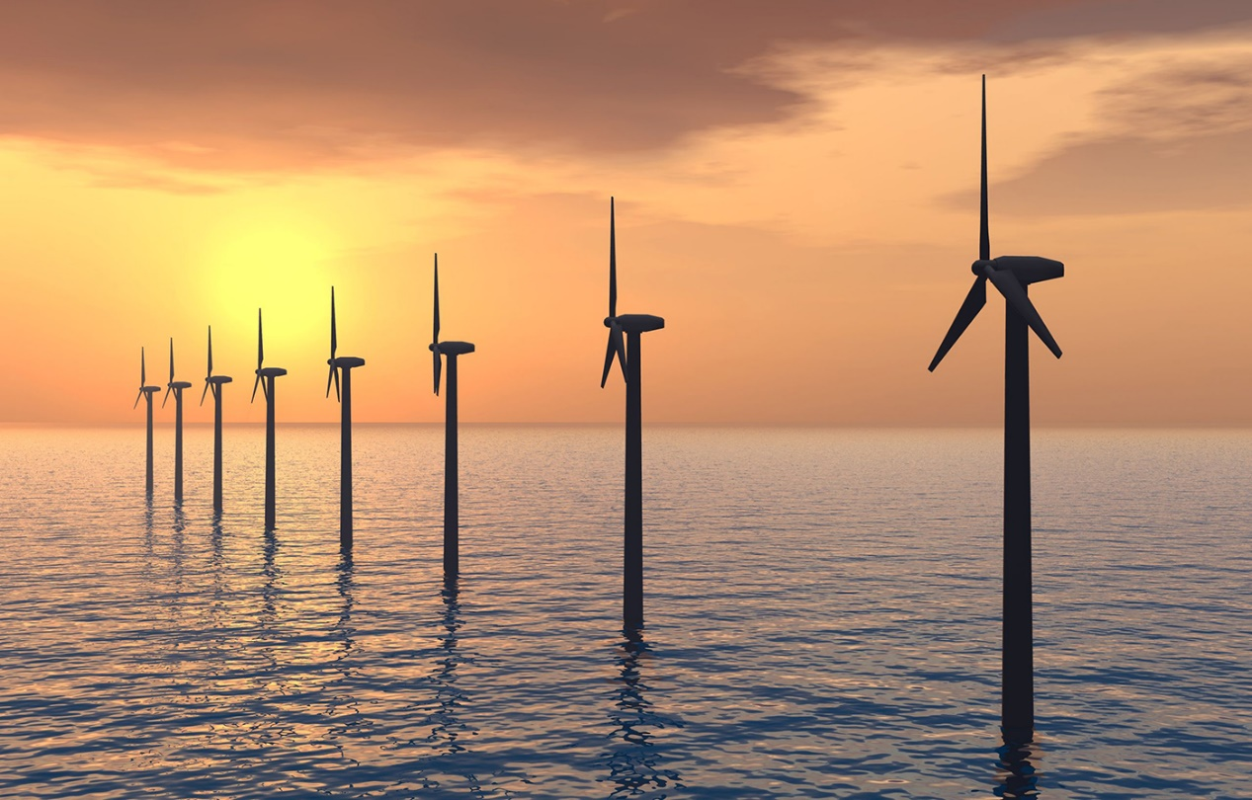

RENBOC_1

Introduction and guidance

About this free course
This free course is an adapted extract from the Open University course .
This version of the content may include video, images and interactive content that may not be optimised for your device.
You can experience this free course as it was originally designed on OpenLearn, the home of free learning from The Open University –
There you’ll also be able to track your progress via your activity record, which you can use to demonstrate your learning.
Copyright © 2015 The Open University
Intellectual property
Unless otherwise stated, this resource is released under the terms of the Creative Commons Licence v4.0 http://creativecommons.org/licenses/by-nc-sa/4.0/deed.en_GB. Within that The Open University interprets this licence in the following way: www.open.edu/openlearn/about-openlearn/frequently-asked-questions-on-openlearn. Copyright and rights falling outside the terms of the Creative Commons Licence are retained or controlled by The Open University. Please read the full text before using any of the content.
We believe the primary barrier to accessing high-quality educational experiences is cost, which is why we aim to publish as much free content as possible under an open licence. If it proves difficult to release content under our preferred Creative Commons licence (e.g. because we can’t afford or gain the clearances or find suitable alternatives), we will still release the materials for free under a personal end-user licence.
This is because the learning experience will always be the same high quality offering and that should always be seen as positive – even if at times the licensing is different to Creative Commons.
When using the content you must attribute us (The Open University) (the OU) and any identified author in accordance with the terms of the Creative Commons Licence.
The Acknowledgements section is used to list, amongst other things, third party (Proprietary), licensed content which is not subject to Creative Commons licensing. Proprietary content must be used (retained) intact and in context to the content at all times.
The Acknowledgements section is also used to bring to your attention any other Special Restrictions which may apply to the content. For example there may be times when the Creative Commons Non-Commercial Sharealike licence does not apply to any of the content even if owned by us (The Open University). In these instances, unless stated otherwise, the content may be used for personal and non-commercial use.
We have also identified as Proprietary other material included in the content which is not subject to Creative Commons Licence. These are OU logos, trading names and may extend to certain photographic and video images and sound recordings and any other material as may be brought to your attention.
Unauthorised use of any of the content may constitute a breach of the terms and conditions and/or intellectual property laws.
We reserve the right to alter, amend or bring to an end any terms and conditions provided here without notice.
All rights falling outside the terms of the Creative Commons licence are retained or controlled by The Open University.
Head of Intellectual Property, The Open University

Contents
- Introduction and guidance
- What is a badged course?
- How to get a badge
- Acknowledgements

Introduction and guidance
Welcome to this free badged open course, Can renewable energy sources power the world?.
The course is made up of eight weeks, with approximately three hours of study in each. It is suggested that you do one session per week, but you can work through the course at your own pace, so if you have more time one week there is no problem with pushing on to complete another session.
The eight weeks cover the following:
- Introduction to renewable energy
- Solar energy for heating and daylighting
- Solar photovoltaics
- Bioenergy
- Hydroelectrivity
- Wind energy
- Wave energy
- Towards a renewable future.
After completing this course, you will:
- understand at an introductory level the basic physical principles underlying the operation of renewable energy systems
- understand the key role of the Sun as the main source of renewable energy
- be aware of the essential characteristics of energy demand and supply in the UK and the world
- be aware of the principal renewable energy technologies and their main characteristics
- be aware of some of the factors that are working to promote the deployment of renewable energies and those acting to inhibit it.

Moving around the course
In the ‘Summary’ at the end of each session, you can find a link to the next one. If at any time you want to return to the start of the course, click on ‘Full course description’. From here you can navigate to any part of the course. Alternatively, use the session links at the top of every page of the course.
It’s also good practice, if you access a link from within a course page (including links to the quizzes), to open it in a new window or tab. That way you can easily return to where you’ve come from without having to use the back button on your browser.

What is a badged course?
While studying Can renewable energy sources power the world? you have the option to work towards gaining a digital badge.
Badged courses are a key part of The Open University’s mission to promote the educational well-being of the community. The courses also provide another way of helping you to progress from informal to formal learning.
To complete a course you need to be able to find about 24 hours of study time, over a period of about 8 weeks. However, it is possible to study them at any time, and at a pace to suit you.
Badged courses are all available on The Open University’s OpenLearn website and do not cost anything to study. They differ from Open University courses because you do not receive support from a tutor. But you do get useful feedback from the interactive quizzes.

What is a badge?
Digital badges are a new way of demonstrating online that you have gained a skill. Schools, colleges and universities are working with employers and other organisations to develop open badges that help learners gain recognition for their skills, and support employers to identify the right candidate for a job.
Badges demonstrate your work and achievement on the course. You can share your achievement with friends, family and employers, and on social media. Badges are a great motivation, helping you to reach the end of the course. Gaining a badge often boosts confidence in the skills and abilities that underpin successful study. So, completing this course should encourage you to think about taking other courses.

How to get a badge
Getting a badge is straightforward! Here’s what you have to do:
- read each session of the course
- score 50% or more in the two badge quizzes in Session 4 and Session 8.
For all the quizzes, you can have three attempts at most of the questions (for true or false type questions you usually only get one attempt). If you get the answer right first time you will get more marks than for a correct answer the second or third time. Therefore, please be aware that for the two badge quizzes it is possible to get all the questions right but not score 50% and be eligible for the badge on that attempt. If one of your answers is incorrect you will often receive helpful feedback and suggestions about how to work out the correct answer.
For the badge quizzes, if you’re not successful in getting 50% the first time, after 24 hours you can attempt the whole quiz, and come back as many times as you like.
We hope that as many people as possible will gain an Open University badge – so you should see getting a badge as an opportunity to reflect on what you have learned rather than as a test.
If you need more guidance on getting a badge and what you can do with it, take a look at the OpenLearn FAQs. When you gain your badge you will receive an email to notify you and you will be able to view and manage all your badges in My OpenLearn within 24 hours of completing the criteria to gain a badge.
Get started with Week 1.

Acknowledgements
This free course was written by Godfrey Boyle, Rodney Buckland and Sebastian Tyrrell.
Except for third party materials and otherwise stated (see terms and conditions), this content is made available under a Creative Commons Attribution-NonCommercial-ShareAlike 4.0 Licence.
The material acknowledged below is Proprietary and used under licence (not subject to Creative Commons Licence). Grateful acknowledgement is made to the following sources for permission to reproduce material in this free course:
Course image: © dennisvdw/iStockPhoto.com
Every effort has been made to contact copyright owners. If any have been inadvertently overlooked, the publishers will be pleased to make the necessary arrangements at the first opportunity.
Don’t miss out:
1. Join over 200,000 students, currently studying with The Open University – http://www.open.ac.uk/ choose/ ou/ open-content
2. Enjoyed this? Find out more about this topic or browse all our free course materials on OpenLearn – http://www.open.edu/ openlearn/
3. Outside the UK? We have students in over a hundred countries studying online qualifications – http://www.openuniversity.edu/ – including an MBA at our triple accredited Business School.
Don't miss out
If reading this text has inspired you to learn more, you may be interested in joining the millions of people who discover our free learning resources and qualifications by visiting The Open University – www.open.edu/ openlearn/ free-courses.

