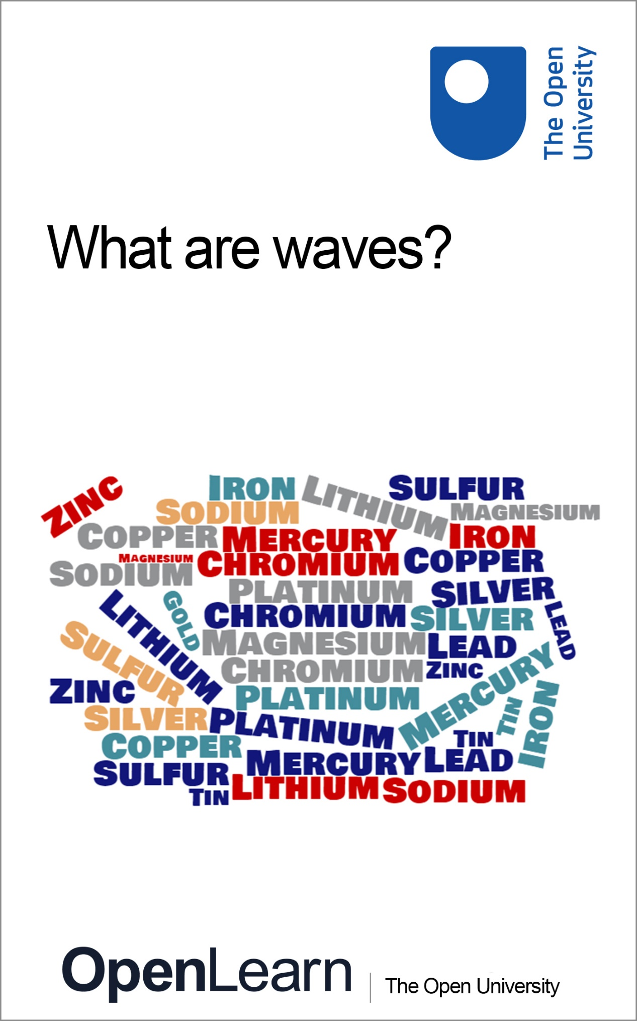

S111_P1

What is a metal?

About this free course
This free course is an adapted extract from the Open University course S111 Questions in science http://www.open.ac.uk/courses/modules/s111.
This version of the content may include video, images and interactive content that may not be optimised for your device.
You can experience this free course as it was originally designed on OpenLearn, the home of free learning from The Open University – The importance of metals
http://www.open.edu/openlearn/science-maths-technology/chemistry/the-importance-metals/content-section-0
There you’ll also be able to track your progress via your activity record, which you can use to demonstrate your learning.
First published 2018.
Unless otherwise stated, copyright © 2024 The Open University, all rights reserved.
Intellectual property
Unless otherwise stated, this resource is released under the terms of the Creative Commons Licence v4.0 http://creativecommons.org/licenses/by-nc-sa/4.0/deed.en_GB. Within that The Open University interprets this licence in the following way: www.open.edu/openlearn/about-openlearn/frequently-asked-questions-on-openlearn. Copyright and rights falling outside the terms of the Creative Commons Licence are retained or controlled by The Open University. Please read the full text before using any of the content.
We believe the primary barrier to accessing high-quality educational experiences is cost, which is why we aim to publish as much free content as possible under an open licence. If it proves difficult to release content under our preferred Creative Commons licence (e.g. because we can’t afford or gain the clearances or find suitable alternatives), we will still release the materials for free under a personal end-user licence.
This is because the learning experience will always be the same high quality offering and that should always be seen as positive – even if at times the licensing is different to Creative Commons.
When using the content you must attribute us (The Open University) (the OU) and any identified author in accordance with the terms of the Creative Commons Licence.
The Acknowledgements section is used to list, amongst other things, third party (Proprietary), licensed content which is not subject to Creative Commons licensing. Proprietary content must be used (retained) intact and in context to the content at all times.
The Acknowledgements section is also used to bring to your attention any other Special Restrictions which may apply to the content. For example there may be times when the Creative Commons Non-Commercial Sharealike licence does not apply to any of the content even if owned by us (The Open University). In these instances, unless stated otherwise, the content may be used for personal and non-commercial use.
We have also identified as Proprietary other material included in the content which is not subject to Creative Commons Licence. These are OU logos, trading names and may extend to certain photographic and video images and sound recordings and any other material as may be brought to your attention.
Unauthorised use of any of the content may constitute a breach of the terms and conditions and/or intellectual property laws.
We reserve the right to alter, amend or bring to an end any terms and conditions provided here without notice.
All rights falling outside the terms of the Creative Commons licence are retained or controlled by The Open University.
Head of Intellectual Property, The Open University

Contents
- Introduction
- Learning outcomes
- 1 What is a metal?
- 2 Arrangement of atoms in metals
  - 2.1 Metallic bonding
- 3 A metal’s signature
  - 3.1 Practical 1 Flame tests
- 4 Uses of metals
  - 4.1 Metals and life
- Conclusion
- Acknowledgements
- Descriptions

Introduction
You will have little hesitation in distinguishing the metal blade of a kitchen knife from the handle which is probably made of plastic or wood. But what really distinguishes a metal from a non-metal? Metals are used in many different ways, such as in jewellery, pots and pans and in wires for conducting electricity and you can probably think of many other examples of metal use. Each metal has its own personal signature and metals can be identified experimentally by being burnt in a naked flame. In this course you will start exploring some of the characteristic properties of metals that allow their varied uses in our everyday lives. You will also undertake an online experiment to identify metals using a ‘flame test’.
This OpenLearn course is an adapted extract from the Open University course S111 Questions in science.

Learning outcomes
After studying this course, you should be able to:
- understand metallic bonding and how it is related to metallic characteristics
- understand the role of metals in everyday life.

1 What is a metal?
To begin, have a look at the following questions.

- Write down the names of as many metals as you can think of.
- Some you may have thought of are iron, silver, gold, tin, lead, zinc, copper, aluminium, sodium and potassium. Slightly more exotic metals are chromium, nickel, cobalt, cadmium, titanium and manganese.

There are a couple of chemistry terms used in this course that you may not be familiar with, so we have defined them to help your study of this course. An element is a substance made up of only one type of basic building block and each element is made up of building blocks, called atoms. You might already know that an atom itself comprises many other smaller particles (e.g. electrons, protons, neutrons).

- What elements can you think of that might be non-metallic?
- Some non-metallic elements that you might have thought of are hydrogen, nitrogen, carbon and oxygen. Chlorine, bromine, sulfur and phosphorus are also non-metals. Living organisms are made of mainly non-metallic elements.

Scientists have tended to formalise the characteristics of metals (as distinct from non-metals) by suggesting that metals are dense, lustrous (shiny), good conductors of heat and electricity and can be shaped by physical forces.
Metals can be shaped by physical forces in two main ways:
- they can be deformed under tensile stress, e.g. by stretching – a property known as ductility
- they can be deformed under compressive stress, e.g. by hammering into thin sheets – a property known as malleability.

- What properties are shown by the elements in Figure 1?

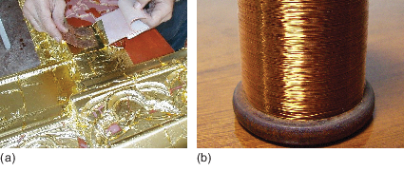
Figure 1 (a) Gold and (b) copper.
View description - Figure 1 (a) Gold and (b) copper.

- The gold is malleable (it has been hammered into thin sheets) and the copper is ductile (it can be stretched into thin wire).

At room temperature metals are solids, with the exception of mercury which is a liquid. There are also chemical criteria that help distinguish metals from non-metals as you will see later.
Table 1 includes some qualitative and quantitative data for a range of metals. It also includes the non-metallic element sulfur for comparison.

Table 1 Typical data for some common metallic elements and the non-metal, sulfur, at 25 °C.
Element | Proportion in Earth’s continental crust by mass/% | Melting temperature  /°C | Density/  10³ kg m^{–3} | Heat conduction (1, best; 10, worst) | Electric conduction (1, best; 10, worst)
Aluminium | 8.2 | 660 | 2.70 | 4 | 4
Chromium | 0.012 | 1857 | 7.19 | 7 | 9
Copper | 0.0068 | 1083 | 8.96 | 2 | 2
Gold | 0.000 0004 | 1064 | 19.3 | 3 | 3
Iron | 5.6 | 1535 | 7.87 | 8 | 7
Magnesium | 2.3 | 649 | 1.74 | 5 | 5
Silver | 0.000 008 | 962 | 10.5 | 1 | 1
Sulfur | 0.034 | 113 | 1.96 | 10 | 10
Tin | 0.000 21 | 232 | 7.31 | 9 | 8
Zinc | 0.0076 | 420 | 7.13 | 6 | 6

We often use percentages to express proportions. However, as you can see above, this is less effective when there is only a very small percentage of something. For example, the proportion of sulfur in the Earth’s crust is 0.034%, or 3.4 × 10^{–2}%.
For such small proportions, it is better to use parts per million.
For example, the 3.4 × 10^{–2}% of sulfur represents 3.4 × 10^{–2}, or 0.034, parts per hundred. As a fraction of the total, this is 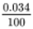. As with any fraction, the top and bottom terms can be multiplied by 10, and the overall value of the fraction does not change, i.e.

View alternative description - Uncaptioned Equation

And as 1000 000 is a million, we can see that 0.034 parts per hundred can also be written as 340 parts per million, or 340 ppm.

- Table 1 shows that the percentage of chromium in the Earth’s crust is 0.012%. Express this as a fraction, and as a proportion in ppm.
- To convert 0.012% into a fraction, divide by 100, i.e.

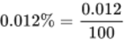
View alternative description - Uncaptioned Equation

or 0.012 parts per hundred.
To convert this fraction into ppm, multiply it by a million:

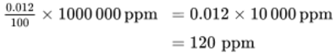
View alternative description - Uncaptioned Equation

Of course, it is sensible to use the most appropriate tool for the job. So, a discussion of the proportions of aluminium and iron would favour the use of percentages. However, when discussing the proportions of the minor constituents in the Earth’s crust (such as sulfur), it is more appropriate to use parts per million. Indeed, if the proportion is very small, even parts per billion (ppb) might be more appropriate; one billion being 10⁹. For example, the concentration of gold in the Earth’s crust is at a level of 0.000 000 4%, i.e. 4 ppb.

- In Table 1, which three metals are the best conductors of electricity? Why do you think just one of these three metals is used much more than the other two?
- Silver, copper and gold are the best conductors of electricity. Silver and gold are both high-cost metals. Copper is a cheaper metal so it is often used as an electrical conductor. Generally, the higher the abundance of the metal in the Earth’s crust, the lower the cost. However, this is not an exact relationship, and the cost of a metal also depends on other factors (such as the ease and cost of extraction).

The non-metal, sulfur, is the poorest heat (thermal) and electrical conductor of the elements in Table 1. In fact sulfur is not regarded as a conductor at all. It is an effective insulator, being as good as the plastic insulation that surrounds electric cables.

- Looking at the data in Table 1, why do you think aluminium is used extensively in the construction of civil aeroplanes?
- Aluminium has low density and this makes it ideal for the construction of aeroplanes where weight is important. Density is dependent on mass, as is weight; so the lower the density, the lower the mass (per unit volume), and the lower the weight.

2 Arrangement of atoms in metals
Most metal atoms pack closely together in a similar way to fruit on packing trays (Figure 2). This arrangement is the most efficient use of space as apples are packed as closely together as they can. Note how most of the apples are in contact with six neighbouring apples.

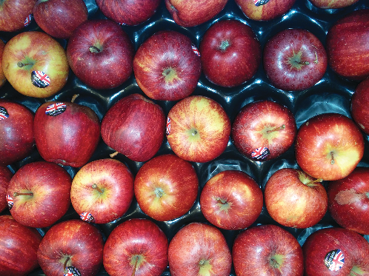
Figure 2 Apples on a packing tray.
View description - Figure 2 Apples on a packing tray.

But metals are three-dimensional. The layer of atoms represented by the apples in Figure 2 will be covered by other layers in a solid metal. For most metals, this three-dimensional structure can be seen in the way fruit is sometimes stacked on market stalls. A second layer of apples will fit neatly in the hollows created by the bottom layer. The third layer of apples will lie directly above the first layer. This pattern is known as a hexagonal closed packed (hcp) structure. Watch Video 1 which illustrates this structure using spheres to build a model.

Video content is not available in this format.
Video 1 Close packing in three dimensions. (2:46 min)
View transcript - Video 1 Close packing in three dimensions. (2:46 min)

The ongoing arrangement of metal atoms in a three-dimensional regular ordered pattern is known in chemistry as a lattice structure.
A simple model of an atom is a central atomic nucleus with electrons arranged in shells at different distances from the nucleus. Lithium has the smallest atom of all metals. Figure 3 shows a simple representation of a lithium atom. The smaller dots represent electrons moving around the central nucleus. The large dot at the centre represents the nucleus of the lithium atom containing protons and neutrons. Moving outwards from the nucleus, you can see a region of empty space before a narrow region where there is a good chance of meeting a set of two electrons. This first shell can only contain a maximum of two electrons. Then there is more empty space before another narrow region in which up to six electrons can be found.

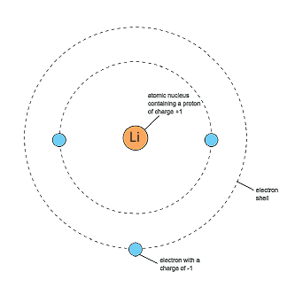
Figure 3 Illustration of shells in a lithium atom
View description - Figure 3 Illustration of shells in a lithium atom

Each electron carries a minute but standard amount of negative electric charge, or charge for short. Electric charge is the property of matter that causes electrical phenomena. Conventionally, chemists and physicists speak of an electron as having a charge of −1. The units do not matter in this case as the ‘−1’ is a comparative amount: one electron has a charge of −1, two electrons a charge of −2 and ten electrons a charge of −10.
However, atoms are neutral particles: that is, they carry no net charge. This means that the total negative charge of the electrons must be balanced by the total positive charge in these positive particles in the atom, so that the whole atom has a net charge of zero. These positive particles are known as protons and each one carries the same amount of charge as an electron but has the opposite sign, +1.
Each element has its own specific signature in terms of number of protons, neutrons and electrons. Lithium has 3 protons, 4 neutrons and three electrons.

- What overall charge would an atom of lithium have?
- One atom of lithium would have an overall charge of zero as the three positive protons will equal the negative charge of the three electrons.

- If a nucleus of an atom was separated from the rings of electrons would it have a positive or a negative charge?
- The nucleus would be positively charged because of the protons within it. The strength of the positive charge would depend upon the number of protons within the nucleus.

A feature of metal atoms is that the electrons in the outer shells do not remain in the proximity of a specific nucleus. In bulk metals, these electrons, rather than being associated with any particular metal atom, can be thought to be part of a shared ‘sea’ of electrons that move freely (Figure 4). These are known as delocalised electrons.

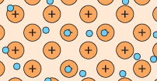
Figure 4 Positively charged nuclei (plural for nucleus) in a cloud of delocalised electrons.
View description - Figure 4 Positively charged nuclei (plural for nucleus) in a cloud of delocalised ...

2.1 Metallic bonding
The attraction between the delocalised electrons and the positively charged nuclei is called metallic bonding. The metallic bonding is strong and occurs in all directions. Breaking this attraction is difficult, and this is the reason that metals have high melting temperatures.
Metals are good conductors of electricity and heat, because the free moving electrons facilitate the transfer of charge or heat through the material.
Figure 5 shows a simple electric circuit with a metal wire, a battery and a bulb. When the wire is connected between the positive and negative terminals of the battery, one end of the wire becomes positively charged and the other becomes negatively charged. This causes the electrons, which are free to move, to travel through the wire towards the positive terminal of the battery, where they are removed. At the same time the negative terminal supplies more electrons to the wire.
Within the battery there is a net flow of negative charge from the positive terminal to the negative terminal, which balances the flow through the wire, so that charges don’t continually build up at the battery terminals.
You may be familiar with the term ‘voltage’. The voltage of the battery can be considered as the ‘push’ exerted on electrons moving along the circuit and the flow of negatively charged electrons in the wire constitutes the electric current. Note that in Figure 5 the arrows refer to the flow of electrons. By convention, the direction of the electric current is in the opposite direction, from the positive terminal towards the negative terminal of the battery.

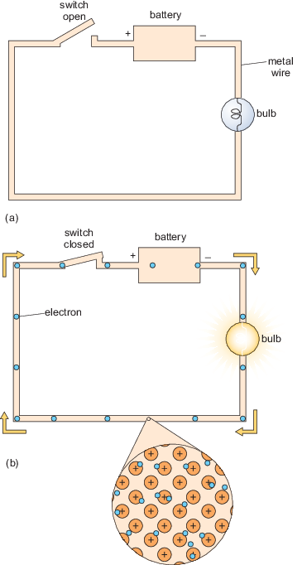
Figure 5 Conductivity of electricity in a metal: (a) open circuit (switch open) (b) closed circuit (switch closed). Arrows indicate flow of electrons.
View description - Figure 5 Conductivity of electricity in a metal: (a) open circuit (switch open) ...

- When will the bulb light?
- The bulb will light only when the circuit is closed and there are electrons flowing through it.

The battery voltage depends on the choice of chemicals inside it.
The delocalised electrons also explain other metallic characteristics such as malleability. The bonding occurs in every direction throughout the metal enabling atoms to roll easily over each other without breaking any bonds when stress is applied (Figure 6).

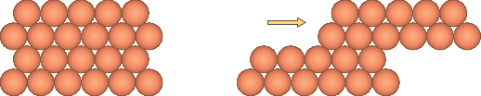
Figure 6 Layers of atoms sliding over each other and creating thin layers of metal.
View description - Figure 6 Layers of atoms sliding over each other and creating thin layers of me ...

3 A metal’s signature
In this section you are going to investigate how metals can be identified by the colour they impart to a flame. Electrons are found in shells around the nucleus. These shells are numbered 1, 2, 3 (and so on), moving outward from the nucleus (Figure 7). The number of the shell is known as the principal quantum number, and is given by the symbol n.
An electron’s energy depends on the shell it is in; in general as n increases, the energy of the electron also increases. The energy level occupied by electrons depend on the amount of energy in the system. At high temperatures (such as under a flame), electrons in the metal atoms will absorb heat energy and be promoted to higher energy levels.

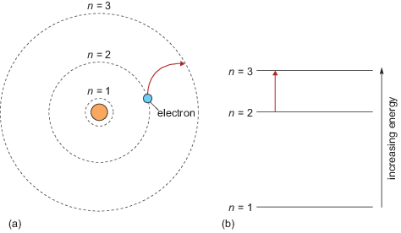
Figure 7 (a) An electron jump from shell n = 2 to n = 3 is shown by the red arrow. (b) The electron jumps to a higher electron shell further away from the nucleus. Note that energy levels are not evenly spaced and they become closer together as they move away from the nucleus.
View description - Figure 7 (a) An electron jump from shell n = 2 to n = 3 is shown by the red arrow. ...

The colour of the flame arises when these excited electrons return to lower energy levels emitting energy as light of a characteristic frequency. This gives a characteristic colour to the flame when a metal is heated in it (Figure 8). If you have ever let a pan containing salt in water boil over on a gas stove you may have noticed that the flame goes yellow; this is caused by the electrons in the sodium atom.

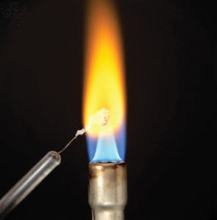
Figure 8 Flame test for sodium.
View description - Figure 8 Flame test for sodium.

Visible light can be split by a prism into an uninterrupted band of colours, known as a continuous spectrum. However, the spectrum produced by the excited electrons of a particular element falling to lower energy levels consists of discrete coloured lines in a dark background. In Figure 9 you can see the emission spectrum of sodium when a beam of light from a sodium lamp is dispersed by a prism; the two intense yellow lines emitted by sodium atoms, are the main reason for the flame colour shown above.


Figure 9 Emission spectrum of sodium in the visible region.
View description - Figure 9 Emission spectrum of sodium in the visible region.

Each element produces a unique set of spectral lines, and in the next section you will use the emission spectra of elements to identify some metals.

3.1 Practical 1 Flame tests
In this section you will investigate the presence of metal ions by recording the colour observed when heating a metal salt in a flame. You will be using solid samples of different metal salts. The metal chlorides you will be analysing are those of copper, lithium, potassium and strontium.

This practical activity will take 45 minutes.

You will perform the experiment in the virtual OpenScience Laboratory (the OU online laboratory for practical science).
What you need to do:
- 1. Turn on the gas, pick up the lighter and light the Bunsen burner, which should give a low yellow flame. Rotate the barrel of the burner so the air hole is open and the flame is blue.
- 2. One end of the nichrome wire is embedded in a cork for safe handling, and the other end has a small loop. Clean the loop of wire by dipping it into the small beaker containing a solution of hydrochloric acid.
- 3. Place the loop into the side of the blue flame, as shown in Figure 10. If the wire is clean it should make no difference to the colour of the flame. If the colour of the flame does change there is an impurity on the wire. Dip it again in the acid and return it to the side of the flame.
- 4. Dip the loop of the wire into the acid and then use it to pick up a few grains of a metal salt.
- 5. Place the loop in the side of the flame and note down the colour of the flame in your copy of Table 2.
- 6. Use the hand spectroscope provided to separate the constituent colours present in the light and look at the emission line spectrum of the flames. Note down the description of spectra in your copy of Table 2. The hand spectroscope is a simple piece of equipment that houses a prism system in order to provide spectra from visible light (Figure 11).
- 7. Repeat this procedure and observe the flame colour given by the other metal salts. Record your observations in Table 2.

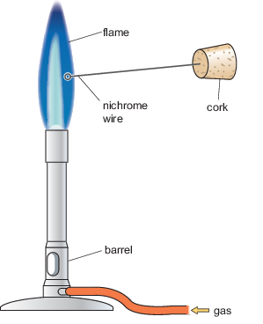
Figure 10 Components of Bunsen burner and the position of nichrome wire for a flame test.
View description - Figure 10 Components of Bunsen burner and the position of nichrome wire for a flame ...

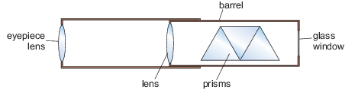
Figure 11 Main components of the hand spectroscope.
View description - Figure 11 Main components of the hand spectroscope.

Table 2 Flame colours and spectra of common metal ions.
Metal | Chemical symbol | Flame colour | Description of spectrum
Lithium
Copper
Strontium
Potassium
Sodium | Na | Yellow | Two bright yellow lines, one weaker blue line, one weaker green line and one weaker red line

- 8. Now try looking at the colour of the flame obtained with the unknown mixtures of metals. Write down what you observed.
Follow the link to access the experiment. Instructions are also provided within the experiment, under ‘Help’.

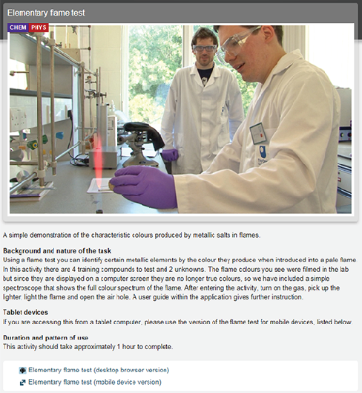

Practical 1 Flame tests in the OpenScience Laboratory

- If you don’t know the contents of a mixture, are you able to identify the metals present using the flame colour?
- It is not easy to identify the contents of a mixture based on the flame colour. Often one flame colour will dominate or a different colour is observed that could be the combination of two colours.

- What spectrum would you expect to see if a mixture of lithium and copper salts is placed in the flame?
- The spectrum of a mixture of lithium and copper will show red and orange lines from lithium and green and blue lines from copper.

- Metals are added to the gunpowder used in fireworks to produce light of different colours when the powder burns. Which metal would you add to gunpowder in order to produce red light?
- Strontium will produce red light.

4 Uses of metals
Metals are extremely useful in our everyday lives and are used in a wide range of situations.

- Write down as many uses of metals as you can think of.
- You might have thought of uses in, for example:
  - construction
  - electronic devices
  - transportation
  - food processing
  - biomedical applications.

Different metals are used for different purposes (Figure 12). For example, in construction, the alloy steel is the usual choice for structural building materials due to its strength and flexibility while copper is used for a range of architectural parts such as roofs and gutters, due to its durability and appearance.
As discussed, metals are good conductors and play an important role in electronics. For example, copper is commonly used in electrical wiring; gold is used in many computer technologies and silver is often used in electronic circuitry.
Aluminium has become one of the most commonly used metals in aircraft manufacturing, shipbuilding and the train and automobile industry. Aluminium is a resistant and light material that reduces the weight of transport vehicles, minimising their fuel consumption.
In the case of the food and drink industry, stainless steel is the ideal alloy due to its inertness and resistance to any acids present in foods. It is also tolerant to a wide range of temperatures allowing heating and freezing, and stainless steel equipment can be repeatedly sterilised.
Metals have also been extensively used as medical implants. Stainless steel and titanium alloys are commonly used in biomedical devices, such as joint replacement parts, while gold, silver and platinum are often used in dentistry. Anti-cancer drugs with different metals are also commonly used in chemotherapy.

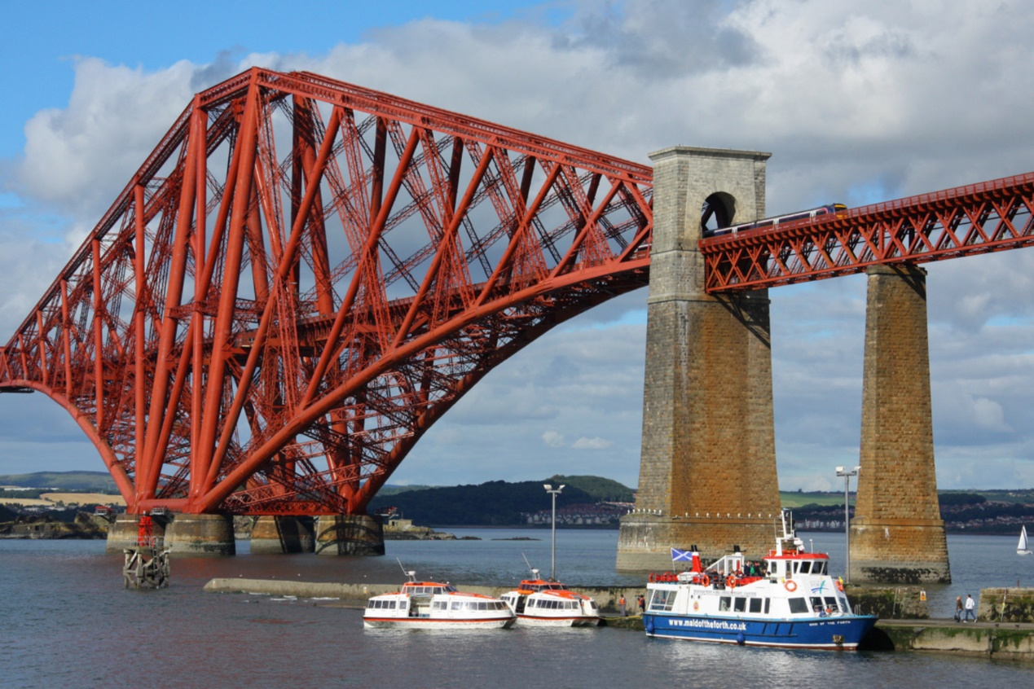
(a) steel


(b) aluminium

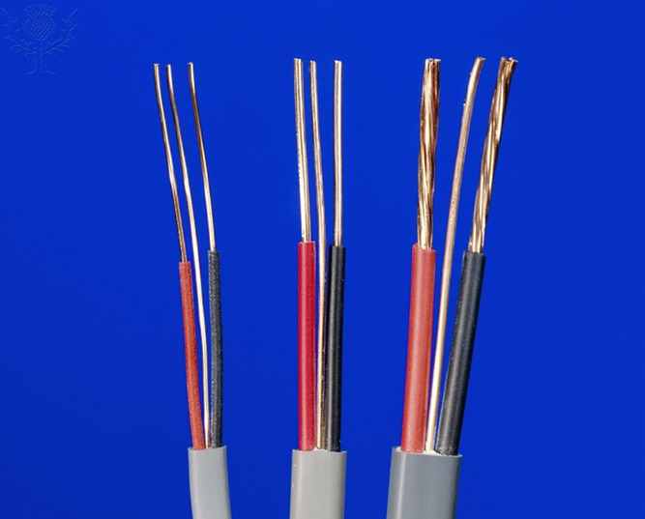

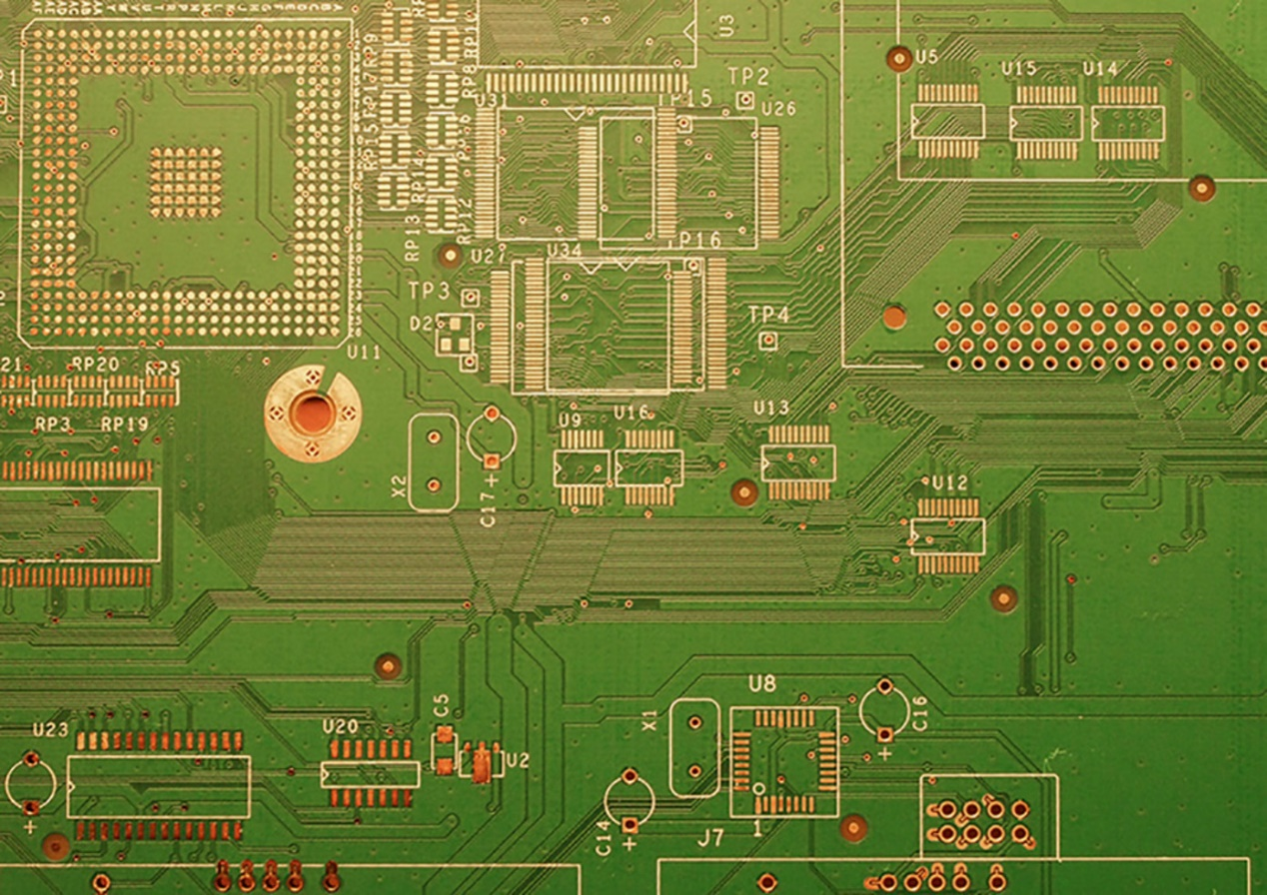
(d) gold


(e) stainless steel

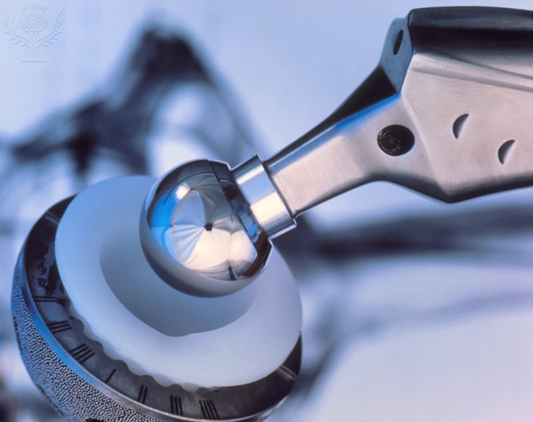
(f) titanium

4.1 Metals and life
Metals also play an important role in biological systems. Iron is essential for transporting oxygen in the blood and tissues. Some metals are part of biological structures: for example, calcium provides strength to our bones (Figure 13). Maintaining different concentrations of sodium and potassium inside and outside living cells is critical for body functions such as muscle contraction and heart function. The presence of metals (such as zinc) is also required for many essential enzymatic reactions (for example, the digestion of proteins).

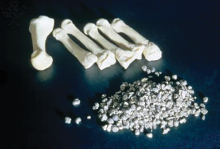
Figure 13 Calcium and bones.
View description - Figure 13 Calcium and bones.

- How do we maintain adequate levels of metals in our bodies?
- We acquire these elements from the food and water that we consume.

Metals normally occur at very low concentration in our bodies and are known as trace elements. At high levels metals may be toxic. In particular, metals such as mercury and lead can interfere with the structure of proteins and their effective function.
Nowadays, consumption of dietary supplements is very common; however, recommended daily allowances should be observed.

Table 3 Average levels of some metals in human blood.
Metal | Chemical symbol | Concentration/ppb
Aluminium | Al | 13
Cobalt | Co | 0.2
Chromium | Cr | 3.0
Nickel | Ni | 5.0

Metals may enter fresh and salty water through industrial waste, sewage and run-off. Microbes, plants and animals that depend on this contaminated water consume or absorb these metals. Over time the metals are concentrated within the food chain, in a process known as bioaccumulation (Figure 14). The concentration of metals in affected organisms is greater than was initially present in the water itself, as species consume greater quantities at each level and so the concentration increases up the food chain.

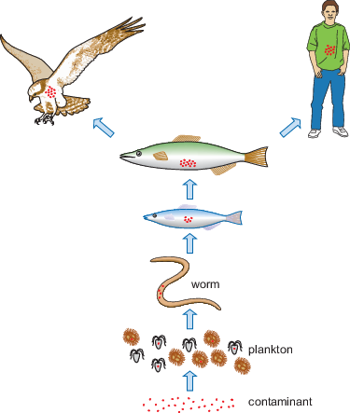
Figure 14 Bioaccumulation of metals in an aquatic food-chain.
View description - Figure 14 Bioaccumulation of metals in an aquatic food-chain.

Conclusion
The materials that have probably been the most influential in shaping society over the past two to three millennia are the metals. You will all have a general idea as to what is metallic and what is not and in this part you have seen some of the criteria for the distinction.
The key concepts and principles you have learned in this part are:
- metallic bonding, and how it is related to metallic characteristics
  - Metallic bonding is the attraction between the delocalised electrons and the positively charged nuclei. It is strong and occurs in all directions.
  - Transitions of electrons from excited states to lower energy levels result in emission spectra.
  - Emission spectra are the basis of simple flame tests for metal salts.
- the role of metals in everyday life.
  - Metals are used in a wide range of applications (construction, electronic devices, transportation, food processing, biomedical applications) and play an important role in biological systems.
  - Bioaccumulation is the accumulation of substances inside an organism over time.

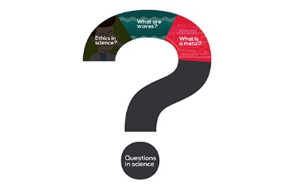
This course is part of a suite of introductory science courses on OpenLearn.
View description - This course is part of a suite of introductory science courses on OpenLearn.

The content of these courses comes from the Open University course S111 Questions in science. Take a look at the other OpenLearn courses that are part of this set here.

Acknowledgements
This free course was written by Maria Velasco-Garcia and adapted by Nicolette Habgood.
Except for third party materials and otherwise stated (see terms and conditions), this content is made available under a Creative Commons Attribution-NonCommercial-ShareAlike 4.0 Licence.
The material acknowledged below is Proprietary and used under licence (not subject to Creative Commons Licence). Grateful acknowledgement is made to the following sources for permission to reproduce material in this free course:
115685 Figure 1a: © Juangonzalez64
115686 Figure 1b: © Hawyih
213984 Figure 2: Moving Moment / Shutterstock
232138 Figure 8: Charles D Winters / Photo Researchers / Universal Images Group
213977 Figure 12a: Kim Traynor This file is licensed under a Creative Commons CC 2.0 license
213978 Figure 12b: Nieuwland Photography / Alamy Stock Photo
213979 Figure 12c: vsoldatov5 / Shutterstock
213980 Figure 12d: blickpixel / Pixabay
213981 Figure 12e: Cristina Pedrazzini / Science Photo Library / Universal Images Group
213982 Figure 12f: LAWRENCE LIVERMORE NATIONAL LABORATORY / SCIENCE PHOTO LIBRARY (NOT CLEARED)
106373 Figure 13: Richard Treptow / Photo Researchers / Universal Images Group
Every effort has been made to contact copyright owners. If any have been inadvertently overlooked, the publishers will be pleased to make the necessary arrangements at the first opportunity.
Don't miss out
If reading this text has inspired you to learn more, you may be interested in joining the millions of people who discover our free learning resources and qualifications by visiting The Open University – www.open.edu/openlearn/free-courses.

Descriptions

Figure 1 (a) Gold and (b) copper.
Two photographs: (a) shows a thin sheet of gold on a surface, part of which is being lifted up; (b) shows thin copper wire tightly wrapped around a wooden spool.
Back to - Figure 1 (a) Gold and (b) copper.

Uncaptioned Equation
equation sequence 0.034 divided by 100 equals 0.34 divided by 1000 equals 3.4 divided by 10 000 equals 34 divided by 100 000 equals 340 divided by 1000 000
Back to - Uncaptioned Equation

Uncaptioned Equation
0.012 percent equals 0.012 divided by 100
Back to - Uncaptioned Equation

Uncaptioned Equation
multiline equation row 1 0.012 divided by 100 multiplication 1000 000 ppm equals 0.012 multiplication 10 000 ppm row 2 equals120 ppm
Back to - Uncaptioned Equation

Figure 2 Apples on a packing tray.
A photograph of red apples arranged in rows on a packing tray. The apples in alternate rows are offset by half an apple, to the left or the right, so that they fit into the small spaces left between the apples in the adjacent rows.
Back to - Figure 2 Apples on a packing tray.

Figure 3 Illustration of shells in a lithium atom
Figure 3 is a schematic diagram representing a lithium atom. It shows a nucleus (a circle) at the centre, with two concentric rings that represent its electron shells. Two electrons are shown in the inner shell, and one in the outer. The nucleus is labelled ‘atomic nucleus containing a proton of charge +1’. The outer electron is labelled as having a charge of -1.
Back to - Figure 3 Illustration of shells in a lithium atom

Figure 4 Positively charged nuclei (plural for nucleus) in a cloud of delocalised electrons.
An animation representing positively charged nuclei in a cloud of delocalised electrons. Each nucleus is represented by a circle with a plus symbol (‘+’) in it. The nuclei are arranged in staggered rows. That is, each row of circles in alternate rows are offset by half a circle, to the left or the right, so that they fit in between the circles in the adjacent rows. The electrons in the outer shells are represented by blue circles that are moving freely (animated) between the nuclei to indicate their delocalisation. Each nucleus is represented by an orange sphere with ‘+’ in it. The 16 nuclei are arranged in four staggered rows of four orange spheres that are static. Each sphere in the second and fourth rows has been shifted horizontally so that it is above the space between adjacent spheres in the first and third rows. The electrons are represented by blue spheres that are moving freely to indicate their delocalisation.
Back to - Figure 4 Positively charged nuclei (plural for nucleus) in a cloud of delocalised electrons.

Figure 5 Conductivity of electricity in a metal: (a) open circuit (switch open) (b) closed circuit (switch closed). Arrows indicate flow of electrons.
Two simple, rectangular electric circuit diagrams show the conductivity of electricity in a metal. Figure 5a shows an open circuit. Straight lines are used to represent a connecting metal wire. The circuit has a gap at the top to indicate a break in the circuit, with a switch labelled ‘open’. To the right of this open switch, there is a rectangular block that represents a battery with its positive (+) terminal next to the switch and its negative (–) terminal on the far right. On the right side of the circuit, there is a circle with a squiggly line in it that represents a light bulb and its filament. Figure 5b shows a closed circuit. The same circuit as in (a) has the switch closed at the top so that the wire has contact with and is connected to the positive (+) terminal of the battery. There are circles, indicating freely moving electrons, around the circuit. There is a lit bulb on the right. Arrows indicate the clockwise flow of the negatively charged electrons in the wire from the negative terminal to the positive terminal of the battery. What is happening within the wire is shown with a magnified diagram. This is a repeat of Figure 1.4. Each nucleus is represented by a circle with a plus symbol (‘+’) in it. The nuclei are arranged in staggered rows. That is, each row of circles in alternate rows are offset by half a circle, to the left or the right, so that they fit in between the circles in the adjacent rows. The electrons in the outer shells are represented by blue circles that are positioned randomly, indicating they are moving freely because they are delocalised.
Back to - Figure 5 Conductivity of electricity in a metal: (a) open circuit (switch open) (b) closed circuit (switch closed). Arrows indicate flow of electrons.

Figure 6 Layers of atoms sliding over each other and creating thin layers of metal.
An animation showing how thin layers of metal are created. The animation begins with four stacked rows of orange spheres, which represent atoms in the metal. Each sphere in alternate rows are offset by half a sphere, to the left of the right, so that it fits into the space between adjacent spheres in row above. The animation shows the top two rows of atoms sliding across the bottom two, towards the right. An arrow indicates stress being to the top two rows of atoms to cause this sliding.
Back to - Figure 6 Layers of atoms sliding over each other and creating thin layers of metal.

Figure 7 (a) An electron jump from shell n = 2 to n = 3 is shown by the red arrow. (b) The electron jumps to a higher electron shell further away from the nucleus. Note that energy levels are not evenly spaced and they become closer together as they move away from the nucleus.
This figure represents an electron jump from shell n = 2 to n = 3. The figure is in two parts. Figure 7(a) is a schematic diagram representing an atom. It shows a nucleus (a circle) at the centre, with three concentric rings that represent its shells labelled (from inside to out) n = 1, n = 2 and n = 3. An electron is shown in the n = 2 shell. The diagram illustrates (using an arrow) than this electron jumps from n = 2 to n = 3. In (b) there are three horizontal lines labelled (from bottom to top) n = 1, n = 2 and n = 3. An arrow to the side of the lines indicates that there is increasing energy from n = 1 to n = 3. The gap between n = 1 and n = 2 is around two and a half times bigger than that between n = 2 and n = 3, indicating more energy is needed to move between n = 1 to n = 2 than from n = 2 to n = 3. The electron jump from part (a) is shown as an arrow between the lines, pointing from n = 2 to n = 3.
Back to - Figure 7 (a) An electron jump from shell n = 2 to n = 3 is shown by the red arrow. (b) The electron jumps to a higher electron shell further away from the nucleus. Note that energy levels are not evenly spaced and they become closer together as they move away from the nucleus.

Figure 8 Flame test for sodium.
A photograph of a Bunsen burner blue flame. A piece of white metal on the end of a wire extending from a glass rod is being heated in the flame to show the flame test for sodium. The blue flame is turning yellow with an orange glow around the piece of metal.
Back to - Figure 8 Flame test for sodium.

Figure 9 Emission spectrum of sodium in the visible region.
Figure 9 shows a spectrum. It is represented by a thin black rectangle in landscape format with five vertical coloured lines positioned along its length. From left to right the lines are: blue, green, two closely arranged yellow and red. The blue line is about a third along the rectangle. The green line is just over halfway along. The two yellow lines are about three quarters along. The red line is between the yellow ones and the end of the rectangle, but closer to the yellow lines.
Back to - Figure 9 Emission spectrum of sodium in the visible region.

Figure 10 Components of Bunsen burner and the position of nichrome wire for a flame test.
Figure 10 shows an illustration of a Bunsen burner in which its components are labelled and the position of nichrome wire for a flame test is shown. The Bunsen burner is a metal thin hollow vertical tube on a flat metal stand. Gas passes into this via a flexible rubber tube and is controlled by the barrel, which is at the base of the metal tube. This can be rotated to allow gas to pass up the main tube. In the diagram this is open, so gas is passing through and the flame at the top of the metal tube is blue. A thin long nichrome wire is shown being held in the side of the flame. This has a loop at the flame end and a cork at the other. The cork is used to hold the wire.
Back to - Figure 10 Components of Bunsen burner and the position of nichrome wire for a flame test.

Figure 11 Main components of the hand spectroscope.
Figure 11 shows an illustration of the main components of the hand spectroscope. The figure is drawn as two thin rectangles in landscape format so that they appear as square tubes, open at facing ends. The right tube (the barrel) is inserted into the left tube to make one long tube. At the left hand end of the long tube is an eyepiece lens, so that you can look into the tube. At the left hand end of the inserted tube is another lens and at the right hand end is a glass window. Inside the right hand part of the inserted tube is a prism. This is shown as three triangles, fitted together to make a trapezium.
Back to - Figure 11 Main components of the hand spectroscope.

Figure 13 Calcium and bones.
A photograph of six white bones with one on the far left being bigger and more prominent than the other five together with grey fragments of calcium in the foreground, all on a black background.
Back to - Figure 13 Calcium and bones.

Figure 14 Bioaccumulation of metals in an aquatic food-chain.
Figure 14 illustrates the bioaccumulation of metals in an aquatic food chain. The figure is presented as a flow chart, from bottom to top. At the bottom is the contaminant (represented by red dots), which is then consumed by plankton (illustrated as small organisms of different shapes containing the contaminant). The plankton is consumed by a worm, the worm by a small fish, the small fish by a larger fish. The diagram shows that the contaminant is passed through the food chain. Eventually, the contaminant is passed to both humans and birds, since they consume the larger fish.
Back to - Figure 14 Bioaccumulation of metals in an aquatic food-chain.

This course is part of a suite of introductory science courses on OpenLearn.
This is a graphic of a question mark with three segments inside it, from left top to right, going down the question mark, are the words Ethics in science? What are waves? What is a metal? At the bottom of the question mark, inside the full point, is the text Questions in science.
Back to - This course is part of a suite of introductory science courses on OpenLearn.

Video 1 Close packing in three dimensions. (2:46 min)

Transcript
INSTRUCTOR
We’ll start by building the simplest of the models, which is the hexagonal close-packed array. First, we fill a tray with transparent spheres so that the row of spheres furthest away from you contains five and the row nearest to you contains four. Next, we put on another layer of the clear spheres. You will find that these fit neatly in the hollows created by the bottom layer.
Notice that the hollows have an almost triangular shape. There are two possible positions for the second layer, covering either triangles with tips pointing away from you or over triangles with their tips pointing towards you. We’re putting the second layer of the triangles with the tips pointing away from you, but it’s an arbitrary choice. It doesn’t matter which you choose.
The second layer now has three rows of spheres - four in the first, three in the middle and four in the next. Now, we add the third layer of spheres. For hexagonal close-packing, they have to lie directly above the first layer. Looking down on the model, you will see that we can do this now by covering the triangles with the tips pointing towards you.
Layer three of the model contains five spheres. Now, look again at the hexagonal close-packed model. We have coloured a sphere in the middle of the second layer.
Count up the number that are touching it. There are three in the bottom layer. There are six in the same layer. In the layer above, there are also three that touch it - making 12 in all.
Back to - Video 1 Close packing in three dimensions. (2:46 min)

