CC_1

Could we control our climate?

About this free course
This free course is an adapted extract from the Open University course .
This version of the content may include video, images and interactive content that may not be optimised for your device.
You can experience this free course as it was originally designed on OpenLearn, the home of free learning from The Open University –
There you’ll also be able to track your progress via your activity record, which you can use to demonstrate your learning.
Copyright © 2020 The Open University
Intellectual property
Unless otherwise stated, this resource is released under the terms of the Creative Commons Licence v4.0 http://creativecommons.org/licenses/by-nc-sa/4.0/deed.en_GB. Within that The Open University interprets this licence in the following way: www.open.edu/openlearn/about-openlearn/frequently-asked-questions-on-openlearn. Copyright and rights falling outside the terms of the Creative Commons Licence are retained or controlled by The Open University. Please read the full text before using any of the content.
We believe the primary barrier to accessing high-quality educational experiences is cost, which is why we aim to publish as much free content as possible under an open licence. If it proves difficult to release content under our preferred Creative Commons licence (e.g. because we can’t afford or gain the clearances or find suitable alternatives), we will still release the materials for free under a personal end-user licence.
This is because the learning experience will always be the same high quality offering and that should always be seen as positive – even if at times the licensing is different to Creative Commons.
When using the content you must attribute us (The Open University) (the OU) and any identified author in accordance with the terms of the Creative Commons Licence.
The Acknowledgements section is used to list, amongst other things, third party (Proprietary), licensed content which is not subject to Creative Commons licensing. Proprietary content must be used (retained) intact and in context to the content at all times.
The Acknowledgements section is also used to bring to your attention any other Special Restrictions which may apply to the content. For example there may be times when the Creative Commons Non-Commercial Sharealike licence does not apply to any of the content even if owned by us (The Open University). In these instances, unless stated otherwise, the content may be used for personal and non-commercial use.
We have also identified as Proprietary other material included in the content which is not subject to Creative Commons Licence. These are OU logos, trading names and may extend to certain photographic and video images and sound recordings and any other material as may be brought to your attention.
Unauthorised use of any of the content may constitute a breach of the terms and conditions and/or intellectual property laws.
We reserve the right to alter, amend or bring to an end any terms and conditions provided here without notice.
All rights falling outside the terms of the Creative Commons licence are retained or controlled by The Open University.
Head of Intellectual Property, The Open University

Contents
- Introduction and guidance
  - Introduction and guidance
    - What is a badged course?
    - How to get a badge
- Session 1: What is ‘engineering the climate’?
  - Introduction
  - 1 An engineered world
    - 1.1 What do we really mean by climate engineering?
    - 1.2 Modifying the Earth’s energy budget
  - 2 What is climate?
    - 2.1 Frequency of different types of weather
    - 2.2 Probability of different types of weather
    - 2.2 Climate is more than just weather
  - 3 How certain can we be?
    - 3.1 Climate dice
  - 4 What are the challenges?
    - 4.1 Identifying change
    - 4.2 The complexity of climate
  - 5 End-of-session quiz
  - 6 Session 1 summary
- Session 2: The planet is changing
  - 1 Trusting sources of information
  - 2 Taking Earth’s temperature
    - 2.1 Global warming through time
    - 2.2 Changes in local and extreme temperatures
  - 3 Changes in Earth’s water
    - 3.1 Rain
    - 3.2 Ice sheets
    - 3.3 Sea ice and snow
    - 3.4 Sea level rise
  - 4 Effects on life
    - 4.1 Natural systems
    - 4.2 Ocean acidification
    - 4.3 Humans – extreme weather
    - 4.4 Humans – climate shifts
  - 5 End-of-session quiz
  - 6 Session 2 summary
- Session 3: We are causing change
  - 1 Deducing the causes of climate change
    - 1.1 The global whodunnit
    - 1.2 Forcing the global thermostat
  - 2 Radiative forcings – increasing temperature
    - 2.1 The Sun
    - 2.2 Greenhouse gases
  - 3 Radiative forcings – cooling temperatures
    - 3.1 Industrial sulfates
    - 3.2 Volcanic sulfates
  - 4 Internal variability
  - 5 Putting it all together
    - 5.1 Climate models
    - 5.2 Deducing the culprits
  - 6 End-of-session quiz
  - 7 Session 3 summary
- Session 4: Future of the planet
  - Introduction
  - 1 The climate forecast
  - 2 Different possible futures
    - 2.1 Representative Concentration Pathways
    - 2.2 The world’s climate models
  - 3 Predictions for the planet
    - 3.1 Global warming
    - 3.2 Rain, ice and snow
    - 3.3 Sea level rise
  - 4 Predictions for life: Natural systems
    - 4.1 Ocean acidification
  - 5 Predictions for humans
  - 6 End-of-session quiz
  - 7 Session 4 summary
- Session 5: Ways to engineer the climate
  - Introduction
  - 1 Tipping the energy balance scales
  - 2 Energy from the Sun
    - Energy reaching the Earth
  - 3 Reducing energy in
    - 3.1 A solar shield
    - 3.2 Earth’s albedo
    - 3.3 Bright cities
    - 3.4 Fake volcanoes
    - 3.5 Ocean spray
    - 3.6 Other possibilities
  - 4 Increasing energy out
  - 4.2 Ocean fertilisation
    - 4.3 Other possibilities
  - 5 End-of-session quiz
  - 6 Session 5 summary
- Session 6: Design and implementation
  - Introduction
  - 1 Climate models
  - 2 Geoengineering scenarios
    - 2.1 Change in surface air temperature
    - 2.2 Rainfall
  - 3 Field experiments
    - 3.1 Field experiments in SRM
    - 3.2 Field experiments in CDR
  - 4 Geoengineering in the real world
    - 4.1 Real world trials in SRM
    - 4.2 Real world trials in CDR
    - 4.3 Governance and law
  - 5 End-of-session quiz
  - 6 Session 6 summary
- Session 7: Should we engineer the climate?
  - Introduction
  - 1 Choose wisely
    - 1.1 Most effective
    - 1.2 Fastest
    - 1.3 Local effects
    - 1.4 Other aspects of climate change
    - 1.5 Monitoring and control
  - 2 Uncertainties
    - 2.1 Uncertainty in predictions
    - 2.2 Science is not like sausage-making
  - 3 What are the risks?
    - 3.1 Dialling down the sun
    - 3.2 Ozone loss
    - 3.3 Air pollution
    - 3.4 Harmful algal blooms
    - 3.5 Social risks
  - 4 Climate predictions and the media
  - 5 End-of-session quiz
  - 6 Session 7 summary
- Session 8: Will we engineer the climate?
  - 1 Are climate models wrong?
  - 2 Public opinion
    - 2.1 Culture and risk
    - 2.2 Lukewarmers
    - 2.3 Chemtrailers
  - 3 Climate targets
    - 3.1 Paris Agreement
    - 3.2 Our current path
  - 4 Decision time
    - 4.1 Climate design tool
    - 4.2 Actions
    - 4.3 Consequences
    - 4.4 Your designs
    - 4.5 Your values
  - 5 End-of-session quiz
  - 6 Session 8 summary
  - Where next?
  - Tell us what you think
- References
- Further reading
- Acknowledgements
- Solutions

Introduction and guidance

Introduction and guidance
This free badged course, Could we control our climate?, lasts 24 hours, with 8 ‘sessions’. You can work through the course at your own pace, so if you have more time one week there is no problem with pushing on to complete a further study session. The eight sessions are linked to ensure a logical flow through the course. They are:
- What is engineering the climate?
- The planet is changing
- We are causing change
- Future of the planet
- Ways to engineer the climate
- Design and implementation
- Should we engineer the climate?
- Will we engineer the climate?
This course looks at climate change in a new way - through the lens of climate engineering, the idea of deliberately trying to modify the climate to counteract the changes we’re observing and predict will happen in the future.
Some of the questions you’ll be studying are: How would you design the perfect climate? How could we control Earth’s climate? How would we predict the consequences of our actions, or even know if they were working as we expected? How would different countries collaborate or compete? What would we as a society be trying to preserve - and what would we be willing to risk?
To answer these questions you will learn some of the science and mathematics involved in measuring, predicting and potentially controlling climate change. You will also consider the context in which that science exists: the political and ethical issues, the deep challenges of communicating and managing climate risks using incomplete evidence, and the influence of competing priorities and values. By considering exactly what we want for our planet's climate, and what we would be willing to sacrifice to get there, climate engineering has the potential to help us find more clarity in our search for solutions.
After completing this course, you will be able to:
- explain the climate change challenges facing the planet
- understand the concepts of climate change measurement and modelling, and be familiar with a range of predictions about climate change and its impacts on humans and other life
- understand the Paris agreement targets for future climate change, and the way these – and other climate change issues – are discussed and presented in the media
- appreciate the advantages and disadvantages of different geoengineering methods for controlling the climate, together with social, physical and governance issues surrounding their implementation
- design the ideal future climate, and reflect on how this decision was made.

Moving around the course
In the ‘Summary’ at the end of each session, you will find a link to the next session. If at any time you want to return to the start of the course, click on ‘Full course description’. From here you can navigate to any part of the course.
It’s also good practice, if you access a link from within a course page (including links to the quizzes), to open it in a new window or tab. That way you can easily return to where you’ve come from without having to use the back button on your browser.
The Open University would really appreciate a few minutes of your time to tell us about yourself and your expectations for the course before you begin, in our optional start-of-course survey. Participation will be completely confidential and we will not pass on your details to others

What is a badged course?
While studying Could we control our climate? you have the option to work towards gaining a digital badge.
Badged courses are a key part of The Open University’s mission to promote the educational wellbeing of the community. The courses also provide another way of helping you to progress from informal to formal learning.
Completing a course will require about 24 hours of study time. However, you can study the course at any time and at a pace to suit you.
Badged courses are available on The Open University’s OpenLearn website and do not cost anything to study. They differ from Open University courses because you do not receive support from a tutor, but you do get useful feedback from the interactive quizzes.

What is a badge?
Digital badges are a new way of demonstrating online that you have gained a skill. Colleges and universities are working with employers and other organisations to develop open badges that help learners gain recognition for their skills, and support employers to identify the right candidate for a job.
Badges demonstrate your work and achievement on the course. You can share your achievement with friends, family and employers, and on social media. Badges are a great motivation, helping you to reach the end of the course. Gaining a badge often boosts confidence in the skills and abilities that underpin successful study. So, completing this course could encourage you to think about taking other courses.

How to get a badge
Getting a badge is straightforward! Here’s what you have to do:
- read each session of the course
- score 50% or more in the two badge quizzes in Session 4 and Session 8.
For all the quizzes, you can have three attempts at most of the questions (for true or false type questions you usually only get one attempt). If you get the answer right first time you will get more marks than for a correct answer the second or third time. Therefore, please be aware that for the two badge quizzes it is possible to get all the questions right but not score 50% and be eligible for the badge on that attempt. If one of your answers is incorrect you will often receive helpful feedback and suggestions about how to work out the correct answer.
For the badge quizzes, if you’re not successful in getting 50% the first time, after 24 hours you can attempt the whole quiz, and come back as many times as you like.
We hope that as many people as possible will gain an Open University badge – so you should see getting a badge as an opportunity to reflect on what you have learned rather than as a test.
If you need more guidance on getting a badge and what you can do with it, take a look at the OpenLearn FAQs. When you gain your badge you will receive an email to notify you and you will be able to view and manage all your badges in My OpenLearn within 24 hours of completing the criteria to gain a badge.
Get started with Session 1.

Session 1: What is ‘engineering the climate’?

Introduction
In this session, you will begin to investigate what ‘engineering the climate’ means, as well as the nature of climate itself. You will also look at the challenges for predicting and engineering climate change.
By the end of this session, you should be able to:
- understand the concept of climate engineering to counteract human-caused climate crisis
- appreciate that ‘climate’ can be defined as the probability of different types of weather, and that more years of weather data makes it easier to measure
- appreciate how the nature of climate brings particular challenges to engineering climate change.
The Open University would really appreciate you taking a few minutes of your time to tell us about yourself and your expectations of the course. Your input will help to improve the online learning experience. If you would like to help, and if you haven’t done so already, please fill in this optional survey.

1 An engineered world
Imagine it’s the future, say fifty years from now. Humans have been forced to devise ways of minimising the impact of climate change. If we are to determine the future, we should first try to imagine how it could be.

Activity 1 Imagining an engineered world
Take 10 minutes to imagine a future.

What climate change challenges do you imagine we are facing? What technologies and processes will we be using to minimise the impact? (Be bold in your ideas!)

Provide your answer...

It is important we can imagine ourselves in the future world, to be able to make decisions. As you will see, engineering the climate can seem a very distant idea, and some of the technologies seem exciting and almost unreal.

1.1 What do we really mean by climate engineering?
Climate engineering is also known as geoengineering and the two terms are used interchangeably. Geoengineering can be defined as:

…deliberate large-scale manipulation of the planetary environment to counteract human-caused climate change.
Shepherd (2009)

Several interesting techniques for engineering the climate have been proposed to counteract human-caused climate crisis.
There are several human causes of climate crisis, but one of the most important is emissions of carbon dioxide (CO₂) gas from activities such as burning fossil fuels, which enhances the greenhouse effect and warms the planet.

1.2 Modifying the Earth’s energy budget
Geoengineering techniques aim to modify Earth’s ‘energy budget’. The energy budget is similar to a financial budget. If your income is greater than your outgoings, you save money over time. Currently there is more energy coming in from the Sun than there is going out, so the planet is storing energy. The extra energy has warmed the Earth and led to other changes. The Earth’s energy budget being out of balance is not unusual in itself, only that we are inadvertently helping ‘tip the scales’ with our activities. As this continues, so will the warming.
Geoengineering aims to tip the scales back. If we could bring the energy budget back in balance, the Earth would stop warming. If we could tip them further, so there is more energy going out than coming in, it would begin to cool.
Geoengineering methods are permanent or long-lasting actions that aim to produce long-term climate change. And Geoengineering only applies to changing the Earth (prefix ‘geo-’, from the Greek meaning ‘earth’). This is different to terraforming, much imagined in science fiction, which is the idea of modifying another planet, moon or other body to be more similar to Earth so that it is suitable for human habitation.
Many kinds of geoengineering have been proposed. Some – such as launching giant mirrors into space, or creating artificial volcanic eruptions – seem utterly fantastical, straight from the pages of science fiction. Others have already been tested or are on the brink of widespread adoption.
But before you can look at fixing it, you need to answer the questions: what is ‘climate’, and how does it differ from ‘weather’?

2 What is climate?
To define climate, one must first define ‘weather’.
‘Weather’ is the state of the atmosphere – such as temperature, rainfall, humidity, pressure, wind speed, sunshine and cloud cover – at a particular time and place. Scientists measure weather with instruments such as thermometers, rain gauges, anemometers and barometers. We can sense it with our skin, eyes and ears.
But climate is different.

2.1 Frequency of different types of weather
One definition of climate might be:

‘the frequency of different types of weather over a given period and in a particular place’.

This conveys the idea that climate describes all possible kinds of weather, not just the average, and – importantly – it takes account of how often each kind occurs.
In a single location, over time, the weather might range from freezing cold to swelteringly hot, and from drought to heavy rain. You could record all these aspects of weather over one year – say, daily temperature and rainfall – by drawing a histogram (or a ‘frequency chart’) for each (Figure 1).
In each histogram, the height of each rectangle gives the number of data in that range. The total area of the histogram is equal to the number of data samples (here 365 days).

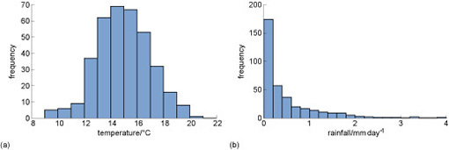
Figure 1 Histograms showing one year of (invented) daily (a) temperature and (b) rainfall data.
View description - Figure 1 Histograms showing one year of (invented) daily (a) temperature and (b) ...

- How many times in the year of data is the temperature in the range 12–13°C?
- The number of counts (frequency) of this temperature range is approximately 35.

- How many times is the rainfall in the range 0.2–0.4 mm day⁻¹?
- The number of counts (frequency) of this rainfall range is approximately 60.

Taking account of the whole range of weather types gives you a more complete picture of climate. It allows you to take extremes into account in a way that you wouldn’t be able to if you looked only at ‘average weather’.
Using all the available weather data is important because at the heart of the study of climate is the subject of statistics: the analysis and interpretation of data. Climate science is often about searching for subtle shifts in the data.

2.2 Probability of different types of weather
One analogy that reflects the idea that climate is a range of different types of weather is:

… weather’s how you choose an outfit, climate’s how you choose your wardrobe.
Kennedy (2013)

For example, if you live in the UK you might mostly own clothes that provide quite good insulation. But you might also have clothes suitable for hot summers and holidays abroad. Your wardrobe reflects what you expect the range of weather types to be, and how often they will occur. For example, if you example if you expect it to be hot every day you may choose to buy some shorts, but if it is hot for only one day, would that be worth it? This range of clothing warmth could be represented in a histogram (Figure 2).

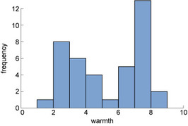
Figure 2 Example histogram showing invented data for clothing types with different levels of warmth.
View description - Figure 2 Example histogram showing invented data for clothing types with different ...

A similar analogy is:

Weather is like your mood. Climate is like your personality.
Marshall Shepherd, cited in Eosco (2013)

Just as for clothing, one could also present a record of one’s moods as a histogram (Figure 3).

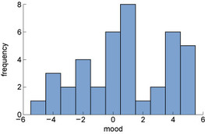
Figure 3 Example histogram showing invented data for mood types, ranging from negative to neutral to positive.
View description - Figure 3 Example histogram showing invented data for mood types, ranging from negative ...

In fact, these two analogies hint at a subtlety that is surprisingly important in defining climate and how we study it.
The second analogy – ‘climate is like your personality’ – implies that climate is a kind of history of past weather. What fraction of time during the last week were you in a good, neutral or bad mood? How many hurricanes of different strengths hit Florida during the last decade? This is exactly like the histogram examples shown in Figure 3.
But the first analogy – ‘climate’s how you choose your wardrobe’ – implies that climate is a kind of prediction about future weather. How likely is it to rain today? Perhaps an 80% chance, looking at those slate-grey skies. What proportion of next summer’s days do you predict will be cloudy?
Both are statements about how likely something is; in other words, statements of probability. So, we can also think of climate not only as a summary of what has happened, but as ‘the probability of different types of weather’.
But the difference between them reveals that there are actually two meanings of the word probability:
- The relative frequency of something happening.
- A statement of belief or a prediction about the likelihood of something happening.
Climate scientists use both meanings. They make measurements (of frequencies) to study past climate, to estimate the probability of different types of weather in the past. This is like the definition of ‘the frequency of different types of weather’ that you saw in the previous section. Climate scientists also make predictions (of belief) about future climate: predicting how the probability of different types of weather will change. This meaning is more like an expectation or prediction about the likelihood of different types of weather.
This might – understandably – seem to be getting rather esoteric and obscure. But you will see how these two different ways of thinking about climate matter when we measure and predict climate change.

Climate is a distribution of different types of weather
As well as frequency (i.e. the number of times a particular type of weather occurs), the distribution of weather is also important for climate scientists.
Figure 4 shows another way of expressing the information you saw in Figure 3. But this time, the data are presented as smooth ‘probability distributions. The scale on the vertical y-axis has changed because we have scaled the data so that if you add up all the different measurements of rainfall and temperature, it equals “1”, and the vertical axis is now labelled ‘density’.

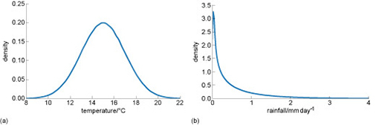
Figure 4 Example probability distributions showing invented daily (a) temperature and (b) rainfall
View description - Figure 4 Example probability distributions showing invented daily (a) temperature ...

- What is the density value when the temperature in the range 14°C?
- The density value at 14°C temperature is approximately 0.18

- What is the density value when the rainfall is 1mm day⁻¹.
- The density values when the rainfall is 1 mm day⁻¹ is approximately 0.25.

From the so called ‘probability density’ we can work out how many occurrences we should expect of things happening. For example, you saw in Figure 4 the density at 14°C temperature was approximately 0.18. But because there was one measurement per day in the data set, the distribution is made up of 365 measurements. So,
The number of times we expect to get a temperature of 14°C = number of measurements* probability density
The number of times we expect to get a temperature of 14°C = 365 * 0.18 = 65.7
And you can see in the figure, the height of the bar is approximately 65.
As well as representing actual data, the shape of the distributions in the figure could equally represent a climate scientist’s judgement as to the probability of temperature or rainfall in the future. The better the scientist’s knowledge or skill, the more likely the distribution is to be correct.
Judgement is formed from a variety of sources of information such as data, theory, computer models, past experience and discussion with others. It might also include educated guesswork. Both data and judgement are used in climate science.

2.2 Climate is more than just weather
There is one final aspect to add. While weather is the state of the atmosphere, climate is concerned with the entire Earth system.
We must also consider the other parts of the planet that affect, or are affected by, the atmosphere such as the oceans, glaciers and the ice sheets of Greenland and Antarctica (we call this the cryosphere), and of course life in the oceans and on land. Along with the atmosphere, these parts together make up the Earth system (Figure 5).

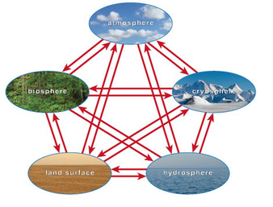
Figure 5 A simple diagram of the Earth system, showing the interactions of the atmosphere, biosphere (living things), hydrosphere (liquid water), cryosphere (frozen water) and land surface.
View description - Figure 5 A simple diagram of the Earth system, showing the interactions of the atmosphere, ...

So it is important to bear in mind that climate is concerned not just with weather but the entire Earth system.

3 How certain can we be?
You have seen that both data and judgement are used in climate science. But with judgement comes uncertainty.
How certain can we be of our science? After all, the world depends on us getting it right!
In the activity which follows, you will be rolling a set of virtual dice and plotting the frequency of dice rolls in a histogram. Is one of the dice loaded? How certain can you be of your results to make this judgement?
This section is a practical application of the idea that climate is a distribution. It demonstrates key issues of uncertainty and data, by using distributions of dice rolls as an analogy for climate.

Activity 2 Find the casino cheat
Allow about 10 minutes
You are at a casino playing craps, a dice game where players roll a pair of dice and bet on the outcome. You suspect one of your fellow players is switching one of the dice for a loaded (unfair) die each time she rolls, making her odds of successful prediction higher than yours.
You need to count the numbers rolled by both dice to try and deduce whether one die is loaded and whether your companion is a cheat.
You will record the results in a histogram, measuring the frequency of the different numbers, 1 to 6. The horizontal axis shows the different numbers on the dice, and the vertical axis shows how often each number is rolled. By recording the results of the dice rolls, you can determine whether or not one of the dice is loaded – whether some values are more likely than others.
So, you can see what you are looking for, Figure 6 shows frequency histograms from dice rolls of (a) a normal die and (b) a loaded die.

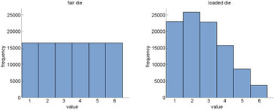
Figure 6 Frequency histograms from dice rolls for (a) a fair die and (b) a loaded die.
View description - Figure 6 Frequency histograms from dice rolls for (a) a fair die and (b) a loaded ...

Below are your two dice. You have a counter for the number of times you roll. Histograms beneath the dice show the frequency of each value you roll for each die.
Roll both dice 15 times – either by selecting the ‘Roll’ button 15 times, or by choosing the number of rolls required from the list and then selecting ‘Roll’. The values you roll will be automatically added to the graphs below. You can select ‘Reset’ to clear the dice rolls and the histograms at any time.

Interactive content is not available in this format.
Dice activity

After 15 throws, can you tell whether one of the dice is loaded?

View answer - Part

Try again: roll the two dice another 15 times.
How do the extra rolls change the histograms?

View answer - Part

The histogram gets closer to the true distribution as you collect more data. If you like, you can add more dice rolls – as many as you like.
So, do you think one of the dice is loaded? If so, which number is the most likely value to be rolled? How confident are you in these results?

View answer - Part

There is no right answer to this activity. In real research, the true answer isn’t always known. The key to estimating the true answer is statistics: the collection, analysis, interpretation and presentation of numerical data. Scientists use a variety of statistical techniques to analyse data and estimate their uncertainty about the results.
The point is, the more data you collect, the more likely you are to be able to find patterns in the data. The more data you have, the more confident you can be in your judgements, and the level of certainty increases.

3.1 Climate dice
You have seen that, the more data you gather, the better your estimate of the relative frequency of each number and the more certain you can be of the answer. If you rolled the two dice 100 000 times in Activity 2, you would have very good estimates of the shape of the two distributions. Your uncertainty about which die was loaded would be small.
In the same way, scientists use as much weather data as possible to make their estimate of climate as robust as it can be. The World Meteorological Organization (WMO) recommends that the minimum period of data collection needed to measure climate is 30 years (WMO, n.d.).

- How is detecting climate change like trying to find the loaded die?
- It is similar because it is detecting the difference between two distributions.

Figure 7 Weather dice
View description - Figure 7 Weather dice

So we can say that detecting climate change is the science of ‘detecting the difference between two distributions’.

4 What are the challenges?
‘Climate’ is really a mathematical concept, not something that can be observed directly, and its definition is not exact or fixed. The fact that climate is a distribution – a set of probabilities – is at the heart of many of the difficulties in studying the climate crisis. It also influences public understanding and decision-making around the subject.

4.1 Identifying change
In order to compare two sets of probabilities with each other and decide whether they are different, we need to measure or predict differences between distributions in every area of the science and engineering of climate change. So we need to:
- measure past climate change
- understand the causes of past climate change
- predict future climate change with different levels of greenhouse gases or geoengineering
- test whether climate predictions are similar to the real world.
For all of the above, we must decide if two distributions are ‘different enough’ to call this a change.

- If the chance of your house being flooded each year increases from 1% to 2%, does this mean you are guaranteed to be flooded every 50 years? And should you look for a new home?
- No, and it depends!

This is difficult because the change might be very subtle or slow, so we must make decisions to help us decide, such as:
- which statistical technique should we use to compare them?
- how large a difference ‘counts’ as a climate change?
- how many years of data do we need to feel confident in our conclusion?
These questions do not always have easy answers – the decisions may be somewhat arbitrary or subjective – so they are often contested by climate sceptics.

4.2 The complexity of climate
Geoengineering might be thought of as a way to cool the planet, to counter global warming. But you saw from Figure 7 there is much more to consider than air temperature alone.
If you were designing the perfect climate: would you focus mainly on cooling the planet? Or would you aim to perfect the monsoon rains, or preserve the long-term future of the Greenland ice sheet? Or design ideal climate conditions for a particular endangered species, or the Amazon forest, or for people living in less developed countries? These might all have different geoengineering solutions.
These issues are the source of many of the difficulties in studying the climate crisis and in the relationship between climate science and society. The fact that climate is an abstract mathematical concept leads directly to many of the societal controversies around climate change, and the fact climate is more than just weather leads to complications and ethical issues around the idea of geoengineering.

5 End-of-session quiz
Check what you’ve learned this session by taking the end-of-session quiz.
Session 1 practice quiz
Open the quiz in a new window or tab then come back here when you’ve finished.

6 Session 1 summary
Climate engineering, also known as ‘geoengineering’, is deliberate large-scale manipulation of the planetary environment to counteract human-caused climate change. This may be done by altering the Earth’s energy budget, either reducing the energy in or increasing the energy out.
Climate is sometimes referred to as ‘average weather’, but it is more useful to include the full range of weather – the extremes, and everything in between. One possible definition of climate is ‘a distribution of weather’, where ‘distribution’ can mean measured frequencies from the past or uncertain predictions about the future.
The more data you have, the better you can estimate the shape of this distribution. The World Meteorological Organization recommends using at least 30 years. The fact that climate is a distribution leads to difficulties in measuring, understanding and predicting climate change, and in communicating and using the predictions. It also makes it difficult to predict and measure the effects of any future potential geoengineering.
In the next session you will tackle the question: how has Earth’s climate changed in the recent past? Get started with Session 2.

Session 2: The planet is changing

1 Trusting sources of information
Google Search is currently the world’s most popular search engine. It has an autocomplete service that provides suggestions when searching the web.
The search terms suggested to you by Google depend on the public popularity of terms, the region you are in, your personal search history, and other factors such as current news events. Google is predicting what you might want to know.

Activity 1 Searching for climate change
Allow about 10 minutes
Put the words ‘climate change is’ into your Google search engine. Make a note of the auto-suggested search terms that are presented (you might like to take a screenshot).
Do another search for the phrase ‘global warming is’. Again, make a note or take a screenshot of the auto-suggested search results.

How do the auto-suggested search terms compare with each other for the two phrases? Are the terms positive, negative or neutral?

Provide your answer...

How objective would you say this information is, and could climate scientists ‘trust’ these suggestions as a source of data?

Provide your answer...
View discussion - Part

The internet is a source of huge amounts of information on the climate crisis, but it can be difficult to determine whether information is reliable.
Climate scientists, and policymakers who use climate science, very often refer to the reports of the Intergovernmental Panel on Climate Change (IPCC) for authoritative summaries of current knowledge about climate change. The IPCC publishes assessment reports about every six years. These reports are written by the many hundreds of natural scientists, social scientists, economists and technical experts engaged in research related to climate change. IPCC assessment reports are extremely comprehensive (Figure 2), taking several years to put together. However, they are written in a way that is not very accessible to non-experts.

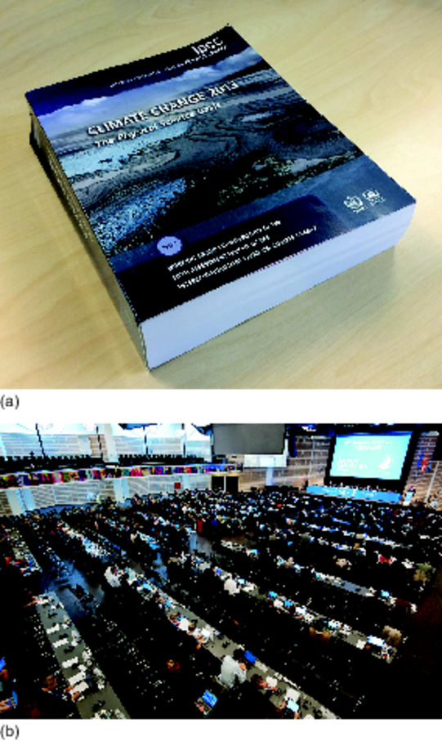
Figure 2 The first of three parts of the IPCC Fifth Assessment Report. At 1535 pages, this represents a substantial body of work, and a substantial weight in paper.
View description - Figure 2 The first of three parts of the IPCC Fifth Assessment Report. At 1535 pages, ...

Throughout this course, you will look at highlights from the IPCC Fifth Assessment Report, which was published in 2013–14. You will also see some ways in which people have communicated this same climate science in a more accessible way.

2 Taking Earth’s temperature
Taking Earth’s temperature is an important measurement for climate science. But how is it possible to take the temperature of an entire planet like the Earth?
Weather over land is observed by ~11 000 weather stations dotted around the planet (Figure 3a). The vast majority are at ground level, while some are mounted on weather balloons and aircraft. Over the oceans, weather data are collected by ships, buoys and fixed stations on islands and platforms such as oil rigs.
Figure 3b shows a snapshot of locations measuring sea surface temperature. Since the late twentieth century, we have also had technologies watching the planet from space: satellites. These ‘Earth Observation’ satellites can measure a variety of aspects of the Earth system, including upper air temperature (tens of kilometres above the ground) and sea surface temperature.

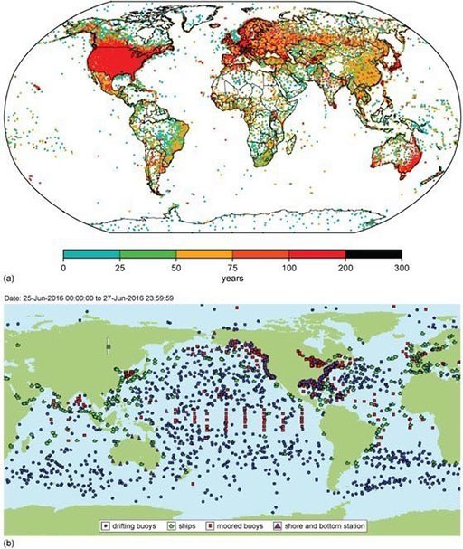
Figure 3 (a) The worldwide network of land weather stations (Rennie et al., 2014). The colour corresponds to the number of years of data available for each station. (b) A snapshot of locations measuring sea surface temperatures (NOAA, 2016).
View description - Figure 3 (a) The worldwide network of land weather stations (Rennie et al., 2014). ...

- Looking at Figure 3a, which three regions of the world’s land have the poorest coverage of weather stations?
- Greenland, North Africa and Antarctica.

- Name two characteristics of areas where land stations tend to be located.
- They tend to be located in areas of higher population and in more developed countries.

If humans have been taking the Earth’s temperature for many years, are we seeing a shift in global temperature?

2.1 Global warming through time

Activity 2 Global warming
Allow approximately 10 minutes

What do you understand by the term ‘global warming’?

Provide your answer...
View answer - Activity 2 Global warming

Climate scientists use the term global mean surface temperature (GMST) to describe the globally averaged temperature. This plays a key part in our current knowledge about climate change.

- Read the following statement from the IPCC and guess the missing value:
The amount of global warming in the period 1880–2012 is ___ degrees Celsius (IPCC, 2013).
- The amount of global warming in the period 1880–2012 is 0.85 degrees Celsius (IPCC, 2013). How close were you? Scientists need to be able to make sensible ‘guess-timates’, and practice helps to improve that skill. You should also note that, in many cases, changes measured in climate are surprisingly small, although their impact may be large.

The full statement from the IPCC also has an uncertainty range. They estimate there is a 9 in 10 chance of the temperature change being between 0.65 and 1.06 degrees Celsius. So, if your guess was in this range, or a little bit outside, you were also right!
Figure 4 shows the observed changes in global mean surface temperature (GMST) for the period 1850–2012 in degrees Celsius (IPCC, 2013).

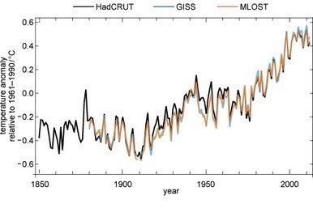
Figure 4 Annual global mean surface temperature change for the period 1850–2012 (IPCC, 2013).
View description - Figure 4 Annual global mean surface temperature change for the period 1850–2012 (IPCC, ...

The x-axis is the year. Each of the data points is an annual mean: the mean of one year of data. The data points are joined by lines to show the changes more clearly.
The y-axis is ‘temperature change relative to 1961–1990 in degrees Celsius’. This is the temperature change relative to the average temperature during the 30 years of what we term as the baseline period of 1961–1990. The average temperature over this period is zero on the y-axis.
You can see there has been an overall upward trend in GMST. There are also short-term large fluctuations over about one to three years, which are known as interannual variability.
The video below shows another powerful way of communicating the same data: through music.

Video content is not available in this format.
Video 1 A Song of Our Warming Planet by Daniel Crawford.
View transcript - Video 1 A Song of Our Warming Planet by Daniel Crawford.

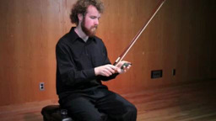

Global warming of 0.85 °C in around 160 years does not sound like much. But humans do not feel global mean temperature: we feel local changes, and we are most affected by extremes (the hottest and coldest days).

2.2 Changes in local and extreme temperatures
Small shifts in average temperatures can mean the local extreme high temperatures become unbearable for humans and other species living in areas with climates that are already challenging
Figure 5 shows a map of the observed surface temperature changes from 1901 to 2012 (IPCC, 2013).

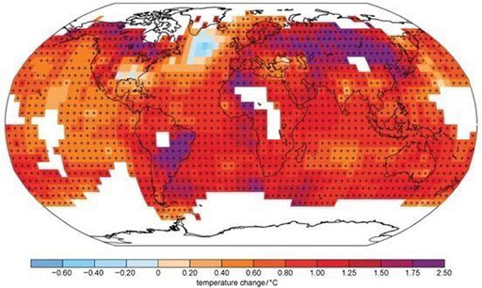
Figure 5 Map of the observed surface temperature change from 1901 to 2012 (IPCC, 2013). Trends have been calculated where data availability permits a robust estimate, while other areas are white, indicating there is not enough data. Grid boxes where the long-term change is significantly larger than the short-term fluctuations are indicated by a + sign.
View description - Figure 5 Map of the observed surface temperature change from 1901 to 2012 (IPCC, ...

Many regional changes have been more than double the global average. Figure 5 shows that changes in large regions of South America and Eurasia have been around 2°C since 1900. This is still not the complete picture: in white regions, there are not enough data to reliably calculate the long-term trend since 1901. This includes most of the northern Arctic regions, where the available measurements show that warming has been greatest.
Global warming shifts the distribution of temperatures. Since 1950, hot days and nights have generally become warmer and more frequent, while cold days and nights have become warmer and less frequent (IPCC, 2013).

3 Changes in Earth’s water
When you design your geoengineering solutions, you will need to strike a balance between controlling temperature and controlling changes in the Earth’s water, as well as other aspects of the Earth’s system – and these choices will not be easy.
Earth’s water comes in the form of rain, ice, snow and sea.

3.1 Rain
Rain is particularly important for geoengineering because living things are very sensitive to the amount and intensity of rain they receive. A broader term for rain is precipitation, the collective word for all forms in which water from the air falls under gravity onto the Earth’s surface (rain, snow, sleet or hail).

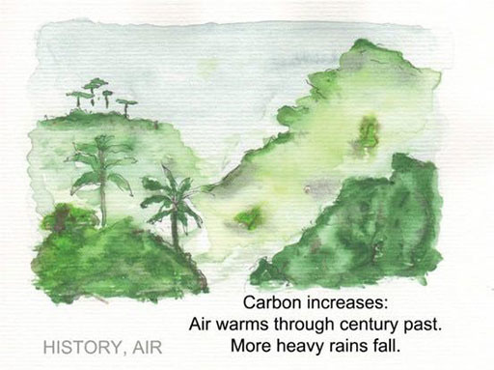
Figure 6 One of nineteen illustrated climate haiku by Greg Johnson (Johnson, 2013), this one relating to rainfall.
View description - Figure 6 One of nineteen illustrated climate haiku by Greg Johnson (Johnson, 2013), ...

The haiku – a Japanese style of poem – in Figure 6 summarises three IPCC (2013) assessments of how climate change has affected rainfall:
- The atmospheric concentrations of the greenhouse gases carbon dioxide, methane, and nitrous oxide have all increased since 1750 due to human activity (‘Carbon increases’).
- The globally averaged surface temperature data show a warming of 0.85°C over the period 1880–2012 (‘Air warms through century past’).
- Since 1950, there are likely more land regions where the number of heavy precipitation events has increased than where it has decreased (‘More heavy rains fall’).
The third statement refers to heavy precipitation events, which can cause devastating effects to human health and infrastructure. But changes to average rainfall – whether increased or decreased – are also important. Too little rainfall over a long period, for example, and supplies for drinking, agriculture and hydroelectric power can be at risk. Figure 7 shows the changes that have happened since the middle of the twentieth century.

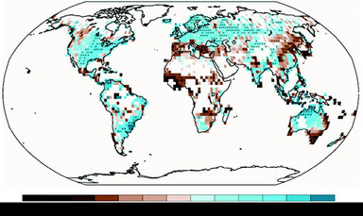
Figure 7 Observed precipitation changes for the period 1951–2010. The trends are calculated with the same criteria for data as Figure 5 (IPCC, 2013).
View description - Figure 7 Observed precipitation changes for the period 1951–2010. The trends are ...

- Which regions tend to have become wetter or drier: the most or least developed countries?
- The regions that have increased rainfall tend to be the more developed countries, and those that have decreased rainfall tend to be the least developed.

3.2 Ice sheets

Activity 3 Global sea level rise
Allow approximately 10 minutes

Which of the following can contribute to global sea level rise when it melts?

land ice (ice sheets and glaciers resting on land)
sea ice (ice floating in the oceans)
neither land ice nor sea ice
both land ice and sea ice
View answer - Activity 3 Global sea level rise
View discussion - Activity 3 Global sea level rise

When ice on the land melts and flows into the seas, this raises sea levels because it adds a new volume of water to the ocean (Figure 8).
Ice is less dense than water, which is why it floats. When floating ice melts, it forms a smaller volume of water than the original volume of ice. In fact, the volume of water formed is exactly the same as the volume of ice that was below the water surface when it was floating, so no change in sea level occurs.

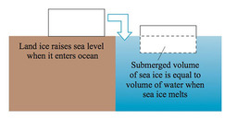
Figure 8 Floating sea ice does not increase sea level when it melts, because the volume of sea ice which is underwater is the same as the volume of water which is left when the floating sea ice melts.
View description - Figure 8 Floating sea ice does not increase sea level when it melts, because the ...

The glaciers and great ice sheets of Greenland and Antarctica (Figure 9) might seem like giant ice cubes, inert but for gradual melting from climate change. In fact, they are dynamic, shifting landscapes, places of delicate balance between the forces that create ice and those that destroy it.

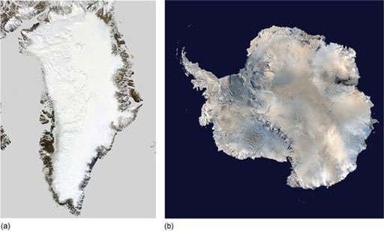
Figure 9 Satellite images of the (a) Greenland and (b) Antarctic ice sheets.
View description - Figure 9 Satellite images of the (a) Greenland and (b) Antarctic ice sheets.

Under its own immense weight, ice flows continuously downwards, towards the sea if possible. Ice is lost whenever icebergs break off into the sea – along ice sheet coasts – or whenever the surface is warm enough to melt it. Ice is constantly replaced as falling snow compacts, or rain and meltwater freeze. It all adds up to an ice ‘mass budget’ that changes with altitude, location, the seasons and long-term climate change.
This dynamic nature of ice means that dramatic images of the end of a glacier collapsing, or a huge iceberg breaking away, are not necessarily caused by climate change. Likewise, these events may not be causing global sea level rise, because glaciers are constantly losing and gaining ice. What matters for climate change and global sea level rise is how fast ice is being lost, and whether the rate of loss is increasing.
Read the following statements and answer the question below:
- The Greenland ice sheet has lost around 34 billion tonnes of ice per year over the period 1971–2009, and around 215 billion tonnes per year from 2002–2011.
- The Antarctic ice sheet has lost around 30 billion tonnes of ice per year over the period 1992–2001, and around 147 billion tonnes per year from 2002–2011.
- Glaciers around the world have lost around 226 billion tonnes of ice per year over the period 1971–2009, and around 275 billion tonnes per year from 1993–2009 (IPCC, 2013).

- For which of these three sources of land ice have ice losses sped up the most?
- The Greenland ice sheet: the rate has increased by around six times.

A loss of 360 billion tonnes of land ice is equivalent to about 1 mm of global mean sea level rise. This may seem a small amount, but this is happening every year, and the rate of loss is not constant.

3.3 Sea ice and snow
Much of Earth’s ice and snow is difficult for humans to access: ice caps on high mountains; vast, cold ice sheets on land, and creaking sea ice. So, we rely on measurements made by satellites to monitor what is happening.
Changes in ice and snow are important for climate change and geoengineering because:
- Ice and snow contribute to people’s livelihoods, water resources and culture.
- Some species depend on ice and snow for their habitat, breeding or feeding grounds.
Sea ice and snow cover affect how quickly the Earth responds to a change in energy budget, whether from human-caused climate change or geoengineering.

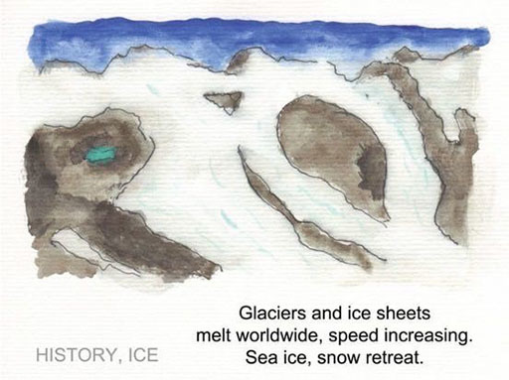
Figure 10 Ice melt haiku (Johnson, 2013).
View description - Figure 10 Ice melt haiku (Johnson, 2013).

Read the following statements about sea ice and snow (IPCC, 2013), and answer the question below:
- Annual mean Arctic sea ice extent decreased over the period 1979–2012, by around 0.5 million kilometres squared (4%) per decade, and the summer minimum extent decreased by 0.7 to 1.1 million kilometres squared (around 9 to 14%) per decade.
- Annual mean Antarctic sea ice extent increased over the period 1979–2012, by around 0.1 to 0.2 million kilometres squared (1 to 2%) per decade. There are strong regional differences, with extent increasing in some regions and decreasing in others.
- The extent of Northern Hemisphere snow cover has decreased since the mid-twentieth century.

- Which of the three statements is not included in the haiku?
- The haiku ends ‘Sea ice, snow retreat’ but one of the statements shows that Antarctic sea ice is, on average, increasing in extent. Communication of science often simplifies results to tell an accessible story.
However, the decrease of sea ice in the Arctic is larger, and Antarctica shows a mixture of both increases and decreases in different locations, so the overall message of the haiku is still reasonable.

3.4 Sea level rise
Tide gauges on coasts and islands have measured sea level, relative to a fixed benchmark on land, for more than 150 years. The oldest measurements date back to the 1700s and consisted of visual observations of water level against a calibrated vertical pole known as a tide staff (Figure 11). Today, sea level is also measured by other methods including buoys and satellites.

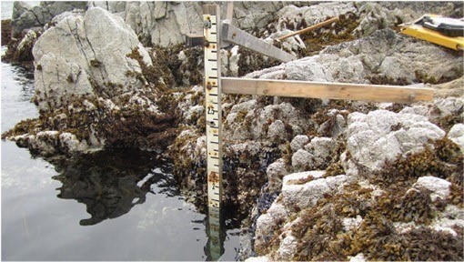
Figure 11 Tide staff used by NOAA ‘Teachers at Sea’ Rosalind Echols and Avery Marvin to check against tide gauge data while surveying the ocean floor off Alaska.
View description - Figure 11 Tide staff used by NOAA ‘Teachers at Sea’ Rosalind Echols and Avery Marvin ...

The measurements show, as you might already expect, that global sea level is rising (Figure 12).
Many people live in low-elevation coastal zones, and sea level rise increases the likelihood of coastal flooding. The IPCC assesses there is around a two-in-three chance that extreme high sea levels have increased since 1970.

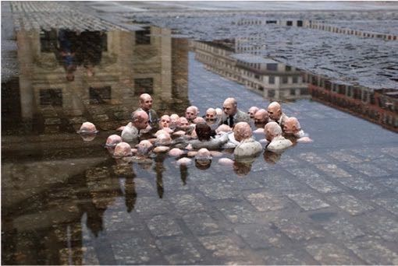
Figure 12 Electoral campaign, by Isaac Cordal (Berlin, Germany, 2011), popularly known as Politicians Discussing Global Warming.
View description - Figure 12 Electoral campaign, by Isaac Cordal (Berlin, Germany, 2011), popularly ...

A number of factors contribute to sea level rise – not only glaciers and the Greenland and Antarctic ice sheets, but also thermal expansion and transfer from land water storage.
Thermal expansion is water in the oceans expanding as it warms.
Transfer from land water storage is the movement of water that was previously stored on land into the oceans. The main reason for this is that humans have been extracting groundwater (water stored in the soil and rock) for agriculture, industry and drinking water. After it is used, it runs off into the rivers and eventually the oceans. Changes in land water storage also include capture of water in reservoirs, which removes water from the oceans (lowering sea level).
Some factors contributing to sea level rise hit the headlines more than others, but this does not necessarily correspond to how much they contribute to sea level rise. Guess the rank of these factors in terms of their contribution to sea level rise for the period 1993–2010. Rank 1 is ‘greatest contribution’ and rank 5 is ‘smallest contribution’:

Interactive content is not available in this format.

You might be surprised at the answer, from 1993–2010:
- thermal expansion contributed 1.1 mm per year to sea level rise
- glaciers contributed 0.8 mm per year
- land water storage contributed 0.4 mm per year, and
- the Greenland and Antarctic ice sheets contributed around 0.3 mm per year each, making a total of around 3 mm per year.
But what do these changes mean for life on our planet?

4 Effects on life
So far you have learned about the physical aspects of past climate change. For example, global mean surface temperature is rising, this is leading to the fact that rainfall is changing, sea level has been rising, and ice is being lost from the Arctic and Antarctic Ice sheets.
But what is the impact of climate change on ecosystems and humans?

4.1 Natural systems
Polar bears (Figure 13) are neither well measured nor well understood. Of the 19 subpopulations, there are enough data for only two to link a decline in numbers with climate change, and some subpopulations remain stable. How will they cope with the impacts of global warming?

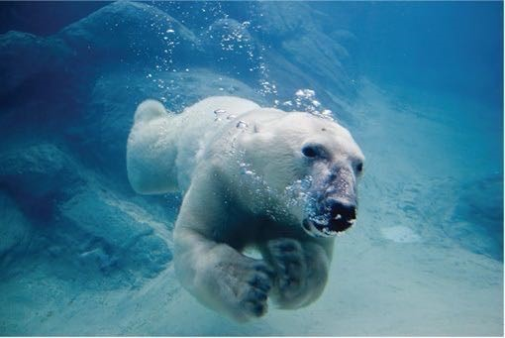
Figure 13 A polar bear in its marine environment. For good or bad, this species is an icon commonly used in discussions of climate change.
View description - Figure 13 A polar bear in its marine environment. For good or bad, this species is ...

In the following activity you will find out more about the impacts of the climate crisis on natural systems.

Activity 4 Climate impacts on life
Allow approximately 15 minutes

Here is a selection of statement extracts from the IPCC (2014) about impacts of climate change on natural systems, i.e. life other than humans, over the past several decades:
- Decline in coral reefs in tropical African and Asian waters.
- Many terrestrial species have recently moved, on average, 17 km towards the poles and 11 m up in altitude per decade (e.g. Europe, North America, Chile, Malaysia).
- The distributions of marine species have shifted by up to a thousand kilometres. Overall, the edge of species ranges expanded towards the poles at around 72 km per decade.
- Over the last 50 years, biological events in the spring and summer shifted earlier for many species by around 4.4 days per decade.
- Increasing burnt forest areas during recent decades in Portugal and Greece.
- Increased wildfire frequency in North American subarctic conifer forests and tundra.
- Increase in wildfire frequency and duration, and burnt areas in forests of the western US and boreal forests in Canada.
- Decreased reproductive success in Arctic seabirds.
- Decline in Southern Ocean seals and seabirds.
- Reduced krill density in Scotia Sea.
Write your own haiku about one or more of these statement extracts in the response box below. It is easier than you might think, and can be quite addictive!

Provide your answer...
View discussion - Activity 4 Climate impacts on life

4.2 Ocean acidification
Another less well-known environmental impact is also affecting our oceans. It is not climate change, although it shares its main cause. It is a critical issue in considering geoengineering design.
The ocean has absorbed about 30% of the carbon dioxide humans have emitted into the atmosphere. When carbon dioxide dissolves in water it forms a weak acid called carbonic acid. The net effect of this is to increase the relative acidity of the water.
This decrease in pH is known as ocean acidification. Note that this does not mean the ocean is now acidic. The surface of the ocean is alkaline, so the pH decreases towards the less alkaline part of the scale (in the same way that a temperature increase from −7°C to −5°C is a warming). The IPCC estimates that ocean mean pH decreased from about 8.2 to about 8.1 for the period 1765–1994. In the Southern Ocean around Antarctica, pH changes are estimated to be larger than the global mean.
Why does it matter whether the ocean pH changes?
Calcifying marine organisms such as planktonic foraminifera (Figure 14) are adapted to the chemistry of the water around them to make their shells. Ocean acidification makes it more difficult for these organisms to precipitate the carbonate. The IPCC assess that the shells of foraminifera in southern oceans have reduced in thickness due to ocean acidification (IPCC, 2014).

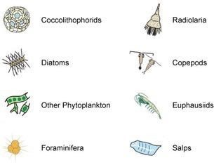
Figure 14 Some types of plankton, including foraminifera (IPCC, 2014).
View description - Figure 14 Some types of plankton, including foraminifera (IPCC, 2014).

Foraminifera are not quite as appealing as polar bears as an icon of human impacts on the environment. But calcifying organisms like these lie at the base of many marine food chains.

4.3 Humans – extreme weather
Humans are affected by climate change too, and particularly by changes to extreme weather and extreme sea level. We are adapted to our local climate and sea level, so these changes push at the boundaries of our resilience.

Activity 5 Extreme weather events
Allow approximately 20 minutes

Use the box below to record as many types of extreme weather events as you can think of:

Provide your answer...
View answer - Part

How do these extreme weather events impact on humans?

Provide your answer...
View answer - Part

Two examples of direct impacts, in Brazil and South Australia, are shown in Figure 15.

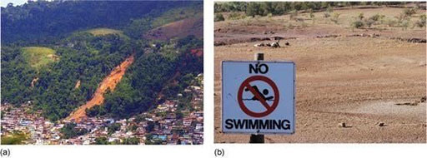
Figure 15 (a) Morro da Carioca, Angra dos Reis in the State of Rio de Janeiro, Brazil, where heavy rain caused fatal mudslides and flooding in January 2010. (b) A sign in Rawnsley Park Station, South Australia, rendered unnecessary by the 2007–08 drought .
View description - Figure 15 (a) Morro da Carioca, Angra dos Reis in the State of Rio de Janeiro, Brazil, ...

Extreme weather events also have indirect impacts. These might be, for example, reduced agricultural yields and social instability such as violent crime and mass migration (Edwards and Challenor, 2013; Watts et al., 2015).
Whether the impact is direct or indirect, the intensity of the impact is also governed by how exposed and vulnerable the human population is. So, contributing factors to impact intensity are:
- The hazard: i.e. the intensity and frequency of extremes.
- Exposure: for example, only coastal areas are exposed to sea level rises.
- Vulnerability: for example, more developed countries generally have more resilient transport and energy systems, buildings and agriculture than do less developed countries. They are also more likely to have systems for reducing health impacts, such as medical infrastructure, warning systems and air conditioning.
An increase in the impacts of extreme weather may be due to increases in the frequency and severity of extreme weather events, or due to increases in exposure and vulnerability.
One important example of an impact of extreme weather is financial losses. Financial losses from extreme weather events have risen during the twentieth century. This is thought to be largely due to increases in exposure and vulnerability.

4.4 Humans – climate shifts
It is not only extreme weather that affects humans, but also general climate change (i.e. the shift in the entire climate distribution). Read the following IPCC assessments of impacts of climate change on humans in recent decades (IPCC, 2014):
- Negative impacts of climate change on crop yields have been more common than positive impacts. Climate change has negatively affected wheat and maize yields for many regions.
- Impacts on livelihoods of Sámi people in northern Europe.
- Advanced timing of wine-grape maturation in Australasia.
- More vulnerable livelihood trajectories for indigenous farmers in Bolivia due to water shortage, in part due to glacier retreat.
- Increase in agricultural yields and expansion of agricultural areas in south-eastern South America.
- Impact on livelihoods of Arctic indigenous peoples, through changing ice and snow conditions, and dwindling access to hunting grounds.
- Increased shipping traffic across the Bering Strait.
- The burden of human ill-health from climate change is relatively small compared with effects of other stressors and is not well quantified.
The Sámi (Figure 16), referred to in the extract above, are the reindeer-herding communities of Lapland (the Arctic regions of Norway, Sweden, Finland and Russia). Warmer winter temperatures lead to rain falling on snow and forming ice layers that prevent reindeer access to lichen, leading to greater herd starvation.

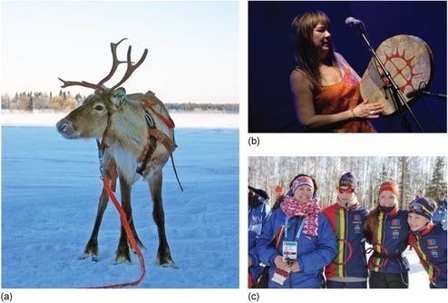
Figure 16 (a) Sámi reindeer. (b) Sámi musician Mari Boine. (c) ‘Team Sámi’ at the Arctic Winter Games in 2014.
View description - Figure 16 (a) Sámi reindeer. (b) Sámi musician Mari Boine. (c) ‘Team Sámi’ at the ...

Activity 6 Prioritising human impacts
Allow approximately 10 minutes

Different types of geoengineering would affect different parts of the Earth system and would reduce different aspects of climate change.
To implement geoengineering, you will need to prioritise which impacts on humans you think it is most important to mitigate.
List these IPCC impact statements in the order that you would prioritise them. 1 is the most important, and 8 is the least important.

1
2
3
4
5
6
7
8
Negative impacts on wheat and maize yields for many regions.
Impacts on livelihoods of Sámi people in northern Europe.
Advanced timing of wine-grape maturation in Australasia.
More vulnerable livelihood trajectories for indigenous farmers in Bolivia due to water shortage, in part due to glacier retreat.
Increase in agricultural yields and expansion of agricultural areas in south-eastern South America.
Impact on livelihoods of Arctic indigenous peoples, through changing ice and snow conditions, and dwindling access to hunting grounds.
Increased shipping traffic across the Bering Strait.
The burden of human ill-health from climate change (relatively small compared with effects of other stressors and not well quantified).
View answer - Activity 6 Prioritising human impacts
View discussion - Activity 6 Prioritising human impacts

Climate science is, of course, constantly changing. In the next session, you will take a closer look at some of the causes.

5 End-of-session quiz
Check what you’ve learned this session by taking the end-of-session quiz.
Session 2 practice quiz
Open the quiz in a new window or tab then come back here when you’ve finished.

6 Session 2 summary
Very many aspects of the Earth system are changing, with important consequences for human and other life. Detecting climate change, and designing and testing geoengineering, requires long data records, over the whole globe, to measure how much climate has changed in the past and whether future geoengineering is working as expected.
Global mean surface temperature records show clear warming since 1850, though large interannual (year-to-year) variability makes the picture more complex. Local changes can be much larger than the global mean. The widespread changes provide motivation for reducing climate change and its risks, but also complicate the design of any geoengineering proposed.
Difficult decisions must be made about reducing one aspect of Earth system change over another, protecting one place over another, and reducing harm to one vulnerable aspect of life over another.
Now move on to Session 3.

Session 3: We are causing change

1 Deducing the causes of climate change
Did humans cause recent climate change?
This question is too simple. There’s no switch that selects ‘natural’ or ‘human’ climate change, and there are always natural changes.
So instead we should ask: how much of recent climate change did humans cause?
Estimating the relative contributions of different possible causes of climate change is called attribution. Uncertainty is, of course, inevitable in attribution because establishing cause and effect relationships in complex natural systems is difficult.

- Read the following statement and guess the missing value:
Scientists are __% confident that at least half the global warming since 1950 is due to human activities.
- Scientists are 95% confident that at least half the global warming since 1950 is due to human activities (IPCC, 2013a).
Did you expect this figure to be higher or lower? As you saw in Session 2, there is also a lot of confusion (and misinformation) about the degree of confidence in the causes of climate change.

1.1 The global whodunnit
Attributing the causes of the climate crisis is like solving a ‘whodunnit’, that is, a crime mystery. Thinking about it in this way is a useful way to unpack the different stages of the issue.
You will study this here in the context of past GMST changes. The six steps in our whodunnit to establish the causes of climate change are:
Step 1: Record the scene (measure climate change over time)
Here, the evidence is the global surface temperature record, but you could measure other aspects of climate change.
Step 2: Identify the suspects (what are the possible factors that can change climate?)
We consider all external factors that could warm surface temperatures.
Step 3: Identify the red herrings (are there any factors that may confuse your investigation?)
Mysteries can be made more difficult to solve by the presence and actions of ‘innocent parties’ which serve to confuse the investigation.
For the attribution of climate change, these ‘red herrings’ could be factors that cool surface temperatures, or random fluctuations that are not caused by any external factor but that might cause warming or cooling.
You will look here at three red herrings, both natural and human-caused.
Step 4: Establish what everyone was doing at the time (how much were each of the factors changing?)
The whodunnit analogy is perhaps a little more stretched here, but the next step is to estimate the strength of each factor (both ‘suspects’ and ‘red herrings’) through time, either by direct measurements or by other methods. If a suspect was not present, then they could not be responsible.
Step 5: Take everyone’s fingerprints (describe the pattern of change each factor causes)
Look for fingerprints. Luckily for us, each of the suspects and red herrings has a different fingerprint on global surface temperatures: a characteristic spatial pattern of temperature changes.
Step 6: Infer who has the most fingerprints on the scene (how strongly does each factor affect the temperature record?)
You will see how climate models – mathematical representations of the climate system are used to quantify the contribution of each of the fingerprint spatial patterns (Step 5) to the temperature record (Step 1).
In Session 2, you saw summaries of the evidence for Step 1 of the whodunnit, the measurement of climate change over time. You will now consider the suspects (Step 2) and the red herrings (Step 3). In climate science, these suspects and red herrings are termed ‘radiative forcings’, or just ‘forcings’, and act to change the Earth’s energy budget.

1.2 Forcing the global thermostat
Forcings either alter the energy into the planet, or the energy out, pushing the climate into a warmer or cooler state (unless an equal forcing is acting in the opposite way). Depending on the size and type of forcing, it may take thousands of years for the climate to finish responding.
Figure 1 illustrates an analogy for a radiative forcing: it is simply something that acts to change the Earth’s energy budget (which results in a climate change). In this case the ‘suspect’ radiative forcing is a mystery hand.

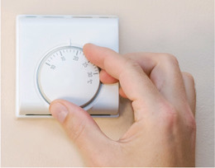
Figure 1 A ‘radiative forcing’ (mystery hand) acts to change the ‘Earth’s energy budget’ (thermostat dial) which produces a change in climate (room temperature).
View description - Figure 1 A ‘radiative forcing’ (mystery hand) acts to change the ‘Earth’s energy ...

Forcings are measured in watts per metre squared (W/m²). One watt (1 W) is defined as 1 joule per second. This is a unit that is commonly used in electric lightbulbs, with modern bulbs using ~15 W/m².
You will now take a closer look at the various ‘suspects’ and ‘red herrings’ that have acted to change this budget in the past and therefore warmed or cooled the planet.

2 Radiative forcings – increasing temperature
You will now explore two different forcings – the Sun and greenhouse gases – which are two of the suspects thought to have influenced Earth’s temperature in the recent past. This is Step 2 of the whodunnit.

2.1 The Sun
Stradivarius violins are considered to be among the finest in the world (Figure 2a). Some experts have suggested this is partly down to the density of the wood in their construction (Stoel and Borman, 2008), and that is different because it is spruce wood grown during the unusual climate at the time they were made (Burckle and Grissino-Mayer, 2003).
Antonio Stradivari was born in Italy in 1644, a year before the start of the Maunder Minimum. This was a 70-year period during which the Sun had abnormally few sunspots, named after the husband-and-wife pair of astronomers who identified the phenomenon. Sunspots (Figure 2b) are areas of intense magnetic activity and they correlate with the intensity of solar radiation: the more sunspots, the greater the Sun’s output.
So the trees surrounding Stradivari’s workshops had grown during a long period of unusually cool climate. Trees grow more slowly in cooler climates, which makes the wood density higher and more uniform between summer and winter growth. To what extent the Sun’s variations contributed to Stradivarius violin sound quality is unknown: but the effect of solar changes on climate is certainly real.

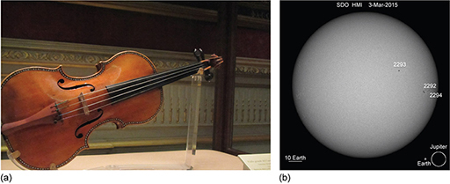
Figure 2 (a) A Stradivarius violin. (b) Sunspots on 3 March 2015.
View description - Figure 2 (a) A Stradivarius violin. (b) Sunspots on 3 March 2015.

The Maunder Minimum was one contributing factor to the Little Ice Age (around 1450–1850), a cool interval during which a number of mountain glaciers expanded. But this is not the only example of a changing Sun. Solar radiation has long-term variations – which are essentially unpredictable – and more regular short-term changes, such as an 11-year cycle.
Step 4 of the whodunnit requires an estimate of how solar radiation reaching the Earth, also known as total solar irradiance, has changed through time. Figure 3 shows two estimates of past changes in total solar irradiance: the longer record is estimated indirectly from sunspot number and characteristics, while the shorter, recent record is from satellite observations. It clearly shows the 11-year cycle, along with longer-term changes.

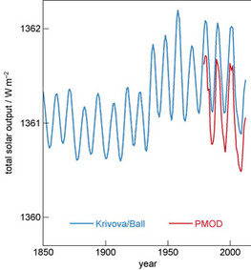
Figure 3 An example reconstruction of total solar irradiance (solar output reaching the Earth) since 1850 (Krivova/Ball). Direct observations from satellite (Physikalisch-Meteorologisches Observatorium Davos, PMOD) are also shown for the later period. (Adapted from IPCC, 2013a)
View description - Figure 3 An example reconstruction of total solar irradiance (solar output reaching ...

- What are the long-term changes in total solar irradiance over the twentieth and start of the twenty-first centuries?
- Total solar irradiance increases in the first half of the twentieth century. It then stays fairly constant (aside from the 11-year cycle), with a decrease at the start of the twenty-first century.

2.2 Greenhouse gases
The Earth’s surface is warm, so it emits energy in the form of radiation. Much of this energy is infrared. Certain gases in the atmosphere absorb infrared radiation: this means that most of the infrared radiation from the Earth’s surface is trapped and recycled by the atmosphere, being repeatedly absorbed and re-emitted in all directions by the greenhouse gases.
These greenhouse gases (GHGs) include carbon dioxide (CO₂), methane (CH₄), nitrous oxide (N₂O), ozone (O₃) and water vapour. You will look at the first three of these gases.
The additional energy keeps the Earth’s GMST over 30 °C warmer than it would be without an atmosphere: without the greenhouse effect, there would not be life as we know it. What matters for recent and future climate change is how much the greenhouse effect is enhanced by our activities.
The human sources of greenhouse gases include:
- CO₂ – mainly as a by-product from fossil fuel burning for energy, and cement production for construction, with some from land use changes such as deforestation.
- CH₄ – rice paddies, livestock flatulence and burping (Figure 4), waste management (e.g. organic matter rotting in landfill sites), leakage from gas pipelines, venting gas at oil production sites and coal mines, and burning vegetation.
- N₂O – mainly from agriculture, such as the application of fertilisers; some also comes from combustion of fossil fuels and vegetation.

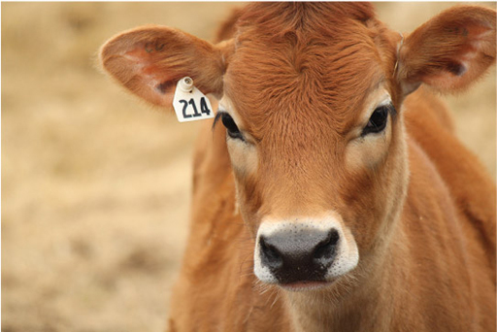
Figure 4 Not just a pretty face: livestock are a major emitter of greenhouse gases.
View description - Figure 4 Not just a pretty face: livestock are a major emitter of greenhouse gases. ...

Continuous direct monitoring of atmospheric CO₂ concentrations dates back to 1958, and direct continuous measurements of CH₄ and N₂O began only in the 1980s. Before this, measurements of past GHG concentrations mostly come from bubbles of air trapped in ice core samples taken from the polar regions.
Figure 5 shows the amounts of the three GHGs since 1850 in terms of mixing ratios. The mixing ratio is the proportion of a given gas in the atmosphere, usually referred to as the atmospheric concentration. Values are usually in parts per million (ppm) or parts per billion (ppb). Hover over a data point to see the year and concentration value.

Interactive content is not available in this format.
Figure 5 Atmospheric concentrations since 1850 of (a) CO₂ to 2014; (b) CH₄ to 2011; (c) N₂O to 2011. (Data from Table 1.1a in IPCC, 2013b)
View description - Figure 5 Atmospheric concentrations since 1850 of (a) CO2 to 2014; (b) CH4 to 2011; ...

- What can you tell from the graph about the concentrations in the atmosphere of these three greenhouse gases?
- You can see from the graph that concentrations of all three are increasing as year increases.

- What are the year and concentration for the final point of the CO₂ data? What are they for the first point?
- The final data point on the CO₂ (black) curve is 398.6 ppm, in 2014. The first point is 286.8 ppm, in 1850.

- Which of the three GHGs has shown the largest percentage increase from 1850 to 2011?
- Methane has exhibited the largest percentage increase in concentration since 1850. It is the only one for which the rise (from around 800 ppb to 1800 ppb, an increase of around 1000 ppb) is larger than the original value. For the other two, the increase is smaller than the original value.
This may be surprising, as CO₂ is the most well-known greenhouse gas. The reason CO₂ is the focus of most discussion around climate change policy is because it has the highest concentration of the three GHGs (measured in parts per million, not parts per billion). It is therefore the largest contributor to total greenhouse gas forcing.

3 Radiative forcings – cooling temperatures
So what of Step 3 of the whodunnit: the red herrings? These are the factors that may confuse your global climate data.
You will start by looking at two major cooling forcings – industrial sulfates and volcanic sulfates. Both of these act to decrease energy because they reflect energy from the Sun back out into space. So, as they increase, their effect is to reduce GMST.

3.1 Industrial sulfates
This section will start from a different perspective.
It’s 1972. The latest global mean surface temperature changes are shown in Figure 6.

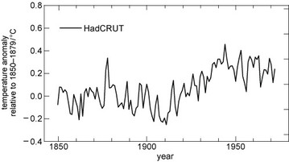
Figure 6 Global mean surface temperature changes for the period 1850–1972 (adapted from IPCC, 2013a).
View description - Figure 6 Global mean surface temperature changes for the period 1850–1972 (adapted ...

- Would you say the ‘recent’ changes in temperature since 1940 showed warming or cooling?
- The trend is negative – in other words, ‘global cooling’.

With the benefit of hindsight, we now know that the long-term trend changed from cooling to warming. But in 1972, with climate science still a new field, it was not at all clear what was going on.
In the 1970s, some media outlets presented dramatic predictions of a new ice age (Figure 7). They were reporting – and, in some cases, exaggerating – a handful of scientific studies that examined the past three decades of GMST and suggested these may be the start of a longer global cooling period.

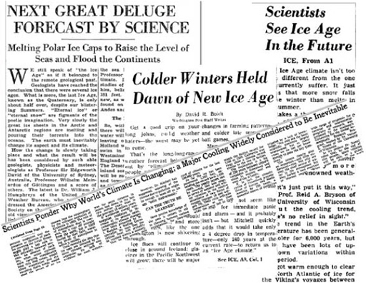
Figure 7 A collage of newspaper articles reporting predictions of global cooling from the 1970s.
View description - Figure 7 A collage of newspaper articles reporting predictions of global cooling ...

Watch the following sequence from the BBC’s ‘Climate Change: A Horizon Guide’ The Horizon Guide series collects sequences from BBC programmes over the past to illustrate how views on a particular scientific topic have evolved.

Video content is not available in this format.
Video 1 Sequence from the BBC’s ‘Climate Change: A Horizon Guide’, first broadcast in March 2015.
View transcript - Video 1 Sequence from the BBC’s ‘Climate Change: A Horizon Guide’, first broadcast ...

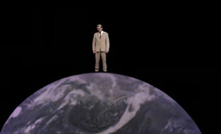

- Did the scientists of the time think CO₂ was still having a warming effect on the planet?
- Yes. Professor Bert Bolin says that if we go on burning oil and coal, ‘in about 50 years’ time the climate may be a few degrees warmer than today’. But some thought the effect of sulfur dioxide pollution might be stronger, so the overall effect would be cooling.

- Why did the predictions of long-term global cooling ‘melt away’?
- Because ‘both the amount of sulfur dioxide pollution and the size of its cooling effect had been overestimated’.

Sulfur dioxide gas (SO₂) is released when burning coal and petroleum, smelting metal and from other industrial processes (Smith et al., 2011). The gas rapidly reacts with water vapour in the atmosphere to make droplets of sulfuric acid called sulfate aerosols, or sulfates for short. (The word aerosol means small particle or droplet.) Because industrial sulfates are emitted at low levels in the atmosphere they have a lifetime of only a few days or weeks before they are rained out, but they are continually replenished.
The droplets reflect some of the Sun’s radiation, thus cooling the atmosphere. But this is not the only story, as they also have complicated indirect effects. Particles of this size can act as cloud condensation nuclei, seeding clouds by encouraging water vapour to condense, and these clouds can have a warming or cooling effect. Despite this complexity, the estimated net effect of the direct and indirect mechanisms is clear: cooling.
The IPCC estimated sulfate aerosols offset about a quarter of the estimated forcing from CO₂ between 1850 and 2011 (IPCC, 2013a). The sulfate aerosol cooling effect is sometimes referred to as ‘global dimming’.
Figure 8 shows an estimate of how global sulfur dioxide emissions have changed through time. You can see the main characteristics of a long-term increase up to about 1975, and then a decrease in the last decades of the twentieth century.

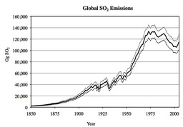
Figure 8 Global sulfur dioxide emissions (solid line) with 5–95% uncertainty bounds (dashed lines) (Smith et al., 2011).
View description - Figure 8 Global sulfur dioxide emissions (solid line) with 5–95% uncertainty bounds ...

- What does this decrease in SO₂ emissions mean for global temperatures?
- It means a decrease in the cooling effect (i.e. a relative warming).

Have a look at some of the individual regional estimates in Figure 9 to investigate the regional impact of this decrease further.

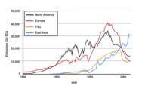
Figure 9 Global sulfur dioxide emissions by region for the four highest emitting regions (North America; Europe, FSU (former Soviet Union); and East Asia (Smith et al., 2011).
View description - Figure 9 Global sulfur dioxide emissions by region for the four highest emitting ...

- Comparing the graphs, which regions in Figure 9 correspond with the global decrease shown in Figure 8?
- The same decrease is seen in the emissions for North America, Europe and (later) the former Soviet Union. It is not seen in the largest current emitter, East Asia.

The declines in SO₂ emissions in North America and Europe were due to pollution regulations in the 1970s, such as the US Clean Air Act of 1970, which were brought in to avoid problems such as acid rain. So – somewhat ironically – regulation to improve air quality reduced the aerosols in the atmosphere, and so has had the side effect of increasing the net global warming effect of fossil fuel combustion.
In recent years there has been a large increase in coal combustion in China, so East Asia has overtaken the other regions: the declining trend in global SO₂ emissions appears to have reversed.

3.2 Volcanic sulfates
The largest volcanic event of modern times, the eruption of Mount Tambora in Indonesia, took place in April 1815. This ‘Year Without a Summer’ suffered gloomy skies, cold weather and failed crops. Where records exist, they reveal abnormally cold weather during the following year, with unseasonal frosts and snowfalls in the north-eastern USA, and crop failures and famine in England, France and Germany.
It has been suggested that Tambora and a later volcanic eruption – which made sunsets a hazy, pinky–orange – influenced Turner’s distinctive artistic style (Figure 10; Zerefos et al., 2007).

Figure 10 Chichester Canal, by J. M. W. Turner.
View description - Figure 10 Chichester Canal, by J. M. W. Turner.

Ash and lava are the most visually dramatic results of volcanic eruptions, but volcanoes also emit SO₂ gas. The gas forms sulfate aerosols with the same cooling effects as described for industrial sulfates. If the eruption is large, these aerosols can be ejected into the stratosphere.
The stratosphere is a layer in the upper regions of the atmosphere (from around 18 km altitude in the tropics), above the more turbulent troposphere layer where rainfall and most conventional ‘weather’ occurs (Figure 11). Aerosols in the stratosphere are too high to be rained out, which means they survive long enough to be dispersed around the world and can affect climate through the direct cooling effect for around one to three years.

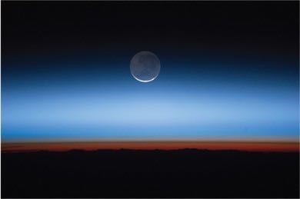
Figure 11 The troposphere (red-brown), stratosphere and beyond taken from the International Space Station.
View description - Figure 11 The troposphere (red-brown), stratosphere and beyond taken from the International ...

This cooling effect can be enormous. After the devastating eruption of Mount Pinatubo in the Philippines in June 1991, global mean surface temperatures decreased by about 0.3 to 0.4 °C (Santer et al., 2016).

4 Internal variability
The third red herring is not a forcing as such but it may blur the picture. This is the idea of ‘internal variability’ where you cannot be sure you are measuring the full picture.
Look at Figure 12, which represents the Delhi Metro system. Around 2.5 million people per day travel on the system ‘flowing’ from one place to another (Sharma et al., 2014).

Interactive content is not available in this format.
Figure 12 Delhi Metro system map, indicating flows of people from one part of the system to another.
View description - Figure 12 Delhi Metro system map, indicating flows of people from one part of the ...

Imagine you have been asked to measure the total number of people travelling on the system at any one time, as well as changes in passenger numbers throughout the day.
But you only have the resources available to measure passenger numbers on the central Ring Railway (dark blue in Figure 12), so you concentrate on measuring this area.

- Will you get an accurate measurement of the total number of passengers on the whole system?
- No, you would only see part of the picture. A large fraction of passengers is in other parts of the system at any one time.

- Will you get a reliable measurement of changes in passenger numbers throughout the day?
- You can never be sure, but as passengers enter and exit the Ring Railway, you might still be able to see the overall trends. The Ring Railway is a large and important part through which many people travel. You would also expect fluctuations in that trend as people flowed in and out.

The same principle applies to climate science, and this is the third of the whodunnit red herrings. Interactions within the climate system generate spontaneous and unpredictable fluctuations in the Earth system known as internal variability.
Internal variability is not a forcing, unlike solar radiation, greenhouse gases and sulfate aerosols. Instead, the fluctuations add ‘noise’ to the long-term trend, making it more difficult to pick out ‘signals’. You have so far considered mostly surface warming. But every moment of every day, heat moves around the planet, from the atmosphere into the oceans, and back again. So if you measure only the surface temperature, you are only seeing part of the picture, as much of Earth’s heat is elsewhere.
One important example of internal variability that affects GMST is the El Niño Southern Oscillation (ENSO). During an El Niño event, winds moving from east to west over the tropical Pacific Ocean weaken, which slows the circulation of the ocean below.
This means less cold water than usual is brought up from the deep ocean, so the eastern tropical Pacific sea surface becomes warmer than normal (Figure 13a). These events, and their opposite counterparts, La Niña events (strengthening winds, leading to cooler eastern tropical Pacific sea surface; Figure 13b), occur every few years and cause huge changes to ocean and surface temperatures – and weather – around the world.

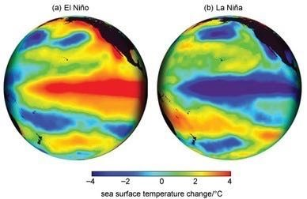
Figure 13 Example sea surface temperature changes during El Niño and La Niña events, showing the characteristic pattern of eastern Pacific warming (a) and cooling (b).
View description - Figure 13 Example sea surface temperature changes during El Niño and La Niña events, ...

Many of the brief spikes and troughs you see in the annual GMST data are caused by ENSO moving heat between the atmosphere and ocean. You can see a short animation of these dynamic transitions back and forth in the following video.

Video content is not available in this format.
Video 2 Animation of sea surface temperature anomalies for the period 1980–99. Every now and then the characteristic patterns of El Niño and La Niña events (Figure 13) emerge. (Note: there is no sound for this video.)

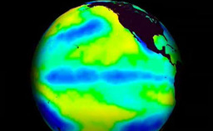

5 Putting it all together
Scientists need a means of calculating how each of the suspects and red herrings have affected the Earth’s temperature over time. Luckily, each factor has its own characteristic pattern (its own ‘fingerprint’) in affecting the temperature record and scientists can analyse these patterns to help deduce how much each factor has contributed to any observed changes.
So how do scientists estimate how each of these suspects and red herrings have affected the climate?

5.1 Climate models
The answer is that scientists use models to estimate to what extent each suspect and red herring affects the climate. A model is simply something that represents something else.
Climate models are mathematical equations that represent part, or all, of the Earth system. Most climate models are extremely complex, with many thousands of equations. These are too complicated for humans to calculate, so they are calculated by computers.
You will study these complex climate models more later. For now, it is enough to say that these state-of-the-art computer models are designed to represent, or simulate, all important aspects of the climate system. Climate models enable climate scientists to assess how the Earth system responds to different factors. They provide us with a means of carrying out virtual experiments on the climate system: by changing the various inputs, we can simulate a wide range of possibilities.

5.2 Deducing the culprits
Now for Step 6 of the whodunnit, the final step. Of our suspects, who are the culprits?
In other words, how strongly does the Sun, the greenhouse gases, and the red herrings affect the temperature record? What is the relative contribution of each factor and how much of this contribution can be explained by human activities?
Using climate models, scientists estimate the fraction of influence from each climate fingerprint by adjusting their contributions until they find the ‘best fit’ to the observed data. You need a mix of all these unique fingerprints in the right amounts and once you have the best fit to the data, you have your best estimate of the fractions of each.
Using the down arrow, scroll through Figure 14 to see how this looks in GMST for the forcings you have studied (plus a few others).

Interactive content is not available in this format.
Figure 14 What’s really warming the world? Use the down arrow to scroll through the figure.
View description - Figure 14 What’s really warming the world? Use the down arrow to scroll through the ...

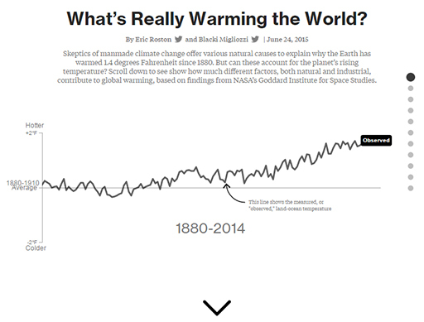
Figure 14 What’s really warming the world? Use the down arrow to scroll through the figure.

It is clear from the individual time series of GMST for each forcing (Figure 14) and their differing fingerprints that human activities are the main cause of recent warming.
As you learned at the start of this session, some degree of uncertainty is inevitable in attribution, because establishing cause and effect relationships in complex natural systems is difficult. But the IPCC (2013a) statement that

‘Scientists are 95% confident that at least half the global warming since 1950 is due to human activities’

is actually quite a conservative summary of scientific studies.
In fact, the best estimate is that human activities have caused all the warming since 1950 through increased greenhouse gas emissions.

6 End-of-session quiz
Check what you’ve learned this session by taking the end-of-session quiz.
Session 3 practice quiz
Open the quiz in a new window or tab then come back here when you’ve finished.

7 Session 3 summary
This session has given you a whodunnit of attributing recent climate change, discussing the most important climate forcings – the Sun, greenhouse gases, industrial sulfates, and volcanic sulfates – as well as internal variability. You may have already had some ideas about how it might be possible to manipulate or alter these forcings to engineer the climate, and you will study these in Session 5.
First, in Session 4, you will look at the last of three parts in the potential motivation for geoengineering: scientists’ predictions for the future. Take a look at Session 4.

Session 4: Future of the planet

Introduction

Trying to predict the future is a mug’s game. But increasingly it’s a game we all have to play because the world is changing so fast and we need to have some sort of idea of what the future’s actually going to be like because we are going to have to live there, probably next week.
Adams (2002)

This quotation from science fiction author Douglas Adams highlights the point that this session is not only about the specific predicted risks of climate change, which might motivate us to engineer the climate. It is also about the science of prediction: are scientists good enough at predicting the future to understand the consequences of geoengineering?
By the end of this session, you will:
- appreciate how predicting climate is different from predicting weather
- be aware that many different climate models exist, and that their predictions differ
- understand the use of scenarios in predicting climate change
- be familiar with a range of predictions about climate change and its impacts on humans and other life.

1 The climate forecast
How can scientists predict climate change in a hundred years, when they can’t even predict the weather next week? The answer will hopefully become clear in Activity 1.

Activity 1 Heads or tails?
Allow approximately 10 minutes

Find a coin and a volunteer.
Ask your volunteer to toss the coin six times in a row. But before they start, ask them to write down a prediction for what the results will be: for example, ‘heads, tails, heads, tails, tails, heads’.
Were they right?

View answer - Part

Now do the same again but ask your volunteer to make a different prediction: to write down how many heads there will be out of the six coin tosses.
Do they get this prediction right? If so, can you explain why this might be?

View answer - Part

Does each type of prediction become easier or harder if you do the same activity with a larger number of coin tosses?

View answer - Part

Which of these is more like predicting weather, and which more like predicting climate, and why?

View answer - Part

However, predicting climate is – in one important sense – harder than predicting the statistics of coin tosses. In the coin toss activity, everything about the environment stays the same each time. This is why it becomes easier to predict the average number of heads as the sequence of coins becomes longer. In the real world, both human-caused and natural forcings will continue to change. This makes future climate harder to predict.
But the overall principle is similar – weather is a sequence of days and climate is a distribution of those days. This is an example of how the statistical definition of climate that you saw in Session 1 can contribute to confusion about how scientists predict it.

2 Different possible futures
Human activities are the dominant influence on current climate change. But how can scientists predict what future greenhouse gas emissions will be?

Activity 2 Human-caused factors
Allow approximately 5 minutes

Take five minutes to note down what human-caused factors you think will influence future greenhouse gas emissions.

Provide your answer...
View discussion - Activity 2 Human-caused factors

Scientists and other experts do have some idea about the likely bounds of future population, wealth, politics, technology, agriculture and culture, but these factors are impossible to predict exactly: and there are often big surprises, such as new inventions. This means it is impossible to predict future greenhouse emissions exactly.
So, scientists make predictions of climate change for a set of different ‘possible futures’. This means that rather than trying to predict how the climate will change, scientists try to predict how the climate would change if human activities changed in a particular way – in other words, they are ‘what-if’ scenarios. These scenarios are designed to span the likely bounds of what could happen, even if no individual scenario comes to pass exactly.

2.1 Representative Concentration Pathways
The IPCC currently uses four ‘possible futures’ called Representative Concentration Pathways (RCPs). These were defined for the IPCC Fifth Assessment Report in 2013–4 (van Vuuren et al., 2011). The process of defining an RCP begins with imagining a plausible description of the future: a socio-economic scenario of possible population, global domestic product (GDP), energy usage and sources, and so on. This scenario is then translated into a set of:
- greenhouse gas concentrations
- air pollutant concentrations (such as industrial sulfates)
- changes in land use (e.g. conversion of forest to cropland).
These are then used by climate models to predict future climate change for each RCP.
The RCPs are called ‘representative’ concentration pathways because they represent the range of futures that have been suggested as possible by previous studies. The four scenarios have the rather technical names RCP2.6, RCP4.5, RCP6.0 and RCP8.5.
Figure 1 shows the predicted changes in population and primary energy consumption for the scenarios underlying the four RCPs. Primary energy is the energy embodied in natural resources such as coal, natural gas, crude oil, solar energy, wind energy and biomass before they are transformed for use.

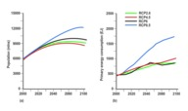
Figure 1 (a) Population and (b) primary energy consumption in the four scenarios underlying the RCPs (van Vuuren et al., 2011).
View description - Figure 1 (a) Population and (b) primary energy consumption in the four scenarios ...

- Looking at Figures 1a and 1b, which RCP would you guess has the highest greenhouse gas emissions and therefore the greatest warming effect on climate?
- RCP8.5 has both the highest population and the highest primary energy consumption. This scenario therefore seems most likely to have the highest greenhouse gas emissions.

Actually, this is indeed the case. The four RCPs described in more detail are:
- RCP8.5: an energy-intensive scenario of very high greenhouse gas concentrations, in which emissions continue to increase through the 21st century
- RCP6.0 and RCP4.5: two stabilisation scenarios, in which emissions stop increasing by the end of the 21st century
- RCP2.6: a mitigation scenario, in which emissions peak in the middle of the twenty-first century and then decline.
The different greenhouse gas concentrations in the RCPs are produced different human emissions of the gases. Figure 2a and 2b show an example for one of the greenhouse gases: it shows the changing CO₂ emissions into the atmosphere and corresponding CO₂ concentration in the atmosphere.
Remember: there is a difference between emissions and concentrations. Think of the atmosphere as like a bath, and carbon dioxide as like the water. The rate of emissions of CO₂ into the atmosphere is like the rate of water flowing in, while the concentration of CO₂ in the atmosphere is like the amount of water in the bath. Burning fossil fuels releases CO₂ into the atmosphere (emissions), which increases the amount in the atmosphere (concentrations).

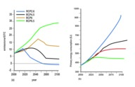
Figure 2 (a) Emissions and (b) concentrations of CO2 in the four RCPs (van Vuuren et al., 2011).
View description - Figure 2 (a) Emissions and (b) concentrations of CO2 in the four RCPs (van Vuuren ...

All four RCPs show increases in greenhouse gas concentrations in the future (Figure 2b). This gives a net positive forcing: in other words, all of them lead to a warming of the climate. Of the four, RCP2.6 has the smallest total forcing (the least warming effect on climate), followed by RCP4.5, RCP6.0 and RCP8.5, which has the highest.

- What happens to CO2 emissions in RCP2.6 towards the end of the century?
- Figure 2a shows that in this RCP the CO2 emissions become slightly negative – that is, humans will need to extract more CO2 from the atmosphere than we emit – by the last two decades of this century.

The RCPs are the standard scenarios of predicting possible future climate change. You will see how scientists predict climate change for different possible geoengineering actions later in the course. One important question you will consider is: how could we use geoengineering to achieve negative emissions of CO₂?
Scientists try to predict climate change for each RCP using climate models. The climate models take the concentrations of greenhouse gases and pollutants, and the land use changes, and simulate the Earth system response: predicting changes in temperatures, rainfall, sea ice, and so on.

2.2 The world’s climate models
Many of the world’s universities and meteorological institutes have created their own climate models for making predictions. The reason for this is that each model is slightly different. The motivation for having many different climate models is to compare their predictions. The wider the spread of predictions, the greater scientists’ uncertainty about the future.
The IPCC (2013) report included results from 42 different climate models. Their acronym-filled names sound rather technical and obscure, but are often derived from the institute name followed by the model version. For example:
- GFDL stands for the U.S. National Oceanic and Atmospheric Administration (NOAA) ‘Geophysical Fluid Dynamics Laboratory’
- GISS stands for the NASA ‘Goddard Institute for Space Studies’
- the ‘Had’ in HadGEM stands for the UK Met Office ‘Hadley Centre’ (and GEM for Global Environmental Model), and
- MPI stands for the Max Planck Institutes in Germany.
As an example, you can see their different predictions for global warming under RCP4.5 in Figure 3. Use the magnifying glass to see the variation in predictions in more detail.

Interactive content is not available in this format.
Figure 3 Projected mean surface air temperature change in 2081–2100 displayed as anomalies with respect to 1986–2005 for RCP4.5 from each of the 42 climate models used in IPCC AR5 (IPCC 2013). Use the magnifying glass to see the variation in predictions in more detail.
View description - Figure 3 Projected mean surface air temperature change in 2081–2100 displayed as ...

You will notice that the models give quite a range of different predictions for the future.

- Recall that all four RCPs had a net positive forcing, i.e. warming the climate. What might seem surprising about some of these predictions?
- As the forcing is positive, one would expect overall warming relative to today, but many predictions show large regions of cooling.

The maps show cooling in some places because regional changes can be quite different to the global mean. Usually maps of predictions show the mean of all the models, so it is not possible to see all the variation between models. It is important to bear this wide variation in mind.

3 Predictions for the planet
What are the predictions for the aspects of the Earth system you looked in the last session? The predictions for temperature, rain, ice and snow, sea level, natural systems and humans are all relevant to geoengineering design.

3.1 Global warming
Figure 4 shows the IPCC (2013) predictions for annual mean GMST change for the lowest and highest greenhouse gas concentration pathways, RCP2.6 and RCP8.5.

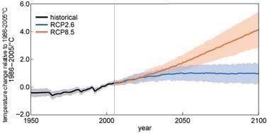
Figure 4 Past and projected annual mean GMST from the world’s climate models, relative to 1986–2005. Black and grey show simulations of the past, and blue and orange are predictions for RCP2.6 and RCP8.5 respectively. Solid lines show the mean, and shading the 90% range. (Adapted from IPCC, 2013)
View description - Figure 4 Past and projected annual mean GMST from the world’s climate models, relative ...

- What do you notice about the predictions during the first few decades of the twenty-first century?
- They are quite similar for the two different RCP scenarios (the shaded bands overlap a lot).

Temperature changes up to 6 °C may not seem much, but estimates of GMST at the end of the century is predicted to be as much above the GMST before the industrial revolution as the ice age was below it.
Compare these predictions with those in the maps in Figure 5.

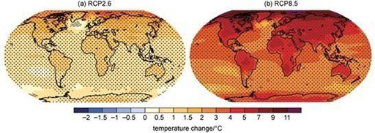
Figure 5 Predictions of mean GMST change 2081–2100 relative to 1986–2005 for the scenarios RCP2.6 (a) and RCP8.5 (b) (IPCC, 2013).
View description - Figure 5 Predictions of mean GMST change 2081–2100 relative to 1986–2005 for the ...

- Comparing Figures 4 and 5, what important extra information does the full map (Figure 5) provide compared with the global mean (Figure 4)?
- Regional variations. The global mean cannot show the fact that warming is predicted to be greater over land (i.e. where humans live) than the oceans, and that regional changes are predicted to be larger than the global mean in many places. For example, more than 10 °C warming is predicted in the Arctic for RCP8.5, while the global average is around 4 °C warming.

In terms of temperature extremes, the IPCC (2013) predicts that it is ‘virtually certain’ that hot days and nights will become warmer and/or more frequent, and that cold days will become warmer and/or less frequent by the end of the twenty-first century – for all four RCPs.

3.2 Rain, ice and snow
Piers Forster, a climate scientist who played a leading role in writing the IPCC (2013) report, wrote 18 tweets when it was published, one for each of its headline statements. Figures 6 and 7 are two of his tweets that relate to the predictions of rain, ice and snow. Their captions give the original IPCC headlines.

Figure 6 Piers Forster’s tweet representing the IPCC (2013) assessment that ‘The contrast in precipitation between wet and dry regions and between wet and dry seasons will increase, although there may be regional exceptions’.
View description - Figure 6 Piers Forster’s tweet representing the IPCC (2013) assessment that ‘The ...

The IPCC (2013) also predicts that it is ‘very likely’ that heavy precipitation events will increase in frequency, intensity or amount of precipitation over many areas: in particular, in the mid-latitudes (around 30°to 60°north or south) and in wet tropical regions.
The picture is less clear for droughts, but they predict it is ‘likely’ that droughts will become more intense and/or longer under the RCP8.5 scenario. They also predict that it is more likely than not that intense tropical cyclone activity will increase in the Western North Pacific and North Atlantic under high greenhouse gas concentrations (between RCP6.0 and RCP8.5).

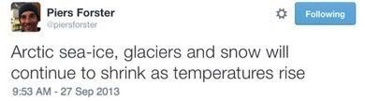
Figure 7 Piers Forster’s tweet representing IPCC (2013) assessment that ‘It is very likely that the Arctic sea ice cover will continue to shrink and thin and that Northern Hemisphere spring snow cover will decrease during the twenty-first century as global mean surface temperature rises. Global glacier volume will further decrease’.
View description - Figure 7 Piers Forster’s tweet representing IPCC (2013) assessment that ‘It is very ...

In fact, the IPCC assessed that for RCP8.5, the Arctic Ocean is likely to be nearly ice-free during its annual minimum in September before the middle of the century.

3.3 Sea level rise
Here is another one of the IPCC headline statements:

Global mean sea level will continue to rise during the 21st century. Under all RCP scenarios the rate of sea level rise will very likely exceed that observed during 1971–2010 due to increased ocean warming and increased loss of mass from glaciers and ice sheets.
IPCC (2013)

Activity 3 Tweeting
Allow approximately 15 minutes

Write a one-tweet summary of this headline.

Provide your answer...
View answer - Activity 3 Tweeting

If you are interested to see them, here is the full set of Piers’ 18 tweets.
The IPCC (2013) predict it is ‘very likely’ that extreme high sea level will increase in frequency and/or magnitude.

4 Predictions for life: Natural systems
What impacts will future climate change and ocean acidification have on life?
You saw in Session 2 that many marine species such as fish are migrating their habitats from one region to another much faster than terrestrial species. This is because there are fewer physical barriers preventing them from adapting in this way.
Figure 9 shows the IPCC (2013) estimates of how fast different species can migrate, along with the average speeds necessary under different RCP scenarios (the ‘climate velocity’, the rate of movement of the climate across the landscape). Freshwater molluscs can migrate rapidly, with the white bar extending far above most predicted climate change. But small terrestrial species and, of course, vegetation, are much more limited. For them, migration speeds may not be sufficient to respond, i.e. to adapt, to RCP6.0 or RCP8.5 scenarios of climate change. Those that cannot adapt will see their population numbers decrease or become extinct in part or all of their ranges.

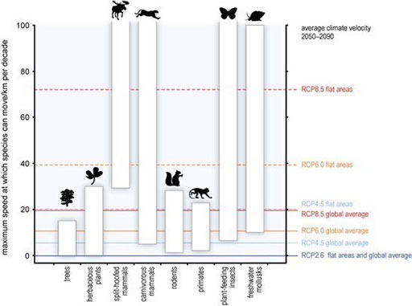
Figure 9 Who can outrun climate change? Maximum speed at which species can migrate, along with corresponding speeds required for each RCP scenario (adapted from IPCC, 2014).
View description - Figure 9 Who can outrun climate change? Maximum speed at which species can migrate, ...

4.1 Ocean acidification
One of the predicted Earth system changes is further ocean acidification. This may have different effects on different species. Those that photosynthesise – algae and seagrasses – may benefit from higher CO₂, just like plants on land would. However, many species that are important to humans are thought to be vulnerable, especially for the higher forcing scenarios RCP6 and RCP8.5.
Figure 10 shows that negative effects from ocean acidification are predicted for a large number of important marine species, particularly molluscs and warm-water (reef-building) corals.

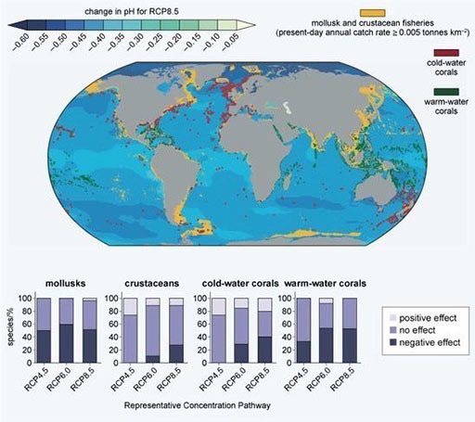
Figure 10 IPCC (2014) predictions for ocean acidification for RCP8.5, along with the estimated sensitivity of molluscs, crustaceans and corals – vulnerable animal phyla with socio-economic relevance (e.g. for coastal protection and fisheries) – for different RCPs (adapted from IPCC, 2014).
View description - Figure 10 IPCC (2014) predictions for ocean acidification for RCP8.5, along with ...

- Which species are in regions affected by the largest predicted pH changes?
- The largest pH changes are in the Arctic (decreases: dark blue), which has molluscs and crustaceans (yellow) and cold-water corals (red).

- Which of those three species (molluscs, crustaceans and cold-water corals) are estimated to be more affected by pH?
- Warm-water corals and molluscs: these have the largest estimates of negative effects (dark bars).

Why is this important? You will see later that some types of geoengineering would address ocean acidification because they tackle the root cause of climate change – greenhouse gas emissions – but others would not.

5 Predictions for humans
It is also predicted that climate change will have a specific impact on humans – on our food, water, health and economies.
The IPCC assesses, for example, that:

For the major crops (wheat, rice, and maize) in tropical and temperate regions, climate change without adaptation is projected to negatively impact production for local temperature increases of 2 °C or more above late-20th-century levels, although individual locations may benefit.
IPCC (2014)

The World Health Organization estimated in 2014 that there could be at least 250 000 deaths annually between 2030 and 2050 due to the impacts of climate change, and that the actual figure was likely to be higher because they did not include the effects of ‘economic damage, major heatwave events, river flooding, water scarcity or the impacts of climate change on human security and conflict’ (Watts et al., 2015).
How about economic costs? The IPCC (2014) assessed that ‘global economic impacts from climate change are difficult to estimate’, but made ‘incomplete estimates’ of global annual economic losses for a warming of around 2 °C from the present day: around a two-thirds chance that the loss of income would be between 0.2 and 2.0%, but more likely to be higher than this range than lower.
Coastal flooding (from extreme high sea level) is considered to be one of the most expensive aspects of future climate change because the world’s population is disproportionately located in ‘low elevation coastal zones’, less than 10 metres above sea level
The science of prediction is, of course, always changing. But if you were to try and control the climate, which impacts would you put first?

6 End-of-session quiz
Now it’s time to complete the Session 4 badge quiz. It is similar to previous quizzes, but this time instead of answering five questions there will be fifteen.
Session 4 compulsory badge quiz
Remember, this quiz counts towards your badge. If you’re not successful the first time, you can attempt the quiz again in 24 hours.
Open the quiz in a new tab or window then come back here when you’ve finished.

7 Session 4 summary
Climate scientists make predictions of the Earth system using a variety of climate models that encapsulate as much of current knowledge as possible. Predictions are made for different scenarios – currently the four Representative Concentration Pathways (RCPs) – that are intended to span the range of our possible futures (emissions of greenhouse gases and air pollutants, and land use changes).
In this session you have studied several of the IPCC’s predictions about future climate change and its impacts on humans and other life. As you can see, these assessments of future climate risks are a key part of our potential motivation for geoengineering.
You are now halfway through the course. The Open University would really appreciate your feedback and suggestions for future improvement in our optional end-of-course survey, which you will also have an opportunity to complete at the end of Week 8. Participation will be completely confidential and we will not pass on your details to others.
In the next session, you will study some of the possible methods of engineering our climate. Get started on Session 5.

Session 5: Ways to engineer the climate

Introduction
Error! Hyperlink reference not valid.
By the end of this session, you should be able to:
- appreciate the rate of energy reaching the Earth’s surface from the Sun, and how Earth’s energy balance can be manipulated by geoengineering
- understand how geoengineering could reduce how much of the Sun’s energy reaches the Earth’s surface
- understand how geoengineering could potentially reduce greenhouse gas concentrations in the atmosphere.

1 Tipping the energy balance scales
Imagine you have been hired as an Energy Balance Consultant to advise humanity on climate change. As you have seen in previous sessions, there are compelling reasons to engineer the climate. But the question now is how?

- As an Energy Balance Consultant, you must ‘tip the scales’ of Earth’s energy budget. What were the two types of approach discussed in Session 1?
- You could geoengineer the climate by reflecting sunlight with mirrors (to reduce the energy coming in) and/or by reducing the greenhouse effect (to increase the energy going out).

The greatest source of Earth’s energy is the Sun. Just how much energy do we receive from the almost unimaginably vast nuclear fusion reactor in our Solar System? You might find the answer surprising!

2 Energy from the Sun
The Sun supplies the Earth with energy: radiation streams out at 385 trillion trillion W (385 followed by 24 zeros!). But as the Earth is 150 million km from the Sun (on average), it intercepts only a tiny fraction of this energy.
It’s like a garden sprinkler or fountain. A large flow of water is supplied to spray out in every direction, but each of the surrounding plants – or, in the case of the photograph of the unusual fountain in Figure 1, birds – receives only a small part.

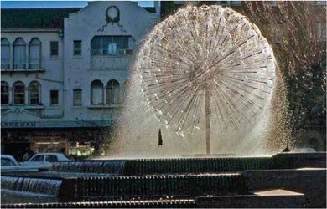
Figure 1 Birds in the spray of the spherical El Alamein Fountain in Sydney.
View description - Figure 1 Birds in the spray of the spherical El Alamein Fountain in Sydney.

- How many 10 W compact fluorescent light bulbs would be needed to create the same energy output as the Sun?
- The number of light bulbs needed will be the Sun's output, divided by the output of a single light bulb: so the answer is 38.5 trillion trillion. This is similar to the highest estimates for the number of stars in our Universe (1 trillion trillion).

Energy reaching the Earth
How much of the Sun’s energy reaches us?

- The average living-room floor area in the UK is around 17 m². Take a guess as to how many 40 W incandescent light bulbs would provide the same energy in an average living room as the energy that reaches the Earth from the Sun:
Around 150?
Around 1500?
Around 15 000?
  - The answer is 146 light bulbs. This might seem surprisingly small, considering the huge output of the Sun, but the Earth intercepts only a tiny fraction of this as it orbits.

The Earth is so far from the Sun, and is so small, that the rate at which this energy falls on the planet is only 343 Watts per metre squared (Wm²). It is this energy that you will be aiming to reduce in your geoengineering design.

3 Reducing energy in

Activity 1
Allow approximately 10 minutes

What technologies and methods could you implement to reduce the amount of energy from the Sun that falls on the planet? Now you know more about what you need to tackle as Energy Balance Consultant, spend a couple of minutes thinking of possible geoengineering options. They can be as fantastical as you like – you could even develop the ideas you had in Session 1.

Provide your answer...

Geoengineering methods that reduce incoming energy from the Sun are known as Solar Radiation Management (SRM). You will look at four key methods, chosen for their scientific principles or the degree to which they have been studied or considered for implementation.

3.1 A solar shield
The simplest concept for reducing the energy in is to ‘dial down’ the Sun: to reduce the amount of solar radiation reaching the Earth using a solar shield or solar sail.

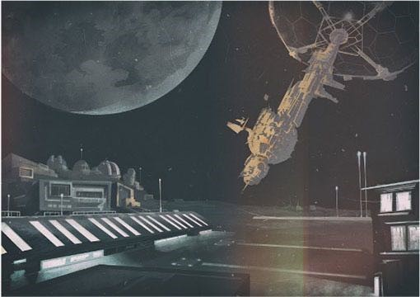
Figure 2 ‘This is the NASA Sail Technology and Launch Location, otherwise known as STaLL. This is the place that will launch EarthShade … the solar sail that will soon unfurl four times further away than the Moon.’ (Repeat of Panel 12 from Session 1, Figure 2, an imagined image of a solar sail in the future.)
View description - Figure 2 ‘This is the NASA Sail Technology and Launch Location, otherwise known ...

In 1989, scientist James T. Early suggested that a space-based glass shield might be made from silicon in the soil on the Moon to offset the greenhouse effect. Art then imitated life as Arthur C. Clarke and Stephen Baxter wrote the science fiction book Sunstorm in 2005 about a shield protecting Earth from solar storms, many years after the idea was first suggested in a scientific paper.
So the suggestion of reflecting, or deflecting, sunlight with one or more solar shields – also referred to as sunshades or solar sails – has a long and imaginative history. This seemingly outlandish idea to ‘avert Climate Armageddon’ is still in the air (Figure 3).

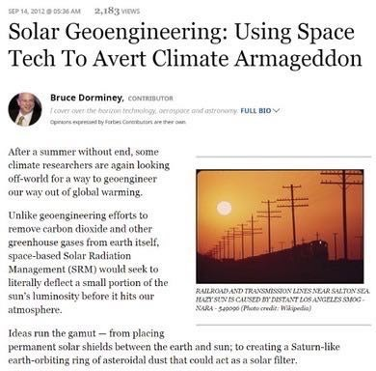
Figure 3 Forbes article on using solar shields to ‘avert Climate Armageddon’ (September 2012).
View description - Figure 3 Forbes article on using solar shields to ‘avert Climate Armageddon’ (September ...

As Earth’s Energy Balance Consultant, you could design a reflective solar shield located between the Sun and the Earth to reflect some of the Sun’s radiation. In theory it is possible to design a solar shield which could offset any amount of CO₂.
Recall the four RCPs you studied in Session 4: scenarios of future greenhouse gas concentrations and other human-caused changes. In all except the lowest, RCP2.6, the atmospheric concentration of CO₂ reaches at least double preindustrial levels by the end of the century: increasing from 280 ppm in preindustrial times to around 560 ppm or more.

Activity 2
Allow approximately 10 minutes

Guess by approximately what percentage you would need to reduce the Sun’s energy falling on the Earth to compensate for a doubling of CO2 concentrations:

0.1%
1%
10%
20%
View answer - Activity 2

You could choose to place a solar shield in a stable location, and around four times further away than the Moon. If you wished to block 1.6% of incoming solar radiation, to counter the global warming effect of doubling CO₂ concentrations, you could use a circular shield of around 2000 km in diameter: roughly the distance from London to the southern tip of Italy.
Solar shields might remain the realm of science fiction for the foreseeable future. So how about making the Earth itself more reflective?

3.2 Earth’s albedo
Figure 4 shows the Earth from space in two photos known as ‘Blue Marble 2012’. They show that the brightness of Earth’s surface is very varied.
Albedo (from the Latin for ‘white’) is the fraction of the solar radiation that hits the Earth (we call this the “incident” radiation) that is reflected.
Albedo is denoted by alpha α, with no units, because it is a fraction, the higher the value, the greater amount of solar radiation that is reflected. Surfaces that reflect more radiation tend to appear light (white or silver) and those that reflect less tend to appear dark. Different surfaces on the Earth have different values of albedo, as do different types and depths of cloud and particles in the atmosphere, such as dust or the sulfate aerosols you studied in Session 3.

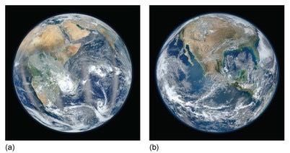
Figure 4 ‘Blue Marble 2012’ images of the Earth showing (a) Africa and the Middle East, and (b) North America.
View description - Figure 4 ‘Blue Marble 2012’ images of the Earth showing (a) Africa and the Middle ...

Activity 3
Allow approximately 5 minutes

Arrange these surfaces into order of decreasing albedo:

fresh snow
thick cloud
sea ice
agricultural crops
coniferous forest
1. (highest albedo)
2.
3.
4.
5.
View answer - Activity 3

Earth has an average albedo of 0.30 so it reflects around 30% of the incoming energy from the Sun. As an Energy Balance Consultant, how might you increase this number?

3.3 Bright cities
The Earth’s albedo has a big effect on the energy received from the Sun. Cities, buildings and roads typically have low albedo – the tarmac, pitch and cement are dark so they absorb radiation very efficiently and keep urban areas warm.
This is called the urban heat island effect: it is so significant it distorts the global mean temperature record and increases human mortality and illness by making heatwaves more severe.
When weather stations are based outside cities, as the city expands to surround them, the extra heat adds more warming to the measured trend. Scientists assess these effects by comparing temperature changes in rural and urban stations, estimating that the urban heat island could affect the temperature record by up to 10% (IPCC, 2013).

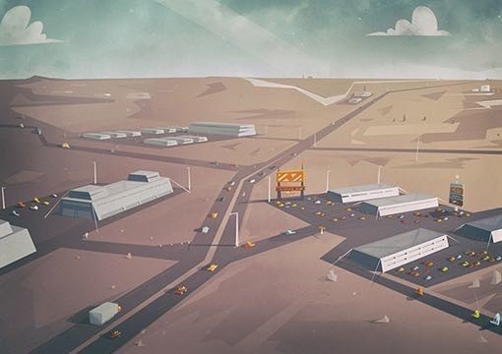
Figure 5 The lighter buildings will reflect more incident radiation back out into space.)
View description - Figure 5 The lighter buildings will reflect more incident radiation back out into ...

Conversely, many weather stations were moved from urban areas out to airports in the 1940s–60s, so the earlier measurements have to be corrected downwards (Brohan et al., 2006). This is one of the most common large adjustments to land surface temperature records, and its effect is to increase estimates of past warming trends.
Instead of correcting the temperature data for the urban temperature difference, is it possible to try and correct it in the real world?
Consider the possibility of increasing the albedo of urban areas to reflect more solar radiation. Roof tops and road surfaces could be painted white, and structures and roads could be built using reflective materials. Could this method of brightening cities be enough to cool the whole planet?

Activity 4
Allow approximately 5 minutes

Guess the percentage of the Earth’s surface we must cover in a perfectly reflective mirror (i.e. with an albedo of 1.0) to exactly compensate a future doubling of carbon dioxide:

0.02%
1.5%
4%
8%
View answer - Activity 4

Urban albedo has been estimated to have the potential to counteract up to 1.3% of a doubling of atmospheric CO₂ concentrations globally (Lenton and Vaughan, 2009). But it can have a much larger local effect.

- Considering the urban heat island effect, if cities were cooled by increasing their albedo, why would this reduce the human health impacts of global warming?
- Cooling cities may reduce the need for air conditioning, which would reduce energy use.

These positive side effects are known as co-benefits. They make urban albedo a more appealing choice than it is for its potential to reduce global warming alone.
A third approach to reflecting solar radiation comes not from space or the surface, but from the sky.

3.4 Fake volcanoes
Injecting sulfate aerosols into the stratosphere to create fake volcanoes is a geoengineering solution which aims to reflect sunlight directly but as you studied in Session 3, they also have indirect effects on climate by influencing cloud formation.

“A paper in Science concluded that a Pinatubo-size [volcanic] eruption every few years would ‘offset much of the anthropogenic warming expected over the next century.’ … The 1992 NAS [National Academy of Sciences] report [Policy Implications of Global Warming] … raised the possibility of intentionally spreading sulfur dioxide in the stratosphere. … All that would be needed to produce a globe-changing effect is one-twentieth of 1 percent of current sulfur emissions, simply relocated to a higher point in the sky. … The task of reversing global warming boils down to a straightforward engineering problem: how to get thirty-four gallons per minute of sulfur dioxide into the stratosphere?
The answer: a very long hose.
… And it would be startlingly cheap. … this plan could be up and running in about three years, with a startup cost of $150 million and annual operating costs of $100 million.”
(Levitt and Dubner, 2009, pp. 176–96)

This chapter attracted widespread criticisms of oversimplifying the issues of climate change and geoengineering, under-emphasising the risks, misquoting a climate scientist, and making a number of factual errors and misleading statements. However, not only is it part of the history of the global conversation about engineering the climate (due to its huge popularity and criticism), but the method described in the extract – stratospheric sulfate aerosol injection, acting as a kind of artificial volcano – has been much discussed as a possible action to counter climate change.

- Having read the extract, would this method be limited in how much CO₂ forcing it could offset (like urban albedo), or unlimited (like the solar shield)?
- Only a small amount of sulfur dioxide would be needed, meaning any amount of CO₂ forcing could be offset.

Figure 6 illustrates some proposed methods of injecting aerosols into the stratosphere: a hose might be supported by a tall tower or suspended by balloons, although Robock et al. (2009) consider the aeroplanes and artillery shell methods more realistic for the near-term.

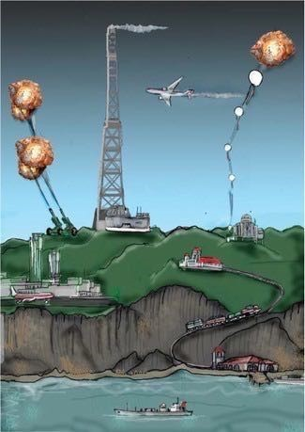
Figure 6 Proposed methods of stratospheric aerosol injection – artillery shells, a tall tower, aeroplanes and balloons – on a mountain, with supplies arriving by train.
View description - Figure 6 Proposed methods of stratospheric aerosol injection – artillery shells, ...

Just like the urban albedo method, there are potential co-benefits. When aerosols scatter sunlight, it makes the light more diffuse. So although less sunlight reaches the surface (as is intended), more of that light comes from other directions than the Sun. This means more of it can reach into plant canopies, and the shadows are less sharp. Plants can photosynthesise more efficiently and this may lead to more growth.

- How might an increase in plant growth be a co-benefit for (a) humans and (b) counteracting global warming?
- An increase in plant growth may help agriculture to be more efficient, i.e. increases food security. It may also increase the amount of CO₂ removed by vegetation from the atmosphere.

Sulfate aerosols can also lead to more spectacular sunsets (Figure 7).

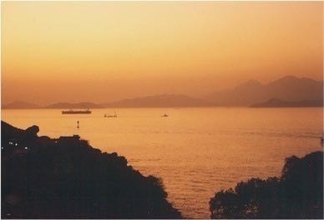
Figure 7 Hong Kong sunset after the eruption of Pinatubo.
View description - Figure 7 Hong Kong sunset after the eruption of Pinatubo.

Another method that acts by intentionally changing the clouds is ocean spray.

3.5 Ocean spray
All the methods you have studied so far involve adding something to the Earth system or Solar System: building a solar shield, coating urban surfaces in new materials, extracting sulfate aerosols from fossil fuels to put in the stratosphere. But another alternative would be to redistribute one part of the system to another where it can reduce the solar energy reaching the surface.
As ships criss-cross the planet, aerosol particles in their exhaust emissions cause clouds to form that brighten the dark oceans (Figure 8). The particles act as cloud condensation nuclei (CCN, as you saw in Session 3). Not only does this encourage new clouds to form, but it also tends to make clouds brighter.
Increasing the number of CCN increases the concentration of cloud droplets, at the same time decreasing their size, which makes the clouds whiter and more reflective. This is because the surface area of the smaller drops is larger, which means they scatter more light.
Low clouds over dark ocean surfaces play an important role in Earth’s energy budget.

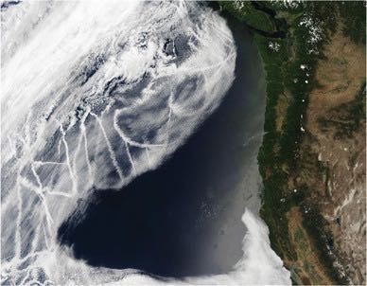
Figure 8 Satellite image of ship tracks
View description - Figure 8 Satellite image of ship tracks

CCN could be created from salt by spraying fine sea water droplets from the ocean into the sky (with air turbulence carrying some of them higher), an idea known as marine cloud brightening. This could be carried out by purpose-built, remotely controlled, wind-powered vessels (Figure 9) or by turbines at the back of existing ships.
Marine cloud brightening could in principle offset any amount of CO₂ forcing (Lenton and Vaughan, 2009).

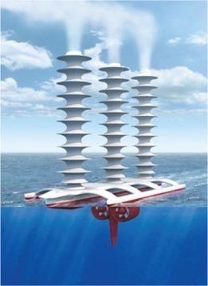
Figure 9 Artist’s impression of a sea spray vessel.
View description - Figure 9 Artist’s impression of a sea spray vessel.

- Brightening marine clouds could be most effective in areas with the cleanest atmosphere – those with fewest cloud condensation nuclei. Which ocean might be most suitable?
- The Southern Ocean surrounding Antarctica, because there are fewest natural and human sources of CCN.

3.6 Other possibilities
Watch the following video to hear of some other suggested methods for solar radiation management (SRM). Other ideas – some worthy of science fiction – to manipulate the Sun or how much sunshine reaches the Earth may also be on the table one day.

Video content is not available in this format.
Video 1 More proposed SRM methods.
View transcript - Video 1 More proposed SRM methods.

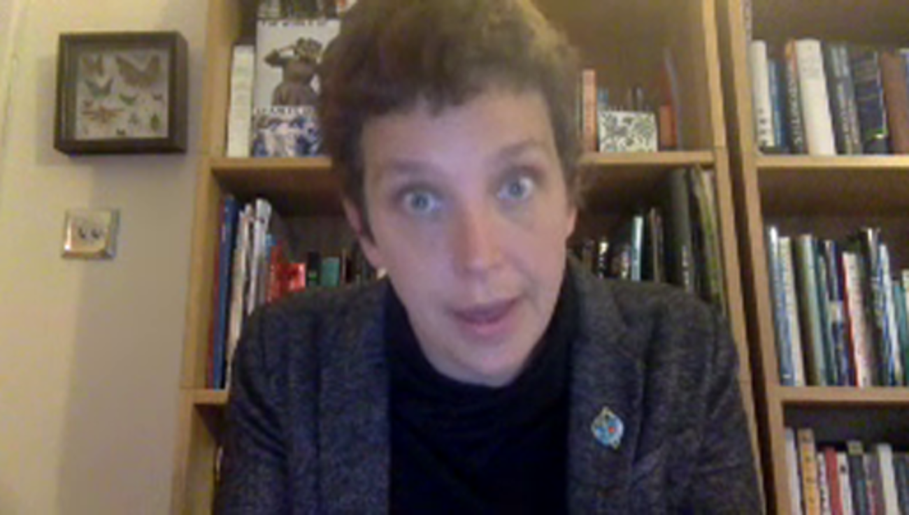

4 Increasing energy out
Geoengineering methods that increase outgoing energy from the Earth include carbon dioxide removal (CDR). These methods reduce the greenhouse effect by decreasing atmospheric carbon dioxide concentrations (note, not emissions). You will look at two key CDR methods.
Unlike SRM methods, CDR methods are not instantaneous in taking effect: there is a limit to how quickly a difference can be made to global CO₂ concentrations.
Once you have extracted CO₂, you need to put it somewhere. So there are two parts to CDR:
- extraction: capturing CO₂ from the atmosphere, and
- sequestration: storing the CO₂ or carbon so that it does not re-enter the atmosphere.

Planting trees is not enough to extract CO₂ from the atmosphere for the long term. When the trees respire, burn or decompose they return carbon to the atmosphere.
Bioenergy with carbon capture and storage (BECCS) extracts CO₂ as a natural process,but then goes one step further in that itcreates energy as a by-product of CO₂ removal.
In BECCS, biomass such as wood, sugar cane or switchgrass is used for energy, and the emitted CO₂ is captured and stored. Carbon capture and storage (CCS) itself is not unique to bioenergy power stations – it can also be used to reduce carbon emissions from fossil fuel power stations. But using it with bioenergy breaks the closed loop system and removes carbon from the system into long-term storage.
The carbon sequestration is usually proposed to be in geological reservoirs – in the porous spaces of rocks, including those left behind when oil and gas are extracted.
Listen to the discussion of CCS and BECCS in the audio, which is an extract from the BBC’s ‘Changing Climate: The Solutions’ broadcast, presented by Roger Harrabin (November 2015). Then study the diagram of a BECCS plant in Figure 10 and answer the questions that follow.

Audio content is not available in this format.
Audio 1 Extract from the BBC’s ‘Changing Climate: The Solutions’, presented by Roger Harrabin (November 2015).
View transcript - Audio 1 Extract from the BBC’s ‘Changing Climate: The Solutions’, presented by Roger ...

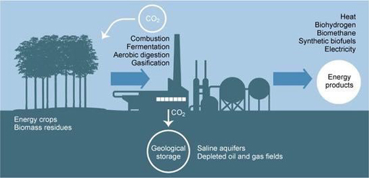
Figure 10 Diagram of a BECCS plant (adapted from Canadell and Schulze, 2014).
View description - Figure 10 Diagram of a BECCS plant (adapted from Canadell and Schulze, 2014).

- Is BECCS a technology that produces positive carbon emissions, zero emissions, or negative emissions, and why?
- It is a negative emissions technology, because it ‘takes CO₂ out of the atmosphere’. In other words, overall, BECCS extracts (and sequesters or stores) more CO₂ from the atmosphere than it emits from the energy use.

- The presenter in the audio describes one stage of BECCS as ‘then you burn the plants’. Looking at Figure 10, what other ways are there to extract carbon from plants?
- As well as combustion, Figure 10 also shows fermentation, aerobic digestion and gasification.

In principle, BECCS could be both achievable in the near term and effective over the long term. Lenton and Vaughan (2009) estimate that BECCS could offset two-thirds of a doubling of atmospheric CO₂ concentrations by the end of the century, while the assessment of McGlashan et al. (2012) is that the technologies ‘could be introduced relatively easily in today’s energy system’ and reduce current UK CO₂ emissions by at least 10% by 2030.

4.2 Ocean fertilisation
Trees and grasses are, of course, not the only type of plant life. Another important example are the green blooms of algae, a type of phytoplankton (plant plankton).
Figure 11 shows an image of phytoplankton blooms. These plants take their CO₂ from the water around them, not directly from the atmosphere. The nearly invisible ‘forests’ of phytoplankton in the world’s oceans remove (we say “fix”) almost as much carbon as all land plants, and that has a profound indirect effect on atmospheric CO₂.

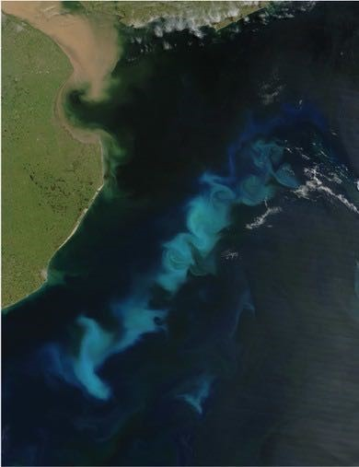
Figure 11 Phytoplankton bloom in the South Atlantic Ocean, off the coast of Argentina.
View description - Figure 11 Phytoplankton bloom in the South Atlantic Ocean, off the coast of Argentina. ...

Phytoplankton are consumed by zooplankton (their microscopic animal counterparts) and other animals, or die in a matter of days and are colonised by bacteria that decompose them. All these marine organisms respire, so most of the dissolved CO₂ taken up by phytoplankton photosynthesis is returned to the surface ocean and may therefore be outgassed to the atmosphere.
But about a quarter of the carbon escapes this recycling system: particles that are large enough to overcome the buoyancy of sea water sink, taking carbon down into the deep ocean.
In many parts of the world, such as the Southern Ocean, the growth of phytoplankton is controlled by the availability of dissolved nutrients such as iron, nitrogen and phosphorus.
Ocean fertilisation proposes adding these nutrients to the water to enhance plankton growth, with the aim of increasing the transfer of atmospheric carbon into the deep ocean water. In other words, biological capture at sea, or a ‘carbon sink’.
As the planet’s ocean circulation patterns are so vast, it can take hundreds or thousands of years for deep water to re-emerge at the surface: easily enough for this to be considered long-term sequestration. Lenton and Vaughan (2009) estimate iron fertilisation could offset around 8% of a doubling of CO₂ by 2100.
Enhancing plankton growth could also provide extra food for krill and, in turn, whales.

4.3 Other possibilities
A further suggested method using the biosphere is to plant trees, then prevent them from decomposing by turning them into charcoal or biochar (Figure 12). This has a co-benefit of improving soil quality.
The technological equivalent uses artificial trees and other direct air capture (DAC) methods (Figure 12) to ‘scrub’ CO₂ from the air with chemical methods; the CO₂ can then be sequestered with CCS.

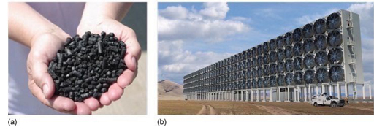
Figure 12 Low-tech and high-tech methods of CDR. (a) A handful of biochar. (b) An example design of a DAC plant by Carbon Engineering.
View description - Figure 12 Low-tech and high-tech methods of CDR. (a) A handful of biochar. (b) An ...

Watch the video below to learn of some other suggested methods for carbon dioxide removal.

Video content is not available in this format.
Video 2 More proposed CDR methods
View transcript - Video 2 More proposed CDR methods

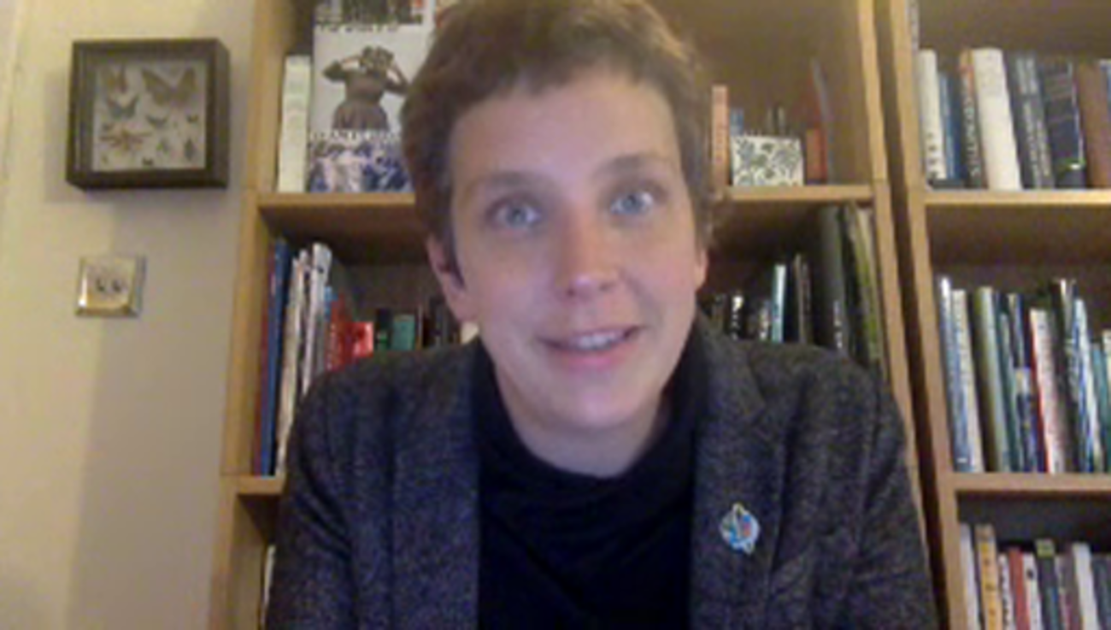

5 End-of-session quiz
Check what you’ve learned this session by taking the end-of-session quiz.
Session 5 practice quiz
Open the quiz in a new window or tab then come back here when you’ve finished.

6 Session 5 summary
Some forcings could, in principle, be altered to reduce energy in to Earth’s energy balance by reflecting sunlight (solar radiation management, SRM) or to increase energy out by reducing the greenhouse effect (carbon dioxide removal, CDR).
A solar shield in space could, in principle, reflect sunlight away from the Earth, and increasing the albedo of cities is a well-understood method for reflecting more sunlight locally. Stratospheric sulfate aerosol injection and marine cloud brightening are further potential ways to increase the reflection of sunlight, either directly by the particles in the atmosphere or by the brighter clouds they can produce.
Photosynthesis can remove carbon dioxide from the atmosphere via enhanced plant growth (terrestrial or marine) combined with long-term storage of carbon in geological, ocean or soil reservoirs. Technological means of capturing CO₂ from the air also exist, such as artificial trees.
Geoengineering may provide co-benefits additional to those of changing global climate.
In the next session, you will study the design, experiments and implementation of these methods of engineering the climate.
Get started on Session 6.

Session 6: Design and implementation

Introduction
So far you have studied the detection, attribution and predictions of climate change and several possible methods of geoengineering to counter it. Now you will consider how to design these methods and put them into practice, not only scientifically but politically.

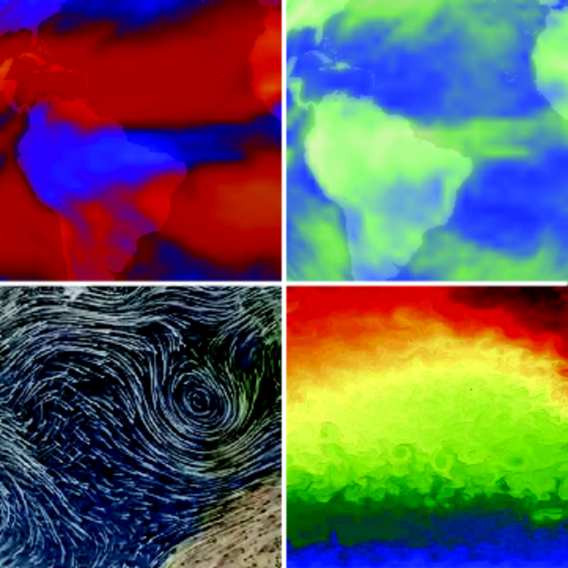
Figure 1 Some excerpts from Earth observations and models that you will explore in this session. Can you tell which are observations and which simulations?
View description - Figure 1 Some excerpts from Earth observations and models that you will explore in ...

By the end of this session, you should be able to:
- appreciate there is a range of climate models of different complexities for different needs
- explain complex scientific predictions in a concise and accessible form suitable for a policy-maker
- understand a selection of experiments and real-world trials of geoengineering or related activities
- reflect on possible tensions around geoengineering decisions due to competing aims in implementation, governance and law.

1 Climate models
Designing geoengineering requires the use of a model to predict its effects. How can models be used to inform both policy-makers and the public?
Video 1 is a stunning visualisation of the Earth system based on climate model simulations of the atmosphere, ocean and sea ice, and incorporating some observational data. It’s called ‘Dynamic Earth’, and is a visualisation based on the Goddard Earth Observing System (GEOS) atmospheric model and the MIT (Massachusetts Institute of Technology) general circulation model for the oceans and ice. First, flowing arrows show the patterns of air circulation, such as the Northern Hemisphere polar jet stream blowing from west to east; then whirls of blue show the eddies and streams of ocean circulation, with the Gulf Stream flowing along the coast of Florida to the North Atlantic.

Video content is not available in this format.
Video 1 ‘Dynamic Earth’, a visualisation based on the Goddard Earth Observing System (GEOS) atmospheric model and the MIT (Massachusetts Institute of Technology) general circulation model for the oceans and ice. The simulations also incorporate satellite and in situ data.

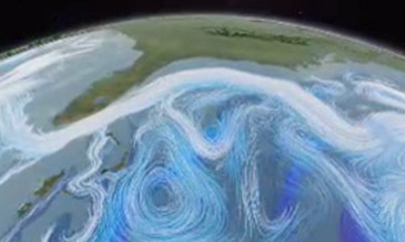

- Why does it help in both weather and climate modelling to divide the world into grid squares?
- The circulation of the atmosphere is very complex, and this breaks the problem down into a series of discrete and achievable tasks.

The smaller the size of grid squares in a climate model, the more detail can be included. The ‘Dynamic Earth’ video demonstrates some of the best examples of climate models available because they have large numbers of very small grid squares – we say, a very high resolution. (The resolution is the total number of points (pixels) within an image produced or displayed by the device.)
The ‘Ocean model’ used in Dynamic Earth is based on 2 332 800 grid squares. In contrast, the IPCC uses a low resolution model, equivalent to using a rather vintage-looking games console.

- This may seem surprising: why could this be?
- The greater the number of grid squares, the greater the number of calculations there are to make and so the slower the model is to run. Using a low-resolution model means it is possible to simulate longer time periods.

For all models apart from those using the lowest resolutions, the models are so slow to run that it is only practical to simulate time periods of a few months or years, even on a supercomputer – nowhere near the tens or hundreds of years needed for predicting climate – unless the area is restricted to a small region.

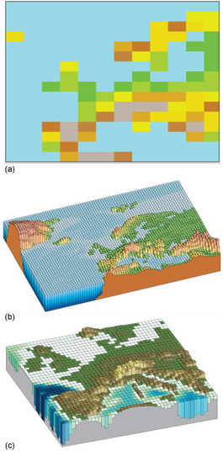
Figure 2 European surface height in global climate models with differing horizontal resolutions: (a) typical model from the IPCC (2007) Fourth Assessment Report; (b) typical and (c) highest horizontal resolution models from the IPCC (2013) Fifth Assessment Report.
View description - Figure 2 European surface height in global climate models with differing horizontal ...

This is why IPCC (2013) global climate models have far lower resolutions than the stunning visualisations you saw in Figure 2.

2 Geoengineering scenarios
The Geoengineering Model Intercomparison Project (GeoMIP) is a project to predict the effects of geoengineering using the world’s climate models. The scientists use scenarios of future human-caused changes in greenhouse gas concentrations accompanied by geoengineering actions that are intended to cancel their effects on climate, to predict the effects of these actions.
Imagine for a moment you are a climate modeller in this project. You attend a meeting with policy-makers and, while getting a coffee before it starts, find yourself standing next to the current UK government minister responsible for energy and climate Change. They ask you: ‘So, what’s the latest from GeoMIP?’.
You will develop your response in the next sections.

2.1 Change in surface air temperature
You decide to tell the minister the key message relating to Figure 3. Read the caption and accompanying text carefully first.

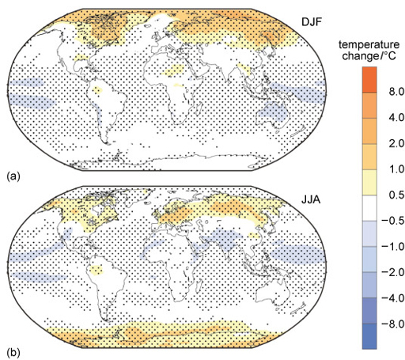
Figure 3 Mean of twelve climate model projections for the change in surface air temperature (°C) relative to the preindustrial period, averaged over (a) December, January and February (DJF) and (b) June, July and August (JJA), for a scenario of solar shield geoengineering (IPCC, 2013). See text for more details.
View description - Figure 3 Mean of twelve climate model projections for the change in surface air temperature ...

The figure shows the mean predictions of surface air temperature change in the winter and summer from twelve climate models. Stippled areas show where at least nine out of the twelve models agree on the sign of the change (e.g. for stippled yellow/orange/red areas, most models show warming). In the scenario shown in this figure, atmospheric CO₂ concentrations are increased to four times preindustrial levels (which is written 4 × CO₂ forcing The warming effect is cancelled by the equivalent reduction in the incoming solar radiation, so that the global temperature is the same as in the preindustrial climate.
Key scientific points are:
- The figure shows predictions of surface air temperature change since preindustrial in the winter and summer from an average of multiple climate models.
- Even though the 4 × CO₂ forcing is exactly balanced by a reduction in solar radiation, there are still changes relative to the preindustrial climate.
- Most areas show less than 0.5 °C of warming or cooling (i.e. white areas), but many regions are warmer than this and some are cooler.
- Most of the map is stippled, which shows that the models generally agree on which areas will warm or cool.

Activity 1
Allow approximately 15 minutes

What will be your key message to the minister, based on the information in Figure 3?

Provide your answer...
View answer - Part
The minister wants to know more …

Write down one or two sentences explaining the main pattern of change.

Provide your answer...
View answer - Part
The minister then asks: ‘Interesting. Why is the climate not the same as with no CO₂?’

Write down two more sentences: one to explain why, and one about what would be required to return to the original climate. Remember to keep it simple.

Provide your answer...
View answer - Part

2.2 Rainfall
As you have seen, changes in rainfall are arguably more important to people than temperature. So now do the same again but for precipitation (Figure 4).

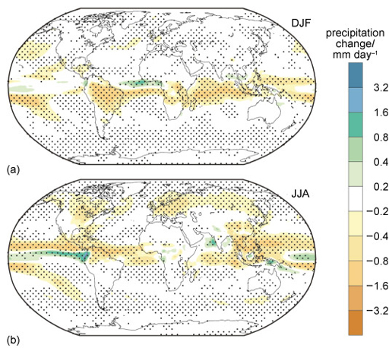
Figure 4 Same as for Figure 3 but for the change in precipitation (in millimetres per day, mm/day). (IPCC, 2013)
View description - Figure 4 Same as for Figure 3 but for the change in precipitation (in millimetres ...

Activity 2
Allow approximately 10 minutes

What will be your key message to the minister, based on the information in Figure 4?

Provide your answer...
View answer - Part

Write down one more sentence explaining the main pattern of change for precipitation.

Provide your answer...
View answer - Part

But these results are from models. How do we know if this will work in reality?

3 Field experiments
We need climate models like GCMs to predict how the climate will respond to forcing. But just as important a task is to test those models with experimental data. Those data may come from laboratory experiments, or from field experiments performed outside the laboratory.
As yet (in 2021), there have been no large-scale field experiments of geoengineering, i.e. testing how the climate responds to SRM or CDR; there have only been small-scale tests of the physical processes involved, which are too small and local to affect climate.

3.1 Field experiments in SRM
The first field experiments intended specifically to inform Solar Radiation Management (SRM) were those led by prominent Russian scientist Yuri Izrael (1930–2014) in 2008.
These sprayed smoke in the air by burning, essentially, firework flares from a helicopter at up to 200 m height and by burning petroleum from a car at ground level (Izrael et al., 2009) (Figure 5a). The scientists then measured how much the resulting clouds of smoke blocked the sun. Experiments continued over the next couple of years (Izrael et al., 2011).
So far this has been the extent of SRM field experiments. In the UK, the 2011 Stratospheric Particle Injection for Climate Engineering (SPICE) project, designed to spray two bathfuls of water as fine droplets at 1 km height from a hose tethered to a helium-filled balloon (Figure 5b), was cancelled for a variety of reasons. Other geoengineering field experiments with sulfates or sea salt have been considered, but have not yet been carried out (Keith et al., 2014).

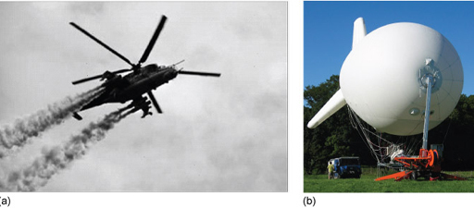
Figure 5 (a) Smoke plumes generated during what are thought to be the first SRM field experiments. (b) The SPICE balloon, never used for the project.
View description - Figure 5 (a) Smoke plumes generated during what are thought to be the first SRM field ...

3.2 Field experiments in CDR
Carbon dioxide removal (CDR) has been tested in more, and larger, process studies than SRM. From 1993–2009, several scientific expeditions carried out iron fertilisation experiments affecting a few hundred square kilometres for a few weeks in the Southern Ocean, tropical Atlantic, and north and equatorial Pacific. Two examples are the European Iron Fertilization Experiment in 2004 and LOHAFEX (taken from ‘loha’, the Hindi word for ‘iron’, and FEX, standing for Fertilisation EXperiment) in 2009 (Figure 6a). The aim of such experiments was to study the effectiveness of fertilisation at encouraging phytoplankton growth, rather than its effectiveness at removing carbon dioxide (Williamson et al. 2012). Similar expeditions have currently ceased due to the variability in their effectiveness, public controversy and concerns about regulation.
Similar and larger-scale iron fertilisation tests have also been planned or carried out by commercial interests, notably Canadian entrepreneur Russ George:
- In the summer of 2002, George borrowed singer Neil Young’s yacht to put iron-based liquid in the oceans near the Hawaiian Islands under his non-profit organisation Planktos Foundation (Schiermeier, 2003, 2004).
- In 2007 and early 2008, George’s for-profit company Planktos Inc. planned to seed a 10 000 km² area of the Pacific Ocean near the Galápagos, and later the Eastern Atlantic near the Canary Islands, with 100 tonnes of iron particles at a time: the expeditions were abandoned after protests by Greenpeace and other environmental groups, and the refusal of the Spanish authorities to let them into their waters (Brahic, 2007; Thompson, 2008; Lukacs, 2012; Burns and Strauss, 2013, p. 273).
- In 2012, George added 100 tonnes of iron off the Pacific coast of Canada, creating a plankton bloom approaching 10 000 km², five times larger than typical blooms in the region (Figure 6b and c; Guardian, 2012; Lukacs, 2012; Xiu et al., 2014).
While Russ George has described his projects as ‘restoration’ of the oceans, there are undoubtedly also long-term commercial aims: to sell carbon offsets and, in 2012, to be paid by locals hoping to revive depleted salmon populations. George is reported to have said his motto is ‘Save the world and make a little cash on the side’ (Goodell, 2010, p. 150; Lukacs, 2012; Hamilton, 2015; Xiu et al., 2014).
Other ocean fertilisation firms have also been set up – start-up company Climos, for example, raised $3.5 million in venture capital in March 2008, including a contribution from famous entrepreneur Elon Musk (LaMonica, 2008).

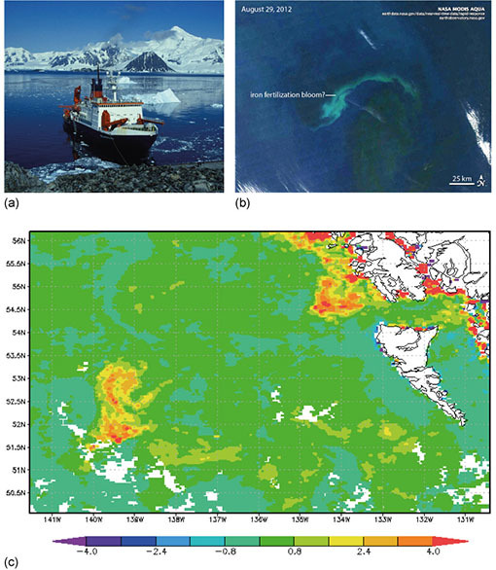
Figure 6 (a) German research vessel and icebreaker Polarstern off the Antarctic Peninsula in February 1994. The Polarstern was used for ocean fertilisation experiments such as the European Iron Fertilization Experiment and LOHAFEX. (b) Satellite image taken by NASA in August 2012 after media reports of a large-scale ocean iron fertilisation project in the northern Pacific Ocean. (c) Change in a measure of chlorophyll concentration, in milligrams per cubic metre, relative to the 10-year August mean, measured in August 2012 by NASA over approximately the same region as (b).
View description - Figure 6 (a) German research vessel and icebreaker Polarstern off the Antarctic Peninsula ...

For BECCS, the first large-scale project is the Illinois Industrial CCS Project, which builds on existing smaller-scale facilities and which converts corn crops to ethanol fuel. It is designed to capture around 1.0 million tonnes per year of the CO₂ emitted by the fermentation process and inject this into deep saline aquifers – porous rock that contains water several times saltier than the ocean – in the sandstone below Mount Simon (Global CCS Institute, 2015; IPCC, 2014). The aim is to implement a full BECCS system and demonstrate its economic viability (US Department of Energy, 2014), rather than test its effect on climate.
But has anyone tested geoengineering at scale in the real world?

4 Geoengineering in the real world
So what geoengineering has taken place ‘in the wild’, and what are the political mechanisms of governance?

4.1 Real world trials in SRM
Actually, we are already substantially engineering our climate.
Humans have been manipulating the environment for hundreds, if not thousands, of years: constructing and painting buildings with white materials to keep them cooler (Figure 7), planting trees to increase shade and moisture and reduce wind, and so on. These methods act to manipulate local climate and reduce the severity of, for example, the impacts of extreme heat.

Figure 7 White houses in Santorini, Greece.
View description - Figure 7 White houses in Santorini, Greece.

Local SRM-type geoengineering continues with modern methods such as very reflective new roofing materials (Figure 8), or the use of paler road surfacing materials in Sydney, Australia (Sharples, 2014).

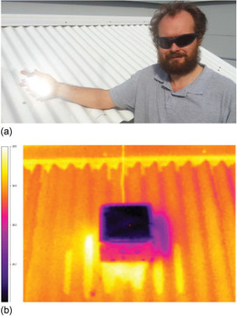
Figure 8 (a) Argus Gentle holds a new roofing material with an albedo of 0.97, made of polymers and a silver film. (b) An infrared photograph shows the much cooler region of the new material (Gentle and Smith, 2015).
View description - Figure 8 (a) Argus Gentle holds a new roofing material with an albedo of 0.97, made ...

4.2 Real world trials in CDR
Bioenergy and CCS are usually used separately in industry, rather than as a closed BECCS system like the Illinois Industrial CCS Project. Biomass is, of course, humanity’s original source of energy for cooking and heating – by direct combustion of fuel wood, charcoal and dried dung (Figure 9) – and still is for one-third of the world’s population (International Energy Agency, 2007).

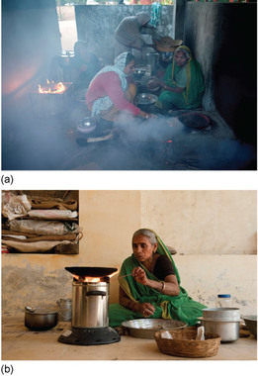
Figure 9 (a) Indoor cooking with biomass stoves. (b) An improved biomass cookstove in India.
View description - Figure 9 (a) Indoor cooking with biomass stoves. (b) An improved biomass cookstove ...

Vegetable and animal oils can be used directly as biodiesel; fermentation of crops produces bioethanol (i.e. alcohol); and anaerobic decomposition of plants or animals produces methane and other biogases. Using this information, match the following biomass sources to the type of biofuel they provide.

Interactive content is not available in this format.

Biofuels and waste were estimated to provide 12% of the world’s total fuel consumption in 2013, little changed from the 1973 estimate of 13% (International Energy Agency, 2015).
CCS, on the other hand, is still a relatively young technology. By 2019 there were 17 operating CCS projects around the world, and 31.5 million tonnes of CO₂ per year is being captured – 3.7 million tonnes of this is stored in geological formations.

Video content is not available in this format.
Video 2 What’s the latest on field experiments and real-world geoengineering?
View transcript - Video 2 What’s the latest on field experiments and real-world geoengineering?

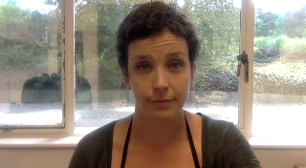

4.3 Governance and law
Science and engineering are, of course, not the only considerations for the design and deployment of geoengineering: political and legal mechanisms are key.

- Which three of the six geoengineering methods you studied in Session 5 would have substantial global or continental impacts on climate and therefore would require international cooperation and coordination for decision-making and deployment?
Marine cloud brightening
Bioenergy with Carbon Capture and Storage (BECCS)
A solar shield
Urban albedo
Stratospheric sulfate aerosols
Ocean fertilisation
- A solar shield, stratospheric sulfate aerosols and marine cloud brightening would each act at global or continental scales and, in principle, could be set to balance any greenhouse gas forcing. The scale and magnitude of these large-scale SRM methods mean international cooperation and coordination would be required.
Urban albedo has only local effects on climate, so could be deployed at a national scale or smaller.
The two CDR methods (BECCS and ocean fertilisation) do affect global atmospheric CO₂ but are much more limited in their magnitude from a single action. CDR methods would therefore also require only local decision-making at the national or smaller scale.

The politics and law of international-scale SRM are seen as far more contentious and troublesome. Potential questions for international SRM governance identified by the US National Research Council (2015) are:
- How is it decided when the benefit to albedo modification will outweigh the harm? And how should we judge that?
- What obligation do the acting parties have to compensate others for damages, anticipated or otherwise, caused by albedo modification? Who decides causality and how is it determined?
- Who decides what is benefit versus harm, and on what time and space scales are such determinations made?

- Think about one potential difficulty with the group of questions labelled as (2) above.
- It may be very difficult to determine whether one group has caused harm to another for several reasons:
  - the Earth is a complex system, so multiple factors are changing and interacting;
  - climate change is a distribution (i.e. inherently statistical), so a given action could lead to a wide range of possibilities;
  - attribution of climate change is also inherently statistical, so determining causality is always challenging and uncertain.

There are currently no specific political mechanisms for governing international SRM research and deployment. Nor have legal mechanisms been accepted, though some existing national laws would apply.
US federal laws require weather modification (defined as ‘any activity performed with the intention of producing artificial changes in the composition, behavior, or dynamics of the atmosphere’) to be reported, which potentially means SRM research must by law be open access (National Research Council, 2015).
There are also relevant international treaties, which vary in their degree of legal requirement. For example, solar shields would fall under the 1967 Outer Space Treaty, signed in the midst of the Space Race between Cold War rivals, the US and former Soviet Union. This states that outer space should be used ‘for the benefit and in the interests of all countries’, and that any party placing an object there is ‘internationally liable for damage to another State Party’ (National Research Council, 2015).
Closer to home, the United Nations 1992 Convention on Biological Diversity (CBD), promoting the ‘conservation and sustainable use of biological diversity’, has been adapted with increasingly strong statements regulating ocean fertilisation. In May 2008, the CBD issued an effective moratorium:

… requests Parties and urges other Governments … to ensure that ocean fertilization activities do not take place until there is an adequate scientific basis on which to justify such activities … and a global, transparent and effective control and regulatory mechanism is in place for these activities; with the exception of small scale scientific research studies within coastal waters …
Conference of the Parties (COP) 9 Decision IX/16, Convention on Biological Diversity (2008)

- What are the potential problems with giving an ‘exception’ in the COP 9 quote above?
- The wording is not very precise: there is no definition of ‘small scale’ or the extent of coastal waters. Even the word ‘scientific’ could be debated, depending on the measurements taken and the motivations of the studies.

5 End-of-session quiz
Check what you’ve learned this session by taking the end-of-session quiz.
Session 6 practice quiz
Open the quiz in a new window or tab then come back here when you’ve finished.

6 Session 6 summary
The world’s climate models have very different complexities and purposes. Coordinated projects such as GeoMIP use these climate models to predict future scenarios of climate change with geoengineering actions such as solar radiation management.
Model predictions need to be tested with evidence from field experiments, though few have been carried out. Small-scale applications of geoengineering ideas are already taking place in the real world using traditional methods and new materials.
A flurry of controversies over ocean fertilisation highlighted tensions between scientific enquiry, sustaining livelihoods, reducing climate change and protecting biodiversity; in response the 1992 UN Convention on Biological Diversity has become increasingly restrictive to try to manage experimentation in this field.
This last point leads naturally to questions of decision-making. When a politician is pulled in different directions by different priorities, what should they do? In the next session you will begin to approach this question: Should we engineer the climate?
Now move onto Session 7.

Session 7: Should we engineer the climate?

Introduction
By asking whether we ‘should’ engineer the climate, the question we are really asking is, what is the best or the right thing to do?
But deciding what is best for Earth’s climate and how to achieve it is, of course, extraordinarily complex.
This session you will study how you might choose and implement different geoengineering methods, the risks of unwanted side-effects, and some contradictory and controversial media reporting of climate predictions.
By the end of this session, you should be able to:
- appreciate the advantages and disadvantages of different geoengineering methods
- understand why there are uncertainties in measuring, understanding and predicting climate change, with or without geoengineering
- be familiar with a range of physical and social risks of geoengineering methods
- reflect on different possible interpretations of climate predictions by the media.

1 Choose wisely
As Earth’s Energy Balance Consultant (Figure 1), which measures would you use to choose your methods? How would you monitor and control the resulting change? And what uncertainties should you consider along the way?

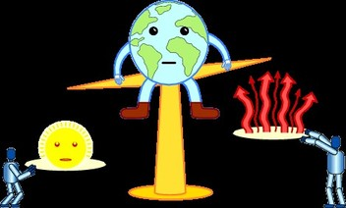
Figure 1 Pushing Earth’s energy scales.
View description - Figure 1 Pushing Earth’s energy scales.

1.1 Most effective
The simplest measure for choosing a geoengineering method might be to choose the one with ‘the maximum achievable forcing’. Recall that of the six geoengineering methods you have studied, three could counter any amount of CO₂ forcing, while the others are more limited.

Interactive content is not available in this format.
Figure 2

The rank order is:
- sulfate aerosols, marine cloud brightening, solar shield (all three could balance any CO2 forcing)
- BECCS (estimated two-thirds of a doubled CO2 forcing by 2100)
- iron fertilisation (estimated 8% of a doubled CO2 forcing by 2100)
- urban albedo (estimated 1.3% of a doubled CO2 forcing).
So if you were looking for methods which achieved the maximum forcing, then you might consider sulfate aerosols, marine cloud brightening and solar shields as your primary focus. However, that’s not the only consideration.

1.2 Fastest
The next aspect you might consider is the speed at which the method acts. If you were under pressure from politicians to counteract climate change, might you choose the fastest technique?
Solar Radiation Management methods would generally be faster at changing Earth’s energy balance than Carbon Dioxide Removal methods. This is because SRM methods work through either:
- direct reflection of solar radiation, and/or
- processes on timescales that range from hours (e.g. cloud formation) to months (e.g. distribution of aerosols around the stratosphere).
In contrast, CDR methods are inherently slow due to:
- the limited speed of the processes (e.g. photosynthesis, chemical extraction, CCS, ocean circulation, tree growth)
- their limited scale (e.g. amount of land used or ocean fertilised, size of geological reservoir), and
- the various ways in which CO₂ can re-enter the atmosphere (e.g. leaks from reservoirs and the ocean, non-carbon-neutral energy used).
This means it will take decades to extract and sequester substantial amounts. If CO₂ emissions continue increasing, this makes the task even slower.

1.3 Local effects
These measures – effectiveness and speed – ignore something fundamental to human lives and ecosystems, that is: changes happening at a local level.
CDR methods, of course, ‘undo’ human CO₂ forcing and therefore would likely have an exactly opposite effect on local changes.
With SRM methods, it might be possible to ‘fine-tune’ global mean climate change, but it would not be possible to fine-tune climate change in every region. This is because forcings from CO₂ and the Sun act in different ways – they have different fingerprints on climate in space and time (Session 3).
In Session 6, you saw GeoMIP predictions for a scenario in which SRM balances a quadrupled CO₂ forcing. Even though the global average temperature was adjusted to be the same as the preindustrial climate, the models predicted many local areas would be warmer than preindustrial times.

1.4 Other aspects of climate change
Temperature is far from being the only aspect of the Earth system to consider. In Session 6, you saw GeoMIP predictions of decreases in rainfall: the models predicted the tropics would be drier all year round, and that northern high latitudes would be slightly drier in the summer.
This introduces potential ethical issues and difficulties for Solar Radiation Management. Different regions would see different climate changes, and those might be worse than preindustrial or current climate, or even future climate change without geoengineering. These changes would vary around the world, so making fair decisions would be extremely difficult.
The varying effectiveness of SRM for different regions and aspects of the Earth system poses a serious ethical challenge.

1.5 Monitoring and control

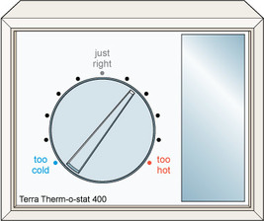
Figure 3 Some people have referred to SRM as creating a global thermostat.
View description - Figure 3 Some people have referred to SRM as creating a global thermostat.

Activity 1
Allow approximately 5 minutes

Describe the behaviour of a central heating room thermostat in your own words.

Provide your answer...
View answer - Activity 1

The two key parts of the negative feedback loop of a thermostat are monitoring and control. In the same way, our setting of the Earth’s ‘thermostat’ (Figure 3) would require monitoring and control to:
- ensure geoengineering was achieving the desired climate
- adjust the level of geoengineering if circumstances changed (for example, if the Sun’s output or greenhouse gas forcings changed, or if there were unexpected negative impacts).
For monitoring, we would need to continue the efforts described in Session 1 to measure the effectiveness and any side-effects of our geoengineering: for example, changes in temperature, rainfall, glaciers, ice sheets, sea ice, snow, sea level rise, ecosystems and human health, as well as ocean pH changes and their effects on marine life. You will consider the difficulties of this monitoring and control later.

2 Uncertainties
Uncertainty is an essential part of both measurement and prediction. But how confident can we be in our efforts to measure changes in the climate and also to predict future changes resulting from our geoengineering choices?

- Why might it be difficult to detect the effect of geoengineering on global mean temperature in the years immediately following its use?
- The global temperature curve has large year-to-year variability, so over the short-term this can mask the underlying trend. A lot of data are needed to detect a climate change: ideally 30 years or more.

Put another way: recall that climate is a distribution (Session 1), so detecting climate change means detecting a shift in the distribution. This may not be obvious over short time periods.
When detecting climate change, scientists must decide how different two distributions should be, and how many years of data are sufficient, to make a reliable decision about whether the climate has changed. As well as this, they must decide which aspects of the Earth system (temperature, rainfall, sea ice, and so on) to use in their decision.
There are no simple answers to these questions, because ‘difference’ is a continuous spectrum, and scientists will be interested in a variety of aspects of climate.
This means it is likely to be extremely difficult to be sure of detecting climate change caused by geoengineering – potentially needing many years of data – and to be confident in attributing those changes to geoengineering rather than other factors.

Unexpected events
Not only that, but deciding whether an individual event is unexpected or ‘extreme’ is essentially subjective. You choose a threshold, and there is always some probability this threshold will be exceeded occasionally as part of natural variability. However, the more extreme your threshold, the less likely this will be.
If a severe heat wave, drought or storm were to occur immediately after you began geoengineering, how would you decide if this was unlikely in an un-engineered climate?

2.1 Uncertainty in predictions
If we intervene in our climate, how confident are we in our ability to predict the resulting change?
Almost by definition, a model is a simplified version, an approximation that can never be perfect.
But their simplifications mean they can be used as tools to understand the world – i.e. they are ‘useful’ – as long as we are aware of their limitations.
We can reduce the uncertainty in climate model predictions in a number of ways.
One approach is to use many different climate models instead of just one. This means that we have multiple predictions and can take, for example, the mean and the 90% range of these, as you saw for the GMST predictions in Session 4, (repeated in Figure 4).

Figure 4 Repeat of Figure 4 in Session 4
View description - Figure 4 Repeat of Figure 4 in Session 4

Another way is to use multiple different versions of one model: changing the inputs slightly each time, to see the effect this has on the results. This is illustrated in the extract below from Tamsin Edwards’ (2015) work, published in the Guardian:

We used a computer model to simulate the Antarctic ice sheet from the recent past up to the year 2200: not just once, but 3000 times. Each version was slightly different to account for ‘known unknowns’ in the physical laws and simplifications describing how ice flows and slides, the map of the bedrock beneath the ice sheet, and when instability might be triggered in each region under [a] mid-high climate scenario…. This gave us a range of model predictions for sea level rise: three thousand possible futures fanning out from today.
Edwards (2015)

If you are interested, you can participate in the citizen science project ‘climateprediction.net’, which uses the public’s spare computing power to run many different versions of climate models.
Using many climate models, or many versions of one climate model, broadens the simulated climate distributions. We can compare simulations of the past with observations to test whether the models were successful.

2.2 Science is not like sausage-making
As you have seen, there are difficulties and, perhaps surprisingly, subjective judgements in deciding:
- whether a weather event is unexpected
- whether past and present climate distributions are different
- whether measured and simulated climate distributions are different.
You might be tempted to think of the scientific method and statistical analysis as objective recipes or methods to follow: put the data in the top, crank the handle and out fall neat ‘sausages’ of results (Figure 5). But it’s not as simple as that.

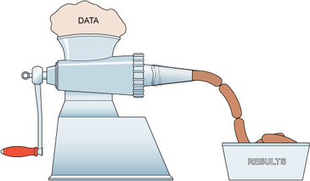
Figure 5 Science is not like sausage-making, with sausage meat (data) going in and neat sausages (results) automatically coming out. Instead, there are many subjective judgements to be made about data and how it is interpreted that influence the outcomes.
View description - Figure 5 Science is not like sausage-making, with sausage meat (data) going in and ...

As you have seen, there may be more than one type of machine.
Statistical analysis is permeated with subjectivity because it involves making choices – assumptions, decisions and judgements – for which more than one option may be justifiable, even though the results may differ.
As such, these choices can be challenged – for positive or negative purposes.

3 What are the risks?
Geoengineering does provide an opportunity to control our climate. But with this opportunity comes a level of risk that must be considered for the full benefit of the opportunity to be assessed. In this section we will consider some of the physical risks and possible social risks of geoengineering.

3.1 Dialling down the sun
Many climate model studies predict that Solar Radiation Management (SRM) would decrease global precipitation and produce major droughts (Hegerl and Solomon, 2009). It may, for example, weaken the Asian and African summer monsoons, which could risk the food and water security of billions of people (Robock et al., 2008). Physical risks of this scale and importance would likely have large social implications.
An indirect risk of SRM is the rapid speed with which it acts.

- What is the disadvantage of this speed?
- If the SRM method were withdrawn after a period of use, there could be rapid and substantial warming that is more damaging than if SRM had never been used in the first place.

In other words, there is a physical risk from a future switch-off of SRM geoengineering, particularly if:
- we have adapted our infrastructure and agriculture to the new (e.g. drier) climate
- greenhouse gas forcing has steadily increased, and SRM has been steadily ramped up to compensate it, so stopping SRM gives a larger climate change than has been seen before
- the switch-off is instant, producing rapid climate change.
What are the specific risks of particular methods of SRM and CDR?

3.2 Ozone loss
You saw in Session 3 that ozone (O₃) is among the greenhouse gases in our atmosphere. As well as absorbing infrared radiation, ozone absorbs most of the Sun’s ultraviolet radiation, shielding us from its harmful effects such as skin cancer. Ozone depletion by human use of chlorofluorocarbons (CFCs) was a major environmental issue of the late 1980s until the Montreal Protocol restricted the use of ozone-depleting substances. The increasing size of the ‘ozone hole’ and recent signs of recovery can be seen in Figure 6.

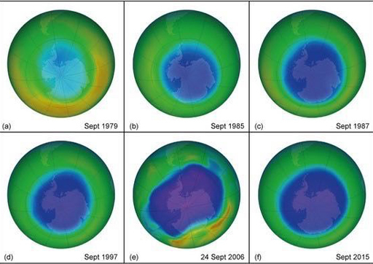
Figure 6 False-colour image of ozone over the South Pole in different years. All show the mean for September, the month of the typical spring minimum, except (e) which is a single day. Blue and purple colours show areas with less ozone, and yellows and reds more ozone. (a) 1979, the start of the records. (b) 1985, the year in which springtime Antarctic ozone losses were first published. (c) 1987, the year of the Montreal Protocol. (d) 1997, a decade later. (e) 24 September 2006, one of the days with the largest observed ozone hole size. (f) 2015
View description - Figure 6 False-colour image of ozone over the South Pole in different years. All ...

CFCs deplete the ozone layer through a cycle of reactions started by light. When CFCs are broken down by UV radiation from the Sun, this produces highly reactive chlorine atoms that react with ozone and destroy it. This is a very destructive process and a single chlorine atom can continue to deplete ozone until it reacts with something different, such as nitrogen oxides.
Sulfate aerosols pose a risk to the ozone layer because they react with nitrogen oxides. This reduces one mechanism of removing chlorine atoms, the result is the amount of chlorine increases, and therefore ozone depletion increases.
One small silver lining is that this risk should become less important. The 1987 Montreal Protocol has been effective in reducing chlorine in the atmosphere from CFCs, so the sulfates will eventually no longer be able to amplify their effect on the ozone layer (Keith, 2013, p. 68).

3.3 Air pollution
Sulfur dioxide has serious health impacts – it causes or worsens a range of diseases including asthma, chronic bronchitis, respiratory infections and cardiac disease (WHO, 2014). Rohde and Muller (2015), for example, estimate that air pollution causes 1.6 million deaths a year in China alone, with SO₂ (predominately from coal-fired power stations) a major contributor of this. SRM with sulfates ‘will probably contribute to thousands of air pollution deaths a year’, according to David Keith (2013, p. 71). On top of this, any sulfuric acid that rains out of the atmosphere then damages buildings and trees.

3.4 Harmful algal blooms
Some CDR methods also have risks. One is rapid escape of stored CO₂ into the atmosphere, reducing its effectiveness.
Iron fertilisation may harm marine ecosystems: for example, by creating ‘red tides’ of harmful algae (Figure 7). Such a red tide in 2013 was reported to have killed 276 manatees in Florida (Brown, 2013). Red tides also pose a risk to human health through eating contaminated shellfish.

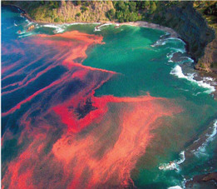
Figure 7 A ‘red tide’ – the common name for a harmful algal bloom of toxic types of phytoplankton – this one is near Cape Rodney, New Zealand.
View description - Figure 7 A ‘red tide’ – the common name for a harmful algal bloom of toxic types ...

3.5 Social risks
Some experts have predicted serious social risks, particularly for SRM, which arise from existing potential threats. India, Pakistan, the Russian Federation and North Korea (Figure 8) are among the states that either have nuclear weapons or are known to have conducted nuclear tests.

If invasive outsiders and provocateurs touch us even slightly, we will not be forgiving in the least and sternly answer with a merciless, holy war of justice.
[North Korean leader Kim Jong Un] Tong-Hyung (2016)

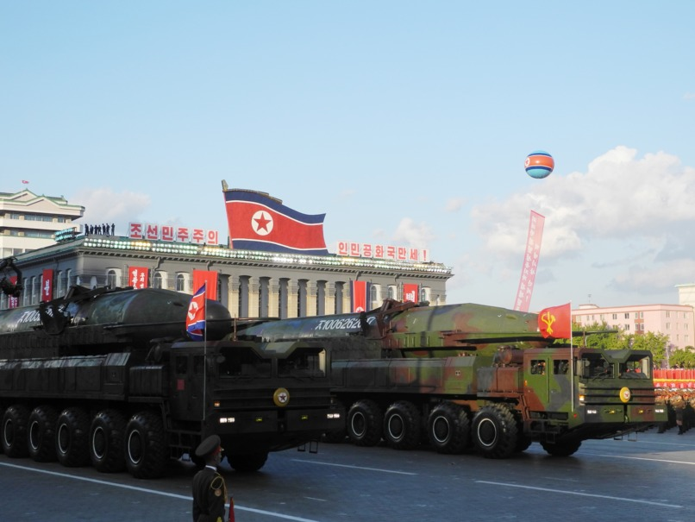
Figure 8 North Korea has a nuclear weapons programme. This photograph shows what appears to be a ballistic missile and a launch-pad vehicle during a military parade held at Kim Il-sung Square in Pyongyang on 15 April 2012.
View description - Figure 8 North Korea has a nuclear weapons programme. This photograph shows what ...

In the following activity, which is in two parts, you will consider serious social risks that could potentially arise as a consequence of scenarios of geoengineering and climate change. The first part of the activity considers political and economic risks, and the second part considers risks of conflict and social unrest. Using your judgement, match the risks to the scenarios.

Activity 2 Plausible risks
Allow approximately 20 minutes

Interactive content is not available in this format.

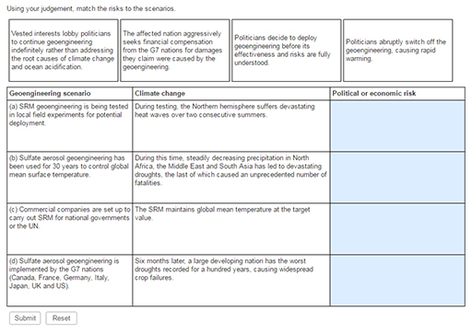

Interactive content is not available in this format.

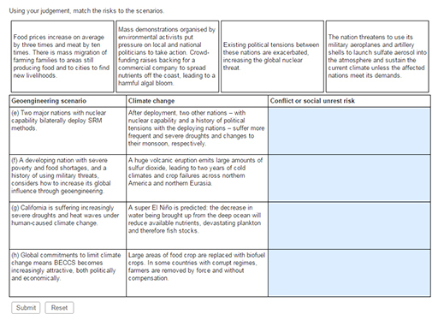

While these doomsday scenarios might not be likely, their serious impacts mean they are all risks that have been considered by experts in the field. The above list was inspired by David Keith’s (2013) book which is largely in favour of SRM geoengineering.
There is one more social-based risk that is very commonly invoked: moral hazard. As Adam Corner put it, writing about his research on this topic (Corner and Pidgeon, 2014):

As geoengineering has gradually moved on to the policy agenda, debates about the ethics of meddling with the global thermostat have become more prominent. Central among these is whether geoengineering might undermine fragile public and political support for the more pressing business of reducing carbon emissions … People who were wealthier, and who identified with self-focused values such as power and status, were more likely to agree with the statement ‘Knowing geoengineering is a possibility makes me feel less inclined to make changes in my own behaviour to tackle climate change’.
Corner (2014)

This seems a suitably thought-provoking quote to round off the discussion of risk.

4 Climate predictions and the media
The question ‘Should we engineer the climate?’ relies in part on public and policy-maker opinions about the topic. Does society think predicted climate change is an important risk? Do people trust climate model predictions of climate change (with or without geoengineering)?
The quality of media reporting is essential to this question.
The European project ice2sea (Ritz et al., 2015) was tasked with predicting sea level rise from Antarctica over the next two centuries and held a press conference in May 2013 announcing their new results to journalists. The press release had the headline ‘Sea-level rise from Antarctic collapse may be slower than suggested’. But Figure 9 shows how the headlines that resulted reflected different media narratives about climate change.

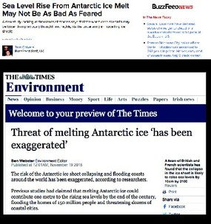
Figure 9 Reporting of Ritz et al. (2015) by (a) BuzzFeed and (b) The Times in November 2015.
View description - Figure 9 Reporting of Ritz et al. (2015) by (a) BuzzFeed and (b) The Times in November ...

- How different are the tone and implications of the messages communicated by the two headlines?
- The BuzzFeed headline communicates a reasonably neutral message, using the word ‘may’ to indicate scientific uncertainty, though the words ‘bad’ and ‘feared’ are emotive.
On the other hand, The Times headline stating ‘has been exaggerated’ implies a possible intention by scientists to mislead, contributing a far more negative message.

The BuzzFeed article is an accurate representation of the press release and study; in contrast, The Times implies that ‘has been exaggerated’ was a quote from the scientists (which it was not).
Clearly this kind of media environment is something for both the public and policy-makers to be aware of, especially so for the even more sensitive topic of global geoengineering. No wonder the public sometimes feels confused.

5 End-of-session quiz
Check what you’ve learned this session by taking the end-of-session quiz.
Session 7 practice quiz
Open the quiz in a new window or tab then come back here when you’ve finished.

6 Session 7 summary
If you were to design geoengineering, you would need to consider the effectiveness of different methods. SRM could give us rapid large-scale climate change but local climate would be hard to control, with potential disruption to rainfall and increased drought. It would also be powerless against the cause of ocean acidification. CDR tackles the root cause of climate change, but is slow to have substantial effect.
A ‘global thermostat’ of SRM geoengineering would need monitoring and control. However, detection, attribution and prediction of climate change always have a degree of uncertainty. Climate is a distribution rather than a single number, so when deciding whether a weather event is ‘unexpected’ or whether two distributions are ‘different’, there are subjective choices to be made due to the statistical nature of climate.
Now move onto the final session of the course: Session 8.

Session 8: Will we engineer the climate?

1 Are climate models wrong?
In March 2013, the Mail on Sunday reported that climate model predictions of GMST are ‘a spectacular miscalculation’ (Figure 2).

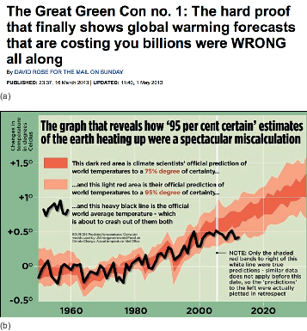
Figure 2 Evaluating models, as reported by the Mail on Sunday, March 2013: (a) headline; (b) accompanying graph based on figure produced by Ed Hawkins.
View description - Figure 2 Evaluating models, as reported by the Mail on Sunday, March 2013: (a) headline; ...

Emotive accusations
The Mail on Sunday article was published six months before the IPCC (2013) report and claims that climate model predictions of GMST are ‘a spectacular miscalculation’ because the observed GMST is ‘about to crash out of’ their range.
Given this media environment and the use of emotive language, how can the public assess the quality of media reporting about new climate studies?
Finding reliable information online is too large a topic to cover here. But if you want to hear directly from climate scientists, you could try climatefeedback.org, a network of climate scientists that comment directly on news articles about their accuracy. Other useful and reliably accurate sources are the climate scientist list on Twitter https://twitter.com/flimsin/lists/climatescientists Carbon Brief.
So were the climate models ‘wrong’, as the Mail on Sunday headline said? Important questions to consider are:
- Was it a fair comparison?
- How does the comparison look now?
- Once the comparison is fair and up-to-date, how much can you learn from it?
Fair comparison
The graph in the Mail on Sunday report says the dark and light red envelopes are the 75% and 95% ranges. In fact, this is an error: they are the 50% and 90% ranges. In other words, the key implies a worse match than it is, so the description of the comparison is not fair.
Full comparison
The observations do show a 15-to 20-year slowdown in the rate of global warming from around 1998 (a record high year, due to a large El Niño) to around 2014. This was often called the ‘pause’ or ‘hiatus’.
Several years have now passed since. On 20 January 2016, the world’s media announced the 2015 mean temperature: the record-breaking year had a dramatic effect on the dataset (Figure 3).

Figure 3 The 2015 update to the GMST reconstructions: animated graphic by the blog ‘Carbon Brief’, January 2016.
View description - Figure 3 The 2015 update to the GMST reconstructions: animated graphic by the blog ...

- Does a comparison of GMST from 1997 to 2016 (Figure 3) provide enough information to judge whether the model predictions were ‘wrong’ (as the Mail on Sunday put it) about global warming?
- Not with great confidence. The period is twenty years, far short of the usual 30-year definition of climate (Session 1). This means it is not a fair test, because climate predictions are only intended to be correct over the longer-term.

However, the longer-term climate model prediction does indeed appear to be successful. Of course, even this is not enough information to judge whether the model predictions were ‘wrong’: GMST is just one aspect of climate change. To test the reliability of climate models, we should – and do – compare with observations of all parts of the Earth system.

2 Public opinion
A key practicality for considering geoengineering is the level of public support. If a particular geoengineering method were decided ‘best’ by scientists but unwanted by the global public, democracy and ethical issues may well determine that it should not be deployed.

2.1 Culture and risk
Public awareness and understanding of geoengineering is low. Surveys in the UK, USA and Canada indicate around a quarter have some familiarity with the word, and a few per cent can correctly define it (Scheer and Renn, 2014), though nearly half of respondents could define or guess the meaning of ‘climate engineering’ (Mercer et al., 2011). Once explained, majorities tend to favour CDR over SRM, and approaches perceived to be ‘natural’ (e.g. enhancing the existing carbon cycle) over those perceived to be ‘man-made’.
These results begin to hint at the importance of values in risk perception. There is evidence that humans perceive risks in ways that reflect and reinforce their cultural ways of life, such as how society should be run. This has been suggested as the reason for strong polarisation of views on climate science along political lines (Kahan et al., 2011).
One area of research that focuses on this idea is ‘cultural cognition theory’ (Kahan et al., 2011). This places people on two axes: one axis of individualism versus communitarianism, the other of hierarchy versus egalitarianism (Figure 4).

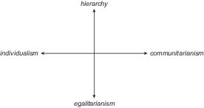
Figure 4 The individualism–communitarianism and hierarchy–egalitarianism axes in cultural cognition theory (Kahan et al., 2011, 2015).
View description - Figure 4 The individualism–communitarianism and hierarchy–egalitarianism axes in ...

How strongly do you agree or disagree with each of these statements? Once you have completed all the statements, click ‘Show’ to see where you sit.

Interactive content is not available in this format.

- Do you think those who are more sceptical of the risks of climate change would tend to be further along the:
  - ‘individualism’ or ‘communitarianism’ directions of the horizontal axis?
  - ‘hierarchy’ or ‘egalitarianism’ directions of the vertical axis?
- Studies by Kahan et al. (2011, 2015) have found that those who are closer to the ‘individualism’ and ‘hierarchy’ ends of these axes tend to be more sceptical of environmental risks such as climate change.

There may also be an interesting interplay between cultural values, geoengineering and perception of climate risk. Those who are ‘hierarchical’ tend to favour geoengineering, and those who are ‘egalitarian’ tend to be cautious or dismissive (Scheer and Renn, 2014). So it could be that cultural values affect the perception of geoengineering.

2.2 Lukewarmers
Now that you have studied the climate model predictions, you can consider a particular type of climate scepticism relating to whether the models have been ‘running too hot’. Here is a quote from one of Edwards’ (2015b) articles on the subject:

So-called ‘climate denial’ is actually not that common in the UK … There are still people who are unconvinced that carbon dioxide has any greenhouse warming effect, particularly in the US and Australia. But by far the most common kind of non-mainstream, contrarian view I see … is the self-described ‘lukewarmer’.
Lukewarmers have much more mainstream views than the easy stereotype of the denier. They agree carbon dioxide is a greenhouse gas, that the world is warming, and that a significant fraction of this is down to humans. In terms of policy, they typically support adaptation to climate change. But they differ from mainstream views because they’re not convinced there’s a substantial risk that future warming could be large or its impacts severe, or that strong mitigation policies are desirable.
Edwards (2015b)

The video which follows is a clip from the BBC programme ‘Newsnight’. Here, Edwards debates with ‘lukewarmer’ Matt Ridley following a video sequence about the success – or rather, lack of success – of models in simulating Antarctic sea ice.

Video content is not available in this format.
Video 1 Tamsin Edwards debating with ‘lukewarmer’ Matt Ridley on BBC ‘Newsnight’, October 2014.
View transcript - Video 1 Tamsin Edwards debating with ‘lukewarmer’ Matt Ridley on BBC ‘Newsnight’, ...

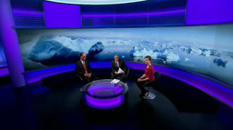

- What are Matt Ridley’s arguments to illustrate the lack of success of climate models? How would you respond?
  - Ridley states that 87 of 90 models overestimate the warming over the past 15 years. This is too short a period with which to assess their ability at predicting long-term climate change.
  - Ridley states that the models are too warm over the past 35 years, which does not seem to be a robust assertion given the GMST comparison you have seen.
  - Ridley focuses on the disagreement between models and data for only two variables while ignoring other aspects of the Earth system.
  - Ridley is inconsistent, stating that the Arctic sea ice is only one small data point whilst his focus is on only two variables, GMST and Antarctic sea ice extent.

2.3 Chemtrailers
Probably the most striking public opinion on engineering the climate is the chemtrail conspiracy theory. This is a belief that aeroplane condensation trails – contrails – are actually chemical trails – chemtrails – part of a secret government plan which believers say has negative impacts on humans and other life. Reasons given by the conspiracy theorists for the practice range from controlling population numbers to controlling minds.
‘Geoengineering’ is popularly considered in this theory to be an official name for chemtrail activities, due to the prominent mention of spraying aerosols in the atmosphere for purposes with global effect. Some websites claim to provide evidence of rainfall contamination or videos of geoengineering conferences, and the internet contains multitudes of photos of contrails in blue skies (Figure 5) presented as ‘proof’ of the theory.

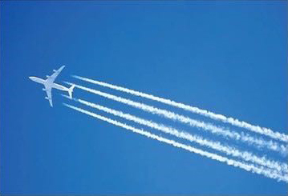
Figure 5 A condensation trail (‘contrail’).
View description - Figure 5 A condensation trail (‘contrail’).

Mercer et al. (2011) surveyed around 3000 adults in the USA, Canada and UK:

We found that 2.6% of the subjects believe that it is completely true that the government has a secret program that uses airplanes to put harmful chemicals into the air, and 14% of the sample believes that this is partly true.
Mercer et al. (2011)

Of course, it is not true but it does illustrate that, in a complex area of science like this, people can look for – and find – cherry-picked and distorted information that supports their views.
Clearly the potential for social upheaval under aerosol SRM is significant: there could be demonstrations, political shifts (e.g. voting for parties that promise to stop the ‘spraying’) and direct action against scientists and engineers.

3 Climate targets
This section considers targets for future climate change: current international agreements, how far we are from these, and whether we could reach the targets by reducing greenhouse gas emissions or with geoengineering.

3.1 Paris Agreement
The UNFCCC (United Nations Framework Convention on Climate Change) is the international environmental treaty at the centre of global climate decision-making. In December 2015, at the UNFCCC Conference of the Parties negotiations in Paris (COP21), under the scrutiny of the world’s media and public, diplomats from 195 nations negotiated an agreement widely described as the first universal, legally binding global climate deal in the UNFCCC’s history of more than 20 years.
The crux of the Agreement is in Article 2:

Article 2
- This Agreement, in enhancing the implementation of the Convention, including its objective, aims to strengthen the global response to the threat of climate change, in the context of sustainable development and efforts to eradicate poverty, including by:
  - Holding the increase in the global average temperature to well below 2°C above pre-industrial levels and pursuing efforts to limit the temperature increase to 1.5°C above pre-industrial levels, recognizing that this would significantly reduce the risks and impacts of climate change;
  - Increasing the ability to adapt to the adverse impacts of climate change and foster climate resilience and low greenhouse gas emissions development, in a manner that does not threaten food production; and
  - Making finance flows consistent with a pathway towards low greenhouse gas emissions and climate-resilient development. 2. This Agreement will be implemented to reflect equity and the principle of common but differentiated responsibilities and respective capabilities, in the light of different national circumstances.
- This Agreement will be implemented to reflect equity and the principle of common but differentiated responsibilities and respective capabilities, in the light of different national circumstances.

Each Nation has a choice about how to contribute, and in 2015 they pledged their planned emissions reductions. This emission reduction is known as an Intended Nationally Determined Contribution (often referred to as an INDC). When a country ratifies the treaty, this is converted into a Nationally Determined Contribution (NDC).

3.2 Our current path
Could we meet the Paris Agreement targets (well below 2 °C above preindustrial climate, pursuing efforts for 1.5 °C) just by reducing greenhouse gas emissions and no geoengineering?
The first question is: where are we heading? Current global emissions are close to, or slightly higher than, the RCP8.5 scenario (Figure 6).

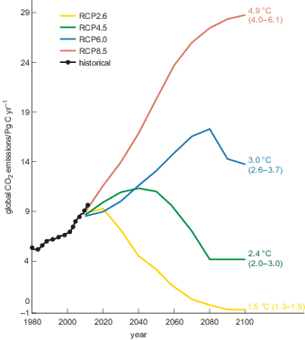
Figure 6 Emissions of CO₂, observed (black dots) and for the RCP scenarios (coloured lines) (Sanford et al., 2014). Numbers on the right-hand side are the median and 66% probability range of GMST projections above preindustrial levels in 2100 by Rogelj et al. (2012).
View description - Figure 6 Emissions of CO2, observed (black dots) and for the RCP scenarios (coloured ...

If we continue on this very high pathway, our odds of exceeding 4 °C warming this century are about 50–50. In other words, as far from preindustrial climate as the last ice age was in the opposite direction. However, following RCP8.5 would require rapidly increasing emissions and it can be considered a ‘no climate policy’ (or worse) scenario – something that we do not have.

How far would current policies and pledges take us?
The website climateactiontracker.org tracks the effects of policies and pledges on our future climate. Perhaps unsurprisingly, predicted temperatures for pledges are higher than the targets, and those for current policies are higher still.

- Visit climateactiontracker.org ‘Global’ page. Have these predictions changed at all ?
- In December 2019, the predicted temperature under current pledges had actually increased by 0.1 °C, to 2.8 °C, while the lower bound for current policies had decreased by the same amount. The answer for future years is unknown, though both are intended to decrease with time.

Pledges are based on current knowledge: unpredictable aspects – such as technology, energy use and political will – will affect the ability of nations to reduce their emissions. To respond to this the Paris Agreement outlines an iterative approach of re-evaluating and repledging every five years, this is known as a ‘ratchet’ mechanism.

4 Decision time
Imagine it is 2030 and you are the Earth’s Energy Balance Consultant. You can put your knowledge into practice to design Earth’s future for the rest of the century, and to mitigate the effects of climate change by choosing your own geoengineering solutions for the world.

4.1 Climate design tool
The ‘Climate design tool’ is a simple model that predicts the effects of different types of geoengineering, mitigation and adaptation on future climate change, and the consequences of these actions for humans and other living things. You will use this to develop a geoengineering design for 2030–2100, and then explain your choices. Can you design the best possible future?
Open the climate design tool. (To open this link in a new tab, select and press ‘Ctrl’ (Windows) or ‘Cmd’ (Mac OS X)).
This is a tool for exploring how you would balance competing priorities. Here is an explanation of how it works. Refer to the climate design tool as you work through the below.

4.2 Actions
In the top section, you have several ‘actions’ available under the headings of mitigation, geoengineering and adaptation.
Mitigation
- This is about working out how to decrease human-caused greenhouse gas emissions.
- The default value for greenhouse gases is equivalent to RCP8.5 in the year 2100.
Geoengineering
There are seven possible methods at your disposal:
- Solar Radiation Management:
  - Solar shield, as area of shield in kilometres squared
  - Bright cities, as percentage area of the Earth’s surface covered in perfectly reflective material
  - Sulfate aerosols, in amount per year
  - Marine cloud brightening, in percentage area of the Earth’s surface covered (maximum is 40%)
- Carbon Dioxide Removal:
  - BECCS (maximum removal is 190 ppm)
  - Ocean fertilisation through iron addition (maximum removal is 30 ppm)
  - Afforestation with biochar (maximum removal is 70 ppm).
Adaptation
- This section is about decreasing our vulnerability to climate change. This does not affect climate or other species.
- This variable expresses the increase in our adaptation from current levels (maximum is 50%, as it is impossible to adapt perfectly to all extreme weather).
- Some examples of adaptation are building sea defences or improving the resilience of people and infrastructure in developing countries to extreme weather.

4.3 Consequences
Your choices for mitigation and geoengineering in the top section will affect the predicted outcomes for climate change (shown in the lower section).
But your actions have other consequences too: they each cost money and have different impacts for climate, humans and other life, as follows:
Climate change:
- Change in GMST relative to preindustrial, in °C
Cumulative impacts by the year 2100:
- number of human lives lost, in millions
- food price increase, in per cent
- biodiversity loss, in per cent
- economic costs, in per cent of Global World Product per year (% GWP per year)
- number of conflicts
- social unrest, in number of mass migrations and demonstrations.
Economic costs include those of actions taken (costs of implementing mitigation, geoengineering and adaptation, and damages caused by geoengineering) plus the damages due to remaining climate change. Global World Product is the combined gross national product of all the countries in the world.
Now you’ve had a brief tour, you can familiarise yourself with the climate design tool a little further by testing out some scenarios.

4.4 Your designs
In the following exercises, you might find it helpful to write down the results as you try different actions. Remember you can select ‘Reset’ at any time.
You wish to achieve the Paris temperature target of 1.5 °C, and quickly, so you test some designs for Solar Radiation Management (SRM).

- What values do you need to input to achieve a 1.5 °C temperature change using:
    - solar shield only
    - sulfate aerosol injection only.
- A solar sail area of 4.4 million km² and sulfate aerosol injection rate of 1.7 Tg yr⁻¹ achieve the closest temperature changes to the target of 1.5 °C.

- Which of the following impacts increase or decrease as a result of adjusting both a) and b) above?
- To achieve a 1.5 °C temperature change for both a) and b), the climate design tool predicts the following impacts:
  - number of human lives lost – decreases
  - food price increases – decrease
  - biodiversity loss – increases
  - economic costs – decrease
  - number of conflicts – increases
  - social unrest – increases.
Sulfate aerosols have worse impacts than the solar shield because they lead to more human lives and biodiversity lost and greater incidences of conflict and social unrest. This is because both are predicted to have similar impacts on climate, but sulfate aerosols have additional physical risks of ozone loss, acid rain and resulting health impacts.
The exception is food prices, which increase slightly less, due to sulfate aerosols diffusing sunlight which can increase plant growth (Session 3).

- Now use only marine cloud brightening to achieve the 1.5 °C target. Are the impacts better or worse than those from using a solar sail or sulfate aerosols?
- Overall, marine cloud brightening seems to reduce negative impacts relative to the solar shield and sulfate aerosols – slightly fewer lives lost, much less biodiversity lost, and less social unrest. The other impacts are similar.
The reasons for the lower impacts from marine cloud brightening are the more local extent of negative impacts on climate such as reduced rainfall, and the lack of sulfate chemical interactions mentioned above.

Having considered the negative impacts of these SRM methods, you look at designing Carbon Dioxide Reduction (CDR) engineering instead. Reset the tool, then select the maximum possible options for all CDR methods (i.e. largest allowed actions for BECCS, ocean fertilisation and afforestation with biochar).

- Start of ITQWhat temperature change is achieved, and how does it compare with the Paris target of ‘well below’ 2 °C? End of Media Content
- Using maximum CDR achieves a temperature change of 2.6 ± 0.8 °C, somewhat higher than 2 °C (though with a small probability of achieving less than 2 °C due to the large uncertainty).

- What do you notice about the impacts of CDR, relative to those of taking no action? Why is this?
- All negative impacts are reduced, except social unrest which increases.
Most negative impacts decrease because the root cause of climate change is reduced. Social unrest increases due to the large-scale conversion of cropland to biofuels and forests, and the toxic algal blooms and risks to ocean biodiversity from ocean fertilisation.
It may be surprising, but food prices decrease overall. This is because – in this particular design tool – the reduction in global warming has a greater effect (smaller food price increases) than the land use changes by CDR (larger food price increases). Economic costs also decrease because the reduction in global warming lowers costs more than the cost of CDR.

Finally, you want to compare your geoengineering designs with mitigation or adaptation, or both.

- Try the following actions. What do you notice about the costs of these, compared with geoengineering or taking no action?
  - using only mitigation to limit warming to 2 °C (the least ambitious end of the Paris targets)
  - using only the maximum possible adaptation
  - using both.
- For mitigation, the main disadvantage is the cost. Using mitigation to reach 2 °C nearly doubles economic costs compared with taking no action, and nearly quadruples costs compared with geoengineering.
Adaptation is much cheaper, costing around the same as taking no action: i.e. in this model, the extra costs of adaptation are balanced by the reduced costs of climate change.
Setting aside cost, mitigation reduces all negative impacts relative to taking no action. Adaptation reduces all negative impacts except the temperature change and biodiversity losses.

So, the question is – what would you do? What future do you want? It is your turn to decide.

Activity 1
Allow approximately 15 minutes

Try combinations of different actions and choose your own set that give the best, or least worst, future for the Earth according to your own priorities.
What is the temperature you achieve?
What costs or other negative consequences were you prepared to accept to achieve this?
How easy did you find it to make your choices?

Provide your answer...
View answer - Activity 1

4.5 Your values

To say that [sulfate aerosol geoengineering] is ‘possible’ understates the case: it is cheap and technically easy. The specialized aircraft and dispersal systems required to get started could be deployed in a few years for the price of a Hollywood blockbuster.
Keith (2013)

… the idea of ‘fixing’ the climate by hacking the Earth’s reflection of sunlight is wildly, utterly, howlingly barking mad.… the idea of ‘fixing’ the climate by hacking the Earth’s reflection of sunlight is wildly, utterly, howlingly barking mad.
Pierrehumbert (2015)

Which view is closer to your own? Have your views changed after studying this course?
You might have expected this course to give you expert, definitive answers on climate change, whether scientific or political. You might well now be thinking: with these uncertainties, subjectivity, contested knowledge, probabilities, judgements and values – how can we know, or do, anything?
Appreciating these issues is essential to understanding climate change and policy. Awareness – even humility – about the complexity and ambiguity of climate science and possible solutions makes us better equipped to tackle this deeply challenging problem. There are no easy, clear answers. We must be vigilant against the dangers of dogma – believing one has absolute certainty, even though all knowledge is inherently imperfect.
The sentiment is expressed in these words spoken by Jacob Bronowski in his landmark series ‘The Ascent of Man’:

Science is a very human form of knowledge. We are always at the brink of the known. We always feel forward for what is to be hoped. Every judgement in science stands on the edge of error and is personal.
Science is a tribute to what we can know although we are fallible. In the end, the words were said by Oliver Cromwell, ’I beseech you, in the bowels of Christ, think it possible you may be mistaken.’
Bronowski (1973)

5 End-of-session quiz
Now it’s time to complete the Session 8 badge quiz. It is similar to previous quizzes, but this time instead of answering five questions there will be fifteen.
Session 8 compulsory badge quiz
Remember, this quiz counts towards your badge. If you’re not successful the first time, you can attempt the quiz again in 24 hours.
Open the quiz in a new tab or window then come back here when you’ve finished.

6 Session 8 summary
Media reporting of climate science can be emotive, and there is always a risk of evidence being misrepresented. It is important to investigate media claims in more detail: you found that climate models do not appear to be ‘wrong’, though they should be tested more thoroughly than with GMST alone.
Just as for climate change, public acceptance of geoengineering varies and is thought to be influenced by political and cultural views. ‘Lukewarmers’ generally consider climate change risks to be small or the proposed actions undesirable. One example of public opposition to geoengineering is the ‘chemtrail’ conspiracy theory, which posits that organisations are secretly distributing chemicals in the atmosphere for a variety of (undesirable) purposes.
The UNFCCC Paris Agreement aims to hold the increase in GMST to ‘well below 2 °C’ above preindustrial levels and to ‘pursue efforts’ to limit it to 1.5 °C. However, if we continue to follow the RCP8.5 scenario of very high greenhouse gas concentrations, there is a predicted one-in-two chance of exceeding 4 °C warming and, even under future pledges, global warming is predicted to be around 3 °C.
You have considered some of the different factors involved in making decisions about climate change (geoengineering, mitigation or adaptation). These include the range of predicted impacts, the inherent uncertainties, the difficulty in reducing changes in the complex Earth system to a simple GMST target such as the Paris Agreement, and the balancing of competing priorities. You have also reflected on the role of your own values in your views on decision-making in geoengineering and climate change.
The conclusion of this course, then, might be that there are no easy answers.

Where next?
If you have enjoyed this course you can find more free resources and courses on OpenLearn.
Why not find out more about studying and gaining qualifications at The Open University? Visit the OU prospectus for more information. You might be particularly interested in science.

Tell us what you think
Now you’ve come to the end of the course, we would appreciate a few minutes of your time to complete this short end-of-course survey (you may have already completed this survey at the end of Session 4).

References
Edwards, T. L. and Challenor, P. G. (2013) ‘Risk and uncertainty in hydrometeorological hazards’, in Rougier, J. et al. (eds) Risk and Uncertainty Assessment for Natural Hazards, Cambridge, United Kingdom, Cambridge University Press, pp. 100–50.
Eosco, G. (2013) “Weather is like your mood. Climate is like your personality.” @AMSPresElect [J. Marshall Shepherd] providing great analogies this evening!, 6 January [Twitter]. Available at https://twitter.com/WxComm/status/287771155392245760 (Accessed 16 December 2020).
Heinlein, R. A. (1973) Time Enough for Love, New York, Putnam.
Keith, D. (2007) ‘A critical look at geoengineering against climate change’, TED (Technology, Entertainment, Design) Talks [Online]. Available at https://www.ted.com/talks/david_keith_s_surprising_ideas_on_climate_change (Accessed 16 December 2020).
Kennedy, J. (2013) Practically speaking: weather’s how you choose an outfit, climate’s how you choose your wardrobe, 6 January [Twitter]. Available at https://twitter.com/micefearboggis/status/287933033628180480 (Accessed 22 December 2020).
Rougier, J. and Goldstein, M. (2014) ‘Climate simulators and climate projections’, Annual Review of Statistics and Its Application, vol. 1, no. 1, pp. 103–23.
Shepherd, J. G. (2009) Geoengineering the climate: science, governance and uncertainty, London, The Royal Society, Report 10/09.
WMO (n.d) World Meteorological Organization Commission for Climatology Frequently Asked Questions (FAQs) [Online]. Available at http://www.wmo.int/pages/prog/wcp/ccl/faqs.php (Accessed 16 December 2020).
Edwards, T. L. and Challenor, P. G. (2013) ‘Risk and uncertainty in hydrometeorological hazards’, in Rougier, J. et al. (eds) Risk and Uncertainty Assessment for Natural Hazards, Cambridge, United Kingdom, Cambridge University Press, pp. 100–50.
Electoral campaign, by Isaac Cordal (Berlin, Germany, 2011), popularly known as Politicians Discussing Global Warming
Griffiths, J. (2006) Wild: An Elemental Journey, London, Penguin.
IPCC (2013) Climate Change 2013: The Physical Science Basis. Contribution of Working Group I to the Fifth Assessment Report of the Intergovernmental Panel on Climate Change, [Stocker, T. F., Qin, D., Plattner, G.-K. et al. (eds)], Cambridge University Press, Cambridge, United Kingdom and New York, NY, USA.
IPCC (2014) Climate Change 2014: Impacts, Adaptation, and Vulnerability. Part A: Global and Sectoral Aspects. Contribution of Working Group II to the Fifth Assessment Report of the Intergovernmental Panel on Climate Change, [Field, C. B., Barros, V. R., Dokken, D. J. et al. (eds)], Cambridge University Press, Cambridge, United Kingdom and New York, NY, USA.
Johnson, G. C. (2013) Climate Change Science 2013: Haiku [Online]. Available at https://www.wmo.int/youth/sites/default/files/field/media/library/full_ipcc_haiku_slides_opt.pdf (Accessed 17 December 2020).
NOAA (2016) Observing System Monitoring Center In Situ Monitoring [Online]. Available at http://osmc.noaa.gov/Monitor/OSMC/OSMC.html (Accessed 17 December 2020).
Rennie, J. J., Lawrimore, J. H., Gleason, B. E. (2014) ‘The international surface temperature initiative global land surface databank: monthly temperature data release description and methods’, Geoscience Data Journal, vol. 1, pp. 75–102.
UN World Food Programme (2016) What causes hunger? [Online]. Available at https://www.wfp.org/zero-hunger (Accessed 9 October 2016).
Watts, G., Battarbee, R. W. and Bloomfield, J. P. (2015) ‘Climate change and water in the UK – past changes and future prospects’, Progress in Physical Geography: Earth and Environment [Online]. doi: 10.1177/0309133314542957 (Accessed 18 June 2020).
Burckle, L. and Grissino-Mayer, H. D. (2003) ‘Stradivari, violins, tree rings, and the Maunder Minimum: a hypothesis’, Dendrochronologia, vol. 21, no. 1, pp. 41–5.
Greenblatt, S. (2006) The Norton Anthology of English Literature, 8th edn, New York and London, Norton.
Hawkins, E. (2016) Guy Stewart Callendar (1898–1964). Discovered global warming in 1938 & suggested that increase in atmospheric CO₂ was responsible. Alter ego: @ed_hawkins [Online] Available at https://twitter.com/GuyCallendar (Accessed 20 October 2016).
Hawkins, E. and Jones, P. (2013) ‘On increasing global temperatures: 75 years after Callendar’, Quarterly Journal of the Royal Meteorological Society, vol. 139, pp. 1961–3.
IPCC (2013a) Climate Change 2013: The Physical Science Basis. Contribution of Working Group I to the Fifth Assessment Report of the Intergovernmental Panel on Climate Change, Stocker, T. F., Qin, D., Plattner, G.-K. et al. (eds), Cambridge, United Kingdom and New York, NY, USA, Cambridge University Press.
IPCC (2013b) ‘Annex II: Climate system scenario tables’, Prather, M., Flato, G., Friedlingstein, P. et al. (eds), in: Climate Change 2013: The Physical Science Basis. Contribution of Working Group I to the Fifth Assessment Report of the Intergovernmental Panel on Climate Change, Stocker, T. F., Qin, D., Plattner, G.-K. et al. (eds), Cambridge, United Kingdom and New York, NY, USA, Cambridge University Press, pp. 1395–445.
IPCC (2014) Climate Change 2014: Impacts, Adaptation, and Vulnerability. Part A: Global and Sectoral Aspects. Contribution of Working Group II to the Fifth Assessment Report of the Intergovernmental Panel on Climate Change, Field, C. B., Barros, V. R., Dokken, D. J. et al. (eds), Cambridge, United Kingdom and New York, NY, USA, Cambridge University Press.
Jackson, R. (2016) John Tyndall Natural Philosopher and Mountaineer. Tweets about my life, loves, science, religion, politics, poetry and mountaineering. Alter ego @roland_jackson [Online]. Available at https://twitter.com/ProfTyndall (Accessed 20 October 2016).
Santer, B., Solomon, S., Ridley, D. et al. (2016) ‘Volcanic effects on climate’, Nature Climate Change, vol. 6, 3–4.
Scripps Institution of Oceanography (2016) The Keeling Curve [Online]. Available at https://scripps.ucsd.edu/programs/keelingcurve (Accessed 20 October 2016).
Sharma, N., Singh, A., Dhyani, R. and Gaur, S. (2014) ‘Emission reduction from MRTS projects – A case study of Delhi metro’, Atmospheric Pollution Research, vol. 5, no. 4, pp. 721–8.
Smith, S. J., van Aardenne, J., Klimont, Z., Andres, R. J., Volke, A. and Delgado Arias, S. (2011) ‘Anthropogenic sulfur dioxide emissions: 1850–2005’, Atmospheric Chemistry and Physics, vol. 11, pp. 1101–16.
Stoel, B. C. and Borman, T. M. (2008) ‘A comparison of wood density between classical Cremonese and modern violins’, PLoS ONE, vol. 3, no. 7: e2554 [Online]. DOI: 10.1371/journal.pone.0002554.
Zerefos, C. S., Gerogiannis, V. T., Balis, D., Zerefos, S. C. and Kazantzidis, A. (2007) ‘Atmospheric effects of volcanic eruptions as seen by famous artists and depicted in their paintings’, Atmospheric Chemistry and Physics, vol. 7, pp. 4027–42.
Adams, D. (2002) The Salmon of Doubt: Hitchhiking the Galaxy One Last Time, London, Macmillan.
Canadell, J. G. and Schulze, E. D. (2014) ‘Global potential of biospheric carbon management for climate mitigation’, Nature Communications, vol. 5, article no. 5282 [Online]. DOI: 10.1038/ncomms6282.
Ellis, A. K. (1977) Teaching and Learning Elementary Social Studies, London, Allyn and Bacon.
Hinkel, J., Lincke, D., Vafeidis, A. T. et al. (2014) ‘Coastal flood damage and adaptation costs under 21st century sea-level rise’, Proceedings of the National Academy of Sciences, vol. 111, no. 9, pp. 3292–7.
IPCC (2013) Climate Change 2013: The Physical Science Basis. Contribution of Working Group I to the Fifth Assessment Report of the Intergovernmental Panel on Climate Change, Stocker, T. F., Qin, D., Plattner, G.-K. et al. (eds), Cambridge, United Kingdom and New York, NY, USA, Cambridge University Press.
IPCC (2014) Climate Change 2014: Impacts, Adaptation, and Vulnerability. Part A: Global and Sectoral Aspects. Contribution of Working Group II to the Fifth Assessment Report of the Intergovernmental Panel on Climate Change, Field, C. B., Barros, V. R., Dokken, D. J. et al. (eds), Cambridge, United Kingdom and New York, NY, USA, Cambridge University Press.
van Vuuren, D. P., Edmonds, J., Kainuma, M. et al. (2011) ‘The representative concentration pathways: an overview’, Climatic Change, vol. 109, pp. 1–27 [Online]. DOI: 10.1007/s10584-011-0148-z.
Watts, N., Adger, W. N., Agnolucci, P. et al. (2015) ‘Health and climate change: policy responses to protect public health’, Lancet, vol. 386, no. 10006, pp. 1861–914 [Online]. DOI: 10.1016/S0140-6736(15)60854-6.
Campbell, G. S., and Norman, J. M. (1998) An Introduction to Environmental Biophysics, 2nd edn, New York, NY, USA, Springer.
Canadell, J. G. and Schulze, E. D. (2014) ‘Global potential of biospheric carbon management for climate mitigation’, Nature Communications, vol. 5, article no. 5282 [Online]. DOI: 10.1038/ncomms6282.
Clarke, A. C. and Baxter, S. (2005) Sunstorm, p. 336, London, Del Rey.
Early, J. T. (1989) ‘Space-based solar shield to offset greenhouse effect’, Journal of the British Interplanetary Society, vol. 42, no. 12, pp. 567–9.
IPCC (2013) Climate Change 2013: The Physical Science Basis. Contribution of Working Group I to the Fifth Assessment Report of the Intergovernmental Panel on Climate Change, Stocker, T. F., Qin, D., Plattner, G.-K. et al. (eds), Cambridge, United Kingdom and New York, NY, USA, Cambridge University Press.
Lenton, T. M. and Vaughan, N. E. (2009) ‘The radiative forcing potential of different climate geoengineering options’, Atmospheric Chemistry and Physics, vol. 9, no. 15, pp. 5539–61.
Levitt, S. D. and Dubner, S. J. (2009) SuperFreakonomics: Global Cooling, Patriotic Prostitutes, and Why Suicide Bombers Should Buy Life Insurance, New York, William Morrow.
McGlashan, N., Workman, M., Caldecott, B. and Shah, N. (2012) Negative Emissions Technologies, London, Grantham Institute for Climate Change, Briefing paper No. 8.
Powell, H. (2007) Oceanus Magazine, Woods Hole Oceanographic Institute [Online]. Available at http://www.whoi.edu/oceanus/feature/fertilizing-the-ocean-with-iron (Accessed 17 December 2020).
Robock, A., Marquardt, A., Kravitz, B. and Stenchikov, G. (2009) ‘Benefits, risks, and costs of stratospheric geoengineering’, Geophysical Research Letters, vol. 36, no. 19, p. L19703.
Schneider, S. H., Mastrandrea, M. D. and Root, T. L. (2011) Encyclopedia of Climate and Weather: Abs-Ero, vol. 1, Oxford, Oxford University Press.
Brahic, C. (2007) ‘Company plans ‘eco’ iron dump off Galapagos’, New Scientist, 22 June [Online]. Available at https://www.newscientist.com/ article/ dn12111-company-plans-eco-iron-dump-off-galapagos/ (Accessed 17 December 2020).
Burns, W. C. G. and Strauss, A. L. (eds) (2013) Climate Change Geoengineering: Philosophical Perspectives, Legal Issues, and Governance Frameworks, Cambridge, UK, Cambridge University Press.
Convention on Biological Diversity (2008) Conference of the Parties 9 Decision IX/16: Biodiversity and climate change [Online]. Available at https://www.cbd.int/decision/cop/default.shtml?id=11659 (Accessed 17 December 2020).
Feynman Chaser - The Key to Science (2008) YouTube video, added by FeynmanChaser [Online]. Available at https://www.youtube.com/watch?v=b240PGCMwV0 (Accessed 17 December 2020).
Gentle, A. R. and Smith, G. B. (2015) ‘A subambient open roof surface under the mid-summer sun’, Advanced Science, vol. 2, no. 9 [Online]. DOI: 10.1002/advs.201500119.
Global CCS Institute (2015) The Global Status of CCS: Summary Report [Online]. Available at https://www.globalccsinstitute.com/wp-content/uploads/2018/12/Global-Status-Report_2015_Summary.pdf (Accessed 5 January 2021).
Goodell, J. (2010) How to Cool the Planet: Geoengineering and the Audacious Quest to Fix Earth’s Climate, New York, USA, Houghton Mifflin Harcourt.
Hamilton, C. (2015) ‘Geoengineering is no place for corporate profit making’, The Guardian, 17 February [Online]. Available at https://www.theguardian.com/sustainable-business/2015/feb/17/geoengineering-is-no-place-for-corporate-profit-making (Accessed 11 August 2016).
International Energy Agency (2007) IEA Good Practice Guidelines: Bioenergy Project Development & Biomass Supply [Online], Paris, IEA.
International Energy Agency (2015) Key World Energy Statistics 2015 [Online], Paris, IEA. DOI: 10.1787/key_energ_stat-2015-en.
IPCC (2013) Climate Change 2013: The Physical Science Basis. Contribution of Working Group I to the Fifth Assessment Report of the Intergovernmental Panel on Climate Change, Stocker, T. F., Qin, D., Plattner, G.-K. et al. (eds), Cambridge, United Kingdom and New York, NY, USA, Cambridge University Press.
Izrael, Y. A., Zakharov, V. M., Petrov, N. N. et al. (2009) ‘Field experiment on studying solar radiation passing through aerosol layers’, Russian Meteorology and Hydrology, vol. 34, no. 5, pp. 265–73.
Izrael, Y. A., Zakharov, V. M., Ivanov, V. N. et al. (2011) ‘A field experiment on modeling the impact of aerosol layers on the variability of solar insolation and meteorological characteristics of the surface layer’, Russian Meteorology and Hydrology, vol. 36, no. 11, pp. 705–14.
Keith, D. W., Duren, R. and MacMartin, D. G. (2014) ‘Field experiments on solar geoengineering: report of a workshop exploring a representative research portfolio’, Philosophical Transactions of the Royal Society A, vol. 372, no. 2031: 20140175 [Online]. DOI: 10.1098/rsta.2014.0175.
LaMonica, M. (2008) ‘Ocean fertilization firm Climos gains financial backing’, CNET, 5 March [Online]. Available at http://www.cnet.com/news/ocean-fertilization-firm-climos-gains-financial-backing/ (Accessed 17 December 2020).
Lukacs, M. (2012) ‘World’s biggest geoengineering experiment ‘violates’ UN rules’, The Guardian, 15 October [Online]. Available at https://www.theguardian.com/environment/2012/oct/15/pacific-iron-fertilisation-geoengineering (Accessed 17 December 2020).
National Research Council (2015) Climate Intervention: Reflecting Sunlight to Cool Earth, Washington, DC, National Academies Press.
Richardson, L. F. (1922) Weather Prediction by Numerical Process, Cambridge, UK, Cambridge University Press (this edition 2007).
Robock, A., Oman, L. and Stenchikov, G. L. (2008) ‘Regional climate responses to geoengineering with tropical and Arctic SO₂ injections’, Journal of Geophysical Research, vol. 113, D16101 [Online]. DOI: 10.1029/2008JD010050.
Schiermeier, Q. (2003) ‘Climate change: The oresman’, Nature, vol. 421, pp. 109–10.
Schiermeier, Q. (2004) ‘Fertilising the sea could combat global warming’, Nature, 22 April [Online]. DOI: 10.1038/news040419-7.
Sharples, S. (2014) ‘City of Sydney is trialling paving roads in Chippendale with pale surfaces to reduce surrounding temperatures’, The Daily Telegraph, 19 June [Online]. Available at https://www.dailytelegraph.com.au/newslocal/inner-west/city-of-sydney-is-trialling-paving-roads-in-chippendale-with-pale-surfaces-to-reduce-surrounding-temperatures/news-story/00268489a533a1e7b38928bd47b95ea6 (Accessed 11 August 2016).
Thompson, K. (2008) ‘Carbon discredit’, Popular Science, 1 July [Online]. Available at http://www.popsci.com/environment/article/2008-07/carbon-discredit (Accessed 17 December 2020).
US Department of Energy (2014) Archer Daniels Midland Company: CO₂ Capture from Biofuels Production and Storage into the Mt. Simon Sandstone [Online], National Energy Technology Laboratory (NETL). Available at http://www.netl.doe.gov/File%20Library/Research/Coal/major%20demonstrations/iccus/ARRA1547.pdf (Accessed 17 December 2020).
Vince, G. (2014) Adventures in the Anthropocene: A Journey to the Heart of the Planet we Made, London, Chatto & Windus.
Williamson, P., Wallace, D. W. R., Law, C. S. et al. (2012) ‘Ocean fertilization for geoengineering: A review of effectiveness, environmental impacts and emerging governance’, Process Safety and Environmental Protection, vol. 90, no. 6, pp. 475–88.
Xiu, P., Thomas, A. C. and Chai, F. (2014) ‘Satellite bio-optical and altimeter comparisons of phytoplankton blooms induced by natural and artificial iron addition in the Gulf of Alaska’, Remote Sensing of Environment, vol. 145, pp. 38–46.
Box, G. E. P. (1979) ‘Robustness in the strategy of scientific model building’, in Launer, R. L. and Wilkinson, G. N. (eds) Robustness in Statistics, London, Academic Press, pp. 201–36.
Edwards, T. L. (2015) ‘Antarctic ice sheet collapse will cause sea levels to rise. So what's new?’, The Guardian, 18 November [Online]. Available at https://www.theguardian.com/science/blog/2015/nov/18/antarctic-ice-sheet-collapse-sea-level-rise-whats-new (Accessed 17 December 2020).
Hoffman, A. (1997) Here on Earth, London, Random House UK.
IPCC (2013) Climate Change 2013: The Physical Science Basis. Contribution of Working Group I to the Fifth Assessment Report of the Intergovernmental Panel on Climate Change, Stocker, T. F., Qin, D., Plattner, G.-K. et al. (eds), Cambridge, United Kingdom and New York, NY, USA, Cambridge University Press.
Keith, D. (2013) A Case for Climate Engineering, Cambridge, MA, USA, MIT Press.
Rapley, C. G., De Meyer, K., Carney, J. and Tucke, D. (2014) Time to Change? Climate Science Reconsidered, London, UCL Policy Commission on Communicating Climate Science.
Ritz, C., Edwards, T. L., Durand, G., Payne, A. J., Peyaud, V. and Hindmarsh, R. C. A. (2015) ‘Potential sea-level rise from Antarctic ice-sheet instability constrained by observations’, Nature, vol. 528, pp. 115–18.
Rogelj, J., Meinshausen, M. and Knutti, R. (2012) ‘Global warming under old and new scenarios using IPCC climate sensitivity range estimates’, Nature Climate Change, vol. 2, pp. 248–53 [Online]. DOI: 10.1038/nclimate138.
Tallentyre, S. G. (1919) Voltaire in His Letters, New York, G. P. Putnam’s Sons.
Trump, D. (2017) Just heard Foreign Minister of North Korea speak at U.N. If he echoes thoughts of Little Rocket Man, they won't be around much longer! 24 September 2017 [Twitter]. Available at https://twitter.com/realDonaldTrump/status/911789314169823232 (Accessed 17 December 2020).
Betts, R. (2017) Hi @DavidRoseUK we updated your graph - hope it helps make your next article OK for Wikipedia :) @ed_hawkins @flimsin @dougmcneall #fixedit [image by Betts, R., Hawkins, E., Edwards, T. and McNeall, D.], 9 February 2017 [Twitter]. Available at https://twitter.com/richardabetts/status/829709315275624448 (Accessed 29 March 2017)
Bronowski, J. (1973) The Ascent of Man. London: BBC Books
Climate Action Tracker Partners (2016) Climate Action Tracker [Online]. Available at http://climateactiontracker.org (Accessed 28 November 2020).
Edwards, T. L. (2015b) ‘The lukewarmers don’t deny climate change. But they say the outlook’s fine’, The Observer, 3 May [Online]. Available at https://www.theguardian.com/science/2015/may/03/climate-change-scepticism-denial-lukewarmers (Accessed 28 November 2020).
IPCC (2013) Climate Change 2013: The Physical Science Basis. Contribution of Working Group I to the Fifth Assessment Report of the Intergovernmental Panel on Climate Change, Stocker, T. F., Qin, D., Plattner, G.-K. et al. (eds), Cambridge, United Kingdom and New York, NY, USA, Cambridge University Press.
Jenner, K. (2015) [Image containing text], 26 May [Twitter].
Kahan, D. M., Jenkins‐Smith, H. C. and Braman, D. (2011) ‘Cultural cognition of scientific consensus’, Journal of Risk Research, vol. 14, no. 2, pp. 147–74 [Online]. DOI: 10.1080/13669877.2010.511246.
Kahan, D. M., Jenkins‐Smith, H. C., Tarantola, T., Silva, C. L. and Braman, D. (2015) ‘Geoengineering and climate change polarization: testing a two-channel model of science communication’, Annals of American Academy of Political and Social Science, vol. 658, pp. 193–222 [Online]. DOI: 10.1177/0002716214559002.
Keith, D. (2013) A Case for Climate Engineering, Cambridge, MA, USA, MIT Press.
Mercer, A. M., Keith, D. W. and Sharp, J. D. (2011) ‘Public understanding of solar radiation management’, Environmental Research Letters, vol. 6, no. 4 [Online]. DOI: 10.1088/1748-9326/6/4/044006.
Pierrehumbert, R. T. (2015) Climate Hacking Is Barking Mad [Online], Slate. Available at http://www.slate.com/articles/health_and_science/science/2015/02/nrc_geoengineering_report_climate_hacking_is_dangerous_and_barking_mad.html (Accessed 28 November 2020).
Ritz, C., Edwards, T. L., Durand, G., Payne, A. J., Peyaud, V. and Hindmarsh, R. C. A. (2015) ‘Potential sea-level rise from Antarctic ice-sheet instability constrained by observations’, Nature, vol. 528, pp. 115–18.
Rogelj, J., Meinshausen, M. and Knutti, R. (2012) ‘Global warming under old and new scenarios using IPCC climate sensitivity range estimates’, Nature Climate Change, vol. 2, pp. 248–53 [Online]. DOI: 10.1038/nclimate138.
Sanford, T., Frumhoff, P. C., Luers, A. and Gulledge, J. (2014) ‘The climate policy narrative for a dangerously warming world’, Nature Climate Change, vol. 4, pp. 164–6 [Online]. DOI: 10.1038/nclimate2148.
Scheer, D. and Renn, O. (2014) ‘Public perception of geoengineering and its consequences for public debate’, Climatic Change, vol. 125, p. 305 [Online]. DOI: http://dx.doi.org/10.1007/s10584-014-1177-1.
Stilgoe, J. (2015) Experiment Earth: Responsible Innovation in Geoengineering, Abingdon, United Kingdom and New York, Routledge.

Further reading
Campaign for Science and Engineering (2016) One climate data point [Online]. Available at http://www.sciencecampaign.org.uk/news-media/guest-blog/one-climate-data-point.html (Accessed 4 March 2020).

Acknowledgements

Introduction

Images
Course image: courtesy: Mark Brandon.

Week 1

Images
Figure 5: Atmosphere: By CreativeInspiration from Pixabay www.pixabay.com; Cryosphere: NASA / Michael Studinger; Hydrosphere: Pexels www.pexels.com; Land surface: Pexels www.pexels.com; Biosphere: © Miguel.v. https://creativecommons.org/licenses/by-sa/3.0/deed.en

Week 2

Images
Figure 1: © Google Inc.
Figure 2: The IPCC AR5 WG1 Report: Image courtesy of Andrew Whitehead
Figure 3: (a) The worldwide network of land stations in the Global Land Surface Meteorological Databank (Rennie et al. 2014). The colour corresponds to the number of years of data available for each station. (b) A snapshot of the locations of the NOAA Observing System Monitoring Center network measuring sea surface temperatures (NOAA, 2016).
Figure 4: Observed annual global mean surface temperature anomalies 1850-2012 from three datasets: Adapted from Figure SPM.1 (a) (top panel) from Climate Change 2014: Synthesis Report. Contribution of Working Groups I, II and III to the Fifth Assessment Report of the Intergovernmental Panel on Climate Change. [Core Writing Team, Pachauri, R.K. and Meyer, L. (eds.)]. IPCC, Geneva, Switzerland.
Figure 5: from IPCC (2013) Summary for Policymakers: Stocker, T.F. et al. (2013) Climate Change 2013: The Physical Science Basis, IPCC, Cambridge University Press, Cambridge, United Kingdom
Figures 6 and 10: courtesy of Gregory Johnson
Figure 7: Observed precipitation changes from 1951 to 2010: IPCC, 2013: Summary for Policymakers. In: Climate Change 2013: The Physical Science Basis. Contribution of Working Group I to the Fifth Assessment Report of the Intergovernmental Panel on Climate Change [Stocker, T.F., D. Qin, G.-K. Plattner, M. Tignor, S.K. Allen, J. Boschung, A. Nauels, Y. Xia, V. Bex and P.M. Midgley (eds.)]. Cambridge University Press, Cambridge, United Kingdom and New York
Figure 8: courtesy of Tamsin Edwards
Figure 9: Greenland: Reproduced by permission, Dr Poul Christoffersen, Scott Polar Research Institute, Department of Geography, University of Cambridge
Figure 10: Tide staff used by the NOAA ‘Teachers at Sea’ Rosalind Echols and Avery Marvin: Rosalind Echols, NOAA Teacher at Sea
Figure 12: Electoral campaign, courtesy of Isaac Cordal: © Isaac Cordal
Figure 13: John-irishwildcat. http://creativecommons.org/licenses/by/2.0/
Figure 14: Adapted from Figure 6-4 from Pörtner, H.-O., D. Karl, P.W. Boyd, W. Cheung, S.E. Lluch-Cota, Y. Nojiri, D.N. Schmidt, and P. Zavialov, 2014: Ocean systems. In: Climate Change 2014: Impacts, Adaptation, and Vulnerability. Part A: Global and Sectoral Aspects. Contribution of Working Group II to the Fifth Assessment Report of the Intergovernmental Panel on Climate Change [Field, C.B., V.R. Barros, D.J. Dokken, K.J. Mach, M.D. Mastrandrea, T.E. Bilir, M. Chatterjee, K.L. Ebi, Y.O. Estrada, R.C. Genova, B. Girma, E.S. Kissel, A.N. Levy, S. MacCracken, P.R. Mastrandrea, and L.L. White (eds.)]. Cambridge University Press, Cambridge, United Kingdom and New York
Figure 15: (a) Morro da Carioca, Angra dos Reis in the State of Rio de Janerio, Brazil, where heavy rain caused fatal mudslides and flooding in January 2010: © Agência Brasil. https://creativecommons.org/licenses/by/3.0/deed.en (b) A sign in Rawnsley Park Station, South Australia, rendered unnecessary by the 2007-2008 drought: © Peripitus via Wikimedia. https://creativecommons.org/licenses/by-sa/3.0/deed.en
Figure 16: (a) Sámi reindeer: © Maisna / iStockphoto.com; Figure 16 (b) Sámi musician Mari Boine: © Henryk Kotowski; https://creativecommons.org/licenses/by-sa/3.0/deed.en; Figure 16(c) ‘Team Sámi’ at the Arctic Winter Games in 2014: © Sámediggi Sametinget. https://creativecommons.org/licenses/by/2.0/;

Audio Visual
Video 1: A Song of Our Warming Planet by Daniel Crawford; Institute of the Environment; University of Minnesota and College of Liberal Arts

Week 3

Images
Figure 1: Andrew_Howe; iStockphoto.com
Figure 2: (a) A Stradivarius violin: © Σπάρτακος https://creativecommons.org/licenses/by-sa/3.0/deed.en; (b) Sunspots on 3 March 2015: © SOHO Solar and Heliospheric Observatory
Figure 3: An example reconstruction of total solar irradiance (solar output reaching the Earth) since 1850 (Krivova/Ball). Direct observations (Physikalisch-Meteorologisches Observatorium Davos, PMOD) are also shown for the later period. (Adapted from IPCC, 2013a)
Figure 4: egrego2. https://creativecommons.org/licenses/by/2.0/
Figure 7: A collage of newspaper articles reporting predictions of global cooling in January 1970: Article back left: New York Times (1932) ‘Next Great Deluge Forecast by Science’, May 15; Article back centre: Washington Post (1970) ‘Colder Winters Held Dawn of New Ice Age’, January 11; Article back right: Washington Post (1970) ‘Scientists See Ice Age In The Future’, January 11; Article front centre: New York Times (1975) ‘Scientists Ask Why World’s Climate Is Changing; Major Cooling Widely Considered to Be Inevitable’, May 21.
Figures 8 and 9: Global sulfur emissions; from Smith et al (2011): Smith, S.J. et al (2011) Anthropogenic sulfur dioxide emissions: 1850-2005, Atmospheric Chemistry and Physics, vol. 11, pp.1101-1116, European Geosciences Union. http://creativecommons.org/licenses/by/3.0/
Figure 10: Papworth House, Sussex, UK/Bridgeman Images
Figure 11: Courtesy of the Earth Science and Remote Sensing Unit, NASA Johnson Space Center.
Figure 12: PlaneMad/Wikimedia; https://creativecommons.org/licenses/by-sa/2.5/deed.en
Figure 13: Steve Albert, National Oceanic and Atmospheric Administration
Figure 14: Eric Rostan and Blacki Migliozzi June 2015

Audio Visual
Video 1: Climate Change: A Horizon Guide', (c) BBC, March 2015

Week 4

Images
Figures 1 and 2: Adapted from van Vuuren, D. et al (2011) 'The representative concentration pathways: an overview', Climate Change, November 2011, © Springer International Publishing AG, Part of Springer Science+Business Media
Figure 3: Projected mean surface air temperature change in 2081–2100 with respect to 1986–2005 for RCP4.5 from each of the 42 climate models used in the IPCC Fifth Assessment Report (IPCC 2013)
Figure 4: Taken from Skeptical Science; http://creativecommons.org/licenses/by/3.0/
Figure 5: taken from: Predictions of mean GMST change 2081–2100 relative to 1986-2005: IPCC, 2013: Summary for Policymakers. In: Climate Change 2013: The Physical Science Basis. Contribution of Working Group I to the Fifth Assessment Report of the Intergovernmental Panel on Climate Change [Stocker, T.F., D. Qin, G.-K. Plattner, M. Tignor, S.K. Allen, J. Boschung, A. Nauels, Y. Xia, V. Bex and P.M. Midgley (eds.)]. Cambridge University Press
Figures 6, 7 and 8: Piers Forster
Figures 9 and 10: taken from: IPCC, 2014: Summary for Policymakers. In: Climate Change 2014: Impacts, Adaptation, and Vulnerability. Part A: Global and Sectoral Aspects. Contribution of Working Group II to the Fifth Assessment Report of the Intergovernmental Panel on Climate Change [Field, C.B., V.R. Barros, D.J. Dokken, K.J. Mach, M.D. Mastrandrea, T.E. Bilir, M. Chatterjee, K.L. Ebi, Y.O. Estrada, R.C. Genova, B. Girma, E.S. Kissel, A.N. Levy, S. MacCracken, P.R. Mastrandrea, and L.L. White (eds.)]. Cambridge University Press, Cambridge, United Kingdom

Week 5

Images
Figure 1: Graham Cosserat, gcosserat via Flickr
Figure 2: NASA
Figure 3: The U.S. National Archives via Flickr https://www.flickr.com/photos/usnationalarchives/7152604933
Figure 4: ‘Blue Marble 2012’ images of the Earth showing (a) Africa and the Middle East, and (b) North America. (c) NASA/NOAA
Figure 6: taken from: Proposed methods of stratospheric aerosol injection: Robock et al. (2009). Benefits, risks, and costs of stratospheric geoengineering. Geophysical Research Letters, 36(19), p.L19703 Drawing by Brian West.
Figure 7: JackyR; https://creativecommons.org/licenses/by-sa/3.0/deed.en
Figure 8: Satellite image of ship tracks: Jeff Schmaltz, MODIS Rapid Response Team, NASA/GSFC
Figure 9: John MacNeill
Figure 10: Raeky, https://creativecommons.org/licenses/by-sa/3.0/deed.en
Figure 11: NASA
Figure 12: Low-tech and high-tech methods of CDR. (a) A handful of biochar, Photo courtesy of USDA-ARS, Prosser, Wash (b) An example design of a DAC plant by Carbon Engineering Limited.

Audio Visual
Audio 1: ‘Changing Climate: The Solutions’, November 2015. BBC

Week 6

Images
Figures 1, 2, 3 and 4: taken from: Climate Change 2013: The Physical Science Basis. Contribution of Working Group I to the Fifth Assessment Report of the Intergovernmental Panel on Climate Change [Stocker, T.F., D. Qin, G.-K. Plattner, M. Tignor, S.K. Allen, J. Boschung, A. Nauels, Y. Xia, V. Bex and P.M. Midgley (eds.)]. Cambridge University Press
Figure 5: Smoke plumes generated during what are thought to be the first SRM field experiments: Izrael, Yu. A., et al. (2009);(b) The SPICE balloon, never used for the project: © theconversation.com; http://creativecommons.org/licenses/by-nd/4.0/
Figure 6: (a) German research vessel and icebreaker Polarstern off the Antarctic Peninsula in February 1994. The Polarstern was used for ocean fertilisation experiments such as the European Iron Fertilization Experiment and LOHAFEX. (b) Satellite image taken by NASA in August 2012 after media reports of a large-scale ocean iron fertilisation project in the northern Pacific Ocean. (c) Change in a measure of chlorophyll concentration, in milligrams per cubic metre, relative to the 10-year August mean, measured in August 2012 by NASA over approximately the same region as (b).
Figure 7: Joseph Tringali; iStockphoto.com
Figure 8: (a) Argus Gentle holds a new roofing material: (b) An infrared photograph shows the much cooler region of the new material: both courtesy of Dr Angus Gentle
Figure 9: (a) Indoor cooking with biomass stoves: (b) An improved biomass cookstove in India: both © Global Alliance for Clean Cookstoves | United Nations Foundation, http://cleancookstoves.org

Week 7

Images
Figure 4: Past and projected annual mean GMST from the multi-model ensemble: Taken from Skeptical Science; http://creativecommons.org/licenses/by/3.0/
Figure 6: NASA Ozone Watch http://ozonewatch.gsfc.nasa.gov/monthly/SH.html
Figure 7: Miriam Godfrey
Figure 8: Jörn Petring/DPA/PA Images
Figure 9: (a) BuzzFeed: From http://www.buzzfeed.com/tomchivers/sea-level-rise-from-antarctic-ice-melt-may-not-be-as-bad-as Figure 2.11 (b) The Times: From http://www.thetimes.co.uk/tto/environment/article4617659.ece

Week 8

Images
Figure 1: National Research Council. 2015. Climate Intervention: Reflecting Sunlight to Cool Earth. Washington, DC: The National Academies Press. https://doi.org/10.17226/18988: fig. (b) National Research Council. 2015. Climate Intervention: Carbon Dioxide Removal and Reliable Sequestration. Washington, DC: The National Academies Press. https://doi.org/10.17226/18805.
Figure 2: A graphic from http://www.dailymail.co.uk/news/article-2294560/The-great-green-1-The-hard-proof-finally-shows-global-warming-forecasts-costing-billions-WRONG-along.html based on graph produced by Dr. Ed Hawkins, National Centre for Atmospheric Science.
Figure 3: The 2015 update to the GMST reconstructions: (a) reported by VICE News and (b) animated graphic by the blog ‘Carbon Brief’, January 2016.
Figure 5: © unknown
Figure 6: Emissions of CO2 observed and for the RCP scenarios: Sanford. T et al. (2014) The climate policy narrative for a dangerously warming world Nature Climate Change 4, 164–166 http://www.nature.com/nclimate/journal/v4/n3/full/nclimate2148.html

Audio Visual
Video 1: Newsnight, October 2014, © BBC
This free course was written by Dr Tamsin Edwards with contributions from Dr Mark Brandon.
Except for third party materials and otherwise stated (see terms and conditions), this content is made available under a Creative Commons Attribution-NonCommercial-ShareAlike 4.0 Licence.
The material acknowledged below is Proprietary and used under licence (not subject to Creative Commons Licence). Grateful acknowledgement is made to the following sources for permission to reproduce material in this free course:
Every effort has been made to contact copyright owners. If any have been inadvertently overlooked, the publishers will be pleased to make the necessary arrangements at the first opportunity.
Don't miss out
If reading this text has inspired you to learn more, you may be interested in joining the millions of people who discover our free learning resources and qualifications by visiting The Open University – www.open.edu/openlearn/free-courses.

Solutions

Activity 2 Find the casino cheat

Part

Answer
You will likely find there is a lot of variation in frequencies for both dice. One die might look more loaded than the other, but would you be confident with the data? Be careful of drawing conclusions – 15 rolls of a dice actually make up a small sample size, unless the loading of the die is very strong.
Back to - Part

Part

Answer
They should make the heights of the bars for a fair die more equal in height and the heights of the bars for a loaded die more unequal. But the picture may still not be clear – again, there may not be enough data to draw conclusions.
Back to - Part

Part

Answer
The answer is … not going to be given here! It might feel frustrating not knowing the correct answer, but this is the reality of scientific research.
Back to - Part

Activity 1 Searching for climate change

Part

Discussion
Figure 1 displays results from February 2015 in which nearly all of the terms were negative, including ‘global warming is a myth’.

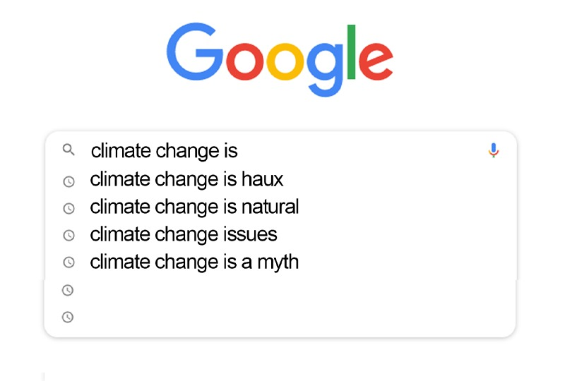
Figure 1 Google autocomplete results obtained in February 2015: (a) Climate change is…
View description - Figure 1 Google autocomplete results obtained in February 2015: (a) Climate change ...

It is always worth reflecting on the objectivity – or otherwise – of internet searches, and how the results you find are influenced by others.
You could also try searching on different search engines or devices, or repeat the searches at a later date. Do you get different results?
Back to - Part

Activity 2 Global warming

Answer
In brief, thousands of land measurements made over time and in different places are combined into a single, globally averaged temperature. An upward trend in the globally averaged temperature is referred to as global warming.
Back to - Activity 2 Global warming

Activity 3 Global sea level rise

Answer
Right:
land ice (ice sheets and glaciers resting on land)
Wrong:
sea ice (ice floating in the oceans)
neither land ice nor sea ice
both land ice and sea ice
Back to - Activity 3 Global sea level rise

Discussion
Only the melting of land ice changes global sea levels: melting sea ice does not change sea level.
Back to - Activity 3 Global sea level rise

Activity 4 Climate impacts on life

Discussion
Haiku 1
(based on extracts 3 and 4):

Ocean life moving
Nature’s calendar shifting
When will the change end?

Haiku 2
(based on extracts 1, 3, 5, 6, 7 and 10):

From fish to forest
Coral, conifer and krill
None are left untouched.

Back to - Activity 4 Climate impacts on life

Activity 5 Extreme weather events

Part

Answer
Extreme weather events can include heatwaves, storms, forest fires, floods and droughts.
Back to - Part

Part

Answer
These events affect every part of the planet and every part of human life: agriculture, transport, power, housing, the environment and, of course, human health. The direct impacts on human health include physical injury, dehydration, malnutrition, heat stroke, water-borne diseases, malaria and famine.
Back to - Part

Activity 6 Prioritising human impacts

Answer
The correct matches are:
1
Negative impacts on wheat and maize yields for many regions.
2
Impacts on livelihoods of Sámi people in northern Europe.
3
Advanced timing of wine-grape maturation in Australasia.
4
More vulnerable livelihood trajectories for indigenous farmers in Bolivia due to water shortage, in part due to glacier retreat.
5
Increase in agricultural yields and expansion of agricultural areas in south-eastern South America.
6
Impact on livelihoods of Arctic indigenous peoples, through changing ice and snow conditions, and dwindling access to hunting grounds.
7
Increased shipping traffic across the Bering Strait.
8
The burden of human ill-health from climate change (relatively small compared with effects of other stressors and not well quantified).
Back to - Activity 6 Prioritising human impacts

Discussion
There are, of course, no right answers. It is a matter of judgement.
One could certainly argue that any risk to food production or water resources should be the first priority when considering geoengineering: for example, by controlling temperature and rainfall.
On the other hand, the world already produces enough food for the entire population. So other contributing factors to chronic hunger – poverty, agricultural infrastructure, conflict, unstable prices and food wastage – are just as urgent.
The Arctic peoples are relatively few in number, so the sea ice and climate on which they rely might be seen as lower priority considerations for geoengineering design – but their ways of life, and the ecosystems on which they depend, are unique in the world.
It's a tough balancing act, but these are the skills you will need to develop to become a successful geoengineer.
Back to - Activity 6 Prioritising human impacts

Activity 1 Heads or tails?

Part

Answer
Chances are they were not! In fact, your volunteer had only a 1.6% chance of getting it right (0.5 multiplied by itself six times).
Back to - Part

Part

Answer
They are much more likely to get this right. This is because they are predicting the average frequency of heads over six coin tosses rather than making six separate predictions for each individual coin toss.
Back to - Part

Part

Answer
As the number of coin tosses increases, it becomes harder to predict the sequence of coins and easier to predict the fraction that are heads. The random fluctuations of a coin toss are ironed out the more times you try, so the average fraction of heads becomes closer to 50%.
Back to - Part

Part

Answer
The first of these is like predicting weather because the sequence of specific coin tosses is analogous to a sequence of day-by-day events. The second is like predicting climate because the frequency of heads is analogous to the frequency of different types of weather.
Back to - Part

Activity 2 Human-caused factors

Discussion
Discussion: Future greenhouse gas emissions will depend on factors such as:
- global population and wealth
- political decisions, like the regulation of industrial sources
- how much energy we will use, and from which sources
- new technologies not yet imagined
- how we’ll make food and use the land.
Back to - Activity 2 Human-caused factors

Activity 3 Tweeting

Answer
There is no correct answer, but here is Piers’ version:

Figure 8 Piers Forster’s tweet representing the IPCC (2013) headline statement on global mean sea level.
View description - Figure 8 Piers Forster’s tweet representing the IPCC (2013) headline statement on ...

Back to - Activity 3 Tweeting

Activity 2

Answer
Right:
1%
Wrong:
0.1%
10%
20%
The answer is 1.6%. This is quite a small number! So you can see that only small adjustments in solar radiation are needed to offset the effects of increasing greenhouse gas concentrations.
Back to - Activity 2

Activity 3

Answer
The correct matches are:
fresh snow
1. (highest albedo)
thick cloud
2.
sea ice
3.
agricultural crops
4.
coniferous forest
5.
The correct answer, with typical albedo ranges (α), is:
- fresh snow (0.75–0.95)
- thick cloud (0.7–0.9)
- sea ice (0.2–0.3)
- agricultural crops (0.16–0.26)
- coniferous forest (0.05–0.15)
(Sea ice values are from IPCC (2013), cloud values are from Schneider et al. (2011), and other values are from Campbell and Norman (1998)).
Back to - Activity 3

Activity 4

Answer
Right:
1.5%
Wrong:
0.02%
4%
8%
The answer is 1.5%. This may seem like a small percentage, but the total urban area of the Earth’s surface is only around 3%. So we would need to cover half of all urban surfaces with perfectly reflective mirrors – and not only every roof and road, but every garden, body of water, and any other object (cars, humans, cats…) – in order to compensate for a doubling of atmospheric CO₂ concentrations.
Back to - Activity 4

Activity 1

Part

Answer
There is no correct answer, but one message to the minister might be:
‘We found that even if we reduced the solar radiation reaching the Earth to exactly balance the increased CO₂, the temperatures weren’t the same as if we didn’t have the extra CO₂’
Back to - Part

Part

Answer
Here is one possible answer:
‘Most models predict that many northern areas would be warmer than the preindustrial climate by a degree or more, particularly in the winter.’
Back to - Part

Part

Answer
Your answer might be:
‘Greenhouse gases and the Sun affect the temperature of the atmosphere in different ways. So the only way to get back to the original climate is to extract CO2 from the atmosphere – with carbon dioxide reduction methods, like bioenergy with carbon capture and storage.’
Back to - Part

Activity 2

Part

Answer
This could be a very similar key point to the temperature example, so maybe:
‘We found that even if we reduced the solar radiation reaching the Earth to exactly balance the increased CO₂, the rainfall patterns weren’t the same as if we didn’t have the extra CO₂.’
Back to - Part

Part

Answer
One answer – concentrating on land areas, because these are likely to be the regions that policy-makers are focused on – might be:
‘Most models predict the tropics will be drier by around half a millimetre a day all year round – and that northern high latitudes are also a bit drier in the summer.’
Back to - Part

Activity 1

Answer
A room thermostat controls the air temperature to be at a particular value. It monitors the temperature and is connected to the central heating system. If it senses the room temperature is too warm it turns the central heating down or off and vice versa.
Back to - Activity 1

Activity 1

Answer
There is obviously no correct answer to this! One possible response is to be broadly in favour of CDR and local SRM, and not in favour of global SRM. But views may change depending on future political responses – or lack thereof – to climate change. Certainly, CDR through BECCS is a method we should approach with an awareness of its limitations and potential impacts on habitats and food security.
Back to - Activity 1

Figure 1 Histograms showing one year of (invented) daily (a) temperature and (b) rainfall data.

Description
Figure 1a - This is an example histogram showing one year of invented daily temperature. This histogram displays bars vertically. The x or horizontal axis shows temperature in °C and the y or vertical axis shows frequency in days. The distribution shows a broad peak, with a peak in the range (14–15) °C
Figure 1b - This is an example histogram showing one year of invented daily rainfall. This histogram is a column chart which displays bars vertically. The x or horizontal axis shows rainfall in mm day-1 and the y or vertical axis shows frequency in days. The tallest column is for the lowest rainfall range (0–0.2) mm day-1 and the columns decrease with increasing rainfall.
Back to - Figure 1 Histograms showing one year of (invented) daily (a) temperature and (b) rainfall data.

Figure 2 Example histogram showing invented data for clothing types with different levels of warmth.

Description
This shows an example histogram of clothing types, a column chart with vertical bars. The x or horizontal axis shows an index of warmth (1-10, no units); the y or vertical axis shows frequency (days). There are 2 peaks to the distribution - one at clothing type 7, and another at clothing type 3.
Back to - Figure 2 Example histogram showing invented data for clothing types with different levels of warmth.

Figure 3 Example histogram showing invented data for mood types, ranging from negative to neutral to positive.

Description
This shows an example histogram of mood ranging from negative to neutral to positive. A column chart with vertical bars. The x or horizontal axis shows an index of mood (-10 - 10, no units); the y or vertical axis shows frequency. There are four peaks, with one positive, two negative and one neutral values of mood.
Back to - Figure 3 Example histogram showing invented data for mood types, ranging from negative to neutral to positive.

Figure 4 Example probability distributions showing invented daily (a) temperature and (b) rainfall

Description
Figure 4a - This is an example probability distribution graph showing one year of invented daily temperature. The x or horizontal axis shows temperature in °C from (8 to 22) °C in steps of 2 °C. The y or vertical axis shows density, from 0.00 to 0.25 in steps of 0.05. The graph is a smooth, bell shaped curve, with a peak in the range (14–15) °C
Figure 4b - This is an example probability distribution graph showing one year of invented daily rainfall. The x or horizontal axis shows rainfall in mm day-1 from (0 to 4) mm day-1. The y or vertical axis shows frequency in days, from 0 to 3.5. The graph is a smooth curve, decreasing exponentially from a maximum where rainfall = 0 mm day-1 to zero at 4 mm day-1.
Back to - Figure 4 Example probability distributions showing invented daily (a) temperature and (b) rainfall

Figure 5 A simple diagram of the Earth system, showing the interactions of the atmosphere, biosphere (living things), hydrosphere (liquid water), cryosphere (frozen water) and land surface.

Description
A simple diagram of the Earth system, showing the interactions of the atmosphere, biosphere (living things), hydrosphere (liquid water), cryosphere (frozen water) and land surface. These realms are illustrated respectively with images of a blue sky with clouds, a forest, the sea, snow on mountains and a crop. Red arrows are drawn to show that each realm interacts with each of the others.
Back to - Figure 5 A simple diagram of the Earth system, showing the interactions of the atmosphere, biosphere (living things), hydrosphere (liquid water), cryosphere (frozen water) and land surface.

Figure 6 Frequency histograms from dice rolls for (a) a fair die and (b) a loaded die.

Description
Figure 6a - This shows frequency distributions from dice rolls for a fair dice. The x or horizontal axis shows values from 1 to 6. The y or vertical axis shows frequency from 0 to 25000. The 6 columns have equal heights (about frequency = 170000).
Figure 6b - This shows frequency distributions from dice rolls for a loaded dice. The x or horizontal axis shows values from 1 to 6. The y or vertical axis shows frequency from 0 to 25000. The 6 columns have different heights with the highest frequency for value = 2 and the lowest frequency for value = 6.
Back to - Figure 6 Frequency histograms from dice rolls for (a) a fair die and (b) a loaded die.

Figure 7 Weather dice

Description
This figure shows two dice. Three faces on each can be see and each shows a different weather symbol. The six symbols are: A white cloud, a black cloud with raindrops, a full sun, a black cloud with snow, a black cloud with a lightning bolt and a white cloud with sunshine.
Back to - Figure 7 Weather dice

Figure 1 Google autocomplete results obtained in February 2015: (a) Climate change is…

Description
Google autocomplete results obtained in February 2015. The search term is Climate change is and below it are 4 autocompleted options: climate change is haux, climate change is natural, climate change issues, climate change is a myth.
Back to - Figure 1 Google autocomplete results obtained in February 2015: (a) Climate change is…

Figure 2 The first of three parts of the IPCC Fifth Assessment Report. At 1535 pages, this represents a substantial body of work, and a substantial weight in paper.

Description
Figure 2a - This photograph shows a hardcopy of the IPCC Working Group 1 report. This is A4 size, but it is over 2 cm in thickness.
Figure 2b - This photograph shows a large conference room with delegates sat at long tables facing a large display screen.
Back to - Figure 2 The first of three parts of the IPCC Fifth Assessment Report. At 1535 pages, this represents a substantial body of work, and a substantial weight in paper.

Figure 3 (a) The worldwide network of land weather stations (Rennie et al., 2014). The colour corresponds to the number of years of data available for each station. (b) A snapshot of locations measuring sea surface temperatures (NOAA, 2016).

Description
Figure 3a - This global map shows the worldwide network of land stations in the Global Land Surface Meteorological Databank (Rennie et al. 2014). The colour corresponds to the number of years of data available for each station. The network is older and denser over the USA, Europe, Australia and Japan; dense but newer over much of Asia and South America whilst sporadic over much of Africa, Northern Asia, Antarctica, Greenland (and ocean areas).
Figure 3b - This global map shows a snapshot of the locations of the NOAA Observing System Monitoring Centre network (NOAA, 2016) measuring sea surface temperatures with markers for drifting buoys, ships, moored buoys and shore & bottom stations. Drifting buoys have coverage across all oceans but with the highest density in the Pacific, southern Indian Ocean, South Atlantic and North Atlantic between the eastern USA and Africa. Ships are distributed mainly around coastlines and the centres of oceans, with high densities around the Chinese coast, the north Atlantic between the USA and Africa, the west African coast and around the European coast. Moored buoys are found within the central Pacific ocean, the Bay of Bengal, the west coast of Canada, the Great Lakes, and around the European coastline. Shore and bottom stations are mainly distributed around the east and west coasts of the USA and the Australian coast.
Figure 3c - This stacked line graph shows the fraction of sea surface temperature observations made with different methods: buckets (shaded blue), engine room intake and hull contact sensors (green), moored and drifting buoys (red) , and unknown (yellow). The x or horizontal axis shows the year from 1920 to about 2010. The vertical axis shows the fractional contribution to global average SST. The graph shows that measurements were exclusively by buckets initially, declining through the period to zero (with a steep decline, then recovery for the few years after 1940). Engine room intake measurements were introduced in the 1930's and have increased to about 0.4 (i.e. 40%)by the 1980's, declining a little to the present. Buoy measurements were introduced around 1980 and have increased almost linearly to over 0.6 of the total by the present day.
Back to - Figure 3 (a) The worldwide network of land weather stations (Rennie et al., 2014). The colour corresponds to the number of years of data available for each station. (b) A snapshot of locations measuring sea surface temperatures (NOAA, 2016).

Figure 4 Annual global mean surface temperature change for the period 1850–2012 (IPCC, 2013).

Description
This line graph shows Observed annual global mean surface temperature anomalies 1850 - 2012 from 3 data sets. The x or horizontal axis shows the year from 1850 to 2010. The y or vertical axis shows temperature anomaly relative to 1961-1900 / °C, from (-0.4 to 0.6) °C.
The data sets are shown as 3 lines - HadCrut in black, GISS in blue and MLOST in orange. The black line covers the whole time extend whilst the other two commence in 1880. The three lines agree well for much of the time though there are small differences and show fluctuations of less than one degree between years. The graph starts around fairly steady values up to 1900 (with a peak just before 1880), a small decline from 1900 to 1910 and a general rise from 1910 onwards.
The graph has no gridlines and the lines join points without symbols.
Back to - Figure 4 Annual global mean surface temperature change for the period 1850–2012 (IPCC, 2013).

Figure 5 Map of the observed surface temperature change from 1901 to 2012 (IPCC, 2013). Trends have been calculated where data availability permits a robust estimate, while other areas are white, indicating there is not enough data. Grid boxes where the long-term change is significantly larger than the short-term fluctuations are indicated by a + sign.

Description
This map is colour coded in square cells on a grid, mostly with crosses in each cell, to show the change of temperature over the globe. Data points are over land and oceans. Most regions show temperature increases over 0.20 °C, some as high as 2.5 °C (including central Asia and parts of west Africa and Brazil). There are some decreases e.g. in the ocean South of Greenland. Some areas are white, largely Antarctica, the polar oceans and some regions of the Pacific Ocean and Africa.
Back to - Figure 5 Map of the observed surface temperature change from 1901 to 2012 (IPCC, 2013). Trends have been calculated where data availability permits a robust estimate, while other areas are white, indicating there is not enough data. Grid boxes where the long-term change is significantly larger than the short-term fluctuations are indicated by a + sign.

Figure 6 One of nineteen illustrated climate haiku by Greg Johnson (Johnson, 2013), this one relating to rainfall.

Description
This water colour painting shows green hills and trees. It has the words 'History, Air' and the Haiku Carbon Increases. Air warms through century past. More heavy rains fall.
Back to - Figure 6 One of nineteen illustrated climate haiku by Greg Johnson (Johnson, 2013), this one relating to rainfall.

Figure 7 Observed precipitation changes for the period 1951–2010. The trends are calculated with the same criteria for data as Figure 5 (IPCC, 2013).

Description
This global map has coloured cells colour coded for changes in rainfall, measured in mm yr-1 per decade. Blue tones show increases, up to 100 mm yr-1, brown tones show decreases down to -100 mm yr-1 and below. Data is almost exclusively over land, with the no data in Greenland, northern Canada and Asia, much of Africa and Antarctica. Increases can be seen in Europe and much of Asia, Norther America and parts of South America, southern Africa and most of Australia. Decreases can be seen in the Mediterranean, much of China, West Africa and southern and western Australia. Some of the data has crosses, including USA, Europe, Argentina, China and northern Australia.
Back to - Figure 7 Observed precipitation changes for the period 1951–2010. The trends are calculated with the same criteria for data as Figure 5 (IPCC, 2013).

Figure 8 Floating sea ice does not increase sea level when it melts, because the volume of sea ice which is underwater is the same as the volume of water which is left when the floating sea ice melts.

Description
A diagram with a brown square on the left, with a white, smaller rectangle on top. Inside the brown square, there is the text: Land ice raises sea level when it enters the ocean. There is an arrow coming from the left, white rectangle pointing down to the right blue box. On the right-hand side, there is a blue box, with a smaller white rectangle overlapping the blue box. Where the rectangle overlaps the blue box, there is a dashed line, forming a smaller rectangle inside the bigger rectangle. This is labelled with the following text: Submerged volume of sea ice is equal to volume of water when sea ice melts.
Back to - Figure 8 Floating sea ice does not increase sea level when it melts, because the volume of sea ice which is underwater is the same as the volume of water which is left when the floating sea ice melts.

Figure 9 Satellite images of the (a) Greenland and (b) Antarctic ice sheets.

Description
Figure 9a - Satellite image of Greenland, with the ice cap shown as almost uniform white across nearly all of the country.
Figure 9b - Satellite image of the Antarctic ice sheet, with the ice shown as pale blue and grey over the whole land mass.
Back to - Figure 9 Satellite images of the (a) Greenland and (b) Antarctic ice sheets.

Figure 10 Ice melt haiku (Johnson, 2013).

Description
This water colour painting shows glaciers and on a mountain landscape, with some of the mountains exposed. It has the words 'History, Ice' and the haiku: Glaciers and Ice Sheets melt worldwide, speed increasing. Sea ice, snow retreat.
Back to - Figure 10 Ice melt haiku (Johnson, 2013).

Figure 11 Tide staff used by NOAA ‘Teachers at Sea’ Rosalind Echols and Avery Marvin to check against tide gauge data while surveying the ocean floor off Alaska.

Description
This photo shows a Tide Staff - a vertical ruler at the sea’s edge.
Back to - Figure 11 Tide staff used by NOAA ‘Teachers at Sea’ Rosalind Echols and Avery Marvin to check against tide gauge data while surveying the ocean floor off Alaska.

Figure 12 Electoral campaign, by Isaac Cordal (Berlin, Germany, 2011), popularly known as Politicians Discussing Global Warming.

Description
This photo shows an art installation with a group of men in suits standing in a flooded cityscape.
Back to - Figure 12 Electoral campaign, by Isaac Cordal (Berlin, Germany, 2011), popularly known as Politicians Discussing Global Warming.

Figure 13 A polar bear in its marine environment. For good or bad, this species is an icon commonly used in discussions of climate change.

Description
This photograph shows a polar bear swimming.
Back to - Figure 13 A polar bear in its marine environment. For good or bad, this species is an icon commonly used in discussions of climate change.

Figure 14 Some types of plankton, including foraminifera (IPCC, 2014).

Description
This shows drawings of eight types of plankton, including foraminifera. Coccolithophorids - spherical organisms. Radiolaria - several round segments decreasing to a point at one end, spines emerging from the other. Diatoms - extended straight body with spines emerging radially. Copepods - thin segmented bodies with 2 stalks at one end, emerging perpendicular to the body. Other phytoplankton - extended or compact bodies with green spots. Euphauslids - shrimp-like with segmented bodies and several pairs of legs. Foraminifera - made from several spherical sections. Salps - barrel shaped, extended bodies.
Back to - Figure 14 Some types of plankton, including foraminifera (IPCC, 2014).

Figure 15 (a) Morro da Carioca, Angra dos Reis in the State of Rio de Janeiro, Brazil, where heavy rain caused fatal mudslides and flooding in January 2010. (b) A sign in Rawnsley Park Station, South Australia, rendered unnecessary by the 2007–08 drought .

Description
Figure 15a - This photograph shows a mudslide flowing down a hillside towards a town.
Figure 15b - This photograph shows a 'No swimming' sign next to a dried up lake.
Back to - Figure 15 (a) Morro da Carioca, Angra dos Reis in the State of Rio de Janeiro, Brazil, where heavy rain caused fatal mudslides and flooding in January 2010. (b) A sign in Rawnsley Park Station, South Australia, rendered unnecessary by the 2007–08 drought .

Figure 16 (a) Sámi reindeer. (b) Sámi musician Mari Boine. (c) ‘Team Sámi’ at the Arctic Winter Games in 2014.

Description
Figure 16a - This photograph shows a Sami reindeer.
Figure 16b - This photograph shows a female musician holding an instrument which looks like a large flat drum.
Figure 16c - This photograph shows four sport women dressed in winter sports clothes.
Back to - Figure 16 (a) Sámi reindeer. (b) Sámi musician Mari Boine. (c) ‘Team Sámi’ at the Arctic Winter Games in 2014.

Figure 1 A ‘radiative forcing’ (mystery hand) acts to change the ‘Earth’s energy budget’ (thermostat dial) which produces a change in climate (room temperature).

Description
This photograph shows a hand moving the dial on a central heating thermostat.
Back to - Figure 1 A ‘radiative forcing’ (mystery hand) acts to change the ‘Earth’s energy budget’ (thermostat dial) which produces a change in climate (room temperature).

Figure 2 (a) A Stradivarius violin. (b) Sunspots on 3 March 2015.

Description
Figure 2a shows a photograph of a Stradivarius violin. Figure 2b shows an image of the Sun on 3 March 2015 with three sunspots marked as black dots.
Back to - Figure 2 (a) A Stradivarius violin. (b) Sunspots on 3 March 2015.

Figure 3 An example reconstruction of total solar irradiance (solar output reaching the Earth) since 1850 (Krivova/Ball). Direct observations from satellite (Physikalisch-Meteorologisches Observatorium Davos, PMOD) are also shown for the later period. (Adapted from IPCC, 2013a)

Description
Figure 3 is a line graph that shows total solar output in W m-2 on the y or vertical axis against year on the x or horizontal axis (from 1850 to the current time). The graph shows two lines which have several peaks and troughs, illustrating oscillating data.
The first (a blue line) represents the Krivova/Ball dataset with the output oscillating around a constant value of around 1361 W m-2 from 1850 to 1940, with a peak to peak range of about 0.4 W m-2. There are 4-5 oscillations per 50 years. From 1940, the pattern continues, but oscillating around a higher mean level of about 1361.5 W m-2, and a larger peak - to peak range, of about 0.7 W m-2. This pattern decreases a little over the period from 1960 to 2000.
The second line (a red line) represents the PMOD data set for the period from 1978. This follows a similar oscillating pattern to the Krivova/Ball line, but with lower values to the blue graph and decreasing a little over that period.
Back to - Figure 3 An example reconstruction of total solar irradiance (solar output reaching the Earth) since 1850 (Krivova/Ball). Direct observations from satellite (Physikalisch-Meteorologisches Observatorium Davos, PMOD) are also shown for the later period. (Adapted from IPCC, 2013a)

Figure 4 Not just a pretty face: livestock are a major emitter of greenhouse gases.

Description
This photograph shows a calf.
Back to - Figure 4 Not just a pretty face: livestock are a major emitter of greenhouse gases.

Figure 5 Atmospheric concentrations since 1850 of (a) CO2 to 2014; (b) CH4 to 2011; (c) N2O to 2011. (Data from Table 1.1a in IPCC, 2013b)

Description
Figure 5 is an interactive line graph that plots greenhouse gas concentrations on the y or vertical axis, against year from 1850 to 2020 on the x or horizontal axis. On the interactive, the horizontal axis can be expanded to beyond 2100 and the vertical axis can be expanded to beyond 2000 ppm. The graph has 3 data sets: carbon dioxide concentrations, which rise from 286.8 ppm in 1850 to 391.6 ppm in 2011 and then 398.6 ppm in 2014; methane concentrations, which rise from 801.6 ppb in 1850 to 1803.0 ppb in 2011, and nitrous oxide concentrations, which rise from 270.4 ppb in 1850 to 324.0 ppb in 2011.
Back to - Figure 5 Atmospheric concentrations since 1850 of (a) CO2 to 2014; (b) CH4 to 2011; (c) N2O to 2011. (Data from Table 1.1a in IPCC, 2013b)

Figure 6 Global mean surface temperature changes for the period 1850–1972 (adapted from IPCC, 2013a).

Description
Figure 6 shows variation of temperature from the HadCrut Dataset. It is shown as a line graph of Temperature Anomaly relative to 1850–1879 in °C against year from 1850–1972. The graph shows a noisy pattern, but there is a decline from 1850 to 1910, an increase from 1910 to about 1940, then a small decrease from 1940–1972.
Back to - Figure 6 Global mean surface temperature changes for the period 1850–1972 (adapted from IPCC, 2013a).

Figure 7 A collage of newspaper articles reporting predictions of global cooling from the 1970s.

Description
A collage of newspaper articles reporting predictions of global cooling in January 1970 (‘Colder Winters Held Dawn of New Ice Age’ and ‘Scientists See Ice Age In the Future’, Washington Post) and May 1975 (‘Scientists Ponder Why World’s Climate Is Changing; a Major Cooling Widely Considered to Be Inevitable’, New York Times). The collage was made by an American conservative think tank and also includes a story from May 1932 about melting ice caps (‘Next Great Deluge Forecast by Science’, New York Times).
Back to - Figure 7 A collage of newspaper articles reporting predictions of global cooling from the 1970s.

Figure 8 Global sulfur dioxide emissions (solid line) with 5–95% uncertainty bounds (dashed lines) (Smith et al., 2011).

Description
Figure 8 is a line graph that plots global sulfur emissions in Gg of SO₂ on the y or vertical axis, against year from 1900 to 2000 on the x or horizontal axis. The data has 12 overlapping data sets, which all show a similar pattern: a rise from 20,000 Gg in 1900 to about 50,000 Gg 1950, a steeper rise to a peak of about 140,000 Gg in 1980 and a steady decline to about 120,000 in 2000.
Back to - Figure 8 Global sulfur dioxide emissions (solid line) with 5–95% uncertainty bounds (dashed lines) (Smith et al., 2011).

Figure 9 Global sulfur dioxide emissions by region for the four highest emitting regions (North America; Europe, FSU (former Soviet Union); and East Asia (Smith et al., 2011).

Description
Figure 9 is a line graph that plots regional sulfur emissions in Gg of SO2 on the y or vertical axis, against year from 1850 to about 2010 on the x or horizontal axis. Four lines are plotted, each representing different global regions: North America, Europe, former Soviet Union (FSU) and East Asia. Three of the curves (North America, Europe and FSU) show a similar pattern, increasing to peaks of 20,000 Gg to 40,000 Gg around 1940 then decreasing towards the present. East Asia shows, on this scale, fairly small increases from zero in 1850 up to about 1950, then steeper increases for the remainder of the period covered.
Back to - Figure 9 Global sulfur dioxide emissions by region for the four highest emitting regions (North America; Europe, FSU (former Soviet Union); and East Asia (Smith et al., 2011).

Figure 10 Chichester Canal, by J. M. W. Turner.

Description
This is a photograph of J.M.W. Turner’s Chichester Canal painting. It shows a small boat fishing boat and a taller boat with upright sails on the canal. The hue of the painting is yellow, suggesting a sunset or sunrise.
Back to - Figure 10 Chichester Canal, by J. M. W. Turner.

Figure 11 The troposphere (red-brown), stratosphere and beyond taken from the International Space Station.

Description
This photograph shows the Earth and moon taken from the International Space Station. The view looks out over the Earth, with the troposphere as the horizon (in red-brown). Above that is the stratosphere, but the stratosphere is not clearly delineated from space. The moon is seen in the centre of the image, appearing above the horizon.
Back to - Figure 11 The troposphere (red-brown), stratosphere and beyond taken from the International Space Station.

Figure 12 Delhi Metro system map, indicating flows of people from one part of the system to another.

Description
The 1.19 is the Delhi Metro system map, indicating flows of people from one part of the system to another. The network is represented as straight lines with markers for stations, like the London Underground map. Red dashed lines show the main flows of travellers between the edges and towards the centre of the map. Black dashed lines show another flow of travellers in a ring around the centre of the map.
Back to - Figure 12 Delhi Metro system map, indicating flows of people from one part of the system to another.

Figure 13 Example sea surface temperature changes during El Niño and La Niña events, showing the characteristic pattern of eastern Pacific warming (a) and cooling (b).

Description
Figure 13 shows two images that show sea surface temperature anomalies during an El Niño as ‘heat maps’ of the globe. The heat maps use a rainbow colour scale to represent temperature changes, with areas coloured red showing a warming and violet showing a cooling.
Figure 13a shows the characteristic pattern of eastern Pacific warming. This global image shows a band coloured red across most of the equator in the Pacific Ocean, indicating temperature increases up to 4 °C.
Figure 13b shows the characteristic pattern of eastern Pacific and cooling. This global image shows a band coloured blue across most of the equator in the Pacific Ocean, indicating temperature decreases up to 4 °C.
Back to - Figure 13 Example sea surface temperature changes during El Niño and La Niña events, showing the characteristic pattern of eastern Pacific warming (a) and cooling (b).

Figure 14 What’s really warming the world? Use the down arrow to scroll through the figure.

Description
Figure 14 is an interactive figure with a series of frames to illustrate the idea summed up in this title: What’s really warming the world? The interactive is credited to Eric Roston and Blacki Migliozzi, June 24, 2015. Each frame has some text and a graph. Frame 1 text reads: Skeptics of manmade climate change offer various natural causes to explain why the Earth has warmed 1.4 degrees Fahrenheit since 1880. But can these account for the planet's rising temperature? Scroll down to see show how much different factors, both natural and industrial, contribute to global warming, based on findings from NASA's Goddard Institute for Space Studies. Frame 1 is a line graph that shows temperature difference from the 1880 - 1910 Average in °F, on the y or vertical axis, ranging from -2 °F (labelled ‘Colder’) to - +2 °F (labelled ‘Hotter’). The x or horizontal axis shows time, from 1880 to 2014, and this axis intersects the y axis at 0 °F. The graph shows a line lies close to the horizontal, i.e. with values of 0 °F temperature change. From 1917, the line increases up to the final point, which must have a temperature difference of 1.4 °F in 2014. From 1930, the temperature differences are always greater than 0 °F The graph fluctuates with variation of up to about 0.7 °F from year to year. The graph is labelled ‘This line shows the measured, or “observed,” land-ocean temperature Frame 2 is titled: Is it the Earth’s Orbit? Frame 2 text reads: The Earth wobbles on its axis, and its tilt and orbit change over many thousands of years, pushing the climate into and out of ice ages. Yet the influence of orbital changes on the planet's temperature over 125 years has been negligible. Frame 2 text is the temperature difference graph from Frame 1, but has had data added to it as a separate line. This shows fluctuations in temperature, labelled ‘Orbital Changes’, i.e. the contribution to the temperature change due to Orbital Changes. This line remains close to temperature change = 0 °F, with very small fluctuations from year to year (less than ±1°F). The confidence band, labelled ‘This band shows where temperatures fall in 95% of climate observations, and shows a confidence of about ±0.5 °F – this is a typical confidence band for all subsequent frames. This graph sets the pattern for subsequent frames. Frame 3 is titled: Is it the Sun? Frame 3 text reads: The sun’s temperature varies over decades and centuries. These changes have had little effect on the Earth’s overall climate Figure 3 graph is the Frame 1 graph with temperature data added to it, labelled ‘Solar’. This line remains close to temperature change = 0 °F, with very small fluctuations from year to year (less than ±1°F) Frame 4 is titled: Is it Volcanoes? Frame 4 text reads: The data suggest no. Human industry emits about 100 times more CO₂ than volcanic activity, and eruptions release sulfate chemicals that can actually cool the atmosphere for a year or two. Frame 4 graph is the Frame 1 graph with temperature data added to it, labelled ‘Volcanic’. This line remains close to temperature change = 0 °F, with very small fluctuations from year to year (less than ±1°F). However, there are some notable dips, down to about – 0.7 °F, in years 1885, 1903, 1964, 1983 and 1992. Frame 5 is titled: Is it all three of these combined? Frame 5 text reads: If it were, then the response to natural factors should match the observed temperature. Adding the natural factors together just doesn’t add up. Frame 4 graph is the Frame 1 graph with temperature data added to it, labelled ‘Natural factors’ which is very similar to the Volcanic data on the previous frame, i.e. the line remains close to temperature change = 0 °F, with very small fluctuations from year to year (less than ±1°F). However, there are some notable dips, down to about – 0.7 °F, in years 1885, 1903, 1964, 1983 and 1992. Frame 6 is titled: So if it’s not Nature, Is it Deforestation? Frame 6 text reads: Humans have cut, ploughed, and paved more than half the Earth’s surface. Dark forests are yielding to lighter patches, which reflect more sunlight – and have a slight cooling effect. Frame 6 graph shows the frame 1 graph with temperature data added to it, labelled ‘Land Use’. This line remains close to temperature change = 0 °F, with very small fluctuations from year to year (less than ±1°F), until about 1940. From then until 2014, the temperature difference falls to about -0.2 °F. Frame 7 is titled: Or Ozone pollution? Frame 7 text reads: Natural ozone high in the atmosphere blocks harmful sunlight and cools things slightly. Closer to Earth, ozone is created by pollution and traps heat, making the climate a little bit hotter. What's the overall effect? Not much. Frame 7 graph shows the original graph with temperature data added to it, labelled ‘Ozone’. The line shows an increase in temperature differences, from about -0.1° F in 1880 to 0 °F between 1906 – 1930, increasing to positive values of about 0.2 °F by 2014. Frame 8 is titled: Or aerosol Pollution? Frame 8 text reads: Some pollutants cool the atmosphere, like sulfate aerosols from coal-burning. These aerosols offset some of the warming. (Unfortunately, they also cause acid rain). Frame 8 graph is the Frame 1 graph with temperature data added to it, labelled ‘Aerosols’. The line a steady value of about -0.1°F (with similar size fluctuations) from 1880 to about 1920, then a steady decline to about -0.8 °F by 2014. Frame 9 is titled: No, it Really is greenhouse Gases Frame 9 text reads: Atmospheric CO₂ levels are 40 per cent higher than they were in 1750. The green line shows the influence of greenhouse gas emissions. It’s no contest. Frame 9 graph is the Frame 1 graph with temperature data added to it, labelled ‘Greenhouse gases’. This line increases from 0 °F in 1880 to almost +2 °F in 2014. The rate of increase of the curve increases through this period too. Frame 10 is titled: See for yourself Frame 10 text reads: Greenhouse gases warm the atmosphere. Aerosols cool it a little bit. Ozone and land-use changes add and subtract a little. Altogether, they match the observed temperature, particularly since 1950. Frame 10 graph is the Frame 1 graph with temperature data added to it, labelled ‘Human Factors’. This matches the ‘Observed line closely’ though smoothing through the year to year variations. However, the ‘Human Factors line is mostly above the ‘Observed’ line up to about 1934, by up to about 0.3 °F. Frame 11 is titled: Compare and Contrast Frame 11 text reads: Putting the possible natural and human causes of climate change alongside one another makes the dominant role of greenhouse gases even more plainly visible. The only real question is: What are we going to do about it? This is the same graph as the previous frame, ‘See for yourself’.
Back to - Figure 14 What’s really warming the world? Use the down arrow to scroll through the figure.

Figure 1 (a) Population and (b) primary energy consumption in the four scenarios underlying the RCPs (van Vuuren et al., 2011).

Description
Figure 1(a) is a graph displaying four lines. It plots population (mlns) on the y or vertical axis, against year from 2000 to 2100. All four lines start from about 6000 and represent RCP2.6, RCP4.5, RCP6 and RCP8.5. RCP2.6, RCP4.5 and RCP6 follow a similar curve where they steadily increase up to 9000 and then very slightly and gradually decline to just under 9000 by 2100. RCP8.5 has a much steeper curve, reching 12000 in 2090 and then very slightly dropping down again by 2100. Figure 1(b) is a graph displaying four lines plotting primary energy consumption (EJ) for the four RCPs shown in figure 1(a). The y or vertical axis plots energy consumption (EJ) against year from 2000 t 2100. RCP2.6, RCP4.5 and RCP6 all start just under 500 EJ and follow a similar curve where they steadily increase up to 750 EJ by 2100, with RCP4.5 being just above and nearly reaching 1000. RCP6 follows the same path but has a much steeper incline, which drops again at 2060 and then slowly increases by 2080. RCP 8.5 starts at 500 EJ and then follows a steep incline up to 1750 EJ by 2100.
Back to - Figure 1 (a) Population and (b) primary energy consumption in the four scenarios underlying the RCPs (van Vuuren et al., 2011).

Figure 2 (a) Emissions and (b) concentrations of CO2 in the four RCPs (van Vuuren et al., 2011).

Description
Figure 2(a) is a graph displaying four lines plotting carbon dioxide emissions/GtC for the four RCPs. The y or vertical axis plots emissions (in GtC) against year from 2000 to 2100. RCP2.6 shows a short increase in emissions until about 2020 then a steady decrease to zero. RCP 4.5 shows an increase until about 2045, a decrease until about 2080 then a steady value of about 5 GtC. RCP6 shows an increase until about 2060 then a decrease to about 13 GtC. RCP8.5 shows an increase to almost 30 GtC by 2100. Figure 2(b) is a graph displaying four lines plotting primary energy consumption (EJ) for the four RCPs. RCP2.6 starts at 370 EJ and shows a sharp increase to about 920 EJ by 2100. RCP 4.5 starts at 370 EJ and shows a much more gradual increase to 650 EJ by 2100. RCP6 starts at 370 EJ and shows an increase to about 520 EJ at 2062 and then more or less stays at a similar level until 2100. RCP8.5 starts at 370 EJ and shows an increase until 2025 and then plateus gradually decreasing until 2100, ending on 440 EJ.
Back to - Figure 2 (a) Emissions and (b) concentrations of CO2 in the four RCPs (van Vuuren et al., 2011).

Figure 3 Projected mean surface air temperature change in 2081–2100 displayed as anomalies with respect to 1986–2005 for RCP4.5 from each of the 42 climate models used in IPCC AR5 (IPCC 2013). Use the magnifying glass to see the variation in predictions in more detail.

Description
This image is a composite of 42 maps of the world showing the output from 42 climate prediction models. The maps are colour coded with changes in mean GMST change. Shades of red and orange are used to represent increases in temperature, whilst shades of blue represent decreases, with the range of temperature changes from (-2 - +11) °C. The predictions are for changes from (1986-2005) to (2081-2000). Most models show temperature increases over the whole of their area, with typically larger temperature rises in continents compared to oceans and the biggest rises in norther, arctic regions. One model, labelled FIO-ESM, shows temperature falls over Greenland, the North Atlantic and Northern Europe. Several models show temperature falls in the ocean around Antarctica.
Back to - Figure 3 Projected mean surface air temperature change in 2081–2100 displayed as anomalies with respect to 1986–2005 for RCP4.5 from each of the 42 climate models used in IPCC AR5 (IPCC 2013). Use the magnifying glass to see the variation in predictions in more detail.

Figure 4 Past and projected annual mean GMST from the world’s climate models, relative to 1986–2005. Black and grey show simulations of the past, and blue and orange are predictions for RCP2.6 and RCP8.5 respectively. Solid lines show the mean, and shading the 90% range. (Adapted from IPCC, 2013)

Description
Figure 4 is a line graph that plots past and projected annual mean GMST from the multi-model ensemble, relative to 1986–2005. Three lines are plotted: historical, RCP2.6 and RCP8.5. Historical data is plotted from 1950 to 2005, and RCP2.6 and RCP8.5 are plotted from 2005 to 2100.
The graph shows Temperature change (in °C) on the y or vertical axis against year on the x or horizontal axis. The historical temperature change rises from a little below 0 °C in 1950 to just above 0 °C in 2005.
RCP 2.6 shows the change rising gently to a peak around 2050 at close to 1 °C then it maintains steady value up to 2100.
RCP 8.5 shows a steady rise to an change of about 4 °C in 2100.
There are shaded regions around each line to show the 90% uncertainty range. This is typically around ± 0.2 °C or less for the historic data, around ± 0.5 °C for the RCP2.6 data by 2100, and around ±0.7 °C for the RCP8.5 data by 2100.
Back to - Figure 4 Past and projected annual mean GMST from the world’s climate models, relative to 1986–2005. Black and grey show simulations of the past, and blue and orange are predictions for RCP2.6 and RCP8.5 respectively. Solid lines show the mean, and shading the 90% range. (Adapted from IPCC, 2013)

Figure 5 Predictions of mean GMST change 2081–2100 relative to 1986–2005 for the scenarios RCP2.6 (a) and RCP8.5 (b) (IPCC, 2013).

Description
Figure 5 is colour coded global map for mean change of temperature from 2081 -2100, relative to 1986 - 2005, for RCP2.6 scenarios. It typically shows temperature increases of about 0.5 -1 °C over the oceans, North and South of the Equator, 1-1.5°C over continents and 1.5 - 3 °C over the Arctic.
Figure 5 is colour coded global map for mean change of temperature from 2081 -2100, relative to 1986 - 2005, for RCP28.5 scenarios. It typically shows temperature increases of about 1-2 °C over the oceans, south of the equator, 2-3 °C over the oceans North of the equator, 4-7 °C over most of the continents and up to 11 °C over the Arctic.
Back to - Figure 5 Predictions of mean GMST change 2081–2100 relative to 1986–2005 for the scenarios RCP2.6 (a) and RCP8.5 (b) (IPCC, 2013).

Figure 6 Piers Forster’s tweet representing the IPCC (2013) assessment that ‘The contrast in precipitation between wet and dry regions and between wet and dry seasons will increase, although there may be regional exceptions’.

Description
This figure shows Piers Forster's tweet which says: Wet regions generally wetter, dry drier but with exceptions.
Back to - Figure 6 Piers Forster’s tweet representing the IPCC (2013) assessment that ‘The contrast in precipitation between wet and dry regions and between wet and dry seasons will increase, although there may be regional exceptions’.

Figure 7 Piers Forster’s tweet representing IPCC (2013) assessment that ‘It is very likely that the Arctic sea ice cover will continue to shrink and thin and that Northern Hemisphere spring snow cover will decrease during the twenty-first century as global mean surface temperature rises. Global glacier volume will further decrease’.

Description
This figure shows Piers Forster's tweet which says: Arctic sea ice, glaciers and snow will continue to shrink as temperatures rise.
Back to - Figure 7 Piers Forster’s tweet representing IPCC (2013) assessment that ‘It is very likely that the Arctic sea ice cover will continue to shrink and thin and that Northern Hemisphere spring snow cover will decrease during the twenty-first century as global mean surface temperature rises. Global glacier volume will further decrease’.

Figure 8 Piers Forster’s tweet representing the IPCC (2013) headline statement on global mean sea level.

Description
his figure shows Piers Forster's tweet which says: Sea level will continue to rise during 21C and accelerate.
Back to - Figure 8 Piers Forster’s tweet representing the IPCC (2013) headline statement on global mean sea level.

Figure 9 Who can outrun climate change? Maximum speed at which species can migrate, along with corresponding speeds required for each RCP scenario (adapted from IPCC, 2014).

Description
Figure 9 is a column bar chart indicating the range of speeds that different animal and plant species can migrate away from their current habitats. The y or vertical axis represents the maximum speed at which species can move (in kilometres per decade), from 0 to 100. The x or horizontal axis shows various species including trees, herbaceous plants, rodents and freshwater molluscs. Not all of the details are required, but as an example, trees might migrate at speeds of (0 - 15) km per decade whilst carnivorous mammals might migrate at speeds from (10 - 100 km per decade).
The graph also indicates speeds needed to survive the various scenarios e.g. RCP8.5 Global average scenarios require a speed of 20 km per decade, which is in range for all species here except trees; RCP8.5 scenarios over flat areas require a speed of over 70 km per decade, achievable by carnivorous mammals and plant -feeding insects but not rodents, primates or any plants shown.
Back to - Figure 9 Who can outrun climate change? Maximum speed at which species can migrate, along with corresponding speeds required for each RCP scenario (adapted from IPCC, 2014).

Figure 10 IPCC (2014) predictions for ocean acidification for RCP8.5, along with the estimated sensitivity of molluscs, crustaceans and corals – vulnerable animal phyla with socio-economic relevance (e.g. for coastal protection and fisheries) – for different RCPs (adapted from IPCC, 2014).

Description
This is contains a colour coded global map showing changes in ocean pH for the RCP8.5 scenarios. It shows that there is a reduction in pH (acidification) over most of the world's oceans. The map also indicates: Regions of mollusc and crustacean fisheries in many coastal regions (particularly North America, South America, India and East Asia. Regions of cold water corals, particularly in the fringes and middle of the north Atlantic and between Australia and New Zealand Regions of warm-water corals, including the oceans of Central America, and in an equatorial band across most of the Pacific and around the islands of south east Asia. Many of the highlighted regions are found in regions of large decreases of pH.
The figure also includes bar charts indicating the numbers of species in various groups, in a range of RCP scenarios (RCP4.5, RCP 6.0 and RCP 8.5, in order of increasing magnitude) Molluscs - negative effects on about 50% of species for all scenarios. Crustaceans - no effects or positive effects for the lightest scenario, increasing up to negative effects for 20% of species in the most sever scenarios. Cold water Corals - increasing number of species experiencing negative effects as the scenarios get worse. Warm water Corals - between 25 and 50 % of species affected, rising as the scenarios get worse.
Back to - Figure 10 IPCC (2014) predictions for ocean acidification for RCP8.5, along with the estimated sensitivity of molluscs, crustaceans and corals – vulnerable animal phyla with socio-economic relevance (e.g. for coastal protection and fisheries) – for different RCPs (adapted from IPCC, 2014).

Figure 1 Birds in the spray of the spherical El Alamein Fountain in Sydney.

Description
This photograph shows the El Alamein Fountain, which has a number of water fountains pointing outwards from one point in all directions, so it is effectively a sphere of nozzles spraying water in all directions.
Back to - Figure 1 Birds in the spray of the spherical El Alamein Fountain in Sydney.

Figure 2 ‘This is the NASA Sail Technology and Launch Location, otherwise known as STaLL. This is the place that will launch EarthShade … the solar sail that will soon unfurl four times further away than the Moon.’ (Repeat of Panel 12 from Session 1, Figure 2, an imagined image of a solar sail in the future.)

Description
The illustration shows a space scene. The solar sail is shown unfurled from a spacecraft. The view is from another industrial area. The moon is shown large, near to the space sail.
Back to - Figure 2 ‘This is the NASA Sail Technology and Launch Location, otherwise known as STaLL. This is the place that will launch EarthShade … the solar sail that will soon unfurl four times further away than the Moon.’ (Repeat of Panel 12 from Session 1, Figure 2, an imagined image of a solar sail in the future.)

Figure 3 Forbes article on using solar shields to ‘avert Climate Armageddon’ (September 2012).

Description
This figure shows an article from Forbes. The headline reads: Solar Geoengineering: Using Space Tech to Avert Climate Armageddon. The article was written by Bruce Dorminey.
Back to - Figure 3 Forbes article on using solar shields to ‘avert Climate Armageddon’ (September 2012).

Figure 4 ‘Blue Marble 2012’ images of the Earth showing (a) Africa and the Middle East, and (b) North America.

Description
Figure 4 shows two satellite images of the whole disc of the Earth, clearly showing land, sea and clouds. Figure 4a shows Africa and the Middle East; Figure 4b shows North America.
Back to - Figure 4 ‘Blue Marble 2012’ images of the Earth showing (a) Africa and the Middle East, and (b) North America.

Figure 5 The lighter buildings will reflect more incident radiation back out into space.)

Description
This scene shows roads with industrial buildings and many vehicles parked by them.
Back to - Figure 5 The lighter buildings will reflect more incident radiation back out into space.)

Figure 6 Proposed methods of stratospheric aerosol injection – artillery shells, a tall tower, aeroplanes and balloons – on a mountain, with supplies arriving by train.

Description
This drawing is a composite of methods that could be used to inject stratospheric aerosols, including aircraft with smoke following; artillery guns shooting shells; a tall tower with a chimney and plume atop; balloons carrying material upwards, shown with the balloon diameters increasing with height.
Back to - Figure 6 Proposed methods of stratospheric aerosol injection – artillery shells, a tall tower, aeroplanes and balloons – on a mountain, with supplies arriving by train.

Figure 7 Hong Kong sunset after the eruption of Pinatubo.

Description
This photograph shows a sunset scene, looking over a body of water. The hue of the image is yellow and hazy.
Back to - Figure 7 Hong Kong sunset after the eruption of Pinatubo.

Figure 8 Satellite image of ship tracks

Description
Figure 8 is a satellite photograph showing tracks of ships as bright lines criss-crossing cloud. The scene is close to the coast.
Back to - Figure 8 Satellite image of ship tracks

Figure 9 Artist’s impression of a sea spray vessel.

Description
Figure 9 is a drawing that shows a 3-hulled floating platform with tall chimneys for spraying sea droplets vertically upwards.
Back to - Figure 9 Artist’s impression of a sea spray vessel.

Figure 10 Diagram of a BECCS plant (adapted from Canadell and Schulze, 2014).

Description
Figure 10 is a drawing showing an industrial plant and trees. Arrows represent flows of carbon dioxide.
One flow is from the air to trees. The trees are labelled with 'Energy Crops and Biomass residue'.
Another flow is from the trees to the industrial plant, and is labelled with 'Combustion, Fermentation, Aerobic digestion and Gasification’.
A flow outwards from the plant is towards 'energy products' and is labelled 'Heat, Biohydrogen, Synthetic biofuels and electricity'.
A flow downwards into the ground from the plant is towards 'Geological Storage' and is labelled 'Saline aquifers’ and ‘Depleted oil and gas fields'.
Back to - Figure 10 Diagram of a BECCS plant (adapted from Canadell and Schulze, 2014).

Figure 11 Phytoplankton bloom in the South Atlantic Ocean, off the coast of Argentina.

Description
Figure 11 is a satellite image of a phytoplankton bloom, showing as cloudy pale patches against a much darker ocean background.
Back to - Figure 11 Phytoplankton bloom in the South Atlantic Ocean, off the coast of Argentina.

Figure 12 Low-tech and high-tech methods of CDR. (a) A handful of biochar. (b) An example design of a DAC plant by Carbon Engineering.

Description
Figure 12 shows a photograph of 2 hands holding a pile of black charcoal pellets. Figure 12 shows a photograph of an array of large fans in a desert region making up a DAC plant. The arrays are stacked in long rows 4 high. A car is shown for scale, it's length is approximately twice the diameter of a fan.
Back to - Figure 12 Low-tech and high-tech methods of CDR. (a) A handful of biochar. (b) An example design of a DAC plant by Carbon Engineering.

Figure 1 Some excerpts from Earth observations and models that you will explore in this session. Can you tell which are observations and which simulations?

Description
Figure 1 shows four images of Earth observation and modelling. The first two show a map of South and Central America and the Atlantic. The first shows red bands corresponding to latitudes equivalent to Central America and the Atlantic and violet bands corresponding to tropical latitudes. The next shows lines representing atmospheric circulation superimposed onto a map of the UK, France and the Iberian Peninsula, showing air circulation across the eastern Atlantic. The final image shows coloured bands (but no map), from red at the top of the image to violet at the bottom.
Back to - Figure 1 Some excerpts from Earth observations and models that you will explore in this session. Can you tell which are observations and which simulations?

Figure 2 European surface height in global climate models with differing horizontal resolutions: (a) typical model from the IPCC (2007) Fourth Assessment Report; (b) typical and (c) highest horizontal resolution models from the IPCC (2013) Fifth Assessment Report.

Description
Figure 2a is a two dimensional image of Europe, colour-coded for topographic height. It is divided into 12 x 16 rectangular cells with about 7 colours used; oceans are uniform blue. The UK is about 3 cells from north to south. Figure 2b is a three dimensional image of Europe, colour-coded for topographic height; many square cells of colour are used, and appear as columns; the UK is approximately 7 cells from north to south. Ocean depth is also coded.
Back to - Figure 2 European surface height in global climate models with differing horizontal resolutions: (a) typical model from the IPCC (2007) Fourth Assessment Report; (b) typical and (c) highest horizontal resolution models from the IPCC (2013) Fifth Assessment Report.

Figure 3 Mean of twelve climate model projections for the change in surface air temperature (°C) relative to the preindustrial period, averaged over (a) December, January and February (DJF) and (b) June, July and August (JJA), for a scenario of solar shield geoengineering (IPCC, 2013). See text for more details.

Description
Figure 3a is a map of the world. It shows temperature changes, averaged over 12 climate models, for the period December to January. The changes are colour coded (full-details in the caption). The biggest temperature anomalies are in the northern regions, with temperature increases roughly (1-4) °C. Some regions in the equatorial oceans and Australia show temperature falls of up to 1 ° C. There are block dots (stippling) over most of the world for areas where the models agree well.
Figure 3b is a map of the world. It shows temperature changes, averaged over 12 climate models, for the period June to August. The changes are colour coded (full-details in the caption). The biggest temperature anomalies are in the southern regions, particularly Antarctica, with temperature increases roughly (0.5-2.0) °C, with similar rises over Europe, Russia and Canada. Some regions in the equatorial oceans and India show temperature falls of up to 1 ° C. There are block dots (stippling) over most of the world for areas where the models agree well.
Back to - Figure 3 Mean of twelve climate model projections for the change in surface air temperature (°C) relative to the preindustrial period, averaged over (a) December, January and February (DJF) and (b) June, July and August (JJA), for a scenario of solar shield geoengineering (IPCC, 2013). See text for more details.

Figure 4 Same as for Figure 3 but for the change in precipitation (in millimetres per day, mm/day). (IPCC, 2013)

Description
Figure 4a is a map of the world. It shows precipitation changes, averaged over 12 climate models, for the period December to January. The changes are colour coded (full-details in the caption). The biggest increases are across the tropical latitudes (approximately 0.8-1.6 millimetres per day change), specifically the Atlantic between Africa and South America and the mid-Pacific. The biggest decreases are across sub-tropical latitudes (approximately -3.2 -1/6 millimetres per day), specifically South America, sub-Saharan Africa, the Indian Ocean and the South Pacific.
Figure 4b is a map of the world. It shows precipitation changes, averaged over 12 climate models, for the period June to August. The changes are colour coded (full-details in the caption).
Back to - Figure 4 Same as for Figure 3 but for the change in precipitation (in millimetres per day, mm/day). (IPCC, 2013)

Figure 5 (a) Smoke plumes generated during what are thought to be the first SRM field experiments. (b) The SPICE balloon, never used for the project.

Description
Figure 5a is a black and white photograph that shows a helicopter with smoke plumes coming from side protrusions. Figure 5b is a photograph showing a white helium filled balloon, with a hose joining the front to some equipment.
Back to - Figure 5 (a) Smoke plumes generated during what are thought to be the first SRM field experiments. (b) The SPICE balloon, never used for the project.

Figure 6 (a) German research vessel and icebreaker Polarstern off the Antarctic Peninsula in February 1994. The Polarstern was used for ocean fertilisation experiments such as the European Iron Fertilization Experiment and LOHAFEX. (b) Satellite image taken by NASA in August 2012 after media reports of a large-scale ocean iron fertilisation project in the northern Pacific Ocean. (c) Change in a measure of chlorophyll concentration, in milligrams per cubic metre, relative to the 10-year August mean, measured in August 2012 by NASA over approximately the same region as (b).

Description
Figure 6a is a photograph that shows a German research vessel and icebreaker Polarstern off the Antarctic Peninsula in February 1994. The Polarstern was used for ocean fertilisation experiments such as EIFEX and LOHAFEX.
Figure 6b shows a satellite image of the northern Pacific ocean, with an arc of bright cyan (labelled iron fertilisation bloom?) across the middle of the image, across a darker blue or green background for the rest of the scene; the date August 12 2012 is shown.
Figure 6c is a colour coded image of the same region and time as figure 6b (north Pacific) and shows 'Chlorophyll' concentration anomalies. Most of the scene has anomalies in the range (-1.6 - +1.6) milligrams per meter cubed; there are small patches in the top-right and bottom left showing increases as high as over 4 milligrams per meter cubed.
Back to - Figure 6 (a) German research vessel and icebreaker Polarstern off the Antarctic Peninsula in February 1994. The Polarstern was used for ocean fertilisation experiments such as the European Iron Fertilization Experiment and LOHAFEX. (b) Satellite image taken by NASA in August 2012 after media reports of a large-scale ocean iron fertilisation project in the northern Pacific Ocean. (c) Change in a measure of chlorophyll concentration, in milligrams per cubic metre, relative to the 10-year August mean, measured in August 2012 by NASA over approximately the same region as (b).

Figure 7 White houses in Santorini, Greece.

Description
This photograph shows white houses on a hillside in Santorini, Greece.
Back to - Figure 7 White houses in Santorini, Greece.

Figure 8 (a) Argus Gentle holds a new roofing material with an albedo of 0.97, made of polymers and a silver film. (b) An infrared photograph shows the much cooler region of the new material (Gentle and Smith, 2015).

Description
Figure 8a is a photograph that shows Argus Gentle holding new roofing material in his hand. The material is very bright so it looks like the Sun's light is reflecting from it like a mirror. He holds it in front of a white corrugated roof. Figure 8b is a colour coded infrared image that shows the corrugated roof (figure 8a) coloured orange, and the sample of the new material colour coded black, cooler than the roof behind it.
Back to - Figure 8 (a) Argus Gentle holds a new roofing material with an albedo of 0.97, made of polymers and a silver film. (b) An infrared photograph shows the much cooler region of the new material (Gentle and Smith, 2015).

Figure 9 (a) Indoor cooking with biomass stoves. (b) An improved biomass cookstove in India.

Description
Figure 9a is a photograph showing several women in a room cooking with two biomass stoves - one is an open fire in an open-topped box; the other is obscured by smoke or steam. Figure 9b is a photograph that shows a woman cooking with a pan on an improved biomass stove, which is directing an intense flame onto a pan; no smoke can be seen.
Back to - Figure 9 (a) Indoor cooking with biomass stoves. (b) An improved biomass cookstove in India.

Figure 1 Pushing Earth’s energy scales.

Description
This is a drawing of a set of balancing scales with the Earth (complete with arms & legs) sat atop. On the left pan, the sun weighs downwards; to the right, emissions from the surface are higher than the sub; robots appear to pull on both pans.
Back to - Figure 1 Pushing Earth’s energy scales.

Figure 3 Some people have referred to SRM as creating a global thermostat.

Description
This is a drawing of a thermostat, labelled 'Terra Thermo-o-start 400' with a circular control. 3 settings are labelled: too cold, just right and too hot.
Back to - Figure 3 Some people have referred to SRM as creating a global thermostat.

Figure 4 Repeat of Figure 4 in Session 4

Description
Figure 4 is a repeat of Figure 4 in Session 4. It is a line graph that plots past and projected annual mean GMST from the multi-model ensemble, relative to 1986–2005. Three lines are plotted: historical, RCP2.6 and RCP8.5. Historical data is plotted from 1950 to 2005, and RCP2.6 and RCP8.5 are plotted from 2005 to 2100.
The graph shows Temperature change (in °C) on the y or vertical axis against year on the x or horizontal axis. The historical temperature change rises from a little below 0 °C in 1950 to just above 0 °C in 2005.
RCP 2.6 shows the change rising gently to a peak around 2050 at close to 1 °C then it maintains steady value up to 2100.
RCP 8.5 shows a steady rise to an change of about 4 °C in 2100.
There are shaded regions around each line to show the 90% uncertainty range. This is typically around ± 0.2 °C or less for the historic data, around ± 0.5 °C for the RCP2.6 data by 2100, and around ±0.7 °C for the RCP8.5 data by 2100.
Back to - Figure 4 Repeat of Figure 4 in Session 4

Figure 5 Science is not like sausage-making, with sausage meat (data) going in and neat sausages (results) automatically coming out. Instead, there are many subjective judgements to be made about data and how it is interpreted that influence the outcomes.

Description
This figure is the drawing of a manual sausage machine, with data forced in through a funnel like mincemeat and a handle to turn to force the meat out as sausages (finished results). Instead, there are many subjective judgements to be made about data and how it is interpreted that influence the outcomes.
Back to - Figure 5 Science is not like sausage-making, with sausage meat (data) going in and neat sausages (results) automatically coming out. Instead, there are many subjective judgements to be made about data and how it is interpreted that influence the outcomes.

Figure 6 False-colour image of ozone over the South Pole in different years. All show the mean for September, the month of the typical spring minimum, except (e) which is a single day. Blue and purple colours show areas with less ozone, and yellows and reds more ozone. (a) 1979, the start of the records. (b) 1985, the year in which springtime Antarctic ozone losses were first published. (c) 1987, the year of the Montreal Protocol. (d) 1997, a decade later. (e) 24 September 2006, one of the days with the largest observed ozone hole size. (f) 2015

Description
This figure shows 6 colour coded satellite images of the amount of Ozone over the South Pole. Colours are coded from blue/purple to green to red yellow for increasing amounts of ozone. The globes are shown predominantly in green. Figure 6a is the mean for September 1979 and shows a pale blue region over Antarctica and an orange region around Antarctica. Figures 6b, c, d and f show means for September 1985, 1987, 1997 and 2015 respectively. Each has a dark blue/purple circular region around Antarctica. Figure 6e shows data for 24th September, 2006, showing the dark blue/purple region extending well beyond Antarctica, with a fringe around part of it in yellow/red.
Back to - Figure 6 False-colour image of ozone over the South Pole in different years. All show the mean for September, the month of the typical spring minimum, except (e) which is a single day. Blue and purple colours show areas with less ozone, and yellows and reds more ozone. (a) 1979, the start of the records. (b) 1985, the year in which springtime Antarctic ozone losses were first published. (c) 1987, the year of the Montreal Protocol. (d) 1997, a decade later. (e) 24 September 2006, one of the days with the largest observed ozone hole size. (f) 2015

Figure 7 A ‘red tide’ – the common name for a harmful algal bloom of toxic types of phytoplankton – this one is near Cape Rodney, New Zealand.

Description
This is a photograph of a 'red tide' in the ocean. It appears as a bright red fringe on the ocean very near the coastline.
Back to - Figure 7 A ‘red tide’ – the common name for a harmful algal bloom of toxic types of phytoplankton – this one is near Cape Rodney, New Zealand.

Figure 8 North Korea has a nuclear weapons programme. This photograph shows what appears to be a ballistic missile and a launch-pad vehicle during a military parade held at Kim Il-sung Square in Pyongyang on 15 April 2012.

Description
This photograph shows what appears to be a new ballistic missile and a launch-pad vehicle during a military parade held at Kim Il-sung Square in Pyongyang on 15 April 2012.
Back to - Figure 8 North Korea has a nuclear weapons programme. This photograph shows what appears to be a ballistic missile and a launch-pad vehicle during a military parade held at Kim Il-sung Square in Pyongyang on 15 April 2012.

Figure 9 Reporting of Ritz et al. (2015) by (a) BuzzFeed and (b) The Times in November 2015.

Description
Figure 9 shows two screen shots. The first is of the headline and sub-heading from a Buzzfeed article titles 'Sea level Rise from Antarctic Ice Melt May Not Be As Bad As Feared'. The text underneath states: ' A new study looking at thousands of models says that the worst case scenario might be lower than previously thought, and highlights the uncertainty in modelling ice sheets. The article is by Tom Chivers. The second is from the Environment section of The Times and is an article written by Ben Websiter, the Times' Environment Editor. The headline is: 'Threat of melting Antactic ice has been exaggerated'. The text shows reads: 'The risk of the Antarctic ice sheet to collapsing and flooding coasts around the world has been exaggerated, according to researchers. Previous studies had claimed that melting Antarctic ice could contribute 1 metre to the rising sea levels by the end of the century, flooding the homes of 150 million people and threatening dozens of coastal cities.'
Back to - Figure 9 Reporting of Ritz et al. (2015) by (a) BuzzFeed and (b) The Times in November 2015.

Figure 2 Evaluating models, as reported by the Mail on Sunday, March 2013: (a) headline; (b) accompanying graph based on figure produced by Ed Hawkins.

Description
Figure 2 is a screenshot of an online newspaper article. Figure 2a shows the article headline 'The Great Green Con no 1: The hard proof that finally shows global warming forecasts that are costing you billions were WRONG all along'. The article is by David Rose for the Mail on Sunday, published 23:37 16 March 2013.
Figure 2b hows a graph of temperature anomaly forecasts on the y or vertical axis (from -0.5 to +0.5 °C) against year on the x or horizontal axis (from 1950 to 2030). The anomaly increases from about - 0.2 °C in 1950 to + 1.2 °C by 2030. The temperature forecast includes 75% and 95 % confidence ranges.
A black line shows observations of temperature which are shown to lie largely within the 75% confidence range up to 2005, then starts to fall below it, appearing to fall outside and below the 95% confidence range by 2013.
Back to - Figure 2 Evaluating models, as reported by the Mail on Sunday, March 2013: (a) headline; (b) accompanying graph based on figure produced by Ed Hawkins.

Figure 3 The 2015 update to the GMST reconstructions: animated graphic by the blog ‘Carbon Brief’, January 2016.

Description
Figure 3 is a graph showing Global Surface Temperature anomaly in °C, relative to the 1961 - 1990 average, on the y or vertical axis (from -0.8 to +1.0) against year on the x or horizontal axis (1850 - 2015). Three similar data sets of global surface temperature anomalies are shown as line graphs: Met Office, NASA and NOAA. All three lines show an increase from around -0.3 °C in 1850 to 0 °C around 1940, increasing to + 0.8 °C by 2015.
The global mean temperature in 2016 and 2017 has remained at similar levels. So there seems to have been a shift in the climate narrative: the ‘pause’ button appears to have been replaced with ‘play’. Whether this is a long-term increase in warming or a brief fluctuation remains to be seen. Alternatively, entirely new stories about GMST may emerge.
Back to - Figure 3 The 2015 update to the GMST reconstructions: animated graphic by the blog ‘Carbon Brief’, January 2016.

Figure 4 The individualism–communitarianism and hierarchy–egalitarianism axes in cultural cognition theory (Kahan et al., 2011, 2015).

Description
Figure 4 shows two arrows (or axes). One runs vertical and one runs horizontal, intersecting to make a cross. On the horizontal scale the dimension is labelled from individualism at the left hand side to communitarianism at the right hand side. On the vertical scale, the dimension is labelled from egalitarianism at the bottom to hierarchy at the top.
Back to - Figure 4 The individualism–communitarianism and hierarchy–egalitarianism axes in cultural cognition theory (Kahan et al., 2011, 2015).

Figure 5 A condensation trail (‘contrail’).

Description
Figure 5 is a photograph of an airliner with 4 distinct contrails.
Back to - Figure 5 A condensation trail (‘contrail’).

Figure 6 Emissions of CO2, observed (black dots) and for the RCP scenarios (coloured lines) (Sanford et al., 2014). Numbers on the right-hand side are the median and 66% probability range of GMST projections above preindustrial levels in 2100 by Rogelj et al. (2012).

Description
Figure 6 is a line graph of global emissions of carbon dioxide in picograms per year on the y or vertical axis (from -1 to +29) against year (from 1980 to 2100) on the x or horizontal axis. Five lines are shown.
The first line plots observed emissions and increases from about 5 to 10 picograms per year in 1980 to about 11 picograms per year in 2014. This end point lies just above the RCP8.5 scenario.
Four lines are used to show forecast data for emissions from 4 RCP multi-model scenarios, from about 2010 with emissions of about 9 picograms per year :
Yellow RCP2.6 – steady decrease of emissions to about -1 picograms per year by 2100 , labelled with a temperature rise of 1.5 °C by 2100 (relative to preindustrial levels)
Green RCP4.5 – steady increase of emissions until about 2040 then a decrease to about 4 picograms per year by 2100, temperature rise of 2.4 °C by 2100
Blue RCP6.0 – steady increase of emissions until about 2080 then a decrease to about 14 picograms per year by 2100 , temperature rise of 3.0 °C by 2100
Orange RCP8.5 – steady increase of emissions to about 29 picograms per year by 2100 , temperature rise of 4.9 °C by 2100
Back to - Figure 6 Emissions of CO2, observed (black dots) and for the RCP scenarios (coloured lines) (Sanford et al., 2014). Numbers on the right-hand side are the median and 66% probability range of GMST projections above preindustrial levels in 2100 by Rogelj et al. (2012).

Video 1 A Song of Our Warming Planet by Daniel Crawford.

Transcript
[SOUND EFFECTS PLAYING]
[WATER DRIPPING]
DANIEL CRAWFORD:
I was in a class with Professor Scott St. George in the geography department and at one point, he posted a slide advertising for interns in his dendrochronology lab. And I was lucky enough to get that job.
He came to me with a set of data with the task of turning it into a piece of music, and we wound up with "A Song of Our Warming Planet." In the piece of music, each note will correspond to a year. And then the pitch of that note will represent the temperature of that year. So then for these really high pitches, that would mean a warmer year and then the lower pitches would be a cooler year.
The data comes from the Goddard Institute for Space Studies at NASA. It's a compilation of global annual surface air temperatures. Climate scientists have a standard toolbox to communicate their data, and what we're trying to do is we're trying to add another tool to that toolbox; another way to communicate these ideas to the people who might get more out of this than out of maps, graphs, and numbers.
Climate change is a defining issue of our generation, and it's still something that a lot of people don't fully understand. And what we're trying to do is to represent with the music, sort of, the immediacy and the importance that this issue has right now. And if we act on that, then maybe it won't be as much of an issue for the future.
[MUSIC PLAYING]
[MUSIC - DANIEL CRAWFORD AND SCOTT ST. GEORGE, “A SONG OF OUR WARMING PLANET”]
[MUSIC PLAYING]
Back to - Video 1 A Song of Our Warming Planet by Daniel Crawford.

Video 1 Sequence from the BBC’s ‘Climate Change: A Horizon Guide’, first broadcast in March 2015.

Transcript
SPEAKER 1:
The weather satellite depicts a planet that grieves for its lost harvests, while the price of food keeps going up.
HELEN CZERSKI:
Climate was becoming an issue but the central message was rather different to today.
SPEAKER 2:
Will a new Ice Age claim our lands and bury our northern cities? It's buried Manhattan Island before when great glaciers half a mile thick filled the valley of New York's Hudson River.
SPEAKER 1:
Unless we learn otherwise, it will be prudent to suppose that the next Ice Age could begin to bite at any time.
HELEN CZERSKI:
Global warming, as the theory was called then, was also being studied by scientists and it was mentioned in the same program, but almost as an interesting aside.
BERT BOLIN:
And there is a lot of oil and there are vast amounts of coal that they seem to be burning it with an ever increasing rate. If we go on doing this, in about 50 years time, the climate may be a few degrees warmer than today. We just don't know. Let's therefore keep an eye on the amount of carbon dioxide in the air.
HELEN CZERSKI:
It would be global warming, not the threat of an Ice Age, that would go on to become the dominant scientific issue. It's fascinating to look back to a time when global warming wasn't the main story. Scientists are only just beginning to get to grips with the complexities of the climate system and how and when it might be changing. And that just wasn't enough information around for them to be confident about what was happening. But that was beginning to change.
In the late 1970s, the arguments for a new Ice Age began to melt away. The theory was based on emissions of the gas sulfur dioxide, then a major atmospheric pollutant. This gas was known to have a cooling effect and some scientists calculated that this could push the planet into an Ice Age. But it soon became clear that both the amount of sulfur dioxide pollution and the size of its cooling effect had been overestimated. There would be no big freeze after all.
Back to - Video 1 Sequence from the BBC’s ‘Climate Change: A Horizon Guide’, first broadcast in March 2015.

Video 1 More proposed SRM methods.

Transcript
Dr Tamsin Edwards
I just wanted to quickly mention a few of the other ideas that have been put out there for solar radiation management, changing the albedo of the surface, the atmosphere or the clouds, on the Earth.
So you may have already heard of these when reading around the topic, but some people have proposed covering the Sahara in reflective, perhaps aluminium foil-- literally trying to change the albedo of a whole patch of the Earth-- or of the Greenland ice sheet. So covering the Greenland ice sheet in some kind of reflective blanket and that would protect the ice sheet as well as having the albedo effect.
People have talked about choosing or genetically modifying crops to be lighter, so kind of a lighter green so that they would be more reflective over crop areas. Instead of sulfate aerosol injection, people have talked about injecting diamond dust into the atmosphere as a different way to reflect particles that would have different effects on the atmosphere.
And one of the more science fiction ones is shooting lasers into clouds because that would potentially break up ice particles in the clouds into smaller pieces and that would then increase the albedo of the cloud, making it more bright, more white. And there's also other methods with clouds: so reducing the thickness of cirrus clouds in the atmosphere, making them last a shorter lifetime.
So there are lots of kind of different ways people have thought about for managing solar radiation on this planet.
Back to - Video 1 More proposed SRM methods.

Audio 1 Extract from the BBC’s ‘Changing Climate: The Solutions’, presented by Roger Harrabin (November 2015).

Transcript
COMMENTATOR:
Carbon capture is where you strip CO2 from power station chimneys and pump that CO2 into porous underground rocks where it remains locked up, supposedly forever. Sally Benson from Stanford University, a UN adviser, is a leading expert on Carbon Capture and Storage.
SALLY BENSON:
I started working in 1998 on Carbon Capture and Storage and when I first heard about it I thought it sounded like a really ridiculous idea, but as I got into it more deeply I actually became persuaded that one day it would play an important role in decarbonisation of the energy system.
I did see it as an option of last resort, that something that after we've tried all the things like PB and wind, and we did as much as we could of those, then that’s when CCS would come along, so that would be, you know, in the 20, 30's, 40's, 50's was my view. Of course everything turned out quite differently.
MAN:
Well a lot of governments, including the UK government, still have Carbon Capture and Storage as a main plank of their energy supply system, in the UK, for instance, after 2030. Is that realistic?
SALLY BENSON:
Well, when we talk about a main plank I, you know, I see CCS as one of those, you know, a 20% solution, you know it's not a silver bullet, it's not the whole story.
COMMENTATOR:
Carbon Capture and Storage is the technology the Intergovernmental Panel on Climate Change, the IPCC, says we'll need if, or when, we overshoot our carbon targets, which most experts think we will. When it comes to that point, they say, we're going to have to engineer global warming into reverse by using plants to suck CO2 from the atmosphere. It may sound bizarre but it is genuinely being considered.
SALLY BENSON:
The only real option for taking carbon dioxide out of the atmosphere, or so-called negative emissions today is something called BECCS, which is Bio-Energy with Carbon Capture and Storage.
COMMENTATOR:
So how would it be done? Well, first you plant crops that grow fast and absorb CO2, then you burn the plants and get electricity in the process. Then, here's the magic bit, you capture the CO2 emissions from burning the plants and bury it under the ground and, there you are, that's Bio-Energy Carbon Capture and Storage, BECCS.
Back to - Audio 1 Extract from the BBC’s ‘Changing Climate: The Solutions’, presented by Roger Harrabin (November 2015).

Video 2 More proposed CDR methods

Transcript
Dr Tamsin Edwards
I want to talk a bit more about carbon dioxide removal, because I think people see this as quite an exciting area, and there's lots of interesting research going on. In terms of biological capture and storage, of course, people are thinking much more broadly than just planting trees. They're thinking about creating straw to bury in the soil, planting mangroves, salt marshes. These things can help.
Mangroves, for example, can help us sea defenses, so there's a co-benefit there. Using more trees and straw as building materials. So that again locks up the carbon without allowing it to decompose and escape into the atmosphere. And in the oceans, not just plankton, not just the kind of small-scale stuff, but higher life forms like seaweed as well.
And in terms of the chemical capture and storage, with the direct air capture with chemicals, it could be more efficient than a biological tree. An artificial tree could be more efficient, but it's not clear at the moment whether it would actually still be more expensive than not emitting the carbon in the first place. But obviously, that could change in the future.
And when you capture the CO2 and have to store it, if you hold it as a gas in a geological reservoir, you obviously have to think about how to prevent it from leaking again. Another possibility is to store it as a liquid under the sea. So pump it down to the bottom of the ocean, and then that will be trapped for hundreds of years, if not thousands.
But one really interesting area I saw recently in the news in 2016 was turning CO2 into rock. It's a very promising area, I think. In Iceland, there was a project called CarbFix, which wasn't about wanting some toast desperately. It was about fixing carbon by pumping CO2 dissolved in water into the basalt rocks underneath Iceland, underneath the ground in Iceland. And those rocks, unlike the kind of normal reservoirs where you pump oil out that we normally think of storing CO2, these basalt rocks contain calcium, magnesium, iron, and they're very active. So the CO2 reacts with the rock and forms carbonate minerals, like calcium carbonate that makes up limestone. So that was really an interesting project, because it worked a lot better than they expected. So I think that's one to watch out for in the future.
There are lots of kind of related chemical capture methods, mainly called enhanced weathering. So we think of weathering of rocks, silicate rocks, where rain, for example, will break down the rocks in combination with CO2. So you could crush silicate rocks, put it into the soil, into the oceans, and then that kind of accelerates the natural processes that breaks down, that break down rocks and helps to capture more of the CO2. And even you could treat the rain itself. So people have mentioned treating clouds to make rain more alkali, and then it is more likely to react with CO2, again, drawing it out of the atmosphere.
Now, one I heard just this week, which was really interesting and kind of an unusual, creative idea was not taking CO2 out of the atmosphere with plants, or with chemical methods, but just with simple freezing, physical methods. So if we had a low enough temperature, the CO2 just simply freezes into a solid out of the air. And so where would you go to do that? Well, Antarctica. The average temperature in the interior is about minus 57 degrees centigrade.
It can go down to about minus 90. And you only need to go about another 50 degrees or so only, or maybe less if it's under high pressure, and actually the CO2 will just freeze out. And that's actually just the same as on Mars, where the temperatures are very cold, and the ice caps you see on Mars are not water, of course. They're made of CO2. So really, you'd be sort of creating these CO2 Mars ice caps, but within Antarctica to lock up that CO2 as a solid, and then you could store it in the usual way.
So different ideas do go in and out of fashion in a way. People think of these immensely creative ideas, and then things change as the science gets explored more, in more detail, the kind of effectiveness, and how well it scales up. All these things get explored. And sometimes they are found to be, of course, less promising than first thought. But I think it's fascinating because it shows such creativity the ways that we think about capturing CO2 out of the atmosphere and locking it up for the long term.
Back to - Video 2 More proposed CDR methods

Video 2 What’s the latest on field experiments and real-world geoengineering?

Transcript
TAMSIN EDWARDS:
It's difficult to know what kind of field experiments we're going to see for geoengineering over the next few years, because, of course, people are quite careful in planning them out in regulation and public opinion.
But the three that were described in most detail by Keith and others in 2014, first of all, were sulphate aerosol particle injection at 20 kilometres. So that plan was to see what effect the particles would have on the ozone layer. That proposed experiment is called SCoPEx -- for stratospheric controlled perturbation experiment.
The second is Marine Cloud Brightening. So putting salt particles into the air to see the effect on clouds. And people have proposed using a scaled up version of part of the E-PEACE experiment for that. And the third is reducing the lifetime and the thickness of cirrus clouds by injecting bismuth triiodide into the clouds to turn water into ice particles. And that reduces their lifetime and their thickness.
But, as I say, these are the most detailed proposals, but we don't know what kind of timeline they might be carried out - if at all - so I think watch this space.
Back to - Video 2 What’s the latest on field experiments and real-world geoengineering?

Video 1 Tamsin Edwards debating with ‘lukewarmer’ Matt Ridley on BBC ‘Newsnight’, October 2014.

Transcript
SPEAKER
Science writer and Times columnist Matt Ridley is with us and Tamsin Edwards who's a climate scientist at the Open University. This has obviously led to a debate. Tamsin, what's your view of what is going on?
TAMSIN EDWARDS
I think it's a fascinating story because the climate is a complex system, and it's a difficult thing to understand. Climate models are getting more and more complicated as we understand them better, and we put more, and more science into the code, and they're getting better at reproducing the climate. But there's always going to be some things that we can do better, and some things that aren't so good. And this is just one example where we don't quite understand all of the things that are going on. And therefore the climate models aren't getting it right. But they are improving, they're improving at reproducing these things.
SPEAKER
A skeptic could be forgiven for looking at the scientists there trying to use the growth in ice as evidence for climate change and global warming. And you might say, well what does that mean for the Arctic where it's in retreat? You're just using everything as evidence for climate change.
TAMSIN EDWARDS
Well, I thought that was a lovely video, actually, by Helen. One thing about models is that there's a popular skeptic view that they are biased about overestimating future climate change but actually it swings and roundabouts. So actually, in the Arctic most models are underestimating the current loss of Arctic sea ice. So it's not this simple story of, oh the climate models are overestimating the change, it's swings and roundabouts.
SPEAKER
Matt Ridley, you're a little more relaxed about climate change than the consensus, aren't you? I mean, what, it is about models, isn't it?
MATT RIDLEY
Yeah, because models predicted, and in 2007 the Intergovernmental Panel on Climate Change said, Antarctic sea ice would retreat. It was very clear about that, and it gave graphs of how much it was likely to retreat under different scenarios. And it hasn't. It's gone the other way. Now that doesn't completely invalidate the whole theory, necessarily, but it's one more example of where models got something wrong.
And what you're supposed to do is reduce your confidence in your model when the facts don't fit it. And if you put that alongside the failure of the models to predict the global temperature changing as slowly as it has over the last 35 years, and particularly over the last 15 years where something like 87 of 90 models have over predicted warming in that period then you should be revisiting your models, and seeing which assumptions you built into them that might be exaggerated.
SPEAKER
Is this a case though where the models are quite good at predicting big picture stuff? I could predict that July 2030 will be warmer than December 2030, but I'd be very nervous about predicting whether Thursday the 15th of November was going to be warmer than Friday the 15th-- the 16th of November. And so the models can be quite good at getting a big picture that when you put carbon dioxide into the atmosphere you get global warming, and they may not be very good at taking into account the wind, and the sea temperature, and all the other things that we know makes this complicated.
MATT RIDLEY
Well, models have been very bad at telling us how fast the climate will warm over the last 30, 40 years, that's clear. It's never warmed at the rate that it should according to the models.
SPEAKER
Let's see -
TAMSIN EDWARDS
I'd like to come back on that -
MATT RIDLEY
Just to finish on that. But you're absolutely right that in terms of the basic greenhouse physics there is not a problem. What we're seeing is roughly what you'd expect. What you're not seeing is the amplification that is built into the models.
TAMSIN EDWARDS
Well, Matt is like a lot of sceptically minded people in that he completely agrees that humans are causing climate change, but also he's come from science in to journalism where you like to paint a simple story. And the simple story of over the last 15 years models aren't getting the warming right is oversimplified, and we do expect, as you say, to get the long term change right, and we don't expect to get the short term bumps and wiggles right. And of course, this is a pause or a slowdown in the warming of the atmosphere. And when you look at the big picture, and you look at the oceans, you look at the ice sheets, you look at everything that's happening then the climate models are really doing a pretty good job.
MATT RIDLEY
Well let me just ask this -
SPEAKER
If the models tell us how little we understand and how there are gaps in our detailed knowledge of these things, does that mean we should be more relaxed about climate change, or does that mean we should adopt an insurance policy and say, look the models point that there really could be something going on here? It's not 100% it's not 0% it's something percent, and that means we should be pretty darn cautious.
MATT RIDLEY
But they're consistently overestimating warming. And that is very clear -
SPEAKER
Is that true?
MATT RIDLEY
- on the global atmosphere, it is true.
TAMSIN EDWARDS
That's true, if you look at a very short time period.
MATT RIDLEY
No.
TAMSIN EDWARDS
And if you look at the time period before that they're longer -
MATT RIDLEY
Looking at the whole period of the last 35 years.
TAMSIN EDWARDS
And if you look at the Arctic sea ice trend, they underestimate it so perhaps you should be just as worried about that--
MATT RIDLEY
The Arctic sea ice is one small data point. The Antarctic sea ice is just as big a data point.
SPEAKER
Matt Ridley, Tamsin Edwards, we won't resolve it now. Thanks very much indeed.
Back to - Video 1 Tamsin Edwards debating with ‘lukewarmer’ Matt Ridley on BBC ‘Newsnight’, October 2014.

