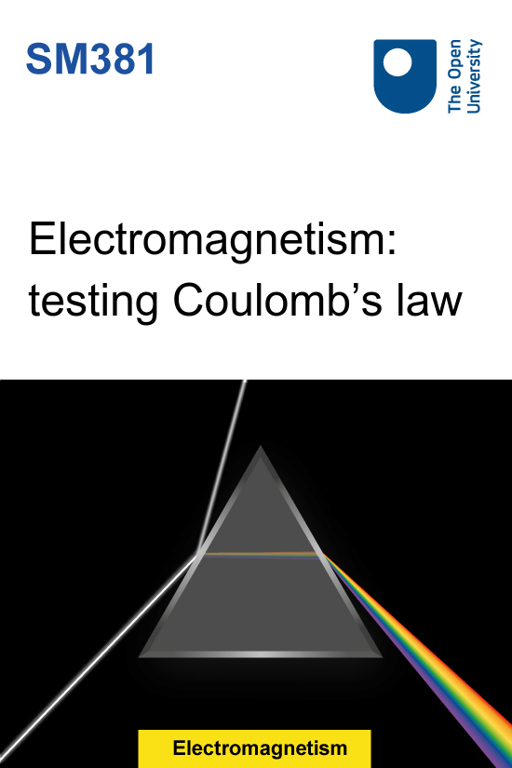

SM381 Electromagnetism

Electromagnetism: testing Coulomb’s law

This publication forms part of the Open University module SM381 Electromagnetism. Details of this and other Open University modules can be obtained from Student Recruitment, The Open University, PO Box 197, Milton Keynes MK7 6BJ, United Kingdom (tel. +44 (0)300 303 5303; email general-enquiries@open.ac.uk).
Alternatively, you may visit the Open University website at www.open.ac.uk where you can learn more about the wide range of modules and packs offered at all levels by The Open University.
The Open University,
Walton Hall, Milton Keynes
MK7 6AA
First published 2025.
Copyright © 2025 The Open University
All rights reserved. No part of this publication may be reproduced, stored in a retrieval system, transmitted or utilised in any form or by any means, electronic, mechanical, photocopying, recording or otherwise, without written permission from the publisher or a licence from The Copyright Licensing Agency Ltd. Details of such licences (for reprographic reproduction) may be obtained from: The Copyright Licensing Agency Ltd, 5th Floor, Shackleton House, 4 Battle Bridge Lane, London, SE1 2HX (website www.cla.co.uk).
Open University materials may also be made available in electronic formats for use by students of the University. All rights, including copyright and related rights and database rights, in electronic materials and their contents are owned by or licensed to The Open University, or otherwise used by The Open University as permitted by applicable law.
In using electronic materials and their contents you agree that your use will be solely for the purposes of following an Open University course of study or otherwise as licensed by The Open University or its assigns.
Except as permitted above you undertake not to copy, store in any medium (including electronic storage or use in a website), distribute, transmit or retransmit, broadcast, modify or show in public such electronic materials in whole or in part without the prior written consent of The Open University or in accordance with the Copyright, Designs and Patents Act 1988.
Edited and designed by The Open University.

Contents
- Introduction
- 1 Electric force – Coulomb’s law
  - 1.1 Coulomb’s law in vector form
- 2 Calculating the electric force between three or more charges
- 3 Testing Coulomb’s law and using vector components
- Conclusion
- Appendix
- Acknowledgements
- Solutions
- Descriptions

Introduction
Electrical charges can be positive or negative. Charges of the same type repel each other, and charges of different types attract each other. For example, static electricity can cause hair to stand on end as similarly charged strands of hair all try to avoid each other, while in lightning a build up of negatively charged electrons moves rapidly to a region of positive charge.
Electrically charged particles exert forces on each other at a distance, that is they don’t need to be touching each other. When these charged particles are stationary the force is referred to as electrostatic, and is described by Coulomb’s law. Coulomb’s law was established experimentally in the late eighteenth century, and is one of the building blocks of the theory of classical electromagnetism.
This course has four parts: a brief introduction to Coulomb’s law in vector form, a video demonstration of an experiment, an exercise and a video solution. This gives you a practical demonstration of electrostatic forces and the opportunity to practise using the vector form of Coulomb’s law. You will also be encouraged to think about the assumptions you make in your calculations and possible sources of experimental uncertainty.
Learning outcomes
After studying this course, you should be able to:
- describe the properties of Coulomb’s law and electrostatic force
- determine the force exerted on one stationary charge by another using Coulomb’s law
- explain some of the uncertainties and errors that can occur in experimental measurements of electrostatic properties.
This OpenLearn course is an adapted extract from the Open University course SM381 Electromagnetism.

1 Electric force – Coulomb’s law
A point charge is a hypothetical charged particle that occupies a single point in space. It has no internal structure, motion or spin, so a stationary point charge is only affected by electric fields and not affected by magnetism. It is useful when defining the concept of electric force.

Definition of the electric force: The electric force is defined as the electromagnetic force on a stationary point charge.

It is important to keep in mind, however, that the electric force is experienced not only by stationary point charges. The electric force is felt by all charges, whether they are moving or not.
Before looking at the electric force in more detail, it is useful to consider forces in general. Unlike charge, force is a vector quantity – it has a magnitude and a direction – and its conventional symbol is . The SI unit of force is the newton (N), where 1 N is equivalent to 1 kg m s.
Newton’s second law of motion states that the force on a particle is equal to its rate of change of momentum or, when the force is applied to a body with a mass that does not change with time, its mass m multiplied by its acceleration . Mathematically this is written as

(1)
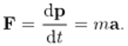
View alternative description - Uncaptioned Equation

Equation 1 gives an example of a vector quantity (in this case acceleration) multiplied by a scalar quantity (mass). The result of this operation is another vector (force).

Multiplying a vector by a scalar
If any vector is multiplied by any scalar , the result is another vector . The magnitude of is equal to the scalar factor multiplied by the magnitude of the original vector. You can express this as or .
If the scalar factor is positive then the product will be parallel to the original vector. If the scalar factor is negative then the product will be antiparallel to the original vector (Figure 1).
Also note the following general points, where could represent any vector.

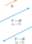
Figure 1Multiplying a vector by a scalar . Here, the resultant vector is shown for and .
View description - Figure 1Multiplying a vector bold cap e by a scalar q. Here, the resultant vector ...

- The quantity

(2)
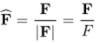
View alternative description - Uncaptioned Equation

is a vector of magnitude 1 (with no units) pointing in the same direction as . This vector is called the unit vector of and is given the symbol (pronounced F-hat).
- Writing

(3)
View alternative description - Uncaptioned Equation

neatly splits a vector into a product of two terms:
  - gives the magnitude of the vector
  - gives its direction in space.
- The units of are contained in the magnitude, . Any unit vector is dimensionless and has magnitude 1; not 1 newton or 1 of anything else.
- Two vectors with the same magnitude and the same direction are defined as being equal, but remember that they can have different starting points.

The study of time-independent (static) electrical phenomena is known as electrostatics. The sections that follow focus on the electric force between static point charges. This so-called electrostatic force between two stationary point charges is given by Coulomb’s law, which has the following observable properties.

Properties of Coulomb’s law
The electrostatic force between two stationary point charges:
- acts along the line of separation between the charges
- is repulsive for charges of the same sign and attractive for charges of opposite sign
- has a magnitude that is proportional to the product of the charges and inversely proportional to the square of the distance between the charges.
In mathematical form, the scalar part of the electrostatic force , acting on the line of separation between two charges, and , separated by a distance is written as

(4)
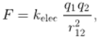
View alternative description - Uncaptioned Equation

where is a positive constant that will be defined later in this course. The denominator in Equation 4 characterises this expression as an inverse square law.

If and have the same sign, then Equation 4 predicts . This is interpreted as a repulsive force.

- What is the sign of if and have opposite signs? How is this interpreted?
- If and have opposite signs, then . This is an attractive force.

1.1 Coulomb’s law in vector form
Equation 4 is adequate for describing the interaction of two charges, but it cannot handle three or more charges that are not arranged in a straight line. Before considering a more general representation of Coulomb’s law, you need to be familiar with vector addition and displacement vectors.

Adding and subtracting vectors
Suppose that a single particle simultaneously feels two different forces, and . It responds just as if a single force, , had been applied to it. This is called the vector sum of the individual forces.
The geometric rule for adding two vectors is shown in Figure 2. Arrows representing the vectors are drawn with the head of the first arrow, , meeting the tail of the second arrow, . The arrow joining the tail of to the head of then represents the vector sum . This is called the triangle rule. Any number of vectors can be added by repeating the application of this rule.
Vector subtraction is defined by multiplying by a negative scalar and using vector addition. The vector is interpreted as the sum of and .

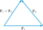
Figure 2The triangle rule for vector addition.
View description - Figure 2The triangle rule for vector addition.

An important use of vector subtraction is in describing the displacement of one point from another.

Working with displacement vectors
Figure 3 shows two vectors and whose arrows start at the origin O and end at charges and . These vectors are called the position vectors of and . A position vector has dimensions of length, where the SI unit of length is the metre (m).

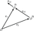
Figure 3The vectors and define the positions of the point charges and with respect to the origin O. The displacement vector points from to , and is parallel to the unit vector .
View description - Figure 3The vectors bold r sub one and bold r sub two define the positions of the ...

The figure also shows , which is the displacement vector of from . Using the triangle rule:

(5)
View alternative description - Uncaptioned Equation

which rearranges to

(6)
View alternative description - Uncaptioned Equation

Using the unit vector , this becomes

(7)
View alternative description - Uncaptioned Equation

This notation is convenient because the indices 1 and 2 are in the same order on both sides of the equation. However, remember that the displacement is from to . The left-hand index labels the end-point and the right-hand index labels the start-point.

Returning now to the discussion of Coulomb’s law for the force between a pair of charged particles, suppose that charges and are at positions and . The displacement vector of from makes it possible to express Coulomb’s law as:

(8)
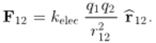
View alternative description - Uncaptioned Equation

The left-hand side of this vector equation is the electrostatic force on charge 1 due to charge 2. The force on charge 2 due to charge 1 is written as . The order of indices matters here because these two forces point in opposite directions.
The right-hand side of the equation is the product of the scalar factor and the unit vector . The unit vector ensures that the force points in the correct direction. To see how this works, suppose that both charges in Figure 3 are positive. Since is positive, the unit vector is multiplied by a positive quantity, and the force on charge 1 points in the direction of . This corresponds to a repulsion away from charge 2, as required for charges of the same sign.
It is conventional to write the constant as

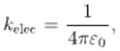
View alternative description - Uncaptioned Equation

where C N m (to 3 significant figures) is called the permittivity of free space. The definition of leaves you with the standard vector form of Coulomb’s law for the electrostatic force between two charges.

Coulomb’s law for two charges

(9)
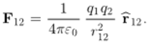
View alternative description - Uncaptioned Equation

- Using the definition of (Equation 7), how can you write Equation 9 without a unit vector?
- Using Equation 7 and noting that , the vector form of Coulomb’s law for two charges becomes

(10)
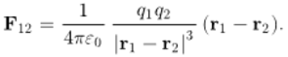
View alternative description - Uncaptioned Equation

You may find that working with this form of Coulomb’s law speeds up some calculations.

2 Calculating the electric force between three or more charges
So far, this course has only considered Coulomb’s law for a pair of point charges. The extension of this law to a collection of many particles requires vector addition. If is the total electrostatic force on a charge , this is calculated from the vector sum of the electrostatic forces that it experiences due to each of the other charges. Mathematically, this is written as

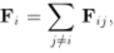
View alternative description - Uncaptioned Equation

where is the electrostatic force on particle due to particle and the sum runs over all the particles that exert an appreciable electrostatic force on particle . Since the electrostatic force between each pair of charges obeys Coulomb’s law, the total electrostatic force on charge is written as follows.

Coulomb’s law for multiple charges

(11)
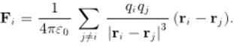
View alternative description - Uncaptioned Equation

- Why are terms with excluded from Equation 11?
- Because a point-like charged particle cannot exert a force on itself.

Now consider a small number of static point charges that are not arranged in a straight line. To work out the force on a given charge, you can begin by representing all the vectors in component form, as explained in the following box. Then you can use the rules of vector algebra to combine them according to the recipe given in Equation 11.

Cartesian components of a vector
It is often helpful to describe a vector in terms of its components along three standard directions. To do this, you can use Cartesian coordinates. This is a set of three mutually perpendicular axes (, and ) pointing outwards from an origin. The unit vectors pointing in the directions of these axes are denoted by , and .
It is conventional to use a right-handed coordinate system, as described by the right-hand rule. Start by pointing the fingers of your right hand in the direction of the -axis (indicated by the black dashed line in Figure 4). Then bend your fingers round to point in the direction of the -axis, so that your hand is in the position shown in the figure. You might need to rotate your wrist to do this. Now your outstretched thumb points along the -axis.
The crucial idea is that any vector can be split into a sum of three vectors that are aligned with each axis, as shown in Figure 4. It follows that any vector (in this case, a force ) can be expressed as

(12)
View alternative description - Uncaptioned Equation

The scalar quantities , and are the Cartesian components of the vector but they are usually just called its components. The vector components , and are all positive in Figure 4 but, in general, vector components may be positive, negative or zero.

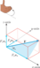
Figure 4Splitting the vector into the sum of three vectors: , , and . You can work out the relative orientations of the Cartesian axes using the right-hand rule, as explained in the text.
View description - Figure 4Splitting the vector bold cap f into the sum of three vectors: cap f sub ...

If you know the magnitude and direction of a vector, you can use trigonometry to find its components. For example, Figure 4 shows

View alternative description - Uncaptioned Equation

where is the magnitude of the force and is the angle between and the -axis. Similarly, if you know a vector’s components then you can use Pythagoras’ theorem to find its magnitude:

(13)
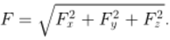
View alternative description - Uncaptioned Equation

The vector operations introduced earlier in this chapter all have simple interpretations in terms of components. For example, if the position vectors of points 1 and 2 are

View alternative description - Uncaptioned Equation

then the displacement vector of point 1 from point 2 is

(14)
View alternative description - Uncaptioned Equation

Vector equations have the great advantage of brevity, but numerical calculations are usually carried out using components.
Now complete Exercise 1 where you will use the vector form of Coulomb’s law to calculate the vector components of the electrostatic force on a charge due to two nearby charges.

Exercise 1

Two charges, and , where is positive, are stationary at points and , as shown in Figure 5.

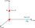
Figure 5The positions of three stationary charges in the -plane.
View description - Figure 5The positions of three stationary charges in the x times y-plane.

Find the electrostatic force on a charge placed at the origin . Evaluate the magnitude of this force and specify its direction as a unit vector in Cartesian coordinates.

View discussion - Exercise 1

3 Testing Coulomb’s law and using vector components
This activity has three parts: a video demonstration of an experiment, an exercise and a video solution. The activity gives you a practical demonstration of electrostatic forces and the opportunity to practise using the vector form of Coulomb’s law. It also encourages you to think about the assumptions in your calculations and possible sources of experimental uncertainty.

Activity Testing Coulomb’s law and using vector components
Allow up to 1 hour

Part 1 Measuring electrostatic forces

Watch Video 1, which shows Open University (OU) academics Sam Eden and Anita Dawes measuring one component of the electrostatic force that a charged sphere feels due to nearby charged spheres.

Video content is not available in this format.
Video 1 Filmed experiment: measuring electrostatic forces at the OU.
View transcript - Video 1 Filmed experiment: measuring electrostatic forces at the OU.

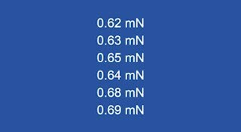

(The data shown on-screen during Video 1 are available in an Appendix to this activity.)

Part 2 Calculating electrostatic force components and comparing them with the measured values

Figure 1 shows the -direction and the relative positions of the charged spheres in the filmed experiment.

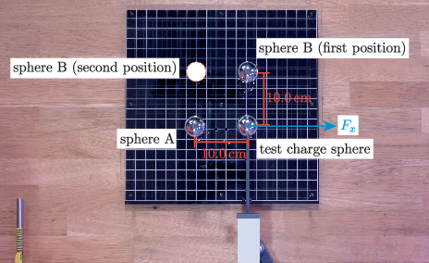
Figure 6 Annotated still image from Video 1 showing the positions of the test charge sphere, sphere A, and two possible positions for sphere B, as well as the force component .
View description - Figure 6 Annotated still image from Video 1 showing the positions of the test charge ...

(a)
Use the vector form of Coulomb’s law to predict the -component of the force that the test charge sphere feels in the three situations described below. All charges are given in units of nanocoloumbs (). Write your answers in millinewtons () in Table 1.
- The test charge sphere and sphere A are charged with each. Sphere B is not present.
- The three spheres are charged with each. Sphere B is in its first position (see Figure 1).
- The three spheres are charged with each. Sphere B is in its second position (see Figure 1).

Table 1 Calculated force on the test charge.
situation | calculated
i | Provide your answer...
ii | Provide your answer...
iii | Provide your answer...

(b)
Comment briefly on possible reasons why your calculated values may not agree exactly with the experimental values. Consider approximations in your calculations and experimental uncertainties that may have significant effects.

Provide your answer...
View discussion - Part

Part 3 Applying the vector form of Coulomb’s law – a model solution and discussion of the results

(a)
Watch Video 2 in which Sam presents model solutions for the three situations described in Part 2(a) of this activity. The video highlights the use of use of displacement vectors, position vectors, unit vectors and vector components.

Video content is not available in this format.
Video 2 Using the vector form of Coulomb’s law to determine theoretical force components for comparison with the measurements in Video 1.
View transcript - Video 2 Using the vector form of Coulomb’s law to determine theoretical force components ...

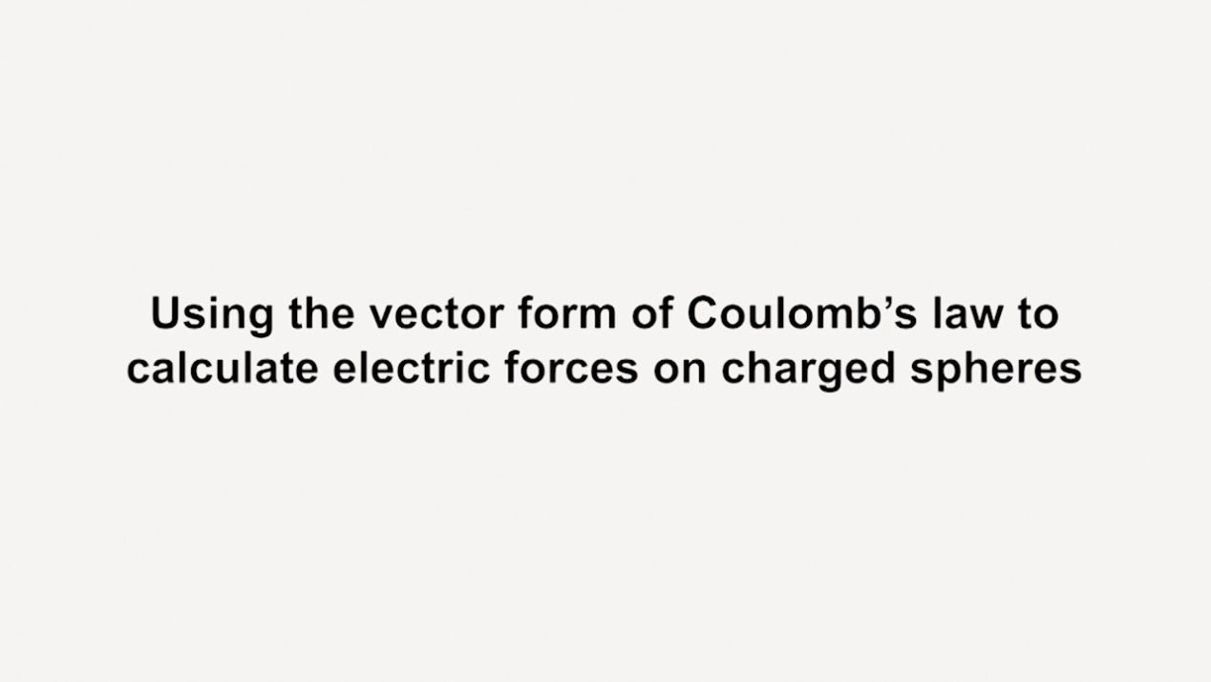

The experimental results from Video 1 are summarised in Table 2 for the three situations described in Part 2(a). In each situation, was recorded in before and after the spheres were charged. The results from Video 2 are also shown and your calculated values from Table 1 are also shown.

Table 2 Summary of the results from Videos 1 and 2.
situation | average measured |  |  | calculated values from Video 2 | your calculated values from Table 1
situation | uncharged | charged | difference
i | –0.058 | 0.65 | 0.71 | 0.81 | Not available in this format.
ii | –0.10 | 0.66 | 0.76 | 0.81 | Not available in this format.
iii | –0.057 | 0.99 | 1.0 | 1.1 | Not available in this format.

(b)
Compare the calculated values in Table 2 with the experimental results (in the ‘difference’ column). Does this comparison support the validity of Coulomb’s law and of your method for applying it in situations with more than two charges?

Provide your answer...
View discussion - Part

Conclusion
Coulomb’s law for the force on a point charge due to a point charge can be written as

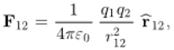
View alternative description - Uncaptioned Equation

where is the permittivity of free space, is the magnitude of the displacement from charge to charge , and is the unit vector for this displacement.
You can use this form of Coulomb's law repeatedly with vector addition to find the force on a point charge due to a system of a few charges. However, when considering more complicated systems of charges or continuous charge distributions it is usually necessary to use computer based methods to determine the resulting force.
This OpenLearn course is an adapted extract from the Open University course SM381 Electromagnetism.

Appendix

Table A Measured forces on a test charge sphere due to spheres A and B. The test charge and sphere A are fixed. Three situations for sphere B are considered (including not present and two different positions, as explained in Video 1 and Figure 1). In each situation, is measured before and after the spheres are charged
sphere B | charge on each sphere/ | measured
not present | 0 | −0.05 | −0.05 | −0.07 | −0.05 | −0.07 | −0.06
not present | 30 | 0.62 | 0.63 | 0.65 | 0.64 | 0.68 | 0.69
first position | 0 | −0.08 | −0.09 | −0.11 | −0.12 | −0.11 | −0.10
first position | 30 | 0.65 | 0.64 | 0.64 | 0.65 | 0.67 | 0.68
second position | 0 | −0.04 | −0.05 | −0.06 | −0.05 | −0.07 | −0.07
second position | 30 | 0.98 | 0.99 | 0.99 | 0.99 | 0.98 | 1.00

Acknowledgements
This free course was written by Anita Dawes, Sam Eden and Andrew James and first published in April 2025.
Except for third party materials and otherwise stated (see terms and conditions), this content is made available under a Creative Commons Attribution-NonCommercial-ShareAlike 4.0 Licence.
The material acknowledged below is Proprietary and used under licence (not subject to Creative Commons Licence). Grateful acknowledgement is made to the following sources for permission to reproduce material in this free course:
Course image: By Kaboompics.com/Pexels
Every effort has been made to contact copyright owners. If any have been inadvertently overlooked, the publishers will be pleased to make the necessary arrangements at the first opportunity.
Don't miss out
If reading this text has inspired you to learn more, you may be interested in joining the millions of people who discover our free learning resources and qualifications by visiting The Open University – www.open.edu/openlearn/free-courses.

Solutions

Exercise 1

Discussion
All the charges lie in the -plane, so you can ignore the -coordinates.
The electrostatic force on charge at the origin is given by the vector sum

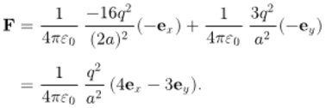
View alternative description - Uncaptioned Equation

This force has magnitude

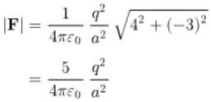
View alternative description - Uncaptioned Equation

and is in the direction of the unit vector

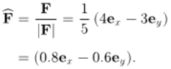
View alternative description - Uncaptioned Equation

As a quick check, this is consistent with the charge being attracted towards the charge on the -axis and repelled from the charge on the -axis.
Back to - Exercise 1

Activity Testing Coulomb’s law and using vector components

Part

Discussion
Keep in mind that the discussion below only addresses a selection of issues; there are various other valid points that you might have raised in your answers.
The key assumption in the calculation is that the charged spheres can be treated as point charges located at the spheres’ centres. At any position outside a spherically symmetric charge distribution, the field produced by the charge distribution is the same as the field that would be produced by a point charge located at its centre. This is a consequence of Gauss’s law (one of the four key laws in electromagnetism known as Maxwell’s equations). However, in this experiment the charge distribution around each sphere will not be perfectly spherically symmetric. This is partly because no manufactured sphere is perfect, but a more fundamental issue is that the electric field produced by one charged sphere will disrupt the spherical symmetry of the charge distribution on another.
Testing the experiment before filming indicated that most significant sources of experimental uncertainty were unwanted forces and charge leakage, as described below.
The test charge sphere can experience unwanted forces (that is, forces other than the electrostatic force due to nearby charged spheres). For example, air flow in the studio and vibrations transmitted from the floor had noticeable effects in the tests before filming.
Charge leakage occurs in the time between charging the spheres and measuring the forces. No insulator is perfect, and the rate at which charge dissipates from the spheres is sensitive to factors such as air humidity and the cleanliness of the plastic rods.
Further sources of experimental uncertainty include:
- The charge transferred to each sphere is known to a limited precision. This depends on the calibration procedure.
- No force meter is perfectly accurate, and the measured forces are displayed to a limited precision.
- Video 1 does not provide information on how precisely the test charge sphere has been positioned to measure the -component of the force that it feels.
- The - and -positions of the spheres’ centres are given to a limited precision, and the video does not provide information about precisely how they are situated on the -plane.
Back to - Part

Part

Discussion
For brevity, this discussion is limited to the point charge assumption, and the effects of charge leakage and unwanted forces.

Point charge assumption
The field produced by one charged sphere disrupts the spherical symmetry of the charge distribution on another. This causes the concentration of positive charge to be greatest on the side of each sphere that is furthest from the other positively charged spheres. Hence, treating the charged spheres as point charges located at the spheres’ centres represents an underestimation of the separation of the charge distributions on each sphere.

Charge leakage
Charge leakage occurs during the time between charging the spheres and measuring the forces. This means that the magnitude of the charge on each sphere at the instant that the force is measured is lower than the that was initially transferred.
It follows that the point charge assumption and charge leakage both cause the calculated forces to be higher than the forces in the experiment. This is broadly consistent with Table 2, where calculated forces are between 6% and 12% higher than the experimental values.

Unwanted forces
Table 2 shows that force measurements prior to charging the spheres vary over a range of . This provides a first approximation for the variation in the unwanted forces. The variation is close to the difference between the values measured in situations (i) and (ii), which the calculations indicate should be the same.

Summary
This short discussion indicates that the key approximation in the calculation and the main sources of experimental uncertainty are broadly consistent with the differences between the calculated and measured forces in this activity. Therefore, the experimental results are broadly supportive of the validity of Coulomb’s law and the present method for applying it in situations with more than two charges.
Back to - Part

Descriptions

Uncaptioned Equation
multiline equation line 1 equation sequence part 1 bold cap f equals part 2 normal d times bold p divided by normal d times t equals part 3 m bold a full stop
Back to - Uncaptioned Equation

Figure 1Multiplying a vector bold cap e by a scalar q. Here, the resultant vector bold cap f equals italic q bold cap e is shown for q greater than zero and q less than zero.
This figure illustrates the multiplication of a vector E by a scalar q. An orange arrow representing the vector E points to the right. A blue arrow is labelled ‘vector F equals q times vector E, open bracket q greater than zero close bracket’. This blue arrow points in the same direction as vector E. A second blue arrow is labelled ‘vector F equals q times vector E, open bracket q less than zero close bracket’. This blue arrow points in the opposite direction to vector E. The two blue arrows are a different length to the vector E but the same length as each other.
Back to - Figure 1Multiplying a vector bold cap e by a scalar q. Here, the resultant vector bold cap f equals italic q bold cap e is shown for q greater than zero and q less than zero.

Uncaptioned Equation
equation sequence part 1 cap f hat equals part 2 bold cap f divided by absolute value of bold cap f equals part 3 bold cap f divided by cap f
Back to - Uncaptioned Equation

Uncaptioned Equation
multiline equation line 1 bold cap f equals cap f times cap f hat comma
Back to - Uncaptioned Equation

Uncaptioned Equation
multiline equation line 1 cap f equals k sub normal e times normal l times normal e times normal c times q sub one times q sub two divided by r sub 12 squared comma
Back to - Uncaptioned Equation

Figure 2The triangle rule for vector addition.
The figure illustrates the triangle rule for vector addition.
The tip of a vector F subscript 1 is connected to the tail of a second vector F subscript 2. A third vector, F subscript 1 plus vector F subscript 2, is the vector sum of vector F subscript 1 and vector F subscript 2. It is represented by a side of a triangle taken in the direction from the tail of vector F subscript 1 to the tip of vector F subscript 2.
Back to - Figure 2The triangle rule for vector addition.

Figure 3The vectors bold r sub one and bold r sub two define the positions of the point charges q sub one and q sub two with respect to the origin O. The displacement vector bold r sub 12 points from q sub two to q sub one, and is parallel to the unit vector r hat sub 12.
Two vectors, r subscript 1 and r subscript 2, are drawn from a point O. A charge q subscript 1 is placed at the tip of vector r subscript 1 and a charge q subscript 2 is placed at the tip of vector r subscript 2. A vector r subscript 1 2 is drawn from charge q subscript 2 to charge q subscript 1. A vector r hat subscript 1 2 is drawn from charge q subscript 1 and points in a direction parallel to vector r subscript 1 2.
Back to - Figure 3The vectors bold r sub one and bold r sub two define the positions of the point charges q sub one and q sub two with respect to the origin O. The displacement vector bold r sub 12 points from q sub two to q sub one, and is parallel to the unit vector r hat sub 12.

Uncaptioned Equation
bold r sub one equals bold r sub two plus bold r sub 12 comma
Back to - Uncaptioned Equation

Uncaptioned Equation
bold r sub 12 equals bold r sub one minus bold r sub two full stop
Back to - Uncaptioned Equation

Uncaptioned Equation
r sub 12 times r hat sub 12 equals bold r sub one minus bold r sub two full stop
Back to - Uncaptioned Equation

Uncaptioned Equation
multiline equation line 1 bold cap f sub 12 equals k sub normal e times normal l times normal e times normal c times q sub one times q sub two divided by r sub 12 squared times r hat sub 12 full stop
Back to - Uncaptioned Equation

Uncaptioned Equation
multiline equation line 1 k sub normal e times normal l times normal e times normal c equals one divided by four times pi times epsilon sub zero comma
Back to - Uncaptioned Equation

Uncaptioned Equation
multiline equation line 1 bold cap f sub 12 equals one divided by four times pi times epsilon sub zero times q sub one times q sub two divided by r sub 12 squared times r hat sub 12 full stop
Back to - Uncaptioned Equation

Uncaptioned Equation
multiline equation line 1 bold cap f sub 12 equals one divided by four times pi times epsilon sub zero times q sub one times q sub two divided by absolute value of bold r sub one minus bold r sub two cubed times left parenthesis bold r sub one minus bold r sub two right parenthesis full stop
Back to - Uncaptioned Equation

Uncaptioned Equation
bold cap f sub i equals n ary summation over j not equals i over bold cap f sub i times j comma
Back to - Uncaptioned Equation

Uncaptioned Equation
bold cap f sub i equals one divided by four times pi times epsilon sub zero times n ary summation over j not equals i over q sub i times q sub j divided by absolute value of bold r sub i minus bold r sub j cubed times left parenthesis bold r sub i minus bold r sub j right parenthesis full stop
Back to - Uncaptioned Equation

Uncaptioned Equation
bold cap f equals sum with 3 summands cap f sub x times bold e sub x plus cap f sub y times bold e sub y plus cap f sub z times bold e sub z full stop
Back to - Uncaptioned Equation

Figure 4Splitting the vector bold cap f into the sum of three vectors: cap f sub x times bold e sub x, cap f sub y times bold e sub y, and cap f sub z times bold e sub z. You can work out the relative orientations of the Cartesian axes using the right-hand rule, as explained in the text.
The figure shows a right-handed Cartesian coordinate system. At the top of the figure, a right hand is depicted with the fingers closing from the x-direction towards the y-direction, such that the thumb points in the z-direction.
The lower portion of the figure illustrates the splitting of a vector F into the sum of three vectors. A cuboid is placed in the space with three of its edges aligned with the coordinate axes. A vector F starts from the origin and is aligned with the body diagonal of the cuboid. The vector F makes an angle theta subscript x with the x-axis. The component of vector F on an edge of the cuboid aligned with the x-axis is F subscript x times vector e subscript x. The component of vector F on an edge of the cuboid aligned with the y-axis is F subscript y times vector e subscript y. The component of vector F on an edge of the cuboid aligned with the z-axis is F subscript z times vector e subscript z.
Back to - Figure 4Splitting the vector bold cap f into the sum of three vectors: cap f sub x times bold e sub x, cap f sub y times bold e sub y, and cap f sub z times bold e sub z. You can work out the relative orientations of the Cartesian axes using the right-hand rule, as explained in the text.

Uncaptioned Equation
cap f sub x equals cap f times cosine of theta sub x comma
Back to - Uncaptioned Equation

Uncaptioned Equation
cap f equals Square root of sum with 3 summands cap f sub x squared plus cap f sub y squared plus cap f sub z squared full stop
Back to - Uncaptioned Equation

Uncaptioned Equation
bold r sub one equals sum with 3 summands x sub one times bold e sub x plus y sub one times bold e sub y plus z sub one times bold e sub z and bold r sub two equals sum with 3 summands x sub two times bold e sub x plus y sub two times bold e sub y plus z sub two times bold e sub z comma
Back to - Uncaptioned Equation

Uncaptioned Equation
multiline equation row 1 bold r sub 12 equation sequence part 1 equals part 2 bold r sub one minus bold r sub two equals part 3 sum with 3 summands left parenthesis x sub one minus x sub two right parenthesis times bold e sub x plus left parenthesis y sub one minus y sub two right parenthesis times bold e sub y plus left parenthesis z sub one minus z sub two right parenthesis times bold e sub z full stop
Back to - Uncaptioned Equation

Figure 5The positions of three stationary charges in the x times y-plane.
The figure depicts an arrangement of three charges in a Cartesian coordinate system. A charge q is fixed at the origin. A second charge negative 16 q is fixed at a point (2a, 0, 0) on the positive x-axis. A third charge 3q is fixed at a point (0, a, 0) on the positive y-axis.
Back to - Figure 5The positions of three stationary charges in the x times y-plane.

Uncaptioned Equation
multiline equation row 1 bold cap f equals one divided by four times pi times epsilon sub zero times negative 16 times q squared divided by left parenthesis two times a right parenthesis squared times left parenthesis negative bold e sub x right parenthesis plus one divided by four times pi times epsilon sub zero times three times q squared divided by a squared times left parenthesis negative bold e sub y right parenthesis row 2 equals one divided by four times pi times epsilon sub zero times q squared divided by a squared times left parenthesis four times bold e sub x minus three times bold e sub y right parenthesis full stop
Back to - Uncaptioned Equation

Uncaptioned Equation
multiline equation row 1 absolute value of bold cap f equals one divided by four times pi times epsilon sub zero times q squared divided by a squared times Square root of four squared plus left parenthesis negative three right parenthesis squared row 2 equals five divided by four times pi times epsilon sub zero times q squared divided by a squared
Back to - Uncaptioned Equation

Uncaptioned Equation
multiline equation row 1 cap f hat equation sequence part 1 equals part 2 bold cap f divided by absolute value of bold cap f equals part 3 one divided by five times left parenthesis four times bold e sub x minus three times bold e sub y right parenthesis row 2 equals left parenthesis 0.8 times bold e sub x minus 0.6 times bold e sub y right parenthesis full stop
Back to - Uncaptioned Equation

Figure 6 Annotated still image from Video 1 showing the positions of the test charge sphere, sphere A, and two possible positions for sphere B, as well as the force component cap f sub x.
The centre of sphere A is placed at a horizontal distance of 10.0 centimeters to the left of the centre of the test charge sphere. The centre of sphere B (first position) is placed at a vertical distance of 10.0 centimeters above the centre of the test charge. The centre of sphere B (second position) is placed at a horizontal distance of 10.0 centimeters to the left of the centre of sphere B (first position). A force arrow labelled F subscript x from the test charge points horizontally to the right.
Back to - Figure 6 Annotated still image from Video 1 showing the positions of the test charge sphere, sphere A, and two possible positions for sphere B, as well as the force component cap f sub x.

Uncaptioned Equation
multiline equation line 1 bold cap f sub 12 equals one divided by four times pi times epsilon sub zero times q sub one times q sub two divided by r sub 12 squared times r hat sub 12 comma
Back to - Uncaptioned Equation

Video 1 Filmed experiment: measuring electrostatic forces at the OU.

Transcript
[Text on screen: Sam Eden, Physicist, The Open University]
SAM EDEN
In this activity, we are going to carry out experiments with the aim of answering two main questions. Firstly, does Coulomb’s law give you the correct electrostatic force that a charged sphere feels due to one other charged sphere? And secondly, does adding vector components give you the correct electrostatic force that a charged sphere feels due to two other charged spheres?
After you’ve watched the experiments, you will analyse the results and compare them with your own calculations using vector components. Now, let’s start with a quick tour of the experiment.
[Text on screen: Anita Dawes, Physicist, The Open University]
ANITA DAWES
OK, so the experiment involves measuring one vector component of the force that a charged sphere feels after we have positioned another charged sphere, or two charged spheres, nearby. So here’s one of the spheres. So it’s a hollow conducting sphere mounted on an insulating plastic rod.
And what we’ve done here is prepared a Perspex system to help us place our spheres in precise positions above a grid. So on this grid, each square is two centimetres by two centimetres. Now, here’s our sphere that we used as a test charge. It’s mounted on an arm with a pressure sensor that’s very sensitive. We can measure the force that it feels between the charges in this direction, perpendicular to the arm.
[In a top-down view of the experiment, sphere A is positioned to the left of the test charge sphere. An arrow labelled ‘F_{x}’ pointing to the right, away from the test charge, is superimposed on the screen.]
Each time we’re ready to take a measurement of the force, this sensor is connected to this unit here, and we can save a series of values at 20-millisecond intervals. Now let’s talk about the system that we use for charging up the spheres.
SAM EDEN
So this is a power supply with a pin that you can touch onto the spheres to transfer a charge onto them. We’ve put the power supply quite far from the rest of the experiment as part of our effort to minimise external electric fields. The power supply’s been calibrated, so we know that a voltage of 17 kilovolts transfers 30 nanocoulombs onto a sphere. So now we’re ready to start the experiments.
ANITA DAWES
Here’s our first arrangement of the test charge sphere and the other sphere, which we’ll call sphere A. The centres of the spheres are ten centimetres away from each other.
[A distance marker labelled ‘10.0 cm’ is superimposed on a top-down view of the experiment, and is positioned between the test charge sphere and sphere A.]
So first, we’ll record the force on the test charge sphere before we put any charge on the spheres. So I’ll take the readings now.
And you should see the last six force readings on your screen that have been saved by this readout. The readings in millinewtons are minus 0.05, minus 0.05, minus 0.07, minus 0.05, minus 0.07 and minus 0.06. You’ll be able to access all the data from these experiments after you’ve watched this video.
So what we’ll do next is put 30 nanocoulombs of charge on the test charge and on sphere A. Now I’ll record the readings, and you should see them appear on your screen. The values in millinewtons are 0.62, 0.63, 0.65, 0.64, 0.68 and 0.69.
Now we’ll ground these two spheres. So I’ll use an earth rod and touch them to take the charge away. And we’ll add a third sphere into the geometry. And I’ll place it into this position here.
[In a top-down view of the experiment, sphere B is positioned above the test charge sphere. The lines from the test charge sphere to spheres A and B are both labelled as ‘10 cm’ and are at right angles to each other.]
Once again, we’ll check the force without any charge on it. The values in millinewtons are minus 0.08, minus 0.09, minus 0.11, minus 0.12, minus 0.11 and minus 0.10.
And we’ll now put 30 nanocoulombs of charge on all three of the spheres. Once again, you will be able to see the values on the screen. The values in millinewtons are 0.65, 0.64, 0.64, 0.65, 0.67 and 0.68.
Don’t forget that we’re only measuring one component of the force on the test charge. So now we’ll ground the three spheres again. And I will move sphere B into a new position, here.
[In a top-down view of the experiment, sphere B is positioned above sphere A. The lines from sphere A to the test charge sphere and sphere B are both labelled as ‘10 cm’ and are at right angles to each other.]
And now once again, we’ll check the force without any charge applied to the spheres. So I’ll make the measurement.
The values in millinewtons are minus 0.04, minus 0.05, minus 0.06, minus 0.05, minus 0.07 and minus 0.07. And now we’ll put 30 nanocoulombs on all three spheres. We’ll take another measurement. The values in millinewtons are 0.98, 0.99, 0.99, 0.99, 0.98 and 1.00. And that completes our measurements.
SAM EDEN
You will find the data that we’ve just recorded in the next part of the activity. You will then do your own calculations to test if Coulomb’s law combined with vector addition predicts these experimental results with good accuracy.
Back to - Video 1 Filmed experiment: measuring electrostatic forces at the OU.

Video 2 Using the vector form of Coulomb’s law to determine theoretical force components for comparison with the measurements in Video 1.

Transcript
[Text on screen: Using the vector form of Coulomb’s law to calculate electric forces on charged spheres]
SAM EDEN
SAM EDEN: In this screencast, we’re going to use the vector form of Coulomb’s law to calculate the forces between the charged spheres in our filmed experiments. So let’s start by sketching the experiment. We’ll assume that we can treat the charge spheres as point charges. So here’s our test charge T. And we’ll place it at the origin of a set of Cartesian coordinates. All our charges are on the xy-plane so we can treat this as a two-dimensional problem.
Charge A is at (minus 0.100 metres, 0.000 metres). I’m giving the coordinates to three significant figures in agreement with the experiment video. And the third charge can be at B, which is (0.000 metres, 0.100 metres). Or at B′, which is (minus 0.100 metres, 0.100 metres). Finally, our sensor measures F_{x}, which is the x-component of any force that the test charge feels.
Now let’s write down the vector form of Coulomb’s law. The force on point charge 1 due to point charge 2 is written F₁₂. And this is equal to a constant, k_{elec}, which is 1 over (4πε₀), multiplied by the charges q₁ and q₂, divided by the magnitude of the displacement vector r₁₂ squared. And the direction of the force is given by the unit vector r₁₂ hat.
Remember that r₁₂ is the vector from point 2 to point 1. And we can express this as the magnitude r₁₂ multiplied by the unit vector, r₁₂ hat, which is equal to the position vector of point 1, r₁, minus the position vector of point 2, r₂.
OK, so our first situation has 30 nanocoulombs at T and at A. Let’s start by working out our displacement vector from A to T.
r_{TA} [times] r_{TA} hat equals the position vector r_{T}, minus the position vector r_{A}, which is (x_{T} minus x_{A}) e_{x} plus (y_{T} minus y_{A}) e_{y}.
Now we can substitute in our coordinates for T and A to give us (0 minus (minus 0.100 metres)) e_{x} plus (0 minus 0.000 metres) e_{y}, which is 0.100 metres times the unit vector e_{x}. So the magnitude r_{TA} is 0.100 metres. And r_{TA} hat is e_{x}. Now you may have recognised this without needing to subtract the position vector r_{A} from r_{T}, but working through this in full is good practice for situations with more complicated geometry.
So if we substitute the magnitude r_{TA} and r_{TA} hat into Coulomb’s law, we get F_{TA} equals k_{elec} times q₁ q₂, which is (30 times 10 to the minus 9 coulombs) squared, divided by (0.100 metres) squared, all multiplied by e_{x}. And then crunching the numbers gives us 0.81 millinewtons e_{x}.
Now on to our second situation. It’s the same as what we just looked at, except we’ve added a third sphere with 30 nanocoulombs at position B. Due to the principle of superposition of electric fields, the total force on T must be the sum of the forces due to the charges at A and B. So we need F_{TB}. We can apply the method you just saw, but it’s quicker to work this out using symmetry.
If you rotate the charge at A 90 degrees clockwise about T, then it ends up at position B. So F_{TB} must be F_{TA} rotated 90 degrees clockwise. So the vector F_{TB} equals the magnitude F_{TA} multiplied by minus e_{y}. And this means that F_{TA} plus F_{TB} equals 0.81 millinewtons e_{x}, that we worked out just a moment ago, minus 0.81 millinewtons e_{y}.
Now in our third situation, we have 30 nanocoulombs at T, A and B′. So we need the force F_{TB′} and we’ll add this to F_{TA}. Let’s work out our displacement vector from B′ to T. That’s the position vector r_{T} minus the position vector r_{B′}, which is (0 minus (minus 0.100 metres)) e_{x} plus (0 minus 0.100 metres) e_{y}. And that equals 0.100 metres (e_{x} minus e_{y}).
Now we need the magnitude of r_{TB′}. And we can work that out by drawing a right-angle triangle like this and then using Pythagoras’ theorem. So the magnitude r_{TB} prime is the square root of (0.100 metres squared plus 0.100 metres squared), which is root (0.0200 metres squared). Now from the definition above we know that r_{TB′} hat is the vector r_{TB′} over the magnitude r_{TB′}.
So let’s substitute this expression for r_{TB′} hat into Coulomb’s law. And we get F_{TB} prime equals k_{elec} times (30 times 10 to the minus 9 coulombs) squared, times the vector r_{TB′}, which is 0.100 metres (e_{x} minus e_{y}), divided by the magnitude r_{TB′} cubed, which is (0.0200 metres squared) to the power of 3 over 2. And this comes to 0.29 millinewtons (e_{x} minus e_{y}).
Now we can add up F_{TA} and F_{TB′} to get 0.81 millinewtons e_{x} plus 0.29 millinewtons (e_{x} minus e_{y}), which is 1.1 millinewtons e_{x} minus 0.29 millinewtons e_{y}, keeping everything to two significant figures in line with the precision of our charge values. So our calculated F_{x} is 1.1 millinewtons.
So now we’ve used vector components to calculate the force that acts on the test charge in each of the three situations in the experiment video.
Back to - Video 2 Using the vector form of Coulomb’s law to determine theoretical force components for comparison with the measurements in Video 1.

