t229_1

Engineering: environmental fluids

About this free course
This free course is an adapted extract from the Open University course .
This version of the content may include video, images and interactive content that may not be optimised for your device.
You can experience this free course as it was originally designed on OpenLearn, the home of free learning from The Open University –
There you’ll also be able to track your progress via your activity record, which you can use to demonstrate your learning.
First published 2023.
Unless otherwise stated, copyright © 2023 The Open University, all rights reserved.
Intellectual property
Unless otherwise stated, this resource is released under the terms of the Creative Commons Licence v4.0 http://creativecommons.org/licenses/by-nc-sa/4.0/deed.en. Within that The Open University interprets this licence in the following way: www.open.edu/openlearn/about-openlearn/frequently-asked-questions-on-openlearn. Copyright and rights falling outside the terms of the Creative Commons Licence are retained or controlled by The Open University. Please read the full text before using any of the content.
We believe the primary barrier to accessing high-quality educational experiences is cost, which is why we aim to publish as much free content as possible under an open licence. If it proves difficult to release content under our preferred Creative Commons licence (e.g. because we can’t afford or gain the clearances or find suitable alternatives), we will still release the materials for free under a personal end-user licence.
This is because the learning experience will always be the same high quality offering and that should always be seen as positive – even if at times the licensing is different to Creative Commons.
When using the content you must attribute us (The Open University) (the OU) and any identified author in accordance with the terms of the Creative Commons Licence.
The Acknowledgements section is used to list, amongst other things, third party (Proprietary), licensed content which is not subject to Creative Commons licensing. Proprietary content must be used (retained) intact and in context to the content at all times.
The Acknowledgements section is also used to bring to your attention any other Special Restrictions which may apply to the content. For example there may be times when the Creative Commons Non-Commercial Sharealike licence does not apply to any of the content even if owned by us (The Open University). In these instances, unless stated otherwise, the content may be used for personal and non-commercial use.
We have also identified as Proprietary other material included in the content which is not subject to Creative Commons Licence. These are OU logos, trading names and may extend to certain photographic and video images and sound recordings and any other material as may be brought to your attention.
Unauthorised use of any of the content may constitute a breach of the terms and conditions and/or intellectual property laws.
We reserve the right to alter, amend or bring to an end any terms and conditions provided here without notice.
All rights falling outside the terms of the Creative Commons licence are retained or controlled by The Open University.
Head of Intellectual Property, The Open University

Contents
- Introduction
- Learning outcomes
- 1 The Earth’s atmosphere and winds
  - 1.1 The properties of the atmosphere
  - 1.2 Upper-atmosphere winds and air movements
  - 1.3 Ground-level winds and air movements
  - 1.4 Spacecraft re-entry considerations
- 2 The Earth’s oceans and seas
  - 2.1 Wave motions in water
  - 2.2 Wave speed, amplitude and displacement
  - 2.3 Waves and winds
  - 2.4 Tides and tidal currents
  - 2.5 Force on a floating tunnel
- Conclusion
- Acknowledgements
- Glossary
- Solutions
- Descriptions

Introduction
We all have constant daily experience of fluids, from breathing air to taking showers and checking weather forecasts, which means that we all have a great deal of intuitive knowledge about how they behave; this course will build on that knowledge.
The Earth’s atmosphere and oceans are two of the most important fluids for engineers, and a working knowledge of them is required in many situations. For example, in the aeronautical and aerospace industries the behaviour and properties of the atmosphere from ground level to outer space are key aspects in the design and operation of aircraft and space vehicles. In the field of civil engineering, the simulation and study of tides and tidal flows is necessary in the design of harbours, canals, protective barrier schemes, drainage pipelines, offshore structures, etc.
In the first half of this course, you will be able to learn about the Earth’s atmosphere – how properties like density, temperature and speed of sound vary with height, the effect of terrain on wind near the ground and how the Coriolis effect contributes to the formation of weather systems.
The second half of the course concerns the study of Earth's oceans, including the formation of waves and tides and how both are affected by land masses.
This free course is an adapted extract from the Open University course T229 Mechanical engineering: heat and flow.

Learning outcomes
After studying this course, you should be able to:
- describe the variation of fluid properties in the Earth’s atmosphere between ground level and space
- understand the formation of wind, waves and tides and appreciate their significance for engineers
- calculate critical factors such as wind and wave speed, displacement amplitude and acceleration
- understand how these critical factors impact on the design of structures which interact with the ocean and sea.

1 The Earth’s atmosphere and winds
Obviously, the Earth’s atmosphere is hugely important in sustaining life by providing and recycling the main gases oxygen and nitrogen, recycling water from seas to rain and back again, and providing warmth and stable temperatures. It also protects life from potentially harmful effects from space such as radioactivity, heat and other radiation, and to a degree from impact with solid bodies such as meteorites and other cosmic detritus. In this section, the focus will be on its behaviour in terms of fluids, statics and dynamics.

1.1 The properties of the atmosphere
The atmosphere’s characteristics are important in various aspects of engineering such as the design and operation of aircraft, road and rail vehicles, buildings and other structures, and the all-important weather forecasting. The atmosphere has also provided a source of mechanical power down the ages – for example for windmills and wind pumps, sailing vessels, etc., and now of course a source for electrical power generation with wind-driven turbines and wind farms. The atmosphere’s properties and behaviour of interest in these fields include density, pressure, temperatures, wind speeds, accelerations and turbulence. These are very rarely stable being in a constant state of flux because of the rotation and other motions of the Earth with respect to the Sun and the intermittent heating and cooling cycles which result.
Although vital, the atmosphere height-wise is relatively very thin in relation to the diameter of the Earth. It has been likened to the thickness of the skin on an apple, but there is no real edge or boundary at the upper level. A common rule of thumb is for the upper limit (the Kármán line) to be 100 km from sea level, but in reality the density and pressure continue to diminish with height, with traces of atmosphere being detected at many hundreds of kilometres further up. Even at the height of some of the lower-orbit satellites (say around 150 km), there is a discernible atmosphere which will ultimately slow them down enough for them to fall back to Earth, and all but the largest will burn up before they hit the ground. The largest ones are decommissioned carefully so as to return to Earth in specified safe areas.
The density of the atmosphere at ground/sea level on a still day is taken as 1.225 kg m⁻³. The mean pressure at this level is stated as 101.325 kPa, which can be read as a mass of air of just over 10 tonnes on each square metre on the Earth’s surface. However, because the pressure reduces with height above ground level, the density decreases in proportion, hence the gradual diminishing with no definite boundary.

An illustrative statistic for the Earth’s atmosphere
As a matter of comparison, if the density of the atmosphere at sea level did remain constant all the way up, what would be the height or thickness of the atmosphere to create the sea-level pressure? Give your answer in km to 3 significant figures.

Solution
From the fundamental law of hydrostatics

View alternative description - Uncaptioned Equation

so

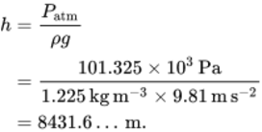
View alternative description - Uncaptioned Equation

Therefore the height of the atmosphere would be 8.43 km (to 3 s.f.).

Activity 4

If the height of the atmosphere was 100.0 km, what would be the atmospheric pressure at sea level if the density was constant at 1.225 kg m⁻³? Express the answer as a comparison with the standard figure of 101.325 kPa. Give your answer to 3 significant figures.

View answer - Activity 4

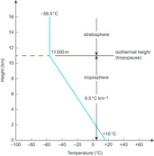
Figure 1 Temperature variation with height in standard atmosphere
View description - Figure 1 Temperature variation with height in standard atmosphere

Note that from sea level (zero on the vertical axis) the temperature reduces with height in a directly linear manner up to about 11 km altitude. This lower region (0–11 km) is called the troposphere. Above 11 km the temperature stays the same at about –56.5 °C for increasing heights. This region is the stratosphere, and the height at which the constant temperature starts is the isothermal height (sometimes isothermal level), also known as the tropopause. At far greater altitudes there is more variation but because the air is so thin by then the concept of atmospheric temperature does not mean very much.
The values describing the graph in Figure 1 vary a little around the Earth, but typically the sea-level mean (average) temperature is assumed to be 15 °C and the slope or gradient of the graph from zero to 11 km height in degrees per km change in height is −6.5 °C km ⁻¹. Above 11 km, the gradient is of course zero as the temperature stays constant.

Calculating the height of the atmosphere at 0 °C
From the above data determine the height at which the air temperature reaches 0°C. Give your answer to 2 significant figures.

Solution
In Figure 1, studying the proportions of the slope part of the graph by similar triangles of height (vertical) divided by temperature (horizontal) gives

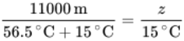
View alternative description - Uncaptioned Equation

so

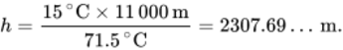
View alternative description - Uncaptioned Equation

Therefore the height at which the air temperature reaches 0 °C is 2.3 km (to 2 s.f.).

Other properties of air have been deduced or derived from known relationships with temperature and some of these are presented in Figure 2 in non-dimensionalised form so as to fit them all on one graph.

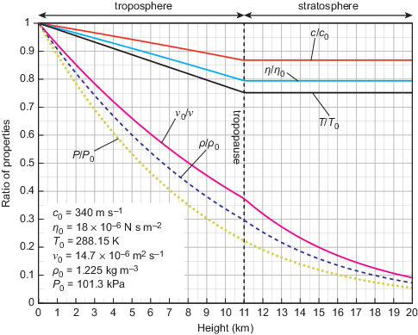
Figure 2 Properties of the standard atmosphere. Note that kinematic viscosity increases with altitude, so the inverse ratio is shown.
View description - Figure 2 Properties of the standard atmosphere. Note that kinematic viscosity eta ...

The constants used to non-dimensionalise the properties are depicted on the graph with the subscript ‘0’ and correspond to the values at sea level. Note that the height is now on the horizontal axis with the 11 km height marked as a vertical line. The properties shown are the local speed of sound (sonic velocity), , the dynamic viscosity, , the kinematic viscosity, , the density, , and the pressure, . For instance, it can be seen from the graph that the speed of sound = 340m s⁻¹ at sea level and decreases linearly through the troposphere; above the tropopause it remains constant, given approximately by

View alternative description - Uncaptioned Equation

In the troposphere two properties, pressure and density, can be modelled by simple expressions as follows.
For pressure:

(Equation 1)
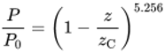
View alternative description - Uncaptioned Equation

where is the absolute pressure, (= ) is the standard sea-level value of 101.3kPa, is the altitude under consideration and is a constant value of 44 300 m.
For density:

(Equation 2)
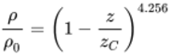
View alternative description - Uncaptioned Equation

where is the required density, is the standard sea-level value of 1.225kg m⁻³, is the altitude under consideration and is a constant value of 44 300 m.
Above the isothermal level of the tropopause, the pressure and density are based on the values at this isothermal level, as:

(Equation 3)
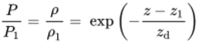
View alternative description - Uncaptioned Equation

where is a constant value of 6377 m and , and are the values of pressure, density and altitude at the isothermal level, and which will be, respectively, 22.6 kPa, 0.364 kg m⁻³ and 11000 m.

Reductions in atmospheric pressure with height
What is the percentage reduction in atmospheric pressure at the height when the air temperature drops to 0 °C? Give your answer to 3 significant figures.

Solution
Rearranging Equation 1 to find pressure gives

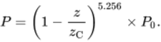
View alternative description - Uncaptioned Equation

From Example 2, the height of the atmosphere at which the air temperature reaches 0 °C was found to be , so

View alternative description - Uncaptioned Equation

Therefore the percentage reduction in pressure is

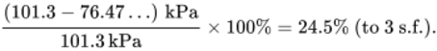
View alternative description - Uncaptioned Equation

Activity 5

What is the percentage reduction in atmospheric density at the height when the air temperature reaches 0 °C, compared with the value at sea level? Give your answer to 3 significant figures.

View answer - Activity 5

Atmospheric model equations
The troposphere denotes the part of Earth’s atmosphere from an altitude of zero to 11 000 m. In this region the local atmospheric pressure can be evaluated from the expression in equation (4) as

View alternative description - Uncaptioned Equation

where is the standard sea-level value of 101.3 kPa, is the altitude in metres under consideration and is a constant value of 44 300 m.
Also in the troposphere, the local air density can be evaluated from the expression in equation (5) as

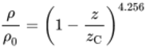
View alternative description - Uncaptioned Equation

where is the required density, is the standard sea-level value of 1.225kg m⁻³, is the altitude under consideration and is a constant value of 44300 m.
The top level of the troposphere is known as the tropopause, and the height of the lower boundary of the tropopause, 11 000 m, is known as the isothermal height. Above this height, the pressure and density are both related by the expression in equation (6) as

View alternative description - Uncaptioned Equation

where is a constant value of 6377 m and , and are the values of the pressure, density and altitude at the isothermal level, and hence will be respectively 22.6 kPa, 0.364kg m⁻³ and 11000 m.

1.2 Upper-atmosphere winds and air movements
Although the upper atmosphere is directly first in line with radiation arriving from the Sun, the mechanism by which it is heated is less direct. A good deal of the solar radiation passes through the atmosphere and warms up the more massive and dense land masses and oceans below. These absorb and retain heat energy which is then re-radiated at infrared wavelengths that do not pass so easily through the air as the incoming radiation. This is not a uniform process, however.
The oceans have a temperature variation which is less (i.e. more steady) than that of land masses, and the clouds reflect heat back and forth in a varying manner. Combine these effects with the daily rotation of the Earth causing heat cycles and the longer heat cycles due to the seasons caused by the Earth’s axis being tilted (obliquity) as it orbits the Sun, and all of this adds up to a highly complex pattern of temperature variations in the atmosphere. It is the temperature variation which causes changes in density and pressure, which in turn cause air movements and winds that affect weather patterns.

Trade winds
Winds may be considered in two groups. First are the more regular settled patterns on a global scale as shown in Figure 3. This represents an overall sustained pattern of regular winds which were important in the days of sailing ships, assisting their sojourns around the world delivering and collecting goods. The term trade winds, which originally referred to the old English expression of ‘tracking winds’, became associated with this commercial context. These and other steady winds arise because of the uneven but regular heating of the Earth. Near the equator where the Sun’s radiant heat is most powerful, the air is heated, expands, reduces in density and rises. In rising, especially over the ocean, it cools, and water vapour condenses, giving up latent heat. This sustains the upwards motion which spills outwards North and South away from the tropics.

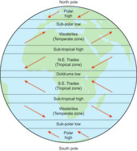
Figure 3 Regular global winds
View description - Figure 3 Regular global winds

Meanwhile cooler higher-pressure air moves towards the equatorial region because of the now lower-pressure there. These movements are deflected laterally, however, due to the Coriolis effect of the Earth’s rotation to form the trade winds. The green box on the Coriolis acceleration outlines how this effect arises. A similar situation arises near the poles of the Earth, where the colder higher-pressure air is induced to flow away from the poles towards the lower-pressure air in the temperate zones. Again the Coriolis effect deflects these to form the so called westerlies in both hemispheres.

Coriolis accelerations
Any object moving on a straight path north of the equator appears to an observer on the ground to be deflected to the right. Conversely, any object moving on a straight path south of the equator appears to be deflected to the left.
This apparent deflection, resulting from movement towards or away from an axis of rotation, is a manifestation of the Coriolis acceleration or the Coriolis effect, named after Gaspard-Gustave de Coriolis (1792–1843) who pioneered the study of rotating frames of reference.

The Coriolis acceleration
The Coriolis acceleration arises in any situations when an object or body travels towards or away from the axis of a rotating frame of reference. The combination of rotation and distance from the axis results in a linear velocity, so if the distance changes the velocity also changes and the result is an acceleration at right angles to both the direction of travel and the axis of rotation. This is the Coriolis acceleration, denoted by .
For a simple visualisation, imagine a fairground worker walking outwards along a radius of a rotating roundabout in order to get tickets (Figure 4). Although everything on the platform is rotating at the same angular velocity about the central vertical axis, the horses further away from the centre have a higher linear velocity relative to the stationary ground. Thus, a worker moving radially outwards on the platform will need to accelerate to keep up with the horses. Equally if travelling radially inwards towards the axis of rotation the worker will need to decelerate in order to match the lower velocities of the inner horses.

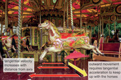
Figure 4 A typical fairground ride and manifestation of Coriolis acceleration
View description - Figure 4 A typical fairground ride and manifestation of Coriolis acceleration

Figure 5 summarises the situation for different combinations of inward or outward movement and clockwise or anticlockwise rotation. The component of velocity towards or away from the axis, , is itself rotating about a vertical axis through O. Note the directions of , the rotating reference angular velocity, , and the resulting acceleration .

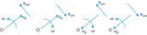
Figure 5 Directions of the Coriolis acceleration
View description - Figure 5 Directions of the Coriolis acceleration

The magnitude of the Coriolis acceleration experienced by the body is given by the simple equation:

View alternative description - Uncaptioned Equation

Figure 6 shows an idealised picture of the Earth viewed from far above the equator. Neglecting the tilt angle (obliquity), the Earth rotates from west to east about the imaginary vertical axis joining the North and South Poles. The angular velocity of rotation, , is of course one revolution or 2π radians per full day (24 hours). (It actually takes the Earth 23 hours, 56 minutes and 4 seconds to make a full 360° rotation. The other 3 minutes and 56 seconds is needed to account for the Earth’s rotation round the sun and can be ignored for most engineering purposes.)
Consider an object or element of something moving on or near the Earth’s surface directly from north to south, shown red in Figure 6. The something could be a chunk of sea, air, a ship, artillery shell, etc.
The object has a velocity and is at a latitude angle of , so the component of velocity parallel to the axis of rotation is and the component of velocity perpendicular to the axis of rotation is . The Coriolis acceleration

View alternative description - Uncaptioned Equation

where

View alternative description - Uncaptioned Equation

therefore

(Equation 7)
View alternative description - Uncaptioned Equation

The same formula applies to travel east or west: in these cases the full Coriolis acceleration of is directed outwards from the axis and the component tangential to the surface is . Since it applies to both north–south and east–west movement, Equation 7 can be applied to any movement on the surface of the earth.

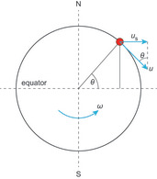
Figure 6 Schematic view of Earth from above the equator
View description - Figure 6 Schematic view of Earth from above the equator

The Coriolis effect on an Earth scale
What is the Coriolis acceleration experienced by a body on the surface of the Earth in terms of its latitude, and its velocity ? Give your answer to 3 significant figures.

Solution
As the earth makes a full rotation (2π radians) every 24 hours, a rotating reference frame moving with it will have an angular velocity given by

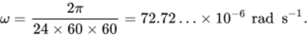
View alternative description - Uncaptioned Equation

Using equation (8), an object travelling with a velocity will be subject to a Coriolis acceleration of

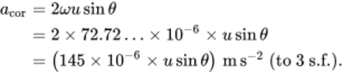
View alternative description - Uncaptioned Equation

This is obviously very small compared to , but in weather systems and tidal currents over many hours or even days, these accelerations can result in major weather effects. Alternatively, if the value of is very high, such as in artillery shells or missiles, the effect has to be allowed for in setting aim coordinates. (This is how Coriolis came into the picture.)

Activity 6

Determine the Coriolis acceleration and the accompanying lateral accelerating force on a cubic metre of air at ground level if the wind speed north to south is 80.0 km h⁻¹ at a latitude of 60.0°. Use as the standard sea-level value of 1.225 kg m⁻³. Give your answer to 3 significant figures.

View answer - Activity 6

Cyclones and anticyclones
The second group of winds comprises the more adhoc erratic fluctuations which can turn into vortices thousands of kilometres across that last for a limited period, usually measured in days. These are the cyclones and anticyclones mentioned in weather reports. A cyclone is often referred to as a depression or a low because it centres on a region of low pressure. The low pressure will be at most around 10 or 12 per cent below standard atmospheric pressure, but on the scale of a cyclone even a drop that small can provoke huge air movements. The air begins to move radially inwards towards the low pressure, and is then deflected by the Coriolis effect as the Earth rotates.
In the northern hemisphere the Coriolis effect will tend to move the airflow direction clockwise away from the centre, as shown in Figure 7. In this figure the airflow was heading towards the central low pressure, but was then deflected away from it to an extent by the Coriolis effect. The pressure gradient inwards can counteract or overcome this tendency of deflection to the point that an equilibrium flow is set up with just enough inward force remaining to provide the centripetal acceleration for overall circular flow to develop in an anticlockwise direction, as shown in Figure 7. (In the southern hemisphere the overall flow direction is clockwise.)

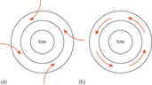
Figure 7 Development of a cyclone (northern hemisphere), (a) showing the beginnings of Coriolis deflection and (b) the balanced equilibrium flow condition
View description - Figure 7 Development of a cyclone (northern hemisphere), (a) showing the beginnings ...

An anticyclone is often referred to as a high because it centres on a region of high pressure. The high pressure will be at most only around 5 or 6 per cent above standard atmospheric pressure with lower pressure gradients than for cyclones, leading to steadier and more gentle air movements. The air begins to move radially outwards towards the surrounding lower-pressure regions. As with cyclones, the air is then deflected by the Coriolis effect as the Earth rotates, this time inducing an overall flow direction clockwise in the northern hemisphere. Figure 8 shows the idea. (In the southern hemisphere the overall flow direction is anticlockwise.)

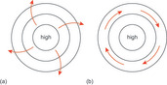
Figure 8 Development of an anticyclone (northern hemisphere), (a) showing the beginnings of Coriolis deflection and (b) the balanced equilibrium flow condition
View description - Figure 8 Development of an anticyclone (northern hemisphere), (a) showing the beginnings ...

Generally speaking, because of the lower pressure differences compared with cyclones, anticyclones invoke fewer clouds and lighter winds. In the summer this can lead to extensive exposure to sunlight and rising warm air from which moisture can condense into thunderclouds or to form morning mists. In the winter, more radiant heat escapes from the ground, leading to lower temperatures both night and day with fogs and frosts at night as well as ice and freezing temperatures. Cyclones, on the other hand, lead to cooler weather in summer due to cloudy and wet conditions, and slightly warmer winter days than with anticyclones but accompanied again by clouds and possibly snow, and importantly, strong winds, as they are driven by higher pressure differences than anticyclones.

1.3 Ground-level winds and air movements
Section 2.2 dealt mainly with the general picture of air movements in the main troposphere (meaning above about 1000 m altitude). These are known as the geostrophic winds or gradient winds. The lower sub-region below 1000 m comprises the atmospheric boundary layer. This has a complex wind profile in terms of wind speed versus height because of the variability of heating effects and geographic features. In this region, the wind speed is modelled from a reference wind speed at a ground level to reference height, , of 10 m. In this layer the flow is mixed and can be modelled as turbulent.
In engineering applications – for example, in the design of buildings and other external structures such as radio masts, or monitoring likely winds around airports – the profile is usually represented by a power model of the form:

(Equation 9)
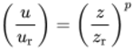
View alternative description - Uncaptioned Equation

where is the required design wind speed at height , is the wind speed at the 10 m reference height , and the exponent is related to the surface roughness. Table 1 shows some values for .

Table 1 Ground-level wind speed model exponents
Feature | Model exponent,
Flat lands and open water | 0.10
Open varied terrain | 0.15
Suburban | 0.25
City centres | 0.35

Selecting design wind speeds
It is proposed to erect a 50.0 m tall radio mast in the flatlands of Norfolk where the reference wind speed at 10.0 m height is 23.0 m s⁻¹. What would be the design wind speed for the top of the mast? Give your answer to 3 significant figures.

Solution
The design wind speed can be found using equation (10):

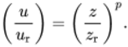
View alternative description - Uncaptioned Equation

First, identify the relevant values:

View alternative description - Uncaptioned Equation

Rearranging equation (10), the design wind speed is

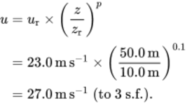
View alternative description - Uncaptioned Equation

Activity 7

What would be the design wind speed at the top of an offshore wind turbine of height 245 m? The reference wind speed at reference height 10.0 m is 25.0 m s−1. Give your answer to 3 significant figures.

View answer - Activity 7

Wind speeds and their effects have been categorised in the Beaufort wind force scale, which will be familiar to listeners of broadcast shipping and weather forecast bulletins (and students of previous modules). It is named after the Irish hydrographer Sir Francis Beaufort, (1774–1857). It is not an exact scale, being based originally on subjective visual observations noted from sailing ships at sea. Table 2 summarises its main features as applied now to effects on land and sea.

Table 2 Beaufort scale and wind effects on land, adapted from Meteorological Office data
Beaufort scale number | Wind type | Wind speed limits |  | Effects on land | Effects out at sea
 |  | (m s⁻¹) | (km h⁻¹)
0 | Calm | < 1 | < 3.6 | Smoke rises vertically | Flat mirror-like surface
1 | Light air | 1–2 | 3.6–7.2 | Smoke drifts, weather vanes not indicating | Ripples like scales, no foam crests visible
2 | Light breeze | 2–3 | 7.2–10.8 | Leaves rustle, weather vanes indicating, wind felt on face | Small wavelets not breaking
3 | Gentle breeze | 4–5 | 14.4–18.0 | Leaves and twigs moving, light flags extended | Large wavelets, a few beginning to break
4 | Moderate breeze | 6–8 | 21.6–28.8 | Dust raised, paper and small branches moved | Small longer waves, frequent ‘white horses’
5 | Fresh breeze | 9–11 | 32.4–39.6 | Small trees sway, crested wavelets on lakes | Moderate waves getting longer, some spray and many ‘white horses’
6 | Strong breeze | 11–14 | 39.6–50.4 | Large branches move, telegraph wires hum, umbrellas difficult to manage | Large waves, widespread longer-length foam crests
7 | Near gale | 14–17 | 50.4–61.2 | Whole trees sway, walking into wind difficult | Waves breaking, foam being blown, spindrift starting
8 | Gale | 17–21 | 61.2–75.6 | Twigs break off trees, walking into wind more difficult | High long waves, crests breaking into spindrift, prominent foam streaks
9 | Strong gale | 21–24 | 75.6–86.4 | Chimney pots, tiles breaking loose, walkers blown over | High waves, dense foam affecting visibility
10 | Storm | 25–28 | 90.0–100.8 | Trees uprooted, considerable structural damage | Very high waves, long overhanging crests, whole surface becoming white. Poor visibility
11 | Violent storm | 29–32 | 104.4–115.2 | Widespread damage | Exceptionally high waves hiding small ships, dense white foam
12 | Hurricane | 33+ | 118.8+ | Devastation | Air filled with foam and spray, sea completely white, very poor visibility

Referred to in the table, spindrift is spray blown from the cresting waves in the direction of the gale, while white horses is a colloquial term for short lengths of foaming white water.
Because the wind motion at ground level is in a turbulent boundary layer, the wind speed at any point varies erratically. The higher-gradient wind can also come into the picture at any time due to the ad hoc nature and development of large-scale weather events. Thus, when designing buildings and outdoor structures, the consideration of wind loads likely to be experienced has to rely on statistical methods using published data.
For buildings and other civil engineering works, these wind loads are covered by a British Standard (BSI, 2010) which in turn is based on a Eurocode (CEN, 2005) with a National Annex for the UK. The Eurocodes are Europe-wide standards for incorporation into national legislation, but because of the vagaries of weather and wind patterns (in particular, for example, the exposed nature of the UK), each country will have its own national specifications based on localised data.
The basic idea is to establish for a particular location a maximum value of mean wind velocity that is sustained for a 10-minute period, and that is only likely to occur with an annual probability of 0.02, i.e. once in every 50 years. This will be chosen from a wind speed map such as that in Figure 9. The wind speeds are shown on each contour in m s⁻¹ and the grid squares labelled NA to TW are 100 km × 100 km each. For a location between contour lines, a value can be interpolated or the higher value of the two adjacent contours can be used. The process then is described in the standard as the calculation of characteristic values of overall wind actions. In brief, this can comprise more than 20 stages considering a number of issues, such as the location (distance from coast), the land terrain, the proximity of other buildings, the height of the building, the altitude of the building from sea level, the shape of the building, the orientation of the building, the proximity of any cliffs, ridges or escarpments, etc.

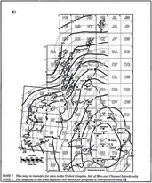
Figure 9 Wind map for the UK from British Standards (2010)
View description - Figure 9 Wind map for the UK from British Standards (2010)

These considerations are quantified as individual factors and coefficients, which are then applied to the chosen worst-case mean wind velocity to determine a peak velocity pressure (usually written even though it is a pressure, with units of pascals) which can be used for design load cases. Equation 11 gives an example:

(Equation 11)
View alternative description - Uncaptioned Equation

where is the wind speed, is the altitude coefficient, is the direction coefficient, is the exposure coefficient and is a town location coefficient. Equation 11 is basically the equation for dynamic pressure in air of density = 1.225 kg m⁻³ i.e.

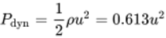
View alternative description - Uncaptioned Equation

but with a series of correction factors for location. When designing real structures, the appropriate values for these factors must be determined from the original standards. As the load cases determined by this method are based on statistics and probability, there is always a possibility, however small, that they will be exceeded in an exceptional storm. There is, however, an optimum design where the cost of further construction for greater safety is not justifiable and the calculated failure probability is extremely small.

Activity 8

Using the simple model in Equation 9 and the British Standards wind speed map (a larger PDF version can be found here), determine the wind speed in km h⁻¹ allowed for in the design of a 30.0 m-high building in the centre of Carlisle. What would it be in the countryside surrounding the city, assuming that the countryside comprises open varied terrain? Give your answers to 3 significant figures.

View answer - Activity 8

Design wind speeds from wind maps
A notional design wind speed is obtained from official maps and then modified with factors to take account of local features and height.
If is the reference wind speed at a reference height of 10 m, is the height under consideration and is a factor related to local features as indicated in Table 1, the design wind speed can be obtained from equation (10):

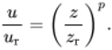
View alternative description - Uncaptioned Equation

1.4 Spacecraft re-entry considerations

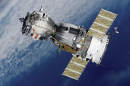
Figure 10 The Soyuz spacecraft
View description - Figure 10 The Soyuz spacecraft

The Soyuz spacecraft pictured in Figure 10 comprises three sections: a spherical orbital module, a blunt-ended descent (sometimes called re-entry) module and a service module (see Figure 11).

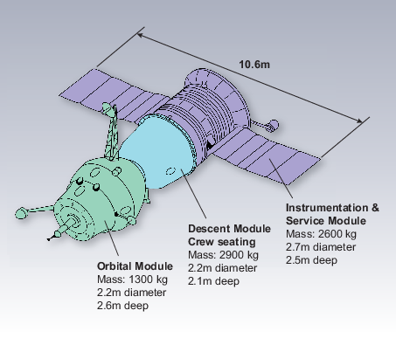
Figure 11 The service module of the Soyuz spacecraft
View description - Figure 11 The service module of the Soyuz spacecraft

Before starting the next activity, you may find it interesting to watch the video about Soyuz re-entry produced by the European Space Agency but note that it is not necessary to watch it to undertake the activity.

Video content is not available in this format.
Video 1 The Soyuz spacecraft
View transcript - Video 1 The Soyuz spacecraft

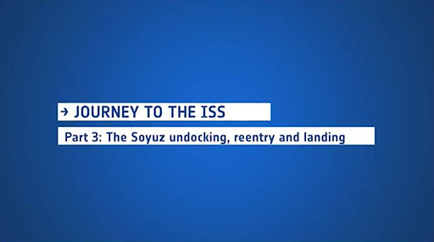

Activity 9
The Soyuz descent module parachute is activated at an altitude of around 10 km, when the capsule has a velocity of around 900 kph (250 m/s). Using Figure 2 (reproduced here for convenience):

Figure 2 (repeated) Properties of the standard atmosphere. Note that kinematic viscosity increases with altitude, so the inverse ratio is shown.
View description - Figure 2 (repeated) Properties of the standard atmosphere. Note that kinematic viscosity ...

Question 1

(a) The local speed of sound at that height ( 10 km), to 2 s.f. (Note: the line c/c_{o} is the ratio of the speed of sound at a given height, c, to the speed of sound at sea level, c_{o}).
Find the following:

View answer - Question 1

(b) The Mach number, Ma (the ratio of speed to speed of sound) of the capsule when the parachute is deployed.

View answer - Part

Question 2

The capsule is assumed to be at its terminal velocity when the parachute is activated (at an altitude of 10 km). At terminal velocity the aerodynamic drag, F_{d}, on the capsule is equal to its weight, W, so:
F_{d} = W = mg, where g is the acceleration due to gravity ( another quantity that varies with altitude, but you can assume to be 9.8 m.s⁻²)
Aerodynamic drag on capsule is given by

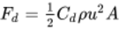
View alternative description - Uncaptioned Equation

Where C_{d} is the drag coefficient, ρ is the local air density, u is the velocity of the capsule and A is the cross sectional area of the capsule.
Using data from Figure 2 and from Figure 11, calculate the value of the drag coefficient of the capsule.

View answer - Question 2

Question 3

A relatively small braking parachute is initially deployed to slow the capsule down. When the braking parachute has reduced the speed of the capsule to around 80 m/s at a height of 7.5km, the main parachute, which has an area of 1000 m², is deployed and reduces the capsule speed to a steady 25 kph (6.9 m/s).
Assuming a drag coefficient of 1.7 (this is fairly standard for parachutes), estimate the altitude at which this new terminal velocity will be established. Neglect the contribution to drag of the capsule itself and give your answer to 2 significant figures.

View answer - Question 3

Question 4

The same parachute is carried to just above ground level, where retro-rockets cushion the final landing. Estimate the velocity of the capsule just before the rockets fire. Give your answer to 2 significant figures.

View answer - Question 4

2 The Earth’s oceans and seas
An ocean is a vast body of salt water of considerable depth. On Earth there are reckoned to be five main oceans; all of them are connected and together they form the World Ocean. Two of the oceans, the Pacific and Atlantic, are bisected on maps by the Earth’s equator, so sometimes it is said that there are seven oceans. Assuming the Earth to be a perfect sphere with a constant radius from its centre to a smoothed-out sea level (known as a geoid), the surface areas of the oceans can be compared with each other and the total surface area of Earth (i.e. land and water combined) as in Table 3.

Table 3 Comparative sizes of Earth’s oceans
Ocean | Average depth (m) | Surface area  (× 10³ km²) | % of Earth’s surface
North Pacific + South Pacific | 3970.0 | 168 723.0 | 33.1
North Atlantic + South Atlantic | 3646.0 | 85 133.0 | 16.7
Indian | 3741.0 | 70 560.0 | 13.8
Antarctic (a.k.a. Southern) | 3270.0 | 21 960.0 | 4.3
Arctic | 1205.0 | 15 558.0 | 3.1

Thus the oceans make up around 70% of the Earth’s surface. The expression ‘sail the seven seas’ actually refers to the oceans. A sea in itself is also a body of water somewhat smaller in surface area and shallower than an ocean and bounded fully or partially by land masses – to a greater extent than oceans at any rate. Table 4 shows a partial list of well-known seas.

Table 4 Comparative sizes of Earth’s seas (not a full list)
Sea | Average depth (m) | Surface area  (× 10³ km²) | % of Earth’s surface
Mediterranean | 1429.0 | 2966.0 | 0.58
Caribbean | 2647.0 | 2718.0 | 0.53
South China | 1652.0 | 2319.0 | 0.45
Bering | 1547.0 | 2292.0 | 0.45
Gulf of Mexico | 1486.0 | 1593.0 | 0.31
East China | 188.0 | 1249.0 | 0.25
Hudson Bay | 128.0 | 1232.0 | 0.24
North Sea | 95.0 | 750.0 | 0.15

2.1 Wave motions in water
The word ‘sea’ is also sometimes used to describe waves and currents whipped up by local winds – as in ‘a sea was running’. The surfaces of oceans and seas are rarely still, owing to their interactions with the atmosphere and the interchanges of energy from air movements or wind. As is well known, when a wind blows over a stretch of water, waves are formed. The area of water over which wind is blowing is called a fetch. In such a situation, it only takes a small random variation in the air pressure normal to the surface to create a disturbance on the surface of the water.
Small waves of only a few millimetres in height and separation (wavelength) may develop. These are called ripples. If the wind persists over the fetch of water, the ripples become larger, turning into waves. The wind transfers some of its kinetic energy to the waves, so the pressure differences in the air increase, feeding more wave growth. If the wind dies down, ripples are restored to a flat surface by the surface tension of the water, but gravity continues to feed the waves.
If the wind continues, a series of waves is set up which can actually travel faster than the wind speed itself. The waves will have a repeating motion with a frequency and wavelength. Water and air are not too good at damping large vibrations, so whilst the smaller shorter-wave energy is soon dissipated, waves with longer wavelengths can and do travel many thousands of kilometres. In this situation, the waves are known as a swell. Swells are often created by strong winds and storms many thousands of kilometres away.
It is important to note that the water is not moving along with the wave, apart from the relatively slow tidal movements or any underlying currents. An individual particle of water more or less stays where it is as a wave passes. The particle will move up and down in a roughly circular path as each wave passes through. This effect can be seen by holding the end of a long rope and flicking back and forth. A half-loop or wave will travel along the rope, but each bit of the rope stays in position in terms of its distance from the end. On the other hand, a tsunami (often called a tidal wave) really is a physical displacement of water caused by a single event like an earthquake; out at sea it might travel as if it were a normal but high-speed wave, but this time the body of water really is moving along with it.

2.2 Wave speed, amplitude and displacement
The interaction of a wind over the surface of water to produce waves is complex. On the surface of deep water the wave speed of typical waves can be modelled as

(Equation 12)
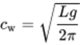
View alternative description - Uncaptioned Equation

where is the wavelength from peak to peak between two waves following each other and is the acceleration due to gravity. The peak is the highest point of the wave, and is also known as the crest. Thus the wave speed is greater for longer wavelengths. Consequently a swell may comprise long and fast waves, which can also be very high if the initiating wind speed itself is both high and sustained for a significant time. The height, , of a wave is taken to be the distance from the lowest level of the surface to the top of the wave. The lowest level is called the trough. The shape of a wave – its cross section or side view – depends upon its height and wavelength. At lower heights, it tends to be sinusoidal, so the amplitude of this type of wave will be half the height from trough to crest.

Wave speeds
The action of wind over deep water is to create a disturbance on the surface layers of the water. This disturbance takes the form of a wave which travels more or less in the same direction as the wind but at a speed which is given by

View alternative description - Uncaptioned Equation

where is the wave speed, is the wavelength and is the acceleration due to gravity.
Note that the wave is a disturbance which moves along and through the water – the water itself does not move along, except in the case of a tsunami.

Higher waves tend to have a narrower crest and a wider and shallower trough, as sketched in Figure 12.
At a value of 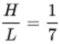 the crests become more pronounced and sharp-edged in profile and the top edges break into foaming white water (white horses). This foaming dissipates energy, which effectively stops further growth in height, meaning that the ratio stays at a maximum value of .

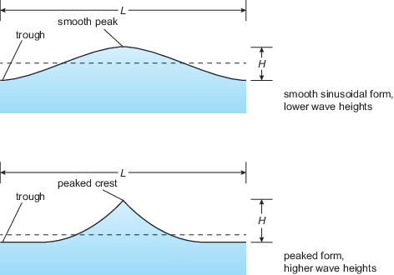
Figure 12 Cross sections of wave profiles
View description - Figure 12 Cross sections of wave profiles

The breaking of waves is of course most evident in shallow water at the beach. Once the depth of water has reduced to about , the shape of the wave profile alters again. If the slope of the beach is small (e.g. less than about 1 in 30 or 3.3%) the wave will break progressively as it rolls in, and the water itself does travel along in this case. If the slope is much greater, the wave is effectively slowed down and cannot adjust; instead, it becomes unstable, growing in height and then breaking by plunging over in a dramatic fashion. This still contains a lot of energy and can impart high forces on anything in its path. Even a non-breaking wave can cause large forces owing to the energy it contains, as the speed causes drag forces on anything it flows past.
A typical wave can be modelled quite easily. Figure 13 shows a wave of sinusoidal form with a relatively small surface displacement amplitude in comparison to the wavelength and depth of the water. The sea bed is assumed to be flat and smooth (with negligible friction), and there is a steady series of waves flowing to the right with speed . The wave depth is , which in this model will be twice the amplitude. The wave periodic time, , is the time taken for one complete wavelength to pass through and is given by

(Equation 13)
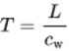
View alternative description - Uncaptioned Equation

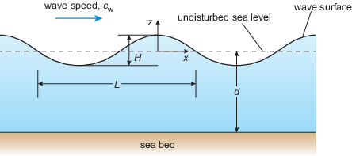
Figure 13 Cross section of a sinusoidal wave profile
View description - Figure 13 Cross section of a sinusoidal wave profile

As mentioned above, each water particle will move in an approximately circular orbit as the wave disturbance passes through. Figure 14 shows the shapes of an individual water particle orbits for shallow, intermediate depth and deep water in schematic form; the relative sizes are not to scale. In shallow water, the orbit is elliptical in cross section and reaches to the sea bed. In the intermediate depth, the orbit is more circular, and in deep water the orbit is completely circular and does not extend to the sea bed.

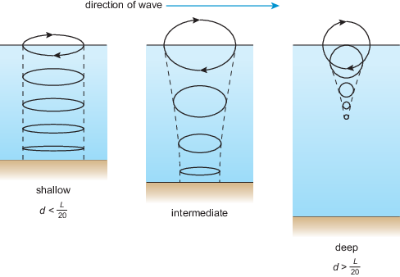
Figure 14 Wave water particle orbits (not to scale)
View description - Figure 14 Wave water particle orbits (not to scale)

Generally at a water depth equivalent to half the wave length, 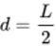, the amplitude of wave motion is barely 4% of that at the surface. This forms a useful rule of thumb in defining a ‘deep water’ wave. Assuming a deep water situation, the wave motion of an individual particle of water as a wave passes is near enough circular. Taking a stationary reference axis set at the flat sea level, as the depth increases with , the wave motion amplitude reduces by a factor of 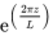, where numerically will be negative.
In other words, if is the surface amplitude and is the amplitude at depth (where is a negative number) then

(Equation 14)
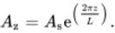
View alternative description - Uncaptioned Equation

If the radius of the circular motion is , the particle speed will be given by (as with any circular motion), and its acceleration will be

(Equation 15)
View alternative description - Uncaptioned Equation

where is the radian circular frequency. Again, as with all circular orbiting motion

(Equation 16)
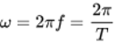
View alternative description - Uncaptioned Equation

and

View alternative description - Uncaptioned Equation

which is a rearranged version of Equation 13.

Deep water wave study
For a wave in deep water of wavelength 200.0 m and height 6.0 m, calculate:
- the wave speed
- the periodic time
- the displacement amplitude at the surface
- the displacement amplitude at 50.0 m depth
- the maximum horizontal acceleration at 25.0 m depth.
Give your answers to 3 significant figures.

Solution
- Using Equation 12:

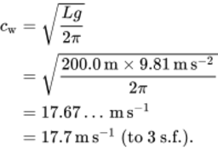
View alternative description - Uncaptioned Equation

- Using Equation 13;

View alternative description - Uncaptioned Equation

- The amplitude at the surface is

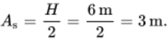
View alternative description - Uncaptioned Equation

- To find the displacement amplitude, Equation 14 is used:

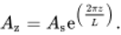
View alternative description - Uncaptioned Equation

First calculate the factor at 50 m depth:

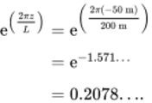
View alternative description - Uncaptioned Equation

This gives a displacement amplitude

View alternative description - Uncaptioned Equation

- First calculate the displacement amplitude at 25 m depth, since this is also the radius of the particle’s circular motion:

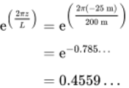
View alternative description - Uncaptioned Equation

so the radius of circular motion (or displacement amplitude) is

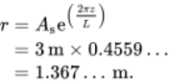
View alternative description - Uncaptioned Equation

Now, using Equation 16:

View alternative description - Uncaptioned Equation

Therefore, from Equation 15, the acceleration amplitude is

View alternative description - Uncaptioned Equation

Activity 1

The wave as described above has decayed such that its height is reduced by 50%. Determine the same parameters, noting the changes in values:
- the wave speed
- the periodic time
- the displacement amplitude at the surface
- the displacement amplitude at 50.0 m depth
- the maximum horizontal acceleration at 25.0 m depth.
Give your answers to 3 significant figures.

View answer - Activity 1

Wave models
For typical wind-provoked waves over deep water the following relationships can be used to model the wave properties:
The speed of the wave is

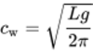
View alternative description - Uncaptioned Equation

where is the wavelength and is the acceleration due to gravity.
The periodic time for one complete wave to pass by is

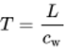
View alternative description - Uncaptioned Equation

and the wavelength in terms of velocity and periodic time is .
The frequency of the waves in relation to the periodic time is

View alternative description - Uncaptioned Equation

where is the radian circular frequency and is the frequency in Hertz or cycles per second.
At a depth (a negative numerical value) the amplitude of a wave is

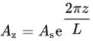
View alternative description - Uncaptioned Equation

where is the amplitude at the surface.

2.3 Waves and winds
A critical factor in the design of structures which interact with the sea is the likely worst-case wave height, which is known as a design wave. It is considered that even this might be exceeded once every 50 years. In the absence of any real wave height records, the 50-year design wave may be predicted using records of severe wind and weather conditions for the area of concern. The more frequent smaller waves that might over time have an effect on the fatigue life of structures must also be considered. Figure 15 shows a historical map for the waters surrounding the UK for the late 1970s; the kind of map that would have been consulted in the design of offshore oil rigs. This was based on maps from the Institute of Oceanographic Sciences.

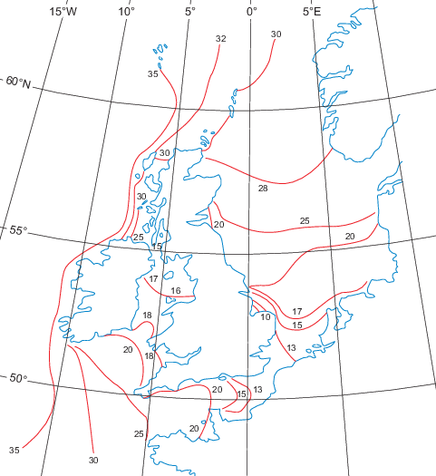
Figure 15 50-year wave heights (in metres) around the UK
View description - Figure 15 50-year wave heights (in metres) around the UK

Winds, of course, have a direct effect on the size and speed of waves beyond causing swells a long distance away. Table 2 related the Beaufort scale of wind speeds to the direct effect on the oceans and seas. Conversely, the state of the seas is one way of estimating the Beaufort wind rating.

2.4 Tides and tidal currents
A tide is the flow away (ebb) and flow back or return (flood) of something. The most obvious are those of the oceans and seas, in which there are regular high tides and low tides. The difference in heights is known as the tidal range. These tides are caused chiefly by the gravitational attraction forces of the Moon, and partly by those of the Sun, acting on the Earth. The gravitational pull of the Sun is overall much stronger but, as it is much further away, they are weaker on Earth than those of the relatively nearby Moon. The effects on the Earth are about 70% from the Moon and 30% from the Sun. Tides affect shipping – progress, mooring, loading and departures – and influence the design, build and maintenance of coastal and offshore infrastructure such as estuary bridges, harbour walls, drainage outlets, gas and oil rigs, etc. They also contain and cycle huge amounts of energy, some of which is diverted through turbines to generate useful power.
The tide is a lift and then release of huge bodies of water in the form of a tidal bulge on a regular basis as the Earth rotates beneath the gravitational pulls of the Moon and Sun. When near to a coast, the bulge turns into physical flows of water towards and away from the shoreline as the Earth rotates. When the effects of Moon and Sun occur in phase (together), the flows and heights increase the tidal ranges in what are called spring tides, as in the phrase ‘spring forth’ – nothing to do with the season. About six days later the relative positions of the Sun and Moon mean that they are pulling at right angles to one another and the result is a smaller tidal range called neap tides, from an Anglo-Saxon word meaning ‘without the power’. Figure 16 illustrates the effects of spring and neap tides.

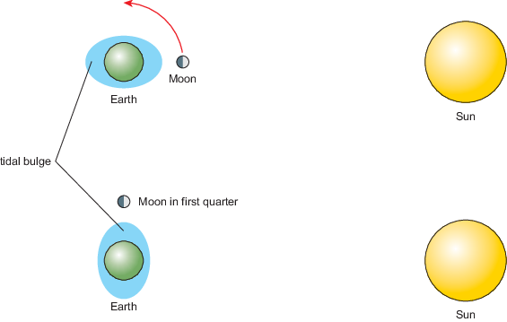
Figure 16 Upper: Earth, Moon and Sun in line – spring tides; lower: Moon and Sun pulling at right angles – neap tides (note: figure not to scale and highly exaggerated)
View description - Figure 16 Upper: Earth, Moon and Sun in line – spring tides; lower: Moon and Sun ...

In the upper part of Figure 16, the Moon is new but is in line with the Sun, and so produces spring tides on Earth. The same thing occurs when the Moon is in its second quarter about two weeks later on the opposite side of the Earth. It is then full but is still in line with the Sun and produces the next spring tides. Meanwhile, in between, the Moon in its first quarter as shown in the lower part of Figure 16 is pulling at right angles to the Sun’s pull, resulting in the lower-range neap tides. The same thing occurs when the moon is in its third quarter. Either way, as the Earth rotates once every 24 hours, it will pass through two tidal bulges; the tides are approximately twelve hours apart. The tidal range takes about a week to go from the largest spring tides to the smallest neap tides, then back again in the next week.
Tidal rise and fall can be predicted as tidal curves. A typical curve (for Hestan Island in the Solway, in October 2019) is shown in Figure 17. The blue peaks represent the twice daily rise and fall of the tides. The graph covers the week that it takes to change from neap to spring tides.

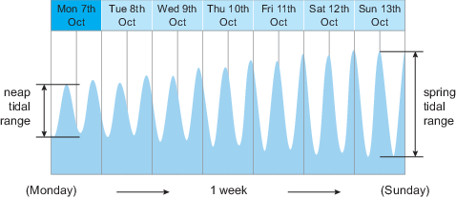
Figure 17 Hestan Island tidal curve
View description - Figure 17 Hestan Island tidal curve

The Earth effectively rotates beneath the tidal bulges and influences the speeds of the tidal flood and ebb streams in an almost sinusoidal way. For many estuaries and other areas subject to high tidal ranges, the 50/90 rule is observed regarding tidal stream speeds, as illustrated in Table 5. From a slack water period (i.e. when the tide changes from ebb to flood and vice versa), the relative speeds of the tidal stream are approximately as in Table 5.

Table 5 Relative speeds of tidal streams
Hour after slack water | Per cent of maximum speed
0 | 0%
1 | 50%
2 | 90%
3 | 100%
4 | 90%
5 | 50%
6 | 0%

Note that the highest speeds occur at mid-flow, in hours 3 and 4. Local features, however, can create anomalous variations that can catch out the unwary.
This is a useful overlying model as to the causes of ocean and sea tides, but, as might be expected, there are some other issues that affect both the overall and local patterns. Without going into too much detail, these can be summarised as follows:
- Astronomical effects: The gravitational pull of the Moon and Sun vary with the distance from these bodies to Earth; so therefore do the tidal effects they cause. These effects are global, but there are also more local effects depending on how far above or below the equator the Moon and Sun are in the sky at that particular location.
- Physical obstructions: The presence of land masses, coastlines, shallows, etc., in addition to physical obstruction can cause tidal flows to be reflected, interfered with and otherwise modified.
- Reflections and interference: The presence of land masses, coastlines, shallows, etc., can cause tidal flows to reflect and otherwise be modified so as to interfere with the incoming bulge. These can either amplify or detract from a local tidal range.
The tidal bulge in the open ocean is at most still less than a metre above stationary sea level, and the direct effect of the tidal forces on smaller seas and inland lakes is much smaller than this. Nevertheless, an ocean tidal bulge is a huge quantity of water when it encounters a shoreline (or, strictly speaking, when the rotating Earth shoreline encounters the bulge). The effects of the depth and shape of the sea bed, the orientation and shapes of the shoreline, etc., can create substantial changes in the local sea level. On the other hand, in some areas these features in conjunction with the Coriolis effect can create a tidal node region or system in which all effects cancel each other out such that there is no regular change in sea level. This is also known as an amphidromic point around which there may be strong currents in the amphidromic system but no net change in the sea level.

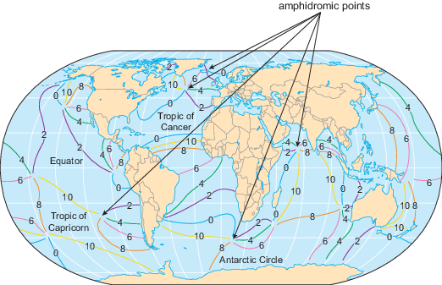
Figure 18 Sample of amphidromic points. There are 140 known such points
View description - Figure 18 Sample of amphidromic points. There are 140 known such points

Figure 18 shows some of the 140 known amphidromic points distributed around the world’s oceans. By definition, the tidal range at amphidromic points is zero, but it increases with distance away from the point. Due to the Coriolis effect, lifting or incoming tides tend to circulate around amphidromic points, anticlockwise in the northern hemisphere and clockwise in the southern hemisphere. This has the effect of creating high tides at the same time in different locations, shown by cotidal lines or contours; some examples of these are shown in Figure 19.

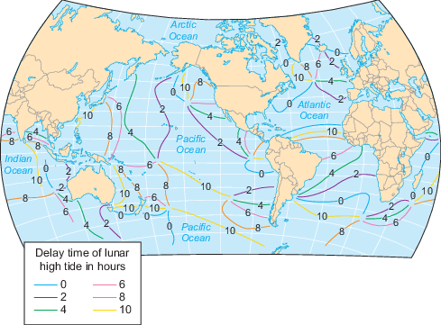
Figure 19 Co-tidal lines indicating high tides occurring at the same times
View description - Figure 19 Co-tidal lines indicating high tides occurring at the same times

Tides can be funnelled to stream around islands, promontories and other features both large and small to create regular surges, currents and amplified sea-level changes. The effect of shallow water and projecting spits of land create the aforementioned wave reflections and interferences, setting up tidal currents which appear to have little direct relationship with the oncoming open ocean tidal bulge. Such currents can give rise to double tides like those around Southampton, where the ebb tide of the English Channel running through Spithead creates a local high tide in addition to the ‘normal’ flood tide up the river Solent.
For the British Isles, the main stream of the Atlantic bulge flood tide approaches from the west, and on approaching the southern part of Ireland it splits into three main current streams. One follows the west coast of Ireland travelling north. Another enters and travels northwards up the Irish Sea, meeting up with the first one to the north of Ireland; both of these combine to continue flowing around the north of Scotland and back down the east coast of Britain and the North Sea towards Dover. Meanwhile, the third current stream flows into the English Channel, meeting the North Sea stream off Dover. In other words, the currents swirl both clockwise and anticlockwise around the island of Great Britain. These North Sea currents and surges can cause large tidal ranges, particularly when accompanied by strong winds, but there is an amphidromic point on the eastern side of the North Sea, off Denmark, and another midway between Norfolk and the Netherlands.

Coriolis effect on a tidal current stream
A tidal current stream is flowing due north at a speed of 10.0 km h⁻¹. What would be the Coriolis acceleration forces on a body of 100.0 tonnes of seawater at latitudes 30 and 75 degrees respectively? Give your answers to 3 significant figures.

Solution
The reference frame angular velocity is that of the Earth, i.e.

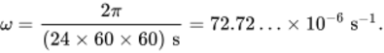
View alternative description - Uncaptioned Equation

The effective radial velocity from the axis of rotation is given by

View alternative description - Uncaptioned Equation

So at latitude 30 degrees

View alternative description - Uncaptioned Equation

and at latitude 75 degrees

View alternative description - Uncaptioned Equation

The velocity itself is

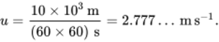
View alternative description - Uncaptioned Equation

The Coriolis accelerations are: for 30 degrees so

View alternative description - Uncaptioned Equation

and for 75 degrees so

View alternative description - Uncaptioned Equation

The Coriolis forces are given by . So for 30 degrees

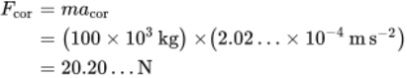
View alternative description - Uncaptioned Equation

and for 75 degrees

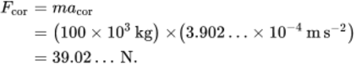
View alternative description - Uncaptioned Equation

Thus at latitude 30 degrees the Coriolis force is 20.2 N and at latitude 75 degrees it is 39.0 N (both to 3 s.f.). Note how the force nearly doubles with the 45 degree increase in latitude. Also, although these are relatively small forces, 100 tonnes of water represents the mass of a cube of water with sides of only about 4.6 m, which is tiny compared with a sizeable chunk of ocean.

Activity 2

A tidal current stream is flowing north to south at a speed of 8.0 km h⁻¹. Referring to the approach presented in Figure 19, estimate the lateral Coriolis acceleration force on a cubic metre of seawater of density 1025.0 kg m⁻³ at latitude 60 degrees. What would be the lateral speed due to the Coriolis acceleration of the same volume of water after 3 hours, neglecting the change in latitude? Give your answer to 2 significant figures.

View answer - Activity 2

2.5 Force on a floating tunnel
A fixed rail/road link has been proposed in the North Channel between south-west Scotland and Northern Ireland (see Figure 20).

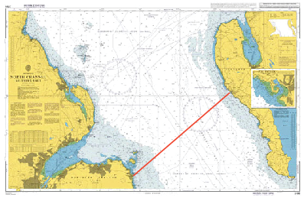
Figure 20 UKHO Chart 2198: North channel, southern part
View description - Figure 20 UKHO Chart 2198: North channel, southern part

Although Portpatrick in Scotland to Donaghadee in Northern Ireland is only 35 km (for comparison, the Channel Tunnel is 50 km long and the Lake Pontchartrain Causeway viaduct is 38 km long) the location poses a series of problems.
- Since the whole of the northern half of the Irish Sea has to fill and drain twice a day through the North Channel, the tidal streams are strong: at maximum (spring tides) the tide flows at 3 knots (1.5 m s⁻¹) mid-channel and at 4.5 knots (2.25 m s⁻¹) near the Irish coast (see Figure 20). Note that tides are normally expressed in knots: 1 knot is 1 nautical mile per hour, equal to 0.514 m s⁻¹.
- The weather in the North Channel is notoriously wild, and the combination of strong winds blowing across fast tidal flow in the opposite direction regularly produces huge waves of up to 20 m peak to trough (10 m amplitude). A breakwater at Portpatrick constructed in 1836 by John Rennie the Younger using techniques developed by his father for building lighthouses lasted less than three years before it was destroyed by a winter storm.
- There is significant shipping traffic, for which a route must be left clear. Any crossing solution must also be able to withstand a collision with a ship.
- In the middle of the channel, slightly towards the Scottish side, is Beaufort’s Dyke, a glacial valley 45 km long, 3 km wide and up to 300 m deep. On its own it would pose a significant challenge, but to make matters worse it was used as a dumping ground for hazardous waste after World War II and contains many thousands of tonnes of high explosives, incendiary bombs, poison gas and some nuclear waste, all poorly contained.
One possible solution to the problems is a floating tunnel (see Figure 21). At the time of writing this technology is under development in Norway as a possible solution to the similar problem of fjord crossings needed for the coastal highway project.

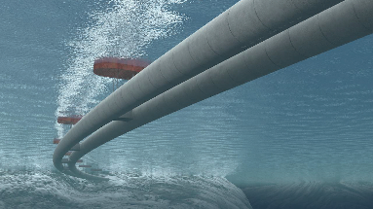
Figure 21 An artist’s impression of a proposed floating tunnel for Norway
View description - Figure 21 An artist’s impression of a proposed floating tunnel for Norway

A floating tunnel may be held up by its own buoyancy and anchored to the sea bed, or it may have negative buoyancy (i.e. a tendency to sink) and be suspended in position by surface pontoons.
In Activities 3.3a–3.3c you will investigate whether a floating tunnel in the North Channel will be able withstand the wave and tidal forces at this location.
Before you attempt Activity 3, it may be necessary to review your understanding of two dimensionless quantities which often occur when analysing and describing fluids: drag coefficient, Cd, and Reynolds number, Re.
Before you attempt Activity 3, it may be necessary to review your understanding of two dimensionless quantities which often occur when analysing and describing fluids: drag coefficient, Cd, and Reynolds number, Re. Start of Activity
Reynolds number
In a fluid flow situation, the Reynolds number is an important dimensionless parameter which characterises the nature of the flow. It is effectively the ratio of inertial forces to viscous forces in the fluid, both of which are resisting changes to velocity (i.e. accelerations of an object or fluid). For a cylinder of circular cross-section placed at right angles to a fluid flow, the equation for Reynolds number can be stated as

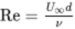
View alternative description - Uncaptioned Equation

Where is the transverse fluid flow velocity some distance away i.e. not disturbed by the cylinder), d is the cylinder diameter and ν (Greek letter nu) is the kinematic viscosity of the fluid.
Drag coefficient
From the definition of drag force presented in the earlier part of the course on the atmosphere, you know that drag force, F_{d} can be stated as

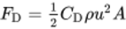
View alternative description - Uncaptioned Equation

Where C_{d} is the dimensionless parameter, the drag coefficient. The drag coefficient is an experimentally determined value which varies characteristically with Reynolds number (Re) for a given flow situation.

Activity 3

Tidal forces: Question 1

Interactive content is not available in this format.

Assuming that a single tunnel is 10 m in external diameter, find the Reynolds number based on diameter for a maximum tidal stream of 2.5 m s⁻¹. Assume that the density of seawater is and kinematic viscosity is . Give your answer to 2 significant figures.

View answer - Tidal forces: Question 1

Tidal forces: Question 2

Interactive content is not available in this format.

Using the following graph, estimate the drag coefficient at the Reynolds number found in Question 1 and hence the expected lateral force per kilometre on the tunnel. Give your answer to 2 significant figures.

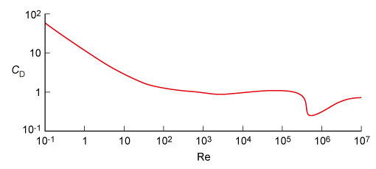
Figure 22
View description - Figure 22

View answer - Tidal forces: Question 2
A winter storm creates deep water waves of amplitude 10 m and wavelength 100 m in the middle of the North Channel. Work through the following questions to find whether the tunnel will be able to withstand the wave forces in winter.
Give your answer to 2 significant figures where appropriate.

Wave forces: Question 3

Interactive content is not available in this format.

How fast will the waves travel?

View answer - Wave forces: Question 3

Wave forces: Question 4

What is the period of the waves if the centre of the tunnel is at a depth of 50 m?

View answer - Wave forces: Question 4

Wave forces: Question 5

Will the waves cause significant forces?

View answer - Wave forces: Question 5

Conclusion: Question 5

Is a floating tunnel a viable solution to the problem from the fluid dynamics point of view?

View answer - Conclusion: Question 5

Conclusion
This course has focused on two of the most important environmental fluids for engineers: the atmosphere and the oceans. It has been shown that a thorough understanding of the mechanics of these fluids is vital to the success of engineering projects as diverse as spacecraft re-entering the earth’s atmosphere and floating tunnels providing road/rail links between land masses.
This free course is an adapted extract from the Open University course T229 Mechanical engineering: heat and flow.

Acknowledgements
Except for third party materials and otherwise stated (see terms and conditions), this content is made available under a Creative Commons Attribution-NonCommercial-ShareAlike 4.0 Licence.
The material acknowledged below is Proprietary and used under licence (not subject to Creative Commons Licence). Grateful acknowledgement is made to the following sources for permission to reproduce material in this free course:
Figures
Course image: P. GONTIER / EURELIOS / SCIENCE PHOTO LIBRARY
Figure 4: WolfBlur / www.needpix.com
Figure 10: NASA
Figure 11: adapted from https://en.wikipedia.org/wiki/Soyuz_(spacecraft)#
Figure 15: based on maps of the Institute of Oceanographic Sciences, May 1977
Figure 17: taken from https://www.tidetimes.org.uk/hestan-island-tide-times
Figure 18: taken from http://slideplayer.com/slide/3761217/13/images/20/Amphidromic+Points+Cotidal+map+shows+tides+rotate+around+amphidromic+points.+There+are+140+amphidromic+points+in+the+world%E2%80%99s+oceans..jpg
Figure 19: taken from http://slideplayer.com/slide/3761217/13/images/21/Cotidal+Lines+Cotidal+lines+show+where+high+tides+occur+at+the+same+time.jpg
Figure 20: © Hydrographic Office. Crown Copyright material is reproduced under Class Licence Number C01W0000065 with the permission of the Controller, Office of Public Sector Information (OPSI):
Figure 21: The Norwegian Public Roads Administration. / Vianova
Video
Video 1: European Space Agency, NASA, Cambridge University Spaceflight, Red Bull Media House, RSC Energia taken from European Space Agency, ESA YouTube Channel https://youtu.be/-l7MM9yoxII
Every effort has been made to contact copyright owners. If any have been inadvertently overlooked, the publishers will be pleased to make the necessary arrangements at the first opportunity.
Don't miss out
If reading this text has inspired you to learn more, you may be interested in joining the millions of people who discover our free learning resources and qualifications by visiting The Open University – www.open.edu/openlearn/free-courses.

Glossary
Beaufort Wind Force Scale
A thirteen-step scale of wind speeds (Force 0 to Force 12) based on observations of the effects at sea and on land.
Coriolis effect
The apparent tangential acceleration of an object moving towards or away from an axis around which it is moving.
Reynolds number
A dimensionless number that indicates the relative importance of inertial and viscous forces and also the likelihood of turbulent flow. Reynolds numbers are frequently used to compare flow patterns.
amphidromic point
A point with no tidal rise or fall. Also called a tidal node.
amphidromic system
A system (e.g. the North Sea or the Sound of Jura) containing an amphidromic point.
amplitude
The maximum extent of a vibration, oscillation or periodic function, measured from the position of equilibrium or centre line. The amplitude of a sinusoidal curve is half the difference between the maximum and minimum values of the curve.
anticyclones
The large-scale atmospheric rotation around an area of high pressure. Anticyclonic rotation is clockwise in the northern hemisphere and anti-clockwise south of the equator.
atmospheric boundary layer
The region of the atmosphere, up to about 1000 m above ground level, in which interaction with the ground significantly affects wind speed and direction.
break
A water wave breaks when it changes from approximately sinusoidal in shape to hooked prior to the crest collapsing. Waves may break as a result of wind action, moving into shallower water or a combination of both.
crest
The top of a water wave.
currents
Bulk flow in the atmosphere or oceans.
cyclones
The large-scale atmospheric rotation around an area of low pressure. Cyclonic rotation is anti-clockwise in the northern hemisphere and clockwise south of the equator. A cyclone is also the name for a hurricane when south of the equator.
depression
An area of atmospheric low pressure. Also called a low.
design wave
The likely worst-case wave height, used as a factor in the design of structures that interact with the sea.
design wind speed
The likely highest wind speed, used as a factor in the design of structures that interact with the atmosphere.
double tides
Two high tides in close succession with a small drop in between (or two low tides in close succession with a small rise in between).
drag coefficient
A non-dimensional form of drag: the drag force produced as a fraction of the product of stagnation pressure and a characteristic area. See also lift coefficient.
ebb
The receding or downward-going tide.
fetch
The distance over which wind can build up waves at sea.
flood
The approaching or upward-going tide.
geostrophic winds
Winds above the atmospheric boundary layer, driven by pressure gradients and Coriolis forces. Also called gradient winds.
gradient winds
See geostrophic winds.
ground level to reference height
The reference height of 10 m used for modelling wind variation in the atmospheric boundary layer.
high tides
The time at which the sea reaches its greatest depth in a particular tidal cycle; also the depth at that time.
isothermal height
See tropopause.
low
See depression.
low tides
The time at which the sea reaches its smallest depth in a particular tidal cycle; also the depth at that time.
neap tides
The time of lowest tidal range, when moon and sun work in opposition.
obliquity
The tilt of the Earth’s axis relative to a normal to the plane in which it orbits the sun.
orbit
The path followed by a body moving round another under the influence of gravity.
peak
The highest point of a wave.
ripples
Surface waves in water (or any other liquid) with an amplitude much smaller than the undisturbed depth.
slack water
A time when tidal currents are zero, usually coinciding with high or low tide.
spring tides
The time of highest tidal range, when moon and sun work together.
stratosphere
The upper part of the atmosphere.
surges
Rapid changes of sea level due to tidal effects.
swell
Long-wavelength oceanic waves.
tidal bulge
One of two areas of increased water depth, caused by the gravitational attraction of the sun and moon, which travel around the world and cause tides.
tidal currents
Horizontal flows of water caused by tidal depth changes.
tidal node
See amphidromic point.
tidal range
The difference in height between a high tide and the preceding or following low tide.
tidal wave
An ocean wave, normally caused by an undersea earthquake, which on approaching land causes a sea level change comparable to that caused by tides.
trade winds
The relatively constant east–west winds that blow in the tropical zones north and south of the equator.
tropopause
The top of the troposphere, above which the atmospheric temperature (in the stratosphere) is effectively constant. Also called isothermal height.
troposphere
The lower part of the atmosphere, in which most weather systems exist.
trough
The lowest part of a surface wave.
tsunami
Japanese term for a tidal wave, derived from ‘tsu’ (harbour) + ‘nami’ (wave).
wave periodic time
The time it takes for any point to experience a full wave cycle.
wave speed
The speed at which a travelling wave advances.
wavelength
The spatial distance over which a periodic waveform repeats (e.g. the distance between successive peaks or successive troughs).
waves
Any regular oscillation of a continuous medium.
westerlies
The relatively constant west–east winds that blow in the temperate zones further north and south of the equator than the tropical zones.

Solutions

Activity 4

Answer
From the fundamental law of hydrostatics

View alternative description - Uncaptioned Equation

therefore the atmospheric pressure will be

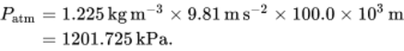
View alternative description - Uncaptioned Equation

Comparing this to the standard figure,

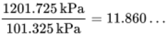
View alternative description - Uncaptioned Equation

which is 11.9 times (to 3 s.f.) greater than the standard figure.
In reality, the atmosphere’s height and thickness are many times what they would be if the density was constant. The real density at sea level varies from a maximum of approximately 1.4 kg m⁻³ to a very low density at and above about 6 km height. The reduction of density of the atmosphere is evident at quite low levels; this limits the heights at which aircraft can generate sufficient lift and is why they have to fly so fast to climb high. Figure 1 is based on previously published data from the United Nations International Civil Aviation Organization (ICAO) regarding temperature variation with height. Other properties of interest can be deduced from their relationships with temperature.
Back to - Activity 4

Activity 5

Answer
Equation 2,

View alternative description - Uncaptioned Equation

can be rearranged to find density

View alternative description - Uncaptioned Equation

Therefore the percentage reduction in density is

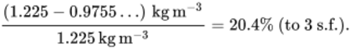
View alternative description - Uncaptioned Equation

Back to - Activity 5

Activity 6

Answer
The wind speed is

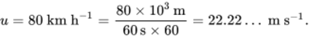
View alternative description - Uncaptioned Equation

The angular velocity of the Earth is

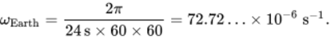
View alternative description - Uncaptioned Equation

At 60 degrees the effective radial velocity is

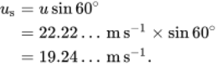
View alternative description - Uncaptioned Equation

So the Coriolis acceleration is

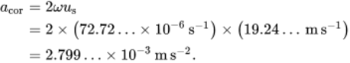
View alternative description - Uncaptioned Equation

The Coriolis force is found from therefore

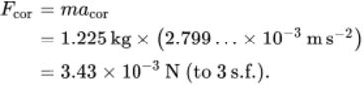
View alternative description - Uncaptioned Equation

Back to - Activity 6

Activity 7

Answer
Considering equation (10),

View alternative description - Uncaptioned Equation

So

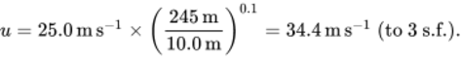
View alternative description - Uncaptioned Equation

Back to - Activity 7

Activity 8

Answer
From the wind speed map shown in Figure 9, the wind speed for Carlisle is 24 m s⁻¹.
From Equation 9 and Table 1

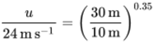
View alternative description - Uncaptioned Equation

so

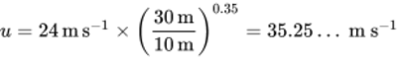
View alternative description - Uncaptioned Equation

or

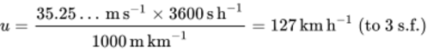
View alternative description - Uncaptioned Equation

In the countryside

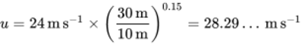
View alternative description - Uncaptioned Equation

or

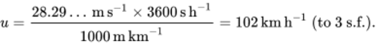
View alternative description - Uncaptioned Equation

Back to - Activity 8

Activity 9

Question 1

Answer
From the figure it can be seen that at 10 km the speed of sound ration 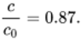and it is stated that so the local speed of sound is:

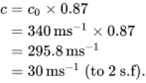
View alternative description - Uncaptioned Equation

Back to - Question 1

Part

Answer
Speed of capsule = 250 m/s

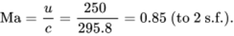
View alternative description - Uncaptioned Equation

Back to - Part

Question 2

Answer
At terminal velocity the weight of the capsule is exactly balanced by its aerodynamic drag, so
by its aerodynamic drag, so

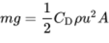
View alternative description - Uncaptioned Equation

which can be rearranged to find the drag coefficient

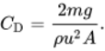
View alternative description - Uncaptioned Equation

From Figure 11, the diameter of the capsule is 2.2 m, so the area is

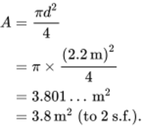
View alternative description - Uncaptioned Equation

Also from Figure 11, the mass of the re-entry module is 2900 kg and from Figure 2, the density ratio at 10 km is about 0.34. The density, therefore, is given by,

View alternative description - Uncaptioned Equation

Substituting in the values gives a drag coefficient of

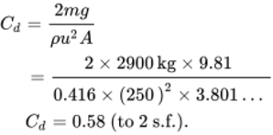
View alternative description - Uncaptioned Equation

Back to - Question 2

Question 3

Answer
As before, at terminal velocity the weight of the capsule is exactly balanced by its aerodynamic drag, so

View alternative description - Uncaptioned Equation

but this time the air density is the unknown and the area is the area of the parachute, so rearranging and substituting known values,

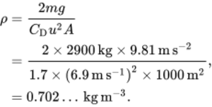
View alternative description - Uncaptioned Equation

Since the standard sea level density of air is , this is density ratio of

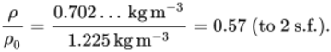
View alternative description - Uncaptioned Equation

Referring to Figure 2, this corresponds to an altitude of 5.5 km
Back to - Question 3

Question 4

Answer
Assuming that the capsule descends at local terminal velocity to ground level, the total drag must remain constant all the way down, that is,
Since neither the drag coefficient nor the parachute area are changing, then this equation can be simplified to,

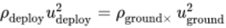
View alternative description - Uncaptioned Equation

Which can be rearranged as,

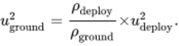
View alternative description - Uncaptioned Equation

and therefore

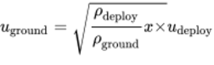
View alternative description - Uncaptioned Equation

View alternative description - Uncaptioned Equation

Back to - Question 4

Activity 1

Answer
- Using Equation 12,

View alternative description - Uncaptioned Equation

The value is the same.
- Using Equation 13,

View alternative description - Uncaptioned Equation

The value is the same.
- The amplitude at the surface is

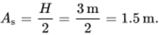
View alternative description - Uncaptioned Equation

The surface amplitude has reduced by 50%.
- To find the displacement amplitude Equation 14 is used:

View alternative description - Uncaptioned Equation

The factor at 50 m depth will be the same:

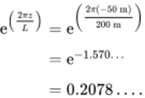
View alternative description - Uncaptioned Equation

This gives a displacement amplitude of

View alternative description - Uncaptioned Equation

This shows a reduction of 50%.
- First calculate the displacement amplitude at 25 m depth, since this is also the radius of the particle’s circular motion. The factor will be the same at

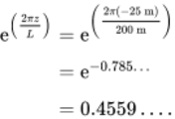
View alternative description - Uncaptioned Equation

The radius of circular motion (or displacement amplitude) is

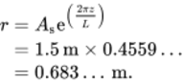
View alternative description - Uncaptioned Equation

This is a reduction of 50%. Now, using Equation 16, angular velocity will be the same at

View alternative description - Uncaptioned Equation

The acceleration amplitude is

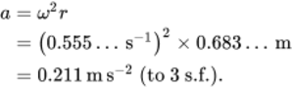
View alternative description - Uncaptioned Equation

This is a reduction of 50%.
Back to - Activity 1

Activity 2

Answer
The angular velocity of the Earth is

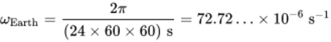
View alternative description - Uncaptioned Equation

and the wind speed is

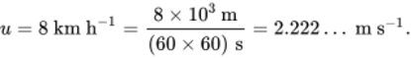
View alternative description - Uncaptioned Equation

At 60 degrees the effective radial velocity north to south is

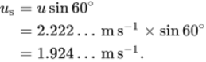
View alternative description - Uncaptioned Equation

So the Coriolis acceleration is

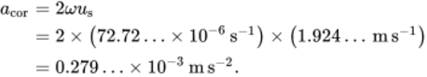
View alternative description - Uncaptioned Equation

The lateral Coriolis force is

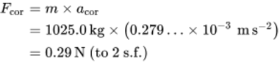
View alternative description - Uncaptioned Equation

and after three hours the lateral speed will be

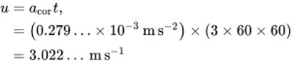
View alternative description - Uncaptioned Equation

or (to 2 s.f.).
Back to - Activity 2

Activity 3

Tidal forces: Question 1

Answer
Using the tidal stream velocity of , external diameter and kinematic viscosity of seawater of , the Reynolds number is

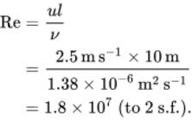
View alternative description - Uncaptioned Equation

Back to - Tidal forces: Question 1

Tidal forces: Question 2

Answer
Flow is completely turbulent and the drag coefficient will be close to that shown for Re = 10⁷, so from the graph .
A 1 km length of pipe has a transverse area of , so the drag force per km is

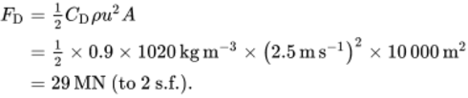
View alternative description - Uncaptioned Equation

This is a substantial force, to put it mildly. However you may care to compare it to the buoyant force exerted by the sea on the same length of tunnel when the centreline is submerged by only 20 m. The buoyant force on an immersed object is equal to the weight of fluid displaced by it (Archimedes’ principle), so

View alternative description - Uncaptioned Equation

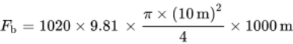
View alternative description - Uncaptioned Equation

View alternative description - Uncaptioned Equation

This is around 27 times greater than the tidal force, which is therefore not particularly large by the standards of the project.
Back to - Tidal forces: Question 2

Wave forces: Question 3

Answer
Using the formula for deep water waves in Equation 12, the wave speed is

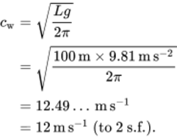
View alternative description - Uncaptioned Equation

Back to - Wave forces: Question 3

Wave forces: Question 4

Answer
Using Equation 13, at 50.0 m depth the period of the waves is

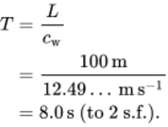
View alternative description - Uncaptioned Equation

Back to - Wave forces: Question 4

Wave forces: Question 5

Answer
According to Section 1.2, deep-water, wave-induced motion at half the wavelength is around 4% of the surface value. That is the case here, so the wave motion at the tunnel centre line will be only 4% × 10 m = 40 cm. Since tidal flow in the centre regularly reaches 150 cm s⁻¹, the extra wave displacement of 40 cm there-and-back every 4 seconds will not add significant additional forces.
Back to - Wave forces: Question 5

Conclusion: Question 5

Answer
Conclusion: A floating tunnel should easily be able to withstand both tidal and wave forces in this location.
Back to - Conclusion: Question 5

Descriptions

Uncaptioned Equation
equation left hand side cap p sub atm equals right hand side rho times g times h
Back to - Uncaptioned Equation

Uncaptioned Equation
equation sequence part 1 h equals part 2 cap p sub atm divided by rho times g equals part 3 101.325 multiplication 10 cubed Pa divided by 1.225 kg m super negative three multiplication 9.81 m s super negative two equals part 4 8431.6 times ellipsis m full stop
Back to - Uncaptioned Equation

Uncaptioned Equation
equation left hand side cap p sub atm equals right hand side rho times g times h
Back to - Uncaptioned Equation

Uncaptioned Equation
cap p sub atm equals 1.225 kg m super negative three multiplication 9.81 m s super negative two multiplication 100.0 multiplication 10 cubed m equals 1201.725 kPa full stop
Back to - Uncaptioned Equation

Uncaptioned Equation
1201.725 kPa divided by 101.325 kPa equals 11.860 times ellipsis
Back to - Uncaptioned Equation

Figure 1 Temperature variation with height in standard atmosphere
This figure is a graph of height (km) on the vertical axis against temperature (degrees C). The region below 11 km height is the troposphere and above it the stratosphere. The boundary at 11 km is labelled ‘isothermal height, tropopause’.
The graph itself is a straight line from 15 degrees C at the surface, sloping upwards to the left to the tropopause at 56.6 degrees C. Above the tropopause the graph is a vertical line up to 16 degrees C. The gradient of the line in the troposphere is – 6.5 degrees C per km.
Back to - Figure 1 Temperature variation with height in standard atmosphere

Uncaptioned Equation
11000 m divided by 56.5 super degree cap c prefix plus of 15 super degree cap c equals z divided by 15 super degree cap c
Back to - Uncaptioned Equation

Uncaptioned Equation
equation sequence part 1 h equals part 2 15 super degree cap c prefix multiplication of 11 000 m divided by 71.5 super degree cap c equals part 3 2307.69 times ellipsis m full stop
Back to - Uncaptioned Equation

Figure 2 Properties of the standard atmosphere. Note that kinematic viscosity eta increases with altitude, so the inverse ratio eta sub zero divided by eta is shown.
This is a graph with a dimensionless vertical scale from 0 to 1, against height (km) from 0 to 20 km. 6 lines are shown. They all start from (0 km, 1) i.e. maximum value at the surface.
Straight line sloping down from the start to 0.85 at 11 km then horizontal for remaining heights. It is labelled c/c subscript 0 where c subscript 0 is 340 m per s.
The second line is sloping down to 0.8 at 11 km and labelled Greek letter eta/eta subscript 0, where eta subscript 0 is 18 x 10 to the power of -6 N s per m squared.
The third line is sloping down to 0.6 at 11 km and labelled T/T subscript 0, where T subscript 0 is 288.15 K.
The remaining 3 graphs are curves that continuously fall with decreasing slope to low values (around 0.1) at 20 km height. They are close together and the top and middle curves have slight kinks at height 11 km.
The top of these is Greek letter nu subscript 0/nu, where nu subscript 0 is 14.7 times 10 to the power of -6 m squared per s.
The middle one is Greek letter rho/rho subscript 0 where rho subscript 0 is 1.225 kg per m cubed.
The lower one is P/P subscript 0 where P subscript 0 is 101.3 kPa.
Back to - Figure 2 Properties of the standard atmosphere. Note that kinematic viscosity eta increases with altitude, so the inverse ratio eta sub zero divided by eta is shown.

Uncaptioned Equation
equation sequence part 1 c equals part 2 c sub zero multiplication 0.865 equals part 3 294 m s super negative one full stop
Back to - Uncaptioned Equation

Uncaptioned Equation
cap p divided by cap p sub zero equals left parenthesis one minus z divided by z sub cap c right parenthesis super 5.256
Back to - Uncaptioned Equation

Uncaptioned Equation
rho divided by rho sub zero equals left parenthesis one minus z divided by z sub cap c right parenthesis super 4.256
Back to - Uncaptioned Equation

Uncaptioned Equation
equation sequence part 1 cap p divided by cap p sub one equals part 2 rho divided by rho sub one equals part 3 exp left parenthesis negative z minus z sub one divided by z sub d right parenthesis
Back to - Uncaptioned Equation

Uncaptioned Equation
cap p equals left parenthesis one minus z divided by z sub cap c right parenthesis super 5.256 multiplication cap p sub zero full stop
Back to - Uncaptioned Equation

Uncaptioned Equation
equation sequence part 1 cap p equals part 2 left parenthesis one minus 2307.69 m divided by 44 300.0 m right parenthesis super 5.256 multiplication left parenthesis 101.3 multiplication 10 cubed Pa right parenthesis equals part 3 76.47 times ellipsis multiplication 10 cubed Pa full stop
Back to - Uncaptioned Equation

Uncaptioned Equation
left parenthesis 101.3 minus 76.47 times ellipsis right parenthesis kPa divided by 101.3 kPa multiplication 100 percent equals 24.5 percent left parenthesis to three s full stop f full stop right parenthesis full stop
Back to - Uncaptioned Equation

Uncaptioned Equation
rho divided by rho sub zero equals left parenthesis one minus z divided by z sub cap c right parenthesis super 4.256
Back to - Uncaptioned Equation

Uncaptioned Equation
equation sequence part 1 rho equals part 2 1.225 kg m super negative three multiplication left parenthesis one minus 2307.69 m divided by 44 300.0 m right parenthesis super 4.256 equals part 3 0.9755 times ellipsis kg m super negative three full stop
Back to - Uncaptioned Equation

Uncaptioned Equation
left parenthesis 1.225 minus 0.9755 times ellipsis right parenthesis kg m super negative three divided by 1.225 kg m super negative three equals 20.4 percent left parenthesis to three s full stop f full stop right parenthesis full stop
Back to - Uncaptioned Equation

Uncaptioned Equation
cap p divided by cap p sub zero equals left parenthesis one minus z divided by z sub cap c right parenthesis super 5.256
Back to - Uncaptioned Equation

Uncaptioned Equation
rho divided by rho sub zero equals left parenthesis one minus z divided by z sub cap c right parenthesis super 4.256
Back to - Uncaptioned Equation

Uncaptioned Equation
equation sequence part 1 cap p divided by cap p sub one equals part 2 rho divided by rho sub one equals part 3 exp left parenthesis negative z minus z sub one divided by z sub d right parenthesis
Back to - Uncaptioned Equation

Figure 3 Regular global winds
This is a schematic of the Earth as a circle divided into horizontal bands. From the north pole working downwards to the south pole these bands are: Polar High with wind vectors sloping down to the left; Sub-polar High – no wind vectors; Westerlies (temperate zone) with wind vectors sloping up to the right; Sub-tropical high – no wind vectors; N. E. Trades (tropical zone) with wind vectors sloping down to the left; Doldrums low, being a band halfway up, around the equator – no wind vectors; S. E. Trades (tropical zone) with wind vectors sloping up to the left; Sub-tropical high – no wind vectors; Westerlies (temperate zone) with wind vectors sloping down to the right; Sub-polar low – no wind vectors; Polar high with wind vectors sloping up to the left.
Back to - Figure 3 Regular global winds

Figure 4 A typical fairground ride and manifestation of Coriolis acceleration
This is a photograph of an ornate horse on a vintage merry-go-round (as found at a fun fair) with poles above and below. Red arrows on the floor are along the direction of the motion of the horse and get bigger further from the centre. They are labelled ‘tangential velocity increases with distance from the axis’. A yellow arrow is directed outwards from the axis at right angles to the red arrows. It is labelled ‘outward movement requires tangential acceleration to keep up with horses’.
Back to - Figure 4 A typical fairground ride and manifestation of Coriolis acceleration

Figure 5 Directions of the Coriolis acceleration
This figure illustrates 4 cases of Coriolis acceleration. Each has a velocity arrow with its tail at a point O labelled u subscript s, an acceleration vector arrow perpendicular to u subscript s, labelled a subscript cor and a curled angular velocity arrow labelled omega. From left to right: U subscript s slopes up to the right, a subscript cor slopes up to the left and omega is anticlockwise; U subscript s slopes up to the right, a subscript cor slopes down to the right and omega is clockwise; U subscript s slopes down to the left, a subscript cor slopes up to the left and omega is clockwise; U subscript s slopes down to the left, a subscript cor slopes down to the right and omega is anticlockwise.
Back to - Figure 5 Directions of the Coriolis acceleration

Uncaptioned Equation
a sub cor equals two times omega times u sub cap s full stop
Back to - Uncaptioned Equation

Uncaptioned Equation
equation left hand side a sub cor equals right hand side two times omega times u sub cap s
Back to - Uncaptioned Equation

Uncaptioned Equation
equation left hand side u sub cap s equals right hand side u times sine of postfix times theta
Back to - Uncaptioned Equation

Uncaptioned Equation
a sub cor equals two times omega times u times sine postfix times theta full stop
Back to - Uncaptioned Equation

Figure 6 Schematic view of Earth from above the equator
This is a diagram of a circular earth with the following features: a vertical line through the centre, labelled N at the top, S at the bottom; a horizontal line through the centre, the equator; omega shows the spinning clockwise (when viewed from above the N pole); a red circle is at a point on the top right of the circle; a velocity vector by the red dot, u, is pointed down to the right (moving southwards) at a tangent to the circle; another vector u subscript s, is a horizontal arrow pointing to the right from the red circle; a vertical line linking the tip of the u subscript s vector with the tip of the u vector shows that u makes an angle theta to the vertical (here about 45 degrees).
Back to - Figure 6 Schematic view of Earth from above the equator

Uncaptioned Equation
equation sequence part 1 omega equals part 2 two times pi divided by 24 multiplication 60 multiplication 60 equals part 3 72.72 times ellipsis multiplication 10 super negative six times normal r times normal a times normal d postfix times s super negative one full stop times
Back to - Uncaptioned Equation

Uncaptioned Equation
equation sequence a sub cor equals two times omega times u times sine of theta equals two multiplication 72.72 times horizontal ellipsis multiplication 10 super negative six multiplication u times sine of theta equals open 145 multiplication 10 super negative six multiplication u times sine of theta close m s super negative two left parenthesis to three s full stop f full stop right parenthesis full stop
Back to - Uncaptioned Equation

Uncaptioned Equation
equation sequence part 1 u equals part 2 80 times km h super negative one equals part 3 80 multiplication 10 cubed times m divided by 60 times s prefix multiplication of 60 equals part 4 22.22 times ellipsis times m s super negative one full stop
Back to - Uncaptioned Equation

Uncaptioned Equation
equation sequence part 1 omega sub Earth equals part 2 two pi divided by 24 times s prefix multiplication of 60 multiplication 60 equals part 3 72.72 times ellipsis multiplication 10 super negative six times s super negative one full stop
Back to - Uncaptioned Equation

Uncaptioned Equation
equation sequence u sub s equals u times sine of 60 super degree equals 22.22 times horizontal ellipsis m equation left hand side s super negative one multiplication sine of 60 super degree equals right hand side 19.24 times horizontal ellipsis m s super negative one full stop
Back to - Uncaptioned Equation

Uncaptioned Equation
equation sequence a sub cor equals two times omega times u sub s equals two multiplication open 72.72 times horizontal ellipsis multiplication 10 super negative six s super negative one close multiplication open 19.24 times horizontal ellipsis m s super negative one close equals 2.799 times horizontal ellipsis multiplication 10 super negative three m s super negative two full stop
Back to - Uncaptioned Equation

Uncaptioned Equation
equation sequence cap f sub cor equals m times a sub cor equals 1.225 kg equation left hand side prefix multiplication of open 2.799 times horizontal ellipsis multiplication 10 super negative three m s super negative two close equals right hand side 3.43 multiplication 10 super negative three cap n left parenthesis to three s full stop f full stop right parenthesis full stop
Back to - Uncaptioned Equation

Figure 7 Development of a cyclone (northern hemisphere), (a) showing the beginnings of Coriolis deflection and (b) the balanced equilibrium flow condition
This shows 2 sets of concentric circles labelled ‘low’ in their common centre. In (a) 4 curved arrows show motion into the circles following a curved clockwise direction that cross the concentric lines. In (b) there are 4 curved arrows parallel to the concentric circles showing anticlockwise movement around the centre.
Back to - Figure 7 Development of a cyclone (northern hemisphere), (a) showing the beginnings of Coriolis deflection and (b) the balanced equilibrium flow condition

Figure 8 Development of an anticyclone (northern hemisphere), (a) showing the beginnings of Coriolis deflection and (b) the balanced equilibrium flow condition
This shows 2 sets of concentric circles labelled ‘high’ in their common centre. In (a) 4 curved arrows show motion out from the circles following a curved clockwise direction that cross the concentric lines. In (b) there are 4 curved arrows parallel to the concentric circles showing clockwise movement around the centre.
Back to - Figure 8 Development of an anticyclone (northern hemisphere), (a) showing the beginnings of Coriolis deflection and (b) the balanced equilibrium flow condition

Uncaptioned Equation
left parenthesis u divided by u sub r right parenthesis equals left parenthesis z divided by z sub r right parenthesis super p
Back to - Uncaptioned Equation

Uncaptioned Equation
left parenthesis u divided by u sub r right parenthesis equals left parenthesis z divided by z sub r right parenthesis super p full stop
Back to - Uncaptioned Equation

Uncaptioned Equation
u sub r equals 23.0 m s super negative one comma z sub r equals 10.0 m comma z equals 50.0 m comma p equals 0.1 full stop
Back to - Uncaptioned Equation

Uncaptioned Equation
equation sequence part 1 u equals part 2 u sub r multiplication left parenthesis z divided by z sub r right parenthesis super p equals part 3 23.0 m s super negative one multiplication left parenthesis 50.0 m divided by 10.0 m right parenthesis super 0.1 equals 27.0 m s super negative one left parenthesis to three s full stop f full stop right parenthesis full stop
Back to - Uncaptioned Equation

Uncaptioned Equation
equation left hand side u sub r equals right hand side 25.0 times ms super negative one comma z sub r equals 10.0 m comma z equals 245 m comma p equals 0.1 full stop
Back to - Uncaptioned Equation

Uncaptioned Equation
u equals 25.0 m s super negative one multiplication left parenthesis 245 m divided by 10.0 m right parenthesis super 0.1 equals 34.4 m s super negative one left parenthesis to three s full stop f full stop right parenthesis full stop
Back to - Uncaptioned Equation

Figure 9 Wind map for the UK from British Standards (2010)
This shows a map of the British Isles. Contour lines join regions of equal wind speed (maximum winds velocity). The contours are 0.5 m per s apart. The wind contours are roughly circular around a point in the SE of England (near Oxford). The circular regions extend to the north of England, thereafter the contours are part of a very roughly closed curve, covering land and the sea between England and Ireland. The lowest speed near Oxford is 21.5 m per s. The highest is on a contour that passes near the Shetland Isles in the north, 30 m per s. It is set on a grid of squares that are 100 x 100 km and coded with 2 letters. England, Scotland and Wales are on a grid 7 x 10 squares and Ireland on a region 4 x 5 squares.
Back to - Figure 9 Wind map for the UK from British Standards (2010)

Uncaptioned Equation
q sub p equals zero .613 left parenthesis u sub map multiplication c sub alt multiplication c sub dir right parenthesis squared prefix multiplication of c sub e multiplication c sub e comma cap t
Back to - Uncaptioned Equation

Uncaptioned Equation
equation sequence part 1 cap p sub dyn equals part 2 one divided by two times rho times u squared equals part 3 0.613 times u squared
Back to - Uncaptioned Equation

Uncaptioned Equation
u divided by 24 m s super negative one equals left parenthesis 30 m divided by 10 m right parenthesis super 0.35
Back to - Uncaptioned Equation

Uncaptioned Equation
u equals 24 m s super negative one multiplication left parenthesis 30 m divided by 10 m right parenthesis super 0.35 equals 35.25 times ellipsis times m s super negative one
Back to - Uncaptioned Equation

Uncaptioned Equation
equation sequence part 1 u equals part 2 35.25 times ellipsis m s super negative one multiplication 3600 s h super negative one divided by 1000 m km super negative one equals part 3 127 km h super negative one postfix times left parenthesis to three s full stop f full stop right parenthesis
Back to - Uncaptioned Equation

Uncaptioned Equation
u equals 24 m s super negative one multiplication left parenthesis 30 m divided by 10 m right parenthesis super 0.15 equals 28.29 times ellipsis m s super negative one
Back to - Uncaptioned Equation

Uncaptioned Equation
equation sequence part 1 u equals part 2 28.29 times ellipsis m s super negative one multiplication 3600 s h super negative one divided by 1000 m km super negative one equals part 3 102 km h super negative one left parenthesis to three s full stop f full stop right parenthesis full stop
Back to - Uncaptioned Equation

Uncaptioned Equation
u divided by u sub r equals left parenthesis z divided by z sub r right parenthesis super p full stop
Back to - Uncaptioned Equation

Figure 10 The Soyuz spacecraft
This is a photograph of the Soyuz spacecraft. It has three joined sections: roughly spherical orbital module at the front; descent module – a shape with a circular cross section that tapers towards the spherical module; cylindrical service module, same cross section as the wider part of the descent module. The service module has two rectangular solar panel ‘wings’ attached to it.
Back to - Figure 10 The Soyuz spacecraft

Figure 11 The service module of the Soyuz spacecraft
The figure contains labels for the Soyuz spacecraft:
Orbital module: mass 1300 kg, 2.2 m diameter, 2.6 m deep
Descent module with crew seating: mass 2900 kg, 2.2 m diameter, 2.1 m deep
Instrumentation and service module: mass 2600 kg, 2.7 m diameter, 2.5 m deep
The solar panel wings are 10.6 m, tip to tip.
Back to - Figure 11 The service module of the Soyuz spacecraft

Figure 2 (repeated) Properties of the standard atmosphere. Note that kinematic viscosity eta increases with altitude, so the inverse ratio eta sub zero divided by eta is shown.
This is a graph with a dimensionless vertical scale from 0 to 1, against height (km) from 0 to 20 km. 6 lines are shown. They all start from (0 km, 1) i.e. maximum value at the surface.
Straight line sloping down from the start to 0.85 at 11 km then horizontal for remaining heights. It is labelled c/c subscript 0 where c subscript 0 is 340 m per s.
The second line is sloping down to 0.8 at 11 km and labelled Greek letter eta/eta subscript 0, where eta subscript 0 is 18 x 10 to the power of -6 N s per m squared.
The third line is sloping down to 0.6 at 11 km and labelled T/T subscript 0, where T subscript 0 is 288.15 K.
The remaining 3 graphs are curves that continuously fall with decreasing slope to low values (around 0.1) at 20 km height. They are close together and the top and middle curves have slight kinks at height 11 km.
The top of these is Greek letter nu subscript 0/nu, where nu subscript 0 is 14.7 times 10 to the power of -6 m squared per s.
The middle one is Greek letter rho/rho subscript 0 where rho subscript 0 is 1.225 kg per m cubed.
The lower one is P/P subscript 0 where P subscript 0 is 101.3 kPa.
Back to - Figure 2 (repeated) Properties of the standard atmosphere. Note that kinematic viscosity eta increases with altitude, so the inverse ratio eta sub zero divided by eta is shown.

Uncaptioned Equation
equation sequence part 1 c equals part 2 c sub zero multiplication 0.87 equals part 3 340 m s super negative one multiplication 0.87 equals 295.8 m s super negative one equals 30 m s super negative one left parenthesis to two s full stop f right parenthesis full stop
Back to - Uncaptioned Equation

Uncaptioned Equation
Ma equation sequence part 1 equals part 2 u divided by c equals part 3 250 super divided by 295.8 super equals part 4 0.85 left parenthesis to two s full stop f full stop right parenthesis full stop
Back to - Uncaptioned Equation

Uncaptioned Equation
cap f sub d equals one divided by two times cap c sub d times rho times u squared times cap a
Back to - Uncaptioned Equation

Uncaptioned Equation
m times g equals one divided by two times cap c sub cap d times rho times u squared times cap a
Back to - Uncaptioned Equation

Uncaptioned Equation
cap c sub cap d equals two times m times g divided by rho times u squared times cap a full stop
Back to - Uncaptioned Equation

Uncaptioned Equation
equation sequence part 1 cap a equals part 2 pi times d squared divided by four equals part 3 pi multiplication left parenthesis 2.2 m right parenthesis squared divided by four equals part 4 3.801 times ellipsis m super two equals 3.8 m super two left parenthesis to two s full stop f full stop right parenthesis full stop
Back to - Uncaptioned Equation

Uncaptioned Equation
rho equals 0.34 multiplication 1.225 kg m super negative three equals 0.416 kg m super negative three full stop
Back to - Uncaptioned Equation

Uncaptioned Equation
equation sequence part 1 cap c sub d equals part 2 two times m times g divided by rho times u squared times cap a equals part 3 two multiplication 2900 kg prefix multiplication of 9.81 divided by 0.416 multiplication left parenthesis 250 right parenthesis squared multiplication 3.801 times ellipsis times cap c sub d equals part 4 0.58 left parenthesis to two s full stop f full stop right parenthesis full stop
Back to - Uncaptioned Equation

Uncaptioned Equation
m times g equals one divided by two times cap c sub cap d times rho times u squared times cap a
Back to - Uncaptioned Equation

Uncaptioned Equation
equation sequence part 1 rho equals part 2 two times m times g divided by cap c sub cap d times u squared times cap a equals part 3 two multiplication 2900 kg prefix multiplication of 9.81 m s super negative two divided by 1.7 multiplication left parenthesis 6.9 m s super negative one right parenthesis squared multiplication 1000 m super two comma equals part 4 0.702 times ellipsis kg m super negative three full stop
Back to - Uncaptioned Equation

Uncaptioned Equation
equation sequence part 1 rho divided by rho sub zero equals part 2 0.702 ellipsis kg m super negative three divided by 1.225 kg m super negative three equals part 3 0.57 left parenthesis to two s full stop f full stop right parenthesis full stop
Back to - Uncaptioned Equation

Uncaptioned Equation
rho sub deploy times u sub deploy squared equals rho sub ground multiplication times u sub ground squared
Back to - Uncaptioned Equation

Uncaptioned Equation
u sub ground squared equals rho sub deploy divided by rho sub ground postfix multiplication times u sub deploy squared full stop
Back to - Uncaptioned Equation

Uncaptioned Equation
u sub ground equals Square root of rho sub deploy divided by rho sub ground times x postfix multiplication times u sub deploy
Back to - Uncaptioned Equation

Uncaptioned Equation
times times times times times times groundu equals Square root of 0.57 multiplication 6.9 ms equals times 5.2 m s super negative one left parenthesis to two s full stop f full stop right parenthesis full stop
Back to - Uncaptioned Equation

Uncaptioned Equation
c sub w equals Square root of cap l times g divided by two pi
Back to - Uncaptioned Equation

Uncaptioned Equation
c sub w equals Square root of cap l times g divided by two pi
Back to - Uncaptioned Equation

Figure 12 Cross sections of wave profiles
This shows 2 waves in cross-section. The upper diagram shows one cycle of a sinusoidal wave (same shape as a sine curve), from a trough to the curved peak to the next trough. The distance between the troughs is L and vertical distance from trough to peak is H. A horizontal line passes halfway between the 2 peaks. The graph label is ‘sinusoidal form, lower wave heights’.
The lower diagram has a different shape. From the trough on the left, the wave has a steady height for about one third of L, then rises diagonally upwards to a pointed peak, then falls to a second trough on the right by sloping down and being flat. H is the distance from trough to peak again and the horizontal line is only a small distance above the troughs. The label is ‘peaked form, higher wave heights’.
Back to - Figure 12 Cross sections of wave profiles

Uncaptioned Equation
cap t sub equals cap l divided by c sub w
Back to - Uncaptioned Equation

Figure 13 Cross section of a sinusoidal wave profile
This shows 2 complete cycles of a sinusoidal wave on the surface of water. There is a horizontal line halfway between peaks and troughs, the flat sea surface. L is the distance between 2 similar points e.g. 2 peaks and H is the vertical distance from peak to trough. d is the depth from the sea bed to flat sea surface. Waves move from the left with wave speed c subscript w. The coordinate axis is x positive to the right and z positive vertically upwards.
Back to - Figure 13 Cross section of a sinusoidal wave profile

Figure 14 Wave water particle orbits (not to scale)
This shows the paths followed by wave water particles for three regimes. In each case, the wave moves from left to right.
Left figure: shallow water, d less than L divided by 20. The path of the surface is elliptical and clockwise. The height of each ellipse is less than length. The height of the ellipse for deeper paths decreases with depth (the ellipses get flatter), though the length of each ellipse remains constant with depth. The ellipses are shown getting close to the sea bed.
Middle: intermediate. The path of the surface is elliptical and clockwise. The height of each ellipse is less than length. The height and length of depth of each ellipse decrease with depth. The ellipses are shown getting close to the sea bed.
Right figure: deep water, d greater than L divided by 20. The path is circular and clockwise. The radius of these paths decreases with depth and disappear completely a long way above the sea bed.
Back to - Figure 14 Wave water particle orbits (not to scale)

Uncaptioned Equation
cap a sub z equals cap a sub s times e super left parenthesis two times pi times z divided by cap l right parenthesis full stop
Back to - Uncaptioned Equation

Uncaptioned Equation
a equals omega squared times r
Back to - Uncaptioned Equation

Uncaptioned Equation
omega equals two pi f equals two pi divided by cap t
Back to - Uncaptioned Equation

Uncaptioned Equation
cap l equals c sub w times cap t
Back to - Uncaptioned Equation

Uncaptioned Equation
equation sequence part 1 c sub w equals part 2 Square root of cap l times g divided by two pi equals part 3 Square root of 200.0 m prefix multiplication of 9.81 m s super negative two divided by two pi equals part 4 17.67 times ellipsis m s super negative one equals 17.7 m s super negative one left parenthesis to three s full stop f full stop right parenthesis full stop
Back to - Uncaptioned Equation

Uncaptioned Equation
equation sequence part 1 cap t equals part 2 cap l divided by c sub w equals part 3 200.0 m divided by 17.67 times ellipsis m s super negative one equals part 4 11.3 s left parenthesis to three s full stop f right parenthesis full stop
Back to - Uncaptioned Equation

Uncaptioned Equation
equation sequence part 1 cap a sub s equals part 2 cap h divided by two equals part 3 six m divided by two equals part 4 three m full stop
Back to - Uncaptioned Equation

Uncaptioned Equation
cap a sub z equals cap a sub s times e super left parenthesis two times pi times z divided by cap l right parenthesis full stop
Back to - Uncaptioned Equation

Uncaptioned Equation
equation sequence part 1 e super left parenthesis two times pi times z divided by cap l right parenthesis equals part 2 e super left parenthesis two times pi of negative 50 times m divided by 200 times m right parenthesis equals part 3 e super negative 1.571 times ellipsis equals part 4 0.2078 horizontal ellipsis full stop
Back to - Uncaptioned Equation

Uncaptioned Equation
equation left hand side cap a sub cap z equals right hand side three times m equation left hand side prefix multiplication of 0.2078 times horizontal ellipsis equals right hand side 0.624 times m left parenthesis to three s full stop f full stop right parenthesis full stop
Back to - Uncaptioned Equation

Uncaptioned Equation
equation sequence part 1 e super left parenthesis two times pi times z divided by cap l right parenthesis equals part 2 e super left parenthesis two times pi of negative 25 m divided by 200 m right parenthesis equals part 3 e super negative 0.785 times ellipsis equals part 4 0.4559 times ellipsis
Back to - Uncaptioned Equation

Uncaptioned Equation
equation sequence part 1 r equals part 2 cap a sub s times e super left parenthesis two times pi times z divided by cap l right parenthesis equals part 3 three m prefix multiplication of 0.4559 times ellipsis equals 1.367 times ellipsis m full stop
Back to - Uncaptioned Equation

Uncaptioned Equation
equation sequence part 1 omega equals part 2 two times pi divided by cap t equals part 3 two times pi divided by 11.3 times ellipsis s equals part 4 0.5551 times ellipsis times s super negative one full stop
Back to - Uncaptioned Equation

Uncaptioned Equation
equation sequence part 1 a equals part 2 omega squared times r equals part 3 left parenthesis 0.5551 times ellipsis s super negative one right parenthesis squared multiplication 1.367 times ellipsis m equals 0.422 m s super negative two left parenthesis to three s full stop f full stop right parenthesis full stop
Back to - Uncaptioned Equation

Uncaptioned Equation
equation sequence part 1 c sub w equals part 2 Square root of cap l times g divided by two pi equals part 3 Square root of 200.0 m prefix multiplication of 9.81 m s super negative two divided by two pi equals part 4 17.67 times ellipsis m s super negative one equals 17.7 m s super negative one left parenthesis to three s full stop f full stop right parenthesis full stop
Back to - Uncaptioned Equation

Uncaptioned Equation
equation sequence part 1 cap t equals part 2 cap l divided by c sub w equals part 3 200.0 m divided by 17.67 times ellipsis m s super negative one equals part 4 11.31 times ellipsis s equals 11.3 s left parenthesis to three s full stop f full stop right parenthesis full stop
Back to - Uncaptioned Equation

Uncaptioned Equation
equation sequence part 1 cap a sub s equals part 2 cap h divided by two equals part 3 three m divided by two equals part 4 1.5 m full stop
Back to - Uncaptioned Equation

Uncaptioned Equation
cap a sub z equals cap a sub s times e super left parenthesis two times pi times z divided by cap l right parenthesis full stop
Back to - Uncaptioned Equation

Uncaptioned Equation
equation sequence part 1 e super left parenthesis two times pi times z divided by cap l right parenthesis equals part 2 e super left parenthesis two times pi of negative 50 times m divided by 200 times m right parenthesis equals part 3 e super negative 1.570 times ellipsis equals part 4 0.2078 times ellipsis full stop
Back to - Uncaptioned Equation

Uncaptioned Equation
cap a sub z equals 1.5 times m prefix multiplication of 0.2078 times ellipsis equals 0.3118 times ellipsis times m equals 0.312 times m left parenthesis to three s full stop f full stop right parenthesis full stop
Back to - Uncaptioned Equation

Uncaptioned Equation
equation sequence part 1 e super left parenthesis two times pi times z divided by cap l right parenthesis equals part 2 e super left parenthesis two times pi of negative 25 m divided by 200 m right parenthesis equals part 3 e super negative 0.785 times ellipsis equals part 4 0.4559 times ellipsis full stop
Back to - Uncaptioned Equation

Uncaptioned Equation
equation sequence part 1 r equals part 2 cap a sub s times e super left parenthesis two times pi times z divided by cap l right parenthesis equals part 3 1.5 m prefix multiplication of 0.4559 times ellipsis equals 0.683 times ellipsis m full stop
Back to - Uncaptioned Equation

Uncaptioned Equation
equation sequence part 1 omega equals part 2 two times pi divided by cap t equals part 3 two times pi divided by 11.3 times ellipsis s equals part 4 0.555 times ellipsis times s super negative one full stop
Back to - Uncaptioned Equation

Uncaptioned Equation
equation sequence a equals omega squared times r equals open 0.555 times horizontal ellipsis s super negative one close squared multiplication 0.683 times horizontal ellipsis m equals 0.211 m s super negative two left parenthesis to three s full stop f full stop right parenthesis full stop
Back to - Uncaptioned Equation

Uncaptioned Equation
c sub w equals Square root of cap l times g divided by two pi
Back to - Uncaptioned Equation

Uncaptioned Equation
cap t sub equals cap l divided by c sub w
Back to - Uncaptioned Equation

Uncaptioned Equation
omega equals two pi f equals two pi divided by cap t
Back to - Uncaptioned Equation

Uncaptioned Equation
cap a sub z equals cap a sub s times e super two times pi times z divided by cap l
Back to - Uncaptioned Equation

Figure 15 50-year wave heights (in metres) around the UK
This is a map of the UK and part of the European coast with contour lines of wave heights in the sea around the UK. North Sea, contours join Scotland to Norway with speeds in the mid 20s (assume the units are m); this decreases moving south. In the English Channel, contours are from South of England to the European coast, with values of about 13 near Dover to about 20 near Devon. The contours are roughly along the coast for the west coasts of Scotland and Ireland, highest value is 35.
Back to - Figure 15 50-year wave heights (in metres) around the UK

Figure 16 Upper: Earth, Moon and Sun in line – spring tides; lower: Moon and Sun pulling at right angles – neap tides (note: figure not to scale and highly exaggerated)
This shows two diagrams of the Earth, Moon and Sun. The top version has the moon between the Earth and Sun, with the moon moving clockwise around the Earth. The tidal bulge is a blue ellipse around the Earth, width greater than height. This is a new moon. The lower image has the moon vertically above the Earth, and the Sun to the right of the Earth. This is the Moon in first quarter. The tidal bulge ellipse is now taller than wide.
Back to - Figure 16 Upper: Earth, Moon and Sun in line – spring tides; lower: Moon and Sun pulling at right angles – neap tides (note: figure not to scale and highly exaggerated)

Figure 17 Hestan Island tidal curve
This is a chart showing the variation in tide height over 1 week from 7 to 13 October. The variation in height is roughly sinusoidal in shape, with a period slightly over half a day (the graph starts at ta trough and covers just over 13 cycles. The range from peak to trough increases over time. This is the neap tidal range at the start and spring tidal range at the end (the latter about double the former).
Back to - Figure 17 Hestan Island tidal curve

Figure 18 Sample of amphidromic points. There are 140 known such points
This is a map of the world with coloured lines in the oceans explained in Figure 19, below. The lines are contour lines in the range 0 to 10, e.g. they pass from Africa to South America with values that increase as you look North. However, there are some points where several of these lines meet, amphidromic points e.g. in the south-west Pacific, south of South Africa and between Somalia in east Africa and the southern tip of India.
Back to - Figure 18 Sample of amphidromic points. There are 140 known such points

Figure 19 Co-tidal lines indicating high tides occurring at the same times
This shows the coloured lines as cotidal lines, contour lines giving the time delay for lunar high tide in hours from 0 to 10. Around the UK this is 0 to the North of Scotland, 2 west of Ireland and 4 off the south-west of England.
Back to - Figure 19 Co-tidal lines indicating high tides occurring at the same times

Uncaptioned Equation
equation sequence part 1 omega equals part 2 two pi divided by left parenthesis 24 multiplication 60 multiplication 60 right parenthesis s equals part 3 72.72 times ellipsis multiplication 10 super negative six times s super negative one full stop
Back to - Uncaptioned Equation

Uncaptioned Equation
equation left hand side u sub s equals right hand side u times sine of theta full stop
Back to - Uncaptioned Equation

Uncaptioned Equation
equation sequence part 1 u sub s equals part 2 u times sine of 30 equals part 3 u multiplication 0.5
Back to - Uncaptioned Equation

Uncaptioned Equation
equation sequence u sub s equals u times sine of 75 equals u multiplication 0.965 times horizontal ellipsis full stop
Back to - Uncaptioned Equation

Uncaptioned Equation
equation sequence part 1 u equals part 2 10 multiplication 10 cubed m divided by left parenthesis 60 multiplication 60 right parenthesis s equals part 3 2.777 times ellipsis m s super negative one full stop
Back to - Uncaptioned Equation

Uncaptioned Equation
a sub cor equals two prefix multiplication of left parenthesis 72 .72 ellipsis multiplication 10 super negative six s super negative one right parenthesis multiplication left parenthesis 2.777 times ellipsis m s super negative one multiplication 0.5 right parenthesis equals 2.02 times ellipsis multiplication 10 super negative four m s super negative two
Back to - Uncaptioned Equation

Uncaptioned Equation
a sub cor equals two prefix multiplication of left parenthesis 72 .72 ellipsis multiplication 10 super negative six s super negative one right parenthesis multiplication left parenthesis 2.777 times ellipsis m s super negative one multiplication 0.965 times ellipsis right parenthesis equals 3.902 times ellipsis multiplication 10 super negative four m s super negative two full stop
Back to - Uncaptioned Equation

Uncaptioned Equation
equation sequence cap f sub cor equals m times a sub cor equals open 100 multiplication 10 cubed kg close multiplication open 2.02 times horizontal ellipsis multiplication 10 super negative four m s super negative two close equals 20.20 times horizontal ellipsis cap n
Back to - Uncaptioned Equation

Uncaptioned Equation
equation sequence cap f sub cor equals m times a sub cor equals open 100 multiplication 10 cubed kg close postfix multiplication times open 3.902 times horizontal ellipsis multiplication 10 super negative four m s super negative two close equals 39.02 times horizontal ellipsis cap n full stop
Back to - Uncaptioned Equation

Uncaptioned Equation
equation sequence part 1 omega sub Earth equals part 2 two pi divided by left parenthesis 24 multiplication 60 multiplication 60 right parenthesis times s equals part 3 72.72 times ellipsis multiplication 10 super negative six times s super negative one
Back to - Uncaptioned Equation

Uncaptioned Equation
equation sequence part 1 u equals part 2 eight times km h super negative one equals part 3 eight multiplication 10 cubed times m divided by left parenthesis 60 multiplication 60 right parenthesis times s equals part 4 2.222 times ellipsis times m s super negative one full stop
Back to - Uncaptioned Equation

Uncaptioned Equation
equation sequence u sub s equals u times sine of 60 super degree equals 2.222 times horizontal ellipsis m equation left hand side s super negative one multiplication sine of 60 super degree equals right hand side 1.924 times horizontal ellipsis m s super negative one full stop
Back to - Uncaptioned Equation

Uncaptioned Equation
equation sequence a sub cor equals two times omega times u sub s equals two multiplication open 72.72 times horizontal ellipsis multiplication 10 super negative six times s super negative one close multiplication open 1.924 times horizontal ellipsis m s super negative one close equals 0.279 times horizontal ellipsis multiplication 10 super negative three m s super negative two full stop
Back to - Uncaptioned Equation

Uncaptioned Equation
equation sequence part 1 cap f sub cor equals part 2 m multiplication a sub cor equals part 3 1025.0 kg prefix multiplication of left parenthesis 0.279 times ellipsis multiplication 10 super negative three m s super negative two right parenthesis equals 0.29 cap n left parenthesis to two s full stop f full stop right parenthesis
Back to - Uncaptioned Equation

Uncaptioned Equation
u equals a sub cor times t comma equation sequence part 1 equals part 2 left parenthesis 0.279 times ellipsis multiplication 10 super negative three m s super negative two right parenthesis multiplication left parenthesis three multiplication 60 multiplication 60 right parenthesis equals part 3 3.022 times ellipsis m s super negative one
Back to - Uncaptioned Equation

Figure 20 UKHO Chart 2198: North channel, southern part
The figure is a navigational chart of the region of the Irish Sea between Northern Ireland and Scotland. A straight line showing the proposed route of the floating tunnel stretches from Portpatrick on the west coast of Scotland to Donaghadee on the east coast of Northern Ireland.
Back to - Figure 20 UKHO Chart 2198: North channel, southern part

Figure 21 An artist’s impression of a proposed floating tunnel for Norway
The figure shows two long, parallel tubes under the sea-surface. They are suspended by cables from floating platforms at the surface.
Back to - Figure 21 An artist’s impression of a proposed floating tunnel for Norway

Uncaptioned Equation
Re equals cap u sub infinity times d divided by nu
Back to - Uncaptioned Equation

Uncaptioned Equation
cap f sub cap d equals one divided by two times cap c sub cap d times rho times u squared times cap a
Back to - Uncaptioned Equation

Uncaptioned Equation
Re equation sequence part 1 equals part 2 u times l divided by nu equals part 3 2.5 m s super negative one multiplication 10 m divided by 1.38 multiplication 10 super negative six m super two s super negative one equals part 4 1.8 multiplication 10 super seven left parenthesis to two s full stop f full stop right parenthesis full stop
Back to - Uncaptioned Equation

Figure 22
The figure is a graph of C D (C underscore D) on the vertical axis against Re on the horizontal axis. The vertical scale is logarithmic from 10 to the power of minus 1 to 10 to the power of 2. The vertical scale is logarithmic from 10 to the power of minus 1 to 10 to the power of 7. The graph decreases from the vertical axis following a curve with decreasing gradient to a plateau, then increases a little, then a sharp fall (a notch) and a steady rise at the end. Approximate values are as follows:

Table 6
Re | C subscript D | Comment
0.01 | 60 | At vertical axis
1 | 10 | Decreasing
10 | 3 | Decreasing
100 | 1 | Decreasing
1000 | 1 | Plateauing
10000 | 1.1 | Plateauing but rising a little
1 times 10 to the power of 4 | 1.1 | Rising a little more
3 times 10 to the power of 5 | 1.1, falling to about 0.5 | Point where rapid decline starts
10 to the power of 7 | 1 | Final point

Back to - Figure 22

Uncaptioned Equation
equation sequence part 1 cap f sub cap d equals part 2 one divided by two times cap c sub cap d times rho times u squared times cap a equals part 3 one divided by two multiplication 0.9 multiplication 1020 times kg m super negative three multiplication left parenthesis 2.5 times m s super negative one right parenthesis squared multiplication 10 000 times m super two equals 29 MN left parenthesis to two s full stop f full stop right parenthesis full stop
Back to - Uncaptioned Equation

Uncaptioned Equation
cap f sub b equals rho times g times cap v
Back to - Uncaptioned Equation

Uncaptioned Equation
cap f sub b equals 1020 times prefix multiplication of 9.81 prefix multiplication of pi multiplication left parenthesis 10 m right parenthesis squared divided by four multiplication 1000 m
Back to - Uncaptioned Equation

Uncaptioned Equation
cap f sub d equals 790 italic MN left parenthesis normal t times normal o postfix times two postfix times normal s full stop normal f full stop
Back to - Uncaptioned Equation

Uncaptioned Equation
equation sequence part 1 c sub w equals part 2 Square root of cap l times g divided by two pi equals part 3 Square root of 100 m prefix multiplication of 9.81 m s super negative two divided by two times pi equals part 4 12.49 times ellipsis m s super negative one equals 12 times m s super negative one left parenthesis to two s full stop f full stop right parenthesis full stop
Back to - Uncaptioned Equation

Uncaptioned Equation
equation sequence part 1 cap t equals part 2 cap l divided by c sub w equals part 3 100 m divided by 12.49 times ellipsis m s super negative one equals part 4 8.0 s left parenthesis to two s full stop f full stop right parenthesis full stop
Back to - Uncaptioned Equation

Video 1 The Soyuz spacecraft

Transcript
[MUSIC]
[BREATHING]
NARRATOR
Every day since November, 1998, the International Space Station has been orbiting the Earth at a speed of 28,000 kilometres per hour. Having spent several months on board the International Space Station, the time has come for three of its crew members to travel back to earth. The return journey aboard a Soyuz capsule takes 3 and 1/2 hours. Before it can start there's a lot of preparation to do, both in space and on the ground.
The normal landing site for the Soyuz is Kazakhstan. A group of ground-based experts prepare meticulously for this operation. They take into account the current orbit of the station and then select the most appropriate landing site on the ground. The landing site is checked by the search and rescue team to make sure that the terrain is flat and free from any obstructions that could complicate the landing.
The search and rescue team is able to operate even in extreme weather conditions. When all the information has been analysed, the optimal return trajectory is calculated. One week before the Soyuz undocks from the station, the instructors and controllers located in the mission control centre near Moscow conduct a remote training session with the crew and the onboard simulator. During the session, the crew are reminded about the most important actions they will have to perform during the reentry.
They carefully run through the procedures for each critical step, including the scenarios that could lead to an emergency descent. They are also briefed on the latest details of their trip back, such as landing conditions and the precise timelines for the activation of vehicle systems. The onboard crew runs a test of the Soyuz vehicle and begins packing items that will travel with them back to the ground.
The Soyuz is then activated, and the crew starts preparing it for undocking. When instructed by the ground controllers, the crew say their goodbyes to the colleagues staying behind and close the hatch that separates the Soyuz orbital module from the station. The hatch is carefully checked to make sure there are no leaks that could cause an unexpected cabin depressurization.
The crew members put on their spacesuits and enter the descent module that they will occupy for the ultimate roller coaster ride back to earth. Former astronaut Frank De Winne is now head of the European Astronaut Centre in Cologne. He remembers clearly the emotions he felt as he was about to leave the International Space Station.
FRANK DE WINNE
Wow. Today I'm really going home. Because of course, the days before, you're preparing for the descent. You're reviewing all the procedures. You're going through all the radiograms. But it's only at the moment that you're in your spacesuit and that the hatches are closing that you know that four hours later, you will be back on earth.
NARRATOR
Both crew and vehicle are now ready for the undocking sequence. The Russian segments of the station have several docking ports for hosting Soyuz vehicles. In this example, the vehicle is going to undock from the so-called service module. In this case, the undocked Soyuz reaches an orbit below the station. The orbital velocity of the Soyuz also increases.
Sometimes, however, the Soyuz is docked to a port underneath the station. In these situations, approximately 40 minutes before the undocking, the station changes its orientation. The Soyuz then undocks and joins a higher orbit, and its velocity decreases. In both cases, after one revolution of the earth, the orbits intersect.
But because of their now different velocities, the station and the Soyuz arrive at the intersection point at different times. This prevents any possibility of a collision between the two vehicles. When the flight director is ready, a go is given to the crew to initiate the undocking. The crew commander issues the command to open the Soyuz hooks.
These are the only mechanical devices holding the vehicles together. After approximately three to four minutes, the hooks are fully opened, and the Soyuz is no longer firmly attached to the station. A set of pushes that were kept mechanically compressed while docked gently ease the Soyuz away from the station at a relative speed of 12 to 15 centimetres per second.
NEWSCASTER
Undocking confirmed at 9:56 PM central time.
NARRATOR
Being so close to the station, the Soyuz propulsion system is inhibited in order to avoid contamination of the station with residual chemical dust produced by the Soyuz thrusters. The crew gets visual confirmation of the separation through the image provided by the external TV camera and also from indications displayed on their monitors.
ESA astronaut Paolo Nespoli returns to earth aboard a Soyuz spacecraft at the end of expedition 27.
PAOLO NESPOLI
I did not actually felt the detach when we detach from the station. Physically I did not feel it. The physical departure with the station is done because of a push of some spring that there are inside. You don't want to start your engines close to the station because you're going to plume everything.
So you're just kind of drifting away. And what you're doing there, what we were doing, we're just looking at the instruments, looking at the camera outside, and checking that the Soyuz would be inside the departure corridor. This is what we were doing. Did not really felt anything. The only thing is that we felt we started this long journey back to earth.
NARRATOR
Three minutes later, when the spacecraft has moved about 20 metres, the crew monitors the 15-second burn that increases the separation speed up to 2 kilometres per hour. This leads the Soyuz to a safe position relative to the space station. After the undocking, the ground controllers upload the data needed by the onboard computer to autonomously perform the descent.
The crew is in constant communication with the ground. They verify the validity of the data before allowing the computer to use it. At this stage, the crew must pay special attention to prepare for the next critical operation, the deorbit burn. As can be seen, although the Soyuz is now far away from the station, it is still orbiting the earth at an altitude close to that of the ISS.
The purpose of the deorbit burn is to force the Soyuz to decrease its speed. As a result, the trajectory of the vehicle changes, and it re-enters the atmosphere. The atmosphere acts as a natural brake and does most of the work in slowing the Soyuz down until a set of parachutes opens and ensures are relatively soft landing.
This braking is achieved by using the main engine, located in the rear side of the spacecraft, to push against the direction of travel. The required orientation and duration of the braking impulse must be precisely calculated and achieved, because it directly influences the steepness of the reentry path.
FRANK DE WINNE
If we don't burn enough, then we have still too much speed, and we will still be too high in the atmosphere. And we can actually skip over the atmosphere and then go further into space. And that, of course, would not be a successful reentry. On the other hand, if we burn too much and we come into steep, then we will have too much speed when we are in the lower parts of the atmosphere.
The heat that is normally around 2000 degrees Celsius will be much higher, and we have a risk of burning up. So also, therefore, it is very critical that we do the correct deorbit burn and that we really fix this around 120 minutes per second.
NARRATOR
To achieve the correct burn, the main engine fires for exactly four minutes and 45 seconds. The Soyuz now follows a trajectory that will lead its to intercept the dense layers of the atmosphere, leading to a safe reentry and landing about 55 minutes later. As the vehicle travels along its trajectory, about 30 minutes before landing, and at an altitude of roughly 140 kilometres, it separates into three parts- the orbital module, the descent module, and the instrument compartment.
There is no chance of the individual modules colliding with each other. This is called impact-less separation. Only the descent module hosting the crew will make it back safely to earth. The other two will disintegrate and burn up in the atmosphere.
PAOLO NESPOLI
The separation of the spacecraft in the three parts is happening through several seconds, because there are several parts that gets detached after one or the other. All of these actions are done with explosive bolts, or explosive implements.
Seen from inside of the spacecraft, it felt like there was somebody outside the spacecraft with a sledgehammer that was hammering here and there, up and down. And so every few milliseconds their spacecraft was shaking with this bang, bang, bang, bang, bang, bang, bang, bang. It felt really interesting, actually.
NARRATOR
The descent module experiences extreme high temperatures during reentry. So to protect it and the crew inside, it's fitted with a special protective coating and has a heat shield on its base. As the atmosphere becomes more dense, the descent module positions itself so that its heat shield points forward. The capsule is about to enter the Earth's atmosphere. This will be the most stressful part of its journey home.
PAOLO NESPOLI
By the time we were supposed to re-enter the atmosphere, I actually looked outside from our window. And I actually looked- we were tumbling. And I was a little bit puzzled, because I thought we need to re-enter in a special angle. So I started looking up procedure, then we did a few things.
And when I looked out again, I saw that we were already inside these plasma things. It was getting really red. And actually, the window was getting pretty dark. What was happening was that a plasma stream is actually burning the outside layer of the window, which has a protective cover. So it was kind of interesting.
At that point I really did not feel that much. I mean, the gravity starts grabbing you, but it's very gentle at the beginning. And you actually use it to feel or go into the seat and buckle up, pull your straps so that you really lay into the seat. It was an interesting feeling.
NARRATOR
The descent module follows a path that is similar in shape to that made by a surfer riding a big wave. Like a surfer, the Soyuz is able to make small adjustments to keep itself on track. So how is the trajectory of a free-falling capsule controlled? Even though it doesn't have wings, the Soyuz capsule is able to change the way it flies through the air. The design of the Soyuz enables it to do this.
The capsule's lift increases when it rotates in one direction and decreases if it rotates in the opposite direction. In this way, the capsule is able to keep to its planned trajectory. As a side effect, this rotation also induces a sideways displacement of the module. This effect is very useful, because it gives more flexibility for the selection of the landing site.
This sideways manoeuvre has already been taken into account when selecting the optimum trajectory. During the descent in the atmosphere, a crew feels the effect of the deceleration when their weight exceeds several times their own weight on the ground. The maximum G load, 4G, is experienced when the capsule reaches an altitude of roughly 35 kilometres, when it's already been travelling for six to seven minutes in the atmosphere.
PAOLO NESPOLI
Gravity is a very, very strong force. We do not understand here on Earth how gravity has such a hold on our body and what is around us. You do feel it when you come back from space, because now you have been in a non-gravity environment for a long time. And then you see all these forces grabbing you.
You look at stuff, and you feel your hands are heavy. You feel your watch weighs a tonne. Your books, the materials around you, your head is extremely heavy. And it's really, really, really a very strong feeling.
NARRATOR
In the unlikely event that the automatic control system fails, the crew is able to use a manual hand controller as a backup. They train extensively to prepare for this possibility. Another option is the ballistic descent. The spacecraft starts spinning and flies a much steeper trajectory without any additional sideways displacement. The G load in this case will increase up to 9.
When the capsule reaches an altitude of 10.5 kilometres, its speed has already decreased from 28,000 to 800 kilometres an hour. In order to further decrease the speed, the parachute cover is jettisoned and a series of parachutes are deployed.
FRANK DE WINNE
At the end of the atmospheric reentry, you really start hearing the noise of the wind and the sound. You're almost breaking the sound barrier. Then in the opposite direction, of course, you're coming back into the normal area of flying.
[WIND SOUNDS]
And this is around 30,000 feet that the parachute has to open. This is actually a very critical moment, and it's one of the only things in the Soyuz where the crew does not have a manual override. So this is only an automated system. So far it has always worked, and we also have a backup parachute that can help us in case that the main would not open.
But it's also a very violent moment. You can imagine this 2,000 kilogramme capsule that is soaring at the speed of sound through the atmosphere. And then all of the sudden, you have a parachute that opens on the side and that pulls on you like with a little swing. It's almost like a yo-yo. And you see the capsule going all around.
It's much worse than in a roller coaster, because it's motions in all directions. And it's a little bit scary for some of us. For some others, it can also be fun. Because they're like, oh, this is the best ride I ever had.
NARRATOR
Then a few minutes later, at a height of 8 and 1/2 kilometres, the drogue chute finally deploys the 1,000 square metre canopy of the main parachute. This slows the capsule down to a speed of 22 kilometres per hour. The capsule is suspended under the parachute with a specific angle relative to the ground. This angle helps the capsule to dissipate the heat accumulated on its surface and structure during the reentry.
FRANK DE WINNE
But then everything comes down. Of course, once the main parachute has deployed, you really come to the calm air after this whole violent reentry, the violent opening of the parachute. Then you're hanging safely, slowly descending to the earth underneath your parachute. And this is actually the first time that you know, yes, I'm safe- we're going to make it.
NARRATOR
At an altitude of roughly 5 and 1/2 kilometres, the frontal heat shield and external window glass are jettisoned. The capsule vents excess fuel and oxygen from pressurised tanks to reduce any chance of an explosion when it hits the ground. In order to position the spacecraft adequately for the landing, the main canopy switches to symmetric suspension.
This set up ensures the cosmonauts' seats are now perfectly positioned to absorb the landing impact shock. The retro rockets that were hidden behind the heat shield are prepared for firing. Inside the capsule, the crew's seats automatically raise in order to prepare shock absorbers. Usually, the search and rescue team, equipped with aircraft and helicopters, start tracking the Soyuz capsule even before the very first parachute is deployed.
The helicopters land next to the capsule shortly after touchdown, and the team help the crew to exit. Finally, 70 centimetres above the ground, the six retro rockets fire to further reduce the capsule speed to approximately five kilometres per hour. The capsule hits the ground, but the crew's seats continue moving down, and shock absorbers help to make the landing softer for the crew.
PAOLO NESPOLI
The soft landing is not really soft. You prepare for it by putting your arms against your body, not touching any of the metallic parts. All your books against you. You're not talking- not to put the tongue in the middle of your teeth. And you're laying there trying to be as inside your seat as well as you can.
And you're waiting for this soft landing to happen, which, for me, felt like a head on collision between a truck and a small car. And of course, I was in the small car. So when this happened, it was like bada-boom. Everything shook. I was kind of checking in there everything was safe. And then silence. Everything was stopped. So I looked a little bit around. I looked at my crew members. And then I said, hey, guys- welcome back to earth.
NARRATOR
Once landed, one of the first actions of the crew commander is to release one of the two ropes that connect the capsule to the parachute. This is important, as in windy conditions, it prevents the capsule from being dragged away on the ground by the inflated parachute.
FRANK DE WINNE
You know that you're on the ground. You hear the voices of the rescue troops that are next to you, and you know that five minutes later they will open up the hatch and you can breathe fresh air.
NARRATOR
The crew is now safely back on earth. They will soon be reunited with their families and begin the rehabilitation process after their extraordinary journey.
[MUSIC PLAYING]
Back to - Video 1 The Soyuz spacecraft

