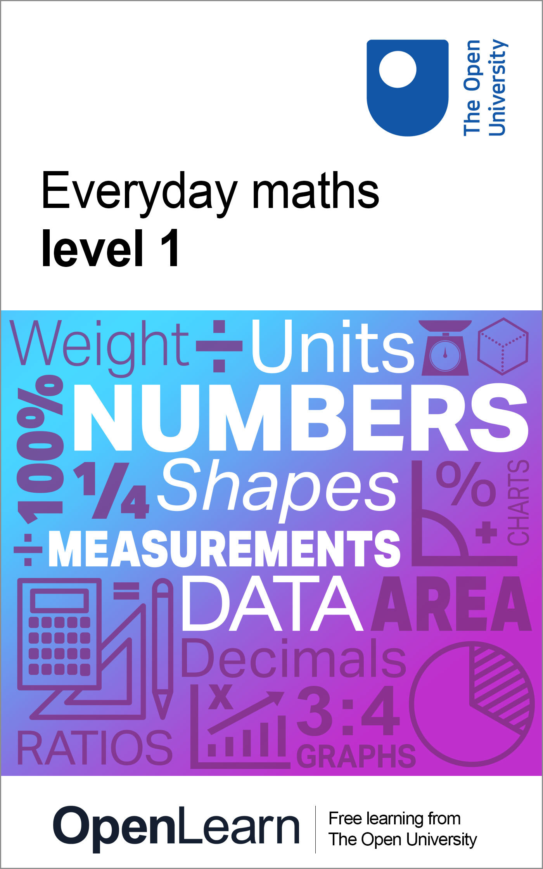

ALT_1

Everyday maths 1

About this free course
This free course is an adapted extract from the Open University course .
This version of the content may include video, images and interactive content that may not be optimised for your device.
You can experience this free course as it was originally designed on OpenLearn, the home of free learning from The Open University –
There you’ll also be able to track your progress via your activity record, which you can use to demonstrate your learning.
Copyright © 2015 The Open University
Intellectual property
Unless otherwise stated, this resource is released under the terms of the Creative Commons Licence v4.0 http://creativecommons.org/licenses/by-nc-sa/4.0/deed.en_GB. Within that The Open University interprets this licence in the following way: www.open.edu/openlearn/about-openlearn/frequently-asked-questions-on-openlearn. Copyright and rights falling outside the terms of the Creative Commons Licence are retained or controlled by The Open University. Please read the full text before using any of the content.
We believe the primary barrier to accessing high-quality educational experiences is cost, which is why we aim to publish as much free content as possible under an open licence. If it proves difficult to release content under our preferred Creative Commons licence (e.g. because we can’t afford or gain the clearances or find suitable alternatives), we will still release the materials for free under a personal end-user licence.
This is because the learning experience will always be the same high quality offering and that should always be seen as positive – even if at times the licensing is different to Creative Commons.
When using the content you must attribute us (The Open University) (the OU) and any identified author in accordance with the terms of the Creative Commons Licence.
The Acknowledgements section is used to list, amongst other things, third party (Proprietary), licensed content which is not subject to Creative Commons licensing. Proprietary content must be used (retained) intact and in context to the content at all times.
The Acknowledgements section is also used to bring to your attention any other Special Restrictions which may apply to the content. For example there may be times when the Creative Commons Non-Commercial Sharealike licence does not apply to any of the content even if owned by us (The Open University). In these instances, unless stated otherwise, the content may be used for personal and non-commercial use.
We have also identified as Proprietary other material included in the content which is not subject to Creative Commons Licence. These are OU logos, trading names and may extend to certain photographic and video images and sound recordings and any other material as may be brought to your attention.
Unauthorised use of any of the content may constitute a breach of the terms and conditions and/or intellectual property laws.
We reserve the right to alter, amend or bring to an end any terms and conditions provided here without notice.
All rights falling outside the terms of the Creative Commons licence are retained or controlled by The Open University.
Head of Intellectual Property, The Open University

Contents
- Introduction and guidance
  - What is a badged course?
  - How to get a badge
- Session 1: Working with numbers
  - Introduction
  - 1 Whole numbers
    - 1.1 Positive numbers and place value
    - 1.2 Negative numbers
    - 1.3 Working with whole numbers
    - 1.4 A note on the four operations
  - 2 Rounding
    - 2.1 Estimating answers to calculations
  - 3 Fractions
    - 3.1 Fractions of amounts
  - 4 Decimals
    - 4.1 Approximations with decimals
    - 4.2 Calculations using decimals
  - 5 Percentages
    - 5.1 Percentage increases and decreases
  - 6 Equivalencies between fractions, decimals and percentages
  - 7 Ratios
  - 8 Proportion
  - 9 Word formulas and function machines
    - 9.1 Formulas in words
    - 9.2 Function machines
  - 10 A quick reminder: checking your work
  - 11 Session 1 quiz
  - 12 Session 1 summary
- Session 2: Units of measure
  - 1 Using metric measurements
    - 1.1 Changing units
  - 2 Mileage charts
    - 2.1 Adding distances
  - 3 Estimating, measuring and comparing weights
    - 3.1 Weighing things
    - 3.2 Comparing weights
  - 4 Capacity
    - 4.1 Changing units
    - 4.2 Using pints and gallons
  - 5 Measuring temperature
    - 5.1 Reading temperatures
    - 5.2 Understanding temperature
  - 6 Session 2 quiz
  - 7 Session 2 summary
- Session 3: Handling data
  - 1 Collecting data
  - 2 Handling data
  - 3 Pictograms
  - 4 Pie charts
  - 5 Bar charts
  - 6 Line graphs
  - 7 Averages
    - 7.1 Advantages and disadvantages of using the arithmetical average
  - 8 Finding the range
  - 9 Probability
    - 9.1 Probability scales
  - 10 Session 3 quiz
  - 11 Session 3 summary
- Session 4: Shape and space
  - 1 Around the edge
    - 1.1 Measuring the perimeter of irregular shapes
  - 2 Area
  - 3 Scale drawings
  - 4 Maps
  - 5 Session 4 summary
  - 6 End-of-course quiz
  - 7 Bringing it all together
  - 8 Next steps
- Acknowledgements
- Solutions

Introduction and guidance

What is a badged course?
While studying Everyday maths 1 you have the option to work towards gaining a digital badge.
Badged courses are a key part of The Open University’s mission to promote the educational well-being of the community. The courses also provide another way of helping you to progress from informal to formal learning.
To complete a course you need to be able to find about 48 hours of study time. It is possible to study them at any time, and at a pace to suit you.
Badged courses are all available on The Open University’s OpenLearn website and do not cost anything to study. They differ from Open University courses because you do not receive support from a tutor. But you do get useful feedback from the interactive quizzes.

What is a badge?
Digital badges are a new way of demonstrating online that you have gained a skill. Schools, colleges and universities are working with employers and other organisations to develop open badges that help learners gain recognition for their skills, and support employers to identify the right candidate for a job.
Badges demonstrate your work and achievement on the course. You can share your achievement with friends, family and employers, and on social media. Badges are a great motivation, helping you to reach the end of the course. Gaining a badge often boosts confidence in the skills and abilities that underpin successful study. So, completing this course should encourage you to think about taking other courses, for example enrolling at a college for a formal qualification. (You will be given details on this at the end of the course.)

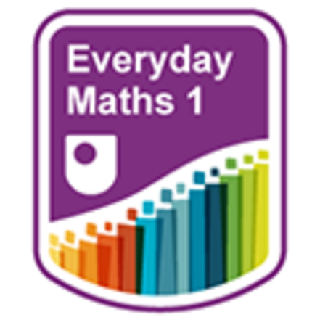

How to get a badge
Getting a badge is straightforward! Here’s what you have to do:
- read all of the pages of the course
- score 70% or more in the end-of-course quiz.
For all the quizzes, you can have three attempts at most of the questions (for true or false type questions you usually only get one attempt). If you get the answer right first time you will get more marks than for a correct answer the second or third time. Therefore, please be aware that for the end-of-course quiz it is possible to get all the questions right but not score 50% and be eligible for the OpenLearn badge on that attempt. If one of your answers is incorrect you will often receive helpful feedback and suggestions about how to work out the correct answer.
If you’re not successful in getting 70% in the end-of-course quiz the first time, after 24 hours you can attempt it again and come back as many times as you like.
We hope that as many people as possible will gain an Open University badge – so you should see getting a badge as an opportunity to reflect on what you have learned rather than as a test.
If you need more guidance on getting a badge and what you can do with it, take a look at the OpenLearn FAQs. When you gain your badge you will receive an email to notify you and you will be able to view and manage all your badges in My OpenLearn within 24 hours of completing the criteria to gain a badge.
Now get started with Session 1.

Session 1: Working with numbers

Introduction
It is very difficult to cope in everyday life without a basic understanding of numbers.
Calculators can be very useful, for example helping you to check your working out, or converting fractions to decimals.
To complete the activities in this course you will need some notepaper, a pen for taking notes and working out calculations and a calculator.
Session 1 includes many examples of numeracy from everyday life, with lots of learning activities related to them that involve whole numbers, fractions, decimals, percentages, ratios and proportion. The activities in this session are quick and easy tasks that should not take long to do.
By the end of this session you will be able to:
- work with whole numbers
- use rounding
- understand fractions, decimals and percentages, and the equivalencies between them
- use ratios and proportion
- understand word formulas and function machines.

Video content is not available in this format.
View transcript - Uncaptioned interactive content

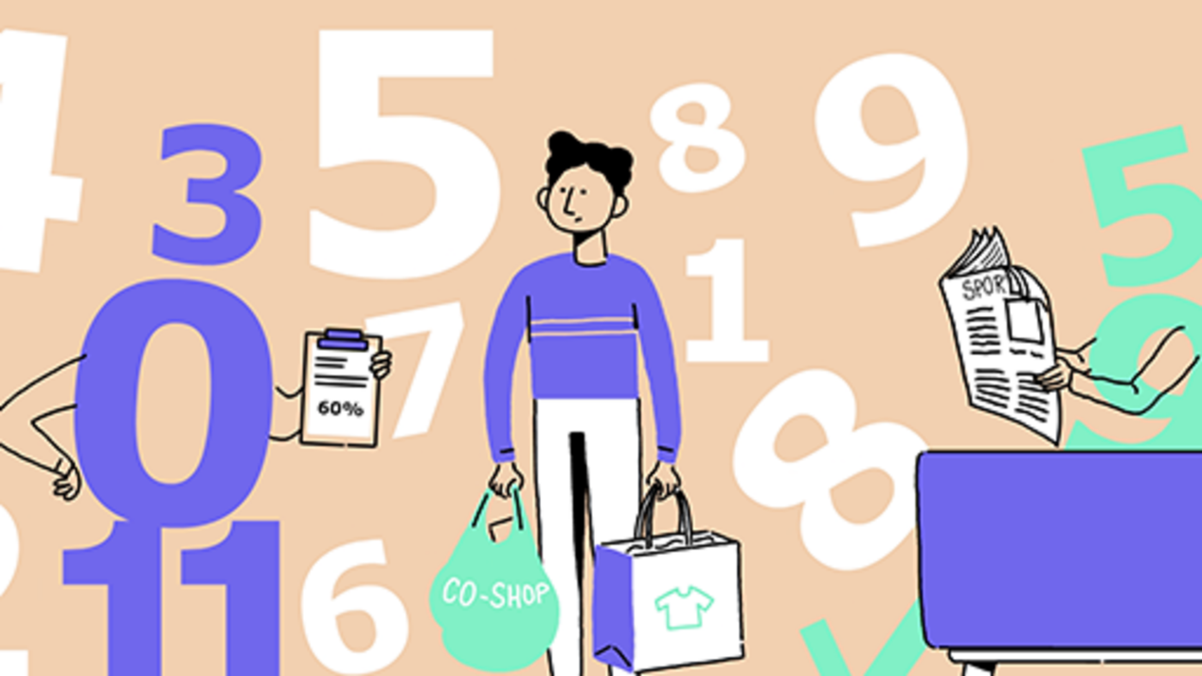

1 Whole numbers
What is a whole number? The simple answer is ‘any number that does not include a fraction or decimal part’.
So for example, 3 is a whole number, but 3 or 3.25 are NOT whole numbers.
Numbers can be positive or negative.
Positive numbers can be written with or without a plus (+) sign, so 3 and +3 are the same.
Negative numbers always have a minus (–) sign in front of them, such as –3, –5 or –2.

1.1 Positive numbers and place value

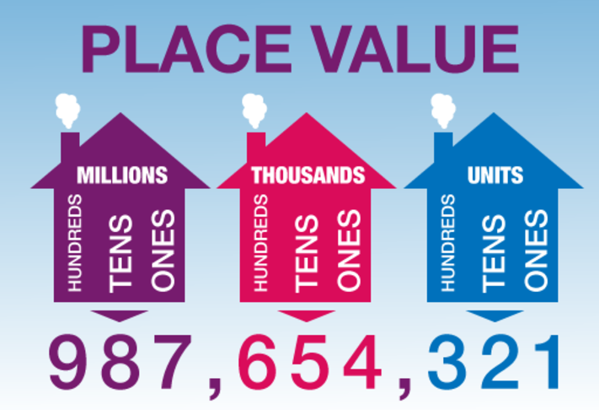
Figure 1 Place value
View description - Figure 1 Place value

Let’s look at positive numbers in more detail.
The place value of a digit in a number depends on its position or place in the number:

The value of 8 in 58 is 8 units.
The value of 3 in 34 is 3 tens.
The value of 4 in 435 is 4 hundreds.
The value of 6 in 6,758 is 6 thousands.

Look at the following example, which shows the place value of each digit in a seven-digit number.

Example: What’s in a number?
Take the number 9,046,251. The value of each digit is as follows:

9 millions
0 hundred thousands
4 ten thousands (or 40 thousand)
6 thousands
2 hundreds
5 tens
1 unit

To make large numbers easier to read, we put them in groups of three digits starting from the right:

6532 is often written as 6,532 (or 6 532).
25897 is often written as 25,897 (or 25 897).
596124 is often written as 596,124 (or 596 124).
7538212 is often written as 7,538,212 (or 7 538 212).

Use the example above to help you with the following activity. Remember to check your answers once you have completed the questions.

Activity 1: Working with place value

- Write 4,025 in words.

Th | H | T | U
4 | 0 | 2 | 5

View answer - Part

- Write six thousand, four hundred and seventy-two in figures.

Th | H | T | U
six | four | seven | two

View answer - Part

- Here are the results of an election to be school governor at Hawthorn School:
  - John Smith: 436 votes
  - Sonia Cedar: 723 votes
  - Pat Kane: 156 votes
  - Anjali Seedher: 72 votes
Who won the election?
Check your answer with our feedback before continuing.

View answer - Part

1.2 Negative numbers
So far you have only looked at positive numbers, but negative numbers are just as important. Negative numbers have a minus sign (–) in front of them.
Some examples of where negative numbers will apply to real life is with temperatures and bank balances, although hopefully our bank balances will not display too many negatives!
Perhaps you’ve seen negative numbers in weather reports where a temperature is below freezing, for example –2°C, or you may have seen them on frozen food packets.
If you ever have an overdraft at the bank, you may see minus signs next to the figures. If a bank statement reads –£30, for example, this tells you how much you’re overdrawn. In other words, what you owe the bank!
Where have you seen negative numbers recently? Look at this thermometer:

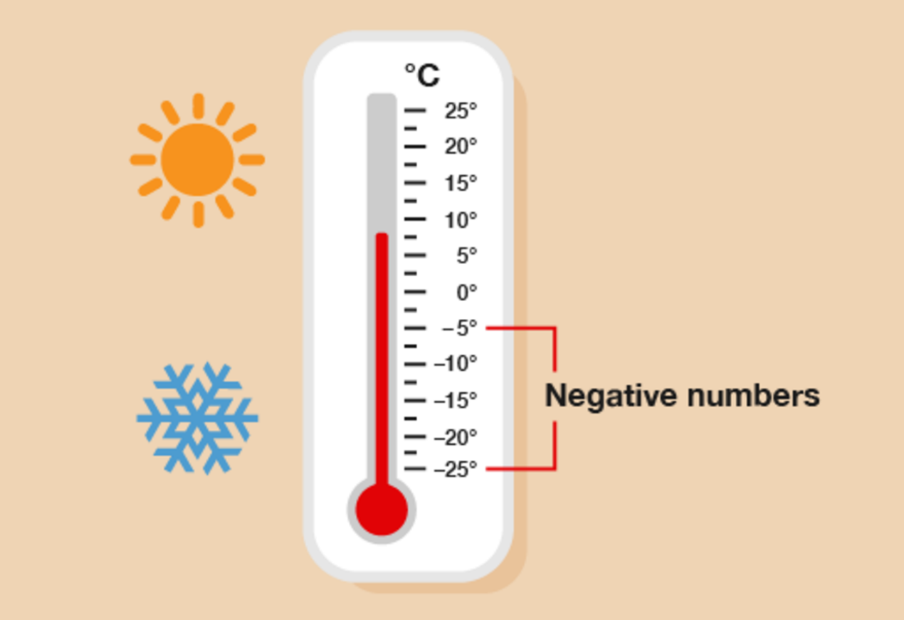
Figure 2 Negative numbers on a thermometer
View description - Figure 2 Negative numbers on a thermometer

It shows us that:
- –10°C is a lower temperature than –5°C
- –15°C is a lower temperature than –10°C.

Hint: ‘Lower’ means ‘less than’.

The lower the temperature, the colder it is.

Activity 2: Using negative numbers in everyday life

- The following table shows the temperatures in several cities on one day.

City | Temperature
A | –2°C
B | –5°C
C | –1°C
D | –8°C
E | –3°C

- Which are the coldest and warmest cities?

- A particular brand of ice cream includes the following note in its storing instructions:
  - For best results, store in temperatures between –10°C and –6°C
If your freezer’s temperature was –11°C, would it be OK to keep this ice cream in it?

View answer - Part

You have now seen how we use negative numbers in everyday life, for example bank balances and temperatures. Try practising using them when you are out and about. You will also use this skill within some simple questions that are coming up.

1.3 Working with whole numbers
The following activities cover everything in the whole numbers section. As you attempt the activities, look for key words to identify what the question is asking you to do.
Remember to check your answers once you have completed the questions.

Activity 3: Looking at numbers

- Look at this newspaper headline:

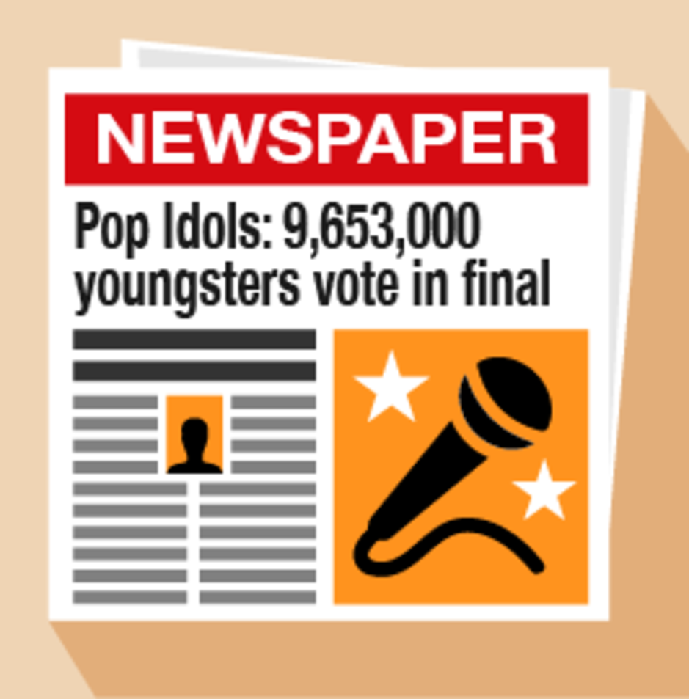
Figure 3 A newspaper headline
View description - Figure 3 A newspaper headline

  - Write down the number in millions.
  - Write down the number in thousands.
  - Look at the details below. Who won the Pop Idols competition?
  - Will: 4,850,000 votes
  - Gareth: 4,803,000 votes

- Look at the data in the following table. It gives the temperatures of five cities on a Monday in January.

City | Temperature
London | 0°C
Paris | –1°C
Madrid | 10°C
Delhi | 28°C
Moscow | –10°C

  - Which city was the coldest?
  - Which city was the warmest?
  - How many cities have a temperature below 5°C?

- You buy a jumper for £24 and a skirt for £18. How much do you spend altogether?

- You have £48. You spend £26. How much do you have left?

View answer - Part

Activity 4: Using multiplication and division

You can use a calculator in this activity.
- What are the answers to these sums?
  - 6 × 4
  - 3 × 9
  - 5 × 7
  - 36 ÷ 9
  - 48 ÷ 6
  - 15 ÷ 3
- Wine glasses come in boxes of 10. There are 25 boxes in a crate. How many wine glasses are there in one crate?
- A circus is selling tickets at £19 for adults and £11 for children. How much would it cost for two adults and two children to go?
Now check your answers to make sure you are ready to move on.

View answer - Part

1.4 A note on the four operations
The four operations are addition, subtraction, multiplication and division. You will already be using these in your daily life (whether you realise it or not!). Everyday life requires us to carry out maths all the time – for example, checking you’ve been given the correct change, working out how many packs of cakes you need for the children’s birthday party and splitting the bill in a restaurant.
Everyday maths 1 allows the use of a calculator throughout, so you do not need to be able to work out these calculations by hand – but you do need to understand what each operation does and when to use it.
- Addition (+) is used when you want to find the total, or sum, of two or more amounts.
- Subtraction (−) is used when you want to find the difference between two amounts or how much of something you have left after a quantity is used. For example, if you want to find out how much change you are owed after spending an amount of money.
- Multiplication (×) is also used for totals and sums, but when there is more than one of the same number. For example, if you bought five packs of apples that cost £1.20 each, to find out the total amount of money you would spend the sum would be 5 × £1.20.
- Division (÷) is used when sharing or grouping items. For example, to find out how many doughnuts you can buy with £6 if one doughnut costs £1.50, you would use the sum £6 ÷ £1.50.

Summary
In this section you have:
- learned how to read, write, order and compare positive numbers
- looked at different ways of using negative numbers in everyday life
- learned about the four operations.

2 Rounding
If you are out on a shopping trip, being able to quickly estimate the total cost of your shopping could help you to decide whether you have enough money to pay for it. Approximating answers to calculations is a very useful skill to have.
Remember the rounding rhyme that will help you:

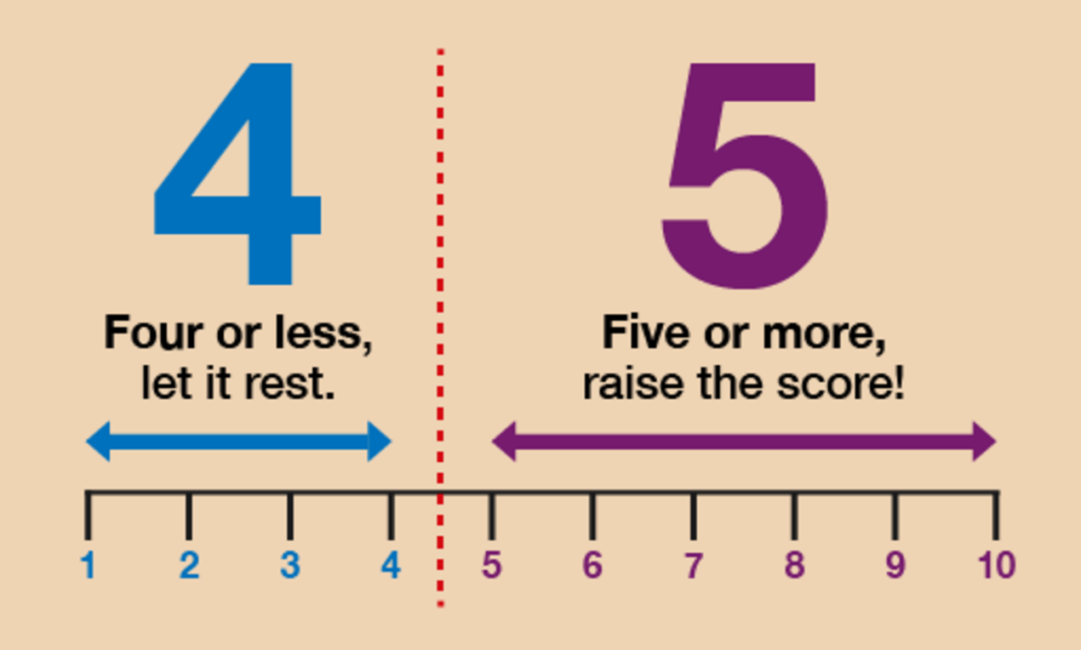
Figure 4 ‘Four or less, let it rest. Five or more, raise the score!’
View description - Figure 4 ‘Four or less, let it rest. Five or more, raise the score!’

Watch this video to refresh your knowledge on rounding. You should make notes throughout:

Watch the video at YouTube.com.

Now try the following activities. Remember to check your answers once you have completed the questions.

Activity 5: Rounding to 10, 100 and 1,000

- Round these numbers to the nearest 10:
  - 64
  - 69
  - 65
Check with our suggestions before continuing.

View answer - Part

- Round these numbers to the nearest 100:
  - 325
  - 350
  - 365
Check with our suggestions before continuing.

View answer - Part

- Round these numbers to the nearest 1,000:
  - 4,250
  - 4,650
  - 4,500
  - 4,060

View answer - Part

Hint: In this activity you should round to the nearest pound, so £4.67 would be rounded to £5.

Activity 6: Bill’s shopping

- Bill has £20 to spend on his shopping. Here’s a list of the items he selects, along with how much they cost:

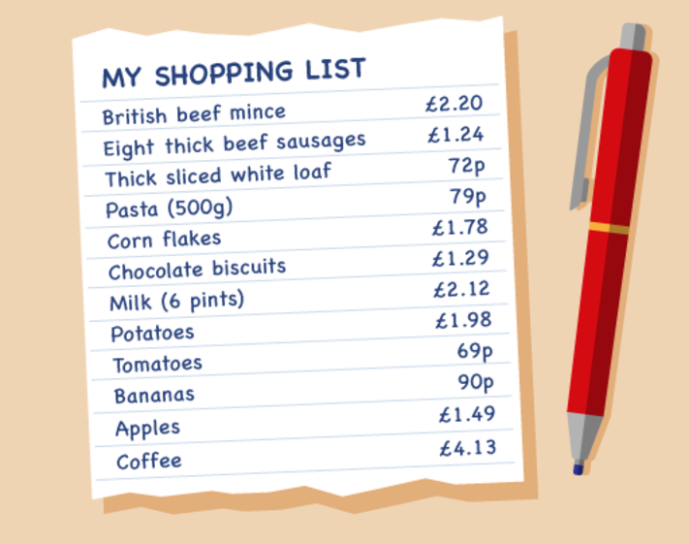
Figure 8 A shopping list
View description - Figure 8 A shopping list

Use your rounding skills to work out whether Bill has enough money to pay for all of his shopping.

View answer - Part

- Can you total all of the items on the shopping list to see what the actual cost of Bill’s shopping is?

View answer - Part

2.1 Estimating answers to calculations
Throughout this course you will be asked to estimate or approximate an answer in a scenario. If you do not use rounding to provide an answer to this question your answer will be incorrect.
Try the following activity using rounding throughout. Pay particular attention to the language used.

Activity 7: Rounding

- The population of a city is 6,439,800. Round this number to the nearest million.
- Tickets to a concert cost £6 each. 6,987 tickets have been sold. Approximately how much money has been collected?
- 412 students passed their Maths GCSE this year at Longfield High School. 395 passed last year. Approximately how many students passed GCSE Maths over the last two years?
- Four armchairs cost £595. What is the approximate cost of one armchair?

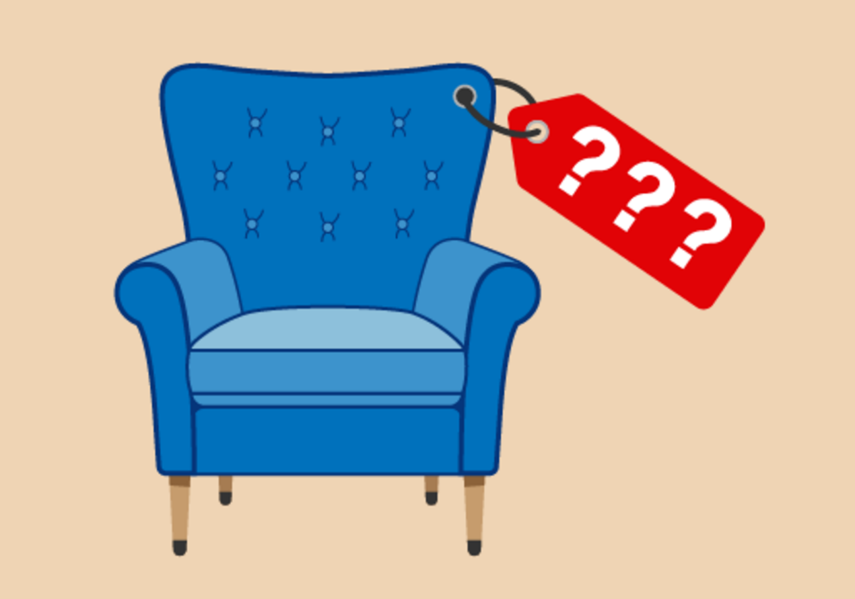
Figure 9 How much for one armchair?
View description - Figure 9 How much for one armchair?

- A box contains 18 pencils. A company orders 50 boxes. Approximately how many pencils is that?

View answer - Activity 7: Rounding

Summary
So far you have worked with negative numbers, whole numbers, estimation and multiples. All of the practised skills will help you with everyday tasks such as shopping, working with a budget and reading temperatures. The objectives that you have covered are:
- the meaning of a positive and negative number
- how to carry out calculations with whole numbers
- how an approximate answer can help to check an exact answer
- multiples and square numbers.
Later in this course you will be looking at inverse calculations. This means reversing all operations to check that your answer is correct.

3 Fractions

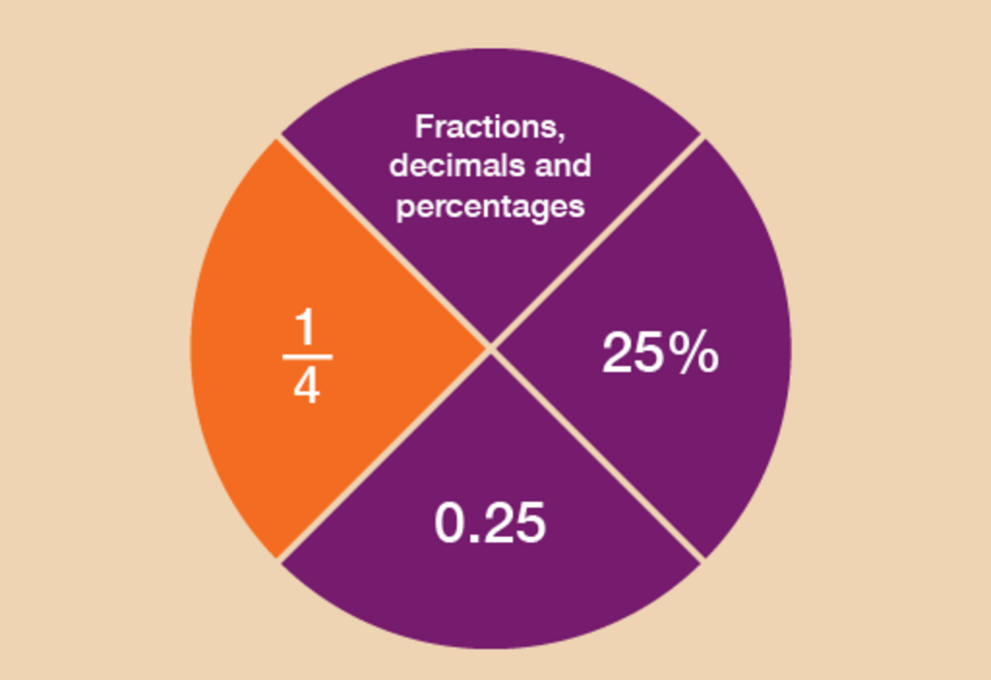
Figure 10 Looking at fractions
View description - Figure 10 Looking at fractions

What is a fraction?
A fraction is defined as a part of a whole. So for example , or ‘one third’, is one part of three parts, all of equal size.
Fractions are an important feature of everyday life. They could ensure that you get the best deal when shopping – or that you receive the largest slice of pizza! As you go through this section, you’ll see how fractions could be used when you are shopping or within the workplace.
Fractions are related to decimals and percentages, which you’ll look at in the sections that follow this one.
This section will help you to:
- order and compare fractions
- identify equivalencies between fractions
- calculate parts of whole quantities and measurements (e.g. calculate discounts in sales).
Please look at the following example before you carry out the activity:
A half can be written as , i.e. one of two equal parts.
A quarter can be written as , i.e. one of four equal parts.
An eighth can be written as , i.e. one of eight equal parts.

Hint: The top of the fraction is called the numerator. The bottom of the fraction is called the denominator. Notice that is bigger than , even though the denominator 2 is smaller than the denominator 4. How would you explain one third? How would you write it as a fraction? Which is bigger: one third or two quarters?

Example: Where there’s a will, there’s a fraction
Lord Walton draws up a will to decide who will inherit the family estate. He proposes to leave of the estate to his son, to his daughter and to his brother.
- Who gets the biggest share?
- Who gets the smallest share?

Method
When numerators of fractions are all 1, the larger the denominator of the fraction, the smaller the fraction.
Looking at the example above, the fractions can be put in order of size starting from the smallest:

, ,

So:
- The biggest share () goes to his son.
- The smallest share () goes to his brother.

If you’re asked to arrange a group of fractions into size order, it’s sometimes helpful to change the denominators to the same number. This can be done by looking for the lowest common multiple – that is, the number that all of the denominators are multiples of.

Example: Looking at equivalent fractions
Arrange the following fractions in order of size, starting with the smallest:
- , ,

Method
The lowest common multiple is 12:
- 6 × 2 = 12
- 3 × 4 = 12
- 12 × 1 = 12
Whatever you do to the bottom of the fraction you must also do to the top of the fraction, so that it holds the equivalent value. The third fraction, , already has 12 as its denominator, so we don’t need to make any further calculations for this fraction. But what about and ?
- 2 × means calculating (2 × 3 = 6) and (2 × 6 = 12), so the equivalent fraction is
- 4 × means calculating (4 × 1 = 4) and (4 × 3 = 12), so the equivalent fraction is
Now you can now see the size order of the fractions clearly:
- , ,
So the answer is:
- , ,

Use the examples above to help you with the following activity. Remember to check your answers once you have completed the questions.

Activity 8: Fractions in order of size

- Put these fractions in order of size, with the smallest first:
- , , , ,

View answer - Part

- What should you replace the question marks with to make these fractions equivalent?
- =
- =
- =
- =

View answer - Part

Example: Drawing the fractions
If you need to compare one fraction with another, it can be useful to draw the fractional parts.
Look at the mixed numbers below. (A mixed number combines a whole number and a fraction.) Say you wanted to put these amounts in order of size, with the smallest first:

2 , 3 , 1

Method
To answer this you could look at the whole numbers first and then the fractional parts. If you were to draw these, they could look like this:

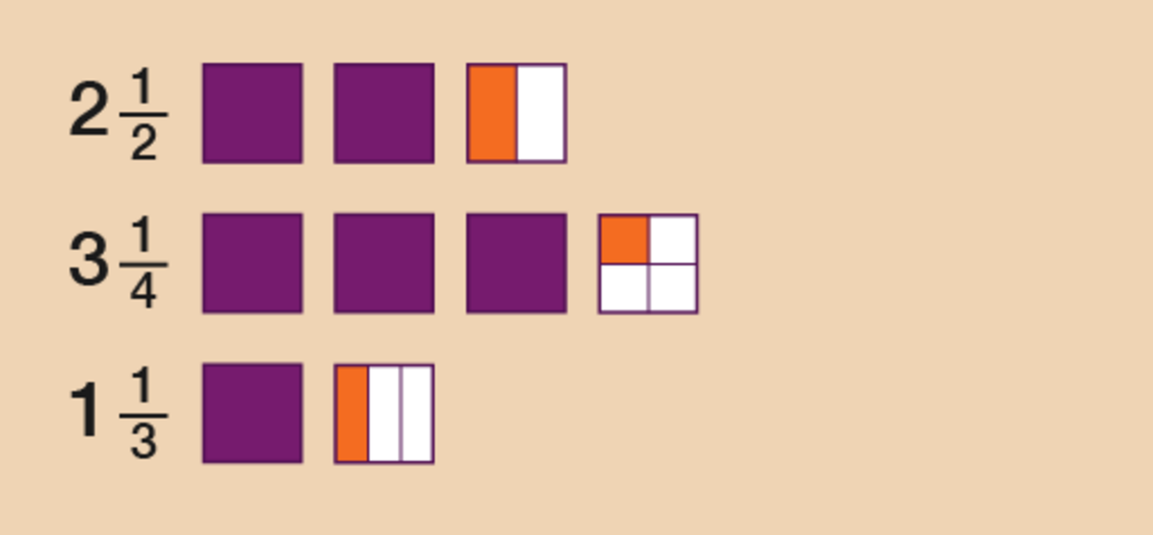
Figure 11 Drawing the fractions
View description - Figure 11 Drawing the fractions

So the correct order would be:

1 , 2 , 3

Use the example above to help you with the following activity. Remember to check your answers once you have completed the questions.

Activity 9: Putting fractions in order

- Put these fractions in order of size, smallest first:
- 5 , 6 , 2
- Put these fractions in order of size, smallest first:
- 2 , 1 , 2

View answer - Activity 9: Putting fractions in order

3.1 Fractions of amounts
Have a look at the following examples, which demonstrate how you would find the fraction of an amount.

Example: Finding fractions

Sale

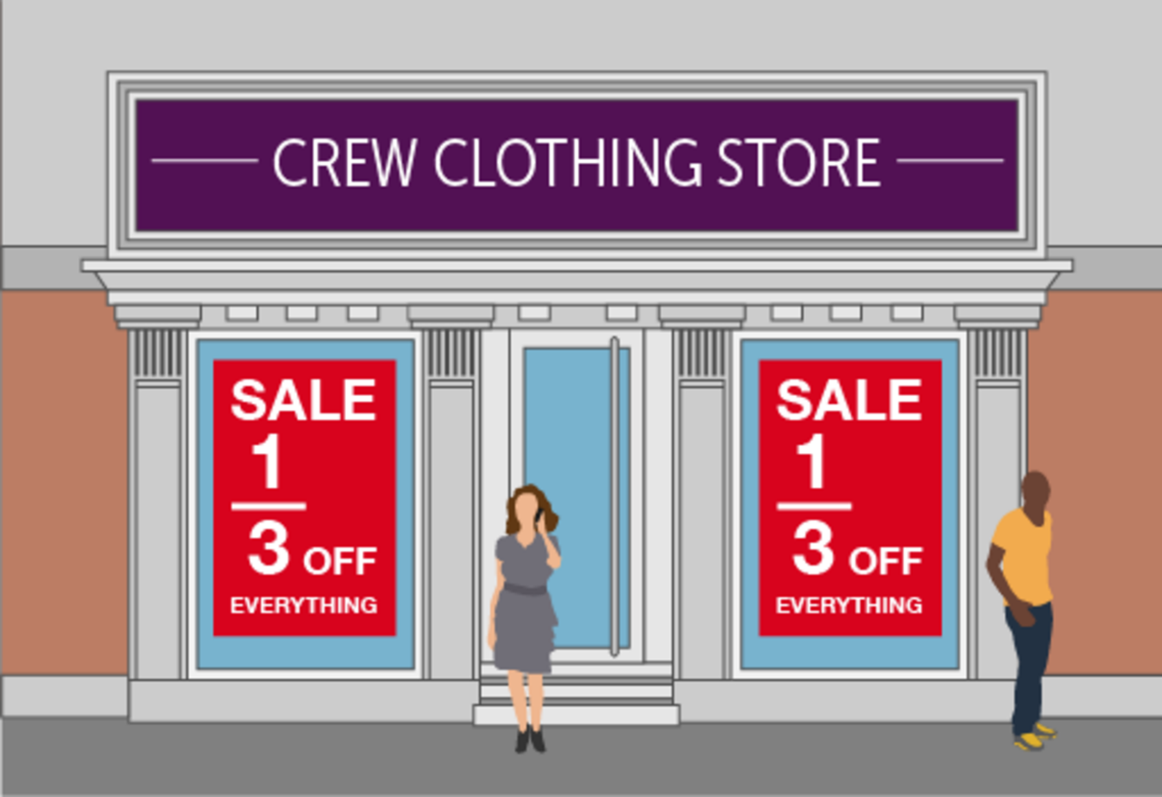
Figure 13 Fractions in a sale
View description - Figure 13 Fractions in a sale

Say you go into a shop to buy a dress. Usually it would cost £90, but today it’s in the ‘ off’ sale. How much would you get off?

Method
The basic rule for finding a unit fraction of an amount is to divide by the how many parts there are (the number on the bottom of the fraction) and multiply the result by the number at the top of the fraction:

of £90 is the same as £90 ÷ 3 = £30

The sum £30 × 1 = £30, so you would get £30 off.

Survey
In a survey, of respondents said that they would like to keep the pound as the currency of the UK. If 800 people were surveyed, how many people wanted to keep the pound?

Method
Again, to find a fraction of an amount you need to divide by the number at the bottom of the fraction and then multiply that result by the number at the top of the fraction:
To answer this you need to first work out what of 800 people is.

of 800 = 800 ÷ 4 = 200

Then use the numerator (the top of the fraction) to work out how many of those unit fractions are needed:

of 800 = 3 × 200 = 600

So 600 people wanted to keep the pound.

Use the example above to help you with the following activity. Remember to check your answers once you have completed the questions.

Activity 10: Paying in instalments

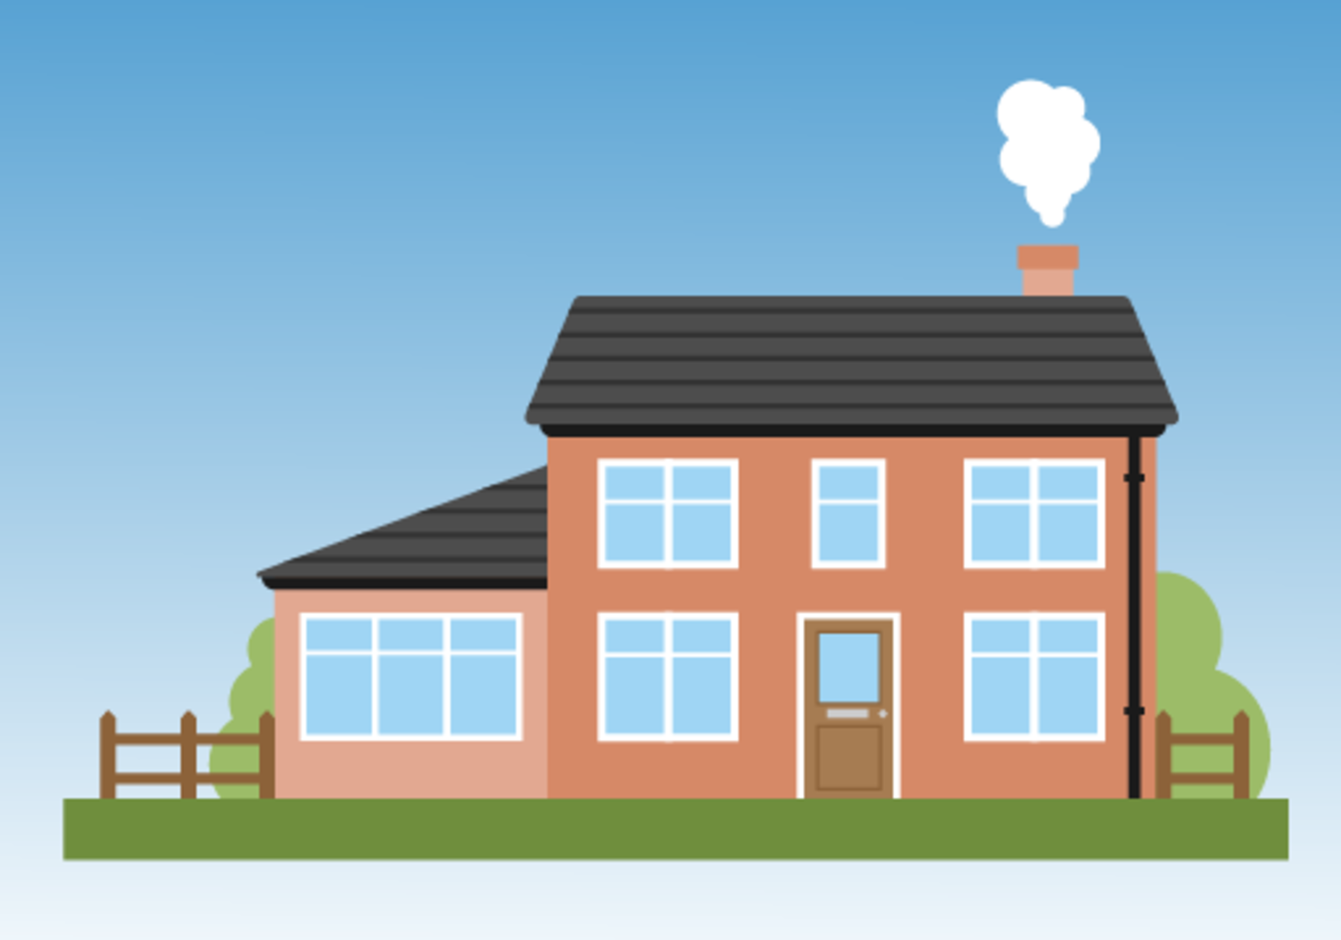
Figure 14 How much would an extension cost?
View description - Figure 14 How much would an extension cost?

A family plans to have its kitchen extended.
The cost of this project is £12,000.
The builder they have chosen to carry out this job has asked for the money to be paid in stages:
- of the money to be paid before starting the project.
- of the money to be paid a month later.
- The remainder to be paid when the extension has been built.
How much is the builder asking for during Stage 1 and Stage 2?

View answer - Activity 10: Paying in instalments

Summary
In this section you have learned how to:
- find equivalencies in fractions
- order and compare fractions
- find the fraction of an amount.
The skills listed above can be used when you are shopping and trying to get the best deal, or when you are splitting a cake or a pizza, say, into equal parts.
It’s important to be able to compare fractions, decimals and percentages in real-life situations. You’ll be looking at percentages later, but first you can look at decimals.

4 Decimals

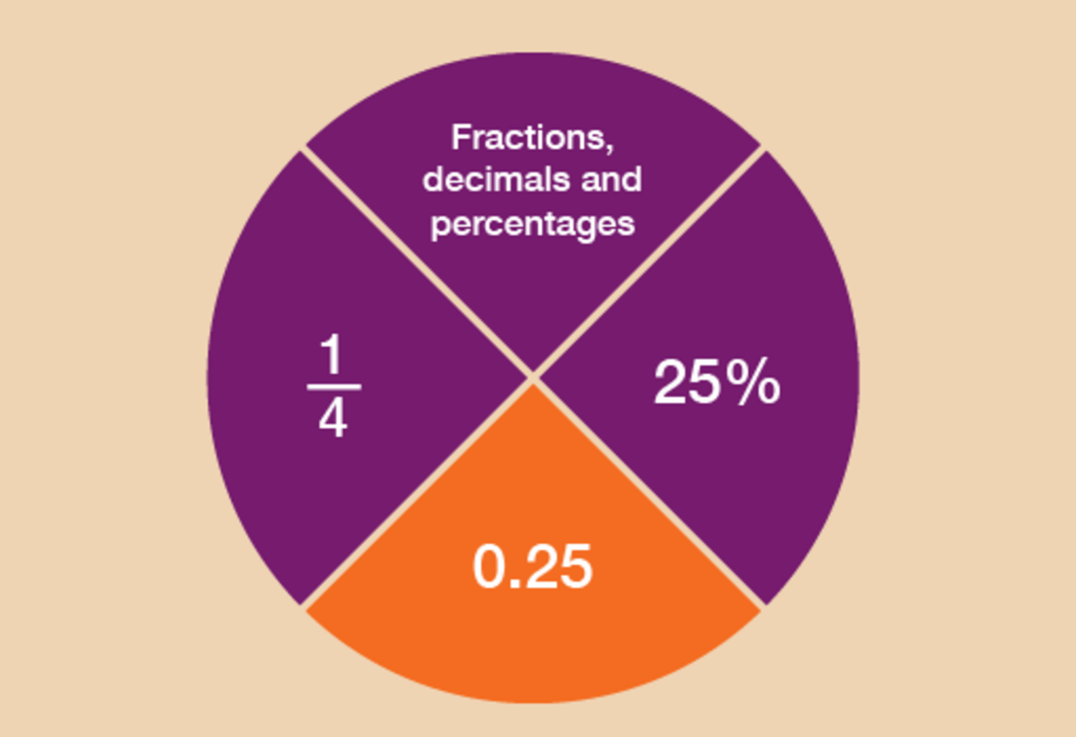
Figure 15 Looking at decimals
View description - Figure 15 Looking at decimals

Can you think of any examples of when you might come across decimal numbers in everyday life?
If you’re dealing with money and the decimal point is not placed correctly, then the value will be completely different, for example, £5.55 could be mistaken for £55.50.
Likewise with weights and measures: if the builder in the last activity made a wrong measurement, the whole kitchen extension could be affected.
This section will help you to understand:
- the value of a digit in a decimal number
- ways of carrying out calculations with decimal numbers
- approximate answers to calculations involving decimal numbers.
You looked at place value in the section on whole numbers. Now you’ll take a look at decimals.

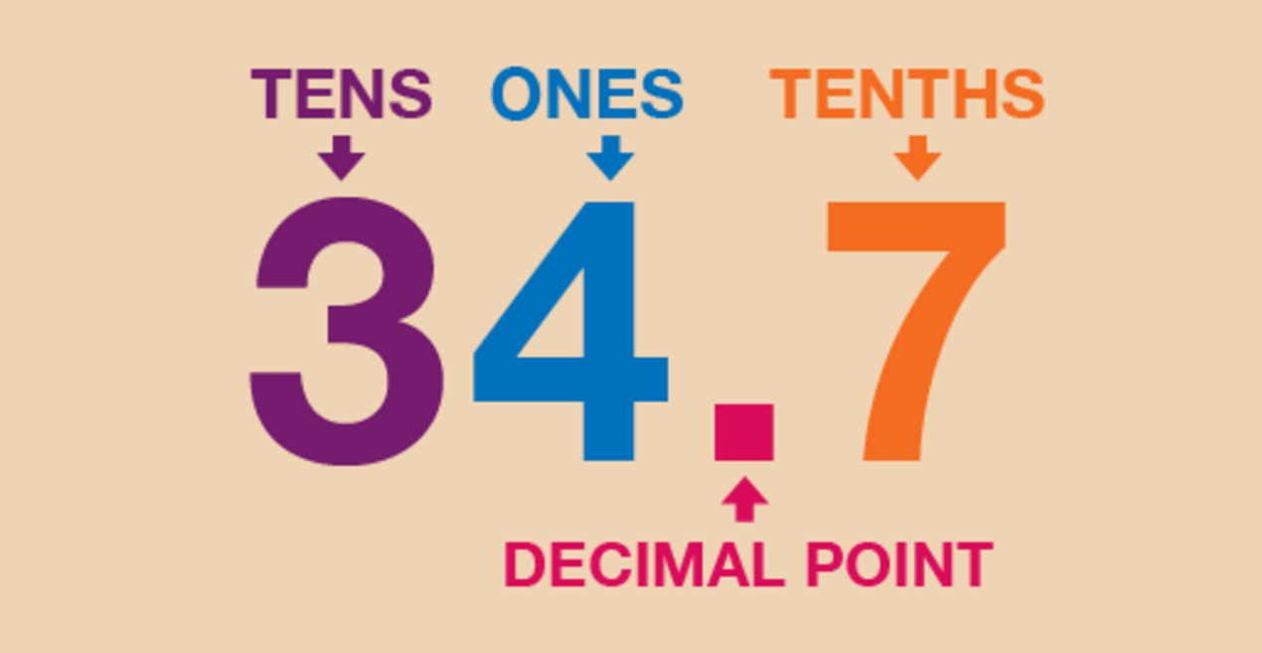
Figure 16 What is a decimal point?
View description - Figure 16 What is a decimal point?

So what is a decimal point?
It separates a number into its whole number and its fractional part. So in the example above, 34 is the whole number, and the seven – or 0.7, as it would be written – is the fractional part.
Each digit in a number has a value that depends on its position in the number. This is its place value:

Whole number part |  |  |  | . | Fractional part
Thousands | Hundreds | Tens | Units | . | Tenths | Hundredths | Thousandths
1000s | 100s | 10s | 1s | . | s | s | 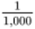s

Look at these examples, where the number after the decimal point is also shown as a fraction:

5.1 = 5 and
67.2 = 67 and
8.01 = 8 and

Example: Finding values
If you were looking for the place value of each digit in the number 451.963, what would the answer be?

Hundreds | Tens | Units | . | Tenths | Hundredths | Thousandths
4 | 5 | 1 | . | 9 | 6 | 3

So the answer is:

4 hundreds
5 tens
1 unit
9 tenths ()
6 hundredths ()
3 thousandths (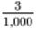)

Use the example above to help you with the following activity. Remember to check your answers once you have completed the questions.

Activity 11: Decimal dilemmas

- Four children are taken to the funfair. One of the rides, the Wacky Wheel, has the following notice on it:
  - For safety reasons, children must be over 0.95 m tall to go on this ride.
- Margaret is 0.85 m tall.
- David is 0.99 m tall.
- Suha is 0.89 m tall.
- Prabha is 0.92 m tall.
- Who is allowed to go on the ride?

- Six athletes run a race. Their times, in seconds, are as follows:

Sonia | 10.95
Anjali | 10.59
Anita | 10.91
Aarti | 10.99
Sita | 10.58
Susie | 10.56

- Who gets the gold, silver and bronze medals?

- In a gymnastics competition, the following points were awarded to four competitors. Who came first, second and third?

Janak | 23.95
Nadia | 23.89
Carol | 23.98
Tracey | 23.88

View answer - Part

4.1 Approximations with decimals
Now you have looked at the place value system for decimals, can you use your rounding skills to estimate calculations using decimals? This skill would be needed in everyday life to approximate the cost of your shopping.

Example: Approximations with decimals
Give approximate answers to these. Round each decimal number to the nearest whole number before you calculate.
- 2.7 + 9.1
- 9.6 – 2.3
- 2.8 × 2.6
- 9.6 × 9.5

Method
- 2.7 lies between 2 and 3, and is nearer to 3 than 2.

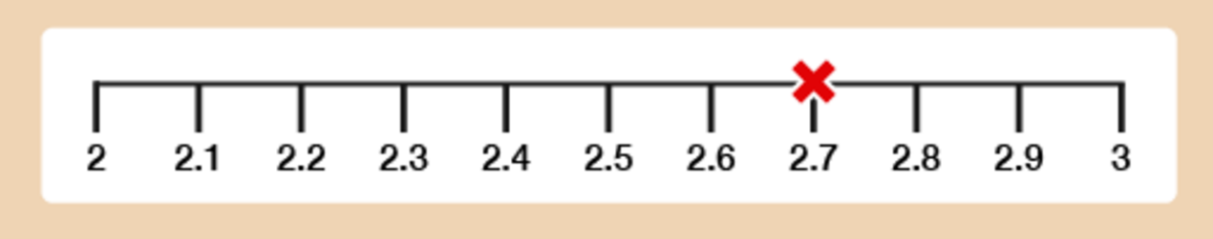
Figure 17 A number line
View description - Figure 17 A number line

9.1 lies between 9 and 10, and is nearer to 9 than 10.

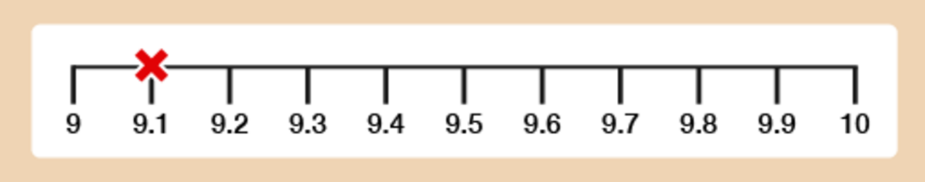
Figure 18 A number line
View description - Figure 18 A number line

So our approximate answer is:
  - 3 + 9 = 12
- Similarly, 9.6 lies between 9 and 10 and is nearer to 10 than 9, and 2.3 is nearer to 2 than 3. So our approximate answer is:
  - 10 – 2 = 8
- 2.8 is nearer to 3 than 2, and 2.6 is also nearer to 3 than 2. So our approximate answer is:
  - 3 × 3 = 9
- 9.6 is nearer to 10 than 9. 9.5 is exactly halfway between 9 and 10. When this happens we always round up, meaning that 9.5 is rounded up to 10. So our approximate answer is:
  - 10 × 10 = 100

Example: Rounding to two decimal places
You may be asked to round a number to two decimal places. All this means is if you are faced with lots of numbers after the decimal point, you will be asked to only leave two numbers after the decimal point. This is useful when a calculator gives us lots of decimal places.
- Round 3.426 correct to two decimal places (we want two digits after the decimal point).

Method
Look at the third digit after the decimal point.
If it is 5 or more, round the previous digit up by 1. If it is less than 5, leave the previous digit unchanged.
The third digit after the decimal point in 3.426 is 6. This is more than 5, so you should round up the previous digit, 2, to 3.
So the answer is 3.43.
- Round 2.8529 to two decimal places.

Method
As in part (a) above, the question is asking you to round to two digits after the decimal point.
Look again at the third digit after the decimal point.
This is 2 (less than 5) so we leave the previous digit (5) unchanged.
The answer is 2.85.
- Round 1.685 to two decimal places.
Here, the third digit after the decimal point is 5, which means the previous digit (8) needs to be rounded up.
The answer is 1.69.

Use the example above to help you with the following activity. Remember to check your answers once you have completed the questions.

Hint: ‘Five or more, raise the score!’

Activity 12: Rounding

- Work out approximate answers to these by rounding each decimal number to the nearest whole number:
  - 3.72 + 8.4
  - 9.6 – 1.312
  - 2.8 × 3.4
  - 9.51 ÷ 1.5
- Round the following numbers to two decimal places:
  - 3.846
  - 2.981
  - 3.475

View answer - Activity 12: Rounding

4.2 Calculations using decimals
When you make any calculation with decimals – that is, addition, subtraction, multiplication and division – you may use a calculator. When using a calculator it is very important to make sure that the decimal point is in the correct place. If you don’t, you’ll get the wrong answer.
Now try the following activity. Remember to check your answers once you have completed the questions.

Activity 13: Using decimals

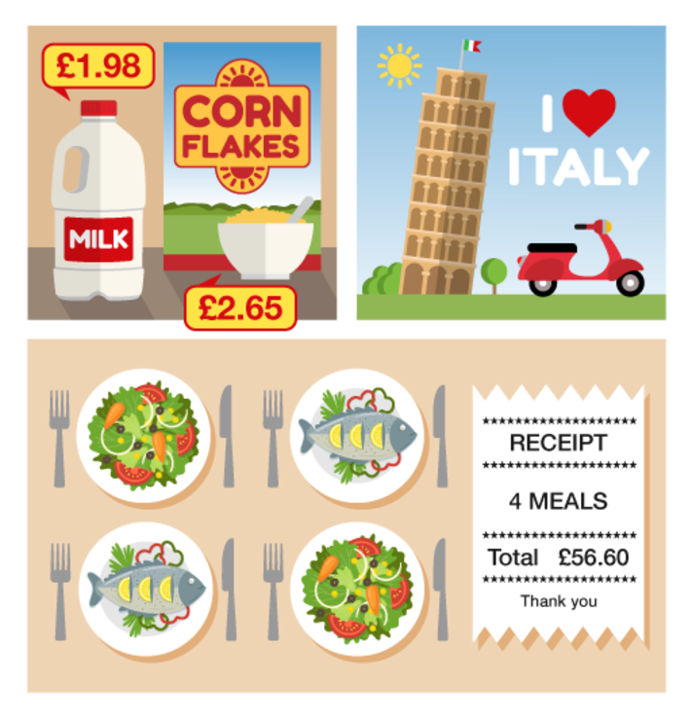
Figure 19 Using decimals
View description - Figure 19 Using decimals

- You buy a box of corn flakes for £2.65 and a bottle of milk for £1.98.
  - What is the total cost of these items?
  - You pay for them with a £5 note. How much change should you get?
- You go on holiday to Italy. The rate of exchange is £1 = €1.4. How many euros do you get for £8?
- You go out for a meal with three friends, and the total cost of the meal is £56.60. You decide to split the bill equally. How much do each of you pay?
- Convert 6.25 m to cm.

View answer - Activity 13: Using decimals

Summary
In this section you have learned about how:
- the value of a digit depends on its position in a decimal number
- to approximate answers to calculations involving decimal numbers
- to add, subtract, multiply and divide using decimal numbers.
This will help when working with money and measurements.

5 Percentages

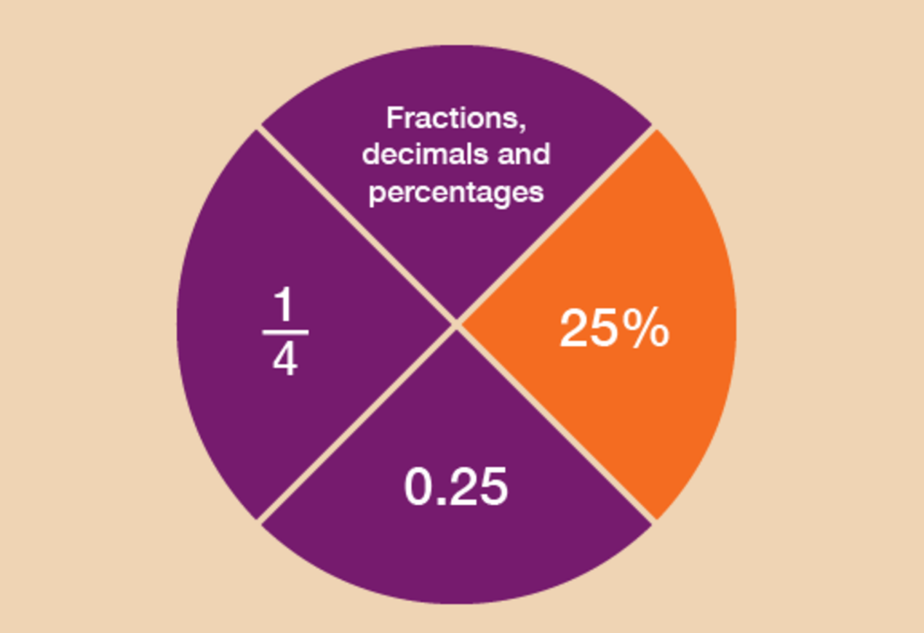
Figure 20 Looking at percentages
View description - Figure 20 Looking at percentages

Like fractions and decimals, you’ll see plenty of references to percentages in your everyday life. For example:

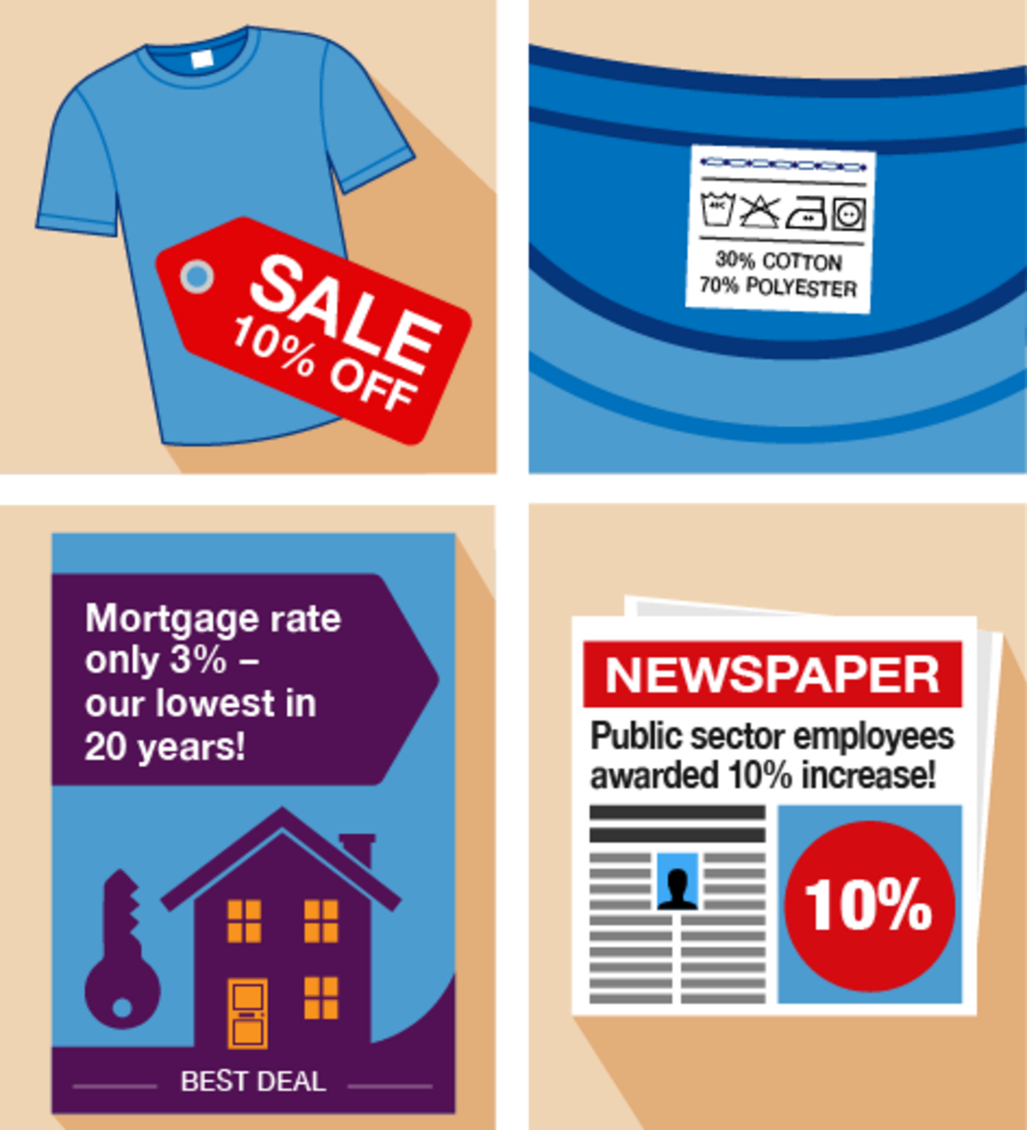
Figure 21 Examples of percentages
View description - Figure 21 Examples of percentages

This section will help you to:
- order and compare percentages
- work out percentages in different ways
- understand how percentages increase and decrease
- recognise common equivalencies between percentages, fractions and decimals.
So what is a percentage?
- It’s a number out of 100.
- 40% means ‘40 out of every 100’.
- The symbol for percentage is %.
- 100% means 100 out of 100. You could also say this as the fraction .
You may have seen examples of percentages on clothes labels. ‘100% wool’ means that the garment is made entirely of wool and nothing else. ‘50% wool’ means that the garment is half made of wool, half made of other materials.
The following example shows how to work out the percentage discount.

Example: How can you calculate percentage reductions?
An online shop offers a 10% discount on a television that usually costs £400. How much discount do you get?
There are different ways that percentages can be worked out. The method that you choose really depends on the numbers that you are working with.
Here are two methods for solving this problem:

Method 1
A percentage is a number out of 100, so 10% means ‘10 out of 100’. This could also be put as , or 10 hundredths.
Just like fractions, we start with finding 1%.
If we first work out of £400, we can then work out of of £400. To find of £400:

400 ÷ 100 = 4

So 10/100 of £400 is:

4 × 10 = 40

The discount is £40.
If you think of 10% as a large fraction, , you use the rule of dividing by the denominator (the bottom number in a fraction) and multiplying by the numerator (the top number).
There is an alternative method for finding the answer.

Method 2
A percentage is a number out of 100, so 10% is , which is the same as saying .
If we want to find out 10% of £400, that’s the same as finding out of £400:

400 ÷ 10 = 40

This gives us the answer £40.
Which method do you prefer?
- Method 1 will always work.
- Method 2 can be used to work out percentages in your head if the numbers are suitable.
If you want to use Method 2, here are some common percentages given in fraction form:

10% =
25% =
50% =
75% =

If you want to know what 20% of a number is, work out 10% and multiply the answer by 2.
Similarly, if you want to know what 30% is, work out 10% and multiply the answer by 3.
If you need to know 5%, work out 10% and then halve the answer.

Use the example above to help you with the following activities. Remember to check your answers once you have completed the questions.

Activity 14: A holiday discount

You need to pay a 20% deposit on a holiday that costs £800. How much is the deposit?

View answer - Activity 14: A holiday discount

Activity 15: Comparing discounts

The same diamond ring is being sold at different prices, and with different percentage discounts, in two different shops.

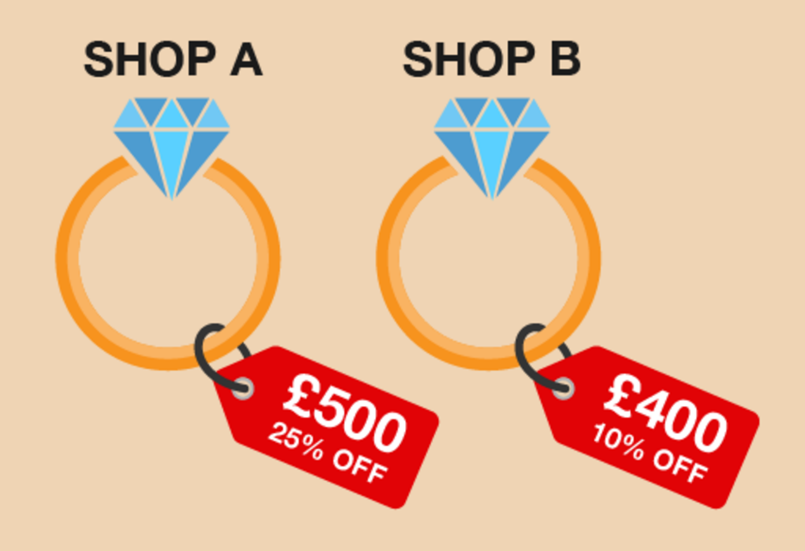
Figure 22 Comparing percentage discounts
View description - Figure 22 Comparing percentage discounts

Which shop offers the better deal?
Please check your answers before you move on.

View answer - Activity 15: Comparing discounts

5.1 Percentage increases and decreases
You’ll often see percentage increases and decreases in sales and pay rises.

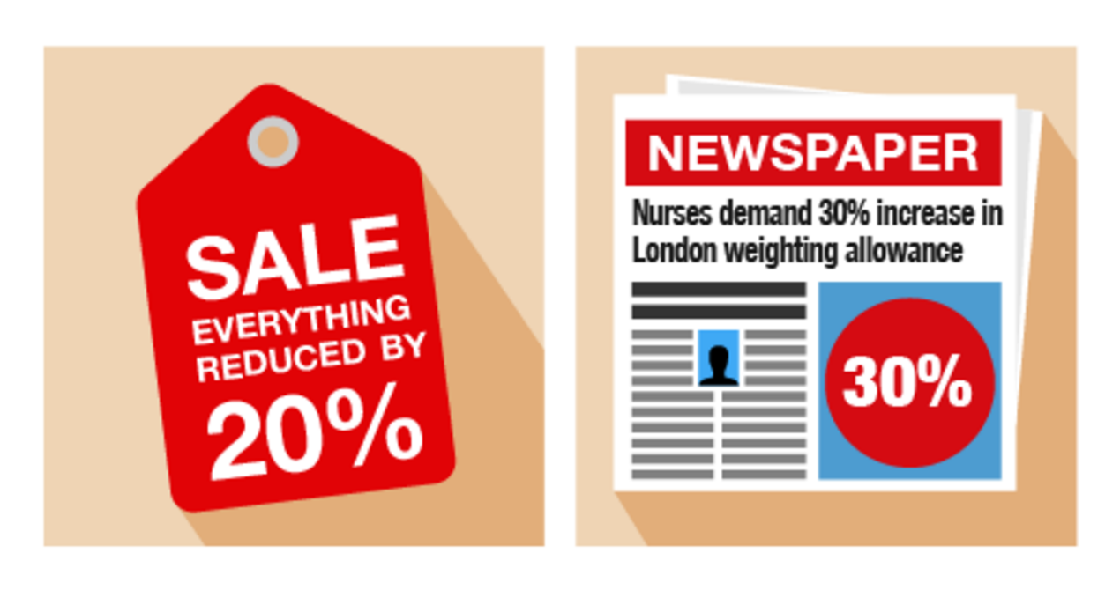
Figure 23 Increasing and decreasing percentages
View description - Figure 23 Increasing and decreasing percentages

Example: Anjali’s pay rise
Anjali earns £18,000 per year. She is given a 10% pay rise. How much does she now earn?

Method
In order to identify Anjali’s new salary, you need to find out what 10% () of £18,000 is. To do this, first you need to find out of £18,000:

18,000 ÷ 100 = 180

So of £18,000 is:

10 × 180 = 1,800

Anjali’s pay rise is £1,800, so her new salary is:

£18,000 + £1,800 = £19,800

Example: A sale at the furniture shop
A furniture shop reduces all of its prices by 20%. How much does a £300 double bed cost in the sale?

Method
In order to identify the new price of the double bed, you need to find out what 20% () of £300 is. To do this, first you need to find out of £300:

300 ÷ 100 = 3

So of £300 is:

20 × 3 = 60

The discount is £60, so the sale price of the double bed is:

£300 – £60 = £240

Use the examples above to help you with the following activity. Remember to check your answers once you have completed the questions.

Activity 16: Calculating percentage increases and decreases

- You buy a car for £9,000. Its value depreciates (decreases) by 25% annually. How much will the car be worth at the end of the first year?
- Since the start of the 21st century, the shares in the InstaBank have risen by 30%. If the price of one share was £10 in 2000, what is it worth now?

View answer - Activity 16: Calculating percentage increases and decreases

In this section you have learned how to calculate percentage increases and decreases. This will be useful when working out the value of a pay increase or how much an item will cost in a sale. You have also seen, and successfully used, two methods of calculating a percentage. There is one method that you haven’t been shown (and it’s probably the easiest!): using the percentage button on your calculator. The percentage button looks like this:

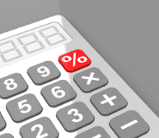
Figure 24 The percentage button on a calculator
View description - Figure 24 The percentage button on a calculator

To successfully use it when calculating percentages you would enter the sum into your calculator as follows.
If you were asked to find 20% of 80, on your calculator you would input:
- 80 × 20%
This would give you the following answer:
- 80 × 20% = 16
This is by far the easiest way of calculating percentages when you have a calculator handy.

Summary
In this section you have learned how to solve problems using percentages, and how to calculate percentage increases and decreases.

6 Equivalencies between fractions, decimals and percentages

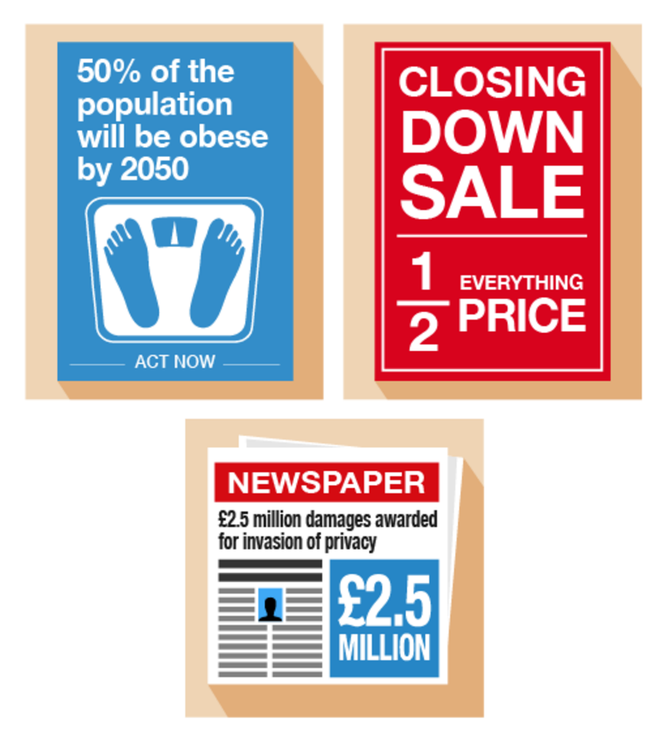
Figure 25 Looking at equivalencies
View description - Figure 25 Looking at equivalencies

Fractions, decimals and percentages are different ways of saying the same thing. It’s an important skill to learn about the relationships (or ‘equivalencies’) between fractions, decimals and percentages to make sure you are getting the better deal.

Video content is not available in this format.
View transcript - Uncaptioned interactive content

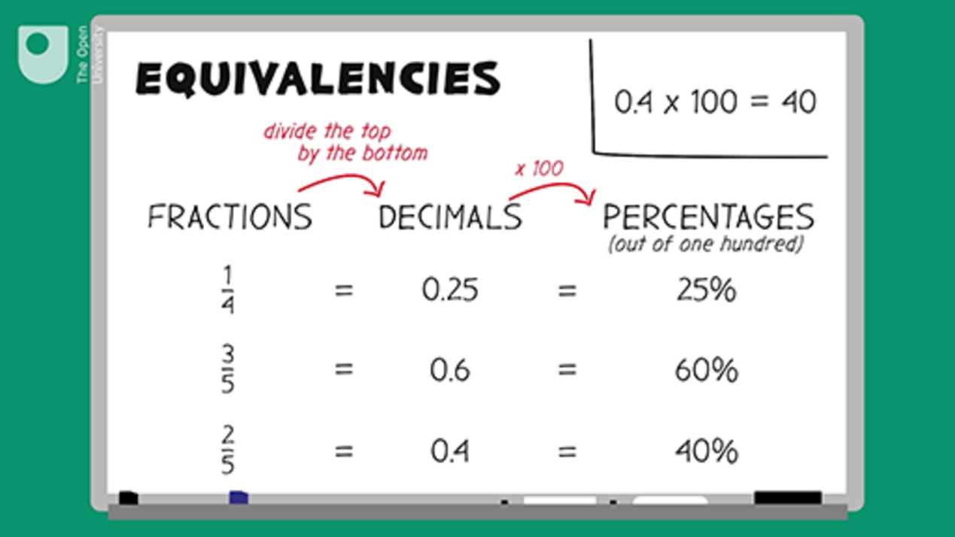

Here are some common equivalencies. Try to memorise them – you will come across them a lot in everyday situations:

10% = = 0.1
20% = = 0.2
25% = = 0.25
50% = = 0.5
75% = = 0.75
100% = 1 = 1.0

Look at the following example. If you can identify equivalences, they’ll make it easier to make simple calculations.

Example: Mine’s a half
What is 50% of £200?

Method
Since 50% is the same as , so:

50% of £200 = of £200 = £100

Use the example above to help you with the following activity. Remember to check your answers once you have completed the questions.

Activity 17: Looking for equivalencies

- What is 20% of £600?
- If you walked 0.25 km each day, what fraction of a kilometer have you walked?
- House prices have increased by in the last five years. What is this increase as a percentage?
- A DIY shop is holding a ‘50% off’ sale on kitchens. How much would you pay for a new kitchen worth £8,000 in the sale?
- You buy an antique necklace for £3,000. After ten years, its value increases by 20%. How much is it now worth?

View answer - Activity 17: Looking for equivalencies

Knowing the common equivalencies between fractions, decimals and percentages is important when trying to compare discounts when shopping or choosing a tariff when paying your bills.

Summary
In this section you have learned about common equivalencies between fractions, decimals and percentages.

7 Ratios
Along with proportion (which you’ll look at in the next section), you use ratio in everyday activities such as gardening, cooking, cleaning and DIY.

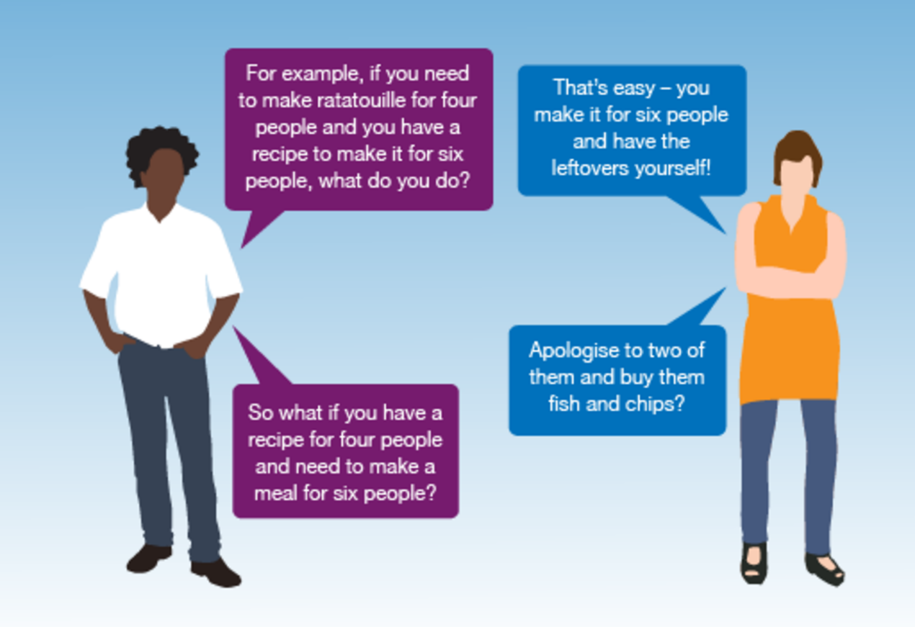
Figure 26 Talking ratios
View description - Figure 26 Talking ratios

Ratio is where one number is a multiple of the other. To find out more about ratios, read the following example.

Example: How to use ratios
Suppose you need to make up one litre (1,000 ml) of bleach solution. The label says that to create a solution you need to add one part bleach to four parts water.
This is a ratio of 1 to 4, or 1:4. This means that the total solution will be made up of:

One part + four parts = five parts

If we need 1,000 ml of solution, this means that one part is:

1,000 ml ÷ 5 = 200 ml

The solution needs to be made up as follows:

Bleach: one part × 200 ml = 200 ml
Water: four parts × 200 ml = 800 ml

So to make one litre (1,000 ml) of solution, you will need to add 200 ml of bleach to 800 ml of water.
You can check your answer by adding the two amounts together. They should equal the total amount needed:

200 ml + 800 ml = 1,000 ml

Use the example above to help you with the following activity. Remember to check your answers once you have completed the questions.

Hint: m³ = cubic metres (m × m × m). You will look at volume later in the course.

Activity 18: Using ratios

- The ratio of sand to cement required to make concrete is 3:1.
How much of each is needed in order to make 60 m³ of concrete?
- Read the label from a bottle of wallpaper stripper:
  - Dilute: add 1 part wallpaper stripper to 7 parts water.
How much wallpaper stripper and water is needed to make 16 litres of solution?
- To make a solution of hair colourant you need to add one part of hair colourant to four parts of water. How much hair colourant and water is needed to make 400 ml of solution?

View answer - Activity 18: Using ratios

Summary
You have now learned how to use ratio to solve problems in everyday life. This could be when you are mixing concrete, hair colourant or screen wash. Can you think of any more examples where you might need to use ratio?

8 Proportion
Proportion is used to scale quantities up or down by the same ratio. This is shown in the following example – what happens if you want to adapt a favourite recipe to serve more people?

Example: Using proportion for more portions …

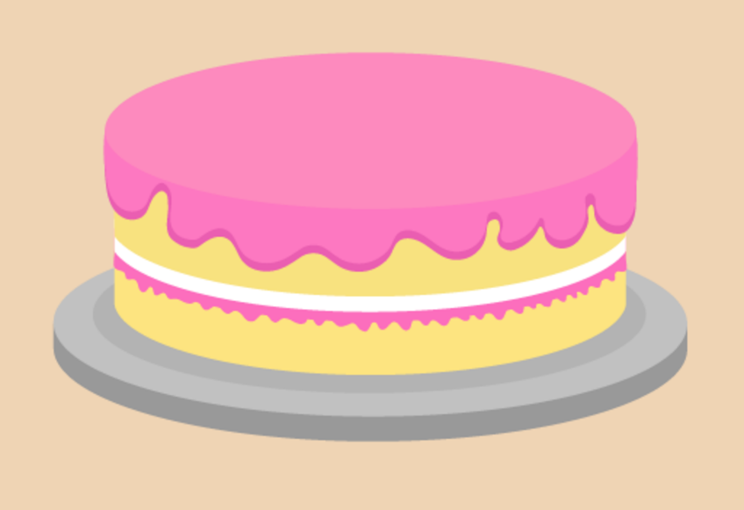
Figure 27 A cake
View description - Figure 27 A cake

Here is a recipe for making a sponge cake for four people:

4 oz self-raising flour
4 oz caster sugar
4 oz butter
2 eggs

How much of each ingredient is needed to make a cake for eight people?

Method
To make a cake for eight people you need twice the amount of each ingredient:

8 oz self-raising flour (4 × 2)
8 oz caster sugar (4 × 2)
8 oz butter (4 × 2)
4 eggs (2 × 2)

Use the example above to help you with the following activity. Remember to check your answers once you have completed the questions.

Activity 19: Scaling up recipes

- This recipe makes ten large cookies:
  - 220 g self-raising flour
  - 150 g butter
  - 100 g caster sugar
  - 2 eggs
How much of each ingredient is needed to make 20 cookies?
- This recipe makes four servings of strawberry milkshake:
  - 800 ml milk
  - 200 g strawberries
  - 4 scoops of ice cream
How much of each ingredient is needed for two people?
- This recipe makes dessert for two people:
  - 300 ml milk
  - 60 g powder
How much of each ingredient is needed to serve six people?

View answer - Activity 19: Scaling up recipes

Once you have checked your answers and have got them all correct, please have a go at the next activity.

Activity 20: Looking at ratio and proportion

Note: Calculators not allowed.
- A label on a bottle of curtain whitener says that you should add one part concentrated curtain whitener to nine parts water.
How much curtain whitener and water is needed to make up a 2,000 ml solution?
- Here is a recipe for a low-fat risotto for two people:
  - 200 g mushrooms
  - 175 g rice
  - 180 ml water
  - 180 ml evaporated milk
  - Salt and pepper
How much of each ingredient is needed if you want to cook enough risotto for six people?

View answer - Activity 20: Looking at ratio and proportion

Summary
In this section you have learned how to use proportion to solve simple problems in everyday life, for example when adapting recipes.

9 Word formulas and function machines
You see formulas in everyday life, but sometimes it can be tricky to spot one that’s written in words.
So what’s a formula? It’s a rule that helps you to work out an amount, you will see this when cooking, working out how much you are going to get paid or your household bills.
A process that involves more than one formula needs a function machine, which we’ll look at a little later.

9.1 Formulas in words
You use formulas a lot throughout a normal day, as the examples below show.

Example: A formula to calculate earnings
Daniel is paid £6.50 per hour. How much does he earn in ten hours?

Method
You’re told that ‘Daniel is paid £6.50 per hour’.
This is a formula. You can use it to work out how much Daniel earns in a given number of hours. The calculation you need to do is:

Daniel’s pay = £6.50 × number of hours

You’ve been asked how much Daniel earns in ten hours, so put ‘10’ into the calculation in place of ‘number of hours’:

£6.50 × 10 = £65.00

You can use the same formula to work out how much Daniel earns for any number of hours.

You will need to be able to use formulas that have more than one step. The next example looks at a two-step formula.

Example: A cooking formula
What are the two steps in word formulas? Watch the following video to find out.

Video content is not available in this format.
View transcript - Uncaptioned interactive content

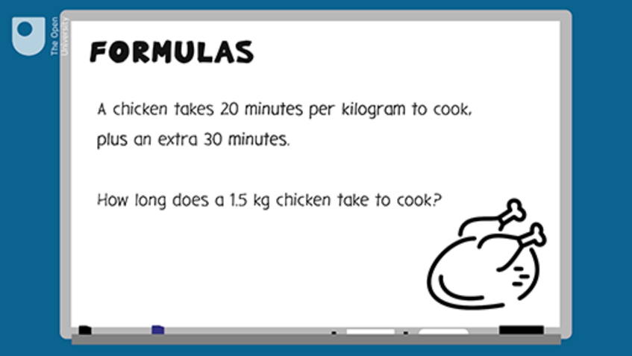

Now test your learning with the following word problems.

Activity 21: Using formulas

- Harvey earns £7.75 per hour. How much will Harvey earn in 8 hours?

View answer - Part

- A joint of pork takes 40 minutes per kilogram to cook, plus an extra 30 minutes to ensure the outside is crisp.
  - How long will it take for a 2 kg joint of pork to cook?
  - How long will it take for a 1.5 kg joint of pork to cook?

View answer - Part

- A mobile phone contract costs £15 a month for the first four months, then £20 a month after that. How much will the phone cost for one year?

View answer - Part

9.2 Function machines

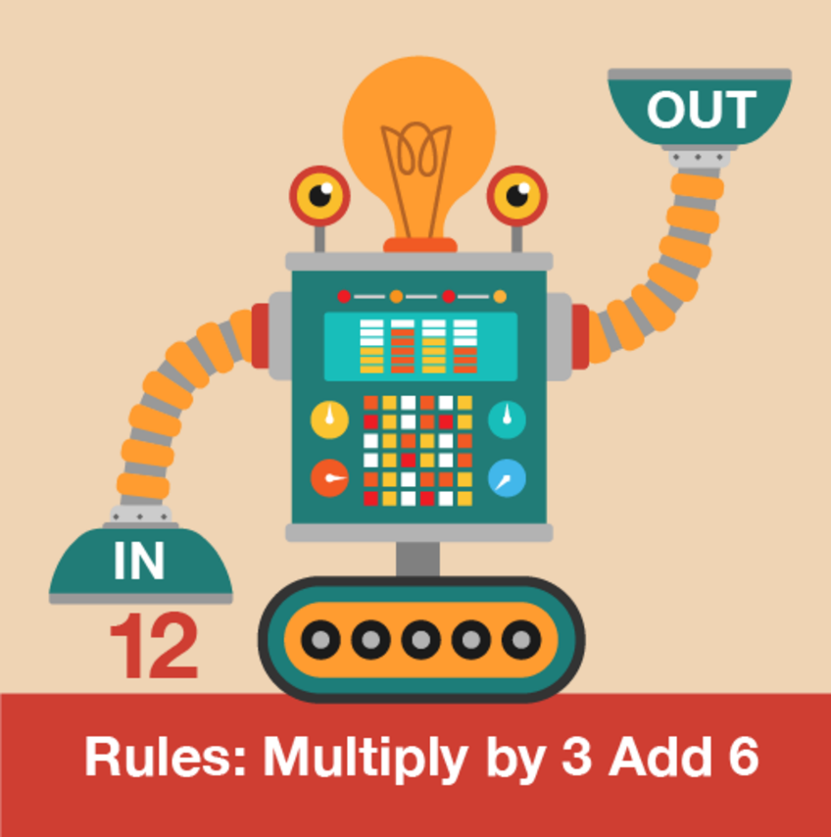
Figure 28 A function machine
View description - Figure 28 A function machine

Function machines can help when you are working with any formula that has more than one step. The difference between formulas and function machines is that you must follow a function machine in the correct order from left to right, or top to bottom, as shown in the example below. In the Level 2 course on maths you will see that when you use formulas, the BIDMAS rule must be followed.

Example: Marathon training
Dominic wants to run a marathon in under four hours. He finds the following method to work out his expected marathon time:

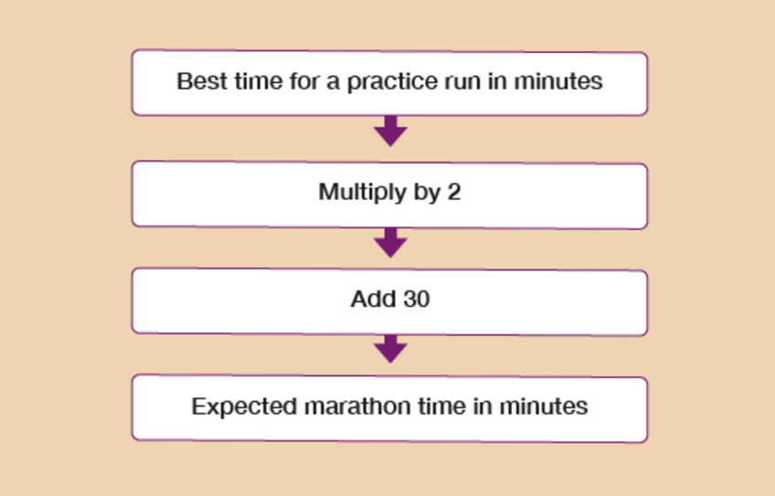
Figure 29 A function machine flow chart
View description - Figure 29 A function machine flow chart

Dominic’s best time for a practice run is 98 minutes. If he runs a marathon at the same pace, will he complete it in less than four hours?

Method
Dominic’s best practice run is 98 minutes, so you need to put 98 as the first number in the function machine:

98 × 2 + 30 = expected marathon time
98 × 2 + 30 = 226 minutes

So to answer the question: yes, if Dominic runs a full marathon at the same pace he runs during practice, he would finish the marathon in under four hours.

Now you have read the example, please have a go at the following activity.

Activity 22: Using function machines

- The battle of the bands will take place in the youth club hall.

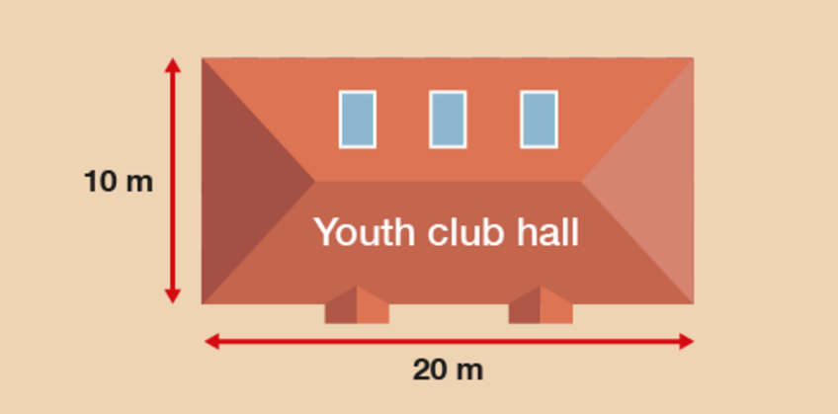
Figure 30 A youth club
View description - Figure 30 A youth club

Shazad uses the following rule to find out the number of people allowed in any hall:

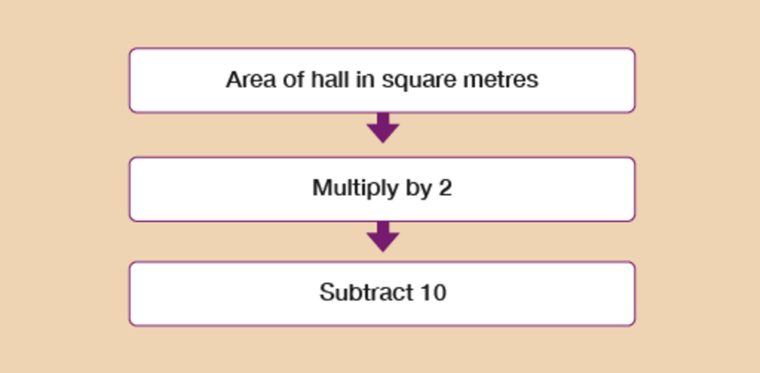
Figure 31 A function machine flow chart
View description - Figure 31 A function machine flow chart

What is the number of people allowed in the youth club hall?

View answer - Part

- Simon meets a trainer at the leisure centre to set fitness goals. The trainer uses the following rule to calculate Simon’s BMI:
  - Simon’s weight in kg ÷ 3 = Simon’s BMI
One of Simon’s fitness goals is to have a BMI between 19 and 25.
He currently weighs 72 kg. Is he meeting his fitness goal?

View answer - Part

- Lena makes candles in containers. She knows a rule to work out how much wax she needs (measured in grams) to use for each container (measured in ml):

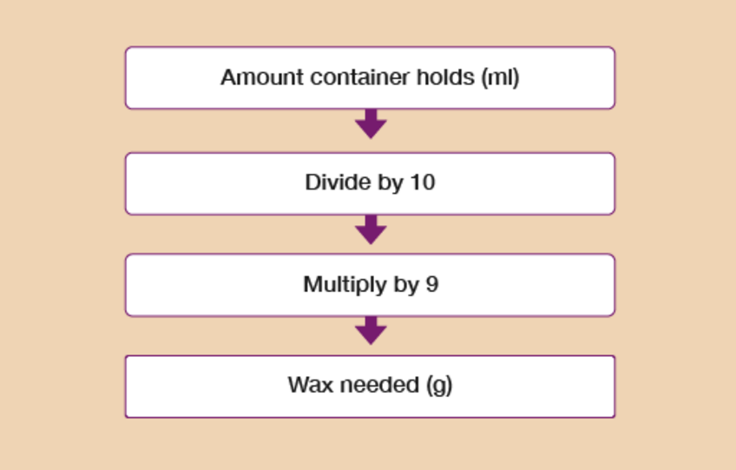
Figure 32 A function machine flow chart
View description - Figure 32 A function machine flow chart

Lena has a container that holds 200 ml. How many grams of wax should Lena use in this container?

View answer - Part

- Kofi sells souvenir photographs to visitors at the karting centre. The cost price of each photo is £2.
Kofi uses this rule to work out the selling price of each photo that will cover his costs and make a profit:

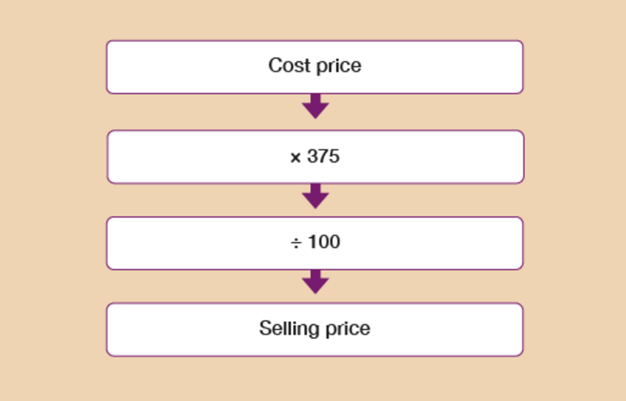
Figure 33 A function machine flow chart
View description - Figure 33 A function machine flow chart

Kofi thinks that the photos should be sold for £8. Is this correct?

View answer - Part

You have now completed the section on working with word formulas and function machines. If you did not get the questions correct, please return to them and identify where you went wrong.

Summary
In this section you have learned about working with word formulas and function machines.

10 A quick reminder: checking your work
Next you can take a quiz to review what you have learned in this session. For this and later quizzes in the course you should check your answers. A check is an alternative method or reverse calculation – you may have heard this being called an inverse calculation. If the check results in a correct answer, it means that your original sum is correct too. For example, you may have made the following calculation:
- 20 – 8 = 12
A way of checking this would be:
- 12 + 8 = 20
Alternatively, if you wanted to check the following calculation:
- 80 × 2 = 160
A way of checking this would be:
- 160 ÷ 2 = 80
If you have carried out several calculations to get to your final answer, you only need to reverse one as a check.

11 Session 1 quiz
Now it’s time to review your learning in the end-of-session quiz.
Session 1 quiz.
Open the quiz in a new window or tab (by holding ctrl [or cmd on a Mac] when you click the link), then return here when you have done it.
Although the quizzes in this course do not require you to show your working to gain marks, real exams would do so. We therefore encourage you to practise this by using a paper and pen to clearly work out the answers to the questions. This will also help you to make sure you get the right answer.

12 Session 1 summary
You have now completed Session 1, ‘Working with numbers’. If you have identified any areas that you need to work on, please ensure you refer back to this section of the course and retry the activities.
You should now be able to:
- understand and use whole numbers, and understand negative numbers in practical contexts
- add, subtract, multiply and divide whole numbers using a range of strategies
- understand and use equivalences between common fractions, decimals and percentages
- add and subtract decimals up to two decimal places
- solve simple problems involving ratio, where one number is a multiple of the other
- use simple formulas expressed in words for one- or two-step operations.
All of the skills above will help you with tasks in everyday life. Whether you are at home or at work, number skills are an essential skill to have.
You are now ready to move on to Session 2, ‘Units of measure’.

Session 2: Units of measure

1 Using metric measurements
So what do you use to measure things? If you were to measure something small, such as a grain of rice, you would probably use a ruler. To measure something bigger, like the length of a room or garden, you would probably use a tape measure.
You could try estimating the size of something before measuring it, which would help you to decide what tool you need to measure it. If you wanted to measure the walls of a room before redecorating, you’d get a more accurate measurement using a tape measure rather than a 30-centimetre ruler! After you’ve made an estimate you can check how accurate it is by measuring the object.
How long is a pen? Find a pen, make an estimate of how long you think it is and then measure it accurately using a ruler. To measure accurately, line up one end of the pen with the 0 mark on the ruler. If there is no 0 mark, use the end of the ruler. Hold the ruler straight against the pen. Which mark does the other end come to?

Hint: Be careful with the bit of ruler or tape measure that comes before the first mark! Make sure you line up whatever you’re measuring with the ‘zero’ mark.

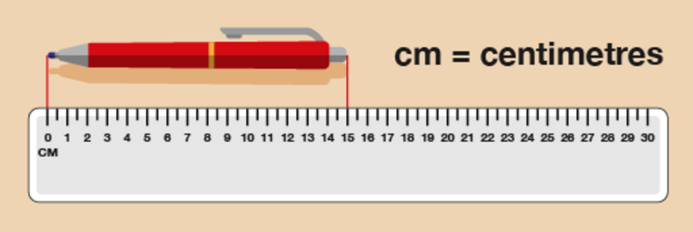
Figure 1 Measuring a pen
View description - Figure 1 Measuring a pen

You can see from this diagram that the pen is 15 cm long.
Now try the following activity. Remember to check your answers once you have completed the questions.

Activity 1: Building a shelf for DVDs

- You want to build a shelf to hold some DVDs. You need to make sure that it’s big enough! How tall is a DVD case?

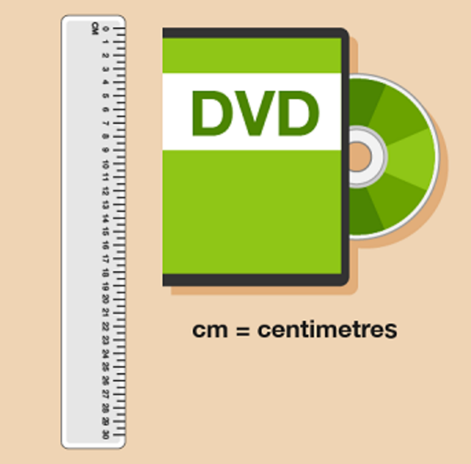
Figure 2 Measuring a DVD case
View description - Figure 2 Measuring a DVD case

- You have run out of screws. Before you go to buy some more, you need to measure the last screw you have to make sure you buy some more in the same size. How long is this screw?

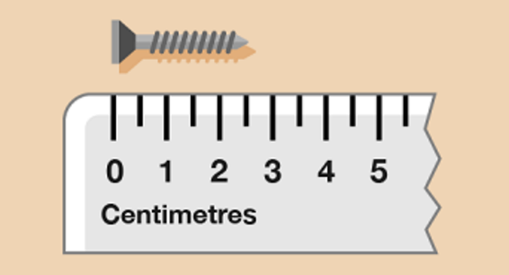
Figure 3 Measuring a screw
View description - Figure 3 Measuring a screw

- How far is it across the head of the screw?
Hint: Draw lines from the edge of the screw head down to the ruler to help you measure it.

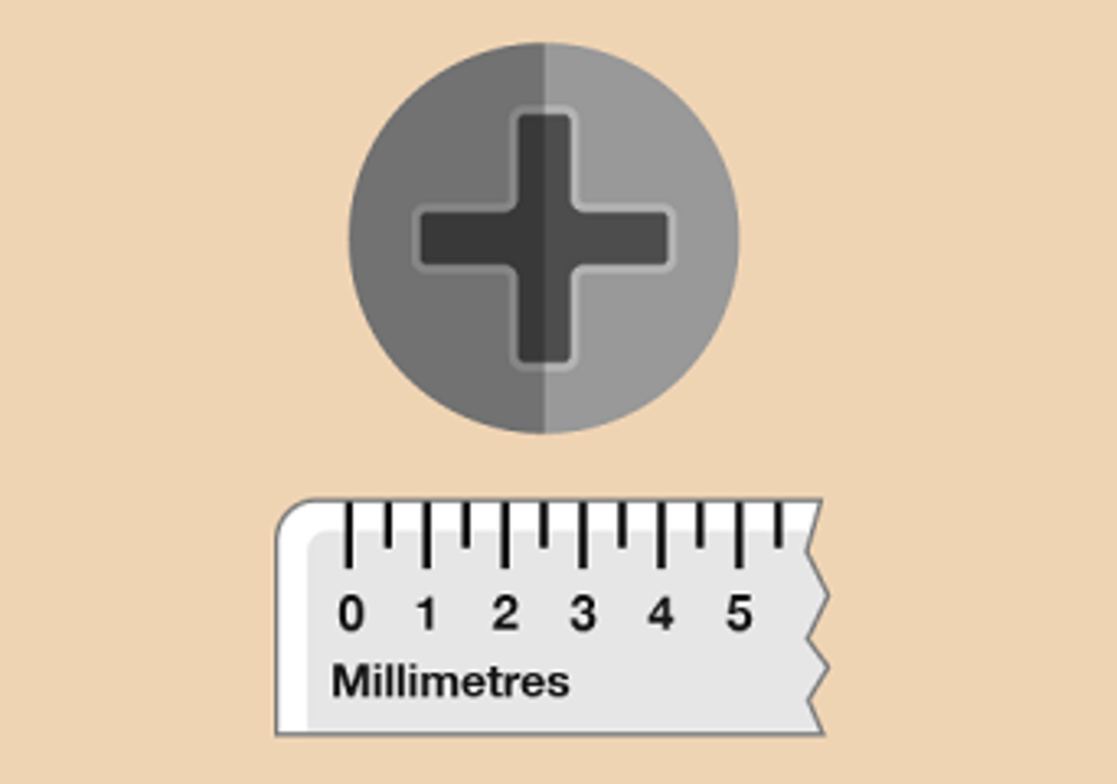
Figure 4 Measuring a screw head
View description - Figure 4 Measuring a screw head

View answer - Part

1.1 Changing units
Sometimes you will need to change between millimetres and centimetres, or centimetres and metres. For example, you might need to do this if you were fitting a kitchen or measuring a piece of furniture.
The diagram below shows you how to convert between metric units if you’re calculating any of the following:
- length, which is a measurement of how long something is
- mass (sometimes referred to as weight), which is a measurement of how heavy something is
- volume (sometimes referred to as capacity), which is a measurement of how much space something takes up.

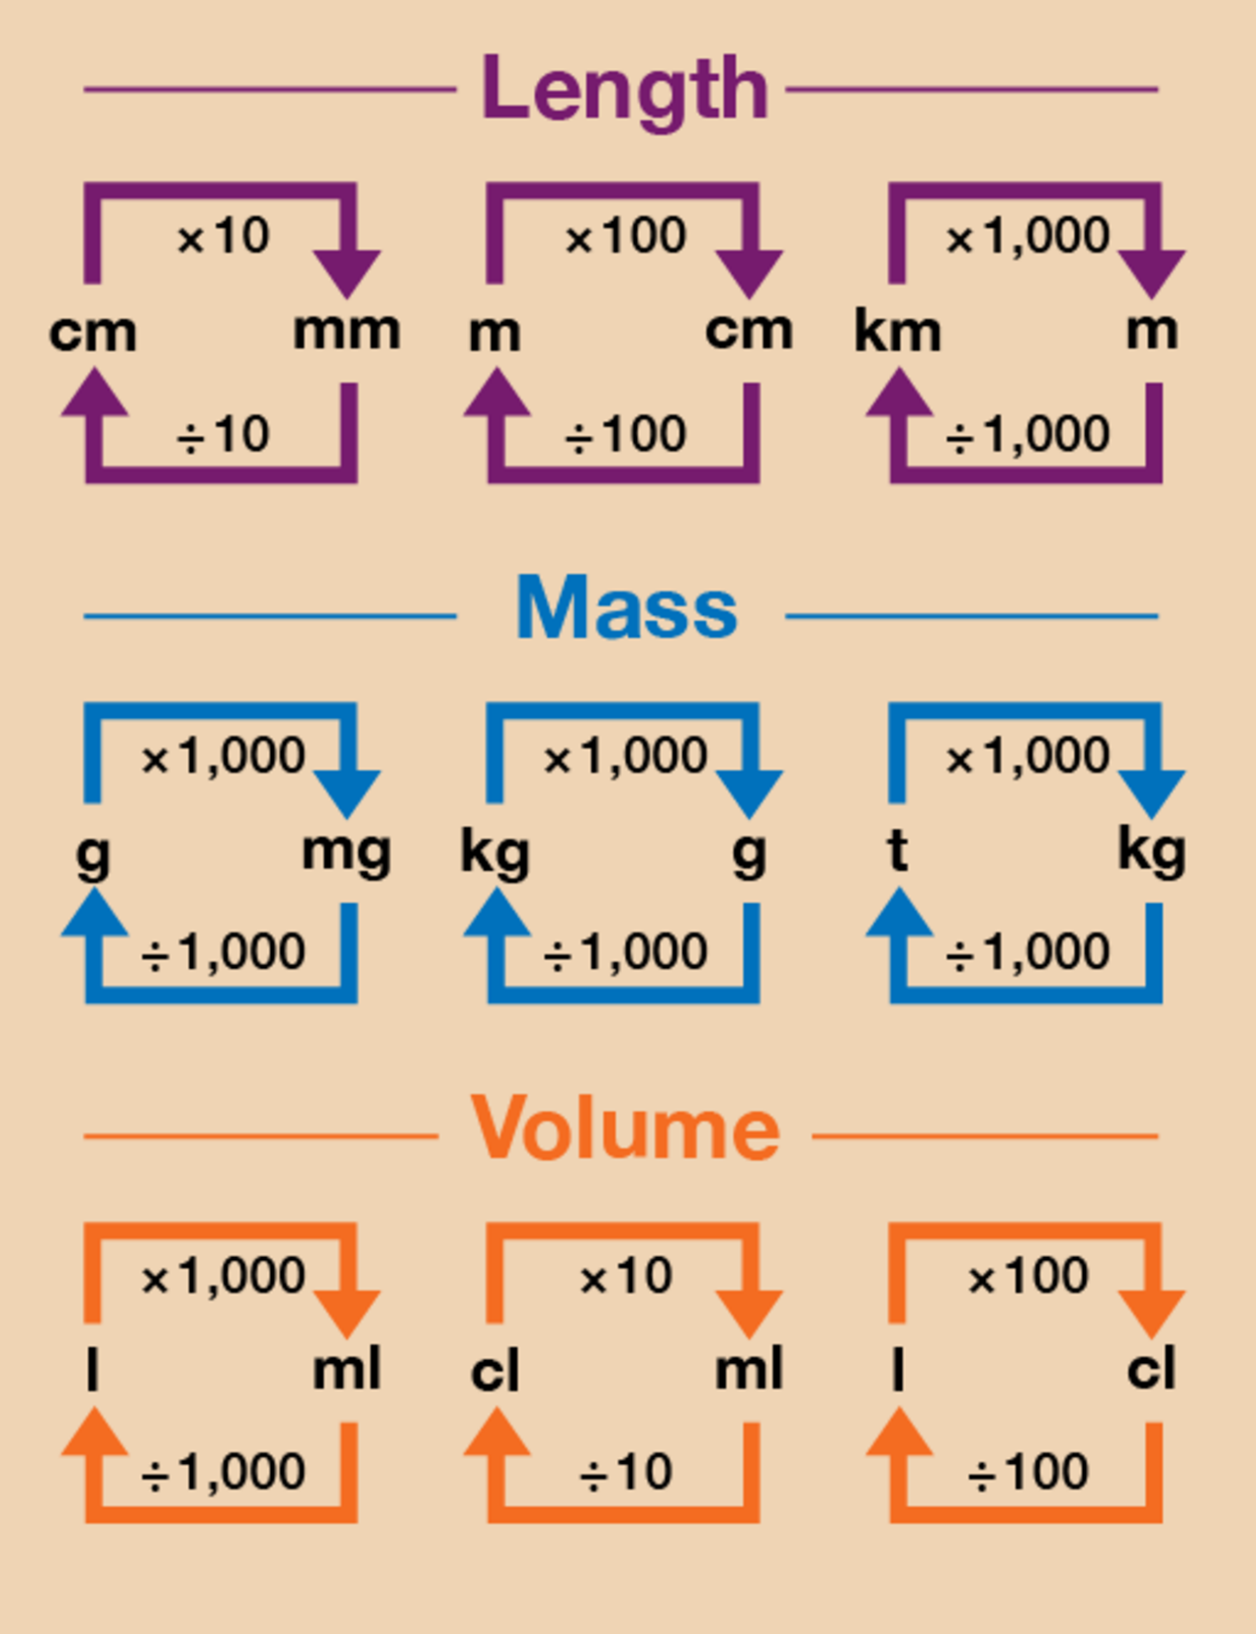
Figure 8 A conversion chart for length, mass and volume
View description - Figure 8 A conversion chart for length, mass and volume

Starting with the smallest, metric measures of length are in millimetres, centimetres and metres. These three measurements are all related:

10 millimetres (or mm, for short) = 1 centimetre (cm)
100 cm = 1 metre (m).

Please take a look at the example below on how to carry out simple metric conversions.

Hint: 10 millimetres = 1 centimetre, 100 centimetres = 1 metre

Example: Making Christmas cards
You are making Christmas cards for a craft stall. You want to add a bow, which takes 10 cm of ribbon, to each card. You plan to make 50 cards. How many metres of ribbon do you need?

Method
First you need to work out how many centimetres of ribbon you need:
- 10 × 50 = 500 cm
Notice that the question asks how many metres of ribbon you need, rather than centimetres. So you need to divide 500 cm by 100 to find out the answer in metres:
- 500 ÷ 100 = 5 m

Do you remember the metric conversion diagram at the start of this session?

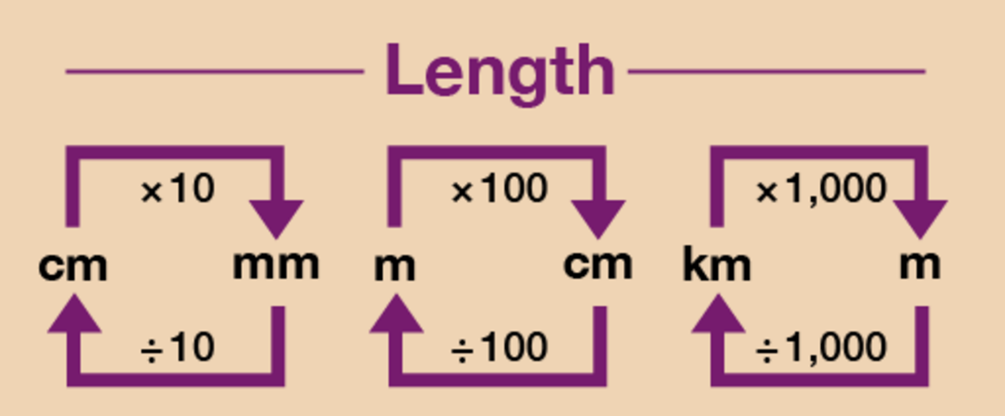
Figure 9 A conversion chart for length
View description - Figure 9 A conversion chart for length

Now try the following activity. Remember to check your answers once you have completed the questions.

Activity 2: Measuring lengths

- You are fitting kitchen cabinets. The gap for the last cabinet is 80 cm. The sizes of the cabinets are shown in millimetres. Which size should you look for?
- Thirty children in a class each need 20 cm of string for a project. How many metres of string will they use all together?
- You want to buy 30 cm of fabric. The fabric is sold by the metre. What should you ask for?

View answer - Activity 2: Measuring lengths

Now have a go at the following quickfire activity, using the conversion chart above if needed.

Activity 3: Converting lengths

What are these lengths in another unit of measurement? Select the correct answers from the list of options below.

- 20 mm = ? cm

200 cm
2 cm
0.2 cm
View answer - Part

- 450 mm = ? m

45 m
4.5 m
0.45 m
View answer - Part

- 0.5 cm = ? mm

5 mm
15 mm
50 mm
View answer - Part

- 400 cm = ? m

0.4 m
4 m
40 m
View answer - Part

Summary
In this section you have looked at measuring and calculating length. You have used different metric measurements, such as kilometres, metres and centimetres. You can now:
- measure and understand the sizes of objects
- understand different units of measurement.

2 Mileage charts
Can you think of a time when it is useful to be able to understand and work out distances between places? It’s useful to know how far apart places are if you’re planning a trip. If your job involves lots of travelling from place to place, you need to calculate how much mileage you do so that you can reclaim how much money you’ve spent on petrol.
How far is it from your home to the nearest shopping centre?
Your answer is probably something like ‘three miles’ or ‘ten kilometres’. Distances between places are often measured in either miles or kilometres. Road signs in the UK and USA use miles, whereas in Canada and Europe, for example, the road signs are in kilometres. What’s the difference between the two?
Kilometres are a metric measure of distance.
- 1,000 metres (m) = 1 kilometre (km)
Miles are an imperial measure of distance.
- 1 mile = 1,760 yards
One mile is a bit less than two kilometres.
Because most maps and road signs in the UK use miles, in this section you’ll work with miles.
If you have to plan a trip, it’s useful to look at a mileage chart. This shows you how far it is between places:

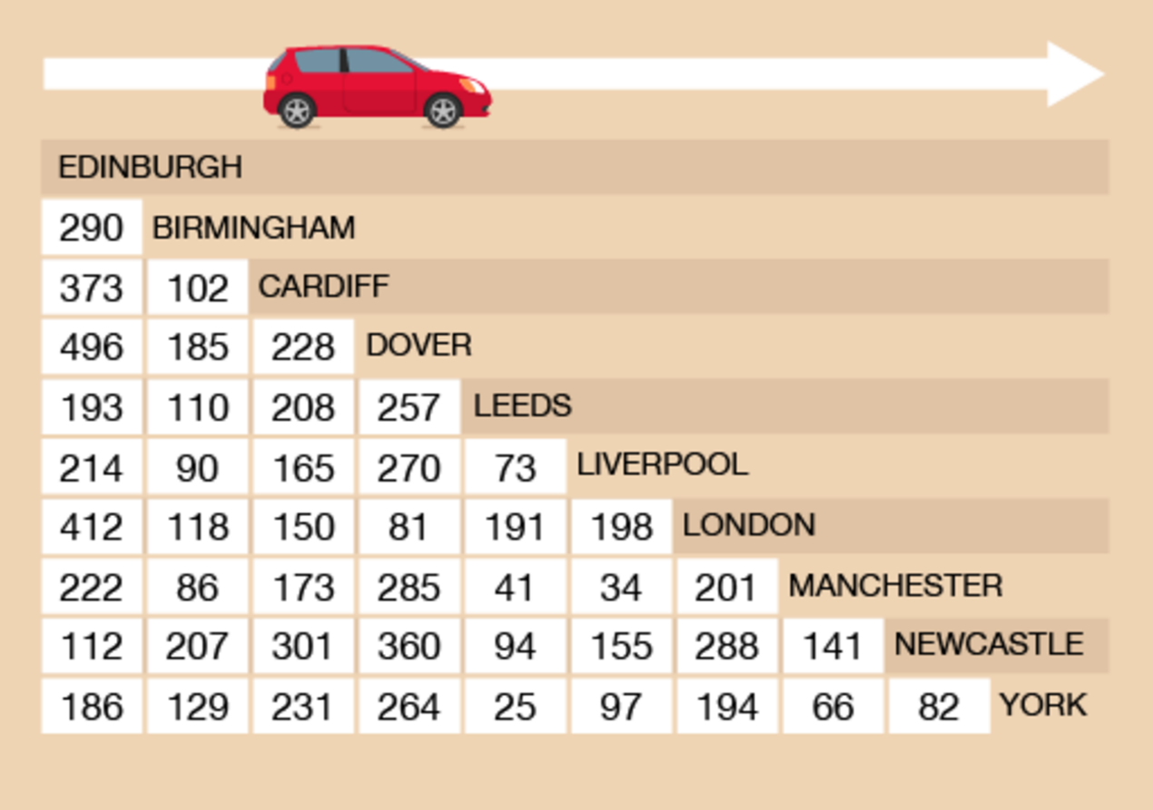
Figure 10 A mileage chart
View description - Figure 10 A mileage chart

To read the chart, find where you want to start from and where you want to go. Then follow the rows and columns until they meet.

Example: A long-distance journey
How far is it from Cardiff to Manchester?

Method
You need to identify the square where the column for Cardiff and the row for Manchester meet.

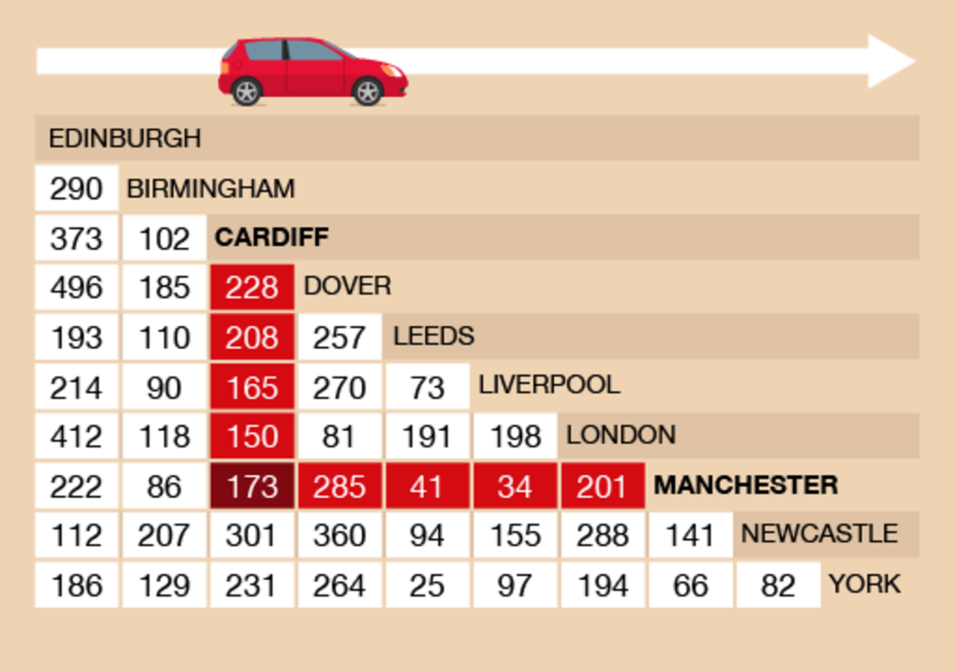
Figure 11 Cardiff to Manchester on a mileage chart
View description - Figure 11 Cardiff to Manchester on a mileage chart

So the answer is 173 miles.

Now try the following activity. Remember to check your answers once you have completed the questions.

Activity 4: A European tour

You want to go on holiday to Florence, crossing the Channel and then driving. You’ll need to refer to this mileage chart to answer the questions in this activity.

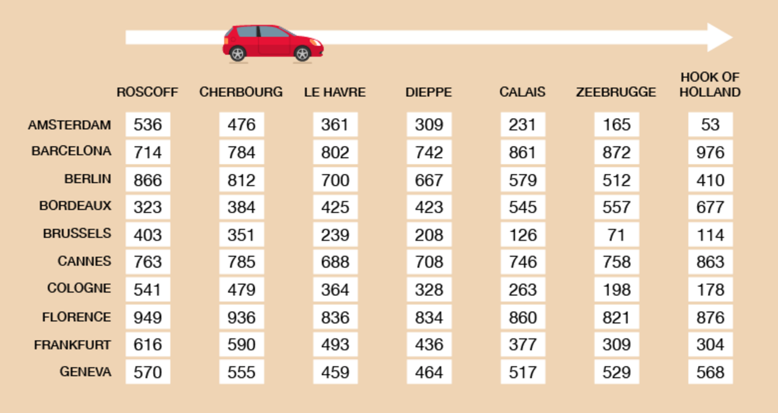
Figure 12 A mileage chart for a European tour
View description - Figure 12 A mileage chart for a European tour

- How far is it to Florence from Calais?
- A series of ports are listed at the top of the table. Which port is closest to Florence?
You will come back via Cologne in Germany.
- How far is it from Cologne to the port you chose?
- How far is it from Cologne to Calais?
- Which would be the best port to use?

View answer - Activity 4: A European tour

2.1 Adding distances
Many trips have more than one stop. To calculate how far you have to travel you need to add together the distances between stops.

Example: The sales trip
A sales rep has to travel from Edinburgh to York, then to London, and then back to Edinburgh. How far will they travel?
Method
Use the mileage chart to find the distances between Edinburgh and York, York and London, and London and Edinburgh.
The distance between Edinburgh and York is 186 miles.

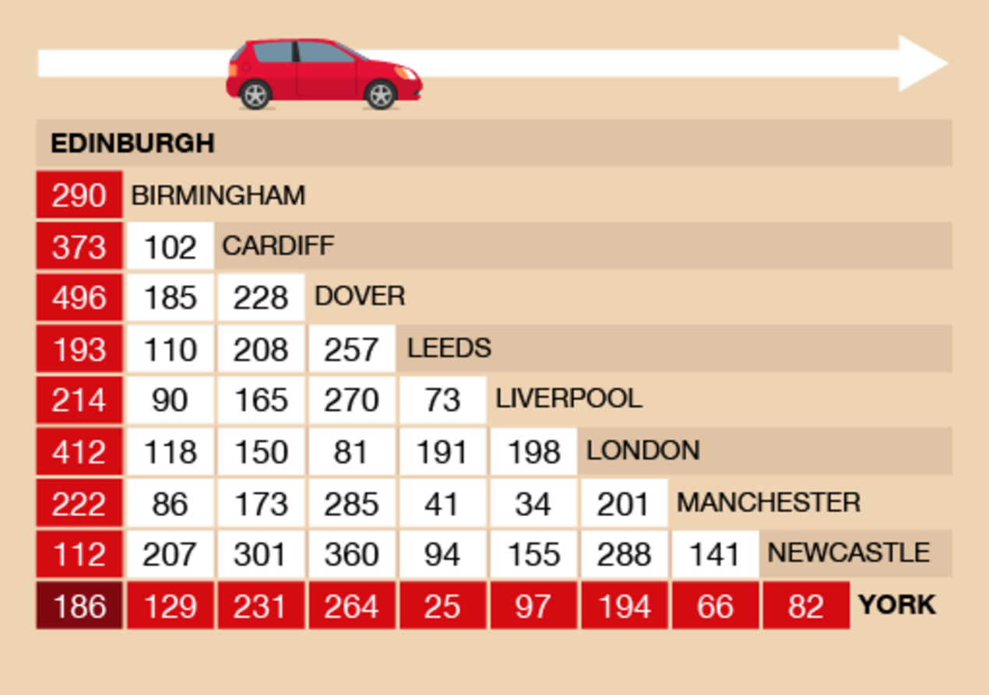
Figure 14 Edinburgh to York on a mileage chart
View description - Figure 14 Edinburgh to York on a mileage chart

London to York is 194 miles.

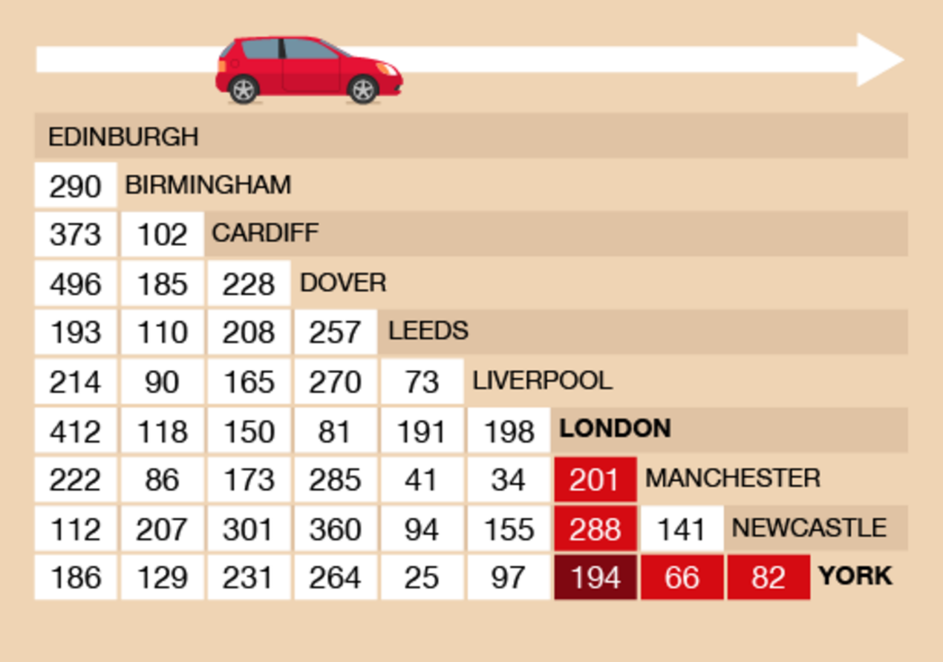
Figure 15 London to York on a mileage chart
View description - Figure 15 London to York on a mileage chart

Returning from London to Edinburgh is 412 miles.

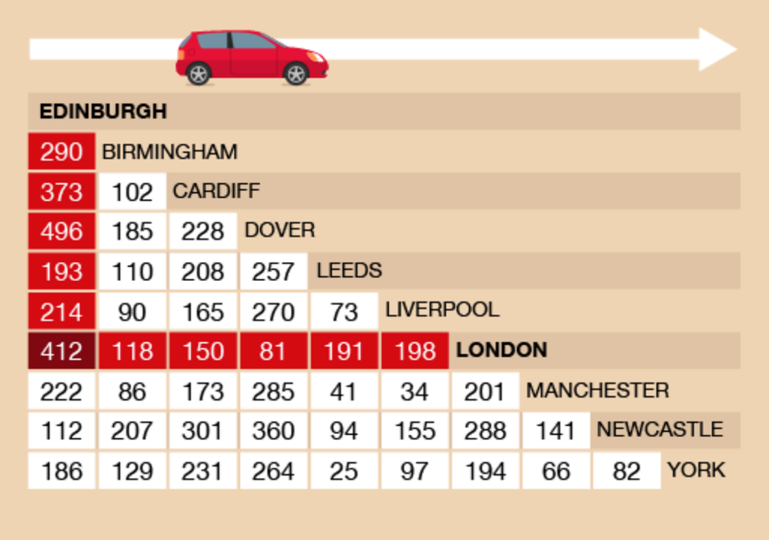
Figure 16 London to Edinburgh on a mileage chart
View description - Figure 16 London to Edinburgh on a mileage chart

The total distance of the trip is:
- 186 + 194 + 412 = 792 miles

Use the mileage table to help you with the following activity. Remember to check your answers once you have completed the questions.

Activity 5: Travelling across the UK

- You use a hire car to go from London to Cardiff, from Cardiff to Liverpool and then back to London. You pay 10p for each mile you drive.
  - How many miles must you pay for?
  - How much would this cost?
- You live in Newcastle and you want to buy a second-hand car trailer. There is one for sale in Leeds and one in York. Which one is closest?

View answer - Activity 5: Travelling across the UK

Summary
You have now completed the activities on using distance charts. This will help you with everyday life when you are planning a journey and or claiming mileage when travelling for work.

3 Estimating, measuring and comparing weights
How much do you weigh?
You might have given your weight in kilograms (kg) or in pounds (lb), or pounds and stone (st). Kilograms are metric weights. Pounds and stones are imperial weights.
- 1,000 grams (g) = 1 kilogram (kg)
You should measure weight in metric units, but you might see the old imperial units used sometimes.
- 1 g is approximately the weight of a paperclip.
Many foods are sold by weight. For example:
- 1 kg of sugar (this is equivalent to about two and a quarter pounds)
- 500 g of rice (about one pound)
- 250 g of coffee (about half a pound)
- 100 g of chocolate (slightly less than a quarter of a pound)
- 30 g of crisps (about an ounce)
- 10 g of a spice (about a third of an ounce).
Heavier things are weighed in kilograms:
- 50 kg of sharp sand (about 110 pounds)
- 10 kg chicken food (about 20 pounds)
- 1 kg of nails (about two pounds).
Note that if you bought ten packets of rice, you would say you had bought 5 kg rather than 5,000 g.
Scales show you how many much something weighs. Digital scales show the weight as a display of numbers. Other scales have a dial or line of numbers and you have to read the weight from this.

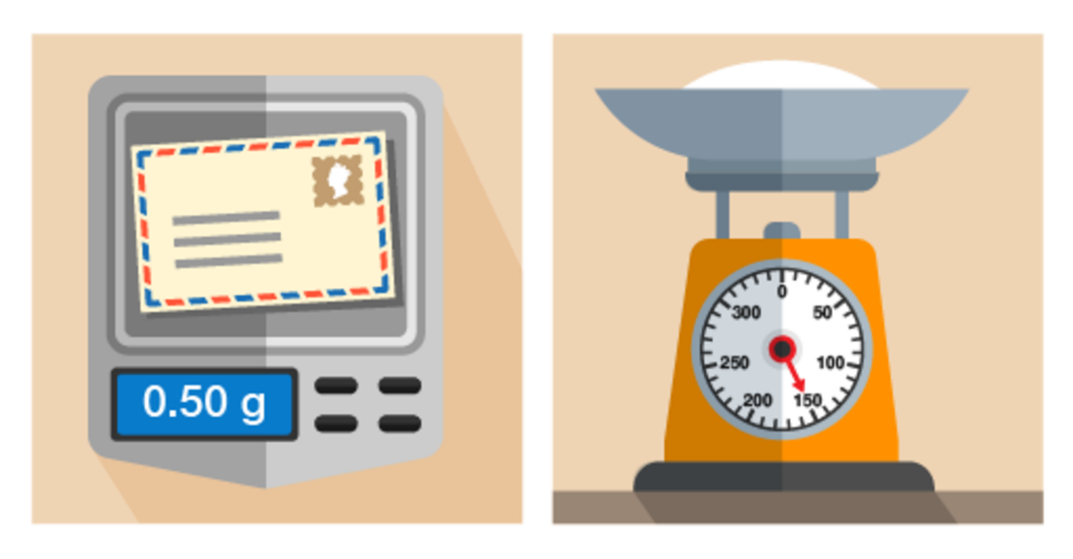
Figure 22 Using different scales for dufferent objects
View description - Figure 22 Using different scales for dufferent objects

You’ll notice that on the right-hand set of scales in the picture above, the needle points to 150 g. If you use scales like this, you need to know the divisions marked on the scales. You might have to count the marks between numbers.

Example: Identifying weights on scales
What is the weight of the flour in these scales?

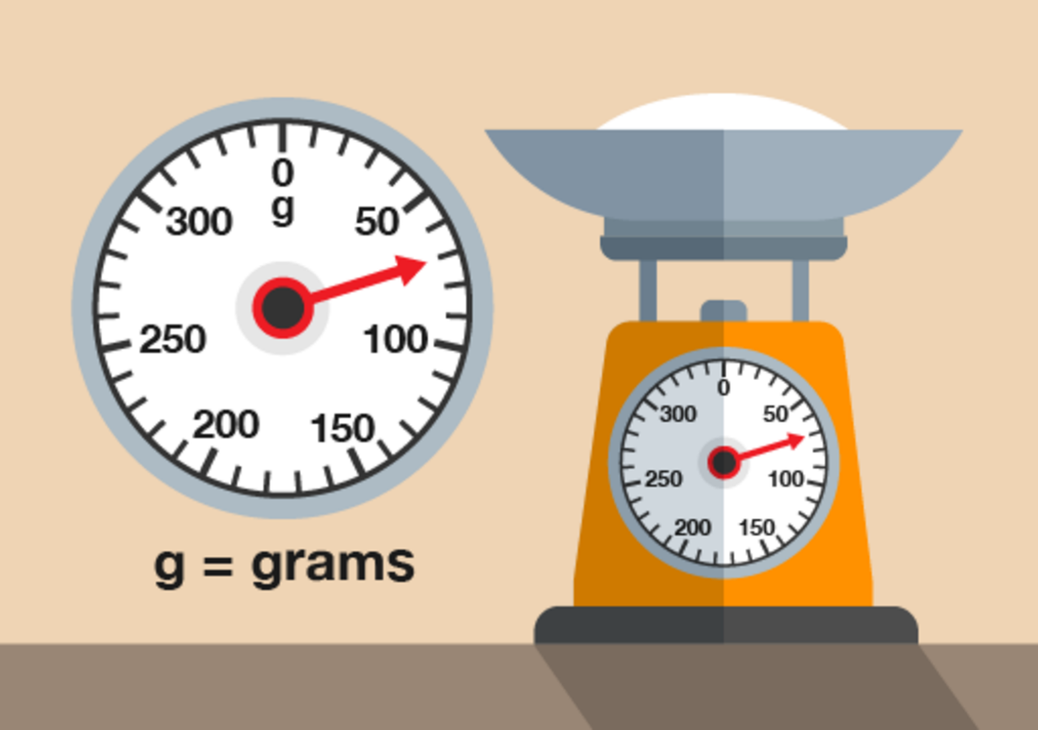
Figure 23 Weighing flour
View description - Figure 23 Weighing flour

(Note that scales like this are calibrated to weigh only the flour inside the bowl – the weight on the scales is just the flour, not the flour and the bowl.)

Method
There are four marks between 50 g and 100 g, each representing another 10 g. So the marks represent 60 g, 70 g, 80 g and 90 g. The needle is level with the second mark, so the weight is 70 g.

Now try the following activity. Remember to check your answers once you have completed the questions.

Activity 6: Reading scales

- How many grams of sugar are on the scales in the picture below?

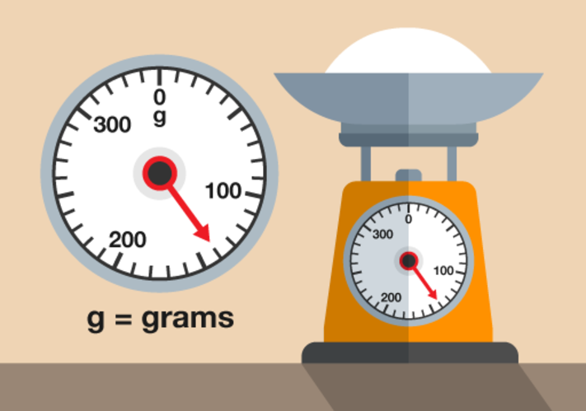
Figure 24 Weighing sugar
View description - Figure 24 Weighing sugar

- What is this person’s weight in kilograms?

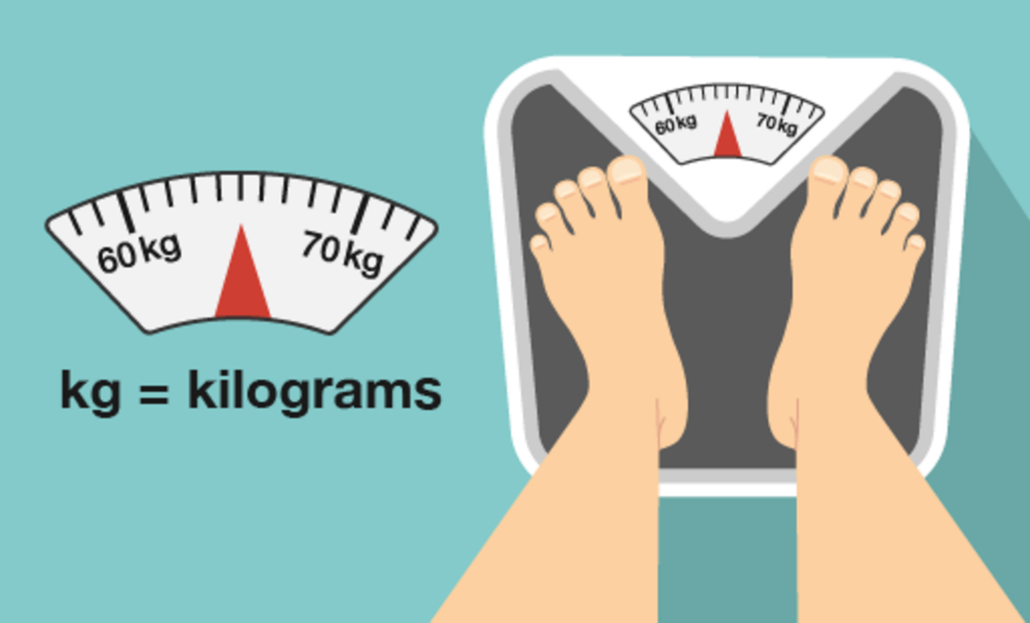
Figure 25 Weighing a person
View description - Figure 25 Weighing a person

- How much does the letter weigh?

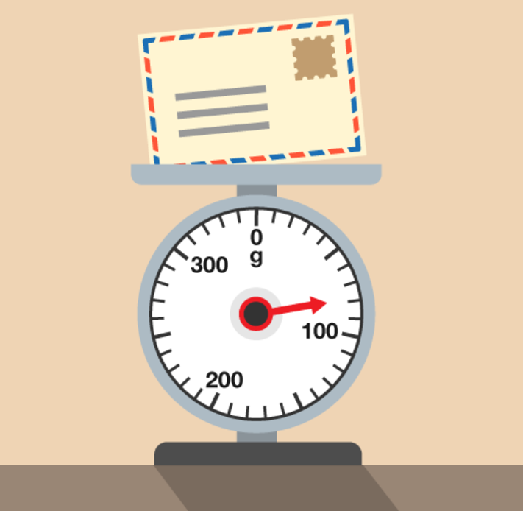
Figure 26 Weighing a letter
View description - Figure 26 Weighing a letter

View answer - Activity 6: Reading scales

3.1 Weighing things
It’s useful to have an idea of how much things weigh. It can help you to work out the weight of fruit or vegetables to buy in a market, for example, or whether your suitcase will be within the weight limit for a flight.
Try estimating the weight of something before you weigh it. It will help you to get used to measures of weight.

Hint: Remember to use appropriate units. Give the weight of small things in grams and of heavy things in kilograms.

Take a look at the example below before having a go at the activity.

Example: Weighing an apple
- Which metric unit would you use to weigh an apple?
- Estimate how much an apple weighs and then weigh one.
- How much would 20 of these apples weigh? Would you use the same units?

Method
- An apple is quite small, so it should be weighed in grams.
- How much did you estimate that an apple weighs? A reasonable estimate would be 100 g.
When we weighed an apple, it was 130 g.
- Twenty apples would weigh:
  - 130 × 20 = 2,600 g
Remember the metric conversion diagram? To convert from grams to kilograms, you need to divide the figure in grams by 1,000. So the weight of the apples in kilograms is:
  - 2,600 g ÷ 1,000 = 2.6 kg

Now try the following activity. Remember to check your answers once you have completed the questions.

Activity 7: Weighing things

- How much do ten teabags weigh? Estimate and then weigh them.
- How heavy is a bottle of sauce? How much would a case of 10 bottles weigh?
Hint: The weight shown on the label is the weight of the sauce – it doesn’t include the weight of the bottle or jar that the sauce comes in. So for an accurate measurement, you need to weigh the bottle rather than read the label!
- How heavy is a book?

View discussion - Activity 7: Weighing things

3.2 Comparing weights
By law, weights of goods for sale in the UK have to be in metric units: grams and kilograms.
Historically, however, most people used imperial measures of weight: in size order these are ounces, pounds and stones.
- 16 ounces (oz) = 1 pound (lb)
- 14 pounds = 1 stone (st)
You might still come across these weights sometimes.
An ounce is a bit less than 30 g. A pound is a bit less than half a kilogram.

Example: Two weight measurements
You have an old ladder with a label that says it can hold up to 20 stone. You weigh 80 kg. Can you safely use the ladder?

Hint: 1 st = 14 lb

Method
You need to work out roughly what 20 stone is in kilograms. First, you need to find out how much 20 stone is in pounds.
- 20 × 14 = 280 lbs
One pound is equivalent to nearly half a kilogram, so next you need to divide the weight in pounds by 2:
- 280 ÷ 2 = 140
The ladder will take about 140 kg – so you’re safe!

Now try the following activity. Remember to check your answers once you have completed the questions.

Activity 8: Converting weights

- An airline’s weight allowance for a piece of hand luggage is 5 kg. You have weighed your bag on some old bathroom scales and found that it is 7 lbs. Can you take it?
- You are using a recipe your grandmother wrote down. It calls for 4 oz sugar. You only have 150 g left. Do you have enough to make the recipe?

View answer - Activity 8: Converting weights

Summary
In this section you have learned how to:
- estimate and measure weight
- use metric units of weight
- know the relationship between grams and kilograms
- convert from imperial to metric units of weight.

4 Capacity
Now you are going to look at capacity, which can also be referred to as volume. Capacity is the maximum amount that something can contain; volume is the amount of space that a substance or object occupies. The two terms are interchangeable and can refer to the same calculation or measurement.
When you buy milk, how much is in each bottle or carton? What about when you buy juice?
Most people buy milk in cartons or bottles of one, two, four or six pints. Juice is usually sold in cartons or bottles of one litre.
Pints are an imperial measure of volume, and litres are a metric measure of volume. One litre is the same as 1,000 millilitres. Volume is the amount of space that something takes up.
To measure a very small amount, you might use a teaspoon. This is the same as 5 millilitres (ml).

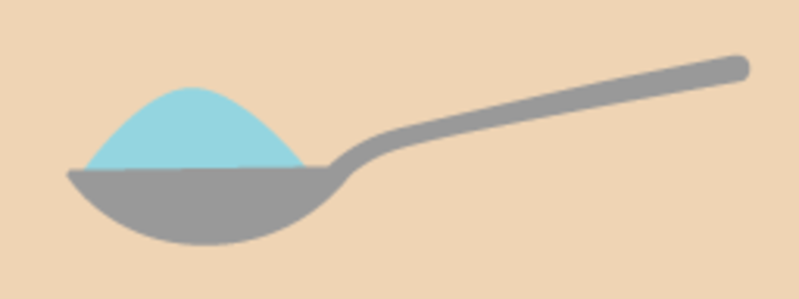
Figure 27 A teaspoon
View description - Figure 27 A teaspoon

To measure larger amounts, you would probably use a measuring jug of some kind – note that measuring jugs can come in different sizes.

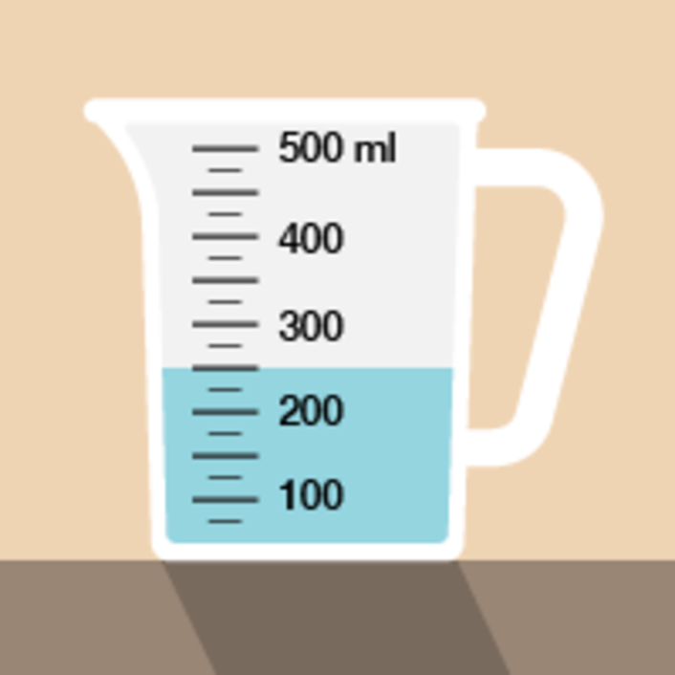
Figure 28 A measuring jug
View description - Figure 28 A measuring jug

Now take a look at the following example.

Example: Measuring liquids
If you had to measure out 350 ml of juice for a recipe, where would the liquid come to in this jug?

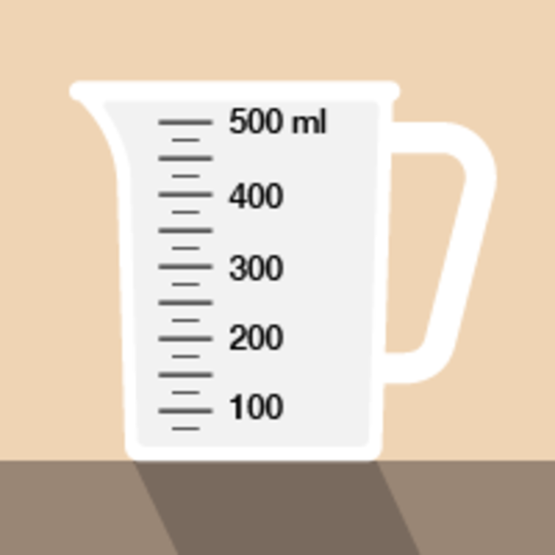
Figure 29 Measuring liquids in a measuring jug
View description - Figure 29 Measuring liquids in a measuring jug

Method
There are three marks on the jug between 300 ml and 400 ml. These mark 325, 350 and 375 ml. So you need to fill the jug to the middle mark (remember to look for the level where the liquid touches the scale):

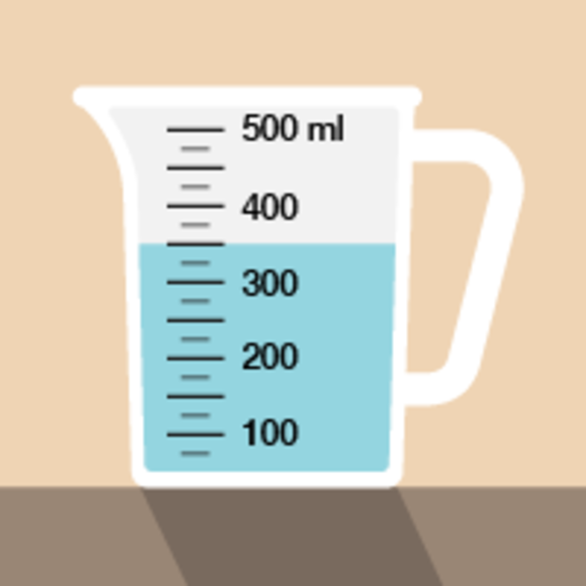
Figure 30 Measuring liquids in a measuring jug (answer)
View description - Figure 30 Measuring liquids in a measuring jug (answer)

Now try the following activity. Remember to check your answers once you have completed the questions.

Activity 9: Looking at volume

Now that you have seen the example, have a go at the following activity;
- How much coffee or tea does a cup you usually drink out of hold? Estimate the volume first, and write down your estimate. Next, fill your cup with water and then pour the water into a measuring jug.
- A scientist has to measure 2.8 ml of liquid in this pipette. Where should the liquid come to?

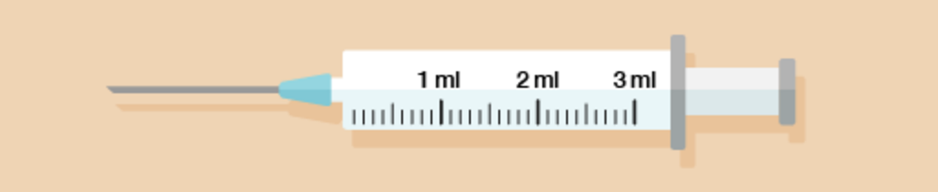
Figure 31 A pipette
View description - Figure 31 A pipette

- A plumber has drained water from a faulty central heating system into a set of measuring jugs. How many litres in total has the plumber drained from the system?

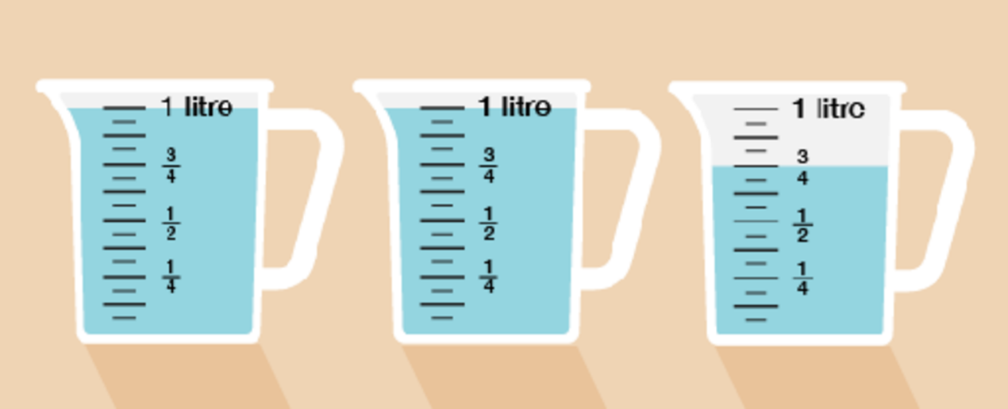
Figure 32 Three measuring jugs
View description - Figure 32 Three measuring jugs

View answer - Activity 9: Looking at volume

4.1 Changing units
You will sometimes need to change between millilitres and litres. There are 1,000 millilitres in a litre.
Take a look at this section of the metric conversion chart to refer to when you are carrying out the activity below.

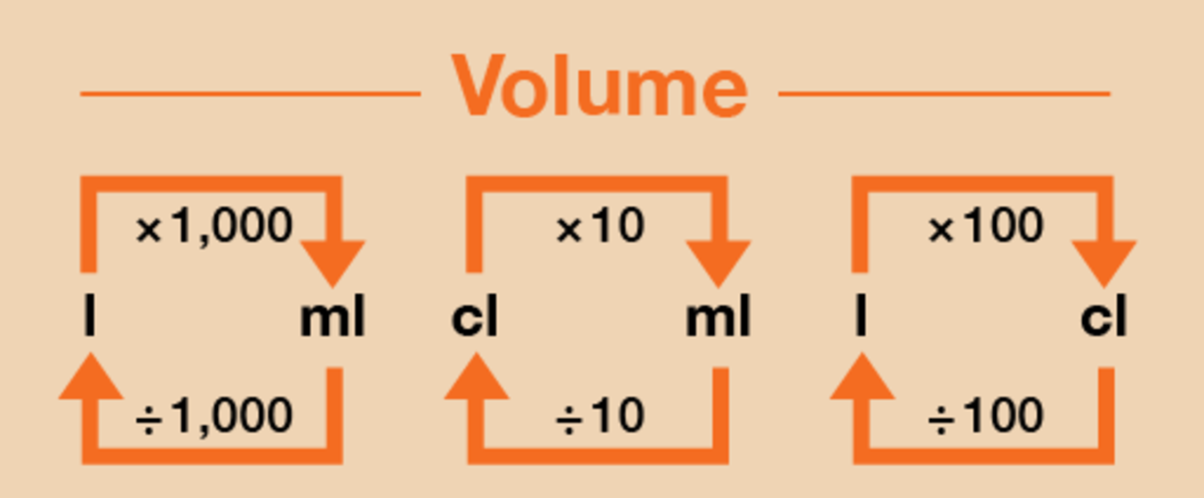
Figure 34 A conversion chart for volume
View description - Figure 34 A conversion chart for volume

Example: Party food
You are cooking for a large party. The recipe you are using calls for 600 ml of milk to make enough for four people.
How many litres of milk will you need to make ten times as much?

Method
First you need to multiply the amount in millilitres by 10:
- 600 × 10 = 6,000 ml
However, the question asks for an amount in litres, not millilitres. To convert from millilitres to litres, you need to divide the figure in millilitres by 1,000. So the amount of milk you need in litres is:
- 6,000 ÷ 1,000 = 6 litres

Now try the following activity using the conversion diagram above to help you answer the questions. Remember to check your answers once you have completed the questions.

Activity 10: Converting between millilitres, centilitres and litres

- A nurse has to order enough soup for 100 patients on a ward. Each patient will eat 400 ml of soup. How many litres of soup must the nurse order?
- Twenty people working in a craft workshop have to share the last two-litre bottle of glue. How many millilitres of glue can each person use? What would this be in centilitres?

View answer - Activity 10: Converting between millilitres, centilitres and litres

4.2 Using pints and gallons
You might still see the old, imperial units for measuring volume.
- 20 fluid ounces (fl oz) = 1 pint (pt)
- 8 pts = 1 gallon (gal)
A pint is a little more than half a litre.
A fluid ounce is about 30 ml.
Some measuring jugs show both metric and imperial units.

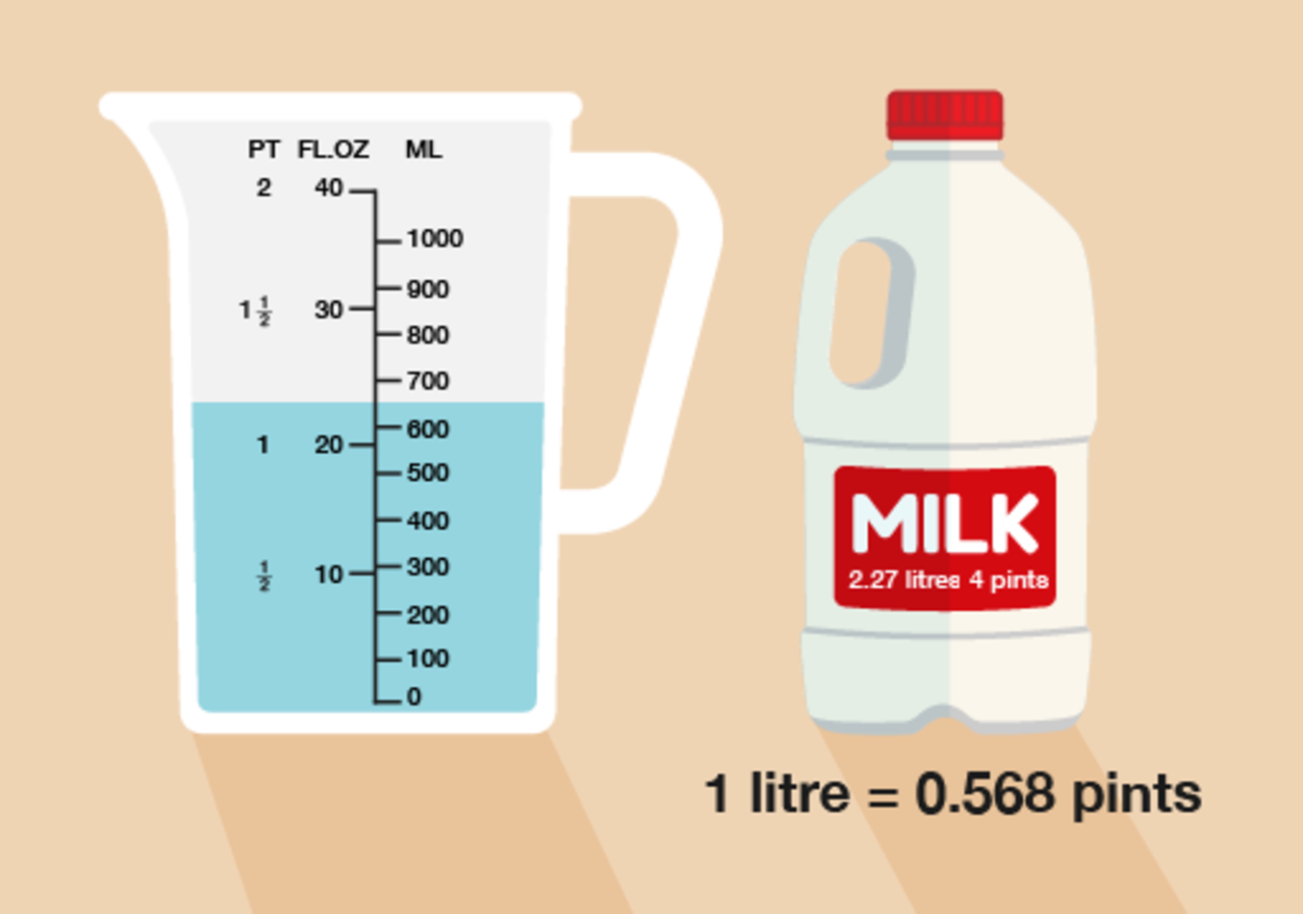
Figure 35 Using metric and imperial units
View description - Figure 35 Using metric and imperial units

Example: Buying petrol
You have an old one-gallon can in your shed. You take it to the garage to buy petrol for your lawnmower. About how many litres of petrol can you buy?

Method
A pint is a little more than half a litre, so you can get just over a litre for every 2 pints.
There are 8 pints in a gallon, so you can get just over 4 litres of petrol.

Now try the following activity. Remember to check your answers once you have completed the questions.

Activity 11: Converting between metric and imperial measurements

- You are mixing up a quantity of weedkiller. The packet says to use a pint of weedkiller in a gallon of water. You have only a metric measuring jug. How much water should you use with 1 litre of weedkiller?
- An old recipe book tells you to make one pint of custard. You prefer to buy custard in the supermarket, where it is sold in cartons of 500 ml. How many cartons do you need to buy to be sure you have enough for the recipe?

View answer - Activity 11: Converting between metric and imperial measurements

Summary
In this section you have learned how to:
- identify the standard units for measuring volume or capacity
- measure volume (or capacity)
- compare metric and imperial measures.

5 Measuring temperature

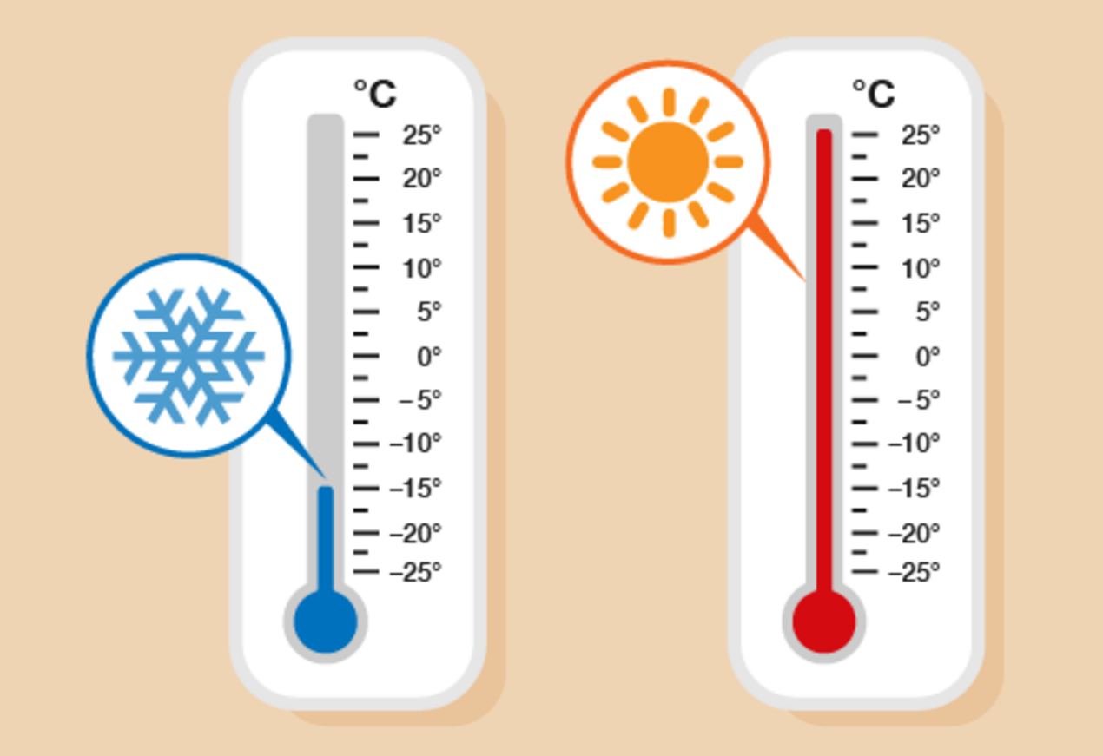
Figure 36 Comparing temperatures
View description - Figure 36 Comparing temperatures

Temperature tells us how hot or cold something is. You will see or hear temperatures mentioned in a weather forecast, and will also come across them in recipes or other instructions.
Temperature is sometimes given in degrees Celsius and sometimes in degrees Fahrenheit.

Hint: You might sometimes see Celsius called ‘centigrade’. Note that Celsius and centigrade are the same thing, referring to the same scale of measurement.

Water freezes at 0° Celsius and boils at 100° Celsius. The temperature in the UK in the daytime is usually between 0° Celsius (0°C) on a cold winter’s day and 25° Celsius on a hot day in summer.

5.1 Reading temperatures
Many things have to be stored or used in a particular temperature range to be safe. Temperature is measured with a thermometer.
Thermometers for different uses show different ranges of temperatures.
Take a look at the following example, which shows two types of thermometer.

Example: Reading thermometers
What is the temperature shown on each thermometer below?

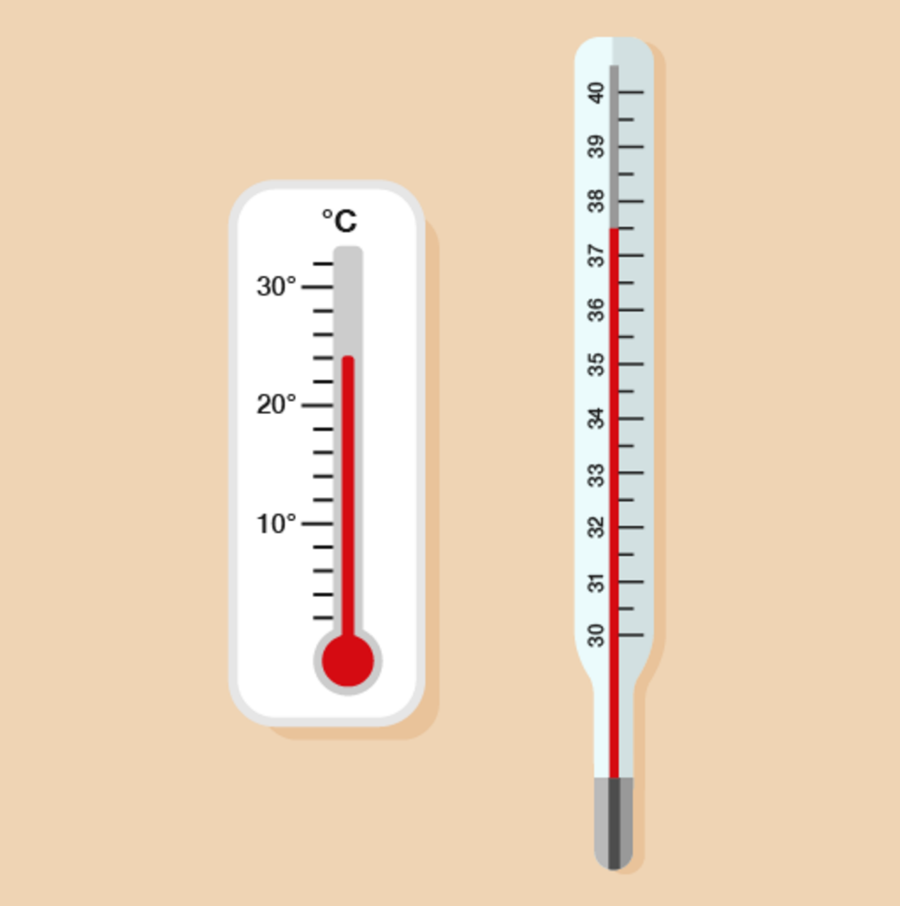
Figure 37 Reading the temperatures
View description - Figure 37 Reading the temperatures

Method
On the first thermometer, there are four divisions between 20 and 30, so the divisions mark every two degrees (22, 24, 26, 28). The reading is at the second mark after 20, so the temperature is 24°C.
On the second thermometer, the temperature is at the mark halfway between 37 and 38, so it’s 37.5°C.

What temperature do you think it is today? If you have a thermometer, check the temperature outside; if you don’t, you could use an online resource such as the BBC Weather pages or your mobile phone to find the temperature near you.
Now try the following activity. Remember to check your answers once you have completed the questions.

Activity 12: Reading thermometers

What temperature is shown on each of these thermometers?

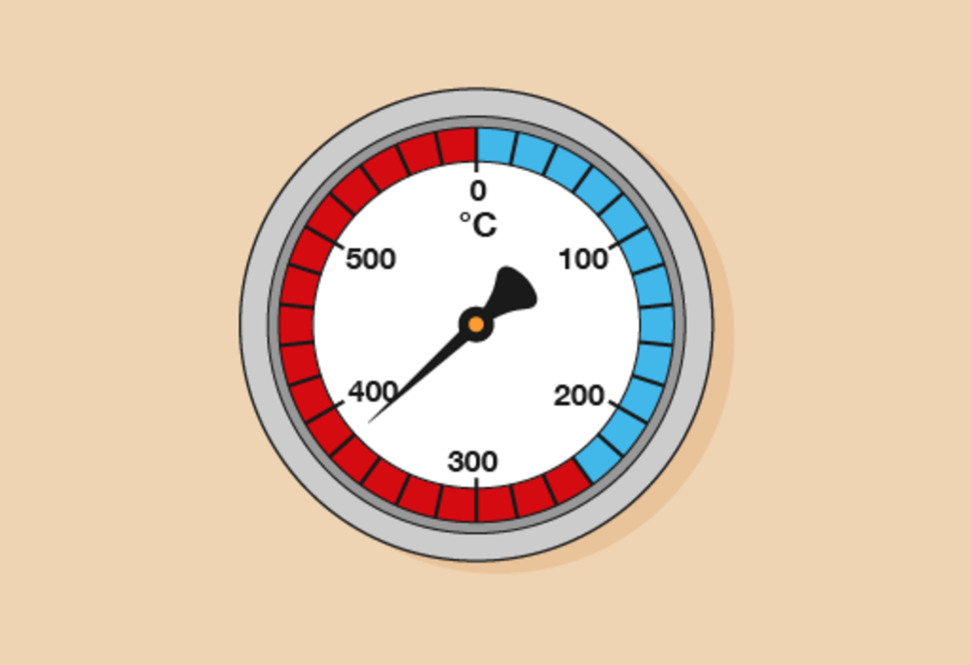
Figure 38 A thermometer
View description - Figure 38 A thermometer

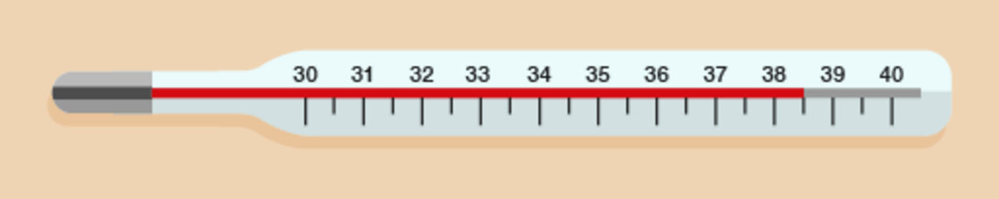
Figure 39 A thermometer
View description - Figure 39 A thermometer

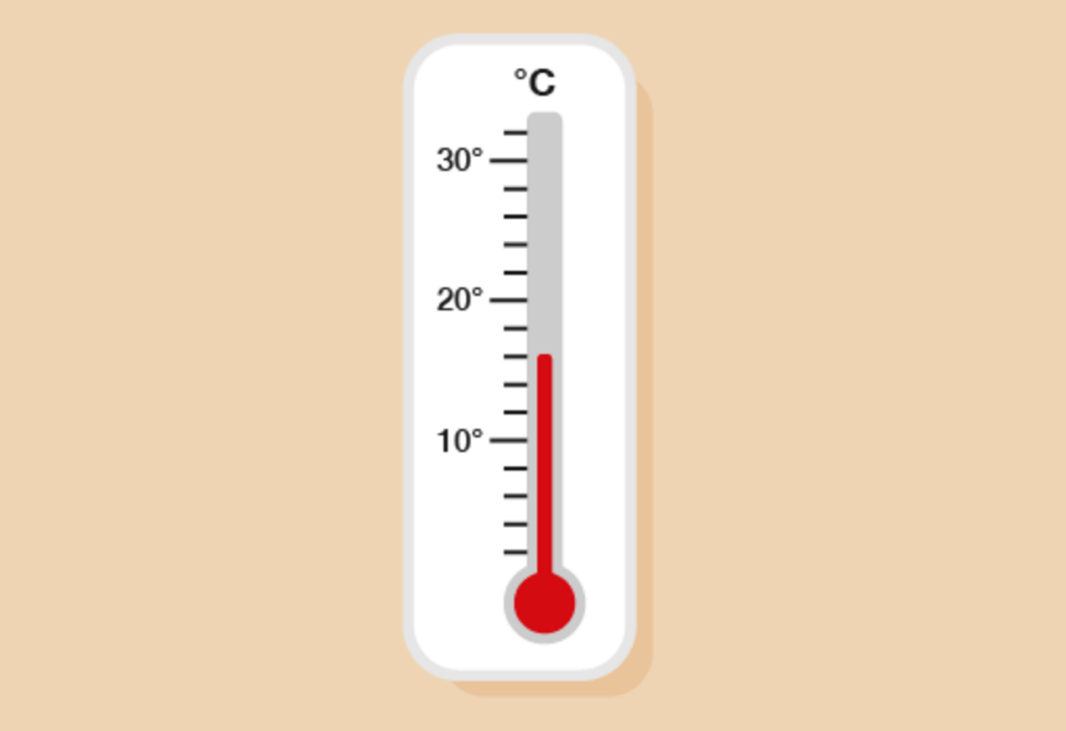
Figure 40 A thermometer
View description - Figure 40 A thermometer

View answer - Activity 12: Reading thermometers

5.2 Understanding temperature
Using the right temperature is often a matter of safety. For example, a piece of machinery may not be able to operate properly below a minimum temperature or above a maximum temperature, or a jar of tablets may include advice on its label about what temperature it should be stored at.

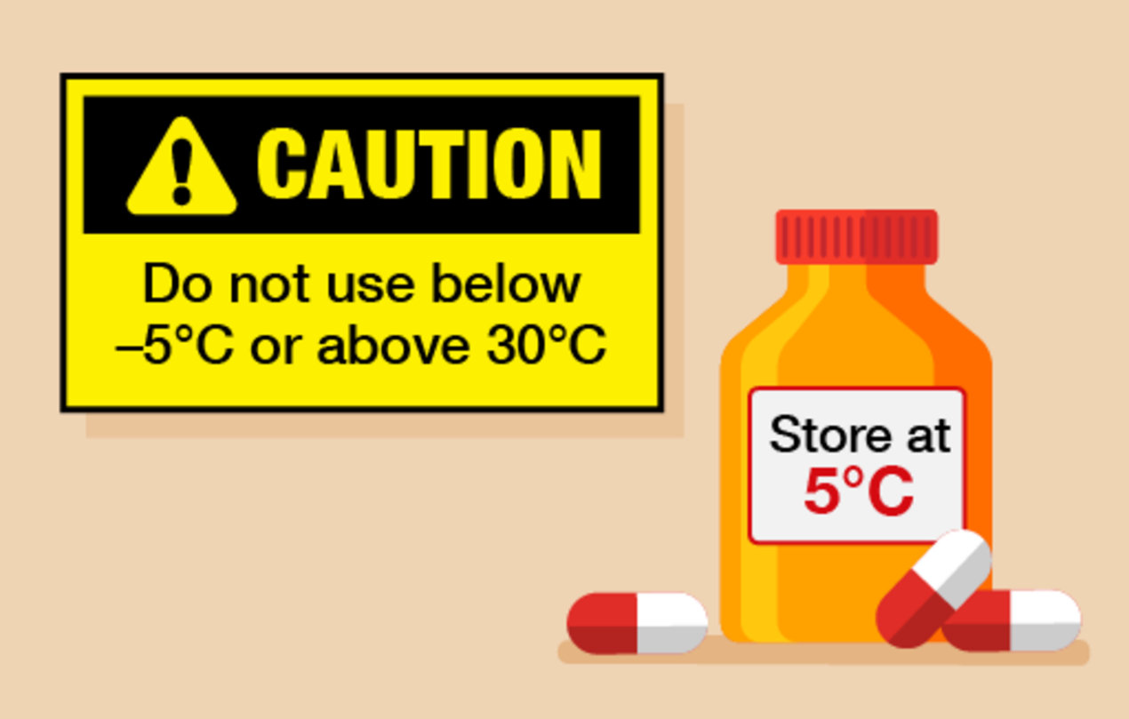
Figure 41 Warning labels
View description - Figure 41 Warning labels

Temperatures used to be shown in degrees Fahrenheit. You will still see these measures sometimes. For example:

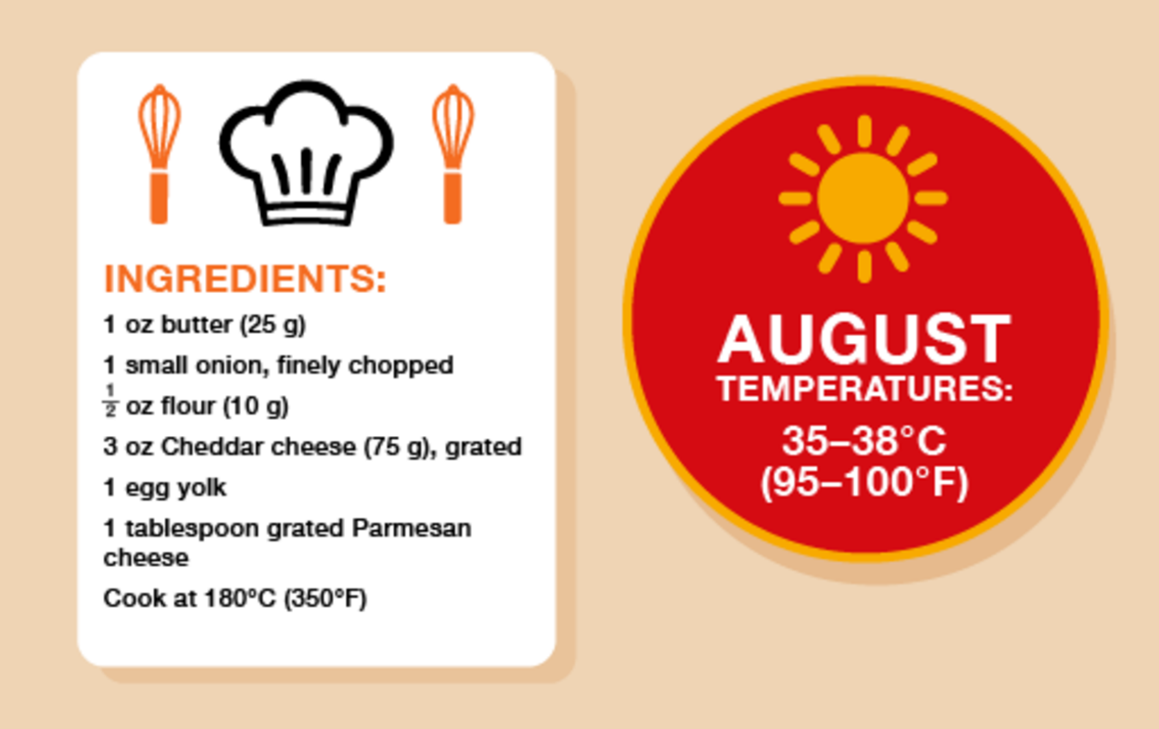
Figure 42 Temperatures in Celsius and Fahrenheit
View description - Figure 42 Temperatures in Celsius and Fahrenheit

Note: Fahrenheit is still used in the USA.

Here are some temperatures in Celsius and Fahrenheit:

Celsius | Fahrenheit
–18 | 0
0 | 32
10 | 50
20 | 68
30 | 86
40 | 104
50 | 122

Take a look at the example below for comparing temperatures.

Example: Safe storage
You have instructions with chemicals sent from the USA that they must be stored at between 50 and 70°F. The thermometer on the storage tank shows the temperature in degrees Celsius.

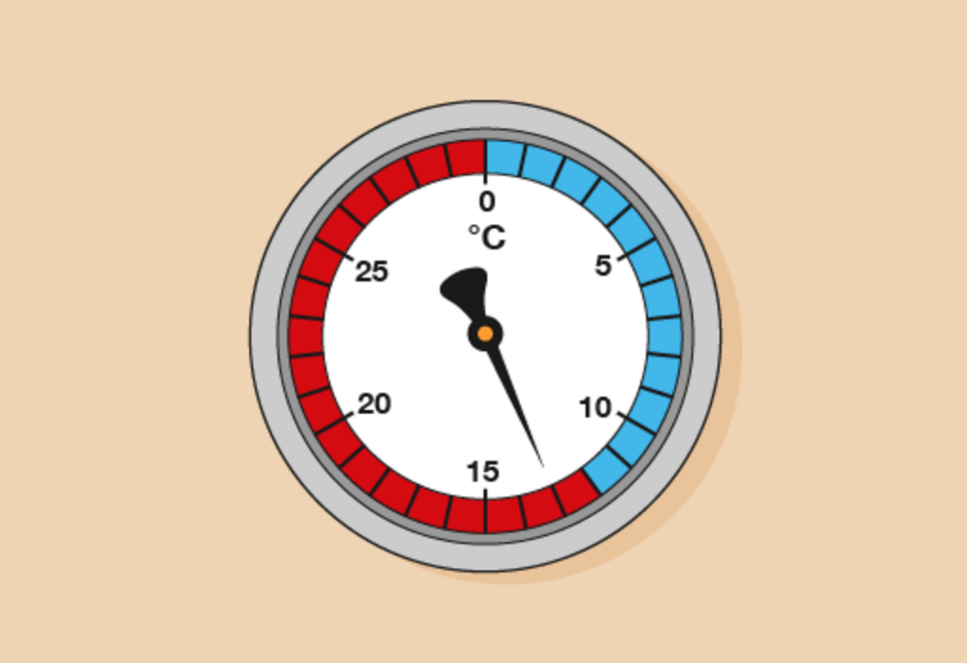
Figure 43 Using a thermometer in safe storage
View description - Figure 43 Using a thermometer in safe storage

Are the chemicals stored safely?

Method
Looking at the temperature comparison chart, 13°C falls in the following range:
- 10°C = 50°F
- 20°C = 68°F
13°C falls between 10°C and 20°C, meaning that it is also in the range between 50°F and 68°F. The chemicals are stored safely.

Now try the following activity. Remember to check your answers once you have completed the questions.

Activity 13: Celsius and Fahrenheit

- A recipe for meringue says you must cook it at 150°C. Your cooker shows temperatures in Fahrenheit. What should you set it to? (Use the conversion chart below to help you.)

Celsius | Fahrenheit
100 | 212
150 | 302
200 | 392
250 | 482
300 | 572
350 | 662

- The thermometer on an old freezer shows the temperature in degrees Fahrenheit.

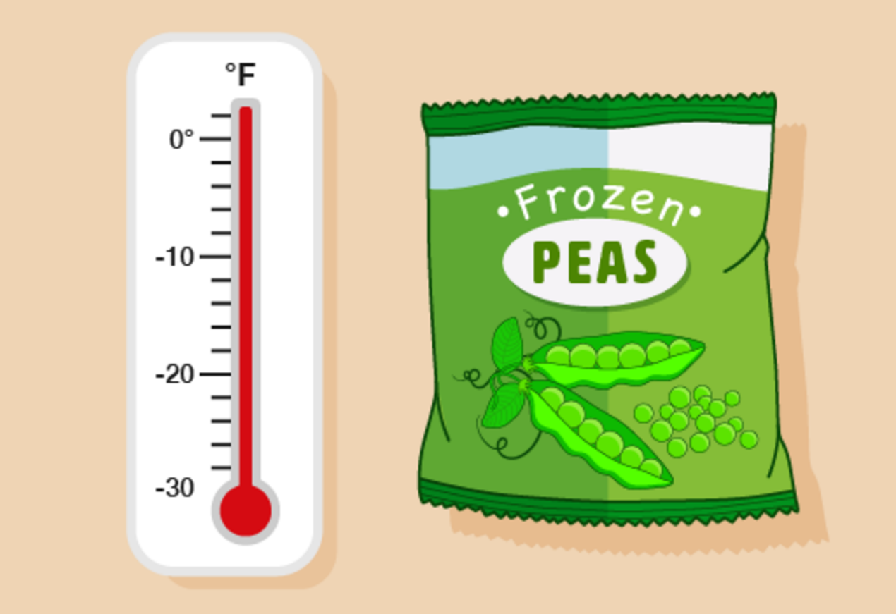
Figure 44 Converting temperatures on old thermometers
View description - Figure 44 Converting temperatures on old thermometers

A pack of food has a warning that it must be stored between –12°C and –25°C. Is the food stored safely? (Use the conversion chart below to help you.)

Celsius | Fahrenheit
–30 | –22
–20 | –4
–15 | 5
–10 | 14
–5 | 23
0 | 32
10 | 50

- A machine must be turned off if the temperature rises above 600°F. Using a Celsius thermometer, you find out that the temperature of the machine is:

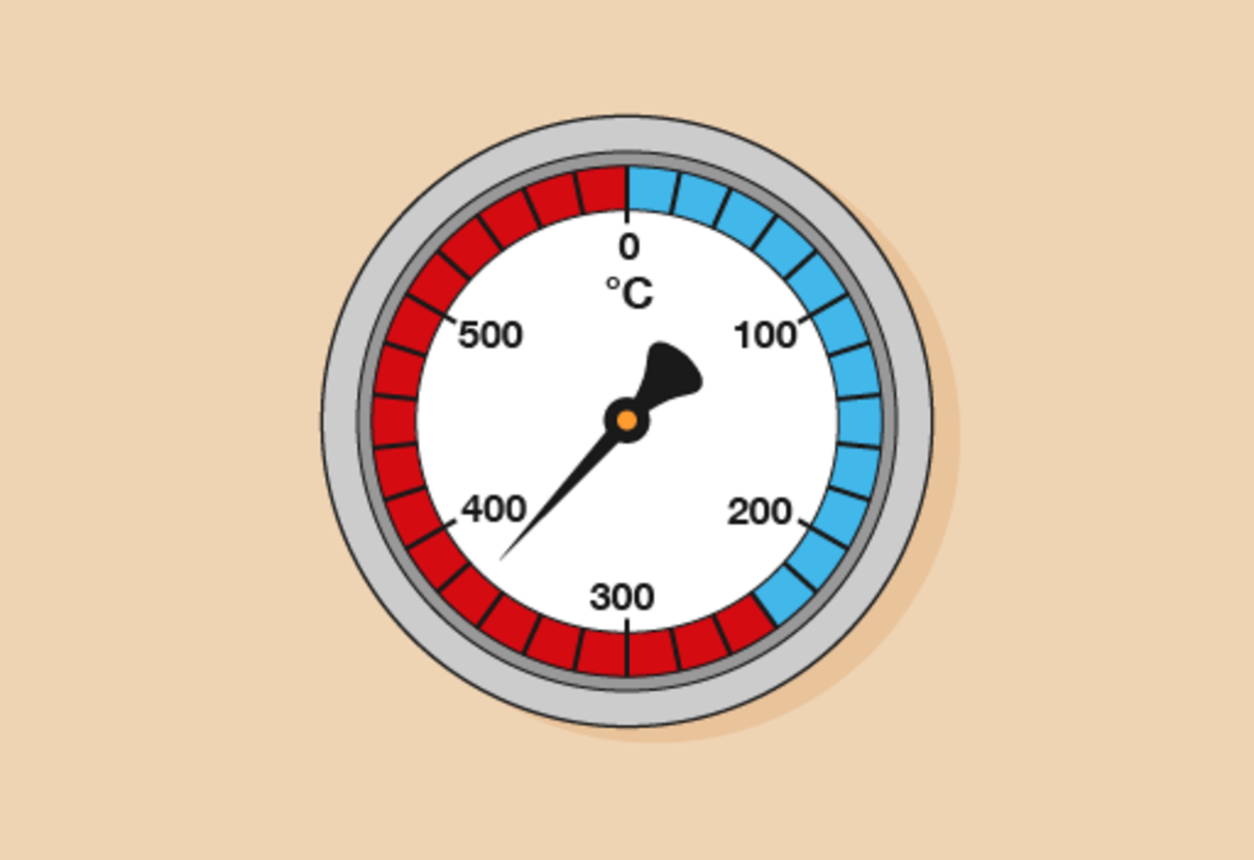
Figure 45 A thermometer
View description - Figure 45 A thermometer

Is it safe to leave it turned on? (Use the conversion chart below to help you.)

Celsius | Fahrenheit
0 | 32
50 | 122
100 | 212
150 | 302
200 | 392
250 | 482
300 | 572
350 | 662
400 | 752

View answer - Activity 13: Celsius and Fahrenheit

Summary
In this section you have identified and practised:
- how to solve problems requiring calculation incorporating temperature
- the correct way to read temperature and the difference between the units used.

6 Session 2 quiz
Now it’s time to review your learning in the end-of-session quiz.
Session 2 quiz.
Open the quiz in a new window or tab (by holding ctrl [or cmd on a Mac] when you click the link), then return here when you have done it.

7 Session 2 summary
You have now completed Session 2, ‘Units of measure’. If you have identified any areas that you need to work on, please ensure you refer to this section of the course and retry the activities.
You should now be able to:
- solve problems requiring calculation with common measures, including money, time, length, weight, capacity and temperature
- convert units of measure in the same system.
All of the skills listed above will help you with tasks in everday life, such as measuring for new furniture or redesigning a room or garden. These are essential skills that will help you progress through your employment and education.
You are now ready to move on to Session 3, ‘Handling data’.

Session 3: Handling data

1 Collecting data
In the introduction we mentioned the different ways you can display information – for example, in tables, diagrams, charts or graphs. Before you can create any of these, however, you need to collect the information to put in them.
One way of collecting information is through a survey. Have you ever been stopped in the street by someone doing a survey, or filled one in online?
You’ll often see surveys by YouGov, which is one example of a market research and data company, referred to on TV news programmes or in newspapers. YouGov commissions surveys on various topics, including the following (which you may want to open in a new window or tab):
- the public’s voting intention if there was a General Election held tomorrow
- the next actor to play James Bond
- how often we check our mobile phones
- people’s preference for dealing with climate change
- the number of grandparents with a favourite grandchild.
A survey is a method of collecting data. But once you’ve collected the data, it needs to be organised and displayed in a way that’s easy to understand.
This is something that’s straightforward to do with discrete data – that is, data made up of things that are separate and can be counted. For example:
- the number of people on a bus
- the number of cars in a car park
- the number of leaves on a tree.
A tally chart is a useful way of collecting information. A tally chart consists of a series of tallies. It works like this:
- For each thing, or unit, that you count – each person on a bus, each car in a car park, each leaf on a tree, or whatever – you make a tally mark like this:
- When you count up to five units, you ‘cross out’ the other four tally marks like this:
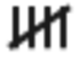
- You then continue to count units in groups of fives, as follows:
= 4
= 5
= 6
= 10

Note: You might have heard of something called a tally table. Tally charts and tally tables are the same thing.

Now try the following activity. Remember to check your answers once you have completed the questions.

Activity 1: Rewriting numbers as tallies

Write the following numbers in tally form:
- 3
- 7
- 9
- 14
- 18

View answer - Activity 1: Rewriting numbers as tallies

Example: Using a tally chart
You can use tally charts to record data when you carry out surveys and collect data.
Have you ever seen people at the side of a road doing a traffic survey? They could be recording the number of people in each car, and at the end of the survey they could add up the tallies and record the totals. Their tally chart would look something like this:

Number of people in car | Number of cars | Total
1 |  | 4
2 |  | 3
3 |  | 1
4 |  | 2
5+ |  | 1

So why use tally charts? It’s because they’re a quick and simple way of recording data.
Now try the following activities. Remember to check your answers once you have completed the questions.

Hint: Tick or cross off each entry as you put it into your tally chart. This will help you stop losing your place.

Activity 2: Creating a tally chart

Twenty people were asked in a survey how many people lived in their house. These were the answers:

2 | 3 | 1 | 4 | 3
2 | 3 | 2 | 1 | 2
1 | 3 | 4 | 2 | 2
3 | 1 | 3 | 2 | 2

Use the information in the table above to create your own tally chart of how many people live in a house. Your tally chart should be arranged as follows:

Number of people in the house | Number of responses

View answer - Activity 2: Creating a tally chart

Activity 3: Creating a tally chart

The following information is a record of the colours of cars in a car park one lunchtime:

red | yellow | red | blue | white
blue | black | white | red | green
red | white | green | black | blue
white | blue | red | red | black

Draw a tally chart to present the data.

View answer - Activity 3: Creating a tally chart

Summary
In this section you have learned about how tally charts are used.

2 Handling data
What does handling data mean?
A dictionary gives the following definitions:
- Handle: To use, operate, manage.
- Data: Facts, especially numerical facts, collected together for reference or information.
So, the phrase ‘handling data’ means being able to read, understand and interpret facts and figures.
You do this every day if you look at bus and train timetables, or diagrams, charts and graphs. All of these show complex information as simply as possible.
In fact, you’re surrounded by mountains of data! If you book a holiday using a brochure, this is full of data that you need to understand. For example:
- tables that show price lists
- maps or diagrams to show where the resort is or the distance to the airport
- charts and graphs to show temperatures and hours of sunshine.
The brochure may provide all the information you need to compare holidays and pick the one you want. If you can, look through a holiday brochure and see for yourself: the tables, charts, graphs and diagrams make the information easier to understand.
Look at the following example from a brochure. Being able to understand the table is important because that will help you to pick the skiing holiday that suits you best.

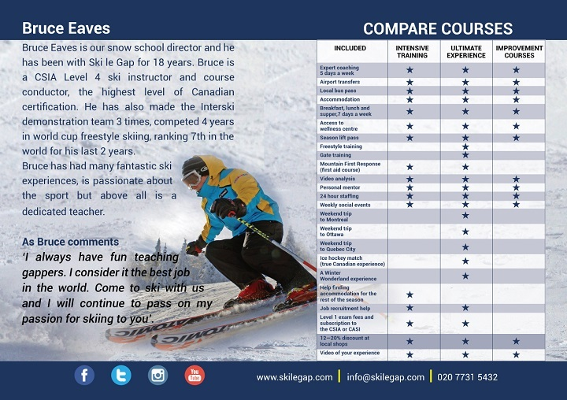
Figure 1 Which holiday suits you best?
View description - Figure 1 Which holiday suits you best?

Example: The weather
If you look in a newspaper, it will probably have a section that tells you the weather forecast. It might even have this information in a table that looks like this:

Weather update
Location | Today |  |  | Tomorrow
 | Weather | Min. temp.  (°C/°F) | Max. temp.  (°C/°F) | Weather | Min. temp.  (°C/°F) | Max. temp.  (°C/°F)
South and southwest |  | 22/72 | 27/81 |  | 16/61 | 21/70
Midlands |  | 22/72 | 28/82 |  | 24/75 | 31/88
Scotland |  | 20/68 | 24/75 |  | 19/66 | 21/70
Wales |  | 15/59 | 19/66 |  | 17/63 | 21/70
Northern Ireland |  | 18/64 | 24/75 |  | 21/70 | 27/81

This could have been written out like this:
- The weather today in the south, southwest, Midlands and Scotland will be sunny. In Wales there will be showers and in Northern Ireland there will be storms. Tomorrow it will be sunny, with showers in the south and southwest. It will be sunny in the Midlands and Northern Ireland, and there will be storms in Scotland and Wales.

Can you see how displaying the information in table form made it easier to understand?
Tables are made up of rows and columns. Rows are horizontal (that is, they go across the page) and the columns are vertical (up and down).

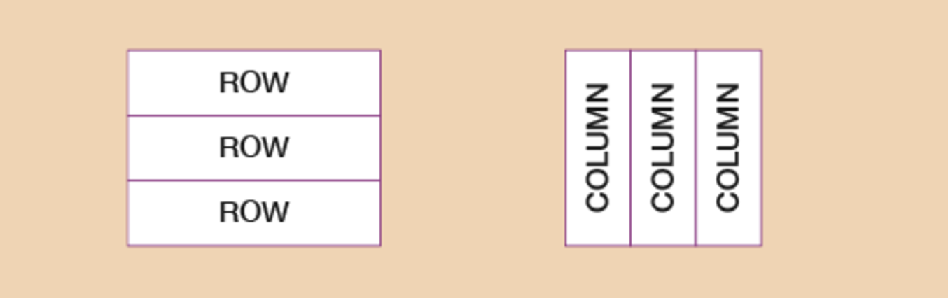
Figure 2 Rows and tables
View description - Figure 2 Rows and tables

To make sense of a table you need to have three things:
- A title that tells you what the table is about. In this table the title is ‘Weather update’.
- Row headings that tell you what is in each row. In the weather table the row headings are:
  - South and southwest
  - Midlands
  - Scotland
  - Wales
  - Northern Ireland
- Column headings that tell you what is in each column. In the weather table the column headings are:
  - Location
  - Today
  - Tomorrow
Tables can be very big, with many rows and columns – it depends how much information you are displaying.
For example, in a bus or train station you will see a huge timetable on the wall with many rows and columns. It is supposed to make the data easier to understand, but it is still complicated and easy to get confused.

Example: A bus timetable
Look at the following page from a bus timetable:

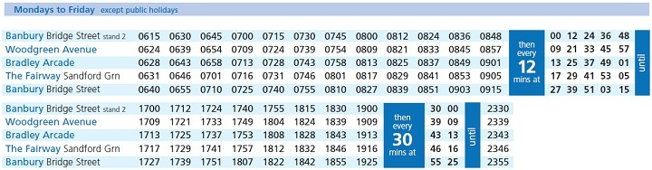
Figure 3 A bus timetable
View description - Figure 3 A bus timetable

Mr Newman would like to catch a bus from Woodgreen Avenue to visit his son in Bridge Street, in Banbury. He would like to get there before 8:45 a.m. What’s the latest bus he can catch to arrive at his son’s house in time?

Method
The latest bus he could catch is the 8:21 a.m. bus from Woodgreen Avenue, which would arrive at his son’s house at 8:39 a.m.

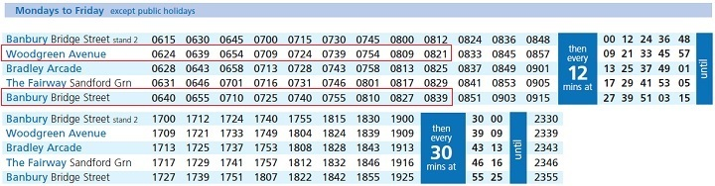
Figure 4 A bus timetable (answer)
View description - Figure 4 A bus timetable (answer)

Now try the following activities. Remember to check your answers once you have completed the questions.

Activity 4: A trip to the library

The local library has the following opening times:

Day | Opening time | Closing time
Monday | 9:30 | 12:30
Tuesday | 12:30 | 5:30
Wednesday | 9:30 | 5:30
Thursday | 9:30 | 12:30
Friday | 9:30 | 5:30
Saturday | 9:30 | 12:30
Sunday | Closed

- When is the library open all day?
- When is the library open only in the afternoon?

View answer - Activity 4: A trip to the library

Activity 5: The waiter’s shift

At the end of his shift a waiter drew up the following table to work out how many drinks he had served:

Drinks | Number served
Tea
Coffee
Orange juice
Hot chocolate
Coke

- The table does not have a title. What would be a suitable title?
- What are the row headings and column headings?
- How many Cokes did the waiter serve?
- How many cold drinks did the waiter serve?
- How many drinks did the waiter serve all together?

View answer - Activity 5: The waiter’s shift

Summary
In this section you have learned about handling data, and specifically, how to present data in tables.

3 Pictograms
One very simple way of showing data is in pictograms, which use pictures to count with. Pictograms have a strong visual impact.
As with tables, you need to decide on your title and what each row of the pictogram means. You also need to decide on your key. The key tells your reader what the picture you are using means.
The following pictogram shows the number of cars using a car wash at different times during the week:

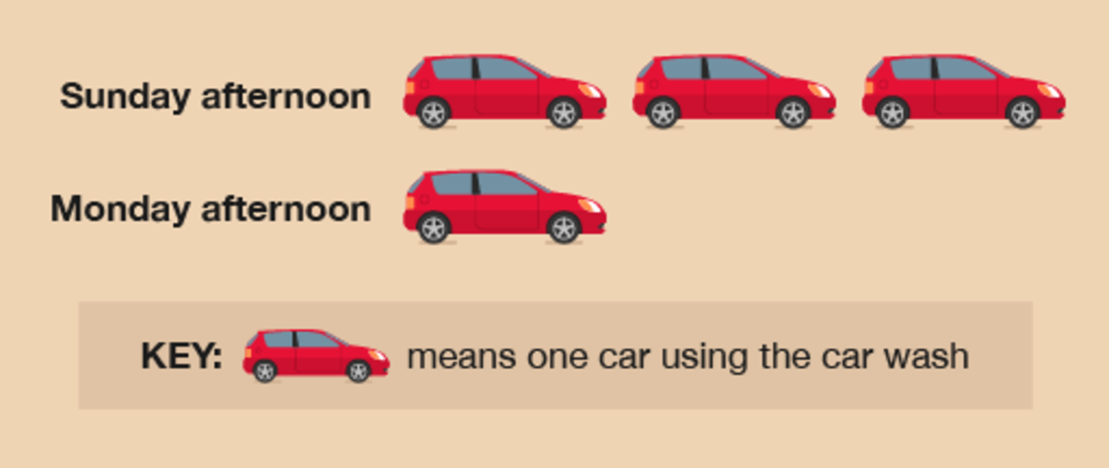
Figure 5 Car wash pictogram
View description - Figure 5 Car wash pictogram

The important thing to remember with pictograms is that there must be a key to tell the reader what the picture means. In the example above, the picture of one car means one car used the car wash. But in the next example, showing the number of people buying petrol from a garage between 2 and 3 p.m. on a Sunday and Monday afternoon, the key is used differently:

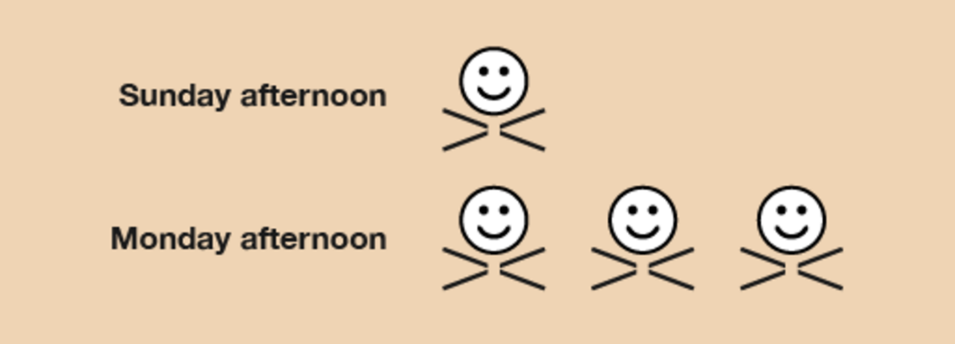
Figure 6 Petrol pictogram
View description - Figure 6 Petrol pictogram

Every pictogram needs a key – but this one doesn’t have one! You might think that means one person buying petrol.
In fact, means five people buying petrol, means four people buying petrol and means three people buying petrol.
Now try the following activity. Remember to check your answers once you have completed the questions.

Activity 6: Deciphering a key

Can you work out what and mean?

View answer - Activity 6: Deciphering a key

It is important to make sure you understand what the key means so that you can understand the data correctly.
There are advantages and disadvantages to using pictograms. On the one hand, they are easy to understand. On the other hand, however, they can only show a few things.

Activity 7: Creating a pictogram

The following table shows the number of people queueing at a local post office at different times of the day:

Time | Number
9 a.m. | 4
11 a.m. | 2
1 p.m. | 7
3 p.m. | 1
5 p.m. | 3

Show this information as a pictogram using the key where represents five people.

View answer - Activity 7: Creating a pictogram

Summary
In this section you have learned about how to present data in pictograms.

4 Pie charts
Charts are basically maths pictures. There are two types of charts: bar charts, which you’ll look at in the next section, and pie charts.
Pie charts are a clear way of presenting data, but they can be difficult to draw and the calculations involved in creating them can be complicated.
A pie chart is a circle (or ‘pie’) divided in sections (or ‘slices’). The sizes of these sections represent the data. Pie charts must contain both a title and a key that explains what each section means.

Example: Soap operas
How would you present information as a pie chart? Watch the following video to find out.

Video content is not available in this format.
View transcript - Uncaptioned interactive content

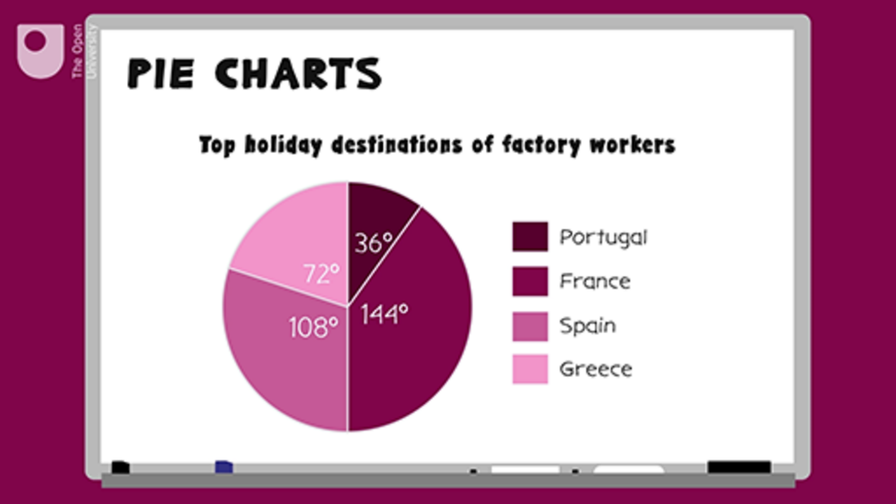

Now try the following activity. If you get stuck, refer to the method summary above, and remember to check your answers once you have completed the questions.

Activity 8: Creating a pie chart

In a survey, 18 people were asked what their favourite pets were. The responses were as follows:

Pet | Frequency
Cat | 5
Dog | 6
Rabbit | 4
Bird | 1
Fish | 2

Draw a pie chart to represent this information.

View answer - Activity 8: Creating a pie chart

Summary
In this section you have learned about how to present data in pie charts.

5 Bar charts
Another way of presenting information would be in a bar chart.
Bar charts are useful because they show data clearly. They must contain the following information:
- A title explaining what the bar chart means.
- Labels that tell you what each bar means. This could be a key or just a label underneath the line that runs along the bottom of the bar graph (the horizontal axis).
- The line going up the left-hand side of the bar graph (the vertical axis) must have numbers at equal intervals. This tells you how big the bars are so that your reader can read the data.

Example: A traffic survey
Let’s have a look at the data from a traffic survey displayed in a table:

Number of people in a car | Number of cars
1 | 4
2 | 3
3 | 1
4 | 2
5+ | 1

This data could be presented in a bar chart, as follows:

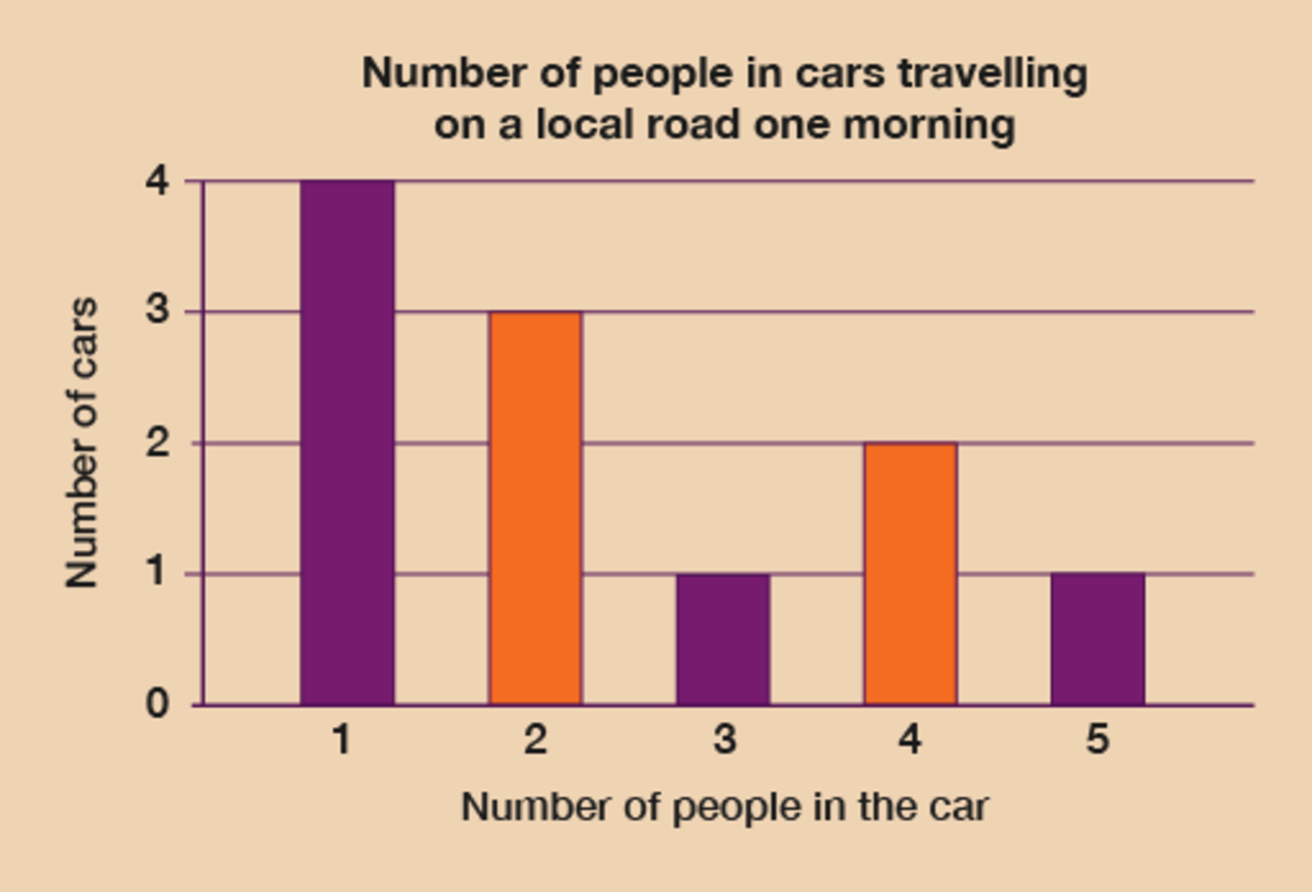
Figure 9 Traffic bar chart
View description - Figure 9 Traffic bar chart

Method
Before you start to draw your bar chart, you need to decide what your labels will be and what number intervals you are going to use – that is, how ‘tall’ your bars are going to be.
To do this you need to look at your data and find the biggest number of occurrences (that is, the largest category). In this traffic survey this is not too difficult: the most cars in one category was ‘cars with one person in’, which had four cars.
This means that the highest number on the vertical axis is 4. The numbers in the survey discrete data – you can’t have half a car! – so the numbers on this axis will be 0, 1, 2, 3 and 4. The vertical axis should always start at 0 and go up by the same number each time. We can take the label for this axis from the table: ‘Number of cars’.
Hint: Discrete data is data made up of things that are separate and can be counted.
You now need to decide on how many bars you are going to draw. This is already decided for because there are five categories in the survey:
- cars with one person in
- cars with two people in
- cars with three people in
- cars with four people in
- cars with five or more people in.
So there will be five bars along the horizontal axis of the bar chart, which should be labelled ‘Number of people in a car’.
Once you have drawn the axes and labels, you can draw the bars as follows:
- Use a ruler.
- The height of each bar is the number you have for that category.
- The width of the bars must be equal.
- When you have finished drawing your bar chart, don’t forget to give it a title.

Method summary
- Find out what the highest number of items is. This will give you the biggest number on the vertical axis (the one on the left-hand side). This will be the size of the tallest bar.
- Decide how many bars to draw: this is the number of categories you are dealing with. The bars should be equal in width.
- Draw and label your axes.
- Use a ruler to draw your bars.
- Make up a title for your bar chart.

Now try the following activity. Remember to check your answers once you have completed the questions.

Activity 9: Creating a bar chart

The following table shows the number of flights from a regional airport on one day of the week made by different airlines.

Airline | Number of flights
Reilly Air | 3
Easyfly | 4
English Airways | 1

Draw a bar chart to display this data. Remember to label your axis and give your chart a title.

View answer - Activity 9: Creating a bar chart

Summary
In this section you have learned about how to present data in bar charts.

6 Line graphs
Now that you’ve had a look at pie charts and bar charts, let’s take a look at line graphs. These are drawn by marking (or plotting) points and then joining them with a straight line. You might have seen them used in holiday brochures or maybe on the television.

Hint: It is best to use graph or squared paper when drawing line graphs because it makes it easier to plot the points.

Example: The estate agent
How would you present information as a line graph? Watch the following video to find out.

Video content is not available in this format.
View transcript - Uncaptioned interactive content

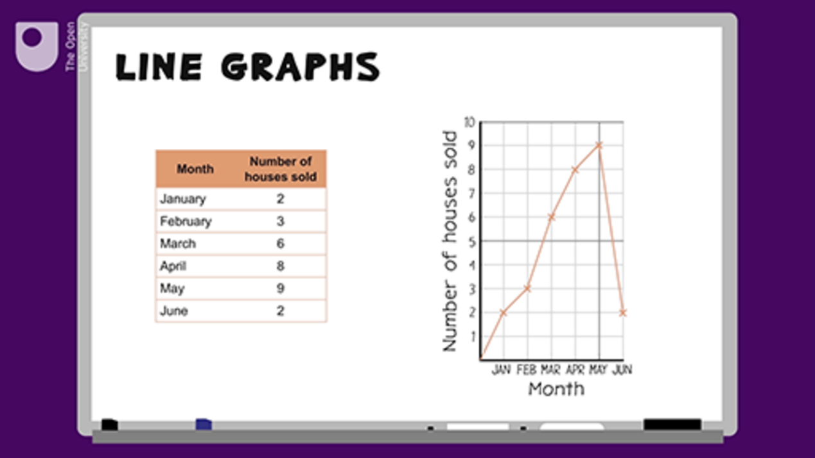

Now try the following activity. Remember to check your answers once you have completed the questions.

Activity 10: Creating a line graph

Line graphs are often used in holiday brochures to show temperatures or hours of sunshine at a particular resort.
The following table shows the hours of sunshine at a holiday resort. Draw a line graph using the data from the table and then answer the questions below.

Month | Hours of sunshine
May | 6
June | 7
July | 8
August | 9
September | 8
October | 7

- What month was the sunniest?
- What month had the least sunshine?

View answer - Activity 10: Creating a line graph

Self-check: always remember the following statements
Before moving on, you need to make sure you are able to collect, organise and show data in the forms of tables, diagrams, charts and graphs. Ask yourself the following questions:
- When I draw tables, diagrams, charts and graphs, is my data displayed clearly so that the information is easy to understand?
- Do I always include titles, scales, labels and keys when they are needed?
If you are not sure about these points, show your work to someone else and ask if they understand the data.

Summary
In this section you have learned about how to present data in line graphs.

7 Averages
Sometimes it’s easier to present data numerically rather than graphically, and to find one number to represent a collection of data instead of lots of numbers. You can do this by finding the arithmetical average: ‘arithmetical’ means ‘doing sums’, and the ‘average’ is the representative value of all our data. So working out the arithmetical average means working out a representative value for your data with mathematical calculations.

Note: With data we talk about ‘data sets’, or sets of data. ‘Sets’ is just another word for ‘group’. So if we carried out a survey, we would have a data set.

You’ll be familiar with the word ‘average’. Outside maths, it is used to mean ‘not special’ or ‘just OK’. But in maths, ‘average’ means we can have one value that is representative of all our data and that uses all our data. You will also encounter the terms ‘mean average’, or just ‘mean’. The mean average is what we are referring to in this course and what we show you how to calculate below.
Where do we find averages in real life?
- If you look at a holiday brochure you will see that it will talk about the ‘average’ hours of sunshine in a day.
- A teacher might work out the average marks for students in a class.
- When you go on a journey you might talk about our average speed.
- The average goals scored per game over a season by your football team.
The arithmetic average is not difficult to work out. You need to do the following.
- Add up all your data to a total. In the first example in the list above, about the number of hours of sunshine in a day, this could be the total number of hours of sunshine in August. (Let’s call this total ‘A’).
- Add up the number of categories that your data falls into. Using the same example, this would be the number of days in August. (Let’s call this amount ‘B’).
- Divide the total of your data (A) by the number of bits of data (B). So A ÷ B = the average. In the example about the average hours of sunshine in August, if there were 434 total hours of sunshine, divided by 31 (the number of days in August), there would be an average of 14 hours of sunshine in a day in August.
Have a look at the example below, where you will be looking at the average hours of sunshine.

Example: Average hours of sunshine
The hours of sunshine per day during one week’s holiday to Torquay in June was recorded as follows:

Day | Hours of sunshine
Sunday | 6
Monday | 1
Tuesday | 7
Wednesday | 8
Thursday | 5
Friday | 2
Saturday | 6

You could draw a bar chart or a line graph to present this data. However – as you might expect from the British weather – the amount of sunshine varied a lot from day to day.
It might be more useful to find out the average amount of sunshine per day. This would give you one value, which you could use as a guide as to how much sunshine to expect per day.

Method
To work out this average value you need to:
- add up the amount of sunshine for each day
- divide this by the number of days you have the data for.
With this example we have:
- 6 + 1 + 7 + 8 + 5 + 2 + 6 = 35 hours of sunshine for the week
and seven days of data. So, the average is:
- 35 ÷ 7 = 5 hours
Note: You must remember what units you are working in and write in these units after your average value – otherwise, it won’t make sense.
So from this data you can see that, on average, there were five hours of sunshine per day in a week in June in Torquay. You could then use that information to help choose your next holiday: if you wanted more than five hours of sunshine a day for a holiday in June, you would choose somewhere hotter (like Spain, perhaps).

Method summary
- Add up all of your data.
- Find out the number of categories that your data falls into.
- Divide the total of your data by the number of categories of data to give the average.
- Don’t forget to put what units you are working in, for example hours, goals, people, etc.

7.1 Advantages and disadvantages of using the arithmetical average
What are the advantages and disadvantages of using the arithmetical average?
Ever heard of families with 2.4 children? This is the national average but it means nothing – because you can’t have 0.4 of a child! This highlights one of the problems with averages: the value you get may not be a real value in terms of what you are talking about.
Another problem is that the average value will be affected by the highest and lowest values. For example, your football team could be having a really bad season, scoring nothing and over nine games. The average number of goals scored per game in these nine games would be zero. Then, suddenly, they start to play very well and in the next match score ten goals. This would increase the average goals scored to one goal per match, which would make it look as though they’d scored a goal in every match when they hadn’t.
Averages are good, however, because they aren’t too complicated to work out (compared to some other statistical calculations) and use they use all the available data.
Now try the following activity. Remember to refer to the example if you get stuck and to check your answers once you have completed the questions.

Activity 11: Finding out averages

- The ages of four children in a family are 4, 6, 8 and 10 years. What is the average age?
- Find the average of the following data sets:
  - 4, 6, 11
  - 3, 7, 8, 4, 8
  - 8, 9, 10, 9, 4, 2
  - 11, 12, 13, 14, 15, 16
- The number of goals scored by a football team in recent matches were as follows:

2 | 3 | 0 | 1 | 3
2 | 3 | 2 | 1 | 3

- Work out the average number of goals per match.

View answer - Activity 11: Finding out averages

Now have a go at another activity to check your knowledge.

Activity 12: The maths test

- In a maths class the scores for a test (out of 10) were as follows:

5 | 6 | 6 | 4 | 4
7 | 3 | 5 | 6 | 7
8 | 6 | 2 | 8 | 5
4 | 5 | 6 | 5 | 6

- What is the average score?
- Some of the students felt that the teacher had been too harsh with their marks. The tests were remarked and the new results were as follows:

4 | 6 | 6 | 4 | 4
6 | 1 | 5 | 6 | 6
7 | 6 | 1 | 9 | 5
3 | 5 | 6 | 5 | 5

- Work out the average score for these new results. Which set of results gave the best marks? Was the teacher harsh with the first marking?

View answer - Activity 12: The maths test

Summary
In this section you have:
- learned that the mean is one sort of average
- learned that the mean is worked out by adding up the items and dividing by the number of items
- understood that the mean can give a ‘distorted average’ if one or two values are much higher or lower than the other values.

8 Finding the range
We talk about ‘range’ in real life in the following situations:
- Schools will have a range of ages of children.
- Companies will have employees on a range of salaries.
- Supermarkets have goods at a range of prices.
The first thing to do when finding ranges is to find the lowest and highest values in your data set. The range is one number that tells you the difference between the highest and lowest.
You can do this in the following way:
- If your data set is not too big then the best thing to do is put the values in numerical order (lowest first).
- As you go through the data set, tick or cross off the numbers as you put them in order so that you don’t count the same one twice or miss one out altogether:

Figure 12 An example of a data set
View description - Figure 12 An example of a data set

Once you have the highest and lowest values, you then have to take the lowest away from the highest. This will give you the range.
The range measures the spread of a set of data. It is important because it can tell you how diverse your data is (or isn’t).
Take, for example, the ages of members of a gardening club. If the average age is 40 years old, say, then this doesn’t tell you much about the people in the club.
- If the spread of the ages was ten years, then you know that every member is in either their thirties or forties.
- But if the spread was 70 years, then both teenagers and pensioners belong to the club.
So the range gives you more information about a data set.
Remember that when you work out the range, you still have to include the units you are working in. So if you are dealing with ages you will usually be talking about years, so your range will be in years.

Example: Age range
Barry has four children. Sophie is 7 years old, Karen is 4, Max is 12 years and Jason is 10.
What is the range?
Method
The data set is:
- 7 4 12 10
Let’s put these numbers in order first:
- 4 7 10 12
Doing this makes it is easy to see that the lowest number is 4 and the highest is 12.
The range is worked out by taking the lowest value away from the highest:
- Range = 12 – 4 = 8 years
(Don’t forget to include the units, in this case years.)

Method summary
- Write the numbers in numerical order (lowest first).
- Find the lowest and highest numbers.
- Take the lowest number away from the highest number to find the range for your data.
- Don’t forget to put what units you are working in (e.g. hours, goals, people, etc.).

Now try the following activity. Remember to check your answers once you have completed the questions.

Activity 13: Finding ranges

- Find the ranges for the following data sets:
  - 1, 6, 7, 10
  - 7, 6, 2, 8, 10, 3, 11
  - 5, 4, 2, 8, 9, 11, 4, 12, 7
  - 5, 15, 6, 9, 12, 4, 2, 8, 1, 14
- In a random survey in Newcastle the ages of 20 people are as follows:

61 | 18 | 42 | 37 | 32
15 | 25 | 52 | 74 | 23
49 | 41 | 58 | 31 | 42
21 | 27 | 65 | 47 | 35

  - Write the data set in order with the lowest number first.
  - What is the lowest age?
  - What is the highest age?
  - What is the range?

View answer - Activity 13: Finding ranges

In this section you have:

Summary
In this section you have:
- learned that the range measures the spread of a set of data
- understood that the range is the difference between the smallest and largest values in a set of data.

9 Probability
Probability is measuring how likely it is that something will happen. We use probability in different ways in real life:
- Bookmakers use a form of probability to give betting odds on anything.
- Insurance actuaries use probability to decide how much to charge for all the different types of insurance and assurance there is.
- Government departments use probability and statistics to help them govern the country.
(Another word for probability is chance. You might say, ‘What are the chances of this happening?’)
Working through this section will enable you to:
- understand the possibility of different events happening
- show that some events are more likely to occur than others
- understand and use probability scales
- show the probability of events happening using fractions, decimals and percentages.
Probability is measuring how likely it is that something will happen. Look at the word itself: ‘probability’. Can you see it is related to the word ‘probable’?
We know that life is full of choices and chances, or that some things are more likely to happen than others.
For example, you could say, ‘I might cut the grass tomorrow.’ Probability would be used to measure how likely it is that you will cut the grass. There are two options involved here: either you cut the grass or you don’t.
If you knew that it was going to rain tomorrow and you had lots of other things to do (and you hate cutting grass), then the probability of actually cutting the grass would be low or even zero! But on the other hand, if you really intended to cut the grass and the weather forecast was good then the probability of cutting the grass would be high.
We use probability to give us an idea of how likely it is that something will happen. It gives us a measuring system.
- If something is very likely to happen, the probability is high.
- If something is not very likely to happen, the probability is low.

Example: What are the chances?
What’s the probability of:
- you winning the lottery this week?
- getting wet in the rain?
- summer following spring?
There’s a very low probability that you’ll win the lottery this week, and a high probability of getting wet in the rain and summer following spring.
Of course, some things have even chances of happening. For example, if you toss a coin, there is an equal probability of it being heads or tails. This could also be called an even chance, or a fifty-fifty chance, of the coin being heads or tails.
How many different things that have different chances of happening can you think of?

Now try the following activity. Remember to check your answers once you have completed the questions.

Activity 14: Thinking about probability

Take a look at the table, think of some events to add to each of the columns.

Events with a high probability of happening | Events with an even chance of happening | Events with a low probability of happening
Provide your answer... | Provide your answer... | Provide your answer...
Provide your answer... | Provide your answer... | Provide your answer...

View answer - Activity 14: Thinking about probability

9.1 Probability scales
In real life, things usually fall somewhere in between the two extremes of ‘will never happen’ and ‘will definitely happen’.
We can use a probability scale to measure how likely events are to occur:

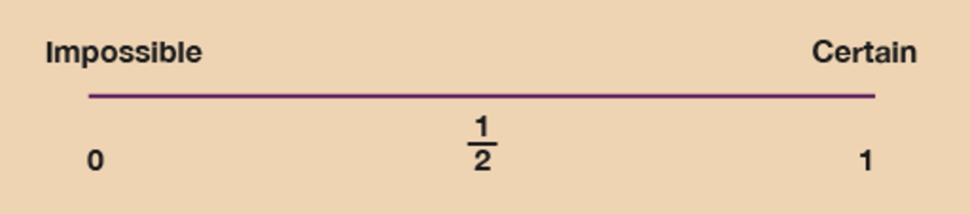
Figure 13 A probability scale
View description - Figure 13 A probability scale

- The probability of an impossible event (‘will never happen’) is 0.
- The probability of a certain event (and ‘will definitely happen’) is 1.
- All other events come between 0 and 1.
- Events with an even chance have a probability of .
Now try the following activity, where you’ll need a ruler and a pencil. Remember to check your answers once you have completed the questions.

Activity 15: Looking at probability

Use a ruler to draw your own probability scale. Mark on it 0, 1/2 and 1. Label 0 as ‘impossible’ and 1 as ‘certain’.
Then mark these statements on the probability scale with crosses and label them with their question letter:
- The probability that the sun will rise tomorrow.
- The probability that you will run the London Marathon next year.
- The probability of dying one day.

View answer - Activity 15: Looking at probability

Summary
In this section you have:
- learned about the possibility of different events happening
- shown that some events are more likely to occur than others.

10 Session 3 quiz
Now it’s time to review your learning in the end-of-session quiz.
Session 3 quiz.
Open the quiz in a new window or tab (by holding ctrl [or cmd on a Mac] when you click the link), then return here when you have done it.

11 Session 3 summary
You have now completed Session 3, ‘Handling data’. If you have identified any areas that you need to work on, please ensure you refer back to this section of the course.
You should now be able to:
- extract and interpret information from tables, diagrams, charts and graphs
- collect and record discrete data, and organise and represent information in different ways
- find the mean and range of a group of numbers
- use data to assess the likelihood of an outcome.
All of the skills listed above will help you when booking a holiday, reading the paper or analysing outcomes within your place of work.
You are now ready to move on to Session 4, ‘Shape and space’.

Session 4: Shape and space

1 Around the edge
When might you need to work out how far it is around a flat shape?
You will need to know how far it is around the edge of a shape when you want to put a border around something, such as a wallpaper border around a room, or a brick wall around a patio. You might have thought of different examples.
The distance around any shape is called the perimeter. You can work out the perimeter by adding up all of the sides. The sides are measured in units of length or distance, such as centimetres, metres or kilometres.

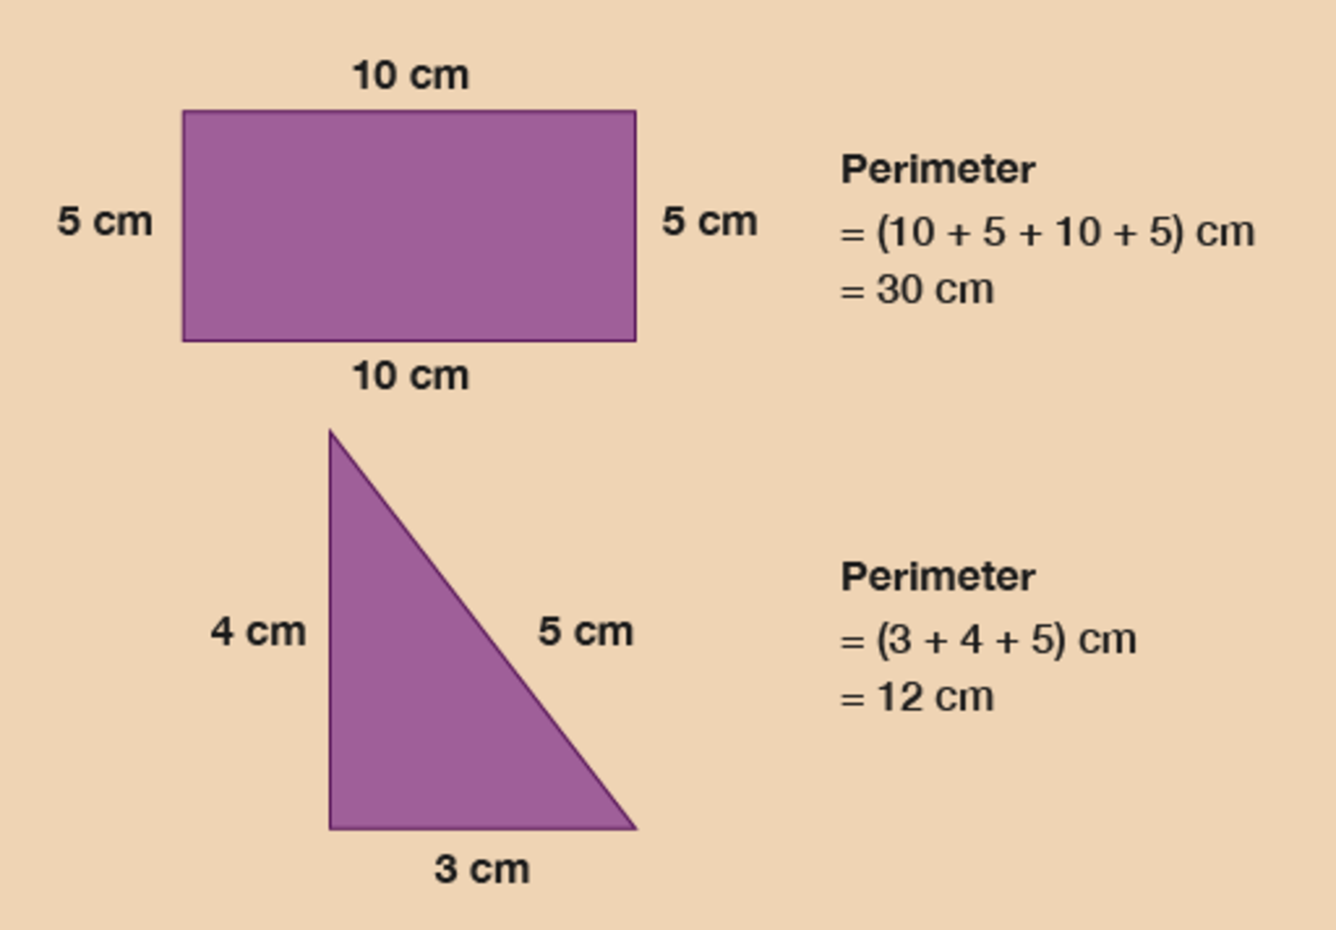
Figure 1 Looking at perimeters
View description - Figure 1 Looking at perimeters

Example: A length of ribbon
Have a look at the figure below to work out how much decorative ribbon you need to go around each shape.

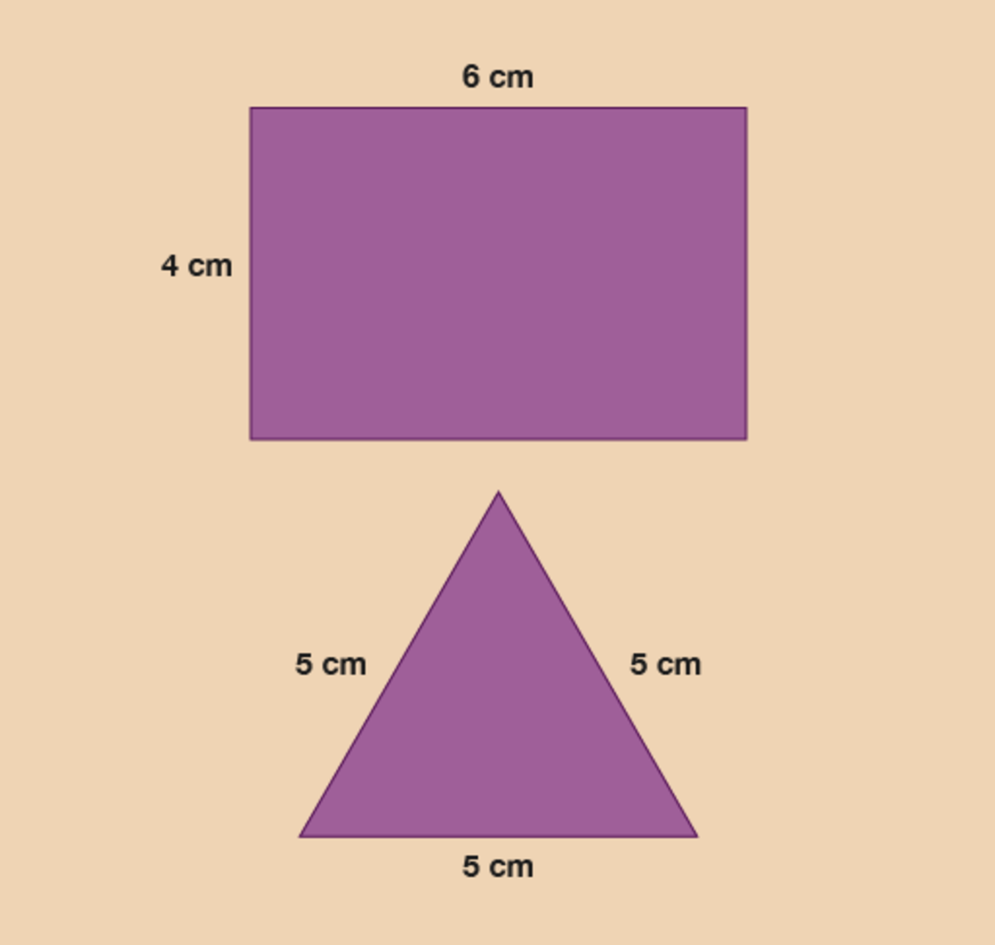
Figure 2 Calculating the length of ribbon
View description - Figure 2 Calculating the length of ribbon

Method
You need to measure all the sides and add them together.

Hint: Opposite sides of a rectangle are the same length.

The sides of the rectangular box are:

6 + 6 + 4 + 4 = 20 cm

You will need 20 cm of ribbon.
The sides of the triangular box are:

5 + 5 + 5 = 15 cm

You will need 15 cm of ribbon.

Example: A quicker calculation
So far when you have been working with perimeter you have added up all four sides, however there is a quicker way of calculating the perimeter. You may have recognised that all rectangles have two equal short sides and two equal long sides. Therefore you can then work out the perimeter by using each number twice.

(2 × long side) + (2 × short side) = perimeter

The long side is the length. The short side is the width.
(A square is a type of rectangle where all four sides are the same length. So to find out the perimeter of a square, the you need to multiply the length of one side by 4.)
How many metres of lawn edging do you need to go around this lawn?

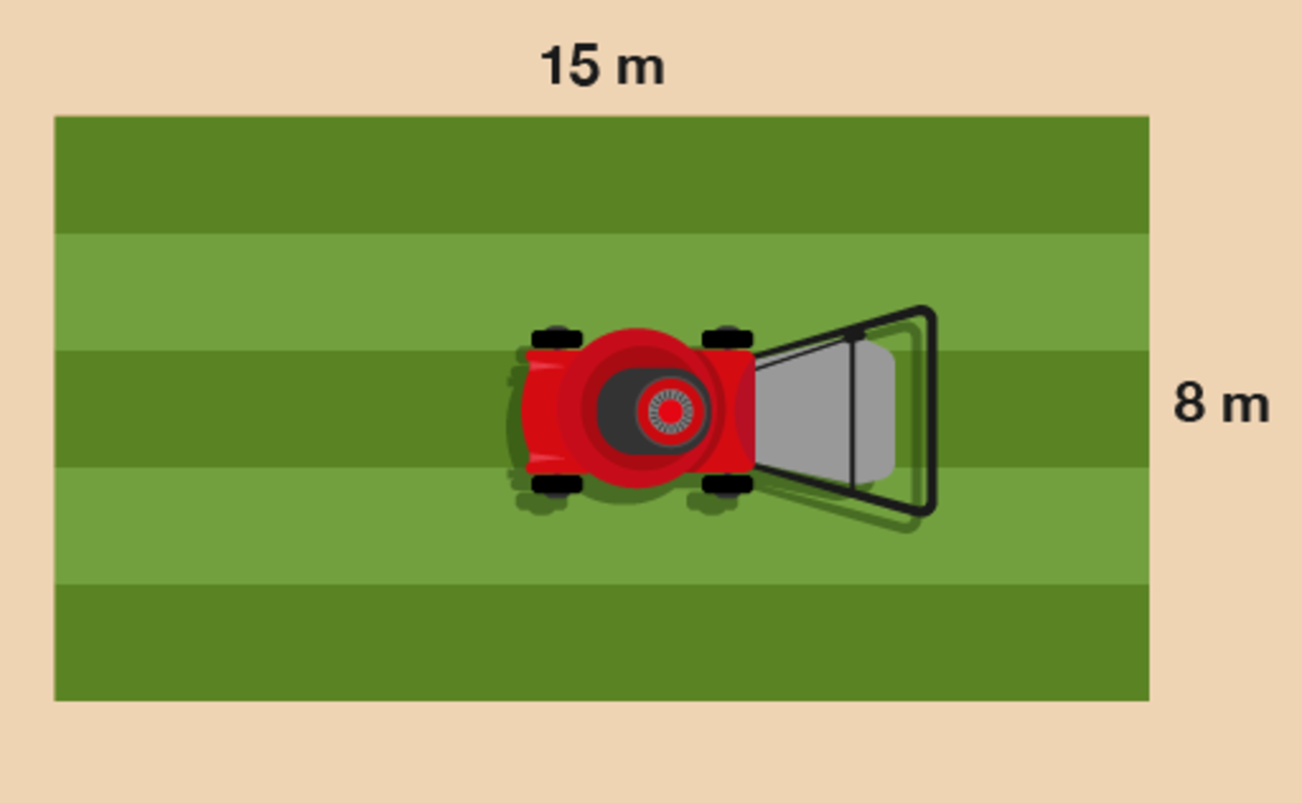
Figure 3 A lawn
View description - Figure 3 A lawn

Method
You need to work out twice the width, plus twice the length:

(2 × 15) + (2 × 8)

Once you’ve worked these out, it makes the answer to the question easier to get:

(2 × 15) + (2 × 8) = 30 + 16 = 46 m

Now try the following activity. Remember to check your answers once you have completed the questions.

Activity 2: Finding the perimeter

- You need to hang bunting around the tennis courts for the local championships. How much bunting do you need?

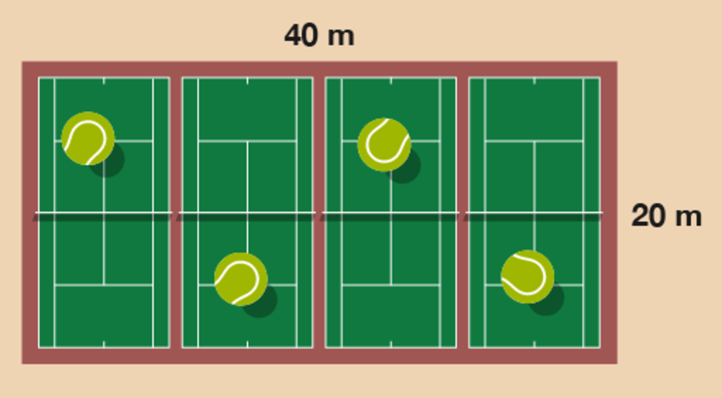
Figure 4 Four tennis courts
View description - Figure 4 Four tennis courts

- How much tape does the police officer need to close off this crime scene?

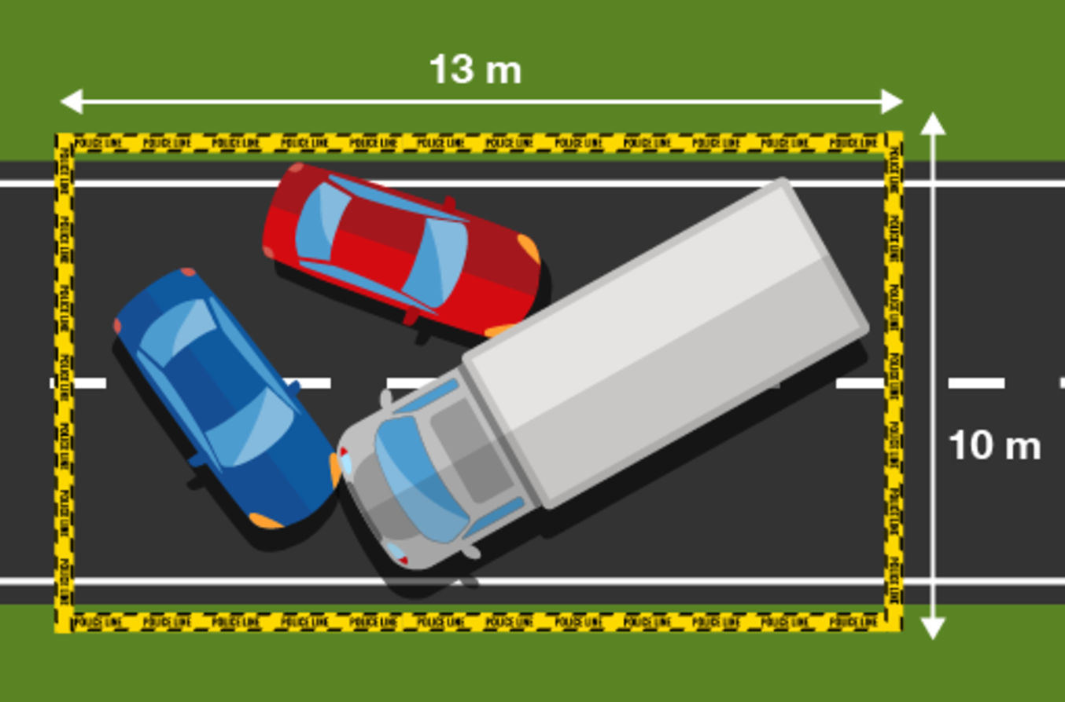
Figure 5 A crime scene
View description - Figure 5 A crime scene

View answer - Activity 2: Finding the perimeter

1.1 Measuring the perimeter of irregular shapes

Example: How to measure the perimeter of an irregular shape
How would you measure the perimeter of an irregular shape – an L-shaped room, for instance – if you didn’t have all of the measurements that you would need? Watch the following video to find out.

Video content is not available in this format.
View transcript - Uncaptioned interactive content

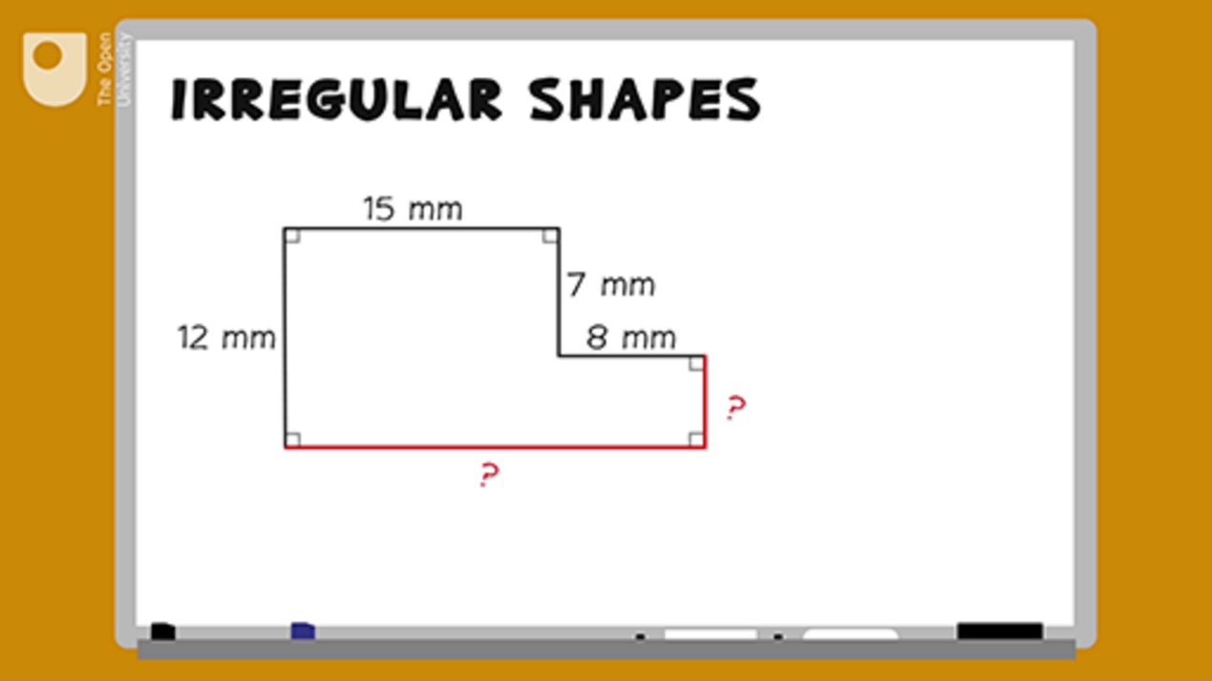

Now try the following activity. Remember to check your answers once you have completed the questions.

Activity 3: Finding the perimeter

Note that you can assume that all of the corners in the images in this activity are right angles.
- A gardener decides to lay a new path next to his lily pond. The drawing shows the dimensions of the path.

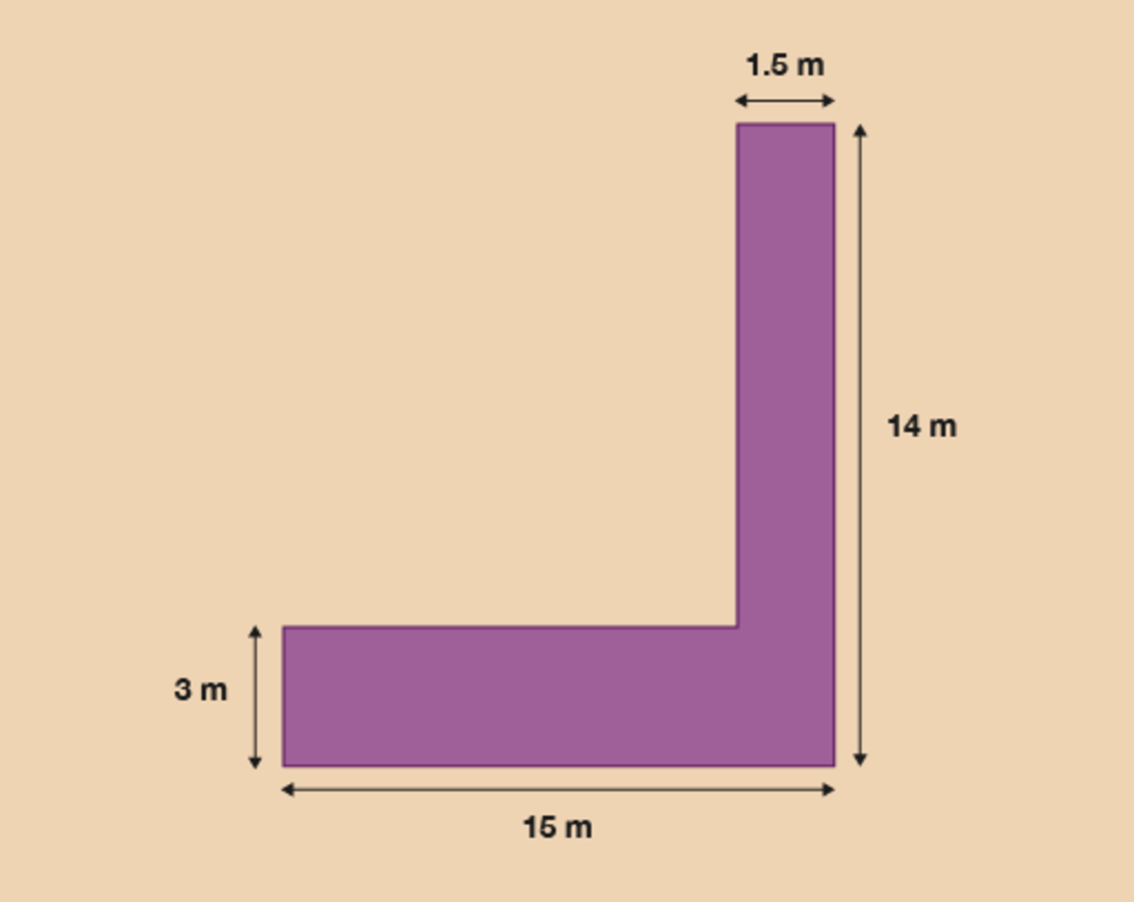
Figure 6 A pathway
View description - Figure 6 A pathway

The gardener decides to paint a white line around the perimeter of the path. What is the perimeter of the path?
- A tourist information centre has a new extension.

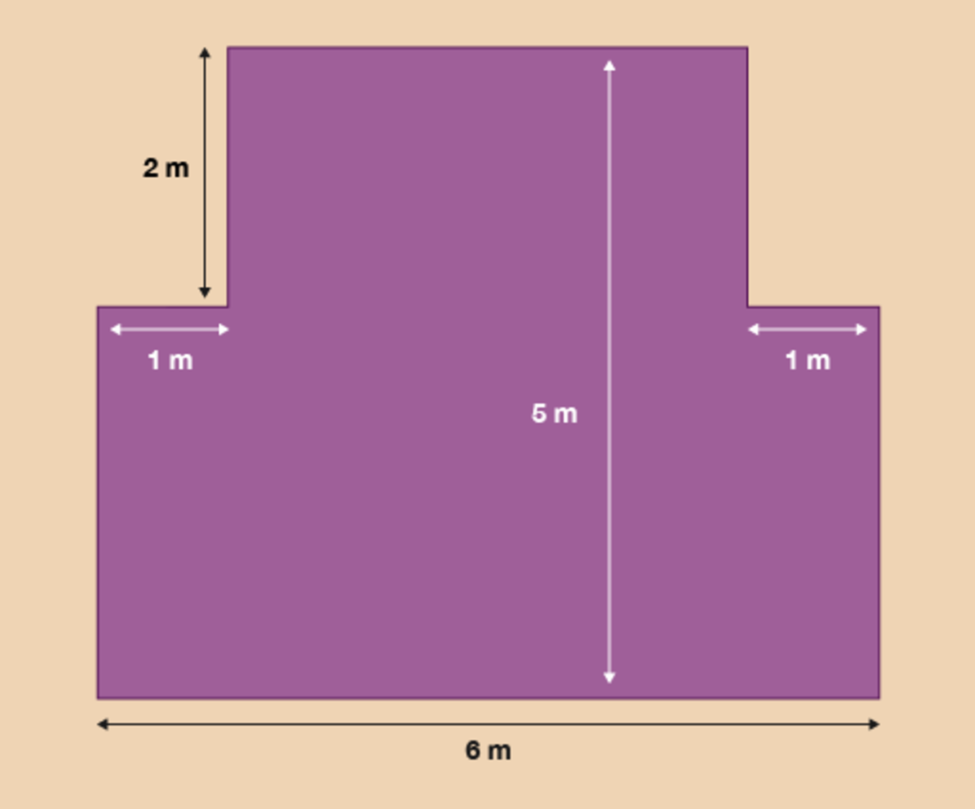
Figure 7 A new extension
View description - Figure 7 A new extension

The tourist board wants to attach a gold strip around the border of the floor of the building. What is the perimeter of the new extension?

View answer - Activity 3: Finding the perimeter

Summary
In this section you have learned how to work out the perimeter of both simple and irregular shapes.

2 Area
You need to be able to calculate area if you ever need to order a carpet for your house, buy tiles for a kitchen or bathroom, or calculate how much paint to buy when redecorating.
This patio has paving slabs that are 1 metre square (each side is 1 metre). How many paving slabs are there on the patio?

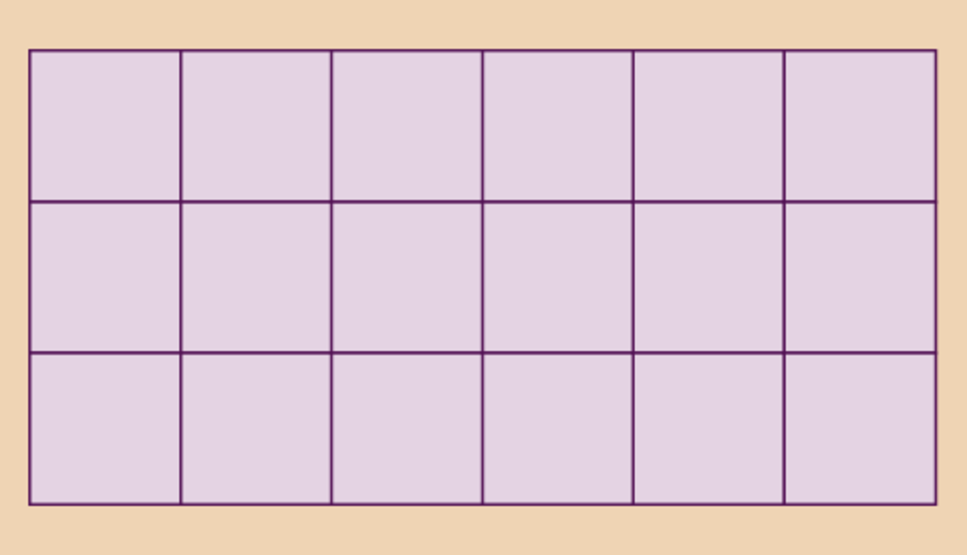
Figure 8 Paving slabs
View description - Figure 8 Paving slabs

Area is measured in ‘square’ units. This means that the area is shown as the number of squares that would cover the surface. So if a patio covered with 18 squares that are 1 metre by 1 metre, the area is 18 square metres.
(If you count them, you will find there are 18 squares.)
Smaller areas would be measured in square centimetres. Larger areas can be measured in square kilometres or square miles.
You can work out the area of a rectangle by multiplying the long side by the short side:

width × length = area

The patio is:

6 × 3 = 18 square metres

‘Square metres’ can also be written ‘sq m’ or ‘m²’.

Hint: Always use the same units for both sides. If you need to, convert one side to the same units as the other side.

Example: The area of a rug
How much backing fabric is needed for this rug?

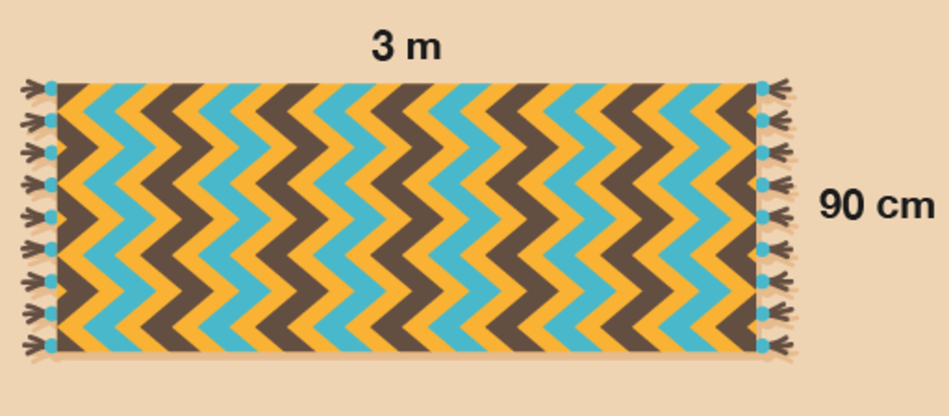
Figure 9 A rug
View description - Figure 9 A rug

Method
To find the answer, you need to work out the width multiplied by the length.
- 90 cm × 3 m = area
First, you need to convert the width to metres so that both sides are in the same units. 90 cm is the same as 0.9 m, so the calculation is:
- 0.9 × 3 = area = 2.7 square metres

Now try the following activity. Remember to check your answers once you have completed the questions.

Activity 4: Finding the area

- How much plastic sheeting do you need to cover this pond for the winter?

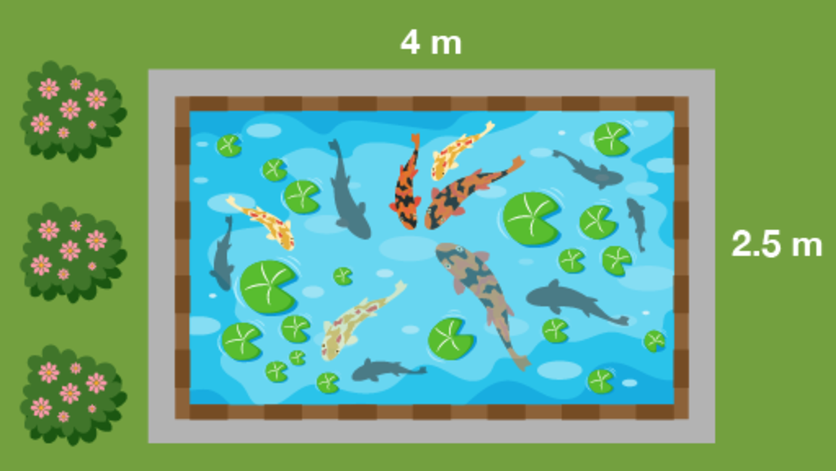
Figure 10 A pond
View description - Figure 10 A pond

- One bag of gravel will cover half a square metre of ground. How many bags do you need to cover this driveway?

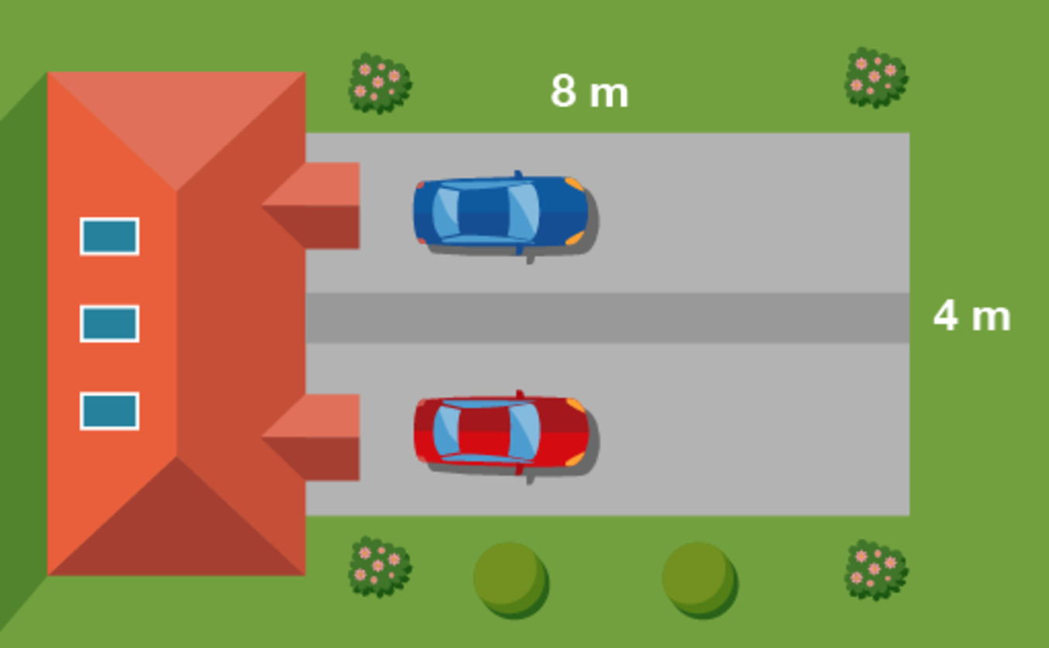
Figure 11 A driveway
View description - Figure 11 A driveway

- A biologist is studying yeast growth. In the sample area shown below the biologist found 80 yeast. What would go in the missing spaces in her recording sheet, as marked with a question mark?

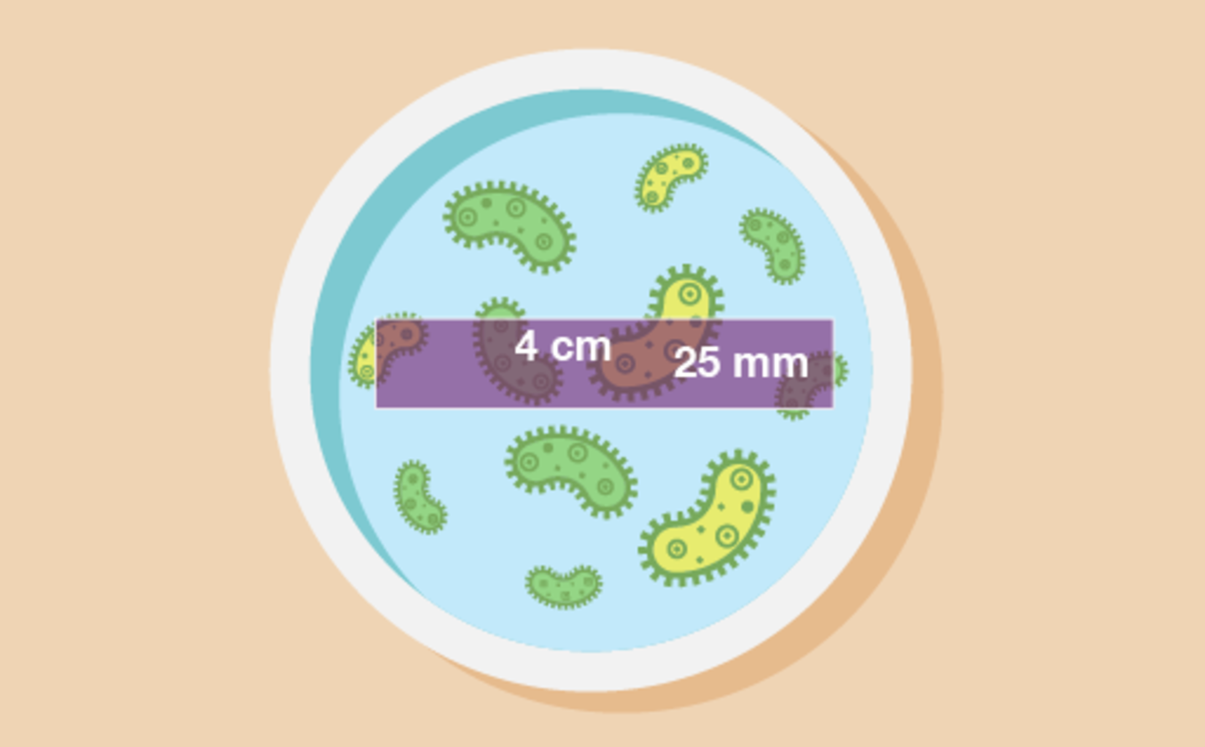
Figure 12 A petri dish
View description - Figure 12 A petri dish

Yeast count
Sample area no. | 21
Date | 17 October
Yeast count | 80
Sample dimensions | ? cm × ? cm
Sample area | ? cm²
Yeast/cm² | ?

- How large is this area of forestry land?

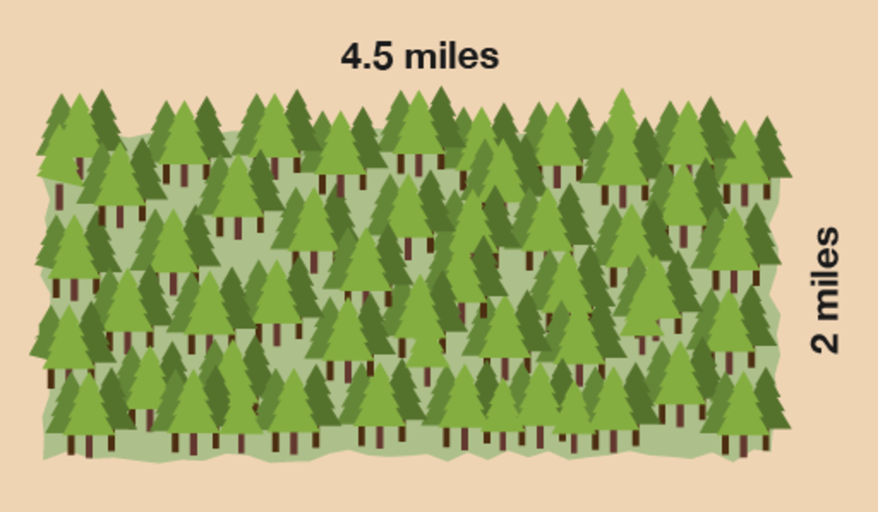
Figure 13 A forest
View description - Figure 13 A forest

View answer - Activity 4: Finding the area

Activity 5: Finding the area of an irregular shape

- The estates manager of a college decides to repaint one of the walls in the reception area. The diagram below shows the dimensions of the wall that needs painting.

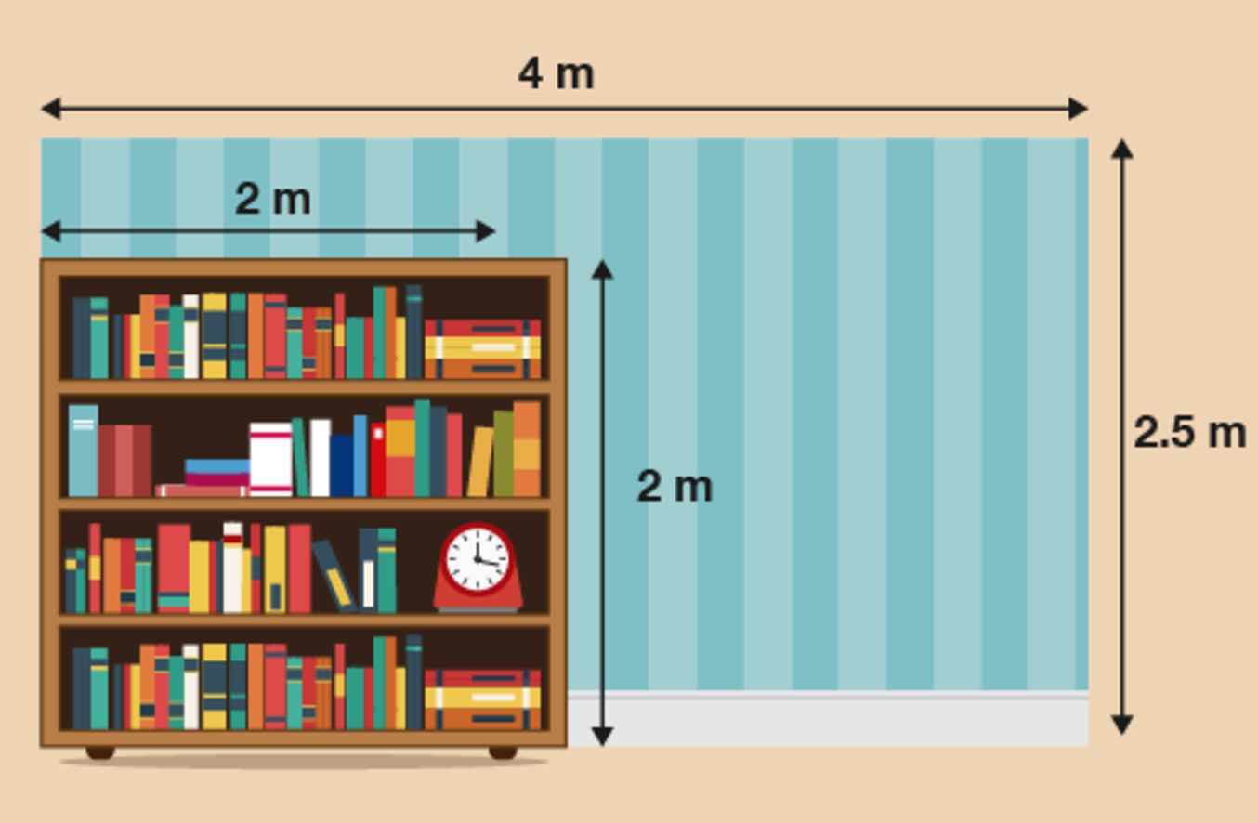
Figure 14 A wall
View description - Figure 14 A wall

The wall is 4 m long and 2.5 m high and has a large fixed bookcase in the corner. What is the area of the section of the wall that needs painting?
- A charity holds a fundraising fête. A volunteer from the charity designs a game that is played by rolling coins across a table. She marks out two areas labelled ‘WIN!’.

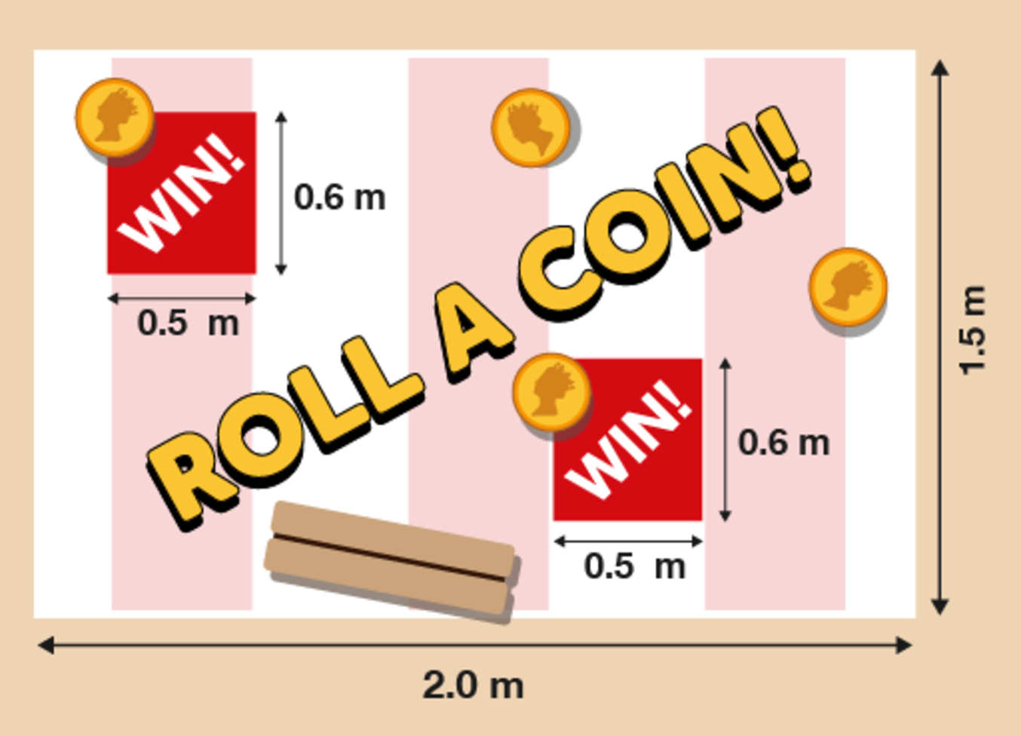
Figure 15 ‘Roll a coin!’
View description - Figure 15 ‘Roll a coin!’

Anyone who rolls a coin into an area labelled ‘WIN!’ will win a prize. But what is the area of the rest of the table?

View answer - Activity 5: Finding the area of an irregular shape

Summary
In this section you have learned how to work out the area of a rectangular shape. You have also looked at more complex, compound shapes for calculating area.

3 Scale drawings
Have you ever drawn a plan of a room in your house to help you work out how to rearrange the furniture? Or maybe you’ve sketched a plan of your garden to help you decide how big a new patio should be?
These pictures are called scale drawings. The important thing with scale drawings is that everything must be drawn to scale, meaning that everything must be in proportion – that is, ‘shrunk’ by the same amount.
All scale drawings must have a scale to tell us how much the drawing has been shrunk by.

Example: In the garden
Here is an example of typical scale drawing:

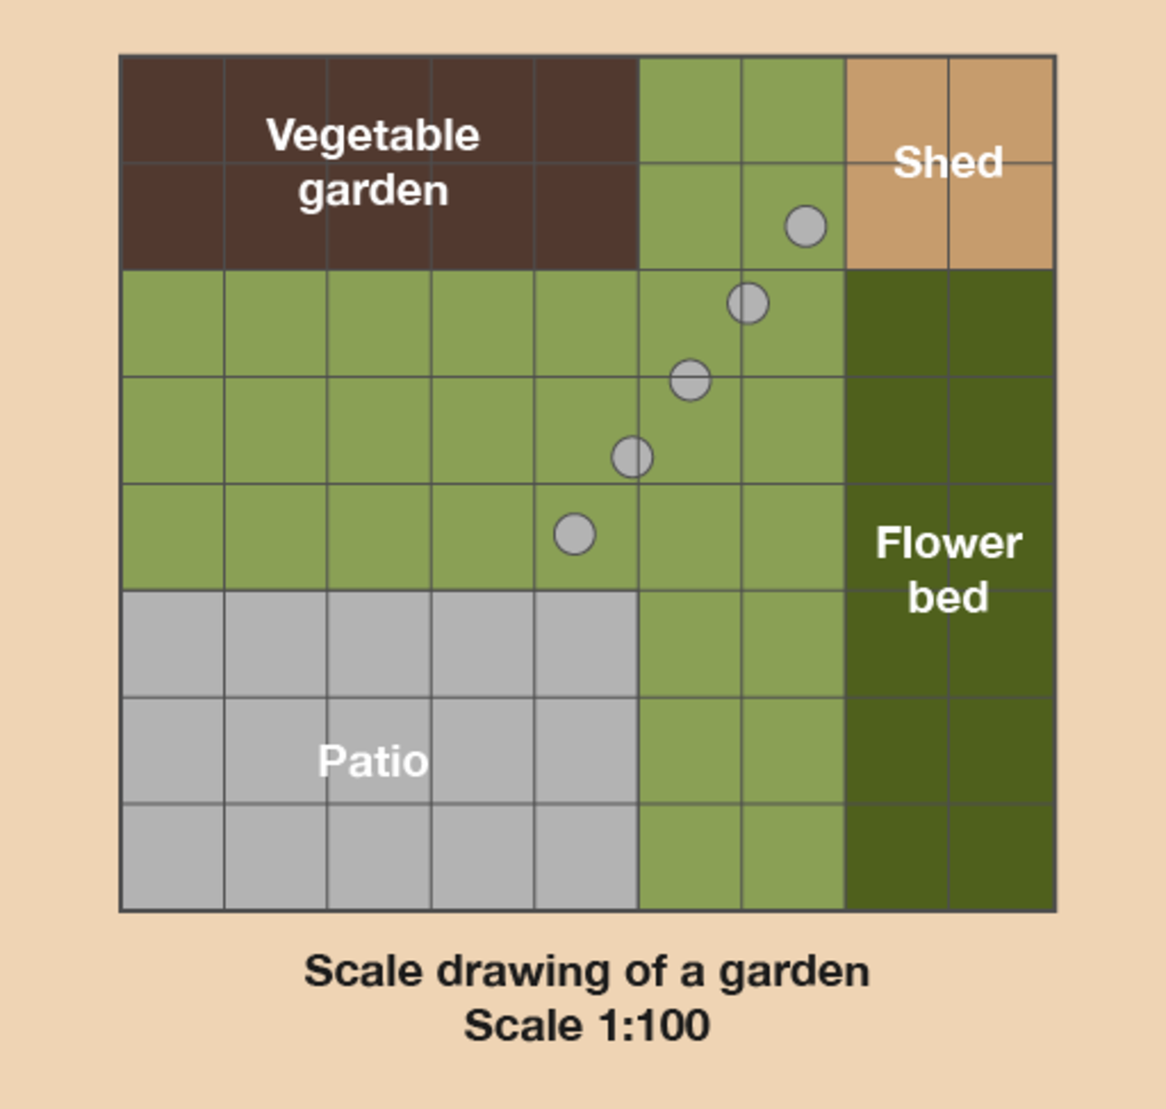
Figure 16 A scale drawing of a garden
View description - Figure 16 A scale drawing of a garden

What’s the width and length of the patio?

Hint: This scale drawing has been drawn on squared paper. This makes it easier to draw and understand. Each square is 1 cm wide and 1 cm long. So instead of using a ruler you can just count the squares and this will tell you the measurement in centimetres.

Method
The scale in this drawing is 1:100. This means that 1 cm on the scale drawing is equal to 100 cm, or 1 m, in real life. Once we know the scale, we can measure the distances on the drawing.
Using a ruler (or just counting the squares), we find that the patio is 5 cm long and 3 cm wide on the drawing. This means that in real life it is 5 metres long and 3 metres wide.
So when you’re working with scale drawings:
- Find out what the scale on the drawing is.
- Measure the distance on the drawing using a ruler (or count the number of squares, if that’s an option).
- Multiply the distance you measure by the scale to give the distance in real life.

Now try the following activity. Remember to check your answers once you have completed the questions.

Activity 6: Getting information from a scale drawing

- Let’s stay with this scale drawing of the garden.

Figure 17 A scale drawing of a garden
View description - Figure 17 A scale drawing of a garden

  - What is the width and length of the vegetable garden?
  - What is the width and length of the flower bed?
  - How far is the patio from the vegetable garden?
  - Say you wanted to put a trampoline between the patio and the vegetable garden. It measures 3 m by 3 m. Is there enough space for it?
- A landscaper wants to put a wild area in your garden. She makes a scale plan of the wild area:

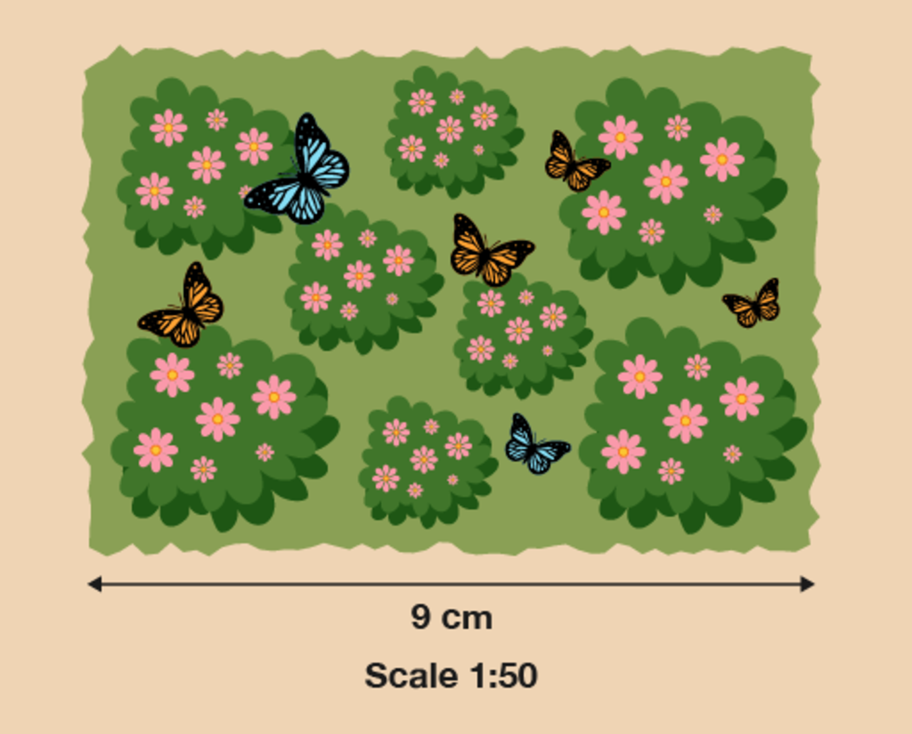
Figure 18 A scale drawing of a wild area of a garden
View description - Figure 18 A scale drawing of a wild area of a garden

What is the length of the longest side of the actual wild area in metres?
- Here is a scale drawing showing one disabled parking space in a supermarket car park. The supermarket plans to add two more disabled parking spaces next to the existing one, with no spaces between them.

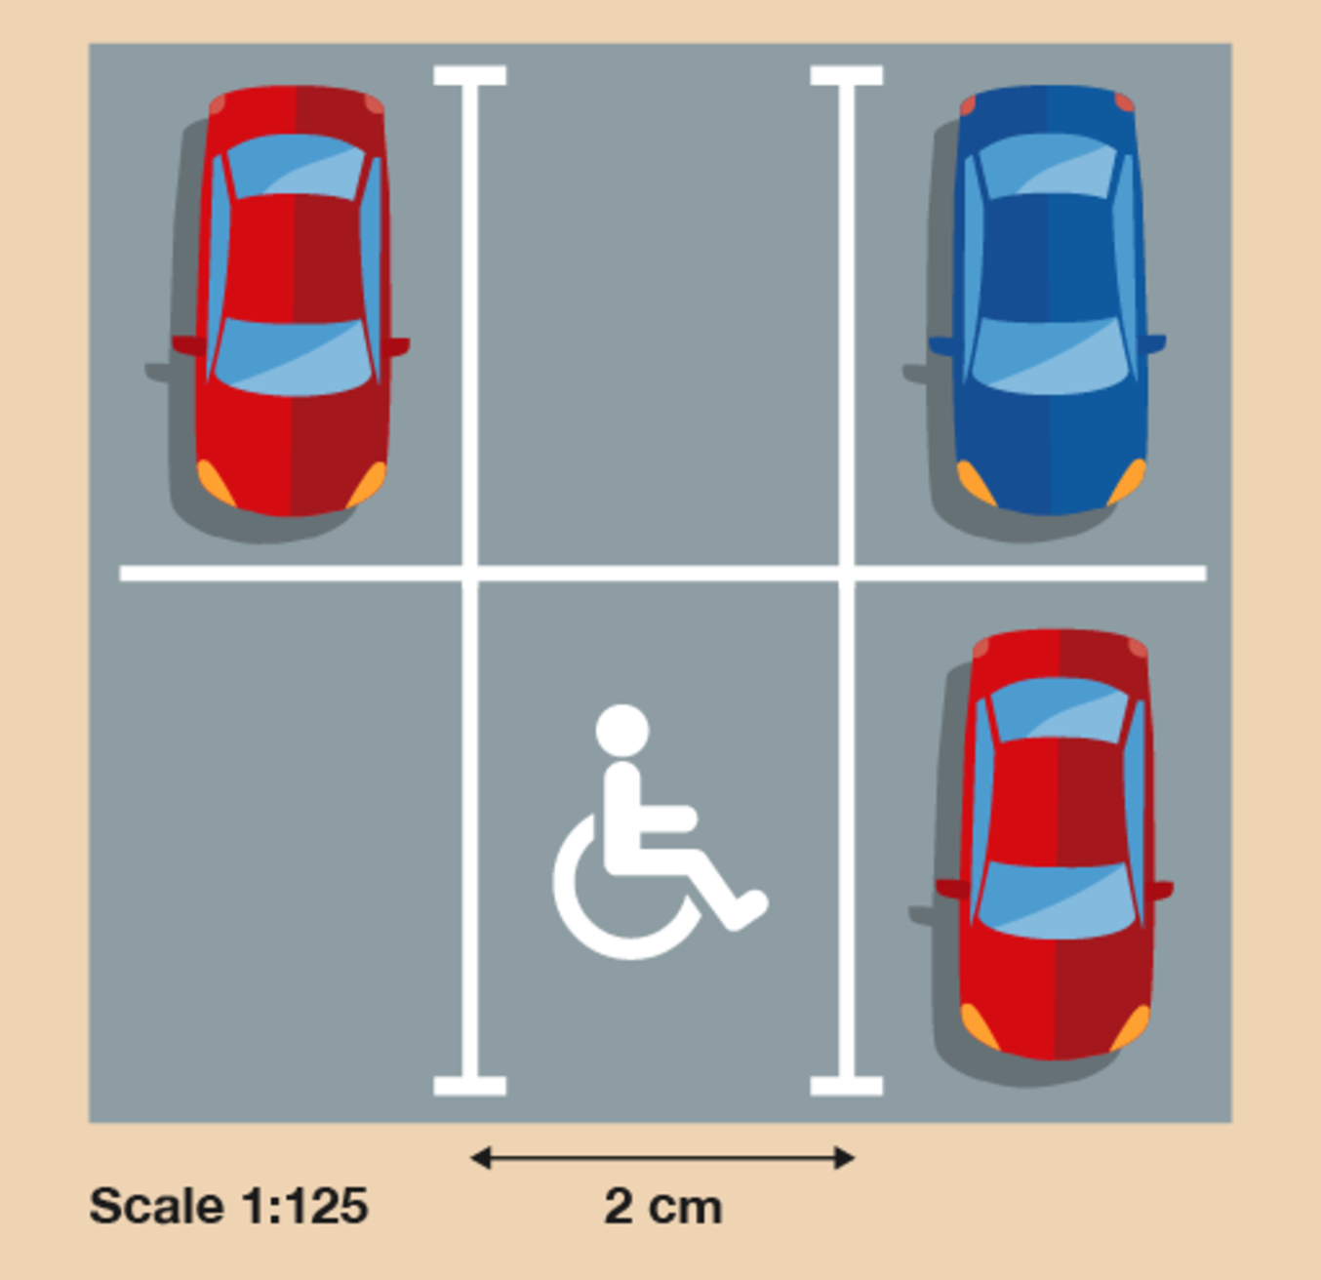
Figure 19 A scale drawing of a car park
View description - Figure 19 A scale drawing of a car park

What will be the total actual width of the three disabled parking spaces in metres?

View answer - Activity 6: Getting information from a scale drawing

Summary
In this section you have learned how to use scale drawings.

4 Maps
Maps are very similar to scale drawings. The main difference is that they are usually used to show places.
If you look in a holiday brochure you will see lots of maps. They are often used to show how a resort is laid out. They show where a few important places are, such as local shops, hotels, the beach, swimming pools and restaurants.
It is important to understand how to read a map so that you do not end up too far from the places you want to be near – or too close to the places you want to avoid!

Example: Holiday map
Here is a typical example of a map you find in a holiday brochure.

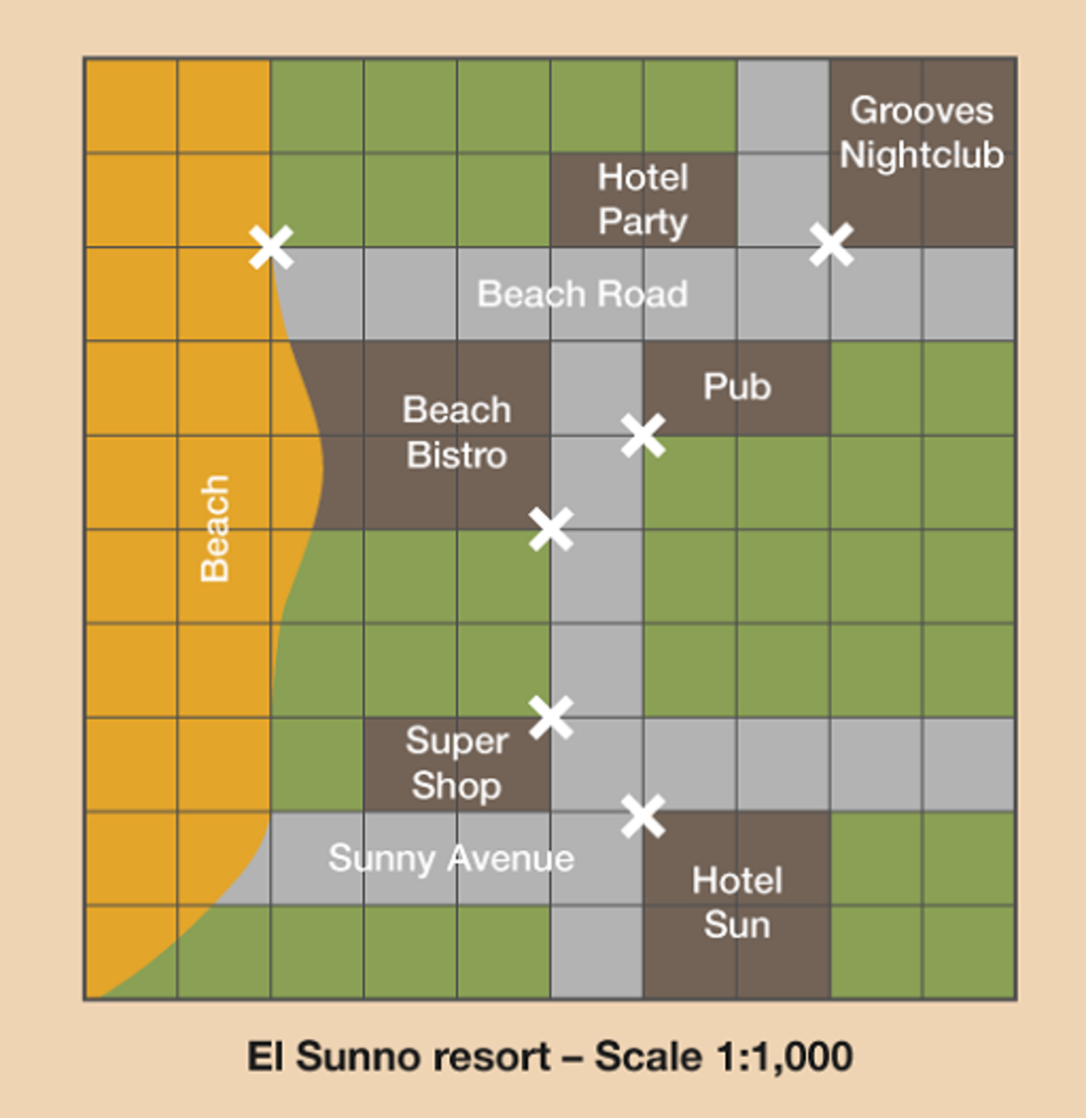
Figure 20 A scale drawing of a holiday resort
View description - Figure 20 A scale drawing of a holiday resort

How far apart is everything on this map?

Method
As with scale drawings, the thing you need to know before you can understand the map is the scale. In this example the scale is 1:1,000. This means that every 1 cm on the map represents 1,000 cm (or 10 m) in real life.
Using the scale, you can interpret the data on the map and work out how far different places are from one another.
To do this you need to measure the distances on the map and then multiply them by 1,000 to get the actual distance in centimetres. Or, more simply, you could multiply the distances in centimetres by 10 to get the actual distance in metres.
So on this map the Grooves Nightclub is 1 cm from Hotel Party. In real life that’s 10 m – not very far at all. Knowing this could affect whether you choose to stay at Hotel Party, depending on whether you like nightclubs or not.

Now try the following activity. Remember to check your answers once you have completed the questions.

Activity 7: Using a map to find distances

Let’s stay with the map of the holiday resort.

Figure 21 A scale drawing of a holiday resort
View description - Figure 21 A scale drawing of a holiday resort

Hint: The entrances to the buildings are marked with crosses on the map. You need to measure from these crosses.

- What is the distance in real life between the pub and Hotel Sun in metres?
- How far is it in real life from the Super Shop to the Beach Bistro in metres?
- What is the distance in real life from Grooves Nightclub to the beach in metres?

View answer - Activity 7: Using a map to find distances

Summary
In this section you have learned how to use maps.

5 Session 4 summary
You have now completed Session 4, ‘Shape and space’. If you have identified any areas that you need to work on, please ensure you refer back to this section of the course.
You should now be able to:
- rearrange furniture in a room
- find out how much paint you need to repaint a wall
- find out how much carpet you need to re-carpet a room
- plan your garden
- read maps and understand scale to get you from one place to another.
All of the skills above will help you with tasks in everyday life. Whether you are at home or at work, number skills are an essential skill to have.
Now try the end-of-course quiz to test your learning of the entire course and hopefully gain your badge. Good luck!

6 End-of-course quiz
Now it’s time to complete the end-of-course quiz. It’s similar to previous quizzes, but in this one there will be 15 questions.
Open the quiz in a new window or tab then come back here when you’re done.
Remember, this quiz counts towards your badge. If you’re not successful the first time, you can attempt the quiz again in 24 hours.

7 Bringing it all together
Congratulations on completing Everyday maths 1. We hope you have enjoyed the experience and now feel inspired to develop your maths skills further.
Throughout this course you have developed your skills within the following areas:
- understanding and using whole numbers, and understanding negative numbers in practical contexts
- adding, subtracting, multiplying and dividing whole numbers using a range of strategies
- understanding and using equivalences between common fractions, decimals and percentages
- adding and subtracting decimals up to two decimal places
- solving simple problems involving ratio, where one number is a multiple of the other
- using simple formulae expressed in words for one- or two-step operations
- solving problems requiring calculation with common measures, including money, time, length, weight, capacity and temperature
- converting units of measure in the same system
- extracting and interpreting information from tables, diagrams, charts and graphs
- collecting and recording discrete data, and organising and representing information in different ways
- finding the mean and range of a group of numbers
- using data to assess the likelihood of an outcome
- identifying various shapes
- working with area and perimeter, scale drawings, and basic map-reading.

8 Next steps
You may now want to develop your everyday maths skills further. If so, you should look into the Everyday maths 2 course, coming soon on OpenLearn. Everyday maths 2 with give you the opportunity to look at some of the topics you’ve explored here in more detail, as well as new content such as calculating capacity.
If you would like to achieve a more formal qualification, please visit one of the centres listed below with your OpenLearn badge. They’ll help you to find the best way to achieve the Level 1 Functional Skills qualification in maths, which will enhance your CV.
- The Bedford College Group
Bedford College, Cauldwell St, Bedford, MK42 9AH
https://www.bedford.ac.uk/ • 01234 291000
Tresham College, Windmill Avenue, Kettering, Northamptonshire, NN15 6ER
https://www.tresham.ac.uk/ • 01536 413123
- Middlesbrough College
Dock St, Middlesbrough, TS2 1AD
https://www.mbro.ac.uk/ • 01642 333333
- West Herts College
Watford Campus, Hempstead Rd, Watford, WD17 3EZ
https://www.westherts.ac.uk/ • 01923 812345

Acknowledgements
This free course was written by Anna E. Crossland, Middlesbrough College using materials belonging to The Open School Trust Ltd. (trading as the National Extension College), in partnership with Bedford College Group, West Herts College and The Open University andin collaboration with Coleg Cambria, Adult Learning Wales, Coleg Gwent and the NPTC Group of Colleges. Copyright in this material belongs to The Open University, 2019.
Except for third party materials and otherwise stated (see terms and conditions), this content is made available under a Creative Commons Attribution-NonCommercial-ShareAlike 4.0 Licence.
The material acknowledged below is Proprietary and used under licence (not subject to Creative Commons Licence). Grateful acknowledgement is made to the following sources for permission to reproduce material in this free course:

Session 1
Figure 24: © deltaart/123 Royalty Free.

Session 3
Figure 1: Ski le Gap – ski and snowboard courses in Canada, https://skilegap.com/.
Figures 3 and 4: taken from Stagecoach UK Bus.
Every effort has been made to contact copyright owners. If any have been inadvertently overlooked, the publishers will be pleased to make the necessary arrangements at the first opportunity.
Don't miss out
If reading this text has inspired you to learn more, you may be interested in joining the millions of people who discover our free learning resources and qualifications by visiting The Open University – www.open.edu/openlearn/free-courses.

Solutions

Activity 1: Working with place value

Part

Answer
4,025 in words is four thousand and twenty-five.
Back to - Part

Part

Answer
Six thousand, four hundred and seventy-two in figures is 6,472.
Back to - Part

Part

Answer
The person who wins the election is the person who gets the most votes.
To find the biggest number we need to compare the value of the first digit in each number. If this is the same for any of the numbers, then we need to go on to compare the value of the second digit in each number and so on.
- The value of the first digit in 436 is 4 hundreds.
- The value of the first digit in 723 is 7 hundreds.
- The value of the first digit in 156 is 1 hundred.
- The value of the first digit in 72 is 7 tens.
Comparing the values of the first digit in each number tells us that the biggest number is 723, so Sonia Cedar is the winner of the election.
Back to - Part

Activity 2: Using negative numbers in everyday life

Part

Answer
- City D is the coldest because it has the lowest temperature. City C is the warmest because it has the highest temperature.
- No, because –11°C is colder than the recommended range of between –10°C and –6°C. Keeping the ice cream in your freezer would probably damage the ice cream.
Back to - Part

Activity 3: Looking at numbers

Part

Answer
- The answers are as follows:
  - 9 million
  - 653 thousand
  - Will
- The answers are as follows:
  - Moscow
  - Delhi
  - London, Paris and Moscow
- £24 + £18 = £42
- £48 – £26 = £22
Back to - Part

Activity 4: Using multiplication and division

Part

Answer
- The answers are as follows:
  - 6 ×4 = 24
  - 3 × 9 = 27
  - 5 × 7 = 35
  - 36 ÷ 9 = 4
  - 48 ÷ 6 = 8
  - 15 ÷ 3 = 5
- 10 × 25 = 250 wine glasses.
- 2 × 19 = £38
11 × 2 = £22
22 + 38 = £60
It would cost £60 to go to the circus.
Back to - Part

Activity 5: Rounding to 10, 100 and 1,000

Part

Answer

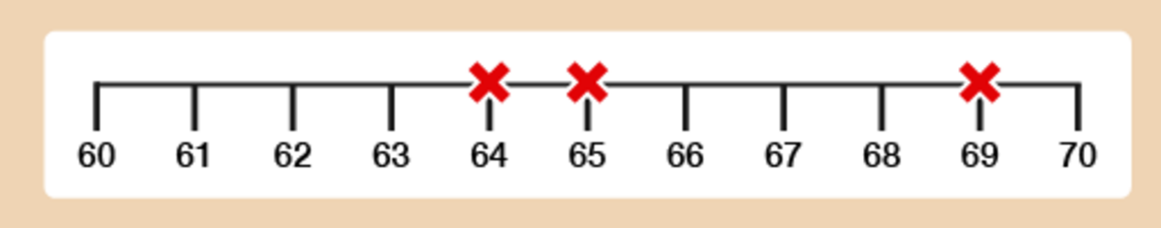
Figure 5 A number line
View description - Figure 5 A number line

You can see that:
- 64 rounded to the nearest 10 is 60.
- 69 rounded to the nearest 10 is 70.
- 65 rounded to the nearest 10 is 70. (Remember: when a number is exactly halfway, you always round up. As the rhyme goes, ‘Five or more, raise the score!’)
Now practise rounding to the nearest 100. The rule is exactly the same.
Back to - Part

Part

Answer

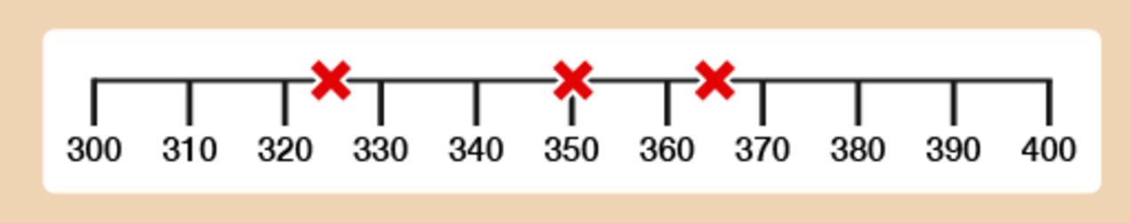
Figure 6 A number line
View description - Figure 6 A number line

You can see that:
- 325 rounded to the nearest 100 is 300.
- 350 rounded to the nearest 100 is 400.
- 365 rounded to the nearest 100 is 400.
Now practise rounding to the nearest 1,000.
Back to - Part

Part

Answer

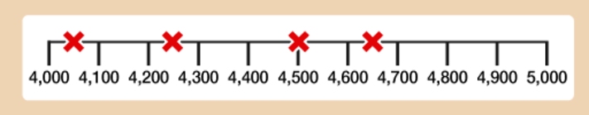
Figure 7 A number line
View description - Figure 7 A number line

You can see that:
- 4,250 rounded to the nearest 1,000 is 4,000.
- 4,650 rounded to the nearest 1,000 is 5,000.
- 4,500 rounded to the nearest 1,000 is 5,000.
- 4,060 rounded to the nearest 1,000 is 4,000.
Back to - Part

Activity 6: Bill’s shopping

Part

Answer
Rounding all of the items should give you a total of £19 – so yes, Bill probably has enough money to pay for all of his shopping.
Back to - Part

Part

Answer
The total cost of all of the items on the shopping list comes to £19.33, which is very close to the answer you achieved through rounding.
Well done! You have now successfully rounded and carried out some basic number work. Can you see the importance of rounding? This is especially important when sticking to a budget.
Back to - Part

Activity 7: Rounding

Answer
- The population rounds to 6,000,000 (six million). This is because 6,439,800 is nearer to 6 million than 7 million.
- 6,987 rounded to the nearest 1,000 is 7,000. If each ticket costs £6, the approximate total amount of money collected is:
  - £6 × 7,000 = £42,000
- 412 to the nearest hundred is 400. 395 to the nearest hundred is also 400. So the total approximate number of students passing GCSE Maths is:
  - 400 + 400 = 800 students
- £595 to the nearest hundred is £600. So the approximate cost of one armchair is:
  - £600 ÷ 4 = £150
- 18 rounded to the nearest 10 is 20. So the approximate total number of pencils is:
  - 20 × 50 = 1,000 pencils
Note: 50 × 20 = 50 × 2 × 10 = 100 × 10 = 1,000.
Back to - Activity 7: Rounding

Activity 8: Fractions in order of size

Part

Answer
Remember that when the numerator of a fraction is 1, the larger the denominator, the smaller the fraction.
From smallest to largest, the order is:
- , , , ,
Back to - Part

Part

Answer
- =
- =
- =
- =
Back to - Part

Activity 9: Putting fractions in order

Answer
- The correct order would be:
- 2 , 5 , 6
- In this case, even though is bigger than and is bigger than , you need to look at the whole numbers first and then the fractions. The diagram illustrates this more clearly:

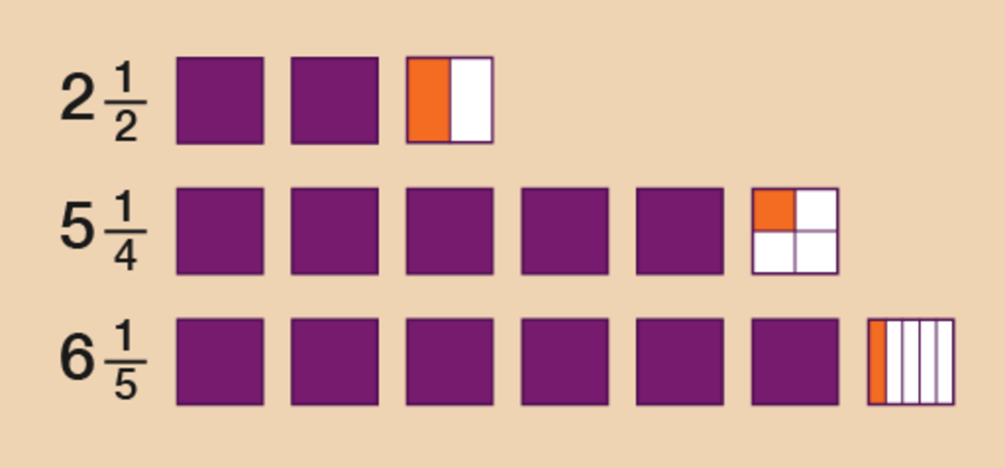
Figure 12 Drawing the fractions
View description - Figure 12 Drawing the fractions

- The correct order would be:
- 1 , 2 , 2
Back to - Activity 9: Putting fractions in order

Activity 10: Paying in instalments

Answer
To work out of £12,000 you need to divide £12,000 by 5.
- 12,000 ÷ 5 = 2,400
So at Stage 1 the builder will need £2,400.
To work out of £12,000 you need to first work out of £12,000. To do this you need to divide £12,000 by 3.
- 12,000 ÷ 3 = 4,000
So of £12,000 is:
- 4,000 × 2 = 8,000
So at Stage 2 the builder will need £8,000.
Back to - Activity 10: Paying in instalments

Activity 11: Decimal dilemmas

Part

Answer
- Any child that is more than 0.95 m tall will be allowed on the ride. So to answer the question you need to compare the height of each child with 0.95 m.

 | Tenths | Hundredths
Margaret | 8 | 5
David | 9 | 9
Suha | 8 | 9
Prabha | 9 | 2

- Comparing the tenths tells us that only two children may possibly be allowed on the ride: David and Prabha.
- If we go on to compare the hundredths, we see that only David is taller than 0.95 m.
- So only David would be allowed on the Wacky Wheel.
- You need to compare the tens, units, tenths and hundredths, in that order.

 | Tens | Units | . | Tenths | Hundredths
Sonia | 1 | 0 | . | 9 | 5
Anjali | 1 | 0 | . | 5 | 9
Anita | 1 | 0 | . | 9 | 1
Aarti | 1 | 0 | . | 9 | 9
Sita | 1 | 0 | . | 5 | 8
Susie | 1 | 0 | . | 5 | 6

- All of the times have the same number of tens and units, so it is necessary to go on to compare the tenths.
- The three times with the lowest number of tenths are 10.59, (Anjali), 10.58 (Sita) and 10.56 (Susie). If we now go on to compare the hundredths in these three times, we see that the lowest times are (lowest first): 10.56, 10.58 and 10.59.
- So medals go to:
  - Susie (10.56 secs): gold
  - Sita (10.58 secs): silver
  - Anjali (10.59 secs): bronze
- Again, we need to compare the tens, units, tenths and hundredths, in that order.

 | Tens | Units | . | Tenths | Hundredths
Janak | 2 | 3 | . | 9 | 5
Nadia | 2 | 3 | . | 8 | 9
Carol | 2 | 3 | . | 9 | 8
Tracey | 2 | 3 | . | 8 | 8

- All the scores have the same number of tens and units. Looking at the tenths, two scores (23.95 and 23.98) have 9 tenths. If you compare the hundredths in these two numbers, you can see that 23.98 is bigger than 23.95.
- To find the third highest number, go back to the other two numbers, 23.89 and 23.88. Comparing the hundredths, you can see that 23.89 is the higher number. So the top three competitors are:
  - Carol (23.98)
  - Janak (23.95)
  - Nadia (23.89)
Back to - Part

Activity 12: Rounding

Answer
- The answers are as follows:
  - The nearest whole number to 3.72 is 4.
The nearest whole number to 8.4 is 8.
So our approximate answer is:
4 + 8 = 12
  - The nearest whole number to 9.6 is 10.
The nearest whole number to 1.312 is 1.
So our approximate answer is:
10 – 1 = 9
  - The nearest whole number to 2.8 is 3.
The nearest whole number to 3.4 is 3.
So our approximate answer is:
3 × 3 = 9
  - The nearest whole number to 9.51 is 10.
The nearest whole number to 1.5 is 2.
So our approximate answer is:
10 ÷ 2 = 5
- The answers are as follows:
  - To round to two decimal places, look at the third digit after the decimal point. This is more than 5, so round the previous digit (4) up to 5.
The answer is 3.85.
  - In this case, the third digit after the decimal point is less than 5, so leave the previous digit unchanged.
The answer is 2.98.
  - The third digit after the decimal point here is 5. Remember in this case we always round up.
The answer is 3.48.
Back to - Activity 12: Rounding

Activity 13: Using decimals

Answer
- The answers are as follows:
  - Add the cost of the two items:
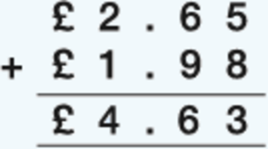
(Keep the decimal points in line.)
The total cost of the items is £4.63.
  - Take away the total cost from £5:
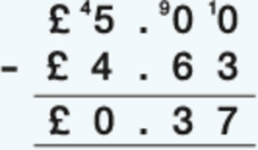
You should get 37p change from £5.
- Multiply the exchange rate in euros (€1.4) by the amount in pounds (£8):
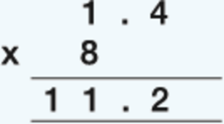
So £8 = €11.20.
- Divide the total cost (£56.60) by the number of people (4):
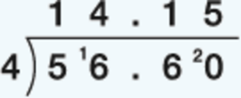
You would each pay £14.15.
- To convert 6.25 m into cm, you need to multiply the amount by 100.
  - 6.25 × 100 = 625
So the answer is 625 cm.
Back to - Activity 13: Using decimals

Activity 14: A holiday discount

Answer

Method 1
In order to identify how much the deposit is, you need to find out what 20% () of £800 is. To do this, first you need to find out of £800:
- 800 ÷ 100 = 8
So of £800 is:
- 8 × 20 = 160
The deposit is £160.

Method 2
In order to calulate 10%, or , you need to divide the number by 10:
- 800 ÷ 10 = 80
You now have 10% and you need 20%. Therefore you need to multiply your 10% by 2:
- 80 × 2 = 160
The deposit is £160.
Back to - Activity 14: A holiday discount

Activity 15: Comparing discounts

Answer
In order to identify Shop A’s discount, you need to find out what 25% () of £500 is. To do this, first you need to find out of £500:
- 500 ÷ 100 = 5
So of £500 is:
- 5 × 25 = 125
The discount is £125, so you would have to pay:
- £500 – £125 = £375
In order to identify Shop B’s discount, you need to find out what 10% () of £400 is. To do this, first you need to find out of £400:
- 400 ÷ 100 = 4
So of £400 is:
- 4 × 10 = 40
The discount is £40, so you would have to pay:
- £400 – £40 = £360
So Shop B offers the best deal.
Back to - Activity 15: Comparing discounts

Activity 16: Calculating percentage increases and decreases

Answer
- In order to identify how much the value of the car will decrease by, you need to find out what 25% () of £9,000 is. To do this, first you need to find out of £9,000:
  - 9,000 ÷ 100 = 90
- So of £9,000 is:
  - 25 × 90 = 2,250
- The car’s value depreciates by £2,250 in the first year, so the value of the car at the end of the first year will be:
  - £9,000 – £2,250 = £6,750
- It might be easier in this example to convert £10 into pence (£10 = 1,000p). In order to identify the new value of the share, you need to find out what 30% () of 1,000p is. To do this, first you need to find out of 1,000p:
  - 1,000 ÷ 100 = 10
- So of 1,000p is:
  - 30 × 10 = 300
- The share’s value has increased by 300p, or £3, since 2000, so the current value of the share is:
  - £10 + £3 = £13
Back to - Activity 16: Calculating percentage increases and decreases

Activity 17: Looking for equivalencies

Answer
- 20% is the same as .
  - 600 ÷ 5 = 120
So 20% of £600 is £120.
- 0.25 is the same as . There are 1,000 m in 1 km.
  - 1,000 ÷ 4 = 250
So walking 0.25 km is the same as 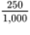 m, simplified to , or of a kilometre.
- is the same as 50%.
So house prices have increased by 50% in the last five years.
- 50% is the same as .
  - 8,000 ÷ 2 = 4,000
The discount is £4,000, so the cost of a new kitchen worth £8,000 in the sale is:
  - £8,000 – £4,000 = £4,000
- 20% is the same as .
  - 3,000 ÷ 5 = 600
The new value of necklace is:
  - £3,000 + £600 = £3,600
Back to - Activity 17: Looking for equivalencies

Activity 18: Using ratios

Answer
- A ratio of 3:1 means three parts of sand to one part of cement, making four parts in total.
We need 60 m³ of concrete. If four parts are worth 60 m³, this means that one part is worth:
  - 60 m³ ÷ 4 = 15 m³
So 60 m³ of concrete requires:
  - Sand: three parts × 15 m³ = 45 m³
Cement: one part × 15 m³ = 15 m³
You can confirm that these figures are correct by adding them and checking that they match the amount needed:
  - 45 m³ + 15 m³ = 60 m³
- A ratio of 1:7 means one part of wallpaper stripper to seven parts of water, making eight parts in total.
We need 16 litres of solution. If eight parts are worth 16 litres, this means that one part is worth:
  - 16 litres ÷ 8 = 2 litres
So 16 litres of solution requires:
  - Wallpaper stripper: one part × 2 litres = 2 litres
Water: seven parts × 2 litres = 14 litres
You can confirm that these figures are correct by adding them and checking that they match the amount needed:
  - 2 litres + 14 litres = 16 litres
- The ratio of 1:4 means one part hair colourant to four parts water, making five parts in total.
We need 400 ml of solution. If five parts are worth 400 ml, this means that one part is worth:
  - 400 ml ÷ 5 = 80 ml
So 400 ml of solution requires:
  - Hair colourant: one part × 80 ml = 80 ml
Water: four parts × 80 ml = 320 ml
You can confirm that these figures are correct by adding them and checking that they match the amount needed:
  - 80 ml + 320 ml = 400 ml
Back to - Activity 18: Using ratios

Activity 19: Scaling up recipes

Answer
- To make 20 cookies you need twice as much of each ingredient:
  - 440 g flour (220 × 2)
  - 300 g butter (150 × 2)
  - 200 g sugar (100 × 2)
  - 4 eggs (2 × 2)
- To make milkshakes for two people you need half as much of each ingredient:
  - 400 ml milk (800 ÷ 2)
  - 100 g strawberries (200 ÷ 2)
  - 2 scoops of ice cream (4 ÷ 2)
- To make dessert for six people you need three times the amount of each ingredient:
  - 900 ml milk (300 × 3)
  - 180 g powder (60 × 3)
Back to - Activity 19: Scaling up recipes

Activity 20: Looking at ratio and proportion

Answer
- A ratio of 1:9 means one part curtain whitener to nine parts water, making ten parts in total.
You need 2,000 ml of solution. If ten parts are worth 2,000 ml, this means that one part is worth:
  - 2,000 ml ÷ 10 = 200 ml
So 2,000 ml of solution requires:
  - Curtain whitener: one part × 200 ml = 200 ml
Water: nine parts × 200 ml = 1,800 ml
You can confirm that these figures are correct by adding them and checking that they match the amount needed:
  - 200 ml + 1,800 ml = 2,000 ml
- To make enough risotto for six people you need three times as much of each ingredient:
  - 600 g of mushrooms (200 × 3)
  - 525 g of mushrooms (175 × 3)
  - 540 ml of water (180 × 3)
  - 540 ml of evaporated milk (180 × 3)
Back to - Activity 20: Looking at ratio and proportion

Activity 21: Using formulas

Part

Answer
To answer this you need to multiply the amount Harvey earns in an hour (£7.75) by the number of hours (eight):
- £7.75 × 8 = £62.00
Back to - Part

Part

Answer
- You need to use a two-step formula to answer each of these questions. To work out how long a 2 kg joint of pork takes to cook, you’ll need a formula with two steps:
  - Step 1: 40 minutes × number of kilograms
Step 2: Add 30 minutes
- Written as a formula, this is:
  - (40 × number of kilograms) + 30 = cooking time
So a 2 kg joint would take:
  - (40 × 2) + 30 = 110 minutes, or 1 hour and 50 minutes
- Using the same formula, a 1.5 kg joint would take:
  - (40 × 1.5) + 30 = 90 minutes, or 1 hour and 30 minutes
Back to - Part

Part

Answer
The information in the question gives you two formulas. To answer the question you need to find the answers to both formulas and add the results together.
The contract costs £15 a month for the first four months. So the formula for this part of the contract is:
- £15 × 4 = £60
After the first four months the contract is £20 a month. The question asks you the total cost of the phone contract for one year, so you need to calculate how much you would pay for another eight months:
- £20 × 8 = £160
So the total cost of the contract for one year is:
- £60 + £160 = £220
Back to - Part

Activity 22: Using function machines

Part

Answer
If you were to write the function machine as a formula, it would look like this:
- (Area of hall in square metres × 2) – 10 = number of people allowed in the youth club hall
The area of the hall in square metres is:
- 10 × 20 = 200 m²
So we would replace ‘Area of hall in square metres’ in the formula with 200:
- (200 × 2) – 10 = 390
So the maximum number of people allowed in the youth club hall is 390 people.
Back to - Part

Part

Answer
Simon’s weight is 72 kg so the calculation is:
- 72 ÷ 3 = 24
Simon’s BMI is 24, so he has met his fitness goal.
Back to - Part

Part

Answer
If you were to write the function machine as a formula, it would look like this:
- (Amount container holds in ml ÷ 10) × 9 = wax needed in g
The container is 200 ml, so we would replace ‘Amount container holds in ml’ in the formula with 200:
- (200 ÷ 10) × 9 = 180
So the maximum amount of wax needed for each container is 180 g.
Back to - Part

Part

Answer
If you were to write the function machine as a formula, it would look like this:
- (Cost price × 375) ÷ 100 = selling price
The cost price is £2, so we would replace ‘Cost price’ in the formula with 2:
- (2 × 375) ÷ 100 = 7.5
So the selling price should be £7.50, not £8.
Back to - Part

Activity 1: Building a shelf for DVDs

Part

Answer
- The DVD case is 19 cm tall.

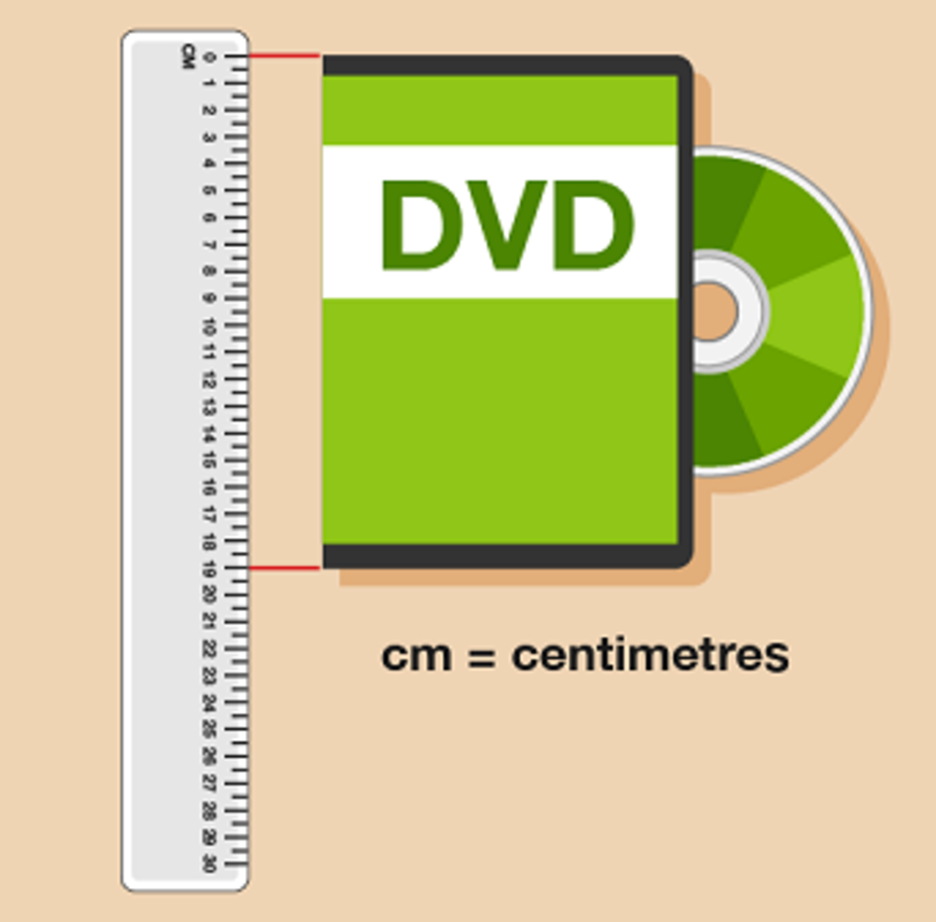
Figure 5 Measuring a pen (answer)
View description - Figure 5 Measuring a pen (answer)

- The end of the screw is halfway between 2 and 3 cm, so the screw is 2.5 cm long.

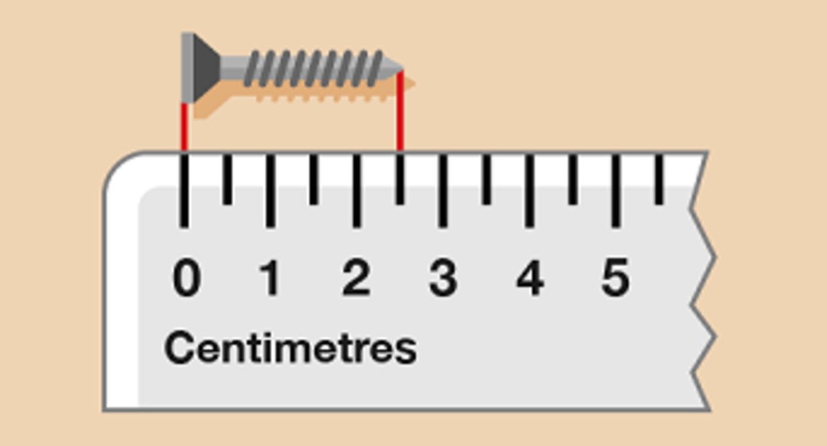
Figure 6 Measuring a screw (answer)
View description - Figure 6 Measuring a screw (answer)

- The screw head is 5 mm wide.

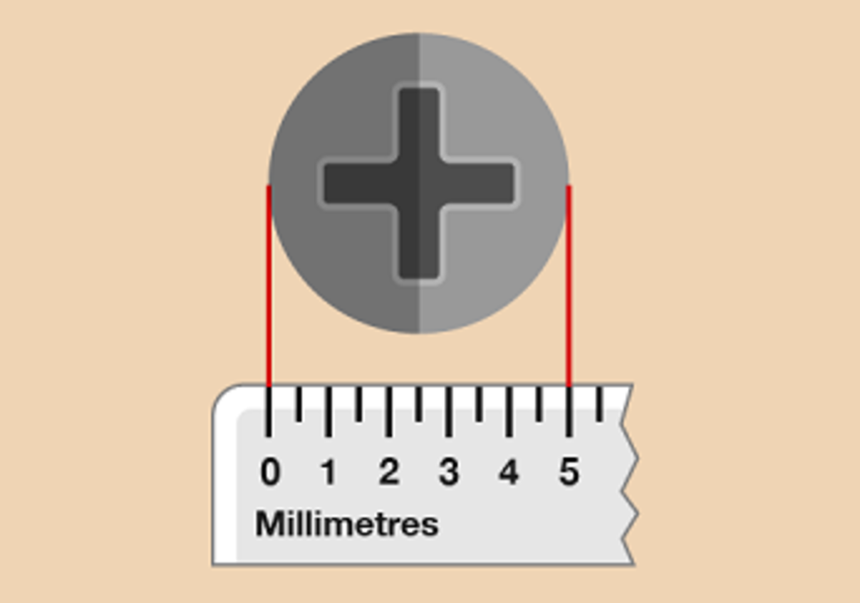
Figure 7 Measuring a screw head (answer)
View description - Figure 7 Measuring a screw head (answer)

Back to - Part

Activity 2: Measuring lengths

Answer
You will have found it useful to refer to the metric conversion diagram for this activity.
- To convert from centimetres to millimetres, you need to multiply the figure in centimetres by 10. The size is 80 cm, so the answer is:
  - 80 × 10 = 800 mm
- Thirty children each need 20 cm of string. To find the total in centimetres you would do the following:
  - 30 × 20 = 600 cm
However, the question asked for how much string is needed in metres, not centimetres. To convert from centimetres to metres, you need to divide the figure in centimetres by 100. So if you need 600 cm, the answer is:
  - 600 ÷ 100 = 6 m
- To convert from centimetres to metres, you need to divide the figure in centimetres by 100. The length of fabric you need size is 30 cm, so the answer is:
  - 30 ÷ 100 = 0.3 m
Back to - Activity 2: Measuring lengths

Activity 3: Converting lengths

Part

Answer
Right:
2 cm
Wrong:
200 cm
0.2 cm
Back to - Part

Part

Answer
Right:
0.45 m
Wrong:
45 m
4.5 m
Back to - Part

Part

Answer
Right:
5 mm
Wrong:
15 mm
50 mm
Back to - Part

Part

Answer
Right:
4 m
Wrong:
0.4 m
40 m
Back to - Part

Activity 4: A European tour

Answer
- You need to find the row for Florence and go along it until it meets the column for Calais.

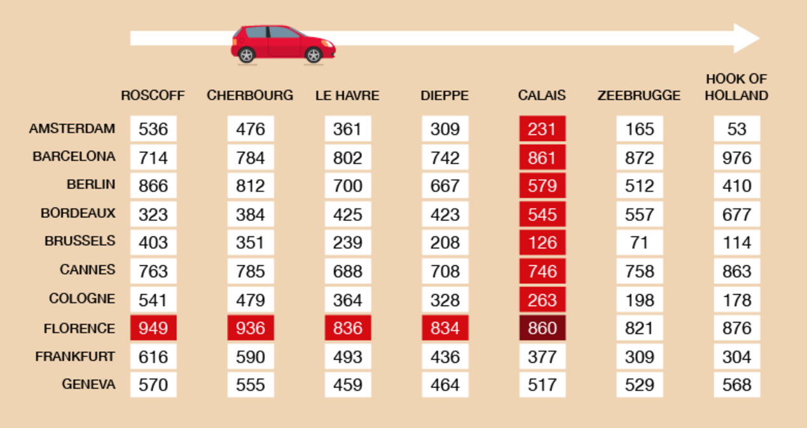
Figure 13 A mileage chart for a European tour (answer)
View description - Figure 13 A mileage chart for a European tour (answer)

The distance between Florence and Calais is 860 miles.
- You need to look along the row for Florence and find the shortest distance, then see which port is named at the top of the column. The shortest distance is 821 miles, from Zeebrugge.
- You need to look along the Cologne row until you get to the Zeebrugge column. The distance in 198 miles.
- Check the distance from Calais to Cologne: 263 miles.
- Zeebrugge is the best port to use because it’s closest to both Cologne and Florence.
Back to - Activity 4: A European tour

Activity 5: Travelling across the UK

Answer
- The answers are as follows:
  - You need to look up all the distances and then add them together:
London to Cardiff is 150 miles.

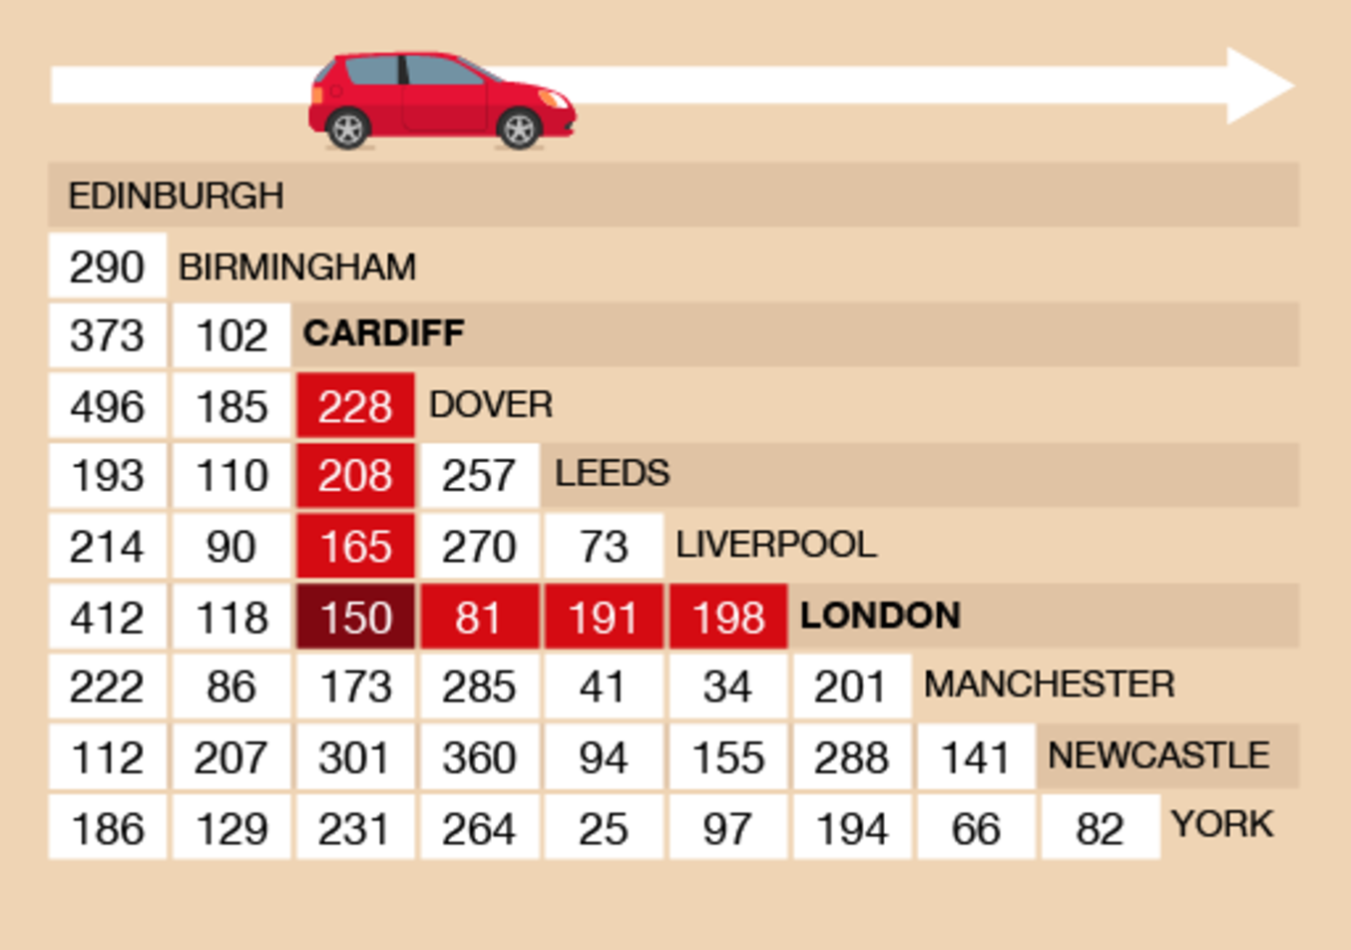
Figure 17 London to Cardiff on a mileage chart
View description - Figure 17 London to Cardiff on a mileage chart

Cardiff to Liverpool is 165 miles.

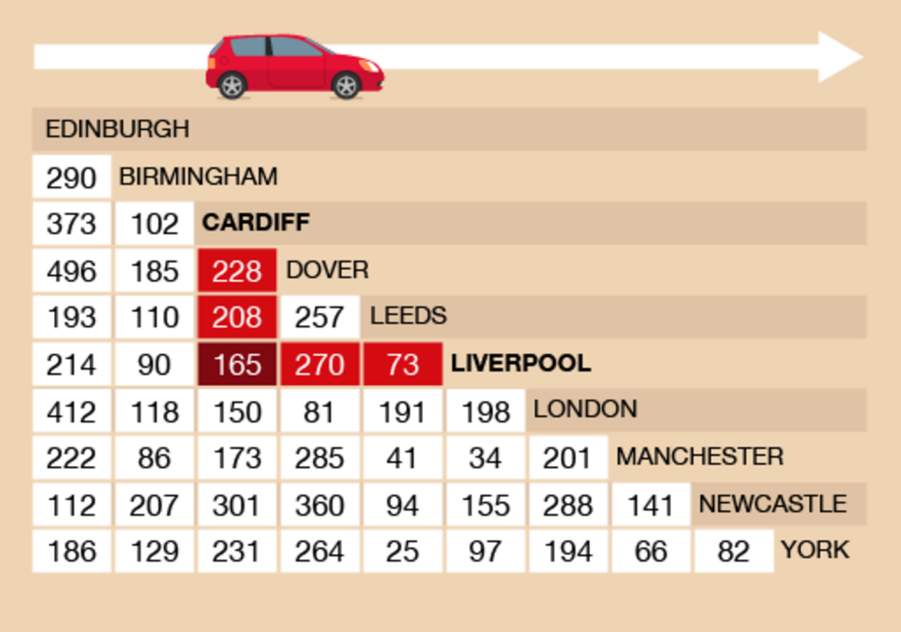
Figure 18 Cardiff to Liverpool on a mileage chart
View description - Figure 18 Cardiff to Liverpool on a mileage chart

Liverpool to London is 198 miles.

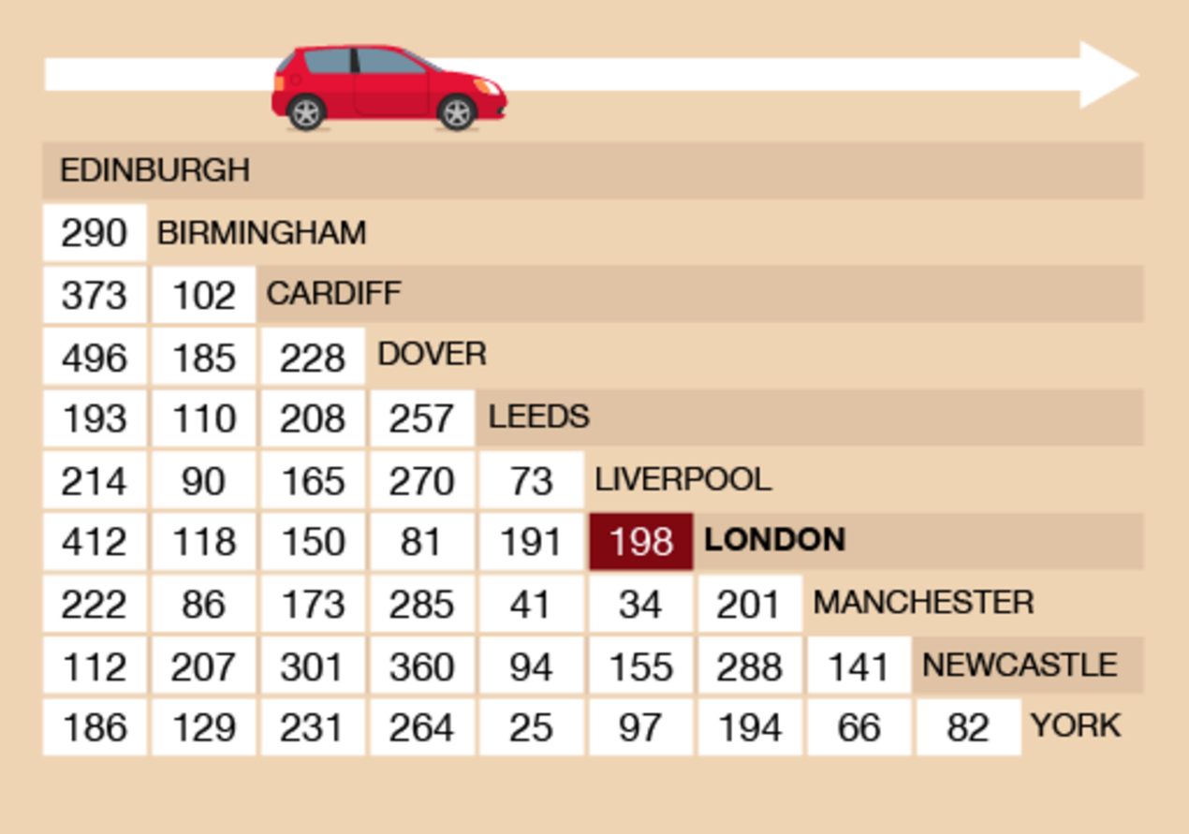
Figure 19 Liverpool to London on a mileage chart
View description - Figure 19 Liverpool to London on a mileage chart

So the total distance is:
  - 150 + 165 + 198 = 513 miles
  - The total distance is 513 miles and you pay 10p for each mile you drive. So you would pay:
  - 513 × 10 = 5,130p
  - You would not usually express an amount of money in this way, so let’s divide this total by 100 to find the amount in pounds:
  - 5,130 ÷ 100 = £51.30
- You need to use the mileage chart to compare the distances from Newcastle to Leeds and Newcastle to York.
Newcastle to Leeds is 94 miles.

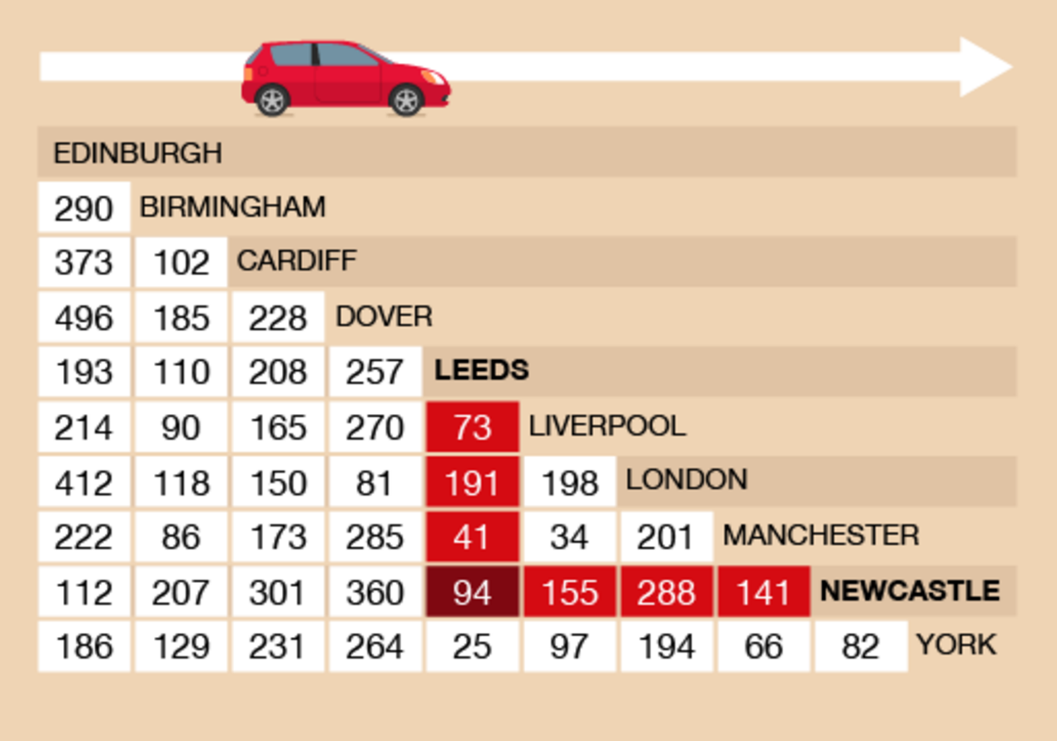
Figure 20 Newcastle to Leeds on a mileage chart
View description - Figure 20 Newcastle to Leeds on a mileage chart

Newcastle to York is 82 miles.

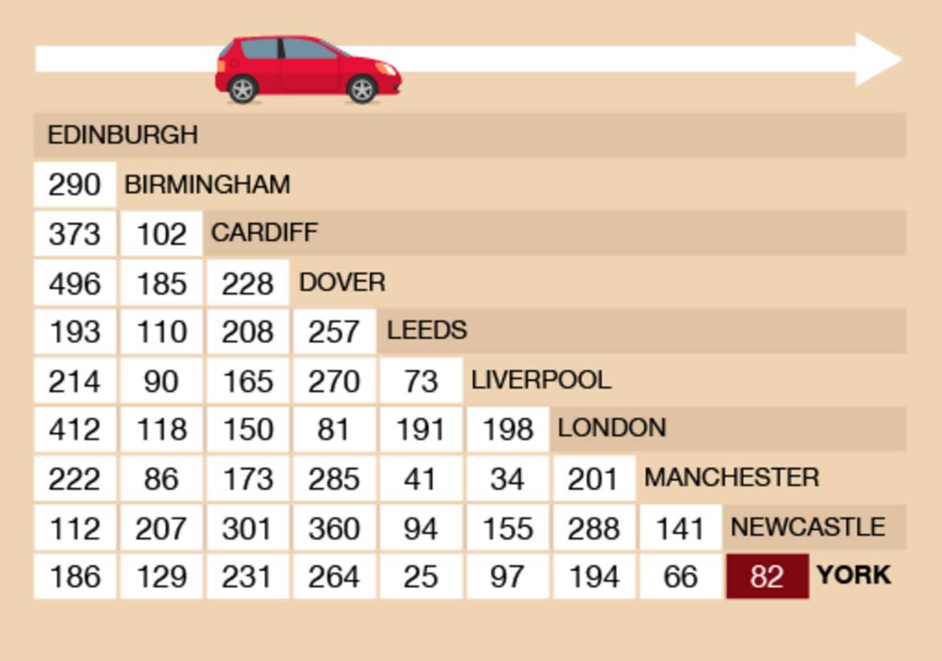
Figure 21 Newcastle to York on a mileage chart
View description - Figure 21 Newcastle to York on a mileage chart

So the trailer in York is closer.
Back to - Activity 5: Travelling across the UK

Activity 6: Reading scales

Answer
- There are nine marks between 100 g and 200 g, so each mark represents 10 g. The needle is at the fourth mark after 100g, so there is:
  - 100 + 40 = 140 g of sugar
- The needle is halfway between 60 kg and 70 kg, so the person weighs 65 kg.
- There are nine marks between 0 g and 100 g, so there’s a mark at every 10 g. The needle is two marks before 100 g, so the letter weighs:
  - 100 – 20 = 80 g
Back to - Activity 6: Reading scales

Activity 7: Weighing things

Discussion
Our suggestions are shown in the table below. Your estimates and measured weights might be different, but they should be roughly similar.

Item | Estimated weight | Actual weight
Ten teabags | 25 g | 30 g
Bottle of sauce | 500 g | 450 g
Book | 900 g | 720 g

A case of ten bottles of sauce would weigh:
- 450 × 10 = 4,500 g
As previously noted, 1,000 g = 1 kg, so 4,500 g = 4.5 kg – which is how you would more usually express this weight.
If your book weighed more than ours, you might have given its weight in kilograms. If you chose a small book, it may have weighed a lot less.
Back to - Activity 7: Weighing things

Activity 8: Converting weights

Answer
- A pound is a bit less than half a kilogram. To estimate what the weight allowance is in pounds, you need to multiply the amount in kilograms by 2:
  - 5 × 2 = 10 lbs
Alternatively, you could estimate how much your bag weighs in kilograms by dividing the amount in pounds by 2:
  - 7 ÷ 2 = 3.5 kg
Using either method, your bag doesn’t exceed the weight allowance.
- An ounce is a bit less than 30 g. To estimate how much sugar you need in ounces, you need to multiply the amount in ounces by 30:
  - 4 × 30 = 120 g
Alternatively, you could estimate how much sugar you have in ounces by dividing the amount in grams by 30:
  - 150 ÷ 30 = 5 oz
Using either method, you have enough sugar for the recipe.
Back to - Activity 8: Converting weights

Activity 9: Looking at volume

Answer
- I estimated that my cup holds 400 ml. It actually holds 350 ml.
- The divisions are marked every 0.1 ml. The pipette should look like this:

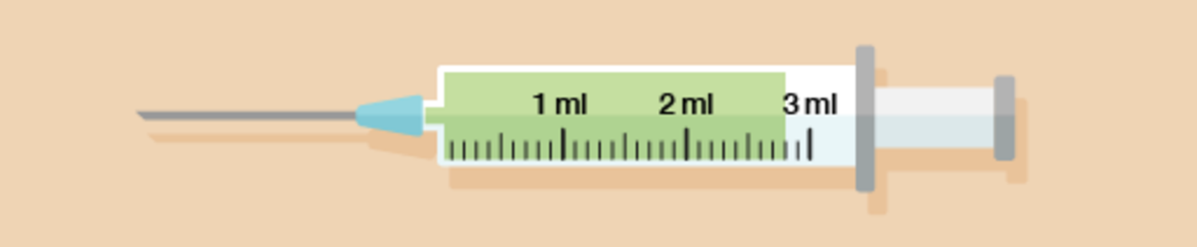
Figure 33 A pipette (answer)
View description - Figure 33 A pipette (answer)

- The plumber has drained two full one-litre jugs and three-quarters of another jug, making 2.75 litres in total.
Back to - Activity 9: Looking at volume

Activity 10: Converting between millilitres, centilitres and litres

Answer
- First you need to work out how much soup you will need in millilitres:
  - 100 × 400 = 40,000 ml
To convert from millilitres to litres, you need to divide the figure in millilitres by 1,000. So the amount of milk you need in litres is:
  - 40,000 ÷ 1,000 = 40 litres
- First you need to work out how many millilitres are in 2 litres of glue:
  - 2 × 1,000 = 2,000 ml
This amount is then divided between the twenty people working in the shop:
  - 2,000 ÷ 20 = 100 ml each
To convert this into centilitres, you would divide this answer by 10:
  - 100 ÷ 10 = 10 cl each
Back to - Activity 10: Converting between millilitres, centilitres and litres

Activity 11: Converting between metric and imperial measurements

Answer
- You know that:
  - 8 pts = 1 gallon (gal)
So you have to use eight times as much water as weedkiller.
If you use 1 litre of weedkiller, you will need 8 litres of water.
- A pint is a little more than half a litre, and the cartons of custard in the supermarket are 500 ml each. So to make one pint of custard, you would need to buy two cartons.
Back to - Activity 11: Converting between metric and imperial measurements

Activity 12: Reading thermometers

Answer
- Each mark on the thermometer represents 20°C and the needle is at the mark below 400, so the temperature is 380°C.
- The reading is on the mark halfway between 38°C and 39°C, so the temperature is 38.5°C.
- Each mark represents 2°C, so the temperature is 16°C.
Back to - Activity 12: Reading thermometers

Activity 13: Celsius and Fahrenheit

Answer
- You will see on the conversion chart that 150°C is equivalent to 302°F. The oven would not be marked this accurately, so you should set it to 300°F.
- The thermometer shows 1°F, which you need to fine the Celsius equivalent of. Five degrees Fahrenheit is –15°C; –4°F is –20°C. The temperature is between –15°C and –20°C, so the food is stored safely.
- You need to find 600°F on the chart. You will see that 300°C is 572°F, and that 350°C is more than 600°F. The temperature on the dial is even higher than this, at 370°C. The machine is therefore not safe and must be switched off.
Back to - Activity 13: Celsius and Fahrenheit

Activity 1: Rewriting numbers as tallies

Answer
Back to - Activity 1: Rewriting numbers as tallies

Activity 2: Creating a tally chart

Answer

Number of people in the house | Number of responses
1
2
3
4

Back to - Activity 2: Creating a tally chart

Activity 3: Creating a tally chart

Answer
Your table should look like this:

Number of cars with certain colours in a car park one lunchtime
Colour of car | Number of cars | Total
Black |  | 3
Blue |  | 4
Green |  | 2
Red |  | 6
White |  | 4
Yellow |  | 1

Back to - Activity 3: Creating a tally chart

Activity 4: A trip to the library

Answer
- The library is open all day on Wednesday and Friday.
- The library is open only in the afternoon on Tuesday.
Back to - Activity 4: A trip to the library

Activity 5: The waiter’s shift

Answer
- A suitable title would be something like ‘Drinks served during shift’.
- The row headings are ‘Tea’, ‘Coffee’, ‘Orange juice’, ‘Hot chocolate’ and ‘Coke’. The column headings are ‘Drinks’ and ‘Number served’.
- The waiter served five Cokes.
- The waiter served two orange juices and five Cokes, making seven cold drinks in total.
- The waiter served 6 + 7 + 2 + 3 + 5 = 23 drinks in total.
Back to - Activity 5: The waiter’s shift

Activity 6: Deciphering a key

Answer
means two people buying petrol and means one person buying petrol.
So the key can be used to show more than one item. This could be done to make the drawing of the pictogram easier when working with bigger numbers.
Back to - Activity 6: Deciphering a key

Activity 7: Creating a pictogram

Answer
Does your pictogram look like the one below?

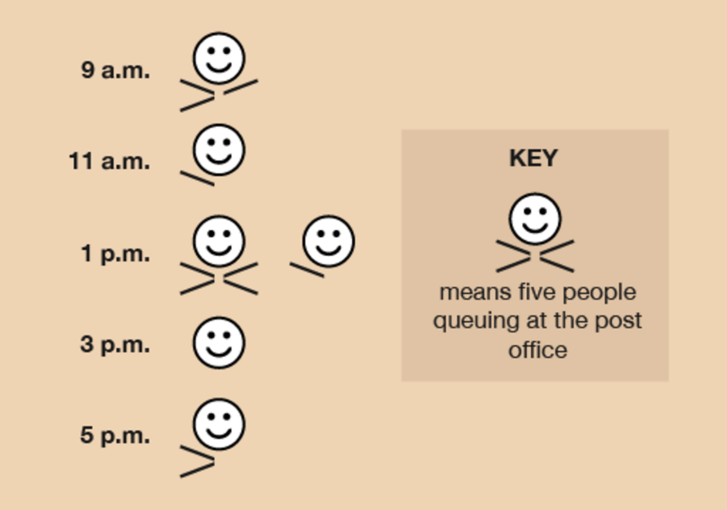
Figure 7 Post office pictogram
View description - Figure 7 Post office pictogram

Back to - Activity 7: Creating a pictogram

Activity 8: Creating a pie chart

Answer
To find out how many degrees each animal is represented by, you must carry out this calculation:
- 360 ÷ 18 = 20
Therefore, each animal is represented by 20°. We can then calculate the size of each section:

Pet | Frequency | Angle
Cat | 5 | 5 × 20° = 100°
Dog | 6 | 6 × 20° = 120°
Rabbit | 4 | 4 × 20° = 80°
Bird | 1 | 1 × 20° = 20°
Fish | 2 | 2 × 20° = 40°

From these measurements you should construct a pie chart as follows:

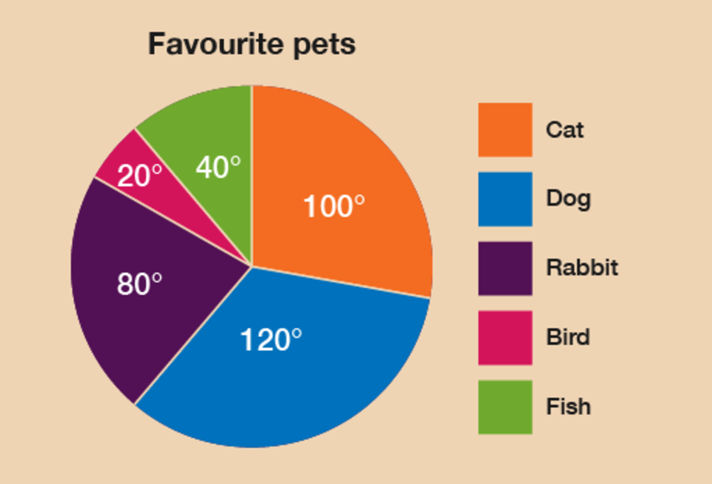
Figure 8 Pets pie chart
View description - Figure 8 Pets pie chart

Back to - Activity 8: Creating a pie chart

Activity 9: Creating a bar chart

Answer
Check with the following suggestions before continuing;
The most flights on one day is four, so you must ensure that the vertical axis should start at 0 and go up to 4.
You must label the horizontal axis with the names of the airlines and the vertical axis with the number of flights.
The title must clearly state what data the bar chart is showing.
Your graph should look something like the following:

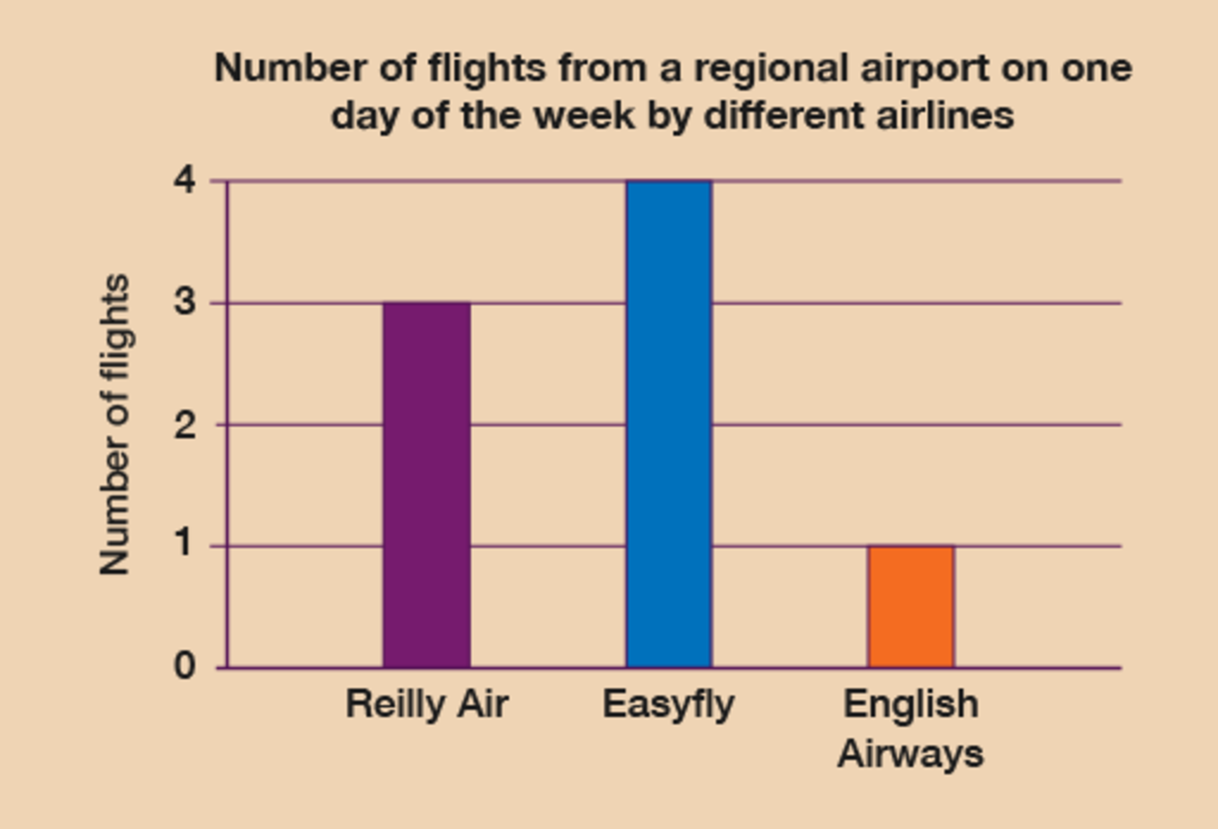
Figure 10 Flights bar chart
View description - Figure 10 Flights bar chart

Back to - Activity 9: Creating a bar chart

Activity 10: Creating a line graph

Answer
When drawing your line graph you should:
- draw the horizontal axis, labelling it ‘Months’, and the vertical axis, labelling it ‘Hours of sunshine’
- divide these axes into suitable scales – your smallest and largest numbers are 6 and 9, so your scale could be one square for one hour
- plot the points from your data, using a pencil and make small crosses
- join the points using a ruler
- give your graph a title such as ‘Hours of sunshine at a holiday resort over a six-month period’.
The finished line graph should look something like this:

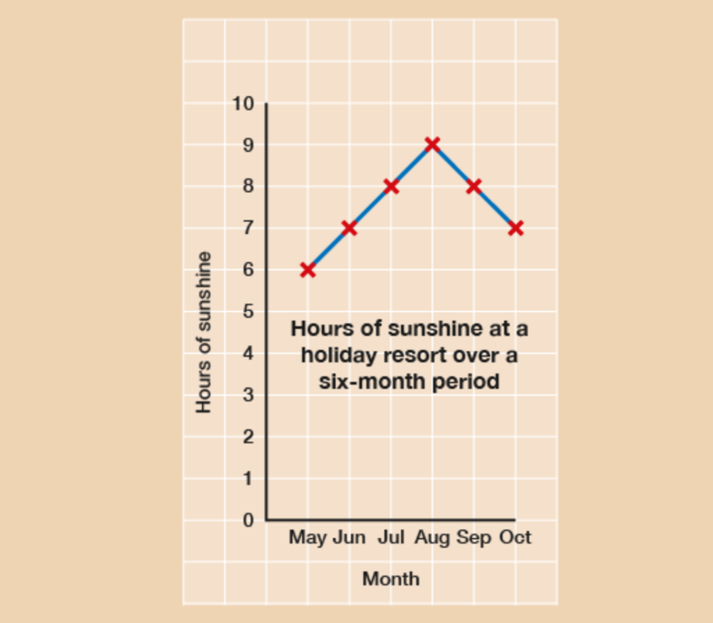
Figure 11 Sunshine line graph
View description - Figure 11 Sunshine line graph

In answer to the questions:
- August is the sunniest month.
- May is the least sunniest month.
Back to - Activity 10: Creating a line graph

Activity 11: Finding out averages

Answer
Check your answers with the answers below.
- First, add all of the ages together:
  - 4 + 6 + 8 + 10 = 28
Then divide this total by the amount of data given:
  - 28 ÷ 4 = 7
The average age is 7.
- You will find the following answers using the same calculation you used for question 1:
  - Add all the numbers (4 + 6 + 11 = 21) and then divide this answer by the amount of data given (21 ÷ 3 = 7). The answer is 7.
  - Add all the numbers (3 + 7 + 8 + 4 + 8 = 30) and then divide this answer by the amount of data given (30 ÷ 5 = 6). The answer is 6.
  - Add all the numbers (8 + 9 + 10 + 9 + 4 + 2 = 42) and then divide this answer by the amount of data given (42 ÷ 6 = 7). The answer is 7.
  - Add all the numbers (11 + 12 + 13 + 14 + 15 + 16 = 81) and then divide this answer by the amount of data given (81 ÷ 6 = 13.5). The answer is 13.5.
- The average number of goals per match is 2:
2 + 3 + 1 + 3 + 2 + 3 + 2 + 1 + 3 = 20
20 ÷ 10 = 2
Back to - Activity 11: Finding out averages

Activity 12: The maths test

Answer
- First, add up the total number of marks:
  - 5 + 6 + 6 + 4 + 4 + 7 + 3 + 5 + 6 + 7 + 8 + 6 + 2 + 8 + 5 + 4 + 5 + 6 + 5 + 6 = 108
Then divide this by the number of scores (or the number of students), which is 20:
  - 108 ÷ 20 = 5.4
So the average score is 5.4 out of 10.
- Again, first add up the total number of marks:
  - 4 + 6 + 6 + 4 + 4 + 6 + 1 + 5 + 6 + 6 + 7 + 6 + 1 + 9 + 5 + 3 + 5 + 6 + 5 + 5 = 100
Then divide this total by 20:
  - 100 ÷ 20 = 5
The best set of results was the first set. The teacher had not been marking it harshly.
Back to - Activity 12: The maths test

Activity 13: Finding ranges

Answer
Now check your answers with the suggestions below.
- The ranges are as follows:
  - 10 – 1 = 9
  - 11 – 2 = 9
  - 12 – 2 = 10
  - 15 – 1 = 14
- The answers are as follows:
  - Here’s the data set in order, with the lowest number first:

15 | 18 | 21 | 23 | 25
27 | 31 | 32 | 35 | 37
41 | 42 | 42 | 47 | 49
52 | 58 | 61 | 65 | 74

  - The lowest age is 15 years.
  - The highest age is 74 years.
  - The range is 74 – 15 = 59 years. If you wrote ‘15 to 74’, it’s the wrong answer. The range is one number. You need to work out the difference.
Back to - Activity 13: Finding ranges

Activity 14: Thinking about probability

Answer
There is no single correct answer to this activity. Have a look at our suggestions below:

Events with a high probability of happening | Events with an even chance of happening | Events with a low probability of happening
The Moon rising tonight | Tossing a coin and getting heads | Winning the lottery
Death | A baby being born a boy | Being kidnapped by aliens

Back to - Activity 14: Thinking about probability

Activity 15: Looking at probability

Answer
Here are the answers:

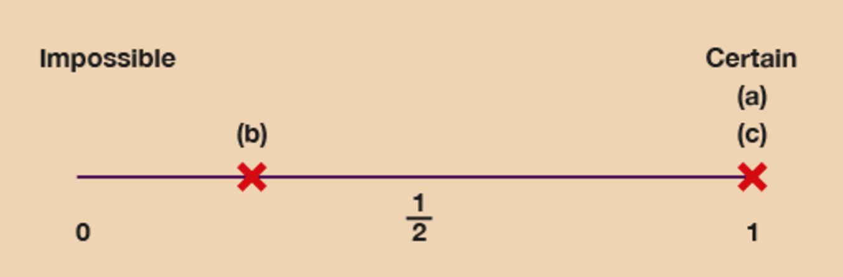
Figure 14 A probability scale (answer)
View description - Figure 14 A probability scale (answer)

Of course, if you are a long-distance runner or plan to be one, your location for (b) might be closer to 1!
Back to - Activity 15: Looking at probability

Activity 2: Finding the perimeter

Answer
Check your answers with the suggestions below before you move on.
- The sides of the tennis courts are 20 m and 40 m.
  - (2 × 20) + (2 × 40) = 40 + 80 = 120
So 120 m of bunting will be needed.
- The sides of the crime scene are 13 m and 10 m.
  - (2 × 10) + (2 × 13) = 20 + 26 = 46
So 46 m of police tape will be needed.
Back to - Activity 2: Finding the perimeter

Activity 3: Finding the perimeter

Answer
- To calculate the missing sides you should have carried out the following calculations:
  - 14 – 3 = 11
  - 15 – 1.5 = 13.5
Now that you have found the missing sides, you can add them all together:
  - 15 + 14 + 1.5 + 3 + 13.5 + 11= 58 m
- To calculate the missing sides you need to carry out the following calculations to calculate the perimeter:
  - 5 – 2 = 3
  - 6 – 2 = 4
Now that you have found the missing sides, you can add them all up together to calculate the perimeter:
  - 6 + 3 + 3 + 1 + 1 + 2 + 2 + 4 = 22 m
Back to - Activity 3: Finding the perimeter

Activity 4: Finding the area

Answer
- The plastic sheeting needs to be:
  - 2.5 × 4 = 10 square metres
- First you need to work out the area of the driveway:
  - 8 × 4 = 32 square metres
If each bag covers half a square metre, you will need two bags for each square metre:
  - 32 × 2 = 64 bags
- First you need to change the width to centimetres. 25 mm is the same as 2.5 cm. Then you can work out the area:
  - 2.5 × 4 = 10 square centimetres
There are 80 yeast, so the amount of yeast per square centimetre (yeast/cm²) is:
  - 80 ÷ 10 = 8 yeast per square centimetre
The recording sheet should look like this:

Yeast count
Sample area no. | 21
Date | 17 October
Yeast count | 80
Sample dimensions | 2.5 cm × 4 cm
Sample area | 10 cm²
Yeast/cm² | 8

- The area of forestry land is:
  - 4.5 × 2 = 9 square miles
Back to - Activity 4: Finding the area

Activity 5: Finding the area of an irregular shape

Answer
- First you need to calculate the area of the whole wall:
  - 4 × 2.5 = 10 m²
Then you need to calculate the area of the bookcase:
  - 2 × 2 = 4 m²
Then subtract the area of the bookcase from the area of the wall:
  - 10 – 4 = 6 m²
So the area of the wall that needs painting is 6 m².
- To calculate the non-winning area of the table, first you need to calculate the area of the whole table:
  - 1.5 × 2 = 3 m²
Then calculate the area of the ‘WIN!’ areas. One of these is:
  - 0.6 × 0.5 = 0.3 m²
There are two ‘WIN!’ areas, so you need to multiply this by 2:
  - 0.3 × 2 = 0.6 m²
You then subtract the ‘WIN!’ areas from the complete area of the table:
  - 3 – 0.6 = 2.4 m²
So 2.4 m² of the table is a non-winning area.
Back to - Activity 5: Finding the area of an irregular shape

Activity 6: Getting information from a scale drawing

Answer
- The answers are as follows:
  - The vegetable garden is 5 m long and 2 m wide.
  - The flower bed is 6 m long and 2 m wide.
  - The patio and vegetable garden are 3 m apart.
  - The distance between the patio and vegetable garden is 3 m and the trampoline is 3 m wide. So the trampoline would fit in the space, but it would be a bit of a squeeze.
- The length on the drawing is 9 cm, and the scale is 1:50. This means that 1 cm on the drawing is equal to 50 cm in real life. So to find out what 9 cm is in real life, you need to multiply it by 50:
  - 9 × 50 = 450 cm
The question asks for the length in metres, so you need to convert centimetres into metres:
  - 450 ÷ 100 = 4.5 m
The actual length of the wild area will be 4.5 m.
- You need to find out the width of three disabled parking spaces. The width of one parking space on the scale drawing is 2 cm, so first you need to multiply this by 3:
  - 2 × 3 = 6 cm
The scale is 1:125. This means that 1 cm on the drawing is equal to 125 cm in real life. So to find out what 6 cm is in real life, you need to multiply it by 125:
  - 6 × 125 = 750 cm
The question asks for the length in metres, so you need to convert centimetres into metres:
  - 750 ÷ 100 = 7.5 m
The actual width of all three parking bays will be 7.5 m.
Back to - Activity 6: Getting information from a scale drawing

Activity 7: Using a map to find distances

Answer
- The distance on the map between the pub and Hotel Sun is 4 cm on the map, and the scale is 1:1,000. This means that 1 cm on the drawing is equal to 1,000 cm in real life. So to find out what 4 cm is in real life, you need to multiply it by 1,000:
  - 4 × 1,000 = 4,000 cm
The question asks for the length in metres, so you need to convert centimetres into metres:
  - 4,000 ÷ 100 = 40 m
The actual distance in real life between the pub and Hotel Sun is 40 m.
- The distance on the map is 2 cm. Using the same calculation, the actual distance in real life between the Super Shop and the Beach Bistro is 20 m.
- The distance on the map is 6 cm. Using the same calculation, the actual distance in real life between Grooves nightclub and the beach is 60 m.
Back to - Activity 7: Using a map to find distances

Figure 1 Place value

Description
An image illustrating place value with the number 987,654,321. 987 is labelled ‘millions’, where the 9 is in the hundreds column, the 8 is in the tens column and the 7 is in the ones column. 654 is labelled ‘thousands’, where the 6 is in the hundreds column, the 5 is in the tens column and the 4 is in the ones column. 321 is labelled ‘units’, where the 3 is in the hundreds column, the 2 is in the tens column and the 1 is in the ones column.
Back to - Figure 1 Place value

Figure 2 Negative numbers on a thermometer

Description
An illustration of a thermometer, showing that anying below 0°C is a negative number.
Back to - Figure 2 Negative numbers on a thermometer

Figure 4 ‘Four or less, let it rest. Five or more, raise the score!’

Description
A rounding rhyme: ‘Four or less, let it rest. Five or more, raise the score!’
Back to - Figure 4 ‘Four or less, let it rest. Five or more, raise the score!’

Figure 5 A number line

Description
An illustration of a number line, with 64, 65 and 69 highlighted.
Back to - Figure 5 A number line

Figure 6 A number line

Description
An illustration of a number line, with 325, 350 and 365 highlighted.
Back to - Figure 6 A number line

Figure 7 A number line

Description
An illustration of a number line, with 4,060, 4,250, 4,500 and 4,650 highlighted.
Back to - Figure 7 A number line

Figure 8 A shopping list

Description
An illustration of a shopping list, featuring the following items and their prices: British beef mince, £2.20; eight thick beef sausages, £1.24, thick sliced white loaf, 72p; pasta (500g), 79p; corn flakes, £1.78; chocolate biscuits, £1.29; milk (6 pints), £2.12; potatoes, £1.98; tomatoes, 69p; bananas, 90p; apples, £1.49; coffee, £4.13.
Back to - Figure 8 A shopping list

Figure 9 How much for one armchair?

Description
An illustration of an armchair that has a price tag reading ‘???’.
Back to - Figure 9 How much for one armchair?

Figure 10 Looking at fractions

Description
A pie chart with four quarters. The top quarter reads ‘Fractions, decimals and percentages’. The other quarters read ‘’, ‘0.25’ and ‘25%’; ‘’ is highlighted.
Back to - Figure 10 Looking at fractions

Figure 11 Drawing the fractions

Description
An illustration that shows how to visualise 2 , 3 and 1 .
Back to - Figure 11 Drawing the fractions

Figure 12 Drawing the fractions

Description
An illustration that shows how to visualise 2 , 5 and 6 .
Back to - Figure 12 Drawing the fractions

Figure 13 Fractions in a sale

Description
An illustration of a shop with posters reading ‘Sale: off everything’ in its windows.
Back to - Figure 13 Fractions in a sale

Figure 14 How much would an extension cost?

Description
An illustration of a house.
Back to - Figure 14 How much would an extension cost?

Figure 15 Looking at decimals

Description
A pie chart with four quarters. The top quarter reads ‘Fractions, decimals and percentages’. The other quarters read ‘’, ‘0.25’ and ‘25%’; ‘0.25’ is highlighted.
Back to - Figure 15 Looking at decimals

Figure 16 What is a decimal point?

Description
An annotated illustration of the number 34.7. ‘3’ is labelled ‘tens’; ‘4’ is labelled ‘ones’; and ‘7’ is labelled ‘tenths’. The decimal point is also labelled.
Back to - Figure 16 What is a decimal point?

Figure 17 A number line

Description
An illustration of a number line, with 2.7 highlighted.
Back to - Figure 17 A number line

Figure 18 A number line

Description
An illustration of a number line, with 9.1 highlighted.
Back to - Figure 18 A number line

Figure 19 Using decimals

Description
A montage of three illustrations: (top left) a bottle of milk, labelled £1.98, and a box of corn flakes, labelled £2.65; (top right) the Leaning Tower of Pisa, a moped and the label ‘I love Italy’; (bottom) four meals and a receipt totalling £56.60.
Back to - Figure 19 Using decimals

Figure 20 Looking at percentages

Description
A pie chart with four quarters. The top quarter reads ‘Fractions, decimals and percentages’. The other quarters read ‘’, ‘0.25’ and ‘25%’; ‘25%’ is highlighted.
Back to - Figure 20 Looking at percentages

Figure 21 Examples of percentages

Description
A montage of four illustrations: (top left) a T-shirt with a price tag reading ‘Sale: 10% off’; (top right) a clothes label reading ‘30% cotton, 70% polyester’; (bottom left) a bank advert labelled ‘Mortgage rate only 3% – our lowest in 20 years!’; (bottom right) a newspaper with the headline ‘Public sector employees awarded 10% increase!’.
Back to - Figure 21 Examples of percentages

Figure 22 Comparing percentage discounts

Description
An illustration of two diamond rings. The ring from Shop A has a price tag of £500, with 25% off; the ring from Shop B has a price tage of £400, with 10% off.
Back to - Figure 22 Comparing percentage discounts

Figure 23 Increasing and decreasing percentages

Description
A montage of two illustrations: (left) a price tag reading ‘Sale: everything reduced by 20%’; (right) a newspaper with the headline ‘Nurses demand 30% increase in London weighting allowance’.
Back to - Figure 23 Increasing and decreasing percentages

Figure 24 The percentage button on a calculator

Description
An illustration of a calculator, with the percentage button (%) highlighted.
Back to - Figure 24 The percentage button on a calculator

Figure 25 Looking at equivalencies

Description
A montage of three illustrations: (top left) a poster reading ‘50% of the population will be obese by 2050’; (top right) a price tag reading ‘Closing down sale: everything price; (bottom) a newspaper with the headline ‘£2.5 million damages awarded for invasion of privacy’.
Back to - Figure 25 Looking at equivalencies

Figure 26 Talking ratios

Description
An illustration of two people talking. Person A: ‘For example, if you need to make ratatouille for four people and you have a recipe to make it for six people, what do you do?’ Person B: ‘That’s easy – you make it for six people and have the leftovers yourself!’ Person A: ‘So what if you have a recipe for four people and need to make a meal for six people?’ Person B: ‘Apologise to two of them and buy them fish and chips?’
Back to - Figure 26 Talking ratios

Figure 27 A cake

Description
An illustration of a cake.
Back to - Figure 27 A cake

Figure 28 A function machine

Description
An illustration of a function machine. The rules for the machine are to multiply by 3 and add 6.
Back to - Figure 28 A function machine

Figure 29 A function machine flow chart

Description
An illustration of a function machine flow chart. The rules are: ‘Best time for a practice run in minutes’; ‘Multiply by 2’; ‘Add 30’; ‘Expected marathon time in minutes’.
Back to - Figure 29 A function machine flow chart

Figure 30 A youth club

Description
An illustration of a youth club hall measuring 10m by 20m.
Back to - Figure 30 A youth club

Figure 31 A function machine flow chart

Description
An illustration of a function machine flow chart. The rules are: ‘Area of hall in square metres’; ‘Multiply by 2’; ‘Subtract 10’.
Back to - Figure 31 A function machine flow chart

Figure 32 A function machine flow chart

Description
An illustration of a function machine flow chart. The rules are: ‘Amount container holds (ml)’; ‘Divide by 2’; ‘Multiply by 9’; ‘Wax needed (g)’.
Back to - Figure 32 A function machine flow chart

Figure 33 A function machine flow chart

Description
An illustration of a function machine flow chart. The rules are: ‘Cost price’; ‘× 375’; ‘÷ 100’; ‘Selling price’.
Back to - Figure 33 A function machine flow chart

Figure 1 Measuring a pen

Description
An illustration of a pen held against a ruler. One end of the pen is level with 0 cm on the scale; the other end is level with 15 cm on the scale.
Back to - Figure 1 Measuring a pen

Figure 2 Measuring a DVD case

Description
An illustration of a DVD case held against a ruler. One end of the case is level with 0 cm on the scale; the other end is level with 19 cm on the scale.
Back to - Figure 2 Measuring a DVD case

Figure 3 Measuring a screw

Description
An illustration of a screw held against a ruler. One end of the screw is level with 0 cm on the scale; the other end is level with 2.5 cm on the scale.
Back to - Figure 3 Measuring a screw

Figure 4 Measuring a screw head

Description
An illustration of a screw head held against a ruler. One end of the screw is level with 0 mm on the scale; the other end is level with 5 mm on the scale.
Back to - Figure 4 Measuring a screw head

Figure 5 Measuring a pen (answer)

Description
An illustration of a DVD case held against a ruler. One end of the case is level with 0 cm on the scale; the other end is level with 19 cm on the scale.
Back to - Figure 5 Measuring a pen (answer)

Figure 6 Measuring a screw (answer)

Description
An illustration of a screw held against a ruler. One end of the screw is level with 0 cm on the scale; the other end is level with 2.5 cm on the scale.
Back to - Figure 6 Measuring a screw (answer)

Figure 7 Measuring a screw head (answer)

Description
An illustration of a screw head held against a ruler. One end of the screw is level with 0 mm on the scale; the other end is level with 5 mm on the scale.
Back to - Figure 7 Measuring a screw head (answer)

Figure 8 A conversion chart for length, mass and volume

Description
A conversion chart for length, mass and volume.
Length
cm × 10 for mm; mm ÷ 10 for cm
m × 100 for cm; cm ÷ 100 for m
km × 1,000 for m; m ÷ 1,000 for km
Mass
g × 1,000 for mg; mg ÷ 1,000 for g
kg × 1,000 for g; g ÷ 1,000 for kg
t × 1,000 for kg; kg ÷ 1,000 for t
Volume
l × 1,000 for ml; ml ÷ 1,000 for l
cl × 10 for ml; ml ÷ 10 for cl
l × 100 for cl; cl ÷ 100 for l
Back to - Figure 8 A conversion chart for length, mass and volume

Figure 9 A conversion chart for length

Description
A conversion chart for length
Length
cm × 10 for mm; mm ÷ 10 for cm
m × 100 for cm; cm ÷ 100 for m
km × 1,000 for m; m ÷ 1,000 for km
Back to - Figure 9 A conversion chart for length

Figure 10 A mileage chart

Description
A mileage chart showing the distances between Edinburgh, Birmingham, Cardiff, Dover, Looed, Liverpool, London, Manchester, Newcastle and York.
Back to - Figure 10 A mileage chart

Figure 11 Cardiff to Manchester on a mileage chart

Description
A mileage chart showing the distances between Edinburgh, Birmingham, Cardiff, Dover, Leeds, Liverpool, London, Manchester, Newcastle and York. The distance between Cardiff and Manchester is highlighted (173 miles).
Back to - Figure 11 Cardiff to Manchester on a mileage chart

Figure 12 A mileage chart for a European tour

Description
A mileage chart showing the distances between European cities (Amsterdam, Barcelona, Berlin, Bordeaux, Brussels, Cannes, Cologne, Florence, Frankfurt and Geneva) and Channel ports (Roscoff, Cherbourg, Le Havre, Dieppe, Calais, Zeebrigge and Hook of Holland).
Back to - Figure 12 A mileage chart for a European tour

Figure 13 A mileage chart for a European tour (answer)

Description
A mileage chart showing the distances between European cities (Amsterdam, Barcelona, Berlin, Bordeaux, Brussels, Cannes, Cologne, Florence, Frankfurt and Geneva) and Channel ports (Roscoff, Cherbourg, Le Havre, Dieppe, Calais, Zeebrigge and Hook of Holland). The distance between Florence and Calais is highlighted (860 miles).
Back to - Figure 13 A mileage chart for a European tour (answer)

Figure 14 Edinburgh to York on a mileage chart

Description
A mileage chart showing the distances between Edinburgh, Birmingham, Cardiff, Dover, Leeds, Liverpool, London, Manchester, Newcastle and York. The distance between Edinburgh and York is highlighted (186 miles).
Back to - Figure 14 Edinburgh to York on a mileage chart

Figure 15 London to York on a mileage chart

Description
A mileage chart showing the distances between Edinburgh, Birmingham, Cardiff, Dover, Leeds, Liverpool, London, Manchester, Newcastle and York. The distance between London and York is highlighted (194 miles).
Back to - Figure 15 London to York on a mileage chart

Figure 16 London to Edinburgh on a mileage chart

Description
A mileage chart showing the distances between Edinburgh, Birmingham, Cardiff, Dover, Leeds, Liverpool, London, Manchester, Newcastle and York. The distance between Edinburgh and London is highlighted (412 miles).
Back to - Figure 16 London to Edinburgh on a mileage chart

Figure 17 London to Cardiff on a mileage chart

Description
A mileage chart showing the distances between Edinburgh, Birmingham, Cardiff, Dover, Leeds, Liverpool, London, Manchester, Newcastle and York. The distance between Cardiff and London is highlighted (150 miles).
Back to - Figure 17 London to Cardiff on a mileage chart

Figure 18 Cardiff to Liverpool on a mileage chart

Description
A mileage chart showing the distances between Edinburgh, Birmingham, Cardiff, Dover, Leeds, Liverpool, London, Manchester, Newcastle and York. The distance between Cardiff and Liverpool is highlighted (165 miles).
Back to - Figure 18 Cardiff to Liverpool on a mileage chart

Figure 19 Liverpool to London on a mileage chart

Description
A mileage chart showing the distances between Edinburgh, Birmingham, Cardiff, Dover, Leeds, Liverpool, London, Manchester, Newcastle and York. The distance between Liverpool and London is highlighted (198 miles).
Back to - Figure 19 Liverpool to London on a mileage chart

Figure 20 Newcastle to Leeds on a mileage chart

Description
A mileage chart showing the distances between Edinburgh, Birmingham, Cardiff, Dover, Leeds, Liverpool, London, Manchester, Newcastle and York. The distance between Leeds and Newcastle is highlighted (94 miles).
Back to - Figure 20 Newcastle to Leeds on a mileage chart

Figure 21 Newcastle to York on a mileage chart

Description
A mileage chart showing the distances between Edinburgh, Birmingham, Cardiff, Dover, Leeds, Liverpool, London, Manchester, Newcastle and York. The distance between Newcastle and York is highlighted (82 miles).
Back to - Figure 21 Newcastle to York on a mileage chart

Figure 22 Using different scales for dufferent objects

Description
A montage of two illustrations: (left) a letter on a set of digital scales weighing 0.50 g; (right) sugar on a set of scales weighing 150 g.
Back to - Figure 22 Using different scales for dufferent objects

Figure 23 Weighing flour

Description
An illustration of flour in a set of scales. There are four marks between 50 g and 100 g, each representing another 10 g. The needle is level with the second mark.
Back to - Figure 23 Weighing flour

Figure 24 Weighing sugar

Description
An illustration of sugar in a set of scales. There are four marks between 100 g and 150 g, each representing another 10 g. The needle is level with the fourth mark.
Back to - Figure 24 Weighing sugar

Figure 25 Weighing a person

Description
An illustration of someone standing on weighing scales. There are nine marks between 60 kg and 70 kg, each representing another 1 kg. The needle is level with the fifth mark.
Back to - Figure 25 Weighing a person

Figure 26 Weighing a letter

Description
An illustration of a letter on a set of scales. There are nine marks between 0 g and 100 g, each representing another 10 g. The needle is level with the eighth mark.
Back to - Figure 26 Weighing a letter

Figure 27 A teaspoon

Description
An illustration of a teaspoon.
Back to - Figure 27 A teaspoon

Figure 28 A measuring jug

Description
An illustration of a measuring jug.
Back to - Figure 28 A measuring jug

Figure 29 Measuring liquids in a measuring jug

Description
An illustration of a measuring jug. It has a scale on the side up to 500 ml.
Back to - Figure 29 Measuring liquids in a measuring jug

Figure 30 Measuring liquids in a measuring jug (answer)

Description
An illustration of a measuring jug. It has a scale on the side up to 500 ml. The water is level with 350 ml on the scale.
Back to - Figure 30 Measuring liquids in a measuring jug (answer)

Figure 31 A pipette

Description
An illustration of a pipette. The scale goes up to 3 ml, with nine marks between each millilitre.
Back to - Figure 31 A pipette

Figure 32 Three measuring jugs

Description
An illustration of three measuring jugs. The water is level with ‘1 litre’ on the first two jugs and with on the third.
Back to - Figure 32 Three measuring jugs

Figure 33 A pipette (answer)

Description
An illustration of a pipette filled to 2.8 ml.
Back to - Figure 33 A pipette (answer)

Figure 34 A conversion chart for volume

Description
A conversion chart for volume.
Volume
l × 1,000 for ml; ml ÷ 1,000 for l
cl × 10 for ml; ml ÷ 10 for cl
l × 100 for cl; cl ÷ 100 for l
Back to - Figure 34 A conversion chart for volume

Figure 35 Using metric and imperial units

Description
An illustration of a measuring jug showing metric and imperial units, and a milk bottle labelled ‘2.27 litres, 4 pints’. Underneath the bottle is ‘1 litre = 0.568 pints’.
Back to - Figure 35 Using metric and imperial units

Figure 36 Comparing temperatures

Description
An illustration of two thermometers, one showing –15°C, the other showing 25°C.
Back to - Figure 36 Comparing temperatures

Figure 37 Reading the temperatures

Description
An illustration of two thermometers. In the first, there are four marks between 20°C and 30°C, and the temperature is level with the second mark. In the second, there is one mark between 37°C and 38°C, and the temperature is level with this mark.
Back to - Figure 37 Reading the temperatures

Figure 38 A thermometer

Description
An illustration of a thermometer. There are four marks between 300°C and 400°C, and the temperature is level with the fourth mark.
Back to - Figure 38 A thermometer

Figure 39 A thermometer

Description
An illustration of a thermometer. There is one mark between 38°C and 39°C, and the temperature is level with this mark.
Back to - Figure 39 A thermometer

Figure 40 A thermometer

Description
An illustration of a thermometer. There are four marks between 10°C and 20°C, and the temperature is level with the third mark.
Back to - Figure 40 A thermometer

Figure 41 Warning labels

Description
An illustration of a label reading ‘Caution: do not use below –5°C or above 30°C’, and a label on a jar of tablets reading ‘Store at 5°C’.
Back to - Figure 41 Warning labels

Figure 42 Temperatures in Celsius and Fahrenheit

Description
An illustration of a list of ingredients with cooking instructions (‘Ingredients: 1 oz butter (25 g); 1 small onion, finely chopped; oz flour (10 g); 3 oz Cheddar cheese (75 g), grated; 1 egg yolk; 1 tablespoon grated Parmesan cheese; cook at 180°C (350°F)’), and a weather warning (‘August temperatures: 35–38°C (95–100°F)’.
Back to - Figure 42 Temperatures in Celsius and Fahrenheit

Figure 43 Using a thermometer in safe storage

Description
An illustration of a thermometer. There are four marks between 10°C and 15°C, and the temperature is level with the third mark.
Back to - Figure 43 Using a thermometer in safe storage

Figure 44 Converting temperatures on old thermometers

Description
An illustration of a thermometer and a bag of frozen peas. The temperature is level with 1°F.
Back to - Figure 44 Converting temperatures on old thermometers

Figure 45 A thermometer

Description
An illustration of a thermometer. There are four marks between 300°C and 400°C, and the temperature is halfway between the third and fourth mark.
Back to - Figure 45 A thermometer

Figure 1 Which holiday suits you best?

Description
A page from a skiing brochure, including a table that lists which features are part of ‘intensive training’, ‘ultimate experience’ or ‘improvement courses’.
Back to - Figure 1 Which holiday suits you best?

Figure 2 Rows and tables

Description
An illustration showing examples of rows and columns in a table.
Back to - Figure 2 Rows and tables

Figure 3 A bus timetable

Description
A bus timetable.
Back to - Figure 3 A bus timetable

Figure 4 A bus timetable (answer)

Description
A bus timetable.
Back to - Figure 4 A bus timetable (answer)

Figure 5 Car wash pictogram

Description
An illustration with a label ‘Sunday afternoon’, with three cars, and ‘Monday afternoon’, with one car. The key is that a picture of a car ‘means one car using the car wash’.
Back to - Figure 5 Car wash pictogram

Figure 6 Petrol pictogram

Description
An illustration with a label ‘Sunday afternoon’, with one stick figure, and ‘Monday afternoon’, with three stick figures.
Back to - Figure 6 Petrol pictogram

Figure 7 Post office pictogram

Description
A pictogram showing the information in the previous table, where a stick figure with a head, two arms and two legs means five people queuing at the post office. The label ‘9 a.m.’ has a stick figure with a head, two arms and one leg; the label ‘11 a.m.’ has a stick figure with a head and one arm; the label ‘1 p.m.’ has a stick figure with a head, two arms and two legs and a stick figure with a head and one arm; the label ‘3 p.m.’ has a stick figure with a head; and the label ‘5 p.m.’ has a stick figure with a head, one arm and one leg.
Back to - Figure 7 Post office pictogram

Figure 8 Pets pie chart

Description
An illustration of a pie chart showing the information in the previous table.
Back to - Figure 8 Pets pie chart

Figure 9 Traffic bar chart

Description
An illustration of a bar chart showing the information in the previous table.
Back to - Figure 9 Traffic bar chart

Figure 10 Flights bar chart

Description
An illustration of a bar chart showing the information in the previous table.
Back to - Figure 10 Flights bar chart

Figure 11 Sunshine line graph

Description
An illustration of a line graph showing the information in the previous table.
Back to - Figure 11 Sunshine line graph

Figure 12 An example of a data set

Description
An illustration of a list of numbers: 4, 2, 9, 7, 6, 3, 5, 8, 2, 3, 4. Three of the numbers have been crossed off.
Back to - Figure 12 An example of a data set

Figure 13 A probability scale

Description
An illustration of a probability scale. It is a horizontal line: above the line, the left-hand end is labelled ‘Impossible’ and the right-hand end is labelled ‘Certain’; below the line, the left-hand end is labelled ‘0’, the midway point is labelled ‘’ and the right-hand end is labelled ‘1’.
Back to - Figure 13 A probability scale

Figure 14 A probability scale (answer)

Description
An illustration of a probability scale. It is a horizontal line: above the line, the left-hand end is labelled ‘Impossible’ and the right-hand end is labelled ‘Certain’; below the line, the left-hand end is labelled ‘0’, the midway point is labelled ‘’ and the right-hand end is labelled ‘1’. A cross labelled ‘(b)’ is about a quarter of the way along the line; a second cross, labelled ‘(a)’ and ‘(c)’, is at the right-hand end of the line.
Back to - Figure 14 A probability scale (answer)

Figure 1 Looking at perimeters

Description
An illustration of an oblong and a right-angled triangle. The sides of both shapes are labelled with measurements. The oblong’s sides are 10 cm, 5 cm, 10 cm and 5 cm (totalling 30 cm), and the triangle’s sides are 4 cm, 5 cm and 3 cm (totalling 12 cm).
Back to - Figure 1 Looking at perimeters

Figure 2 Calculating the length of ribbon

Description
An illustration of an oblong and an equilateral triangle. The sides of both sides are labelled with measurements. The oblong’s sides are 6 cm (×2) and 4 cm (×2), and the triangle’s sides are 5 cm, 5 cm and 5 cm.
Back to - Figure 2 Calculating the length of ribbon

Figure 3 A lawn

Description
An illustration showing a lawn that measures 15 m by 8 m.
Back to - Figure 3 A lawn

Figure 4 Four tennis courts

Description
An illustration showing a row of four tennis courts that measures 40 m by 20 m.
Back to - Figure 4 Four tennis courts

Figure 5 A crime scene

Description
An illustration showing a crime scene that measures 13 m by 10 m.
Back to - Figure 5 A crime scene

Figure 6 A pathway

Description
An illustration showing an irregular shape. Not all of its horizontal and vertical medges are measured: of those that are, the horizontal edges measure 1.5 m and 15 m, and the vertical edges measure 3 m and 14 m.
Back to - Figure 6 A pathway

Figure 7 A new extension

Description
An illustration showing an irregular shape. Not all of its horizontal and vertical medges are measured: of those that are, the horizontal edges measure 1 m, 1 m and 6 m, and the vertical edges measure 2 m and 5 m.
Back to - Figure 7 A new extension

Figure 8 Paving slabs

Description
An illustration of three rows of six paving slabs.
Back to - Figure 8 Paving slabs

Figure 9 A rug

Description
An illustration showing a rug that measures 3 m by 90 cm.
Back to - Figure 9 A rug

Figure 10 A pond

Description
An illustration showing a pond that measures 4 m by 2.5 m.
Back to - Figure 10 A pond

Figure 11 A driveway

Description
An illustration showing a driveway that measures 8 m by 4 m.
Back to - Figure 11 A driveway

Figure 12 A petri dish

Description
An illustration showing a petri dish with a highlighted section that measures 4 cm by 25 mm.
Back to - Figure 12 A petri dish

Figure 13 A forest

Description
An illustration showing a forest that measures 4.5 miles by 2 miles.
Back to - Figure 13 A forest

Figure 14 A wall

Description
An illustration showing a wall that measures 4 m by 2.5 m. It includes a fixed bookcase that measures 2 m by 2 m.
Back to - Figure 14 A wall

Figure 15 ‘Roll a coin!’

Description
An illustration showing a tabletop game at a fête that measures 2.0 m by 1.5 m. It includes two areas labelled ‘WIN!’ that each measure 0.5 m by 0.6 m .
Back to - Figure 15 ‘Roll a coin!’

Figure 16 A scale drawing of a garden

Description
An illustration of a scale drawing of a garden. It is drawn on square paper (nine squares wide, eight squares tall) and the scale is 1:100. In the top left corner is the vegetable garden, which is five squares wide and two squares high; in the top right corner is the shed, which is two squares wide and two squares high; in the bottom left corner is the patio, which is five squares wide and three squares high; in the bottom right corner is the flower bed, which is two squares wide and six squares high.
Back to - Figure 16 A scale drawing of a garden

Figure 17 A scale drawing of a garden

Description
An illustration of a scale drawing of a garden. It is drawn on scale paper and the scale is 1:100. In the top left corner is the vegetable garden, which is five squares wide and two squares high; in the top right corner is the shed, which is two squares wide and two squares high; in the bottom left corner is the patio, which is five squares wide and three squares high; in the bottom right corner is the flower bed, which is two squares wide and six squares high.
Back to - Figure 17 A scale drawing of a garden

Figure 18 A scale drawing of a wild area of a garden

Description
An illustration of a scale drawing of a wild area in a garden. It is labelled 9 cm wide and the scale is 1:50.
Back to - Figure 18 A scale drawing of a wild area of a garden

Figure 19 A scale drawing of a car park

Description
An illustration of a scale drawing of car parking spaces. A space is labelled 2 cm wide and the scale is 1:125.
Back to - Figure 19 A scale drawing of a car park

Figure 20 A scale drawing of a holiday resort

Description
An illustration of a scale drawing of El Sunno resort. It is drawn on square paper (10×10) and the scale is 1:1,000. There are various attractions included on the map (the beach, Hotel Party, Grooves Nightclub, Beach Bistro, a pub, Super Shop and Hotel Sun). There are also crosses to mark entrances to buildings. The x,y coordinates of the entrances are as follows: the beach (2,8), Grooves Nightclub (8,8), Beach Bistro (5,5), a pub (6,6), Super Shop (5,3) and Hotel Sun (6,2).
Back to - Figure 20 A scale drawing of a holiday resort

Figure 21 A scale drawing of a holiday resort

Description
An illustration of a scale drawing of El Sunno resort. It is drawn on square paper (10×10) and the scale is 1:1,000. There are various attractions included on the map (the beach, Hotel Party, Grooves Nightclub, Beach Bistro, a pub, Super Shop and Hotel Sun). There are also crosses to mark entrances to buildings. The x,y coordinates of the entrances are as follows: the beach (2,8), Grooves Nightclub (8,8), Beach Bistro (5,5), a pub (6,6), Super Shop (5,3) and Hotel Sun (6,2).
Back to - Figure 21 A scale drawing of a holiday resort

Uncaptioned interactive content

Transcript
[MUSIC PLAYING]
Whether you’re out shopping, busy at work or even at home, numbers are everywhere.
It’s impossible to avoid them. From knowing what size clothes to shop for to working out how much money you have to spend, it’s hard to imagine a world without numbers.
A basic understanding of maths and numbers is important for so many decisions we make in our everyday lives. And whatever it is you’re shopping for, you will have to deal with fractions as well as percentages, which can be really useful when working out whether a special offer is, in fact, a bargain. If you’re mixing cement, the idea of ratio and proportion is really important, in just the same way as if you’re working out the correct quantities of ingredients you need for baking.
In everyday life, numbers don’t have to be a challenge. They can be useful in all sorts of ways.
Back to - Uncaptioned interactive content

Uncaptioned interactive content

Transcript
In this video, you’re going to look at equivalent fractions, decimals and percentages. First, let’s look at turning fractions into decimals. You have the fraction one quarter. To turn this into a decimal, you need to divide the top of the fraction by the bottom. 1 divided by 4 equals 0.25. Therefore, 0.25 is the equivalent decimal.
Let’s have a look at another fraction, three fifths. (Remember, divide the top of the fraction by the bottom.) 3 divided by 5 equals 0.6. So 0.6 is the equivalent decimal.
Now let’s try one last fraction see if you can calculate it before the answer is revealed! Two fifths: divide the top by the bottom. 2 divided by 5 equals 0.4. So the decimal is 0.4.
Now let’s use the decimals that we’ve calculated to find the percentage equivalent. A percentage is out of 100. Remember, ‘cent’ means 100. So to turn a decimal into a percentage, you need to multiply the decimal by 100.
For example, 0.25 times 100 equals 25. This is 25%.
0.6 times 100 equals 60, 60%.
0.4 times 100 equals 40. This is 40%.
Now, looking at the table, you can see how fractions, decimals and percentages relate to each other. You just need to remember the basic rules of turning a fraction into a decimal: you divide the top by the bottom, then, once you have the decimal, you can convert to per cent by multiplying by 100, remembering that ‘cent’ means 100.
Thank you for watching. Now you have a go.
Back to - Uncaptioned interactive content

Uncaptioned interactive content

Transcript
A chicken takes 20 minutes per kilogram to cook, plus an extra 30 minutes. So how long does a 1.5-kilogram chicken take to cook? The formula here is 20 minutes per kilogram, plus 30 minutes.
So to work out how long a 1.5-kilogram chicken takes to cook, you’ll need a formula with two steps.
Step 1: 20 minutes times number of kilograms.
Step 2: add 30 minutes.
So if you write this out as a formula: 20 times number of kilograms plus 30 equals cooking time. You don’t need to worry about why there are brackets in this formula. That’s how we know that we need to do this sum first before we add the 30 minutes.
Then you just need to put the numbers in the right place. In this case, you would replace number of kilograms with 1.5. 20 times 1.5 plus 30 equals 60 minutes. Your chicken will take one hour to cook.
Back to - Uncaptioned interactive content

Uncaptioned interactive content

Transcript
Take a look at this pie chart showing the top holiday destinations for a group of workers in a factory. You’ll see that pie charts must contain both a title and a key, explaining what each segment or colour means.
So when do we use pie charts? It’s usually when we have a few pieces of information about different parts of one whole group the whole pie. It’s a clear way of showing data because you can quickly see what has the biggest or smallest slice of the pie.
In the example, you can see that the most popular holiday destination was France, because this has the biggest slice. The example also notes the size of each segment in degrees. So if you know the number of people the chart is dealing with, you can work out how many went to Spain, Portugal, France and Greece.
Let’s create a pie chart to show you how it’s done. So in a survey, 36 people were asked what their favourite soap opera was. Their responses were as follows: Coronation Street, 18; EastEnders, 9; Hollyoaks, 6; other or none, 3. To draw a pie chart, first you need to work out the size of each section of the circle, or each slice of the pie. To do this, you need to remember that angles are measured in degrees, written like this, and that a circle is divided into 360 degrees.
In this example, we’re told that 36 people were surveyed. So you need to work out how many degrees of your circle one person makes. If 360 degrees (the total number of degrees in a circle) is equivalent to 36 people (the total number of people surveyed), this means that one person equals 360 divided by 36, which equals 10. So every 10 degrees of the pie represents one person. You can then work out what the size of each slice or category should be.
So for Coronation Street, 18 people times 10 degrees equals 180 degrees. EastEnders, 9 people times 10 degrees equals 90 degrees. For Hollyoaks, 6 people times 10 degrees equals 60 degrees. And other/none, 3 people times 10 degrees equals 30 degrees. You can now start to draw your pie chart.
First, you need to draw a circle. The best way to do this is with a compass. If you don’t have a compass, drawing around a circular object or using a double protractor will be fine but you will need to find out the centre of the circle, which you might be able to guess. Next, draw a line from the centre of the circle to the top of the circle. This will be the line that you start drawing your slices from.
Using a protractor, measure each slice one after the other. First, place the protractor on top of the line you’re drawing an angle from. Then, count along the protractor the number of degrees you want your angle to be. Mark this on your circle. Then use the straight side of the protractor to draw a line from the line you started with to the mark you’ve just made. You can also include the degrees.
In this example, you’ll draw a slice that is 180 degrees for Coronation Street. From that line, you’ll draw a slice of 90 degrees for EastEnders. Work through all the data categories until you get to the line you started with.
Colour or shade each slice differently adding a key. Give your pie chart a title. Here is the pie chart for the soap opera data.
Here’s a summary. Find out what the whole of the pie is going to represent. This is the total of your categories added together. Divide 360 (the size of a circle in degrees) by this total to tell you what one unit of your data makes. Use a calculator if you need to. Multiply the amount for this one unit by the size of each category. This gives the size of what each segment should be in degrees. Draw a circle and draw a line from the middle of the circle to the top. Starting from this line, use a protractor to measure and draw each slice. Label the slices and give your pie chart a title.
Back to - Uncaptioned interactive content

Uncaptioned interactive content

Transcript
Here is a table showing the number of houses sold by an estate agent over a six-month period. How could you represent this information as a line graph?
To draw this in a graph, you need to first draw the axes. The months go on the bottom (horizontal) axis, and the house sales go up the left-hand side on the vertical axis.
Next, we need to decide on how we divide up these axes. There are six months, so there will be six marks on the horizontal axis. The highest number of house sales was 9, so the vertical axis will go from 0 to 10.
Now we can begin to mark our points. Starting with the first row of the table, you go up the line marked January, and then when you get to the line going across marked 2, you make a small cross. You then do this for the other points. Finally, you join the points using a ruler, and add your title.
Here’s a summary. To draw a line graph, you need to draw the horizontal and vertical axes and label them. Divide these axes into suitable scales to do this, you need to look at the data and find out what the smallest and largest numbers are. Plot the points from your data using a pencil to make small crosses. Join the points using a ruler, and give your graph a title.
Back to - Uncaptioned interactive content

Uncaptioned interactive content

Transcript
Say you needed to find the perimeter of this shape, but two of the measurements are missing. How would you find them out? You can assume that all of the corners are right angles. You need to use the measurements that you do know.
So if you want to find out the missing side on the right, you know that the left-hand side opposite to this is 12 millimetres long. And there is another measurement on the same side in the middle of the shape that is 7 millimetres long.
The missing length must then be the difference between 7 and 12 millimetres. Here’s a sum to show this: 12 minus 7 equals 5 millimetres. So the answer for the right-hand side is 5 millimetres. You can check this by adding 5 and 7, which makes 12 millimetres, the same as the left-hand side.
To find out the length at the bottom of the shape, because you know that all of the corners are right angles, you can add together the other two parallel measurements that are given: 15 plus 8 equals 23 millimetres. So the bottom of the shape is 23 millimetres.
Now you know the measurements for all of the shape’s edges, you can measure the perimeter. 12 plus 15 plus 7 plus 8 plus 5 plus 23 equals 70 millimetres. So the perimeter is 70 millimetres.
Back to - Uncaptioned interactive content

Figure 3 A newspaper headline

Description
A newspaper with the headline ‘Pop Idols: 9,653,000 youngsters vote in final’.
Back to - Figure 3 A newspaper headline

Uncaptioned InlineFigure

Description
The sum £2.65 + £1.98 = £4.93.
Error! Hyperlink reference not valid.

Uncaptioned InlineFigure

Description
The sum £5.00 – £4.63 = £0.37.
Error! Hyperlink reference not valid.

Uncaptioned InlineFigure

Description
The sum 1.4 × 8 = 11.2.
Error! Hyperlink reference not valid.

Uncaptioned InlineFigure

Description
The sum 56.60 ÷ 4 = 14.15.
Error! Hyperlink reference not valid.

Uncaptioned InlineFigure

Description
A tally count of 1.
Error! Hyperlink reference not valid.

Uncaptioned InlineFigure

Description
A tally count of 5.
Error! Hyperlink reference not valid.

Uncaptioned InlineFigure

Description
A tally count of 4.
Error! Hyperlink reference not valid.

Uncaptioned InlineFigure

Description
A tally count of 5.
Error! Hyperlink reference not valid.

Uncaptioned InlineFigure

Description
A tally count of 5.
Error! Hyperlink reference not valid.

Uncaptioned InlineFigure

Description
A tally count of 1.
Error! Hyperlink reference not valid.

Uncaptioned InlineFigure

Description
A tally count of 5.
Error! Hyperlink reference not valid.

Uncaptioned InlineFigure

Description
A tally count of 5.
Error! Hyperlink reference not valid.

Uncaptioned InlineFigure

Description
A tally count of 3.
Error! Hyperlink reference not valid.

Uncaptioned InlineFigure

Description
A tally count of 5.
Error! Hyperlink reference not valid.

Uncaptioned InlineFigure

Description
A tally count of 2.
Error! Hyperlink reference not valid.

Uncaptioned InlineFigure

Description
A tally count of 5.
Error! Hyperlink reference not valid.

Uncaptioned InlineFigure

Description
A tally count of 4.
Error! Hyperlink reference not valid.

Uncaptioned InlineFigure

Description
A tally count of 5.
Error! Hyperlink reference not valid.

Uncaptioned InlineFigure

Description
A tally count of 5.
Error! Hyperlink reference not valid.

Uncaptioned InlineFigure

Description
A tally count of 4.
Error! Hyperlink reference not valid.

Uncaptioned InlineFigure

Description
A tally count of 5.
Error! Hyperlink reference not valid.

Uncaptioned InlineFigure

Description
A tally count of 5.
Error! Hyperlink reference not valid.

Uncaptioned InlineFigure

Description
A tally count of 5.
Error! Hyperlink reference not valid.

Uncaptioned InlineFigure

Description
A tally count of 3.
Error! Hyperlink reference not valid.

Uncaptioned InlineFigure

Description
A tally count of 4.
Error! Hyperlink reference not valid.

Uncaptioned InlineFigure

Description
A tally count of 3.
Error! Hyperlink reference not valid.

Uncaptioned InlineFigure

Description
A tally count of 1.
Error! Hyperlink reference not valid.

Uncaptioned InlineFigure

Description
A tally count of 2.
Error! Hyperlink reference not valid.

Uncaptioned InlineFigure

Description
A tally count of 1.
Error! Hyperlink reference not valid.

Uncaptioned InlineFigure

Description
A tally count of 4.
Error! Hyperlink reference not valid.

Uncaptioned InlineFigure

Description
A tally count of 5.
Error! Hyperlink reference not valid.

Uncaptioned InlineFigure

Description
A tally count of 3.
Error! Hyperlink reference not valid.

Uncaptioned InlineFigure

Description
A tally count of 5.
Error! Hyperlink reference not valid.

Uncaptioned InlineFigure

Description
A tally count of 1.
Error! Hyperlink reference not valid.

Uncaptioned InlineFigure

Description
A tally count of 2.
Error! Hyperlink reference not valid.

Uncaptioned InlineFigure

Description
A tally count of 3.
Error! Hyperlink reference not valid.

Uncaptioned InlineFigure

Description
A tally count of 4.
Error! Hyperlink reference not valid.

Uncaptioned InlineFigure

Description
A tally count of 2.
Error! Hyperlink reference not valid.

Uncaptioned InlineFigure

Description
A tally count of 5.
Error! Hyperlink reference not valid.

Uncaptioned InlineFigure

Description
A tally count of 1.
Error! Hyperlink reference not valid.

Uncaptioned InlineFigure

Description
A tally count of 4.
Error! Hyperlink reference not valid.

Uncaptioned InlineFigure

Description
A tally count of 1.
Error! Hyperlink reference not valid.

Uncaptioned InlineFigure

Description
A sun icon.
Error! Hyperlink reference not valid.

Uncaptioned InlineFigure

Description
A sun-and-showers icon.
Error! Hyperlink reference not valid.

Uncaptioned InlineFigure

Description
A sun icon.
Error! Hyperlink reference not valid.

Uncaptioned InlineFigure

Description
A sun icon.
Error! Hyperlink reference not valid.

Uncaptioned InlineFigure

Description
A sun icon.
Error! Hyperlink reference not valid.

Uncaptioned InlineFigure

Description
A lightning icon.
Error! Hyperlink reference not valid.

Uncaptioned InlineFigure

Description
A rain icon.
Error! Hyperlink reference not valid.

Uncaptioned InlineFigure

Description
A lightning icon.
Error! Hyperlink reference not valid.

Uncaptioned InlineFigure

Description
A lightning icon.
Error! Hyperlink reference not valid.

Uncaptioned InlineFigure

Description
A sun icon.
Error! Hyperlink reference not valid.

Uncaptioned InlineFigure

Description
A tally count of 5.
Error! Hyperlink reference not valid.

Uncaptioned InlineFigure

Description
A tally count of 1.
Error! Hyperlink reference not valid.

Uncaptioned InlineFigure

Description
A tally count of 5.
Error! Hyperlink reference not valid.

Uncaptioned InlineFigure

Description
A tally count of 2.
Error! Hyperlink reference not valid.

Uncaptioned InlineFigure

Description
A tally count of 2.
Error! Hyperlink reference not valid.

Uncaptioned InlineFigure

Description
A tally count of 3.
Error! Hyperlink reference not valid.

Uncaptioned InlineFigure

Description
A tally count of 5.
Error! Hyperlink reference not valid.

Uncaptioned InlineFigure

Description
A stick figure with a head, two arms and two legs.
Error! Hyperlink reference not valid.

Uncaptioned InlineFigure

Description
A stick figure with a head, two arms and two legs.
Error! Hyperlink reference not valid.

Uncaptioned InlineFigure

Description
A stick figure with a head, two arms and one leg.
Error! Hyperlink reference not valid.

Uncaptioned InlineFigure

Description
A stick figure with a head, one arm and one leg.
Error! Hyperlink reference not valid.

Uncaptioned InlineFigure

Description
A stick figure with a head and one arm.
Error! Hyperlink reference not valid.

Uncaptioned InlineFigure

Description
A stick figure with a head.
Error! Hyperlink reference not valid.

Uncaptioned InlineFigure

Description
A stick figure with a head and one arm.
Error! Hyperlink reference not valid.

Uncaptioned InlineFigure

Description
A stick figure with a head.
Error! Hyperlink reference not valid.

Uncaptioned InlineFigure

Description
A stick figure with a head, two arms and two legs.
Error! Hyperlink reference not valid.

