

S296_1

Exploring cells with digital fluorescence microscopy

About this free course
This free course is an adapted extract from the Open University course .
This version of the content may include video, images and interactive content that may not be optimised for your device.
You can experience this free course as it was originally designed on OpenLearn, the home of free learning from The Open University –
There you’ll also be able to track your progress via your activity record, which you can use to demonstrate your learning.
First published 2025.
Unless otherwise stated, copyright © 2025 The Open University, all rights reserved.
Intellectual property
Unless otherwise stated, this resource is released under the terms of the Creative Commons Licence v4.0 http://creativecommons.org/licenses/by-nc-sa/4.0/deed.en. Within that The Open University interprets this licence in the following way: www.open.edu/openlearn/about-openlearn/frequently-asked-questions-on-openlearn. Copyright and rights falling outside the terms of the Creative Commons Licence are retained or controlled by The Open University. Please read the full text before using any of the content.
We believe the primary barrier to accessing high-quality educational experiences is cost, which is why we aim to publish as much free content as possible under an open licence. If it proves difficult to release content under our preferred Creative Commons licence (e.g. because we can’t afford or gain the clearances or find suitable alternatives), we will still release the materials for free under a personal end-user licence.
This is because the learning experience will always be the same high quality offering and that should always be seen as positive – even if at times the licensing is different to Creative Commons.
When using the content you must attribute us (The Open University) (the OU) and any identified author in accordance with the terms of the Creative Commons Licence.
The Acknowledgements section is used to list, amongst other things, third party (Proprietary), licensed content which is not subject to Creative Commons licensing. Proprietary content must be used (retained) intact and in context to the content at all times.
The Acknowledgements section is also used to bring to your attention any other Special Restrictions which may apply to the content. For example there may be times when the Creative Commons Non-Commercial Sharealike licence does not apply to any of the content even if owned by us (The Open University). In these instances, unless stated otherwise, the content may be used for personal and non-commercial use.
We have also identified as Proprietary other material included in the content which is not subject to Creative Commons Licence. These are OU logos, trading names and may extend to certain photographic and video images and sound recordings and any other material as may be brought to your attention.
Unauthorised use of any of the content may constitute a breach of the terms and conditions and/or intellectual property laws.
We reserve the right to alter, amend or bring to an end any terms and conditions provided here without notice.
All rights falling outside the terms of the Creative Commons licence are retained or controlled by The Open University.
Head of Intellectual Property, The Open University

Contents
- Introduction
- Learning outcomes
- 1 Introduction to microscopy
  - 1.1 Why do we need microscopy?
  - 1.2 Magnification and resolution are important when studying details
- 2 Types of microscopy
  - 2.1 Components of a light microscope
  - 2.2 Fluorescence (light) microscopy
  - 2.3 Components of a fluorescence microscope
  - 2.4 Electron microscopy
- 3 The science behind fluorescence and its applications in microscopy
  - 3.1 Fluorescence is activated by light
  - 3.2 The colour of the emitted light depends on the fluorescent molecule
- 4 Applying fluorescence microscopy to make cells colourful
  - 4.1 Journey into a cell
  - 4.2 Using dyes (or probes) to stain structures
  - 4.3 Immunolabelling
  - 4.4 Expression of fluorescent proteins
  - 4.5 Similarities and differences between the three types of microscopy
- 5 Why is fluorescence microscopy so versatile?
  - 5.1 Fluorescence microscopy allows observing specific structures individually and combined
  - 5.2 Fluorescence microscopy allows visualising dynamic processes
  - 5.3 Specialised applications: Confocal microscopy
  - 5.4 Specialised applications: Studying molecular dynamics
  - 5.5 Specialised applications: Super-resolution microscopy
- 6 Inspecting structures in a 3D cell
- 7 Using the digital fluorescence microscope
- 8 Quiz
- Conclusion
- Further reading
- Acknowledgements
- Glossary
- Solutions
- Descriptions

Introduction
[Editor: course image to be added (banner on front page / top of each page)]
[Editor: I thought one of the DFM images would be a logical pick. I couldn't find any of those specific images on the protein atlas site (to find the largest / highest res version), so I've dropped in something else that felt visually striking... any thoughts on that, or something else specific we should use?]
[Editor: source for image currently in place, HPA056283: HeLa: https://www.proteinatlas.org/ENSG00000114745-GORASP1/subcellular]
For centuries, humans have wondered what lies beyond what we can see. With the invention of the microscope, we unlocked an entirely new dimension, revealing the delicate architecture of cells, the vibrant complexity of bacteria, and even the atoms that build our world. Microscopy is not just a tool, it’s a portal into the hidden stories of life, science, and discovery. This powerful technology has transformed our understanding of biology, medicine, and materials, and continues to push the boundaries of what is possible.
But what if we wanted to do more than just see? What if we wanted to highlight specific parts of this hidden world, make them glow, move, and tell their own stories? That’s where fluorescence microscopy comes in.
Fluorescence microscopy doesn’t just show us what’s there, it lets us light up the inner workings of life in stunning colours. By tagging molecules with fluorescent markers, we can track proteins inside cells, follow the spread of disease, or even watch neurons communicate in real time. It’s like turning on the lights in a dark room and discovering not just objects, but activity, interaction, and purpose.
This course will explore how this glowing frontier of microscopy is helping us unlock secrets at the cellular level and pushing science to new and exciting frontiers.
You will begin by building a solid foundation in the basic principles that underpin microscopy. From there, you will get a brief overview of the various types of microscopy and how they reveal different aspects of the microscopic world. Then, the course will dive deeper into the captivating realm of fluorescence microscopy, where glowing markers bring cellular processes to life in vivid detail. Along the way, you will revisit key cellular structures through an interactive 3D cell model, before applying your knowledge in the final section by exploring real biological samples using a digital fluorescence microscope.
Throughout the course you will encounter many micrographs, images taken with a microscope, and some videos that illustrate the power of microscopy. Questions and quizzes will help you to test your understanding throughout the course.
To gain maximum benefit from the course, you should have a basic understanding of the structures you can find inside cells. The free OpenLearn course ‘A tour of the cell’ can help you to acquire or deepen this knowledge. It also shows many images taken with electron microscopy, perfect if you are curious about this technique. If you are interested in exploring light microscopy in more detail including how to stain samples for histological examination, the free OpenLearn course ‘Histology, microscopy, anatomy and disease’ may also be of interest to you.
This OpenLearn course is an adapted extract from the Open University course S296 Cell and molecular biology.

Learning outcomes
After studying this course, you should be able to:
- describe some of the key principles of microscopy (with a focus on fluorescent microscopy) and the differences of light, fluorescence (light) and electron microscopy
- describe some labelling techniques used in fluorescence microscopy
- explore the structures and organelles found in a cell via fluorescence microscopy
- understand how to use a digital fluorescence microscope to collect data and images
- interpret images and data collected using fluorescence microscopy.

1 Introduction to microscopy
In this first section, you will be introduced to the units and sizes commonly used to measure structures within cells, some of which you may already be familiar with. You then explore the factors that determine how much detail a microscope can reveal and be introduced to the concept of resolution. By applying this concept, you will understand why an electron microscope can reveal cellular structures in far greater detail than a light microscope.

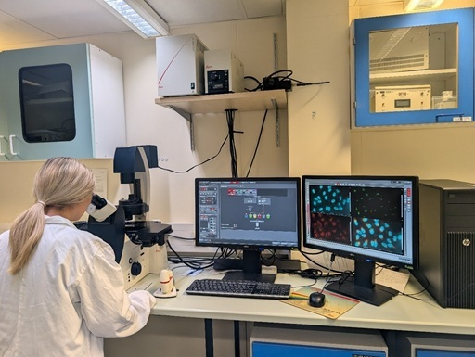
Figure 1 PhD student using a fluorescence microscope in The Open University’s laboratories.
View description - Figure 1 PhD student using a fluorescence microscope in The Open University’s l ...

1.1 Why do we need microscopy?
Almost all cells are too small to be seen with the naked eye, so the study of cellular structure only began with the development of lenses and microscopes that could magnify cells many hundreds of times. A typical bacterium, for example, is about one micrometre in diameter and no more than a few micrometres in length (Box 1).

Box 1 Units used to measure the size of cells
To get down to the scale of cells, a unit of length is needed that is one-thousandth of a millimetre. This unit is the micrometre – abbreviated to µm (µ is the Greek letter mu) and sometimes referred to as a micron.
An even smaller unit, called the nanometre (abbreviated to nm), is needed when describing the size of subcellular components such as organelles, the membrane-bound structures inside eukaryotic cells that have a specific function. A nanometre is one-thousandth of a micrometre (Table 1).

Table 1 SI units of length.
Unit (symbol) | Multiple in metres | Multiple in micrometres
metre (m) |  | 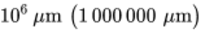
centimetre (cm) |  | 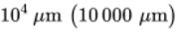
millimetre (mm) | 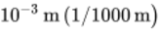 | 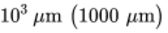
micrometre (µm) | 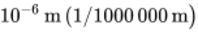
nanometre (nm) | 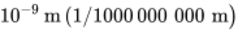 | 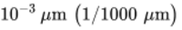

If you are not familiar with the very small units of measurement mentioned in Box 1, you should study Figure 2 and work through the questions that follow. Familiarity with the relative sizes of various molecules and organisms will be helpful in this topic and throughout the module.

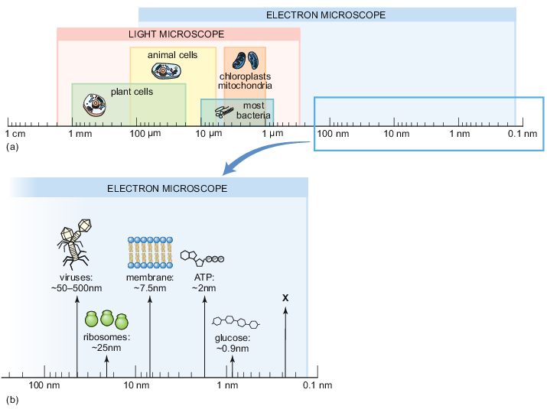
Figure 2 The relative sizes of cells, organelles and molecules arranged on a logarithmic scale: (a) shows structures larger than 100 nm which can be visualised using light and electron microscopy; (b) shows those smaller than 100 nm which can only be visualised in an electron microscope.
View description - Figure 2 The relative sizes of cells, organelles and molecules arranged on a logarithmic ...

How many nanometres are there in one millimetre?

View answer - SAQ

What type of scale is used in Figure 2 and why is it used?

View answer - SAQ

In Figure 2, approximately what size is the structure labelled as X?

View answer - SAQ

What is the size range (from smallest to largest) of bacteria in micrometres and in nanometres?

View answer - SAQ

Next, you’ll be introduced to the important difference between magnification and resolution, which helps you to understand why some microscopy techniques allow you to see more detail.

1.2 Magnification and resolution are important when studying details
You should now be familiar with the sizes of cells and structures that you will see when using the digital fluorescence microscope. Before you get to that, it’s important to understand the difference between two different terms: magnification and resolution. Magnification describes by how much a microscope or a digital camera can enlarge, or magnify, an object. This increases the size in which you can see a structure – think about the zoom a camera can offer you. However, whilst the structure is enlarged, it might become blurry and you can’t see the details. The ability of being able to separate two neighbouring objects in an image is described with the term resolution (i.e. the two objects can be resolved; they do not appear as a single object). You might be familiar with the concept of resolution from using digital cameras. A camera with more Megapixels has a higher resolution, meaning that it will show more details when enlarging the image compared to an image taken with a camera that has fewer Megapixels. A typical light microscope has a maximum resolution of around 200 nm, whilst electron microscopy can achieve a resolution of around 0.1 nm.

Inspect Figure 3 and state which of the panels has been taken on a microscope with a higher resolution.

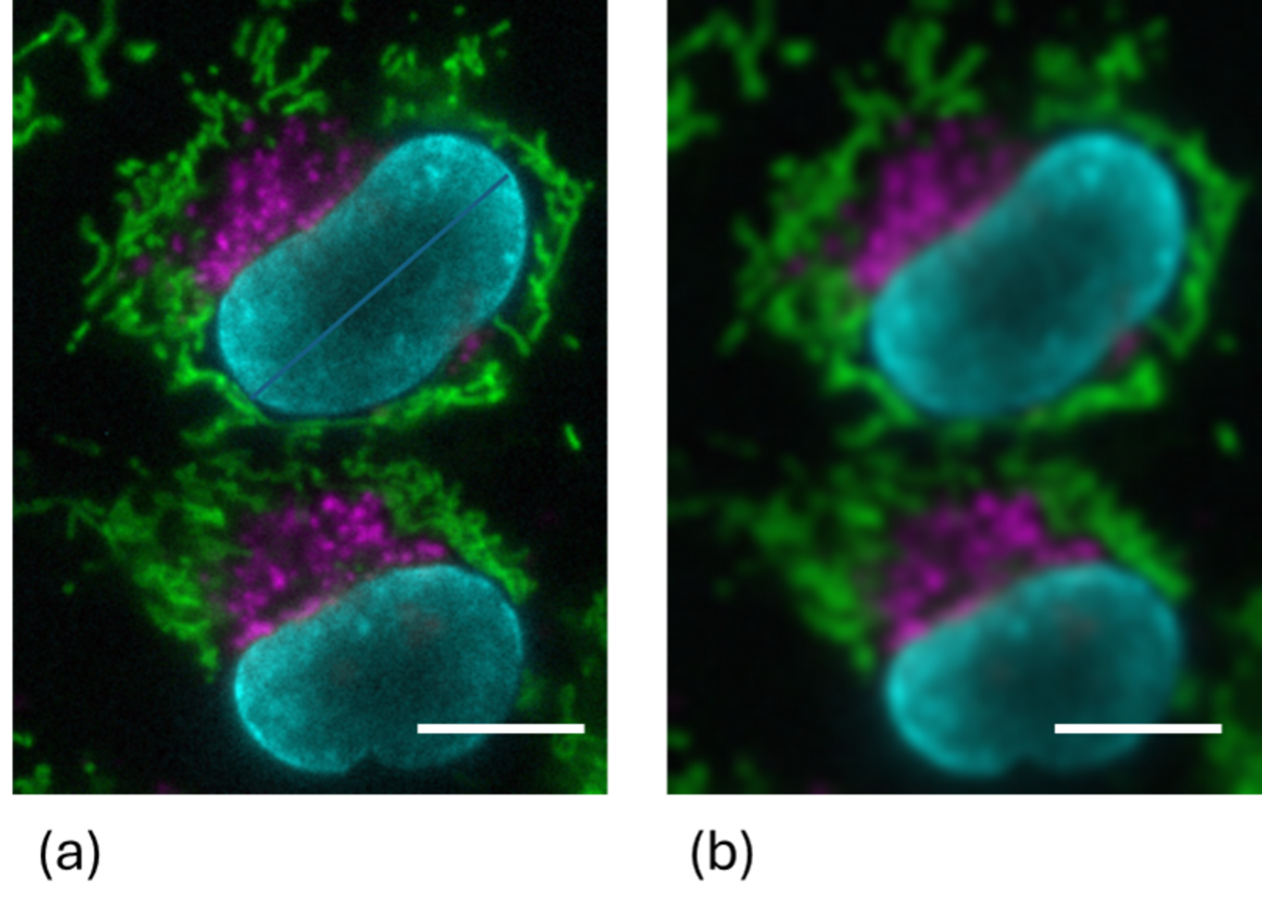
Figure 3 Two fluorescence micrographs of the same structure inside a cell, taken at two different resolutions. The scale bar equals 10 µm.
View description - Figure 3 Two fluorescence micrographs of the same structure inside a cell, taken ...

Panel (a)
Panel (b)
View answer - SAQ

So, it’s not just about zooming in (magnification), it’s about how clearly you can see once you’ve zoomed in and that’s resolution.

2 Types of microscopy
The three different microscopy techniques most commonly used to study cells are light microscopy, fluorescence (light) microscopy and electron microscopy. The first two use light to visualise the sample, while electron microscopy uses a beam of electrons. Because cells have a very limited contrast, they are difficult to see clearly under any microscope without staining. Various staining techniques can be used to visualise structures, or even specific proteins, inside cells. The choice of staining method depends on the type of microscopy, and the particular research question being addressed.
Each type of microscopy has its own advantages and limitations, which you will explore as you learn more about the three types. Examples of cells visualised with each technique are shown in Figure 4.

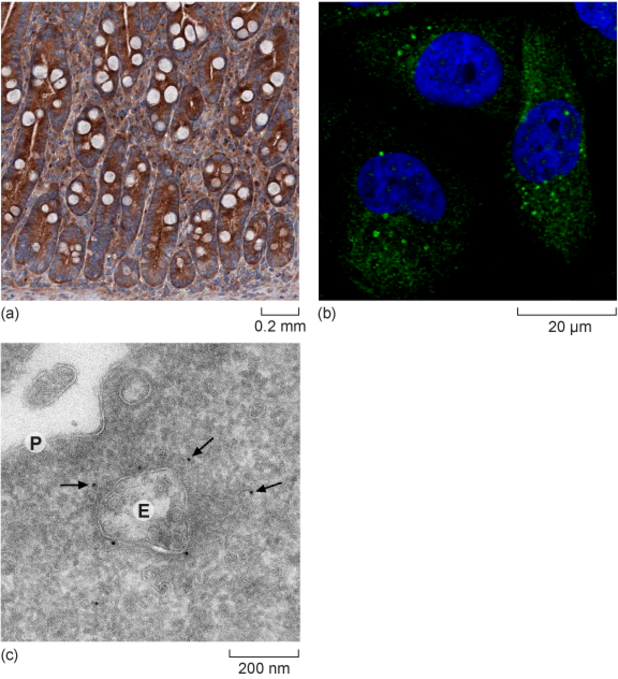
Figure 4 (a) Light microscopy image showing the protein of interest stained brown. (b) Fluorescence microscopy image with the protein of interest labeled in green and cell nuclei in blue. (c) Transmission electron microscopy (TEM) image. The dark dots indicated by arrows represent the protein of interest. ‘E’ marks an endosome, and ‘P’ indicates the plasma membrane.
View description - Figure 4 (a) Light microscopy image showing the protein of interest stained brown. ...

What difference can you observe in the scale bars shown in Figure 3?

View answer - SAQ

Which of the panels in Figure 3 was taken with the highest resolution?

View answer - SAQ

Box 2 Use of scale bars in microscopy
The magnification of a structure in a micrograph, an image taken using a microscope, results as a combination of several steps in which the original structure is magnified. First, the microscope objective applies a magnification. Them the camera used for taking the image can apply an additional magnification. Finally, the computer software displaying the image can also apply magnification or display the image in various sizes, depending on your screen. That’s why stating the magnification is not the most useful way to show the size of a structure, and where the use of scale bars is critical.
A scale bar is added to a micrograph to illustrate the size of the cells or structure independent of the equipment used to display it, and independent of the size of the image that is displayed. It can be shown within or underneath the micrograph. In multi-panel figures, one scale bar might apply to several images.

You will now be introduced to the components of light microscopes.

2.1 Components of a light microscope
All microscopes use a series of magnifying lenses to enable very small objects such as cells to be seen by the human eye. A light microscope (or optical microscope) uses visible light to illuminate the sample and glass lenses to focus and magnify the image. Light microscopy can magnify an object up to about 1000 times the original size, obtain a resolution of around 200 nm and it can be used with either living or fixed cells. The box below briefly explains how a light microscope works.

Box 3 How a light microscope works
In a light microscope, three lenses are important for forming the magnified image: the condenser, the objective and the camera (Figure 5).

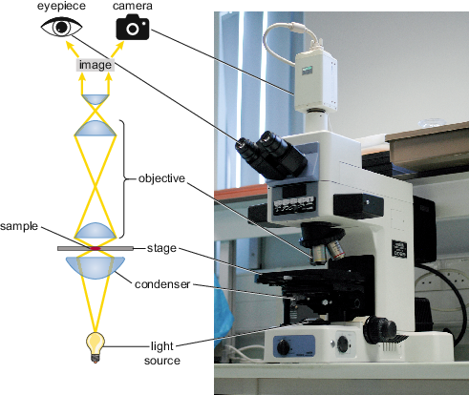
Figure 5 A compound (multiple lens) light microscope with a diagram illustrating how the condenser focuses light on the sample and transmits the light through the objective and eyepiece lenses to the observer.
View description - Figure 5 A compound (multiple lens) light microscope with a diagram illustrating ...

The condenser focuses a beam of light onto the sample placed on the stage. In an upright microscope, like the one shown in Figure 4, the light source and condenser are both located beneath the stage. The focused beam of light is transmitted through the sample and then passes through the objective, which magnifies the image and passes it to the eyepiece(s), or to a camera that directs the captured image to a computer screen. The image is brought into sharp focus by moving the sample closer to, or further from, the objective. Most microscopes have several objectives ranging from ×4 to ×100 magnification (note that ‘×’ means times and indicates the times-fold magnification). The eyepiece adds further magnification, often ×10. For example, the total magnification achieved by a ×4 objective combined with a ×10 eyepiece will be 4 × 10 = ×40. Often, additional magnification is added by the camera taking the images, or within computer software. When using digital microscopes later in this topic, you will gain experience with using different objectives and magnifications.

To increase the contrast and visualise specific structures in cells or tissues, different staining techniques can be used. Light microscopy is very important as a technique to detect changes in cell structure during the development of diseases and are routinely used in pathology labs around the world. If you are interested to learn more about histology, the study of the microscopic structure of complex plant and animal tissues, the free OpenLearn course ‘Histology, microscopy, anatomy and disease’ provides a lot more information. In this course, you will now take a look at fluorescence microscopy.

2.2 Fluorescence (light) microscopy
A particularly insightful technique that scientists use to obtain information about the structure and function of the inner workings of cells is fluorescence microscopy (also called fluorescence imaging).
Fluorescence is very much part of the natural world. You may be aware of fluorescent lighting, perhaps in your home or workplace, but fluorescence is also abundant in minerals, plants and animals. The jellyfish Aequorea victoria is an example of an animal that uses fluorescence as part of its defence against predators (Figure 6).

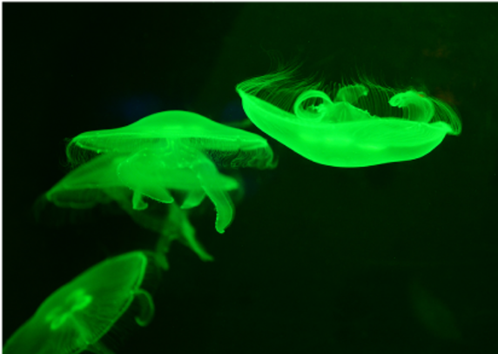
Figure 6 Green fluorescent protein fluorescence in the jellyfish Aequorea victoria.
View description - Figure 6 Green fluorescent protein fluorescence in the jellyfish Aequorea victor ...

This jellyfish became famous when the gene that encodes the protein that makes it appear fluorescent, green fluorescent protein (GFP), was isolated and cloned. GFP, along with many other fluorescent proteins that have different colours, has since been used extensively in cell biology research.
The awarding of the 2008 Nobel Prize in Chemistry to Roger Tsien, Osamu Shimomura, and Martin Chalfie for their work in characterising green fluorescent protein (GFP) highlights the profound impact of fluorescent proteins on biological research. Their groundbreaking contributions have revolutionised how scientists visualise and study cellular processes in real time. For more information on GFP and its applications, see the ‘Further Reading’ section at the end of this course.

2.3 Components of a fluorescence microscope
Fluorescence microscopes are similar to conventional light microscopes but include special filters that allow specific wavelengths of light to illuminate the sample and detect the emitted fluorescence (Figure 7). While understanding the technical details of these filters is not necessary for this course, it is helpful to know that they enable the detection of fluorescent signals from labeled cell and tissue components. When working with living cells growing in a dish or flask, researchers often use a so-called inverted microscope. In an inverted microscope, the objectives are located below the sample and the light is directed from above, making it easier for the researcher to access and manipulate the sample.

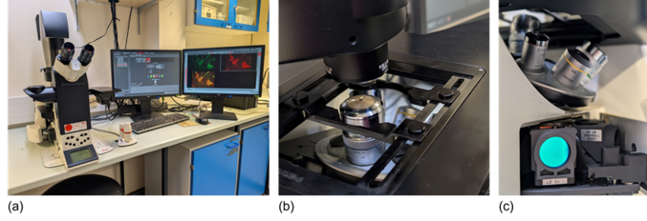
Figure 7 Inverted fluorescence (light) microscope at The Open University. (a) shows the whole microscope including the computer used to control the microscope and acquire the images. (b) Detailed view of the objectives, places underneath the sample. (c) Filters that allows selecting light of a specific wavelength to illuminate the sample.

Like conventional light microscopy, fluorescence microscopy can be used in living or fixed cells. There are several methods for staining specific structures and proteins within cells for visualisation using fluorescence microscopy. Because the structures are viewed against a dark background, fluorescence microscopy provides much greater contrast making it easier to clearly identify and distinguish cellular structures.

Why might you want to use an inverted microscope and have access to the sample when working with living cells?

View answer - SAQ

2.4 Electron microscopy
Although not being the focus of this course, electron microscopy was mentioned because of its higher resolution and ability to study ultrastructure in detail. You will now be briefly introduced to two important types of electron microscope (EM).
- Transmission electron microscopy: a beam of electrons is accelerated in a transmission electron microscope (TEM) at high velocity through a sample, which is a very thin section (less than 10 nm). Samples can range from tissue sections to purified protein complexes. Electrons cannot pass through glass; instead, magnets are used as the ‘lenses’ that control and focus the path of the electron beam. The interior of the microscope is under vacuum to prevent scattering of the electrons by air molecules. Electrons that have passed through the sample reach the detector, where they activate a fluorescent screen, or are captured with a digital camera, forming the image (Figure 8a and b). Electron microscopes first became available in 1939 and assisted in the discovery of organelles like the Golgi apparatus (Figure 8c).
- Scanning electron microscopy: a technique for studying the surface of intact cells using a scanning electron microscope (SEM). The sample is first coated with a thin metallic layer that deflects an electron beam onto the detector, giving a very fine detail of the surface features (Figure 8d).

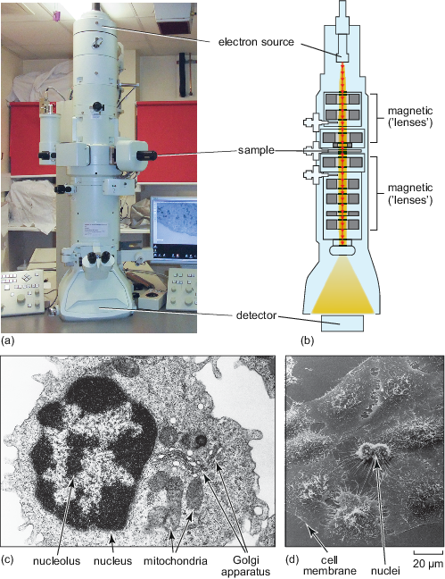
Figure 8 (a) A transmission electron microscope in the imaging facility at The Open University. (b) Diagram illustrating the components of an electron microscope. (c) Transmission electron micrograph of a frog leukocyte (white blood cell). (d) Scanning electron micrograph of a HeLa cell, illustrating that cells are not flat and that their surface has many extensions.
View description - Figure 8 (a) A transmission electron microscope in the imaging facility at The Open ...

Electron microscopy can only be used in fixed cells. During the sample preparation, heavy metals are used to increase the contrast in the samples, for example to clearly see cellular membranes.

3 The science behind fluorescence and its applications in microscopy
The following section will introduce you to the theory behind fluorescence. Understanding this concept will help you to understand how it is possible to see several different colours in one image taken on a fluorescence microscope.

3.1 Fluorescence is activated by light
What makes fluorescent molecules like GFP ‘glow’ the way they do? To understand this, it is necessary to look at the molecular level and specifically at the arrangements of atoms. Atoms contain a central nucleus around which electrons move in electron shells (or orbitals). The energy state of electrons increases from the innermost to the outer shells.
Fluorescent molecules, also called fluorophores, generally contain rings of carbon atoms (called aromatic rings). These molecules can absorb incoming energy (usually in the form of light). As a result of the absorption of energy, electrons within the molecules change from a resting condition called the ‘ground state’ to an ‘excited state’ on a shell further away from the nucleus for a very brief period of time. Eventually, the excited electrons return to their ground state, and as they do this, they emit some of the energy they had originally absorbed as photons of light (Figure 9).

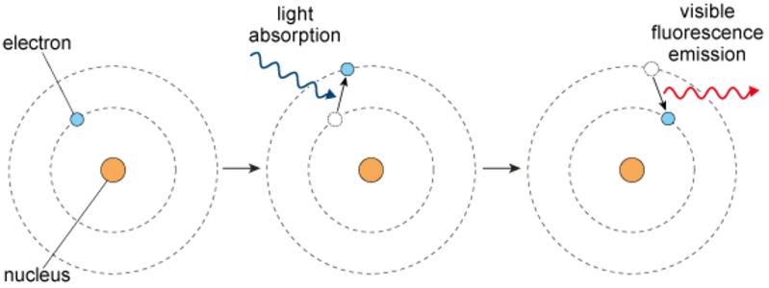
Figure 9 A single atom within a molecule is shown absorbing energy, which excites an electron from its ground state to an excited state. When the electron returns to its ground state, light is emitted.
View description - Figure 9 A single atom within a molecule is shown absorbing energy, which excites ...

[Author: SAQ to be added?] [Editor: - not sure if this was still to be decided? all fine either way, we can drop something in here, or I can just remove this comment if not needed]

3.2 The colour of the emitted light depends on the fluorescent molecule
The light emitted by a fluorescent molecule is a different colour to the light that it absorbs. This is because electrons in their excited state lose a tiny amount of energy before they return to the ground state. Fluorescent molecules absorb light at specific wavelengths in the visible spectrum, which is depicted in Figure 10. If you examine the Figure 10 you will notice that the wavelength of light increases as the spectrum progresses from blue to red, while the energy of the light decreases. Therefore, the light used to excite a fluorescent molecule (e.g., blue or violet light) has more energy and a shorter wavelength than the light the molecule emits (often green, yellow, or red).
This shift in colour (known as the Stokes shift), is crucial in fluorescence microscopy. It allows researchers to clearly distinguish between the excitation light and the emitted fluorescence, enabling accurate visualisation of specific targets within cells and tissues.

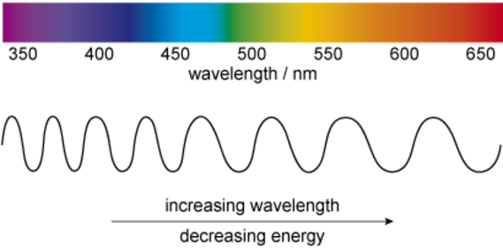
Figure 10 The visible spectrum, showing the colours with their corresponding wavelength in nanometres (10^{–9} m).
View description - Figure 10 The visible spectrum, showing the colours with their corresponding wavelength ...

If a fluorescent probe absorbed light in the green part of the visible spectrum, what colour range might its emitted light have?

View answer - SAQ

The wavelength of light absorbed by a fluorescent molecule is characteristic of that particular molecule, as is the wavelength of light it emits. The absorption and emission of specific colours by different fluorescent molecules allows researchers to investigate many different aspects of cell biology at the same time within a single biological sample.
In the next section, you will learn how different structures inside cells can be stained differently to obtain the images you will encounter throughout the rest of the course. But before that you will embark on a ‘Journey into a cell’, an immersive exploration that showcases the remarkable capabilities of both fluorescence and electron microscopy.

4 Applying fluorescence microscopy to make cells colourful
You will now see examples of cells being visualised with fluorescence microscopy and learn about different ways researchers use to make specifically label structures inside cells to see them using fluorescence microscopy.

4.1 Journey into a cell
Video 1 provides you with a ‘Journey into a cell’, in which the course author uses images and videos to illustrate how cell structures and organelles can be viewed within living cells, and how multiple fluorescent probes can be used within the same cell or tissue to build high-resolution two- and three-dimensional representations. The following sections will explain some of the techniques mentioned in the video in more detail.
Watch the video and then answer the following questions.

Video content is not available in this format.
Video 1 Provides you with a ‘journey into a cell’, in which the topic authors use images and videos to illustrate how cell structures and organelles can be viewed within living cells, and how multiple fluorescent probes can be used within the same cell or tissue to build high-resolution two- and three-dimensional representations.
View transcript - Video 1 Provides you with a ‘journey into a cell’, in which the topic authors use ...

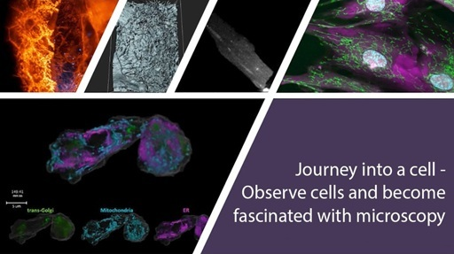

Which technique allows scientists to mark and visualise structures inside living cells?

View answer - SAQ

How can you identify the nucleus in a cell?

View answer - SAQ

Can you think of a reason why using more than three colours in fluorescence microscopy might prove difficult?

View answer - SAQ

What conclusions can you draw from experiments done with the fluorescent staining of living cells and tissues that you would not be able to draw using fixed material (where the cells/organs were killed before staining)?

View answer - SAQ

What example was given in Video 1 of fluorescence being used to measure the change in concentration of an ion over time?

View answer - SAQ

From your ‘Journey into a cell’, you should now have a good understanding of how fluorescence can be used to study cells and tissues. Some of the techniques mentioned in the video will be explained in more detail in the following sections.
You will now learn about some techniques that are being used to stain structures and proteins inside cells before they can be inspected using fluorescence microscopy. Later in this course you will see examples of these staining techniques when you inspect cells in the digital fluorescence microscope.

4.2 Using dyes (or probes) to stain structures
You learned about fluorescent molecules (also known as fluorophores) earlier in this course, and that it is possible to visualise several structures inside cells at the same time using fluorophores that emit different colours of light (Figure 11).

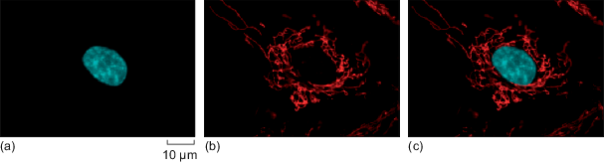
Figure 11 HeLa cells labelled with two fluorescent dyes: one that binds to DNA and one that accumulates inside mitochondria. (a) Micrograph taken after illuminating the cells with ultraviolet (UV) light to excite the dye bound to DNA, which then emits blue light. (b) A second micrograph taken after illuminating the cells with green light to excite the dye localised in mitochondria, which then emits red light. (c) The images are merged using computer software to show the fluorescence of both dyes at the same time.
View description - Figure 11 HeLa cells labelled with two fluorescent dyes: one that binds to DNA and ...

If you want to visualise red fluorescence, like the one in mitochondria shown in Figure 11, why would you use green light to excite the fluorophore?

View answer - SAQ

Staining of structures can be done with, for example, fluorescent dyes, stains, probes, or labels. These terms are often used interchangeably in science literature. Fluorescent indicators change their properties, for example their brightness, depending on their environment. For example, they get brighter when the concentration of a certain ion changes.

The concentration of which ion can be measured by a fluorescent indicator that can show the change of the intracellular pH value?

View answer - SAQ

Many fluorescent dyes and fluorescent indicators are designed to be membrane-permeable and can be taken up by living cells by simply immersing a tissue section, or cells grown on a glass coverslip, in a solution containing the dye or indicator and then rinsing off the excess.

4.3 Immunolabelling
Immunolabelling is a technique used to detect specific proteins or structures in cells or tissues by using antibodies — molecules that naturally recognise and bind to particular targets. A so-called primary antibody (yellow Y-shapes in Figure 12a) binds to a target, for example the protein actin. Primary antibodies are raised in different animals. The so-called primary antibody is either directly attached to a fluorescent dye or detected by a second fluorescently labeled antibody (green and red Y-shapes in Figure 12a). When viewed under a fluorescence microscope, the dye lights up, allowing researchers to see where the protein is located in the sample. A common variation of this technique is double immunolabelling, where two different proteins are labeled at the same time using antibodies tagged with two distinct fluorescent dyes, or by using two primary antibodies that were raised in different animal species. These primary antibodies are recognised specifically by different secondary antibodies, labelled with different fluorophores.
Double-immunolabelling allows scientists to observe the spatial relationship or co-localisation of different proteins within the same cell or tissue (Figure 12). Immunolabelling can only be performed in fixed and permeabilised cells, because the large antibody molecules would otherwise not be able to enter the cells. By using labels other than fluorophores, immunolabelling can also be visualised with light and electron microscopy.

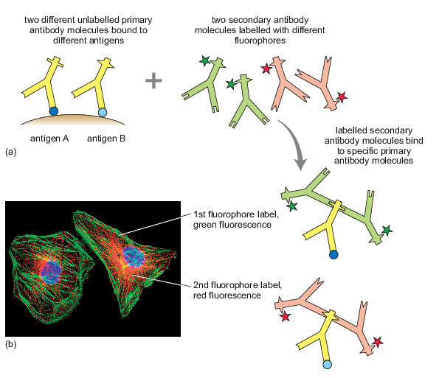
Figure 12 Double immunolabelling of the cytoskeleton. (a) Illustration of the principle of double immunolabelling using two primary antibodies and two differently labelled ‘secondary’ antibodies. Note that the epitopes on the primary antibodies, to which the secondary antibodies bind, differ in shape. (b) Double immunofluorescence staining in cells using a primary antibody against actin (the secondary antibody was labelled with a green fluorophore) and tubulin (the secondary antibody was labelled with a red fluorophore). The nucleus is shown in blue.
View description - Figure 12 Double immunolabelling of the cytoskeleton. (a) Illustration of the principle ...

Double immunolabelling to detect two proteins, A and B, would not work if the primary antibodies for A and B were both mouse antibodies. Can you suggest why?

View answer - SAQ

4.4 Expression of fluorescent proteins
Some dyes can be used in living cells, but one of the most powerful and widely used labeling techniques in live cultured cells, and even whole organisms, is to genetically modify them to express a fluorescent protein. Interestingly certain animals naturally produce fluorescent proteins as part of their defence against predators. One well-known example is the jellyfish Aequorea victoria, which produces GFP a molecule that you have encountered earlier in the course (Figure 13a).
Scientists can take the gene that encodes GFP and fuse it to a gene of interest and then introduce this modified gene into cells (Figure 13b) or even whole animals (Figure 13c and d). The resulting GFP-fusion protein can be visualised in real time under a fluorescence microscope, allowing researchers to track where the protein is located inside the living cell. In most cases, the fusion protein behaves like the original protein, maintaining its normal function and proper localisation within the cell.

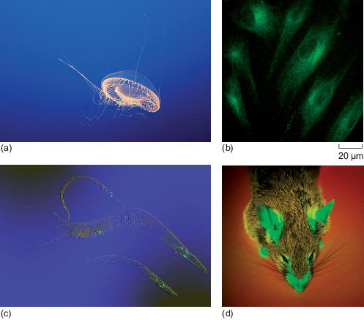
Figure 13 GFP expression. (a) The jellyfish Aequorea victoria naturally expresses GFP in the light-emitting organs at the bottom of its bell. (b) HeLa cells expressing GFP on their ER. (c) GFP expressed in neurons of the worm Caenorhabditis elegans. (d) A mouse expressing GFP.
View description - Figure 13 GFP expression. (a) The jellyfish Aequorea victoria naturally expresses ...

You have now learned about the different types of microscopy, the principles of fluorescence and how cellular structures using fluorescence. In the next section you will briefly explores why fluorescence microscopy is considered such a versatile technique in cell biology.

4.5 Similarities and differences between the three types of microscopy
After learning about three types of microscopy that are often used to study cells, and about commonly used different ways to make structures in cells fluorescent, you are now encouraged to test your learning and understanding by filling in the following table and answering the quiz questions.

Using your knowledge from this course, fill in Table 2. To give you an idea how much detail to include, the first column has been filled in. You will find a filled-in version in the answer underneath.

Table 2 Comparison of the three types of microscopy that were introduced in this course and their applications.
Feature | Light microscopy | Fluorescence microscopy | Electron microscopy
Source of Illumination | Visible white light | Provide your answer... | Provide your answer...
Resolution | ~ 200 nm | Provide your answer... | Provide your answer...
Magnification (maximum) | Up to ~1,000× | Provide your answer... | Provide your answer...
Staining required? | Often needed (e.g., dyes) | Provide your answer... | Provide your answer...
Live imaging? | Yes | Provide your answer... | Provide your answer...
Contrast? | Low (without stains) | Provide your answer... | Provide your answer...
Is specific labeling possible? | Limited (general stains) | Provide your answer... | Provide your answer...
Type of image produced | Brightfield image (natural contrast or stained) | Provide your answer... | Provide your answer...
Sample preparation | Simple and fast | Provide your answer... | Provide your answer...
Main applications | Basic cell structure, tissues | Provide your answer... | Provide your answer...

View answer - SAQ

You are part of a research team investigating the localisation and function of a specific protein in nerve cells. In your studies, you want to study different aspects of this protein. Unless specifically mentioned, the protein has not been genetically modified to carry a fluorescent marker. You have access to three types of microscopes: a standard light microscope, a fluorescence microscope, and an electron microscope. Questions 1-4 explain experiments your research team wants to perform. Based on the features of each microscopy technique (illumination, resolution, sample preparation, and ability to image live cells), which microscope would you choose for each of the experiments and why?

Question 1
Your goal is to identify if this protein is found in ribosomes, which have a diameter of around 25 nm.

View answer - Part

Question 2
Your goal is to identify if this protein is present in lysosomes, which have a diameter of 0.5 – 1 µM. Your research team commonly uses a fluorescent dye that you know specifically labels lysosomes.

View answer - Part

Question 3
Your goal is to track this protein in real time to understand how its behavior changes in response to different stimuli. For this experiment, the protein has been genetically tagged with a fluorescent marker.

View answer - Part

Question 4
You have already confirmed that cells from individuals with a certain disease express a higher level of the protein you are studying. Now you want to know if the overall cell structure is changed in cells from individuals with the disease. You don’t need to visualise the protein itself.

View answer - Part

5 Why is fluorescence microscopy so versatile?
The remainder of this course will focus on fluorescence microscopy, widely regarded as one of the most versatile techniques for visualising cells and proteins. Here are the key reasons for its versatility:
- Specificity: Fluorescent dyes or proteins can label specific structures, organelles, or molecules, such as DNA, mitochondria, or individual proteins. Using antibodies (immunolabelling), researchers can target virtually any protein of interest.
- Multiplexing: Different fluorescent dyes emit light at different wavelengths thus allowing multiple targets to be visualised simultaneously in different colours within the same sample.
- Compatibility with other techniques: Fluorescent microscopy could be combined with molecular and genetic techniques to visualise genetically engineered proteins inside cells.
- Live-cell imaging: The main benefit of the above compatibility is that researchers can track dynamic processes such as the expression or the movement of a protein, the behavior of an organelle in living conditions.
- Enhanced capabilities: Different types of fluorescent microscopy such as confocal microscopy offer some important enhancements.
- Quantification and analysis: Fluorescence intensity can be measured, allowing for quantitative data collection on things like protein concentration, gene expression levels, or ion concentrations.
The following sections provide a bit more insight on the points mentioned above.

5.1 Fluorescence microscopy allows observing specific structures individually and combined
Fluorescence microscopy makes it possible to observe specific cellular structures both individually and in combination. After staining different structures within a cell using fluorophores of different colours, the microscope’s separate channels can be used to select specific wavelengths of light to excite each dye one at a time. This allows for the capture of individual images, each showing a single labeled structure (Figure 14a and b, and Video 1). These individual fluorescence images are then digitally merged or overlaid using computer software, creating a combined image that reveals the spatial relationship between all stained structures within the cell or tissue (Figure 14c).

Figure 14 (repeat of Figure 11) HeLa cells labelled with two fluorescent dyes: one that binds to DNA and one that accumulates inside mitochondria. (a) Micrograph taken after illuminating the cells with ultraviolet (UV) light to excite the dye bound to DNA, which then emits blue light. (b) A second micrograph taken after illuminating the cells with green light to excite the dye localised in mitochondria, which then emits red light. (c) The images are merged using computer software to show the fluorescence of both dyes at the same time.
View description - Figure 14 (repeat of Figure 11) HeLa cells labelled with two fluorescent dyes: one ...

Capturing separate images and merging them allows detailed studies of the localisation of structures and proteins. You will see more examples when using the digital fluorescence microscope yourself.

5.2 Fluorescence microscopy allows visualising dynamic processes
Fluorescence microscopy is a powerful tool for observing dynamic processes like the movement of mitochondria inside cells (Video 2).
While you might picture mitochondria as many small, oval-shaped structures scattered throughout the cell, fluorescence imaging reveals that in many cases, they actually form an interconnected, network-like structure. This network is often in motion, constantly changing shape and position. As a result, the simplified appearance of mitochondria in static micrographs doesn’t fully reflect their complex and dynamic nature.

Video content is not available in this format.
Video 2 Mitochondrial dynamics. Mitochondria in HeLa cells expressing a red fluorescent protein were visualised using fluorescence microscopy. Constant movement of mitochondria can be seen in all cells. The cell towards the bottom left shows changes in the shape of its elongated mitochondria.
View transcript - Video 2 Mitochondrial dynamics. Mitochondria in HeLa cells expressing a red fluorescent ...

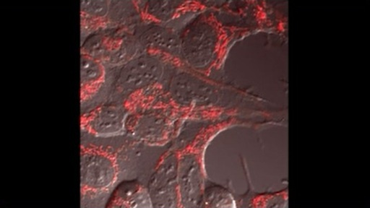

Visualising these dynamic processes greatly helps with the understanding how a cell functions. Comparing how such processes are affected for example in the context of a disease can help to understand how diseases develop and affect cellular behavior.

5.3 Specialised applications: Confocal microscopy
Specialised applications of fluorescence microscopy are continuously being developed, and the examples presented here present only a snapshot, this list will undoubtedly expand in the future. While this course does not cover these advanced techniques in detail, they are introduced to give you an idea of the wide-ranging possibilities fluorescence microscopy offers.
Confocal microscopy (Figure 15a) enhances image clarity by eliminating out-of-focus light, using a pinhole and laser scanning system. This allows for the capture of a series of optical sections—thin, focused slices—at different depths within a specimen. These images form a z-stack (Figure 15b), which computer software can reconstruct into a highly detailed three-dimensional (3D) image of the cell or tissue (Figure 15c). This is particularly useful for studying complex structures in thick specimens, such as tissues or organoids, and provides insights into spatial relationships within cells.

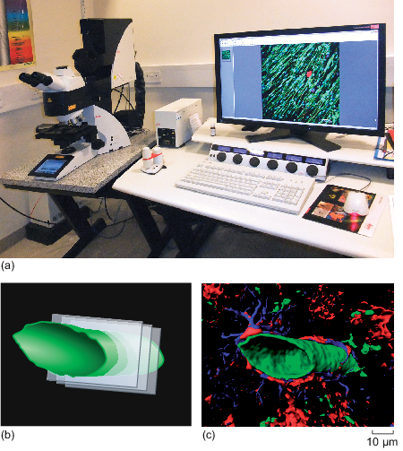
Figure 15 (a) A confocal microscope at The Open University, used to take some of the fluorescence micrographs in this module. (b) Illustration of the process involved in taking optical sections. (c) 3D reconstruction of blood vessels (green), surrounded by astrocytes (shown in blue and red) within brain tissue.
View description - Figure 15 (a) A confocal microscope at The Open University, used to take some of ...

5.4 Specialised applications: Studying molecular dynamics
Fluorescence microscopy can also be used to investigate real-time molecular interactions and dynamics within live cells. Two commonly used techniques are:
- Fluorescence Resonance Energy Transfer (FRET): Measures the energy transfer between two fluorescent molecules in close proximity, allowing researchers to study protein–protein interactions, conformational changes, and signal transduction pathways at the nanoscale.
- Fluorescence Recovery After Photobleaching (FRAP): Involves irreversibly bleaching a region of fluorescence and monitoring the movement and replacement of fluorescent molecules into that region over time. This helps in understanding protein mobility, membrane fluidity, and molecular binding dynamics.

5.5 Specialised applications: Super-resolution microscopy
Traditional light microscopy is limited by the diffraction of light, which restricts resolution to around 200 nanometres. Super-resolution microscopy breaks this barrier by using advanced optics, fluorescent molecule behavior, and computational techniques to achieve resolutions as fine as ~25 nanometres. This allows researchers to visualise structures previously invisible with standard fluorescence methods. Key techniques include:
- Structured Illumination Microscopy (SIM): Projects a patterned light grid onto the sample and reconstructs images computationally. SIM doubles resolution (to ~100 nm) and is ideal for live-cell imaging due to its low light exposure.
- STORM (Stochastic Optical Reconstruction Microscopy): Uses randomly blinking dyes to localise individual molecules and reconstruct ultra-high-resolution images of fixed samples.
- PALM (PhotoActivated Localization Microscopy): Similar to STORM, but uses photoactivatable fluorescent proteins, achieving comparable resolution (~20–30 nm).
Each technique offers unique advantages, expanding what can be visualised at the molecular level and enabling deeper insight into cell structure and function.
Super-resolution microscopy was able to achieve a resolution of ~25 nm when this course was written, which is far beyond the limit of light microscopy.
When visiting the digital fluorescence microscope, you will see slides of various cellular structures. Prior to that you now have a chance to inspect an interactive 3D cell to get a reminder about the function and localisation of different structures. After that, you’ll be introduced to the digital fluorescence microscope and use it.

6 Inspecting structures in a 3D cell

The interactive 3D animal cell below helps you to see the arrangement of animal cell components.
- Select each cell component from the drop-down list to read explanations.
- Click on the micrographs to see the structures in more detail.

Interactive content is not available in this format.
Interactive 3D animal cell

When you have explored the whole cell, attempt the following questions.

Question 1

Based on your observations in the 3D interactive cell, put the following structures into the correct order from the largest to the smallest.

(largest)
(smallest)
nucleus
mitochondria
nucleolus
secretory vesicle
ribosomes
View answer - Question 1

Question 2

What is the name of the membrane system that begins at the nuclear envelope and spreads throughout the cell?

Provide your answer...
View answer - Question 2

Question 3

What are the three main components of the cell membrane?

Provide your answer...
View answer - Question 3

Question 4

What is the membrane structure of mitochondria and which type of microscopy allows studying it?

Provide your answer...
View answer - Question 4

Question 5

Which specialised organelle in animal cells fuses with vesicles to break down worn-out cell components?

Provide your answer...
View answer - Question 5

7 Using the digital fluorescence microscope
Finally, it’s time for you to leave the theory behind and explore real samples using the digital fluorescence microscope (DFM). Start by watching Video 3 which introduces the DFM and how to use it. Please note that the microscope shown in the video contains a different set of slides than the one you will be working with. For example the ‘Tutorial slide’ featured in the video is labelled ‘Training slide A’ in your version of the DFM. Despite the difference in slide sets, both DFMs operate in the same way, and the instructions provided in the video are fully applicable to your microscope experience. Each slide includes a brief text explaining the type of staining used and highlighting the key features you should focus on when exploring the slides. For convenience, you might want to open the DFM in a separate tab so you can refer to the course questions while examining the slides.

Video content is not available in this format.
Video 3 An introduction to the digital fluorescence microscope. (This video mentions other resources from the full OU course – these can be ignored.)
View transcript - Video 3 An introduction to the digital fluorescence microscope. (This video mentions ...



Now go to the DFM in [Editor: add live link] and examine Slide 01: Training slide A – fluorescent dyes.
Inspect the staining for nuclei, mitochondria and cytoplasm using the respective channels (Channels 01–03), then look at the merged images (Channels 04–07) to familiarise yourself with the microscope. Note that if the view doesn’t change when clicking on a specific channel, choose a different channel and then try again. After inspecting all channels, answer the following questions. Record your answers in the text boxes below.

Question 1
How many nuclei are there on Slide 01: Training slide A – fluorescent dyes? Which channel did you use to count them and why?

Provide your answer...
View answer - SAQ

Question 2
What is the length and width of the nucleus at position X: 3016, Y: 575? For your measurements, assume that the nucleus has an elliptical shape. The length is the longest diameter (distance). The width is measured at approximately a right angle to the length, at the place where the ellipse is the widest, You can see examples of these measurements in the answer. Give your answer to one decimal place. Which channel and objective did you use to make your measurement? You can record your measurement(s) in Table 3 below.

Table 3 Measurements of cell nuclei
Lengths (longest lengths) to 1 decimal place (μm) |  |  | Widths (smallest lengths) to 1 decimal place (μm)
Provide your answer... | Provide your answer... | Provide your answer... | Provide your answer... | Provide your answer... | Provide your answer...
Mean = | Provide your answer... |  | Mean = | Provide your answer...

View answer - SAQ

Question 3
To develop your skills in making observations in micrographs, inspect Slide 01: Training slide A – fluorescent dyes and take notes about the appearance of the mitochondria and their localisation. Include information of which channels you have used to make the observations.

Provide your answer...
View answer - SAQ

Question 4
Now inspect Slide 02: Training slide B – EGF receptor (cell membrane) and practise determining if two structures co-localise, meaning they are present in the same place in a cell. Co-localisation can be identified by a colour change in the fluorescence micrographs (e.g. co-localisation of a green and a red structure results in a yellow colour; co-localisation of green and purple structures results in white).
To practise identifying co-localisation, go to the positions listed in the first column of Table 4 and observe the colour at this position in Channel 08. Use this information to state which structures might overlap at this position. Record your observations in Table 4 below. Note that one example answer is provided.

Table 4 Observations to identify the co-localisation of cellular structures
Position | Colour | Co-localisation | Explanation
X: 1963  Y: 714 | yellow | microtubules and ER | The yellow colour indicates overlap of Channel 03 (microtubules) and Channel 04 (ER)
X: 2124  Y: 2586 | Provide your answer... | Provide your answer... | Provide your answer...
X: 2095  Y: 2082 | Provide your answer... | Provide your answer... | Provide your answer...

View answer - SAQ

Question 5
In Slide 06: Endoplasmic reticulum (ER), compare the distribution of the ER in the cells at positions X: 1400, Y: 2700 and at X: 3800, Y: 1600. Referring to what you have learned in the module and comparing to what you have seen in the other slides in the DFM, which appearance is typical for the ER?
Hint: use Channels 01 and 05 to answer the question.

Provide your answer...
View answer - SAQ

Question 6
This is a fun and light-hearted question. In Slide 07: Golgi apparatus, which nucleus resembles an emoji of a face with an open mouth: 😮?
Hint: use Channel 02 to answer this question.

Provide your answer...
View answer - SAQ

Question 7
Compare the ER staining in Slide 07: Golgi apparatus to that you have seen in previous slides. What is unusual?
Hint: use Channels 04 and 08 to answer the question.

Provide your answer...
View answer - SAQ

Question 8
Using the ×40 or ×100 objective, go to X: 2630, Y: 1700 in Slide 08: Early endosomes and explain why the structure at this position is white.
Hint: use Channels 01–04 and Channel 08 to answer the question.

Provide your answer...
View answer - SAQ

8 Quiz
Now that you’ve reached the end of this course, here are some quiz questions to test and consolidate your learning.

Question 1

Interactive content is not available in this format.

Question 2

Choose which information is better to judge the size of a cellular structure in a micrograph.
(Note: Information for answering this question was provided in Section 2.)

Scale bar
Value of magnification
View answer - Question 2

Question 3

True or false?
Light is the only medium used in microscopy to obtain an image from a sample.
(Note: Information for answering this question was provided in Section 2.4.)

True
False
View answer - Question 3

Question 4

Interactive content is not available in this format.

Question 5

True or false?
The wavelength by which a fluorophore emits fluorescence is shorter than the wavelength used for excitation.
(Note: Information for answering this question was provided in Section 3.)

True
False
View answer - Question 5

Question 6

[Editor: double check first sentence here – both answers were listed as dyes but I think the second should’ve been indicators? (I’ve adjusted accordingly)]

Interactive content is not available in this format.

Conclusion
You should now have an understanding why fluorescence microscopy is seen as one of the most versatile techniques to study cell biology.
You gained an understanding of the sizes of cells and structures within cells, and that resolution affects how much detail you can see in micrographs.
You explored the differences between the three types of microscopy, and saw that light microscopy is useful to study overall changes in cellular structure, whilst fluorescence microscopy allows to study the detailed localisation of specific proteins and structures in both living and fixed cells. Electron microscopy uses an electron beam instead of light to visualise the sample and has a superior resolution but it can only be used in fixed cells.
You gained an understanding how the wavelength of excitation and emission determines which colours fluorophores have when being used in fluorescence microscopy.
You saw examples of using microscopy to image dynamic process in real time – for example the movement of cells or of organelles like mitochondria. You learned that fluorescent dyes can be used to label structures and fluorescent indicators can be used to measure changes of e.g. ion concentrations. Immunolabelling is a technique used to specifically identify proteins in fixed cells. Both, immunolabelling and the expression of GFP-fusion proteins can be used to study if two proteins co-localise in a cell. GFP-fusion proteins can be used to track the movement of proteins in real time.
Specialised applications of fluorescence microscopy allow studying cellular processes in more detail than traditional fluorescence microscopy. These will continue to be developed, ensuring that fluorescence microscopy continues to be one of the most exciting techniques in cell biology.
This free OpenLearn course is an adapted extract from the Open University course S296 Cell and molecular biology.

Further reading
This is a press release for the 2008 Nobel Prize in Chemistry for the discovery and development of the green fluorescent protein, GFP:
The Nobel Prize (2008) ‘The Royal Swedish Academy of Sciences has decided to award the Nobel Prize in Chemistry for 2008 jointly to Osamu Shimomura, Marine Biological Laboratory (MBL), Woods Hole, MA, USA and Boston University Medical School, MA, USA, Martin Chalfie, Columbia University, New York, NY, USA and Roger Y. Tsien, Howard Hughes Medical Institute, University of California, San Diego, La Jolla, CA, USA “for the discovery and development of the green fluorescent protein, GFP”’, 8 October [Press release]. Available at: https://www.nobelprize.org/prizes/chemistry/2008/press-release/ (Accessed: 10 February 2023).
This article describes fluorescence imaging techniques in 3D tissues and organisms and is the source for some of the videos shown in Video 1 ‘Journey into a cell’.
Liu, T.-L., Upadhyayula, S., Milkie, D.E., Singh, V., Wang, K., Swinburne, I.A., Mosaliganti, K.R., Collins, Z.M. et al. (2018) ‘Observing the cell in its native state: Imaging subcellular dynamics in multicellular organisms’, Science, 360(6386), eaaq1392. Available at: https://www.science.org/doi/10.1126/science.aaq1392 (Accessed: 10 September 2025).

Acknowledgements
This free course was written by Katja Rietdorf and Ilias Kounatidis. It is an adapted extract from the Open University course S296 Cell and molecular biology.
Figures
Figure 4: (a) The Human Protein Atlas, https://www.proteinatlas.org/ENSG00000176783-RUFY1/summary/antibody#IHC, licensed under the Creative Commons Attribution-ShareAlike 3.0 International License, https://creativecommons.org/licenses/by-sa/3.0/; (b) The Human Protein Atlas, https://www.proteinatlas.org/ENSG00000176783-RUFY1/summary/antibody#IHC, licensed under the Creative Commons Attribution-ShareAlike 3.0 International License, https://creativecommons.org/licenses/by-sa/3.0/; (c) Ivan V, Martinez-Sanchez E, Sima LE, Oorschot V, Klumperman J, Petrescu SM, et al. (2012) AP-3 and Rabip4’ Coordinately Regulate Spatial Distribution of Lysosomes, PLoS ONE, 7(10): e48142. https://doi.org/10.1371/journal.pone.0048142., Reproduced under the terms of the Creative Commons Attribution License
Figure 6: © Woravit Vijitpanya | Dreamstime.com
Figure 8: (c) Dr Gopal Murti/Science Photo Library; (d) National Institutes of Health / United States Department of Health and Human Services
Figure 12: (b) Winship Cancer Institute at Emory University / National Cancer Institute / Science Photo Library
Figure 13: (a) Heiti Paves, CC BY-SA 4.0 (https://creativecommons.org/licenses/by-sa/4.0), via Wikimedia Commons; (c) Miguel Hermoso Cuesta, CC BY-SA 4.0 (https://creativecommons.org/licenses/by-sa/4.0), via Wikimedia Commons; (d) Knut Haugland, CC BY-SA 3.0 (http://creativecommons.org/licenses/by-sa/3.0/), via Wikimedia Commons
Videos
Video 1: footage courtesy of:
Simon Walker, PhD, The Babraham Institute, Cambridge, UK
Dr Martin Bootman, The Open University, School of Life, Health and Chemical Sciences, Faculty of Science, Technology, Engineering and Mathematics
Professor Tom Kirchhausen, Harvard Medical School, USA, for providing the movies published in Liu, T.-L. et al. (2018) ‘Observing the cell in its native state: Imaging subcellular dynamics in multicellular organisms’, Science, 360(6386), eaaq1392. Available at: https://www.science.org/doi/10.1126/science.aaq1392 (Accessed: 10 September 2025).
Dr Katja Rietdorf, The Open University, School of Life, Health and Chemical Sciences, Faculty of Science, Technology, Engineering and Mathematics
Video 2: Dr Martin Bootman, The Open University, School of Life, Health and Chemical Sciences, Faculty of Science, Technology, Engineering and Mathematics
Except for third party materials and otherwise stated (see terms and conditions), this content is made available under a Creative Commons Attribution-NonCommercial-ShareAlike 4.0 Licence.
The material acknowledged below is Proprietary and used under licence (not subject to Creative Commons Licence). Grateful acknowledgement is made to the following sources for permission to reproduce material in this free course:
Every effort has been made to contact copyright owners. If any have been inadvertently overlooked, the publishers will be pleased to make the necessary arrangements at the first opportunity.
Don’t miss out
If reading this text has inspired you to learn more, you may be interested in joining the millions of people who discover our free learning resources and qualifications by visiting The Open University – www.open.edu/openlearn/free-courses.

Glossary
Antibodies
(Singular, antibody) Large Y-shaped proteins with two identical binding sites produced by the immune system of vertebrate animals in response to infections. Antibodies recognise antigens on the surface of cells and bind to specific epitopes. They are used in many cell biological techniques.
Confocal microscopy
A specialised type of fluorescence (light) microscopy that allows taking images in thin sections through a cell which can be assembled into a 3D image.
Double immunolabelling
Immunolabelling that uses two antibodies directed against two different proteins inside the same cell. The localisation of both proteins can be visualised simultaneously using secondary antibodies carrying different labels.
Electron microscope
Microscope that uses a beam of electrons instead of light, and magnetic fields as lenses. Electron microscopes have a much higher resolution than light and fluorescence microscopes and allow one to study cellular ultrastructure.
Electron microscopy
A type of microscopy that uses an electron beam to visualise the samples.
Fixed cells
Fixation is a process in which cells are first killed, then their structure is preseved by applying a fixative like formaldehyde. It is often followed by permeabilisation, which allows molecules like antibodies access to the cytoplasm.
Fluorescence microscope
Specialised type of light microscope which detects fluorescence, given off by fluorophores which were used to label the sample. Fluorescence microscopes use filters so samples are only illuminated with light of specific wavelengths.
Fluorescence microscopy
A specialised type of light microscopy that uses a fluorescence microscope and filters to illuminate the sample with light of a specific wavelength.
Fluorescence Recovery After Photobleaching
Abbreviated as FRAP. Specialised application of fluorescence microscopy that allows studying the movement of proteins in living cells.[Editor: think these definitions were the wrong way round, so I’ve swapped them. can that be double checked, to make sure it wasn't just the wrong acronyms in each definition? (looks like it better matches the text in section 5.4 now)]
Fluorescence Resonance Energy Transfer
Abbreviated as FRET. Specialised application of fluorescence microscopy that allows studying how close two proteins are inside a (living) cell.
Fluorescent dye
Fluorescent molecules that can be used to label structures in a cell. They can be cell-permeable.
Fluorescent indicator
Fluorescent molecule that changes its characteristics (e.g. the brightness) depending on environmental factors, for example the concentration of a certain ion. It is often cell-permeable and can be used to monitor changes of e.g. the concentration of an ion inside cells.
Fluorophore
Alternative name for fluorescent molecule. Chemicals which emit fluorescent light of a particular colour when illuminated with light at specific wavelengths.
Immunolabelling
Technique that allows the labelling of specific proteins inside a cell or on its surface using antibodies.
Light microscope
Microscope that uses visible light to illuminate a sample and glass lenses to focus and magnify the image. Also called an optical microscope.
Light microscopy
A type of microscopy that uses visible light to visualise the samples.
Magnification
Term that describes by how much a structure has been enlarged.
Micrograph
Image taken with a microscope.
Organelles
Membrane-bound components of eukaryotic cells, specialised to carry out particular functions.
Resolution
The smallest distance between two objects that can be distinguished by a particular type of microscopy.
Scale bar
Visual representation of a known length, typically a line, that is included in a microscopic image to provide a reference for the size of objects in the image. It helps to establish the magnification and the actual size of structures being viewed.
Scanning electron microscope
A type of electron microscope used to study the surface of intact cells and tissues. A sample is coated with a thin metallic layer that deflects an electron beam onto a detector.
Staining
Technique used during sample preparation in microscopy to increase the contrast of structures inside cells. Different stains are used in the different types of microscopy.
Super-resolution microscopy
A specialised type of fluorescence (light) microscopy that allows taking images with a better resolution than that of normal fluorescence (light) microscopy (up to ~25 nm vs. 200 nm).
Transmission electron microscope
A type of microscope used to study inside of cells and tissue sections. The sample is stained to increase the contrast of cellular structures when they are exposed to an electron beam. A transmission electron microscope is also known as a TEM.

Solutions

SAQ

Answer
There are 1000 (10³) nm in 1 µm and there are 1000 (10³) micrometres in 1 mm. So, there are 1000 × 1000 = 1 000 000 (or 10⁶) nm in 1 mm.
Back to - SAQ

SAQ

Answer
It is called a logarithmic scale. Each unit is ten times greater than the previous unit, which is helpful when you want to show a very wide range of values using the same scale.
Back to - SAQ

SAQ

Answer
Just under 0.3 nm, which is the size of a water molecule.
Back to - SAQ

SAQ

Answer
0.8–10 µm, which is 800 nm to 10,000 nm (or to ).
Back to - SAQ

SAQ

Answer
Right:
Panel (a)
Feedback
Correct. You can identify this because both micrographs are shown with the same magnification and panel (a) shows more details.
Wrong:
Panel (b)
Feedback
Incorrect. Remember that an image taken with a higher resolution will show more details when presented with the same magnification.
Back to - SAQ

SAQ

Answer
The scale bars range from 0.2 mm to 200 nm, indicating that the images taken with a light microscope reveal fewer details this taken for fluorescence (light) microscopy. However, they allow to see the whole cells.
Back to - SAQ

SAQ

Answer
The image taken with a transmission electron microscope has the highest resolution and reveals most details.
Back to - SAQ

SAQ

Answer
You might want to exchange the medium that is covering the cells to ensure they are kept alive, or in order to add compounds to stimulate the cells so you can observe their response in real time.
Back to - SAQ

SAQ

Answer
The emitted light would have a longer wavelength (less energy) than green light, and so would be in the yellow to red part of the visible spectrum.
Back to - SAQ

SAQ

Answer
Fluorescence microscopy (not electron microscopy).
Back to - SAQ

SAQ

Answer
By applying a DNA-binding probe to visualise it by its fluorescence, or by the space it occupies being left ‘dark’ when probes are used that detect other cellular organelles that are present in the cytoplasm.
Back to - SAQ

SAQ

Answer
It can be difficult to distinguish the colours/organelles stained.
Back to - SAQ

SAQ

Answer
The ability to use living cells and tissues means that you can study cells in their native environment and also examine interactions between cells and how they change over time. You can also observe the movement of organelles and/or molecules inside cells in real time.
Back to - SAQ

SAQ

Answer
Calcium ion changes in the cardiac myocyte.
Back to - SAQ

SAQ

Answer
Referring back to the spectrum of visible light shown in Figure 10, and the principle of fluorescence, the excitation wavelength must be shorter than the emission wavelength. Green light has a shorter wavelength and more energy, so it can be used to cause emission of red light.
Back to - SAQ

SAQ

Answer
The concentration of ions (protons). An increase in the proton concentration causes a drop in the pH (it becomes more acidic). A decrease in the proton concentration causes an increase of the pH (it becomes more alkaline).
Back to - SAQ

SAQ

Answer
Each protein would bind a mouse primary antibody. The anti-mouse secondary antibody subsequently applied to detect the primary antibodies would then bind to both primaries, and so they would both be labelled with the same detection molecule (e.g. the same colour of fluorescence) and it would not be possible to see the separate locations of proteins A and B.
Back to - SAQ

SAQ

Answer
Here is a filled-in version of the table with information from this course.

Table 2 (completed) Comparison of the three types of microscopy that were introduced in this course and their applications.
Feature | Light microscopy | Fluorescence microscopy | Electron microscopy
Source of Illumination | Visible white light | Specific wavelengths of light (often UV or laser) | Beam of electrons
Resolution | ~ 200 nm | ~ 200 nm | ~0.1–1 nm (much higher due to electron wavelength)
Magnification | Up to ~1,000× | Up to ~1,000× | Up to ~1,000,000 for TEM  Up to ~2,000,000 for SEM
Staining required? | Often needed (e.g., dyes) | Yes, fluorescent dyes or proteins | Yes, heavy metals
Live imaging? | Yes | Yes | No (requires vacuum and fixed/dehydrated samples)
Contrast? | Low (without stains) | High (fluorescent signal on dark background) | Very high due to electron scattering
Is specific labeling possible? | Limited (general stains) | Yes, highly specific using antibodies or tagged proteins | Limited; specific structures identified by morphology
Type of image produced | Brightfield image (natural contrast or stained) | Fluorescent image on dark background | Black and white
Sample preparation | Simple and fast | Moderate (labeling, fixing if needed) | Complex, time-consuming
Main applications | Basic cell structure, tissues | Protein localisation, live-cell imaging, molecular tracking | Ultrastructure, organelles, viruses, nanostructures

Back to - SAQ

Activity

Part

Answer
To identify if the protein is localised in ribosomes, using the electron microscope is the most suitable option. Here’s why:
- Resolution:
The electron microscope is the only one of the three types that has a high enough resolution to visualise ribosomes. It has a resolution of 0.1 – 1 nm.
- Specific Labeling:
You would use immunolabelling to visualise the protein in the cell, and you would identify ribosomes by their characteristic appearance.
- Live-Cell Imaging:
To identify the localisation, you don’t need to work with living cells. Fixing the samples during the preparation for electron microscopy ensures that structures and proteins are found in the place where they were present in the living cell.
Back to - Part

Part

Answer
To identify if a specific protein is present in lysosomes, which can be identified with a fluorescent dye, using the fluorescence microscope combined with immunolabelling is the most suitable option. Here’s why:
- Specific Labeling:
The protein is not tagged with a fluorescent marker, which means you need to visualise it using immunolabelling. Lysosomes can be specifically labelled with the fluorescent dye, so you want to visualise your immunolabelling with fluorescence microscopy. Light microscopy cannot visualise your protein with such high specificity.
- Live-Cell Imaging:
For the purpose of this experiment, you cannot use live cell imaging because the process of immunolabelling needs the cells to be fixed and permeabilised.
- Resolution:
The resolution of fluorescence microscopy is ~200 nm, which is sufficient for visualising lysosomes.
Back to - Part

Part

Answer
To track a specific protein in real time within living nerve cells, using the fluorescence microscope is the most suitable option. Here’s why:
- Specific Labeling:
The protein has been tagged with a fluorescent marker, which means fluorescence microscopy is required to excite and detect that specific signal. Neither light microscopy nor electron microscopy can visualise tagged proteins with such specificity.
- Live-Cell Imaging:
Fluorescence microscopy allows imaging of living cells. Electron microscopy cannot be used for live samples, as it requires the sample to be fixed, dehydrated, and placed in a vacuum. Light microscopy can image live cells but cannot track specific proteins unless general staining is sufficient, which isn’t in this case.
- Real-Time Observation:
Fluorescence microscopy can capture dynamic processes over time, making it ideal for tracking the movement of proteins or organelles within cells.
- Resolution:
While not as high as electron microscopy, the resolution (~200 nm) is sufficient for visualising protein localisation and movement within the broader cellular context, especially with the help of time-lapse imaging or even super-resolution techniques if needed.
Back to - Part

Part

Answer
Changes in cellular structure, without the need to identify specific proteins, is best done with a light microscope. Here’s why:
- Specific Labeling:
Light microscopes are not good to visualise specific labelling due to the lower contrast of the samples. However, specific labelling is not necessary in this study, and the sample preparation for light microscopy is often quicker and cheaper than that for the other techniques. That’s why light microscopy is often used in pathology labs to study changes in cellular structure in disease development.
- Live-Cell Imaging:
There is no need for live-cell imaging in this study.
- Resolution:
Studying changes in the overall cellular structure does not need a high resolution, so light microscopy is suitable.
Back to - Part

Activity

Question 1

Answer
The correct matches are:
(largest)
nucleus
mitochondria
nucleolus
secretory vesicle
(smallest)
ribosomes
Back to - Question 1

Question 2

Answer
The endoplasmic reticulum (ER). The nuclear envelope is continuous with the rough ER (RER), which is studded with ribosomes on its outside. Further away from the nucleus, the RER continues into the smooth ER (SER), which no longer has ribosomes on its membrane. You will see different shapes of the ER when inspecting slides in the digital fluorescence microscope.
Back to - Question 2

Question 3

Answer
Lipids, mostly phospholipids (forming a lipid bilayer), membrane proteins and sugars. The sugars are attached to proteins (forming glycoproteins) or lipids (glycolipids). When inspecting cells in the digital fluorescence microscope, you will see that the cell membrane is not smooth, but has many extensions.
Back to - Question 3

Question 4

Answer
Mitochondria are surrounded by a double membrane. The inner membrane is folded into structures called cristae. The space between the inner and outer membrane is called the intermembrane space. The membrane structure can be studied using electron microscopy which has a high enough resolution to clearly show both membranes.
Back to - Question 4

Question 5

Answer
Lysosomes fuse with vesicles containing old organelles and ingested material and break down the contents.
Back to - Question 5

SAQ

Answer
There are seven nuclei (Figure 16). Each cell has a single nucleus, so the nuclear staining in Channel 01 (or in Channels 04, 05 or 06) is a good way to identify the nuclei on the slide.

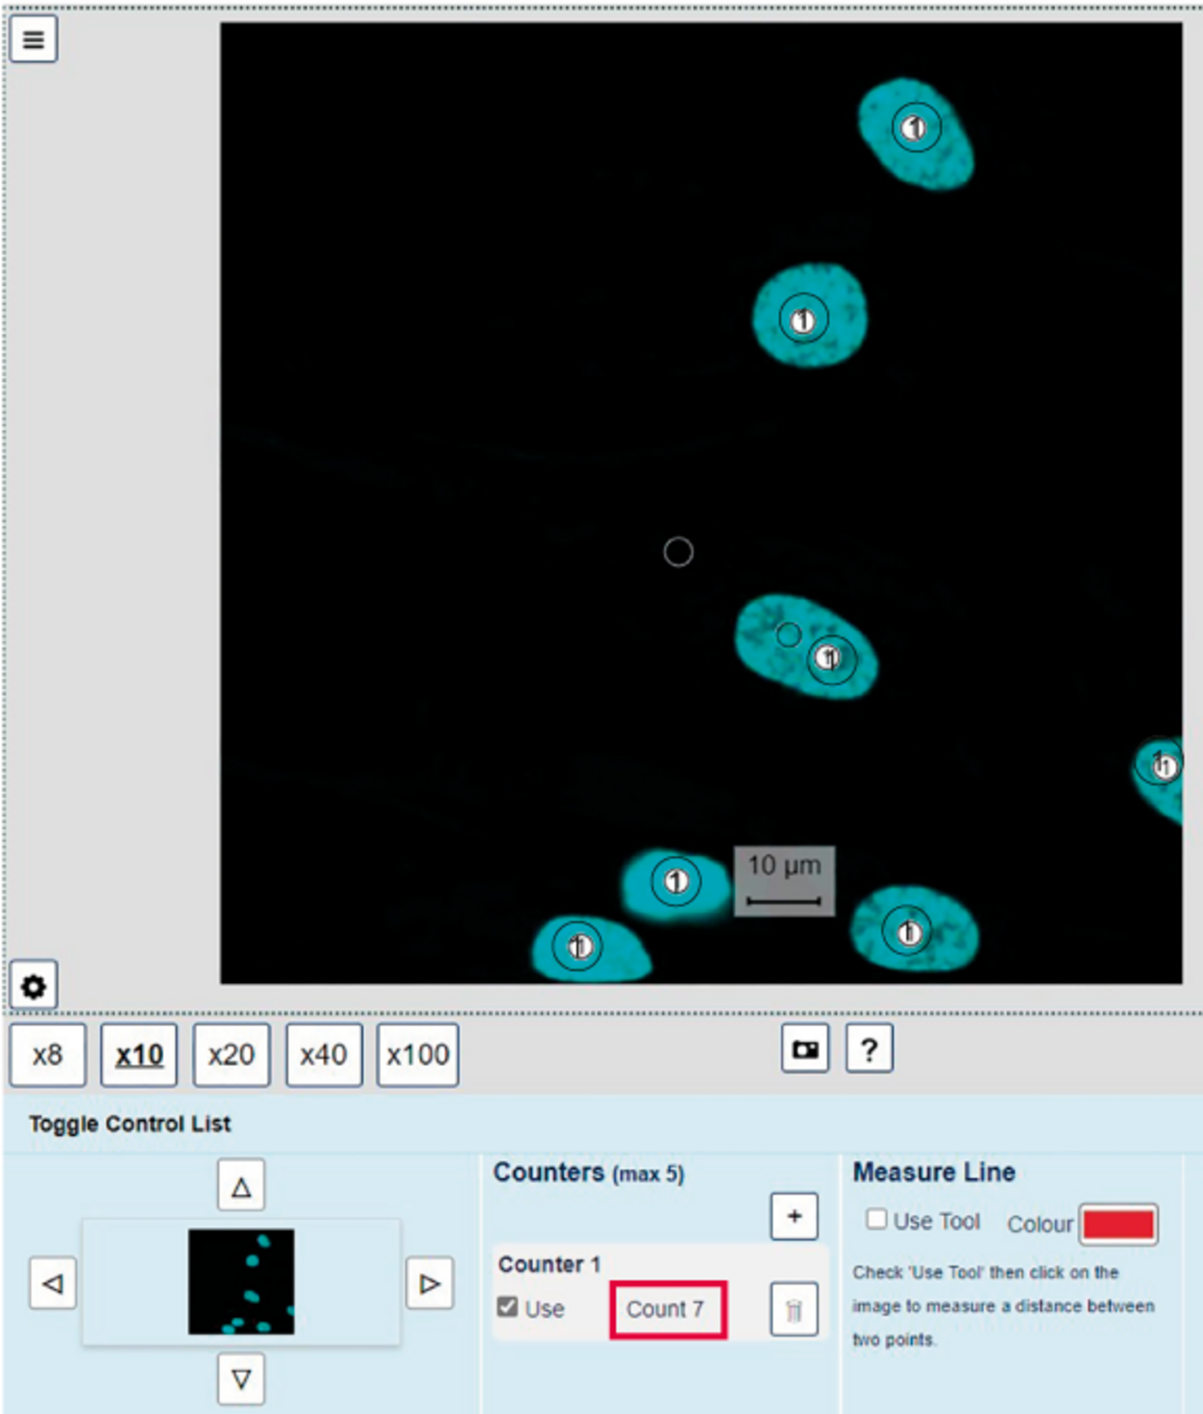
Figure 16 Screenshot illustrating the seven nuclei counted with the counting tool using the ×10 objective and Channel 01.
View description - Figure 16 Screenshot illustrating the seven nuclei counted with the counting tool ...

Back to - SAQ

SAQ

Answer
Here’s a completed version of the table.

Table 3 (completed) Measurements of cell nuclei
Lengths (longest lengths) to 1 decimal place (μm) |  |  | Widths (smallest lengths) to 1 decimal place (μm)
18.7 | 18.3 | 18.9 | 12.4 | 12.5 | 12.8
Mean = | 18.6 |  | Mean = | 12.6

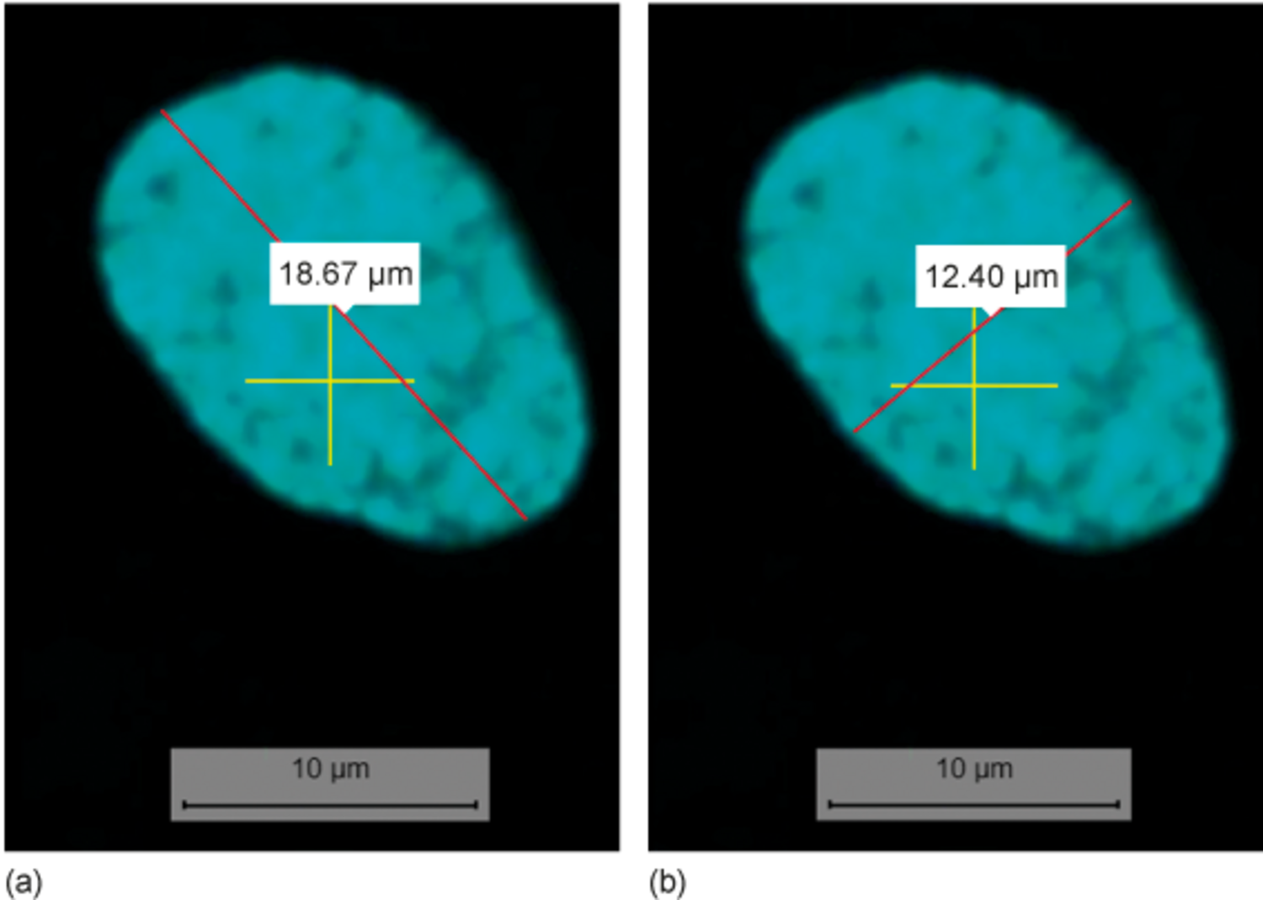
Figure 17 Measurements of (a) the length and (b) the width of the nucleus at X: 3016, Y: 575 using Channel 01 and the ×40 objective.
View description - Figure 17 Measurements of (a) the length and (b) the width of the nucleus at X: ...

The measurement should be done in Channel 01 because it only shows the nuclei, thus clearly identifying the borders of the nucleus.
The largest objective that shows the whole nucleus should be used to make the most accurate measurement. For the module team member, this was the ×40 objective. The value differs depending on your screen size.
Back to - SAQ

SAQ

Answer
Mitochondria form a tubular network (Channel 02) that spreads through the cytoplasm (Channels 06 and 07). They are absent from the nucleus (Channel 06 and 07; or flicking between Channels 01 and 02). In a few places, mitochondria can be seen in an area with only weak staining for the cytoplasm (e.g. X: 3731, Y: 2060; Channel 06).
Back to - SAQ

SAQ

Answer
Here’s a completed version of the table.

Table 4 (completed) Observations to identify the co-localisation of cellular structures
Position | Colour | Co-localisation | Explanation
X: 1963  Y: 714 | yellow | microtubules and ER | The yellow colour indicates overlap of Channel 03 (microtubules) and Channel 04 (ER).
X: 2124  Y: 2586 | red | none | The ER does not co-localise with structures nearby, e.g. the cell membrane (purple) or microtubules (green).
X: 2095  Y: 2082 | white | cell membrane and microtubules | The white colour indicates co-localisation of Channel 01 (cell membrane) and Channel 03 (microtubules).

Back to - SAQ

SAQ

Answer
The ER forms a network distributed throughout large parts of the cytoplasm in the cell at X: 1400, Y: 2700. In contrast, the ER is only present around the nucleus in the cell at X: 3800, Y: 1600. A distribution throughout the cytoplasm is more typical for the ER.
Channel 01 clearly shows the ER surrounding the nucleus in the cell at X: 3800, Y: 1600, better than the merged view in Channel 05. The ER network can be seen in Channel 05.
Back to - SAQ

SAQ

Answer
The nucleus at X: 3130, Y: 890 looks a bit like the open-mouthed emoji (Figure 18).

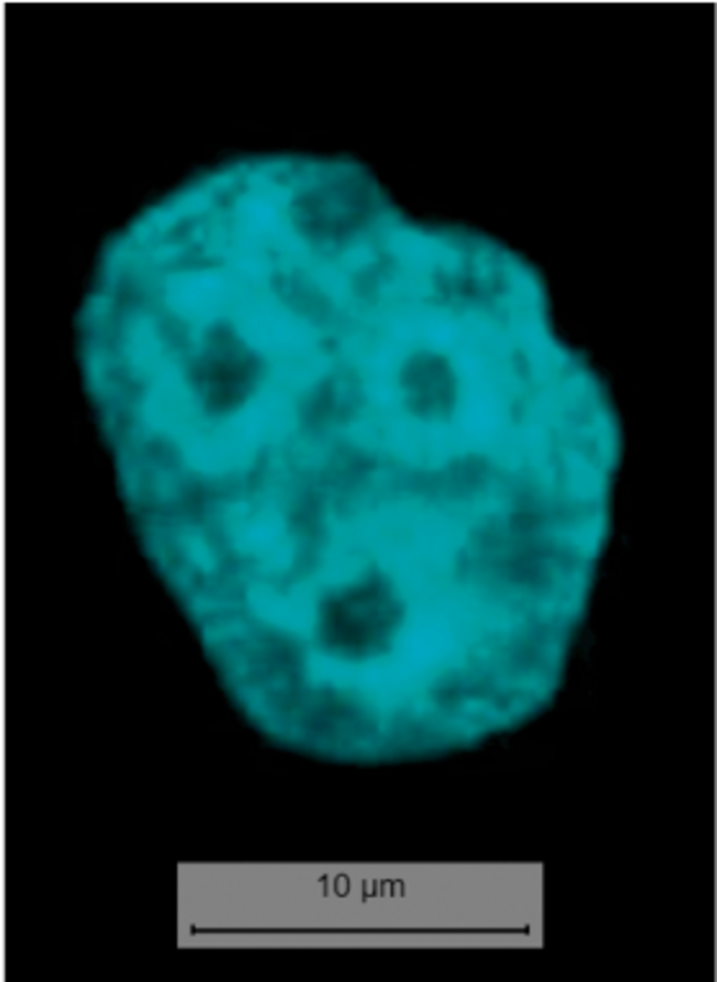
Figure 18 Nucleus at X: 3130, Y: 890 in Slide 07, using Channel 02.
View description - Figure 18 Nucleus at X: 3130, Y: 890 in Slide 07, using Channel 02.

Back to - SAQ

SAQ

Answer
In Slide 07, the ER is located in the centre of the cell (Channel 04). It does not appear as a network in the cytoplasm, which is the typical distribution of the ER. The staining here is probably an artefact, caused by, for example, a problem with the fixation of the cells or the antibody staining.
Back to - SAQ

SAQ

Answer
At the position of X: 2630, Y: 1700, early endosomes (Channel 01, purple) and microtubules (Channel 03, green) co-localise (i.e. are present at the same place). The merging of these two colours results in the structure being white (instead of green or purple) in Channel 08. (Remember that a co-localisation of green and red staining would be visible as yellow.)
Back to - SAQ

Question 2

Answer
Right:
Scale bar
Feedback
Correct. A scale bar allows to directly judge the size of structures in an image, independent of any magnification that might have happened after the image was take (e.g. resolution of the screen, size of a printed image).
Wrong:
Value of magnification
Feedback
Incorrect. The magnification depends on the objective with which the image was taken, but also on other factors that might be applied after the micrograph was taken. For example, the size of a printed image or the resolution of a computer screen affect the magnification of structures in a micrograph.
Back to - Question 2

Question 3

Answer
Right:
False
Feedback
Light is commonly used, but electron microscopy uses electron beams to visualise the sample.
Wrong:
True
Back to - Question 3

Question 5

Answer
Right:
False
Wrong:
True
Back to - Question 5

Descriptions

Figure 1 PhD student using a fluorescence microscope in The Open University’s laboratories.
Photograph of a student using a fluorescence microscope.
Back to - Figure 1 PhD student using a fluorescence microscope in The Open University’s laboratories.

Figure 2 The relative sizes of cells, organelles and molecules arranged on a logarithmic scale: (a) shows structures larger than 100 nm which can be visualised using light and electron microscopy; (b) shows those smaller than 100 nm which can only be visualised in an electron microscope.
The figure consists of two parts, Figures 2a and b, that illustrate the relative sizes of various structures (cells, organelles and molecules).
Figure 2a: a horizontal logarithmic scale shows the size range of various structures. The scale has the following markings from left to right: 1 centimetre, 1 millimetre, 100 micrometres, 10 micrometres, 1 micrometre, 100 nanometres, 10 nanometres, 1 nanometre and 0.1 nanometres.
Size range visible using a light microscope (ranging from approximately 2 millimetres to 400 nanometres) for the following structures is shown.
Plant cells (a typical plant cell with a central nucleus, mitochondria, chloroplasts, endoplasmic reticulum, ribosomes, cell wall and cell membrane): approximately 1 millimetre to 20 micrometres.
Animal cells (a typical animal cell with a nucleus, mitochondria, endoplasmic reticulum, ribosomes and cell membrane): approximately 150 micrometres to 6 micrometres.
Most bacteria (rod-shaped, spherical, chain of spherical cells): approximately 10 micrometres to 800 nanometres.
Chloroplasts and mitochondria (organelles): approximately 5 micrometres to 1 micrometre.
Figure 2b: the size range visible using the electron microscope (ranging from approximately 100 nanometres to 0.125 nanometres) for the following structures is shown.
Viruses (composed of a polyhedral head, a short collar and a helical tail): approximately 50 to 500 nanometres.
Ribosomes (three ribosomes): approximately 25 nanometres.
Cell membrane (phospholipid bilayer; each layer composed of a spherical hydrophilic head with a pair of hydrophobic tails): approximately 7.5 nanometres.
ATP (a central pentagonal ring bound to a fused ring (hexagon fused to a pentagon) on the upper left and a chain of three circles indicating phosphates on the upper right): approximately 2 nanometres.
Glucose (a chain of four hexagonal rings): approximately 0.9 nanometres.
X: structure for which the size should be read by the student.
Back to - Figure 2 The relative sizes of cells, organelles and molecules arranged on a logarithmic scale: (a) shows structures larger than 100 nm which can be visualised using light and electron microscopy; (b) shows those smaller than 100 nm which can only be visualised in an electron microscope.

Figure 3 Two fluorescence micrographs of the same structure inside a cell, taken at two different resolutions. The scale bar equals 10 µm.
The figure consists of two parts, a and b. Both are fluorescence micrographs of two cells, taken at the same magnification but with different resolutions. The cells in panel b are more blurry than those in panel a.
Back to - Figure 3 Two fluorescence micrographs of the same structure inside a cell, taken at two different resolutions. The scale bar equals 10 µm.

Figure 4 (a) Light microscopy image showing the protein of interest stained brown. (b) Fluorescence microscopy image with the protein of interest labeled in green and cell nuclei in blue. (c) Transmission electron microscopy (TEM) image. The dark dots indicated by arrows represent the protein of interest. ‘E’ marks an endosome, and ‘P’ indicates the plasma membrane.
The figure consists of three parts, Figures 4a to c, that illustrate micrographs taken with three different types of microscopy.
Figure 4a: a micrograph of a slice of duodenum tissue taken with a light microscope. The protein of interest is shown in brown. It is present in the cytoplasm. Numerous elongated oval-shaped nuclei are visible in light blue. The scale bar is 1 centimetre equals 0.2 millimetres.
Figure 4b: a fluorescent micrograph shows a vesicular localisation of the protein of interest (visible in green) surrounding oval-shaped large nuclei visible in blue. The scale bar is 2 centimetres equals 20 micrometres.
Figure 4c: a transmission electron micrograph shows the protein of interest as small densely stained tiny structure related to endosomes is indicated by arrows. Circular endosomes are labelled ‘E’, and ‘P’ indicates the plasma membrane at the periphery. The scale bar is 1.5 centimetres equals 200 nanometres.
Back to - Figure 4 (a) Light microscopy image showing the protein of interest stained brown. (b) Fluorescence microscopy image with the protein of interest labeled in green and cell nuclei in blue. (c) Transmission electron microscopy (TEM) image. The dark dots indicated by arrows represent the protein of interest. ‘E’ marks an endosome, and ‘P’ indicates the plasma membrane.

Figure 5 A compound (multiple lens) light microscope with a diagram illustrating how the condenser focuses light on the sample and transmits the light through the objective and eyepiece lenses to the observer.
The figure shows a schematic diagram illustrating the path of light and the type of illumination produced by a compound light microscope and the corresponding photograph of a compound light microscope.
The diagram shows the arrangement of lenses and a sample inside the microscope shown as follows from top to bottom: eyepiece, camera, image, objective lenses, sample on stage, condenser lens, and light source.
The light source is located at the bottom, emitting rays that pass through the sample positioned on a flat stage platform above. The objectives, positioned on the rotational nosepiece, focus on these rays.
The resulting image can be observed through the binocular eyepiece lenses. Additionally, a camera is set up at the top to capture the image.
The path of light (from bottom to top): a pair of diverging rays of light emerge from the light source, passes through the condenser lens (convex lens placed below the stage), and converge at a common point on the bottom of the sample placed on a stage.
A pair of diverging rays of light emerge from the top centre of the sample, strike the objective lenses, becomes converging at a common point, and again diverge and strike the eyepiece lens.
The rays then become parallel while passing through the eyepiece. The magnified image is then observed by the eye and captured by the camera attached at the top of the eyepiece.
A photo of a compound light microscope is also shown on the right. The compound microscope shows the following labelled parts from top to bottom: camera, eyepiece, objective, stage, and light source.
Back to - Figure 5 A compound (multiple lens) light microscope with a diagram illustrating how the condenser focuses light on the sample and transmits the light through the objective and eyepiece lenses to the observer.

Figure 6 Green fluorescent protein fluorescence in the jellyfish Aequorea victoria.
A photograph showing the fluorescence of a green fluorescent protein in four jellyfish of the species Aequorea victoria.
Back to - Figure 6 Green fluorescent protein fluorescence in the jellyfish Aequorea victoria.

Figure 8 (a) A transmission electron microscope in the imaging facility at The Open University. (b) Diagram illustrating the components of an electron microscope. (c) Transmission electron micrograph of a frog leukocyte (white blood cell). (d) Scanning electron micrograph of a HeLa cell, illustrating that cells are not flat and that their surface has many extensions.
The figure consists of four parts, Figures 8a to d, that illustrate the typical arrangement of a transmission electron microscope and micrographs of a frog leukocyte and HeLa cell.
Figure 8a: a photo shows a tall cylindrical transmission electron microscope (TEM) with a binocular eyepiece near its base just above the detector. The transmission electron microscope shows the following labelled parts from top to bottom: electron source, sample, and detector.
Figure 8b: the typical arrangement of a transmission electron microscope has an electron source located at the top, emitting a beam of electrons that pass through a set of magnets acting as lenses, a sample positioned on a middle sample holder, and more magnets acting as lenses. The beam of electrons diverges and hits the fluorescent screen to form a highly magnified image, which is then recorded by the detector present at the bottom.
Figure 8c: a transmission electron micrograph of a frog leukocyte shows a large densely stained nucleus with a nucleolus in its core. The nucleus is surrounded by numerous small oval-shaped organelles labelled mitochondria and a horizontal stack of tubules and vesicles labelled Golgi apparatus residing in the lightly stained cytoplasm.
Figure 8d: a scanning electron micrograph of a HeLa cell shows dividing nuclei surrounded by the cell membrane. The cell membrane has several surface extensions. The scale bar reads 20 micrometres.
Back to - Figure 8 (a) A transmission electron microscope in the imaging facility at The Open University. (b) Diagram illustrating the components of an electron microscope. (c) Transmission electron micrograph of a frog leukocyte (white blood cell). (d) Scanning electron micrograph of a HeLa cell, illustrating that cells are not flat and that their surface has many extensions.

Figure 9 A single atom within a molecule is shown absorbing energy, which excites an electron from its ground state to an excited state. When the electron returns to its ground state, light is emitted.
Three atoms are illustrated on the page, each with a central nucleus (brown circle) surrounded by two rings. From left to right: in the ground state, an electron (blue circle) is present on the inner ring. If energy from light (indicated by the blue wavy line with an arrowhead in the middle image) is absorbed by the electron, it moves to the outer ring. From there, the electron returns to the ground state on the inner ring again (right hand side). During this process it emits fluorescent light (indicated by the red wavy line with an arrowhead).
Back to - Figure 9 A single atom within a molecule is shown absorbing energy, which excites an electron from its ground state to an excited state. When the electron returns to its ground state, light is emitted.

Figure 10 The visible spectrum, showing the colours with their corresponding wavelength in nanometres (10–9 m).
An illustration of the visible spectrum of light, showing the colours with their corresponding wavelength in nanometres (10–9 m). A coloured horizontal bar indicates the colours visible at various wavelengths. An oscillating black line below the bar illustrates that the wavelength of light increases as the spectrum progresses from violet through blue to red, but the energy of the light decreases.
If you are interested in the colours for the respective wavelength (in nanometres) shown in the horizontal bar, these are (from left to right) violet around 350; purple around 400; blue around 450; green around 500; yellow around 550; orange around 600, and red around 650.
Back to - Figure 10 The visible spectrum, showing the colours with their corresponding wavelength in nanometres (10–9 m).

Figure 11 HeLa cells labelled with two fluorescent dyes: one that binds to DNA and one that accumulates inside mitochondria. (a) Micrograph taken after illuminating the cells with ultraviolet (UV) light to excite the dye bound to DNA, which then emits blue light. (b) A second micrograph taken after illuminating the cells with green light to excite the dye localised in mitochondria, which then emits red light. (c) The images are merged using computer software to show the fluorescence of both dyes at the same time.
The figure consists of three parts, Figures 11a to c, that illustrate micrographs of HeLa cells labelled with two fluorescent dyes.
Figure 11a: a fluorescence micrograph shows an oval-shaped nucleus emitting blue fluorescence. The scale bar is 10 micrometres.
Figure 11b: a fluorescence micrograph shows a cluster of mitochondria arranged in a circular pattern emitting red fluorescence.
Figure 11c: a merged image from parts a and b shows an oval-shaped nucleus emitting blue fluorescence and surrounded by mitochondria emitting red fluorescence.
Back to - Figure 11 HeLa cells labelled with two fluorescent dyes: one that binds to DNA and one that accumulates inside mitochondria. (a) Micrograph taken after illuminating the cells with ultraviolet (UV) light to excite the dye bound to DNA, which then emits blue light. (b) A second micrograph taken after illuminating the cells with green light to excite the dye localised in mitochondria, which then emits red light. (c) The images are merged using computer software to show the fluorescence of both dyes at the same time.

Figure 12 Double immunolabelling of the cytoskeleton. (a) Illustration of the principle of double immunolabelling using two primary antibodies and two differently labelled ‘secondary’ antibodies. Note that the epitopes on the primary antibodies, to which the secondary antibodies bind, differ in shape. (b) Double immunofluorescence staining in cells using a primary antibody against actin (the secondary antibody was labelled with a green fluorophore) and tubulin (the secondary antibody was labelled with a red fluorophore). The nucleus is shown in blue.
The figure consists of two parts, Figures 12a and b, that illustrate double immunolabelling of the cytoskeleton.
Figure 12a: step 1. Two different unlabelled ‘primary’ antibody molecules are bound to different antigens. A schematic diagram shows antigen A (dark-blue circle) and antigen B (light-blue circle) attached to a common surface below. Primary antibody 1: An inverted yellow Y-shaped primary antibody has circular terminal grooves on each branch, and the tail end has two small rectangular lateral projections. The circular terminal groove of the right branch of antibody 1 is bound to antigen A. Primary antibody 2: An inverted yellow Y-shaped primary antibody has circular terminal grooves on each branch, and the tail end has two small triangular lateral projections. The circular terminal groove of the right branch of antibody 2 is bound to antigen B. Step 2. Two secondary antibody molecules are labelled with different fluorophores. Secondary antibodies type 1: Two inverted light-green Y-shaped secondary antibody molecules have rectangular terminal grooves on each branch. The tail end of each antibody has two small triangular lateral projections bound complementary on the left to a fluorophore label (green star). Secondary antibodies type 2: Two inverted light-pink Y-shaped secondary antibody molecules have triangular terminal grooves on each branch. The tail end of each antibody has two small triangular lateral projections bound complementary to a fluorophore label (red star). Step 3: Labelled ‘secondary’ antibody molecules bind to specific primary antibody molecules. The rectangular grooves of labelled ‘secondary’ antibodies type 1 are bound to the lateral rectangular projections of primary antibody 1. Secondary antibodies are bound laterally to the green fluorophore labels. Primary antibody 1 is bound to antigen A. The triangular grooves of labelled ‘secondary’ antibodies type 2 are bound to the lateral triangular projections of primary antibody 2. Secondary antibodies are bound laterally to the red fluorophore labels. Primary antibody 2 is bound to antigen B.
Figure 12b: a fluorescence micrograph shows double immunolabelling of the cytoskeleton (actin and tubulin) in two cells using two primary and secondary antibodies. A central nucleus is shown in blue surrounded by tubulin, followed by actin (cell periphery). Each cytoskeletal structure is detected by a different secondary antibody. Actin is labelled with the first fluorophore label, green fluorescence. Tubulin is labelled second fluorophore label, red fluorescence. The scale bar equals 10 micrometres.
Back to - Figure 12 Double immunolabelling of the cytoskeleton. (a) Illustration of the principle of double immunolabelling using two primary antibodies and two differently labelled ‘secondary’ antibodies. Note that the epitopes on the primary antibodies, to which the secondary antibodies bind, differ in shape. (b) Double immunofluorescence staining in cells using a primary antibody against actin (the secondary antibody was labelled with a green fluorophore) and tubulin (the secondary antibody was labelled with a red fluorophore). The nucleus is shown in blue.

Figure 13 GFP expression. (a) The jellyfish Aequorea victoria naturally expresses GFP in the light-emitting organs at the bottom of its bell. (b) HeLa cells expressing GFP on their ER. (c) GFP expressed in neurons of the worm Caenorhabditis elegans. (d) A mouse expressing GFP.
The figure consists of four parts, Figures 13a to d, that illustrate fluorescence micrographs of GFP expression in different organisms.
Figure 13a: a micrograph shows the bell-shaped jellyfish Aequorea victoria expressing GFP. The light-emitting organs of the jellyfish express GFP and emit fluorescence at the bottom of its bell.
Figure 13b: a micrograph shows spindle-shaped HeLa cells with the nucleus at the centre surrounded by a network of endoplasmic reticulum. The endoplasmic reticulum of the HeLa cells expresses GFP and emits green fluorescence. The scale bar reads 20 micrometres.
Figure 13c: a micrograph shows three spindle-shaped worms Caenorhabditis elegans expressing GFP in neuron, which emit green fluorescence.
Figure 13d: a micrograph shows a mouse expressing GFP. The ears, eyes, and front part of the mouth express GFP and emit green fluorescence.
Back to - Figure 13 GFP expression. (a) The jellyfish Aequorea victoria naturally expresses GFP in the light-emitting organs at the bottom of its bell. (b) HeLa cells expressing GFP on their ER. (c) GFP expressed in neurons of the worm Caenorhabditis elegans. (d) A mouse expressing GFP.

Figure 14 (repeat of Figure 11) HeLa cells labelled with two fluorescent dyes: one that binds to DNA and one that accumulates inside mitochondria. (a) Micrograph taken after illuminating the cells with ultraviolet (UV) light to excite the dye bound to DNA, which then emits blue light. (b) A second micrograph taken after illuminating the cells with green light to excite the dye localised in mitochondria, which then emits red light. (c) The images are merged using computer software to show the fluorescence of both dyes at the same time.
The figure consists of three parts, Figures 13a to c, that illustrate micrographs of HeLa cells labelled with two fluorescent dyes.
Figure 14a: a fluorescence micrograph shows an oval-shaped nucleus emitting blue fluorescence. The scale bar is 10 micrometres.
Figure 14b: a fluorescence micrograph shows a cluster of mitochondria arranged in a circular pattern emitting red fluorescence.
Figure 14c: a merged image from parts a and b shows an oval-shaped nucleus emitting blue fluorescence and surrounded by mitochondria emitting red fluorescence.
Back to - Figure 14 (repeat of Figure 11) HeLa cells labelled with two fluorescent dyes: one that binds to DNA and one that accumulates inside mitochondria. (a) Micrograph taken after illuminating the cells with ultraviolet (UV) light to excite the dye bound to DNA, which then emits blue light. (b) A second micrograph taken after illuminating the cells with green light to excite the dye localised in mitochondria, which then emits red light. (c) The images are merged using computer software to show the fluorescence of both dyes at the same time.

Figure 15 (a) A confocal microscope at The Open University, used to take some of the fluorescence micrographs in this module. (b) Illustration of the process involved in taking optical sections. (c) 3D reconstruction of blood vessels (green), surrounded by astrocytes (shown in blue and red) within brain tissue.
The figure consists of three parts, Figures 15a to c, that illustrate a confocal microscope, optical section processing, and a micrograph showing a 3D reconstruction of a blood vessel within the brain tissue.
Figure 15a: a photo shows a confocal microscope. The microscope is connected to a computer system on the right. The desktop displays a fluorescent micrograph, captured by the confocal microscope, of a sample positioned on a slide beneath the microscope.
Figure 15b: an illustration shows the optical sectioning process comprising three parallel transverse sectioning of a blood vessel (green) along the horizontal plane.
Figure 15c: a fluorescence micrograph shows a cylindrical blood vessel emitting green fluorescence and surrounded by astrocytes emitting blue and red fluorescence. The scale bar reads 10 micrometres.
Back to - Figure 15 (a) A confocal microscope at The Open University, used to take some of the fluorescence micrographs in this module. (b) Illustration of the process involved in taking optical sections. (c) 3D reconstruction of blood vessels (green), surrounded by astrocytes (shown in blue and red) within brain tissue.

Figure 16 Screenshot illustrating the seven nuclei counted with the counting tool using the ×10 objective and Channel 01.
The figure is a screenshot taken from the digital fluorescence microscope (DFM). The fluorescence micrograph was taken with the ×10 objective and shows seven elliptical nuclei in light blue. Each nucleus contains a white circle with the number one in it. These are markers from using the counter tool. Various controls can be seen underneath the micrograph: a thumbnail of the slide with arrows pointing to the right, left, top and bottom is shown on the left-hand side. In the centre, the counter tool is visible. One counter is activated, indicated by a tick next to the ‘Use tool’ box. The current count of seven is highlighted by a red box around the counted number. On the right-hand side is the measure line tool. The scale bar in the image indicates 10 micrometres.
Back to - Figure 16 Screenshot illustrating the seven nuclei counted with the counting tool using the ×10 objective and Channel 01.

Figure 17 Measurements of (a) the length and (b) the width of the nucleus at X: 3016, Y: 575 using Channel 01 and the ×40 objective.
The figure consists of two panels labelled (a) and (b). Both are screenshots taken from the digital fluorescence microscope (DFM) after using the measure line tool. The fluorescence micrographs show the same nucleus in light blue. It contains a yellow cross graticule. In (a) the measure line was used to measure the length of the nucleus. The red line is 18.67 micrometres long. The value is written in a light grey box that is placed across the line. In (b) the measure line was used to measure the width of the nucleus. The red line is 12.40 micrometres long. The value is written in a light grey box that is placed across the line. The scale bar in the images indicates 10 micrometres.
Back to - Figure 17 Measurements of (a) the length and (b) the width of the nucleus at X: 3016, Y: 575 using Channel 01 and the ×40 objective.

Figure 18 Nucleus at X: 3130, Y: 890 in Slide 07, using Channel 02.
The figure shows a screenshot taken from the digital fluorescence microscope (DFM). The fluorescence micrograph shows the nucleus found at the coordinates X: 3130 and Y: 890 in light blue. The nucleus contains three small round dark areas that resemble the arrangement of the circles in an emoji: 😮. The scale bar in the images indicates 10 micrometres.
Back to - Figure 18 Nucleus at X: 3130, Y: 890 in Slide 07, using Channel 02.

Video 1 Provides you with a ‘journey into a cell’, in which the topic authors use images and videos to illustrate how cell structures and organelles can be viewed within living cells, and how multiple fluorescent probes can be used within the same cell or tissue to build high-resolution two- and three-dimensional representations.

Transcript
DR KATJA RIETDORF:
Within this video, we will show you some examples to illustrate just how powerful microscopy is to study cellular structures and processes happening inside cells. The main purpose of this video is to share our fascination of cell biology and the techniques of fluorescence and electron microscopy. Honestly, I never get bored looking at organelles moving in cells or cells themselves moving. You will learn about the methods used to obtain the videos shown here elsewhere. So rather than teaching your detailed knowledge, we would like you to sit back and watch the images and videos we present and, hopefully, come to share our fascination.
So first comes the question, how do we take the multicoloured images of living cells that you will have seen already? Each colour shows the staining of one particular structure of protein inside a cell. Depending on the staining method used, the cells can be alive. Here, you can see an image of nuclei shown in light blue.
In the same cells, a different probe showing us a purple colour was used to stain both the cytosol and the nuclei. If you combine both images, you get this two-coloured image. If you then add a third stain with a different colour, here a green probe specific for mitochondria, you will get an image with three colours.
While these images are static, the following examples show the use of fluorescence in living cells. This image shows a cell in which three organelles can be seen, each expressing a different fluorescent protein. Mitochondria are shown in light blue. And the endoplasmic reticulum, or ER, is shown in pink. Both organelles form a three dimensional network that spreads through the cell. In green, you can see the Golgi apparatus, which is much smaller than the other two organelles.
In theory, you can use probes of many more colours to stain different proteins or organelles. However, to ensure that the signal you capture only comes from one probe, the colours must be sufficiently different. Components of the specific microscope you use will determine how many colours you can separate and use inside a cell. If you rotate the cell, you get an even better idea of the three dimensional arrangement of the organelles. At certain angles, you can see an empty elliptical shape, which is the nucleus.
Let us now observe the process of cell division. During cell division, the cell changes its shape. And the organelles move towards the opposite poles of the cell. The cell then becomes rounded. Both the ER and mitochondria are found near the cell membrane at the cell’s periphery.
Finally, cytokinesis, the process of the physical division of the cell, takes place. You see the cell membrane constrict, and two daughter cells form. This whole process took around two and a half hours.
You will have heard about imaging techniques to visualise tissues inside the body, for example, to detect a cancer. Tissues can also be imaged using fluorescence microscopy. You will now see an example of immune cells being imaged inside a blood vessel.
Cells in this image express a yellow protein in the cell membrane. That’s why the walls of the blood vessel on the right and left are showing in a brighter fluorescence than the lumen of the blood vessel, which you can see here in the centre. The lumen is the hollow part of the blood vessel. It is filled with blood, which contains several cell types, including immune cells.
Within the lumen of the vessel, you can see small blue dots. These are fluorescent particles that have been injected into the blood. Because they are foreign to the body, they will be taken up by immune cells. And we will see this process once I start playing the video.
You can see a cell entering the blood vessel from the bottom of the image. Now, you can see a second cell appearing. This cell has already taken up several of the blue particles. Both cells move within the lumen of the blood vessel and constantly change their shape. They are only clearly visible when they are in focus. And you can see the cell moving through a three dimensional space, leaving the area that is in focus and disappearing at times.
This video was taken over a period of 55 minutes. I feel it is fascinating to see immune cells in their native environment and it is absolutely amazing to see how these cells constantly change their shape whilst moving around. If you use distinct colours to stain different cell types, techniques like this also allow you to observe the interaction of different cell types over time.
After seeing a whole blood vessel, let us zoom in again and look at one individual cell. Here, you see an isolated heart muscle cell. It is loaded with a fluorescent indicator that is sensitive to changes in the intracellular calcium concentration. When the intracellular calcium concentration increases, the indicator increases its brightness. An increase of the intracellular calcium concentration causes muscle cells to contract.
So what you will see in this video are small local increases in the calcium concentration. Approximately every 14 seconds, you see a big increase in the brightness, starting in the bottom right-hand corner and moving to the top left. This indicates a large increase in the intracellular calcium concentration, which causes the cell to contract. Several billion of these cells make up your heart and contract rhythmically throughout your lifetime. Did I mention before that I can spend a long time looking at these cells and being fascinated by how much detail we can observe?
So this is the end of our journey. We hope you enjoyed it and see why we love using microscopy to study cell biology in living cells. One question remains, which is your favourite?
Back to - Video 1 Provides you with a ‘journey into a cell’, in which the topic authors use images and videos to illustrate how cell structures and organelles can be viewed within living cells, and how multiple fluorescent probes can be used within the same cell or tissue to build high-resolution two- and three-dimensional representations.

Video 2 Mitochondrial dynamics. Mitochondria in HeLa cells expressing a red fluorescent protein were visualised using fluorescence microscopy. Constant movement of mitochondria can be seen in all cells. The cell towards the bottom left shows changes in the shape of its elongated mitochondria.

Transcript
DR KATJA RIETDORF:
This video shows mitochondria in HeLa cells that express red fluorescent protein. Many of the mitochondria are elongated and form a network. The cells in the top right and the bottom left-hand corner clearly show how the mitochondria move and change their shape.
Back to - Video 2 Mitochondrial dynamics. Mitochondria in HeLa cells expressing a red fluorescent protein were visualised using fluorescence microscopy. Constant movement of mitochondria can be seen in all cells. The cell towards the bottom left shows changes in the shape of its elongated mitochondria.

Video 3 An introduction to the digital fluorescence microscope. (This video mentions other resources from the full OU course – these can be ignored.)

Transcript
DR KATJA RIETDORF:
This briefing video provides an overview of the use of the digital fluorescence microscope. Full instructions for the ‘Fluorescence Microscopy Activity – Your journey into the cell’ are found in your Practical Workbook.
In the previous topic, you learned how to use a digital microscope. Here you will encounter a digital microscope with the added functionality of using fluorescent light to inspect your cells. The workbook contains an introduction to fluorescence microscopy and explains how this works. You should read these sections if you are unfamiliar with using a fluorescence microscope. It will help you to understand how the differently coloured images that you will see in this activity have been captured using light of different wavelengths in separate channels to excite the probes used for staining the cells.
On opening the microscope, you’ll see an image fairly similar to that of the digital microscope you have already used. In the slide box on the right hand side, you find a description of each slide. You see a numbered list of the available channels. This contains the details on which fluorescent probes or antibodies have been used to obtain the respective image. It also lists the information which channels have been combined into merged views. To display the different channels, click on the numbers at the bottom of the slide description.
In the tutorial slide, channel one shows you the nuclei, channel two the mitochondrial network, and channel three the cytosol and nuclei. The following four channels give you a merged view. Channel four combines nuclei and the cytosol, illustrating that the bright elliptical areas you saw in channel three are in the same place as the nuclei. Channel five is a merged view of nuclei and mitochondria, channel six of the cytosol and mitochondria. This view nicely illustrates that mitochondria are absent from the nucleus.
Finally, channel seven is a merged view of all three channels. Like before, you’ve got points of interest indicated, which take you to specified coordinates in the slides. And you can change between different objectives. As noted in the workbook, additional magnification was used when capturing these images, explaining why you see cellular structures in more detail here than when using the same objectives in the earlier digital microscope activity.
The slide box contains a selection of slides, showing examples of organelles and proteins that you will encounter when studying this topic. As you have seen before, there’s a tool box on the left hand side and a camera button to capture images for your records and assessment activities.
Back to - Video 3 An introduction to the digital fluorescence microscope. (This video mentions other resources from the full OU course – these can be ignored.)

