S826_1P3

Exploring the relationship between anxiety and depression

About this free course
This free course is an adapted extract from the Open University course S826 Introduction to mental health science www.open.ac.uk/postgraduate/modules/s826
This version of the content may include video, images and interactive content that may not be optimised for your device.
You can experience this free course as it was originally designed on OpenLearn, the home of free learning from The Open University – Exploring the relationship between anxiety and depression.
http://www.open.edu/openlearn/science-maths-technology/exploring-the-relationship-between-anxiety-and-depression/content-section-0
There you’ll also be able to track your progress via your activity record, which you can use to demonstrate your learning.
Copyright © 2019 The Open University
Intellectual property
Unless otherwise stated, this resource is released under the terms of the Creative Commons Licence v4.0 http://creativecommons.org/licenses/by-nc-sa/4.0/deed.en_GB. Within that The Open University interprets this licence in the following way: www.open.edu/openlearn/about-openlearn/frequently-asked-questions-on-openlearn. Copyright and rights falling outside the terms of the Creative Commons Licence are retained or controlled by The Open University. Please read the full text before using any of the content.
We believe the primary barrier to accessing high-quality educational experiences is cost, which is why we aim to publish as much free content as possible under an open licence. If it proves difficult to release content under our preferred Creative Commons licence (e.g. because we can’t afford or gain the clearances or find suitable alternatives), we will still release the materials for free under a personal end-user licence.
This is because the learning experience will always be the same high quality offering and that should always be seen as positive – even if at times the licensing is different to Creative Commons.
When using the content you must attribute us (The Open University) (the OU) and any identified author in accordance with the terms of the Creative Commons Licence.
The Acknowledgements section is used to list, amongst other things, third party (Proprietary), licensed content which is not subject to Creative Commons licensing. Proprietary content must be used (retained) intact and in context to the content at all times.
The Acknowledgements section is also used to bring to your attention any other Special Restrictions which may apply to the content. For example, there may be times when the Creative Commons Non-Commercial Sharealike licence does not apply to any of the content even if owned by us (The Open University). In these instances, unless stated otherwise, the content may be used for personal and non-commercial use.
We have also identified as Proprietary other material included in the content which is not subject to Creative Commons Licence. These are OU logos, trading names and may extend to certain photographic and video images and sound recordings and any other material as may be brought to your attention.
Unauthorised use of any of the content may constitute a breach of the terms and conditions and/or intellectual property laws.
We reserve the right to alter, amend or bring to an end any terms and conditions provided here without notice.
All rights falling outside the terms of the Creative Commons licence are retained or controlled by The Open University.
Head of Intellectual Property, The Open University

Contents
- Introduction
- Learning outcomes
- 1 Anxiety and depression
- 2 The biopsychosocial model of mental health: revisited
  - 2.1 The monoaminergic hypothesis for mood disorders: re-examined
- 3 Overlap of symptoms between anxiety and depression and comorbidity with other conditions
  - 3.1 Mixed anxiety and depressive disorder – a separate diagnostic category?
  - 3.2 Trajectory of illness from anxiety to depression and comorbidity with other conditions
- 4 Inter-individual variability and factors that contribute ‘resilience’ to anxiety and depression
- 5 Psychedelics for the treatment of anxiety and depression?
- 6 ‘Electrotherapy’ for anxiety and depression?
  - 6.1 Evidence for the use of electrotherapy for anxiety and depression
- Conclusion
- References
- Further reading
- Acknowledgements

Introduction

If you are about to embark on this course, please be aware that this is the third and final part in a three-part series covering anxiety and depression. We would encourage you to start with Exploring anxiety and then move on to Exploring depression before starting this free course.

In this final part we explore the relationship between anxiety and depression. The course will help you to consider some key issues around diagnosis, causes and interventions for anxiety and depression, and to think critically about some of the more pressing contemporary questions and controversies. For example:
- Do anxiety and depression lie along a ‘continuum’ of human emotions?
- Do culture and societal views matter?
- Are anxiety and depression simply caused by the stresses and strains of daily living and by life’s events and traumas, and not by genes?
- How much of mental illness can the biology of the brain explain?
- Are anxiety and depression more common in women or in men?
- Can or should anxiety and depression be ‘cured’?
- Could psychedelics be used to treat anxiety and depression?
This OpenLearn course has been developed from the Open University course S826 Introduction to mental health science (Stage 1 in the Masters in Mental Health Science), and is suitable preparatory reading if you are considering moving on to postgraduate study in this area. A number of related free courses are also available on OpenLearn. They are recommended to complement your studies. They can serve as background reading, introduce you to underlying concepts, and provide a basis that will help to support and broaden your knowledge and understanding of topics further. You can find these in the Further Reading section.
Please note that we have not provided a glossary of terms on this course. However, you may find it helpful to keep one as you study. The course may contain some specialist vocabulary, terms or ideas with which you are unfamiliar. Typically, this may involve a medical condition, a complex technical term or a specific procedure or assessment. At this more advanced level of study, we expect you to use your initiative and find the missing information for yourself, perhaps using medical dictionaries or encyclopaedias, or by conducting an online search using a search engine. Searching for information is also an overt feature of study at Masters level, and will help you to better prepare for postgraduate study.

Learning outcomes
After studying this course, you should be able to:
- Understand anxiety and depression from biopsychosocial perspectives
- Discuss contemporary issues in mental health science related to anxiety and depression
- Recognise different lines of evidence and appreciate the uncertainty, ambiguity and limits of current knowledge in the study of mental health science

1 Anxiety and depression
In this final course, we reflect on the biopsychosocial model for mental health, take a look at the monoaminergic hypothesis for mood disorders, examine the overlap of signs, symptoms and behaviours between anxiety and depression, briefly consider resilience and interindividual variability, and explore a controversial treatment for depression using the psychedelic compound psilocybin (the active ingredient in magic mushrooms). We leave you with some final thoughts and questions which you may wish to explore beyond this course.

2 The biopsychosocial model of mental health: revisited
Cast your mind back to the first course in the series Exploring anxiety (Section 1.1), where we introduced the biopsychosocial model for mental health. Recall that a central assumption behind the biopsychosocial model is the interdependence between biological, psychological and social factors. We noted that 'this approach examines the three interdependent factors, biological, psychological and social, in devising explanations and possible interventions in mental health', and that 'the biopsychosocial model is … an arguably more "integrative, non-reductionist clinical and theoretical" model that "honors the importance of all relevant domains of knowledge, not just the ‘biological" (Benning, 2015). In Figure 1, you will see that we have added ‘environmental’ to ‘social’ factors. In certain respects, environmental factors also encompass social elements (or vice versa), so in this version of the model, we have included both within the same category. This bio-psycho-socio-environmental (BPS-E) model is shown in Figure 1. We have compartmentalised elements that have been discussed in this course on the figure according to where they best align – in some cases you will see that the alignment falls across boundaries (intersections). Look carefully at this figure, and from what you have learned from this series (and from your prior studies or professional experience), see if you agree with the positioning of these important elements. Are there any others that you think should be added to this Venn diagram, and if so, in which segment?

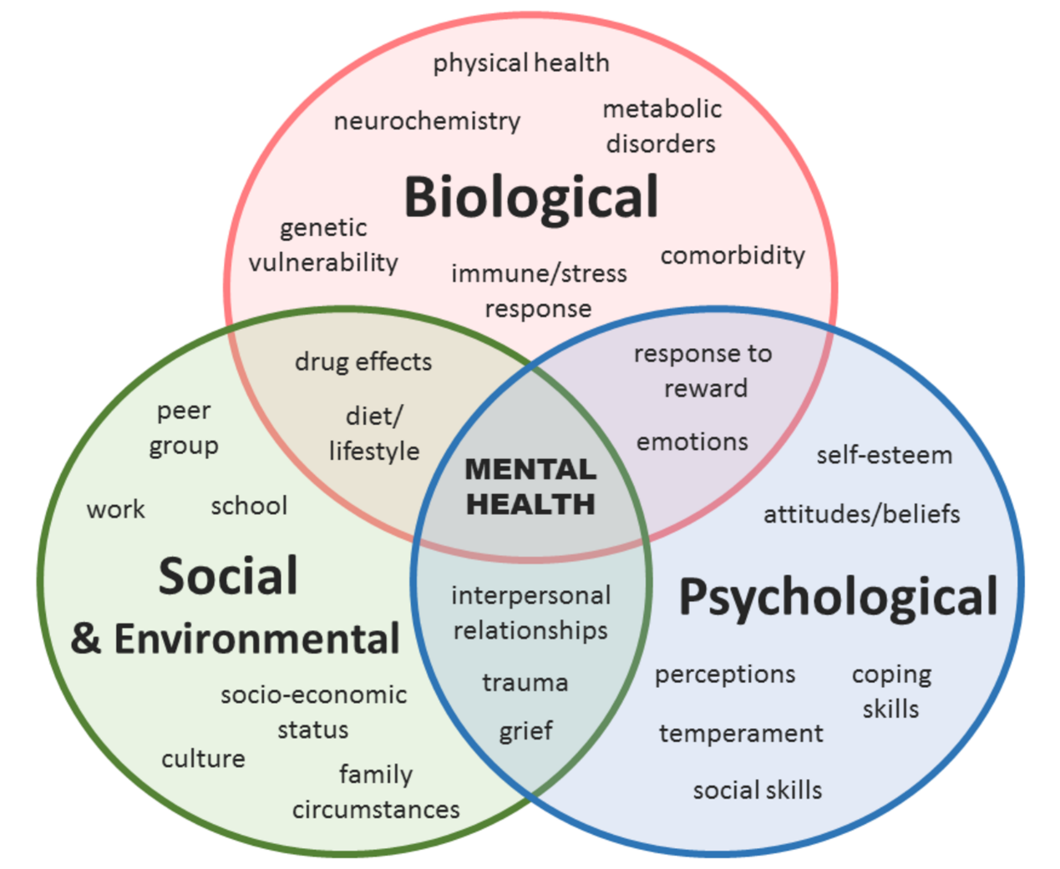
Figure 1 The bio-psycho-socio-environmental model for mental health.

2.1 The monoaminergic hypothesis for mood disorders: re-examined
The BPS-E model offers a more holistic understanding of mental health science by giving importance to all relevant domains of knowledge. This does not mean that we should not focus on a given domain and explore this in more depth. Development of greater understanding requires us to critically examine defined aspects within a given domain, as well as their relationship with other elements.
The ‘monoaminergic hypothesis’ is one such component, considered to be central to a biological understanding of mood disorders (which include both anxiety and depression). The hypothesis proposes that the underlying neurobiological basis of anxiety and depression rests on the depletion of levels of key monoamine neurotransmitters: serotonin, noradrenaline (termed ‘norepinephrine’ in the US) and/or dopamine within the brain. The hypothesis is supported by the mechanism of action of antidepressant drugs which have been shown to elevate the levels of these neurotransmitters in the brain, and are known to be effective in alleviating the symptoms of anxiety and depression.
Selective serotonin reuptake inhibitors, or SSRIs, in particular, which increase serotonin levels (by preventing the reuptake of this neurotransmitter from synapses) can be effective for both depressive disorders and anxiety. However, of the estimated 350 million people worldwide who experience depression, between a third to a half do not improve with ‘standard’ antidepressant treatment.
Similarly, 'at least a third of patients with anxiety disorders do not adequately respond to available pharmacological treatment' (Maron and Nutt, 2015). The occurrence of such ‘treatment-resistant’ (or ‘treatment refractory’) cases, casts doubt on the primary (or sole) dysfunction of the monoaminergic system in anxiety and depression. Consistent with this view, the gamma-aminobutyric-acid (GABA) system, a target for tricyclic antidepressant medications, has long been recognised as relevant to understanding mood disorders. More recently, attention has shifted to an imbalance in glutamatergic neurotransmission with the finding that ketamine (an analgesic/anaesthetic drug) may also act as a novel fast-acting antidepressant (Kirby, 2015; Malhi et al., 2016). Considering the overlapping and inter-related functions governed by these neurotransmitter systems, it is perhaps not surprising that the picture that emerges here is complex. We have provided you with a glimpse of this in Figure 2.

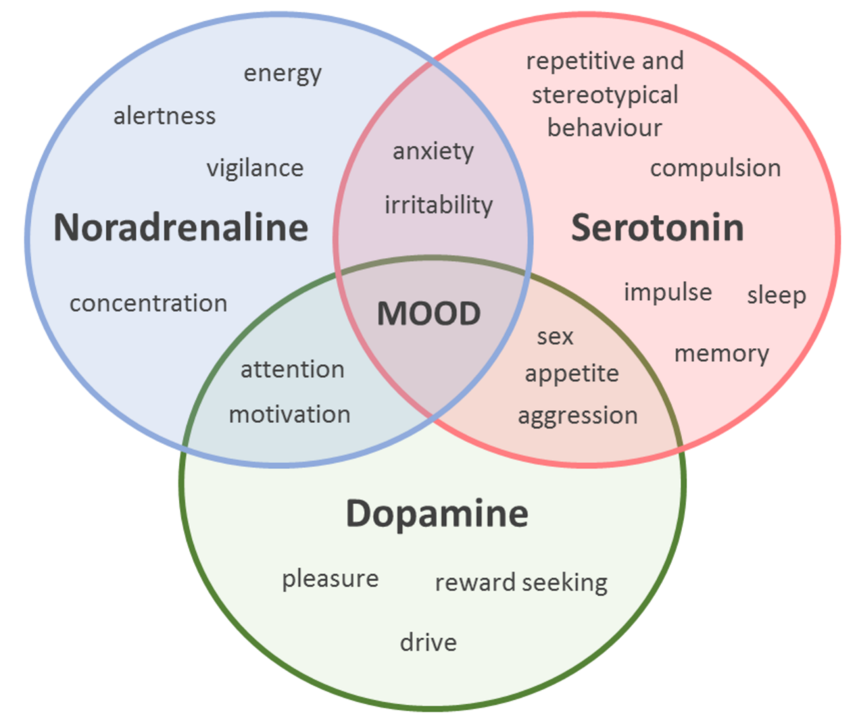
Figure 2 Monoaminergic neurotransmitters and the regulation of mood, emotion and cognitive function.

3 Overlap of symptoms between anxiety and depression and comorbidity with other conditions
An important and frequently-asked question concerns whether anxiety and depression are in fact two sides of the same coin. Do anxiety and depression lie on a continuum with overlapping social, environmental, biological and psychological causes? Or, do anxiety disorders and major depressive illness represent discrete ‘categories’ of illness?
To consider these questions, we first have to examine the symptom profiles for anxiety and depressive illness (see Figure 3). Recent studies suggest that around '85% of patients with depression also experience significant symptoms of anxiety' (Möller et al., 2016). Similarly, 'symptoms of depression occur in up to 90% of patients with anxiety', and such ‘comorbid anxiety and depression’ can occur at any age.

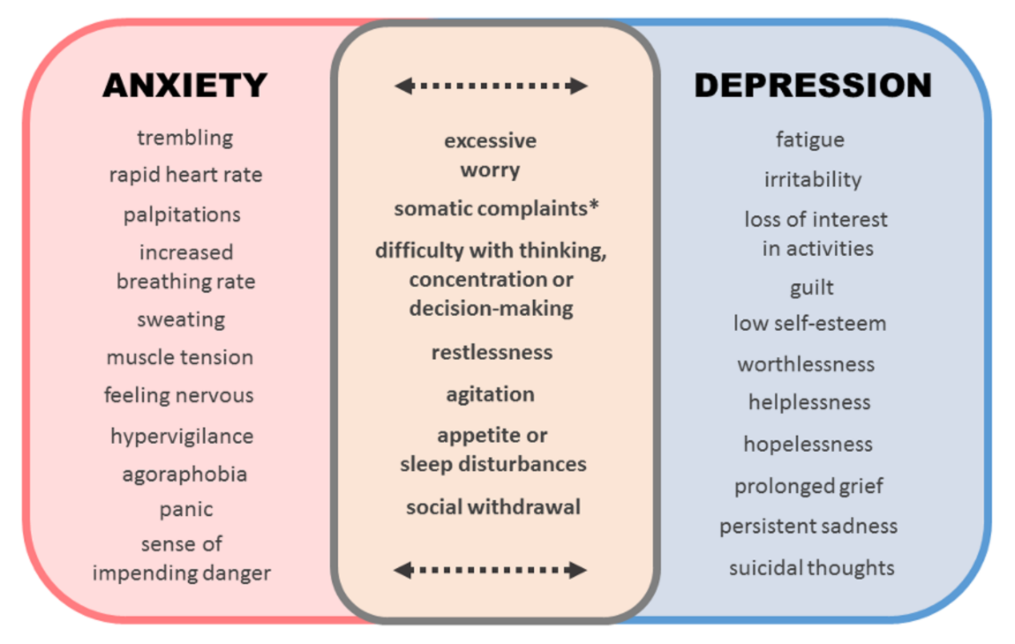
Figure 3 Symptom overlap between anxiety and depression.

(*) Somatic complaints: unexplained physical complaints such as headache, stomach ache, chronic pain.

3.1 Mixed anxiety and depressive disorder – a separate diagnostic category?
Mixed anxiety and depressive disorder, or ‘MADD’, is included as a separate diagnostic category in ICD-10, but has not been included in DSM-5. MADD is characterised in ICD-10 by subsyndromal symptoms of anxiety and depression (i.e symptoms that are severe enough to justify the diagnosis of MADD, but neither of which predominate sufficiently to warrant a separate diagnosis of an anxiety disorder or major depression). The validity and clinical usefulness of MADD as a diagnostic category continue to be debated and disputed, due to 'divergent results regarding its prevalence and course, diagnostic stability over time, and nosological inconsistencies between subthreshold and threshold presentations of anxiety and depressive disorders' (Möller et al., 2016). ICD-11 continues to include a separate diagnostic category, however subsyndromal, comorbid anxiety, and depression has been moved from the anxiety disorders to the depressive disorders section and renamed 'mixed depressive and anxiety disorder' (ICD-11, 2019). This change seems to align to some extent with the update to the DSM − although DSM-5 does not include a diagnostic category for MADD, 'the specifier "with anxious distress" has been added to depressive and bipolar disorders, and thus patients presenting with co-morbid, subsyndromal, equally important anxiety and depressive symptoms may be coded to be suffering from "Other specified depressive disorder with anxious distress”' (Möller et al., 2016).
Patients who meet ICD-10 diagnostic criteria for MADD frequently present in primary care settings, and many present initially with somatic complaints (e.g. muscle tension, headaches, palpitations, tachycardia, shortness of breath, etc.) that can ‘mask’ an underlying affective (mood) disorder. Patients with cardiovascular disease, cancer, diabetes and other metabolic conditions may also have comorbid symptoms of anxiety and/or depression. Möller et al. (2016) argue that a diagnosis of MADD 'may enable patients to gain access to appropriate treatments early', will help to alleviate distress, prevent worsening of symptoms (i.e. developing into a more serious illness), and reduce the overall socioeconomic costs associated with the illness. But would the inclusion of MADD within a separate classification system not lead to ‘medicalisation’ and further stigmatisation?
The authors explain: 'We are not advocating to lower the bar for a diagnosis and thus to unnecessarily tag millions of moderately "neurotic" individuals with a psychiatric label. Our concern is with patients who suffer profoundly from distress… denying such patients an appropriate diagnosis could well imply to withhold [sic] the required treatment as well.' (p. 732)
Möller and colleagues (2016) make an intriguing analogy with treatment for the common cold, stating that 'in day-to-day clinical practice, particularly in primary care, physicians diagnose and treat large numbers of patients who present with comparatively trivial, self-limiting disorders'.

A good example is the common cold which although it [sic] usually subsides within two weeks untreated, may cause profound, subjective suffering and has an enormous economic impact, mainly through loss of productivity. Of course, treatment of the common cold appears to be perfectly justified both from a clinical and from an economic perspective, since (a) patients suffer, (b) there is a certain risk of much more severe and difficult to treat complications and exacerbations, and (c) secondary costs, resulting from disability, may be reduced by an acceleration of recovery. (p. 733)

They argue that 'We have never heard of any criticism of common cold treatment founded in the conviction that a diagnosis of the disorder could lead to unjustified medicalization and stigmatization of millions of individuals who suffer from minor, self-limiting symptoms'. They further explain that 'This is because somatic disorders still appear to be perceived as something more "acceptable" and less stigmatizing than psychiatric disorders, both in the general population and in the medical community. One thing that somatic and psychiatric disorders have in common is that patients suffer' (Möller et al. 2016).

3.2 Trajectory of illness from anxiety to depression and comorbidity with other conditions
Kupfer and colleagues (2012) have separately pointed out that 'major depressive disorder was assumed to precede generalized anxiety disorder until a 32-year prospective follow-up study challenged this notion', citing the work of Moffitt et al. published in the Archives of General Psychiatry in 2007, and that 'the reverse pattern seems to be frequently present', 'the combination of generalized anxiety disorder and major depression might represent an additional burden' and 'social anxiety disorder (social phobia) is now also regarded as an important and consistent risk factor for the development of severe depression' (Kupfer et al., 2012).
Creswell et al. (2014, p.674) highlight the significance that 'anxiety disorders are among the most common psychiatric conditions in young people […] often co-occur with other anxiety disorders, depression and behavioural disorders [and] are associated with increased rates of anxiety and depression in early adulthood…'.
Silk and colleagues (2012) have emphasised that 'anxiety disorders commonly precede the onset of depression in adolescence' and that 'epidemiological studies reveal that up to ¾ of depressed youth have a history of at least one anxiety disorder'. They cite a community study of adolescents that was published by Orvaschel et al. (1995) which found that '42% of youth with a first diagnosis of an anxiety disorder developed a second diagnosis of MDD [major depressive disorder] by one-year follow-up' and, further, that 'one of the best predictors of the presence of both depression and anxiety in youth is a family history of depression'. The authors put forward the hypothesis that two neurobehavioral vulnerability factors − ‘social evaluative threat’ and altered ‘reward processing’ − could be involved in the pathway from anxiety to depression in youth, and support this with evidence from behavioural and neuroimaging studies. They propose that these vulnerabilities 'are likely to be present in many, but not all, anxious youth, and if present, are likely to be exacerbated by pre-pubertal developmental processes in ways that create a potential spiral toward depressive disorder' (Silk et al. 2012).
Asselmann and Beesdo-Baum (2015) point to prospective epidemiological studies as being 'indispensable to inform on the course of anxiety disorders, as they are less susceptible towards biases'. According to the authors such studies have 'consistently found that anxiety disorders in childhood or adolescence strongly predicted the presence of the same condition (homotypic continuity) […] as well as other mental disorders (heterotypic continuity)' in later life, and particularly a higher 'risk of developing secondary mental disorders, especially depression'.
Anxiety and depressive symptoms are also known to be linked with conditions such as Alzheimer’s and other neurodegenerative disorders, cardiovascular disease, stroke or cancer, and can be comorbid with other psychiatric conditions, including bipolar affective disorder and schizophrenia.
The studies cited above emphasise the possible trajectory of illness from anxiety to depression, identify the potential for comorbidity between the two conditions, and acknowledge that symptoms commonly associated with anxiety and depressive-related illness co-occur in a number of other medical and psychiatric conditions. This reinforces the notion that anxiety and depression are heterogeneous conditions, and opens up the possibility for the existence of subtypes with disparate biological, psychological, social or environmental causes that warrant further investigation.

4 Inter-individual variability and factors that contribute ‘resilience’ to anxiety and depression
Another key issue that generates considerable debate is the extent to which inter-individual vulnerability and factors that contribute to resilience vary amongst different individuals. Developmental and genetic susceptibility are key considerations in this debate. Factors that are thought to contribute to ‘resilience’ include: parenting, secure attachment, and trauma in early life, stress exposure during adolescence, lifestyle factors (such as diet, exercise, environment, positive social interaction, positive emotion, life purpose, spirituality), the stress circuitry (HPA axis), genetic and environmental interactions, epigenetics, and plasticity (adaptation) within the neural networks governing stress and reward.

5 Psychedelics for the treatment of anxiety and depression?
We now turn to a controversial treatment for mood disorders, interest in which has recently been revived following some small-scale trials. You may be wondering how it is even possible to consider the use of psychedelic (‘mind-altering’) drugs for the treatment of anxiety or depression. It may perhaps come as a surprise to you that prior to their prohibition in the late 1960s, drugs such as lysergic acid diethylamide (LSD) and psilocybin (magic mushrooms) were actually used in the treatment of mood disorders and fairly extensively researched across a range of psychiatric conditions in the 1950s and 1960s (Rucker et al., 2016). While these substances were found not to be useful for psychotic disorders, those 'suffering from so-called "neurotic" disorders, characterized by constrained, entrenched and often negative patterns of thought, feeling and behaviour, often reported new insights [and transformative states of mind] under the influence of psychedelics when taken in therapeutically supportive settings […] that allegedly conferred long-lasting beneficial change' (Rucker et al. 2016). The recent upsurge in interest in these compounds has focused attention once again on their mechanism of action and the nature of the therapeutic outcome. Activity 1 explores a recent small-scale ‘feasibility’ study into the use of psilocybin for the treatment of depression. This study was funded by the UK’s Medical Research Council, and published in the Lancet Psychiatry in 2016.

Activity 1 Psychedelics for the treatment of depression?
Allow 60 minutes

Read the press release and commentary provided below (you can access these via the associated links) and note down your responses to the questions that follow. The full open access article has also been provided for reference. You are not required to read the full article, but may do so if you wish. Please note that there is no discussion associated with this activity. The questions posed, however, will help you to structure your thoughts as you reflect on the issues raised in the resources you engage with as part of this activity. You might find it useful to take notes and write down your answers to individual questions.
Magic mushroom compound for the treatment of depression?
Wighton, K. (2016) Magic mushroom compound tested for treatment-resistant depression, Imperial College London, Press Release. [Press Release]
Cowen, P. (2016) ‘Altered states: psilocybin for treatment-resistant depression’, Lancet Psychiatry, vol. 3, no. 7, pp. 592-3. [Commentary]
Carhart -Harris, R.L., Bolstridge, M., Rucker, J., Day, C.M., Erritzow, D., Kaelen, M., Bloomfield, M., Rickard, J.A., Forbes, B., Feilding, A., Taylor, D., Piling, S., Curran, V.H. and Nutt, D.J. (2016) ‘Psilocybin with psychological support for treatment-resistant depression: an open-label feasibility study’, Lancet Psychiatry, vol. 2, no. 7, pp. 619-27. [Main Article]
- What type of research was this?
- What is the rationale for treating depression using psilocybin?
- What did the research involve?
- What were the main findings of the study?
- How did the researchers interpret their results?
- What can you conclude from this study?
- Are there any strengths or limitations to the research?
- Does the study have any ethical or legal implications?
- Do you think there are any long-term consequences to using psilocybin for mood disorders?

Provide your answer...

6 ‘Electrotherapy’ for anxiety and depression?
There has been some interest in recent years in ‘electrotherapy’ (cranial electrotherapy stimulation) for the treatment of mood disorders (this is not to be confused with electroconvulsive therapy or ‘ECT’, sometimes also referred to as ‘electroshock therapy’, which has long been recognised as effective for treatment-resistant depression). Interest in this potential new therapy centres around a portable device, the Alpha-Stim SCS, which sends mild (50-100 microamp) electrical currents through the body by way of wires attached to the earlobes, and is thought to modulate brain activity ‘at rest’ inducing a ‘relaxed, yet alert’ state. The device’s American inventor, Dr Daniel Kirsch has authored papers (Kirsch et al., 2014; Kirsch and Nichols, 2013) reporting on benefits of the use of the device for wide-ranging conditions from fibromyalgia through to anxiety, PTSD and insomnia. Patrick Strudwick, reporting for the Telegraph in 2010, wrote about his experience of using this new device (Strudwick, 2010).

Used by the military:
The Alpha-Stim device has been used by the US military for the treatment of anxiety, PTSD insomnia and depression amongst service members and veterans (Kirsch et al., 2014), and was trialled in the UK at the British Armed Forces Rehabilitation Centre in Surrey (at Headley Court), following its endorsement by Dr Bob Lister of London Metropolitan University (Strudwick, 2010). Dr Kirsch has explained that 'one of the reasons the military like this product is that many of the psychopharmacological approaches to anxiety have side effects that impair alertness' (cited in Strudwick, 2010).

Trialled within an NHS setting:
In 2016, Sayid and Jarvis, reporting for the Mirror, noted that in addition to its use for PTSD by the US and UK military, the device was also being considered in a trial carried out by Nottinghamshire Healthcare Trust, on the back of a pilot study of 12 participants which reported that 'the device reduced anxiety by 50%'. They also noted that 'if the pilot gets the go-ahead from the National Institute for Health and Care Excellence it could be rolled out by the NHS within two years' (Sayid and Jarvis, 2016).
The UK’s National Institute for Health Research (NIHR) issued a news release on 22 June 2017 titled ‘East Midlands leads commercial study to help treatment of anxiety with a device’, which referred to evaluation of the Alpha-Stim device ‘in the treatment of moderate to high anxiety’. The release noted that 'Nottinghamshire Healthcare NHS Foundation Trust was chosen by the commercial sponsors as the single site for running the study… All participants were suffering from moderate to high anxiety and were on the waiting list in Leicestershire and Rutland "Let’s Talk Wellbeing" Improving Access to Psychological Therapies services for Step 3 intensive psychological therapy' (NIHR, 2017).
The Health Research Authority’s website ‘Clinical and cost effectiveness of Alpha-Stim AID CES' described this commercially-sponsored study as 'a naturalistic study in patients with a primary working diagnosis of moderate-to-severe generalised anxiety disorder who did not improve with low intensity psychological therapy', specifying that this is 'a single-centre research study in patients seen within an NHS Improving Access to Psychological Interventions (IAPT) service with suspected generalised anxiety disorder (GAD)'. The study involves '120 patients from the Leicestershire and Rutland area' who will use the device 'for 60 minutes every day for 6 or 12 weeks, either whilst on the waiting list for standard care treatment from IAPT, or in conjunction with standard care treatment from IAPT'. The website also explains that 'The study will involve 6 study visits − one face-to-face at visit 1, followed by 5 visits via telephone at week 4, 6, 8, 12 and 24. At each visit, participants will be asked to complete questionnaires to assess anxiety, depression, sleep difficulty, quality of life and work and social functioning. The purpose of the study is to gather evidence for the clinical benefits and cost effectiveness of the Alpha-Stim AID when used in an NHS setting − how well does it work, and does its use result in cost savings for the NHS. The study may show that the Alpha-Stim AID should be available on the NHS for patients with suspected GAD.' The follow-up was expected to continue up until September 2017, after which the results are expected to be published (NIHR, 2017).
You can read the latest published results in Morriss et al. (2019) in the Journal of Affective Disorders. Two further press releases were issued by the company behind the product (Alpha-Stim 2019a and 2019b) with The Sunday Times stating that 'half of patients went into remission after treating themselves with the battery-operated device' and that 'researchers say it has the potential to revolutionise mental healthcare and could save the health service millions of pounds' (Gregory 2019).

Offered to teachers:
David Jarvis, reporting for the Telegraph (2017), has separately flagged the use of the device as a ‘drug-free treatment’ that is being rolled out to teachers at seven primary, seven secondary and a special educational needs school in Kent. The decision was taken by Leigh Academies Trust after a pilot scheme 'to combat anxiety and depression' and to 'help teachers cope with what is recognised as a nationwide problem', 'augmenting existing strategies to deal with stress'. Other than its non-invasive nature and its potential to offer an alternative form of therapy to medication, part of the appeal of the device may also be in its appearance, which is non-intrusive, hands-free and 'gives the impression the patient is simply wearing headphones'. The article raises the issue that workload and stress among teachers ranks in the top three most stressful occupations (recall your reading from Exploring anxiety, and the report from the Health and Safety Executive). The pilot, which involved 21 staff using the device for between 20 and 60 minutes over a period of four weeks, found that 'participants had better post-treatment sleep quality'.

6.1 Evidence for the use of electrotherapy for anxiety and depression
The pilot studies referred to above are clearly small-scale. Examining the literature, a pilot study published in 2008 by Bystritsky and colleagues reported improvements in anxiety ratings in six of the 12 participants with a DSM-IV diagnosis of generalised anxiety disorder (50% reduction in the Hamilton Rating Scale for Anxiety (HAM-A) scores following treatment), with adverse events 'generally mild in severity, mostly consisting of headache and nausea' (Bystritsky et al., 2008). In an independent study, Barclay and Barclay (2014) reported on a clinical trial involving a more extensive cohort of 115 participants with a primary diagnosis of an anxiety disorder, using the HAM-A and HAM-D17 rating scales. They found cranial electrotherapy stimulation (CES) to ‘significantly reduce’ anxiety and comorbid depression with 'no adverse events during the study'.
However, a Cochrane Collaboration systematic review also published in 2014, which examined the efficacy of CES 'in reducing symptoms of depression as reflected in change scores on standardized depression rating scales' reached the conclusion that 'there are insufficient methodologically rigorous studies of CES in treatment of acute depression' and that 'there is a need for double-blind randomized controlled trials' (see Kavirajan et al., 2014). Inclusion of appropriate controls, accounting for possible confounding factors are important considerations that are required to establish the empirical evidence (evidence base) for the use of electrotherapy for mood disorders.

- In your view, has the more recent CES study (Morriss et al., 2019) addressed such methodological concerns?

Conclusion
Use the visual summaries below to reflect on your learning for this section (see ‘Anxiety and Depression’) and the course as a whole (see ‘The Whole Picture’). Key questions that remain to be explored are highlighted in Box 1. The visual summaries span the ‘trajectory’ from anxiety over on the left to depression to the right, presenting an overview of themes and discussion points taken from this course and new areas that you may wish to explore.

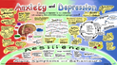
Figure 4 Visual summary ‘Anxiety and Depression’

We have provided you with a larger version of this image in PDF format.

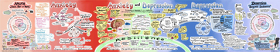
Figure 5 Visual summary ‘The Whole Picture’

We have provided you with a larger version of this image in PDF format.

Box 1 Some key questions around anxiety and depression
- Do anxiety and depression lie along a ‘continuum’ of human emotions?
- Is it common for anxiety and depression to co-exist?
- What is the impact of diagnosis?
- Do culture and societal views matter?
- Are anxiety and depression ‘contagious’?
- Are they brain disorders or psychological constructs?
- Are ‘biomarkers’ (e.g. genetic, blood, brain imaging) of any relevance to anxiety and depression?
- Where do glutamate and GABA feature in our understanding of the neurobiology of affective disorders?
- What is the relationship between anxiety and fear?
- Are ‘sickness behaviour’ and depression related conditions?
- Can anxiety and depression be inherited (are we genetically predisposed)?
- How do diet, lifestyle and social interactions impact on anxiety and depression?
- How closely do animal models for mood disorders relate to people?
- Anxiety and depression can co-exist with other conditions such as diabetes, cancer, cardiovascular disease or dementia; are mood disorders a cause or consequence of the illness?
- Can (or should) anxiety and depression be ‘cured’?
- Which is better − psychological or pharmacological therapies?
- What emerging treatments are out there?

We hope you have enjoyed your learning on this course. If you would like to continue your studies with the Open University, we offer courses at undergraduate and postgraduate level in this area (please refer to www.open.ac.uk/courses/). After completing this course, you should also be better prepared to move on to the MSc in Mental Health Science. You can find out more by visiting www.open.ac.uk/postgraduate/qualifications/f78. We wish you the very best for your future studies.

References
Alpha-Stim (2019a) ‘NHS Study of Alpha-Stim for Anxiety Can Revolutionize Mental Health Care in the UK: Study Proves Alpha-Stim Treatment is As Effective and More Cost Efficient Than Current First-Line Therapy’, Alpha-Stim, June 2019. Available online at https://www.alpha-stim.com/2019/06/nhs-study-of-alpha-stim-for-anxiety-can-revolutionize-mental-health-care-in-the-uk/ (Accessed 09-07-2019).
Alpha-Stim (2019b) ‘Clinical effectiveness and cost minimisation model of Alpha-Stim cranial electrotherapy stimulation in treatment seeking patients with moderate to severe generalised anxiety disorder’, Alpha-Stim. Available online at https://www.alpha-stim.com/clinical-effectiveness-and-cost-minimisation-model-of-alpha-stim-cranial-electrotherapy-stimulation-in-treatment-seeking-patients-with-moderate-to-severe-generalised-anxiety-disorder/ (Accessed 09-07-2019).
Asselmann, E. and Beesdo-Baum, K. (2015) ‘Predictors of the course of anxiety disorders in adolescents and young adults’, Current Psychiatry Reports, vol. 17, no. 2, article 7. doi: 10.1007/s11920-014-0543-z.
Barclay, T.H. and Barclay, R.D. (2014) ‘A clinical trial of cranial electrotherapy stimulation for anxiety and comorbid depression’, Journal of Affective Disorders, vol. 164, pp. 171-17.
Benning, T.B. (2015) ‘Limitations of the biopsychosocial model in psychiatry’, Advances in Medical Education and Practice, vol. 6, pp. 347-352.
Bystritsky, A., Kerwin, L. and Feusner, J. (2008) ‘A pilot study of cranial electrotherapy stimulation for generalized anxiety disorder’, Journal of Clinical Psychiatry, vol. 69, no. 3, pp. 412-7.
Carhart -Harris, R.L., Bolstridge, M., Rucker, J., Day, C.M., Erritzow, D., Kaelen, M., Bloomfield, M., Rickard, J.A., Forbes, B., Feilding, A., Taylor, D., Piling, S., Curran, V.H. and Nutt, D.J. (2016) ‘Psilocybin with psychological support for treatment-resistant depression: an open-label feasibility study’, Lancet Psychiatry, vol. 2, no. 7, pp. 619-27.
Cowen, P. (2016) ‘Altered states: psilocybin for treatment-resistant depression’, Lancet Psychiatry, vol. 3, no. 7, pp. 592-3.
Craske, M. G. and Stein, M. B. (2016) 'Anxiety disorders', The Lancet, vol. 388, no. 10063, pp. 3048-3059.
Creswell, C., Waite, P., Cooper, P.J. (2014) ‘Assessment and management of anxiety disorders in children and adolescents’, Archives of Disease in Childhood, vol. 99, no. 7, pp. 674-8.
Gregory, A. (2019) ‘No bigger than a mobile phone, the Alpha-Stim zaps anxiety with soothing electric currents’, The Sunday Times, May 26. Available online at: https://www.thetimes.co.uk/article/mobile-phone-sized-alpha-stim-zaps-anxiety-with-electric-currents-z0jhh82fp (Accessed 09-07-2019)
International Classification of Diseases 11th Revision, ICD-11 (2019) '6A73 Mixed depressive and anxiety disorder', World Health Organization, April 2019. Available online at: https://icd.who.int/browse11/l-m/en#/http://id.who.int/icd/entity/314468192 (Accessed 09-07-2019).
Jarvis, D. (2017) ‘Stressed teachers offered electric shock therapy to combat anxiety and depression’, The Telegraph, July 1. Available at: http://www.telegraph.co.uk/education/2017/07/01/stressed-teachers-offered-electric-shock-therapy-combat-anxiety/ (Accessed 09-07-2019)
Kavirajan, H.C., Lueck, K. and Chuang, K. (2014) ‘Alternating current cranial electrotherapy stimulation (CES) for depression’, Cochrane Database Systematic Review, vol. 8, no. 7, article CD010521. doi: 10.1002/14651858.CD010521.pub2.
Kirby, T. (2015) ‘Ketamine for depression: the highs and lows’, Lancet Psychiatry, vol. 2, no. 9, pp. 783-4.
Kirsch, D.L. and Nichols, F. (2013) ‘Cranial electrotherapy stimulation for treatment of anxiety, depression, and insomnia’, Psychiatric Clinics of North America, vol. 36, no. 1, pp. 169-76.
Kirsch, D.L., Price, L.R., Nichols, F., Marksberry, J.A. and Platoni, K.T. (2014) ‘Military service member and veteran self reports of efficacy of cranial electrotherapy stimulation for anxiety, posttraumatic stress disorder, insomnia, and depression’, US Army Medical Department Journal, Oct-Dec; pp. 46-54.
Malhi, G.S., Byrow, Y., Cassidy, F., Cipriani, A., Demyttenaere, K., Frye, M.A., Gitlin, M., Kennedy, S.H., Ketter, T.A., Lam, R.W., McShane, R., Mitchell, A.J., Ostacher, M.J., Rizvi, S.J., Thase, M.E. and Tohen, M. (2016) ‘Ketamine: stimulating antidepressant treatment?’ British Journal of Psychiatry Open, vol. 2, no. 3, pp. e5-e9.
Malhi, G. S. and Mann, J. J. (2018) 'Depression', The Lancet, vol. 392, no. 10161, pp. 2299-2312.
Maron, E. and Nutt, D. (2015) ‘Biological predictors of pharmacological therapy in anxiety disorders’, Dialogues in Clinical Neuroscience, vol. 17, no. 3, pp. 305-17.
Moffitt, T.E., Harrington, H., Caspi, A., Kom-Cohen, K., Goldberg, D., Gregory, A.M. and Poulton, R. (2007) ‘Depression and generalized anxiety disorder: cumulative and sequential comorbidity in a birth cohort followed prospectively to age 32 years’, Archives of General Psychiatry, vol. 64, no. 6, pp. 651–660.
Möller, H.J., Bandelow, B., Volz, H.P., Barnikol, U.B., Seifritz, E. and Kasper, S. (2016) ‘The relevance of "mixed anxiety and depression" as a diagnostic category in clinical practice’, European Archives of Psychiatry and Clinical Neuroscience, vol. 266, no. 8, pp. 725-36.
Morriss, R., Xydopoulos, G., Craven, M., Price, L. and Fordham, R. (2019) ‘Clinical effectiveness and cost minimisation model of Alpha-Stim cranial electrotherapy stimulation in treatment seeking patients with moderate to severe generalised anxiety disorder’, Journal of Affective Disorders, vol. 253, pp. 426-437.
National Institute for Health Research (NIHR) (2017) 'East midlands lead commercial study to help treatment of anxiety with a device', June 22. Available at: https://www.nihr.ac.uk/news/east-midlands-leads-commercial-study-to-help-treatment-of-anxiety-with-a-device/6381 (Accessed 09-07-2019)
Orvaschel, H., Lewinsohn, P.M. and Seeley, J.R. (1995) ‘Continuity of psychopathology in a community sample of adolescents’, Journal of the American Academy of Child and Adolescent Psychiatry, vol. 34, no. 11, pp. 1525-35.
Rucker, J.J., Jelen, L.A., Flynn, S., Frowde, K.D. and Young, A.H. (2016) ‘Psychedelics in the treatment of unipolar mood disorders: a systematic review’, Journal of Psychopharmacology, vol. 30, no. 12, pp. 1220-1229.
Sayid, R. and Jarvis, D. (2016) ‘Shock therapy device to treat depression, stress and anxiety being trialled by the NHS’, The Mirror, May 5. Available online at: http://www.mirror.co.uk/news/uk-news/shock-therapy-device-treat-depression-7906206 (Accessed 09-07-2019)
Silk, J.S., Davis, S., McMakin, D.L., Dahl, R.E. and Forbes, E.E. (2012) ‘Why do anxious children become depressed teenagers? The role of social evaluative threat and reward processing’, Psychological Medicine, vol. 42, no. 10, pp. 2095-107.
Strudwick, P. (2010) ‘Treating anxiety with the Alpha-Stim: Patrick Strudwick tests a new device that relieves anxiety and manages pain via "electrotherapy"’, The Telegraph, August 2. Available at: http://www.telegraph.co.uk/lifestyle/wellbeing/7918685/Treating-anxiety-the-Alpha-Stim.html (Accessed 09-07-2019)
Wighton, K. (2016) 'Magic mushroom compound tested for treatment-resistant depression', Imperial College London, Press Release. Available at: www.imperial.ac.uk/news/172407/magic-mushroom-compound-tested-treatment-resistant-depression/ (Accessed 09-07-2019).

Further reading
Find out more about this topic on OpenLearn:
Understanding depression and anxiety
Emotions and emotional disorders
Challenging ideas in mental health
Work and mental health
Exercise and mental health
or browse all our free course materials on OpenLearn – http://www.open.edu/openlearn/

Acknowledgements
This free course was written and compiled by Dr Payam Rezaie, critically read by Dr Christopher Heath and edited by Nick Adams (Faculty of STEM). It was commissioned by Simon Hull (Senior Producer, Free Learning, OMIL) and Dr Patrina Law (Head of OpenLearn). We are grateful to Dawn Partner, Dale Harry and Sofia Maruzza for production assistance, Katie Meade for Rights and Debbie Roberts (engagevisually.co.uk) for creative assistance in developing the visual summaries for this course.
Parts of the course were redeveloped from S826 Introduction to mental health science.
Except for third party materials and otherwise stated in the acknowledgements at the end of each session, this content is made available under a Creative Commons Attribution-NonCommercial-ShareAlike 4.0 Licence.
Illustrations
Visual summaries are licensed for use under Creative Commons Attribution-NonCommercial-ShareAlike 4.0 Licence CC BY-NC-SA 4.0.
We gratefully acknowledge the following sources:
Imperial College London for use of article text from ‘Magic mushroom compound tested for treatment-resistant depression’ available under an Attribution-NonCommercial-ShareAlike Creative Commons license. Article available at http://www3.imperial.ac.uk/newsandeventspggrp/imperialcollege/newssummary/news_17-5-2016-10-42-14 (Accessed 09-07-2019)
The material acknowledged below is Proprietary and used under licence (not subject to Creative Commons Licence). Grateful acknowledgement is made to the following sources for permission to reproduce material in this course:
Images
Course image: © BsWei / Shutterstock, Inc.
Every effort has been made to contact copyright owners. If any have been inadvertently overlooked, the publishers will be pleased to make the necessary arrangements at the first opportunity.
Don't miss out:
1. Join over 200,000 students, currently studying with The Open University – http://www.open.ac.uk/choose/ou/open-content
2. Enjoyed this? Find out more about this topic or browse all our free course materials on OpenLearn – http://www.open.edu/openlearn/
3. Outside the UK? We have students in over a hundred countries studying online qualifications – http://www.openuniversity.edu/ – including an MBA at our triple accredited Business School.

