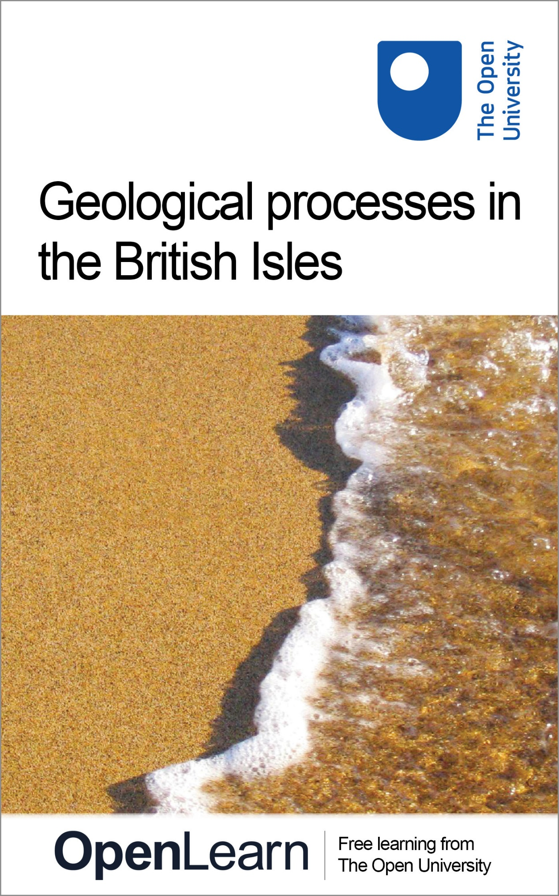

SXR260_1 The geological history of the British Isles

Geological processes in the British Isles

About this free course
This free course provides a sample of Level 2 study in Science: http://www.open.ac.uk/courses/find/science.
This version of the content may include video, images and interactive content that may not be optimised for your device.
You can experience this free course as it was originally designed on OpenLearn, the home of free learning from The Open University - www.open.edu/openlearn/science-maths-technology/science/geology/geological-processes-the-british-isles/content-section-0.
There you’ll also be able to track your progress via your activity record, which you can use to demonstrate your learning.
The Open University, Walton Hall, Milton Keynes, MK7 6AA
Copyright © 2016 The Open University
Intellectual property
Unless otherwise stated, this resource is released under the terms of the Creative Commons Licence v4.0 http://creativecommons.org/licenses/by-nc-sa/4.0/deed.en_GB. Within that The Open University interprets this licence in the following way: www.open.edu/openlearn/about-openlearn/frequently-asked-questions-on-openlearn. Copyright and rights falling outside the terms of the Creative Commons Licence are retained or controlled by The Open University. Please read the full text before using any of the content.
We believe the primary barrier to accessing high-quality educational experiences is cost, which is why we aim to publish as much free content as possible under an open licence. If it proves difficult to release content under our preferred Creative Commons licence (e.g. because we can’t afford or gain the clearances or find suitable alternatives), we will still release the materials for free under a personal end-user licence.
This is because the learning experience will always be the same high quality offering and that should always be seen as positive – even if at times the licensing is different to Creative Commons.
When using the content you must attribute us (The Open University) (the OU) and any identified author in accordance with the terms of the Creative Commons Licence.
The Acknowledgements section is used to list, amongst other things, third party (Proprietary), licensed content which is not subject to Creative Commons licensing. Proprietary content must be used (retained) intact and in context to the content at all times.
The Acknowledgements section is also used to bring to your attention any other Special Restrictions which may apply to the content. For example there may be times when the Creative Commons Non-Commercial Sharealike licence does not apply to any of the content even if owned by us (The Open University). In these instances, unless stated otherwise, the content may be used for personal and non-commercial use.
We have also identified as Proprietary other material included in the content which is not subject to Creative Commons Licence. These are OU logos, trading names and may extend to certain photographic and video images and sound recordings and any other material as may be brought to your attention.
Unauthorised use of any of the content may constitute a breach of the terms and conditions and/or intellectual property laws.
We reserve the right to alter, amend or bring to an end any terms and conditions provided here without notice.
All rights falling outside the terms of the Creative Commons licence are retained or controlled by The Open University.
Head of Intellectual Property, The Open University
Designed and edited by The Open University
978-1-4730-0877-9 (.epub)
978-1-4730-1645-3 (.kdl)

Contents
- Introduction
- Learning outcomes
- 1 Landscape formation
- 2 Geological time-scales – a brief review
- 3 A global view of Earth history
- 4 Plate tectonics reviewed
  - 4.1 Introduction
  - 4.2 Revealing past plate tectonic events
  - 4.3 Continental extension
  - 4.4 Closure of an ocean
  - 4.5 How wide were the oceans?
  - 4.6 Continental collision
- 5 The main lithotectonic units of the British Isles
  - 5.1 Introduction
  - 5.2 Precambrian and Lower Palaeozoic Basement
  - 5.3 Caledonian Orogenic Belt
  - 5.4 Older Cover
  - 5.5 Variscan Orogenic Belt
  - 5.6 Younger Cover
- 6 Conclusion
- 7 Course questions
- Acknowledgements
- Solutions

Introduction
This course provides an introduction to the processes that have shaped the evolution of the Earth, with many detailed examples from the geology of the British Isles. These are studied through the use of the British Geological Survey bedrock geology maps. This course also helps to give a theoretical foundation for any students considering the residential school for the SXR260 The geological history of the British Isles course, based in the north of England.
This OpenLearn course provides a sample of Level 2 study in Science.

Learning outcomes
After studying this course, you should be able to:
- summarise and identify descriptions of the principal features of the main lithotectonic units of the British Isles, namely the Precambrian Basement, the Caledonian Orogenic Belt, the Variscan Orogenic Belt, the Older Cover and the Younger Cover
- identify any of the main terranes making up the British Isles on the basis of a description of its age, main rock types, dominant structures, and plate tectonic setting.

1 Landscape formation
This course is an introduction to the geological history of the British Isles, a remarkable part of the world upon which many of the great events in Earth history have left their mark. In this course we use the term ‘British Isles’ in its geographical sense, referring to the islands of Great Britain and Ireland and the adjacent lesser isles. The British Isles did not exist as such until comparatively recent times, and the surface environment of the continental crust that now forms this region has undergone dramatic changes during the geological history of the Earth.
You will gain the most from this course, and enhance your understanding of the geology of the British Isles, if you purchase the British Geological Survey's (BGS) 1:625 000 bedrock geology maps of the UK. These are available direct from the BGS at:
Bedrock geology UK North (1:625 000 map)
Bedrock geology UK South (1:625 000 map)
(accessed October 2019).

Please note: these BGS maps have been updated since this course was first published (2008), and you may find some inconsistencies between the activity instructions and the maps.
You can also now find digital geological map data based on BGS's published poster maps of the UK on this page. There are various downloadable formats available.

They are referred to as Ten Mile Maps (N) or (S) throughout the course.
Figure 1, below, is an artist's impression of what part of northern England looked like during different periods of the region's geological history. You can see that over a relatively short period of time (~100 million years), the area experienced significant changes in:
- climate (varying from subtropical to arid and semi-arid);
- sea-level (with two transgressions onto the land by shallow seas); and
- landmass relief (a progressive decrease in the height of the highlands).

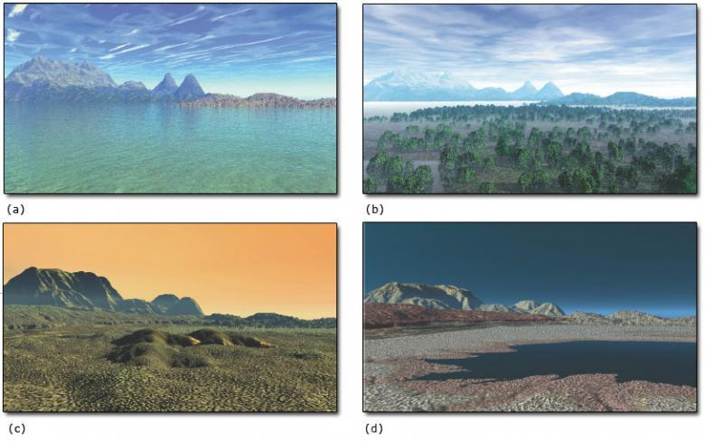
Figure 1 A reconstruction of northern England looking westwards towards the Lake District at different geological times from the Early Carboniferous (a) to the Late Permian (d). The progressive northwards drift of the British Isles resulted in rocks from a wide range of environments being formed and later preserved. Much of the Lake District highlands consists of Ordovician volcanic rocks. During the Early Carboniferous (a), the region lay close to the equator, with the low ground covered by a shallow sea in which corals and other marine fauna and flora prospered. As this sea receded, this was replaced by the Late Carboniferous coal swamps (b) and later by the deserts of the Early Permian (c), as the British Isles continued to drift northwards towards the present latitude of the Sahara. By the Late Permian (d), a shallow sea had encroached on this area once again

Students who attend the Open University residential school week in northern Britain associated with this course will begin to evaluate the range of environments that existed there in the geological past. In the Lake District, a deep ocean has left a thick sequence of mudstones, shales and siltstones overlying and juxtaposed to a series of volcanic rocks. In contrast, the somewhat younger rocks outcropping in the Pennines (running down the centre of northern England) were laid down in a warm shallow subtropical sea conducive to the formation of limestones containing corals and other marine organisms (Figure 1a). At several times across the region, marine conditions were interrupted by sands and silts deposited in river deltas, with organic material, which eventually formed coal, deposited in coastal swamps (Figure 1b). Later still in the Vale of Eden (south of Carlisle), alluvial fans and sand dunes indicate a desert environment (Figure 1c). This was in turn superseded by a shallow sea, now represented by limestones and evaporite deposits (Figure 1d), which are found throughout the counties of Cleveland and Durham.
In addition to this sedimentary succession, a number of igneous extrusive and intrusive episodes have left their mark. Periods of uplift, deformation and erosion have also influenced the geological history of northern England and indeed the British Isles as a whole.
Geologists find out about these and similar changes by examining the different types of rock formed throughout the geological record, and comparing them with their modern-day equivalents. A number of climatic, sea-level and topographical changes can be recognised throughout the 3.8 billion years of the geological history of the British Isles. The majority of these relate to the ever-changing position of the Earth's tectonic plates.
Throughout this course you will find that geological Periods may be prefixed by the terms, ‘Early’, ‘Mid-’ and ‘Late’, or ‘Lower’, ‘Middle’ and ‘Upper’. The first three are used in the context of time (e.g. a specific age period), whereas the last three refer to successions of rocks. So, for example, Lower Jurassic rocks were formed during the Early Jurassic.

2 Geological time-scales – a brief review
Geological time can be divided into a number of Eons, Eras and Periods, with further subdivisions into sub-Periods or series and epochs. These are arranged chronologically, with the oldest at the bottom, younging upwards to form the stratigraphic column (Figure 2).
The stratigraphic column can be looked at in two ways. The first deals with the order of rock units. This order has been established using the Principle of Superposition and the Principle of Faunal Succession, and produces the lithostratigraphic (‘rock-stratigraphic’) column, based simply on the relative ages for rock successions. The second aspect of the stratigraphic column relates to the geochronological dating of rocks using a variety of radiogenic isotopes. This forms the chronostratigraphic (‘time-stratigraphic’) column and allows geologists to apply absolute ages to rock successions.

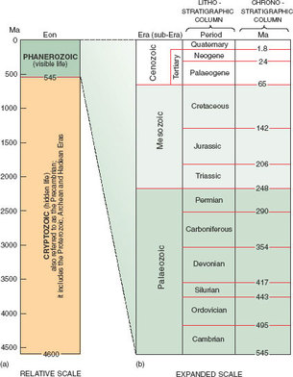
Figure 2 The stratigraphic column for the whole of geological time: (a) to true scale and (b) expanded scale for the Phanerozoic. (The Cryptozoic Eon represents ~90% of all geological time.) The scale is divided into Eons, Eras and Periods, which form the lithostratigraphic column. The column of ages of each Period, in millions of years (Ma), forms the chronostratigraphic column

3 A global view of Earth history
Figure 3, below, shows how the Earth's continents have drifted across the globe over the past 550 million years. This is a reconstruction of continental configurations of the Earth's landmasses during the Phanerozoic Eon. Note how northern and southern parts of the British Isles (red) were dispersed over two continents/tectonic plates until the end of the Devonian (a–d), and that all the landmasses formed one supercontinent during the Permo-Triassic (f).

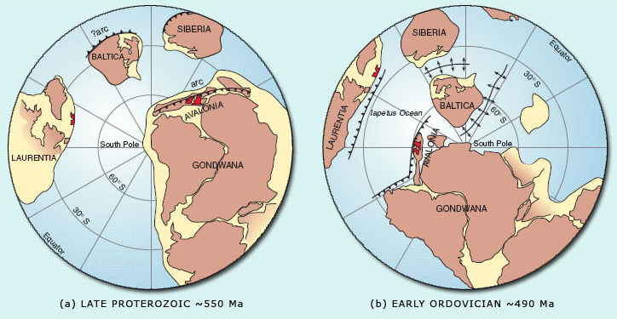

- (a) The northern British Isles is located at the passive margin of Laurentia, while the southern British Isles is situated behind the subducting margin of Avalonia, a micro-continent on the edge of Gondwana. Both Laurentia and Avalonia are south of ~40° S and are separated from each other by a spreading ocean (which becomes the Iapetus).
- (b) The southern British Isles is still located at the margin of Avalonia, which has drifted southwards to ~60° S. In contrast, Laurentia, carrying the northern British Isles, has started to drift northwards, residing at ~20° S, separated from Gondwana by the Iapetus Ocean (which is now beginning to close).

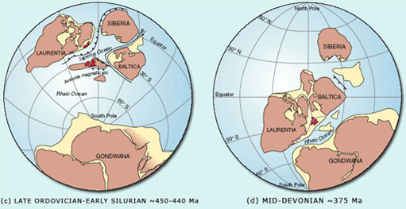

- (c) The Iapetus Ocean has been progressively closing, bringing the micro-continent of Avalonia (including the southern British Isles, ~30° S), closer to Laurentia (including the northern British Isles, ~20° S). At the northern margin of the ocean, subduction is occurring below Laurentia, whereas the southern margin with Avalonia is passive. To the south of Avalonia, the Rheic Ocean is actively spreading.
- (d) ‘Zipper-like’ continental collision has been occurring between Laurentia and Avalonia, uniting the British Isles along the Iapetus suture zone (purple line). This collision is known as the Caledonian Orogeny. At this time, the British Isles are at ~20°–25° S, located within the southern desert latitudes.

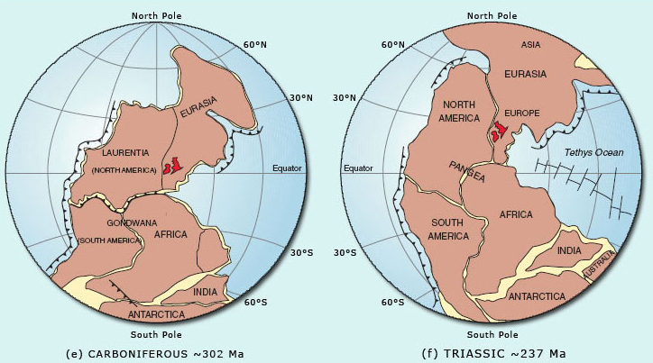

- (e) As the Rheic Ocean closes between Laurentia, Eurasia and Gondwana, the Variscan Orogeny starts to affect the southern British Isles. During the Carboniferous, continental drift has carried the British Isles northwards across the equator, into subtropical latitudes.
- (f) All of the landmasses have united to form the supercontinent Pangea. To the east, Tethys is actively spreading, while the British Isles continues to drift northwards to 20°–30° N, equivalent to the modern day Sahara latitudes.

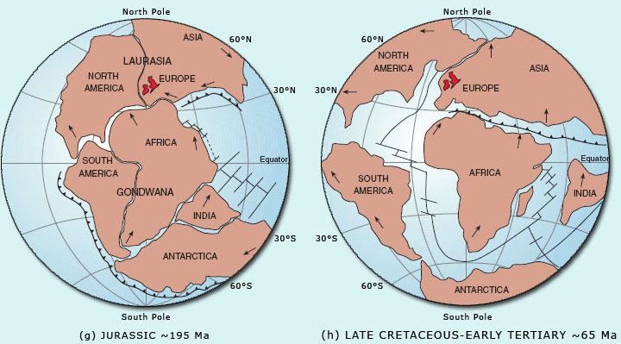

- (g) Break-up of Pangea results in Gondwana and Laurasia separating, as the southern Atlantic Ocean starts to rift open. The British Isles continues to drift northwards to ~35°–40° N into more temperate conditions, with lithospheric extension and passive rifting occurring to the east (forming the North Sea) and west (where later the North Atlantic will open).
- (h) Passive rifting has given way to active rifting to the west of the British Isles, allowing the northern Atlantic Ocean to continue opening in a zipper-like fashion northwards. Active sea-floor spreading is occurring throughout the Atlantic, Indian and Pacific Oceans, whilst Tethys closes, resulting in the eventual collision of Africa, India and Eurasia.

Question 1

Describe in one sentence how the geographical position of the British Isles has varied since the Cambrian.

View answer - Question 1

Until the end of the Silurian and beginning of the Devonian, the northern and southern halves of what is now the British Isles were on different continents, separated by an ocean – the Iapetus (Figure 3a–c). The existence of this ocean, along with the collision between these continents is recorded by the Caledonian Orogenic Belt, which contains rocks formed within and on the flanks of the now vanished Iapetus (Figure 3d). By ~375 Ma (Figure 3d–e), this ocean had closed with the resultant continental collision producing a series of major tectonic structures that can be observed on the Ten Mile Map.
At a later date, the Variscan Orogenic Belt (which is found in the southern British Isles) formed as a result of another period of continental collision, when the Rheic Ocean closed between Laurentia and Gondwana (Figure 3e). This tectonic activity led to the unification of all the globe's main continental landmasses into one supercontinent called Pangea (Figure 3f).
Figure 3g and h shows stages in the break-up of Pangea, which resulted in the formation of new oceans (including the Atlantic), as well as the formation of another extensive orogenic belt when Africa collided with Europe to form the Alps, and India collided with Asia to form the Himalayas. These last two examples illustrate that orogenic episodes in one region can occur at the same time as ocean spreading in another region.
In addition to the continental landmasses moving over time, driven by a variety of plate tectonic processes, geologists can also recognise episodic fluctuations in the relative global sea-level throughout the Phanerozoic (Figure 4). Although a detailed study of the causes of relative sea-level change is beyond the scope of this course, it is important to recognise that these processes do occur. If these processes cause the relative sea-level of the whole globe to change, they are referred to as eustatic sea-level changes, whereas if they have a more local effect and are due to isostatic readjustments (e.g. orogenic movements), they are referred to as epeirogenic sea-level changes. In Figure 4, the relative change in eustatic sea-level (and mean global temperature) is plotted against time, using the present day sea-level as a baseline.

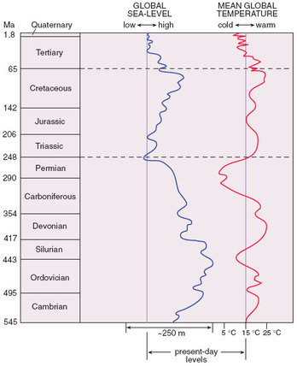
Figure 4 Relative global (eustatic) sea-level and mean global temperature changes for the Phanerozoic compared with that of the present day. (Present sea-level and global temperature lines are based on averages for the whole of the Pleistocene, which have been affected by numerous glaciations, lowering the average sea-level and temperature values from today's actual values.)

Question 2

Compare the sea-level curve in Figure 4 with the maps in Figure 3 showing the changing assembly of continental masses through time. Briefly describe any correlation between sea-level and the degree of unification of the continental landmasses that you can detect.

View answer - Question 2

One cause of global changes in sea-level could be the formation of thick continental ice caps reducing the volume of water in the oceans, resulting in a eustatic fall. When this ice melts, the sea-level must rise. Table 1, below, summarises the occurrence of major ice ages over the past 2300 million years.

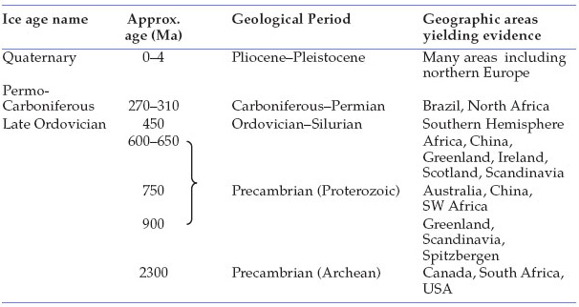
Table 1 Occurrence of major ice ages in the geological record and their geographic locations

Question 3

Compare the approximate ages of the ice ages from Table 1 with the global sea-level curve in Figure 4. How well do these data correlate with each other?

View answer - Question 3

What other process can you think of that would affect the sea-level on a global scale?
One clue can be obtained by using Figure 3 and looking at what has happened to the continents during periods of eustatic lows. When a supercontinent such as Pangea breaks up (Figure 3g–h), a new series of ocean ridges will form associated with the formation of new ocean basins by sea-floor spreading. These ridges can be thought of as submarine mountains that grow in width and length as the spreading process develops. As they grow, the ridges displace water from the ocean basins onto the continental regions. In other words, unlike an ice age, which changes the volume of water in the oceans, continental break-up and the formation of new ocean ridges changes the volume of the ocean basins, so that seawater is displaced onto the land. Therefore, the sea-level ‘highs’ of the Early Palaeozoic and Cretaceous may be attributed to an increase in ocean spreading activity. It has been estimated that the extreme sea-level high during the Cretaceous was ~300 m above present-day sea-level. Not surprisingly, as you will see later, its effects can be seen across the British Isles on the Ten Mile Map.
Thus, we see that the three themes of plate tectonics, climatic changes and sea-level changes are all interlinked.

4 Plate tectonics reviewed

4.1 Introduction
In the theory of plate tectonics there are three main types of plate boundary, namely: constructive, destructive and conservative plate boundaries.

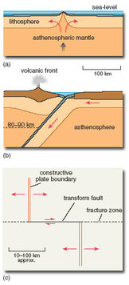
Figure 5 Schematic cross-sections through (a) a constructive plate margin and (b) a destructive plate margin (both are drawn to the same scale), along with a sketch map of (c) a conservative plate margin, which in this case has a transform fault offsetting a constructive plate margin. (Conservative plate margins can occur between any two plates that are sliding past each other without creating or destroying crustal material.)

- Constructive plate margins occur as the result of lithospheric extension (Figure 5a). As the plates are pulled apart, buoyant mantle wells upwards to prevent a gap from opening. The upwelling mantle undergoes partial melting to form oceanic crustal material.
- Destructive plate margins form where two plates collide. The more dense plate is subducted below the other, where it is eventually reclaimed by the mantle asthenosphere (Figure 5b). The location of destructive plate margins is marked by a volcanic arc on the overriding plate, which forms above the point at which partial melting commences. Much of the partial melting is triggered in the mantle wedge by the release of fluids from the subducting slab.
- When two plates slide past each other without creating or destroying crustal material, this is referred to as a conservative plate margin (Figure 5c). As new crust is not produced at this type of margin, it can be described as being amagmatic. Conservative plate boundaries typically form in oceanic settings and cause constructive plate margins to be offset by tens to hundreds of kilometres, along strike-slip (transform) faults.
This section briefly considers the types of igneous processes that occur in different tectonic environments, looking at constructive and destructive plate margins as well as intraplate environments and collision zones. However, you will primarily be looking at how this information can be used to recognise and understand the processes of ocean basin formation and closure in more detail.

4.2 Revealing past plate tectonic events
In Section 3 we referred to the Caledonian and Variscan Orogenic Belts. These are interpreted as representing past destructive plate margins or more strictly speaking, representing the final phases of ocean closure that resulted in continental collision. Section 4 explores the extent to which it is possible to detect different stages throughout the cycle of ocean basin formation and closure; in other words it examines how geologists can identify:
- the initial rifting and separation of continents;
- the former presence of a wide ocean;
- the closure of an ocean by subduction; and
- the collision of two continents once an ocean has closed.
When doing this, it is important to remember that individual features such as andesitic lavas, granite plutons, intense folding or high-grade metamorphism should never by themselves be taken as unequivocal evidence for the occurrence of a particular type of plate margin. It is essential to consider all the geological evidence, as well as how all of the evidence fits together on a regional basis. (This approach is sometimes called the principle of consilience.) Even if such detective work is successful, it cannot indicate how wide a past ocean was, even though the suture zone can often be detected marking where its closure is located. To estimate the width of past oceans, additional information such as palaeomagnetic data or fossil evidence needs to be used.

4.3 Continental extension
Understanding how and why continental plates break apart is extremely important, as this step precedes the formation and development of all new ocean basins. A generalised model for the extension, rifting and separation of continental plates has been developed by examining currently active rifting environments, such as the East African and Red Sea rifts, and comparing these with mature basins, such as the Atlantic Ocean. The East African and Red Sea rifts are regarded as representing continental rifting and the early stages of ocean opening respectively. They can therefore be used as an analogy for how mature oceans, such as the Atlantic or Pacific, first developed. The Red Sea is of particular interest to geologists as a ‘living experiment’, as the final stages of continental extension and the very beginning of sea-floor spreading can be observed in this one location. At the northern end of the Red Sea, the basin floor consists of thinned continental lithosphere that has been injected by numerous basaltic dykes, indicative of the very last stages of continental extension prior to breaking apart. This contrasts with the southern end, where volcanic sites are associated with rifting and the formation of new oceanic lithosphere produced by sea-floor spreading.
Although geologists are primarily interested in the development of new ocean basins, it is important to remember that not all rifts proceed to completion. Many fail after opening just a few kilometres. However, these failed rifts are still extremely important, as they have the potential to be of exceptional economic interest as petroleum reservoirs.
Based on the present-day analogies, a number of stages in the formation, development and eventual closure of ocean basins can be identified (Figure 6).

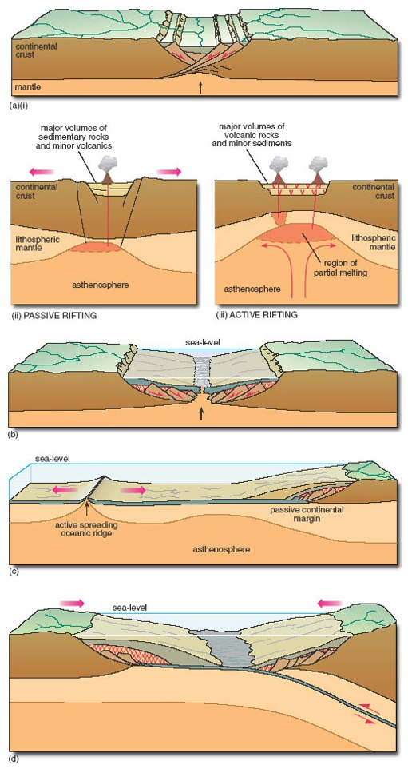
Figure 6 Schematic cross-section of the sequence of events leading to the formation, development and closure of an ocean basin. (a) Crustal thinning. At first, the upper parts of the crust extend by developing a series of brittle normal faults. This can be initiated either by passive rifting (a)(ii), or by active rifting (a)(iii). After the crust extends, it will eventually undergo ‘thermal sag’, creating a basin in which sedimentary and/or volcanic rocks can accumulate. (b) Embryonic ocean basin formation. As extension continues, the lower lithosphere will rise and melt. (c) Active rifting and formation of a passive continental margin. (d) Onset of subduction

4.3.1 Stage 1: Continental rifting (northern Red Sea stage)
There are two mechanisms for breaking up a continental plate, the simplest of which is to pull it apart under lithospheric extension, forcing the mantle to rise up to occupy the ‘space’ that otherwise would be left by the thinned overlying plate (Figure 6a). Continued extension of this already thinned plate will result in it eventually splitting apart. This is often referred to as passive rifting (Figure 6a(ii)), and is driven by extensional processes. Another way of thinning the continental lithosphere is by stretching it upwards rather than laterally. This can be caused by a hot, buoyant mantle plume rising up through the mantle, and forcing the continental lithosphere to dome upwards. This is referred to as active rifting, and is driven by mantle processes (Figure 6a(iii)).
With both rifting mechanisms, as the continental lithosphere is stretched, the upper crust undergoes brittle failure forming a series of horsts and grabens, which progressively separate along normal faults, while the lower crust is subjected to ductile stretching and thinning. Although the end result of both passive and active rifting is the same (i.e. the division of a continental plate and the formation of new oceanic crust), the sequences of events leading up to rifting are very different.

SAQ 1

Based on Figure 6a, what do you think will be the first visible effects of passive and active rifting processes on the continental plate?

View answer - SAQ 1

The North Atlantic Tertiary Igneous Province (NATIP), which consists of flood basalts covering areas of Greenland, northern America, Skye and County Antrim, formed because of active rifting that led to the opening of the North Atlantic Ocean. This contrasts with the more minor (but still impressive) Carboniferous volcanic features found throughout the Midland Valley of Scotland (including the Castle Rock and Salisbury Crags in Edinburgh), that formed as a result of passive rifting associated with the Variscan Orogeny.

4.3.2 Stage 2: Embryonic ocean basin formation (southern Red Sea stage)
If extension and rifting progresses sufficiently, this will lead to the development of an embryonic ocean along the site of the earlier rift zone (see Figure 6b). Prior to true oceanic lithosphere being produced, basaltic magma will be repeatedly intruded into the continental lithosphere along fractures and shear zones. Continued intrusion will eventually lead to the development of a complex of sub-vertical sheeted dykes. If these dykes allow magma to be extruded onto the basin floor, pillow lavas or small lava flows will result. As the embryonic ocean grows, an igneous sequence typical of sea-floor spreading (i.e. a layered sequence of lavas, sheeted dykes, gabbro and peridotite) will form. While this embryonic ocean is still narrow, water circulation will be restricted, allowing organic-rich and/or evaporitic sediments to accumulate. Basin subsidence will occur rapidly as the new ocean opens and crustal blocks on either side of the basin are stretched and faulted.

4.3.3 Stage 3: Passive continental margin formation
Eventually, movement along faults initiated during the continental rifting stage ceases, and the entire continental margin starts to subside. Subsidence at this stage occurs because of lithospheric cooling as the distance between the margin and spreading ridge-axis increases, rather than as a result of tectonic movement of the fault blocks (as during the continental rifting stage). By now, all tectonic activity is focused at the new oceanic spreading axis and the continental lithosphere can be referred to as a passive continental margin (see Figure 6c). Throughout this stage, sediments deposited on the passive continental margin prograde laterally (advance seawards).
In summary, important indicators of continental rifting and separation include the association of basaltic igneous activity with the development of relatively narrow rift-basins, followed by more widespread regional subsidence. This is not limited exclusively to continental margins, but can also be exhibited by intracontinental rifts that have failed to develop by forming an ocean-spreading centre.

4.4 Closure of an ocean
Some of the oldest rocks in the British Isles are over 2500 million years old, whereas elsewhere on the Earth rocks as old as 3800 million years have been found within the continents. These ages contrast with that of the world's oldest in situ oceanic crust (excluding obducted ophiolites), which is only 200 million years. Considering that basins must have been opening and closing for approximately the same amount of time as continental crust has been forming, this implies that after an ocean basin has grown for a period of ~200 million years, the adjacent passive continental margin becomes a destructive margin and starts subducting the oceanic lithosphere (see Figure 6d).

SAQ 2

Why does this change occur?

View answer - SAQ 2

By the time the oceanic lithosphere is ~200 million years old, it is so cold and dense compared with the adjacent continental lithosphere, that it starts to sink into the underlying asthenosphere under its own weight (helped by the continual push of newly formed oceanic lithosphere). This initiates subduction. If the rates of subduction and sea-floor spreading are equal, this system will remain stable. If, however, subduction is occurring at a faster rate than spreading, convergence will occur and may result in collision of the two plates, eventually forming an orogenic belt.
Recent research on how long it takes for a passive margin to switch to an active, destructive margin suggests that this can be as little as ~10 million years. Therefore, a complete cycle of ocean-basin formation, opening and closure should take approximately 400–500 million years (i.e. ~200 million years to open + ~10 million years for the switch from a passive continental to destructive margin + ~200 million years to close).

SAQ 3

What evidence do you think geologists can use to identify the presence of past oceans and their margins?

View answer - SAQ 3

In addition, specific structural features that are characteristic of a subduction zone can be looked for.

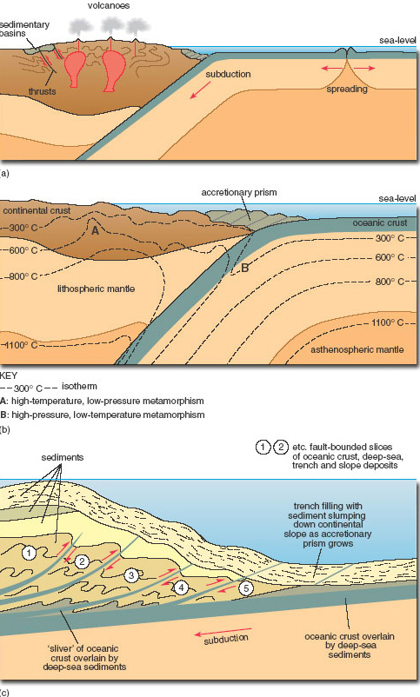
Figure 7

- (a) Schematic cross-section through a subduction zone involving continental crust, illustrating the key features described in the text.
- (b) Detailed sketch showing the arrangement of a paired metamorphic belt, which runs parallel to the subducting plate boundary. High-temperature, low-pressure metamorphism (A) occurs in the overlying continental plate, where the elevated geothermal gradients result in a rapid increase in metamorphic facies from greenschist to amphibolite and maybe granulite facies with increasing depth. The low-temperature, high-pressure metamorphism (B) in the subducting oceanic plate is characterised by blueschist facies, indicative of low geothermal gradients.
- (c) Detailed sketch of the principal features of an accretionary prism developed in the trench above a subduction zone. A series of thrust-bounded slices of oceanic crust and sediment develops on the margin of the opposing plate, as the downgoing plate carries material beneath the sedimentary-tectonic pile. As the newest slice is inserted, it alters the orientation of earlier slices , so that older fault planes become steeper. Sedimentation is contemporaneous with thrusting, with slumps and turbidity flows triggered by tectonic steepening of the trench slope.
Specific examples of evidence for a destructive plate margin are:
Igneous rocks: At subduction zones, tholeiitic and calc-alkaline basalts are formed by the release of fluids from the subducting slab into the overlying mantle wedge, which undergoes partial melting (Figure 5b and Figure 7a). These basaltic melts rise up into the crust, where they can be temporarily stored in a magma chamber and undergo fractional crystallisation eventually to form andesites and rhyolites (extrusive) or their intrusive equivalents, diorites and granites. In general, island arcs are dominated by mafic–intermediate extrusive rocks, whereas active continental margins are dominated by intermediate–felsic plutons. In addition, magmas that are rich in CaO and alkali elements (Na₂O, K₂O) and have a low FeO/MgO ratio (known as ‘calc-alkaline magmas’) are indicative of a subduction zone environment, and are typically more abundant at mature (i.e. older, more established) island arcs and active continental margins than immature island arcs.
The terms ‘tholeiitic’ and ‘calc-alkaline’ can be used to classify different types of igneous rocks according to their geochemistry and/or subtle changes in groundmass mineralogy. Even though these different categories of rocks cannot be distinguished from each other in hand-specimen, once recognised (by detailed petrological and geochemical studies), they can help petrologists to identify the environment of formation. For example, although tholeiitic rocks form in most igneous environments, calc-alkaline rocks are generally restricted to mature arc systems. Alkaline rocks meanwhile represent melts that have formed at deep levels in the upper mantle, and are common at the back of mature island arcs or in continental rifting zones.
Metamorphic rocks: The key metamorphic indicator of a past subduction zone is a paired metamorphic belt (Figure 7b). In this belt, the subducting oceanic plate is subjected to low-temperature, high-pressure (i.e. blueschist) metamorphism, while the overriding plate is characterised by high-temperature, low-pressure greenschist to amphibolite (or even granulite) facies metamorphism, associated with the intrusion of magma and thickening of the continental crust.
Sedimentary rocks: The continental shelves bordering subduction zones are relatively narrow, with sedimentary material transported rapidly from the source area into the oceanic trench, by a series of high-energy density currents called turbidity currents. A turbidity current consists of a dense mixture of sediment and water that flows downslope beneath the overlying, less dense, clear water. The end result is a succession of fining-up units formed each time the sediment is deposited, initially from the bed load and then out of suspension. Each unit is referred to as a turbidite. Turbidites can contain grains from nearby volcanic terrains as well as deep-sea sediments. Turbidite sequences deposited on the downgoing plate are not generally subducted, but accumulate as an accretionary prism above the subduction zone (Figure 7a–c). (Students attending the residential school will see a nice example of a turbidite sequence at Tebay, which is situated on the edge of the Lake District.)
Structure: Accretionary prisms form in the oceanic trench directly above the shallowest part of the subduction zone (Figure 7b–c). In many cases, slices of trench-fill sediments and oceanic crust become detached from the subducting slab and stick to the overriding plate. As subduction continues, these slices of detached sediments and oceanic crust begin to stack up and form a series of thrusts, as a result of tectonic accretion. While more slices are tectonically accreted, early-formed thrusts are progressively rotated so that they dip more steeply. With continued sedimentation into the trench, the accretionary prism can become covered by younger turbidite successions, which themselves may be included in later tectonic accretion and thrusting as subduction continues. The end result of this is that within each thrusted slice, the sedimentary successions get younger upwards and in the direction away from the downgoing plate, and pass upwards from deep-water sediments (e.g. chert, black shales) to trench, trench slope and shelf deposits (Figure 7c). However, the ages of successive thrusted slices decrease towards the trench and downwards in the prism, with faulting changing from low angle near the trench front to high angle towards the overriding plate (Figure 7c).

4.5 How wide were the oceans?
Once evidence has been found to prove the existence of an ancient ocean, is it possible to calculate its maximum width? Palaeomagnetic studies can give geologists an idea of the palaeolatitude (N–S) of the ocean but not its palaeolongitude (E–W), so depending on its orientation, an indication of how wide it was may not be possible. However, an approximate indication of how wide the former oceans were can be obtained by examining the fossil faunal assemblages that are present (e.g. the range of species and type of biota present over a specific area). Assemblages on one side of the ocean may differ from those on the other, with the range of species only converging once the ocean has become sufficiently narrow (i.e. closed) for the biota to migrate across the basin. Of course, the opposite of this is that presently separated continental masses that have nearly identical fossil fauna assemblages must once have been united (e.g. southern India, South Africa and Antarctica, which were once united as Gondwana, Figure 3).

4.6 Continental collision
It should be clear from the previous discussions that every ocean basin has a finite lifetime. As the basin closes, former passive and/or destructive plate margins are brought together and eventually collide. This can result in a discrete series of large continental and oceanic crustal fragments being wedged against each other. Collision is often oblique, in which case they are separated by major strike–slip fault systems. Each of these crustal fragments is referred to as an exotic terrane, and is recognised by its distinct sedimentary, igneous, metamorphic and structural history compared with that of its eventual neighbours.
Figure 8 is a compilation of the range of features that can form when destructive and passive margins collide. The five main features associated with the crustal thickening and shortening produced by collision are:
- (a) deformation of pre-existing rock units, producing a series of folds and thrusts inclined towards the suture zone;
- (b) formation of regional nappe structures, produced by outward gravity-driven sliding related to isostatic uplift of the thickened crust;
- (c) high-temperature and high-pressure metamorphism;
- (d) crustal melting, which produces collision-related granitic bodies; and
- (e) deposition of thick post-collision (post-orogenic) fluvial (e.g. river-deposited) mixed sediments, forming molasse successions, which are a poorly sorted mixture of sands and conglomerates deposited on the landward side of the suture zone, produced by the rapid erosion of the newly uplifted mountains.

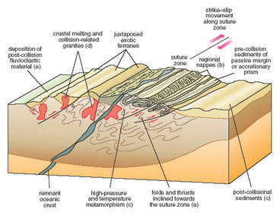
Figure 8 Schematic section through a continental collision zone, illustrating the key features discussed in the text

In addition to the five features listed above, continental collision zones often undergo significant amounts of strike–slip displacement. In some instances, the suture zone is marked by slices of oceanic lithosphere (referred to as an ‘ophiolite’) that have failed to be subducted, and have instead been forced up on to the other plate (i.e. obducted). Some small and incomplete examples of ophiolites can be found in the British Isles at Ballantrae (NX(25)0882), Fetlar–Shetland (HU(N41)69–HP(N42)61) and on the Lizard peninsula (SW(10)7015).
The range of rock assemblages present can be used to identify the types of margin that formed on either side of a closing ocean, as well as to detect changes in the tectonic environments on either side of the ocean, as closure proceeded.

5 The main lithotectonic units of the British Isles

5.1 Introduction

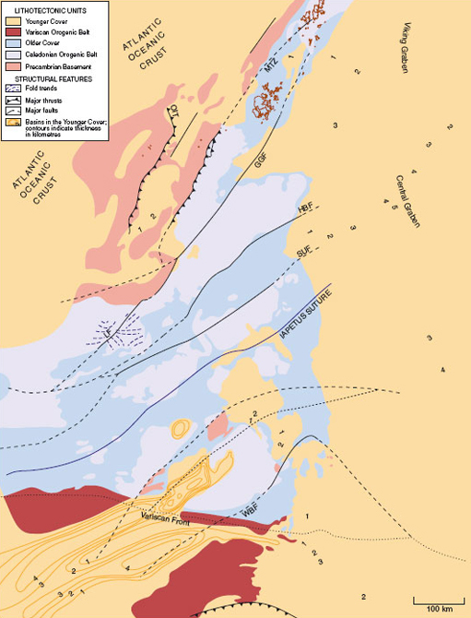
Figure 9 Lithotectonic units of the British Isles

In previous sections, it was revealed that in the British Isles, the Phanerozoic era was punctuated by two major tectonic periods referred to as the Caledonian and Variscan Orogenies. Both events involved the collision of continental plates, resulting in extensive crustal thickening and isostatic uplift. Over time, the mountain chains formed by these collisions underwent rapid erosion, so that during times of sea-level highs, the sea inundated the land. This allowed new sedimentary units to be deposited, separated from the underlying deformed rocks by a major unconformity, representing a significant change in the tectonic and lithological history of the area. Figure 10 illustrates the steps involved in the formation of such an unconformity, examples of which can be found marking specific episodes in the geological history of the British Isles.

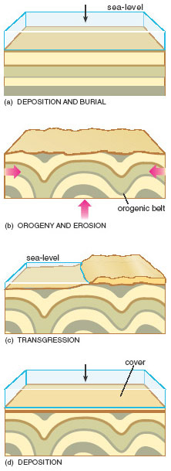
Figure 10 The development of a major angular unconformity and the relationship between what are termed in the text ‘orogeny’ and ‘cover’. In some instances, the orogenic belt below a cover unit is referred to as ‘basement’

Using this model, the geological history of the British Isles can be interpreted in terms of a series of distinct orogenic units and their overlying covering units. By doing this, the whole of the British Isles geological history can be simplified into five main units – the Precambrian and Lower Palaeozoic Basement, the Caledonian Orogenic Belt, the Older Cover, the Variscan Orogenic Belt and the Younger Cover (see Figure 9). Although these units each have a distinct geological history based on lithology and tectonic structures, they do not correlate with distinct geological periods. Instead, these five units are referred to as lithotectonic units.
Note that ‘Basement’ (with capital ‘B’) implies the Precambrian and Lower Palaeozoic Basement in the sense used in this section, whereas ‘basement’ (with lower case ‘b’) is used to indicate any other rocks underlying a covering lithotectonic unit. For example, the orogenic belt in Figure 10 could be referred to as basement, regardless of its age.

5.2 Precambrian and Lower Palaeozoic Basement
The Precambrian and Lower Palaeozoic Basement of the British Isles is a series of nine discrete, exotic terranes whose boundaries are fault systems that have undergone large but usually unknown amounts of lateral and vertical movement over time (Figure 11 and Table 2). Each terrane is a specific geographical area characterised by a distinctive geological history, which was different from that of its current neighbour up until the time that they ‘docked’ together. Once united, the originally separate terranes then underwent the same geological processes.

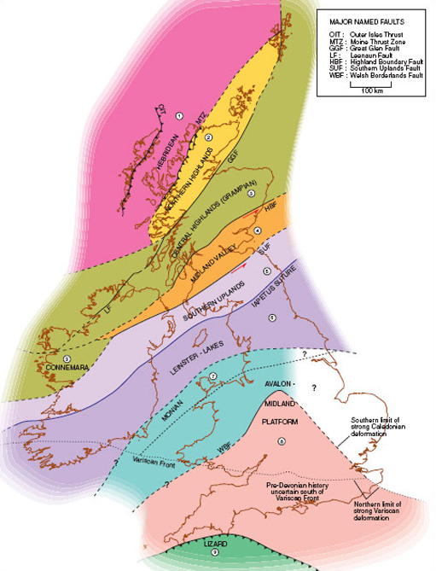
(From Cope, J.C.W., Ingham, J.K. and Rawson, P.F. (eds) (1992) Atlas of Palaeogeography and Lithofacies, Geol. Soc. Publishing House)
Figure 11 Simplified map of the British Isles summarising the nine main exotic terranes. Note how the five principal lithotectonic units (see Figure 9 in Section 5.1) are not limited to specific exotic terranes, but occur in several of these across the British Isles

Click to view larger version of a simplified map of the British Isles

Table 2 Summary of the main rock units found in each of the nine discrete, exotic terranes that make up the British Isles
Terrane | Main rock units
(1) Hebridean Terrane | Archean and Lower Proterozoic gneiss overlain by undeformed sediments from the Upper Proterozoic (terrigenous red sandstones) and Cambrian to Middle Ordovician (shallow-water marine siliciclastics and limestones).
(2) Northern Highlands Terrane | Precambrian to Upper Ordovician and Silurian metamorphosed sediments and mafic to felsic igneous rocks.
(3) Central Highlands (Grampian) Terrane | Upper Proterozoic metasediments overlying gneiss. Based on metamorphic evidence, this terrane is known to have accreted to the previous two by the Early Silurian.
(4) Midland Valley Terrane | A series of small, discrete terranes faulted into one main region, or superterrane. The main basement is thought to be an ancient fore-arc region, covered by Upper Palaeozoic volcanics (tholeiitic and calc-alkaline), volcaniclastic sediments, mudstones, sandstones and carbonates.
(5) Southern Uplands Terrane | Lower–Middle Palaeozoic sediments including turbidites, mudstones, pillow lavas, chert and some ophiolite material, indicative of an open, spreading oceanic environment.
(6) Leinster–Lakes Terrane | Lower Palaeozoic marine siliciclastic sediments, mudstones and limestones, along with subduction-related calc-alkaline volcanics.
(7) Monian Terrane | Precambrian calc-alkaline volcanics, blueschists, sediments and mélange, representative of a Precambrian to Early Cambrian subduction zone.
(8) Avalon–Midland Platform Terrane | Cambrian–Ordovician sedimentary succession of shallow-water marine siliciclastics and limestones on a Precambrian basement, grading to terrigenous red beds and some mafic volcanics.
(9) Lizard Terrane | Middle–Upper Devonian ophiolite complex associated with metamorphosed igneous and sedimentary successions, overlying Ordovician quartzites.

Using the rock units present in each area, it is possible to establish the type of environment(s) each terrane originally represented. However, as each terrane is delimited by fault boundaries, it is not always apparent exactly where the terranes originally formed in relation to each other. Despite this we can be sure that the nine terranes that make up the British Isles joined together into their present configuration between Proterozoic (Late Precambrian) and Carboniferous (Late Palaeozoic) times.

Question 4

Using the Ten Mile Map (N) in conjunction with Figure 11, find the thick black line that represents the Moine Thrust. Everything to the west (left) of this line (including the Outer Hebrides and part of the Inner Hebrides) is the Hebridean Terrane.
- (a) What is the oldest rock unit in this terrane?
- (b) Apart from this, what other rock unit is dominant in this terrane?

View answer - Question 4

Question 5

Trending across the northern Hebridean Terrane is a series of multiple thin units (numbered 5 and 6) oriented in a north-westerly direction. What name can be used to describe them?

View answer - Question 5

Question 6

How does the dyke swarm in the north of the Hebridean Terrane compare with that on Skye?

View answer - Question 6

In fact, the dykes on Skye are much younger than those to the north, and were intruded as the North Atlantic Ocean began to rift open during the Early Tertiary. These dykes can be followed all the way across southern Scotland into northern England, and students attending the residential school will examine one of the more extensive dykes from this event – the Cleveland Dyke.

Question 7

Using the stratigraphic key on the Ten Mile Map (S) as a guide, what are the oldest rocks in the southern British Isles?

View answer - Question 7

Careful examination of the map reveals that these rocks occur in Anglesey, north-west Wales (SH(23)48). The units labelled 29 and 30 near the Lizard (SW(10)71) and Start Point (SX(20)83) are now known not to be Precambrian; they are in fact associated with the Variscan Orogeny. There are, however, Precambrian rocks in England that are not distinguished on the key, because they are intrusive, with the oldest of these occurring near Leicester (SK(43)51). In Ireland, the oldest rocks occur in the south-eastern corner around Rosslare, County Wexford, and are part of the same basement terrane as those in Anglesey (the Monian Terrane, Figure 11 and Table 2).
As the unit numbering system in the North and South Ten Mile Maps is the same, it should be apparent that the oldest rocks in the southern British Isles are considerably younger (units 29–33) than those in the northern British Isles. Table 2 summarises the main units found in each of the basement terranes across the British Isles. Although for many purposes the geological history of the British Isles can be described using the simpler five-fold lithotectonic system, it is often helpful to consider these nine discrete exotic terranes, particularly in relation to the structural evolution of the region.

5.3 Caledonian Orogenic Belt
From Figure 9, it can be seen that the Caledonian Orogenic Belt outcrops in several locations across the British Isles including Shetland, northern Scotland (between the Moine Thrust Zone and the Highland Boundary Fault), the northwestern and eastern corners of Ireland, the Southern Uplands, the Lake District, the Isle of Man and central and northern Wales.

SAQ 4

Using Figure 9 and Figure 11 in conjunction with the North and South Sheets of the Ten Mile Maps, how do the rock units that make up the Caledonian Orogenic Belt differ across the British Isles? Can any of the outcrops belonging to this orogenic event be subdivided in any way?

View answer - SAQ 4

Therefore, the Caledonian Orogenic Belt can be subdivided into the high-grade metamorphic Caledonides (northern Scotland, Shetland and north-west Ireland), and the low-grade to non-metamorphic Caledonides (all locations from the Southern Uplands southwards).

Question 8

Look carefully at central and northern Wales on the Ten Mile Map (S).
- (a) What trends do the major fold structures and outcrops in this part of the low-grade to non-metamorphic Caledonides follow? (Figure 9 may help you answer this and the following questions in this section.)
- (b) How does this compare with the Southern Uplands, Lake District and Isle of Man? (You will need to look at both North and South Sheets for this second part.)

View answer - Question 8

Return to Wales and look in particular at the island of Anglesey (SH(23)38), and the territory between Bangor (SH(23)5673) and the tip of the Lleyn Peninsula (SH(23)1424).

Question 9

What is the stratigraphic relationship between the low-grade to non-metamorphic Caledonides and the underlying Precambrian Basement in this region (i.e. units 40, 41 and 60)?

View answer - Question 9

Now move back to the Ten Mile Map (N) and the high-grade metamorphic Caledonides in the northern Highlands of Scotland and Shetland.

Question 10

What trends in outcrop pattern or major folds can be detected in this region? (If you have a geological map of Ireland, you can answer the same question for the north-west of Ireland from County Donegal to County Galway.)

View answer - Question 10

Using the Ten Mile Map (N) and Figure 11, it can be seen that the high-grade metamorphic Caledonides and the underlying basement (the Hebridean Terrane) in the north-west of Scotland are separated by several major thrust zones, the main one of which is the Moine Thrust Zone. This dips gently to the south-east. In this area, the Basement consists primarily of the Precambrian metamorphic Lewisian Complex (1–7) with the unmetamorphosed Torridonian sediments (61), and some Cambrian (62–3) and Ordovician sediments (67) on top. The Basement has been overthrust from the south-east by the Northern Highlands Terrane, which consists of younger metamorphosed Moine Supergroup sediments. The unmetamorphosed nature of the Torridonian shows that the Northern Highlands Terrane must have been metamorphosed before being thrust on top of the Hebridean Terrane.

5.4 Older Cover
Moving up succession, the next lithotectonic unit is the Older Cover. By referring to Figure 9 and Table 2 in conjunction with the Ten Mile Map, you should be able to see that throughout the British Isles, the Older Cover consists of Devonian (75–8) and Carboniferous (79–84) strata, with significant outcrops of Carboniferous volcanic rocks (53–5) occurring in the Midland Valley of Scotland. Minor Carboniferous volcanics also occur in the Derbyshire area around Matlock (SK(43)2560) and Buxton (SK(43)1074).
Examine the outcrop patterns on the Ten Mile Maps in relation to the areas covered by Older Cover in Figure 9, and attempt the following questions.

Question 11

Describe in one sentence each, the style of contact between the Older Cover and underlying Caledonian Orogenic Belt in the following areas:
- (a) around the Moray Firth (NC(29)8510 and NH(28)6733);
- (b) the Southern Uplands south-west of Berwick-upon-Tweed (NU(46)0053);
- (c) the Lake District (e.g. NY(35)5810);
- (d) northern and central Wales (e.g. SJ(33)2435).

View answer - Question 11

Question 12

Similarly, what is the nature of the contacts between the Older Cover and underlying Caledonian Orogenic Belt on the northern and southern sides of the Midland Valley, on your Ten Mile Map (N) between:
- (a) Helensburgh (NS(26)2982) and Stonehaven (NO(37)8786)?
- (b) Girvan (NX(25)1898) and Dunbar (NT(36)6879)?

View answer - Question 12

Question 13

Look carefully at the strata that make up the Older Cover between Manchester (SJ(33)89) and Sheffield (SK(43)38) on your Ten Mile Map (S). Describe the type and significance of the folding.

View answer - Question 13

5.5 Variscan Orogenic Belt
Unlike the Caledonian Orogenic Belt, outcrops of the Variscan Orogenic Belt are limited to the south-west of England, southern Wales and the south of Ireland (see Figure 9 and Figure 11). However, this does not mean that the effects of the Variscan Orogeny were limited only to these southern regions.
Use the Ten Mile Map (S) in conjunction with Figure 9 to answer the following questions about the Variscan Orogenic Belt, and to explore the geology and structures that make up this lithotectonic unit.

Question 14

From the stratigraphic key on the Ten Mile Map (S), what is the stratigraphic age of the rocks in the Variscan Orogenic Belt (i.e. south of the Variscan Front on Figure 11)?

View answer - Question 14

Question 15

What are the major igneous intrusions present within the Variscan Orogenic Belt in the south-west of England? Are there any similar intrusions in southern Wales? (If you have a geological map of Ireland, you can answer the same question for Counties Cork and Kerry in the south-west of Ireland.)

View answer - Question 15

Question 16

Look carefully at the stratigraphical units that make up the Variscan Orogenic Belt across south-west England and in southern Wales. Describe the folding that has occurred in these two areas.

View answer - Question 16

It is not possible to detect what lies below the Variscan Orogenic Belt from the Ten Mile Map, as the basement is not exposed. The small outcrop of Ordovician rocks (69) near Veryan on the south coast of Cornwall (SW(10)9238) is a small thrust slice and not a stratigraphic inlier.

5.6 Younger Cover
The Younger Cover can be found covering a large part of England, and to a lesser extent, north-east Ireland, south-west Scotland, Arran, Mull, and the north of Skye. From the Ten Mile Maps and Figure 9, you can see that the Younger Cover consists of Permian to Triassic sandstones, breccias, mudstones and limestones, Jurassic to Cretaceous limestones and carbonate clays and Tertiary to Pleistocene mudstones, sands and clays.
Using Figure 9 in conjunction with the Ten Mile Map (S), examine the outcrop pattern of the Younger Cover in the British Isles, and answer the following questions:

Question 17

What kind of boundary does the Younger Cover form with the older lithotectonic units?

View answer - Question 17

The outcrop of the unconformity below the Younger Cover is highly sinuous. In some places (e.g. near Cheddar (ST(31)4653)) this is because the Older Cover landscape was buried by Younger Cover sediments (in other words this represents a buried topography). Elsewhere (e.g. east of Durham (NZ(45)3340)) Younger Cover was deposited over a fairly planar erosion surface and the irregular pattern of the outcrop represents uneven stripping away of the Younger Cover by recent erosion.

Question 18

Describe the type of folding that affects the Younger Cover. (Look in particular at the southern British Isles.)

View answer - Question 18

You should also be aware of one further lithotectonic unit that is not included on the Ten Mile Maps or in Figure 9. This is the thin cover of Quaternary drift that mantles much of the British Isles, deposited between ~2 million and 10 000 years ago.

6 Conclusion
- A discrete exotic terrane refers to a large crustal fragment that can be recognised by its distinct sedimentary, igneous, metamorphic and structural history compared with that of its eventual neighbours, and has been juxtaposed into position by major strike–slip faults.
- Nine discrete exotic terranes make up the Basement in the British Isles. These consist primarily of Precambrian metamorphosed rocks but also contain some unmetamorphosed sedimentary units from the Lower Palaeozoic (e.g. in north-west Scotland). In general, the oldest Basement rocks in the southern British Isles are considerably younger than those in the northern British Isles. (Section 5.1–Section 5.2)
- In addition to the nine Basement terranes, the geological history of the British Isles can be interpreted in terms of a series of five distinct orogenic and overlying covering units. These are the Precambrian and Lower Palaeozoic Basement, the Caledonian Orogenic Belt, the Older Cover, the Variscan Orogenic Belt and the Younger Cover. Although each of these units has a distinct geological history, as inferred from its lithology and tectonic structures, they do not correlate with distinct geological periods, and are therefore referred to as lithotectonic units.
- The Caledonian Orogenic Belt consists of the high-grade metamorphic Caledonides to the north of the Highland Boundary Fault, and the low-grade to non-metamorphic Caledonides from the Southern Uplands southwards. In both areas, regional outcrop patterns and fold axes follow the same NE–SW Caledonian structural trend. In the southern British Isles, the Caledonides lie unconformably over the Basement rocks, whereas in north-west Scotland, the Moine Thrust Zone, which is tectonic in origin, separates the Precambrian Basement from the overlying Caledonides. (Section 5.3)
- The Older Cover consists of Devonian and Carboniferous strata that either overlie the underlying Caledonian Orogenic Belt at an angular unconformity, or are faulted up against it. The most significant faults are the NE–SW trending Highland Boundary Fault and the Southern Uplands Fault, which bound the Midland Valley Terrane. (Section 5.4)
- The Variscan Orogenic Belt consists of intensely deformed Upper Palaeozoic rocks and occurs in the far south-west of the southern British Isles. In the south-west of England, the Variscan is intruded by a series of large granitic bodies. (Section 5.5)
- The Younger Cover consists of a succession of weakly folded strata of post-Carboniferous age that rests unconformably on the older lithotectonic units. (Section 5.6)

7 Course questions
Now you have completed this course, try the following questions to test your understanding of this material.

Question 19

Like the Variscan Orogenic Belt, the Caledonian includes large granitic intrusions. Using the Ten Mile Maps in conjunction with Figure 9, determine whether these intrusions are confined to specific geographical regions, to the high-grade metamorphic Caledonides, or to the low-grade to non-metamorphic Caledonides.

View answer - Question 19

Question 20

On Figure 11, the boundary between the Variscan Orogenic Belt and the Older Cover in southern Wales is shown. From the fold structures on the Ten Mile Map (S), can you pinpoint this line or is the boundary between the two lithotectonic units more subtle?

View answer - Question 20

Question 21

Using the contour lines in Figure 9, describe how the thickness of the Younger Cover varies between onshore and offshore areas.

View answer - Question 21

We hope you have enjoyed this course and that it has given you a satisfactory taste of the really rather splendid, if intricate, geological history of the British Isles. We hope too that you have an appreciation of the complexities of some of the evidence upon which the geological history of the British Isles as presented in this course is based.

Acknowledgements
The content acknowledged below is Proprietary (see terms and conditions). This content is made available under a Creative Commons Attribution-NonCommercial-ShareAlike 4.0 Licence
Grateful acknowledgement is made to the following sources for permission to reproduce material in this course:
Course image: Katrina Br*?#*!@nd in Flickr made available under Creative Commons Attribution-NonCommercial-ShareAlike 2.0 Licence.
Figure 1 John Watson/Open University;
Figure 3a–c T.H. Torsvik et al. (1996) ‘Continental break up and collision in the Neoproterozoic and Palaeozoic’, Earth Science Reviews, 40, Elsevier;
Figure 3d T.C. Pharaoh (1999) ‘Palaeozoic terranes and their lithospheric boundaries within the Trans-European Suture Zone (TESZ)’, Tectonophysics, 314, Elsevier;
Figure 3e J. Golonka and D. Ford (2000) ‘Pangean (Late Carboniferous–Middle Jurassic) paleoenvironment and lithofacies’, Palaeogeography, Palaeoclimatology, Palaeoecology, 161, Elsevier;
Figure 3f P.J. Wylie (1970) The Way the Earth Works, Wiley, originally in R.S. Dietz and J.C. Holden (1970) Jour. Geophys. Res., 75;
Figure 3g–h R.S. Dietz and J.C. Holden (1970) Jour. Geophys. Res., 75 © 1970 American Geophysical Union;
Figure 4 L.A. Frankes, J.E. Francis and J.I. Syktus (1992) Climate Modes of the Phanerozoic, Cambridge University Press;
Figure 6a(i)–c from an illustration by Ian Worpole in P. Molnar (1986) ‘The structure of mountain ranges’, Scientific American, July.
Adapted from works by John Watson/ Open University
Don't miss out:
If reading this text has inspired you to learn more, you may be interested in joining the millions of people who discover our free learning resources and qualifications by visiting The Open University - www.open.edu/openlearn/free-courses

Solutions

Question 1

Answer
Over the last ~550 million years, the British Isles has formed a small portion of a series of different continental masses (being in fact part of two separate continents in the Cambrian), and has slowly drifted northwards to its present latitude.
Back to - Question 1

Question 2

Answer
A crude correlation between these factors can be observed, with the sea-level low between 300–200 Ma corresponding to a time when all of the land was together in the supercontinent of Pangea (Figure 3e–f). The sea-level highs before and after this period correspond to times when the continents were drifting apart.
Back to - Question 2

Question 3

Answer
There is a good correlation between the sea-level ‘lows’ and the Quaternary and Permo-Carboniferous ice ages, but global sea-levels were high during the Late Ordovician glaciation. This means that ice ages cannot be the only factor controlling sea-level changes.
Back to - Question 3

SAQ 1

Answer
With passive rifts, the first visible effect is the formation of a rift zone produced by lithosphere extension. This is followed by regional doming (as hot asthenosphere wells up under the thinned lithosphere), and then by minor volcanism. By contrast in active rifting, regional doming occurs first (as the mantle plume forces the lithosphere upwards), followed by the eruption of huge volumes of extrusive material (e.g. flood basalts), ending with the rifting stage.
Back to - SAQ 1

SAQ 2

Answer
When the oceanic lithosphere first forms, it is relatively hot and buoyant. As it moves away from the spreading centre and underlying heat source, it cools down and becomes less buoyant.
Back to - SAQ 2

SAQ 3

Answer
They can look for specific igneous, sedimentary and metamorphic assemblages that are characteristic of subduction zones, continental slopes and deep ocean basins.
Back to - SAQ 3

Question 4

Answer
- (a) Much of the Hebridean Terrane is made up from undifferentiated gneiss from the Lewisian complex, which is the oldest rock unit in the British Isles.
- (b) From Rhum (NM(17)3090), up to Enard Bay (NC(29)0513), Torridonian Sandstone is predominant, dating from the Proterozoic (i.e. Late Precambrian and not the Palaeozoic, as indicated on the Ten Mile Map).
Back to - Question 4

Question 5

Answer
Units 5 and 6 consist of intermediate to mafic dykes, and form part of the Lewisian Complex. In this abundance, they can be referred to as a dyke swarm. Note that they do not cut across the Torridonian Sandstone, which indicates that the dykes were intruded before the sandstones were deposited.
Back to - Question 5

Question 6

Answer
One of the most obvious differences between the two dyke swarms is that on Skye, the dykes are trending in a NNW–SSE direction, rather than NW–SE. Closer inspection also reveals that they are made up of unit 35, and not units 5–6.
Back to - Question 6

Question 7

Answer
According to the key, the oldest rocks in the southern half of the British Isles consist of Precambrian hornblende schists (29) and gneiss and mica schists (30).
Back to - Question 7

SAQ 4

Answer
In the north of Scotland, Shetland and north-west Ireland, the Caledonian Orogenic Belt consists of high-grade metamorphic Moine (8–12) and Dalradian (13–28) rocks. This contrasts with the Caledonian Orogenic Belt outcrops from the Southern Uplands southwards, which consist of low-grade or unmetamorphosed successions from the Cambrian (64) to Silurian (74).
Back to - SAQ 4

Question 8

Answer
- (a) In central and northern Wales, the outcrop patterns indicate that the major folds have NE–SW trending axes. These are well displayed between Carmarthen (SN(22)4119) and Llandrindod Wells (SO(32)0760), and Montgomery (SO(32)2296) and Llanrwst (SH(23)8061) where NE–SW trending tongues of 70–2 occupy the cores of anticlines extending into younger 73–4. This fold trend can be followed towards West Dyfed (Pembrokeshire (SN(22)0015)), where it swings round to a more E–W trend.
- (b) The same general NE–SW trend can also be seen in outcrops of 70–3 in the low-grade to non-metamorphic Caledonide terranes of the Southern Uplands and Lake District. This is often referred to as the Caledonian structural trend.
Back to - Question 8

Question 9

Answer
In Anglesey, to the south-west of Bangor and on the Lleyn Peninsula, the Lower Palaeozoic rocks that make up the low-grade to non-metamorphic Caledonides can be seen to rest unconformably on the Precambrian Basement (some of which is metamorphic).
Back to - Question 9

Question 10

Answer
Throughout the Highlands of Scotland, a general NE–SW Caledonian trend can be recognised, particularly in the Dalradian (13–28). Likewise, some major faults with the same trend are also marked on the Ten Mile Map (N), e.g. the Great Glen Fault, which cuts south-west across the Highlands from Inverness (NH(28)6745) on the Moray Firth, along Loch Ness to Fort William (NN(27)1174) and is picked up again in Northern Ireland at Londonderry ((24)5422) (Figure 11). This fault is an important strike–slip fault, the movement of which may have begun during the Caledonian Orogeny, and certainly continued into the Mesozoic.
In Shetland, the trend of the high-grade metamorphic Caledonides swings round to a N–S direction, which can be traced down to the NNE–SSW trend on the Scottish mainland between Findochty (NJ(38)4767) and Portsoy (NJ(38)5766).
Back to - Question 10

Question 11

Answer
In each of these areas, the Older Cover lies unconformably on top of rocks of the Caledonian Orogenic Belt.
Back to - Question 11

Question 12

Answer
On both sides of the Midland Valley, the Older Cover is faulted against older rocks.
Back to - Question 12

Question 13

Answer
The Older Cover forms a gentle N–S trending anticline. This implies that the major direction of crustal shortening during this folding event was E–W.
Back to - Question 13

Question 14

Answer
The Variscan Orogenic Belt consists primarily of Devonian (75–8) and Carboniferous (79–83) strata, with older metamorphic rocks at Lizard Point and Start Point. In older books and maps, the Lizard Point was incorrectly assigned to the Precambrian. Recent radiometric dating suggests that most of the rocks in this terrane were actually formed during the Devonian.
Back to - Question 14

Question 15

Answer
The large red outcrops of unit 34 are granites that trend from Dartmoor, south-westward down to the Isles of Scilly. Although there are seven discrete granitic outcrops in this area, geophysical surveys have revealed that these are connected at depth, forming one large regional sheet-like plutonic batholith. There are no equivalent plutonic bodies in southern Wales or Ireland associated with the Variscan Orogenic Belt.
Back to - Question 15

Question 16

Answer
From the Ten Mile Map, you should have noted that the Devonian strata (75–8) outcrop as two strips: one along the north coast of Devon, and the other along the south coast of Devon and running into Cornwall. These two strips of Devonian outcrop are separated by a belt of Carboniferous strata (80–3), which forms the axial part of a large synclinal structure. This fold structure is actually a complex syncline as shown by a variety of smaller-scale folds in the field. These are too small to be shown on the Ten Mile Map.
In southern Wales, across the Gower Peninsula, east of Worms Head (SS(21)4087) and in the southernmost part of West Dyfed in Pembrokeshire, north of St. Govan's Head (SR(11)9793), tight folds can be recognised with a WNW–ESE trend.
Back to - Question 16

Question 17

Answer
Almost everywhere throughout the British Isles, the base of the Younger Cover (whether Permian or Triassic) lies unconformably over the older rocks.
Back to - Question 17

Question 18

Answer
Throughout the southern and south-eastern areas of England (through Dorset, Hampshire, Sussex and Essex), there is a series of E–W trending asymmetrical folds. The northern limbs of the anticlines (i.e. the southern limbs of the synclines) are more steeply dipping.
Back to - Question 18

Question 19

Answer
Examination of the Ten Mile Map (N) shows that large granitic intrusions (34) occur in both high-grade metamorphic and low-grade to non-metamorphic parts of the Caledonides in Scotland and northern England, but are absent in Wales.
Back to - Question 19

Question 20

Answer
Although the boundary is shown as a distinct dotted line on Figure 11, it is not possible to use the outcrop patterns to locate this boundary precisely on the Ten Mile Map.
In south-west England, the Variscan is characterised by relatively intense E–W folding (the intensity of which is not apparent on the Ten Mile Map), forming a complex syncline. In the Mendips (ST(31)4050 just south of Bristol) and southern Wales, a series of asymmetrical folds can be seen on the Ten Mile Map. These intense folds trend E–W in the Mendips, but WNW–ESE in southern Wales. The more open syncline of the south Wales Carboniferous coalfields may be associated with the Variscan folding, but is not included in the orogenic belt on Figure 11. To the north of Bristol (ST(31)5070), the fold axes have swung round to a N–S orientation, and are therefore obviously different to the Variscan trend.
Therefore, the tectonic distinction between the Variscan and Older Cover lithotectonic units does not form a sharp well-defined line, but is gradational in nature.
Back to - Question 20

Question 21

Answer
Figure 9 shows that the onshore Younger Cover areas are much thinner (generally <1 km) than the offshore areas (which are up to 6 km thick).
Back to - Question 21

