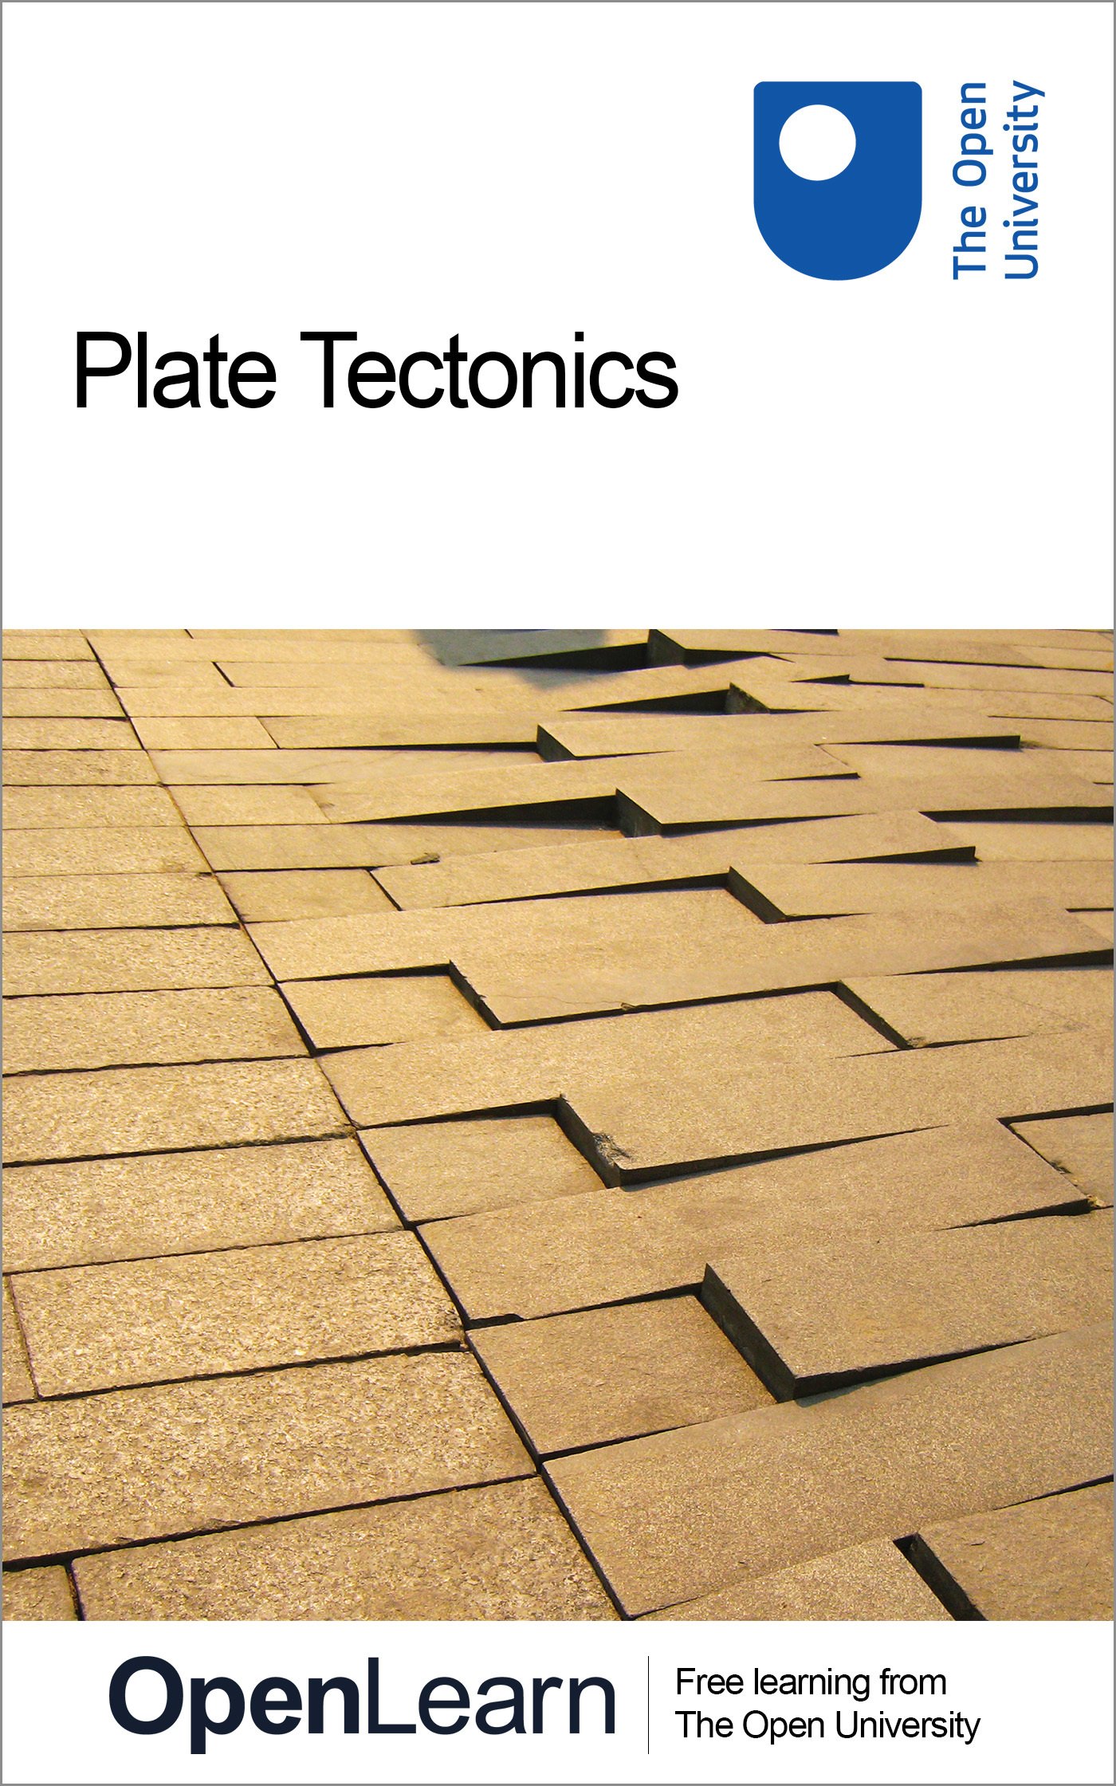

S279_1 Our Dynamic Planet: Earth and Life

Plate Tectonics
About this free course
This free course is an adapted extract from the Open University course S279 Our dynamic planet: Earth and life http://www3.open.ac.uk/study/undergraduate/course/s279.htm.
This version of the content may include video, images and interactive content that may not be optimised for your device.
You can experience this free course as it was originally designed on OpenLearn, the home of free learning from The Open University: http://www.open.edu/openlearn/science-maths-technology/science/geology/plate-tectonics/content-section-0.
There you'll also be able to track your progress via your activity record, which you can use to demonstrate your learning.
The Open University, Walton Hall, Milton Keynes MK7 6AA
Copyright © 2016 The Open University
Intellectual property
Unless otherwise stated, this resource is released under the terms of the Creative Commons Licence v4.0 http://creativecommons.org/licenses/by-nc-sa/4.0/deed.en_GB. Within that The Open University interprets this licence in the following way: www.open.edu/openlearn/about-openlearn/frequently-asked-questions-on-openlearn. Copyright and rights falling outside the terms of the Creative Commons Licence are retained or controlled by The Open University. Please read the full text before using any of the content.
We believe the primary barrier to accessing high-quality educational experiences is cost, which is why we aim to publish as much free content as possible under an open licence. If it proves difficult to release content under our preferred Creative Commons licence (e.g. because we can't afford or gain the clearances or find suitable alternatives), we will still release the materials for free under a personal end-user licence.
This is because the learning experience will always be the same high quality offering and that should always be seen as positive - even if at times the licensing is different to Creative Commons.
When using the content you must attribute us (The Open University) (the OU) and any identified author in accordance with the terms of the Creative Commons Licence.
The Acknowledgements section is used to list, amongst other things, third party (Proprietary), licensed content which is not subject to Creative Commons licensing. Proprietary content must be used (retained) intact and in context to the content at all times.
The Acknowledgements section is also used to bring to your attention any other Special Restrictions which may apply to the content. For example there may be times when the Creative Commons Non-Commercial Sharealike licence does not apply to any of the content even if owned by us (The Open University). In these instances, unless stated otherwise, the content may be used for personal and non-commercial use.
We have also identified as Proprietary other material included in the content which is not subject to Creative Commons Licence. These are OU logos, trading names and may extend to certain photographic and video images and sound recordings and any other material as may be brought to your attention.
Unauthorised use of any of the content may constitute a breach of the terms and conditions and/or intellectual property laws.
We reserve the right to alter, amend or bring to an end any terms and conditions provided here without notice.
All rights falling outside the terms of the Creative Commons licence are retained or controlled by The Open University.
Head of Intellectual Property, The Open University
The Open University
978-1-4730-1982-9 (.kdl)
978-1-4730-1214-1 (.epub)

Contents
- Introduction
- Learning outcomes
- 1 Preamble: the moving Earth
- 2 From continental drift to plate tectonics
  - 2.1 Continental drift
  - 2.2 Evidence for continental drift
  - 2.3 Sea-floor spreading
- 3 The theory of plate tectonics
  - 3.1 Assumptions
  - 3.2 Heat flow within plates
  - 3.3 Constructive plate boundaries
  - 3.4 Destructive plate boundaries
  - 3.5 Destructive plate boundaries, continued: ocean-ocean (island-arc) subduction
  - 3.6 Destructive plate boundaries, continued: ocean-continent (Andean type) subduction
  - 3.7 Destructive plate boundaries, continued: continent-continent destructive boundaries
  - 3.8 Conservative plate boundaries and transform faults
  - 3.9 Triple junctions
- 4 Plate tectonic motion
  - 4.1 Relative plate motions
  - 4.2 Hot-spot trails and true plate motions
  - 4.3 Plate motion on a spherical Earth
- 5 Plate driving forces
  - 5.1 Why do plates move?
  - 5.2 Forces acting upon lithospheric plates
  - 5.6 Implications of plate tectonics
  - Conclusion
  - 5.8 Further reading
- Keep on learning
- Acknowledgements

Introduction
In this course, you will examine how the evidence for the movement of continents was gathered and how this movement relates to, and generates, geological features and phenomena such as ocean basins, mountain ranges, volcanoes and earthquakes. You will learn how and why the continents have moved, and continue to move, and the forces that drive them around our globe.
To get the most out of this course you will need the latest Flash Player plug-in. You can download it here.
This OpenLearn course is an adapted extract from the Open University course S279 Our dynamic planet: Earth and life.

Learning outcomes
After studying this course, you should be able to:
- demonstrate a knowledge and understanding of the theory of tectonic plates and the different forms of evidence (e.g. palaeontology, palaeomagnetism, continuity of structures etc.) that can be used to understand the movement of the lithospheric plates over geological time
- demonstrate a knowledge and understanding of the mechanisms of crustal growth and transfer of heat at spreading ocean ridges
- demonstrate a knowledge and understanding of the three main types of plate boundary (constructive, destructive and conservative) and how they interact at triple junctions
- demonstrate a knowledge and understanding of the difference between relative and true plate motion
- demonstrate a knowledge and understanding of the driving and retarding forces that influence plate motion at constructive, destructive and conservative plate boundaries.

1 Preamble: the moving Earth
The Earth's face is changing all the time, but at barely perceivable rates. It is now known that the Earth is a highly dynamic planet - far more so than the other terrestrial planets (Mercury, Venus and Mars) and the Moon - and one that has altered its outward surface many times over geological time. On Earth, this dynamism is manifest in the opening and closure of ocean basins and the associated movements of continents called continental drift. At times, continental drift has resulted in the continents fragmenting into many smaller land masses, whilst at other times collisions have assembled vast supercontinents with immense mountain chains along their joins (Figure 1). Such constant rearrangement has had a profound effect upon the surface geology of our planet. It has also affected the hydrosphere through the changes in the shape and size of the oceans, the ocean-atmosphere circulation, the configuration and extremities of the Earth's climate zones and, perhaps, even the nature of the biosphere and the course of the evolution of life itself.
The Earth formed from a primordial nebula and then developed its layered structure (i.e. core, mantle and crust). There are physical and chemical differences between those three layers, differences that distinguish the mantle and the crust, the heat that is generated within them makes its way to the surface to be lost into space. It is the movement of this internal heat that drives the forces that result in the formation and destruction of ocean basins and, ultimately, the movement of the continents.

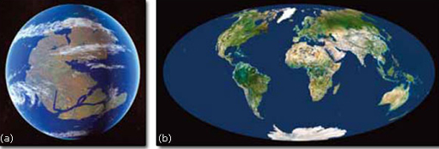
Figure 1 An example of (a) a continental reconstruction for the late Carboniferous showing the supercontinent of Pangaea compared with (b) today's more fragmented arrangment.

Click on 'View document' below to see a larger version of the above image.
View document

2 From continental drift to plate tectonics

2.1 Continental drift
The remarkable notion that the continents have been constantly broken apart and reassembled throughout Earth's history is now widely accepted. The greatest revolution in 20th century understanding of how our planet works, known as plate tectonics, happened in the 1960s, and has been so profound that it can be likened to the huge advances in physics that followed Einstein's theory of relativity. According to the theory of plate tectonics, the Earth's surface is divided into rigid plates of continental and oceanic lithosphere that, through time, move relative to each other, and which increase or decrease in area. The growth, destruction and movement of these lithospheric plates are the major topics of this course, but it is first worth considering how the theory actually developed from its beginnings as an earlier idea of 'continental drift'.
The German meteorologist Alfred Wegener (1880-1930) is largely credited with establishing the fundamentals of the theory that we now call plate tectonics. The idea that continents may have originally occupied different positions was not a new one (Box 1), but Wegener was the first to present the evidence in a diligent and scientific manner.

Box 1: Continental drift to plate tectonics: the evolution of a theory
1620 Francis Bacon commented upon the 'conformable instances' along the mapped Atlantic coastlines.
1858 Antonio Snider-Pellegrini suggested that continents were linked during the Carboniferous Period, because plant fossils in coal-bearing strata of that age were so similar in both Europe and North America.
1885 Austrian geologist Edward Seuss identified similarities between plant fossils from South America, India, Australia, Africa and Antarctica. He suggested the name 'Gondwana' (after the indigenous homeland of the Gond people of north-central India), for the ancient supercontinent that comprised these land masses.
1910 American physicist and glaciologist Frank Bursley Taylor proposed the concept of 'continental drift' to explain the apparent geological continuity of the American Appalachian mountain belt (extending from Alabama to Newfoundland) with the Caledonian Mountains of NW Europe (Scotland and Scandinavia), which now occur on opposite sides of the Atlantic Ocean.
1912 Alfred Wegener reproposed the theory of continental drift. He had initially become fascinated by the near-perfect fit between the coastlines of Africa and South America, and by the commonality among their geological features, fossils, and evidence of a glaciation having affected these two separate continents. He compiled a considerable amount of data in a concerted exposition of his theory, and suggested that during the late Permian all the continents were once assembled into a supercontinent that he named Pangaea, meaning 'all Earth'. He drew maps showing how the continents have since moved to today's positions. He proposed that Pangaea began to break apart just after the beginning of the Mesozoic Era, about 200 Ma ago, and that the continents then slowly drifted into their current positions.
1920-1960 A range of geophysical arguments was used to contest Wegener's theory. Most importantly, the lack of a mechanism strong enough to 'drive continents across the ocean basins' seriously undermined the credibility of his ideas. The theory of continental drift remained a highly controversial idea.
1937 South African geologist Alexander du Toit provided support through the years of controversy by drawing maps illustrating a northern supercontinent called Laurasia (i.e. the assembled land mass of what was to become North America, Greenland, Europe and Asia). The idea of the Laurasian continent provided an explanation for the distribution of the remains of equatorial, coal-forming plants, and thus the widely scattered coal deposits in the Northern Hemisphere.
1944 Wegener's theory was consistently championed throughout the 1930s and 1940s by Arthur Holmes, an eminent British geologist and geomorphologist. Holmes had performed the first uranium-lead radiometric dating to measure the age of a rock during his graduate studies, and furthered the newly created discipline of geochronology through his renowned book The Age of the Earth. Importantly, his second famous book Principles of Physical Geology did not follow the traditional viewpoints and concluded with a chapter describing continental drift.
1940-1960 The complexity of ocean floor topography was realised through improvements to sonar equipment during World War II. Accordingly, there was a resurgence of interest in Wegener's theory by a new generation of geophysicists, such as Harry Hess (captain in the US Navy, later professor at Princeton), through their investigations of the magnetic properties of the sea floor. In addition, an increasing body of data concerning the magnetism recorded in ancient continental rocks indicated that the magnetic poles appeared to have moved or 'wandered' over geological time. This apparent polar wander was explained by the movement of the continents, and not the magnetic poles.
1961 The American geologists Robert Dietz, Bruce Heezen and Harry Hess proposed that linear volcanic chains (mid-ocean ridges) identified in the ocean basins are sites where new sea floor is erupted. Once formed, this new sea floor moves toward the sides of the ridges and is replaced at the ridge axis by the eruption of even younger material.
1963 Two British geoscientists, Fred Vine and Drummond Matthews, propose a hypothesis that elegantly explained magnetic reversal stripes on the ocean floor. They suggested that the new oceanic crust, formed by the solidification of basalt magma extruded at mid-ocean ridges, acquired its magnetisation in the same orientation as the prevailing global magnetic field. These palaeomagnetic stripes provide a chronological record of the opening of ocean basins. By linking these observations to Hess's sea-floor spreading model, they lay the foundation for modern plate tectonics.
1965 The Canadian J. Tuzo Wilson offered a fundamental reinterpretation of Wegener's continental drift theory and became the first person to use the term 'plates' to describe the division and pattern of relative movement between different regions of the Earth's surface (i.e. plate tectonics). He also proposed a tectonic cycle (the Wilson cycle) to describe the lifespan of an ocean basin: from its initial opening, through its widening, shrinking and final closure through a continent-continent collision.
1960s-present day. There was an increasingly wide acceptance of the theory of plate tectonics. A concerted research effort was made into gaining a better understanding of the boundaries and structure of Earth's major lithospheric plates, and the identification of numerous minor plates.

Evidence for Wegener's ideas on continental drift is presented on the pages that follow, and remains the root of modern continental reconstructions.

2.2 Evidence for continental drift

2.2.1 Geometric continental reconstructions
Ever since the first global maps were drawn following the great voyages of discovery of the 15th and 16th centuries, it has been realised that the coastline geography of the continents on either side of the Atlantic Ocean form a pattern that can be fitted back together; in particular, the coastlines of western Africa and eastern South America have a jigsaw-like fit (Box 1).
Although some coastline fits are striking, it is important to note that the current coastlines are a result of relative sea level rather than the actual line along which land masses have broken apart. Indeed, coastline-fit is a common misconception - Wegner himself pointed out that it is the edge of the submerged continental shelf, i.e. the boundary between continental and oceanic crust that actually marks the line along which continents have originally been joined.
It was not until 1965 that the first computer-drawn reassembly of the continents around the Atlantic Ocean was produced by the British geophysicist Edward Bullard and his colleagues at Cambridge University. They used spherical geometry to generate a reconstruction of Africa with South America, and Western Europe with North America, which were all fitted together at the 500 fathom (about 1000 m) contour, which corresponded to the edge of the continental shelf. This method revealed the fit to be excellent (Figure 2), with few gaps or overlaps.

Question 1

Figure 2 shows some overlaps in the way in which the continents fit together around the Atlantic. Why might these exist?

View answer - Question 1

Figure 2 (interactive): A computer-generated spherical fit at the 500 fathom contour (i.e. edge of continental shelf) showing Bullard's fit of the continents surrounding the Atlantic.

Interactive content is not available in this format.

2.2.2 Geological match and continuity of structure
Previous configurations of continents can also be recognised by the degree of geological continuity between them. These include similar rock types found on either side of an ocean or, more commonly, successions of strata or igneous bodies that have otherwise unique characteristics. Taylor (Box 1) was first prompted to consider continental drift by noting the similarity of the rock strata and geological structures of the Appalachian and Caledonian mountain belts of eastern USA and NW Europe respectively. Similarly, Wegener investigated the continuity of Precambrian rocks and geological structures between South America and Africa (Figure 3).

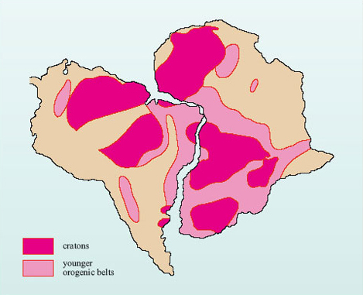
Figure 3 Continuity of Precambrian rocks. There is good correlation between these geological units when the continents are fitted along their opposing margins. The immense periods of time over which these Archaean and Precambrian units were formed (>2 Ga) indicate that South America and Africa had together formed a single land mass for a considerable part of the Earth's history. (Adapted from Hallam, 1975)

2.2.3 Climate, sediment and the mismatch of sedimentary deposits with latitude
The climate of modern Earth may be divided into different belts that have cold arctic conditions at high latitudes and hot tropical conditions at equatorial and low latitudes. The nature and style of rock weathering and erosion varies according to these climate belts, such that glaciation and freeze-thaw action predominate at present-day high latitudes, whilst chemical alteration, aeolian and/or fluvial processes are more typical of present-day low latitudes. Once a rock is weathered and eroded, each climatically controlled suite of processes gives rise to its own type of sedimentary succession and landforms:
- sand dunes form in hot, dry deserts
- coal and sandstone successions form in tropical swamps and river deltas
- boulder clay deposits and 'U-shaped' valleys form where there are ice sheets and glaciers.
It has long been recognised that geologically ancient glacial-type features are not just restricted to the present-day, high-latitude locations, but also occur in many warm-climate continents such as Africa, India and South America. Similarly, warm-climate deposits may be found in northern Europe, Canada and even Antarctica. For instance, coal is one of our most familiar geological materials, yet the European and North American coal deposits are derived from plants that grew and decayed in hot, steamy tropical swamps 320-270 Ma ago during the late Carboniferous and early Permian Periods. Reasons for these unusual distributions are often provided by reconstructing the ancient continental areas and determining their original positions when the deposits or landforms were created.

Activity 1

Late Carboniferous coalfields are found in northern Britain around latitude 55°N. If these coals formed from plants that grew in the tropics between 23°N and 23°S, what is the minimum distance Britain has travelled in 300 Ma? At what rate has it travelled (in mm y⁻¹)? (Assume the radius of the Earth is 6370 km.)

View answer - Activity 1

2.2.4 Palaeontological evidence
Palaeontological remains of fossil plants and animals are amongst the most compelling evidence for continental drift. In many instances, similar fossil assemblages are preserved in rocks of the same age in different continents; the most famous of these assemblages is the so-called Glossopteris flora. This flora marks a change in environmental conditions. In the southern continents, the Permian glacial deposits were succeeded by beds containing flora that was distinct from that which had developed in the climatically warm, northern land masses of Laurasia. The new southern flora grew under cold, wet conditions, and was characterised by the ferns Glossopteris and Gangamopteris, the former giving its name to the general floral assemblage. Today, this readily identifiable flora is preserved only in the Permian deposits of the now widely separated fragments of Gondwana.

2.2.5 Palaeomagnetic evidence and 'polar wander'
The Earth has the strongest magnetic field of all the terrestrial planets, with similar properties to a magnetic dipole or bar magnet. As newly erupted volcanic rocks cool, or sediments slowly settle in lakes or deep ocean basins, the magnetic minerals within them become aligned according to the Earth's ambient magnetic field. This magnetic orientation becomes preserved in the rock. The ancient inclination and declination of these rocks can then be measured using sensitive analytical equipment.
As a continent moves over the Earth's surface, successively younger rocks forming on and within that continent will record different palaeomagnetic positions, which will vary according to the location of the continent when the rock was formed. As a result, the position of the poles preserved in rocks of different ages will apparently deviate from the current magnetic pole position (Figure 4a). By joining up the apparent positions of these earlier poles, an apparent polar wander (APW) path is generated. It is now known that the Earth's magnetic poles do not really deviate in this manner, and the changes depicted in APW paths are simply a result of the continent moving over time (Figure 4b).

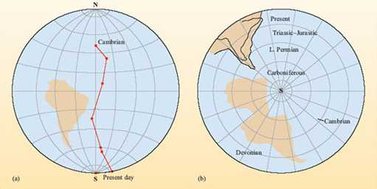
Figure 4 Two methods of displaying palaeomagnetic data: (a) assumes that the continent has remained fixed over time, and records the apparent polar wandering path of the South Pole; (b) assumes the magnetic poles are fixed over time, and records the latitude drift of a continent. (Adapted from Creer, 1965)

Nevertheless, APW paths remain a commonly used tool because they provide a useful method of comparing palaeomagnetic data from different locations. They are especially useful in charting the rifting and suturing of continents.
Figure 5a shows North America and Europe have individual apparent polar wander paths. However, they are broadly alike in that they have similar changes in direction at the same time. Figure 5b shows the APW paths if the Atlantic Ocean is closed by matching the continental shelves.

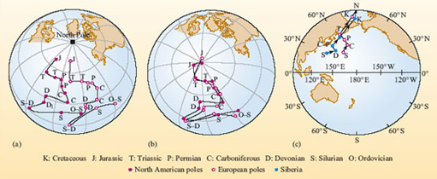
Figure 5 (a) Apparent polar wander paths for North America and Europe, as measured, (b) Apparent polar wander paths for North America and Europe with the Atlantic closed. Poles for successive geological periods are shown. (c) The apparent polar wander paths for Europe and Siberia. (Adapted from Mussett and Khan, 2000)

Question 2

What does this tell you about the North American and European continental masses during the periods spanned by these palaeomagnetic records?

View answer - Question 2

Conversely, if the APW paths of two regions were different to begin with, but became similar later on, one explanation would be that the two regions were originally on independent land masses that then collided and subsequently began to move together as a single continental unit.

Activity 2

What do the APW paths in Figure 5c tell you about the way in which Europe and Siberia have drifted from the Silurian Period to the present day?

View answer - Activity 2

Despite Wegener's amassed evidence and the increasing body of geological, palaeontological and palaeomagnetic information, there remained strong opposition to his theory of continental drift, leaving just a few forward-thinking individuals to continue seeking evidence to support this theory (Box 1).
The scientific opposition reasoned that if continents move apart, then surely they must either leave a gap at the site they once occupied or, alternatively, must push through the surrounding sea floor during their movement. The geophysicists of the day quickly presented calculations demonstrating that the continents could not behave in this way and, more importantly, no one could conceive of a physical mechanism for driving the continents in the manner Wegener had proposed. Consequently, the theory of continental drift did not gain scientific popularity at the time and became increasingly neglected for several decades. To gain a wider scientific acceptance, Wegener's ideas had to await a greater understanding in the internal structure of the Earth and the processes controlling the loss of its internal heat.

2.3 Sea-floor spreading
During and just after World War II, the technological improvement to submarines led to an improvement in underwater navigation and surveying that revealed many intriguing underwater features. The most important of these were immense, continuous chains of volcanic mountains running along the ocean basins. These features are now termed mid-ocean ridges or more accurately, oceanic ridge systems.
Using this new information, three American scientists Hess, Dietz and Heezen (Box 1) proposed that the sea floor was actually spreading apart along the ocean ridges where hot magma was oozing up from volcanic vents. They further suggested that the oceanic ridges were the sites of generation of new ocean lithosphere, formed by partial melting of the underlying mantle followed by magmatic upwelling. They named the process sea-floor spreading. Moreover, they proposed that the topographic contrast between the ridges and the oceanic abyssal plains was as a consequence of the thermal contraction of the crust as it cooled and spread away from either side of the ridge axis. Most importantly, because new oceanic crust is generated at the ridge, the ocean must grow wider over time and, as a consequence, the continents at its margin move further apart. The evidence to support this model was found, once again, in the magnetic record of the rocks, but this time using rocks from the ocean floor.

2.3.1 Linear magnetic anomalies - a record of tectonic movement
At the time that sea-floor spreading was proposed, it was also known from palaeomagnetic studies of volcanic rocks erupted on land that the Earth's magnetic polarity has reversed numerous times in the geological past. During such magnetic reversals, the positions of the north and south magnetic poles exchange places. In the late 1950s, a series of oceanographic expeditions was commissioned to map the magnetic character of the ocean floor, with the expectation that the ocean floors would display largely uniform magnetic properties. Surprisingly, results showed that the basaltic sea floor has a striped magnetic pattern, and that the stripes run essentially parallel to the mid-ocean ridges (Figure 6). Moreover, the stripes on one side of a mid-ocean ridge are symmetrically matched to others of similar width and polarity on the opposite side.

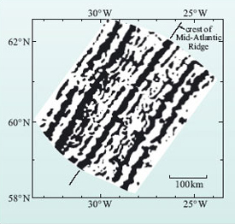
Figure 6 A modern map of symmetrical magnetic anomalies about the Atlantic Ridge (the Reykjanes Ridge), south of Iceland. (Adapted from Hiertzler et al., 1966)

In 1963, two British geoscientists, Vine and Matthews (Box 1), proposed a hypothesis that elegantly explained how these magnetic reversal stripes formed by linking them to the new idea of sea-floor spreading. They suggested that as new oceanic crust forms by the solidification of basalt magma, it acquires a magnetisation in the same orientation as the prevailing global magnetic field. As sea-floor spreading continues, new oceanic crust is generated along the ridge axis. If the polarity of the magnetic field then reverses, any newly erupted basalt becomes magnetised in the opposite direction to that of the earlier crust and so records the opposite polarity. Since sea-floor spreading is a continuous process on a geological timescale, the process preserves rocks of alternating polarity across the ocean floor (Figure 7a). Reading outwards in one direction from the mid-ocean ridge gives a record of reversals over time, and this can be matched with the record read in the opposite direction.
Figure 7 (interactive): The animation in Figure 7 below shows the pattern of magnetic reversals on either side of a mid-ocean ridge. Black = normal magnetic field; white = reversed field. When these reversal data are combined with age data (derived by radiometric dating of rocks dredged from the sea floor), a geomagnetic timescale can be produced, as you can see in the right of the animation. Detailed geomagnetic timescales have now been produced for all of the geological time since the Jurassic Period.

Interactive content is not available in this format.

Magnetic and oceanographic surveys of the ocean floor have collected information on both its palaeomagnetic polarity and its absolute age (by radiometric dating of retrieved sea-floor samples). Combining these two records has helped establish a geomagnetic timescale (Figure 7b) and, by using samples from the oldest sea floor, this timescale has now been extended back into the Jurassic Period, allowing the ages and rates of sea-floor spreading to be established for all the world's oceans, as shown in Figure 8. (The different types of plate boundary shown in Figure 8 are discussed later in the text.)

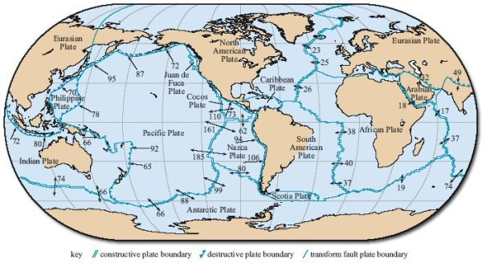
Figure 8 Map showing the global distribution of tectonic plates and plate boundaries. The black arrows and numbers give the direction and speed of relative motion between plates. Speed of motion is given in mm y⁻¹. (Adapted from Bott, 1982)

Click on 'View document' below to see a larger version of the above image.
View document
Two measures of spreading rate are commonly cited:
- where the rate of spreading is determined on one side (i.e. the rate of movement away from the ridge axis), this is termed the half spreading rate;
- where the rate is determined on both sides (i.e. the combined rate of divergence), the combined value is termed the full spreading rate.

Question 3

Assuming symmetrical spreading rates, use the data given on Figure 8 to discover the maximum and minimum spreading rates, and half spreading rates for the ocean ridge system of (i) the Atlantic Ocean (ii) the Pacific Ocean.

View answer - Question 3

Activity 3

The width of ocean floor between the spreading ridge in the South Atlantic Ocean at 30°S and the edge of the continental shelves along the east coast of South America and the west coast of southern Africa at 3°S is approximately 3100 and 2700 km respectively. Assuming that the spreading rate on this segment of the ridge is 38 mm y⁻¹, estimate the maximum age of the sea floor on either side of the South Atlantic.

View answer - Activity 3

Magnetic stripes not only tell us about the age of the oceans, they can also reveal the timing and location of initial continental break-up. The oldest oceanic crust that borders a continent must have formed after the continent broke apart initially, and just as sea-floor spreading began. In effect, it records the age when that continent separated from its neighbour. In the northern Atlantic, for example, oceanic crust older than 140 Ma is restricted to the eastern USA and western Saharan Africa, therefore separation of North America from this part of Africa must have commenced at this time. The oldest oceanic crust that borders South America and sub-equatorial Africa is only about 120 Ma old. Accordingly, it follows that the North Atlantic Ocean started to form before the South Atlantic Ocean.
If new sea floor is being created at spreading centres, then old sea floor must be being destroyed somewhere else. The oldest sea floor lies adjacent to deep ocean trenches, which are major topographic features that partially surround the Pacific Ocean and are found in the peripheral regions of other major ocean basins. The best known example is the Marianas Trench where the sea floor plunges to more than 11 km depth. Importantly, ocean trenches cut across existing magnetic anomalies, showing that they mark the boundary between lithosphere of differing ages. Once this association had been recognised, the fate of old oceanic crust became clear - it is cycled back into the mantle, thus preserving the constant surface area of the Earth.

2.3.2 Plate tectonics
The combination of evidence for continental drift with the increasing evidence in favour of sea-floor spreading finally led to the development of plate tectonics (Box 1). Ideas developed in the 1960s and 70s have survived largely unaltered to the present day, albeit modified by more sophisticated data and modelling methods.

3 The theory of plate tectonics

3.1 Assumptions
The surface of the Earth is divided into a number of rigid plates that extend from the surface to the base of the lithosphere. A plate can comprise both oceanic and continental lithosphere. As you already know, continental drift is a consequence of the movement of these plates across the surface of the Earth. Thus the need for the continents to plough through the surrounding oceans is removed, as is the problem of the gap left in the wake of a continent as it drifts - both issues that led to scientific opposition to Wegener's ideas.
The theory of plate tectonics is based on several assumptions, the most important of which are:
- New plate material is generated at ocean ridges, or constructive plate boundaries, by sea-floor spreading.
- The Earth's surface area is constant, therefore the generation of new plate material must be balanced by the destruction of plate material elsewhere at destructive plate boundaries. Such boundaries are marked by the presence of deep ocean trenches and volcanic island arcs in the oceans and, when continental lithosphere is involved, mountain chains.
- Plates are rigid and can transmit stress over long distances without internal deformation - relative motion between plates is accommodated only at plate boundaries.
As a consequence of these three assumptions, and particularly the third assumption, much of the Earth's geological activity, especially seismic and volcanic, is concentrated at plate boundaries (Figure 9). For example, the position of the Earth's constructive, destructive and conservative plate boundaries can be mapped largely on the basis of seismic activity. However, it is not enough just to know where boundaries are. In order to understand the implications that plate tectonics has for Earth evolution and structure, you first need to explore the structure of lithospheric plates, their motion - both relative and real - and the forces that propel the plates across the Earth's surface.
Figure 9 (interactive): (a) Global earthquake epicentres between 1980 and 1996. Only earthquakes of magnitude 4 and above are included. Click on the highlighted areas for more details.

Interactive content is not available in this format.

Click on 'View document' below for a bigger version of Figure 9a.
View document

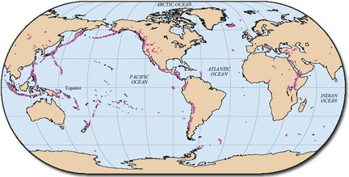
Figure 9 (b) Map showing locations of active, sub-aerial volcanoes. Enlarged versions of Figures 9a and b are in the Appendix. ((a) BGS; (b) adapted from Johnson, 1993)

Click on 'View document' below to see a larger version of Figure 9b.
View document

3.1.1 What is a plate?
In order to understand how and why the lithospheric plates move it is first necessary to understand their physical and thermal structure:
- the Earth can be divided into the core, mantle and crust based on its physical and chemical properties
- the lithosphere comprises the Earth's crust and the upper, brittle part of the mantle.
The thickness of the lithosphere is variable, being up to 120 km thick beneath the oceans; it is considerably thicker beneath ancient continental (cratonic) crust. However, the thermal structure of a plate is best illustrated with reference to the ocean basins and how their thermal characteristics change with time.

3.2 Heat flow within plates
As newly formed lithosphere moves away from an oceanic ridge, it gradually cools and heat flow (Box 2) decreases away from constructive plate boundaries.

Question 4

If a body cools, what happens to its density?

View answer - Question 4

The cooling and shrinking of the lithosphere result in an increase in its density and so, as a result of isostasy, it subsides into the asthenosphere and ocean depth increases away from the ridge, from about 2-3 km at oceanic ridges to about 5-6 km for abyssal plains. Indeed, one of the more remarkable observations of ocean-floor bathymetry is that ocean floor of similar age always occurs at similar depths beneath sea level (Figure 10). The relationship between mean oceanic depth (d in metres) and lithosphere age (t in Ma) can be expressed as:
d = 2500 + 350t^{½} ( 1 )
If the depth of the ocean floor can be determined, then the approximate age of the volcanic rocks from which it formed may also be estimated, and vice versa.

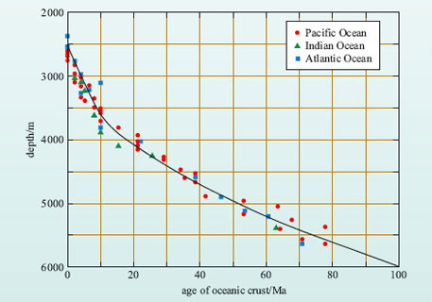
Figure 10 Observed relationship between depth of the ocean floor (both for ocean ridges and abyssal plains) and age of formation of the oceanic crust for the Pacific, Indian and Atlantic Oceans. The solid curve shows the relationship between age and ocean depth according to Equation 1.

Activity 4

The ocean depth at a distance of 1600 km from the Mid-Atlantic Ridge is 4700 m.
- (a) Calculate:
  - (i) the age of the crust at this location
  - (ii) the mean spreading rate represented by this age.
- (b) Is this a half or a full spreading rate?

View answer - Activity 4

Box 2: Earth's heat flow
The sources of Earth's internal heat are:
- heat remaining from the initial accretion of the Earth
- gravitational energy released from the formation of the core
- tidal heating
- radiogenic heating within the mantle and crust.
Although the proportion of each heat source cannot be determined accurately, radiogenic heat is considered to have been the major component for much of the Earth's history. There are three main processes by which this internal heat gets to the Earth's surface, these being conduction, convection and advection.
Heat flow (or heat flux), q, is a measure of the heat energy being transferred through a material (measured in units of watts per square metre; W m⁻²). It may be determined by taking the difference between two or more temperature readings (ΔT) at different depths down a borehole (d), and then determining the thermal conductivities (k) of the rocks in between. q can then be calculated according to the relationship:

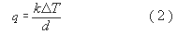

Earth scientists are interested in the heat flow measured at the Earth's surface because it reveals important information concerning the nature of the rocks and the processes that affect the lithosphere.
The total annual global heat loss from the Earth's surface is estimated as 4.1-4.3 × 10¹³ W. This yields an average of q ≥ 100 mW m⁻² (milliwatts per square metre), though individual measurements may be much higher than this. However, values of q decrease to less than 50 mW m⁽² for oceanic crust older than 100 Ma (Figure 11). In continental areas, the younger crust (i.e. mountain belts that are less than 100 Ma) have relatively high values of q, which are 60-75 mW m⁻², whilst old continental crust and cratons have much lower heat flow values, averaging q = 38 mW m⁻². Thus, variations in heat flow are closely related to different types of crustal materials and, importantly, different types of tectonic plate boundary.

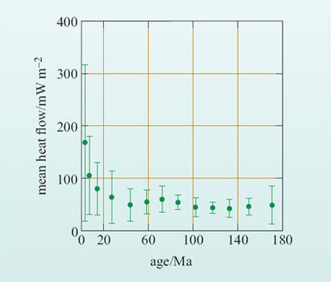
Figure 11 Mean heat flow (q) and associated standard deviation (vertical lines) plotted against the age of the oceanic lithosphere for the North Pacific Ocean.

There are two general models for the thermal evolution of the oceanic lithosphere: the plate model and the boundary-layer (or half-space) model.
- The plate model (Figure 12a) assumes that the lithosphere is produced at a mid-ocean ridge with constant thickness and that the temperature at the base of the plate corresponds to its temperature of formation.
- The boundary-layer model (Figure 12b) assumes that the lithosphere does not have a constant thickness, but thickens and subsides as it cools and moves away from the ridge. This is achieved by loss of heat from the underlying asthenosphere, which progressively cools below the temperature at which it can undergo solid-state creep and is transformed from asthenosphere to lithosphere.

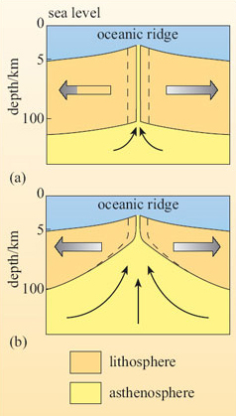
Figure 12 Schematic sections through oceanic lithosphere formed at an oceanic ridge: (a) plate model, in which oceanic lithosphere thickness remains constant as the lithosphere moves away from the ridge; (b) boundary-layer model, in which the lithosphere thickens as it ages and cools. The dashed lines show where new lithosphere forms in both models.

The thermal consequences of these two models can be calculated from a knowledge of the temperature of the mantle at depth (the geotherm) and the thermal conductivity of the rocks in the lithosphere. As it turns out, both models predict similar results for both heat flow and ocean depth, as shown in Figure 13.

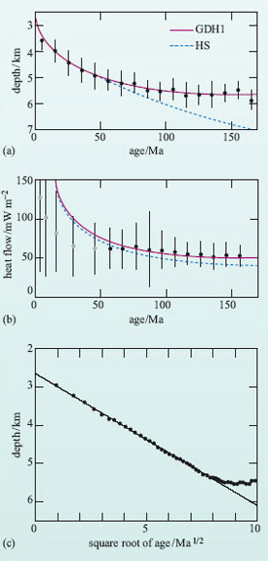
Figure 13 Graphical plots of (a) depth and (b) heat flow against age for the Pacific Ocean. The line labelled GDH1 refers to the plate model, whereas the curve labelled HS refers to the boundary layer model. (c) Graphical plot of ocean bathymetry (depth) against the square root of the age of the lithosphere for the Pacific Ocean. Note the good linear relationship for young lithosphere and the deviation from the simple linear trend for older lithosphere. (Fowler, 2005)

Activity 5

Study Figure 13(c) and then answer the following questions:
- (a) Is the correlation between depth and the square root of the age of the lithosphere positive or negative?
- (b) At what age does the relationship depart from a linear correlation?
- (c) Does this departure imply that older oceanic lithosphere is warmer or cooler than predicted from the simple, linear boundary-layer model?

View answer - Activity 5

Both models predict the observed linear variation between ocean depth and the square root of age of the lithosphere, showing that the oceanic lithosphere cools and subsides as it ages away from a spreading centre. However, the plate model fits the data better for older lithosphere (>60 Ma), suggesting that once lithosphere has cooled to a certain thickness, the thickness remains more-or-less constant until the plate is subducted.
Both models also predict greater heat flow from young oceanic crust than that observed in the ocean basins, as shown in the example in Figure 13b.

Question 5

What do you think the cause of this difference might be?

View answer - Question 5

The formation of oceanic lithosphere involves contact between hot rocks and cold seawater. As the rocks cool and fracture, they allow seawater to penetrate the young, hot crust to depths of at least a few kilometres. During its passage through the crust the seawater is heated before being cycled back to the oceans. This process is known as hydrothermal circulation and the development of submarine hydrothermal vents ('black smokers') close to mid-ocean ridges is the most dramatic expression of this heat transfer mechanism. However, less dramatic but probably equally significant lower temperature circulation continues well beyond the limits of oceanic ridges and contributes to heat loss from the crust up to 60 Ma after formation.
The geophysical evidence from seismology and isostasy suggests that the oceanic lithosphere increases in thickness as it ages until it reaches a maximum of about 100 km. By contrast, bathymetry and heat flow indicate a more constant thickness for older plates. To explain these observations, a plate structure such as that shown in Figure 14 has achieved wide acceptance. The plate is divided into two layers: an upper, rigid mechanical boundary layer and a lower, viscous thermal boundary layer. Both layers thicken progressively with time until the lithosphere is about 80 Ma old, after which the thermal boundary layer becomes unstable and starts to convect. Convection within this layer provides a constant heat flow to the base of the mechanical boundary layer. Thus old lithosphere maintains a constant thickness because the heat flow into its base, and hence the basal temperature, is maintained by convection.

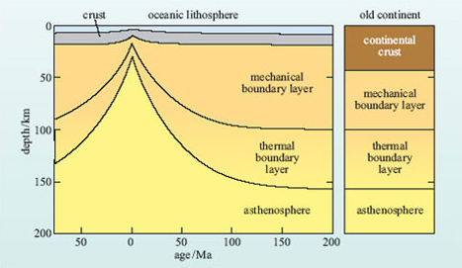
Figure 14 Thermal model of lithospheric plates beneath oceans and continents. Note the thicker crust and thinner mantle lithosphere in the continental section. (Fowler, 2005)

3.3 Constructive plate boundaries
Constructive plate boundaries or margins are regions where new oceanic crust is being generated. However, in order for the magma to ascend to the surface and build new lithosphere, the earlier formed crust must be pulled apart and fractured to create a new magma pathway. Hence constructive plate boundaries are regions of extensional stresses and extensional tectonics. The process of fracturing, injection and eruption is repeated frequently, so that tensional stresses do not have time to accumulate significantly and, as a result, constructive plate boundaries are characterised by frequent, low-magnitude seismicity (typically less than magnitude 5), occurring at shallow crustal depths (<60 km) along the ocean ridge systems.

Question 6

Why do you think earthquakes are restricted to shallow depths beneath ocean ridges?

View answer - Question 6

Sonar surveying, and direct investigation by sea-floor drilling or deep sea submersibles, has revealed that volcanism along the ridge systems typically consists of a series of individual, active eruption centres. Each eruptive centre is no more than about 2-3 km long, and along the ridge axis they are often separated from each other by an inactive gap of about 1 km. Beneath the spreading ridge the feeder magma chambers that supply the volcanic centres are more continuous, often linking between and across the active segments. This means that magma generation occurs along much of the length of the ridge even though it is erupted via a chain of individual volcanic centres.
Plates move away from constructive boundaries at speeds that can be as low as <10 mm y⁻¹ to so-called ultra-fast spreading ridges where half spreading rates can exceed 100 mm y⁻¹. Examples of slow spreading ridges include parts of the mid-Atlantic Ridge and the southwest Indian Ridge. Fast and ultra-fast ridges occur in the East Pacific, along the East Pacific Rise and the Galapagos spreading centres (Figure 8).
The depth structure of a constructive plate boundary can be further defined from the variation in the Earth's gravity (Box 3). Figure 15 shows gravity anomalies across the Mid-Atlantic Ridge. Despite the topographic rise associated with the ridge, the free-air gravity anomaly is relatively flat and close to zero across the whole structure. This indicates that there is no mass deficit or excess down to the level of isostatic compensation, i.e. the ridge is in isostatic equilibrium with the lithosphere of the abyssal plains. By contrast, when the free-air anomaly is corrected for the effects of the ridge topography and overall altitude, the resulting Bouguer gravity anomaly is strongly positive but with a local dip across the ridge axis. The positive anomaly occurs because of the raised topography of the ridge, but the ridge zone itself is underlain by lower-density material. A possible density model is shown in Figure 15b.

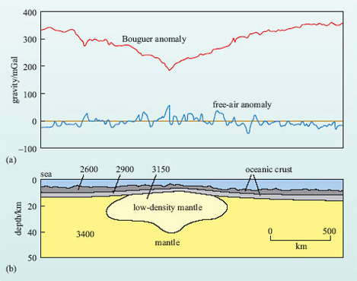
Figure 15 (a) Bouguer and free-air gravity anomalies across part of the Mid-Atlantic Ridge. (b) One possible density model that could produce the observed anomalies and satisfies other constraints (e.g. seismic structure). Figures give the densities of different layers in kg m⁻³.

Question 7

What do you think the low-density material beneath the ridge might represent?

View answer - Question 7

Box 3: Gravity and gravity anomalies
Gravity is the attractive force experienced by all objects simply as a consequence of their mass. The magnitude of the attraction is determined from Equation 3:

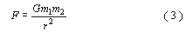

where m ₁ and m ₂ are the masses (measured in kg) of two objects, r is the distance (measured in m) between them and G is the universal gravitational constant (6.672 × 10⁻¹¹ N m² kg⁻²).
If one object is the Earth, with mass M, and the other is a much smaller object with mass m, Equation 3 can be rewritten:

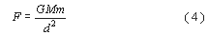

where d is the radius of the Earth, i.e. the distance to the Earth's centre of gravity.
However, the force experienced by an object at the surface of the Earth can be measured:

where m is its mass and g is the acceleration due to gravity. Hence:

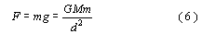

Cancelling m gives

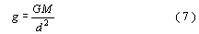

Hence g is proportional to the mass of the Earth and inversely proportional to the square of the distance from the centre of the Earth. Note that Equation 7 gives a way of measuring the mass of the Earth (M) if g can be measured and G and d are known.
- Given that the Earth is not truly spherical and that the poles are closer to the centre than the Equator is, will g at the poles be greater than, less than or similar to g at the Equator?
- Because the poles are closer to the centre of the Earth than the Equator, d² in Equation 7 will be lower, therefore g will be slightly greater.
Variations in gravity are measured in milligals (mGal) and 1 mGal is equivalent to 10⁻⁵ m s⁻². Since g = 9.81 m s⁻², this means that 1 mGal ∼10⁻⁶ g.
Measured variations in gravity across the surface of the Earth relate to the mass in the vicinity of the point of measurement. Thus a region underlain by dense rocks, such as basalt, will exhibit a slightly stronger gravitational pull than those underlain by less dense rocks, such as granite or sediments. In addition, gravity is affected by the underlying topography and the altitude at which the measurement was made. Thus measurements of the variation in the Earth's gravitational field require numerous corrections for latitude and topography, the details of which are beyond the scope of this course (but see the texts recommended in the Further Reading section). The resultant gravitational anomaly is known as a Bouguer anomaly and this reflects the variations in the Earth's gravity due to the underlying geology. Bouguer gravity is usually calculated over continental regions where the surface topography and the underlying geology are both highly variable. In marine surveys, fewer corrections are applied to the measured value of g, and gravitational anomalies are conventionally referred to as free-air anomalies. Gravity measurements, particularly over the oceans, are now routinely recorded from satellites and have resulted in accurate and detailed maps of the free-air anomaly over most of the Earth.

Hot material is generally less dense than cold material, so the low density of the mantle beneath the ridge is related to the locally high geothermal gradient, as also indicated by the presence of basaltic magma and the restriction of earthquakes to the upper levels of the lithosphere.
Finally, it should be noted that constructive plate boundaries by definition cannot occur within continental lithosphere as they must be bounded by new oceanic lithosphere. There are regions of the Earth's crust where a constructive boundary (or boundaries) can be traced into a continental region, for example at the southern end of the Red Sea and the Gulf of Aden the marine basins join and extend into the Ethiopian segment of the African Rift Valley by way of the Afar Depression. While these three features are all part of an extensional tectonic regime, the African Rift Valley cannot be considered to be a true constructive plate boundary, although, in future, if plate configurations are suitable, it may provide the site for the opening of a new ocean.

3.4 Destructive plate boundaries
Destructive plate boundaries are regions where two lithospheric plates converge. This situation provides a more varied range of tectonic settings than do constructive plate boundaries. Firstly, and in contrast to constructive plate boundaries, destructive plate boundaries are asymmetrical with regard to plate speeds, age and large-scale structures. Secondly, whereas true constructive boundaries occur almost invariably in oceanic lithosphere, destructive boundaries also affect continental lithosphere - they can occur entirely within continental lithosphere. Consequently, there are three possible types of destructive plate boundary:
- those involving the convergence of two oceanic plates (ocean-ocean subduction)
- those where an oceanic plate converges with a continental plate (ocean-continent subduction)
- collisions between two continental plates (continent-continent destructive boundaries).
These can be thought of as representing three stages in the evolution of destructive boundaries.
In addition to the disappearance of old lithosphere, destructive boundaries associated with ocean-ocean subduction and ocean-continent subduction are also characterised by:
- ocean trenches, generally 5-8 km deep, but sometimes up to 11 km deep. The sea floor slopes into the trenches from both the landward and oceanward sides. They are continuous for many hundreds of kilometres, occurring both adjacent to continents and wholly within oceans;
- a belt of earthquakes that are shallow-centred closest to the trench and deeper further away. Earthquakes can occur as deep as 600-700 km;
- most destructive boundaries are associated with a belt of active volcanoes that, in the case of intra-oceanic boundaries, form chains of islands known as island arcs.

3.5 Destructive plate boundaries, continued: ocean-ocean (island-arc) subduction
The convergence of two oceanic plates represents the simplest type of destructive plate boundary and exemplifies most of the features associated with the destruction of oceanic lithosphere. Around the northern and western edges of the Pacific Ocean, many islands are arranged in gently curved archipelagos: anticlockwise these include the Aleutian Islands, the Kuril Islands, Japan, the Mariana Islands, the Solomon-New Hebrides archipelagos and the Tonga-Kermadec Islands north of New Zealand. These all occur some distance off the edge of the continental areas, but lie adjacent to a deep ocean trench. To the oceanward side of the deep trenches the ocean lithosphere is amongst the oldest on Earth. For example, the oceanic crust adjacent to the Marianas Trench, the deepest trench on Earth, is Jurassic in age and up to 180 Ma old. The trenches are sites where old oceanic lithosphere is being destroyed, or subducted, beneath younger lithosphere. For this reason, destructive boundaries are often referred to by their alternative name of subduction zones.
The typical pattern of earthquakes associated with ocean-ocean subduction is well illustrated in the interactive Figure 16 below, which shows the distribution of earthquakes associated with the Tonga Trench in the southwest Pacific. The earthquake data summarised in this diagram clearly define a zone of earthquakes deepening to the west away from the Tonga Trench, beneath the Tonga volcanic islands, and reaching a final depth in excess of 600 km. This inclined plane of earthquakes associated with the Tonga Trench (and every other deep ocean trench) in known as a Wadati-Benioff zone, after the first seismologists to recognise its existence.
Figure 16 (interactive)

Interactive content is not available in this format.

Question 8

Using the information in Figure 16, estimate the angle of the Wadati-Benioff zone beneath the Tonga island arc at ∼20°S. (Assume the first occurrence of >400 km earthquakes along this line is representative of earthquakes with a minimum depth of 400 km.)

View answer - Question 8

Question 9

Is the angle constant along the whole length of the Tonga Trench?

View answer - Question 9

The presence of earthquakes at great depth in Wadati-Benioff zones shows that rocks are undergoing brittle failure throughout this depth range.

Question 10

What does this observation tell you about the thermal state of subducted lithosphere?

View answer - Question 10

Subduction involves the recycling of old, and therefore cold, oceanic lithosphere back into the mantle. A common misconception is that earthquakes represent failure between the subducted lithosphere and the overlying mantle. While this may be the case for the shallowest levels of subduction, analysis of earthquake waves from deeper seismic events indicate that earthquake foci lie within the subducted lithosphere and reflect differential movement between rigid blocks in the subducted lithosphere as it heats up and expands.
The fact that the subducted slab remains colder than ambient mantle at a comparable depth raises a problem for the generation of volcanic activity - a diagnostic feature of subduction. If subduction zones are regions where cold material is being cycled back into the mantle, why are they the site of volcanic activity? Constructive plate boundaries are underlain by regions of hot mantle that rises in response to the separation of the overlying plates and so it is easy to see how magma can be generated from the mantle. Beneath island arcs there is less evidence for hot mantle and so melting must be triggered by some alternative mechanism. Seismic profiles of subduction zones show that melt is generated immediately above the subducted plate, and most volcanic arcs are located approximately 100 km above its surface, so there is clearly a relationship between subducted oceanic lithosphere and the presence of island-arc volcanism.
The link between subduction and volcanism lies in the composition of the subducted lithosphere.

Question 11

In addition to basaltic crust and mantle rocks, what other rocks would you expect in the subducted plate?

View answer - Question 11

Subduction provides a mechanism for introducing water-bearing sediments into the mantle, and as the subducted lithosphere heats up the water is gradually released. Water has the effect of reducing the melting temperature of the mantle. It is this process that allows the generation of magma at depth that feeds surface volcanism. As a result, subduction-related magmas are also richer in volatiles than similar rocks from other tectonic environments, such as constructive plate boundaries.
All of the above characteristics are more or less diagnostic of an oceanic destructive plate boundary. There are, however, a number of other structural features that may or may not be present, but reflect different processes associated with subduction. Figure 17b shows the mean ocean depth across the Kuril Trench in the NW Pacific Ocean. On the oceanward side of the Kuril Trench, as with all deep ocean trenches, the ocean depth is between 4 km and 6 km, whereas the trench is 2-4 km deeper still. Note that the vertical scale has been exaggerated fifty times in Figure 17b and the actual angles of the sides of the trench are quite shallow, being between 20° and 5°.

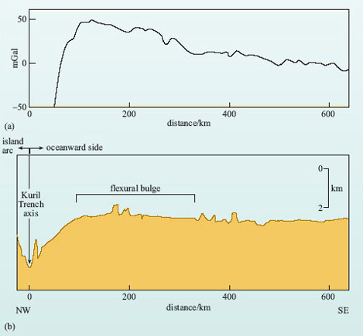
Figure 17 (a) Free-air gravity variations and (b) topography across the Kuril Trench. (Adapted from Watts, 2001)

Question 12

What happens to ocean depth immediately to the ocean side of the trench?

View answer - Question 12

The decrease in ocean depth towards the trench is characteristic of all island-arc systems and can elevate the ocean floor by as much as 0.5 km. It is caused by the flexure of the lithosphere in response to its entry into the subduction zone and is known as a flexural bulge. It is analogous to flexing a ruler over the edge of a table. If you place an ordinary plastic ruler on the edge of a table so that about one-third of it protrudes over the edge and then apply pressure to the extreme tip of the ruler while holding the other end firmly on the table, the ruler will flex and the part that was lying flat on the table will rise slightly. When the pressure is released the ruler will return to its original position because it is a rigid but elastic material. (Imagine trying this experiment with plasticine.)
The flexural bulge is a common feature of ocean-trench systems and is marked by a small increase in free-air gravity, while the trench itself is marked by a large decrease in free-air gravity (Figure 17a). Such gravity variations imply that arc systems are out of isostatic equilibrium - the negative anomaly over the trench reflects a mass deficit, meaning that the crust in the trench must be being held down, while the increase over the flexural bulge implies that it is underlain by dense material beneath the plate. The interpretation is that as the plate flexes upwards it 'pulls in' the asthenospheric mantle beneath. The isostatic imbalance, with the trench held down and the bulge supported, is due largely to the rigidity of the subducting plate.
While many ocean trenches are particularly deep, others are not. However, they are still characterised by a strongly negative free-air gravity anomaly, implying that they are filled with low-density material.

Question 13

What do think this low-density material might be?

View answer - Question 13

As a plate ages, it accumulates a veneer of deep-sea sediments made up of clays and the remains of micro-organisms in the oceans. At the subduction zone, this sedimentary cover is partly scraped off against the overriding plate to form huge wedges of deformed sediment that can eventually fill the trench system. This material is often known as an accretionary prism. Not all the sediment is removed, however, and some remains attached to the descending oceanic plate and may become attached to the base of the overlying plates or even be carried into the upper mantle.
Behind many island-arc systems, especially those in the western Pacific, small ocean basins open up between the arc and the adjacent continent. Typical examples include the ocean basins immediately to the west of the Tonga and Marianas island arcs. Various lines of evidence show that these regions of ocean crust are very young and characterised by active spreading centres. Such features are known as back-arc basins.

Question 14

Does the existence of young oceanic crust suggest an extensional or a compressional tectonic regime in back-arc basins?

View answer - Question 14

The presence of an extensional regime in the back-arc region basin may appear counter-intuitive because where two plates are converging the dominant tectonic regime should be compressional. The mechanisms that give rise to back-arc tension may relate to convection in the asthenosphere underlying the back-arc region. Alternatively, it has been suggested that old, dense slabs may subside into the mantle at a faster rate than the plate is moving, causing the trench to migrate towards the spreading centre (euphemistically called 'slab roll-back'). This gives rise to an extensional regime not only in the back-arc basin but also across the whole arc, even to the extent of suggesting that back-arc basins may originate as arcs that have been split by extension as a consequence of slab roll-back.
All of the major features of an oceanic destructive boundary are included in Figure 18, which is an idealised cross-section through an oceanic island-arc system.

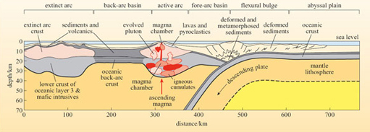
Figure 18 Schematic cross-section through an ideal island arc. Note that not all of the features shown here will be present in any one arc system. (Note: 2x vertical exaggeration.)

3.6 Destructive plate boundaries, continued: ocean-continent (Andean type) subduction
When an oceanic plate converges with a continental plate, it is always the ocean plate that subducts beneath the continental plate. Continental lithosphere lies at a higher surface elevation than oceanic lithosphere because of its lower overall density. The resistance shown by continental lithosphere to subduction is simply a further reflection of its lower density.
This type of destructive plate boundary is characterised by the west coast margin of South America. Here, the oceanic lithosphere of the Nazca Plate is being subducted beneath the overriding continental lithosphere that forms the western part of the South American Plate. The overriding continental edge is uplifted to form mountains (the Andes) and the collision zone itself is marked by a deep ocean trench that runs parallel to the continental margin. A chain of active volcanoes runs along much of the length of the South American Andes from Colombia to southern Chile. The ocean trench is similarly characterised by a dipping Wadati-Benioff zone, and is marked by earthquakes reaching depths of several hundred kilometres. The shallowest earthquakes (<60 km) occur at, or near, the trench, with the deepest ones recorded as being up to 700 km deep - the depth before which the plate becomes sufficiently heated to prevent further brittle behaviour. The overall structure of such Andean margins is very similar to those described in the previous section, with the added influence of the greater thickness of the overriding continental lithosphere and the probable increased flux of sedimentary material into the system as a result of continental erosion.

3.7 Destructive plate boundaries, continued: continent-continent destructive boundaries
When two continental plates meet at a destructive boundary, the continents themselves collide. These types of continental collision are typically the result of an earlier phase of subduction of intervening oceanic lithosphere that has resulted in the closure of an ocean. Perhaps the best known and most spectacular example is the collision of peninsular India with Asia, which began 50 Ma ago, following the closure of an intervening ocean and produced the Himalayas and Tibetan Plateau . Even today, India continues to move northwards, indenting the southern edge of Asia at a rate of 40-50 mm y⁻¹. Such collisions result in intense deformation at the edges of the colliding plates, and those sea-floor sediments that were not subducted become folded and compressed into immense mountain chains or orogenic belts. Active mountain belts, such as the Alps and Himalayas in Eurasia, and the Rocky Mountains in the USA and Canada, are generally much wider than mountain belts associated with Andean-style arc systems, with deformation belts occurring many hundreds of kilometres into continental interiors.

Question 15

What does this observation suggest about the strength of continental lithosphere relative to oceanic lithosphere?

View answer - Question 15

The continents are made up of less-dense rock than oceanic lithosphere and are dominated by quartz and feldspars. At elevated temperatures, these minerals are much weaker than the olivine and pyroxene characteristic of the oceanic crust and mantle. Moreover, continental crust contains a higher concentration of the heat-producing elements K, U and Th. The overall higher heat production conspires with the dominance of weaker minerals to make the continental crust much less rigid than the crust beneath the oceans and, therefore, easier to deform. During deformation the continental crust is thickened and this gives rise to the dramatic topography of active mountain ranges. However, once the forces that drive collision are removed, erosion takes over and the high topography is reduced to more modest elevations. Older mountain belts, such as the Appalachian and Caledonian orogenic belts, which are the products of continental collisions that occurred hundreds of millions of years ago, are now supported by a balance between isostatic support of their thickened crustal roots and erosion that is controlled by climate.

3.8 Conservative plate boundaries and transform faults
Conservative plate boundaries and transform faults occur when plates slide past each other in opposite directions, but without creating or destroying lithosphere. Transform faults connect the end of one plate boundary to the end of another plate boundary, so there are potentially three types of transform fault:
- those that link two segments of a constructive boundary
- those that link two destructive boundaries
- those that link a destructive boundary with a constructive boundary.
Transform faults linking two constructive boundaries are the most common, and account for the displacements between adjacent segments of mid-ocean ridges. Accordingly, this type of ocean transform fault forms an integral part of constructive plate boundaries, and their position is made obvious by the jagged shape of parts of the ocean-ridge system that are split into several segments by series of so-called fracture zones. Examples can be easily seen on the Cocos-Nazca Ridge (also known as the Galapagos Spreading Centre), and the Pacific Ocean spreading ridge (i.e. East Pacific Rise) between 10°N and 10°S, and 40°S and 55°S respectively, or manifest as shorter segments along the Atlantic Ocean spreading ridge between 0°and 40°S. Generally, oceanic transform faults occur at right angles to spreading ridges and, therefore, their orientation is indicative of the direction of plate motion.
Transform faults are seismically active - but only where two different plates are adjacent to one another. In Figure 19, the fault trace marks the boundary between plates A and B. Plate A is moving towards the east while plate B is moving towards the west.

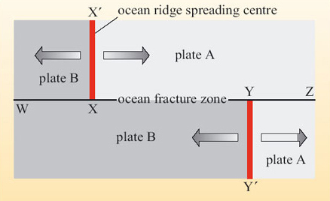
Figure 19 Diagram showing relative movements across an oceanic transform fault W, X, Y and Z off-setting a constructive plate boundary. The large arrows indicate the sense of plate motion away from the ridges XX' and YY'.

Question 16

Describe the sense of relative movement along the length of the fault between W and X, X and Y, and Y and Z.

View answer - Question 16

Question 17

Which part of the fault between W and Z will be seismically active?

View answer - Question 17

Only those sections of transform faults between two segments of constructive boundaries (e.g. the segment between X and Y in Figure 19) are seismically active and therefore real plate boundaries. Transform faults continue to exhibit a topographic expression beyond the constructive plate boundaries, even though only a short length of a transform fault is active. This topographic expression is simply a result of the different ages of adjacent oceanic lithosphere: younger lithosphere rests at a higher elevation than older lithosphere - this situation is illustrated schematically in Figure 20.

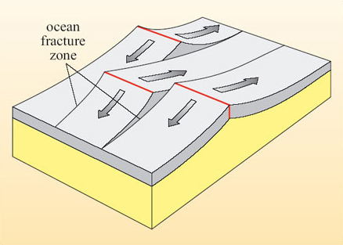
Figure 20 Block diagram showing how the topographic contrast across an ocean fracture zone (transform fault) develops as a consequence of lithospheric age as opposed to differential vertical movement.

Transform faults associated with subduction zones are much less common, and destructive plate boundaries do not, in general, show the segmented structure so common in constructive boundaries. An example occurs at the eastern end of the Cocos-Nazca Ridge, where a heavily faulted seismic zone delineates a transform fault (the Panama Fracture Zone), connecting a constructive boundary (the eastern end of the Costa Rica Rift, which is the easternmost part of the Cocos-Nazca Ridge) with the eastern end of a destructive boundary (the Middle America Trench). Similarly, the Scotia arc in the southern Atlantic is terminated in the north by a long transform fault along the North Scotia Ridge that marks the boundary between the South American Plate and the Scotia Plate.
Occasionally, conservative plate boundaries occur in continental plates. The most famous example is the San Andreas Fault of California, which marks a segment of the boundary between the North American and Pacific Plates. Here, Baja and southern California (including Los Angeles) are moving slowly northwards relative to the rest of California. This type of transform boundary produces shallow earthquakes and accompanying ground faulting. The friction between the two plates is often so great that the two sliding margins become 'stuck' together, allowing stresses to build up, which are then relieved by large earthquakes.

3.9 Triple junctions
All of the plate boundaries discussed so far have involved junctions between two plates. However, there are some localities where three plates are in contact, and these are termed triple junctions. Triple junctions between three ocean ridges, such as that in the South Atlantic between the African, South American and Antarctic Plates, are known as ridge-ridge-ridge, or RRR triple junctions. A similar notation can be used to identify triple junctions involving ocean trenches (T) or transform faults (F). For instance, a ridge-ridge-trench junction would be termed an RRT triple junction. The ordering of the letters is not significant. Considering all the geometric possibilities of fitting together three plate boundaries and their relative motions, there are actually only ten possible triple junctions. Some of these, such as RRR junctions, are termed stable triple junctions, which means they maintain their form over time. However, some can only exist briefly before they evolve into another plate configuration and these are termed unstable triple junctions. Figure 21 shows the evolution of three triple junctions over time.

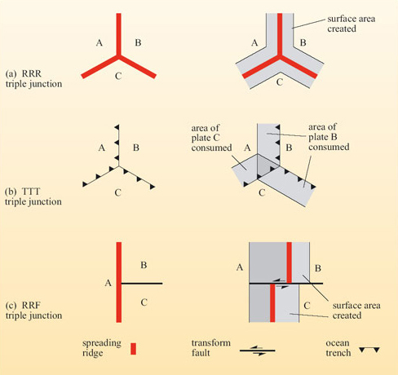
Figure 21 The evolution of triple junctions with time. (a) A triple junction involving three ridges (RRR triple junction) is always stable, and the magnetic anomalies within the surface area created have Y-shaped patterns around the spreading ridges. (b) A triple junction between three trenches (TTT) is almost always unstable except in the special circumstance shown here when the relative motion of plates A and C is parallel to the plate boundary between B and C. (c) A triple junction between two ridges and a transform fault (RRF) can only exist for a short instant in geological time, and decays immediately to two FFR stable plate junctions.

The RRR junction shown in Figure 21a is always stable, regardless of the relative rates of spreading at each of the three ridges. The TTT junction in Figure 21b is basically unstable except if, by coincidence, the movement rates are the same and if the direction of subduction of plate C below plate A is exactly parallel to the boundary between plates B and C. The triple junction in Figure 21c is an RRF junction, and is unstable because there is relative motion between plate B and plate C. The RRF triple junction evolves immediately to form two RFF junctions. FFF and RRF junctions are always unstable.
Seven types of triple junction exist in the present plate tectonic configuration. These are:
- RRR (e.g. in the South Atlantic, the Indian Ocean and west of the Galapagos Islands in the Pacific)
- TTT (e.g. central Japan)
- TTF (e.g. off the coast of Chile)
- TTR (e.g. off Moresby Island, western North America)
- FFR, FFT (e.g. junction of the San Andreas Fault and the Mendocino Transform Fault off western USA)
- RTF (e.g. southern end of the Gulf of California).

4 Plate tectonic motion

4.1 Relative plate motions
Plates move relative to one another and relative to a fixed reference frame, such as the rotational axis of the Earth. Plates also move across the curved surface of the Earth and so should not be considered as flat sheets on a flat surface but as caps moving across the roughly spherical surface of the Earth. Consequently, plate motion is not as simple as it might at first appear. This section begins with a consideration of relative plate motions and how they can be measured before moving on to the more complex assessment of plate motions across a sphere and how true plate motions may be measured.
In previous sections you have already tackled the problem of assessing the full and half spreading rates of ocean ridges.

Question 18

Recall two different methods of determining spreading rates.

View answer - Question 18

A simple calculation dividing the distance from the ridge by the age gives the plate speed and, combined with the direction of travel, its velocity.

Activity 6

Figure 22 shows a section through the Earth from the Atlantic to the Indian Ocean, cutting across three different plates and two constructive plate boundaries. The half spreading rates are shown for each plate at each plate boundary. For the situations in Table 1, estimate the relative rates and relative directions of motion of the African Plate.
Figure 22 (interactive)

Interactive content is not available in this format.

The answer to this question reveals two important points about plate motion:
- measured plate velocities (speed and direction) must be stated relative to one another;
- plates and their boundaries cannot be fixed in relation to the mantle.
The second point derives from a consideration of the African Plate - as it grows in size, at least one of its constructive boundaries must have moved. So how can we determine the true movement of a plate against a truly fixed frame of reference? One possibility would be to assume that one plate is stationary and to determine plate movement relative to that 'fixed' reference (as in Question 6). However, polar wander curves for all of the continents show that all plates bearing continents have moved relative to the Earth's magnetic pole over periods of tens of millions of years. Another way would be to determine plate motion relative to surface features that might be more firmly rooted in the deeper mantle and for this we turn to volcanism that is not dependent on plate boundary interactions - the so-called within-plate or hot-spot volcanism on ocean islands.

4.2 Hot-spot trails and true plate motions
In addition to volcanism associated with constructive and destructive plate boundaries there is a third important component to global volcanism. This occurs in the interior of plates and is associated with broad surface up-doming, which is often 1000 km across and hundreds of metres in elevation. Gravity anomalies across these domes show that they are not in isostatic equilibrium, but are supported from sub-lithospheric depths, presumably by upwelling mantle. Perhaps the best-known example is located beneath the active volcanoes of Hawaii (Section 3.4), whose long history of volcanism has been related to a structure in the deep mantle known as a mantle plume. Mantle plumes are an important feature of mantle convection, but for now it is sufficient to know that they produce surface volcanism that is not necessarily associated with plate boundaries. There are numerous plumes of different sizes recognised around the globe. Some are associated with chains of islands and seamounts, whereas others have produced long ridges in the ocean floor. A good example is the Ninetyeast Ridge in the Indian Ocean. Termed aseismic ridges because of a lack of seismicity along their lengths, these ridges are very different structures from the ocean ridges associated with constructive plate boundaries.

Box 4 Hawaii
Hawaii is part of an extensive chain of islands and submarine volcanic peaks (called seamounts) stretching almost 6000 km across the floor of the Pacific Ocean. The chain forms an 'L'-shaped chain of volcanic islands and seamounts across the sea floor that increase in age northwards from Hawaii (Figure 23).

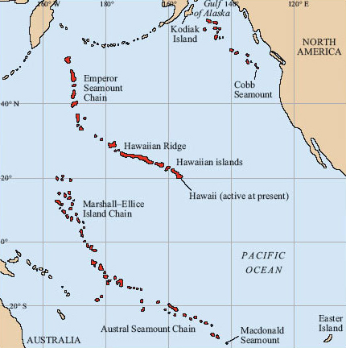
Figure 23: Map showing three of the major seamount and island chains in the Pacific Ocean. These are the Kodiak Island-Cobb Seamount Chain in the northeastern Pacific, the Marshall-Ellice Islands-Austral Seamount Chain of the southern Pacific, and the well-known Hawaiian Ridge-Emperor Seamount Chain in the central Pacific. The Hawaiian Islands are located at the southeastern end of the Hawaiian Ridge.

Hawaii rises from the sea floor some 6 km below the Pacific Ocean to a summit elevation of about 4 km above sea level, making it taller than Mt Everest. Although all of the Hawaiian Islands are volcanic in origin, only Hawaii is currently active and still growing in size. The islands are situated within the Pacific Plate some 4000 km from the nearest plate boundary. The magma that has caused the volcanism is the result of a plume of anomalously hot material rising through the mantle. Where this plume impinges upon the base of the lithosphere, magma finds its way to the surface to produce a so-called hot spot. Other island and seamount chains located on the Pacific Plate (Figure 23) show a similar pattern of age progression, and are related to different hot spots. In fact, hot-spot volcanoes may be found dotted around the world and most of them are remote from plate boundaries.
The ages of the islands and seamounts are proportional to their distance away from the currently active site of Hawaii, as shown in the graph in Figure 24. The best-fit line through the data points indicates that the site of volcanic activity has apparently migrated at a constant speed along the chain. Each island or seamount has been constructed as the Pacific Plate has moved over the stationary hot spot. If it is assumed that the Hawaiian hot spot has remained stationary with respect to the Earth's axis, then the rate of migration of volcanism along the chain gives the rate of plate movement across the Hawaiian hot spot.

Question 19

The Hawaii-Emperor chain of islands and seamounts is not straight, but kinked. What do you think the kink represents?

View answer - Question 19

Careful interpretation of the age progression along the Hawaii-Emperor chain suggests that this change in direction occurred 43-50 Ma ago, which ties in with a series of tectonic adjustments around the world, including the start of continental collision between India and Asia.

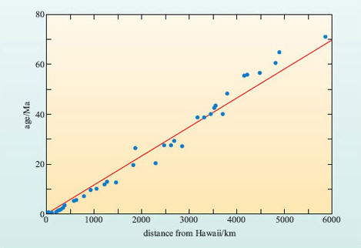
Figure 24 Graph of age versus distance from Hawaii measured along the Hawaii-Emperor chain of islands and seamounts. A best-fit line has been drawn through the data.

Activity 7

Use Figure 24 to estimate the average rate at which volcanic activity has appeared to move along the Hawaiian-Emperor Seamount Chain. Express your answer in mm y⁻¹ to two significant figures. With reference to Figure 23, determine in which direction the active volcanism has moved, and from this, the direction the plate has moved. Note: the speed at which volcanic activity moves is the inverse of the gradient of the best-fit straight line.

View answer - Activity 7

By assuming mantle plumes and hot spots are stationary, the motions derived from age progressions such as those along the Hawaii-Emperor Seamount Chain represent true plate motions. However, if the mantle plumes underlying hot spots have also moved with respect to the Earth's axis, but at a rate different from that of plate movement, then the motions defined by a hot-spot trace (see Figure 23) may be misleading.

Question 20

How do you think plate motions could be verified?

View answer - Question 20

For the Pacific Plate, the Hawaiian hot spot may be the largest hot spot, but it is not the only example of a hot-spot trace on the ocean floor. Two other examples related to the mantle plumes currently beneath the Cobb and the Macdonald Seamounts are shown in Figure 23. You should be able to appreciate from this figure that both of these chains of seamounts and islands are broadly parallel with the Hawaiian-Emperor Seamount Chain, and the Austral-Marshall Islands Seamount Chain shows a similar bend. Detailed geochronology of these chains reveals that the age progression along them is also consistent with the rates of northwesterly plate motion derived from the Hawaiian-Emperor Seamount Chain. Since the chances of three (and more) hot-spot traces moving independently of the plates and one another giving such similar results is remote, these results strongly indicate that hot spots do provide a reference frame within which true plate motions can be measured.
This methodology has been extended to studies of numerous hot-spot trails on other plates. Combined with a knowledge of relative plate motions between adjacent plates, such measurements have allowed the development of a framework of true plate motions across the globe, which are summarised in Figure 25.

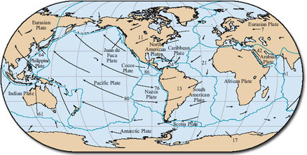
Figure 25 Map showing present-day motion of lithospheric plates (indicated by arrows) relative to hot spots (i.e. true plate motion). The lengths of the arrows indicate the amount of movement that would occur over a period of 50 Ma and the figures represent the current mean true plate speed.

4.3 Plate motion on a spherical Earth
Earth's tectonic plates are continuously in motion with respect to each other, and together they form the closed surface of a sphere (i.e. the Earth's surface). Understanding the movement of plates, therefore, requires a geometrical analysis of motions over a spherical surface. This is described in the Euler (pronounced 'oiler') geometrical theorem, which shows that every displacement of a plate from one position to another on the Earth's surface can be regarded as a simple rotation of that plate about a suitably chosen axis, known as an Euler pole or pole of rotation, which passes through the centre of the Earth.
Plate movement on a spherical Earth is illustrated in Figure 26. Two plates, A and B, are separating at a constructive plate boundary and rotating about a pole of rotation (which in this case is the North Pole). The constructive plate boundaries lie along lines of longitude, whereas the transform faults are parallel to lines of latitude. Lines of longitude are great circles with centres that coincide with the centre of the Earth; lines of latitude, which are at right angles to lines of longitude, are small circles with centres displaced from the Earth's centre. When the plates separate, the gap between them increases but, quite obviously, they separate a smaller amount close to the North Pole than at the Equator.

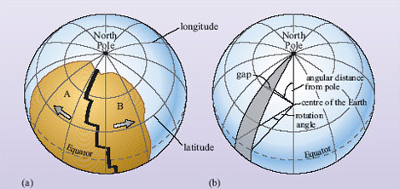
Figure 26 (a) The geometry of a constructive boundary in which two plates are separating. (b) The geometrical relationships that may be used to describe plate movement. Note that whilst the rotation angle remains the same along the length of the split, the width of the gap increases with angular distance from the pole of rotation (in this case the North Pole).

Question 21

What effect does this have on local full and half spreading rates along the length of the constructive plate boundary?

View answer - Question 21

This aspect of spherical geometry explains why relative plate motions expressed simply in terms of mm y⁻¹ vary along the length of a plate margin. Needless to say, poles of rotation are not all located at the geographical poles but can fall anywhere on the Earth's surface. For example, the Mid-Atlantic Ridge has variable spreading rates along its length, with values of 37-40 mm y⁻¹ in the South Atlantic, to lower values of 23-26 mm y⁻¹ in the North Atlantic (Figure 8).

Question 22

What do these variations in spreading rate tell you about the location of the pole of rotation of the South American Plate?

View answer - Question 22

The location of the pole of rotation can be determined more accurately from the orientation of the transform faults that cut the Mid-Atlantic Ridge. Transform faults lie along small circles and, by definition, lines at right angles to them will pass through the pole of rotation (Figure 27a). Using this method, the pole of rotation of the South Atlantic Plate can be shown to be located in the North Atlantic, south of Greenland (Figure 27b).

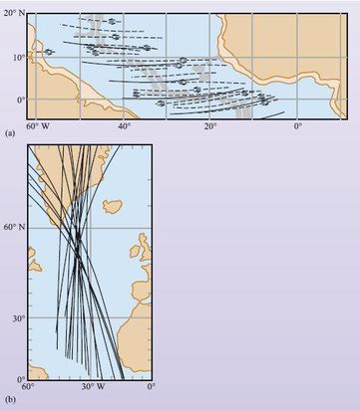
Figure 27 (a) Transform faults (dashed lines) in the equatorial region of the Atlantic Ocean compared with small circles (solid lines) concentric about a rotation pole at 58°N, 36°W. (b) Great circles drawn perpendicular to the transform faults that offset the Atlantic spreading ridge. The great circles converge on an area in the North Atlantic, defining the general position of the pole of rotation of the plate.

Finally, some plates have an internal pole of rotation that results in some complex consequences for relative plate motions. The first, and possibly most obvious, is that the real motion of the plate becomes one of rotation. The African Plate (Figure 25) is a good example. The southern part of the African Plate is moving to the east while the northern part is moving to the west - the plate is rotating anticlockwise about a pole located somewhere near the Canary Islands, off the northwest coast of Africa. The second consequence is that an internal pole can lead to a given plate boundary transforming from a constructive plate boundary through a conservative plate boundary to a destructive plate boundary along its length, although this is not apparent around the African Plate.

5 Plate driving forces

5.1 Why do plates move?
One of the key questions associated with plate tectonics is why plates move and what drives them. Plate tectonics is an expression of the thermal state of the Earth's interior and is the way that the Earth is currently losing a large proportion of its internal heat. Hot lithosphere generated at constructive plate boundaries loses its heat to the oceans, atmosphere and, ultimately, space by conductive cooling as it ages and spreads away from the ridge before being recycled into the mantle by subduction. It is perhaps, tempting to relate this cycling of material to a convective cycle, with hot material upwelling beneath ocean ridges and cold material sinking in subduction zones.

Question 23

Can you think of a reason why this might not be the case?

View answer - Question 23

The migration of plate boundaries across the surface of the Earth means that they are not firmly fixed into the underlying convective motions of the mantle - from our analysis of real plate motions mantle convection is more likely to be related to the location of hot spots and mantle plumes. So what, then, drives the plates? An answer to this question may lie in an analysis of the forces acting on plates, both on their undersides and at their boundaries.

5.2 Forces acting upon lithospheric plates
Figure 28 provides a very simplified overview of the forces that are thought to affect the movement of lithospheric plates. The relative contribution of these forces to plate motion needs to be established before their roles can be explored.

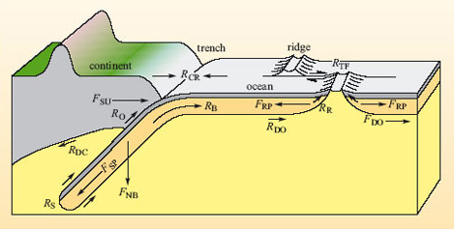
Figure 28 Forces acting upon a plate. F denotes a driving force, whereas R denotes a retarding force. See text for explanation. (Bott, 1982)

5.2.1 Forces acting on the underside of lithospheric plates
Lithospheric plates are decoupled from the rest of the mantle because the underlying asthenosphere is weak. However, plates may be driven, at least in part, by forces imparted by the convecting mantle. For instance, if a lithospheric plate is being carried along by a faster moving asthenosphere, then the force acting along the bottom surface of the oceanic plate can be considered as an ocean driving force, F_{DO} in Figure 28, which helps the plate to move. By contrast, if the asthenosphere is moving slower than the plate in the direction of plate movement or even in the opposite direction, then the force acting along the bottom surface of the oceanic plate can be considered as an ocean drag force, R_{DO}, retarding the movement of the plate.
Continental lithosphere is thicker than oceanic lithosphere, so continents almost always have a 'keel' of lithospheric material projecting downward. As a result, the resistance to movement might be greater beneath continental plates than oceanic plates. Accordingly, continental plates might be associated with an additional continental drag force, R_{DC} in Figure 28, and so the resistive force acting on the base of a continental plate would be the sum of both oceanic and continental drag forces, R_{DO} + R_{DC} in Figure 28.

5.2.2 Lithospheric plates: forces acting at plate margins
Other forces that act on plates must be generated at their boundaries. These forces push from the ridge, drag the plates down at the trenches, or act along the sides of plates at conservative boundaries (Figure 28).
At constructive boundaries, the upwelling of hot material at ocean ridges generates a buoyant effect that produces the ocean ridge, which stand some 2-3 km above the surrounding ocean floor. Here, oceanic plates experience a force that acts away from the ridge, the so called ridge-push force (F_{RP} in Figure 28), which is a result of gravity acting down the slope of the ridge. The occurrence of shallow earthquakes, resulting from the repeated tearing apart of newly formed oceanic crust, indicates there is also some frictional resistance to this force at ridges. This can be called ridge resistance, shown as R_{R} in Figure 28. Bounding the ridge segments, the oceanic transform faults, where the plate segments slide past each other, encounter resistance to movement, and produce a series of earthquakes: this retarding force is the transform fault resistance, R_{TF} in Figure 28.
The situation at destructive plate boundaries is more complex. A major component is the downward gravitational force acting on the cold and dense descending slab as it sinks into the mantle. This gravity-generated force pulls the whole oceanic plate down as a result of the negative buoyancy of the slab: this is the negative buoyancy force, shown as F_{NB} in Figure 28. The component of this downward-acting force that is transmitted to the plate is the slab-pull force, shown as F_{SP} in Figure 28. The magnitude of the slab pull is related to the angle at which the plate descends, and is greater for steeply dipping plates. However, the sinking slab encounters resistance as it descends, both from the frictional drag on its upper and lower surfaces and from the viscosity of mantle material that is being displaced: this combined resistive force is termed slab resistance, R_{S} (Figure 28). A further complication is that the downwards moving plate must flex at the trench before it begins to slide beneath the opposing plate. This provides a further resistance to the plate motion; this is labelled bending resistance, R_{B} (Figure 28). Due to the pushing of the subducting slab against the overriding plate, there is in addition, frictional resistance that gives rise to shallow and deep earthquakes at subduction zones. These frictional forces can be labelled collectively as overriding plate resistance, shown as R_{O} in Figure 28.
For the overriding plate, another theoretical force analogous to the ocean driving force has been proposed, which is derived from convection induced in the mantle above the subducted plate. Cooling of the mantle wedge against the upper surface of the subducting plate induces convection that sucks more mantle into the wedge. This is the trench suction force, F_{SU}, which serves to pull the plate towards the trench. The collision of plates and the associated deformation processes generate a collisional resistance force, shown as R_{CR} in Figure 28. This acts in the opposite direction within each converging plate, but it is equal in magnitude in both.
The velocities of present-day plate motions appear to be constant, indicating a state of dynamic equilibrium where a balance exists between the driving and resistive forces. However, each plate moves at its own rate - which suggests that the relative importance of the driving and retarding forces must vary from plate to plate. It seems unlikely that any single force is the sole driving mechanism of plate motions. For example, if the ridge-push force is the only driving force, why does the Philippine Plate, with no ridge on its boundary, move at a similar rate (70 mm y⁻¹) to the Indian Plate, which is bounded by both the Carlsberg and South Indian Ocean spreading ridges? Plate motions must, therefore, be controlled by a combination of forces.

Activity 8

For each of the forces listed in Table 3, decide whether they are likely to act as a driving force or a resistive force, and note the correct answer. Some forces can act as either a driving force or resistive force.

Table 3 For use with Question 8.
Force | Acts as a driving force | Acts as a resistive force | Might act as either a driving force or a resistive force
oceanic drag
continental drag
ridge-push
transform fault
slab-pull
slab resistance
trench suction

View answer - Activity 8

To investigate which are the most important forces that act on plates, the reasoning process applied in the previous paragraph can be adopted and the plate speed compared quantitatively with factors that relate to the different driving forces. For example, if the dominant driving force is ridge-push (F_{rp}), then the fastest moving plates should be the oceanic plates with the highest ratio of ridge length to surface area. The forces acting at plate boundaries should have magnitudes that are proportional to the length of ocean ridge (in the case of ridge-push), the length of ocean trench (for slab-pull (F_{SP}), trench suction (F_{SU}) and inter-plate resistances) and the length of transform fault (for transform fault resistance (R_{TF})). Oceanic and continental drag act over the lower surface of the plate, and so they should be proportional to the area of the plate. The rates of true plate motion in relation to the relative lengths of ocean ridge, ocean trench, transform fault, and plate area must, therefore, be examined to estimate the effects of each of the plate driving forces. The motions of the twelve plates listed in Table 5 are shown graphically in Figure 29a-e. Some of the important physical properties of each plate are listed in the table, together with the average true velocity of each plate calculated relative to a hot-spot reference frame. To explore whether or not each of these physical attributes of plate configuration are significant in producing plate motion, the degree and character of data correlation need to be examined.

Table 5 Dimensions and true velocities of lithospheric plates.
Plate | Total plate area × 10⁶/km² | Total continental area × 10⁶/﻿km² | Average true velocity /mm y⁻¹ | Circumference × 10²/km | Length (effective length)* × 10²/km
 |  |  |  |  | Ocean ridge | Ocean trench | Transform fault
(a) Eurasian | 69 | 51 | 7 | 421 | 90 (35) | 0 | 56
(b) N.American | 60 | 36 | 11 | 388 | 146 (86) | 12(10) | 122
(c) S.American | 41 | 20 | 13 | 305 | 87 (71) | 5(3) | 107
(d) Antarctic | 59 | 15 | 17 | 356 | 208 (17) | 0 | 131
(e) African | 79 | 31 | 21 | 418 | 230 (58) | 10(9) | 119
(f) Caribbean | 4 | 0 | 24 | 88 | 0 | 0 | 44
(g) Arabian | 5 | 4 | 42 | 98 | 30 (27) | 0 | 36
(h) Indian | 60 | 15 | 61 | 420 | 124 (108) | 91 (83) | 125
(i) Philippine | 5 | 0 | 64 | 103 | 0 | 41 (30) | 32
(j) Nazca | 15 | 0 | 76 | 187 | 76 (54) | 53 (52) | 48
(k) Pacific | 108 | 0 | 80 | 499 | 152(119) | 124(113) | 180
(l) Cocos | 3 | 0 | 86 | 88 | 40 (29) | 25 (25) | 16

*Effective lengths (in brackets) are the lengths of plate boundary that are capable of exerting a net driving or resistive force.
Plot 1 in Figure 29 shows the total plate area against average true plate velocity. The graph reveals that whilst it is true that the plate with the largest area (k, the Pacific Plate) has one of the highest velocities, it does not always follow that large plates have high velocities - the plate with the second largest area (e, the African Plate) has a relatively low velocity. Moreover, the plate with the highest velocity (l, the Cocos Plate) is one of the smallest. Whilst it would be possible to draw a best-fit line through some of the data points (for instance, a, b, d, e and k) that showed reasonable positive correlation (i.e. that larger plates have faster velocities and smaller plates have slower velocities), there is little obvious pattern if the data are taken as a whole. Accordingly, it is reasonable to conclude that there is no real correlation between these two variables of plate area and true plate velocity. This logic can be extended to examine the role of oceanic drag: if this were a significant motive force then these same data would show a positive correlation; if it were a significant plate-retarding force then the data would show a negative correlation. Since neither is true, the role of oceanic drag appears to have an insignificant effect on plate motion.
Plot 2 shows the continental area of each plate compared with the average true velocity of that plate. If the continental 'keel' were acting to retard plate motion, those plates with the largest proportion of continental lithosphere might be expected to display the slowest velocities. Interestingly, the plate with the largest continental area (a, the Eurasian Plate) does have the lowest velocity, while the plate with the lowest continental area (l, the Cocos Plate) has the highest velocity; this is the negative correlation predicted above. Clearly, the data points in Plot 2 do not fall on a line, but the general trend is for low speed to be associated with a large continental area. Accordingly, these data appear to indicate that continental drag is an effective resistance to plate movement.
Figure 29 (interactive)

Interactive content is not available in this format.

Activity 9

Interactive content is not available in this format.

Figure 29 shows that the most striking positive data correlation is between true plate velocity and the length of ocean trench boundary, which includes a subducted slab (Plot 4). In fact, the plates form two distinct data groups:
- the Indian, Philippine, Nazca, Pacific, and Cocos Plates (h-k), which are all connected to descending slabs and are all moving at an absolute rate of 60-90 mm y⁻¹ relative to the asthenosphere
- the remaining plates (i.e. Eurasian, North American, South American, Antarctic, Caribbean and Indian Plates (a-g)) are moving much more slowly at 0-40 mm y⁻¹ and do not have significant connections with descending slabs.
It is reasonable, therefore, to conclude that slab-pull is the dominant plate-driving force. By contrast, there is a poorer correlation between ridge length and plate velocity (Figure 29c), from which it can be concluded that the so-called 'ridge-push' may also contribute to plate speed.
The best correlations from the data shown in Figure 29, and summarised in the answer to Question 9, suggest that true plate velocity depends largely on the slab-pull force associated with the descent of oceanic lithosphere, and to a lesser extent on the ridge-push force; continental plate drag is a major retarding force.
Finally, it should be noted that slab-pull and ridge-push forces are largely a consequence of density differences and gravity-slab pull relates to the gravitational sinking of a cold slab of lithospheric material into the mantle whereas ridge-push relates to the gravitational potential energy of the ocean ridge standing 2-3 km above the surrounding ocean floor. So the answer to the question, 'What drives plate tectonics?' is not directly related to mantle convection, but to gravity acting on density differences in the lithosphere that have resulted from its own thermal history.

5.6 Implications of plate tectonics

5.6.1 The Wilson cycle
High-quality, palaeomagnetic data are now sufficiently abundant that it is possible to reconstruct the movement of the continents throughout the past 500-600 million years (i.e. the Phanerozoic) and, with increasing uncertainty, back to 750 Ma and possibly earlier. From these reconstructions it became apparent that the continental masses have been assembled previously into supercontinents that have broken apart, dispersed, and then later reassembled in a different configuration to form another supercontinent. This observation was noted by Wilson (Box 1) who proposed that an ocean basin has a lifespan with several stages: it begins with the initial opening, and then goes through a widening phase before starting to close and on to its ultimate destruction. This theory accounts for the cycle of continental break up and reassembly, and became known as the Wilson cycle in his honour. From the palaeomagnetic reconstructions, it appears that the cycle of supercontinent assembly - break-up and subsequent reassembly - takes about 500 million years to complete. This time period can be further explained by a simple calculation.

Activity 10

Imagine that a roughly circular supercontinent, 5000 km in radius, and located about the Equator, rifts in two along a north-south line. A new spreading centre between the rifted halves spreads at an average rate of about 3 cm y⁻¹. How long would it take for the two halves to first meet again on the opposite side of the globe? (Assume that the circumference of the Earth is 40 000 km.)

View answer - Activity 10

Clearly, this is an average estimate because spreading rates vary, and continental configurations are far more complex than the simple two-continent rifting model outlined in Question 10. But if it is correct, then, given that Pangaea formed about 300 Ma ago, the next supercontinent is due to begin to assemble in about 200 million years, perhaps once the Pacific Ocean has been closed by the subduction zones that surround it.
Various stages have been identified for the Wilson cycle, and all of these stages can be recognised in different parts of the Earth today.
- The earliest stage, called the embryonic stage, involves uplift and crustal extension of continental areas with the formation of rift valleys (e.g. the East African Rift System).
- The young stage involves the evolution of rift valleys into spreading centres with thin strips of ocean crust between the rifted continental segments. The result is a narrow, parallel-sided sea, for example the Red Sea that is opening between NE Africa and Arabia.
- The mature stage is exemplified by widening of the growing basin and its continued development into a major ocean flanked by continental shelves and with the continual production of new, hot, oceanic crust along the ridge system (e.g. Atlantic Ocean).
- Eventually, this expanding system becomes unstable and, away from the ridge, the oldest oceanic lithosphere sinks back into the asthenosphere, forming an oceanic trench subduction system with a Wadati-Benioff zone demarking the descending plate and associated island arcs, such as the situation in the western Pacific Ocean, or Andean-type volcanism. The onset of subduction at the ocean boundary marks the subduction stage of the cycle (e.g. the Pacific Ocean).
- Once subduction outpaces the formation of new crust at the constructive boundary, the ocean begins to contract. Island arc complexes, complete with their inventory of sedimentary and volcanic rocks, collide and create young mountain ranges around the periphery of the contracting ocean. These features mark the terminal stage of the cycle (e.g. the Mediterranean).
- The end stage occurs once all the oceanic crust between the continental masses has subducted, and the continents converge along a collision zone characterised by an active fold mountain belt, such as the Himalayas. Finally the plate boundary becomes inactive, but the site of the join, or suture, between the two continental masses is a zone of weakness in the lithosphere that has the potential to become the site of a new rift and so the cycle continues.

5.6.2 Plate tectonics and climate change
This course began by considering the evidence in the Earth's past for the existence of supercontinents and how evidence of past climates recorded in continental rocks can be used to reassemble ancient continental configurations. The evidence was interpreted in such a way that the continents were considered as passive recorders of the surface conditions that they have experienced on their inexorable passage across the Earth's surface. While such an assumption is broadly correct, it does not take more than a momentary glance at a map of the world today to realise that the disposition of the continents has a marked effect on both local and global climate. Not the least of these effects results from the difference in the thermal properties of land versus ocean - a continental region will be colder in winter and warmer in summer than an oceanic region at any given latitude. Moreover mountain belts formed as a consequence of plate tectonic activity dramatically modify rainfall through the effects of orography - the development of a rain shadow on the leeward side of mountain belts.
Global climate is also strongly controlled by ocean currents. For example, northwestern Europe is significantly warmer than other regions at similar latitudes because of the warming effects of the Gulf Stream and North Atlantic Drift. The reversal of oceanic currents in the equatorial Pacific - a phenomenon known as El Niño - has a far-reaching effect on climate around the Pacific. Ocean currents depend on the geometry of the oceans and this is controlled by plate tectonics. Hence, over geological timescales the movement of plates and continents has a profound effect on the distribution of land masses, mountain ranges and the connectivity of the oceans. As a consequence, plate tectonics has a very direct and fundamental influence on global climate.
To illustrate this effect, the next page briefly describes the opening of a seaway between the southern tip of South America and Antarctica, and how that affected global climate.

The climate of modern Antarctica is extreme. Located over the South Pole and in total darkness for six months of the year, the continent is covered by glacial ice to depths in excess of 3 km in places. Yet this has not always been the case. 50 Ma ago, even though Antarctica was in more or less the same position over the pole, the climate was much more temperate - there were no glaciers and the continent was covered with lush vegetation and forests. So how did this extreme change come about?
The modern climate of Antarctica depends upon its complete isolation from the rest of the planet as a consequence of the Antarctic Circumpolar Current that completely encircles Antarctica and gives rise to the stormy region of the Southern Ocean known as the roaring forties. The onset of this current is related to the opening of seaways between obstructing continents. Antarctica and South America were once joined together as part of Gondwana and were the last parts of this original supercontinent to separate. By reconstructing continental positions from magnetic and other features of the sea floor in this region, geologists have shown that the Drake Passage opened in three phases between 50 Ma and 20 Ma, as illustrated in Figure 32. At 50 Ma there was possibly a shallow seaway between Antarctica and South America, but both continents were moving together. At 34 Ma the seaway was still narrow, but differential movement between the Antarctic and South American Plates created a deeper channel between the two continents that began to allow deep ocean water to circulate around the continent. Finally, at 20 Ma there was a major shift in local plate boundaries that allowed the rapid development of a deep-water channel between the two continental masses.

Interactive content is not available in this format.

Question 24

What other major change in global plate motions occurred between 43 Ma and 50 Ma?

View answer - Question 24

The coincidence of the change in motion of the Pacific Plate with changes in plate motions between S. America and Antarctica shows how the motions of all the plates are interconnected - a change in the true motion of one plate leads to changes in the true motions of many others.
While these plate motions were taking place the effect on Antarctica was profound. By 34 Ma the climate cooled from the temperate conditions that previously existed. This was sufficient for glaciers to begin their advance, and was followed by a period of continued cooling until at about 20 Ma, glaciation was complete. Even though the Drake Passage first opened at 50 Ma it was not until it opened to deep water at 34 Ma that glaciation really took hold
Today, the Antarctic Circumpolar Current is the strongest deep ocean current and its strength is responsible for the 'icehouse' climate that grips the planet. The opening of the Drake Passage had both a local and a global effect, initially cooling the climate of Antarctica from temperate to cold and ultimately playing an important role in the change from global 'greenhouse' conditions 50 Ma ago to the global 'icehouse' of today.

This example shows how plate tectonics, continental drift and the opening and closing of seaways can have a profound influence on both local and global climate. Throughout the Phanerozoic there were long periods when the Earth was much warmer than today - often called a 'greenhouse' climate - and other times when it was cold - called an 'icehouse' climate. These cycles, like the Wilson cycle, occur over periods of 100 Ma, reflecting the timescale of plate movements and the growth and destruction of oceans. Given the clear link between ocean circulation and climate, and the similar timescales of global climate change and plate motions, it is inescapable that one of the chief controls on long-term changes in the global climate must be plate tectonics.

Conclusion
Plate tectonics is the grand, unifying theory of Earth sciences, combining the concepts of continental drift and sea-floor spreading into one holistic theory that explains many of the major structural features of the Earth's surface. It explains why the oceanic lithosphere is never older than about 180 Ma and why only the continents have preserved the Earth's geological record for the past 4000 Ma. It provides the framework to explain the distribution of earthquakes and volcanoes and a mechanism for the slow drift of the continents across the Earth's surface. The theory has now reached such a level of scientific acceptance that the movement of plates, both relative to one another and to the hot-spot reference frame, are being used to infer movement of the hot-spot reference frame with respect to the Earth's rotational axis.
Plate tectonics is an expression of the convective regime in the underlying mantle, but the link between individual convection cells and plate boundaries is not direct because plate boundaries are not fixed and, like the plates, move relative to one another. Plate movements are driven by gravity, largely by cold, dense lithospheric slabs pulling younger lithosphere towards a destructive boundary. A less-powerful driving force is generated by the potential energy of spreading centres, elevated some 2-3 km above the general level of the abyssal plains.
As ideas concerning plate tectonics have evolved since the 1970s, it has become apparent that while the theory can be applied rigorously to the oceans, the same cannot be said of the continents. Because of the strength and rigidity of oceanic plates, deformation is focused into narrow linear zones along plate margins. By contrast, when continental lithosphere approaches a plate boundary, deformation can extend hundreds of kilometres into the continental interior because continental plates are less strong. Such deformation gives rise to the major mountain belts of the Earth, as exemplified by the Alpine Himalayan Chain.

5.8 Further reading
Fowler, C.M.R. (2005) 'The Solid Earth' Cambridge University Press, pp. 685
Mussett, A.E. and Khan, M.A. (2000) Looking into the Earth, Cambridge, Cambridge University Press.

Keep on learning



Study another free course
There are more than 800 courses on OpenLearn for you to choose from on a range of subjects.
Find out more about all our free courses.

Take your studies further
Find out more about studying with The Open University by visiting our online prospectus.
If you are new to university study, you may be interested in our Access Courses or Certificates.

What's new from OpenLearn?
Sign up to our newsletter or view a sample.

For reference, full URLs to pages listed above:
OpenLearn - www.open.edu/openlearn/free-courses
Visiting our online prospectus - www.open.ac.uk/courses
Access Courses - www.open.ac.uk/courses/do-it/access
Certificates - www.open.ac.uk/courses/certificates-he
Newsletter - www.open.edu/openlearn/about-openlearn/subscribe-the-openlearn-newsletter

Acknowledgements
Course image: David Brown in Flickr made available under Creative Commons Attribution-NonCommercial-ShareAlike 2.0 Licence.
Except for third party materials and otherwise stated (see terms and conditions), this content is made available under a Creative Commons Attribution-NonCommercial-ShareAlike 4.0 Licence
Grateful acknowledgement is made to the following sources for permission to reproduce material in this course:
Figure 1a Christian Darkin/Science Photo Library;
Figure 1b M-Sat Ltd/Science Photo Library;
Figure 3 adapted from Hallam, A. (1975) Alfred Wegener and the hypothesis of continental drift, Scientific American Inc;
Figure 4 adapted from Creer, K.M. (1965) 'Palaeomagnetic data from gondwanic continents' in Blacket, P.M.S. et al. (eds|) A Symposium on Continental Drift, The Royal Society;
Figures 5a, b and c Mussett, A.E. and Khan, M.A. (2000) Looking into the Earth: an introduction to geological geophysics, Cambridge, Cambridge University Press;
Figure 6 Hiertzler, J.R. et al (1966) 'Magnetic anomalies over the Reykjanes Ridge', Deep Sea Research, vol. 13, Elsevier Science Limited;
Figures 8 and 28 Adapted from Bott, M.H.P. (1982) The Interior of the Earth, Its Structure, Constitution and Evolution, Edward Arnold;
Figure 9a Adapted from the British Geological Survey World Seismicity Database, Global Seismology and Geomagnetism Group, Edinburgh;
Figure 9b Adapted from Johnson, R.W. (1993) AGSO Issues Paper No. 1, Volcanic Eruptions and Atmospheric Change, Australian Geological Survey Organisation;
Figure 11 Parsons, B. and Sclater, G. (1977) 'An analysis of the variation of ocean floor bathymetry and heat flow with age', Journal of Geophysical Union;
Figures 13 and 14 Fowler, C.M.R. (2005) The solid Earth, Cambridge, Cambridge University Press;
Figure 16 Sykes, R. (1966) 'The seismicity and deep structure of island arcs', Journal of Geophysical Research, vol.71, no 12 © American Geophysical Union;
Figure 17 adapted from Watts, A.B. (2001) Isostasy and flexure of the lithosphere, Cambridge, Cambridge University Press;
Figure 18 Westbrook, G.K. (1982) 'The Barbados ridge complex, Special Publication of The Geological Society of London, Blackwell, © The Geological Society;
Figure 21 Dalrymple, G.B. et al. (1973) 'The origin of the Hawaiian islands', American Scientist, Vol 61, Scientific Research Society (Sigman X1);
Figure 22 adapted from Clague, D. and Dalrymple, G.B. (1987) USGS Professional Paper 1350, United States Geological Survey;
Figure 30 Adapted from Livermore, R. et al. (2005) 'Paleogene opening of the Drake Passage', Earth and Planetary Science Letters, vol. 236, pp459-470.
Don't miss out:
If reading this text has inspired you to learn more, you may be interested in joining the millions of people who discover our free learning resources and qualifications by visiting The Open University - www.open.edu/openlearn/free-courses

Question 1

Answer
Most of the overlaps are caused by features that have formed since the continents broke up or rifted apart, such as coral banks (Florida), recent river deltas (Niger) and volcanoes (Iceland).
Back to Session 2 SAQ 1

Activity 1

Answer
The coalfields formed from plants that grew in the tropical and sub-tropical climate belts. They must have drifted to their present positions from these latitudes either south or north of the Equator (i.e. 23°S-23°N).
This represents a latitude drift of between 23°S to 55°N (i.e. 78°) and 23°N to 55°N (i.e. 32°).
If the Earth's radius is 6370 km, its circumference must be 2 × 6370 km=40 024 km.
1° of latitue (assuming the Earth is a sphere) is therefore = 1 11 km
Therefore the minimum distance that Britain can have drifted since the late Carboniferous is 32 × 111=3552 km (i.e. about 3500 km at the level of accuracy of this information), which gives a rate of:
≈ 12 mm y⁻¹ or 10 mm y⁻¹ to 1 sig. fig.
The maximum distance is at least 8672 km (i.e. about 8700 km), which gives a rate of:
≈ 29 mm y⁻¹ or 30 mm y⁻¹ to 1 sig. fig.
Both these values could be larger if Britain drifted in terms of longitude as well - in other words, if its course was not in a straight line.
Back to Session 2 Activity 1

Question 2

Answer
The two continents were moving together as one mass from the Ordovician right through to the opening of the Atlantic Ocean during the Jurassic Period.
Back to Session 2 SAQ 2

Activity 2

Answer
The APW parts of Europe and Siberia are the same as far back as the Triassic, but before this time the Siberian pole was to the west of the European pole. This indicates that the two regions were part of different land masses until the Triassic; at this time they must have collided, and afterwards they continued to move as a single unit.
Back to Session 2 Activity 2

Question 3

Answer
The maximum and minimum spreading rates for (i) the Atlantic Ocean are 40 mm y⁻¹ and 23 mm y⁻¹ (as shown by the double-ended arrows along the central Atlantic ridge); these represent half spreading rates of 20 mm y⁻¹ and 11.5 mm y⁻¹ respectively. The maximum and minimum spreading rates for the Pacific are 185 mm y⁻¹ and 66 mm y⁻¹ (as shown by the double-ended arrows along the ridge). These represent half spreading rates of 92.5 mm y⁻¹and 33 mm y⁻¹ respectively.
Back to Session 2 SAQ 3

Activity 3

Answer
For the South Atlantic Ocean:

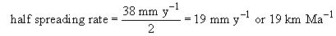

The age of ocean crust (t) adjacent to the South American continental shelf is derived from:

The age of ocean crust adjacent to the southern African continental shelf

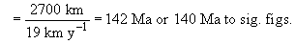

Back to Session 2 Activity 3

Question 4

Answer
It contracts, so its volume decreases, resulting in an increase in density.
Back to Session 3 SAQ 1

Activity 4

Answer
(a) (i) Rearranging Equation 1:

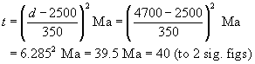

The age of the crust at this location is 40 Ma.
(a) (ii) The mean spreading rate is given by distance divided by time: 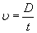

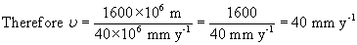

(b) This is a half spreading rate because it refers to one side of the constructive margin only.
Back to Session 3 Activity 1

Activity 5

Answer
- (a) Ocean depth increases with the square root of lithosphere age so the correlation is positive.
- (b) The departure from linearity occurs between 8 and 9 on the horizontal scale, which is equivalent to an age of 64-81 Ma.
- (c) For crust older than 64 Ma, ocean depth is less than predicted, i.e. the ocean floor is shallower, implying that it is warmer than predicted by the boundary-layer model.
Back to Session 3 Activity 2

Question 5

Answer
The thermal models are based on the assumption that heat is lost by conduction only, whereas in reality other mechanisms of heat transfer might be in operation.
Back to Session 3 SAQ 2

Question 6

Answer
Earthquakes can only occur in brittle rocks that fail by fracture rather than solid-state creep. As a result of high geothermal gradients beneath oceanic ridges, the brittle lithosphere is thin and so earthquakes are restricted to shallow depths.
Back to Session 3 SAQ 3

Question 7

Answer
Hot, possibly partially molten mantle that feeds the basaltic volcanism of the ridge axis.
Back to Session 3 SAQ 4

Question 8

Answer
Earthquakes at about 400 km depth are located ∼400 km west of the Tonga Trench. Hence the tangent of the angle of subduction is 400/400=1, so the angle of subduction is ∼45°(tan 45°=1).
Back to Session 3 SAQ 5

Question 9

Answer
No. To the north at ∼16°S the horizontal distance between trench and the deepest earthquakes is much greater than at 20°S, so the angle of subduction is shallower.
Back to Session 3 SAQ 6

Question 10

Answer
Subducted lithosphere must remain cool to fail seismically.
Back to Session 3 SAQ 7

Question 11

Answer
As the plate ages it accumulates a veneer of sediments on it surface. Also hydrothermal processes close to the ridge add water to the upper layers of the basaltic crust. So the subducting plate will include sediments and altered basalt crust.
Back to Session 3 SAQ 8

Question 12

Answer
It decreases slightly.
Back to Session 3 SAQ 9

Question 13

Answer
Sediments.
Back to Session 3 SAQ 10

Question 14

Answer
An extensional tectonic regime. New ocean crust is only produced when lithospheric plates move apart.
Back to Session 3 SAQ 11

Question 15

Answer
It suggests that the continents are less strong and less rigid than oceanic lithosphere.
Back to Session 3 SAQ 12

Question 16

Answer
Between W and X, the fault separates different parts of plate B and so there is no differential movement. Between X and Y it separates plate A from plate B, which are moving in opposite directions. Between Y and Z it separates different parts of plate A and there is, again, no differential movement.
Back to Session 3 SAQ 13

Question 17

Answer
Only that segment between X and Y where two different plates are adjacent to one another.
Back to Session 3 SAQ 14

Question 18

Answer
The use of dated magnetic anomalies, and the known relationship between ocean depth and age.
Back to Session 4 SAQ 1

Question 19

Answer
If the hot spot is stationary then this must represent a change in direction of the Pacific Plate.
Back to Session 4 SAQ 2

Activity 7

Answer
You should recall that:

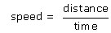

but the graph is plotted as time against distance, so the gradient of the graph as it is plotted is 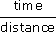. To calculate the gradient, and hence the speed, choose distance two points on the best-fit straight line that are some distance apart and find their coordinates. For example, at a distance of 5500 km the age is 63 Ma, and at a distance of 1000 km the age is 11 Ma. The gradient of the line is:

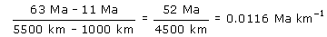

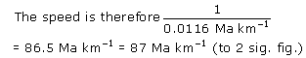

This is equivalent to 87 mm y⁻¹. The current overall direction of migration of volcanism is towards the southeast, therefore the plate is moving to the northwest. However, prior to about 43-15 Ma volcanism migrated more or less due south, therefore the Pacific Plate prior to 43-15 Ma was moving to the north.
Back to Session 4 Activity 2

Question 20

Answer
By measuring true plate motion from another hot-spot trace.
Back to Session 4 SAQ 3

Question 21

Answer
Spreading rates measured close to the pole of rotation will be small while those further away will be much greater.
Back to Session 4 SAQ 4

Question 22

Answer
Spreading rates are lower in the North Atlantic and so the pole of rotation must be located somewhere in the northernmost Atlantic Ocean.
Back to Session 4 SAQ 5

Question 23

Answer
Plate boundaries migrate over time and it is unlikely that convection cells within the mantle would migrate with them.
Back to Session 5 SAQ 1

Activity 8

Answer

Table 4 Completed Table 3.
Force | Acts as a driving force | Acts as a resistive force | Might act as either a driving force or a resistive force
oceanic drag
continental drag
ridge-push
transform fault
slab-pull
slab resistance
trench suction

Back to Session 5 Activity 1

Activity 10

Answer
The spreading rate is equivalent to an ocean width increase of 30 km Ma⁻¹. For the continents to meet on the opposite side of the globe, the ocean will need to have opened to half the circumference of the Earth less the original width of the continent (i.e. 20 000 km - 5000 km = 15 000 km). The time taken to achieve this will be:
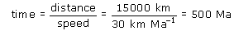
Back to Session 5 Activity 3

Question 24

Answer
The change of orientation of the Hawaiian hot-spot trace shows that at this time the Pacific Plate changed from a northward velocity direction to a northwestward direction.
Back to Session 5 SAQ 2

