M337_2

Introduction to complex analysis

About this free course
This free course is an adapted extract from the Open University course .
This version of the content may include video, images and interactive content that may not be optimised for your device.
You can experience this free course as it was originally designed on OpenLearn, the home of free learning from The Open University –
There you’ll also be able to track your progress via your activity record, which you can use to demonstrate your learning.
Copyright © 2022 The Open University
Intellectual property
Unless otherwise stated, this resource is released under the terms of the Creative Commons Licence v4.0 http://creativecommons.org/licenses/by-nc-sa/4.0/deed.en_GB. Within that The Open University interprets this licence in the following way: www.open.edu/openlearn/about-openlearn/frequently-asked-questions-on-openlearn. Copyright and rights falling outside the terms of the Creative Commons Licence are retained or controlled by The Open University. Please read the full text before using any of the content.
We believe the primary barrier to accessing high-quality educational experiences is cost, which is why we aim to publish as much free content as possible under an open licence. If it proves difficult to release content under our preferred Creative Commons licence (e.g. because we can’t afford or gain the clearances or find suitable alternatives), we will still release the materials for free under a personal end-user licence.
This is because the learning experience will always be the same high quality offering and that should always be seen as positive – even if at times the licensing is different to Creative Commons.
When using the content you must attribute us (The Open University) (the OU) and any identified author in accordance with the terms of the Creative Commons Licence.
The Acknowledgements section is used to list, amongst other things, third party (Proprietary), licensed content which is not subject to Creative Commons licensing. Proprietary content must be used (retained) intact and in context to the content at all times.
The Acknowledgements section is also used to bring to your attention any other Special Restrictions which may apply to the content. For example there may be times when the Creative Commons Non-Commercial Sharealike licence does not apply to any of the content even if owned by us (The Open University). In these instances, unless stated otherwise, the content may be used for personal and non-commercial use.
We have also identified as Proprietary other material included in the content which is not subject to Creative Commons Licence. These are OU logos, trading names and may extend to certain photographic and video images and sound recordings and any other material as may be brought to your attention.
Unauthorised use of any of the content may constitute a breach of the terms and conditions and/or intellectual property laws.
We reserve the right to alter, amend or bring to an end any terms and conditions provided here without notice.
All rights falling outside the terms of the Creative Commons licence are retained or controlled by The Open University.
Head of Intellectual Property, The Open University

Contents
- Session 1: Differentiation
  - Introduction to differentiation
  - 1 Derivatives of complex functions
    - 1.1 Defining differentiable functions
    - 1.2 Combining differentiable functions
    - 1.3 Non-differentiability
    - 1.4 Higher-order derivatives
    - 1.5 A geometric interpretation of derivatives
    - 1.6 Further exercises
  - 2 The Cauchy–Riemann equations
    - 2.1 The Cauchy–Riemann theorems
    - 2.2 Proof of the Cauchy–Riemann Converse Theorem
    - 2.3 Further exercises
    - 2.4 Laplace’s equation and electrostatics
  - 3 Summary of Session 1
- Session 2: Integration
  - Introduction to integration
  - 1 Integrating real functions
    - 1.1 Areas under curves
    - 1.2 Integration on the real line
    - 1.3 Properties of the Riemann integral
    - 1.4 Introducing complex integration
  - 2 Integrating complex functions
    - 2.1 Integration along a smooth path
    - 2.2 Integration along a contour
    - 2.3 Reverse paths and contours
    - 2.4 Further exercises
  - 3 Evaluating contour integrals
    - 3.1 The Fundamental Theorem of Calculus
    - 3.2 Further exercises
  - 4 Summary of Session 2
  - Course conclusion
- Acknowledgements
- Solutions

Session 1: Differentiation

Introduction to differentiation
The derivative of a real function at a point is the gradient of the tangent to the graph of at . This gradient is calculated by finding the gradient of the chord joining the point to a (nearby) point , and taking the limit as approaches (Figure 1).

Figure 1 A chord between two points on a graph
View description - Figure 1 A chord between two points on a graph

Now, the gradient of the chord is equal to the ratio

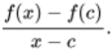
View alternative description - Uncaptioned Equation

This ratio is often called the difference quotient for at , and its limit as tends to provides a formal definition of the (real) derivative of at , denoted by . Thus

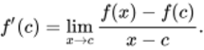
View alternative description - Uncaptioned Equation

In the case of complex functions, it is difficult to think about derivatives in terms of gradients of tangents, since the graph of a complex function is not drawn in two dimensions. Instead we define the derivative of a complex function directly in terms of difference quotients, using the notion of complex limits.
Fortunately, the derivatives of many complex functions turn out to have the same form as those of the corresponding real functions. For example, the derivative of the complex sine function is the complex cosine function, and the complex exponential function is its own derivative. On the other hand, the complex modulus function fails to be differentiable at any point of , even though the real modulus function (Figure 2) is differentiable at every point of . This reflects the fact that complex differentiation imposes a much stronger condition on functions than does real differentiation. Indeed, as the course progresses, you will see that differentiable complex functions have remarkably pleasant properties. For example, if a complex function can be differentiated once throughout a region, then it can be differentiated any number of times. There is no equivalent result for real functions.

Figure 2 Graph of
View description - Figure 2 Graph of y equals absolute value of x

Section 1 will define complex differentiation and show how the definition can be used to establish whether a function is differentiable. By introducing rules for combining differentiable functions, you will see how complex polynomial and rational functions can be differentiated just as in the real case. The end of Section 1 will give a geometric interpretation of complex differentiation by introducing the idea of a complex scale factor.
Section 2 will introduce the concept of partial differentiation for real functions of two real variables, and use it to establish a relationship between complex differentiation and real differentiation. This relationship sometimes enables us to differentiate a complex function using real derivatives. Indeed, at the end of the section, this approach will be used to show that the complex exponential function is its own derivative.

This OpenLearn course is an extract from the Open University course M337 Complex analysis.

1 Derivatives of complex functions
After working through this section, you should be able to:
- use the definition of derivative to show that a given function is differentiable, and to find its derivative
- use the Combination Rules for differentiation to differentiate polynomial and rational functions
- use various strategies to show that a given function is not differentiable at a point
- interpret the derivative of a complex function at a point as a rotation and a scaling of a small disc centred at the point.

1.1 Defining differentiable functions
As with limits and continuity, the way in which the derivative of a complex function is defined is similar to the real case. Thus a complex function is said to have a derivative at a point if the difference quotient, defined by

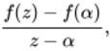
View alternative description - Uncaptioned Equation

tends to a limit as tends to . Equivalently, it is sometimes more convenient to replace by , and examine the corresponding limit as tends to 0. The difference quotient then has the form

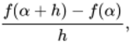
View alternative description - Uncaptioned Equation

where is a complex number. The equivalence of these two limits can be justified by noting that if , then ‘’ is equivalent to ‘’.

Definitions
Let be a complex function whose domain contains the point . Then the derivative of at is

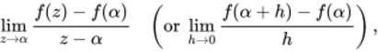
View alternative description - Uncaptioned Equation

provided that this limit exists. If it does exist, then is differentiable at . If is differentiable at every point of a set , then is differentiable on . A function is differentiable if it is differentiable on its domain.
The derivative of at is denoted by , and the function

View alternative description - Uncaptioned Equation

is called the derivative of . The domain of is the set of all complex numbers at which is differentiable.

The function is sometimes called the derived function of .

Remarks
- The existence of the limit

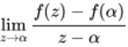
View alternative description - Uncaptioned Equation

implicitly requires the domain of to contain as one of its limit points. This always holds if the domain of is a region.
- The derivative is sometimes written as 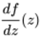 or 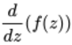.
- Some other texts use the phrase complex derivative in place of derivative to draw a distinction with the standard real derivative of a function (which we will not need).
In certain cases it is easy to find the derivative of a function directly from the definition above.

Example 1
Use the definition of derivative to find the derivative of the function .

Solution
The domain of is the whole of , so let be an arbitrary point of . Then

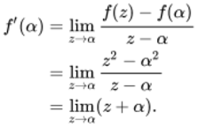
View alternative description - Uncaptioned Equation

Now is a basic continuous function, continuous at , so we see that .
Since is an arbitrary complex number, the derivative of is the function . Its domain is the whole of .

Notice the way in which the troublesome term cancels from the numerator and the denominator in the calculation of in the preceding example. This often happens when you calculate derivatives directly from the definition.

Exercise 1

Use the definition of derivative to find the derivative of
- the constant function
- the function .

View answer - Exercise 1

Example 1 and Exercise 1 show that the functions , and are differentiable on the whole of . Functions that have this property are given a special name.

Definition
A function is entire if it is differentiable on the whole of .

Not all functions are entire; indeed, many interesting aspects of complex analysis arise from functions that fail to be differentiable at various points of .

Exercise 2

Use the definition of derivative to find the derivative of the function . Explain why is not entire.

View answer - Exercise 2

Although the function is not entire, it is differentiable on the whole of its domain . This domain is a region because it is obtained by removing the point 0 from . (The removal of a point from a region leaves a region.) As the course progresses, you will discover that regions provide an excellent setting for analysing the properties of differentiable functions. We therefore make the following definitions.

Definitions
A function that is differentiable on a region is said to be analytic on . If the domain of a function is a region, and if is differentiable on its domain, then is said to be analytic. A function is analytic at a point if it is differentiable on a region containing .

It follows immediately from the definition that if a function is analytic on a region , then it is automatically analytic at each point of .
Notice that a function can have a derivative at a point without being analytic at the point. For example, in the next section we will ask you to show that the function has a derivative at 0, but at no other point. This means that there is no region on which is differentiable, and hence no point at which is analytic.
By contrast, is analytic at every point of its domain. It is an analytic function, and it is analytic on any region that does not contain 0. Three such regions are illustrated in Figure 3.

Figure 3 Three regions on which is analytic
View description - Figure 3 Three regions on which f of z equals one solidus z is analytic

An appropriate choice of region can often simplify the analysis of complex functions.

Exercise 3

Classify each of the following statements as True or False.
- An entire function is analytic at every point of .
- If a function is differentiable at each point of a set, then it is analytic on that set.

View answer - Exercise 3

There is a close connection between differentiation and continuity. The function , for example, is not only differentiable, but also continuous on its domain. This is no accident for, as in real analysis, differentiability implies continuity.

Theorem 1
Let be a complex function that is differentiable at . Then is continuous at .

ProofLet be differentiable at ; then
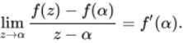
View alternative description - Uncaptioned Equation
To prove that is continuous at , we will show that as . We do this by proving the equivalent result that as . By the Product Rule for limits of functions, we have 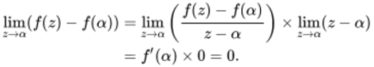
View alternative description - Uncaptioned Equation
Hence as , so is continuous at . âˆŽ

In fact, differentiability implies more than continuity. Continuity asserts that for all close to , is close to . For differentiable functions, this ‘closeness’ has the ‘linear’ form described in the following theorem.

Theorem 2 Linear Approximation Theorem
Let be a complex function that is differentiable at . Then can be approximated near by a linear polynomial. More precisely,

View alternative description - Uncaptioned Equation

where is an ‘error function’ satisfying as .

Informally speaking, the statement ‘ as ’ means that ‘ tends to zero faster than does’.

ProofWe have to show that the function defined by
View alternative description - Uncaptioned Equation
satisfies as . Dividing by and letting tend to , we obtain 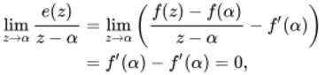
View alternative description - Uncaptioned Equation
as required. âˆŽ

Theorem 1 and Theorem 2 are often used to investigate the properties of differentiable functions. An illustration of this occurs in the next subsection, where Theorem 1 is used in a proof of the Combination Rules for differentiation. Later in this section we use Theorem 2 to give a geometric interpretation of complex differentiation.

1.2 Combining differentiable functions
It would be tedious if we had to use the definition of the derivative every time we needed to differentiate a function. Fortunately, once the derivatives of simple functions like and are known, we can find the derivatives of other more complicated functions by applying the following theorem.

Theorem 3 Combination Rules for Differentiation
Let and be complex functions with domains and , respectively, and let be a limit point of . If and are differentiable at , then
- Sum Rule is differentiable at , and

View alternative description - Uncaptioned Equation

- Multiple Rule is differentiable at , for , and

View alternative description - Uncaptioned Equation

- Product Rule is differentiable at , and

View alternative description - Uncaptioned Equation

- Quotient Rule is differentiable at (provided that , and

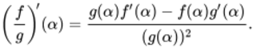
View alternative description - Uncaptioned Equation

We remark that if the domains and in Theorem 3 are regions, then every point of is a limit point of and of .
In addition to these rules, there is a corollary to Theorem 3, known as the Reciprocal Rule, which is a special case of the Quotient Rule.

Corollary Reciprocal Rule for Differentiation
Let be a function that is differentiable at . If , then is differentiable at , and

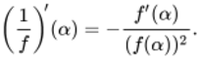
View alternative description - Uncaptioned Equation

The proof of the Combination Rules for differentiation uses the Combination Rules for limits of functions. In the next example we illustrate the method by proving the Product Rule for differentiation. We use the Sum, Product and Multiple Rules for limits of functions, and we also use the fact that if a function is differentiable at , then it is continuous at , so 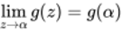.

Example 2
Prove the Product Rule for differentiation.

Solution
Let . Then

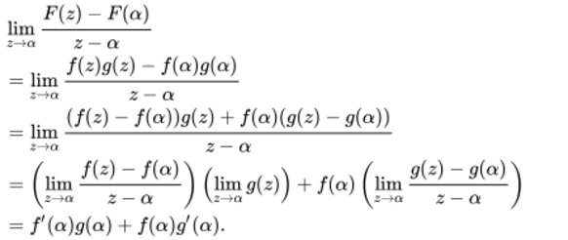
View alternative description - Uncaptioned Equation

The proofs of the other Combination Rules are similar. We ask you to prove the Sum and Multiple Rules in Exercise 4, and the Quotient Rule later in Exercise 12.

Exercise 4

Prove the following rules for differentiation.
- Sum Rule
- Multiple Rule

View answer - Exercise 4

The Combination Rules enable us to differentiate any polynomial or rational function. (Recall that a rational function is the quotient of two polynomial functions.)
For example, since the function is entire with derivative , we can use the Product Rule repeatedly to show that the function

View alternative description - Uncaptioned Equation

is entire, and that its derivative is

View alternative description - Uncaptioned Equation

(This result can be proved formally using the Principle of Mathematical Induction.) Next, we can use this fact, together with the Sum and Multiple Rules, to prove that any polynomial function is entire, and that its derivative is obtained by differentiating the polynomial function term by term. For example,

View alternative description - Uncaptioned Equation

In general, we have the following corollary to Theorem 3.

Corollary Differentiating Polynomial Functions
Let be the polynomial function

View alternative description - Uncaptioned Equation

where and . Then is entire with derivative

View alternative description - Uncaptioned Equation

Since a rational function is a quotient of two polynomial functions, it follows from the corollary on differentiating polynomial functions and the Quotient Rule that a rational function is differentiable at all points where its denominator is non-zero; that is, at all points of its domain.

Example 3
Find the derivative of

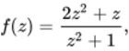
View alternative description - Uncaptioned Equation

and specify its domain.

Solution
By the corollary on differentiating polynomial functions, the derivative of is

View alternative description - Uncaptioned Equation

and the derivative of is

View alternative description - Uncaptioned Equation

Provided that is non-zero, we can apply the Quotient Rule to obtain

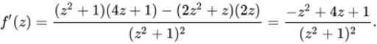
View alternative description - Uncaptioned Equation

Since is non-zero everywhere apart from and , it follows that the domain of is .

Exercise 5

Find the derivative of each of the following functions. In each case specify the domain of the derivative.
- 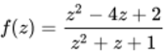

View answer - Exercise 5

So, any rational function is differentiable on the whole of its domain. What is more, this domain must be a region because it is obtained by removing a finite number of points (zeros of the denominator) from .

Corollary
Any rational function is analytic.

A particularly simple example of a rational function is , where is a positive integer. This can be differentiated by means of the Reciprocal Rule:

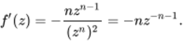
View alternative description - Uncaptioned Equation

If is used to denote the negative integer , then we can write and . In this form, it is apparent that the formula for differentiating a negative integer power is the same as the formula for differentiating a positive integer power. The only difference is that for negative powers, 0 is excluded from the domain. We state these observations as a final corollary to Theorem 3.

Corollary
Let . The function has derivative

View alternative description - Uncaptioned Equation

The domain of is if and if .

1.3 Non-differentiability
In Theorem 1 you saw that differentiability implies continuity. An immediate consequence of this is the following test for non-differentiability.

Strategy A for non-differentiability
If is discontinuous at , then is not differentiable at .

Example 4
Show that there are no points of the negative real axis at which the function is differentiable.

Solution
The function is discontinuous at all points of the negative real axis. It follows that there are no points of the negative real axis at which is differentiable.

Exercise 6

Show that there are no points of the negative real axis at which the principal logarithm function

View alternative description - Uncaptioned Equation

is differentiable.

View answer - Exercise 6

The converse of Theorem 1 is not true; if a function is continuous at a point, then it does not follow that it is differentiable at the point. A particularly striking illustration of this is provided by the modulus function . This is continuous on the whole of and yet, as you will see, it fails to be differentiable at any point of .
Since is continuous, Strategy A cannot be used to show that is not differentiable at a given point . Instead we return to the definition of derivative and show that the difference quotient for fails to have a limit.
In general, if the domain of a function contains as one of its limit points, then the existence of the limit

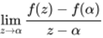
View alternative description - Uncaptioned Equation

means that for each sequence in that converges to ,

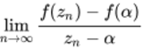
View alternative description - Uncaptioned Equation

exists, and has a value that is independent of the sequence .
So, if two such sequences and can be found for which

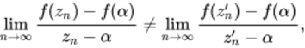
View alternative description - Uncaptioned Equation

then cannot be differentiable at .
In the next example, you will see that is not differentiable at . This result should not surprise you because the real modulus function is not differentiable at . Indeed, the proof is identical to that of the real case.

Example 5
Prove that is not differentiable at 0.

Solution
We need to find two sequences and that converge to 0 which, when substituted into the difference quotient, yield sequences with different limits. A simple choice is to pick sequences and that approach 0 along the real axis: one from the right, and one from the left, as shown in Figure 4.

Figure 4 Sequences converging to from the right and left
View description - Figure 4 Sequences converging to zero from the right and left

There is no point in picking sequences that are more complicated than they need to be, so let , . Then

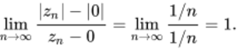
View alternative description - Uncaptioned Equation

Now let , . Then

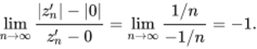
View alternative description - Uncaptioned Equation

Since the two limits do not agree, the difference quotient does not have a limit as tends to 0. It follows that is not differentiable at 0.

The next exercise asks you to extend the method used in Example 5 to show that is not differentiable at any point of .

Exercise 7

Let be any non-zero complex number, and consider the circle through centred at the origin. By choosing one sequence that approaches along the circumference of the circle, and another sequence that approaches along the ray from through , prove that is not differentiable at .

View description - Uncaptioned Figure

View answer - Exercise 7

The modulus function illustrates an important difference between real and complex differentiation. When the modulus function is treated as a real function, the limit of its difference quotient has to be taken along the real line. But when treated as a complex function, the limit of the difference quotient is required to exist however the limit is taken. This explains why the real modulus function is differentiable at all non-zero real points, whereas the complex modulus function fails to be differentiable at any point of . More generally, it shows that complex differentiability is a much stronger condition than real differentiability.
In Exercise 7 you were asked to prove that the modulus function fails to be differentiable by observing that its behaviour along the circumference of a circle centred at 0 is different from its behaviour along a ray. Similar observations can be applied to other functions. For example, in the next exercise you may find it helpful to notice that directions of paths parallel to the imaginary axis are reversed by the function , whereas directions of paths parallel to the real axis are left unchanged (Figure 5).

Figure 5 Images of horizontal and vertical lines under
View description - Figure 5 Images of horizontal and vertical lines under f of z equals z macron

Exercise 8

Show that there are no points of at which the complex conjugate function is differentiable.

View answer - Exercise 8

For some functions , you may be able to find a sequence that converges to for which the sequence

(equation 1)
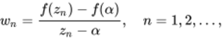
View alternative description - Uncaptioned Equation

is divergent. In such cases, there is no need to look for a second sequence.

Example 6
Show that the function is not differentiable at 0.

Solution
Strategy A cannot be used here, since is continuous at 0. Instead we look for a sequence that converges to for which the sequence 1 (above) is divergent. To make the square roots easy to handle, let , . Then

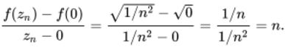
View alternative description - Uncaptioned Equation

This sequence tends to infinity, and is therefore divergent. It follows that is not differentiable at 0.

The methods exemplified above for showing that a function is not differentiable at a given point can be summarised as follows.

Strategy B for non-differentiability
To prove that a function is not differentiable at , apply the strategy for proving that a limit does not exist to the difference quotient

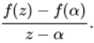
View alternative description - Uncaptioned Equation

If you think that a given function is not differentiable, then you should try to apply Strategy A or Strategy B. A third strategy for proving that is not differentiable at a point will appear in Section 2.1. If, on the other hand, you think that the function is differentiable, then you should try to find the derivative.

Exercise 9

Decide whether each of the following functions is differentiable at . If it is, then find its derivative at .
- 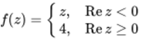

View answer - Exercise 9

1.4 Higher-order derivatives
In Exercise 2 you saw that the function has derivative , a result that you can also obtain using the Reciprocal Rule. If you now apply the Reciprocal Rule to the derivative , then you obtain a function

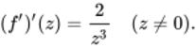
View alternative description - Uncaptioned Equation

In general, for a differentiable function , the function is called the second derivative of , and is denoted by . Continued differentiation gives the so-called higher-order derivatives of . These are denoted by , and the values , are called the higher-order derivatives of at .
Since the dashes in this notation can be rather cumbersome, we often indicate the order of the derivative by a number in brackets. Thus mean the same as , respectively. Here the brackets in are needed to avoid confusion with the fourth power of .
When we wish to discuss a derivative of general order, we will refer to the th derivative of . It is often possible to find a formula for the th derivative in terms of . For example, if , then

View alternative description - Uncaptioned Equation

so the th derivative is given by

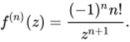
View alternative description - Uncaptioned Equation

(This can be proved formally by the Principle of Mathematical Induction.)
One interesting feature about this formula is that the domain remains the same, no matter how often the function is differentiated. This is a special case of a much more general result which states that: a function that is analytic on a region has derivatives of all orders on . Here we confine our attention to first derivatives, and we continue to do this in the next subsection by giving a geometric interpretation of the first derivative.

1.5 A geometric interpretation of derivatives
As we mentioned in this session’s introduction, the derivative of a real function is often pictured geometrically as the gradient of the graph of the function. This interpretation is useful in real analysis, but it is of little use in complex analysis, since the graph of a complex function is not two-dimensional.
Fortunately, there is another way of interpreting derivatives that works for complex functions.
If a complex function is differentiable at a point , then any point close to is mapped by to a point close to .
Indeed, by the Linear Approximation Theorem,

View alternative description - Uncaptioned Equation

where as . So if , then, to a close approximation,

View alternative description - Uncaptioned Equation

Multiplication of by has the effect of scaling by the factor and rotating it about 0 through the angle ; see Figure 6. We refer to as a complex scale factor, because it causes both a scaling and a rotation.

Figure 6 Scaling and rotating
View description - Figure 6 Scaling and rotating z minus alpha

We can rewrite the equation above as

(equation 2)
View alternative description - Uncaptioned Equation

From this we see that is obtained by scaling and rotating the vector based at by the complex scale factor , as illustrated in Figure 7.

Figure 7 Interpreting a derivative as a complex scale factor
View description - Figure 7 Interpreting a derivative as a complex scale factor

Another useful way to picture how behaves geometrically is to consider the effect it has on a small disc centred at (still assuming that ). From equation 2 (above), we see that, to a close approximation, a small disc centred at is mapped to a small disc centred at . In the process, the disc is rotated through the angle , and it is scaled by the factor (see Figure 8). As usual, the rotation is anticlockwise if is positive, and clockwise if it is negative.

Figure 8 The approximate image of a disc centred at a point , where
View description - Figure 8 The approximate image of a disc centred at a point alpha, where f super ...

The geometric interpretation of derivatives is more complicated if , and we do not discuss it here.

Example 7
Using the notion of a complex scale factor, describe what happens to points close to under the function .

Solution
To a close approximation, a small disc centred at is mapped by to a small disc centred at

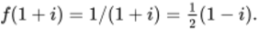
View alternative description - Uncaptioned Equation

In the process, the disc is scaled by the factor and rotated through the angle .
Now , so

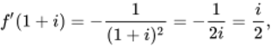
View alternative description - Uncaptioned Equation

which has modulus and principal argument .
So scales the disc by the factor and rotates it anticlockwise through the angle .

Exercise 10

Using the notion of a complex scale factor, describe what happens to points close to under the function

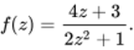
View alternative description - Uncaptioned Equation

View answer - Exercise 10

It is important to bear in mind that the complex scale factor interpretation of a derivative is only an approximation, and that it is unlikely to be reliable far from the point under consideration.

1.6 Further exercises
Here are some further exercises to end this section.

Exercise 11

Use the definition of derivative to find the derivative of the function

View alternative description - Uncaptioned Equation

View answer - Exercise 11

Exercise 12

Prove the Quotient Rule for differentiation.

View answer - Exercise 12

Exercise 13

Find the derivative of each of the following functions . In each case specify the domain of .
- 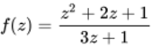
- 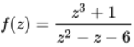
- 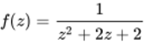
- 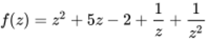

View answer - Exercise 13

Exercise 14

Use Strategy B to show that there are no points of at which the function

View alternative description - Uncaptioned Equation

is differentiable.

View answer - Exercise 14

Exercise 15

Describe the approximate geometric effect of the function

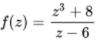
View alternative description - Uncaptioned Equation

on a small disc centred at the point 2.

View answer - Exercise 15

2 The Cauchy–Riemann equations
After working through this section, you should be able to:
- find the partial derivatives of a function from to
- use the Cauchy–Riemann equations to show that a function is not differentiable at a given point
- use the Cauchy–Riemann equations to show that a function, such as the exponential function, is differentiable at a given point, and to find the derivative.
This section is challenging, so you may find that you do not appreciate some of the details on a first reading. Most importantly, you should try to understand the definitions, strategies and theorems, and apply them in the examples and exercises.

2.1 The Cauchy–Riemann theorems
Here we will explore the relationship between complex differentiation and real differentiation. To do this, we introduce the notion of a partial derivative and use it to derive the Cauchy–Riemann equations (pronounced ‘coh-she ree-man’). These equations are conditions that any differentiable complex function must satisfy, so they can be used to test whether a given complex function is differentiable. In particular, we use them to investigate the differentiability of the complex exponential function. The technique is to split the exponential function

View alternative description - Uncaptioned Equation

into its real and imaginary parts:

View alternative description - Uncaptioned Equation

each of which is a real-valued function of the real variables and . The derivative of exp is then calculated by using the derivatives of the real trigonometric and exponential functions, which we assume to be known.
Before we deal with the exponential function, however, let us first consider the simpler function . By writing , we see that

View alternative description - Uncaptioned Equation

Let us define

View alternative description - Uncaptioned Equation

Then and are the real and imaginary parts of , respectively; that is, and . For the moment we will concentrate on the real part ; part of its graph (given by the equation ) is shown in Figure 9. Since is a function of two real variables, its graph is a surface. The height of the surface above the -plane represents the value of the function at the point . For instance, the point on the surface has coordinates because .

Figure 9 Graph of
View description - Figure 9 Graph of u of x comma y equals x cubed minus three times x times y squa ...

Let us now explore the concept of the gradient of the surface at a point such as . We will find that the answer depends on the ‘direction’ from which we approach the point. To make this more precise, consider Figure 10, in which the vertical plane with equation is shown intersecting the surface in a curve that passes through . By substituting into , we see that the curve has equation , so we can calculate its gradient at ; this is the gradient of the surface in the -direction at .

Figure 10 Intersection of the graph of with the vertical plane
View description - Figure 10 Intersection of the graph of u of x comma y equals x cubed minus three ...

More generally, whenever we intersect the surface with a vertical plane with equation , we obtain a curve on the surface with equation (where is considered to be fixed). We can find the gradient at any point on this curve by differentiating with respect to and then substituting and . The resulting expression is called the partial derivative of with respect to at , and it is denoted by

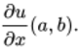
View alternative description - Uncaptioned Equation

A curly is used rather than a straight to emphasise that this is a partial derivative, for which we differentiate with respect to one variable and keep the other variable fixed. In our particular case, differentiating with respect to (and keeping fixed) gives

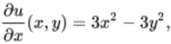
View alternative description - Uncaptioned Equation

and substituting and gives

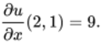
View alternative description - Uncaptioned Equation

Hence the gradient of the surface in the -direction at the point is 9. This is a positive value because near the point , increases as increases (with ), as you can see from Figure 10.
Figure 11 shows the vertical plane with equation intersecting the surface in a different curve that passes through .

Figure 11 Intersection of the graph of with the vertical plane
View description - Figure 11 Intersection of the graph of u of x comma y equals x cubed minus three ...

Reasoning similarly to before, we see that intersecting the surface with a vertical plane with equation gives a curve on the surface, and we can obtain the gradient at a point on this curve by differentiating with respect to while keeping fixed (and then substituting and ). The resulting expression is called the partial derivative of with respect to at , and it is denoted by

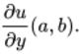
View alternative description - Uncaptioned Equation

Differentiating with respect to (and keeping fixed) gives

View alternative description - Uncaptioned Equation

this is the gradient of the surface in the -direction at the point . It is a negative value this time, because when and are positive, decreases as increases (keeping fixed), as you can see from Figure 11.
You will need to work with partial derivatives a good deal here, so let us state the definitions formally.

Definitions
Let be a function with domain a subset of that contains the point .
- The partial derivative of with respect to at , denoted 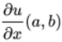, is the derivative of the function at , provided that this derivative exists.
- The partial derivative of with respect to at , denoted 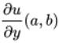, is the derivative of the function at , provided that this derivative exists.

Partial derivatives are real derivatives, not complex derivatives.
The next exercise asks you to work out the partial derivatives of the imaginary part of the complex function .

Exercise 16

- Calculate the partial derivatives of .
- Evaluate these partial derivatives at .

View answer - Exercise 16

Let us collect together the partial derivatives of the real and imaginary parts and of the function :

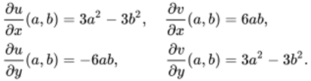
View alternative description - Uncaptioned Equation

As you can see, we have

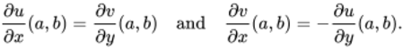
View alternative description - Uncaptioned Equation

This pair of equations is called the Cauchy–Riemann equations, and they hold true for the real and imaginary parts of any differentiable complex function, as the following important theorem testifies.

Theorem 4 Cauchy–Riemann Theorem
Let be defined on a region containing .
If is differentiable at , then , , , exist at and satisfy the Cauchy–Riemann equations

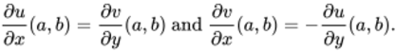
View alternative description - Uncaptioned Equation

Proof Let . Suppose that is any sequence in that converges to . Let us write . According to the definition of a derivative, we have
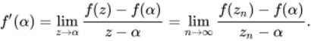
View alternative description - Uncaptioned Equation
Observe that, by expressing in terms of its real and imaginary parts, we can write
View alternative description - Uncaptioned Equation
(equation 3)We proceed by choosing two different types of sequences , and observing the behaviour of the expressions in large brackets in equation 3 (above) in each case. For our first choice, let us begin by defining to be any sequence in that converges to . Let , so the sequence converges to . By removing a finite number of terms from , if need be, we can assume that each point belongs to the open set . Substituting into equation 3 gives 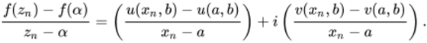
View alternative description - Uncaptioned Equation
We know that the expression on the left-hand side converges (to ), so its real and imaginary parts (indicated by the bracketed expressions on the right-hand side) converge too. Since was chosen to be any sequence in that converges to , we see from the definition of partial derivatives that and exist at and
View alternative description - Uncaptioned Equation
In summary, we have 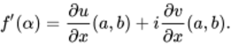
View alternative description - Uncaptioned Equation
(equation 4)Next let be any sequence in that converges to , and define , so . Again, by omitting a finite number of terms from , if need be, we can assume that for all . Substituting into equation 3 gives 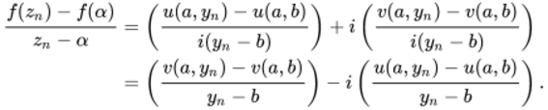
View alternative description - Uncaptioned Equation
Reasoning as before, we see that and exist at and 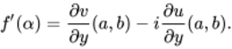
View alternative description - Uncaptioned Equation
(equation 5)Comparing equation 4 and equation 5 (both above), and equating real and imaginary parts, we obtain the Cauchy–Riemann equations, as required.âˆŽ

Origin of the Cauchy–Riemann equations
The Cauchy–Riemann equations are named after the mathematicians Augustin-Louis Cauchy and Bernhard Riemann (1826–1866), who were among the first to recognise the importance of these equations in complex analysis.
The Cauchy–Riemann equations first appeared in the work of another mathematician, however: the Frenchman Jean le Rond d’Alembert (1717–1783), who is perhaps best remembered for his work in classical mechanics. Indeed, the Cauchy–Riemann equations were written down by d’Alembert in an essay on fluid dynamics in 1752 to describe the velocity components of a two-dimensional irrotational fluid flow.

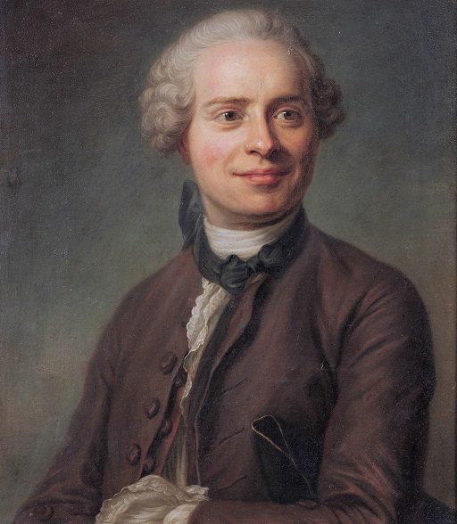
Jean le Rond d’Alembert (1717–1783)
View description - Jean le Rond d’Alembert (1717–1783)

The Cauchy–Riemann Theorem gives us another strategy for proving the non-differentiability of a complex function. (Two other strategies were described earlier in Section 1.3.) If a complex function is differentiable, then it must satisfy the Cauchy–Riemann equations. So if those equations do not hold, then the function cannot be differentiable.

Strategy C for non-differentiability
Let . If either

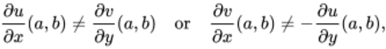
View alternative description - Uncaptioned Equation

then is not differentiable at .

To illustrate this strategy, consider the function

View alternative description - Uncaptioned Equation

The real part and imaginary part of this function are given by

View alternative description - Uncaptioned Equation

Hence

View description - Uncaptioned Figure

As you can see, the partial derivatives have been grouped into two pairs according to the Cauchy–Riemann equations.

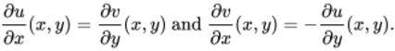
View alternative description - Uncaptioned Equation

In this case, these equations are and , which are satisfied only when and ; that is, they are satisfied only when . If , then the Cauchy–Riemann equations fail, so Strategy C tells us that is not differentiable at .
Notice that the Cauchy–Riemann Theorem and Strategy C do not tell us whether is differentiable at the point at which the Cauchy–Riemann equations are satisfied. To deal with points of this type we need another theorem, which we will come to shortly. First, however, try the following exercise, to practise applying Strategy C.

Exercise 17

Show that each of the following functions fails to be differentiable at all points of .

View answer - Exercise 17

We have seen that if the Cauchy–Riemann equations are not satisfied, then the function is not differentiable. Let us now describe an example to show that even if the Cauchy–Riemann equations are satisfied, then the function may still not be differentiable.
Consider the function , where for all and , and

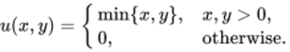
View alternative description - Uncaptioned Equation

The graph of is shown in Figure 12.

Figure 12 Graph of
View description - Figure 12 Graph of u

Since and take the value at all points on the - and -axes, we see that all the partial derivatives vanish at ; that is,

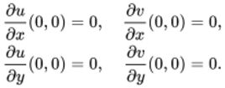
View alternative description - Uncaptioned Equation

However, even though the Cauchy–Riemann equations are satisfied at the origin, is not differentiable there. To see this, observe that if , , then

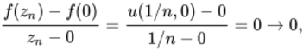
View alternative description - Uncaptioned Equation

whereas if , , then

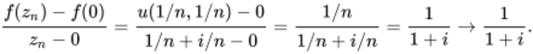
View alternative description - Uncaptioned Equation

The two limits and differ, so is not differentiable at .
This example demonstrates that the differentiability of a complex function does not follow from the Cauchy–Riemann equations alone. However, if certain extra conditions are satisfied, then is differentiable, as the following theorem reveals.

Theorem 5 Cauchy–Riemann Converse Theorem
Let be defined on a region containing . If the partial derivatives , , ,
- exist at for each
- are continuous at
- satisfy the Cauchy–Riemann equations at ,
then is differentiable at and

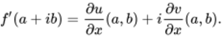
View alternative description - Uncaptioned Equation

The proof of this theorem is postponed until the next subsection.
Let us now return to the function , considered earlier, which satisfies the Cauchy–Riemann equations at the point only, and is therefore not differentiable at any other point. You saw earlier that the partial derivatives exist for every point (so we can choose in applying Theorem 5) and they satisfy

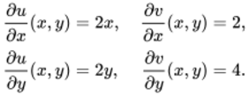
View alternative description - Uncaptioned Equation

Each of these functions is continuous at because each of them is either constant or a multiple of one of the basic continuous functions or . For example, the function can be thought of as .
It follows, then, from the Cauchy–Riemann Converse Theorem that is differentiable at . In fact, the theorem even tells us the value of , namely

View alternative description - Uncaptioned Equation

Now, we investigate the differentiability of the complex exponential function, as promised earlier.

Example 8
Prove that the complex exponential function is entire, and find its derivative.

Solution
The real part and the imaginary part of are given by

View alternative description - Uncaptioned Equation

Hence the partial derivatives of and exist for every point and satisfy

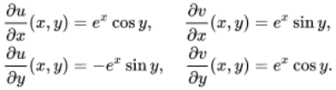
View alternative description - Uncaptioned Equation

Since the real exponential and trigonometric functions are continuous, and the real and imaginary part functions and are basic continuous functions, we see from the Combination Rules and Composition Rule for continuous functions that each partial derivative is continuous at every point .
The Cauchy–Riemann equations are satisfied at all points , so the Cauchy–Riemann Converse Theorem tells us that is differentiable at every point of the complex plane (it is entire) and

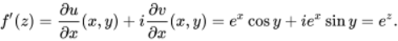
View alternative description - Uncaptioned Equation

Exercise 18

Use the Cauchy–Riemann theorems to find the derivatives of the following functions. In each case specify the domain of the derivative.
(Hint: For part (a), write and use a trigonometric addition identity to find the real and imaginary parts of .)

View answer - Exercise 18

2.2 Proof of the Cauchy–Riemann Converse Theorem
The proof of the Cauchy–Riemann Converse Theorem is rather involved and may require more than one reading.
We will need two results from real analysis. The first result is known as the Mean Value Theorem.

Theorem 6 Mean Value Theorem
Let be a real function that is continuous on the closed interval and differentiable on the open interval . Then there is a number such that

(equation 6)
View alternative description - Uncaptioned Equation

To appreciate why this theorem is true, imagine pushing the chord between and in Figure 13 parallel to itself until it becomes a tangent to the graph of at a point , where lies somewhere between and . Clearly, the gradient of the original chord must be equal to the gradient of the tangent, so

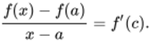
View alternative description - Uncaptioned Equation

Multiplication by gives . Notice that this equation is also true if .

Figure 13 Graph of the real function
View description - Figure 13 Graph of the real function f

The second result that we will need is a Linear Approximation Theorem, which asserts that if is a real-valued function of two real variables and , then for near , the value of can be approximated by the value of the linear function defined by

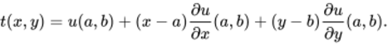
View alternative description - Uncaptioned Equation

Now, the graph of is a plane passing through the point on the graph of (Figure 14). Moreover, the partial - and -derivatives of coincide with the partial - and -derivatives of at . This means that both have the same gradient in the - and -directions, so you can think of the plane as the tangent plane to the graph of at .

Figure 14 Tangent plane to the graph of at the point
View description - Figure 14 Tangent plane to the graph of u at the point cap p

The accuracy with which this tangent plane approximates the graph of depends on the smoothness of the graph of . If the graph exhibits the kind of kink shown in Figure 12, then the approximation is not as good as for a function with continuous partial derivatives.

Theorem 7 Linear Approximation Theorem ( to )
Let be a real-valued function of two real variables, defined on a region in containing . If the partial - and -derivatives of exist on and are continuous at , then there is an ‘error function’ such that

View alternative description - Uncaptioned Equation

where 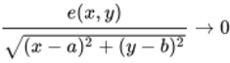 as .

Since is the distance from to , the theorem asserts that the error function tends to zero ‘faster’ than this distance. Theorem 7 is the real-valued function analogue of Theorem 2.

ProofWe have to show that the function defined by
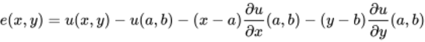
View alternative description - Uncaptioned Equation
satisfies 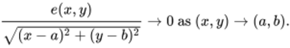
View alternative description - Uncaptioned Equation
Since the partial derivatives exist on , they must be defined on some disc centred at . Let us begin by finding an expression for on this disc. If we apply the Mean Value Theorem to the real functions (where is kept constant) and , then we obtain 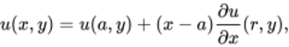
View alternative description - Uncaptioned Equation
where is between and , and 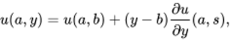
View alternative description - Uncaptioned Equation
where is between and (see Figure 15). Hence 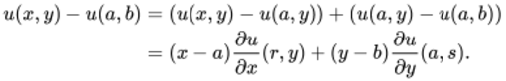
View alternative description - Uncaptioned Equation
Figure 15 Vertical and horizontal line segments from to
View description - Figure 15 Vertical and horizontal line segments from left parenthesis a comma b right ...
Substituting this expression for into the definition of , we obtain
View alternative description - Uncaptioned Equation
Dividing both sides by , and noting that 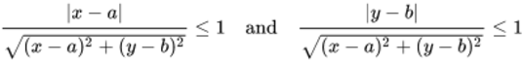
View alternative description - Uncaptioned Equation
(because both and do not exceed ), we see that 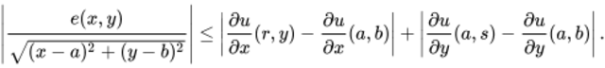
View alternative description - Uncaptioned Equation
Figure 15 illustrates that as tends to , so do and . So, by the continuity of the partial - and -derivatives at , the two terms on the right of the inequality above must both tend to 0 as tends to . It follows that tends to 0 as tends to . âˆŽ

We are now in a position to prove the Cauchy–Riemann Converse Theorem.

Theorem 5 Cauchy–Riemann Converse Theorem (revisited)
Let be defined on a region containing . If the partial derivatives , , ,
- exist at for each
- are continuous at
- satisfy the Cauchy–Riemann equations at ,
then is differentiable at and

View alternative description - Uncaptioned Equation

ProofWe need to show that the limit of the difference quotient for at exists and has the value indicated in the theorem. In order to calculate the difference quotient for at , we find an expression for . Since and fulfil the conditions of Theorem 7, it follows that
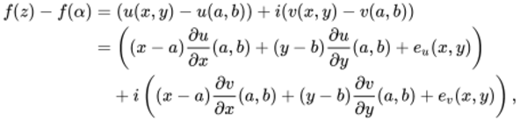
View alternative description - Uncaptioned Equation
where and are the error functions associated with and , respectively. Collecting together terms, we see that 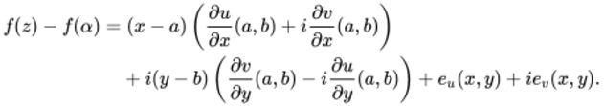
View alternative description - Uncaptioned Equation
Since and satisfy the Cauchy–Riemann equations, both expressions in the large brackets must be equal, so 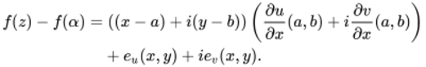
View alternative description - Uncaptioned Equation
Dividing by gives 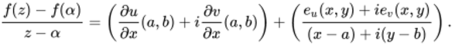
View alternative description - Uncaptioned Equation
The limit of this difference quotient exists, and has the required value 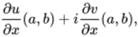
View alternative description - Uncaptioned Equation
provided that we can show that the expression involving the error functions and tends to 0 as tends to . To this end, notice that is equal to and so, by the Triangle Inequality, 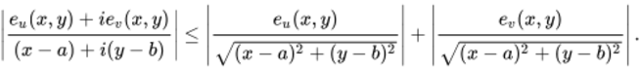
View alternative description - Uncaptioned Equation
By Theorem 7, both expressions on the right tend to 0 as tends to . Consequently, the expression on the left must also tend to 0, and the theorem follows. âˆŽ

2.3 Further exercises
Here are some further exercises to end this section.

Exercise 19

Calculate the partial derivatives 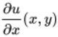 and 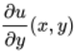 of each of the following functions.

View answer - Exercise 19

Exercise 20

Calculate the partial derivatives and of each of the following functions, and evaluate these partial derivatives at .

View answer - Exercise 20

Exercise 21

Find the gradient of the graph of at the point in the -direction and in the -direction.

View answer - Exercise 21

Exercise 22

Use the Cauchy–Riemann equations to show that there is no point of at which the function

View alternative description - Uncaptioned Equation

is differentiable.

View answer - Exercise 22

Exercise 23

Use the Cauchy–Riemann equations to show that the function

View alternative description - Uncaptioned Equation

is entire, and find its derivative.

View answer - Exercise 23

Exercise 24

Use the Cauchy–Riemann equations to find all the points at which the following functions are differentiable, and calculate their derivatives.

View answer - Exercise 24

2.4 Laplace’s equation and electrostatics
The Cauchy–Riemann equations for a differentiable function tell us that

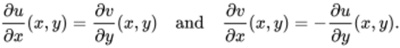
View alternative description - Uncaptioned Equation

These partial derivatives are themselves functions of and , so, provided that they are suitably well behaved, we can partially differentiate both sides of the first of the two equations with respect to , and partially differentiate both sides of the second equation with respect to , to obtain

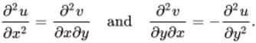
View alternative description - Uncaptioned Equation

(Here we have omitted the variables after each derivative, for simplicity.) For sufficiently well-behaved functions, the two partial derivatives

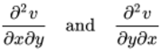
View alternative description - Uncaptioned Equation

are equal; the order in which you partially differentiate with respect to and does not matter. Hence

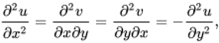
View alternative description - Uncaptioned Equation

which implies that

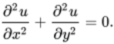
View alternative description - Uncaptioned Equation

This equation for is called Laplace’s equation. (The imaginary part of satisfies Laplace’s equation too.) It is named after the distinguished French mathematician and scientist Pierre-Simon Laplace (1749–1827), who studied the equation in his work on gravitational potentials.

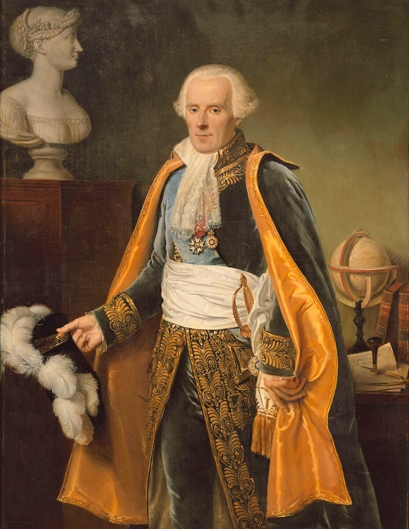
Pierre-Simon Laplace (1749–1827)
View description - Pierre-Simon Laplace (1749–1827)

Laplace’s equation has proved to have huge importance to physics, with particular significance in fluid mechanics. It also has a key role in the subject of electrostatics. In that theory, it is known that the electrostatic potential at a point of a region without charge satisfies Laplace’s equation. It can be shown that is the real part of some differentiable function . Using these observations allows one to move between complex analysis and electrostatics: many of the theorems of complex analysis have important physical interpretations in electrostatics.

3 Summary of Session 1
In this session you have seen how we can define differentiation for complex functions, check whether such a function is differentiable, and seen how to differentiate complex rational and polynomial functions. You have learnt how this can be extended to the partial derivatives of complex functions of more than one variable, and studied the Cauchy-Riemann equations that link the first partial derivatives of the real and imaginary parts of a differentiable complex function of two variables.
You can now move on to Session 2: Integration.

Session 2: Integration

Introduction to integration
This session introduces complex integration, an important concept which gives complex analysis its special flavour. We spend most of this session setting up the complex integral, deriving its main properties, and illustrating various techniques for evaluating it.
To define the integral of a complex function, it is instructive to first consider real integrals, such as

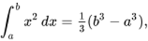
View alternative description - Uncaptioned Equation

where , which represents the area of the shaded part of Figure 1 (for ). We can express this equation in words by saying that

the integral of the function over the interval is 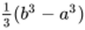.

Figure 1 Area under the graph of between and
View description - Figure 1 Area under the graph of y equals x squared between a and b

Suppose now that we wish to integrate the complex function between two points and in the complex plane. To do this, we first need to specify exactly how to get from to . We could, for example, choose the line segment from to , as shown in Figure 2. It turns out (as you will see later) that if we make this choice, then

the integral of the function along the line segment from to is 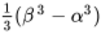.

We write this as

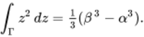
View alternative description - Uncaptioned Equation

Figure 2 Line segment from to
View description - Figure 2 Line segment normal cap gamma from alpha to beta

But there are many other paths in the complex plane from to , which raises the following question. Do we get the same answer if we integrate the function along a different path from to ?
In order to address this question, we first need to explain exactly what it means to ‘integrate a function along a path’. This is one of the objectives of Section 1, where we briefly review the Riemann integral from real analysis, and then use similar ideas to construct the integral of a complex function along a path in the complex plane. We will see that if is a complex function that is continuous on a smooth path in the complex plane, then the integral of along , denoted by 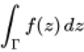, is given by the formula

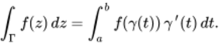
View alternative description - Uncaptioned Equation

We can evaluate this integral by splitting into its real and imaginary parts and , and evaluating the resulting pair of real integrals:

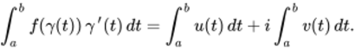
View alternative description - Uncaptioned Equation

Section 2 begins with this definition of the integral of a complex function along a smooth path, and then extends the idea to allow integration along a contour – a finite sequence of smooth paths laid end to end.
In Section 3 we prove the Fundamental Theorem of Calculus, which shows that integration and differentiation are essentially inverse processes. From this result it follows that the integral of along any contour from to is 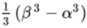.
We will need to be careful about how we apply results such as the Fundamental Theorem of Calculus. For example, suppose that the endpoints and of coincide, as illustrated in Figure 3. Then

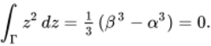
View alternative description - Uncaptioned Equation

In this case, the integral of the function along is .

Figure 3 Contour with initial point and final point coinciding
View description - Figure 3 Contour with initial point alpha and final point beta coinciding

Consider now the function . We will see later in Example 4 that if we integrate along the smooth paths and shown in Figure 4, where and are circles traversed once anticlockwise, then

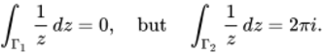
View alternative description - Uncaptioned Equation

The reason for this difference will become apparent in Section 3.

Figure 4 Circular paths and
View description - Figure 4 Circular paths normal cap gamma sub one and normal cap gamma sub two

This OpenLearn course is an extract from the Open University course M337 Complex analysis.

1 Integrating real functions
After working through this section, you should be able to:
- appreciate how the Riemann integral is defined
- state the main properties of the Riemann integral
- appreciate how complex integrals can be defined.
In this section we define the Riemann integral of a continuous real function (named after Bernhard Riemann, whom we met in Session 1 for the Cauchy–Riemann equations) and outline its main properties. We then discuss complex integrals.

1.1 Areas under curves
One of the uses of real integration is to determine the area under a curve. For example, the integral of a continuous function that takes only positive values between the real numbers and , where , is the area bounded by the graph of , the -axis, and the two vertical lines and , as illustrated by the shaded part of Figure 5.

Figure 5 Area under the graph of between and
View description - Figure 5 Area under the graph of y equals f of x between a and b

We can estimate this area by first splitting the interval into a finite number of subintervals, such as those shown in Figure 6.

Figure 6 Interval split into subintervals
View description - Figure 6 Interval open a comma b close split into subintervals

We can then underestimate the area under the graph of between and by summing the areas of those rectangles that have the various subintervals as bases and for which the top edge of each rectangle touches the graph from below, as shown in Figure 7(a). Similarly, we can overestimate the area under between and by summing the areas of those rectangles that have the various subintervals as bases and for which the top edge of each rectangle touches the graph from above, as shown in Figure 7(b).

Figure 7 (a) An underestimate (b) An overestimate
View description - Figure 7 (a) An underestimate (b) An overestimate

We now let the number of subintervals tend to infinity, in such a way that the lengths of the subintervals tend to zero. It can be shown that the underestimates and overestimates of the area tend to a common limit , written as

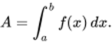
View alternative description - Uncaptioned Equation

We call the area under the graph of between and .
This underestimating and overestimating approach is often how Riemann integration is first introduced, and you may have seen it before. However, we encounter a problem if we try to generalise this particular approach to complex functions. Inequalities between complex numbers have no meaning, so it makes no sense to try to estimate complex numbers from ‘below’ or ‘above’. To get round this problem, we now outline a different approach to defining the integral of a real function – one that does generalise to complex functions.
Rather than underestimating and overestimating the area under the curve with rectangles, we choose a single point inside each subinterval and use this to construct a rectangle whose base is the subinterval, and whose height is the value of the function at the chosen point. The sum of the areas of these rectangles should then be an approximation to the area under the graph. As long as our function is continuous on the interval , then this modified approach (which does generalise to complex integrals) agrees with the underestimating and overestimating approach.
In this section we use this modified approach to give a formal definition of the Riemann integral, and then we summarise the main properties of the Riemann integral. We omit all proofs, which can be found in texts on real analysis.

1.2 Integration on the real line
We wish to define the Riemann integral of a continuous real function in such a way that if is positive on some interval , then the integral of from to is the area under the graph of between and . This is illustrated by the shaded part of Figure 8. To do this, we first split the interval into a collection of subintervals called a partition.

Figure 8 Area under the graph of between and
View description - Figure 8 Area under the graph of y equals f of x between a and b

Definitions
A partition of the interval is a finite collection of subintervals of ,

View alternative description - Uncaptioned Equation

for which

View alternative description - Uncaptioned Equation

The length of the subinterval is .
We use to denote the maximum length of all the subintervals, so

View alternative description - Uncaptioned Equation

Given a partition of , we can approximate the area under the graph of between and by constructing a sequence of rectangles, as shown in Figure 9.

Figure 9 Approximating the area under a graph using a sequence of rectangles
View description - Figure 9 Approximating the area under a graph using a sequence of rectangles

Here the th rectangle has base and height (so the top-right corner of the rectangle touches the curve). The area of the rectangle is (see Figure 10). Note that we could equally have chosen the rectangle to be of height for any point in , and the theory would still work. This is because, for a continuous function , the difference between one set of choices of values for , , and another disappears when we take limits of partitions. We have chosen merely for convenience.

Figure 10 Rectangle of height and width
View description - Figure 10 Rectangle of height f of x sub k and width delta times x sub k

Summing the areas of all the rectangles gives an approximation to the area under the graph. This sum is called the Riemann sum for , with respect to this particular partition. (You may have seen upper Riemann sum and lower Riemann sum defined slightly differently elsewhere.)

Definition
The Riemann sum for with respect to the partition

View alternative description - Uncaptioned Equation

is the sum

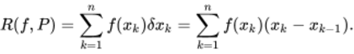
View alternative description - Uncaptioned Equation

We now calculate the Riemann sum for a particular choice of function and partition, and then ask you to do the same for a second function.

Example 1
Let , where . Show that for

View alternative description - Uncaptioned Equation

we have

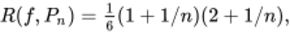
View alternative description - Uncaptioned Equation

and determine 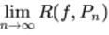.

Solution
Each of the subintervals of has length . Therefore

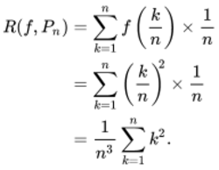
View alternative description - Uncaptioned Equation

Using the identity

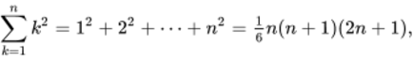
View alternative description - Uncaptioned Equation

we obtain

View alternative description - Uncaptioned Equation

as required.
Finally, since is a basic null sequence, we see that

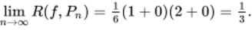
View alternative description - Uncaptioned Equation

Now try the following exercise, making use of the identity

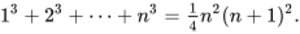
View alternative description - Uncaptioned Equation

Exercise 1

Let , where . Show that for

View alternative description - Uncaptioned Equation

we have

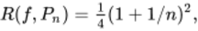
View alternative description - Uncaptioned Equation

and determine .

View answer - Exercise 1

The Riemann sums of Example 1 approximate the area under the graph of between and . The approximation improves as increases, and we expect the limiting value to actually be the area under the graph. However, to be sure that this limit gives us a sensible value, we should check that 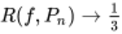 for any sequence of partitions of such that . The following important theorem, for which we omit the proof, provides this check.

Theorem 1
Let be a continuous function. Then there is a real number such that

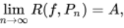
View alternative description - Uncaptioned Equation

for any sequence of partitions of such that .

We can now define the Riemann integral of a continuous function.

Definition
Let be a continuous function, where . The value determined by Theorem 1 is called the Riemann integral of over , and it is denoted by

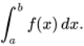
View alternative description - Uncaptioned Equation

The theorem tells us that to calculate the Riemann integral of over , we can make any choice of partitions for which and calculate . Thus the calculation of Example 1 really does demonstrate that

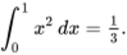
View alternative description - Uncaptioned Equation

We define the Riemann integral 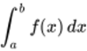 when , as follows.

Definitions
Let be a continuous real function.
If , and is contained in the domain of , then we define

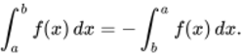
View alternative description - Uncaptioned Equation

Also, for values of in the domain of , we define

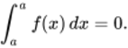
View alternative description - Uncaptioned Equation

As we have discussed, for a continuous real function that takes only positive values on , where , the Riemann integral

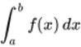
View alternative description - Uncaptioned Equation

measures the area under the graph of between and . If we no longer require to be positive, then the integral still has a geometric meaning: it measures the signed area of the set between the curve , the -axis and the vertical lines and , where we count parts of the set above the -axis as having positive area, and parts of the set below the -axis as having negative area, as illustrated in Figure 11.

Figure 11 Signed area determined by the graph of between and
View description - Figure 11 Signed area determined by the graph of y equals f of x between a and b

1.3 Properties of the Riemann integral
In practice we do not usually calculate integrals by looking at partitions, but instead use a powerful theorem known as the Fundamental Theorem of Calculus, which allows us to think of integration and differentiation as inverse processes.
To state the theorem, we need the notion of a primitive of a continuous real function ; this is a real function that is differentiable on with derivative equal to , that is, the function satisfies , for all . A primitive of a function is not unique, because if is a primitive of , then so is the function with rule , for any constant .

Theorem 2 Fundamental Theorem of Calculus
Let be a continuous function. If is a primitive of , then the Riemann integral of over exists and is given by

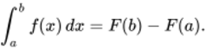
View alternative description - Uncaptioned Equation

We denote by 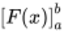.
For example, a primitive of is , so

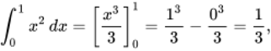
View alternative description - Uncaptioned Equation

which agrees with our earlier calculation using Riemann sums.
The Riemann integral has a number of useful properties.

Theorem 3 Properties of the Riemann integral
Let and be real functions that are continuous on the interval .
- Sum Rule 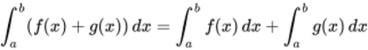.
- Multiple Rule 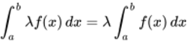, for .
- Additivity Rule

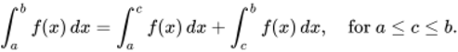
View alternative description - Uncaptioned Equation

- Substitution Rule If is differentiable on and its derivative is continuous on , and if is continuous on , then

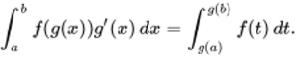
View alternative description - Uncaptioned Equation

- Integration by Parts If and are differentiable on and their derivatives and are continuous on , then

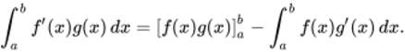
View alternative description - Uncaptioned Equation

- Monotonicity Inequality If for each , then

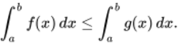
View alternative description - Uncaptioned Equation

- Modulus Inequality 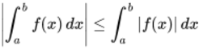.

The first five properties are probably familiar to you and we have stated them only for reference. The last two inequalities may be less familiar. The Monotonicity Inequality, illustrated in Figure 12, states that if you replace by a greater function , then the integral increases.

Figure 12 Monotonicity Inequality
View description - Figure 12 Monotonicity Inequality

The Modulus Inequality, illustrated in Figure 13, says that the modulus of the integral of over (a non-negative number) is less than or equal to the integral of the modulus of over (another non-negative number). If is positive, then these two numbers are equal, but if takes negative values, then at least part of the signed area between and the -axis is negative, so the first number is less than the second.

Figure 13 Modulus Inequality
View description - Figure 13 Modulus Inequality

Exercise 2

Use the Monotonicity Inequality and the fact that

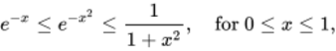
View alternative description - Uncaptioned Equation

to estimate 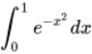 from above and below.

View answer - Exercise 2

1.4 Introducing complex integration
We come now to the central theme of this course – integrating complex functions. Informed by the discussion in the introduction, we should expect that the integral of a continuous complex function from one point to another point in the complex plane may depend on the path that we choose to take from to . So it is necessary to first choose a smooth path such that and (see Figure 14), and then we will define the integral of along this smooth path, denoting the resulting quantity by

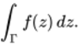
View alternative description - Uncaptioned Equation

Figure 14 A smooth path from to
View description - Figure 14 A smooth path from alpha to beta

There are two ways to achieve this goal.
One method is to imitate the approach of Section 1.2, as follows.
- Choose a partition of the path into subpaths

View alternative description - Uncaptioned Equation

determined by points , , …, , such as those illustrated in Figure 15.

Figure 15 (a) A partition of (b) A partition of the line segment from to
View description - Figure 15 (a) A partition of normal cap gamma (b) A partition of the line segment ...

- Define a complex Riemann sum

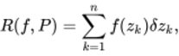
View alternative description - Uncaptioned Equation

where , for , and define

View alternative description - Uncaptioned Equation

- Define the complex integral to be

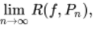
View alternative description - Uncaptioned Equation

where is any sequence of partitions of for which as .
It can be shown (although it is quite hard to do so) that this limit exists when is continuous, and that it is independent of the choice of partitions of . Thus we have defined the integral of a continuous complex function. We can then develop the standard properties of integrals, such as the Additivity Rule and the Combination Rules, by imitating the discussion of the real Riemann integral.
The second, quicker method is to define a complex integral in terms of two real integrals. To do this, we use a parametrisation of the smooth path , where and . Any set of parameter values

View alternative description - Uncaptioned Equation

yields a partition

View alternative description - Uncaptioned Equation

of , where is the subpath of that joins to , for . We can then define the complex Riemann sum

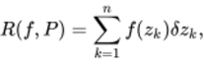
View alternative description - Uncaptioned Equation

where , for ; see Figure 16.

Figure 16 A partition of induced by the parameter values
View description - Figure 16 A partition of normal cap gamma induced by the parameter values t sub zero ...

Notice that

View alternative description - Uncaptioned Equation

Hence, if is close to , then, to a good approximation,

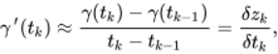
View alternative description - Uncaptioned Equation

where , so

View alternative description - Uncaptioned Equation

Thus if is small, then, to a good approximation,

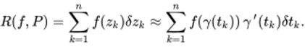
View alternative description - Uncaptioned Equation

The expression on the right has the form of a Riemann sum for the integral

(integral 1)
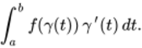
View alternative description - Uncaptioned Equation

Here the integrand

View alternative description - Uncaptioned Equation

is a complex-valued function of a real variable. We have defined integrals of only real functions so far, but if we split into its real and imaginary parts , then the integral (1) above can be written as

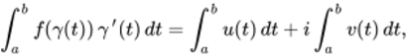
View alternative description - Uncaptioned Equation

which is a combination of two real integrals. We then define the integral of along by the formula

(formula 2)
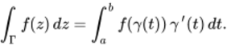
View alternative description - Uncaptioned Equation

It can be shown that both of these methods for defining the integral of a continuous complex function along a smooth path give the same value for

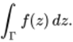
View alternative description - Uncaptioned Equation

In the next section we will develop properties of complex integrals, and there we will use the formula (2) above for the definition of the integral of a complex function along a path .

History of complex integration
The first significant steps in the development of real integration came in the seventeenth century with the work of a number of European mathematicians. Notable among this group was the French lawyer and mathematician Pierre de Fermat (1601–1665), who found areas under curves of the form , for an integer (possibly negative), using partitions and arguments involving infinitesimals.
A major breakthrough was the discovery of calculus made independently by the English mathematician and scientist Isaac Newton (1642–1727) and the German philosopher and mathematician Gottfried Wilhelm Leibniz (1646–1716). They observed that differentiation and integration are inverse processes, a fact encapsulated in the Fundamental Theorem of Calculus.
Towards the end of the eighteenth century, mathematicians began to consider integrating complex functions.
Two pioneers in this endeavour were Leonhard Euler and Pierre-Simon Laplace. They were mainly concerned with manipulating complex integrals in order to evaluate difficult real integrals such as

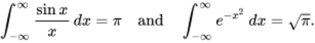
View alternative description - Uncaptioned Equation

However, it was through the work of Augustin-Louis Cauchy that complex integration began to assume the form that is now used in complex analysis. Cauchy’s first paper on complex integrals in 1814 treated complex integrals as purely algebraic objects; it was only much later that he came to properly appreciate their geometric significance.
By the mid to late nineteenth century, mathematicians began to consider how to expand the theory of integration to deal with functions that are not continuous. The first rigorous theory of integration to do this was put forward by Riemann in 1854. The Riemann integral was followed by a number of other formal definitions of integration, some equivalent to Riemann’s, and some more general, such as Lebesgue integration, named after the French mathematician Henri Lebesgue (1875–1941).

2 Integrating complex functions
After working through this section, you should be able to:
- define the integral of a continuous function along a smooth path, and evaluate such integrals
- explain what is meant by a contour, define the (contour) integral of a continuous function along a contour, and evaluate such integrals
- define the reverse contour of a given contour, and state and use the Reverse Contour Theorem.

2.1 Integration along a smooth path
Motivated by the discussion of the preceding section, we make the following definition of the integral of a complex function.

Definition
Let be a smooth path in , and let be a function that is continuous on . Then the integral of along the path , denoted by , is

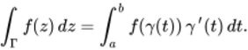
View alternative description - Uncaptioned Equation

The integral is evaluated by splitting into its real and imaginary parts and , and evaluating the resulting pair of real integrals,

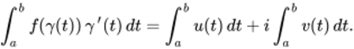
View alternative description - Uncaptioned Equation

Remarks
- Since is continuous on and is a smooth parametrisation, the functions and are both continuous on , so the function is continuous on . It follows that the real functions and are continuous on , and hence

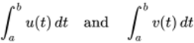
View alternative description - Uncaptioned Equation

exist, so 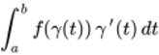 also exists.
- An important special case is when , so is the real line segment from to . Since , we see that 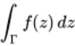 equals

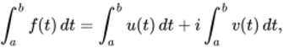
View alternative description - Uncaptioned Equation

where and . This equation is a formula for the integral of a complex function over a real interval.
- An alternative notation for is 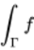.
- If the path of integration has a standard parametrisation , then, unless otherwise stated, we use in the evaluation of the integral of along .
- To help to remember the formula used to define , notice that it can be obtained by ‘substituting’

View alternative description - Uncaptioned Equation

We consider to be a shorthand for 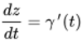.
The following examples demonstrate how to evaluate integrals along paths. In each case, we follow the convention of Remark 3 and use the standard parametrisation of the path.

Example 2
Evaluate

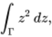
View alternative description - Uncaptioned Equation

where is the line segment from to .

Solution
Here , and we use the standard parametrisation

View alternative description - Uncaptioned Equation

of , which satisfies .
Then , so

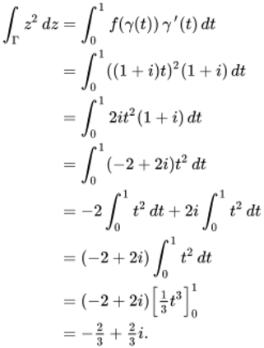
View alternative description - Uncaptioned Equation

You need not include every line of working of Example 2 if you do not need to. Here is another example.

Example 3
Evaluate

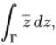
View alternative description - Uncaptioned Equation

where is the line segment from 0 to .

Solution
Here , and again we use the standard parametrisation

View alternative description - Uncaptioned Equation

of , which satisfies . Then

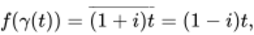
View alternative description - Uncaptioned Equation

so

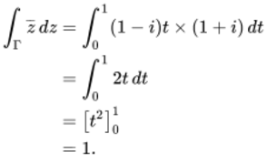
View alternative description - Uncaptioned Equation

We set out our solution to the next example using the observation and notation of Remark 4.

Example 4
Evaluate

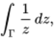
View alternative description - Uncaptioned Equation

where is the unit circle .

Solution
Here , and we use the standard parametrisation

View alternative description - Uncaptioned Equation

of . Then , and . Hence

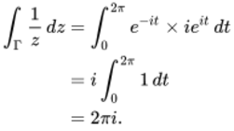
View alternative description - Uncaptioned Equation

Sometimes when evaluating integrals we will use the alternative notation of Example 4 instead of the notation of Example 2 and Example 3; both notations are commonly used in complex analysis.
In the examples above, we used the standard parametrisation in each case. The following exercise suggests that the value of the integral is not affected by the choice of parametrisation.

Exercise 3

- Verify that the result of Example 3 is unchanged if we use the smooth parametrisation

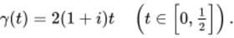
View alternative description - Uncaptioned Equation

- Verify that the result of Example 4 is unchanged if we use the smooth parametrisation

View alternative description - Uncaptioned Equation

View answer - Exercise 3

The reason why we have obtained the same values in Exercise 3 as those in Example 3 and Example 4 is because of the following theorem.

Theorem 4
Let and be two smooth parametrisations of paths with the same image set , and let be a function that is continuous on . Then

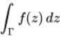
View alternative description - Uncaptioned Equation

does not depend on which parametrisation or is used.

The proof of Theorem 4 uses the Inverse Function rule and the Chain rule for the derivatives of complex functions, which are not covered within this course. So we shall omit the details of this proof.
In practical terms, this theorem allows you to choose any convenient smooth parametrisation when evaluating a complex integral along a given path. We will see how this can be helpful in the next subsection.
For further practice in integration, try the following exercise.

Exercise 4

Evaluate the following integrals.
- 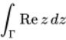, where is the line segment from 0 to .
- 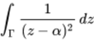, where is the circle with centre and radius .

View answer - Exercise 4

2.2 Integration along a contour
Consider the path from 0 to in Figure 17, with parametrisation given by

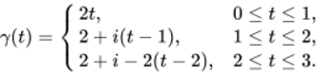
View alternative description - Uncaptioned Equation

This path is not smooth, because is not differentiable at or . However, can be split into three smooth straight-line paths, joined end to end. This leads to the idea of a contour: it is simply what we get when we place a finite number of smooth paths end to end.

Figure 17 A path from to
View description - Figure 17 A path normal cap gamma from zero to i

Definitions
A contour is a path that can be subdivided into a finite number of smooth paths joined end to end. The order of these constituent smooth paths is indicated by writing

View alternative description - Uncaptioned Equation

The initial point of is the initial point of , and the final point of is the final point of .

The definition of a contour is illustrated in Figure 18.

Figure 18 The contour
View description - Figure 18 The contour normal cap gamma equals sum with 4 summands normal cap gamma ...

As an example, the contour in Figure 17 can be written as , where , and are smooth paths with smooth parametrisations

(equation 3)
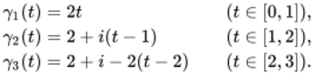
View alternative description - Uncaptioned Equation

Now, we have seen how to integrate a continuous function along a smooth path. It is natural to extend this definition to contours, by splitting the contour into smooth paths and integrating along each in turn. We formalise this idea in the following definition.

Definition
Let be a contour, and let be a function that is continuous on . Then the (contour) integral of along , denoted by 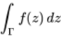, is

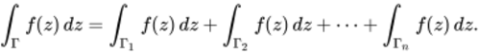
View alternative description - Uncaptioned Equation

Remarks
- It is clear that a contour can be split into smooth paths in many different ways. Fortunately, all such splittings lead to the same value for the contour integral. We omit the proof of this result, as it is straightforward but tedious.
- When evaluating an integral along a contour , we often consider each smooth path separately, using a convenient parametrisation in each case. For example, consider the contour of Figure 17. To evaluate a contour integral of the form

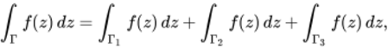
View alternative description - Uncaptioned Equation

we can use the smooth parametrisations (above) of , and , or we could use another convenient choice of parametrisations, such as

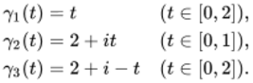
View alternative description - Uncaptioned Equation

- The alternative notation 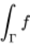 is sometimes used for contour integrals when the omission of the integration variable will cause no confusion.

Example 5
Evaluate

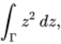
View alternative description - Uncaptioned Equation

where is the contour shown in Figure 19.

Figure 19 A contour from to
View description - Figure 19 A contour normal cap gamma from zero to one plus i

Solution
We split into two smooth paths , where is the line segment from 0 to 1 with parametrisation , and is the line segment from 1 to , with parametrisation . Then

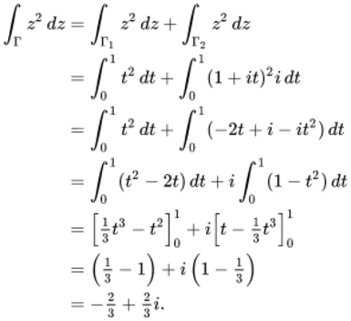
View alternative description - Uncaptioned Equation

Notice that this answer is the same as that obtained in Example 2 for

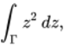
View alternative description - Uncaptioned Equation

where is the line segment from to . The reason for this will become clear when we get to Theorem 8, the Contour Independence Theorem.

Exercise 5

Evaluate

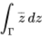
View alternative description - Uncaptioned Equation

for each of the following contours .

View description - Uncaptioned Figure

In part (b) the contour consists of a line segment and a semicircle, traversed once anticlockwise. Take to be the initial (and final) point of this contour.

View answer - Exercise 5

This section will conclude by stating some rules for combining contour integrals. To prove them, we split the contour into constituent smooth paths, and use the Sum Rule and Multiple Rule for real integration given in Theorem 3 to prove the results for each path. We omit the details.

Theorem 5 Combination Rules for Contour Integrals
Let be a contour, and let and be functions that are continuous on .
- Sum Rule 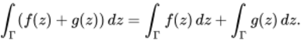
- Multiple Rule 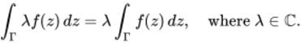

2.3 Reverse paths and contours
We now introduce the concept of the reverse path (some texts use the name opposite path) of a smooth path . This is simply the path we obtain by traversing the original path in the opposite direction, starting from the final point of the original path and finishing at the initial point of the original path. In order to define the reverse path formally, we use the fact that as increases from to , so decreases from to .

Definition
Let be a smooth path. Then the reverse path of , denoted by , is the path with parametrisation , where

View alternative description - Uncaptioned Equation

Note that the initial point of is the final point of , and the final point of is the initial point of (see Figure 20). The path is smooth because is smooth. Also note that, as sets, and are the same.

Figure 20 (a) A smooth path and (b) its reverse path
View description - Figure 20 (a) A smooth path normal cap gamma and (b) its reverse path cap gamma ...

Exercise 6

Write down the reverse path of the path with parametrisation

View alternative description - Uncaptioned Equation

View answer - Exercise 6

We can also define a reverse contour. This is done in the natural way – namely by reversing each of the constituent smooth paths of a contour and reversing the order in which they are traversed.

Definition
Let be a contour. The reverse contour of is

View alternative description - Uncaptioned Equation

A contour and its reverse contour are illustrated in Figure 21.

Figure 21 A contour and its reverse contour
View description - Figure 21 A contour sum with 3 summands normal cap gamma sub one plus normal cap ...

As an example, if is the contour from 0 to in Figure 22(a), with smooth parametrisations

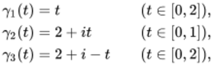
View alternative description - Uncaptioned Equation

then is the contour from to 0 in Figure 22(b), with smooth parametrisations

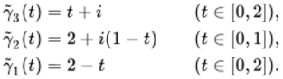
View alternative description - Uncaptioned Equation

Figure 22 (a) The contour (b) The reverse contour
View description - Figure 22 (a) The contour normal cap gamma equals sum with 3 summands normal cap ...

Example 6
Evaluate

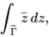
View alternative description - Uncaptioned Equation

where is the reverse path of the line segment from to .

Solution
We use the standard parametrisation

View alternative description - Uncaptioned Equation

of . For the reverse path , the corresponding parametrisation is

View alternative description - Uncaptioned Equation

Then , so we substitute

View alternative description - Uncaptioned Equation

to give

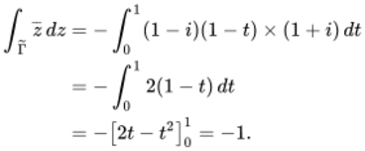
View alternative description - Uncaptioned Equation

In Example 3 we saw that

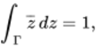
View alternative description - Uncaptioned Equation

which is the negative of the value that we obtained in Example 6. This illustrates the general result that if we integrate a function along a reverse contour , then the answer is the negative of the integral of the function along .

Theorem 6 Reverse Contour Theorem
Let be a contour, and let be a function that is continuous on . Then the integral of along the reverse contour of satisfies

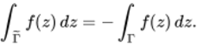
View alternative description - Uncaptioned Equation

Proof The proof is in two parts. We first prove the result in the case when is a smooth path, and then extend the proof to contours.
• Let be a smooth path. Then the parametrisation of is

View alternative description - Uncaptioned Equation

It follows that , by the Chain Rule, so

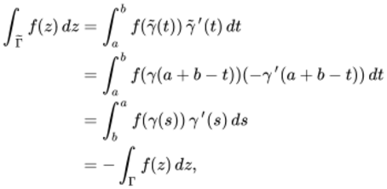
View alternative description - Uncaptioned Equation

where, in the second-to-last line, we have made the real substitution

View alternative description - Uncaptioned Equation

• To extend the proof to a general contour , we argue as follows.
Let , for smooth paths . Then

View alternative description - Uncaptioned Equation

and we can apply part (a) to see that

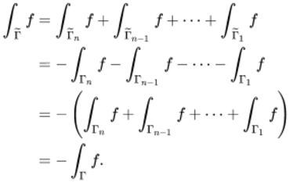
View alternative description - Uncaptioned Equation

âˆŽ

In Example 4 we saw that

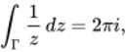
View alternative description - Uncaptioned Equation

where is the unit circle . The next exercise asks you to check Theorem 6 for this contour integral.

Exercise 7

Verify that

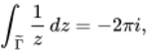
View alternative description - Uncaptioned Equation

where is the unit circle.

View answer - Exercise 7

2.4 Further exercises
Here are some further exercises to end this section.

Exercise 8

Evaluate the following integrals (using the standard parametrisation of the path in each case).
  - 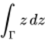,
  - 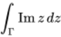,
  - 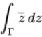,
where is the line segment from 1 to .
  - 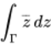,
  - 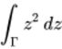,
where is the unit circle .
  - 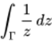,
  - 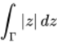,
where is the upper half of the circle with centre 0 and radius 2 traversed from 2 to .

View answer - Exercise 8

Exercise 9

Evaluate

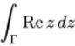
View alternative description - Uncaptioned Equation

for each of the following contours from 0 to .

View description - Uncaptioned Figure

View answer - Exercise 9

3 Evaluating contour integrals
After working through this section, you should be able to:
- state and use the Fundamental Theorem of Calculus for contour integrals
- state and use the Contour Independence Theorem
- use the technique of Integration by Parts
- state and use the Closed Contour Theorem, the Grid Path Theorem, the Zero Derivative Theorem and the Paving Theorem.

3.1 The Fundamental Theorem of Calculus
In Example 5 we saw that

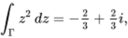
View alternative description - Uncaptioned Equation

where is the contour shown in Figure 23. Our method was to write down a smooth parametrisation for each of the two line segments, replace in the integral by these parametrisations, and then integrate.

Figure 23 A contour from to
View description - Figure 23 A contour normal cap gamma from zero to one plus i

It is, however, tempting to approach this integral as you would a corresponding real integral and write

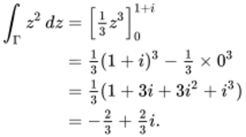
View alternative description - Uncaptioned Equation

The Fundamental Theorem of Calculus for contour integrals tells us that this method of evaluation is permissible under certain conditions. Before stating it, we need the idea of a primitive of a complex function, which is defined in a similar way to the primitive of a real function (Section 1.3).

Definition
Let and be functions defined on a region . Then is a primitive of on if is analytic on and

View alternative description - Uncaptioned Equation

The function is also called an antiderivative or indefinite integral of on .
For example, 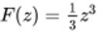 is a primitive of on , since is analytic on and , for all . Another primitive is 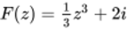; indeed, any function of the form 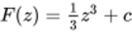, where , is a primitive of on .

Exercise 10

Write down a primitive of each of the following functions on the given region .

View answer - Exercise 10

We now state the Fundamental Theorem of Calculus for contour integrals, which gives us a quick way of evaluating a contour integral of a function with a primitive that we can determine. The theorem will be proved later in this section.

Theorem 7 Fundamental Theorem of Calculus
Let be a function that is continuous and has a primitive on a region , and let be a contour in with initial point and final point . Then

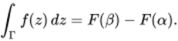
View alternative description - Uncaptioned Equation

We often use the notation

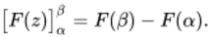
View alternative description - Uncaptioned Equation

Some texts write 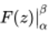 instead of 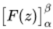.
For an example of the use of the Fundamental Theorem of Calculus, observe that if , then is continuous on and has a primitive 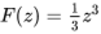 there. Hence, for the contour in Figure 23, we can write

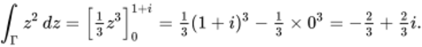
View alternative description - Uncaptioned Equation

Exercise 11

Use the Fundamental Theorem of Calculus to evaluate

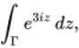
View alternative description - Uncaptioned Equation

where is the semicircular path shown in Figure 24.

Figure 24 A semicircular path from to
View description - Figure 24 A semicircular path normal cap gamma from two to negative two

View answer - Exercise 11

You have seen that

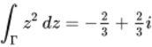
View alternative description - Uncaptioned Equation

both when is the contour in Figure 23 and also when is the line segment from to (see Example 2). This is not a coincidence: in fact, it is a particular case of the following important consequence of the Fundamental Theorem of Calculus.

Theorem 8 Contour Independence Theorem
Let be a function that is continuous and has a primitive on a region , and let and be contours in with the same initial point and the same final point . Then

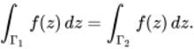
View alternative description - Uncaptioned Equation

Proof By the Fundamental Theorem of Calculus for contour integrals, the value of each of these integrals is .

The idea that a contour integral may, under suitable hypotheses, depend only on the endpoints of the contour (and not on the contour itself) has great significance.

Exercise 12

Use the Fundamental Theorem of Calculus to evaluate the following integrals.
- 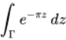, where is any contour from to .
- 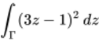, where is any contour from 2 to 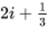.
- 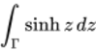, where is any contour from to 1.
- 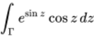, where is any contour from 0 to .
- 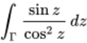, where is any contour from 0 to lying in 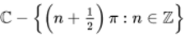.

View answer - Exercise 12

Next we give a version of Integration by Parts for contour integrals.

Theorem 9 Integration by Parts
Let and be functions that are analytic on a region , and suppose that and are continuous on . Let be a contour in with initial point and final point . Then

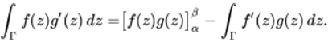
View alternative description - Uncaptioned Equation

Proof Let and . Then is continuous on , by hypothesis. Also, has primitive , since is analytic on and
View alternative description - Uncaptioned Equation
by the Product Rule for differentiation. It follows from the Fundamental Theorem of Calculus that 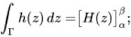
View alternative description - Uncaptioned Equation
that is, 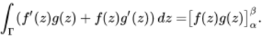
View alternative description - Uncaptioned Equation
Using the Sum Rule (Theorem 5(a)) and rearranging the resulting equation, we obtain 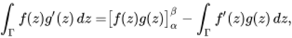
View alternative description - Uncaptioned Equation
as required. âˆŽ

Example 7
Use Integration by Parts to evaluate

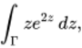
View alternative description - Uncaptioned Equation

where is any contour from to .

Solution
We take , 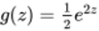 and . Then and are analytic on , and and are continuous on .
Integrating by parts, we obtain

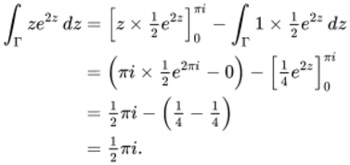
View alternative description - Uncaptioned Equation

Exercise 13

Use Integration by Parts to evaluate the following integrals.
- 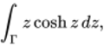 where is any contour from 0 to .
- 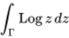, where is any contour from 1 to lying in the cut plane .
(Hint: For part (b), take and .)

View answer - Exercise 13

The Fundamental Theorem of Calculus is a useful tool when the function being integrated has an easily determined primitive . However, if the function has no primitive, or if we are unable to find one, then we have to resort to the definition of an integral and use parametrisation. For example, we cannot use the Fundamental Theorem of Calculus to evaluate

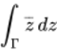
View alternative description - Uncaptioned Equation

along any contour, since the function has no primitive on any region.
To see why this is so, suppose that is a function that is defined on a region in the complex plane. We observe that if is not differentiable, then has no primitive . This is because any differentiable complex function can be differentiated as many times as we like. Thus, if has a primitive , then is differentiable with . Hence is also differentiable.
It follows that we cannot use the Fundamental Theorem of Calculus to evaluate integrals of non-differentiable functions such as

View alternative description - Uncaptioned Equation

We conclude this section by proving the Fundamental Theorem of Calculus.

ProofThe proof of the Fundamental Theorem of Calculus is in two parts. We first prove the result in the case when is a smooth path, and then extend the proof to contours.
• Let be a smooth path. Then

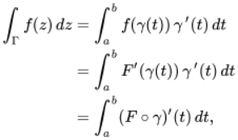
View alternative description - Uncaptioned Equation

by the Chain Rule. Now, if we write as a sum of its real and imaginary parts , then

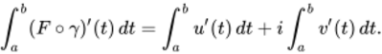
View alternative description - Uncaptioned Equation

The Fundamental Theorem of Calculus for real integrals (Theorem 2) tells us that

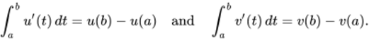
View alternative description - Uncaptioned Equation

Hence

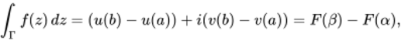
View alternative description - Uncaptioned Equation

since and .
• To extend the proof to a general contour with initial point and final point , we argue as follows.
Let , for smooth paths , and let the initial and final points of be and , for . Then

View alternative description - Uncaptioned Equation

By part (a),

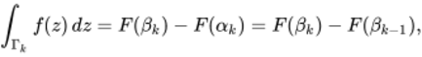
View alternative description - Uncaptioned Equation

for (where ). Hence

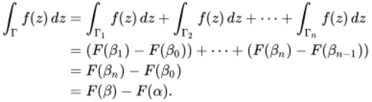
View alternative description - Uncaptioned Equation

âˆŽ

3.2 Further exercises
Here are some further exercises to end this section.

Exercise 14

For each of the following functions , evaluate

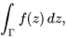
View alternative description - Uncaptioned Equation

where is any contour from to .
- 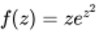

View answer - Exercise 14

Exercise 15

Evaluate the following integrals. (In each case pay special attention to the hypotheses of the theorems you use.)
- 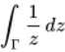,
where is the arc of the circle from to passing through 1.
- 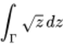, where is as in part (a).
- 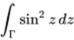, where is the unit circle .
- 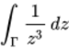, where is the circle .
(Hint: For part (c), use the identity 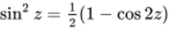.)

View answer - Exercise 15

Exercise 16

Construct a grid path from to in the domain of the function , for each of the following cases.
- ,
- 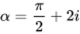, 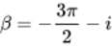

View answer - Exercise 16

4 Summary of Session 2
In this session you have seen how the idea of integration of real functions can be extended to the integration of complex functions along paths in the complex plane. You have seen the surprising result that for a continuous function the integral is independent of the precise path taken.

Course conclusion
Well done on completing this course, Introduction to complex analysis. As well as being able to understand the terms and definitions, and use the results introduced, you should also find that your skills in understanding complex mathematical texts are improving.
You should now be able to:
- use the definition of derivative to show that a given function is or is not differentiable at a point
- use the Cauchy–Riemann equations to show that a function is or is not differentiable at a point
- interpret the derivative of a complex function at a point as a rotation and a scaling of a small disc
- appreciate how complex integrals can be defined by analogy with real integrals
- define the integral of a complex function along a contour and evaluate such integrals
- state and use several key theorems to evaluate contour integrals.
This OpenLearn course is an extract from the Open University course M337 Complex analysis.

Acknowledgements
This free course was written by the Open University School of Mathematics and Statistics.
Except for third party materials and otherwise stated (see terms and conditions), this content is made available under a Creative Commons Attribution-NonCommercial-ShareAlike 4.0 Licence.
The material acknowledged below is Proprietary and used under licence (not subject to Creative Commons Licence). Grateful acknowledgement is made to the following sources for permission to reproduce material in this free course:
Images
Portrait of Jean le Rond d’Alembert (1717–1783); photographer Bonhams, London, 4 Dez 2013
Portrait of Pierre Simon Marquis de Laplace (1745-1827), by Jean-Baptiste Paulin Guérin (1783–1855); photograph: http://www.photo.rmn.fr
Every effort has been made to contact copyright owners. If any have been inadvertently overlooked, the publishers will be pleased to make the necessary arrangements at the first opportunity.
Don't miss out
If reading this text has inspired you to learn more, you may be interested in joining the millions of people who discover our free learning resources and qualifications by visiting The Open University – www.open.edu/openlearn/free-courses.

Solutions

Exercise 1

Answer
- is defined on the whole of , so let . Then

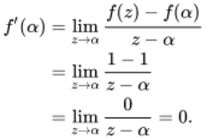
View alternative description - Uncaptioned Equation

Since is an arbitrary complex number, is differentiable on the whole of , and its derivative is the zero function

View alternative description - Uncaptioned Equation

- is defined on the whole of , so let . Then

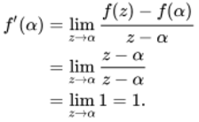
View alternative description - Uncaptioned Equation

Since is an arbitrary complex number, is differentiable on the whole of , and its derivative is the constant function

View alternative description - Uncaptioned Equation

Back to - Exercise 1

Exercise 2

Answer
The domain of is the region . Since cannot exist unless is defined at , we confine our attention to . Then

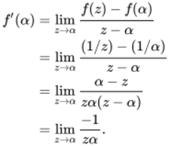
View alternative description - Uncaptioned Equation

Now is a basic continuous function with domain , so we see that

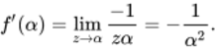
View alternative description - Uncaptioned Equation

Since is an arbitrary non-zero complex number, the derivative of is

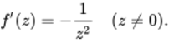
View alternative description - Uncaptioned Equation

The function is not entire since its domain is not .
Back to - Exercise 2

Exercise 3

Answer
- True.
- False. (The set must be a region.)
Back to - Exercise 3

Exercise 4

Answer
- Let . Then

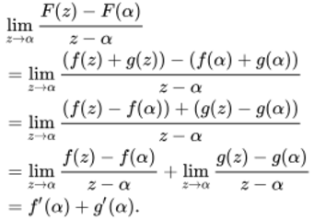
View alternative description - Uncaptioned Equation

- Let , for . Then

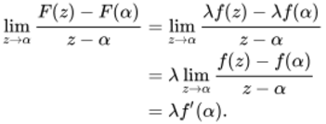
View alternative description - Uncaptioned Equation

Back to - Exercise 4

Exercise 5

Answer
- By the corollary on differentiating polynomial functions, we have

View alternative description - Uncaptioned Equation

- By the Quotient Rule,

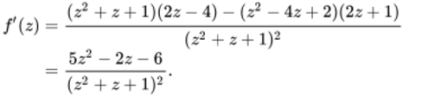
View alternative description - Uncaptioned Equation

Now, if and only if 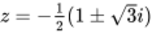, so the domain of is

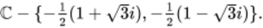
View alternative description - Uncaptioned Equation

Back to - Exercise 5

Exercise 6

Answer
The function Arg is discontinuous at each point of the negative real axis. It follows that Log is discontinuous at each point of the negative real axis, and hence that there are no points on it at which Log is differentiable.
Back to - Exercise 6

Exercise 7

Answer
Let , . Then tends to along the circumference of the circle, and

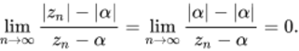
View alternative description - Uncaptioned Equation

Now let , . Then tends to along the ray from through , and

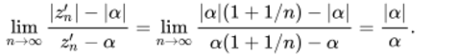
View alternative description - Uncaptioned Equation

Since for , these two limits do not agree. It follows that is not differentiable at .
Back to - Exercise 7

Exercise 8

Answer
Let be an arbitrary complex number. Directions of paths parallel to the imaginary axis through are reversed by , while directions of paths parallel to the real axis are not. This suggests looking at the sequences and , .
First let ; then

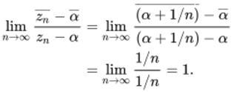
View alternative description - Uncaptioned Equation

Now let ; then

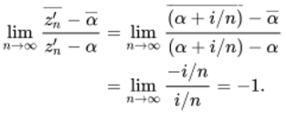
View alternative description - Uncaptioned Equation

Since these two limits do not agree, and since is arbitrary, it follows that there are no points of at which is differentiable.
Back to - Exercise 8

Exercise 9

Answer
- The fact that is constant along the imaginary axis, but variable parallel to the real axis, suggests that is not differentiable at (or anywhere else, for that matter). It also suggests looking at the sequences and , .
First let ; then

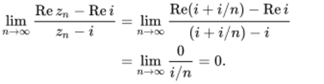
View alternative description - Uncaptioned Equation

Now let ; then

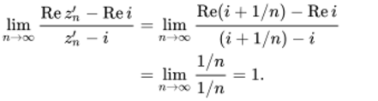
View alternative description - Uncaptioned Equation

Since these two limits do not agree, it follows that is not differentiable at .
- is a polynomial function, so for all . Thus .
- is not differentiable at , since it is not continuous at .
Back to - Exercise 9

Exercise 10

Answer
To a close approximation, a small disc centred at is mapped by to a small disc centred at

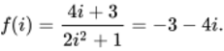
View alternative description - Uncaptioned Equation

In the process the disc is scaled by the factor and rotated through the angle .
By the Quotient Rule,

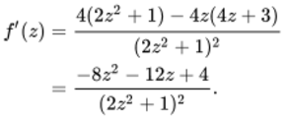
View alternative description - Uncaptioned Equation

So

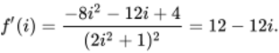
View alternative description - Uncaptioned Equation

This has modulus and principal argument .
So scales the disc by the factor and rotates it clockwise through the angle .
Back to - Exercise 10

Exercise 11

Answer
The function is defined on the whole of . Let . Then

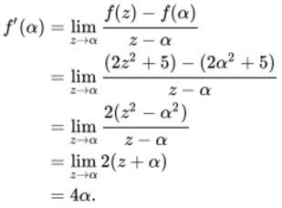
View alternative description - Uncaptioned Equation

Since is an arbitrary complex number, is differentiable on the whole of , and the derivative is the function

View alternative description - Uncaptioned Equation

Back to - Exercise 11

Exercise 12

Answer
Let . Then

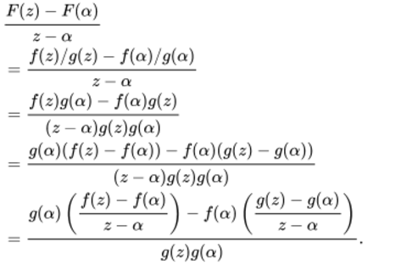
View alternative description - Uncaptioned Equation

Using the Combination Rules for limits of functions, the continuity of , and the fact that , we can take limits to obtain

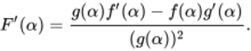
View alternative description - Uncaptioned Equation

Back to - Exercise 12

Exercise 13

Answer
- By the Combination Rules,

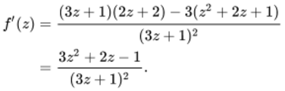
View alternative description - Uncaptioned Equation

The domain of is .
- By the Combination Rules,

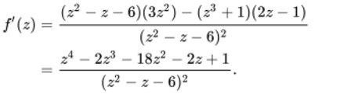
View alternative description - Uncaptioned Equation

Since , the domain of is .
- By the Reciprocal Rule,

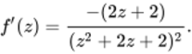
View alternative description - Uncaptioned Equation

The roots of are 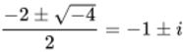. The domain of is therefore .
- By the Sum Rule and the rule for differentiating integer powers,

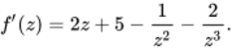
View alternative description - Uncaptioned Equation

The domain of is .
Back to - Exercise 13

Exercise 14

Answer
Consider an arbitrary complex number , where . Let , . Then , and

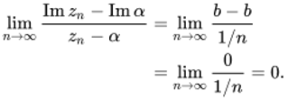
View alternative description - Uncaptioned Equation

Now let , . Then , and

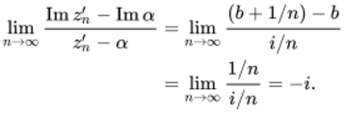
View alternative description - Uncaptioned Equation

Since the two limits do not agree, it follows that fails to be differentiable at each point of .
Back to - Exercise 14

Exercise 15

Answer
To a close approximation, a small disc centred at 2 is mapped by to small disc centred at . In the process, the disc is scaled by the factor and rotated through the angle .
By the Quotient Rule,

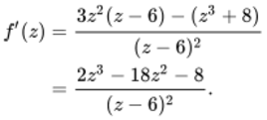
View alternative description - Uncaptioned Equation

So scales the disc by the factor 4 and rotates it anticlockwise through the angle .
Back to - Exercise 15

Exercise 16

Answer
- Differentiating with respect to while keeping fixed, we obtain

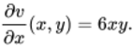
View alternative description - Uncaptioned Equation

Differentiating with respect to while keeping fixed, we obtain

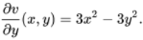
View alternative description - Uncaptioned Equation

- So, at the partial derivatives have the values

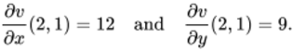
View alternative description - Uncaptioned Equation

Back to - Exercise 16

Exercise 17

Answer
- Writing in the form

View alternative description - Uncaptioned Equation

we obtain

View alternative description - Uncaptioned Equation

Hence

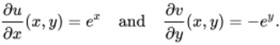
View alternative description - Uncaptioned Equation

Since is always positive, whereas is always negative, the first of the Cauchy–Riemann equations fails to hold for each . It follows that fails to be differentiable at all points of .
- Writing in the form

View alternative description - Uncaptioned Equation

we obtain

View alternative description - Uncaptioned Equation

Hence

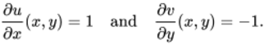
View alternative description - Uncaptioned Equation

It follows that the first of the Cauchy–Riemann equations fails to hold for each , so fails to be differentiable at all points of .
Back to - Exercise 17

Exercise 18

Answer
- From the trigonometric identities,

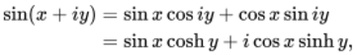
View alternative description - Uncaptioned Equation

so , where

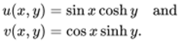
View alternative description - Uncaptioned Equation

Hence

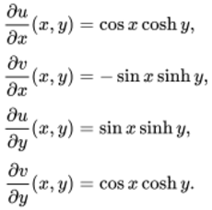
View alternative description - Uncaptioned Equation

These partial derivatives are defined and continuous on the whole of . Furthermore,

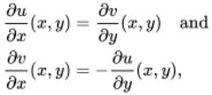
View alternative description - Uncaptioned Equation

so the Cauchy–Riemann equations are satisfied at every point of .
By the Cauchy–Riemann Converse Theorem, is entire, and

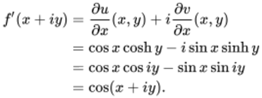
View alternative description - Uncaptioned Equation

Hence has domain and .
- Here , so

View alternative description - Uncaptioned Equation

Hence

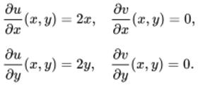
View alternative description - Uncaptioned Equation

The Cauchy–Riemann equations cannot be satisfied unless and , so fails to be differentiable at all non-zero points of .
However, the Cauchy–Riemann equations are satisfied at , and the partial derivatives are defined on and continuous (at ), so by the Cauchy–Riemann Converse Theorem, is differentiable at , and

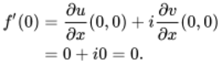
View alternative description - Uncaptioned Equation

Thus has domain and .
(This is the example referred to in Section 1.1 of a function that is differentiable at a point, but not analytic at that point.)
Back to - Exercise 18

Exercise 19

Answer
- Differentiating with respect to while keeping fixed, we obtain

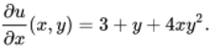
View alternative description - Uncaptioned Equation

Differentiating with respect to while keeping fixed, we obtain

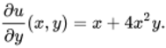
View alternative description - Uncaptioned Equation

- Here , so

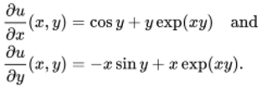
View alternative description - Uncaptioned Equation

- Here , so

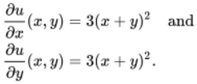
View alternative description - Uncaptioned Equation

Back to - Exercise 19

Exercise 20

Answer
- Here , so

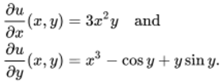
View alternative description - Uncaptioned Equation

So, at the partial derivatives have the values

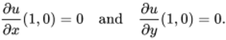
View alternative description - Uncaptioned Equation

- Here , so

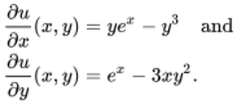
View alternative description - Uncaptioned Equation

So, at the partial derivatives have the values

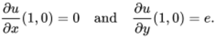
View alternative description - Uncaptioned Equation

Back to - Exercise 20

Exercise 21

Answer
Since , it follows that

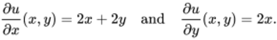
View alternative description - Uncaptioned Equation

The gradient of the graph at in the -direction is

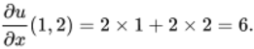
View alternative description - Uncaptioned Equation

The gradient of the graph at in the -direction is

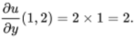
View alternative description - Uncaptioned Equation

Back to - Exercise 21

Exercise 22

Answer
Writing in the form

View alternative description - Uncaptioned Equation

we obtain

View alternative description - Uncaptioned Equation

Hence

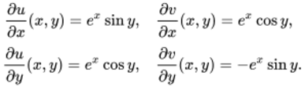
View alternative description - Uncaptioned Equation

If is differentiable at , then the Cauchy–Riemann equations require that

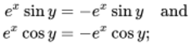
View alternative description - Uncaptioned Equation

that is,

View alternative description - Uncaptioned Equation

But is never zero, so , which is impossible. It follows that there is no point of at which is differentiable.
Back to - Exercise 22

Exercise 23

Answer
In this case,

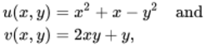
View alternative description - Uncaptioned Equation

so

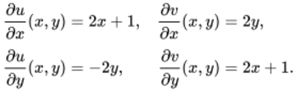
View alternative description - Uncaptioned Equation

These partial derivatives are defined and continuous on the whole of . Furthermore,

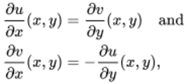
View alternative description - Uncaptioned Equation

so the Cauchy–Riemann equations are satisfied at every point of .
By the Cauchy–Riemann Converse Theorem, is entire, and

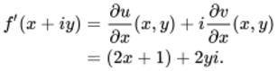
View alternative description - Uncaptioned Equation

(So , and in fact .)
Back to - Exercise 23

Exercise 24

Answer
- Here

View alternative description - Uncaptioned Equation

so

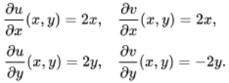
View alternative description - Uncaptioned Equation

The Cauchy–Riemann equations are satisfied only if . So cannot be differentiable at unless . Since the partial derivatives above exist, and are continuous on (and in particular when ), it follows from the Cauchy–Riemann Converse Theorem that is differentiable on the set .
On this set,

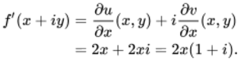
View alternative description - Uncaptioned Equation

- Here

View alternative description - Uncaptioned Equation

so

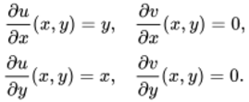
View alternative description - Uncaptioned Equation

The Cauchy–Riemann equations are not satisfied unless and . So is not differentiable except possibly at 0. Since the partial derivatives above exist, and are continuous at , it follows from the Cauchy–Riemann Converse Theorem that is differentiable at 0. Furthermore,

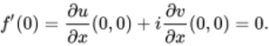
View alternative description - Uncaptioned Equation

Back to - Exercise 24

Exercise 1

Answer
Each of the subintervals of has length . Therefore

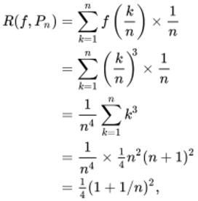
View alternative description - Uncaptioned Equation

as required.
Since is a basic null sequence, we see that

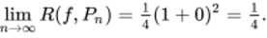
View alternative description - Uncaptioned Equation

Back to - Exercise 1

Exercise 2

Answer
Since

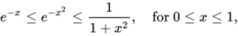
View alternative description - Uncaptioned Equation

it follows from the Monotonicity Inequality that

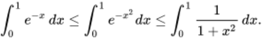
View alternative description - Uncaptioned Equation

Hence

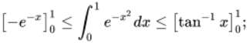
View alternative description - Uncaptioned Equation

that is,

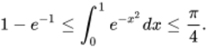
View alternative description - Uncaptioned Equation

Since and , we see that

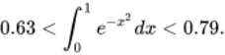
View alternative description - Uncaptioned Equation

(In fact, 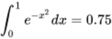 to two decimal places.)
Back to - Exercise 2

Exercise 3

Answer
- Here 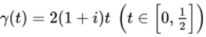. Let . Then

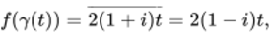
View alternative description - Uncaptioned Equation

and, since , we obtain

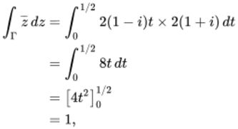
View alternative description - Uncaptioned Equation

in accordance with Example 3.
- We set out this solution in a similar style to Example 4.
Here . Then

View alternative description - Uncaptioned Equation

Hence

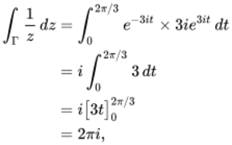
View alternative description - Uncaptioned Equation

in accordance with Example 4.
Back to - Exercise 3

Exercise 4

Answer
- The standard parametrisation of is

View alternative description - Uncaptioned Equation

Then

View alternative description - Uncaptioned Equation

Hence

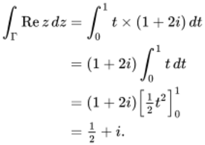
View alternative description - Uncaptioned Equation

- The standard parametrisation of is

View alternative description - Uncaptioned Equation

Then

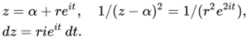
View alternative description - Uncaptioned Equation

Hence

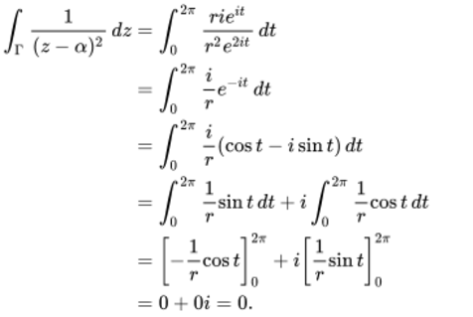
View alternative description - Uncaptioned Equation

Back to - Exercise 4

Exercise 5

Answer
- , where is the line segment from 0 to 1, is the line segment from 1 to , and is the line segment from to . We choose to use the associated standard parametrisations

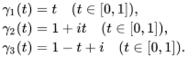
View alternative description - Uncaptioned Equation

Then , , . Hence

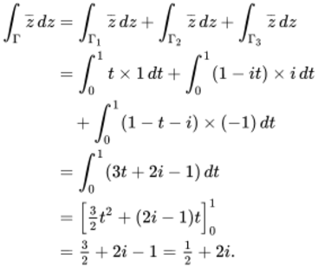
View alternative description - Uncaptioned Equation

- , where is the line segment from to 1, and is the upper half of the circle with centre 0 from 1 to . We choose to use the parametrisations

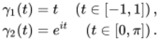
View alternative description - Uncaptioned Equation

Then , . Hence

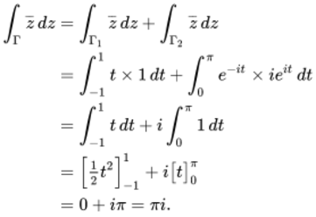
View alternative description - Uncaptioned Equation

Back to - Exercise 5

Exercise 6

Answer
Since and , the reverse path is (), where

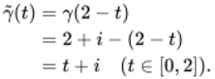
View alternative description - Uncaptioned Equation

Back to - Exercise 6

Exercise 7

Answer
In Example 4 we used the parametrisation

View alternative description - Uncaptioned Equation

For the reverse path we use the parametrisation

View alternative description - Uncaptioned Equation

Since , we have

View alternative description - Uncaptioned Equation

and . Hence

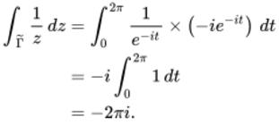
View alternative description - Uncaptioned Equation

(Therefore, by Example 4,

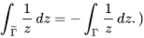
View alternative description - Uncaptioned Equation

Back to - Exercise 7

Exercise 8

Answer
- The standard parametrisation of , the line segment from 1 to , is

View alternative description - Uncaptioned Equation

hence

View alternative description - Uncaptioned Equation

  - Here , and

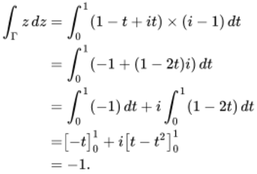
View alternative description - Uncaptioned Equation

  - Here , and

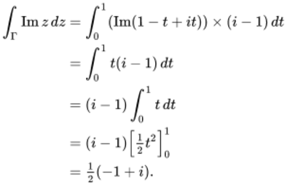
View alternative description - Uncaptioned Equation

(Note that this integral is different from 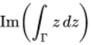, which from part (a)(i) is 0.)
  - Here , and

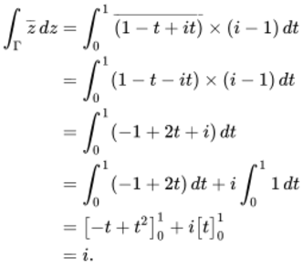
View alternative description - Uncaptioned Equation

(Again, note that this is different from 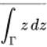.)
- We set out this solution in a similar style to Example 4.
The standard parametrisation of , the unit circle , is

View alternative description - Uncaptioned Equation

hence

View alternative description - Uncaptioned Equation

  - Here , and

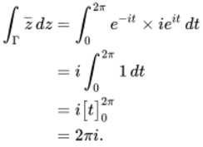
View alternative description - Uncaptioned Equation

  - Here , and

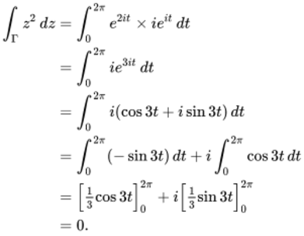
View alternative description - Uncaptioned Equation

- The standard parametrisation of , the upper half of the circle with centre 0 and radius 2, traversed from 2 to , is

View alternative description - Uncaptioned Equation

hence

View alternative description - Uncaptioned Equation

  - Here , and

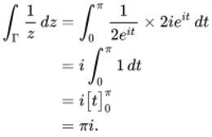
View alternative description - Uncaptioned Equation

  - Here , and

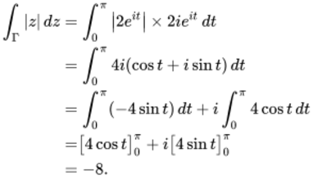
View alternative description - Uncaptioned Equation

Back to - Exercise 8

Exercise 9

Answer
- , where is the line segment from 0 to and is the line segment from to .
We choose to use the standard parametrisations

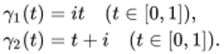
View alternative description - Uncaptioned Equation

Then , . Hence

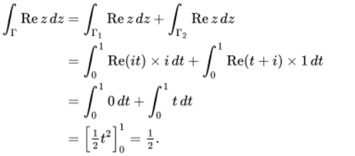
View alternative description - Uncaptioned Equation

- , where is the line segment from 0 to 1 and is the line segment from 1 to .
We choose to use the standard parametrisations

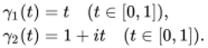
View alternative description - Uncaptioned Equation

Then , . Hence

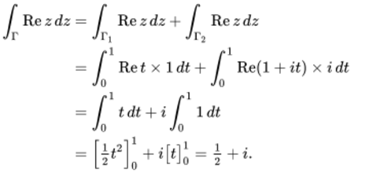
View alternative description - Uncaptioned Equation

(Note that the integrals in parts (a) and (b) have different values.)
Back to - Exercise 9

Exercise 10

Answer
- 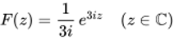
Back to - Exercise 10

Exercise 11

Answer
Let , and . Then is continuous on , and is a primitive of on . Thus, by the Fundamental Theorem of Calculus,

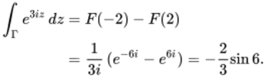
View alternative description - Uncaptioned Equation

The final simplification follows from the formula

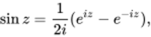
View alternative description - Uncaptioned Equation

with .
Back to - Exercise 11

Exercise 12

Answer
- Let , and . Then is continuous on , and is a primitive of on . Thus, by the Fundamental Theorem of Calculus,

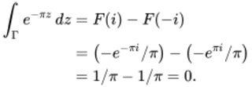
View alternative description - Uncaptioned Equation

- Let , 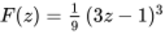 and . Then is continuous on , and is a primitive of on . Thus, by the Fundamental Theorem of Calculus,

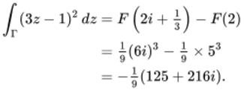
View alternative description - Uncaptioned Equation

- Let , and . Then is continuous on , and is a primitive of on . Thus, by the Fundamental Theorem of Calculus,

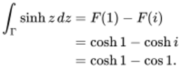
View alternative description - Uncaptioned Equation

- The integrand can be written as

View alternative description - Uncaptioned Equation

which equals by the Chain Rule. So let , and . Then is continuous on , and is a primitive of on . Thus, by the Fundamental Theorem of Calculus,

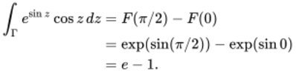
View alternative description - Uncaptioned Equation

Remark: If you have a good deal of experience at differentiating and integrating real and complex functions, then you may have chosen to write down the primitive of straight away.
- The integrand can be written as

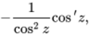
View alternative description - Uncaptioned Equation

which equals

View alternative description - Uncaptioned Equation

So let

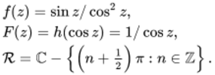
View alternative description - Uncaptioned Equation

Then is continuous on , and is a primitive of on . Thus, by the Fundamental Theorem of Calculus,

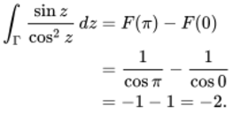
View alternative description - Uncaptioned Equation

(In this solution, note that the region does not contain the point , as ; thus cannot be chosen to be a path that contains . In particular, the real integral 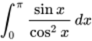 does not exist.)
Back to - Exercise 12

Exercise 13

Answer
- We take , and .
Then and are analytic on , and and are continuous on .
Integrating by parts, we obtain

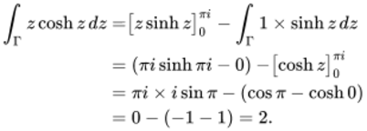
View alternative description - Uncaptioned Equation

- We take , and . Then and are analytic on , and and are continuous on .
Integrating by parts, we obtain

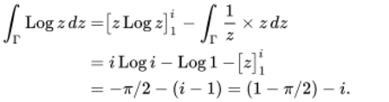
View alternative description - Uncaptioned Equation

Back to - Exercise 13

Exercise 14

Answer
In each case, is continuous on and has a primitive on , so we can apply the Fundamental Theorem of Calculus to evaluate the integral using any contour from to .
- 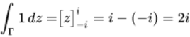
- 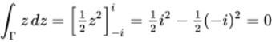
- 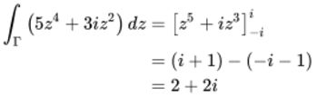
- 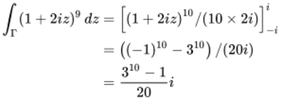
- 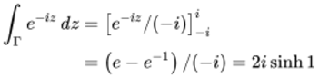
- 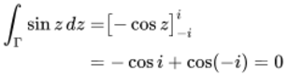
- A primitive of 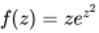 is

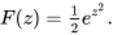
View alternative description - Uncaptioned Equation

Hence

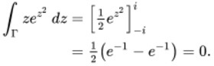
View alternative description - Uncaptioned Equation

- A primitive of is

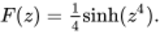
View alternative description - Uncaptioned Equation

Hence

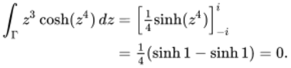
View alternative description - Uncaptioned Equation

- Let , . Then and are entire (that is, and are differentiable on the whole of ), and and are entire and hence continuous. Then, using Integration by Parts (Theorem 9), we have

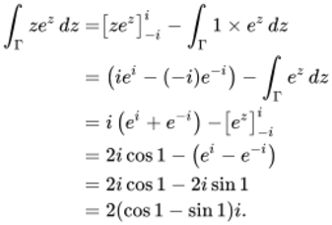
View alternative description - Uncaptioned Equation

Back to - Exercise 14

Exercise 15

Answer
- Let , and . Then is continuous on , is a primitive of on , and is a contour in . Thus, by the Fundamental Theorem of Calculus,

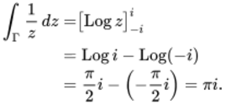
View alternative description - Uncaptioned Equation

- Let , 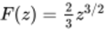 and . Then is continuous on , is a primitive of on , and is a contour in . Thus, by the Fundamental Theorem of Calculus,

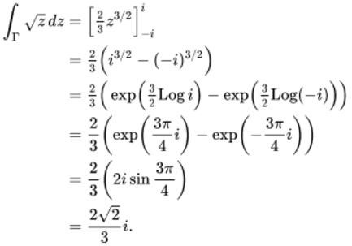
View alternative description - Uncaptioned Equation

- The function

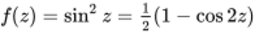
View alternative description - Uncaptioned Equation

is continuous and has an entire primitive 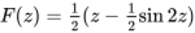. Thus, by the Closed Contour Theorem,

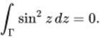
View alternative description - Uncaptioned Equation

- Let , and . Then is continuous on , is a primitive of on , and is a contour in . Thus, by the Closed Contour Theorem,

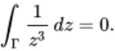
View alternative description - Uncaptioned Equation

Back to - Exercise 15

Exercise 16

Answer
The domain of is the region

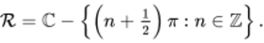
View alternative description - Uncaptioned Equation

- The figure shows one grid path in from 1 to 6 (there are many others).

View description - Uncaptioned Figure

- The figure shows one grid path in from 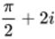 to 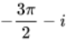 (again, there are many others).

View description - Uncaptioned Figure

Back to - Exercise 16

Figure 1 A chord between two points on a graph

Description
The figure shows Cartesian axes labelled x and y. It is focused on the upper-right quadrant. A smooth curve that looks like part of the graph of a quadratic function with positive coefficient of x-squared starts in the upper-left quadrant a little above the x-axis and a little to the left of the y-axis. At this point it is nearly horizontal. As x increases the curve slopes upwards with steadily increasing gradient. A line with positive gradient also starts in the upper-left quadrant, below the curve, and slopes upwards into the upper-right quadrant. The curve and the line intersect at two points in the upper-right quadrant, both of which are marked with solid dots. The coordinates of these points are illustrated by vertical and horizontal broken line segments joining each point to the x and y axes. From the lower point of intersection, the vertical broken line segment crosses the x-axis at a point marked c. The horizontal broken line segment crosses the y-axis at a point marked f of c. From the upper point of intersection, the vertical broken line segment crosses the x-axis at a point marked x. The horizontal broken line segment crosses the y-axis at a point marked f of x. From the lower point of intersection a horizontal line segment is drawn to the right. It meets a vertical line segment that extends downwards from the upper point of intersection. They form a right-angled triangle with a segment of the original sloping line as its hypotenuse. The length of the horizontal side of this triangle is marked x minus c. The length of its vertical side is marked f of x minus f of c.
Back to - Figure 1 A chord between two points on a graph

Figure 2 Graph of y equals absolute value of x

Description
The figure shows Cartesian axes labelled x and y. It is focused on the upper half-plane. The graph of the function y equals the modulus of x is drawn and labelled. In the upper-left quadrant the graph is a line sloping down with gradient negative 1 to the origin. In the upper-right quadrant the graph is a line sloping up with gradient 1 from the origin.
Back to - Figure 2 Graph of y equals absolute value of x

Figure 3 Three regions on which f of z equals one solidus z is analytic

Description
This figure consists of three copies of the complex plane arranged side by side, from left to right. The axes are not labelled. Each of the three diagrams has a different region, bounded by broken lines or curves, and shaded inside. The left-hand diagram shows a horseshoe-shaped region symmetrical about the vertical axis; the boundary of the shape is drawn as a broken line. The arms of the horseshoe are pointing down and they straddle the horizontal axis. The open end of the horseshoe is at the bottom, so that the origin is not inside the region. The middle diagram shows an open annulus, and both of its boundaries are drawn as broken lines. It consists of the area between two concentric circles, centred at the origin. The right-hand diagram shows a square region centred on the origin, with two vertical and two horizontal sides; its boundaries are drawn as broken lines. It is symmetrical about both axes. The origin itself is marked with a hollow dot.
Back to - Figure 3 Three regions on which f of z equals one solidus z is analytic

Figure 4 Sequences converging to zero from the right and left

Description
This figure consists of two copies of the complex plane, one above the other. The upper copy shows on the positive real axis a sequence of points that approach zero from the right. The origin is labelled zero and marked with a solid blue dot. The point 1 is labelled, and the first three points in the sequence, starting with 1, are marked with solid black dots. An ellipsis to the left of the third point (one third) indicates that the sequence continues indefinitely getting closer to zero. A horizontal arrow above the real axis, between zero and 1, points from right to left. Above it is the label, open bracket, z sub n, close bracket. The lower copy of the complex plane shows on the negative real axis a sequence of points that approach zero from the left. The origin is labelled zero and marked with a solid blue dot. The point negative 1 is labelled, and the first three points in the sequence, starting with negative 1, are marked with solid black dots. An ellipsis to the right of the third point (negative one third) indicates that the sequence continues indefinitely getting closer to zero. A horizontal arrow above the negative real axis, between negative 1 and zero, points from left to right. Above it is the label, open bracket, z prime sub n, close bracket.
Back to - Figure 4 Sequences converging to zero from the right and left

Uncaptioned Figure

Description
This figure consists of two copies of the complex plane, arranged side by side. The axes are not labelled. The left-hand copy shows a circle centred at the origin. An arbitrary point on the circle in the upper-right quadrant is labelled alpha and marked with a solid blue dot. A sequence of points on the circumference starts in the upper-left quadrant and approaches the point alpha at decreasing intervals. The first four points in the sequence are marked with solid black dots. An ellipsis between the fourth point and the point alpha indicates that the sequence of points continues indefinitely getting closer to alpha. Above the sequence of points is a curved arrow pointing from left to right. It is labelled: open bracket, z sub n, close bracket. The right-hand copy of the complex plane shows the same circle centred at the origin, and the same arbitrary point alpha on the circle is labelled and marked with a solid blue dot. A sequence of points outside the circle approaches the point alpha at decreasing intervals along the normal to the circle at alpha. The first three points in the sequence are marked with solid black dots. An ellipsis between the third point and the point alpha indicates that the sequence of points continues indefinitely getting closer to alpha. An arrow directed towards alpha is drawn outside the circle parallel to the sequence of points. It is labelled: open bracket, z prime sub n, close bracket.
Back to - Uncaptioned Figure

Figure 5 Images of horizontal and vertical lines under f of z equals z macron

Description
This figure consists of two copies of the complex plane, arranged side by side. The axes are not labelled. On the left-hand diagram, a bold vertical line, drawn in black, passes through an arbitrary point on the positive horizontal axis. It is marked with a direction arrow pointing upwards, and labelled capital gamma sub 1. A bold horizontal line, drawn in blue, passes through an arbitrary point on the positive vertical axis. It is marked with a direction arrow pointing to the right, and labelled capital gamma sub 2. The two bold lines intersect at right angles in the upper-right quadrant. Between the two copies of the complex plane is a curved horizontal arrow pointing from left to right. It is labelled f of z equals z bar. On the right-hand diagram, a bold vertical line, drawn in black, passes through the same arbitrary point on the positive horizontal axis. It is marked with a direction arrow pointing downwards, and labelled f of capital gamma sub 1. A bold horizontal line, drawn in blue, passes through a point on the negative vertical axis. (This point is the same distance below the origin as the point used on the vertical axis in the left-hand diagram was above it.) The horizontal line is marked direction arrow pointing to the right, and labelled f of capital gamma sub 2. The two bold lines intersect at right angles in the lower-right quadrant.
Back to - Figure 5 Images of horizontal and vertical lines under f of z equals z macron

Figure 6 Scaling and rotating z minus alpha

Description
This figure consists of a diagram of the complex plane, focused on the right half-plane. The axes are not labelled. A line segment extends from the origin to a point in the lower-right quadrant. The point is marked with a solid dot and labelled z minus alpha. A second line segment extends from the origin to a point in the upper-right quadrant. The second line segment is longer than the first. Above it is the text, scale by the modulus of f prime of alpha. The point at the end of the second line segment is marked with a solid dot and labelled f prime of alpha times open bracket, z minus alpha, close bracket. A curved arrow between the two line segments points in the anticlockwise direction. Next to it is the text, rotate by Arg f prime of alpha.
Back to - Figure 6 Scaling and rotating z minus alpha

Figure 7 Interpreting a derivative as a complex scale factor

Description
This figure consists of two copies of the complex plane side by side, both focused on the upper-right quadrant. The axes are not labelled. On the left-hand diagram there are two points in the upper-right quadrant, alpha marked with a solid black dot and z marked with a solid blue dot. The point z lies to the right of the point alpha and a little below it. The vector from alpha to z is drawn as a solid blue line with an arrowhead. Between the left-hand and right-hand diagrams is a curved arrow pointing from left to right and labelled f. On the right-hand diagram, three points are marked with solid dots. The first, which is the closest to the origin, is drawn in black labelled f of alpha. The second, also in black, lies above and to the right of the first point, and is labelled f of z. The third point, drawn in blue, lies to the right and a little below the point labelled f of alpha. It is not labelled. Two vectors are also shown, both starting from the point f of alpha. The first vector, drawn in blue, runs from the point f of alpha to the unlabelled blue point. It is an identical copy of the vector from alpha to z that was drawn in the left-hand diagram. The second vector, drawn in black, starts at the point f of alpha and finishes at the point f of z. Above this second vector is the text, scale by the modulus of f prime of alpha. Between the two vectors is a curved arrow, pointing in the anticlockwise direction. Next to it is the text, rotate by Arg f prime of alpha.
Back to - Figure 7 Interpreting a derivative as a complex scale factor

Figure 8 The approximate image of a disc centred at a point alpha, where f super prime of alpha not equals zero

Description
This figure consists of two copies of the complex plane side by side, both focused on the upper-right quadrant. The axes are not labelled. On the left-hand diagram a point in the upper-right quadrant is marked with a solid black dot and labelled alpha. A small circular disc is drawn with alpha as its centre and a solid black circle as its boundary. Inside the disc a second point, a little to the right and below the point alpha, is marked with a solid green dot. It is labelled z. The disc is shaded blue. Between the left-hand and right-hand diagrams is a curved arrow pointing from left to right. Above it is the label f. On the right-hand diagram the point f of alpha is marked with a solid black dot and labelled. A circular disc is drawn with the point f of alpha as its centre and a solid black circle as its boundary. This disc has radius approximately 50% greater than the radius of the disc surrounding the point alpha in the left-hand diagram. Inside the disc a second point, above and to the right of the point f of alpha, is marked with a solid green dot and labelled f of z. The disc is shaded blue. Outside the disc, above it and slightly to the left, is the text, scale by the modulus of f prime of alpha. Outside the disc, diametrically opposite the first text, is a curved arrow parallel to the circular boundary of the disc, which points in an anticlockwise direction. Next to it is the text, rotate by Arg f prime of alpha.
Back to - Figure 8 The approximate image of a disc centred at a point alpha, where f super prime of alpha not equals zero

Figure 9 Graph of u of x comma y equals x cubed minus three times x times y squared

Description
The figure consists of a perspective drawing of a three-dimensional set of Cartesian axes with a smooth surface sketched on it. The complex plane is drawn as horizontal, with axes labelled x and y. The x-axis points out of the page and to the left and the y-axis points out of the page and to the right from the origin. The vertical axis is labelled s. A smooth surface shaded darker on top and lighter underneath starts like a sheet with the top edge attached along the y-axis. At this point it is flat. As the x-coordinate increases, the surface rises up in a saddle shape above the x-axis, and dips down on either side. The vertical cross-section of the surface parallel to the s-y plane is shaped like an inverted parabola, symmetrical about a vertical line through the x-axis. On the surface a point is marked with a solid dot and labelled with its coordinates: capital P equals, open bracket, 2 comma 1 comma 2, close bracket.
Back to - Figure 9 Graph of u of x comma y equals x cubed minus three times x times y squared

Figure 10 Intersection of the graph of u of x comma y equals x cubed minus three times x times y squared with the vertical plane y equals one

Description
This figure is identical to Figure 9, except for the addition of a vertical plane, parallel to the x-axis and intersecting the curved surface. It consists of a perspective drawing of a three-dimensional set of Cartesian axes with a smooth surface sketched on it. The complex plane is drawn as horizontal, with axes labelled x and y. The x-axis points to the left and the y-axis to the right from the origin. The vertical axis is labelled s. A smooth surface shaded darker on top and lighter underneath starts like a sheet with the top edge attached along the y-axis. At this point it is flat. As the x-coordinate increases, the surface rises up in a saddle shape above the x-axis, and dips down on either side. The vertical cross-section of the surface parallel to the s-y plane is shaped like an inverted parabola, symmetrical about a vertical line through the x-axis. On the surface a point is marked with a solid dot and labelled with its coordinates: capital P equals, open bracket, 2 comma 1 comma 2, close bracket. The vertical plane is shaded red, and labelled with its equation, y equals 1. A curve is drawn on the surface to show where the surface intersects the plane. It passes through the point marked P.
Back to - Figure 10 Intersection of the graph of u of x comma y equals x cubed minus three times x times y squared with the vertical plane y equals one

Figure 11 Intersection of the graph of u of x comma y equals x cubed minus three times x times y squared with the vertical plane x equals two

Description
This figure is identical to Figure 9, except for the addition of a vertical plane, parallel to the y-axis and intersecting the curved surface. It consists of a perspective drawing of a three-dimensional set of Cartesian axes with a smooth surface sketched on it. The complex plane is drawn as horizontal, with axes labelled x and y. The x-axis points to the left and the y-axis to the right from the origin. The vertical axis is labelled s. A smooth surface shaded darker on top and lighter underneath starts like a sheet with the top edge attached along the y-axis. At this point it is flat. As the x-coordinate increases, the surface rises up in a saddle shape above the x-axis, and dips down on either side. The vertical cross-section of the surface parallel to the s-y plane is shaped like an inverted parabola, symmetrical about a vertical line through the x-axis. On the surface a point is marked with a solid dot and labelled with its coordinates: capital P equals, open bracket, 2 comma 1 comma 2, close bracket. The vertical plane is shaded red, and labelled with its equation, x equals 2. A curve is drawn on the surface to show where the surface intersects the plane. It passes through the point marked P.
Back to - Figure 11 Intersection of the graph of u of x comma y equals x cubed minus three times x times y squared with the vertical plane x equals two

Jean le Rond d’Alembert (1717–1783)

Description
This figure shows the image of Jean le Rond d’Alembert. It is a head and shoulders shot with him looking to the right of the viewer.
Back to - Jean le Rond d’Alembert (1717–1783)

Uncaptioned Figure

Description
This figure shows the first partial derivatives of u and v with respect to x and y, shown in a two by two grid. Top left: partial derivative of u of x and y with respect to x equals two times x. Bottom left: partial derivative of u of x and y with respect to y equals two times y. Top right: partial derivative of v of x and y with respect to x equals two. Bottom right: partial derivative of v of x and y with respect to y equals four. The partial derivatives of u with respect to x and that of v with respect to y are grouped in a bubble, as are the partial derivatives of u with respect to y and that of v with respect to x.
Back to - Uncaptioned Figure

Figure 12 Graph of u

Description
This figure consists of a perspective drawing of a three-dimensional set of Cartesian axes. The complex plane is drawn as horizontal, with axes labelled x and y. On the page, the x-axis slopes up and to the right in the positive direction, while the y-axis slopes up and to the left. The third axis is drawn as vertical on the page and is labelled s. It is used to represent the value of the real-valued function u, defined in the text, for each pair of values of x and y. The surface corresponding to the graph of the function u is shaded on the diagram. In the upper-left, lower-left and lower-right quadrants of the x-y plane, the function u takes the value zero, so the x y plane itself is shaded in these quadrants. In the upper-right quadrant, the value of the function at each point on the x-y plane is the minimum of the x and y coordinates of the point. The surface corresponding to the graph in the upper-right quadrant looks a little like a square pyramid, with the origin at one corner of its base, and one of its slant edges sloping up from the origin at an angle of 45 degrees, above the line y equals x on the x-y plane. To emphasise this shape, the slanting face of the pyramid that slopes up from the y-axis is shaded darker than the slanting face that slopes up from the x-axis.
Back to - Figure 12 Graph of u

Figure 13 Graph of the real function f

Description
This figure consists of a pair of Cartesian axes, labelled x and y. The diagram is focused on the upper-right quadrant. A curve representing part of the graph of an arbitrary real function f of x is drawn. (Actually, to facilitate the comprehensibility of the diagram, the graph is drawn to look like part of a cubic curve. It starts with positive gradient, then as x increases it reaches a local maximum, slopes down to a local minimum, and then slopes up again.) Three points are marked on the positive x-axis, labelled, from left to right, a, c and x. From each of these points a broken vertical line extends upwards to meet the curve. The three points where these three broken vertical lines meet the curve are marked with filled dots. The dot on the curve that lies above the point c on the x-axis is labelled with its coordinates, open bracket, c comma f of c, close bracket. This point is close to the local maximum of the graph. Through the point a line is drawn, tangent to the curve. A line segment is also drawn joining the other two points marked with dots on the curve (the points on the curve above the points a and x on the x-axis). This line segment is parallel to the tangent at c.
Back to - Figure 13 Graph of the real function f

Figure 14 Tangent plane to the graph of u at the point cap p

Description
The figure consists of a perspective drawing of a three-dimensional set of axes. The two axes in the horizontal plane are labelled x and y. The x-axis points out of the page and to the right; the y-axis points into the page and to the right. The vertical axis is labelled s. The diagram is focused on the section where x, y and s are all positive. The graph of the function u is shown as a convex curved surface shaded blue. The surface is labelled s equals u bracket x comma y close bracket. A point capital P is marked on the surface, and the tangent plane to the surface at the point capital P is shaded in red.
Back to - Figure 14 Tangent plane to the graph of u at the point cap p

Figure 15 Vertical and horizontal line segments from left parenthesis a comma b right parenthesis to open x comma y close

Description
The figure consists of a circle and two joined line segments. The centre of the circle is marked with a solid dot. This point is labelled with its coordinates, open bracket, a comma b, close bracket. A vertical line segment extends upwards from the centre of the circle, reaching about two-thirds of the way to the circumference. A point half-way up the line segment is marked with a solid dot, and labelled with its coordinates, open bracket, a comma s, close bracket. Another point at the top end of the vertical line segment is also marked with a solid dot, and labelled with its coordinates, open bracket, a comma y, close bracket. From this point at the top of the vertical line segment, a horizontal line segment extends to the right, reaching close to the circumference but remaining inside the circle. Half-way along it, a point is marked with a solid dot, and labelled with coordinates, open bracket, r comma y, close bracket. At the right-hand end of the horizontal line segment, a point is marked with a solid dot, and labelled with coordinates, open bracket, x comma y, close bracket.
Back to - Figure 15 Vertical and horizontal line segments from left parenthesis a comma b right parenthesis to open x comma y close

Pierre-Simon Laplace (1749–1827)

Description
This figure is a full-length portrait of Laplace as an older man, painted as a tribute after his death by the well-known contemporary artist Jean-Baptiste Paulin Guérin. Laplace is standing richly attired, clean-shaven, and wears a short white wig. At his side is a ceremonial sword, and round his shoulders a sumptuous velvet cloak. Some medals are visible on his chest, and in his right hand he is holding a velvet hat trimmed with fur. In the background are a pedestal with a classical bust, perhaps of a Greek goddess, and a table with a globe, a pair of compasses and some papers, presumably mathematical.
Back to - Pierre-Simon Laplace (1749–1827)

Figure 1 Area under the graph of y equals x squared between a and b

Description
The figure shows Cartesian axes labelled x and y and is concentrated in the upper-right quadrant. The graph of y equals x squared is drawn and labelled. Points a and b are labelled on the positive x-axis with a being nearer the origin. The line joining these two points on the x-axis is a bold line. The two points have vertical lines drawn to meet the parabola y equals x squared. The area under the graph and above the positive x-axis is shaded.
Back to - Figure 1 Area under the graph of y equals x squared between a and b

Figure 2 Line segment normal cap gamma from alpha to beta

Description
The figure shows the complex plane with unlabelled axes and concentrated in the upper half-plane. There is a point alpha in the upper-left quadrant marked with a solid dot and a point beta in the upper-right quadrant also marked with a solid dot. The point beta is higher than alpha and further to the right than alpha is to the left of the origin. A bold line joins the two points and is marked with an arrow in the direction from alpha to beta and is labelled capital gamma.
Back to - Figure 2 Line segment normal cap gamma from alpha to beta

Figure 3 Contour with initial point alpha and final point beta coinciding

Description
The figure shows the complex plane with unlabelled axes. There is a closed contour with irregular shape marked with an arrow in an anticlockwise direction and labelled capital gamma. The contour covers all four quadrants and has the point alpha equals beta marked with a solid dot.
Back to - Figure 3 Contour with initial point alpha and final point beta coinciding

Figure 4 Circular paths normal cap gamma sub one and normal cap gamma sub two

Description
The figure shows the complex plane with unlabelled axes. There are two circles drawn both with radius 1. The first is in the upper-right quadrant with centre 1 plus i. and is labelled with an arrow in an anticlockwise direction marked as capital gamma sub 1. The second has the origin as its centre and is labelled with an arrow in an anticlockwise direction marked as capital gamma sub 2. The points i and 1 are marked as solid dots and both circles pass through these points.
Back to - Figure 4 Circular paths normal cap gamma sub one and normal cap gamma sub two

Figure 5 Area under the graph of y equals f of x between a and b

Description
The figure shows the Cartesian axes labelled x and y concentrated in the upper-right quadrant. There is an arbitrary curve labelled y equals f of x contained inside the upper-right quadrant with one local maximum point and one local minimum point and the curve gradually rising bottom left to top right. There are points a and b marked on the positive x-axis with a being closer to the origin. These points are joined by a bold line. Vertical lines join the points a and b to the curve and the area between the curve and above the positive x-axis is shaded.
Back to - Figure 5 Area under the graph of y equals f of x between a and b

Figure 6 Interval open a comma b close split into subintervals

Description
The figure shows a single horizontal axis labelled x. The points a and b are marked with a being on the left and b on the right. The interval a to b is split into five irregular subintervals. A horizontal brace is drawn beneath the axis and connects a and b; there is a label that says subintervals of open-square-bracket a comma b close-square-bracket.
Back to - Figure 6 Interval open a comma b close split into subintervals

Figure 7 (a) An underestimate (b) An overestimate

Description
The figure is in two parts: (a) and (b). Each part shows a set of Cartesian axes labelled x and y and focuses on the upper-right quadrant. Both parts have the same curve labelled y equals f of x which is a curve going through the origin from the lower-left quadrant but concentrated mainly in the upper-right quadrant and it has two local maximum points and one local minimum. In both parts the points a and b are marked on the positive x-axis with a being nearer the origin. A bold line joins the points a and b. There are five irregular subintervals shown as rectangles and shaded. Part (a) has the top of each shaded rectangle touching the graph from below. Part (b) has the top of each shaded rectangle touching the graph from above.
Back to - Figure 7 (a) An underestimate (b) An overestimate

Figure 8 Area under the graph of y equals f of x between a and b

Description
The figure shows a set of Cartesian axes labelled x and y concentrated mainly in the upper-right quadrant. The graph of y equals f of x is shown and it passes through the origin from the lower-left quadrant and has two local maximum points and one local minimum. There are points a and b marked on the positive x-axis and joined by a bold line with the point a nearer the origin. Vertical lines join the points a and b to the curve and the area between the graph and the positive x-axis is shaded.
Back to - Figure 8 Area under the graph of y equals f of x between a and b

Figure 9 Approximating the area under a graph using a sequence of rectangles

Description
The figure shows a set of Cartesian axes labelled x and y concentrated mainly in the upper-right quadrant. The graph of y equals f of x is shown which passes through the origin from the lower-left quadrant and has two local maximum points and one local minimum. The points x sub zero equals a is marked on the positive x-axis and is close to the origin. The point x sub one is marked on the positive x-axis and is further from the origin. The point x sub n equals b is marked on the positive x-axis and is further away still. There is an ellipses shown on the positive x-axis to demonstrate the sequence x sub zero to x sub n. There are five consecutive touching rectangles under the curve which have base along the horizontal axis. The base of the first rectangle goes from x sub 0 to x sub1 and its height is from x sub 1 to the curve of y equals f of x. The subsequent four rectangles each have arbitrary width and height which is determined by the right-hand side of the rectangle intersecting the curve. The final rectangle’s right-hand side is at x sub n.
Back to - Figure 9 Approximating the area under a graph using a sequence of rectangles

Figure 10 Rectangle of height f of x sub k and width delta times x sub k

Description
The figure shows a horizontal line with points x sub k minus 1 and point x sub k marked. The distance between the two points is marked with a double-ended arrow as delta x sub k. and creates the base of a shaded rectangle. Part of the curve y equals f of x is shown and a vertical line from the point x sub k meets the curve and this represents the height of the rectangle. The height of the rectangle is labelled with a double-ended arrow as f of x sub k.
Back to - Figure 10 Rectangle of height f of x sub k and width delta times x sub k

Figure 11 Signed area determined by the graph of y equals f of x between a and b

Description
The figure shows a set of Cartesian axes labelled x and y concentrated in the upper-right and lower-right quadrants. A curve of y equals f of x is labelled. There are points a and b labelled on the positive x-axis with a being nearer the origin. The curve starts in the lower-right quadrant below the positive x-axis directly below the point a, it continues to a local maximum point in the upper-right quadrant and continues to the lower-right quadrant to finish at a point directly below the point b below the positive x-axis. The areas between the curve and the positive x-axis are shaded. The area between the point a and where the curve crosses from the lower-right to the upper-right quadrant is shaded below the positive x-axis and labelled with a minus sign, similarly so too is the area between where the curve crosses back from the upper-right to the lower-right quadrant to the point b. The area above the positive x-axis is shaded and labelled with a plus sign.
Back to - Figure 11 Signed area determined by the graph of y equals f of x between a and b

Figure 12 Monotonicity Inequality

Description
The figure shows a set of Cartesian axes labelled x and y concentrated in the upper-right quadrant. There are points a and b labelled on the positive x-axis with a being nearer the origin. An arbitrary curve labelled y equals g of x slopes down from left to right and another arbitrary curve labelled y equals f of x is below the first curve but this one has a shallow local minimum and maximum. Both curves start and finish at point directly above the points labelled a and b. The area under g of x to f of x is shaded. The area under f of x to the positive x-axis is shaded in a darker shade.
Back to - Figure 12 Monotonicity Inequality

Figure 13 Modulus Inequality

Description
The figure shows two sets of Cartesian axes labelled x and y. The first is concentrated in the upper-right and lower-right quadrants. A curve of y equals f of x is labelled. There are points a and b labelled on the positive x-axis with a being nearer the origin. The curve starts in the lower-right quadrant below the positive x-axis directly below the point a, it continues to a local maximum point in the upper-right quadrant and continues to the lower-right quadrant to finish at a point directly below the point b below the positive x-axis. The areas between the curve and the positive x-axis are shaded. The area between the point a and where the curve crosses from the lower-right to the upper-right quadrant is shaded below the positive x-axis and labelled with a minus sign, similarly so too is the area between where the curve crosses back from the upper-right to the lower-right quadrant to the point b. The area above the positive x-axis is shaded and labelled with a plus sign. The second, which is directly beneath the first, is identical apart from a couple of differences. The curve is labelled y equals modulus f of x. The whole curve is now all above the positive x-axis in the upper-right quadrant and all the shaded areas are labelled with plus signs.
Back to - Figure 13 Modulus Inequality

Figure 14 A smooth path from alpha to beta

Description
This figure shows an unlabelled set of Cartesian axes concentrated in the upper-right and upper-left quadrants. There is an arbitrary point in the upper-left quadrant labelled gamma of a equals alpha and another arbitrary point in the upper-right quadrant labelled gamma of b equals beta. A path joins the two points and is marked with an arrow in a direction from point alpha to beta and labelled capital gamma. The curve starts at alpha then drops to a local minimum in the upper-left quadrant, it continues a local maximum in the upper-right quadrant then drops to point beta.
Back to - Figure 14 A smooth path from alpha to beta

Figure 15 (a) A partition of normal cap gamma (b) A partition of the line segment from zero to one plus i

Description
This figure has two parts: (a) and (b). Part (a) has a path which starts at the point z sub zero equals alpha and continues in an arbitrary manner from left to right to the final point z sub n equals beta. Along the path are four arrows in a left to right direction labelled capital gamma sub 1, capital gamma sub 2, capital gamma with an ellipsis underneath and finally capital gamma sub n. There are points marked on the path and labelled as follows. The point z sub 1 which is between the arrows capital gamma sub 1 and 2. The point z sub 2 which is between the arrows capital gamma sub 2 and capital gamma with an ellipsis underneath. The point z sub n minus 1 which is between the arrows capital gamma with an ellipsis underneath and capital gamma sub n. Part (b) shows an unlabelled set of Cartesian axes. There is a straight-line segment shown in the upper-right quadrant starting at the origin and this point is labelled z sub zero equals zero. The final point of the line segment is labelled z sub n equals 1 plus i. On the line segment are four arrows marked in a direction from the origin to the point 1 plus i labelled capital gamma sub 1, capital gamma sub 2, capital gamma with an ellipsis underneath and finally capital gamma sub n. There are points marked on the line segment and labelled as follows. The point z sub 1 which is between the arrows capital gamma sub 1 and 2. The point z sub 2 which is between the arrows capital gamma sub 2 and capital gamma with an ellipsis underneath. The point z sub n minus 1 which is between the arrows capital gamma with an ellipsis underneath and capital gamma sub n.
Back to - Figure 15 (a) A partition of normal cap gamma (b) A partition of the line segment from zero to one plus i

Figure 16 A partition of normal cap gamma induced by the parameter values t sub zero comma t sub one comma ellipsis comma t sub n

Description
This figure has two parts. On the left-hand side is a single unlabelled horizontal axis and on the right is an unlabelled set of Cartesian axes. There is a curved arrow linking the two labelled gamma. The left-hand axis is labelled with four points starting at the left with t sub zero equals a, then t sub 1, t sub k and finally t sub n equals b. A bold line segment joins the points a to b type. Underneath the line segment between the points t sub 1 and t sub k and t sub k and t sub n is an ellipsis. The right-hand set of axes is concentrated in the upper-right quadrant and has an arbitrary path marked with an arrow going from left to right and labelled capital gamma. The path starts at the point labelled z sub zero equals gamma of a and finishes at the point labelled z sub n equals gamma of b. The path is labelled as z sub k equals gamma of t sub k. The point z sub 1 equals gamma of t sub 1 is on the paths and labelled. There are two instances of an ellipsis shown under and along the path.
Back to - Figure 16 A partition of normal cap gamma induced by the parameter values t sub zero comma t sub one comma ellipsis comma t sub n

Figure 17 A path normal cap gamma from zero to i

Description
This figure shows a diagram of the complex plane with the axes unlabelled concentrated in the upper-right quadrant. The following points are labelled; 2, 2 plus i and i. A path labelled capital gamma is labelled and consists of three joining line segments. The first from zero to 2 with an arrow marked in that direction, from 2 to 2 plus i again with an arrow and from 2 plus i to i with another arrow.
Back to - Figure 17 A path normal cap gamma from zero to i

Figure 18 The contour normal cap gamma equals sum with 4 summands normal cap gamma sub one plus normal cap gamma sub two plus normal cap gamma sub three plus normal cap gamma sub four

Description
The figure shows a contour capital gamma made up of four paths added together. The first path starts from an arbitrary point, but each of the subsequent paths start from the end of that which was previous. The first path labelled capital gamma sub 1 is a slight curve downwards from left to right. The second labelled capital gamma sub 2 is a vertical line pointing down. The third capital gamma sub 3 is a slight curve downwards from right to left but not as steep as capital gamma sub 1. The final path capital gamma sub 4 is a slight horizontal curve going from left to right. There are arbitrary points marked and labelled initial point and final point to show the start and end of the contour. All four paths are marked with arrows in a general direction from initial point to final point.
Back to - Figure 18 The contour normal cap gamma equals sum with 4 summands normal cap gamma sub one plus normal cap gamma sub two plus normal cap gamma sub three plus normal cap gamma sub four

Figure 19 A contour normal cap gamma from zero to one plus i

Description
This figure shows a diagram of the complex plane with the axes unlabelled and concentrated in the upper-right quadrant. The following points are labelled: zero, 1 and 1 plus i. A contour is made up of two line segments and labelled capital gamma. The first from zero to point 1 is marked with an arrow from left to right and the second from point 1 to 1 plus i is marked with an arrow in an upwards direction.
Back to - Figure 19 A contour normal cap gamma from zero to one plus i

Uncaptioned Figure

Description
This figure is in two parts, (a) and (b), and shows two copies of the unlabelled complex plane. Part (a) is concentrated in the upper-right quadrant and shows a contour capital gamma labelled and marked with an arrow in an anticlockwise direction. The contour is made up of three line segments. The first from zero to the labelled point 1, the second from the point 1 to the labelled point 1 plus i and the last from 1 plus i to the labelled point i. Part (b) is concentrated in the upper-right and upper-left quadrants. A closed contour is shown and labelled capital gamma with a marked arrow in an anticlockwise direction. The contour is a line segment and a semicircle with the line segment from the labelled points negative 1 to point 1 and the semicircle from the point 1 to the point negative 1 passing through the labelled point i.
Back to - Uncaptioned Figure

Figure 20 (a) A smooth path normal cap gamma and (b) its reverse path cap gamma tilde

Description
This figure is in two parts: (a) and (b). Part (a) starts with a horizontal line with two points labelled a and b with a being furthest left and a bold line joining the two points. A curved arrow labelled gamma links this to an unlabelled copy of the complex plane concentrated in the upper-right quadrant. A contour labelled capital gamma is labelled and has labelled initial point gamma of a and final point gamma of b. A direction arrow is shown. The contour travels from the point gamma of a near the origin in a left to right and upwards direction to gamma of b. Part (b) again starts with a horizontal line with two points labelled a and b with a being furthest left and a bold line joining the two points. A curved arrow labelled gamma tilde links this to an unlabelled copy of the complex plane concentrated in the upper-right quadrant. A contour labelled capital gamma tilde is labelled and has labelled initial point gamma tilde of a and final point gamma tilde of b and gamma tilde of b is closest to the origin. A direction arrow is shown. The contour travels from point gamma tilde of a to gamma tilde of b right to left and downwards direction.
Back to - Figure 20 (a) A smooth path normal cap gamma and (b) its reverse path cap gamma tilde

Figure 21 A contour sum with 3 summands normal cap gamma sub one plus normal cap gamma sub two plus normal cap gamma sub three and its reverse contour sum with 3 summands cap gamma tilde sub three plus cap gamma tilde sub two plus cap gamma tilde sub one

Description
This figure shows two contours side by side, the one on the left is made up of three paths labelled capital gamma sub 1, capital gamma sub 2 and capital gamma sub 3. All have arrows marked in direction of travel. Capital gamma sub 1 is an arc travelling left to right top to bottom and looks like the lower left quarter of a circle. Capital gamma sub 2 is a vertical line travelling top to bottom and capital gamma sub 3 is an arc travelling right to left and top to bottom and looks like the top left quarter of a circle. The contour on the left is the reverse of this contour from capital gamma tilde sub 3 to capital gamma tilde sub 1.
Back to - Figure 21 A contour sum with 3 summands normal cap gamma sub one plus normal cap gamma sub two plus normal cap gamma sub three and its reverse contour sum with 3 summands cap gamma tilde sub three plus cap gamma tilde sub two plus cap gamma tilde sub one

Figure 22 (a) The contour normal cap gamma equals sum with 3 summands normal cap gamma sub one plus normal cap gamma sub two plus normal cap gamma sub three (b) The reverse contour cap gamma tilde equals sum with 3 summands cap gamma tilde sub three plus cap gamma tilde sub two plus cap gamma tilde sub one

Description
This figure is in two parts: (a) and (b). Each part is a copy of the unlabelled complex plane. Part (a) is concentrated in the upper-right quadrant and shows a contour capital gamma labelled and marked with an arrow in an anticlockwise direction. The contour is made up of three line segments. The first labelled capital gamma sub 1 from zero to the labelled point 2, the second labelled capital gamma sub 2 from the point 2 to the labelled point 2 plus i and the last labelled capital gamma sub 3 from 2 plus i to the labelled point i. Part (b) is identical to the left but it is the reverse contour that is indicated. The contours are labelled with capital gamma tilde.
Back to - Figure 22 (a) The contour normal cap gamma equals sum with 3 summands normal cap gamma sub one plus normal cap gamma sub two plus normal cap gamma sub three (b) The reverse contour cap gamma tilde equals sum with 3 summands cap gamma tilde sub three plus cap gamma tilde sub two plus cap gamma tilde sub one

Uncaptioned Figure

Description
This figure is in two parts: (a) and (b). Each part is a copy of the unlabelled complex plane concentrated in the upper-right quadrant and showing contours labelled capital gamma made up of two line segments. Part (a) has the first line segment from zero to the unlabelled point i with a direction arrow marked and the second from the unlabelled point i to the labelled point 1 plus i. Part (b) has the first line segment from zero to the unlabelled point 1 and marked with a direction arrow and the second from the unlabelled point 1 to the labelled point 1 plus i.
Back to - Uncaptioned Figure

Figure 23 A contour normal cap gamma from zero to one plus i

Description
This figure shows an unlabelled copy of the complex plane. The contour capital gamma is shown as two line segments, the first starting at the origin and finishing at the labelled point 1, the second starting at 1 to the labelled point 1 plus i. There is a direction arrow on both segments to indicate the direction of travel.
Back to - Figure 23 A contour normal cap gamma from zero to one plus i

Figure 24 A semicircular path normal cap gamma from two to negative two

Description
This figure shows an unlabelled copy of the complex plane focused on the upper half-plane. The contour capital gamma is shown as a semicircular path from the point labelled 2 to the point labelled negative 2 and centre origin. A directional arrow shows the anticlockwise direction of the path.
Back to - Figure 24 A semicircular path normal cap gamma from two to negative two

Uncaptioned Figure

Description
This figure shows a copy of the complex plane with unlabelled axes focused on the upper-right and lower-right quadrants. The points 1, 1 plus i, 6 plus i and 6 are labelled and marked as solid dots. 1 and 6 are on the positive real axis. 1 plus i and 6 plus i are in the upper-right quadrant. The point 1 plus i is directly above the point 1 and the point 6 plus i is directly above the point 6. The points pi over 2 and 3 pi over 2 are labelled and marked as hollow dots on the positive real axis with pi over 2 being to the right but close to the point 1 and the point 3 pi over 2 being to the left but close to the point 6. There is an unlabelled path made up of 3 joining line segments with direction arrows going from points 1 to 1 plus i then 1 plus i to 6 plus i and finally 6 plus i to 6. The entire complex plane except for the hollow dots is shaded.
Back to - Uncaptioned Figure

Uncaptioned Figure

Description
This figure shows an unlabelled copy of the complex plane. The points pi over 2 plus 2 i, 2 i, negative i and negative 3 pi over 2 minus i are all labelled as solid dots. The points 2 i and negative i are on the imaginary axis. The point pi over 2 plus 2 i is in the upper-right quadrant directly to the right of the point 2 i. The point negative 3 pi over 2 minus i is in the lower-right quadrant directly to the left of the point negative i. The points pi over 2, negative pi over 2 and negative 3 pi over 2 are labelled as hollow dots. An unlabelled path is shown as two horizontal line segments and one vertical line segment with marked direction arrow. The first line segment goes from point pi over 2 plus 2 i to point 2 i. The second from 2 i to minus i along the imaginary axis and the third from negative i to negative 3 pi over 2 minus i.
Back to - Uncaptioned Figure

Uncaptioned Equation

Alternative description
f of x minus f of c divided by x minus c full stop
Back to - Uncaptioned Equation

Uncaptioned Equation

Alternative description
f super prime of c equals lim over x right arrow c of f of x minus f of c divided by x minus c full stop
Back to - Uncaptioned Equation

Uncaptioned Equation

Alternative description
f of z minus f of alpha divided by z minus alpha comma
Back to - Uncaptioned Equation

Uncaptioned Equation

Alternative description
f times left parenthesis alpha plus h right parenthesis minus f of alpha divided by h comma
Back to - Uncaptioned Equation

Uncaptioned Equation

Alternative description
lim over z right arrow alpha of f of z minus f of alpha divided by z minus alpha times left parenthesis or lim over h right arrow zero of f times left parenthesis alpha plus h right parenthesis minus f of alpha divided by h right parenthesis comma
Back to - Uncaptioned Equation

Uncaptioned Equation

Alternative description
f super prime colon z long right arrow from bar f super prime of z
Back to - Uncaptioned Equation

Uncaptioned Equation

Alternative description
lim over z right arrow alpha of f of z minus f of alpha divided by z minus alpha
Back to - Uncaptioned Equation

Uncaptioned Equation

Alternative description
multiline equation row 1 f super prime of alpha equals lim over z right arrow alpha of f of z minus f of alpha divided by z minus alpha row 2 Blank equals lim over z right arrow alpha of z squared minus alpha squared divided by z minus alpha row 3 Blank equals lim over z right arrow alpha of z plus alpha full stop
Back to - Uncaptioned Equation

Uncaptioned Equation

Alternative description
multiline equation row 1 f super prime of alpha equals lim over z right arrow alpha of f of z minus f of alpha divided by z minus alpha row 2 Blank equals lim over z right arrow alpha of one minus one divided by z minus alpha row 3 Blank equation sequence part 1 equals part 2 lim over z right arrow alpha of zero divided by z minus alpha equals part 3 zero full stop
Back to - Uncaptioned Equation

Uncaptioned Equation

Alternative description
f super prime of z equals zero times left parenthesis z element of double-struck cap c right parenthesis full stop
Back to - Uncaptioned Equation

Uncaptioned Equation

Alternative description
multiline equation row 1 f super prime of alpha equals lim over z right arrow alpha of f of z minus f of alpha divided by z minus alpha row 2 Blank equals lim over z right arrow alpha of z minus alpha divided by z minus alpha row 3 Blank equation sequence part 1 equals part 2 lim over z right arrow alpha of one equals part 3 one full stop
Back to - Uncaptioned Equation

Uncaptioned Equation

Alternative description
f super prime of z equals one times left parenthesis z element of double-struck cap c right parenthesis full stop
Back to - Uncaptioned Equation

Uncaptioned Equation

Alternative description
multiline equation row 1 f super prime of alpha equals lim over z right arrow alpha of f of z minus f of alpha divided by z minus alpha row 2 Blank equals lim over z right arrow alpha of left parenthesis one solidus z right parenthesis minus left parenthesis one solidus alpha right parenthesis divided by z minus alpha row 3 Blank equals lim over z right arrow alpha of alpha minus z divided by z times alpha times left parenthesis z minus alpha right parenthesis row 4 Blank equals lim over z right arrow alpha of negative one divided by z times alpha full stop
Back to - Uncaptioned Equation

Uncaptioned Equation

Alternative description
equation sequence part 1 f super prime of alpha equals part 2 lim over z right arrow alpha of negative one divided by z times alpha equals part 3 negative one divided by alpha squared full stop
Back to - Uncaptioned Equation

Uncaptioned Equation

Alternative description
f super prime of z equals negative one divided by z squared times left parenthesis z not equals zero right parenthesis full stop
Back to - Uncaptioned Equation

Uncaptioned Equation

Alternative description
lim over z right arrow alpha of f of z minus f of alpha divided by z minus alpha equals f super prime of alpha full stop
Back to - Uncaptioned Equation

Uncaptioned Equation

Alternative description
multiline equation row 1 lim over z right arrow alpha of f of z minus f of alpha equals lim over z right arrow alpha of f of z minus f of alpha divided by z minus alpha multiplication lim over z right arrow alpha of z minus alpha row 2 Blank equation sequence part 1 equals part 2 f super prime of alpha multiplication zero equals part 3 zero full stop
Back to - Uncaptioned Equation

Uncaptioned Equation

Alternative description
f of z equals sum with 3 summands f of alpha plus left parenthesis z minus alpha right parenthesis times f super prime of alpha plus e of z comma
Back to - Uncaptioned Equation

Uncaptioned Equation

Alternative description
e of z equals f of z minus f of alpha minus left parenthesis z minus alpha right parenthesis times f super prime of alpha
Back to - Uncaptioned Equation

Uncaptioned Equation

Alternative description
multiline equation row 1 lim over z right arrow alpha of e of z divided by z minus alpha equals lim over z right arrow alpha of f of z minus f of alpha divided by z minus alpha minus f super prime of alpha row 2 Blank equation sequence part 1 equals part 2 f super prime of alpha minus f super prime of alpha equals part 3 zero comma
Back to - Uncaptioned Equation

Uncaptioned Equation

Alternative description
left parenthesis f plus g right parenthesis super prime times left parenthesis alpha right parenthesis equals f super prime of alpha plus g super prime of alpha
Back to - Uncaptioned Equation

Uncaptioned Equation

Alternative description
left parenthesis lamda times f right parenthesis super prime times left parenthesis alpha right parenthesis equals lamda times f super prime of alpha
Back to - Uncaptioned Equation

Uncaptioned Equation

Alternative description
left parenthesis f times g right parenthesis super prime times left parenthesis alpha right parenthesis equals f super prime of alpha times g of alpha plus f of alpha times g super prime of alpha
Back to - Uncaptioned Equation

Uncaptioned Equation

Alternative description
left parenthesis f divided by g right parenthesis super prime times left parenthesis alpha right parenthesis equals g of alpha times f super prime of alpha minus f of alpha times g super prime of alpha divided by left parenthesis g of alpha right parenthesis squared full stop
Back to - Uncaptioned Equation

Uncaptioned Equation

Alternative description
left parenthesis one divided by f right parenthesis super prime times left parenthesis alpha right parenthesis equals negative f super prime of alpha divided by left parenthesis f of alpha right parenthesis squared full stop
Back to - Uncaptioned Equation

Uncaptioned Equation

Alternative description
multiline equation row 1 Blank lim over z right arrow alpha of cap f of z minus cap f of alpha divided by z minus alpha Blank row 2 Blank equals lim over z right arrow alpha of f of z times g of z minus f of alpha times g of alpha divided by z minus alpha Blank row 3 Blank equals lim over z right arrow alpha of left parenthesis f of z minus f of alpha right parenthesis times g of z plus f of alpha times left parenthesis g of z minus g of alpha right parenthesis divided by z minus alpha Blank row 4 Blank equals left parenthesis lim over z right arrow alpha of f of z minus f of alpha divided by z minus alpha right parenthesis times left parenthesis lim over z right arrow alpha of g of z right parenthesis plus f of alpha times left parenthesis lim over z right arrow alpha of g of z minus g of alpha divided by z minus alpha right parenthesis Blank row 5 Blank equals f super prime of alpha times g of alpha plus f of alpha times g super prime of alpha full stop Blank
Back to - Uncaptioned Equation

Uncaptioned Equation

Alternative description
multiline equation row 1 Blank lim over z right arrow alpha of cap f of z minus cap f of alpha divided by z minus alpha row 2 Blank equals lim over z right arrow alpha of left parenthesis f of z plus g of z right parenthesis minus left parenthesis f of alpha plus g of alpha right parenthesis divided by z minus alpha row 3 Blank equals lim over z right arrow alpha of left parenthesis f of z minus f of alpha right parenthesis plus left parenthesis g of z minus g of alpha right parenthesis divided by z minus alpha row 4 Blank equals lim over z right arrow alpha of f of z minus f of alpha divided by z minus alpha plus lim over z right arrow alpha of g of z minus g of alpha divided by z minus alpha row 5 Blank equals f super prime of alpha plus g super prime of alpha full stop
Back to - Uncaptioned Equation

Uncaptioned Equation

Alternative description
multiline equation row 1 lim over z right arrow alpha of cap f of z minus cap f of alpha divided by z minus alpha equals lim over z right arrow alpha of lamda times f of z minus lamda times f of alpha divided by z minus alpha row 2 Blank equals lamda times lim over z right arrow alpha of f of z minus f of alpha divided by z minus alpha row 3 Blank equals lamda times f super prime of alpha full stop
Back to - Uncaptioned Equation

Uncaptioned Equation

Alternative description
f of z equals z super n times left parenthesis z element of double-struck cap c right parenthesis
Back to - Uncaptioned Equation

Uncaptioned Equation

Alternative description
f super prime of z equals n times z super n minus one times left parenthesis z element of double-struck cap c right parenthesis full stop
Back to - Uncaptioned Equation

Uncaptioned Equation

Alternative description
if f of z equals sum with 3 summands z super four minus three times z squared plus two times z plus one comma then f super prime of z equals four times z cubed minus six times z plus two full stop
Back to - Uncaptioned Equation

Uncaptioned Equation

Alternative description
p of z equals sum with variable number of summands a sub n times z super n plus ellipsis plus a sub two times z squared plus a sub one times z plus a sub zero times left parenthesis z element of double-struck cap c right parenthesis comma
Back to - Uncaptioned Equation

Uncaptioned Equation

Alternative description
p super prime of z equals sum with variable number of summands n times a sub n times z super n minus one plus ellipsis plus two times a sub two times z plus a sub one times left parenthesis z element of double-struck cap c right parenthesis full stop
Back to - Uncaptioned Equation

Uncaptioned Equation

Alternative description
f of z equals two times z squared plus z divided by z squared plus one comma
Back to - Uncaptioned Equation

Uncaptioned Equation

Alternative description
z long right arrow from bar four times z plus one comma
Back to - Uncaptioned Equation

Uncaptioned Equation

Alternative description
z long right arrow from bar two times z full stop
Back to - Uncaptioned Equation

Uncaptioned Equation

Alternative description
equation sequence part 1 f super prime of z equals part 2 left parenthesis z squared plus one right parenthesis times left parenthesis four times z plus one right parenthesis minus left parenthesis two times z squared plus z right parenthesis times left parenthesis two times z right parenthesis divided by left parenthesis z squared plus one right parenthesis squared equals part 3 sum with 3 summands negative z squared plus four times z plus one divided by left parenthesis z squared plus one right parenthesis squared full stop
Back to - Uncaptioned Equation

Uncaptioned Equation

Alternative description
f super prime of z equals four times z cubed plus nine times z squared minus two times z plus four times left parenthesis z element of double-struck cap c right parenthesis full stop
Back to - Uncaptioned Equation

Uncaptioned Equation

Alternative description
multiline equation row 1 f super prime of z equals left parenthesis sum with 3 summands z squared plus z plus one right parenthesis times left parenthesis two times z minus four right parenthesis minus left parenthesis z squared minus four times z plus two right parenthesis times left parenthesis two times z plus one right parenthesis divided by left parenthesis sum with 3 summands z squared plus z plus one right parenthesis squared Blank row 2 Blank equals five times z squared minus two times z minus six divided by left parenthesis sum with 3 summands z squared plus z plus one right parenthesis squared full stop Blank
Back to - Uncaptioned Equation

Uncaptioned Equation

Alternative description
double-struck cap c minus negative one divided by two times left parenthesis one plus Square root of three times i right parenthesis comma negative one divided by two times left parenthesis one minus Square root of three times i right parenthesis full stop
Back to - Uncaptioned Equation

Uncaptioned Equation

Alternative description
equation sequence part 1 f super prime of z equals part 2 negative n times z super n minus one divided by left parenthesis z super n right parenthesis squared equals part 3 negative n times z super negative n minus one full stop
Back to - Uncaptioned Equation

Uncaptioned Equation

Alternative description
f super prime of z equals k times z super k minus one full stop
Back to - Uncaptioned Equation

Uncaptioned Equation

Alternative description
Log of z equals log of absolute value of z plus i times Arg of z
Back to - Uncaptioned Equation

Uncaptioned Equation

Alternative description
lim over z right arrow alpha of f of z minus f of alpha divided by z minus alpha
Back to - Uncaptioned Equation

Uncaptioned Equation

Alternative description
lim over n right arrow normal infinity of f of z sub n minus f of alpha divided by z sub n minus alpha
Back to - Uncaptioned Equation

Uncaptioned Equation

Alternative description
lim over n right arrow normal infinity of f of z sub n minus f of alpha divided by z sub n minus alpha not equals lim over n right arrow normal infinity of f of z sub n super prime minus f of alpha divided by z sub n super prime minus alpha comma
Back to - Uncaptioned Equation

Uncaptioned Equation

Alternative description
equation sequence part 1 lim over n right arrow normal infinity of absolute value of z sub n minus absolute value of zero divided by z sub n minus zero equals part 2 lim over n right arrow normal infinity of one solidus n divided by one solidus n equals part 3 one full stop
Back to - Uncaptioned Equation

Uncaptioned Equation

Alternative description
equation sequence part 1 lim over n right arrow normal infinity of absolute value of z sub n super prime minus absolute value of zero divided by z sub n super prime minus zero equals part 2 lim over n right arrow normal infinity of one solidus n divided by negative one solidus n equals part 3 negative one full stop
Back to - Uncaptioned Equation

Uncaptioned Equation

Alternative description
equation sequence part 1 lim over n right arrow normal infinity of absolute value of z sub n minus absolute value of alpha divided by z sub n minus alpha equals part 2 lim over n right arrow normal infinity of absolute value of alpha minus absolute value of alpha divided by z sub n minus alpha equals part 3 zero full stop
Back to - Uncaptioned Equation

Uncaptioned Equation

Alternative description
multiline equation row 1 Blank equation sequence part 1 lim over n right arrow normal infinity of absolute value of z sub n super prime minus absolute value of alpha divided by z sub n super prime minus alpha equals part 2 lim over n right arrow normal infinity of absolute value of alpha times left parenthesis one plus one solidus n right parenthesis minus absolute value of alpha divided by alpha times left parenthesis one plus one solidus n right parenthesis minus alpha equals part 3 absolute value of alpha divided by alpha full stop Blank
Back to - Uncaptioned Equation

Uncaptioned Equation

Alternative description
multiline equation row 1 lim over n right arrow normal infinity of zn macron minus alpha macron divided by z sub n minus alpha equals lim over n right arrow normal infinity of left parenthesis right parenthesis solidus solidus plus plus alpha one n macron minus alpha macron divided by left parenthesis alpha plus one solidus n right parenthesis minus alpha row 2 Blank equation sequence part 1 equals part 2 lim over n right arrow normal infinity of one solidus n divided by one solidus n equals part 3 one full stop
Back to - Uncaptioned Equation

Uncaptioned Equation

Alternative description
multiline equation row 1 lim over n right arrow normal infinity of zn prime macron minus alpha macron divided by z sub n super prime minus alpha equals lim over n right arrow normal infinity of left parenthesis right parenthesis solidus solidus plus plus alpha in macron minus alpha macron divided by left parenthesis alpha plus i solidus n right parenthesis minus alpha row 2 Blank equation sequence part 1 equals part 2 lim over n right arrow normal infinity of negative i solidus n divided by i solidus n equals part 3 negative one full stop
Back to - Uncaptioned Equation

Uncaptioned Equation

Alternative description
w sub n equals f of z sub n minus f of alpha divided by z sub n minus alpha comma n equals one comma two comma ellipsis comma
Back to - Uncaptioned Equation

Uncaptioned Equation

Alternative description
equation sequence part 1 f of z sub n minus f of zero divided by z sub n minus zero equals part 2 Square root of one solidus n squared minus Square root of zero divided by one solidus n squared minus zero equals part 3 one solidus n divided by one solidus n squared equals part 4 n full stop
Back to - Uncaptioned Equation

Uncaptioned Equation

Alternative description
f of z minus f of alpha divided by z minus alpha full stop
Back to - Uncaptioned Equation

Uncaptioned Equation

Alternative description
multiline equation row 1 lim over n right arrow normal infinity of Re of z sub n minus Re of i divided by z sub n minus i equals lim over n right arrow normal infinity of Re of i plus i solidus n minus Re of i divided by left parenthesis i plus i solidus n right parenthesis minus i Blank row 2 Blank equation sequence part 1 equals part 2 lim over n right arrow normal infinity of zero divided by i solidus n equals part 3 zero full stop Blank
Back to - Uncaptioned Equation

Uncaptioned Equation

Alternative description
multiline equation row 1 lim over n right arrow normal infinity of Re of z sub n super prime minus Re of i divided by z sub n super prime minus i equals lim over n right arrow normal infinity of Re of i plus one solidus n minus Re of i divided by left parenthesis i plus one solidus n right parenthesis minus i Blank row 2 Blank equation sequence part 1 equals part 2 lim over n right arrow normal infinity of one solidus n divided by one solidus n equals part 3 one full stop Blank
Back to - Uncaptioned Equation

Uncaptioned Equation

Alternative description
left parenthesis f super prime right parenthesis super prime times left parenthesis z right parenthesis equals two divided by z cubed times left parenthesis z not equals zero right parenthesis full stop
Back to - Uncaptioned Equation

Uncaptioned Equation

Alternative description
f super prime prime of z equals two divided by z cubed comma f super prime prime prime of z equals negative two multiplication three divided by z super four comma f super left parenthesis four right parenthesis of z equals two multiplication three multiplication four divided by z super five comma ellipsis comma
Back to - Uncaptioned Equation

Uncaptioned Equation

Alternative description
f super left parenthesis n right parenthesis of z equals left parenthesis negative one right parenthesis super n times n factorial divided by z super n plus one full stop
Back to - Uncaptioned Equation

Uncaptioned Equation

Alternative description
f of z equals sum with 3 summands f of alpha plus left parenthesis z minus alpha right parenthesis times f super prime of alpha plus e of z comma
Back to - Uncaptioned Equation

Uncaptioned Equation

Alternative description
f of z minus f of alpha almost equals f super prime of alpha times left parenthesis z minus alpha right parenthesis full stop
Back to - Uncaptioned Equation

Uncaptioned Equation

Alternative description
f of z almost equals f of alpha plus f super prime of alpha times left parenthesis z minus alpha right parenthesis full stop
Back to - Uncaptioned Equation

Uncaptioned Equation

Alternative description
equation sequence part 1 f times left parenthesis one plus i right parenthesis equals part 2 one solidus left parenthesis one plus i right parenthesis equals part 3 one divided by two times left parenthesis one minus i right parenthesis full stop
Back to - Uncaptioned Equation

Uncaptioned Equation

Alternative description
equation sequence part 1 f super prime times left parenthesis one plus i right parenthesis equals part 2 negative one divided by left parenthesis one plus i right parenthesis squared equals part 3 negative one divided by two times i equals part 4 i divided by two comma
Back to - Uncaptioned Equation

Uncaptioned Equation

Alternative description
f of z equals four times z plus three divided by two times z squared plus one full stop
Back to - Uncaptioned Equation

Uncaptioned Equation

Alternative description
equation sequence part 1 f of i equals part 2 four times i plus three divided by two times i squared plus one equals part 3 negative three minus four times i full stop
Back to - Uncaptioned Equation

Uncaptioned Equation

Alternative description
multiline equation row 1 f super prime of z equals four times left parenthesis two times z squared plus one right parenthesis minus four times z times left parenthesis four times z plus three right parenthesis divided by left parenthesis two times z squared plus one right parenthesis squared row 2 Blank equals negative eight times z squared minus 12 times z plus four divided by left parenthesis two times z squared plus one right parenthesis squared full stop
Back to - Uncaptioned Equation

Uncaptioned Equation

Alternative description
equation sequence part 1 f super prime of i equals part 2 negative eight times i squared minus 12 times i plus four divided by left parenthesis two times i squared plus one right parenthesis squared equals part 3 12 minus 12 times i full stop
Back to - Uncaptioned Equation

Uncaptioned Equation

Alternative description
f of z equals two times z squared plus five full stop
Back to - Uncaptioned Equation

Uncaptioned Equation

Alternative description
multiline equation row 1 f super prime of alpha equals lim over z right arrow alpha of f of z minus f of alpha divided by z minus alpha row 2 Blank equals lim over z right arrow alpha of left parenthesis two times z squared plus five right parenthesis minus left parenthesis two times alpha squared plus five right parenthesis divided by z minus alpha row 3 Blank equals lim over z right arrow alpha of two times left parenthesis z squared minus alpha squared right parenthesis divided by z minus alpha row 4 Blank equals lim over z right arrow alpha of two times left parenthesis z plus alpha right parenthesis row 5 Blank equals four times alpha full stop
Back to - Uncaptioned Equation

Uncaptioned Equation

Alternative description
f super prime of z equals four times z times left parenthesis z element of double-struck cap c right parenthesis full stop
Back to - Uncaptioned Equation

Uncaptioned Equation

Alternative description
multiline equation row 1 Blank cap f of z minus cap f of alpha divided by z minus alpha Blank row 2 Blank equals f of z solidus g of z minus f of alpha solidus g of alpha divided by z minus alpha row 3 Blank equals f of z times g of alpha minus f of alpha times g of z divided by left parenthesis z minus alpha right parenthesis times g of z times g of alpha Blank row 4 Blank equals g of alpha times left parenthesis f of z minus f of alpha right parenthesis minus f of alpha times left parenthesis g of z minus g of alpha right parenthesis divided by left parenthesis z minus alpha right parenthesis times g of z times g of alpha Blank row 5 Blank equals g of alpha times left parenthesis f of z minus f of alpha divided by z minus alpha right parenthesis minus f of alpha times left parenthesis g of z minus g of alpha divided by z minus alpha right parenthesis divided by g of z times g of alpha full stop Blank
Back to - Uncaptioned Equation

Uncaptioned Equation

Alternative description
cap f super prime of alpha equals g of alpha times f super prime of alpha minus f of alpha times g super prime of alpha divided by left parenthesis g of alpha right parenthesis squared full stop
Back to - Uncaptioned Equation

Uncaptioned Equation

Alternative description
multiline equation row 1 f super prime of z equals left parenthesis three times z plus one right parenthesis times left parenthesis two times z plus two right parenthesis minus three times left parenthesis sum with 3 summands z squared plus two times z plus one right parenthesis divided by left parenthesis three times z plus one right parenthesis squared row 2 Blank equals three times z squared plus two times z minus one divided by left parenthesis three times z plus one right parenthesis squared full stop
Back to - Uncaptioned Equation

Uncaptioned Equation

Alternative description
multiline equation row 1 f super prime of z equals left parenthesis z squared minus z minus six right parenthesis times left parenthesis three times z squared right parenthesis minus left parenthesis z cubed plus one right parenthesis times left parenthesis two times z minus one right parenthesis divided by left parenthesis z squared minus z minus six right parenthesis squared Blank row 2 Blank equals z super four minus two times z cubed minus 18 times z squared minus two times z plus one divided by left parenthesis z squared minus z minus six right parenthesis squared full stop Blank
Back to - Uncaptioned Equation

Uncaptioned Equation

Alternative description
f super prime of z equals negative left parenthesis two times z plus two right parenthesis divided by left parenthesis sum with 3 summands z squared plus two times z plus two right parenthesis squared full stop
Back to - Uncaptioned Equation

Uncaptioned Equation

Alternative description
f super prime of z equals two times z plus five minus one divided by z squared minus two divided by z cubed full stop
Back to - Uncaptioned Equation

Uncaptioned Equation

Alternative description
f of z equals Im of z
Back to - Uncaptioned Equation

Uncaptioned Equation

Alternative description
multiline equation row 1 lim over n right arrow normal infinity of Im of z sub n minus Im of alpha divided by z sub n minus alpha equals lim over n right arrow normal infinity of b minus b divided by one solidus n row 2 Blank equation sequence part 1 equals part 2 lim over n right arrow normal infinity of zero divided by one solidus n equals part 3 zero full stop
Back to - Uncaptioned Equation

Uncaptioned Equation

Alternative description
multiline equation row 1 lim over n right arrow normal infinity of Im of z sub n super prime minus Im of alpha divided by z sub n super prime minus alpha equals lim over n right arrow normal infinity of left parenthesis b plus one solidus n right parenthesis minus b divided by i solidus n row 2 Blank equation sequence part 1 equals part 2 lim over n right arrow normal infinity of one solidus n divided by i solidus n equals part 3 negative i full stop
Back to - Uncaptioned Equation

Uncaptioned Equation

Alternative description
f of z equals z cubed plus eight divided by z minus six
Back to - Uncaptioned Equation

Uncaptioned Equation

Alternative description
multiline equation row 1 f super prime of z equals three times z squared times left parenthesis z minus six right parenthesis minus left parenthesis z cubed plus eight right parenthesis divided by left parenthesis z minus six right parenthesis squared row 2 Blank equals two times z cubed minus 18 times z squared minus eight divided by left parenthesis z minus six right parenthesis squared full stop
Back to - Uncaptioned Equation

Uncaptioned Equation

Alternative description
exp of x plus i times y equals e super x times left parenthesis cosine of y plus i times sine of y right parenthesis
Back to - Uncaptioned Equation

Uncaptioned Equation

Alternative description
u of x comma y equals e super x times cosine of y and v of x comma y equals e super x times sine of y comma
Back to - Uncaptioned Equation

Uncaptioned Equation

Alternative description
equation sequence part 1 f times left parenthesis x plus i times y right parenthesis equals part 2 left parenthesis x plus i times y right parenthesis cubed equals part 3 left parenthesis x cubed minus three times x times y squared right parenthesis plus i times left parenthesis three times x squared times y minus y cubed right parenthesis full stop
Back to - Uncaptioned Equation

Uncaptioned Equation

Alternative description
u of x comma y equals x cubed minus three times x times y squared and v of x comma y equals three times x squared times y minus y cubed full stop
Back to - Uncaptioned Equation

Uncaptioned Equation

Alternative description
prefix partial differential of of u divided by prefix partial differential of of x times left parenthesis a comma b right parenthesis full stop
Back to - Uncaptioned Equation

Uncaptioned Equation

Alternative description
prefix partial differential of of u divided by prefix partial differential of of x times left parenthesis x comma y right parenthesis equals three times x squared minus three times y squared comma
Back to - Uncaptioned Equation

Uncaptioned Equation

Alternative description
prefix partial differential of of u divided by prefix partial differential of of x times left parenthesis two comma one right parenthesis equals nine full stop
Back to - Uncaptioned Equation

Uncaptioned Equation

Alternative description
prefix partial differential of of u divided by prefix partial differential of of y times left parenthesis a comma b right parenthesis full stop
Back to - Uncaptioned Equation

Uncaptioned Equation

Alternative description
prefix partial differential of of u divided by prefix partial differential of of y times left parenthesis x comma y right parenthesis equals negative six times x times y comma so prefix partial differential of of u divided by prefix partial differential of of y times left parenthesis two comma one right parenthesis equals negative 12 semicolon
Back to - Uncaptioned Equation

Uncaptioned Equation

Alternative description
prefix partial differential of of v divided by prefix partial differential of of x times left parenthesis x comma y right parenthesis equals six times x times y full stop
Back to - Uncaptioned Equation

Uncaptioned Equation

Alternative description
prefix partial differential of of v divided by prefix partial differential of of y times left parenthesis x comma y right parenthesis equals three times x squared minus three times y squared full stop
Back to - Uncaptioned Equation

Uncaptioned Equation

Alternative description
prefix partial differential of of v divided by prefix partial differential of of x times left parenthesis two comma one right parenthesis equals 12 and prefix partial differential of of v divided by prefix partial differential of of y times left parenthesis two comma one right parenthesis equals nine full stop
Back to - Uncaptioned Equation

Uncaptioned Equation

Alternative description
multiline equation row 1 prefix partial differential of of u divided by prefix partial differential of of x times left parenthesis a comma b right parenthesis equals three times a squared minus three times b squared comma prefix partial differential of of v divided by prefix partial differential of of x times left parenthesis a comma b right parenthesis equals six times a times b comma row 2 prefix partial differential of of u divided by prefix partial differential of of y times left parenthesis a comma b right parenthesis equals negative six times a times b comma prefix partial differential of of v divided by prefix partial differential of of y times left parenthesis a comma b right parenthesis equals three times a squared minus three times b squared full stop
Back to - Uncaptioned Equation

Uncaptioned Equation

Alternative description
prefix partial differential of of u divided by prefix partial differential of of x times left parenthesis a comma b right parenthesis equals prefix partial differential of of v divided by prefix partial differential of of y times left parenthesis a comma b right parenthesis and prefix partial differential of of v divided by prefix partial differential of of x times left parenthesis a comma b right parenthesis equals negative prefix partial differential of of u divided by prefix partial differential of of y times left parenthesis a comma b right parenthesis full stop
Back to - Uncaptioned Equation

Uncaptioned Equation

Alternative description
prefix partial differential of of u divided by prefix partial differential of of x times left parenthesis a comma b right parenthesis equals prefix partial differential of of v divided by prefix partial differential of of y times left parenthesis a comma b right parenthesis and prefix partial differential of of v divided by prefix partial differential of of x times left parenthesis a comma b right parenthesis equals negative prefix partial differential of of u divided by prefix partial differential of of y times left parenthesis a comma b right parenthesis full stop
Back to - Uncaptioned Equation

Uncaptioned Equation

Alternative description
equation sequence part 1 f super prime of alpha equals part 2 lim over z right arrow alpha of f of z minus f of alpha divided by z minus alpha equals part 3 lim over n right arrow normal infinity of f of z sub n minus f of alpha divided by z sub n minus alpha full stop
Back to - Uncaptioned Equation

Uncaptioned Equation

Alternative description
f of z sub n minus f of alpha divided by z sub n minus alpha equals left parenthesis u of x sub n comma y sub n minus u of a comma b divided by left parenthesis x sub n minus a right parenthesis plus i times left parenthesis y sub n minus b right parenthesis right parenthesis plus i of v of x sub n comma y sub n minus v of a comma b divided by left parenthesis x sub n minus a right parenthesis plus i times left parenthesis y sub n minus b right parenthesis full stop
Back to - Uncaptioned Equation

Uncaptioned Equation

Alternative description
f of z sub n minus f of alpha divided by z sub n minus alpha equals left parenthesis u of x sub n comma b minus u of a comma b divided by x sub n minus a right parenthesis plus i of v of x sub n comma b minus v of a comma b divided by x sub n minus a full stop
Back to - Uncaptioned Equation

Uncaptioned Equation

Alternative description
u of x sub n comma b minus u of a comma b divided by x sub n minus a right arrow prefix partial differential of of u divided by prefix partial differential of of x times left parenthesis a comma b right parenthesis and v of x sub n comma b minus v of a comma b divided by x sub n minus a right arrow prefix partial differential of of v divided by prefix partial differential of of x times left parenthesis a comma b right parenthesis full stop
Back to - Uncaptioned Equation

Uncaptioned Equation

Alternative description
f super prime of alpha equals prefix partial differential of of u divided by prefix partial differential of of x times left parenthesis a comma b right parenthesis plus i times prefix partial differential of of v divided by prefix partial differential of of x times left parenthesis a comma b right parenthesis full stop
Back to - Uncaptioned Equation

Uncaptioned Equation

Alternative description
multiline equation row 1 f of z sub n minus f of alpha divided by z sub n minus alpha equals left parenthesis u of a comma y sub n minus u of a comma b divided by i times left parenthesis y sub n minus b right parenthesis right parenthesis plus i of v of a comma y sub n minus v of a comma b divided by i times left parenthesis y sub n minus b right parenthesis row 2 Blank equals left parenthesis v of a comma y sub n minus v of a comma b divided by y sub n minus b right parenthesis minus i of u of a comma y sub n minus u of a comma b divided by y sub n minus b full stop
Back to - Uncaptioned Equation

Uncaptioned Equation

Alternative description
f super prime of alpha equals prefix partial differential of of v divided by prefix partial differential of of y times left parenthesis a comma b right parenthesis minus i times prefix partial differential of of u divided by prefix partial differential of of y times left parenthesis a comma b right parenthesis full stop
Back to - Uncaptioned Equation

Uncaptioned Equation

Alternative description
prefix partial differential of of u divided by prefix partial differential of of x times left parenthesis a comma b right parenthesis not equals prefix partial differential of of v divided by prefix partial differential of of y times left parenthesis a comma b right parenthesis or prefix partial differential of of v divided by prefix partial differential of of x times left parenthesis a comma b right parenthesis not equals negative prefix partial differential of of u divided by prefix partial differential of of y times left parenthesis a comma b right parenthesis comma
Back to - Uncaptioned Equation

Uncaptioned Equation

Alternative description
f times left parenthesis x plus i times y right parenthesis equals left parenthesis x squared plus y squared right parenthesis plus i times left parenthesis two times x plus four times y right parenthesis full stop
Back to - Uncaptioned Equation

Uncaptioned Equation

Alternative description
u of x comma y equals x squared plus y squared and v of x comma y equals two times x plus four times y full stop
Back to - Uncaptioned Equation

Uncaptioned Equation

Alternative description
prefix partial differential of of u divided by prefix partial differential of of x times left parenthesis x comma y right parenthesis equals prefix partial differential of of v divided by prefix partial differential of of y times left parenthesis x comma y right parenthesis and prefix partial differential of of v divided by prefix partial differential of of x times left parenthesis x comma y right parenthesis equals negative prefix partial differential of of u divided by prefix partial differential of of y times left parenthesis x comma y right parenthesis full stop
Back to - Uncaptioned Equation

Uncaptioned Equation

Alternative description
f times left parenthesis x plus i times y right parenthesis equals u of x comma y plus i times v of x comma y comma
Back to - Uncaptioned Equation

Uncaptioned Equation

Alternative description
u of x comma y equals e super x and v of x comma y equals negative e super y full stop
Back to - Uncaptioned Equation

Uncaptioned Equation

Alternative description
prefix partial differential of of u divided by prefix partial differential of of x times left parenthesis x comma y right parenthesis equals e super x and prefix partial differential of of v divided by prefix partial differential of of y times left parenthesis x comma y right parenthesis equals negative e super y full stop
Back to - Uncaptioned Equation

Uncaptioned Equation

Alternative description
f times left parenthesis x plus i times y right parenthesis equals u of x comma y plus i times v of x comma y comma
Back to - Uncaptioned Equation

Uncaptioned Equation

Alternative description
u of x comma y equals x and v of x comma y equals negative y full stop
Back to - Uncaptioned Equation

Uncaptioned Equation

Alternative description
prefix partial differential of of u divided by prefix partial differential of of x times left parenthesis x comma y right parenthesis equals one and prefix partial differential of of v divided by prefix partial differential of of y times left parenthesis x comma y right parenthesis equals negative one full stop
Back to - Uncaptioned Equation

Uncaptioned Equation

Alternative description
u of x comma y equals case statement case 1column 1 comma of minmin left curly bracket right curly bracket comma x comma y comma comma comma x comma greater than greater than y zero comma case 2column 1 comma zero comma full stop otherwise full stop
Back to - Uncaptioned Equation

Uncaptioned Equation

Alternative description
multiline equation row 1 prefix partial differential of of u divided by prefix partial differential of of x times left parenthesis zero comma zero right parenthesis equals zero comma prefix partial differential of of v divided by prefix partial differential of of x times left parenthesis zero comma zero right parenthesis equals zero comma row 2 prefix partial differential of of u divided by prefix partial differential of of y times left parenthesis zero comma zero right parenthesis equals zero comma prefix partial differential of of v divided by prefix partial differential of of y times left parenthesis zero comma zero right parenthesis equals zero full stop
Back to - Uncaptioned Equation

Uncaptioned Equation

Alternative description
multirelation f of z sub n minus f of zero divided by z sub n minus zero equals u of one solidus n comma zero minus zero divided by one solidus n minus zero equals zero right arrow zero comma
Back to - Uncaptioned Equation

Uncaptioned Equation

Alternative description
multirelation f of z sub n minus f of zero divided by z sub n minus zero equals u of one solidus n comma one solidus n minus zero divided by one solidus n plus i solidus n minus zero equals one solidus n divided by one solidus n plus i solidus n equals one divided by one plus i right arrow one divided by one plus i full stop
Back to - Uncaptioned Equation

Uncaptioned Equation

Alternative description
f super prime times left parenthesis a plus i times b right parenthesis equals prefix partial differential of of u divided by prefix partial differential of of x times left parenthesis a comma b right parenthesis plus i times prefix partial differential of of v divided by prefix partial differential of of x times left parenthesis a comma b right parenthesis full stop
Back to - Uncaptioned Equation

Uncaptioned Equation

Alternative description
multiline equation row 1 prefix partial differential of of u divided by prefix partial differential of of x times left parenthesis x comma y right parenthesis equals two times x comma prefix partial differential of of v divided by prefix partial differential of of x times left parenthesis x comma y right parenthesis equals two comma row 2 prefix partial differential of of u divided by prefix partial differential of of y times left parenthesis x comma y right parenthesis equals two times y comma prefix partial differential of of v divided by prefix partial differential of of y times left parenthesis x comma y right parenthesis equals four full stop
Back to - Uncaptioned Equation

Uncaptioned Equation

Alternative description
equation sequence part 1 f super prime times left parenthesis two minus i right parenthesis equals part 2 prefix partial differential of of u divided by prefix partial differential of of x times left parenthesis two comma negative one right parenthesis plus i times prefix partial differential of of v divided by prefix partial differential of of x times left parenthesis two comma negative one right parenthesis equals part 3 two multiplication two plus i multiplication two equals part 4 four plus two times i full stop
Back to - Uncaptioned Equation

Uncaptioned Equation

Alternative description
u of x comma y equals e super x times cosine of y and v of x comma y equals e super x times sine of y full stop
Back to - Uncaptioned Equation

Uncaptioned Equation

Alternative description
multiline equation row 1 prefix partial differential of of u divided by prefix partial differential of of x times left parenthesis x comma y right parenthesis equals e super x times cosine of y comma prefix partial differential of of v divided by prefix partial differential of of x times left parenthesis x comma y right parenthesis equals e super x times sine of y comma row 2 prefix partial differential of of u divided by prefix partial differential of of y times left parenthesis x comma y right parenthesis equals negative e super x times sine of y comma prefix partial differential of of v divided by prefix partial differential of of y times left parenthesis x comma y right parenthesis equals e super x times cosine of y full stop
Back to - Uncaptioned Equation

Uncaptioned Equation

Alternative description
equation sequence part 1 f super prime of z equals part 2 prefix partial differential of of u divided by prefix partial differential of of x times left parenthesis x comma y right parenthesis plus i times prefix partial differential of of v divided by prefix partial differential of of x times left parenthesis x comma y right parenthesis equals part 3 e super x times cosine of y plus i times e super x times sine of y equals part 4 e super z full stop
Back to - Uncaptioned Equation

Uncaptioned Equation

Alternative description
multiline equation row 1 sine of x plus i times y equals sine of x times cosine of i times y plus cosine of x times sine of i times y row 2 Blank equals sine of x times hyperbolic cosine of y plus i times cosine of x times hyperbolic sine of y comma
Back to - Uncaptioned Equation

Uncaptioned Equation

Alternative description
multiline equation row 1 u of x comma y equals sine of x times hyperbolic cosine of y and row 2 v of x comma y equals cosine of x times hyperbolic sine of y full stop
Back to - Uncaptioned Equation

Uncaptioned Equation

Alternative description
multiline equation row 1 prefix partial differential of of u divided by prefix partial differential of of x times left parenthesis x comma y right parenthesis equals cosine of x times hyperbolic cosine of y comma row 2 prefix partial differential of of v divided by prefix partial differential of of x times left parenthesis x comma y right parenthesis equals negative sine of x times hyperbolic sine of y comma row 3 prefix partial differential of of u divided by prefix partial differential of of y times left parenthesis x comma y right parenthesis equals sine of x times hyperbolic sine of y comma row 4 prefix partial differential of of v divided by prefix partial differential of of y times left parenthesis x comma y right parenthesis equals cosine of x times hyperbolic cosine of y full stop
Back to - Uncaptioned Equation

Uncaptioned Equation

Alternative description
multiline equation row 1 prefix partial differential of of u divided by prefix partial differential of of x times left parenthesis x comma y right parenthesis equals prefix partial differential of of v divided by prefix partial differential of of y times left parenthesis x comma y right parenthesis and row 2 prefix partial differential of of v divided by prefix partial differential of of x times left parenthesis x comma y right parenthesis equals negative prefix partial differential of of u divided by prefix partial differential of of y times left parenthesis x comma y right parenthesis comma
Back to - Uncaptioned Equation

Uncaptioned Equation

Alternative description
multiline equation row 1 f super prime times left parenthesis x plus i times y right parenthesis equals prefix partial differential of of u divided by prefix partial differential of of x times left parenthesis x comma y right parenthesis plus i times prefix partial differential of of v divided by prefix partial differential of of x times left parenthesis x comma y right parenthesis row 2 Blank equals cosine of x times hyperbolic cosine of y minus i times sine of x times hyperbolic sine of y row 3 Blank equals cosine of x times cosine of i times y minus sine of x times sine of i times y row 4 Blank equals cosine of x plus i times y full stop
Back to - Uncaptioned Equation

Uncaptioned Equation

Alternative description
u of x comma y equals x squared plus y squared and v of x comma y equals zero full stop
Back to - Uncaptioned Equation

Uncaptioned Equation

Alternative description
multiline equation row 1 prefix partial differential of of u divided by prefix partial differential of of x times left parenthesis x comma y right parenthesis equals two times x comma prefix partial differential of of v divided by prefix partial differential of of x times left parenthesis x comma y right parenthesis equals zero comma row 2 prefix partial differential of of u divided by prefix partial differential of of y times left parenthesis x comma y right parenthesis equals two times y comma prefix partial differential of of v divided by prefix partial differential of of y times left parenthesis x comma y right parenthesis equals zero full stop
Back to - Uncaptioned Equation

Uncaptioned Equation

Alternative description
multiline equation row 1 f super prime of zero equals prefix partial differential of of u divided by prefix partial differential of of x times left parenthesis zero comma zero right parenthesis plus i times prefix partial differential of of v divided by prefix partial differential of of x times left parenthesis zero comma zero right parenthesis row 2 Blank equation sequence part 1 equals part 2 zero plus i times zero equals part 3 zero full stop
Back to - Uncaptioned Equation

Uncaptioned Equation

Alternative description
f of x equals f of a plus left parenthesis x minus a right parenthesis times f super prime of c full stop
Back to - Uncaptioned Equation

Uncaptioned Equation

Alternative description
f of x minus f of a divided by x minus a equals f super prime of c full stop
Back to - Uncaptioned Equation

Uncaptioned Equation

Alternative description
t of x comma y equals sum with 3 summands u of a comma b plus left parenthesis x minus a right parenthesis times prefix partial differential of of u divided by prefix partial differential of of x times left parenthesis a comma b right parenthesis plus left parenthesis y minus b right parenthesis times prefix partial differential of of u divided by prefix partial differential of of y times left parenthesis a comma b right parenthesis full stop
Back to - Uncaptioned Equation

Uncaptioned Equation

Alternative description
u of x comma y equals sum with 4 summands u of a comma b plus left parenthesis x minus a right parenthesis times prefix partial differential of of u divided by prefix partial differential of of x times left parenthesis a comma b right parenthesis plus left parenthesis y minus b right parenthesis times prefix partial differential of of u divided by prefix partial differential of of y times left parenthesis a comma b right parenthesis plus e of x comma y comma
Back to - Uncaptioned Equation

Uncaptioned Equation

Alternative description
e of x comma y equals u of x comma y minus u of a comma b minus left parenthesis x minus a right parenthesis times prefix partial differential of of u divided by prefix partial differential of of x times left parenthesis a comma b right parenthesis minus left parenthesis y minus b right parenthesis times prefix partial differential of of u divided by prefix partial differential of of y times left parenthesis a comma b right parenthesis
Back to - Uncaptioned Equation

Uncaptioned Equation

Alternative description
e of x comma y divided by Square root of left parenthesis x minus a right parenthesis squared plus left parenthesis y minus b right parenthesis squared right arrow zero as left parenthesis x comma y right parenthesis right arrow left parenthesis a comma b right parenthesis full stop
Back to - Uncaptioned Equation

Uncaptioned Equation

Alternative description
u of x comma y equals u of a comma y plus left parenthesis x minus a right parenthesis times prefix partial differential of of u divided by prefix partial differential of of x times left parenthesis r comma y right parenthesis comma
Back to - Uncaptioned Equation

Uncaptioned Equation

Alternative description
u of a comma y equals u of a comma b plus left parenthesis y minus b right parenthesis times prefix partial differential of of u divided by prefix partial differential of of y times left parenthesis a comma s right parenthesis comma
Back to - Uncaptioned Equation

Uncaptioned Equation

Alternative description
multiline equation row 1 u of x comma y minus u of a comma b equals left parenthesis u of x comma y minus u of a comma y right parenthesis plus left parenthesis u of a comma y minus u of a comma b right parenthesis row 2 Blank equals left parenthesis x minus a right parenthesis times prefix partial differential of of u divided by prefix partial differential of of x times left parenthesis r comma y right parenthesis plus left parenthesis y minus b right parenthesis times prefix partial differential of of u divided by prefix partial differential of of y times left parenthesis a comma s right parenthesis full stop
Back to - Uncaptioned Equation

Uncaptioned Equation

Alternative description
e of x comma y equals left parenthesis x minus a right parenthesis times left parenthesis prefix partial differential of of u divided by prefix partial differential of of x times left parenthesis r comma y right parenthesis minus prefix partial differential of of u divided by prefix partial differential of of x times left parenthesis a comma b right parenthesis right parenthesis plus left parenthesis y minus b right parenthesis times left parenthesis prefix partial differential of of u divided by prefix partial differential of of y times left parenthesis a comma s right parenthesis minus prefix partial differential of of u divided by prefix partial differential of of y times left parenthesis a comma b right parenthesis right parenthesis full stop
Back to - Uncaptioned Equation

Uncaptioned Equation

Alternative description
absolute value of x minus a divided by Square root of left parenthesis x minus a right parenthesis squared plus left parenthesis y minus b right parenthesis squared less than or equals one and absolute value of y minus b divided by Square root of left parenthesis x minus a right parenthesis squared plus left parenthesis y minus b right parenthesis squared less than or equals one
Back to - Uncaptioned Equation

Uncaptioned Equation

Alternative description
absolute value of e of x comma y divided by Square root of left parenthesis x minus a right parenthesis squared plus left parenthesis y minus b right parenthesis squared less than or equals absolute value of prefix partial differential of of u divided by prefix partial differential of of x times left parenthesis r comma y right parenthesis minus prefix partial differential of of u divided by prefix partial differential of of x times left parenthesis a comma b right parenthesis plus absolute value of prefix partial differential of of u divided by prefix partial differential of of y times left parenthesis a comma s right parenthesis minus prefix partial differential of of u divided by prefix partial differential of of y times left parenthesis a comma b right parenthesis full stop
Back to - Uncaptioned Equation

Uncaptioned Equation

Alternative description
f super prime times left parenthesis a plus i times b right parenthesis equals prefix partial differential of of u divided by prefix partial differential of of x times left parenthesis a comma b right parenthesis plus i times prefix partial differential of of v divided by prefix partial differential of of x times left parenthesis a comma b right parenthesis full stop
Back to - Uncaptioned Equation

Uncaptioned Equation

Alternative description
multiline equation row 1 f of z minus f of alpha equals left parenthesis u of x comma y minus u of a comma b right parenthesis plus i times left parenthesis v of x comma y minus v of a comma b right parenthesis row 2 Blank equals left parenthesis sum with 3 summands left parenthesis x minus a right parenthesis times prefix partial differential of of u divided by prefix partial differential of of x times left parenthesis a comma b right parenthesis plus left parenthesis y minus b right parenthesis times prefix partial differential of of u divided by prefix partial differential of of y times left parenthesis a comma b right parenthesis plus e sub u of x comma y right parenthesis row 3 Blank prefix plus of i times left parenthesis sum with 3 summands left parenthesis x minus a right parenthesis times prefix partial differential of of v divided by prefix partial differential of of x times left parenthesis a comma b right parenthesis plus left parenthesis y minus b right parenthesis times prefix partial differential of of v divided by prefix partial differential of of y times left parenthesis a comma b right parenthesis plus e sub v of x comma y right parenthesis comma
Back to - Uncaptioned Equation

Uncaptioned Equation

Alternative description
multiline equation row 1 f of z minus f of alpha equals left parenthesis x minus a right parenthesis times left parenthesis prefix partial differential of of u divided by prefix partial differential of of x times left parenthesis a comma b right parenthesis plus i times prefix partial differential of of v divided by prefix partial differential of of x times left parenthesis a comma b right parenthesis right parenthesis row 2 Blank sum with 3 summands prefix plus of i times left parenthesis y minus b right parenthesis times left parenthesis prefix partial differential of of v divided by prefix partial differential of of y times left parenthesis a comma b right parenthesis minus i times prefix partial differential of of u divided by prefix partial differential of of y times left parenthesis a comma b right parenthesis right parenthesis plus e sub u of x comma y plus i times e sub v of x comma y full stop
Back to - Uncaptioned Equation

Uncaptioned Equation

Alternative description
multiline equation row 1 f of z minus f of alpha equals left parenthesis left parenthesis x minus a right parenthesis plus i times left parenthesis y minus b right parenthesis right parenthesis times left parenthesis prefix partial differential of of u divided by prefix partial differential of of x times left parenthesis a comma b right parenthesis plus i times prefix partial differential of of v divided by prefix partial differential of of x times left parenthesis a comma b right parenthesis right parenthesis row 2 Blank prefix plus of e sub u of x comma y plus i times e sub v of x comma y full stop
Back to - Uncaptioned Equation

Uncaptioned Equation

Alternative description
f of z minus f of alpha divided by z minus alpha equals left parenthesis prefix partial differential of of u divided by prefix partial differential of of x times left parenthesis a comma b right parenthesis plus i times prefix partial differential of of v divided by prefix partial differential of of x times left parenthesis a comma b right parenthesis right parenthesis plus left parenthesis e sub u of x comma y plus i times e sub v of x comma y divided by left parenthesis x minus a right parenthesis plus i times left parenthesis y minus b right parenthesis right parenthesis full stop
Back to - Uncaptioned Equation

Uncaptioned Equation

Alternative description
prefix partial differential of of u divided by prefix partial differential of of x times left parenthesis a comma b right parenthesis plus i times prefix partial differential of of v divided by prefix partial differential of of x times left parenthesis a comma b right parenthesis comma
Back to - Uncaptioned Equation

Uncaptioned Equation

Alternative description
absolute value of e sub u of x comma y plus i times e sub v of x comma y divided by left parenthesis x minus a right parenthesis plus i times left parenthesis y minus b right parenthesis less than or equals absolute value of e sub u of x comma y divided by Square root of left parenthesis x minus a right parenthesis squared plus left parenthesis y minus b right parenthesis squared plus absolute value of e sub v of x comma y divided by Square root of left parenthesis x minus a right parenthesis squared plus left parenthesis y minus b right parenthesis squared full stop
Back to - Uncaptioned Equation

Uncaptioned Equation

Alternative description
prefix partial differential of of u divided by prefix partial differential of of x times left parenthesis x comma y right parenthesis equals sum with 3 summands three plus y plus four times x times y squared full stop
Back to - Uncaptioned Equation

Uncaptioned Equation

Alternative description
prefix partial differential of of u divided by prefix partial differential of of y times left parenthesis x comma y right parenthesis equals x plus four times x squared times y full stop
Back to - Uncaptioned Equation

Uncaptioned Equation

Alternative description
multiline equation row 1 prefix partial differential of of u divided by prefix partial differential of of x times left parenthesis x comma y right parenthesis equals cosine of y plus y times exp of x times y and row 2 prefix partial differential of of u divided by prefix partial differential of of y times left parenthesis x comma y right parenthesis equals negative x times sine of y plus x times exp of x times y full stop
Back to - Uncaptioned Equation

Uncaptioned Equation

Alternative description
multiline equation row 1 prefix partial differential of of u divided by prefix partial differential of of x times left parenthesis x comma y right parenthesis equals three times left parenthesis x plus y right parenthesis squared and row 2 prefix partial differential of of u divided by prefix partial differential of of y times left parenthesis x comma y right parenthesis equals three times left parenthesis x plus y right parenthesis squared full stop
Back to - Uncaptioned Equation

Uncaptioned Equation

Alternative description
multiline equation row 1 prefix partial differential of of u divided by prefix partial differential of of x times left parenthesis x comma y right parenthesis equals three times x squared times y and row 2 prefix partial differential of of u divided by prefix partial differential of of y times left parenthesis x comma y right parenthesis equals x cubed minus cosine of y plus y times sine of y full stop
Back to - Uncaptioned Equation

Uncaptioned Equation

Alternative description
prefix partial differential of of u divided by prefix partial differential of of x times left parenthesis one comma zero right parenthesis equals zero and prefix partial differential of of u divided by prefix partial differential of of y times left parenthesis one comma zero right parenthesis equals zero full stop
Back to - Uncaptioned Equation

Uncaptioned Equation

Alternative description
multiline equation row 1 prefix partial differential of of u divided by prefix partial differential of of x times left parenthesis x comma y right parenthesis equals y times e super x minus y cubed and row 2 prefix partial differential of of u divided by prefix partial differential of of y times left parenthesis x comma y right parenthesis equals e super x minus three times x times y squared full stop
Back to - Uncaptioned Equation

Uncaptioned Equation

Alternative description
prefix partial differential of of u divided by prefix partial differential of of x times left parenthesis one comma zero right parenthesis equals zero and prefix partial differential of of u divided by prefix partial differential of of y times left parenthesis one comma zero right parenthesis equals e full stop
Back to - Uncaptioned Equation

Uncaptioned Equation

Alternative description
prefix partial differential of of u divided by prefix partial differential of of x times left parenthesis x comma y right parenthesis equals two times x plus two times y and prefix partial differential of of u divided by prefix partial differential of of y times left parenthesis x comma y right parenthesis equals two times x full stop
Back to - Uncaptioned Equation

Uncaptioned Equation

Alternative description
equation sequence part 1 prefix partial differential of of u divided by prefix partial differential of of x times left parenthesis one comma two right parenthesis equals part 2 two multiplication one plus two multiplication two equals part 3 six full stop
Back to - Uncaptioned Equation

Uncaptioned Equation

Alternative description
equation sequence part 1 prefix partial differential of of u divided by prefix partial differential of of y times left parenthesis one comma two right parenthesis equals part 2 two multiplication one equals part 3 two full stop
Back to - Uncaptioned Equation

Uncaptioned Equation

Alternative description
f times left parenthesis x plus i times y right parenthesis equals e super x times left parenthesis sine of y plus i times cosine of y right parenthesis
Back to - Uncaptioned Equation

Uncaptioned Equation

Alternative description
f times left parenthesis x plus i times y right parenthesis equals u of x comma y plus i times v of x comma y comma
Back to - Uncaptioned Equation

Uncaptioned Equation

Alternative description
u of x comma y equals e super x times sine of y and v of x comma y equals e super x times cosine of y full stop
Back to - Uncaptioned Equation

Uncaptioned Equation

Alternative description
multiline equation row 1 prefix partial differential of of u divided by prefix partial differential of of x times left parenthesis x comma y right parenthesis equals e super x times sine of y comma prefix partial differential of of v divided by prefix partial differential of of x times left parenthesis x comma y right parenthesis equals e super x times cosine of y comma row 2 prefix partial differential of of u divided by prefix partial differential of of y times left parenthesis x comma y right parenthesis equals e super x times cosine of y comma prefix partial differential of of v divided by prefix partial differential of of y times left parenthesis x comma y right parenthesis equals negative e super x times sine of y full stop
Back to - Uncaptioned Equation

Uncaptioned Equation

Alternative description
multiline equation row 1 e super x times sine of y equals negative e super x times sine of y and row 2 e super x times cosine of y equals negative e super x times cosine of y semicolon
Back to - Uncaptioned Equation

Uncaptioned Equation

Alternative description
e super x times sine of y equals zero and e super x times cosine of y equals zero full stop
Back to - Uncaptioned Equation

Uncaptioned Equation

Alternative description
f times left parenthesis x plus i times y right parenthesis equals left parenthesis x squared plus x minus y squared right parenthesis plus i times left parenthesis two times x times y plus y right parenthesis
Back to - Uncaptioned Equation

Uncaptioned Equation

Alternative description
multiline equation row 1 u of x comma y equals x squared plus x minus y squared and row 2 v of x comma y equals two times x times y plus y comma
Back to - Uncaptioned Equation

Uncaptioned Equation

Alternative description
multiline equation row 1 Blank prefix partial differential of of u divided by prefix partial differential of of x times left parenthesis x comma y right parenthesis equals two times x plus one comma prefix partial differential of of v divided by prefix partial differential of of x times left parenthesis x comma y right parenthesis equals two times y comma row 2 Blank prefix partial differential of of u divided by prefix partial differential of of y times left parenthesis x comma y right parenthesis equals negative two times y comma prefix partial differential of of v divided by prefix partial differential of of y times left parenthesis x comma y right parenthesis equals two times x plus one full stop
Back to - Uncaptioned Equation

Uncaptioned Equation

Alternative description
multiline equation row 1 prefix partial differential of of u divided by prefix partial differential of of x times left parenthesis x comma y right parenthesis equals prefix partial differential of of v divided by prefix partial differential of of y times left parenthesis x comma y right parenthesis and row 2 prefix partial differential of of v divided by prefix partial differential of of x times left parenthesis x comma y right parenthesis equals negative prefix partial differential of of u divided by prefix partial differential of of y times left parenthesis x comma y right parenthesis comma
Back to - Uncaptioned Equation

Uncaptioned Equation

Alternative description
multiline equation row 1 f super prime times left parenthesis x plus i times y right parenthesis equals prefix partial differential of of u divided by prefix partial differential of of x times left parenthesis x comma y right parenthesis plus i times prefix partial differential of of v divided by prefix partial differential of of x times left parenthesis x comma y right parenthesis row 2 Blank equals left parenthesis two times x plus one right parenthesis plus two times y times i full stop
Back to - Uncaptioned Equation

Uncaptioned Equation

Alternative description
u of x comma y equals x squared plus y squared and v of x comma y equals x squared minus y squared comma
Back to - Uncaptioned Equation

Uncaptioned Equation

Alternative description
multiline equation row 1 prefix partial differential of of u divided by prefix partial differential of of x times left parenthesis x comma y right parenthesis equals two times x comma prefix partial differential of of v divided by prefix partial differential of of x times left parenthesis x comma y right parenthesis equals two times x comma row 2 prefix partial differential of of u divided by prefix partial differential of of y times left parenthesis x comma y right parenthesis equals two times y comma prefix partial differential of of v divided by prefix partial differential of of y times left parenthesis x comma y right parenthesis equals negative two times y full stop
Back to - Uncaptioned Equation

Uncaptioned Equation

Alternative description
multiline equation row 1 f super prime times left parenthesis x plus i times y right parenthesis equals prefix partial differential of of u divided by prefix partial differential of of x times left parenthesis x comma y right parenthesis plus i times prefix partial differential of of v divided by prefix partial differential of of x times left parenthesis x comma y right parenthesis row 2 Blank equation sequence part 1 equals part 2 two times x plus two times x times i equals part 3 two times x times left parenthesis one plus i right parenthesis full stop
Back to - Uncaptioned Equation

Uncaptioned Equation

Alternative description
u of x comma y equals x times y and v of x comma y equals zero comma
Back to - Uncaptioned Equation

Uncaptioned Equation

Alternative description
multiline equation row 1 prefix partial differential of of u divided by prefix partial differential of of x times left parenthesis x comma y right parenthesis equals y comma prefix partial differential of of v divided by prefix partial differential of of x times left parenthesis x comma y right parenthesis equals zero comma row 2 prefix partial differential of of u divided by prefix partial differential of of y times left parenthesis x comma y right parenthesis equals x comma prefix partial differential of of v divided by prefix partial differential of of y times left parenthesis x comma y right parenthesis equals zero full stop
Back to - Uncaptioned Equation

Uncaptioned Equation

Alternative description
equation sequence part 1 f super prime of zero equals part 2 prefix partial differential of of u divided by prefix partial differential of of x times left parenthesis zero comma zero right parenthesis plus i times prefix partial differential of of v divided by prefix partial differential of of x times left parenthesis zero comma zero right parenthesis equals part 3 zero full stop
Back to - Uncaptioned Equation

Uncaptioned Equation

Alternative description
prefix partial differential of of u divided by prefix partial differential of of x times left parenthesis x comma y right parenthesis equals prefix partial differential of of v divided by prefix partial differential of of y times left parenthesis x comma y right parenthesis and prefix partial differential of of v divided by prefix partial differential of of x times left parenthesis x comma y right parenthesis equals negative prefix partial differential of of u divided by prefix partial differential of of y times left parenthesis x comma y right parenthesis full stop
Back to - Uncaptioned Equation

Uncaptioned Equation

Alternative description
prefix partial differential of squared of u divided by prefix partial differential of of x squared equals prefix partial differential of squared of v divided by prefix partial differential of of x times prefix partial differential of of y and prefix partial differential of squared of v divided by prefix partial differential of of y times prefix partial differential of of x equals negative prefix partial differential of squared of u divided by prefix partial differential of of y squared full stop
Back to - Uncaptioned Equation

Uncaptioned Equation

Alternative description
prefix partial differential of squared of v divided by prefix partial differential of of x times prefix partial differential of of y and prefix partial differential of squared of v divided by prefix partial differential of of y times prefix partial differential of of x
Back to - Uncaptioned Equation

Uncaptioned Equation

Alternative description
equation sequence part 1 prefix partial differential of squared of u divided by prefix partial differential of of x squared equals part 2 prefix partial differential of squared of v divided by prefix partial differential of of x times prefix partial differential of of y equals part 3 prefix partial differential of squared of v divided by prefix partial differential of of y times prefix partial differential of of x equals part 4 negative prefix partial differential of squared of u divided by prefix partial differential of of y squared comma
Back to - Uncaptioned Equation

Uncaptioned Equation

Alternative description
prefix partial differential of squared of u divided by prefix partial differential of of x squared plus prefix partial differential of squared of u divided by prefix partial differential of of y squared equals zero full stop
Back to - Uncaptioned Equation

Uncaptioned Equation

Alternative description
integral over a under b x squared d x equals one divided by three times left parenthesis b cubed minus a cubed right parenthesis comma
Back to - Uncaptioned Equation

Uncaptioned Equation

Alternative description
integral over normal cap gamma z squared d z equals one divided by three times left parenthesis beta times cubed minus alpha cubed right parenthesis full stop
Back to - Uncaptioned Equation

Uncaptioned Equation

Alternative description
integral over normal cap gamma f of z d z equals integral over a under b f of gamma of t times gamma times super prime times left parenthesis t right parenthesis d t full stop
Back to - Uncaptioned Equation

Uncaptioned Equation

Alternative description
integral over a under b f of gamma of t times gamma times super prime times left parenthesis t right parenthesis d t equals integral over a under b u of t d t plus i times integral over a under b v of t d t full stop
Back to - Uncaptioned Equation

Uncaptioned Equation

Alternative description
equation sequence part 1 integral over normal cap gamma z squared d z equals part 2 one divided by three times left parenthesis beta times cubed minus alpha cubed right parenthesis equals part 3 zero full stop
Back to - Uncaptioned Equation

Uncaptioned Equation

Alternative description
integral over normal cap gamma sub one one divided by z d z equals zero comma but integral over normal cap gamma sub two one divided by z d z equals two times pi times i full stop
Back to - Uncaptioned Equation

Uncaptioned Equation

Alternative description
cap a equals integral over a under b f of x d x full stop
Back to - Uncaptioned Equation

Uncaptioned Equation

Alternative description
cap p equals left square bracket x sub zero comma x sub one right square bracket comma left square bracket x sub one comma x sub two right square bracket comma ellipsis comma left square bracket x sub n minus one comma x sub n right square bracket comma
Back to - Uncaptioned Equation

Uncaptioned Equation

Alternative description
multirelation a equals x sub zero less than or equals x sub one less than or equals x sub two less than or equals ellipsis less than or equals x sub n equals b full stop
Back to - Uncaptioned Equation

Uncaptioned Equation

Alternative description
absolute value of cap p equals max of delta times x sub one comma delta times x sub two comma ellipsis comma delta times x sub n full stop
Back to - Uncaptioned Equation

Uncaptioned Equation

Alternative description
cap p equals left square bracket x sub zero comma x sub one right square bracket comma left square bracket x sub one comma x sub two right square bracket comma ellipsis comma left square bracket x sub n minus one comma x sub n right square bracket
Back to - Uncaptioned Equation

Uncaptioned Equation

Alternative description
equation sequence part 1 cap r of f comma cap p equals part 2 n ary summation from k equals one to n over f of x sub k times delta times x sub k equals part 3 n ary summation from k equals one to n over f of x sub k times left parenthesis x sub k minus x sub k minus one right parenthesis full stop
Back to - Uncaptioned Equation

Uncaptioned Equation

Alternative description
cap p sub n equals left square bracket zero comma one solidus n right square bracket comma left square bracket one solidus n comma two solidus n right square bracket comma ellipsis comma left square bracket left parenthesis n minus one right parenthesis solidus n comma one right square bracket comma
Back to - Uncaptioned Equation

Uncaptioned Equation

Alternative description
cap r of f comma cap p sub n equals one divided by six times left parenthesis one plus one solidus n right parenthesis times left parenthesis two plus one solidus n right parenthesis comma
Back to - Uncaptioned Equation

Uncaptioned Equation

Alternative description
multiline equation row 1 cap r of f comma cap p sub n equals n ary summation from k equals one to n over f of k divided by n multiplication one divided by n row 2 Blank equals n ary summation from k equals one to n over left parenthesis k divided by n right parenthesis squared multiplication one divided by n row 3 Blank equals one divided by n cubed times n ary summation from k equals one to n over k squared full stop
Back to - Uncaptioned Equation

Uncaptioned Equation

Alternative description
equation sequence part 1 n ary summation from k equals one to n over k squared equals part 2 sum with variable number of summands one squared plus two squared plus ellipsis plus n squared equals part 3 one divided by six times n times left parenthesis n plus one right parenthesis times left parenthesis two times n plus one right parenthesis comma
Back to - Uncaptioned Equation

Uncaptioned Equation

Alternative description
equation sequence part 1 cap r of f comma cap p sub n equals part 2 one divided by n cubed multiplication one divided by six times n times left parenthesis n plus one right parenthesis times left parenthesis two times n plus one right parenthesis equals part 3 one divided by six times left parenthesis one plus one solidus n right parenthesis times left parenthesis two plus one solidus n right parenthesis comma
Back to - Uncaptioned Equation

Uncaptioned Equation

Alternative description
equation sequence part 1 lim over n right arrow normal infinity of cap r of f comma cap p sub n equals part 2 one divided by six times left parenthesis one plus zero right parenthesis times left parenthesis two plus zero right parenthesis equals part 3 one divided by three full stop
Back to - Uncaptioned Equation

Uncaptioned Equation

Alternative description
sum with variable number of summands one cubed plus two cubed plus ellipsis plus n cubed equals one divided by four times n squared times left parenthesis n plus one right parenthesis squared full stop
Back to - Uncaptioned Equation

Uncaptioned Equation

Alternative description
cap p sub n equals left square bracket zero comma one solidus n right square bracket comma left square bracket one solidus n comma two solidus n right square bracket comma ellipsis comma left square bracket left parenthesis n minus one right parenthesis solidus n comma one right square bracket comma
Back to - Uncaptioned Equation

Uncaptioned Equation

Alternative description
cap r of f comma cap p sub n equals one divided by four times left parenthesis one plus one solidus n right parenthesis squared comma
Back to - Uncaptioned Equation

Uncaptioned Equation

Alternative description
multiline equation row 1 cap r of f comma cap p sub n equals n ary summation from k equals one to n over f of k divided by n multiplication one divided by n row 2 Blank equals n ary summation from k equals one to n over left parenthesis k divided by n right parenthesis cubed multiplication one divided by n row 3 Blank equals one divided by n super four times n ary summation from k equals one to n over k cubed row 4 Blank equals one divided by n super four multiplication one divided by four times n squared times left parenthesis n plus one right parenthesis squared row 5 Blank equals one divided by four times left parenthesis one plus one solidus n right parenthesis squared comma
Back to - Uncaptioned Equation

Uncaptioned Equation

Alternative description
equation sequence part 1 lim over n right arrow normal infinity of cap r of f comma cap p sub n equals part 2 one divided by four times left parenthesis one plus zero right parenthesis squared equals part 3 one divided by four full stop
Back to - Uncaptioned Equation

Uncaptioned Equation

Alternative description
lim over n right arrow normal infinity of cap r of f comma cap p sub n equals cap a comma
Back to - Uncaptioned Equation

Uncaptioned Equation

Alternative description
integral over a under b f of x d x full stop
Back to - Uncaptioned Equation

Uncaptioned Equation

Alternative description
integral over zero under one x squared d x equals one divided by three full stop
Back to - Uncaptioned Equation

Uncaptioned Equation

Alternative description
integral over a under b f of x d x equals negative integral over b under a f of x d x full stop
Back to - Uncaptioned Equation

Uncaptioned Equation

Alternative description
integral over a under a f of x d x equals zero full stop
Back to - Uncaptioned Equation

Uncaptioned Equation

Alternative description
integral over a under b f of x d x
Back to - Uncaptioned Equation

Uncaptioned Equation

Alternative description
integral over a under b f of x d x equals cap f of b minus cap f of a full stop
Back to - Uncaptioned Equation

Uncaptioned Equation

Alternative description
equation sequence part 1 integral over zero under one x squared d x equals part 2 left square bracket x cubed divided by three right square bracket sub zero super one equals part 3 one cubed divided by three minus zero cubed divided by three equals part 4 one divided by three comma
Back to - Uncaptioned Equation

Uncaptioned Equation

Alternative description
integral over a under b f of x d x equals integral over a under c f of x d x plus integral over c under b f of x d x comma for a less than or equals c less than or equals b full stop
Back to - Uncaptioned Equation

Uncaptioned Equation

Alternative description
integral over a under b f of g of x times g super prime of x d x equals integral over g of a under g of b f of t d t full stop
Back to - Uncaptioned Equation

Uncaptioned Equation

Alternative description
integral over a under b f super prime of x times g of x d x equals left square bracket f of x times g of x right square bracket sub a super b minus integral over a under b f of x times g super prime of x d x full stop
Back to - Uncaptioned Equation

Uncaptioned Equation

Alternative description
integral over a under b f of x d x less than or equals integral over a under b g of x d x full stop
Back to - Uncaptioned Equation

Uncaptioned Equation

Alternative description
e super negative x less than or equals e super negative x squared less than or equals one divided by one plus x squared comma for zero less than or equals x less than or equals one comma
Back to - Uncaptioned Equation

Uncaptioned Equation

Alternative description
e super negative x less than or equals e super negative x squared less than or equals one divided by one plus x squared comma for zero less than or equals x less than or equals one comma
Back to - Uncaptioned Equation

Uncaptioned Equation

Alternative description
integral over zero under one e super negative x d x less than or equals integral over zero under one e super negative x squared d x less than or equals integral over zero under one one divided by one plus x squared d x full stop
Back to - Uncaptioned Equation

Uncaptioned Equation

Alternative description
left square bracket negative e super negative x right square bracket sub zero super one less than or equals integral over zero under one e super negative x squared d x less than or equals left square bracket tangent super negative one of x right square bracket sub zero super one semicolon
Back to - Uncaptioned Equation

Uncaptioned Equation

Alternative description
one minus e super negative one less than or equals integral over zero under one e super negative x squared d x less than or equals pi divided by four full stop
Back to - Uncaptioned Equation

Uncaptioned Equation

Alternative description
0.63 less than integral over zero under one e super negative x squared d x less than 0.79 full stop
Back to - Uncaptioned Equation

Uncaptioned Equation

Alternative description
integral over normal cap gamma f of z d z full stop
Back to - Uncaptioned Equation

Uncaptioned Equation

Alternative description
cap p equals normal cap gamma sub one comma normal cap gamma sub two comma ellipsis comma normal cap gamma sub n comma
Back to - Uncaptioned Equation

Uncaptioned Equation

Alternative description
cap r of f comma cap p equals n ary summation over k equals one under n of f of z sub k times delta times z sub k comma
Back to - Uncaptioned Equation

Uncaptioned Equation

Alternative description
absolute value of cap p equals max of absolute value of delta times z sub one comma absolute value of delta times z sub two comma ellipsis comma absolute value of delta times z sub n full stop
Back to - Uncaptioned Equation

Uncaptioned Equation

Alternative description
lim over n right arrow normal infinity of cap r of f comma cap p sub n comma
Back to - Uncaptioned Equation

Uncaptioned Equation

Alternative description
t sub zero comma t sub one comma ellipsis comma t sub n colon multirelation a equals t sub zero less than t sub one less than ellipsis less than t sub n equals b
Back to - Uncaptioned Equation

Uncaptioned Equation

Alternative description
cap p equals normal cap gamma sub one comma normal cap gamma sub two comma ellipsis comma normal cap gamma sub n
Back to - Uncaptioned Equation

Uncaptioned Equation

Alternative description
cap r of f comma cap p equals n ary summation from k equals one to n over f of z sub k times delta times z sub k comma
Back to - Uncaptioned Equation

Uncaptioned Equation

Alternative description
equation sequence part 1 delta times z sub k equals part 2 z sub k minus z sub k minus one equals part 3 gamma of t sub k minus gamma of t sub k minus one full stop
Back to - Uncaptioned Equation

Uncaptioned Equation

Alternative description
multirelation gamma times super prime times left parenthesis t sub k right parenthesis almost equals gamma of t sub k minus gamma of t sub k minus one divided by t sub k minus t sub k minus one equals delta times z sub k divided by delta times t sub k comma
Back to - Uncaptioned Equation

Uncaptioned Equation

Alternative description
delta times z sub k almost equals gamma times super prime times left parenthesis t sub k right parenthesis times delta times t sub k full stop
Back to - Uncaptioned Equation

Uncaptioned Equation

Alternative description
multirelation cap r of f comma cap p equals n ary summation from k equals one to n over f of z sub k times delta times z sub k almost equals n ary summation from k equals one to n over f of gamma of t sub k times gamma times super prime times left parenthesis t sub k right parenthesis times delta times t sub k full stop
Back to - Uncaptioned Equation

Uncaptioned Equation

Alternative description
integral over a under b f of gamma of t times gamma times super prime times left parenthesis t right parenthesis d t full stop
Back to - Uncaptioned Equation

Uncaptioned Equation

Alternative description
t long right arrow from bar f of gamma of t times gamma times super prime times left parenthesis t right parenthesis times left parenthesis t element of left square bracket a comma b right square bracket right parenthesis
Back to - Uncaptioned Equation

Uncaptioned Equation

Alternative description
integral over a under b f of gamma of t times gamma times super prime times left parenthesis t right parenthesis d t equals integral over a under b u of t d t plus i times integral over a under b v of t d t comma
Back to - Uncaptioned Equation

Uncaptioned Equation

Alternative description
integral over normal cap gamma f of z d z equals integral over a under b f of gamma of t times gamma times super prime times left parenthesis t right parenthesis d t full stop
Back to - Uncaptioned Equation

Uncaptioned Equation

Alternative description
integral over normal cap gamma f of z d z full stop
Back to - Uncaptioned Equation

Uncaptioned Equation

Alternative description
integral over negative normal infinity under normal infinity sine of x divided by x d x equals pi and integral over negative normal infinity under normal infinity e super negative x squared d x equals Square root of pi full stop
Back to - Uncaptioned Equation

Uncaptioned Equation

Alternative description
integral over normal cap gamma f of z d z equals integral over a under b f of gamma of t times gamma times super prime times left parenthesis t right parenthesis d t full stop
Back to - Uncaptioned Equation

Uncaptioned Equation

Alternative description
integral over a under b f of gamma of t times gamma times super prime times left parenthesis t right parenthesis d t equals integral over a under b u of t d t plus i times integral over a under b v of t d t full stop
Back to - Uncaptioned Equation

Uncaptioned Equation

Alternative description
integral over a under b u of t d t and integral over a under b v of t d t
Back to - Uncaptioned Equation

Uncaptioned Equation

Alternative description
integral over a under b f of t d t equals integral over a under b u of t d t plus i times integral over a under b v of t d t comma
Back to - Uncaptioned Equation

Uncaptioned Equation

Alternative description
z equals gamma of t comma d times z equals gamma times super prime times left parenthesis t right parenthesis times d times t full stop
Back to - Uncaptioned Equation

Uncaptioned Equation

Alternative description
integral over normal cap gamma z squared d z comma
Back to - Uncaptioned Equation

Uncaptioned Equation

Alternative description
gamma of t equals left parenthesis one plus i right parenthesis times t times left parenthesis t element of left square bracket zero comma one right square bracket right parenthesis
Back to - Uncaptioned Equation

Uncaptioned Equation

Alternative description
multiline equation row 1 integral over normal cap gamma z squared d z equals integral over zero under one f of gamma of t times gamma times super prime times left parenthesis t right parenthesis d t row 2 Blank equals integral over zero under one left parenthesis left parenthesis one plus i right parenthesis times t right parenthesis squared times left parenthesis one plus i right parenthesis d t row 3 Blank equals integral over zero under one two times i times t squared times left parenthesis one plus i right parenthesis d t row 4 Blank equals integral over zero under one left parenthesis negative two plus two times i right parenthesis times t squared d t row 5 Blank equals negative two times integral over zero under one t squared d t plus two times i times integral over zero under one t squared d t row 6 Blank equals left parenthesis negative two plus two times i right parenthesis times integral over zero under one t squared d t row 7 Blank equals left parenthesis negative two plus two times i right parenthesis times left square bracket one divided by three times t cubed right square bracket sub zero super one row 8 Blank equals negative two divided by three plus two divided by three times i full stop
Back to - Uncaptioned Equation

Uncaptioned Equation

Alternative description
integral over normal cap gamma z macron d z comma
Back to - Uncaptioned Equation

Uncaptioned Equation

Alternative description
gamma of t equals left parenthesis one plus i right parenthesis times t times left parenthesis t element of left square bracket zero comma one right square bracket right parenthesis
Back to - Uncaptioned Equation

Uncaptioned Equation

Alternative description
equation sequence part 1 f of gamma of t equals part 2 times times left parenthesis right parenthesis plus plus one it macron equals part 3 left parenthesis one minus i right parenthesis times t comma
Back to - Uncaptioned Equation

Uncaptioned Equation

Alternative description
multiline equation row 1 integral over normal cap gamma z macron d z equals integral over zero under one left parenthesis one minus i right parenthesis times t multiplication left parenthesis one plus i right parenthesis d t row 2 Blank equals integral over zero under one two times t d t row 3 Blank equals left square bracket t squared right square bracket sub zero super one row 4 Blank equals one full stop
Back to - Uncaptioned Equation

Uncaptioned Equation

Alternative description
integral over normal cap gamma one divided by z d z comma
Back to - Uncaptioned Equation

Uncaptioned Equation

Alternative description
gamma of t equals e super i times t times left parenthesis t element of left square bracket zero comma two times pi right square bracket right parenthesis
Back to - Uncaptioned Equation

Uncaptioned Equation

Alternative description
multiline equation row 1 integral over normal cap gamma one divided by z d z equals integral over zero under two times pi e super negative i times t multiplication i times e super i times t d t row 2 Blank equals i times integral over zero under two times pi one d t row 3 Blank equals two times pi times i full stop
Back to - Uncaptioned Equation

Uncaptioned Equation

Alternative description
gamma of t equals two times left parenthesis one plus i right parenthesis times t times left parenthesis t element of left square bracket zero comma one divided by two right square bracket right parenthesis full stop
Back to - Uncaptioned Equation

Uncaptioned Equation

Alternative description
gamma of t equals e super three times i times t times left parenthesis t element of left square bracket zero comma two times pi solidus three right square bracket right parenthesis full stop
Back to - Uncaptioned Equation

Uncaptioned Equation

Alternative description
equation sequence part 1 f of gamma of t equals part 2 times times times two left parenthesis right parenthesis plus plus one it macron equals part 3 two times left parenthesis one minus i right parenthesis times t comma
Back to - Uncaptioned Equation

Uncaptioned Equation

Alternative description
multiline equation row 1 integral over normal cap gamma z macron d z equals integral over zero under one solidus two two times left parenthesis one minus i right parenthesis times t multiplication two times left parenthesis one plus i right parenthesis d t row 2 Blank equals integral over zero under one solidus two eight times t d t row 3 Blank equals left square bracket four times t squared right square bracket sub zero super one solidus two row 4 Blank equals one comma
Back to - Uncaptioned Equation

Uncaptioned Equation

Alternative description
z equals e super three times i times t comma one solidus z equals e super negative three times i times t and d times z equals three times i times e super three times i times t times d times t full stop
Back to - Uncaptioned Equation

Uncaptioned Equation

Alternative description
multiline equation row 1 integral over normal cap gamma one divided by z d z equals integral over zero under two times pi solidus three e super negative three times i times t multiplication three times i times e super three times i times t d t row 2 Blank equals i times integral over zero under two times pi solidus three three d t row 3 Blank equals i times left square bracket three times t right square bracket sub zero super two times pi solidus three row 4 Blank equals two times pi times i comma
Back to - Uncaptioned Equation

Uncaptioned Equation

Alternative description
integral over normal cap gamma f of z d z
Back to - Uncaptioned Equation

Uncaptioned Equation

Alternative description
gamma of t equals left parenthesis one plus two times i right parenthesis times t times left parenthesis t element of left square bracket zero comma one right square bracket right parenthesis full stop
Back to - Uncaptioned Equation

Uncaptioned Equation

Alternative description
z equals left parenthesis one plus two times i right parenthesis times t comma Re of z equals t comma d times z equals left parenthesis one plus two times i right parenthesis times d times t full stop
Back to - Uncaptioned Equation

Uncaptioned Equation

Alternative description
multiline equation row 1 integral over normal cap gamma Re of z times d times z equals integral over zero under one t multiplication left parenthesis one plus two times i right parenthesis d t row 2 Blank equals left parenthesis one plus two times i right parenthesis times integral over zero under one t d t row 3 Blank equals left parenthesis one plus two times i right parenthesis times left square bracket one divided by two times t squared right square bracket sub zero super one row 4 Blank equals one divided by two plus i full stop
Back to - Uncaptioned Equation

Uncaptioned Equation

Alternative description
gamma of t equals alpha plus r times e super i times t times left parenthesis t element of left square bracket zero comma two times pi right square bracket right parenthesis full stop
Back to - Uncaptioned Equation

Uncaptioned Equation

Alternative description
multiline equation row 1 Blank z equals alpha plus r times e super i times t comma one solidus left parenthesis z minus alpha right parenthesis squared equals one solidus left parenthesis r squared times e super two times i times t right parenthesis comma row 2 Blank d times z equals r times i times e super i times t times d times t full stop
Back to - Uncaptioned Equation

Uncaptioned Equation

Alternative description
multiline equation row 1 integral over normal cap gamma one divided by left parenthesis z minus alpha right parenthesis squared d z equals integral over zero under two times pi r times i times e super i times t divided by r squared times e super two times i times t d t Blank row 2 Blank equals integral over zero under two times pi i divided by r times e super negative i times t d t Blank row 3 Blank equals integral over zero under two times pi i divided by r times left parenthesis cosine of t minus i times sine of t right parenthesis d t Blank row 4 Blank equals integral over zero under two times pi one divided by r times sine of t times d times t plus i times integral over zero under two times pi one divided by r times cosine of t times d times t Blank row 5 Blank equals left square bracket negative one divided by r times cosine of t right square bracket sub zero super two times pi plus i times left square bracket one divided by r times sine of t right square bracket sub zero super two times pi Blank row 6 Blank equation sequence part 1 equals part 2 zero plus zero times i equals part 3 zero full stop Blank
Back to - Uncaptioned Equation

Uncaptioned Equation

Alternative description
gamma of t equals case statement case 1column 1 comma times times two t comma comma less than or equals less than or equals less than or equals zero t one comma case 2column 1 comma plus plus two times times i left parenthesis right parenthesis minus minus t one comma comma less than or equals less than or equals less than or equals one t two comma case 3column 1 comma minus minus plus plus two i times times two left parenthesis right parenthesis minus minus t two comma less than or equals less than or equals less than or equals two t three full stop
Back to - Uncaptioned Equation

Uncaptioned Equation

Alternative description
normal cap gamma equals sum with variable number of summands normal cap gamma sub one plus normal cap gamma sub two plus ellipsis plus normal cap gamma sub n full stop
Back to - Uncaptioned Equation

Uncaptioned Equation

Alternative description
multiline equation row 1 Blank gamma sub one of t equals two times t left parenthesis t element of left square bracket zero comma one right square bracket right parenthesis comma row 2 Blank gamma sub two of t equals two plus i times left parenthesis t minus one right parenthesis left parenthesis t element of left square bracket one comma two right square bracket right parenthesis comma row 3 Blank gamma sub three of t equals two plus i minus two times left parenthesis t minus two right parenthesis left parenthesis t element of left square bracket two comma three right square bracket right parenthesis full stop
Back to - Uncaptioned Equation

Uncaptioned Equation

Alternative description
integral over normal cap gamma f of z d z equals sum with variable number of summands integral over normal cap gamma sub one f of z d z plus integral over normal cap gamma sub two f of z d z plus ellipsis plus integral over normal cap gamma sub n f of z d z full stop
Back to - Uncaptioned Equation

Uncaptioned Equation

Alternative description
integral over normal cap gamma f of z d z equals sum with 3 summands integral over normal cap gamma sub one f of z d z plus integral over normal cap gamma sub two f of z d z plus integral over normal cap gamma sub three f of z d z comma
Back to - Uncaptioned Equation

Uncaptioned Equation

Alternative description
multiline equation row 1 gamma sub one of t equals t left parenthesis t element of left square bracket zero comma two right square bracket right parenthesis comma row 2 gamma sub two of t equals two plus i times t left parenthesis t element of left square bracket zero comma one right square bracket right parenthesis comma row 3 gamma sub three of t equals two plus i minus t left parenthesis t element of left square bracket zero comma two right square bracket right parenthesis full stop
Back to - Uncaptioned Equation

Uncaptioned Equation

Alternative description
integral over normal cap gamma z squared d z comma
Back to - Uncaptioned Equation

Uncaptioned Equation

Alternative description
multiline equation row 1 integral over normal cap gamma z squared d z equals integral over normal cap gamma sub one z squared d z plus integral over normal cap gamma sub two z squared d z row 2 Blank equals integral over zero under one t squared d t plus integral over zero under one left parenthesis one plus i times t right parenthesis squared times i d t row 3 Blank equals integral over zero under one t squared d t plus integral over zero under one left parenthesis negative two times t plus i minus i times t squared right parenthesis d t row 4 Blank equals integral over zero under one left parenthesis t squared minus two times t right parenthesis d t plus i times integral over zero under one left parenthesis one minus t squared right parenthesis d t row 5 Blank equals left square bracket one divided by three times t cubed minus t squared right square bracket sub zero super one plus i times left square bracket t minus one divided by three times t cubed right square bracket sub zero super one row 6 Blank equals left parenthesis one divided by three minus one right parenthesis plus i times left parenthesis one minus one divided by three right parenthesis row 7 Blank equals negative two divided by three plus two divided by three times i full stop
Back to - Uncaptioned Equation

Uncaptioned Equation

Alternative description
integral over normal cap gamma z squared d z comma
Back to - Uncaptioned Equation

Uncaptioned Equation

Alternative description
integral over normal cap gamma z macron d z
Back to - Uncaptioned Equation

Uncaptioned Equation

Alternative description
multiline equation row 1 Blank gamma sub one of t equals t times left parenthesis t element of left square bracket zero comma one right square bracket right parenthesis comma row 2 Blank gamma sub two of t equals one plus i times t times left parenthesis t element of left square bracket zero comma one right square bracket right parenthesis comma row 3 Blank gamma sub three of t equals one minus t plus i times left parenthesis t element of left square bracket zero comma one right square bracket right parenthesis full stop
Back to - Uncaptioned Equation

Uncaptioned Equation

Alternative description
multiline equation row 1 integral over normal cap gamma z macron d z equals sum with 3 summands integral over normal cap gamma sub one z macron d z plus integral over normal cap gamma sub two z macron d z plus integral over normal cap gamma sub three z macron d z row 2 Blank equals integral over zero under one t multiplication one d t plus integral over zero under one left parenthesis one minus i times t right parenthesis multiplication i d t row 3 Blank prefix plus of integral over zero under one left parenthesis one minus t minus i right parenthesis multiplication left parenthesis negative one right parenthesis d t row 4 Blank equals integral over zero under one left parenthesis three times t plus two times i minus one right parenthesis d t row 5 Blank equals left square bracket three divided by two times t squared plus left parenthesis two times i minus one right parenthesis times t right square bracket sub zero super one row 6 Blank equation sequence part 1 equals part 2 three divided by two plus two times i minus one equals part 3 one divided by two plus two times i full stop
Back to - Uncaptioned Equation

Uncaptioned Equation

Alternative description
multiline equation row 1 Blank gamma sub one of t equals t times left parenthesis t element of left square bracket negative one comma one right square bracket right parenthesis comma row 2 Blank gamma sub two of t equals e super i times t times left parenthesis t element of left square bracket zero comma pi right square bracket right parenthesis full stop
Back to - Uncaptioned Equation

Uncaptioned Equation

Alternative description
multiline equation row 1 integral over normal cap gamma z macron d z equals integral over normal cap gamma sub one z macron d z plus integral over normal cap gamma sub two z macron d z row 2 Blank equals integral over negative one under one t multiplication one d t plus integral over zero under pi e super negative i times t multiplication i times e super i times t d t row 3 Blank equals integral over negative one under one t d t plus i times integral over zero under pi one d t row 4 Blank equals left square bracket one divided by two times t squared right square bracket sub negative one super one plus i times left square bracket t right square bracket sub zero super pi row 5 Blank equation sequence part 1 equals part 2 zero plus i times pi equals part 3 pi times i full stop
Back to - Uncaptioned Equation

Uncaptioned Equation

Alternative description
gamma tilde of t equals gamma times left parenthesis a plus b minus t right parenthesis times left parenthesis t element of left square bracket a comma b right square bracket right parenthesis full stop
Back to - Uncaptioned Equation

Uncaptioned Equation

Alternative description
gamma of t equals two plus i minus t times left parenthesis t element of left square bracket zero comma two right square bracket right parenthesis full stop
Back to - Uncaptioned Equation

Uncaptioned Equation

Alternative description
multiline equation row 1 gamma tilde of t equals gamma times left parenthesis two minus t right parenthesis row 2 Blank equals two plus i minus left parenthesis two minus t right parenthesis row 3 Blank equals t plus i times left parenthesis t element of left square bracket zero comma two right square bracket right parenthesis full stop
Back to - Uncaptioned Equation

Uncaptioned Equation

Alternative description
cap gamma tilde equals sum with variable number of summands cap gamma tilde sub n plus cap gamma tilde sub n minus one plus ellipsis plus cap gamma tilde sub one full stop
Back to - Uncaptioned Equation

Uncaptioned Equation

Alternative description
multiline equation row 1 gamma sub one of t equals t left parenthesis t element of left square bracket zero comma two right square bracket right parenthesis comma row 2 gamma sub two of t equals two plus i times t left parenthesis t element of left square bracket zero comma one right square bracket right parenthesis comma row 3 gamma sub three of t equals two plus i minus t left parenthesis t element of left square bracket zero comma two right square bracket right parenthesis comma
Back to - Uncaptioned Equation

Uncaptioned Equation

Alternative description
multiline equation row 1 gamma tilde sub three of t equals t plus i left parenthesis t element of left square bracket zero comma two right square bracket right parenthesis comma row 2 gamma tilde sub two of t equals two plus i times left parenthesis one minus t right parenthesis left parenthesis t element of left square bracket zero comma one right square bracket right parenthesis comma row 3 gamma tilde sub one of t equals two minus t left parenthesis t element of left square bracket zero comma two right square bracket right parenthesis full stop
Back to - Uncaptioned Equation

Uncaptioned Equation

Alternative description
integral over cap gamma tilde z macron d z comma
Back to - Uncaptioned Equation

Uncaptioned Equation

Alternative description
gamma of t equals left parenthesis one plus i right parenthesis times t times left parenthesis t element of left square bracket zero comma one right square bracket right parenthesis
Back to - Uncaptioned Equation

Uncaptioned Equation

Alternative description
equation sequence part 1 gamma tilde of t equals part 2 gamma times left parenthesis one minus t right parenthesis equals part 3 left parenthesis one plus i right parenthesis times left parenthesis one minus t right parenthesis times left parenthesis t element of left square bracket zero comma one right square bracket right parenthesis full stop
Back to - Uncaptioned Equation

Uncaptioned Equation

Alternative description
z equals left parenthesis one plus i right parenthesis times left parenthesis one minus t right parenthesis comma z macron equals left parenthesis one minus i right parenthesis times left parenthesis one minus t right parenthesis and d times z equals negative left parenthesis one plus i right parenthesis times d times t
Back to - Uncaptioned Equation

Uncaptioned Equation

Alternative description
multiline equation row 1 integral over cap gamma tilde z macron d z equals negative integral over zero under one left parenthesis one minus i right parenthesis times left parenthesis one minus t right parenthesis multiplication left parenthesis one plus i right parenthesis d t row 2 Blank equals negative integral over zero under one two times left parenthesis one minus t right parenthesis d t row 3 Blank equation sequence part 1 equals part 2 negative left square bracket two times t minus t squared right square bracket sub zero super one equals part 3 negative one full stop
Back to - Uncaptioned Equation

Uncaptioned Equation

Alternative description
integral over normal cap gamma z macron d z equals one comma
Back to - Uncaptioned Equation

Uncaptioned Equation

Alternative description
integral over cap gamma tilde f of z d z equals negative integral over normal cap gamma f of z d z full stop
Back to - Uncaptioned Equation

Uncaptioned Equation

Alternative description
gamma tilde of t equals gamma times left parenthesis a plus b minus t right parenthesis times left parenthesis t element of left square bracket a comma b right square bracket right parenthesis full stop
Back to - Uncaptioned Equation

Uncaptioned Equation

Alternative description
multiline equation row 1 integral over cap gamma tilde f of z d z equals integral over a under b f of gamma tilde of t times gamma tilde times super prime times left parenthesis t right parenthesis d t row 2 Blank equals integral over a under b f of gamma times left parenthesis a plus b minus t right parenthesis times left parenthesis negative gamma times super prime times left parenthesis a plus b minus t right parenthesis right parenthesis d t row 3 Blank equals integral over b under a f of gamma of s times gamma times super prime times left parenthesis s right parenthesis d s row 4 Blank equals negative integral over normal cap gamma f of z d z comma
Back to - Uncaptioned Equation

Uncaptioned Equation

Alternative description
s equals a plus b minus t comma d times s equals negative d times t full stop
Back to - Uncaptioned Equation

Uncaptioned Equation

Alternative description
cap gamma tilde equals sum with variable number of summands cap gamma tilde sub n plus cap gamma tilde sub n minus one plus ellipsis plus cap gamma tilde sub one comma
Back to - Uncaptioned Equation

Uncaptioned Equation

Alternative description
multiline equation row 1 integral over cap gamma tilde f equals integral over cap gamma tilde sub n f plus integral over cap gamma tilde sub n minus one f postfix plus times ellipsis plus integral over cap gamma tilde sub one f row 2 Blank equals negative integral over normal cap gamma sub n f minus integral over normal cap gamma sub n minus one f postfix minus times ellipsis minus integral over normal cap gamma sub one f row 3 Blank equals negative left parenthesis integral over normal cap gamma sub n f plus integral over normal cap gamma sub n minus one f postfix plus times ellipsis plus integral over normal cap gamma sub one f right parenthesis row 4 Blank equals negative integral over normal cap gamma f full stop
Back to - Uncaptioned Equation

Uncaptioned Equation

Alternative description
integral over normal cap gamma one divided by z d z equals two times pi times i comma
Back to - Uncaptioned Equation

Uncaptioned Equation

Alternative description
integral over cap gamma tilde one divided by z d z equals negative two times pi times i comma
Back to - Uncaptioned Equation

Uncaptioned Equation

Alternative description
gamma of t equals e super i times t times left parenthesis t element of left square bracket zero comma two times pi right square bracket right parenthesis full stop
Back to - Uncaptioned Equation

Uncaptioned Equation

Alternative description
equation sequence part 1 gamma tilde of t equals part 2 gamma times left parenthesis two times pi minus t right parenthesis equals part 3 e super i times left parenthesis two times pi minus t right parenthesis times left parenthesis t element of left square bracket zero comma two times pi right square bracket right parenthesis full stop
Back to - Uncaptioned Equation

Uncaptioned Equation

Alternative description
gamma tilde of t equals e super negative i times t times left parenthesis t element of left square bracket zero comma two times pi right square bracket right parenthesis comma
Back to - Uncaptioned Equation

Uncaptioned Equation

Alternative description
multiline equation row 1 integral over cap gamma tilde one divided by z d z equals integral over zero under two times pi one divided by e super negative i times t multiplication left parenthesis negative i times e super negative i times t right parenthesis d t row 2 Blank equals negative i times integral over zero under two times pi one d t row 3 Blank equals negative two times pi times i full stop
Back to - Uncaptioned Equation

Uncaptioned Equation

Alternative description
integral over cap gamma tilde one divided by z d z equals negative integral over normal cap gamma one divided by z d z full stop right parenthesis
Back to - Uncaptioned Equation

Uncaptioned Equation

Alternative description
gamma of t equals one minus t plus i times t times left parenthesis t element of left square bracket zero comma one right square bracket right parenthesis semicolon
Back to - Uncaptioned Equation

Uncaptioned Equation

Alternative description
gamma times super prime times left parenthesis t right parenthesis equals i minus one full stop
Back to - Uncaptioned Equation

Uncaptioned Equation

Alternative description
multiline equation row 1 integral over normal cap gamma z d z equals integral over zero under one left parenthesis one minus t plus i times t right parenthesis multiplication left parenthesis i minus one right parenthesis d t row 2 Blank equals integral over zero under one left parenthesis negative one plus left parenthesis one minus two times t right parenthesis times i right parenthesis d t row 3 Blank equals integral over zero under one left parenthesis negative one right parenthesis d t plus i times integral over zero under one left parenthesis one minus two times t right parenthesis d t row 4 Blank equals left square bracket negative t right square bracket sub zero super one plus i times left square bracket t minus t squared right square bracket sub zero super one row 5 Blank equals negative one full stop
Back to - Uncaptioned Equation

Uncaptioned Equation

Alternative description
multiline equation row 1 integral over normal cap gamma Im of z times d times z equals integral over zero under one left parenthesis Im of one minus t plus i times t right parenthesis multiplication left parenthesis i minus one right parenthesis d t row 2 Blank equals integral over zero under one t times left parenthesis i minus one right parenthesis d t row 3 Blank equals left parenthesis i minus one right parenthesis times integral over zero under one t d t row 4 Blank equals left parenthesis i minus one right parenthesis times left square bracket one divided by two times t squared right square bracket sub zero super one row 5 Blank equals one divided by two times left parenthesis negative one plus i right parenthesis full stop
Back to - Uncaptioned Equation

Uncaptioned Equation

Alternative description
multiline equation row 1 integral over normal cap gamma z macron d z equals integral over zero under one left parenthesis right parenthesis plus plus minus minus one t times times it macron multiplication left parenthesis i minus one right parenthesis d t row 2 Blank equals integral over zero under one left parenthesis one minus t minus i times t right parenthesis multiplication left parenthesis i minus one right parenthesis d t row 3 Blank equals integral over zero under one left parenthesis sum with 3 summands negative one plus two times t plus i right parenthesis d t row 4 Blank equals integral over zero under one left parenthesis negative one plus two times t right parenthesis d t plus i times integral over zero under one one d t row 5 Blank equals left square bracket negative t plus t squared right square bracket sub zero super one plus i times left square bracket t right square bracket sub zero super one row 6 Blank equals i full stop
Back to - Uncaptioned Equation

Uncaptioned Equation

Alternative description
gamma of t equals e super i times t times left parenthesis t element of left square bracket zero comma two times pi right square bracket right parenthesis semicolon
Back to - Uncaptioned Equation

Uncaptioned Equation

Alternative description
z equals e super i times t comma d times z equals i times e super i times t times d times t full stop
Back to - Uncaptioned Equation

Uncaptioned Equation

Alternative description
multiline equation row 1 integral over normal cap gamma z macron d z equals integral over zero under two times pi e super negative i times t multiplication i times e super i times t d t row 2 Blank equals i times integral over zero under two times pi one d t row 3 Blank equals i times left square bracket t right square bracket sub zero super two times pi row 4 Blank equals two times pi times i full stop
Back to - Uncaptioned Equation

Uncaptioned Equation

Alternative description
multiline equation row 1 integral over normal cap gamma z squared d z equals integral over zero under two times pi e super two times i times t multiplication i times e super i times t d t row 2 Blank equals integral over zero under two times pi i times e super three times i times t d t row 3 Blank equals integral over zero under two times pi i times left parenthesis cosine of three times t plus i times sine of three times t right parenthesis d t row 4 Blank equals integral over zero under two times pi left parenthesis negative sine of three times t right parenthesis d t plus i times integral over zero under two times pi cosine of three times t times d times t row 5 Blank equals left square bracket one divided by three times cosine of three times t right square bracket sub zero super two times pi plus i times left square bracket one divided by three times sine of three times t right square bracket sub zero super two times pi row 6 Blank equals zero full stop
Back to - Uncaptioned Equation

Uncaptioned Equation

Alternative description
gamma of t equals two times e super i times t times left parenthesis t element of left square bracket zero comma pi right square bracket right parenthesis semicolon
Back to - Uncaptioned Equation

Uncaptioned Equation

Alternative description
gamma times super prime times left parenthesis t right parenthesis equals two times i times e super i times t full stop
Back to - Uncaptioned Equation

Uncaptioned Equation

Alternative description
multiline equation row 1 integral over normal cap gamma one divided by z d z equals integral over zero under pi one divided by two times e super i times t multiplication two times i times e super i times t d t row 2 Blank equals i times integral over zero under pi one d t row 3 Blank equals i times left square bracket t right square bracket sub zero super pi row 4 Blank equals pi times i full stop
Back to - Uncaptioned Equation

Uncaptioned Equation

Alternative description
multiline equation row 1 integral over normal cap gamma absolute value of z d z equals integral over zero under pi absolute value of two times e super i times t multiplication two times i times e super i times t d t row 2 Blank equals integral over zero under pi four times i times left parenthesis cosine of t plus i times sine of t right parenthesis d t row 3 Blank equals integral over zero under pi left parenthesis negative four times sine of t right parenthesis d t plus i times integral over zero under pi four times cosine of t times d times t row 4 Blank equals left square bracket four times cosine of t right square bracket sub zero super pi plus i times left square bracket four times sine of t right square bracket sub zero super pi row 5 Blank equals negative eight full stop
Back to - Uncaptioned Equation

Uncaptioned Equation

Alternative description
integral over normal cap gamma Re of z times d times z
Back to - Uncaptioned Equation

Uncaptioned Equation

Alternative description
multiline equation row 1 Blank gamma sub one of t equals i times t times left parenthesis t element of left square bracket zero comma one right square bracket right parenthesis comma row 2 Blank gamma sub two of t equals t plus i times left parenthesis t element of left square bracket zero comma one right square bracket right parenthesis full stop
Back to - Uncaptioned Equation

Uncaptioned Equation

Alternative description
multiline equation row 1 integral over normal cap gamma Re of z times d times z equals integral over normal cap gamma sub one Re of z times d times z plus integral over normal cap gamma sub two Re of z times d times z Blank row 2 Blank equals integral over zero under one Re of i times t multiplication i d t plus integral over zero under one Re of t plus i multiplication one d t Blank row 3 Blank equals integral over zero under one zero d t plus integral over zero under one t d t Blank row 4 Blank equation sequence part 1 equals part 2 left square bracket one divided by two times t squared right square bracket sub zero super one equals part 3 one divided by two full stop Blank
Back to - Uncaptioned Equation

Uncaptioned Equation

Alternative description
multiline equation row 1 Blank gamma sub one of t equals t times left parenthesis t element of left square bracket zero comma one right square bracket right parenthesis comma row 2 Blank gamma sub two of t equals one plus i times t times left parenthesis t element of left square bracket zero comma one right square bracket right parenthesis full stop
Back to - Uncaptioned Equation

Uncaptioned Equation

Alternative description
multiline equation row 1 integral over normal cap gamma Re of z times d times z equals integral over normal cap gamma sub one Re of z times d times z plus integral over normal cap gamma sub two Re of z times d times z Blank row 2 Blank equals integral over zero under one Re of t multiplication one d t plus integral over zero under one Re of one plus i times t multiplication i d t Blank row 3 Blank equals integral over zero under one t d t plus i times integral over zero under one one d t Blank row 4 Blank equation sequence part 1 equals part 2 left square bracket one divided by two times t squared right square bracket sub zero super one plus i times left square bracket t right square bracket sub zero super one equals part 3 one divided by two plus i full stop Blank
Back to - Uncaptioned Equation

Uncaptioned Equation

Alternative description
integral over normal cap gamma z squared d z equals negative two divided by three plus two divided by three times i comma
Back to - Uncaptioned Equation

Uncaptioned Equation

Alternative description
multiline equation row 1 integral over normal cap gamma z squared d z equals left square bracket one divided by three times z cubed right square bracket sub zero super one plus i row 2 Blank equals one divided by three times left parenthesis one plus i right parenthesis cubed minus one divided by three multiplication zero cubed row 3 Blank equals one divided by three times left parenthesis sum with 4 summands one plus three times i plus three times i squared plus i cubed right parenthesis row 4 Blank equals negative two divided by three plus two divided by three times i full stop
Back to - Uncaptioned Equation

Uncaptioned Equation

Alternative description
cap f super prime of z equals f of z comma for all z element of script cap r full stop
Back to - Uncaptioned Equation

Uncaptioned Equation

Alternative description
integral over normal cap gamma f of z d z equals cap f of beta minus cap f of alpha full stop
Back to - Uncaptioned Equation

Uncaptioned Equation

Alternative description
left square bracket cap f of z right square bracket sub alpha super beta equals cap f of beta minus cap f of alpha full stop
Back to - Uncaptioned Equation

Uncaptioned Equation

Alternative description
equation sequence part 1 integral over normal cap gamma z squared d z equals part 2 left square bracket one divided by three times z cubed right square bracket sub zero super one plus i equals part 3 one divided by three times left parenthesis one plus i right parenthesis cubed minus one divided by three multiplication zero cubed equals part 4 negative two divided by three plus two divided by three times i full stop
Back to - Uncaptioned Equation

Uncaptioned Equation

Alternative description
integral over normal cap gamma e super three times i times z d z comma
Back to - Uncaptioned Equation

Uncaptioned Equation

Alternative description
multiline equation row 1 integral over normal cap gamma e super three times i times z d z equals cap f of negative two minus cap f of two row 2 Blank equation sequence part 1 equals part 2 one divided by three times i times left parenthesis e super negative six times i minus e super six times i right parenthesis equals part 3 negative two divided by three times sine of six full stop
Back to - Uncaptioned Equation

Uncaptioned Equation

Alternative description
sine of z equals one divided by two times i times left parenthesis e super i times z minus e super negative i times z right parenthesis comma
Back to - Uncaptioned Equation

Uncaptioned Equation

Alternative description
integral over normal cap gamma z squared d z equals negative two divided by three plus two divided by three times i
Back to - Uncaptioned Equation

Uncaptioned Equation

Alternative description
integral over normal cap gamma sub one f of z d z equals integral over normal cap gamma sub two f of z d z full stop
Back to - Uncaptioned Equation

Uncaptioned Equation

Alternative description
multiline equation row 1 integral over normal cap gamma e super negative pi times z d z equals cap f of i minus cap f of negative i row 2 Blank equals left parenthesis negative e super negative pi times i solidus pi right parenthesis minus left parenthesis negative e super pi times i solidus pi right parenthesis row 3 Blank equation sequence part 1 equals part 2 one solidus pi minus one solidus pi equals part 3 zero full stop
Back to - Uncaptioned Equation

Uncaptioned Equation

Alternative description
multiline equation row 1 integral over normal cap gamma left parenthesis three times z minus one right parenthesis squared d z equals cap f times left parenthesis two times i plus one divided by three right parenthesis minus cap f of two row 2 Blank equals one divided by nine times left parenthesis six times i right parenthesis cubed minus one divided by nine multiplication five cubed row 3 Blank equals negative one divided by nine times left parenthesis 125 plus 216 times i right parenthesis full stop
Back to - Uncaptioned Equation

Uncaptioned Equation

Alternative description
multiline equation row 1 integral over normal cap gamma hyperbolic sine of z times d times z equals cap f of one minus cap f of i row 2 Blank equals hyperbolic cosine of one minus hyperbolic cosine of i row 3 Blank equals hyperbolic cosine of one minus cosine of one full stop
Back to - Uncaptioned Equation

Uncaptioned Equation

Alternative description
exp of sine of z multiplication sine super prime of z comma
Back to - Uncaptioned Equation

Uncaptioned Equation

Alternative description
multiline equation row 1 integral over normal cap gamma e super sine of z times cosine of z times d times z equals cap f times left parenthesis pi solidus two right parenthesis minus cap f of zero row 2 Blank equals exp of sine of pi solidus two minus exp of sine of zero row 3 Blank equals e minus one full stop
Back to - Uncaptioned Equation

Uncaptioned Equation

Alternative description
negative one divided by cosine squared of z times cosine super prime of z comma
Back to - Uncaptioned Equation

Uncaptioned Equation

Alternative description
left parenthesis h ring operator cosine right parenthesis super prime times left parenthesis z right parenthesis comma where h of z equals one solidus z full stop
Back to - Uncaptioned Equation

Uncaptioned Equation

Alternative description
multiline equation row 1 Blank f of z equals sine of z solidus cosine squared of z comma row 2 Blank equation sequence part 1 cap f of z equals part 2 h of cosine of z equals part 3 one solidus cosine of z comma row 3 Blank script cap r equals double-struck cap c minus left parenthesis n plus one divided by two right parenthesis times pi colon n element of double-struck cap z full stop
Back to - Uncaptioned Equation

Uncaptioned Equation

Alternative description
multiline equation row 1 integral over normal cap gamma sine of z divided by cosine squared of z d z equals cap f of pi minus cap f of zero row 2 Blank equals one divided by cosine of pi minus one divided by cosine of zero row 3 Blank equation sequence part 1 equals part 2 negative one minus one equals part 3 negative two full stop
Back to - Uncaptioned Equation

Uncaptioned Equation

Alternative description
integral over normal cap gamma f of z times g super prime of z d z equals left square bracket f of z times g of z right square bracket sub alpha super beta minus integral over normal cap gamma f super prime of z times g of z d z full stop
Back to - Uncaptioned Equation

Uncaptioned Equation

Alternative description
cap h super prime of z equals h of z comma
Back to - Uncaptioned Equation

Uncaptioned Equation

Alternative description
integral over normal cap gamma h of z d z equals left square bracket cap h of z right square bracket sub alpha super beta semicolon
Back to - Uncaptioned Equation

Uncaptioned Equation

Alternative description
integral over normal cap gamma left parenthesis f super prime of z times g of z plus f of z times g super prime of z right parenthesis d z equals left square bracket f of z times g of z right square bracket sub alpha super beta full stop
Back to - Uncaptioned Equation

Uncaptioned Equation

Alternative description
integral over normal cap gamma f of z times g super prime of z d z equals left square bracket f of z times g of z right square bracket sub alpha super beta minus integral over normal cap gamma f super prime of z times g of z d z comma
Back to - Uncaptioned Equation

Uncaptioned Equation

Alternative description
integral over normal cap gamma z times e super two times z d z comma
Back to - Uncaptioned Equation

Uncaptioned Equation

Alternative description
multiline equation row 1 integral over normal cap gamma z times e super two times z d z equals left square bracket z multiplication one divided by two times e super two times z right square bracket sub zero super pi times i minus integral over normal cap gamma one multiplication one divided by two times e super two times z d z row 2 Blank equals left parenthesis pi times i multiplication one divided by two times e super two times pi times i minus zero right parenthesis minus left square bracket one divided by four times e super two times z right square bracket sub zero super pi times i row 3 Blank equals one divided by two times pi times i minus left parenthesis one divided by four minus one divided by four right parenthesis row 4 Blank equals one divided by two times pi times i full stop
Back to - Uncaptioned Equation

Uncaptioned Equation

Alternative description
multiline equation row 1 integral over normal cap gamma z times hyperbolic cosine of z times d times z equals left square bracket z times hyperbolic sine of z right square bracket sub zero super pi times i minus integral over normal cap gamma one multiplication hyperbolic sine of z times d times z row 2 Blank equals left parenthesis pi times i times hyperbolic sine of pi times i minus zero right parenthesis minus left square bracket hyperbolic cosine of z right square bracket sub zero super pi times i row 3 Blank equals pi times i multiplication i times sine of pi minus left parenthesis cosine of pi minus hyperbolic cosine of zero right parenthesis row 4 Blank equation sequence part 1 equals part 2 zero minus left parenthesis negative one minus one right parenthesis equals part 3 two full stop
Back to - Uncaptioned Equation

Uncaptioned Equation

Alternative description
multiline equation row 1 integral over normal cap gamma Log of z times d times z equals left square bracket z times Log of z right square bracket sub one super i minus integral over normal cap gamma one divided by z multiplication z d z Blank row 2 Blank equals i times Log of i minus Log of one minus left square bracket z right square bracket sub one super i Blank row 3 Blank equation sequence part 1 equals part 2 negative pi solidus two minus left parenthesis i minus one right parenthesis equals part 3 left parenthesis one minus pi solidus two right parenthesis minus i full stop Blank
Back to - Uncaptioned Equation

Uncaptioned Equation

Alternative description
integral over normal cap gamma z macron d z
Back to - Uncaptioned Equation

Uncaptioned Equation

Alternative description
multiline equation row 1 Blank z long right arrow from bar z macron comma z long right arrow from bar Re of z comma z long right arrow from bar Im of z and z long right arrow from bar absolute value of z full stop
Back to - Uncaptioned Equation

Uncaptioned Equation

Alternative description
multiline equation row 1 integral over normal cap gamma f of z d z equals integral over a under b f of gamma of t times gamma times super prime times left parenthesis t right parenthesis d t row 2 Blank equals integral over a under b cap f super prime of gamma of t times gamma times super prime times left parenthesis t right parenthesis d t row 3 Blank equals integral over a under b left parenthesis cap f ring operator gamma right parenthesis super prime times left parenthesis t right parenthesis d t comma
Back to - Uncaptioned Equation

Uncaptioned Equation

Alternative description
integral over a under b left parenthesis cap f ring operator gamma right parenthesis super prime times left parenthesis t right parenthesis d t equals integral over a under b u super prime of t d t plus i times integral over a under b v super prime of t d t full stop
Back to - Uncaptioned Equation

Uncaptioned Equation

Alternative description
integral over a under b u super prime of t d t equals u of b minus u of a and integral over a under b v super prime of t d t equals v of b minus v of a full stop
Back to - Uncaptioned Equation

Uncaptioned Equation

Alternative description
equation sequence part 1 integral over normal cap gamma f of z d z equals part 2 left parenthesis u of b minus u of a right parenthesis plus i times left parenthesis v of b minus v of a right parenthesis equals part 3 cap f of beta minus cap f of alpha comma
Back to - Uncaptioned Equation

Uncaptioned Equation

Alternative description
alpha sub one equals alpha comma alpha sub two equals beta sub one comma ellipsis comma alpha sub n equals beta sub n minus one comma beta sub n equals beta full stop
Back to - Uncaptioned Equation

Uncaptioned Equation

Alternative description
equation sequence part 1 integral over normal cap gamma sub k f of z d z equals part 2 cap f of beta sub k minus cap f of alpha sub k equals part 3 cap f of beta sub k minus cap f of beta sub k minus one comma
Back to - Uncaptioned Equation

Uncaptioned Equation

Alternative description
multiline equation row 1 integral over normal cap gamma f of z d z equals sum with variable number of summands integral over normal cap gamma sub one f of z d z plus integral over normal cap gamma sub two f of z d z plus ellipsis plus integral over normal cap gamma sub n f of z d z row 2 Blank equals sum with variable number of summands left parenthesis cap f of beta sub one minus cap f of beta sub zero right parenthesis plus ellipsis plus left parenthesis cap f of beta sub n minus cap f of beta sub n minus one right parenthesis row 3 Blank equals cap f of beta sub n minus cap f of beta sub zero row 4 Blank equals cap f of beta minus cap f of alpha full stop
Back to - Uncaptioned Equation

Uncaptioned Equation

Alternative description
integral over normal cap gamma f of z d z comma
Back to - Uncaptioned Equation

Uncaptioned Equation

Alternative description
cap f of z equals one divided by two times e super z squared full stop
Back to - Uncaptioned Equation

Uncaptioned Equation

Alternative description
multiline equation row 1 integral over normal cap gamma z times e super z squared d z equals left square bracket one divided by two times e super z squared right square bracket sub negative i super i row 2 Blank equation sequence part 1 equals part 2 one divided by two times left parenthesis e super negative one minus e super negative one right parenthesis equals part 3 zero full stop
Back to - Uncaptioned Equation

Uncaptioned Equation

Alternative description
cap f of z equals one divided by four times hyperbolic sine of z super four full stop
Back to - Uncaptioned Equation

Uncaptioned Equation

Alternative description
multiline equation row 1 integral over normal cap gamma z cubed times hyperbolic cosine of z super four d z equals left square bracket one divided by four times hyperbolic sine of z super four right square bracket sub negative i super i row 2 Blank equation sequence part 1 equals part 2 one divided by four times left parenthesis hyperbolic sine of one minus hyperbolic sine of one right parenthesis equals part 3 zero full stop
Back to - Uncaptioned Equation

Uncaptioned Equation

Alternative description
multiline equation row 1 integral over normal cap gamma z times e super z d z equals left square bracket z times e super z right square bracket sub negative i super i minus integral over normal cap gamma one multiplication e super z d z row 2 Blank equals left parenthesis i times e super i minus left parenthesis negative i right parenthesis times e super negative i right parenthesis minus integral over normal cap gamma e super z d z row 3 Blank equals i times left parenthesis e super i plus e super negative i right parenthesis minus left square bracket e super z right square bracket sub negative i super i row 4 Blank equals two times i times cosine of one minus left parenthesis e super i minus e super negative i right parenthesis row 5 Blank equals two times i times cosine of one minus two times i times sine of one row 6 Blank equals two times left parenthesis cosine of one minus sine of one right parenthesis times i full stop
Back to - Uncaptioned Equation

Uncaptioned Equation

Alternative description
multiline equation row 1 integral over normal cap gamma one divided by z d z equals left square bracket Log of z right square bracket sub negative i super i row 2 Blank equals Log of i minus Log of negative i row 3 Blank equation sequence part 1 equals part 2 pi divided by two times i minus left parenthesis negative pi divided by two times i right parenthesis equals part 3 pi times i full stop
Back to - Uncaptioned Equation

Uncaptioned Equation

Alternative description
multiline equation row 1 integral over normal cap gamma Square root of z d z equals left square bracket two divided by three times z super three solidus two right square bracket sub negative i super i row 2 Blank equals two divided by three times left parenthesis i super three solidus two minus left parenthesis negative i right parenthesis super three solidus two right parenthesis row 3 Blank equals two divided by three times left parenthesis exp of three divided by two times Log of i minus exp of three divided by two times Log of negative i right parenthesis row 4 Blank equals two divided by three times left parenthesis exp of three times pi divided by four times i minus exp of negative three times pi divided by four times i right parenthesis row 5 Blank equals two divided by three times left parenthesis two times i times sine of three times pi divided by four right parenthesis row 6 Blank equals two times Square root of two divided by three times i full stop
Back to - Uncaptioned Equation

Uncaptioned Equation

Alternative description
equation sequence part 1 f of z equals part 2 sine squared of z equals part 3 one divided by two times left parenthesis one minus cosine of two times z right parenthesis
Back to - Uncaptioned Equation

Uncaptioned Equation

Alternative description
integral over normal cap gamma sine squared of z times d times z equals zero full stop
Back to - Uncaptioned Equation

Uncaptioned Equation

Alternative description
integral over normal cap gamma one divided by z cubed d z equals zero full stop
Back to - Uncaptioned Equation

Uncaptioned Equation

Alternative description
script cap r equals double-struck cap c minus left parenthesis n plus one divided by two right parenthesis times pi colon n element of double-struck cap z full stop
Back to - Uncaptioned Equation

