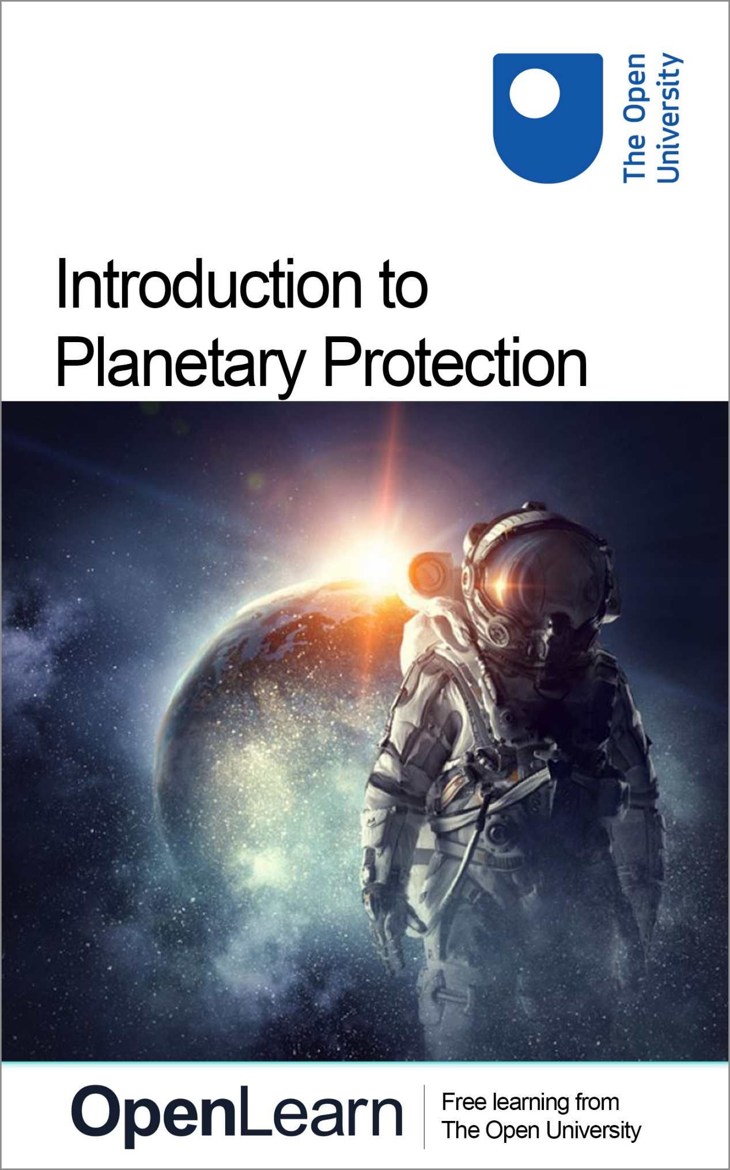

IPP_1

Introduction to Planetary Protection

About this free course
This version of the content may include video, images and interactive content that may not be optimised for your device.
You can experience this free course as it was originally designed on OpenLearn, the home of free learning from The Open University –https://www.open.edu/openlearn/science-maths-technology/introduction-planetary-protection/content-section-0
There you’ll also be able to track your progress via your activity record, which you can use to demonstrate your learning.
First published 2025.
Unless otherwise stated, copyright © 2025 The Open University, all rights reserved.
Intellectual property
Unless otherwise stated, this resource is released under the terms of the Creative Commons Licence v4.0 http://creativecommons.org/licenses/by-nc-sa/4.0/deed.en. Within that The Open University interprets this licence in the following way: www.open.edu/openlearn/about-openlearn/frequently-asked-questions-on-openlearn. Copyright and rights falling outside the terms of the Creative Commons Licence are retained or controlled by The Open University. Please read the full text before using any of the content.
We believe the primary barrier to accessing high-quality educational experiences is cost, which is why we aim to publish as much free content as possible under an open licence. If it proves difficult to release content under our preferred Creative Commons licence (e.g. because we can’t afford or gain the clearances or find suitable alternatives), we will still release the materials for free under a personal end-user licence.
This is because the learning experience will always be the same high quality offering and that should always be seen as positive – even if at times the licensing is different to Creative Commons.
When using the content you must attribute us (The Open University) (the OU) and any identified author in accordance with the terms of the Creative Commons Licence.
The Acknowledgements section is used to list, amongst other things, third party (Proprietary), licensed content which is not subject to Creative Commons licensing. Proprietary content must be used (retained) intact and in context to the content at all times.
The Acknowledgements section is also used to bring to your attention any other Special Restrictions which may apply to the content. For example there may be times when the Creative Commons Non-Commercial Sharealike licence does not apply to any of the content even if owned by us (The Open University). In these instances, unless stated otherwise, the content may be used for personal and non-commercial use.
We have also identified as Proprietary other material included in the content which is not subject to Creative Commons Licence. These are OU logos, trading names and may extend to certain photographic and video images and sound recordings and any other material as may be brought to your attention.
Unauthorised use of any of the content may constitute a breach of the terms and conditions and/or intellectual property laws.
We reserve the right to alter, amend or bring to an end any terms and conditions provided here without notice.
All rights falling outside the terms of the Creative Commons licence are retained or controlled by The Open University.
Head of Intellectual Property, The Open University

Contents
- Introduction
- Learning outcomes
- 1 Why are we protecting the planets?
  - 1.1 ‘Are we alone?’
  - 1.2 Where did we come from?
  - 1.3 Protecting the Earth
- 2 What are we protecting space from?
  - 2.1 Biological contamination
  - 2.2 Organic contamination
- 3 The governance of planetary protection
  - 3.1 The Outer Space Treaty
  - 3.2 The COPSAR Panel on Planetary Protection
  - 3.3 The COPSAR Planetary Protection Policy
  - 3.4 The Icy Worlds: A Planetary Protection Case Study
- 4 Planetary Protection Requirements
  - 4.1 The history of planetary protection requirements
  - 4.2 Cleanroom environments
  - 4.3 Bioburden Reduction
- 5 The future of planetary protection
- 6 Conclusion
- 7 Quiz
- 8 Tell us what you think?
- Acknowledgements
- Glossary
- Solutions
- Descriptions

Introduction
We are witnessing a transformation in humanity’s relationship with space. The early decades of the space age were dominated by government-funded, space agency-led exploration programmes and satellite launches for societal need. You will already be familiar with the use of the local space environment for telecommunications (mobile phones and internet), Earth observation (environmental monitoring, e.g., Figure 1, meteorology), transport (air, maritime) and security (surveillance, defence). You may even know a little about the space race to the Moon, the exploration of Mars, or have seen the stunning images from the Hubble or James Webb Space Telescopes.

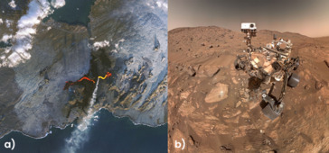
Figure 1a) Photograph taken by NASA/US Geological Survey Landsat-9 satellite of Iceland’s Reykjanes peninsula in November 2024, a few days into the volcanic eruption. An infra-red photograph that shows heat signatures, taken by a different satellite, is overlain to investigate the extent of the lava flow to support emergency response activities and geological investigations. Figure 1b) Selfie taken by NASA’s Perseverance rover on Mars, July 2024, investigating rocks that might show evidence that life may once have survived on the red planet.
View description - Figure 1a) Photograph taken by NASA/US Geological Survey Landsat-9 satellite of Iceland’s ...

However, since the dawn of the 21st century, launch technologies have reduced in cost and there is increased participation from smaller, private sector organisations and nations with commercial interests in using the space environment. New sectors such as healthcare, urban development, energy and insurance are all now benefitting from increased access to the space environment and are even setting their sights on exploration of the Solar System, building lunar habitats (e.g., Figure 2) and sending humans to Mars.

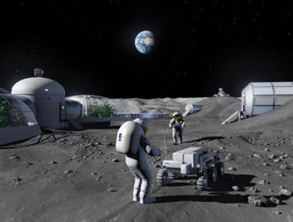
Figure 2 Artist impression of a Moon Base to be used for prospecting for resources
View description - Figure 2 Artist impression of a Moon Base to be used for prospecting for resourc ...

With this shift comes growth to the space sector, and projections of its value towards $2 trillion by the mid-2030s are not uncommon, making it an attractive investment for the future. More nations than ever before, including the UK, have ambitions to launch satellites into Earth orbit and beyond from their own territories, supported by commercial investment. But this also comes with risks to the space environment and responsibilities to mitigate these. Such risks are particularly prevalent when considering environments that are, as yet, untouched by humans but might harbour, or have harboured, life.
This course provides an introduction to ‘Planetary Protection’, one of the approaches used to help protect the space environment from contamination from Earth – and protect Earth from potential contamination from space. It is suitable for anyone with an interest in space exploration, including the search for life, and the methods used within the space sector to promote sustainable uses of space.
The first section explores some of the debates that surround the requirement to maintain the space environment as ‘pristine’. Then you will learn about what it is that might disrupt that environment and lead to contamination. You will then move on to explore the governance of space, then learn how governance is put into practice when designing, building and launching spacecraft. Given the growth of the sector, and changing geopolitical objectives, the course will end by you considering the future for planetary protection.

Learning outcomes
After studying this course, you should be able to:
- describe ‘Planetary Protection’ and its importance, including for the space sector
- understand the scientific rationale behind planetary protection
- understand the risks of exploring planetary bodies and how to mitigate this
- recognise the global cooperation needed to protect the space environment
- appreciate the efforts needed to limit contamination of other planetary bodies and protect the Earth.

1 Why are we protecting the planets?
In this section we will introduce you to some of the scientific debates that mean planetary protection is a key consideration within the space sector today, especially for missions to other planetary bodies.

Activity 1
5 minutes

The Open University’s AstrobiologyOU research group (who have authored this course) organised an international event in London in 2024 – the International COSPAR Planetary Protection Week (ICPPW) – which brought together researchers, policy makers, and representatives from national space agencies and industry representatives. At the event we asked the participants ‘why is planetary protection important?’
Watch Video 1 that collates some of their views. As you watch the video, note down some of the reasons that they suggest.

Video content is not available in this format.
Video 1 Experts’ responses to the question ‘why is planetary protection important?’
View transcript - Video 1 Experts’ responses to the question ‘why is planetary protection importan ...

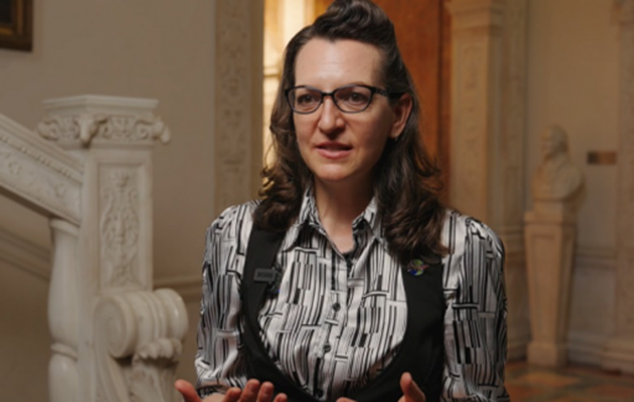

Note that COSPAR is the Committee on Space Research, and you will learn more about them later.

Provide your answer...
View answer - Activity 1

Although this course focuses on planetary protection, there are many other reasons why we should try to protect the wider space environment. There is an interest, for example, in exploiting resources available elsewhere in the Solar System, but who owns these resources? Is it morally appropriate to disrupt or destroy pristine space environments? Who is responsible for stewardship of the space environment when space endeavours change from being the domain of nation states and into commercial ventures? Shouldn’t we ensure we do not limit the opportunities of future generations to explore and enjoy our Solar System?
If you’re interested in learning more about some of these wider issues, you may choose to watch our videos:
- Space Resources: how do we make space fair?
- Space Debris: Is space getting too dangerous?
For now, let’s explore some of the scientific reasons for planetary protection, starting with the search for life beyond Earth.

1.1 ‘Are we alone?’
The question, ‘are we alone in the Universe?’, has been at the heart of scientific, philosophical and religious discourse for millennia. Greek and Roman philosophers, Renaissance astronomers with early telescopes, 20th century space agencies with robotic spacecraft and 21st century artificial intelligence-based technologies that search vast swathes of the cosmos, have all contributed to furthering this debate.
Since the dawn of the space age in the 1950s, this question has become the central tenet of the interdisciplinary science of astrobiology.
Although there are programmes searching for advanced, intelligent life, for example SETI – the Search for Extraterrestrial Intelligence – this is largely focused outside our own Solar System. In this section, and this wider course, we are considering the search for life as investigated by exploring our own Solar System in more detail, using robotic spacecraft to do the job of the scientist on or around other planets and moons.
Several space missions (Table 1) have had the search for life as an explicit objective and many more have contributed to our understanding of the environments beyond Earth that might be, or might once have been, habitable. Take a look at Table 1 and answer the questions that follow.

Table 1 Space exploration missions that have had the search for life as an objective. Only those that reached their target destination and partially or fully deployed have been included.
Mission Name | Mission type | Target | Launch Year | Country/Agency | Objective
Viking 1 & 2 | Orbiter-lander (x2) | Mars | 1975 | USA (NASA) | Direct life detection on Mars via biology experiments
Cassini-Huygens | Orbiter-lander | Titan and Enceladus | 1997 | NASA/ESA/ASI | Investigate Saturn's moon's Titan and Enceladus for organic chemistry and habitability, Titan lander
Beagle 2 / Mars Express | Lander | Mars | 2003 | UK/ESA | Search for biosignatures on Mars
Spirit & Opportunity (Mars Exploration Rovers) | Rover | Mars | 2003 | USA (NASA) | Investigate past water activity and habitability
Phoenix | Lander | Mars | 2007 | USA (NASA) | Search for water ice and potential habitability near martian poles
Curiosity (Mars Science Laboratory) | Rover | Mars | 2011 | USA (NASA) | Assess Mars' habitability, detect organic molecules
ExoMars TGO-Schiaparelli | Orbiter-lander | Mars | 2016 | ESA/Roscosmos | Search for trace gases related to biological processes
Perseverance | Rover | Mars | 2020 | USA (NASA) | Search for biosignatures and collect samples for return
Tianwen-1 / Zhurong Rover | Orbiter-lander-rover | Mars | 2020 | China (CNSA) | Study martian soil and water-related features to assess habitability
James Webb Space Telescope | Space telescope | Cosmos | 2021 | NASA/ESA/CSA | Analyse atmospheres of exoplanets for gaseous biosignatures
JUICE | Orbiter | Jupiter’s moons | 2023 | ESA | Explore Jupiter's moons for subsurface oceans and signs of habitability
Europa Clipper | Orbiter | Europa | 2024 | USA (NASA) | Investigate Europa, habitability and subsurface ocean

- What does Table 1 tell you about where scientists think life is most likely?
- Over half of the missions deployed to date have been to Mars, which suggests this is thought to be the most likely place for life to be found. However, there are other factors to consider that lead to this focus, such as the cost and timescales of sending missions over longer distances and changing priorities of space agencies. For example, you might notice a hiatus in missions from the 1970s to the 1990s during which time NASA focused their efforts on the space shuttle programme and developing the use of low Earth orbit (e.g., the International Space Station).

Mars has been a focus for the search for life for over a hundred years, since Italian astronomer Giovanni Schiaparelli observed lines on the martian surface through a telescope in the 1870s. These ‘canali’ as he described them were mistranslated to be ‘canals’ - artificial waterways - and suggestions of the existence of martian civilisations emerged. Since then, even though the ‘canali’ features themselves have been shown to be nothing other than irregular features on the martian surface, Mars has captured the imagination of wider society as a potential home to extraterrestrial life and remains the target for much scientific attention.
If you want to learn more about the exploration of Mars, you can visit the OpenLearn interactive ‘15 minutes on Mars’, and we shall return to consider Mars in the context of planetary protection shortly. However, we first need to consider what it is we are looking for when searching for ‘life’.

1.1.1 What is life?
To search for life means we must understand what we mean by ‘life’. This isn’t as straightforward as you might imagine and has been the subject of much debate. It is also important to remember that everything we understand about life is based on a single planet - Earth. As you will learn later, we don’t yet know everything there is to know about terrestrial life, and it may be that extraterrestrial life does not have the same requirements or features. Not knowing what we don’t know makes searching for life difficult and is an important reason for much of the science of astrobiology.
What we do know about life on Earth is that it shares a number of characteristics. Firstly, all life is made up of one or more cells, the basic biological building block of living organisms. Cells are discrete packages bounded by a cell membrane. Within the cell is a gel-like substance called cytosol, made mostly of water, plus other structures and molecules that help the cell to function. You will learn more about some of these molecules and different types of cells later. Secondly, all life can grow and reproduce, allowing it to proliferate. Thirdly all life carries out chemical processes (called metabolism), which requires an input of energy. And finally, all life can exhibit responses to external stimuli such as changes in the environment (e.g., temperature, amount of sunlight, water, etc.).
In their search for life, NASA devised a straightforward working definition for life: ‘a self-sustaining chemical system capable of Darwinian evolution’.

Darwinian evolution is a scientific theory proposed by Charles Darwin in the 19th Century. It explains how species change over time through a process of natural selection in which they adapt to their changing environment so that they can survive and reproduce.

NASA’s definition of life states that it is a chemical system: life needs elements and molecules to form its structure and provide energy for grow and proliferation, to become self-sustaining within an environment (i.e. not dependent on others) to be supportive to its needs.

Activity 2
10 minutes

In this activity you will think about these definitions of life by considering some possible examples – real and (so far!) fictional. The examples are:
- a dormant seed
- a virus (an infectious microbe)
- a salt crystal
- an AI chatbot
For each one, note down whether you consider it to be alive and why. What assumptions are you making in order to define it this way? What does your definition include or exclude?

Provide your answer...
View answer - Activity 2

Based on our wider understanding (to date), life has some basic requirements:
- Bio-essential elements (carbon, hydrogen, oxygen, nitrogen, phosphorus and sulfur)
- Water
- An energy source
These requirements are at the heart of what it is that we look for when we are searching for life beyond Earth. We aren’t necessarily looking for present life (extant life) – finding intact cellular life would be the holy grail for an astrobiologist – but we are often looking for evidence of extinct life and its basic requirements. This means that the evidence we seek is potentially very wide-ranging.
You might recall from Table 1 that many of the past exploration missions have been searching for water because of its importance to life. If you are interested in finding out more about this aspect of astrobiology, you can visit the OpenLearn course ‘The Search for Water on Mars’. However, we will next explore the other evidence that missions search for when seeking life beyond Earth.

1.1.2 Biosignatures
Carbon is fundamental to every living organism because it can form covalent bonds with atoms of many other elements.

A covalent bond is a bond in which pairs of electrons are shared between atoms (one electron is shared from each atom).

This ability to chemically bond with other elements means it offers the opportunity for chemical variability to emerge, resulting in a wide variety of organic molecules. You might be familiar with the term ‘organic’ in different contexts, for example, organic foods are those produced without synthetic fertilisers, and ‘organic’ is often used to describe anything associated with biology. However, organic molecules and the science of organic chemistry are concerned only with the chemistry of compounds that contain carbon.
Living systems on Earth are based on organic molecules (e.g., lipids, carbohydrates, proteins and nucleic acids). Most of these molecules are large (macromolecules), made of smaller molecular building blocks, such as amino acids. However, life also generates organic molecules; methane (CH₄) is an example of a carbon molecule generated through metabolic processes. Any of these molecules might be indicative of the presence, or past presence, of life. In this respect, we call these molecules ‘biosignatures’ – biological signatures. However, there are many other potential biosignatures, not all associated with organic molecules. These are summarised on Table 2.

Table 2 Types of biosignatures used in the search for life beyond Earth.
Type of Biosignature | Description | Examples
Chemical biosignatures
Organic molecules | Molecules containing carbon that are found in biological organisms that may be left by the breakdown of cells. Some may survive over long periods of time, preserved in rocks and minerals. | Lipids, carbohydrates, nucleic acids, proteins or fragments of those macromolecules
Atmospheric gases | Gases produced by life through its metabolic processes. These need to be present in sufficient quantities for detection, be concentrated in specific areas, accompanied by other gases, or at specific times, for it to suggest the present of life. | Oxygen (O₂), methane (CH₄), nitrous oxide (N₂O)
Isotope ratios | Organisms tend to prefer utilising lighter stable isotopes during metabolism, leaving light isotopes behind as evidence. If more lighter isotopes of certain elements are found this could suggest the presence of life. | ¹²C is preferred over ¹³C
Chirality | Some organic molecules express a preferred orientation to their structure if they are from a biological organism, compared to when they are formed by non-biological processes. | L-alanine (biological) compared to D-alanine (non-biological)
Chemical Disequilibrium | The co-existence of substances that should otherwise be incompatible because they would react with one another. | Co-existence of CH₄, and O₂, in Earth’s atmosphere
Physical biosignatures
Microfossils | Physical traces of an organism in the rock record. Often produced when the organic parts of an organism are replaced by inorganic minerals. | Bacterial microfossils in ancient terrestrial rocks
Textural fabrics | Some organisms can influence the structure of sediments around them by trapping sediments. Can be difficult to distinguish from non-biological features. | Stromatolites, filamentous structures
Biogenic minerals | Minerals that can be formed by biological processes | Carbonates, phosphates

You will notice that only some of the biosignatures on Table 2 are directly associated with life while others indirectly indicate that life was once present. For example, some organisms may promote the formation of certain minerals (biogenic minerals) – this would be indirect evidence of past life.

- From Table 2, what other biosignatures can be considered indirect evidence of life?
- Atmospheric gases, isotope ratios, chemical disequilibrium and chirality are all indirect indicators that life is or has been present.

Finding biosignatures preserved in the geological record or atmosphere of another planetary body would be a significant scientific discovery and so it is critical to determine that it is indeed formed by life, i.e. that it is biotic, and was not formed by other natural processes that might operate in the environment, i.e., is abiotic.
It is therefore critically important that we do not inadvertently carry organisms or substances that might give us a false positive result (i.e. that suggest life is present, but it is in fact from Earth). We must be sure that missions are able to gather robust and unequivocal evidence, and that the scientific integrity of the mission is maintained. This contamination of the environment of another planetary body, in the context of planetary protection, is called forward contamination.
Further, it is also important to ensure that, in our quest to find evidence of life, we do not disturb or destroy such evidence through our investigations. This is challenging because to search for biosignatures or determine if an environment is habitable requires complex physical and chemical analyses, including of the geological record. This is done using scientific instruments hosted on rovers or landers that interact with a planetary surface, scooping rocks, drilling into the surface or even destroying small areas using lasers.
These robotic missions are superb feats of engineering, often miniaturising otherwise large laboratory instruments so they can be sent to another planet (e.g., Figure 3) but they are also made of materials that could be harmful to other environments without proper precaution. This is where planetary protection plays a critical role.

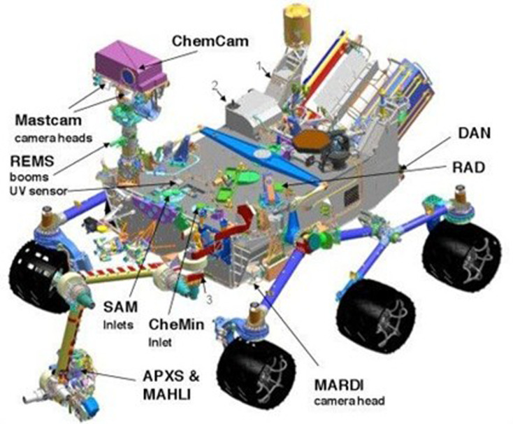
Figure 3 Schematic showing the science instruments onboard NASA’s Curiosity rover on Mars. Curiosity has been investigating Gale crater on Mars since August 2013.
View description - Figure 3 Schematic showing the science instruments onboard NASA’s Curiosity rover ...

A further challenge to facing missions is that many specifically target regions for exploration precisely because they are likely to host biosignatures, especially environments that are thought to be, or have been, habitable.

1.1.3 Habitable environments
Earth is our only reference for what can be defined as a habitable environment for life. However, the conditions needed to sustain complex animal and plant life on our planet are less diverse than those needed by microbial life. You will learn more about microbial life in Section 2.

- Before we move on, what do you think makes the Earth habitable to life?
- The Earth has both land and sea, allowing for a range of species diversity to evolve. There is a moderate amount of oxygen in the atmosphere (and dissolved in water) to allow animals to respire, an ozone layer to protect life from harsh radiation from space, and has an environment (temperature, climate) that is reasonably stable, regulated by complex systems such as the water cycle and plate tectonics. The Sun also provides light for plants to photosynthesise, and heat energy.

You will realise that the Earth system is complex – it balances many different and important interactions between land, sea, atmosphere, and its components to maintain a balance that means Earth can host life. Any changes to this system, such as those we are experiencing through the input of human-derived carbon dioxide (CO₂), can upset this balance.
As we explore other planetary bodies, we must be sure that we are not inadvertently disrupting another potentially habitable environment, since this could have dire consequences for extraterrestrial ecosystems, and even limit our own future search for life in the Solar System.

1.2 Where did we come from?
Finding evidence of life beyond Earth is not the only reason why we want to explore the Solar System and not the only reason why we need to protect other planetary bodies. It is impossible to go into details of all the objectives of all exploration missions that have been launched over the last decades, but one strong theme among them is the quest for understanding how the Earth, and our Solar System more broadly (Figure 4), formed and evolved.

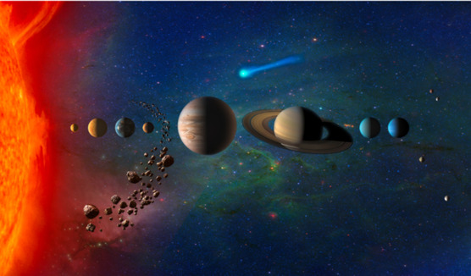
Figure 4 Artists concept of our Solar System showing the Sun, planets, asteroid belt, comets and other objects
View description - Figure 4 Artists concept of our Solar System showing the Sun, planets, asteroid belt, ...

Our Solar System formed 4.65 billion years ago, with the planets, asteroids, comets and other objects forming from within a swirling disk of gas and dust with the Sun at the centre. Since their formation, many of the planets have experienced processes that have destroyed or changed the original materials from which they were formed – you may be aware of the tectonic processes that operate on Earth that destroy and create the planet’s crust – but some asteroids and comets have not experienced these processes. These objects retain chemistry and solid components that were formed when the Solar System was very young and can provide clues to its formation. Importantly, this includes the molecular building blocks of life.

- What element are the molecular building blocks of life mainly composed of?
- Carbon is the common element, being the basis for the organic molecules from which all life is formed.

- Can you name any molecular building blocks? (Hint: you met some in Section 1.1.2!)
- You might have remembered some of the larger molecular building blocks like lipids, proteins and nucleic acids, or some of the smaller ones such as amino acids. But this list is not exclusive!

Organic molecules are not just associated with life, or even with Earth – they are ubiquitous throughout the cosmos, being found throughout our Solar System and beyond. And it is proposed that these building blocks may have been delivered to the early Earth by impacts from meteorites (fragments of asteroids) or comets as they would not have survived the planet-building processes that formed the Earth. It is also believed that these building blocks, along with components such as water, would have been delivered to other planetary bodies, including our Moon.
Determining which molecules may have come from space and which may be biosignatures is really challenging, so it is important that this is not further complicated by introducing organic molecules from Earth, such as those sourced from the spacecraft manufacturing process (like lubricants or through the degradation of materials) or those that may be remnants of organisms inadvertently carried onboard.
Planetary protection is predominantly concerned with the transfer of life, however understanding what organic molecules might be carried with a spacecraft has become increasingly important. You will learn more about this later.

1.3 Protecting the Earth
Humanity has had the technology to send spacecraft and people into space and return them for over seventy years, since the early days of the space age saw the Sputnik satellite orbit the Earth and cosmonaut Yuri Gagarin in Vostok 1 became the first man in space.
So far, we have considered why we need to protect other planets, but humanity’s exploration and use of space is not only one-way.


Figure 5 Yuri Gagarin, the first human in space
View description - Figure 5 Yuri Gagarin, the first human in space

1.3.1 Launch and return
The Apollo missions to the Moon were the first to collect rock and soil samples from the surface of another planetary body, with nearly 400 kg returned by the astronauts to be analysed in laboratories on Earth. Since then, robotic spacecraft have returned samples to Earth from the Moon, low Earth orbit (LEO, the area of space occupied by satellites and the International Space Station), asteroids, a comet and even the Sun. Table 3 summarises previous and currently planned sample return missions. Use your mouse to scroll left and right across the table, or click on the table and use your keyboard arrows.

Table 3 Sample return missions
Mission Name | Space Agency | Launch date | Sample return date | Target Body | Amount of sample | Type of sample | Comments
Apollo 11 | NASA | 1969 | 1969 | Moon | 21.5 kg | Lunar soil and rock | First crewed lunar sample return mission
Apollo 12 | NASA | 1969 | 1969 | Moon | 34.4 kg | Lunar soil and rock
Luna 16 | USSR | 1970 | 1970 | Moon | 101 g | Lunar soil | First robotic lunar sample return mission
Apollo 14 | NASA | 1971 | 1971 | Moon | 42.8 kg | Lunar soil and rock
Apollo 15 | NASA | 1971 | 1971 | Moon | 77.3 kg | Lunar soil and rock
Apollo 16 | NASA | 1972 | 1972 | Moon | 94.7 kg | Lunar soil and rock
Apollo 17 | NASA | 1972 | 1972 | Moon | 110.5 kg | Lunar soil and rock | Last crewed lunar sample return mission
Luna 20 | USSR | 1972 | 1972 | Moon | 55 g | Lunar soil
Luna 24 | USSR | 1976 | 1976 | Moon | 170 g | Lunar soil | Last Soviet lunar sample return mission
Stardust | NASA | 1999 | 2006 | Comet Wild 2 | 1 mg | Cometary dust | Also collected interstellar particles
Genesis | NASA | 2001 | 2004 | Solar Wind | N/A | Solar wind particles | Capsule crash-landed, some samples recovered
Hayabusa | JAXA | 2003 | 2010 | Asteroid Itokawa | 1500 grains | Asteroid regolith | First asteroid sample return mission
Hayabusa2 | JAXA | 2014 | 2020 | Asteroid Ryugu | 5.4 g | Asteroid regolith
OSIRIS-REx | NASA | 2016 | 2023 | Asteroid Bennu | 250 g | Asteroid regolith
Chang’e 5 | CNSA | 2020 | 2020 | Moon | 1.73 kg | Lunar soil and rock | First Chinese lunar sample return mission
Chang’e 6 | CNSA | 2024 | 2024 | Moon (farside) | 2 kg (planned) | Lunar soil and rock | First mission to return samples from the Moon’s far side
Tianwen-2 | CNSA | 2025 | 2027 (TBC) | Asteroid 469219 Kamo’oalewa | ≥100 g (planned) | Asteroid regolith | Will return samples in 2027; then continue to Comet 311P/PANSTARRS
MMX | JAXA | 2026 (planned) | 2031 (TBC) | Phobos (Mars’ moon) | 10 g (planned) | Regolith from Phobos | First mission to return samples from a martian moon
Tianwen-3 | CNSA | 2028 (planned) | TBC | Mars | TBD | Martian soil and rock | First Chinese Mars sample return mission
Chandrayaan-4 | ISRO | 2028 (planned) | TBC | Moon (south pole) | TBD | Lunar soil and rock | India’s first lunar sample return mission
Mars Sample Return (MSR) | NASA / ESA | Ongoing | 2033 (TBC) | Mars | 0.5-1 kg (estimated) | Martian rock and soil | Multi-mission campaign to retrieve samples collected by the Perseverance rover (already on Mars)

We now have a new generation of launch vehicles that can be launched, recovered and relaunched several times. Replacing single-use launch vehicles with re-useable ones will significantly reduce launch costs, meaning launches can happen more frequently, new nations will enter the space age, more private investment will be attracted, and the sector can become more sustainable in the long-term.
At the time of writing, only three companies have developed and tested re-useable launch vehicles: SpaceX (Falcon 9 and Starship), Blue Origin (New Shepherd and New Glenn), and Rocket Lab (Electron (R)). SpaceX’s Falcon 9 (Figure 6) is already used to transport crew and cargo to the International Space Station, and Blue Origin’s New Shepherd (named after Alan Shepherd, the first NASA astronaut in space) has been used to carry celebrities, scientists, business people, and entrepreneurs into space – some paying vast fees to be part of the crew.

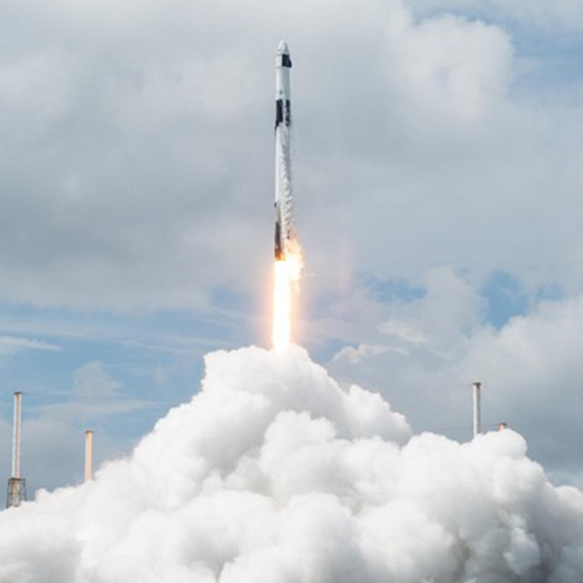
Figure 6 A launch of SpaceX’s Falcon 9 carrying crew to the International Space Station
View description - Figure 6 A launch of SpaceX’s Falcon 9 carrying crew to the International Space ...

1.3.2 Biohazards
A satellite returns to Earth carrying with it a mysterious extraterrestrial lifeform that is deadly to humans. Scientists rush to investigate what this organism is, how it is transmitted, and how to contain it to prevent it from killing all life on Earth.
If you are an avid science fiction reader, you may recognise this as the plot of the 1969 book ‘The Andromeda’ strain by Michael Crichton, but you may be familiar with similar tropes from many movies and television series. Whilst fictional and (we hope) greatly exaggerated, it is scientifically plausible that life (or other contamination) could be carried to Earth via spacecraft or within one of samples returned from another planetary body. As such, science fiction scenarios such as the one above present a powerful allegory for the risk of biohazards from space.

Hazards and risks
A hazard is a potential source of harm and can be an object or a situation that poses a level of threat to life, health, property or environment.
A biohazard is a biological substance that could pose a threat to human health or the environment.
Hazards are components of risk, along with the probability of an event coming to pass. Risk also depends on the nature of the consequences arising from the event.
The simplest form of risk assessment is to rate the risk as high, medium or low. The two elements to risk that have to be considered are the likelihood of harm, and the severity of that harm if it were to happen. The process of risk assessment seeks to answer the questions: ‘what can go wrong?’, ‘how bad are the consequences?’, ‘how often might it happen?’, ‘who might be harmed?’ and ‘is there a need for action?’

Recall the habitable environments that we discussed earlier. The Earth has many environments that harbour life, but some of these are fragile and any sort of disruption – such as changing the physical or chemical conditions of the environment or introducing life that might disrupt the local ecosystem – could be catastrophic. In the context of planetary protection, we describe this contamination to the Earth’s environment as backward contamination, in contrast to forward contamination we discussed earlier.
In the face of such consequential scenarios, control measures are needed to mitigate (reduce) the risk. This is where planetary protection comes in, with international guidelines, containment measures and cleaning protocols. You will meet all of these shortly, but for now, let’s look in more detail at what it is that we are protecting space from.

2 What are we protecting space from?
You will have gathered from earlier sections of this course that the two main areas of concern for planetary protection are biological contamination (living microorganisms), or organic contamination (the molecular building blocks/remains of life, or molecules containing carbon that may be mistaken for a biosignature of life).
Understanding the possible types of contamination are important for determining the ways in which their presence can be mitigated, and for determining what can be considered ‘safe’ if they cannot be eliminated entirely.

2.1 Biological contamination
In the context of planetary protection, ‘biological contamination’ is not referring to humans in space – it is microscopic life – microbes.
Watch Video 2 that revisits some of the ideas you have already met about the definition of life. After watching the video, answer the questions that follow.

Video content is not available in this format.
Video 2 How do you know what is alive?
View transcript - Video 2 How do you know what is alive?

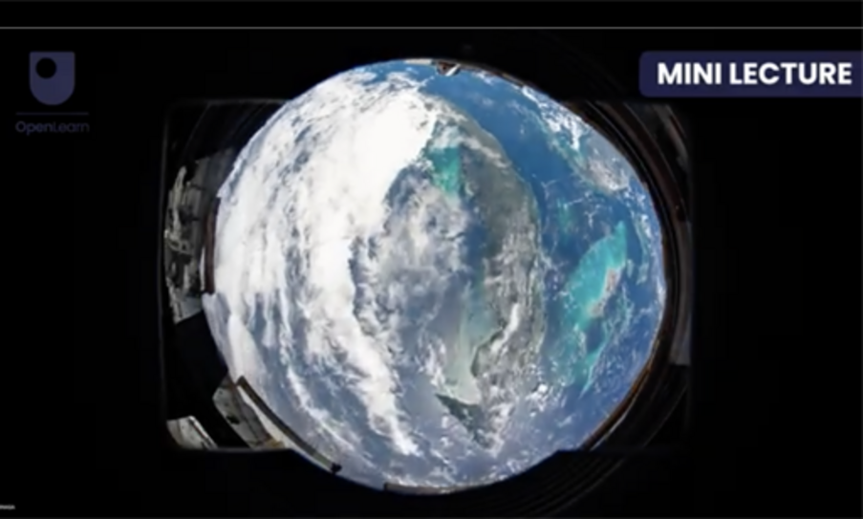

- What are the two main types of cells?
- Prokaryotic and Eukaryotic.

- What is the main difference between these two types of cells?
- Eukaryotic cells have their internal contents packaged up in compartments, including the nucleus that contains DNA. Prokaryotic cells do not have any internal compartments.

Microbes include various, diverse groups of organisms. Bacteria (singular: bacterium) are the most common microbe. In fact, bacteria are probably the most abundant group of organism on the Earth; almost all surfaces which have not been specially sterilised harbour bacteria. Archaea (singular: archaeon) are a separate domain of life, are also single celled and have been found in many environments including those with extreme environmental conditions, such as hot springs in volcanic areas.

- What type of cells do bacteria and archaea have?
- Bacteria and archaea have prokaryotic cells.

While bacteria and archaea are prokaryotes, there are also microbes that are eukaryotes. Microbial eukaryotes include Fungi, such as yeast, and Algae, such as those which form the powdery green coating on the shady side of tree trunks. The term microbe also includes Viruses, which you considered in Activity 2.
Some microbes perform roles that are beneficial to humanity, including supporting the production of food and medicines (e.g., Saccharomyces cerevisiae and brewing). Other microbes can be harmful, causing infections or disease in animals and plants (e.g., Escherichia coli and food poisoning). However, most microbes have no direct effect on humanity, positive or negative.
Since microbes are everywhere – including on the skin, breath and clothes of astronauts, on and inside spacecraft, within the facilities in which spacecraft are built and tested, and even within the fuel tanks that might propel the missions – they present a challenge to planetary protection. Terrestrial microbes can also tolerate a much wider range of environmental conditions than humans can, which means they could survive in planetary environments beyond Earth if we were to take them there.

2.1.1 Living in extreme environments
All exploration missions – their objectives, landing sites, the instruments they carry and the analyses of the data they generate – are informed by investigations here on Earth where life is ubiquitous.
Studying the microbes that inhabit extreme environments on Earth – those with extremes of temperature or pressure, or where there is no liquid water for long periods of time – helps us to recognise which environments beyond Earth may be capable of supporting life. But it can also help us to understand which microbes might be capable of surviving a journey through space and into an unknown extraterrestrial environment.
The range of conditions over which an organism is adapted to live is called the tolerance range. This can be represented graphically (Figure 7) by plotting a biological factor associated with the organism (e.g., growth rate on the y axis) against variable environmental factors (e.g., temperature on the x axis). In the case of Figure 7, this shows the response of growth rate to changes in temperature for five different species of microbes (represented as curves labelled A to E). For this example, the temperature at which each species grows and reproduces most rapidly is the ‘optimum temperature’, shown as the peak of each curve. At temperatures above and below this optimum, but relatively close to it, the microbe will survive, but its growth rate will be reduced.

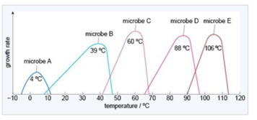
Figure 7 Graph showing how growth rate varies with temperature for 5 microbes (A-E), and their optimum temperatures
View description - Figure 7 Graph showing how growth rate varies with temperature for 5 microbes (A-E), ...

Similar responses can also be shown for other environmental conditions (both physical and chemical, e.g., amount of radiation, salinity, pH, etc.) against any biological processes (e.g., reproductive success, respiration rates), for any type of organism. In each case, the organism will have its own set of response functions that define its limits of survival.
Microbes that can tolerate exposure to these extremes are extremotolerant. Microbes that require extreme conditions to survive and grow are known as extremophiles, with this survival requiring specialised biological adaptations. Indeed, since Earth hosts an incredible diversity of extreme environments, with each type of physical or chemical extreme (temperature, pH, salinity, pressure) requiring a separate collection of biological adaptations to survive. Table 4 represents the current state of knowledge for all categories of extremophile.

Table 4 Our current understanding of extremophiles
Environmental factor | Limiting conditions | Type of extremophile | Comment
temperature | <15 °C | psychrophiles | Consist mainly of bacteria, algae and fungi. Psychrophiles have adaptations that enable them to survive low temperatures, e.g. cell membranes and enzymes that function optimally at relatively low temperatures.
 | 15–50 °C | mesophiles | The vast majority of organisms on Earth are mesophiles, inhabiting all the major temperate and tropical regions.
 | 50–80 °C | thermophiles | The majority are single-celled organisms found in hot springs and undersea hydrothermal vents. Thermophiles have adaptations that enable their cell machinery to function at high temperatures, including structural modifications of their proteins, nucleic acids and cell membranes to give them greater heat stability.
 | 80–121 °C | hyperthermophiles | Similar to thermophiles but able to tolerate even higher temperatures.
radiation |  |  | The bacterium Deinococcus radiodurans is the most radiation-tolerant organism known, having been recovered from irradiated materials and also from rocks from regions of Antarctica that are thought to most closely resemble martian surface conditions.
salinity | 15–37.5% salt | halophiles | Bacteria that are able to grow in high concentrations of salt.
pH | 0.7–4 | acidophiles | Organisms able to tolerate highly acidic environments.
 | 8–12.5 | alkaliphiles | Organisms able to tolerate highly alkaline environments.
desiccation | dry conditions | desiccation-tolerant organisms | A wide range of organisms are able to survive very dry conditions, including plants, fungi and bacteria.
pressure | high pressure | piezophiles | Organisms able to tolerate pressures hundreds of times that of atmospheric pressure at the Earth’s surface. Some organisms may be able to tolerate the pressures produced by shock waves in meteorite impacts.

- Which one of the following names would least accurately describe the kind of extremophile you might expect to find in an ice-covered Antarctic lake?
Hyperthermophile
Psychrophile
Acidophile
Piezophile
Mesophile
- Mesophile is the correct answer.
Antarctic ice-covered lakes contain multiple potential extremes including low temperature and high pressure. Some may have high salinity or extreme pH, depending on the chemistry of the water. Therefore, an array of different types of extremophiles can be expected to be found within an ice-covered Antarctic Lake.

Extreme environments are the dominant environments identified on other planetary bodies today. Only where there have been geological investigations by space missions have clement environments been identified, but these have existed only in the past.
Now watch Video 3, which introduces some of the ideas around whether life might have once existed on Mars. Once you’ve watched the video, answer the questions that follow.

Video content is not available in this format.
Video 3 Could life have ever existed on Mars?
View transcript - Video 3 Could life have ever existed on Mars?



- Give two examples of extreme environments on Earth.
- The video mentioned high temperature hot springs in New Zealand, freezing temperatures of the High Arctic and high pressures at the bottom of the ocean, and desiccated salt flats of northern India.

- Why is present day Mars inhospitable to life?
- The surface of Mars receives extremely high levels of radiation from the Sun, and has low temperatures.

- What type of organism from Table 4 might survive on the surface or near sub-surface of Mars today?
- A psychrophile (one that can survive extremely low temperatures) or one that is radiation tolerant might survive. A desiccation resistant could also survive.

To determine what life could survive in these environmental extremes, and how, requires a study of life on Earth in environments that are similar – these are known as analogue sites.

2.1.2 Analogue sites
Analogue sites are environments that have physical and chemical conditions similar to those found on other planetary bodies. In Video 4, Prof Karen Olsson Francis (Director, AstrobiologyOU) explains the importance of analogue sites.
Analogue sites allow us to investigate the habitability of environments beyond Earth. Studying these sites can also help us understand microbial survival mechanisms and biological adaptations that could evolve to cope with the extremes, giving us a picture of what types of organisms might be present in extraterrestrial environments.
However, in the same way that no single environment could represent all of Earth, no single analogue site is perfectly representative of any one extraterrestrial environment. Also, no environment on Earth is a perfect fit, since Earth is rich in both life and oxygen. Despite this, there are many environments that are chemically similar enough for us to develop our understanding of environments on other planets, whether life could have ever existed in them, the types of evidence life could have left behind and – critically – how life might have interacted and changed the environment in which it lived.
We’ve selected five examples of analogue sites for you to learn more about. Click on the arrows below the following box to explore these further.

View description - Uncaptioned interactive content

Video content is not available in this format.
Video 4 Prof Karen Olsson-Francis explains the importance of analogue sites
View transcript - Video 4 Prof Karen Olsson-Francis explains the importance of analogue sites

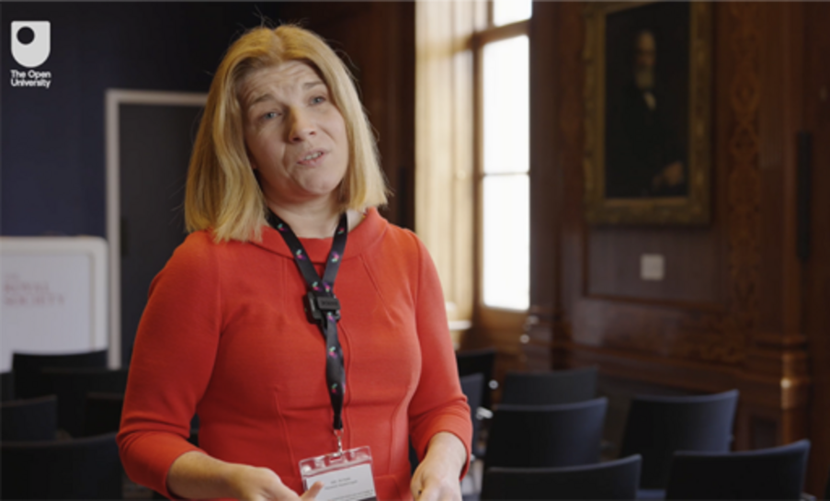

2.1.3 Survival strategies
To coin a phrase from a popular dinosaur movie, in many environments ‘life finds a way’. From an astrobiological perspective this is great news, but for planetary protection it does bring challenges. It is therefore important to understand how life might adapt under different conditions.
For microbes to survive in very low temperatures on Earth, some have developed the ability to accumulate compounds that act as an ‘anti-freeze’, preventing the formation of ice crystals. Others coat any ice crystals that do form with a layer of proteins, preventing them from growing any larger.

- What type of organism might use these survival strategies?
- Psychrophiles can live at temperatures <15 °C.

In high temperatures, biological molecules such as proteins and nucleic acids will breakdown and cell membranes will leak important cellular constituents, so thermophilic organisms have adapted by developing DNA and proteins that are better able to cope with higher temperatures, and more stable cell membranes.
High pressure environments, such as might be found within the oceans of icy worlds such as Enceladus or Europa, can result in restrictions in the movement of essential fluids through a cell membrane. To mitigate this, some organisms have adapted the compositions of their cell membranes to improve the flow of essential fluids and nutrients.
To survive in low or high pH environments (acidic or alkaline conditions, respectively), some organisms produce enzymes that can maintain a neutral pH within their cells.
In high radiation environments, such as on the outside of the International Space Station or even on the surface of Mars today, some organisms, (e.g., Figure 13) have developed the ability to repair damaged DNA. You will learn later about the role of radiation in mitigating against contamination and why this microbial ability presents a challenge!


Figure 13 Deinococcus radiodurans, a radiation-tolerant organism, acquired in the laboratory of Michael Daly, Uniformed Services University, Bethesda, MD, USA.
View description - Figure 13 Deinococcus radiodurans, a radiation-tolerant organism, acquired in the ...

In the face of dry, desiccating conditions, some organisms (e.g., some bacteria, fungi, and even plants and animals such as Figure 14) survive by entering a state of apparent suspended animation where biological activity pauses. In the absence of water these organisms appear dead, but after days, weeks, or even years, if moisture returns, they reanimate and resume biological activities.

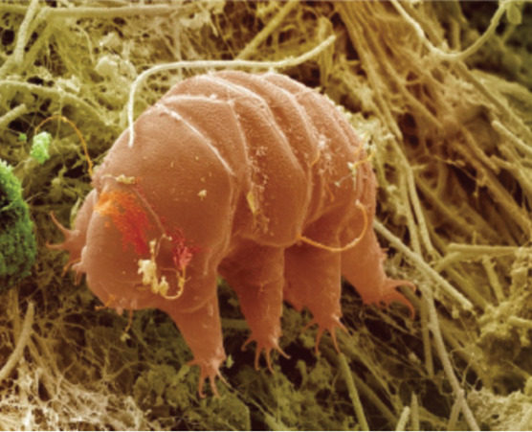
Figure 14 A tartigrade, a desiccation-tolerant organism only 0.2 mm in length
View description - Figure 14 A tartigrade, a desiccation-tolerant organism only 0.2 mm in length

In some instances, a microbe’s only way of surviving extreme environmental conditions is to shut down most of its life processes and form spores. Spores are cells that have a multi-layered protective coating allowing them to exist, dormant, within an environment cannot be otherwise tolerated. Figure 15 shows the process by which spores form to protect the organism.
This protective coating can allow microbes to survive extreme heat, radiation and drought. Not all microbes can form spores, but the ability to form spores is found in many different species of bacteria and fungi.
Microbial spores are very common in the air around us and settle out onto surfaces both indoors and outdoors. They have even been found preserved in ancient tombs for several thousands of years. If conditions in the environment improve (e.g., the cell detects nutrients, water and less extreme conditions), then the spore can germinate, turning back into a non-dormant and un-coated cell that can replicate and grow.
The hardy nature of spores, combined with their ability to survive for thousands of years and still change back into a growing cell, makes them a major focus for planetary protection and clean room sterilisation.

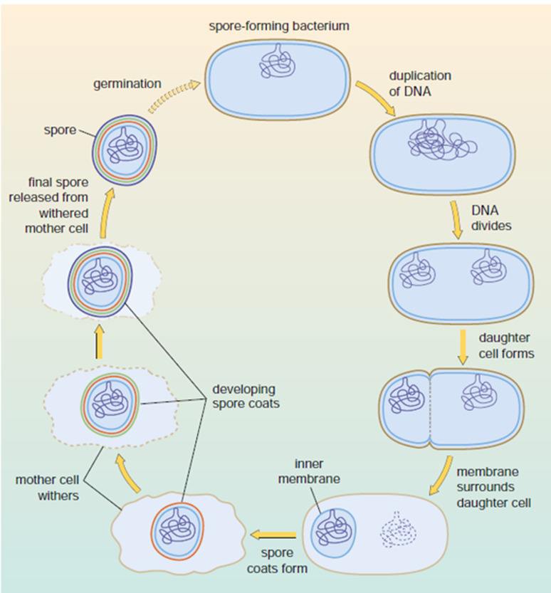
Figure 15 The formation of a spore
View description - Figure 15 The formation of a spore

2.2 Organic contamination
As well as microbes themselves, you learned earlier that the detection of organic building blocks or remnants of microbes might also be compromised by contamination from Earth. In this section we discuss what organic contamination is and how and why we need to differentiate between compounds that have been produced by ‘life’ or produced by non-life processes.

- How might we describe processes that form organic molecules without living organisms?
- Abiotic (non-living) processes can form organic molecules without the involvement living organisms. Processes that involve life are described as biotic and can result from organisms themselves, their waste products and the interactions between organisms.

In the context of planetary protection, organic molecules unrelated to biology that can cause contamination are classified as molecular organic contamination (MOC). These can be found on surfaces, be used to manufacture spacecraft (e.g. lubrication or bonding), or be in the environment around the spacecraft. Their presence can degrade the performance or lifespan of the spacecraft, as well as make it harder for us to decide if an organic compound is a biosignature or MOC. We also don’t want to contaminate space with organic compounds that could be detrimental to pristine environments.

2.2.1 MOC on spacecraft
When flight hardware (parts of spacecraft) is built on Earth, the materials used might contain traces of organic molecules adsorbed on their surfaces, or within substances used during manufacturing, for example within silicon-based glues. When the spacecraft is exposed to different conditions, these organic molecules are emitted into the local environment (Figure 16).
For example, when exposed to UV irradiation in space, parts of a spacecraft may heat up. When this happens, any organic molecules can desorb from surfaces, become volatile (e.g., easily vaporise and evaporate to become gaseous) and migrate to cooler surfaces.

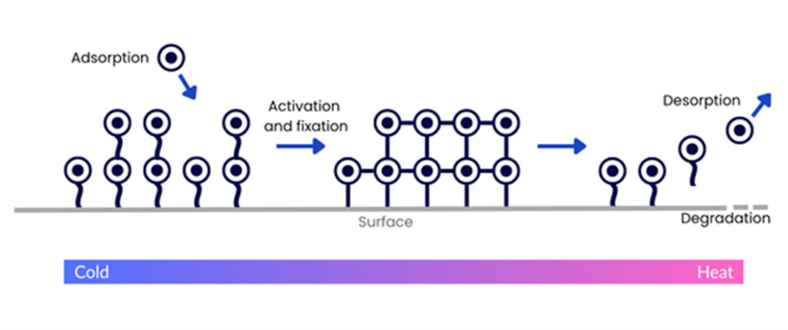
Figure 16 Adsorption and desorption of MOC on spacecraft surfaces
View description - Figure 16 Adsorption and desorption of MOC on spacecraft surfaces

2.2.2 MOC in the natural environment
Organic molecules are very good at binding to sediments. This is really useful for biosignatures, because minerals have been shown to help preserve organic molecules over time. However, it also means they pose a contamination risk to the natural environment.
For example, you may have heard of a group of chemicals called polychlorinated biphenyls (PCBs). On Earth, these are a group of persistent organochlorine pollutants that don’t break down easily, are hydrophobic (water hating) and can bind strongly to sediments. This means they can remain as a long-term contaminant in the natural environment and have even been detected in Antarctica and in dust collected from the International Space Station.
On Earth, their use and disposal are regulated but they have been used in coolants and hydraulic fluids for their thermal and chemical stability, or as plasticisers in paints and as flame retardants in adhesives. This included in the construction of spacecraft or satellite systems. However, now that it is known that these can emit unwanted and dangerous chemicals, they are no longer used.
This has not, however, eliminated all MOC from spacecraft, and as you will learn later, there are further planetary protection mitigations required in some circumstances. Before you learn what those are, the next section shows the potential negative impact of MOC on the lunar environment.

2.2.3 MOC and the Moon
Since the Apollo missions of the 1960’s and 70’s, the Moon was considered to be sterile. However, since the early 2000s, permanently shadowed regions (PSRs) have been identified on the Moon (Figure 17) that are in permanent darkness and remain at temperatures cold enough for surface and subsurface water ice deposits. Estimated at about 1.8 billion years old, these areas could provide a record of how water was first delivered to the lunar surface and to the Earth-Moon system more generally, but they have the potential to act as a cold trap for pre-biotic organic molecules from early in the Solar System. Pre-biotic molecules are those that may have been the building blocks of the first life and should not be confused with probiotic molecules that you may have heard of promoted as an aid to gut health.

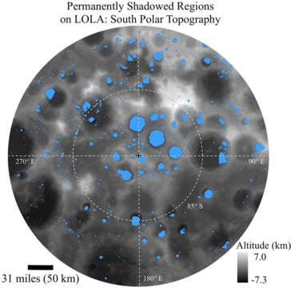
Figure 17 PSRs (indicated in blue) at the Moon’s south pole, identified by NASA’s Lunar Reconnaissance Orbiter spacecraft.
View description - Figure 17 PSRs (indicated in blue) at the Moon’s south pole, identified by NASA’s ...

PSRs have triggered further scientific interest in the Moon, but the water ice deposits have also been identified by government and commercial entities who wish to explore and utilise them as potential resources.

In-situ resource utilisation (ISRU) is the use of local natural resources on planetary bodies to limit the need to transport everything from Earth. ISRU could vastly improve the reach of human exploration of our Solar System.
If you are interested in learning more about ISRU and some of its implications, watch our video ‘Space Resources: How do we make space fair for all?’

Since the Moon is in such close proximity to the Earth, robotic and human missions are easier and cheaper to accomplish than they might be for Mars, for example. The question therefore arises of whether the PSRs on the Moon need protection from MOC, (e.g., spacecraft propellant or organic materials the spacecraft are made of) and ultimately humans and any microbes they may carry.
It also raises the question of whether certain PSRs should be scientifically protected (like national parks or UNESCO sites on Earth) so they can remain pristine, while other areas could be utilised for commercial gain.
How these two areas might interact together or how contamination may spread is still being debated, but it does mean that there is a requirement for clear guidelines on how both biological and organic contamination are dealt with when we leave Earth’s atmosphere.

3 The governance of planetary protection
Now that you’ve learned about the reasons why we need to protect planetary bodies, and what it is we’re protecting them from, you’re probably wondering how it is possible to achieve this. Are there rules for space? Who decides what they are? How do we ensure everyone engaging in space activities plays fair?
The answer is the Outer Space Treaty (OST), which provides the legal basis for planetary protection.

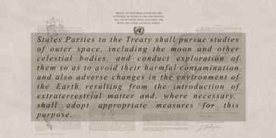
Figure 18 An excerpt of Article IX of the Outer Space Treaty of 1967
View description - Figure 18 An excerpt of Article IX of the Outer Space Treaty of 1967

‘States parties’ is a legal term used in the OST to refer to a nation or sovereign state that has agreed to be bound by the treaty.
A state is defined by the UN as a political entity with a permanent population, a defined territory, a government, and the capacity to enter into relations with other states.

3.1 The Outer Space Treaty
The Outer Space Treaty (OST), or the ‘Treaty on Principles Governing the Activities of States in the Exploration and Use of Outer Space, including the Moon and Other Celestial Bodies (1967)’, was developed at the United National (UN) General Assembly to outline the responsibilities and liabilities of ‘states parties’ engaged in the exploration or use of space.
Watch Video 5, which shows the signing of the OST within the White House in the USA.

Watch the video at YouTube.com.
Video 5 The official signing of the Outer Space Treaty in 1967

At the time of its signing, there were only two major players involved in space, the USA and the USSR (succeeded by the Russian Federation) and some of the motivation for the OST came from their desire to explore options for using space for military purposes (e.g., nuclear weapons and intelligence gathering), however many states viewed signing of the OST as a way of achieving international cooperation in space and as of May 2025, 116 States, including the United Kingdom, China, and the United States, had signed the Treaty.
Importantly, states are responsible for ensuring that their space activities, including those of government and non-governmental actors, adhere to the Treaty. This means that states are responsible for the actions of commercial entities operating within their borders.
The OST was developed and is overseen by the United Nations Committee on the Peaceful Uses of Outer Space (COPUOS). In the next videos (Videos 6 and 7) you will learn more about COPUOUS and the Outer Space Treaty.

Video content is not available in this format.
Video 6 Niklas Hedman explains COPUOUS.
View transcript - Video 6 Niklas Hedman explains COPUOUS.

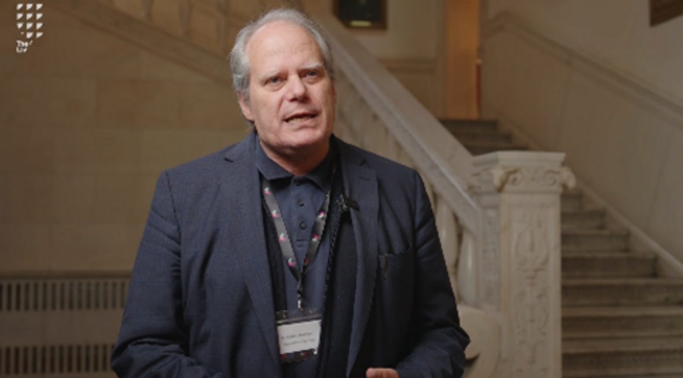

Provide your answer...

Video content is not available in this format.
Video 7 Does space need laws
View transcript - Video 7 Does space need laws

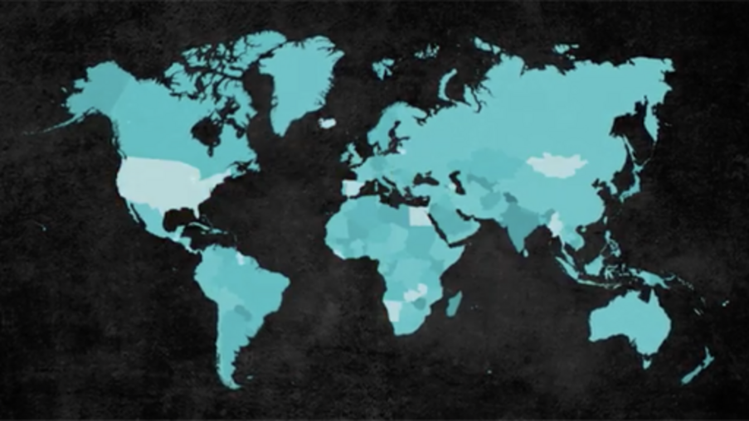

- How is the OST enforced?
- It is a challenge to enforce the OST, but political pressure encourages states to comply. Use of space is dependent on global co-operation and following the rules is in everyone’s interest – even those operating with a commercial interest. It does, however, need continual review and refresh.

The OST contains a number of Articles (sections) relating to different aspects of the use of space, but Article IX provides the legal basis for principles around Planetary Protection. Every state then organises their governance and implementation of planetary protection in a different way. For example, in the United Kingdom, the government established a Planetary Protection Advisory Panel (PPAP), which works with the UK Space Agency, the Civil Aviation Authority (CAA), and academic experts to ensure that UK-licensed space missions adhere to the principles of planetary protection.
Internationally, planetary protection is overseen by the Committee on Space Research (COSPAR) Panel on Planetary Protection.

3.2 The COPSAR Panel on Planetary Protection
While Article IX of the Outer Space Treaty provides the overarching legal framework for planetary protection, the Committee on Space Research (COSPAR) is at the heart of providing the scientific and technical basis for the implementation.

Activity 3
10 minutes

COSPAR was established over sixty years ago and is dedicated to promoting international science research in space. COSPAR has close links to COPUOS and has been granted observer status. Watch Video 8 that provides an overview of the work of COSPAR. As you watch, take notes on some of its key features and activities, such as:
- how they work with space scientists
- how they work with industry
- how they support emerging space-faring nations
- types of activities they undertake in relation to the use of space.

Watch the video at YouTube.com.
Video 8 Committee on Space Research (COSPAR)

Provide your answer...
View answer - Activity 3

As you will have seen from the video, the COSPAR Panel on Planetary Protection plays a significant role within COSPAR. It develops and maintains the COSPAR Planetary Protection Policy, which is an internationally recognised guide for compliance with Article IX of the Outer Space Treaty.
Watch Video 9 to understand more about the role of the COSPAR Planetary Protection Panel from the Panel Chair, Dr Athena Coustenis.

Video content is not available in this format.
Video 9 Dr Athena Coustenis discusses the COPSAR Panel on Planetary Protection
View transcript - Video 9 Dr Athena Coustenis discusses the COPSAR Panel on Planetary Protection

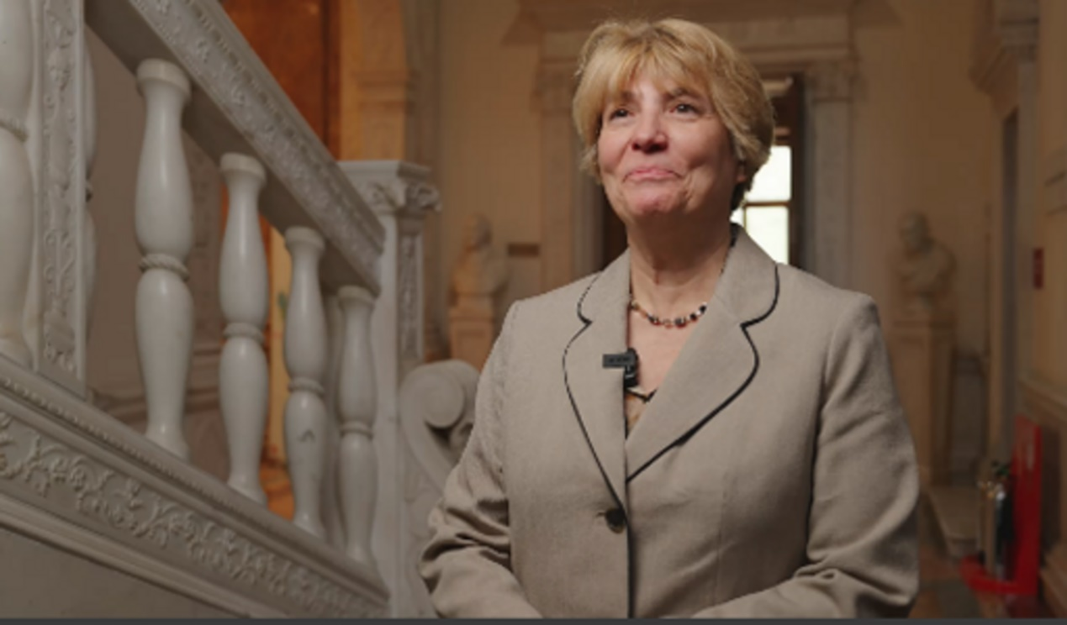

The Panel currently consists of 26 members, which includes 12 representatives from national space agencies, including China, France, Germany, the United Kingdom, India, Italy, Japan, the Russian Federation, Canada, the United Arab Emirates, the United States, the European Space Agency, and nine experts from the international scientific community. The Panel has several ex-officio members from the National Academies of Science, Engineering and Medicine (NASEM), the United Nations Office of Outer Space Affairs (UNOOSA), and the COSPAR Committee on Industrial Relations.

3.3 The COPSAR Planetary Protection Policy
The COSPAR Planetary Protection Policy is a set of guidelines agreed upon internationally. Although it is not legally binding, it is considered the gold standard to which nations should aim within their own policies and strategies.
The Policy has two roles (summarised on Figure 19):
- ensure that scientific investigations of possible extra-terrestrial life forms, precursors, and remnants are not jeopardised
- Earth is protected from the potential hazard posed by extraterrestrial matter carried by spacecraft returning from an interplanetary mission.

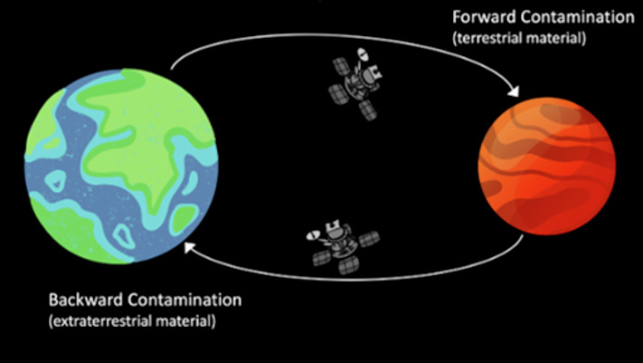
Figure 19 Forward and backward contamination as the key processes encapsulated in the Planetary Protection Policy
View description - Figure 19 Forward and backward contamination as the key processes encapsulated in ...

The Policy consists of a list of categories that are dependent on the following:
- The type of mission. Is the mission a flyby, orbiter, or lander, or is it returning samples to Earth?
- The scientific objectives. Is the aim of the mission to find evidence of past or present life, or investigate prebiotic evolution?
- The target body. Does the target body potentially support growth, or do host environments have prebiotic potential?

- Do you think a lander mission to Mars would have higher planetary protection requirements than a lander mission to the Moon?
- The requirements for Mars would be higher. This is because we believe that the environmental conditions on Mars could have once been habitable and hold evidence of life.

The categories (Table 5) are important because they determine how stringent planetary protection controls need to be during the spacecraft design, build, launch and operations.

Table 5 A simplified overview of the Planetary Protection categories
Category | Mission Type | Rationale | Target body (considered to date)
I | Flyby, orbiter, lander | Bodies that are not of direct interest for understanding chemical evolution and/or origin of life. | Asteroids that have experienced significant heating and melting; Io (moon of Jupiter)
II (divided into II, IIa and IIb for the Moon) | Flyby, orbiter, lander | Bodies that could have significance for the process of chemical evolution and/or origin of life, but where scientific judgement indicates remote possibility of contamination by organic or biological materials. | Venus, Moon, comets, carbon-rich asteroids, gas giant planets and some of their moons, some dwarf planets and Kuiper Belt Objects
III | Flyby, orbiter | Bodies that could have significance for the process of chemical evolution and/or origin of life, but where scientific judgement indicates significant possibility of contamination by organic or biological materials that could compromise future mission objectives. | Mars, Europa (moon of Jupiter), Enceladus (moon of Saturn)
IV (divided into a, b and c) | Lander | Bodies that could have significance for the process of chemical evolution and/or origin of life, but where scientific judgement indicates significant possibility of contamination by organic or biological materials that could compromise future mission objectives. | Mars, Europa, Enceladus
V ‘Restricted Earth Return’ | – | All Earth-return missions to protect the Earth-Moon system that scientific judgement indicates could have indigenous life. | Mars, Europa, Enceladus
V ‘Unrestricted Earth Return’ | – | All Earth-return missions from bodies that scientific judgement indicates will have no indigenous life. | Venus, Moon

Activity 4
5 minutes

To understand how planetary protection plays a key part in developing missions, work through the following interactive that will show you the decisions that have to be taken to design and fly a space exploration mission. Space: to boldly, but cautiously, go.

The interactive in Activity 4 introduced you to the importance of icy worlds in the search for life beyond Earth. The next section uses icy worlds as a case study to illustrate how the Planetary Protection Policy and its categories are applied.

3.4 The Icy Worlds: A Planetary Protection Case Study
All of the giant planets have satellites, and some of them are large enough that they have been observed since the days of astronomer Galileo Galilei who observed satellites of Jupiter in the 1600s (these are known as the Galilean satellites Io, Europe, Ganymede and Callisto). However, relatively little was known about them until the advent of space exploration in the 20th century. Before that, telescope observations could determine their orbits, and small changes to these allowed estimations to be made of their masses. Surprisingly, some of them were less dense than would be expected from their size if they were composed entirely of solid rock (like our own Moon).
Some of this difference can be accounted for by the presence of an outer layer of ice, with Europa’s icy shroud discovered by astronomers in the 1950s (Figure 20). It is now known that several of the satellites of the outer planets have an icy surface, but the ice is not necessarily frozen water. In the outer Solar System, although water is usually the dominant component, ice can incorporate other frozen volatile molecules such as ammonia (NH₃), carbon dioxide (CO₂), carbon monoxide (CO), methane (CH₄) and nitrogen (N₂).
With this discovery came the possibility that there could be water on these icy worlds, and with it a focus for astrobiological studies.

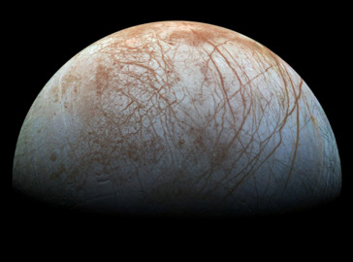
Figure 20 Jupiter's moon Europa, imaged by NASA's Galileo spacecraft in the late 1990s.
View description - Figure 20 Jupiter's moon Europa, imaged by NASA's Galileo spacecraft in the late ...

3.4.1 Exploring icy worlds
In the late 1970s, NASA’s Voyager mission provided the first tantalising clues that Europa, one of Jupiter’s moons, might have an ocean beneath its thick icy shell. Since then, missions such as NASA’s Galileo and Cassini-Huygens spacecraft have provided evidence of sub-surface oceans on other moons of Jupiter and Saturn, such as Ganymede, Callisto, Titan and Enceladus (Figure 21).
With the identification of water comes the possibility of life, and much effort has been put into understanding whether these subsurface environments could be habitable. Excitingly, several missions are planned to visit these bodies in the coming years: Europa Clipper, to explore Europa in more detail from orbit; JUICE (JUpiter ICy Moons Explorer), to study the icy moons Ganymede, Europa and Callisto; and Dragonfly, focusing on the surface of Saturn’s moon Titan.

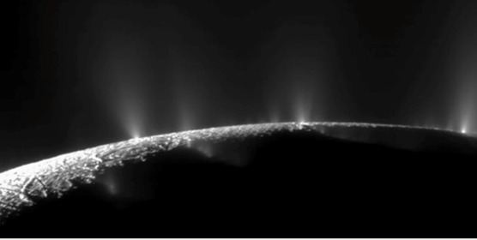
Figure 21 Plumes of gas and ice emitted from the south pole of Enceladus
View description - Figure 21 Plumes of gas and ice emitted from the south pole of Enceladus

These missions present exciting opportunities to learn more about icy worlds, their potential habitability, role in pre-biotic chemistry and physical and chemical conditions that result in the presence of water and energy that might support life. However, there is only so much that a single space mission can accomplish, especially since Europa Clipper and JUICE are orbiters. So, it is likely that these moons will be targets for other missions in the future. It is therefore critical to ensure these moons remain unspoilt and pristine to not jeopardise future investigations. More importantly, if these moons were to harbour life, it is imperative that we do not interfere or disrupt their habitat in any way.

3.4.2 Limiting contamination on icy worlds

- What planetary protection category would a mission to an icy world fit into?
- Missions to icy worlds are classified based on their mission type, target body, and scientific objectives. Using Table 5 we can see that icy world missions might be classified as Category III, IV or even V (Restricted Earth return).

One of the underlying concepts in the planetary protection policy is that of the ‘period of biological exploration (PBE)’. This is the time needed for a robotic mission to operate at a potentially habitable environment and detect biological life. However, in Activity 4 you considered what might happen to the spacecraft at the end of its mission, since that might also result in a potential contamination event. Hence, the PBE is longer than the mission lifetime.
For icy worlds, the PBE has been defined as 1000 years, and the probability that a robotic mission could potentially contaminate an icy world in that period is less than 1 × 10⁻⁴. This probability is based on the following equation:

View alternative description - Uncaptioned Equation

Where
- P_{c} = the probability of contamination of a single terrestrial organism
- N₀= the number of microorganisms on the spacecraft initially
- R = reduction due to sterilisation pre-launch
- P_{S} = Probability that the microorganisms on the spacecraft will reach the surface of the planet
- P_{I}= Probability that the spacecraft will impact the planet (1 for landers)
- P_{R} = Probability of microorganisms being released into the environment after landing (usually set at 1 for landers and crash-landers)
- P_{g} = Probability of growth (usually set at 1 where the target is liquid water)
You can see that calculating the probability of contamination takes into consideration several factors, including whether the spacecraft might crash into the surface, deliberately or otherwise. For the JUICE mission, which is a Category II mission, the mission team addressed the planetary protection requirements by limiting the probability of impact on Europa to a level of 1 × 10⁻⁴, which by default limits the probability of contamination of the sub-surface ocean to levels below 1 × 10⁻⁴.

3.4.3 Cassini’s sacrifice
The Cassini spacecraft delivered the Huygens probe to the surface of Titan in 2004 (Figure 22). However, it was launched seven years earlier, in 1997. At that time, it was considered highly unlikely that life could survive in the extreme cold of Titan’s surface and the risk of contamination of the moon was low. For this reason, it was classified as a Category II mission (interesting for origin of life but low risk of contamination).
By the time Cassini reached the end of its mission, much more was known about the potential for water on nearby moons, such as Enceladus. With the mission initially destined to be adrift in the Saturnian system once operations had ended, the possibility of it crashing into an astrobiologically important body was therefore high. To avoid this, while Cassini was still operating, it was programmed for a controlled descent into Jupiter’s atmosphere where it was destroyed, losing contact with Earth in 2017 and avoiding a collision and contamination event elsewhere.

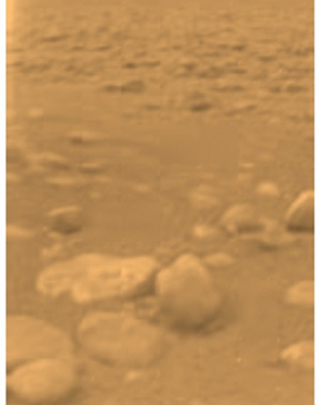
Figure 22 The icy surface of Titan as photographed by the Huygens mission in 2004.
View description - Figure 22 The icy surface of Titan as photographed by the Huygens mission in 2004. ...

Cassini’s example may seem drastic, but our understanding of the Solar System is constantly changing, and planetary protection requirements need to evolve to accommodate this.

4 Planetary Protection Requirements
In this section you will learn how the planetary protection requirements have evolved over time and some of the current requirements that missions need to put into place, using missions to Mars as a case study.

4.1 The history of planetary protection requirements
The history of planetary protection has been intertwined with the development of space exploration.
For example, for the Apollo missions to the Moon, scientists were concerned that: 1) potential lunar microorganisms could comprise the Earth’s biosphere and 2) that microbial contamination from Earth could compromise the integrity of lunar samples returned by astronauts. These concerns led to the development of the mobile quarantine facility (as shown in Figure 23) that could accommodate both the astronauts and the lunar sample receiving facility.
Analysis of the initial lunar samples demonstrated that they contained no biological material, so backward contamination requirements were decreased for Apollo 14 onwards and today, missions to the Moon are currently Category II (Table 5).

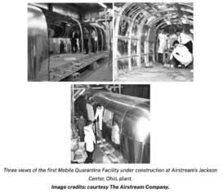
Figure 23 NASA image
View description - Figure 23 NASA image

4.1.1 Planetary protection and Mars exploration
Early missions to Mars were a huge learning curve for planetary protection (then called ‘planetary quarantine’). The twin Viking landers that reached Mars in 1976 had stringent planetary protection requirements applied to prevent the microbial contamination of the martian surface to a probability of less than 1 × 10⁻³. This meant the Viking landers were required to carry with them no more than 300 terrestrial bacterial spores per m².

- Why might spores be included in planetary protection requirements?
- Spores are highly resistant to environmental extremes.

Spores are used as a proxy for all microbes, to represent bioburden. Bioburden includes all the microorganisms living on a surface. To demonstrate the challenges associated with this, consider that it is estimated that there are up to 10000 microbes on 1 cm² of human skin.
Monitoring bioburden is therefore one of the key requirements needed during spacecraft build. For example, for the Viking missions (Figure 24), the landers were cleaned and then dry heat sterilised for 30 hours at temperatures above 120 °C to remove viable organisms (viable mean those that are alive and can perform essential biological functions). This was especially critical on Viking because the landers carried four biology experiments specifically designed to look for life within the martian regolith (soil).

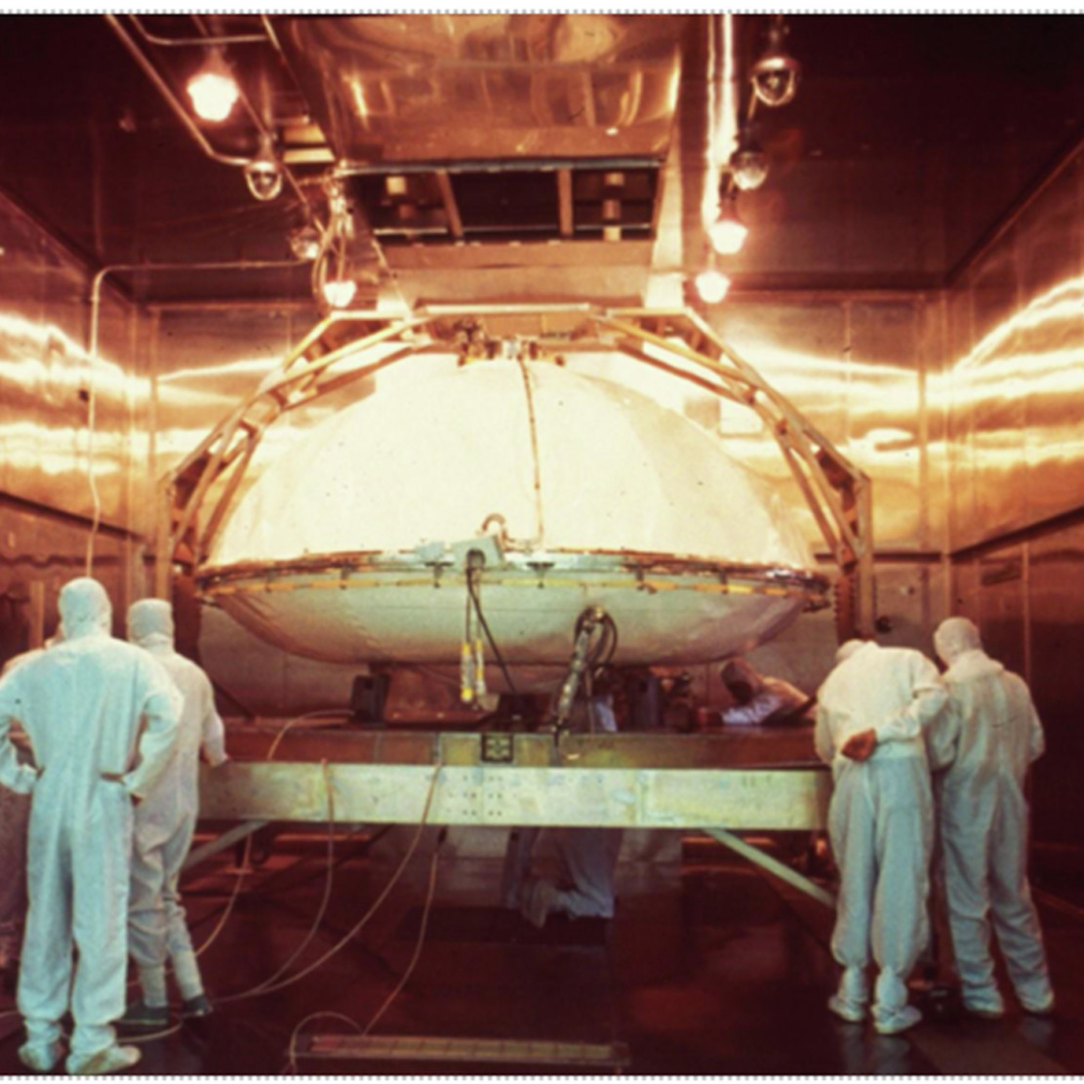
Figure 24 The Viking lander being prepared for sterilisation
View description - Figure 24 The Viking lander being prepared for sterilisation

Our understanding of Mars has evolved considerably since the first Viking mission, and so the next section will look at planetary protection requirements for current Mars missions.

4.1.2 Planetary protection for Mars today
Today, the Policy on Planetary Protection outlines the bioburden a mission to Mars can carry, as well as defining the planet’s period of biological exploration as 50 years.
Orbiting spacecraft, such as the ExoMars Trace Gas Orbiter, are Category III, and require less than 5 × 10⁵ bacterial spores to be carried by the spacecraft, or a probability of impact of less than 1 × 10⁻² (for 20 years after launch). Although orbiter missions are not planned to land on the planet’s surface, there is still a possibility that it might touch down either through mission failure or at mission end and so planetary protection considerations are still important.
Landers are Category IV missions. These pose the greatest risk because they could deliver terrestrial contamination directly to the planet’s surface, but the planetary protection requirements depend on the mission objectives. Those lander missions not designed to look for evidence of life (Category IVa) must carry fewer than 3 × 10⁵ bacterial spores, whereas those that are designed to look for life (Category IVc) are restricted to fewer than 30 spores.
All spacecraft in these categories must be built within an environmentally monitored cleanroom and undergo stringent monitoring and cleaning procedures before launch. For example, the Beagle 2 Mars lander, which was carried by ESA’s Mars Express mission, was assembled within the Aseptic Assembly Facility, a high-specification clean room on the Open University’s campus in Milton Keynes (Figure 25).

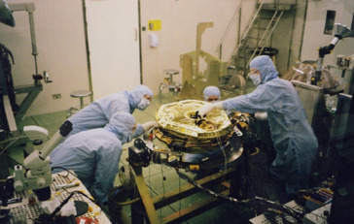
Figure 25 Assembly of the Beagle 2 Mars lander in the Aseptic Assembly Facility at the Open University in Milton Keynes. Beagle 2 landed on Mars in 2003 but did not communicate with Earth and was presumed lost until identified on images taken from orbit in 2014.
View description - Figure 25 Assembly of the Beagle 2 Mars lander in the Aseptic Assembly Facility at ...

Category IVc missions are a special case because they are likely to visit Special Regions on Mars. These have been defined as areas where terrestrial organisms carried by a spacecraft might be able to survive and thrive, or where there is high potential for living organisms to be found. The temperature of the region must be greater than −28 °C and have a water activity of 0.5 (see below). This currently includes gullies, cavities, and the surface features known as Recurrent Slope Lineae (RSL, Figure 26) but could include any areas that show evidence of groundwater.

Water activity is a measurement of the availability of water to biological processes. It depends on the presence of solutes (dissolved substances) and the relative humidity of the environment. The higher the concentration of solutes in a water, the lower the water activity. The lower the water activity, the less likely the environment is to host life.

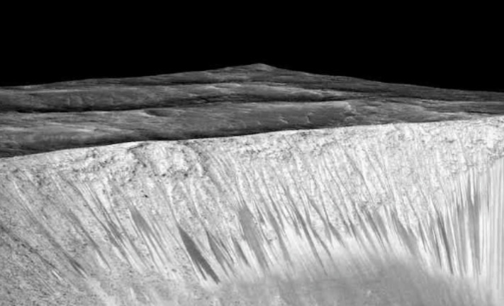
Figure 26 Recurring Slope Lineae (RSL) appearing as dark streaks on the walls of Garni Crater on Mars.
View description - Figure 26 Recurring Slope Lineae (RSL) appearing as dark streaks on the walls of ...

4.1.3 Mars sample return
While most of the focus around planetary protection has been on the risks to Mars from terrestrial contamination, missions that might return to Earth from Mars carrying martian materials are already planned. Samples of rocks and soils are being collected by NASA’s Perseverance rover (currently on Mars), stored there, and will be returned to Earth by a future mission, sometime in the 2030s. A sample return mission from Mars would be categorised as Category V ‘Restricted Earth return’.
To prepare for this eventuality, much effort has been put into understanding the harsh martian environment and its potential effect on life and its proliferation. In addition, to reduce the risk to Earth’s biosphere, the samples brought back to Earth would be stored, curated and analysed in a special facility (a Sample Receiving Facility), preventing any material from entering the outside world until it was proven to be safe. In Video 10, the rationale behind such a facility is explained and Figure 27 shows one proposed process by which samples returned from Mars would be delivered through the Earth’s atmosphere to the sample receiving facility.

Video content is not available in this format.
Video 10 Dr Francis McCubbin explains the importance of sample return planetary protection
View transcript - Video 10 Dr Francis McCubbin explains the importance of sample return planetary ...



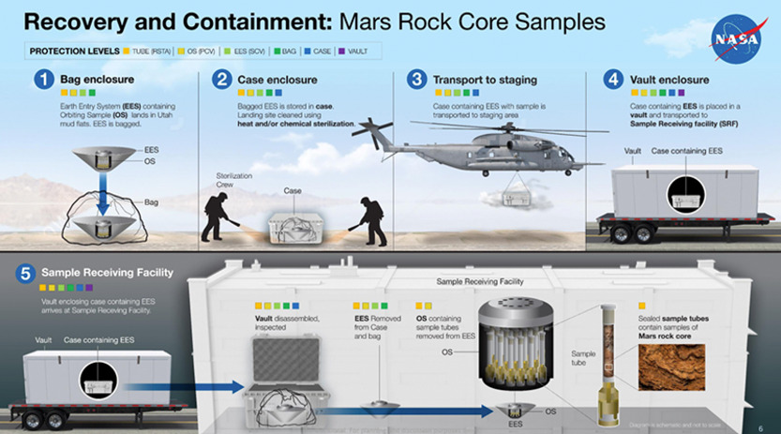
Figure 27 A proposed process for safely recovering, containing, and transporting Mars samples gathered by NASA's Perseverance Mars rover.
View description - Figure 27 A proposed process for safely recovering, containing, and transporting ...

At the Sample Receiving Facility, the samples would be placed in a cabinet to contain any potentially harmful life, whilst also ensuring that the samples are kept ultra-clean, so that terrestrial life doesn’t contaminate the samples (causing false negative results).

A false positive result is one that indicates the presence of something that is not actually there. In the search for life, contamination might suggest extraterrestrial life is present, but it is in fact from Earth.
A false negative result is one that indicates the absence of something, even though it is present. In the sample receiving facility, terrestrial contamination may be detected and identified but might mask the presence of extraterrestrial life.

These are good reasons for ensuring there is an understanding of potential contamination, but also for developing suitable facilities on Earth for returned samples.
A consortium in the UK (including The Open University) is developing a cabinet that can protect the samples and the Earth environment. The concept is called a ‘double walled isolator’, and it uses positive pressure as a barrier between the laboratory and the samples. That is, the pressure inside the cabinet is higher than around it, preventing anything from entering the chamber (Figure 28).

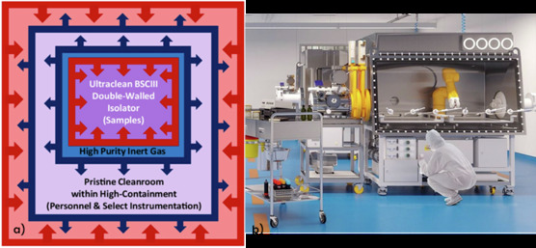
Figure 28a) The Double Walled Isolator into which returned samples from Mars could be placed. The arrows indicate the direction of airflow, creating a protective barrier. Figure 28b) An artist’s impression of the cabinet when built.
View description - Figure 28a) The Double Walled Isolator into which returned samples from Mars could ...

While the cabinet provides protection for returned samples, it still needs to be operated within a cleanroom environment. As has already been alluded to, cleanrooms are also critical environments for the building of spacecraft as part of contamination mitigation.

4.2 Cleanroom environments
Cleanrooms are semi-closed environments in which bioburden can be monitored. Environmental conditions that might affect spacecraft instruments, e.g., humidity, temperature, might also be closely controlled. Cleanrooms must comply with international standards as defined by the International Standard Organization (ISO), regardless of whether they are being used for building spacecraft or other types of activity that might require cleanliness (e.g., healthcare and medicine, food).

4.2.1 How clean is clean?
The ISO standard (ISO 14644) specifies how a cleanroom should be designed, built and operated and classifies cleanrooms from ISO1 (cleanest) to ISO9 (least clean). When the Beagle 2 spacecraft you met in Section 4.1.1 was built, the cleanroom standards were described differently as Class 1, 10, 100, 1000, 10000 or 100000, with Class 1 the cleanest; Beagle 2’s Aseptic Assembly Facility on the Open University campus was a Class 1.
The Class number (and today’s ISO classification) was determined by the number of airborne particles between 0.1 to 10 μm in one m³ of air (Table 6). These particles could be aerosols, dust, cells, or spores.

Table 6 Maximum concentration of particles per m3 of varying sizes
ISO classification number | ≥0.1 μm | ≥0.2 μm | ≥0.3 μm | ≥0.5 μm | ≥1 μm | ≥5 μm
ISO class 1 | 10 | – | – | – | – | –
ISO class 2 | 100 | 24 | 10 | – | – | –
ISO class 3 | 1,000 | 237 | 100 | 35 | – | –
ISO class 4 | 10,000 | 2,370 | 1020 | 352 | 83 | –
ISO class 5 | 100,000 | 23,700 | 10,200 | 3,520 | 832 | –
ISO class 6 | 1,000,000 | 237,000 | 102,000 | 35,200 | 8,320 | 293
ISO class 7 | – | – | – | 352,000 | 83,200 | 2,930
ISO class 8 | – | – | – | 3,520,000 | 832,000 | 29,300
ISO class 9 | – | – |  | 35,200,000 | 8,320,000 | 293,000

The choice of cleanroom class per mission depends on the category of the mission, as defined on Table 5. The COSPAR recommendation is for a minimum of ISO8 for the build and testing of any spacecraft. If parts of the spacecraft will come into contact with a planetary surface, then an ISO5 cleanroom (or better) is required. However, the specific requirements depend on the details of each mission and a single spacecraft might have components built within different classifications of cleanroom.
To maintain ‘cleanliness’, the cleanroom environment is controlled by being constructed from materials unlikely to shred or outgas, adding filters to the airflow and applying a positive pressure to the room. The surfaces are regularly cleaned using sterile wipes and a cleaning product such as ethanol or isopropyl alcohol.
Since humans are estimated to bring up to 80% of particles into a cleanroom, users may need to use an air shower before entering/exiting and are required to wear cleanroom garments (Figure 29). This reduces the risk of microorganisms on human skin, hair or clothes being introduced into the clean room environment and settling onto the spacecraft.

- What term describes microbes that settle onto surfaces?
- We describe these as bioburden.

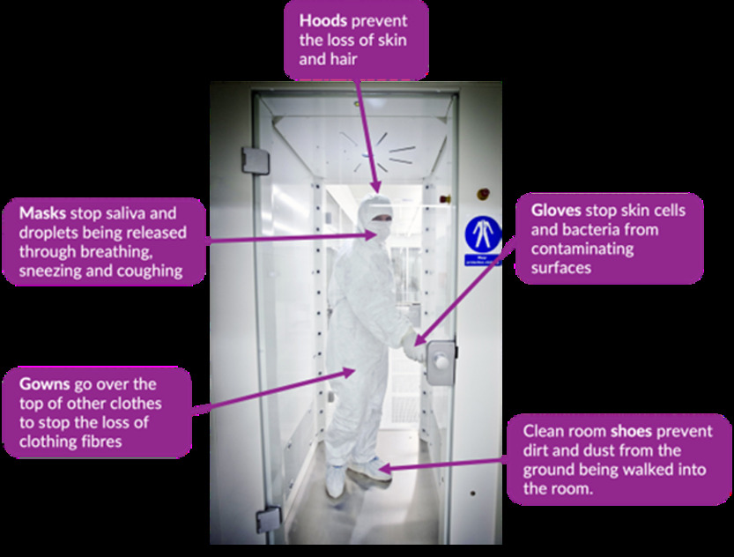
Figure 29 User in an air shower wearing cleanroom garments designed to minimise contamination
View description - Figure 29 User in an air shower wearing cleanroom garments designed to minimise contamination ...

4.2.2 Monitoring bioburden
Monitoring bioburden during the building of a spacecraft is critical since the bioburden requirements for each mission are dependent on its category as defined in the Planetary Protection Policy (Table 7).

Table 7 Planetary Protection Policy
Category | Target body (considered to date) | Bioburden requirements
I | Asteroids that have experienced significant heating and melting; Io (moon of Jupiter) | No bioburden requirements
II (divided into II, IIa and IIb for the Moon) | Venus, Moon, Comets, carbon-rich asteroids, gas giant planets and some of their moons*, some dwarf planets and Kuiper Belt Objects* | contamination avoidance probability <1.0 × 10⁻⁴
III | Mars, Europa (moon of Jupiter), Enceladus (moon of Saturn) | ≤5 × 10⁵ spores at launch or <1.0 × 10⁻⁴ contamination avoidance probability 50 years after launch
IV (divided into a, b and c) | Mars, Europa, Enceladus | ≤3 × 10⁵ spores
V ‘Restricted Earth Return’ | Mars, Europa, Enceladus | ≤30 + (2 × 10⁵) spores
V ‘Unrestricted Earth Return’ | Venus, Moon | Same as Category I and Category II
*Additional analysis is required for Ganymede, Titan, Charon, KBOs >1/2 the size of Pluto. Assignment to Category II must be supported by an analysis of the ‘remote’ potential for contamination (a probability of introducing a single viable terrestrial organism e.g., <1 x 10⁴).

Monitoring bioburden involves a systematic approach involving sampling, culturing, and quantifying microorganisms.
Sampling is undertaken to monitor bioburden on cleanroom and spacecraft surfaces, as well as within the air and on the personnel working there. Sterile swabs or wipes are used to sample surfaces, hard-to-reach areas, or equipment. The swab or wipe is rubbed over a defined area to collect any microbes present, then the collected microbes are transferred to a growth medium to assess the number of microbes present.
Cleanroom air is samples in two ways. Active sampling involves drawing air through a filter, transferred it to a growth medium, and then assessing the number of microbes per m³ of air (the unit used to represent the number of microbes is explained below). Passive Sampling involves opening a sampling vessel containing growth medium and exposing it to the cleanroom environment for a defined amount of time. Microbes in the air settle onto the growth medium, and the colonies are counted to deduce the microbes per time period.
The cleanroom garments of users are also swabbed to assess the effectiveness of gowning procedures and personnel hygiene. There are also sometimes constraints placed on the number of users permitted into the clean room at any one time.
Culturing is the process by which microbes are grown in a laboratory.

- If microbes are to be successfully cultured, what will need to be provided?
- They will need appropriate sources of water, raw materials (nutrients) and energy, and they will need appropriate environmental conditions.

Culturing can be achieved either in a liquid, called a growth medium, or the liquid can be solidified as a firm gel using agar (extracted from seaweed) on the surface of which the microbes can be grown. The medium contains the nutrients and energy sources for the microbes to grow. The usual container for the gel is a small plastic dish with a lid called a Petri dish and a dish of agar is often referred to as an ‘agar plate’. The shape and colour of the microbial colonies that grow on the surface of the gel can then be examined under a microscope (Figure 30). The microorganisms present are quantified using a measure known as ‘colony forming units (CFUs)’. CFUs are a measure of the number of viable microbes that could multiply and form colonies.
This is one example of a biological assay in which the presence of cells or key molecules that comprise cells can be quantified by their response to a chemical environment. Other techniques involve characterising the genetic sequences of the microbes in a cleanroom once sampled.

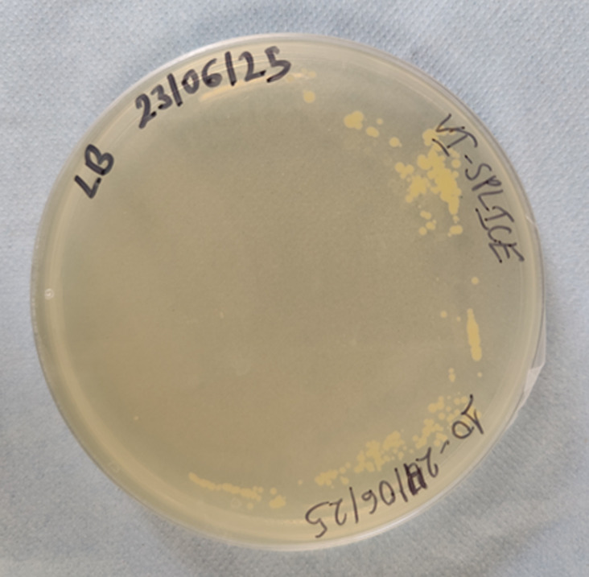
Figure 30 A plate showing colony forming units
View description - Figure 30 A plate showing colony forming units

4.2.3 Monitoring MOC in cleanrooms
In addition to microbial contamination, planetary protection guidelines require clean assembly protocols to minimise particulates, dust and molecular organic compounds.

- Can you suggest another reason why minimising MOC might be important?
- MOC can also cause the degradation of spacecraft surfaces or even prevent adequate bonding between materials.

The organic substances that could contaminate hardware and vacuum chambers used in the process of building and cleaning hardware can include:
- Volatile condensable materials outgassing under vacuum
- Volatile condensable materials off gassing directly
- Back-streaming of materials from pumping systems
- Residues from cleaning agents
- Handling residues (e.g., human fingerprints)
- Creep of substances (e.g., silicones)
- Non-filtered external pollution.
Two methods are employed to detect and measure MOC in cleanrooms: direct and indirect.
Direct methods use infrared (IR)-transparent ‘windows’ to capture organic compounds on their surfaces and are positioned at critical locations around the cleanroom. We call these windows witness plates as they act as a proxy for any other surface that MOC could accumulate onto and they are made of materials such as zinc selenide, germanium, or calcium fluoride. The plates are then analysed using IR-spectroscopy that can determine the presence and identity of any groups of organic compounds (hydrocarbons, esters, and silicones are the most concern).

IR spectroscopy is a common analytical technique that detects the absorption of light by a compound in the IR region of the electromagnetic spectrum. Different chemical bonds will absorb IR radiation at different areas of the IR spectrum, referred to as wavenumbers. An IR spectrometer is a relatively simple device consisting of a lamp or heated rod that will emit light in the IR region. A detector then collects all wavelengths of IR radiation that have passed through the sample and converts these to wavenumbers. Each type of molecule will have a different pattern of wavenumbers, so identification can be made.

Indirect methods involve rinsing a surface with a solvent, which is then evaporated until a few drops remain and this liquid is transferred to an IR-transparent window. Further evaporation occurs of the remaining solvent, and the window is analysed by IR-spectroscopy. A second indirect method uses pre-cleaned tissues to wipe a surface (wet or dry) eight times. The tissue is then immersed in solvent, removed, and the solvent analysed by IR-spectroscopy.
New methods of sampling and determining organic contamination within cleanrooms are also in development (Figure 31), that can give near real-time results by identifying and detecting organic molecules that are emitted by materials within a cleanroom, such as adhesives, lubricants and the flight hardware itself. By identifying these volatile organic compounds (VOCs) individually, unlike the IR-spectroscopy that identifies groups of compounds, steps can then be taken to mitigate the contamination more efficiently and effectively, since many VOCs will behave very differently under the same conditions. This technique can also be used to help identify organic compounds from returned samples in a way that is non-invasive, thus not further contaminating any precious samples.

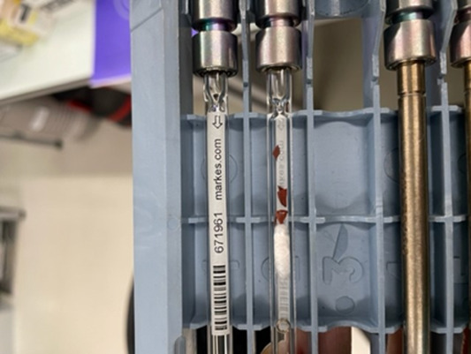
Figure 31 Tubes into which VOCs are collected for analysis
View description - Figure 31 Tubes into which VOCs are collected for analysis

4.3 Bioburden Reduction
Planetary protection requirements do not expect complete sterilisation of a spacecraft but need assurance that the statistical risk of contamination is negligible. Reduction of contamination can occur in two ways:
- pre-launch in clean rooms, and
- during missions, using radiation exposure in the space environment.

4.3.1 Pre-launch sterilisation
As you have already learned, bioburden reduction is considered from the beginning of a mission. Spacecraft are built in cleanrooms and bioburden is constantly monitored. However, other steps are taken to actively reduce bioburden, which can include applying the following methods to cleanroom equipment, spacecraft hardware or tools being used during assembly:
- Dry heat microbial reduction: exposing items to heat for up to 180 °C for over 1 hour to destroy microbial contamination
- Isopropyl/ethyl alcohol: Cleaning with clean wipes and alcohol to physically remove contamination and disinfect surfaces
- Radiation: Applying gamma, beta, or UV radiation to destroy viable cells and organic molecules
- Wet heat microbial reduction: exposing hardware to temperatures up to 134 °C for 20–30 min to destroy microbial contamination.
- Plasma sterilisation: exposing hardware to a low temperature plasma (ionised gas) to destroy microbes.
Not all of these approaches are suitable for all parts of a spacecraft, for example some electronic equipment may be unable to withstand high temperatures. This means that in some cases, there may be a need for other techniques that can reduce bioburden.

4.3.2 Sterilisation during a mission
If only pre-launch sterilisation had been applied to the Europa Clipper mission, the bioburden reduction processes would have been too extreme for most electronics and optics to withstand.
Therefore, the mission team took on a statistical approach that took into account:
- The probability of impact after failure.
- The probability of Europa’s surface hosting one or more microbes and a resurfacing (overturn of the surface) that causes the microbe to contact Europa’s surface ocean.
- Estimation of the number of microorganisms pre-launch and the biocidal effect on the route and on the surface of Europa (should there be an impact).
Previous experiments, including laboratory simulations and experiments onboard the International Space Station (Section 2.1.2), which have involved scientists from The Open University, have shown that the radiation environment of space, its cold temperatures, the vacuum of space and impacts from dust in space are detrimental to microbial life. For this reason, the Open University are also investigating whether the environment conditions at the surface of Mars could also be used as a sterilisation approach for planetary protection. For this work, an environmental simulation facility is used (Figure 32) that can simulate conditions experienced at the martian surface, including low atmospheric pressure (6 mbar), low temperatures (243 K) and exposure to UV radiation, to study microbial survival.

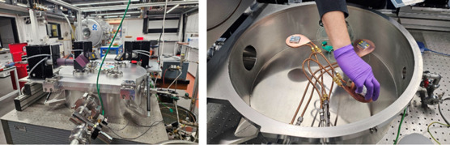
Figure 32a) outside and Figure 32b) inside of an environmental simulation chamber that can be used to study the effect of simulated surface conditions on Mars.
View description - Figure 32a) outside and Figure 32b) inside of an environmental simulation chamber ...

5 The future of planetary protection
Planetary protection is facing several new challenges. As access to space by the private sector increases, planetary protection requirements still need to be upheld. It is the legal (and arguably ethical and moral) obligation of those signatories to the Outer Space Treaty to ensure that mechanisms are in place to achieve this, such as embedding it into regulations, and licenses, even though the Policy on Planetary Protection itself is not legally binding.
As has been alluded to in places, work to understand the resilience of microbes to different extraterrestrial conditions is providing insights that could be used both to develop requirements for planetary protection and to use as methods of reducing the potential of contamination. Understanding the organic emissions from spacecraft is also critical for compiling organic inventories needed for future exploration missions.
In this course, we have focused mainly on robotic missions, but several space agencies and other organisations are also planning for near-future crewed missions to Mars and the Moon. COSPAR’s Planetary Protection Panel have identified several knowledge gaps that need to be filled to address this challenge and have begun to work with space agencies to identify how to apply planetary protection principles and requirements to such missions. However, it is recognised that removing the possibility of biological and organic contamination by a human is not possible; humans have their own microbiome made up of thousands of different types of microorganisms. It is also impossible to fully isolate any members of a crew or their spacecraft from an extraterrestrial environment.
This is prompting efforts to better understand the interactions between humans and the space environment, how life support and other essential systems could be adapted to minimise contamination events, and how the space environment itself might propagate or sterilise any biological life humans might invertedly deliver.


Figure 33 Human exploration is an upcoming challenge for planetary protection
View description - Figure 33 Human exploration is an upcoming challenge for planetary protection

6 Conclusion
In this course you have learned about the scientific reasoning behind planetary protection, including efforts to search for life and its origins in the Solar System. You have been introduced to how we determine the survival and proliferation of microorganisms using analogue sites so that we can apply this knowledge to limiting bioburden carried to extraterrestrial environments. You also learned about the prevalence of organic molecules and why it is critical to know which ones are carried by spacecraft.
You have also learned about the governance of planetary protection by the COSPAR Panel on Planetary Protection and its requirements for space missions to various planetary bodies. Through the examples of icy world and martian exploration, you learned about the ways in which contamination is minimised before launch.
Finally, you heard about some of the new developments in planetary protection and how this needs to evolve in the future as human interactions with space change.

7 Quiz
Answer the following questions to test your understanding of the key ideas you have learned in this course.

Activity 5

Question 1

Which of the following are reasons behind the need for planetary protection protocols? (select all that apply)

The potential for crewed missions to travel to Mars
The increasing prevalence of space debris orbiting Earth
The exploitation of resources on the Moon from polar regions
The protection of Earth’s environment from asteroid impacts
The search for life and its building blocks
View answer - Question 1

Question 2

Which of the following is not a biosignature? (select one correct answer)

A mineral produced because a microbe changes the local chemical and physical conditions
The presence of a gas in a planetary atmosphere
The predominance of light stable isotopes within rock samples
The presence of L-alanine in higher abundances than D-alanine
View answer - Question 2

Question 3

Match the type of extremophile to the environmental condition it can thrive within.

temperatures <15 °C
pH 8-12.5
high salinity
very dry conditions
temperatures 80–121 °C
psychrophiles
alkaliphiles
halophiles
piezophiles
hyperthermophiles
View answer - Question 3

Question 4

Which of the following are important considerations when determining the planetary protection category of a mission? (select all that apply)

The possibility of habitable environments on the target body
The potential presence of organic molecules formed without the presence of life
The type of mission (flyby, orbiter, lander)
The duration of the mission
Whether samples will be returned to Earth
View answer - Question 4

Question 5

What planetary protection category might be applied to a sample return mission to a comet? (select one correct answer)

I
II
V ‘restricted’
IV
V ‘unrestricted’
View answer - Question 5

Question 6

According to the Outer Space Treaty, states (nations) are responsible for the actions of commercial entities operating within their borders. True or false?

True
False
View answer - Question 6

Question 7

The Planetary Protection Policy is constantly evolving to reflect changing scientific evidence. The responsibility for this sits with (select one correct answer)

COPUOS
NASA’s Office for Planetary Protection
COSPAR Panel on Planetary Protection
UKSA’s Planetary Protection Advisory Panel
International Astronomical Union
View answer - Question 7

Question 8

Which of the following is used as a measure of bioburden on spacecraft? (select one correct answer)

Number of organic molecules in an air sample
The number of particulates that settle on a surface
The presence of bacteria
Number of spores per unit area
The number of human skin cells
View answer - Question 8

Question 9

Which of the following approaches are not used to minimise bioburden on spacecraft before launch? (select one correct answer)

Dry heat
Application of alcohol on wipes
Plasma sterilisation
Gamma radiation
Acid bath
View answer - Question 9

Question 10

Crewed missions to Mars or the Moon are not subject to planetary protection requirements. True or false?

True
False
View answer - Question 10

8 Tell us what you think?
Now that you’ve come to the end of the course, we would appreciate a few minutes of your time to complete a short end-of-course survey. Participation is completely confidential, and we will not pass on your details to others.
End-of-course survey

Acknowledgements
This free course was written by Vic Pearson, Michael Macey, Claire Batty and Karen Olsson-Francis and first published in October 2025.
Except for third party materials and otherwise stated (see terms and conditions), this content is made available under a Creative Commons Attribution-NonCommercial-ShareAlike 4.0 Licence.
The material acknowledged below is Proprietary and used under licence (not subject to Creative Commons Licence). Grateful acknowledgement is made to the following sources for permission to reproduce material in this free course:
Images
Course image: Sergey Nivens; Shutterstock
Figure 1a): NASA/Michala Garrison, using Landsat data from the U.S. Geological Survey and VIIRS day-night band data from the Suomi National Polar-orbiting Partnership; Figure 1b): NASA
Figure 2: image ESA - P. Carril
Figures 3, 4, 24 and 27: NASA
Figures 5 and 22: image ESA
Figure 6: NASA/Keegan Barber
Figures 7, 14, 15, 16 and 25: The Open University
Analogue sites slideshow: Slide 1 (Figure 8): Macey, M.C., Fox-Powell, M., Ramkissoon, N.K. et al. The identification of sulfide oxidation as a potential metabolism driving primary production on late Noachian Mars. Sci Rep 10, 10941 (2020)., https://creativecommons.org/licenses/by/4.0/; Slide 2 : (Fgure 9) courtesy of Velislava Ilieva; Slide 3 (Figure 10): Courtesy of Daniel Loy; Slide 4 (Figure 11): courtesy of Hannah Cooper; Slide 5 (Figure 12): NASA/MSFC
Figure 13: © TEM of D. radiodurans acquired in the laboratory of Michael Daly, Uniformed Services University, Bethesda, MD, USA
Figure 17: NASA/GSFC/Timothy P. McClanahan
Figure 18: Article 9 of the Outer Space Treaty; 'United Nations Office for Outer Space Affairs
Figure 19: taken from: Microbial Interactions in Sustainability and Astrobiology (MISA) Lab; https://misalab.org/research/mars-planetary-protection/
Figure 20: NASA/JPL-Caltech/SETI Institute
Figure 21: NASA/JPL/Space Science Institute
Figure 23: (c) The Airstream Company
Figure 26: NASA/JPL/Space Science Institute
Figures 28a © unknown; 28b courtesy of Space Park, Leicester
Figure 29: image ESA-Guus Schoonewille
Figure 30: courtesy of Velislave Ilieve
Figure 31: Courtesy of Claire Batty
Figures 32 (a) and (b): courtesy of Zoe Emerald
Figure 33: AI generated image using Adobe Firefly
Audio/Visual
The Open University and its Licensees
Every effort has been made to contact copyright owners. If any have been inadvertently overlooked, the publishers will be pleased to make the necessary arrangements at the first opportunity.
Don’t miss out
If reading this text has inspired you to learn more, you may be interested in joining the millions of people who discover our free learning resources and qualifications by visiting The Open University – www.open.edu/openlearn/free-courses.

Glossary
Abiotic
associated with non-living matter or processes
Activated
the increasing reactivity of a molecule when energy is applied
Adsorbed
the accumulation of molecules onto a surface of a solid
Archaea
a domain of life consisting of single celled microbes
Astrobiology
the study of the potential for life beyond the Earth
Backward contamination
the transfer of biological organisms or organic molecules from space to Earth
Bacteria
a domain of life consisting of single celled microbes
Bioburden
a measure of all the microorganisms living on a surface
Biocidal
a substance or process that destroys all living organisms
Biogenic minerals
minerals produce by microbes directly or indirectly
Biohazards
a biological substance that could pose a threat to human health or the environment
Biological assay
a controlled chemical environment in which organisms can be detected and quantified
Biosignatures
a chemical or physical product that indicates the presence, or former presence, of life
Biotic
associated with living matter or processes
Cells
the basic biological building block of living organisms
Colony forming units (CFUs)
a measure of the number of viable microbes that could multiply and form colonies
Contamination
the process of making something less clean by introducing unwanted organisms or chemicals
Desorb
the release of a substance from a surface
Extant
current or existing life
Extinct
past life, no longer in existence
Extremotolerant
organisms that can survive, but perhaps not thrive, in extreme environmental condition
Extremophile
organisms that thrive in extreme environmental conditions
False negative
a result that indicates the absence of something, even though it is present.
False positive
a result that indicates the presence of something, even though it is not
Fixated
the attachment of molecules to a surface and becoming stable and unreactive
Forward contamination
the transfer of biological organisms or organic molecules from Earth to space
Growth medium
a solution used to grow microbes containing essential nutrients and energy sources
Hazard
a potential source of harm and can be an object or a situation that poses a level of threat to life, health, property or environment
Hydrophobic
a molecule that is repelled from water molecules
In-situ resource utilisation (ISRU)
extraction of resources from a planetary body for use as resources in space exploration of other activities
Microbes
a microscopic organism including bacteria, archaea, fungi, viruses and algae
Metabolism
the essential chemical processes that operate within an organism to sustain life
Molecular organic contamination (MOC)
organic molecules unrelated to biology that can cause contamination
Organic molecules
compounds that contain carbon
Payloads
the part of a spacecraft that performs its primary objective, and can include instruments, equipment and people
Period of biological exploration (PBE)
the time needed for a robotic mission to operate at a potentially habitable environment and detect biological life
Positive pressure
a state where the pressure inside a system is higher than around it
pre-biotic
Molecules that formed in the early Solar System that may have been the building blocks of the first life.
Regolith
a layer loose, unconsolidated material covering a rocky surface, sometimes referred to as soil
Risk
exposure to a hazard with the possibility of harm
Risk Assessment
an assessment of the possibility harm from a hazard
Sample return mission
missions that return samples of other planetary bodies to Earth
Special Regions
regions of Mars determined as scientifically important for the search for life and so are subject to stringent planetary protection requirements
Spores
a shell created by some microorganisms that allows them to survive inhospitable condition
Viable organisms
organisms that are alive and can perform essential biological functions
virus
An infectious microorganism that can only replicate within another living organism. Viruses are not considered living or non-living.
Volatile organic compound (VOC)
carbon-containing compounds that easily evaporate at room temperature
Water activity
a measurement of the availability of water to biological processes
Witness plates
a sample surface of known composition used to assess contamination by observing the accumulation of contaminants on it

Solutions

Activity 1

Answer
Each of the experts came to the meeting with a different perspective on planetary protection, so there were several ideas you might have noted down. You might have mentioned that planetary protection helps our ability to undertake safe and sustainable exploration of the Solar System, allowing us to protect environments that might harbour life or environments that are pristine and free from contamination. You might also have noted that planetary protection enables us to ensure that any life we might find is not from Earth but is native to the body we might be visiting. This means that our scientific investigations of other parts of the Solar System are rigorous and reliable. We could also put our own biosphere in danger if we don’t protect our environment here on Earth from life from space.
Back to - Activity 1

Activity 2

Answer
Once placed in a suitable environment, a dormant seed can grow and reproduce – it is alive even if there is a period in which its essential biological functions were paused.
Viruses are organic life, but they aren’t made of cells – their structure is RNA or DNA surrounded by proteins. They can reproduce, but not independent of a host, i.e. they are not self-sustaining. They can’t make their own energy, but they can adapt to their environment. Most biologists do not consider them to be ‘life’, but this is subject to debate!
A salt crystal forms when salty water evaporates, and as more water evaporates, the salt crystal grows and organises into a defined shape. However, although it is a chemical system, it cannot reproduce, and it cannot use energy to grow.
An AI chatbot can respond to stimuli (the chat) and learn from this to improve its output. Is this ‘learning’ its equivalent of growth, adaptation or reproduction? It doesn’t have a physical form, is not carbon-based, but it is a complex system. So, AI could satisfy some of the criteria for life, especially as it becomes more sophisticated.
You may have different levels of understanding of each of the examples and so have quite different notes to those here, but this will have made you realise that defining life is very complex and may even change as we come to understand it more!
Back to - Activity 2

Activity 3

Answer
COSPAR encompasses 46 national scientific institutions and 13 scientific unions and has a membership of over 13000 space scientists. Through scientific commissions, panels and task groups (as well as publications and events) they develop policies and approaches to using space. This includes technical panels to support the next generation of space scientists in countries with emerging space sectors, to train them to use data collected from space. They also have a Committee on Industry Relations comprising 18 commercial partners and committees addressing topics such as space weather, satellite constellations and planetary protection.
Back to - Activity 3

Activity 5

Question 1

Answer
Right:
The potential for crewed missions to travel to Mars
The exploitation of resources on the Moon from polar regions
The search for life and its building blocks
Wrong:
The increasing prevalence of space debris orbiting Earth
The protection of Earth’s environment from asteroid impacts
The prevalence of space debris within Earth’s orbital environment is not a reason behind planetary protection, although it is important that the space sector considers carefully how they use the space environment sustainably and responsibly. Protecting Earth from asteroidal impact is also not associated with planetary protection.
Back to - Question 1

Question 2

Answer
Right:
The presence of a gas in a planetary atmosphere
Wrong:
A mineral produced because a microbe changes the local chemical and physical conditions
The predominance of light stable isotopes within rock samples
The presence of L-alanine in higher abundances than D-alanine
The presence of a gas in a planetary atmosphere is not a biosignature. It might imply the presence of life, but it needs to be detected around a specific area of the planet, or at difference times.
Back to - Question 2

Question 3

Answer
The correct matches are:
temperatures <15 °C
psychrophiles
pH 8-12.5
alkaliphiles
high salinity
halophiles
very dry conditions
piezophiles
temperatures 80–121 °C
hyperthermophiles
Back to - Question 3

Question 4

Answer
Right:
The possibility of habitable environments on the target body
The potential presence of organic molecules formed without the presence of life
The type of mission (flyby, orbiter, lander)
The duration of the mission
Whether samples will be returned to Earth
Wrong:
All of these factors are taken into consideration when assigning a mission’s category, including the duration of the mission, since this determines the period of biological exploration and the potential for contamination.
Back to - Question 4

Question 5

Answer
Right:
V ‘unrestricted’
Wrong:
I
II
V ‘restricted’
IV
A sample return mission from a comet is likely to be a Category V ‘unrestricted’. Although comets are known to contain organic molecules, scientific opinion deems them to have no indigenous life for backward contamination to pose a risk. The Stardust mission that collected samples from Comet Wild-2 was a Category V ‘unrestricted’ mission but had outbound planetary protection requirements equivalent to Category II, that is, the comet was considered of interest to the origin of life, but the possibility of contamination was considered to be low risk.
Back to - Question 5

Question 6

Answer
Right:
True
Wrong:
False
Back to - Question 6

Question 7

Answer
Right:
COSPAR Panel on Planetary Protection
Wrong:
COPUOS
NASA’s Office for Planetary Protection
UKSA’s Planetary Protection Advisory Panel
International Astronomical Union
The COSPAR Panel on Planetary Protection maintains and updates the Planetary Protection Policy on the basis of emerging scientific evidence.
Back to - Question 7

Question 8

Answer
Right:
Number of spores per unit area
Wrong:
Number of organic molecules in an air sample
The number of particulates that settle on a surface
The presence of bacteria
The number of human skin cells
The number of spores per unit area is used as a measure of bioburden. Spores are a proxy for all microorganisms that might be present on a spacecraft.
Back to - Question 8

Question 9

Answer
Right:
Acid bath
Wrong:
Dry heat
Application of alcohol on wipes
Plasma sterilisation
Gamma radiation
An acid bath is not used for minimising bioburden because this would be potentially destructive to the sensitive parts of a spacecraft.
Back to - Question 9

Question 10

Answer
Right:
False
Wrong:
True
False. Crewed missions are subject to planetary protection requirements, but this has been identified as an area that needs more scientific investigation.
Back to - Question 10

Descriptions

Figure 1a) Photograph taken by NASA/US Geological Survey Landsat-9 satellite of Iceland’s Reykjanes peninsula in November 2024, a few days into the volcanic eruption. An infra-red photograph that shows heat signatures, taken by a different satellite, is overlain to investigate the extent of the lava flow to support emergency response activities and geological investigations. Figure 1b) Selfie taken by NASA’s Perseverance rover on Mars, July 2024, investigating rocks that might show evidence that life may once have survived on the red planet.
Figure 1a) Aerial photograph of Rekjanes peninsular, with land mass horizontally aligned across the centre of the image and ocean at the top and bottom. The land has extensive snow covering. In the middle of the peninsula is a horizontally-aligned, undulating long black shape with bright orange and red in its centre. A plume of smoke is emitted from the centre of this.
Figure 1b) A photograph of a robotic rover on the surface of Mars. The rover has four wheels, a roughly cubic body, and a vertical projection with a smaller cubic box at the top, with a camera lens showing from the front. The martian landscape is red-brown, dusty with some rock outcrops and loose boulders.
Back to - Figure 1a) Photograph taken by NASA/US Geological Survey Landsat-9 satellite of Iceland’s Reykjanes peninsula in November 2024, a few days into the volcanic eruption. An infra-red photograph that shows heat signatures, taken by a different satellite, is overlain to investigate the extent of the lava flow to support emergency response activities and geological investigations. Figure 1b) Selfie taken by NASA’s Perseverance rover on Mars, July 2024, investigating rocks that might show evidence that life may once have survived on the red planet.

Figure 2 Artist impression of a Moon Base to be used for prospecting for resources
A digitally created cartoon depicting two astronauts, a small four-wheeled vehicle, and a series of buildings on the surface of the moon. The full globe of the Earth can be seen in the distance, beyond the horizon.
Back to - Figure 2 Artist impression of a Moon Base to be used for prospecting for resources

Figure 3 Schematic showing the science instruments onboard NASA’s Curiosity rover on Mars. Curiosity has been investigating Gale crater on Mars since August 2013.
A rover with six wheels carrying a roughly cubic body and a vertical projection with a smaller cubic box at the top. Arrows point to the positions of various instruments, which are labelled DAN, RAD, Mardi camera head, CheMin inlet, APXS and MAHLI, SAM inlets, UV sensor, REMS booms, Masthead camera heads and ChemCam.
Back to - Figure 3 Schematic showing the science instruments onboard NASA’s Curiosity rover on Mars. Curiosity has been investigating Gale crater on Mars since August 2013.

Figure 4 Artists concept of our Solar System showing the Sun, planets, asteroid belt, comets and other objects
The Solar System with the orange Sun at the left hand side. To the right of the Sun, the planets are shown in a line from Mercury to Neptune. The asteroid belt is shown between Mars and Jupiter, and a comet is shown moving through the Solar System.
Back to - Figure 4 Artists concept of our Solar System showing the Sun, planets, asteroid belt, comets and other objects

Figure 5 Yuri Gagarin, the first human in space
A black and white head shot photograph of Gagarin in a spacesuit
Back to - Figure 5 Yuri Gagarin, the first human in space

Figure 6 A launch of SpaceX’s Falcon 9 carrying crew to the International Space Station
Photograph showing the vertical launch of a black and white rocket. At the base of the rocket is a bright white streak, and beneath that the ground is covered in billowing white smoke.
Back to - Figure 6 A launch of SpaceX’s Falcon 9 carrying crew to the International Space Station

Figure 7 Graph showing how growth rate varies with temperature for 5 microbes (A-E), and their optimum temperatures
The x-axis of this graph is labelled temperature in degrees C, and it is divided into ten degree intervals from minus ten at the origin to 120 degrees at the right of the graph. The y-axis is labelled growth rate, and it does not have any units or divisions, so the top of the axis is instead marked with an arrow to illustrate the direction of increase is upwards. The total height of the graph is about 4 and a half centimetres on the image.
Curves are drawn on the graph to illustrate the growth rate for each of five microbe species, A, B, C, D and E, at different temperatures.
The curve for Microbe A starts at minus five degrees, rises to a rounded peak of 1.2 centimetres at plus four degrees, and tails off again to disappear at about 12 degrees. The curve is roughly symmetrical.
The curve for Microbe B appears at plus eight degrees, rises gradually to a rounded peak of 2.7 cm at 39 degrees, and then drops sharply to disappear at 47 degrees.
The curve for Microbe C appears at 41 degrees, rises less gradually to a rounded peak of 3.5 cm at 60 degrees, and then drops sharply to disappear at 67 degrees.
The curve for Microbe D appears at 65 degrees, rises (more gradually than C but less so than B) to a rounded peak of 3.0 cm at 88 degrees, and then drops away to disappear at 96 degrees.
The curve for Microbe E appears at 90 degrees, rises to a rounded peak of 3.0 cm at 106 degrees, and then drops away to disappear at 114 degrees. The shape of the curve for E is very similar to that for C.
Back to - Figure 7 Graph showing how growth rate varies with temperature for 5 microbes (A-E), and their optimum temperatures

Uncaptioned interactive content
Clickable slideshow with 5 slides
Slide 1: Colour Peak, Canada and Mars
Data returned by the NASA Curiosity rover from Gale crater on Mars showed that water may have been present on the red planet 4.1–3.7 billion years ago. Chemical analysis of Colour Peak, a spring system located on Axel Heiberg Island in the High Arctic of Canada (Figure 8) identified a sulfate-rich and hypersaline chemistry similar to that found at Gale crater. Analysis of the microbes in the Colour Peak environment also identified the presence of sulfur oxidising bacteria, that yield energy from sulfur. These are being studied to understand the feasibility of sulfur oxidising bacteria on Mars billions of years ago, and what biosignatures they might leave behind.
Figure 8a) a map showing a roughly diamond shaped island with a white star labelled colour Peak in the centre. Beside this a red circle labelled ‘Gypsum Hill’ and to the south east another red circle is labelled ‘Lost Hammer’. In the top right hand corner of the map is a small map of Canada, showing Axel Heiberg Island within the country's islands in the north.
Figure 8b) the photograph shows land in the foreground and sea in the background. Seven springs are labelled with an arrow on land, with a circle indicating the study area.
Slide 2: Lake Yeguas, Spain and Mars
A series of hypersaline lagoons in the semiarid La Mancha region of Spain is used as an analogue for ancient martian environments where surface water regularly forms then evaporates seasonally resulting in the formation of saturated, salty brines and desiccated salt flats (Figure 9). The drainage networks linked to the La Mancha source river are characterised by weak erosive power, like the basins observed on the surface of Mars. Chemical analysis of the waters of these lagoons also identified a higher concentration of sulfate compared to chloride, similar to Gale crater and Jezero crater, analysed by the Curiosity and Perseverance rovers, respectively. The lagoons are dominated by sulfate reducing bacteria, which yield energy from sulfur and produce sulfide. These are being studied to understand the diversity of life that may exist in similar environments on Mars.
Figure 9 Laguna de las Yeguas captured during the dry winter period. No water was visible on the surface. However, as revealed by our footsteps, just beneath the dry layer, there is moist sediment. A photograph of a dark white flat landscape extending to the horizon. In the foreground are some dark footprints and a geological hammer.
Slide 3: Makgadikgadi Basin, Botswana and Mars
The Makgadikgadi Basin, Earth’s largest inland evaporitic basin in the Kalahari Desert, Botswana, represents an analogue for ancient aqueous environments on Mars. This vast basin, encompassing salt pans (vast plains covered in salt) like Sua (Figure 10) and Ntwetwe, is a remnant of a mega-palaeolake. It is arid to semi-arid, and fed by groundwater and precipitation, resulting in conditions mirroring early Mars, including high UV radiation, extreme salinity, and deposition of salts and clays. The sedimentary beds found across the basin are very similar to deposits observed on Mars. Analysis of the microbes in this environment identified the presence of sulfur oxidising bacteria, the same as Colour Peak, as well as Cyanobacteria that yield energy from sunlight.
Figure 10 View south across the Sua salt pan, Botswana during a sampling campaign in January 2024. The black regions are dried mats of Cyanobacteria. A photograph of a light grey flat landscape extending to the horizon. The surface appears to be sandy, with some black sediments accummulating in places on the surface.
Slide 4: Iceland and icy worlds
Iceland’s active geology and cold climate make it a good analogue site for studying the icy words of the outer Solar System, such as Enceladus (a moon of Saturn) and Europa (a moon of Jupiter), that harbour sub-surface oceans that could be habitable. Its unique combination of glacial, volcanic, and geothermal environments makes it a natural laboratory that can be used to understand the process occurring within these icy worlds. For example, the Geyser system in south-west Iceland, contains a variety of hot springs that might be analogous to hydrothermal conditions on extraterrestrial ocean floors. Sampling aerosols produced at the springs can also provide clues to how particulates form and become dispersed in the plumes that are emitted from Enceladus’ south pole. These particulates have been sampled by the Cassini mission.
Figure 11 The Geyser system of Iceland showing hot springs that are analogues of environments on icy worlds that were sampled during a 2025 field study. A photograph taken at dawn showing a black flat landscape interrupted by pools of water. Some of the pools are bubbling and steam is rising.
Slide 5: Space as an analogue
Even space itself can be used in astrobiological studies. Research carried out on the International Space Station can address fundamental questions regarding the resistance of microbes to extraterrestrial conditions and their probability of surviving when exposed to space conditions including the radiation environment, the vacuum of space, reduced gravity, and extreme temperature fluctuations. Experiments conducted in low Earth orbit (LEO), including involvement from scientists at the Open University, have been performed to expose microbes to conditions over time, even on the scale of years. This showed the profound negative impact of solar radiation on their survival. However, if microbes were embedded in layers of minerals, rock, or grown in thick layers, they often had better survival rates. Many species of extremophile have also shown remarkable resilience in the combined presence of vacuum and radiation. Understanding this survival can shed light on the viability of microbial transfer between planetary bodies and be used to assess risk for planetary protection, informing cleaning strategies for cleanrooms and contamination controls.
Figure 12 Astronaut Patrick G. Forrester worked on the Materials International Space Station Experiment (MISSE) during a spacewalk. MISSE exposed 750 material samples on the ISS Quest Airlock for 18 months. A photograph of an astronaut in a white space suit on a space walk. The astronaut is on his side and is holding a large metal box with different colour and shaped panels.
Back to - Uncaptioned interactive content

Figure 13 Deinococcus radiodurans, a radiation-tolerant organism, acquired in the laboratory of Michael Daly, Uniformed Services University, Bethesda, MD, USA.
A photograph of Deinococcus radiodurans taken using a transmission electron microscope. The shape is roughly round and is divided into quarters.
Back to - Figure 13 Deinococcus radiodurans, a radiation-tolerant organism, acquired in the laboratory of Michael Daly, Uniformed Services University, Bethesda, MD, USA.

Figure 14 A tartigrade, a desiccation-tolerant organism only 0.2 mm in length
A photograph of a tardigrade taken using a microscope. It appears to have eight legs and a ridged body.
Back to - Figure 14 A tartigrade, a desiccation-tolerant organism only 0.2 mm in length

Figure 15 The formation of a spore
A circular flow chart. At the top is a spore forming bacterium. Moving clockwise, the flow chart shows: the duplication of DNA, DNA divides, daughter cell forms, membrane surrounds daughter cell (depicted on the spore-forming bacterium as the 'inner membrane' around one of the two DNA strands), the spore coats form (depicted as a second membrane surrounding the inner membrane), the mother cell withers, and further spore coats form around the original one. The final spore is released from the withered cell and is now a spore. The spore is then germinated to form spore-forming bacterium and the process begins again.
Back to - Figure 15 The formation of a spore

Figure 16 Adsorption and desorption of MOC on spacecraft surfaces
A surface is shown as a line. A scale shows that at the left hand side the surface is cold warms towards the right hand side where the surface is hot. At the left hand side, molecules are depicted as circles. Five molecules are adsorbed to the surface, with the intermolecular attraction between the molecule and the surface shown as wiggly lines. Further molecules are shown adsorbing to the adsorbed molecules to make a larger network of molecules. To the right of these molecules, at warmer temperatures, the figure shows these molecules have become activated and fixated, and the wiggly intermolecular attraction lines have become straight lines, depicting more stable bonds with the surface and each other. To the right of this, at warmer temperatures, the straight intermolecular bond lines have become wiggly intermolecular attraction lines and the molecules are being desorbed from the surface.
Back to - Figure 16 Adsorption and desorption of MOC on spacecraft surfaces

Figure 17 PSRs (indicated in blue) at the Moon’s south pole, identified by NASA’s Lunar Reconnaissance Orbiter spacecraft.
A circular greyscale photograph covering approximately 600km diameter. The darker the grey the lower the altitude. The darkest features are round impact craters of different sizes. Several blue irregular blobs of different sizes are drawn overlain onto some impact craters.
Back to - Figure 17 PSRs (indicated in blue) at the Moon’s south pole, identified by NASA’s Lunar Reconnaissance Orbiter spacecraft.

Figure 18 An excerpt of Article IX of the Outer Space Treaty of 1967
A depiction of the Outer Space Treaty, highlighting the text of Article 9, which states that “States Parties to the Treaty shall pursue studies of outer space, including the Moon and other celestial bodies, and conduct exploration of them so as to avoid their harmful contamination and also adverse changes in the environment of the Earth resulting from the introduction of extraterrestrial matter and, where necessary, shall adopt appropriate measures for this purpose.
Back to - Figure 18 An excerpt of Article IX of the Outer Space Treaty of 1967

Figure 19 Forward and backward contamination as the key processes encapsulated in the Planetary Protection Policy
The illustration shows the Earth on the left hand side, and a smaller red planet on the right hand side. An arrow at the top of the illustration goes from the Earth to the planet, showing a spacecraft moving between the planets, and the arrow is labelled ‘forward contamination (terrestrial material). Another arrow at the bottom of the illustration goes from the planet to the Earth, showing a spacecraft moving between the planets, and the arrow is labelled ‘backward contamination (extraterrestrial material).
Back to - Figure 19 Forward and backward contamination as the key processes encapsulated in the Planetary Protection Policy

Figure 20 Jupiter's moon Europa, imaged by NASA's Galileo spacecraft in the late 1990s.
A photograph of a hemisphere of Europa, coloured pale blue with brown streaks criss-crossing across the surface.
Back to - Figure 20 Jupiter's moon Europa, imaged by NASA's Galileo spacecraft in the late 1990s.

Figure 21 Plumes of gas and ice emitted from the south pole of Enceladus
A black and white photograph of Enceladus’ south pole. The moon is in the foreground with black space behind. The moon’s surface is mostly in shadow but is lit from the left-hand side to reveal the arc of the moon’s horizon. Bright white points of light are emitted from the surface, which diffuse into space.
Back to - Figure 21 Plumes of gas and ice emitted from the south pole of Enceladus

Uncaptioned Equation
multiline equation line 1 cap p sub c equals cap n sub italic zero times RP sub cap s times cap p sub cap i times cap p sub cap r times cap p sub g
Back to - Uncaptioned Equation

Figure 22 The icy surface of Titan as photographed by the Huygens mission in 2004.
An orange-hued photograph of the surface of Titan showing rounded boulders of ice.
Back to - Figure 22 The icy surface of Titan as photographed by the Huygens mission in 2004.

Figure 23 NASA image
Three black and white photographs. One shows the construction of a large, rectangular, metal box, which is rounded on its roof. The floor, ceiling and some wall supports are visible. Five men are standing inside it. A second photograph is taken from within the box and shows that the metallic walls have been added. Two men and several cables and wire are shown. The third photograph shows the completed metal box. It has the appearance of a metal caravan, with a door on the side and a window. Two men are standing at the door.
Back to - Figure 23 NASA image

Figure 24 The Viking lander being prepared for sterilisation
A photograph of the Viking spacecraft with a roughly hemispherical shape. It is white and approximately 3 metres in diameter. It is positioned on a raised stage within a square room that appears to have metallic walls. Five people are looking at the spacecraft and they are dressed in all-in-one white cleanroom suits with hoods and overshoes.
Back to - Figure 24 The Viking lander being prepared for sterilisation

Figure 25 Assembly of the Beagle 2 Mars lander in the Aseptic Assembly Facility at the Open University in Milton Keynes. Beagle 2 landed on Mars in 2003 but did not communicate with Earth and was presumed lost until identified on images taken from orbit in 2014.
A photograph showing a gold, approximately 1 metre diameter spacecraft in the centre of a relatively empty room. Four people dressed in blue all-in-one suits, hoods, masks, goggles and gloves are looking at the spacecraft.
Back to - Figure 25 Assembly of the Beagle 2 Mars lander in the Aseptic Assembly Facility at the Open University in Milton Keynes. Beagle 2 landed on Mars in 2003 but did not communicate with Earth and was presumed lost until identified on images taken from orbit in 2014.

Figure 26 Recurring Slope Lineae (RSL) appearing as dark streaks on the walls of Garni Crater on Mars.
A black and white photograph taken from orbit of the inside wall of an impact crater. The horizon beyond the crater is dark grey and the background is space coloured black. The crater wall has many black vertical steaks.
Back to - Figure 26 Recurring Slope Lineae (RSL) appearing as dark streaks on the walls of Garni Crater on Mars.

Figure 27 A proposed process for safely recovering, containing, and transporting Mars samples gathered by NASA's Perseverance Mars rover.
A multi-part diagram entitled Recovery and containment: Mars rock core samples. It is divided horizontally into two halves. The top half shows the first four steps: 1. bag enclosure, 2. case enclosure; 3 transport to staging; 4 vault enclosure. The bottom half shows the final step, Sample receiving facility.
- Bag enclosure reads: Earth entry system (EES) containing orbiting sample (OS) lands in Utah mud flats. EES is bagged. A schematic of a cone-shaped spacecraft with a cylinder in the centre. A downward arrows shows that this is put into a bag.
- Case enclosure reads: Bagged EES is stored in case. Landing site cleaned using heat and/or chemical sterilisation. A schematic shows the silhouette of two people in protective clothing spraying something onto the bag, which is now contained in a case.
- Transport to staging reads: Case containing EES with sample is transported to staging area. An artists impression of a helicopter is shown carrying the case underneath.
- Vault enclosure reads: Case containing EES is placed in a value and transported to Sample Receiving facility (SRF). A photograph of a truck carrying the case is shown and the truck is labelled ‘vault’.
- Sample Receiving Facility reads: Vault enclosing case containing EES arrives at Sample Receiving Facility. An artists impression of the truck is shown to the left of a white building. An arrow extends from the truck, to show the case containing the EES passing through the facility. First the vault is disassembled and inspected. Then the EES is removed from the case and bag. Then the OS containing sample tubes is removed from the OS. A sample tube is shown, which is a long cylinder sealed at both ends with Mars core rock in the middle.
Back to - Figure 27 A proposed process for safely recovering, containing, and transporting Mars samples gathered by NASA's Perseverance Mars rover.

Figure 28a) The Double Walled Isolator into which returned samples from Mars could be placed. The arrows indicate the direction of airflow, creating a protective barrier. Figure 28b) An artist’s impression of the cabinet when built.
Figure 28a) shows a schematic consisting of 5 concentric squares representing different containment boxes of the Isolator. Each box is shown with arrows indicating the direction of airflow. At the centre is the ultra-clean BSCIII double walled isolator (samples) and air flows into this. This is surrounded by high purity inert gas which flows out into the next box, which is a pristine cleanroom with high containment (personnel and select instrumentation). Air flows out of this and into another box, into which air from outside is also flowing. Figure 28b) shows a cleanroom containing a cubic cabinet that has a solid metal base with several digital controls. On top of this is a cabinet with a transparent pane and gloves attached so that whatever is contained within can be reached.
Back to - Figure 28a) The Double Walled Isolator into which returned samples from Mars could be placed. The arrows indicate the direction of airflow, creating a protective barrier. Figure 28b) An artist’s impression of the cabinet when built.

Figure 29 User in an air shower wearing cleanroom garments designed to minimise contamination
A person dressed heat to foot in personal protective equipment, standing in a clean room. The annotations read: Hoods prevent the loss of skin and hair; Gloves stop skin cells and bacteria from contaminating surfaces; Clean room shoes prevent dirt and dust from the ground being walked into the room; Gowns go over the top of other clothes to stop the loss of clothing fibres; Masks stop saliva and droplets being released through breathing, sneezing and coughing.
Back to - Figure 29 User in an air shower wearing cleanroom garments designed to minimise contamination

Figure 30 A plate showing colony forming units
A circular opaque disk coloured orange, on a white surface. Considering the disk as a clock face, from approximately 12 o’clock to 7pm there are dark yellow rounded shapes – some of which are in isolation and some are merged together to make larger shapes.
Back to - Figure 30 A plate showing colony forming units

Figure 31 Tubes into which VOCs are collected for analysis
Photograph showing three vertically positioned, thin tubes. Two are glass and one is metal. The tubes are houses in a plastic frame, and each are connected at the top by a metal cylindrical connector. One tube contains a small amount of cotton wool, and three red-coloured fragments of a material are also visible.
Back to - Figure 31 Tubes into which VOCs are collected for analysis

Figure 32a) outside and Figure 32b) inside of an environmental simulation chamber that can be used to study the effect of simulated surface conditions on Mars.
Figure 32a) A laboratory containing a large construction of metal boxes and cylinders, with wires and electronics. Figure 32b) A metal circular drum, approximately 50 cm diameter. A gloved hand is shown holding copper tubing attached to the centre of the drum.
Back to - Figure 32a) outside and Figure 32b) inside of an environmental simulation chamber that can be used to study the effect of simulated surface conditions on Mars.

Figure 33 Human exploration is an upcoming challenge for planetary protection
An artist’s impression of an astronaut, in a white space suit with a helmet, standing on a mound on a red planet, presumed to be Mars. The sky over the horizon shows the Earth in the distance.
Back to - Figure 33 Human exploration is an upcoming challenge for planetary protection

Video 1 Experts’ responses to the question ‘why is planetary protection important?’

Transcript
Planetary protection is so important because it enables exploration, it enables science, both current missions and future missions.
So it's all about protecting our ability to learn and to learn through exploration of the solar system.
To me, planetary protection is really important because as a scientist that's looking for life elsewhere, we need to be able to protect the environments that we're looking for that life so we know that it's life endemic to a planet and not something that we brought from Earth.
One of the key reasons plastic protection is so important is that when we go to these worlds, we want to be sure that what we're detecting there is native to that world.
We want to, we don't want to be studying something we've brought with us from the Earth.
So that's one key reason, scientific reason for wanting to, to understand what we're bringing with us and take any necessary steps we can to minimize it.
And that's quite aside from from other reasons, which could be, you know, protecting the, the, the environment itself for its own sake.
We don't want to kind of be spreading Earth contamination to these places because they, they have their own history and that we want to keep them pristine for their own sake as well.
Planetary production is a very important item in space exploration.
The reason is if we do not do planetary protection, then we cannot do a safe and sustainable exploration of our solar system and the bodies within it because we cannot retrieve the science that we need without contaminating the body that we're exploring.
And we also could put in danger our own biosphere by bringing back material that has not gone through the protocol and the processes that planetary protection has put in place.
So as we go through time, we're going to explore further and further into our solar system.
Hopefully, we're going to be bringing back more and more samples from different planetary bodies, some of them habitable.
And we're going to need to make sure that we can protect the Earth while doing it, while taking everything we can from these samples to understand the origin of our solar system and perhaps ourselves.
Back to - Video 1 Experts’ responses to the question ‘why is planetary protection important?’

Video 2 How do you know what is alive?

Transcript
NARRATOR
The planet Earth hosts an incredible diversity of life with over 1.5 million classified species, but possibly billions to trillions not yet identified. But how do we know what is alive? Despite this exceptional diversity, all living things share key characteristics. The first of which is that they're made up of cells.
What is a cell? A cell resembles a rubber balloon filled with jelly, with its outer boundary known as the membrane. This thin, but essential structure contains the cell contents, acting as a barrier to the environment. It also controls the movement of molecules in and out of the cell that are essential for the cell to function.
Inside the cell is a gel-like substance called cytosol, along with other structures that help the cell to function. All life on Earth is made of cells, and all cells on Earth can be classified as one of two types, either prokaryotic or eukaryotic. Like the cell that has been shown, eukaryotic cells have their internal contents packaged up in compartments. This includes the nucleus, which contains DNA. Plants, fungi, and humans are all made up of eukaryotic cells.
On the other hand, prokaryotic cells do not have separate compartments. DNA is loose within the gel-like cytosol. Bacteria and archaea, single-celled, and microscopic organisms that make up the majority of life on Earth all have prokaryotic cells.
Despite these fundamental differences, all life shares some characteristics. These are the ability to grow and reproduce, performing chemical reactions to generate or require energy, sensing and responding to information from the environment. Whilst the way living things perform these fundamental processes may vary, it is the combination of these characteristics that let us know what is of life. To discover more about the study of life and develop your scientific thinking, explore our introductory science module, Questions in Science.
SPEAKER
If you enjoyed this clip, feel free to follow the links on screen for more interesting articles and free courses from the Open University.
Back to - Video 2 How do you know what is alive?

Video 3 Could life have ever existed on Mars?

Transcript
NARRATOR
Microscopic single-celled organisms, like bacteria, fungi, and archaea, can persist in some of the most extreme environments on Earth. The high temperatures of hot springs in New Zealand, the freezing temperatures of the Canadian Arctic, the extreme pressures at the bottom of the ocean, and the desiccated salt flats of northern India. Microbial life is found in almost every environmental condition on Earth's surface.
And if we want to know if it could have ever existed elsewhere, we need to study the life that thrives at these extremes. One possibility for life beyond Earth is the planet Mars. Whilst there are many similarities between Mars and Earth, including the length of its day and the presence of seasons, there are some big differences that mean it is an extremely hostile place for life.
Mars's surface experiences high levels of radiation and extremely low temperatures that would be detrimental to life as we know it. Any life there would need to be able to cope with such extreme conditions, perhaps existing below the surface. However, evidence suggests that about four billion years ago, Mars had liquid water on its surface and may have been a much more hospitable place. This means that while life might struggle to survive on Mars today, it may have been able to thrive in Mars's past.
Missions to Mars haven't yet provided any evidence either way to answer the question of whether life exists or ever existed on Mars, and so the question remains unsolved. However, as there were times in Mars's past where it may have been suitable for life, and with a stream of new discoveries and planned returns of samples to Earth, who knows what we may discover in the future. To discover more about the search for life in the solar system and develop your scientific thinking, explore our introductory science module, Questions in Science.
MAN
If you enjoyed this clip, feel free to follow the links on screen for more interesting articles and free courses from the Open University.
Back to - Video 3 Could life have ever existed on Mars?

Video 4 Prof Karen Olsson-Francis explains the importance of analogue sites

Transcript
Prof Karen Olsson-Francis
So we can use the environment on Earth to understand habitability, to understand why where life could potentially exist.
And understanding those environments are really important for plant protection.
So at the Open University in Astrobolgio U, we use analogue sites.
So for example, we use the salt the salt pans in Botswana as an analogue for for Mars.
Back to - Video 4 Prof Karen Olsson-Francis explains the importance of analogue sites

Video 6 Niklas Hedman explains COPUOUS.

Transcript
Niklas Hedman
COPUOS is the prime forum in the United Nations discussing the exploration and peaceful uses of outer space. Through all the space law instruments, the five treaties on outer space and other instruments have been developed and adopted by that intergovernmental body.
And I would like to add that Coopers was founded in 1958 and today it has 102 states members.
Back to - Video 6 Niklas Hedman explains COPUOUS.

Video 7 Does space need laws

Transcript
NARRATOR
Space-- the final frontier, perhaps, but not a lawless frontier. So why do we need rules in space? And who gets to decide what they are and how they're enforced? The Outer Space Treaty of 1967 states that the exploration and use of space should be for the benefit of all humankind.
At the time, it was really a two-horse race between the US and the Soviet Union. But it has since become a pretty crowded field that includes many nations and the private sector too. So what stops the most powerful nations from claiming territory in space? What prevents big business from exploiting space resources for profit? And how do we keep space peaceful, safe, and open to all?
As we've continued to venture beyond Earth, these questions have become increasingly important. And new laws have been introduced to answer them. Over 100 countries have agreed to rules on issues like how best to protect astronauts and how to ensure satellites work properly. They've taken measures to prevent contamination of celestial bodies. And they've even thought about how we should be using the valuable resources found in space.
As with any system, this one doesn't always work perfectly. We've littered Earth's orbit with dangerous space junk, for instance. Satellites aren't always properly registered. And militaries have already tested weapons in space. Enforcing the rules can be a challenge. There are no space police. Like all international law, it's a voluntary process. And enforcement is largely a matter of political pressure.
Most of the time, though, the rules do work. Space-based activities are always complex. And so to be successful, they often demand global cooperation and coordination. That means following the rules is in everyone's best interest, especially private companies, since a stable, rules-based environment is good for business. But since we're continually progressing into new and more ambitious activities in space, the rules need to be constantly reviewed and updated.
Key questions that need to be addressed include, how do we make sure the rules are followed? Who gets to make them? And how do we make the rules fair? Space lawyers are grappling with all this at places like the UN Committee on the Peaceful Uses of Outer Space. But these aren't just questions for them. If the exploration and use of space is to be truly beneficial for everyone, then we all need to be in on the debate.
Astrobiology OU is working on this. But we can't do it alone.
[INTRIGUING MUSIC]

Back to - Video 7 Does space need laws

Video 9 Dr Athena Coustenis discusses the COPSAR Panel on Planetary Protection

Transcript
Dr Athena Coustenis
I am currently chairing a panel within COSPAR.
COSPAR is the Committee for Space Research and that panel has to deal with planetary protection.
The panel's purpose is to actually promote and maintain and actually update from time to time the COSPAR International policy on planetary protection and the requirements that go along.
This cost per panel is very important because we are putting together guidelines for space exploration.
So it includes 26 people today.
From those 26 people, half are agency representatives and the other half are scientists or engineers with a lot of expertise.
So we operate under a lot of experts and knowledge for what we do in the cost per panel.
Back to - Video 9 Dr Athena Coustenis discusses the COPSAR Panel on Planetary Protection

Video 10 Dr Francis McCubbin explains the importance of sample return planetary protection

Transcript
Francis Mccubbin
So we need to be able to protect the samples from us and also us from the samples
These samples are precious, They're not contaminated, and we need to do everything we can to make sure they stay uncontaminated, as pristine as the day that they're returned, so that we can continue to use them as a scientific resource.
Back to - Video 10 Dr Francis McCubbin explains the importance of sample return planetary protection

